Role of β-hydroxy-β-methylbutyrate (HMB)
in leucine stimulation of muscle mitochondrial
biogenesis and fatty acid oxidation

A Thesis
Presented for
The Master of Science Degree
The University of Tennessee, Knoxville

Renée Ashley Stancliffe
December 2012

Copyright © 2012 by Renée Ashley Stancliffe
All rights reserved
ii
Dedication

To my husband
John Stancliffe

To my parents
John and Brenda Hanlin

To the memory of my grandmother
Imogene Drexl
iii
Acknowledgements

I would like to thank the distinguished faculty members who served on my committee: Professors Michael B. Zemel, Melissa Hansen-Petrik, and Ling Zhao. As my major professor Dr. Zemel provided guidance and encouragement throughout the course of this thesis. I am grateful for the opportunity to have worked with him on this project and to have been a member of his laboratory, which has shaped me personally and professionally in countless ways. Thank you to all of my committee members for their support, patience, encouragement, and suggestions. Additionally, I would like to express my gratitude to my lab-mates for their assistance and companionship throughout this thesis. Finally, I must thank my husband for his continual support and encouragement throughout this project, and for his pride in this accomplishment.
iv
Abstract

Mitochondrial dysfunction and the resulting oxidative stress is widely recognized as a contributing factor to the development of numerous pathophysiologies including obesity, diabetes, cardiovascular disease, sarcopenia, liver disease, dementia, amongst others. Mitochondrial dysfunction results in a reduced mitochondrial number and oxidative capacity, causing an increase in free radical production and consequently oxidative stress. As such, the characterization of compounds that can attenuate mitochondrial biogenesis and function could provide the foundation for the development of therapeutic nutraceuticals that promote mitochondrial health and consequently reduce oxidative stress. Leucine is well recognized to stimulate muscle protein synthesis, and we have recently demonstrated that leucine increases mitochondrial biogenesis and fatty acid oxidation (FAO) in muscle cells, although the mechanism of these effects is not clear. However, it is likely that that the leucine metabolites α-ketoisocaproic acid (KIC) and [beta]-hydroxy-[beta]-methylbutyrate (HMB) may play a role. Once ingested, dietary leucine is transaminated by branched-chain aminotransferase (BCAT) to the [alpha]-keto analogue KIC. KIC is then metabolized into either isovaleryl-CoA via the branched chain [alpha]-ketoacid dehydrogenase (BCKD) enzyme or HMB by the cytosolic enzyme KIC-dioxygenase (KICD). To assess the roles of KIC and HMB on the effects of leucine on mitochondria, we have demonstrated that KIC and HMB both stimulate mitochondrial biogenesis and FAO similarly to leucine. To confirm that the leucine stimulation of muscle mitochondrial biogenesis and fatty acid oxidation were mediated by HMB, we have established that leucine and KIC catabolism to HMB is required to elicit the observed mitochondrial effects. This data indicates that the leucine modulation of mitochondrial biogenesis is mediated by its metabolite HMB.
v
Table of Contents

Part I: Introduction..................................................................................................................1
Literature Cited ……...................................................................................................................3

Part II: Literature Review........................................................................................................5
2.1 Mitochondria: An Overview .................................................................................................6
Mitochondrial Dysfunction in Health and Disease ........................................................... 6
Mitochondrial Form and Function ............................................................................7
Mitochondrial Biogenesis …...............................................................................................8
The Role of PGC-1α in Mitochondrial Biogenesis………………………………………10
The Role of NRF-1 in Mitochondrial Biogenesis………………………………………..11 Measuring Mitochondrial Biogenesis …...........................................................................11
2.2 Leucine…………….................................................................................................13
The Brancged-Chain Amino Acids…………........................................................... 13
Chemical profile of Leucine……......................................................................................13 Leucine and Protein Synthesis…………………………………………………………15
Leucine and Mitochondrial Biogenesis……………………………………...…………..16
2.3 HMB………………….................................................................................................16
HMB: The Leucine Metabolite………….............................................................. 16
Lean Body Mass, Mitochondrial Function, and Health ..........................................17
Chemical Profile of HMB……………………………………………………………….18
Proposed Mechanism of Action……………………………………………...…………..18 Efficacy of HMB Supplementation ...........................................................................20
2.4 Research Objectives…………...........................................................................................21
Leucine vs. HMB………………………….............................................................. 21
Literature Cited…………………………………………………………………………..…23

Part III : Role of β-hydroxy-β-methylbutyrate in leucine stimulation of muscle mitochondrial biogenesis and fatty acid oxidation ..................................................................33
3.1 Abstract ............................................................................................................................. 34
3.2 Introduction ....................................................................................................................... 35
3.3 Material and Methods ....................................................................................................36
Cell Culture..........................................................................................................36
Treatment of Cells....................................................................................................37
Fat Oxidation........................................................................................................37
Total RNA Isolation....................................................................................................37
Quantitative Real-Time PCR......................................................................................38
Mitochondrial Mass Assay....................................................................................38
Gene Silencing......................................................................................................38
Statistical Analysis......................................................................................................39
3.4 Results............................................................................................................................ 39
3.5 Discussion.................................................................................................................... 48
Literature Cited…………………………………………………………………………..…51

Part IV: Conclusions..................................................................................................................54
vi
Vita……………………………………………………………………………………………….56
vii

Part I
Introduction
1
β-hydroxy-β-methylbutyrate (HMB) is a metabolite of the branched chain amino acid (BCAA) leucine, and is produced endogenously by human skeletal muscle [1]. Of the BCAAs, leucine is the most widely investigated due to its varied physiological roles in mitochondrial function, protein synthesis, exercise recovery, glucose homeostasis and insulin action [2-8]. It has been hypothesized that its metabolite HMB may contribute to these observations due to the myriad clinical trials involving HMB [9]. HMB has been the focus of considerable recent attention as a supplement to support protein synthesis and muscle maintenance in athletes, the elderly, as well as in atrophic disease states such as advanced AIDS and cancer cachexia [9-13]. Our lab has previously demonstrated leucine to increase mitochondrial biogenesis and fatty acid oxidation in murine muscle cells [2,3]. Considering the similar results obtained following leucine and HMB supplementation on lean body mass and mTOR stimulation of protein synthesis, it is possible that HMB may also mediate the leucine stimulation of mitochondrial number and function. Accordingly, the primary objective of this project was to determine whether HMB mediates the effects of leucine on mitochondrial biogenesis. The following questions will be addressed:

- What are the effects of the leucine metabolites KIC and HMB on mitochondrial biogenesis and fatty acid oxidation?
- What is the role of HMB in mediating the leucine effects on mitochondrial biogenesis?

2
Literature Cited

- Nissen SL AN: Nutritional role of the leucine metabolite β-hydroxy β-methylbutyrate (HMB). Journal of Animal Science 1997, 8(6):300-311.
- Sun X, Zemel MB: Leucine and Calcium Regulate Fat Metabolism and Energy Partitioning in Murine Adipocytes and Muscle Cells. Lipids 2007, 42:297-305.
- Sun X, Zemel MB: Lecuine Modulation of mitochondrial mass and oxygen consumption in skeletal muscle cells and adipocytes. Nutrition and Metabolism 2009, 26(6).
- Garlick PJ: The role of leucine in the regulation of protein metabolism. J Nutr 2005, 135(6 Suppl):1553S-1556S.
- Wilson J, Wilson GJ: Contemporary issues in protein requirements and consumption for resistance trained athletes. J Int Soc Sports Nutr 2006, 3:7-27.
- Layman DK: The role of leucine in weight loss diets and glucose homeostasis. J Nutr 2003, 133(1):261S-267S.
- Patti ME, Brambilla E, Luzi L, Landaker EJ, Kahn CR: Bidirectional modulation of insulin action by amino acids. J Clin Invest 1998, 101(7):1519-1529.
- Mero A: Leucine supplementation and intensive training. Sports Med 1999, 27(6):347-358.
- Wilson GJ, Wilson JM, Manninen AH: Effects of beta-hydroxy-beta-methylbutyrate (HMB) on exercise performance and body composition across varying levels of age, sex, and training experience: A review. Nutr Metab (Lond) 2008, 5:1.
- Kim JS, Wilson JM, Lee SR: Dietary implications on mechanisms of sarcopenia: roles of protein, amino acids and antioxidants. J Nutr Biochem 2010, 21(1):1-13.
3
- Vukovich MD, Stubbs NB, Bohlken RM: Body composition in 70-year-old adults responds to dietary beta-hydroxy-beta-methylbutyrate similarly to that of young adults. J Nutr 2001, 131(7):2049-2052.
- Clark RH, Feleke G, Din M, Yasmin T, Singh G, Khan FA, Rathmacher JA: Nutritional treatment for acquired immunodeficiency virus-associated wasting using beta-hydroxy beta-methylbutyrate, glutamine, and arginine: a randomized, double-blind, placebo-controlled study. JPEN J Parenter Enteral Nutr 2000, 24(3):133-139.
- May PE, Barber A, D'Olimpio JT, Hourihane A, Abumrad NN: Reversal of cancer-related wasting using oral supplementation with a combination of beta-hydroxy-beta-methylbutyrate, arginine, and glutamine. Am J Surg 2002, 183(4):471-479.
4

Part II
Literature Review
5
2.1 Mitochondria: An Overview

Mitochondrial Dysfunction in Health and Disease
Mitochondria play an essential role in cellular metabolism and energy homeostasis, cell signaling, and apoptosis [1]. An increasing body of literature identifies mitochondrial dysfunction as a contributing factor to numerous pathophysiologies [1,2]. Given its central role in the cell, it is no surprise that damage to mitochondria ultimately leads to disease [2]. For example, mitochondrial dysfunction is recognized as a causative factor in a wide variety of disease states which include obesity, diabetes, cardiovascular disease, cancer, liver disease, dementia, amongst others [2-7]. Additionally, the accumulation of mitochondrial damage and the resultant oxidative stress has been identified as a potential mechanism for aging [8].
The common pathophysiology amongst these diseases stems from the production of reactive oxygen species which results in the accumulation of damage to mitochondrial DNA [1,3,8]. This ultimately leads to mitochondrial dysfunction, which consequently results in the generation of more reactive oxygen species thus perpetuating a vicious cycle (Figure 2-1) [1,3,8]. This combination of oxidative stress and mitochondrial dysfunction is common to a number of conditions, making the identification of compounds that can attenuate oxidative stress and mitochondrial function of particular importance [1,9].
6
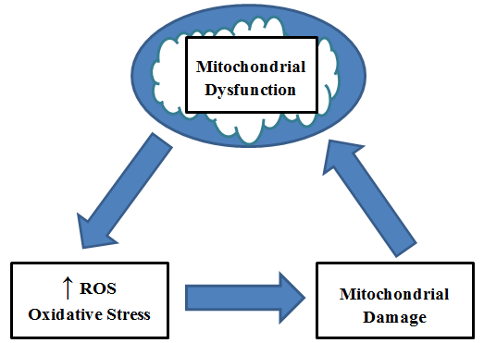
Figure 2-1. The Cycle of Mitochondrial Dysfunction

Mitochondrial Form and Function
Mitochondria are essential membrane-enclosed eukaryotic organelles that generate the cellular energy carrier adenosine tri-phosphate (ATP), and are often deemed the “powerhouse” of the cell [10]. The mitochondria accomplish this task through oxidative phosphorylation by utilizing the products of glycolysis and lipolysis [1,10]. The word mitochondria is derived from the Greek mitos or thread, and chondrion or granule, and these organelles range from 0.5 to 1.0 micrometer in diameter [10].
Mitochondria are highly organized, allowing them to perform their myriad biological processes [1,10]. Mitochondria possess a double membrane organization, resulting in distinct compartments within the organelle [10]. The semi-permeable outer mitochondrial membrane encloses the organelle, separating it from the cytosol [10]. Between the outer and inner membrane is the intermembrane space, a location for protein transport [10]. The inner mitochondrial membrane serves as the site for oxidative phosphorylation and ATP synthases, and a location for protein transport [10]. The inner membrane is further compartmentalized to form cristae which increases the surface area thereby augmenting the organelles ability to synthesize ATP [10]. Finally, the mitochondrial matrix is the space within the mitochondrial membrane and is the location of the citric acid cycle as well as fatty acid oxidation [10].
7
While the primary function of mitochondria is often cited as ATP production, this organelle is essential for numerous cellular processes including cellular metabolism, cell signaling and apoptosis [1]. For example, in addition to being the site of the citric acid cycle, lipolysis, and oxidative phosphorylation, mitochondria contain enzymes essential for the synthesis of lipids, cholesterol, and heme synthesis and play a critical role in amino acid metabolism [1,10]. The controlled generation of reactive oxygen species (ROS) by the mitochondria is critical for both cell signaling and apoptosis [1].

Mitochondrial Biogenesis
Due to the essential role the mitochondria have in bioenergetics, metabolism and cell signaling, there is tight regulation of mitochondrial mass and function [1]. This regulation allows for differentiations in mass, morphology and function dependent upon the organism or cell type with some cells containing a single mitochondrion and others possessing several thousand [1,10]. Strict control over mitochondrial dynamics also permits this organelle to have varying responses based upon alterations in the environment (i.e. physical activity, availability of nutrients, temperature, etc.) [1,10].
8
This control is achieved through mitochondrial biogenesis, which is an essential biological process required for growth and development as well as to meet the variable energy requirements of the cell [1,9]. Mitochondrial biogenesis requires the synthesis, import, and integration of macromolecules to the mitochondrial reticulum [1,11]. Mitochondrial biogenesis is further complicated by the presence of dual genomes, and the necessary replication of the mitochondrial genome [1,11]. Roughly fifteen hundred proteins comprise the mitochondrial proteome, which are predominantly encoded by the nuclear genome [11]. The human mitochondrial genome is a circular segment of DNA that encodes a mere thirty-seven genes [1,11]. Of those thirty-seven genes encoded by mitochondrial DNA, thirteen encode proteins required for oxidative phosphorylation, twenty-two encode mitochondrial transfer RNA, and two encode mitochondrial ribosomal RNA [11]. Much of the mitochondrial proteome is committed to specialized functions, as evidenced by tissue-specific mitochondrial gene expression [12].
Comparison of mitochondria in multiple mouse tissues revealed significant conformity between protein levels and gene expression levels as measured by messenger RNA [12]. This suggests that the tight control of mitochondrial biogenesis is largely achieved through transcriptional regulation [1,12]. As such, the transcriptional regulation of mitochondrial biogenesis is achieved through the synchronized transcription of mitochondrial genes in both the nucleus and the mitochondria [13].

9
The Role of PGC-1α in Mitochondrial Biogenesis
PPARγ coactivator-1, or PGC-1α, is often referred to as the master regulator of mitochondrial biogenesis due to its ability to attenuate the expression of myriad mitochondrial genes [1]. PGC-1α possesses molecular features allowing it to interact with, and ultimately increase the transcription of, numerous mitochondrial genes [14]. The vital role of PGC-1α in mitochondrial biogenesis has been clearly demonstrated in transgenic studies [15-18]. The overexpression of PGC-1α in skeletal muscle results in increased mitochondrial abundance and gene expression, and improved exercise performance [15,16]. While PGC-1α null mice display decreases in mitochondrial gene expression and impaired mitochondrial function [17,18].
While PGC-1α attenuates the expression of numerous mitochondrial genes, its own expression is dictated by the energetic needs of the cell [14]. For example, PGC-1α is expressed in a tissue-specific manner exhibiting higher expression levels in tissues with elevated energy requirements [13,14]. Additionally, PGC-1α expression and activity is sensitive to external signals of increased energy needs [14]. For example, PGC-1α expression is increased following caloric restriction and physical activity [13,19]. Furthermore, the activity of PGC-1α is attenuated by posttranslational modifications by AMP-activated protein kinase (AMPK) and sirtuin1 (SIRT1) which are themselves activated by an increase in cellular energy needs [13,20,21]. This collectively implies that PGC-1α is a key influence in the long-term adaptation to the changing energy needs of the cell [1,13].

10
The Role of NRF-1 in Mitochondrial Biogenesis
Nuclear respiratory factor-1, or NRF-1, is a DNA binding transcription factor that regulates the expression of numerous mitochondrial genes [22]. NRF-1 stimulates the expression of a segment of the mitochondrial genome, specifically the genes that encode oxidative phosphorylation components and mitochondrial ribosomal proteins [22,23]. NRF-1 also controls the expression of transcription factor a, mitochondrial (TFAM) [23]. TFAM is a nuclear encoded gene, that is partially responsible for the coordinated transcription of the nuclear and mitochondria genomes during mitochondrial biogenesis [11,23]. Furthermore, NRF-1 activity is essential for the basal expression of mitochondrial genes, as silencing of NRF-1 results in significant reductions in the expression of said genes and NRF-1 null embryos exhibit reduced mitochondrial DNA and mitochondrial membrane potential [24-26].
NRF-1 expression and activity is modulated by signals recognized to promote mitochondrial biogenesis [19,25,27-28]. For example, physical activity and/or increased levels of AMPK results in augmented expression of NRF-1 in muscle tissue [27,28]. Overexpression of PGC-1α in myotubes induces the expression of NRF-1 [19], while physical interaction between NRF-1 and PGC-1α enhances the activity of NRF-1 and results in greater expression of NRF-1-dependent genes [19,25]. Collectively, this suggests that NRF-1 expression and activity is modulated by the energetic needs of the cell much like PGC-1α [19].

Measuring Mitochondrial Biogenesis
Mitochondria are highly polymorphic, exhibiting structural variants that are contingent upon cell type, metabolic needs of the cell, and the cell cycle stage [1,10]. Similarly, mitochondrial mass varies amongst different organisms and tissue types, and is specifically dependent upon the energy requirements of the cell [1,10]. In the literature, mitochondrial abundance is often utilized as an indicator of mitochondrial biogenesis [29,30]. This measurement is achieved through the use of a cell-permeable, mitochondrion-selective fluorescent dye [30]. In order to fluorescently label the mitochondria, cells are incubated with nanomolar concentrations of fluorescent probe [31]. The probe is able to diffuse through the cell membrane and accumulate within the mitochondria, thus allowing researchers to measure mitochondrial mass via fluorescence [31]. 10-Nonyl acridine orange (NAO) and MitoTracker Green are two such fluorescent probes, often utilized for measuring mitochondrial mass quantitatively as they accumulate within the mitochondria independent of membrane potential [29-31]. MitoTracker Green has the additional benefit of only fluorescing within the lipid environment of the mitochondria, thereby minimizing background fluorescence making it an ideal choice for qualitative imaging data [29,31].
11
While the aforementioned probes are useful for measuring mitochondrial mass, the data generated by said probes cannot distinguish changes in the size of mitochondria versus mitochondrial number [29-32]. Given that control of mitochondrial biogenesis is achieved through transcriptional regulation [1,12], gene expression levels of key mitochondrial regulatory and component genes should be used to confirm alterations in mitochondrial number rather than size [32]. For example, increased fluorescence measured via NAO and an upregulation in the expression of PGC-1α and/or NRF-1 are indicative of increased mitochondrial biogenesis [32]. The branched chain amino acid (BCAA) leucine significantly upregulates mitochondrial biogenesis, as measured by fluorescent probe and gene expression levels, in skeletal muscle cells [32].
12
2.2 Leucine

The Branched Chain Amino Acids
Leucine, isoleucine, and valine are categorized as BCAAs, a group of essential amino acids that play important roles in protein synthesis and energy production [33]. Of the BCAAs, leucine is the most widely investigated due to its varied physiological roles in mitochondrial function, protein synthesis, exercise recovery, glucose homeostasis and insulin action [32-38]. In humans, between fifteen and twenty-five percent of total protein intake is BCAAs, and BCAAs comprise forty percent of the essential amino acids in body protein [39, 40]. As essential amino acids, the BCAAs must be obtained through diet, and dairy products are one of the richest sources of BCAAs and of leucine in particular [39]. Estimated requirements for leucine in the diet vary greatly, ranging from one to twelve grams daily [41].

Chemical Profile of Leucine
Leucine is a branched-chain, hydrophobic amino acid composed of thirteen hydrogen atoms, six carbon atoms, two oxygen atoms, and a single nitrogen atom (C₆H₁₃NO₂) [10]. Due to its essentiality, leucine cannot be biosynthesized and must be consumed through diet [39]. Once ingested, dietary leucine is transaminated to α-ketoisocaproate (KIC) via the mitochondrial enzyme BCAA transferase (BCAT) [42]. The reversible BCAT reaction occurs predominantly extrahepatically, following this reaction KIC can enter one of two degradative pathways [42,43]. The principal route for leucine metabolism results in the generation of isovaleryl-CoA from KIC, through the enzymatic action of the mitochondrial branched-chain ketoacid dehydrogenase complex (BCKD) [42,44]. Following a series of reactions isovaleryl-CoA ultimately yields acetyl-CoA and acetoacetate, which can enter into the citric acid cycle [42,43].
13
The above pathway is common to isoleucine and valine, however, leucine has an alternative catabolic pathway available for the degradation of KIC [23]. β-hydroxy-β-methylbutyrate (HMB) can be produced from KIC via KIC-dioxygenase, a cytosolic enzyme found predominantly in the liver [42-44]. Under normal conditions, approximately five to ten percent of ingested leucine is converted into HMB [9,10]. Following this pathway, HMB can be metabolized to yield β-hydroxy-β-methylglutaryl-CoA (HMG-CoA) which can be utilized for cholesterol synthesis [9,22]. Leucine metabolism is summarized in Figure 2-2, adapted from Nissen and Abrumrad (1997) and Van Koverin and Nissen (1992) [42].

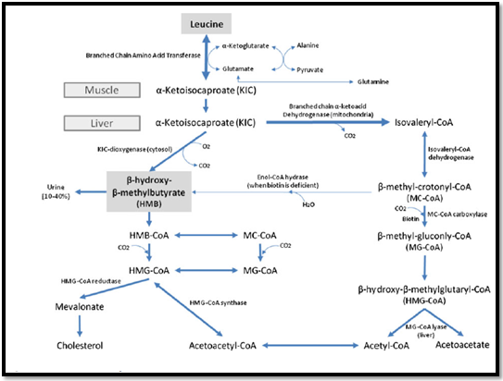
Figure 2-2. Leucine Catabolism.
14
Leucine and Protein Synthesis
While it is a function of all amino acids to serve as a substrate for protein synthesis, leucine possesses the unique ability to upregulate protein synthesis [45]. Leucine supplementation inhibits muscle catabolism during periods of caloric deprivation and prolonged endurance training, and stimulates muscle protein synthesis following exercise [46-48]. Furthermore, elimination of leucine while during protein administration abates protein synthesis in vitro, while eliminating other amino acids has little to no effect on protein synthesis [45]. Additionally, a structural analogue of leucine (nor-leucine) enhances protein accretion despite the fact that it cannot act as a substrate for a growing polypeptide chain [45].
The anabolic effect of leucine on protein synthesis is largely mediated by the activation of mammalian target of rapamycin (mTOR) pathway in skeletal muscle, which results in the activation of S6 ribosomal protein kinase (S6K1) and eukaryotic initiation factor 4E (eIF4E) [49-52]. Leucine administration stimulates protein synthesis through the hyperphosphorylation of the translational repressor eIF4E-binding protein 1 (eIF4E-BP1), resulting in enhanced activity of the translation initiator eIF4E [45,52]. The activation of S6K1 results in increased synthesis of ribosomal proteins and elongation factors [52,53]. Through mTOR leucine is able to initiate signal transduction pathways that enhance the activity and synthesis of proteins involved in translation [52]. Although the majority of leucine’s ability to promote protein accretion appears to be modulated by mTOR, leucine is also able to activate the eukaryotic initiation factor-4G (eIF4G) through an mTOR-independent mechanism [53]. While these effects are predominantly insulin-independent, baseline fasting levels of insulin are required in order to observe said effects [52,53].
15
Leucine & Mitochondrial Biogenesis
The benefits of BCAA supplementation extend beyond protein accretion, as a body of evidence has been accumulating that suggests that BCAA and leucine in particular can promote mitochondrial health and potentially reduce oxidative stress [32,34,54-56]. Experiments in the model organism Saccharomyces cerevisiae have revealed that BCAAs may promote long-term survival in this species [54]. Furthermore, long-term administration of BCAA rich diet resulted in a significant increase in the lifespan of male mice, complemented by a concurrent increase in mitochondrial biogenesis and reduced oxidative damage in skeletal and cardiac muscle [55]. Our own laboratory has demonstrated that leucine significantly upregulates mitochondrial biogenesis and enhances FAO in murine myotubes [32,34].

2.3 HMB

HMB: The Leucine Metabolite
HMB, the leucine metabolite, is produced endogenously by skeletal muscle [57]. HMB has been the focus of considerable recent attention as a supplement to support protein synthesis and/or muscle maintenance in a variety of populations [43,58-61]. There is much overlap between the leucine and HMB literature as both compounds are renowned for its ability to promote protein synthesis and muscle health [43,57].

16

Lean Body Mass, Mitochondrial Function, and Health
Lean body mass (LBM) accounts for seventy-five percent of normal body weight, and includes all tissues except adipose tissue [62]. Skeletal muscle comprises the majority of LBM, the maintenance of which is critical in supporting whole-body protein metabolism, wound healing, physical strength, organ function, and immune function [62-64]. A progressive loss of LBM, or sarcopenia, occurs naturally with age [58]. Injury and illness can cause or accelerate this loss of LBM [15]. For example, sarcopenia is exacerbated by several chronic conditions including AIDS, cancer, non-healing wounds, and congestive heart failure [62,65,66]. In addition to a loss of skeletal muscle, the sarcopenic phenotype is associated with a shift in muscle fiber type and a reduced ability to perform activities of daily living [65]. Sarcopenia is also associated with increased morbidity and mortality regardless of age, and documented consequences of LBM loss range from impaired immune function to physical disability to depression in the elderly [58,62,66].
Post-mortem histological examinations have demonstrated that sarcopenia results in an approximately fifty-percent reduction in total muscle fibers between the ages of twenty and eighty, with a disproportionate loss of fast-twitch muscle fibers [67,68]. The function of skeletal muscle is highly dependent upon the production of ATP by mitochondria [68]. Mitochondrial dysfunction results in a reduced mitochondrial number and oxidative capacity, causing an increase in free radical production and consequently oxidative stress [65,68]. Sarcopenic muscle is associated with mitochondrial dysfunction, demonstrating a clear relationship between muscle and mitochondrial health [65,67,68]. As such, the identification of compounds that can attenuate both the mitochondrial dysfunction and the loss of LBM associated with sarcopenia is an important focus in current medical research.
17
Chemical Profile of HMB
HMB is one such compound that has been documented to support muscle health in a variety of populations [43,58-61]. As a metabolite of leucine, HMB is produced endogenously following the consumption of dietary leucine [57]. HMB is also found in a variety of food sources such a catfish, grapefruit, alfalfa, and avocado and is available commercially as a supplement in the form of a calcium salt [43,69].
Following modest HMB consumption plasma levels peak within two hours, with an increased plasma response observed following larger doses of HMB [70]. Depending upon the dosage provided between ten and forty percent of HMB undergoes urinary excretion, with as much as eighty-six percent of HMB remaining in the body [43,70]. Animal toxicity studies have demonstrated no adverse effects following HMB exposure, and HMB supplementation in humans appears to be both safe and well tolerated in the diverse populations studied [42,43,70]. In clinical trials to date, the most frequently administered dose of HMB is three grams daily but optimal dosage and frequency have not been established [43]. The average person produces less than one gram of HMB endogenously daily, and would need to consume between thirty and sixty grams of leucine to achieve the results observed in standard supplementation studies of HMB [43,57].

Proposed Mechanism of Action
Within the current body of HMB literature, there is much to support the efficacy of supplementation on specific outcomes, and very few publications examining the mechanisms of action of the compound [42,43]. While these mechanisms remain unclear, they likely relate to the ability of HMB to modulate protein synthesis and degradation pathways and/or maintain the integrity of the sarcolemma [43].
18
HMB disrupts two pathways that promote proteolysis, caspase-8 and nuclear factor kappa B (NFκB) [71-73]. The activation of caspase-8 results in a cascade of events that ultimately downregulates protein synthesis, while NFκB stimulates proteosome activity [43,71]. HMB inhibits the activation of caspase-8 and interferes with the protein degradation activities of NFκB, thus maintaining protein synthesis and preventing proteolysis [71-74]. HMB also appears to directly upregulate protein synthesis through the activation of mTOR (mammalian target of rapamycin), the intracellular protein that regulates protein synthesis [75].
Another possible mechanism in which HMB exerts its effect lies in its ability to provide readily available substrate for cholesterol synthesis in muscle cells which is critical for the integrity of myotube membranes [43,57]. There is evidence that damage muscle cells are unable to produce adequate cholesterol, resulting in decreased sarcolemmal integrity and increased susceptibility to cell rupture [57]. The majority of HMB is metabolized into HMG-CoA, which is often termed the rate limiting step in cholesterol synthesis [43,57]. Thus, HMB is able to support the maintenance of sarcolemmal structure by providing an essential substrate for myotube cholesterol synthesis [43]. It is important to note that HMB supplementation does not result in an increase in circulating cholesterol [76,77]. HMB may play a role in the production of coenzyme Q, a downstream metabolite of HMG-CoA, which plays an important role in myocyte proliferation and mitochondrial function [78]. While the mechanisms of action of HMB may not be well understood, the efficacy of supplementation in a variety of populations on protein synthesis and muscle maintenance is well established [43].
19
Efficacy of HMB Supplementation
The use of HMB as an ergogenic aid has been extensively studied in healthy adults, alone and in combination with other amino acids [42,43]. Presently, more than twenty clinical trials support the efficacy of HMB supplementation in delaying muscle soreness, decreasing muscle damage, improving strength and other performance markers, and increasing LBM [43]. These effects are more pronounced in untrained individuals, compared to experienced athletes [42].
The elderly have an increased risk for loss of LBM, and several studies have focused on HMB supplementation in this high-risk population [43,58]. For example, Vukovich et al. examined the effect of HMB supplementation in combination with resistance training in healthy, elderly men and women [59]. Thirty-one participants were randomized to either an HMB supplemented or a placebo group, and participated in an eight-week resistance training program [59]. The individuals receiving the HMB exhibited increased fat loss measured via computerized tomography scans, and a greater increase in upper and lower body strength compared to the placebo group [59]. A study conducted by Flakoll et al. studied the effects of supplementing HMB in combination with arginine and lysine versus a placebo in healthy elderly women [79]. The researchers hypothesized that the reductions in protein degradation observed with HMB, may attenuate the effects of sarcopenia [43,79]. After twelve weeks, the group receiving the HMB combination demonstrated increased leg and handgrip strength, and a twenty percent increase in protein synthesis relative to the placebo [79]. Based upon the available data, healthy elderly individuals exhibit increased strength and a more desirable body composition with HMB supplementation alone and in conjunction with an exercise program [43,59,79].
Much like the elderly, critically ill patients are at an increased risk for loss of LBM compared to the general population [62-65]. Due to its anti-catabolic properties HMB supplementation has been studied in numerous disease states associated with muscle atrophy [59-62]. Supplementation of HMB in conjunction with glutamine and arginine has been demonstrated to decrease muscle-wasting associated with advanced AIDS and cancer cachexia over a period of eight to twenty-four weeks [60,61]. In critical care patients, supplementation of the aforementioned HMB combination resulted in increased protein synthesis while patients exhibited negative nitrogen balance during their stay in the intensive care unit [80]. Similarly, Cohen et al. demonstrated that supplementing exclusively HMB during negative nitrogen balance maintained LBM to a greater extent than placebo during a hospital stay [43].
20
While much of the research to date supports the efficacy of HMB supplementation in promoting protein synthesis and muscle maintenance, the literature is not without flaws. For example, the standard dosage of HMB supplemented is three grams per day provided in three equal dosages [43]. With few studies examining the topic, optimal dosage and frequency have yet to be established for HMB supplementation [42,43]. Additionally, studies relating to HMB supplementation are conducted by a core group of authors, many of whom profit from the sale of HMB which introduces bias in the research [43]. While a conflict of interest is present, the HMB research has been sufficiently replicated in a variety of laboratory and clinical settings, suggesting the validity of the findings [42].

  - Research Objectives

Leucine versus HMB
The efficacy of HMB supplementation on protein synthesis and the maintenance of LBM in healthy and critically ill patients has been well documented, and similar effects have been observed with leucine supplementation. Amongst the BCAAs leucine has been most frequently used as an ergogenic aid in athletes, and has been demonstrated to increase protein synthesis in an mTOR dependent manner [43,57]. The mechanism by which these effects occur has not been clearly established, and it has been postulated that these effects are in fact mediated by its metabolite HMB [43].
21
The association between muscle health and mitochondrial function has been well established, and our lab has recently demonstrated that leucine promotes mitochondrial biogenesis and upregulates fatty acid oxidation in murine muscle cells [32,34]. HMB has been recognized to promote muscle health in both exercise and clinical settings, but the effect of HMB on mitochondrial function has not been examined in the literature [43]. Based upon the similar results obtained from leucine and HMB supplementation on LBM and mTOR stimulation of protein synthesis, it is possible that HMB may also mediate the leucine stimulation of mitochondrial function. We hypothesize that the leucine attenuation of proteolysis, muscle health, and mitochondrial function are potentially mediated by its metabolite HMB. Accordingly, the primary objective of this project is to determine whether HMB mediates the effects of leucine, or merely mimics its effects which will be discussed in the proceeding section.
22
Literature Cited:
- Hock MB, Kralli A: Transcriptional control of mitochondrial biogenesis. Ann Rev Physiol 2009, 71:177-203.
- Duchen MR: Roles of mitochondria in health and disease. Diabetes 2004, 53(Suppl. 1):S96–S102.
- Joseph AM, Joanisse DR, Baillot RG, Hood DA: Mitochondrial dysregulation of diabetes for mitochondrial biogenesis-mediated interventions. Exper Diabetes Res 2012.
- Zhang D, Mott JL, Farrar P, Ryerse JS, Chang SW, Stevens M, Denniger G, Zassenhaus HP: Mitochondrial DNA mutations activate the mitochondrial apoptotic pathway and cause dilated cardiomyopathy. Cardiovasc Res 2003, 57:147-157.
- Krieger C, Duchen MR: Mitochondria, Ca(2+) and neurodegenerativedisease. Eur J Pharmacol 2002, 447:177–188.
- Schon EA, Manfredi G: Neuronal degeneration and mitochondrial dysfunction. J Clin Invest 2003, 111:303–312.
- Cairns CB: Rude unhinging of the machinery of life: metabolic approaches to hemorrhagic shock. Curr Opin Crit Care 2001, 7:437–443.
- Weber TA, Reichert AS: Impaired quality control of mitochondria: aging from a new perspective. Exper Gerontol 2010, 45:503-511.
- Stefano GB, Kim C, Mantione K, Casares F, Kream RM: Targeting mitochondrial biogenesis for promoting health. Med Sci Monit 2012, 18(3):SC1-3.
- Campbell N, Reece J. Biology. 6th ed. San Francisco, CA: Pearson Education, Inc.; 2002: 155-174.
23
- Pagliarini DJ, Calvo SE, Chang B, Sheth SA, Vafai SB: A mitochondrial protein compendium elucidates complex I disease biology. Cell 2008, 134:112–23.
- Mootha VK, Bunkenborg J, Olsen JV, Hjerrild M, Wisniewski JR: Integrated analysis of protein composition, tissue diversity, and gene regulation in mouse mitochondria. Cell 2003, 115:629–40.
- Poyton RO: Crosstalk between nuclear and mitochondrial genomes. Atmu. Rev. Bimheni. 1996, 65:563-607.
- Handschin C, Spiegelman BM: Peroxisome proliferator-activated receptor γ coactivator 1 coactivators, energy homeostasis, and metabolism. Endocr. Rev. 2006, 27:728–35.
- Lin J, Wu H, Tarr PT, Zhang CY, Wu Z: Transcriptional coactivator PGC-1α drives the formation of slow-twitch muscle fibres. Nature 2002, 418:797–801.
- Calvo JA, Daniels TG, Wang X, Paul A, Lin J: Muscle-specific expression of PPARγ coactivator-1α improves exercise performance and increases peak oxygen uptake. J. Appl. Physiol. 2008, 104:1304–12.
- Leone TC, Lehman JJ, Finck BN, Schaeffer PJ, Wende AR: PGC-1α deficiency causes multi-system energy metabolic derangements: muscle dysfunction, abnormal weight control and hepatic steatosis. PLoS Biol. 2005, 3:e101.
- Arany Z, Novikov M, Chin S, Ma Y, Rosenzweig A, Spiegelman BM: Transverse aortic constriction leads to accelerated heart failure in mice lacking PPAR-γ coactivator 1α. Proc. Natl. Acad. Sci. USA 2006, 103:10086–91.
- Wu Z, Puigserver P, Andersson U, Zhang C, Adelmant G: Mechanisms controlling mitochondrial biogenesis and respiration through the thermogenic coactivator PGC-1. Cell 1999, 98:115–24.
24
- Jager S, Handschin C, St-Pierre J, Spiegelman BM: AMP-activated protein kinase (AMPK) action in skeletal muscle via direct phosphorylation of PGC-1α. Proc. Natl. Acad. Sci. USA 2007, 104:12017–22.
- Gerhart-Hines Z, Rodgers JT, Bare O, Lerin C, Kim SH: Metabolic control of muscle mitochondrial function and fatty acid oxidation through SIRT1/PGC-1α. EMBO J. 2007, 26:1913–23.
- Virbasius CA, Virbasius JV, Scarpulla RC: NRF-1, an activator involved in nuclear-mitochondrial interactions, utilizes a new DNA-binding domain conserved in a family of developmental regulators. Genes Dev. 1993, 7:2431–45.
- Scarpulla RC: Transcriptional paradigms in mammalian mitochondrial biogenesis and function. Physiol. Rev. 2008, 88:611–38.
- Dhar SS, Ongwijitwat S,Wong-Riley MT: Nuclear respiratory factor 1 regulates all ten nuclearencoded subunits of cytochrome c oxidase in neurons. J. Biol. Chem. 2008, 283:3120–29.
- Andersson U, Scarpulla RC: Pgc-1-related coactivator, a novel, serum-inducible coactivator of nuclear respiratory factor 1-dependent transcription in mammalian cells. Mol. Cell. Biol. 2001, 21:3738–49.
- Huo L, Scarpulla RC: Mitochondrial DNA instability and peri-implantation lethality associated with targeted disruption of nuclear respiratory factor 1 in mice. Mol. Cell. Biol. 2001, 21:644–54.
- Murakami T, Shimomura Y, Yoshimura A, Sokabe M, Fujitsuka N: Induction of nuclear respiratory factor-1 expression by an acute bout of exercise in rat muscle. Biochim. Biophys. Acta 1998, 1381:113–22.
25
- Bergeron R, Ren JM, Cadman KS, Moore IK, Perret P: Chronic activation of AMP kinase results in NRF-1 activation and mitochondrial biogenesis. Am. J. Physiol. Endocrinol. Metab. 2001, 281:E1340–46.
- Marques-Santos LF, Oliveira JGP, Maia RC, Rumjaneki VM: Mitotracker Green is a p-glycoprotein substrate. Biosci Reports. 2003, 23(4):199-212.
- Keij JF, Bell-Prince C, Steinkamp JA. Staining of mitochondrial membranes with 10-nonyl acridine orange, mitofluor green, and mitotracker green is affected by mitochondrial membrane potential altering drugs. Cytometry. 200, 39:203-210.
- Life Technologies. The Molecular Probes Handbook: Probes for Mitochondria. http://www.invitrogen.com/site/us/en/home/References/Molecular-Probes-The-Handbook/Probes-for-Organelles/Probes-for-Mitochondria.html. Accessed June 27, 2012.
- Sun X, Zemel MB: Lecuine Modulation of mitochondrial mass and oxygen consumption in skeletal muscle cells and adipocytes. Nutrition and Metabolism 2009, 26(6).
- Wilson J, Wilson GJ: Contemporary issues in protein requirements and consumption for resistance trained athletes. J Int Soc Sports Nutr 2006, 3:7-27.
- Sun X, Zemel MB Leucine and Calcium Regulate Fat MEtabolism and Energy Partitioning in Murine Adipocytes and Muscle Cells. Lipids 2007, 42:297-305.
- Garlick PJ: The role of leucine in the regulation of protein metabolism. J Nutr 2005, 135(6 Suppl):1553S-1556S.
- Layman DK: The role of leucine in weight loss diets and glucose homeostasis. J Nutr 2003, 133(1):261S-267S.
26
- Patti ME, Brambilla E, Luzi L, Landaker EJ, Kahn CR: Bidirectional modulation of insulin action by amino acids. J Clin Invest 1998, 101(7):1519-1529.
- Mero A: Leucine supplementation and intensive training. Sports Med 1999, 27(6):347-358.
- Blomstrand E, Saltin B. BCAA intake affects protein metabolism in muscle after but not during exercise in humans. Am J Physiol Endocrinol Metab. 2001, 281(2):E365-74.
- Riazi R, Wykes LJ, Ball RO, Pencharz PB. The total branched-chain amino acid requirement in young healthy adult men determined by indicator amino acid oxidation by use of L-[1-13C] phenylalanine. J Nutr. 2003,133(5):1383-9.
- Lynch CJ, Halle B, Fujii H, Vary TC, Wallin R, Damuni Z, Hutson SM. Potential role of leucine metabolism in the leucine-signaling pathway involving mTOR. Am J Physiol Endocrinol Metab. 2003,285(4):E854-63.
- Zanchi NE, Gerlinger-Romero F, Guimaraes-Ferreira L, de Siqueira Filho MA, Felitti V, Lira FS, Seelaender M, Lancha AH, Jr.: HMB supplementation: clinical and athletic performance-related effects and mechanisms of action. Amino Acids 2011, 40(4):1015-1025.
27
- Wilson GJ, Wilson JM, Manninen AH: Effects of beta-hydroxy-beta-methylbutyrate (HMB) on exercise performance and body composition across varying levels of age, sex, and training experience: A review. Nutr Metab (Lond) 2008, 5:1.
- Crouch NP, Lee MH, Iturriagagoitia-Bueno T, MacKinnon CH: Cloning, expression, and purification of mammalian 4-hydroxyphenylpyruvate dioxygenase/alpha-ketoisocaproate dioxygenase. Methods Enzymol 2000, 324:342-355.
- Stipanuk MH. Leucine and protein synthesis: mTOR and beyond. Nutr Rev. 2007, 65(3):122-129.
- Koopman R, Wagenmakers AJ, Manders RJ, Zorenc AH, Senden JM, Gorselink M,Keizer HA, van Loon LJ: Combined ingestion of protein and free leucine with carbohydrate increases postexercise muscle protein synthesis in vivo in male subjects. Am J Physiol Endocrinol Metab. 2005, 288:E645-53.
- Howarth KR, Moreau NA, Phillips SM, Gibala MJ. Coingestion of protein with carbohydrate during recovery from endurance exercise stimulates skeletal muscle protein synthesis in humans. J Appl Physiol. 2009,106:1394-402.
- Crozier SJ, Kimball SR, Emmert SW, Anthony JC, Jefferson LS. Oral leucine administration stimulates protein synthesis in rat skeletal muscle. J Nutr. 2005, 135:376-82.
- Anthony JC, Yoshizawa F, Anthony TG, Vary TC, Jefferson LS, Kimball SR: Leucine stimulates translation initiation in skeletal muscle of postabsorptive rats via a rapamycin-sensitive pathway. J Nutr. 2000, 130:2413-2419.
28
- Lynch CJ, Patson BJ, Anthony J, Vaval A, Jefferson LS, Vary TC: Leucine is a direct-acting nutrient signal that regulates protein synthesis in adipose tissue. Am J Physiol Endocrinol Metab. 2002, 283:E503-E513.
- Crozier SJ, Kimball SR, Emmert SW, Anthony JC, Jefferson LS: Oral leucine administration stimulates protein synthesis in rat skeletal muscle. J Nutr. 2005, 135:376-382.
- Anthony JC, Anthony TG, Kimball SR, Jefferson LS: Signaling pathways involved in translational control of protein synthesis in skeletal muscle by leucine. J Nutr. 2001, 131: 856S–860S.
- Kimball SR, Jefferson LS. Signaling pathways and molecular mechanisms through which branched-chain amino acids mediate translational control of protein synthesis. J Nutr. 2006, 136:227S-31S.
- Alvers AL, Fishwick LK, Wood MS, Hu D, Chung HS, Dunn WA, Aris JP: Autophagy and amino acid homeostasis are required for chronological longevity in Saccharomyces cerevisiae. Aging Cell. 2009, 8:353‐369.
- D'Antona G, Ragni M, Cardile A, Tedesco L, Dossena M, Bruttini F, Caliaro F, Corsetti G, Bottinelli R, Carruba MO, Valerio A, Nisoli E: Branched‐chain amino acid supplementation promotes survival and supports cardiac and skeletal muscle mitochondrial biogenesis in middle‐aged mice. Cell Metab. 2010, 12:362‐372.
- Valerio A, D’Antona G, Nisoli E: Branched-chain amino acids, mitochondrial biogenesis, and healthspan: an evolutionary perspective. Aging. 2011, 3(5):464-478.
- Nissen SL AN: Nutritional role of the leucine metabolite β-hydroxy β-methylbutyrate (HMB). Journal of Animal Science 1997, 8(6):300-311.
29
- Kim JS, Wilson JM, Lee SR: Dietary implications on mechanisms of sarcopenia: roles of protein, amino acids and antioxidants. J Nutr Biochem 2010, 21(1):1-13.
- Vukovich MD, Stubbs NB, Bohlken RM: Body composition in 70-year-old adults responds to dietary beta-hydroxy-beta-methylbutyrate similarly to that of young adults. J Nutr 2001, 131(7):2049-2052.
- Clark RH, Feleke G, Din M, Yasmin T, Singh G, Khan FA, Rathmacher JA: Nutritional treatment for acquired immunodeficiency virus-associated wasting using beta-hydroxy beta-methylbutyrate, glutamine, and arginine: a randomized, double-blind, placebo-controlled study. JPEN J Parenter Enteral Nutr 2000, 24(3):133-139.
- May PE, Barber A, D'Olimpio JT, Hourihane A, Abumrad NN: Reversal of cancer-related wasting using oral supplementation with a combination of beta-hydroxy-beta-methylbutyrate, arginine, and glutamine. Am J Surg 2002, 183(4):471-479.
- Demling RH: Nutrition, anabolism, and the wound healing process: an overview. Eplasty 2009, 9:e9.
- Wolfe RR: The underappreciated role of muscle in health and disease. Am J Clin Nutr 2006, 84(3):475-482.
- Bourdel-Marchasson I, Joseph PA, Dehail P, Biran M, Faux P, Rainfray M, Emeriau JP, Canioni P, Thiaudiere E: Functional and metabolic early changes in calf muscle occurring during nutritional repletion in malnourished elderly patients. Am J Clin Nutr 2001, 73(4):832-838.
- Johnston AP, De Lisio M, Parise G: Resistance training, sarcopenia, and the mitochondrial theory of aging. Appl Physiol Nutr Metab 2008, 33(1):191-199.
30
- Evans WJ, Morley JE, Argiles J, Bales C, Baracos V, Guttridge D, Jatoi A, Kalantar-Zadeh K, Lochs H, Mantovani G et al: Cachexia: a new definition. Clin Nutr 2008, 27(6):793-799.
- Drey M: Sarcopenia - pathophysiology and clinical relevance. Wien Med Wochenschr 2011, 161(17-18):402-408.
- Verdijk LB, Snijders T, Beelen M, Savelberg HH, Meijer K, Kuipers H, Van Loon LJ: Characteristics of muscle fiber type are predictive of skeletal muscle mass and strength in elderly men. J Am Geriatr Soc 2010, 58(11):2069-2075.
- Zhang Z, Rathmacher J, Coates C, Nissen S. Occurrence of β-hydroxy-β-methylbutyrate in foods and feeds. FASEB J. 1994;8:A464 [Abstract 2685].
- Vukovich MD, Slater G, Macchi MB, Turner MJ, Fallon K, Boston T, Rathmacher J: beta-hydroxy-beta-methylbutyrate (HMB) kinetics and the influence of glucose ingestion in humans. J Nutr Biochem 2001, 12(11):631-639.
- Eley HL, Russell ST, Tisdale MJ: Attenuation of depression of muscle protein synthesis induced by lipopolysaccharide, tumor necrosis factor, and angiotensin II by beta-hydroxy-beta-methylbutyrate. Am J Physiol Endocrinol Metab 2008, 295(6):E1409-1416.
- Eley HL, Russell ST, Tisdale MJ: Mechanism of attenuation of muscle protein degradation induced by tumor necrosis factor-alpha and angiotensin II by beta-hydroxy-beta-methylbutyrate. Am J Physiol Endocrinol Metab 2008, 295(6):E1417-1426.
- Yeh SS, Blackwood K, Schuster MW: The cytokine basis of cachexia and its treatment: are they ready for prime time? J Am Med Dir Assoc 2008, 9(4):219-236.
- Eley HL, Russell ST, Baxter JH, Mukerji P, Tisdale MJ: Signaling pathways initiated by beta-hydroxy-beta-methylbutyrate to attenuate the depression of protein synthesis in skeletal muscle in response to cachectic stimuli. Am J Physiol Endocrinol Metab 2007, 293(4):E923-931.
31
- Manzano M GM, Salto R, Sevillano N, Rueda R, Lopez-Pedrosa JM. : Is β-hydroxy-β-methylbutyrate (HMB) the bioactive metabolite of L-leucine (LEU) in muscle? Molecular evidence and potential implications. Clin Nutr Supp 2009, 4(2):137.
- Nissen S, Sharp RL, Panton L, Vukovich M, Trappe S, Fuller JC, Jr.: beta-hydroxy-beta-methylbutyrate (HMB) supplementation in humans is safe and may decrease cardiovascular risk factors. J Nutr 2000, 130(8):1937-1945.
- Portal S, Eliakim A, Nemet D, Halevy O, Zadik Z: Effect of HMB supplementation on body composition, fitness, hormonal profile and muscle damage indices. J Pediatr Endocrinol Metab 2010, 23(7):641-650.
- Evans M, Rees A: Effects of HMG-CoA reductase inhibitors on skeletal muscle: are all statins the same? Drug Saf 2002, 25(9):649-663.
- Flakoll P, Sharp R, Baier S, Levenhagen D, Carr C, Nissen S: Effect of beta-hydroxy-beta-methylbutyrate, arginine, and lysine supplementation on strength, functionality, body composition, and protein metabolism in elderly women. Nutrition 2004, 20(5):445-451.
- Kuhls DA, Rathmacher JA, Musngi MD, Frisch DA, Nielson J, Barber A, MacIntyre AD, Coates JE, Fildes JJ: Beta-hydroxy-beta-methylbutyrate supplementation in critically ill trauma patients. J Trauma 2007, 62(1):125-131; discussion 131-122.
- Stancliffe RA, Eades M, Smart K, Zemel MB: Role of mTOR and {beta}-hydroxy-{beta}-methylbutyrate (HMB) in leucine stimulation of muscle mitochondrial biogenesis and fatty acid oxidation FASEB J 2011, 25(Abstract # 606.1).
32

Part III
Role of β-hydroxy-β-methylbutyrate (HMB)
in leucine stimulation of muscle mitochondrial
biogenesis and fatty acid oxidation *

___________________________
* This article will be submitted to Nutrition & Metabolism for review.
33
3.1 Abstract
Background: Leucine is well recognized to stimulate muscle protein synthesis, and we have recently demonstrated that leucine increases mitochondrial biogenesis and fatty acid oxidation (FAO) in muscle cells, although the mechanism of these effects is not clear. However, it is likely that that the leucine metabolite HMB may play a role.
Methods: We tested the effect of leucine versus its metabolites (α-ketoisocaproic acid (KIC) and HMB) in the regulation of mitochondrial mass measured via fluorescence, and examined the expression levels of key mitochondrial regulatory and component genes. We also evaluated the effect of leucine versus the aforementioned metabolites on mitochondrial function, measured by fat oxidation. Finally, we tested the effect of intact leucine on mitochondrial biogenesis while inhibiting leucine catabolism.
Results: KIC (0-0.5mM) and HMB (0-50μM) induced comparable increases in FAO (~ 60-70%, p<0.001) in C2C12 myocytes when compared to leucine (0-0.5mM). Both leucine and HMB increased myotube mitochondrial biogenesis (assessed fluorometrically via NAO binding) by ~ 50%, (p<0.005) in C2C12 cells. Consistent with this, HMB and leucine both stimulated the expression of mitochondrial regulatory (PGC-1α and NRF-1) and component (UCP3) genes (p<0.01) in murine myotubes. Transfection of C2C12 myocytes with branched-chain amino transferase (BCAT), branched-chain α-ketoacid dehydrogenase enzyme (BCKD), or KIC dioxygenase (KICD) siRNA resulted in the suppression of the leucine-induced stimulation of mitochondrial biogenesis (p<0.05).
Conclusions: These data suggest that the leucine-induced stimulation of mitochondrial biogenesis and FAO is mediated by its metabolite HMB.
34
3.2 Introduction
The branched chain amino acids (BCAAs) leucine, isoleucine, and valine comprise more than one third of muscle protein, and have important physiological roles in protein synthesis and energy metabolism [1,2]. Amongst the BCAAs leucine is the most widely investigated due to its varied physiological roles in mitochondrial abundance and function, protein synthesis, exercise recovery, glucose homeostasis and insulin action [1,3-8]. β-hydroxy-β-methylbutyrate (HMB) is a metabolite of the branched chain amino acid (BCAA) leucine, and is produced endogenously by human skeletal muscle [9].
Once consumed, dietary leucine is transaminated to α-ketoisocaproate (KIC) by the mitochondrial enzyme BCAA transferase (BCAT) [10]. The reversible BCAT reaction occurs predominantly extrahepatically, and following this reaction KIC can enter one of two potential degradative pathways [10,11]. The chief pathway for leucine catabolism results in the production of isovaleryl-CoA from KIC, through the enzymatic action of the mitochondrial branched-chain ketoacid dehydrogenase complex (BCKD) [10,12]. Following a series of reactions isovaleryl-CoA ultimately generates acetyl-CoA and acetoacetate, both of which can act as substrate for the citric acid cycle [10,11].
The aforementioned pathway is common to all of the BCAAs, however, leucine has an alternative degredative pathway available for the catabolism of KIC [12]. KIC is metabolized into HMB via KIC-dioxygenase, a cytosolic enzyme found predominantly in the liver [10-12]. Under normal conditions, approximately five to ten percent of ingested leucine is converted into HMB [9,11]. Following this pathway, HMB can be metabolized to yield β-hydroxy-β-methylglutaryl-CoA (HMG-CoA) which can be utilized for cholesterol synthesis [9,10]. HMB is also found in a variety of food sources such a catfish, grapefruit, alfalfa, and avocado and is available commercially as a supplement in the form of a calcium salt [9,10].
35
HMB has been the focus of considerable recent attention as a supplement to support protein synthesis and muscle maintenance in athletes, the elderly, as well as in atrophic disease states such as advanced AIDS and cancer cachexia [11,13-16]. Due to the overlap in the literature with regard to leucine and HMB supplementation and protein accretion, it has been suggested that HMB may mediate the effects of leucine [11]. Our lab has previously demonstrated leucine to increase mitochondrial biogenesis and fatty acid oxidation in murine muscle cells [3,4]. Accordingly, the primary objective of this project is to determine whether HMB mediates the effects of leucine on mitochondrial biogenesis and FAO.

3.3 Materials and Methods

Cell Culture
C2C12 myoblasts were incubated at a density of 8,000 cells/cm² (T75 flask) and grown in Dulbecco’s modified eagle’s medium (DMEM) containing 10% fetal bovine serum (FBS) and antibiotics at 37°C in 5% CO2. Cultures were re-fed every 1 to 2 days until 80 to 90% confluency had been achieved. Confluent C2C12 myoblasts were induced to differentiate with a standard differentiation medium (DMEM with 2% horse serum and 1% penicillin-streptomycin), and fed with fresh differentiation medium daily until myotubes were fully formed (approximately 3 days).
36
Treatment of Cells
Leucine, KIC, and HMB were freshly diluted in medium before treatment of cells. Cells were incubated in serum free medium overnight and then washed with fresh medium, re-fed with medium containing the different treatments (0-0.5mM leucine, 0-0.5mM KIC, and 0-50μM HMB), and incubated at 37°C in 5% CO2 for 48 hours before analysis.
Fat Oxidation
Fat oxidation of muscle cells was measured as previously described (17), with minor modifications. C2C12 myotubes were rinsed twice with phosphate-buffering saline (PBS) and incubated in substrate mixture containing 22μM unlabeled palmitate plus 5μCi [³H]palmitate in Hank’s basic salt solution containing 0.5mg/ml BSA for two hours. Negative controls were created by treating cells with methanol for 30s to eliminate cellular metabolism. The reaction medium was then collected from cells and treated with 0.2ml 10% trichloroacetic acid. The protein precipitate was then removed via centrifugation, and supernatants were treated with 6N NaOH and then applied to a poly-prep chromatography column with 1ml Dowex-1. The ³H2O was passed through the column and the following 1ml of wash was collected and radioactivity was measured with a liquid scintillation counter.
Total RNA Isolation
RNA was extracted was performed per the manufacturer’s instructions using total cellular RNA isolation kit (Ambion, Austin, TX). The concentration and purity of the isolated RNA was then measured spectrophotometrically (A280/A260 between 1.9 and 2.1).
37
Quantitative Real-Time PCR
Muscle 18s, peroxisome proliferator-activated receptor gamma coactivator 1-alpha (PGC-1α), nuclear respiratory factor 1 (NRF1), and mitochondrial uncoupling protein 3 (UCP3) were quantitatively measured using an ABI 7300 Real-Time PCR System (Applied Biosystems, Branchburg, NJ) with a TaqMan 1000 Core Reagent Kit (Applied Biosystems, Branchburg, NJ). Primer and probe sets were purchased from Applied Biosystems TaqMan Assays-on-Demand and utilized according to manufacturer instructions. A standar curve was created using serial diluted pooled total RNA were serial-diluted (1.5625-25ng). Reactions of quantitative RT-PCR for standards and unknown samples were performed per ABI 7300 Real-Time PCR System and TaqMan Real-Time PCR Core Kit instructions. The mRNA quantitation for each sample was normalized using the corresponding 18s quantitation.
Mitochondrial Mass Assay
Nonyl acridine orange (NAO) (Invitrogen, Carlsbad, CA), a mitochondrial probe, was used to analyze mitochondrial mass by fluorescence (excitation 485nm and emission 520nm). A fluorescence microscope (Leica, Lasertechnik GmbH, Heidelberg, Germany) linked to a Hamamatsu color chilled 3CCD camera (Hamamatsu, Japan) was used to generate qualitative imaging data. Quantitative data were obtained via fluorescence microplate reader (Promega, Fitchburg, WI), with the intensity of fluorescence was expressed as arbitrary units per μg of protein.
Gene Silencing
An siRNA gene silencer and support products(Santa Cruz Biotechnology, Santa Cruz, CA) were used to knockdown KIC-dioxygenase (KICD) in myoblasts according to manufacturer’s instructions. The percent knockdown was assessed and optimized via Real-Time PCR as described previously.
38
Statistical Analysis
All data are presented as mean ± SD. Data were evaluated by one-way or ANOVA, and significantly different group means (p<0.05) were then separated by the least significant difference test using SPSS (SPSS Inc, Chicago, IL).

3.4 Results
We have previously shown leucine to upregulate FAO in murine myotubes [4]. Consistent with this observation, we found the leucine metabolites KIC and HMB to induce comparable increases in FAO in C2C12 cells compared to leucine (Figure 3-1). Prior data generated our laboratory has demonstrated leucine to induce significant increases in mitochondrial mass and to augment the expression of key mitochondrial regulatory and component genes in murine myotubes [3]. Similar effects were observed in C2C12 cells following treatment with KIC and HMB. All three compounds significantly increased mitochondrial abundance in the muscle cells compared to the control group (Figure 3-2). Likewise, treatment with leucine and its metabolites increased the expression of mitochondrial biogenesis regulatory genes PGC-1α and NRF-1, and the mitochondrial component gene UCP3 (Figure 3-3).
To further investigate the role of HMB in mediating the leucine-induced effects on mitochondrial biogenesis, we knocked down BCAT, BCKD, and KICD using siRNA in C2C12 myocytes. BCAT and BCKD siRNA transfection successfully decreased the corresponding mRNA by approximately thirty to forty percent (Figure 3-4). BCAT knockdown showed a significant reduction in the leucine-induced expression of mitochondrial regulatory genes PGC-1α and NRF-1, and the mitochondrial component gene UCP3 (Figure 3-5). This effect was not observed in leucine treated murine myocytes following BCKD or KICD knockdown. However, knockdown of BCAT and KICD abated the leucine-induced stimulation of mitochondrial mass while BCKD knockdown had no effect (Figure 3-6).
39
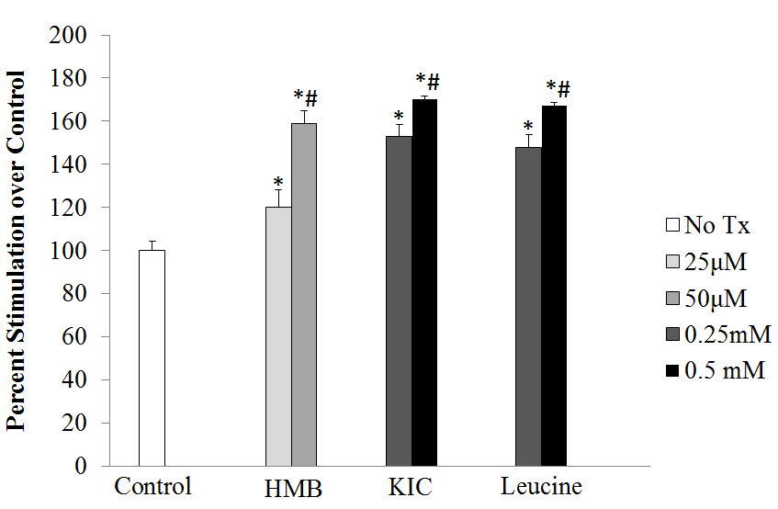
Figure 3-1. The effect of HMB, KIC, and leucine on fatty acid oxidation in C2C12 muscle cells. FAO was determined by palmitate oxidation. C2C12 myotubes were treated with one of two concentrations of HMB, KIC, or leucine for 48 hours. Values are presented as mean ± SEM, n = 6. Means with * differ compared with control group p<0.001, and means with # differ by concentration p<0.05.
40
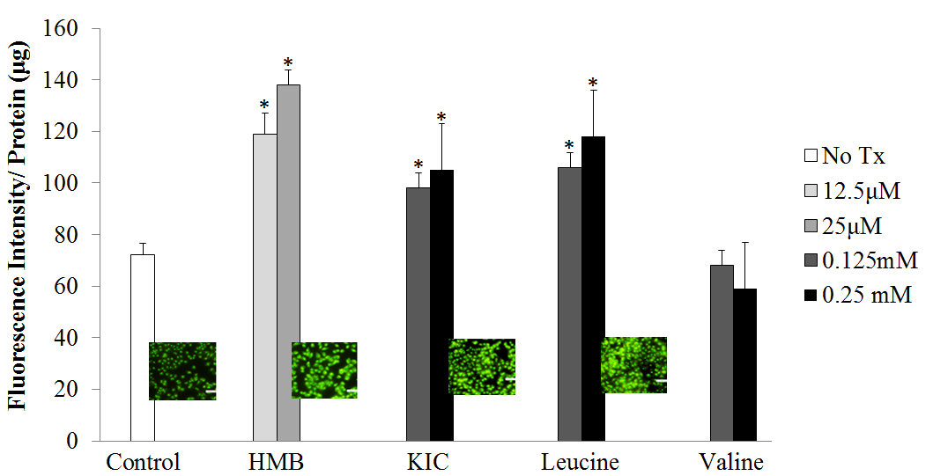
Figure 3-2. The effect of HMB, KIC, and leucine on mitochondrial mass by NAO binding in C2C12 myotubes. The images show fluorescent photographs of mitochondrial density and the bars show the quantity data in response to treatment. Cells were treated with one of two concentrations of HMB, KIC, or leucine for 48 hours. Values are presented as mean ± SEM, n = 12. Means with * differ compared with control group p<0.005.

41
A 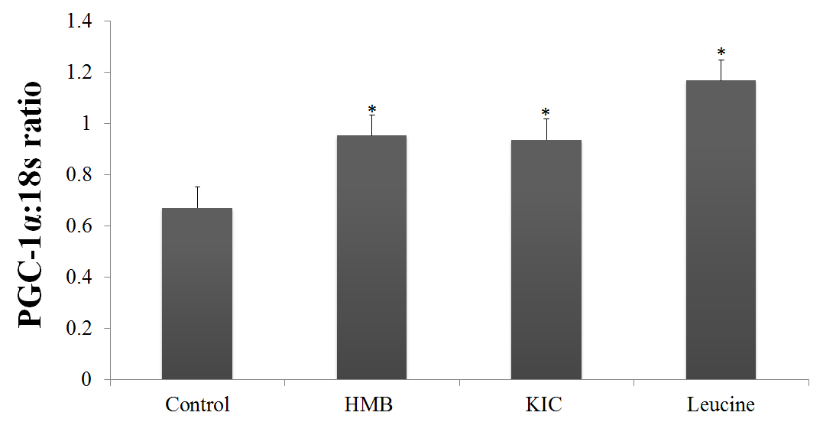
B 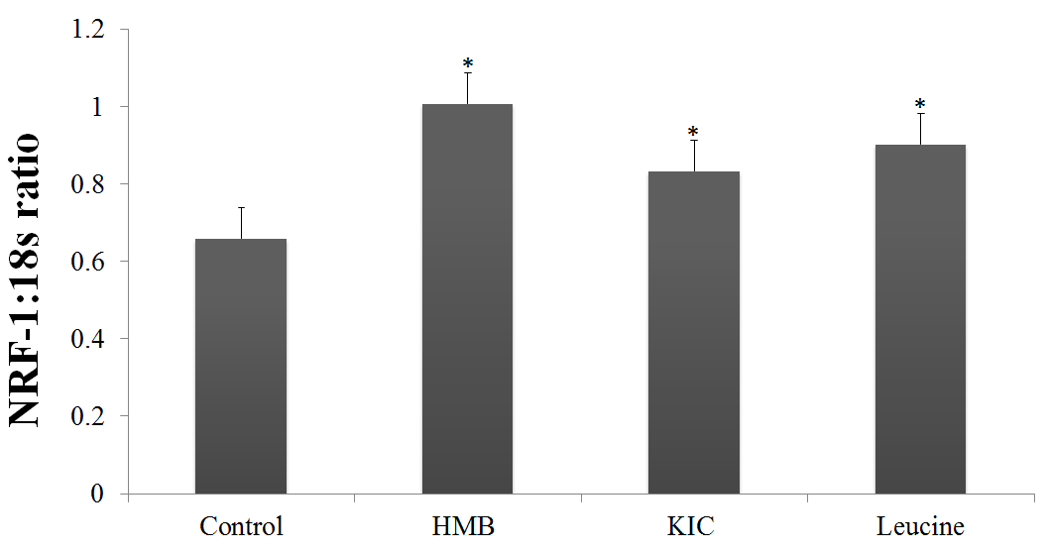
42
C 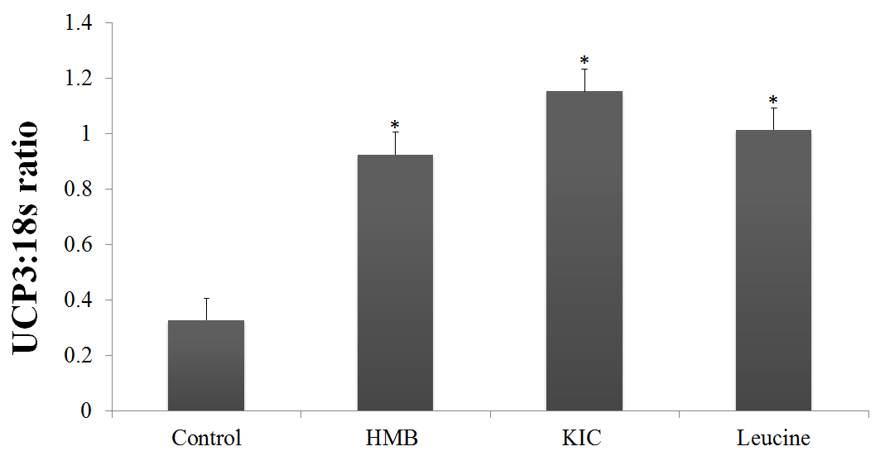
Figure 3-3. The effect of HMB, KIC, or leucine on (A) PGC-1α, (B) NRF-1, and (C) UCP3 gene expression in C2C12 myotubes; expression of each gene is normalized to 18s expression. Cells were treated with HMB (12.5μM), KIC (0.125mM), or leucine (0.125mM) for 48 hours. Values are presented as mean ± SEM, n = 6. Means with * differ compared with control group p<0.01.

43
A 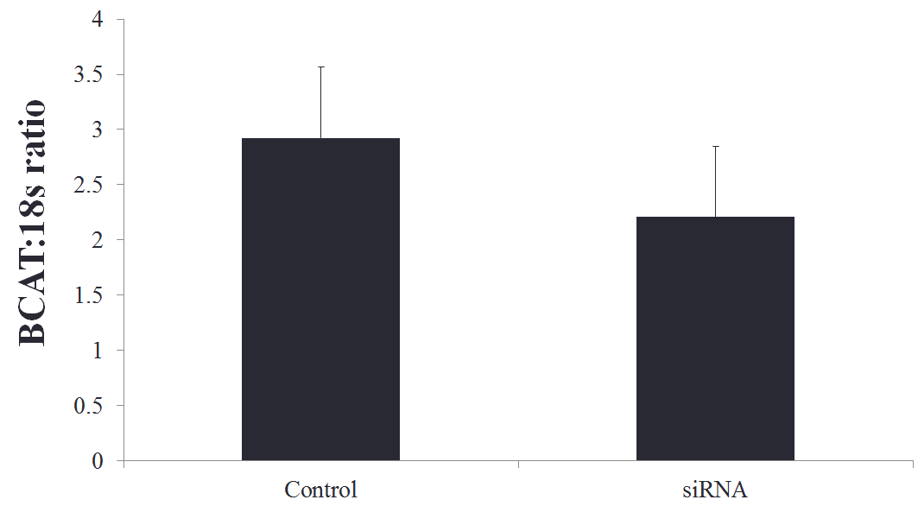
B 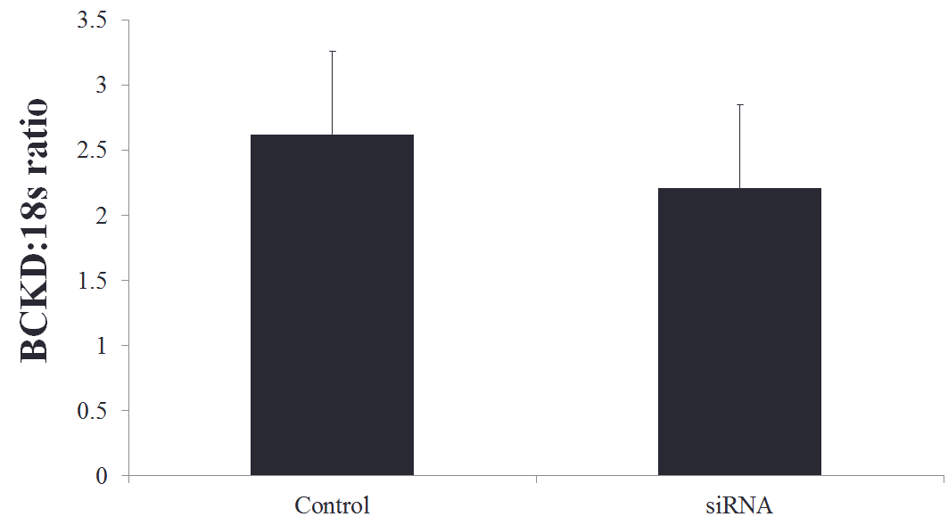
44
Figure 3-4. The expression of (A) BCAT and (B) BCKD in C2C12 myocytes with or without (A) BCAT and (B) BCKD siRNA transfection; expression of each gene is normalized to 18s expression. Values are presented as mean ± SEM, n = 6.

A 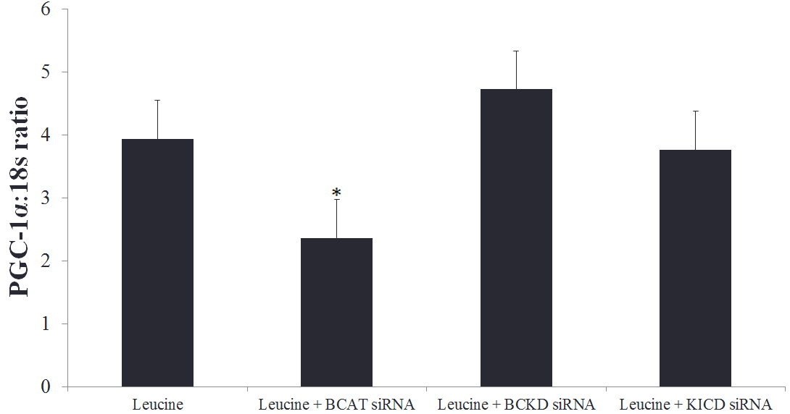
45
B 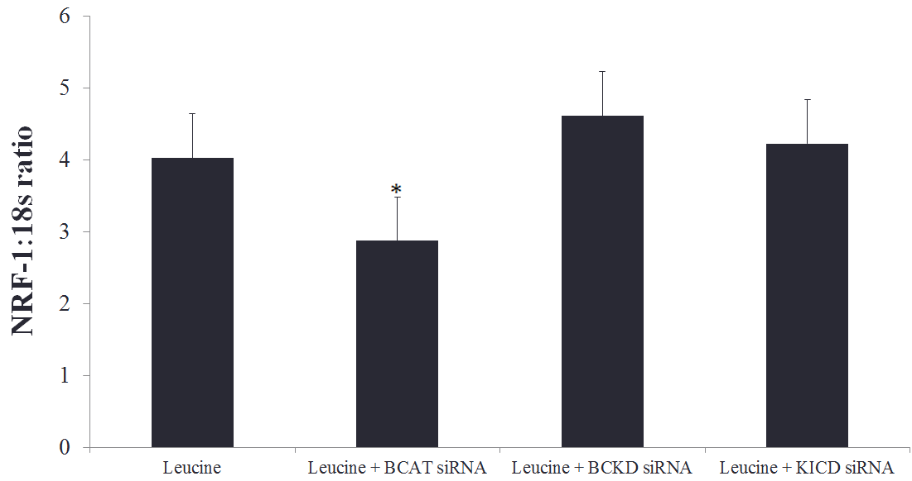
C 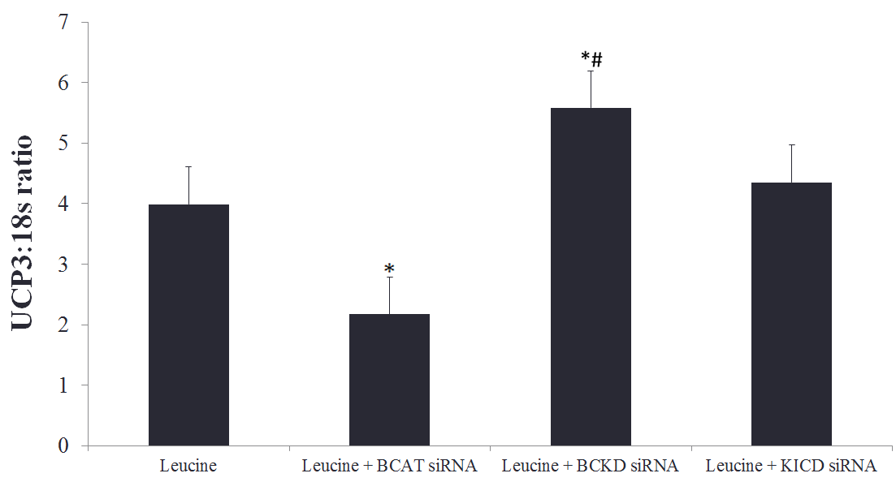
Figure 3-5. The effect of HMB, KIC, or leucine on (A) PGC-1α, (B) NRF-1, and (C) UCP3 gene expression in C2C12 myocytes with or without BCAT, BCKD, and KICD siRNA transfection; expression of each gene is normalized to 18s expression. Cells were treated with HMB (50μM), KIC (0.5mM), or leucine (0.5mM) for 48 hours. Values are presented as mean ± SEM, n = 6. Means with * differ compared with control group p<0.05, and means with # differed from siRNA groups p<0.01.
46

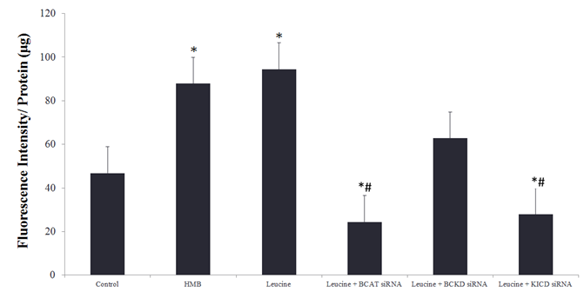
Figure 3-6. The effect of HMB, KIC, or leucine on mitochondrial mass by NAO binding in C2C12 myocytes with or without BCAT, BCKD, and KICD siRNA transfection. . Cells were treated with HMB (50μM), KIC (0.5mM), or leucine (0.5mM) for 48 hours. Values are presented as mean ± SEM, n = 12. Means with * differ compared with control group p<0.05, and means with # differed from siRNA groups p<0.01.
47
3.5 Discussion
Data from the present study demonstrate that the leucine metabolites KIC and HMB stimulate mitochondrial biogenesis and fat oxidation at levels comparable with leucine, and leucine catabolism to HMB is required to elicit the leucine-induced stimulation of mitochondrial biogenesis. This suggests that HMB mediates the effects of leucine on mitochondrial biogenesis.
The efficacy of HMB administration on protein accretion and the maintenance of lean body mass (LBM) in a variety of populations is well established, and leucine supplementation exerts similar effects [1]. Leucine has been identified to be a useful ergogenic aid in athletes, and the resultant increase in protein synthesis has been demonstrated to be mTOR dependent [9,11]. The upregulation of protein synthesis following HMB supplementation also appears to be the result of the direct activation of mTOR [18]. Considering the vast areas of overlap in the literature between the two compounds, it is not surprising that HMB has been suggested to be mediating the effects of leucine [11].
LBM accounts for seventy-five percent of normal body weight, and the maintenance of LBM is critical in supporting whole-body protein metabolism, wound healing, physical strength, organ function, and immune function [19-21]. Sarcopenia, a progressive loss of LBM occurs naturally with age and is exacerbated by several chronic conditions including AIDS, cancer, non-healing wounds, and congestive heart failure [13,19,22,23]. The sarcopenic phenotype is associated with a shift in muscle fiber type and a reduced ability to perform activities of daily living, and is also associated with increased morbidity and mortality regardless of age [13,19]. Other recognized consequences of LBM loss range from impaired immune function to physical disability to depression in elderly populations [13,19,23].
48
Post-mortem histological examinations have demonstrated that sarcopenia results in a disproportionate loss of fast-twitch muscle fibers, and an approximate fifty-percent reduction in total muscle fiber between age twenty and age eighty [24,25]. Skeletal muscle is highly dependent upon ATP production in the mitochondria, and as such this tissue is rich in mitochondrial abundance [24]. There is a clear association between muscle health and mitochondrial health as sarcopenic muscle is often coupled with mitochondrial dysfunction [22,24,25].
The connection between muscle health and mitochondrial function has been well recognized [24,25], and our lab has demonstrated that leucine promotes mitochondrial biogenesis and upregulates fatty acid oxidation in murine muscle cells [3,4]. Consequences of mitochondrial dysfunction include a reduced mitochondrial number and oxidative capacity, resulting in an increase in the production of free radicals and ultimately oxidative stress [22,24]. In addition to sarcopenia, mitochondrial dysfunction is a contributing factor to a number of disease states and the resulting complications [22]. These diseases include: cardiovascular disease, cancer, diabetes, obesity, dementia, liver disease, among others [21,23-25]. Considering the health consequences of mitochondrial dysfunction and the growing elderly population in the United States, the identification of compounds that can attenuate the mitochondrial dysfunction and the loss of skeletal muscle associated with sarcopenia is critical.
Leucine and HMB are two such compounds that warrant additional research. HMB has been well documented to promote protein synthesis and maintain muscle mass in a variety of populations studied to date [11,13-16]. Much of the HMB research has focused on clinical trials demonstrating the efficacy of supplementation, indicating the essentiality of additional mechanistic studies [11,25].
49
In summary, the present data demonstrate that leucine, KIC, and HMB attenuate mitochondrial biogenesis and function in murine myotubes. Additionally, the catabolism of leucine to HMB appears to be required for the observed mitochondrial effects. Collectively, this indicates that HMB is the active metabolite of leucine, and mediates its effects on mitochondrial biogenesis and function.

50
Literature Cited
- Wilson J, Wilson GJ: Contemporary issues in protein requirements and consumption for resistance trained athletes. J Int Soc Sports Nutr 2006, 3:7-27.
- Harper AE, Miller RH, Block KP: Branched-chain amino acid metabolism. Annu Rev Nutr 1984, 4:409-454.
- Sun X, Zemel M: Leucine and Calcium Regulate Fat Metabolism and Energy Partitioning in Murine Adipocytes and Muscle Cells. Lipids 2007, 42:297-305.
- Sun X, Zemel M: Lecuine Modulation of mitochondrial mass and oxygen consumption in skeletal muscle cells and adipocytes. Nutrition and Metabolism 2009, 26(6).
- Garlick PJ: The role of leucine in the regulation of protein metabolism. J Nutr 2005, 135(6 Suppl):1553S-1556S.
- Layman DK: The role of leucine in weight loss diets and glucose homeostasis. J Nutr 2003, 133(1):261S-267S.
- Patti ME, Brambilla E, Luzi L, Landaker EJ, Kahn CR: Bidirectional modulation of insulin action by amino acids. J Clin Invest 1998, 101(7):1519-1529.
- Mero A: Leucine supplementation and intensive training. Sports Med 1999, 27(6):347-358.
- Nissen SL, Abumrad N: Nutritional role of the leucine metabolite β-hydroxy β-methylbutyrate (HMB). Journal of Animal Science 1997, 8(6):300-311.
- Zanchi NE, Gerlinger-Romero F, Guimaraes-Ferreira L, de Siqueira Filho MA, Felitti V, Lira FS, Seelaender M, Lancha AH, Jr.: HMB supplementation: clinical and athletic performance-related effects and mechanisms of action. Amino Acids 2011, 40(4):1015-1025.
51
- Wilson GJ, Wilson JM, Manninen AH: Effects of beta-hydroxy-beta-methylbutyrate (HMB) on exercise performance and body composition across varying levels of age, sex, and training experience: A review. Nutr Metab (Lond) 2008, 5:1.
- Crouch NP, Lee MH, Iturriagagoitia-Bueno T, MacKinnon CH: Cloning, expression, and purification of mammalian 4-hydroxyphenylpyruvate dioxygenase/alpha-ketoisocaproate dioxygenase. Methods Enzymol 2000, 324:342-355.
- Kim JS, Wilson JM, Lee SR: Dietary implications on mechanisms of sarcopenia: roles of protein, amino acids and antioxidants. J Nutr Biochem 2010, 21(1):1-13.
- Vukovich MD, Stubbs NB, Bohlken RM: Body composition in 70-year-old adults responds to dietary beta-hydroxy-beta-methylbutyrate similarly to that of young adults. J Nutr 2001, 131(7):2049-2052.
- Clark RH, Feleke G, Din M, Yasmin T, Singh G, Khan FA, Rathmacher JA: Nutritional treatment for acquired immunodeficiency virus-associated wasting using beta-hydroxy beta-methylbutyrate, glutamine, and arginine: a randomized, double-blind, placebo-controlled study. J Parenter Enteral Nutr 2000, 24(3):133-139.
- May PE, Barber A, D'Olimpio JT, Hourihane A, Abumrad NN: Reversal of cancer-related wasting using oral supplementation with a combination of beta-hydroxy-beta-methylbutyrate, arginine, and glutamine. Am J Surg 2002, 183(4):471-479.
- Murase T, Haramizu S, Shimotoyodome A, Nagasawa A, Tokimitsu I. Green tea extract improves endurance capacity and muscle lipid oxidation in mice. Am J Physiol Regul Integr Comp Physiol 2005, 186:5-16.
52
- Manzano M GM, Salto R, Sevillano N, Rueda R, Lopez-Pedrosa JM. : Is β-hydroxy-β-methylbutyrate (HMB) the bioactive metabolite of L-leucine (LEU) in muscle? Molecular evidence and potential implications. Clin Nutr Supp 2009, 4(2):137.
- Demling RH: Nutrition, anabolism, and the wound healing process: an overview. Eplasty 2009, 9:e9.
- Wolfe RR: The underappreciated role of muscle in health and disease. Am J Clin Nutr 2006, 84(3):475-482.
- Bourdel-Marchasson I, Joseph PA, Dehail P, Biran M, Faux P, Rainfray M, Emeriau JP, Canioni P, Thiaudiere E: Functional and metabolic early changes in calf muscle occurring during nutritional repletion in malnourished elderly patients. Am J Clin Nutr 2001, 73(4):832-838.
- Johnston AP, De Lisio M, Parise G: Resistance training, sarcopenia, and the mitochondrial theory of aging. Appl Physiol Nutr Metab 2008, 33(1):191-199.
- Evans WJ, Morley JE, Argiles J, Bales C, Baracos V, Guttridge D, Jatoi A, Kalantar-Zadeh K, Lochs H, Mantovani G et al: Cachexia: a new definition. Clin Nutr 2008, 27(6):793-799.
- Drey M: Sarcopenia - pathophysiology and clinical relevance. Wien Med Wochenschr 2011, 161(17-18):402-408.
- Verdijk LB, Snijders T, Beelen M, Savelberg HH, Meijer K, Kuipers H, Van Loon LJ: Characteristics of muscle fiber type are predictive of skeletal muscle mass and strength in elderly men. J Am Geriatr Soc 2010, 58(11):2069-2075.

53

Part IV:
Conclusions
The use of HMB as a nutritional supplement to promote protein accretion and the maintenance of lean body mass has been demonstrated to be efficacious in a variety of populations and clinical settings. Additionally, there is significant overlap in the literature between HMB and its amino acid precursor leucine with regard to anabolic effects on total body protein. Previous data generated by our laboratory has shown leucine to promote mitochondrial biogenesis and to stimulate mitochondrial function. It was our hypothesis that HMB mediated these effects of leucine, and the present study supports this concept. We have demonstrated the leucine metabolites KIC and HMB to have a comparable effect on mitochondrial biogenesis, as measured by mitochondrial mass and the expression of key regulatory and component genes, as leucine in murine myotubes. Likewise, we have shown these metabolites to enhance fat oxidation at levels similar to leucine. Furthermore, we have shown that the effects of leucine on mitochondrial biogenesis are abated when leucine metabolism is inhibited, which indicates that the catabolism to HMB is required to produce this effect. This data implies that HMB is the active metabolite of leucine, and mediates the leucine-induced effects on mitochondrial biogenesis and fat oxidation in skeletal muscle.
54
55

Vita
Born and raised in Los Angeles, California, Renée Stancliffe (née Hanlin) graduated from Occidental College in 2005 with a B.A. in biology. After teaching middle school and high school math and science, she returned to school as a student at the University of Tennessee. In 2009 she earned a B.S. in nutrition, and remained at the University of Tennessee as a graduate student in the nutrition department. She completed the dietetic internship in 2011, and defended her thesis in August 2012.

56

