HerStory: Dr. Ruth Simmons’ Journey to the Presidency

A Dissertation Presented for the
Doctor of Philosophy
Degree
The University of Tennessee, Knoxville

Patricia Yvette Jones
May 2016

Copyright © 2016 by Patricia Jones
All rights reserved.

Dedication

If you have come to help me, you are wasting your time. But if you have come because your liberation is bound up in mine, then let us work together.

-Lila Watson

This dissertation is dedicated to everyone that came before me who struggled and fought for me and all African Americans and women to be a free people, have equal rights and opportunities. This is to all those who refused to give up on their dreams even though they were challenged and denied. To everyone in my family who supported me through this journey – Geoffroy Vallee, Sylvie and Jean-Luc Vallee, Je vous remercie. Je vous aime. My mother, Leona Boyd; my father, Curtis Jones and stepfather Robert Boswell; my sisters and brothers, Leon, Shaleen, Charity, Quentin and Shantel; my aunts Sonya, Unity, Jenny and Kim and my cousins Summer (much love) and Storm. I also dedicate this dissertation to Zion, my son, know that I love you all!!! Oh, and my two four legged boys Redd Dog and Peekoo

Acknowledgements

You may encounter many defeats, but you must not be defeated. In fact, it may be necessary to encounter the defeats, so you can know who you are, what you can rise from, how you can still come out of it

-Maya Angelou

Nothing can dim the light which shines from within

-Maya Angelou

Completion of this dissertation would not have been possible without the incredible influence of so many individuals to whom I owe my deepest appreciation and gratitude. While everyone who has assisted in the success of this work may not be named, please know that you are certainly remembered. In addition, there have been a great number of people who have helped me in my career both academically and professionally.
I am truly thankful for each of my committee members for their support of this research project and for my personal and academic development. Dr. Biddix, you have not only advised me, you have inspired, guided and encouraged me. Dr. Mertz, for all the guidance you provided, when we first met and through this entire process you have enlightened me. Many who encounter you may not realize the significance of the guidance you provide, your constructive criticism is and was much needed and appreciated. Dr. Barb, without you I would have long abandoned the idea that led this study. It was because of the courses you taught that nurtured the idea that I had and began the growing process. Dr. McCoy, for your continuous support and guidance. Thank you all.
While here in Tennessee I have to thank all those in my social circle all of my friends and mentors, Dr. Leslie Fisher, Cheria Morris, Wendy Bennett, Dr. Tracia Cloud, Wendy Woodard, The Lutz Family, Rev. Jacqueline Braggs, Rev. Latisha Reeves, Linda Parris-Bailey and Amy Jordan. It is because of each and every one of you that when I reached out someone was there to offer your hand even in those moments when I refused or neglected to do so you still extended your hand and held on. Thank you.
I must thank the ACF Divas: Margo Miller, and KJ. Community Shares: Shelley, Amber and Flo. You were there for me when no one else was and you listened. You heard every word that I spoke and you continuously reminded me not to give up and stay strong!!! You were my advisors, counselors and stronghold. You refused to let me give up regardless of how hopeless I felt. You reminded me to fight. You challenged me, inspired me and gave me hope. Thank you for everything you have done!!!
A special thanks to Dr. Ruth Simmons and Helen Pallas-Viola for agreeing to be interview and openly shared your experiences. You and all that you do and have done are deeply appreciated.

STAY STRONG!!!
Abstract

This study’s goal is to give voice to the experiences of one individual: Dr. Ruth Simmons, the first woman president of Brown University and the first African American president of an Ivy League institution. Simmons’ HerStory is a narrative of her becoming rather than being. It is a story of her moving forward. In this study Simmons is permitted to take back her narrative by telling HerStory, in her own words and along with sharing her ethos. HerStory provides insight into and a deep understanding of how Simmons became the president and what shaped her development spanning from her childhood to her presidency at Brown. Simmons’ multiple firsts place her in a unique category and demonstrates the need for more opportunities to be created for African American women to be presidents of four-year PWIs such as Ivy League and doctorate granting institutions.
Simmons is an activist, change agent, and transformational leader. Black feminism was used as a lens to examine Simmons’ HerStory while applying Few, Stephens and Rouse-Arnett’s (2003) three dimensions of power that empower women, personal, interpersonal and institutional. These themes describe ways in which others empowered Simmons, and how Simmons empowered herself and others, as well as society on her journey to the presidency.

Table of Contents

Chapter 1 Introduction 1
African American Women and the College Presidency 3
Problem Statement 5
Purpose of the Study 7
Significance of the Study 7
Research Questions 8
Context 9
Theoretical Framework 11
Activism 11
Change Agent 11
Transformational Leaders 12
Black Feminist Theory 13
Organization of the Study 17
Chapter 2 Literature Review 19
Women Firsts 19
First Women Presidents in Higher Education 20
Pathway to the Presidency 21
People of Color 22
African American Women 23
Women in the Pipeline 24
Challenges and Barriers for Women in Higher Education 25
Challenges and Barriers for African American Women in Higher Education 27
Summary 33
Chapter 3 Methodology 34
Narrative Inquiry 35
Research Procedures 37
Participant Selection 37
Data Collection 38
Transcription 42
Document and Data Analysis 43
Respondent Validation/Member Checking 44
Delimitations and Limitations 45
Trustworthiness 48
Researcher Positionality 49
Reflexivity 53
Writing for a Broader Audience 54
Summary 56
Chapter 4 HerStory 57
HerStory, Their Words 58
Childhood 58
Mentor and Influence 61
Journey to Higher Education 62
Journey to the Presidency 66
Princeton 68
Smith College 72
Brown University 77
Summary 84
Chapter 5 HerStory: In Her Own Words 85
HerStory, Her Words 85
Childhood 86
Society 88
Education 91
Mentor and Influence 93
Journey to Higher Education 100
Journey to the Presidency 110
Presidency 127
Smith. 129
Brown. 132
Summary 152
Chapter 6 Discussion 153
Juxtaposition 154
Challenges 158
Theoretical Framework 167
Summary 177
Final Thoughts 178
Epilogue: My Journey 180
References 187
Appendices 212
Appendix A 213
HerStory: Her Ethos 213
On Being the First African American President of an Ivy League 217
On Her Style of Governance 219
On Not Changing Who You Are 225
On the Role of Parents 227
On Students 228
On Education as a Movement 230
On the Importance of Educating Young Girls and Empowering Women 234
On the Future of Young Boys 238
On Civility 240
Summary 254
Appendix B 256
Appendix C 260
Appendix D 263
Appendix E 265
Appendix F 266
Appendix G 270
Appendix H 272
Appendix I 286
Vita 304

Chapter 1
Introduction

Although African American women have increasingly emerged as high achievers and leaders in the general labor force, “colleges and universities . . . have not contributed substantively to the successful emergence of these women in the [higher education] work force . . . when advancement occurs . . . it is generally at a slow rate of progress” (Young, 1984, p. 133). During the 1980s, African American women administrators significantly increased their share of positions in higher education, most of them securing positions in non-predominately white institutions (PWIs). According to the American Council of Education (Benjamin, 1997), African American women made up 2.9% of full-time administrators in 1979; a decade later, the percentage increased to 4.2%, representing an 87% change. African American women administrators in higher education held more positions than African American women faculty (Benjamin, 1997), but their status was still unimpressive (Moses, 1997). Compared to their white counterparts, African American women are still underrepresented in administrative positions today.
Today’s African American women leaders in higher education stand on the shoulders of giants, those past African American women leaders who paved the way for them (Alston & McClellan, 2011). Research shows that most of the administrative positions held by African American women have been in the areas of academic support, student services, and diversity. Very few people of color hold the top positions in any of these areas, except for chief diversity officers, with almost 70% being African American (ACE, 2013). The underrepresentation of people of color, particularly African American women, is even greater in senior-level administrative positions, such as dean, provost, and vice president (ACE, 2013). Those who manage to advance beyond mid-management positions are often locked into assistant or associate positions that are typically peripheral to decision-making (Mosley, 1980) and that provide little opportunity for advancement. Of the three executive positions most likely to lead to the college presidency – chief academic officer, academic dean, and chief student affairs officer – women of color have made the greatest progress as chief student affairs officers.
In 2006, 19% of all female presidents were women of color, 8.1% of whom were African American (King & Gomez, 2007). King and Gomez’s (2007) findings indicated African American women not only were previously in senior leadership roles but also had been college presidents at community colleges and HBCUs. When institution type was examined, African American women presidents were highly represented at community colleges (40%) compared to those at doctorate granting institutions (8%) (Ryu, 2010). African American women also represented 23% of HBCUs presidents.
Even today, few African American women are presidents of PWIs, more specifically four-year PWIs. According to the Executive Compensation report for private colleges in 2011 and for public colleges in 2012, seven African American women were presidents of PWIs excluding community colleges. There were 550 chief executives at 500 private nonprofit colleges in the United States during 2011, and 212 chief executives at 191 public universities and systems in the United States during 2012.

African American Women and the College Presidency
Black women’s journey and struggle to the college and university presidency is an example of the “first dimension” of Black women’s activism within higher education (Collins, 2000, p. 204). Several women resisted the oppressive structures within higher education by undermining those structures and creating spheres of influence. Resistance and activism within higher education for Black women began with Dr. Mary McLeod Bethune, the founder and principal of the Daytona Educational and Industrial School for Negro Girls, established in 1904. Growing from six students, the school merged with an African American boys’ school, eventually becoming the Bethune-Cookman School, whose quality far surpassed the educational standards for African American students and rivaled those for white schools. Bethune worked tirelessly to ensure funding for the school and to showcase for tourists and donors what educated African Americans could do. President of the college from 1923 to 1942 and from 1946 to 1947, Dr. Bethune was one of the few women serving as a college president at that time and the only African American female president until the 1950s (Bethune-Cookman College, 2002). Thus, Dr. Bethune’s leadership as a college president began a new phase for African American women in higher education.
Dr. Bethune paved the way for other African American women, such as Willa Player. During Ms. Player’s tenure at Bennett College for Women from 1955 until 1966, she was known for boosting the profile of Bennett as one of the first Black colleges to be accredited by the Southern Association of Colleges and Schools (SACS). In addition, she was the first female African American in the country to be named president of an accredited four-year liberal arts college (New York Times, 2003). Other women among the first to hold presidencies were Dr. Rosetta Wheadon, the first African American woman to become founding president of a community college, State Community College in 1967 (Robinson, 1996); Ms. Leadie Clark, the first African American woman chancellor of a community college district in Los Angeles Southwest College, California in 1977 (Robinson, 1996); Mable Parker McLean, J.D., the ninth president of Barber-Scotia College in 1975 (Smith, 1982); Dr. Reatha Clark King, the first African American woman to become president of Metropolitan State University in 1977; and Dr. Yvonne Taylor, president of Wilberforce University in 1984 (Harvey, 1999).
Gradually, progress continued as more African American women were appointed college presidents. Three African American presidents of four-year colleges and universities served simultaneously from 1987 through 1992 at historically Black colleges and universities (HBCUs) (Harris, Wright, & Msengi, 2011): Dr. Johnetta Besch Cole at Spelman, Dr. Gloria Dean Randle Scott at Bennett College for Women, and Dr. Niara Susarkasa at Lincoln University (Spelmen College, 2003; Bennett College, 2002). During this time, several African American women also served as presidents of two-year colleges: Del Anderson at San Jose City College, Dr. Constance Carroll at Saddleback College, Dr. Ruth Burgos-Sasser at San Antonio College, and Dr. Jerry Sue Thornton at Cuyahoga Community College (Chenoweth, 2007).
Two African American women who recently served as presidents at four-year PWIs are Dr. Shirley Ann Jackson, the first African American woman to be president of a major research university, Rensselaer Polytechnic Institute (Rensselaer Polytechnic Institute, 2012); and Dr. Ruth Simmons, the 18th president and first woman president of Brown University, and the first African American president of an Ivy League institution (Brown University, 2013).

Problem Statement
College and university senior leaders are not representative of the nation as a whole. According to the 2013 U.S. Census, people of color are projected to outnumber non-Latino whites by 2035. If this lack of representation in higher education continues, institutions of higher education run the risk of becoming places where relevance is diminished and whose graduates are unprepared for leadership situations in which the public’s backgrounds and perspectives differ from their own (Princeton University, 2013).
Using the theory of representative bureaucracy, researchers have studied the importance of having leaders in higher education institutions who reflect the student population’s demographic composition (Flowers, 2003; Jackson, 2004). Research findings suggest that the more diverse a leadership group, the more responsive it is to a highly diverse institution’s many concerns (Lloyd-Jones, 2011). According to the report Making Diversity Work on Campus: A Research-based Perspective, a diverse population of faculty, staff, and students yields tremendous educational benefits, including opportunities for cognitive and personal growth; chances for improving leadership abilities; and a rich social environment for promoting all students’ learning and development. Although diversification’s benefits in higher education institutions are clear, diversification is not reflected at every administrative level, specifically the presidency of these institutions.
According to Smith (2013), documenting the experiences of African American women presidents of four-year PWIs is important in order to develop strategies that address these presidents’ concerns. These experiences afford young women, particularly young African American women aspiring to be college presidents, a model to follow in striving to reach their career goals and aspirations.
Documenting and sharing the experiences of African American women presidents, specifically those heading four-year PWIs, allows for questions to be asked and addressed regarding what is hindering and/or preventing African American women from pursuing the presidency of higher education institutions. As Harris, Wright, and Msengi (2011) noted, “African American female college/university administrators are at risk of not being in the pipeline that leads to becoming president” (p. 91). A central purpose of this study is to provide insight into African American women’s journey to becoming presidents of higher education institutions. This research is important because it represents a discourse and a perspective that has historically been silenced, dismissed and ignored.

Purpose of the Study
The purpose of this study is to draw insight from how Dr. Ruth Simmons, the first African American president of an Ivy League institution and the first woman president of Brown University, journeyed to the presidency of an Ivy League institution and what shaped her development. I believe HerStory will provide hope and inspiration to African American women and to other women striving to reach their career goals outside of academia as well as those coming through the educational pipeline. This research will also provide an important and credible narrative about an African American president’s HerStory, within and outside of academia. As with most African American women presidents, HerStory has largely gone untold in academic research.

Significance of the Study
A study examining an African American female president’s experiences at a four-year PWI is needed because despite rich HerStories in higher education, they remain absent from educational literature (Stroud, 2009; Wolfe, 2010; Zamani, 2003). Thus, African American women’s “powerful and poetic voices” (Marable, 1998, p. viii) must not continue to be ignored or underestimated. As Bailey (2010) noted, a qualitative study of African American women presidents—specifically, at PWIs—would provide a clearer picture of their experiences. This study’s goal is to give voice to the experiences of one individual: Dr. Ruth Simmons, the first woman president of Brown University and the first African American president of an Ivy League institution. HerStory not only offers unique insight into how Dr. Simmons journeyed to the presidency of an Ivy League institution and what shaped her development but also adds to the current literature by addressing a gap that exists due to the absence of in-depth narratives about African American women presidents of PWIs. Further it, helps women, particularly African Americans, aspiring to be college presidents, higher education scholars, administrators, stakeholders and those outside of academia, extend their understanding of how to be successful.

Research Questions
The following research questions will guide this study:
- What was the experience of the first African American woman college president of an Ivy League institution?
- What strengths and attributes did the first African American woman college president use to achieve the presidency of an Ivy League institution?
- What challenges and barriers did the first African American woman college president overcome in achieving the presidency of an Ivy League institution?

Context
Each time a woman stands up for herself, without knowing it possibly, without claiming it, she stands up for all women.

-Maya Angelou
Though Black women are subject to numerous forms of oppression, they are not mere victims (Turner-Essel, 2013). Black women historically have engaged in numerous acts of resistance through refusing to accept or comply, or through attempting to prevent something by action and/or argument. The act of resistance varies. For some women, resistance is characterized by opposing oppression; for others, it is proactively searching for and enacting alternative realities (Turner-Essel, 2013). According to Ward (1996), resistance as it specifically applies to Black women is “the refusal to allow oneself to be stifled by victimization or to accept an ideology of victim-blame” (p. 89). Resistance is closely linked to activism, intentional efforts to promote, impede or direct social, political, or economic change (Collins, 2000). Popova (2010) defined activism as “any action or set of actions, be it organized, grassroots or self-initiated, that aims to resolve a problem that diminishes the quality of life of individuals, communities or society” (para. 5). Baumgardner and Richards (2000) argued that a “regular woman becomes an activist when she rights some glaring human mistake, or recognizes a positive model of equality and takes the opportunity to build on it” (p. 148). Resistance represents a refusal to accept existing notions of oppressive structures, whereas activism actively challenges and/or changes those structures.
Black women possess a long legacy of both resistance and activism in the United States. Numerous scholars have described ways in which Black women have actively struggled throughout history to question, confront, resist, and change prevailing structures of domination by participating in formally organized social movements for institutional transformation and legal, political and economic equality (Collins, 1990; Davis, 1981; hooks, 1997; James, 1999; Olson, 2001). Such efforts represent direct stances against oppressive structures. Other significant practices challenging oppression have been a matter of everyday life and survival for Black women, who have constructed and passed down psychological strategies for overcoming the ubiquitous degradation of Black female existence. These mechanisms represent a challenge to the status quo by replacing negative concepts of Black womanhood with more affirming definitions and representations, and by promoting a worldview that sees Black women’s experiences as significant (Collins, 2000).
Collins (2000) emphasized that, for many Black women, ensuring personal and family survival is a valid but under-acknowledged aspect of activism against racial and class oppression. She argued that historically “struggles to transform United States educational, economic, and political institutions could not have been sustained” without an equally important struggle for group and individual survival (p. 202). Struggles for institutional transformation are tied with what Collins referred to as the “first dimension” of Black women’s activism (p. 204): the struggle for group survival. Those struggles consist of actions taken to create Black female spheres of influence within existing social structures and serve to resist oppressive forces primarily by undermining them. They are usually subtle, avoiding directly challenging oppressive structures, but are no less powerful.

Theoretical Framework
A truly participatory development process cannot be generated spontaneously, given the existing power relations at all levels and the deep-rooted dependency relationships. It requires a catalyst. The catalyst or change agent who can break this vicious circle is a new type of activist . . . .

-Wignaraja

Activism
Martin, Hanson, Fontaine and McChesney (2007) defined activism as “everyday actions by individuals that foster new social networks or power dynamics” (p. 79). They also explored how “small acts” of “individuals embedded in communities” transform social relations in ways that could potentially cultivate social change. Activism is a precursor to political action. People can be activists by simply using their power as individuals, through small acts, to build social connections without necessarily addressing specific political issues (Martin et al., 2007).
Aspects of activism such as consciousness, intentionality, experience, and agency that are often unaccounted for or assumed can be seen through the prism of women’s lives (Hodges & Brooks, 2007). Few women regard what they are doing as activism, yet they create social connections and social changes that address community problems (Hodges & Brooks, 2007). Martin et al. (2007) argued that not only resisting and protesting should count as activism, but also “building relationships between people that foster change in a community” (p. 1).

Change Agent
A change agent’s primary role is stirring people’s creative energies and working with groups to enable them to better control their own situations. This process has been called the “pedagogy of empowering” (Burkey, 1993). In The Change Agents Guide to Innovation in Education, Havelock (1973) defined a change agent as an individual facilitating planned change or planned innovation. Burkey (1993) described a change agent as a person who initiates change. The direction of change is determined by interacting with the people with whom the change agent is working rather than the change agent acting alone or on behalf of outside interests.

Transformational Leaders
Bass and Riggio (2008) described transformational leaders as those who inspire others to achieve extraordinary outcomes and develop their own leadership capacity. Transformational leaders help others grow and develop into leaders by responding to the needs of others through empowering them and aligning the objectives and goals of the individual followers, the leader, the group, and the larger organization. According to Pennings (2007), transformational leaders seek opportunities for change to grow, innovate, and improve their environment. Taking charge of change, these leaders instill “a sense of adventure in others, look for ways to radically alter the status quo, and … scan the environment for new and fresh ideas. Leaders always search for opportunities to do what has never been done” (Kouzes & Posner, 2002, p. 177).
Thus, transformational leaders reflect a vision for the future, influence others, inspire and encourage others, and possess high performance expectations. As a result, people are motivated to succeed, and institutions are strengthened and transformed. Transformational leadership is a process whereby ordinary people bring forth the best in themselves and others (Pennings, 2007). Even though the transformational leader provides initiatives to spark transformation, the transformational process requires the follower’s and leader’s shared motives, values, and goals (Northhouse, 2007). According to Pennings (2007) and Chekwa (2001), transformational leaders are change agents.

Black Feminist Theory
Black women are informed and shaped not only by their own personal experiences, but the experiences of those around them and those that came before them. If the influence one’s own experience (or that of another) has on one’s vision and construction of the world in which one lives is acknowledged, then Black Feminist Theory is not simply a method for viewing, constructing, or even deconstructing social reality. Rather, it is a way of life and living in general.

-Jewel Amoah

Applying an appropriate theoretical framework for this study was challenging because many theories were unable to act as a guiding lens when accounting for the multiple roles and identities of African American women. Black feminist theory is an appropriate framework to investigate African American women’s experiences in higher education because it speaks directly to African American women’s lived experiences (Collins, 2000; Howard-Hamilton, 2003; Walker, 2003).
Several concepts must be explained prior to discussing Black feminist theory. First is the significance of the term Black feminism:
In the United States, the term Black Feminism disrupts the racism inherent in presenting feminism as a “for-Whites-only” ideology and political movement. Inserting the adjective Black challenges the assumed White and Black American women. Since many White women think that Black women lack feminist consciousness, the term Black feminism both highlights the contradictions underlying the assumed Whiteness of feminism and reminds White women that they are neither the only nor the normative “feminists.” (Collins, 1998, p. 67).
Secondly, there is ambiguity in determining who can be considered a Black feminist and what constitutes Black feminism (Hazelsapien, 2014). Due to the varying interpretations attached to the terms Black feminism and Black feminist that go beyond this study’s scope, defining those terms as they relate to this study is essential. For this study’s purpose, Black feminism and Black feminist are defined as follows,
Taken together, the ideas of Anna Julia Cooper, Pauli Murray, bell hooks, Alice Walker, Fannie Lou Hamer, and other Black women intellectuals too numerous to mention suggest a powerful answer to the question ‘What is Black Feminism?’ Inherent in their words and deeds is a definition of Black Feminism as a process of self-conscious struggle that empowers women and men to actualize a humanist vision of community. (Collins, 1990, p. 39)
Thirdly, in asserting the unique experience of African American women, it must not be assumed that all African American women share the same experience or self-identify as a Black feminist. According to Collins (1998),
Because it challenges Black women to confront their own views on sexism and women’s oppression, the term Black feminism also makes many African-American women uncomfortable. Even though they support the global feminist ideas, large numbers of African-American women reject the term feminism because of its perceived association with Whiteness. (p. 67)
No other group in America has had their identity socialized out of existence as much as African American women, who are seldom recognized as a separate and distinct group (hooks, 1981). When African American people are discussed, the focus tends to be on African American men. When women are discussed, the focus tends to be on white women (hooks, 1981). Giddings (1984) offered a compelling historical interpretation of how African American women leaders have successfully transcended white women’s racism and African American men’s sexism, underscoring the notion that for African American women the causes of racial injustice and women’s rights are inextricably linked. According to Crenshaw (1989), one cannot understand the struggle of women of color without considering the intersection of their racial and gendered identities. Some feminists suggest that racism, not sexism, is the problem African American women face and that African American women can simply divorce themselves from being African American and female. Thus, African American women are in a unique category, positioning them to experience the effects of being both African American and women (Collins, 1990). Houston (2004) noted,
While African American women’s experiences of womanhood may overlap with those of both White women and other women of color, they will also differ from them in important ways; and their experience of African Americanness may overlap with those of African American men, but will significantly differ from them as well. (p. 157)
Black feminist theory aims to conceptualize “African-American women’s struggles against intersecting oppressions” (Collins, 1990, p. 32). As an interdisciplinary theoretical framework, this theory conceptualizes and analyzes multiple intersecting identities’ and oppressions’ effects on Black women’s experiences, emphasizing Black women’s methods of coping, surviving, resisting, and acting to change systems of domination (hooks, 1995).
Collins (2000) emphasized the ongoing interplay between Black women’s oppression and activism. An example of this interplay is the life of Sojourner Truth. Truth’s ability to cross borders of race, class, gender, and geography is symbolic of Black women’s freedom struggles (Collins, 2000). Truth could move in and out of several worlds while expanding her definition of freedom. Collins (2000) noted Truth’s “mobility as a ‘sojourner’ among multiple outsider-within locations highlights the importance of social contexts in determining truth” (p.231). Dr. Simmons’ journey has been one of a “sojourner” crossing racial, class, gender, geographical, educational, and academic institutional borders. As Collins (2000) emphasized, intellectuals in the academy can make a conscious effort to participate in this “migration” “to the borderlands, boundaries, or outsider-within locations linking communities of differential power” (p. 233). Individual migration involves border crossing and positive transformation of previously segregated spaces.
Black feminists serve as agents of social change for their communities and also are accountable for how they represent and validate the knowledge claims of those communities in their research and creative writings (Collins, 1991, 1998; hooks, 1984). Black feminists incorporate an activist approach to research through a three-phase process: knowledge, consciousness, and empowerment. The concept of knowledge begins with validating the individual’s experience as an authoritative standpoint (hooks, 1984). Acknowledging abuse, naming it, and recognizing that it happened are all examples of this phase. Consciousness is moving beyond knowing to understanding what factors influence that abuse experience. During this phase, ideas, images, symbols, and ideologies are manipulated (Collins, 1991).
Finally, Black feminists emphasize empowerment within the context of Black women’s lives; this emphasis is the first step toward social change. According to Few, Stephens and Rouse-Arnett (2003), empowering women requires a contextualized understanding of power in three dimensions. These three dimensions will be used to examine and explain in narrative form the main points to be studied such as key factors, concepts, or variables, and presumed relationships (Miles & Huberman, 1994).

Organization of the Study
Chapter One provided the background, problem statement, significance, purpose of study, research questions, and theoretical framework. While discussing the theoretical framework, I identified similarities among activists, change agents, and transformational leaders. I ended with Black feminism and its connection with activism, change agents, and transformational leaders. Chapter Two includes salient points about women and their journey to the presidency based on the existing body of literature and research studies. Chapter Three outlines the study’s design, data collection, my interview with Dr. Simmons, and limitations. It also describes my positionality and the role of the theoretical framework used for this study’s design and analysis. Trustworthiness and ethical considerations are also addressed. Chapter Four introduces Dr. Simmons’ HerStory, biographical information, and experiences from birth up to retirement as president of Brown University, based on publically available information. Chapter Five presents Dr. Simmons’ HerStory in her own words. Chapter Six includes the discussion, summary of findings, conclusion, and reflection on my journey. The Appendix provide HerStory: Her Ethos: an addendum that builds upon Chapter Five by allowing Dr. Simmons to voice her authentic expression of her values and beliefs. The Appendix also includes an archive log, the institutional review board forms, the interview protocol, timelines, copies of the communications with Dr. Simmons, and Dr. Simmons’ Vita.

Chapter 2
Literature Review
This chapter’s literature review provides background and context for this study. Major themes: women firsts, pathway to the presidency, and challenges and barriers for women in higher education are introduced as context and followed by a review of the relevant and related research.

Women Firsts
In the past 15 years, several women have broken through gender barriers by becoming “firsts” and rising to the top of male-dominated industries ranging from the White House to the United States’ Fortune 500 companies. For example, Janet Yellen took over the Federal Reserve, making her one of the most powerful women in the world. Mary Barra was the first woman to lead a global automaker, General Motors Company, and the first woman to lead one of the top-three automotive manufactures. Virginia Rometty became the first female CEO of IBM in the company’s 100-year history. Vice Admiral Michelle Howard was the first woman and first African American to hold the number-two spot in the United States Navy. Condoleezza Rice became the first African American woman Secretary of State. Cristeta Comerford became the first woman White House executive chef. Nancy Pelosi was the first woman to become Speaker of the House. Hillary Clinton was the first woman to win a Presidential Primary Contest. Peggy Whitson, an American astronaut, became the first woman to command the International Space Station. Julia Pierson was appointed as the first woman director of the Secret Service. Avril Haines was the first female Central Intelligence Agency, CIA, deputy director.
Yet, while these “firsts” are notable, the gender gap and lack of racial diversity in the workplace remains vast. Women and people of color are underrepresented in leadership positions in many fields, including in our nation’s institutions of higher education.

First Women Presidents in Higher Education
In the early 1900s, women were unlikely to achieve leadership positions on college campuses (Miller-Bernal, 2004). Women’s movement into power positions, such as the presidency or chief executive officer, was a significant factor in the development of women’s colleges, including Wellesley, Bryn Mawr and Trinity, in the late nineteenth century (Brown, 2001). Wellesley was the first college where a woman was chief executive officer. Alice Freeman Palmer’s tenure at Wellesley (1881-1887) was marked by collaboration and accessibility (Brown, 2001).
Most female presidents were at Catholic institutions until the early 1960s (Introcaso, 2001). Their presence in an otherwise male-dominated arena paved the way for future generations of women. Intocaso (2001) labeled these women “sister presidents.”
Only within the last 30 years have women been appointed to lead major research universities in the United States. Yet in education, which attracts considerably more women than do other career fields, women continue to be underrepresented as presidents of colleges and universities. The exceptional women who have succeeded punctuate women’s underrepresentation in leadership positions in higher education. For example, Hanna Gray, a recognized educational pioneer, was Yale University’s provost before becoming president of the University of Chicago in 1978. Gray is the first woman whose leadership resulted in a thriving research university. Judith Rodin became the first woman to lead an Ivy League institution, the University of Pennsylvania, in 1994. Shirley M. Tilghman became Princeton’s first female president in 2001. Susan Hockfield was Massachusetts Institute of Technology’s first female president in 2004. Drew Gilpin Faust, who became the first woman President of Harvard University in 2007, is among a cohort of women who broke through academia’s glass ceiling in the past 15 years. As Brown University’s first female president, Ruth Simmons was the first African American leader of an Ivy League institution in 2001.

Pathway to the Presidency
Women represent almost half of all senior-level administrators in higher education and nearly one quarter of college presidents. Women comprised 23% of college presidents in 2006, up from 9.5% two decades earlier (King & Gomez, 2007). In 1975, there were 148 women college presidents (Touchton et al., 1993); more than 600 women led institutions of higher education in 2008 (Touchton, 2008).
However, women made the greatest inroads in community colleges, where they held 52% of senior leadership positions (Touchton, 2008). Combining all institution types, women represent 31% of executive vice presidents; 38% of Chief Academic Officers (CAOs) at the campus level and 50% at the system or central level; 36% of all academic college deans (excluding colleges of education and nursing); between 43% and 49% of chief administrative, external affairs, and student affairs officers; and 55% of diversity officers (King & Gomez, 2007).

People of Color
People of color have taken on the role of president for instance, according to King and Gomez (2007) 45% African Americans and 60% Latinos. They were also more likely than white presidents to lead larger institutions. King and Gomez (2007) found only 4% of women of color were CAOs; and women were found to be more likely to serve in senior leadership roles other than the presidency. The most likely position for people of color to serve in was diversity officer, and 70% were African Americans. One would think these gains in the presidency would work to their advantage, but King and Gomez (2007) suggests otherwise:
In order for more people of color to rise to the presidency, either institutions must promote these individuals serving in positions such as chief diversity officer or chief student affairs officer that do not typically lead to a presidency, or campuses must work harder to elevate people of color into the senior academic affairs positions that are the most common pathways to the presidency. (p. 5)
In a 2004 study, Holmes interviewed six African American college presidents (three men and three women) and found that their career paths were consistent with those of presidents in national studies. He also found that the most common pathway to the presidency was through such positions as CAO, provost or academic officer. African Americans are far less likely to serve as CAO at doctorate granting schools than at any other type of educational institution (King & Gomez, 2007).

African American Women
In 2006, 19% of all female presidents were women of color, 8.1% of whom were African American (King & Gomez, 2007). African American women surpassed African American men in both full-time faculty and administrative positions; but at the presidential level, men outnumbered women by a large margin, with 69% of presidencies held by African Americans filled by men and 31% by women in 2006.
According to The American Council on Education (2012), female presidents were more likely to be women of color, compared to 22% of white women presidents. Latina women represented more than one-third of presidents, and African American women represented another one-third. These findings indicate that African American women were not only in senior leadership roles but were also already college presidents at community colleges and HBCUs (King & Gomez, 2007). Ryu (2010) posited when institution type was examined, African American women presidents were highly represented at community colleges, 40% compared to 8% at doctorate granting institutions. African American women also made up 23% of the HBCUs’ presidencies.
African American women presidents provide a significant pool of candidates who could fill the presidency vacancies. These candidates could also provide information on what is hindering African American women from beginning the journey to the presidency. If these findings are not examined further, African American women will remain underrepresented. As Harris et al. (2011) stated, “In other words, African American female college/university administrators are at risk of not being in the pipeline that leads to becoming president” (p. 91).

Women in the Pipeline
When considering career path to the university presidency for African American women, it is important to remember studies on career path are often disaggregated by gender, but less often by ethnicity (Harries et al., 2011). The data in this section was not disaggregated by ethnicity.
In 2012, women represented 43% of the senior administrators considered to be in the pipeline to the presidency in higher education; women held only 26% of college presidencies, up from 13% in 1986. Four women were presidents of Ivy League universities in 2007 (one of which was an African American woman), and currently, 2013, women hold five of the eight presidencies of those universities. This unprecedented number distracts from the fact that women still lag behind in achieving the position of president at higher education institutions and hold disproportionately fewer leadership positions than men. According to King and Gomez (2007), “Women have made significant inroads into the senior leadership of American higher education, but parity for women who serve as senior administrators and as full-time faculty provides a standard for equity, then women remain underrepresented as presidents” (p. 18). For more women to become senior leaders, change in the system is necessary.
The two most common paths to the college presidency have been through the academic ranks, with the Chief Academic Officer (CAO) being the most common position immediately preceding the presidency (King & Gomez, 2007; Leatherwood & Williams, 2008). According to a CAO census, 40.1% were female and 59.9% were male (Eckel, Cook & King, 2009). Based on these statistics, women were already at a disadvantage because fewer of them were in positions that commonly lead to the college presidency. Women were further underrepresented in deanships, a role commonly leading to the position of CAO, further decreasing the number of women in the presidential pipeline (Wolverton & Gonzales, 2000).
Arguing that men outnumber women not because they are more effective leaders, but because more men are in the pipeline, Harrow (1993) stated, “...men have more opportunities for entrance into top-level leadership roles and have established quality power-bases for career mobility” (p. 144). Furthermore, women are appointed to their first college presidency later in life than men (Leatherwood & Williams, 2008), implying that women take longer to achieve leadership roles.

Challenges and Barriers for Women in Higher Education
Women’s attainment of the presidency has not come without significant challenges. Several factors hinder women’s career advancement, including lack of pay equity, sex-based discrimination, undesirable job assignments, and low job status (Gorena, 1996; Newman, 2014). The Equal Pay Act of 1963, which President John F. Kennedy declared to be the end of the “unconscionable practice of paying female employees less wages than male employees for the same job” (History.com, 2009, para. 3) and one component of the Civil Rights Act of 1964, outlawed discrimination based on sex. Yet, women still experience discrimination and their salaries have still not caught up with men’s. In 2012, as in 2002, among full-time, year-round workers, women were paid 77% (77 cents for every dollar) of what men were paid (AAUW, 2013). This gap is even worse for African American and Latina women (National Partnership for Women and Families, 2013). Compared with non-Latino white men, Pacific Islander/Native Hawaiian women were paid 66%, African American women 64%, American Indian/Alaska Native women 60%, and Latina women 53% (National Partnership for Women and Families, 2013).
While more education is an effective tool for increasing earnings, it does not eliminate the gender pay gap. At every level of academic achievement, women’s median earnings remain less than men’s; and in some cases, the gender pay gap is greater at higher levels of education.
Sexist behavior is another issue women face in academia. In a survey of 280 female college CEOs conducted in 1985, 80% of the respondents reported feeling discriminated against regarding access to leadership positions, more specifically the college presidency (Touchton et al., 1993). In a more recent survey of female department chairs, some reported blatant sexist behaviors within their departments (Mullen, 2009). For example, women in roles of leadership and women faculty were expected to perform service-oriented tasks, freeing up men in the department to do research.
Additional inequities are also common in higher education (Sandler, 1993). Individuals may be singled out, ignored, discounted, or overlooked on the basis of gender or other characteristics. For example, because women are still not represented in roles of leadership in large numbers, most people think of leaders as being male and this perception could undermine women’s chances of moving into leadership roles (Sandler, 1993). Men in leadership or authority positions have a vested interest in maintaining the status quo, so they exclude women from leadership positions. Because men are most often in positions to hire other leaders within the organization, they tend to hire other men, thus maintaining the gender gap. Whether this behavior is intentional or not, it is one explanation for why men outnumber women in higher education leadership roles (A. Smith, 2002; Trower & Chait, 2002; Valverde, 2011).

Challenges and Barriers for African American Women in Higher Education
Black women administrators were an endangered species. They were few in number, and the number was shrinking. They occupy positions that were outside the main structure of the university. They have little, if any, power. Many receive little or no support from their peers, Black or White. They were underpaid and overworked. Affirmative action policies, once thought of as a panacea for equal opportunity, have failed them miserably.

-Myrtis Mosley

The literature indicates that great disparities exist between the experiences of African American women and their white counterparts. White women have made significant gains in academia, coming only second to their white male counterparts (Holmes S., Holmes L., & Hinton-Huston, 2007). Even after the passing of Brown v. Board of Education of 1954 African American women continue to face racial inequities beyond gender barriers (Nichols & Tanksley, 2004). This myriad of challenges hinders African American women’s professional growth and “their full participation in and contribution to higher education” (Carter, Pearson, & Shavlik, 1988, p. 98). King and Gomez (2007) reiterated, people of color as a whole are being hindered, but more precisely African American women regarding the presidency of higher education institutions.
African American women have made significant progress in educational attainment and achievement. However, race and gender discrimination continues to be widespread which creates barriers for these women desiring equality in leadership attainment in higher education institutions (Robinson, 2012). Some believe race and gender discrimination do not impede African American women’s pursuit of leadership positions; however, completely removing racism and sexism from the discussion would be inappropriate because these two “isms” still persist. Collins (2009) posited that for African American women many of their experiences are centered on the double oppression of racism and sexism, which are not independent of each other. If a Black women experiences racism then she is most likely to sexism (hooks, 1984).
In academia, just as in society as a whole, African American women face the double negative of being African American and female, and their lives are significantly affected as a result (Kawewe, 1997). Sexual and racial discrimination has been said to cause tremendous stress and hardship for African American women in academia. These multiple forms of discrimination have been termed “multiple jeopardy” or “triple jeopardy” (L. Benjamin, 1997; P. Benjamin, 1997; Chliwniak, 1997; Cook & Glass, 2014; King, 1990; Lindsay, 1980, 1997; Malveaux, 2013; Valverde, 2011).
According to the literature, one of the ways in which this discrimination is manifested is when African American women are blatantly disregarded and disrespected by their white colleagues. For instance, these women are frequently “shut down” and “shut up” by their white peers when excluded from critical information and institutional policy-making, and are intentionally left out of meetings that relate directly to their area of responsibility and expertise (Farmer, 1993; Jean-Marie, 2011; Robinson, 2012; Williams, 2012). One respondent in Moses’ (1997) study stated,
I have been upset by the racist and sexist treatment that I have received from both white men and white women unable to deal with a black woman in a position of authority. Frequently they would attempt to go over my head or around me to keep from dealing with me. (p. 26)
Waring (2003) interviewed 12 African American female college presidents who discussed the effect that educational background, class and the process of emerging as leaders had on their views of themselves as leaders. The researcher found race was a key component in the presidents’ identities and motivated them to take on leadership positions. A common theme that emerged was that those different from the “typical” president believed they needed to work to “prove” themselves. This belief suggests African American women may work harder to convince others that anyone can be a leader, not only white men and women (Cain, 2015).
Lindsay (1999) explored the climate for women leaders in higher education by interviewing three African American women university presidents and a provost. Participants were asked what factors if any affected them negatively due to their gender and race. Interviewees shared that people had difficulty accepting their position of authority, that their institution did not value women and people of color, and that they felt expectations were higher for them than for their white counterparts. They were also asked what issues impeded their career as dean, associate dean or department chair. Interviewees discussed working under racist bosses who took credit for their ideas, being belittled in front of colleagues, having bosses who tried to sabotage their career advancement, and being betrayed by colleagues (Lindsay, 1999).
When asked why very few African American women were provosts and presidents of universities, the interviewees discussed stereotypes, gender biases and discrimination as reasons (Lindsay, 1999). Several interviewees mentioned the tendency of false attributions about strong, outspoken, risk-taking women leaders. According to Collins (1990), “Black women have been described as generally outspoken and self-assertive speakers” (p. 109). An interviewee bluntly stated that strong women are seen as “bitches.”
Racist and sexist behavior is also evidenced in institutional hiring practices, which affect African American women’s pursuit of career advancement. For example, Myers (2002) noted that to be considered for a senior-level position such as dean or university president, one must have prior experience in a similar job setting. Yet, she argued “African-American female(s)...who have not had opportunities to gain previous experience (because of racism, sexism, or any of the other numerous inhibitors of success) find themselves in a cycle that can seem hopelessly difficult to end” (Myers, 2002, p.8). Interviewees felt search committees discriminated by placing people of color in the pool without any real intention of hiring them. By “opening” the search, the administration can claim they interviewed women of color, but then hire a white male (Lindsay, 1999).
A fairly recent study conducted by Robinson (2012) examined the perceptions of institutional barriers experienced by African American women in predominantly white higher education institutions. The participants of this study were 12 African American women that held senior level titles (i.e., Dean or higher). The most commonly cited barriers by the women included: the culture of the organization, unequal expectations of African American women, lack of support from constituents and supervisors, subtle racist acts, negative perceptions of race and gender, administrative structure being mostly white and male, and feelings of isolation.
Many of the participants felt their voices went unheard when it came to decisions making by the board or administrative leaders. One participant shared, “the decision is made and you implement it, it’s just as simple as that” (Robinson, 2012, p. 135). Participants also noted subtle racist acts as challenges faced in higher education. The participants expressed anger as their white counterparts with lower credentials and less experience were advancing at a faster pace into leadership positions (Robinson, 2012). One participant stated, “Even when we [Higher Education] say diversity is valued, sometimes it doesn’t play out when it comes to leadership, and so yeah, I would definitely say that my race, and my gender have impacted my ability to move up” (Robinson, 2012, p. 136).
More than half of the participants felt they had to prove their worth and work harder than their white counterparts. Even though they possessed a doctoral degree they still believed there was a culture barrier, which contributed to what they referred to as a double glass ceiling. One glass ceiling was for their race and the other for their gender (Robinson, 2012). One participant asserted, “It’s not always negating the African American woman but I think that sometimes we’re dismissed as not even thought of, I don’t think it’s taken serious that I have aspirations to be a President, but I did see other people being groomed” (Robinson, 2012, p. 146).
Additionally, African American women in higher education continue to suffer from the negative stereotype of their positions being secondary (Moseley, 1980; Robinson, 2012; Williams, 2012). Furthermore, African American women typically engage in more teaching, advise more students, and participate in more committee work than their white faculty peers (Moses, 1997; Aguirre, 2000; Benjamin, L., 1997; Stanley, 2006; Thompson & Louque, 2005; Williams, 2012; Robinson, 2012). They also experience the following problems:
- Tokenism (Fontaine & Greenlee, 1993; Moses, 1997; Mosley, 1980; Trower & Chait, 2002).
- Alienation and isolation (Alfred, 2001; Jayakumar, Howard, Allen, & Han, 2009; Myers, 2002; Trower & Chait, 2002; Williams, 2012).
- Absence of institutional support networks, mentors and sponsors (Gregory, 1995, 1999; Cain, 2015; Madsen, 2012; Moses, 1997; Myers, 2002; Thomas & Hollenshead, 2001; Trower & Chait, 2002).
- Racism and discrimination (Cain, 2015; Farmer, 1993; Fontaine & Greenlee, 1993; Green, 1997; Gregory, 1999; Moses, 1997, 2009; Mosley, 1980; Myers, 2002; Thompson & Louque, 2005; Thomas & Hollenshead, 2001; Turner, 2002).
- Undue burdens of non-research activities (i.e. sitting on multiple committees, counseling African American students) (Gregory, 1999; Locke, 1997; Moses, 1997; Mosley, 1980; Trower & Chait, 2002; Williams, 2012).
- Unfair or lack of transparent tenure requirements (Gregory, 1995, 1999, 2001; Moses, 2009; Stout, et al., 2007; Thompson & Louque, 2005; Trower & Chait, 2002; Williams, 2012).

Summary
The research cited in this chapter suggests women in the professional workplace have made progress during the last two decades despite challenges they have faced such as, sex-based discrimination, lack of pay equity, undesirable job assignments, and low job status (Gorena, 1996). However, even with this progress, women continue to be underrepresented in leadership positions, including college presidencies. Women hold one in four college and university presidencies, and the ratio is even smaller for African American women presidents. As posited by King and Gomez (2007) women have made significant inroads into the senior leadership of American higher education, but women remain underrepresented as presidents. Further, women are at a disadvantage because fewer of them hold positions that commonly lead to the college presidency (Wolverton & Gonzales, 2000).
Concerning race and the presidency, African American women face not only the challenges previously listed, but also the stigma of being both African American and female, and their lives are significantly impacted (Kawewe, 1997). Thus, the need to diversify the college presidency is pronounced (American Council on Education, 2008). Further empirical focus on African American women who have succeeded in achieving the peak leadership role of college president is needed.

Chapter 3
Methodology
I write for those women who do not speak, for those who do not have a voice because they were so terrified, because we are taught that silence would save us, but it won’t.

-Audre Lorde

This narrative study investigated the HerStory of the first African- American president of an Ivy League institution and the first woman president of Brown University, Dr. Ruth Simmons. This chapter details the research methodology, including narrative inquiry, the research procedures, and my positionality.
Qualitative research embraces experience’s contextual nature. The researcher’s study occurs in the participants’ natural setting; describes in detail the observations; generates data capturing the experience’s situatedness; seeks to discover rather than prove or disprove; and is concerned with meaning, with what participants experience, and what they create in and out of those experiences (Bogdan & Biklen, 2007; Kramp, 2004).
Allowing the research data to guide me, rather than placing my own restrictions on the process, was very important. Using a qualitative approach enabled me to accomplish this goal by analyzing the data inductively. With an inductive data analysis, theories came from the “bottom up” rather than the “top down” (Bogdan & Bilken, 1982). A qualitative researcher’s theory is grounded in data and emerges as a piece of art that is yet to be created, rather than as a puzzle whose image is already known. The theory is more open at the beginning, more directed and specific at the bottom. At the beginning of qualitative research, the researcher discovers the important questions, rather than assuming to know the important questions prior to beginning the research (Bogdan & Bilken, 1982).

Narrative Inquiry
Writers and readers of narrative inquiry research texts need to muster a certain tolerance for the unease that may accompany ambiguity and the abandonment of what Dewey called The Quest for Certainty.

-Clandinin

I explored Dr. Simmons’ HerStory through narrative inquiry research, which “looks backward and forward, looks inward and outward, and situates the experiences within place” (Clandinin & Connelly, 2000, p. 140). This approach examines the completeness of an experience, situated within the experiencer’s life. This type of research generally has been seen as a method for collecting and analyzing data (e.g., participants’ stories) or a method for reporting (e.g., telling the participants’ stories) or both.
Humans are natural storytellers more than story-ers. We experience in narrative—cataloguing and recording our experiences within the context of our lives’ settings, plots, and timelines, creating the stories as we experience them—before we begin telling the stories to ourselves or to others. Thus, narrative is a way of knowing, a way of both constructing experience and giving meaning to it (Bruner, 1987; Kramp, 2004). Narrative knowing is expressed in the narrative form we call stories (Kramp, 2004). In a story, the participant frames his or her experience, authors it, and tells the researcher what mattered and what meaning the experience has for him or her (Heikkinen, 2002; Kramp, 2004). According to Bruner (1987), participants also narrate in the context of culture, audience, and social norms (life told) the experience that is remembered through images, feelings, consequences, and thoughts (life experienced) of the event (life lived).
Clandinin (2007) discussed the importance of using narrative inquiry when working with members of marginalized, underserved populations in a research setting. When implementing this approach, the researcher often “gives voice” to participants, especially those whose stories often are not told accurately. The act of “giving voice” reflects my goal of sharing the story of an African-American woman president of a four-year PWI. Her story has been overlooked in academic research, further silencing this underserved population. Therefore, this research’s goal is to bring greater focus on the experiences of this African-American female university leader. As Clandinin (2007) noted, this process of “giving voice” to underrepresented individuals is a collaborative effort. Within this framework, Dr. Simmons served as the “authority” of the information where I grounded “the ethics of the report” in her words, thoughts, and vision; thus, this product is a coproduction of sorts (p. 548).
Like other narrative inquirers, I sought to understand the participant’s experiences. Furthermore, I recognize that knowledge is socially constructed, contextually bound, and complex and that it can take shape in many forms. Individuals as well as their social surroundings shape knowledge. Context plays a vital role in every situation, every individual experience, and every observation/interview. Furthermore, I worked to understand history’s complexity and role in the life of Dr. Simmons and in her identity as a woman and an African American.

Research Procedures

Participant Selection
Purposeful sampling is a non-random method whereby the researcher selects “information-rich cases” to study in depth. An information-rich case sampling was used in this study. Patton (2015) posited that information-rich cases are those select individuals from whom we have the most to learn, those who can provide insight and deep understanding regarding the topic of interest. Dr. Ruth Simmons was selected for this study because she was the first African American president of an Ivy League institution and the first woman president of Brown University. Therefore, HerStory provides insight into and a deep understanding of how she became the president of an Ivy League institution and what shaped her development.
Selecting an information-rich case requires an intentional, strategic, and creative approach. Choosing an information-rich case also entails well thought-out criteria. The individual should be one who is close to the issue, possesses characteristics of interest, and is willing to share her knowledge. My selection process began with researching current African American women presidents of four-year non-Predominately White Institutions (PWIs). I referred to research reports published by the American Council on Education, research conducted by King and Gigi (2008), and articles from the Chronicle of Higher Education. In addition, I conducted an extensive Internet search of four-year PWIs with African-American women presidents and reviewed their institutions’ Web pages to determine if the women still held their positions.
After conducting my search, I discovered only two African- American women presiding over four-year PWIs: Dr. Shirley Ann Jackson at Rensselaer Polytechnic Institute and Dr. Ruth Simmons at Brown University. I initially contacted Dr. Simmons in 2011, shared my research interest, and discussed how her participation would be important to my study. I then began developing a relationship with Dr. Simmons via email. As I advanced through my doctorate program, I remained in contact with Dr. Simmons to keep her informed of my progress. In 2013, I contacted Dr. Jackson for the first time and Dr. Simmons to explain my dissertation proposal and extend an invitation to participate. Dr. Jackson declined my invitation due to prior commitments (see Appendix G), but Dr. Simmons agreed to participate. Upon gaining IRB approval to proceed with my research in May 2014, I emailed Dr. Simmons to inform her of the approval and extended an official invitation.

Data Collection
This study was not anonymous, which is a strength because Simmons’ story is not diluted by attempts to mask her identity and that of the institutions she headed. Using multiple data sources was important to acquire dependable data (Merriam, 2009). These multiple sources included field notes, thoughts, and interpretations of the interview through journaling—all assisting in formulating follow-up interview questions and the dissertation’s analysis phase. I also collected supporting information about Dr. Simmons from doctoral dissertations, the Internet, speeches, televisions interviews (networks were contacted to attain copies of footage and transcripts) and magazine and newspaper articles, which noted her education, family experiences, and professional accomplishments. All of this research provided a better sense of Dr. Simmons’ HerStory.
In the spring of 2014, Dr. Simmons invited me to review her personal archives at Brown University (see Appendix H). Upon arriving at Dr. Simmons’ office on March 26, 2014, I was greeted by her secretary, Helen Pallas-Viola, and taken to a secure area where Dr. Simmons’ personal files were located. While reviewing the files, which took a day, I established a system of going through each drawer systematically, starting with the top drawer and going from right to left. Organized by year and employment location, the files ranged from personal photos of Dr. Simmons with distinguished people such as former Secretary of State Hillary Clinton, letters and post cards from various prominent people such as renowned author Toni Morrison, magazine interviews, honorary doctorates from several colleges and universities, and items from Dr. Simmons’ childhood.
I carefully reviewed each document, taking notes of information important and relevant to this study. Not wanting to be intrusive, I faced the challenge of not including everything. Even though Dr. Simmons opened her personal space to me, I remained true to the ethic of caring and personal accountability (Collin, 2000), excluding information beyond this study’s scope, such as Dr. Simmons’ personal correspondence with Toni Morrison. I do not think her story is lacking as a result of these omissions.
After I returned from Brown University, Helen Pallas-Viola emailed to inform me Dr. Simmons wanted to be interviewed by phone that week. Based on Dr. Simmons’ expertise, position, influence, and prominence (as the first African-American president of an Ivy League institution and the first woman president of Brown University), this interview is considered to as an “elite” interview (Marshall & Rossman, 2011).
Elite interviewing has many advantages and disadvantages. According to Marshall and Rossman (2011), advantages of elite interviewing include the following: participants can provide valuable information because of their position; they can offer unique perspectives; and they can provide a broader vision of their role within an organization. Disadvantages of interviewing elites include difficulty of gaining access to them and time constraints due to their responsibilities. Typically, these individuals are very busy. Because of time constraints, Dr. Simmons’ schedule permitted neither multiple interviewing opportunities nor long interview sessions. Her availability was limited due to her travel schedule and prior professional and personal commitments.
Interview questions were crafted to relate to the research questions. My committee chair and I created a semi-structured interview protocol (see Appendix D). According to Merriam (1988), in this type of interview the researcher attempts to use prompts or probing questions that gives structure to the interview while allowing the participant to use her voice in relating her leadership responsibilities and experiences. Agreeing with Merriam, McMillan (2000) stated that this type of interview is most common in educational research.
I sent Dr. Simmons a follow-up email confirming the interview time, contact number, description of the interview plan, and the interview questions. As noted in Glesne (2006), providing Dr. Simmons with this information ahead of time allowed her to reflect on her life in more depth than she may have in the past. I kept in mind that the interview questions were not a binding contract, but could be changed or altered during the interview based on the conversation’s flow and mood.
I then conducted a 90-minute phone interview, searching for what Glesne (2006) described as the participant’s “opinions, perceptions, and attitudes” toward specific topics (p. 80). The phone interview, which occurred on April 15, 2014, also allowed time to clarify any questions I had as a result of reviewing Dr. Simmons’ personal archives. This protocol was used throughout the interview. At the beginning of the interview, Dr. Simmons referred me to a number of other sources that could be used to answer several of the questions pertaining to her childhood since her time was limited. I allowed Dr. Simmons to answer the questions in the order in which she felt comfortable. While conducting this interview, I realized that elite individuals are use to being in control and may try to control the interview process (Marshall & Rossman, 2011). Establishing credibility and expertise was important in order for me to gain Dr. Simmons’ respect. I did so by referring to information that I had found in her personal archives and during my Internet research.
I asked Dr. Simmons secondary questions as they came to me. Several questions in the “As President” section went unanswered because Dr. Simmons had to end the conversation (it was her travel day); however, she agreed to answer these questions during a second interview. Although questions were used to guide the interview, sources such as newspaper and magazine articles, Internet sites, and Dr. Simmons’ curriculum vitae were also used. Furthermore, as Creswell (2009) noted, during this data collection, learning the meaning of the questions posed to Dr. Simmons was important. Thus, I served as not only an active listener but also a collaborator while conversing with her. The interview questions’ purpose was to extract responses and tell a story based on Dr. Simmons’ experiences.

Transcription
Once I conducted the interview and collected all biographical and demographic information, I ensured the protection of both the participant and the transcriptions by storing all recordings and transcriptions at two locations: (a) my personal computer; and (b) my personal external hard drive, which remained locked in a personal safe when not in use. All methods of document protection were noted in the Institutional Review Board (IRB) guidelines.
I had intended to audio-record Dr. Simmons’ responses and to transcribe them verbatim with her permission, but she asked not to be recorded. Upon making a second request to record the interview, Dr. Simmons responded via email, “I'm sorry, but I do not wish to provide an opportunity for verbatim quotes. For my own thesis, I interviewed without recording” (see Appendix G).
According to Merriam (2009) interview data can be recorded in three ways: using a tape recorder, taking notes during the interview, and writing down as much as one remembers immediately following the interview. I took notes during the interview; and immediately following the interview, I wrote down as much as I remembered. Verbatim transcription was utilized when reviewing televisions interviews and speeches. All notes were downloaded onto my password-protected personal computer, where all the study’s data were stored. Notes from the interview were transcribed as close to verbatim as possible. Non-standard language or dialect was noted without being altered. Verbatim transcription consists of typing everything heard during the interview. Although the goal of verbatim transcription is to capture “everything,” doing so is impossible (Paulus et al., 2013).

Document and Data Analysis
Document analysis is a systematic procedure for reviewing or evaluating documents, both printed and electronic. Like other analytical methods in qualitative research, document analysis requires that data be examined and interpreted to elicit meaning, gain understanding, and develop empirical knowledge (Corbin & Strauss, 2008; Rapley, 2007). Documents contain text (words) and images that have been recorded without a researcher’s intervention. Atkinson and Coffey (1997) refer to documents as “social facts,” which are produced, shared, and used in socially organized ways (p. 47). The analytic procedure entails finding, selecting, appraising and synthesizing data contained in documents. Document analysis yields data—excerpts, quotations, or entire passages—that are then organized into major themes, categories, and case examples specifically through content analysis (Labuschagne, 2003).
I used an inductive data analysis, which Bogdan and Bilken (1982) described as a “bottom up” process rather than one derived from a theory or from the researcher’s experiences. This process can occur when the researcher and the participants work together, and their interactions can construct themes or patterns from the stories presented.
I reviewed all data, including written notes from the interview, personal documents, letters, and images from Dr. Simmons’ personal archives, and Internet documents, speeches, televisions interviews several times: first, to gain a sense of Dr. Simmons’ overall perspective; and then to note comments, observations, and queries that were interesting, potentially relevant, or particularly telling. This process is similar to having a conversation with the data, or asking questions of it (Merriam, 1998). A list of themes was created for all notes, to include a separate master list of comments comparing notes. This master list was used as an outline reflecting the study’s recurring patterns (Merriam, 1998). Moving from Dr. Simmons’ words to higher-order themes, I used patterns to organize the themes and subthemes into major categories.

Respondent Validation/Member Checking
Black women’s narratives historically have been distorted, maligned, appropriated, and rendered invisible in the interpretation and re-presentation processes (Hull et al., 1982). To increase data dependability, three techniques are recommended: asking the same question in multiple ways; collecting multiple nontraditional data sources; and taking the interview data back to the participant for review, a technique helpful in addressing language barriers (Few et al., 2003). In this study, I took the interview data back to Dr. Simmons to solicit her feedback on emerging findings. Maxwell (2005) posited that this approach
. . . is the single most important way of ruling out the possibility of misinterpreting the meaning of what participants say and do and the perspective they have on what is going on, as well as being an important way of identifying your own biases and misunderstanding of what you observed. (p. 111)
Sharing tools and knowledge is essential in Black feminist theory. This approach reinforces the need to link actual experiences with the research experience, validating both processes as knowledge sources, albeit generated differently. Equality in the research approach is essential to ensure all efforts are made to acknowledge and minimize power imbalance.
As a means of member checking, Dr. Simmons was sent the transcriptions for review. Lincoln and Guba (1985) stated that the purpose of member checking is to provide “not only a test for factual and interpretative accuracy but also to provide evidence of credibility” (p. 373). After reviewing the data from the initial interview, I contacted Dr. Simmons to ask if I could send her any follow-up questions. She agreed. Follow-up questions allowed me to develop a more comprehensive narrative of Dr. Simmons’ experiences. In addition to member checking, sending follow-up questions allowed Dr. Simmons to provide additional response to previous questions. By providing additional commentary, Dr. Simmons clarified and elaborated on previous questions as well as answered new questions.

Delimitations and Limitations
It is imperative to be open and clear about a study’s limitations i.e., to anticipate and address potential criticisms of a particular method and/or analysis (Patton, 2002). Delimitations narrow the study’s scope and are aspects of the study a researcher can control, whereas limitations identify potential weaknesses and are elements the researcher cannot control (Creswell, 2003). Both delimitations and limitations provide parameters by which the researcher can create boundaries, exceptions, reservations, and qualifications within the design (Castetter & Heisler, 1977).
This study focused solely on one African American woman who was the first African American president of an Ivy League institution and the first woman president of Brown University. I recognize including other African American women presidents, assistant- and associate-level positions, deans, vice presidents and provosts from different institutions would have provided a richer understanding of the experiences of African American women in senior executive positions at PWIs (Bailey, 2010; Wolfe, 2010). However, focusing on Dr. Ruth Simmons provided a richer understanding of how she became president of an Ivy League institution and what shaped her development.
The findings cannot be generalized to all African American female administrators but maybe transferable. Explaining the experiences of all African American women presidencies in the nation's institutions of higher education is beyond this investigation’s scope. Instead, this research captures only Dr. Simmons’ voice. HerStory and experiences may or may not reflect the situations or opinions of other African American women presidents and/or upper-level administrators of higher education institutions; nonetheless, this study may give voice to their feelings, experiences, and viewpoints.
This study’s limitations are inherent in qualitative research. For instance, the research’s quality is dependent on me, the researcher; duplicating this study may be challenging for other researchers; and the research process was long because I had to carefully pore over the data while fashioning the analysis.
Further limiting this study was that there were only two African-American women presidents of four-year PWIs; and only one, Dr. Ruth Simmons, was available to interview. Furthermore, written resources on Dr. Simmons were limited to non-scholarly sources, such as articles from popular periodicals. The university archives pertaining to Dr. Simmons were unavailable during my visit to Brown University because the residing president had them. Dr. Simmons’ personal archives were only available to me for a day because they were being relocated. Time constraints were yet another limitation. Because of travel and prior professional and personal commitments, Dr. Simmons’ schedule did not permit multiple or long interviews.
An additional limitation of this study was the lens my dissertation chair used in guiding me throughout the research process. This question arose: What if my chair’s perspective directly influenced my work? His race and gender became salient. More specifically, he is a white male who has not shared many of the experiences Dr. Simmons and I have. Consequently, my chair created a conducive environment in which open dialogues were maintained to converse about his role in “getting out of the way of the story” and offering advice on the study’s conduct and mechanics as opposed to “directing” it. By doing so, a negotiation approach was adopted so as to respect my perspective as a Black woman. My chair and I acknowledged that as a result of the commonalities I share with my participant, Dr. Simmons and I would co-create this study very differently than if Dr. Simmons and my chair were co-creators.

Trustworthiness
When considering the research’s trustworthiness, I reflected on Glesne’s (2006) approach to pre-pilot testing, which calls for using the expertise of collaborators outside of my research project who would review my research processes and questions for clarity and fit. The collaborators for this study were my dissertation chair, committee members, and several African American women who recently had obtained their doctorate and who offered their perspectives given that their experiences and research interests were similar to mine. In this study, credibility and confirmability were also sought through member checking, “the process of having these individuals review statements made in the report for accuracy and completeness” to avoid misrepresentation of the data as well as to give Dr. Simmons the opportunity to review the interpretations (Gall, et al., 1996). Dependability was sought by providing a detailed description of the research procedures so that others could assess the methodology’s adequacy.
In quantitative research, rigor is assessed using established procedures for assuring reliability and validity. Although the reliability criterion is not meaningful for interpretive, qualitative research, the validity criterion is critical in assessing a qualitative study’s trustworthiness (Bogdan & Bilken, 1998; Creswell, 1998). Lincoln and Guba (2005) proposed four criteria for assessing research’s trustworthiness: (a) credibility and confidence in the findings’ truth; (b) transferability (i.e., the findings are applicable in other contexts); (c) dependability, (i.e., the findings are consistent and could be repeated); and (d) confirmability, (i.e.,) the findings are shaped by the respondents and are not researcher biased.

Researcher Positionality
I have come to understand that my African-ness does not diminish my American-ness and vice versa. My identity is not an either/or proposition. Rather, it is both/and. In the same way my scholarship and my personal/cultural life are not either/or propositions. I do scholarly work that both challenges and enhances my personal/cultural life. I live a personal/cultural life that challenges and enhances my scholarly work. I am a ‘colored girl’ who has attempted to make life in the academy satisfying and meaningful ‘enuf.’

-Ladson-Billings

A positionality statement allowed me to clarify my choices in how I approached fieldwork, coded and analyzed data, and established a rapport with the participant. Equally important was the ability to reflect critically on my multiple positionalities and “think through the ways in which various identities may influence and shape the research encounters, process and outcomes” (Hopkins, 2007, p. 396). Positionality has origins within feminist literature and provides a clear path for identifying the lens with which I interpret the world, where I stand in relation others (Madison, 2005). This study was guided by my dual positionality: 1) an African American woman interested in understanding the experiences of other African American women, and 2) an educator interested in using African American women’s narratives to inform educational practices in higher education institutions.
Upon reading The American Council of Education study, On the Pathway to the Presidency, a fire burned within me when I discovered women, more specifically African American women, were disproportionately underrepresented in the presidency of four-year PWIs. As I discussed this topic with others, I quickly learned that not everyone saw its significance or the injustice associated with it. As a result, I began questioning if this topic was of real importance. Furthermore, unsure as to how I would be received as a young African American woman interviewing older women, I asked myself the following questions: How would I go about selecting my participants? How would I explain the project? How would I use narratives to tell the participant’s story? Throughout the research process, I continued to ask myself, “Why am I doing this work?” Or in the words of Alice Walker, I asked, “What is the work my soul must have?” (Walker, 1984, p. 242).
Although I now know my purpose and that my research is significant, I was previously concerned that I might struggle with my academic commitment to my research and to the African-American community because I wanted to become a respected researcher as well as remain loyal to who I am as an African-American woman. As stated by Carter (2003), “Though the two are not mutually exclusive, this effort requires ongoing vigilance. This vigilance emerges from an ideological framework, informs that focus of my research, directs my inquiry, and stipulates the level of my commitment to and action toward my community” (p. 30). Therefore, I now know what impact I could possibly have on the population I studied and the impact they had on me.
My multiple roles as an African American, a woman, a student, a member of a low social class, and a researcher shape my scholarly work. Likewise, hooks (1981) addressed her multiple roles:
…race and sex were two separate issues. My life experience had shown me that the two issues were inseparable, that at the moment of my birth, two factors determined my destiny, my having been born Black and my having been born female. (p. 12)
Thus, as a Black woman researcher, I had to consider the places I was reared; my gender, race, class, and ability; along with other interrelated factors that have played a crucial role in developing and shaping my experiences as well as my participant’s (Jeffries & Generett, 2003). As Villenas (1996) noted, “We are both colonized, marginalized by the academy yet using the resources and tools for the academy to write about our own communities and, even more intimately, our own lived experiences” (p. 3).
Being an African American woman drew me to researching an individual of the same racial background and gender. The disparities that race creates, such as racial and educational injustices that exist in the African American community, have driven my interests. As a researcher, I knew I was expected to assume the singular identity of researcher, which could have hindered me because I am both an African American and a woman. However, I embraced my multiple identities as an African American, a woman, a student, a member of a low social class, and a researcher. By doing so, I emphasized the authenticity of the fictive relationship between me as the researcher and the participant of my research (Carter, 2003).
I tried to resist taking on a singular identity by embracing my multiple identities, allowing myself to grow as a researcher and to potentially offer society a different view of how research can be conducted. I attempted to work through these limitations by initially stating my beliefs. Obviously, being totally unbiased is impossible; however, I acknowledged possible biases related to selection, sampling, procedures, measurement, interviewer, response, and reporting.
Being a young (34 years younger than Dr. Simmons) African-American woman could have had its setbacks because Dr. Simmons is an older African-American woman who is professionally established and successful. Although we are of the same race, she might not have taken me seriously as a professional or as a researcher. Even seasoned African American women researchers have lost participants because of differences in color, class, or language. Thus, as a qualitative researcher, I had to be attentive to not only my personal appearance and body movements but also my language use throughout the interview process. Like personal appearance and body movements, language is a social status marker, which can connote a privileged education or socialization that can either drive a wedge in or cement the participant-researcher relationship.
Another concern was that Dr. Simmons and I come from diverse families of origin, linguistic traditions, geographical locations, and socioeconomic status. For example, Dr. Simmons is from Texas whereas I am from Ohio. Furthermore, while we are at different phases of our academic career, we are both Black and female in academia. Although I am a Black woman studying Black women, I could not assume that I would be granted unmitigated “insider” status. The “isms” of daily life—racism, sexism, and classism—are potential barriers that had to be negotiated with Dr. Simmons throughout the research process. Idiosyncrasies embedded in our identities inevitably created moments of both intimacy and distance between Dr. Simmons and me.
As the late Maya Angelou (2007) asserted, “I’m a feminist. I’ve been a female for a long time now. It’d be stupid not to be on my own side ” However, as a Black feminist researcher, I also had to be conscious of the ongoing, unspoken discourse with Dr. Simmons and how power shifts in a hierarchal participant-researcher relationship (Foucault, 1979; Sampson, 1993). I also had to be willing to engage in the self-reflexive process through sharing power. As Creswell (2007) stated, “We conduct qualitative research when we want to empower individuals to share their stories, hear their voices, and minimize the power relationships that often exist between a researcher and the participants” (p. 40).
Black female researchers who reveal little information about themselves run the risk of not being trusted by Black women participants. A relationship lacking trust could have created an attitude of benign benevolence with the Black women participants I was researching (Carter, 2003). To establish trust with Dr. Simmons, when I first contacted her I informed her of my goals, including one day rising through the academic ranks, and of my attending the Higher Education Resource Services (HERS) institute.

Reflexivity
As Watt (2007) suggested in On Becoming a Qualitative Researcher: The Value of Reflexivity, having ongoing dialogue with oneself is very important as a researcher. This process allows researchers to “better determine what they know and how they think they came to know it … [and] helps them take stock of the biases, feelings, and thoughts, so they can understand how these maybe influencing the research” (p. 84). One of Watt’s (2007) key assertions is the following:
Students are necessarily preoccupied with acquiring a myriad of research skills (such as interview techniques and data analysis) and may be tempted to delay the use of a reflective journal until after they become more comfortable with what might be considered the basics. However, maintaining a journal during my first study, followed by reflective writing which focused on that work, led to a more sophisticated understanding of not only reflexivity, but all aspects of research methodology. (p. 84)
To monitor their subjectivity in data interpretation and the re-presentation of metanarratives in the research process, qualitative researchers must develop and maintain an “informed reflexive consciousness” (Allen, 2000, p. 7). Feminist qualitative research requires the researcher to be reflexively attuned to the participant-researcher relationship’s dynamics, with the goal of minimizing the hierarchy of power in this relationship (Collins, 1998). Yet, recording experiences, reactions, and emerging awareness during the research process need not be done in isolation (Paulus, Lester & Dempster, 2013).
As a Black woman studying another Black woman, I had to remember that my participant is not merely a subject of research but an active agent in defining who we are and have been and why we do things the way we do as a diverse yet collective group. I asked my participant to engage in a self-reflexivity process by answering my questions during interviews; participating in follow-up interviews (member-checking exercises); and sharing her stories through creative art, poetry, and writings.

Writing for a Broader Audience
My writing style is lyrical, rhetorical, “poetic, literary, and very personal” (Thayer-Bacon, 2000, p. 119). This style is quite deliberate because I intended this study to be read by a diverse audience. As Thayer-Bacon (2000) asserted about the authors she turns to,
Their literary styles of writing are not a detriment, though their voices are crystal clear and their images powerful. They are like lighthouses to me, guiding me and giving me a point of reference, a way to mark my place. When I begin to feel like I am getting lost in a fog of academic language, I turn to them to help me find my way and keep my focus. (p. 119)
I aspire to be a “lighthouse” for others. Thus, I have adopted a writing style that differs from the “conventional” for several reasons and turned to hooks to assist in arguing why my writing style in this dissertation is not only needed but also beneficial. According to hooks (1990),
Marginalized groups may not engage in particular ways of thinking and writing because they learn early that such work may not be recognized or valued, or are told by gatekeepers, usually white males, that it is better to write and think in a more conventional way. (p. 129)
During a conversation with hooks, Cornel West shared how he could see hooks’ rationale for not wanting to be so narrowly “academicized.” When asked to elaborate on how she handled the tension and anxiety of addressing a broad public audience and negotiating her career within the academy, hooks (date) replied, “I think that the major dilemma is the way professionalization within the academy limits those of us who want to speak to broader audiences” (p. 72). She continued by identifying the problem of professionalization in the academy, the editorial practice of all articles sounding alike (hooks & West, 1991). My intent is not to sound like or emulate everyone else but to use my own voice. We struggle to find our ability to use the full extent of our voices to express the entirety of ourselves (Collins, 1991). I used my voice’s full range, an approach differing from “conventional” academic writing styles; but like hooks, I yearned to take my work where practical wisdom can be shared across such boundaries as class and race.
I adopted this writing style because of my belief that “we can do work that can be shared with everyone. And this work can serve to expand all our communities of resistance so that they are not just composed of college teachers, students, or well-educated politicos” (hooks, 2003, p. xii). Writing for a broader audience is key in sharing and disseminating knowledge. The poly-vocality in hooks’ writings attests to the value of employing non-jargonistic language to address adequately an audience beyond the academy (hooks, 1992; hooks & West, 1991), making hooks’ work more accessible to the general public (hooks, 1998). Like hooks, I hoped that by adopting this candid writing style, even if it may not be widely accepted, my approach would be an effective way to draw attention to the urgency of issues that are so often ignored. I also hoped to convey the significance and urgency of such issues as racism, sexism, and classism to marginalized groups (hooks, 1998, p. xxiii).

Summary
This chapter on the study’s methodology provided an explanation of how I came to work with Dr. Simmons and my approach using narrative inquiry. It then outlined the research procedures and finally my positionality and reflexivity as a researcher.

Chapter 4
HerStory
My journey has not been all that arduous, contrary to the way that my life is often presented. I had this wonderful grounding by my parents, and then an extraordinary streak of luck.

-Ruth Simmons

Being educated about the participant’s history and culture is crucial for a researcher. Displaying ignorance of HerStories and culture can quickly close doors when tackling sensitive topics with Black women (Few, Stephens, & Rouse-Arnett, 2003). Without a comprehensive understanding of the participant’s HerStory and culture, one risks inaccurately interpreting the collected data, thereby contributing to the silence, distortion, generalization, and/or marginalization of Black women’s diverse experiences (Collins, 1991; hooks, 1989). Woven from several sources, this chapter provides a glimpse of Dr. Ruth Simmons’ HerStory from childhood to her presidency at Brown University. These sources range from Crace (2006), Beckham (2001), Lesinski and Minderovic (2003), and several other interviews.
In his conclusion to Fettered Genius: The African American Bardic Poet from Slavery to Civil Rights, Leonard (2006) referred to a 60 Minutes interview in which Dr. Ruth Simmons, who holds a Ph.D. in French, was asked, “But why does a kid, a tenant farmer’s kid from the wrong side of the tracks in this country decide to study French?” She replied, “Because everything belongs to me. There is nothing, there is nothing that is withheld from me simply because I’m poor” (p. 254). This statement illustrates Dr. Simmons’ exemplary nature. HerStory is one of a woman that rose above her circumstances even when the odds were against her.

HerStory, Their Words
I summarized the primary themes that emerged. These included childhood, mentor and influence, journey to higher education, journey to the presidency, Princeton, Smith College, and Brown University. The themes are related in chronological format.
Henceforth, I will switch (reframe) from using Dr. Ruth Simmons or Dr. Simmons to using solely Simmons. The use of her title masks who Simmons was as she sojournered as a child in Grapeland, TX to who she was to become. By using only Simmons, HerStory can be told in its entirety.

Childhood
I was a kid from very poor surroundings. My first encounter with wealth was perhaps the moment I walked in the schoolhouse door and I looked around and I saw this wonderful place where there were books and chairs and desks. Not only was there a wealth of material at my disposal, there was a guardian [Ida Mae Henderson, kindergarten teacher] of all of this wealth who was cheerful and open-minded and who thought that I was wonderful, treated me as if I was really the most special person in the world. And that’s what teachers do to children. They teach them that their mind is very special and that if they care for it they could do wonderful things with it.

-Ruth Simmons

Dr. Ruth Jean Stubblefield Simmons’ great-great-grandparents were slaves. Born in 1945 and raised in the community of Grapeland, Texas, she was the last of 12 children and learned quickly to negotiate forcefully but shrewdly to get her way. Her family worked as sharecroppers in the cotton fields, “one of the hardest things that you can do—backbreaking” (Hewitt, 2001, para. 3) Simmons said. Education was not a priority for sharecroppers’ children, who did not attend school because they were expected to join their parents in the fields during harvest time picking cotton (Crace, 2006).
During this time, blatant racism, especially in the South, resulting in violence and civil unrest (Rhett-Rocque, 2013). Simmons has noted that the neighborhoods where she grew up were brutally segregated and that law enforced the segregation. As a result, her parents were very strict with their children. Simmons’ earliest memories are of being told to step aside when a white person approached and never to answer back. As a result, she observed,
I very quickly became socialized into believing I was worthless. Grapeland was the kind of small, east Texan town where Blacks got murdered if they stepped out of line. The boundary between Black and white was absolute; the possibility of crossing it was not in my comprehension. (as cited in Crace, 2006, para. 11)
Yet during those years, she received some of her most valuable lessons.
It was a hard life that got harder when the family moved to Houston. In addition to battling the racism of the 1950s, Simmons realized for the first time how poor she really was. She became conscious of people making fun of her because she didn’t have proper clothes and only had two outfits (Hewitt, 2001). In Houston, Simmons’ father became a factory worker and later the minister of the Mount Hermon Missionary Baptist Church, while her mother scrubbed floors in the homes of well-to-do white families. Simmons admitted that although the family was poor, their poverty made her recognize love and intellect. She also learned to negotiate as her parents allowed her and her siblings to end their disputes with a minimum of interference (Lesinski & Minderovic, 2003).
In Houston, Simmons entered public school, and life began to look more promising. Despite the terrifying treks to elementary school, where the word nigger was hurled at her from passing cars, Simmons was thrilled with the value of education; and her parents instilled in her the importance of hard work (Beckham, 2001). The other children laughed at the way Simmons dressed and spoke. In the face of this difficult transition, her family was her source of strength. Simmons reflected on her upbringing:
The neighborhood was shabby, there were bars on every corner, and crime and alcoholism were part of the daily routine. And yet I was blissfully happy. People bothered to insist I went to school, and I loved it. There was a calm and order that was missing elsewhere in my life. But, above all, there were books. My parents were deeply suspicious about my reading, but for me it opened a window into a different reality, where it was possible for someone like me to be accepted. (as cited in Crace, 2006, para. 12)
Her family was so poor they didn’t own any books. Thus, one of her most significant childhood memories is borrowing books from the local community center. Her goal was to read every book written. She recalls, “My sister thought that something was wrong with me because I read all the time. She brought my odd behavior to the attention of my mother, who assured her that I was okay” (as cited in Beckham, 2001, p. 2).
Inspired and coached by teachers in the segregated schools, Simmons recalled those mentors who led her down a philosophical road that had the sign,
Teachers made all the difference in the world to me. They said, ‘Ruth, you can do wonderful things. Congratulations, you are very smart.’ I could live with having clothes that were unattractive, because people were constantly telling me that there was something very attractive about me and that is my mind. (as cited in Hewitt, 2001, para. 6)
Her teachers told her how education could take her places. Simmons fondly remembers one of those teachers, Ida May Henderson, who excited her with the learning process (Lesinski & Minderovic, 2003).

Mentor and Influence
Simmons always acknowledges positive examples in her life. Foremost among Simmons’ influences is her mother, whose education stopped at the seventh grade. No matter what her mother did, even scrubbing floors, she was conscientious and took pride in her work (Crace, 2006). Simmons remembers watching her mother, who worked cleaning houses and doing laundry, ironing “those mountains of clothes ... the long tedious process” and her mother’s careful attention to all the details. Her mother insisted on doing the best job she could. (as cited in My Hero Project, 2010, para. 1) Simmons recalled, “I remember thinking what a horrible, horrible thing to have to do. And yet she would see a crease invisible to everyone else, and she would work on it and work on it until it disappeared” (Kingsbury, 2007, para. 3).
Simmons’ mother also taught her children by sharing stories of those who had faced bigotry with courage. Leading by example, her mother faced life’s daily challenges. Simmons told Lauren Picker of Parade Magazine, “The conditioning I got when I was a child was to not do anything unless you tried to do it at the best possible level” (pp. 4-5). Simmons’ mother also counseled her to fit into the role white society had cast for Blacks, something she chose not to do. Instead, she was determined to excel despite Jim Crow segregation policies (Lesinski & Minderovic, 2003). Simmons emulates people who others may not consider role models. She noted,
I admired my mother immensely. Yet she would never be someone who would be described as having done anything great or powerful.... But that is the most powerful force in my life - my mother, who happened to do day work. (as cited in Clayton, 2000, para. 13)
Simmons’ mother was a strong woman even on the evening of her death. Sensing Simmons’ uneasiness that last night, her mother suggested, “You can go home if you want to; you don’t have to stay” (as cited in Beckham, 2001, p.5). However, Simmons, then 15 years old, stayed, remembering her mother’s words: “My only concern is to live long enough to see that all of my children are okay” (as cited in Beckham, 2001, p. 6). Acknowledging that the lessons learned from her mother are the cornerstone of her faith in humanity.

Journey to Higher Education
Simmons continued to dream despite her environment’s harsh realities, and getting an education was one of her top priorities (Rhett-Rocque, 2013). In an interview with PBS, Simmons recalled a moment when she asked her mother if she could go to college one day. Her mother gave her a strange look because at the time going to college seemed impossible due to lack of funding. In the years before the Civil Rights marches, when segregation ruled the South, it was seemingly impossible for a Black child to attend college (Crace, 2006). No one Simmons knew had gone to college, and certainly no one in her family was college educated. Simmons, however, decided to break the mold. At Phyllis Wheatley High School in Houston, Simmons gained the attention of drama teacher Vernell Lillie, who recognized her talent and drive and stepped into the void left by her mother’s death when Simmons was 15 years old (Lesinski & Minderovic, 2003). The drama teacher believed Simmons would have a better chance to be cast in leading roles at historically black Dillard University in New Orleans. Lillie convinced Simmons she was college material, and Simmons’ teachers had written to Dillard asking for Simmons to be awarded a scholarship to study drama. Simmons not only graduated at the top of her high school class, but also won the scholarship.
When she had nothing to wear to college, a teacher took her into her closet and gave her clothes. In 1963, with a suitcase of donated clothes in one hand and a scholarship in the other, Simmons arrived at Dillard University. Simmons’ brothers and sisters, proud that a family member could gain a college education, sent her money when they could (Lesinski & Minderovic, 2003). Simmons noted, “I had no way of repaying them—the only thing I could do was to show them that their efforts were well-placed” (Picker, 1996, p. 4).
Simmons eventually changed her major from drama to French and was active on the college newspaper staff, using the newspaper to cry out against injustices (Lesinski & Minderovic, 2003). Recalling her years at Dillard, Simmons shared with John Pope of the Times-Picayune,
I came to believe that I had something to offer. Because Dillard was a small college with very close nurturing of students, I worked with dynamic teachers who instilled in me the belief that I had a mind that was interesting and strong and agile and capable of doing a lot of different things. (1996, p. B1)
As a junior on scholarship at Dillard, Simmons was handpicked by its president to go on a year-long exchange program that gave her the opportunity to study at Wellesley, a prestigious all-women’s college in the Northeast (Clarke, 1995 & Crace, 2006). The experience further strengthened Simmons’ belief in her abilities when she compared herself favorably to the students from privileged backgrounds. This was the first time Simmons had studied alongside whites, apart from an unforgettable summer spent learning Spanish in Mexico; and she was surprised to find that class issues were just as problematic as race (Crace, 2006). She recalled, “The college was very solicitous, and a family was assigned to look after me, but it was strange to be living on a corridor alongside women who had so much more money than me. I used to have to work as a maid—I could be grand and call it a cleaner, but that would be a lie—to survive. The cultural gap between the other students and me was huge” (as cited in Crace, 2006, para. 15).
At Wellesley College, Simmons came to admire President Margaret Clapp, who helped change her notions of gender. Simmons recalled, “That [change] was defining for me, the notion that women didn’t have to play restricted roles that you didn’t have to hold back at all. The faculty demanded that you work up to your potential” (Kingsbury, 2007). Simmons learned that women could pursue careers in many fields and that they could assume leadership positions. She also became convinced of the value of all-women schools (Crace, 2006). Simmons told Caroline V. Clarke of the Black Enterprise,
What happened for me in the classroom at Wellesley probably shaped my life. It was 1966, and while watching the Civil Rights Movement unfold on TV, I came to recognize that my mind was just the same as the students in the classroom with me. I could do everything that these very wealthy, very well prepared white women could do. I had sort of suspected that there wasn’t very much to all this hype that blacks were inferior to whites. But now I knew the truth, and an electric bolt went through me. (p. 126)
Like most Black students in the early 1960s, Simmons became an active member of the Civil Rights Movement; but her battle over organized religion brought her up against Dillard’s authorities (Crace, 2006). She recalled,
There was a rule that every student had to attend chapel. It felt wrong to insist that atheists or Jews should be made to go to something that contradicted their beliefs, so I refused to go on principle. The college threatened not to allow me to graduate unless I backed down, but I stood firm. In the end, it was them that had to give way, as I had become the first ever student to win a Fulbright scholarship to Harvard and they realized they wouldn’t be able to boast about it if I wasn’t first awarded my degree. (Crace, 2006, para. 17)
After graduating summa cum laude from Dillard in 1967, Simmons then spent a year studying French at a university in Lyons, France, on a Fulbright fellowship (Crace, 2006). While in France, Simmons saw an alternative to the prejudices in the United States but observed that cultural differences in Europe were also met with hatred and bigotry. However, Simmons believed that people would eventually overcome the ignorance and mistrust that becomes bigotry (Kingsbury, 2007).
Simmons then went to Harvard to earn her master’s and doctoral degrees in Romance languages. Language fascinated her, and her favorite book became Song of Solomon written by the language specialist and Nobel Prize winner Toni Morrison. Simmons was swept away by its evocation. The beauty and brilliance of Morrison’s language inspired Simmons, who studied five languages and speaks French fluently (Beckham, 2001).

Journey to the Presidency
Leadership did not come easily for Simmons. Her mother, Simmons recalled, “believed herself to be subservient to the interests of men,” a traditional belief of gender roles that Simmons found challenging to completely eliminate (Kingsbury, 2007, para. 4). She noted, “I expected that in my relationships with men, I should pretend not to be smart. I never wanted to be valedictorian because I thought it was very important for a boy to be valedictorian” (as cited in Kingsbury, 2007, para. 5). Outspoken and political in her public life, she was remarkably quiescent in her personal life. Married in 1968 at age 22, she had two children: a son, Khari, and a daughter, Maya. Simmons’ has stated that family was her priority and that everything she did was solely in their interest (Crace, 2006). Simmons knew her children needed her when they were young but there would be a time when they would grow up. Consequently, she kept working hard to gain more skills and become a better person (Lesinski & Minderovic, 2003). Using the flexibility of her career in higher education and her drive to excel, she frequently awakened at four in the morning to write or study (Crace, 2006).
Simmons spent 15 years crossing America, from Washington to Los Angeles through Boston and New Orleans, following her husband as he started a profession as a lawyer and diplomat before ending up in the film industry. “It’s just the way it was back then,” she shrugged, “Besides, I knew I was more marketable than him, so it was no big deal for me to find a job” (as cited in Crace, 2006, para. 17). Thus, Simmons’ career decisions depended on her husband.
When her husband’s work took the couple to New Orleans, Simmons was hired as an assistant French professor at the University of New Orleans, where a fire was ignited in her to help others (Crace, 2006). The only Black faculty member in the French Department, Simmons recognized that not many Black students were enrolled in French classes. Simmons believed she could change this and make an impact on the lives of students of color in her position, “As an administrator, I would encounter more students of color,” Simmons explained (as cited in Beckham, 2001, p. 3).
Within two years, Simmons became the assistant dean of the College of Liberal Arts. “I didn’t really decide to go into administration,” she explained. “I’m always trying to tell people what to do,” she says with a laugh, “and I’m an inveterate problem solver” (as cited in Beckham, 2001, p. 3). Simmons thought the French offered at the University of New Orleans was esoteric, not taught very well, and unorganized (Beckham, 2001).
Additional administrative positions followed. After New Orleans, Simmons spent six years on the West Coast. In the late 1970s, the Simmons family moved to Southern California, where Simmons coordinated a National Endowment for the Humanities liberal studies project and taught in the Pan-African Studies program at California State University at Northridge (Beckham, 2001). Simmons’ academic specialty was the literature of Francophone Africa and the Caribbean, an interest ignited by Mercer Cook, author of The Militant Black Writer in Africa and America and a visiting professor at Harvard during Simmons’ years as a graduate student there. Simmons later became the graduate school’s assistant dean at the University of Southern California at Los Angeles (Beckham, 2001).

Princeton
In 1983, the Simmons separated, divorcing six years later’ and Simmons found herself managing a job, household, and two teenage children. At first, she felt anxious; but she realized she was free to make her own career decisions (Crace, 2006). After accepting a directorship of Princeton University’s Butler College, which had been admitting women since 1970, Simmons and her children moved to New Jersey. While at Princeton, Simmons revitalized the anemic Afro-American studies program, firing all the adjunct professors and bringing in full-time faculty. Reflecting on that time in her career, Simmons said,
My impression of myself is that I was something of a pain in the neck. I was incredibly serious, and was always pushing the university to do more to make the faculties more diverse and their more admissions policies more open. (as cited in Crace, 2006, para. 19)
Becoming acting director became the springboard for Simmons’ academic career.
Simmons recalled her experience in the position:
I had to lay the groundwork so that the departments would welcome Black scholars. Their concept of African American studies was that it was something strange. They had to be shown that it was a method of legitimate inquiry, that Black scholars did the same things as other professors. (as cited in Beckham, 2001, p. 4)
Being given the chance to understand and overcome their stereotypes, the Princeton faculty supported the initiative. Simmons’ approach was twofold. First, she convened an interdisciplinary search committee; and second, she sought scholars who would attract each other and offer each other intellectual sustenance (Beckham, 2001). She declared, “No scholar should be isolated; each should benefit from the other’s work so that there is increased status ... and a critical mass of influence is taking place” (Beckham, 2001, p. 4). For example, a scholar like Arnold Rampersad, author of a Langston Hughes’ biography, could benefit from his contact with novelist Toni Morrison, while philosopher and religious studies authority Cornel West could connect with like-minded specialists (Beckham, 2001). Morrison observed, “When we met, I immediately knew her milieu because I’d come from the very same place. We did have a connection from the beginning.” The scholars Simmons recruited connected not only with each other, but also with Simmons.
In 1986, Simmons was promoted to assistant dean of faculty at Princeton and served as associate dean of faculty from 1987 to 1990, all the while learning to master the university administration’s rigors under the leadership of Neil L. Rudenstine and Harold T. Shapiro, who later went on to presidencies of other Ivy League institutions. In 1990, Simmons left Princeton for two years to be provost at Spelman College, where she revamped the college’s faculty review process (Beckham, 2001). When Simmons returned to Princeton, she encountered doubts expressed by students while counseling them. She explains, “They all had this sense that they didn’t belong, that the university had made a mistake in admitting them. It wasn’t just a minority issue. Somehow, they were stuck with this powerful ideal that we must be perfect” (as cited in Beckham, 2001, p. 3). Simmons told students that education takes place at different rates and that growth and achievement vary.
In 1993, Simmons became vice provost and executive secretary of the Priorities Committee, the university’s budget committee. She was also involved in academic and facilities planning and policy development. After several racist incidents on campus in 1993, the university administration asked Simmons to research Princeton’s racism problem. She was at first offended by the request since it was more appropriate research for a sociologist, but Simmons knew the problem had to be addressed. With assurances that her recommendations would be acted on, Simmons spent several months interviewing staff and students (Beckham, 2001). During this time, issues related to minority students were discussed on college campuses across America. Yet Princeton, historically the Ivy League school that attracted Southern aristocracy, was not progressive when it came to multiculturalism debates (Beckham, 2001). Simmons’ proclivity for identifying and solving problems radically changed Princeton’s image.
Simmons wrote The Simmons Report, which became a national model for improving race relations on college campuses (Clayton, 2000), including setting the bar for improving tolerance. Two recommendations in that report are noteworthy. Simmons maintained, “First, we make these assumptions that interracial accord is easy and that if you only try, everybody will be able to negotiate the terrain. But, in fact, we need expert guidance” (as cited in Beckham, 2001, p. 4). She recommended Princeton use an ombudsman’s office to help solve and manage difficulties by using practices such as conflict resolution (Beckham, 2001). Simmons also maintained that a forum was required for different groups to communicate with one another. “Positions become hardened,” she contended, “so we need a neutral place where different conversations can occur” (as cited in Beckham, 2001, p. 5). This recommendation led to the affirmative action office’s refocusing and the university’s writing a diversity statement. As a result of such initiatives, Simmons became a person of interest for search committees (Lesinski & Minderovic, 2003).
Simmons consistently found people eager to advise her on how to succeed in academia. They instructed her to work her way up through the faculty ranks and not to get pigeonholed by focusing on affirmative action, African-American studies, or women’s issues. However, Simmons, opted not to heed that advice. “My career,” she says proudly, “has always been about things I care about” (Kantrowitz, 2001, para. 1). This focus allowed Simmons to move quickly up the administrative ladder at several institutions after only a few years in the classroom.

Smith College
In 1995, the young African-American girl who excelled at the segregated Houston public school became president of Smith College, an elite all-women’s college in Northampton, Massachusetts. The same teachers who had encouraged Simmons watched as she was being sworn in. Simmons made history by becoming the first African American in the United States to head a college or university in the national rankings’ upper tier. She became Smith’s ninth president and made a number of significant changes that solidified her standing as not only one of the country’s top college presidents, but also one of the most admired (Beckham, 2001).
Simmons is known for her intellect, empathy, and ability to achieve her goals, characteristics for which her peers admire her (Lesinski & Minderovic, 2003). According to Princeton University’s president, Harold T. Shapiro, quoted in the Journal of Blacks in Higher Education (JBHE), “Ruth Simmons represents quality, Ruth Simmons represents integrity, and Ruth Simmons has a vision of how higher education can serve the society that supports it” (1995, p. 55).
Simmons was the subject of a number of presidency searches but took few of them seriously, believing she was mainly included to place a minority on the list of candidates. In fact, she created a computerized refusal letter to respond to such offers (Lesinski & Minderovic, 2003). In 1995, when the Smith College search committee approached Simmons, it had to prove its sincerity, and Simmons had to prove that she was the right person to lead the all-women’s college into the twenty-first century. Simmons’ accepting a college presidency encompassed being a scholarly role model, developing faculty, budgeting, developing curriculum, and handling student affairs and enrollment. With the views of Smith College’s search committee and Simmons coinciding, she became the committee’s unanimous choice from a list of 350 candidates (Lesinski & Minderovic, 2003).
At that time, Simmons wished the inauguration of an African-American woman would not be a major media event in the country (Lesinski & Minderovic, 2003); but she was also realistic about her appointment to Smith College. It “shattered stereotypes in powerful ways” (Hawkins, 2007, para. 1). Becoming president-elect was monumental; Simmons received calls and letters of congratulations from across the country. University of Michigan president, James J. Duderstadt, confidently predicted to JBHE,
Smith College enjoys a long and proud history. I believe the best is yet to come for Smith under Ruth Simmons’s presidency. She already has established herself nationally as a perceptive scholar, an adroit administrator, and a courageous leader who welcomes challenges. (1995, p. 55)
Neil L. Rudenstine, president of Harvard University, described Simmons in a JBHE article (1995) as “a person of exceptional insight and humanity” (p. 56). Rudenstine added,
She understands institutions, and how to bring people together. She cares passionately about keeping the doors of higher education open to students from all backgrounds and from across the entire economic spectrum. She knows talent when she sees it, and she has an uncommon capacity for bringing out the best in everyone. She’s still a bit of a miracle as far as I’m concerned. (p. 56)
During her years at Smith, Simmons continued her pioneering approach to work. She established the first nation’s first engineering program in a women’s college and started Meridians, a journal that focuses on minority women. Nobel Prize winning author Toni Morrison described Simmons in a 1994 New York Times interview:
She has an unusual combination of real politics and integrity, and this very keen sense of morals which does not interfere with her generosity and her wide spiritedness. She’s extremely creative in terms of solving other people’s problems. And she’s a lot of fun. (A34)
Simmons also introduced Praxis, a program that provided a college-funded internship for every Smith student. During her tenure at Smith, she also raised the school’s endowment from $400 million to $900 million and reduced faculty teaching loads from five to four courses (Beckham, 2001).
Simmons’ bond with students at Smith was very strong (Clayton, 2000). For example, Ohenewaa Larbi, a senior biochemistry major from Ghana, said of Simmons, “She’s influenced me in a lot of ways. As a Black woman, it’s very encouraging for me to see someone who’s intelligent and humble at the same time” (cited in Clayton, 2000, para. 8). Ms. Larbi’s experience, like that of many other Smith students, parallels the personal story of Simmons, who said,
My teachers didn’t dismiss me as just another poor kid from a family that could never support their aspirations. Instead of shoving me to the side, they said, ‘You could do some things with your mind.’ It’s impossible to describe what it is these teachers gave me. The only thing I can say is that I understood, early on, that what education had given me was richer than anything anybody could ever give me in the form of material goods. So I have my wealth. It’s in my mind. (as cited in Clayton, 2000, para. 24)
Simmons’ need to contribute and to be an asset has been a driving force in her career. She once told a youth in a NASA-sponsored Internet chat room, “My goal in life is to be helpful to other people. I hope you will also have that goal” (as cited in Beckham, 2001, p. 3). To increase minority applications at Smith, Simmons visited inner-city schools from Springfield, Massachusetts, to Los Angeles, encouraging girls to consider higher education (Beckham, 2001). Simmons recalled of one of those visits: “I went into a school last year, a public school in Houston, Texas in the inner city. I walked in the door ... the halls were strewn with trash.” I walked into the principal’s office ... chaos.” She paused and continued, “It is preposterous to ask those students to perform at the same level as a student at Exeter” (as cited in Hewitt, 2001, para. 9). Simmons’ passion for students is driven by a belief that students should have someone to look up to, just as she did.
Simmons worked to open higher education, particularly elite private institutions, to disadvantaged minorities. She explained,
I don’t want to see higher education segmented so that community colleges are for people like me - and universities go on to educate the elite, the ‘haves.’ It’s important for these universities to continue to be places that are validating their democratic ideals. They have to be seen that way. Because to the extent that they are no longer such places, I think society will feel very differently about supporting them. (as cited in Clayton, 2000, para. 2)
For instance, in 1997 Simmons created with a New York City high school a partnership known as the Young Women’s Leadership School of East Harlem. Visits were arranged not only for the Harlem High School students to the Smith campus, but also for Smith students to the school. At that time, minority students represented about 17% of Smith’s student body, and Smith had a retention rate above 80% (Beckham, 2001).
Quick to address difficult topics, whether academic or societal, Simmons tackled issues other campus leaders either didn’t address or simply ignored. For instance, she addressed whether colleges should eliminate SAT exams since minority students’ scores lag behind white students’. Simmons said, “I am not religious about them. They have their value when combined with additional information, but I favor looking at the secondary school record as a better reflection of success in college” (as cited in Beckham, 2001, p. 5).
Simmons was especially concerned with how society accepted racial cruelty and legally enforced segregation: “It has been a long struggle toward equal access, and the struggle is still in front of us. But we must focus on showing our youth how to survive” (as cited in Beckham, 2001, p. 5). Similarly, Simmons has noted that African-American males’ hugely disproportionate incarceration rates have a negative effect on Black families and need to be addressed. “The prison situation is the main issue,” she declared, “and I don’t know why it hasn’t caught the imagination of the African-American community” (as cited in Beckham, 2001, p. 5).
Throughout Simmons’ HerStory, she accomplished much. She also came to understand her story can and will inspire the next generation:
There are young people out there in the worst possible schools who have it in their mind that they’re just going to break out and go to the best possible schools you can imagine. The only way for that to happen is for people to actually see you. (as cited in Kantrowitz, 2001, para. 2)

Brown University
Being "first" is common for Dr. Ruth Simmons. She made history as the first African-American woman to head a top-ranked American college or university as the president of Smith College. And on July 1, 2001, despite a mentor telling Simmons she would go far, but the presidency of an Ivy League college was out of the question (Beckham, 2001), Simmons became the first woman and first African American to head one of the eight Ivy League institutions, Brown University in Providence, Rhode Island.
Former Brown Chancellor Stephen Robert was clear as to why Simmons was selected to preside over Brown University:
Ruth Simmons is a gifted academic leader with impressive accomplishments in areas of particular importance to Brown: institutional diversity, collaborative research and learning initiatives, faculty support and minority faculty recruitment, undergraduate scholarships, and a deep appreciation for fundamental personal values. We have selected an extraordinary leader, a person of character, of integrity, and of depth. (cited in Black Enterprise, 2001, p. 26)
Even though Simmons was selected to take the helm of Brown University, she felt much was at stake by accepting the presidency, making it a difficult decision. Simmons discussed that difficulty during an interview:
When Brown first approached me [in 2000], my instinct was to turn them down. But a friend told me I had a duty to accept, as no black woman had ever been president of an Ivy League college and I owed it to the African-American people to be a role model. To show what could be achieved. (as cited in Crace, 2006, para. 3)
Her decision went beyond merely filling a position. Simmons revealed,
It wasn't just a question of doing the job. It was about being seen to do it well. If I had done it badly—or just averagely, for that matter—everyone would have thought, ‘Well, we've done our bit by appointing a black woman but it didn't quite work out,’ and gone back to choosing a white man next time. This could have set back the cause of black people claiming the top jobs by a couple of decades. (as cited in Crace, 2006, para. 4)
Simmons possessed a deep conviction and unwavering energy, which were needed as Brown University’s president. She embraced Brown University's innovative spirit and the open curriculum approach to education that placed “the burden of choice, freedom, intellectual curiosity and independent motivation” on the student. She shared with Mark Clayton of The Christian Science Monitor (2000), “What makes me want to do this job is that I believe passionately in what colleges and universities do, because I've benefited from it” (para. 5). Simmons believed in the power of education and how education could transform lives. She believed that the university was responsible for challenging students intellectually and preparing them to become informed, conscientious citizens (Rodman, 2012). “My obligation,” Simmons revealed, “is to try to preserve the opportunity for future generations of students like me, who came from the margins of society and longed to believe in the democratic ideals that were being expressed to me as a child” (Clayton, 2000, para. 6). She focused on ensuring a renewed emphasis on Brown University’s core egalitarian values and not just increasing its endowment (Clayton, 2000).
Simmons’ goal was simple: “We are bringing people from all areas of society to ensure ... that people who graduate from Brown have a sense of the plurality of interests and backgrounds in this country” (Clayton, 2000, para. 21). Also personally recruiting students to Brown University, she acknowledged, “It’s probably the most important thing I can do on a national basis” (Kingsbury, 2007, para. 8).
Simmons effortless connection with students at Brown University possibly
stemmed from her past teachers who supported and helped her succeed. Simmons explained, “I wanted to make a difference by working with students. I wanted to make a difference because when I was a child without means, people did that for me” (Black Issues in Higher Education, 1995, p. 9). This desire made her an avid defender of universities’ right to make admissions decisions that draw students from all sectors of society. She maintained, “If that means admitting a student from West Virginia who has a 1400 SAT score over yet another student from New York with a 1420 to bolster diversity, then so be it” (Clayton, 2000, para. 18). Simmons was, however, concerned that the public didn’t understand her decision’s significance:
We don’t have an exclusive system. Anybody can hit a homerun. That fundamental ideal is what makes this complex system actually work. When we stop having that, then we’ve lost a lot in this country. I want to be sure Brown is attentive to the kid whose family has no means, and who's somewhere hidden in the plains of the country, but aspiring to do something with their life. And if they want to go to Brown, and they have the ability, I want them to be able to go. (as cited in Clayton, 2000, para. 11)
Simmons instituted a blind admissions policy so all qualified applicants were accepted and could attend Brown University regardless of their ability to pay. Simmons asserted,
We would never take a student who didn’t have the right qualifications. But it would be wrong to suggest universities don’t take a second look at the children of the rich and famous. We would be missing a trick if we didn’t. It’s not about giving the rich and famous preferential treatment, so much as not wanting the university to pass up the opportunity to educate and influence someone who is likely to play a major role in public life at some time in the future. (as cited in Crace, 2006, para. 9)
Simmons believes Ivy League and other top higher education institutions are in danger if they remain primary focused on increasing endowments and prestige instead of the fundamental mission of producing an educated citizenry (Clayton, 2000). Simmons
The danger comes if institutions play the rankings game, build endowments, and adapt curriculum to meet the demands of those giving money—instead of hewing to their core purpose. If that happens, she suggests, higher education will go the way of professions that have found themselves the object of public mistrust and disinterest in recent years. I think the American public believes that a small number of institutions make it possible for the students they accept to become wealthy and successful. They fear that unless their children can get into those institutions, they are being locked out of the American dream. That's why the stakes are so high. (as cited in Clayton, 2000, para. 21)
During her presidency at Brown University, Simmons received an 87 percent approval rating from the student body according to the student newspaper. Student’s admiration for Simmons only grew as she engaged in a media debate with conservative Bill O’Reilly, who called her a “pinhead” for permitting an on-campus party sponsored by a gay-rights group called Queer Alliance.
To enhance Brown’s academic programs, Simmons developed the Boldly Brown: The Campaign for Academic Enrichment, which successfully raised $1.4 billion, the largest in Brown's history. This campaign was designed to expand and strengthen the faculty; increase financial support and resources for undergraduate, graduate, and medical students; improve facilities; renew a broad commitment to shared governance; and ensure that diversity informs every dimension of the university. This campaign led to a major investment of new resources in Brown’s educational mission (Rodman, 2012).
In 2005, Dr. Simmons motivated philanthropist and former Brown student Sidney E. Frank to give $120 million, the largest aggregate monetary contribution in Brown’s history. This gift was primarily allocated to Brown students’ scholarship assistance to Brown's science programs. In 2007, philanthropist Warren Alpert made a contribution to strengthen the programs of Brown University’s Warren Alpert Medical School in the amount of $100 million. The campaign continued until its designated endpoint in 2010, raising a total of $1.61 billion.
Simmons made internationalization a priority for Brown, equipping its students for the global economy by preparing Brown students for lives and careers with an international dimension; making Brown a top competitor for the best students and faculty available for transnational scholarly collaboration; enhancing Brown’s position in addressing global problems; providing transnational professional development opportunities for young leaders educated at Brown; and initiating dialog with peer institutions globally.
To implement this international approach, Simmons appointed David W. Kennedy, the former Manley O. Hudson Professor of Law at Harvard Law School, as vice president for international affairs (Brown, 2015). In addition to supporting the Watson Institute for International Studies’ leadership, the new university officer led a multidisciplinary advanced research project in the field of global law, governance, and social thought to strengthen the University’s international work in the social sciences.
An additional element of Simmons’ international efforts, Brown and Banco Santander of Spain inaugurated an annual series of International Advanced Research Institutes to convene a rising generation of scholars from emerging and developing countries at Brown in a signing ceremony on November 13, 2008. As noted by Simmons,
To be at the forefront of research today means being in conversation with global peers. The Brown Institutes provide exciting opportunities to encounter new ideas, build collegial relationships and enrich faculty development for young scholars and teachers from around the world. (Transnational initiatives at Brown, para. 4)
In March 2010, Simmons traveled to India as part of a major program called the Year of India, dedicated to improving understanding Indian history, politics, education, and culture among Brown students and faculty. Simmons has also been invited to participate global leaders’ meetings organized by the Clinton Global Initiative and the World Economic Forum at Davos.
Brown University, founded in 1764 by John Nicholas Brown, accumulated a fortune through the slave trade. At that time. Rhode Island traffickers controlled between 60 and 90 percent of American’s African slave trade throughout the 18th century (Brown University, 2003). As the wealth that the founding Brown family contributed to the university was based in part on the slave trade, Simmons established the University Steering Committee on Slavery and Justice in 2003 to examine this complex history and make recommendations for how the university might approach relevant issues. On February 16, 2007, the Report of the Brown University Steering Committee on Slavery and Justice was published in conjunction with an event celebrating the 200-year anniversary of passing the Slave Trade Act of 1807 and the involvement of Cambridge University alumni William Wilberforce, Thomas Clarkson and William Pitt the Younger. Simmons delivered a lecture at St. John's College, Cambridge entitled Hidden in Plain Sight: Slavery and Justice in Rhode Island.
In September 2011, Simmons resigned from her position as Brown President but remained at Brown as a professor of comparative literature and Africana studies. During her tenure at Brown, Simmons increased diversity, raised money, strengthened the role of the faculty and preserved the university's mission as a refuge for academic inquiry. Simmons shared in an interview with Barbara Kantrowitzi of Newsweek,
I stayed in education because I believed in it. I thought it was the most important thing a person could do. University life is critical in our civilization. We either go on to improvements or we don’t, and the story of what we do will be told in universities.
At Brown, Simmons became a vital component of that story.

Summary
This chapter wove together existing literature and retold Dr. Simmons’ HerStory beginning with her childhood, moving to those who mentored and influenced her. HerStory then traced her journey into higher education at Dillard University and eventually to the presidency beginning with Princeton as she climbed the academic ranks and then moved into the presidency at Smith College and Brown University.

Chapter 5
HerStory: In Her Own Words
No one can understand the path I’ve actually been on because you would have to have lived that life . . . .

-Ruth Simmons

Dr. Ruth Simmons’ narrative is a journey from Grapeland, Texas, to Brown University and one of her sojourn across racial, class, gender, geographical, educational, and academic borders. This narrative is very complex, and any attempt to understand it holistically highlights its breadth and depth. While clarifying that capturing every moment and detail is impossible. Having not lived Simmons’ life, we do not know what she has experienced; but with her permission I share HerStory.
The previous chapter provided the framework of Simmons' HerStory as told by others, including Beckham (2001), Lesinski and Minderovic (2003), and Crace (2006). This chapter captures Simmons’ voice by providing the framework of HerStory as told by her, structured from an, in-depth data analysis of her personal archives (speeches, articles and reports) and from a personal interview.
Simmons’ experiences, strengths and attributes, and challenges and barriers as the first African American woman college president included not only her presidency but also her life leading up to becoming president. Therefore, presenting HerStory from childhood to her presidency at Brown was important.

HerStory, Her Words
Taking great care to avoid my own perspective, I summarized the primary themes that emerged from an, in-depth data analysis of Simmons’ personal archives (speeches, articles and reports) and from a personal interview. The themes included childhood, society, education, mentor and influence, journey to higher education, journey to the presidency, and her presidencies were pieced together in chronological format.
I included lengthy quotations to preserve Simmons’ voice. I did not want to use paraphrasing because it is not always a reliable method of relaying information. Instead, I began each major section with introductory observations and remarks before presenting her words in italics. In addition, I interspersed additional comments within each section to help transition between the stories she tells.

Childhood
I remember aspiring to do something with my life. I think that even then, as a high school student and even much younger, I came to desire to achieve something spectacular. I didn’t know what that would be, but I thought that I wanted to make a difference somewhere.

-Ruth Simmons

Simmons’ parents played a major role in her life, teaching her many values, including decency and concern for others.
Not well, educated people, they finished eighth grade, probably equivalent about two grades today, my parents were very, very wise. They taught us that we were human beings who had a lot of potential. My parents would stand up to people who derogated them, and seeing that as a child had an enduring effect. They set high expectations for my brothers and sisters and me, and they were very exacting in terms of our measuring up to those expectations because they were in fact fighting for the right to live with dignity.
Their values were clear: Work hard, be honest, be kind to people, be respectful, be a decent human being. Do good work; don’t ever get too big for your breeches; always be an authentic person; don’t worry too much about being famous and rich because that doesn’t amount to too much. In short, just try to be a good person.
The conditioning I got when I was a child was to not do anything unless you tried to do it at the best possible level. I was always independent-minded. I was always encouraged to work hard, to study very hard, and to develop my own personal skills and my own humanity.
The hierarchy of Simmons’ family was very clear. It internalized and perpetuated ideologies of male dominance. In her family, the girls waited on the boys, serving their meals, cleaning up after them, only eating after the boys filled their places. If there were not enough chairs for everyone, the girls stood.
I had spent most of my life in a family dominated by men. I have seven brothers and a very strong father, and the women in my family—I have four sisters—were expected to be deferential toward men. Men made decisions; men's lives were more important. Men deserved to be treated with great respect no matter what they had done in life. In fact, in my own family men ate first, because we were too many for everyone to be at the table at the same time. Men were served; women served themselves. When important matters had to be discussed, women were asked to leave the room.
The girls were not expected to do what the boys in the family were expected to do. The girls in my family were brought up to believe that men came first and that we were secondary in every respect. That was just the way that it was. It didn’t mean that we accepted it. We were always in the minority, and we felt that acutely. It was a male-dominated family in every sense of the word. Women didn’t have their own voice in my family.
I had to fight for a place for myself. Boys had wide latitude and more importance than girls. The role of girls was to support whatever the boys wanted to do. I had to fight for the legitimacy of what I wanted to do and became outspoken. I went my own way, and I didn’t think my wishes should be subservient to boys.

Society
Simmons grew up in a pernicious system that could have prevented her from succeeding.
In the world I grew up in, the boundary between Blacks and whites was absolute; the possibility of crossing it was not within the realm of my comprehension. I grew up understanding that the restrictions on where I could go, what I could do, and whom I could be were exactingly clear and enforced frequently through violent deterrence. I was aware that there were certain ways of behaving that were essential to surviving in that environment. Don’t ever talk back to a white person, okay? If you’re on the sidewalk and you meet a white person, step off the sidewalk and let them pass. So, we had a long list of things that we dared not do for fear of what might happen to us because violence against Blacks in those days was commonplace, so we were in this vise. We lived in this bazaar universe as if it were, quasi-normal to be considered less than human, less than intelligent, less than fully free.
So as a girl like most who grow up in a small limited environment, I knew and cared little for the broader world. Growing up in a segregated environment, I learned from my parents how dangerous it was in fact to aspire to be anything but what was mandated for me at that time. I could not speak freely, could not assert myself, could not dare to seek equality, could not educate myself except within the confines of what was expected for a Black person of my circumstances to divert from the expected constituted actions for which the time of my coming of age people were severely punished and sometimes killed. So my parents protected me by insisting that we remain firmly within the safety of our limitations.
Pre-Civil Rights years, I was not hampered by expectations of achievement. A Black child was not expected, certainly, to aspire to college; for the most part, colleges were not open to African Americans until the 1960s. Naturally, it would have been unseemly, even unthinkable, for me to aspire to this goal. Everything about the society that I grew up in told me I better not aspire to do anything. In that system, it was understood that I should never aspire to go to college, that I should never aspire to the middle class that I should never aspire to go to the theater.
But Jim Crow didn’t understand the power of Simmons’ mind.
I do wonder sometimes how it was that I had the imagination to think I could do something different from what was being dictated to me by the political messages of the time. I think somehow this sense of myself came from my mother, who instilled in us very strong values about who we were. And this was quite essential at the time I grew up because in that environment, in the Jim Crow South, everybody told you that you were worth nothing. Everybody told you that you would never be anything. Everybody told you that you couldn’t go here, you couldn’t go there. She would just constantly talk to us: ‘Never think of yourself as being better than anybody else. Always think for yourself. Don’t follow the crowd.’ So we grew up with a sense of being independent in our thinking.
There was no expectation of Simmons to succeed. In her household, Simmons was expected to do nothing more than get married.
Girls were expected to marry, have children, and maybe to have a small job. When I was growing up, my expectation was to do well enough in high school so that I could get a job in an office. My goal was not to become a maid or factory work but instead to get a job that was in an office. That was my modest goal growing up.
My parents had an eighth-grade education. They grew up in the rural area of Texas and didn’t know people who went to college; and so growing up, there was no expectation that I would go to college at all. I could not have had any aspiration other than to follow in the footsteps of my parents. This way of life was certain to be my fate. I asked my mother whether or not I could go to college and her answer was . . ., and I think she was kind of mystified by the question because she didn’t see any way financially that we would be able to manage that. And so she said, ‘Well, if a way could be found.’ But she clearly in the tone of her voice suggested that she didn’t really believe that it was going to be possible, but she was kind of letting me down gentle. So, there was no expectation whatsoever, and I didn’t expect it myself, honestly.
Very few people expected you to achieve. And to know that and to see it in their eyes and to hear it in what they said had to be one of the hardest things I think. The fact that I did well in school was nice, but it didn’t have any particular meaning. I’m sure that my family feared the disappointment I would suffer when I eventually realized that my efforts would not really take me anywhere.

Education
In Grapeland at W.R. Banks Elementary School, Simmons developed her love for learning and experienced what she refers to as “an intellectual awakening.” Education allowed Simmons to feel included, not excluded, and to feel valued, not dispensable.
I understood that although I didn’t have shoes or toys, my mind, and what I poured into it, equalized all that. Fortunately, I first came to know a broader world because of the wonderful and safe existence of books. The rigid segregation practices enforced at the time were not clever enough to outlaw libraries; and so while not well stocked, our community and school libraries afforded us the opportunity to know that there were circumstances vastly different from the one we actually lived. This information, initially just the hint of it, lit a fire in me to know more and more of that intriguing world so different from my own. That curiosity kept me going to school and back to the library in an effort to understand better the peculiar circumstances of my environment. The existence of alternative cultures and societies that were miraculously not built on the ideal of racial supremacy gave me hope as a child.
That move to Houston changed my life because the city required us to go to school every day and that sort of saved things for me. The pivotal difference between what they [my parents] had faced and what I experienced was that I was able to attend school in every season and to advance from grade to grade in the routine manner taken for granted today. This simple difference would set me on a path not foretold by the life into which and for which I was ostensibly born. School was a refuge from hopelessness, the turmoil of the day, the civil rights struggle, the inclination to dismiss Blacks and their capabilities, which was so much a part of growing up in the South when I was young. Here was a place where you were not a nigger. You were a human being who had capabilities and who had potential. I had never been made to feel that before.
As a child I had no reason to believe I could learn. I should have been willing to settle for little or nothing. But education empowered me to feel that with intelligence there were many things that could be done. Retreating into my studies, a variety of subject areas but especially fiction and history, provided a way for me to establish a more assured place and identity for myself both within my community and within society at large. This new identity had been created for me neither by the constraints of my birth nor by those of segregation though still an evolving one it had been freely elected. It facilitated a new understanding of the absurdity of the limitations imposed upon me by others. I drew increasing satisfaction from exerting some control in a context in which I objectively had so little. Education gave me freedom, the freedom to do things that I couldn't dream of doing before. Imagine at seventeen to discover that I could assert my intelligence, I could strive, I could imagine doing things that I couldn't have imagined before. I could travel, I could seek the truth; this is a very powerful thing for me.

Mentor and Influence
It’s amazing how a lone person helping you, reaching out to you, can be so instrumental.
-Ruth Simmons
Simmons attributes much of her success to her mentors. The list of people who significantly influenced her include humble people she encountered earlier (parents and teachers).
This is one of my concerns because I think the whole issue of mentoring has gotten a little bit out of whack. With mentors being defined as people of great accomplishment who bring people along behind them. I’ve never seen mentoring that way at all, and I don’t experience it that way even now. I‘ve had an enormous variety of mentors, starting with my first-grade teacher who essentially introduced me to learning in an exciting way that made me want to be a very good student. So, there’s a whole string of teachers in my life who have made an enormous difference. Their relationship with me went beyond the 8-3 school day. They looked for opportunities for me. They went beyond the curriculum, beyond the guidelines they had as teachers. Mentoring involved a wide range of things introducing me to things that young Blacks didn’t have access to at that time: taking me to the theatre and restaurants.
I grew up with all these people trying to show me a middle-class life. I was not in the middle class. We were very poor, and all of these ideas of how to move around the world and how to associate with different people was completely foreign to me because of my socioeconomic status and background coming from a rural area, being a part of a farming family, and not having any type of sophistication about those things. All these people came along; and how I dressed, talked, and my understanding of the world—all that was introduced to me by others. But at the same time, the personal qualities that defined me tended to be mentored by very humble, unsophisticated folk; and I would say my mother was the dominant influence in my life In terms of teaching me how to be a human being. So, my mother and my father, who had 8th grade educations, these are my first mentors and the way that I move about the world today. If anyone asked me today what’s the reason why I do what I do or how I do it, it’s certainly because of my mother mostly and of course my father.
A lot of people I encountered in my early life, humble people who had tremendous values, incredible work ethic and just observing them taught me the values I have today. If it had not been for the support and encouragement of mentors, I would not have had the courage to set on this path. Along the way, many others appeared to guide and encourage me because I was open to receiving help and I was willing to act on the advice I was given. These mentors and advisors helped me succeed, and I know I was lucky to have them; so today, whenever I have a chance, I pay homage to these wonderful people who pointed the way for me when I was young. And no matter how strong you are, no matter how talented you are, you have never ever made it on your own, so whenever you get a chance, acknowledge the people who helped you; and in that regard, I just want to say how.
Mother. Simmons’ mother was the greatest influence in her life. She inspired the way Simmons thought about everything she did from her work to the way she treated others and expected to be treated by others.
My mother was busy cooking, cleaning, and doing so many things. Because she had so many children, my mother had to stay at home. But she also needed to earn money. So, for a part of my childhood after we got to Houston, she took in ironing. That was the term that was used: she took in ironing. And that means that lower-income white families brought mounds of clothes to be ironed—this was in lieu of going to a laundry—and she would basically iron clothes. This way she could be at home and watch over us and at the same time earn a little bit of money to help the household. On occasion, she would do what was called, day’s work, which meant she didn’t have a full-time job with one family. She would do a day here, a day there for different families, cleaning houses.
I was given the privilege to observe a remarkable woman take great pride in her work and carry herself with extraordinary dignity and with extraordinary kindness. I watched her iron those clothes meticulously. As a child very much thinking about how stupid this work was and how boring it was and how undignified it was and how horrible it was, I saw that this woman—in addition to having to have responsibility for all these children and in addition to being poor and in addition to having to care for all of us—she had to do this backbreaking work. Yet what she did was to carry it off with great dignity and with absolutely no complaint. I think she helped me understand how important it was to do whatever one does very well.
I learned from my mother and from the way she worked how to care about my work, how to care about everything I do. I will always remember the ironing she used to do. There was no permanent press then, I will remind you, or steam iron. She would build mountains of ironing, and I would help her sprinkle every garment, roll each one up in a ball to keep it moist. Then she would begin the long and tedious ironing process. I remember her careful labor on the piles of cotton shirts, ironing the collar, ironing the horizontal piece across the back of the shirt, ironing the top and all around the button, one by one. I tell this story about watching my mother doing this abject work and the care that she took when she did it, these clothes that were brought to her by people who had no respect for her. And yet she did what she needed to do. She gave careful attention to what she did and insisted on doing it well.
[I was] first schooled by my mother having a sense that what was visited upon us should not be visited upon anybody else. And there's something about growing up in an environment where the essence of who you are matters not at all, the fact that you could be gifted or could be intelligent or could be skilled or could be articulate, none of that mattered. One was always reduced under Jim Crow in the South to nothing, unworthy, inferior, with no hope for the future; and the unfairness of that struck me when I was very young. That and the combination with the fact that I was one of a very large family, I was the youngest, and so sharing was absolutely essential in my family; and perhaps that's why my mother insisted on thinking about others, whether we were respecting others. I remember very much that thought that I could never consider myself better than any other human being. This is just a mantra that we all grew up with; and of course as a child, I didn't pay much attention to it because this is after all something your mother is telling you, and I kind of half listened. But as I grew older, the power of that idea began to rest with me. And I understood what she was trying to say to us.
I always say that my mother was by far the greatest influence on my life and the person to whom I am most indebted. She was a wise and inspiring teacher, though she didn’t have an education. She taught me to value no person on the basis of their material worth. She handed down stories of courage in the face of bigotry. She suggested a way for me to survive in the midst of the acute intolerance in our society. She showed me how she could, with grace, magnanimity, and aplomb, carry out the most difficult and most unfulfilling work. Now, that had a terrific influence over me because it made me feel that I had no right as a human being to be less worthy than she. And so my task was to care as much about my work—which after all was far more interesting and far better remunerated—to care as much about my work as my mother cared about hers. To have a sense of responsibility, to see dignity in what I did, irrespective of what I was being paid.
My mother was raised to believe that you should afford people respect, but not only that. She also understood that you are entitled as a human being to have theirs. She knew, by her bearing, how to insist on that, to carry herself in such a way that she was respected, always. So when people ask me how I learned to be a leader, I tell them about this extraordinary person who taught me not only how to think about myself, not only how to interact with people irrespective of their path in life, but also about how to recognize the value of human beings and how to treat people, including myself, with fundamental respect. None of us can be a leader of much merit if we do not know how to do that.

Teachers. Simmons believed that it is the people who nurture us; the opportunity to develop our mind, the freedom of thought and high expectations that affect us. This mixture of circumstances came together in Simmons’ life because of the teachers who nurtured her after she lost her mother to kidney disease immediately before her junior year in high school.
After my mother died and probably largely because of my mother’s death my teachers and administrators at Wheatley High School in Houston took a particular interest in me because a child has lost a parent. Usually a teacher is going to pay special attention and hover a bit more, at least in those days. Because of that I grew very close to several of my teachers, and they took me under their wing and decided that they were going to move me along and talk about college and help me get to college. That really was the thing that put me on the path to college; my 11th and 12th grade teachers and administrators at my high school really focused on doing that. I was one of the top- two students.
People who seek to know why the expectation of failure did not overtake me when I was growing up should know it was teachers who saw in me at an early age the potential to think, to act, and to lead. I could not have seen that myself but, no matter, they did. From the time I set foot in their classrooms, these teachers set a standard for me to follow.
One of the first teachers that greatly influenced Simmons was Ida Mae Henderson, her first- year teacher at Grapeland’s W. R. Banks School.
She [Ida Mae Henderson] loved her students. In fact, she called us all babies. In fact, she’d say, ‘Ruth baby, why don’t you think of doing this?’ She loved us; she held us close; she inspired us to do more than we ever thought we could do. Here’s a place where you were pushed to do the things that society forbade. So, this wonderful woman with this cheerful voice was encouraging while society was putting you down all the time.
What made a difference for me with Ida Mae was, never in her instructions to us, never in her vision for us did she say, ‘You can do this, but you can’t do that.’ If I’m here today, it’s because in my heart of hearts, when I was small I grew up believing that I could do anything. I didn’t know if society would permit me to do it, but I knew I could do it. So, that’s why Ida Mae Henderson is so important to me.
Then Vernell Lillie, Simmons’ drama teacher in high school, taught her to believe in possibilities and encouraged her to ignore the limitations others tried to impose on her.
I was especially close to Mrs. Lillie in high school because she was a very special teacher for me then. In many ways, I think that Lillie is responsible for my broader cultural interests and for the expansion of my personality in a way far beyond the sort of limitations of fifth ward, Houston, Texas. She got us involved in debate tournaments, and we traveled and learned to speak publicly.
Vernell Lillie helped Simmons get a scholarship to Dillard University, Lillie’s alma mater. Teachers gave Simmons money and went into their own closets and took clothing out to give to Simmons so that she could go to college.
When I was in high school, I had never considered the possibility of going to college; I mean after all, how could I? But a teacher [Vernell Lillie] encouraged me and pointed me in the direction of a small college in New Orleans, Dillard University. Dedicated teachers helped me with my application. They prepared me for an experience that was completely unknown to anybody I knew and listen to this, you know, when I got ready and I got in, I got a scholarship. When I got ready to leave for college I had no clothes and a teacher from my high school took me to her house went into her closet and took clothes off hangers in her closet and packed my bag. That's the kind of help this country ought to be about all the time not the kind of vitriolic messages that we get today from across the political spectrum telling us that people are not deserving, telling us that we have to be… we can be selfish and hold things to ourselves and not share it with the rest of the world, telling us that reaching out to others doesn't matter. What kind of message is that?

Journey to Higher Education
When I went to Harvard or to Wellesley and people behaved as if they thought I didn’t belong or that I didn’t know very much or that I couldn’t do the work, I had a secret I had learned over 19 or 20 years. And that is that I was very smart. I don’t really know how I retained that secret, except there were a lot of people who worked with me as a young person and who said ‘Ruth, you are very smart and you should realize it; you can do anything you want to do.’

-Ruth Simmons
Many of Simmons’ older siblings had to work to help financially support the family. Attending school was not an option so few of Simmons’ older siblings had the opportunity to graduate high school or attend college.
Most of my older siblings didn’t graduate from high school; they dropped out; it’s not fair to say they dropped out. In those days, it was expected that you would go to work. My sisters did it as well; my older sisters stopped out of school to go to work. It was only the last five youngest who stayed in school and finished 12th grade. My older sisters later went back and got GEDs, but it was really the five youngest who had an opportunity to go to high school and finish.
I had a Brother who was four years older than me who had been very successful in basketball. Got an offer to play basketball at Pairie View College, and so he was in college when I was finishing up high school. So, I knew that sports provided an avenue for going to college because of my brother Clarence who was at Pairie View playing basketball and doing it very successfully. I clearly recall going to see him play a basketball game and being on the Pairie View campus, which was probably my first foray on to a college campus and getting sort of a sense of what it must be like to be on a college campus . . . . I wasn’t an athlete, and so I didn’t see myself having that type of opportunity at all. Just because my brother had gone to college it would not have been thought that I should go because he went because boys had greater freedom and they had greater expectations.
Dillard University. When Simmons’ arrived at Dillard University, she discovered it was not an easy transition. She contemplated dropping out her first year and did not intend on returning.
My first year of college, my grief for my mother became more acute. I would say that year was one of the hardest in my life. Thank goodness I was poor enough that I couldn’t go home. If I had had the means to go home, I would have left and probably never gone back. What kept me going was the fact that all these people had helped me and I had these scholarships. How did I say, ‘Thanks very much, but I’m going to squander that’? How could I say that? So what actually kept me going was the fact that I had all of this help.
Simmons persevered. She decided to stay in college and pursue a liberal education because she believed it was the solution for all that she had seen growing up. At Dillard University, she found her rebellion, she discovered the ability to assert her views and to be alone and stand alone, in those views.
I had the instinct, somehow, to believe that the humanities and the arts could teach me something. I knew something was wrong with the world I lived in, knew this segregated society was not normal. I knew something was wrong when I would walk down the street minding my own business and gangs of white boys would pass by me in their car and call me ‘nigger’ and assault my dignity. I knew that there was a way to deal with this barbarism and to understand it; and I thought that somehow the humanities could give me a way to do that.
I studied theater and art and music and mostly literature, where I settled because I needed to know the ways in which mankind had over the centuries responded to social change. I knew that I needed to understand this because I recognized that if I couldn’t come to understand it I was going to go crazy or kill somebody. I knew I needed something that would strengthen me in the uncivil world.
During Simmons’ undergraduate years, she was a troublemaker.
I was defensive. As a young person I was pretty angry: that was my response to ignorance and to bigotry. I became a rebel in college, and in my early career I was still a protester. I protested every injustice on campus. When I was an undergraduate at Dillard University, a Black college in New Orleans, I was a fiery activist. I took up the cause of all kinds of disenfranchised groups.
One of the causes Simmons took up was protesting required chapel, a Protestant service at Dillard, which was a Methodist school. This almost ended her pursuit of a higher education. Even though her father was a Baptist minister, and this was a culture she understood, she believed that the requirement was unjust.
I was enraged by this because I thought it was so unfair; and I asked myself, ‘What about Jewish people, what about Catholics? How could you require them to go to chapel?’ So, I decided that I had to protest and not go to chapel. Of course, there were no Jewish students there at all, and there were no Catholic students there at all. But it just seemed to me that institutionally that had to be the wrong approach. The university was very severe about that because you couldn’t graduate if you didn’t go to chapel. And so, the university was very upset with me.
This was embarrassing to a college of Christian affiliation, and the fact that I was a top student made it even more so. So they concluded that this quixotic quest was meant to embarrass the college. In my youthful ardor, the ideal of fairness meant more than a degree. More than approbation. More than the censure of my family. And they wrote to my family that I was going to be kicked out of school. In my senior year, when I was preparing to graduate from college, this resurfaced again; and they said I couldn’t graduate because I had failed to complete the required number of chapels.
Notoriety saved Simmons. She received a Danforth Fellowship and a Fulbright Award. It was unusual for students from Dillard to win these awards, and Dillard couldn’t announce those awards without letting her graduating.
I did graduate. In April of my graduation year, I had been awarded a Fulbright and Danforth Fellowship for graduate study. I did not succeed in overturning this requirement, but I took with me from this experience a lesson that strengthened my voice and my efforts to acquire a moral discernment that could be my companion through the Civil Rights era.
Simmons had no experiences with other races until she was 17 years old because Houston was deeply segregated. She also attended a segregated college, so getting outside the United States where races mingled more freely was an opportunity for her to debunk some of the myths she had grown up with regarding the United States and the characteristics of different races.
In pursuit of this understanding, I started taking languages in college and then decided that I could understand my own country better if I went to other countries and studied their cultures. So I did. The reason is actually quite utilitarian. If I mastered languages, I would have an opportunity to travel around the world. I could be an interpreter, I could do all kinds of different things, and I thought that as a young person I would not get those opportunities otherwise. And I craved learning about the world more than anything else.
I went off to Mexico at the age of 18 to see if my instinct was correct. The experience of living with a Mexican family as part of a summer’s studies program was in some ways the beginning of my education frankly because it was the first moment when my education truly opened out rather than closed in. Segregated for 17 years, I had known the places that I could go and the places that were taboo, and I had remained imprisoned within those strict boundaries; but there in Mexico I found that there were no such boundaries for me. Here was a place where the outlook, traditions, politics and culture differed greatly from anything I have ever known. I was a different kind of “other” there. Curious and at times apprehensive about the northern neighbor Mexicans that I encountered [who] projected their own bias about white Americans (‘Yankees’ they call them) in a curious way after feeling victimized by the discrimination I felt in the United States, I felt an unsettling and unwelcome solidarity with white U.S. students who were targeted by Mexicans as crude, insensitive Yankees. It was perhaps the first time in my life that I understood I had a vastly more complex identity as a world citizen.
Now, cite my experience in Mexico because it provided a pivotal in my life not because of the efficaciousness of the course I took that summer but because I understood for the first time that international and cross-cultural study is an inevitable component of an education that prepares one for a modern life. And what it inevitably does is allow you to look back on your own culture from an entirely different perspective. And as a young African American, I needed desperately to do that because the country was in turmoil. And I needed to understand this country of mine because I needed to have hope in it. Standing outside the country in Mexico and looking at the cultural dynamics of a different society probably saved me because I could have been a very angry person.
Other cultures looked unflawed to me when I was a young person. And this culture looked like one of the worst in the world. I needed to stand in another culture to see the challenges that other people faced, to understand how the challenges of my own country came about. Because when you're mired in this country, it's easy to think that the flaws are not part of other cultures. But they are.
I went to France, a country that I just loved. I loved being there. I nevertheless had to take the rose-colored lenses off and see that France had its own problems. The mistreatment of Arabs in the era when I was there, some experiences that I had personally taught me that I was not going to be able to conclude as I thought I might that the United States was merely an aberration, that racism in the United States was somehow exceptional, that somehow if I could reach other shores, I would find a different reality. That was clearly not the case; I learned that. So, I began to see my own country. It would be many years before I would be witness to these cultures, but the possibility of a different norm stuck in my mind; but eventually foreign study persuaded me that international exchange could be an essential element in not only improving my own outlook but also transforming American society. Oh, I know that the mission of most exchange programs was to spread greater understanding of our country throughout the world, but I was interested in this larger purpose: expanding our understanding of human differences.
Traveling to Mexico and living in France, I could see the incivilities of other countries and started to understand what was happening in my own. Part of what I saw was that they were just as messed up as we were! Cultural prejudices in Europe and elsewhere created the same outrageous displays of hatred and incivility as in the United States! Then I started to get it. It's not so much that Texans or people from the United States are uniquely flawed; it's that we are all flawed. And we all face the same great challenge to try to learn how to overcome the uncivilized instincts that come so naturally to us, instincts to distrust, belittle, and attack anyone who is different.
When Simmons heard Dillard’s president wanted to see her, she instantly thought she was to be punished for something she had done. Instead of going to his office, Simmons went to the president’s house where the president informed her that Dillard had an exchange program with Wellesley College, and he wanted her to be the next participant. Simmons accepted the offer and spent her junior year at Wellesley, where she experienced culture shock.
I was coming from a segregated South. I had never had substantial interactions with whites. I had never been in an environment where I felt that people were watching me all the time to see whether I was stupid or smart or crazy. And here I am in this kind of environment where people are having high tea every afternoon.
Wellesley College transformed Simmons. She found confidence in her intellectual ability taking anchor. There was a woman president, and for the first time the idea a woman could occupy a position of power “crystallized” for Simmons. Margret Clapp was a phenomenon for her. At that moment she thought, “Maybe those barriers are coming down.” And they did.
When I got to Wellesley, I saw, my God, there was a woman running the place. And I was so startled by the role that women played at the college and in the classroom. One didn't have to hold back. And as you know, African Americans of my generation were all reared to hold back because not holding back could cost one's job, one's life, and do great harm to one's family. I actually didn't have to hold back in terms of the force of my intellect, the force of my opinions, and the force of my aspirations. I felt affirmed in a way I had never known, free from invidious comparisons with male students and inspired by the self-assurance of so many other bright women. I took ownership of my abilities that year. It was an epiphany. I can’t tell you what a thrilling experience it was to be in a class where I was really listened to and encouraged. My year at a women’s college transformed me. It helped me identify and develop my intellectual capacity.
In her French class at Wellesley, Simmons had trouble keeping up because it was taught completely in French. She told the professor she was going to drop the class.
His response was no, I should just stick with it, and after a while I would start to understand. I thought that was the silliest thing I had ever heard. Simmons did not have the money to return home, so she went to class every day. One day I realized that I was understanding French, and I was speaking French; and I think that was the pivotal intellectual experience for me in my undergraduate years because the moment that I understood I was speaking French, I thought nothing again would be foreign to me.
Once I understood that I could go from zero (that is, not understanding anything) to realizing there was a solution and then solving the problem, I was never afraid again, ever. From that moment on, I’ve never been anywhere intellectually where I’ve been afraid, and that is why I always regard every obstacle that I encounter as having a solution. After that, I really thought I could do anything. Of course it wasn’t true, but I thought it. And that was the most important thing.
Harvard. Simmons graduated from Dillard and matriculated at Harvard where she soon felt inadequate while studying French literature. After being assigned an explication du texte Simmons was stunned when a professor considered her paper excellent but shunned her because she was Black, or a woman, or both.
The surprise in his eyes when he handed the paper back to me revealed that I would have to prove over and over again that I deserved my place at Harvard.
There was a professor, of sixteenth-century French literature, who wouldn’t talk to me. I think it wasn’t suitable to him that I should be African American and be the best student in the class. I came to understand that I not only deserved to be here, I needed to be here.
Simmons’ specialty was the Negritude movement, which in the early decades of this century attempted to integrate African influences into French culture.
Here I was, a young person searching for identity, studying French. I'm studying La Chanson de Roland and Renaissance literature and ideas that, one might say were far afield of what I was experiencing as a human being. At the same time, the student body was in turmoil at Harvard. There are sit-ins, and there is Black-power rhetoric everywhere. And then I discover something really quite remarkable when a visiting professor, Mercer Cook, comes to teach the Negritude movement. I discovered that the same kind of thing we were discussing as students at Harvard had been undertaken by people like [the Martinique poet and playwright] Aimé Césaire and [the Senegalese poet and statesman Léopold] Senghor, and that there had been a movement in France to challenge some of the thinking of traditional French society in the same way that we were challenging the traditional thinking here. And at the heart of all of this was this notion that my heritage—that is, African heritage—was a heritage to be taken seriously, to be understood, to be studied. Probably because of that I finished my PhD. Without that I probably would have dropped out of graduate school.

Journey to the Presidency
If I’m here today, it’s because in my heart of hearts, I grew up believing that I could do anything. I didn’t know if society would permit me to do it, but I knew I could do it.

-Ruth Simmons

Simmons had several mentors she believes were imperative to her journey to the presidency. She believes that learning can take place in the most unexpected ways and from the most unexpected sources.
A number of people told me as I was coming along that I would surely one day become a president of a college or university. My own view of my leadership is that it’s been characterized by what people see as my values more than anything else. I have certain abilities to do things, it’s true; and I have a certain vision, it’s true; but most people will talk about my character more than anything else, and that was provided to me by fundamentally uneducated people who worked hard and who believed in respecting other people and who insisted that when we were growing up that we be the kind of people who treasure those values.
One incident that I have recalled a number of times for people is that many minorities and women came up in environments where they were patronized. They were told they were doing well when they weren’t doing well and they were given a pat on the head and people thought they were doing the best they can. Unlike many men in the environment who are constantly challenged, constantly reviewed and told the score, women and minorities often weren’t because people were afraid of the consequences of doing that. I would say to my students, ‘If you are around somebody who is constantly praising you, get as far away from them as you can because you never need that in a mentor. What you need in a mentor is someone who tells you what you actually need to do to improve. It’s very hard to find a mentor who does that because most mentors don’t want to give you bad news. So they move people along from experience to experience never telling them what they actually need to know. I tried to be a mentor to people by telling them what they need to know.
I have had a variety of mentors coming up early in life; and then when I went into the profession, I also had some dominate mentors along the way. I tried never to rely solely on identity as the basis for working with people or being mentored by people. Not surprisingly the people who supported me mostly were white men, Jewish people, people who were very different from me. Because I never thought it was very useful to use your ethnicity or your race or your gender as the basis for determining who has something important to say to you, I always looked for people who had something admirable about them, something to teach. The people who supported me, it’s a very diverse group of people across decades who has been helpful to me and inspiring to me.
Some of my greatest moments of growth have come at the hands of people who were not noble laureates or captains of industry, not from my world of faith, not from my field of endeavor. I would say my greatest mentor in my life was a Jewish man [Aaron Lemonic] from Philadelphia who we have had absolutely nothing ostensibly in common with him, and yet he was my greatest champion and my greatest teacher. Throughout my personal journey, I have been able to count on the care and concern of Jewish men and women who were infused with the principles that they learned in their faith. Rabbi Eddie Feld and his wife Merle Feld who gave me their friendship and show me the deep faith and upright religious identity carry an obligation to be generous in one’s faith as well as in one’s deed. Some of my greatest teachers were unexpected: a Korean monk with whom I shared a cup of tea in Seoul Korea; a teacher in inner-city Houston; and my greatest teacher overall, my mother who was a maid.
Radcliffe College. Although Simmons had scholarships in graduate school, she had to work to meet expenses. During her junior year at Dillard, she cleaned houses, and in graduate school she had a part-time job interviewing prospective Radcliffe students.
When I was a Ph.D. student at Harvard, I was asked to drop out of my Ph.D. program and become a full-time staff member at Radcliffe. I was, first of all, the only Black student in my Ph.D. program, and they wanted me to drop the program in order to become an administrator. So I just thought that was very odd, and I always remember that. I was skeptical of letting others create that path for me. In the end, however, because there were so few African-American faculty at the time, I realized that I would see very few minorities in my classes. And that the only way I could influence what was happening with regard to minorities was to take a central position. And that’s why I ultimately did it. It never occurred to me that this would be a path that I would stay on or that I would accomplish anything at a significant level.
After graduation, Simmons realized she was in the “most esoteric” of fields, French literature, teaching both language and literature. She also discovered she was one of the few African Americans in her profession.
I started as a faculty member, tenure-track faculty member, in the French department at the University of New Orleans; that was my path. When I started my first job in 1973, the year that I completed my PhD. there were no Blacks to speak of at the time at the University of New Orleans. One of the inevitable things that happened was I was the only other Black person in sciences/medicine. When you are the only one and if you have any ability at all, then people focus on you. It all started because of my unique status as a faculty member. It’s probably also true that in those days I was an anomaly. I was an African America, woman, and faculty member with a degree from Harvard and there were not many of me out there at the time and that garnered attention early on, the fact that I had a fairly trouble-free education in which I clearly excelled.
I had very bad advice as a young faculty member. It's even fair to say I had no advice. People talk a lot about mentoring today, but I had no mentoring. I was the only African-American faculty member in all of the humanities at the University of New Orleans when I started. People didn't quite know what to do with me. And so they mostly kept their distance. I had no one to say, ‘Here is the way an academic career works. This is what you have to do to get tenure. This is what you have to do in order to get published.’
University of New Orleans. Simmons’s journey to the presidency serendipitously began as she supported and followed her husband’s career.
When I left Harvard, people were surprised that I ended up starting at the University of New Orleans because they thought I was destined for other kinds of institutions with my background; but I was married. My husband was just finishing and started a career in a law practice. He was from New Orleans, and so I just followed my husband’s career. I didn’t make choices based on what I felt I could do, but I made choices based on family and the fact that it was easier for me to move around than for him to move around. So, I ended up at the University of New Orleans and because I had that administrative role that served me extremely well because in the late 70s there was a huge crisis in higher education with a lack of jobs.
My husband got a job at Universal Studios running a venture capital, and we moved again because that was an opportunity for him. I was following my husband again; and then what happened is when I got to Los Angles, there were no faculty jobs, no tenure-track faculty jobs. It was lucky for me that I had administrative experience because I was able to get an administrative appointment.
My very first job was as an assistant professor in French. I decided that everybody in my department, all the senior faculty, they were all teaching French wrong. I don't know what came over me, but I decided that I was going to reform teaching in my department. And I set about to do it; so I went from office to office talking with all of the faculty and saying, ‘Don’t you think we could do better, and should we try to coordinate our teaching and give our students a better experience?’ I think they thought I was odd; and they tolerated it somehow, which I could never understand, the most junior person in the department. And that was the first time I really had a chance to dig my hands in and say, ‘This needs to be fixed, and maybe I’m the person to do it.’ I started there and never stopped.
I always found something that seemed to me to warrant addressing. And I never liked the idea, perhaps from my childhood, of seeing all the people who stood by and watched discrimination for years and never thought to do anything about it. And I think somehow the idea that there were problems to be addressed and people needed to embrace the task of solving them was always with me somehow from the time I was a child; and as soon as I got a chance to do something, I actually did it. So, I moved from there; and I was assistant professor for couple of years, and the dean came to me and said, ‘I have a dean who is going on leave. Would you be willing to serve as acting assistant dean of the college?’ I was only two years out of graduate school. So, it was pretty clear from the outset that I was inveterately, I suppose, a mixture of something; and I just started doing that work and continued it actually from that time on, from the earliest time when I had my first job.
My administrative path occurred because I was a typical married woman following my husband’s career and moving to accommodate his job opportunities. This is the way I was brought up; men’s opportunities were more important than women’s. I didn’t think twice about doing that. A person today would probably pursue a different path; but because I was well educated and was pretty good at what I did, I was always able to find another job.
Princeton. The first time Simmons made a career decision for herself was in 1983, when she went to Princeton University to work.
When my husband and I separated in 1983, I was no longer shaping my career to accommodate his. It wasn’t until I came to Princeton that I really landed in the sort of place that I was after intellectually. Where I grew up in a real sense. I really didn’t quite fit any place that I was working at before I came to Princeton.
When I was graduate dean, people said, ‘Let’s stay on that path because if you just stay on that path you’re going to become a college presidency.’ But I didn’t want to do that I wanted to understand undergraduate education better, so I left the graduate school and took a tremendous pay cut and went to Princeton to deal with undergraduates because I thought that’s what I wanted to learn more about: What are the components of an excellent undergraduate education? I wanted to know that, and that’s why I went to Princeton in the first place to understand that.
At the time, the advice I was given was it was a huge mistake to do that because generally people don’t go backwards. People said, ‘Don’t do that; it’s a terrible mistake. ‘You’ll never recover from it, if you do it.’ I got all kinds of bad advice along the way.” But I did what I thought was the right thing to do for me, and it seemed to me to be the right thing to do, to be in an environment like Princeton that had the reputation of being one of the best undergraduate institutions in the country; and so I said, ‘If it’s one of the best undergraduate institutions in the country, that’s a good place for me to be to see up close how to frame an excellent experience for undergraduates.’ And that’s exactly what it did for me. It gave me that experience.
It wasn’t until I was there for a couple of years that people began to see me as maybe having the potential to play a leadership role in higher education. I don’t remember the first time I heard this; but after I became associate dean of the faculty at Princeton, the dean said to me, ‘You know, you could become president one day.’ That may be the first time that I really thought it was a serious comment. I didn’t pay much attention to it. I didn’t think much of it at the time because I’m use to people saying those things in a passing comment. I certainly didn’t do anything that would have propelled me into a presidency. In fact, I continued to do just the opposite.
Simmons attributes much of her success to her mentors, later in life after she became an administrator, a colleague (Aaron Lemonic) and a college president (Harold Shapiro),
If you were to ask me who was most critical mentors for becoming president, then I would cite Aaron Lemonick, dean of the faculty of Princeton; Harold Shapiro, Princeton president. They were people who quite late in life after I had become an administrator worked hard to provide a means for me to learn to do what I did. The only reason they took interest in me was presumably because of the hard work that had been done by people along the way when I was growing up, so I’m very grateful for them for that.
At Princeton, Simmons’ talents caught the attention of Aaron Lemonic, a colleague whose advice helped her overcome her fears of leaving to accept the Smith’s presidency.
Probably the most important experience I had in that regard was working at Princeton in the dean of the faculty office for a man named Aaron Lemonick, my beloved mentor, who bequeathed to me the importance of being indignant about injustice in the invisible reaches of my thoughts and actions. He was an unlikely sort of mentor for me. He was Jewish and from Philadelphia. I was a Baptist from the South. But we had an immediate connection for a very important reason, and that is that he said what he thought and I said what I thought. And the first time that we met and we spoke, we both understood that we’d found something valuable. He was very focused on details, and it was the first time in my career that I had worked with someone who was so focused on every minor thing, or everything that I thought at the time was minor.
We couldn’t have been more different, but he was very demanding of me, and he didn’t patronize me. It was the first time probably in my entire career that I actually met somebody who did not patronize me as an African-American and a woman. The lesson of that, of course, is that as you’re trying to help people, you can give very honest criticism; but if you do it in the context of genuinely wanting to help them, it makes all the difference in the world.
Aaron Lemonick, did the best thing for me that I can think of. One day, one of my responsibilities as associate dean of the faculty was I did the faculty salaries. Every year I would have to do a spreadsheet and deal with the budget for faculty salaries. I worked out the spreadsheet and took it into him for us to try to make some determinations. He looked at it and said, ‘This is the worst thing I’ve ever seen.’ He did more than say it was the worst thing he’d ever seen. He went on and on about how awful it was. I went to my office, put my head on my desk, and cried. Then I got up and redid it. The fundamental principle here is that for everyone that told me I was awful when I was awful basically is responsible for the quality of work I have today. I’m especially grateful that I had a mentor who would honestly tell me when I needed improvement.
Harold Shapiro taught and still teaches Simmons by his example how to be a strong leader.
I was personally pleased to have my mentor, President Harold Shapiro, offer readings at my Smith College inauguration. Before he spoke at my inauguration, he had given me a gift, a giant size bottle of aspirin, not so subtly suggesting that I would experience more than a few headaches during my time as president. You all know that exaggerated accounts of the plight of university leaders are generally populated by colorful caricatures are recalcitrant faculty, rambunctious students, troublesome activists, cureless alumni, and overly intrusive trustees.
Simmons also encountered mentors that doubted her ability to lead an Ivy League university but she persevered.
I had a mentor who was wonderful for me, who encouraged me along the way. But he said, ‘Ruth, you certainly have the ability to become a college president; but you’ll never become president, of course, of an Ivy League university. But you can become president of a college.’
Simmons repeatedly fought against inequality, and in particular, race or gender. One example was when she confronted an employer after discovering a male colleague was making more money than her when she held the senior position.
I discovered the salary of my colleague. ‘He is being paid considerably more than I while I am the senior person of the two, and I only want you to know one thing; I know this is unfair, and I will never feel the same way about working for you again.’ And that’s all I said. I was always unable to sit and take it. I always spoke up for myself. And it worked for me.
Another example was when the president of Princeton tried to get Simmons to speak on behalf of minorities, but she refused to do it. Although she was warned that she would never advance because of refusing, Simmons still refused.
My experience growing up in the segregated Jim Crow South, as a woman and African American, my unusual journey through the ranks to the elite higher education during the difficult period of integration of women and minorities into the mainstream, and my persistent abhorrence of permitting others to define my outlook and choices or the way I express my identity generally prevent me from wanting to be an expert on the subject of a concept as inchoate as diversity.
On principle, I wasn’t there to do that; I wasn’t there to be the show minority person. I’ve always made it clear since I’ve been at Princeton that I don’t want to fall into stereotypical patterns. I don’t want to fulfill people’s stereotypical notions. I remember when I was at Princeton, the president had a small Monday morning cabinet and it was called the staff group, it was a small group of people, and the president asked me to join. I remember thinking, ‘What are you talking about? I am way down the ladder in terms of being a part of that group. So, why are you asking me?’ What began to happen is my voice needed to be in certain places and people thought of that voice; and when they needed to collaborate about certain things, they thought it useful for me to be there, not as a token from time to time but all the time; so I was invited to serve on the president’s cabinet and on the smaller staff group at Princeton. People thought that’s the way it’s supposed to be. It was difficult for me at first because I didn’t notice that an evolution was taking place until it was on me and then it was there. In the early days, people thought I was a nuisance because I was always bringing up unpleasant things they didn’t want to think about.
Simmons continued to speak out against injustices she encountered at Princeton. In 1985, friends and colleagues advised Simmons against directing the African-American studies program. Most people told her it would ruin her career because she might typecast herself.
I fought the idea of being a token, really since the time I was a student. I remember when Princeton came to me and asked me to direct Afro-American Studies. So, my first comment was ‘Why are you asking me to do that?’ and demanding an answer to it. ‘You’re asking me to do it because I’m African American. I have no qualifications whatsoever to direct Afro-American studies. My field is French. Do you understand what French is?’ And so, I had to make that point. And it's always been important to make that point because that’s a part of institutional change is not to let that pass.
So I refused initially to do it. They came back to me and asked me to reconsider, and I thought about it and decided that perhaps this might be something that was important to do if I could do it in the right way. And so I went to the dean of the faculty and I gave him eight conditions; and I said, ‘If you reject any one of these, I won't do it.’ And I gave him those conditions and he accepted them all and so I agreed to take it on. And then as I said when I started I wouldn't continue, I would only do it on a very short- term basis, so that's what I did.
There’s no question that they asked me because I was African American and because they thought I could do the job, but I was a novice. I had to learn as much as I could about the field and try to revive the department. I did it anyway because I cared about Afro-American studies and I wanted to demonstrate how important it was to take seriously the study of other cultures.
I started by trying to get the university to take Afro-American studies seriously. I wanted to build a program that had the same stature as other academic programs at Princeton. I was angry that the university permitted a program of very minimal quality to exist alongside departments of extraordinary stature. I thought the program lacked rigor and the university was not investing appropriately in Afro-American studies. I thought it represented the worst of the way the academy treats African Americans. What I wanted to say to the provost and president is that, ‘You ought to be ashamed that you would permit a program of this quality to exist on this campus, so either get rid of it or fix it.’ Luckily they chose to fix it.
And what did I do? You know, the strength of any academic program is its faculty; so I started trying to recruit faculty. Not just to Afro-American studies but to the university generally. And I think it worked out okay. We recruited Nell Painter, a historian, and Cornel West, who was a philosopher. Toni Morrison came into the creative writing program. Many more people were recruited eventually, including Arnold Rampersad, who's a scholar of Afro-American literature and author of the masterful study of Langston Hughes.
Simmons also created a proposal to recruit and hire more women in the sciences at Princeton.
I was very concerned about a lack of women in the sciences at Princeton. Zero women in math, zero in physics, almost none in engineering. I decided that I was going to take on this problem. So, I stayed up late one night working in Nassau Hall and I wrote out a proposal and it was a proposal argument that if Princeton could build buildings and it could structure endowments for all manner of things, then it certainly should be able to endow this all-important question of putting women faculty in the classroom in front of students. So, I wrote out this proposal, and I expected it to be, I was doing it for myself as much as anything, so I expected it to be dismissed. And so, I marched down to the president’s office as an associate dean, and I handed him the proposal and said, ‘This is my proposal for what Princeton’s high priority should be in getting women into this university in these fields.’ And to my surprise, the answer was ‘Okay, so go do it.’ I thought, ‘Go do it? How would I do that? How would I start?’ In any case, we came up with a Target of Opportunity Program and opened up the competition for departments to bring women; and then the math department, which had no women and no women’s restroom in the building, came in and asked for six positions for mathematics. I gave them all the positions. That’s how we broke the bar in math at Princeton just by daring them to find women in mathematics and to go after them.
In the spring of 1993 Simmons prepared The Simmons Report, a report on race relations at Princeton. The Report guided Princeton’s actions and served as a national model for other institutions. Simmons did not consider herself skilled enough to address race relations. She also worried that leading the effort would reinforce people’s expectations that only minority administrators should handle race relations.
In a report I wrote at Princeton, I urged colleges to take a hard look at our policies and to ask whether we are doing harm by encouraging separation of students into enclaves. At the time, Princeton was having race-relations problems; and I was becoming known as the problem solver, the person who gets called on to do special projects. This was one of those special projects, and the university needed to review the problem of race and come up with a set of recommendations. So they came to me and asked me if I would take it on. And again I had the same reaction: ‘Why are you asking me to do it? Just because I'm Black?’ I was the budget person; I was the priorities committee. I was not the race person on campus. But still, because it was such a need, I decided to take it on.
I asked for a number of things when I undertook the report. The first thing I insisted on from the president was that I'd be given the resources to implement whatever I recommended. And I got that agreement in advance, which was unheard of and probably very unwise for him to do. I had an advisory group on campus, but basically I wrote the report and developed the recommendations, about eighteen recommendations, calling for specific measures to alleviate some of the difficulties on campus.
It’s something that I did and that I am proud of, but I just feel that there are so many people who could have done a much better job than I did. It’s hard to be known for something that doesn’t represent your very best.
The Simmons Report concluded that the problems on campus grew out of natural misunderstandings on the part of both Black and white students. White students, for example, resented the way Black students segregated themselves on campus, and Blacks resented being stigmatized because of their skin color. Simmons found that persistent stereotyping and bias directed toward minority students was both a severe impediment to their academic success as well as a deterrent to healthy, unforced, unstructured association with members of other races on campus. She dispelled the notion that only victims of poor race relations were minority students who had difficulty fitting into a dominant culture. Rather, Simmons maintained that all students suffer from being deprived of interracial contact’s benefits. The Simmons Report called on the university to:
- Establish an office of conflict committee to defuse ongoing misunderstandings has been adopted by other universities around the country.
- Issue a statement of its aspirations in the areas of community and diversity.
- Appoint a senior-level coordinator to oversee racial and ethnic programs.
- Reorganize and expand its affirmative action effort.
- Consider adding a race and ethnicity requirement to the curriculum.
- Strengthen the network of minority affairs advisers for underclassmen by merging it with the resident adviser program.
- Build a comprehensive student center
Spelman College. Simmons stepped off the path to becoming president when she decided to leave Princeton and to go to Spelman College. She became the right-hand woman of Johnnetta Cole, Spelman’s president and Simmons’ role model. She taught Simmons the practice of tough love, nurturing students with a realistic view of the problems confronting the Black community.
I was the associate dean of faculty at Princeton, which a lot of people would say, ‘Well, that is going to take you into a very successful career.’ But instead, I stepped off the path again and went to Spelman to be provost. Again everyone said, ‘Oh, this is disastrous; you are now going from a major research university as associate dean of the faculty, and you can’t get any better than that; and now you’re going to go to a small Historically Black Institution (HBCU). You’re taking yourself off the path to become a university president by doing it.’ That was conventional reason. I thought it would be interesting to go to Spelman because I started off on this path because I wanted to contribute something to society, and I thought, ‘What’s the point of doing it at a place like Princeton where they have an unlimited supply of talent, and why should I give them the benefit of what I know at Princeton? Why don’t I just take my knowledge to a place like Spelman that’s a much more socially responsible course to go to Spelman?’ So I left Princeton and went to Spelman, one of the high points of my career in higher education administration.
Two years after leaving Princeton to go to Spelman, Princeton came to me and said, ‘Could you come back to Princeton?’ At that time my daughter had a very difficult adjustment to Atlanta. And the reason I ended up going back to Princeton is because she had grown up in Princeton, I learned from my experience in Atlanta, which is a large city with huge schools, and taking her from the Princeton environment into that was not a very successful experience; so I went back to Princeton for my daughter so she could have a better experience growing up in Princeton. I didn’t even go back because I thought it would be useful for my career. I went back for personal reasons.

Presidency
Every day is astonishing to me. When I’m meeting with a head of state, I have a small imperceptible smile in my head which says, ‘Do you realize you were born in a one-room shake and you’re sitting here talking to the leader of one of the greatest nations in the world? Aren’t you intimidated? Aren’t you afraid?’ And then, I’m able to smile and say, ‘Not at all, I belong here.’

-Ruth Simmons

Simmons didn’t set out to become president; it happened largely because other people who knew her, who knew her character, and who knew her abilities and her success, started telling others, ‘She would make a really good president.’ So, when people were searching for a president, Simmons’ name continued to come up.
College administration allowed me to feel that I was directly contributing to improving educational access for disadvantaged students. It was the freedom to challenge the status quo that led me to university life when I could see no other place for myself in the country I loved. This space is so dear to me for having been a home to debate over the centuries, debates about the injustice of slavery, discrimination against women and minorities, and so many other wrongs.
The question of what influenced me to become a college president is a tough one because I didn’t set out to be a college president. There was never a conscious decision that I wanted to be an administrator. I saw myself a professor for all of my career. Circumstances arose that pushed me in that direction.
My goal was always to do the best job that I could do, and for me there are a number of factors that led me to want to do that: the first, the influence of my mother who always taught me when I did anything to do it well. I also was naturally curious, so I took advantage of opportunities that came my way to learn more. I didn’t allow myself to get typecast in a particular job. When opportunities came to learn more about something different, then I learned more; but I didn’t do it because I was trying to advance. I did it because I wanted to do better at what I did.
I continued to make personal choices, and they’ve worked out for me; but it’s not fair to say I put myself on a path to a presidency. I really didn’t do that. I was probably the person who was most surprised when I was offered a presidency because I hadn’t designed it that way.
Simmons went to give the keynote address for Katherine Bergeron, her former dean of college at Brown who became president of Connecticut College. According to an article in the Connecticut Magazine, Bergeron “had worked for the famously demanding Ruth Simmons.” Being “famously demanding” led Simmons to the presidency and influenced those who worked for her.
This person [Katherine Bergeron] at the inaugural, for example, as we were walking to the site of the inauguration, she said, ‘I remember some advice you gave me once, that you will never remember. You told me once when I was in a meeting making comments under my breath about somebody’s presentation that I should stop it because that was a very negative thing to do and I would never advance if I were known as a person who didn’t try to provide positive support to other people.’ I don’t remember that, but I’m often in a position where I’m saying to people, ‘You know your writing is horrible; and if you don’t do something about, it you’re not going to be able to advance, or you need to take courses in speech because you don’t speak well.’ Those are the kinds of things I had to tell people, but a lot of the people I’ve been able to say that to have become immensely successful. Someone was kind enough to do that for me; I try to do it for other people.
That ‘famously demanding’ piece is probably what made me rise to presidency and to be a good president, being that ‘famously demanding’ aspect of my character because I always tried to do things well and I always demanded that people who worked for me do things well. That’s probably what propelled me to different positions; that was my reputation. I since learned my provost at Brown has become president of the University of Michigan [Mark Schlissel] and my first provost of Brown is president of the University of Chicago [Robert J. Zimmer]. One of the things I’ve learned is that these people who worked for me have garnered attention because they worked for the ‘famously demanding Ruth.’

Smith.
Though I was only fifteen, my mother had already given me everything that I needed in life. And so the answer to those questions people ask (‘What made me capable of leading a place like Smith? What made me what I am?’) has become very clear. As I look around my life for answers, I know that my mother is the primary, the number-one reason.

-Ruth Simmons

Simmons discovered that people were looking for leaders like her, despite her belief that she would never have an opportunity to lead because she was outspoken when it came to issues of injustice. Simmons’ first encounter with the presidency was when she was one of two finalists named for the Oberlin College position. She thought Oberlin College, which has a long history of liberalism, would be the first of the top-rated colleges to name a Black president. But they did not select her. Instead Smith College, which was thought to be one of the more conservative of the Seven Sisters schools, hired Simmons to her first presidency.
But it’s Smith that accepted me. I thought becoming a college president was plausible the day they called and asked me to become president of Smith. That’s the day I thought it was plausible. Before that, I was the biggest skeptic. It is overwhelming when someone knocks unexpectedly on your door and invites you to become a leader.
I was cast as a troublemaker in my early career and accepted the disapproval that accompanies the expression of unpopular views: unpopular views about disparate pay for women and minorities; unpopular views about sexual harassment; unpopular views about exclusionary practices in our universities. I was so thoroughly convinced that the record of my actions and statements on these and other social issues made me ineligible for a presidency that when Smith approached me about becoming president I hesitated, fearing that perhaps they had mistaken me for someone else. Just to be sure there was no misunderstanding, I asserted that I could only be one kind of president: one who must act from the experience of her own journey and in concert with her own identity and conscience.
When approached about becoming president of Smith College, I quickly reverted to the messages of my childhood: perhaps I was not smart enough, not seasoned enough, not deserving enough to lead a major college. After all, I did not have the social connections, the networks, or the profile of previous leaders that I associated with such an important role. Furthermore, I knew that my focus as president could not be what a board of trustees normally sought in a president. At the same time understanding that all I had been working to accomplish in encouraging children who were poor to aspire to a college education was on the line in my consideration to accept this role. Ultimately, setting aside personal misgivings, I concluded that it was simply my turn to serve.
Simmons questioned Smith College’s search committee members and the trustees about the possibility of backlash against her appointment.
Is Smith ready for this? I pushed them hard. I was feeling somewhat tentative. They persuaded me. They responded that they thought there would be a tremendous positive response and that the appointment would be accepted by the alumnae.
Simmons did not have a predetermined plan for Smith.
My experience tells me that I cannot and must not attempt to import a blueprint for the college’s future. Instead, I will continue for some months listening and learning, posing questions and testing my impressions, debating the major issues before the college and exploring promising new themes, and conferring with the faculty and others on the right place for Smith in the pantheon of educational excellence. My intention will be to develop, after wide and exacting consideration, a design for continuing Smith’s tradition of excellence in all areas.
I began to be asked questions from puzzled people. ‘How can someone like you become president of a place like Smith?’ The first few times I got the question I was rather perplexed; as it continued, I became a little annoyed. I started thinking very seriously about the question in order to be able to say something meaningful about what I consider to be major influences in my life. That could prove useful for young people, I thought, that was service I should provide. It was an opportunity finally at the head of a women’s college to say some things about the silent barriers that continued to exist.
Accomplishments at Smith. Simmons did her own recruiting in places where Smith was not known for drawing students, places like inner-city Los Angeles and Martin Luther King Elementary school in the Southeast, where she talked to students about their future. Simmons had several other achievements at Smith College, which included Praxis – a program that allows every Smith student the opportunity to pursue an internship funded by the college; an engineering program – the first undergraduate engineering program at a women’s college and one of very few at liberal arts colleges; The Kahn institute – an innovative, inter-disciplinary program that encourages the interaction of students, faculty and visiting scholars through intensive research and other collaborations and enhances the intellectual life of the college through symposia, performances, exhibitions and workshops; and Medians Journal – an academic publication focused on women of color that Simmons felt that there should be a place in the bibliography of scholarly journals.

Brown.
At the very moment when Brown was looking for president, I was available and I was qualified; and why I was, I can only tell you because every day, every year, every month of my life, when I worked I tried to learn more and I kept learning.

-Ruth Simmons

A member of the Board of Trustees at Smith told Simmons that if she ever got an opportunity to become president of a major university she should take it because it would be too important historically for Simmons to pass it up. The opportunity presented it self when Brown approached Simmons to take over the helm.
I was very surprised to get the offer to be president of Smith. I was even more surprised to be approached by Brown. That was making me nervous. I felt responsible to the future and to opportunities that others might have after me, and I didn’t want to fail. After all, if you look at the composition of presidencies across the country, you’ll still find that it isn’t what it really should be. I know so many outstanding qualified people who don’t get the chance that I’ve gotten. They’re more brilliant than I am; they’re more qualified than I am; and yet opportunity passes them by. On one level, one doesn’t want to feel, ever, that one is chosen because of one’s race or gender. Every time one of us becomes a kind of icon of success we also know that the next person will have a better time or a more difficult time because of what we do.
I was apprehensive. What if I fail? I was stunned and said, ‘Well no, of course not, I can’t do that.’ There is some part of me still from those days in Texas that feels that I’m really not all that, as the young people say. There was no question in my mind of the importance of Brown or about the desirability of the position. But I needed to resolve whether or not I could make a difference at Brown. And, I think over time, I was persuaded that I could.
I certainly had the sense that there were particular expectations of me as an African American and as a woman. Trying to navigate that and bring in a breath and complexity when sometimes people were not ready for that has been a part of my task as a leader for some time. And when I first started at Brown and I was asked the question, ‘What is the most important thing Brown needs to do in the very near term?’ I came up with a set of things that I thought were very important to do. First, to greatly expand the faculty, to support the graduate school at a higher level, to go need blind and of course many other things that became the core for academic enrichment.
My concern about the inevitable hype that would arise if I agreed to become president of Brown worried me considerably. More than being merely distracting, attention to the fact that I would be the first African American president of an Ivy League university, what I knew would be uncomfortable for me. After all, it was no more than a convergence of historical happenstance that would lead me to wear that mantle for all time. The case would never be made, for many, that I had earned my place of leadership in higher education. And did I wish, after all, to spend yet more of my life proving myself? Much of what I would do would be judged through the high stakes and distorting prism of race. All of these factors weighed against my accepting the position as president of Brown. But the appeal of Brown’s culture and progressive tradition was a powerful draw. The mere possibility that I might find in Brown a university to match my impossible hope for a community of equals in which bias has no quarter was far too tempting to resist. I imagined the world impact of a genuinely high functioning, teaching, learning and research environment in which the desire to devise solutions to world problems impelled scholars to teach with commitment, to conduct research with honor, and demonstrate respect and care for others.
Simmons took the reins of Brown in turmoil. The former president, Gordon Gee, had resigned the previous year after the shortest presidency in Brown’s history and amid a cloud of criticism from students, staff and faculty. The Corporation, the University’s highest governing body, was divided between those who wanted a return to Brown’s traditional focus on the liberal arts and those who advocated an increased emphasis on science, research and corporate ties. The financial collapse that began on Wall Street hurt Brown and many other colleges and universities. As the markets fell, Brown’s endowment shrank to $2.04 billion as of mid-2009, from $2.78 billion in 2008. Just months after Simmons’s arrival, terrorists launched the attacks of September 11, 2001; and seven years after that, the entire global economy melted down. Universities, defined by their long history and unchanging traditions, are notoriously slow to adapt; but the events of 2001 and 2008 were a call to action. Only those institutions able to adapt to the precarious transformations of the post-9/11 era would thrive.
In the midst of chaos Simmons received important advice after taking the helm of Brown.
The first advice I got, and this is mostly from the Corporation leadership and search committee, which is really – those are the first conversations I had about Brown – and that was that I needed to act quickly, that stasis had set in at Brown. There were lots of aspirations, many goals. But there was some dissatisfaction with our recent history in getting those things done. So I was told not to take much time, to come up with a plan pretty quickly, and enact that plan. So ‘Move fast’ is what they said. Of course, if I had more knowledge about Brown, I definitely wouldn’t have done that. So thank goodness I didn’t know much about Brown because I acted on that, and probably some of the best things we did were the consequence of not having enough information about Brown.
Simmons acted on the advice of the Corporation and created a plan for Brown’s academic enrichment; however, she was deliberate in how she presented her proposed changes.
I came up with a package of ideas centering around my plan for academic enrichment. It appeared to some people to be overreaching, too grandiose, impractical. The first thing I had to do was to persuade the corporation for example, that Brown really needed to do these things because anytime you talk about change, there’s always the implied suggestion that something is wrong. And so people first react to the notion you’re criticizing the institution. You really have to deal with that because that can poison any plans. If you proceed from a position of disrespect (and because I’ve been at the margins all of my life and I understand disrespect), I knew it was important to focus on that because this is a broad agenda and it could very well be derailed by a sense that rather than supporting Brown, I was criticizing Brown. And there were some who were angry at some of the things that I said that needed to be done. At the same time, you can’t have a very ambitious program without saying something needs to change. And so, that was a very delicate time, the very beginning. But I had the good fortune to have allies who were intelligent and who understood the need for change and who assisted me. That’s another thing about broad institution change is that nobody is good enough to do that alone. And so, somehow you have to bring people together in an enterprise that is so exciting to everybody where many people have a role and engage them so thoroughly that they take ownership of it and help you move change through the institution.
Simmons’s Plan for Academic Enrichment was a blueprint for expansion: more faculty, more and better facilities for faculty and students, a bigger medical school, an expanded graduate school. She reorganized the Corporation, the faculty, and the staff. She also launched the biggest fund-raising campaign in Brown’s history, setting a goal of $1.4 billion, almost three times higher than any previous campaign. Despite the economic collapse of 2008, during which time Brown lost $800 million in endowments, she exceeded her goal, raising a total of $1.61 billion.
The plan was intended to keep all of the units on the same script and to hold them accountable. It provided a central narrative telling us where we were going and how we were going to get there. I remember one of the early things I said to the Corporation was if Brown is not what you think it should be, then you’re directly responsible for that. And if the faculty salaries are not what they should be, you are directly responsible for that. I had heard in the transition period from many faculty and others at Brown that faculty—in terms of compensation, leave programs, equipment, and startup money for research projects—were greatly under-resourced and that that had reached a critical point at Brown. Faculty were paid at lower than market levels, which meant they could be recruited away pretty easily. It meant that departments did not feel they could compete aggressively for the best candidates. And this resulted in a kind of acceptance that we should not aim for the highest-quality candidates but aim for a tier below that. Almost twelve years later, we are still trying to build up these resources. That’s going to be an ongoing challenge for Brown for some years to come.
The novelty of my leadership in the beginning probably was challenging but at the same time probably helped because I think there was enough goodwill to help me that somehow the plan came into being, it got developed, the corporation supported it and now of course, we’ve done a lot of things that we set out to do. One of the things I have tried to say in my time at Brown is that you cannot ignore the fundamentals. And for a time Brown tried to ignore the fundamentals. The work we have done has been about the fundamentals. Start with Brown’s mission and its legacy. Now here is a very unusual thing: an institution founded during the colonial period that survives to this day. You have to ask, ‘What opportunities do we have, and what responsibilities do we have as a consequence of the fact that we are a 250-year-old institution with a certain legacy?’ During our earliest days, look what we were doing in the debate about slavery. We could have insulated ourselves, particularly given the involvement of certain of our incorporators in slavery. But even then students and others were raising questions about a fundamental issue in this country: Was slavery right or not?
Slavery Justice Center. The conception of the Slavery Justice Center came at the approach of Brown’s 250th anniversary, which was an ideal opportunity not only to set the record straight about slavery’s role in the founding of the University but also to offer a helpful vision of how universities might address such questions with the highest standards.
On March 20, 2002, less than a year after my tenure as president began, the Reparations Coordination Committee led by Randall Robinson and Charles Ogletree threatened to sue a number of universities, including Brown, over their presumed ties to slavery. However, given the widespread coverage of this issue, the reparations story excited questions from many Brown alumni. ‘What were Brown’s ties to slavery?’ they asked.
When I was appointed president of Brown University, I was unaware of any entanglement of the university with the slave trade and slavery. Perhaps if I had known, becoming Brown’s president would have been a more difficult decision for me, not because of the fact of any past association with slavery but because of the strange and inconvenient coincidence of how my own history as an all-too-near descendant of slaves might be uncomfortable entwined with this question. I would have known that my leadership of Brown would be colored, so to speak, by this fact. It is a peculiar consequence of the history of slavery and race in this country that African American perspectives on these vital issues are often feared, discounted, treated with suspicion, held in contempt, or too readily dismissed. Where I stand in regard to race and slavery was to be an inescapable question during my time as president. While this was an ever-present dimension of the presidency that at the same time had all the demands of any other university presidency, as time went by, I came to see the convergence of my history and that of the university’s at this particular moment as important, historic and timely in several very important regards.
It certainly didn’t escape me, my own past in relationship to that. I sit here in my office beneath the portrait of people who lived at a different time and who saw the ownership of people in a different way. You can’t sit in an office and face that every day unless you really want to know, unless you really want to understand this dichotomy. My grandparents’ lives bore the indelible marks of slavery’s legacy. Until her last days, my grandmother transported heavy loads on her head and dressed in long dresses reminiscent of the rough cotton manufactured for the specific use of slaves. My parents continued the fieldwork of their parents, toiling in cotton fields for much of their lives for the enrichment of plantation owners. Born on a hillock overlooking those very fields, I came along too late to be fully enfranchised in the sharecropping system but soon enough to experience firsthand the long days that my parents and siblings spent dragging cotton sacks down unforgiving rows from sun up to sun down to meet the goal imposed by the farm’s owner. There was no overseer with whip in hand, it is true; but low wages and brutal living conditions were an effective means of keeping poor farmers from escaping the brutal sharecropping system. The modern underground railroad in which family members extracted themselves from this practice, making it possible for others to join them in cities across the country, was the vehicle my family employed to escape this environment.
The nearness of my life to the true end of slavery holds me and obligates me. Would that one could simply set aside such images and realities and turn to a new day, decree that all that is past shall never be revisited. But knowing and understanding this history is as vital to the improvement of our lives as nourishment is necessary to our survival. Further, minimizing the scope and cruelty of massive human rights violation can easily empower ever greater atrocities. Thus, I believe that the practice of disclosing such deeds and ties as fully as possible is critical to the progress of human dignity, equality and understanding.
My time in the bull’s eye on matters of race and slavery was uncomfortable, to be sure; but the discomfort of this reality taught me much about who I am and how much I can bear. It connected me in a much stronger way to those who placed me on this path through their suffering and their hope. It helped me better understand my responsibilities to history and to those who came after me. The journey to this recognition was longer than it should have been; but I would not finally have wanted it to be any different, for through it all, while grappling with what I owed to the public and private dimensions of my life, I found as Cladis said, ‘It is better to cope with the inevitable conflict than to eliminate one for the sake of the other.’
How does one repair a kind of social breach in human rights so that people are not just coming back to it periodically and demanding apologies, so that society learns from it, acknowledges what has taken place and then moves on? What I'm trying to do, you see, in a country that wants to move on, I'm trying to understand as a descendant of slaves how to feel good about moving on. There are those who believe that African Americans carry a chip on their shoulders that we ought to get over slavery. You know, ’Why is that still relevant today?’ they say. ‘Just move on.’ How do you move on from who you are?
I don't think there can be a person with a better background for dealing with this issue than me. If I have something to teach our students, if I have something to offer Brown, it's the fact that I am a descendant of slaves. My own history offered the University a singular opportunity to tell its story in a light different from that of its peers that share similarly compromised histories but have been slow to examine and disclose this history with the same rigor they devoted to other subjects. To place in context how this confluence of factors played out during my presidency and then to explore briefly how governance structures that wrestle successfully with moral issues are central to the needs of modern institutions. I must note how Brown commenced the struggle to understand its entanglement with slavery. As I do so, I offer a personal perspective on these events in the hope that the record of these times can be improved by this additional perspective.
In thinking about how to resolve conflicting assertions about Brown and slavery, I pondered an uncomfortable dilemma. Virtually any action I chose to take to address alumni inquiries could be misunderstood or deemed compromised because of my position, race and personal story. Others were concerned about this as well. Members of my cabinet having persuaded me that this was an issue best explored as a scholarly project without my involvement or oversight, I appointed a committee led by historian James Campbell, then a professor at Brown, to uncover and report the facts objectively. Once the committee was appointed, their process established, and their work sufficiently beyond my reach, I thought this would be a rather straightforward undertaking, my naïveté and the reaction to their work.
Many questioned the need to explore Brown’s involvement in slavery.
I would be wrong to suggest that discomfort with the study arose solely from a narrow basis of long-held grievances and anger. They also came from the sensible and sane, from supporters and advocates, from friends and loved ones. A long-time friend and eminent scholar called to express her concern that perhaps I had ‘lost my mind’ in taking on such a controversial subject. Before any findings or conclusions had been issued by the committee, there were predictions of disastrous outcomes: fundraising would decline, the university’s reputation would be sullied, and I would personally be attacked and ridiculed if not terminated. The mere act of starting an inquiry on the university’s ties to slavery elicited these strong concerns.
The committee led by historian James Campbell presented The Slavery Justice Report, which explored events pertaining to Brown’s ties to slavery. Brown started as Rhode Island College. Its founder, the Reverend James Manning, freed his only slave, but accepted donations from slave owners and traders, including the Brown family of Providence. Moses Brown and other members of the Brown family recognized slavery’s ills and took action to overturn it. During this period, Brown students gave orations questioning slavery and Francis Wayland, a professor who taught Moral Science, posited for his students the problems inherent in arguments favoring the morality of slavery.
In the listing for the Brown family of Rhode Island, for example, reference to slavery appears in this context: ‘James and Obadiah Brown of the fourth generation turned to trade with the West Indies, delivering livestock and food from Rhode Island and bringing back molasses and rum, and also transported slaves from Africa.’ The fact that Brown’s history was corrected or amplified to include a fuller record of what transpired in the founding of the university is no less than a testament to the strength of universities, the soundness of their commitment to fact-based inquiry and learning, and their willingness to face the most fraught and complex questions.
At Brown, the uncovering of ties to slavery began with the notion that our entanglement with slavery was ordinary and unremarkable because holding and trading slaves was simply the accepted practice at the time of the university’s founding. The work of the Committee brought to light very starkly that, by the extremely inhuman and deadly nature of the trade, it is impossible, immoral, and perhaps dangerous to erase evidence of its practice and consequences.
This is the lesson that I take from Brown’s early history: a governance process that is broadly inclusive is the greatest protection against the aspect of our institutional duality that could sacrifice important ethical principles in the service of utility. The bodies that today make up the decision-making process at Brown must look to their mandates and practices to make certain that when their motives and intentions are questioned one hundred years hence, they can be said to have wrestled earnestly with difficult choices, to have disclosed their approach to the questions at hand, and to have acted based on a manifest intention to do good for humankind. None of us is ever wise enough or pure enough to be assured that we can do what is wise and just in all circumstances; but broad, genuine, and robust governance can often protect us from harboring the seeds of massive exploitation and carrying out monumentally unprincipled actions.
We’re going to have on the front lawn of the University a sculpture done by a leading African American sculptor that is going to be a recognition of slavery. I must say I’m not a fan of apologies. I think they are rather superficial. People tend to issue apologies and then move on. And I thought that was unworthy of a process that had been so deep and expansive and important in the history of the University. I thought history ought to reflect not something singular. One of the clearest messages in the Slavery Justice Report is that institutions of higher education must take a greater interest in the health of their local communities, especially kindergarten through 12th grade education. Lack of access to a good education, particularly for urban school children, is one of the most pervasive and pernicious social problems of our time. Colleges and universities are uniquely able to improve the quality of urban schools. Brown is committed to undertaking that work. But the university’s new Slavery and Justice Center should not be a hub for social and political activism. Inquiry with integrity is no small thing, especially in a world full of misinformation.
The report, criticized and misunderstood, was an admirable piece of scholarship that uncovered Brown’s long-hidden past.
David Horowitz advertisement. Simmons faced various challenges at Brown including battles over ROTC, the future of athletics at Brown, and a nasty disagreement with the near-bankrupt city of Providence over the amount of the University’s contributions to the municipal budget. However, one of her most notable challenges was her dispute with David Horowitz. Horowitz’s advertisement opposing Brown making financial reparations because of their presumed ties to slavery made Simmons question her belief in the right to free speech.
It is impossible to know what you'll be given to deal with when you're in a leadership position. Would it have been my fondest wish to come into a presidency at the very moment the Horowitz matter was being resolved? No.
At the time that my appointment as president of Brown was confirmed, I was informed of the David Horowitz affair in which the Brown Daily Herald (BDH) published a Horowitz advertisement against reparations. Students protested the publishing of the ad removed BDH. Causing a national uproar over free speech at Brown.
In that ad, Horowitz implied that were it not for the transatlantic slave trade ‘Blacks would still be slaves.’ This was not only strangely contorted reasoning but also an unwittingly blatant defense of the manifest immorality of slavery. Further, he implied that African Americans were fortunate to have been taken from Africa since today their per capita income is greater than that of modern inhabitants of the nations from which they were taken. While at the time I did not voice my opinion about these outrageous assertions nor about the questionable Brown Daily Herald decision to publish the ad, the campus upheaval made it evident to me that what awaited me as the great granddaughter of slaves heading an institution like Brown would not be a stroll along the Champs Elysee. In matters of race, I would need to pursue a measured course as the university’s spokesperson even as I wrestled with emotions that I could not escape given my heritage. To set aside those emotions would not only be impossible but to do so would signal a kind of self-loathing that could cripple any effectiveness I sought to have as a leader. From the moment of the Horowitz ad, I knew that I would wish at times to be free of the burden of holding private my thoughts on such issues. I was to learn in time the wisdom of what Mark Cladis observed about the conflict between public and private lives.
At the time, I felt it was an enormous burden to carry. I could not obscure the fact that my race would be the centerpiece of it all, in a sense. But I just don't believe it's fair or appropriate for people to complain about the fact that they are dealing with issues that are particular to their identities. I had to insist that Brown permit a speaker whose every assertion was dangerous and deeply offensive to me on a personal level. Indeed, he maintained that Blacks were better off having been enslaved. Attending his talk and hearing his perspective was personally challenging but not in the least challenging to my convictions about the absolute necessity of permitting others to hear him say these heinous things. I could have avoided the talk as his ideas were known to me, but to have done so would have been to choose personal comfort over a freedom whose value is so great to my own freedoms that hearing his unwelcome message could hardly be assessed as too great a cost.
The voice and pen of a president should be used with the greatest care and the deepest concern for potential misuse and abuse of office. There are many hidden levers that easily and invisibly enable a leader to suppress freedom, punish individuals for offenses taken, or advance a private agenda. As upsetting as the ad was, I understood that to speak against it would be to incite further disagreement within the Brown community and possibly suppress expression that universities desire to protect. Thus, in the context, I chose to remain silent about my views on the ad.
I think because if one has ever grown up in an environment where it was a crime to speak, in effect, one can appreciate more than others the freedom that we have to express our views. I felt that if I silence others then I can be silenced myself; and I want that not ever to happen again because you know in the Jim Crow South, even one’s intonation in combination with an arrogant look could result in swift punishment by whites. The whole syndrome of the uppity nigger in the South, was all about silence. The whole effort to prevent Blacks from being educated so they could find their voice was all about silence. The whole effort to prevent Blacks from voting was all about silence. So, this whole notion of keeping people from speaking whatever their views happened to be even when they’re heinous views, that's something that means a lot to me. So, I went to this event to hear a man say that my forebears were better off being slaves because I want to protect their right to oppose what he says to speak freely in the interest especially of human rights.
Goldman Sachs. Simmons’ successes at Brown were not immune to criticism. In 2009, Simmons endured intense criticism from students and alumni for her years-long service on the board of Goldman Sachs, the banking and investment firm. The question arose as to how Simmons could serve on a board of a bank that works to profit on the inflation of bubbles in poor and minority communities (Cheng & Shaw, 2011). Brown is considered to be a bastion of activism against exploitation by corporations and Simmons lectured on inequities on racial issues and the existence of slavery in Rhode Island (Cheng & Shaw, 2011). One possible explanation for Simmons serving on the board is the new relationship developing between academia and Wall Street. There appears to be an increasing number of board seats being purchased by bankers while university president’s service on corporate boards is also increasing (Zywicki, 2010).
I can explain the reason I was on the Goldman board — because both Brown and Smith encouraged me to be on the board — and that is all I can say. And if I thought for a minute that my being president of Brown served Brown poorly or was an embarrassment to Brown, I would have been gone a long time ago. It’s not my intent to embarrass the University. Quite the contrary, I think my being president of Brown has lifted Brown.
Serving on Goldman’s board gave me economic savvy to take certain risks that might not have been taken otherwise, such as the introduction of need-blind admissions. I’m not the person to judge, but I have never been unwilling to have responsibility for what I do. Everything I do and everything I say is subject to people’s judgment. I’m entirely comfortable with that.
If you look at the history, there are a lot of people who have left Brown and gone to Goldman. That’s been going on for a long time and has nothing to do with me whatsoever. I don’t think their recruiting here [at Brown] has anything to do with me at all, actually. They recruit everywhere, and one of the things that Goldman says about Brown students is they like Brown students for the same reason other companies like Brown students: They tend not to be cookie-cutter. That means they can walk into an organization and they can think for themselves and add value because they have not had the traditional educational program in which they have been passive learners.
Simmons insisted that she joined Goldman’s board expressly to advocate for women and minorities. The goal was to make certain fields more accessible to women and minorities through her service on the boards of Goldman, Texas Instruments and Pfizer.
We had a big push to think about how we could improve the knowledge and ability of women to manage their financial affairs. Also, at the same time, there was a good deal of interest in the fact that women have not done so well in the financial sector and on Wall Street. The fact that other people have opinions about things has really not touched me very deeply. I have a very, very strong compass, and that was given to me by my parents. Criticism in a newspaper article will not throw me off my course, frankly.
Simmons stepped down from Goldman Sach’s board in 2010. She said she had joined the board at the behest of the trustees at Smith, but she had no apologies for having followed their advice. She denied responsibility for any of the company's past actions that have inspired criticism.
There are lots of things in a complex institution that go on. You're not in charge of everything that your friends do and every policy that organizations that you're affiliated with issue.
According to a filing with the U.S. Securities and Exchange Commission, Simmons owned 27,386 restricted stock units in Goldman Sachs, worth $4.2 million at a closing share price of $153.93 (Poses, 2010). That was on top of her salary at Brown, which was $576,000 (Poses, 2010). According to the filing, the units convert to shares on the first trading day in the third quarter of the year following her retirement from the board. Simmons also has 10,000 options that she can exercise on the date she ceases to be a director, according to the filing. Simmons was paid $323,539 for her work on the board (Dealbook, 2010).
Accomplishments at Brown. Before concluding her presidency on June 30, 2012 Simmons charged Brown to create a new – different and assertive – role, not only in education, but also in society. She vowed that Brown could be among those universities willing to move boldly to meet the needs of today’s learners; but only if it believed in the majesty of its purpose and its right to chart its own course. Simmons had numerous successes at Brown. She launched the Plan for Academic Enrichment securing more faculty, more and better faculty and student facilities, an expanded graduate school and a larger medical school. She also launched the biggest fundraising campaign in Brown’s history, with a $1.4 billion goal, almost three times higher than any previous campaign. Simmons superseded her objective, raising a total of $1.61 billion. Simmons also introduced the Slavery Justice Center after publishing the Slavery Justice Report, which explored events pertaining to Brown’s ties to slavery.
Under Simmons’ leadership, Brown promised to devote millions of dollars to improve public education in the Providence area, including a $10 million endowment to create an education fund for the city’s children (Borg, 2007). Simmons also personally donated $25,000 to help purchase graphic calculators for the entire ninth-grade class at Hope High School (Borg, 2007). Texas Instruments partnered with Brown to provide 350 calculators, but Simmons paid for more than half. Brown provided 15 volunteers to serve as teaching assistants at Hope High School and covered the cost of replacing math teachers while they were trained to use the new technology, through its Urban Education Policy Program (Borg, 2007).

Summary
This chapter captured Simmons’ voice by providing the framework of HerStory a journey from Grapeland, Texas, to Brown University and one of her sojournering across racial, class, gender, geographical, educational, and academic institutional borders. I examine the challenges and barriers African American women administrators experienced and compare those challenges and barriers to what Simmons experienced. I use a Black feminist theory as a lens to examine Simmons’ HerStory.

Chapter 6
Discussion
I was intent on doing something productive and on being everything my parents taught me to be. Their values were clear: do good work; don’t ever get too big for your breeches: always be an authentic person; don't worry too much about being famous and rich because that doesn't amount to too much.

-Ruth Simmons

The purpose of this study was to draw insight from how Dr. Ruth Simmons, the first African American to head Smith College and an Ivy League institution and the first woman to head Brown University, journeyed to the presidency and what shaped her development. Simmons’ HerStory is a narrative of her becoming rather than being. It is also the story of her moving forward. HerStory provides insight into and a deep understanding of how Simmons became a college president and what shaped her development spanning from her childhood to her presidency at Brown. These multiple firsts place her in a unique category and emphasize the need for more opportunities to be created for African American women to be presidents of four-year PWIs, such as Ivy League and doctorate granting institutions.
The following research questions were explored:
- What was the experience of the first African American woman college president of an Ivy League institution?
- What strengths and attributes did the first African American woman college president use to achieve the presidency of an Ivy League institution?
- What challenges and barriers did the first African American woman college president overcome in achieving the presidency of an Ivy League institution?
In this chapter, I juxtapose Chapter 4 with Chapters 5 to highlight differences. Chapter 4 examined several sources of Simmons’ HerStory from childhood to her becoming the first African American president of an Ivy League school. In contrast, Chapters 5 used solely the voice of Simmons, permitting her to take back her narrative by telling HerStory. I then examine the challenges and barriers African American women administrators experienced and compare those challenges and barriers to what Simmons experienced.
I use a Black feminist theory to consider how: Simmons sojourned across racial, class, gender, geographical, educational, and academic institutional borders and positive transformation of previously segregated spaces; she struggled with the intersection of her identities of being both African American and a woman; she coped, survived, resisted, and acted to change systems of domination by presenting the Other.
Lastly, I discuss why I believe Simmons is an activist, change agent, and transformational leader and return to Black feminist theory as a lens to examine Simmons’ HerStory while applying Few, Stephens and Rouse-Arnett’s (2003) three dimensions of power that empower women: personal, interpersonal and institutional.

Juxtaposition
Chapter 4 wove together Simmons’ HerStory from several sources and provided only a glimpse of HerStory from childhood to her becoming the first African American president of an Ivy League school. Chapter 5 provided a reframing of Simmons HerStory by using solely Simmons’ voice, thus permitting Simmons to take back her narrative.
In the reframing of HerStory, Simmons revealed not only how her parents taught her to navigate a pernicious system but also valuable lessons she learned living in the pre-Civil Rights era. Only with the reframing of HerStory can we begin to understand why she always mentions her mother when asked to list individuals who have played a significant role in her life. She clarified why the detailed account of her mother meticulously ironing is so important to her. Simmons observed how her mother possessed dignity and self-respect doing menial work, even when those she worked for were not respectful, showing Simmons the importance of respecting others but also demanding others’ respect.
The reframing of HerStory also revealed Simmons’ coming of age. She told how education aided her in establishing a more assured place and identity but also allowed her to exert some control in a context in which she had little. Simmons’ pursuit of education included her vigorously seeking answers to better understanding the prejudice, discrimination, and injustices she endured. Simmons’ search led her to the humanities, resulting in her changing her major from theater to French. In this pursuit of answers, Simmons also discovered her rebelliousness and the ability to assert, be alone, and stand alone in her views.
Furthermore, in the reframing of HerStory Simmons shared how her pursuit of a higher education was an arduous journey. Simmons recounted how she doubted herself and contemplated dropping out of college several times. The first time, she didn’t have the money to leave. She considered dropping out again at Dillard because of the immense grief she experienced in losing her mother. Later, she considered dropping out of Wellesley because although she mastered understanding written French, she struggled with the spoken form; however, a professor encouraged her to stay. Yet again at Harvard while working on her doctorate, she discovered she would have to prove herself again and again.
In addition, in the reframed narrative, Simmons revealed she did not intentionally set out to become a college president. Simmons also revealed she did not have any guidance or advice as a young faculty member because a majority of the time she was the only African American woman. Instead, Simmons navigated her pathway to the presidency by doing what she wanted and what was best for her, while those around her told her she was making bad decisions. Twice Simmons stepped off the path to the presidency: first when she went from being the graduate dean at Princeton to the undergraduate school, taking a tremendous pay cut because she wanted to understand undergraduate education better; and again when she left Princeton as associate dean of the faculty to go to Spelman because she wanted to contribute something to society. In order to do so, Simmons took her knowledge to Spelman College, which she felt was more socially responsible.
Simmons also divulged in her reframed HerStory how she continuously fought against race and gender inequality. For example, she confronted a supervisor after discovering a male colleague she was senior to was making more money than she; and when the president of Princeton requested Simmons to speak on behalf of minorities (women or African Americans), she refused.
Through this reframing, we also learn Simmons was not afraid to ask questions. When Princeton asked her to lead the Afro-American studies revitalization project, Simmons asked, “Why are you asking me to do that?” “You’re asking me to do it because I’m African American.” She had no qualifications to direct Afro-American studies; her field was French. She believed, however, she was being asked to do it because she was African American. Initially she refused, but then decided to accept. Yet again, when she was asked to handle the race relations project, later called The Simmons Report, Simmons questioned Princeton: “Why are you asking me to do it? Just because I'm Black?’ Before Simmons agreed to take over the project, she created a list of demands that was Princeton’s president preapproved.
Only though reframing Simmons’ HerStory do we see Simmons’ personal struggle with deciding to become president of Smith College and later Brown University. When Simmons was approached to take the helm of Smith College, she found herself once more questioning why; but this time she questioned herself and Smith. Plagued with self-doubt, Simmons challenged Smith to carefully consider its readiness for an African American to be president since she would be the first to take the helm. Simmons experienced this same apprehension when Brown University approached her to become president as not only the first African American but also the first woman to lead Brown. She was convinced countless others were more qualified, but Brown selected her. Taking over Brown’s presidency in the midst of turmoil, she developed the Plan for Academic Enhancement. In fact, turmoil appeared to foreshadow Simmons’ presidency at Brown. She endured personal and professional struggles when, researching Brown’s connection to slavery, the Horowitz dispute about transatlantic slave trade arose and her seat on the board of Goldman Sachs was questioned.
Juxtaposing Chapter 4 with Chapters 5 shows notable differences. The most visible is that Chapters 5 is a reframing of Simmons HerStory, which permitted Simmons to take back her narrative. In summary, through this reframing we see:
- The lessons Simmons learned living in the pre-Civil Rights era
- Why the detailed account of her mother ironing was so important to her
- How Simmons sought answers to better understand the prejudice, discrimination and injustices she endured
- Simmons pursuit of a higher education as an arduous journey
- How Simmons did not intentionally set out to become a president
- How Simmons stepped off the path to the presidency several times
- Simmons continuous fight against race and gender inequality
- Simmons fearlessly questioning why
- Simmons’ struggle with deciding to become president of both Smith College and Brown University

Challenges
One of the inevitable things that happened was I was the only other Black person in sciences/medicine. When you are the only one and if you have any ability at all, then people focus on you. It all started because of my unique status as a faculty member. It’s probably also true that in those days I was an anomaly. I was an African American, woman, and faculty member with a degree from Harvard; and there were not many of me out there at the time, and that garnered attention early on, the fact that I had a fairly trouble-free education in which I clearly excelled.

-Ruth Simmons

The research reviewed in Chapter 2 revealed that African American women face a myriad of difficulties on the pathway to academic leadership. These include:
- Tokenism
- Having to prove their worth and work harder than White counterparts
- Negative stereotype of their positions as being secondary
- Blatant disregard and disrespect
- Organizational culture
- Unequal expectations for African American women
- Lack of constituents’ and supervisors’ support
- Subtle racist acts
- Negative perceptions of race and gender
- Mostly White and male administrative structure
- Alienation and isolation
To illustrate how Simmons’ experiences aligned with these challenges, I have woven her words from the previous chapters with discussion grounded in the research.
Tokenism. Tokenism involves making only a perfunctory effort or symbolic gesture toward accomplishing goal, such as racial integration (Fontaine & Greenlee, 1993; Moses, 1997; Mosley, 1980; Trower & Chait, 2002). Fontaine and Greenlee (1993) as well as Moses (1997) found that African American women academic leaders experienced tokenism by being considered spokespersons for all African Americans instead of individuals with other qualifications. Examples of tokenism include asking African American women to sit on committees as experts on African Americans and to solve problems or handle situations involving racial difficulties that others should manage.
Simmons had similar experiences. For example, when she was approached at Princeton to direct Afro-American studies, Simmons immediately questioned, “Why are you asking me to do that?” She confronted the individuals by answering her own question: “You’re asking me to do it because I’m African American. I have no qualifications whatsoever to direct Afro-American studies. My field is French. Do you understand what French is?” From the time she was a student Simmons resisted being a token. She made a point of not being anyone’s token, saying, “a part of institutional change is not to let that pass.”
Simmons journeyed through the ranks of elite higher education during a period when women and people of color were being integrated into mainstream society. As a woman and an African American, Simmons was expected to be the expert on diversity. However, Simmons resisted that role. She emphasized, “my persistent abhorrence of permitting others to define my outlook and choices or the way I express my identity generally prevent me from wanting to be an expert on the subject of a concept as inchoate as diversity.”
Simmons emphasized that she was did not want to be a token minority figure: “I wasn’t there to be the show minority person. I’ve always made it clear that I don’t want to fall into stereotypical patterns. I don’t want to fulfill people’s stereotypical notions.” At Princeton, the president asked Simmons to join the small Monday morning cabinet called the Staff Group. Simmons immediately thought, “What are you talking about? I am way down the ladder in terms of being a part of that group. So, why are you asking me?” But Simmons soon learned that her voice needed to be heard in certain places and people thought of her voice when it came to certain issues: “. . . when they needed to collaborate about certain things, they thought it useful for me to be there, not as a token from time to time but all the time; so I was invited to serve on the president’s cabinet and on the smaller staff group at Princeton.”
Having to prove one’s worth and work is harder than White counterparts. Simmons believes being a woman at certain levels trying to lead is hard “because people still find it difficult to be led by women” and because men are much more successful in the academy. Very early in her career, Simmons wrestled with being so different and “naturally marginalized always.” She quickly realized, “Wherever I went and whatever I did, I would always have to justify myself. That was going to be my life. I was never going to be able to escape it.” Thus, Simmons took charge of her situation by accepting her differences and preparing for the struggles that lay ahead: “I could let go of trying to prove myself to people because I would have an extraordinary, extraordinarily difficult job to do with everybody that I met. So, I decided to let go of that.” After making this decision, Simmons set out to leave a mark “for all the people who are marginalized by fighting the very idea that people because they are different are less.” Simmons started expressing her ideas about what institutions needed to be doing, instead of focusing on what they were not doing. This approach became a successful strategy for Simmons, who noted, “I wanted to give voice to that. That was very important to me. So, I gradually found myself doing that.”
Moses (1997) and Robinson (2012) documented the academic climate for African American women leaders. Moses found that African American women administrators experienced racist and sexist treatment from both White men and women incapable of dealing with African American women in a position of authority. Robinson (2012) discovered that African American women believed they had to work harder and give greater than 100% to prove their worth.
Negative stereotype of one’s position being secondary. According to Robinson (2012) and Williams (2012), one of the reasons for the under-representation of African American women academic leaders is that these women do not fall into the stereotypes that society has of Black women being too, strong, aggressive, or loud. They found that African American women believed that accepting these stereotypes was not an option and that many women felt their knowledge and abilities were ignored, making them feel they were not as capable as their White counterparts.
Because of Simmons’ unpopular views about disparate pay for women and people of color, sexual harassment, and exclusionary practices in universities, Simmons was cast as a troublemaker early in her career. Simmons’ views attracted Smith College’s attention, but she ensured that Smith College was aware of where she stood. She noted, “I could only be one kind of president: one who must act from the experience of her own journey and in concert with her own identity and conscience.”
Blatant disregard and disrespect. Robinson (2012) and Williams (2012) found African American women leaders in academia were not perceived as equal among their peers. African American women were often found in the professorate’s lowest ranks of the and often have lower salaries then their White peers. In Williams (2012) study, seven of the nine participants indicated they had experienced salary inequities. Upon earning tenure and associate professor rank, one of the participants thought she would earn the same salary as her male colleague who was also an associate professor. Ultimately, she was given neither the same salary nor an explanation for not receiving the salary increase.
Simmons’ encounter with blatant disregard and disrespect came when a superior told her, “I’m not going to raise your salary as much as I am for the guy who’s in the next office cause you don’t really need it because you’re married and you don’t need the money.” Noting that she did not have anyone to whom she could report the incident, Simmons asked, “Who do you go to talk to about pay discrimination when there is nobody who’s going through that at the same time?” Taking matters into her own hands, she told her superior, “He is being paid considerably more than I while I am the senior person of the two, and I only want you to know one thing: I know this is unfair, and I will never feel the same way about working for you again.” She emphasized, “And that’s all I said. I was always unable to sit and take it. I always spoke up for myself.”
Unequal expectations for African American women. Robinson (2012) revealed African American women academic leaders were expected to do more. In Robinson’s study, the women felt they had to not only meet their White colleagues’ expectations, but also exceed them. The women indicated they had seen White colleagues get positions and move up quickly. However, these African American women had to put in more time and effort just to get to the level they reached.
Throughout her academic career, Simmons sensed particular expectations of her as an African American and as a woman. She remarked, “Trying to navigate that and bring in a breath and complexity when sometimes people were not ready for that has been a part of my task as a leader for some time.” When Princeton was having race-relations problems, Simmons was asked if she would take on those problems. Again, Simmons questioned their motives: “Why are you asking me to do it? Just because I'm Black? I was the budget person; I was the priorities committee. I was not the race person on campus.” Even though race relations was not Simmons’ field, she agreed to head a race relations project because of the need: “I decided to take it on. I asked for a number of things when I undertook the report [The Simmons Report on race relations]. The first thing I insisted on from the president was that I'd be given the resources to implement whatever I recommended. And I got that agreement in advance.”
Lack of constituents’ and supervisors’ support. Cain (2015), Madsen (2012) and Robinson (2012) found that African American women academic leaders did not have a support system and that a majority of the women lacked support from their supervisors or colleagues. They faced major challenges establishing mentoring relationships due to the lack of mentoring opportunities. For African American women, finding a mentor can be difficult because it can be very time-consuming to serve in this capacity for the already limited African American women in higher education.
As a young faculty member, Simmons received no advice. She noted, “I had no mentoring. I was the only African-American faculty member in all of the humanities at the University of New Orleans when I started.” Later in her academic career, she found several mentors she believed were imperative to her journey to the presidency Simmons explained,
I tried never to rely solely on identity as the basis for working with people or being mentored by people. Not surprisingly, the people who supported me … were very different from me. Because I never thought it was very useful to use your ethnicity or your race or your gender as the basis for determining who has something important to say to you, I always looked for people who had something admirable about them, something to teach.
Subtle racist acts. Subtle racist acts are defined as beliefs in or doctrines asserting racial differences in character, intelligence, and the superiority of one race over another (Robinson, 2012). In a study of African American women academic leaders, Robinson (2012) found that based on others’ perceptions, these leaders felt racism or gender differences, though subtle, were still a part of academe’s culture.
When Simmons was a Ph.D. student at Harvard, she was asked to drop out of the program and become a full-time staff member at Radcliffe. She recalled, “I was, first of all, the only Black student in my Ph.D. program, and they wanted me to drop the program in order to become an administrator. I was skeptical of letting others create that path for me.” In the end, Simmons agreed because so few African-Americans were on the faculty at the time and she wanted to have an impact. She noted, “I realized that I would see very few minorities in my classes. And that the only way I could influence what was happening with regard to minorities was to take a central position.”
Mostly White and male administrative structure. Robinson (2012) found African American women academic leaders agreed that their governance structure was mostly White and male dominated. The perception was that leaders were supposed to be men, and this perception was especially true in higher education.
The biggest obstacle Simmons faced in her journey was working mostly in PWIs where people didn’t know what to do with her. Developing her own approach, she began to speak out against injustices, Simmons said,
I always believed that it was important for me to be unapologetically who I am. So, if I’m in a meeting and they said something that was offensive to me, I often said it was offensive to me. I always reacted as honestly as I could. If I saw policies that were unfair, I tended to point that out.
Alienation and isolation. In their studies, Robinson (2012) and Trower and Chait (2002) discovered African American women academic leaders who persisted in their desire to succeed in senior administration. Expressing feelings of isolation and loneliness stemming from lack of support, these women felt that their White counterparts had an unfair advantage in obtaining information about position openings and leadership opportunities.
Simmons was always isolated because most of the time she was the only Black person and often the only woman. She combated isolation by joining national organizations: “It was very helpful to have national organizations that provided some kind of support system. I joined women’s groups whenever I could; I joined African American support groups whenever I could.”
Simmons’ actions not only speak to the various forms of oppression Black women have been subjected to but also exemplify how Black women are not mere victims (Turner-Essel, 2013). Similar to other Black women throughout history, Simmons resisted by refusing to accept or comply or by attempting to prevent something through action and/or argument. Numerous scholars have described ways in which Black women have actively struggled throughout history to question, confront, resist, and change prevailing structures of domination by participating in formally organized social movements for institutional transformation and legal, political and economic equality (Collins, 1990; Davis, 1981; hooks, 1997; James, 1999; Olson, 2001). Such efforts represent direct stances against oppressive structures. Other significant challenges of oppression have been a matter of everyday life and survival for Black women.

Theoretical Framework
In this section, I used Black feminist theory to consider Simmons’ HerStory because it speaks directly to African American women’s lived experiences (Collins, 2000; Howard-Hamilton, 2003; Walker, 2003). By using Black feminist theory as a guiding lens I will:
- Account for and analyze Simmons’ multiple intersecting identities;
- Conceptualize Simmons’ struggles against intersecting oppressions;
- Emphasize Simmons’ methods of coping, surviving, resisting, and acting to change systems of domination; and
- Apply Few, Stephens and Rouse-Arnett’s (2003) three dimensions of power that empower women.
I close by discussing why I believe Simmons is an activist, change agent, and transformational leader.
Identity. In order to analyze Simmons’ intersecting identities (social class, race/ethnicity, gender and age), it is important to acknowledge she is African American and a woman. There are other identities Simmons possesses that extend beyond her race and gender, but in this analysis I focus on the intersecting identities of Simmons being African American and a woman. The intersection of these two identities positions her to experience both in tandem (Collins, 1990). Intersectionality is the concept that oppression within society does not act independently but creates a system that reflects the “intersection” of multiple forms of discrimination.
Simmons’ HerStory is one of ongoing struggles created by the intersection of her identities of being both African American and a woman. The outcome of this struggle led Simmons to adopt two lives, one for self and the other for society. Doing this created tension for Simmons as she constructed her own definition of self (Collins, 2000). The following are examples:
Simmons journeyed through the ranks of elite higher education occurred during a period when women and people of color were being integrated into mainstream society. Because of this Simmons was an African American and a woman she was expected to be the expert on diversity. However, Simmons resisted that role. She emphasized, “my persistent abhorrence of permitting others to define my outlook and choices or the way I express my identity generally prevent me from wanting to be an expert on the subject of a concept as inchoate as diversity.”
As a woman Simmons soon discovered leading would be hard “because people still find it difficult to be led by women” and because men are much more successful in the academy. Very early in her career, Simmons wrestled with being so different and “naturally marginalized always.” She quickly realized, “Wherever I went and whatever I did, I would always have to justify myself. That was going to be my life. I was never going to be able to escape it.”
Intersectionality. Simmons’ struggle against intersecting oppressions resembles that of many African American women intellectuals. African American women have attained advanced levels of education and occupy high-ranking position within academia but many in administrative positions encounter social inequity from intersectionality (Lloyd-Jones, 2011). From these struggles African American women intellectuals, including Simmons, have created strategies that have allowed them to cope and transcend the boundaries of intersecting oppressions including race, class, gender and sexuality (Collins, 2000).
In order to examine Simmons’ methods of coping, surviving, resisting, and acting to change systems of domination, we must return to Collins’ (2000) example of the ongoing interplay that exists between Black women’s oppression and activism through the life of Sojourner Truth. Truth crossed borders of race, class, gender, and geography symbolic of Black women’s freedom struggles. She moved in and out of several worlds while expanding her definition of freedom. Truth’s sojourning among multiple outsider-within locations emphasized the importance of social settings in determining truth. Simmons’ HerStory is one of a “sojourner” crossing racial, class, gender, geographical, educational, and academic institutional borders. Simmons’ sojourning involved border crossing and positive transformation of previously segregated spaces. While analyzing Simmons’ HerStory, the question became how did Simmons sojourn across these borders? I came to discover the possibility that Simmons was presenting the Other, her public face, to sojourn across these borders, so not to reveal her entire or true self.
Presentation of other. Just as Truth deconstructed the term woman by using her own lived experiences to challenge it (Collins, 2000), Simmons exhibited a similar approach. Simmons deconstructed the terms African American and woman using her own lived experiences thus, presenting the Other. Simmons presentation of Other reverberated throughout HerStory. Simmons’ life was one of continuous negotiations in an attempt to resolve the contradictions separating her self-defined image of self as an African American woman with her objectification as Other. Through the presentation of Other, Simmons was able to sojourn across racial, class, gender, geographical, educational, and academic borders. Simmons presentation of Other was one others expected of her. For example:
Simmons became aware that there were particular expectations of her as an African American and as a woman. When Princeton needed someone to lead the race-relations initiative, or become director of Afro-American studies Princeton approached Simmons. She questioned: “Why are you asking me to do it? Just because I'm Black?” Simmons field was French not race relations or Afro-American studies. Simmons also asked the president of Princeton “Why are you asking me?” when he requested she join the Staff Group.
Throughout Simmons’ career she frequently questioned “Why?” she was being asked to lead certain projects or initiatives. Did Simmons’ question of “Why?” stem from the uncertainty of the reason she was being asked to lead certain projects or initiatives? Was Simmons being asked to lead certain projects or initiatives because of her race and gender or because of the strength of her character, abilities or credentials? Was Simmons questioning “Why?” her being defensive and if so, could Simmons have been defensive because she was expected to present the Other?
This presentation of Other led to repetition in Simmons’ HerStory. This repetition could be due to Simmons presenting the Other while interviewing. An example is when, during my interview with her, Simmons directed me to the “public domain” when questions regarding her personal life were presented for instance, when I asked, “What are some of the important messages you received growing up that shaped your life today?” Simmons replied, “That has been treated endlessly in articles” instead of her answering the questions. By presenting the Other Simmons negated some of my goals for this study. For example, Simmons’ HerStory lacked in-depth discussions about her personal life, detailed accounts of her childhood, siblings, marriage, husband, children, and her experiences during the Civil Rights Movement.
Holloway (1995) posited, “the realities to include an awareness of what our public image might mean to others. This is not paranoia. It is preparedness” (p. 36). Simmons’ presentation of Other allowed her to protect herself by solely presenting and consistently wearing a public face. The presentation of the Other permitted Simmons to not live a life of opprobrium. Simmons’ presentation of the Other not only speaks to the various forms of oppression Black women have been subjected to but also exemplifies how Black women are not mere victims (Turner-Essel, 2013).
Throughout HerStory Simmons resisted allowing others to define who she was because she was a woman and African American, “I wasn’t there to be the show minority person. I’ve always made it clear that I don’t want to fall into stereotypical patterns. I don’t want to fulfill people’s stereotypical notions.” Simmons ultimately decided to take charge of her situation by accepting her differences and preparing for the struggles that lay ahead: “I could let go of trying to prove myself to people because I would have an extraordinary, extraordinarily difficult job to do with everybody that I met. So, I decided to let go of that.” After making this decision, Simmons set out to leave a mark “for all the people who are marginalized by fighting the very idea that people because they are different are less.” Simmons started expressing her ideas about what institutions needed to be doing, instead of focusing on what they were not doing. This approach became a successful strategy for Simmons, who noted, “I wanted to give voice to that. That was very important to me. So, I gradually found myself doing that.”
Activism, change agent, transformational leader. Similar to other Black women throughout history, Simmons resisted various forms of oppression by refusing to accept or comply or by attempting to prevent something through action and/or argument. She actively struggled throughout HerStory to question, confront, resist, and change prevailing structures of domination. Simmons’ efforts represent a direct stance against oppression and a matter of everyday life and survival for her.
Simmons served as an agent of social change by taking a direct stance against oppressive structures. As an agent of social change Simmons adopted an activist approach by acknowledging oppressive structures existed, being consciousness of oppressive structures, and empowering herself to fight against these oppressive structures. For example, Simmons’ unpopular views about disparate pay for women and minorities, sexual harassment, and exclusionary practices in universities, put her in the category of troublemaker early in her career. People didn’t know what to do with her but Simmons developed her own approach, by speaking out against injustices Simmons noted,
I always believed that it was important for me to be unapologetically who I am. So, if I’m in a meeting and they said something that was offensive to me, I often said it was offensive to me. I always reacted as honestly as I could. If I saw policies that were unfair, I tended to point that out.
Because of this and Simmons’ questioning, confronting, resisting, and changing prevailing structures of domination I believe Simmons is an activist, change agent, and transformational leader. Transformational leaders are change agents (Pennings, 2007 & Chekwa, 2001) and can also be activists. Individuals can be activists by simply using their individual power through small acts to build social connections (Martin, Hanson, Fontaine & McChesney, 2007). A change agent is a person who initiates change (Burkey, 1993), while a transformational leader inspires others to achieve extraordinary outcomes and develop their own leadership capacity (Bass & Riggio, 2008). Simmons’ HerStory is one of sojourning across boundaries. Through her small acts—including actively seeking opportunities for change and empowering herself, others and her environment, Simmons exemplifies the characteristics of a change agent, activist, and transformational leader.
Empowerment. Empowerment is the first step toward social change. According to Few, Stephens and Rouse-Arnett (2003), empowering women requires a contextualized understanding of power in three dimensions: personal, interpersonal, and political. These three dimensions offer a set of standards recognizing the connection between experience and consciousness that shaped Simmons’ everyday life and often pervaded the work she did (Collins, 2000).
Another method of coping, surviving, resisting, and acting to change systems of domination was how Simmons’ utilized empowerment. I applied Few, Stephens and Rouse-Arnett’s (2003) three dimensions of power that empower women to further examine:
- Personal power (i.e., experiencing oneself as an agent of change with the personal ability to effect change);
- Interpersonal power (i.e., influencing others through social location, interpersonal skills, or credibility); and
- Political power (i.e., effectively using both formal and informal means to allocate resources in an organization or community).
I conceptualized these dimensions as themes by analyzing Simmons' personal archives (speeches, articles, and reports) and my interview with her. These themes describe the ways in which others empowered Simmons and how Simmons empowered herself, others, and society along her journey to college presidency.
Personal power. Various individuals empowered Simmons. Her mother, who meticulously ironed clothes and insisted that her daughter do the very best job she could, directly influenced Simmons’ leadership style as a president. Others included Ida Mae Henderson, Simmons’ first-year teacher at Grapeland’s W. R. Banks School, and Vernell Lillie, Simmons’ high school drama teacher whose relationship with Simmons went beyond a teacher’s average school day, curriculum, and guidelines. These individuals empowered Simmons to see herself as a person with the ability to effect change.
Simmons was also shaped by her experiences growing up in a male-dominant household where women did not have their own voice. Being raised in a pernicious system that attempted to prevent her from succeeding and that told her she should not aspire to anything was another defining life experience. Other transformative experiences included the following:
- Receiving an education that empowered her
- Protesting chapel at Dillard
- Studying abroad in Mexico and France and seeing the challenges other countries faced
- Attending Wellesley, which transformed her and helped her identify and develop her intellectual capacity

Interpersonal power. Simmons empowered others by encouraging poor parents that they could be just as good at parenting as the wealthiest parents; championing for children’s right to an education; and reaffirming the importance of empowering women. She emphasized the necessity for strong leaders, the importance of being unapologetically oneself, and the urgent need to speak out against group victimization. Simmons is well known for being “famously demanding.” This reputation influenced those who worked for her. For example, her dean of the college at Brown became president of Connecticut College (Katherine Bergeron), her provost at Brown became president of the University of Michigan (Mark Schlissel), and her first provost of Brown became president of the University of Chicago (Robert J. Zimmer). These individuals gained recognition because they worked for the “famously demanding Ruth.”
Political power. As an institutional leader, Simmons empowered institutions.
At Princeton, Simmons developed the African-American studies program recruiting renowned scholars. She made hiring women in math or physics, and engineering a high priority. She also wrote The Simmons Report, which guided Princeton’s race relations.
At Smith, Simmons went into the inner city to recruit. In addition, she created the Medians Journal, a scholarly journal focusing on women of color, and started a finance program to address the lack of women in the field. Simmons also developed Praxis, a program allowing every Smith student to select a college-funded internship. Finally, she began the first undergraduate engineering program at a women’s college and one of very few in liberal arts colleges.
At Brown, Simmons launched the Plan for Academic Enrichment to secure more faculty, more and better facilities for faculty and students, a bigger medical school, and an expanded graduate school. Despite the 2008 economic collapse, during which Brown lost $800 million in endowments, she raised a total of $1.61 billion. Simmons introduced the Slavery Justice Center after publishing the Slavery Justice Report, which explored Brown’s ties to slavery.
Even in the face of adversity Simmons overcame. For example, in 2001 she took the reins of Brown in the midst of various forms of turmoil: Gordon Gee resigning the previous year after the shortest presidency in Brown’s history; the terrorist attacks of September 11, 2001; David Horowitz publishing an ad suggesting slavery would still exist if it were it not for the transatlantic slaver trade; and, the Brown community harshly criticized Simmons for occupying a seat on the Goldman Sachs’ board.
Simmons took a direct stance against oppressive structures. She did not want to be chosen for a presidency because of her race or gender, instead Simmons wanted to contribute to society. She challenged Smith’s readiness to have an African American president and Brown’s readiness to have an African American and woman president. However, Simmons’ influence spanned beyond higher education and into society. During her career, Simmons fought against typecasting, marginalization, stereotyping, elitism in higher education, and the silencing of others. She advocated for equal pay, diversity, free speech, transparency, and education for everyone.

Summary
Simmons’ HerStory is one of empowerment and encompasses personal, interpersonal and political power. HerStory is also one of a “sojourner” crossing racial, class, gender, geographical, educational, and academic institutional borders. Simmons’ sojourning involved border crossing and positive transformation of previously segregated spaces. Simmons had ongoing struggles created by the intersection of her identities of being both African American and a woman, which made Simmons’ life one of continuous negotiations attempting to resolve the contradictions separating her self-defined image of self as an African American woman with her objectification as Other. Throughout Simmons career she questioned “Why?” she was being asked to lead certain projects or initiatives. This method of coping, surviving, resisting, and acting to change systems of domination led to Simmons presentation of Other. By presenting the Other, Simmons also negated some of the potential of this study. HerStory lacked in-depth discussions about her personal life and created repetition in Simmons’ HerStory. Yet HerStory revealed itself through her small acts—including actively seeking opportunities for change and empowering herself, others and her environment. In these ways, Simmons exemplified the characteristics of a change agent, activist, and transformational leader.

Final Thoughts
You may encounter many defeats, but you must not be defeated. In fact, it may be necessary to encounter the defeats, so you can know who you are what you can rise from, how you can still come out of it.

-Maya Angelou
In the abstract, Simmons’ journey to the presidency was noble, heroic, and one of a champion. In reality, her journey was one of survival; struggle; and according to Simmons, coincidence. Not setting out to be a college president, Simmons considers doing so no more than a convergence of an accident of history, and a coincidence that she happened to be born and grow up at a time that gave her the chance to be the first African American president of an Ivy League institution and the first woman president of Brown University. She does not see herself as having broken through a glass ceiling or having been a pioneer. Her journey to the presidency began with mentoring by “very humble, unsophisticated” people (her parents and teachers). Later as an administrator, Simmons found mentors who guided her.
Simmons’ HerStory of crossing racial, class, gender, geographical, educational, and academic borders is one of a sojourner. Through small acts, she transformed social relations in ways that have promoted change within not only the institutions where she has worked and led but also society as a whole. A change agent, activist, and transformational leader, Simmons actively sought opportunities for change to grow and innovate as well as improve herself, others and her environment. Perspective though the lens of Black feminism while applying Few, Stephens and Rouse-Arnett’s (2003) three dimensions of power has shown the ways in which others empowered Simmons, and how Simmons empowered herself, others, and her environment along her journey to college presidency.
The juxtaposition of Chapter 4 with Chapters 5 and 6 reveals differences in Simmons’ HerStory from her childhood to becoming the first African American president of an Ivy League school. Simmons’ HerStory as told by others reveals one narrative, while Simmons’ words reveal another, a reframing. Simmons’ HerStory offers unique insight into how she journeyed to the presidency of an Ivy League institution and what shaped her development. Documenting and sharing these experiences allowed for questions to be asked and addressed regarding what is hindering African American women from pursuing the presidency of higher education institutions.
This study examining an African American female president’s experiences at a four-year PWI was needed because despite rich HerStories in higher education, they remain absent from educational literature (Stroud, 2009; Wolfe, 2010; Zamani, 2003). Thus, other African American women’s “powerful and poetic voices” (Marable, 1998, p. viii) must not continue to be ignored or underestimated. This research is important because it represents a discourse and a perspective that have historically been silenced, dismissed, and ignored.

Epilogue: My Journey
Nothing can dim the light which shines from within.
-Maya Angelou
Pursuing my dissertation has been a mental and emotional journey, but gaining access to such a prestigious professional as Dr. Simmons took that journey to an entirely different level. In the very beginning of this study, I did not consider the possibility, let alone the difficulties, of getting an interview with her. Realizing she was a prominent person, I nevertheless mustered the courage to email her; and she responded, agreeing to participate. After initially agreeing, Simmons later contacted me to withdraw from the study. However, when I immediately responded, emphasizing the importance of sharing HerStory, she agreed once again to participate. Although I did not expect her to be completely at my disposal, I did hope to conduct a second interview with her. Unfortunately, a second interview did not follow.
I am deeply appreciative of Simmons’ affording me the opportunity to share HerStory. To my knowledge, Simmons has been invited to participate in one other study, another dissertation; however, Simmons declined.
Interview. The following are some of my thoughts while interviewing Simmons. I was extremely nervous and concerned about timing, especially since I only had 30 minutes for the interview, (see Appendix G). When Simmons called, however, she was very welcoming and caring and asked me about my dissertation deadlines to make sure I had ample time to meet them.
Simmons is very busy. While visiting Brown, I observed her assistant Helen scheduling and making arrangements for Simmons’ various appointments, meetings, and events. Simmons shared that her busyness is the “byproduct of doing [her] career for a longtime.” She added, “You know a lot of people, and things don’t go away once you step down; so I’m finding that I’m as busy as I want to be.”
Before answering questions, Simmons wanted to gain a sense of what I was looking for and informed me that many of my questions were covered in the public domain and encouraged me to conduct a “general search” for sources to quote. (At this point in the research process, I had reviewed Simmons’ personal archives and had already begun a general search online.) Simmons emphasized that information in her personal archives was not in the public domain.
Simmons also referred me to several different sources to review. One was an article in The New Yorker, which Simmons said contained many “inaccuracies.” Curious about those “inaccuracies,” I retrieved the article, along with the other sources she had suggested. Simmons also emphasized the need to know the difference between what people write in public venues (i.e., how a public person is treated in the public domain) and what is actually true. She did not think I could really understand her presidency unless I took “the time to go through all of that kind of material.”
Once we started addressing the interview questions, I commented on how many people might assume that because of Simmons’ presidencies her college education was bestowed on or expected of her. She responded, “Not in the least, quite the contrary.” Then I shared my own family’s educational history, how I was the only one to graduate high school and college, and my hope that my nieces and nephew will aspire for something more because of my education. I also emphasized the generational difference between HerStory and mine.
At one point in the interview, I allowed Simmons to lead the conversation to make her comfortable while conversing and answering questions. Since I only had initially allotted 30 minutes for the interview, I hoped that with Simmons’ leading, time would not be a factor. This approach seemed to work to my advantage considering the interview lasted 90-minutes.
When discussing leadership, Simmons encouraged me to decide for myself what her leadership style was after reviewing the data. She said that her view of her leadership is primarily characterized by what people see as her values. I told her I liked the fact that she noted others speaking highly of her character. I also shared with her what Helen, her assistant, told me about returning to work for Simmons, a gesture which says much about Simmons.
Because becoming a college president was not her plan, one of the toughest questions for Simmons to answer was what influenced her decision to become one. When asked about the career path she took to become president, she laughed as she commented, “I continued to make personal choices, and they’ve worked out for me.”
Simmons also laughed as she discussed her mother ironing, the way she “paid such attention to these clothes that were brought to her by people who had no respect for her,” and that her mother “gave careful attention to what she did and insisted on doing it well.” She then mentioned she had just returned from giving a keynote address at the installation of Katherine Bergeron, who was her dean of college at Brown and who had become president of Connecticut College. In a Connecticut Magazine article, Bergeron was quoted as saying she worked for the “famously demanding Ruth Simmons.” Simmons then elaborated on Bergeron’s description of her. I believe that as she was describing her mother’s attention to detail while ironing, she realized that her work ethic was similar to her mother’s, explaining how Simmons came to be known as “famously demanding.” I think this was an “ah-ha” moment for Simmons.
After the interview as I reflected on my notes and data, I began wondering why during the interview Simmons frequently repeated “I tell the story,” leading me to consider the possibility of her having created a mental script by repeatedly sharing the same stories/memories. I was also puzzled by Simmons’ encouraging me to search for sources to “quote” from that have been quoted and referred to widely in the public domain. This dissertation, based on qualitative research, is not about just quoting sources that are readily available or that have been exhaustively used, although those sources were important and relevant. This work is more than simply weaving together pre-existing stories and information. It represents the discovery of a story that had not been told. Using the data, to guide me, I was able to reveal Dr. Simmons’ HerStory.
“To thine own self be true.” Being an African American woman pursuing a doctorate has presented moments that have challenged me to be true to who I am as both an African American and a woman. This dissertation stemmed from such a moment. One of my professors during my doctoral studies wrote the following comment on my response to an assignment about the lack of African American women presidents at four-year PWIs:
Certainly the diversity of executive-level appointments in higher education is a relevant leadership and governance theme. As you note, we have some hard realities facing us, given the age profile of sitting presidents. I am encouraged that we are making some progress in enhancing diversity; but as you note, we are not close to the end of the story.
It is an unfortunate and contradictory part of heritage that we are a nation created to celebrate the dignity and promise of every man and woman in our democracy, but managed to keep women and African Americans in confined and often subservient roles for too many years. The encouraging news for our democracy is that this is changing. It has, however, taken important sacrifice on the part of women and African Americans to forge these “new pathways” in most every part of our society. Look, however, at the new roles (combat pilots) and new executive levels that are now being occupied. When Colin Powell became Chief of Staff for the U.S. Army and Hilary Clinton and Condoleezza Rice became Secretaries of State, one might believe that something good for diversity is happening, to say nothing of our current President Barack Obama.
My thoughts about and response to this comment birthed this dissertation, and I am thankful that my professor challenged me in such a profound way. However, because of Simmons I came to the realization that this professor was the type of mentor I needed. During our phone interview, Simmons noted:
I would say to my students if you are around somebody who is constantly praising you get as far away from them as you can because you never need that in a mentor. What you need in a mentor is someone who tells you what you actually need to do to improve. It’s very hard to find a mentor who does that because most mentors don’t want to give you bad news. So, they move people along from experience-to-experience never telling them what they actually need to know. I tried to be a mentor to people by telling them what they need to know.

I came to appreciate this professor’s perspective, even though my view on this topic differs. Progress is being made in enhancing diversity but there is a lot of work that still needs to be done. I will close with a statement made by Nicole Price, Chief Diversity Officer, of Suffolk University (Boston, MA):
Many say that the country has entered a post-racial era: We have a Black president Barack Obama; we have had Black CEOs – Kenneth Chenault and Ursula Burns; we have Black university presidents – Ruth Simmons, Lee Pelton, Shirley Ann Jackson; we have had Black secretaries of states – Colin Powell and Condoleeza Rice. There have been and there currently is a Black Supreme Court Justice –Thurgood Marshall in the past and Clarence Thomas today – as well as Black judges at every level of the judicial system – O. Rogeriee Thompson, Michael Bolden, Joyce London Alexander. We have Black millionaires – Janice Bryant Howroyd, Quinton Primo III, Robert Johnson – and even one Black billionaire – Oprah Winfrey. Therefore, some think … that Black people are equal and there’s certainly equity, access and opportunities for advancement, education and employment. But … are people treated equally, and is there equity? As a nation we have made great strides towards being guided by equity and less so by prejudice, but we have not become a nation guided by truth and reason. It appears that the more advanced we have become, the more we let prejudice and stereotypes guide our thoughts and decisions… While all the above-mentioned Black Americans accomplishments are real, these are not the images we see every day, or even every week, and thus they are seen as anomalies or as history – the past.

References

Alfred, M. V. (2001). Expanding theories of career development: Adding the voices of
African-American women in the white academy. Adult Education Quarterly,
51(2), 108-127.
Alfred, M. V. (2001). Success in the ivory tower: Lessons from Black tenured female
faculty at a major research university. In R. O. Mabokela & A. L. Green (Eds.),
Sisters of the academy: Emergent Black women scholars in higher education
(pp. 57-80). Sterling, VA: Stylus Publishing, LLC.
American Council on Education. (2012). The American college presidency 2012.
Washington, D.C.
Allen, K. R. (2000). A conscious and inclusive family studies. Journal of Marriage and
the Family, 62, 4-17.
Alston, J.A., & P.A. McClellan. 2011. Herstories: Leading with the lessons of the lives of
Black women activists. New York, NY: Peter Lang.
Angelou, M. (2007). French by design. Available from
http://frenchbydesignblog.com/2014/07/quote-feminist-maya-angelou.html.
Aguirre, Jr. A. (2000). Women and minority faculty in the academic workplace:
Recruitment, retention, and academic culture. San Francisco, CA: Jossey Bass.
Bailey, K. M. (2010). The hidden leaves of the baobab tree: Lived experiences of African
American female chief academic officers. (Doctoral dissertation). Retrieved from http://utexas.summon.serialssolutions.com/link/0/eLvHCXMwQ4wAwMqDxPR0 I8LFgam5uaUusLICdSFDXM3dwsxcfC28kcp6N1EGOTfXEGcPXViZGZ- SkxNvZAy-ZwWo0ZBvl-2GqDdLHL_MyP9R5DF7-X4AWW8rvA.
Bass, B., & Riggio, R. (2008). Transformational leadership. Mahwah, NJ: Lawrence
Erlbaum Associates, Inc.
Baumgartner, J., & Richards, A. (2000). Manifesta: Young women, feminism, and the
future. New York, NY: Farrar, Strauss, and Giroux.
Beckham, B. (2001, March/April), Precedent-setting president. Crisis Magazine, 108, 22-
25.
Bell-Scott, P. (1994). Black women writing lives: An introduction. In P. Bell-Scott (Ed.),
Life notes: Personal writings by contemporary Black women (pp. 17-26). New York, NY: W. W. Norton.
Bell, E., & Nkomo, S. (2001). Our separate ways: Black and white women and the
struggle for professional identity. Cambridge, MA: Harvard Business School Press.
Benjamin, L. (1997) Black women and the academy: Promises and perils. Gainesville:
University Press of Florida.
Benjamin, P. (1997). The case for affirmative action. The Black World Today, 111.
Retrieved from http://www.tbwt.com.
Bennet College. (2002). About Bennett: Bennett College history. Retrieved from
http://www.bennett.edu.
Bethune-Cookman College. (2002). Our history. Retrieved from
http://www.bethune.cookman.edu/.
Bogdan, R. & Biklen, S. (2007). Qualitative research of education: An introduction to
theories and methods (5th Ed). Boston, MA: Pearson.
Borg, L. (2007, May 9). Brown president’s gift figures to help Providence math students.
The Providence Journal. Retrieved from http://www.projo.com/news/content/Hope_simmons9_05-09-07_815IGQU.343bf2c.html.
Brody, J. E. (2007, December 11). Mental reserves keep brain agile. The New York
Times. Retrieved from http://www.nytimes.com
Brown, C. (2001). Patterns of leadership: The impact of female authority in four
women’s colleges, 1880-1910. In J. Nidiffer & C. Bashaw (Eds.), Women
administrators in higher education (pp. 37-65). Albany: State University of New
York Press.
Brown University (2013). Retrieved from http://www.brown.edu.
Bruner, J. (1987). Life as narrative. Social Research, 54, 11-32.
Burkey, S. (1993). People first: A guide to self-reliant participatory rural development.
New York, NY: Zed Books.
Cain, L.D. (2015). Barriers encountered by African American women executives.
Walden University, ScholarWorks. Retrieved fromhttp://scholarworks.waldenu.edu/dissertations/571/
Carter, M. (2003). Telling tales out of school: “What’s the fate of a Black story in a white
world of white stories?” In G. López & L. Parker (Eds.), Interrogative racism in
qualitative research methodology (pp. 28-48). New York, NY: Peter Lang.
Carter, D., Pearson, C., & Shavlik, D. (Fall 1987/Winter 1988). Double jeopardy:
Women of color in higher education. Educational Record, 68(4), 98-103.
Castetter, W., & Heisler, R. (1977). Developing and defending a dissertation proposal.
Philadelphia: University of Pennsylvania Press.
Chekwa, E. (2001). Searching for African American Transformational Leaders.
Proceedings from Academy of Business & Administrative Science’s Fourth
International Conference: Quebec City, CA.
Cheng, T., & Shaw (2011, May 25). What do the top liberal colleges have in common
with Goldman Sachs? HuffingtonPost. Retrieved from
http://www.huffingtonpost.com/donny-shaw/what-do-the-top-liberal-
c_b_420635.html.
Chenoweth, K. (2007). Powerful sisters—college presidents—cover story.
Retrieved December 14, 2013, from http://diverseeducation.com
Chliwniak, L. (1997). Higher Education Leadership: Analyzing the gender gap. ASHE
ERIC Higher Education Report, 25(4). Washington DC: The George Washington
University Graduate School of Education and Human Development.
Clandinin, D. J., & Connelly, F. M. (2000). Narrative inquiry (1st ed.). San Francisco,
CA: Jossey-Bass, Inc. Publishers.
Clandinin, D.J. (2007). Handbook of narrative inquiry: Mapping a methodology.
Thousand Oaks, CA: Sage Publications.
Clarke, C. (1995, October). A new face in the ivory tower. Black Enterprise, 120-22,
126-28.
Clayton, M. (2000). From society's margins to helm of Brown U. The Christian Science
Monitor. Retrieved from http://www.csmonitor.com/2000/1121/p17s1.html.
Collins, P. (1990). African American feminist thought: Knowledge, consciousness, and
the politics of empowerment. New York, NY: Routledge.
Collins, P. (1991). Black feminist thought: Knowledge, consciousness, and the politics of
empowerment. New York, NY: Routledge.
Collins, P. (1998). Fighting words: Black women and the search for justice. Minneapolis:
University of Minnesota Press.
Collins, P. (2000). Black feminist thought: Knowledge, consciousness, and the politics of
empowerment. New York, NY: Routledge.
Cook, A., & Glass, C. (2014). Women and top leadership positions: Towards an
institutional analysis. Gender, Work, & Organization, 21, 91-103.
doi:10.1111/gwao.12018
Crace, J. (2006). Ruth Simmons: The visible woman. The Guardian. Retrieved from
http://www.theguardian.com/education/2006/oct/03/highereducationprofile.intern
ationaleducationnews.
Crenshaw, K. (1989). Demarginalizing the intersection of race and sex: A Black feminist
critique of antidiscrimination doctrine, feminist theory and antiracist politics. University of Chicago Legal Forum, 1989, 139–67.
Creswell, J. (1998). Qualitative inquiry and research design: choosing among five‬ ‬‬‬‬‬‬‬‬‬‬‬‬‬
traditions‬, ‬‬Thousand Oaks, CA: Sage Publications.
Creswell, J. (2003). Research design: Qualitative, quantitative and mixed methods
approaches. Thousand Oaks, CA: Sage Publications.
Creswell, J. (2009). Research design: Qualitative, quantitative, and mixed methods
approaches. Thousand Oaks, CA: Sage Publications.
Daniel, E. (1997) African American nursing administrators in the academy: Breaking the
glass ceiling. In L. Benjamin (Ed.), Black women and the academy: Promises and
perils (168-178). Gainesville: University Press of Florida.
Davis, A. (1981). Women, race and class. New York, NY: Vintage Books.
Dealbook (2010, March 2). At Brown, spotlight on the president’s role at a bank. New
York Times. Retrieved from http://dealbook.nytimes.com/2010/03/02/at-brown-
spotlight-on-the-presidents-role-at-a-bank/?_r=1.
Denzin, N. (1989). Lincoln, Y. (Ed.), Handbook of qualitative research Theorizing
African American women's leadership in predominantly white institutions of
higher education (2nd ed.). London, UK: Sage Publications, Inc.
Eckel, P., Cook, B., & King, J. (2009). The CAO census: A national profile of chief
academic officers. Washington, D.C.: American Council on Education.
Ellis, C. (2004). The ethnographic I: A methodological novel about autoethnography.
Walnut Creek, CA: AltaMira Press.
Famous Firsts by American Women, 1901-Present. (2007). Retrieved from
http://www.infoplease.com/spot/womensfirsts2.html.
Farmer, R. (1993). Place but not importance: The race for inclusion in academe. In J.
James & R. Farmer (Eds.), Spirit, space & survival: African-American women in
(white) academe (pp. 196-217). New York, NY: Routledge, Inc.
Few, L. Stephens, D., & Rouse-Arnett, M. (2003). Sister talk: Transcending boundaries
and challenges in qualitative research with Black women. Family Relations,
52(3), 205-215.
Flick, U. (1998). An introduction to qualitative research. London, UK: Sage.
Flowers, A. (2003). Investigating the representation of African American student affairs
administrators: A preliminary study. NSASAP Journal, 6(1), 37-46.
Foucault, M. (1979). Discipline and punishment: The birth of the prison. New York, NY:
Random House.
Fontaine, D., & Greenlee, S. (1993). Black women: Double solos in the workplace. The
Western Journal of Black Studies, 17(3), 121-125.
Giddings, P. (1984). When and where I enter: The impact of Black women on race and
sex in America. New York, NY: William Morrow. Glesne, C. (2006). Becoming qualitative researchers: An introduction (3rd ed.). Boston,
MA: Pearson Education, Inc.
Gorena, M. (1996, April). Hispanic women in higher education administration: Factors
that positively influence or hinder advancement to leadership positions. Paper
presented at the Annual Meeting of the American Educational Research
Association, New York, NY.
Green, S. (1997). Rites of passage and rights of way: A woman administrator's
experiences. In L. Benjamin (Ed.), Black women in the academy: Promises and
perils (pp. 147-157). Gainesville: University Press of Florida.
Gregory, T. (1995). Black women in the academy: The secrets to success and
achievement. Lanham, MD.: University Press of America.
Gregory, T. (1999). Black women in academe: Progress but no parity. Advancing Women in Leadership, 2(1). Retrieved from http://awljournal.org/winter99/gregory.html
Gregory, T. (2001). Black faculty women in the academy: History, status, and future.
E- Journal of The Journal of Negro Education, 70 (3), 124-138. Retrieved from
http://www.jstor.org/stable/3211205
Harris, S., Wright, S., & Msengi, C., (2011). African American females’ career paths to
the presidency: Navigating the glass ceiling challenge. Wagon Lane, UK: Emerald Group Publishing Limited.
Harrow, A. (1993). Power and politics: The leadership challenge. In P. T. Mitchell (Ed.),
Cracking the wall: Women in higher education administration (pp. 42-158).
Washington, DC: The College and University Personnel Association.
Harvey, W. (1999). Grass roots and glass ceilings: African American administrators in
predominately white colleges and universities. Albany: State University of New
York Press.
Havelock, R. (1973). The change agent's guide to innovation in education. Englewood
Cliffs, NJ: Educational Technology Publications.
Hawkins, B. (2007). Being presidential in Dixie – African-Americans as presidents at
traditionally white colleges. Retrieved from http://diverseeducation.com/article/7459/.
Heikkinen, H. (2002). Whatever is narrative research? In R. Huttunen, H. Heikkinen, &
L. Syrjälä (Eds.), Narrative research: Voices from teachers and philosophers (pp. 13-25). Jyväskylä, Finland: SoPhi.
History.com (2009). June 10, 1963: JFK has busy day, Retrieved August 6, 2015, from
http://www.history.com/this-day-in-history/jfk-has-busy-day
Hoke, B. (1997). Women's colleges: The intersection of race, class and gender. In L.
Benjamin (Ed.), Black women in the academy: Promises and perils (pp. 291-301).
Gainesville: University Press of Florida.
Holmes, S. L., Land, L. D., & Hinton-Huston, V. D. (2007). Race still matters:
Considerations for mentoring Black women in academe. The Negro Educational
Review, 58(1/2), 105-129.
Holloway, K. (1990). Revision and (Re)membrance: A Theory of Literary Structures in
Literature by African-American Women Writers, Black American Literature Forum, Women Writers Issue, 24(4) 617-631.
Honan, W. (December 16, 1994), Smith College makes history in naming its next
president. New York Times. Retrieved from
http://www.nytimes.com/1994/12/16/us/smith-college-makes-history-in-naming-its-next-president.html.
hooks, b. (1981). Ain’t I a woman: Black women and feminism. Boston, MA: South End
Press.
hooks, b. (1989). Talking back: Thinking feminist, thinking Black. Toronto, CA: Between
the Lines.
hooks, b. (1984). Feminist theory: Margin to center. Cambridge, MA: South End Press.
hooks, b. (1990). Yearning: Race, gender, and cultural politics. Boston, MA: South End
Press.
hooks, b. (1992). Black looks: Race and representation. Boston, MA: South End Press.
hooks, b. (1995). Killing rage: Ending racism. New York, NY: Owl Books.
hooks, b. (1997). Cultural criticism & transformation. Northampton, MA: Media
Education Foundation.
hooks, b. (1998). Engaged pedagogy: A transgressive education for critical
consciousness. Westport, CT: Bergin & Garvey.
hooks, b. (2003). Teaching community: A pedagogy of hope. New York, NY: Routledge.
hooks, b. & West, C. (1991). Breaking bread. Boston, MA: South End Press.
Hopkins, P. (2007). Positionalities and knowledge: Negotiating ethics in practice. ACME:
An International e-Journal for Critical Geographies, 386-394. Retrieved from http://acme-journal.org/index.php/acme/article/viewFile/787/646
Houston, M. (2004). Multiple perspectives: African American women conceive their talk.
In R. Jackson (Ed.), African American communication and identities: Essential
readings (pp. 157-164). Thousand Oaks, CA: Sage.
Howard-Hamilton, M. (2003). Theoretical frameworks for African American women.
New Directions for Student Services, 104, 19-27. doi: 10.1002/ss.104.
Hull, G., Bell-Scott, P., & Smith, B. (1982). All the women are white, all the Blacks are
men, but some of us are brave. New York, NY: The Feminist Press.
Hurtado, A. (1996). Strategic suspensions feminists of color theorize the production of
knowledge. In Goldberger, N., Tarule, J., Clinchy, B., & Belenky, M. (Eds.),
Knowledge, difference, and power (pp. 372-392), New York, NY: Basic Books.
Introcaso, C. (2001). Determination in leadership: Pioneering Roman Catholic women
presidents. In J. Nidiffer & C. T. Bashaw (Eds.), Women administrators in higher
education: Historical and contemporary perspectives (pp. 67-83). Albany: State
University of New York Press.
Jackson, J. F. L. (2004). Engaging, retaining, and advancing African American in
executive postsecondary education. Journal of Negro Education, 73(1), 4-20.
James, J. (1999). Resting in gardens, battling in deserts: Black women’s activism. The
Black Scholar, 29(4), 2-7.
James, J., & Farmer, R. (Eds.). (1993). Spirit, space & survival: African-American
women in (white) academe. New York, N.Y.: Routledge, Inc.
Jayakumar, U., Howard, T.C., Allen, W.R., & Han, J.C. (2009). Racial privilege in the
professoriate: An exploration of campus climate, retention, and satisfaction. The
Journal of Higher Education, 80(5), 538-563. doi: 10.1353/jhe.0.0063
Jean-Marie, G. (2011). Unfinished ’agendas: Trends in women of color’s status in higher
education. Women of Color in Higher Education: Turbulent Past, Promising
Future: Turbulent Past, Promising Future, 9, 1.
Jeffries, R., & Generett, G. (2003). Black women as qualitative researchers. In Jefferies,
R. & Generett, G. (Eds.), Black women in the field: Experiences understanding
ourselves and others through qualitative research. (p.1-10). Cresskill, NJ:
Hampton Press.
Kantrowitz, B. (2001). Ruth Simmons. Newsweek. Retrieved from
http://www.newsweek.com/ruth-simmons-148261.
Kawewe, M. (1997). The dynamics of patriarchal meritocracy in the academy: A case
study. In L. Benjamin (Ed.), Black women in the academy: Promises and perils
(pp. 246-251). Gainesville: University Press of Florida.
Kim, Y., & Cook, B. (2013). On the pathway to the presidency: Characteristics of higher
education’s senior leadership. Washington, DC: American Council on Education.
King, K. (1990). Multiple jeopardy, multiple consciousness: The context of Black
feminist ideology. In M. Malson, E. Boyi, J. F. O'Barr, & M. Wyer (Eds.), Black
women in America: Social science perspectives (pp. 42-72). Chicago, IL: The
University of Chicago Press.
King, J., & Gomez, G. (2007). On the pathway to the presidency: Characteristics of
higher education’s senior leadership. Washington, DC: American Council on
Education.
King, J., & Gigi, G. (2008). On the pathway to the presidency: Characteristics of higher
education’s senior leadership. Washington, DC: American Council on Education.
Kingsbury, A. (2007). More proof that mentors matter. US News. Retrieved from
http://www.usnews.com/news/best-leaders/articles/2007/11/12/ruth-j-simmons.
Kouzes, J. & Posner, B. (2002). The leadership challenge (3rd Ed.). San Francisco, CA:
Jossey Bass.
Kramp, M. (2004). Exploring life and experience through narrative inquiry. In K.
DeMarrais & S. Lapan (Eds.), Foundations for research: Methods of inquiry in
education and the social sciences (pp. 103-122). Mahwah, NJ: Lawrence Erlbaum
Associates, Publishers.
Ladson-Billings, G. (1997). For colored girls who have considered suicide when the
rainbow is enough: Reflections of an African American woman scholar. In A.
Neumann & P. Peterson (Eds.), Learning from our lives: Women, research, and
autobiography in education (pp.52-70). New York, NY: Teachers College Press.
Leatherwood, L., & Williams, M. (2008). Gender and career paths. Journal of Women in
Educational Leadership, 6(4), 261-273.
Leonord, K. (2006). Fettered genius: The African American bardic poet from slavery to
civil rights. Charlottesville: University of Virginia Press.
Lesinski, J., & Minderovic, C. (2003). Simmons, Ruth J. 1945–. Contemporary Black
Biography. Retrieved from Encyclopedia.com: http://www.encyclopedia.com/doc/1G2-2874000064.html+
Lincoln, Y. S., & Guba, E. G. (2005). Paradigmatic controversies, contradictions, and
emerging confluences. In N. K. Denzin & Y. S. Lincoln (Eds.), Handbook of
qualitative research (pp. 191-216). Thousand Oaks, CA: Sage.
Lindsay, B. (1980). Comparative perspectives of third world women: The impact of race,
sex, and class. New York, NY: Praeger.
Lindsay, B. (1997). Surviving the middle passage: The absent legacy of African
American women education deans, In L.A. Castenell & J.M. Tarule (Eds.), The
minority voice in educational reform: An analysis by minority and women college
of education deans (pp. 3-31). Greenwich, CT: Ablex Publishing Corporation.
Lindsay, B. (1999). Women chief executives and their approaches towards equity in
American universities. Comparative Education, 35(2), 187-199.
Lloyd-Jones, B. (2011). Examining the “present” status of women of color in higher
education. In G. Jean-Marie & B. Lloyd-Jones (Eds.), Women of color: Turbulent past, promising future, Vol. 9. (pp.xxi-xxvii). Diversity in Higher Education Series. Bingley, UK: Emerald Publishing Group.
Locke, E. (1997). Striking the delicate balances: The future of African-American women
in the academy. In L. Benjamin (Ed.), Black women in the academy: Promises
and perils (pp. 340-346). Gainesville: University Press of Florida.
Lorde, A. (1984). Sister outsider. Trumansberg, NY: Crossing Press.
Madison, S. D. (2005) Critical ethnography: Method, ethics, and performance. Thousand
Oaks, CA: Sage Publications.
Madsen, S. (2012). Women and leadership in higher education: Current realities,
challenges, and future directions. Advances in Developing Human Resources, 14,
131-139. doi:10.1177/1522311436299
Malveaux, J. (2013, March). Still slipping: African American women in the economy and
in society. Review of Black Political Economy, 40, 13-21. doi: 10.1007/s12114-
013-9167-5.
Marable, M. (1998). Black leadership: Four great American leaders and the struggle for
civil rights. New York, NY: Penguin.
Martin, D., Hanson, S., & Fontaine, D. (2007). What counts as activism? The role of
individuals in creating change. Women’s Studies Quarterly 34(3 & 4): 78-94.
Merriam, S. (1998). Qualitative research and case study applications in education. San
Francisco, CA: Jossey-Bass.
Merriam, S. (2009). Qualitative research: A guide to design and implementation. San
Francisco, CA: Jossey-Bass.
Miller-Bernal, L. (2004). Coeducation: An uneven progression. In L. Miller-Bernal & S.
L.
Poulson (Eds.), Going coed: Women’s experiences in formerly men’s colleges and
universities, 1950-2000 (pp. 3-21). Nashville, TN: Vanderbilt University Press.
Mitchell, J. (1995). A bell tale. Black Issues in Higher Education, 11(23), 9–12.
Moen, T. (2006). Reflections on the narrative research approach. International Journal of
Qualitative Methods 5(4): 56–69.
Moore, W., & Wagstaff, L. H. (1974). Black educators in white colleges. San Francisco,
CA: Jossey-Bass.
Moses, T. (1997). Black women in academe: Issues and strategies. In L. Benjamin (Ed.),
Black women in the academy: Promises and perils (pp. 23-37). Gainesville:
University Press of Florida.
Moses T. (2009). Advice from the field: Guiding women of color to academic leadership.
In D. R. Dean, S. J. Bracken, & J. K. Allen (Eds.), Women in academic
leadership: Professional strategies. (pp. 181-207). Sterling, VA: Stylus
Publishing, LLC.
Mosley, M. H. (1980). Black women administrators in higher education: An endangered
species. Journal of Black Studies, 10(3), 295-310.
Mullen, A. (2009). Challenges and breakthroughs of female department chairs across
disciplines in higher education. Advancing Women in Leadership, 29(9) 1-33.
My Hero Project (2010). Teacher hero: Ruth Simmons. Retrieved from
http://myhero.com/hero.asp?hero=r_simmons
Myers, W. (2002). A broken silence: Voices of African-American women in the academy.
Westport, CT: Bergin and Garvey.
Myers, J., Newman, J., Dunn, S., & Zweifler, S. (2013). The look of leadership in the Ivy
League. Chronicle of Higher Education. Retrieved from
http://chronicle.com/article/The-Look-of-Leadership-in-the/139615/.
National Partnership for Women and Families. Retrieved February 1, 2014 from
http://www.nationalpartnership.org/issues/fairness/fair-pay.html
Newman, J., (2014). There is a gender pay gap in academe, but it may not be the gap that
matters. Chronicle of Higher Education. Retrieved from http://chronicle.com/blogs/data/2014/04/11/there-is-a-gender-pay-gap-in-academe-but-it-may-not-be-the-gap-that-matters/.
Newman, J., & O’Leary, B. (2013). Executive compensation at private colleges, 2011.
Chronicle of Higher Education. Retrieved from http://chronicle.com/article/Executive-Compensation-at/143541/#id=table.
Newman, J., & O’Leary, B. (2013). Executive compensation at public colleges, 2012
Fiscal Year. Chronicle of higher education. Retrieved from
http://chronicle.com.proxy.lib.utk.edu:90/article/Executive-Compensation
at/139093#id=table.
Nicolas, J. C., & Tanksley, C. B. (2004). Revelations of African American women with
terminal degrees: Overcoming obstacles to success. The Negro Educational Review, 55(4), 175-185.
Northhouse, P. (2007). Leadership theory and practice (4th ed.). Thousand Oaks, CA:
Sage.
Olian, C. (Producer). (2001, March 4). 60 minutes [Television series]. New York, NY:
CBS News.
Olson, L. (2001). Freedom’s daughter: The unsung heroines of the civil rights movement
from1830 to 1970. New York, NY: Touchstone.
Patton, M. Q. (1987). How to use qualitative methods in evaluation. Newbury Park, CA:
Sage.
Paulus, L., & Dempster, P. (2013). Digital tools for qualitative research. London, UK:
Sage.
Pennings, R. (2007). Transformational leadership: How do we get there? Paper presented
at Leadership Conference, Maricopa Community College, Phoenix, AZ. Retrieved
from http://www.mc.maricopa.edu/community/chair /conference
/2007/papers/transformational_leadership.pdf.
Phillip, M. (1995). A campus of her own: Ruth Simmons takes the helm at Smith. Black
Issues in Higher Education, 11(23) 9.
Picker, L. (1996, April 21). Lessons from some of America’s most successful women,
Parade Magazine, 4–5.
Pinderhughes, E. (1989). Understanding race, ethnicity, and power: The key to efficacy
in clinical practice. New York, NY: Free Press.
Popova, M. (2010, October 6). Macolm Gladwell is wrong. Change Observer. Retrieved
from http://changeobserver.desinobserver.com/feature/malcolmgladwell-is-
wrong/19008.
Poses, R., (2010, February 15). A university president, but no longer a Goldman Sachs
director. [Web log comment]. Retrieved from
http://hcrenewal.blogspot.com/2010/02/university-president-but-no-longer.html.
Princeton University. (2013). Report of the trustee ad hoc committee on diversity.
Princeton, NJ: Eisgruber.
Ramey, H. (1995). Obstacles faced by African-American women administrators in higher
education: How they cope. The Western Journal of Black Studies, 19(2), 113-119.
Rensselaer Polytechnic Institute (2012). Retrieved from
http://www.rpi.edu/president/index.html.
Rhett-Rocque, S. (2013). #Our moments Ruth Simmons becomes the first African
American president of an Ivy League university. Retrieved from http://mymajicdc.com/3144528/ourmoments-ruth-simmons-becomes-the-first-african-american-president-of-an-ivy-league-university/.
Robinson, F. (1996). Preparing African American women for the community college
presidency: Implications for adult continuing education (Unpublished doctoral
dissertation). DeKalb: Northern Illinois University.
Robinson, K. A. (2012). Institutional factors contributing to the under-representation of
African American women in higher education: Perceptions of women in
leadership positions. (Doctoral dissertation) Retrieved from Electronic Theses &
Dissertations. Paper 811.
Rossi, P., Freeman, H., & Lipsey, M. (1999). Evaluation: A systemic approach. London,
UK: Sage.
Ruth Simmons. (n.d.). Contemporary Black Biography. Retrieved from
Answers.com Web site: http://www.answers.com/topic/ruth-j-simmons
Ryu, M. (2010). Minorities in higher education. Washington, D.C.: American Council on
Education.
Sagon, C. (2005, August 15). Toque of the town: White House names 1st female
executive chef. The Washington Post. Retrieved from
http://www.washingtonpost.com/wp-dyn/content/article/2005/08/14/AR2005081400625.html
Sampson, E. (1993). Identity politics: Challenges to psychology's understanding.
American Psychologist, 48, 1219-1230.
Sandler, B. (1993). The campus climate revisited: Chilly for women faculty,
administrators, and graduate students. In J. S. Glazer, E. M. Bensimon & B. K.
Townsend (Eds.), Women in higher education: A feminist perspective (pp. 175- 204). Needham Heights, MD: Simon & Schuster.
Saunders, E. V., (2007). A narrative analysis of four African American women’s work
experiences across four diverse fields and the meaning constructed at the intersection of race and gender. (Unpublished doctoral dissertation). University of Maryland, College Park.
Shorter-Gooden, K. (2004). Multiple resistance strategies: How African-American
women cope with racism and sexism. Journal of Black Psychology, 30(3), 406-425.
Silverman, D. (1992) Interpreting qualitative data: Methods for analyzing talk, text and
interaction (1st ed.). London, UK: Sage.
Simmons, R. (1998). My mother’s daughter: Lessons I learned in civility and
authenticity. Texas Journal of Ideas, History and Culture, 20, 20–29.
Simmons, R. (1995). Sister president: Ruth Simmons. Journal of Blacks in Higher
Education, 51.
Smith, L. (2013). African American females in senior-level executive roles navigating
predominately white institutions: Experiences, challenges and strategies for success. (Unpublished doctoral dissertation). University of Texas, Austin.
Smith, R. (2002). Race, gender, and authority in the workplace: Theory and research.
Annual Review of Sociology, 28, 509-542.
Smith, H., (1982). Black female achievers in academe. The Journal of Negro Education,
51(3), 318-341.
Solorzano, D., & Yosso, T. (2002). Critical race methodology: Counter-storytelling as an
analytical framework for education research. Qualitative Inquiry. 23, 23-44.
Spelman College (2003). A chronology of Spelman College. Available from
http://www.Spelman.edu
Stanley, C.A. (2006). Coloring the academic landscape: Faculty of color breaking the
silence in predominantly white colleges and universities. American Educational
Research Journal, 43(4), 701-736. doi: 10.3102/00028312043004701
Stout, P.A., Staiger, J., & Jennings, N. A. (2007). Affective stories: Understanding the
lack of progress of women faculty. Feminist Formations, 19(3), 124-144. Retrieved from http://muse.jhu.edu.proxy.lib.fsu.edu/journals/nwsa_journal/v019/19.3stout.html
Stroud, R. (2009). Theorizing African American women's leadership in predominantly
white institutions of higher education.(Doctorate dissertation) Retrieved from
http://utexas.summon.serialssolutions.com/link/0/eLvHCXMwQ- w8Qi4PjAmXB6A9Iya6hmbgk_dDXM3dwsxcfC28kUp7N1EGOTfXEGcPXVip GZ-SkxNvaA7aL2ppYWxoyHdLeie7W4IX08TlH4X5frtkAACk-imI
Tajfel, H. (1981). Human groups and social categories: Studies in social psychology.
London, UK: Cambridge University Press.
Tajfel, H., & Turner, J. (1979). An integrative theory of intergroup conflict. In W. G.
Austin & S. Worchel (Eds.), The social psychology of intergroup relations (pp. 33, 47). Pacific Grove, CA: Brooks/Cole.
Thayer-Bacon, B. (2000). Transforming critical thinking: Thinking constructively. New
York, NY: Teaching College.
The American Association of University Women. Retrieved February 1, 2014,
from http://www.aauw.org/research/the-simple-truth-about-the-gender-pay-gap/.
Thomas, G., & Hollenshead, C. (2001). Resisting from the margins: The coping strategies
of Black women and other women of color faculty members at a research university. The Journal of Negro Education, 70(3), 166-175.
Thompson, G. L., & Louque, A.C. (2005). Exposing the “culture of arrogance” in the
academy: A blueprint for increasing Black faculty satisfaction in higher
education. Sterling, VA: Stylus Publishing.
Thompson, Mark. (2013, December 13). Navy names first 4-star female admiral. Time.
Retrieved fromhttp://swampland.time.com/2013/12/13/navy-names-first-4-star-female-admiral/#ixzz2skKAJvFy
Touchton, J. G. (2008). A measure of equity: Women's progress in higher education.
Washington, DC: Association of American College and Universities.
Touchton, J. G., Shavlik, D., & Davis, L. (1993). Women in presidencies. Washington,
DC: American Council on Education.
Trower, C., & Chait, R. (March/April 2002). Faculty diversity: Too little for too long.
Harvard Magazine, 33.
Turner, C. S.V. (2002). Women of color in academe: Living with multiple marginality.
The Journal of Higher Education, 73(1), 74-93. doi: 10.1353/jhe.2002.0013
Turner-Essel, L. (2013). The critical consciousness development of Black women
activists: A qualitative examination (Unpublished dissertation). The University of
Akron, Akron, OH.
U.S. Census Bureau. (2013). Census demographic profiles. Retrieved from
http://www.census.gov/newsroom/releases/archives/population/cb13-112.html.
U.S. Department of State. Office of the Historian. Frequently asked questions:
Distinguished African-Americans. Retrieved from http://history.state.gov/about/faq/distinguished-african-americans.
Valverde, L. A. (2011). Women of color: Their path to leadership makes for a better
higher education for all. Women of Color in Higher Education: Turbulent Past, Promising Future, 9, 49-75.
Villenas, S. (1996). The colonizer/colonized chicana ethnographer: Identity,
marginalization, and co-optation in the field. Harvard Educational Review, 66(4), 711-731.
Walker, A. In search of our mothers’ gardens: Womanist prose by Alice Walker. San
Diego, CA: Harcourt Brace Jovanovich, 1984.
Walker, A. (2003). In search of our mothers' gardens: Womanist prose. New York, NY:
Mariner Books.
Wallace, M. (1978). Black macho and the myth of the superwoman. New York, NY: Dial
Press.
Ward, J. (1996). Raising resisters: The role of truth telling in psychological development
of African American girls. In Ross, B. J. & Way, Niobe. Urban girls: Resisting
stereotypes, creating identities (pp 85-99). New York, NY: New York University
Press.
Waring, L. (2003). African-American female college presidents: Self conceptions of
leadership. Thousand Oaks, CA: Sage.
Watt, D. (2007). On becoming a qualitative researcher: The value of reflexivity. The
Qualitative Report 12(1), 82-101.
Willa Player, 94, pioneer Black educator. (2003, August 30). The New York Times. p. 7.
Williams, T. (2012). Job satisfaction of African American female faculty: Role of race
and gender. (Doctoral dissertation) Retrieved from Electronic Theses, Treatises
and Dissertations. Paper 5458.
Wolfe, B. L. (2010). When being Black isn't enough: Experiences and persistence
strategies of six African American administrators at a PWI. (Doctoral
dissertation) Retrieved from
http://utexas.summon.serialssolutions.com/link/0/eLvHCXMwQ- w8Qi4PjAmXB8CWPzDvgc4uAd2w4GruFmbm4mvhjVTau4kyyLm5hjh76MJK zfiUnJx4IyMLC2BRbAzMtnzrjE_0ld_xubthX9eeHo1iNgDDLiuZ
Wolverton, M., & Gonzales, M. J. (2000). Career paths of academic deans. (ERIC
Document Reproduction Services No. ED 442 447).
Young, L. (1984). Black women faculty in academia: Strategies for career leadership
development. Educational and Psychological Research, 4(3), 133-145.
Zamani, E. M. (2003). African American women in higher education. New Directions for
Student Services, 2003(104), 5-18. doi: 10.1002/ss.103.
Zywicki, T., (2010, February 17). Brown president resigns as Goldman director. [Web
log comment]. Retrieved from http://volokh.com/2010/02/17/brown-president-resigns-as-goldman-director/.

Appendices

Appendix A

HerStory: Her Ethos
Perhaps it was this invented comfort that became the ultimate enabler of much of what I have accomplished in my life. Perhaps the solace and excitement of that world saved me from losing hope, saved me from retreating from my aspirations when others were hostile to my ambitions and achievement, saved me when I started my career and found myself isolated as the only African American in my group or at my rank, saved me when my advocacy for educational access pitted me against others, saved me when I was trying to do justice to managing a career and parenthood.

-Ruth Simmons

In Chapter 5, I reframed Dr. Ruth Simmons HerStory using solely her voice, permitting her to take back her narrative and tell HerStory. I also related Simmons’ experiences, strengths and attributes, and challenges and barriers as the first African American woman college president including not only her presidency but also her life leading up to becoming president.
This chapter builds upon Chapter 5 by allowing Simmons to voice her personal ethos, her authentic expression of her values and beliefs. Structured from an, in-depth data analysis of her personal archives (speeches, articles and reports) and from a personal interview. Throughout this chapter there are constant messages entailing social injustices that draw on Simmons’ own life experiences, HerStory, from childhood through her journey to the presidency. These messages encompass her perspectives on the future of academia and society. Simmons also shares her personal ethos to appeal, convince, educate, inspire, lead, and compel others into action to fight social injustices.
Simmons’ personal experience with social injustices spanned throughout HerStory beginning with her childhood to her journey to the presidency. The following is a glimpse of experiences that assisted in the development of Simmons’ ethos. These experiences consist of social movements that had a lasting influence on Simmons, obstacles she faced and the evolution of the world around her.
There were two movements that tremendously impacted Simmons’ life, the Civil Rights Movement and the Women’s Movement. Both equipped Simmons to educate and inspire future generations.
Growing up, I always felt I was being fairly aggressive in pursuing my interests, and I was unwilling to accept a second-class status. But in truth, a lot of this was confusing to me because this was before the Civil Rights era, and frankly, Blacks were so subjugated that being a woman and Black, it was hard to know whether the limitations placed on you were gender related or race related. I didn’t even recognize segregation as a line that I could cross. The Women’s Movement also had an enormously powerful impact on my career because although we went through the civil rights struggle and I got in the door, I was still impeded by this notion that women could not do certain things.
It is important for Simmons to share HerStory of traversing the chasm between being African American and a woman, the obstacles she faced but also how she overcame those obstacles on her pathway to the presidency.
An independent mind, a determination to do things that would be unpopular, a sense of holding people accountable and an absolute dedication to doing this because of the history in my family and the history of racism in the United States so, somehow I thought it was important to be of an independent mind and when necessary to be of a fighting mind when it came to addressing some other longstanding ills of racism in the United States. Sometimes it’s very hard to be generous when oppression is so great and when exclusion is so painful. Yet, what I have learned is that it is essential to be your most generous when people are being their most awful.
The biggest obstacle I faced coming along was working mostly in predominately white institutions; the biggest obstacle was the fact that people just didn’t know what to do with me. I always believed that it was important for me to be unapologetically who I am; and therefore, I didn’t make it easier for people coming along. So, if I’m in a meeting and they said something that was offensive to me, I often said it was offensive to me. I always reacted as honestly as I could to what people were doing. If I saw policies that were unfair, I tended to point that out. For a time I was a pariah; a lot of people were uncomfortable around me because I was not in the in-crowd in most of the places where I worked.
When you reach a certain level and you are trying to lead, it’s harder to be a woman because people still find it difficult to be led by women. My sense is that in the academy, men, if they have ability, are much more likely to be able to make it. Very early on in my career I had to wrestle with the fact that I was so different and naturally marginalized always. The moment that I realized wherever I went and whatever I did I would always have to justify myself. That was going to be my life. I was never going to be able to escape it. And therefore it seemed to me to take charge of that, to accept the fact that that is the way my life would be lived. That I could let go of trying to prove myself to people because I would have an extraordinary, extraordinarily difficult job to do with everybody that I met. So, I decided to let go of that. I remember I wanted to leave a mark for all the people who are marginalized by fighting the very idea that people, because they are different are less. So, I just started to express ideas, not about what was wrong, what institutions needed to be; and I wanted to give voice to that. That was very important to me. So, I gradually found myself doing that.
I was always isolated. I was the only Black person most of the time, other than at Spelman, operating in my sphere and often the only woman as well. It was very helpful to have national organizations that provided some kind of support system. I joined women’s groups whenever I could, I joined African American support groups whenever I could. I tried to bring people together to provide that for them. I’m a big, big fan of the kind of affinity groups that exist within organizations. Where if you’re gay, you have a gay support group; if you’re African American, you have an African American or minority support group. I think these kinds of organizations have really helped to level the playing field greatly and give people the support they need in sometimes a very alien environment.
Most of the time coming along, I had absolutely nobody really to talk to because I was alone, I mean really alone, in the kinds of jobs I was doing. For most of the time there was nobody else around who even could begin to understand what I was doing and how I was doing it. When a boss said, ‘I’m not going to raise your salary as much as I am for the guy who’s in the next office cause you don’t really need it because your married and you don’t need the money.’ Who do you go to talk to about pay discrimination when there is nobody who’s going through that at the same time? Support groups were very, very important to me.
Without Simmons’ awareness the world changed around her and the obstacles she once faced no longer existed.
What happened during the course of time was society evolved; and this difficult person who was pointing out certain issues that were unjust, unequal pay, expectations of minorities that were not expected of others and actions that create a chilly environment for women and minorities evolved to the point where people said, ‘That’s the way it should be.’ All of a sudden in my last days at Princeton, I had discovered that the world changed had changed around me and I became more acceptable. Because I not only became more acceptable but because I often played a leadership role in trying to redefine the environment, it became more logical for people, for me to play a leadership role. I think it was the evolution of things around me that really made those obstacles go away, and I wasn’t aware it was happening until it actually happened.

On Being the First African American President of an Ivy League
Simmons has gained a reputation as a wise counselor and a great advocate for education but is leery of being described as the first African American to head an Ivy League university.
Most of us did not expect to see an African American president of an Ivy League in our lifetime. For me knowing the importance of it for so many people who are African American, I’m not entitled to resent it. I’m not because there are people who’ve waited their entire lives thinking that they would die before a place like Brown would ever have a person like me leading it. It’s okay to notice that it happened, but to make too much of it is probably not a good thing. You can’t substantively do the job on the basis of the fact that you’re African American. You have to do the job based on what you have to offer.
If I do poorly, I would shut a lot of doors. I believe that I’m in a double bind in a real sense; and that is if I do well as president, people will point to how remarkable that is, that despite the fact that I am an African American, I still did very well as president. And if I do very poorly as president, people will say, ‘Well, you see, she’s an African American, and she just didn’t fit. She just didn’t do well.’
Simmons considers becoming the first Black president of an Ivy League an accident of history and coincidence that she just happened to be born and grow up in the time period that gave her the chance to be the first.
A lot of people made a good deal over the fact that I was the first Black president of an Ivy League university, not really a big deal at all, an accident of history. Someday, someone would have broken the barrier. I know as much as anybody what tremendous talent there is around this country in higher education. Because there are so many people I know to be capable at that level, it’s just hard for me to understand how I could be singled out to achieve that. There are so many people like me who have done much more significant things who have not received recognition. There’s no honor in being the first African American to do this, that or the other. Where’s the honor in that?
How does it happen that I am the first person to do what I’m doing? It’s an accident. It just means that I came along at a time when there had not been any others, but I also know that I came along at a time when there ought to have been many others before me. That’s not something to celebrate, actually. You see, I know the politics of higher education. I just never believed I would see the day when an African American was named president of an Ivy League university or Seven Sister college.
Simmons doesn’t consider herself a pioneer and finds being called “a pioneer” offensive.
Broke through glass ceiling? No, but everybody seems to think I have. I try not to concern myself with being a pioneer or a role model. I understand that if I simply do my best, I will be honoring my commitment to social justice and equality. When people say, ‘Oh, you’re a role model,’ I cringe because I don’t think I believe in that, frankly. I always say to people that they shouldn’t look up to people. The people who influenced me were humble people. They would have never been on the nightly news. They would have never been looked up to by other people. I was doing what I thought was possible within the parameters set for me by society, not anticipating that one day I would be free to pursue a career like the one that I have. I never expected to be a significant public figure.

On Her Style of Governance
Simmons possessed a unique style of governance. She governed with transparency. She was a champion for individuals who were distrusted by the academy because they were different and their ideas were unconventional.
I aimed to be an honest broker for faculty who were innovative and had cutting-edge ideas. I have always wanted to find a place in the academy where very good ideas could be supported even though they fell outside the mainstream. I looked for the people who couldn’t get their ideas through, for those gems of whom the academy was distrustful. I tried to look beyond what I thought was the appearance of quality to the underlying merit of ideas. It is the people who fight hardest, who are the most cantankerous, and the most different, and the most offbeat that I’m attracted to in the academy. Those are the people I always want to support first because to me they’re closer to the soul of the academy and it doesn’t matter to me that they might be wrong and it doesn’t matter to me that they make my life uncomfortable; that’s what I find thrilling.
I'm proudest in the way that I tried to govern, that is to say with transparency, with full inclusion of the community in the decision-making process. I worked very hard on governance because it was important to me continuing on the same theme of the freedom of people to participate in the democratic process. I'm proudest perhaps of that. But in addition to that, I think both Smith and Brown expanded greatly under my leadership. I created an engineering program for women at Smith College: the first, the only one at a women's college in the United States.
The goal is still there that I can somehow feel at some point when I get ready to retire from higher education that there’s something different in higher education as a result of my having been here. I don’t think that’s true yet.
Simmons extracted numerous leadership lessons from everywhere and everyone along her journey. Even bad experiences taught her life-long leadership lessons, which challenged her to think about the kind of leader she wanted to be and served as a springboard for her leadership style.
It’s very important in a leadership role not to place your ego at the foreground and not to judge everything in relationship to how your ego is fed. And that seems to be all-important if you’re going to lead well. The other thing is just how unpleasant it is to work in an environment where you’re demeaned or disrespected. It calls for us who lead to pay attention to the ill expressed and the suppressed, the unconventional and less empirical, the subjective subliminal. For underlying so much in the strife and distrust that plague the world is the persistent need of every human being to be treated with respect no matter where he or she stands in relation to will power and privilege.
I had some bad experiences, and I don’t think we can say enough in leadership about what bad experiences contribute to our learning. I worked for someone who did not support me. And it was a very painful experience, and in many ways a defining experience for me. So having a bad supervisor really probably started me thinking about what I would want to be as a supervisor. That led me to think about the psychology of the people I worked with. And in some ways, because I had exhibited behavior that was not the most positive in the workplace myself, it gave me a mirror to what I might do that might be similarly undermining of others. So I think at that juncture that’s really when I started being much more successful.
As a leader, Simmons believes it is essential to take risks, but one must encourage others to do the same.
Leadership is all about enabling people to see what they would really like to see, but they’re afraid to undertake because it’s a frightening world out there, and they don’t want to have to test it. Leadership is about staking out an area where you can do a good job and caring enough about that job to take chances, to put your skills on the line, to put your viewpoints and vision on the line, and then seeing what works. Often women and minorities think they have to imitate to be successful. They think they have to do what their white peers are doing or they have to be invisible and quiet and that will get them someplace. If there’s anything that marks my career, it is that I never believed that and I never cared about that.
There’s nothing worse than a leader who lacks ambition. If you are the kind of person who listens to conservative advice, you may do okay in life, but you probably won’t ever be a fantastic leader. You have to take risks, and you also have to go against conventional wisdom because conventional wisdom doesn’t make for startling advances in society. Fear of failure is the fuel of achievement. If you weren’t afraid to fail, you probably wouldn’t be highly motivated to work at the level that most of us have to work at to do well.
If you think that in our time being a disruptor was easy, you don’t understand what it was like. It was mean, it was a very mean world. I think that the thing to remember, here’s what’s finally struck me at some point and actually allowed me to be president of Brown because without this knowledge I couldn’t have taken the job. And I certainly wouldn't have been able to do well in it. Here's the big secret people never tell you and that is leadership is really what people are desperately seeking and sometimes they don't know that they are. Sometimes they don't know that they want disruption. But, if you are involved in searches at all, you know that when people are searching for leaders the last thing in the world they want is a compliant person because they know with that they get no leadership at all. So, what they're actually looking for, they’re looking for that spark of courage, of innovation, of creativity; and where we often fail as women, I give this lecture to women all the time. Women who come into my office, I say, ‘Well, tell me what are your thoughts and what do you need?’ And you know what they say for the most part? ‘I’m just happy to be here.’ There is a sense among many that in order to warrant remaining, to be a part of the community, you have to be compliant. But if you are compliant, that is really the worst thing that you can do because you become undifferentiated and you've become further marginalized and further dismissed because you’re not bringing all of what you offer to the institution; and what institutions crave more than anything is all of what you have to give: your energy, your complete energy, your analysis of works and what doesn't work. I would encourage you to think in terms of what you can do that adds value. It doesn't add a lot of value to just imitate what's already there. And it's going to be difficult; there's no question about that. Everybody who decides to break off in a new direction and to pursue a new field, for example, is taking risks because there will be people who do not understand what you're trying do; and if you offer a different perspective, there will be people who don't understand it and who dismiss it.
As a leader, Simmons expects to encounter criticism.
That's what comes with leadership; people are testing you at every turn and looking to see what you do as a consequence of the challenges that they present. And you have to be up to the challenge. Otherwise, it will be very difficult to survive in what is very often a tough environment this is not a career for the faint at heart. For our critics would have us believe that the times require application, rather than creation.
If you come to a leadership role on the basis of your experience, knowledge and ability, you have to assume ownership of that, which means you endorse the notion that you deserve to be where you are because your leadership has almost unquestionably been vetted. You are entitled to make decisions. But you’re also required to withstand the criticism when those decisions turn out to be unpopular. Managing leadership is managing cynicism; sometimes you look like a fool or don’t express yourself as well. Sometimes people criticize or say that you’re too assertive. You have to accept that not because you like it, but because you know it comes with being a leader.
According to Simmons, acknowledging, understanding and meeting basic human needs are the very essence of a leader.
Moral leadership on the part of institutions does not reside in one individual or in one body. It does not rest with one decision or one failure to act. It rests in the totality of how a university community defines its role and values then acts on it over time.
One of the first and most important things from my experience as a university leader is the burden and the responsibility of leadership in the academy. I think the balance in reform leaders is the most vital part of the equation that solves for the reconciliation of intergroup conflict. Leaders who model the desired behavior for the beloved community are more important than we often acknowledge. Elite institutions make much of intelligence and education and quantifiable results. We think too much about analysis and about empirical results, and we know precious little about the admixture of emotions we are made up of as human beings. Leaders have to get that because they won't be able to lead if they only look at the kinds of facts and figures that come to them as leaders. Meaningful experience with different cultures, friendships across race, political perspective, religion and identities, evidence of respect for different and adverse points-of-view all make for better leaders in a multicultural world.
There are such moments for all of us as learners when we can see beyond our community, beyond our clan, beyond our nation, to what is possible when mankind puts its intelligence and its knowledge of basic human needs and capacities in service of improving the world. That moment when we look outside of who we are and embrace what we have to learn from difference. That moment can be the moment that launches the best of our leadership capacity.

On Not Changing Who You Are
Simmons is a firm believer in being yourself unapologetically.
There’s so many factors that you cannot quantify. You can’t quantify the connection that you make with people, you can’t quantify whether or not people will feel inspired to follow, you can’t quantify whether or not your ideas are actually good enough for x number of people to sign on to them. It’s an elixir of sorts that you can’t really always mix in exactly the same way. So, what I relied on in my time is just a basic authentic approach to people coming from a deep well of experience. And what I promised myself I’d never do is apologize for that experience. I know what I know. I’ve done what I’ve done. I was born what I was born. And I always wanted to bring all of that to what I do because seeing all of that people have a chance to understand your leadership more fully. And then you can establish trust, and people can understand what you’re all about because you make terrible mistakes when you do these jobs. And the question is not always whether you make mistakes but whether or not a community has the wherewithal to forgive you for the terrible mistakes you make. That’s the only way a leader can survive, by having the trust of the community to do just that, to extend a hand when there’s difficulty or to forgive you when you do something that is not good.
A life of success is not about imitating what others have done; it’s about searching for the things that matter to you and trying to make use of all the talent you have. Being successful is trying to do that with the highest degree of intention. One of the things I try to do in my role as president is to be a good model for my students. And so I always return to this fundamental principal: I am who I am, I am different by virtue of where I was born, by virtue of the time I was born in; and so my perspective is what’s most valuable about my leadership because my experience has been different.
There are people who believe that in order to achieve you have to suppress everything about you and imitate some prevailing modal. I just want young people to know that isn’t at all true. The truer you are to who you are, the better you can lead. When my students at Brown would ask me all the time what they could do in order to achieve what I’ve achieved, I always said, ’The best thing you can do is really to dig deeply within yourself to know who you are and never ever run away from that.’
The advice I would offer is never ever let anyone take away from you that sense of yourself and that sense of dignity. You can be who you are. It doesn't matter whether your investment banking or whether you are doing not-for-profit work. You can still be the person that you were born to be. Don't ever let anybody take that away from you. Never let anyone force you to apologize for who you are.
Simmons has advice for women aspiring to be academic leaders.
I would hope that they would be passionate about equal access and fairness. I would hope they would govern from the perspective of demonstrating how powerful it is for us to respect each other as human beings. I would hope that they would never change who they are in order to govern. Most of the time when we’re selected as leaders we’re selected because of who we are, but often people become imbued with the notion that they must imitate some other model once they become leaders. So, what one of the things I've tried to do is to be staunchly who I am and to bring all of who I am to my leadership roles. That means that little girl who grew up very poor, sitting in this chair, I haven't forgotten her. I'm motivated by the things that she experienced, I’m motivated by thinking about girls like that who will be coming along after me. I am the person who was outspoken and worked hard for equal rights for women and for minorities when I become a leader and the first African American president at an Ivy League university. I want people to say that's who I still am. So, it's been important to me not to change, not to round out the rough edges, not to accommodate some image that people have of who I should be but to be staunchly who I am and who I have always been.

On the Role of Parents
The best thing parents can do for their children, according to Simmons, is to give them a sense of love and support and be open to the idea that they need to learn.
When I talk with parents who have been influenced by the absurd notion that somehow one has to be of a certain social class or have a certain amount of education to be an important mentor to one’s children, I don’t believe that for a minute. I am associated with elite higher education, yes; but when I speak to parents, especially poor parents, I always say to them, ‘You can be as good a parent as the wealthiest parent. You can teach your child the right approach to life, the right values to give them a lifetime of protection as they make their way through life.’ They may not be able to give their children the best, this is what I tell them: ‘When I watched my mother iron those mounds of clothes and move the iron around those buttons, absolutely insisting that she do the very best job she could, that is how I learned to be a college president.

On Students
Simmons believes society needs a population that is well educated, able to retool quickly in response to economic and technological changes, and able as well to be critically adaptive as the world constantly changes.
When I get up every day and think about my work, that’s really what I think about. I don’t think about the money that I’m raising. I don’t think about the facilities meeting I’m going to. I think about my students and whether or not there’s one that will do something important because of a simple thing I did for them, like Miss Ida Mae did for me.
What helped me most growing up is I knew somewhere that this world I lived in, a world of segregation and bigotry, wasn’t really the real world. I knew that and what I had to do was go outside it, and that’s what everybody has to do; they have to find a way to be a part of that larger world. And if they do that, they’ll be better problem solvers, they’ll be better leaders, they’ll be better mothers, they’ll be better partners, they’ll be better in every respect if they have that broader purview.
There are ways in which I think whatever we have done over the past years has represented an immense contribution from students. Because some of the ideas that they have come up with, frankly, have been extraordinarily well-researched, extraordinarily well-considered and often their ideas are just – well, first of all, their ideas are bountiful, and secondly, they’re often excellent ideas. So I’ve regarded students in this process as partners in a very challenging and important endeavor. And perhaps partly my respect for students and the role that they play is understood.
Simmons feels it is her responsibility to talk to young people about the challenges they will encounter as they journey through life and about what it will take for them to lead. The following is what she advises.
If you're learning has taught you to be curious and open minded, you'll be open to the unexpected lessons in life and live every day in anticipation of the possibility that the greatest lesson of your life can present itself on your path at any moment. One has to be open and alert at every turn to the possibility that you’re about to learn the most important lesson of your life.
Fight for those who haven’t the means to protect themselves, work to preserve the spirit of this college as a place for the free exchange of ideas, however much those ideas elicit discomfort, challenge, and debate. The act of becoming a person of moral discernment and deep personal conviction is essential in ameliorating injustices that rise up, in challenging institutions that oppress, and in addressing inequities that destroy human relations. The actions we take may be deemed unwise or offensive on the one hand, or they may elicit a multitude of encomiums on the other. One’s voice grows stronger in encounters with opposing views.
I know that you have certain hopes and plans and that you have the intelligence and determination to make them materialize. I also know that life happens. I hope that your studies and experiences will have given you the wherewithal to live with the uncertainty that life inevitably brings. At the same time, I trust that you will grow in your ability to be impatient for positive change, to discern the good from the merely adequate, to embrace the challenge of fighting for those who are less fortunate, to insist that your choices measure up to your values, and in all things to allow for the fact that change will come. Hope not for what is feasible but for what is needed, work not for the best that you think you can do but for all that should be done. Fight, fight, fight for the rights of the many over the privilege for the few. Be what your education tells you you can be, the best! I hope your voices are strong and resonant. I hope your voices will become even stronger in the years ahead, as we continue to fight human trafficking; social, economic and health disparities; unjust incarceration; acts of human genocide and exploitation; and still massive civil rights violations. Don't just go forward with your plans as they are carefully mapped out; remember to dream big and dream hard.

On Education as a Movement
Because of the tremendously positive impact teachers had on her life, Simmons constantly reminds others of the importance of teachers.
We stress too much the circumstances of people’s birth. I made my way in school because I found teachers who encouraged me. There are many talented people who happen to be born poor, and they have great potential if we have ways of fostering that potential.
I still believe the educational calling is the very best calling you can heed; teaching is the best thing you can do for others. The teacher-student relationship is the core of a good education. If we want to save our schools, we’ve got to understand it won’t be because of computers; it won’t be anything but having teachers who care. We offer numerous incentives for researchers and discovery, but few for true genius in teaching. How can future generations of faculties choose the path of inspired, ever-improving and selfless leadership in their fields if we fail in our duty to keep education alive in its full measure, insisting not only on its duty to empirical research but also in its majesty; for nothing is so beautiful, nothing so moving as the observance of a mind at work?
Thinking about the experiences I’ve been through and looking around that table and seeing the other presidents and being in that room and knowing that for all those young people out there who have a spark of genius that the opportunity is there for them to do exactly what I did. They could be leading an Ivy League university, they could be leading our country, they could be helping people all over the world but for the lack of opportunity to be in a school where they can have their needs met.
Simmons believes education has the ability to transform lives.
Children are the sacred trust. The future depends on how well young people are educated. It’s puzzling to me that our government says it wants to improve economic stability but wants to cut funding to education. Education offers the possibility of empowerment. I realized the development of the human intellect was a useful thing and it could be applied to conflict resolution, to overturning injustice, to healing, to being a caring person, and to passing on knowledge to the next generation. Everyone, every child, irrespective of their means, should have access to that kind of empowerment. That is why I stayed in education: it is a very powerful medium.
Education offers the greatest possibility for us to learn about the true scope of the life we live. And if we can learn that, I think we can solve a lot of the problems that we face. That doesn’t mean that every person who is educated will be pure and just. Education doesn’t make up for character deficiencies. Education can lead to empowerment and edification for the human psyche. If education could eradicate the many constraints of my early life, it could also be the answer to advancing the wellbeing of millions. Fighting for that idea became the focus of my work in the academy and fueled my determination to persevere through failures, obstacles, cynicism, and discouragement.
I know firsthand how vital the quality of school and teachers is for young people. Sometimes the only difference for a child without economic means, the only difference that can be made in that child’s life is sometimes getting to a school and finding somebody there who embraces them, who inspires them, who gives them hope, and who says simply you can do it. And that happened to me as a child. While the socioeconomic and pre-Civil Rights conditions in which I grew up suggested limited options for me, education did a lot of blocking and tackling that made all the difference in the life I could have.
While the Civil Rights Act made discrimination illegal, passing legislation was just the beginning of the struggle for equal opportunity, equality and access. In the past 10 years, numerous politicians including President Bush and President Obama have declared inequality in education is the civil rights issue of our generation. Unequal treatment in many areas can be overcome, but inequities in education can have lifetime ramifications. Our vastly disbursed educational outcomes across the racial divides portends differential life outcomes for our children, making this one of the most significant impediments to a level playing field for children.
I’m persuaded by the assertion that what’s missing is a widespread inclusive movement to eliminate disparities in education and in the same way that civil rights was a broad social and political movement. The work on education has been focused thus far on practices, on principles, on individual programs on reform. And while this continues to be important work, a larger social and political force may be required to bring about the structural and systemic change needed. Education is the critical component to eradicating racism and ending discrimination, and yet educational structures are contributing to the very racism and discrimination education seeks to end.
The noise from this discord may cause others to criticize the legitimacy of the academic enterprise, but how can knowledge advance without the questions that overturn misconceptions, push further into previously impenetrable areas of inquiry and assure us stunning breakthroughs in human knowledge? If there is anything that colleges must encourage and protect it is the persistent questioning of the status quo. Our health as a nation, our health as women, our health as an industry requires it.
Simmons believes education should not be elitist, and all young people should have the opportunity to get a first-rate education that is fit for what they need.
Elitism in education should pertain not to the place where one studies or to the field of study undertaken, but to the singular devotion one has to the exacting devotion of discipline. It is not a good thing for the premier universities in this country to be seen as the province of the wealthy. Losing touch with the broad spectrum of citizens of their country, becoming isolated as institutions, is not in the interest of higher education generally and certainly is not in the interest of these institutions. So that basically means that anybody who is bright enough, capable enough, should see themselves as able to apply to and be considered for admission to the top universities in this country.
Education itself should not be elitist, but that educators are an elite group. Brown should be considered elite not because it is part of any particular group but because it is committed to education. I worked very hard on making the university available to and accessible to the students with the least economic ability to attend so-called elite institutions. It was my belief that the Ivy League ought to be the province of the poorest in our country and carrying that message forward was extremely important to me. And so, expanding financial aid and making Brown need blind and increasing financial assistance at Smith, I think most people would say that those were among my most important achievements.

On the Importance of Educating Young Girls and Empowering Women
We are still in a world where women are told they cannot achieve. Simmons believes she can debunk that notion.
I hope my own stories will help women see what they can attain. This is really the area of the greatest importance it seems to me because the social problems that arise because of the fact that those women are held back it goes to their children, it goes to their grandchildren and it continues. A kind of hopelessness because these women are not able to earn at the appropriate level and they don’t have the rights that most of us take for granted in the middle class. It’s not true that all barriers faced by women have come down.
Because operating from the margin, you have the great advantage of surprising people all the time. And that’s terrific. So, somehow I think, women, and I would love to say that is no longer present; but I know that would be a lie, so I wouldn’t dare say that. There have been moments in my presidency at Brown where I’ve heard the same things I heard earlier in my career. Where I’ve heard resistance to women doing certain kinds of things and whether they have the capacity to lead on the same basis as men. I’ve heard people make references to tenure cases, which women are doing odd kinds of research that pales in comparison with the great work that men are doing. So, these things are still with us. And therefore, it's very exciting to be in a position to still do this work. It’s a crusade, and that is to make it possible for people to be considered for what they bring and who they are and not measured falsely against the standard that really is not the standard we should be looking at.
Women assume that they have to be just like everybody else and downplay whatever is unique about them. I think it’s just the opposite. Whatever I’ve accomplished in my life, I’ve done it precisely because I have been different. I have expressed different opinions, and I have been outspoken. I don’t have any regrets about what remained unsaid or unspoken. The regrets I have are about decisions that I didn’t take because I thought somebody else knew better. I think women always have a little twinge of thinking that maybe somebody else is smarter, somebody else has the secret formula for reaching the right decision. I have to fight against that sometimes.
You have earned your place, and you should never forget that because although you have your graduate degree or soon will have, you're still going to meet people who talk over you, who dismiss what you say, who minimize the importance of who you are and what you can bring. That's going to happen anyway, but I hope that one of the things this terrifying mascot will give you the courage to do is to fight back. Don't let anybody treat you like a second-class citizen ever.
According to Simmons educating young girls is imperative.
I know because of my experience in the South that a strong education is the key to ensuring the success of young girls. Something magical happened to me when I was a girl. And I know what it means for somebody to reach across and to say to you, ‘You matter, you’re smart, you can do things’ and that's what prompted me to go to school, to stay in school, to go to college, and to become a college president. That encouragement to care about someone in that way is an enormously powerful thing that we do, as a society. When you educate a girl, you’re helping an entire family and you're helping descendants of that generation the girl is able to help; so it has a more lasting benefit to society when you educate girls. That's been my own experience as a child of poverty; and I think it's largely true that girls when they become mothers, especially, even when they don’t, are inclined to help society more broadly and hand down the benefit of their education to others.
Within academia, Simmons’ personal goal is to empower young women as they journey through the college system.
Because the academy has long been influenced by powerful male voices. Those powerful male voices shaped the academy. They even deliberately excluded women for a period of time. When they finally admitted women, they thought there were certain kinds of pursuits that were inappropriate for them, either because their minds were not strong enough or because the pursuit of those areas would somehow harm the traditional roles that women played in society. The academy also excluded women's perspectives. And I would say that the denigration of those perspectives continues even today.
And here we are, a century later, we are still asking how to make women comfortable in academia. Getting in isn’t the only part of the problem. So many are dissuaded from pursuing higher education that they don’t seek it or drop out. Women had the same aspirations as men. They were going to be physicists and astronomers and chemists and mathematicians. But by the time they were sophomores or juniors, many of those young women found themselves in her office with tears streaming down their cheeks because some faculty member told her she couldn’t do the work. Women are often made to feel unwelcome in the sciences, and that really does something to a child that’s very hard to address. We should make sure that teachers really believe in a child’s capacity to learn.
Women must be educated today as if their lives depend on it because for most of them, their lives will. There remains in many parts of this country and the world a kind of special education for women that manifestly undertrains women. This special undereducation takes place in primary- and secondary-level schools and in colleges. And in fact, it takes place in some of the best institutions in the country. In this stream, women are still gently guided toward those areas that are defined as being suitable for their dispositions. They are still directed to areas of their chosen fields that are thought to be less demanding. Women who show promise for leadership roles and capacity for critical decision making may be told that they are unattractive and unappealing. Girls who single-mindedly pursue an interest may be deemed peculiar and awkward. Yes, 120 years after Smith opened and as we approach the end of this century, these stereotypes continue to undermine achievement and choice for girls and women in many of our school systems, colleges and universities.

On the Future of Young Boys
Simmons is concerned with the ways boys are being socialized and what is happening in the country with respect to boys.
One should be concerned about that number of boys consigned to special education because of so-called behavioral problems. One should be concerned about the ease with which we categorize young people who have certain difficulties because it stigmatizes them and it also provides a kind of animosity in a sense towards learning that is really unjustified. We have to meet students where they are, every student; and I think that we have to be careful in going back into K through 12 and looking at what's happening with boys because pretty soon if we don't do that we really will have an educated class that is female; and that would not, it seems, be desirable because there will be so much potential lost for boys who are stopping out of school at a much earlier age. So I don't deny that I think that is a problem, that we should be doing something about it; but that has to take place with parents. It has to take place in the early grade because it actually starts to happen very early, and there is a link also in the African American community, a very strong link between the so-called criminalization of young males and their incarceration that we simply have not dealt with as a nation. And that's one of the most urgent problems I think we face in this country is to figure out how to get ourselves out of that mess because it is a mess, and it’s going to reap terrible things for the country if we don't solve it. I think that is something that is a priority that we need to address.
I recently accepted an invitation to speak to a group of young Black men at Morehouse College, my son’s alma mater, about the subject of ethics in higher education. These young men, so intense and full of promise, I thought, are the hope of our community. The pressure they must feel everyday of their lives to fulfill the expectations of their families, their mentors and teachers, their local institutions and communities, their nation; and the diaspora must be immense. Even more daunting are their internally imposed expectations. It is the very immensity of their duty, their debt, and their expectation that could lead to their undoing.

On Civility
Civility is a subject of great interest to Simmons because she cares about this country and feels a sense of responsibility for young people.
Civility is about crossing boundaries. It isn’t difficult to be civil to someone who is exactly like us, someone with whom we have a deep affinity. It is quite another thing to be civil to people who are different from us. Civility is not the same thing as harmony. Rather, civility is about membership; etymologically that is where it comes from—civilité—being a member of particular entity. People who are members of a social group share familiar outlooks and goals. Being a member of a community does not mean that we like everybody; it means that we work to sustain membership through shared standards of conduct, shared norms which we generally agree to uphold.
Simmons is concerned about the harm group victimization causes because of her own first-hand experiences in the Jim Crow South during the pre-Civil Rights era.
Our struggle for justice has to be wider than the space between our two oceans. It has to embrace the world because there are children who have needs everywhere. And if we can be an inspiration for them as they have been for us, that’s something I think we ought to embrace. Our primary task is to teach our children fundamental respect for other people. It is not possible to be involved in a hate crime if one genuinely respect people; it is simply impossible for us to perpetrate violence against others if we are respectful of human life.
Credible research on stereotype threat suggests the biased behavior and speech has a proven adverse effect not only on the psyche and performance of groups victimized by these kinds of incidents but also on those who are not members of the affected group. Indeed, any group can be susceptible to the harmful effects of stereotyping although it's clear in the studies that have been done that some groups experienced greater harm from this kind of activity than others.
We can understand that the psychological damage done by stereotyping people has real consequences in the way individuals of affected groups perform and in the way they experience similar kinds of experiences. Inciting incidents that result from stereotyping groups invariably result in extensive efforts to calm community tensions and in some cases too hastily enact changes to mollify those protesting the incidence. But while mollifying those who are offended, their actions often create adverse reactions from those who resent leaders privileging one point of view over another. This is the cycle that is so familiar to us when these kinds of incidents arise. The cycle of anger, recrimination, and the resurrection of prior grievances is a deeply embedded phenomenon in the interplay of group interests. And I think it's very important to post-traumatic stress. It's amazing how one can find oneself years later in an environment in which suddenly you recall all the horrible things that have happened to you through bias and stereotyping.
I think of myself as being known as a very strong individual, I who is not given to weaknesses. I was shocked recently to find myself in a situation where we were discussing a particular group of students who had been deeply wounded and harmed by a racial incident. I was shocked to discover myself unable to speak about this without weeping, and I thought about that later and realized that's 1968 when a Harvard professor did X to me. You know, that’s, that's, that's about things that have happened to me in the past. Things that I thought I had lived beyond and overcome that are somewhere deep in my psyche that come to the fore whenever there's a triggering event and we should understand that when these occurrences are at issue that often what is happening is people are recalling things that happened over a long period of time.
Simmons feels that her involvement in both white and Black institutions provided an example of how we must move through artificial barriers that separate higher education.
Living our lives well is an unending exercise in perfecting, who we are, how we relate to others and how we serve God and the common good. But what more is there to say about diversity? Have we not heard it all, and if we heard it all and made so many efforts, why are we making so little progress in the area that perhaps counts most in establishing a lasting union, the human-to- human interaction in which we avidly learn about and respect difference and care for others in ways that elevate our commitment to society and improve our experience as human beings. Like so many others, I've been struck by the increased occurrence of events that call into question just how much progress we have made in race relations, gender equality and diversity. For city after city, community after community, campus after campus, institution after institution is being thrown into devices of struggle around issues of community diversity and civility.
Simmons discovered that even through we strive for diversity we continue to manage diversity largely through separation.
When people are in universities, which tend to be among the most diverse institutions in society today, they take advantage of that diversity when they're at the university. And when they leave, what do they do? They resegregate in their social groups and in their neighborhoods. I pray that for the sake of our country and the sake of the world that you won't do that. That one of the things you'll take away from this place is that community should not have racial barriers. You should be open to people on the basis of who they are and what they are. You should judge them according to that and not according to whether or not they are in your social group, whether or not they have enough money, whether or not they're the same color, whether or not they’re the same faith. If this country is going to survive, the people who lead it have to get that.
In the diversity domain, leaders should be the fittest of the fit. All students need to study the deep relevance and benefit of the diversity of the world and grapple with advances and challenges to come. Using all our resources to create problem-solving to restore ourselves is a mandate we should not ignore or refuse. Frequent interaction with the other helps to form citizens who can navigate the confusing world of difference. The very notion or expectation that all groups must be of one mind in a multicultural community is inimical to our democratic approach to the jangling discords clashing opinions is the most helpful vehicle of a healthy community; but if one is unaccustomed to hearing differences of perspective, the clash of opinions and differences will be alienating.
We do learn from the juxtaposition of these ideas and ideologies. And I try to remember as university president that that's what this enterprise is all about, so I have to be faithful to that myself if I want the university to thrive and to symbolize that myself. I have to embrace the idea of engaging with people who have views that are very much opposed to ours. In terms of changing an institution, you have to know that there is no way to get there if you assembled a group of like-minded people and you want force change; because you have a critical group of like-minded people, it will never be enough to change. You have to have the rest of the community members who disagree come along to some extent.
Simmons strongly believes that protecting free speech insulates us from being silenced from our unpopular views.
My coming of age was marred by the wide acceptance of the violent suppression of speech. Any criticism or complaint that was deemed unsuitable could result in summary violence against one’s family and against one’s person. No forums of open expression existed for me or mine in the Jim Crow South of my early youth. Once you have tasted the bitterness and brutality of being silenced in this way, it is easy to recognize the danger of undermining free speech. It is definitely not to try to prevent people from speaking on controversial topics and voicing heinous opinions. We have to be prepared to hear that, to see it, and to deal with that; and only in dealing with that can we get better at understanding fundamentally what the makeup of a multicultural community is. Free speech, advocacy, is a particular source of tension between minority communities in mainstream institutions. Many groups on the margin resent officials raising free speech as a justification for allowing hateful speech. Perhaps you've heard the slogan ‘Hate speech is not free speech.’ Actually, hate speech is free speech unless it can be shown to be unlawful, such as when creating a certain hostile environment or harmful actions.
So, protecting the ability of individuals to express their opinions, however heinous they may be, I think essential just as it is essential for those who disagreed with such opinions to be free to express their opposition just as forcefully. I was called into a community recently that was broken because of a free speech issue. I tried to explain to the students that I was so grateful for the fact of having lived in a time when my voice could not be heard, when I did not have the freedom of speech. I was so grateful to live in an era where finely I had an equal right to free speech; and that understanding that I could at any point oppose hate speech, oppose actions that were contrary to the values that I held dear was just as important to me as any other right that I had. So, we have to protect free speech because we need the right to counter bad things that happen and we need to be able to speak powerfully to that and denounce things that need to be denounced. So, if we take way others’ free speech, we take way our own; that's a very basic precept that everybody should understand.
I would also say that the best experiences I’ve had probably arise from people who have been in opposition to me at some point because it's fine to meet people who are completely in agreement with our view of change; but to meet people who are in absolute opposition to how we see the world and to have an opportunity to work with them and to see whether we can learn from them and they can learn from us is another level of endeavor.
Simmons believes institutions have a structure that reflects the diversity of viewpoints, background, aims, personal expression, and sexuality but there is still much work that needs to be done.
Fifty years after the historic I Have A Dream speech, many universities run for cover when diversity is an issue. I don't mean that they are shooing diversity; quite the contrary, on the whole, universities are much more intentional in their diversity efforts. Officially, they welcome diversity; yet in many universities, diversity manifests itself in soft and abhorrent tokenism in the mere tolerance of affinity-group programming and a laissez faire statement on inclusion and free speech.
I believe there's a gap between the stated diversity mission of most institutions and the actual will to engage seriously with diversity and to include diversity in their curriculum. Don't get me wrong, I don't believe that one can construct a meaningful required course in diversity. It’s too broad a concept for that, but it is eminently possible to have a rigorous set of courses and policies that reflect the importance of diversity to the country and to the world. I do not mean the superficial exposure to historical facts and figures. I mean constant exposure to the ways in which all knowledge is profoundly inter-related. And to the fact that one cannot begin to understand the meaning and potential of human existence without embracing the interconnectedness of knowledge and all creation.
I want to speak about expectations and one of the things that’s always impressed me in the institutions that I've been a part of that have been very focused on high achievement is that it seems very easy to set high expectations of students and faculty, but [there is] very limited willingness to accept high expectations in the area of diversity. Now that has never made sense to me. Exceptional organizations invariably have high expectations and they set high standards, but it's difficult to enforce and live by these standards. One of the things that I tried to do when president was to be consistent in setting high expectations of everybody. So, invariably students would come to me and say, ‘Ruth I can't do it; I’m just fed up with having to live with the stereotypes that people impose on me. I don't want to engage with people who don't understand who I am.’ My response to that is ‘Then why do you think you're here? If you are not here to explain to people who you are, what good are you to this community? Really? If you don't explain to people why your hair is dreadlocked, then don’t come here. If you don't want explain to people why you see things the way you see things, you’re never going to benefit from being in this community.’ So, high expectations for personal behavior, high expectations for academic rigor, high expectations for the way the people interact with each other is absolutely essential because if you don't set high expectations for that, it's clear you’re being inconsistent and you don't value it the way you value research, the way you value high achievement.
The making and remaking of this country is an endless enterprise. It changes from generation to generation, and so it will always be with universities. Whatever diversity is today, it will not be 100 years from now. So diversity is something to be worked at all the time. It's not something that you fix. It's not something that gets settled once and for all. It's a dynamic part of the institution. It's something that one commits oneself to and works at energetically all the time.
The role of the community. According to Simmons, the academy has become too specialized which has led to the academy deviating from its mission of advancing knowledge and inspiring new ideas. She believes teamwork is an important feature of university work. Teamwork helps one sustain the sense of community that preexisted university matriculation and builds skills–political and social–that ease the transition back to regular communal and civic life. Teamwork also helps to build political communities on campus that are important to developing skills of activism and leadership that are important to community building and the preservation of safe and free societies.
I think that what I fight for is the capacity of the academy to be true to its mission, which is to advance knowledge and to inspire new ideas. I fear that the academy has strong tendencies in the opposite direction. It rewards sameness, the embellishment of often discredited ideas; and it has a tendency to punish people for true innovation. The academy is extraordinarily rule bound. It’s easy to fall into patterns of endorsing the same kinds of work, vision, and scholarship that have been conducted before. Being so tightly rule bound does not sit well for me in a place, the university, where creativity and a sense of adventure should be forever present. The academy as an institution has a tendency to be frightened by that which is new and different, which is the exact opposite of what our mission is, to question and overturn the status quo.
One of the problems we have, of course, in universities is we’re so specialized, and it's very difficult to draw people together to solve problems. That gets to be much bigger and harder when you're in the real world because then you're drawing from different agencies, competing against each other in government; for example, you're trying to solve problems across different companies. This is very, very, hard to do; and I think trying to encourage students to look beyond those barriers, those silos, to really develop knowledge of widely different areas, skills and acting across those areas is probably the best thing we can do for the future of the world. Last year [2008] when things unraveled, I think a lot of us were very surprised that people who understand economics couldn't agree on what was happening; and as I like to tell my faculty in economics, it's not enough just to be the economist; you have to understand a lot about human behavior in order to figure out what's going on in the world. I think a variety of skills, how to relate to human beings, how to understand human behavior and that's one of the reasons I think it's so important for people to study art and literature to be familiar with culture because you can’t understand human behavior if you don't understand those things.
The great thing about institutions and communities is that we are all educating each other. And the fact that somebody says ‘Well, that's a perfectly lousy idea” is always an invitation to exchange ideas and to try to demonstrate in compelling ways why people may be wrong. The most exciting aspect of being in the academy is being alert to the possibility that things can be done differently and better and knowing that it is our task to make sure that we challenge society to question itself, to overturn things that are unjust. And there’s no more exciting place to me for that reason.
Simmons is leery of the university undermining its role by going too far. The world is full of bad information, and higher education must contribute thoughtful answers to the problems facing the world. That comes from careful consideration of different views and ideas, the kind of environment that increasingly exists only at universities.
Every community made up of human beings is a collection of differences, a union of disparate identities, opinions, and individual and group interests; and invariably these differences interact in a puzzlingly varied cross-cutting way, and as they do the need for process of resolving and reconciling differences comes urgently into relief. The question of who legitimately leads that process and how reconciliation can be affected to the good of the whole is frequently a nearly imponderable question.
When we ask ourselves why we do not do better in resolving conflicts, we should look in part to the very limited attention we pay to these very emotions and impulses. The supremacy of knowledge is incontestably central to human advancement; yet it appears increasingly likely that no matter how much we advance, how long we extend life without a more studied approach to how we form and sustain healthy social beings able to live in and shape safe and robust communities, this so-called human age will fail us. And so even as universities enable advances in science technology, medicine, the humanities, and other disciplines, I hope they will pay greater attention to the way that they prepare students to live with and resolve conflict and to imbue in those who follow them a love of peace and a respect for others. The creation of an ideal community of respect across difference is a goal worth setting, and it is also a goal worthy of presidential leadership. Even learning to respect other fields and different forms of scholarship and creativity has not come easily to the Academy where strong opinions exist about the intrinsic worth of certain fields as opposed to others. Well known is the bias that has hampered the access and advancement of different groups in the Academy. A campus environment that recognizes and gives little quarter to such bias would be an excellent point of departure for modeling how differences among us can not only coexist but also create extraordinary opportunities for enhanced learning.
Of course it is an accepted convention that differences of perspectives across groups can lead to sharp, uncomfortable and often unresolvable interactions. The reason that one should avoid engaging across groups around difficult or sensitive topics such as race, religion or politics is a long-held and oft-stated view; but this approach, it must be said repeatedly, is extremely limited in practicality. The avoidance of overmeasure to engage with others on difficult topics requires us to live in segregated circles in which we can freely express our views and opinions without offending or alienating others. The separation interests and the closeted expression that such segregation used to afford are frankly no longer possible in the world linked intimately through communication and travel. Whether through the unsegregated social media platforms or the omnipresent multifarious communication devices, able to expose secret speech and behavior, the walls we have relied on in the past to hide our secret thoughts and biases invariably come down. And when they do, we have insufficient knowledge and know-how to assuage the horror we experience at the apparent depth of the divisions they reveal. The permission we tacitly give to the construction of partitions of association is especially dangerous today not because the problems revealed are greater or the solutions needed more elusive but because today's society offers more powerful enablers of the kinds of behaviors that could ultimately lead to a fatal breakdown of community.
At the heart of the challenge of advancing our country in new and positive directions is the long smoldering sense among many that we remain an unequal society, unequal in terms of treatment, unequal in terms of opportunity, unequal in terms of perception ability and worth. The effect of this unequal standing and lack of respect led Lyndon Johnson to call the effort to establish full human equality a battle. In our time, I see no better site to join that battle than universities, and I see no better generals for that battle than university presidents. Great universities so adept at selecting and enhancing the intellectually fittest achievers must go beyond providing the means for the most gifted members of society to advance to prominence in their chosen fields. They must advocate consistently that academic and professional excellence encompasses not merely a standard of scholarship and achievement but also a standard of living responsibility and generously. Not merely excellence as a professional but excellence as a human being striving for compassion, seeking to understand difference, supporting important common aims. Let us hope that as educational delivery modes multiply, we’re able to impart these qualities to those who will never be required to be physically present in a diverse educational community.
According to Simmons, the constructive work that must be done to perfect the union lies in activities that help us to understand how to improve and maintain balance. We must persevere even when virtually every personal impulse and individual group interest propels us in the opposite direction.
As we get caught up in the very practical issues to save the world from destruction . . . . What we’ve got to remember to do is to think about the way that we all link together as human beings and find a way to communicate that. To draw people from very disparate parts of the world together because systems will never solve the problem if we don’t do that. So, whether it’s with Iran or North Korea or Russia or any other part of the world, if you can’t make that human connection, then our future is still at risk no matter how good we get at solving problems ostensibly.
We all know that once you get to be successful you’re living in communities in which there are very little diversity, frankly even now. And unless you make a conscious effort to get out of this small world that you dwell in, then you really don’t learn that much about what’s going on in the world; so I think that if you were to become president of the United States or head of any nation, your influence is still circumscribed by who you are as a human being and your capacity to reach other human beings because you still have to convince people.
So, how do you build those skills and work across these divides and help people to see you at that very, very human level that helps you gain entry into their way of thinking and their way of living and their way of functioning? That’s a skill that however good we are as universities, as much knowledge our students acquire, they have to have those skills as well to be successful in solving these problems.
According to Simmons, in order for societal change to happen community support is essential.
It’s extremely important as a minority that we be able to walk through the world with some confidence in ourselves, and what helps us to feel that confidence usually comes from our community. So, it's also important to understand the importance of that kind of support. I am fond of saying to people, ‘You know, we can be critical in the context of supporting each other. We need to learn to do that better; but most of all, given what each member of that community faces, we've first of all an obligation to provide that support.’ I think mentorship is so important. One of the things to think about is the kind of mentorship that we want to sustain. Is it a mentorship that's professional, a mentorship that is psychological support? Is it a mentorship that encompasses all of that? And I think being clear to people about the kind of mentorship we want them to provide makes it possible to be much more effective.
As an eyewitness to and participant in a civil rights movement that in hindsight was ever so elegant, well-organized and eloquent as to garner worldwide support, I ask myself not only why these recent events are happening so frequently and seemingly so ubiquitously and yet why there is so little momentum to build more robust processes for the formation of healthier integrated communities and the restoration of broken ones. I have to ask, ‘Does the misconduct of frat boys singing an offensive song about Blacks lynching merit the same attention as police misconduct with regard to African American men? Does a style commentator’s comments about an African American hairstyle or a chef’s comments about Blacks merit extensive news coverage?’ Not to my mind; yet highly exploitative media treat such offenses as fodder for hysterical reporting, in such a world there's little respite or recovery from an onslaught of slights, slurs and attacks against groups. justice

Summary
This chapter was a discussion of Simmons’ personal ethos on being the first African American President of an Ivy League, her style of governance, not changing who you are, the role of parents, students, education as a movement, women and girls, the future of young boys and civility. Messages of social injustices reverberated throughout this chapter, were intended to appeal, educate, convince, inspire, and galvanize us to combat social injustices.

Appendix B
Dr. Simmons’ personal achieves included:
- 1959 Certificate of Attendance from E.O. Smith junior high school1962-1963
  - Top ten percent of high ninth class 1959-1960
- Phillis Wheatley Senior high school commencement booklet
  - Showing Ruthe Jeanne Stubblefield graduating with highest honors
- 1967 Dillard University newspaper, Courtbouillon
  - Year that Dr. Simmons graduated after Dillard refused to graduate her because she did not meet the chapel attendance requirement
- Letter from The White House thanking Dr. Simmons for participating in the Makers documentary event 2013/Brown
- Thank you letter for providing funding to Darfur projects 2007/Brown
- Letter to Professor Chinua Achebe for being awarded the Man Booker International Prize
- Thank you from the International Olympic Committee, the Salt Lake Organizing Committee for participating in the Salt Lake 2002 Olympic Torch Relay 2002
- Letter from The White House, Hillary Rodham Clinton for participating in discussion on the women’s rights movement and providing advice and insight as First Lady Hillary Rodham Clinton prepared for the 150th Anniversary of the Women’s Rights Convention in Seneca Falls 1998/Smith
- Text of Dr. Simmons’ remarks at Afro-American Studies at Princeton University 1995/Smith
- Note from Supreme Court of the United States, Chambers of Justice Ruth Bader Ginsburg “Brave on becoming an AAAS Fellow.”
- Picture of Dr. Simmons, Cornel West and Toni Morrison
- Boston Globe article announcing American Academy of Arts and Sciences inductees
- The Brown Daily Herald 2001 Dr. Simmons inauguration
  - 2012, Simmons’ final year, student opinion remain favorable
  - After 31 years, program in Afro-American studies gets dept. status
- Washington Post article, Education’s Golden Door/2012
- Rhode Island news: Brown president’s gift figures to help Providence math students 2007/Brown
  - Simmons made personal donation of $25,000 to help purchase graphic calculators for the entire ninth-grade class at Hope High school
- Harvard University Gazette, Phi Beta Kappa, Simmons moves audience with her life story
- Grapeland Messenger 2002, her hometown paper discussing her inauguration to Brown.
- George Street Journal (A publication for the Brown University Community) 2001, Teaching, learning at heart of Simmons’ inauguration
- Article New York Times, 2001, The Fresh Princess Diaries-The BAP Handbook: The Official Guide to the Black American Princess
  - Simmons listed as a one of the BAP Legends
- The New York Times March, 2001, Givers Unmasked: March 8- The United Negro College Fund and the Greater New York Inter-Alumni Council gave their 57th anniversary dinner. The event raised $1 million. Dr. Simmons attended
- The New York Times February, 2001, Givers Unmasked: February 7- Associated Black Charities, which represents volunteer groups that provide health and human services in New York, held its annual Black History Markers Award dinner and dance. The event raised more than $500,000. Dr. Simmons and Dr. Shirley Ann Jackson was in attendance.
- Parade magazine, 1996 Lessons from some of America’s most successful women
- Essence August 1996 article on Simmons
- Grapeland Messenger, Grapeland (Houston County Texas) December 1995, paper Smith College inauguration
- Houston Chronicle November, 1995
- Article on Simmons (president of Smith College) returning to Houston, Texas for a fundraiser
- News Smith-Smith College 1995, First Thoughts from the Ninth President (written by Simmons)
- Princentonian 1995 announcing inauguration of Smith
- Ms. Magazine 1995, From the It’s About-Time Files
- The Christian Science Monitor 1995, From Poverty to the Helm of Smith College
- The Louisiana Weekly, 1994 Dillard Alumnus Ruth Simmons Named President of Smith College
- Princeton Weekly Bulletin. 1994 Smith College Selects Simmons as President
- The Atlanta Journal 1994 Q&A on the News, Spelman ‘primed’ new Smith lead
- The Providence Journal-Bulletin 1994, Smith College Chooses Black Woman as New President
- USA Today Life 1994, Simmons to Lead Smith College
- Richard Times Dispatch 1994, Princeton Official to Lead Smith College
- Daily Hampshire Gazette 1994, About Smith College’s New Leader
- The Boston Globe 1994, Black Woman Chosen to Lead Smith College
- New York Times 1994, New President at Smith
- The Times1994, Smith Woos Princeton Vice Provost
- Spelman Spotlight 1990, The search is over: new provost is here
- The Journals of Blacks In Higher Education 1994/1995
- The Philadelphia Inquiry 1995, Smith’s new president gets her bearings
- American Academy of Arts and Sciences Bulletin 2011
- Inclusion letter on 02138’s the Harvard 100, list of most influential alumni today
- Ebony 1995
- Newsweek 2006, Lessons We Have Learned
- Smith College Sophian 1994
- The New Yorker November 1, 2004: In 2004, Richard Avedon decided that he would try to capture a sense of the country in the midst of a crucial Presidential election campaign. He had traveled across the country and photographed over fifty sessions, when he suffered a cerebral hemorrhage on September 25th, dying six days later. The unfinished work, entitled "Democracy 2004", was presented as a 32-page portfolio in this issue of The New Yorker for the first and only time
- Texas Monthly 2003, Head of the Class
- Times 1970, The Law, Norbert Simmons (Dr. Simmons’ husband article/photo)
- Vanity Fair, The Women, Seven Sisters
- The Touro Synagogue Foundation invitation to attend 60th Annual George Washington Letter Celebration, 2007
- Touro Synagogue speech
- Letter of thanks from The Women’s Conference 2009
- Speech, The Uncomfortable Dualism: The Survival of Universities and the Challenge of Conscience
- Bard College A Weekend Conference in Celebration of Chinua Achebe’s 70th Birthday, 2000 (program and Dr. Simmons’ speech for the event)
- Glamour 1996 Women of the Year
- Texas Monthly 1999, Ebony and Ivy
- USAir magaizine
- BHMagazino 2008 (foreign magazine)
- A mind Is… A Publication of the United Negro College Fund 2001
- Brown Alumni Magazine 2001
- Rhode Island Monthly 2010
- The Transatlantic Project at Brown University 2012
- Beethoven’s 9th: A Joyful Tribute to President Ruth J. Simmons 2012
- Alpha Kappa Alpha, Honorary Members Induction
- The Historic Charles St. AME Church Women’s Day 2001, Soaring on Wings, Honoring Dr. Ruth J. Simmons
- ACE Lifetime Achievement Award 2001
- 2001 Black History Makers Award
- The CBCF Chairs Award
- 2003 Hello Friend Honoree
- Announcement of The Fannie Stubblefield Scholarship
- The Pell Award for Outstanding Leadership in Arts Education
- 23rd Anniversary SCLS/W.O.M.E.N. INC Drum Major for Justice Awards Observance
- Smith Presidential search committee criteria
- List of broadcast mentions 1994
- The Daily Princetonian 1994, Smith College chooses Simmons as finalist in search for president
- Associated press NYC metro wire 1994
- The Washington Post 1994, First Black President Chosen for a ‘Seven Sisters’ School
- The Houston Post 1994, Ex-Houstonian to be first black president of elite Smith College
- Brown Medicine 2012

Appendix C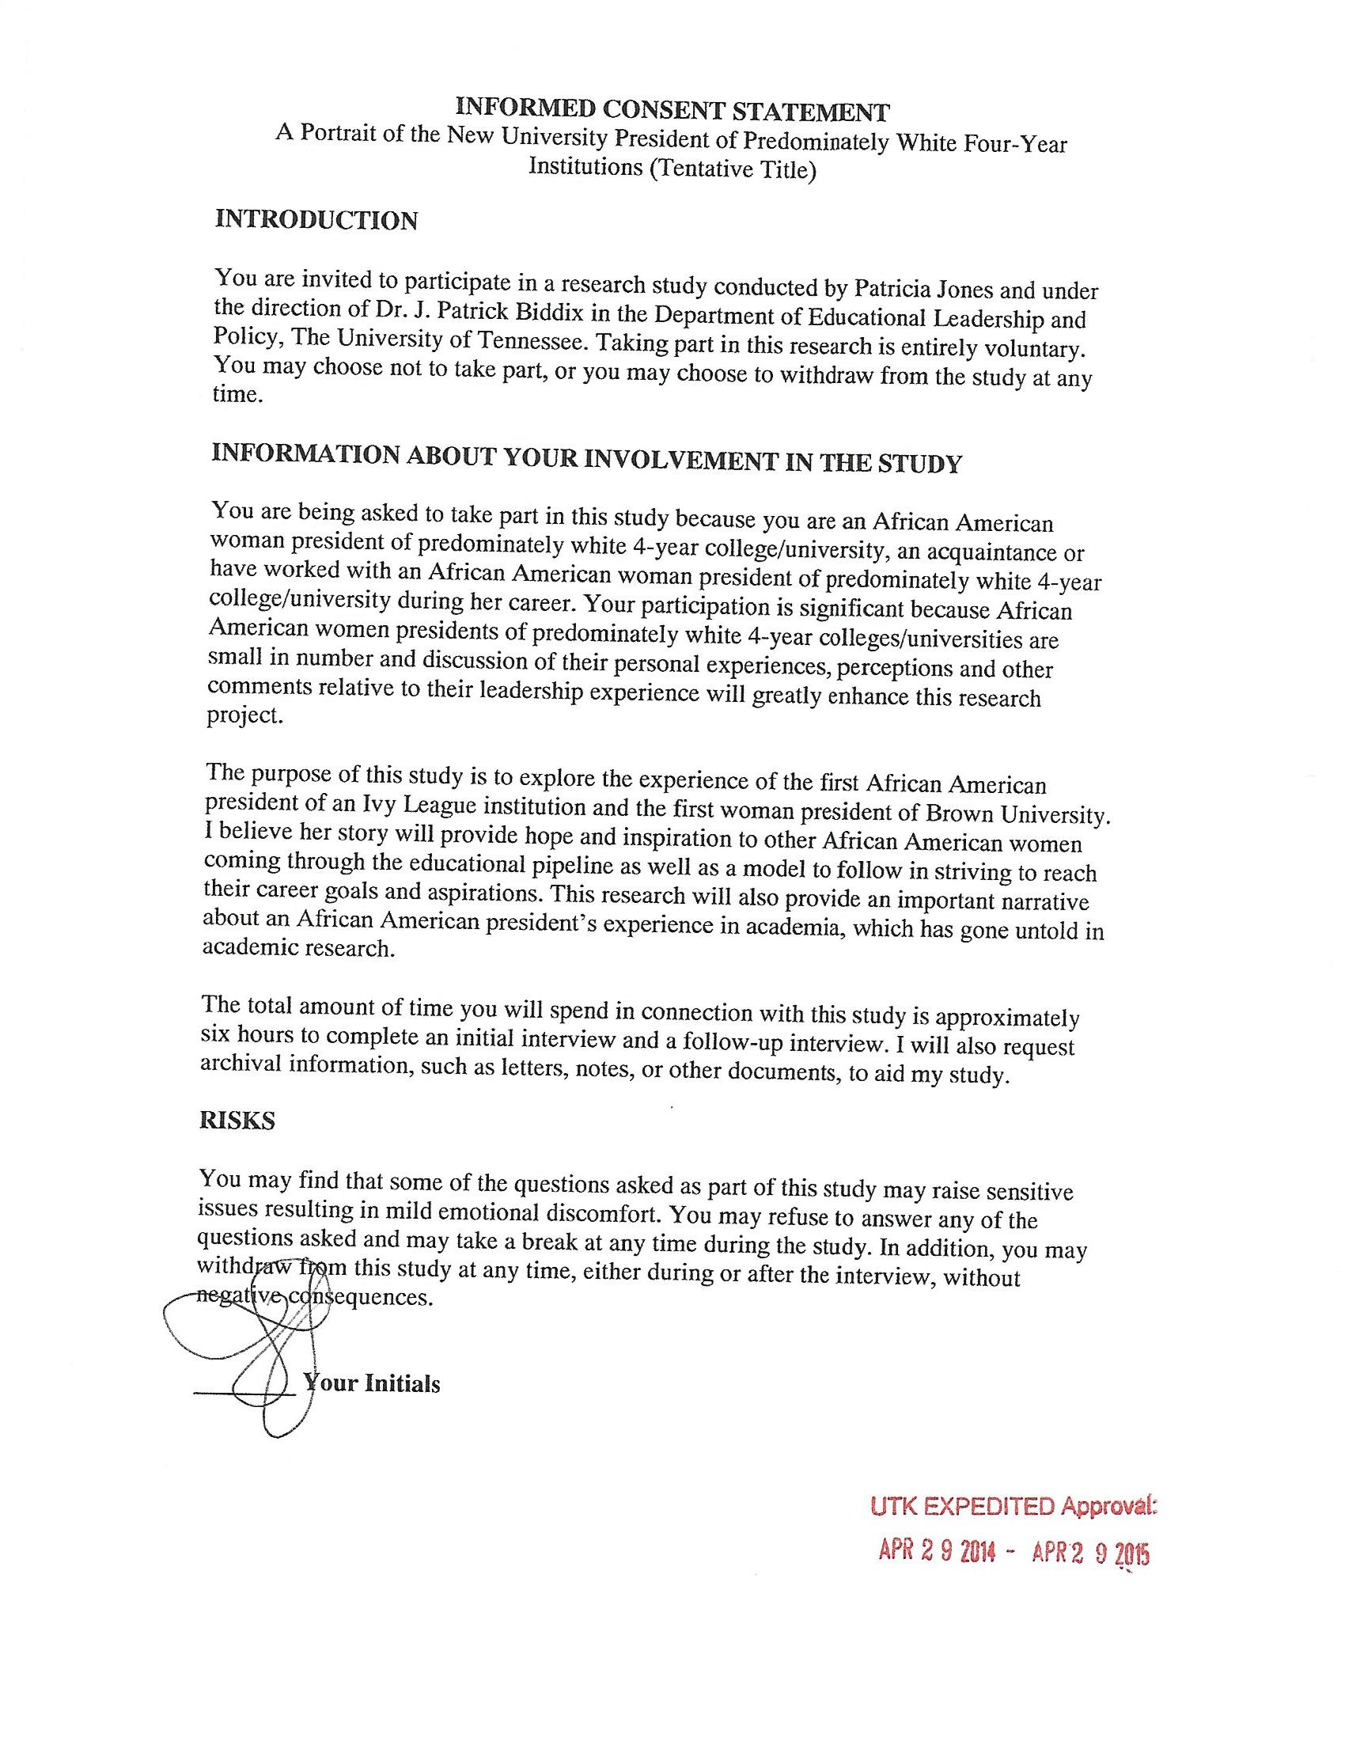
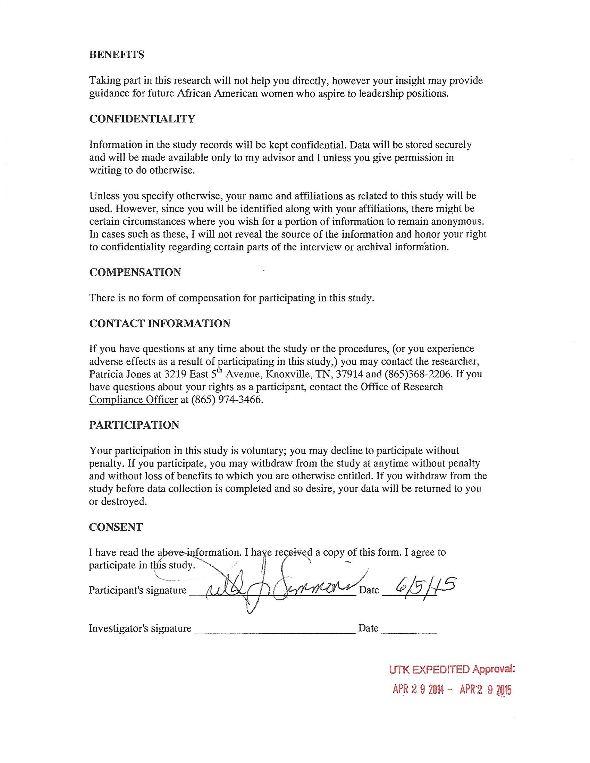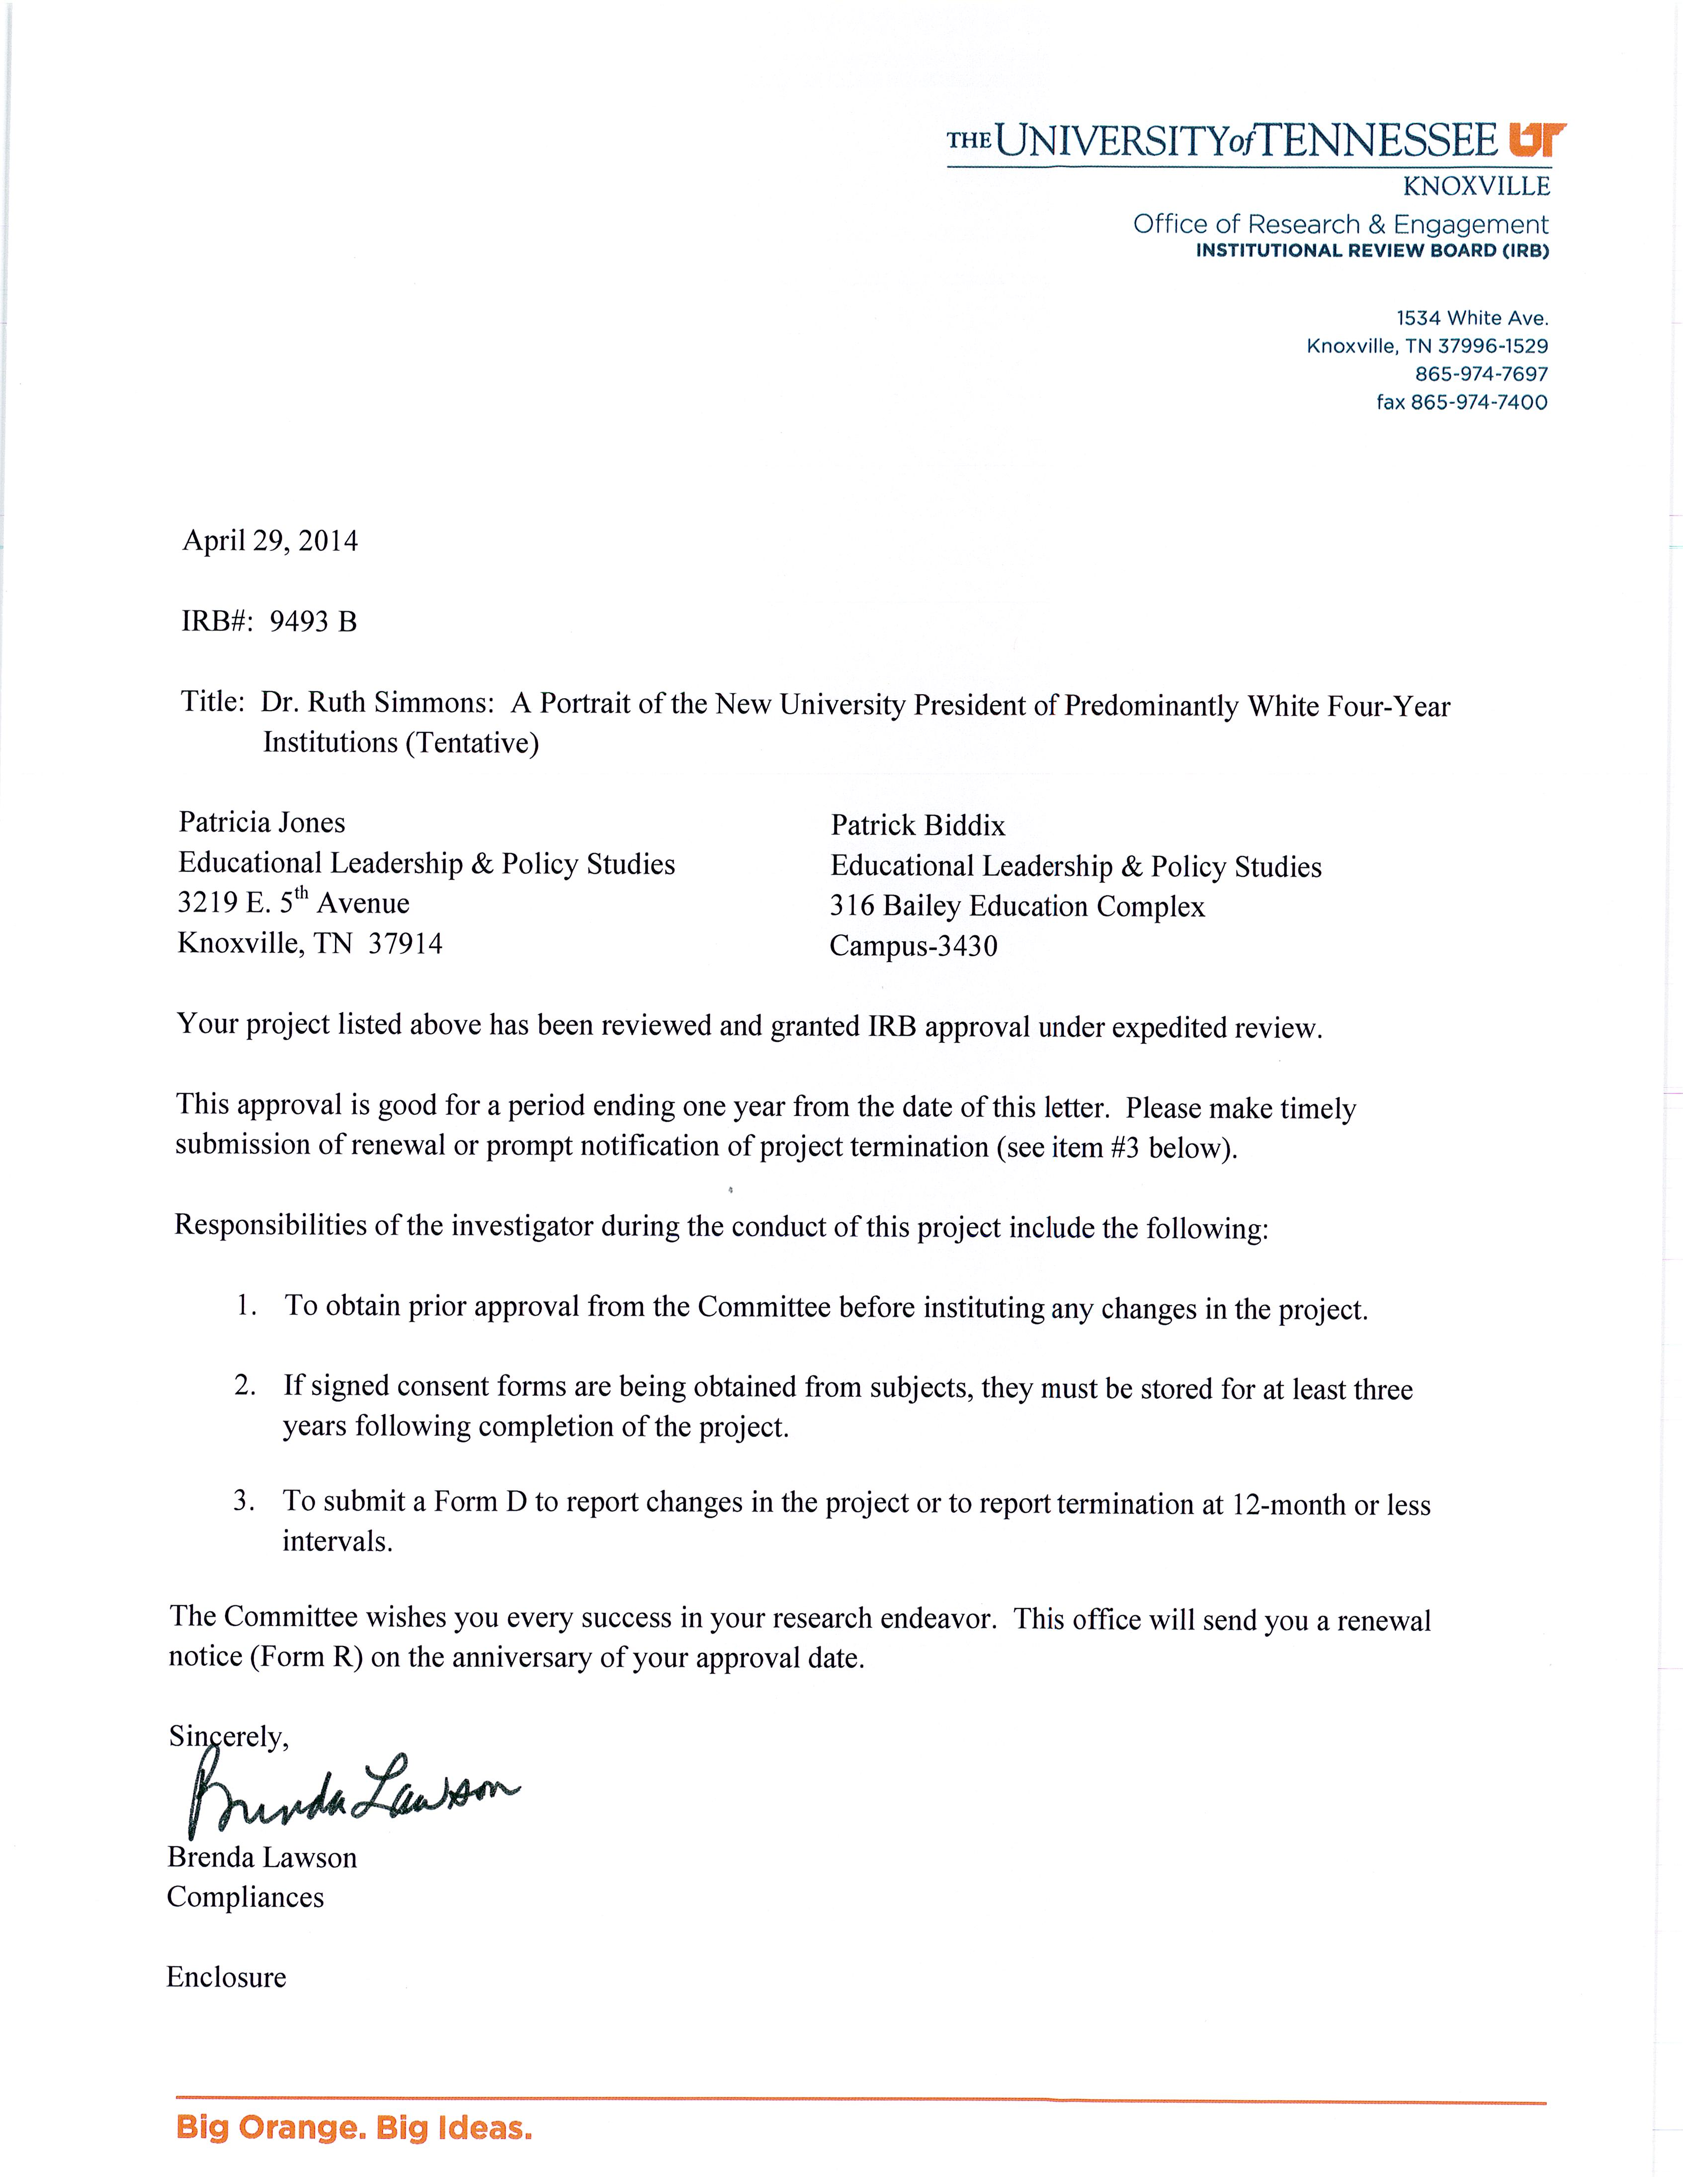

Appendix D
Interview Protocol
Influences
- What are some of the important messages you received growing up that shaped your life today?
- Was there a personal and family expectation for college?
- Who were your mentors in your life?
The Journey
- How and why did you get involved in administration
  - What led you to administration as a career path?
- What influenced your decision to become college president?
  - When did you realize that you wanted to become a college president?
  - When did you think it was plausible?
- Can you tell me what the most significant influences in your life have been to lead you to this position?
  - Can you tell me a story or give an example about this important event?
- Tell me about your support system as you moved up the professional ladder?
- What specific obstacles did you overcome/deal with as you progressed through your career, professionally?
As President
- What was the most difficult aspect of your job?
- What was the most pleasurable aspect of your job?
- In your opinion, was race a factor shaping interactions between you and your senior administrators (i.e. deans and vice presidents)?
- When issues of diversity were discussed on campus – did you feel that there was a different expectation for you?
- I envision this dissertation as a source of information for those young administrators and faculty who might want to move into top level administrative jobs and chart individual presidential career paths but lack the direct mentorship from a Black perspective – So three questions?
  - What are skills/attributes that they may need to learn that cannot be articulated/understood from your CV?
  - What would you like to impart to those individuals about navigating the higher education structure?
  - What is it going to take to see an increase in the number of Black women in leadership positions at Research 1 and selective institutions?
Conclusion
- What legacy did/do you want to leave?
- Is there anything else you would like to share that we have not already covered?
- Would you be willing to participate in another interview?
- Would you be willing to answer questions via email?
- Are there any other people you would like for me to interview?
- May I contact you if necessary to clarify/augment answers?
- Thank you for your participation in this study.

Appendix E
Dr. Simmons and I Timeline

- October 27, 2011 Initial email sent to Dr. Simmons
- October 27, 2011 Dr. Simmons responded: I would be unable to do an interview this year but could possibly find time after June 30, 2012
- May 4, 2012 Reached out to Dr. Simmons again
- May 4, 2012 Dr. Simmons responded: Patricia, I have taken on some additional obligations for next year. It now appears that I will not be able to participate in your project. I wish you the best with your dissertation
- May 4, 2012 I responded with a “Thank you”
- June 4, 2013 Reached out to Dr. Simmons one last attempt
- June 4, 2013 Dr. Simmons responded: Patricia, it will be difficult arranging a time but if you want to give it a try, we can work toward that end.
- February 7, 2014 Began arranging visit to Brown University
- February 20, 2014 Finalized travel arrangements
- March 24, 2014 Visited Brown University
- April 8, 2014 Dr. Simmons requests phone interview
- April 11, 2014 Sent Dr. Simmons interview questions for her review
- April 14, 2012 Request for interview to be recorded but Dr. Simmons responded: I'm sorry but I do not wish to provide an opportunity for verbatim quotes. For my own thesis I interviewed without recording.
- April 15, 2014 Conducted phone interview with Dr. Simmons
  - Dr. Simmons agreed to second interview

Appendix F
Dr. Simmons Timeline

- 1945 Birth Grapeland, Texas (youngest of 12)
- 1950 moved to Houston, Texas entered public school
  - Started borrowing books from community center
    - Sister thought something was wrong with her because she read all the time
  - Was inspired and coached by teachers (Ida May Henderson
    - Asked her mother if she could go to college one day
- 1960 Mother passed
  - Entered Phyllis Wheatley High School
    - Drama teacher Vernell Lillie recognized her talent and drive
    - Lillie convinced Simmons she was college material
    - Teachers wrote to Dillard asking for Simmons to be awarded a scholarship
- 1963 Left for Dillard University
  - Awarded scholarship to study drama
    - Switched major to French
  - Active on college newspaper staff to cry out against injustices
    - Became active member of the Civil Rights Movement and battled the university over organized religion
- 1965 Attended the Unvirsidad International in Mexico
  - Hand picked by the Dillard president to study at Wellesley for a year
    - Came to admire Wellesley president Margaret Clapp who helped her change her notions of gender
- 1967 graduated summa cum laude from Dillard
  - Awarded Fulbright fellowship to study French in Lyons, France
- 1968 Got Married and began her family
- 1970 attended Harvard University for masters in romance languages and literature
  - 1973 attended Harvard University for doctorate in romance languages and literature
    - Assistant professor of french
- 1973 University of New Orleans Assistant dean of the college of liberal arts
- 1977 California State University Adminstrative coordinator of National Endowmnet for the Humanities liberal studies
- 1978 Acting director of Internatl programs and visiting associate professor of Pan-African studies
- 1979 University of Southern California Assistant dean of the graduate school
- 1982 Associate dean of the faculty
- 1983 Princeton University Director of studies
  - 1985 Acting director, Afro-American Studies
    - Revamped the program
      - Sought scholars such as Arnold Rampersad, Toni Morrison, Cornel West
        - Her resolution of the impasse created when Morrison refused to submit a résumé to Princeton as a condition of her employment: Simmons, revealing her characteristic combination of determination and pragmatism, wrote it herself
  - 1986 Assistant Dean of the faculty, Associate Dean of the Faculty
- 1990 Spelman College Provost
  - Revamped faculty review process
- 1992 Princeton University Vice Provost
  - Civil Rights Complaints Sought at Princeton by minority students
  - Authored The Simmons Report
- 1995 became first African American in the United States to head a college in the national rankings’ upper tier, Smith College
  - Smith college graduated more black women than before
- 1996 Simmons is named one of NBC Nightly News' "Most Inspiring Women"; one of Glamour magazine's (December 1996) Women of the Year; one of CBS's Women of the Year
  - Campus Climate Working Group is established to encourage dialogue on campus regarding race relations and diversity
  - Simmons initiates institutional self-study and challenges the college to envision its character in the 21st century
- 1997 Poetry Center is established, bringing to campus each year an impressive list of poets
  - Ruth Simmons is one of only five college presidents in the United States to receive $150,000 in discretionary funds from the John S. and James L. Knight Foundation from its Presidential Leadership Grant program
  - The innovative Kahn Liberal Arts Institute begins taking shape
  - Created Young Women’s Leadership School of East Harlem by partnership with New York City high school
- 1998 Simmons is invited to join First Lady Hillary Rodham Clinton and prominent women academics for a discussion at the White House on the history and significance of the women's rights movement
  - Simmons is named by Vanity Fair (November 1998) among "America's Most Influential Women: 200 Legends, Leaders and Trailblazers"
  - Simmons addresses a formal assembly of the Massachusetts House of Representatives as a lecturer at the invitation of House Speaker Thomas Finneran
  - Simmons is honored for her contributions to the cause of equal opportunity by the National Urban League in New York
  - Smith launches Praxis, a program that ensures that every student will have access to at least one paid internship during her undergraduate career
- 1999 Picker Program in Engineering and Technology, the first engineering program at a women's college in the United States, is launched
  - President Bill Clinton names Simmons to the Women's Progress Commemoration Commission
  - Smith hosts a national conference on racial and ethnic diversity, "What's Next? American Pluralism and the Civic Culture: Challenges and Proposals"
  - Simmons pays a visit to Hamilton High School in Los Angeles as part of a recruiting mission to urban public high schools
- 2000 A $250 million capital campaign -- at the time of its announcement the most ambitious fund-raising effort ever undertaken by a liberal arts college -- is announced
  - Simmons joins Goldman Sachs Group Board of Directors
  - Construction for Smith's $5.6 million parking garage and a $35 million renovation/ expansion of the Fine Arts Center begins
  - Meridians, a peer-reviewed journal devoted to publishing outstanding scholarly works by and about women of color, publishes its first issue
  - Preliminary design for a new $20 million campus center is introduced and reviewed
  - A $5 million renovation of Lyman Conservatory is planned
  - When Brown first approached me [in 2000], my instinct was to turn them down. But a friend told me I had a duty to accept, as no black woman had ever been president of an Ivy League college and I owed it to the African-American people to be a role model. To show what could be achieved. (as cited in Crace, 2006, para. 3)
- 2001 Brown University announces its new president: Dr. Ruth Simmons
  - Simmons makes a memorable appearance on a scooter in 2001 senior Rally Day show
  - Smith hosts a national engineering summit to discuss strategies for encouraging women to pursue careers in technology
  - Raised Smith’s endowment from $400 million to $900 million
  - Simmons assumes the presidency of Brown University
- 2002 Corporation unanimously approved the Initiatives for Academic Enrichment, precursor of the Plan for Academic enrichment
  - Brown hires architectural firm Kliment & Halsband to write a master plan for campus growth
- 2003 First need-blind class enters Brown, removing the ability to pay from the admission equation
- 2004 Corporation approves detailed and ambitious Plan for Academic Enrichment
  - Liquor magnate Sidney Frank ’49 gives Brown $100 million to enable scholarships for the neediest students
- 2005 Dillard University Katrina Hurricane Relief Assistance
- Pembroke Hall renovated, housing the new Cogut Center for the Humanities to stimulate interdisciplinary research
  - Promoted campus discussions about the lack of diversity of opinion on campus
  - Campaign for Academic Enrichment, Brown’s most ambitious fund-raising drive ever, launched with a goal of $1.4 billion
- 2006 Five-story, 169,000 square foot Sidney E. Frank ’49 Hall of Life Sciences opens
  - McCormick incident: How Brown betrayed one of its students
- 2007 Medical School renamed the Warren Alpert Medical School of Brown University in recognition of a $100 million gift from Alpert’s foundation
  - After studying a report on the subject by a faculty committee, Simmons makes recommendations for acknowledging Brown’s role in slavery
- 2008 World economic meltdown prompts modification of Plan for Academic Enrichment. New Faculty hiring scaled back, Graduate School growth postponed, and existing buildings renovated rather than new ones built. Brown downsizes staff
- 2009 Joukowsky Institute for Archaeology and the Ancient World opens on the College Green in renovated Rhode Island Hall
  - Appointed by President Obama to the President's Commission on White House Fellowships
- 2010 Stephen Robert ’62 Campus Center, Brown’s first real student center, opens in Faunce House
  - Simmons ends tenure on Goldman Sachs Group Board of Directors
  - $1.61 billion raised, “Boldly Brown” the Campaign for Academic Enrichment, concludes
  - Wrote to Avi Gross Schaeger’s parents. Avi was a student, soldier, future peacemaker who died in a car accident
- 2011 Perry and Marty Granoff Center for the Creative Arts opens
  - Simmons forms a campus committee to review the status of ROTC at Brown
  - New Medical Education Building opens in Providence’s Jewelry District, creating a home for the Warren Alpert Medical School
  - After review of athletics, Simmons reduces number of admission slots for athletes and orders higher pay for coaches
  - Simmons announces she will resign at the end of the academic year
  - Renovated Metcalf Laboratories opens, providing home for Cognitive, Linguistic, and Psychological Sciences
- 2012 Simmons concluded her term as president of Brown University
  - Joins Princeton Board of trustees

Appendix G
Dr. Jackson Correspondence: Initial Contact

From: Jones, Patricia Yvette
Sent: Thursday, June 06, 2013

Dr. Jackson,

My name is Patricia Jones, I am currently a doctorate student in Higher Education Administration at the University of Tennessee. I would like to begin corresponding with you so that I can interview you in the near future. I know you have been told time and time again that you are a legacy for being an African American Woman President of Rensselaer Polytechnic Institute the nation’s oldest technological university, I will not repeat it. Instead, I will say you are a phenomenal woman!

I to aspire to one day be a college president. In making this decision I have been positioning myself so that if a leadership role or position presents itself I am prepared. I have attended and graduated from the HERS Institute in Denver this past summer and plan to attend other leadership training.

Currently, I have been researching African American women and the college/university presidency. More specifically, how African American women get to the presidency, what the journey has been like for them and what advice they can give to those who come after them to stand on their shoulders. See we are all standing on the shoulder's of giants and if it were not for those who came before us we would not have all that we have today or be where we are today. Realistically, it is because of you that other women not only African American but minority women in general, will strive for presidencies at all types of higher education institutions. This is what I want my dissertation to be on.

I am at the beginning phase of the dissertation process. I just selected my committee head and committee members. I complete my coursework this summer and will take my comprehensive exam in the fall. I estimate I will begin collecting data (conducting interviews) in 2014.

I am reaching out to you in hopes that you will allow me to interview you. If you agree to participate, as I proceed through the dissertation process I will keep you informed via email. I will forward you the purpose statement, problem statement and other documents as I go through the dissertation process.

As I near the data collection phase I plan to completely work around your schedule. So, whenever you are free to meet I will travel to where you are to meet with you. Since I will be in the dissertation phase I will be free to travel to wherever you are. Please keep this in mind. Also, we have technology and can use programs such as Skype.

***My projected data collection time frame as of now is fall/summer 2014. This is tentative and depends heavily upon all of the steps leading up to the data collection.
Interviewing you is very important to me and I'm not one to just give up on the opportunity to meet you. The ability to share what you accomplished so that those minority women who come after you is what drives me to pursue this interview with you. As I stated prior we stand on the shoulders of giants and you are one of those giants please allow us to stand on your shoulders.

Thank you again and again,

Please let me know if you are willing to allow me to interview you and know this will be for my dissertation.

Thank you every so much for taking the time out to read this. Know that I wish you the best in all of your future endeavors for I know you are not done yet!

Until then, Patricia Jones

Mon 6/17/2013
To: Jones, Patricia Yvette

Patricia:

Thank you very much for your request to interview our President, Dr. Shirley Ann Jackson. Unfortunately, we can not accommodate your request. As you can imagine, we receive literally dozens of requests such as yours over the course of a year, and sadly, it is not physically possible to support them all due to her travel and engagement schedule.
Many of the issues which you want to address have been covered in writings and published statements by Dr. Jackson. I direct your attention to rpi.edu/president/profile.html, which includes the text of many of her speeches.

You are welcome to cite these remarks with appropriate attribution.

Best of luck to you with your endeavors.

Respectfully,

Appendix H
Dr. Simmons Correspondence: Initial Contact

On Thu, Oct 27, 2011
Jones, Patricia Yvette

Dr. Simmons,

My name is Patricia Jones, I am currently a doctorate student at the University of Tennessee and the Director of the Office of Enrollment Management and Retention at Knoxville College in Knoxville Tennessee.

I've read you are retiring and I would like to begin corresponding with you so that I can interview you in the near future. I know you have been told time and time again that you are a legacy for being the first African American Woman President at an Ivy League University, I will not repeat it. Instead, I will say you are a phenomenal woman!

I to aspire to one day be a college president. In making this decision I have been positioning myself so that if a leadership role or position presents itself I am prepared. I have attended and graduated from the HERS Institute in Denver this past summer and plan to attend other leadership training.

Currently, I have been researching African American women and the college/university presidency. More specifically, how African American women get to the presidency, what the journey has been like for them and what advice they can give to those who come after them to stand on their shoulders. See we are all standing on the shoulder's of giants and if it were not for those who came before us we would not have all that we have today or be where we are today. Realistically, it is because of you that other women not only African American but minority women in general, will strive for presidencies at all types of higher education institutions.
Please let me know if you are willing to allow me to interview you and know this will be for my dissertation.

Thank you every so much for taking the time out to read this. Know that I wish you the best in all of your future endeavors for I know you are not done yet!

Until then,

Patricia Jones

From: Simmons, Ruth
Sent: Thursday, October 27, 2011
To: Jones, Patricia Yvette

I would be unable to do an interview this year but could possibly find time after June 30, 2012. Thanks so much for your interest.

Jones, Patricia Yvette
To: Simmons, Ruth
Thu 10/27/2011

That would be great. I am soooo excited. Thank you sooo much. Please let me know the best way to remain in contact with you.

Jones, Patricia Yvette
To: Simmons, Ruth
Wed 2/15/2012

Dr. Ruth,

I want to remain in contact with you to continue the discussion of us meeting and the interview. Please let me know if you are still interested in me interviewing you and the possibility of us meeting prior to the interview. I will make time to meet with you whenever your schedule well allow :)

Thank you,

Jones, Patricia Yvette
To: Ruth Simmons
Thu 11/7/2013

Dr. Simmons,

Let me begin by saying how thankful I am for you. You have been patient and remained in contact with me throughout this process. Thank you! I know you are very busy.

This is just a quick update of where I am in the dissertation process. On yesterday I passed my oral defense of my comprehensive exam. I will now begin writing my chapter one then the proposal. I will send you copies of both once complete. I will keep you informed.

I can't wait for the day I actually get to meet you!

Thank you for everything once again.
Follow Up

May 4, 2012, at 11:02 AM
Jones, Patricia Yvette
Dr. Ruth,
I would like to continue our discussion of us meeting and me interviewing you for my dissertation. Please let me know if you are still interested in being interviewed and the possibility of us meeting prior to the actual interview. I will make time to meet with you whenever your schedule well allow :) I want to give you the opportunity to get to know me as well.

Below you will find our initial communication regarding the interview. I know that you are extremely busy (I know this is an understatement) and have a lot going on. So, please note the projected start date of my dissertation is around Fall of 2013 but I want to remain in contact with you until this time and hopefully meet with you prior when possible. Please keep in mind that, I will work around your schedule and we don't have to meet this year if you are unable.

Thank you in advance,

From: Ruth Simmons
Sent: Friday, May 04, 2012 3:25 PM
To: Jones, Patricia Yvette

Patricia, I have taken on some additional obligations for next year. It now appears that I will not be able to participate in your project.

I wish you the best with your dissertation.

Jones, Patricia Yvette
Fri 5/4/2012 3:37 PM
To: Ruth Simmons

Thank you

Second Interview Attempt

Jun 4, 2013
Jones, Patricia Yvette

Dr. Simmons,

The last contact we had you informed me that you would not be able to participate in my project due to other commitments. I want to properly explain where I am in the dissertation process. I don't think I did this prior to now. I am at the beginning phase of the dissertation process. I just selected my committee head. I complete my coursework this summer thereafter I take my comps. I estimate I will begin collecting data (conducting interviews) in 2014.

I am reaching out to you in hopes that you will reconsider and allow me to interview you. Please let me know your thoughts. I truly appreciate you and all you do : )
Please also keep in mind when it is time, I will work completely around your schedule and we will use technology so to make the process smoother or come meet with you where ever you are.

Interviewing you is very important to me and I'm not one to just give up on the opportunity to meet you. The ability to share what you accomplished so that those minority women who come after you is what drives me to pursue this interview with you. It is said that we stand on the shoulders of giants and you are one of those giants please allow us, others to stand on your shoulders.

Thank you again and again, Below is my original message.

Tue 6/4/2013
To: Jones, Patricia Yvette

Patricia, it will be difficult arranging a time but if you want to give it a try, we can work toward that end.

Jones, Patricia Yvette
To: Ruth Simmons
Wed 6/5/2013

Dr. Simmons,

First and foremost, THANK YOU! I cannot thank you enough. It is truly an honor and privilege to have the opportunity to meet you and interview you.

As I proceed through the dissertation process I will keep you informed via email. I will forward you the purpose statement, problem statement and other documents as I go through the dissertation process.

As I near the data collection phase I plan to completely work around your schedule. So, whenever you are free to meet I will travel to where you are to meet with you. Since I will be in the dissertation phase I will be free to travel to wherever you are. Please keep this in mind. Also, we have technology and can use programs such as Skype.

***My projected data collection timeframe as of now is fall/summer 2014. This is tentative and depends heavily upon all of the steps leading up to the data collection.

I will be in touch. Thank you once again Dr. Simmons!

Jones, Patricia Yvette
To: Ruth Simmons
Thu 11/7/2013

Dr. Simmons,

Let me begin by saying how thankful I am for you. You have been patient and remained in contact with me throughout this process. Thank you! I know you are very busy.

This is just a quick update of where I am in the dissertation process. On yesterday I passed my oral defense of my comprehensive exam. I will now begin writing my chapter one then the proposal. I will send you copies of both once complete. I will keep you informed.

I can't wait for the day I actually get to meet you!

Thank you for everything once again.

Brown University Visit (Personal Archives)

Jones, Patricia Yvette
To: Ruth Simmons
Fri 2/7/2014

Dear Dr. Simmons,

I began corresponding with you in the fall of 2011 to express my interest in having you participate in my dissertation. I am contacting you to arrange an initial meeting. I will work around your schedule and will travel to meet with you. If you are still agreeable to the study, please provide me with a time we might talk to discuss the logistics of a my visit.

My study will explore your experience as the first African American president of an Ivy League institution and the first woman president of Brown University. I believe your story will provide hope and inspiration to other African American women coming through the educational pipeline as well as a model to follow in striving to reach their career goals and aspirations. This research will also provide an important and credible narrative about your experience in academia, which has gone untold in academic research.

Sincerely,

Please note I am copying Patrick Biddix, my committee chair, on this email.

Ruth Simmons Pallas-Viola, Helen
Fri 2/7/2014
To: Jones, Patricia Yvette

Dear Ms. Jones,

Ruth Simmons passed your email to me for reply. Since she is on academic leave this year she asked that you set a time with me to visit our office for a review of her archive files. This will have to be done before July as the files will be moved at that time.
I am in the office on Tuesdays and Thursdays from 9 to 4. You can call me or email me at any time. I am never far away from the computer.

Looking forward to hearing from you. Best, --helen

Jones, Patricia Yvette
To: Pallas-Viola, Helen
Fri 2/7/2014

Helen, I want to thank both you and Dr. Simmons for responding so quickly. I will definitely be contacting you to make arrangements to visit. Please give me time to gather myself. I am so nervous and excited. I will contact you soon. Thank you again!

From: Pallas-Viola, Helen
Sent: Thursday, February 20, 2014
To: Jones, Patricia Yvette

Hi Patricia, as I mentioned to you I am only in on Tues/Thurs and you thought correctly that the inclement weather had me in and out. Please call me so we can set up a time for you to come to the office to go over the archive files. Best, --helen

Jones, Patricia Yvette
To: Pallas-Viola, Helen
Thu 2/27/2014

Hello Helen, I hope all is with you. I am in the process of planning my trip and am following up to see if you have heard anything about possible lodging for me during my visit? Please let me know. Thank you.​

Jones, Patricia Yvette
Wed 3/26/2014

Dr. Simmons, thank you sooooo much for allowing me access to your archives. There is a wealth of information that I will be able to use. This has been a very productive trip. I arrived in Providence on Monday, met with Helen on Tuesday and reviewed documentation located at the library today. It has been a very busy three days. I will be leaving for Knoxville tomorrow at 10:00 am.

Please know I am still very interested and wanting to interview you be it, in person or over the phone. I will work entirely around your schedule so please let me know when you are available. I will travel to where you are. After conversing with Helen I asked her if she would interview as well. She has agreed so I will be returning to Rhode Island to interview her. We have not set a date as of yet but I know we will definitely wait until the weather is nicer.

Thank you again for everything!

Interview

Ruth Simmons Pallas-Viola, Helen
Tue 4/8/2014
To: Jones, Patricia Yvette

Hello Patricia,

Ruth is wondering if you will be available for a telephone conversation the beginning of next week. Monday or Tuesday, preferably in the morning.

On Apr 8, 2014
Jones, Patricia Yvette

Helen, I will also need to know how much time I will have to interview Dr. Simmons.

Thank you.

From: Helen Pallas-Viola
Sent: Wednesday, April 9
To: Jones, Patricia Yvette

Patricia, Tuesday morning at 9am Eastern Standard Time. NO recording. Use your time wisely. Be concise. Have your questions ready. Please give me your number. She will call you.

Best, --helen

Jones, Patricia Yvette
Fri 4/11/2014
To: Helen Pallas-Viola
1 attachment: Interview Questions

Dr. Simmons, my study will explore your experience as the first African American president of an Ivy League institution and the first woman president of Brown University. Some of the things I hope to address in my study are things that have influenced you personally and professionally, your journey to the presidency and your experiences as president. Please find attached questions I would like to cover during this interview. The number I can be reached at on Tuesday morning at 9 am EST is-----. Until then and thank you for everything!

Recording of Interview

Jones, Patricia Yvette
To: Ruth Simmons
Mon 4/14/2014

Dr. Simmons,​ I want to ask you to reconsider allowing me to record the interview on tomorrow. I want to make sure that I give an accurate and thorough account of what you share in the biographical narrative I will be creating. Having the ability to record the conversation will allow for me to capture all that is shared in comparison to solely taking handwritten notes where I may miss important facts that need to be shared.

My over goal is to be as transparent as possible and by doing so I want to include you in this entire process. I will provide you with a copy of all interviews so that you can change, add or expand upon things. I will also provide you a copy of the transcript of the biographical narrative and my dissertation. Collaboration and member checking is very important to me. We are partners in this process. This is your story and all I am doing is sharing it so that others can read, learn and hopefully take something away from reading it.

Please let me know your thoughts. Thank you for everything and I look forward to speaking with you on tomorrow. Thank you again.

Apr 14, 2014
From: Ruth Simmons

I'm sorry but I do not wish to provide an opportunity for verbatim quotes. For my own thesis I interviewed without recording.

Jones, Patricia Yvette
Mon 4/14/2014
To: Ruth Simmons

Thank you for responding and considering my request. Until tomorrow : )

Jones, Patricia Yvette
To: Ruth Simmons
Tue 4/15/2014

​​Dr. Simmons, thank you for taking the time to speak with me this morning and for all of the guidance you provided. I will do as you suggested and review everything I have and can find. After completing a thorough review I will be contacting you to arrange an interview focused on your presidency. Thank you again and have safe travels.

Second Interview Request

Jones, Patricia Yvette
To: Simmons, Ruth
Fri 12/19/2014

Dr. Simmons, I am reaching out to you to schedule our final interview. My hope is that we can meet in person for this interview. I am looking at a time frame of late January or early February to visit. I know your time is valuable, so please let me know your availability. I’m more than happy to work around your schedule and travel to meet with you. I look forward to hearing back from you! I wish you and your family a Happy Holiday Season!

Helen Pallas-Viola
To: Jones, Patricia Yvette
Wed 12/24/2014

Dear Patricia, unfortunately, Dr. Simmons is unavailable for a follow-up interview with you. Her calendar is very constrained in the year ahead as she will be traveling in and out of the country. Dr. Simmons sends you her best wishes and success as you move forward with your work.

Regards,

--helen

Jones, Patricia Yvette
To: Helen Pallas-Viola
Fri 1/9/2015

Dear Helen, sorry for the delayed response. This is very unfortunate news but I understand. I know Dr. Simmons is very busy. I appreciate both of you for everything. As I continue writing, I would like to know if it is possible to email Dr. Simmons (only when necessary) with clarifying questions since I will be relying solely on archival data from this point on? Also, does Dr. Simmons want me to send her a draft of my dissertation for her review once complete and prior to submission? Please let me know.

Admittedly, I am stubborn, with that being said, I will reemphasize I am still very hopefully I will one day meet Dr. Simmons. I am more than willing to travel to meet Dr. Simmons be it to hear her speak at a conference or to meet for lunch. I am a world traveler and will be in France and London this spring so who knows :) Thank you again for everything!

Institutional Review Board Request: IRB Form Signatures Needed

Jones, Patricia Yvette
To: Helen Pallas-Viola; Ruth Simmons
Sat 4/18/2015

Dear Helen and Dr. Simmons,

I hope this email finds you both well and in good health. Here is a quick update of my progress thus far, on February 4th I successfully defended my prospects and since then have been implementing recommendations and edits made by my committee. This in and of itself, has been a battle. Thereafter, I will begin to analysis the data and write the last several chapters of my dissertation.

I am in need of both of your signatures. I need both of you to sign an informed consent form. Helen, I am asking you to sign the form as well because I will paraphrase something you shared with me the very first time we met. I remember you telling me, "It says a lot when a person comes back to work for the same person." This continues to echo in my mind as I write. Please note prior to now,​ I furnished copies of all of our email correspondence to the University of Tennessee's Institutional Review Board which was accepted and I was permitted to conduct my study. It wasn't until recently, I was contacted by the Institutional Review Board requesting that I submit signed copies of the informed consent for renewal purposes. Please find the consent form attached. Once the form has been signed it can be scanned and emailed back to me.

Lastly, during our last exchange of emails I was informed that Dr. Simmons was unable to do a final interview. I want to take this opportunity to make one last appeal for a final interview. A final interview is significant to me because I want to make sure Dr. Simmons' story (HerStory) is told in its entirety. The first interview had a great impact on my PhD and I believe, no, I know, that a second interview will have an even greater impact on the telling/sharing of Dr. Simmons' HerStory. I am aware that some believe "a good dissertation is a done dissertation" but for me this is more than a research study, project or a dissertation to be completed for a PhD. This is a HerStory that needs to be told/shared. En espe​rant sincerement que vous accepterez cette interview et que nos chemins se croiseront un jour.

I will be in France April 21 so if you email me and I do not respond immediately I will respond as soon as I can or as soon as I get back on May 5th.

Thank you both again for all of your support!

Bien cordialement,

Jones, Patricia Yvette
To: Helen Pallas-Viola; Ruth Simmons
Tue 5/5/2015

Dear Helen and Dr. Simmons, this is just a follow up to the email I sent prior.

Please note, I am in need of both of your signatures. I need both of you to sign an informed consent form. Helen, I am asking you to sign the form as well because I will paraphrase something you shared with me the very first time we met. I remember you telling me, "It says a lot when a person comes back to work for the same person." This continues to echo in my mind as I write. Please note prior to now,​ I furnished copies of all of our email correspondence to the University of Tennessee's Institutional Review Board which was accepted and I was permitted to conduct my study. It wasn't until recently, I was contacted by the Institutional Review Board requesting that I submit signed copies of the informed consent for renewal purposes. Please find the consent form attached. Once the form has been signed please scan and email back to me as soon as you can.

Thank you,

Jones, Patricia Yvette
To: Helen Pallas-Viola; Ruth Simmons
Fri 6/5/2015

Dear Helen and Dr. Simmons, this is just a follow up to my previous emails.

I am in need of either one of your signatures on the following attached informed consent form. Once the form has been signed please scan and email back to me.

Thank you,

Ruth Simmons
To: Jones, Patricia Yvette
Sat 6/6/2015

I will sign and return. Thanks. Jones, Patricia Yvette

Jones, Patricia Yvette
To: Simmons, Ruth
Sun 6/7/2015

Thank you.
Simmons, Ruth
To: Jones, Patricia Yvette
Sun 6/7/2015

See the attached (Permission Form).

Jones, Patricia Yvette
To: Ruth
Sat 6/6/2015

Thank you.

DISSERTATION RELATED CORRESPONDANCE

To: Simmons, Ruth
Mon 7/27/2015

Dr. Simmons,

Please find attached a copy of chapter four (HerStory, a brief history going from your childhood to your retirement from Brown University) of my dissertation for your review. In order for me to have sufficient time to implement any changes you may have, prior to my defense, I will need the document back by September 1st. Unfortunately, I have some tight deadlines seeing I am preparing to defend and graduate this semester and, my chair, Dr. Biddix, will be in Montreal working on a Fulbright from September 1-November 15. Thank you for everything.

Jones, Patricia Yvette
To: Ruth Simmons
Fri 9/11/2015

Dr. Simmons,

Do you consider yourself to be a/an: feminist, black feminist, activist, transformative leader or change agent?

Final Attempt For Second Interview

Jones, Patricia Yvette
To: Simmons, Ruth
Sat 10/10/2015
Hello Dr. Simmons,

I will be visiting Austin, TX, November 15-20! If you are in Texas during this time please let me know, I would love to meet you! Thank you.

Ruth Simmons
To: Jones, Patricia Yvette
Mon 10/12/2015

My plans are not set yet; I may be going to Atlanta to visit my son.

Jones, Patricia Yvette
To: Ruth Simmons
Mon 10/12/2015

Thank you for responding. We could also meet in Atlanta. My fiancé is presenting in Texas and invited me to come with. He knows how important you are to me so he was hoping you and I could meet in Texas since the opportunity presented itself. If you're not going to be in Texas but in Atlanta, I reside in Knoxville, TN so I could come to Atlanta easily, that is, if it wouldn't interfere with you visiting your son. Please let me know.

Ruth Simmons
To: Jones, Patricia Yvette
Thu 10/29/2015

I am traveling during those periods, Patricia. So sorry.

Jones, Patricia Yvette
To: Ruth Simmons
Thu 10/29/2015

Thank you for responding. Have safe travels and happy holidays. Also, if there ever comes a time when you are free and available to meet please let me know. Even if it's years from now. Yes, meeting you is that important to me.

Appendix I
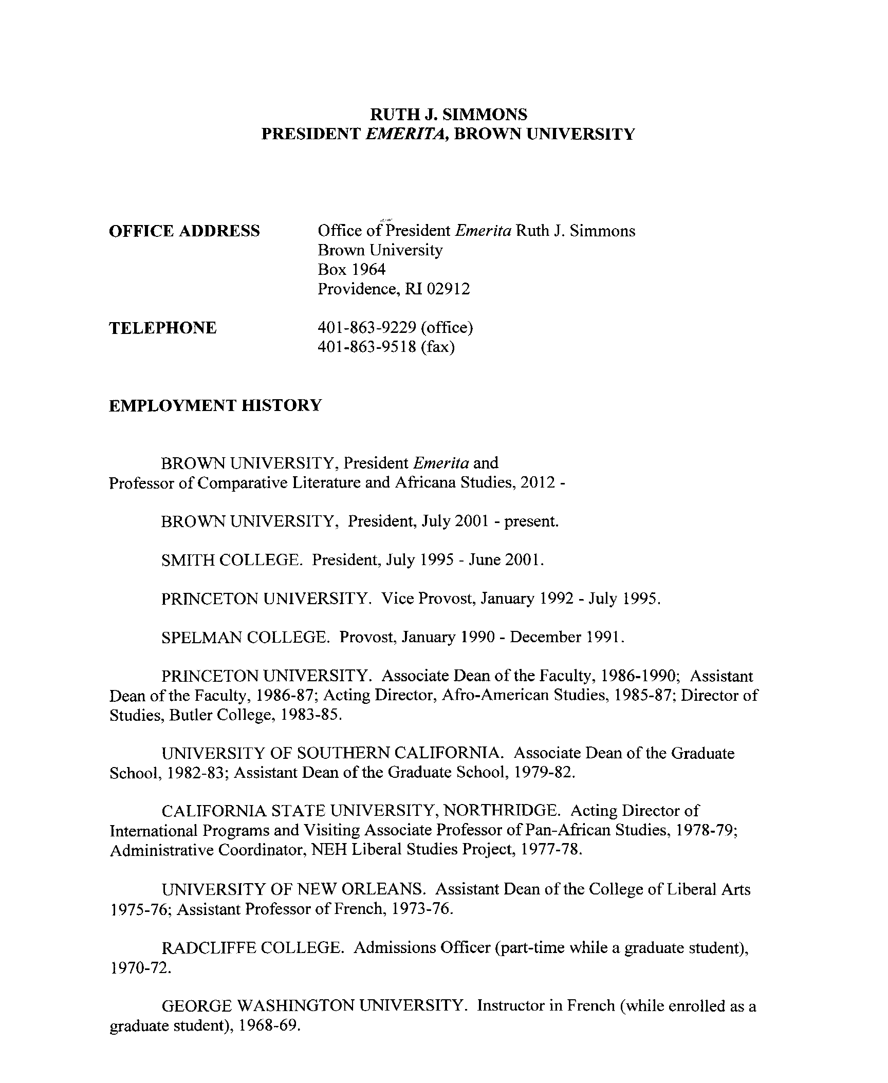
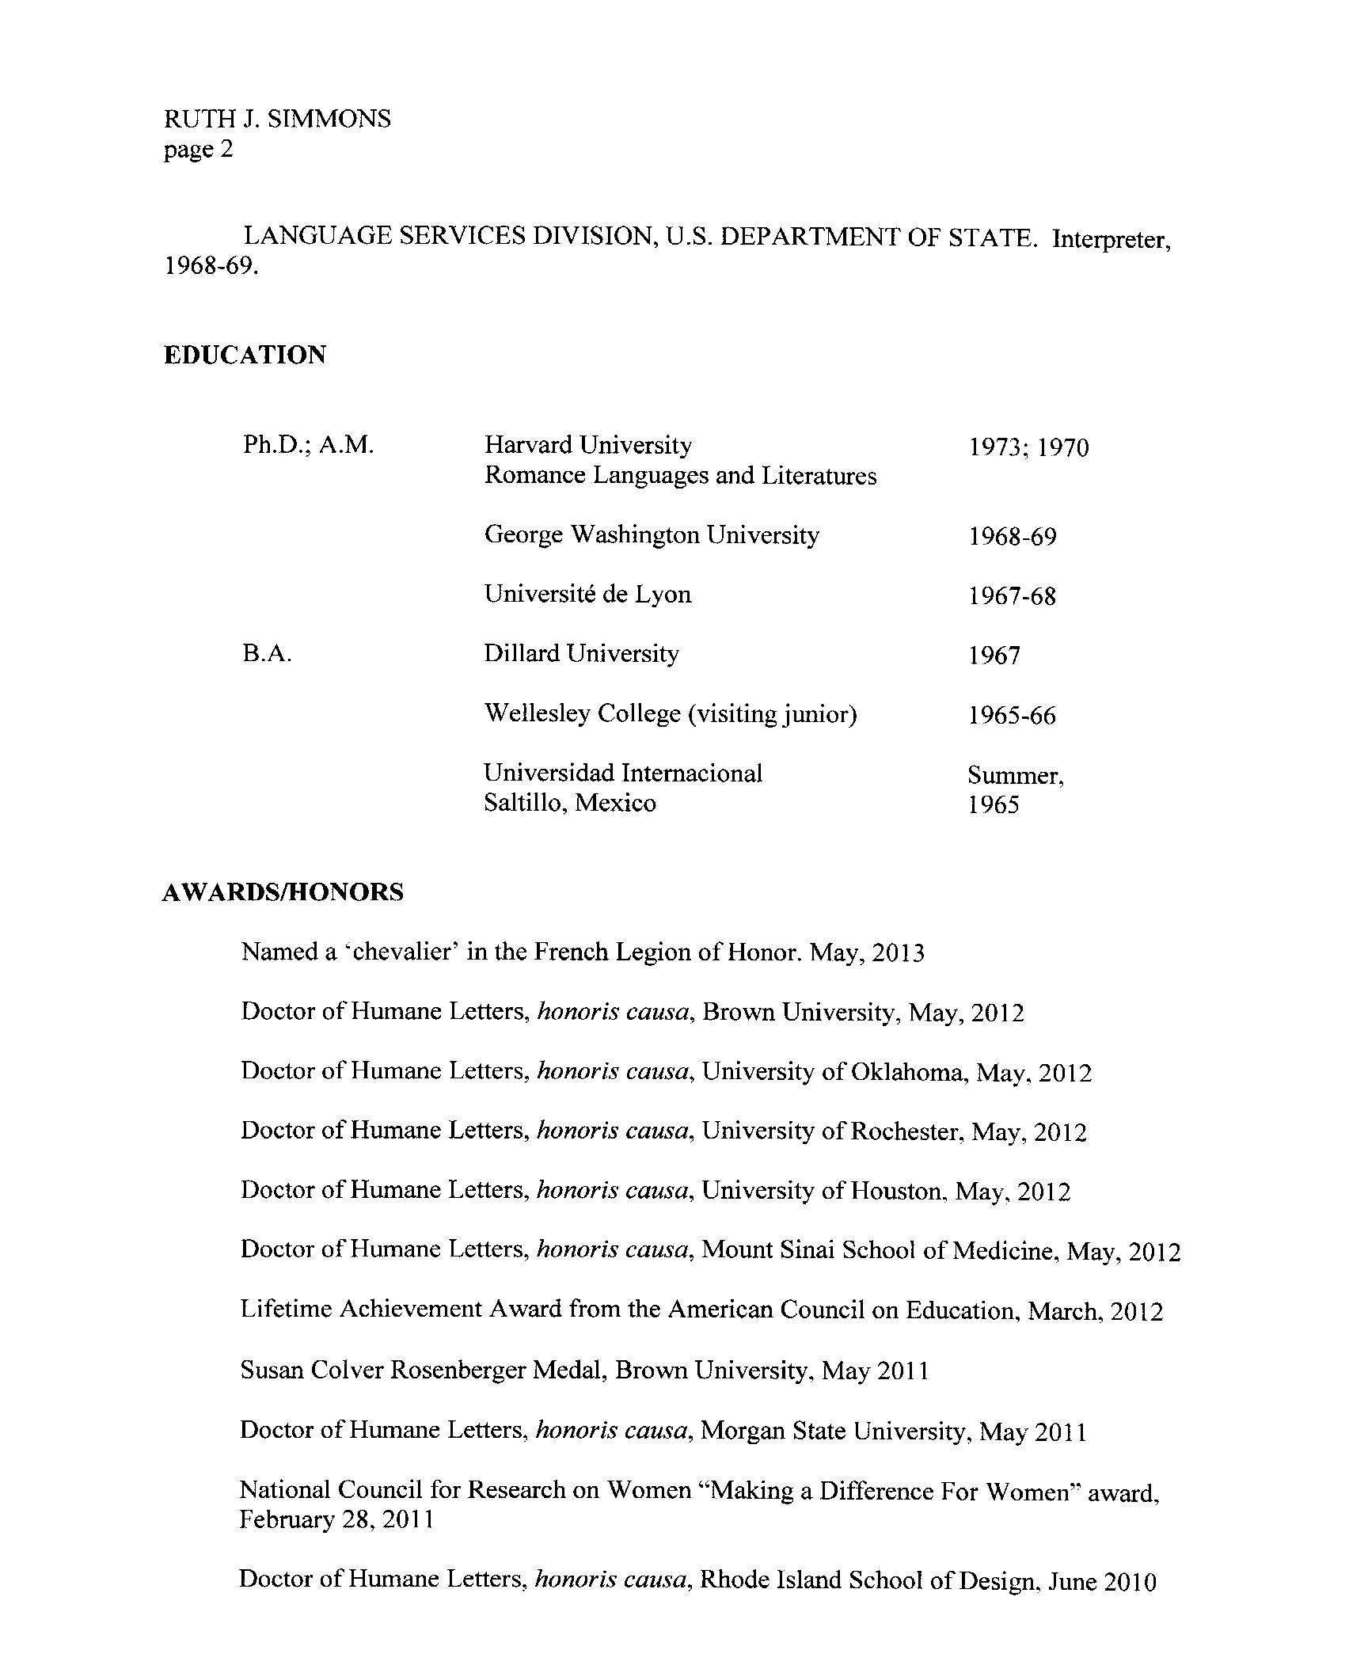
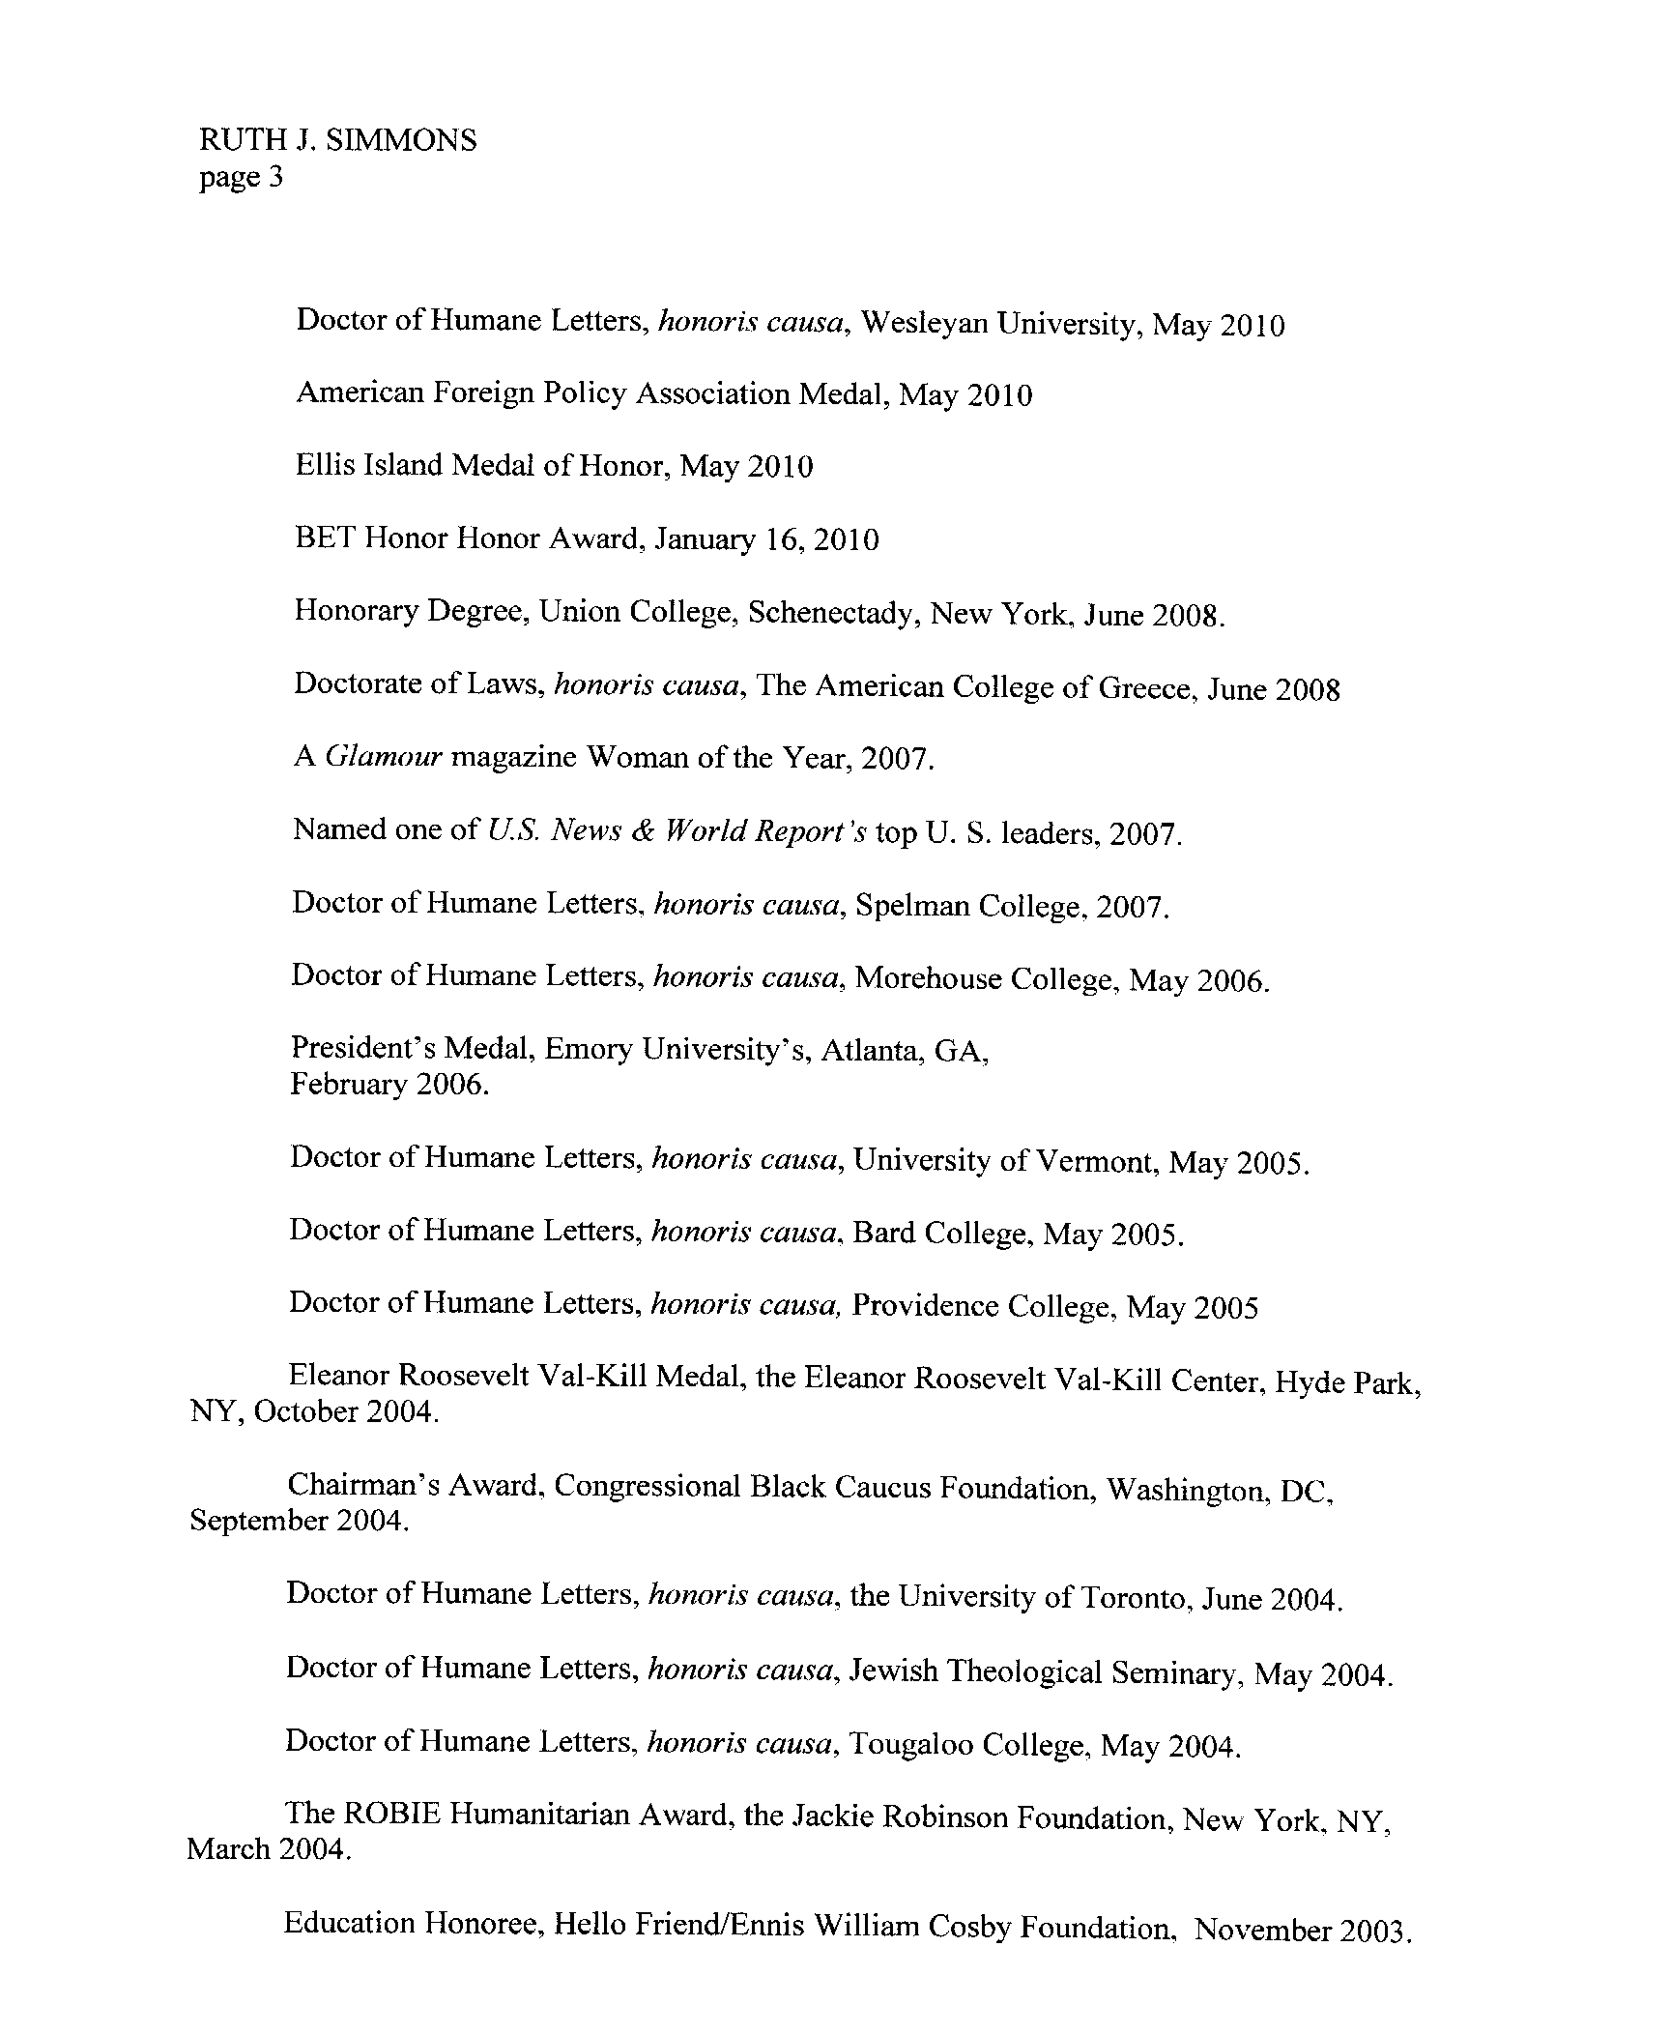
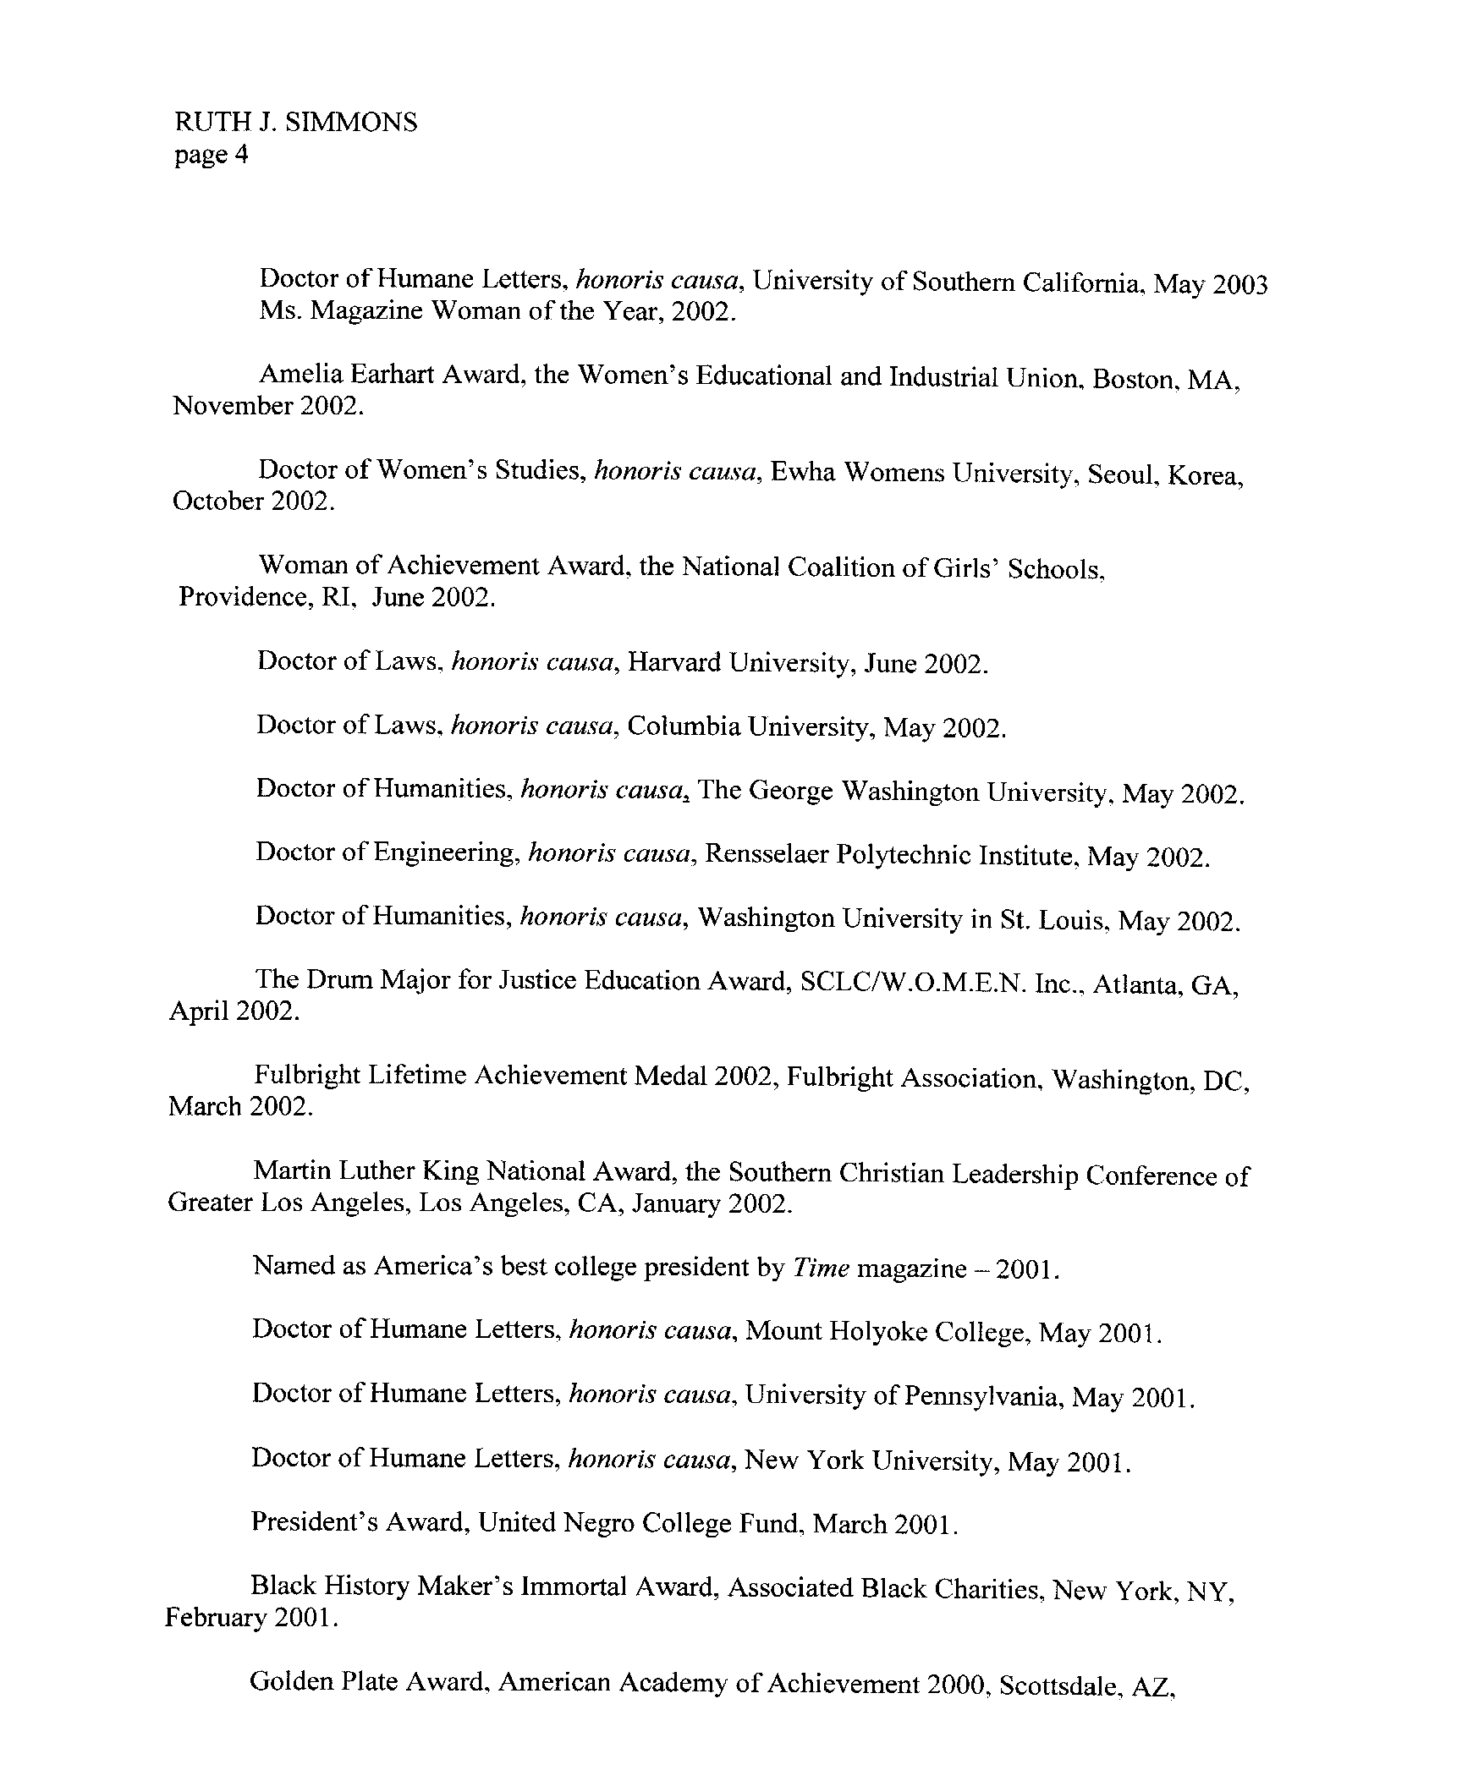
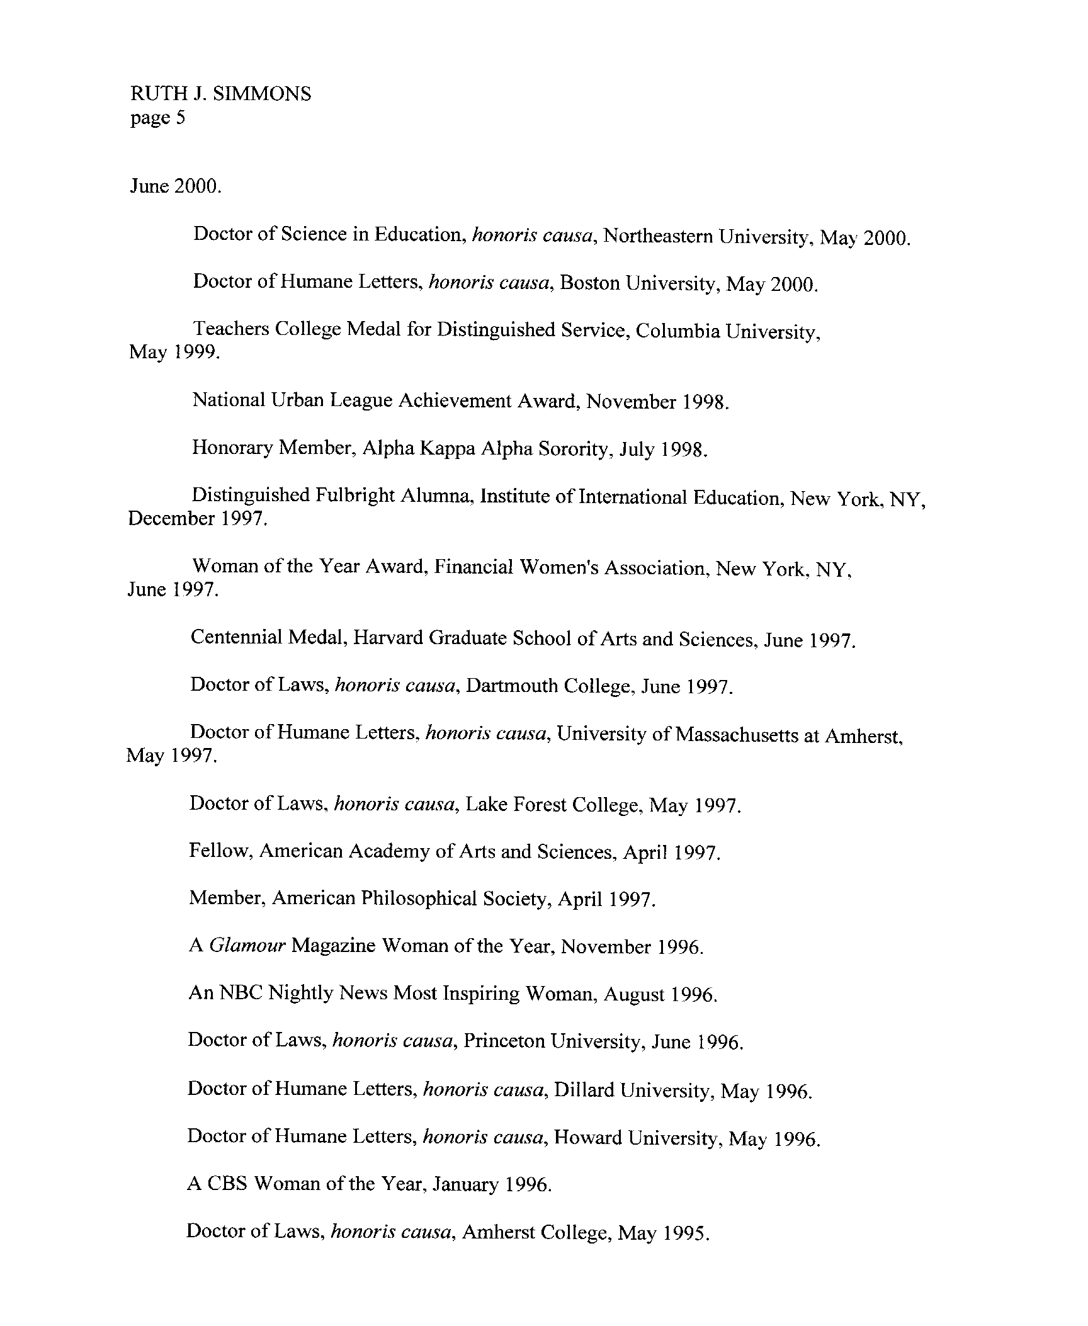
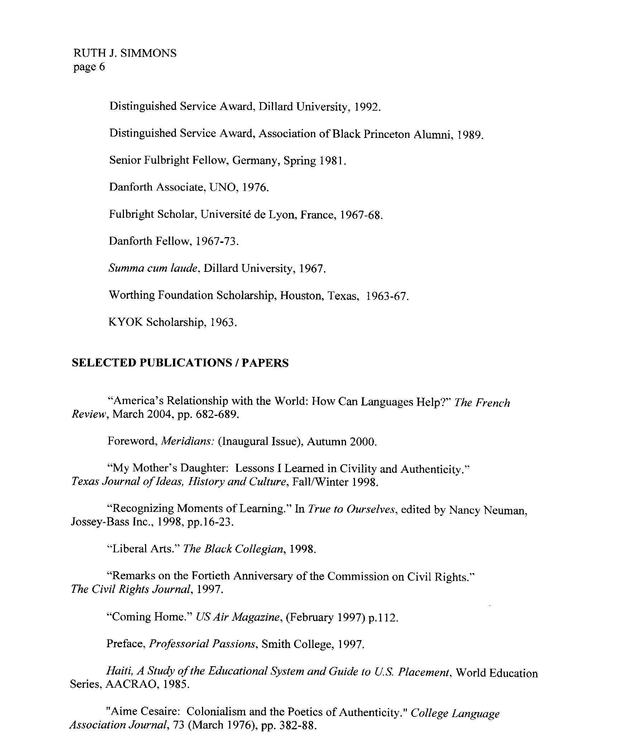
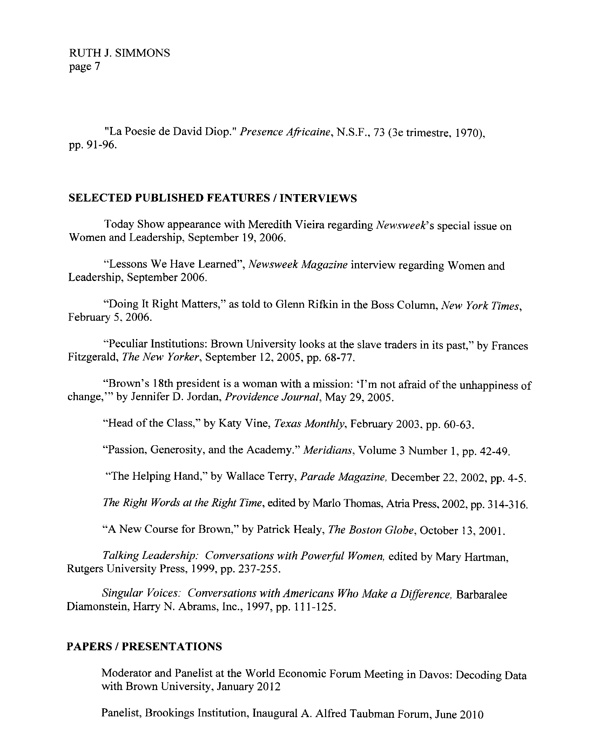
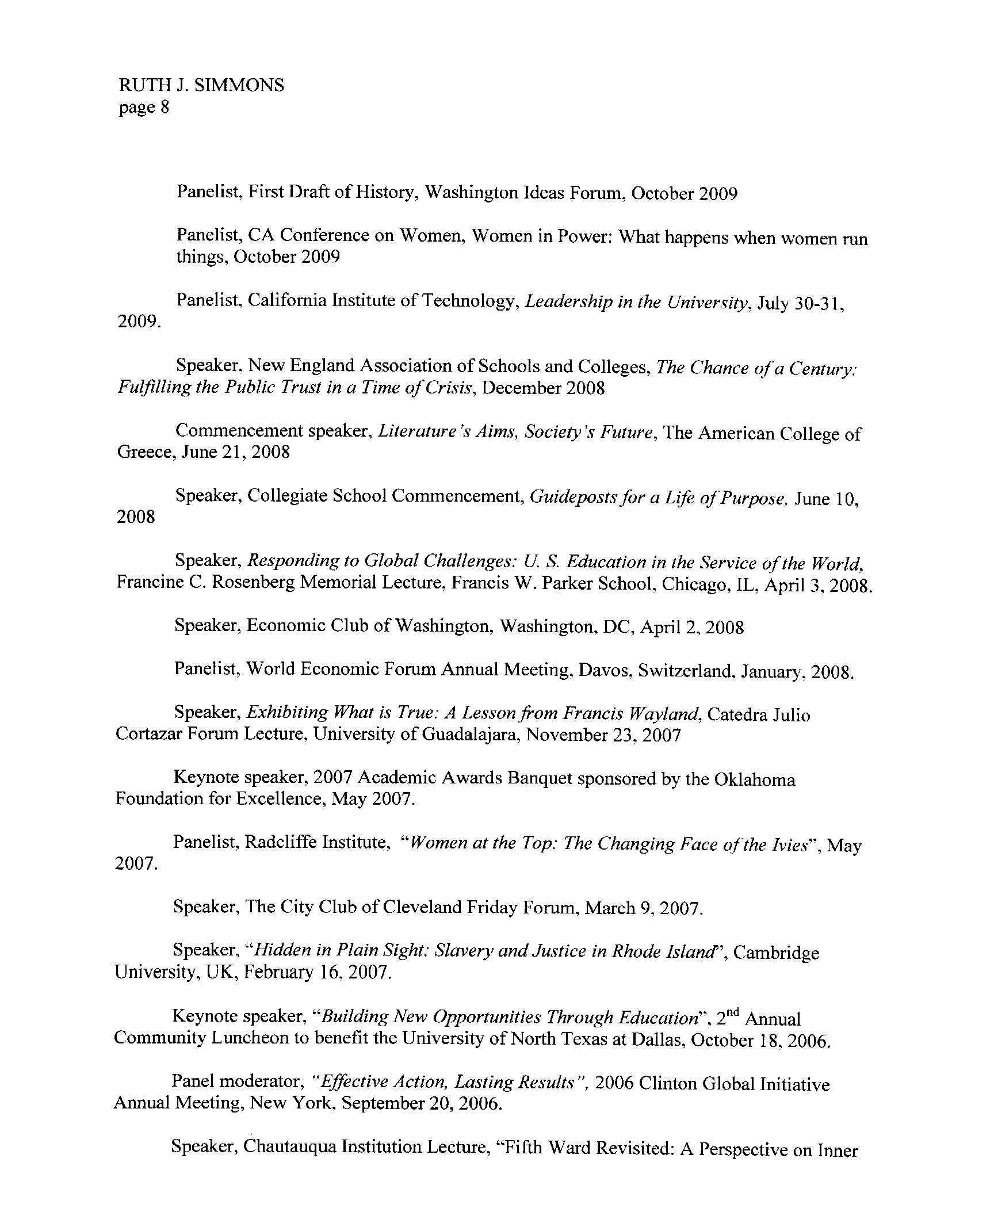
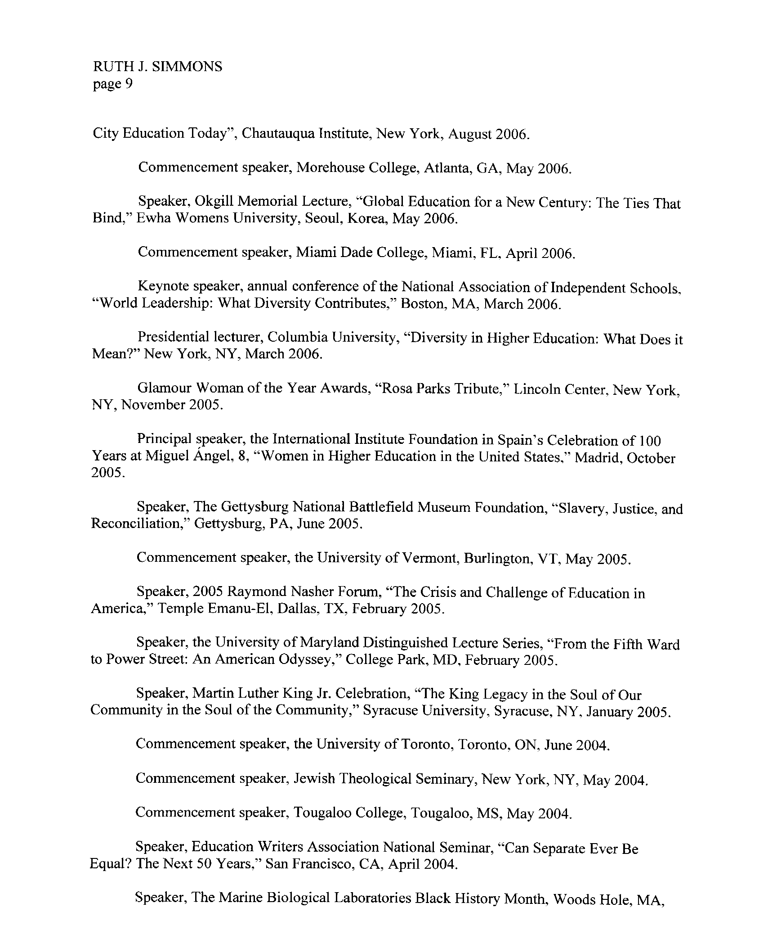
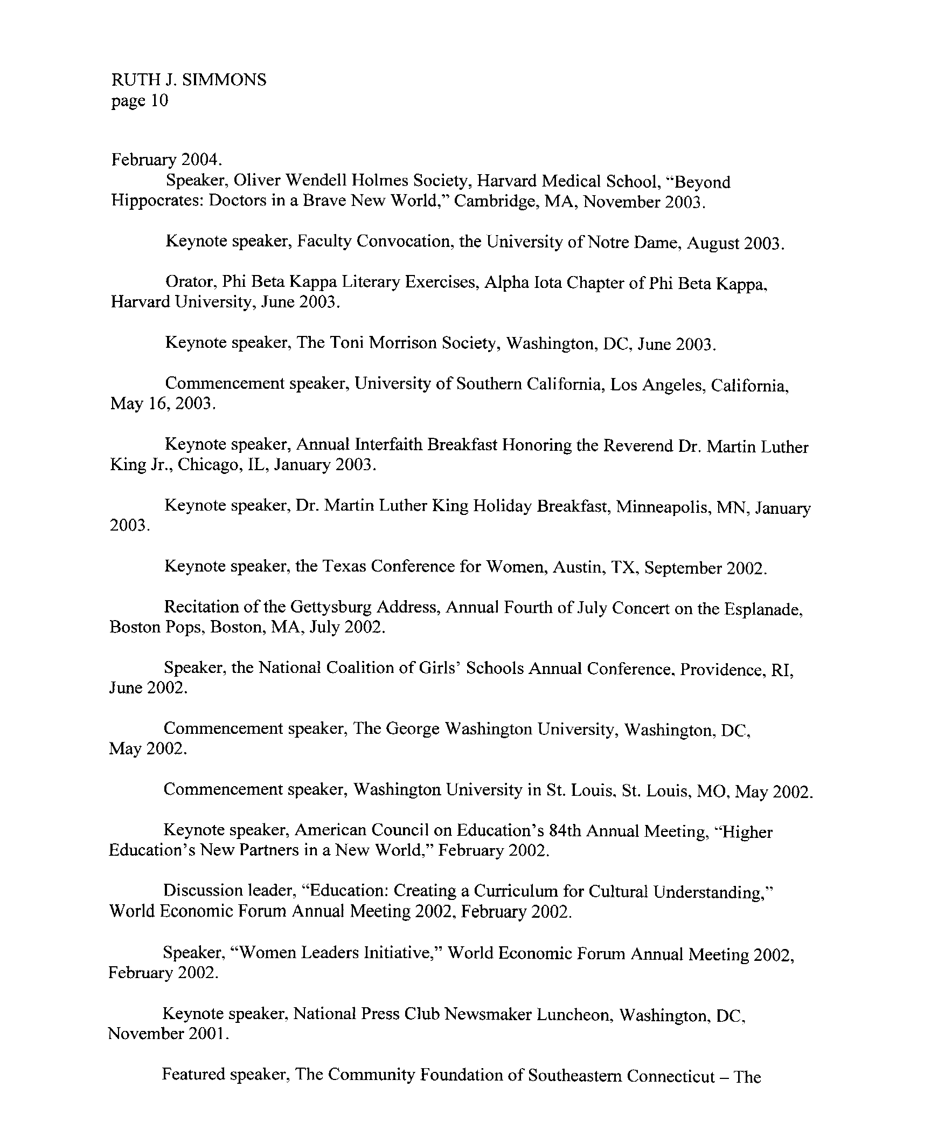
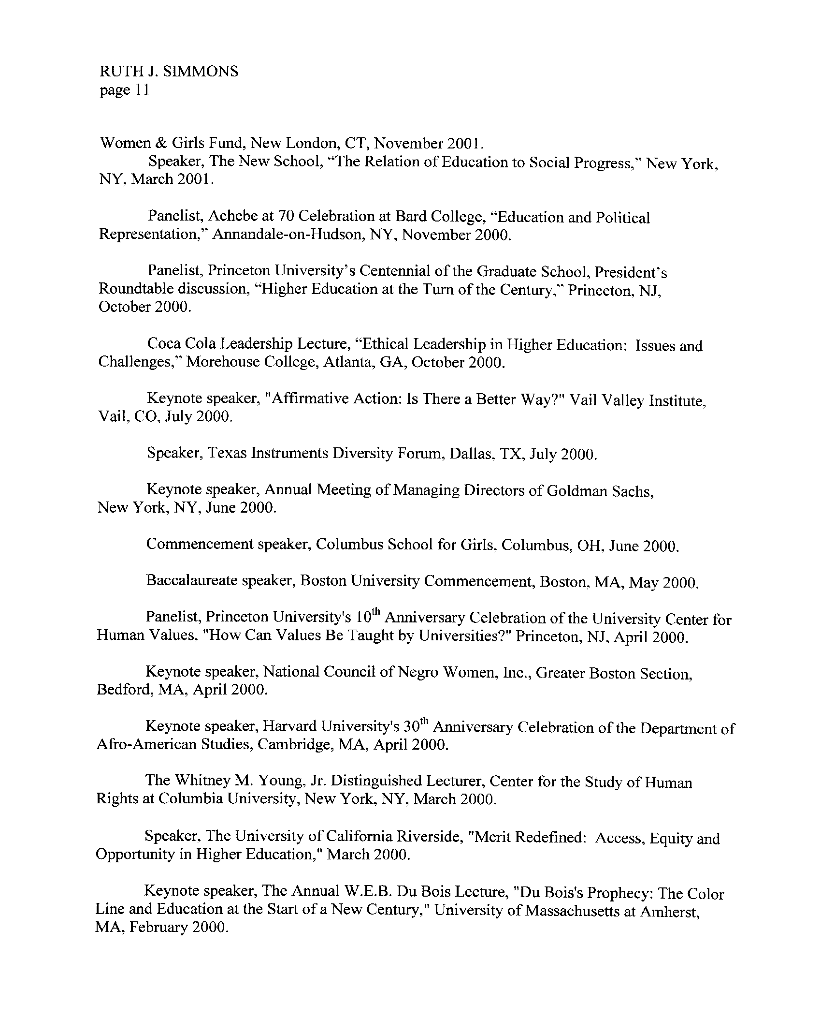
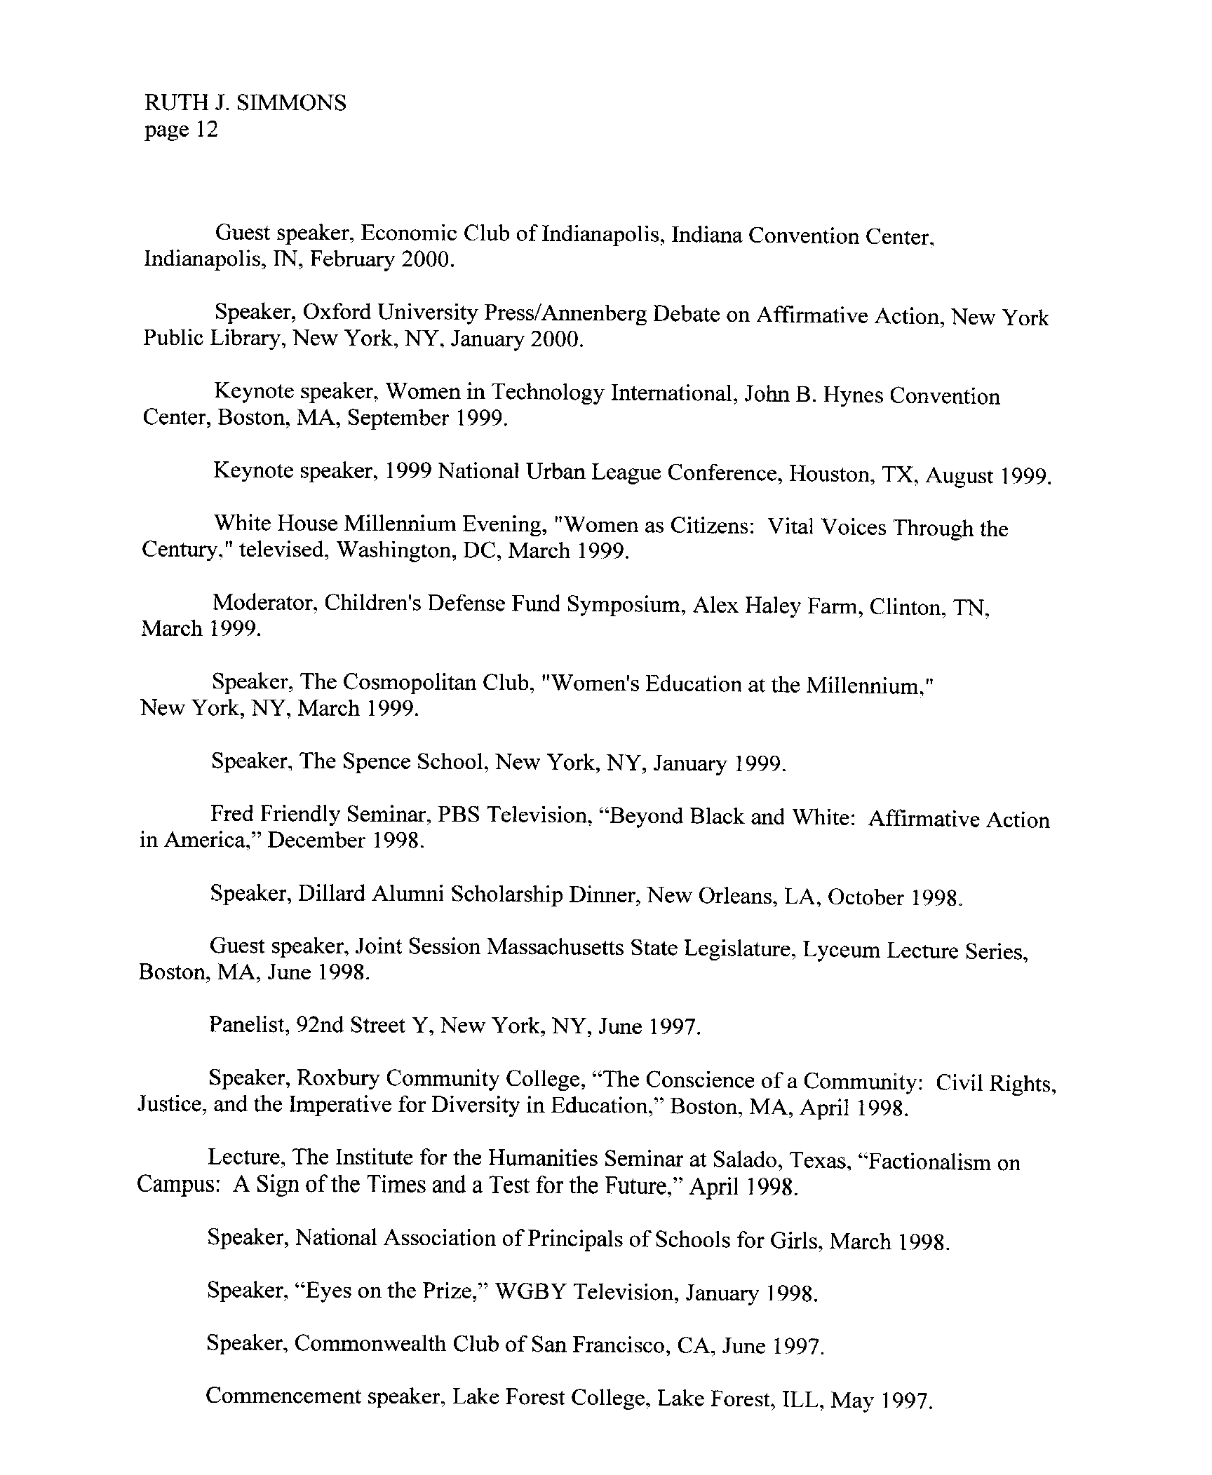
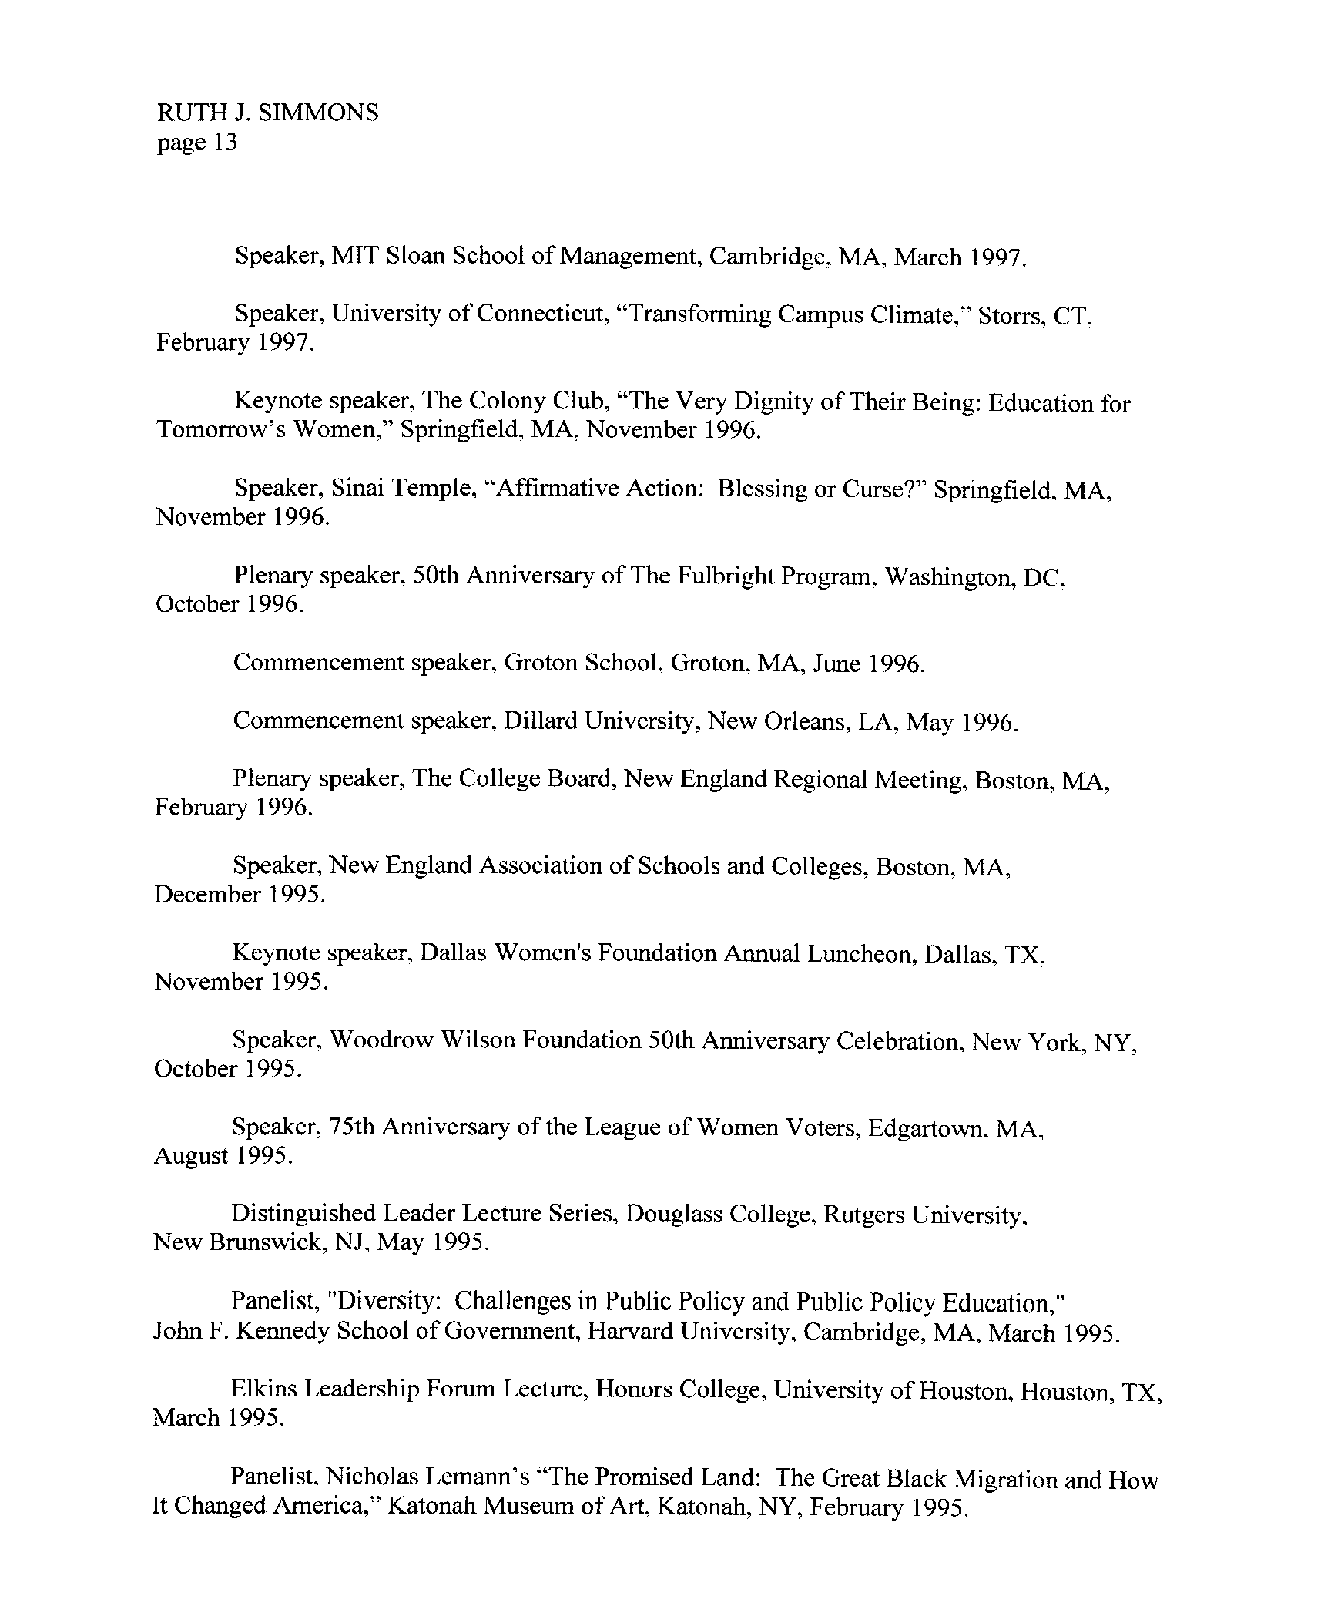
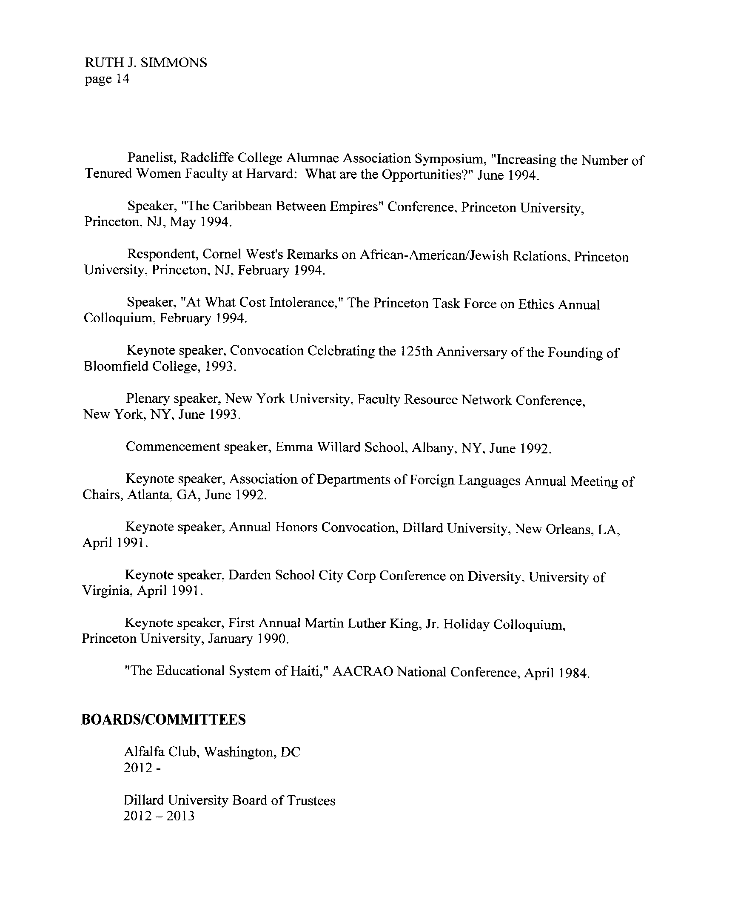
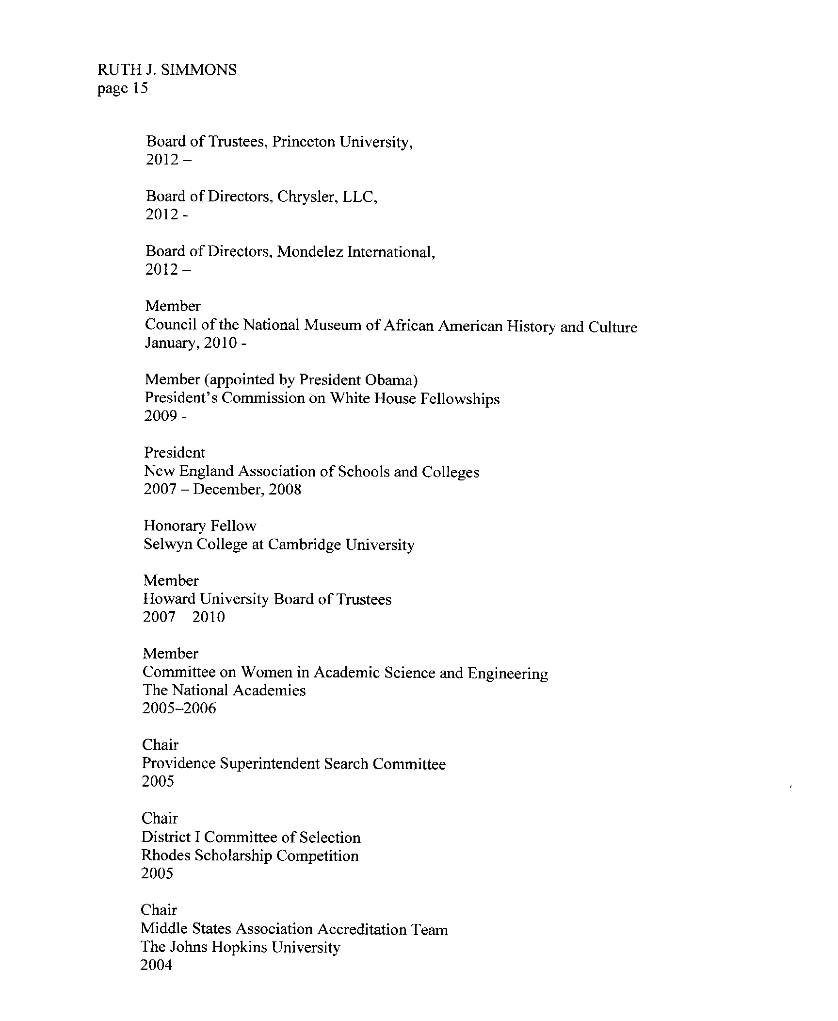
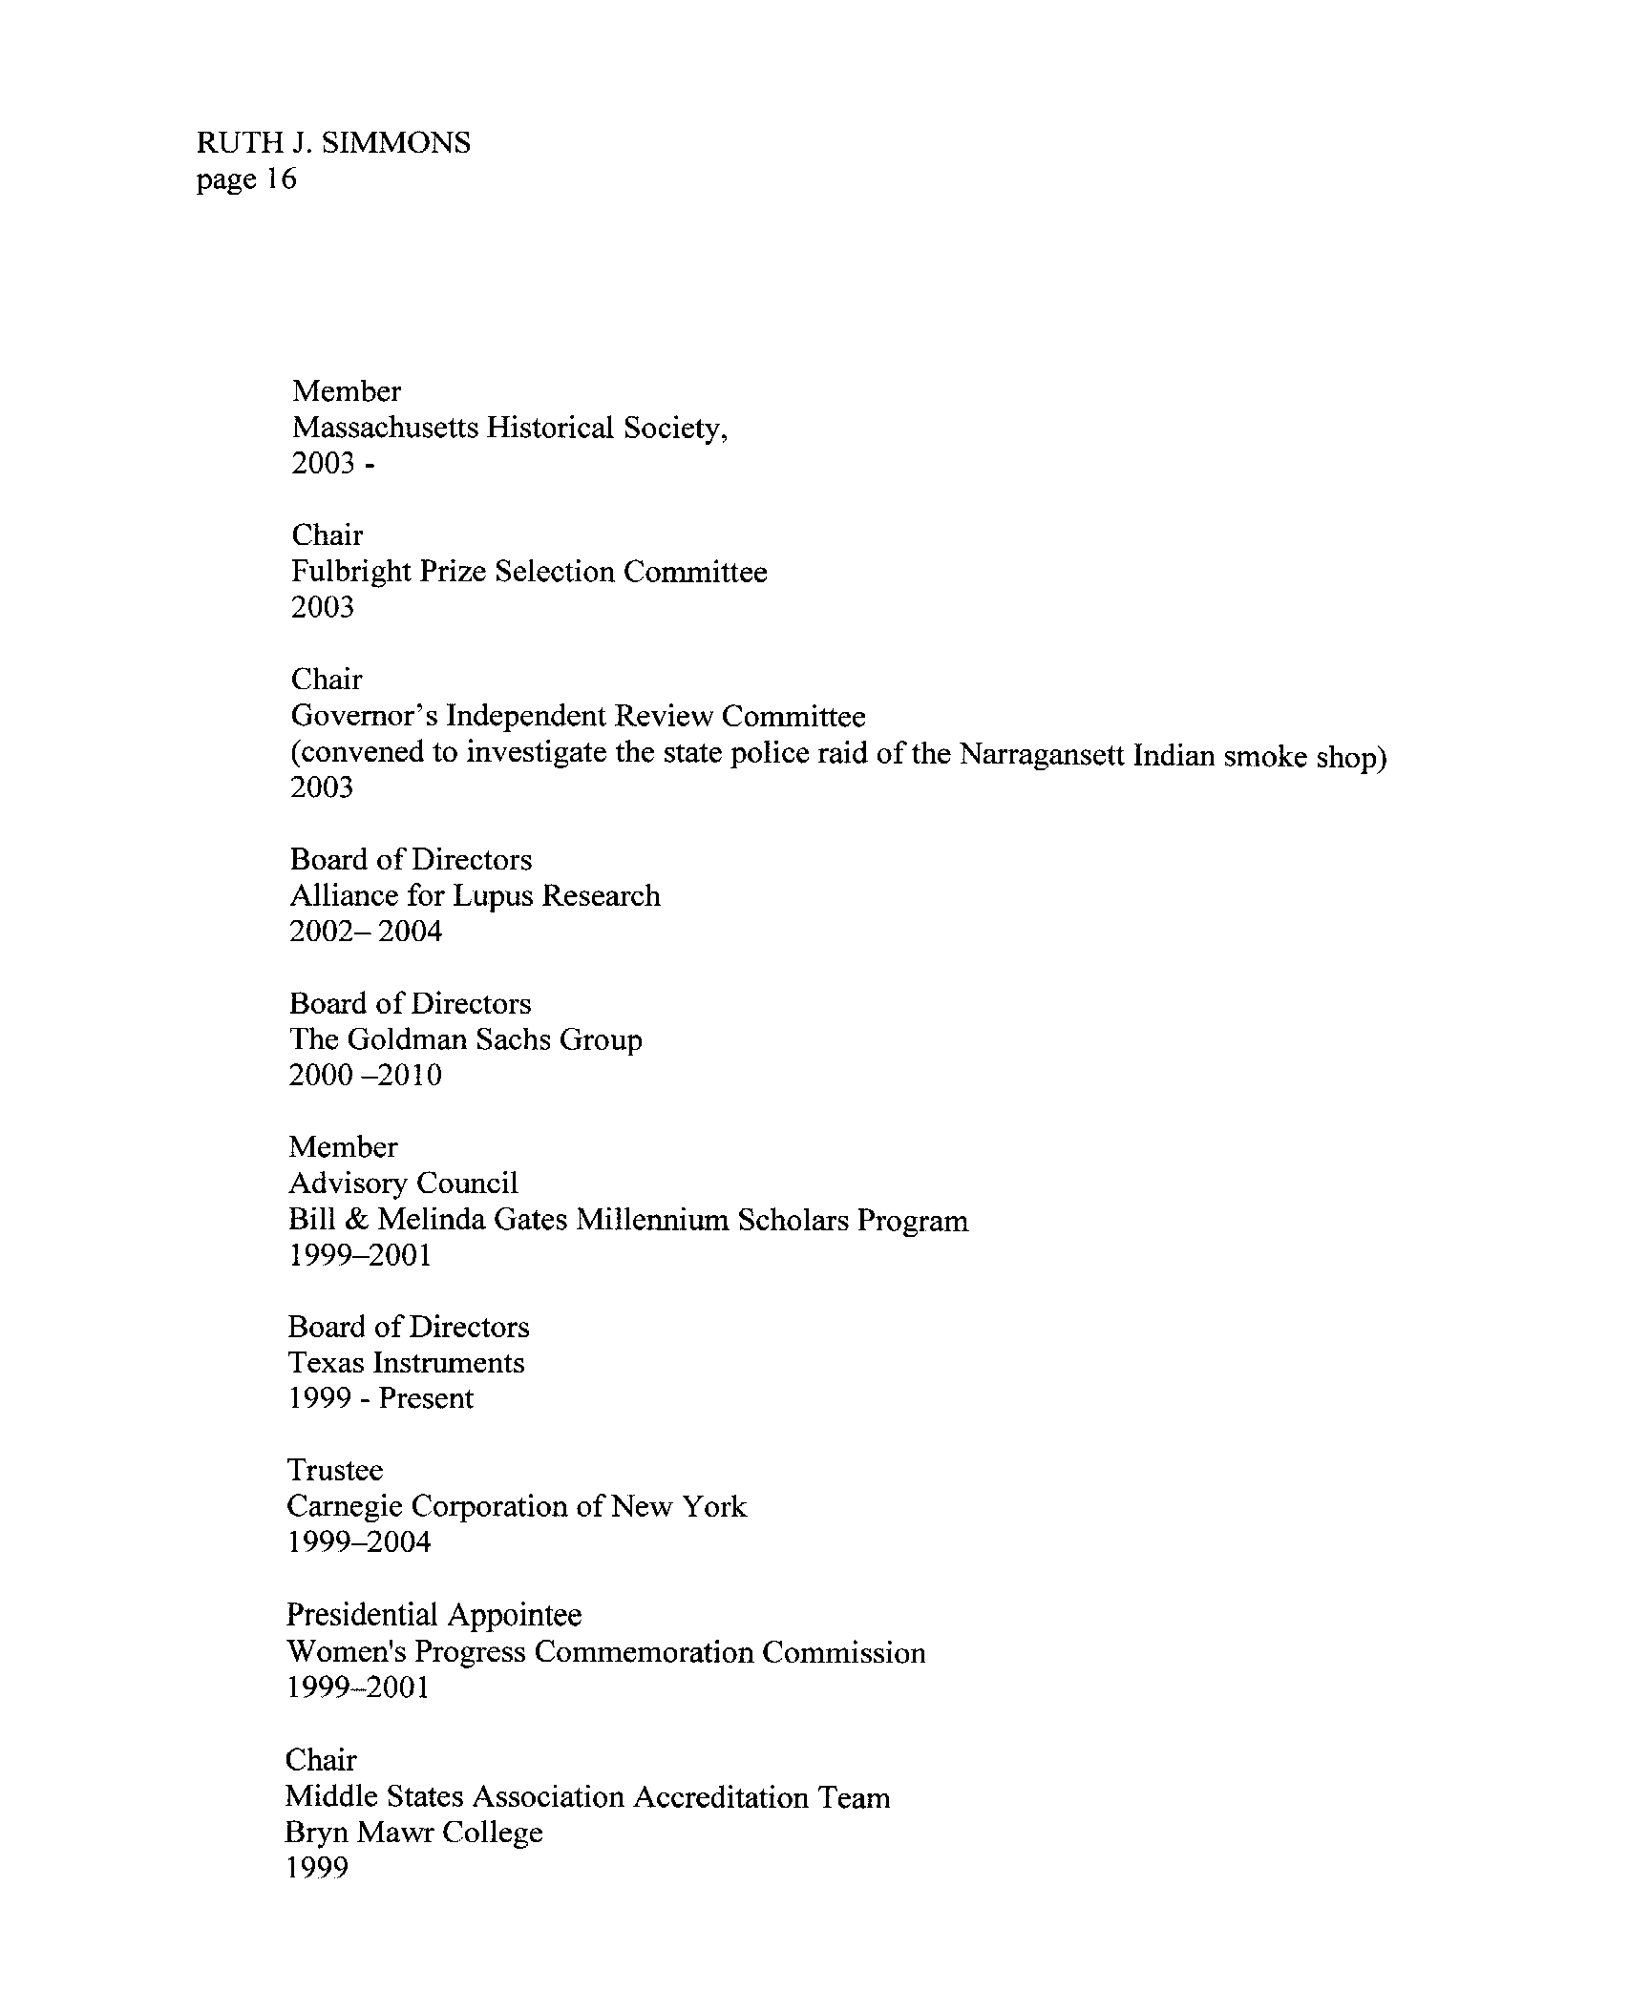
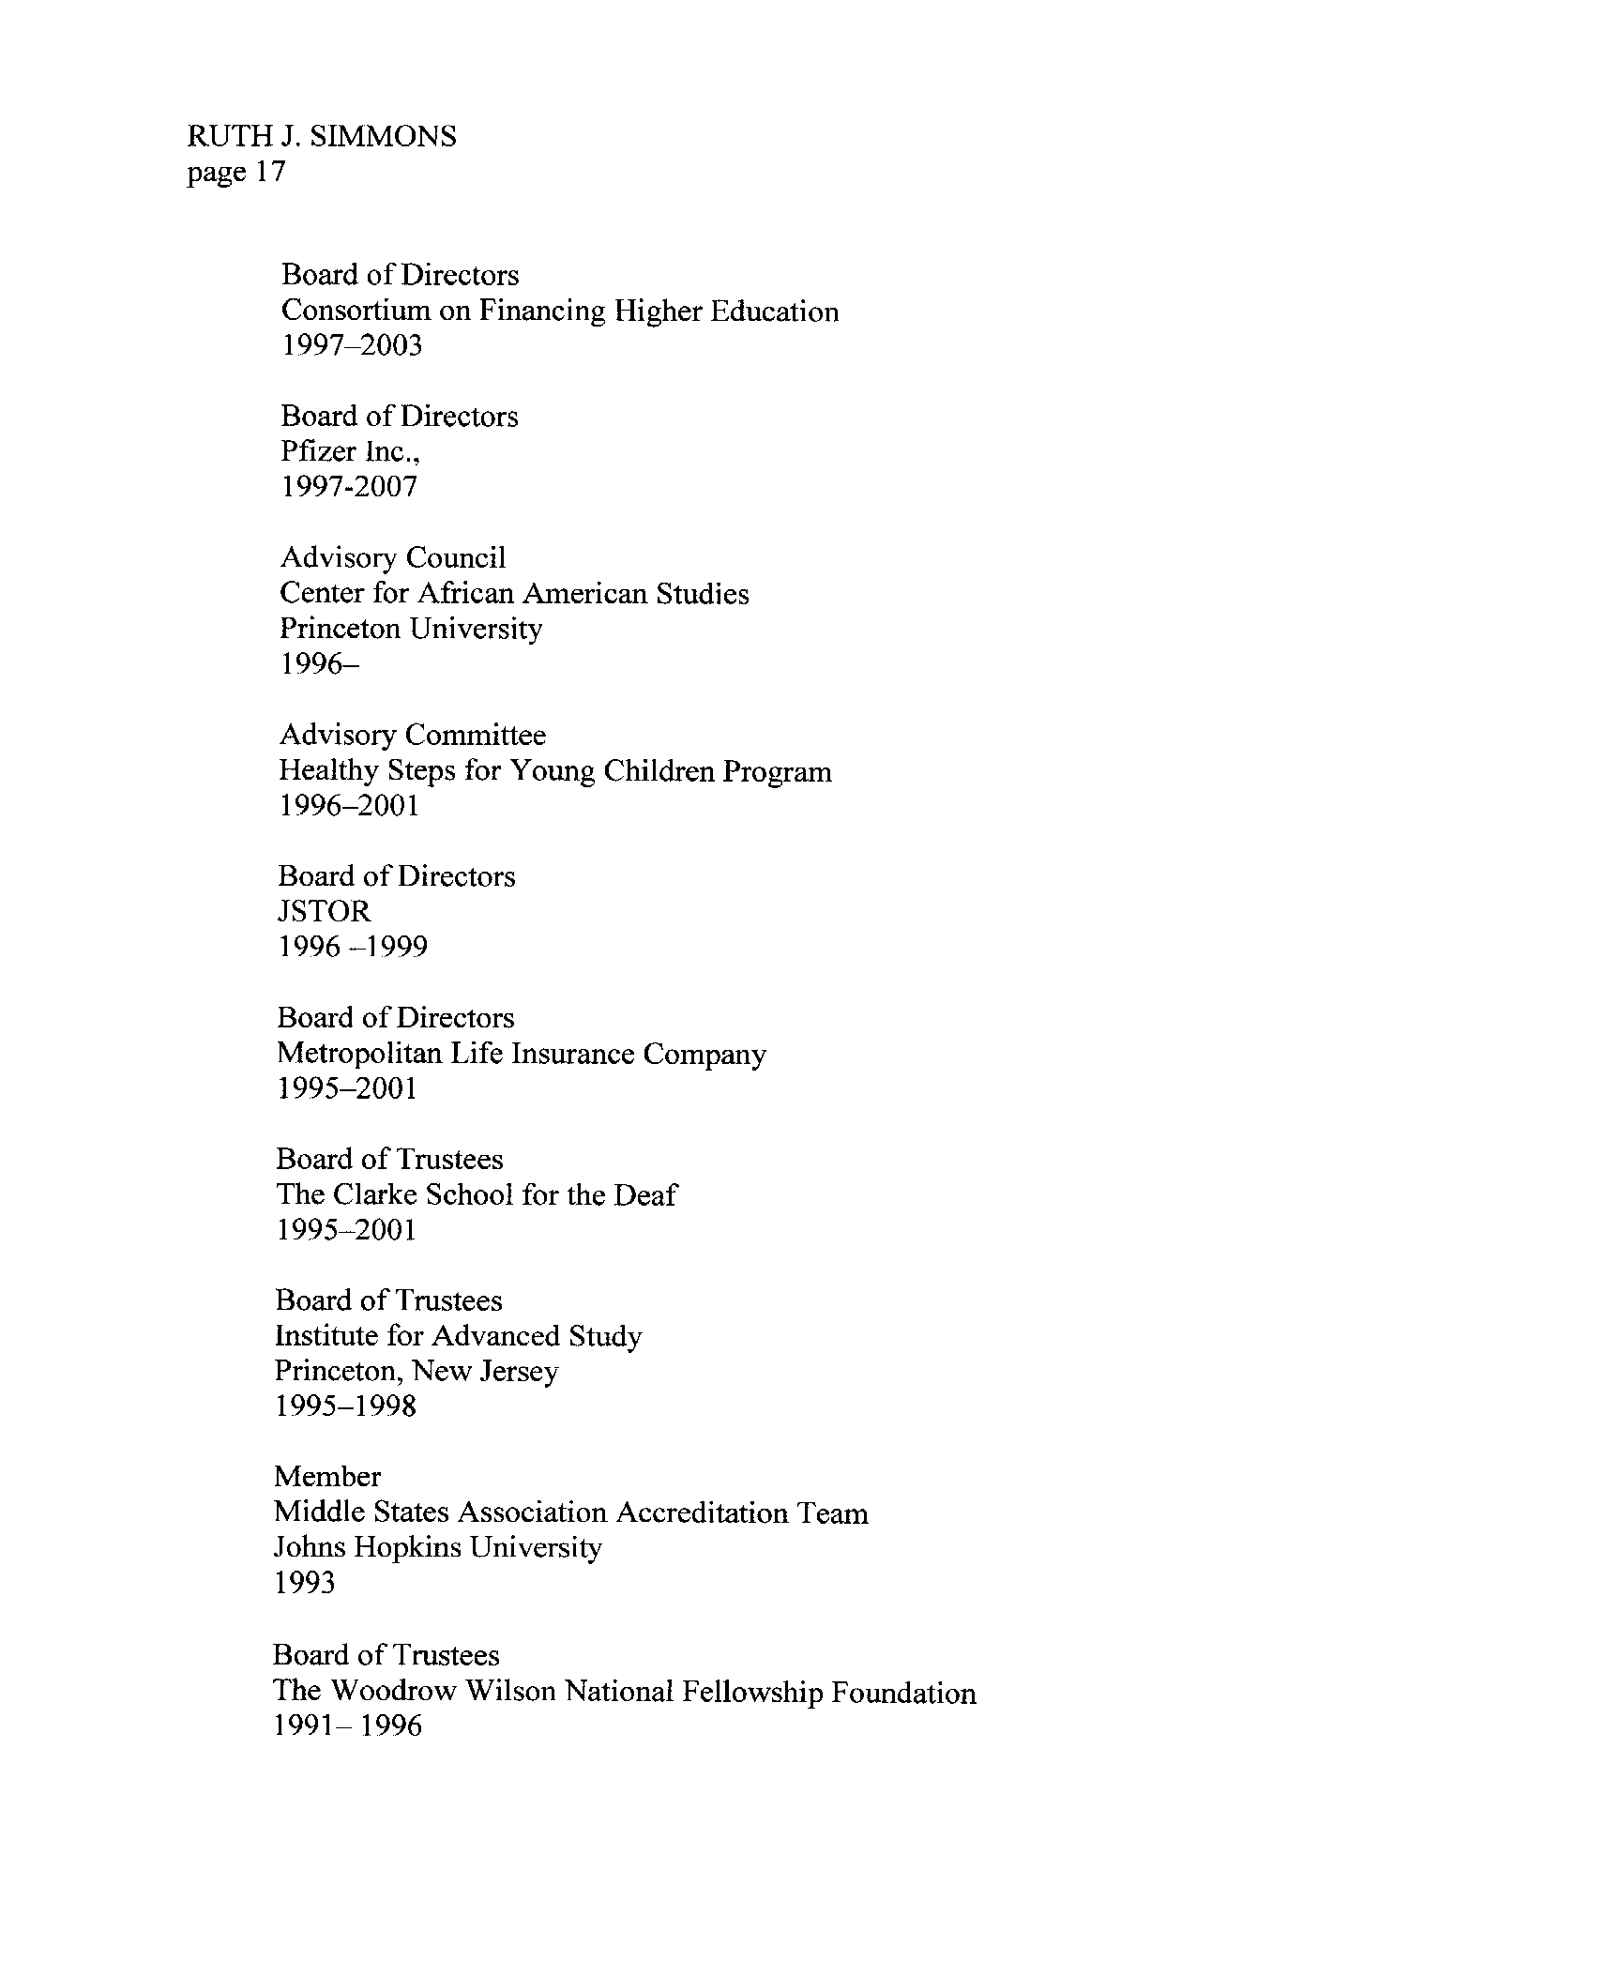


Vita
Patricia Yvette Jones was born in New Castle, Pennsylvania to the parents of Curtis Patrick Jones and Leona Yvette Body. She was the second child in the Boyd family that consisted of four girls and two boys.
Her formative education began at Lincoln Elementary Lorain, Ohio. Her secondary education was at Southview High School. After her high school graduation, she entered into the United States Army for four years and continued on to complete four additional years in the United States Army National Guard.
Immediately after joining the United States Army National Guard she attended The Ohio State University. In May 2006, she would receive her undergraduate degree from The Ohio State University in Psychology, minor in Sociology.
Upon graduating from The Ohio State University, she went on to graduate school at the University of Tennessee in August 2006. While at the University of Tennessee, she received her graduate degree in May 2008 in Sports Psychology, Sport Studies. Whe continued on to pursue her doctorate at the University of Tennessee in Higher Education Administration and expects to receive her degree in May 2016. After graduation she will continue on her hero’s journey.

For the purpose of this study, predominantly white institutions are defined as those that are not historically Black and that have a majority white student population.
Because the ACE presidential data are not reported in disaggregated numbers by both gender and ethnicity, extracting data for African American females and determining the actual number of African American female presidents are difficult.
The term Black is used interchangeably with African American throughout this dissertation because Blacks, like Asians, Latinos and other people of color, constitute a specific racial group, thus denoted as a proper noun by being capitalized. On the other hand, the word white, which is not a proper noun because whites do not constitute a specific racial group, is not capitalized. For the same reason, the term women of color is not capitalized. The term minority is not used to describe people of color for several reasons. First, the term is offensive to some people of color. Second, other groups can, or should, be considered minorities, such as those with mental or physical disabilities, those from cultures different than American mainstream culture, and those for whom English is not their first language. Thus, the term people of color is used in an effort to be more precise and to reduce the number of people offended by my choice of language.
Herstory is a neologism coined in the late 1960s as part of a feminist critique of conventional historiography. In feminist discourse the term refers to history (re-stated as “his story”) written from a feminist perspective, emphasizing the role of women, or told from a woman’s point of view.

