Sexual Assault Survivors’ Experiences of Campus Spaces: A Photovoice Study

A Dissertation Presented for the
Doctor of Philosophy
Degree
University of Tennessee, Knoxville

Amber Giffin

August 2023

Dedication
To Joey. Thank you for always being my safe place.

April 9, 2000 – February 19, 2022

To my mom. Thank you for always believing in me, even when I couldn’t believe in myself.

Acknowledgements

I would have never made it this far without the unending support of my chair, Dr. Qi Sun. Your guidance and belief in me have been instrumental to my success. Words cannot express how grateful I am to have you as a mentor and advisor. I would also like to thank the rest of my wonderful committee, Dr. Michelle Glowacki-Dudka, Dr. Courtney Cronley, and Dr. Ashlee Anderson. I have learned so much by working with the three of you on this dissertation, and I appreciate you all answering all of my questions with endless patience and supporting my vision for this study. I am so lucky to have gotten to work with such brilliant and skilled scholars, and I will be forever grateful to all of you.
To everyone at Teaching and Learning Innovation (TLI), including the ones who have moved on to other career paths, you all have supported me from day one. I have never had the opportunity to work with such amazingly talented and intelligent individuals, and your support of me through all of the trials and tribulations that I’ve been through these past four years will not be forgotten. Chris L., Ferlin, Yuijie, Chris K., Wes, Anoff, Gwyneth, Josie, Deepa, and Virginia, I will always consider all of you my friends and part of my chosen family. I could not have done any of this without you. The mentorship and guidance you all have provided to me over the years will benefit me for my entire life, and I am so lucky to have each of you in my life.
To my friends and family, including Finnegan, I appreciate the support I have received from each of you. You all have been there for me through some of the hardest and most rewarding times in my life. You all mean the world to me. Thank you for believing in me.
Abstract
Sexual violence continues to be a widespread issue for women, and many survivors of sexual assault face numerous challenges in higher education when they are working to achieve their educational goals. The purpose of this study was to develop an understanding of how women adult learners who are also sexual assault survivors experience the university campus. Two research questions framed this study: 1) What types of spaces on university campuses engender feelings of safety for women adult learners who are sexual assault survivors? 2) How can universities create more inclusive learning spaces for women adult learners who are sexual assault survivors? I used Photovoice, a participatory action research method that seeks to promote critical dialogue and knowledge and reach policy makers through the use of photographs, targeted qualitative interviews, and photo exhibitions, to research this phenomenon. In this study, there were a total of seven participants, aged 22-35. Six of the participants were White, American students, and one participant was an Asian international student. Descriptive and emotive coding, along with thematic analysis were used to analyze the data. Three main themes emerged from the study: 1) safety, 2) community, and 3) wellbeing. Each theme was addressed in detail through photographs taken by the participants and excerpts from the participant interviews. This research contributes to the existing research on feminism and sexual violence, feminist geography, and sexual assault survivorship in higher education. Research suggests that several policy changes at the university, state, and national levels are needed, in addition to more safe spaces, in order to create a more inclusive and welcoming learning environment for survivors of sexual violence. Suggestions for future research are discussed.
Keywords: sexual assault survivorship, higher education, photovoice

Table of Contents
Chapter 1: Introduction 1
Problem Statement 6
Purpose Statement and Research Questions 6
Significance 7
Definitions 8
Limitations 8
Delimitations 8
Study Overview 9
Chapter 2: Literature Review 10
Higher Education Landscape 11
Sexual Assault Survivorship in Higher Education 12
Culture of Silence 13
Title IX 16
Adult Learners 19
Trauma Theory 22
History 23
Understanding Trauma 28
Feminist Geography 33
Feminist Theory 34
Feminist Epistemologies 41
The History of Feminist Geography 43
Feminist Geographies of Fear and Trauma 44
Creating the Conceptual Framework 47
Conclusion 51
Chapter 3: Methodology 52
Qualitative Research Design 52
Epistemology 53
Photovoice 54
Participant Recruitment 60
Data Collection 62
Data Analysis 65
Trustworthiness 67
Triangulation 67
Member Checking 68
Subjectivity Statement 68
Conclusion 70
Chapter 4: Findings 71
Introduction 71
Demographics and General Information 71
Participants 72
Clarissa 74
Elena 74
Wendy 75
Eden 76
Taylor 77
Lennie 78
Jennifer 78
Themes 79
Safety 81
Community 100
Wellbeing 105
Conclusion 109
Chapter 5: Discussion 111
Introduction 111
Discussion 111
Safety 112
Community 117
Wellbeing 119
Theoretical Implications 120
Implications for Practice 122
Campus Policies 123
Campus Resources 126
Architectural and Environmental Changes 127
Suggestions for Future Research 128
Conclusion 130
References 132
Appendices 151
Appendix A: University of Tennessee IRB Approval 152
Appendix B: Recruitment Flyer 154
Appendix C: Recruitment Email 155
Appendix D: Consent Script 156
Appendix E: Consent Form 157
Appendix F: Photo Prompts 161
Appendix G: Interview Guide 162
Appendix H: List of Resources 163
Appendix I: Initial Codebook 164
Vita 165

List of Figures
Figure 2.1 Image Illustrating Conceptual Framework…………………………………...48
Figure 4.1 Table of participant demographics…………………………………………...73
Figure 4.2 Chart of themes……………………….....….………………………………...80
Figure 4.3 Chart of subthemes……………………….....….………………………..…...82
Figure 4.4 Lennie’s office………………………………………………………………..85
Figure 4.5 Where Eden spends time between classes………………..…………………..88
Figure 4.6 Parking garage on Clarissa’s campus………………………………………...92
Figure 4.7 Area outside where Elena escapes to when having panic attacks……………95
Figure 4.8 The one punching bag on Wendy’s campus………………………………….98
Figure 4.9 Sign in Clarissa’s library……………………………………………………102
Figure 4.10 Clarissa’s library………………………………………………………..…106
Figure 4.11 One of Wendy’s favorite campus spaces………………………………….108

Chapter 1: Introduction
Higher education has diverse populations in terms of their sociocultural, socioeconomic, and sociopolitical identities. When addressing diversity, equity, and inclusion, practitioners in higher education often focus on visible identities, like race and gender. However, when we start exploring individual’s identities for higher education justice, we often ignore or marginalize invisible identities like sexual assault survivorship. According to the Department of Justice (2019), a person is sexually assaulted every 73 seconds, and 90% of those assaulted are women. Some survivors were sexually assaulted when they were in their childhood. The Center for Disease Control (CDC) (2022) reported that four in five women rape survivors were assaulted before the age of 25. Additionally, the National Sexual Violence Resource Center (2020) reports that one in four women are sexually assaulted while in college. Additionally, 49.7% of childhood sexual abuse survivors are revictimized in the future (Walker et al., 2017). Due to the widespread occurrence of sexual assault, it is likely that many women adult learners at universities are also sexual assault survivors. Research has shown that experiencing sexual assault prior to or during enrolling in a university has detrimental impacts on undergraduate survivors’ academic trajectories, with researchers reporting lowered grade point averages and a higher rate of attrition than their non-survivor counterparts (Jordan et al., 2014; Mengo & Black, 2015; Potter et al., 2018). Wagner and Magnusson (2005) explained that “women’s status as survivors has virtually not been problematized as an issue within our system of higher education” (p. 450).
As Wagner and Magnusson (2005) argued, the patriarchal university culture seeks to suppress the issue of male violence against women, and this culture promotes the idea that those who suffer from traumatic symptoms due to their identity as sexual assault survivors are stigmatized and viewed as aberrations who are expected to process their traumatic experience in silence. However, many female survivors of sexual assault face lifelong impacts and never fully heal. Due to the lifelong impacts that sexual assault can have on survivors, researchers consider sexual trauma an educational barrier for women (Jordan et al., 2014; Potter et al., 2018; Raymond & Corse, 2018; Wagner & Magnusson, 2005).
Sexual assault survivors suffer from numerous negative social impacts within the university community, including ostracization, negative reactions to disclosing, and a lack of support from their university (Carey et al., 2018; Jordan et al., 2014; Raymond & Corse, 2018; Wagner & Magnusson, 2005). For example, Raymond and Corse (2018) explained that a sexual assault survivor experiences “seeing a promise for university students from which she is excluded by a kind of invisible barrier, an experience that exposes deeply elided codes of social stratification within the university” (p. 469). Raymond and Corse (2018) also explained that sexual assault survivors’ lived experiences often separate them from the community of students. This can impair their ability to participate in college life, resulting in feelings of isolation and a lack of socialization. These feelings often stem from students, university faculty, student-facing staff, and healthcare professionals criticizing and blaming survivors for being attacked.
One of the ways that survivors may feel unsupported in their university environment is due to the way that universities comply with Title IX regulations. The majority of universities devote small amounts of effort to Title IX requirements, such as sexual assault prevention trainings. In order to comply with Title IX guidelines, universities are required to provide sexual assault prevention and awareness programming (White House, 2014). There are three main types of prevention that are generally taught at universities: 1) positive sexuality, 2) bystander intervention, and 3) resistance training.
Positive sexuality prevention education is based on the premise that people should focus on what they want from their relationships instead of what they want to avoid. They challenge the abstinence-only education that many entering university students may have received while growing up by teaching students “how to discuss their sexual development and properly articulate their intentions to others in respectful relationships” (LaFrance et al., 2012, p. 446). Bystander intervention programming, on the other hand, teaches the university community that it is their responsibility to change pro-rape attitudes and to intervene safely when they see another student in danger (Mabry & Turner, 2016; Exner & Cummings, 2011). Unlike positive sexuality and bystander intervention, resistance training focuses on assertiveness and self-defense. The target audience for this type of programming is usually women, and the program can be presented as a standalone self-defense workshop or part of a more comprehensive prevention curriculum (Gidycz & Dardis, 2014; Senn, 2013).
The way that universities implement other Title IX policies in higher education makes many of the policies ineffective in practice. For example, Albrecht et al. (2022) found that the complexity of Title IX policies leads to undergraduates being unable to understand the laws that were designed to protect them. This leads to Title IX policies, and their implementation within university systems, being an ineffective way to combat sexual violence. Bolger (2016) discussed the gaps between creating Title IX policies and actually enforcing them, explaining that if universities want to guarantee educational equity, when sexual violence is an educational barrier for women, Title IX policies should allow for the survivor to recover the costs attributed to the crime, which is based on gender discrimination. Bolger (2016) argued that that there is a gap between policy goals and enforcement, causing Title IX to be less effective than many proponents of gender equity in higher education hoped it would be. However, not all of the research regarding Title IX illustrates that the implementation of the policies is ineffective. Mancini et al.’s (2016) examination of the mandatory reporting policy showed that while many were concerned about reduced survivor autonomy and forced disclosures, many students felt that while mandatory reporting has both positive and negative aspects, the law will help better protect students and increase university accountability.
In addition to ineffective implementations of Title IX policies, the lack of support that universities provide survivors with often leads to educational challenges. The trauma from sexual assault can affect a student’s life in many ways. According to the literature, the following three are most common: “1) disruption in study, 2) academic challenges, and 3) focusing on academics as a coping mechanism” (Potter et al., 2018, p. 499).
While focusing on academics as a coping mechanism seems positive, it can actually lead to burnout and the return of the maladaptive traits that the survivor was trying to ignore through her hyper-focus on her schoolwork (Potter et al., 2018). None of the three main ways that posttraumatic symptoms present themselves within an educational environment leads to sustainable or stable behavior that promotes the continuation of one’s education. In fact, all of the ways that trauma presents itself both inside and outside of learning environments make it extremely difficult for sexual assault survivors who are suffering from posttraumatic symptoms to achieve their educational goals (Jordan et al., 2014; Potter et al., 2018; Raymond & Corse, 2018; Wagner & Magnusson, 2005).
The alienation of and lack of support available for sexual assault survivors in higher education is due in part to what Wagner and Magnusson (2005) refer to as a “culture of silence” within the university. The culture of silence is a prevailing and paternalistic culture that fosters the belief that trauma from sexual violence is a private matter that should be kept secret and never publicly acknowledged (Wagner & Magnusson, 2005). This culture ensures that the sexual assault survivors are either unacknowledged or seen as “problems” within the university community (Raymond & Corse, 2018). The culture of silence is insidious and serves to further ostracize and shame sexual assault survivors for the crimes committed against them. It removes their voices and makes them feel invisible, which can negatively impact their educational trajectory (Wagner & Magnusson, 2005).
The culture of silence is expressed in many ways, including silence as a response to sexual assault as well as the survivors of sexual violence being silenced by others. When institutions employ silence as a response to sexual violence, it can exacerbate the harm experienced by the survivor by reinforcing “dynamics that perpetuate the prevalence of sexual violence” (DeLaet & Mills, 2018, p. 497). In addition to utilizing silence as a response to sexual assault, survivors of this crime are often silenced by the reactions of others, including their peers, educators, and educational institution.
According to the research conducted by Ahrens’ (2006) research, four main reactions resulted in the silencing of sexual assault survivors: 1) victim-blaming, 2) insensitive responses, 3) “ineffective disclosures” (p. 269), and 4) unhelpful support. When sexual assault survivors are blamed for being assaulted, have their experiences minimized, are ignored when they ask for help dealing with their trauma and are told to keep silent or treated as if they are incapable of caring for themselves, they often choose silence over risking experiencing these negative reactions again (Ahrens, 2006). Therefore, in order to create an inclusive educational environment for sexual assault survivors, it is important to create safer and more supportive learning spaces where they can heal as they achieve their academic goals.

Problem Statement
Despite the increasing number of adult learners in higher education and the alarming statistics on sexual assault, there is a significant gap in research regarding how sexual assault survivors spatially experience their campus environments. While existing studies have explored the experiences of trauma survivors in university spaces, there is a lack of focused research specifically examining the spatial experiences of adult women learners who are also sexual assault survivors. Furthermore, previous research on sexual assault in higher education predominantly includes younger and whiter participants than the overall American college student population. Additionally, the existing body of research on sexual assault in higher education primarily revolves around prevention, educational outcomes, and policy, with little attention given to understanding the experiential aspects of the university environment for sexual assault survivors. Consequently, there is a need to investigate how sexual assault survivors navigate and engage with their campus environments both inside and outside the classroom. By exploring these experiences, educators and university personnel can gain insights into creating a more inclusive and supportive learning environment for this population.

Purpose Statement and Research Questions
The purpose of this study was to develop an understanding of how women adult learners who are also sexual assault survivors experience the university campus. There were two research questions that frame this study:
- What types of spaces on university campuses engender feelings of safety for women adult learners who are sexual assault survivors?
- How can universities create more inclusive learning spaces for women adult learners who are sexual assault survivors?
I used Photovoice to research this phenomenon. By asking participants to take photographs and then discuss them in individual interviews, I was able to see the campus through the participants’ eyes and gain a deeper understanding of why they felt that certain spaces were safer than others. This process also provided thick descriptions of what inclusive learning spaces for sexual assault survivors might look like.

Significance
This research will impact adult learning and higher education in both theoretically and practically and fill a gap in the literature regarding how adult women sexual assault survivors experience the university space and how we, as educators and university personnel, can create more survivor-friendly learning spaces for these individuals. The conceptual framework I utilized in this study is the geography of trauma, which is a combination of trauma theory and feminist geography. This conceptual framework helped frame the study by directing the focus of the research questions, photo prompts, and interview questions on spaces within the university campus and how they are impacted by the trauma experienced by the participants. Furthermore, by viewing these images and interview through the lens of geographies of trauma, we gained a deeper understanding of how trauma impacts learning as well as how it acts as an educational barrier for many learners. By utilizing Photovoice to see the university through sexual assault survivors’ eyes, we gained crucial insight regarding what spaces on a college campus look and feel like to survivors. This provided concrete examples of what features made the spaces feel safe and inclusive for sexual assault survivors. Additionally, after gaining a deeper understanding of how adult women sexual assault survivors experience the university space, university administrators, educators, and personnel will have the opportunity to create more inclusive learning spaces for this population.

Definitions
Adult learner – a learner “whose age, social roles, or self-perception, define them as adults” (Merriam & Brockett, 2007, p. 8).
Sexual assault/sexual violence – rape (attempted or completed), unwanted sexual touching, and forcing a victim to perform sexual acts (RAINN, 2022).
Sexual assault survivor – “a person who has been sexually assaulted and is dealing with the short-term and long-term effects of the trauma” (Potter et al., 2018, p. 496).
Campus sexual assault programs – educational programs facilitated by college campuses to educate students, faculty, and staff on how to report sexual misconduct and how to prevent sexual violence on their campus (Burgess-Proctor et al., 2016).
Rape culture – “the set of social attitudes about sexual assault that leads to survivors being treated with skepticism and even hostility, while perpetrators are shown empathy and imbued with credibility not conferred on people accused of other serious crimes, like armed robbery” (Pazzanese, 2020).

Limitations
Since this was a qualitative study, it involved targeted photograph prompts and interview questions to a small number of participants across one state in the southeastern United States. Some participants were more open with their answers than others. Not all participants were able to find spaces to photograph for all prompts.

Delimitations
This study was delimited to Ph.D.-granting, higher education institutions in a southeastern state in the US. As the focus of the research was to gain a deeper understanding of how adult women sexual assault survivors who are enrolled in higher education courses experience university spaces, the sampling methods were not randomized, and the inclusion criteria are also delimitations of this study. More delimitations may present themselves over the course of the study.

Study Overview
The first chapter of this dissertation included an overview of the background information regarding the study. An explanation of the research problem, purpose, and the questions that guided this study were addressed, as well as the significance of the study and important definitions of terms that were used throughout the dissertation. The second chapter provides a comprehensive literature review, including the conceptual framework that was used in this Photovoice project, in order to help the reader frame the study. The third chapter details the methodology that was used in the study and the research design that was implemented. The fourth chapter provides the findings from the data analysis, and the fifth chapter discusses practical and theoretical implications as well as suggestions for future research.

Chapter 2: Literature Review
Considering the high rates of sexual violence against women in the United States, it stands to reason that some women who are enrolled in university programs were sexually assaulted prior to attending college. Additionally, even more women will be sexually assaulted during their college career (Department of Justice, 2019; National Sexual Violence Resource Center, 2020). However, aside from examining how sexual violence affects rates of attrition and academic achievement, there is a dearth of research regarding how the university environment itself impacts sexual assault survivors’ ability and willingness to meet their educational goals. Therefore, the purpose of this study was to explore how the campus space influences how sexual assault survivors experience the university.
To facilitate a better understanding of how sexual assault can impact women in higher education, this chapter will include discussions on concepts and theories relating to sexual assault survivorship in higher education, adult learners, trauma theory, and feminist geography. In the chapter, I will first introduce the current landscape of higher education, followed by topics related to sexual assault survivorship in higher education. Next, I will discuss adult learners, focusing on Knowles’ assumptions regarding adult learners. Then, I will explain how trauma theory provides context to better understand women adult sexual assault survivors’ experiences, both inside and outside of the classroom. Finally, this section will close with an exploration of feminist geography, looking at how place and trauma can intersect, forcing women to alter their actions in an effort to remain safe.
The purpose of this study was to develop an understanding of how women adult learners who are also sexual assault survivors experience the university campus. I used Photovoice to research this phenomenon. There were two research questions that framed this study:
- What types of spaces on university campuses engender feelings of safety for women adult learners who are sexual assault survivors?
- How can universities create more inclusive learning spaces for women adult learners who are sexual assault survivors?

Higher Education Landscape
In order to understand the diversity among sexual assault survivors in higher education, it is important to realize that US postsecondary institutions are diverse global learning institutions. In fall 2021, 15.4 million people were enrolled in an undergraduate degree program at a postsecondary institution in the US, and 3.2 million people were enrolled in postbaccalaureate degree programs at a postsecondary institution in the US (National Center for Education Statistics, 2023a; National Center for Education Statistics, 2023b). Of the 18.6 million students, 948,519 of them were international students (Parker, 2023). In fall 2020, the overall race and/or ethnicity of resident undergraduate students was 53% White, 22% Hispanic, 13% Black, 7% Asian, and 1% American Indian/Alaska Native, while the overall race and/or ethnicity of resident postbaccalaureate students was 61% White, 14% Black, 12% Hispanic, 9% Asian, and 1% American Indian/Alaska Native (National Center for Education Statistics, 2022a). These statistics illustrate that while there is certainly diversity among students in higher education, including sexual assault survivors, the samples recruited for studies regarding sexual assault in higher education are likely not representative of the race and/or ethnicity of sexual assault survivors in the US as a whole.
As universities try to meet diverse students’ needs regardless of their age, race, ethnicity, or geographic location, online learning has become a popular learning modality for universities (Hiltz & Turoff, 2005). Since the COVID-19 pandemic in spring 2020, online learning has further increased in popularity with 75% of undergraduate students and 71% of postbaccalaureate students being enrolled in at least one online course in fall 2020 (National Center for Education Statistics, 2022b). The increase in availability of online courses also has the potential to help sexual assault survivors meet their educational goals. Quezada et al. (2023) found that sexual assault survivors who were assaulted by a fellow student often felt safer when they were further away from campus, which makes online learning an excellent option for them. Additionally attending classes online could help sexual assault survivors not have to share a physical space with their assailant, which would make it easier for them to attend classes (Quezada et al., 2023).

Sexual Assault Survivorship in Higher Education
As previously mentioned, the large number of women who experience sexual violence means that there are women sexual assault survivors in universities; however, institutions of higher education often seem ill-equipped to support sexual assault survivors through their academic journey. The resources for women who enter college as sexual assault survivors are severely lacking. Aside from overtaxed university counseling centers (Abrams, 2022), there are not many resources available for survivors who were assaulted prior to entering the university, although some universities do provide their students with campus victim resource centers (Burgess-Proctor et al., 2016). Lack of resources aside, many sexual assault survivors express an unwillingness to utilize campus sexual assault resources due to a distrust of the institution and its employees, fear of negative treatment, disbelief that the programs offered will benefit them, and internalized rape myth acceptance, which all serve to perpetuate the culture of silence surrounding sexual violence at the university (Burgess-Proctor, 2016; Holland et al., 2021; Munro-Kramer et al., 2017; Sinko et al., 2021). In addition to not having sufficient resources to support survivors of sexual violence and survivors’ unwillingness to use the resources, Title IX, which is the policy and office that handles sexual misconduct within the university system, is often unable or unwilling to provide support for those who are sexually assaulted by a fellow student (Bloom et al., 2021; Holland et al., 2019). Furthermore, some universities do not take sexual assault seriously, and the students do not report the crime due to either being unaware of how to report, being afraid that they will be blamed for their assault, or that what happened to them did not classify as sexual assault (Lindquist et al., 2016; Richards et al., 2017; Sinko et al., 2021; Spencer et al., 2017). In order to provide a clearer context for my study, this section of the literature review focuses on explaining the culture of silence surrounding sexual violence on college campuses and Title IX policies and procedures.

Culture of Silence
One way that the university system creates a hostile learning environment for sexual assault survivors is through the culture of silence. Freire (1970/2000) introduced the concept of the culture of silence to explain the phenomenon that occurs when the oppressed society adopts the values of the oppressor and are either unable or unwilling to think critically and speak authentically due to their immersion in their oppressive realities. This concept ties in closely with Freire’s (1970/2018) idea of dehumanization, where the oppressors force their will onto the oppressed through violence and exploitation. Because of the violence and exploitation, the oppressed often reject their right to voice due to their fear that they will be further oppressed and experience more violence if they disrupt the current power structures. While Freire (1970/2000, 1970/2018) examined the class systems in what he refers to as the Third World, the culture of silence itself extends well beyond classist exploitation and violence.
In Women’s Ways of Knowing (WWK), the silent women were much like Freire’s (1970/2000, 1970/2018) oppressed population. The silent women did not have the ability to think critically due to oppressive life circumstances. Those life circumstances rendered the women voiceless and unable or afraid to form their own opinions and beliefs. Like the oppressed population in Freire’s (1970/2018) work, these women had internalized the values and beliefs of their oppressors and did not speak authentically. In fact, many of the silent women were so afraid of the repercussions of listening to or using words that they claimed they could not learn from words at all. These women blamed themselves for the various types of abuses they endured, and they were terrified of gaining or using their voices because they were afraid that the abuse would escalate if they did speak for themselves. The silent women also lacked the ability to reflect due to the fact that many of them had been cut off from the outside world by their abuser. These women had been completely dehumanized, and their abusers ensured that the oppressive systems that they had created were reproduced through the values they forced on the silent women. Additionally, the misogynistic culture and neglect they experienced growing up aided in the reproduction of the systems of oppression that their current abusers had in place. The silent women believed that critical thinking and dialogue were inappropriate for women (Belenky et al., 1997), and that belief kept them from breaking free from the culture of silence and reclaiming their voices.
The culture of silence is not only present in extreme cases of abuse and neglect. It is prevalent across society, especially regarding tools of oppression, such as sexual assault. In the context of sexual assault survivorship, the culture of silence is expressed in many ways, including silence as a response to sexual assault as well as the survivors of sexual violence being silenced by others (Ahrens, 2006; DaLaet & Mills, 2018). Wagner and Magnusson’s (2005) study illustrates that silence does not always imply a lack of education or critical thinking skills. The researchers pointed out that even in institutions of higher learning, where critical thinking is valued, women sexual assault survivors’ experiences are often still silenced through institutional pressures and oppression (Wagner & Magnusson, 2005). When institutions employ silence as a response to sexual violence, it can exacerbate the harm experienced by the survivor by reinforcing “dynamics that perpetuate the prevalence of sexual violence” (DeLaet & Mills, 2018, p. 497).
In addition to utilizing silence as a response to sexual assault, survivors of this crime are often silenced by the reactions of others, including their peers, educators, and educational institution. Out of the four main reactions regarding disclosing sexual violence, victim-blaming is the most frequent response (Ahrens, 2006). Victim blaming refers to when others blame the survivor for putting themselves in a position in which a sexual assault could occur. Insensitive responses, which all of the survivors in the study experienced, occur when the person the survivor disclosed to minimizes the assault. Ineffective disclosures, which are not quite as common, refer to when survivors ask for help and the request is denied. Unhelpful support was experienced by all but one survivor in the study, and it occurs when someone close to the survivor advises them to not report the assault or treats them as if they are unable to take care of themselves after the assault is disclosed (Ahrens, 2006). These types of reactions serve to protect the assailant and reproduce the systems that enable sexual assault to occur by silencing survivors’ voices (Wagner & Magnusson, 2005).
Wagner and Magnusson (2005) explained that through patriarchal systems, such as the culture of silence surrounding sexual assault survivorship, the men who sexually assault women are protected while the survivors are blamed for showing any emotional or behavioral reaction to having experienced the trauma. Oppressive mechanisms, such as the culture of silence, make survivors feel invisible and make the university feel like a hostile environment (Mengo & Black, 2016; Raymond & Corse, 2018; Wagner & Magnusson, 2005). The insidious culture of silence follows women sexual assault survivors through all aspects of their lives, including into their learning environments. This feeling is suppression negatively impacts survivors' ability to learn (Mengo & Black, 2016; Raymond & Corse, 2018; Wagner & Magnusson, 2005). In fact, Wagner and Magnusson (2005) argued that sexual assault is an educational barrier for women, and many studies have examined the role that sexual assault survivorship plays in retention, attrition, and grade point averages (GPAs) in a university setting (Jordan et al., 2014; Mengo & Black, 2016; Potter et al., 2018).

Title IX
Title IX, which applies to any US university that receives federal funding, has been in effect since 1972, but over the decades universities have received little guidance regarding how to implement some of the more important aspects of the policy, such as sexual assault prevention techniques, to improve women’s educational experiences and to ensure that women have continued access to education, even if they have been assaulted while on campus. In 2011, the US Department of Education’s Office for Civil Rights released the “Dear Colleague Letter,” a federal guidance document that offered a bit more clarification on Title IX and how colleges and universities should develop and implement sexual assault prevention education programs and survivor resources. The “Dear Colleague Letter” (Office for Civil Rights, 2011) explained that the goal of Title IX is equal access to education that is free from discrimination. When a student is sexually assaulted, a hostile environment is created that can limit the student’s access to a productive educational environment; therefore, it is the school’s responsibility to step in and ensure that the complainant (student who was attacked) and the responder (the student accused of the attack) are able to fulfill their academic and extracurricular activities. During the Obama administration, Title IX compliance included a proactive approach, through educational prevention programs, and a reactive approach, through survivor support and interim measures to ensure that affected students can continue their education. (Office for Civil Rights, 2011).
In addition to offering preventive measures and survivor resources, Title IX also ensures that women have equal access to educational funding through various sources, including athletic scholarships. Athletics programs are considered to be educational programs, and therefore university sports is also covered under Title IX. There are three main parts of Title IX that apply to college athletics: 1) Participation: Title IX stipulates that men and women are to be provided equitable opportunities to participate in sports, 2) scholarships: Title IX requires both male and female student-athletes to receive scholarship funding, and 3) treatment: Title IX requires that male and female student-athletes receive equal treatment regarding other issues such as equipment, housing and dining options, and support services (NCAA, 2023). Due to its involvement in student athletics, Title IX vastly increases educational access to female students by allowing them to receive athletic scholarships to help pay for their education.
Even with the Obama administration’s increased focus on Title IX as a tool to mitigate sexual assault within the university, Title IX offices, which are charged with upholding the laws, policies, and procedures associated with Title IX, are notoriously understaffed, and many universities do not even have one full-time Title IX coordinator. (Carroll et al., 2013; Wiersma-Mosley & DiLoreto, 2018). Federal funding being tied to Title IX compliance for public universities ensures that public institutions have at least one Title IX coordinator on staff; however, compliance with Title IX varies drastically from one institution to the next, leading to Title IX coordinators having a wide range of duties and various levels of institutional support for their position (Pappas, 2016).
In addition to inconsistency across universities when it comes to enforcing Title IX policies and procedures, the law itself is vulnerable to the political whims of the federal administration. An example of this is the policy changes from the Obama administration to the Trump administration. The Trump administration rescinded the Title IX guidance and policies that had taken effect during the Obama era, opting to protect the accused instead of the victim (Carter, 2021). Trump-era policies stated that an educational institution only violates Title IX if it is purposefully indifferent, if the sexual harassment is so severe that it denies a survivor access to their education, if the university employee who has the ability to implement corrective measures has knowledge of the attack, and if the survivor could produce clear and convincing evidence that they were attacked (Carter, 2021). Additionally, Trump-era Title IX guidance advocated for universities allowing the cross examination of complainants, which could further traumatize them and lead to fewer reports (Bizier, 2020).
Regardless of the federal administration governing Title IX policies, at its core, Title IX is in place to ensure gender equity in educational spaces. According to Pappas (2016),
Title IX promotes equity in academic and athletic programs, prohibits hostile environments on the basis of sex, prohibits sexual harassment and sexual violence, and directs universities to protect complainants against retaliation and to remedy the effects of other gender-based forms of discrimination. (p. 126).
From the description of Title IX, individuals who have experienced sexual violence prior to entering the university may have little to no support from their educational institutions. The law, and the policies and procedures associated with it, were not created with survivors who were assaulted prior to attending the university in mind. This lack of support can exacerbate feelings of ostracization as well as posttraumatic stress symptoms (Raymond & Corse, 2018; Wagner & Magnusson, 2005). Additionally, for survivors of sexual violence who were assaulted during their time at their university, many of the policies, such as mandatory reporting, often prove to do more harm than good.

Adult Learners
Scholars have debated for years over what constitutes an adult learner. In the United States, the legal age of adulthood is 18, while non-traditional students, or adult learners, are classified as being 25 years of age or older. However, relying simply on age is not inclusive of all adults. For example, a teenage mother may go to school full time, but she would obviously have the full-time role as a caretaker of her child as well. A more inclusive definition of an adult learner was created by Merriam and Brockett (2007) who classified an adult learner as someone “whose age, social roles, or self-perception, define them as adults” (p. 8). Due to the aforementioned circumstances, adult learners often add “student” as one of their many roles (Merriam & Bierema, 2014). In addition to the more traditional roles of caretaker and spouse, some adult learners may also embody the role of sexual assault survivor, which will also impact their learning, as experience is the main factor in an adult’s educational endeavors.
The concept that adult learners draw from their life experiences and have several competing roles is certainly supported by both the early and contemporary understandings of adult learners and adult education. Lindeman (1926) postulated that adult learners seek knowledge that adds value to their lives. In other words, adult learners are hoping to gain the tools necessary to understand and evaluate their own experiences and situations. Lindeman (1926) explained that because student is only one role in an adult learner’s life, adult education must complement the learner’s situations. When it comes to adult learners, Houle (1961) found that there are three main types of learners: 1) goal-oriented, 2) activity-oriented, and 3) learning-oriented. Goal-oriented learners learn to accomplish defined objectives. For example, a sexual assault survivor may be taking a class on mindfulness in order to help manage posttraumatic stress symptoms. Activity-oriented learners look for meaning in the activities associated with the learning, rather than in course objectives. When looking at an activity-oriented learner through the lens of sexual assault survivorship, a survivor may take self-defense classes, not only to learn how to defend themselves, but to also gain an increased sense of self efficacy and confidence. Learning-oriented learners seek knowledge for the sake of learning new things. For instance, a sexual assault survivor may want to understand the causes of gender-based violence, in order to gain a deeper understanding of what happened to them, and that would make them a learning-oriented adult learner. Houle (1961) stressed that most learners have aspects of all three learning orientations in their desire to engage in educational endeavors, and that it is best to think of these orientations as overlapping circles rather than independent silos. To help us better understand adult learners, Knowles (1980) expanded on the findings of both Houle and Lindeman in his discussion of andragogy.
Knowles (1980) originally defined andragogy as “the art and science of helping adults learn” (p. 43). However, after receiving feedback from K-12 instructors as well as university educators, Knowles (1980) began to conceptualize andragogy as “another model of assumptions about learners” that may be used alongside pedagogical assumptions in order to form a more comprehensive teaching framework. Knowles (1980) further explained that he views pedagogy and andragogy as to opposite ends of the educational spectrum, meaning that it is possible for educators to use both pedagogical and andragogical techniques in their classes, as they see fit. Below, I will discuss Knowles’ six andragogical assumptions and briefly describe how these assumptions may impact sexual assault survivors in university settings.
Knowles’ (1980) first assumption is that as people mature, they move from a more dependent style of learning to self-directed learning. Knowles’ (1980) posits that it is an educator’s job to encourage students to become more self-directed as they progress through their educational experiences. This means that adult learners rely more on themselves than on instructors when it comes to learning new material. The second assumption is that adult learners bring their experiences with them into the classroom. While this has pedagogical implications, as Knowles (1980) points out, this can also mean that the lived experiences of the learner may impact their learning experiences. While Knowles (1980) views lived experiences as a rich resource for learning, lived experiences can also hinder one’s ability to learn. For a sexual assault survivor, their lived experiences may make it more difficult for them to concentrate on the material being presented.
The third assumption that Knowles (1980) made about adult learners is that “they become ready to learn something when they experience a need to learn it in order to cope more satisfyingly with real-life tasks or problems” (p. 44). Knowles’ (1980) fourth assumption is that adult learners engage in education in order to increase their competencies to achieve goals in their lives. Both of these assumptions could relate directly to sexual assault survivors who take certain classes to learn more about PTSD, gender-based violence, or other topics surrounding sexual assault survivorship, and how the topics are delivered could impact the success of survivors’ learning endeavors.
The final two assumptions made by Knowles came in later publications. The fifth assumption Knowles et al. (1984) made was that adult learners are internally motivated, rather than externally motivated. This means that adults tend to gravitate toward learning opportunities that benefit them on a personal level instead of seeking outside approval. For sexual assault survivor-students, this could occur when they seek out learning experiences to teach them how to cope with their status as a survivor of sexual violence. Finally, Knowles’ (1984) sixth assumption is that adults need to know why they are being asked to learn something. Adults have a limited amount of time and mental bandwidth to devote to learning; therefore, they need to understand why they are being asked to learn about a certain topic before being willing to spend time on the endeavor. This could be especially salient for understanding how sexual violence is a barrier to education for survivors because for many survivors, much of their mental and physical energy is spent on managing their posttraumatic stress symptoms (van der Kolk, 2014). That makes it very difficult to spend time learning things that they feel will not benefit them.

Trauma Theory
Trauma theory provides a framework for understanding the neurobiological and psychological impacts of trauma on a person or group (Gilfus, 1999; Herman, 1997; Radstone, 2007; van der Kolk, 2014). Trauma theory has a long history and has evolved tremendously over the past century, due to technology providing researchers with the ability to see brain activity. Trauma theory offers explanations of the neurobiological and behavioral symptoms that adult women sexual assault survivors may experience. While trauma theory started out as narrowly defined, excluding certain groups from being considered as having trauma (Gilfus, 1999), the more recent iterations of trauma theory have become more inclusive and look at a variety of trauma sources experienced by diverse individuals or groups (e.g., Brown-Rice, 2014; Estrada, 2009; Menakem, 2017). Furthermore, while earlier forms of trauma theory viewed posttraumatic symptoms through a deficit lens (Gilfus, 1999), more contemporary works focus on trauma more holistically, and how this information can help those with trauma heal (e.g., Menakem, 2017; van der Kolk, 2014).
Trauma is a complex subject with many variations in theory. However, as this study focuses on sexual assault survivorship in higher education, the use of trauma theory is vital to the understanding of the participants’ experiences. Due to the variations in trauma theory over the years, this section will first focus on the origins of trauma theory, followed by an exploration of the neurobiological changes that occur when someone experiences trauma. Each set of symptoms and neurological discussion will be followed by an example of how these symptoms are displayed and how they impact sexual assault survivors’ lives.

History
The interest in trauma studies has ebbed and flowed over the past century, with public, political, and scholarly interest rising and then falling again once uncomfortable truths regarding the origin of trauma and disorders related to trauma came to light. There are three distinct eras in the history of trauma studies: 1) hysteria, 2) shell shock/combat neurosis, and 3) sexual and domestic violence (Herman, 1997). The study of hysteria took place during the late 1800s – early 1900s and was a disorder said to impact only women. Shell shock, or combat neurosis, was first examined after World War I, and it rose in popularity during the Vietnam War, due to anti-war sentiment. The most recent form of trauma to be examined comes from the feminist movement and focuses on domestic and sexual violence (Herman, 1997).
Hysteria. The study of hysteria began in the late 1800s in Paris, France, by a neurologist named Jean-Martin Charcot. Hysteria was thought to only inflict women, and most doctors believed it originated in the uterus. The disorder never had a systematically defined meaning nor set of symptoms. It served mainly to describe anything about women that men found puzzling or uncontrollable (Herman, 1997). Charcot practiced his research in an ancient hospital that served as an asylum for prostitutes, beggars, and the insane. He approached the disorder in a detached manner and objectively recorded every symptom a patient displayed when he retraumatized her. In addition to attempting to understand hysteria, Charcot also wanted the public to see his scientific research in action (Herman, 1997; Luckhurst, 2008). Therefore, he held Tuesday lectures where the bourgeois of Paris could attend and watch as he re-traumatized his patients and theatrically catalogued the posttraumatic symptoms they displayed for his audience. Neurologists and psychiatrists from all over the world traveled to study with Charcot, including Pierre Janet, who coined the term dissociation, and Sigmund Freud (Herman, 1997).
Both Janet and Freud decided that simply knowing the symptoms of hysteria was not enough; therefore, they sought to find the cause of hysteria by talking to their female patients. Both clinicians realized that the cause of hysteria was linked to traumatic life events, such as sexual violence (Coddington & Micieli-Voutsinas, 2017; Herman, 1997). Janet, unlike Freud, believed that the physiological symptoms presented by hysteria were translations of psychological manifestations. This belief led to Janet engaging in what would, today, be considered unethical practices. He manipulated, erased, and falsified the memories of his patients in an attempt to heal them from their past traumas. His stance that physiological symptoms were due to psychological manifestations, and the resulting interventions he practiced, led to his marginalization in the history of trauma studies (Luckhurst, 2008).
Freud, on the other hand, distanced himself from hypnotic suggestion and successfully published regarding the topic of hysteria (Herman, 1997; Luckhurst, 2008). Freud understood that hysterics suffered from memories of a traumatic past and that the symptoms presented in hysteria very rarely linked directly back to the traumatic memory, but rather symbolized the traumatic event for the patient (Coddington & Micieli-Voutsinas, 2017; Luckhurst, 2008). Additionally, Freud believed that hysteria did not stem from biology, but rather from a traumatic experience (Coddington & Micieli-Voutsinas, 2017; Luckhurst, 2008). Freud’s main conviction from his findings regarding the cause of hysteria was that every case of hysteria stemmed from a case of childhood sexual abuse. After Freud published on his findings, he was ostracized from the medical community, and, two years later, Freud recanted his statement regarding hysteria being based in childhood sexual violence (Herman, 1997; Luckhurst, 2008).
At that point, he stopped engaging in talk therapy with his clients and began blaming them for the violence they suffered by accusing women and children who had been sexually abused of facilitating the event based on their hidden sexual desires. Freud then focused his studies elsewhere. Shortly after Freud’s turn away from the study of hysteria, trauma was ignored until World War I (Herman, 1997).
Shell Shock/Combat Neurosis. During the first World War, a large number of men started having mental breakdowns due to prolonged experiences to the carnage of war. Clinicians soon realized that these men were displaying many of the same symptoms as the hysterical women had displayed a few decades ago, such as screaming and crying uncontrollably, freezing in panic and being unable to move, feeling numb, and experiencing memory loss (Herman, 1997; Luckhurst, 2008). This condition was called shell shock due to the initial assumption that multiple concussions due to explosions caused damage to the brain and nervous system. While it soon became clear that what the soldiers were experience was a psychological issue instead of a physical issue, the name shell shock remained, even though in 1918, it was forbidden as a diagnostic category (Herman, 1997; Luckhurst, 2008).
Those who suffered from shell shock were seen to be morally deficient and endured harsh forms of victim-blaming by clinicians. Traditional doctors believed that normal soldiers should find glory in the act of war and show no emotions. Some military authorities argued that the men who developed shell shock should be court marshalled or dishonorably discharged (Herman, 1997; Luckhurst, 2008). There were two schools of thought regarding the treatment of shell-shocked soldiers: 1) conservative clinicians, such as Lewis Yealland, advocated for treatment based on threats, shame, and abuse, including electric shock therapy; 2) liberal clinicians, such as W. H. R. Rivers, advocated for humane treatment of the soldiers and relied on talk therapy and treating the soldiers with respect and dignity. Rivers’ approach was extremely successful, and the success of that approach informed the practices used by U.S. military psychologists in the next war (Herman, 1997; Luckhurst, 2008).
During World War II, the medical community began to realize that any man could develop combat neurosis. Practitioners, such as Abram Kardiner, an American psychiatrist who suffered from childhood trauma, became interested in treating soldiers with combat neurosis and set up private practice in New York. His own background allowed him to empathize with the soldiers suffering from posttraumatic symptoms. Clinicians, like Kardiner, began engaging in talk and exposure therapy in attempts to help relieve the posttraumatic symptoms that soldiers were experiencing; however, Kardiner and his colleagues realized that one cathartic session was not enough to cure the veterans, nor was it enough to produce long lasting results. Kardiner’s findings were ignored, however, and around 30% of the soldiers suffering from combat neurosis received quick treatment and returned to battle (Herman, 1997; Luckhurst, 2008). Kardiner tried to develop a framework for understanding war trauma within psychoanalysis, but the limitations of the field were too great (Herman, 1997). He eventually gave up on developing a framework and pursued work in the field of anthropology for many years before returning to the subject of combat neurosis. Kardiner’s ability to use anthropology, which recognized how social reality impacted people’s live, as a framework to contextualize trauma led to the basis of contemporary trauma theory (Herman, 1997; Luckhurst, 2008).
During the 1970s, Vietnam soldiers and veterans demanded investigations into combat neurosis, as well as new, and longer lasting, forms of treatment. They formed rap groups, that served as group therapy sessions as well as a method for raising awareness about the impacts of war. These veterans refused to be stigmatized and ignored, and due to their hard work and dedication, a legal mandate was passed called Operation Outreach that provided psychiatric care through the Veterans’ Association (Herman, 1997). Additionally, anti-Vietnam War psychiatrists named and defined posttraumatic stress disorder, based off the symptoms presented by war veterans (Luckhurst, 2008). In 1980, posttraumatic stress disorder was first recognized as a diagnosable psychiatric syndrome (Herman, 1997). Thanks to the efforts of Holocaust survivors and the feminist movement, PTSD diagnostic criteria was inclusive of trauma stemming from war, captivity, and interpersonal violence (Luckhurst, 2008).
Sexual and Domestic Violence. The work done by the women’s liberation movement of the 1970s drew attention to the fact that civilian women experience posttraumatic stress disorder more frequently than combat veterans (Herman, 1997). In the 1970s, feminists created consciousness-raising events that, much like the rap groups formed by soldiers and veterans, functioned as group therapy sessions as well as methods of social activism. The feminist movement also provided new language for understanding the causes of sexual violence against women. No longer was rape considered a sexual act, but rather a crime of violence to ensure the oppression of women within a patriarchal society (Herman, 1997).
Through the research and activist work that stemmed out of the 1970s, researchers Ann Burgess, who was a psychiatric nurse, and Lynda Holmstrom, who was a sociologist, discovered that women’s and children’s reactions to rape were similar to the reactions of combat veterans. They found that “women experienced rape as a life-threatening event, having generally feared mutilation and death during the assault” (Herman, 1997, p. 31). Some of the symptoms that rape survivors experienced were nausea, increased startle response, insomnia, dissociation, and nightmares. Burgess and Holmstrom (1974), who had interviewed 146 patients during a one-year period working in the emergency ward of a Boston-area hospital, called the disorder they witnessed rape trauma syndrome. Psychologist Lenore Walker discovered similar symptomatology among survivors of domestic violence and used the term battered woman syndrome to describe the posttraumatic symptoms she witnessed survivors experiencing (Herman, 1997). Walker (2006) conceptualized battered woman syndrome as a subcategory of PTSD, and it has similar symptoms to rape trauma syndrome: hypervigilance, flashbacks of the traumatic event, and avoidant behaviors. These two types of PTSD illustrate that while survivors of interpersonal violence and survivors of war share many of the same symptoms, such as nightmares and flashbacks, that there are some differences as well. The foundational conceptualizations of rape trauma syndrome and battered woman syndrome have led to a greater understanding of how trauma presents itself in survivors of gendered violence.

Understanding Trauma
According to Herman (1997), “traumatic events generally involve threats to life or bodily integrity, or a close personal encounter with violence and death” (p. 33); however, it is important to note that trauma is centered in the individual experience. Thus, there is no way to measure whether an event is traumatic (Herman, 1997). Trauma occurs when an individual is faced with a situation in which they are rendered completely helpless. This causes the brain and body’s normal system of self-defense to become fractured and disorganized, causing the effects of the event to last well beyond the end of the traumatic occurrence itself. Experiencing a traumatic event can cause memory, emotions, and the body to separate from one another. Some traumatized individuals may remember every detail of their experience but feel no emotions regarding the event while others may have amnesia surrounding the event, but feel intense emotions without knowing the source of the feelings. Additionally, posttraumatic symptoms can end rather quickly after an event or persist throughout an individual’s life (Charles, 2014; Herman, 1997; van der Kolk, 2014).
While each person experiences trauma differently, there are three main groups of posttraumatic symptoms: 1) hyperarousal, 2) intrusion, and 3) constriction. Traumatized individuals usually do not move through these symptom groups in any sort of order, but rather they vacillate between the groups, or at times, symptoms of all three groups can be present (Herman, 1997). Also, not every traumatized person experiences every symptom or group of symptoms, but these three groups provide a framework to aid in understanding trauma. Each symptom group will be discussed in detail below.
Hyperarousal. After experiencing a traumatic event, the mind and body go into a status of high alert. This means that a person who is suffering from hyperarousal is constantly scanning the area for threats. This symptom group presents itself through exaggerated startle responses, trouble sleeping, and increased irritability or defensiveness (Herman, 1997; van der Kolk, 2014). Those who experience hyperarousal also find it difficult, if not impossible, to ignore repetitive stimuli that other people may consider to be minor annoyances. For the traumatized person, each time the stimulus occurs, it presents a new threat (Herman, 1997). This group of symptoms is often due to a spike in adrenaline that occurred when the traumatic event happened and never fully returned to its baseline level. The nervous system is altered, and the trauma survivor devotes a good portion of their energy to suppressing their chaotic emotions, which further harms the body and the mind (van der Kolk, 2014). As van der Kolk (2014) explains, “Being traumatized means continuing to organize your life as if the trauma were still going on—unchanged and immutable—as every new encounter or event is contaminated by the past” (p. 53).
As one can imagine, existing in a constant state of hyperarousal makes achieving academic or career goals difficult. Raymond and Corse (2018) found that after the assault, university students who were also sexual assault survivors expressed mistrust of everyone at their university. Additionally, survivors often were afraid to share their stories with others due to fears of causing more damage to their lives. Hyperarousal also presented itself in the form of the student-survivors avoiding spaces where they may encounter their assailant, such as the classroom, the library, or any other public space within the university (Raymond & Corse, 2018). While this study focused on the sociopolitical dynamics of university life and the impacts those have on sexual assault survivors within the higher educational system, the experience of hyperarousal following the assault permeated the research participants’ responses.
Intrusion. Often, after a person has experienced a traumatic event, the memory, or fragments of memory, of the occurrence intrude into the traumatized person’s life at unexpected times. This happens because the event becomes encoded as an abnormal form of memory, full of pictures and sensations instead of words and chronological narratives, which gives the memory a sense of “heightened reality” (Herman, 1997, p. 38). These memories are often incoherent and incomplete due to how traumatic memory is encoded (Charles, 2014). Visuals, sounds, smells, and physical sensations are encoded separately from the event itself, which is why places, objects, sounds, and sights that are vaguely connected to the traumatic episode can cause a traumatic memory to resurface unexpectedly. The intrusive return of these memories, often referred to as flashbacks, often leave the person experiencing them feeling as if they are reliving their traumatic experience again in the present moment (van der Kolk, 2014). This happens because of how the brain functions when these fragmented memories are triggered. Brain scans have shown that the left hemisphere of the brain deactivates when traumatic memories surface, and the left side of the brain is in charge of the executive functioning. Thus, the right hemisphere of the brain, which is in charge of emotions and sensory experiences, recalls the fragmented memories based on a sensory trigger, and the person relives the emotions, sometimes the physical sensations, of the event. (van der Kolk, 2014). Unfortunately, flashbacks do not only occur during waking hours; they are also present in the form of vivid nightmares, leading to insomnia, and sometimes a fear of falling asleep (Herman, 1997; van der Kolk, 2014).
The intrusion group of symptoms can profoundly affect trauma survivors’ lives. Ritchie (2018) penned an autoethnography of her life as a sexual assault survivor, and she details how mundane daily activities, such as going to the grocery store, can trigger the resurgence of traumatic memories. Between the sights, sounds, and smells of the store, Ritchie (2018) is mentally ripped from her current reality and tossed back into her traumatic past. Trapped in her traumatic memories, Ritchie (2018) navigates the grocery store and completes her shopping trip, but the cost of that one outing is high. Similar occurrences happen in higher education classrooms when professors show visual media of traumatic events. Wagner and Magnusson (2005) found that the sexual assault survivors in their study had extremely painful reactions to a film regarding childhood sexual abuse that was shown in one of their classes. The reactions included losing sleep and feeling as if they were on the verge of tears constantly because they were stuck reliving the moment due to the memory being triggered (Wagner & Magnusson, 2005). Experiencing flashbacks understandably has a negative impact on students’ ability to learn and feel safe in their learning environments.
Constriction. Constriction refers to the dissociative symptoms of trauma. When a person is completely overpowered, they may completely withdraw and disconnect from what is happening. This often occurs when fight and flight did not work, and so they freeze. In a state of constriction, the traumatized individual is completely numb (Herman, 1997). Nearly every area of the brain has decreased activity when an individual disconnects from themselves during a traumatic event (van der Kolk, 2014). This type of dissociation, also known as depersonalization, is also characterized by loss of certain physical sensations, and sometimes is accompanied by an “out of body” feeling (Herman, 1997; van der Kolk, 2014). For traumatized individuals, these symptoms are not only used as coping mechanisms when they are overwhelmed by pain, trauma survivors also use constriction in regard to risks in their own lives in an effort to control the fear they constantly feel (Herman, 1997). When depersonalization occurs, it is difficult for the individual to think about, make meaning of, or remember what is currently happening (van der Kolk, 2014). Obviously, when the brain is mostly deactivated, and the person is disconnected from themselves, remaining present in their current environment is nearly impossible. Depersonalization would negatively impact all aspects of a trauma survivor’s life, including their academic experiences.
During her autoethnography, Ritchie (2018) describes what it feels like when depersonalization hits while she is in the checkout lane at the grocery store. The person behind her was agitated with how long the checkout process was taking and started edging his things into her space. She felt overwhelmed by his anger and pushiness and retreated into herself because his mannerisms and the products he was buying reminded her of her attacker. Ritchie (2018) states, “I dissociate as helium replaces my spinal fluid, an unpleasant and sometimes frightening sensation of numbness and release” (p. 79). This sentence explains how some student-survivors may feel if they are triggered by anything in the campus or classroom environment prior to or during instruction. Clearly, this feeling would inhibit one’s ability to focus and learn, and as noted above, the brain’s decreased activity inhibits meaning making and remembering (van der Kolk, 2014).

Feminist Geography
In this study, literature from feminist geography will be used to analyze how adult women sexual assault survivors interact with and are influenced by the spaces around them on their university campuses. Feminist geography, which stems from human geography, considers the implications of spatial structures for women and how those structures and spaces impact women’s social processes (Pain, 1991). As Kern (2021) notes, “built environments reflect the societies that construct them” (p. 14). This means that human constructed spaces reproduce the status quo. Thus, the university, which is the physical representation of higher education, a patriarchal institution (Canella & Perez, 2012), reproduces patriarchal constructs, such as rape culture. While little research has been conducted that examines the geography of the university through a feminist lens, work has been done exploring women’s fear of gendered violence in urban spaces. Additionally, researchers have studied how trauma impacts the way that survivors experience various spaces and places. This section will begin with an overview of feminism, the theoretical basis of feminist geography, followed by a summary of the history of feminist geography. I will then discuss the connections between trauma and geography before providing an analysis explaining how the literature from feminist geography will help frame my study.

Feminist Theory
According to Elias and Merriam (2005), “Feminist theory is a comprehensive philosophical perspective that seeks to explain the nature of unequal power relations based on gender, race, and class” (p. 178). While some scholars take a more intersectional approach to feminist theory, the omission of women of color and from different social classes has been a longstanding point of contention among critics of feminist theory and many feminist scholarly works (Goldberger, 1996; LeGates, 2001). While feminist action got its start through anti-slavery and abolitionist movements, it quickly distanced itself from race and class issues to focus on the oppression of women (LeGates, 2001; O’Conner, 1996). Indeed, white, middle-class women have dominated organized feminist movements in the United States, and many activists and scholars believe that the recognition of women, in the general sense, as an oppressed group, is not only a stronger bond than the social bonds of race and class, but also that the acknowledgement of the oppression of women was a precondition for the development of feminist theory (LeGates, 2001). However, because women are not a homogenous group, it is important to note that there is no one “version” of contemporary feminist theory, but rather multiple feminist perspectives, including radical, Marxist, Black, and Latina (Elias & Merriam, 2005; LeGates, 2001).
Background. While organized feminist movements did not occur until the 19th century, a social ideology that allowed women and men to conceive a society with different gender relations emerged in the late 17th to early 18th century (LeGates, 2001). For example, in the United States, John Adams’ wife implored him to remember the women of the country when drafting the Constitution in 1776 (O’Conner, 1996). However, women were pushing back against male authority long before the 18th century. According to LeGates (2001), individual women were protesting their oppression and rebelling against patriarchal authority as early as the 4th century BCE. By the Middle Ages, women were taking advantage of the freedoms that religious life offered them and some individual women even rebelled against the marriages that their parents had arranged for them (LeGates, 2001). Unlike the feminist women who came later, though, the women during the Middle Ages did not acknowledge systemic oppression, nor did they organize together to rebel against patriarchal control (LeGates, 2001).
First Wave of Feminism. Unlike the earlier women who individually rebelled against their patriarchal societies, the women of the 19th century organized social movements to benefit women’s rights (LeGates, 2001; By the 1820s, women started publishing “radical feminist convictions” (LeGates, 2001, p. 153), and by the 1850s, women had organized in the northern US to oppose slavery and organize abolitionist petition drives (O’Conner, 1996). During the abolitionist movement, women honed their organizational skills, and with the abolitionist movement, women won the right to speak in public for the first time (O’Conner, 1996). By 1851, the feminist movement began distancing itself from race and class issues and focused more on gender equality (LeGates, 2001). This time period would later be known as the first wave of feminism, and in the US, the main issues of this time period were marriage reform, the right to vote, access to higher education, and the right to vote (LeGates, 2001; O’Conner, 1996).
Second Wave of Feminism. The first wave of feminism lasted until the 1920s, and the second wave of feminism, also known as the Women’s Liberation Movement, began in the 1960s by women protesting against the Miss America Pageant and tossing uncomfortable devices designed to help women meet societal beauty standards into the trash (LeGates, 2001; Looft, 2017 Phillips & Cree, 2014). These items included high heels, bras, and eyelash curlers, and sparked the myth of bra burning in the 1960s (LeGates, 2001). The major issues during the second wave of feminism in the US have laid the groundwork for contemporary women to have a more equitable society. Specifically, women fought to gain more access to what were traditionally known as “men’s spaces” in society (Looft, 2017). Some of the accomplishments during the second wave include moving closer to pay equality, Affirmative Action, and perhaps most closely tied to this study, the passage of Title IX (Bilken et al., 2008), which states regardless of sex, each person deserves equal access to higher education (Patsy Mink Equal Opportunity in Education Act, 1972). Title IX, also known as the Patsy Mink Equal Opportunity in Education Act, also protects women from interpersonal violence on college and university campuses (Patsy Mink Equal Opportunity in Education Act, 1972).
During the second wave of feminism, women started to focus on issues, such as interpersonal violence, more closely. Inspired by the rape speakouts of the 1970s, Susan Brownmiller, who coined the term “date rape,” penned her seminal book, Against Our Will: Men, Women, and Rape, in 1975 (Brownmiller, 1975; Herman, 1997). The first of its kind, Brownmiller’s work provides a comprehensive and intersectional examination of rape and rape culture, from historical, sociological, and political standpoints. Brownmiller (1975) discusses rape in many sociocultural contexts, including rape as a war crime, as a hate crime, as a colonial tool, and as a method of racism. Further, Brownmiller (1975) explores the power dynamics surrounding issues such as police rape and the sexual abuse of children before challenging rape myths. The book ends with a chapter dedicated to women fighting back against sexual violence. Brownmiller’s work has been criticized as painting broad generalizations about society (Pain, 1991). However, this book provides an excellent starting point for discussing the power dynamics between men and women and how rape is used to protect men’s power and privilege. (Brownmiller, 1975).
In addition to Brownmiller’s book, the women’s movement created many resources for sexual assault survivors that are still in place today. Legislation to better protect women from rape was created in the U.S. in the mid-1970s, and by the mid 1980s, there were efforts in all 50 states to encourage women to speak out about their experiences as sexual assault survivors (Herman, 1997). The feminists of the 1970s also opened the door for women researchers to examine the impacts of rape on society and created the first rape crisis centers in America. These networks operated outside of the traditional legal and mental health systems and provided sexual assault survivors with advocates to support them through each stage of their healing journey (Herman, 1997).
Third Wave of Feminism. The third wave of feminism began on the heels of the second wave of feminism, which ended in 1988 (Looft, 2017). While many scholars believe that this wave stemmed from a new group of women coming to the forefront to fight for equality, others believe that it is a new discourse for understanding gender relations that evolved from the critiques and admonishments of the second wave that inspired third wave feminists (Mann & Huffman, 2005). Third wave feminism had broader focuses and was considered to be much more inclusive as it focused on issues, such as intersectionality, postcolonialism, poststructuralism, postmodernism, and materialism (Mann & Huffman, 2005; Phillips & Cree, 2014). This group of women grew up around feminism and rejected the idea that women were a homogenous group with one set of goals (Looft, 2017). Thus, the third wave of feminism, which ended around 2010, acknowledged the multiple identities that women carry with them and the many ways that they can be oppressed (Looft, 2017). Unlike the feminists of the past, many third wave feminists did not ignore race, sexual orientation, or class (Fernandes, 2010). The third wave of feminism also brought about changes regarding how research is conducted in academia. For instance, qualitative research courses that taught about reflexivity and complexity in research, which are based on feminist praxis, were introduced at some universities during this time (Phillips & Cree, 2014). These epistemological shifts during the third wave paved the way for fourth wave feminism.
In addition to the increase in qualitative research courses taught at universities, feminist scholars began to use feminism as a way to challenge conceptualizations of trauma in both research and practice. Brown (1991) argued that the way that trauma and PTSD were defined in the late 1980s and early 1990s excluded traumatic events, such as sexual violence, due to the fact that sexual assault was considered to be inside the range of human experience for women. Therefore, the way that psychologists and psychiatrists were taught to diagnose and treat PTSD and other posttraumatic symptoms maintained the social and political status quo, and made it so that it seemed as if trauma from combat were the only “real” trauma. Additionally, the fact that most sexual violence takes place in a private space leads to stigma that survivors of public traumatic events, such as war, rarely face (Brown, 1991). Brown (1991) advocates for an understanding of trauma that recognizes both unusual and normal human experiences.
Fourth Wave of Feminism. The fourth wave of feminism, which started around 2008, continues and expands on the idea that intersectionality is the thread that links women from different socioeconomic, cultural, and political backgrounds (Looft, 2017). Like the third wave of feminism, the fourth wave constitutes a broad range of issues that cross national and cultural borders, such as sexual violence, equal pay, sexual harassment, body positivity, and reproductive rights (Darwin & Miller, 2020; Looft, 2017; Phillips & Cree, 2014; Shiva & Kharazmi, 2019). The defining characteristic of the fourth wave of feminism is the use of the internet and social media as a space to fight for women’s rights (Darwin & Miller, 2020; Looft, 2017; Phillips & Cree, 2014; Shiva & Kharazmi, 2019). This has been especially salient in sexual assault awareness efforts, such as #metoo. The interconnectedness of social media platforms gave women survivors across cultures, nations, and economic backgrounds a voice and a space for their stories to be heard (Shiva & Kharazmi, 2019).
The worldwide sexual assault awareness campaigns during the fourth wave of feminism have changed the way society views sexual assault. According to Chasteen (2001), the “contemporary feminist antirape movement” has “challenged traditional assumptions about rape’s prevalence, causes, and consequences” (p. 102). Due to the accessibility of the internet, people who have not previously been able to gain knowledge about sexual assault and its causes have been able to educate themselves on the phenomenon (Shiva & Kharazmi, 2019). The prevailing idea that men’s concepts are the truth is especially applicable in cases of sexual assault, where a victim-blaming culture is still extremely prevalent in the current times (Gray et al., 2016), is being challenged by contemporary feminist movements, such as the #MeToo Movement. The #MeToo Movement rose to popularity in 2017 when Harvey Weinstein, a powerful director in Hollywood, was accused was accused of sexual assault by multiple women (Soucie et al., 2018). With women celebrities speaking up about their own experiences with sexual violence, other women from across the world also began sharing their stories on social media using the hashtag #MeToo (Soucie et al., 2018). This movement served to give survivors of sexual violence a platform and hold men accountable for their actions (Soucie et al., 2018). The #MeToo movement, like many other forms of feminist activism, provided “an alternative framework for defining and interpreting sexual violence” (Chasteen, 2001, p. 102), which will continue to impact how both survivors and society at large view sexual assault.
Issues in Feminism. Feminism has a long history of claiming colorblindness in the name of uniting women from all backgrounds, races, and ethnicities. However, the women during the first wave of feminism were extremely accepting of the racist values of the period, and the willful colorblindness often served to relegate Black women’s issues to the background as White, middle class women’s issues predominated the movement (LeGates, 2001). During the first wave of feminism, many feminist activists assumed that all women had similar experiences, regardless of race or class, with some going as far as to deny that a privileged class of women even existed (LeGates, 2001). By the second wave of feminism, White feminist activists outwardly admitted to viewing themselves as superior to women from other races or ethnicities. For example, Anne Kenney, a British feminist, called Asian women weak and degraded (LeGates, 2001). During this time, feminists had identified the source of the previously unnamed problem and dubbed it the patriarchy. Adopting this term further excluded women who were experiencing even more oppressions due to their race or ethnicity, leading underrepresented groups of women to form their own feminist agendas that spoke to their issues (LeGates, 2001). During the third wave of feminism, women addressed this issue by forming various approaches to feminism, such as intersectionality, and decentering Eurocentric views of feminism (Fernandes, 2010).
Much like the erasure of the issues that women of color faced, and still face, based on their race and gender, feminists have also attempted to relegate women’s experiences who did not fit into the heteronormative concepts of what a woman should look and act like to the sidelines. During the suffrage movement in the second wave, many suffragettes turned their backs on dress reform during their fight for women’s right to vote. Dress reform meant that women should be allowed to wear clothing that was comfortable and functional, such as trousers, instead of only dresses (Rouse, 2022). While the third wave of feminism garnered more inclusivity and feminists who were more accepting of the LGBTQ+ community in general, there were still feminist separatists who refused to acknowledge transgender women as part of the feminist movement (Davies, 2018). Unfortunately, the fourth wave of feminism still has many factions who are against transgender rights and refuse to see beyond the idea of binary gender identities. However, there are more inclusive groups of feminists who argue in favor of transgender rights and challenge the transphobic ideas of the separatist feminist factions by arguing that their resistance to transgender inclusivity is actually a tool of the very patriarchal values that the separatist feminists claim to fight against (Scherer, 2020).

Feminist Epistemologies
Over the years, there have been many feminist works examining how women learn, their experiences in various educational systems, and how societal constructs impact women’s ability of making meaning. One of the most well-known texts regarding how external forces affect women’s knowledge production is the seminal work, Women’s Ways of Knowing, which was a 1986 study of how women’s identities and ways of knowing are connected, illustrated that external factors, such as educational institutions, experiences with abuse or trauma, and community ideals impacted, not only women’s sense of self, but also their perceived ability to learn and make decisions for oneself (Belenky et al., 1997). While Women’s Ways of Knowing has endured criticism over the years, such as the text privileges white women’s experiences, promotes the idea that women do not use reason when constructing knowledge, and provides an essentialist view of gender differences (Goldberger et al., 1996), the five perceptions are still an excellent starting point for understanding how the patriarchal constructs within US society affect women, their concepts of self, and their perceptions of if they can or should make meaning from their experiences. Indeed, Women’s Ways of Knowing has inspired countless feminist scholars to examine women’s experiences within formal, informal, and nonformal education systems for more than two decades.
The five perspectives discussed by Belenky et al. (1997) are: 1) silence, 2) received knowing, 3) subjective knowing, 4) procedural knowing, and 5) constructed knowing. Silence occurs when women have been abused and oppressed to the point that they feel as if they know nothing. They cannot make their own decisions, and they have no sense of their identity. Everything exists externally for them, and there is no internal sense of self (Belenky et al., 1997). Received knowing occurs when women view knowledge and authority as external structures, but they do believe that they can learn. They simply have difficulties communicating what they have learned (Belenky et al., 1997). Subjective knowing happens when women construct knowledge in a personal and private manner that is based on intuition more than thoughts and ideas with evidence (Belenky et al., 1997). Procedural knowing is when women use reason and evaluate knowledge claims for themselves (Belenky et al., 1997). Finally, constructed knowing occurs when women understand that there are multiple truths and knowledge is not absolute. The women who are constructed knowers are aware of their role in the learning process (Belenky et al., 1997). It is important to note that these stages of knowing are fluid and women can move between them at different points in their lives, or based on the subjects being discussed (Belenky et al., 1997). While these perspectives do not represent only women, and are certainly not all-encompassing (Goldberger et al., 1996), they provide an excellent framework to understand how women who have been sexually assaulted make meaning of the event and construct their post-assault identity.

The History of Feminist Geography
Lived experiences not only influence women’s education in the classroom context, they also impact how they interact with and feel about their educational environments, including the university campus as a whole. The field of feminist geography provides the tools necessary to understand how women’s experiences impact their feelings regarding the campus climate because it examines how built spaces remain inequitable for women and are created to maintain patriarchal values (Kern, 2021). Feminist geography stems from the field of human geography, which is a branch of geography that examines how humans, nature, and space interact with one another (Cox, 2014). Human geography, as a field, was recognized in the late 1800s, and was a field that was dominated by male viewpoints up until the 1970s (Bowlby et al., 1989; Cox, 2014).
Geography of Women. According to Bowlby et al. (1989), there are two main phases in the history of feminist geography. The first category is referred to as the “geography of women,” and its main concern were shining a light on the inequality that women faced in various areas of their lives and explaining the causes of that inequality. Much of that work focused on the spatial entrapment of women, due to traditional gender roles. The geography of women brought to light how women were confined to the home due to the reproductive and homemaker expectations placed on them by society, and how that limited their chances at gaining employment. Additionally, due to women’s dual role as both a married homemaker and employee gave employers a reason to pay women less than their male counterparts (Bowlby, 1989; Cox, 2014).
Feminist Geography. Feminist geography, which came after the geography of women, focuses more on the construction of gender identities, sexuality, and femininity; men’s power in the workplace; and the challenges women face in public and industrial spaces (Bowlby et al., 1989; Kern, 2021). Since the 1980s, studies regarding women’s restricted use of public space due to the constraints placed on them has been a main focus of the field (Pain, 1991). Much of feminist geography has focused on the urban space and how the geospatial constraints placed on women in urban areas limit their mobility (Kern, 2021). Contemporary feminist geography has a variety of lenses with which to examine how women interact with and experience space and place, such as the geographies of fear and trauma, which was the focus of the conceptual framework for this study.

Feminist Geographies of Fear and Trauma
Many feminist geographers (Kern, 2021; Listerborn, 2002; Pain, 1991; Valentine, 1989) explain that women create maps of danger within their minds in order to feel that they have some semblance of control over their own safety. These maps often detail the places where women feel that they are most likely to encounter dangerous men (Kern, 2021). However, when a woman has experienced gender-based violence, such as sexual assault, the geographies of fear and safety are generally unmappable due to the fact that “mental and material spaces of trauma become enmeshed in counterintuitive ways” (Coddington & Micieli-Voutsinas, 2017, p. 52). Thus, when examining how women sexual assault survivors experience space and place, it is important to understand women’s geography of fear as well as geographies of trauma.
Geography of Fear. Analyzing women’s fear of crime on a spatial level began in the late 20th century. Gill Valentine (1989) coined the term “geographies of women’s fear” (p. 385) to describe how the fear of male violence reproduces patriarchal power structures by inhibiting women’s use of space. Pain (1991) argues that in the field of geography, women’s fear of crime should be analyzed separately from men’s because it “differs in its extent, its nature, its relation to actual risks, its effects and its potential for structural analysis” (p. 416). This means that women are more likely to worry about crime, and they are more worried about certain types of crime, such as sexual violence. Listerborn (2002) explains that women fear rape more than any other crime. This fear would understandably inhibit women’s lives in both public and private spaces. However, researchers have noted that women seem to fear sexual violence more in public spaces than in private ones, even though they are more likely to be assaulted by someone they know in a private space (Listerborn, 2002; Pain, 1991; Valentine, 1989). Pain (1991) stated that women’s fear of being sexually assaulted by a stranger in a public space often stems from the media’s reporting of crimes of that nature. Additionally, Pain (1991) noted, sexual violence perpetrated by someone known to the survivor is less likely to be reported. Valentine (1989) found that while most instances of sexual violence are perpetrated by an acquaintance and in a private space, many women have had frightening experiences, such as being “flashed” by a man, in a public space. These experiences reify women’s fear of sexual violence. Women’s geography of fear impacts their daily lives and spatial movements, limiting their ability to equally participate in society (Pain, 1991; Valentine, 1989).
Listerborn (2002) posited that when public spaces are planned, human bodies are often viewed as neutral, even though masculine bodies experience space and place very differently from feminine bodies. Kern (2021) argued that bodies are not, in fact, seen as neutral, but that masculine bodies are viewed as the norm. The normalizing of masculine bodies in public spaces is a tool of patriarchal control that causes women to view urban spaces as dangerous due to men’s potential or actual threatening behavior (Kern, 2021; Pain, 1991). Therefore, the fear of male violence inhibits many women’s ability to lead socially independent lives. The lack of ability or willingness to lead socially independent lives reproduces the patriarchal power structures within the urban space (Listerborn, 2002). Therefore, women are trapped within a cycle of oppression due to their fear of crime in public spaces. However, the spaces themselves may not be entirely to blame as much as the social implications associated with them. Pain (1991; 2000) explained that this fear of sexual violence is largely symbolic, and that redesigning buildings and structures in and of itself will not ease women’s fear of crime. Listerborn (2002) cautioned that excluding the material, structural aspect of women’s geographies of fear would be a mistake, and instead researchers should view the physical and social dimensions of space as interwoven. That way scholars can understand the full scope of power relations occurring within a specific space, since power dynamics are built into man-made environments.
Geographies of Trauma. When examining the effects of trauma on how survivors relate to space and time, many researchers use an interdisciplinary approach in order to encapsulate the complexities surrounding trauma, space, and time. Many survivors experience trauma in ways that unsettle the connection between the event, time, and space, which makes mapping their experiences virtually impossible; thus, an interdisciplinary approach helps researchers understand how trauma impacts all facets of survivors’ lives (Coddington & Micieli-Voutsinas, 2017). Drawing heavily from trauma theory, geographers who study trauma utilize concepts from a variety of disciplines, such as sociology and psychology in order to gain a deeper understanding of how experiencing trauma impacts people’s relations with the world around them. Those who study geographies of trauma also look at various types of traumatic events to compare and contrast the differences between how each type of trauma leaves its imprint on both temporal and material spaces (Coddington & Micieli-Voutsinas, 2017; Ritchie, 2019). However, trauma and geography cannot truly be separated. As Pain et al. (2020) explain, “Place… becomes hardwired in trauma, and trauma can become hardwired in place, affecting the possibilities for recovery” (p. 288). An example of this concept would be if a student were sexually assaulted in a parking garage on campus, and then had to walk by that parking garage every day to get to class. The student’s ability to learn, and to heal, would be negatively impacted by constantly walking past the place where their life was irreparably changed.
While geographies of trauma examine traumatic events experienced by people of various intersecting identities, one of the main focuses in feminist geography is how temporal and material spaces are impacted, and thus impact the survivor, in cases of gender-based violence (GBV). While GBV is a result of gender role expectations and can happen to a person of any gender identity, it most commonly affects women and girls (Pain et al., 2020). For women sexual assault survivors on university campuses, the campus itself often worsens their posttraumatic symptoms. If the campus space is where the sexual assault occurred, or if it contains sensory triggers that remind the survivor of the event, then the university campus can quickly turn from a place of hope to a place of hostility and threat. Since trauma drastically affects survivors’ sense of time, if a trigger is encountered, the survivor is thrown, often times without warning, back into the past, forced to relive the worst moment(s) of their lives. This, understandably impacts sexual assault survivors’ ability and willingness to engage in learning (Pain et al., 2020; Ritchie, 2019).

Creating the Conceptual Framework
Trauma theory and feminist geography do overlap in research that examines geographies of trauma. While feminist geography helps us understand how the participants utilize and navigate the spaces they are in, trauma theory helps us understand how they feel in different spaces. Trauma theory and feminist geography combine to center the survivors’ experiences on their college campuses. The ability to understand and contextualize their experiences comes at the intersection of the two concepts, where the neurobiological reactions overlap with the social context of how women trauma survivors experience space.
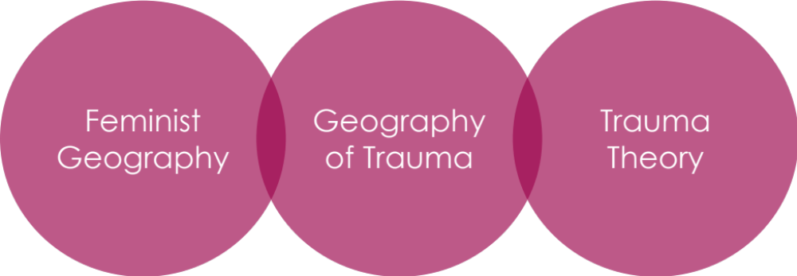
Figure 2.1. Image to illustrate the conceptual framework.

Examining how sexual assault survivors experience space and place through a feminist lens will help me better understand the participants’ social contexts as well as their reactions (Richmond et al., 2013). Additionally, feminist theory promotes person-centered practices that will highlight women survivors’ experiences while simultaneously challenging patriarchal rape-supportive beliefs. Employing a feminist lens in research analysis will guard against patriarchal constructs, such as false consciousness, the data collection and analysis processes. According to Mayo (2013), false consciousness occurs when people are blinded by a dominant ideology, such as patriarchy. Mayo (2013) explained that sometimes people are so blinded by the dominant ideology that even when they are experiencing a traumatic event themselves, such as sexual assault, they blame themselves and their gender for the violence committed against them. In other words, some women unknowingly promote pro-rape and pro-rapist beliefs, even when they have been sexually assaulted themselves, due to the dominant patriarchal discourse surrounding sexual assault, women’s sexuality, and women’s empowerment. Exploring geography through a feminist lens will help guard against these issues by centering the participants’ experiences and empowering them to construct their own meanings of their campus space.
The main limitation of utilizing literature from feminist geography to form a conceptual framework is that the majority of feminist geography looks at urban spaces. There are very few works regarding how women experience university campuses, and the research done in university spaces comes from faculty perspectives. For example, Adams-Hutcheson and Johnston (2019) wrote an article regarding academic workspaces and mentorship relationships within their geography department. A book chapter, written by Hansen (2020), detailed how disabled women academics are still a marginalized group, when it comes to the academic space. Hansen (2020) posited that while there have been some gains made, regarding physical access for disabled students, the same cannot be said for disabled academics. While both of these articles address important truths within the academy, there is a dearth of research regarding how women students experience the campus environment.
Trauma theory provides a deeper understanding of how trauma, such as sexual assault, impacts survivors’ brains. The two main works focused on in this paper, Trauma and Recovery by Judith Herman (1997) and The Body Keeps the Score by Bessel van der Kolk (2014) explained the neuroscience behind trauma as well as the behavioral effects that the brain activity causes. Herman’s (1997) work looked more at the lived experience of trauma survivors. Van der Kolk’s (2014) book examined how trauma impacts the brain, and what the brain does when a traumatic memory is triggered. The combination of these to works give a rich understanding of how environmental stimuli can impact the brain function of a trauma survivor and affect their learning experiences.
The main limitation with trauma theory is that a lot of the work surrounding the theory is approached from a deficit mindset (Gilfus, 1999). This way of understanding trauma is evident in Herman’s (1997) work more so than in van der Kolk’s (2014) book. The tone of Herman’s (1997) book does sound as if she believes that people who have suffered trauma are flawed due to the effects that trauma has on their social interactions, as well as on their lives in general. In van der Kolk’s (2014) work, he takes the approach of understanding how the brain functions when exposed to traumatic stimuli in order to explain why trauma survivors often have a certain set of reactions to triggers. Van der Kolk (2014) then discusses how he uses this information with his patients in order to help them better understand themselves and heal.

Conclusion
Adult learners bring their experiences with them into the classroom (Knowles, 1980), and those experiences can either increase or hinder learners’ academic progress. In the case of adult women sexual assault survivors who are enrolled in degree-seeking programs in higher education, their lived experiences can sometimes create barriers to learning, due to triggering stimuli that exists both inside and outside of the classroom. While the geographies of fear and trauma examine how women’s movements and opportunities are limited by fearing or experiencing traumatic life events, researchers have not examined how the construction of university spaces impacts adult women sexual assault survivors in higher education. Trauma theory helps explain how traumatic stimuli impacts trauma survivors, both from neurobiologically and behaviorally, which will lead to a better understanding of how encountering traumatic stimuli may impact many sexual assault survivors who are also adult learners within the university. Thus, the conceptual framework explained in this chapter may contribute to creating more inclusive spaces of learning for women sexual assault survivors in higher education.

Chapter 3: Methodology
Sexual assault is a pervasive problem in the United States (Department of Justice, 2019) with long-lasting consequences for the survivors. Research has shown that experiencing sexual assault prior to or during enrolling in a university has detrimental impacts on undergraduate survivors’ academic trajectories, with researchers reporting lowered grade point averages and a higher rate of attrition than their non-survivor counterparts (Jordan et al., 2014; Mengo & Black, 2015; Potter et al., 2018). However, there is a dearth in the literature regarding how sexual assault survivors experience the university space. The goal of this study was to fill that gap, and the study’s purpose was to develop an understanding of how women adult learners who are also sexual assault survivors experience the university campus. The research questions that guided this Photovoice study were:
- What types of spaces on university campuses engender feelings of safety for women adult learners who are sexual assault survivors?
- How can universities create a more inclusive learning space for women adult learners who are sexual assault survivors?

Qualitative Research Design
Qualitative research has a rich history in the social sciences, with roots in anthropology in sociology (Merriam & Tisdell, 2016). As early as the 1920s, Chicago sociologists were examining how social contexts intersect with people’s biographies (Merriam & Tisdell, 2016). The use of qualitative methods gained popularity in other parts of the world at roughly the same time. For example, in Germany and France, researchers conducted studies using what are now known as qualitative methods as early as the 1890s (Jovanović, 2011). Since then, people in a variety of fields, such as psychology, education, law, health, and social work have begun using qualitative research methods (Merriam & Tisdell, 2016). Today, qualitative research is used across the disciplines as a way to gain better understanding of humans’ experiences with a variety of topics and events (Merriam & Tisdell, 2016). Qualitative research is, indeed, a broad and diverse research practice, with a variety of methodologies for researchers to choose from (Glesne, 2016).
While qualitative research has become a multidisciplinary endeavor, there are some general characteristics that span across the various academic fields. Merriam and Tisdell (2016) explained that qualitative researchers engage in research in order to gain a better understanding of human experiences and how humans make meanings from the occurrences in their lives. Another defining characteristic of qualitative research is that the researcher is the research instrument (Cranton & Merriam, 2015; Creswell & Creswell, 2018). This means that the researcher collects the data themselves through interviewing participants, observing participants’ behaviors, and examining documents. Once the data has been collected, the researcher is the one who analyzes the data and interprets it (Cranton & Merriam, 2015; Creswell & Creswell, 2018). Cranton and Merriam (2015) explained that since the primary goal of qualitative research is to gain a deeper understanding of the human experience, the human researcher, who is adaptable and responsive, is the perfect research instrument for this task.

Epistemology
My epistemology is grounded in social constructionism. According to Crotty (1998), constructionism is the view that knowledge is constructed through human interactions between each other and the world around them. Constructionists believe that there is no absolute truth and that no interpretation of the world is completely true or valid (Crotty, 1998). Constructionists also posit that humans do not create meaning individually within their minds, but instead construct meaning from external experiences and interaction with objects that already exist within the world (Crotty, 1998). This knowledge is then developed and shared within social contexts (Crotty, 1998). For constructionists, humans ascribe meaning to the world, and those meanings vary across sociocultural contexts (Crotty, 1998). In other words, human experiences and their subsequent interpretations of those experiences are not predetermined aspects of their personalities; instead meaning is made based on cultural, social, and political contexts (O’Reilly & Kiymba, 2015). Therefore, the meanings that humans construct from their interactions with the world is not free from sociopolitical contexts. Lee (2012) explained that social constructionism “focuses on collective generation of meaning” and that “knowledge is not disinterested and apolitical” (p. 405). Lee’s belief is echoed by Crotty (1998), who states that “culture brings things into view for us and endows them with meaning and, by the same token, leads us to ignore other things” (p. 54). Thus, social constructions take a critical stance against “taken-for-granted knowledge,” which illuminates reproductions of social systems, including problematic systems, such as patriarchy, and allows for a critical lens to examine knowledge production and reproduction (O’Reilly & Kiymba, 2015).

Photovoice
Photovoice is a qualitative research methodology that was developed by Wang and Burris (1997). There are three main goals of Photovoice: “1) to enable people to record and reflect their community’s strengths and concerns, 2) to promote critical dialogue and knowledge about important issues through large and small group discussion of photographs, and 3) to reach policy makers” (p. 369). Therefore, Photovoice is a research methodology as well as a tool for social justice.
There are three main theoretical underpinnings of Photovoice: 1) Paulo Freire’s (1970) development of emancipatory education and his commitment to increasing critical consciousness, 2) feminist theory, and 3) documentary photography (Breny & McMorrow, 2021). The goals of Photovoice, along with its theoretical underpinnings, make it an excellent methodology to use with survivors of sexual violence. The way that Photovoice is designed levels out power imbalances and empowers research participants to both show and tell their stories to the researchers, their larger community, and policymakers, allowing the participants to facilitate social change (Breny & McMorrow, 2021; Wang & Burris, 1997).
Development of Photovoice. As discussed above, Photovoice’s theoretical underpinnings are obvious in the way that Photovoice projects are designed. Freire’s (1970) goal of critical consciousness took place through dialogue among his learners. Similarly, Photovoice studies ask the participants to meet and make meaning of their photos in discussion groups throughout the study. Feminist theory and research practices are apparent in Photovoice due to its goal of reducing the hierarchies and power dynamics between researcher and participant. This takes place by allowing the participants to take part in, at least, the initial stages of data analysis to ensure that their meanings are being conveyed properly through the research. Finally, documentary photography is apparent in the fact that Photovoice participants take pictures that represent their lived experiences. Each theoretical foundation is discussed in more detail below.
Freire (1970/2000; 1970/2018) utilized the concept of emancipatory pedagogy as a way to combat the culture of silence that is pervasive among many oppressed groups of people. Freire (1970/2000) explains the culture of silence as a type of disengagement with the world and the people in it, brought on by reproductions of oppressive forces throughout the educational system. Freire (1970/2018) posited that the way to free people from the oppressive constraints of the culture of silence was for educators to help them engage in critical thinking, critical dialogue, and critical reflection. In Photovoice research, the meetings held between the researcher(s) and participants, in which the participants present their photos and the meanings behind the pictures, critical thinking and critical reflection are taking place through the use of critical dialogue.
In Freire’s (1970/2018) emancipatory learning, discussion and education about oppression go hand-in-hand, acting against the oppressors in order to liberate those who are being dominated. Freire (1970/2018) argues it is the responsibility of those who are oppressed to take action to improve their own quality of life and achieve humanization, and in social justice movements, thought and action are inseparable. One way for oppressed groups to achieve this is through participating in Photovoice research and presenting community issues to stakeholders and policy makers through the use of Photovoice exhibits.
Feminist research is a branch of critical research because it examines the oppression and exploitation that women experience in their daily lives (Glesne, 2016). Additionally, the majority of feminist research utilizes qualitative research methods due to the fact that positivist and postpositive research tends to focus on objective truth, which inherently privileges masculine knowledge. However, there are some forms of feminist research that utilize quantitative methodology and mixed methods (Cokley & Awad, 2013; Krause et al., 2017; O’Reilly & Kiyimba, 2015). O’Reilly and Kiyimba (2015) explain that feminist research has three defining characteristics: 1) research should be conducted for women and not on them, 2) the use of innovative methodologies to challenge conventional ways of collecting and analyzing data are welcomed, and 3) the research should be focused on gender-based issues that are related to social justice efforts to elicit social change. Additionally, feminist research attempts to disrupt the power dynamics between researcher and researched, often utilizing participatory research methods and advocating for critical reflection throughout the research process (Glesne, 2016; Krause et al., 2017). Campbell et al. (2010) suggest providing information to participants that helps normalize their experiences, allowing the participants to know that they are not alone. This practice provides comfort to the participants. Other research practices that are prominent in feminist research include designing research that allows the researcher and the participants to co-construct knowledge and centering the participants’ experiences (Krause et al., 2017).
Documentary photography began as a way to shed light on social issues, such as the living conditions in poor urban areas or in poor rural areas. However, documentary photography lacked a participatory element, as photographers would go into communities, and people’s homes, and photograph them as they saw fit (Latz, 2017). Worth and Adair (1972) began to question how to teach people in different cultures to use video to capture their lives in their own ways. Wendy Ewald’s (1985) work with children was a turning point for documentary photography because her documentary included work produced by the subjects. The evolution of documentary photography continued, becoming more participatory, and as a result, the Photovoice method was created (Latz, 2017).
Approaches in Photovoice. When researching approaches in Photovoice, I examined literature that focused on the use of Photovoice as a method to research gender-based violence (GBV). The design of the studies varied across the literature, though the most common framework was for the researchers to organize a total of six meetings for participants to attend. The first meeting introduced the participants to the Photovoice methodology and taught them how to ethically take photos. These meetings ended with the first photograph prompt being given to participants. In the subsequent five meetings, participants were told to select a certain number of photos that they felt best represented the topic assigned to them and bring those to the meeting to discuss with the rest of the group (Ascroft, 2021; Banyard et al., 2020; Brännström et al., 2019; Moya et al., 2014; Taylor, 2020; Tomlinson & Humphreys, 2021). Other studies utilized the introductory meeting, followed by group discussion meeting(s) design, but had a different number of meetings in their study (Boyce et al., 2016; Duffy, 2015; Duffy, 2018; Ngidi, 2022; Ngidi & Moletsane, 2019; Rolbiecki et al., 2016; Solano-Ruiz et al., 2021). Only two studies (Asikin et al., 2021; Cha & Lee, 2022) deviated from the introductory meeting, followed by group discussion meeting(s) design, and these studies utilized individual interviews in lieu of or prior to a group meeting.
The research design seemed to be based largely on the culture or population being studied. For example, Cha and Lee (2022) conducted in-depth interviews with participants in a secure location in order to protect the participants’ privacy for their study on healing from sexual violence. Once the interviews were complete, the researchers asked the participants to collect two-to-five photographs, drawings, or symbols that represented their healing experiences and to write a reflection on the photograph and what it represented to them. While Cha and Lee (2022) did not state that their choice of data collection was due to the cultural norms surrounding sexual violence in South Korea, they did explain how pervasive the culture of silence is surrounding sexual assault and how it makes discussing sexual violence or seeking help after one has been assaulted extremely difficult: “women in Eastern cultures have difficulties actively seeking help for sexual violence due to the cultural value of suppression of oneself and nonverbal communication” (p. 52). The researchers go on to explain that in Asian countries, sexual violence is rarely discussed or recognized, and survivors’ healing journeys are also topics that are considered private. Due to these cultural norms, the research design that Cha and Lee (2022) chose protected their participants’ privacy and empowered them to discuss their healing journeys without fear of social repercussions. Additionally, conducting an in-depth interview first, in a secure location, allowed the researchers to build rapport with the participants and ensure that the participants felt safe speaking with them about such a sensitive topic.
Duffy (2015; 2018) also showed cultural sensitivity and awareness of their participants’ lives in their research designs. Duffy’s 2015 study sought to identify the financial goals, strengths, impactful sociocultural factors, and supports for single mother survivors of interpersonal violence (IPV) who were trying to achieve a sustainable livelihood. While Duffy (2015) did not explicitly state that they were taking the mothers’ busy schedules into account with their research design, instead of having the participants meet weekly, as many Photovoice studies do, Duffy had their participants meet once a month to discuss the photos they took. In contrast, for Duffy’s 2018 study, which sought to understand Guatemalan women’s experiences with GBV and the services available to those survivors, the researcher took a mixed qualitative methods approach that incorporated ethnographic research methods as well as a Photovoice component. Prior to beginning the Photovoice portion of the study, Duffy conducted two ethnographic interviews with a male community leader and a female social worker in order to gain a better understanding of the community in which they would be working. These two different approaches to the studies illustrate Duffy’s sensitivity to their research participants’ lives.
Two of the articles had samples that consisted of college students, and those studies were designed differently as well, perhaps to accommodate the students’ busy lives. Solano-Ruiz et al. (2021) conducted a Photovoice study as part of their Culture of Care class in the nursing program at the University of Alicante in Spain. Since this study was one assignment for the semester, it was designed very differently from the other studies in this review. The students were asked to choose a medical context that related to violence against women, write a short story about their scenario, and then act it out. While the scenario was being acted out, the students took three to four photographs of the dramatization. There were two meetings that followed the dramatization and photography session. One in which the students presented their photos, story, and reflections and discussed any changes in beliefs and values, and another in which the students and researchers identified themes from the project. This study allowed the researchers to impact future nurses’ views on violence against women in the medical field while also incorporating this project into a larger course context. The way that this study was designed also helped the students gain valuable research experience by participating in the analysis.
Another Photovoice project conducted with a higher education sample was a study conducted by Rolbiecki et al. (2016) that sought to measure the effects of participating in a Photovoice project on PTSD and posttraumatic growth. In this study, the participants were invited to an introductory session, in which Photovoice and how to ethically take pictures were explained. Next, the participants were given several photo prompts, which they had two weeks to complete, before reconvening and presenting one or two of their photos to the group. After the two meetings for the project, the participants worked together to plan exhibitions of their photographs for stakeholders within their academic community. While this study was not linked to a course, the design of the study resembles that of a class assignment, with the participants having a number of steps to complete before a specific due date. This type of design may work better for a college student’s schedule than the more common weekly meetings for six weeks.

Participant Recruitment
Like the research design, recruitment methods vary, depending on the population of the sample. In many studies that had samples from secondary and upper secondary schools, the participants were recruited from class rosters or information given to the researchers by school officials. For example, Ascroft (2021) recruited students in Barbados who were 14-17 years old from a list of adolescents who had taken a non-formal sex education course. Ngidi and Moletsane (2019) wanted to explore how orphans experienced sexual violence in and around their secondary school in South Africa; therefore, the school provided them with a list of students who were known to have lost both of their biological parents. Similar recruitment styles were utilized in higher education samples. Solano-Ruiz et al. (2021) invited students in their Culture of Care course to take part in their study, and the project was built into their course curriculum. Rolbiecki et al. (2016) used a number of recruitment techniques, including social media ads, university mass email, and contacting student sexual assault survivors who had sought help at their university’s sexual assault center. However, contacting sexual assault survivors who had sought help at the university’s sexual assault center does not seem ethically sound.
Recruitment methods for participants outside of educational settings varied a bit more, with some researchers posting ads in subway stations (Cha & Lee, 2022), at clinics and gender-based violence resource providers’ offices (Boyce et al., 2016; Duffy, 2015; Duffy, 2018; Moya et al., 2014; Taylor, 2020), in a chat app (Asikin et al., 2021), and on Craigslist (Tomlinson & Humphreys, 2021). While each researcher approached recruitment differently, based on their population, the population’s location, and the culture surrounding gender-based violence in the area they were conducting the study, each method of recruitment seemed ethical. Placing flyers and advertisements regarding research at clinics, public transit stations, and on the internet allows the participants to decide whether they want to take part in the study without any power dynamics interfering with their decision. For at-risk populations, such as survivors of gender-based violence, this method seems to be the less intrusive and coercive than directly contacting survivors who have sought services from a community resource in the past.
For this study, I recruited a total of seven participants from Ph.D.-granting institutions, including the state’s one HBCU, in one state in the southeastern US. The criteria for my sample was adult learners, who met Merriam and Brockett’s (2007) sociocultural definition of an adult, identified as women at the time of their assault, and are survivors of sexual violence. Because of the widespread recruitment effort, I utilized flyers to post at local campuses, along with emailing the flyer to department heads, relevant university offices, and relevant student organizations for distribution to their students. The flyers were posted and emailed to all of the departments within the universities. Also, I sent flyers to all of the cultural centers, women’s centers, international student centers, and LGBTQ+ centers at the universities in an effort to get a diverse sample.

Data Collection
When reviewing the literature regarding Photovoice as a research methodology for studying gender-based violence, I found that many of the researchers created data collection activities that ensured participants’ comfort and safety. For example, in their study that explored the experiences of sexual violence among orphan girls in secondary school, Ngidi and Moletsane (2019) allowed their participants to select their own groupmates for the project. Additionally, the researchers ensured that an adult accompanied each group that ventured off of school property to guarantee the students’ safety while they participated in the project. Banyard et al. (2020) also kept their participants’ comfort in mind when collecting and analyzing the data. Each Photovoice meeting that was held began with a check-in to build trust and rapport, and food was served to the participants as well to foster a sense of community among the research team, community partners, and participants.
When collecting the data, seven of the studies (Asikin et al., 2021; Banyard et al., 2020; Duffy, 2015; Duffy, 2018; Rolbiecki et al., 2016; Taylor, 2020; Tomlinson & Humphreys, 2021) employed the SHOWeD method (Wang, 1999) to facilitate discussions. With nearly half of the studies engaging in this method, it appears to be a popular way to frame discussions around the photographs. The SHOWeD method stands for the following questions: “What do you See here? What is really Happening here? How does this relate to Our lives? Why does this situation, concern, or strength exist? What can we Do about it?” (Wang, 1999, p. 188). According to Wang (1999), this sets the stage for participants to tell stories and contextualize the photos that they chose to share with the group. However, some researchers have found this method was challenging to use and that it yielded somewhat ineffective results (e.g., McIntyre, 2003; Wilson et al., 2007). Another popular method for interviewing participants about their pictures is called the PHOTO method (Graziano, 2004; Hussey, 2006). The PHOTO acronym stands for the following questions: “Describe your Picture. What is Happening in this picture? Why did you take a picture Of this? What does this Tell us about your life? How can this picture provide Opportunities for us to improve life?" (Latz, 2017, p. 84).
For this project, I utilized Rolbiecki et al.’s (2016) method of holding an introductory meeting and one follow-up meeting, due to college students’ busy schedules. For the introductory meeting with the participants, I explained Photovoice, the purpose of the project, how to take the photos, and obtained informed consent. This meeting was held via Zoom, and transcribed using Zoom’s transcription feature, in order to accommodate participants from across the state. During the initial meeting, I assigned six photograph prompts to the participants and planned to reconvene in two weeks to discuss the photographs. The prompts assigned to participants were:
- Please photograph places on campus that makes you feel safe.
- Please photograph places on campus where you like to study or prepare for class.
- Please photograph places on campus where you like to relax.
- Please photograph places on campus where you feel supported and included.
- Please photograph places on campus that show how you arrive to, and navigate, campus (i.e., parking garages, bus stops, the bus, sidewalks, crosswalks, etc.)
- Please create an image or photograph a place that you wish existed on campus (Optional).
The rationale behind choosing these particular prompts was that I wanted to ensure that participation in this study felt empowering for the participants instead of triggering. The purpose of the study was to learn how women sexual assault survivors inhabit university spaces, and I hoped that through this study policymakers, educators, and higher education staff and administrators could learn more about what types of spaces created a more welcoming and inclusive environment for women sexual assault survivors.
During the follow-up interview, I asked participants to each select one photograph that best represents the topic of the prompt and used the PHOTO (Graziano, 2004; Hussey, 2007) method to elicit discussion about the photo. Often, the questions from the PHOTO method (Graziano, 2004; Hussey, 2007) presented opportunities to ask follow-up questions, which I did as necessary, in order to get rich data for the study. I asked the participants to email the photographs to me, and I stored them on the University of Tennessee’s cloud storage to ensure confidentiality. The meetings were recorded, and field notes were be taken during the meetings. The videos of the interview were stored in the University of Tennessee’s cloud storage until the transcriptions were complete, and then they were deleted. Additionally, I asked the participants about their experience in the study. While participant experiences are not within the scope of this dissertation study and its research questions, the responses were saved in the University of Tennessee’s cloud storage, along with the transcriptions, field notes, and photos, for future research purposes. However, this dissertation will not address the participants’ experiences in the study.

Data Analysis
When analyzing the data, five of the studies (Banyard et al., 2020; Brännström et al., 2020; Duffy, 2015; Duffy, 2018; Moya et al., 2014) took a more participatory research approach and included the participants in the first round of data analysis by allowing them to generate themes or codify the data while discussing the photos. For instance, Brännström et al. (2020) utilized deductive and inductive thematic analysis when analyzing their data. During the first phase of data analysis, deductive thematic analysis was used, based on discussion prompts and the photographs. During this phase, the participants contributed greatly to the data analysis by categorizing the topics. Through the participants’ thematizing of the data, new data emerged as well, and the researchers then turned to inductive thematic analysis in order to sort through the new data and existing themes that were identified by the participants. Allowing the participants to take part in the first stage of data analysis empowers them by ensuring that their voices are heard throughout the research process.
For this study, I allowed participants to do descriptive coding and emotion coding during the meeting. According to Saldaña (2016), both practices are often used when analyzing visual data. Descriptive coding “summarizes in a word or short phrase – most often a noun – the basic topic of a passage of qualitative data” (Saldaña, 2016, p. 102). This form of coding was already performed by the participants during the meeting and laid the foundation for a rich analysis of the data. In addition to descriptive coding, I also asked follow-up questions that allowed the participants to engage in emotion coding, which “label the emotions recalled and/or experienced by the participant” (Saldaña, 2016, p. 125). Emotion coding, in conjunction with descriptive coding provided a solid foundation that holistically represented the participants’ experiences. Many of these codes served as a starting point for the emerging themes during the thematic analysis by generating the initial codes.
For my individual analysis, I utilized NVivo in order to ensure that all of my codes and quotes were properly matched, making it easier to find the necessary information in order to produce a report. I chose to use thematic analysis to analyze the transcripts from the meetings, my field notes, and the photographs. While trauma theory and feminist geography are used to contextualize and frame this study, the type of thematic analysis I used was inductive thematic analysis because I wanted to ensure that the themes generated stemmed from the data itself and that I was not imposing any theoretical constraints on the analysis process (Braun & Clarke, 2006). For this process, I followed the six steps recommended by Braun & Clarke (2006) when conducting a thematic analysis: 1) Becoming familiar with the data, 2) “generating initial codes,” 3) “searching for themes,” 4) “reviewing themes,” 5) “defining and naming themes,” and 6) “producing the report” (p. 87). To become familiar with the data, I read each transcript and all the field notes and examined all of the photos, making notes of any information that stood out. After the cursory read, I went back through and re-read each transcript and set of field notes and re-examined all of the photos to ensure that I recorded all pertinent information. Next, I grouped the initial codes that emerged during the interviews into themes and retrieved quotes that I felt were representative of each theme. After the themes were reviewed, and I felt that the research questions were answered, I went back and defined and named the themes to ensure clarity. Finally, I gathered all of the information and summarized the results and implications.

Trustworthiness
In qualitative research, trustworthiness is used to discuss the rigor of the research conducted, rather than the term, validity, which is used by quantitative researchers (Glesne, 2016). Glesne (2016) explains that “trustworthiness is about alertness to the quality and rigor of a study, about what sorts of criteria can be used to assess how well the research was carried out” (p. 53). The idea of trustworthiness stems from researchers’ concerns about how qualitative work can compare to, and compete with, quantitative studies (O’Reilly & Kiyimba, 2015). Lincoln and Guba’s (1985) work that discusses how the validity markers used in quantitative research are inappropriate for qualitative research, and thus suggested the following criteria for trustworthiness: credibility, transferability, dependability, and confirmability. In order to satisfy the criteria for trustworthiness in this study, triangulation and member checking will be used.

Triangulation
According to Glesne (2016), triangulation is “using multiple data-collection methods, multiple sources, multiple investigators, and/or multiple theoretical perspectives” (p. 53). Triangulation is an important component for assessing the trustworthiness of a study because researchers may interpret things incorrectly or may not be aware of the complexity of a situation if they are only using one source of data or one perspective (Gibbs, 2007). For example, taking field notes about participants’ body language while interviewing them paints a much richer picture of the social complexities of the topic being discussed (Gibbs, 2007; Glesne, 2016). Therefore, analyzing multiple data sources is imperative to accurate interpretation of the data. In the study, I analyzed interview transcripts, photos, and field notes to ensure that my interpretations were as accurate as possible. In some instances, I also found literature to support the themes that were generated throughout the analysis process.

Member Checking
Member checking is when the researcher shares interview transcripts, analytical memos, and sometimes drafts of the final report with the research participants to obtain their feedback on the interpretations made by the researcher (Glesne, 2016). Van den Hoonaard and van den Hoonaard (2013) recommend that instead of sending transcripts to the participants, giving them the impression that much of what they say will be in the final report, to send participants sections of the draft of the report that use their quotes, asking if you interpreted them correctly and if they have any suggestions regarding the report. Since Photovoice is a form of participatory action research, this is the approach I took with my participants.
Once a draft of the report was written, I sent it to the participants using a non-university email to ensure the participants remained anonymous. During this time, I asked the participants to read over the report and ensure that their discussions were interpreted correctly. I corrected any errors that the participants discovered and took their suggestions regarding the report into account before producing my official findings. This ensured that the final report represents the participants’ voices, thoughts, and discussions as accurately as possible.

Subjectivity Statement
As previously discussed, the human researcher is the primary instrument in qualitative research, and as Merriam and Tisdell (2016) noted, humans have biases, or subjectivities, that could affect their studies. According to Glesne (2016), subjectivities are “the researcher’s personal selves created historically” (p. 146), and they are an important part of the interpretive work required during qualitative research. Therefore, instead of trying to eliminate the subjectivities, it is important for the qualitative researcher to identify and monitor them throughout the course of their research (Glesne, 2016; Merriam & Tisdell, 2016). This will ensure that the researcher is aware of why they ask certain questions or why they may interpret an interaction a certain way and can correct for that as needed (Glesne, 2016).
In light of the importance of transparency and my understanding of subjectivity, I now offer my own subjectivity statement in connection with my study and research topic. Reflecting my lived experiences that led me to this research topic, I will be approaching this study from both an emic, or insider, perspective, and an etic, or outsider perspective. I am an insider because I, too, am a survivor of sexual assault who is currently enrolled in a PhD program at a public university. However, I am also an outsider because of the role of researcher that I am adopting for this study. I have been and will continue to critically reflect and examine on what effects my positionality as a sexual assault survivor has on my study to ensure that this study tells the story of the participants, instead of my own story.
In addition to being a sexual assault survivor, I am a single, 40-year-old white woman who was born and raised in Knoxville, Tennessee. I was raised by both parents in a middle class household and attended public school. My parents divorced once I moved to Chicago, Illinois, to chase my dream of being a singer and musician. Thanks to my love of music, I have gotten to experience life in several different states, including Tennessee, California, North Carolina, and Illinois. Not only have I lived in various regions of the U. S., but I have traveled abroad to Canada, as well as several countries in Europe. My goal is for these travels, which helped globalize and diversify my worldview, to positively impact my research through the adaptability and open-mindedness that I learned while traveling and living in various regions.
I am a first-generation college student, and I started my educational career as a non-traditional student, at the age of 27. I began my studies as an English major at a community college in a suburb of Chicago, Illinois. I transferred to the University of North Carolina – Chapel Hill to complete my undergraduate studies and switched my major from English to indigenous studies. Learning from the diverse and world-renowned scholars in the field of indigenous studies was a transformative experience for me that taught me how to critically examine systemic oppression and the reproduction of harmful social and political systems. This experience has prepared me to conduct research regarding social justice issues, such as sexual assault survivorship in higher education.

Conclusion
In this chapter, I began with an overview of qualitative research, followed by my research epistemology. Next, Photovoice, its history, and its theoretical underpinnings were explained. After providing an overview of Photovoice, I discussed the various approaches used in the methodology before explaining my research design for the study. This chapter closed with my subjectivity statement in order to provide transparency and improve trustworthiness in the study.

Chapter 4: Findings

Introduction
In this chapter, I describe the findings of the study, beginning with the demographics and general information about each participant. Next, I discuss the themes and subthemes that emerged through the data collection and analysis processes. The analysis produced three main themes as well as various subthemes. The study’s purpose was to develop an understanding of how women adult learners who are also sexual assault survivors experience the university campus. The research questions that guided this inquiry were:
- What types of spaces on university campuses engender feelings of safety for women adult learners who are sexual assault survivors?
- How can universities create a more inclusive learning space for women adult learners who are sexual assault survivors?

Demographics and General Information
This study had 17 respondents, and 13 of them passed the screening. Eight participants attended the introductory meeting, and seven participants completed the study. The participants’ ages ranged from 21 to 35 years old. The participants came from four universities across a state in the southeastern US and were undergraduate seniors, master’s students, or doctoral students. When asked at what time of the day they preferred to take classes, the responses varied, and were based more on their schedules and competing responsibilities than on their experience as a survivor of sexual violence. All of the participants self-identified as sexual assault survivors, with the number of assaults they experienced ranging from one to 60 across the course of their lifetimes. Six out of seven participants were sexually assaulted for the first time prior to enrollment into a university program, and only two participants experienced a sexual assault on their university campus. Several of the participants had been diagnosed with PTSD and also suffered from other physical and mental health issues related to their trauma. Six of the seven participants identified as women, and one participant identified as non-binary; however, all participants identified as women at the time of their assault(s). Three participants identified as bisexual, and four participants identified as heterosexual. Six out of seven participants identified as White, and one identified as Asian. All participants lived in off campus housing at the time of the study.
Each participant had a desire to share their experience in order to help raise awareness regarding sexual violence and to inform policies regarding creating inclusive university spaces for sexual assault survivors. They all shared the sentiment that participating in the study made them feel like they were doing a small part to help others like them, and that is what inspired them to join the study. While some participants became emotional during the sharing of their stories, they all said that none of the photograph prompts or interview questions were triggering for them. All of the participants stated that they were glad that they participated in the study and that they learned more about themselves by taking the photographs and discussing them with me.

Participants
Pseudonyms were used in this study to protect participant confidentiality. The names chosen are based on favorite book characters. I specifically chose names that correlated with strong and resilient characters to underscore the strength and resiliency of those who participated in the study. In this section, I am introducing the participants and talking about some of their experiences to help familiarize the readers with the participants’ lived experiences, what different stages of the healing journey looked like for these participants, and how the participants approached the study.
Pseudonym | Age | Gender Identity | Sexual Orientation | Race/ Ethnicity | Degree Level | Years Enrolled | # of Assaults
Clarissa | 26 | Woman | Bisexual | White | Graduate | 1 year | 1
Elena | 22 | Woman | Heterosexual | White | Undergraduate | 4 years | 10
Wendy | 30 | Woman | Bisexual | White | Graduate | 8 years | 3
Eden | 22 | Woman | Heterosexual | White | Undergraduate | 3.5 years | 5
Taylor | 27 | Non-Binary | Bisexual | White | Graduate | 1.5 years | 5-8
Lennie | 35 | Woman | Heterosexual | White | Graduate | 8 years | 50-60
Jennifer | 28 | Woman | Heterosexual | Asian | Graduate | 4 years | 2
Figure 4.1. Table of participants’ demographics.

Clarissa
Clarissa was very aware of social context and the current sociopolitical discourse. She approached the interview in a friendly and open manner, and she was happy to share her experiences with me. Clarissa has a somewhat extroverted personality, and she enlisted the help a friend during this project. In order to obtain the photos she needed for the study, she explained the research project to one of her friends, and they took a walking tour of the campus. Clarissa explained that she and her friend have shared several classes together and spent a lot of time together between classes. They walked in a loop, recalling where they spent the most time. Once they decided on the places they tended to frequent the most, they discussed the different images, and Clarissa then decided which areas to photograph.
Clarissa really values inclusivity and made several statements about how many spaces in higher education are dominated by white men, which often makes survivors of sexual assault, such as herself, uncomfortable. She used this study as an opportunity to show both the good and the bad regarding how she experiences her university space in hopes of eliciting some change regarding the uncomfortable areas of campus that she shared. Clarissa believes that the project was not difficult for her because she is at a point in her healing process where she can face what has happened to her. She explained that if she had seen the recruitment flyers for the project a few years ago, then she would not have volunteered to participate in the study. However, Clarissa said that she enjoyed being a part of the study, and that she is now more aware of the spaces she enters and spends time in and is better able to assess what the spaces offer her.

Elena
Elena spoke quietly during our interview and gave shorter answers than many of the other participants. For Elena, campus was a very difficult place to be, and she had a hard time identifying spaces where she felt safe or included. Elena appeared to be very introverted, and she spent the majority of her time alone. Elena relied on her cats for emotional support and commented that she preferred to be at home as much as possible because that is where her cats are. She seemed to feel like an outsider in her own campus, which was apparent when she was speaking about her campus. Elena consistently referred to the campus as “their campus,” instead of “our campus” or “my campus,” which indicates that she did not feel that she was a part of the campus community. Elena became emotional during various parts of the interview, mainly when she discussed how she felt like she was very different from the other students or when she talked about her isolation from the campus community. She stated a desire to reconnect with her friends and to become more connected with people that she knew.
Elena said that she was excited to participate in the study and was happy that she was able to make a difference for other survivors of sexual violence. Elena explained that she had a difficult time with this project because it is hard to admit to being a survivor of sexual violence, and she also had a hard time figuring out which spaces to photograph. She shared that this project helped her reflect on why she was struggling currently and decide what changes she wanted to make to improve her quality of life. Elena said that while the project was challenging for her, she did enjoy being a part of it.

Wendy
Wendy was very literal and direct in her photography and during the interview. She was friendly and fairly open when answering interview questions, even though she seemed to have a more introverted personality. Wendy approached the photography portion of the study similarly to Clarissa. She took a walk around campus and identified the spaces where she felt most comfortable and included. Unlike Clarissa, Wendy did not enlist the help of a friend for the study and chose to take the photographs alone.
Wendy was very much a problem solver, and she seemed to approach most things in her life in that way. She was naturally curious, and one of the ways that she coped with her sexual assault was to learn new skills and new information in order to better protect herself. While Wendy was in the middle of writing her own dissertation, she still made time to participate in this study so that her voice could be heard and hopefully make an impact in campus policies in the future. Wendy said that she did not find it difficult to participate in the study, and that she enjoyed being a part of the project. She explained that her participation in the study encouraged her to think about things that she had a tendency to ignore. Wendy felt that participating in the study gave her more self-awareness.

Eden
Eden identified herself as an introvert and explained that she is not a very outgoing person. However, she was friendly and open throughout the interview process. Eden chose spaces that made her feel secure, included, and safe. Her choices of location were based the feelings the spaces elicited and convenience to her classes. Eden really valued comfort and home-like environments. She did not like cold and impersonal spaces. While she preferred solitude some of the time, she also enjoyed some spaces that had other people in them and seemed to like spending time with friends.
Eden said that she found the study interesting and that she gained insight on why she chose to frequent certain spaces. When deciding on what photographs to take, Eden spent several days walking around campus, doing her normal routine, and really paying attention to the spaces that she visited. After she identified the spaces, she took another few days and spent more time in those areas to gain a deeper understanding of how each place made her feel. Once she did that, she decided on the areas to focus on and took her photographs. Eden said that she enjoyed being a part of the study and that talking about her images was fun.

Taylor
Taylor, like Clarissa, was very aware of social context and power dynamics. They were very outgoing and open during our interview, and they seemed to have an extroverted personality. Several times when they were talking, Taylor discussed various connections and friendships that they had made across their campus during their time spent there. It was obvious that they valued the connections that they had made and that the people in her life meant a lot to them. During the interview, Taylor discussed their assault, the aftermath of the assault, and shared other personal experiences that helped provide context for their life. They talked about how those responsible for their assault stalked them after the fact and how they feared for their life during that time. Taylor explained that they had been through trauma therapy and that it had helped them tremendously.
When deciding which photos to take for the study, Taylor engaged in self-reflection and thought about the spaces they frequent. They said that the availability of the places she photographed also played into their decision regarding which pictures to take. Taylor was surprised to find out that they felt safe in more spaces than they realized, and they said that they found the project interesting and were able to see how they had grown and moved beyond some of the issues regarding the assault while other issues were still a problem for them. Taylor said that they found the project challenging in some ways because they had a hard time deciding what to focus on for some of the prompts, but that they did not find it distressing or emotionally difficult. Taylor enjoyed being a part of the project and that it helped them realize that the people in their life care about them and want them to feel supported and included.

Lennie
Lennie, much like Wendy, was very literal and to the point in her interview. She was open and friendly and shared many of her lived experiences with me. Her answers were very detailed, which helped me gain a better understanding of her lived experiences. Lennie seemed to be a bit of an extrovert, and her family was the most important thing to her. Lennie explained how her childhood experiences with sexual abuse impacted how she viewed the world today. She also discussed on the experiences she missed out on growing up because of the abuse. Lennie shared that she had been through trauma therapy, and that it had helped her immensely, and she was working on several projects to try and make her university more inclusive to adult learners who are also parents.
Lennie said that being in the study was not difficult for her and credited her time spent in therapy for that. She stated that if she had attempted to participate in this study several years ago, then it would have been extremely hard for her. Lennie said that she enjoyed being in the study because it gave her a platform to discuss important parts of her life that are difficult to bring up in day-to-day conversations. Lennie shared that she did have a hard time deciding what to photograph because she always feels very rushed and stressed when she is on campus, but she said that it was easy for her to talk about her images.

Jennifer
Jennifer was very friendly and outgoing in the interview, and she came across as an extroverted person. She enjoyed being around people and interacting with her friends. As an international student, Jennifer shared that she had a difficult time finding a sense of belonging, but she finally made friends and felt like she was a part of the university community. Unlike the other participants who valued more private spaces, Jennifer preferred to be surrounded by people. She really liked that she got to take photos as a part of the project, and she enjoyed being able to share her ideas and experiences through pictures as well as through the interview.
When deciding the places to photograph, Jennifer thought about the spaces she liked to frequent and then did a walking tour of the campus, like some of the other participants, and took the photos. She was very careful with the spaces she selected because she wanted it to authentically represent her lived experiences. Jennifer said that talking about the images was easy, and that she found the entire project uplifting because of the prompts, which focused more on the positive aspects of her campus life instead of the negative aspects. Jennifer said that she felt that participating in this study enhanced her well-being.

Themes
The themes that emerged during data analysis were consistent from participant to participant. While the participants attended universities across a state in the southeastern US and came from diverse backgrounds, they had similar ways of interacting with and navigating the spaces at their universities. However, there were some anomalies in their motivations for choosing certain spaces as well as how they felt about the spaces themselves. The three main themes identified during data analysis were: 1) safety, 2) community, and 3) wellbeing. Safety was the most prominent theme throughout the study, followed by community, and wellbeing. These themes, as well as their subthemes will be discussed in greater detail in this section. The chart below illustrates the frequency in which codes under each theme appeared across the seven participants’ photographs and interviews. Codes for safety appeared 107 times, codes for community appeared 50 times, and codes for wellbeing appeared 47 times.

Figure 4.2. Chart of the themes.

Safety
For this study, safety refers to the ways that the participants utilized and altered the spaces they frequented in order to make them safer, their concerns about safety, the acts they took to ensure safety on their campuses and in their lives, places they avoided in order to maintain a feeling of safety, and existing and absent campus resource that impact their feelings
of safety. The theme of safety permeated the interviews, as well as the photographs, and three subthemes emerged during the analysis: 1) environment, 2) isolation, and 3) campus resources. While safety was a main concern for all of the participants, and the majority of the participants had similar ideas regarding what made them feel safe, one participant had vastly different views about what made her feel safe. In this section, I explain the three different subthemes that emerged during data analysis and offer examples from the data to foster a deeper understanding of how the participants negotiated the topic of safety within their own lives. The chart below shows how prominent each subtheme was in the study.
Environment. The subtheme environment refers to how the participants engaged with their environment in order to feel safe. It also illustrates that the participants of this study rarely enter a space without thinking about what the space has to offer them in terms of safety. Each participant expressed that they think about how safe a space is, and what dangers it may
represent, before deciding whether to frequent that place. While some of the participants had little choice regarding if they were able to avoid unsafe areas, when they were faced with being in an unsafe area, they chose to vacate the space as soon as possible and move to a place that they deemed safer. Various things contributed to the participants’ feelings of safety in different environments, including the lighting in the environment, whether they could have privacy, and if the space within a certain environment was where their assault occurred.

Figure 4.3. Chart of the subthemes.

Whether participants felt safe in specific environments, how they reacted to feeling as if they were in unsafe environments, and what contributed to their feelings of safety, or lack thereof, in different environments were also covered in this subtheme. Since environment is a broad subtheme, I have chosen to explain the main ideas expressed by the participants regarding safety and their environment. These concepts include participants controlling or altering their environment in order to create a feeling of safety; the need for private spaces within the university environment; and avoidance of certain spaces.

Controlling the Environment. When explaining how different spaces made them feel, participants expressed that they preferred being in an environment that is somewhat controlled by the university, that they controlled, or that they had altered to meet their own safety needs. Sexual assault, like many other forms of trauma, often make survivors feel as if they had no control over their lives or what happened to them when they were assaulted, and these feelings reassert themselves at different times and for different reasons, leading to partial or full dissociation (Herman, 1997; Ritchie, 2018; van der Kolk, 2014). Therefore, it stands to reason that having the ability to create a safe environment for oneself within a university setting would lead to feelings of empowerment and allow for all of the learner to be present when engaging in academic activities, such as studying.
Lennie was aware that she was unable to study if she felt as if others were taking an interest in her or her activities. In fact, she rearranged her entire office to ensure that she and her colleagues who shared the office with her, could study and work without anyone being able to view them from the window in the door. Lennie explained how hard she worked to achieve a safe space to study and work in after being assigned an office:
When [the room] was pre-arranged, these desks were lined up like this [against the left
wall, right in front of the door], almost like cubicles in front of this window [in the door]. Notice that the window is covered. I covered it. It’s not fully covered, like you could be able to see if someone is in here with the lights or motion, or whatever. But you can’t just stand there gawking all day. This is a locked door. Here’s a place where I could hang a coat. And I stood here, like right here is where my feet are, when trying to figure out, where can we sit that’s not going to have people looking at us, to study without worrying about it? And I drew this like imaginary line in my head *draws a diagonal line from the door to the left side of the desk* (the desk is completely hidden from the door). So, if somebody was standing there looking in, their perspective line could go to here. And so, everything from here over, you notice on this side of the imaginary line you would see that on this space there’s just empty tables, so it would look like no one is here. And that’s so that, like part of my brain… if I want to use all of my brain to study. None of my brain can be spent with people looking at me.
It is clear that Lennie expended large amounts of mental and physical energy to ensure that her study and workspace felt safe to her so that she could focus on the work that she needed to do. However, Lennie did not simply think of herself and her own safety when rearranging the office, she also thought of her colleagues who share the office with her. Lennie’s use of “we” and “us” indicate that she wanted to create a space where all of them could feel safe and could work to the best of their ability. Lennie’s experience highlights the need for customizable spaces on university campuses to increase feelings of safety for sexual assault survivors. Her self-awareness regarding her ability to focus in different situations also exemplifies the importance of safe spaces on campus, as well as safe learning environments, to ensure that survivors of sexual violence can more easily achieve their academic goals.

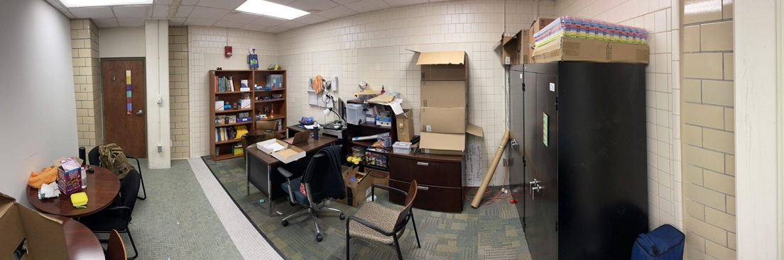
Figure 4.4. Lennie’s office.

In addition to altering the environment to make it feel safer, having control within their environments made some participants feel safer. When Taylor shared their photo from the prompt to take a picture of a place where they felt safe, they shared a photo of their college classroom, where they taught an entry-level undergraduate course. When explaining why they chose this picture to represent a space where they felt safe, Taylor said,
I guess I feel like this is a good picture for… like representative of a place that I feel safe because it is a space where I feel like I really get to control what is going on in the room, and like, no matter how tricky or weird things get with my students, there's no question of I’m the one in power there.
After experiencing a situation in which they felt completely powerless, being able to manage their own classroom provided Taylor with a sense of security. They went on to explain,
I was assaulted my freshman year, and a lot of these students, most of my students are freshmen, and it feels like a kind of way for me to provide the sort of space that I wanted provided for me during that time.
Like Lennie, Taylor was also concerned with providing others with a sense of safety. Taylor’s hope that they are providing the type of space they wish had been available to them when they were reeling after their sexual assault shows that they want to help others, who may be in similar situations to what they experienced during their freshman year, persevere through difficult times. Their comments suggest that both Lennie and Taylor have a deep understanding of how important feeling safe is to academic success, and how hard achieving feelings of safety can be after experiencing a traumatic event, such as sexual assault, so when presented with the opportunity, they chose to create safe spaces for themselves as well as those around them.

Private Spaces. When discussing areas that made them feel safe, the majority of the participants expressed that they felt safest in private spaces. The desire for small, private spaces that had lockable doors was expressed by multiple participants throughout the interviews. When Eden was asked to take a photograph of a place that made her feel safe, she opted to take a picture of an empty restroom that she frequented between classes. When asked about why she chose to take the photo of the restroom, Eden explained,
I go here pretty much every time I’m about to go into the class that starts right after this, because I have a class right before that's in [one building], and then I have to walk across campus to get to [the building my next class is in], but by the time I get there it's still like 20 minutes before it class starts, so I have a lot of time to kill. I'd rather spend some of it in this quiet bathroom by myself than in a class with a bunch of other people.
Eden indicated later in the interview that for her, the campus feels more comfortable and inviting when she is able to feel as if she has her own, personal space. She summed up the sentiment simply by stating, “it’s all about the private spaces.”
Other participants shared Eden’s preference for quiet, private spaces with lockable doors. Wendy’s photograph for a place where she felt safe was not on campus, but instead in her own home. When asked about how the photo of her bedroom could help campus faculty, staff, and policy makers better understand how to improve life on campus for survivors of sexual assault, she replied, “In general, providing a space that can be not necessarily just theirs, but for a time, anyway, just theirs… like with the door with a lock. Not unlockable, I guess. That can be made private, I suppose.” Lennie shared a similar preference for locked doors when she said, “It's messy, and I'm okay with a messy room. I don't need to have a super clean room, but I do appreciate that I feel safe with this locked door.”
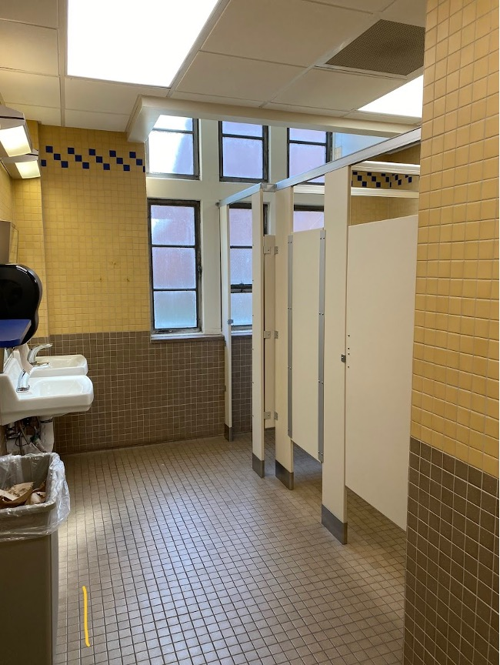
Figure 4.5. Where Eden spends time between classes.

Another reason that participants preferred private spaces was in case they become overwhelmed and need to escape a situation in order to process their emotions. Elena shared her experience with becoming overwhelmed in a campus building and needing to escape to a less populated area:
I get overwhelmed very easily in the [campus building], because that's where everything like, you know, took place and stuff, and so I was like mentally kind of like, you know, screw this I can't do this. I'm going to go outside.
Elena explained that she preferred the spot outside because it gives her privacy and that campuses need to “make more places where somebody can go by themselves, and like, if they need to cry, or if they need to laugh. I like it over there because nobody comes to bother me if I’m not okay.”
While the majority of the participants preferred private spaces to public ones, Jennifer disclosed that she feels safer in a public space, as long as university personnel is present and the places are mainly frequented by university students. Jennifer explained her reasoning for preferring public spaces:
In a public place, normally, I think sexual assault won't occur or won't happen in public place where others are witnessing. And also, I feel you have some authority figures, like those people who work there, who have the responsibility as the school official, as the authority figure, you can turn to for help.
Jennifer shared during the interview that her experience with sexual assault did not occur on a university campus, and therefore she believed that the university space felt safer to her than it would to those who experienced sexual violence on a university campus.

Avoidance of Certain Spaces. Many of the participants in this study mentioned avoiding certain areas due to the spaces feeling uncomfortable to them. For example, Elena avoided the building in which her assault occurred as much as possible, even though the majority of her classes were there because of her major. She elaborated on her situation when discussing that all of the places she used to frequent had been tainted by her assault:
I would have posted a picture of, like the room where we all practice in. But like the old professor, that's who I got Title IX’d, so that just like… it's like everywhere that normally would have been my, you know, good spot. It's just like tainted by it. It's been a journey.
Understandably, the conditions surrounding Elena’s assault made her want to avoid the building as much as possible. However, she did not change majors after the assault, and was looking forward to graduation.
Along with spaces where their assault occurred or spaces that reminded them of their assault, the participants all tried to avoid dark, isolated areas, such as parking garages that are not well-lit.
When discussing the parking garage shown in the photograph, Clarissa said,
I took a picture of this honestly to highlight how depressing this parking garage is. It's not the average of what most of our parking spaces are, but it is a standout one that's for sure, because it is really dark. It is well lit, as far as in terms of safety, but it's still just like kind of eerie in general, like I’m, you know, holding my… I don't want to say, holding my breath. That's a bit too dramatic, but I’m like clenching my butt cheeks a little bit when I’m walking through, you know, it's not a very like welcoming space. I just... I don't know. It kind of sticks out to me in that way. It just makes me think of the Cold War. There, there's no natural light, and it's scary and dark. It like looks damp. It’s not, but it looks like it.
Clarissa went on to explain that the parking garage felt “claustrophobic” and had no other safety features and that the closest emergency call box was across the street from the parking garage, so it was virtually useless for those who used the garage. Wendy also expressed her anxiety surrounding parking garages:
Parking garages always feel, even if you're not claustrophobic, they always have that claustrophobic like, you know there are 3 flights of cars above you, and it would just take one teeny, little earthquake in California to bring them all on top of your head.
For participants in this study, parking garages seemed to elicit feelings of anxiety and claustrophobia.
In addition to avoiding certain spaces due to reminders of their assault or feelings of anxiety, some participants also avoided certain areas within the spaces they frequented due to the feelings associated with different areas. For instance, Clarissa enjoyed studying in the library, but she purposefully avoided the area within the library where portraits of older white men were hanging. When discussing the photos, Clarissa explained,
I hate that they are all old white men. It drives me nuts. That is part of the reason I did take this picture because it does have a bit of an eerie feel that they are kind of like looming over your head. And I don't love that in this space. But I do usually study specifically in this corner [zooms in and shows a corner of the library that is out of the white men’s “gaze”], which is further down this area. So, I don't look at them very often.
Even though Clarissa enjoyed the library study space, she could not utilize the entire room due to the portraits making her uncomfortable.
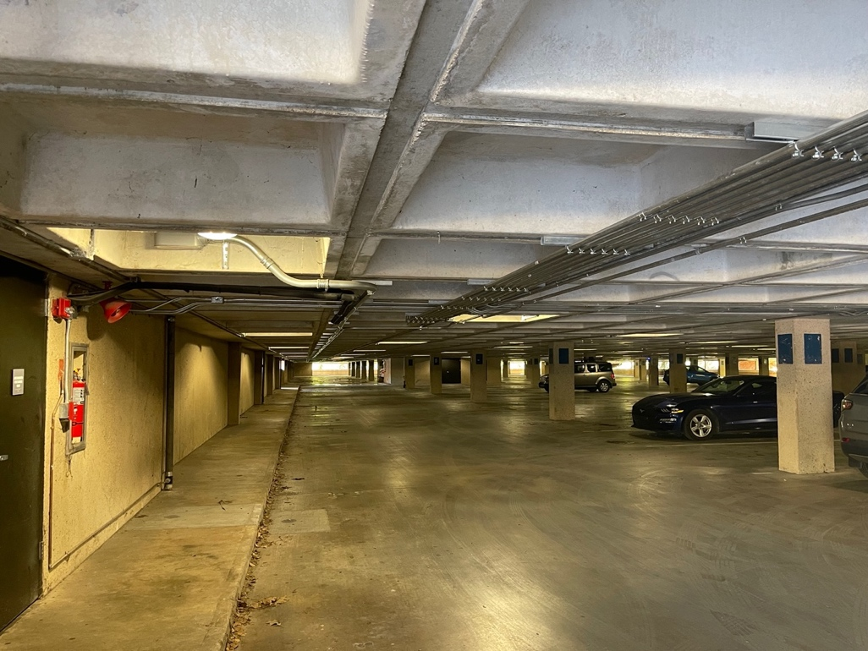
Figure 4.6. Parking garage on Clarissa’s campus.

Isolation. For this study, isolation refers to participants choosing secluded environments in an effort to protect themselves, emotionally and/or physically. Elena and Lennie explained that once an individual has been sexually assaulted, it is difficult to trust people again. Therefore, the majority of the participants in this study chose isolation as a way to stay safe. When asked about why she has a tendency to isolate herself, Elena said, “I guess part of me feels like I act weird and different now. Like I'm not completely mentally stable, you know, and people think I’m weird for that. And you know I just don't really trust people that much.” In Elena’s case, she isolated herself in order to protect herself against possible judgment and ridicule from her peers because she felt that she was a different person after her assault.
Some participants discussed how difficult it was for them to study in crowded places, or on campus at all, because of their feelings of hypervigilance, so they chose to either study in areas on campus where they could feel alone or at home. Clarissa explained,
So, part of the reason I love this area is because it is pretty quiet, and I can be by myself. I really, when I’m studying, I don't want to have to worry about people around me, because I am like a kind of jumpy person, and so I don't know if jumpy is the right word, but like anxious like, I am a little on edge, and it just makes it a lot easier to breathe in a semi-empty space like this. And I can like, actually study. And I don't have to worry about anything else.
Others could not study on campus due to their anxiety being so high when others were around. Elena, who experiences panic attacks in the building where most of her classes are held due to her assault occurring there, shared how her anxiety made her unable to study on campus: “I can't get myself to calm down and focus on schoolwork, and I can't sit there and just work because I’m like. Oh, what if, what if, what if you know?”
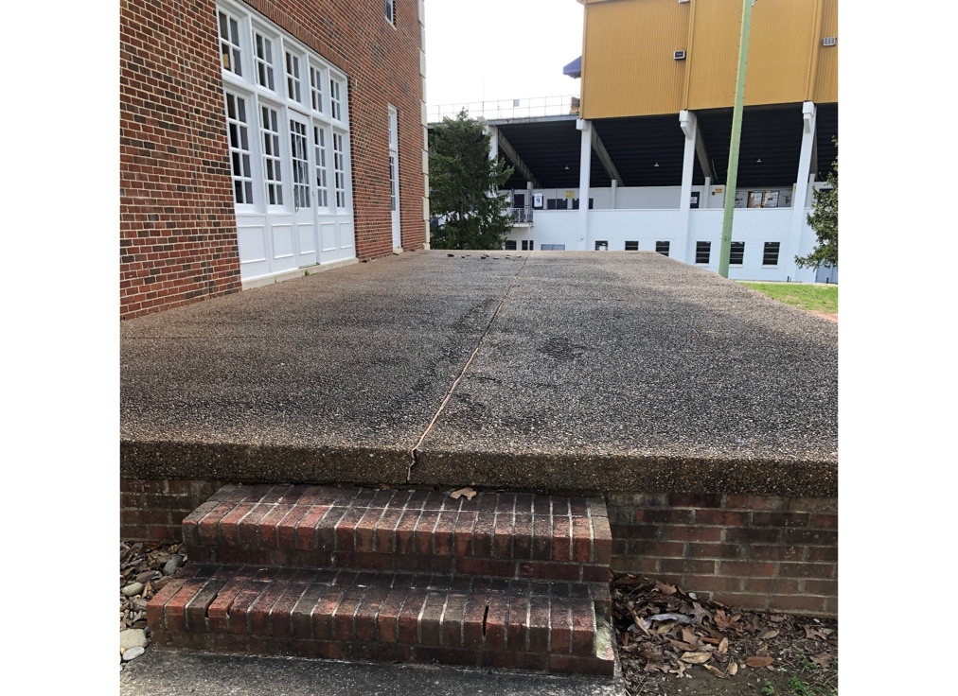
Figure 4.7. Area outside where Elena escapes to when having panic attacks.

Other participants did not necessarily state why they chose to isolate themselves. For example, Wendy simply stated, “I prefer solitude.” Eden shared a similar observation about herself by saying, “I am not a very socially outgoing person.” Lennie, however, explained that while she would enjoy working with others, it takes a lot of mental capacity for her to be able to engage in group work:
It's easy for me to isolate myself. So, if I were here working, and I was the only one in the
room, I could have classmates walking by, and there could be opportunity to interact, and they would never know that I’m in here. I would never know that they're out there. So, it's very easy for me to isolate, and especially considering I know that optimal performance. I can't feel like… optimal brain performance… I can't feel like I’m in front of other people performing anything. So, it shows that, I want to collaborate with other people, but it takes capacity. It takes capacity to work with others.
These statements show that while some of the participants may have a desire to interact more with their peers, it is difficult for them to do so due to a variety of reasons. In essence, most of them seemed to feel safer when they were alone.
Campus Resources. The topic of campus resources refers to resources that the participants are glad that their university had, resources that they wish the university had, or resources that they wish the university had more of. There were a wide range of resources that the participants discussed, and all of them tied back to safety. For instance, after her assault, Wendy enrolled in several different martial arts classes in order to be able to better protect herself in the future. She explained:
I guess I don't like being scared; of course, nobody likes being scared. But I didn't like it, of course, and I tend to freeze when… or I used to tend to freeze when I’m scared, and that's not particularly helpful. So, a few years ago I started taking a bunch of different martial arts, classes, and I don't really have time for that anymore, of course, but on the main campus, which is 15ish minutes away does have, like the bag area… the heavy bag area. And it's helpful when I wouldn't say when I’m scared, but I guess when I’m nervous it's helpful to beat something up, and obviously it's preferred to be a bag, not a person, of course. But yeah, I find it not quite cathartic, but similar.
Wendy was glad that her campus had a heavy punching bag so that she could continue to work out and practice her martial arts; however, the campus only had one punching bag. Wendy attended a larger campus, so with only one punching bag, it sometimes became difficult to have access to the bag when she needed it. Wendy detailed the situation:
[My university] has, I believe. 10,000 to 15,000 students at any given semester, and there's one bag. We kind of have to… there's a couple of other people who I always see on there. We just take our turns, sometimes schedule with each other, like, “yeah, I have a test coming up. Can I use this for 45 min that day?” “Yeah, that works out.” One bag seems a little short, but hey, I'm biased towards it, so…
Wendy went on to explain that her university used to have four punching bags, but as they wore out, they simply were never replaced.
In addition to a shortage of gym equipment, many participants expressed dismay over the lack of lighting in certain areas of the campus. Elena said that she would feel safer on campus if they would put “lights into the parking lot. Their parking lots don't have any lights.” Eden voiced a similar sentiment when she explained that she felt safe walking on campus during the day, but she was uncomfortable walking in certain parts of the campus at night due to bad lighting: “Streetlights go out, and… I don't know that quarter of [area on campus] that [campus building is] on almost never has good streetlights on it, but I haven’t had a night exam in a little over year now.” She went on to discuss that sometimes she had to attend night exams, and the lighting conditions made her feel unsafe:
I think more lighting always makes me feel safe. I hate being in the dark. I love natural lighting, obviously, from the other pictures, but you know sometimes you just have to be on campus in the dark, and that's… fine *voice shakes a little*… I guess. But more streetlights would make it feel a lot better for sure.
It stands to reason that attending a final exam when already anxious from feeling unsafe on their commute to campus would make the exam more difficult.
In addition to lighting, the majority of the participants were also acutely aware of the emergency call boxes located on their campuses. While the participants had different views of the call boxes, most of them did take notice of the call boxes locations. Elena mentioned that her campus only has two emergency call boxes that she knows of, while Wendy expressed that she appreciated having an emergency call box where she parks:
Right here where my mouse is pointing... They're these little red towers with a little blue light on them that’s always glowing. It's hard to tell in the daylight, but it's there. That is like an emergency button. So, it's… I think it was put in place for, like if you got a flat tire your car won't start, or something like that. But I know for a fact that women in my undergrad would use these as well like, “hey, there's some creepy dude here, and he's standing right next to my car, so I’m going to push this, and just you know, hang out till somebody comes to help,” and that goes directly to the campus security… I don't know if all campuses have that. But they should.
Clearly Wendy felt that the call boxes were important to campus security.
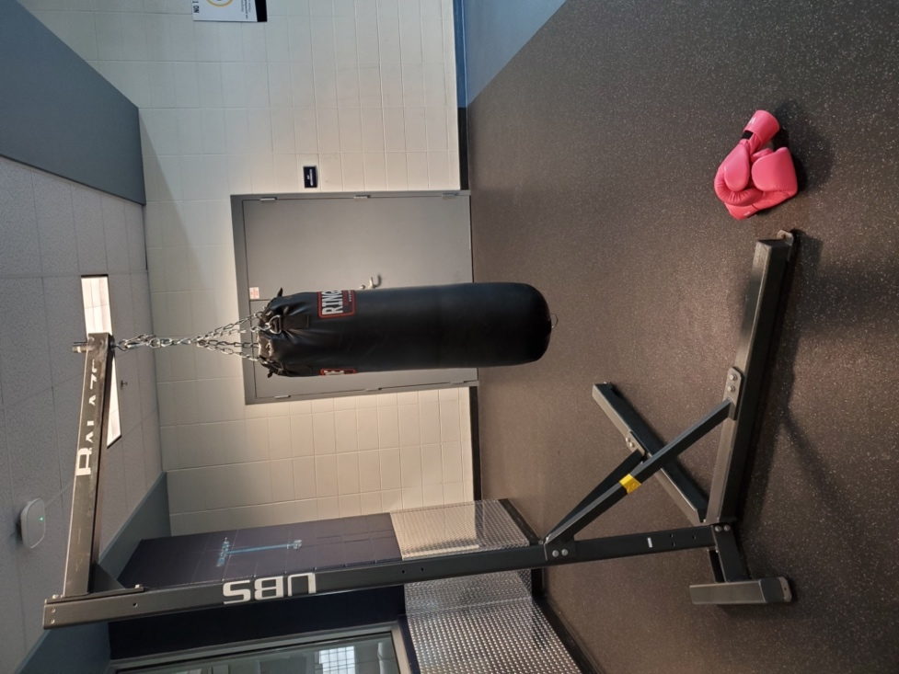
Figure 4.8. The one punching bag on Wendy’s campus.

Lennie, on the other hand, did not think that the emergency call boxes were very useful. She discussed how she thought other safety features on campus were more effective:
There's a blue light back behind me for like emergencies, and I think those are hilariously ironic. If I were to ever be attacked, not that I feel like I would be attacked on campus. I actually don't have a fear of that. But I kind of joke at those lights. What the hell are those stationary lights going to do? Nobody’s going to be standing right next to it when they get attacked. I do really like the Angel, or whatever it's called, that app that you can walk and have somebody else watch you walk. I think it is a better resource than the stationary lights, but it's important to note that the sexual assault that I experienced was not related to a university at all. So, my experiences are not all experiences.
For Lennie, an app that she could activate ahead of time so that someone would know the moment she needed help seemed more effective than the emergency call boxes.
Unlike Lennie, Clarissa wanted more emergency call boxes on campus to increase her feelings of safety. While Clarissa was able to park in open parking lots at her current campus, during her undergraduate program, she attended school on a campus that had a lot of parking garages, which made her feel unsafe when she was walking to her car.
I think also because, you know there's those [emergency call boxes] on a lot of college campuses, and I believe we definitely have them. I can think of some. The blue poles. Other colleges have them. I think putting things like that in a parking garage like immediately inside of a parking garage, is probably something that would be worth like looking into as well. Because, you are going to have all of these garages on campus, which are necessary. At some colleges, they were everywhere. I mean, this is what all of the parking looks like [at another college], and I probably would have felt a lot better walking to my car a lot of times if there was one like on every floor or something, you know, like something very easy access would be nice.
While there was no consensus on the perceived efficacy of the emergency call boxes, the fact that so many participants were aware of them and had opinions about them illustrated how often they think about safety. The discussions about call boxes also underscores the participants’ desires for accessible and effective safety resources on their campuses.

Community
The theme of community refers to participants feeling a sense of belonging in a campus environment. The participants who reported a higher sense of belonging also expressed more feelings of safety on their campus. Feelings of belonging also appeared to lead to increased trust in the university to not only keep them safe, but to help them if something were to happen. This section explores the participants’ feelings of community within various spaces on their university campuses, and how those experiences impacted how they felt about spending time on campus.
Feeling a sense of belonging encompasses spaces where participants felt free to be themselves, as well as the people or environment in those spaces that made them feel as if they belonged. For instance, Clarissa felt a sense of community and belonging every time she entered the library because of the inclusive imagery that greeted each patron as they entered the building. The photograph Clarissa took is of two drag queens with a famous RuPaul quote. She discussed why this artwork made her feel included on campus:
I think that, like having diverse representation makes a lot of women, in general, feel safe. I think that a lot of us feel safe in spaces outside of white men, and just most of society as a whole… It's nice to have a bit to ourselves that is just safe, and we don't have to worry about it, and you can just feel like you are okay in the hands of other different people or like, just you know, anyone, basically. And I think that that is like a lot of what it is to be a woman and also to be a woman who has gone through what is, unfortunately a very shared but traumatic experience, and like having some community in it, I guess.
Clarissa further explained that in her state, where drag culture is constantly under attack, it was refreshing to see such an inclusive message on her campus.
For Eden, feeling a since of belonging meant being in a place where she was surrounded by likeminded people:
I feel like it's a good area for me because it's always just like-minded people there. You know, there's not like any crazy frat bros running around or like business majors up here. It's just other sciencey people who are here to do sciencey things.
Similarly, Taylor enjoyed being around likeminded people. They explained the dynamics in their assigned office space:
Well, in this room in particular, it's really nice, because everybody in this room is queer and neurodivergent. So we got to pick our own like spaces. There's a bunch of just like big rooms in here, and people kind of picked the space that they liked best. And in this room, everyone's beer and neuro divergent, and it's really nice to be able to come in, and I think I’m actually the only one in here who's not a PhD student. Everybody else in this room is a PhD student. So, like they give me lovely advice… It's a good environment for camaraderie.
Like most people, it is clear that the participants in this study valued being in environments where they felt that people understood them. Inclusivity and acceptance and appreciation of differences were very important to the participants. Feeling as if their differences were not a burden helped increase their sense of community.
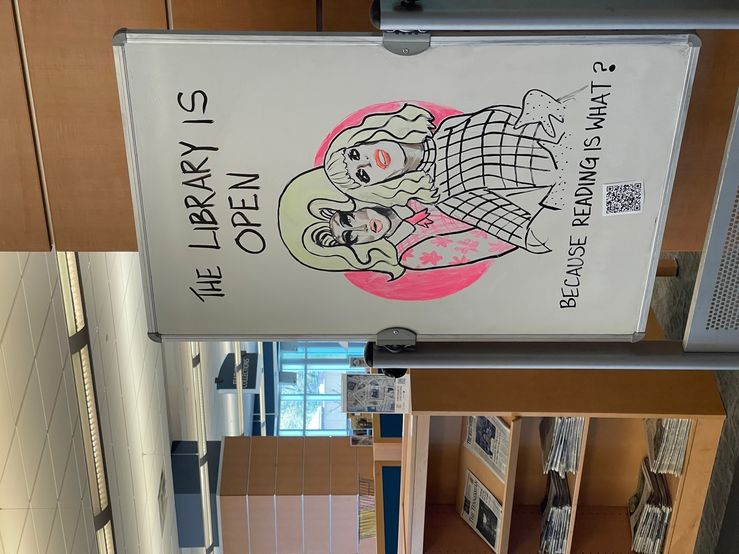
Figure 4.9. Sign in Clarissa’s library.

In addition to enjoying the company of likeminded individuals, Taylor also felt included in environments where people accepted and supported them. Taylor discussed how the staff at the university’s writing center really made them feel welcome and included:
Most of the writing center staff in general, but like especially [administrative assistant] and [name redacted], who is the like training admin person, they really make me feel valued and included, and like my differences and difficulties are not… I guess, like damning or really distracting, and, in fact, like they find them enjoyable, and like they understand what’s going on with those difficulties I have, and like nobody views it as a problem. And in fact, they’re just like really nice to me about it, and that’s really cool. I feel really valued by the people in the writing center for my kind of alternative ways of looking at things of which I think you know trauma is part. But, like as I said, like I got really bad ADHD. I’m also autistic. I’m just a little bit different all around, and I think as much as we kind of like act like that’s not really a problem in Academia, like a lot of times it is. And it’s really cool to see someone keeping those things in mind about me and offering, not just accommodation, but kindness with that.
Taylor’s experience serves as a good reminder that the people in a space often set the tone for the entire place.
Other participants, like Lennie, felt included in spaces when the university worked with them to ensure that they could participate in events in a way that made them feel comfortable. Lennie explained that attending her first university baseball game as a very inclusive experience:
So a time when I felt included… recently, the graduate students had the ability to go to a baseball game together, and I've been having these ongoing conversations with the University about how I am not myself if I am only a fraction of myself. If I only bring a splintered portion of me, then you're never going to see the whole me, and I can never like… I know these are strong words, but it's true. I will never belong if I cannot include all of me, and all of me means my family. And I had a very strong value that where I go and what I do that's fun, my children ought to be doing with me, and I know in part that strong value is because of the way that I was sexually assaulted.
Lennie went on to say that university leadership invited her and her family to the baseball game for a graduate student appreciation event, and explained why it is so important for her to have her children with her at university events:
My kids are here with me in this, and I've been working with the university on, “What does it look like to be a mom and a student?” I struggle with who I’m willing to allow my kids to be with. I have a very small group of people that I trust. I don't trust everyone with my children. I want to go do fun stuff on campus. I want to be included on campus, but I have no desire to be included on any of the fun activities with my kids being left with someone. Where I go, my kids go. When I was a child, and I was being sexually abused, it was when my mom was gone. I will not go to a baseball game and think, “what if my kids are with somebody hurting them?”
Lennie’s experience draws attention to the fact non-traditional students’ lives often look different from traditional students’ lives, and that sometimes in order to be a truly inclusive institution, universities need to ensure that all students are able to participate in university events, including adult learners.
For Jennifer, feeling as if she were a part of a community helped her study and complete schoolwork more efficiently:
I want to study in this place, where it's like inclusive, like diverse like in not just the not
just narrowed down to one subgroup, but coming to all the people so, and also create such a group learning environment. So, I think that's why it works for me. Because I need this momentum from the group energy.
Unlike Eden and Taylor, Jennifer did not necessarily want to be around like-minded people. She appreciated the diversity that the library offered. However, sharing a common goal inspired her to work harder on her assignments.

Wellbeing
The theme wellbeing refers to features that spaces offer that positively or negatively impact participants’ mental or physical health. When speaking with participants, it became apparent rather quickly that certain aspects of the environment affected them in. various ways. For example, some participants expressed sensory sensitivity when it came to lighting and sound within the area. When discussing why she preferred to study in the library, Clarissa said that one of the main reasons she chose this place was due to the natural lighting: “I really don't like harsh lights, because I get migraines easily, but natural lighting doesn't bother me.” Natural lighting was also an important feature for Eden, who stated, “I think I like natural light, because it feels a lot brighter and warmer, and like easier to sit in than the fluorescent bars that they have in all the classrooms.” Natural lighting also appealed to Wendy, who joked, “I think I'm part plant because I really like the sunlight.” While their reasons for enjoying natural light may be different, it was clear that the type of lighting in the environment impacted these participants’ enjoyment of the space.
In addition to natural lighting, many participants also valued spending time outdoors while on campus, as a way to relax between classes or tasks. In fact, the amount of outdoor space on her campus is one of the reasons that Wendy chose the university she did:
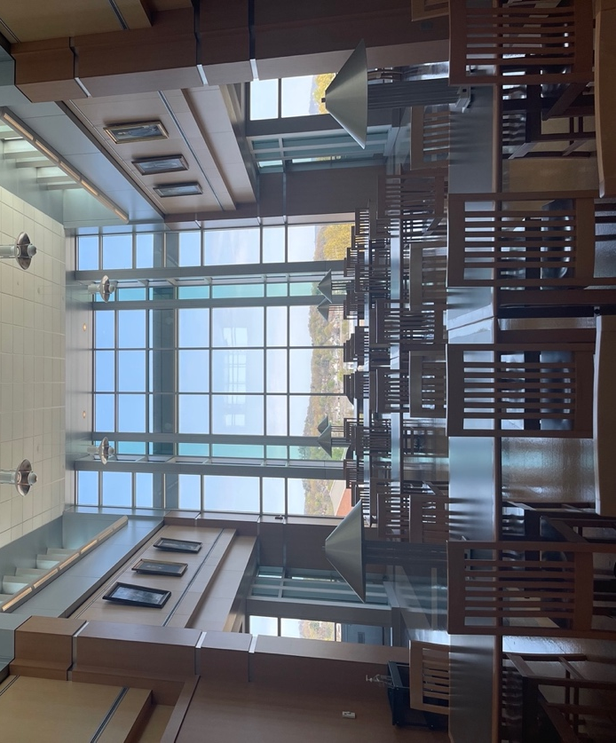
Figure 4.10. Clarissa’s library.

I chose this college in part, because it does have a large propensity for outdoor activities and outdoor areas, if only that. Whereas at college, I think [undergraduate university] doesn't have as many trees, which I’m sure they still have trees. It's a place, after all, but they don't have as much of an outdoor area. So, I know it's not possible for all colleges, but I do think that being outside, actually in nature, not just on the sidewalk, is helpful.
For Wendy, the ability to engage in outdoor activities was important for her wellbeing.
Wendy was not the only participant who expressed a desire to spend time outside while on campus. Jennifer also shared that she enjoyed utilizing a walking trail at her school for daily exercise in order to increase her longevity. She explained,
If I can, I try to take a daily walk. I chose this place because this is a safe place as well, because I know it's on campus, and I take the daily walk in the daytime. So, I will feel secure walking there because there are also always people walking there as well. So yeah. So, this is part of my effort to keep a healthy lifestyle.
While Jennifer went on to say that she enjoyed spending time outside in the fresh air, being outside did not seem to be quite as important to her as it was to Wendy.
Taylor also enjoyed the outdoors, and when they had time, they liked to relax in a hammock. However, at this point in their program, Taylor did not feel as if they had the ability to spend an extended amount of time relaxing outside, so they opted to bring the outdoors to their current workspace by placing photographs of nature in their cubicle. They described the pictures hanging on their cubicle walls during the interview:
Those pictures on the wall are pictures of nature in [undergrad campus]… the little beautiful things, like trees covered in ice, trees in the spring, flower blooms, a really awesome wasps’ nest, some caves, some flowers, some tree bark. Good stuff.

Figure 4.11. One of Wendy’s favorite campus spaces

For Taylor, being surrounded by things that they loved, and things that brought them a sense of comfort, enhanced their wellbeing.
Along with natural lighting and spending time in nature, some participants also found comfort in spending time with their pets. When asked why she preferred studying at home, Elena immediately answered, “Well, I have my cats here, which it helps a lot.” Like Eden, Clarissa shared that when she was in “cram mode,” she did not spend time on campus, and instead studied at home with her dog. However, the healing power of animals did not just cover the participants’ pets. When discussing the place where they liked to relax, Taylor chose a specific room in their campus’ writing center that showed videos of kittens at a cat rescue to help students unwind. They explained,
They play kitten videos. It's a shelter live stream of little kitties, and they have different cameras. And so, when I need a break, or I'm having a really frustrating moment, I can just go in and like, watch the little kitty cats for a while and feel better about my life and the world.
While not all sexual assault survivors would find animals healing, these participants made it clear that having pets, or at the very least having access to videos of animals playing, helped them relax and feel better when they were stressed.

Conclusion
In this chapter, I introduced the participants of the study and discussed the main themes and subthemes that emerged from the analysis of the data. The three main themes were safety, community, and wellbeing. The theme of safety referred to all of the ways that the participants engaged with spaces in order to increase their feelings of safety. Safety also included participants’ concerns about safety, the acts they took to ensure safety on their campuses and in their lives, places they avoided in order to maintain a feeling of safety, and existing and absent campus resource that impact their feelings of safety. Three subthemes emerged under safety: 1) environment, 2) isolation, and 3) campus resources. Environment encompassed all aspects of the environment that impacted how safe the participants felt when inhabiting a space. The subtheme of environment produced three subtopics: 1) controlling the environment, 2) private spaces, and 3) avoidance of certain spaces. Isolation and campus resources were not connected to any subtopics. The second theme, community, referred to the participants’ sense of belonging when they were on campus. It did not produce any subthemes. The third, and final, theme, wellbeing encompassed spaces that participants frequented in order to increase their mental and physical health as well as the features within a space that positively or negatively impacted participants’ wellbeing. This theme also did not produce any subthemes.

Chapter 5: Discussion

Introduction
The purpose of this study was to develop an understanding of how women adult learners who are also sexual assault survivors experience the university campus. I conducted research with seven participants and used Photovoice to investigate this phenomenon. The three research questions that framed this study were 1) What types of spaces on university campuses engender feelings of safety for women adult learners who are sexual assault survivors? 2) How can universities create more inclusive learning spaces for women adult learners who are sexual assault survivors? In this chapter, I discuss what factored into feelings of safety on university campuses for these participants, how the participants navigated and manipulated university spaces to meet their needs, and what factors were important in increasing their sense of wellbeing while they occupied campus spaces. I also address how universities can create more inclusive learning spaces for women adult learners who are sexual assault survivors, and I close this chapter with suggestions for future research.

Discussion
As I previously discussed, sexual violence is an educational barrier for women (Wagner & Magnusson, 2005). Academically, survivors of sexual assault have been shown to have higher attrition rates, lower grade point averages, and more self-regulated learning problems (Jordan et al., 2014; Mengo & Black, 2016; Molstad et al., 2021; Potter et al., 2018; Raymond & Corse, 2018). The academic issues experienced by sexual assault survivors are due in part to the mental and physical manifestations of trauma that many survivors live with their entire lives (Carey et al., 2018; Herman, 1997; van der Kolk, 2014; Raymond & Corse, 2018; Ritchie, 2019; Wagner & Magnusson, 2005). Experiencing a trauma, such a sexual violence, often leaves survivors in a state of hypervigilance, constantly searching for danger, which can lead to other issues, such as sensory overload, aggression, and inability to concentrate (Herman, 1997; van der Kolk, 2014). These issues can alter survivors’ behaviors, causing them to self-isolate; avoid reminders of the assault; and lose interest in things that were once important to them, such as academics (Mengo & Black, 2016; Jordan et al., 2014; Potter et al., 2018; Raymond & Corse, 2018).
The participants in this study had each experienced at least one sexual assault, and six out of seven of the participants had survived sexual violence prior to beginning their college careers. Students who enter the university as sexual assault survivors tend to slip between the cracks. Their assault does not fall under the purview of Title IX, as the assault did not take place on the university campus or by a university student, faculty, or staff member, and unlike many other populations, there are few, if any, support systems in place for survivors of sexual violence (Albrecth et al., 2022; Jordan et al., 2014, Molstad et al., 2021; Raymond & Corse, 2018; Wagner & Magnusson, 2005). One of the universities attended by some of the participants did not even have a women’s center, although two of the participants mentioned the importance of having a women’s center at their universities during their interviews. However, for the most part, the participants learned to navigate their academic lives and have been successful scholars throughout their college careers due to their ability to create a sense of safety for themselves, form and participate in communities that felt inclusive for them and focus on their wellbeing.

Safety
Safety was a major focus of all of the participants, and one of the ways that they created a sense of safety for themselves was through engaging with and controlling their environment, frequenting private spaces, and avoiding certain spaces. Participants controlled their environments in one of two ways: 1) rearranging the space to make it feel safer or 2) controlling the area to create a space that they wish had been available to them during the aftermath of their sexual assault. According to van der Kolk (2014), long after a traumatic event, many trauma survivors continue to live and organize their lives as if the trauma is still occurring; thus, the participants of this study took control of their environment to keep themselves, and those around them, safe from perceived threats. Ritchie (2019) explains that “the essence of how someone navigates and perceives their environment… is altered neurobiologically under the catalyst of violence.” These alterations are expressed in many different ways. For example, while rearranging an office space to make it feel safer so that the participant can fully focus on the task at hand is based in what Herman (1997) refers to as hyperarousal. After someone has experienced a traumatic event, such as sexual assault, their brain does not have a normal baseline level of arousal. Instead, a larger portion of the brain is dedicated to constantly scanning for, and at times misinterpreting, threats (Herman, 1997; van der Kolk, 2014). When sexual assault survivors attend a university, it is rare that their entire brain is in focused on class material, studying, or doing homework because they are often easily distracted by repetitive stimuli and feel anxious and threatened in their environment (Herman, 1997; Raymond & Corse, 2018; van der Kolk, 2014; Wagner & Magnusson, 2005). In this case, the participant chose to rearrange her office in order to accommodate her hypervigilant state, which shows her resilience and willingness to create a safe space for herself so that she can accomplish her goals.
Other participants suffer more from Herman’s (1997) intrusion in their daily lives, which is evident in actions such as trying to create a safe classroom space as a graduate teaching assistant. For this participant, Herman (1997) would argue that they are re-enacting their trauma in an adaptive and “socially useful manner” (p. 40) by creating a space that they wish had existed for them after they had been sexually assaulted. Like other trauma survivors, many sexual assault survivors do not fully exist in the present. Instead, part of their mind and body are still reliving their past trauma, which makes focusing on the tasks they need to complete incredibly difficult (Herman, 1997; van der Kolk, 2014). When they were sexually assaulted, they were rendered helpless, and the participant found that creating a safe space for their students empowered them. This phenomenon is common among trauma survivors and occurs as an attempt to develop a new understanding of what happened to them and how it integrates into their post-assault life (Coddington et al., 2017; Herman, 1997; Ritchie, 2019; van der Kolk, 2014). Providing sexual assault survivors with opportunities, such as teaching a class, helps them reclaim their life and empowers them, which aids in healing (Herman, 1997; van der Kolk, 2014).
The participants in this study were emphatic about wanting private spaces that they could inhabit on their university campuses. They spoke of the importance of having a door that can be locked, and stated multiple times that they wished they had more private spaces they could frequent. The desire for privacy and the ability to protect themselves by relaxing behind locked doors is not surprising. Being in a quiet environment where no one else is around can help calm the symptoms that are caused by hyperarousal. As previously discussed, trauma survivors who experience hyperarousal symptoms are constantly scanning the area for threats, which makes it difficult to concentrate or fully relax (Herman, 1997; van der Kolk, 2014). Therefore, it makes sense that survivors of sexual violence would enjoy having access to private spaces where they do not have to constantly scan the area for threats and can fully relax and focus.
In addition to hyperarousal, the lack of trust in other people is another reason that the participants wanted rooms that could be locked. The participants shared that once someone has been sexually assaulted, it is hard to trust people. The participants’ statements regarding the difficulties they had trusting others were similar to Herman’s (1997) description of the breaking of basic trust individuals experience once they have been subjected to a traumatic event. Due to their loss of trust, the participants felt safer in spaces where they could control who entered and exited the space. The participants who did not have access to doors with locks chose to spend time in restrooms, in a locked stall, or to spend as much time in their off-campus home as possible because they found it difficult to concentrate and manage their anxiety when they were constantly surrounded by people.
The desire to isolate oneself goes hand-in-hand with wanting to have access to private spaces. However, the reasons for isolation are a bit more complex. One reason for a desire to isolate is to avoid many of the things that trigger hyperarousal in the participants. It could be due to a lack of trust in humanity in general, or it could be to reduce the anxious feelings that many participants discussed regarding being in public spaces. Another reason participants chose to isolate themselves was because they wanted to hide their heightened emotional states, that were due to experiencing sexual violence. Herman (1997) and van der Kolk (2014) explain that many who have experienced lifetime traumatic events, such as sexual assault, have heightened emotions because of the new neuropathways that formed in their brains in response to the trauma they experienced. Additionally, in institutions of higher education, public displays of traumatic symptoms are discouraged as part of the silencing mechanism surrounding sexual violence (Wagner & Magnusson, 2005). Some participants stated that they were different now and more emotional, and they desired private spaces and isolation in order to deal with those changes. They did not want others to view them as weak or different.
One participant, who was an Asian international student, felt differently about isolating herself. She believed that she was safer in a group and that she was more likely to be assaulted again if she were in a private space. Additionally, she felt that the university staff would protect her if something violent were to occur in the space she occupied. This view was not shared by her American counterparts. Possible reasons for this anomaly could be due to the participant being raised in an Asian country, which focuses more on community and less on individualization. Hofstede (2001) found that most Western countries, such as the U.S., are more individualistic, whereas most East Asian countries fall more on the collectivist side of the spectrum. Also, many East Asian countries share values of deference to authority (Zhai, 2017), which explains why the participant felt safer with authority figures being close by.
All participants in the study stated that they avoid places that feel unsafe, such as dark parking garages, areas that are not well-lit, and places where their assault occurred, if it happened on campus. Valentine (1989) found that women develop mental maps that are based on their fears and experiences and will often take longer routes that offer more safety features in order to stay safe. Valentine (1989) also discovered that women are more vigilant at night and that they feel safer in familiar places. These spatial patterns and behaviors adopted by women to stay safe are most likely exacerbated when the women in question are experiencing hyperarousal. Therefore, it came as no surprise that the majority of the participants in the study were aware of the safety resources their campus offered. Many participants knew where the closest emergency call box was located, and they also identified other resources, such as safety apps and security escorts to cars. While not all participants were comfortable requesting help from security officers because they were afraid that the security officers would not take them seriously and would shame them for being afraid, they were aware of the campus resources regarding safety, as well as the safest places to park and most well-lit paths to take to evening classes. They had created their own mental maps to help cope with their fear, like the women as Valentine’s (1989) study.

Community
Each participant in the study mentioned community in their interviews, whether they were sharing spaces where they felt included and accepted or places where they felt ostracized, they all expressed the desire to inhabit spaces where they felt accepted and included. However, feeling a sense of community at a university after experiencing sexual violence is not always easy. Raymond and Corse (2018) found that after experiencing sexual violence, many women felt excluded from the university community as a whole by an “invisible barrier” (p. 469). The researchers found that sexual assault survivors often feel alienated by the university’s response to their experience and the aftereffects of experiencing such a traumatic event oftentimes causes survivors to disengage from the university community (Raymond & Corse, 2018). This feeling of ostracization from their university was apparent in one participant’s interview, in particular. Throughout the duration of the project, the participant realized that she had no place on campus that she felt safe. She had been sexually assaulted by one of the professors in her major, and while she stayed in the same major, she no longer felt safe attending classes in the building where the assault occurred. Her feelings of ostracization were apparent throughout the interview. For example, she referred to her college campus as “their campus” instead of “my campus,” and while the university’s Title IX office did respond to the professor’s assault, the participant no longer felt comfortable interacting with her peers. She felt as if she needed to hide away in order to be safe.
Having a sense of community, or a social support group, is incredibly important to sexual assault survivors’ healing process (Herman, 1997). It helps them learn to rebuild trust and can help mitigate the emotional aftermath of the event (Herman, 1997). Feeling as if they are a part of the college community and having support are also important factors in sexual assault survivors’ academic success (Raymond & Corse, 2018; Reilly & D’Amico, 2011). In a study looking at what sexual assault survivors want regarding post-assault care and support on their campus, it was found that sexual assault survivors wanted a “culture of caring” (Munro-Kramer et al., 2017, p. 300). In this context, a culture of caring means that university students, staff, and faculty understand the severity of sexual violence and would have the resources and knowledge to provide support for each other (Munro-Kramer et al., 2017). In other words, sexual assault survivors want to be understood and accepted in their university communities.
The majority of the participants in this study discussed finding spaces on campus where they felt that they belonged. Some participants talked about feeling included in spaces that highlighted and welcomed different aspects of their identity while others chose to focus on joining on-campus groups and activities. One participant shared that she felt included when she was allowed to bring her family with her to attend campus events and activities, and another participant said that they felt included in spaces where they were able to be authentically themself and have the various aspects of their identity not only accepted but celebrated. One participant felt as if she were a part of her campus community because she could access more natural environments from her campus, and she felt that she was most able to be herself in nature, and one participant felt most included when she was able to be around likeminded people. When discussing feelings of belonging and inclusion, many of the participants mentioned their campus’ women’s center, and some of those who attended college on a campus that did not have a women’s center said that they wished one existed on the campus.
Having spaces where sexual assault survivors feel as if they belong can also create a feeling of safety. Lewis et al. (2015) found that having a women-only space made the participants of a feminist retreat feel safe from misogyny, abuse, and harassment. In this environment, they also felt that they were safe to be authentically themselves and to express their thoughts and feelings openly (Lewis et al., 2015). Van der Kolk (2014) explained that many trauma survivors feel most comfortable around others who have had similar experiences to theirs because it helps reduce their feelings of isolation. Additionally, Pain (1991) found that women respond to fear of sexual violence by going places in groups. Therefore, having a sense of community and people that they can rely on is likely to make survivors of sexual assault feel safer when they are engaging in both on- and off-campus activities.

Wellbeing
Throughout their interviews, all of the participants discussed different features that either decreased or increased their sense of wellbeing. One of the main things that participants talked about during their interviews was experiencing sensory overload in various spaces. Fluorescent lighting triggered migraines in some participants while others were incredibly sensitive to sound. Natural lighting was valued because it felt less harsh than the fluorescent lights in classrooms, and the majority of participants preferred quiet spaces so that they could focus without becoming anxious. According to van der Kolk (2014), those who experience posttraumatic stress symptoms are constantly in a state of sensory overload, which impacts their ability to focus and emotionally regulate. Reducing the amount of sensory overload that sexual assault survivors experience is very important and often overlooked.
Many of the participants in the study mentioned that they preferred to relax or study at home because their pet was there. Several participants talked about when they were experiencing a high level of stress, they would not be on campus, but instead they would be at home with their cat or dog. Van der Kolk explained that since it is difficult for many trauma survivors to trust other humans once they have experienced a traumatic event, they feel safer engaging with animals. Additionally, researchers have found that animal-assisted therapy has been quite successful in treating many mental health disorders, including PTSD and posttraumatic symptoms (Currin-McCulloch, 2021; Germain et al., 2018; O’Haire et al., 2019; Tomaszewska et al., 2017; van der Kolk, 2014). In addition to finding comfort by spending time with their own animals, one participant also shared that they often frequented a building on their campus that showed videos of kittens playing when they were in need of relaxation. Clearly, engaging with animals, or simply watching them play, was an effective way to reduce stress for these participants.
During the study, participants photographed and discussed many natural areas on campus, and one participant even said that one of the reasons they chose their current university was because of the natural environment in and around the campus. Many participants stated that being outside, walking, and looking at the grass and trees were relaxing activities. One participant said that she always frequented a place outside when she became overwhelmed because of the grass. She said that the greenness of the area calmed her. Another participant explained that she was happiest when she was surrounded by trees. Other participants talked about how they enjoyed hanging hammocks outside and relaxing in a campus green space or sitting outside, leaning against the trees and relaxing. Nature’s restorative effects are not limited to sexual assault survivors, though. Ha and Jin Kim (2021) found that college students reported improved moods when they were in an area that on campus that had high biodiversity and a large number of natural sounds. Therefore, it seems that green spaces on campuses benefit all students.

Theoretical Implications
The findings of this study add to the current literature on feminism, trauma theory, feminist geography, and geographies of trauma. As previously mentioned, the participants in this study chose to participate because they wanted to do help make a difference for sexual assault survivors in higher education. Their desire to share their stories and to help improve life for survivors of sexual violence is a form of feminist activism, similar to the #MeToo Movement. In fact, many participants mentioned that the #MeToo Movement inspired them to begin talking about their experiences. This illustrates that the feminist activism prevalent during the fourth wave not only inspires survivors to share their stories on social media platforms, but to also seek out other ways to make a difference, such as participating in research studies.
This work also contributes to the literature on trauma theory by providing an in depth look of sexual assault survivors’ experiences of university spaces. Herman (1997) and van der Kolk (2014) both state that various places can trigger those who have experienced trauma, and that some posttraumatic symptoms, such as flashbacks, cognitively remove the survivor from the current space and time and place them back into the traumatic event. This study shows how survivors of sexual violence cope with encountering potentially triggering environments and the steps that they take to feel safe and achieve their goals despite the spaces often feeling less than friendly.
The study expands on previous works in feminist geography and geographies of trauma by looking at what attributes make spaces feel safe or unsafe to sexual assault survivors. While both feminist geography and geographies of trauma acknowledge that many women have extreme fear of being sexually assaulted, very few, if any, studies have examined how to make spaces feel safer for those who have been assaulted. Ritchie’s (2019) autoethnographic study showed how seemingly innocuous places, such as the grocery store, can trigger PTSD responses in sexual assault survivors, but the focus of that study was exploring how sexual assault survivors with active PTSD symptoms struggle and cope with everyday tasks. This study, on the other hand, looked at what steps need to be taken in order to make spaces feel safer for survivors of sexual violence and how to create spaces that are less triggering for survivors.
Finally, this study shows another way that Photovoice can be utilized to study the experiences of survivors of sexual violence. There have been studies conducted that use Photovoice to gain a deeper understanding of sexual assault survivors’ lived experiences (e.g., Rolbiecki et al., 2016), but no Photovoice studies have looked at the how the environments in which survivors exist on a day-to-day basis affect them emotionally, mentally, and physically. This study shines a light on how sexual assault survivors who are also students experience their university campuses, and provides suggestions for new ways to use Photovoice to better understand how survivors of sexual assault engage with the world around them.

Implications for Practice
This study looked at how adult sexual assault survivors experienced spaces on their university’s campus. This research provided an opportunity to see university campuses across a state in the southeastern US through the eyes of the participants, and it showed ways that their experiences can be used in practice in adult and higher education. One of the ways that universities can create more inclusive campuses for survivors of sexual assault is to allocate some of their Title IX funding to the suggestions mentioned below. Additionally, Title IX could create new stipulations that require universities to have physical spaces for survivors of sexual assault, such as a victim/survivor resource center or a women’s center, in order to make the campus truly equitable. This study contributes to the knowledge of how university faculty, staff, and administration can improve the lives of sexual assault survivors on their campuses. These implications can be applied throughout institutions of higher education in order to improve sexual assault survivors’ academic success and to reduce their attrition rates. I have identified three areas of improvement: 1) campus policies, 2) campus resources, and 3) architectural and environmental changes.

Campus Policies
Arguably the majority of sexual assault survivors who are students at a university are adult learners. Most are over the age of 18, which is the legal age of adulthood in the United States, and once someone has experienced a lifetime traumatic event, such as sexual assault, their self-perception has shifted. They become an adult in many ways due to the lack of trust and posttraumatic symptoms that cause them to want to defend themselves. Therefore, they meet Merriam and Brockett’s (2007) sociocultural definition of an adult learner. As Knowles (1980) stated, adult learners bring their lived experiences with them into their learning environments. In higher education, the learning environment often extends outside of the classroom as well; however, very few campuses take sexual assault survivor students’ lived experiences into consideration when creating campus policies. While there is no universal solution to creating a more inclusive campus for sexual assault survivors, these recommendations could provide a good starting point for further policy changes that make sense for each campus.
The overarching theme for these implications is creating a trauma-informed campus. There are many opportunities to implement policies that help to create a more trauma-informed campus environment, which will be discussed below. One way to achieve the goal of creating a more trauma-informed campus is to train university faculty and staff about sexual violence and trauma-informed practices, both inside and outside of the classroom. These trainings could be part of the mandatory professional development trainings that are given each year, and helping faculty and staff better understand trauma and how it affects those who have experienced it will aid in building empathy and creating a culture of caring and support for sexual assault survivors.
Another way to inform faculty, staff, and graduate students about sexual assault survivorship is by offering optional training, based on the premise of Safe Zone training, that has different levels of training regarding trauma and sexual violence. Once all of the levels have been completed, faculty, staff, and graduate students could have a decal to place on their office door or window to let student survivors know where their safe spaces are. Places, such as women’s centers, gender and sexuality centers, and counseling centers could ensure that their staff take the training and can display the decal as well. This type of training and displaying of a decal in support of sexual assault survivors would help survivors feel more supported and let them know safe places to frequent where they can relax. It would also serve to destigmatize sexual violence on university campuses.
Due to the sensory sensitivity experienced by many sexual assault survivors, giving students the opportunity to reserve quiet rooms, with a door, to study in, either alone or with friends, would be extremely helpful. These rooms could be classrooms that are not being used during certain times, or the university could create new spaces for quiet study spaces. The ability to reserve quiet spaces in which to study would help sexual assault survivors feel less threatened and less like a spectacle, which would help reduce their anxiety so they could focus.
Since companion animals improved the quality of life for several participants in this study, and since animals are often used in certain types of trauma therapy (Germain et al., 2018; O’Haire et al., 2019; Tomaszewska et al., 2017; van der Kolk, 2014), creating some pet friendly dorms on the campus would give sexual assault survivors who feel more at peace with animal companions an opportunity to live on campus. Living off campus can often serve to further remove the survivors from the university community. As research has shown, sexual assault survivors often feel ostracized from their university community due to their experience, the culture of silence surrounding sexual violence in academia, and suffering from posttraumatic symptoms (Raymond & Corse, 2018; Wagner & Magnusson, 2005). Having the option to bring their pets with them and live on campus could help survivors re-integrate into their university community.
In addition to creating pet friendly dorms, bringing emotional support animals on campus during stressful times, such as during final exams, could be helpful for all students, including sexual assault survivors. As previously noted, sometimes it is easier for sexual assault survivors to interact with animals than it is for them to engage with people (van der Kolk, 2014). Because of this, giving sexual assault survivors the opportunity to take a break from studying, spend some time with an emotional support animal, and relax could help them feel less alone and more supported during a stressful time.
Finally, recognizing that student is just one identity that a sexual assault survivor has, and that like other adult learners, they have competing responsibilities and various social roles (Merriam & Bierema, 2014), allowing them to bring friends or family from outside the university community to university events could help them feel more connected to the university. After experiencing a traumatic life event, such as sexual assault, individuals often lose their ability to trust (Herman, 1997; van der Kolk, 2014). However, sexual assault survivors may have members of their family or friends that they already trust and consider to be safe people. In this study, participants reported feeling very stressed when they chose to attend university events but were not allowed to bring any members from their support group with them. Allowing them to bring those people with them to university events would help them feel safe, included, and accepted within the university community.

Campus Resources
The creation of women-only spaces could help sexual assault survivors feel safer and more included on campus. Herman (1997) and van der Kolk (2014) posit that being surrounded by others who have had similar experiences is an important component for helping sexual assault survivors reconnect to others. Additionally, Lewis et al. (2015) found that women, in general, feel safer in women only spaces. For universities that already have resources, such as a women’s or women’s and gender center, creating a women’s only floor in the campus gym or adding a workout space to the women’s center could make it much more comfortable for sexual assault survivors to work out. Providing resources, such as a women’s center or women’s and gender center, along with women-only spaces to exercise, has the potential to decrease stress among adult women sexual assault survivors and increase their feelings of safety, wellbeing, and community, leading to a more positive university experience.
Another resource that could help add to feelings of safety for sexual assault survivors is offering multiple types of self-defense classes. These classes would give sexual assault survivors the opportunity to learn skills that could protect them in the future, which could reduce their feelings of hypervigilance. Additionally, taking self-defense classes could improve their sense of belongingness at their university because they will be meeting others who hope to accomplish similar goals. While many universities offer rape aggression defense courses, offering a variety of self-defense classes, such as different martial arts classes, boxing, and kickboxing, would have a higher likelihood of appealing to a wider range of sexual assault survivors. Also, learning self-defense in general, instead of in a rape aggression defense course, could be less triggering for survivors.
Developing a partnership with the local sexual assault centers would create many new opportunities to offer different and more specialized resources to sexual assault survivors. These partnerships could help the university supply advocates for survivors after they are assaulted, more trauma-informed therapists, and experts to teach about sexual assault prevention on campus. This partnership could benefit could further help university students if the university chose to provide university-paid internship opportunities at the sexual assault center for students who plan to go into counseling, social work, or other helping fields in return for the services provided by the sexual assault center.

Architectural and Environmental Changes
Due to the constant sensory overload experienced by many trauma survivors (van der Kolk, 2014), including those who are survivors of sexual violence, one way that the university could make classrooms and other indoor areas of campus more comfortable would be to add more windows to existing buildings when renovating. If the campus chooses to construct new buildings, they could be sure that the design included large windows to let in more natural light. This not only help sexual assault survivors be more comfortable in classrooms, libraries, and other buildings, but it could also prove to be more economical for universities because they may not have to use as much electricity to ensure the spaces have adequate lighting.
Another way that the campus environment could be improved would be to increase lighting in dark areas. This would benefit students, faculty, and staff who are sometimes on campus after dark, ensuring that they can see their surroundings when they walk to their cars, dorm rooms, homes, or other mode of transportation. Also, adding better lighting in parking garages and other safety features, such as cameras, if possible, would enhance feelings of safety among many students, including sexual assault survivors.
The creation of women’s only spaces and a victim/survivor resource center on university campuses would greatly benefit survivors of sexual violence. The findings indicate that many of the participants preferred to be around those who have experienced similar events in their lives, and the creation of women’s only spaces and a victim/survivor resource center could help students who enter the university as survivors as well as those who are assaulted while at the university find a sense of community. Additionally, these spaces would provide safe spaces for sexual assault survivors where they could study and relax while they are on campus.
Finally, creating green spaces on campus, when possible, would benefit sexual assault survivors. Research has shown that green spaces on campus improve students’ moods and reduce stress (Ha & Jin Kim, 2021). Many of the participants in this study also expressed their love of being in nature and discussed how relaxing it was for them. For urban campuses simply do not have the space to create park-like areas at their universities, a division of student affairs could schedule regular nature excursions, such as hiking trips, throughout each semester. The scheduled trips into nature could, again, help sexual assault survivors who participated in the excursions feel as if they are more included in the university community.

Suggestions for Future Research
The findings of this study revealed that sexual assault survivors often find it difficult to find spaces on campus that meet their needs. They often have to do work on the space, or repurpose certain spaces, in order to have spaces that enable them to study and work without triggering their hypervigilance. However, there is still much research to be done in this area. Exploring how green spaces impact sexual assault survivors on a college campus is one avenue that should be looked at more closely. Also, studies involving how having access to companion animals impacts sexual assault survivors who are university students is another area that needs additional research.
Research looking at if sexual assault survivors prefer online or blended courses, and if attending courses in that format helps to reduce their posttraumatic stress symptoms could be beneficial for this population. Since the majority of the survivors in this study found certain aspects of their campuses triggering, learning how sexual assault survivors experience online learning environments versus in-person learning environments is a topic that should be addressed. Also, examining how to make online learning spaces safe and inclusive for sexual assault survivors is another area of study that needs additional research.
An unexpected outcome of this study was the difference in how the participant who was an international student viewed safety and authority figures versus how the participants from the United States viewed them. Therefore, researching various aspects of sexual assault survivorship in international student populations who are studying in the United States could be very beneficial and help us better understand how they cope with their survivorship, what makes them feel safe, and what they need to feel supported on their campuses. Furthermore, conducting studies with students of color who are also sexual assault survivors would be extremely beneficial. While there are challenges in recruiting students of color and international students, one way to mitigate recruitment issues could be to partner with a woman of color, or an international scholar, in order to help gain access to these populations. It is important to create resources for all sexual assault survivors, not only the ones that meet a certain demographic.
Additionally, this research identified adult learners through a sociocultural lens rather than by a certain age group. Conducting a study with adult learners who are at least 25 years of age and are sexual assault survivors could help paint a more comprehensive picture of how the multiple social roles that adult learners have to manage play into their experiences on university campuses. This research would benefit both the fields of higher education and adult learning.
Finally, this study focused on participants who attended a PhD-granting institution in a state in the southeastern US. In order to gain a more comprehensive understanding of the spatial needs of sexual assault survivors on their university campuses, a larger, national study should be conducted. A national study could provide valuable information that could inform university and federal policies.

Conclusion
While surviving sexual assault can make navigating the university landscape more complex and challenging, there are still many survivors enrolled in universities across the country. This study examined how women adult learners who are also sexual assault survivors experienced the university space. The majority of studies on sexual assault survivorship focus on academic performance within the classroom and rates of attrition, but a university education takes place both inside the classroom and in spaces throughout the campus. Higher education, in general, has never been a welcoming space for sexual assault survivors, and survivors are often silenced for displaying posttraumatic symptoms after surviving an assault (Wagner & Magnusson, 2005). Further, sexual assault survivors often feel ostracized from their university communities, which creates an unsupportive and almost hostile feeling environment for them. The reluctance of institutions of higher education to support sexual assault survivors often leads to lower grade point averages and higher rates of attrition (Raymond & Corse, 2018). Therefore, providing support to sexual assault survivors is instrumental to their success.
This study shines a light on how women sexual assault survivors engage with their campus environments and has provided much needed insight into how the campus environment as a whole affects sexual assault survivors. A limitation of this study was that the sample included six White participants and one Asian participant. Therefore, the findings of this study may not reflect the experiences of women from other races, ethnicities, or backgrounds. However, in order to meet the needs of sexual assault survivors, institutions of higher education must increase their knowledge regarding how sexual assault survivors experience the university space, and how many survivors suffer from long-term, if not lifelong, posttraumatic symptoms due to their experience. Creating a sense of empathy for sexual assault survivors and taking the impact of sexual violence seriously are imperative to creating a safer and more inclusive environment for sexual assault survivors.
This photovoice study added to the literature regarding sexual assault survivorship in higher education. It sought to raise awareness, center survivors’ voices, and help university administration, faculty, and staff gain a deeper understanding of what it means to be a sexual assault survivor in higher education. By learning about the lived experiences of sexual assault survivors as they tried to navigate an unsupportive and sometimes hostile environment, a larger audience could begin to understand what it is like to be a sexual assault survivor and how the university space impacts their ability to accomplish their academic goals.

References
Abrams, Z. (2022). Student mental health is in crisis. Campuses are rethinking their approach. American Psychological Association, 53(7). https://www.apa.org/monitor/2022/10/mental-health-campus-care
Adams-Hutcheson, G., & Johnston, L. (2019). Flourishing in fragile academic work spaces and learning environments: Feminist geographies of care and mentoring, Gender, Place, and Culture, 26(4), 451-467. https://doi.org/10.1080/0966369X.2019.1596885
Ahrens, C. E. (2006). Being silenced: The impact of negative social reactions to the disclosure of rape. American Journal of Community Psychology, 38, 263-274. https://doi.org/10.1007/s10464-006-9069-9
Albrecht, K., Nielsen, L. B., & Wuorien, L. (2022). Misunderstanding law: Undergraduates’ analysis of campus Title IX policies. Educational Evaluation and Policy Analysis, 0(0). https://doi.org/10.3102/01623737221113576
Ascroft, E. (2021). Gender violence through the eyes of the Bajan youth: Using Photovoice methods in small island states. Visual Studies, 36(4-5), 537-553. https://doi.org/10.1080/1472586X.2020.1827975
Asikin, A. S., Aipipidely, D., & Kiling, I. Y. (2021). Experience of dating violence's victims in Indonesia: A Photovoice study. Interpersona, 15(2), 183-196. https://doi.org/10.5964/ijpr.4303
Banyard, V., Edwards, K., Herrington, R., Hopfauf, S., Simon, B., & Shroll, L. (2020). Using Photovoice to understand and amplify youth voices to prevent sexual and relationship violence. Journal of Community Psychology, 50, 90-110. https://doi.org/10.1002/jcop.22495
Belenky, M. F., Clinchy, B. M., Goldberger, N. R., & Tarule, J. M. (1997). Women’s ways of knowing: The development of self, voice, and mind (2nd ed.). Basic Books.
Bilken, S., Marshall, C., & Pollard, D. (2008). Experiencing second-wave feminism in the USA. Discourse: Studies in the cultural politics of education, 29(4), 451-469. https://doi.org/10.1080/01596300802410185
Bizier, L. (2020). Maintaining the delicate balance between due process and protecting reporting students from re-traumatization during cross-examination: Title IX investigations in the wake of the Trump administration’s proposed regulations. Roger Williams University Law Review, 25(2), 242-264. https://docs.rwu.edu/rwu_LR/vol25/iss2/3
Bloom, B. E., Raine Sorin, C., Wagman, J. A., & Oaks, L. (2021). Employees, advisees, and emerging scholars: A qualitative analysis of graduate students’ roles and experiences of sexual violence and sexual harassment on college campuses. Sexuality & Culture, 25, 1653-1672. https://doi.org/10.1007/s12119-021-09841
Bolger, D. (2016). Gender violence costs: Schools’ financial obligations under Title IX. Yale Law Journal, 125(7), 1820-2181. https://www.yalelawjournal.org/feature/gender-violence-costs-schools-financial-obligations-under-title-ix
Bowlby, S., Lewis, J., McDowell, L., & Foord, J. (1989). The geography of gender. In R. Peet & N. Thrift (Eds.), New Models in Geography: Vol. 2 (1st ed., pp. 157-175). Routledge.
Boyce, S., Zeledón, P., Tellez, E., & Barrington, C. (2016). Gender-specific jealousy and infidelity norms as sources of sexual health risk and violence among young coupled Nicaraguans. American Journal of Public Health, 106(4), 625-632. https://doi.org/ 10.2105/AJPH.2015.303016
Brännström, L., Nyhlén, S., & Gådin, K. G. (2019). “You are so ugly, you whore” – Girls in rural Sweden discuss and address gendered violence. International Journal of Qualitative Studies on Health and Well-Being, 15(1), 1-11. https://doi.org/10.1080/17482631.2019.1695308
Braun, V., & Clarke, V. (2006). Using thematic analysis in psychology. Qualitative Research in Psychology, 3(2), 77-101. https://doi.org/10.1191/1478088706qp063oa
Breny, J. M., & McMorrow, S. L. (2021). Photovoice for social justice: Visual representation in action. Sage.
Brown, L. S. (1991). Not outside the range: One feminist perspective on psychic trauma. American Imago, 48(1), 119-133. https://jstor.org/stable/26304034
Brown-Rice, K. (2014). Examining the theory of historical trauma among Native Americans. The Professional Counselor, 3(3), 117-130. https://doi.org/10.15241/kbr.3.3.117
Brownmiller, S. (1975). Against Our Will: Men, Women, and Rape. Fawcett Books.
Burgess, A. W., & Holmstrom, L. L. (1974). Rape trauma syndrome. Psychiatry, 131(9), 981-986. https://doi.org/10.1176/ajp.131.9.981
Burgess-Proctor, A., Pickett, S. M., Parkhill, M. R., Hamill, T. S., Kirwan, M., & Kozak, A. T. (2016). College women’s perceptions of and inclination to use campus sexual assault resources: Comparing the views of students with and without sexual victimization histories. Criminal Justice Review, 41(2), 204-218. http://doi.org/10.1177/0734016816624786
Campbell, R., Adams, A. E., Wasco, S. M., Ahrens, C. E., & Sefl, T. (2010). “What has it been like for you to talk with me today?”: The impact of participating in interactive research on rape survivors. Violence Against Women, 16(1), 60-83. https://doi.org/10.1177/1077801209353576
Cannella, G. S., & Perez, M. S. (2012). Emboldened patriarchy in higher education: Feminist readings of capitalism, violence, and power. Cultural Studies <-> Critical Methodologies, 12(4), 279-286. http://doi.org/10.1177/1532708612446421
Carey, K. B., Norris, A. L., Durney, S. E., Shepardson, R. L., & Carey, M. P. (2018). Mental health consequences of sexual assault among first-year college women. Journal of American College Health, 66(6), 480-486. https://doi.org/10.1080%2F07448481.2018.1431915
Carroll, C. M., Dahlgren, M. G., Grab, K. L., Hasbun, M. E., Hayes, M. A., & Muntis, S. E. (2013). Implementing the Dear Colleague Letter: A Title IX case study for university compliance. Journal of the Indiana University Student Personnel Association, 45-56. https://scholarworks.iu.edu/journals/index.php/jiuspa/article/download/3673/3375/11926
Carter, H. C. (2021). Under the guise of “due process”: Sexual harassment and the impact of Trump’s Title IX regulations on women students of color. Berkeley Journal of Gender, Law, and Justice, 36(1), 181-210. https://doi.org/10.15779/Z38JM23G9Z
Center for Disease Control. (2022). Fast Facts: Preventing Sexual Violence. National Center for Injury Prevention and Control, Division of Violence Prevention. https://www.cdc.gov/violenceprevention/pdf/sv/SV-factsheet_2022.pdf
Cha, C., & Lee, M. (2022). Healing from sexual violence among young women in South Korea. International Journal of Mental Health Nursing, 31, 51-61. https://doi.org/10.1111/inm.12931
Charles, M. (2014). Trauma, fragmentation, memory, and identity. In M. O’Loughlin & M. Charles (Eds.), Fragments of trauma and the social production of suffering: Trauma, history, and memory (pp. 25-44). Rowman & Littlefield Publishers.
Chasteen, A. L. (2001). Constructing rape: Feminism, change, and women’s everyday understandings of sexual assault. Sociological Spectrum, 21(2), 101-139. https://doi.org/10.1080/02732170121403
Coddington, K., & Micieli-Voutsinas, J. (2017). On trauma, geography, and mobility: Towards geographies of trauma. Emotion, Space, and Society, 24, 52-56. https://doi.org/10.1016/j.emospa.2017.03.005
Cox, K. R. (2014). Making human geography. Guilford Press.
Cranton, P., & Merriam, S. B. (2015). A Guide to Research for Educators and Trainers of Adults (3rd ed.). Krieger Publishing Company.
Creswell, J. W., & Creswell, J. D. (2018). Research Design: Qualitative, Quantitative, and Mixed Methods Approaches (5th ed.). Sage.
Cokley, K., & Awad, G. H. (2013). In defense of quantitative methods: Using the “master’s tools” to promote social justice. Journal for Social Action in Counseling and Psychology, 5(2), 26-41. https://doi.org/10.33043/JSACP.5.2.26-41
Crotty, M. (1998). The Foundations of Social Research: Meaning and Perspective in the Research Process. Sage.
Currin-McCulloch, J., Bussolari, C., Packman, W., Kogan, L., & Erdman, P. (2021). Grounded by purrs and petting: Experiences with companion cats during COVID-19. Human-Animal Interaction Bulletin, 11(2), 1-15. https://doi.org/10.1079/hai.2021.0009
Dalaet, D. L., & Mills, E. (2018). Discursive silence as a global response to sexual violence: From Title IX to truth commissions. Global Society, 32(4), 496-519. https://doi.org/10.1080/13600826.2018.1516200
Darwin, H., & Miller, A. (2020). Factions, frames, and postfeminism(s) in the body positive movement. Feminist Media Studies, 1-18. https://doi.org/10.1080/14680777.2020.1736118
Davies, E. (2018). Third wave feminism and transgender: Strength through diversity. Routledge.
Department of Justice. (2019). National Crime Victimization Survey 2018. Bureau of Justice Statistics. https://bjs.ojp.gov/content/pub/pdf/cv18.pdf
Duffy, L. (2015). Achieving a sustainable livelihood after leaving intimate partner violence: Challenges and opportunities. Journal of Family Violence, 30, 403-417. https://doi.org/10.1007/s10896-015-9686-x
Duffy, L. (2018). Viewing gendered violence in Guatemala through Photovoice. Violence Against Women, 24(4), 421-451. https://journals.sagepub.com/doi/10.1177/1077801217708058
Elias, J. L., & Merriam, S. B. (2005). Philosophical foundations of adult education (3rd ed.). Krieger Publishing Company.
Estrada, A. L. (2009). Mexican Americans and historical trauma theory: A theoretical perspective. Journal of Ethnicity in Substance Abuse, 8(3), 330-340. https://doi.org/10.1080/15332640903110500
Ewald, W. (1985). Portraits and dreams: Photographs and stories by children of the Appalachians. Writers and Readers Publishing.
Exner, D., & Cummings, N. (2011). Implications for sexual assault prevention: College students as prosocial bystanders. Journal of American College Health, 59(7), 655-657. https://doi.org/10.1080/07448481.2010.515633
Fernandes, L. (2010). Unsettling “third wave feminism”: Feminist waves, intersectionality, and identity politics in retrospect. In N. A. Hewitt & N. Hewitt (Eds.), No permanent waves: Recasting histories of U.S. feminisms (pp. 98-118). Rutgers University Press.
Freire, P. (2000). Cultural action for freedom. Harvard Educational Review. (Original work published 1970).
Freire, P. (2018). Pedagogy of the oppressed: 50th anniversary edition. Bloomsbury. (Original work published 1970).
Germain, S. M., Wilkie, K. D., Milbourne, V. M. K., & Theule, J. (2018). Animal-assisted psychotherapy and trauma: A meta-analysis. Anthrozoös, 31(2), 141-164. https://doi.org/10.1080/08927936.2018.1434044
Gibbs, G. (2007). Analyzing qualitative data. Sage.
Gilfus, M. E. (1999). The price of the ticket: A survivor-centered appraisal of trauma theory. Violence Against Women, 5(11), 1238-1257. https://doi.org/10.1177/10778019922183354
Glesne, C. (2016). Becoming qualitative researchers: An introduction (5th ed.). Pearson.
Goldberger, N., Tarule, J., Clinchy, Bl, & Belenky, M. (1996). Knowledge, differences, and power: Essays inspired by Women’s Ways of Knowing. Basic Books.
Gray, M. J., Hassija, C. M., & Steinmetz, S. E. (2016). Sexual assault prevention on college campuses. Routledge.
Graziano, K. J. (2004). Oppression and resiliency in a Post-Apartheid South Africa: Unheard voices of Black gay men and lesbians. Cultural Diversity and Ethnic Minority Psychology, 10(3), 302-316. https://doi.org/0.1037/1099-9809.10.3.302
Ha, J., & Jin Kim, H. (2021). The restorative effects of campus landscape biodiversity: Assessing visual and auditory perceptions among university students. Urban Forestry & Urban Greening, 64, 1-11. https://doi.org/10.1016/j.ufug.2021.127259
Hansen, N. (2020). Disabled women academics reshaping the landscape of the academy. Routledge handbook of gender and feminist geographies. Routledge.
Herman, J. (1997). Trauma and recovery: The aftermath of violence – from domestic abuse to political terror. Basic Books.
Hiltz, S. R., & Turoff, M. (2005). Education goes digital: The evolution of online learning and the revolution of higher education. Communications of the ACM, 48(10), 59-64. https://doi-org.utk.idm.oclc.org/10.1145/1089107.1089139
Hofstede, G. J. (2001). Culture’s consequences: Comparing values, behaviors, institutions, and organizations across nations (2nd ed.). Sage.
Holland, K. J., Cipriano, A. E., & Hult, T. Z. (2021). LGBTQ and straight sexual assault survivors’ interactions with counseling in a campus counseling center and women’s center. Women & Therapy, 44(3-4), 337-357. https://doi.org/10.1080/02703149.2021.1961439
Holland, K. J., Gustafson, A. M., Cortina, L. M., & Cipriano, A. E. (2019). Supporting survivors: The roles of rape myths and feminism in university resident assistants’ response to sexual assault disclosure scenarios. Sex Roles, 82, 206-218. https://doi.org/10.1007/s11199-019-01048-6
Houle, C. O. (1961). The inquiring mind. University of Wisconsin Press.
Hussey, W. (2006). Slivers of the journey: The use of Photovoice and storytelling to examine female to male transsexuals’ experience of health care access. Journal of Homosexuality, 51(1), 129-158. https://doi.org/10.1300/J082v51n01_07
Jordan, C. E., Combs, J. L., & Smith, G. T. (2014). An exploration of sexual victimization and academic performance among college women. Trauma, Violence, & Abuse, 15(3), 191-200. https://doi.org/10.1177/1524838014520637
Jovanić, G. (2011). Toward a social history of qualitative research. History of the Human Sciences, 24(2), 1-27. https://doi.org/10.1177/0952695111399334
Kern, L. (2021). Feminist City. Verso Publishing.
Knowles, M. S. (1980). The modern practice of adult education: From pedagogy to andragogy. Cambridge Press.
Knowles, M. S. (1984). The adult learner: A neglected species (3rd ed.). Gulf.
Knowles, M. S., & Associates (1984). Andragogy in action: Applying modern principles of adult learning. Jossey-Bass.
Krause, K., Miedema, S. S., Woofter, R., & Yount, K. M. (2017). Feminist research with student activists: Enhancing campus sexual assault research. Family Relations: An Interdisciplinary Journal of Applied Family Studies, 66(1), 211–223. https://doi.org/10.1111/fare.12239
LaFrance, D. E., Loe, M., & Brown, S. C. (2012). “Yes means yes:” A new approach to sexual assault prevention and positive sexuality promotion. American Journal of Sexuality Education, 7, 445-460. https://doi.org/10.1080/15546128.2012.740960
Latz, A. O. (2017). Photovoice research in education and beyond: A practical guide from theory to exhibition. Routledge.
Lee, C. G. (2012). Reconsidering constructivism in qualitative research. Educational Philosophy and Theory, 44(4), 403-412. https://doi.org/10.1111/j.1469-5812.2010.00720.x
LeGates, M. (2001). In their time: A history of feminism in Western society. Routledge.
Lewis, R., Sharp, E., Remnant, J., & Redpath, R. (2015). ‘Safe spaces’: Experiences of feminist women-only space. Sociological Research Online, 20(4). https://doi.org/10.5153/sro.3781
Lincoln, Y., & Guba, E. (1985). Naturalistic inquiry. Sage.
Lindeman, E. C. (1926). The meaning of adult education. New Republic.
Lindquist, C. H., Crosby, C. M., Barrick, K., Krebs, C. P., & Settles-Reaves, B. (2016). Disclosure of sexual assault experiences among undergraduate women at historically black colleges and universities (HBCUs). Journal of American College Health, 64(6), 469-480. https://doi.org/10.1080/07448481.2016.1181635
Listerborn, C. (2002). Understanding the geography of women’s fear: Toward a reconceptualization of fear and space. In L. Bondi (Ed.), Subjectivities, knowledges, and feminist geographies: The subjects and ethics of social research (pp. 34-43). Rowan & Littlefield.
Looft, R. (2017). #girlgaze: Photography, fourth wave feminism, and social media advocacy. Journal of Media & Cultural Studies, 31(6), 892-902. https://doi.org/10.1080/10304312.2017.1370539
Luckhurst, R. (2008). The trauma question. Routledge.
Mabry, A., & Turner, M. M. (2016). Do sexual assault bystander interventions change men’s intentions? Applying the theory of normative social behavior to predicting bystander outcomes. Journal of Health Communication, 21, 312-324. https://doi.org/10.1080/10810730.2015.1058437
Mancini, C., Pickett, J. T., Call, C., & Roche, S. P. (2016). Mandatory reporting (MR) in higher education: College students’ perceptions of laws designed to reduce sexual assault. Criminal Justice Review, 41(2), 219-235. https://doi.org/10.1177/0734016816634787
Mann, S. A., & Huffman, D. J. (2005). The decentering of second wave feminism and the rise of the third wave. Science & Society, 69(1), 56-91. https://www.jstor.org/stable/40404229
Mayo, C. (2013). Gender disidentification. In B. J. Thayer-Bacon, L. Stone, & K. M. Sprecher (Eds.), Education feminism: Classic and contemporary readings (pp. 243-251). SUNY Press.
McIntyre, A. (2003). Through the eyes of women: Photovoice and participatory research as tools for reimagining place. Gender, Place, and Culture: A Journal of Feminist Geography, 10(1), 47-66. https://doi.org/10.1080/0966369032000052658
Menakem, R. (2017). My grandmother’s hands: Racialized trauma and the pathway to mending our hearts and bodies. Central Recovery Press.
Mengo, C, & Black, B. M. (2015). Violence victimization on a college campus: Impact on GPA and school dropout. Journal of College Student Retention: Research, Theory, & Practice, 18(2), 234-248. https://doi.org/10.1177/1521025115584750
Merriam, S. B., & Bierema, L. L. (2014). Adult learning: Linking theory and practice. Jossey-Bass.
Merriam, S. B., & Brockett, R. G. (2007). The profession and practice of adult education. Jossey-Bass.
Merriam, S. B., & Tisdell, E. J. (2016). Qualitative research: A guide to design and implementation (4th ed.). Jossey-Bass.
Molstad, T. D., Weinhardt, J. M., & Jones, R. (2021). Sexual assault as a contributor to academic outcomes in university: A systematic review. Trauma, Violence, & Abuse, 24(1), 1-13. https://doi.org/10.1177/15248380211030247
Moya, E. M., Chávez-Baray, S., & Martinez, O. (2014). Intimate partner violence and sexual health: Voices and images of Latina immigrant survivors in southwestern United States. Health Promotion Practice, 15(6), 881-893. https://doi.org/10.1177/1524839914532651
Munro-Kramer, M. L., Dulin, A. C., & Gaither, C. (2017). What survivors want: Understanding the needs of sexual assault survivors. Journal of American College Health, 65(5), 297-305. https://doi.org/10.1080/07448481.2017.1312409
National Center for Education Statistics. (2022a). Characteristics of postsecondary students. Postsecondary Education. https://nces.ed.gov/programs/coe/indicator/csb/postsecondary-students
National Center for Education Statistics. (2022b). Distance learning. Fast Facts. https://nces.ed.gov/fastfacts/display.asp?id=80
National Center for Education Statistics. (2023a). Undergraduate enrollment. Postsecondary Education. https://nces.ed.gov/programs/coe/indicator/cha/undergrad-enrollment
National Center for Education Statistics. (2023b). Postbaccalaureate enrollment. Postsecondary Education. https://nces.ed.gov/programs/coe/indicator/chb/postbaccalaureate-enrollment
National Sexual Violence Resource Center. (2020). Statistics. https://www.nsvrc.org/statistics
NCAA. (2023). Title IX frequently asked questions. http://www.ncaa.org/about/resources/inclusion/title-ix-frequently-asked-questions#title
Ngidi, N. D. (2022). The geographies of sexual violence in education: A Photovoice study in and around a South African township secondary school. Social and Cultural Geography, 1-19. https://doi.org/10.1080/14649365.2022.2090022
Ngidi, N. D., & Moletsane, R. (2019). Using Photovoice to engage orphans to explore sexual violence in and around a township secondary school in South Africa. Sex Education, 19(4), 501-517. https://doi.org/10.1080/14681811.2018.1514595
O’Connor, S. D. (1996). History of the women’s suffrage movement. Vanderbilt Law Review, 49(3), 657-676. https://assets.ctfassets.net/t9guaos1bsy4/LeIG3MO0J63iF1ky4LlwG/c571d3780b74389dda9974f4bb8b6a25/49VandLRev657-nofirst.pdf
O’Haire, M. E., Tedeschi, P., Jenkins, M. A., Braden, S. R., & Rodriguez, K. E. (2019). The impact of human-animal interaction in trauma recovery. In P. Tedeschi & M. A. Jenkins (Eds.), Transforming Trauma: Resilience and healing through our connections with animals (pp. 15-53). Purdue Press.
O’Reilly, M., & Kiyimba, N. (2015). Advanced qualitative research: A guide to using theory. Sage.
Office for Civil Rights. (2011). Dear colleague letter [Policy brief]. United States Department of Education. https://www2.ed.gov/about/offices/list/ocr/letters/colleague-201104.pdf
Pain, R. (1991). Space, sexual violence and social control: Integrating geographical and feminist analyses of women’s fear of crime. Progress in Human Geography, 15(4), 415-431. https://doi.org/10.1177/030913259101500403
Pain, R. (2000). Place, social relations and the fear of crime: A review. Progress in Human Geography, 24(3), 365-387. https://doi.org/10.1177/030913259101500403
Pain, R., Rezwana, N., & Sahdan, Z. (2020). Trauma, gender, and space: Insights from Bangladesh, Malaysia and the UK. In A. Datta, P. Hopkins, L. Johnston, E. Olsen, & J. M. Silvia (Eds.), Routledge handbook of gender and feminist geographies (pp. 287-296). Routledge.
Pappas, B. A. (2016). Dear colleague: Title IX coordinators and inconsistent compliance with the laws governing campus sexual misconduct. Tulsa Law Review, 52(1), 121-166. https://digitalcommons.law.utulsa.edu/tlr/vol52/iss1/5
Parker, A. (2023). International students in the US (72 stats for 2023). Prosperity. https://www.prosperityforamerica.org/international-students-in-the-us
Patsy Mink Equal Opportunity in Education Act, 20 U.S.C. § 1681 et seq. (1972). https://www.justice.gov/crt/title-ix-education-amendments-1972
Pazzanese, C. (2020). How rape culture shapes whether a survivor is believed: Survivors’ and suspects’ gender and familiarity can inform respondent bias, the study says. The Harvard Gazette. https://news.harvard.edu/gazette/story/2020/08/how-rape-culture-shapes-whether-a-survivor-is-believed/
Phillips, R. & Cree, V. E. (2014). What does “fourth wave” mean for teaching feminism in twenty-first century social work? Social Work Education, 33(7), 930-943. https://doi.org/10.1080/02615479.2014.885007
Potter, S., Howard, R., Murphy, S., & Moyihan, M. M. (2018). Long-term impacts of college sexual assaults on women survivors’ educational and career attainments. Journal of American College Health, 66(6), 496-507. https://doi.org/10.1080/07448481.2018.1440574
Quezada, C. A. C., Armstrong, L., Kilmer, R., Quinlan, M., & Reeve, C. (2023). Trauma of the shared environment: A qualitative analysis of the experiences of survivors of college campus sexual assault. Violence Against Women, 1-26. https://doi-org.utk.idm.oclc.org/10.1177/107780122311635
Radstone, S. (2007). Trauma theory: Context, politics, ethics. Paragraph, 30(1), 9-29. https://doi.org/10.1080/10.3366/prg.2007.0015
RAINN. (2022). Sexual Assault. https://www.rainn.org/articles/sexual-assault
Raymond, C., & Corse, S. (2018). A distorting mirror: Educational trajectory after college sexual assault. Feminist Studies, 44(2), 464-490. https://www.jstor.org/stable/10.15767/feministstudies.44.2.0464
Reilly, R. C., & D’Amico, M. (2011). Mentoring undergraduate university women survivors of childhood abuse and intimate partner violence. Journal of College Student Development, 52(4), 409-424. https://doi.org/10.1353/csd.2011.0046
Richards, T. N., Branch, K. A., Fleury-Steiner, R. E., & Kafonek, K. (2017). A feminist anlysis of campus sexual assault policies: Results from a national sample. Family Relations, 66, 104-115. https://doi.org/10.111/fare.12236
Richmond, K., Geiger, E., & Reed, C. (2013). The personal is political: A feminist and trauma-informed therapeutic approach to working with a survivor of sexual assault. Clinical Case Studies, 12(6), 443-456. https://doi.org/10.1177/1534650113500563
Ritchie, M. (2019). An autoethnography on the geography of PTSD. Journal of Loss and Trauma, 24(1), 69-83. https://doi.org/10.1080/15325024.2018.1532628
Rolbiecki, A., Teti, M., Anderson, K., & Albright, D. L. (2016). "Waiting for the cold to end": Using Photovoice as a narrative intervention for survivors of sexual assault. Traumatology, 22(4), 242-248. http://dx.doi.org/10.1037/trm0000087
Rouse, W. L. (2022). Public faces, secret lives: A queer history of the women’s suffrage movement. New York University Press.
Saldaña, J. (2016). The coding manual for qualitative researchers (3rd ed.). Sage.
Scherer, B. (2020). Atypical bodies: Queer-feminist and Buddhist perspectives. In D. T. Mitchell & S. L. Snyder (Eds.), A cultural history of disability in the modern age (Vol. 6, pp. 19-28). Bloomsbury Academic.
Schrag, R. J. V. (2017). Campus based sexual assault and dating violence: A review of study contexts and participants. Journal of Women and Social Work, 32(1), 67-80. https://doi.org/10.1177/0886109916644644
Shalka, T. R. (2023). Traversing the shadow space: Experiences of spatiality after college student trauma. The Review of Higher Education, 45(1), 93-116. https://doi.org/10.1353/rhe.2021.0015
Shiva, N., & Kharazmi, Z. N. (2019). The fourth wave of feminism and the lack of social realism in cyber space. Journal of Cyberspace Studies, 3(2), 129-146. https://doi.org/ 10.22059/JCSS.2019.72456
Sinko, L., Munro-Kramer, M., Conley, T., & Saint Arnault, D. (2021). Internalized messages: The role of sexual violence normalization on meaning-making after campus sexual violence. Journal of Aggression, Maltreatment, & Trauma, 30(5), 565-585. https://doi.org/10.1080/10926771.2020.1796872
Solano-Ruiz, M., Andina-Díaz, E., Noreña-Peña, A., & Siles-González, J. (2021). Photovoice and dramatisation in the classroom with nursing students: An exploratory study to raise awareness of the cultural and social dimensions of violence against women. Nurse Education Today, 103, 1-8. https://doi.org/10.1016/j.nedt.2021.104974
Soucie, S. M. A., Parry, D. C., & Cousineau, L. S. (2018). The fourth wave: What #MeToo can teach us about millennial mobilization, intersectionality, and men’s accountability. In D. Parry (Ed.), Feminisms in Leisure Studies (pp. 149-164). Routledge.
Spencer, C., Mallory, A., Toews, M., Stith, S., & Wood, L. (2017). Why sexual assault survivors do not report to universities: A feminist analysis. Family Relations, 66, 166-197. https://doi.org/10.1111/fare.12241
Taylor, P. (2020). System entrapment: Dehumanization while help-seeking for suicidality in women who have experienced intimate partner violence. Qualitative Health Research, 30(4), 530-546. https://doi.org/10.1177/1049732319857671
Tomaszewska, K., Bomert, I., & Wilkiewicz-Wawro, E. (2017). Feline-assisted therapy: Integrating contact with cats into treatment plans. Polish Annals of Medicine, 24(2), 283-286. https://doi.org/10.1016/j.poamed.2016.11.011
Tomlinson, E. R., & Humphreys, J. (2021). Using Photovoice to understand survivors’ healthcare experiences and strategies. Issues in Mental Health Nursing, 42(4), 321-331. https://doi.org/10.1080/01612840.2020.1795762
Valentine, G. (1989). The geography of women’s fear. Area, 21(4), 385-390. https://www.jstor.org/stable.20000063
van den Hoonaard, W. C., & van den Hoonaard, D. K. (2013). Essentials of thinking ethically in qualitative research. Left Coast Press.
van der Kolk, B. (2014). The body keeps the score: Brain, mind, and body in the healing of trauma. Penguin Books.
Wagner, A., & Magnusson, J. L. (2005). Neglected realities: Exploring the impact of women’s experiences of violence on learning in sites of higher education. Gender and Education, 17(4), 449-461. https://doi.org/10.1080/09540250500145189
Wang, C. C. (1999). Photovoice: A participatory action research strategy applied to women’s health. Journal of Women’s Health, 8(2), 185-192. https://doi.org/10.1089/jwh.1999.8.185
Wang, C., & Burris, M. A. (1997). Photovoice: Concept, methodology, and use for participatory needs assessment. Health Education and Behavior, 24(3), 369-387. https://doi.org/10.1177/109019819702400309
Walker, H. E., Freud, J. S., & Wilson, L. C. (2017). The prevalence of sexual revictimization: A meta-analytic review. Trauma, Violence, and Abuse, 20(1), 67-80. https://doi.org/10.1177/1524838017692364
Walker, L. E. A. (2006). Battered woman syndrome: Empirical findings. Annals NY Academy of Science, 1087, 142-157. https://doi.org/10.1196/annals.1385.023
White House. (2014). Not alone: The first report of the White House task force to protect students from sexual assault. https://www.justice.gov/archives/ovw/page/file/905942/download
Wiersma-Mosley, J. D., & DiLoreto, J. (2018). The role of Title IX coordinators on college and university campuses. Behavioral Sciences, 8(4), 1-14. https://doi.org/10.3390/bs8040038
Wilson, N., Dasho, S., Martin, A. C., Wallerstein, N., Wang, C. C., & Minkler, M. (2007). Engaging young adolescents in social action through Photovoice: The Youth Empowerment Strategies (YES!) project. Journal of Early Adolescence, 27(2), 241-261. https://doi.org/10.1177/0272431606294834
Worth, S., & Adair, J. (1972). Through Navajo eyes: An exploration in film communication and anthropology. Indiana University Press.
Zhai, Y. (2017). Values of deference to authority in Japan and China. International Journal of Comparative Sociology, 58(2), 120-139. https://doi.org/10.1177/0020715217694078

Appendices

Appendix A: University of Tennessee IRB Approval

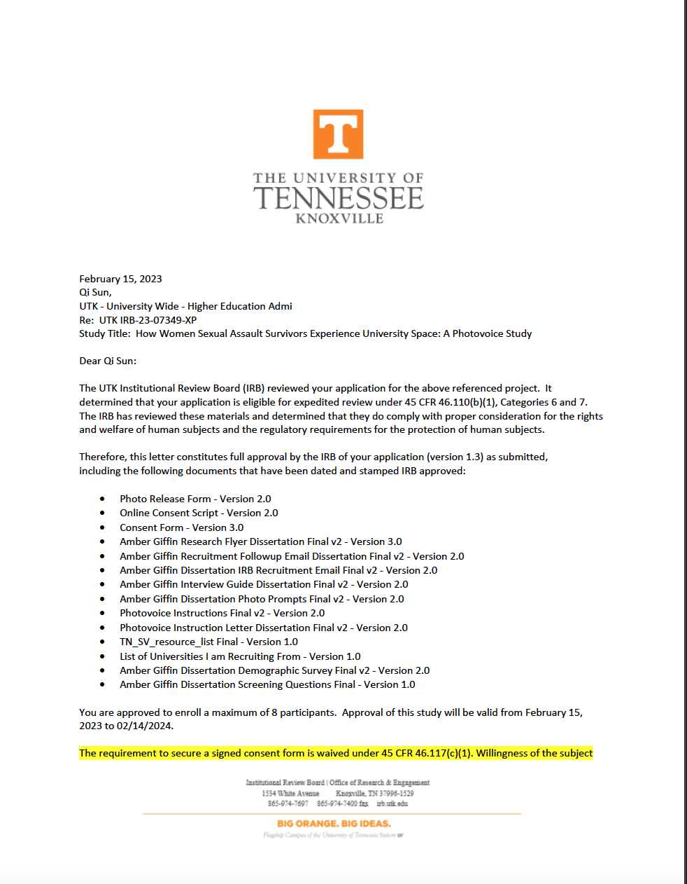

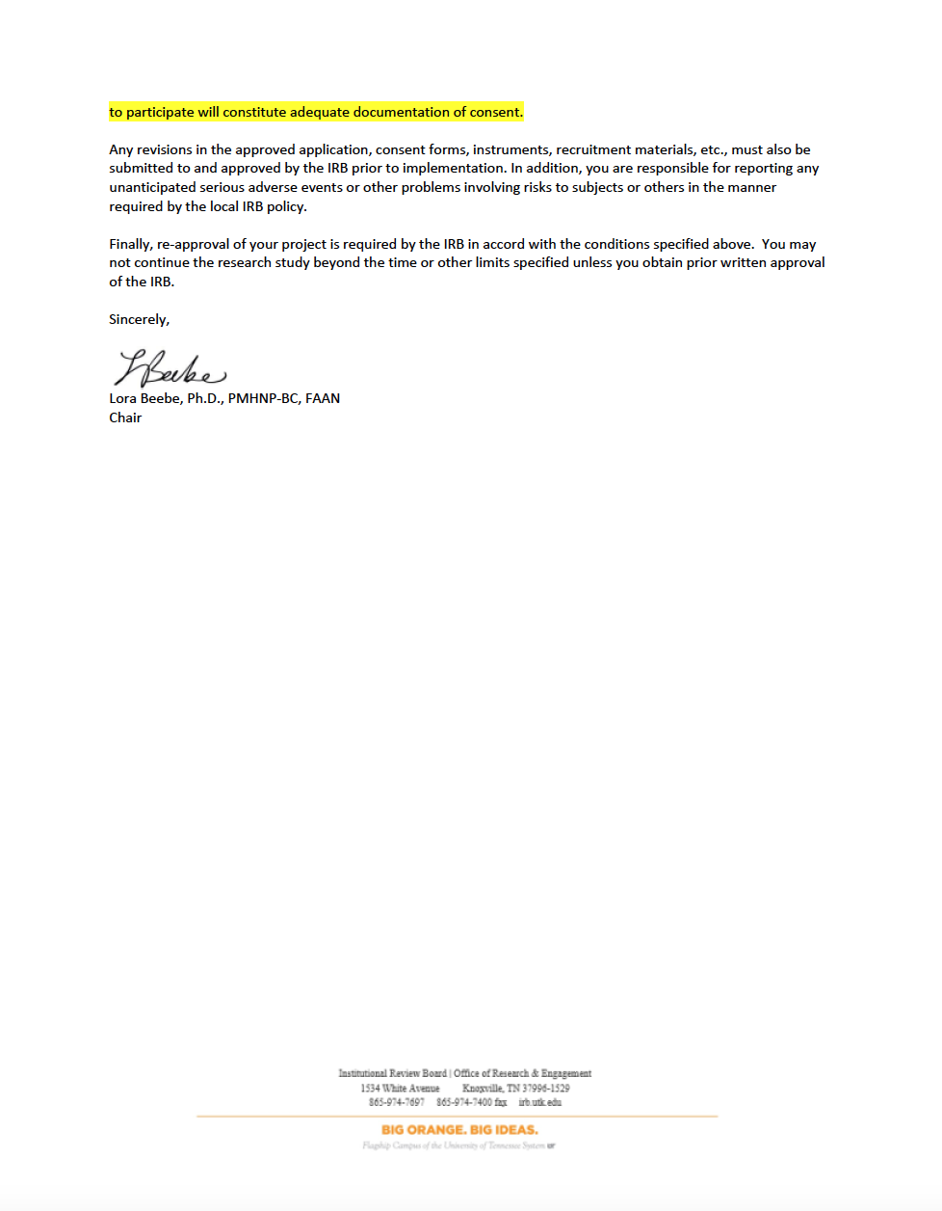

Appendix B: Recruitment Flyer
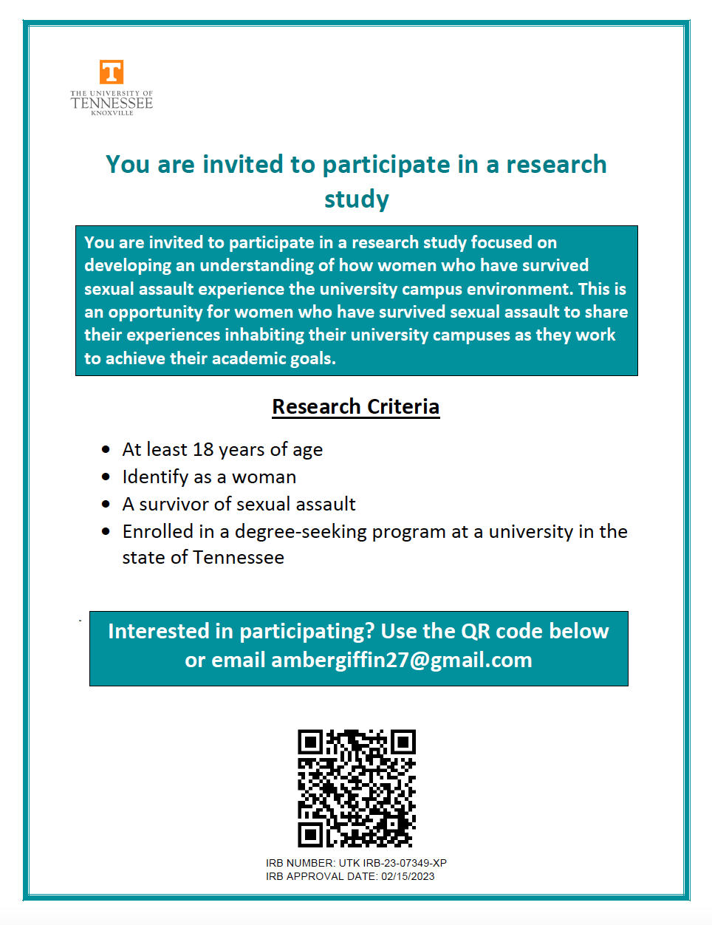

Appendix C: Recruitment Email
Dear [Name],
Today I’m writing to ask for your help. I am a PhD candidate in Educational Psychology and Research at the University of Tennessee, Knoxville, and I am currently recruiting participants for my dissertation study. This study focuses on developing an understanding of how women sexual assault survivors experience the university campus environment. This is an opportunity for sexual assault survivors to share their experiences inhabiting their university campuses as they work to achieve their academic goals.
Participation will mean signing a consent form and participating in a two-week long Photovoice study. The study will begin with a group meeting where participants learn about the Photovoice method, receive photo prompts, and how to take pictures for the study. During the two weeks after the initial meeting, participants will have the opportunity to photograph places and spaces that make them feel empowered. Then, participants will be asked to share their thoughts about their university campus in a group meeting at the end of the two-week period. Students are eligible to participate in this study if they are at least 18 years old, are enrolled in a degree-seeking program at a university in the state of Tennessee, and are survivors of sexual assault.
If you are interested in helping me recruit participants for this study, please place the flyer (attached) in spaces that receive a lot of student traffic (student union, libraries, etc.). You are also welcome to share this email with on university listservs. Participation is completely voluntary, and participants can leave the study at any time.
Feel free to get in touch if you have any questions about the study.
Thank you so much for your time,
Amber Giffin

Appendix D: Consent Script
Amber Giffin Live Online Consent Script for Dissertation
Hello!
As you know, we are here to conduct a training on how to take photos for a Photovoice research study led by me. The purpose of this study is to gain an understanding of how sexual assault survivors experience their university environments. As you know, this research study will involve you taking a series of photographs based on the prompts that will be shared at the end of the training. We will hold another meeting in two weeks to discuss the photos you took.
Before we begin, I would like to invite you to review the consent document available via the attached link and decide if you would like to participate. You are eligible to participate in this study if you are a survivor of sexual assault, who identifies as a woman, attends a public university in the state of Tennessee, and are at least 18 years old.
If you are still willing to participate, all you need to do is click “yes” on the online consent form, and then on the next screen, digitally sign your name.
As I mentioned before, participation in the study is entirely voluntary. Your name and any identifying information will be removed from all the documents, prior to analyzing any of the material.
I am available now if you have any questions about the study, and/or please feel free to contact me (ambergiffin27@gmail.com) if you have questions about the study at any time. Do you have any questions?

Appendix E: Consent Form
Consent for Research Participation
Research Study Title: How Women Sexual Assault Survivors Experience University Space: A Photovoice Study
Researcher(s): Amber Giffin, University of Tennessee, Knoxville
Qi Sun, University of Tennessee, Knoxville

Why am I being asked to be in this research study?
You are being asked to participate in this research study because you have contacted the researcher and expressed interest in participating in the study. You are eligible to participate in this study if you are a survivor of sexual assault, who identifies as a woman, attends a public university in the state of Tennessee, and are at least 18 years old.

What is this research study about?
The purpose of this research study is to develop an understanding of how women adult learners who are also sexual assault survivors experience the university campus.

How long will I be in the research study?
If you agree to be in the study, we will continue our online conversation for about an hour, during which time I will explain how the project works, train you to take photos for the project, and assign the photo prompts. Once this meeting is complete, you will be given two weeks to photograph images that you feel represent the prompts. At the end of the two weeks, we schedule a meeting where you can share the photo you feel best represents each prompt and are free to answer interview questions that will be asked of participant during the meeting.
While the photo prompts ask you to take pictures of spaces where you feel most empowered, I acknowledge that you have experienced at least one trauma, and that these prompts may activate past traumatic memories and emotions among some participants. Therefore, I will provide a list of resources in the Zoom chat during the first meeting, in case you feel any distress throughout this process. Additionally, if you feel distress during the interview portion of the project, we will stop the interview.

What will happen if I say “Yes, I want to be in this research study”?
If you agree to be in this study, I will ask you to digitally sign this form (below). When you have signed, we will undertake the following:
- We will complete an initial meeting where you will be trained on how to take photographs for this project and will be given the photograph prompts. I will record the meeting, and use Rev.com transcription to make a transcript.
- Two weeks later, we will meet individually via Zoom to conduct our interview. This process should take one hour to an hour and a half. I will record the interview, and use Rev.com’s unpaid AI transcription to make a transcript.
- I will then review the transcript while reviewing the video to check it for accuracy.
- When I have the final, accurate transcript, I will delete the original Zoom video recording.
- Once the initial research report has been completed, I will send you the report to ensure accuracy.
If my analysis finds noteworthy results, I might quote small excerpts from interview statements and photographs that you’ve taken in any eventual publications, but such excerpts and photographs will not include identifying or potentially identifying information. It is possible that photos and excerpts will be used in other research projects and publications in the future; however, all identifying or potentially identifying information will be removed.

What happens if I say “No, I do not want to be in this research study”?
Being in this study is up to you. You can say no now or leave the study later.

What happens if I say “Yes” but change my mind later?
Even if you decide to be in the study now, you can change your mind and stop at any time before the data sources are de-identified.
If you decide to withdraw from the study before then, please email Amber Giffin (ambergiffin27@gmail.com), and I will remove your name from the participant list, and your interview data will be deleted. If you decide to withdraw from the study after your data have been deidentified, it may be difficult to remove your data since your information will no longer be linked by your name or any other identifying indicators.

Are there any risks to me?
It is possible that someone could find out you were in this study or see your study information, but I believe this risk is small because of the procedures I use to protect your information. These procedures are described later in this form. It is also possible that you may find participating in this project distressing, which is why I will be providing you with resources to contact if you are in distress at any point throughout this study.

Are there any benefits to being in this research study?
I do not expect you to benefit from being in this study. While this study will not benefit participants directly, your participation may help to learn more about the best practices for creating a more trauma-informed campus environment. I hope the knowledge gained from this study will benefit others in the future.

Who can see or use the information collected for this research study?
I will protect the confidentiality of your information by storing it on UT computers, accessible only via 2-factor authentication login.
If information from this study is published or presented at scientific meetings, your name and other personal information will not be used.
I will make every effort to prevent anyone who is not on the research team from knowing that you gave us information or what information came from you. Although it is unlikely, there are times when others may need to see the information, we collect about you. These include:
- People at the University of Tennessee, Knoxville, who oversee research to make sure it is conducted properly.
- Government agencies (such as the Office for Human Research Protections in the U.S. Department of Health and Human Services), and others responsible for watching over the safety, effectiveness, and conduct of the research.
- If a law or court requires us to share the information, we would have to follow that law or final court ruling.

What will happen to my information after this study is over?
I will keep your de-identified information for five years, in case it becomes important to compare these experiences with future participants’ experiences. After five years, the information will be destroyed. Your name and other information that can directly identify you will be removed from all study materials, and it will not be possible to link your identity with these materials. Once I have received your feedback on the accuracy of our transcripts, I will de-identify and save the transcripts, and delete the original video recording.
I will not share your research data with other researchers.

Who can answer my questions about this research study?
If you have questions or concerns about this study, or have experienced a research related problem or injury, contact me, Amber Giffin, at ambergiffin27@gmail.com. For questions or concerns about your rights or to speak with someone other than the research team about the study, please contact:
Institutional Review Board
The University of Tennessee, Knoxville
1534 White Avenue
Blount Hall, Room 408
Knoxville, TN 37996-1529
Phone: 865-974-7697
Email: utkirb@utk.edu

STATEMENT OF CONSENT
If you do not wish to take part in this study, click “I Decline,” below, and then close the window when you see the confirmation screen.
If you wish to participate, and are at least 18 years of age or older, please click “I Consent” below. On the next screen, you will be asked to enter your name, and digitally sign this form. Please make sure you see the “thank you” screen before closing the browser window.

Appendix F: Photo Prompts
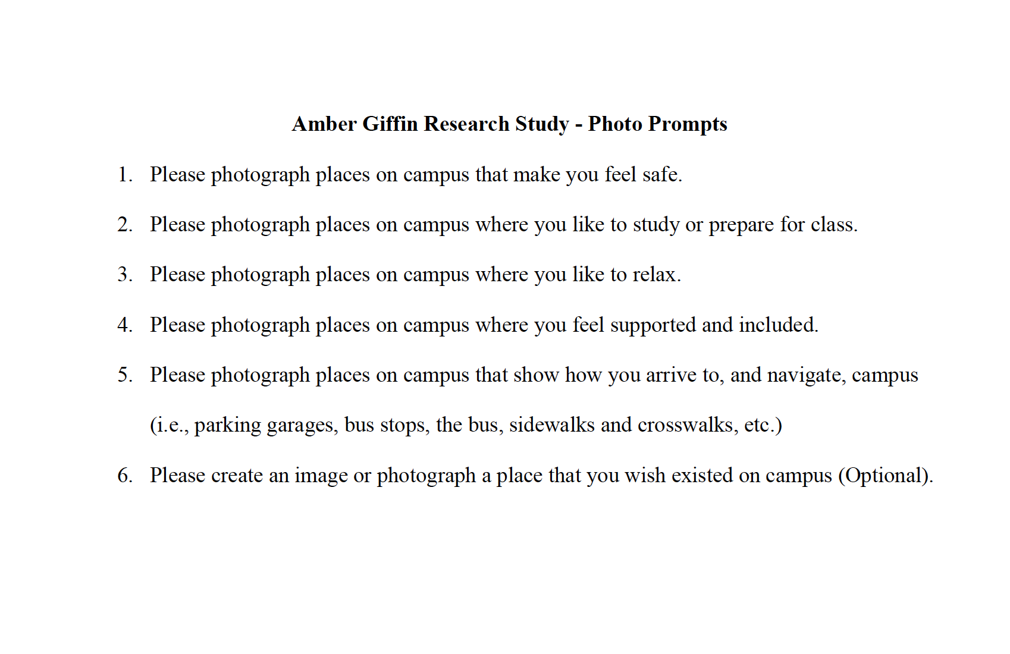

Appendix G: Interview Guide
Introductory text: Thank you for taking the time to join me for a group discussion regarding the photos you have taken over the past two weeks.

As a reminder, the purpose of this study is to understand how women who have survived sexual assault experience the university campus. If you feel distress at any point during this interview, please let me know and we will stop the interview immediately.

So that I get an accurate transcript, would you mind if I record this session?

Interview Questions:
I would like to start by discussing the photos that you all took. These questions will be asked about each photo you present.
  - Describe your picture.
  - What is happening in this picture?
  - Why did you take a picture of this?
  - What does this picture tell us about your life?
  - How can this picture provide opportunities for us to improve life on campus for women who have survived sexual assault?
Thank you for sharing all of this with me. Now I would like to talk a little bit about your experience in this study.
- What was being a part of this project like?
- How did you decide what to photograph?
  - How did you decide which photos to share with the group?
- Was this project difficult for you? Why or why not?
- Did you enjoy being a part of this study? Why or why not?
- What was it like for you to talk about your images?
- What did you gain or learn, if anything, from being a part of this project?

Thank you so much for taking the time to take part in this study and discuss your experiences with me. Just as a reminder, if you found any part of this study distressing, please do not hesitate to any of the resources listed on the file that I am now providing in the chat.

Appendix H: List of Resources
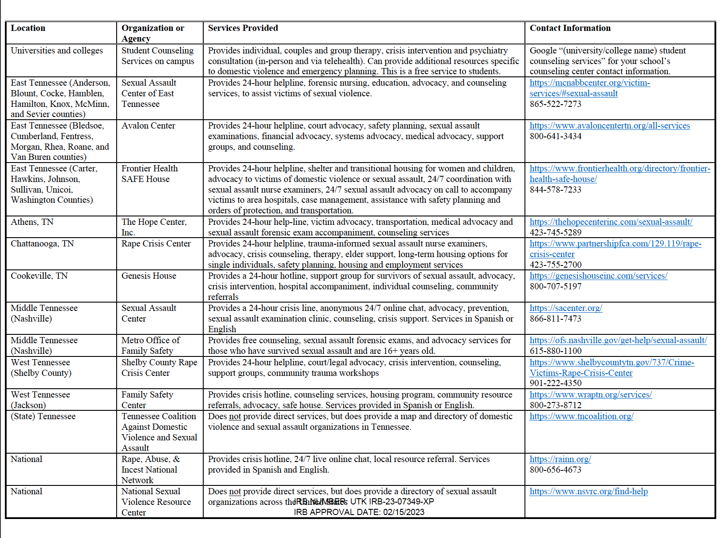

Appendix I: Initial Codebook
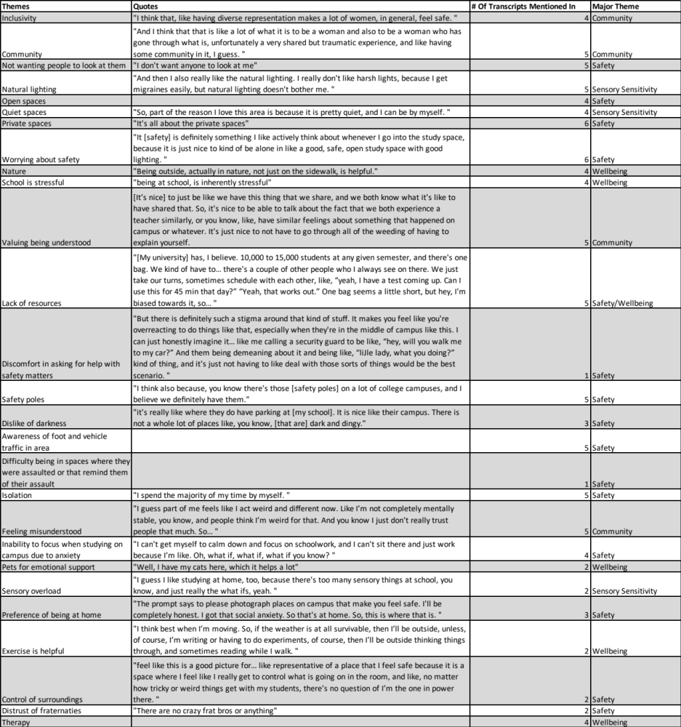

Vita
Amber Giffin was born to Peggy and Thomas Giffin on December 2, 1981, in Rockwood, Tennessee. She earned her Bachelor of Arts degree in American Studies with a focus on Indigenous Studies from the University of North Carolina – Chapel Hill in May 2013. She earned her Master of Science degree in Educational Psychology and Research with a focus on Applied Educational Psychology from the University of Tennessee, Knoxville in December 2018. Amber’s primary professional experience is in faculty development, and she worked as a graduate research assistant at Teaching and Learning Innovation for the past four years. She currently works as a full-time faculty consultant at Teaching and Learning Innovation. She also has professional experience as a musician, financial specialist, and assistant learning specialist. Amber will graduate with a Ph.D. in Educational Psychology in Research with a focus on Adult Learning in August 2023.

