Practical Methods for Optimizing
Equipment Maintenance Strategies
Using an Analytic Hierarchy Process and Prognostic Algorithms

A Thesis Presented for the
Master of Science
Degree
The University of Tennessee, Knoxville

Gregory M. Bosco
April 2017

Copyright © 2017 by Gregory M. Bosco
All rights reserved.

DEDICATION

To almighty God and my savior, Jesus Christ: I dedicate myself to doing your will by applying this knowledge to promote safe and responsible equipment management.

To my daughters: I think we live in a time period when young girls like you are limited only by their imagination and dedication to achieving their dreams. Your dreams will not come easily, though. You will need to sacrifice, sometimes putting aside important parts of your life to focus on the job ahead. You should expect setbacks and failures. When they happen, pick yourself up, make adjustments and move forward – always forward. You should expect criticism, doubters, and roadblocks; some of them will be unfair and beyond control. If you cannot work through them, go around. You will also have successes, often creating a difference between you and other people. Be humble and charitable by giving back; help people achieve their potential just like so many have done for you. Most important, believe in yourself. I dedicate this thesis and the time spent working towards it to you.

ACKNOWLEDGEMENTS

To Dr. Jamie Coble, my advisor and committee chair from the Department of Nuclear Engineering at the University of Tennessee: Thank you for sharing your knowledge and insight, and helping me find the answers to my questions over the past few years. The opportunity to work with you made a difference.

To my wife - thank you. Thank you for your selflessness and support. I could not have done this without you.
ABSTRACT

Abstract cannot exceed 350 words.

Will provide later.

Table of Contents
Chapter 1: Introduction 1
Chapter 2: Literature Review 7
2.1 (Levels 0 & 1) Equipment Life Cycle & Stages 8
2.2 (Levels 2 & 3) Maintenance & Strategies 11
2.3 (Level 4) Maintenance Policies 14
2.4 (Level 5) Maintenance Tactics 18
2.5 (Linking Levels 1 - 5 to Levels 6 - 8) Optimizing Maintenance 24
2.6 (Levels 6 & 7) Prognostics and Health Management 52
2.7 (Level 8) Data / Knowledge Feedback & Implementation 80
Chapter 3: Materials and Methods 81
3.1 (Levels 0 – 5) AHP 82
3.2 (Level 6) Data Management 87
3.3 (Level 7) Prognostic Methods 93
3.4 Maintenance Policy Cost Considerations 114
Chapter 4: Results and Discussion 116
4.1 (Levels 0 - 5) AHP Models 117
4.2 (Level 7) Prognostic Models 122
Chapter 5: Conclusions and Recommendations 136
Chapter 6: Future Work 141
List of References 142
Appendices 153
Appendix A - Tables 154
Appendix B - Figures 165
Vita 175

LIST OF TABLES

Table 1. Continuous Distributions and Parameters 94
Table 2. Maintenance Policy Costs 114
Table 3. Critical Criteria Analysis 120
Table 4. Benefit-Cost Ratio 121
Table 5. Type 1 Models – Fitted Functions & Parameter Results 123
Table 6. Type 1 Models – Function Goodness of Fit Results 124
Table 7. Cox PhM Statistics 126
Table 8. Type 3 Models – GPM with Bayesian Mean Squared Error 130
Table 9. Quadratic Model Parameter Evaluation 130
Table 10. Cumulative Relative Accuracy of Prognostic Models 133
Table 11. Literature Review of Topics 154
Table 12. Literature Review of Topic Publishing By Year 154
Table 13. Literature Review of Quantity of Publishing By Year 155
Table 14. Literature Review on Optimization Criteria Reported 157
Table 15. Literature Review on Optimization Case Studies 158
Table 16. Literature Review on Optimization Case Studies 158
Table 17. PCA and PLS Applications for Fault Diagnostics 159
Table 18. AHP Demonstration – Requirements Definition 160
Table 19. AHP Demonstration – Judgement Score Matrix 162
Table 20. AHP Demonstration – Level 1 Criteria PCM 162
Table 21. AHP Demonstration – Level 2 & Level 3 Criteria PCM 163
Table 22. Database 164

LIST OF FIGURES

Figure 1. PHM In Equipment Life Cycle Management 5
Figure 2. AHP in Maintenance Policy Decision 6
Figure 3. Life Cycle Stage Comparison 8
Figure 4. Affordable System Operational Effectiveness 27
Figure 5. Affordable Solutions – Trade Space 28
Figure 6. Optimal Cost Effective Time to Replace 30
Figure 7. Elements of Maintenance Downtime 35
Figure 8. Relationship Between RUL, Reliability, and Maintenance Cost 54
Figure 9. Notional PHM System 55
Figure 10. Data Cube Structure 59
Figure 11. Condition Monitoring Applications 70
Figure 12. Idealized P-F Interval 72
Figure 13. Failure Characterization 73
Figure 14. Classification of Fault Diagnostic Methods 75
Figure 15. Criteria Pairwise Comparison Matrix 82
Figure 16. Alternative Pairwise Comparison Matrix 83
Figure 17. Level 1 Criteria Scores Matrix 84
Figure 18. Benefit_Cost Ratio 84
Figure 19. GPM-Bayesian Updating Prognostics Process 106
Figure 20. Pseudo-Inverse Calculation 108
Figure 21. Pseudo-Inverse Calculation – Bayesian Updating 111
Figure 22. AHP in Maintenance Policy Decision 118
Figure 23. Type 1 Models – Reliability vs Time 124
Figure 24. Type 1 Models – Reliability Based RUL 125
Figure 25. Type 2 Models – Cox PhM Cumulative Hazard Rate vs Time 127
Figure 26. Type 2 Models – Cox PhM Reliability vs Time 128
Figure 27. Type 2 Models – Cox PhM Based RUL 129
Figure 28. Type 3 Models – GPM With Updating, Degradation Paths 131
Figure 29. Type 3 Models – GPM With Bayesian Updating RUL 132
Figure 30. Literature Review Appearance in Publications 166
Figure 31. Coating System Failure Modes 167
Figure 32. Coating System Corrosion and Blistering Fault Tree 168
Figure 33. Coating System & Substrate Cross Section With Faults 169
Figure 34. ASTM D610 Rust Ratings 170
Figure 35. ASTM D714 Blister Ratings 171
Figure 36. Database Structure & Mapping 172
Figure 37. Condition Rating & Service Life 173
Figure 38. Time of Failure for Factors 174

ACRONYMS

AFT | Accelerated Failure Time
AHP | Analytic Hierarchy Process
AM | Autonomous Maintenance
ASTM | American Society for Testing and Materials
CbM | Condition Based Maintenance
cc | Correlation Coefficient
COMADEM | Condition Monitoring and Diagnostic Engineering Management
CRA | Cumulative Relative Accuracy
DMG | Decision Making Grid
ELECTRE | Elimination and Choice Translating Reality
FMECA | Failure Modes Effects and Criticality Analysis
FTA | Fault Tree Analysis
FL | Fuzzy Logic
GPM | General Path Model
HR | Hazard Ratio
IFDD | Incipient Fault Detection and Diagnosis
INCOSE | International Council on Systems Engineering
IT | Information Technology
JIT | Just-In-Time
KM | Kaplan-Meier Estimator
KS | Kolmolgorov-Smirnov
LCC | Life Cycle Cost
LP | Line Productivity
MCDM | Multi-Criteria Decision Making
MCMC | Markov Chain Monte Carlo
MTBF | Mean Time Between Failure
MTTF | Mean Time To Failure
MSE | Mean Squared Error
NRC | Nuclear Regulatory Commission
O-Level | Organizational Level
O&M | Operations and Maintenance
PCA | Principal Component Analysis
PdM | Predictive Maintenance
PhM | Proportional Hazard Model
PHM | Prognostics and Health Management
PLS | Partial Least Squares
PM | Preventive Maintenance
RBD | Reliability Block Diagram
RCA | Root Cause Analysis
RCM | Reliability Centered Maintenance
RTFF | Remaining Time to Functional Failure
RUL | Remaining Useful Life
SoS | System-of-Systems
TdM | Time Directed Maintenance
TOC | Total Ownership Cost
ToF | Time of Failure
TOPSIS | Technique for Order Preference by Similarity to Ideal Solution
TPM | Total Productive Maintenance
WSM | Weighted Sum Model

Chapter 1: Introduction
Many organizations report that equipment-level Condition Based Maintenance (CbM) is not effective at the plant-level. Conflicting or undefined requirements, and incomplete or inappropriate use of CbM are the leading causes for low performance. To improve, the following two tools should be adopted and integrated. Maintenance strategies should be used to resolve conflicts and ensure alignment among enterprise-level requirements and expectations, business and operational processes, safety and technical performance requirements, logistics and scheduling, funding and other resource constraints, and customer needs and expectations. A Prognostics and Health Management (PHM) system should be used to manage CbM, optimizing performance at the equipment-level. Separately, these tools exist today. What is missing, however, is a demonstration of methods that can be used to identify CbM as the best approach to maintenance and explain how to integrate CbM within a maintenance strategy, proving that optimization techniques are effective at the plant-level.

The purpose for this project is to demonstrate how to design maintenance strategies using certain methods for manage requirements and optimize equipment maintenance. It provides structure missing from other resources, putting in-service equipment maintenance as the center-piece in the context of life cycle management and continuous improvement. Then, It explains how to derive requirements from numerical data and subjective opinions, and how to drive them all the way down to connect with equipment operators and mechanics. It explains and demonstrates how their resource demands can be balanced, controlled, and the information gathered during normal execution of their work can be used to optimize the performance and maintenance of equipment. It demonstrates how the practices, processes, and methods applied here are simple to use and integrate, and can be scaled for large plants or smaller systems. These methods apply to both new and in-service systems.

Where the state-of-the-art is concerned, we are at the crossroads of equipment optimization capabilities and organizational commitment. When we look back, we see twenty years of research and unprecedented technological advances in sensors, microcomputers and software, and wireless communications that were used to transform the idea of maintenance from the practice of restoration to a new state that uses degrading performance as an opportunity to improve. We understand now that data collected during operations and maintenance can still be used as a tool that ensures safety, while also making changes that improve operational performance, control downtimes, reduce costs, and increase profit.

The architecture for this new state is the PHM system. Without enterprise level commitment though, resources that support PHM may be lost to process inefficiencies and gaps caused by unparticipating stakeholders, customers, and partners, ultimately causing them to loose faith and turn elsewhere. They are likely to commit and eliminate barriers when they participate in building and using a maintenance system that is specifically designed for their individual and collective success. The problem is, for all the many stakeholders typically involved, they have different measures of success and different ideas about how to achieve it. So what tools should be used to obtain and incorporate their input, engender their participation and trust, and encourage commitment to PHM? What methods should be used to translate all the different ideas about what an optimal maintenance system should be, how it should operate, and how it should measure success? How should an organization design a unified set of strategic practices that are both practical and simple to use?

The following work presents a top-down, outside-in investigation into some of the structures, methods, practices, and techniques that can be used to optimize equipment operations and maintenance, and answer the questions posed above. It coordinates system life cycle management, an Analytic Hierarchy Process (AHP), and Multi-Criteria Decision Making (MCDM) to outline both why and how an organization should make the strategic decision to employ certain maintenance policies, tactics, and methods and tailor them for individual or families of systems. It openly acknowledges that PHM is not for every organization or system, but does show that some of the practices, if immediately implemented, will be helpful when transitioning equipment and the management system to a more advanced state later.

The focus of this project is prognostics. While its detail and demonstration are found in the second half of the work, all that comes before is considered essential to understanding how and when to use it. Included in this chapter are critical, often negative comments discussed in journal articles and returned in surveys on the effectiveness of CbM. This type of feedback is important because it indicates a need to resolve issues that prevent its success. For example, PHM comes with the costs for increased infrastructure, management, and decision-making workforce in the office. Scaling-up in the office to scale-down in the field can be unexpected, and may be one of the causes for negative feedback.

To be very clear, this project finds that PHM principles and practices are useful and provide a benefit. It also finds that their implementation and use often do not. Resolving these differences is the focus of this project.

Figure 1 illustrates a novel approach to defining PHM through a life cycle structure, maintenance taxonomy, and eight distinct levels of management. The path of processes and decisions that lead to PHM is outlined in solid red. The path that leads to continuous improvements is shown in dashed red lines with arrows. Blue lines, both dashed and solid, indicate a relationship. This figure provides a rational roadmap that should be used first, to determine if a product should be maintained. It then advances that path all the way down to the most advanced processes that ensure data collected in the field are used to extend the useful life and improve the performance and maintenance of in-service equipment, and make new versions or different equipment better. The stages in this figure are referenced by other figures throughout the rest of the document.

Figure 2 illustrates a sample framework of MCDM considerations that influence the maintenance policy decision. This is one of the many practices where stakeholders, customers, and partners require joint input and agreement on the decision to select a policy. It highlights the fact that traditional types of requirements like availability and reliability alone provide unsatisfactory results because other considerations need to be incorporated. For example, if an organization operates under a fixed maintenance budget, has a limited access to a workforce, and often prioritizes maintenance at the last minute; how are these ‘maintainability’ constraints combined with performance requirements to select the appropriate policy? AHP is a vehicle for doing so. This figure is used throughout the rest of the document to describe the AHP structure, and is used in the demonstration beginning in Chapter 3.

Explain why applying AHP to data on coating system. Sustainability. Degrading infrastructure…anonymity…

Just as much about organizational structure and behavior as it is about meeting technical objectives. Big organization – small organization. Differences in decision making processes and capability. Which type of maintenance policy works best? Turn abstract thoughts and decisions into organized, consistent process.

Figure 1. PHM In Equipment Life Cycle Management
Level 8
Level 7
Level 6
Level 5
Level 0
Level 1
Level 2
Level 3
Level 4
Level 4
Levels 1 - 3

Figure 2. AHP in Maintenance Policy Decision

Chapter 2: Literature Review

2.1 (Levels 0 & 1) Equipment Life Cycle & Stages

Every system has a life cycle. A life cycle is a framework of stages that describe the system from concept; through development, production, and implementation; service and support, and retirement. Given various operating environments, organizational structures, and other constraints, there is little agreement on specific stages. In general, though, most approaches align with overarching processes that should be addressed throughout the life of a system. Figure 3 below illustrates variations from different industries, standards, and United States government agencies [1]. The remainder of this paper will discuss a life cycle using the ISO/IEC/IEEE 15288 framework at the top.

Generic life cycle (ISO/IEC/IEEE 15288:2015)
 | Concept stage |  |  | Development stage |  |  |  | Production stage |  |  |  |  | Utilization (sustainment) stage |  |  |  |  |  |  |  |  |  |  |  |  |  |  | Retirement stage
 |  |  |  |  |  |  |  |  |  |  |  |  | Support stage
Typical high-tech commercial systems integrator
 | Study period |  |  |  |  |  |  |  |  |  |  | Implementation period |  |  |  |  |  |  |  |  |  |  | Operations period
 | User requirements definition |  |  |  | Concept definition |  | System specification |  |  |  | Acq prep | Source selection |  |  |  |  | Development |  |  |  | Verification |  | Deployment |  |  |  | Operations and maintenance |  |  |  |  | Deactivation
Typical high-tech commercial manufacturer
 | Study period |  |  |  |  |  |  |  |  |  |  | Implementation period |  |  |  |  |  |  |  |  |  |  | Operations period
 | Product requirements |  |  |  | Product definition |  | Product development |  |  |  |  | Engr model |  |  | Internal test |  |  | External test |  |  |  |  | Full-scale production |  |  | Manufacturing, sales, and support |  |  |  |  | Deactivation
US Department of Defense (DoD)
 | User needs |  |  |  | Pre-systems acquisition |  |  |  |  |  |  |  |  |  | Systems acquisition |  |  |  |  |  |  |  |  |  |  |  | Sustainment
 | Tech support resources |  |  |  | Material solution analysis |  |  |  |  |  | Technology development |  |  |  | Engineering and manufacturing |  |  |  |  |  | Production and deployment |  |  |  |  |  | Operations and support (including disposal)
National Aeronautics and Space Administration (NASA)
 |  | Formulation Approval Implementation
 |  | Concept studies |  |  |  | Concept & technology development |  |  |  | Preliminary design & technology completion |  |  |  |  |  | Final design & fabrication |  |  |  | System assembly integration & test, launch |  |  |  | Operations & sustainment |  |  |  |  | Closeout
US Department of Energy (DoE)
 | Project planning period |  |  |  |  |  |  |  |  |  |  |  |  | Project execution |  |  |  |  |  |  |  |  |  |  | Mission
 | Pre-project |  | Preconceptual planning |  |  |  |  |  | Conceptual design |  |  |  |  | Preliminary design |  |  |  |  | Final design |  |  | Construction |  |  | Acceptance |  |  |  |  | Operations

Figure 3. Life Cycle Stage Comparison

A framework of stages should be considered as a guide only. In practice, some of the activities for different stages will overlap, so tailoring for specific situations and environments is encouraged. Skipping stages to reduce cost and schedule is discouraged because it has a cascading effect later, causing rework and delays.

Maintenance, modernization, and life cycle logistics support, including funding and budgetary processes and requirements, should be fully developed through user requirements definition conducted during the concept and development stages. Reliability growth, which are a series of activities that design-test-assess-modify, ensure reliability is designed into the system before it is fielded. It should also be performed during the development stage [2, 3]. Fully addressing these factors in early stages greatly increases the potential for successful and expected performance later during sustainment because as much as 80% of the life cycle costs are designed into the system by the time full production begins, and approximately 75% of the costs occur during sustainment [1, 4].

During development, one of the most commonly overlooked factors is the affordability of the system. An affordable and operationally effective system manages the trade-space between required capabilities and specific environments and uses “…at the cost constrained by the maximum resources the [organization] Department can allocate for that capability [5, 6, 1].” Simply stated, the owner cannot afford a system without sufficient incoming resources to pay the costs for, among other things, maintenance and modernization. Affordability depends heavily on the user’s context. So given different operating environments and conditions, influences, and constraints, the funds required for sustaining the system may be different for each user or owner. To ensure enterprise level satisfaction with performance during sustainment, affordability objectives and requirements must be fully explained and used to develop a comprehensive plan for maintenance before the system is put into service.

2.2 (Levels 2 & 3) Maintenance & Strategies

The sustainment stage of the life cycle is defined principally by maintenance, modernization, and logistics support. Maintenance encompasses the principles and practices that repair damage or replace components that exhibit potential or actual degraded performance or damage. Depending on the expected service life of the system, the sustainment stage may include a plan for modernization through material or configuration modifications, upgrades, and replacements. Logistics support refers to activities that identify the demand for, and acquire and procure materials and resources, and provision product support [1]. Of these three factors, the remainder of this paper will focus only on maintenance, addressing it from a global planning and scheduling perspective, and not the specific activities involved with making repairs to equipment.

The approach to selecting the optimal maintenance strategy is a critical step towards achieving an affordable and operationally effective system. Past efforts to optimize maintenance focused only on minimizing costs and maximizing production or availability, not addressing other factors that are all interrelated and equally important such as safety, profit, sustainability, logistic support, fixed or limited funding, etc. Focusing on cost and availability alone often leads to low reliability and an unbalanced system. This is probably why organizations report that they are only satisfied with their results using maintenance optimization techniques [7]. It appears that either important elements are missing from their application, they employ the wrong approach, or they do not fully commit to the effort [8]. To achieve the best results, organizations should use specialized MCDM optimization techniques such as AHP, that are specifically designed to aid in selecting a maintenance strategy that balances System-of-Systems (SoS) affordability and operationally effective objectives and requirements.

To begin, Khazraei and Deuse suggest defining maintenance in the context of a maintenance strategy, illustrated in Figure 1 [9]. A strategy is a structure that binds together the “complex web of thoughts, ideas, insights, experiences, goals, expertise, memories, perceptions and expectations” into affordability objectives and measurable requirements that explain what is to be done to execute “management’s game plan for the business [9]”, see Figure 2. It should fill the white space between deterministic and stochastic factors. Using the taxonomy suggested by Khazraei and Deuse, strategies can be decomposed to policies that explain how maintenance is to be accomplished, and down further to tactics that “translate the plan into action” through specialized methods that will be used to accomplish it [9].

In a comprehensive literature review, Khazraei and Deuse find two principle types of maintenance strategies, reactive and preventive; Moubray, a frequently cited source, finds the same [9, 10]. They explain that strategies should be system or component-specific, and not arbitrarily applied across a broad range of systems without proper evaluation.

Reactive Maintenance is performed after a failure occurs with the goal of minimizing life cycle costs, at the expense of unexpected frequency and duration of downtime. Additionally, many, if not most of the affordability and operational objectives may not be satisfied. So a reactive maintenance strategy should be used with caution and consideration for its negative influence on a number of associated factors that affect affordability.

Preventive Maintenance (PM) is performed at pre-determined intervals or when pre-determined conditions or thresholds are achieved. Action is taken for the purpose of reducing the probability of failure and controlling degradation of the system. Preventive actions include inspections and monitoring, detection and diagnostics, and corrective actions prior to functional failure. A preventive strategy is appropriate for higher or highly complex systems, and components with higher criticality and strong influence over affordability and operational objectives.

2.3 (Level 4) Maintenance Policies

According to Khazraei and Deuse, maintenance strategies are higher order to policies. Strategies explain ‘what’ is to be done, specifying the guiding factors, objectives, requirements, and goals that should be considered. Policies, however, focus on ‘how’ the organization is to execute the strategy by specifying the governing rules and regulations the organization is to follow while executing it. A single strategy can involve several policies, each employed for different equipment, environments, or situations that ensure success of the whole. Khazraei and Deuse, Bevilacqua and Bradlia, and numerous other sources identify or align with the following five major classifications of maintenance policies, illustrated in Figure 1 and discussed as follows:

Reactive maintenance policies: use after a functional failure

Corrective Maintenance Policy, the oldest and most commonly used, replaces or restores a system to as-good-as-new or to some earlier condition after a failure occurs. This policy is appropriate when the profit ratio is high due to potentially long downtimes for repair, at the potential cost of damage to the system and environment, or injury to personnel. It may cause long periods of downtime at unexpected frequency [9].

Prospective Maintenance Policy is commonly referred to as opportunistic or block maintenance. It executes preventive work that is either not due yet or overdue on wear-out components. This is done at times when a plant or system is taken out of service to perform maintenance on a different system that has already failed. It provides the greatest benefit when there is a clear economic or performance dependency between the failed component and others located in close proximity. For prospective policy components, the maintenance crew will have the opportunity to perform maintenance before a failure occurs, at lower total cost for maintenance due to economies of scale. Long-term maintenance planning and scheduling, and allocation of resources, at the cost of longer system downtimes, are additional characteristics of this policy [9, 11].

Preventive maintenance policies: use at time or on condition, before a functional failure

Pre-determinative Maintenance Policy is commonly referred to as planned or scheduled maintenance, or simply as Time-directed Maintenance (TdM). This policy uses maintenance as a tool to control the performance of increasingly complex systems where the failure of one component may cause failure at the system level. It can increase the life of the system through maintenance occurring at fixed intervals, at the cost, though, of taking the system offline and spending money on maintenance when there is significant remaining useful life for the system [7]. This policy is designed to promote stability, control, and more certain up-times, and may be easier to manage through an automated computer scheduling system.

Predictive Maintenance Policy. Fixed intervals of TdM do not always achieve safe and failure free periods of operation due to nonhomogeneous behaviors caused principally by imperfect repair, environmental influences, or various operating conditions and uses. A different policy, specifically designed to reduce the risk of failure during the inter-TdM period, reduce costs for excessive maintenance, and aid in coordinating logistics is the Predictive Maintenance (PdM) policy. It uses technology and a SoS approach to measure, detect, assess, and then schedule maintenance at a time and condition ideally just days or a few weeks before failure. Sensor technologies and a condition monitoring system are used to diagnose influential causes for conditions and degraded performance, and project the time range when a future condition may occur; this includes a projection of the Remaining Useful Life (RUL). At the component or system level, this policy reduces life cycle costs by extending intervals between maintenance with the intent of performing just-in-time maintenance during potentially irregular downtimes [9].

Irregular downtimes complicate managing availability requirements and logistics. The impact of these complicated factors are reduced using prognostic algorithms. These algorithms project future performance, and can be used to group systems by risk of failure for periods of planned downtime through opportunistic maintenance, at times of planned system outages [11]. Prognostics and opportunistic maintenance together can be used as tools for ‘smoothing’ the rough effects of highly weighted performance requirements, such as availability. Beyond controlled risk and safety, these tools enable logistic queuing and sequencing, long lead-time and just-in-time material ordering and storage, workforce alignment, balanced budgets, and level-loading work, at lower costs due to economies of scale [11].

PdM is not appropriate for all systems. Some cannot be monitored. For others, there is no prior knowledge from which to make predictions. So less advanced levels of CbM, successive periods of observation in the P-F interval, which is discussed later, may be appropriate for performing maintenance and building the knowledgebase [10].

Proactive Maintenance Policy. In recent years policies have been introduced that advance the maintenance paradigm from one of sustainment to one that improves performance by using the entire maintenance system as a tool to improve effectiveness, efficiency, availability, and costs. Proactive maintenance, at its highest level is known as Autonomous Maintenance (AM), relying on a partnership between operators, maintenance execution and planning departments, professional disciplines, and management to couple their experience with collected data [7]. This approach advances the activities of a predictive maintenance policy through feedback and follow-through routines that detect and isolate opportunities for improvement; measure and simulate potential operational range changes and their effects; and then propagating necessary changes and resourcing through new product development, maintenance, and modernization. The proactive policy is geared towards designing-out failure mechanisms and maximizing efficiency and effectiveness, so many of its functions can be used to transition systems from other policies to a proactive policy.

Barriers include costs, training, and top-down long-term commitment to a self-improving maintenance management system and proactive policy. Training is required throughout the organization to ensure all parties communicate, cooperate, and align with the policy. Management decisions should align with the policy, and organizational structures and processes may need to be updated accordingly.

Organizations that are unsatisfied, or even just satisfied with their current performance should evaluate their current approach to determine if they are applying the best policy, or the best policy in an appropriate way because each of the five discussed above have their own special characteristics. They should be used under different circumstances to satisfy a variety of objectives and requirements. Successful maintenance programs apply an individualized maintenance policy to each system; so there is no single best policy appropriate for all [7]. Given the focus of this paper is on prognostics and health management, the remaining sections will focus primarily on predictive maintenance policy tactics.

2.4 (Level 5) Maintenance Tactics

Maintenance policy tactics generalize the specific methods used to implement and act on the policy. Implementation is a highly complex and challenging step, requiring communication, resources, and fully functioning processes throughout the entire organization. “Without [complete] implementation, even the most superior strategy is useless [9].” The following examination is limited to predictive and proactive tactics to focus on areas that achieve better results [11]. Proactive tactics will be discussed here due to their powerful potential for improving the performance of an entire enterprise, but will not be used in the analysis later because Level 8 feedback mechanisms are beyond the scope of this paper. Most of them involve the recursive data and knowledge feedback loop illustrated by the red dashed lines in Figure 1.

Predictive Tactics

Avoidance-based Maintenance Tactics focus on foresing a failure and then scheduling maintenance to prevent it from occurring in the future. Recently, it has been used with hi-tech systems, for which there is little research and few models; i.e. selective-splitting and cache-maintenance algorithms for associative-client caches that prevent unwanted access to databases [12].

CbM Tactics are defined by “maintenance action[s] based on actual condition (objective evidence of need) obtained from in situ, non-invasive tests, and [actual] operating and condition measurements [13].” Maintenance occurs each time the parameter of interest exceeds or is projected to exceed a specified limit. These tactics require various levels of analysis to determine if maintenance is needed, and coordination for scheduling downtime and other logistic considerations, ideally within days or weeks after detection. CbM can be used to maximize availability while reducing damage from secondary failures, overall downtime, overtime costs for repairs, and the opportunity to modify end-use to extend life. The cost for CbM depends greatly on the method of detection, information management, analysis, reporting, and scheduling maintenance [14]. The level of automation in assessing conditions varies greatly, from human visual inspections to fully automated systems that make use of embedded sensors and continuous condition monitoring. Regardless of the level, a well-trained staff and fully functioning maintenance management system are needed for CbM tactics.

Detective-based Maintenance Tactics are a basic level of CbM using the least expensive method for detection, the human sensor [9]. They can achieve some of the benefits of more advanced methods, but at the cost of wide variance (noisy) results due to highly subjective assessments and decision making by the these sensors [15, 16, 17].

Proactive Tactics

Availability Centered Maintenance Tactics requires analyzing degradation from failure modes to make improvements in the areas of service, repair, and replacement based on the availability of the system; specifically, mean up-times and mean down-times updated to maximize availability through adjustments to the replacement interval [18]. Above, mechanical service refers to lubrication, cleaning, adjusting, and checking for the purpose of reducing the chance for degraded strength. Repair refers to actions that slow down the rate of degradation and partially restore strength. Replacement restores a component or system to its original or some level of former condition [19].
Business Centered Maintenance Tactics align maintenance actions solely with profit. In a recursive process developed by Kelly, business objectives are identified first, and then maintenance requirements are derived from data on production processes, demand and workload forecasting, service life plans, and the expected availability of the system [20].

Design-out Maintenance Tactics monitor in-service systems for reoccurring faults on which the maintenance staff perform root cause analysis. They redesign the system to improve performance through improved maintainability and elimination of failure modes [20].

Risk-based Maintenance Tactics are used to determine the probability of failing and potential consequences within a particular time interval. It is often used to reduce overall costs and scheduled downtime, safety, and control public image, etc. In a literature review, Krischnasamy identifies four major stages to this tactic. First, the scope is explored by constructing either a physical or functional relationship among the major systems and components, and aligning them with the main system under investigation. Next, a risk assessment is performed and the potential major hazards are identified and modeled, often using a fault tree or life cycle event trees. Faults for each component are evaluated independently, and the effects propagated down to basic events near the bottom of the tree. Failure data from a statistical database and expert opinion-experience are often combined for each component or event during this stage. Consequence analysis modeling the cost or other impacts is usually included. In the third stage, risk criteria are established and used to determine the estimated acceptable risks from each scenario. For those with unacceptable risk, in the fourth stage, the maintenance team examines mitigating solutions that create an alternate path to reduce them to an acceptable level. The two most common alternate paths used are to adjust inspection and maintenance periodicities, or employ more conservative maintenance policies that avoid risks, rather than manage them [21, 22, 23].

Reliability-centered Maintenance (RCM) Tactics, are recursive, periodically assessing the performance of equipment to adjust maintenance practices, and design-in improvements to the maintenance system, as well as new products. According to NASA, RCM integrates preventive, predictive, reactive, and proactive maintenance to increase the chance that a system or component will perform its function in the required manner and design-life with minimum maintenance and downtime, with the goals of safe operations and minimum life-cycle costs. The US Department of Energy (DoE) goes on to explain that the RCM methodology recognizes that not all equipment is of equal importance, having different probabilities of failure and degradation rates and mechanisms. It recommends structuring the maintenance program with consideration for limited financial and personnel resources. RCM relies heavily on predictive tactics, but incorporates other policies such as reactive maintenance to lower risk and expenses. The US DoE publishes the following notional breakdown of RCM applied to facility management: <10% reactive maintenance, 25-35% preventive, and 45-55% predictive [24, 25]. Further, in a notional example, the DoE explains a reactive policy may cost $18/horsepower/year; a preventive policy $13/horsepower/year; a predictive policy $9/horsepower/year; and finally RCM (proactive or preventive maintenance) can achieve $6/horsepower/year.

The DoE recommends implementing a RCM program through the following notional steps: 1. Establish a master equipment (systems and components) database; 2. Prioritize the list based on criticality – contribution towards performing mission; 3. Assign systems and components to logical groups by criticality and performance characteristics; 4. Determine the appropriate type of maintenance, and number of actions and periodicity for them that are required; 5. Asses the size of the maintenance staff to determine capacity; 6. Identify tasks appropriate for on-site operations personnel (commonly referred to as organizational level, or (O-Level)); 7. Identify and analyze equipment failure modes and impact; and finally, 8. Determine maintenance tasks that will effectively mitigate risks, improve performance, and meet service life objectives and requirements [25]. Moubray and Carlson explain specific methods for conducting RCM, which in general, align with the framework suggested by the DoE [10, 26].

Total Productive Maintenance (TPM) Tactics address the maintenance system, equipment, processes, people – everything, throughout the enterprise. Ahuja and Khamba explain “…attention has been shifted from increasing efficiency by means of economies of scale and internal specialization to…flexibility, delivery performance and quality” in response to competition on the supply side and changing customer requirements, including just-in-time manufacturing, on the demand side. In response to the lack of coordination and alignment between maintenance management and quality improvement, a new holistic approach, TPM, was developed to strategically drive improvements throughout an enterprise by integrating, process, cultures, and technology and 100% continuous employee interaction. Common Analytic tools include pareto analysis, statistical process control (control charts), problem solving exercises (brainstorming, cause-effect diagrams, fishbone diagrams, 5-M approach), team-based problem solving, autonomous-maintenance, continuous improvements, setup time reduction, waste minimization, bottleneck analysis, recognition and reward programs, and simulations. The Japan Institute of Plant Maintenance summarizes TPM in the following eight pillars: Autonomous Maintenance; Focused Maintenance; Planned Maintenance; Quality Maintenance; Education and Training; Safety, Health, and Environment; Office TPM; and Development Management [27].

To improve overall productivity, TPM has three main objectives, 1. Improve the working condition of machinery to reduce failure cost and increase throughput; 2. Reduce maintenance costs through workforce reductions and increased automation; and 3. Increase production volume by reducing downtime and improved processing speed [28]. Ireland and Dale expand, explaining that objectives include 1. Standardizing worldwide organizational models; 2. Increasing autonomy and empowerment at all levels; 3. Introduction of effective and efficient teamwork; 4. Empowering team structures; 5. Improving flexibility and reaction time to customer needs; and 6. Improving competitiveness through quality, performance, and cost. Further, if successfully implemented, TPM can reduce losses from breakdowns, production speed, quality-failures, set-up, delivery-failure, and waste [29].

Successful implementation depends on a number of factors including the current organizational structure and commitment, product line, market conditions, and customer demand. Initiation requires “…dissatisfaction with the way things are to initiate the need for change... [30].” Barriers include “…company is not serious about change…”, and “At least 2 to 3 years, most likely 5 years are required for a total TPM implementation, but if there is no urgency for change this could take longer [31].”

Dashed lines in Figure 1 summarize just a few paths for TPM. They shows that TPM uses many of the predictive technology tactics, a condition monitoring system, and knowledge and feedback loops to ensure vital information is purposely relayed back to the new product design team, and maintenance and modernization teams for continuous improvements.

2.5 (Linking Levels 1 - 5 to Levels 6 - 8) Optimizing Maintenance

Organ, Whitehead, and Evans state the purpose for maintenance is to “keep [a system] in existence [18].” They go on to explain that for business practices, where customer confidence and satisfaction are concerned, the traditional approach of repair after failure has evolved to a much broader scope of improving lazy assets, growing profits, and agile adjustments in a dynamic market place. In a life cycle context, maintenance during the sustainment phase should include enhanced features that collect data and feed it back through reoccurring improvement (optimization) processes to benefit the entire organization. This is not an aimless effort of hunting down areas for improvement, but consists of carefully coordinated activities, designed into the system during the development stage [1, 32]. Note, as with system operational objectives and requirements, organizational objectives and requirements that promote optimization should also be identified as functional requirements, and integrated during development stage through requirements definition and modeling and simulation exercises.

Full disclosure and integration of functional and operational constraints into a comprehensive model is required from the start to select the best maintenance policy that satisfies traditional reliability, availability, and cost constraints, and puts the organization in a position to initially satisfy and then adjust other relevant cross-enterprise factors, such as those that contribute to affordability. Simply stated, if the organization does not have the funds in place, or cannot apply maintenance when it is required, all the time, money, and effort invested in conducting CbM up to that point is, to some degree, wasted. To this end, Organ, Whitehead, and Evans offer a realistic and pointed commentary,
“TPM and RCM cannot, of themselves, provide an answer to the problem of plant maintenance…A mistake frequently made is to think RCM can be “installed” at the design stage of a capital project. Project design is vital but, without feedback from maintenance, other projects, and the development of cross-functional teams (TPM), all that is done is an expensive and largely wasted failure mode analysis (FMECA). In the same way, without a technical rationale (RCM) TPM breaks down to a group of people trying to do good things [18].”

2.5.1 Organizational Objectives and Requirement Considerations

Affordability. It is a concept that addresses the affordable, whole life operational effectiveness of customer focused solutions. It recognizes the “…shared contribution of primary and enabling systems and, in the framework, creates a more complete trade space that facilitates improved long-term user effectiveness [33].” Addressing the government market, Markeset and Kumar explain the need for designing enabling systems at the same time as primary systems, noting the history of doing separately has not sufficiently met operational and taxpayer needs [34].

In a 2003 United States Government Accountability Office report, major reasons for the high cost of operating and supporting fielded systems include: 1. Little to no attention to trade-offs between readiness goals (availability) and the cost of achieving them when setting key performance parameters; 2. Use of immature technologies during development and delays in acquiring knowledge about design and reliability until as late as production; and 3. Insufficient data on operations and maintenance costs from fielded systems that can be used to for improve those currently under development [35]. The report highlights studies on a few leading commercial companies (Polar Tanker, United Airlines, FedEx Express, and Maytag) concluding they deliberately manage ownership costs through product requirements and design, collaborating to initially establish them and through feedback to trade between the differences.

Bobinis and Herald summarize problems in the period of time leading up to the GAO report as 1. Engineering and acquisition cycles are too long and focus on unique attributes of system requirements, 2. Engineering solutions are product-focused rather than capability-focused, 3. There is minimal re-use of engineering solutions across the services, even within services, 4. There are minimal incentives for industry to manage and evolve their systems, and 5. There is disregard for Total Cost of Ownership during acquisition as a measure of mission affordability.

The GAO report, and Bobinis and Herald explain a way to integrate key primary and support considerations through a Systems Operation Effectiveness framework [33, 35]. The Defense Acquisition Guidebook (DAG) expands on that framework in the Sustainment Metrics & Affordable System Operational Effectiveness structure. It highlights just some of the major factors that should be considered to satisfy organizational objectives and requirements. It illustrates functional areas, indicating that data collected from the field can be used to measure performance and drive improvements through the system. The DAG figure is recreated below in Figure 4 and is the basis for constructing the structure and elements for optimization shown in Figure 2.

There are many important features to this structure. First, it does not address all the factors that need to be considered. In addition, it does not explain the level of importance (weights) that should be applied to individual factors. Here, Life Cycle Cost / Affordability is shown on a separate branch. In the DAU report, however, it is represented as Cost as An Independent Variable and located equal rank to mission effectiveness, positioned lower in the tree. None of the documents cited above specify the exact method that should be used to model and optimize performance of all factors shown. To fill this gap, in the following section common methods found in literature will be reviewed to identify one that should be used for this purpose.
Mean Down Time
Maintainability Support Features Process Efficiency
Materiel Reliability
Reliability Process Efficiency
Materiel Availability
Supportability Process Efficiency
Source: US Government, Defense Acquisition Guidebook, 2016
Figure 4. Affordable System Operational Effectiveness

Affordable designs “…provide the capability to manage and evolve system capabilities over long life cycles… [36].” Derived requirements assume the system will change due to environmental influences, different uses, and deterioration of performance. Causes for system, sub-system and component lifecycle changes should be identified and re-identified over time through feedback processes and systems that measure various behaviors of both the equipment and the organization. The affordability concept should “…inductively translate behaviors into actionable engineering processes…” and define the trade space between cost and performance, see Figure 5 below [1, 36].

The International Council on Systems Engineering (INCOSE) explains that at least one of the elements used to measure affordability must be designated and specified as the decision criteria for the trade study. Elements not designated as decision criteria are added to the list of constraints. In Figure 5 above, schedule, capabilities, and other considerations are fixed, leaving the balance between acceptable performance and cost as the decision. The upper bound of the solution space is constrained by the maximum budget as a line in the sand for managing a program with costs limited by maximum affordable resources. Conversely, the upper bound of performance represents a situation when all of the budget is consumed to obtain performance that exceeds what is actually needed. The blue curve represents the measurable costs for performance that provide the best value, noting that in practice, the curve is rarely smooth and continuous [1].
Cost
Performance
Maximum
‘Budget’
Affordable Solutions
Lowest ‘Cost’
Compliant Solutions
Best Value Solutions ‘Along Curve’
Minimum Performance

Affordability
Trade Space

Figure 5. Affordable Solutions – Trade Space
Source: Bobinis et al., "Affordability Considerations: Cost Effective Capability," 2013

Budget. Many highly complex systems that have relatively long services lives will experience low reliability without maintenance. Maintenance typically does not occur, or, is not adequately performed without funding and other resources. Funding is usually allocated, obligated, and provided from a budget. Given this clear relationship between the maintenance portion of a budget and the remaining length of service and reliable performance, an organization cannot afford a system or capability unless there is enough funding from the budget to cover maintenance for a period of time. Exact budget cost elements are highly dependent on the organization. Best practices include itemizing all elements at the lowest level, addressing time-phased sequencing [1]. Time-phased budgeting is particularly important because different types of maintenance may be required at different times. For example, for systems with long service lives, their sub-systems and components may undergo long periods of condition-based inspections and preventive maintenance before replacement becomes the optimal and required solution. If multiple sub-systems and components are not intentionally staggered into service or maintenance, and they have relatively similar usage and service lives, many of them may require maintenance at the same time. If the budget does not include enough funding for these types of spikes in required maintenance, then some sub-systems may not receive required maintenance in favor of more critical sub-systems, throwing off any attempts at optimizing performance of them all. Budgets need to either provide sufficient margins or be agile enough to cover spikes in required maintenance to support optimized system performance.

Cost. Affordability trade studies require evaluating maximum budgets in terms of cost elements with different units. At times, cost elements may mean market share, defined by percentages, or in terms of numerous sub-factors such as fuel consumption and number of passengers, as with the airline industry. Urban transportation may quantify costs to sustain or add to its infrastructure by the number of trains, buses, roadways, bridges, etc. For health services, cost elements are often measured in terms such as quality of sight regained, premature births and deaths, and remaining years of life. Military applications measure costs for different designs, not in terms of purchase price, but in terms of capability; speed, operating radius, rate of fire, protection, as well as others [1]. A common method for calculating optimal replacement time uses a repair intensity with a nonhomogeneous poisson process and the power law process [2, 37, 38]. See Figure 6 below for an illustration. It shows that the original unit cost decreases over time. It also shows fixed annual maintenance costs, and the probability in number of repair or replacement activities (intensity) increases over time. So, the optimal time of replacement in terms of minimum annual cost is where the slope of the total cost is zero, the trough.

Replace @ 6 yrs, Lowest Annual Cost
Figure 6. Optimal Cost Effective Time to Replace

Life Cycle Cost (LCC) - Total Ownership Cost (TOC) – Total Cost of Ownership. These three terms are synonymous, and are used to describe the total long-term cost for developing, sustaining, and retiring systems, Figure 1. Within the affordability trade space, higher costs to develop and manufacture a system may reduce the costs required to support it during the sustainment stage, and reduce costs to retire the system due to higher resale values. It has been argued that life cycle costs are sometimes used internally only to measure the trade-space itself, not sufficiently measuring the full scope and accurately quantifying all costs and considerations. If not done properly, cost estimation has the strong potential to act as a constraint or barrier to system optimization. Therefore, it is recommended that planned and returned costs be evaluated from time-to-time to mature estimates and assist with system optimization. Common cost estimating methods and techniques suggested by INCOSE include [1]:
- Expert judgement – Consultation with experienced practitioners. May not be accurate; best for providing ballpark estimates.
- Analogy – Compare proposed performance to another that is in-service. Good for early assessments; highly dependent on usages and environments as measured in the past, under different operating conditions and environments.
- Parkinson technique – Estimate costs for work based on available resources.
- Price to win – Provide estimate at or below the price to necessary to win the contract.
- Top focus – Estimate for top-level characteristics only.
- Bottoms up – Estimate for lowest-level characteristics only.
- Algorithmic (parametric) – Mathematical algorithms on cost as a function of variables and historical data.
- DTC – Estimates to provide a solution based on predetermined production cost.
- Delphi techniques – Recursive exercise, building estimates from several rounds of consulting with experts to achieve a stable solution.
- Taxonomy method – Hierarchical structure, classifying elements and assigning costs.

Safety. According to Moubray, systems have a primary function, the one it was designed to perform. They also have secondary functions designed into the system to satisfy user, public, statutory, and business requirements [10]. Moubray indicates that safety is a secondary function. In the operation of equipment, users expect not to be harmed, and the public expects, as amplified through local codes and general regulations, not to be harmed either immediately and directly, or later, perhaps through environmental impact. Structural integrity is another secondary function related to safety inherent to the normal operation of the equipment [10]. If the system moves when it operates, dynamic conditions affecting housing, foundation. The building or platform support structure should be designed to sufficiently transmit loads and other service conditions to the foundation. Containment and protective devices are also secondary functions that should be built-in during design.

In the context of system optimization, safety can be accomplished through performance indicators on goals and objectives [39]. Saqib and Siddiqi, in a study on safety performance indicators for nuclear power plants, state “…while safety is difficult to define, it is easy to recognize.” They describe a method and structure where measures of safe operational attributes are described for the top event, and safety indicators are described for successively lower levels until sufficient explanation of declining performance and safety are derived. In all cases, they suggest establishing goals and objectives. Goals define the level of performance a plant desires or is required to achieve. A condition monitoring system, then, is recommended for comparing operating conditions to the goals to provide early warning of degradation and maintenance planning. The goals should be “meaningful, achievable, and aggressive [39]”, and based on experience, as well as technical specifications and empirical data analysis. They should also be dynamic to avoid stagnant operating environments, and positioned to drive improvements in safe operations. If a region of unsatisfactory conditions are not bound by regulatory or safety requirements, then engineering judgement should be used to establish and manage thresholds, using the median (50th percentile) from analysis of five year data as the line between satisfactory and unsatisfactory performance [39].

Reliability. It is the probability that a component or system will perform a required function, for a given period of time when used under stated operating conditions [2]. Common measures include the Mean Time To Failure (MTBF) and the Mean Time Between Failures. MTTF is useful for the time-period between initial service and the first failure. It is also useful for systems that are replaced or restored to as-good-as-new because repair to lower levels of performance are likely to have increasingly shorter periods between required maintenance or failures due to nonhomogeneous behaviors. For nonhomogeneous behaviors, MTBF is appropriate. Best practice is to specify reliability in terms of a limiting probability of survival; i.e. take the system out of service for maintenance when analysis on a population of data indicates there is a 90% probability of survival after that point in time, where there is a 10% of probability before that time. Establishing maintenance plans based on this approach is highly inaccurate, often leading to excessive maintenance, performed earlier than required. It is most useful for systems with a constant hazard rate (commonly referred to as the failure rate, the inverse of the MTTF).

To some degree, the reliability requirement is retrospective in that it relies on data analysis on the performance of the average component, operating in the average environment, under average conditions. In a modern view of reliability for a proactive system, O’Connor and Kleyner explain it should be used to apply engineering knowledge, experience, and specialized mathematical and systems management techniques to reduce the likelihood or frequency of failures [40]. They go on to suggest that reliability engineering be used to detect, assess, and measure faults to determine different ways of using and maintaining the equipment to increase reliability in the future.

Maintainability. It is the probability that a [degraded or] failed component or system will be restored or repaired to a specified condition, within a period of time, when maintenance is performed in accordance with prescribed procedures. Simply stated, it’s the ability (efficiency) of the system to be maintained [2]. The common measure is the Mean Time To Repair (MTTR). Maintainability is highly dependent on a number of support functions, each with their own constraints, enablers, units of measure, and distributions of performance. A summary of the elements discussed by Ebeling is shown in Figure 7 below. Enterprise and system optimization needs to address maintainability factors at the maintenance policy level because MTTF alone cannot achieve optimal system performance [2]. It is important to recognize the dependencies between supply delay, maintenance delay, and equipment access and the maintenance budget elements. If the budget does not provide sufficiently for required maintenance when it is technically required, then tradeoffs will occur, decreasing reliability and maintainability, and increasing downtime in the future. It is difficult to optimize performance without balancing all the factors involved, especially funding and scheduling of repair or replacement services.

Total Downtime
Supply Delay | Maintenance Delay (continued degradation | Access | Diagnosis | Replacement or Repair | Verification and Alignment
 |  | Repair Time
Source: Ebeling, An Introduction to Reliability and Maintainability Engineering, 2010
Figure 7. Elements of Maintenance Downtime

The modern view of maintainability is that it should be inherent. Inherent is understood to mean that it should be specified and designed into the system during the development stage of the life cycle, both physically and procedurally [1].

Availability. It is the probability that a component or system is performing its required function, at a given point in time, when used under stated operating conditions. Simply stated, it is a measure of the up-time of the equipment [2]. It is a function of system reliability (MTTF or MTBF) and downtime for maintenance (MTTR).

There are different types of availability. Inherent availability assumes ideal support with available funding, tools, spare parts, maintenance personnel, typically excluding preventive maintenance, logistics delay, and other constraining factors. It is usually based solely on failure and repair distributions [2]. Achieved availability is similar to inherent availability, except it includes predeterminative (scheduled) maintenance, excluding costly logistics delay, and other factors. If scheduled maintenance is performed too often, it can reduce the availability of the system [2]. Operational availability, the most common measure discussed in literature, includes the actual operating environment with all the efficiencies and inefficiencies of real life operations.

Interoperability. It is a factor of increasing importance, especially in high tech SoS environments. It addresses the compatibility of elements and components of physical components and system processes, encompassing connectors, software, commercial vs developed hardware, etc. [1]. An integrative and interoperable system is one that ensures that all pieces, parts, and processes fit and correctly work together.

Supportability. Commonly referred to as logistics engineering or product support engineering, focuses on identifying, acquiring, procuring, and provisioning all resources required to sustain operations and maintenance of a system, in all stages of its life cycle. It entails “…personnel, spares and repair parts, transportation, test and support equipment, facilities, data and documentation, computer resources, etc [1].” It’s an integral part of the system that should be incorporated during development to achieve more optimal results during operations. It is initiated through various types of analysis conducted during the development stage. It encompasses various forms of functional failure analysis; Failure Modes Effects and Criticality Analysis (FMECA), Fault Tree Analysis (FTA), and Reliability Block Diagrams (RBD). It also includes a physical definition via hardware structure, a physical failure analysis that aligns FMECA, FTA, and RBDs with hardware, and task identification and optimization. Detailed task analysis addresses other integrated logistics factors such as continuous education, and package handling, and other activities that occur throughout the sustainment stage [1].

Just-In-Time Maintenance; Just-In-Time-Manufacturing; Just-In-Time Supply. The Just-In-Time (JIT) concept integrates several operations and maintenance steps into one, to deliver the product immediately when needed by reducing inefficiencies in the process to zero [18].

Personnel. The operations and maintenance environment tends to polarize personnel who support these different efforts. Organ, Whitehead, and Evans explain errors arise when management attempts to merge the duties of tradespeople who are master craftsman in operating equipment and performing work, with process operators responsible for ensuring the SoS function within the guidelines of the business. They go on to cite Albright and Wilson who explore the potential benefits of multiskilling and computerization as a way to cut down on the number of workers and reduce efficiencies of overlapping and redundant processes. They found, however, that in recent years, a return to focus on the people through empowerment, taking initiative at the lowest level as the best course for the future. They conclude “…success is measured by achieving agreed common objectives and not individual benefit [18].”

2.5.2 Optimization Models

The goals for optimizing a maintenance policy are to improve performance, prevent failures, and reduce maintenance costs [7]. To accomplish these goals, organizations should apply a process that identifies, measures, and builds a model of performance based on the variables (physical, internal, and external) that either maximize or minimize the function of the equipment, and then follow through with improvement projects that achieve a balanced solution, satisfying stated objectives and requirements. There are many approaches; some qualitative, some quantitative. Geraerds, and Marais and Saleh suggest that any model used should describe the purpose and function of the system or systems, and explain how it wears, deteriorates, and the consequences. It should also describe the data and information, and the analytic tools and infrastructure that model performance [41, 42].

Optimization models have been scientifically evaluated and organized into several classifications [43, 9]. Many useful approaches have surfaced, including one by Ding and Kamaruddin that categorize models based on information available on the states that influence a system. In a literature review, they identify three states, certainty, risk, and uncertainty.

Certainty Models. There is complete information and sufficient understanding about the factors that influence performance, enabling reasonably accurate, quick, and easy decisions. Tools and reporting are typically visual using graphs and figures to assist with the conducting the evaluation process to identify the optimal solution.

Labib and Fernandez developed a Decision-Making Grid (DMG) to aid managers in the automotive industry with selecting the optimal policy for performing maintenance on production equipment, at both the machinery and component levels. A DMG consists of a grid of repair frequency and length of downtime ‘boxes’ organized by low/medium/high downtime and low/medium/high frequency. Within each box of the (in this case) 3x3 grid is an indication of the type of maintenance that the organization believes is appropriate. Proposed maintenance at the Low/Low grid is Operate to Failure. Maintenance at the High/High grid is Design-Out Maintenance. Other types range from Condition-Based Monitoring at the Low Frequency/High Downtime grid, Skill Level Upgrade at the High Frequency/Low Downtime grid, and Total Productive Maintenance at all medium grids. Procedurally, Labib and Fernandez used MCDM and AHP to align the types, frequency, downtime, and criticality of failures with the optimal type of maintenance [44, 45]. The result was a tailored DMG grid showing component identification numbers and a description of required maintenance. Management receives and reviews this grid and plans maintenance accordingly. Labib and also Khalil et al. apply the same process under the name of a Modified DMG. Here, failure cost was used as a decision criterion instead of failure duration [46]. Ding and Kamaruddin cite several studies where Fuzzy Logic (FL) was incorporated into DMG to improve the effectiveness of maintenance for aerospace, food, and other manufacturing industries. Gupta et al., however, employ a different graphical approach using control charts to identify appropriate maintenance practices for a conveyor used in a coalmine [47].

Risk Models. They involve assumptions about complex systems using only vague information due to low quantity or quality data. The condition and performance states themselves are known, and can be modeled and optimized stochastically through probability distributions and other methods. Given the current condition, risk models can be used to predict future conditions determine optimal maintenance. Ding and Kamaruddin identify three types of risk models, mathematical, simulation, and artificial intelligence models.

Mathematical models are the most frequently used [7]. The Cox Proportional Hazard Model (PhM) can be used to model the influence that different covariates have on degradation or the age of the system, compared to a baseline age of that system under what are considered normal factors and conditions [48]. Martorell et al. applied PhM to model life distributions building nuclear power plant working conditions, surveillance, and maintenance effectiveness into the model [49].

Another common application is the Markov method. It too is a stochastic process used to describe how a random variable transitions between different states of condition or operation. Models can be as simple as having two states, functioning-not functioning. Or, they can be more complicated with multiple states, each with specific distributions transitioning between states. Ding and Kamaruddin provide a literature review of studies and uses, including nuclear power, locomotive diesel engines, coal transportation systems, air-blast circuit breaker, etc. They also pause to mention modeling using probability density functions, non-linear programming, classic logic with probability theory, mixed-integer linear programming, Modified Powell method, and non-homogeneous Poisson process, with particular attention to Bayesian pre-posterior decision theory [7]. Bayesian updating is particularly attractive because it provides a constructive and controlled path for combining new information with old, while preventing the old data from dominating the new. The exact procedures for PHM, Markov, and Bayesian updating will be detailed in the next chapter.

Simulation-based Modeling. It has become a popular method for exploring the range of possible outcomes and densities (average and standard deviations) that can be used to make well informed decisions [7]. Monte Carlo simulation uses random sampling to combine different conditions and environments to derive ‘what-if’ outcomes not possible using other mathematical methods. It is particularly useful for optimization where the interaction between different factors is critical, but otherwise unknown. Simulation calls the concept of multi-dimensional mathematical functions, indicating the need for and use of multi-variable, multi-component, time-based data to develop the optimal solution to the maintenance policy selection problem. Ding and Kamaruddin provide a literature review of studies and uses of Monte Carlo simulation, gas compression, transmission system, electrical network, chemical plant, gear pump, motor engine company, etc. They also pause to discuss particular applications, including SIMSCRIPT simulation, discrete-event simulation, SIMAN simulation, SIMUL8, data envelopment analysis with TOAD, and fuzzy discrete event simulation [7].
Artificial Intelligence-based Models. They are “…concerned with computational understanding of what is commonly called intelligent behavior and with the creation of artifacts [models or algorithms] that exhibit such behavior… [7]”. Genetic algorithms can be used to optimize maintenance policies, using unsupervised (those that do not incorporate training data sets) on binary data, and are slower to evolve compared to other methods, such as neural networks. Ding and Kamaruddin provide a literature review of studies and uses of genetic algorithms, including those on series production line, emergency diesel generator, concrete bridge decks, bridge superstructure, power transmission, and motor-driven pump. They expand explaining Monte Carlo simulation with genetic algorithms were applied to a model chemical processing plant, high-pressure injection systems, and raw mill in the cement industry [7].

Uncertainty Models. They involve judgements about future conditions where corresponding probabilities are unknown. In this case, information is obtained from expert witnesses and derived subjective probabilities. Models include heuristic, hazard-based, and multi-criteria models.

Heuristic Models. They apply ‘rule-of-thumb’ methods to logically derive the optimal solution from experience and expert opinion. They are useful when there is little information available or it is impractical to obtain in detail. In a series of studies and applications, Waeyenbergh and Pintelon use a decision tree comprised of technical and economic objectives and factors to select the optimal maintenance policy. Their process required asking experts and members of respective organizations a series of questions that compare the applicability and effectiveness of different aspects of maintenance policies. Based on those answers, different individual ratings (weights) are assigned, where the overall rating was used to select the optimal maintenance policy [50, 51, 52]. They go on to prescribe implementation and steps for follow through using a series of Plan-Do-Act-Check actions. Ding and Kamaruddin provide a literature review of studies and uses of heuristic decision tree models to select the best maintenance policy for equipment in a thermal power plant, a drilling system, and the cigar industry [7].

Hazard-based Models. They were developed to counter the trend toward developing policies based on effects, rather than root-causes [7]. Hazard models are dominated by FMECA and FTA activities due to their visibility and easiness [53]. FMECA is used to classify every failure mode according to criticality and number or probability. FTA is deductive, evaluating failures from top to bottom, and causes for them. Li and Gao combine FMECA and FTA in models as part of Root Cause Analysis (RCA) on a petrochemical plant [54]. FMECA and FTA have weaknesses. They consider probability of failure, probability of non-detection, and severity, ignoring other important aspects such as economic and logistics considerations [53]. Expert staff and managers find it difficult to effectively quantify these other factors, often inconsistently assigning different weights of importance to criteria.

Ding and Kamaruddin explain that in general, hazard-based models are subjective, so Braglia et al. developed a FL model to address the “…imprecision, randomness, and ambiguity” of contemporary FMECA [53]. The main problem with FL models is with implementation when defining rules and membership functions; they can become unmanageable. Further research is recommended for FL, although promising results have been found so far. Ding and Kamaruddin provide a literature review of studies and uses of hazard-based models used to select the best maintenance policy for equipment in oil refinery industry, power plant, water treatment plant, gasification plant, petrochemical industry, flour process plant, paper mill, and a paper manufacturing plant [7].

Multi-criteria-based Models. They involve MCDM techniques, the most widely adopted approaches in maintenance policy optimization. The chief advantage of MCDM is it provides a way to integrate multiple, usually conflicting objectives and requirements into the decision process. MCDM helps to assign adequate weight to more broad and important aspects of maintenance like safety to personnel, the system, and environment; added value, like spare parts inventory, production loss, fault identification; logistics support, and budget and funding issues. It is easy to understand that not all of these other important factors are involved with alternative methods that focus, principally, on cost, availability, reliability and failure modes analysis. There are three major steps for implementing MCDM. First, the organization is required to determine relevant criteria (goals, objectives, and requirements) and alternatives (if not this type of maintenance, then that, or the next type). Second, the organization is required to establish a weighting system for both the criteria and alternatives. Finally, the optimal maintenance policy is identified after calculating the relative ranks among alternatives. There are three main types of models, Weighted Sum Model (WSM); AHP, and Fuzzy Analytic Hierarchy Process. Other methods and tools include Elimination and Choice Translating Reality (ELECTRE), and the Technique for Order Preference by Similarity to Ideal Solution (TOPSIS) [7].

The simplest and probably still most widely used MCDM is the WSM. Where maintenance planning is concerned, the process begins by assigning maintenance policies numerically to different levels of preference. Assuming all criteria have common units, importance (weights) are assigned to each criteria, which are then summed to calculate the level of preference, and subsequently identify the appropriate maintenance strategy [7, 55]. This method has some weaknesses. While the process assigns ‘actual weights’, reflecting the ‘subjective opinions’ of the organization. They are not always accepted because subjective weights are sometimes insensitive to global or local environments.

An alternative approach that makes use of the same preference, importance, and criteria is AHP. It was proposed by Mason and Korkmaz (1998) and applied to failure analysis by Braglia and Bevilacqua (2000) [53]. With AHP, the process for establishing weights is more widely accepted. It typically entails a tree structure, using top-down decomposition and pair-wise comparisons to assigning weights to criteria [55]. As with WSM, AHP can be used to identify the best-suited maintenance plan. However, simulation is recommended to develop the optimal maintenance plan. So to this end, the critical-criteria should be identified. The critical-criteria is often thought of as the one with the highest weight. This is misleading. The critical criteria, however, is the criteria for which the smallest change has the greatest impact on the type of decision that is being made. For the purpose of this paper, the decision is selection of the optimal maintenance policy. In addition to conducting AHP and simulation, the organization should identify the critical-criteria and identify the range needed to transition from one type of maintenance policy to another of greater perceived benefit. Ding and Kamaruddin provide a literature review of studies and uses of AHP models used to select the best maintenance policy for equipment in oil refineries, oil pipelines, virtual learning facilities, the wind turbine industry, the textile industry, news printing industry, automotive manufacturing, a chemical plant, and a power plant.

Fuzzy Logic AHP is discussed extensively by Ding and Kamaruddin, but will not be detailed by this paper. FL AHP is listed here due to its relevancy and promise for the future. Ding and Kamaruddin cited studies and uses of FL AHP models used to select the best maintenance policy for equipment in oil refineries, the benzene extraction industry, the textile industry, air craft industry, the semiconductor industry, and the copper mining industry.

2.5.3 Frequency of Publication

In completing the previous subsection, it is concerning to find so many methods available to use for selecting a maintenance policy. Maintenance communities and industries have yet to identify the definitive method. To better understand the spread in efforts to reach unification, and focus on where the global community stands now, the following sources and discussion provide context to concepts discussed earlier.

In a literature review by Garg and Deshmukh, 157 papers were collected and analyzed to organize methods and techniques into six broad classifications of topics and publish dates [56]. They are summarized in Tables 11 through 13 of Appendix A for review and discussion below.

The Garg and Deshmukh study, summarized in Tables 11 and 12, indicates that from 1995 through 2006, there has been a steady increase in the volume of research into methods for optimizing maintenance, with little published before this time period. Further, there has been considerably more research devoted to maintenance techniques compared to methods for optimization, performance measurement, and maintenance policies; with relatively little focus on scheduling and information systems. According to this study, activity peaks between 2001 and 2002.

Garg and Deshmokh offer the following insight. Maintenance plans become “…immediately out of place as soon as an emergency job…” or some other disruption is inserted into the system. The impact that disruption has on maintenance scheduling continues to be an underserved area in research and practice. It should be carefully considered when identifying optimal maintenance policies [56].

In a separate literature review of maintenance optimization by Sharma, Yadava, and Deshmukh, they collected and evaluated a series of published literature reviews, categorizing sources by maintenance optimization models and case studies [57]. In their evaluation, they distinguish and focus exclusively on ‘real’ publications, those published only after review by academia and researchers who and include the model, data, and application. Their findings discussed below are on the ‘real’ publications by Sharma et al. The purpose for their study and discussion here is to continue to uncover the broad scope of topics involved with maintenance optimization, and better understand the maturity of optimization principles and practices.

Table 14 indicates an increasing number of publications on failure rates, cost, and optimization. Tables 15 and 16 demonstrate from 1997 to 2007 an increasing number of publications in all categories; optimization, mathematical modeling, and preventive maintenance.

The results of Sharma et al., shown in Figure 30 in Appendix B, are consistent with those from Garg & Deshmukh. Where maintenance optimization is concerned, there appears to be little ‘real’ literature published before 1997. The number of published literature peaks between 2000 and 2002, with the bulk center found in the early to mid 2000s. Both studies show a decline towards the late 2000s.

Sharma et al. discuss the following important considerations and conclusions. With companies adopting policies that use maintenance to improve profit, aligning maintenance practices with corporate objectives is more important now than ever through value added activities, such as data collection, analysis, and automated feedback mechanisms. They explain that optimal maintenance for multi-component systems should simultaneously consider cost, reliability, the applied maintenance policy, and other factors that enable or constrain the business model. Many of the methods require a new Corporate Philosophy and long-term commitment. Mathematical models are ineffective without a system that collects and analyzes data on operations, maintenance, degradation, cost, and modifications. They conclude the gap between theory and practice is still very wide. So more needs to be done to implement and demonstrate the effectiveness of these methods. Information Technology (IT) as a tool and enabler of optimized maintenance continues to be an underserved area. Its appearance in literature and general use is expected to continue to decrease in cost and increase in availability for the everyday user. The models use to optimize maintenance have had little impact on making decisions, so demonstrated effectiveness has been limited. To improve, Garg and Deshmokh recommend developing a common definition of the problem to solve, training on economics and its place in maintenance, as well as training on the principles of optimization and use of IT-enabled systems. In closing, optimization models are useful if the staff is capable of incorporating information on the conditions, degradation, and the maintenance strategy back into the general maintenance system.

2.5.4 Benefits

The benefits of different maintenance strategies, policies, tactics, and methods, like all things, depend on a large number of factors. That is why there is not a best practice for selecting a maintenance policy, and no standard cost reduction or profit increase to achieve. Benefits are identified by how an organization measures improvement. Without improvement, the organization will not accept the added effort and expense as beneficial. To that end, the benefit of a maintenance strategy is a function of how close (in some form of measurement) the current approach is to alternative approaches, and the organization’s capability and commitment to implementing and sustaining beneficial alternatives.

Swanson measured the perceived benefits of different maintenance strategies in his study. 708 surveys were sent to 354 manufacturing plants, where 287 respondents returned completed surveys. Various factors were considered for each respondent such as age, occupation, size of plant, and plant maintenance budget. Respondents were asked to provide ordinal values measuring the importance of different aspects of the maintenance program, and its affects on quality, equipment availability, and production costs. Respondents did so for three categories of maintenance, aggressive, proactive, and reactive. Swanson used principle component and multiple regression analysis to extract features from the responses. Swanson found that aggressive and proactive maintenance strategies are associated with improved performance, concluding that transitioning to these will provide a benefit. Likewise, reactive strategies are associated with lower performance. Further, certain processes and practices are required to ensure a transition will provide a benefit. For a proactive strategy, equipment monitoring and analysis is required. For an aggressive strategy, proactive elements are required as well as feedback and design changes [58].

Koochaki et al. examine the influence that CbM has on workforce planning and maintenance scheduling. CbM, in a theoretical application, is performed just days or weeks before a failure to maximize up-time and minimize life cycle costs. This approach implies just-in-time repairs. Koochaki explains the problem with CbM is with scheduling downtime and obtaining materials and services. In practice, while organizations may claim that they do CbM, what they actually do is opportunistic or block maintenance, where the system or whole areas within a plant are taken out of service to repair failed components and perform early or overdue maintenance on others.

Koochaki et al. explain that most research, and theoretical and fielded methods measure the benefits of maintenance on a single component, whereas there is little research and feedback from the field on multiple components. In their study they evaluate the efficiency of predeterminative (age or time-based replacement; TdM) and CbM by the operational availability of the plant. They do so for two configurations, three components in series, and separately three components in parallel, for both ideal maintenance, where maintenance prevents all failures, and non-ideal maintenance which prevents only some failures. An important feature is that TdM allows scheduled downtimes and subsequently regular workforce and material sequencing. CbM does not, so blocking and opportunistic downtimes are built in to the analysis. Another important feature is systems repaired in parallel can be repaired in a shorter period of time, but with a larger workforce. Conversely, systems repaired in series take longer, but enable a smaller workforce. And finally, systems designed for high maintainability are best maintained by organizational level mechanics with general knowledge and capability; they can perform maintenance at any time, reducing downtime for sequencing and other logistics. They find that efficiency is slightly better under CbM compared to TdM for the parallel configuration because there is a longer average time between maintenance events. In the serial configuration, however, CbM has a slightly lower efficiency than TdM because more systems can be grouped together, reducing the need for inefficiencies built into the system for blocking under the pretense of CbM. Where cost, not efficiency, is concerned, CbM out-performs TdM. The authors note, though, that TdM results in a much smoother maintenance plan, especially when ideal maintenance is performed [59].

In a separate study, Koochaki et al. examine the effectiveness of CbM in a plant-wide, multi-component environment. They begin by explaining that there is no known research and return data on CbM simultaneously applied to multiple systems. They go on to express that this is justification for stating “…CbM programs are not always in line with the holistic maintenance goals of the organization [11].” Expanding on their earlier work, they explain that opportunistic maintenance is a policy for systems-of-systems, creating efficiency for maintenance crews by combining maintenance on several components into the same timeframe, reducing costs and increasing availability through economies of scale. The concept of opportunistic maintenance itself is based on economic dependency among the components [11].

In a bold statement, Koochaki et al. said “…theoretical advantages of CbM for plant components are not necessarily transferable to the plant level [60].” CbM, however, can be used to provide the right information to schedule maintenance for an opportunistic maintenance timeframe. This is a period of time when degradation has started, is observable, and maintenance makes sense, but before functional failure and shutdown of operations. To aid in identifying this timeframe, Zheng and Fard propose establishing a hazard rate tolerance. When a component within the system exceeds its hazard rate, all other components within specified thresholds are replaced at the same opportunistic time period [61]. This approach neglects the tranditional MTTF, and assumes all components use the same maintenance policy.

To better understand the effectiveness of CbM, Koochaki et al performed an experiment where they used sensitivity analysis to investigate a different number of components under CbM and TdM with the following factors: different lengths of opportunistic maintenance; economic dependency among components; and the probability of failure within a PM interval. They compared benefits in terms of Line Productivity (LP) (% increase of production) and total maintenance costs, finding the following:

- Without opportunistic maintenance, LP increases when more components use CbM because there are less maintenance events, and longer uptimes.
- With opportunistic maintenance, maintenance of components is synchronized, increasing the number of group events, decreasing, however, the total number of events for the system.
- If the maintenance opportunity zone is increased, then more opportunistic maintenance is performed, improving LP.
- Increasing the number of components that use CbM decreases the effectiveness of opportunistic maintenance because TdM components under opportunistic maintenance have more total maintenance events.
- Given the factors and constraints of the study, LP efficiency for multi-component systems is improved through an opportunistic maintenance strategy that uses TdM, rather than increasing the number of components under CbM.
- Opportunistic maintenance can decrease total maintenance costs, whereas the effect is largest when all components are under TdM and smallest effect when all components are under CbM.
- Opportunistic maintenance results in shorter PM intervals, more group maintenance events, and less total number of maintenance events, thus decreasing annual maintenance costs, and decreasing corrective maintenance events under the TdM policy.
- The higher the economic dependency between opportunistic maintenance components, the lower the maintenance cost potential.

They conclude as follows: There is no single optimal maintenance policy for a multi-component system for cost and line production. In an experimental setting, implementing CbM for all components under an opportunistic strategy would [theoretically] minimize cost, but not LP. Setting all components under TdM and opportunistic maintenance would maximize LP, but not cost. So if cost is more important, then strict CbM or CbM under opportunistic maintenance may be optimal. If LP and regular schedules are more important, then TdM may be optimal. The intent is to use this information to better manage the trade space between cost and efficiency (availability) [11].

2.6 (Levels 6 & 7) Prognostics and Health Management

This section is organized similar to how a PHM systems should be designed, from the top-down and outside-in, discussing first the purposes, uses, and features; and later specific analytic methods. Earlier sections of Chapter 2 were dedicated to organizational structures and behaviors, requirements, types of maintenance, and processes that enable optimal maintenance. All of those things must exist, and be effective and suitably functioning to enable PHM [8]. In the following, specific principles and processes of PHM that optimize performance and maintenance of a specific component, operating in a specific environment, under specific conditions will be examined.

A well conceived PHM system is instituted at the enterprise level, comprehensively supporting the maintenance and health of a number of systems through common infrastructure. It should be designed and integrated during the development phase of the equipment life cycle to serve all phases of life through the highest levels of organizational performance and improvement, a proactive maintenance policy and TPM approach. The PHM system should provide information to operators enabling on-condition changes in operational states that ensure safe operations and optimal service lives, as well as provide information that support CbM and opportunistic maintenance workforce scheduling, material ordering, and other logistic issues that reduce downtime and aid in controlling production schedule. Illustrated by red dashed lines in Figure 1, it should also provide information back to designers responsible for developing new products, and also to operators and maintenance managers who are responsible for developing modernization changes that increase the maintainability and reliability of in-service equipment. A PHM system is an enabler that unlocks the cost cutting, operational availability and profit increasing potential that resides within equipment SoS.

A PHM system senses, collects, stores, and analyzes data, and reports information that can be used to detect abnormal performance and diagnose faults, detect and quantify degradation, and can be used by operators to make maintenance decisions based on projection of the remaining useful life of the equipment. Advanced versions integrate with decision, operating, and maintenance management systems to automatically change operational setting and initiate maintenance, thereby increasing safety, reducing downtime, the number of personnel involved, costs, and inconsistent human decisions.

As with the concept of affordability discussed earlier, PHM can be used to manage the trade space between material performance, safety, maintenance cost, and logistics support. Figure 8 below, adopted from Peng et al., illustrates an idealized relationship between RUL, reliability, and maintenance cost [62]. It indicates that there is a local minimum in the cost curve, indicating the time when it is best to perform maintenance for the lowest cost. Reading along the horizontal axis of decreasing remaining useful life, the time when maintenance should be performed for the lowest cost appears to be when the reliability curve has a rapidly decreasing change, typically when the system is wearing out.

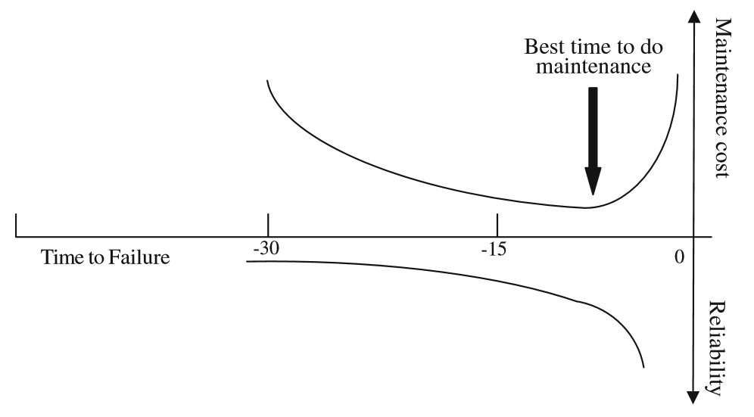
RUL
Source: Peng et al., "Current status of machine prognostics in condition-based maintenance: a review", 2010
Figure 8. Relationship Between RUL, Reliability, and Maintenance Cost

The remaining sections of this paper will focus only on the data and analytical features that are used to identify optimization. Figure 9 below illustrates major features and relationships of a PHM system that manage data and analytics. In an ideal situation, a population of historical data is evaluated to identify features that are known or are thought to be important to making a decision about the health and maintenance of a system or component. Relevant features are then extracted and used in a supervised environment to train a set of data from which certain test and validation functions are performed in the process of conducting diagnostics and prognostics on the equipment [62].

PHM works best with continuous real time data, which can be combined with historical data. Monitoring and anomaly detection correct certain errors within the system, estimating the true value of feature variables [63]. Estimates are compared to the true values, creating residuals, which are then monitored for abnormal deviations, indicating anomalies or degraded performance. Noise and noise reduction is also considered. Diagnostics are used to isolate areas or specific components where faults have occurred, and estimate the root cause for a change in performance. Prognostics then, rely on physics based or empirical models to understand the relationship between changes in performance and the RUL. Diagnostics are useful for improving new in-service equipment. Prognostics useful for planning maintenance and extending the life in-service equipment.

Tiddens et al. present six postulates discussing factors that prevent PHM from working properly.

Postulate 1 - Often, data are not useful for advanced analysis. More mature companies have a lot of data with sufficient storage and retrieval. Smaller companies have trouble accessing useful data because it is often incomplete and stored in multiple locations. Operators often refuse to enter the correct data because the maintenance system is complicated and new to them. Even when data is uploaded and stored real-time, it is often difficult to access because file sizes are too large to be transferred.

Level 6

Feature Selection

Selected Data

Selected Data

Selected Data

Selected Data

Data Training

Historical Data

Update
Database

Monitoring-Anomaly and Detection,
Diagnostics & Prognostics

Reliability & RUL Reporting

Maintenance Schedule

Real Time Data

Verification

Cost Function

Feedback To New Development & Modernize InService

Precision of
Prognostic

Level 7

Level 8

Figure 9. Notional PHM System

Postulate 2 - Selection of parameters to monitor is not well motivated. When a new system is fielded, often the exact parameters for evaluation are not immediately known. So organizations collect a lot of data on many parameters, sometimes missing those most important to system performance or maintenance managers.

Postulate 3 - Higher levels of analysis result in higher value analyses. This is the expectation, but it is not always true. Operators and mechanics are sometimes more useful than continuous monitoring sensors. They can see, smell, hear, and feel many different conditions; sensors do that for very specific conditions.

Postulate 4 - Predictive performance of prognostic systems improve over time; they are evolving systems. When the equipment is new, we do not know how it will perform. After a period of time, the experience gained and data collected helps to better interpret signals that indicate changes in performance.

Postulate 5 - Selection of advanced maintenance analysis is not well motivated. More mature companies are better positioned to perform advanced analyses. Less mature, though, use straightforward methods. One stating they only perform FMECA and common sense. Another respondent said “Sometimes we try a particular method. When this doesn’t work, we will try another method…we find a nice software package which enables its use… [8].”

Postulate 6 - The quality level of current analyses is not sufficient to improve maintenance decisions. Of the companies that were queried, current data analyses was known to be imprecise, so applying more advanced PHM methods was not believed to provide markedly better results from which maintenance decision can be made. One respondent said “Our FMECAs are used for long term prediction. Resulting maintenance intervals are rather conservative, therefore maintenance is often conducted too early.”

There are many topics on data management that are critically important for accurate PHM. They will be incorporated into the analysis used in later sections, and only briefly mentioned here because they distract focus from ‘bigger picture’ strategic maintenance policy selection and use of PHM.

2.6.1 Data Management

Add introduction here.

2.6.1.1 Multidimensional Data & Data Cubes

The accuracy of anomaly detection and diagnostic and prognostic algorithms depends heavily on the number of assessment readings, assessment reading frequency, and the number of different features (variables) used to describe component condition, use, behavior, and operating environment. Analysis using binary data, like ‘failed’ or ‘not failed yet’, yield marginally informative results [8]. Anomaly detection and diagnostics must use of a wide variety of complete data to be effective. Prognostic projections of future conditions are improved greatly by the number of relevant features and frequency of readings.

For this project, the term ‘features’ is synonymous to ‘dimensions’; they describe different ways the performance of a component can be evaluated. If an analyst is evaluating different failure modes to identify the root cause for a failure, that means they are exercising a multidimensional root cause analysis. Multidimensional analyses often incorporate different numbers and combinations of independent variable (features) to measure the influence or effect that each has on the dependent response variable.

The multidimensional structure of data is often viewed as a cube with three-dimensional coordinates for each data element [64] [65]. Each dimension within a three dimensional cube can represent, for example, x-dimension as the features or failure modes under investigation, y-dimension as the values recorded during successive readings or inspections on individual components, and the z-dimension as the number of components on which x-features, and y-number recordings are made. Note however, that a fourth dimension of time is implied to occur at regular frequency along the y-axis, illustrated in Figure 10 below. In the figure it shows the common x-dimension as ‘s’ for sensors, y-dimension is ‘j’ for observations, z-dimension is ‘k’ for components, and the forth dimension of time is ‘i’ for time or frequency. The figure indicates a structure where data can be explored (analyzed) from different perspectives to better understand events and degradation in the field.
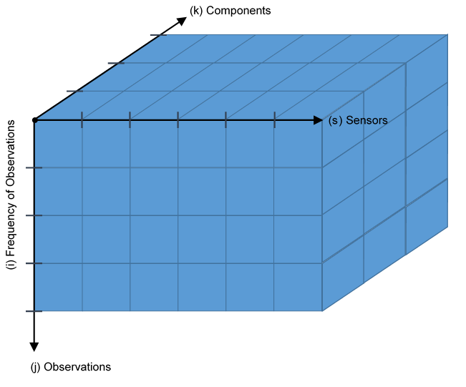

Anomaly Detection
& Diagnostics

Reliability & Monitoring

Prognostics

Figure 10. Data Cube Structure

When the enterprise level system is designed, it is important to understand how the database should be structured to support the analysis that is used to make maintenance decisions later on in the process. This influences the way data is collected and transmitted to and from the field, ultimately affecting the fidelity and accuracy of conclusions and predictions.
2.6.1.2 Types of Variables

Tamhane and Dunlop explain that features or characteristics of interest are called variables, and that data are their measured values [66]. They, along with Hellerstein, describe different categories of variables. Qualitative variables are typically identified as nominal or ordinal. Nominal variables describe labels; i.e. red, yellow, green. Ordinal variables represent rank or order; i.e. 1 is low, 2 is medium, 3 is high. Numerical variables are typically identified as continuous or discrete. Continuous variables are from a set of numbers or from a common unit of measurement; i.e. time. Discrete variables are from a defined set; i.e. number of pieces of equipment [66, 67]. These concepts play an important role for understanding limits in accuracy from different types of analysis. An inspection program that collects qualitative data, or only ordinal values provides less informative information compared to one that collects continuous data which provide the most information. An optimally performing system strives to collect the most informative data.

Fienburg assigned ordinal rank – weight – to categorical variables when he evaluated the randomness of the US 1970 draft lottery. In 1970, public outcry over the conduct of the war draft heightened inspection into its conduct. The process consisted of inserting January dates into 31 capsules, February dates into 29 capsules, and so on. They were poured into a box, separated, and ordered by month. The box was shaken several times to randomize the capsules before they were poured out into an open container, where several thousand drawings were made each day for 31 days. The public claimed the process was unfair because it was not random. When Fienburg studied the issue, he first plotted the number of capsules selected during each day of the drawing by birth month-category. While the plot showed a reasonable spread in the data, some regions were sparely populated, and others had slight clumps of data. To determine if selections made for some birth months outweighed selections made for other month, he took the average number drawn for each month. The result found significant bias for selecting capsules for birth months early in the calendar year compared to those selected for months later in the year [68]. Fienburg concluded, after interviews, several causes for bias – initial separation by month; inadequate shaking; pouring from the end of the box with later calendar year months first placed them at the bottom and early months at the top; and selecting capsules located at the top.

2.6.1.3 Collecting, Cleaning, and Storage of Data

Before, during, and after data enter a database, errors often creep into the system through data entry, measurement, distillation (when raw data is preprocessed and summarized), and integration (data combined from different sources) errors [67]. To reduce the number of errors, a number of steps should be taken. Through ‘interface design’, an organization can incorporate integrity constraints in the graphical user interface and storage system by controlling, often limiting, the types of data that can be entered; pull-down menus are helpful. ‘Organizational management’ approaches call on the Total Data Quality Management concept to use technological solutions that streamline data collection, archiving, and analysis, incentivizing all parties to align with single processes. ‘Automated data quality and cleaning’ uses technology to identify and correct errors. ‘Exploratory data analysis and cleaning’ is the most common, requiring a validator to review, identify, initiate, and follow through with correcting errors. Common errors include missing and stuck data, and multiple entries of the same value (for which multiple entries of the same value is considered unusual).

Cleaning quantitative data. Quantitative data consist of numbers with dimensions that can be measured in terms of distance (spread or variance) from each other, with consistency among units of measure. Statistical methods for outlier detection are the most commonly used approach to managing quantitative errors. It is worth mentioning that outliers are often not included in analyses. They should not be discarded, but kept and evaluated because they may provide the best information for evaluating inefficiencies in a system and causes for failure in equipment. An organization’s view on the definition of outliers is subjective, often reflecting the weight of importance they place on the item under investigation [67].

Cleaning categorical data. Categorical data typically have no natural distance between values, so evaluating errors by outliers is not possible. For these, errors often occur when a subcategory value is incorrectly mapped to a ‘master category’. Another type of error is typos or misspellings. Limiting data entry to discrete subcategories and pull down menus is helpful for managing these errors.

Cleaning postal address data. Postal address data are often free text. So consistency and completeness are challenges.

Cleaning Identifier data. Identifier data typically are used as keys that assign membership to a particular group. Challenges include detecting and correcting reuse, or loss of association when multiple databases use the same data, but in a different context; i.e. used as an identifier in one database, but subservient data element to another identifier in a related database.

2.6.1.4 Data Exploration

Will add in concert with Chapter 3.

2.6.1.5 Training, Test, and Validation Groups of Data

Tamhane and Dunlop recommend the following approach when building regression models; it can be applied to other model building exercises as well [66] [69]:

- Determine the type of model needed for analysis. The type of model dictates the type of variable data.
- Collect the data. Before beginning, determine independent predictors and dependent response variables so the structure for analysis is well understood.
- Explore the data. Examine it for errors, outliers, missing values, and biases. At this point, erroneous, unwanted, or unneeded data should be corrected or removed.
- Divide the data into training and test sets; Afendras and Markatou discuss a third set for validation. All of the data should be divided in a constructive way (even/odd; venetian blinds, random, or visual inspection) that populates these three sets. The training set should be used to build models and fit parameters. They should include data that covers the full range of values (for quantitative data, the largest and least) observed in the field. Test sets are used to optimize the models, including cross-validation to avoid overfitting. Over-fitting is when the model fits historical data very closely, but is not likely to fit other data in the future as well. A validation data set is used to characterize performance, indicating the best performing model of those used for analyses.
- Fit several candidate models. This is the training set.
- Select and evaluate a few good models. This is a combination of training and test sets discussed above.
- Select the final model. This is from the validation set.

Combining data with different units while retaining relationship. This is accomplished by calculating the mean-center-unit-variance for covariates [70]. If, for example, the performance of a pump is evaluated by sensors that collect data on vibration, amperage, temperature, and revolutions per minute, it is difficult to calculate the response or cause for failure if covariates remain in their current form (units). After transforming them to a common form of variance about their respective means, analysis can then evaluate spread in the data, identifying relationships and abnormal behaviors.

2.6.1.6 Treatment of Censored Data

Allison explains that survival analysis is a class of statistics that studies the occurrence and timing of events [71]. Often, this involves using life data analysis to fit data to certain life functions; calculating the parameters of those functions that most closely reflect performance in the field; and then extracting features from those parameters that identify conditions or environments that contribute most to the occurrence of events. For PHM, continuously recorded data provides the best information. Often though, especially when reviewing data collected in the past, it is not continuous. In these cases different techniques are needed to deal with the time-value of incomplete or ‘censored’ data.

Where censoring is concerned, complete data is when the exact time of event is known. For right censored data, also known as suspended data, the test is stopped (analysis is performed) before failures occur. For left censored data, failure times occur before the test is conducted. For interval censored data, failures occur between two known times. Multiply censored studies involve complete, right, left, and interval censored data, or any combination thereof. Type I censoring involves conducting tests for a fixed length of time. Type II censoring involves conducting tests until a predetermined number of failures occur [2, 71, 72].

Singh and Totawattage explore more commonly used methods for managing censored data, ultimately concluding that parametric models provide better results compared to non-parametric models. Their advantage is in applying specific conditions and environments to more accurately model performance for the specific component or system. Their disadvantage is often there is not enough data that can be used to develop models and optimize parameters [72].

2.6.1.6.1 Parametric Methods

Singh and Totawattage suggest using the Accelerated Failure Time (AFT) to fit life distributions (functions) to interval censored data [72]. Procedurally, AFT is used to calculate failure times, from which life distributions are fit according to their respective parameters.

AFT models are parametric models similar to the PhM. PhM assumes the covariate has a multiplicative effect on a basic hazard function; see Equation 1 below. $H_{z}$ represents the hazard rate for an individual with covariate z. $H_{0}$ represents the basic hazard rate if the contribution from any and all covariates is zero. $β$ represents regression coefficients for different covariates (factors). If $β$ is negative, then the covariate $z$ has the effect of speeding up the hazard rate.

$H_{z}=H_{0}e^{-βz}$ Equation 1

AFT similarly assumes the covariate has multiplicative effect on a predicted time event by some constant; see Equation 2 as follows. $T_{z}$ represents the failure time. $T_{0}$ represents the basic failure time. Other terms are the same as those in Equation 1.

$T_{z}=T_{0}e^{-βz}$ Equation 2

Continuing, taking the natural log, and expressing $\log{T_{0}}$ as $μ+σW$, the AFT model is shown in Equation 3, where terms can be substituted and a linear function derived as shown in Equations 4, and 5 in the SAS PROC LIFEREG module. $μ$ represents the intercept parameter. $σ$ represents the scale parameter. And $W$ represents error [72].

$\log{T_{z}}=\log{T_{0}}-βz$ Equation 3

$\log{T_{z}}=μ-βz+σW$ Equation 4

$\log{T_{z}}=μ+βz+σW$ Equation 5

In this final form, estimates of time of events for different conditions can be estimated.

It is important to note that in their multi-application on breast cancer data, AIDS data, and Hemophilia Data, Singh and Totawattage, and others cited in the study, found parametric methods resulted in reduced error compared to non-parametric estimation methods.

2.6.1.6.2 Nonparametric Methods

Nonparametric methods are typically characterized by steps of declining magnitude in probability plots.

Kaplan-Meier Estimator (KM). KM is the nonparametric maximum likelihood estimate of the survival function. It is one of the most common methods used because it is simple to construct and well suited to incorporate censored data. When a sample is large enough, or there is no censoring of the population, KM approaches the actual survival function. The estimator is shown in Equation 6 as follows . $\hat{S}\left(t\right)$ represents the survival as a function of time. $n_{i}$ represents the number of survivors just before time t. $d_{i}$ represents the number of deaths at time t [72].

$\hat{S}\left(t\right)= \prod_{t_{i}<t}{\frac{n_{i}-d_{i}}{n_{i}}}$ Equation 6

Turnbull Estimator. Peto was the first to recommend a nonparametric method for estimating survival in 1973. In 1975, Turnbull derived the same estimator, but used a different approach. He published his iterative self-consistency algorithm described in the following narrative and steps [72, 73].

When survival times for candidate equipment are considered independent random variables with survival function Equation 7, and failures are not directly observed (occurring within an interval), then the likelihood of survival is explained by Equation 8.

$S\left(t\right)=Pr⁡(T≥t)$ Equation 7

$L= \prod_{i}^{n}{\left\{S\left(L_{i}\right)-S\left(R_{i}^{+}\right)\right\}}$ Equation 8

where $\lim_{∆→0^{+}}{S\left(t+∆\right)}$

Step 1 - Compute probability of event occurring at time t_{j}.

$p_{j}=S\left(t_{j-1}\right)-S\left(t_{j}\right), j=1,…,m$ Equation 9

Step 2 - Estimate the number of events that occurred by time t_{j.}

$d_{j}= \sum_{i=1}^{n}{\frac{α_{ij}p_{j}}{\sum_{k=1}^{m}{α_{ik}p_{k}}}}, j=1,…,m$ Equation 10

Step 3 - Compute estimated number at risk at time t_{j.}

$n_{j}=\sum_{k=j}^{m}{d_{k}}$ Equation 11

Step 4 - Compute and update the Product-Limit estimator (Equation 8) using the pseudo code from steps 2 and 3 above until the updated survival value is close to the old values of t.

Other nonparametric methods include logspline estimation of the survival curve, and calculating the mid-point or extreme lower or upper observation times to estimate failure times from censored data.

In their study, Singh and Totawattage performed several experiments. One experiment compared plots of two treatments of breast cancer patient data using the mid-point method and KM, finding the results to be very similar. At most times, the study found that the mid-point plot was either above or below (over-under estimation) the KM interval plot. They go on to explain that over-under estimation becomes more pronounced when estimates are taken at the lower or upper bounds of the censoring interval, and even more pronounced with long intervals [72].

They applied three different approaches to evaluate breast cancer, AIDS, and hemophilia data. First, they used the parametric approach with assumed baseline hazard rate to fit exponential, Weibull, gamma and generalized F distributions. Second, they used what they call a flexible or semi-parametric strategy by making ‘mild’ assumptions about the baseline hazard rate. And third, they used a non-parametric strategy to estimate parameters, leaving the baseline hazard rate unspecified. For the general effect of using chemotherapy on breast cancer patients, they found that all analyses provided similar results. Where the individual effects of stage and dose of treatment are concerned, they found non-parametric methods did not perform as well as parametric methods. With the AIDS data, which was heavily censored, they found non-parametric methods lead to unstable estimation of time of events. They had similar findings for analysis on the Hemophelia data set, concluding that Weibull and log-normal distributions provide the best results.

2.6.2 (Level 6) Health Monitoring

The term Health Monitoring refers also to performance monitoring.

Ramachandran et al. explain that the Condition Monitoring and Diagnostic Engineering Management (COMADEM) was developed in 1987 to provide a cross disciplinary approach to monitor, diagnose, prognose, control, and manage complex systems throughout their life cycle [74]. In this context, the following terms are used. The ‘condition’ of a system refers to how well its integrity and intended reliable performance are ‘monitored’, scrutinized, and controlled under specified operational and environmental conditions. ‘Diagnostics’ refers to the critical analysis that determines the causes and effects of failure modes. ‘Prognostics’ refers to methods used to project the time when symptoms will occur enabling prevention and control of failures. Finally, effective ‘engineering management’ uses all of these and other resources to resolve problems that prevent monitoring, diagnostic, and prognostic methods from working.

Condition monitoring is applied in two ways, continuous monitoring and periodic monitoring. Both approaches rely on sufficient evaluation of failure modes and historical data during system development to identify parameters needed for monitoring and baseline data from which abnormal performance can be detected. Continuous monitoring is necessary for critical machines and some times necessary for essential machines to alarm operators or other mechanisms to shut them down before damage occurs. Periodic monitoring, then, is performed on essential machines and recommended for general purpose machines at fixed intervals to forecast future conditions and maintenance planning. Figure 11 below, adapted from Ramachandran et al. illustrates these uses.

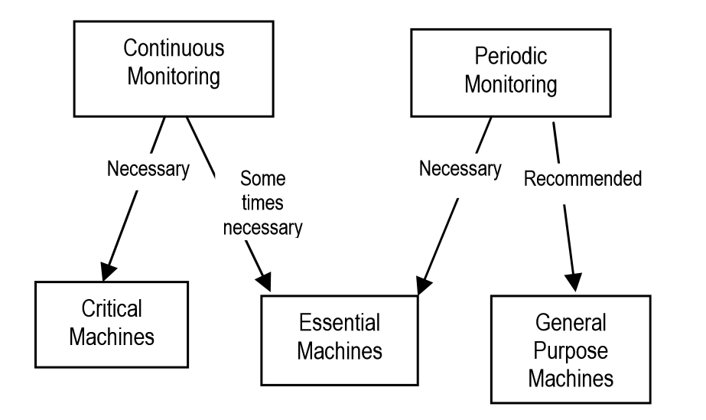
Source: Ramachandran et al., "Recent Trends in Systems Performance Monitoring & Failure Diagnostics", 2010
Figure 11. Condition Monitoring Applications

Moubray identifies six distinct patterns of failure, modeling system condition as a function of time through the P-F interval [10]. ‘P’ is the time after a failure begins to occur, and when it becomes detectable. ‘F’ is the time when functional failure occurs. The P-F interval, then, is the warning period, during which assessments, maintenance planning and execution should occur. Moubray generalizes in his recommendation to perform assessments at successively shorter intervals within the P-F interval. Figure 12 below illustrates this method and its relationship between signal-alarms and the conditional probability of failure which is often modeled using the bathtub curve.

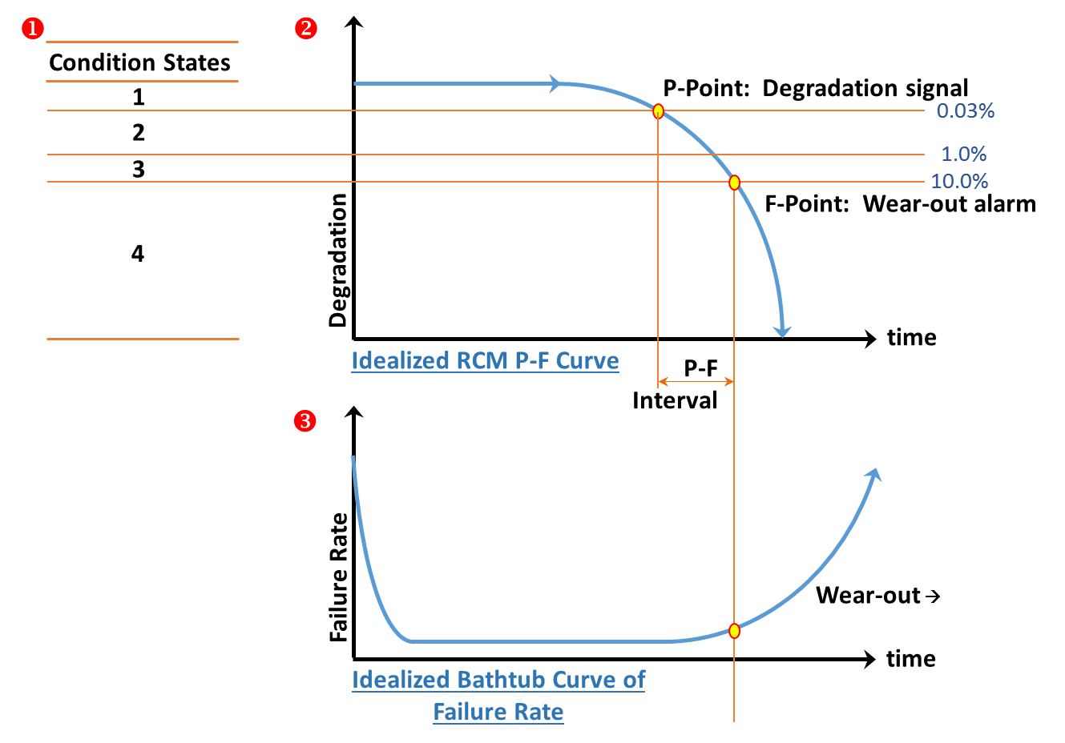
Figure 12. Idealized P-F Interval

Ramachandran et al. present a slightly different model, Figure 13 below, which make use of an alarm threshold and upper limit. It describes a region of stable performance until such time that an alarm signals the onset of failure. After that, the failure zone continues until the upper limiting condition occurs and the system is considered failed. Several useful calculations can be made from this model. An estimation of the time that has lapsed since the alarm point is presented in Equation 12. The Remaining Time until a Functional Failure (RTFF) is presented in Equation 13. Both of these equations are cited by Ramachandran et al. who credit Goode et al. and Wang et al. [74].

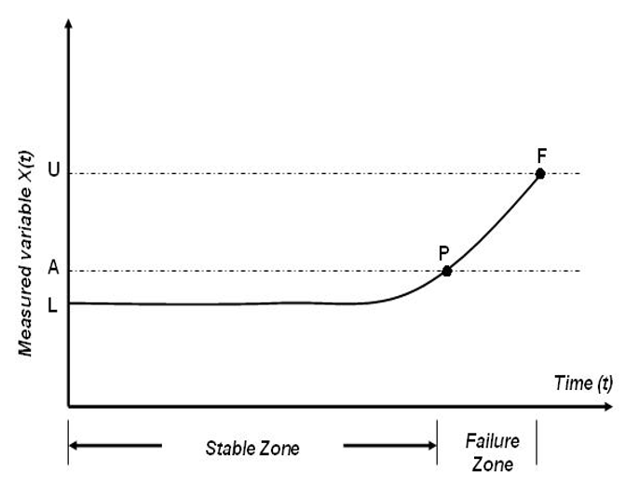
Source: Ramachandran et al., "Recent Trends in Systems Performance Monitoring & Failure Diagnostics", 2010
Figure 13. Failure Characterization

$t=PF\left[\ln\left(\frac{X\left(t\right)-L}{A-L}\right)÷\ln\left(\frac{U-L}{A-L}\right)\right]$ Equation 12

$RTFF=PF-T=\left(γ+θ{\left\{-\ln\left[1-risk\right]\right\}}^{1/β}\right)x$ *
$\left\{1-\left[\left[\ln\left(\frac{X\left(t\right)-L}{A-L}\right)÷\ln\left(\frac{U-L}{A-L}\right)\right]\right]\right\}$ Equation 13

There are several methods for detecting anomalous behaviors. There are first principle models, such as those used to evaluate ball-bearing wear. And there are empirical models which are helpful when characterizing performance in the context of specific operational environments. Where statistic models are concerned, evaluation of residuals is particularly helpful for characterizing performance away from that normal observed [63, 70]. Other methods include thresholding techniques and hypothesis testing, such as the Sequential Probability Ratio Test [63, 75].

2.6.3 (Level 7) Diagnostic Methods

For these purposes, faults are understood to mean abnormal or unintended behaviors or performance. Faults are diagnosed using isolation techniques that focus the investigation on the performance of specific components or features for root cause analyses [63]. In his research, Yang found that fault diagnostic methods can be classified into two general categories, Model-based and Data Driven methods [76]. His hierarchy of fault diagnostic methods is recreated here in Figure 14 below.

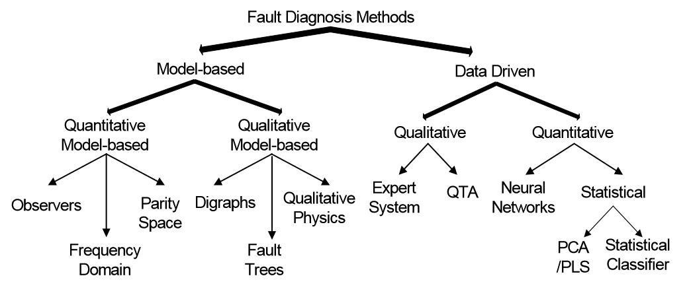
Source: Yang, http://rave.ohiolink.edu/etdc/view?acc_num=case1080246972., 2004
Figure 14. Classification of Fault Diagnostic Methods

Yang explains that prior knowledge (a priori process knowledge) about the faults is the most important factor for classifying diagnostic methods. ‘a priori’ knowledge involves information and data on failures and the relationship between observed symptoms and those failures. It is built from first-principles, commonly known as causal or model-based knowledge – deep knowledge. It is also built from experience with equipment or processes, commonly known as evidence or history-based knowledge – shallow knowledge. Model-based methods can be quantitative or qualitative, usually developed from an understanding about the physics of the equipment or process. This is the not the focus of this paper, so model-based methods are acknowledged, but will not be explored any further except to discuss overlaps between the two different approaches. Data driven methods rely on historical data. These methods transform data by extracting certain features of interest for use later during diagnostics. Features can be extracted through qualitative or quantitative methods [76].

Yang explains data-driven methods can be classified as statistical or non-statistical. Neural networks are an important class of non-statistical methods. Common statistical methods include Principal Component Analysis (PCA), and regression methods including simple linear regression, nonlinear regression, ridge regression, locally weighted and kernel regression, and Partial Least Squares (PLS) regression [66, 70, 76, 77, 78, 79]. Details of different regression models used in these analyses will be discussed later in Chapter 3. In his work, Yang cites several sources and explains the broad application of PCA and PLS regression methods for fault diagnostics. They are summarized in Table 17 of Appendix A.

Yang goes on to explain that fault diagnosis is a classification problem, so a statistical pattern recognition framework should be used. Rengaswamy et al. propose the Incipient Fault Detection and Diagnosis (IFDD) approach for characterizing faults in complex systems with high dimensionality and nonlinearity. They propose estimating the density function of classifiers using neural networks and then using Bayesian methods to update classifications [80].

Further, Yang explores neural network quantitative data-driven methods, as well as qualitative methods, such as expert system hierarchical classification, rule-based fuzzy logic, and several hybrid methods that integrate with neural networks. He also explores qualitative trend analysis through extracting and classifying primitives from noisy data using neural networks, wavelet theory, and a dyadic B-Spline algorithm. These methods will not be discussed in detail as they are not the focus of this paper [76].

2.6.4 (Level 7) Prognostic Methods

Prognostics are either physics of failure or empirical techniques that can be used to predict future performance of equipment so that operations and maintenance can be effectively planned and executed in a way that maximizes safety and availability, at affordable levels and minimum life cycle cost. It is considered the highest state “holy grail” of CbM [81].
In 1964, Sims wrote a short article on a new concept, physics of failure, for Nature, a peer review journal. In it he explains that increasingly complex systems like satellites and rockets should be designed with very high reliability because once they are launched, servicing is not possible if there is a problem [82]. A good example of a failure to fully address the criticality of systems that require high reliability with no servicing time was made by famed physicist Dr. Feynman, in his appendix to the Presidential Commission on the Space Shuttle Challenger Accident. In the appendix, he comments on the difference in approach to addressing reliability for the network of four parallel-switching avionics computers, comparing them to the two O-ring gaskets in series configuration that had a history of failures during launches at lower temperatures [83]. Sims goes on to explain that less critical systems with higher servicing reaction time should be designed based on the probability of component failure. The problem for the systems engineer, then, is how to design and maintain a system that is part of a much larger and highly complex SoS, for which high reliability is required. In this case, Sims and also Coble explain that often there is little data from which to explore times to failure because critical components are usually maintained or replaced before the onset of degradation. Therefore, accelerated life testing is not possible because there is little historical information [81, 82]. Sims goes on to explain that the physics of failure method was developed to manage failure at the “…’molecular engineering’ level [82].”

Similar to concepts conceived in the early days of US space exploration, and at times, perhaps, ignored later, physics of failure and empirical method concepts are still relevant today. In their review of prognostics and health management applications in nuclear power plants, Coble et al. explain there are two major classifications of prognostics, physics-based and empirical models. They explain that physical processes that lead to failure are not always well understood because highly critical and complex systems are taken out of service for maintenance or replacement before degradation can be detected and measured. They go on to explain that empirical models can be developed, providing an advantage over physics based models because they reflect real-world conditions and environments. They also make the distinction between active and passive components. Active components and systems move when they perform their intended function. They typically include compressors, drive mechanisms, fans, generators, sensors, motors, pumps, transistors, and valves. Passive components, which may be a component within an active system, instead do not move. They typically include cables and connections, containment structures and their liners, heat exchangers, piping, pump casings, steam generators, support structures, transformers, valve bodies, and ventilation ducts [63]. They go on to explain that the US Nuclear Regulatory Commission (NRC) Maintenance Rule (10 CFR 50.65, 2011) specifies a performance-based approach to maintenance. In practice, however, most components remain under a scheduled maintenance program. They conclude that a well conducted CbM program could reduce unnecessary maintenance and resulting costs, and recommend PHM, especially non-destructive testing of passive structures where corrosion or chemical attack are prevalent, as a possible solution [63].

In a paper that categorizes prognostic algorithms, Coble and Hines identify three types of empirical prognostic models [81]. Many methods have been developed, but in general, they can be classified as follows:

Type I Reliability Data-Based Prognostic Models - They model the remaining useful life of the average component, operating in the average environment, under average operating conditions. These models fit life distributions to historical failure time data to predict future performance, and are typically the least accurate of the three methods. Common life distributions include the Weibull, exponential, normal, and lognormal distributions.

Type II Stress Based Prognostic Models - They model the remaining useful life of the average component, operating in a specific environment, or under specific operating conditions. Similar to Type I models, Type II models fit life distributions to historical failure time data to predict future performance, but incorporate specific environmental or operating conditions using the PhM or a Markov Chain model; Monte Carlo simulation is often incorporated into both of these models. In her book on Bayes’ theorem, Bertsch quotes Gil who said Markov Chain Monte Carlo [(MCMC)] is “…arguably the most powerful mechanism ever created for processing data and knowledge [84] .”

Type III Effects-Based Prognostic Models - They model the remaining useful life of a specific component, operating in its specific environment, under specific conditions. These models are the most accurate, and most useful for optimizing maintenance. The General Path Model (GPM) is a common model. Bayesian updating usually improves the accuracy of GPM.

Details of different prognostic models used in these analyses will be discussed later in Chapter 3.

2.7 (Level 8) Data / Knowledge Feedback & Implementation

Research to into this area is important, but beyond the scope of this project.

Chapter 3: Materials and Methods

This chapter is organized according to the sequence of levels from Figure 1. Section 3.1 covers Levels 0 through 5, describing strategic, policy, and tactical considerations that are represented within objective technical requirements, subjective judgements about enterprise criteria, and cost data for the component or system under investigation; in this case, a particular type of paint coating system. It explains the processes and mathematical methods used to identify the best maintenance policy. Section 3.2 covers Level 6, explaining how the raw material condition data were evaluated, organized, and used in Level 7 prognostic analyses of technical performance requirements, Section 3.3. Section 3.4 covers lifecycle cost considerations that were fed back into Section 3.1. The RUL estimates from the best performing prognostic model were used, in part, to calculate the costs for the predictive and proactive maintenance policies.

It should be noted that the results of prognostic and cost analyses performed later in the process, as outlined in Figure 1, were used to make decisions that occur earlier in the process during AHP. The existence and use of prior knowledge stored within a PHM system should be a key consideration when examining the efficacy of different maintenance policies.

3.1 (Levels 0 – 5) AHP

This section outlines the steps used to conduct AHP [43, 55].

Step 1 – Requirements Definition. Define technical, procedural, and business requirements. See Table A15 in Appendix A for requirement considerations used in these analyses.

Step 2 – Judgement Criteria. Define judgement criteria in the Judgement Score Matrix. See Table A16 in Appendix A for judgement considerations used in these analyses.

Step 3 – Maintenance Criteria Comparison. Gather data and perform the Delphi Technique to obtain subjective cross-organizational input and populate the pairwise comparison matrix of criteria. This step gathers input on the difference in intensity, Table A18, for satisfying different criteria. See Table A17 in Appendix A for Level 1 pairwise comparisons of criteria used in these analyses. Repeat this process for each level of criteria; Level 1 are Global Criteria; Level 2 are Local Criteria; and Level 3 are Sub-Criteria, see Table A15. See Figure 15 below for a generalized criteria pairwise comparison matrix. Matrix [A] symbolizes the general criteria matrix for individual comparisons, represented by a_{mn}, m-rows, and n-columns.

$$\left[A\right]= \left[\begin{matrix}a_{11} & \begin{matrix}a_{12} & ⋯\end{matrix} & a_{1n} \\ a_{21} & \begin{matrix}a_{22} & ⋯\end{matrix} & a_{2n} \\ \begin{matrix}⋮ \\ a_{m1}\end{matrix} & \begin{matrix}\begin{matrix}⋮ \\ a_{m2}\end{matrix} & \begin{matrix}⋱ \\ ⋯\end{matrix}\end{matrix} & \begin{matrix}⋮ \\ a_{mn}\end{matrix}\end{matrix}\right]$$
Figure 15. Criteria Pairwise Comparison Matrix

Step 4 – Maintenance Policy-Criteria Performance Comparison. Gather data and perform the Delphi Technique to obtain subjective cross-organizational input and populate pairwise alternative comparison matrices for each criterion and alternative maintenance policy. This step gathers input on judgments about how much better one maintenance policy will satisfy a criterion compared to another. The process is similar to that for Step 3 above. See Figure 16 below for a generalized alternative pairwise comparison matrix. Matrix [W_{k}] symbolizes the general criteria matrix with individual criteria elements represented by w_{kmn}, which is always square matrix.

$$\left[W_{k}\right]= \left[\begin{matrix}w_{k11} & \begin{matrix}w_{k12} & ⋯\end{matrix} & w_{k1n} \\ w_{k21} & \begin{matrix}w_{k22} & ⋯\end{matrix} & w_{k2n} \\ \begin{matrix}⋮ \\ w_{km1}\end{matrix} & \begin{matrix}\begin{matrix}⋮ \\ w_{km2}\end{matrix} & \begin{matrix}⋱ \\ ⋯\end{matrix}\end{matrix} & \begin{matrix}⋮ \\ w_{kmn}\end{matrix}\end{matrix}\right]$$
Figure 16. Alternative Pairwise Comparison Matrix

Step 5 – Relative Importance and Strength Calculation. Calculate the eigenvectors for the Criteria Pairwise Comparison Matrix [eA_{m}] and each of the Alternative Pairwise Comparison Matrices [eW_{km}]. With this application of AHP, eigenvectors represent the relative importance among criteria, or relative strength among maintenance policies for achieving specific criteria as judged by stakeholders throughout the organization.

Step 6 – Level 1 Criteria, Identify Best (Preferred) Maintenance Policy. Calculate the Level 1 Scores Matrix to identify the preferred maintenance policy. It has the highest score for satisfying Level 1 Global Criteria. See Figure 17 below for a generalized scores matrix. [P] represents Level 1 criteria scores. [eW_{km}] represent eigenvector (weights) for each maintenance policy alternative and criteria. [eA_{m}] represent eigenvectors for the Level 1 criteria comparison.

$\left[P\right]= \left[{eW}_{km}\right]* \left[{eA}_{m}\right]= \left[\begin{matrix}{eW}_{11} & \begin{matrix}{eW}_{21} & ⋯\end{matrix} & eW_{k1} \\ {eW}_{12} & \begin{matrix}{eW}_{22} & ⋯\end{matrix} & eW_{k2} \\ \begin{matrix}⋮ \\ {eW}_{1m}\end{matrix} & \begin{matrix}\begin{matrix}⋮ \\ {eW}_{2m}\end{matrix} & \begin{matrix}⋱ \\ ⋯\end{matrix}\end{matrix} & \begin{matrix}⋮ \\ {eW}_{km}\end{matrix}\end{matrix}\right]*\left[\begin{matrix}\begin{matrix}{eA}_{1} \\ {eA}_{2}\end{matrix} \\ ⋮ \\ {eA}_{m}\end{matrix}\right]=\left[\begin{matrix}\begin{matrix}P_{1} \\ P_{2}\end{matrix} \\ ⋮ \\ P_{m}\end{matrix}\right]$
Figure 17. Level 1 Criteria Scores Matrix

Step 7 – Lower Level Criteria-Compare Importance. Propagate the individual Level 1 scores [P_{m}] as scalar values down to their related Level 2 Local Criteria. Having already calculated the Alternative Pairwise Comparisons at Level 2, calculate the Level 2 Scores Matrix to compare the importance of Level 2 criteria. Repeat the same for Level 3 Sub-Criteria. It should be noticed that Level 1 scores are a composite of Level 2 scores, and Level 2 scores are a composite of Level 3 scores. Level 1 scores should add up to 1.00, with Inconsistency Index limit of 0.05 (deviation from 1.00) used as a measure for the goodness of judgements [43]. Level 2 scores, for their related criteria, should equal the Level 1 score. The same applies to Level 2 and Level 3 scores.

Step 8 – Cost as an Independent Variable Option. For these analyses, costs were not an independent variable. If the organization desires to make a decision based on the benefit to cost ratio, the cost for achieving the benefit $\left[P_{m}\right]$ (the criteria scores) of that alternative, it should first normalize costs, and divide the score for each alternative by its respective life cycle cost as shown in Figure 18 below.

Figure 18. Benefit_Cost Ratio
$$\left[Benefits_Cost Ratio\right]= \left[P_{m}\right]/ \left[{Costs}_{normalized}\right]$$

Step 9 – Critical Criteria Analysis. Triantaphyllou et al. explain that many decision makers think that the criteria with the highest weight is the most critical criteria in MCDM [55]. They go on to state that the most critical criteria is the one for which the smallest change in weight $\left[w_{kmn}\right]$ changes the preferential ranking of alternatives $\left[P_{m}\right]$. This relationship is useful to maintenance managers who are comparing the benefits to the costs for transitioning from their current maintenance policy to one that is more advance, or to one that provides an enterprise level solution.

Triantaphyllou et al. explain that there are two approaches to determining the critical criteria. The first, brute-force simulation, requires holding all but one of the weights constant while testing a range of values for the weight under investigation. The same process is repeated until all weights are tested. The value in this approach is it reveals probable targets for threshold and objective values.

These analyses used the second approach, outlined as follows:

The minimum change in weight of a particular criteria that changes the order of alternatives:

$W_{k}^{*}=W_{k}-δ_{k,i,j}$ Equation 14

$W_{k}$ is the weight of criteria k. $δ_{k,i,j}$ is the minimum change in weight of criteria k that changes the preference of maintenance policies P_{i} and P_{j}. ‘i' represents the better scoring maintenance policy, and ‘j’ correspondingly represents the lower scoring policy. $W_{k}^{*}$ is the modified weight. Whenever the weight of one criteria is changed, all the rest at that level must be re-normalized as shown in Equation 15 below.
$W_{n}^{*}= \frac{W_{n}}{W_{1}^{*}+W_{2}+…+W_{n}}$ Equation 15

The minimum change in weight is calculated using Equation 16:

$δ_{k,i,j }≤ \frac{\left(P_{j}-P_{i}\right)}{\left(a_{jk}-a_{ik}\right)}*\frac{100}{W_{k}} , if \left(a_{jk}>a_{ik}\right), or$
$δ_{k,i,j }≥ \frac{\left(P_{j}-P_{i}\right)}{\left(a_{jk}-a_{ik}\right)}*\frac{100}{W_{k}} , if \left(a_{jk}<a_{ik}\right),$ Equation 16

For a change to be feasible, the following condition must be satisfied:

$\frac{\left(P_{j}-P_{i}\right)}{\left(a_{jk}-a_{ik}\right)}*\frac{100}{W_{k}} ≤100$ Equation 17

If P_{i} dominates P_{j}, $a_{jk}<a_{ik}$ for any criteria k, then it is impossible to change the preference of maintenance policies by changing weights of the criterion $a_{mn}$. A criterion $a_{mn}$ is robust if all of the $δ_{k,i,j}$ associated with it are not feasible. That is, they are greater than zero according to Equation 18.

$\frac{\left(P_{j}-P_{i}\right)}{\left(a_{jk}-a_{ik}\right)}*\frac{100}{W_{k}}>100$ Equation 18

3.2 (Level 6) Data Management

The data were reviewed to understand the quality, completeness, types of variables that were used, and to identify inherent deficiencies.

To begin this initial step of review, the data were evaluated to identify features that contribute to degradation. Martin et al. and Schmitt describe an array of coating system failure modes; major categories are summarized in Figure B2 of Appendix B [85, 86]. After comparing categories found in literature to the data, it was found that only the rust grade and blistering categories were represented in the data. A more in-depth review of faults that cause rusting and blisters was used to construct the high level fault tree, Figure B3 of Appendix B [85, 86]. Here too, the data reflect only a few faults found in literature, namely application considerations for surface cleanliness and profile, and environmental factors such as the fluid the coating system comes in contact. These faults are illustrated in Figure B4 of Appendix B.

At the time when the data were recorded, conditions were evaluated using a localized standard that integrates two American Society for Testing and Materials (ASTM) standards [85]. The first, ASTM D610, was used to measure the rust grade. It provides a summary evaluation, percent of the total area damaged. Damage is judged sometimes by the amount of delamination between layers of the coating system. But most commonly by disbondment between the bottom layer and the substrate material - the surface a coating system is designed to protect [87]. For steel surfaces in a wet, oxygen environment, the characteristic sign of coating failure is the presence of iron oxide rust staining. The second standard, ASTM D714, was used to measure the size and frequency of blisters that form on unclean substrate surfaces when there are salt deposits or other deleterious materials on the surface, or when there are unfavorable environmental conditions, such as high humidity or when substrate surface temperatures are below the dew point [85, 88]. When blisters form, sometimes they contain fluid, and sometimes they encapsulate small voids. In both cases, blisters represent a weakness in the coating system that may affect its RUL. Specific coating system physics of failure causes for damage and degradation are beyond the scope of this paper.

The local schema used to rate coating conditions is illustrated in Figure B5. It shows how the four condition states recorded in the data are used to categorize one of ten ranges of total area coating damage. The total area of damaged coating is the total area of rust corrosion plus the total area that is blistered evaluated; see Figure B6 for blister ratings. Condition state 1 ranges from zero up to and including 0.03 percent damage. Condition state 2 ranges from greater than 0.03 percent up to and including 1.0 percent damage. Condition state 3 ranges from greater than 1.0 percent up to and including 10 percent damage. Condition state 4 is any damage greater than ten percent. Condition state 4 is considered the wear-out alarm as illustrated earlier in Figure 13. This condition is considered the point when failures occur at an increasing rate, and when the costs for high-efficiency grit-blast media - to remove coatings throughout the entire area – are less than the costs for using hand-held tools to repair an increasingly uncontrollable number of spots of coating failure. The benefit for using grit-blast media is it cleans the surface of coatings and other contaminants very quickly and thoroughly, creating an anchor tooth profile for increased surface area, resulting in better coating-substrate adhesion and increased service life. Hand tool methods take much longer to remove existing coatings, do not do as good a job removing contaminants, and do not create the desired surface profile. As a result, they increase the MTTR, and decrease system availability.

After examining the data, and researching candidate features for degradation analysis, only the data on the coating service life and time data on when inspections occurred; data on the condition rating; the service environment data; and surface preparation method data were advanced for analysis. In the following sections, it will be shown how these data were managed and analyzed to evaluate the affect that service environment and surface preparation have on the coating RUL and costs for a predictive maintenance policy.

3.2.1 Multidimensional Data & Data Cubes

The data were organized in a database as shown in Table A20 in Appendix A and Figure B7 in Appendix B. The table shows how data are structured within the database. The figure shows how data are mapped to destination data sets for training, test, and validation, and associated prognostic analyses.

3.2.2 Collection, Cleaning, and Storage

Raw data consisted of 3,278 observations on multiple factors. Erroneous, duplicate, and incomplete observations were removed. The remaining 813 observations formed the final dataset, containing at least three consecutive observations for each component where the last observation was always a Condition 4 failure. The set contains 145 failures. There are no consecutive observations of failures; they were removed from the data because the condition state could not be rated any worse than Condition 4.

3.2.3 Types of Variables

Table A20 shows the types of variables used in the prognostic analyses that follow. Most of the raw data were either categorical or ordinal, except for observation date and service life. For each of the five factors, either service type or surface preparation, ordinal values were calculated by normalizing their average time of Condition 4 failure, the dependent variable, by the average value of the factor with longest average time of failure. This created an ordinal index, satisfying the following reasonable assumptions: Coatings in contact with clean-storage fluids are in a less severe environment compared to those in contact with contaminated fluids. Coatings applied to surfaces that had the last coating system completely removed by grit blast media have less severe operating conditions compared to coatings applied over hand/machine tool repairs.

3.2.4 Data Exploration

The data were evaluated visually by plotting the observed condition states and times when they were observed in blue, Figure B8 in Appendix B. The figure shows that observations earlier in the life of the coating system tend to result in ratings of Condition 1 or 2. Observations later in life tend to result in ratings of Condition 3 and 4. The average time for each condition, shown in red, appears to resemble the shape of a wear-out curve. There are fewer observations on contaminated service coatings compared to storage service coatings. There are also much fewer instances of hand/machine tool repairs compared to grit-blast repairs.

Data on the five factors were also evaluated by plotting the times when Condition 4 failures occur in green, blue, or black; their mean shown in a red triangle pointing left; and plus and minus one standard deviation shown in magenta triangles pointing right; see Figure B9 in Appendix B. The figure shows that storage service coatings last slightly longer than service coatings do; both of which last slightly longer than contaminated service coatings do. It also shows that hand/machine tool repairs can be used to extend the life of the coating system, but only slightly. Their efficacy and benefit will be explored later using Type 2 prognostics and the Cox PhM.

3.2.5 Training, Test, and Validation Groups of Data

The data were further divided. Data with half of the series of observations and associated failures, sufficiently representing each of the five factors, were assigned to the training group. The rest to test and validation groups, with twenty-five failure observations to the validation group. See Figure B7 in Appendix B for groups assignments to different types of prognostic analyses. Reliability and Cox PhM models share data from the training and test groups. MCMC models, for this project, do not incorporate the validation group for reasons discussed later. PGM models use all three groups.

3.2.6 Treatment of Data With Different Units

Significant effort was applied to pre-process the data, ensuring that all date, time, condition readings, and categories of data were consolidated into common units of measure and uniform categories. For more information on converting categorical variables, refer to Section 3.2.3 above. Residuals used in Type 3 prognostic models were calculated by determining the mean center unit variance, Equation 19 below.

$x_{residual}= \frac{\left(x_{i}-\overline{x_{i}}\right)}{σ_{i}}$ Equation 19

Where $x_{residual}$ = distance between the actual value and the factor mean
$x_{i}$ = value to be converted
$\overline{x_{i}}$ = average values of this category
$σ_{i}$ = standard deviation

3.2.7 Treatment of Censored Data

For this project, the midpoint approach was used to manage censored data, Equation 20 below.

$T_{F}= T_{Last Inspection }+ \frac{T_{InspFailed}-T_{Last Inspection }}{2}$ Equation 20

The midpoint is an estimate of the service life of the component at the time of failure. It is the midpoint between the time of observation that found the component in the failed condition, and the time of the most recent observation before that, finding that the component had not yet failed.

3.3 (Level 7) Prognostic Methods

This section evaluates a population of data, identifying the factor that was used as a common degradation parameter for prognostics. The data and degradation parameter were evaluated using Type 1, 2, and 3 prognostic algorithms to identify the algorithm that most accurately models degradation and estimate the RUL of the component. The following sections summarize the mathematical techniques and procedural steps used in the prognostic models.

3.3.1 Type 1 Reliability Models (Conditional Reliability Model)

Fit a Function of a Continuous Distribution
Continuous distributions were fit to the data. Only continuous distributions were used to estimate the RUL because empirical step functions often bias the estimate of future failures in favor of factors that influence past failures.

The two most common methods used to estimate the parameters of continuous distributions are Rank Regression and the Maximum Likelihood Estimate (MLE). While Rank Regression is commonly used with smaller data sets, MLE is used here because it provides a better estimate for data sets with more than 30 failures, as is the case with these analyses [40]. MLE is a procedure that makes use of the characteristic equations and parameters of continuous distributions. The exponential distribution, normal distribution, and a 2-parameter Weibull distribution were investigated here, Table 1 [40].

Table 1. Continuous Distributions and Parameters
Distribution | Probability Density Function | Reliability Function | Parameters
Exponential | $$f\left(t\right)=λ*e^{-λt}$$ | $$R\left(t\right)=e^{-λt}$$ | m: Mean
Normal | $$f\left(t\right)= \frac{1}{σ{\left(2π\right)}^{1/2}}e^{\left[-\frac{{\left(t-μ\right)}^{2}}{2σ^{2}}\right]}$$ | $$R\left(t\right)= \int_{t}^{∞}{f\left(t\right)dt}$$ | μ: Mean  σ: Standard Deviation
2-Parameter Weibull | $$f\left(t\right)= \frac{β}{θ}*{\left(\frac{t}{θ}\right)}^{β-1}*e^{{-\left(\frac{t}{θ}\right)}^{β}}$$ | $$R\left(t\right)= e^{{-\left(\frac{t}{θ}\right)}^{β}}$$ | θ: Scale  β: Shape

The MLE process, in the case of complete data, involves taking the natural log of the product of the failure times in the probability density function; setting the equation equal to zero; taking the derivative; and then back-solving for each of the parameters. Essentially, the derivation locates where the rate of change of a particular parameter is equal to zero, the maxima, indicating the most likely value of the parameter. Equations 21 and 22, and the procedure below, summarize the process to determine the parameters of the 2-Parameter Weibull distribution.

$$L\left(t | θ,β\right)= \prod_{i=1}^{n}{ \frac{β}{θ}*{\left(\frac{t}{θ}\right)}^{β-1}*e^{{-\left(\frac{t}{θ}\right)}^{β}}}$$

$$L\left(t\right)= {\left(\frac{β}{θ}\right)}^{n}\frac{\prod{t_{i}^{β-1}}}{θ^{n\left(β-1\right)}}*e^{-\sum{{\left(\frac{t_{i}}{θ}\right)}^{β}}}$$

$$ln\left(L\right)= ln\left({\left(\frac{β}{θ}\right)}^{n}\frac{\prod{t_{i}^{β-1}}}{θ^{n\left(β-1\right)}}*e^{-\sum{{\left(\frac{t_{i}}{θ}\right)}^{β}}}\right)$$

$$\frac{d ln⁡(L)}{dθ}= \frac{d \left(ln\left({\left(\frac{β}{θ}\right)}^{n}\frac{\prod{t_{i}^{β-1}}}{θ^{n\left(β-1\right)}}*e^{-\sum{{\left(\frac{t_{i}}{θ}\right)}^{β}}}\right)\right)}{dθ}=0$$

$θ= {\left(\frac{1}{n}\sum{t_{i}^{β}}\right)}^{\frac{1}{β}}$ Equation 21

Insert the terms for θ into the general equation, take the natural log, take the derivative with respect to β, set it equal to zero, and solve numerically to maximize β.

$\frac{d ln⁡(L)}{dβ}= \frac{n}{β}-\frac{n}{\sum{t_{i}^{β}}}\sum{t_{i}^{β}\ln\left(t_{i}\right)}+\sum{ln⁡(t_{i})}=0$ Equation 22

Select the Best Performing Distribution
Selecting a distribution that best describes the data should take several factors into account. The best distribution should minimize error, the difference between the predicted values using the distribution and the empirical data. While there are several methods from which to evaluate distributions, the Chi-Squared and Kolmolgorov-Smirnov (KS) goodness-of-fit tests were considered here. The KS test results in the least error at 0.05 or less level of significance, so it was used here [89]. The KS test procedure follows: The distribution with the smallest maximum difference between the general continuous distribution and a cumulative stepped function of the empirical data represents the data best; see Equation 23 below. This maximum difference can also be compared to a critical value to accept or reject the hypotheses.

$D= {}_{i=1:N}^{max}{\left(\left|F\left(x_{i}\right)- F_{n}(x_{i})\right|\right)}$ Equation 23

$$where F_{n}\left(x\right)= \frac{k}{N}, and k is the number of samples$$

In addition to goodness-of-fit, another factor to consider when selecting a continuous distribution, especially for life data, is how well the parameters describe different phases of a system’s functional life. Most continuous distributions have a scale parameter that explains the variance in the data. Life distributions, however, include both a scale and a shape parameter. The shape parameter can be used to describe decreasing, continuous, or increasing failure rates that are useful for determining the most economical approach to maintenance [90].

Define Failure
When failure is used in these analyses, it refers to a time when the system exceeds a limit or changes state. RCM requires a measurable reliability limit and performance monitoring to determine when the system or component exceeds that limit. RUL, however, focuses on projecting how much longer the component will last before it exceeds the limit.

Many factors should be considered when determining a failure limit. Maintenance and replacement costs, system performance risk, and client or public perception are just a few. For these analyses, maintenance and replacement costs (warrantee analyses) will be the focus. Todinov suggests a novel approach. The maximum probability of failure (p_{f}) should be set to a limiting index (r_{max}) which is a ratio of the maximum acceptable maintenance cost of failure (K_{max}) – the affordable limit – to the cost of failure or replacement (C) [90]. The reliability requirement was set to a limiting index of 0.90 using Equations 24 and 25 below.

$r_{max}= \frac{K_{max}}{C} , p_{f }≤ r_{max}$ Equation 24

$R\left(t\right)=1- p_{f}$ Equation 25

Determine the Remaining Useful Life
Type 1 prognostics focus on determining the RUL for systems early in their lifecycle or when there is little data from which to evaluate the environmental factors that influence its performance. The Type 1 approach involves calculating the conditional probability that a component will survive until some later time, given it has survived until the current time, incorporating the failure limit and parameters of the continuous distribution. Equation 26 and the following process summarize the calculations that were used.

$$R\left(t|T\right)= \frac{R(t, t>T)}{R(T)}= α$$

$$R\left(t|T\right)= α*R(T)$$

Since R(t) = 1 – F(t),

$$1-F(t, t>T)= α*R(T)$$

$$F\left(t, t>T\right)= 1-α*R(T)$$

$$t= F^{-1}[1-α*R\left(T\right)]$$

$RUL=t-T$ Equation 26

3.3.2 Type 2 Cox Proportional Hazards Model

Data Management
The normalized values on average time to failure for service and surface preparation data were converted to the reciprocal, and used throughout the calculations that follow.

Fit Cox PhM Parameters to the Data
The Cox PhM model and following functions were used to fit the parameters to the data, Equation 27 below.

$$λ\left(t,z_{0}, z_{1},z_{2},…,z_{n}\right)= λ_{0}\left(t\right)*e^{0}*e^{β_{1}Z_{1}}*e^{β_{2}Z_{2}}*…*e^{β_{n}Z_{n}}$$

$$λ\left(t,z_{1},z_{2},…,z_{n}\right)= λ_{0}\left(t\right)*e^{β_{1}Z_{1}}*e^{β_{1}Z_{1}}*e^{β_{2}Z_{2}}*…*e^{β_{n}Z_{n}}$$

$$λ\left(t,z_{1},z_{2},…,z_{n}\right)= λ_{0}(t)*e^{\sum{\left(β_{1}Z_{1}+β_{2}Z_{2}+…β_{n}Z_{n}\right)}}$$

$λ\left(t,Z\right)= λ_{0}(t)*ψ(βZ)$ Equation 27
where $λ_{0}=baseline hazard rate$
$β_{n}=model regression parameter$
$Z_{n}=explanatory variable (covariate)$

This equation shows that the hazard rate is influenced most strongly by the product of the baseline hazard rate, which is a function of time, and the exponent of the sum of individual parameters and covariates. The Cox model can also be used to isolate and measure the effects of the factors that influence the rate of failure. A key difference between this method and traditional regression analysis is the Cox method examines the multiplicative effect of the covariates, rather than the additive effect from regression.

The explanatory variable ($Z_{n})$ represents factors within the data; condition rating, tank type, surface preparation. Model parameter $(β_{n})$, is determined using the MLE to fit the data to parameters for each covariate. The following derivation describes the MLE calculation for Equation 28.

$$L\left(β\right)= \prod_{\frac{i=1}{m∈F(t_{i})}}^{k}{\frac{e^{(\sum{z_{i}β_{i}})}}{\sum{e^{(z_{m}β_{m})}}}}$$

$$ln⁡(L)= ln⁡\left(\prod_{\frac{i=1}{m∈F(t_{i})}}^{k}{\frac{e^{(\sum{z_{i}β_{i}})}}{\sum{e^{(z_{m}β_{m})}}}}\right)$$

$\frac{∂ln⁡(L)}{∂β}= \frac{∂}{∂β}\left[ln⁡(\prod_{\frac{i=1}{m∈F(t_{i})}}^{k}{\frac{e^{(\sum{z_{i}β_{i}})}}{\sum{e^{(z_{m}β_{m})}}}})\right]=0$ Equation 28

Solve for $β_{i}$.

Once the regression parameters were calculated, Equation 29 was used to calculate the baseline hazard rate, $λ_{0}\left(t\right)$. The data from all factors were combined to identify the baseline rate. It measures the rate of occurrence of events common to all circumstances, as explained by the covariates.

$λ_{0}\left(t\right)= \frac{d_{i}}{\left(t_{i}- t_{i-1}\right)*e^{\sum{(βZ)}}}$ Equation 29

Where $d_{i}$ is the number of failures at time $\left(t_{i}\right)$.

The hazard rate is unique in this set of coefficients because it is a function of time. The other terms, ($e^{\sum{(βZ)}}$), are only proportional factors of the covariates, and do not address time. The Hazard Ratio (HR) is used to measure the strength of influence a particular covariate has over the baseline rate. This is calculated using Equation 30 below.

$HR= \frac{h(t,Z_{n})}{h(t,Z_{m})}= \frac{h_{o}\left(t\right)*e^{β_{i}z_{i}}}{h_{o}\left(t\right)*e^{β_{0}z_{0}}}= e^{β_{i}z_{i}}$ Equation 30

Proportionality between the HR for each covariate and the baseline rate can be observed by plotting Equation 31 verses time. If the plots for each of the HRs indicate a similar shape and proportional separation from the baseline rate, then the Cox PHM is a valid model and the procedure was performed correctly. If not, then there may be issues with transforming covariates, or the baseline value was not removed from respective covariates. It should be noted, the plots of the HRs might show a very slight difference in shape, and the separation between HRs may not be equal distant due to different proportions.

$log\left(-log\left(R\left(t\right)\right)\right)$ Equation 31

Determine System Reliability
System reliability can be calculated using the cumulative hazard rate (H(t,Z)) which sums the baseline hazard rate over time, Equation 32. The cumulative rate is related to reliability as shown in Equation 33, which describes reliability as a function of both time and the influences of the covariates. This is the primary difference between the Cox PhM method in Type 2 prognostics, and Type 1 prognostics which addresses failures and time only.

$H\left(t, z\right)= \int_{0}^{t}{λ\left(t,Z\right) dx}$ Equation 32

$R\left(t,z\right)= e^{-H\left(t,z\right)}$ Equation 33

While exploring the effects of different covariates, equations 34 and 35 were used.

$H\left(t\right)= \int_{0}^{t}{λ_{0}(t) dx}$ Equation 34

$R\left(t,z\right)= e^{-H\left(t\right)*e^{β_{i}Z_{i}}}$ Equation 35

Define Failure
See discussion about defining failure in Section 3.3.1 above.

Determine the Remaining Useful Life
Type 2 prognostics are useful when determining the RUL for systems mid-lifecycle, and when there is environmental and operation data from which to evaluate the factors that influence its performance. This Type 2 approach involves determining the conditional probability that a component will survive until some later time, given it has survived until the current time under stated conditions by incorporating the failure limit and parameters determined earlier. Equation 36 and the following derivation summarize the calculations that were used.

$$R\left(t|T,Z\right)= \frac{R(t; t>T,Z)}{R(T,Z)}= α$$

$$R\left(t|T,Z\right)= α*R(T,Z)$$

Since R(t) = 1 – F(t),

$$1-F(t; t>T,Z)= α*R(T,Z)$$

$$F\left(t; t>T,Z\right)= 1-α*R(T,Z)$$

$$t= F^{-1}[1-α*R\left(T,Z\right)]$$

$RUL=t-T$ Equation 36

Explore Different Environmental or Operational Conditions and Settings
One of the many useful properties of Cox’s PhM is it provides the opportunity for quick and simple evaluation of the effects of different environmental conditions or operational conditions and settings.

3.3.4 Type 3 General Path with Bayesian Updating Models

Type 3 Prognostics using a GPM and Bayesian Updating, with and without residuals, was accomplished using the following 10 summary steps:

Step 1 - Prepare the data so it can be processed within the following specialized algorithms.
Step 2 - Evaluate it, analytically or visually, to identify the degradation parameter, and determine if it is valid to use in the GPM.

Step 3 - Using the residuals, from data on components that have failed in the past, perform a least squares fit of the degradation condition, and extract the characteristic parameters. Compute and compare the average error for each model, and then select the one that results in the least error to compute the average and standard deviations for respective parameters.

Step 4 - Evaluate the parameters of the selected distribution to determine if each represents a component effect or population effect; population effects are held constant throughout the remaining steps.

Step 5 - Determine if the parameters of the best distribution are normally distributed and univariate. This supports the assumption that the error is normally distributed, the parameters are independent, and variance-covariance should be populated along the diagonal with variances, and zeros everywhere else.

Step 6 - Calculate the mean and variance for the individual parameters from the failed equipment data set.

Step 7 - Calculate the noise in the degradation parameter data by taking the difference between the actual degradation and its estimate. This step helps build-in a measure of accuracy for the Bayesian model used later.

Step 8 - Establish a critical failure threshold. This can be done analytically, by statute, or by inspection.

The preceding steps develop the GPM and Bayes’ prior distribution. The remaining steps apply the GPM with Bayesian updating to calculate Type 3 Prognostics:

Step 9 - Calculate the new parameters (posterior) of the GPM using new data from sensor residuals of unfailed components, adding prior distribution parameters and their variances. Calculate the ToF by taking the difference between the estimated degradation and the failure threshold.

Step 10 - Calculate the RUL by taking the difference between the ToF and the time when the last condition was recorded for each in-service component.

Finally, algorithms that support the calculations described above may result in RULs that are less than zero or greater than actual RULs. These cases are evaluated to determine the cause.

Figure 19, below, summarizes all steps into the GPM-Bayesian Updating Prognostics Process.

Having presented the process and context, expanded instruction on the ten steps follows:

Data Management
For these analyses, three groups of data were used. The first, ‘failed’ data, include a variable number of observations on the three factors and their residuals. The readings were set at regular one-year intervals. Condition states were aligned with time of inspection during pre-processing. The last condition recorded is the time when the component failed. ‘Unfailed’ data for in-service components or systems, include a variable number of observations on the same three factors. The last recording of time and condition do not represent failure. The third groups, ‘Test’ data, contain a column vector of actual failure times. These data serve as a benchmark to measure the performance of these analyses, while the first sets are used to develop the GPM, the Bayes prior and posterior, and calculate the RUL.

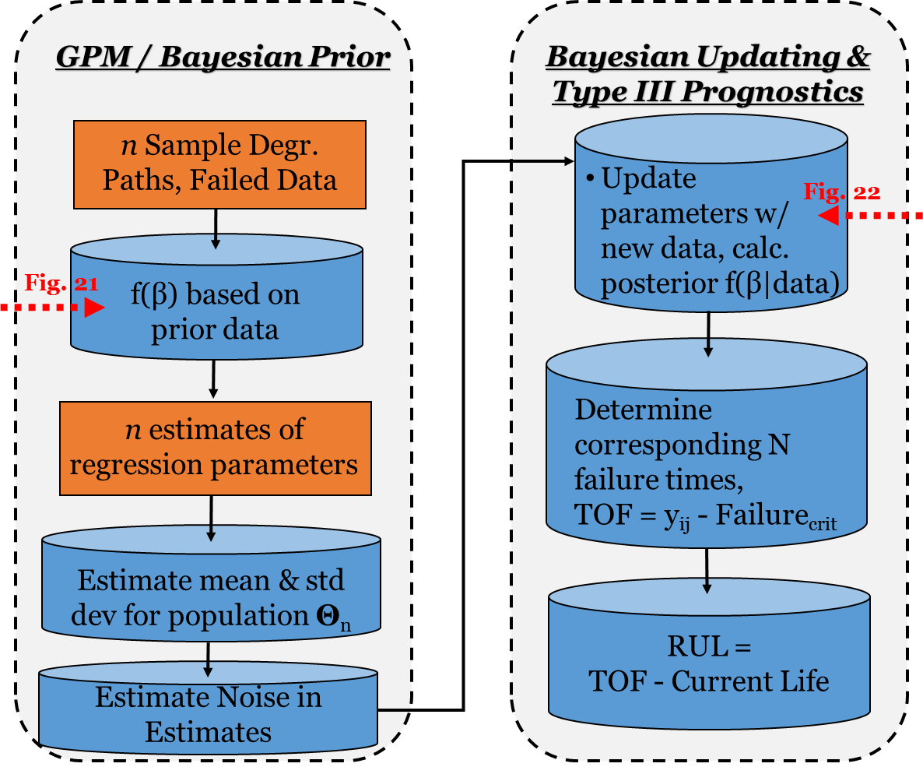
Figure 19. GPM-Bayesian Updating Prognostics Process

Identify Prognostic Parameter
After the data were formatted, the next step identified the prognostic parameter. Observations from the ‘failed’ data set are the residuals. For a system that performs as expected, residuals typically fall within a, sometimes, well defined operational range. When the system fails or begins to wear-out, the residuals begin to appear outside of the normal operating condition range.

A valid prognostic parameter must be trendable, monotonic, and prognosable. For a residual degradation parameters to be trendable, the analyst must be able to fit functions to the data. Monotonic residual degradation parameters cannot self-heal; they must either increase or decrease, and not reverse direction (from decreasing to increasing, or increasing to decreasing, or multiple direction changes) over time. A prognosable residual degradation parameter explains how well the data relate to a failure limit by the variance relative to that limit. With large variance, noted by a broad spread in the data, indicates the limit may not sufficiently explain degradation over a long period of time. Too small a variance may not provide any explanation for degradation. A reasonable grouping in the spread of the data is ideal. Since there were three factors, variances in many were zero. This makes sense because once the substrate is painted, the surface preparation method results in stationary data. The specific service is assumed to be stationary as well. Only one parameter, condition states, was selected to use for building the prior model and identifying prognostic parameters, due to complications just described with the other two factors.

For these analyses, the data were evaluated visually because this step was exploratory in nature. The data were plotted and the results reviewed as further validation of decisions made on the degradation parameter.

Fit & Select Best Performing Distribution
Two types of nonlinear models were fit to the ‘failed’ data to determine the one that best explains the path of the degradation. These models were selected because they generalize trends for degradation. In each case, the pseudo-inverse, shown in Figure 20, was used to calculate the parameters of the distribution. Then, the estimated parameters were inserted back into their standard equations to calculate the estimated degradation, Equations 37 and 38. An exponential model was not used because it resulted in greater error compared to the quadratic model.

Figure 20. Pseudo-Inverse Calculation
$$β= \frac{X^{'}*pp}{X^{'}*X}$$

$$= \frac{\left[\begin{matrix}x_{11} & ⋯ & x_{1m} \\ ⋮ & ⋱ & ⋮ \\ x_{n1} & ⋯ & x_{nm}\end{matrix}\right]\left[\begin{matrix}{pp}_{1} \\ ⋮ \\ {pp}_{m}\end{matrix}\right]}{\left[\begin{matrix}x_{11} & ⋯ & x_{1m} \\ ⋮ & ⋱ & ⋮ \\ x_{n1} & ⋯ & x_{nm}\end{matrix}\right]\left[\begin{matrix}x_{11} & ⋯ & x_{1n} \\ ⋮ & ⋱ & ⋮ \\ x_{m1} & ⋯ & x_{mn}\end{matrix}\right]}$$

Where ‘x_{mn}’ are time-cycles data and ‘pp’ is the prognostic parameter.

$y_{linear}=m*t+c$ Equation 37

Where ‘y’ is the degradation path, and ‘m’ and ‘c’ are the parameters.

$y_{quadratic}= b_{1}*t^{2}+b_{2}*t+b_{3}$ Equation 38

Where ‘y’ is the degradation path, and ‘b_{1’}, ‘b_{2’}, and ‘b₃‘ are the parameters.

For both models, an estimate of degradation was calculated for failed components using the parameters calculated above. These were then used to calculate the Mean Squared Error (MSE) between the actual data (pp) and the prediction model (est) for all data points, see Equation 39.

$MSE={avg}_{population}\left[mean\left({\left(pp-est\right)}^{2}\right)\right]$ Equation 39

The best performing model is the one with the smallest MSE.

Identify Individual Component and Population Effects
From the model with the lowest MSE, the mean and standard deviation for each of the parameters was calculated, and the ratio (r) of the standard deviation to mean evaluated, Equation 40. This method normalizes the spread of the data about its mean creating a more objective method for evaluating the effects of the parameters by comparing them to one anther.

$ratio = {\left.\frac{std dev}{mean}\right]}_{param1}; {\left.\frac{std dev}{mean}\right]}_{param2};{\left.\frac{std dev}{mean}\right]}_{param-n}$ Equation 40

A general rule of thumb is if r ≤ 2%, then the parameter represents a somewhat consistent effect that the population has on the degradation of the component. If r ≥ 2%, then the effect is related to the component. Population effects, with r ≤ 2%, have little variance from component to component. Whereas component effects result in a much greater spread in the data. So, for RUL calculations, degradation paths should be represented by population parameters set to constants and component parameters calculated from individual populations of in-service data.

Determine if (Prior Data) Parameters Are Normal
The Correlation Coefficients (cc) for the distribution parameters were calculated to determine if the data were normally distributed and univariate. This was done to support the assumption that the parameters should be independent and that the variance is normally distributed.

After calculating the ‘cc’, a Roy’s Test (algorithm) was used as an objective means for determining if the parameters are normally distributed. Roy’s Test is analogous to the Chi-Squared test for determining normality. It makes use of the p-value from which the null hypothesis (the distribution is normal) can be rejected if the value of the Roy’s P-value is less than the set p-value. The p-value was set to 0.05 significance for these analyses as per standard practice.

Statistics of Prior Distributions
The mean and variance for the calculated parameters from the failed data set were calculated using standard equations. These data establish the prior understanding of how the component degrades, and are used next in calculating the noise within the existing model, and later when the model is updated with new data on unfailed components.

Noise within Prior Distributions
A median filtering algorithm was used to estimate the median performance of degradation for the failed data set. Noise, then, was calculated as the difference between the actual degradation parameter value and the median estimate. The average variance for these values was calculated and is used later when the model is updated with new data for unfailed components.

Set Failure Threshold
See discussion about defining failure in Section 3.3.1 above.

Prognostics Using GPM
The pseudo-inverse equation was used again. Only this time, new data for unfailed components are coupled with the degradation model parameters from the failed data set, to calculate new linear-in-parameters degradation parameter values, Figure 21 below.

$$β= \frac{X^{'}*\sum_{y}^{-1}{*}y}{X^{'}*\sum_{y}^{-1}{*}X}$$

$\sum_{y}^{-1}{= \left[\frac{\begin{matrix}σ_{y} & 0 & \begin{matrix}⋯ & \begin{matrix}0 & 0\end{matrix}\end{matrix} \\ 0 & σ_{y} & \begin{matrix}⋯ & \begin{matrix}⋮ & 0\end{matrix}\end{matrix} \\ \begin{matrix}⋮ \\ 0\end{matrix} & \begin{matrix}⋮ \\ ⋯\end{matrix} & \begin{matrix}\begin{matrix}⋱ & \begin{matrix}0 & ⋮\end{matrix}\end{matrix} \\ \begin{matrix}0 & \begin{matrix}σ_{y} & 0\end{matrix}\end{matrix}\end{matrix}\end{matrix}}{\begin{matrix} \begin{matrix}0 \\ ⋮\end{matrix} & \begin{matrix}0 \\ ⋮\end{matrix} & \begin{matrix} \begin{matrix}⋯ \\ ⋮\end{matrix} & \begin{matrix}\begin{matrix}0 & σ_{y}\end{matrix} \\ \begin{matrix}⋮ & ⋮\end{matrix}\end{matrix}\end{matrix}\end{matrix}}\right]}$ $y= \left[\frac{\begin{matrix}y_{1} \\ y_{2} \\ \begin{matrix}⋮ \\ y_{n}\end{matrix}\end{matrix}}{\begin{matrix}β_{J_{0}} \\ ⋮\end{matrix}}\right]$

$$X^{'}= \left[\begin{matrix}x_{11} & x_{21} & \begin{matrix}⋯ & x_{m1} & \begin{matrix}| & \begin{matrix}0 & ⋯\end{matrix}\end{matrix}\end{matrix} \\ x_{12} & x_{22} & \begin{matrix}⋯ & x_{m2} & \begin{matrix}| & \begin{matrix}⋮ & ⋯\end{matrix}\end{matrix}\end{matrix} \\ \begin{matrix}⋮ \\ x_{1n}\end{matrix} & \begin{matrix}⋮ \\ x_{2n}\end{matrix} & \begin{matrix}\begin{matrix}⋱ \\ ⋯\end{matrix} & \begin{matrix}⋮ \\ x_{mn}\end{matrix} & \begin{matrix}\begin{matrix}| \\ |\end{matrix} & \begin{matrix}\begin{matrix}1 & ⋯\end{matrix} \\ \begin{matrix}0 & ⋯\end{matrix}\end{matrix}\end{matrix}\end{matrix}\end{matrix}\right]$$

$$X= \left[\frac{\begin{matrix}x_{11} & x_{12} & \begin{matrix}⋯ & x_{1n}\end{matrix} \\ x_{21} & x_{22} & \begin{matrix}⋯ & x_{2n}\end{matrix} \\ \begin{matrix}⋮ \\ x_{m1}\end{matrix} & \begin{matrix}⋮ \\ x_{m2}\end{matrix} & \begin{matrix}\begin{matrix}⋱ \\ ⋯\end{matrix} & \begin{matrix}⋮ \\ x_{mn}\end{matrix}\end{matrix}\end{matrix}}{\begin{matrix}\begin{matrix}0 \\ ⋮\end{matrix} & \begin{matrix}⋯ \\ ⋮\end{matrix} & \begin{matrix} \begin{matrix}1 \\ ⋮\end{matrix} & \begin{matrix}0 \\ ⋮\end{matrix}\end{matrix}\end{matrix}}\right]$$

Figure 21. Pseudo-Inverse Calculation – Bayesian Updating

Here, sigma-inverse represents the variance-covariance noise matrix, describing the accuracy of data in the ‘y’ degradation vector [91]. ‘y’ are the new degradation values at the top, with mean parameter values from prior data (calculated in Step 6 above) inserted at the bottom. ‘X’ are new time (cycles) data for this project at the top, with an identity matrix at the bottom used to process the Bayesian updating in the matrix format. ‘β’ represents the update parameters of the prior data with the new data keeping with the linear-in-parameters assumption.

The updated parameters, then, are used to calculate the ToF using a quadratic equation set equal to the established failure limit, Equation 41.
$ToF\left(t_{i}\right)= y_{nonlinear function of time}= failure limit$ Equation 41

Finally, the RUL was calculated. It is the difference between the ToF and the time of the last recorded condition for each component using in-service data, Equation 42.

$RUL=ToF- t_{last recorded cond.}$ Equation 42

Investigate Negative or Excessive RULs
From the last step above, there may be cases when the RUL is a negative number or exceeds the known values. This happens, primarily, for three reasons. Negative rules occur when components are very close to failure. When there is not enough information, too much variance or noise, a function cannot fit the data very well. Managing negative or excessive RUL data and inclusion in the analysis is done on a case-by-case basis.

Most Accurate Model – Cumulative Relative Accuracy
The Cumulative Relative Accuracy (CRA) was calculated for each model. This approach is better suited for prognostics because it incorporates the desire for improved accuracy near the end of life, as well as other geometric features otherwise hidden by standard Root Mean Squared Error evaluations customary to diagnostics. Equations 43 and 44 were used, incorporating a standard ToF = 37 years that was obtained by inspection and used throughout the analyses.

$RA=1- \frac{\left|ToF-RULest\right|}{TOF}$ Equation 43

$CRA= \frac{\sum{RA}}{ToF}$ Equation 44

3.4 Maintenance Policy Cost Considerations

The life cycle costs for each maintenance policy used in these analyses are shown in Table 2. The assumptions and major considerations behind these costs are listed in the bullets that follow.

Table 2. Maintenance Policy Costs
Policy | Development | Annual O&M Infrastructure | Actual Repairs for 50 years | Logistics | Retirement | Life Cycle Cost
Corrective | - | $10,000 | $27,000,000 | - | - | $27,500,000
Prospective | - | $10,000 | $13,500,000 | - | - | $14,000,000
Predictive | $3,000,000 | $25,250 | $5,400,000 | - | - | $9,662,500
Proactive | $3,500,000 | $33,750 | $3,618,000 | - | - | $8,805,500
Predeterminative | - | $10,000 | $12,500,000 | - | - | $13,000,000

- 50 year life cycle
- Time value of money and inflation not included.
- Logistics and system retirement costs not included.
- Number of components (coating systems) considered = 25
- 25 Coating systems out of 500 total number of systems in maintenance management system = 5%
- Develop sensors and automated predictive technology & personnel training = $3 mil; one-time cost
- Develop proactive use of sensors and predictive technology & personnel training = $3 mil +$500 k; one-time cost
- Basic Operations and Maintenance (O&M) cost for scheduling, monitoring, reporting on 25 systems = $10,000/yr
- Electronic system security = $250,000/yr
- Operate predictive system; 3 analysts/technicians @ $85,000/yr = $255,000/yr
- Portion of O&M Effort to manage 25 coating systems on secure / ‘predictive’ system = 0.05*($255,000/yr+$250,000/yr) = $25,250/yr
- Operate proactive system; 5 analysts/technicians @ $85,000/yr = $425,000/yr
- Portion of O&M Effort to manage 25 coating systems on secure / ‘proactive’ system = 0.05*($425,000/yr+$250,000/yr) = $33,750/yr
- Cost to repair 1 coating system, Determinative Maintenance = $180,000
- 6x Cost to repair 1 coating system and structural damage under Corrective Maintenance Policy = $1,080,000; range of costs for corrective repairs range from 2x to 10x Predeterminative cost; chose mid-point, 6x cost for these analyses.
- Assume 1 replacement in 50 years under Corrective Maintenance Policy, considering average RUL is 35 yrs
- Prospective Maintenance Policy. Repair cost is one half the cost of Corrective Maintenance Policy
- Predeterminative Maintenance Policy. Replace each coating system every 18 years; 2.78 replacements for each system in 50 years
- Predictive Maintenance Policy. Considering RUL estimates, average number of replacements in 50 years = 1.2
- Proactive Maintenance Policy. Follow DoE which explains repair cost is 67% of Predictive Maintenance Policy Costs [25]

Chapter 4: Results and Discussion

This chapter is organized according to the sequence of levels from Figure 1. Section 4.1 discusses the results of AHP, identifying the most preferred maintenance policy for a paint coating system. It also addresses the results of critical criteria analysis, and policy selection using cost as an independent variable. Section 4.2 discusses the results of prognostic analyses. It identifies the most accurate model, and provides expanded commentary features revealed by the analysis the performance of the paint coating system.

4.1 (Levels 0 - 5) AHP Models

The APH process was used to calculate the relative weights of different criteria and identify the most preferred maintenance policy. Figure 22 below presents the calculated weights, underlined, in Levels 1-3 at the top, and the policy scores, underlined, in Level 4 at the bottom. According to the objective technical requirements, subjective judgements about enterprise criteria, and cost data for the paint coating system under investigation, a proactive maintenance policy is the most preferred. It outperforms, in declining order of preference, a predictive policy, a predeterminative policy, a prospective policy, and a corrective policy.

In review of the weights calculated for each criterion, the results of the analysis provide reasonable results. A proactive policy incorporates and enhances all aspects of predictive policy, so naturally it is more preferred. Where safety, the Level 1 criterion with the highest weight, is concerned, a proactive policy is more preferred because it measures and reports degradation, enabling operational changes and maintenance scheduling and other logistics before the performance threshold is reached. It also feeds back data collected in the field to make procedural and physical changes that improve performance in the future, features not part of a predictive policy. All other criteria have lower weights compared to safety, and follow the reasonable conclusion that benefits for advanced planning and extended RUL for a predictive policy, coupled with enhanced benefits for improving performance in the future from a proactive policy, create a robust set of criteria and satisfactory ranking of preferred maintenance policies.

Level 4
Policy Scores from AHP
Levels 1 – 3
Criteria Weights from AHP
Figure 22. AHP in Maintenance Policy Decision
Inconsistency Index:
0.0001

Traditional criteria, such as MTBF and availability, as it turns out, did not result in high weights. Considering factors such as ‘availability of funds’ and ‘tradeoff potential’, these calculations found that maintainability and logistic support features have greater influence over the maintenance policy decision. Further, conflicting requirements, such as ‘availability of funds’ and ‘tradeoff potential’ are resolved within the process. By structuring conflicting requirements under the same Level 1 criteria, a less expensive decision is made during planning, relieving the entire organization from more expensive infrastructure, complex processes, and longer downtimes during operations and maintenance execution. In this case, ‘availability of funds’ is the fourth most important criteria. This is reasonable because, in general, maintenance will not occur without funding. Regardless of the ‘tradeoff potential’ (risk priority) assigned to the component, timely acquisition of maintenance funding is a limiting factor.

AHP exposes considerations that are otherwise hidden by subjective and arbitrary decision-making. The results indicate that ‘applicability’ criteria rank slightly higher than ‘operations’ criteria. A closer look at applicability criteria finds that ‘technical reliability’ criteria are weighted significantly higher compared to all of the operations criteria. According to input from the organization, the level of current and past repairs, and the ability to detect damage weigh more heavily in the overall maintenance policy decision compared to meeting operational objectives. This is a reasonable result considering the level of repair and nonhomogeneous failures, coupled with the organization’s ability and opportunity to detect increasingly more frequent failures weighs more heavily with maintainability performance compared to reliability performance.

Weights assigned to ‘TPM maturity’ and ‘PHM maturity’ area also interesting. These criteria represent both the organization’s direction and capability for TPM self-improvement and PHM optimization. A lightbulb in an office desk lamp would probably be weighted very-very low. Here, for the paint coating system, there is some measured level of maturity and lower weights assigned. For rotating machinery where sensor technology is more mature, these criteria would probably be weighted much higher, at least for advanced predictive and proactive maintenance policies.

To demonstrate that the ranking of policies is robust, Table 3 below lists the results of the critical criteria analysis for the predictive policy and the predeterminative policies. It proves that a change in the weight of any criteria will not change order of preference for these policies. This is a reasonable result because the weights for all of the predictive policy criteria were several magnitudes higher compared to those for a predeterminative policy except for safety criteria. The percent change for safety is lower than the other values. This is because the potential for predeterminative scheduling of maintenance to be overly conservative, if used correctly, can reduce the safety risk between the two policies.

Table 3. Critical Criteria Analysis
Level 1 Criteria | % Change Required
Operations | 965
Safety | 164
Applicability | 646
Added Value | 744
Execution Cost | 1,066

The benefit to cost ratio, an alternate method for identifying the most preferred policy, focuses on the value that each policy provides, using cost as an independent variable for the decision. Table 4 below lists the results where a higher number, in this case proactive policy, is best. Comparing the results listed in Table 4 to the scores shown in Figure 23, the difference among values in the ratio are more pronounced than the differences among weights. This approach provides a good explanation about what the organization gets for the money it is spending. An AHP alone does not address this aspect the decision process.

Table 4. Benefit-Cost Ratio
Maintenance Policy | Benefit / Cost
Proactive Maintenance | 3.7
Predictive Maintenance | 1.9
Predeterminative Maintenance | 0.8
Prospective Maintenance | 0.5
Corrective Maintenance | 0.2

4.2 (Level 7) Prognostic Models

The RUL for each model was calculated, and its accuracy compared to a common group of failure data. Type 3 prognostics with Bayesian updating provided the most accurate results. Type 3 prognostics with Bayesian updating and residual analysis did not provide better results because the factors used in the analyses were, for the most part, stationary. Type 2 prognostics with a Cox PhM provided informative and reasonable results. As is customary of this method, the analysis exposed the relative differences between each of the service and environment service lives. The results were reasonable and mirror conditions found in the field. Type 2 prognostics with MCMC did not provide informative results. Suspected causes are the data never transition from a higher state to a lower state. Also, there are very-very few transitions from a lower state to a higher state. Type 1 prognostic models provided the least accurate results.

The following sub-sections are ordered by Type 1, Type 2 Cox PhM, and Type 3 GPM with Bayesian Updating results, followed by a composite summary of CRAs.

4.2.1 Type 1 Reliability Models

Censored data were fit to the exponential, normal, and a 2-parameter Weibull functions. Parameters of each function are listed in Table 5 and plotted in Figure 23 below. The shape parameter of the Weibull distribution is greater than one, indicating an increasing failure rate. Also included in the figure is a plot of empirical failures, characterized by steps of declining magnitude and the red line. These empirical failures do not account for right censored data. Right censored, non-failure data, indicate the system has a longer reliable life, shifting failure times farther to the right. Difference between the plots of the three continuous functions and the empirical function illustrate the importance of including all data, failures and non-failures, when investigating system reliability.

Table 5. Type 1 Models – Fitted Functions & Parameter Results
Distribution | Parameters
Exponential | m: 37.9
Normal | μ: 31.9
2-Parameter Weibull | θ: 36.1  β: 3.4

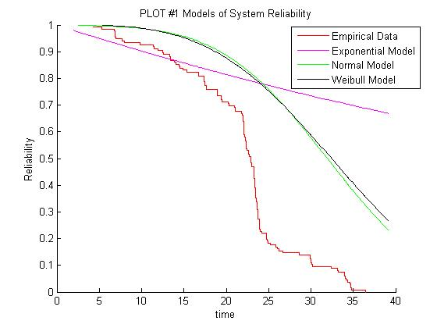
Figure 23. Type 1 Models – Reliability vs Time

The Kolmogorov-Smirnov (KS) test found that the 2-Parameter Weibull distribution best fits the data. Results of that test are listed in Table 6 below – lowest is best.

Table 6. Type 1 Models – Function Goodness of Fit Results
Distribution | KS Results
Exponential | 0.9899
Normal | 0.5787
2-Parameter Weibull | 0.5722

A plot of the RUL verses service life using the Weibull function is shown in Figure 24 below. It illustrates that at the beginning of service, the coating system is expected to have 18 years of remaining useful life, compared to historical data. Based on the condition that coating system survives and remains in service, it is expected to have a steadily decreasing RUL until such time as the organization finds that the opportunity for maintenance before failure is less than the RUL, or the expected costs begin to exceed the benefits; see Figure 9.

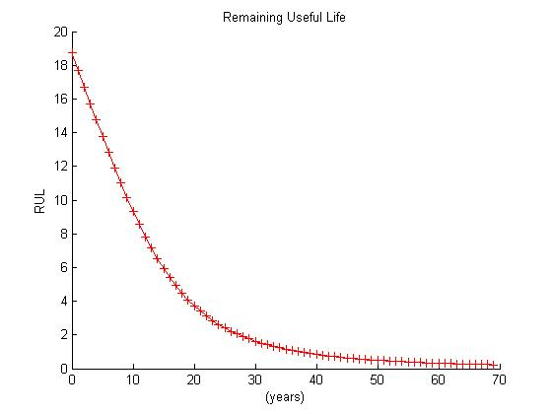
Figure 24. Type 1 Models – Reliability Based RUL

4.2.2 Type 2 Cox Proportional Hazards Model

MLE was used to determine the values of the parameters, Table 7.

Table 7. Cox PhM Statistics
Statistic | Value
covb | $$\left[\begin{matrix}3.3439 & -0.1680 \\ -0.1680 & 1.9741\end{matrix}\right]$$
Beta (β) | $$\left[\begin{matrix}-0.9229 \\ 5.5504\end{matrix}\right]$$
se | $$\left[\begin{matrix}1.8286 \\ 1.4050\end{matrix}\right]$$
z (β/se) | $$\left[\begin{matrix}-0.5047 \\ 3.9504\end{matrix}\right]$$
p-value | $$\left[\begin{matrix}0.6138 \\ 0.0001\end{matrix}\right]$$

‘covb’ describes the variance of the model parameter Beta (β). ‘se’ is the standard error of (β). ‘z’ is the z-statistic. ‘p-value’ indicates the effect of the covariate is significant.

Figure 25 illustrates the differing affects that service environment has on the hazard rate, and by extension, the life of the coating system. This plot shows that contaminated service coatings fail earlier than storage service coatings. It also shows that coating systems with grit blast surface preparation degrade slower.

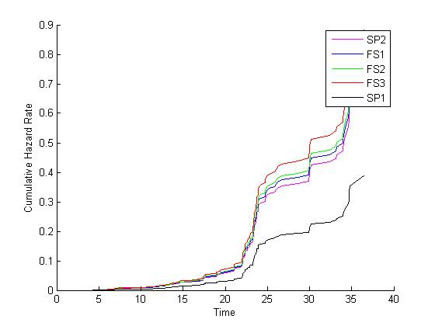
Figure 25. Type 2 Models – Cox PhM Cumulative Hazard Rate vs Time

Figure 26 illustrates the reliability of the system using parameters for each of the five factors. It shows that substrate with grit blast surface preparation and storage service environments result in longer lasting coating systems. It also shows that coatings in a contaminated service environment degrade faster than the environments.
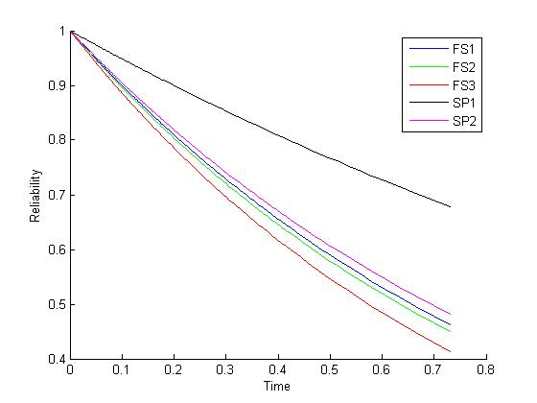
Figure 26. Type 2 Models – Cox PhM Reliability vs Time

Figure 27 illustrates the RULs using data for each of the 4 features shown. The RUL for service environment 2 were not shown because it performs very similar to service 1. Local peaks in the data represent some type of activity or change in the field as it was recorded in the data. The results show that late in the coating service life, there appear to be a number of actions that may represent maintenance or risk decisions.
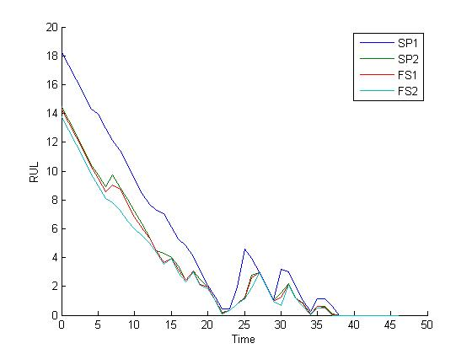
Figure 27. Type 2 Models – Cox PhM Based RUL

4.2.3 Type 3 General Path with Bayesian Updating Model

A linear function, a quadratic function, and an exponential function were fit to the training data. The average Mean Squared Error (MSE) for each are listed in Table 8 below. While the exponential function provided a slightly better fit, parameters from the quadratic function were advanced in the analysis due to certain complications associated with the exponential function.

Table 8. Type 3 Models – GPM with Bayesian Mean Squared Error
Model Type | MSE
Linear | 3.0959
Quadratic | 2.3583
Exponential | 2.3317

The parameters of the quadratic function are listed in Table 9 below. Values in the ratio are all over 2%, indicating the effects represented by the data and the parameters of these analyses are component effects, not constant population effects.
Table 9. Quadratic Model Parameter Evaluation
 | Parameter b1 | Parameter b2 | Parameter b3
Mean (M) | 0.0194 | -0.3615 | 1.3825
Std Dev (S) | 0.0180 | 0.1724 | 0.3092
ratio = S/M | 0.9265 | -0.4771 | 0.2236

Roy’s Test resulted in a Royston’s statistic p-value of 6.0e-6, well below the typical p=0.050 threshold for confirming normality. Figure 28 shows degradation paths for training data. At the top are red asterisks indicating the time of failure, when the system was found in condition state 4. Degradation paths are dominated by step-changes instead of smooth paths. This result is reasonable for data collected on components with very long service lives and relatively few condition states changes.

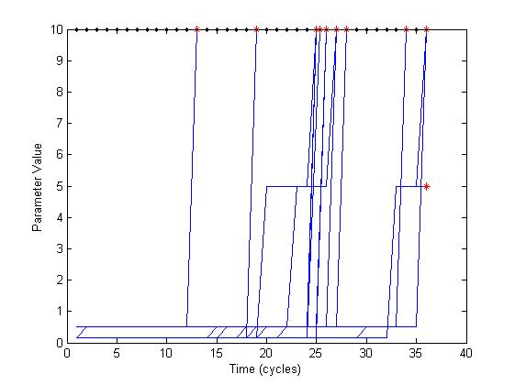
Figure 28. Type 3 Models – GPM With Updating, Degradation Paths

Figure 29 shows two results. First, it identifies the estimated RUL for the specific components, operating in specific environments and conditions as the blue asterisks. Second, the red line shows actual failure times. Any separation between the blue asterisk and the red line, actual failure from the validation data group, is error within the model. The two values that are less than zero are typically a result of the model not having enough data, or the item having already failed. The point with an Actual RUL of approximately 27 had relatively little data. The point with an Actual RUL of approximately 37 had the failure recorded at a lower threshold compared to the others. What is apparent from the figure is that the Estimate RUL values are lower than the Actual RUL values. When estimates are lower that actual values, they appear below the red line. This indicates that the model is conservative, and more information is needed to reduce the error in the projection of the RUL.

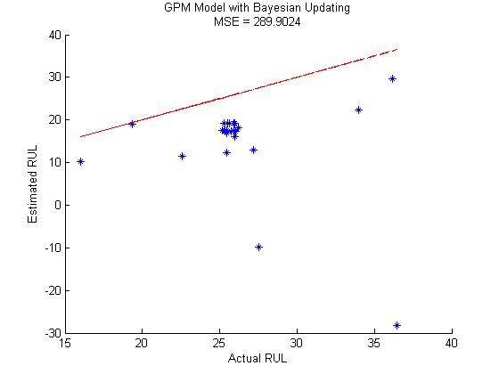
Figure 29. Type 3 Models – GPM With Bayesian Updating RUL

4.2.4 Accuracy of Models

The CRA is listed in Table 10 below for each model. It shows that a Type 3 prognostic model using the General Path Model and Bayesian updating provided the most accurate results. A Type 3 model with residuals was expected to provide more accurate results, but did not due to limitations within the residuals themselves. A Type 2 prognostic model using Cox PhM provides slightly more accurate results than the Type 1 model for data on coating systems applied over substrate prepared using grit blast media. Other PhM factors did not result in more accurate models. Type 2 MCMC is listed as a consideration, but no CRA is provided because the approach did not result in informative CRA.

Table 10. Cumulative Relative Accuracy of Prognostic Models
Model | CRA
Type 1 – Reliability | 0.043
Type 2 – Cox Proportional Hazards
Surface Preparation 1 | 0.046
Surface Preparation 2 | 0.022
Service 1 | 0.021
Service 3 | 0.019
Type 2 – Markov Chain Monte Carlo | -
Type 3 – GPM w/ Bayesian Updating | 0.269
Type 3 – GPM w/ Bayesian & Residuals | 0.179

Figure 30, below, consolidates the results of the four different models. In the Type 1 model, area 1 shows a layered grouping of several different RUL points. This highlights the fact that Type 1 models do not represent dimensionality in the data very well. In this model, all components are evaluated just the same as the average component, regardless of their specific operating environments and conditions. In contrast, area 2 in the Type 2 model shows dimensionality in the RUL estimates. Different colors represent RULs for the average component, operating in specific environments and conditions. The Type 3 models are the most sensitive. They represent the RUL for the specific component, operating its specific environment, under specific conditions. Figure 30 illustrates the benefit gained from using a maintenance policy and practices that make use of data with higher dimensionality to improve the accuracy in estimated RULs. For the Type 3 model with residuals, while it centered the individual RULs about the red reference line, it also caused greater spread among the data and lower accuracy compared to the other Type 3 model. This is not the typical result for data with continuous variables, a sufficient number of levels for ordinal data, and data collected at more regular frequency. Residual monitoring is a cornerstone to a well performing PHM system.

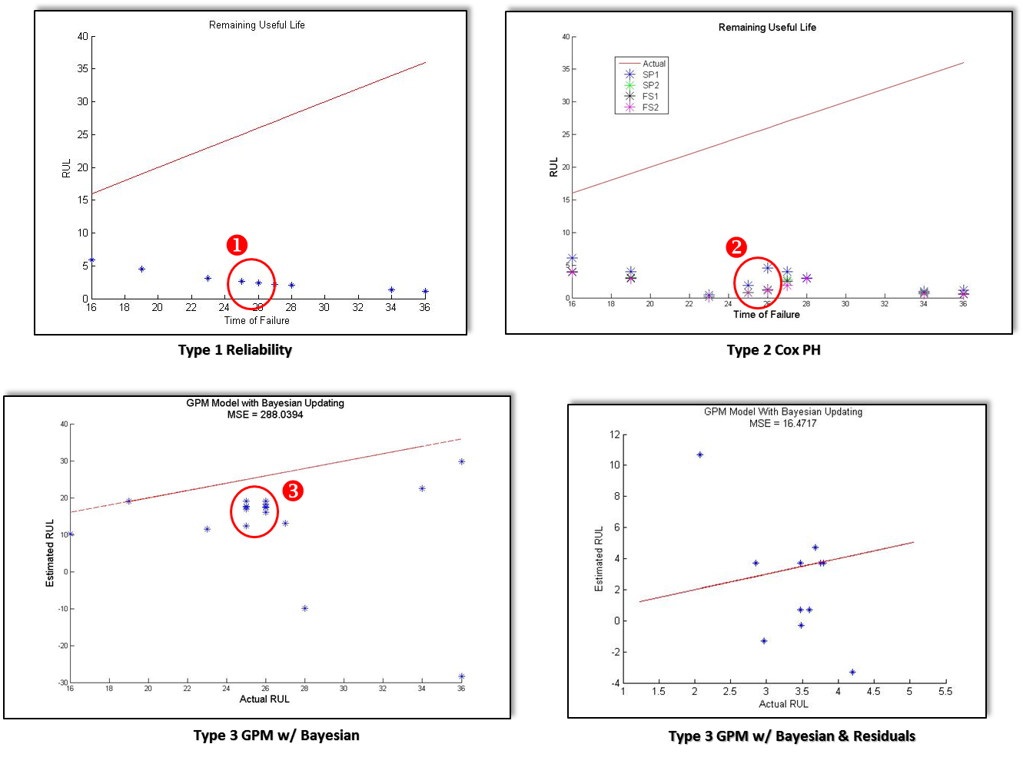
Figure 30 Prognostic Model Comparison

Chapter 5: Conclusions and Recommendations

The original scope of this project was to apply prognostic algorithms to a set of data and, depending on the results, prove they can be used to optimize equipment maintenance. In due course, research identified some instances and feedback that indicated otherwise. So it became necessary to expand the scope and investigate a number of related topics to ensure the following conclusions are based on facts, evidence, and different perspectives that influence the success of a particular method for planning maintenance.

On the outset, the major conclusion of this project is that prognostic algorithms can be used to optimize equipment maintenance. This was proven in Chapter 4. The secondary conclusion is, if they are not applied correctly, then they are less likely to provide optimal results. In a traditional sense, optimization is achieved by minimizing cost and maximizing availability of equipment. However, in practice, it can only be achieved by simultaneously satisfying objective requirements and subjective opinions that address the context of optimization for the individual organization. It is concluded that if the organization does not fully commit to the effort, adjusting its structure to be more sensitive to affordability and logistic factors that contribute to maintainability at the plant or SoS levels, then it may be dissatisfied with the results of prognostic analyses that, today, mostly apply to individual pieces of equipment. The following discussion continues along these lines and with the top-down, outside-in approach used throughout the Chapters above.

Where organizational structure is concerned, the size of the organization appears to be related to efficiency, and, as a result, the most preferred policy. Smaller organizations tend to be more centralized, enabling quicker and more definitive decisions. They are often limited by the amount and quality of historical data, and by the costs associated with implementing and sustaining more advanced systems. Rapid advancements in computer software and electronic communications will close many of the gaps between small and large organizations in the future making a PHM system a more frequent choice. Larger organizations, in contrast, make decisions more slowly due to the spread in their infrastructure and processes, and broad communication. While it is wise for large organizations to make decisions based on input from all of the stakeholders, it does so at the cost of decreased response time and increases maintenance delays. Small organizations benefit from the fact that sounded condition alarms can rise to the top, and descend in the form of a decision to field activities very quickly for JIT maintenance, the intent of CBM. Larger organizations route alarms throughout a network of locations and suppliers, each step and stop consuming the benefits of JIT maintenance, forcing wider margins to be designed into the objective technical requirements to compensate for inefficient logistic and scheduling processes. This project demonstrated how AHP can be used to select a maintenance policy, or transition to a maintenance policy that is best for all stakeholders in a large organization. Once this is done, the organization can use a smaller structure and a PHM system to localize the decision process, enabling faster and for more precise scheduling and execution. This project recommends using AHP to shrink the size of the maintenance planning process and decision space.

Most of the literature that was reviewed provided incomplete instruction on life cycle maintenance. While they provided an outline of different milestone-activities for life cycle management, Figure 3, and directed subordinate activities use advanced methods such a predictive and proactive maintenance, for in-service systems or equipment they did little to explain how to transition to using advanced policies. They did little to explain all the considerations that should be involved in the decision making process. They also did little prepare systems engineers and planners for managing enterprise level tradeoff decisions. This project introduces a novel structure, Figure 1, and recommends larger organizations use it as a guide when designing maintenance plans for new equipment, or when managing maintenance plans for in-service equipment. The figure standardizes the taxonomy, highlighting and drawing attention to major considerations needed to make decisions and transition between policies. This project recommends, as shown in the figure, that regardless of the policy, all systems should be connected and managed through a PHM system. Data that is stored in a PHM system enables proactive improvements and transitions to more advanced policies.

This project concludes that AHP is the most practical method for translating Affordable System Operational Effectiveness considerations to manage the trade space between cost and performance. While other methods exist, they are either less accurate, doubted, too complicated to explain to at both the mechanic and senior management levels, or take a long time to build, train, and validate. AHP appears to strike the right balance between comprehensive requirements management, accuracy, fidelity, and usefulness. It comes along with tools that help an organization identify critical criteria and measure the values they need to change to transition between maintenance policies. This project recommends using APH exclusively, or using AHP while more advanced fuzzy or neural models are developed.

The results, conclusions, and recommendations of this project are neutral when it comes to preference for a particular maintenance policy. It concludes, however, that the important part is that a comprehensive set a requirements, criteria, and input be involved in the policy selection process. It is equally important to employ a standard and repeatable method such as AHP, and ensure it is conducted consistently by facilitators specifically trained in the method and with facilitating technical matters.

Concerning the data on the pain coating system used in the prognostic analyses. This project concludes that the use of categorical variables and long periods of time between assessments resulted in low accuracy for even the best performing prognostic model. This is a severe weakness of the assessment program for that system. Categorical variables can easily and immediately be offset by collecting data using ordinal variables, or continuous data collected by sensors. The results in Chapter 4 indicate that the costs for developing sensors are far outweighed by the benefits of lower total ownership costs. Fielding sensors that collect continuous data is recommended.

Based on the data that was used, and the prognostic methods involved, this project concludes that a GPM with Bayesian Updating will provide the most accurate prediction of the RUL and optimal maintenance for paint coating systems. If changes are made to the way the data is collected, then a GPM with Bayesian Updating and Residuals will provide the most accurate results. It also finds that other prognostic models, and diagnostic models by extension, provide useful information for examining different factors in the data, performing FMECA, and doing risk analysis. This project recommends employing a PHM system designed to build and report the results of several different kinds of prognostic and diagnostic models.

The results of the GPM with Bayesian Updating analyses were used to calculate the repair costs for Predictive and Proactive policies in the AHP analyses, Figure 22 above. Based on the requirements, preferences, processes, and optimized performance and cost data that were used to conduct AHP, the results indicate that policies that use prognostic algorithms are the most preferred. This project concludes that both AHP and prognostic algorithms can be used to optimize equipment maintenance strategies for paint coating systems. Further, for this specific application, it finds that the criteria are robust and significant changes are required to change the order of preferred policies. If improvements in data collection are not made and sensors not employed, then the state of the art for these systems resides somewhere between the Predeterminative and Predictive Policies. To complete this project, it is recommended that both AHP and prognostic models be used optimize maintenance strategies for paint coating systems.

Chapter 6: Future Work

Parametric Censoring of Data – In Section 2.6.1.6.1 it was explained that parametric methods provide the most accurate estimate of ToF for interval censored data. The results of these analyses were calculated using the mid-point method. RUL projections will be more accurate if parametric methods are used to estimate ToF, and greatly improved if continuous data are used, eliminating the need to use parametric methods.

Interaction affects and combinations of factors in AHP – The calculations used in these analyses evaluated the influence of each factor individually. This project acknowledges enhanced benefits of AHP based on interaction affects and combinations of factors.

List of References

[1] | INCOSE, Systems Engineering Handbook: A Guide for Systems Life Cycle Processes and Activities, New York: John Wiley & Sons, 2015.
[2] | C. Ebeling, An Introduction to Reliability and Maintainability Engineering, Long Grove: Waveland Press, Inc., 2010.
[3] | ReliaSoft Corporation, "Weibull.com," January 2011. [Online]. Available: http://www.weibull.com/hotwire/issue119/hottopics119.htm. [Accessed 12/17/2016 December 2016].
[4] | F. Khan, "Equipment reliability a life-cycle approach," Engineering Management Journal, vol. 11, no. 3, pp. 127-135, June 2001.
[5] | A. Carter, "Better Buying Power: Mandate for Restoring Affordability and Productivity in Defense Spending," DoD, Washington, DC, 2010.
[6] | "Defense Acquisition University," Defense Acquisition University, 17 December 2016. [Online]. Available: https://dap.dau.mil/aap/pages/qdetails.aspx?cgiSubjectAreaID=43&cgiQuestionID=118392. [Accessed 17 December 2016].
[7] | S. Ding and S. Kamaruddin, "Maintenance policy optimization-literature review and directions," The International Journal of Advanced Manufacturing Technology, vol. 76, no. 5, pp. 1263-1283, 2015.
[8] | W. Tiddens, A. Braaksma and T. Tinga, "The adoption of prognostic technologies in maintenance decision making: a multiple case study," in The Fourth International Conference on Through-life Engineering Services, 2015.
[9] | K. Khazraei and J. Deuse, "A strategic standpoint on maintenance taxonomy," Journal of Facility Management, vol. 9, no. 2, pp. 96-113, 2011.
[10] | J. Moubray, Reliability-centered Maintenance, 2nd Ed., New York: Industrial Press Inc., 1997.
[11] | J. Koochaki, J. Bokhorst, H. Wortmann and W. Klingenberg, "Condition based maintenance in the context of opportunistic maintenance," International Journal of Production Research, vol. 50, no. 23, pp. 6918-6929, 2012.
[12] | J. Gao, D. Quass and Y. Ng, "Selective-Splitting and Cache-Maintenance Algorithms for Associative-Client Caches," Distributed and Parallel Databases, vol. 16, no. 1, pp. 5-43, 2004.
[13] | J. Mitchell, "Five to ten year vision for CBM," in paper presented at the ATP Fall Meeting - Condition Based Maintenance Workshop, Atlanta, 1998.
[14] | S. Yang, "A condition-based failure-prediction and processing-scheme for preventive maintenance," IEEE Transactions on Reliability, vol. 52, no. 3, pp. 373-383, 2003.
[15] | L. Wang, J. Chu and J. Wu, "Selection of optimum maintenance strategies based on a fuzzy analytic hierarchy process," International Journal of Production Economics, vol. 107, no. 1, pp. 151-163, 2007.
[16] | P. Tsai, Y. Lin, Y.-Z. Ou, E. Chy and J. Liu, "A Framework for Fusion of Human Sensor and Physical Sensor Data," IEEE Transaction fon Systems, Man, and Cybernetics: Systems, vol. 44, no. 9, pp. 1248-1261, 2014.
[17] | G. Waeyenbergh, L. Pintelon and L. Gelders, "A stepping stone towards knowledge based maintenance," South African Journal of Industrial Engineering, vol. 12, no. 2, pp. 61-81, 2001.
[18] | M. Organ, T. Whitehead and M. Evans, "Availability-based maintenance within an asset management programme," Journal of Quality in Maintenance, vol. 3, no. 4, pp. 221-232, 1997.
[19] | Y. Tsai, K. Wang and L. Tsai, "A study of availability-centered preventive maintenance for multi-component systems," Reliability Engineering and Systems Safety, vol. 84, no. 3, pp. 261-270, 2004.
[20] | G. Waeyenbergh and L. Pintelon, "A framework for maintenance concept development," International Journal of Production Economics, vol. 77, no. 3, pp. 299-313, 2002.
[21] | L. Krishnasamy, F. Khan and M. Haddara, "Development of a risk-based maintenance (RBM) strategy for a power-generating plant," Journal of Loss Prevention in the Process Industries, vol. 18, pp. 69-81, 2005.
[22] | J. BareiB, P. Buck, B. Matschecko, A. Jovanovic, D. Balos and M. Perunicic, "RIMAP demonstration project. Risk-based life management of piping system in power plant Heilbronn," International Journal of Pressure Vessels and Piping, vol. 81, pp. 807-813, 2004.
[23] | K. Fujiyama, S. Nagai, Y. Akikuni, T. Fujiwara, K. Furuya, S. Matsumoto, K. Takagi and T. Kawabata, "Risk-based inspection and maintenance systems for steam turbines," International Journal of Pressure Vessels and Piping, vol. 81, pp. 825-835, 2004.
[24] | NASA, "NASA Public Web Page," September 2008. [Online]. Available: http://www.hq.nasa.gov/office/codej/codejx/Assets/Docs/NASARCMGuide.pdf. [Accessed 22 December 2016].
[25] | U. DoE, "Department of Energy Public Web Page," August 2010. [Online]. Available: https://energy.gov/sites/prod/files/2013/10/f3/omguide_complete.pdf. [Accessed 22 December 2016].
[26] | C. Carlson, Effective FMEAs, Hoboken: Wiley, 2012.
[27] | I. Ahuja and J. Khamba, "Total productive maintenance: literature review and directions," International Journal of Quality & Reliability Management, vol. 25, no. 7, pp. 709-756, 2008.
[28] | J. Majumdar and M. Manohar, "Implementing TPM programme as a TQM tool in Indian manufacturing industries," Asian Journal on Quality, vol. 13, no. 2, pp. 185-198, 2012.
[29] | F. Ireland and B. Dale, "A study of total productive maintenance implementation," Journal of Quality in Maintenance Engineering, vol. 7, no. 3, pp. 183-192, 2001.
[30] | H. Steinbacher and N. Steinbacher, TPM for America, Portland: Productivity Press, 1993.
[31] | R. Davis, "Making TPM a part of factory life," Works Management, vol. 49, no. 7, pp. 16-17, 1996.
[32] | U. S. Government, Defense Acquisition Guidebook, 2016.
[33] | J. Bobinis and T. Herald, "An enterprise framework for operationally effective system of systems design," Journal of Enterprise Architecture, vol. 8, no. 2, pp. 60-75, 2012.
[34] | T. Markeset and U. Kumar, "Design and development of product support and maintenance concepts for industrial systems," Journal of Quality in Maintenance Engineering, vol. 9, no. 4, pp. 376-392, 2003.
[35] | G. A. Office, "Setting Requirements Differently Could Reduce Weapons Systems' Total Ownership Costs," United States GAO, Washington, DC, 2003.
[36] | J. Bobinis, C. Garrison, J. Haimowitz, J. Klingberg, T. Mitchell and P. Tuttle, "Affordability Considerations: Cost Effective Capability," INCOSE Affordability Working Group, 2013.
[37] | A. Jardine and A. Tsang, Maintenance, Replacement, and Reliability, New York: Taylor and Francis Group, 2006.
[38] | L. Crow, "Methods for Reducing the Cost to Maintain a Fleet of Repairable Systems," in Annual Reliability and Maintainability Symposium, 2003.
[39] | N. Saqib and M. Siddiqi, "Thresholds and goals for safety performance indicators for nuclear power plants," Reliability Engineering and System Safety, vol. 87, pp. 275-286, 2005.
[40] | P. O'Connor and A. Kleyner, Practical Reliability Engineering, West Sussex: Wiley & Sons, 2012.
[41] | W. Geradas, "The EUT maintenance model," International Journal of Production Economics, vol. 24, no. 3, pp. 209-216, 1992.
[42] | K. Marais and J. Saleh, "Beyond its cost, the value of maintenance; an analytical framework for capturing its net present value," Reliability Engineering System Safety, vol. 94, no. 2, pp. 644-657, 2009.
[43] | B. Bevilacqua and M. Braglia, "The analytic process applied to maintenance strategy selection," Reliability Engineering and System Safety, vol. 70, no. 1, pp. 71-83, 2000.
[44] | A. Labib, "World-class maintenance using a computerised maintenance management system," Journal of Quality in Maintenance Engineering, vol. 4, no. 1, pp. 66-75, 1998.
[45] | O. Fernandez and A. Labib, "A decision support maintenance management system Development and implementation," International Journal of Quality & Reliability Management, vol. 20, no. 8, pp. 965-979, 2003.
[46] | J. Khalil, S. Saad, N. Gindy and K. MacKechnie, "A maintenance policy selection tool for industrial machine parts," International Federation for Information Processing, vol. 159, pp. 431-440, 2005.
[47] | S. Gupta, J. Maiti, R. Kumar and U. Kumar, "A control chart guided maintenance policy selection," International Journal of Mining, Reclamation and Environment, vol. 23, no. 3, pp. 216-226, 2009.
[48] | M. Samrout, E. Chatelet, R. Kouta and N. Chebbo, "Optimization of maintenance policy using the proportional hazard model," Reliability Engineering and System Safety, vol. 94, pp. 44-52, 2009.
[49] | S. Marorell, A. Sanchez and V. Serradell, "Age-dependent reliability model considering effects of maintenance and working conditions," Reliability Engineering and System Safety, vol. 64, pp. 19-31, 1999.
[50] | G. Waeyenbergh and L. Pintelon, "A framework for maintenance concept development," International Journal of Production Economics, vol. 77, pp. 299-313, 2002.
[51] | G. Waeyenbergh and L. Pintelon, "Maintenance concept development: A case study," International Journal of Production Economics, vol. 89, pp. 395-405, 2004.
[52] | G. Waeyenbergh and L. Pintelon, "CIBOCOF: A framework for industrial maintenance concept development," International Journal of Production Economics, vol. 121, pp. 633-640, 2009.
[53] | M. Braglia, M. Frosolini and R. Montanari, "Fuzzy criticality assessment model for failure modes and effects analysis," International Journal of Quality & Reliability Management, vol. 20, no. 4, pp. 503-524, 2003.
[54] | D. Li and J. Gao, "Study and application of Reliability-centered Maintenance considering Radical Maintenance," Journal of Loss Prevention in the Process Industries, vol. 23, pp. 622-629, 2010.
[55] | E. Triantaphyllou, B. Kovalerchuk, L. Mann and G. Knapp, "Determining the most important criteria in maintenance decision making," Journal of Quality in Maintenance Engineering, vol. 3, no. 1, pp. 16-28, 1997.
[56] | A. Garg and S. Deshmukh, "Maintenance management: literature review and directions," Journal of Quality in Maintenance Engineering, vol. 12, no. 3, pp. 205-238, 2006.
[57] | A. Sharma, G. Yadava and S. Deshmukh, "A literature review and future perspectives on maintenance optimization," Journal of Quality in Maintenance Engineering, vol. 17, no. 1, pp. 5-25, 2011.
[58] | L. Swanson, "Linking maintenance strategies to performance," International Journal of Production Economics, vol. 70, pp. 237-244, 2001.
[59] | J. Koochaki, J. Bokhorst, H. Wortmann and W. Klingenberg, "The influence of condition-based maintenance on workforce planning and maintenance scheduling," International Journal of Production Research, vol. 51, no. 8, pp. 2339-2351, 2013.
[60] | J. Koochaki, J. Veldman and J. Wortmann, "Literature survey on condition based maintenance within the process industry," in 21st Congress of COndition Monitoring and DIagnostic Engineering Management, 2008.
[61] | X. Zheng and N. Fard, "Hazard-rate tolerance method for an opportunistic-replacement policy," IEEE Transactions on Reliability, vol. 41, no. 1, pp. 13-20, 1992.
[62] | Y. Peng, M. Dong and M. Zuo, "Current status of machine prognostics in condition-based maintenance: a review," International Journal of Advanced Manufacturing Technologies, vol. 50, pp. 297-313, 2010.
[63] | J. Coble, P. Ramuhalli, L. Bond, J. Hines and Upadhyaya, "A Review of Prognostics and Health Management Applications in Nuclear Power Plants," International Journal of Prognostics and Health Management, vol. 6, no. 3, pp. 1-22, 2015.
[64] | C. Jensen, T. Pedersen and C. Thomsen, Multidimensional Databases and Data Warehousing, San Rafael: Morgan & Claypool, 2010.
[65] | M. Kaya and R. Alhajj, "Development of multidimensional academic information networks with a novel cube based modeling method," Information Sciences, vol. 265, pp. 211-224, 2014.
[66] | A. Tamhane and D. Dunlop, Statistics and Data Analysis from Elementary to Intermediate, Upper Saddle River: Prentice Hall, 2000.
[67] | J. Hellerstein, "Quantitative Data Cleaning for Large Databases," United Nations Economic Commission for Europe, Berkeley, 2008.
[68] | S. Fienberg, "Randomization and Social Affairs: The 1970 Draft Lottery," Science, vol. 171, no. 3968, pp. 255-261, 1971.
[69] | G. Afendras and M. Marianthi, "UTK ONESEARCH," 10 November 2015. [Online]. Available: http://utk-almaprimo.hosted.exlibrisgroup.com/primo_library/. [Accessed 31 December 2016].
[70] | D. Montgomery, G. Runger and N. Hubele, Engineering Statistics, Hoboken: John Wiley & Sons, Inc., 2011.
[71] | P. Allison, Survival Analysis Using SAS, Cary: SAS Institute Inc., 2010.
[72] | R. Singh and D. Totawattage, "The Statistical Analysis of Interval-Censored Failure Time Data with Applications," Open Journal of Statistics, vol. 3, pp. 155-166, 2013.
[73] | B. Turnbull, "The Empirical Distribution Function with Arbitrarily Grouped, Censored and Truncated Data," Journal of the Royal Statistical Society, vol. 38, no. 3, pp. 290-295, 1976.
[74] | K. Ramachandran, K. Fathi and B. Rao, "Recent Trends in Systems Performance Monitoring & Failure Diagnostics," in IEEE International Conference on Industrial Engineering and Engineering Management (IEEM), Macao, 2010.
[75] | A. Wald, "Sequential Tests of Statistical Hypotheses," The Annals of Mathematical Statistics, vol. 16, no. 2, pp. 117-186, 1945.
[76] | Q. Yang, "Case Western Reserve University," 2004. [Online]. Available: http://rave.ohiolink.edu/etdc/view?acc_num=case1080246972. [Accessed 1 January 2017].
[77] | T. Dijkstra, "Ridge regression and its degrees of freedom," Quality & Quantity, vol. 48, no. 6, pp. 3185-3193, 2014.
[78] | A. Sen and M. Srivastava, Regression Analysis, New York: Springer-Verlag, 1990.
[79] | V. Centner and D. Massart, "Optimization in locally weighted regression," Analytical Chemistry, vol. 70, no. 19, pp. 4206-4211, 1998.
[80] | R. Rengaswamy and V. Venkatasubramanian, "A fast training neural network and its updation for incipient fault detection and diagnosis," Computers and Chemical Engineering, vol. 24, pp. 431-437, 2000.
[81] | J. Coble and J. Hines, "Prognostic Algorithm Categorization with PHM Challenge Application," in International Conference on Prognostics and Health Management, Denver, 2008.
[82] | G. Sims, "Physics of Failure," Science, vol. 201, p. 435, 1964.
[83] | R. Faynman, "feynman," 1986. [Online]. Available: http://www.feynman.com/. [Accessed 2 January 2017].
[84] | S. Bertsch, The theory that would not die, New Haven: Yale, 2011.
[85] | J. Martin, S. Saunders and F. W. J. Floyd, "Methodologies for predicting the service lives of coating systems," National Institute of Standards and Technology, Springfield, VA, 1994.
[86] | E. Schmitt, "Development and Deployment of a High Throughput Exterior Durability Program for Architectural Paint Coatings," in Service Life Prediction of Polymeric Materials Global Perspectives, New York, Springer, 2009, pp. 397-404.
[87] | ASTM, ASTM D610 Standard Practice for Evaluating Degree of Rusting on Painted Steel Surfaces, West Conshohocken: ASTM International, 2012.
[88] | ASTM, ASTM D714 Standard Test Method for Evaluating Degree of Blistering of Paints, West Conshohocken: ASTM International, 2009.
[89] | H. Wang, "Comparison of the Goodness-of-Fit Tests; the Pearson Chi-Squared and Kolmogorov-Smirnov Tests," Ling Tung University, Taiwan, 2009.
[90] | M. Todinov, Reliability and Risk Models Setting Reliability Requirements, West Sussex: Wiley, 2005.
[91] | J. Coble and W. Hines, "Applying the General Path Model to Estimation of Remaining Useful Life," International Journal of Prognostics and Health Management, vol. 2, no. 1, pp. 72-84, 2011.
[92] | R. Sharma, D. Kumar and P. Kumar, "FLM to select suitable maintenance strategy in process industries using MISO model," Journal of Quality Maintenance Engineering, vol. 15, no. 6, pp. 1129-1140, 2005.
[93] | J. Koochaki, J. Bokhorst, H. Wortmann and W. Klingenberg, "Condition based maintenance in the context of opportunistic maintenance," International Journal of Production Research, vol. 50, no. 23, pp. 6918-6929, 2012.
[94] | B. Rao, "Educational needs in condition monitoring and diagnostic engineering management (COMADEM)," Journal of Measurement and Control, vol. 19, no. 10, pp. 306-309, 1987.
[95] | K. Goode, B. Roylance and J. Moore, "Development of model to predict condition monitoring interval times," Iron making and steel making, vol. 27, pp. 63-68, 2000.

Appendices

Appendix A - Tables
Table 11. Literature Review of Topics
Source: Garg et al., "Maintenance management: literature review and directions”, 2006
Topic ID | Maintenance Topic
A | Optimization models
B | Techniques
C | Scheduling
D | Performance measurement
E | Information system
F | Policies

Table 12. Literature Review of Topic Publishing By Year
Source: Garg et al., "Maintenance management: literature review and directions”, 2006
 | Year
ID | 2004-2006 | 2003 | 2002 | 2001 | 2000 | 1999 | 1998 | 1997 | 1996 | 1995 | Earlier | Topic Total
A Quantity | 3 | 7 | 5 | 1 | 5 | 1 | 3 | 1 | - | - | 1 | 27
B Quantity | 6 | 9 | 8 | 15 | 5 | 7 | 3 | 16 | 2 | - | 2 | 73
C Quantity | 1 | 1 | 2 | 2 | 2 | 1 | - | - | - | - | - | 9
D Quantity | 3 | 4 | 1 | 3 | 1 | 3 | 3 | 2 | 1 | 2 | - | 23
E Quantity | 1 | - | 1 | - | - | 3 | - | - | 1 | - | - | 6
F Quantity | 2 | 1 | 5 | 4 | 1 | 1 | 2 | 1 | 1 | - | 1 | 19
Annual  Total | 16 | 22 | 22 | 25 | 14 | 16 | 11 | 20 | 5 | 2 | 4 | 157
26
24
22
20
18
16
14
12
10
8
6
4
2
0

Table 13. Literature Review of Quantity of Publishing By Year
Source: Garg et al., "Maintenance management: literature review and directions”, 2006
 |  | Year
Area | Sub Area | 2004-2006 | 2003 | 2002 | 2001 | 2000 | 1999 | 1998 | 1997 | 1996 | 1995 | Earlier | Sub-Total | Topic Total
A | Maintenance Optimization Models |  |  |  |  |  |  |  |  |  |  |  |  | 27
 | A.1 Bayesian | 1 | 1 | - | - | - | - | - | - | - | - | - | 2
 | A.2 MILP – Mixed Integer Linear Programming | - | 1 | - | - | - | - | - | - | - | - | - | 1
 | A.3 MCDM – Multi Criteria Decision Making | - | 1 | - | - | - | - | - | 1 | - | - | - | 2
 | A.4 Fuzzy Linguistic | - | 1 | - | 1 | - | - | - | - | - | - | - | 2
 | A.5 Galbraith | - | 1 | - | - | - | - | - | - | - | - | - | 1
 | A.6 MAIC – Materially per Apparecchiature de Impiariti Chemiei | - | - | 1 | - | - | - | - | - | - | - | - | 1
 | A.7 Simulation | - | - | 2 | - | 1 | - | - | - | - | - | 1 | 4
 | A.8 Markovian Deterioration | - | 2 | 1 | - | 1 | - | - | - | - | - | - | 4
 | A.9 AHP – Analytic Hierarchy Process | - | - | - | - | 1 | - | 1 | - | - | - | - | 2
 | A.10 Petri Nets - | - | - | - | - | - | 1 | - | - | - | - | - | 1
 | A.11 Maintenance Organization Modeling | 1 | - | - | - | 1 | - | - | - | - | - | - | 2
 | A.12 Miscellaneous | 1 | - | 1 | - | 1 | - | 2 | - | - | - | - | 5
 | ‘A’ Sub-Totals | 3 | 7 | 5 | 1 | 5 | 1 | 3 | 1 | - | - | 1 | 27
B | Maintenance Techniques |  |  |  |  |  |  |  |  |  |  |  |  | 73
 | B.1 PM – Preventive Maintenance | 3 | 4 | 4 | 5 | 2 | 1 | 1 | 1 | - | - | - | 21
 | B.2 CBM – Condition Based Maintenance | 1 | - | 2 | 1 | - | 2 | - | - | - | - | - | 6
 | B.3 TPM – Total Productive Maintenance | 1 | - | - | 7 | 2 | 1 | - | - | - | - | - | 11
 | B.4 CMMS – Computerized Maintenance Management Systems | - | 1 | - | 1 | - | 1 | 1 | 14 | 2 | - | - | 20
 | B.5 RCM – Reliability Centered Maintenance | - | 2 | - | 1 | 1 | - | 1 | - | - | - | - | 5
 | B.6 Predictive Maintenance | - | 1 | - | - | - | 1 | - | - | - | - | 2 | 4
 | B.7 Outsourcing | 1 | - | - | - | - | 1 | - | 1 | - | - | - | 3
 | B.8 ECM – Effectiveness-Centered Maintenance | - | - | 1 | - | - | - | - | - | - | - | - | 1
 | B.9 SMM – Strategic Maintenance Management | - | - | 1 | - | - | - | - | - | - | - | - | 1
 | B.10 RBM – Risk-Based Maintenance | - | 1 | - | - | - | - | - | - | - | - | - | 1
 | ‘B’ Sub-Totals | 6 | 9 | 8 | 15 | 5 | 7 | 3 | 16 | 2 | - | 2 | 73
C | Maintenance Scheduling |  |  |  |  |  |  |  |  |  |  |  |  | 9
 | C.1 Techniques
 | C.1.1 CBM | 1 | 1 | - | - | - | - | - | - | - | - | - | 2
 | C.1.2 Predictive | - | - | 1 | - | - | - | - | - | - | - | - | 1
 | C.1.3 PM | - | - | - | 1 | 1 | - | - | - | - | - | - | 2
 | C.2 Wear-Out Components | - | - | 1 | - | - | - | - | - | - | - | - | 1
 | C.3 Repair Rate Modifying Activities | - | - | - | 1 | - | - | - | - | - | - | - | 1
 | C.4 Combining Production and Maintenance | - | - | - | - | 1 | - | - | - | - | - | - | 1
 | C.5 Maintenance Personnel | - | - | - | - | - | 1 | - | - | - | - | - | 1
 | ‘C’ Sub-Totals | 1 | 1 | 2 | 2 | 2 | 1 | - | - | - | - | - | 9

Table 13. Continued – Literature Review of Quantity of Publishing By Year
 |  | Year
Area | Sub Area | 2004-2006 | 2003 | 2002 | 2001 | 2000 | 1999 | 1998 | 1997 | 1996 | 1995 | Earlier | Sub-Total | Topic Total
D | Maintenance Performance Measurement |  |  |  |  |  |  |  |  |  |  |  |  | 23
 | D.1 Techniques
 | D.1.1 Various Models | - | - | - | - | - | 1 | - | 1 | - | - | - | 2
 | D.1.2 VBM – Vibration-Based Maintenance | 1 | - | - | - | - | - | - | - | - | - | - | 1
 | D.1.3 BSC – Balanced Score Card | - | 1 | - | - | - | - | 1 | - | - | - | - | 2
 | D.1.4 QFD – Quality Function Deployment | - | - | - | 1 | - | - | - | - | - | - | - | 1
 | D.1.5 MIS – Maintenance Information Systems | - | - | - | - | - | - | 1 | - | - | - | - | 1
 | D.1.6 TMM – Total Maintenance Management | - | - | - | - | - | - | - | - | - | 1 | - | 1
 | D.1.7 System Audit Approach | - | - | - | - | - | 1 | - | - | - | 1 | - | 2
 | D.1.8 Maintenance Productivity Index | - | - | - | - | 1 | - | - | - | - | - | - | 1
 | D.2 Overall Equipment / Craft Effectiveness | - | 2 | - | 1 | - | - | 1 | - | - | - | - | 4
 | D.3 Relation With Maintenance Strategy | 2 | - | - | 1 | - | - | - | - | - | - | - | 3
 | D.4 Effect of Failure on Effectiveness | - | - | - | - | - | 1 | - | - | - | - | - | 1
 | D.5 Miscellaneous | - | 1 | 1 | - | - | - | - | 1 | 1 | - | - | 4
 | ‘D’ Sub-Totals | 3 | 4 | 1 | 3 | 1 | 3 | 3 | 2 | 1 | 2 | - | 23
E | Maintenance Information System |  |  |  |  |  |  |  |  |  |  |  |  | 6
 | E.1 Opportunity Created by IT | - | - | - | - | - | 1 | - | - | - | - | - | 1
 | E.2 Computerized Data Based Info System to Reduce MTTR / MTBF | - | - | - | - | - | - | - | - | 1 | - | - | 1
 | E.3 Development of DSS (Decision Support Systems) in Maintenance Planning | - | - | - | - | - | 1 | - | - | - | - | - | 1
 | E.4 Miscellaneous | 1 | - | 1 | - | - | 1 | - | - | - | - | - | 3
 | ‘E’ Sub-Totals | 1 | - | 1 | - | - | 3 | - | - | 1 | - | - | 6
F | Maintenance Policies |  |  |  |  |  |  |  |  |  |  |  |  | 19
 | F.1 Maintenance Integration | - | - | 1 | 2 | 1 | 1 | - | - | - | - | - | 5
 | F.2 Emerging Maintenance Concepts
 | F.2.1 EMQ Determination in Imperfect PM | - | - | - | 1 | - | - | 1 | - | - | - | - | 2
 | F.2.2 Simulation in Maintenance | 1 | - | 1 | - | - | - | - | - | - | - | - | 2
 | F.2.3 Customized Maintenance Concept | - | - | 1 | - | - | - | - | - | - | - | - | 1
 | F.2.4 Object-Oriented Maintenance Management | - | 1 | - | - | - | - | - | - | - | - | - | 1
 | F.3 New Ideas | 1 | - | - | 1 | - | - | 1 | - | - | - | - | 3
 | F.4 Miscellaneous (Includes review papers) | - | - | 2 | - | - | - | - | 1 | 1 | - | 1 | 5
 | ‘F’ Sub-Totals | 2 | 1 | 5 | 4 | 1 | 1 | 2 | 1 | 1 | - | 1 | 19
 | Totals | 16 | 22 | 22 | 25 | 14 | 16 | 11 | 20 | 5 | 2 | 4 |  | 157

Table 14. Literature Review on Optimization Criteria Reported
Source: Sharma et al., "A literature review and future perspectives on maintenance optimization," 2011
Researchers | Optimal Criteria | Optimal Function
Labib et al. (1998) | Reliability/Maintainability | TPM
Dinesh Kumar (1999) | Maintenance Cost | Availability
Ben-Daya and Alghamdi (2000) | Availability | Optimal Degradation
Marseguerra et al. (2002) | Reliability | Level for Preventive Maint.
Goel et al. (2003) | Maintenance Cost | Equipment / Manpower
Mirghani (2003) | Cost/Availability | Planned Maintenance Job
Liu and Yu (2004) | Availability | Efficient Plant Maintenance
Moya (2004) | Failure Rate | Preventive Maint. Prog
Mathew (2004) | Availability/Reliability | Spare Parts Req.; Man-Hour
Eti et al. (2005) | Failure Rate | Maintenance Scheduling
Kianfar (2005) | Maintenance Cost | Discounted Profit
Pongpech et al. (2006) | Failure Rate | Equipment Availability
Ho and Silva (2006) | Optimal Sequence | Reliability
Nahas et al. (2008) | Failure Probability | Reliability
Cadini et al. (2009) | Reliability | Replacement on Failure; Preventive Replacement

Table 15. Literature Review on Optimization Case Studies
Source: Sharma et al., "A literature review and future perspectives on maintenance optimization," 2011
Topic ID | Maintenance Topic
A | Optimization
B | Mathematical Model
C | Preventive Maintenance
D | Maintenance

Table 16. Literature Review on Optimization Case Studies
Source: Sharma et al., "A literature review and future perspectives on maintenance optimization," 2011
 | Year
ID | 2007 | 2006 | 2005 | 2004 | 2003 | 2002 | 2001 | 2000 | 1999 | 1998 | 1997 | Topic Total
A Quantity | 1 | 2 | 4 | 3 | 1 | 1 | 2 | 1 | 1 | 1 | 1 | 18
B Quantity | - | - | 1 | 3 | 1 | 1 | 1 | 3 | 2 | 2 | - | 14
C Quantity | - | 1 | 1 | 4 | 1 | 2 | 2 | - | - | 1 | - | 12
D Quantity | - | 2 | 3 | 1 | 2 | 1 | 1 | 2 | 1 | - | 2 | 15
Annual  Total | 1 | 5 | 9 | 11 | 5 | 5 | 6 | 6 | 4 | 4 | 3
12
10
8
6
4
2
0

Table 17. PCA and PLS Applications for Fault Diagnostics
Source: Yang, http://rave.ohiolink.edu/etdc/view?acc_num=case1080246972, 2004
Sources | Method | Application
Dunia et al. | PCA | Sensor fault detection, identification, reconstruction
Qin and Li | PCA | Sensor fault detection, identification, reconstruction
Dunia and Qin | PCA | Fault subspace for process and sensor fault detection
Qin | PLS | Recursive updating to account for time-varying
Li et al. | PCA | Recursive updating to account for time-varying

Table 18. AHP Demonstration – Requirements Definition
Global Criteria | Local Criteria | Sub-Criteria | a. Description  b. Measure(s)
1.0 Operations | 1.1 Functional Objectives |  | a. Provide barrier; prevent electrolytic cell  b. ASTM D610 Rust Corrosion & ASTM D714 Blister Density
 | 1.2 Capabilities |  | a. Coating controls environment & structural steel corrosion  b. Coating @ 10% loss; Struct.@ 25% thickness loss for 18 years
 | 1.3 Inherent Availability |  | a. Probability of unrestricted use, under normal conditions  b. 6 operational cycles @ 3 years each for 18 yrs
 | 1.4 MTBF |  | a. Reliability limit  b. 90% prob. survival for 18 yrs coating service; 157,680 hrs uptime
 | 1.5 MTTR |  | a. Maintainability requirement  b. 90% prob. of repair; 384 hrs downtime
2.0 Safety | 2.1 Equipment Safety |  | a. Structural steel transmits loads; provides barrier  b. Struct.@ 25% thickness loss
 | 2.2 Plant Safety |  | a. Structural steel transmits loads; provides barrier  b. Struct.@ 25% thickness loss
 | 2.3 Personnel Safety |  | a. Structural steel transmits loads; provides barrier  b. Struct.@ 25% thickness loss
 | 2.4 Image Safety |  | a. Structural steel transmits loads; provides barrier  b. Struct.@ 25% thickness loss
 | 2.5 Environmental Safety |  | a. Structural steel transmits loads; provides barrier  b. Struct.@ 25% thickness loss
3.0 Applicability | 3.1 Investment | 3.1.1 Hardware | a. Cost for monitoring equipment / system; repair QA/QC system  b. Monetary ($$)
 |  | 3.1.2 Software | a. Cost for monitoring-data collection, analysis, reporting system  b. Monetary ($$)
 |  | 3.1.3 Personnel | a. Cost for monitoring initial and continuous training; repair system  b. Monetary ($$)
 | 3.2 Technical Reliability | 3.2.1 Failure Identification | a. Measure degradation and detect failure  b. Ordinal. Monitoring Sys=4; O-Level=3; I-Level=2; D-Level=1
 |  | 3.2.2 Repair Level | a. Longest lasting and least costly maintenance and/or repair  b. Ordinal. As-Good-As-New=3; Mid=2; Former Condition=1
Table 18. Continued - AHP Demonstration – Requirements Definition
Global Criteria | Local Criteria | Sub-Criteria | a. Description  b. Measures
4.0 Added Value | 4.1 TPM Feedback Maturity |  | a. TPM provides best results to organization; state-of-the-art  b. Ordinal. Highest and best=5; Lowest=1
 | 4.2 PHM Processing Maturity |  | a. PHM provides best results to organization; state-of-the-art  b. Ordinal. Highest and best=5; Lowest=1
 | 4.3 Logistics Support |  | a. Potential from integrating logistics support is best; state-of-art  b. Ordinal. Highest and best=5; Lowest=1
 | 4.4 Tradeoff Potential |  | a. Maintenance tradeoff in favor of other work degrades plan  b. Ordinal. High tradeoff potential is worst=5; Low tradeoff pot.=1
 | 4.5 Affordability |  | a. Regular funding ensures maintenance and repairs when needed  b. Ordinal. High likelihood of funds is best=5; Low likelihood=1
 | 4.6 Facility Capability |  | a. Organizational level monitoring and operations changes best  b. Ordinal. O-Level=3; I-Level=2; D-Level=1
5.0 Execution Cost | 5.1 LCC | 5.1.1 Development  5.1.2 Initial Purchase  5.1.3 Installation  5.1.4 Regular Maintenance  5.1.5 Spare Parts  5.1.6 Other Logistics  5.1.7 Repairs  5.1.8 Replacement / Retirement | a. Total cost of ownership for all stages of life  b. Monetary ($$)

Table 19. AHP Demonstration – Judgement Score Matrix
Judgement | Explanation | Score
Equally | Two activities contribute equally to the objective. | 1
 | Higher than equal | 2
Moderately | Experience and judgement slightly favor one activity over another. | 3
 | Higher than moderately | 4
Strongly | Experience and judgement strongly favor one activity over another. | 5
 | Higher than strongly | 6
Very Strongly | An activity is strongly favored and its dominance demonstrated. | 7
 | Higher than very strongly | 8
Extremely | Evidence favoring one activity is highest possible order of affirmation. | 9

Table 20. AHP Demonstration – Level 1 Criteria PCM
 | 1.0 Operations | 2.0 Safety | 3.0 Applicability | 4.0 Added Value | 5.0 Cost
1.0 Operations | 1.0 | 1/7 | 1/7 | 5/1 | 1/3
2.0 Safety | 7/1 | 1.0 | 9/1 | 9/1 | 7/1
3.0 Applicability | 7/1 | 1/9 | 1.0 | 1/3 | 1/5
4.0 Added Value | 1/5 | 1/9 | 3/1 | 1.0 | 2/1
5.0 Cost | 3/1 | 1/7 | 5/1 | 1/2 | 1.0

Table 21. AHP Demonstration – Level 2 & Level 3 Criteria PCM
Criteria ID & Corresponding Judgements
 | 1.1 | 1.2 | 1.3 | 1.4 | 1.5 | 2.1 | 2.2 | 2.3 | 2.4 | 2.5 | 3.1.1 | 3.1.2 | 3.1.3 | 3.2.1 | 3.2.2 | 4.1 | 4.2 | 4.3 | 4.4 | 4.5 | 4.6 | 5.1
1.1 | 1.0 | 1/2 | 2/1 | 3/1 | 5/1
1.2 | 2/1 | 1.0 | 2/1 | 3/1 | 5/1
1.3 | 1/2 | 1/2 | 1.0 | 3/1 | 5/1
1.4 | 1/3 | 1/3 | 1/3 | 1.0 | 3/1
1.5 | 1/5 | 1/5 | 1/5 | 1/3 | 1.0
2.1 |  |  |  |  |  | 1.0 | 1/3 | 1/5 | 1/5 | 1/7
2.2 |  |  |  |  |  | 3/1 | 1.0 | 1/2 | 1/3 | 1/5
2.3 |  |  |  |  |  | 5/1 | 2/1 | 1.0 | 5/1 | 1/7
2.4 |  |  |  |  |  | 5/1 | 3/1 | 1/5 | 1.0 | 1/3
2.5 |  |  |  |  |  | 7/1 | 5/1 | 7/1 | 3/1 | 1.0
3.1.1 |  |  |  |  |  |  |  |  |  |  | 1.0 | 1/2 | 1/2
3.1.2 |  |  |  |  |  |  |  |  |  |  | 2/1 | 1.0 | 1/2
3.1.3 |  |  |  |  |  |  |  |  |  |  | 2/1 | 2/1 | 1.0
3.2.1 |  |  |  |  |  |  |  |  |  |  |  |  |  | 1.0 | 1/7
3.2.2 |  |  |  |  |  |  |  |  |  |  |  |  |  | 7/1 | 1.0
4.1 |  |  |  |  |  |  |  |  |  |  |  |  |  |  |  | 1.0 | 2/1 | 1/2 | 1/7 | 1/9 | 2/1
4.2 |  |  |  |  |  |  |  |  |  |  |  |  |  |  |  | 1/2 | 1.0 | 1/2 | 1/2 | 1/9 | 1/2
4.3 |  |  |  |  |  |  |  |  |  |  |  |  |  |  |  | 2/1 | 2/1 | 1.0 | 1/3 | 1/7 | 2/1
4.4 |  |  |  |  |  |  |  |  |  |  |  |  |  |  |  | 7/1 | 2/1 | 3/1 | 1.0 | 1/5 | 2/1
4.5 |  |  |  |  |  |  |  |  |  |  |  |  |  |  |  | 9/1 | 9/1 | 7/1 | 5/1 | 1.0 | 7/1
4.6 |  |  |  |  |  |  |  |  |  |  |  |  |  |  |  | 1/2 | 2/1 | 1/2 | 1/2 | 1/7 | 1.0
5.1 |  |  |  |  |  |  |  |  |  |  |  |  |  |  |  |  |  |  |  |  |  | 1.0

Table 22. Database
 | Column 1 | Column 2 | Column 3 | Column 4 | Column 5 | Column 6 | Column 7
Description | Inspection ID | Component ID | Component Service Life At Time of Recording  years | Condition Rating  % surface corroded  (interval mid-point) | Censed Data Indicator  Right Censored=1 | Service  (environment considerations)  (1) Storage  (2) Service  (3) Contaminated | Surface Prep  (application considerations)  (1) Grit Blast  (2) Hand/Power Tool
Variable Type | Categorical | Categorical | Numeric | Numeric | Ordinal | Ordinal | Ordinal

Appendix B - Figures

Source: Sharma et al., "A literature review and future perspectives on maintenance optimization," 2011
Figure 30. Literature Review Appearance in Publications

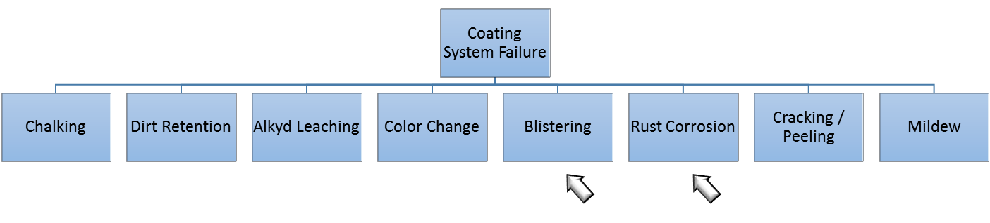
Source: Martin et al., "Methodologies for predicting the service lives of coating systems," 1994
Figure 31. Coating System Failure Modes

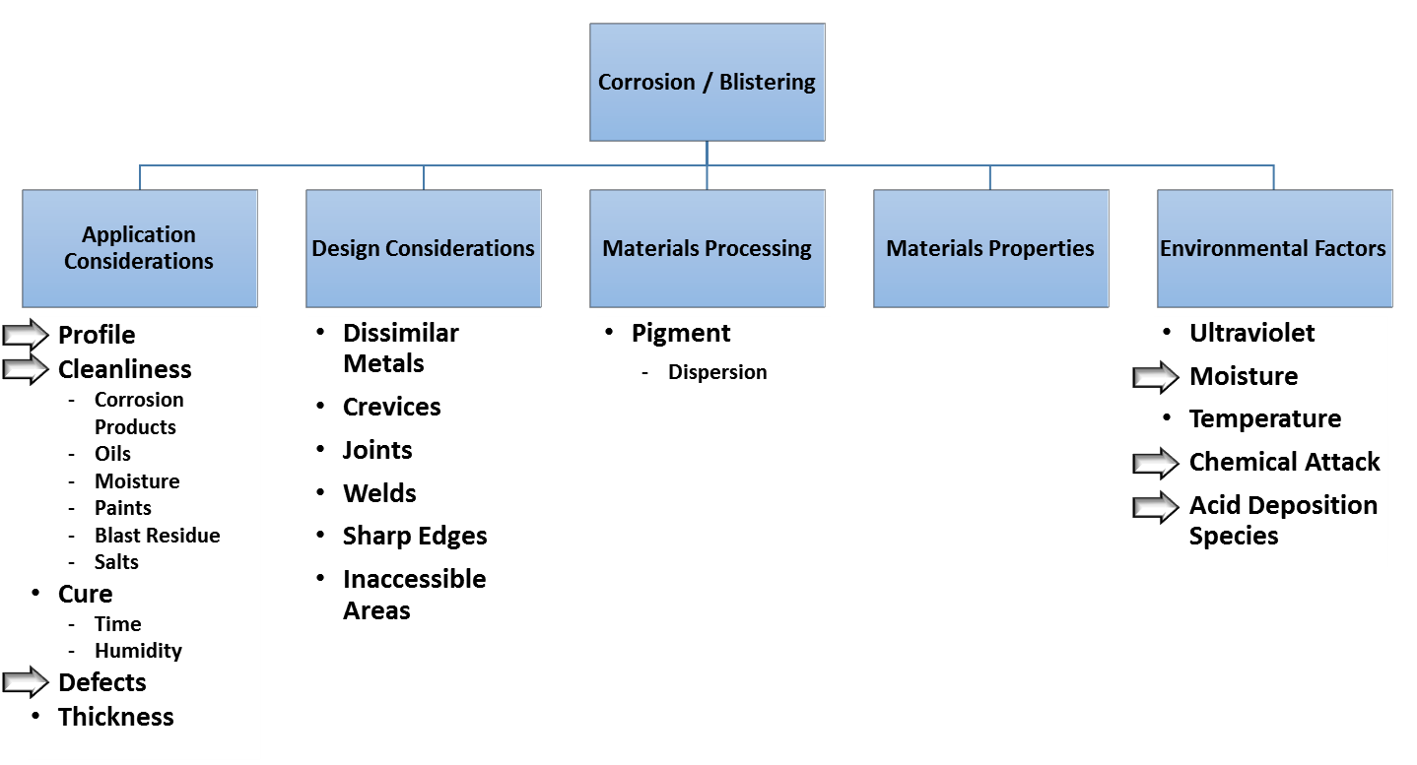
Source: Martin et al., "Methodologies for predicting the service lives of coating systems," 1994
Figure 32. Coating System Corrosion and Blistering Fault Tree

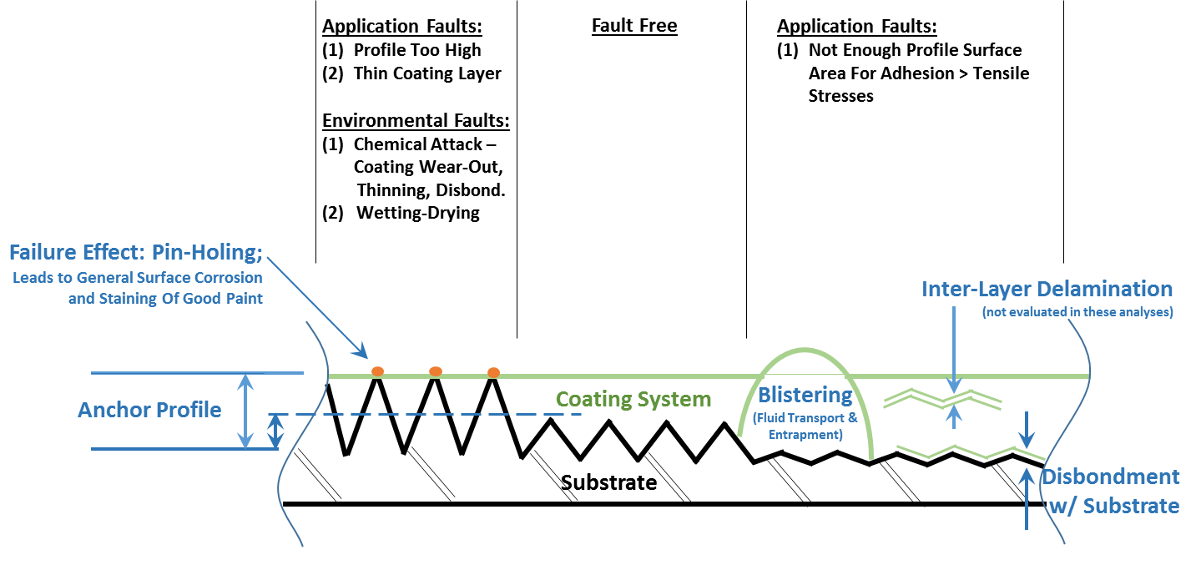
Figure 33. Coating System & Substrate Cross Section With Faults
Scale: None

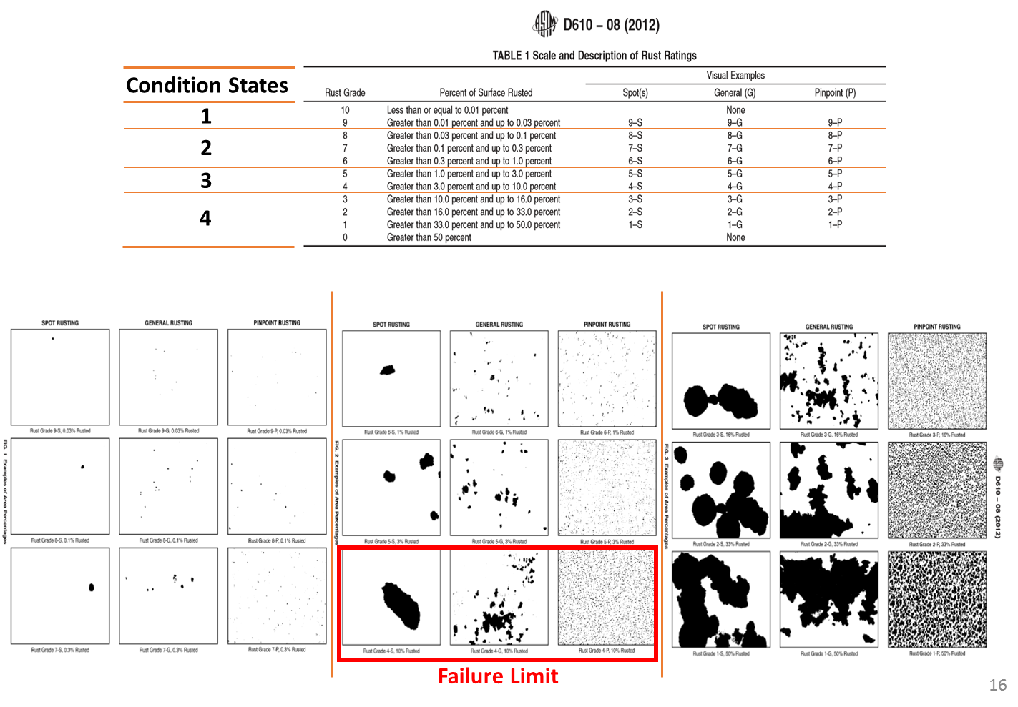
Figure 34. ASTM D610 Rust Ratings
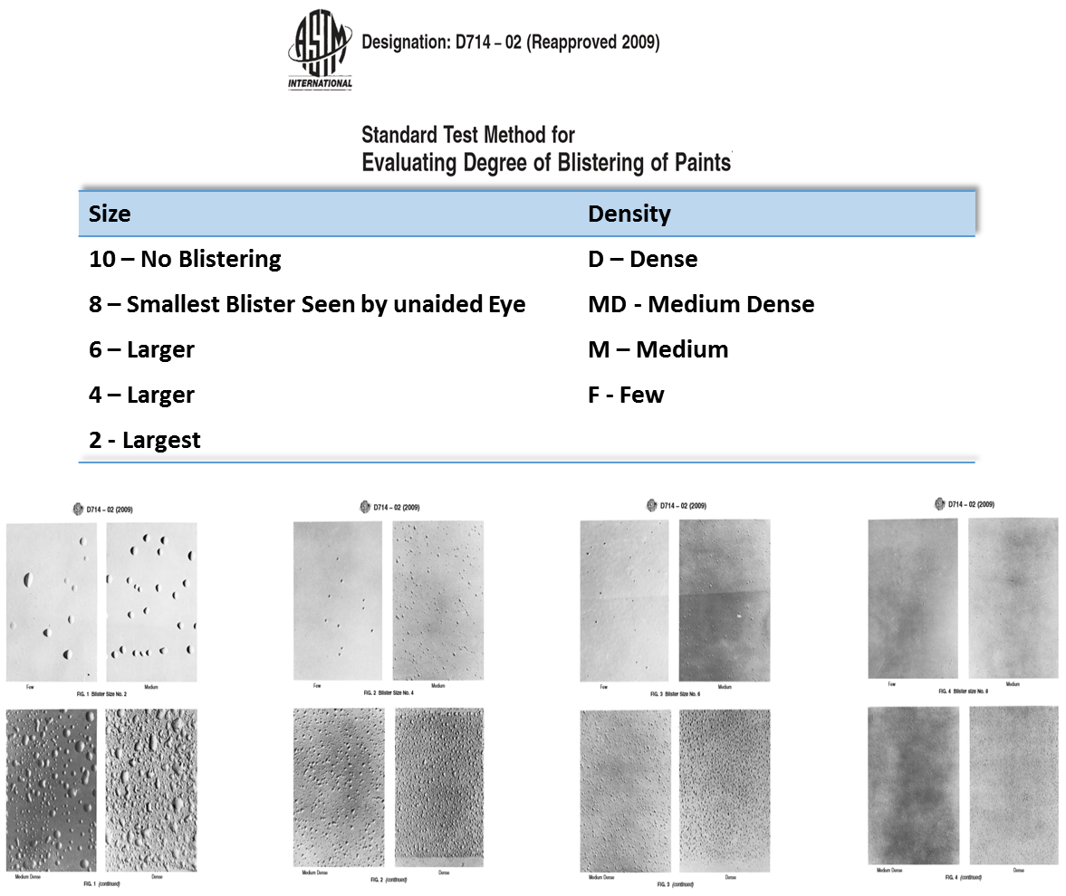
Figure 35. ASTM D714 Blister Ratings
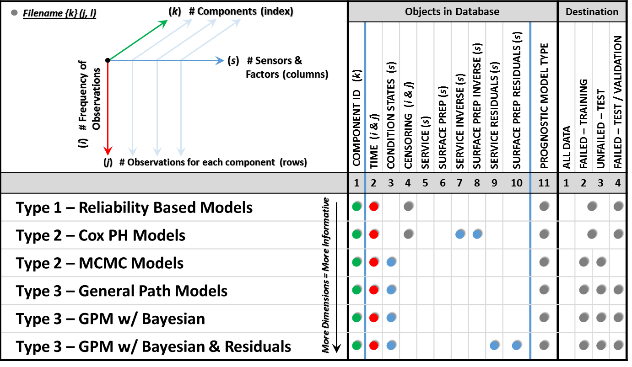
Figure 36. Database Structure & Mapping

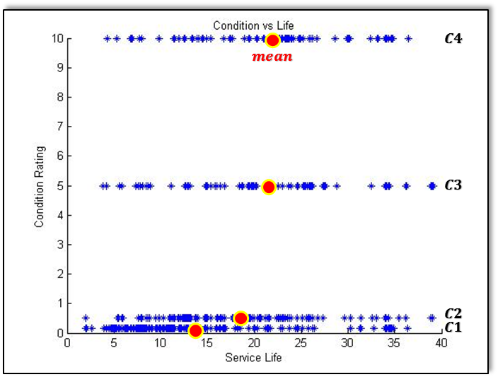

Condition Rating; Percent Area Corroded
Figure 37. Condition Rating & Service Life

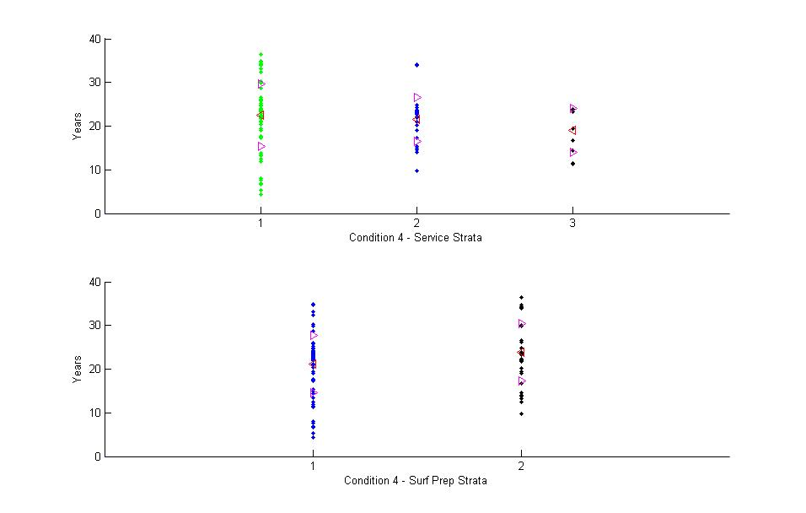
Figure 38. Time of Failure for Factors

Vita

Greg Bosco received a Bachelor of Science in Civil Engineering with a focus on Structural Engineering from Old Dominion University in 1999. He went on to receive a Master of Science in Engineering Management from the George Washington University in 2010. With the University of Tennessee, he continued graduate level work, studying Reliability and Maintainability Engineering, specializing in prognostics. He is also a licensed professional engineering in the Commonwealth of Virginia.

