ADSORPTION OF NATIVE WASTEWATER VIRUSES
BY IRON OXIDE-COATED SAND

A Thesis Presented for the
Master of Science
Degree
The University of Tennessee, Knoxville

Bailey Dills
August 2025
© by Bailey Dills, 2025
All rights reserved.

ACKNOWLEDGEMENTS
I would like to thank the modicum of individuals who continue to support me through this decisive period of life. Human interaction is my primary income under the unnecessary duress that is higher education. Explicitly, thank you to my sister for accompanying me on my commute, by phone. Our conversations provide mental decompression in the face of perpetual perturbation and doubt. You keep me in a state of quasi-ease. In addition, I extend gratitude to my girlfriend and parents for sharing in my stress and shouldering my anxieties. I am endlessly appreciative.
ABSTRACT
Waterborne pathogenic viruses pose a significant risk to public health. Although modern wastewater treatment facilities employ potent methods to remove microorganisms, disinfection is not 100% effective, and some microbes persist. Further, resource-limited regions lack adequate infrastructure to support tertiary processes and conventional wastewater treatment altogether. Mounting interest in nanotechnology has spurred investigation into new antimicrobial agents, and current environmental studies recommend iron oxide nanoparticles (IONPs) for their sorbent and catalytic capabilities. Literature suggests that IONPs could play a substantial role in wastewater reclamation by electrostatic adsorption and degradation of recalcitrant contaminants of emerging concern. Because both viral protein capsids and IONPs have ionizable functional groups, their surface charges are variable depending on solution potential of hydrogen (pH) and ionic strength. Batch microcosm experiments were conducted to determine the optimal reaction conditions for viral adsorption and inactivation by iron oxide-coated sand. Virus-like particle (VLP) abundance and community composition were measured pre- and post-equilibration using epifluorescence microscopy (EFM) and genetic fingerprinting (RAPD-PCR) to learn the extent of adsorption and changes in viral composition following reaction with uncoated and iron oxide-coated sand (IOCS). The greatest reduction in virus count and alteration in community composition occurred in IOCS treatment groups. IOCS significantly decreased the number of VLPs post-equilibration, on average, by 92.63%.

Table of Contents
Chapter One Introduction and General Information 1
Overview 2
Wastewater treatment 2
Constructed wetlands 3
Iron oxides 5
Naturally occurring 5
Artificially prepared 6
Applications in wastewater remediation 7
Viruses 8
Morphology 8
Inactivation 9
Chapter Two Literature Review and Theory 12
Adsorption behavior 12
Electrostatic interactions 12
Hydrophobic and steric interactions 15
Sorption coefficient (K_{d}) 16
Goal of the project 16
Objectives 17
Hypotheses 17
Chapter Three Materials and Methods 18
Synthesis of iron oxide-coated sand 18
Collection of wastewater viruses 19
Batch microcosm experiments for viral adsorption 19
Variable ionic strength 19
Variable pH 21
Variable dissolved organic carbon 22
Measurement Techniques 22
Epifluorescence microscopy 22
DNA amplification and separation 24
Statistical interpretation 25
Chapter Four Results and Discussions 27
Characterization of iron oxide-coated sand 27
Effect of ionic strength 28
Abundance 28
Genetic fingerprint 31
Discussion 34
Effect of pH 36
Abundance 36
Elution 38
Genetic fingerprint 40
Discussion 43
Effect of dissolved organic carbon 46
Abundance 46
DOC concentration 48
Genetic fingerprint 48
Discussion 51
Chapter Five Conclusions and Recommendations 53
Blanket conclusions 53
Troubles and suggestions 54
List of References 58
Vita 64

LIST OF TABLES
Table 3.1 Experimental design of the batch microcosm adsorption investigation 20
Table 3.2 Statistical assumptions 26
Table 4.1 Average percent decrease in viral abundance for differing ionic strength 29
Table 4.2 ANOVA for independent and interaction effects of IOCS and ionic strength 29
Table 4.3 Average percent decrease in viral abundance for differing pH 37
Table 4.4 ANOVA for independent and interaction effects of IOCS and pH 37
Table 4.5 Average theoretical, viral extraction for IOCS pH 5.0 and 8.0 samples 38
Table 4.6 Average percent decrease in viral abundance for differing DOC 46
Table 4.7 ANOVA for independent and interaction effects of IOCS and DOC 46
Table 4.8 DOC (NPOC) concentration pre- and post-equilibration 48

LIST OF FIGURES
Figure 1.1 Hematite (α-Fe₂O₃) crystalline structure 6
Figure 1.2 Illustration of virus morphologies 9
Figure 2.1 Overview of interactions between a viral particle and IOCS 12
Figure 2.2 Schematic of the pH-dependent surface charge 13
Figure 2.3 Schematic of electrostatic attraction 14
Figure 3.1 Stabilized iron oxide-coated sand, synthesized July 2024 18
Figure 3.2 Overall microcosm setup 20
Figure 3.3 Data collection workflow 23
Figure 4.1 [Uncoated] Sand at 10,000x magnification using SEM-EDXS 27
Figure 4.2 IOCS at 25,000x magnification using SEM-EDXS 28
Figure 4.3 Average K_{d} from the ionic strength study 30
Figure 4.4 Cluster score plot for ideal cluster count for the ionic strength study 31
Figure 4.5 HCA cluster dendrogram for the ionic strength study 32
Figure 4.6 PCoA plot for the ionic strength study 33
Figure 4.7 Average K_{d} from the pH study 39
Figure 4.8 Cluster score plot for ideal cluster count for the pH study 40
Figure 4.9 HCA cluster dendrogram for the pH study 41
Figure 4.10 PCoA plot for the pH study 42
Figure 4.11 Average K_{d} from the DOC study 47
Figure 4.12 Cluster score plot for ideal cluster count for the DOC study. 49
Figure 4.13 HCA cluster dendrogram for the DOC study 49
Figure 4.14 PCoA plot for the DOC study 50

Introduction and General Information
Waterborne infections, estimated at 7.15 million annual cases in the United States, substantially impact public health despite water treatment initiatives (Gerdes et al., 2023). Population growth and urbanization are placing an unprecedented strain on resources worldwide. By 2050, 68% of the global population is expected to reside in urban areas, an action tied to industrialization and economic development and accounting for 75% of total resource depletion (Shah et al., 2023). This poses a considerable threat to water security in the face of increasing consumption and waste production. Given that supplying potable water remains a challenge in all countries, exacerbated by decaying infrastructure and climate change, new technologies are required to sustain human and ecological well-being.
To decrease reliance on wastewater treatment facilities (WWTFs), constructed wetlands (CWs) are becoming a viable, nature-based solution. They are a promising avenue for meeting the 6th Sustainable Development Goal, set forth by the Environmental Protection Agency (EPA), stating that all individuals share the right to access clean water. CWs are a facet of aesthetic, blue-green infrastructure and sustainable water management, and they take advantage of filtration, sedimentation, and innate biochemical processes to eliminate pollutants (Zhao et al., 2020). CWs are implemented pre- or post-municipal treatment as an ancillary level of mitigation.
Viruses are ubiquitous, present in soil, water, and air. They are the most abundant biological entity on Earth (Moelling & Broecker, 2019). Despite both beneficial and neutral functions, viruses are commonly studied for their disease-causing capabilities, especially in the wake of the coronavirus (SARS-CoV-2) pandemic. With inadequate sewage disinfection, improper placement of WWTFs, and land application of wastewater and sewage sludge, viral pathogens can be transported into drinking water sources (Quyen et al., 2021; Chen et al., 2021). The U.S. federal government’s target removal efficiency is 99.99%, or two viral particles per 10⁷ liters of water, but modern tertiary treatment methods (i.e., free chlorine or ultraviolet (UV) irradiation) are limited to 99.90% inactivation (Kong, 2021).
This research was conducted at the microcosm scale to optimize reaction conditions for the removal of potentially harmful viruses from municipal wastewater through interactions with solid-water interfaces (i.e., iron oxide-coated sand). By studying the chemical conditions, this analysis aimed to maximize viral adsorption to reactive mineral surfaces to improve water quality and alleviate the introduction of pathogenic viruses to water bodies. A secondary, but important, purpose was to assess how diverse viral taxa, with a range of surface properties, interact with the solid-water interface. The results may uncover clues to augment reactivity for the removal and degradation of the most resistant viral particles during treatment.

Overview

Wastewater treatment
Over the past 50 years, practicing widespread water disinfection has markedly combatted cholera and typhoid related deaths (Gerdes et al., 2023). Even so, the endurance of microorganisms, like noroviruses and rotaviruses, lead to drinking water and recreational water-related illness. Wastewater effluent comes from a variety of sources, namely industry, agriculture, and households, which yield a conglomeration of different, complex pollutants.
Conventional WWTFs employ primary, secondary, and tertiary treatment methods (Nishat et al., 2023). The primary stage is the physical separation of fats, oils, and greases and the sedimentation or filtration of large, suspended solids. The secondary stage generates satisfactory conditions for microbial degradation (i.e., aerobic respiration) of organic matter (Quach-Cu et al., 2018). The resulting microbial biomass/activated sludge is removed. In large-scale, more affluent regions, specialized facilities apply tertiary procedures, including chlorination, UV irradiation, and ozonation to further purify the water prior to environmental release (Zagklis & Bampos, 2022).

Constructed wetlands
This research was part of a larger project regarding constructed wetlands for decentralized wastewater treatment systems. The proposal originated from the International Workshop of Urban Wetland Infrastructure (May 2021), combining the efforts of the University of Tennessee, Knoxville and an environmental engineering team from the Czech Republic. This work was funded by the National Science Foundation.
CWs play a crucial role in the collection and reclamation of wastewater and stormwater runoff. They utilize organic materials and intrinsic biological, chemical, and physical processes to eliminate contamination, providing a low-energy and low-cost remedy. Contemporary CWs are highly effective at removing suspended solids, bulk organics, and excess nutrients (i.e., nitrogen and phosphorus); however, they are often ineffective, or fail to remove pathogenic viruses and contaminants of emerging concern (CECs) (Biswal & Balasubramanian, 2022). Human health is conceivably threatened by unintended environmental exposure to residual viral pathogens if the water from a CW is inadequately treated and recycled, for example, for irrigation, industry, or groundwater recharge.
CW performance pivots on configuration, water flow, and plant species. Aquatic vegetation house microorganisms, and together, they escalate nutrient and contaminant uptake and degradation (Shahid et al., 2018). Over time, soil organic matter can accumulate and contribute to long-term carbon storage. Inversely, in saturated, anoxic conditions, decomposition can emit unpleasant odors and greenhouse gases (Li et al., 2024). With adequate monitoring, CWs can be beneficial tools against climate change. In addition, they impart ecosystem services such as flood protection, food production, heat reduction, improved biodiversity, and carbon sequestration (Shah et al., 2023).
Moreover, CWs can be integrated with gravel filters, aeration, and reactive solid-water interfaces (Biswal & Balasubramanian, 2022). This project aimed to elucidate experimental parameters for IOCS for future CW applications. IOCS can assist in the removal of recalcitrant contaminants that are not easily broken down in wetlands by biological degradation. This is imperative for regions that lack the appropriate infrastructure to support robust engineered systems, and IOCS presents a scalable virus removal technology for resource-limited areas.

Iron oxides

Naturally occurring
Iron oxides are naturally occurring minerals with several iron to oxygen ratios and crystal arrangements. The most common forms are hematite (α-Fe₂O₃), maghemite (γ-Fe₂O₃), and magnetite (Fe₃O₄) (Sahoo et al., 2010). This work examined the affinity of hematite, with two formula units per rhombohedral unit cell, for the adsorption of wastewater viruses (Figure 1.1 (a)) (Rodriguez et al., 2007). The crystalline structure includes a dense grid of oxygen atoms with octahedrally coordinated iron atoms (Figure 1.1 (b)). The lattice contains a large quantity of defect sites that create regions of elevated catalytic activity, strengthened by high electron densities (Mishra et al., 2024).
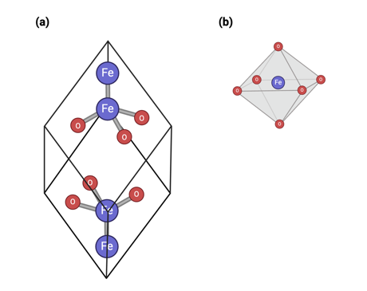
Figure 1.1 Hematite (α-Fe₂O₃) crystalline structure: (a) rhombohedral unit cell with two formula units and (b) octahedrally coordinated iron (III) [Created with BioRender].

Artificially prepared
Iron oxide particles can be produced on the nanoscale from 1-100 nanometers (nm) in diameter. This significant expansion of the surface area to volume ratio makes iron-based nanoparticles exemplary adsorbents and potential sites for catalysis. Iron has received great attention, for the metal is abundant and cost effective, and its oxides are stable and biologically compatible (Aragaw et al., 2021).
Iron oxide nanoparticles (IONPs) have application potential in wastewater treatment, nanotechnology, and medicine (i.e., drug delivery, imaging, cancer therapy, etc.). Presently, in the biomedical field, IONPs are conjugated with therapeutic substances. Drug release can be targeted by local (i.e., pH or biomarkers) or external (i.e., magnetic field) stimuli (Stanicki et al., 2022). Due to superparamagnetic properties, magnetic targeting can be monitored by Magnetic Resonance Imaging (MRI) as demonstrated by Chertok et al. (2008).
Schneider et al. (2022) and Soetaert et al. (2020) indicate that IONPs are distinguished agents for thermal cancer therapy. Explicitly, the nanoparticles cause the ablation of tumor cells by inducing hyperthermia. Additionally, IONPs have been integrated into cotton fabric to investigate virucidal activity of personal protective equipment (i.e., disposable masks) (Constantino et al., 2024).
The synthesis technique determines the specific physiochemical properties like size, shape, surface area, porosity, and functionalization. IONPs are formed through means of co-precipitation, thermolysis, sol-gel, and microemulsion, amongst other biosynthetic methods (Aragaw et al., 2021). Chemical conditions like pH and ionic strength can further influence surface properties and stoichiometric phase.

Applications in wastewater remediation
In the environmental sphere, IONPs are typically coated on silica sand to limit aggregation and enhance durability. Sand acts as a substrate for filtration while the coating increases the number of active surface sites for contaminant removal (Zhang et al., 2022). Iron oxide-coated sand (IOCS) is a non-toxic and environmentally friendly option for modern wastewater remediation. IOCS is an efficient antimicrobial agent due to its capacity for adsorption, reduction, and photocatalytic degradation. Guo et al. (2024) demonstrated that iron oxides have a strong affinity for negatively charged pathogens and CECs (i.e., antibiotics, heavy metals, and dyes).
Mechanistically, (1) adsorption is driven by both electrostatic and hydrophobic interactions; (2) the surface reduction mechanism (REDOX) transforms molecules into less harmful forms; and (3) in sunlit conditions, light radiation causes photo-generated electrons to initiate the formation of reactive oxygen species (ROS), which can partially degrade viral protein capsids and internal nucleic acids (Adekunle et al., 2021; Wydra et al., 2015).
Previous literature has illustrated the advantage of virus surface charges in flocculation and evidences the use of iron oxide-incorporated membranes to reclaim drinking water (Shirasaki et al., 2007; Guo et al., 2024). Nanofiltration technology appears to be the future of wastewater recovery and has been recommended by the EPA (Michen & Graule, 2010). These membranes work by electrostatic adsorption and subsequent elution for membrane reuse (Ezugbe & Rathilal, 2020). Commercial membranes are generally composed of the polymer, polyamide, which carries a positive charge at neutral pH, or common wastewater conditions (pH 6-8) (Guo et al., 2024).

Viruses

Morphology
Viruses are noncellular and nonmotile microscopic organisms that require a host cell or organism for replication. Particle diameters typically range from 20-200 nm among viruses that infect prokaryotes but can be much larger for viruses that infect some eukaryotes. Representative eukaryotic and prokaryotic cells are 10-100 micrometers (µm) and 1-10 µm, respectively (Louten, 2016). Virus-like particles (VLPs) consist of two primary components: (1) nucleic acids surrounded by a (2) protein capsid. The genome is comprised of single or double-stranded deoxyribonucleic acid (DNA) or ribonucleic acid (RNA). Capsomeres make up the protective capsid, which can be naked or enveloped by a lipid bilayer. The amino acids forming the protein coat contain weakly acidic and basic functional groups which contribute to its amphoteric nature (Michen & Graule, 2010).
Virus shape depends upon the amino acid sequence and subunit configuration of the protein capsid. Viruses self-assemble into helical, icosahedral, head-to-tail, and spherical morphologies (Figure 1.2) (Silva et al., 2022). Structural arrangement including the presence or absence of surface-bound glycoproteins can influence virus-host interactions and pathogenesis. Commonly, bacteriophages, or viruses that infect bacteria, contain double-stranded DNA within an icosahedral head, with a characteristic filamentous tail used for DNA transmission (Louten, 2016).
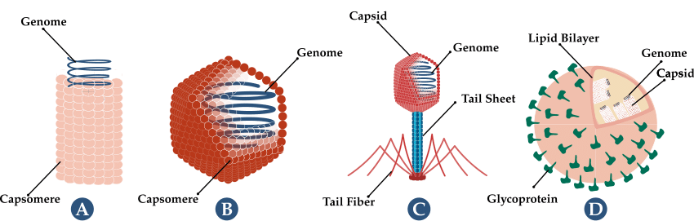
Figure 1.2 Illustration of virus morphologies: (a) helical, (b) icosahedral, (c) head-to-tail, and (d) spherical, enveloped. Glycoproteins (proteins coupled with sugar molecules) are attached to the lipid bilayer for host recognition and penetration.

Model viruses are regularly applied in adsorption and pathogenic studies due to structural and genetic simplicity. ϕX174 and MS-2 are well-characterized bacteriophages with known properties, ideal for understanding adsorptive behavior at solid-water interfaces. ϕX174 is a relatively hydrophilic virus with an isoelectric point at 6.6, and MS-2 is a relatively hydrophobic virus with an isoelectric point at 3.9 (Zhuang & Jin, 2008). The vast majority of virus adsorption and transport studies in porous media have been conducted using these two model viruses. However, few studies have examined the sorption behavior of complex viral communities from water or soil. This novel research investigated the adsorption of native wastewater viral communities, with diverse morphologies and electrostatic properties, to uncoated and iron oxide-coated sand.

Inactivation
Virus inactivation is impacted by inherent characteristics and environmental factors (Elveborg et al., 2022). For example, some enteric viruses like rotavirus have advanced resistance to UV disinfection because they have a three-layer capsid. In this case, having extra proteins makes the inactivation process less effective and the virus more impervious. For free viruses in solution, sanitation depends on time and physiochemical conditions like ROS, detergents, and temperature. These elements accelerate damage to the genome, the capsid or envelope, and specific proteins corresponding to host recognition (i.e., spike proteins). (Sadraeian et al., 2022). Therefore, inactivation results from either direct genetic destruction or indirectly through replication inhibition.
Temperature is a known effector of protein structure, causing conformational changes and unfolding. The SARS-CoV-2 spike protein undergoes thermal denaturation at 75°C after 40 minutes (min) (Afaghi et al., 2021). Genomic DNA and RNA separate into single strands between 70-95°C, with features like higher guanine-cytosine content and double-strandedness increasing the melting temperature, or energy needed to break hydrogen bonds (Wang et al., 2014). Further, solvents and detergents dissolve membranous envelopes by solubilizing the lipid bilayer (Elveborg et al., 2022).
UV radiation is the most studied germicide for its universality and non-selectivity, but its effectiveness hinges on the wavelength of the incident photons. High energy light can ionize genetic molecules causing oxidative stress, pyrimidine dimers, and cross-linking (Sadraeian et al., 2022). RNA is less susceptible to UV damage because it lacks thymine, the primary base target for pyrimidine dimerization (Lytle & Sagripanti, 2005).
Adsorbed viruses face the same mechanisms; however, inactivation can be enhanced or minimized by attachment. As reported by Harvey & Ryan (2004), adsorption to organic matter can protect viruses by blocking damaging agents. On the contrary, adsorption to oxides can augment inactivation since strong electrostatic attraction can be sufficiently impairing. Additionally, surface-attachment can temporarily trap viruses in a specific location where tertiary treatment methods can be applied (Armanious & Mezzenga, 2022).
Natural viral decay generally follows first-order kinetics (Hiatt, 1964):
$$N_{t}=N_{0}e^{-kt}$$
Where virus concentration at a given time (N_{t}) is proportional to the initial concentration (N₀), following the exponential decay constant (k) measured per hour (h⁻¹). Documented decay rates for enveloped and non-enveloped viruses have been exhibited by Gundy et al. (2009) and Mena et al. (2003). Assuming moderate and constant decay of 0.30 h⁻¹, the fraction of remaining viruses after 2.5 hours would be 0.47. This hypothetical scenario yields a spontaneous 53% reduction.

Literature Review and Theory

Adsorption behavior

Electrostatic interactions
Adsorption and desorption behavior is controlled by the electrostatic interactions between the virus and the sorbent surface (i.e., iron oxide-coated sand) (Figure 2.1). These interactions include the attractive and repulsive forces of the electric double layer, Van der Waals forces, and hydrogen bonding.
Electrostatic interactions are non-covalent forces that arise from charged or partially charged particles. Attraction exists between opposite charges, and repulsion exists between like charges according to Coulomb’s Law (Besley, 2023). The strength of the force is directly proportional to the magnitude and inversely proportional to the distance between the charges.
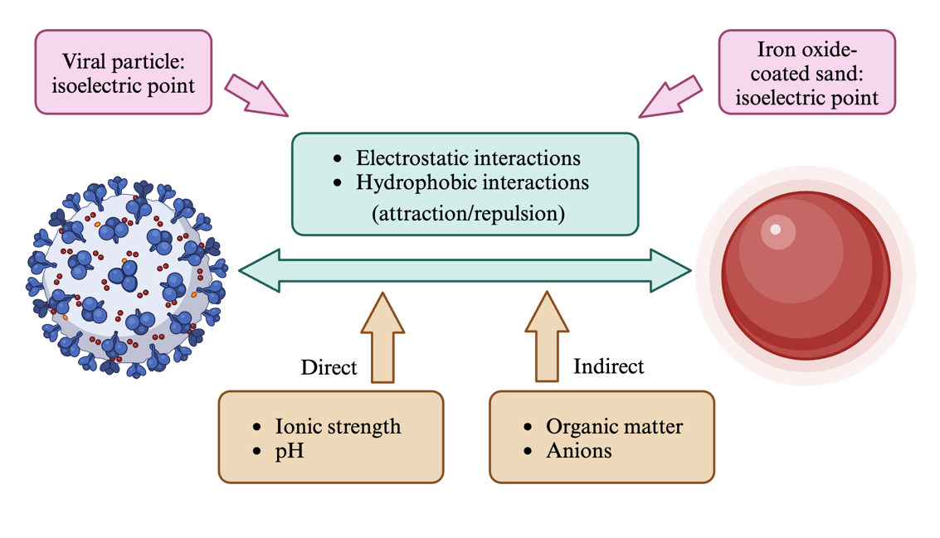
Figure 2.1 Overview of interactions between a viral particle and iron oxide-coated sand. IOCS is represented by a perfect sphere for simplicity [Created with BioRender].

Van der Waals forces, or London dispersion, occurs between uncharged particles when an instantaneous dipole moment is created by transient shifts in electron density.
Electrostatic qualities are influenced by a surface’s isoelectric point (pI), or the pH at which the net surface charge is neutral (Michen & Graule, 2010). In general, when the pH is greater than the pI, the surface will have a net negative electrical charge. When the pH is less than the pI, the surface will have a net positive electrical charge. This concept is governed by the Derjaguin-Landau-Verwey-Overbeek (DLVO) theory (Figure 2.2) (Derjaguin, 1934; Derjaguin & Landau, 1993; Verwey & Overbeek, 1948).
For better comprehension, it is important to discuss the response of amino acids and iron oxides to fluctuating pH. First, viral protein capsids are constructed of ionizable amino acids with individual amino (-NH₂) and carboxyl (-COOH) groups that protonate, or gain a hydrogen ion (H⁺), and deprotonate, or lose H⁺. Distinct viruses ordinarily carry an assortment of isoelectric points, varying from 3.7 to 7.0 (Michen & Graule, 2010).
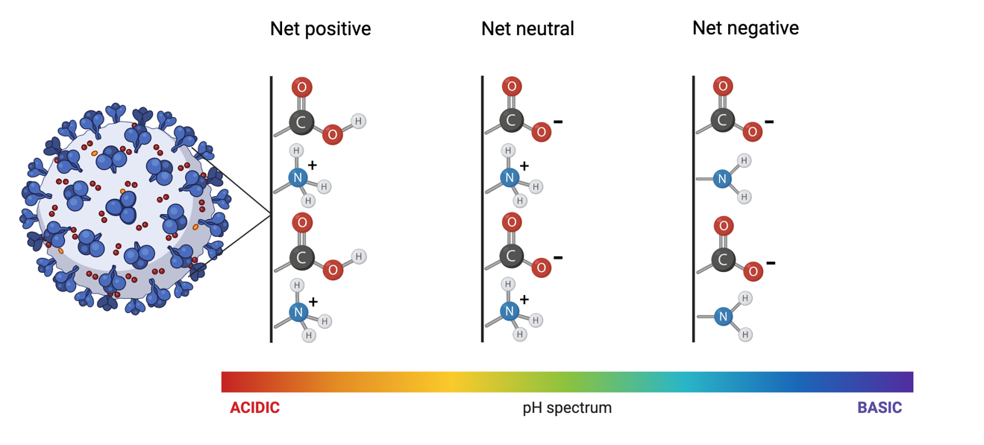
Figure 2.2 Schematic of the pH-dependent surface charge of a virus particle in accordance with the DLVO theory, displaying the protonation states of amino and carboxyl groups as a function of pH [Created with BioRender].

When the pH is greater than the pI, more groups are deprotonated than protonated, resulting in a net negative charge (Figure 2.3). As the pH increases away from the pI, the ratio of deprotonation to protonation increases, and the magnitude of the net negative charge becomes larger.
An iron oxide like hematite has an isoelectric point around 8.3 and surface hydroxyl groups (Kędra et al., 2021). When the pH is less than the pI, the hydroxyl groups (-OH) protonate and take on positive charges (-OH₂⁺). As the pH decreases away from the pI, the ratio of protonation to deprotonation increases, and the magnitude of the net positive charge becomes larger. Additionally, hydrogen bonding plays a role in viral adsorption to hydroxyl-containing surfaces (Joonaki et al., 2020).
Theoretically, in this inquiry, the iron oxide-coated sand remains positively charged throughout. However, due to the heterogeneity of virus samples and range of isoelectric points, the capsid charges are more unpredictable. The surface interactions can be further influenced by ionic strength (IS), or the concentration of ions in solution.
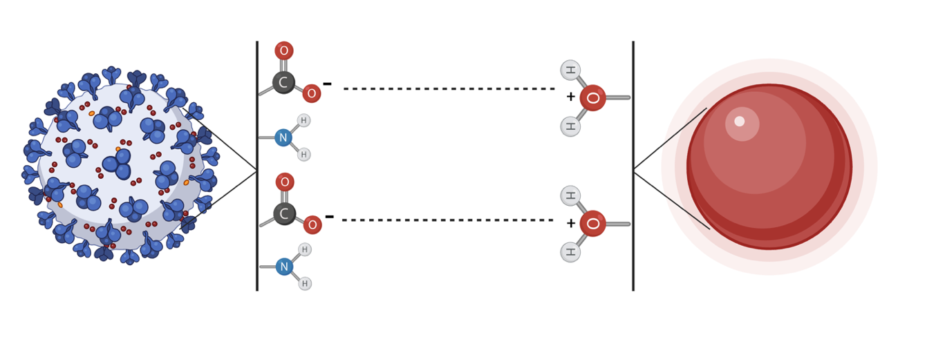
Figure 2.3 Schematic of electrostatic attraction between a viral particle (left) and iron oxide-coated sand (right) through negatively charged carboxyl (-COO⁻) and positively charged hydroxyl (-OH₂⁺) groups [Created with BioRender].

These ions produce a shielding effect, in which they align and partially screen surface charges, diminishing electrostatic potential (Zhuang & Jin, 2003). In other words, increasing ionic strength tends to reduce electrostatic interactions; therefore, it can decrease the electrostatic attraction between negatively charged viral particles and positively charged iron oxides.
In addition to pH and ionic strength, which directly influence electrostatic interactions, organic matter content and anions have an indirect effect. Dissolved organic carbon (DOC) can compete with viruses for iron oxide binding sites, thus blocking adsorption (Yilmaz et al., 2023). DOC sources may include proteins, carbohydrates, lipids, and an array of chemicals (i.e., pesticides, antibiotics, etc.). This constituent of total organic carbon can foul the IOCS surface and direct the fate of the adsorbent.

Hydrophobic and steric interactions
Hydrophobic interactions occur between nonpolar molecules in water and drive the stability of membranes and proteins (Bogunia & Makowski, 2020). Protein folding relies on spans of hydrophilic and hydrophobic amino acid sequences, whose relations determine conformation. Spans of amino acids with low affinities for water prefer to aggregate rather than associate with water. This preference is considered water-mediated hydrophobic “attraction,” despite no real attractive forces, but rather, driven by beneficial changes in entropy (Harvey & Ryan, 2004). Aggregation is thermodynamically favorable due to the expulsion of water molecules into a disordered arrangement around the hydrophobic region (Bogunia & Makowski, 2020). Since viruses have elaborate, amphipathic surfaces, hydrophobic interactions can guide adsorption.
The complex and irregular spatial composition of viral and iron oxide surfaces can cause steric hindrance. When molecules are brought close together, suitable orientation and spacing are determined by the energy cost incurred by overlapping electron clouds (Chen et al., 2021). As viruses gather on the IOCS, adsorption may be hindered by the volume occupied by surface-bound viruses.

Sorption coefficient (K_{d})
In environmental chemistry, the sorption or partition coefficient (K_{d}) quantifies the distribution of a substance between a solid and liquid phase (Ma et al., 2023). This estimates the fraction of sorbed viruses (V_{s}) to those in the aqueous phase (V_{aq}). V_{s} and V_{aq} are measured in VLPs per milliliter of equilibration solution (VLP⋅mL⁻¹). K_{d} is used to assess the potential partitioning between the two phases and estimate the aqueous concentration, fate, and transport of contaminants in the environment. The greater the K_{d} the greater the adsorption, and K_{d} is represented by volume (mL) per mass unit (g).
$$K_{d}= \frac{V_{s}}{V_{aq}}$$

Goal of the project
Through the synthesis of iron oxide-coated sand, this research developed a system to allow virus adsorption behavior to emerge and be observed. A batch microcosm approach was utilized to mimic environmental conditions within a controlled setting, to explore the effects of IOCS, solution ionic strength, pH, and DOC.

Objectives
- Determine the effect of ionic strength, pH, and dissolved organic carbon on the adsorption of native viral communities from municipal wastewater to uncoated and iron oxide-coated sand.
- Compare pre- and post-treatment viral abundance and community composition with epifluorescence microscopy and genetic fingerprinting to discover if diverse viral taxa exhibit similar adsorption affinity to a model adsorbent.

Hypotheses
- pH 5.0, low ionic strength, and no dissolved organic carbon content will be most favorable to the adsorption of the greatest number of viruses.
- IOCS treatments will reduce the virus concentration in solution by at least 95%. V_{aq} will significantly decrease after equilibration with the IOCS compared to uncoated and sand-free treatment groups, due to notable adsorption to IONPs. Unsought adsorption to uncoated sand and labware may occur.
- Viral community diversity and composition will be modified post-equilibration. Alterations will be greatest in treatments that adsorb the most viruses.

Materials and Methods

Synthesis of iron oxide-coated sand
Ottawa sand (D50 = 0.80 mm, Spectrum Chemical) was rinsed with deionized (DI) water and oven-dried at 60°C to remove impurities (Zhuang & Jin, 2008). The hematite (Fe₂O₃) precipitation procedure was adapted from Benjamin et al. (1996). Ottawa sand (345 g) was added to 80 mL of 2.5 M iron (III) chloride (FeCl₃) solution. The overall reaction is as follows: ${Fe}^{3+}+n H_{2}O→Fe{(OH)}_{n}^{3n}+n H^{+}$. Caution and a fume hood should be exercised in preparing the FeCl₃ solution has hydrogen chloride can off-gas. The mixture was heated to 110°C and stirred hourly for 3 hours, before calcination in a muffle furnace (550°C for 3 hours). The IOCS was cooled to 23 ± 2°C and rinsed with DI water. The reactive solid particles were stabilized by a series of heating and cooling cycles (i.e., 3 hours at 110°C, followed by 21 hours at 23 ± 2°C, repeated for 7 cycles) and washed until rinsate was clear (Figure 3.1).
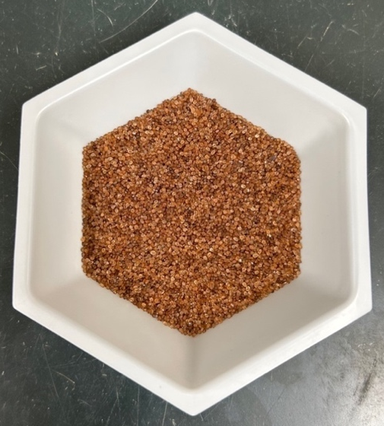
Figure 3.1 Stabilized iron oxide-coated sand, synthesized July 2024.

To confirm proper synthesis of the IONPs, the chemical and physical properties were analyzed with Phenom ProSuite software. Structure and surface topography were determined by both scanning electron microscopy (SEM) and energy-dispersive X-ray spectroscopy (EDXS). Elemental mapping analysis was conducted by EDXS. Imaging was carried out for both the uncoated sand and IOCS.

Collection of wastewater viruses
Municipal wastewater was collected from the secondary clarifier at First Utility District of Knox County. Samples were taken between 9:00-11:00 am on the day of each incubation, on consistent weather days. The samples were subject to low-speed centrifugation to pellet particulate and purified by passage through 0.22 µm Millex membrane filters (MilliporeSigma) to remove microorganisms larger than 0.22 µm or 220 nm (i.e., bacteria), following the protocol described by Garcia-Fontana et al. (2020).

Batch microcosm experiments for viral adsorption

Variable ionic strength
Batch adsorption experiments were prepared to assess viral affinity for uncoated sand and IOCS utilizing Nunc 15 mL conical tubes (Table 3.1, Figure 3.2). The sorption determinations were limited to single point K_{d} measurements rather than isotherms at a range of initial virus concentrations. This was done due to difficulty in concentrating sufficient volumes of wastewater viruses. Microcosms were constructed with a 4:1 liquid to solid phase ratio under aseptic conditions, with 4 replicates per treatment group and 2 replicates per sand-free control. Five and 20 millimolar (mM) sodium chloride (NaCl) solutions (pH ~7) were made. All compatible materials were autoclaved before use.
Table 3.1 Experimental design of the batch microcosm adsorption investigation.
Variable | Value | Levels
Ionic strength | 5 mM | 2
Ionic strength | 20 mM | 2
pH | 5.0 | 3
pH | 6.5 | 3
pH | 8.0 | 3
DOC | Present | 2
DOC | Absent | 2
Solid phase | Coated (IOCS) | 3
Solid phase | Uncoated (Sand) | 3
Solid phase | Absent | 3
Viral particles | Present | 2
Viral particles | Absent | 2

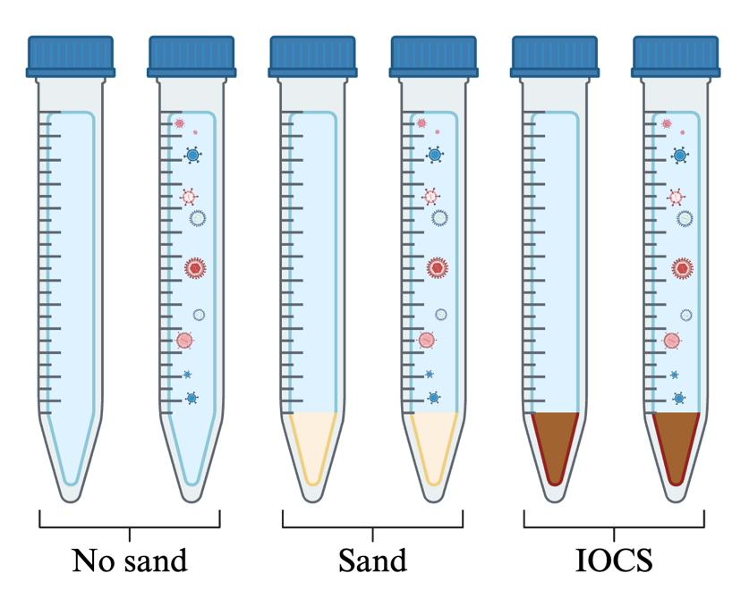
Figure 3.2 Overall microcosm setup with virus-containing and virus-free tubes (4 replicates per treatment; 2 replicates for No sand controls) [Created with BioRender].

Uncoated sand and IOCS (3 g) were amended with 11.5 mL of either 5 or 20 mM NaCl solutions. Each tube, omitting the virus-free controls, was inoculated with 500 microliters (µL) of the purified wastewater virus stock, containing 1.84 x 10⁹ VLP⋅mL⁻¹. Therefore, the starting V_{aq} was 7.67 x 10⁷ VLP⋅mL⁻¹, and the microcosms were equilibrated at 23 ± 2°C for 2.5 hours with continuous horizontal shaking. In a preliminary, dynamic experiment, tubes were destructively sampled every 2 hours for 6 hours to determine a peak equilibration time. Sand-free and virus-free controls were included to assess contamination, decay, and potential viral adsorption to the tubes.
After the incubation period, 900 µL of the equilibration solution was extracted into 2 mL microfuge tubes for processing and ultimate viewing with EFM. The remaining volume of equilibration solution was separated from the sand, and both phases were flash-frozen with liquid nitrogen before storage at -18°C. The following week, samples were thawed for random amplified polymorphic DNA-polymerase chain reaction (RAPD-PCR) and gel electrophoresis. All samples were flash-frozen after each use.

Variable pH
The same experimental setup was repeated from the ionic strength evaluation with modifications. Constant ionic strength (5 mM) buffered solutions were prepared at pH 5.0, 6.5, and 8.0. The solution at pH 5.0 was buffered with acetate; pH 6.5 was buffered with MOPS (3-morpholinopropane-1-sulfonic acid); and pH 8.0 was buffered with Tris-hydrochloride (HCl). MOPS (Thermo Scientific) and Tris-HCl (Teknova) were diluted from stock solutions. The acetate buffer was prepared from sodium acetate trihydrate and acetic acid, following the Henderson-Hasselbalch equation.
The fresh, purified wastewater stock contained 3.01 x 10⁹ VLP⋅mL⁻¹, and the starting V_{aq} was 1.25 x 10⁸ VLP⋅mL⁻¹. An additional 30-min equilibration in a 0.14% beef extract-glycine solution was executed for select treatment groups after the adsorption phase of the experiment, to extract adsorbed viruses from the IOCS (CITE). The desorption solution was prepared by adding Bacto beef extract (2.4 g) and 0.3 g glycine to 2,000 mL DI water.

Variable dissolved organic carbon
The same experimental elements were repeated; however, sand-free controls were omitted given the negligible adsorption to labware in the two previous trials. DOC-free samples were run in a 20 mM MOPS solution (pH 6.5) to mimic real wastewater. These tubes were inoculated with 500 µL of fresh wastewater stock with 1.63 x 10⁹ VLP⋅mL⁻¹. The starting V_{aq} was 6.78 x 10⁷ VLP⋅mL⁻¹. Alternatively, DOC-containing samples were run in the wastewater stock itself; therefore, the starting V_{aq} was 1.63 x 10⁹ VLP⋅mL⁻¹. The equilibration solutions were analyzed pre- and post-incubation for non-purgeable organic carbon (NPOC) by catalytic high temperature combustion (multi-N/C 2300).

Measurement Techniques

Epifluorescence microscopy
Figure 3.3 outlines the data collection workflow. Viral stock and equilibrium V_{aq} were enumerated by EFM, and samples were processed following the procedure published by Williamson et al. (2003). V_{s}, or the concentration of adsorbed viruses, was estimated by the difference between the starting and equilibrium V_{aq} (V_{aq1} – V_{aq2}).
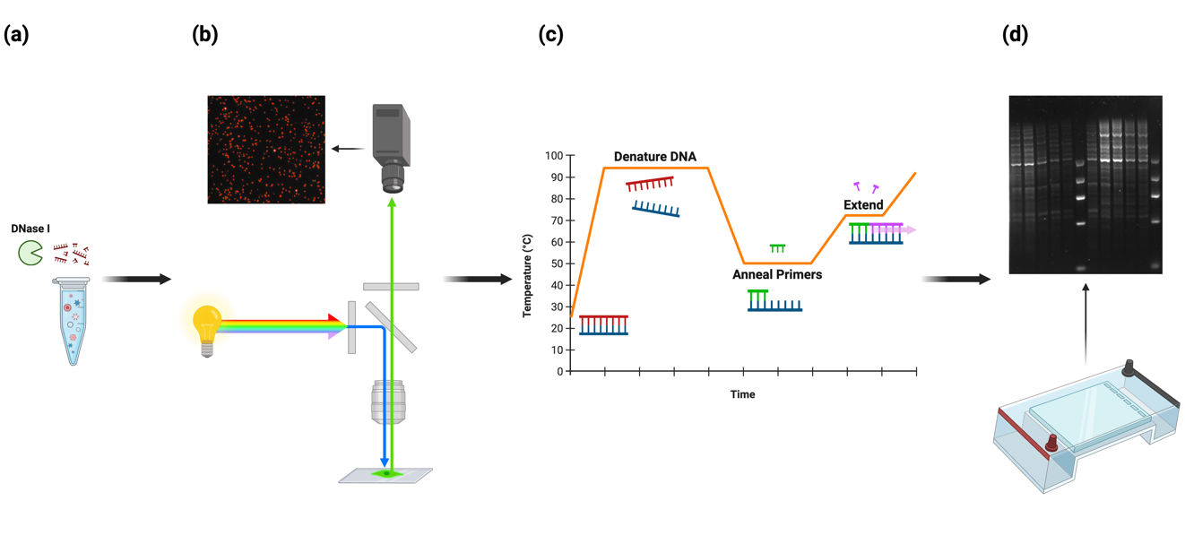
Figure 3.3 Data collection workflow: (a) post-equilibration treatment with DNase I, (b) VLP enumeration by EFM, (c) DNA amplification with RAPD-PCR, and (d) gel electrophoresis for genetic fingerprinting [Created with BioRender].
Aliquots from each treatment group were treated with deoxyribonuclease (DNase) (Thermo Scientific) to remove free-floating DNA, before 400 μL were vacuum filtered through a stack of filters: 0.02 μm Anodisc atop a glass microfiber filter (Whatman). The viruses immobilized on the Anodisc were stained with 600 μL 2x SYBR gold (Thermo Scientific) for 20 min in the dark. Fluorescing viruses were visualized with a Nikon Eclipse E600 microscope through a fluorescein isothiocyanate excitation filter. The samples were imaged with a QImaging Retiga EXi camera and counted with IPLab (v.3.6). Images were taken at 10 randomly selected microscope fields at 100x magnification (Nikon Plan Fluor). VLP count was taken from the average of the 10 fields and the grand mean from the replicate filters from each experimental treatment (10 x 4 = 40 images per treatment group).

DNA amplification and separation
All treatment groups were normalized to 10⁵ VLPs per PCR reaction by either concentration with Amicon Ultra spin filters (100 kilodalton cut off, MilliporeSigma) or dilution with appropriate buffer. Finer standardization was achieved by varying the amount of sample (template DNA) added to the RAPD-PCR reactions. Template was amended with 2.5 μL Ex Taq buffer, 1.6 μL deoxynucleoside triphosphate (dNTPs), 1.0 μL of 50 picomole primer, and 0.5 μL TaKaRa Taq DNA polymerase Hot Start (Srinivasiah et al., 2013). Tubes were brought to a final volume of 25 μL with DI water.
The primer used in this investigation was HCB-1 (5’-CCAGCAGCAG-3’), and it served as both a forward and reverse primer during amplification (Srinivasiah et al., 2013). Bio-Rad MyCycler thermal cycler conditions were set as follows: (i) denaturation at 94°C for 10 min, (ii) annealing at 47°C for 3 min, (iii) extension at 72°C for 1 min, (iv) 94°C for 0.5 min. Steps ii-iv were repeated for 29 cycles ending on step ii, followed by a final primer extension at 72°C for 10 min (Srinivasiah et al., 2013).
The DNA amplicons were separated by electrophoresis on a 1.5% HiRes agarose gel (GeneMate) made with 10x Tris-Borate-EDTA (TBE, Thermo Scientific). SYBR gold (15 μL) was incorporated before casting in a Fisherbrand midi-horizontal gel box. TriTrack loading dye (5 μL, Thermo Scientific) was pipetted into each PCR tube, and 18 μL of each sample was loaded into subsequent wells. Avantor Low DNA Ladder (5 μL, 100-1,000 base pairs) was loaded into the first, central, and last lanes. All gels were run in 0.5x TBE (~750 mL) at 110 Volts for 3.3 hours.
Gels were imaged using an Axygen Gel Documentation System under Epi Blue light with 62 millisecond exposure, and bands were assigned and analyzed using GelJ (v.2.0) and RStudio (v.4.3.2). Banding pattern similarity was arbitrated by the Dice coefficient, a metric ranging from 0 (no overlap) to 1 (identical). The distance matrices were used to construct dendrograms and principal coordinate analysis (PCoA) plots using vegan and ggplot2 packages. Tree linkages were determined by Ward D2 Hierarchical Clustering Analysis (HCA). PCoA plots delineated obvious variation by principal coordinate (PC) 1 and PC 2. Datasets were clustered with HCA, and boundaries were drawn with convex hulls.

Statistical interpretation
In this examination, the data was continuous and quantitative with multiple variables (solid phase, pH, ionic strength, and DOC). The consequence of each was tested by two-way Analysis of Variance (ANOVA) to determine a potentially significant decrease in the number of viruses post-equilibration. For each controlled experiment, two factors were considered: (1) solid phase and (2) the singular, varying chemical condition. ANOVA imparted the main effects and the interaction effect between factors 1 and 2. Post hoc, Tukey’s honest significant difference (HSD) test delivered pairwise comparisons. DOC content, itself, was expounded by one-way ANOVA. Error was managed by performing replicates. ± 5,000,000 VLP⋅mL⁻¹ was considered within the natural deviation of virus count whenever samples were processed immediately or stored at -18°C (Table 3.2).

Table 3.2 Statistical assumptions.
Parameters:
Change (Δ) | 95%
Standard deviation (σ) | ± 5.0 x 10⁶ VLP⋅mL⁻¹
Significance level (α) | 0.05
Sample size (n) | ≥ 2 per treatment

Results and Discussions

Characterization of iron oxide-coated sand
SEM-EDXS provides topographic and elemental analyses for the IOCS and uncoated sand. The uncoated sand has an unaltered surface. Elemental mapping of eight different surface sites per granule shows a silicon to oxygen ratio of 1:3 (Figure 4.1). This corroborates the absence of iron. IOCS has a rough, modified surface with nanoscopic, rhombus-shaped crystals. Elemental analysis of ten different surface sites validates the presence of iron oxides (Figure 4.2). The iron to oxygen ratio exists at 1:4.
The results may indicate hematite, although the true phase of the mineral is unsubstantiated without XRD. Structurally, hematite (Fe₂O₃) has two formula units per rhombohedral unit cell, so the SEM-visualized rhombus-shaped crystals align, with 40% iron and 60% oxygen. These percentages are slightly higher than the measurement (20% iron and 80% oxygen) because they do not include silicon as part of the whole.
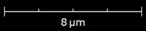
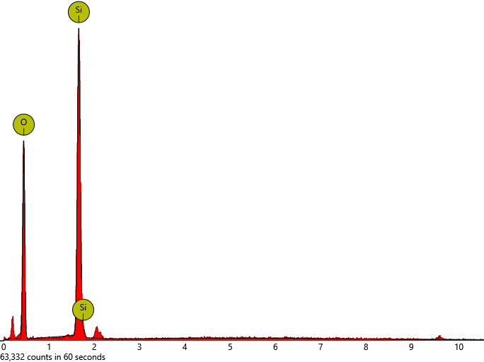
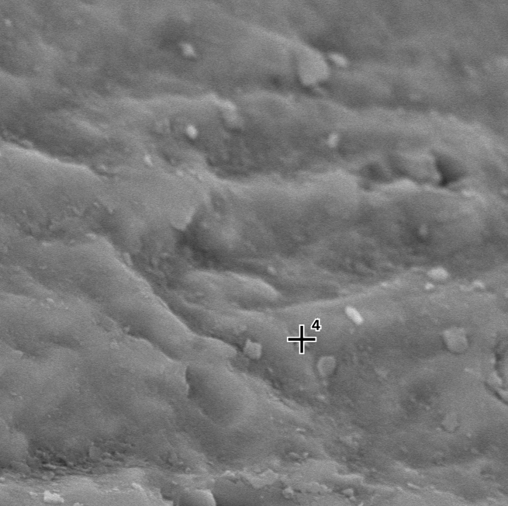
Figure 4.1 [Uncoated] Sand at 10,000x magnification using SEM-EDXS to reveal topography and elemental composition at a specific surface site.

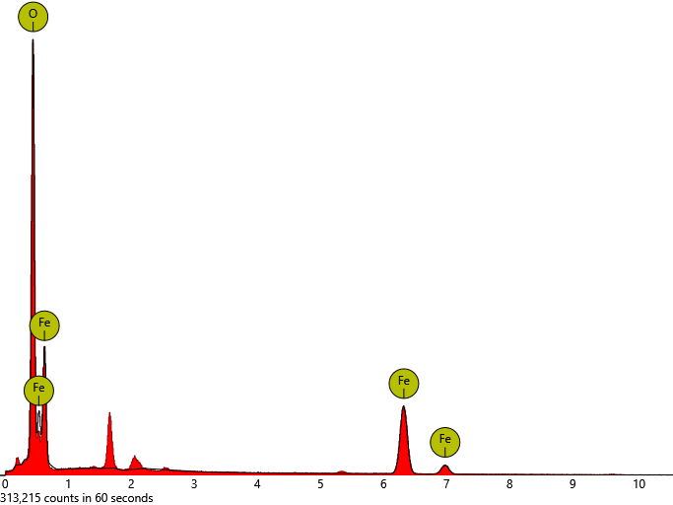
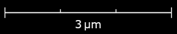
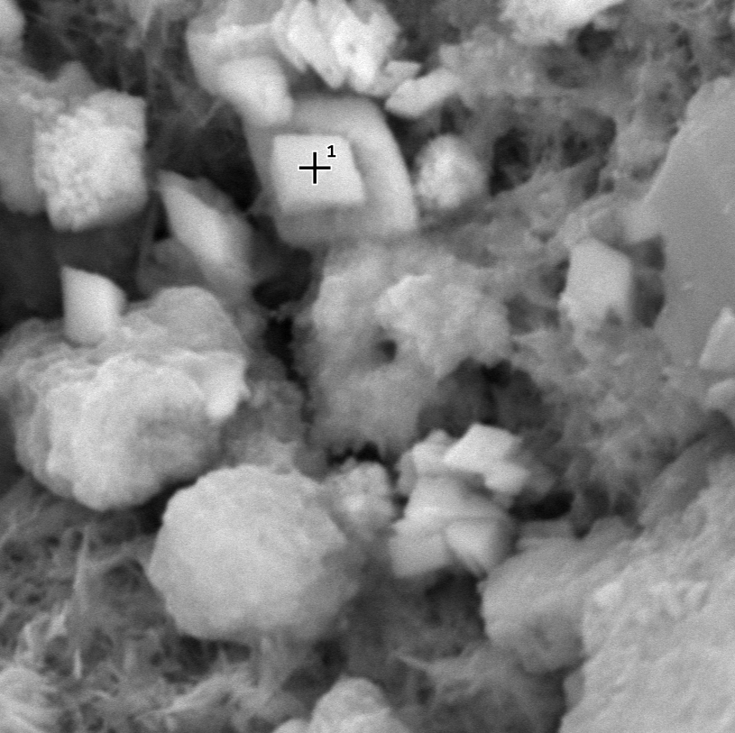
Figure 4.2 IOCS at 25,000x magnification using SEM-EDXS to reveal topography and elemental composition at a specific surface site.

Effect of ionic strength

Abundance
The IOCS treatments gave rise to the greatest percent decrease in abundance at 88.85 and 94.43% in 5 and 20 mM ionic strength solutions, respectively (Table 4.1). These values were comparable to the concentration of viruses adsorbed (V_{s}) and/or inactivated. The Sand treatments had a markedly smaller percent decrease at 5.77 and 12.14%. The No sand treatments actually experienced a percent increase of 28.34 and 29.87%. Additionally, when comparing ionic strength, the 20 mM samples had a larger reduction in viral abundance than the 5 mM counterparts. Two-way ANOVA revealed that both the solid phase, or presence of IOCS, and varying ionic strength significantly affected viral abundance in the aqueous phase post-equilibration (Table 4.2). The interaction effect was not significant, so the factors acted independently. One factor did not affect the efficacy of the other.

Table 4.1 Average percent decrease in viral abundance for differing ionic strength.
Treatment | Decrease (%)
IOCS 5 mM | 88.85
IOCS 20 mM | 94.43
Sand 5 mM | 5.77
Sand 20 mM | 12.14
No sand 5 mM | (28.34)
No sand 20 mM | (29.87)

The average sorption coefficients (K_{d}), approximating the fraction of V_{s} to V_{aq}, for each treatment group were as follows: at 5 mM NaCl, the IOCS is 32 (± 1.977), the Sand K_{d} is 0 (± 0.2906), and the No sand K_{d} is -3 (± 0.0484). At 20 mM NaCl, the IOCS K_{d} is 70 (± 14.84), the Sand K_{d} is 1 (± 0.0933), and the No sand K_{d} is -3 (± 0.0685) (Figure 4.3).
Table 4.2 ANOVA for independent and interaction effects of IOCS and ionic strength. Significance codes are as follows: 0-0.001(***), 0.001-0.01(**), and 0.01-0.05(*).
Factor | p-value
Solid phase (SP) | 1.01 x 10⁻¹⁴***
Ionic strength (IS) | 0.0043**
SP:IS (interaction) | 0.8189

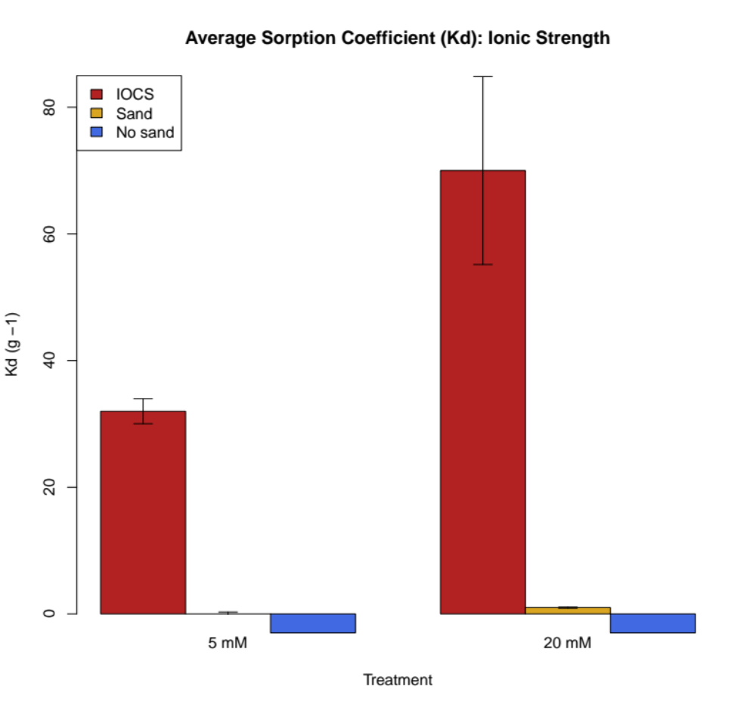
(mL/g)
Figure 4.3 Average K_{d} from the ionic strength study. ‘IOCS’ treatments are red, the (uncoated) ‘Sand’ treatments are gold, and the (sand-free) ‘No sand’ treatments are blue. Standard deviation error bars are included.

Genetic fingerprint
The cluster score plot indicated an optimal count of four clusters for this dataset (Figure 4.4). This was recommended by the elbow, or the point at which the rate of decrease rapidly diminishes (Shi et al., 2021). Beyond this value, the change in within-cluster variation becomes negligible (no benefit to further grouping).
The cluster dendrogram outlined the similarity/dissimilarity between the banding patterns from gel electrophoresis, or DNA fragment separation. Hierarchical clustering, utilizing the Ward D2 linkage function, iteratively merged samples until one node remained (Nielsen, 2016). This agglomerative (bottom-up) method determined relationships based upon the input distance matrix to output a dendrogram (Figure 4.5). The four selected clusters, from left to right, had nodes at heights 0.45, 0.9, 0.7, and 1.0. A red horizontal line shows the locations at which the tree was cut.
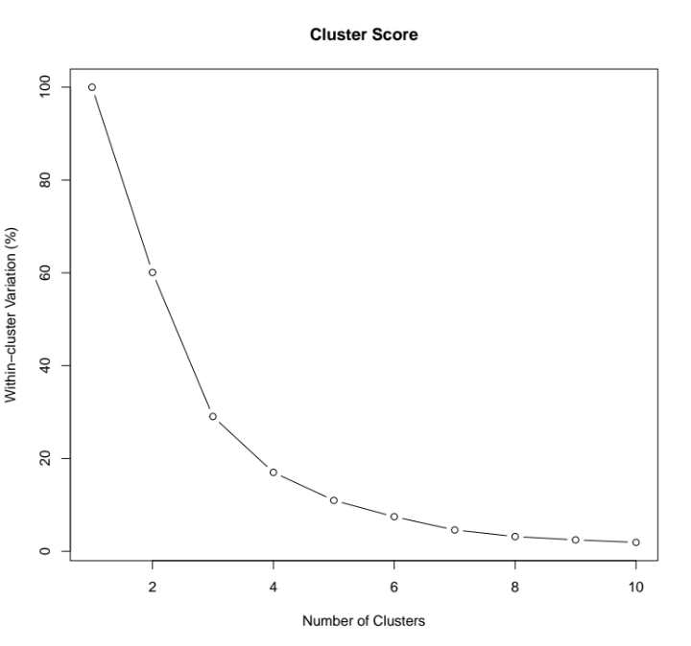
Figure 4.4 Cluster score plot for ideal cluster count (k = 4) for the ionic strength study.

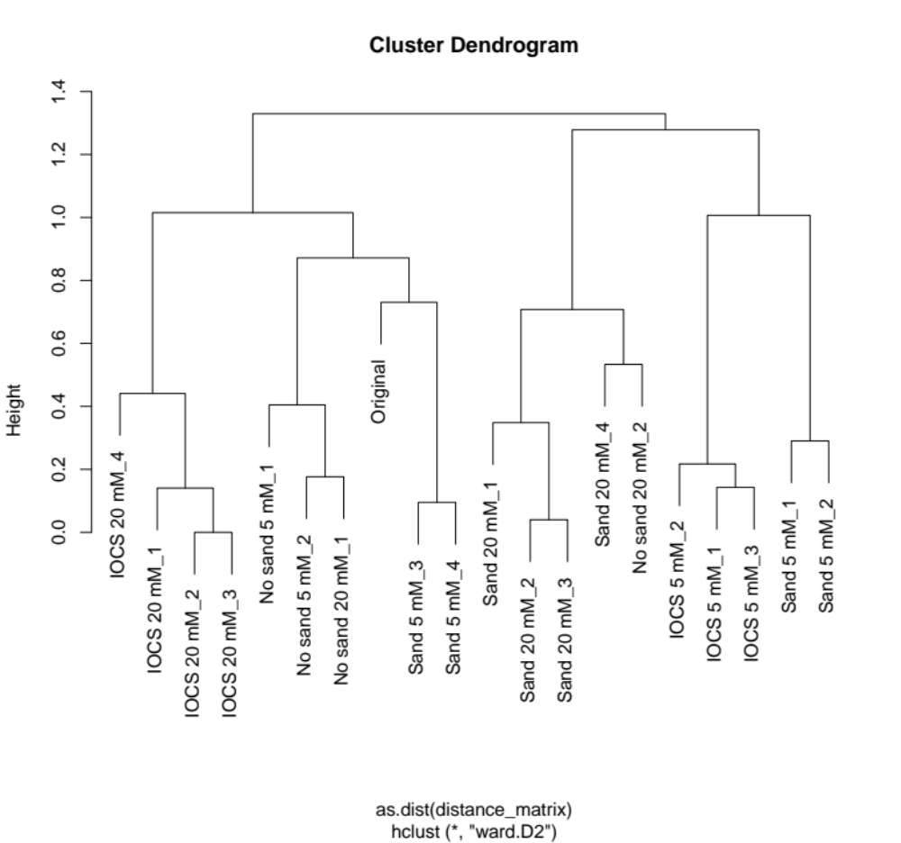
Figure 4.5 HCA cluster dendrogram for the ionic strength study. Linkages are severed by a red horizontal line to emphasize clusters.
The distance matrix and HCA were employed to produce a multivariate PCoA plot (Figure 4.6). The distance between points represented the dissimilarity between the viral genetic composition of each treatment. Eigenvalues were used to classify the data by two axes (PC1 and PC2) that captured the greatest meaningful variation (Lozupone & Knight, 2005). PC1 explained 28.1%, and PC2 explained 25.4% of the variation. The remaining proportion (46.5%) was defined by higher dimensions not shown here. Clusters were visually bound by convex hulls, or polygons, that connected the outermost points. This method was considered most beneficial for small datasets that included categorical variables, to highlight spread or overlap (Cevikalp, 2019).

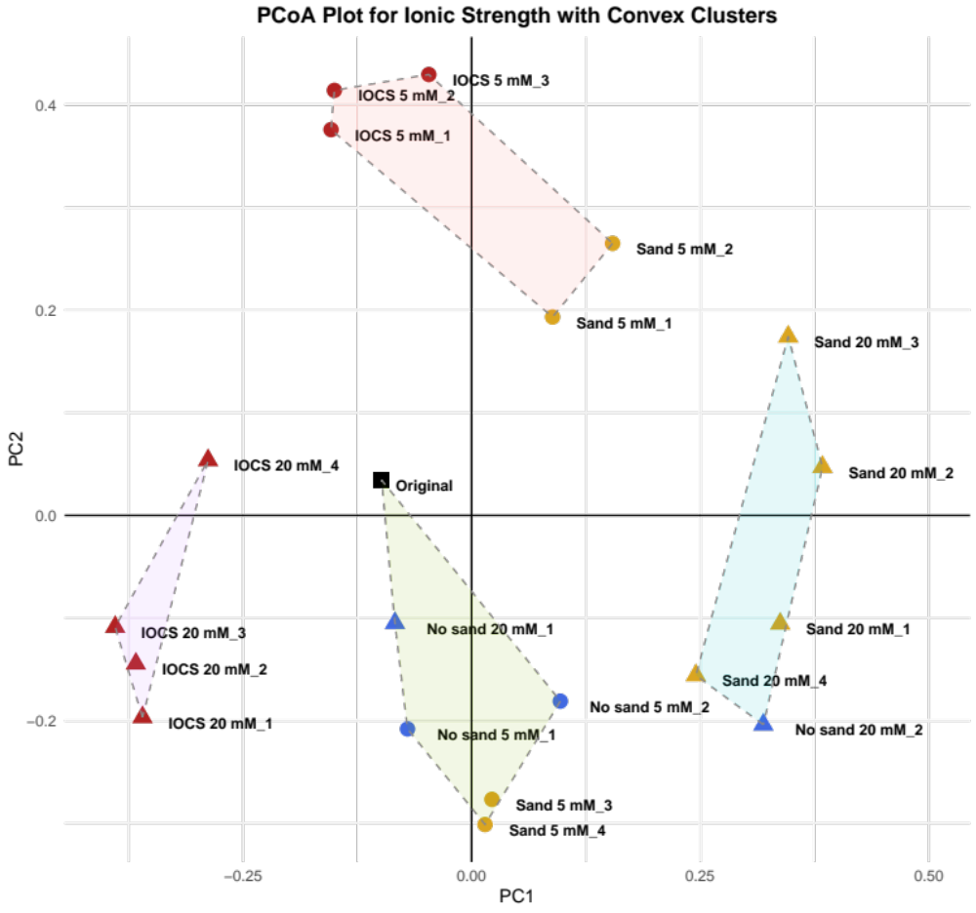
Figure 4.6 PCoA plot for the ionic strength study: black square = Original wastewater, red circle = IOCS 5 mM, red triangle = IOCS 20 mM, gold circle = Sand 5 mM, gold triangle = Sand 20 mM, blue circle = No sand 5 mM, blue triangle = No sand 20 mM. The coordinates account for 53.5% of the variation between the samples.

Discussion
For all abundance discussions, a greater percent decrease is equivalent to a greater K_{d} because higher values express more adsorption and less viruses remaining in solution. Based upon the measurements and data collected, it was not possible to discern adsorption from inactivation.
In the presence of IOCS, the number of VLPs in the aqueous phase significantly decreased post-equilibration in both 5 mM and 20 mM NaCl solutions (p < 0.001) (Table 4.1). This is partially consistent with hypothesis (2), stating that V_{aq} will significantly decrease after equilibration with the IOCS compared to uncoated [Sand] and sand-free [No sand] treatment groups, due to notable adsorption to IOCS. Hence, the IONP coating increased the adsorption capacity of the sand substrate. However, hypothesis (2) also predicted that IOCS will induce a 95% reduction in virus concentration. This was not achieved by either condition, although marginally so for IOCS 20 mM (94.43%).
VLP adsorption from 20 mM reaction solutions was greater than at 5 mM (p < 0.01). Approximately 2 times more adsorption occurred to IOCS at 20 mM than 5 mM (Figure 4.3). This was inconsistent with hypothesis (1), stating that low ionic strength will be favorable to the adsorption of the greatest number of viruses. This hypothesis is under the assumption that electrostatic attraction is occurring between a majority of VLPs and binding sites. Given the result, a substantial amount of repulsion may have taken place because increasing ionic strength, or the concentration of Na and Cl ions, weakens the dominant electrostatic interaction.
Presuming the existence of many repulsive forces, the higher ionic strength (20 mM) should reduce repulsion and thus, increase adsorption. The two surfaces are repelling as a consequence of a higher-than-anticipated concentration of positively charged viruses. Still, this is not surprising because of the heterogeneity/diversity of the virus stock, including a range of unknown isoelectric points.
Lastly, sand-free (No sand) control samples underwent an average increase in viral abundance post-equilibration. Host, bacterial cells were ostensibly absent, so there are two main conclusions: (1) contamination was present, facilitating viral reproduction, or (2) the count is artificially high due to experimental error.
For all genetic discussions, the ‘Original’ (black square) water refers to the wastewater collected from the secondary clarifier from the treatment plant. The abundance and genetic diversity measured reflects the “original” status of the viral communities at the time of sampling. The values assessed are pre-reaction. Additionally, since the post-reaction community composition was measured, the adsorbed community composition should mirror that of the original wastewater less the viruses that were adsorbed by the solid phase. The dendrogram and PCoA plot can be interpreted in tandem, as they were both derived from the RAPD-PCR fingerprint data. The latter provides a 2-D graph that is easier to interpret from visual inspection.
Considering the PCoA plot, most samples clustered according to the solid phase and ionic strength, independently (Figure 4.6). For example, IOCS in 20 mM replicates clustered amongst themselves, indicating an unmistakably distinct viral community composition, influenced by both factors, and good experimental reproducibility. This was consistent with hypothesis (3), stating that viral composition will be modified post-equilibration, and the resulting viral community will be shaped primarily by adsorption to the IOCS. IOCS imposed a stronger influence over virus community structure.
An analogous pattern was observed for the post-reaction aqueous phase in the IOCS 5 mM treatments; however, the community structure had shared similarity to Sand 5 mM_1 and Sand 5 mM_2, meaning that genetically similar viruses are adsorbed. Overall, post-reaction communities in the Sand 5 mM treatment appeared most variable with respect to the others. For example, two replicate samples from this group clustered with the sand-free controls and the original wastewater, while the other two replicates clustered with the Sand in 5 mM ionic strength. One replicate from the IOCS treatment group failed to yield a RAPD-PCR genetic fingerprint.
The dimensional separation between Sand and No sand samples at 5 and 20 mM suggests that ionic strength, alone, was a significant factor in structuring these viral communities. Further, Sand and No sand treatments exhibited higher genetic variation, and No sand aqueous virus samples were the most similar to the Original. This is logical and consistent with hypothesis (3) because the Original viruses should be the most diverse.

Effect of pH

Abundance
The reaction of virus suspensions with IOCS resulted in the greatest percent decrease in viral abundance of 99.35, 97.41, and 99.35% at pH 5.0, 6.5, and 8.0, respectively (Table 4.3). The percent decrease in the presence and absence of uncoated sand was significantly less and more variable, compared to the IOCS treatments. The Sand samples reduced viral count by 86.54, 28.00, and 47.95%, while the No sand samples reduced the count by 34.49, 13.08, and 51.35% at pH 5.0, 6.5, and 8.0, respectively. When comparing across pH values, pH 5.0 and 8.0 had a larger reduction in viral abundance than the central, pH 6.5, regardless of the solid phase. Two-way ANOVA revealed that both the solid phase, or presence of IOCS, and varying pH significantly impacted viral abundance (Table 4.4). The interaction effect was also significant, so the factors acted dependently. One factor affected the efficacy of the other.
Table 4.3 Average percent decrease in viral abundance for differing pH.
Treatment | Decrease (%)
IOCS pH 5.0 | 99.35
IOCS pH 6.5 | 97.41
IOCS pH 8.0 | 99.35
Sand pH 5.0 | 86.54
Sand pH 6.5 | 28.00
Sand pH 8.0 | 47.95
No sand pH 5.0 | 34.49
No sand pH 6.5 | 13.08
No sand pH 8.0 | 51.35
Table 4.4 ANOVA for independent and interaction effects of IOCS and pH.
Factor | p-value
Solid phase (SP) | 2.00 x 10⁻¹⁶***
pH | 2.00 x 10⁻¹⁶***
SP:pH (interaction) | 2.00 x 10⁻¹⁶***

At pH 5.0, K_{d} values were 600 (± 0), 26 (± 4.122), and 2 (± 0.6882) in the IOCS, Sand, and No sand treatments, respectively (Figure 4.7). At pH 6.5, K_{d} values were 155 (± 34.09), 2 (± 0.1852), and 1 (± 0.0486) in the IOCS, Sand, and No sand treatments, respectively. At pH 8.0, K_{d} values were 600 (± 0), 4 (± 0.2848), and 4 (± 0.6219) in the IOCS, Sand, and No sand treatments, respectively. On the bar chart, the y-axis was broken from 200-500 to compress the upper range and normalize the lower measurements.

Elution
The viral abundance in the equilibration solutions of the IOCS pH 5.0 and pH 8.0 treatments were at or below the EFM detection limit of 1 VLP per microscopic field at 100x magnification, which was equivalent to 99.35% adsorption and/or inactivation. To determine the mass balance of VLPs for these conditions, viruses were eluted from the IOCS with a dilute (0.14%) beef extract-glycine solution. The recovery efficiency was calculated by dividing the desorbed VLP concentration by V_{s}. On average, 6.20 and 6.86% of estimated adsorbed viruses were recovered (Table 4.5). The extracted viruses were used to create genetic fingerprints for these treatment groups. Therefore, on the PCoA plot, the IOCS treatments at pH 5.0 and 8.0 are not directly comparable to the other datapoints, which come from viruses remaining in the aqueous phase post-reaction.
Table 4.5 Average theoretical, viral extraction for IOCS pH 5.0 and 8.0 samples.
Treatment | Theoretical elution (%)
IOCS pH 5.0 | 6.20
IOCS pH 8.0 | 6.86

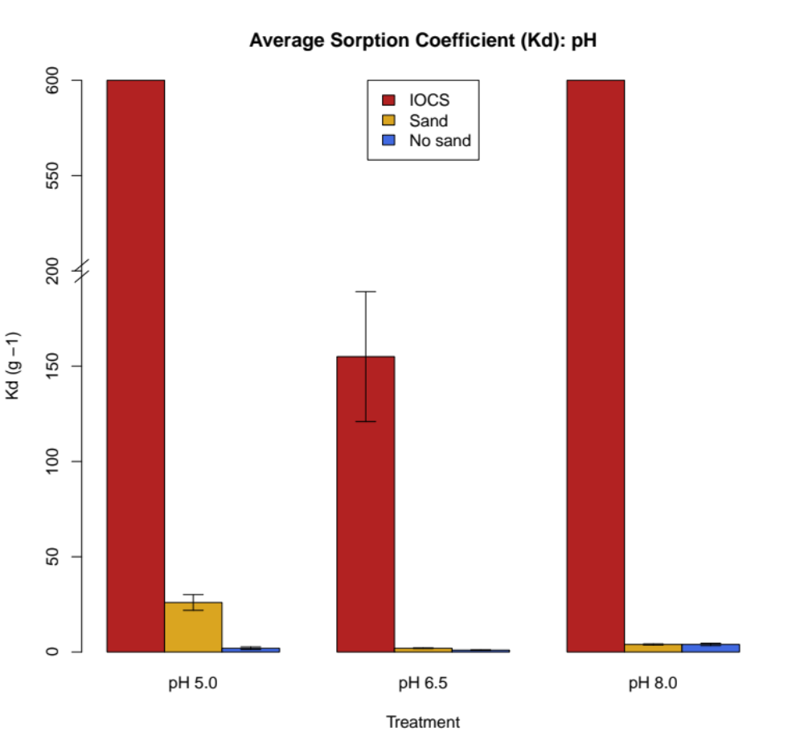
(mL/g)
Figure 4.7 Average K_{d} from the pH study. ‘IOCS’ treatments are red, the (uncoated) ‘Sand’ treatments are gold, and the (sand-free) ‘No sand’ treatments are blue. Standard deviation error bars are included. The y-axis is broken from 200-500 to compress the upper range.

Genetic fingerprint
The cluster score plot recommended an optimal count of four clusters for this dataset, indicated by the elbow, or the point at which the rate of decrease declines approaching zero (Shi et al., 2021) (Figure 4.8). Considering the HCA dendrogram, the four clusters, from left to right, had nodes at heights 0.3, 0.8, 1.0, and 1.0 (Figure 4.9). A red horizontal line shows the locations at which the tree was cut.
The distance matrix and HCA were employed to construct a multivariate PCoA plot (Figure 4.10). PC1 explained 33.4%, and PC2 explained 15.0% of the variation. The remaining proportion (51.6%) was defined by higher dimensions not shown here. Interpretations were made with awareness of the lower total translation of variation. Clusters were visually bound by convex hulls (fitted polygons).
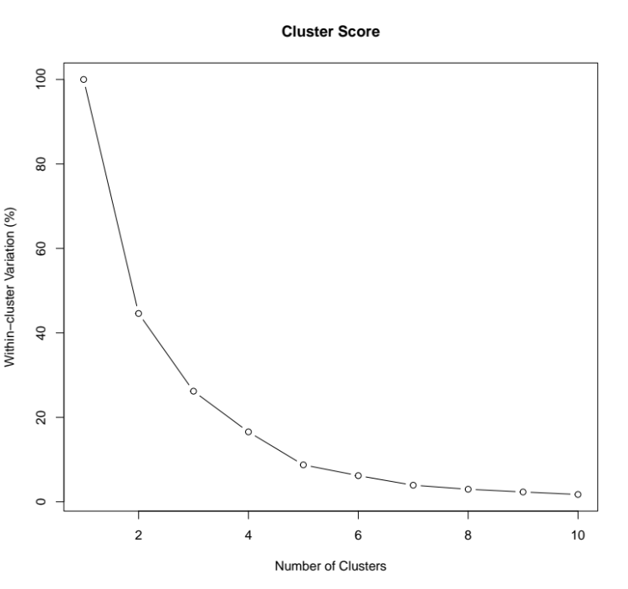
Figure 4.8 Cluster score plot for ideal cluster count (k = 4) for the pH study.

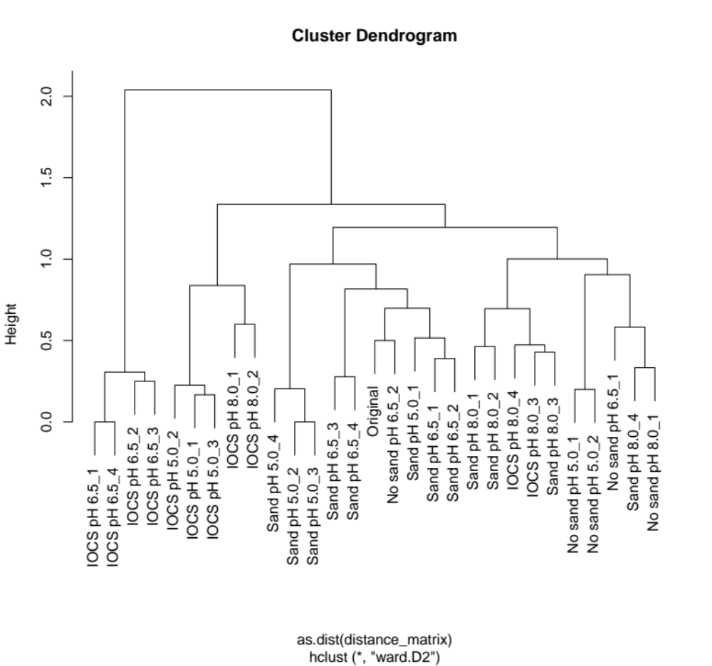
Figure 4.9 HCA cluster dendrogram for the pH study. Linkages are severed by a red horizontal line to emphasize clusters.

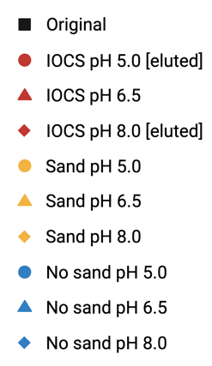
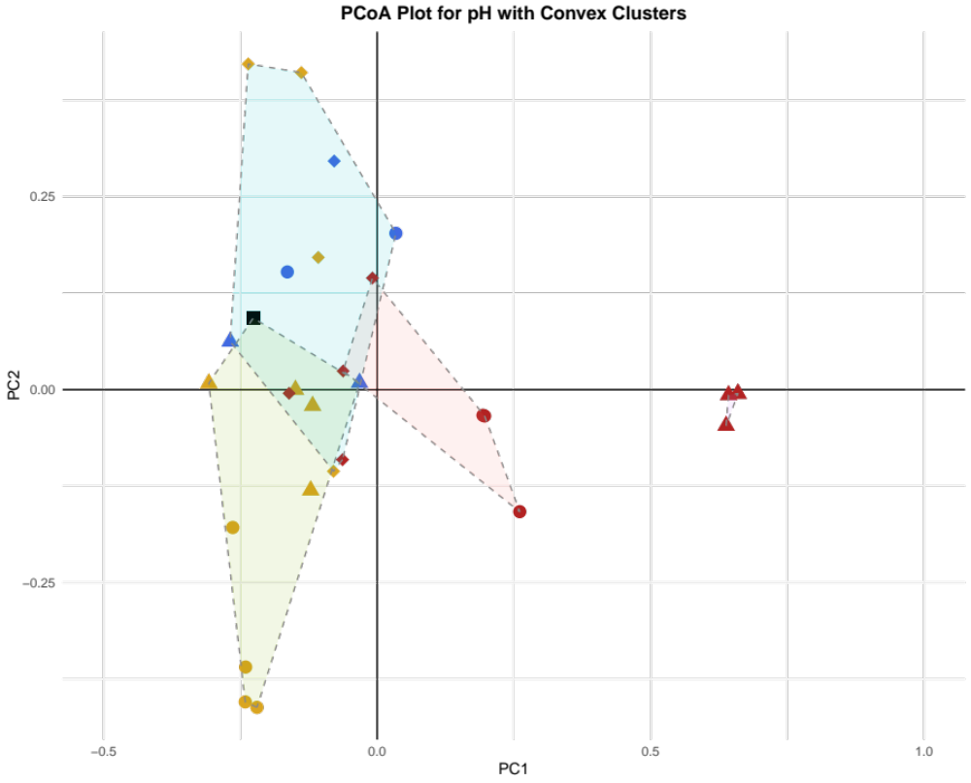
Figure 4.10 PCoA plot for the pH study: black square = Original wastewater, red circle = IOCS pH 5.0 [eluted], red triangle = IOCS pH 6.5, red rhombus = IOCS pH 8.0 [eluted], gold circle = Sand pH 5.0, gold triangle = Sand pH 6.5, gold rhombus = Sand pH 8.0, blue circle = No sand pH 5.0, blue triangle = No sand pH 6.5, blue rhombus = No sand pH 8.0. The coordinates account for 48.4% of the variation between the samples.

Discussion
IOCS significantly decreased the abundance of VLPs in the aqueous phase, post-reaction across all pH values (p < 0.001) (Table 4.3). This was consistent with hypothesis (2), since each IOCS pH group demonstrated a greater than 95% reduction in virus concentration. At pH 5.0 and 8.0, the solution viral abundance was below the detection limit, or reduced by 99.35%. Hence, the IONP coating appreciably increased the adsorption and/or destruction of municipal wastewater viruses.
Regardless of the solid phase, pH 5.0 and 8.0 generated more adsorption than pH 6.5 (p < 0.001) (Figure 4.7). This was partially consistent with hypothesis (1), stating that pH 5.0 will be favorable to the adsorption of the greatest number of viruses. Unexpectedly, the reaction solution adjusted to pH 8.0 yielded a similar result, despite being the closest to the isoelectric point of the iron oxide. Under this condition, the iron oxides were likely less positive than at lower pH values; therefore, there should have been less adsorption than at pH 5.0. However, a possible explanation could be that viruses were maximally negative at pH 8.0, boosting attraction and mitigating repulsion.
Assuming a moderate, average decay rate over the 2.5-hour equilibration, spontaneous viral decay can explain up to 53% of the reduction in VLPs. A Sand pH 5.0 replicate exceeded this natural decrease prediction. The rationale is as follows: the synergistic effects of the solid phase and pH potentially caused an increase in inactivation by enhancing envelope or protein disruption. Alternatively, pH 5.0 strengthened the interaction with uncoated sand which can, itself, carry a charge (Xie et al., 2020).
It is important to note that the viral community compositions from samples at pH 5.0 and 8.0 came from previously adsorbed viruses (V_{s}). Since the theoretical desorption percentages were low, it is likely that a majority of viruses were destroyed or irreversibly bound. Considering the PCoA plot, most samples clustered according to solid phase, pH, and the significant interaction effect (p < 0.001) (Figure 4.10). pH reinforced the influence of the solid phase, and vice versa. Samples were evaluated under both factors, due to dually altered adsorption dynamics and/or inactivation.
IOCS pH 6.5 replicates were secluded and clustered amongst themselves, indicating an unmistakably distinct viral community composition, influenced by both factors and different from all other treatments. All four replicates were present, but two had the same genetic fingerprint, so the data points (triangles) were superimposed. The IOCS pH 6.5 cluster was consistent with hypothesis (3). Post-equilibration viral composition was heavily modified. Moreover, this condition resulted in bulk adsorption of viruses, in contrast with Sand and No sand groups.
The communities from all treatments, except the aforementioned post-reaction IOCS at pH 6.5, exhibited high similarity, so the clusters were more overlapped than in the previous experiment that varied ionic strength. The blue and green clusters are explicitly listed for discernment below:
- Blue – Sand pH 8.0 (_1, _2, _3, _4), No sand pH 8.0 (_1), No sand pH 5.0 (_1, _2),
No sand pH 6.5 (_1), IOCS pH 8.0 (_3, _4).
- Green – Original, No sand pH 6.5 (_2), Sand pH 6.5 (_1, _2, _3, _4),
Sand pH 5.0 (_1, _2, _3, _4).
Although clusters were determined by encoded parameters, the extensive convergence implies that multiple rationale could apply to one cluster, or vice versa. The high overlap also communicates that pH had a lesser influence over community composition change. In other words, pH-mediated adsorption led to broad, but similar, losses in virus type.
The predominantly (uncoated) sandy and acidic, green cluster was spatially variable with the Sand pH 5.0 replicates nearly forming a separate group. Sand pH 5.0 and Sand pH 6.5 groups were similar to the Original virus community makeup. The close proximity was consistent with hypothesis (3). Alterations in viral communities in the post-reaction solutions were slightest in treatments that adsorbed the fewest viruses. Further, this aggregate contained the genetic fingerprints from two replicates of the adsorbed viruses extracted from IOCS at pH 8.0.
The blue cluster displayed the largest spread, or genetic variation. Here, No sand treatment groups across all pH values were most indistinguishable from Sand pH 8.0 viral communities. It was interesting to note that these treatment groups all collected around, and were similar to, the Original viral composition. Cluster number (k) could have been abated to merge the center; however, the vertical range was wide and called for partition.
Finally, the extracted viruses from IOCS at pH 5.0 and 8.0 congregated. The pair were indistinct, unlike IOCS at pH 6.5, because the IOCS at pH 5.0 and 8.0 were not selective. They adsorbed all available viruses up to the detection limit of the enumeration method. This action spawned correspondence with the Original virus communities and viruses remaining in solution post-treatment with and without uncoated sand.

Effect of dissolved organic carbon

Abundance
The IOCS groups exhibited the greatest percent decrease in viral abundance post-reaction at 72.63 and 96.40% in the presence and absence of DOC, respectively (Table 4.6). The Sand DOC group decreased VLPs in the aqueous phase by 40.13%. The presence of DOC inhibited the adsorption of viruses to IOCS as the decrease in the concentration of viruses was greatest in the absence of DOC. Two-way ANOVA revealed that the presence of IOCS and DOC significantly affected viral abundance (Table 4.7). The interaction effect was also significant, so the factors acted dependently.
The average sorption coefficients (K_{d}) for each treatment group were represented by a vertical bar chart (Figure 4.11). For DOC samples, the IOCS K_{d} was 11 (± 0.2537), and the Sand K_{d} was 3 (± 0.2262). For No DOC samples, the IOCS K_{d} was 107 (± 0), and the Sand K_{d} was -3 (± 0.0580).
Table 4.6 Average percent decrease in viral abundance for differing DOC.
Treatment | Decrease (%)
IOCS DOC | 72.63
IOCS No DOC | 96.40
Sand DOC | 40.13
Sand No DOC | (50.76)

Table 4.7 ANOVA for independent and interaction effects of IOCS and DOC.
Factor | p-value
Solid phase (SP) | 1.36 x 10⁻¹⁴***
DOC | 4.77 x 10⁻¹³***
SP:DOC (interaction) | 4.36 x 10⁻¹⁴***

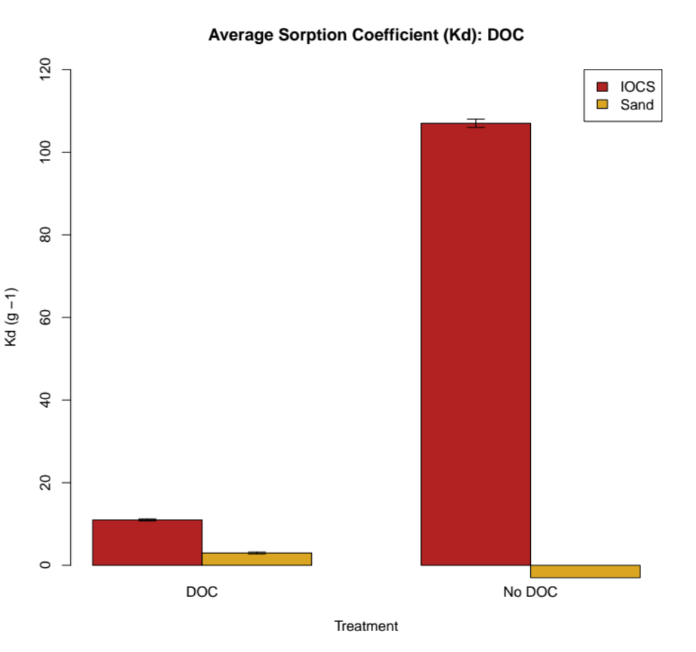
(mL/g)
Figure 4.11 Average K_{d} from the DOC study. ‘IOCS’ treatments are red, and the (uncoated) ‘Sand’ treatments are gold. Standard deviation error bars are included.

DOC concentration
Non-purgeable organic carbon (NPOC) accounts for the average DOC content across treatment replicates (Table 4.8). For IOCS DOC treatments, there was a significant decrease in DOC concentration post-equilibration, from 66.03 to 59.97 mg carbon⋅L⁻¹ (p < 0.001). For Sand DOC samples, there was no significant difference in DOC concentration post-equilibration (p = 0.99).

Genetic fingerprint
The cluster score plot recommended an optimal count of three clusters for this dataset (Figure 4.12). This was indicated by the elbow, or the point at which the rate of decrease of the within-cluster variation rapidly diminishes or levels out (Shi et al., 2021). Examination of the HCA dendrogram revealed three readily identifiable clusters with nodes, from left to right at heights 0.4, 0.3, and 0.7 (Figure 4.13). A red horizontal line shows the locations at which the tree was cut.
The distance matrix and HCA were employed to furnish a multivariate PCoA plot (Figure 4.14). PC1 explained 61.0%, and PC2 explained 27.1% of the variation. The remaining proportion (11.9%) was defined by higher dimensions not shown here. This plot captured the most complete picture of the orientation of the viral communities relative to the previous two experiments. Clusters were visually bound by convex hulls.
Table 4.8 DOC (NPOC) concentration pre- and post-equilibration.
Treatment | NPOC (mg/L)
Original wastewater | 66.03
IOCS DOC | 59.97***
Sand DOC | 66.05
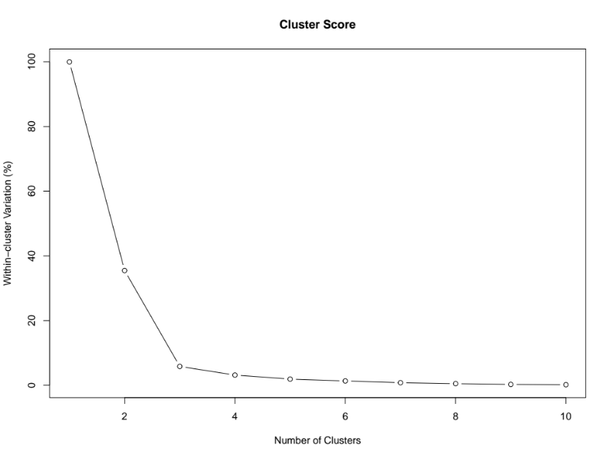
Figure 4.12 Cluster score plot for ideal cluster count (k = 3) for the DOC study.

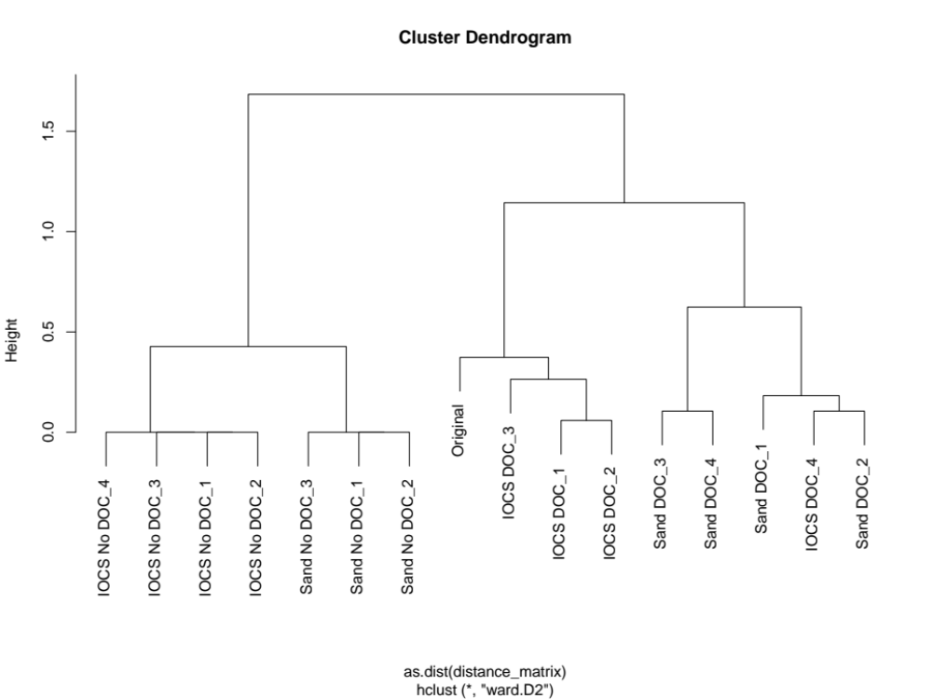
Figure 4.13 HCA cluster dendrogram for the DOC study. Linkages are severed by a red horizontal line to emphasize clusters.

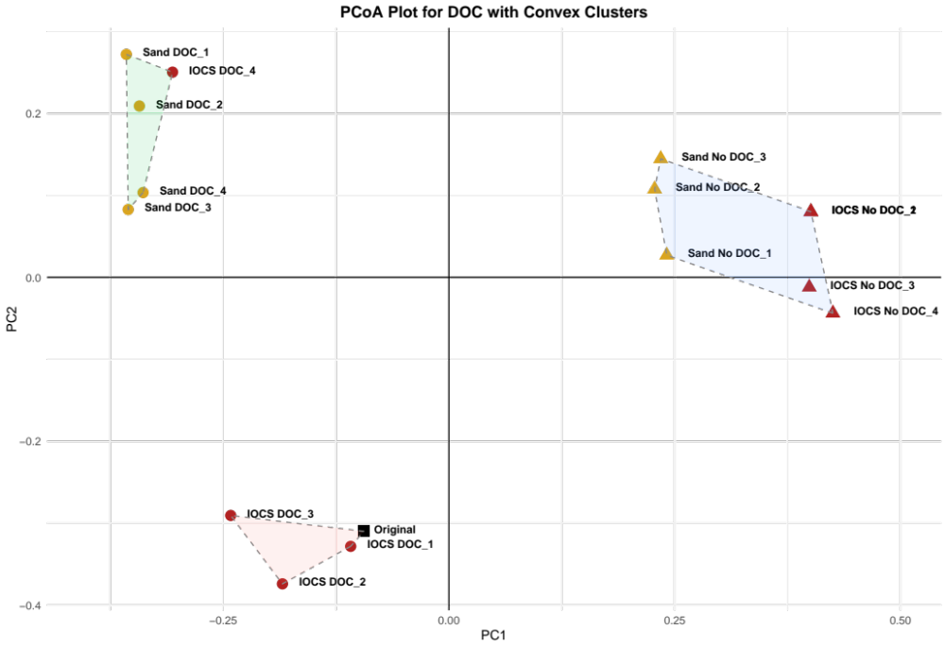
Figure 4.14 PCoA plot for the DOC study: black square = Original wastewater, red circle = IOCS DOC, red triangle = IOCS No DOC, gold circle = Sand DOC, gold triangle = Sand No DOC. The coordinates account for 88.1% of the variation between the samples.

Discussion
IOCS significantly decreases the number of VLPs post-equilibration (p < 0.001) (Table 4.6). This was partially consistent with hypothesis (2). The IONP coating increased the adsorption capacity of the sand substrate. However, only the IOCS No DOC treatment group induced >95% reduction in virus concentration. The IOCS DOC treatment’s percent decrease was lower but significant. Additionally, Sand No DOC underwent an average increase in viral abundance post-equilibration. This, again, have resulted from contamination or an artificially high count.
IOCS No DOC treatments generated approximately 10 times more adsorption than IOCS DOC (p < 0.001) (Figure 4.11). This was consistent with hypothesis (1), stating that the absence of dissolved organic carbon will be favorable to the adsorption of the greatest number of viruses. DOC content is plausibly competing with viruses for iron oxide binding sites, inhibiting adsorption. This concept was confirmed by Table 4.8. For IOCS DOC treatments, there was a significant decrease in NPOC post-reaction (p < 0.001). DOC likely adsorbed to the IONPs and remained in solution in their absence.
Considering the PCoA plot, the clusters were singularly tight and comparatively divergent, suggesting that the viral communities are evidently different in genetic composition. The solid phase and DOC have a strong influence over adsorption and/or inactivation (p < 0.001) (Figure 4.14). DOC affected the efficacy of the IOCS. IOCS DOC replicates, except IOCS DOC_4, clustered with the Original virus composition. Also, Sand DOC replicates were similar to the Original cluster along PC1. This suggested that organic carbon blocked adsorption, so the virus community structure remained similar to wastewater viruses pre-reaction.
All of the DOC-free groups, irrespective of the solid phase, were similar and assembled in the same cluster. This was consistent with hypothesis (3), with the greatest change in virus community structure occurring in the treatments that resulted in the largest K_{d} values (i.e., the largest extent of adsorption). Genetically analogous viruses were adsorbed and/or inactivated by IOCS and Sand in the presence of DOC.

Conclusions and Recommendations

Blanket conclusions
IOCS significantly reduced the number of VLPs in the aqueous phase post-reaction, on average by 92.63%. The percent decrease for each IOCS treatment was significantly greater than that of Sand and No sand samples; therefore, IOCS efficiently removed viruses from municipal wastewater. Additionally, DOC inhibited the full capacity of the IOCS by blocking viral adsorption. Supplementally, within each experiment, maximum IOCS adsorption and/or inactivation capacity occurred at pH 5.0 and 8.0 (600 K_{d}), 20 mM NaCl (70 K_{d}), and DOC-free (107 K_{d}) conditions. It is worth mentioning that IOCS at pH 6.5 also had high adsorption (155 K_{d}) when compared to the ionic strength and DOC experiments.
Peak adsorption and/or inactivation by uncoated sand materialized under Sand at pH 5.0 (26 K_{d}). Under all other uncoated sand conditions, the maximum K_{d} value was 4. Adsorption to labware was generally low but occurred most notably throughout the pH experiment, with an average sorption coefficient of 2. When manipulating ionic strength, all sand-free (No sand) samples experienced an increase in VLPs post-reaction.
Cumulatively, the greatest alterations in viral community composition corresponded with IOCS at pH 6.5, IOCS at 5 and 20 mM NaCl, and IOCS in the absence of DOC. This reinforced the notion that treatments groups with high adsorption resulted in the most change in genetic diversity post-reaction. Interestingly, IOCS at pH 5.0 and 8.0 treatment groups produced comparable adsorption and extractable viral community compositions. This was somewhat unexpected since viruses with contrasting isoelectric points should have been more susceptible to adsorption at contrasting pH values. These treatment groups were therefore non-selective with respect to virus adsorption, and imaginably, they adsorbed all viruses at similar relative abundances.
Iron oxide nanoparticle synthesis was verified by SEM/EDXS, and IOCS was confirmed as an effective adsorbent over a broad range of conditions. The efficacy was influenced by pH and DOC content. Further, IOCS was somewhat universal and efficiently removed or deactivated a diverse community of wastewater viruses. This aspect was truly novel, given the vast genetic diversity of the native viruses.
The comprehensive results, though not definitive, were statistically significant and provided confidence in the IOCS as a productive adsorbent and potential disinfectant of wastewater viruses. The coating procedure and preliminary characterization pointed to hematite as the predominant iron oxide deposited on the surface of the sand grains. Hematite is known to demonstrate photo-Fenton abilities by the reduction of ferric iron (${Fe}^{3+}+UV→{Fe}^{2+}$) and the re-oxidation of ferrous iron by hydrogen peroxide (${Fe}^{2+}+H_{2}O_{2}+H^{+}→{Fe}^{3+}+H_{2}O+{OH}^{*}$). Upon exposure to UV radiation, the surface adsorbed viruses may be inactivated through this reaction mechanism, though further experiments are required to test this hypothesis. The following section reviews struggles, recommendations, and future directions to strengthen this body of work.

Troubles and suggestions
This thesis offered encompassing insights into the adsorptive capacity of IOCS for wastewater viruses and how it varied with solution chemistry, including ionic strength, pH, and DOC. With more time and resources, additional outcomes could have been discovered. Eight possibilities are proposed for future research:
- Coupled with genetic fingerprinting, DNA sequencing and subsequent metagenomic analysis could be utilized to identify viral taxa, and potential structural patterns, with enhanced susceptibility to adsorption/inactivation. Without sequencing data, viruses could only be inspected via genetic fingerprinting methods to assess beta diversity. With metagenomic and proteomic awareness, specific viruses and their surface properties could be determined and anticipated under different chemical conditions.
- Ancillary infectivity procedures should be run to differentiate between adsorption and inactivation. Both mechanisms may be occurring, but all decreases in VLP abundance in the aqueous phase were attributed to adsorption (K_{d}). In reality, the K_{d} values were likely lower. Formally, culture-dependent and plaque assays could be employed to ascertain the extent of inactivation. By inoculating concentrated bacterial hosts from the original wastewater stock, inactivation could be calculated by plaque-forming units or EFM. The rate of infectivity would be compared pre- and post-equilibration. Rapid proliferation of viruses post-reaction would suggest that, at least, some portion of the adsorbed viruses remained infectious.
- Mass balance should be attempted or obtained for each treatment group, in the light of missing infectivity data. For example, V_{aq} pre-equilibration (total) minus V_{aq} post-equilibration should equal the concentration of extractable VLPs. If the math is inconsistent, meaning that the number of eluted VLPs does not amount to the total, then viruses are irreversibly bound to the solid phase or destroyed.
- Transmission electron microscopy (TEM) could be used to confirm viral binding to the solid phase and visualize gross morphological changes, as an index of viral destruction. Damage could occur to both adsorbed and solution viruses as a consequence of IONP activity.
- An adsorption isotherm could be practical for uncovering the adsorption mechanism or, at least, a more accurate estimate of the sorption coefficients under the varying chemical conditions. To do so, an equilibration would be run with multiple viral concentrations, rather than one stock, pre-equilibration value. This was not done in this investigation due to the difficulties associated with concentrating enough viruses from wastewater to replicate these experiments at many initial virus concentrations.
- Genetic material posed a fault or instability. As considered in the introduction, viruses carry both single- and double-stranded DNA and RNA. In this study, RAPD-PCR was performed with a DNA-specific primer; therefore, only DNA viruses were scrutinized. This is reasonable since bacteriophages are plentiful and primarily DNA-based. To capture the RNA fingerprint, RNA would need to be reverse transcribed to prepare a complementary DNA library for amplification. Further, issues arose with DNA extraction, so template was normalized by VLP count rather than exact DNA concentration. This technique assumed that the viruses carried the same amount of DNA.
- X-ray diffraction (XRD) could have confirmed the mineral structure and phase of the iron oxide. The EDXS elemental analysis was able to predict the iron to oxygen ratios, which supplement SEM imagery, but XRD would be more qualified and objective. With access to instrumentation, additional methods like Brunauer-Emmet-Teller for active surface area, isoelectric focusing for pI, and X-ray photoelectron spectroscopy for charge (oxidation state) would be informative.
- In practice, further tertiary purification of the wastewater to remove viruses may involve filtration through columns. Scale-up of the experiments presented here in lab-scale column experiments using the batch microcosm data would be the next logical step. This will determine optimal flow conditions (i.e., saturation, flow, etc.) for virus and contaminant removal. Columns are dynamic and representative of actual field conditions, essential for CW application.

List of References
Adekunle, A. S., Oyekunle, J. A., Durosinmi, L. M., Saheed, O., Ajayeoba, T. A., Akinyele, O. F., Elugoke, S. E., & Oluwafemi, O. S. (2021). Comparative photocatalytic degradation of dyes in wastewater using solar enhanced iron oxide (Fe₂O₃) nanocatalysts prepared by chemical and microwave methods. Nano-Struct. & Nano-Objects, 28(1-2):100804. doi: 10.1016/j.nanoso.2021.100804

Afaghi, P., Lapolla, M. A., & Ghandi, K. (2021). Denaturation of the SARS-CoV-2 spike protein under non-thermal microwave radiation. Sci. Rep., 11:23373. doi: 10.1038/s41598-021-02753-7
Aragaw, T. A., Bogale, F. M., & Aragaw, B. A. (2021). Iron-based nanoparticles in wastewater treatment: A review on synthesis methods, applications, and removal mechanisms. Saudi Chem. Soc., 25(8). doi: 10.1016/j.jscs.2021.101280

Armanious, A., & Mezzenga, R. (2022). A Roadmap for Building Waterborne Virus Traps. JACS Au., 2(10):2205-2221. doi: 10.1021/jacsau.2c00377

Benjamin, M. M., Sletten, R. S., Bailey, R. P., & Bennett, T. (1996). Sorption and filtration of metals using iron-oxide-coated sand. Water Res., 30(11):2609-2620. doi: 10.1016/S0043-1354(96)00161-3

Besley, E. (2023). Recent Developments in the Methods and Applications of Electrostatic Theory. Acc. Chem. Res., 56(17):2267-2277. doi: doi.org/10.1021/acs.accounts.3c00068

Biswal, B. K., & Balasubramanian, R. (2022). Constructed Wetlands for Reclamation and Reuse of Wastewater and Urban Stormwater. Front. Environ. Sci., 10:836289. doi: 10.3389/fenvs.2022.836289

Bogunia, M., & Makowski, M. (2020). Influence of Ionic Strength on Hydrophobic Interactions in Water: Dependence on Solute Size and Shape. J. Phys. Chem., 124(46):10326–10336. doi: 10.1021/acs.jpcb.0c06399

Cevikalp, H. (2019). High-dimensional data clustering by using local affine/convex hulls. Pattern Recognit. Lett., 128:427-432. doi: 10.1016/j.patrec.2019.10.007

Chen, H. Y., Liu, C., Li, Y. Z., & Teng, Y. G. (2021). Integrating Metagenomic and Bayesian Analyses to Evaluate the Performance and Confidence CrAssphage as an Indicator for Tracking Human Sewage Contamination in China. Environ. Sci. & Tech., 55(8):4992-5000. doi: 10.1021/acs.est.1c00071

Chen, Y., Liu, X., & Chen, J. (2021). Steric hindrance effect on adsorption of xanthate on sphalerite surface: A DFT study. Minerals Eng., 165. doi: 10.1016/j.mineng.2021.106834
Chertok, B., Moffat, B. A., David, A. E., Yu, F., Bergemann, C., Ross, B. D., & Yang, V. C. (2008). Iron oxide nanoparticles as a drug delivery vehicle for MRI monitored magnetic targeting of brain tumors. Biomaterials, 29(4):487-496. doi: 10.1016/j.biomaterials.2007.08.050

Constantino, J. S. F., Mesquita, I. D. S., Segundo, J. D. P. M., Filho, R. N. F. M., Araujo, A. B., Ferreira, M. V. P., Almeida, J. J. A., Silva, G. S., Souza, F. F. P., Lorevice, M. V., Andrade, F. K., Beppu, M. M., Leal, K. A., & Vieira, R. S. (2024). Antiviral and nontoxic dermal iron oxide nanoparticle/biopolymer coatings for cotton fabric. ACS Appl. Nano Mat., 7(12):13991-14004. doi: doi.org/10.1021/acsanm.4c00951

Derjaguin, B. (1934). Untersuchungen über die Reibung und Adhäsion, IV [Analysis of friction and adhesion, IV]. Kolloid-Zeitschrift, 69(2):155-164. doi: 10.1007/BF01433225

Derjaguin, B., & Landau, L. (1993). Theory of the stability of strongly charged lyophobic sols and of the adhesion of strongly charged particles in solutions of electrolytes. Prog. Surf. Sci., 43(1-4):30-59. doi: 10.1016/0079-6816(93)90013-L

Elveborg, S., Monteil, V. M., & Mirazimi, A. (2022). Methods of Inactivation of Highly Pathogenic Viruses for Molecular, Serology or Vaccine Development Purposes. Pathogens, 11(2):271. doi: 10.3390/pathogens11020271

Ezugbe, E. O., & Rathilal, S. (2020) Membrane Technologies in Wastewater Treatment: A Review. Membranes, 10(5):89. doi: 10.3390/membranes10050089

Garcia-Fontana, C., Rodriguez-Sanchez, A., Munoz-Palazon, B., Gonzalez-Martinez, A., Vela-Cano, M., & Gonzalez-Lopez, J. (2020). Profile of the Spatial Distribution Patterns of the Human and Bacteriophage Virome in a Wastewater Treatment Plant Located in the South of Spain. Water, 12(8):2316. doi: 10.3390/w12082316

Gerdes, M. E., Miko, S., Kunz, J. M., Hannapel, E. J., Hlavsa, M. C., Hughes, M. J., Stuckey, M. J., Francois Watkins, L. K., Cope, J. R., Yoder, J. S., Hill, V. R., & Collier, S. A. (2023). Estimating Waterborne Infectious Disease Burden by Exposure Route, United States, 2014. Emerg. Infect. Dis., 29(7):1357-1366. doi: 10.3201/eid2907.230231

Gundy, P. M., Gerba, C. P., & Pepper, I. L. (2009). Survival of coronaviruses in water and wastewater. Food Env. Virol., 1(1):10. doi: 10.1007/s12560-008-9001-6

Guo, S., Yan, X., Luo, Z., Zhang, J., & Yuan, C. (2024). Preparation of positively charged nanofiltration membranes: Manipulation of the positive charge. Desalination, 586. doi: 10.1016/j.desal.2024.117780
Harvey, R. W., & Ryan, J. N. (2004). Use of PRD1 bacteriophage in groundwater viral transport, inactivation, and attachment studies. FEMS Microbiol. Ecol., 49(1):3-16. doi: 10.1016/j.jconhyd.2013.06.002

Hiatt, C. W. (1964). Kinetics of the inactivation of viruses. Bacteriol. Rev., 28(2):150-63. doi: 10.1128/br.28.2.150-163.1964

Joonaki, E., Hassanpouryouzband, A., Heldt, C. L., & Areo, O. (2020). Surface Chemistry Can Unlock Drivers of Surface Stability of SARS-CoV-2 in a Variety of Environmental Conditions. Chemistry, 6(9):2135-2146. doi: 10.1016/j.chempr.2020.08.001

Kędra, K., Łazarczyk, M., Begović, T., Namjesnik, D., Lament, K., Piasecki, W., & Zarzycki, P. (2021). Electrochemical Perspective on Hematite–Malonate Interactions. Colloids Inter., 5(4):47. doi: 10.3390/colloids5040047

Kong, J., Lu, Y., Ren, Y., Chen, Z., & Chen, M. (2021). The virus removal in UV irradiation, ozonation and chlorination. Water Cycle, 2:23-31. doi: 10.1016/j.watcyc.2021.05.001

Li, Z., Kong, L., Hu, L., Wei, J., Zhang, X., Guo, W., & Shi, W. (2024). Greenhouse gas emissions from constructed wetlands: A bibliometric analysis and mini-review. Sci. Total Env., 906. doi: 10.1016/j.scitotenv.2023.167582

Louten, J. (2016). Virus Structure and Classification. Essent. Human Virol., 19-29. doi: 10.1016/B978-0-12-800947-5.00002-8

Lozupone, C., & Knight, R. (2005). UniFrac: a new phylogenetic method for comparing microbial communities. Appl. Env. Microbiol., 71(12):8228–8235. doi: 10.1128/AEM.71.12.8228-8235.2005

Lytle, C. D., & Sagripanti, J. L. Predicted inactivation of viruses of relevance to biodefense by solar radiation. (2005). J. Virol., 79(22):14244-52. doi: 10.1128/JVI.79.22.14244-14252.2005

Ma, W., Wang, M., Jiang, R., & Chen, W. (2023). A machine learning based approach for estimating site-specific partition coefficient Kd of organic compounds: Application to nonionic pesticides. Env. Pollution, 323. doi: 10.1016/j.envpol.2023.121297

Mena, K. D., Gerba, C. P., Haas, C. N., & Rose, J. B. (2003). Risk assessment of waterborne coxsackievirus. J. AWWA, 95(7):122-131. doi: 10.1002/j.1551-8833.2003.tb10413.x
Michen, B., & Graule, T. (2010). Isoelectric points of viruses. J. Appl. Microbiol., 109(2):388-397. doi: 10.1111/j.1365-2672.2010.04663.x
Mishra, R. K., Verma, K., & Singh, D. S. (2024). Defect engineering in nanomaterials: Impact, challenges, and applications. Smart Mat. Mfg., 2:100052. doi: 10.1016/j.smmf.2024.100052

Moelling, K., & Broecker, F. Viruses and Evolution - Viruses First? A Personal Perspective. Front. Microbiol., 10:523. doi: 10.3389/fmicb.2019.00523
Nielsen, F. (2016). Hierarchical Clustering. Intro. HPC with MPI for Data Sci., 195-211. doi: 10.1007/978-3-319-21903-5_8

Nishat, A., Yusuf, M., Qadir, A., Ezaier, Y., Vambol, V., Khan, M. I., Moussa, S. B., Kamyab, H., Sehgal, S. S., Prakash, C., Yang, H. H., Ibrahim, H., & Eldin, S. M. (2023). Wastewater treatment: A short assessment on available techniques. Alexandria Eng. J., 76:505-516. doi: 10.1016/j.aej.2023.06.054

Quach-Cu, J., Herrera-Lynch, B., Marciniak, C., Adams, S., Simmerman, A., & Reinke, R. A. (2018). The Effect of Primary, Secondary, and Tertiary Wastewater Treatment Processes on Antibiotic Resistance Gene (ARG) Concentrations in Solid and Dissolved Wastewater Fractions. Water, 10(1):37. doi: 10.3390/w10010037

Quyen, D. T., Masahiro, O., Otaki, Y., & Chaminda, T. (2021). Sewage Markers as Determinants to Differentiate Origins of Emerging Organic Pollutants in an Urban Sri Lankan Water Drainage Network. Water, 13(20). doi: 10.3390/w13202898

Rodriguez, R. D., Demaille, D., Lacaze, E., Jupille, J., Chaneac, C., & Jolivet, J. P. (2007). Rhombohedral shape of hematite nanocrystals synthesized via thermolysis of an additive-free ferric chloride solution. J. Phys. Chem., 111(45):866-870. doi: 10.1021/jp075381i

Sadraeian, M., Zhang, L., Aavani, F., Biazar, E., & Jin, D. (2022). Viral inactivation by light. eLight, 2(18). doi: 10.1186/s43593-022-00029-9

Sahoo, S. K., Agarwal, K., Singh, A. K., Polke, B. G., & Raha, K. C. (2010). Characterization of γ- and α-Fe2O3 nano powders synthesized by emulsion precipitation-calcination route and rheological behavior of α-Fe2O3. Intern. J. Eng., Sci. & Tech., 2(8):118-126. doi: 10.4314/ijest.v2i8.63841

Schneider, M. G. M., Martín, M. J., Otarola, J., Vakarelska, E., Simeonov, V., Lassalle, V., & Nedyalkova, M. (2022). Biomedical Applications of Iron Oxide Nanoparticles: Current Insights Progress and Perspectives. Pharmaceutics, 14(1):204. doi: 10.3390/pharmaceutics14010204

Shah, A. M., Liu, G., Chen, Y., Yang, Q., Yan, N., Agostinho, F., Almeida, C. M., & Giannetti, B. F. (2023). Urban constructed wetlands: Assessing ecosystem services and disservices for safe, resilient, and sustainable cities. Front. Eng. Manag., 10:582-596. doi: 10.1007/s42524-023-0268-y

Shahid, M. J., Arslan, M., Ali, S., Siddique, M., & Afzal, M. (2018). Floating Wetlands: A Sustainable Tool for Wastewater Treatment. CLEAN, 46(10). doi: 10.1002/clen.201800120

Shi, C., Wei, B., Wei, S., Wang, W., Liu, H., & Liu, J. (2021). A quantitative discriminant method of elbow point for the optimal number of clusters in clustering algorithm. J. Wireless Com. Network, 2021(31). doi: 10.1186/s13638-021-01910-w

Shirasaki, N., Matsushita, T., Matsui, Y., & Ohno, K. (2007). Virus removal in a hybrid coagulation microfiltration system: Investigating mechanisms of virus removal by a combination of PCR and PFU methods. Water Sci. & Tech., 7(5-6):1-8. doi: 10.2166/ws.2007.136

Silva, J. M. F., Pratas, D., Caetano, T., & Matos, S. (2022). The complexity landscape of viral genomes. GigaScience, 11. doi: 10.1093/gigascience/giac079

Soetaert, F., Korangath, P., Serantes, D., Fiering, S., & Ivkov, R. (2020). Cancer therapy with iron oxide nanoparticles: Agents of thermal and immune therapies. Adv. Drug Delivery, 163-164:65-83. doi: 10.1016/j.addr.2020.06.025

Srinivasiah, S., Lovett, J., Polson, S., Bhavsar, J., Ghosh, D., Roy, K., Fuhrmann, J. J., Radosevich, M., & Wommack, K. E. (2013). Direct Assessment of Viral Diversity in Soils by Random PCR Amplification of Polymorphic DNA. Appl. Env. Microbiol., 79(18):5450-5457. doi: 10.1128/AEM.00268-13

Stanicki, D., Vangijzegem, T., Ternad, I., & Laurent, S. (2022). An update on the applications and characteristics of magnetic iron oxide nanoparticles for drug delivery. Expert Op. Drug Delivery, 19(3):321–335. doi: 10.1080/17425247.2022.2047020

Verwey, E. J. W, & Overbeek, J. T. G. (1948). Theory of the Stability of Lyophobic Colloids. J. Phys. & Colloid Chem., 51(3):631-636. doi: 10.1021/j150453a001

Wang, X., Lim, H. J., & Son, A. (2014). Characterization of denaturation and renaturation of DNA for DNA hybridization. Env. Health Toxicol., 29:e2014007. doi: 10.5620/eht.2014.29.e2014007

Williamson, K. E., Wommack, K. E., & Radosevich, M. (2003). Sampling natural viral communities from soil for culture-independent analyses. Appl. Env. Microbiol., 69(11):6628-6633. doi: 10.1128/AEM.69.11.6628-6633.2003

Wydra, R. J., Oliver, C. E., Anderson, K. W., Dziubla, T. D., & Hilt, J. Z. (2015). Accelerated generation of free radicals by iron oxide nanoparticles in the presence of an alternating magnetic field. RSC Adv., 5(24):18888-18893. doi: 10.1039/C4RA13564D

Xie, L., Li, J., & Liu, Y. (2020). Review on charging model of sand particles due to collisions. TAML, 10(4):276-285. doi: 10.1016/j.taml.2020.01.047

Yilmaz, E., Altiparmak, E., Dadaser-Celik, F., & Ates, N. (2023). Impact of Natural Organic Matter Competition on the Adsorptive Removal of Acetochlor and Metolachlor from Low-Specific UV Absorbance Surface Waters. ACS Omega, 8(35):31758-31771. doi: 10.1021/acsomega.3c02588

Zagklis, D. P., & Bampos, G. (2022). Tertiary Wastewater Treatment Technologies: A Review of Technical, Economic, and Life Cycle Aspects. Processes, 10(11):2304. doi: 10.3390/pr10112304

Zhang, R., Wang, L., Lakho, F. H., Yang, X., Depuydt, V., Igodt, W., Le, H. Q., Rousseau, D. P. L., & Hulle, S. V. (2022). Iron oxide-coated sand (IOS): Scale-up analysis and full-scale application for phosphorus removal from goat farm wastewater. Sep. Purif. Tech., 284:120213. doi: 10.1016/j.seppur.2021.120213.

Zhao, Y., Ji, B., Liu, R., Ren, B., & Wei, T. (2020). Constructed treatment wetland: Glance of development and future perspectives. Water Cycle, 1:104-112. doi: 10.1016/j.watcyc.2020.07.002

Zhuang, J., & Jin., Y. (2008). Interactions between viruses and goethite during saturated flow: Effects of solution pH, carbonate, and phosphate. J. Contam. Hydrol., 98(1-2):15-21. doi: 10.1016/j.jconhyd.2008.02.002
Zhuang, J., & Jin., Y. (2003). Virus retention and transport through Al-oxide coated sand columns: Effects of ionic strength and composition. J. Contam. Hydrol., 60(3-4):193-209. doi: 10.1016/S0169-7722(02)00087-6

Vita
Bailey A. Dills was born in Indiana, PA. She graduated from Indiana Area Senior High (2018). Subsequently, she secured a B.S. in Biochemistry and Molecular Biology from Lebanon Valley College (2022). At LVC, Bailey was a John Bowman Allwein Scholar and captain of the women’s lacrosse team. She received the Owen A. Moe Biochemistry Award and the Outstanding Senior in Biochemistry Award from the American Institute of Chemists. Next, she worked in environmental contracting at RSI EnTech, LLC in Oak Ridge, TN before returning to academia. Her M.S. was conferred in Environmental and Soil Sciences from the University of Tennessee, Knoxville (2025).

