The Calculus War: The Ultimate Clash of Genius

The Instructor’s Manual

Version 1.1

Walker Bussey-Spencer

Contents
Introduction for Instructors 3
How to Teach RTTP 3
Brief Introduction to the Game 7
Game Setup 8
Model Schedules 8
Preparation For Game Session 10
Assigning Roles 11
Overview of game play 11
Written Assignments 14
Managing the Game 15
Debriefing 17
Exiting the Game 17
What Really Happened 17
Subsequently in History 17
Appendix A: Introduction for the Students (Handout) 19
Appendix B: Role Sheets (Handouts) 20
Newtonian Faction Sheet/Role Sheets 21
Leibnizian Faction Sheet/Role Sheets 34
Indeterminate Role Sheets 46
Appendix C: Chaotic Events 63
Appendix D: Math Duels Problems and Solutions 66
Appendix E: Instructor’s Academic Prestige Tracker 68
Appendix F: Instructor’s Voting Sheet 69
Appendix G: Attendance Sheet (Handout) 70
Appendix H: Bibliography 71

Introduction for Instructors

How to Teach RTTP
Reacting to the Past is a series of historical role-playing games. Students are given elaborate game books which place them in moments of historical controversy and intellectual ferment. The class becomes a public body of some sort; students, in role, become particular persons from the period, often as members of a faction. Their purpose is to advance a policy agenda and achieve their victory objectives. To do so, they will undertake research and write speeches and position papers; and they will also give formal speeches, participate in informal debates and negotiations, and otherwise work to win the game. After a few preparatory lectures, the game begins and the players are in charge; the instructor serves as adviser or “gamemaster.” Outcomes sometimes differ from the actual history; a post-mortem session at the end of the game sets the record straight.

Game Set-up

Before the game begins, instructors must help students to understand the historical background. During the set-up period, students will read several different kinds of material:

- The game book, which includes historical information, rules and elements of the game, and essential documents; and
- Their roles, which describes the historical figures they will play in the game.

You may also assign primary and secondary sources outside the game book (perhaps including one or more accompanying books). Some texts are recommended in the annotated bibliography that appears in the game book. If you want players to use these readings, they need to be tied in to the functioning of the game. Figure out how they tie into the game by relating them to specific roles and particular assignments.

Characterize the set-up sessions as a brief introductory overview. Remind players that they should go back and reread these materials throughout the game. A second reading while in role will deepen their understanding. Remind players that players who have carefully read the materials and who know the rules of the game will invariably do better than those who rely on general impressions and uncertain recollections.

This IM provides prompts for leading discussions during these set-up sessions.

From Instructor to Gamemaster

Once the game begins, you become a Gamemaster (GM). During regular game sessions, this means you will often take a seat in the back of the room. While no longer in control, you may do any of the following:

- Pass notes to spur players to action;
- Interrupt and redirect proceedings that have gone off track.

Much more of your work will occur outside of the classroom. Guide players by responding to their oral presentations and written work. Probably the best way you can help students is to provide nearly immediate feedback of both. Quick feedback is important because the game issues often shift rapidly.

In addition, it is quite likely that students (individually or in groups) will seek your counsel. Sometimes these consultations will involve confusion with the situation or game mechanics. Other times, they will involve students who are seeking some sort of in-game advantage. Thus, the more familiar you are with the game the better.

Student-Centered Classroom

Once the game begins, certain players preside over the class sessions. These presiding officers may be elected or appointed. The schedule section of this IM explains how this process works. Make sure that you have taken the necessary steps to select the first presiding officer before the game begins.

Presiding officers may act in a partisan fashion, speaking in support of particular interests, but they must observe basic standards of fairness. As a failsafe device, most Reacting games employ the “Podium Rule,” which allows a player who has not been recognized to approach the podium and wait for a chance to speak. Once at the podium, the player has the floor and must be heard.

Encourage students to avoid the colloquialisms and familiarities of today’s college life. Never should the presiding officer, for example, open a session with the salutation, “Hi guys.”

Role Playing

Role sheets are extremely important to players. Given their unfamiliarity with role-playing and the chaotic and unpredictable nature of many of the class sessions, they will cling to them like life preservers in a stormy sea. Encourage them to keep their role sheets close and stress their confidential nature. Role sheets contain secrets!

It is unlikely that you will be able to master the contents of all the role sheets in this game – particularly the first time you use it. Consequently, encourage students to bring their role sheets along if they want to consult with you. Similarly, if you are corresponding with a student, pull their role sheet up on a screen so that you can consult it with ease.

Roles are often clumped into factions. This gives these players allies. In many games, one faction represents utopian theorists who seek to accommodate mankind to their intellectual visions; another faction represents social “realists” who seek to adapt these ideas to fit the obdurate shapes of human nature.

Remind faction members that in order to achieve their objectives, they will need the support of other students. They will never have the strength to prevail without allies. Consequently, collaboration and coalition-building are at the heart of every game. Along these lines, discourage them from resorting to violence in order to achieve their objectives. (Unless that is part of the learning objectives of this particular game). Remind these faction members that every game includes roles that are undecided (or “indeterminate”) about certain issues. Similarly, encourage indeterminate roles by reminding them that they are the true kingmakers. Without their support, no faction can hope to prevail.

Liminality

Most games begin with some sort of “liminal moment.” For example, Threshold of Democracy begins every session of the Athenian assembly with a pig sacrifice. These are odd rituals that are not unlike the cry of “play ball” at the beginning of a baseball game. They signal that the classroom has become a different place in which the students will be interacting in strange, unusual, and delightful ways. As the game continues, students may find that their liminality deepens.

Student discomfort

This sense of being immersed in a role may be particularly challenging to students charged with promoting worldviews that are antithetical to their own beliefs. If this causes discomfort, remind them that they are merely playing roles. Also remind them to direct their criticisms at one another’s roles rather than one another as persons. (For example, you may need to intervene if someone repeatedly says, "Sally's argument is ridiculous." But encourage them to say, "Governor Winthrop's argument is ridiculous"). Similarly, remind students that it is inappropriate to trade on out-of-class relationships when asking for support within the game. ("Hey, you can't vote against me. We're both on the tennis team!")
Remind students to always assume, when spoken to by a fellow player—whether in class or out of class—that that person is speaking in role. Some roles may include elements of conspiracy or deceit. Such roles will cause some students stress, so you should encourage students to talk with you if they become uncomfortable with their roles. In the vast majority of cases, you will be able to talk them through their discomfort. To encourage these students make it clear that everyone is merely playing a role.

Victory

The challenges of achieving their victory objectives highly motivate many students even if the impact on their grades is insignificant.

Assignments

In general, RTTP games require several distinct but interrelated activities:
- Reading: This standard academic work is carried on more purposefully in a Reacting course, since what students read is put to immediate use.
- Research and Writing: The exact writing requirements depend on you, but in most cases students will be writing to persuade others (particularly the indeterminates).
- Public Speaking and Debate: Expect most of your students to deliver at least one formal speech from the podium.
- Strategizing: Communication among students is a pervasive feature of Reacting games. Encourage them to continue the game outside of class. You may want facilitate this by organizing their initial faction meetings – perhaps during a regular class meeting.

Some game-specific variations on these requirements are described in the Assignments section of the gamebook, but for the most part, the particular structure of these assignments is up to you. Tailor the game to fit your learning objectives by consulting the suggestions in the Assignments section of this IM.

Schedule

Similarly, this IM includes a number of sample schedules. They should help you to fit the game to a variety of formats as well as learning objectives.

Ahistorical outcomes

Every game includes the potential for ahistorical outcomes. These fall within a “plausibility corridor” of possible counterfactual outcomes that have been designed by the author. If it is important for you to retain historical verisimilitude you may want to keep this corridor narrow. You can do this by nudging players to take certain actions or through deus ex machina interventions. In either case, it is usually best to do this outside of regular game sessions. Otherwise, students begin to feel as if they are your puppets.

Alternatively, if your learning objectives feature leadership, writing, and speaking you may want to release these controls. As you balance between encouraging students and staying true to the history, you may find yourself in a dilemma. For example, if a weak student who rarely speaks makes a presentation that is riddled with historical errors, should you immediately correct those errors publicly, which will ensure that the class learns the correct history, or should you wait, let the mistakes go uncorrected, and build the student’s confidence? Alternatively, what if an irrepressible student manages to cobble together an implausible coalition? Should you jump into the fray by forcefully reminding each faction of its purposes, or do you let it play out? This requires subtle judgment on complicated matters of content, student psychology, and pedagogy. That is to say, you must be a good teacher.

Debriefing

Every game ends with at least one session dedicated to debriefing. Comparing the historical record with student experiences is often an excellent pedagogical exercise, which helps students to understand historical causation and contingency. If nothing else, it provides you with an opportunity to set the record straight

In addition, this session allows students to exit the game. They put aside their game names, reveal their secrets, and disclose any skullduggery. Encourage them to tell all – it is important for them to put the conflicts between their roles behind them.

Modifications

Once you are familiar with the workings of the game, feel free to modify the game as you see fit (to go off on your own, in readings, written assignments, etc.). It’s your game now.

Brief Introduction to the Game
  - Game Synopsis
“The Calculus War: The Ultimate Clash of Genius” takes place from March 6th- April 20th of 1712 at the headquarters of the Royal Society of London where the students will adorn the robes of fellows of the Royal Society who have been elected to a committee created to adjudicate the dispute between Sir Isaac Newton and Gottfried Wilhelm Leibniz over who deserves the claim to calculus.

  - Learning Objectives
The main learning objective of “The Calculus War: The Ultimate Clash of Genius” is for the students to understand the development of and the arguments used in the dispute between Sir Isaac Newton and Gottfried Wilhelm Leibniz over who truly invented calculus. In order to settle this dispute, the students will argue about what criteria should be weighed when assigning intellectual property. During their discussions, the students should also begin to understand the two opposing mindsets of Newton, the geometer, and Leibniz, the analyst, in a pivotal time of mathematical innovation. Moreover, the students will have the chance to compete to solve math problems and to become familiar with the differences between the analytic notations of Newton and Leibniz.

  - Major Topics for Debate
    - What is the evidence supporting each side’s claim for calculus?
    - What criteria should matter when assigning someone claim to an idea?
      - Does the first inventor deserve the right?
      - Does the first publisher deserve the right?
      - Should an inventor’s use or nonuse of his ideas affect his right?
    - Going forward, should mathematics have its basis in the rigors of geometry or in the abstract symbolism of analysis?

Game Setup

Model Schedules
  - Standard Schedule
The game begins on the eve of the first meeting of the committee as the factions are given a chance to come together and meet with each other (This time could also serve as a chance to explain the Math Duel process by example). During this time the Leibnizians and Newtonians should gather with their respective factions to discuss their objectives and how they might be achieved. The Indeterminates will all meet with each other to introduce themselves and try to learn more about each other’s roles and objectives. After 15 minutes, the secretary, Francis Aston, who is responsible for keeping track of time, should notify Abraham Hill, the chairman of the committee, that it is time to begin the first committee session.
The first committee session occurs on March 6th 1712. Hill will open this session by reading the “Committee Debrief” found in his role sheet. Thereafter, Aston will check the attendance on a sheet supplied to him by the Game Master. Once Aston is done, Hill will officially commence the meeting by first appointing a volunteer to sing or say a prayer. After the prayer, Hill will announce the topic of the discussion for the first meeting: what pertinent evidence does each side have? After the allotted 30 minutes are over, Abraham Hill will conclude the session and remind the committee that the next meeting will convene on April 3rd.
The first intermission, which represents the few weeks between the first and second meetings, occurs for the last 15 minutes of the first class session and the first 15 minutes of the second class-session. During this time, the players are free to meet within their factions to strategize or with other factions to help them attain their goals. For example, students may want to speak with an indeterminate to learn what sort of message would be persuasive to him. Math Duels and Chaotic Events drawings (the procedures for which are explained in Game Mechanisms) should also take place during this time. At the end of the allotted time, Aston will notify Hill who will commence the second committee meeting.
The second committee meeting, which occurs on April 3rd, will follow a template similar to the first, though, Hill will not read the “Committee Debrief”. Hill will, after welcoming back the committee members, ask for any news. At this point, students will announce any news from the Chaotic Events cards they received during the prior intermission. Thereafter, there should be a new volunteer for the opening prayer. Hill will announce the topic of the discussion for the second meeting: what should be considered when assigning intellectual property? Then he will open the meeting to discussion. At the end of the allotted time, Hill will conclude this meeting in similar fashion to the first. The next and final meeting will convene on April 24th.
The second intermission represents the weeks between the second and final meetings. The intermission is allotted 30 minutes and it allows for the same activities as the first intermission.
When the second intermission is over, Hill will commence the third and final meeting in the same fashion as the second meeting. The main topic of this meeting will address the future of mathematics: should mathematics be grounded in the rigors of geometry or the symbols of analysis. Also during this meeting, the Newtonians and Leibnizians should give their final statements before the vote is taken. Then, during the last 15 minutes, after these closing statements have been made, voting will take place as described in Game Mechanisms.

  - Standard Schedule Outline
The game is meant to take place over the span of three 60-minute classes. In a session prior to these three, the instructor should include time to introduce the game and hand out the introduction and role sheets found in Appendices A & B. After the game ends, it is important to reorient the students to the regular classroom, discuss with them their impressions from the game, and inform them about what truly occurred historically as seen in the Debriefing section.

Table 1: Standard 60-minute Class Schedule Outline
Activity | Session # | Class Time
Faction Pre-Committee Meetings | 1 | 0-15
First Committee Meeting | 1 | 15-45
First Intermission | 1 | 45-60
First Intermission | 2 | 0-15
Second Committee Meeting | 2 | 15-45
Second Intermission | 2 | 45-60
Second Intermission | 3 | 0-15
Final Committee Meeting | 3 | 15-45
Voting | 3 | 45-60

  - Altering the Schedule
Since different institutions may offer classes of various lengths, the schedule of this game has been made flexible. Although it is critical to have the full 30 minutes of each committee meeting held on one day, the intermissions may be manipulated so that the schedule for this game can be adjusted for any class length. Possible altered schedules are included below for a 75-minute class and a 45-minute class.

Table 2: Expanded 75-minute Class Schedule Outline
Activity | Session # | Class Time
Faction Pre-Committee Meetings | 1 | 0-15
First Committee Meeting | 1 | 15-45
First Intermission | 1 | 45-75
First Intermission | 2 | 0-5
Second Committee Meeting | 2 | 5-35
Second Intermission | 2 | 35-75
Final Committee Meeting | 3 | 0-30
Voting | 3 | 30-45
Exit Game & Start Debriefing | 3 | 45-75

Table 3: Compressed 45-minute Class Schedule Outline
Activity | Session # | Class Time
Faction Pre-Committee Meetings | 1 | 30-45
First Committee Meeting | 2 | 0-30
First Intermission | 2 | 30-45
 | 3 | 0-15
Second Committee Meeting | 3 | 15-45
Second Intermission | 4 | 0-15
Final Committee Meeting | 4 | 15-45
Voting | 5 | 0-15
Debrief | 5 | 15-45

Preparation For Game Session
- Classroom Set-up
The desks in the classroom should be set up prior to game day to reflect what will be occurring during the game. To create the meeting-like atmosphere, position the desks as though the players were all sitting around a large table as in the diagram shown below:

Figure 1: Arrangement of Desks

Aston’s Chair Hill’s Chair
A H
N L
N L
Newtonian Chairs N L Leibnizian Chairs
N L
L
I I I I
Indeterminate Chairs

*All desks should be facing inwards
**Consider keeping two extra desks near the Indeterminate Chairs so Hill and Aston can easily join them during faction meetings.

- Necessary Items
    - A list of the roles that are assigned in the current game (for the secretary to take roll)
    - Print and cut out the Chaotic Events (page 63)
    - A hat/pot/bag from which to draw the Chaotic Events
    - Print the Math Duel calculus problems and solutions (page 66)
    - A calculator will be helpful for arithmetic with academic prestige
    - Dice for some Chaotic Events

Assigning Roles
- List of Factions and Roles
The factions in this game consist of the Newtonians, who support Newton and John Keill against Leibniz, the Leibnizians, who oppose the Newtonians as they support Leibniz, and the Indeterminates, who must decide which faction they will side with. Beneath are the 15 possible roles, sorted by faction.

Table 4: List of Possible Roles by Faction
Newtonians | Leibnizians | Indeterminates
1) Edmond Halley | 1) Johann Bernoulli | 1) Abraham Hill
2) William Jones | 2) Giovanni Poleni | 2) William Burnet
3) Abraham de Moivre | 3) Ludwig Friedrich Bonet | 3) Francis Robartes
4) Francis Aston | 4) Christian Von Wolff | 4) Antonio Vallisneri
5) Brook Taylor | 5) Johann Scheuchzer | 5) John Arbuthnot

- Role Allocation Table
In the event that a class has less than the full 15 students, the table below explains which roles to assign for classes ranging from 12-14 students.

Table 5: Roles to Assign Based on Class Size (the numbers refer to roles in Table 4)
Faction | Roles Assigned 12 Students | 13 Students | 14 Students
Newtonians | 1-4 | 1-4 | 1-5
Leibnizians | 1-4 | 1-4 | 1-5
Indeterminates | 1-4 | 1-5 | 1-4

Overview of game play
- Victory conditions
Each role is assigned a Primary objective and at least one Secondary objective on its role sheet. Students achieve “Ultimate Victory” by completing all objectives, “Victory” by achieving their primary objective, and “Partial Victory” by completing all of their secondary objectives.

- Game Mechanisms
- Voting
Voting will only occur during the voting period at the end of the third committee meeting. The committee absolutely must decide how to settle Leibniz’s charge against Keill. The proposal from each faction should explicitly declare either Newton or Leibniz as the official inventor of calculus. The committee will vote by raising hands, and the GM will record who voted for whom (see Appendix D for a helpful form). Then, the GM will weigh the votes by accounting for academic prestige. However much academic prestige a role has, that is how much his or her vote counts for. The side of the vote that has the simple majority (>50% of the total academic prestige) wins the vote.

- Academic Prestige
Academic prestige is meant to represent the sway that more academically renowned members of the Royal Society of London would have over the others in the committee and in the academic community at large. A controversy between Newton and Robert Hooke—another famous scientist and fellow of the Royal Society—that erupted in 1672 serves establishes the critical role of a scholar’s reputation in that time period. The dispute started when Newton submitted a paper about his experiments involving light that he had undertaken during his annus mirabilis, when he also invented calculus. In this paper, Newton introduced revolutionary theories about light and color that contradicted many prominent theories at the time, including some of Hooke’s. Newton had empirical support for his new theories, and the results of his experiments were incompatible with the current theories of the time, but Hooke still convinced other fellows that Newton’s ideas were wrong. Hooke was able to do so, primarily because of his well-established scientific reputation. His colleagues, who had been aware of his discoveries for years, quickly sided with him instead of the lesser know Newton. Furthermore, this controversy between Hooke and Newton affected the conflict under scrutiny in this game because it contributed to Newton’s disdain for publishing.
In this game, academic prestige is measured as a number. Each role has an initial amount of academic prestige assigned to it. None of the materials available to all of the students will reveal the initial academic prestige of other students. Students may share this information with other students at their discretion.
During the game, however, the number is subject to change. Academic prestige can be increased or decreased by a variety of means. Role-specific prestige opportunities, which are specified on each role sheet, give the student an opportunity to complete a small assignment before the game session that will grant him or her an increase in prestige upon completion and submission. Two activities, Math Duels and Chaotic Events, which are described below, can also affect the academic prestige of the students. Lastly, the Game Master may decide to award academic prestige to certain students based on performance. If the GM thinks a student has done well in capturing their role or giving an exceptional speech he or she may award prestige points. The GM may even use academic prestige as an incentive for students to get more into character—for instance, by offering a 5-point academic prestige bonus for anyone who wears a white wig. Make sure to make any such opportunities for academic prestige clear to all students before the day of the game session. The GM will need to track the prestige changes (for a helpful tool see Appendix E on page 68).

- Math Duels
Math Duels are an opportunity for students to compete with each other to increase their academic prestige. The concept for Math Duels comes from two historical practices: math challenges from the Italian Renaissance and math challenges from the late 17th and early 18th centuries.
In the 16th century, it was a fairly common practice for one mathematician to challenge another to a public contest. Each scholar would prepare a list of thirty problems, to which he already knew the solution, for the other to solve. The men were given a month to work on the problems. At the end of this time, the men would meet publicly, and a third-party would decide the winner based on who had correctly solved more of the opponent’s problems. Those who won would receive whatever prize had been agreed upon, but, more importantly, the winner gained renown for his abilities, while the public humiliation could be disastrous for the loser’s career. The most famous of these contests was between Antonio Fior and Niccolo Fontana, and it resulted in the discovery of a general solution to the cubic equation.
Arguably a legacy of these earlier public challenges, mathematicians in the late 17th and early 18th centuries would hold a contest by posing a problem in a journal and asking other scholars to send in their solutions to the problem. These contests were a major opportunity to increase one’s academic renown. For example, in 1696, Johann Bernoulli offered the challenge of the “brachistochrone”. He challenged mathematicians to find the path between two points that, if travelled along by a sliding mass, would minimize the travel time. Interestingly, both Leibniz and Newton submitted correct solutions to this problem.
The Math Duels in this game will differ from the two historical precedents. To initiate a Math Duel, a student must challenge another specified student during either the first or the second committee meeting. All Math Duels still occur during the intermission that follows. Math Duels can only take place one at a time, and should adhere to the following procedure:
At the beginning of the intermission, Abraham Hill, Francis Aston, or Antonio Vallisneri—preferably Hill, Aston if Hill is involved, and Vallisneri if both Hill and Aston are involved—will announce the challenger and the challengee. These two students will be given pieces of scratch paper, and the GM will present (by writing out on a white board, reading it aloud, or printing off two copies of each problem) one of the problems found in Appendix D (page 66). The first student to write down the correct answer to the problem, put his pencil down, and raise his hand—in that order—will be deemed the winner of the challenge. The two participants in the Math Duel can agree to wager a number of academic prestige points beforehand. The default amount, if both parties do not previously agree upon a wager, is 10 academic prestige points. In this case, the winner would gain 10 points while the loser would lose 10 points.

- Chaotic Events
Chaotic Events introduce a dimension of randomness to the game. When people look back at history it is easy to see it as fixed so that it could not have occurred another way. By assuming the roles in the game, the students will challenge this notion of historical inevitability as they take actions and make decisions that could have happened, but did not in history. Chaotic Events further challenge this notion, by extending the mutability beyond just that of these characters’ actions to include the effects of plausible actions taken by relevant people, but for whom no roles are assigned in the game, and unpredictable phenomena that could have randomly occurred.
A number of Chaotic Events have already been prepared and supplied in Appendix C (page 63). The Game Master should print, cut apart, and place these cards in a container (hat/bag/pot) ahead of the game session. During each of the two intermissions, the GM will draw a number of cards (3 is recommended for a class of 15 students, but game testing may reveal a better number). These cards will affect the academic prestige of the lucky or unlucky students to whom the drawn cards apply. The GM should deliver the drawn cards to the students to whom they apply. Abraham Hill will ask at the beginning of the second and third meetings whether there is any news that members have to share, and any students who received a Chaotic Events card in the previous intermission must announce the news on their card to the committee.

- Rules and Procedures
Applicable By-Laws of the Royal Society of London
- Committees
  - Committee Officials
    - Every committee shall have an official chairman and secretary.
    - These positions shall be appointed prior to the committee’s first meeting by either
      - The President of the Royal Society or
      - The Secretary of the Royal Society

  - Meetings
    - An opening prayer must be said before each meeting.
    - The committee chair shall appoint a committee member to pray.

  - Discussion
    - Thou shalt raise thy hand and speak when called upon by the appointed committee chair.
    - The first time a member speaks at a committee, they must introduce themselves, including some of the following:
      - Name
      - Degrees and Positions
      - Areas of Expertise

Written Assignments
- Voting Tables
The Indeterminates all have a table attached to their role sheet that they will be required to fill out during the game and submit after voting. This assignment is meant to keep the Indeterminates focused on the discussion and to encourage educated and intentional voting. Instructors should count the completion and submission of this sheet toward the students’ participation grade.

- Prestige Opportunities
Each role has a Prestige Opportunity on the Role Sheet that is an optional assignment that will grant player’s extra Academic Prestige points upon completion.

Managing the Game
This section describes what should happen during each session, specifically highlighting what is expected of the GM. Pertinent information might include:

- Learning Objectives
The GM may need to alter the game to address different learning objectives that are more suitable for his or her class. The Learning Objectives intended in this game are listed here.

  - The students should learn about the background events that led up to the dispute between Newton and Leibniz.
    - It is imperative for this learning objective that the GM has read the materials presented to the students and can distinguish between historical facts and inaccuracies to help the students along.

  - The students should think about what it means to own an idea and reflect on our current structure of publishing compared to that in the past.
    - These concepts are built into some of the role sheets to be read about and presented to the class. If the GM had any further ideas in this regard, he or she may want to assign additional readings that convey that point of view.

  - The students should become familiar with the differences between the notations and motivations behind Newton and Leibniz’s methods of calculus.
    - If the GM is so inclined, he or she may require that the students solve the Math Duel problems in the notation of the side that the student’s faction supports (not applicable to Indeterminates).

  - The students should be introduced to the fact that, in the past, there were differing opinions of mathematics by arguing the validity of Newton’s rigorous geometry versus Leibniz’s symbolic analysis.
    - In history of mathematics courses, this can be a good transition after the game into later 18th century mathematics and Euler’s reliance on and development of symbols, algebra, number theory, and analysis.
- Readings
  - All students ought to read pages 431-441 of The Cambridge Companion to Newton 1st Edition.
    - Note that page 442 of this text will describe the actual report that this committee composed. It is suggested that the GM not allow the students to read that far, perhaps by photo-scanning the pages (431-441) onto a website accessible to all the students.

  - In addition to this core text, each role sheet will have suggested readings from a list of primary and secondary sources to help the students prepare their arguments.

- Guidance for discussion
See Table 6 & 7 on the Faction Sheets to find out who should be talking during each meeting. If time is running out in a meeting and a player who was assigned to talk has not, then the GM should write a note to him or her as a reminder that he or she needs to make an argument.

- GM Interventions
TBD through game testing.

Debriefing

Exiting the Game
At the end of the game, it is important to help the students reorient to the classroom. The instructor should congratulate them all on a game well played, and demonstrate that the game is now over by having them set their desks back up the way that they are for a regular class. If there is time left in class after the game, then the instructor should engage the students in a discussion about their feelings about how the game went down, about what they think they could have done differently, and about any messages they feel they can take away from the game.
Either during this class meeting or during the next class meeting, you should debrief the students about what truly happened with this committee and how the calculus controversy affected history moving forward. Printing out and distributing the following 2 sections will help the students follow along and grasp the true historical occurrences.

What Really Happened
The Committee’s Decisions

Whereas the committee in this game had no net predisposition to support one man’s claim to calculus over the other, the actual committee appointed to settle the dispute between Leibniz and Newton was completely biased. When he appealed to the Royal Society to settle the matter, Leibniz actually believed that Newton would support him, as Newton had a decade before when Fatio de Duiller accused Leibniz of stealing Newton’s calculus. Leibniz was unaware that Keill was basically acting as Newton’s puppet. This time, angered by an anonymous review in Acta Eruditorum, Newton now believed that Leibniz had indeed stolen his calculus.
Effectively, when he appealed to the Royal Society, Leibniz was appealing to Newton himself, as Newton had been appointed president of the Royal Society in 1705. Newton used this authority to appoint the committee tasked with settling the dispute. Newton appointed several of his close friends—Edmond Halley, William Jones, John Machin, and Brook Taylor— several Englishmen—Abraham Hill, William Burnet, Francis Robartes, Francis Aston, and John Arbuthnot—and a couple of non-Englishmen (to create the appearance of fairness)—Abraham de Moivre and Ludwig Bonet—to serve on the committee.
Instead of looking at the evidence indiscriminately, the committee started with the hypothesis that Leibniz stole calculus from Newton and spent the time between March 6th and April 24th of 1712 consolidating documents that supported this hypothesis. In fact, Newton himself composed the committee’s final report titled Commercium epistolicum. The report concluded that Leibniz had the means and the opportunity to plagiarize Newton’s ideas and declared Newton the rightful owner of the title “the inventor of calculus”.

Subsequently in History
After the Committee

The committee did little to solve the dispute. Leibniz’s friends continued to wage the war for him against Newton and his friends. Particularly combative were Brook Taylor and Johann Bernoulli. Unfortunately, Leibniz died in 1716 and was no longer able to advocate for himself—not that he had been able to at the committee of the Royal Society anyway. Even after Leibniz’s death, Newton held his grudge. In 1726, in his 3rd edition of the Principia, Newton removed any acknowledgement of Leibniz’s contributions. Newton died the next year in 1727, and the dispute essentially ended then.
Although, Newton may have gotten the best of Leibniz in their lifetimes, Newton’s mathematical legacy would pale in comparison to Leibniz’s over the next century. Newton was never quite satisfied with his method of fluxions and he sought a more rigorous way of defining it. Hence, his publications of the Principia followed the styles of the ancient geometers like Euclid. Newton’s inability to get past the need for rigor or to establish a definition of calculus based on limits—though he came very close—would leave a shadow of British mathematics for the next century. Most British mathematicians in this time were hampered by the same need for rigor, and progress stagnated on the isle.
Meanwhile, the Continentals took Leibniz’s method of calculus, with its more intuitive notations, and developed it ever further. Just as Leibniz had felt, the Continental mathematicians who succeeded him believed that this method could ascertain truths even if there were some seeming logical inconsistencies. They felt little need to ground their algebraic analysis. Eventually, Leonhard Euler, a Swiss mathematician who was a student of Johann Bernoulli, would become one of the most prolific mathematicians of all time. Euler abandoned the need to ground his analysis in geometry altogether, as he invented the notion of a mathematical function.

Modern Times

Today, the widely accepted view is that Newton and Leibniz both discovered their methods independently. Therefore both are regarded as co-founders of calculus. The dispute between the two has been analyzed from various points of view, including those of sociologists and psychologists. For instance, Rupert Hall sees the whole controversy as an indictment of the incentive system of the time.
Although one of the most prolific disputes in history, this was not the first case of simultaneous independent discoveries occurring. The discovery of non-Euclidean geometry is another such instance in mathematics, while the invention of the theory of natural fitness is an example from biology.

Appendix A: Introduction for the Students (Handout)

Appendix B: Role Sheets (Handouts)

Newtonian Faction Sheet/Role Sheets

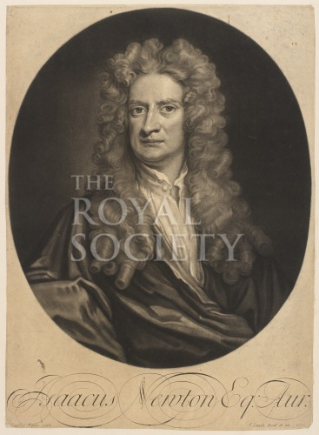
https://pictures.royalsociety.org/assets/object_images/6/75/3576/v0_web.jpg
Newtonian Faction Overview:
As a member of the Newtonian faction you are a friend and ally to Sir Isaac Newton. Your main objective is to convince the committee to name Newton the inventor of Calculus. Before the final meeting, your faction will need to draft a proposal to achieve your objective that you will submit to the vote of the committee. This proposal may address John Keill’s attacks and assertion of Leibniz’s plagiarism in addition to Newton’s claim to calculus. You will collaborate with your fellow faction members and help each other strategize. By working as a team, you can accrue and share information amongst yourselves that may give you the edge in this Calculus War.

Strategy Advice:
- Get to know your fellow faction members.
  - Develop a method for communicating outside of the classroom.
  - Discuss your background, goals, etc. during faction meetings.
- Persuade the Indeterminates to agree with you.
  - Make your speeches persuasive and base them on the readings.
  - Talk to the Indeterminates during intermissions to find out how you can better appeal to them.
- Maximize your Academic Prestige.
  - Complete extra assignments.
  - Win Math Duels.
  - Make informed and persuasive arguments.

Table 6: Assignment of Points to Debate for Newtonian Faction
Roles | Arguments Assigned (Meeting #)
Roles | What evidence supports Newton’s claim to calculus?  (1) | What evidence supports that Leibniz could have plagiarized Newton’s calculus? (1) | What criteria should be weighed when determining someone’s claim to an idea? (2) | Is Newton’s geometrical approach to mathematics appropriate?  Why or why not? (3) | Is Leibniz’s analytic/algebraic approach to mathematics appropriate?  Why or why not?  (3) | Summarize your faction’s arguments and the faults in your opponents’ arguments. (3)
Halley |  | x |  | x
Jones |  |  | y |  | x
Moivre | x
Aston |  |  |  |  |  | x
*Taylor |  |  | x
x denotes an assignment in all games.
y denotes the assignment of an argument if Brook Taylor’s role is not assigned (in a class size <15)

Edmond Halley (1656-1742)
Royal Society Induction: Nov 30, 1678
Nationality: English
Age: 56
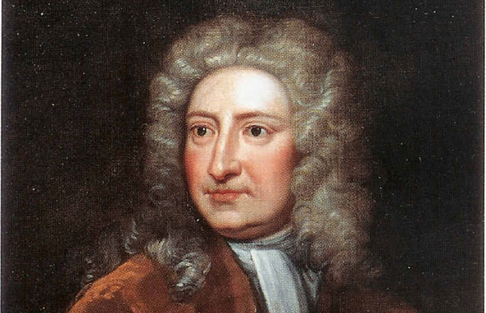
http://www.famous-mathematicians.com/images/edmund-halley.jpg
Faction: Newtonian

Biography:
You were born in Haggerton, near London, on November 8th 1656. The son of a wealthy businessman, you attended the esteemed St. Paul’s School in London followed by the renowned Oxford University where you wrote and published a book on the laws of Johannes Kepler. You spent two years on the island of St. Helena pursuing your passion for astronomy as you attempted to chart for the first time several stars visible only to the southern hemisphere. Upon your return in 1678 you were inducted into the Royal Society at the young age of 22. Thereafter, you travelled far and wide, meeting with internationally renowned astronomers.
You have accepted several offices throughout yout life. Thanks to your friendship with Sir Isaac Newton, you took up the post as deputy controller of the Mint at Chester in 1696, and two years letter, you accepted command of a Royal Navy warship upon which you spent a lengthy time at sea. In 1704 you were appointed the Savilian Professor of Geometry at Oxford University and you maintain this office to this day.
Your passion for astrology has led you to the study of comets. Using the laws of gravity and motion in Newton’s Principia, you have calculated that a certain comet should pass by Earth again in December 1758.

Role in the Calculus Conflict:
You have been great friends with Sir Isaac Newton for decades now. You still recall that day back when you were the spry, young age of 18, when you realized his brilliance. Through talks with other great mathematicians and your own studies you had arrived at the inverse square law of gravity, but a proof eluded you, so you asked Newton his thoughts on the subject. To your astonishment, he had solved the problem almost 20 years prior. You realized the greatness of his notes from that creative and productive period in his life and urged him to publish his research. With your motivation and financial backing, Newton organized his notes from that time and published what you believe is the most influential scientific treatise of all time, his Principia. You recognize your friend’s brilliance, and, having seen his notes from when he discovered both the material in his Principia and his Method of Fluxions, you believe whole-heartedly that he deserves recognition as the inventor of calculus. You will do whatever you can to secure it for him.

Initial Academic Prestige: 200

Objectives/Victory Conditions:
- Primary Objective:
  - See Newtonian faction sheet

- Secondary Objective:
  - Find a method that allows your faction to communicate outside of class.
  - Attain a Final Academic Prestige of 250+.

Prestige Opportunity:
- Find documentation of any comet’s being visible during the year 1712 and bring in the proof. +25 Prestige

Quote: “It is not lawful for mortals to approach divinity nearer than this.” –Edmond Halley regarding Sir Isaac Newton.

Readings That Will Inform Your Debate:
- In Meeting 1:
  - Bardi, Jason Socrates. The Calculus Wars: Newton, Leibniz, and the Greatest Mathematical Clash of All Time. New York, NY: Thunder's Mouth Press, 2006.
  - Newton’s first letter to Leibniz, the “Epistola Prior” (in Latin) written June 1676. http://www.newtonproject.ox.ac.uk/view/texts/normalized/NATP00181
  - Newton’s second letter to Leibniz, the “Epistola Posterior” (in Latin) written October 1676. http://www.newtonproject.ox.ac.uk/view/texts/normalized/NATP00180
- In Meeting 3:
  - Guicciardini, Niccolo. "Analysis and synthesis in Newton's mathematical work." In The Cambridge Companion to Newton, edited by I. Bernard Cohen and George E. Smith, 329-357. New York, NY: Cambridge University Press, 2002

William Jones (1675-1749)
Royal Society Induction: Nov 30, 1711
Nationality: English
Age: 37
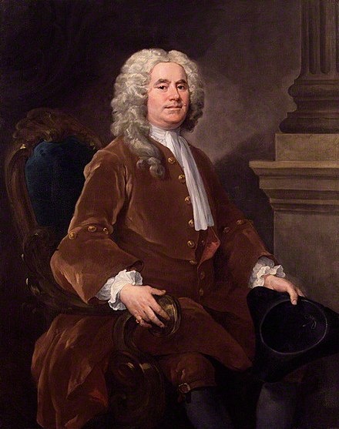
https://upload.wikimedia.org/wikipedia/commons/thumb/7/76/William_Jones%2C_the_Mathematician.jpg/220px-William_Jones%2C_the_Mathematician.jpg
Faction: Newtonian

Biography:
You were born in Anglesey, Wales in 1675 to a humble origin. Your family was poor, so you received your first schooling at a charity school. When a local landowner discovered your mathematical talents, you were granted a job working in London at a merchant’s counting-house. While working this job, you were sent on a voyage to the West Indies. Between 1695 and 1702 you spent a great amount of time at sea. During this time you cultivated your passion for navigation and you passed idle hours by teaching your crewmates about mathematics and navigation.
After your time at sea, you returned to London and became a teacher in mathematics, supporting yourself by lecturing at coffee houses. Thereafter, your tutored a man named Philip Yorke, who would eventually become the Baron Hardwicke of Hardwicke, in mathematics for three years. You consolidated your notes from your lectures and from tutoring and published your Synopsis palmariorum mathesios (Synopsis of elementary mathematics), an introductory text on differential calculus and infinite series, in 1706. In this text, you pioneered the use of the symbol $π$ to denote the ratio between a circle’s circumference and diameter.

Role in the Calculus Conflict:
You are great friends with both Sir Isaac Newton and Edmond Halley, who offered you references when you applied for a position as master at a mathematical school. You are pivotal to the current conflict, as, back in 1708 you purchased the mathematical papers of John Collins. Among these papers you found transcripts of Newton’s notes about his method of infinite series from 1664-1665 when he first encountered calculus. You know and have proof that Newton invented his method of calculus far before Leibniz developed his. For this reason, you know that Sir Isaac Newton should be named the official inventor of Calculus. You are friends with other members of your faction, many of which you met at coffee house lectures.

Initial Academic Prestige: 100

Objectives/Victory Conditions:
- Primary Objective:
  - See Newtonian faction sheet

- Secondary Objective:
  - Challenge a Leibnizian to a Math Duel and win.
  - Attain a Final Academic Prestige of 100+.

Prestige Opportunity:
- Create and submit a timeline about the history of the concept behind $π$ up to 1712. +25 Prestige

Readings That Will Inform Your Debate:
- Collingwood, James; Alexander, Daniel; Kleiner, Alexander. “Rigor in Analysis: From Newton to Cauchy.” Williamsburg, IA: Drake University, 2005. http://historyofmathematics.org/wp-content/uploads/2013/09/2005-Collingwood.pdf

Additional Readings If there is no Brook Taylor:
- Kollerstrom, Nicholas. “The Birth of Calculus: Towards a More Leibnizian View” https://arxiv.org/pdf/1212.2666.pdf
- Guicciardini, Niccolo. "Analysis and synthesis in Newton's mathematical work." In The Cambridge Companion to Newton, edited by I. Bernard Cohen and George E. Smith, 329-357. New York, NY: Cambridge University Press, 2002

Abraham de Moivre (1667-1754)
Royal Society Induction: Nov 30, 1697
Nationality: French
Age: 45
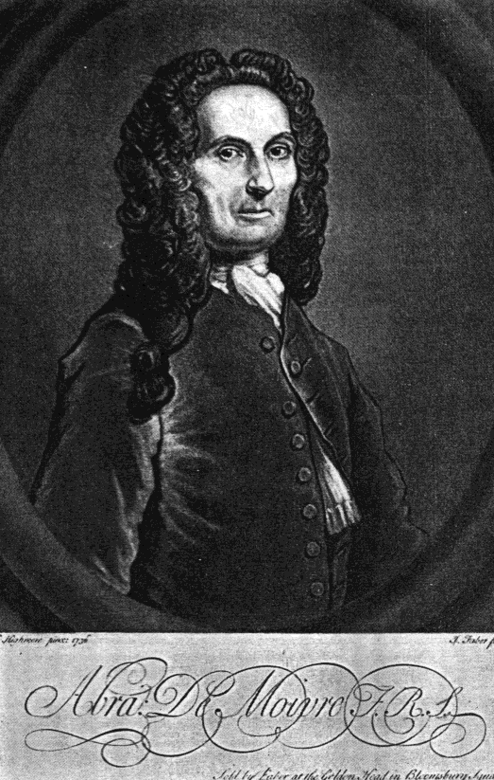
https://www.york.ac.uk/depts/maths/histstat/people/de_moivre.gif
Faction: Newtonian

Biography:
You were born on May 26th, 1667 in Vitry-le-Francois, Champagne, France where your father worked as a surgeon. His job afforded your family a modest living; while your parents could not be described as poor, they were by no means wealthy. Your parents were proud Protestants, who believed wholeheartedly in the teachings of John Calvin. They passed their beliefs down to you, and you embrace Protestantism to this day, no matter the strife it has caused you.
It was not easy for you growing up a Protestant minority in France. Although the Edict of Nantes protected your freedom to worship Protestantism legally, there was still religious tension with the body that most of your fellow countrymen belonged to, the Roman Catholic Church.
In fact you first attended school at Christian Brothers in Vitry, which was an uncommonly tolerant school. When you were eleven, your parents moved you to the Protestant Academy at Sedan where you studied Greek for four years. In 1681, although the Edict of Nantes made it illegal, the Academy at Sedan was suppressed as part of King Louis XIV’s opposition to Protestantism. Hence, you moved to Saumur and began studying logic. At this point you began studying mathematics in your spare time. On of the first texts you read was On Reasoning in Games of Chance by Christiaan Huygens, a prominent Dutch mathematician and mentor to Gottfried Wilhelm Leibniz. By 1684 your parents had relocated to Paris, so you followed them there and enrolled at the College de Harcourt where you received your first formal instruction in mathematics.
In 1685, Louis XIV revoked the Edict of Nantes, removing any legal recognition of Protestantism and amplifying its persecution. You felt the toll of this persecution as you were imprisoned in the priory of St. Martin. Some people believe that shortly after you were imprisoned, you were allowed to emigrate to England. Others believe that you were not afforded an escape to England until 1688. Only you know the truth.
In England, you found your way to London where you gave mathematics lectures in coffee houses and tutored pupils privately to make an honest living. In London you came across Sir Isaac Newton’s Principia and immediately realized the depth of this work. You decided to study it thoroughly, so you bought a copy of the manuscript and parsed out the pages so that you could carry a few with you and read them whilst travelling between pupils.
By 1692 you had become acquainted with Edmond Halley, then the assistant secretary of the Royal Society of London. Halley introduced you to Newton, and you became friends. You wrote your first paper Method of fluxions from your investigation of Newton’s fluxions (his differential calculus) in his Principia. Halley presented your paper to the Royal Society in 1695, and by 1697 you were elected a fellow of the Royal Society. Just last year, with the encouragement of your friend Francis Robartes, you published a Latin version of The Doctrine of Chance, a treatise on probability, in the Royal Society’s journal, the Philosophical Transactions.
Although you have enjoyed lecturing in coffee houses and you have met several good friends including Brook Taylor, and William Jones in this way, your aim was and continues to be to attain the chair of mathematics at a University. You realize that the odds are against you, as a Frenchman vying for such a position at English institutions, but you still persist. You used both Newton and Halley as references. You even begged Johann Bernoulli to sway Leibniz to advocate for your appointment to the chair of mathematics at Cambridge. Even with the help of these widely renowned men, you still have not accomplished your goal.

Role in the Calculus War:
Your allegiance lies with Sir Isaac Newton and your other great friends in your faction. You have a deep understanding of Newton’s fluxions and you appreciate his rigor. You have great respect for Leibniz as well. You realize the potential of his notation, and you lament the conflict that is occurring. Still, you will support your truly genius friend, Newton, and do your best to establish his claim to calculus.

Initial Academic Prestige: 100

Objectives/Victory Conditions:
- Primary Objective:
  - See Newtonian faction sheet

- Secondary Objective
  - Get to know two indeterminates well enough that they agree to be references for you when you seek your next academic chair.
  - Attain a Final Academic Prestige of 150+.

Prestige Opportunity:
- Research any mathematical publications by de Moivre and write a 200-word paper on your impressions of it. +25 Prestige

Readings That Will Inform Your Debate:
- Newton’s first letter to Leibniz, the “Epistola Prior” (in Latin) written June 1676. http://www.newtonproject.ox.ac.uk/view/texts/normalized/NATP00181
- Newton’s second letter to Leibniz, the “Epistola Posterior” (in Latin) written October 1676. http://www.newtonproject.ox.ac.uk/view/texts/normalized/NATP00180
- Bardi, Jason Socrates. The Calculus Wars: Newton, Leibniz, and the Greatest Mathematical Clash of All Time. New York, NY: Thunder's Mouth Press, 2006.

Brook Taylor (1685-1731)
Royal Society Induction: March 20, 1712
Nationality: English
Age: 27
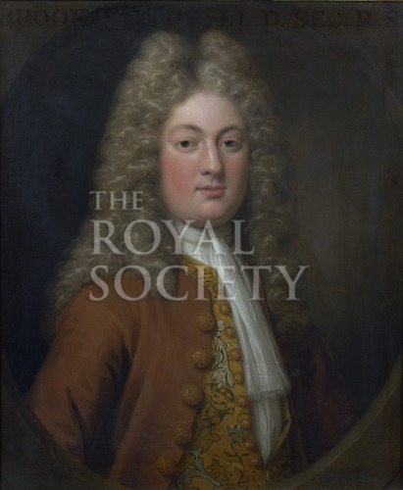
https://pictures.royalsociety.org/assets/object_images/0/14/5410/v0_web.jpg

Faction: Newtonian

Biography:
You were born on August 18th, 1685 in Edmonton, Middlesex, England. Your father was John Taylor, whose own father was Natheniel Taylor, a representative of Befordshire in Oliver Cromwell’s Assembly. Your other grandfather, your mother Olivia Tempest’s father, was Sir John Tempest. Thus, you were born to a family of fair status and wealth. Accordingly, your family hired private tutors to guide you in your education. Your private instructions laid you a good foundation in the classics and mathematics. You attended a school for the first time when you enrolled at St. John’s College Cambridge at the age of 17. At St. John’s you furthered your love for mathematics on your way to graduating with a Doctorate of Law in 1709.
Of course, a year earlier, you had already written an impressive mathematics paper addressing the problem of the center of an oscillating body. Your study of Sir Isaac Newton’s fluxions (his differential calculus) equipped you with the ability to tackle this problem.

Role in the Calculus Conflict:
You are a friend of John Machin, who essentially secured your election to the Royal Society. John Machin is a close friend of Newton, Edmond Halley, Abraham de Moivre, and William Jones. Thus, you are an acquaintance of each of them. You are a young mathematician, and although you support Newton’s method of fluxions, you have seen the symbolism of Leibniz’s calculus used in L’hopital’s textbook.

Initial Academic Prestige: 50

Objectives/Victory Conditions:
- Primary Objective:
  - See Newtonian faction sheet

- Secondary Objective:
  - Defeat Johann Bernoulli in a Math Duel.
  - Attain a Final Academic Prestige of 100+.

Prestige Opportunity:
- Research and write a 200-word paper on the history of the Taylor Series before 1712. +25 Prestige

Readings That Will Inform Your Debate:
- Kollerstrom, Nicholas. “The Birth of Calculus: Towards a More Leibnizian View” https://arxiv.org/pdf/1212.2666.pdf

Francis Aston (1645-1715)
Royal Society Induction: Nov 30, 1678
Nationality: English
Age: 68
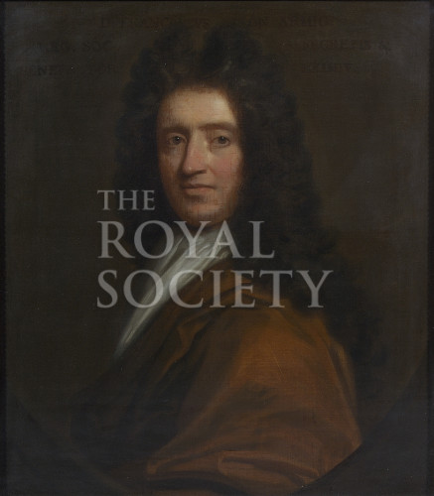
https://pictures.royalsociety.org/assets/object_images/6/35/2536/v0_web.jpg
Faction: Newtonian

Office: Secretary of the Committee

Official Duties:
- Take role at the beginning of each meeting.
- Keep track of the time during each session.
  - Let Abraham Hill, the chair of the committee, know when it is time to open and close meetings.
Other Duties:
- You will have to lead all Math Duels in which Hill is a participant.

Biography:
You were born in 1645. You began attending Trinity College, Cambridge in 1661. You became good friends with Sir Isaac Newton shortly thereafter. In 1669 you even asked him for advice before you left for the Continent on an academic journey.
You take pride in your membership in the Royal Society of Fellows. You served as Second Secretary in 1680 and 1681 while Robert Hooke was the First Secretary. You attained Hooke’s position the next year due to your obvious efforts and impressive attendance records at the Council meetings. Later, between the years of 1694 and 1711, you served on the Council of the Royal Society for a total of seven years. You are delighted to be on this council.

Role in the Calculus Conflict:
You are excited to serve this committee as the secretary. You wish to see your friend Isaac Newton achieve the title of inventor of calculus that you believe he deserves. You are very familiar with Robert Hooke and with the soured relationship between him and Newton that led to Newton’s resistance to publishing.

Initial Academic Prestige: 50

Objectives/Victory Conditions:
- Primary Objective:
  - See Newtonian faction sheet

- Secondary Objective:
  - You have the utmost respect for the Royal Society. Hold anyone who disrespects the by-laws accountable.
  - Attain a Final Academic Prestige of 100+.

Prestige Opportunity:
- Type up notes of the first two meetings and post them online for your fellow committee members to see. +25 Prestige

Leibnizian Faction Sheet/Role Sheets

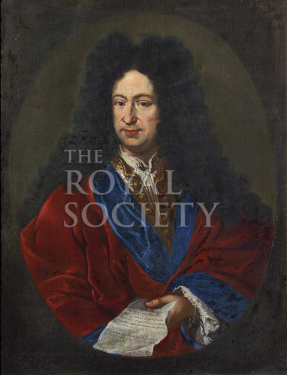
https://pictures.royalsociety.org/assets/object_images/0/46/2640/v0_web.jpg

Leibnizian Faction Overview:
As a member of the Leibnizian faction you are a friend and ally to Gottfried Wilhelm Leibniz. Your main objective is to convince the committee to name Leibniz the inventor of Calculus. . Before the final meeting, your faction will need to draft a proposal to achieve your objective that you will submit to the vote of the committee. This proposal may demand an apology from John Keill and refute the accusation of plagiarism in addition to reasserting Leibniz’s claim to calculus. You will collaborate with your fellow faction members and help each other strategize. By working as a team, you can accrue and share information amongst yourselves that may give you the edge in this Calculus War.

Strategy Advice:
- Get to know your fellow faction members.
  - Develop a method for communicating outside of the classroom.
  - Discuss your background, goals, etc. during faction meetings.
- Persuade the Indeterminates to agree with you.
  - Make your speeches persuasive and base them on the readings.
  - Talk to the Indeterminates during intermissions to find out how you can better appeal to them.
- Maximize your Academic Prestige.
  - Complete extra assignments.
  - Win at Math Duels.
  - Make intelligent and persuasive arguments.

Table 7: Assignment of Points of Discussion for Leibnizian Faction
Roles | Arguments Assigned (Meeting #)
Roles | What evidence supports Leibniz’s claim to calculus?  (1) | What evidence denies the accusation that Leibniz plagiarized Newton’s calculus? (1) | What criteria should be weighed when determining someone’s claim to an idea? (2) | Is Newton’s geometrical approach to mathematics appropriate?  Why or why not? (3) | Is Leibniz’s analytic/algebraic approach to mathematics appropriate?  Why or why not?  (3) | Summarize your faction’s arguments and the faults in your opponents’ arguments. (3)
Bernoulli |  |  |  | x |  | x
Poleni | y |  |  |  | x
Bonet |  | x
Wolff |  |  | x
Schuechzer | x
x denotes an assignment in all games.
y denotes the assignment of an argument if Scheuchzer’s role is not assigned (in a class size <15).

Johann Bernoulli (1667-1748)
Royal Society Induction: Jan 12, 1712
Nationality:
Age: 45
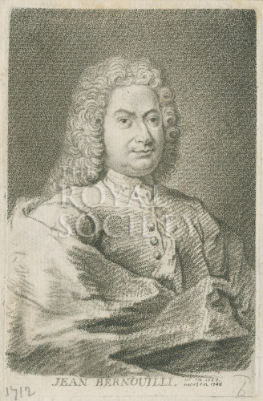
https://pictures.royalsociety.org/image-rs-12171
Faction: Leibnizian

Biography:
You were born on July 27th 1667 in Basel Switzerland. You are the tenth child of your parents Nicolaus and Margaret Bernoulli. Your brother, Jacob Bernoulli, who is also a prominent figure in mathematics is twelve years your senior. Your parents ensured that you had a proper education and were taught morals and religion. You and your family are Calvinists. Though your parents initially intended for you to take control of the family spice business, you followed Jacob’s path towards a mathematical career. You enrolled in the University of Basel in 1683 at the age of 16, and, compromising with your parents, you began studying medicine.
Although you were on the course to receive a medical degree, you spent much of your time studying the calculus of Gottfried Wilhelm Leibniz with Jacob who then taught experimental physics at the University of Basel.
In 1691 you relocated to Geneva where you earned an income by giving lectures on differential calculus. Next, you moved to France, where you met L’Hopital who sought your tutelage in the calculus of Leibniz. L’Hopital paid you generously for these sessions, and you continued your instruction of him by letter even when you returned to Basel. In 1696 L’Hopital published the first calculus textbook Analyse des infiniment petits pour l’intelligence des lignes courbes (1696) that he based on your lectures about Leibniz’s calculus. You felt that you deserved more acknowledgment that he supplied you in the textbook. In fact, people have started calling one the rules you developed on your own L’Hopital’s rule, and this bothers you.
You produced other original mathematical ideas as well. In 1694 you investigated the function $y=x^{x}$ and discovered the method of integration by parts. As a result of these and other mathematical innovations, you received the chair of mathematics at Groningen in 1695. In June of 1696 you posed the famous “brachistochrone” problem to which only yourself, Sir Isaac Newton, Leibniz, and your brother Jacob gave correct solutions.
By 1705 you had a wife and two children. You decided to take your family back to Basel to be closer to family, but shortly thereafter, your brother Jacob died. You worked hard and attained his chair of mathematics at Basel. You enjoy this position to this day.

Role in the Calculus Conflict:
You have admired Leibniz since you were a young lad attending the University of Basel and vehemently studying his papers on calculus alongside your brother Jacob. You are the most mathematically inclined follower of Leibniz, and your notes on his calculus that L’Hopital compiled into the first textbook have been spreading Leibniz’s calculus to brilliant minds young and old across Continental Europe. Furthermore, you have devised many formulas for finding tricky integrals and derivatives. If Leibniz had not published his calculus back in that critical period of your life in 1684, you would not be the man you are today. You will encourage your fellow faction members and persuade the committee that John Keill’s remarks against Leibniz are slanderous. You have no doubt that Leibniz is the true inventor of calculus—even if Newton arrived at his method of fluxions first. You and Leibniz have spent decades expanding the methods of calculus and disseminating this analytic tool throughout Europe.

Initial Academic Prestige: 200

Objectives/Victory Conditions:
- Primary Objective:
  - See Leibnizian faction sheet

- Secondary Objective
  - Find a method that allows your faction to communicate outside of class
  - Defeat Brook Taylor in a Math Duel.
  - Attain a Final Academic Prestige of 250+.

Prestige Opportunity:
- . +25 Prestige

Readings That Will Inform Your Debate:
- Guicciardini, Niccolo. "Analysis and synthesis in Newton's mathematical work." In The Cambridge Companion to Newton, edited by I. Bernard Cohen and George E. Smith, 329-357. New York, NY: Cambridge University Press, 2002.

Giovanni Marquis Poleni (1683-1761)
Royal Society Induction: Nov 30, 1710
Nationality: Venetian
Age: 29
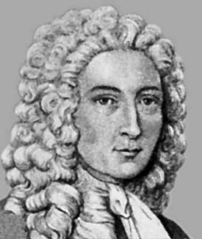
https://upload.wikimedia.org/wikipedia/commons/1/15/Giovanni_Poleni.jpeg
Faction: Leibnizian

Biography:
You were born in the August of 1683 in Venice, Venetian States. You inherited the title Marquis of the Holy Roman Empire, which was granted to your father, Jacob Poleni, by Emperor Leopold I. In your younger years, you first studied philosophy and theology in Venice. Your parents, however, encouraged you to pursue a career in law. Eventually, your love for mathematics and science, areas introduced to you by your father, became your passion and the focus of your career. In 1709, you attained the chair of Astronomy and Meteorology at the University of Padua. At this time, you also published a compilation of dissertations that included information about a calculating machine you had constructed based on the work of Gottfried Wilhelm Leibniz.
Your main ambitions at this time are to become the professor of physics and to further develop hydraulic engineering, an area in which you are an expert.

Role in the Calculus Conflict:
You have been obsessed with Leibniz ever since you first encountered his genius design for a calculating machine that could not only add and subtract, but even multiply and divide! One day, you hope to join the esteemed Berlin Sciences Academy that Leibniz was fundamental in founding. You have impressive mathematical talent, and you look to impress all those around you. You especially appreciate mathematics that can quickly and efficiently be applied as a tool. That is partly why you admire Leibniz so—his method is efficient and helps you with your hydraulic engineering.

Initial Academic Prestige: 100

Objectives/Victory Conditions:
- Primary Objective:
  - See Leibnizian faction sheet

- Secondary Objective
  - Challenge a Newtonian to a Math Duel and win.
  - Attain a Final Academic Prestige of 100+.

Prestige Opportunity:
- Create 2 problems involving hydraulic engineering and solve them. +25 Prestige

Readings That Will Inform Your Debate:
- Collingwood, James; Alexander, Daniel; Kleiner, Alexander. “Rigor in Analysis: From Newton to Cauchy.” Williamsburg, IA: Drake University, 2005. http://historyofmathematics.org/wp-content/uploads/2013/09/2005-Collingwood.pdf

Additional Readings If there is no Johann Scheuchzer:
- Kollerstrom, Nicholas. “The Birth of Calculus: Towards a More Leibnizian View” https://arxiv.org/pdf/1212.2666.pdf

Johann Jakob Scheuchzer (1672-1733)
Royal Society Induction: Nov 30, 1703
Nationality: Swiss
Age: 39
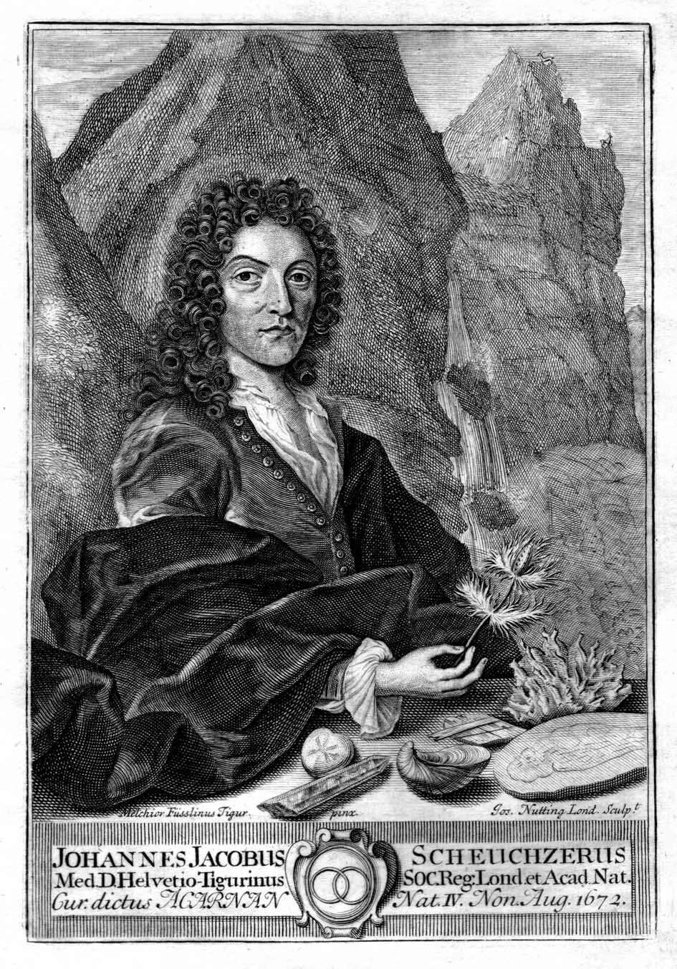
https://upload.wikimedia.org/wikipedia/commons/d/d0/Johann_Jakob_Scheuchzer_1708.jpg
Faction: Leibnizian

Biography:
You were born on August 2nd 1672, the son of the senior town physician of Zurich. It was there that you received your boyhood education, and you attended the University of Altdorf near Nuremburg in 1692 seeking to enter the medical field. In 1694, you received your M.D at the University of Utrecht before returning to Altdorf to finish your studies in mathematics. Two years later, in 1696, you returned to Zurich and became the junior town physician (Poliater). At the time you were promised a professorship in mathematics, but you did not receive this until you were appointed the chair of physics in 1710.
You have travelled throughout your homeland of Switzerland and produced several manuscripts about your travels. You have written about the Swiss mountains, the Swiss rivers, lakes and mountain baths, and Swiss meteorology and geology. Earlier this year, you even published a map of Switzerland, which you fancy the most accurate to date.

Role in the Calculus Conflict:
During your journey throughout the Continent, you were lucky enough to meet Wilhelm Gottfried Leibniz. You find his philosophy fascinating, but worry that it may be too ideal and ungrounded at times. Still, he is your friend. You and the rest of Europe have known him as the inventor of calculus since he first published his De Novo.. back in 1684. Leibniz has always contended that he arrived at calculus independently of Newton. You believe him. You intend to support his claim to calculus against the wicked accusations of John Keill.

Initial Academic Prestige: 50

Objectives/Victory Conditions:
- Primary Objective:
  - See Leibnizian faction sheet

- Secondary Objective:
  - Mention Switzerland every time that you talk in a meeting.
  - Attain a Final Academic Prestige of 100+.

Prestige Opportunity:
- Research any original publication of Scheuchzer and write a 200-word paper about your impressions of it. +25 Prestige

Readings That Will Inform Your Debate:
- Kollerstrom, Nicholas. “The Birth of Calculus: Towards a More Leibnizian View” https://arxiv.org/pdf/1212.2666.pdf

Christian Freiherr Von Wolff (1679-1754)
Royal Society Induction: Nov 8, 1710
Nationality: Austrian
Age: 33
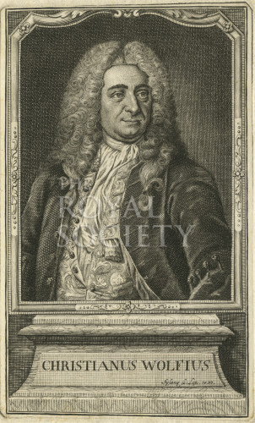
https://pictures.royalsociety.org/assets/object_images/4/74/10474/v0_web.jpg
Faction: Leibnizian

Biography:
You were born on January 24th 1679 in Breslau, Silesia to a modest family headed by your father who worked as a tanner. You attended the University of Jena where you studied mathematics, physics, and philosophy. In 1703 you received a position at the University of Leipzig that recognized your ability to teach courses, though you were not a professor. You lectured there until 1706, when you received a professorship of mathematics and natural philosophy at the University of Halle. Your next ambition is to prove your ability in physics and attain that chair as well.

Role in the Calculus Conflict:
You are a dear friend of Gottfried Wilhelm Leibniz. You have learned much from him over the years through your letters of correspondence. You modeled your philosophy after his, molding it with your own ingenuity. You believe that philosophy should “embrace in its survey the whole of human knowledge” and you insist “everywhere on clear and methodic exposition”. Thus, you seek to apply reason to all problems in order to arrive at a methodology for resolving them. You plan to help your friend Leibniz maintain the title as inventor of calculus that you know he deserves and clear his name of plagiarism. To do this, you will develop and propose a method of assigning intellectual property rights that will establish Leibniz’s claim to calculus.

Initial Academic Prestige: 100

Objectives/Victory Conditions:
- Primary Objective:
  - See Leibnizian faction sheet

- Secondary Objective
  - Attain a Final Academic Prestige of 150+

Prestige Opportunity:
- Find a quote relevant to the current dispute in the letters between yourself and Leibniz and turn it in. +25 Prestige

Readings That Will Inform Your Debate:
- Kollerstrom, Nicholas. “The Birth of Calculus: Towards a More Leibnizian View” https://arxiv.org/pdf/1212.2666.pdf

Ludwig Friedrich Bonet (1670-1763)
Royal Society Induction: Nov 30. 1711
Nationality: Swiss
Age: 27
Faction: Leibnizian

Biography:
You were born to a family originating in Naples that relocated to Geneva in the time of the Reformation. Your father was the court physician to the Duke von Longveville, and your mother was a daughter of Frederich Spanheim, a famous Calvinist. In 1695 you received your M.D in Leiden (Germany). At this time, you received great recognition from the Elector of Brandenburg and eventual King in Prussia, Friedrich III, appointed you Councilor and Agent in England. Later, in 1701 the now King in Prussia Friedrich III named you Resident Minister at the Prussian court in England. In the same year, you also accomplished a doctorate of jurisprudence at Oxford.
By now you have been living in England for about 15 years. You enjoy your work as the head Prussian diplomat to England but you do miss your home back in Geneva. You are chiefly interested in theology and law but are proficient in mathematics as well. You were just recently inducted into the Royal Society of London, and this is your first experience serving on a council. You are eager to make your mark.
Now that you are a fellow of the Royal Society of London, you have turned your sights towards your next goal; you seek membership in the Academy of Sciences in Berlin, a similar society that Gottfried Wilhelm Leibniz was instrumental in founding.

Role in the Calculus Conflict:
You have known Leibniz for a while now and are familiar with his work. He too shares your love of diplomacy, and you intend to represent him and the Prussian people to the best of your ability. Having served as a spokesman for the Prussian kings for years now in England, you know all too well that Englishmen are often conceited, thinking themselves and their country to be supreme in all aspects. Be on the look out for any such English bias, and be sure to tactfully point it out to the committee.

Initial Academic Prestige: 50

Objectives/Victory Conditions:
- Primary Objective:
  - See Leibnizian faction sheet

- Secondary Objective:
  - With the help of your fellow Leibnizians, draft your faction’s proposal for the settlement of this conflict and propose it yourself to the committee.
  - Accrue enough Academic Prestige 90+ to boost your chances at induction into the Academy of Sciences in Berlin.
  - Persuade William Burnet to vote for your faction’s proposal.

Prestige Opportunity:
- Research a German mathematician predecessor to Leibniz and write 200 words about him/her. +25 Prestige

Readings That Will Inform Your Debate:
- Kollerstrom, Nicholas. “The Birth of Calculus: Towards a More Leibnizian View” https://arxiv.org/pdf/1212.2666.pdf

Indeterminate Role Sheets


https://royalsociety.org/~/media/Redesign2015/rs-crest-footer.png?w=200

Indeterminate Faction Overview:
As a member of the Indeterminate faction you are free to choose which side to support over the three meetings. You and your fellow faction members have different backgrounds and different objectives that you will individually pursue. Still, you should get to know your fellow Indeterminates when you have the opportunity. You may be able to help each other attain your goals.
You all have the same responsibility. Your valuable votes will determine whether the Newtonians or Leibnizians win the title of inventor of calculus for the man they support. Although your role is more ambiguous, it is the most important in the game. The Newtonians and Leibnizians are focused on swaying you to vote for their cause. Be critical and skeptical when listening to their arguments, as though your reputation were on the line. You never know when it might be.
To help you keep track with the discussion from meeting to meeting, you have an “Indeterminate Voting Reasons” sheet attached to your role sheet. You should take notes on the discussion in each meeting and reflect on the arguments using that sheet. You will have to turn it in for a grade when you vote at the end of the final game session.

Abraham Hill (1633-1721)
Royal Society Induction: November 28, 1660
Nationality: English
Age: 79

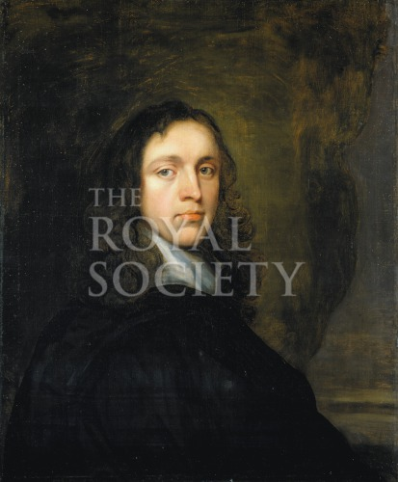
https://pictures.royalsociety.org/image-rs-9738
Faction: Indeterminate

Office: Chairman of the Committee

Official Duties:
- Open the meeting by asking a volunteer to give an opening prayer.
- Before the debate in the first meeting read aloud the “Committee Brief”.
- Before discussion in the second and third meeting ask “is there any news?”.
  - People who received Chaotic Events cards will then reveal them.
- Ensure that discussion is on topic, productive, and professional.
- Close each meeting on time.
  - The committee secretary, Francis Aston, should keep track of time for you.

Other Duties:
- In the event of a Math Duel that does not involve yourself, it is your duty to present the question, which will be supplied by the GM.

Biography:
You were born in London, England in 1635. You were the first son of a well-off merchant named Richard and his wife Agnes Hill. You received ordinary schooling and were raised by your father to also become a merchant probably specializing in foreign trade. In 1660, your parents both died and your sizeable inheritance allowed you to further foster your intrigue in the study of languages and natural philosophy, which you had already delighted in discussing with company at Gresham College. It was with the ties you developed there that you became one of the foundational members of the Royal Society of London in 1663.
Still, you are more than just a founding member. You are now in your 33rd year serving as a Member of Council. You have also served as the Treasurer for a total of 25 years and the Secretary for another 2 years.

Role in the Calculus Conflict:
The President of the Royal Society of London has entrusted you as the chairman of this committee. You have served on over 20 committees in your time with the Royal Society and you look forward to serving the society once again with your calm and composed demeanor. Although you have an abundance of experience on committees, you realize that you are nowhere near the expert on mathematics and science that several other members of this committee are. You do not completely understand this analytical tool they call calculus, but you have heard that it has valuable application. You value utility and will be sensitive to arguments based on utility and applicability. It is your imperative to keep the meetings running smoothly, and to usher this committee towards a final decision in the last meeting.

Initial Academic Prestige: 50

Objectives/Victory Conditions:
- Primary Objective:
  - Hone your knowledge of this new tool of calculus such that you are able to win a Math Duel.

- Secondary Objective:
  - Keep everyone on track, such that the GM never has to intervene and return the discussion to the matter at hand.
  - Attain a Final Academic Prestige of 100.

Prestige Opportunity:
- Write and solve a calculus problem that involves the Royal Society of London. +25 Prestige

Quote:
“Abraham Hill’s claim to remembrance is founded not on contributions to the advancement of knowledge (for he made none), but on his services to the Royal Society… where his administrative and business abilities were exercised.” –R. E. W. Maddison

The Committee Brief:
My good Fellows of the Royal Society, we join here today to settle a dispute between two of our honorable Fellows Mr. John Keill and Mr. Gottfried Wilhelm Leibniz. I remind you today on March 6th 1712 that we are charged with the responsibility of coming to a conclusion regarding this matter by our last session on April 20th. After speaking with you all, I have determined that we shall be able to meet here three times before then to address this dispute. May we all act in accordance with the by-laws of the Royal Society and keep our discussions in the tone of the fine gentleman I know us all to be.
The question we must answer, my good men, is “Do we find Mr. Keill at fault in his accusations that Mr. Leibniz stole the analytic tool known as calculus from Sir Isaac Newton?”

Table: Indeterminate Voting Reasons
NAME: Abraham Hill
Meeting #: | 1 | 2 | 3
Newtonian  Arguments | Pros: | Pros: | Pros:
Newtonian  Arguments | Cons: | Cons: | Cons:
Leibnizian  Arguments | Pros: | Pros: | Pros:
Leibnizian  Arguments | Cons: | Cons: | Cons:
You are to fill this table out during the game and turn it in at the end of the game.

William Burnet (1687-1729)
Royal Society Induction: Feb 13, 1706
Nationality: English
Age: 25
Faction: Indeterminate

Biography:
You were born in 1687 at Hague in the Netherlands to your father, Gilbert Burnet. Gilbert held the post of bishop of Salisbury. He was once a chaplain to Charles II, but he had smartly changed allegiance to William and Mary. When he went to the Netherlands to pay his respects to William and Mary, he met your mother, Mary Scott, who was a wealthy woman born in the Netherlands but of Scottish descent.
Your parents named you after your godfather who would become the king of England in 1689. When you were thirteen, you enrolled at Trinity College, Cambridge, but you were soon expelled for laziness and insubordination. For a short time, while you were there, though, you did receive the tutelage of Sir Isaac Newton. Later in your education, you became a close acquaintance with Gottfreid Wilhelm Leibniz. As a young man, you were charming but rash. Moreover, you had a keen interest in matters of the academics, although your strong connections with the Whigs in England meant that you were destined for a life in politics. One day you hope to move to the New World and become a leader in one of the colonies.

Role in the Calculus Conflict:
You were lucky enough in your life to have learned from both Newton and Leibniz. You appreciate the work of both men, and are interested to learn of the discoveries of the other men on the committee. You are a man who craves intellectual stimulation. You care less about the concrete facts of the case, and will be more responsive to novel and accurate logical reasoning.

Initial Academic Prestige: 50

Contribution to the Discussion: (Second Meeting)
- Since you have had the fortune of learning from both Newton and Leibniz, you are familiar with both of their notations. At the beginning of the second meeting, introduce Newton’s notation and approach to differentiation versus Leibniz’s notation and approach to differentiation.

Objectives/Victory Conditions:
- Primary Objective: Get in the good graces of those committee members who have any ties to political power. Draft a petition stating why you should be chosen to head a colony in the New World and have them all sign it.

- Secondary Objective:
  - Even though your main ambitions are in politics, you also seek to establish your intelligence. Win a Math Duel.
  - Generate a reputation. Be the first to introduce yourself to the Committee during the second meeting.
  - Attain a Final Academic Prestige of 100+.

Strategy Advice:
- Intermissions and periods between classes will be of utmost importance to your primary objective. Use them wisely to reach out to other students.

Prestige Opportunity:
- Compile a list of committee members who have gone on exquisite journeys like the one you dream of embarking on to the New World. +25 Prestige

Table: Indeterminate Voting Reasons
NAME: William Burnet
Meeting #: | 1 | 2 | 3
Newtonian  Arguments | Pros: | Pros: | Pros:
Newtonian  Arguments | Cons: | Cons: | Cons:
Leibnizian  Arguments | Pros: | Pros: | Pros:
Leibnizian  Arguments | Cons: | Cons: | Cons:
You are to fill this table out during the game and turn it in at the end of the game.

Francis Robartes (1650-1718)
Royal Society Induction: Dec 11, 1673
Nationality: English
Age: 62
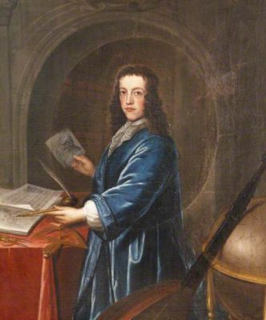
http://www.thepeerage.com/323914_001.jpg
Faction: Indeterminate

Biography:
You were born in January 1650 in England to your father John Robartes, the 1st Earl of Radnor, and your mother Isabella Smythe. At the young age of thirteen you first enrolled at Christ’s College, Cambridge. You have always been interested in music and have even composed several pieces and written manuscripts on the theory of sound. In 1673 you were inducted into the Royal Society Later, by 1689 you became the vice-president, and you still hold the position today. Also in 1673, you began your political career. Through the years you have risen through the ranks and have attained a position in the House of Commons. You want to be re-elected next year, so you should be careful not to upset the wrong people.
In addition to your interest in music and politics, you are a capable mathematician. In fact, just two years ago you published your "Concerning the Proportion of Mathematical Points to Each Other” in the 1710 publication of the Royal Society’s Philosophical Translations.

Role in the Calculus Conflict:
You are proficient in mathematics and, as the Vice President of the Royal Society, you know who both Sir Isaac Newton and Gottfried Wilhelm Leibniz are. You have a slight bias to support Newton, because you wish to see a fellow Englishman celebrated, but you also realize that such biases should have no place in the Royal Society. Judge each side’s arguments keenly.

Initial Academic Prestige: 50

Contribution to the Discussion:
- You must prepare a prayer and a statement of gratitude to the current monarch in England that you will sing or recite at the beginning of one of the three meeting sessions.

Objectives/Victory Conditions:
- Primary Objective:
  - You are a politician. You have charisma and want to support the members of the Royal Society. Listen to the arguments of your fellows and write a note to the most persuasive fellow in each meeting telling them what you liked about their presentation. You will submit a copy of each note to your instructor as well.

- Secondary Objective:
  - Generate a reputation. Be the first member to introduce yourself to the Committee in the first meeting.
  - Avoid any Math Duels. There is no sense in risking your reputation.
  - Attain a Final Academic Prestige of 90+.

Prestige Opportunity:
- Read your publication “Concerning the Proportion of Mathematical Points to Each Other” and write a 150-word description conveying your thoughts about the logic and conclusions. Would they hold up against today’s rigor? +25 Prestige

Table: Indeterminate Voting Reasons
NAME: Francis Robartes
Meeting #: | 1 | 2 | 3
Newtonian  Arguments | Pros: | Pros: | Pros:
Newtonian  Arguments | Cons: | Cons: | Cons:
Leibnizian  Arguments | Pros: | Pros: | Pros:
Leibnizian  Arguments | Cons: | Cons: | Cons:
You are to fill this table out during the game and turn it in at the end of the game.

Antonio Vallisneri (1661-1730)
Royal Society Induction: Nov 30, 1703
Nationality: Tuscan
Age: 51
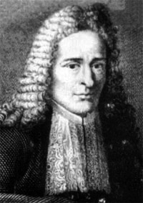
Faction: Indeterminate

Biography:
You were born in 1661 at Trassilico, a town in the region of Tuscany near Modena. You enrolled at the University of Bologna where you focused on medicine under the tutelage of the renowned Marcello Malpighi. You proceeded to earn your M.D. from the University of Modena and Reggio Emilia in 1684. You practiced medicine there in Reggio for the next 16 years before you were appointed to the chair of medicine at the University of Padua in 1700, a position you continue to hold today. In 1700 you also produced a paper “On the Strange Origin of Many Insects” that furthered the argument against spontaneous generation of life, as you were the first to detect insect eggs as the source of larvae in plant galls. You are passionate about applying the scientific method to the abundance of life found in nature. Your latest publication this year was a paper on ostriches.

Role in the Calculus Conflict:
You have heard of the new method of analysis. How could you not have? Although, you do not completely understand it, you have heard from colleagues that it is an important tool in mathematics. You have never heard Sir Isaac Newton’s name associated with the tool. Rather, the first time you heard about the development at least 20 years ago, it was the first time you had heard of Gottfried Wilhelm Leibniz, who has been celebrated as the inventor without contest until now. You do not have the same background in mathematics as several of the other members of the present committee, you are a brilliant scientist and you believe whole-heartedly in the methods of empiricism and reason. You appreciate sound logic and arguments supported by experimental evidence. You will bring your unique background to this committee and help decide whether Leibniz deserves claim to the invention of calculus or whether it belongs to Newton.

Initial Academic Prestige: 50

Contribution to the Discussion:
- At the beginning of the first meeting, you should ask for someone to explain what calculus is. Take note of who can give a satisfactory answer.

Objectives/Victory Conditions:
- Primary Objective:
  - You seek to demonstrate your intelligence as a representative of the people of Tuscany. Think critically during discussions and ask questions. Ask at least three different questions each meeting.

- Secondary Objective:
  - Keep your ears open for any ad hominem attacks against the English or against the Continentals. These tactics disgust you. Record at least two such instances on your Voting Reasons handout.
  - You wish to create a Tuscan Academy of Sciences. Draft a charter and get signatures equivalent to 250+ Academic Prestige Points. You must have at least one Newtonian and one Leibnizian signature.
  - Attain a Final Academic Prestige of 100+.

Prestige Opportunity:
- Think of five biology-related calculus problems. Submit these questions alongside your solutions to them. +25 Prestige

Duties:
- If both Abraham Hill, the chair of the committee, and Francis Aston, the secretary of the committee, are involved in a Math Duel, then it is your duty to present the question, which will be supplied by the GM.

Table: Indeterminate Voting Reasons
NAME: Antonio Vallisneri
Meeting #: | 1 | 2 | 3
Newtonian  Arguments | Pros: | Pros: | Pros:
Newtonian  Arguments | Cons: | Cons: | Cons:
Leibnizian  Arguments | Pros: | Pros: | Pros:
Leibnizian  Arguments | Cons: | Cons: | Cons:
You are to fill this table out during the game and turn it in at the end of the game.

John Arbuthnot (1667-1735)
Royal Society Induction: Nov 30, 1704
Nationality: Scottish
Age: 45
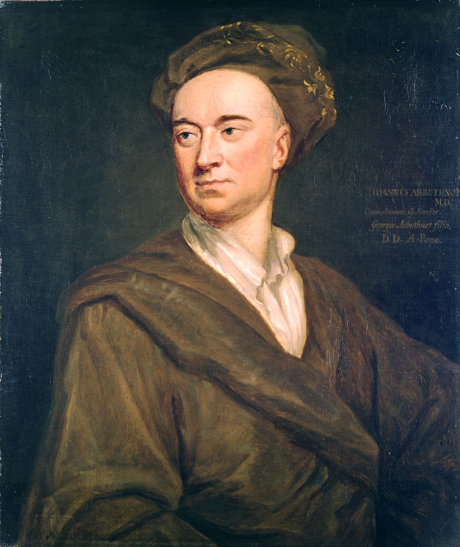
https://upload.wikimedia.org/wikipedia/commons/1/17/Arbuthnot_John_Kneller.jpg
Faction: Indeterminate

Biography:
You were born in the April of 1667 in Inverbervie, Scotland. Your father is a Scottish clergyman, or he was until he refused to conform to the Presbyterian system instituted as a result of the Revolution. You attended multiple colleges including the University of Aberdeen and the University of St. Andrews. You received your M.D. in 1696, and then relocated to London where you first tutored mathematics to make a living. In 1697, you published your “Essay on the usefulness of Mathematical Learning.” This publication granted you much favor. It, along with your personality—you have been described as a man of courteous demeanor and capable of well-read conversation—helped you take advantage of your degree. Being at the right place at the right time did not hurt either.
You were in Epsom in 1705 when Prince George of Denmark grew sick. You were requested and skillfully able to restore his health. Since then, he has acted as your patron and you have even gained the favor of Queen Anne, as you were appointed her fourth physician in 1709.
Back in 1704 you were inducted as a fellow into the Royal Society of London. They elected you because of a brilliant paper you wrote and presented. In it you took data on births in 1629, established that there are an equal number of males and females born, and used this fact to support the supremacy of monogamy. In 1710 you received the honor of induction into the Royal College of Physicians. Although you are an accomplished physician, your true passion is in literature, specifically, satire. You have been experimenting with the idea of writing satires that warn of the abuses of learning in every branch of human knowledge.

Role in the Calculus Conflict:
Although you have been more focused on your medical practice and your creation of satire recently, you still retain your knowledge of mathematics and are aware of both Gottfried Wilhelm Leibniz and Sir Isaac Newton’s greatness. You once studied the former’s analytic tools and the latter’s harnessing of nature via mathematics in his Principia. Still, you do not really know who deserves claim to calculus. Upon notification that you were appointed to this committee, you were somewhat surprised, but you are excited to refresh yourself in the art of mathematics.

Initial Academic Prestige: 50

Objectives/Victory Conditions:
- Primary Objective:
  - You are skeptical by nature. While listening to the arguments, find one in each meeting that seems invalid to you. Research them and write 100 words of analysis on each.

- Secondary Objective:
  - You are not afraid of losing. Challenge someone who seems unsure of his abilities to a Math Duel.
  - Attain a Final Academic Prestige of 100+.

Prestige Opportunity:
- Write at least 150 words of a satire on the methods of calculus. (Hint: Did they completely make sense at this point? Why did they need to be more rigorously defined later?) + 25 Prestige

Quotes: “Mathematical Knowledge adds a manly Vigour to the Mind, frees it from Prejudice, Credulity, and Superstition.” –Dr. John Arbuthnot

Table: Indeterminate Voting Reasons
NAME: John Arbuthnot
Meeting #: | 1 | 2 | 3
Newtonian  Arguments | Pros: | Pros: | Pros:
Newtonian  Arguments | Cons: | Cons: | Cons:
Leibnizian  Arguments | Pros: | Pros: | Pros:
Leibnizian  Arguments | Cons: | Cons: | Cons:
You are to fill this table out during the game and turn it in at the end of the game.

Appendix C: Chaotic Events
Print these out and cut them into strips before the game session.
PROOF OF CONCEPT:

Role: Abraham Hill
Chaotic Event: The Royal Society honors you for your exemplary work as a committee chair.
Effect: +20

Role: Abraham Hill
Chaotic Event:
Effect: -10

Role: William Burnet
Chaotic Event:
Effect: +20

Role: William Burnet
Chaotic Event: An anonymous article reveals the fact that you were expelled from Trinity College.
Effect: -10

Role: Francis Robartes
Chaotic Event:
Effect: +20

Role: Francis Robartes
Chaotic Event:
Effect: -10

Role: Antonio Vallisneri
Chaotic Event: You were able to get detailed notes about the elusive chameleon.
Effect: +20

Role: Antonio Vallisneri
Chaotic Event: You can no longer find a manuscript you were working on for over a year. On ostrich must have eaten it.
Effect: -10

Role: Francis Aston
Chaotic Event: The Royal Society honors you for your exemplary work as a committee secretary.
Effect: +20

Role: Francis Aston
Chaotic Event: An error in your minutes from 1683 has been found.
Effect: -10

Role: Edmond Halley
Chaotic Event:
Effect: +20

Role: Edmond Halley
Chaotic Event: The comet that you predicted would return next in 1758 has just been spotted 46 years too early.
Effect: -10

Role: William Jones
Chaotic Event:
Effect: +20

Role: William Jones
Chaotic Event:
Effect: -10

Role: Abraham de Moivre
Chaotic Event: You draw the biggest crowd ever to a coffee house lecture.
Effect: +20

Role: Abraham de Moivre
Chaotic Event: You lost 5 pounds and 10 shillings betting on dice. People see this as discrediting your work on probability.
Effect: -10

Role: Brook Taylor
Chaotic Event:
Effect: +20

Role: Brook Taylor
Chaotic Event:
Effect: -10

Role: John Arbuthnot
Chaotic Event:
Effect: +20

Role: John Arbuthnot
Chaotic Event:
Effect: -10

Role: Johann Bernoulli
Chaotic Event:
Effect: +20

Role: Johann Bernoulli
Chaotic Event:
Effect: -10

Role: Giovanni Poleni
Chaotic Event:
Effect: +20

Role: Giovanni Poleni
Chaotic Event:
Effect: -10

Role: Johann Schechuzer
Chaotic Event:
Effect: +20

Role: Johann Scheuchzer
Chaotic Event: A family of Swiss nobility gets lost in the Alpines while using your map.
Effect: -10

Role: Christian Von Wolff
Chaotic Event:
Effect: +20

Role: Christian Von Wolff
Chaotic Event:
Effect: -10

Role: Ludwig Friedrich Bonet
Chaotic Event:
Effect: +20

Role: Ludwig Friedrich Bonet
Chaotic Event:
Effect: -10

Appendix D: Math Duels Problems and Solutions
The GM should use his or her own judgment as to what problem should be given for each Math Duel. Also, GM’s may decide to use different problems according to the skills he/she want the student’s to master.

Problems:
- Problem: Find a general formula for the rate of change of the curve $y = 5x^{2}e^{3x}$

- Problem: Find a general formula for the rate of change of the curve $y= -cos⁡(5x^{4})$

- Problem: Find a general formula for the rate of change of the curve $y=\cot{(2x)}$

- Problem: Find a general formula for the rate of change of the curve $y=\frac{7x^{2}+{\left(x+1\right)}^{3}}{{\left(x+2\right)}^{2}}$

- Problem: Find a general formula for the rate of change of the curve $y=x^{x}$

- Problem: Find a general formula for the area under the curve $y= {xe}^{2x^{2}}$

- Problem: Find a general formula for the area under the curve $y=\frac{1}{1+x^{2}}$

- Problem: Find a general formula for the area under the curve $y=\frac{1}{1-x^{2}}$

- Problem: Find a general formula for the area under the curve $y={\left(2x^{11}-5x^{6}+2x\right)}^{3}(22x^{10}-30x^{5}+2)$

- Problem: Find a general formula for the area under the curve $y= ln⁡(x^{\frac{1}{2}})$

- Problem: Whoever can accurately recite more digits of $π$ wins.

- Problem: What is the sum of the infinite series 1/5 + 1/10 + 1/20 + …

- Problem: Find the minimum value of the curve $y =\frac{1}{1-x^{2}}$

- Problem: Find two positive integers whose sum equals 9, such that the product of one number and the square of the other is a maximum.

- Problem: Assume that the radius $r$ of a spherical bubble is expanding at a rate of 2 m/min. The surface area is 4$πr^{2}$. Determine the rate of change of the surface area after 2 minutes given that the initial radius is $r=1$.

Solutions:
- Solution: $y'=10xe^{3x}+15x^{2}e^{3x}$

- Solution: $y'=20x^{3}sin⁡(5x^{4})$

- Solution: $y'= -{2csc}^{2}{(2x})$

- Solution: $y^{'}=\frac{x^{3}+6x^{2}+37x+4}{{\left(x+2\right)}^{3}}$

- Solution:$y^{'}=x^{x}\left(\ln\left(x\right)+ 1\right)$

- Solution: $\frac{1}{4}e^{2x^{2}}+C$

- Solution: $\arctan\left(x\right)+ C$

- Solution: $\frac{1}{2}\left(\ln\left(x+1\right)-\ln\left(1-x\right)\right)+ C$

- Solution: $\frac{{\left(2x^{11}-5x^{6}+2x\right)}^{4}}{4}+C$

- Solution: $\frac{1}{2}x\left(\ln\left(x\right)-1\right)+C$

- Solution: 3.141592653589793238462643383279 (to 30 digits)

- Solution: 2/5

- Solution: $y=1$

- Solution: $3, 6$

- Solution: $80π$ m/min

Appendix E: Instructor’s Academic Prestige Tracker

Table 8: Tool for Tracking Academic Prestige (AP)

Faction | Role | IAP | Bonus | M1 | M2 | M3 | Chaotic Events |  | Math Duels | FAP
Newtonians |  | (500) |  |  |  |  | + | -
 | Halley | 200 |  |  |  |  | + | -
 | Jones | 100 |  |  |  |  | + | -
 | de Moivre | 100 |  |  |  |  | + | -
 | Aston | 50 |  |  |  |  | + | -
 | Taylor | 50 |  |  |  |  | + | -
Leibnizians |  | (500) |  |  |  |  | + | -
 | Bernoulli | 200 |  |  |  |  | + | -
 | Poleni | 100 |  |  |  |  | + | -
 | Bonet | 50 |  |  |  |  | + | -
 | Von Wolff | 100 |  |  |  |  | + | -
 | Schuechzer | 50 |  |  |  |  | + | -
Indeterminates |  | (250) |  |  |  |  | + | -
 | Hill | 50 |  |  |  |  | + | -
 | Burnet | 50 |  |  |  |  | + | -
 | Robartes | 50 |  |  |  |  | + | -
 | Vaillisneri | 50 |  |  |  |  | + | -
 | Arbuthnot | 50 |  |  |  |  | + | -
IAP = Initial Academic Prestige
FAP = Final Academic Prestige

Appendix F: Instructor’s Voting Sheet

Table 9: Tool to Make Voting Calculations Easier

Proposal:

Faction | Role | Final Academic Prestige | For | Against
Newtonians
 | Halley
 | Jones
 | de Moivre
 | Aston
 | Taylor
Leibnizians
 | Bernoulli
 | Poleni
 | Bonet
 | Von Wolff
 | Scheuchzer
Indeterminates
 | Hill
 | Burnet
 | Robartes
 | Vaillisneri
 | Arbuthnot
Total:

Suggested use:
Write in the Proposal. Either copy and paste the final column (FAP) from Table 6 into the Final Academic Prestige column of this table, or enter the values manually. When the vote occurs, check mark the left side of the associated “For” cell if the student votes in favor of the proposal, and the left hand side of the associated “Against” cell if the student votes against the proposal. After voting is over, write the Final Academic Prestige for each role in the box with the check mark for his role. Finally add all of the Academic Prestige values in the “For” column and then in the “Against” column. The higher total wins the vote.

Appendix G: Attendance Sheet (Handout)

Table 10: Attendance Sheet for the Secretary (Francis Aston)

Person | Meeting 1 | Meeting 2 | Meeting 3
Person | Present = x
Edmond Halley
William Jones
Abraham de Moivre
Francis Aston
*Brook Taylor
Johann Bernoulli
Giovanni Poleni
Ludwig Friedrich Bonet
Christian Von Wolff
*Johann Scheuchzer
Abraham Hill
William Burnet
Francis Robartes
Antonio Vaillisneri
*John Arbuthnot
*These roles may not be assigned if the class has less than 15 students.

Appendix H: Bibliography

Antonio Vallisneri (1661-1730). January 1, 2003. http://www.oxfordreference.com/view/10.1093/oi/authority.20110803115117479 (accessed December 10, 2017).

Bardi, Jason Socrates. The Calculus Wars: Newton, Leibniz, and the Greatest Mathematical Clash of All Time . New York, NY: Thunder's Mouth Press, 2006.

Brittanica, The Editors of Encyclopaedia. John Arbuthnot. September 13, 2013. https://global.britannica.com/biography/John-Arbuthnot (accessed December 9, 2017).

Chambers, Robert. "Arbuthnot, John." A Biographical Dictionary of Eminent Scotsmen. Vol. I. London: Blackie & Son, 1835.

Coolidge, William A. B. "Scheuchzer, Johann Jakob." Encyclopedia Brittanica. 11. Vol. 24. Internet. Cambridge: Cambridge University Press, 1911.

Cruickshanks, Eveline. "ROBARTES, Hon. Francis (1650-1718), of Truro, Cornw. and Twickenham, Mdx." History of Parliament Online. Edited by D Hayton, S Handley and E Cruickshanks. 2002. http://www.historyofparliamentonline.org/volume/1690-1715/member/robartes-hon-francis-1650-1718 (accessed November 25, 2017).

Dunham, William. Journey Through Genius: the Great Theorems of Mathematics. New York, NY: Penguin Group, 1991.

Mellor, Jeff, trans. Fortgesetzte neue genealogisch-historische Nachrichten von den vornehmsten Begebenheiten, welche sich an den europäischen Höfen zugetragen. Vol. 5. Google Books. Leipzig: Heinsius, 1766.

Guicciardini, Niccolo. "Analysis and synthesis in Newton's mathematical work." In The Cambridge Companion to Newton, edited by I. Bernard Cohen and George E. Smith, 329-357. New York, NY: Cambridge University Press, 2002.

Hall, A. Rupert, and Newton, Isaac. Philosophers at War: The Quarrel between Newton and Leibniz. Cambridge [Eng.]; New York: Cambridge University Press, 1980.

Hall, A. Rupert. "Newton versus Leibniz: from geometry to metaphysics." In The Cambridge Companion to Newton, edited by I. Bernhard Cohen and George E. Smith, 431-454. New York, NY: Cambridge University Press, 2002.

Helicon, ed. "Halley, Edmond (1656-1742)." The Hutchison Dictionary of Scientific Biography. Internet. Helicon, 2016.

Lyons, Henry George. The Royal Society, 1660-1940. Cambridge: Cambridge University Press, 1968.

Merzbach, Uta C., and Carl B. Boyer. A History of Mathematics. 3rd Edition. Hoboken, NJ: John Wiley & Sons, 2011.

Mulligan, Lotte. "Hill, Abraham (bap. 1635, d. 1722), secretary of the Royal Society and cultural dilettante." Oxford Dictionary of National Biography. Internet. Oxford: Oxford University Press, September 23, 2004.

O'Connor, John J., and Edmund F. Robertson. MacTutor History of Mathematics Archive. June 2004. http://www-history.mcs.st-and.ac.uk/Biographies/De_Moivre.html (accessed November 23, 2017).

—. MacTutor History of Mathematics Archive. May 2000. http://www-history.mcs.st-and.ac.uk/Biographies/Taylor.html (accessed November 23, 2017).

—. MacTutor History of Mathematics Archive. August 2006. http://www-history.mcs.st-and.ac.uk/Biographies/Poleni.html (accessed November 23, 2017).

—. MacTutor History of Mathematics Archive. September 1998. http://www-history.mcs.st-and.ac.uk/Biographies/Bernoulli_Johann.html (accessed November 23, 2017).

—. MacTutor History of Mathematics Archive. February 2005. http://www-history.mcs.st-andrews.ac.uk/Biographies/Jones.html (accessed November 23, 2017).

Pringle-Pattison, Andrew S. "Wolff, Christian." Encyclopedia Brittanica. 11. Vol. 28. Internet. Cambridge: Cambridge University Press, 1911.

Strassburger, John. "Biography of William Burnett." web.archive.org. 2012. http://slic.njstatelib.org/slic_files/imported/NJ_Information/Digital_Collections/Governors_of_New_Jersey/GBURN.pdf (accessed November 25, 2017).

The game is ready to be play tested. Future addition and modifications will be made accordingly thereafter.
Although the main ideas produced by the Scientific Revolution were circulating and igniting the secularism that defines the age of the Enlightenment, many members of the Royal Society, including Leibniz and Newton, were still genuinely religious in 1712.
(Helicon 2016)
(O'Connor and Robertson 2005)
(O'Connor and Robertson 2004)
(O'Connor and Robertson 2000)
(Lyons 1968)
(O'Connor and Robertson 1998)
(O'Connor and Robertson 2006)
(Coolidge 1911)
(Pringle-Pattison 1911)
Different sources give different dates of birth/death.
(Fortgesetzte neue genealogisch-historische Nachrichten von den vornehmsten Begebenheiten, welche sich an den europäischen Höfen zugetragen 1766)
(Mulligan 2004)
(Strassburger 2012)
(Cruickshanks 2002)
(Antonio Vallisneri (1661-1730) 2003)
(Chambers 1835)
(Brittanica 2013)

