The Causative Agents of Viral Hemorrhagic Fever: Do They Have a Common Ancestor?

Mark Schneider
Chancellor’s Honors Thesis
Colleen B. Jonsson, Ph.D.
March 5, 2016

The Causative Agents of Viral Hemorrhagic Fever: Do They Have a Common Ancestor?
Mark Schneider
BCMB Undergraduate Program, University of Tennessee, Knoxville
Abstract:
Hantaviruses of the Bunyaviridae family and arenaviruses of the family Arenaviridae are both single-stranded, segmented, negative-sense, enveloped RNA viruses that cause mild to severe hemorrhagic fever in humans. Hantaviruses and arenaviruses are often referred to as Old or New World viruses due to their geographically distribution. In this paper, we explore the question as to whether these two viruses shared a common genetic ancestor. The similarities of disease pathology and reservoir host distributions are reviewed. The genomes of arenaviruses and hantaviruses were analyzed using Mega 6 software. While the information presented suggests the idea that a common ancestor may exist, further investigation is needed to confirm the existence of the common genetic ancestor.
Introduction:
While the invention of antibiotics has changed the way we treat bacterial infection, viral infections are a different story. Viruses are difficult for healthcare providers to combat, and most often it falls on the immune system to grapple with the pathogen. Virus genomes can be incredibly small as compared to bacteria. Further, in contrast to bacteria the rate of genetic evolution can be magnitudes larger. For example, RNA viruses such as thehantaviruses and arenaviruses incorporate mutations at a rate of 1 in 10,000 per generation. The International Committee on Taxonomy of Viruses (ICTV), tasked with categorizing viruses and describing what defines a viral species, classifies viruses on the basis of “natural and experimental host range, cell and tissue tropism, pathogenicity, vector specificity, antigenicity, and the degree of relatedness of their genomes or genes.” In the case of hantaviruses and arenaviruses, the two virus groups are classified distinctly based on their genome organization.
Hantavirus:
Hantavirus is a negative-sense RNA virus with a tripartite genome comprised of a small (S), medium (M), and large (L) segment. The L segment encodes for a protein which protein which functions as a replicase, transcriptase, and endonuclease. The M segment encodes a glycoprotein precursor that is modified to produce two surface glycoproteins. The S segment encodes a nucleocapsid protein (Elliot 1991). Hantavirus was first discovered by virologists Karl M. Johnson and Ho Wang Lee in 1978 when Hantaan virus was successfully isolated from the rodent Apodemus agrarius. The rodent was captured near the Hantaan River and identified as the causative agent in Korean Hemorrhagic Fever (Lee 1978). Hantaviruses are grouped within the family Bunyaviridae, although the proteins of hantavirus do not have extensive similarity or antigenic relationships to other genera in the family (Plyusnin 1996). A distinct feature of hantavirus when compared to other members of the Bunyaviridae family is that hantavirus does not infect arthropods, but rather rodents, bats and insectivores.
In humans, hantaviral infection causes either hantavirus hemorrhagic fever with renal syndrome (HFRS), generally caused by Old World viruses, or hantavirus pulmonary syndrome (HPS) by New World viruses. In both cases, viral infection leads to injury of capillary tissues, leading to hemorrhages and shock in HRFS, or pulmonary edema and suffocation in HPS (Plyusnin 1996). HFRS has made an impact on human health globally. For example, over 3000 American and Korean troops contracted Korean Hemorrhagic Fever, caused by the Hantaan virus species of hantavirus, during the Korean War (Lee 1978). Another species, Puumala virus, can affect 20-40% of Finland’s population over a lifetime (Bonn 1998). Hantaviruses gained attention in the United States in 1993, when an outbreak in the Four Corners region of the southwest marked the first case of a HPS in the United States. Though the Four Corners outbreak was the first detected case of human infection in the US, European and American strains of hantavirus are believed to have diverged over 20 million years ago (Bonn 1998).
Arenavirus:
The family of Arenaviridae consists of two genera: Mammarenavirus and Reptarenavirus (Salvato 2005). Like Bunyaviridae, Arenaviridae is not assigned to any order. The New and Old World species are distinguished by genetic similarity and serological properties (Charrel 2008). Arenaviruses are negative-sense RNA viruses, containing a bipartite genome (Charrel 2008). The L segment encodes a viral RNA-dependent RNA polymerase (L protein) and a zinc-binding matric protein (Z protein). The S genomic segment encodes a nucleocapsid protein and a glycoprotein precursor; the latter is cleaved to produce two envelope proteins (Charrel 2008). Specific rodents are the principal host of arenaviruses, with the exception of Tacaribe virus, which was isolated from fruit bats of the genus Artibeus (Charrel 2008). Arenavirus exhibits horizontal and vertical transmission without the need of intermediate hosts, and can asymptomatically persist in a host population of rodents (Johnson 1975). Arenavirus is extremely virulent, and high biocontainment is often required for working with the virus. For this reason, there are very few labs that are capable of working with the disease.Currently, only a few species of arenavirus are known to infect humans: Lassa, Junin, Machupo, Guanarito, Sabia, Lujo, Whitewater Arroyo and Lymphocytic choriomeningitis (LCM) viruses. All of these species cause viral hemorrhagic fever (VHF) in humans with the exception of LCM, whose symptoms are mild and mortality is low (Charrel 2008, Johnson 1997). Human infection results from exposure to a host animal or the feces of a host animal (Charrel 2008). 1-2 weeks after infection, patients experience a wide variety of nonspecific symptoms including: fever, headache, abdominal and muscle pain, loss of appetite, vomiting, tremors, and diarrhea. 2-4 weeks after infection, patients enter shock, the central feature of the disease and the primary contributor to patient mortality. Hemorrhage can be found in the mucous membranes and the gastrointestinal tract, with a shock syndrome in terminal stages (Nathanson 1975). Acute LCM infection has been shown to suppress the immune system, primarily by inhibiting T lymphocyte function (Bro-Jørgesen 1975). It is not understood whether the hemorrhagic phenomena are caused by lytic effects of the virus or as a result of immunological factors (Nathanson 1975, Bro-Jørgesen 1975, Charrel 2008). In general, the pathophysiology of arenaviral infection is poorly understood (Charrel, 2008; Nathanoson, 1975; Moraz 2011).
Arenavirus has been identified as the causative agent in a number of human disease outbreaks, and it is attributed to regional diseases, especially in Africa, where humans are most likely to contract the disease (Johnson 1975). Arenavirus has the potential to do a great amount of harm to humanity. For example, LCMV has the potential for worldwide distribution due to the introduction of a host species, Mus musculus, to the New World (Charrel 2008).
Arenaviruses and hantaviruses pose a continuing threat to humans. Since their discovery, proper identification and study have provided insight into the circumstances that promote human infection and the best methods for prevention and symptom management. If arenavirus and hantavirus were classified in the same order, management of their similarities could reduce the risk of human infection by either pathogen. The similarities between the two viruses may include relatedness of genome structure, vector specificity, host reservoir, and potentially the mechanisms of hemorrhage in human infections.
Methods:
Genetic sequences of complete L segments (approximately 7,000 bp in length) and S segment nucleocapsid segments (approximately 1,600 bp in length) of select species of arenaviruses and hantaviruses were provided by GenBank and phylogenetic and molecular evolutionary analyses were conducted using MEGA version 6 (Koichiro 2013). Sequences were aligned with Multiple Sequence Comparison by Log Expectation (MUSCLE) with a gap open penalty of -400, a gap extend penalty of 0, and UPGMB clustering method for all iterations with a Min Diag Length (lambda) of 24 (Edgar 2004). Maximum likelihood phylogenetic trees were constructed with a bootstrap method with 500 replications to improve confidence. Nucleotide substitutions were made using the Tamura-Nei model, and the ML Heuristic Method for tree inference was Nearest-Neighbor Interchange (NNI). Phylogenetic trees were generated to represent nucleotide similarity between species based on complete L segment genomic data (Figure 1), and S segment nucleocapsid genomic data (Figure 2). Both the S segment and L segment comparisons were placed in a timetree (Figures 3 and 4) using RelTime method (Tamura et al. 2012) where time between nodes is represented on a relative scale.
Geographic ranges of select species were provided by the IUCN Red List of Threatened Species. For hantavirus, the species of host investigated were Abrothrix longipilis, Apodemus agrarius, Bandicota indica, Bolomys lasiurus, Calomys laucha, Megadontomys thomasi, Microtus californicus, Microtus pennsylvanicus, Myodes glareolus, Necromys benefactus, Oligoryzomys chacoensis, O. flavescens, O. longicaudatus, O. nigripes, Peromyscus baetae, P. maniculatus, Rattus norvegicus, R. rattus, Reithrodontomys megalotis, Re. mexicanus, Re. sumichrasti, Sigmodon alstoni, and S. hispidus. For arenavirus, the species of host used were Akodon azarae, Artibeus jamaicensis, Ar. literatus, Ar. planirostris, C. callosus, C. musculinus, Deramanura arderseni, Mastomys natalensis, Mus musculus, and Zygodontomys brevicauda. Background map data was provided by ESRI. Spatial data was manipulated with the program ArcGIS to produce a map showing overlap of the geographic ranges of the mentioned rodents (Figure 5).
Results:
The L segments of five species of hantavirus (Hantaan, Seoul, Sin Nombre, Puumala, and Prospect Hill viruses), and seven species of arenavirus (Machupo, Junin, Latino, Whitewater Arroyo, LCM, Mopeia, and Mobala viruses) are compared in Figure 1. The S segments of six species of hantavirus (Hantaan, Seoul, Sin Nombre, Puumala, Prospect Hill, and Thailand) and seven species of arenaviruses (Machupo, Junin, LCM, Mopeia, Mobala, Lassa, and Tacaribe viruses) are compared (Figure 2). On the nodes of the tree, numbers represent the degree of support for the adjacent node; values above 50 are considered to be reliable.
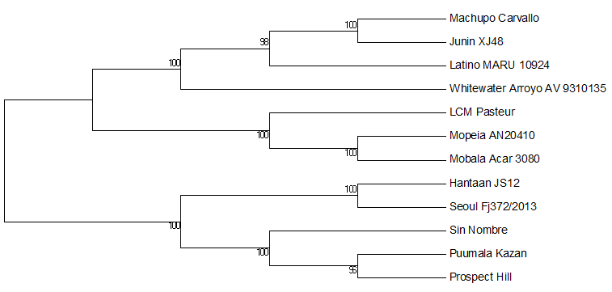
Figure 1. Molecular Phylogenetic analysis of complete L segments by Maximum Likelihood method
The evolutionary history was inferred by using the Maximum Likelihood method based on the General Time Reversible model (Nei and Kumar 2000). The bootstrap consensus tree inferred from 500 replicates (Felsenstein 1985) is taken to represent the evolutionary history of the taxa analyzed [2]. Branches corresponding to partitions reproduced in less than 50% bootstrap replicates are collapsed. Initial tree(s) for the heuristic search were obtained by applying the Neighbor-Joining method to a matrix of pairwise distances estimated using the Maximum Composite Likelihood (MCL) approach. A discrete Gamma distribution was used to model evolutionary rate differences among sites (5 categories (+G, parameter = 1.8712)). The rate variation model allowed for some sites to be evolutionarily invariable ([+I], 0.0000% sites). The analysis involved 12 nucleotide sequences. All positions containing gaps and missing data were eliminated. There were a total of 5205 positions in the final dataset. Evolutionary analyses were conducted in MEGA6 (Tamura 2013).
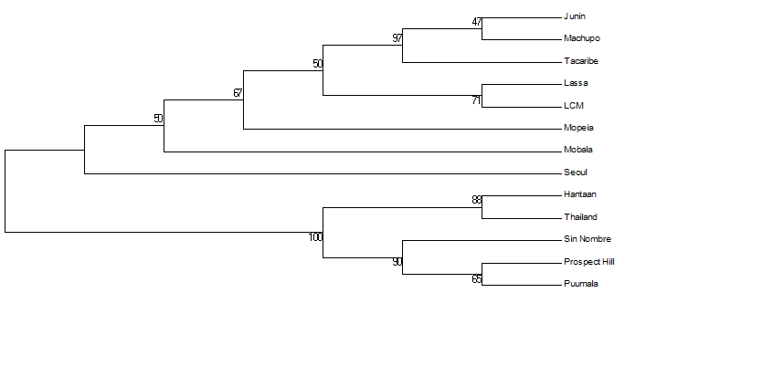
Figure 2. Molecular Phylogenetic analysis of S segment nucleocapsid proteins by Maximum Likelihood method
The evolutionary history was inferred by using the Maximum Likelihood method based on the General Time Reversible model (Nei and Kumar, 2000). The bootstrap consensus tree inferred from 500 replicates [2] is taken to represent the evolutionary history of the taxa analyzed (Felsenstein 1985). Branches corresponding to partitions reproduced in less than 50% bootstrap replicates are collapsed. Initial tree(s) for the heuristic search were obtained by applying the Neighbor-Joining method to a matrix of pairwise distances estimated using the Maximum Composite Likelihood (MCL) approach. A discrete Gamma distribution was used to model evolutionary rate differences among sites (5 categories (+G, parameter = 1.4088)). The rate variation model allowed for some sites to be evolutionarily invariable ([+I], 0.0000% sites). The analysis involved 13 nucleotide sequences. All positions containing gaps and missing data were eliminated. There were a total of 243 positions in the final dataset. Evolutionary analyses were conducted in MEGA6 (Tamura 2013).
In, figures 3 and 4, branch lengths indicate the amount of time in between nodes in relative time. The boxes on the nodes represent the range of uncertainty for the position of the node in time.
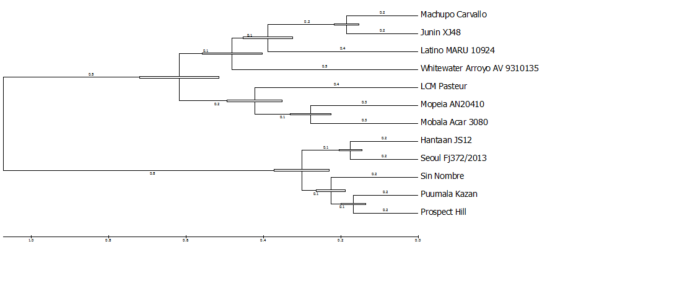
Figure 3. Molecular Phylogenetic analysis by Maximum Likelihood method (timetree)
The timetree shown was generated using the RelTime method (Tamura 2012). Divergence times for all branching points in the topology were calculated using the Maximum Likelihood method based on the General Time Reversible model (Nei 2000). The estimated log likelihood value of the topology shown is -61358.4328. A discrete Gamma distribution was used to model evolutionary rate differences among sites (5 categories (+G, parameter = 1.8712)). The rate variation model allowed for some sites to be evolutionarily invariable ([+I], 0.0000% sites). The tree is drawn to scale, with branch lengths measured in the relative number of substitutions per site. The analysis involved 12 nucleotide sequences. All positions containing gaps and missing data were eliminated. There were a total of 5205 positions in the final dataset. Evolutionary analyses were conducted in MEGA6 (Tamura 2013).
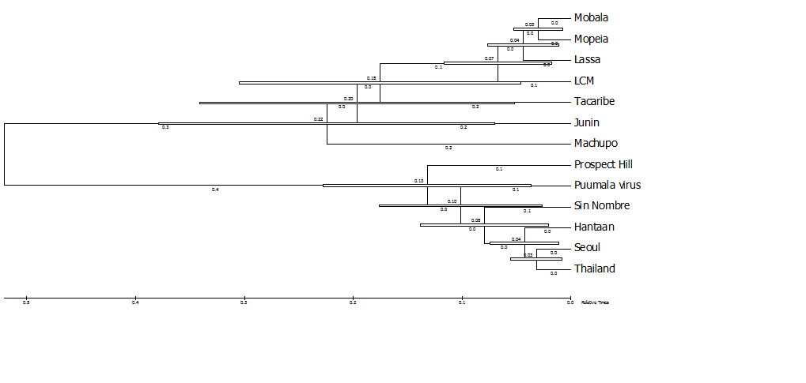
Figure 4. Molecular Phylogenetic analysis by Maximum Likelihood method (timetree)
The timetree shown was generated using the RelTime method (Tamura 2012). Divergence times for all branching points in the topology were calculated using the Maximum Likelihood method based on the General Time Reversible model (Nei 2000). The estimated log likelihood value of the topology shown is -2972.4740. A discrete Gamma distribution was used to model evolutionary rate differences among sites (5 categories (+G, parameter = 1.4088)). The rate variation model allowed for some sites to be evolutionarily invariable ([+I], 0.0000% sites). The tree is drawn to scale, with branch lengths measured in the relative number of substitutions per site. The analysis involved 13 nucleotide sequences. All positions containing gaps and missing data were eliminated. There were a total of 243 positions in the final dataset. Evolutionary analyses were conducted in MEGA6 (Tamura 2013).
In figure 5, the geographic ranges of ten known arenavirus hosts (Akodon azarae, Artibeus jamaicensis, Ar. literatus, Ar. planirostris, Calomys callosus, C. musculinus, Deramanura arderseni, Mastomys natalensis, Mus musculus, and Zygodontomys brevicauda) are combined to produce the region colored blue. Twenty three hosts of hantavirus (Abrothrix longipilis, Apodemus agrarius, Bandicota indica, Bolomys lasiurus, C. laucha, Megadontomys thomasi, Microtus californicus, Microtus pennsylvanicus, Myodes glareolus, Necromys benefactus, Oligoryzomys chacoensis, O. flavescens, O. longicaudatus, O. nigripes, Peromyscus baetae, Peromyscus maniculatus, Rattus norvegicus, R. rattus, Reithrodontomys megalotis, Re. mexicanus, Re. sumichrasti, Sigmodon alstoni, and S. hispidus) are combined in the region colored red. Regions where host species ranges overlap are colored green.
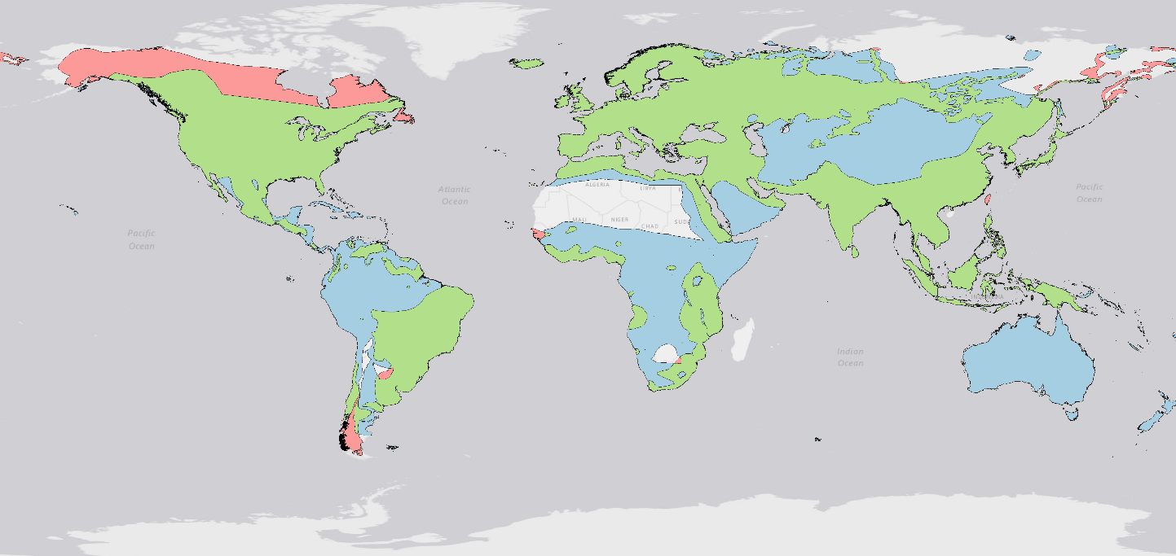Figure 5. World map aiming depict the global overlap of key arenavirus and hantavirus host reservoir species. It is important to remember that the green area is an area of overlap were both arenavirus and hantavirus vectors are present.

Hantavirus Vector Range
Arenavirus Vector Range
Overlapping Area
Discussion:
Initially, the above data do not provide evidence to suggest that arenaviruses and hantaviruses shared a common ancestor. The reference sequences showed two major clades. The time trees show that theoretically with enough time the random mutations in the genome could have driven enough divergence between the arenaviruses and hantaviruses in their reservoir hosts from a shared ancestor. However, the long and poorly understood evolution of viruses provides obstacles in understanding the origin of these two virus groups.
Within the spectrum of characteristics used for ICTV classification, there were some findings that could justify further exploration of whether arenaviruses and hantaviruses share a common ancestor. While the sequences of the viral genomes differ greatly, the organization of L segment genes on the genome are similar. The L segment of both arenavirus and hantavirus encodes a protein responsible for genome replication, and both S segments encode nucleocapsid proteins. The argument against this is that hantaviruses contain an M segment for encoding its glycoproteins, while arenaviral genomes do not contain an M segment. If the S and M segments of hantavirus are postulated to be originally from a single segment, they encompass proteins encoded by the S segment of arenaviruses. A major setback with this comparison is the size of the segments. The M segment size of hantaviruses is around 3,600 bp in length, which is longer than the complete S segment size for arenaviruses. With the additional ~1,600 bp added from the S segment of a hantavirus S segment, the size difference between the two is around 1,800 bp.
In regards to pathogenicity, both viruses cause damage to host tissue leading to a characteristic hemorrhagic phenomenon. The mechanism of hemorrhage arenaviral hemorrhagic fever is not fully understood and therefore cannot be readily compared to hantaviral infections, where degradation of capillary tissue and exertion in the early stages of infection lead to HFRS.
The reservoirs of both types of viruses are mainly rodents, many of which have similar diet and geographic range. If all the hosts of the viruses were included, the map generated would provide a more complete picture of distribution. Hosts with a tremendous amount of range extent, such as Mus musculus and species of the Rattus genus, comprise the majority of the area shown on the map in Figure 5. In North America, Asia, the Oceana and Europe, a considerable amount of land is overlapped by reservoir hosts species of both viruses. In at least one instance the viruses share rodent carriers from the same family (e.g. Calomys). Many of these rodents utilize human structures for shelter (especially Mus and Rattus, the common household rodent genera), and therefore can easily come into contact with each other. These and other characteristics of rodent community structures would benefit from a fuller statistical assessment, however it is not within the capabilities of this paper to provide deeper inquiry into their pertinence. However, these qualities form an argument to the similarity of the two viruses.
Conclusion:
This paper does not find substantial evidence to suggest that arenavirus and hantavirus have a common ancestor. Some of the evidence presented suggests the two viruses could be classified within the same clade, but the evidence could encompass a wide range of viruses. This is not necessarily a shortcoming, as the distinct rank of order is meant to encompass multiple families, thus covering a wide variety of species. A more thorough investigation, including a comparison of structure of major proteins, analysis of their function, and a detailed comparison of the lifecycle of the viruses would provide a more encompassing argument on the relatedness of arenaviruses and hantaviruses.
Acknowledgments:
I dedicate this paper to my thesis advisor, Dr. Colleen B. Jonsson, in gratitude of all her guidance. I’d also like to thank Postdoctoral Fellows Dr. Gillian Eastwood and Dr. Leonardo Valdivieso-Torres for their constructive criticism and donation of time in review of this thesis.
References:
Álvarez-Castañeda, S.T., Castro-Arellano, I., Lacher, T. & Vázquez, E. 2008. Microtus californicus. The IUCN Red List of Threatened Species 2008: e.T13427A3929686. http://dx.doi.org/10.2305/IUCN.UK.2008.RLTS.T13427A3929686.en.
Álvarez-Castañeda, S.T. & Castro-Arellano, I. 2008. Megadontomys thomasi. The IUCN Red List of Threatened Species 2008: e.T12942A3400467. http://dx.doi.org/10.2305/IUCN.UK.2008.RLTS.T12942A3400467.en.
Amori, G., Hutterer, R., Kryštufek, B., Yigit, N., Mitsain, G. & Palomo, L.J. 2015. Rattus rattus. The IUCN Red List of Threatened Species 2015: e.T19360A80732662. http://dx.doi.org/10.2305/IUCN.UK.2015.RLTS.T19360A80732662.en.
Amori, G., Hutterer, R., Kryštufek, B., Yigit, N., Mitsain, G., Palomo, L.J., Henttonen, H., Vohralík, V., Zagorodnyuk, I., Juškaitis, R., Meinig, H. & Bertolino, S. 2008. Myodes glareolus. The IUCN Red List of Threatened Species 2008: e.T4973A11104409. http://dx.doi.org/10.2305/IUCN.UK.2008.RLTS.T4973A11104409.en.
Aplin, K., Lunde, D. & Molur, S. 2008. Bandicota indica. The IUCN Red List of Threatened Species 2008: e.T2541A9451779. http://dx.doi.org/10.2305/IUCN.UK.2008.RLTS.T2541A9451779.en.
Barquez, R. & Diaz, M. 2015. Artibeus planirostris. The IUCN Red List of Threatened Species 2015: e.T2139A21997607. http://dx.doi.org/10.2305/IUCN.UK.2015-4.RLTS.T2139A21997607.en.
Barquez, R., Perez, S., Miller, B. & Diaz, M. 2015. Artibeus lituratus. The IUCN Red List of Threatened Species 2015: e.T2136A21995720. http://dx.doi.org/10.2305/IUCN.UK.2015-4.RLTS.T2136A21995720.en.
Bonn D. 1998. “Hantaviruses: an emerging threat to human health?” The Lancet. 352: 886
Bro-Jørgesen, K. et al. 1975. T Lymphocyte function as the principal target of lymphocytic choriomeningitis virus-induced immunodepression. Infect. Immun., 11: 622-629
Charrel RN, Lamballerie X, Emonet S. 2008. Phylogeny of the genus Arenavirus. Current Opinion in Microbiology. 11; 362-368
Christoff, A., Weksler, M., Vieira, E, D'Elia, G., Jayat., J.P. & Pardinas., U. 2008. Calomys laucha. The IUCN Red List of Threatened Species 2008: e.T3613A9983560. http://dx.doi.org/10.2305/IUCN.UK.2008.RLTS.T3613A9983560.en.
Delgado, C., Rivas, B., Anderson, R. P., Gómez-Laverde, M. & Emmons, L. 2008. Zygodontomys brevicauda. The IUCN Red List of Threatened Species 2008: e.T23321A9431576. http://dx.doi.org/10.2305/IUCN.UK.2008.RLTS.T23321A9431576.en.
D'Elia, G. & Pardinas., U. 2008. Akodon azarae. The IUCN Red List of Threatened Species 2008: e.T726A13070704. http://dx.doi.org/10.2305/IUCN.UK.2008.RLTS.T726A13070704.en.
Dunnum, J., Vargas, J., Bernal, N., D'Elia, G., Pardinas, U. & Teta., P. 2008. Calomys callosus. The IUCN Red List of Threatened Species 2008: e.T3611A9980442. http://dx.doi.org/10.2305/IUCN.UK.2008.RLTS.T3611A9980442.en.
Edgar RC. 2004. MUSCLE: multiple sequence alignment with high accuracy and high throughput. Nucleic Acids Research. 32(5): 1792-1797
Elliot RM, Schmaljohn CS, Collett MS. 1991. Bunyaviridae genome structure and gene expression. Current Topics in Microbiology and Immunology. 169, 91-141
Felsenstein J. (1985). Confidence limits on phylogenies: An approach using the bootstrap. Evolution 39:783-791.
Granjon, L., Lavrenchenko, L., Corti, M., Coetzee, N. & Abdel-Rahman, E.H. 2008. Mastomys natalensis. The IUCN Red List of Threatened Species 2008: e.T12868A3392767. http://dx.doi.org/10.2305/IUCN.UK.2008.RLTS.T12868A3392767.en.
Johnson KM. 1975. The arenaviruses: some priorities for future research. Bull. World Health Organ. 52; 761-763
Kaneko, Y., Kryštufek, B., Zagarondnyuk, I., Vohralík, V., Batsaikhan, N., Avirmed, D. & Sukhchuluun, G. 2008. Apodemus agrarius. The IUCN Red List of Threatened Species 2008: e.T1888A8654207. http://dx.doi.org/10.2305/IUCN.UK.2008.RLTS.T1888A8654207.en.
Koichiro T, Glen S, Daniel P, Filipski A, Sudhir K. 2013. MEGA6: Molecular Evolutionary Genetics Analysis version 6.0. Molecular Biology and Evolution. 30 2725-2729
Lamoreux, J. 2008. Peromyscus beatae. The IUCN Red List of Threatened Species 2008: e.T136323A4274532. http://dx.doi.org/10.2305/IUCN.UK.2008.RLTS.T136323A4274532.en.
Lee HW, Lee PW. 1978. Korean hemorrhagic fever. Demonstration of causative antigen and antibodies. Kor J Med. 19: 371–383
Linzey, A.V. & Matson, J. 2008. Reithrodontomys megalotis. The IUCN Red List of Threatened Species 2008: e.T19410A8878817. http://dx.doi.org/10.2305/IUCN.UK.2008.RLTS.T19410A8878817.en.
Linzey, A.V., Matson, J., Timm, R. & Woodman, N. 2008. Sigmodon hispidus. The IUCN Red List of Threatened Species 2008: e.T20213A9179086. http://dx.doi.org/10.2305/IUCN.UK.2008.RLTS.T20213A9179086.en.
Linzey, A.V. 2008. Peromyscus maniculatus. The IUCN Red List of Threatened Species 2008: e.T16672A6268838. http://dx.doi.org/10.2305/IUCN.UK.2008.RLTS.T16672A6268838.en.
Linzey, A.V. & NatureServe (Hammerson, G.). 2008. Microtus pennsylvanicus. The IUCN Red List of Threatened Species 2008: e.T13452A3970160. http://dx.doi.org/10.2305/IUCN.UK.2008.RLTS.T13452A3970160.en.
Marinhio-Filho, J., Vieira, E., D'Elia, G. & Pardinas, U. 2008. Necromys lasiurus. The IUCN Red List of Threatened Species 2008: e.T2859A9488040. http://dx.doi.org/10.2305/IUCN.UK.2008.RLTS.T2859A9488040.en.
Miller, B., Reid, F., Arroyo-Cabrales, J., Cuarón, A.D. & de Grammont, P.C. 2008. Artibeus jamaicensis. The IUCN Red List of Threatened Species 2008: e.T2135A9272998. http://dx.doi.org/10.2305/IUCN.UK.2008.RLTS.T2135A9272998.en.
Musser, G., Amori, G., Hutterer, R., Kryštufek, B., Yigit, N. & Mitsain, G. 2008. Mus musculus. The IUCN Red List of Threatened Species 2008: e.T13972A4374382. http://dx.doi.org/10.2305/IUCN.UK.2008.RLTS.T13972A4374382.en.
Nathanson N. 1975. Directions for future research on the pathogenesis of arenaviral infections. Bull. World Health Organ. 52; 753-760
Nei M. and Kumar S. (2000). Molecular Evolution and Phylogenetics. Oxford University Press, New York.
Pardinas, U., D'Elia, G. & Patterson, B. 2008. Abrothrix longipilis. The IUCN Red List of Threatened Species 2008: e.T743A13073334. http://dx.doi.org/10.2305/IUCN.UK.2008.RLTS.T743A13073334.en.
Pardinas, U., Teta, P. & D'Elia, G. 2008. Necromys benefactus. The IUCN Red List of Threatened Species 2008: e.T136665A4324976. http://dx.doi.org/10.2305/IUCN.UK.2008.RLTS.T136665A4324976.en.
Pardinas, U., D'Elia, G., Teta, P. & Patterson, B. 2008. Oligoryzomys longicaudatus. The IUCN Red List of Threatened Species 2008: e.T15250A4505440. http://dx.doi.org/10.2305/IUCN.UK.2008.RLTS.T15250A4505440.en.
Pardinas, U. & D'Elia, G. 2008. Calomys musculinus. The IUCN Red List of Threatened Species 2008: e.T3615A9985114. http://dx.doi.org/10.2305/IUCN.UK.2008.RLTS.T3615A9985114.en.
Patton, J., Weksler, M., Delgado, C., Rivas B. & Aguillera, M. 2008. Sigmodon alstoni. The IUCN Red List of Threatened Species 2008: e.T20210A9178432. http://dx.doi.org/10.2305/IUCN.UK.2008.RLTS.T20210A9178432.en.
Plyusnin A, Vapalahti O, Vaheri A. 1996. Hantaviruses: genome structure, expression, and evolution. Journal of General Virology. 77; 2677-2687
Reid, F., Samudio, R. & Pino, J. 2008. Reithrodontomys sumichrasti. The IUCN Red List of Threatened Species 2008: e.T19417A8887451. http://dx.doi.org/10.2305/IUCN.UK.2008.RLTS.T19417A8887451.en.
Ruedas, L. 2008. Rattus norvegicus. The IUCN Red List of Threatened Species 2008: e.T19353A8866848. http://dx.doi.org/10.2305/IUCN.UK.2008.RLTS.T19353A8866848.en.
Salvato MS et al. 2005. Family Arenaviridae in Virus Taxonomy. Eighth report of the International Committee on Taxonomy of Viruses. 725-738
Tamura K, Battistuzzi FU, Billing-Ross P, Murillo O, Filipski A, Kumar S. Estimating divergence times in large molecular phylogenies. Proc Natl Acad Sci U S A. 2012;109:19333–19338.
Tamura K., Stecher G., Peterson D., Filipski A., and Kumar S. (2013). MEGA6: Molecular Evolutionary Genetics Analysis version 6.0. Molecular Biology and Evolution30: 2725-2729.
Weksler, M., Bonvicino, C., Pardinas, U., Teta, P., Jayat, J.P. & D'Elia, G. 2008. Oligoryzomys chacoensis. The IUCN Red List of Threatened Species 2008: e.T15243A4503869. http://dx.doi.org/10.2305/IUCN.UK.2008.RLTS.T15243A4503869.en.
Weksler, M., Bonvicino, C., D'Elia, G. & Teta, P. 2008. Oligoryzomys nigripes. The IUCN Red List of Threatened Species 2008: e.T15253A4505962. http://dx.doi.org/10.2305/IUCN.UK.2008.RLTS.T15253A4505962.en.
Weksler, M., Bonvicino, C., D'Elia, G., Pardinas, U. Teta, P. & Jayat, J.P. 2008. Oligoryzomys flavescens. The IUCN Red List of Threatened Species 2008: e.T15247A4504640. http://dx.doi.org/10.2305/IUCN.UK.2008.RLTS.T15247A4504640.en.

