Macroscopic Charcoal as Evidence of Long-Term Fire History in the
Cuatro Ciénegas Valley, Mexico

A Thesis Presented for the
Master of Science
Degree
The University of Tennessee, Knoxville

John Henry Eads
May 2013
ACKNOWLEDGEMENTS
I would like to thank Dr. Sally Horn for her guidance and support. The many long hours she spent guiding me through the research process were critical to the successful completion of this study. Her ability to work under pressure, and her commitment to excellence were a constant source of inspiration through the years. This project builds upon the dissertation work of Matthew Valente, whose knowledge, enthusiasm, and support rivaled that of an advisor rather than a colleague. His help, as well as that of undergraduate research assistants Rachel Wilson and Nick Hendershot, was essential in completing the laboratory work for this project. I thank Roger Horn for the technical assistance he provided in fabricating the sediment cutting apparatus. I would also like to thank my committee members, Dr. Yingkui Li and Dr. Henri Grissino-Mayer, for the suggestions they made for improving my research.
The collection and analysis of Cuatro Ciénegas sediments has been supported by The Nature Conservancy, the W.K. McClure Fund for the Study of World Affairs and other sources at the University of Tennessee, and by the National Science Foundation under grants DGE-0538420, BCS-1031082, and BCS-1125532. Dr. Thomas Minckley of the University of Wyoming is a PI on the latter award, a collaborative research grant with Dr. Sally Horn that provided a GRAship for me to participate in the project. I thank the teams responsible for recovering the core from Poza Cortador that I analyzed. Sally Horn, Matthew Valente, and Zachary Taylor carried out initial reconnaissance fieldwork in Cuatro Ciénegas, and Matthew Valente and Chad Lane co-led the collection of the Poza Cortador core. Pronatura Noreste, The Nature Conservancy, and CONANP provided access to the Reserva Privada Pozas Azules, and Ivo García Gutiérrez, Director of the Dirección del Área Natural Protegida de Cuatro Ciénegas, granted permission to collect the sediment cores. Andrés Nájera Díaz, José Manuel Pérez, and Emilio Ramírez Rodríguez provided field, planning, and logistical support. Alfredo Nolasco and Hernando Cabral of The Nature Conservancy also provided key logistical and other support. Some AMS radiocarbon dates were provided through a grant-in-aid to Matthew Valente from the NSF University of Arizona AMS Laboratory, supported by the National Science Foundation under grants EAR-0622305 and EAR-0929458.

ABSTRACT
In this study, I present a high-resolution sedimentary charcoal record of fire for a freshwater marsh in the Cuatro Ciénegas Basin of Mexico. The basin lies within the grasslands of the Chihuahuan Desert ecoregion where opportunities for fire history studies are exceptionally rare. In this arid environment, fire-scarred trees are restricted to montane forests, and depositional environments conducive to the preservation of charcoal are uncommon. The charcoal record comes from a 12.3 m sediment core that extends to the late Pleistocene and includes various sediment types. Sediment typed proved to be a major influence on charcoal concentration. During dry times, burning of the sediments themselves caused exceptionally high charcoal concentrations for peat intervals of the core. Charcoal was sparse during the late glacial period, but increased dramatically in the Holocene. An age reversal in the sediments between 1092 cm and 930 cm complicated the record for the early Holocene, but the middle Holocene was characterized by abundant charcoal and by what appears to be a drier climate around the study site. The late Holocene contained some of the largest charcoal peaks in the core, and includes elevated charcoal production in the Medieval Warm Period and a marked decrease at the onset of the Little Ice Age. The most recent few centuries are missing from the sediment record, but included are key intervals of the Holocene and Late Pleistocene. The abundance of charcoal demonstrates that fires have been an integral part of the Cuatro Ciénegas ecosystem and must be better understood to properly manage this sanctuary of biodiversity in the future.
TABLE OF CONTENTS

CHAPTER 1: INTRODUCTION 1
CHAPTER 2: LITERATURE REVIEW 5
Sedimentary Charcoal 5
Fire and Climate 8
Human Activity 9
Paleoenvironmental Research in the Cuatro Ciénegas Valley
and Surrounding Deserts 10
CHAPTER 3: RESEARCH SETTING 19
Climate and Vegetation 22
Historical and Cultural Context 22
CHAPTER 4: MATERIALS AND METHODS 26
The Poza Cortador Core 26
Methods of Charcoal Analysis 29
CHAPTER 5: RESULTS 36
CHAPTER 6: DISCUSSION 41
Radiocarbon Dating 41
Macroscopic Charcoal Size Classes 41
Depositional Environment and Fire History 42
Interpretation of Fire History 44
Comparison with other Records of Quaternary History 48
Climate Change and the Future 51
CHAPTER 7: CONCLUSIONS 52
REFERENCES 55
VITA 64
LIST OF TABLES
Table 4.1. AMS radiocarbon determinations and calibrations for samples
from Poza Cortador 27

LIST OF FIGURES
Figure 3.1. Shaded relief map of the Cuatro Ciénegas Valley. 20
Figure 3.2. Poza Cortador on June 26, 2008. 21
Figure 3.3. Location of Poza Cortador in relation to other pozas
at the Reserva Privada Rancho Pozas Azules 23
Figure 3.4. The stromatolite reef-ringed Poza Azul “Rod Sanders” 24
Figure 4.1. Generalized diagram of the stratigraphy of the Poza Cortador core 28
Figure 4.2. Age-depth diagram for the Poza Cortador sediment core. 30
Figure 4.3. Sampling apparatus used for slicing core sections 31
Figure 4.4. Top view of color-coded petri dish holder 33
Figure 4.5. Side view of color-coded petri dish holder 33
Figure 4.6. Count sheet used to estimate number of 125–250 µm charcoal particles. 34
Figure 5.1. Total macroscopic charcoal concentration 37
Figure 5.2. Late Holocene macroscopic charcoal concentration by age 38
Figure 5.3. Macroscopic charcoal concentration of both 125–250 µm
and >250 µm size classes 40
Figure 6.1. Combined charcoal record, generalized stratigraphy diagram,
and age-depth model 43
Figure 6.2. The large spike in charcoal concentration at the
Pleistocene-Holocene boundary 45

Chapter 1

Introduction
Ciénega is a Spanish word for the desert wetlands found throughout southwestern North America. These sanctuaries of moisture within the harsh, arid environments of the Sonoran and Chihuahuan deserts are a valuable resource for plants, animals, and humans living nearby (Minckley and Brunelle 2007). They can also provide a wealth of paleoenvironmental information in an understudied region that is often not conducive to recovering proxy records (Metcalfe 2006). Sediment cores taken from desert wetlands offer a unique opportunity for reconstructing past fire and vegetation characteristics in desert grasslands of the Southwest that are generally too dry to have lakes or ponds to core, or to support trees for dendrochronological study (Brunelle et al. 2010).
Because of these dry conditions, a gap exists in the knowledge we have of past environments in parts of the American Southwest and northern Mexico, particularly in desert grasslands such as my study site in the Cuatro Ciénegas Valley in Coahuila, Mexico, within the Chihuahuan Desert. The adjacent Mexican state of Chihuahua has somewhat more potential for paleoenvironmental study than Coahuila. Falling within the southernmost portion of the basin and range physiographic province, Chihuahua contains numerous ancient lake beds from lakes that were active during pluvial periods but have since dried up (Metcalfe 2006). However, this is not the case for the Cuatro Ciénegas Valley. Meyer (1973) found no exposures of pluvial lake beds at the surface in the valley. Any deposits from paleolakes that once existed have been lost to erosion or buried, making the wetlands of Cuatro Ciénegas a rare and truly unique resource for studying the paleoecology of this fascinating desert landscape.
The waters of Cuatro Ciénegas are home to more than 70 endemic species of aquatic vertebrates, and are one of only a few inland waters in the world to have living stromatolites (Souza et al. 2006). The microbial life at Cuatro Ciénegas exhibits extraordinary diversity as well. Aquatic bacterial diversity in the waters of Cuatro Ciénegas is comparable to that of temperate terrestrial soils, which are typically much richer in species than any aquatic samples (Souza et al. 2006). While microorganisms lack the charisma of other endangered residents of the valley, such as the aquatic box turtle, they play a critical role in maintaining a functioning ecosystem. This ecosystem, already precariously placed within a desert environment, is under constant threat from drought and human use of groundwater, and the region has been named a high priority conservation region (Minckley and Jackson 2008). Knowledge of the natural history of this valley, particularly how it has fostered such biodiversity amidst what appear to be changing environmental conditions, could be important for maintaining this valuable desert resource and hotspot of diversity (Minckley and Jackson 2008).
Fire plays a significant, but highly variable, role in maintaining ecosystems in southwestern North America (Brunelle et al. 2010), and has become an increasing concern in recent years as human activities encroach upon the wildland interface (Gavin et al. 2007). The desert grasslands of the Cuatro Ciénegas Valley are no exception. Understanding the historical role of fire, and the long-term interaction between fire and climate in this region, is important for managing it under changing climates of the future (Brunelle et al. 2010). Given current global climate change concerns, it would be useful to observe how this region has responded to rapid climate change through time (Brunelle and Anderson 2003). Quantifying and understanding historical fire variability for the Cuatro Ciénegas Valley under natural conditions of the past can help others make informed decisions about properly maintaining the landscape into the future (Gavin et al. 2007). Swetnam et al. (1999) put it best, saying we must “know and understand the past to properly manage ecosystems for the future.” Knowing and understanding the past of the Cuatro Ciénegas Valley, particularly the historical role of fire and what that says about past climate, is precisely what I hope to accomplish with this project.
My M.S. research focuses on macroscopic charcoal in a sediment core extracted from Poza Cortador, one of the ciénegas in the Cuatro Ciénegas Valley. The core spans more almost 14,000 years and is being studied for pollen and other evidence of past environments by Ph.D. student Matthew Valente and Dr. Thomas Minckley at the University of Wyoming. Using high-resolution sampling of macroscopic charcoal, I will construct a record of local fires in the valley that will contribute important insights on the ecological history of the area, while also revealing the natural fire variability in the Cuatro Ciénegas Valley. I compare my results with other charcoal records from arid regions of southwestern North America as well as various global charcoal records. I ultimately seek to answer the following questions:
- How has fire varied over the late Pleistocene/Holocene and what does it reveal about the vegetation, climate, and hydrological history of the area around Poza Cortador?
- How do interpretations of environmental history based on the charcoal record compare with other records of Quaternary history in arid regions of southwestern North America?
My M.S. work is linked to a larger project co-directed by Dr. Sally Horn at the University of Tennessee and Dr. Thomas Minckley at the University of Wyoming. Funded by the National Science Foundation, this project includes pollen analysis by Ph.D student Matthew Valente and Thomas Minckley, and other charcoal work and shell analyses by undergraduates at both the University of Wyoming and the University of Tennessee. The paleoecological knowledge to be gained in my study is significant from a conservation standpoint, and will help remedy a lack of paleoenvironmental knowledge in an often challenging-to-study portion of North America. The results of this study will provide the first sedimentary charcoal record for the Cuatro Ciénegas Valley, and the entire Chihuahuan Desert ecoregion. My results will contribute to research on desert fires in understudied regions of the Southwest and northern Mexico, and potentially yield insights on past climate that can contribute to global climate models.
This thesis is divided into seven chapters. Chapter 1 introduces ciénegas and their value in paleoenvironmental reconstructions, and presents my research questions. In the second chapter, I review macroscopic charcoal as a fire proxy and the many uses of sedimentary charcoal records. In Chapter 3, I describe the research site including the present day climate and vegetation. In Chapter 4, I describe the sediment core along with laboratory methods of analysis. My results and the discussion are presented in chapters 5 and 6, respectively. I conclude the thesis in Chapter 7.

Chapter 2
LITERATURE REVIEW
Sedimentary Charcoal
Charcoal fragments are angular black particles produced when fire incompletely combusts organic material. This occurs between temperatures of 280 °C and 500 °C; at higher temperatures, organic material is reduced to ash (Whitlock and Larsen 2001). Charcoal fragments are then transported by air currents and fluvial processes away from the burn site, with some eventually settling to the bottom of nearby lakes and ponds, where anoxic conditions allow them to be preserved for millennia (Whitlock and Larsen 2001). This makes lake sediments, under the right conditions, a repository for many thousands of years of fire history (Whitlock and Millspaugh 1996). Over thousands of years, lake sediments accumulate charcoal produced during intervals of different climate conditions, perhaps since the Pleistocene. The analysis of charcoal in sediment cores is thus an excellent tool for uncovering how fire responds to long-term climate variability (Whitlock and Bartlein 2004).
Charcoal found in sediment cores is typically classified into two categories that are analyzed separately. The first category includes charcoal fragments that can be seen without the aid of a microscope, called macroscopic charcoal. The second category is microscopic charcoal, usually analyzed on pollen slides. Samples for macroscopic charcoal analysis are prepared by disaggregating the sediments in water or a chemical bath, depending on the nature of the sediments, and wet-sieved through nested sieves of different mesh sizes. Samples for microscopic charcoal analysis are prepared as part of routine pollen analysis (Whitlock and Larsen 2001). The two types of charcoal serve as proxies of fire in two slightly different ways. Microscopic charcoal can be carried by wind currents as far as several hundred kilometers from its source, and is believed to be more of an indicator of the fire history for a large geographic area (Ali et al. 2009). Macroscopic charcoal is more resistant to transport, generally settling much closer to the source fire, depending on the diameter of the charcoal fragments (Whitlock and Larsen 2001). For this reason, macroscopic charcoal is interpreted to be a better indicator of local fires. Additionally, macroscopic charcoal records can be developed at higher temporal resolutions than microscopic charcoal records (Schlachter and Horn 2010). They can be used to supplement dendrochronological and historical accounts of fire, and can be combined with pollen data from the same core to further understand the interaction between fire, vegetation, and climate (Whitlock and Larsen 2001; Whitlock and Millspaugh 1996).
The sedimentary charcoal record is composed of both primary and secondary charcoal (Whitlock and Larsen 2001). Primary charcoal is the material deposited during or shortly after a fire, while secondary charcoal can accumulate in lake sediments for years after a fire through fluvial and eolian processes (Whitlock and Millspaugh 1996). Large, high-intensity fires produce larger charcoal particles than smaller smoldering fires and also produce a greater percentage of wood charcoal as grass and leaves have combusted already (Whitlock and Larsen 2001). But particle size and the percentage of wood charcoal do not necessarily correlate to fire intensity because numerous other factors could have obscured the relationship between the two through the years. Secondary transport, damage during transport, and variable charcoal preservation all complicate efforts to interpret fire intensity from charcoal assemblages (Whitlock and Larsen 2001).
Good sites for sedimentary charcoal studies are small, deep lakes with limited inflow, no outflow, steep watersheds, and sparse riparian vegetation (Whitlock and Millspaugh 1996). A lake with a large watershed relative to its size would be a good choice in that it would catch more charcoal from the surrounding area, but this would also magnify the secondary charcoal signal (Whitlock and Larsen 2001). Secondary charcoal is just one of the challenges faced when interpreting sedimentary charcoal records. Fires downwind from the lake can be missing from the record entirely and the preservation of charcoal and continuity of sedimentation are never certain (Whitlock and Larsen 2001).
Another issue is a lack of uniformity in methods for analyzing macroscopic charcoal. Most studies agree on the basic steps required, but differ substantially in how to carry out those steps. A step as basic as sampling the core involves various possible tools of different volumes, and different options for slicing the core before sampling. The pretreatment method for disaggregating sediments can involve the use of several chemicals, in varying concentrations, at varying temperatures, for times ranging from 1 to 48 hours. The sieve size or sizes selected to isolate macroscopic charcoal also varies. Once samples have been sieved, they can be bleached or left unbleached, counted wet or dry, and counted by eye or by using image analysis software. Some standardization in techniques could improve the quality of fire history reconstructions from sedimentary charcoal.
Charcoal particles can be quantified by number, area, or volume. Ali et al. (2009) conducted an experiment using sediments from two lakes in western Quebec to determine which quantification method most accurately represented past fire activity, ultimately reporting that all three methods produced comparable fire history reconstructions. Charcoal records are commonly broken down into two components: a background component and a peaks component (Long et al. 1998). The background component is somewhat of an average made up of the amount of secondary charcoal and any regional charcoal that may have washed in from outside the watershed (Long et al. 1998). An abundance of charcoal in the sediment greater than background levels can be identified as a fire event or a peak (Whitlock and Bartlein 2004). Peaks in charcoal abundance can be compared with known fires from dendrochronological and historical records to calibrate the record to accurately identify fire events earlier in time (Whitlock and Larsen 2001).
Fire and Climate
Fire is the primary natural disturbance in temperate regions and a catalyst for vegetation change (Whitlock and Bartlein 2004). Fires can be started naturally by volcanic eruptions, spontaneous combustion in caves and bogs, extraterrestrial impacts, or by sparks produced from rockfalls (Clark et al. 1997). Far more frequently, however, fires are ignited by lightning strikes. Lightning strikes the Earth an estimated 100 times per second, with as many as 8 million strikes occurring per day, making lightning by far the most common natural ignition source for fires (Patterson et al. 1987; Clark et al. 1997). Fire is highly dependent on the composition, structure, and flammability of vegetation as well as environmental conditions such as the frequency of lightning strikes and the moisture content of vegetation (Clark 1983). Environmental conditions conducive to the spread of fire are divided into two categories: fire weather and fire climate. Fire weather concerns specific meteorological conditions that control the ignition and spread of fires, such as wind, air temperature, relative humidity, precipitation, and convective thunderstorm activity (Whitlock and Bartlein 2004). Fire climate relates to long-term climate conditions that influence fire such as seasonality, climate oscillations, and the locations of semi-permanent pressure systems (Whitlock and Bartlein 2004).
Paleoecologists face the unique challenge of having their study sites in areas wet enough to support lakes or bogs, while the fires they may wish to study often occur in dry areas (Clark et al. 1997). Naturally, plenty of pieces will be missing from the picture. However, our understanding of climate and climate change cannot be limited to the less than two centuries of meteorological record keeping (Hughes and Diaz 2008). Extreme variability and unseen conditions have occurred deeper in time and the only way to observe them is through high resolution plaeoclimate studies (Hughes and Diaz 2008). Using sediment cores allows researchers to work on a millennial scale and to examine links between fire and larger scale climate change such as changes in atmospheric composition, variations in insolation, recession of continental glaciers, and anomalies in thermohaline circulation (Whitlock and Bartlein 2004).
Sedimentary charcoal records are an excellent tool for understanding natural fire variability on longer timescales, but we must also be careful when using fire reconstructions to create management plans in the present day. The environmental conditions of today might be unlike anything in the past. With the introduction of invasive species as well as a rapidly changing atmospheric composition, the “natural” fire regime of the past may no longer be appropriate for properly managing the present day landscape (Conedera et al. 2009). The better we can understand the controls on fire and the interactions between fire, climate, and vegetation, the more powerful of a tool sedimentary charcoal records become for studying climate change and climate variability through the Holocene (Whitlock and Bartlein 2004).
Human Activity
The complex interaction between fire and climate is further complicated by anthropogenic influence. Since Homo erectus first developed the ability to set fires, Earth’s ecosystems have never been the same (Clark et al. 1997). Humans can affect fire activity directly by igniting more fires, or indirectly by altering the flora and fauna in their immediate environment, which affects fuel levels (Marlon et al. 2009). Teasing apart the anthropogenic signal from the climate signal can be a major challenge in analyzing charcoal data. However, sedimentary charcoal can also answer questions of human migration and colonization. A sudden spike in charcoal, followed by a prolonged period of high charcoal concentration, is often interpreted as the initial human arrival to an area (Burney and Burney 2003). This method has proven particularly successful at pinpointing human arrival on islands, and also has been applied in continental areas (Burney and Burney 2003).
Paleoenvironmental Research in the Cuatro Ciénegas Valley and Surrounding Deserts
Much of the previous research in the Cuatro Ciénegas Valley has been focused on the abundant and tremendously diverse aquatic plant and animal life found in the crystal clear waters of this unique desert habitat. Comparatively little research has addressed the paleoenvironmental history of the region, and previous studies of fire history in the valley have not been performed. In fact, no sedimentary charcoal studies have been published for any site in the Chihuahuan Desert ecoregion, and the few palynological studies in the region fail to completely agree on a vegetation and environmental history for northern Mexico.
Meyer (1973) pioneered an early effort to interpret the paleoecology of the Cuatro Ciénegas Valley. He started with the observation that the absence of pluvial lake beds and the high degree of endemism found in Cuatro Ciénegas implied long-term isolation and environmental stability for the valley. Meyer tested this hypothesis, a terrestrial adaptation of the stability-time hypothesis proposed by Sanders (1968), by analyzing two sediment cores extracted from small marshy springs on the valley floor. He also examined surface sediment samples to obtain data on modern pollen rain to strengthen his interpretation of the fossil pollen record. Meyer determined from the pollen record that no significant changes in vegetation had occurred on the valley floor since the mid-Wisconsin glaciation, a finding he interpreted as confirmation of his hypothesis of environmental stability. He concluded that the woodlands that occupy nearby mountain slopes were likely more extensive during cooler and wetter periods of the past, but never invaded the valley floor, leaving the streams, springs, and ponds of Cuatro Ciénegas unaltered since perhaps the Tertiary (Meyer 1973).
The results obtained by Meyer would indeed appear to support the stability-time hypothesis, but his findings are at odds with several paleoecological studies in similar environments of northern Mexico and the American Southwest that document climate shifts and significant changes in vegetation change since the Pleistocene alone (Ortega-Ramirez et al. 1998; Metcalfe 2006, and references therein). These studies have inferred climate variability for northern Mexico through the Late Quaternary from multiple proxies. Less is known about the Mexican portion of the Chihuahuan Desert than the United States side, and despite the several thousand packrat middens that have been analyzed in the Southwest, a gap in data still exists for the U.S.A-Mexico Borderlands region (Metcalfe 2006; Holmgren et al. 2003). However, from the studies available, there seems to be a consensus that the climate in northern Mexico has been far from stable.
Although the idea of a stable late Quaternary climate in northern Mexico is gradually being put to rest, recent research findings underscore how much more there is to learn. The debate about the climate of Quaternary Mexico has only intensified since the work of Meyer. The existing research in the southwestern United States and northern Mexico fails to agree on the timing, magnitude, and sometimes the existence of a signal for particular paleoclimatological events of the late Quaternary. Even charcoal records from very similar regions of the continent can yield different results. Out of the events, probably the least controversial is that the melting of continental ice sheets brought significant change to southwestern North America. While plenty still dispute the specifics, the transition from the Pleistocene to the Holocene left behind evidence of dramatic, undeniable impacts on the region.
One dissenting opinion comes from a soil geomorphology study in the Chihuahuan Desert, less than 200 km from Cuatro Ciénegas. Butzer et al. (2008) found no evidence for a wetter climate during the late Pleistocene/early Holocene, and cautioned other researchers about oversimplifying paleoclimatic records. They argued the climate of northern Mexico was more intricate than previous research indicated, operating in wet and dry cycles of various magnitude rather than simply a wet or dry climate. A more widely held opinion, at odds with the Butzer et al. study, was outlined by Nordt (2003). Nordt investigated the soil stratigraphy in the desert grasslands of Northern Mexico and found evidence for a cooler and wetter climate in the Late Pleistocene that warmed and dried in the Holocene. However, like Butzer, he also reported evidence of climate cycles. Betancourt et al. (2001) did not deny a transition at the Pleistocene-Holocene boundary, but challenged the idea that it was a rapid transition. They suggested that the change may have taken place in gradual stages rather than abruptly. They offered poor resolution in radiocarbon dates as one possible explanation for the interpretation of change as rapid.
At a site on the western margin of the Chihuahuan Desert, Metcalfe et al. (1997) found evidence that a large lake once occupied the Babícora Basin, a dry lake basin nested in the foothills of the Sierra Madre Occidental (2200 m elevation). This lake existed until the early Holocene, and indicates a wetter climate for the Chihuahuan Desert during the glacial period. Metcalfe et al. (1997) found evidence in the diatom record for a cooler and wetter climate before 11,060 ± 390 yr B.P., and evidence of lake level fluctuations that could correspond to the Younger Dryas. In the same basin, Ortega-Ramirez et al. (1998) confirmed these results, finding two distinct periods of high effective moisture in the Chihuahuan Desert: one during the Late Pleistocene (16,342 ± 201 B.P.), and another in the early Holocene (9614 ± 130 B.P.).
Marlon et al. (2009) proposed that the warming climate was a catalyst for the emergence of new vegetation communities in the Holocene. Van Devender and Burgess (1985) found that the cooler and wetter climate of the Late Pleistocene caused pinyon-juniper woodland vegetation, now confined to higher elevations, to expand into the desert lowlands. Beginning in the Holocene, this vegetation transitioned to the modern-day desert scrubland vegetation, implying increasing aridity and warming. Holmgren et al. (2003) worked in a similar desert area in southwestern New Mexico and also found evidence of glacial-age pinyon-juniper woodlands that transitioned into modern desert scrub in the Holocene. The authors interpreted this shift to indicate greater effective moisture in the Late Pleistocene. Packrat middens from Pendejo Cave in south-central New Mexico also showed evidence for mild winters, cooler summers, and higher effective moisture during the glacial period (Betancourt et al. 2001).
Botanical remains in sediment cores and packrat middens are not the only evidence of a changing climate for the Cuatro Ciénegas Valley. In a cave within the southeast portion of the Cuatro Ciénegas Basin, Taylor (2003) found the bones of several animals that no longer exist in the region, including grizzly bear, jaguar, and yellow-haired porcupine. Elias and Van Devender (1990) analyzed beetle remains found in packrat middens at sites just to the north of Cuatro Ciénegas, in the Texas part of the Chihuahuan Desert. Coleopteran species that prefer cooler, moister climates began to decline around 12,000 B.P., and were gradually replaced by desert-dwelling species, again indicating greater effective moisture and cooler temperatures during the glacial period.
Based on the proxy data, the climate of northern Mexico in the late Pleistocene was characterized by mild winters and cool summers, with most precipitation coming in the winter (Metcalfe 2006). Winter precipitation was driven by the Westerlies, making precipitation patterns in the desert grasslands more like those seen at higher elevations of the Sierra Madre today (Metcalfe et al. 1997). Winter precipitation originated over the Pacific Ocean and was steered towards the Chihuahuan Desert by a southward displacement of the jet stream caused by the presence of the Laurentide Ice Sheet (Metcalfe 2006). In the Holocene, winter precipitation moved north to the mid-latitudes and desert shrubs replaced pinyon-juniper woodlands as the dominant vegetation type in all but the highest latitudes (Metcalfe 2006). Summer temperatures increased and there was a shift to the drier, modern-day conditions of summer precipitation coming from monsoon circulation originating over the Gulf of Mexico (Metcalfe et al. 1997).
A possible explanation for the discrepancy between Meyer’s results and those of more recent studies is that Meyer focused too much on the valley floor, missing the greater environmental processes acting on the region (Minckley and Jackson 2008). The poorly drained, haline soils of Cuatro Ciénegas may have prevented woodland vegetation from reaching the valley lowlands, despite climate shifts most now agree were taking place at the time, giving a false impression of environmental stability for the valley (Minckley and Jackson 2008). This possible scenario demonstrates the challenges involved in untangling past climatic conditions from proxy records. Although it is possible the valley floor vegetation has remained stable, it is clear from numerous other studies that the regional climate has changed throughout the Late Quaternary as shown by the dramatic shifts observed in upland vegetation (Minckley and Jackson 2008).
While the particulars of the extent of environmental change in southwestern North America at the Pleistocene-Holocene boundary are still debated, the growing body of evidence for significant change during this period makes it a less contentious topic than some events in the Holocene. The mid-Holocene altithermal, for one, is shrouded in dissension. Some studies have found no evidence for a warmer and drier middle Holocene (Nordt 2003; Butzer et al. 2008). Others have claimed to see its signal, but fail to agree on the timing (Holmgren et al. 2008; Metcalfe 2006; Ortega-Ramirez et al. 1998). Holmgren et al. (2008) observed a mid-Holocene drought lasting from 8,000–4,000 ¹⁴C yr B.P. Metcalfe (2006) proposed a different idea about the middle Holocene. She suggested it was a time of high variability in moisture, with wet periods at 4,000 and 6,000 B.P., and a dry period at 5,000 B.P. Ortega-Ramirez et al. (1998) argued that the middle Holocene was characterized by warmer and drier than present climate based on the presence of aeolian deposits, calcium carbonate concretions, and a decrease in magnetic minerals. They also observed evidence for increasing aridity in the late Holocene since around 4000 B.P. from geochemical analysis of sediments. Conversely, Minckley et al. (2009) found the climate at the Arizona/Sonora border to be arid ca. 4000 B.P., moving towards wetter conditions in the present.
Events of the late Holocene are better understood. Being more recent, more proxy evidence exists, including historical and dendrochronological records. In the Arizona-Sonora borderlands, Brunelle et al. (2010) found their highest charcoal concentrations to occur between 1100 and 740 cal yr B.P., which they proposed could be a signal of the Medieval Warm Period (950–750 cal yr B.P.). The Medieval Warm Period is manifested as drought in the western US (Brunelle et al. 2010), and was a time of high fire activity (Swetnam 1993). The reconstruction by Brunelle et al. (2010) confirms this, showing high fire activity during the Medieval Warm Period, with fires occurring as often as every 38 years. After the Medieval Warm Period, charcoal abundance significantly decreased, signaling the end of prolonged drought conditions in the Southwest. Because charcoal concentrations were low before and after the Medieval Warm Period, Brunelle et al. (2010) do not believe burning by indigenous populations obscured the signal.
Power et al. (2012) observed a marked decrease in biomass burning in the Americas after 450 cal yr B.P. that they linked to the Little Ice Age. This decline had previously been attributed to population collapse in the Americas, but Power et al. (2012) were unconvinced population collapse could adequately explain the phenomenon. They synthesized data from 498 sedimentary charcoal records obtained from the Global Charcoal Database to better understand the geographic extent, magnitude, and cause of this event. The decline would need to be globally unique to the Americas in order to support the population collapse hypothesis (Power et al. 2012). They found instead a global reduction in biomass burning that they attributed to reduced vegetation productivity as a result of cooling temperatures during the Little Ice Age. They did not, however, discount the possibility that population collapse in the Americas affected fire regimes at finer spatial scales.
Miller et al. (2012) observed an intensification of Little Ice Age conditions from 520–495 cal yr B.P. that they linked to volcanic activity. They attributed these colder temperatures of the Little Ice Age to stratospheric sulfur loading caused by four large eruptions within a 50 year period. While the insolation blocking effects of a sulfur-rich explosive eruption are short lived, the colder temperatures might have been prolonged through sea ice/ocean feedback (Miller et al. 2010). The initial negative solar forcing caused by the eruption led to a weakened poleward transport of warm water and expansion of sea ice, initiating a positive feedback loop of expanding sea ice and increasing albedo that further decreased temperatures (Miller et al. 2010).
Cleaveland et al. (2003) also examined evidence for climate conditions during the Little Ice Age. In their >600 year tree-ring record from Durango, Mexico they discovered evidence for the “Megadrought” of 1540–1579, a term coined by Stahle et al. (2000) for a climate event originally identified by Grissino-Mayer (1996). As the name suggests, this drought far exceeded the severity, duration, and spatial coverage of the Dust Bowl or any other drought in the period of meteorological record keeping, and was most extreme over northern Mexico (Stahle et al. 2000). Cleaveland et al. (2003) suggested that La Niña conditions may have played a role in the development of these exceedingly dry conditions. How this drought is manifested in the sedimentary charcoal record is unclear.
Davis et al. (2002) reported a dramatic decrease in charcoal production during the historic period, based on analysis of the sediments of six wetlands in the Sonoran Desert. They identify the beginning of the historic period in the Arizona/Sonora borderlands as synonymous with the arrival of the pollen of exotic plants about 200 years before present. Charcoal was the most abundant particle in pollen diagrams, with charcoal abundance increasing right up to the sudden decline. The decline corresponds with the timing of increasing pollen from wetland taxa and an increase in the percentage of the dung fungus Sporormiella. Davis et al. (2002) attributed the dramatic decrease in fire frequency to human activity in the area based on the presence of Zea pollen and other taxa frequently associated with disturbed areas.
Working from the global charcoal database, Power et al. (2008) synthesized charcoal records to identify spatial patterns in fire activity at the global scale. They came up with spatially heterogeneous results. The last glacial maximum, with its cooler, drier climate and decreased biomass, could have been a time of decreased burning worldwide. However, through the Holocene, the impacts of particular climate events on fire regimes differed dramatically from region to region in both timing and magnitude. Large-scale drivers of climate change such as insolation, ice sheets, atmospheric composition, and atmospheric circulation control fire regimes at orbital timescales, but regional climates govern the key variables that control fire activity in the smaller time scales of human lives, such as ignition sources, vegetation type, and site productivity (Power et al. 2008). The authors identified a need for more regional studies of fire, particularly in understudied regions of the world, as well as collaboration and data syntheses to advance our understanding of the global climate.

CHAPTER 3
RESEARCH SETTING
The study site for my project lies within the Reserva Privada Pozas Azules, a nature reserve jointly managed by the Nature Conservancy and Pronatura Noreste, and is part of the Cuatro Ciénegas Natural Protected Area. The Cuatro Ciénegas Valley lies at approximately 27° N, 104° W, roughly 65 kilometers due west of Monclova in the shadow of the Sierra San Marcos (Figure 3.1). High mountains (>2500 m) rise on either side of the coring site (Souza et al. 2006). The valley as well as much of the state of Coahuila lie within the Chihuahuan Desert and, on average, receive <200 mm of rainfall per year (Meyer 1973). Despite these dry conditions, Cuatro Ciénegas is host to living stromatolites and a remarkable amount of biodiversity that has been compared to that of the Galápagos Islands. Sometimes called a “desert aquarium,” the valley is an oasis for unique species, boasting the highest level of local endemism in North America (Grall 1995; Minckley and Jackson 2008).
Within the valley are more than a hundred pozas, small desert pools, in various stages of development (Valente et al. in preparation). So many pozas exist just within the Reserva Privada Pozas Azules that the first steps taken by Sally Horn and Matthew Valente in beginning work on the reserve was a survey of the surface sediments and water chemistry of 23 ponds and test coring of two ponds (Horn 2008). The goal of the preliminary work was to determine which kinds of sites could best answer questions regarding the biogeography, ecology, and evolution of the unique biota of Cuatro Ciénegas. The site selected for this study, Poza Cortador (Figure 3.2), is a sub-circular spring head marsh (ciénega) approximately 12 m in diameter (Valente et al. in preparation). It sits roughly 720 m above sea level, and is located at 26.8268º N, 102.0276º W, a
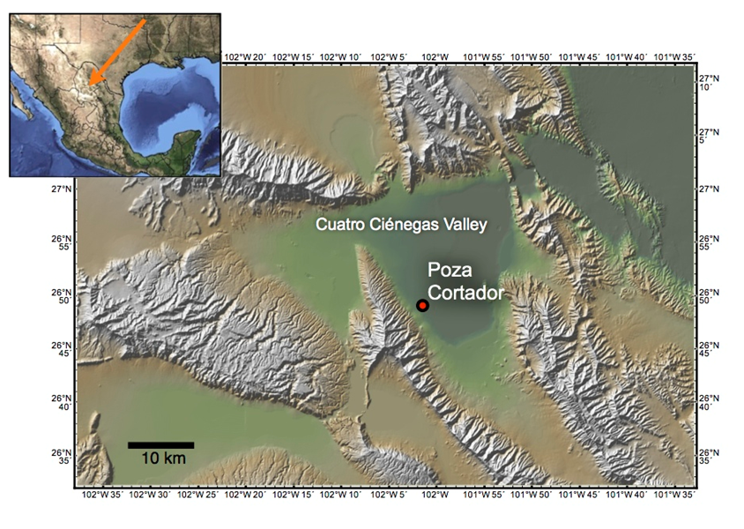Figure 3.1. Shaded relief map of the Cuatro Ciénegas Valley showing the location of the Poza Cortador core site in the Eastern lobe of the Cuatro Ciénegas Valley. Inset map on upper left shows the location of the study area in the state of Coahuila, Mexico. The shaded relief map was constructed with GeoMapApp (http://www.geomapapp.org) using elevation data from the Global Multi-Resolution Topography Synthesis (Ryan et al. 2009).

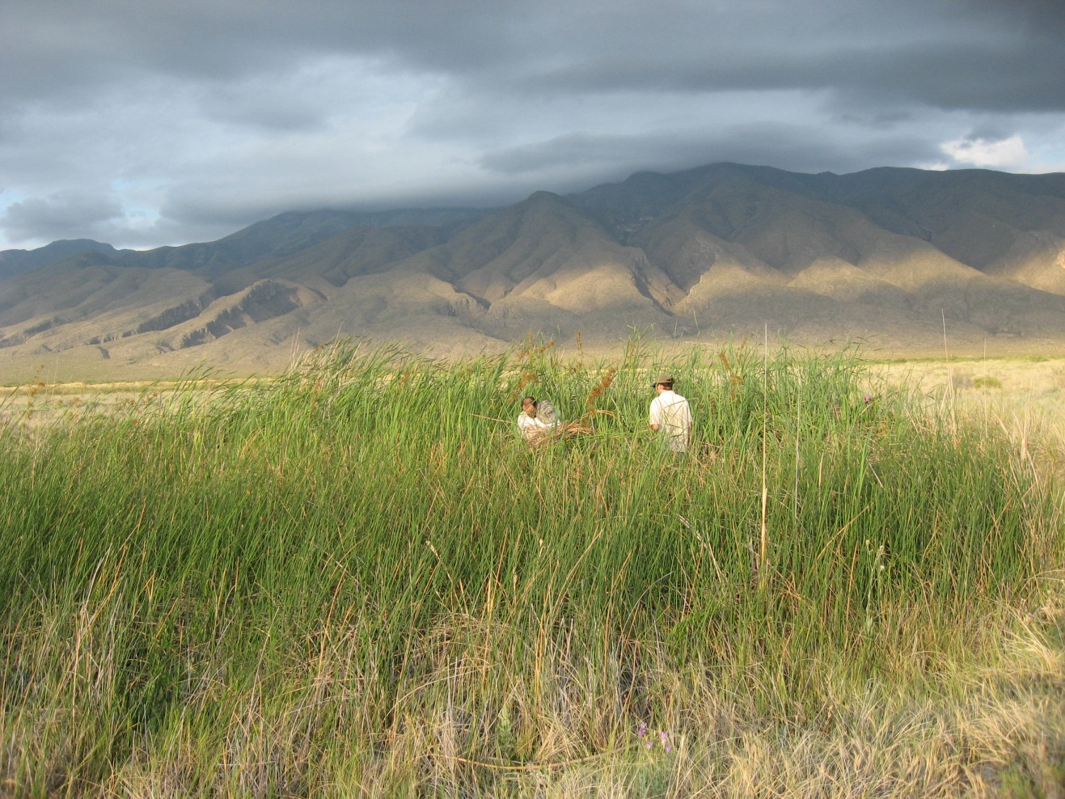
Figure 3.2. Poza Cortador on June 26, 2008. View approximately to the Southwest. A cloud-enveloped Sierra San Marcos is in the background. Chad Lane (left) and Matthew Valente (right) are standing within a few meters of the core site in the center of the marsh. Photo credit: Andrés Nájera Díaz.
mere 350 m from the azure waters of Poza Azul “Rod Sanders,” one of the most photographed pozas in the Cuatro Ciénegas Valley. Poza Cortador is ca. 500 m distant from Poza Tule, another coring site in the larger NSF project (Figure 3.3, 3.4).
Climate and Vegetation
Cuatro Ciénegas is under the influence a sub-tropical high pressure cell for most of the year, is situated a long distance from a significant moisture source, and is enclosed by mountains to both the east and the west (Metcalfe 2006). These characteristics combine to keep rainfall around the site to a minimum. What precipitation does make it into the valley comes with the northward migration of the Inter-Tropical Convergence Zone in the summer, allowing moisture-laden easterly circulation from the Gulf of Mexico to reach further inland (Metcalfe 2006). Although the higher elevations in the Chihuahuan Desert receive additional precipitation carried by the Westerlies, the lowlands remain very dry and unable to support tree growth. Valente et al. (in preparation) observed ciénega vegetation to be dominated by sawgrass (Cladium jamaicense) and cattails (Typha latifolia). The vegetation surrounding the marsh consisted of herbaceous plants in the Poaceae and Amaranthaceae families, with a few Opuntia spp. individuals on the western edge of the marsh. No woody shrubs such as Prosopis sp. were observed near the site.
Historical and Cultural Context
Taylor (2003) excavated several caves and rock shelters in the Cuatro Ciénegas Basin, discovering an astounding assortment of sandals and other human artifacts dating back as early as ca. 8950 B.P. He obtained radiocarbon dates for a large array of sandals, basketry, plant material, and tools that indicated the caves and rock shelters of Cuatro Ciénegas were continuously occupied for thousands of years. How long before 8950 B.P. indigenous people

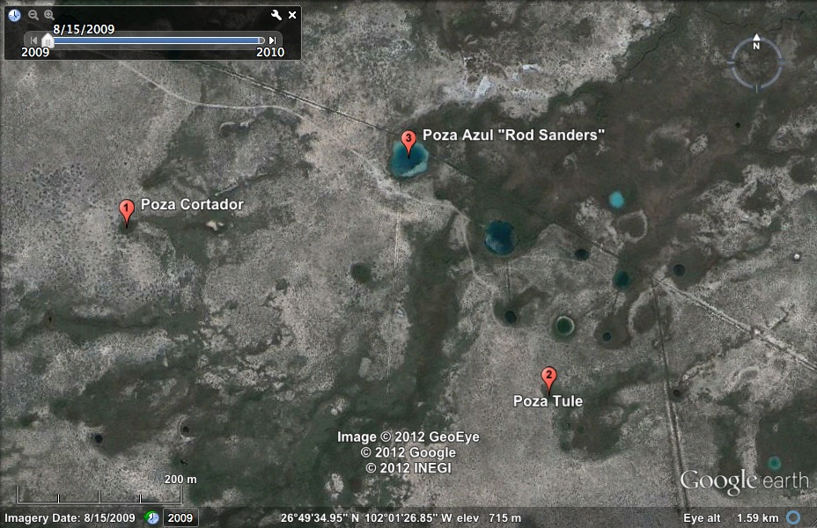
Figure 3.3. Satellite imagery showing the study site in the poza-spring-marsh complex at Reserva Privada Rancho Pozas Azules. The image also shows the locations of Poza Tule, another coring site in the larger NSF project, and the iconic Poza Azul “Rod Sanders.”
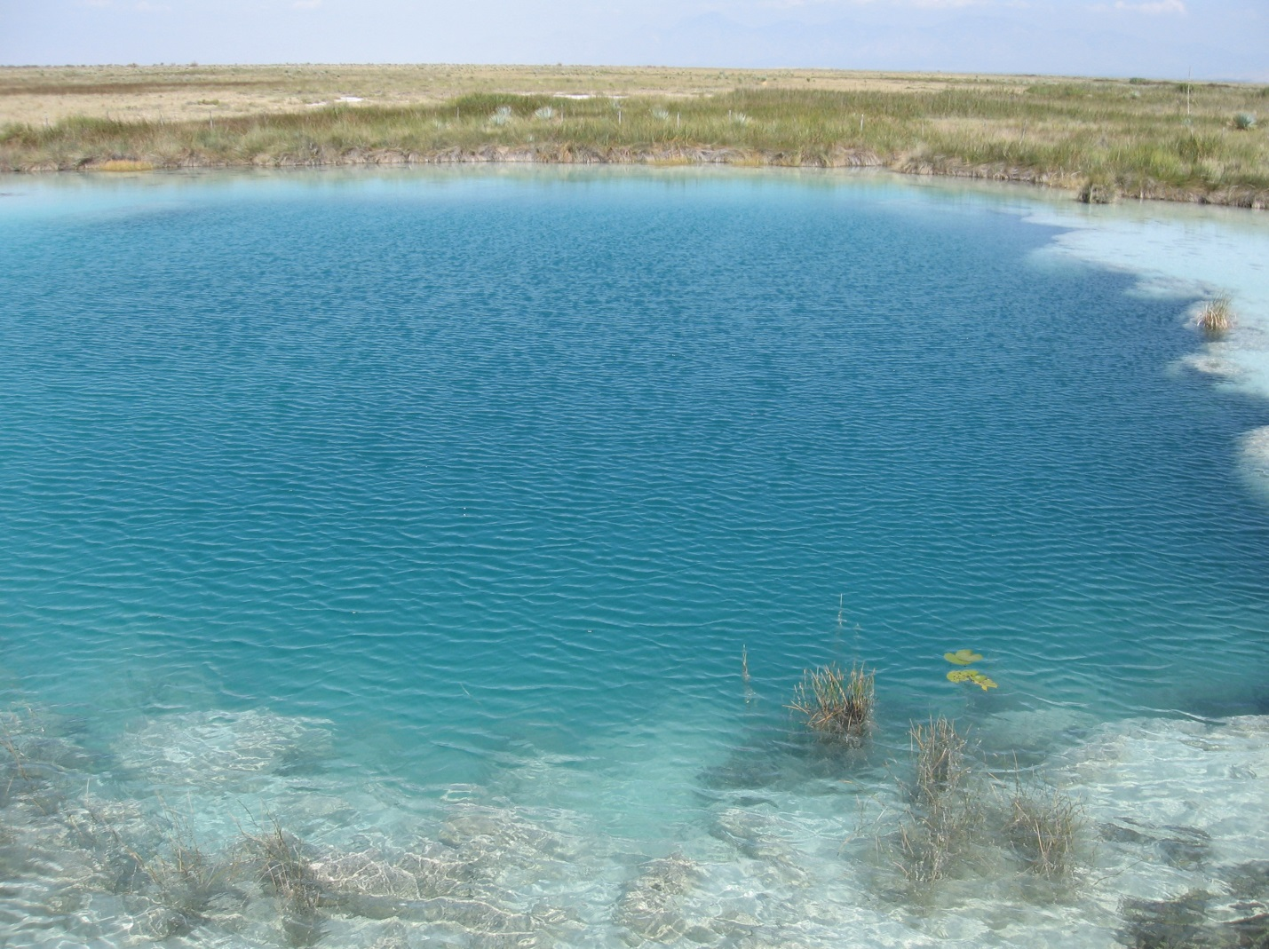
Figure 3.4. The stromatolite reef-ringed Poza Azul “Rod Sanders” is one of the more recognizable features of the Reserva Privada Pozas Azules. Its brilliant turquoise waters harbor life found nowhere else on the planet. Photo credit: Sally Horn.
might have been living in the Cuatro Ciénegas Basin, however, is unclear. There is evidence of Clovis occupation in Sonora between 11,500 and 11,000 B.P., but further east, in the Chihuahuan Desert, the record is more convoluted (Phillips 1989). A single fragment of a Folsom projectile point dated to 11,000 B.P. is the earliest evidence for Paleo-Indian occupation of the region (Phillips 1989).
In the first half of the 16th century, Spanish colonists expanded into northern Mexico in pursuit of profitable mining opportunities (Forbes 1959). By the late 16th Century, the Chichimecos, an alliance of several Indian groups in the region between Zacatecas and Saltillo (~250 km south of Cuatro Ciénegas), were hostile to the Spanish, and acquiring and learning to ride their horses (Forbes 1959). However, no primary written sources have been located describing the environmental conditions or specific identity of the group(s) of Indians living in the Cuatro Ciénegas Basin (Gabriel Martinez-Serna, personal communication with M. Valente). The identity, material culture, and fate of the pre-conquest inhabitants of Cuatro Ciénegas is not known with any certainty. Various Indian groups succeeded in preventing the total control of much of the Chihuahuan Desert region by Spanish Colonial interests much longer than in Central Mexico (Forbes 1959). Permanent Spanish settlements like those that developed in the colonial cities of Saltillo and Parras were not established in Cuatro Ciénegas prior to the city's official founding in 1800 (M. Valente, personal communication).

CHAPTER 4
MATERIALS AND METHODS
The Poza Cortador Core
The sediment core used for this study was taken from the informally named Poza Cortador by Matt Valente and Chad Lane on June 26, 2008. Poza Cortador is a groundwater-fed desert marsh that has had continuous sediment deposition since the Late Pleistocene, with sedimentation beginning ~14,000 calibrated years before present (Table 4.1). The core was recovered in one-meter sections using a 5 cm diameter square-rod piston corer. The upper 60 cm of sediment were lost due to plowing, a situation where a clogged corer penetrates further into the sediment without capturing any new material. After removing the root mat clogging the corer, subsequent drives from 60 cm to 960 cm were all recovered in 1 m sections (Valente et al. in preparation). Beyond this depth, the densely packed sediments prevented the recovery of a full meter with each drive. The final section of the core, 1184–1249 cm, was the deepest Valente and Lane could reach with the number of rods they brought with them. Core sections were extruded in the field, wrapped in plastic, then aluminum foil, and placed in PVC tubes for transport to our lab at the University of Tennessee, where they are stored in a cold room at 6 °C.
In the lab, each core section was sliced longitudinally into a sample half and an archive half with 10 inch wide stainless steel drywall knives. Sediments were immediately photographed, and described on core logs. The sedimentary history of Poza Cortador (Figure 4.1) is complex and beyond the scope of this paper, but a few general patterns can be seen in the stratigraphy. The deepest sediments are organic clays that may be from a time when Poza Cortador was a deepwater poza similar to Poza Azul “Rod Sanders.” This section spans 1232–1084 cm in the core and represents what appears to be a wetter time in the Cuatro Ciénegas Basin. Poza
Table 4.1. AMS radiocarbon determinations and calibrations for samples from Poza Cortador.
¹ Analyses were performed by the NSF-Arizona AMS Laboratory (AA) and the University of Georgia Center for Applied Isotope Studies (UGAMS).
² Calibrations were calculated using the R_Date function of the software OxCal v 4.1.7 using the IntCal09 calibration dataset of Reimer et al. (2009).
Figure 4.1. Generalized diagram of the stratigraphy of the Poza Cortador sediment core. Numerical ranges to the left of the diagram are calibrated age ranges with dates that show reversals omitted.
Cortador then transitions to peat-rich marsh sediments with the drying climate at the termination of the Pleistocene. Peat predominates in the upper 10 m of sediment except for a layer of gray clay centered around 9000 cal yr B.P., and at least 4 possible paleosols interspersed through the record, indicating cycles of wetter and drier conditions. Poza Cortador sediments begin to most closely resemble modern day ciénega sediments ca. 1800 cal yr B.P.
Chronological control for the Poza Cortador sediments has been established by AMS radiocarbon dating of plant macrofossils and charcoal picked from the cut core surface, identified, and pretreated by Matthew Valente. An age-depth model (Figure 4.2.) made by Matthew Valente using all available radiocarbon dates highlights the major reversal shown in the table of dates. For reasons that are still unclear, sediment between depths of ca. 930 cm and 1092 cm shows dates that are younger than expected. Gaps between core sections are assumed to be missing sediments rather than a result of compression.
Methods of Charcoal Analysis
To develop my high resolution charcoal record, I sliced the sample half of each core section into equal 1 cm intervals using a custom-made sampling apparatus (Figure 4.3) that kept the thickness of each slice uniform throughout the process. Matt Valente and undergraduate students Nicholas Hendershot and Rachel Wilson assisted in slicing and sampling core sections. At each 1 cm interval, we removed 2 cm³ samples for macroscopic charcoal analysis using a custom-made tubular brass sampler. These samples were pretreated for sieving by gently boiling them in 20 ml of 10% sodium hydroxide solution. The samples were boiled in glass test tubes for one hour in a hot block set at 105 °C. After disaggregation, the sediments were wet sieved through a 250 µm mesh sieve and then a 125 µm mesh sieve, trapping macroscopic charcoal particles 125–250 µm in diameter on one sieve, and charcoal particles >250 µm in diameter

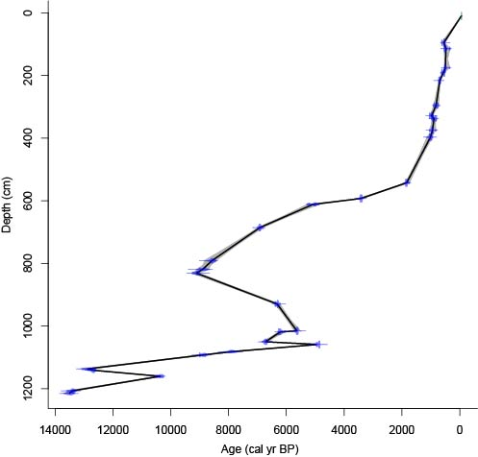
Figure 4.2. Age-depth model reproduced with permission from M. Valente. This model was made using Clam software (Blaauw 2010).

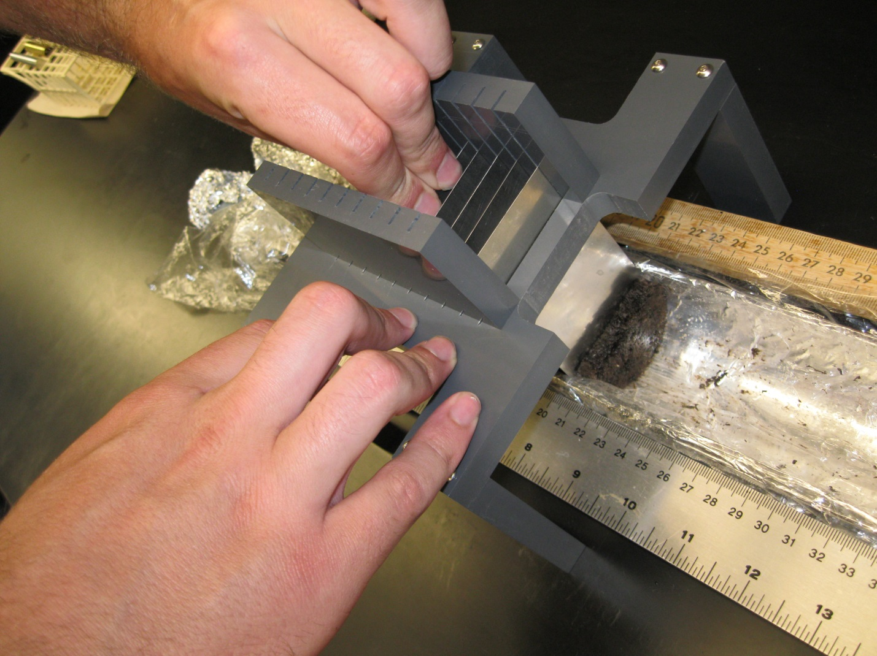
Figure 4.3. Sampling apparatus used for slicing core sections into equal 1 cm intervals. The device was designed by Matthew Valente with input from Sally Horn and Roger Horn, and fabricated by Roger Horn. Photo credit: Sally Horn.

on another. Charcoal particles, shells, and other macrofossils remaining on each sieve were washed into separate petri dishes using deionized water. I then added 10 ml of cosmetic grade hydrogen peroxide (~3% H₂O₂) and dried them overnight in an oven at 50 °C. The hydrogen peroxide bleaches non-charred organic matter, making it easier to distinguish charcoal fragments (Schlachter and Horn 2010).
I graphed and analyzed charcoal concentration on a volumetric basis for every centimeter of the core. To do this, I first counted the number of charcoal fragments in each dried sample using a binocular dissecting scope. Although several studies have observed similar trends in charcoal abundance between each size class (Whitlock and Millspaugh 1995; Long et al. 1998), I used both the 125–250 µm and >250 µm size classes because counting only one size class can lead to oversight of potentially important signals (Mooney and Tinner 2011). I counted the more numerous 125–250 µm size class to ensure charcoal abundance in all levels of the core was sufficient to highlight the paleoenvironmental signal, and the >250 µm size class to explore other possible details larger charcoal particles could illuminate.
I performed full counts on every petri dish of charcoal >250 µm, but counting the 125–250 µm size class was difficult and time-consuming. I used a strategy devised by Matthew Valente to estimate charcoal abundance for this size class. The strategy divides a petri dish into 18 color-coded bands (Figures 4.4 and 4.5) that allowed me to obtain a representative sample by counting only a portion of the dish. Counts were recorded on a sheet that simplified the estimation strategy (Figure 4.6), and then scanned for archiving. A comparison of full counts of the 125–250 µm size class and estimated counts using a prototype counting grid for 10 samples showed that the estimated charcoal count was within 5% of the full count for most samples, and within 12% for all samples. Calculations of Poza Cortador charcoal concentrations were made


Figure 4.4. Petri dish holder that divides a dish into 18 color-coded bands and prevents the dish from slipping around. The holder was designed and fabricated by Matthew Valente.

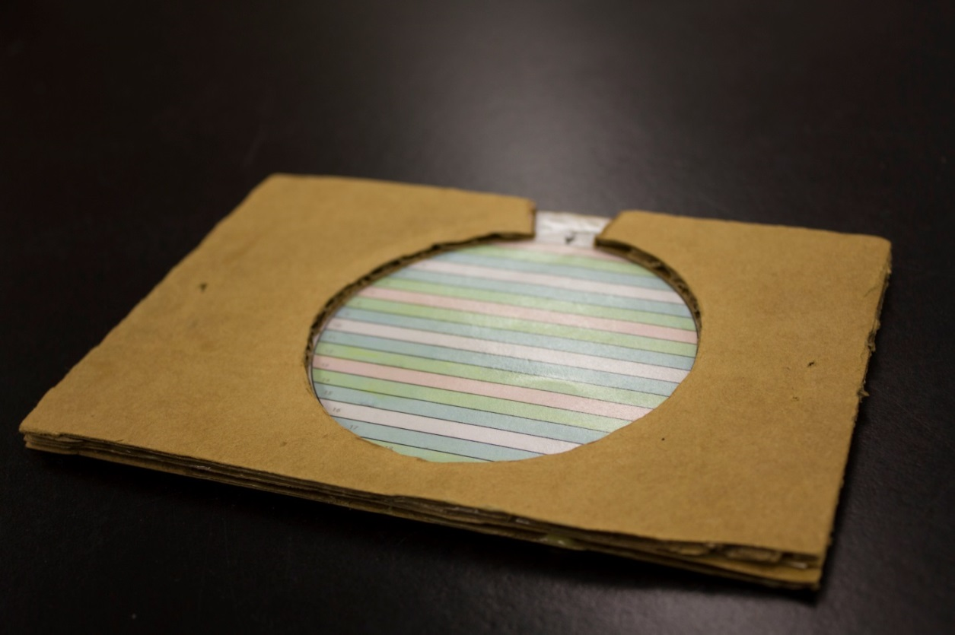
Figure 4.5. Side view of petri dish holder showing the walls that hold the dish in place.

Figure 4.6. Count sheet used for estimating number of charcoal particles in the 125–250 µm size class.
using Excel. I graphed charcoal concentration by age and depth using the C2 data analysis software (Juggins 2003), and finished graphs in Adobe Illustrator.

CHAPTER 5
RESULTS
Total macroscopic charcoal concentration values (Figure 5.1) in the Poza Cortador sediments vary substantially throughout the core. Macroscopic charcoal was sparse in the late Pleistocene, but charcoal shows an abrupt increase of three orders of magnitude at the Pleistocene-Holocene boundary (~1100 cm). After this point, charcoal concentration values vary widely from none to more than 8,000 particles/cm³. Numerous large, discreet peaks (>2,000 particles/cm³) are distributed through the next 10 m of sediment, including five peaks at or above 6,000 particles/cm³. Sediments within the age reversal are characterized by large peaks from 1100–960 cm, and an interval of low charcoal (<500 particles/cm³) from 960–840 cm. Above the age reversal are high charcoal concentrations from 9000–5000 cal yr B.P., followed by an interval of exceptionally low charcoal concentration (<200 particles/cm³) occurring from 620–560 cm, separating the middle and late Holocene. Charcoal concentrations are high again for around a thousand years of the late Holocene before dramatically dropping off near the top of the record.
The late Holocene record contains the highest charcoal concentrations, the highest peaks in charcoal, and the highest variability in the core. Plotting macroscopic charcoal concentration for the last ca. 1850 cal yr by age (Figure 5.2) rather than depth reveals more detailed patterns. Charcoal concentration values were low before 1300 cal yr B.P. Burning increased after 1300 cal yr B.P., reaching its highest point during the early portion of the Medieval Warm Period, and briefly dropping off just before 700 cal yr B.P. High charcoal concentrations last into the Little Ice Age where they decrease dramatically ca. 500 cal yr B.P.

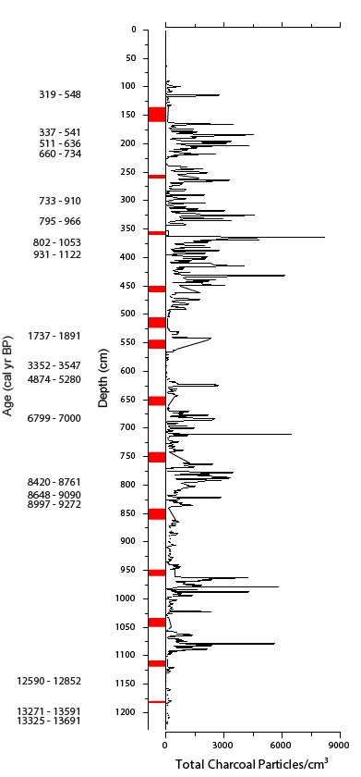
Figure 5.1. Total macroscopic charcoal concentration. Calibrated ages to the left are two-sigma ranges determined using the R_Date function of the software OxCal v 4.1.7 using the IntCal09 calibration dataset of Reimer et al. (2009). Dates showing reversals are excluded. Intervals of missing sediments are shown in red.
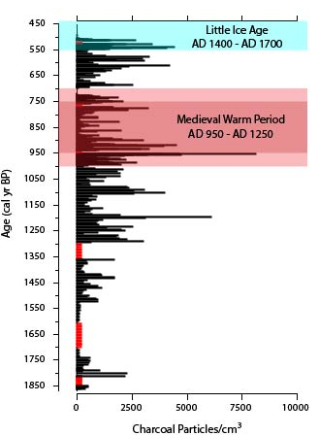
Figure 5.2. Late Holocene total macroscopic charcoal concentration by age. Includes approximate ages of Little Ice Age and Medieval Warm Period outlined by Mann et al. (2009), as well as the narrower age range for the Medieval Warm Period (AD 1000–1200) used by Brunelle et al. (2010) in a deeper shade of red. Intervals of missing sediments are shown in red.
Macroscopic charcoal concentration values follow a similar pattern in both the 125–250 µm and >250 µm size classes (Figure 5.3). Charcoal concentrations for each size class are positively and significantly correlated (r = 0.913, p <0.001, n = 992). The smaller 125–250 µm particles are more numerous, but most peaks in charcoal concentration are associated with increased numbers of larger particles. While the peaks in data of the larger size class are usually less than 30% the magnitude of peaks in the 125–250 µm size class, the two records indicate a high degree of similarity in pattern. Charcoal concentration in either size class is also strongly linked with sediment type. Large peaks in the charcoal record occur almost exclusively in peat sediments. Because too many extreme values make the dataset follow a non-normal distribution, a Mann-Whitney test was used to compare the amount of charcoal found in peat samples against that found in other sediments. I found that charcoal concentration in peat samples was significantly higher than in other sediment types, allowing me to reject the null hypothesis of no difference between the two.

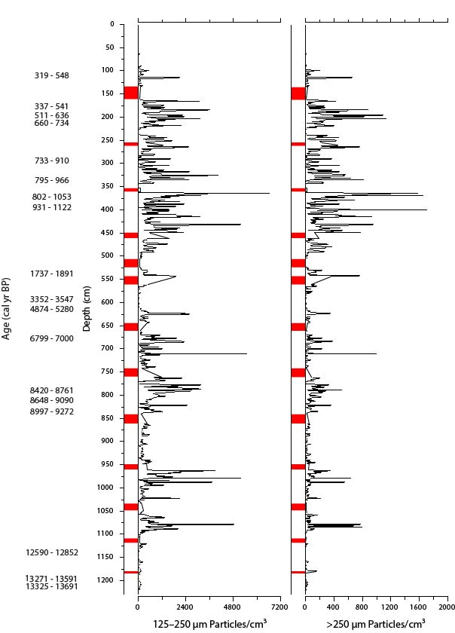
Figure 5.3. Macroscopic charcoal concentration of both the 125–250 µm and >250 µm size classes. Calibrated ages to the left are two-sigma ranges determined using the R_Date function of the software OxCal v 4.1.7 using the IntCal09 calibration dataset of Reimer et al. (2009). Dates showing reversals are excluded. Intervals of missing sediments are shown in red.
CHAPTER 6
DISCUSSION
Radiocarbon Dating
Most of the 29 radiocarbon dates are in order, with the age of sediments increasing with depth in the core. The upper 5 m of peat are especially well anchored in time with 10 radiocarbon dates in this section alone. However, in a few sections of the core, the age of the sediments is less certain. Dates on macrofossils from 612 cm and 593 cm span a peat interval less than 20 cm wide, but are more than a thousand years apart. These dates could still be correct, with one or both of them falling outside of their two-sigma range. Alternatively, the peat may have been compressed, or some material lost. The more troubling section of the core is the interval of apparent reversal in age between 1092 cm and 930 cm. This inversion could have been caused by groundwater contamination, erosion, or a rearrangement of material during coring. The final questionable date was taken from 1160 cm. The two-sigma range of 10,245–10,500 cal yr B.P. for this sample is anomalously young, but the sample mass was very low, and the date probably does not represent the true age of the sediments at this depth.
Macroscopic Charcoal Size Classes
The high degree of similarity between the 125–250 µm and >250 µm size classes further validates the estimation strategy used for quantifying 125–250 µm charcoal particles. That the estimated size class was so highly correlated with the samples on which I performed full counts, lends credence to this method and its utility for future studies. The similar pattern between the two corroborates the Mooney and Tinner (2011) conclusion that all size classes of macroscopic charcoal are significantly correlated. Although this was not clear in the Poza Cortador sediments until all counts were finished, my results could help streamline later sedimentary charcoal studies. The time spent separating and counting different size classes could instead be applied to improving the record through high-resolution contiguous analysis or replication (Mooney and Tinner 2011).
Depositional Environment and Fire History
The numerous changes in sediment type in the Poza Cortador core indicate that at least the area around the marsh itself was a dynamic place over the past ca. 14,000 years, a condition that might characterize the entire valley. A major pattern emerges when comparing the complex depositional history of Poza Cortador with the sedimentary charcoal record (Figure 6.1). Peaks in charcoal abundance occur predominately during intervals of peat in the core. Mean charcoal concentrations were significantly higher in peat-rich sections of the core than in paleosols or lake sediments of the late Pleistocene.
Based on the formation of paleosols at several points in the record, Poza Cortador has dried out in the past. When marsh sediments dry out, organic surface sediments are exposed to fire (Allen et al. 2008). This kind of in situ burning combusts the organic sediments, leaving behind an extremely high proportion of charcoal particles (Allen et al. 2008). This explains why the peat samples contained charcoal concentrations orders of magnitude higher than anywhere else in the core, and makes it difficult to compare fire activity at Poza Cortador across differing depositional environments. The various sediments types of Poza Cortador have recorded charcoal differently through history. While studying marsh sediments such as those of the Poza Cortador core, it may be necessary to tease apart changes in charcoal concentration indicative of fire activity from those that are a reflection of the environment and sediment type.
Figure 6.1. Combination of the macroscopic charcoal record, generalized stratigraphy diagram, and age-depth model. A table of mean charcoal concentration helps show the relationship between sediment type and charcoal abundance.

Interpretation of Fire History
My results show a pronounced change in charcoal concentration near the bottom of the core (Figure 6.2), which corresponds with the timing of vegetation transition at the Pleistocene-Holocene boundary (Holmgren et al. 2003; Metcalfe 2006). While this change in charcoal abundance at the Pleistocene-Holocene boundary accompanies a change in sediment type from clay to peat, and may largely reflect a changed depositional environment, this finding still indicates the desert grasslands of northern Mexico were a dynamic landscape during this transitional period. Although Butzer et al. (2008) found no evidence for a wetter than present Pleistocene, and dismissed as conjectural some of the temperature inferences around the Pleistocene-Holocene transition, this large spike in charcoal abundance and transition from lake to marsh conditions is a better fit with the more widely held belief that a warming and drying climate in the early Holocene brought on changes in vegetation and fire activity. As Butzer et al. (2008) suggested, classifying climate as “wet” or “dry” is almost certainly an oversimplification, but it seems to explain the general pattern seen in the record, as increases in charcoal in the early Holocene are likely a consequence of warming (Marlon et al. 2009).
The spike also appears sudden, occurring over the course of a few centimeters. However, this section of the core is poorly anchored in time. What appears to be a sharp transition could be an artifact of sediment preservation. If some sediments are missing in this part of the core, then my findings could support the Betancourt et al. (2003) idea of a gradual transition. It is unfortunate that the chronology for this section of the core is uncertain. Although a growing consensus holds that the Pleistocene-Holocene transition was a time of great changes in northern Mexico, more precise timing of these events is needed at the Poza Cortador site. Completely lost within the age reversal is any signal of the rapid return to cooler temperatures during the
Figure 6.2. The large spike in charcoal concentration at the Pleistocene-Holocene boundary might be more an indication of depositional environment rather than fire activity. Intervals of missing sediments are shown in red.

Younger Dryas. In their paper synthesizing charcoal records across North America, Marlon et al. (2009) observed that several studies have shown problematic radiocarbon dates around the Younger Dryas. This period also corresponds to the most complex stratigraphy in the core.
Above the age reversal, charcoal concentration is high for an extended period. The high charcoal concentrations between 9,000 and 5,000 cal yr B.P. can largely be attributed to the burning of organic surface sediments, but also possibly the result of a warmer and drier middle Holocene. Allen et al. (2008) attributed a major increase in charcoal in northern New Mexico at 9000 B.P. to warming and the strengthening of the summer monsoon. While charcoal concentration in this portion of the core is overall lower than the late Holocene, fire activity may not have been any less. We cannot extrapolate specific information about the fire based on the size of the peaks (Marlon et al. 2009). The period of elevated charcoal production in the middle Holocene also persisted for 5000 years while high concentrations in the late Holocene only lasted around 1000 years.
While short compared to the extended period of elevated charcoal in the middle Holocene, the highest charcoal concentrations in the record occur in the peat section at the top of the core. This section spans 5 m of sediment, but represents less than 2000 years of deposition, providing a very high resolution look at fire variability in the late Holocene. The high sedimentation rate, uniformity of depositional environment, number of radiocarbon dates, and similarity to modern-day conditions likely makes the late Holocene sediments of Poza Cortador of the most interest to land managers. The high charcoal concentrations of the late Holocene are again related to sediment type and the burning of organic surface sediments. However, the late Holocene environment of northern Mexico was also characterized by more frequent high-magnitude floods probably associated with El Niño cycles bringing enhanced winter precipitation (Nordt 2003). Perhaps this change in precipitation patterns increased fuel loads and consequently wildfire activity and charcoal abundance in Poza Cortador.
The late Holocene contains the highest charcoal peak in the core (>8000 particles/cm³) between 1000 and 800 cal yr B.P. The patterns in charcoal abundance in this period could be a signal of the Medieval Warm Period. The Medieval Warm Period manifested itself in southwestern North America as a prolonged drought and a period of increased charcoal production (Brunelle et al. 2010). Towards the end of the Medieval Warm Period is a very short interval of little to no charcoal production. Whereas low moisture might be crucial for starting fires, extended periods of drought might mean no fuel was available for burning (Brunelle and Anderson 2003). As fires raged across southwestern North America during the Medieval Warm Period, all fuel sources could have been destroyed with insufficient precipitation to replenish them in subsequent years, leaving no organic material behind to produce charcoal. Humidity and biomass appear to return soon thereafter as charcoal concentrations rebound and remain high until ~500 cal yr B.P.
The upper portion of the Poza Cortador sediments records the beginning of what Mann et al. (2009) defined as the onset of the Little Ice Age. The abrupt decrease in charcoal concentration after 500 cal yr B.P. corresponds to a known intensification of Little Ice Age conditions at 520 B.P. linked to stratospheric sulfur loading and sea ice/ocean feedbacks during a particularly volcanically active time (Miller et al. 2010). Reduced vegetation productivity as a result of cooling temperatures during the Little Ice Age could have kept fire activity around Poza Cortador to a minimum, a condition lasting until the upper limit of the core just after 500 cal yr B.P. The most recent years of fire history are, unfortunately, lost.
In wetlands of southwestern North America, where organic material in the ciénega itself is burning, charcoal concentrations can vary substantially. Allen et al. (2008) suggested fire frequency or severity cannot be confidently interpreted from changes in charcoal abundance within wetland sediments of this type. We must be careful interpreting anything from the size of a peak in charcoal concentration, but unusually large peaks have been linked to extreme fire years (Marlon et al. 2009). Perhaps the strongest signal is simply whether fire was present on the landscape or not. The larger differences in charcoal production make it easy to distinguish periods of fire from those without. But, gauging the extent of past fires may not be possible, and therefore we are missing part of what we need to understand “natural” fire regimes.
Comparison with other Records of Quaternary History
Charcoal is practically nonexistent in my record during the late glacial, but later spikes dramatically. Several other studies observed similar patterns. Power et al. (2010) found that fires were uncommon in the northern tropics during glacial times. This only began to change with increasing moisture beginning 17,700 cal yr B.P., a little earlier than in northern Mexico (Power et al. 2010). Closer to my study site, in northern New Mexico, Allen et al. (2008) found no charcoal from ~16,000–9000 cal yr B.P., followed by an abrupt increase of >10,000 particles/cm³. Their study showed incredibly high charcoal concentrations, and charcoal peaks that were several thousands of particles higher than background levels. This is the only study I have seen with charcoal concentration values comparable to mine. Marlon et al. (2009) found that fire activity increased as temperatures warmed at the end of the glacial period and continued until the Younger Dryas (12,900–11,700 cal yr B.P.). At this time, Marlon et al. (2009) found that burning remained the same, but increased dramatically again after the Younger Dryas ended (Marlon et al. 2009). This period is difficult to compare with my record because of uncertainty in dating. An interval of high charcoal exists centered on 975 cm, but the rest of the early Holocene sediments contain relatively little charcoal until ~9000 cal yr B.P.
In my record, there is a stretch of high charcoal concentration between 9,000 and 5,000 cal yr B.P. that includes the second highest charcoal peak in the core. This could represent the same period of warm and dry climate identified by Holmgren et al. (2008). It also agrees with the abrupt charcoal spike seen by Allen et al. (2008) in northern New Mexico, as well as the Marlon et al. (2009) observation that fire frequency was not particularly high in North America until after the Younger Dryas. After this point, most records fail to agree on the characteristics of climate in southwestern North America. Ortega-Ramirez et al. (1998) and Holmgren et al. (2008) found evidence for a warmer and drier middle Holocene, whereas Nordt (2003) and Butzer et al. (2008) found nothing to support this. Metcalfe (2006) described the mid-Holocene climate of northern Mexico as highly variable. The middle Holocene climate could have been very specific to each region. The high charcoal concentrations in my record seem to indicate a dry climate, but there is some variability.
Comparing results with other charcoal studies from the American Southwest and northern Mexico, I found that a closer study site did not necessarily mean results more similar to mine. Brunelle and Anderson (2003), working in Yosemite National Park, found their highest fire incidence to be prior to 7,000 cal yr B.P. after which fires tapered off. While charcoal concentrations in my core do not begin to taper off until after 600 cal yr B.P., the period of elevated charcoal from 9,000–7,000 cal yr B.P. they observed shows up clearly in my results as well. However, much closer to Cuatro Ciénegas, on the Arizona/Sonora border, Brunelle et al. (2010) found charcoal patterns very different from mine. For the period 8100–5300 cal yr B.P., when they found no charcoal, I had my second highest peak. From 5300–4400 cal yr B.P., when they observed increasing charcoal counts, I found concentrations less than 20 particles/cm³. This discrepancy likely demonstrates the effect of differing climatic mechanisms across the expansive arid regions of southwestern North America. The difference may be due to the proximity of the Sonoran site to the Pacific Ocean.
The results of Brunelle et al. (2010) begin to agree more with mine towards the top of the core. Their highest charcoal concentrations occur between 1100 and 740 cal yr B.P. Although it begins later and does not last as long, this period overlaps with the time of highest charcoal for Cuatro Ciénegas. The highest peak in my record, just below 350 cm, roughly corresponds to the period identified by Brunelle et al. (2010) as the Medieval Warm Period (~950 –750 cal yr B.P.). The Cuatro Ciénegas record also appears to record the Medieval Warm Period, and, in general, agrees with that of Brunelle et al. (2010) and others in indicating the late Holocene was a time of high charcoal production.
This time of high charcoal production lasted until the Little Ice Age, at which time Power et al. (2012) observed an abrupt drop in biomass burning. A rapid decrease in burning occurs in Cuatro Ciénegas ca. 500 cal yr B.P., only slightly earlier than their proposed time of 450 cal yr B.P. This corresponds to the intensification of Little Ice Age conditions identified by Miller et al. (2010), and helps contribute to the mounting evidence that this reduction in burning was indeed a result of climate forcing related to the Little Ice Age rather than a lingering effect of population collapse. Unfortunately, the Poza Cortador core does not have sediments young enough to capture the signal of the rest of the Little Ice Age or the southwestern “Megadrought” of 410–371 B.P (Stahle et al. 2000). The companion core from Poza Tule that T.L. Minckley and students are studying may include sediment from recent centuries that record these climate events.
Climate Change and the Future
Climate models warn that the next 50 years will bring more intense drought to the interior of North America (Hughes and Diaz 2008). Anthropogenic climate change and more intense drought will lead to increased fire activity in this region (Marlon et al. 2009). Currently, the role of fire in maintaining ciénegas remains poorly understood (Minckley et al. 2013). Therefore it is a priority to better understand how fire in this region has responded to climate change in the past (Marlon et al. 2009). However, we must also be cautious in applying conditions of the past to managing the landscape in the present, and carefully consider the specific challenges faced, resources available, and the preservation of rare and endangered species, while always being mindful of the future.
CHAPTER 7
CONCLUSIONS
Some have argued that, prior to European contact, fires were uncommon in desert ecosystems (Brunelle et al. 2010). My results, however, show that fire has been a significant part of the Cuatro Ciénegas landscape for thousands of years, predating the arrival of European colonists by several millennia. Because fires can burn the exposed organic surface sediments of a ciénega and leave behind an exceptionally high charcoal concentration, charcoal concentrations in Poza Cortador were highly dependent on depositional environment. Macroscopic charcoal was sparse in the lake sediments of the late Pleistocene, but abruptly increased in the peat-rich sediments at the Pleistocene-Holocene boundary. However, increased charcoal production in North America in the early Holocene has also been linked to a warming climate (Marlon et al. 2009), and the timing of this spike in charcoal concentration corresponds to the period identified by several studies as a transitional period in northern Mexico. The increased charcoal production at my site and others, change in depositional environments, vegetation in transition, and the regional decline of several species that thrive in cooler and wetter climates all point toward a warming and drying climate in the early Holocene.
The early Holocene sediments of Poza Cortador pose difficulties for reconstructing fire history. Sediment between 1092 cm and 930 cm showed dates that were younger than expected, making it challenging to infer climate or fire activity around the time of the Younger Dryas. Whether from erroneous dates, groundwater contamination, erosion, or rearrangement during coring, this age reversal limits what can be said about the early Holocene in Cuatro Ciénegas. To further complicate the matter, several other sedimentary charcoal studies in North America have shown problematic radiocarbon dates around the Younger Dryas (Marlon et al. 2009). However, most of the 29 radiocarbon dates on the Poza Cortador core are in order and show a relatively smooth age-depth curve.
Previous research indicates that the climate of southwestern North America during the middle Holocene was characterized by spatially heterogeneous temperature and moisture patterns. The location-specific climate reconstructions from studies in the southwestern United States and northern Mexico suggest that no single model of climate can be applied for the entire region. At Poza Cortador, ~5000 years of elevated charcoal production through the peat sediments of the middle Holocene appear to favor the idea of a drier climate. A second interval with high charcoal concentration begins with the transition of Poza Cortador to its modern day marsh-like form, ca. 5 m. The increased fire activity at this time might be a result of increased biomass brought on by frequent high-magnitude floods probably associated with El Niño cycles bringing enhanced winter precipitation to northern Mexico (Nordt 2003).
The largest charcoal peak in the core occurs during this period. This major peak between 1000 and 800 cal yr B.P. could be associated with the Medieval Warm Period, a time of increased charcoal production in southwestern North America (Brunelle et al. 2010). Charcoal concentration remained high in the late Holocene until an abrupt decrease in burning at 520 B.P. This dramatic shift in charcoal abundance corresponds to a known intensification of Little Ice Age conditions initially caused by volcanic activity and maintained by sea ice/ocean feedback (Miller et al. 2010). Other major climate events of the most recent part of the Holocene are not recorded at Poza Cortador because of the gap of a few centuries at the top of the record.
It may be tempting to compare the magnitudes of charcoal peaks in the record, but we must be wary about inferring characteristics about a fire event based on peak size because it is unclear how variability in charcoal concentration reflects fire frequency or severity (Allen et al. 2008). While unusually large peaks in charcoal indices have been linked to extreme fire years (Marlon et al. 2009), perhaps the strongest signal is simply whether fire was present on the landscape or not. Although more detailed information is desirable for fully understanding the “natural” fire regime, identifying fire as a part of the Cuatro Ciénegas landscape is an integral first step of this process.
The findings of this study provide high-resolution data on local fire history that contributes to the existing body of research in arid regions of southwestern North America, and can aid land managers in making informed conservation decisions to preserve this fascinating desert resource for future generations. Combining my results with the complementary research on the Poza Cortador and Poza Tule cores by Matthew Valente and by Dr. Thomas Minckley and students at the University of Wyoming will be a major step towards understanding the environmental history and wonder of the beautiful desert oasis of Cuatro Ciénegas.
REFERENCES

Ali, A.A., P.E. Higuera, Y. Bergeron, and C. Carcaillet. 2009. Comparing fire-history interpretations based on area, number and estimated volume of macroscopic charcoal in lake sediments. Quaternary Research 72: 462–468.
Allen, C.D., R.S. Anderson, R.B. Renata, J.L. Toney, and C.H. Baisan. 2008. Paired charcoal and tree-ring records of high-frequency Holocene fire from two New Mexico bog sites. International Journal of Wildland Fire 17(1): 115–130.
Betancourt, J.L., K.A. Rylander, C. Peñalba, J.L. McVickar. 2001. Late Quaternary vegetation history of Rough Canyon, south-central New Mexico, USA. Palaeogeography, Palaeoclimatology, Palaeoecology 165: 71–95.
Blaauw, M. 2010. Methods and code for ‘classical’ age-modelling of radiocarbon sequences. Quaternary Geochronology 5: 512–518.
Brunelle, A., and R.S. Anderson. 2003. Sedimentary charcoal as an indicator of late-Holocene drought in the Sierra Nevada, California, and its relevance to the future. The Holocene 13(1): 21–28.
Brunelle, A., T.A. Minckley, S. Blissett, S.K. Cobabe, and B.L. Guzman. 2010. A ~8000 year fire history from an Arizona/Sonora borderland ciénega. Journal of Arid Environments 74: 475–481.
Burney, L.P., and D.A. Burney. 2003. Charcoal stratigraphies for Kaua’i and the timing of human arrival. Pacific Science 57(2): 211–226.
Butzer, K.W., J.T. Abbott, C.D. Frederick, P.H. Lehman, C.E. Cordova, J.F. Oswald. 2008. Soil- geomorphology and “wet” cycles in the Holocene record of north-central Mexico. Geomorphology 101: 237–277.
Clark, R.L. 1983. Pollen and charcoal evidence for the effects of Aboriginal burning on the vegetation of Australia. Archaeology in Oceania 18(1): 32–37.
Clark, J.S., B.J. Stocks, H. Cachier, and J.G. Goldammer. 1997. Sediment Records of Biomass Burning and Global Change. Springer Verlag, Berlin.
Cleaveland, M.K, D.W. Stahle, M.D. Therrell, J. Villanueva-Diaz, and B.T. Burns. 2003. Tree- ring reconstructed winter precipitation and tropical teleconnections in Durango, Mexico. Climatic Change 59: 369–388.
Conedera, M., W. Tinner, C. Neff, M. Meurer, A.F. Dickens, and P. Krebs. 2009. Reconstructing past fire regimes: Methods, applications, and relevance to fire management and conservation. Quaternary Science Reviews 28: 555–576.
Davis, O.K., T. Minckley, T. Moutoux, T. Jull, and B. Kalin. 2002. The transformation of Sonoran Desert wetlands following the historic decrease of burning. Journal of Arid Environments 50: 393–412.
Elias, S.A., and T.R. Van Devender. 1990. Fossil insect evidence for Late Quaternary climatic change in the Big Bend region, Chihuahuan Desert, Texas. Quaternary Research 34: 249–261.
Forbes, J.D. 1959. The appearance of the mounted Indian in northern Mexico and the Southwest, to 1680. Southwestern Journal of Anthropology 15(2): 189–212.
Gavin, D.G., D.J. Hallett, F.S. Hu, K.P. Lertzman, S.J. Prichard, K.J. Brown, J.A. Lynch, P. Bartlein, and D.L. Peterson. 2007. Forest fire and climate change in western North America: Insights from sediment charcoal records. Frontiers in Ecology and the Environment 5(9): 499–506.
Grall, G. 1995. Mexico’s desert aquarium. National Geographic 188: 85–97.
Grissino-Mayer, H.D. 1996. A 2129-year reconstruction of precipitation for northwestern New Mexico, USA. Pages 191–204 in J.S. Dean, D.M. Meko, and T.W. Swetnam, eds., Tree Rings, Environment, and Humanity. The University of Arizona, Tucson.
Holmgren, C.A., M.C. Peñalba, K.A. Rylander, and J.L. Betancourt. 2003. A 16,000 14C yr B.P. packrat midden series from the USA-Mexico Borderlands. Quaternary Research 60: 319–329.
Horn, S.P. 2008. Assessing the Potential to Reconstruct Fire and Vegetation History from Sedimentary Charcoal and Pollen in the Valle de Cuatro Ciénegas, Mexico. Final report on Nature Conservancy contract CNOMEX-042307. 34 pp.
Hughes, M.K., and H.F. Diaz. 2008. Climate variability and change in the drylands of western North America. Global and Planetary Change 64: 111–118.
Juggins, S. 2003. C2 Version 1.7.2: Software for ecological and palaeoecological data analysis and visualization. Newcastle upon Tyne: University of Newcastle.
Long, C.J., C. Whitlock, P.J. Bartlein, and S.H. Millspaugh. 1998. A 9000-year fire history from the Oregon Coast Range, based on a high-resolution charcoal study. Canadian Journal of Forest Research 28: 774–787.
Mann, M.E., Z. Zhang, S. Rutherford, R.S. Bradley, M.K. Hughes, D.Shindell, C. Ammann, G. Faluvegi, and F. Ni. 2009. Global signatures and dynamical origins of the Little Ice Age and Medieval Climate Anomaly. Science 326: 1256–1260.
Marlon, J.R., P.J. Bartlein, M.K. Walsh, S.P. Harrison, K.J. Brown, M.E. Edwards, P.E. Higuera, M.J. Power, R.S. Anderson, C. Briles, A. Brunelle, C. Carcaillet, M. Daniels, F.S. Hu, M. Lavoie, C. Long, T. Minckley, P.J.H. Richard, A.C. Scott, D.S. Shafer, W. Tinner, C.E. Umbanhowar Jr., and C. Whitlock. 2009. Wildfire responses to abrupt climate change in North America. Proceedings of the National Academy of Sciences of the United States of America 106(8): 2519–2594.
Metcalfe, S.E. 2006. Late Quaternary environments of the northern desert and central volcanic belt of Mexico. Annals of the Missouri Botanical Garden 93(2): 258–273.
Metcalfe, S.E., A. Bimpson, A.J. Courtice, S.L. O’Hara, and D.M. Taylor 1997. Climate change at the monsoon/Westerly boundary in Northern Mexico. Journal of Paleolimnology 17: 155–171.
Meyer, E.R. 1973. Late Quaternary paleoecology of the Cuatro Ciénegas Basin, Coahuila, Mexico. Ecology 54(5): 982–995.
Miller, G.H., Á. Geirsdóttir, Y. Zhong, D.J. Larsen, B.L. Otto-Bliesner, M.M. Holland, D.A. Bailey, K.A. Refsnider, S.J. Lehman, J.R. Southon, C. Anderson, H. Björnsson, and T. Thordarson. 2012. Abrupt onset of the Little Ice Age triggered by volcanism and sustained by sea-ice/ocean feedbacks. Geophysical Research Letters 39: L02708. doi:10.1029/2011GL050168
Minckley, T.A., and A. Brunelle. 2007. Paleohydrology and growth of a desert ciénega. Journal of Arid Environments 69: 420–431.
Minckley, T.A., and S.T. Jackson. 2008. Ecological stability in a changing world? Reassessment of the paleoenvironmental history of Cuatrociénegas, Mexico. Journal of Biogeography 35: 188–190.
Minckley, T.A., M.T. Clementz, A. Brunelle, and G.A. Klopfenstein. 2009. Isotopic analysis of wetland development in the American Southwest. The Holocene 19(5): 737–745.
Minckley, T.A., D.S. Turner, and S.R. Weinstein. 2013. The relevance of wetland conservation in arid regions: A re-examination of vanishing communities in the American Southwest. Journal of Arid Environments 88: 213–221.
Mooney, S.D., and W. Tinner. 2011. The analysis of charcoal in peat and organic sediments. Mires and Peat 7: 1–18.
Nordt, L.E. 2003. Late Quaternary fluvial landscape evolution in desert grasslands of northern Chihuahua, Mexico. Geological Society of America Bulletin 115: 596–606.
Ortega-Ramirez, J.R., A. Valiente-Banuet, J. Urrutia-Fucugauchi, C.A. Mortera-Gutiérrez, and G. Alvarado-Valdez. 1998. Paleoclimatic changes during the Late Pleistocene – Holocene in Laguna Babícora, near the Chihuahuan Desert, México. Canadian Journal of Earth Sciences 35: 1168–1179.
Patterson, W.A., K.J. Edwards, and D.J. Maguire. 1987. Microscopic charcoal as a fossil indicator of fire. Quaternary Science Reviews 6: 3–23.
Phillips, D.A. 1989. Prehistory of Chihuahua and Sonora, Mexico. Journal of World Prehistory 3(4): 373–401.
Power, M.J., M.B. Bush, H. Behling, S.P. Horn, F.E. Mayle, and D.H. Urrego. 2010. Paleofire activity in tropical American during the last 21 ka: A regional synthesis based on sedimentary charcoal. PAGES News 18(2): 73–75.
Power, M.J., J. Marlon, N. Ortiz, P.J. Bartlein, S.P. Harrison, F.E. Mayle, A. Ballouche, R. Bradshaw, C. Carcaillet, C. Cordova, S. Mooney, P. Moreno, I.C. Prentice, K. Thonicke, W. Tinner, C. Whitlock, Y. Zhang, Y. Zhao, R.S. Anderson, R. Beer, H. Behling, C. Briles, K.J. Brown, A. Brunelle, M. Bush, P. Camill, G.Q. Chu, J. Clark, D. Colombaroli, M. Daniels, J. Dodson, E. Doughty, M.E. Edwards, W. Fisinger, D. Foster, M.J. Gaillard, D.G. Gavin, E. Gobet, S. Haberle, D.J. Hallett, P. Higuera, G. Hope, S. Horn, J. Inoue, P. Kaltenrieder, L. Kennedy, Z.C. Kong, C. Larsen, C.J. Long, J. Lynch, B. Lynch, M. McGlone, S. Meeks, S. Mensing, G. Meyer, T. Minckley, J. Mohr, R. Newnham, R. Noti, W. Oswald, J. Pierce, P.J.H. Richard, B.J. Shuman, H. Takahara, J. Toney, C. Turney, C. Urbanhower, M. Vandergross, B. Vanniere, E. Vescovi, M. Walsh, X. Wang, N. Williams, J. Wilmhurst, and J.H Zhang. 2008. Changes in fire activity since the Last Glacial Maximum: An assessment based on a global synthesis and analysis of charcoal data. Climate Dynamics 30: 887–907.
Power, M.J., F.E. Mayle, P.J. Bartlein, J.R. Marlon, R.S. Anderson, H. Behling, K.J. Brown, C. Carcaillet, D. Colombaroli, D.G. Gavin, D.J. Hallett, S.P. Horn, L.M. Kennedy, C. Lane, C. Long, P.I. Moreno, C. Paitre, G. Robinson, Z.Taylor, and M. Walsh. 2012. Climatic control of the biomass-burning decline in the Americas after AD 1500. The Holocene 23(1): 3–13.
Reimer, P.J., M.G.L. Baillie, E. Bard, A. Bayliss, J.W. Beck, P.G. Blackwell, C. Bronk Ramsey, C.E. Buck, G.S. Burr, R.L. Edwards, M. Friedrich, P.M. Grootes, T.P. Guilderson, I. Hajdas, T.J. Heaton, A.G. Hogg, K.A. Hughen, K.F. Kaiser, B. Kromer, F.G. McCormac, S.W. Manning, R.W. Reimer, D.A. Richards, J.R. Southon, S. Talamo, C.S.M Turney, J. van der Plicht, and C.E. Weyhenmeyer. 2009. IntCal09 and Marine09 Radiocarbon age calibration curves, 0–50,000 years cal BP. Radiocarbon 51: 1111–1150.
Ryan, W.B.F., S.M. Carbotte, J.O. Coplan, S. O’Hara, A. Melkonian, R. Arko, R.A. Weissel, V. Ferrini, A. Goodwillie, F. Nitsche, J. Bonczkowski, R. Zemsky. 2009. Global Multi- Resolution Topography synthesis. Geochemistry, Geophsyics, Geosystems 10: Q03014. doi:10.1029/2008GC002332.
Sanders, H.L. 1968. Marine benthic diversity: A comparative study. American Naturalist 102: 253–282.
Schlachter, K.J., and S.P. Horn. 2010. Sample preparation methods and replicability in macroscopic charcoal analysis. Journal of Paleolimnology 44: 701–708.
Souza, V., L. Espinosa-Asuar, A.E. Escalante, L.E. Eguiarte, J. Farmer, L. Forney, L. Lloret, J.M. Rodríguez-Martínez, X. Soberón, R. Dirzo, and J.J. Elser. 2006. An endangered oasis of aquatic microbial diversity in the Chihuahuan desert. Proceedings of the National Academy of Sciences of the United States of America 103(17): 6565–6570.
Stahle, D.W., E.R. Cook, M.K. Cleaveland, M.D. Therrell, D.M. Meko, H.D. Grissino-Mayer, E. Watson, and B.H. Luckman. 2000. Tree-ring data document 16th century megadrought over North America. Eos, Transactions, American Geophysical Union 81(12): 121–132.
Stuiver M. and H.A. Polach. 1977. Discussion: Reporting of ¹⁴C data. Radiocarbon 19(3): 355– 363.
Swetnam, T.W. 1993. Fire history and climate change in giant sequoia groves. Science 262: 885– 889.
Swetnam, T.W., C.D. Allen, and J.L. Betancourt. 1999. Applied historical ecology: Using the past to manage for the future. Ecological Applications 9(4): 1189–1206.
Taylor, W.W. 2003. Sandals from Coahuila caves with an introduction to the Coahuila Project, Mexico: 1937–1941, 1947. Dumbarton Oaks Research Library and Collection, Washington, D.C., 151 pp.
Van Devender, T.R., and T.L. Burgess 1985. Late Pleistocene woodlands in the Bolson de Mapimi: A refugium for the Chihuahuan Desert biota? Quaternary Research 24: 346– 353.
Whitlock, C., and P. J. Bartlein. 2004. Holocene fire activity as a record of past environmental change. Pages 479–489 in A. Gillespie and S. C. Porter, eds., Developments in Quaternary Science, The Quaternary Period in the United States vol. 1. Elsevier, Amsterdam.
Whitlock, C., and C. Larsen. 2001. Charcoal as a fire proxy. Pages 75–98 in J.P. Smol, H.J.B. Birks, and W.M. Last, eds., Tracking Environmental Change Using Lakes Sediments Volume 3: Terrestrial, Algal, and Siliceous Indicators. Kluwer Academic Publishers, Dordrecht, The Netherlands.
Whitlock, C., and S.H. Millspaugh. 1996. Testing the assumptions of fire-history studies: an examination of modern charcoal accumulation in Yellowstone, National Park, USA. The Holocene 6(1): 7–15.

VITA
John is the first of two children born to loving parents Lawrence and Rebecca Eads in Johnson City, Tennessee. He moved to Knoxville, Tennessee in 2006 to pursue a Bachelor’s Degree in Geography at the University of Tennessee. He completed this task in 2010, graduating with honors in the spring ceremony. He discovered his love for biogeography during a spring break trip his senior year of college. Vacationing on a private island in the Bahamas, John left his sleeping girlfriend to bake in the noonday Caribbean sun to investigate a coconut that had washed up on the beach. Walking right past a free rum punch waterfall, and completely oblivious to a game of beach volleyball going on right behind him, John pondered this coconut and the spectacular journey it went on to wash up there on his beach. It was at this moment he realized geography might play a bigger role in his life than he first thought.
He was admitted to the Master’s Program at the University of Tennessee the very next school year to continue his study of biogeography. There he taught introductory physical geography lab classes, and was a research assistant in the Laboratory of Paleoenvironmental Research. After graduating in 2013, John plans to share his love for geography with the rest of the world in every way he can.

