The Characterization of a CMOS Radiation Hardened-by-Design Circuit Technique

A Thesis Presented for the
Master of Science Degree
The University of Tennessee, Knoxville

Austin Womac
July 2013

I dedicate this thesis to my parents,
Alvin and Eleanore Womac, and my friends
for their unwavering support and love.
Acknowledgements

I would like to first extend gratitude to my major professor, Dr. Benjamin Blalock. His charisma and energy inspire me. His expertise in the fields of mixed-signal IC design and extreme-environment electronics provided me the resources to complete this thesis. His support and guidance have made me a better engineer.
In addition I would like to thank Dr. Charles Britton. Chuck’s patient guidance as a mentor has grown my understanding of electronics especially PLL loop dynamics. I would also like to thank Dr. Syed Islam. He taught my first electronics class, ECE 335, (along with other classes) which fueled my interest in electronics.
I thank Dr. Robert Greenwell whose wealth of knowledge of Cadence and analog layout strategies and his eagerness to help were invaluable to me in the lab. Also, I thank Ben Prothro for his guidance in the design of the first ASIC (Cappadocia) and the test boards.
This work was supported by a NASA Office of the Chief Technologist’s Space Technology Research Fellowship.
Abstract

This thesis presents the analysis, implementation and testing of a circuit-level radiation hardened-by-design (RHBD) technique first presented in [1]. Radiation effects heavily influence the cost and design of electronics bound for radiation-rich environments such as in nuclear reactors or space. The circuit-level RHBD technique is presented as a cost-effective way to mitigate total-ionizing dose (TID) radiation in digital complementary metal-oxide-semiconductor (CMOS) transistor circuits. These claims are analyzed and experimentally tested.
Devices from a relatively old and a newer semiconductor fabrication process are tested to investigate the impact of device scaling on the RHBD technique’s effectiveness. A rad-tolerant frequency synthesizer that implements this technique is discussed. Challenges in the project included implementing efficient testing procedures at the radiation test facilities. Testing time was limited and in-situ test methodologies utilizing LabView programs were used effectively.
Table of Contents

CHAPTER 1: Introduction 1
1.1 Motivation 1
1.2 Thesis Scope and Organization 3
CHAPTER 2: Background 4
2.1 TID Radiation and Its Effect on MOSFET Devices 4
2.2 Interaction of Radiation with Solids 6
2.3 TID in MOSFET Devices 9
2.4 TID-Induced Performance Degradations in MOSFETs 13
2.4.1 Thick-Gate Oxide Devices 15
2.4.2 Thin-Gate Oxide Devices 17
2.5 The Traditional, Straight-Gate Inverter’s Shortcomings under TID 26
2.6 Hardened-By-Design Layout Techniques 31
2.6.1 Annular Gate MOSFET 31
2.6.2 Enclosed-Source/Drain MOSFET 35
CHAPTER 3: Methodology 38
3.1 The Inverted-Source Technique 38
3.1.1 How it Works 38
3.1.2 Potential TID Mitigation in Thin-Gate Oxide Devices 42
3.1.3 The Inverted-Source’s Limitations 44
3.1.4 Summary 50
3.2 Thick-Gate Oxide Device Testing 50
3.2.1 The ALD1106 and ALD1107 Devices 50
3.2.2 The Test Circuits 51
3.2.3 In Situ Radiation Test Setup at Auburn 54
3.2.4 Test Methodology 57
3.3 Thin-Gate Oxide Device Testing 57
3.3.1 A Rad-Tolerant Frequency Synthesizer in the IBM 7WL Process 57
3.3.2 The Test Circuits 60
3.3.2.1 Cappadocia Die 60
3.3.2.2 Archelais Die 64
3.3.3 In Situ Radiation Testing 64
3.3.3.1 Cappadocia Die Test Setup and Methodology 64
3.3.3.2 Archelais Run 66
3.3.4 Summary 66
CHAPTER 4: Results and Discussion 68
4.1 Thick-Gate Oxide Test Results 68
4.2 Thin-Gate Oxide Test Results 68
CHAPTER 5: Conclusions and Recommendations 69
References 70
Appendices 74
A.1 The Test Boards 75
A.2 The LabView Virtual Instruments (VIs) 81
Vita 82

List of Tables

Table 1 - The radiation testing summary. 67

List of Figures

Figure 01 - The major sources of radiation to Earth [8]. 5
Figure 02 - The LET of protons and electrons in SiO₂ versus the particle's energy. “The effective LET of Co-60 is indicated in terms of an equivalent energetic electron” [8]. 8
Figure 03 - Trapping mechanisms in gate oxide with a positively-biased gate node [10]. 10
Figure 04 - The location and response of trapped charge within SiO₂ [9]. 12
Figure 05 - Cross-sectional view of NMOS transistor in the channel length direction. 14
Figure 06 - Threshold voltage variation in PMOS and NMOS thick-gate oxide transistors via trapped charge (N_{ot}) [9]. 16
Figure 07 - Cross-sectional view of NMOS transistor in the channel width direction. 18
Figure 08 - 3D cross-section of 0.4 µm NMOS FET. Current density is calculated when a sheet charge is placed on the STI/Si interface. Results show leakage current density depends on depth in the channel with more current flowing deeper within the channel [16]. 20
Figure 09 - Measured V_{GS} vs. I_{D} curve of an NMOS transistor fabricated in a 0.18 µm CMOS process for various TID [16]. 21
Figure 10 - Measured I_{D} vs. V_{GS} of NMOS in 0.35 µm BiCMOS process [14]. 23
Figure 11 - Diagram of STI corner for three NMOS devices in a 0.18 µm CMOS process [17]. 25
Figure 12 - Typical CMOS inverter. 27
Figure 13 - CMOS inverter equivalent DC model with an input voltage of zero. As TID increases, the current through the NMOS transistor increases, modeled here as a decreasing resistance. 29
Figure 14 - An inverter (a) and its DC transfer function (b) showing output failure at high-TID levels [18]. 30
Figure 15 - Schematic diagram of (a) traditional, straight-gate MOSFET and (b) annular gate MOSFET [8]. 32
Figure 16 - I_{D} versus V_{G} curve for annular gate NFET fabricated in TSMC 0.25 µm process [5]. 34
Figure 17 - Conceptual view of (a) enclosed-source transistor and (b) enclosed-drain transistor [8]. 36
Figure 18 - Inverted-Source TID HBD technique. 39
Figure 19 - Conceptual I_{D} vs. V_{GS} curves for thick-gate oxide NMOS transistor under TID. Point A shows the operating point of a traditional CMOS inverter, whereas the spectrum from B to C indicates the operating region of the HBD inverter over TID. 41
Figure 20 - VGS vs. ID curve for NMOS fabricated in a 0.18 µm CMOS technology [16]. Extrapolated curves indicate potential reduction in subthreshold leakage current if gate voltage is set below zero volts. 43
Figure 21 - Measured I_{D} vs. V_{GS} curves for various TID levels in the TSMC 0.18 µm process [8]. 45
Figure 22 - DC-equivalent model of HBD inverter with a logic 'low' input. 47
Figure 23 - Matlab simulation of DC-equivalent models of the traditional, non-HBD inverter (Figure 13) and the HBD inverter (Figure 22) of NMOS devices that exhibit no current control for V_{GS} < 0 V (i.e. worst-case scenario). 48
Figure 24 - V_{GS} vs. I_{D} test circuit, the 1st test circuit. 52
Figure 25 - Inverter DC transfer function test circuit, the 2nd test circuit. 53
Figure 26 - The Auburn Co-60 test room where the ALD1106 and ALD1107 chips were irradiated. The source is raised and lowered from a pool of heavy water by the elevator (center of frame). 56
Figure 27 - Block diagram of frequency synthesizer. 59
Figure 28 - Layout of 7WL test inverters. 61
Figure 29 - Layout of 31-stage test ring oscillators. 63
Figure 30 - Vanderbilt University's X-ray source (left) and the Cappadocia testing equipment (right). 65
Figure 31 – Test board used for radiation testing of ALD1106 and ALD1107. 76
Figure 32 - Bias board for Cappadocia chips. 77
Figure 33 - Daughter card housing Cappadocia chips. Inverter and ring oscillator outputs along the bottom of the board. 78
Figure 34 - Bias board for Archelais chips. 79
Figure 35 - Daughter card for Archelais chips. 80

Introduction

Motivation
Electronic devices pervade our society. From our smartphones to the control and entertainment systems in our cars to industrial process control systems, electronic devices perform vital functions in a multitude of applications that we may or may not realize. Their prevalence is in part due to their continuously increasing performance and decreasing cost. They have been increasingly called upon to perform in new, niche applications. Many of these applications include radiation-rich environments such as space, nuclear reactors and military applications.
Radiation can damage electronics causing performance degradation or malfunctions. NASA along with Jet Propulsion Laboratory (JPL) launched the Mars Science Laboratory (MSL) in 2011 to determine whether the Martian environment was ever habitable for life [1]. This mission included a small car-sized, autonomous rover dubbed Curiosity with a full suite of science sensors and instrumentation. In February of 2013, after roaming the Martian surface for seven months, Curiosity experienced failure of its primary onboard computer [2]. The problem was traced to the computer’s memory bank. The cause of the problem is believed to be a recent solar storm; charged particles from the storm may have reached Curiosity’s primary memory bank and corrupted some of the digital data bits [3]. This example illustrates the worst-case effect radiation can have on an electronic device: complete device failure.
MSL represents a 2.5 billion dollar investment by the American public. For the entire program to be halted by a relatively common solar storm would be a catastrophic blow to the space program. Fortunately, a redundant computer system was able to take over when the failure occurred. Normal operation of Curiosity has been resumed thanks to radiation mitigation techniques in use aboard the rover.
Radiation mitigation techniques are more commonly called radiation-hardening techniques or just rad-hard techniques. The rad-hard technique that saved Curiosity is a system-level technique. These techniques usually involve system redundancy, majority-voting circuits and digital parity checking. They are suited for mitigating single-event effects (SEE). SEE include both single event upsets (SEU) and single event transients (SET) [4]. SEU occur when charged particles, such as a cosmic ray or protons, change the state of a storage element such as a flip-flop, latch or memory bit [5]. An SET is a temporary voltage glitch in combinational logic caused by excessive charge deposited on a node from a large ion or proton [4]. By incorporating system-level mitigation techniques, SEE logic upsets can be detected and corrected.
Total-ionizing-dose (TID) effects are also important to consider when hardening electronic devices. SEE logic upsets are due to single ion strikes on vulnerable electrical nodes; TID quantifies the total radiative energy imparted to an electronic device. It is useful for understanding the degradation of device performance in the presence of radiation. These degradations are especially important in complementary metal-oxide-semiconductor (CMOS) transistors. According to [5], devices fabricated in older CMOS processes exhibit large changes in transistor threshold voltage. Newer CMOS processes tend to suffer more from subthreshold current leakage. System-level rad-hard techniques are not suited for mitigating these degradations.
One form of radiation hardening for TID is termed hardened-by-process. Hardened-by-process requires special “rad-hard” foundries to manufacture inherently rad-hard electronics. In his paper “Improving integrated circuit performance through the applicaiton of hardness-by-design methodology,” Lacoe describes these special foundries as boutique, expensive foundries lagging the latest commercial foundries by around three CMOS generations (about eight years). This gap is primarily due to the small demand for rad-hard electronics. It is desirable to avoid these foundries and harden higher performing commercial processes directly [5].
Hardened-by-design (HBD) techniques provide superior cost-to-performance ratio than hardened-by-process techniques. These techniques involve combining the intrinsic radiation hardness of current generation CMOS processes and special design techniques to create rad-hard electronics [5]. These special design techniques can include layout-level techniques and circuit-level techniques. Many of the layout techniques involve novel transistor designs, such as annular gate transistors or enclosed-source transistors [5]. These novel transistor designs are extremely tolerant of TID; however they incur layout area, speed and power penalties. They are also much more difficult to model than standard transistors [5]. These drawbacks motivate the investigation of HBD techniques that do not use novel transistor designs.
Dong Pan et al. propose a novel HBD circuit-level technique [6]. This technique uses process-standard transistors in a novel circuit configuration dubbed the “inverted-source” configuration. They show simulation data indicating the technique is effective at mitigating threshold voltage variation under TID. However, no experimental data is provided to quantify this. Also, this paper was published in 2003 when state-of-the-art CMOS devices were more susceptible to threshold voltage variation. There is no data indicating whether this novel technique is capable of mitigating subthreshold current leakage dominant in today’s CMOS devices exposed to TID radiation. These shortcomings motivate this thesis.

Thesis Scope and Organization
Radiation effects and hardening techniques to mitigate them constitute a very wide field-of-study. It is necessary to narrow the scope of this work. The primary focus of this thesis is the testing methodology used to determine the effectiveness of the inverted-source TID radiation hardening technique. This includes choosing the processes for testing, designing the circuits in these processes that characterize the performance of the technique and the radiation test setup used at the testing facilities. The goals of this thesis are to experimentally characterize the TID immunity and assess layout area, speed and power penalty of this novel HBD circuit-level technique in both an old and new CMOS process.
Chapter 2 provides background information on TID radiation effects and common HBD techniques used to mitigate them. It also introduces the inverted-source HBD technique and describes the CMOS processes implementing it. Chapter 3 analyzes the viability of the HBD technique, describes the HBD circuits designed and discusses the tests and test setup. Chapter 4 presents and analyzes the results of the radiation testing. Chapter 5 concludes the thesis by answering whether the goals of the thesis were met and presents some of the possible future direction of this research.

Background

TID Radiation and Its Effect on MOSFET Devices
Radiation-rich environments include space, nuclear reactors, processing, weapons, and controlled fusion [7]. The space environment contains a broad range of energetic particles that can have various deleterious effects on microelectronics including TID effects, SEE, and displacement of atoms. A discussion of the radiation in space encompasses many of the types of radiation harmful to microelectronics that are seen in other radiation-rich environments. Therefore, for the purposes of covering TID radiation and its effect on MOSFETs, it is suitable to provide a brief discussion of radiation in the space environment.
The largest sources of TID-inducing radiation around the Earth are the van Allen belts. These belts consist of electrons and protons trapped in the Earth’s magnetosphere [8]. Figure 1 shows the magnetic field lines of the Earth that contain the trapped particles. The trapped particle flux depends on the distance from the Earth and the latitude. Electrons tend to be found further from the earth and can have energies up to 7 MeV, while heavier protons are found closer and can have energies of several hundred MeV [7]. The typical altitudes of many space satellites are within the van Allen belts making it important that microelectronics aboard are tolerant of TID radiation.

Figure 01 - The major sources of radiation to Earth [8].

Flux lines emanating from the sun shown in Figure 1 depict a continuous solar wind from the sun. Solar wind is plasma consisting of 96% protons and 4% hydrogen and heavy ions with an equal number of electrons [8]. This solar wind is mostly deflected by the Earth’s magnetic field and creates a wake zone behind the Earth. However, if particles have energy higher than a certain threshold, dubbed the geomagnetic cutoff, they may penetrate the Earth’s magnetic field [7]. Another source of radiation includes galactic cosmic rays (GCRs). GCRs originate outside of the solar system and primarily consist of heavy bursts of protons [7]. Solar flares are moments of intense activity on the sun. They eject large bursts of electromagnetic radiation ranging from gamma rays to radio waves along with heavy ions, protons and electrons [8]. Solar flares also interact with the Earth’s magnetic field and may temporarily reduce the geomagnetic cutoff allowing increased radiation exposure [7]. While the bulk of TID effects are primarily attributed to the van Allen belts, these other sources of radiation in space contribute to TID as well.

Interaction of Radiation with Solids
When energetic particles such as protons, electrons or heavy ions impact a solid they deposit energy in the solid. The rad is the most common measure of the total energy deposited in a material. A rad is absorbed when 100 ergs per gram is deposited where an erg is 100 nJ. The gray is the SI unit of total energy deposited. A gray is defined as 1 joule per kilogram. There are therefore 100 rads in one gray. More commonly the rad is simply equated with one centigray (cGy). Because the rad is still the most common unit in use, it is used in this thesis. The amount of energy deposited by an energetic particle depends on the energy and size of the impinging particle [9]. This energy is lost at nearly a constant rate per distance traveled in the solid. When normalized by the density of the solid, this rate is defined as the linear energy transfer (LET). The units of LET are usually given in $\frac{MeV}{cm}×\frac{g}{{cm}^{3}}=\frac{MeV-{cm}^{2}}{g}$ [8].
The process of energy transfer from an impinging particle and a solid is a complicated process; the next few paragraphs give the reader a basic introduction to the subject. The primary loss of energy for a charged particle such as a proton or electron occurs through Coulomb scattering where the charged particle ejects an outer shell electron from an atom in the solid [8]. This is the creation of an electron-hole pair (ehp). Charged particles with enough energy to create electron-hole pairs (ehps) are called ionizing radiation. A single charged particle may create many ehps along its trajectory. Charged particles may also directly displace atoms if they collide with them. However, it is much more probable that a charged particle will lose its energy through Coulomb scattering [10].
According to [10], uncharged particles, on the other hand, such as neutrons primarily lose their energy in solids by colliding with an atom. A struck atom may recoil from its original lattice site and come to rest at an interstitial site damaging the material. This is termed displacement damage. The struck atom may also impart its energy to additional atoms causing further displacement damage or create ehps [10]. Thus, neutrons can be indirectly ionizing.
X-rays and gamma rays may also ionize semiconductor solids primarily through Compton scattering [8]. Compton scattering occurs when a photon collides with an atom and an electron is energized which is then capable of creating more ehps through the Coulomb scattering process. Cobalt-60 is a commonly used element to produce ionizing gamma rays in test chambers. It produces gamma rays with an energy of 1.173 MeV [7]. The LET in SiO₂ of gamma rays is shown along with that of protons and electrons in Figure 2. The LET is plotted versus the energy of the particles. The gamma ray’s LET is equivocated to an electron of about 300 keV. As a general explanation of the plot’s trends, the more energy a charge particle has, the faster it is traveling and the less probability it has of interacting with the solid(???); therefore the LET drops as the particle’s energy increases. The graph also indicates the number of ehps created per cm as horizontal dashed lines.

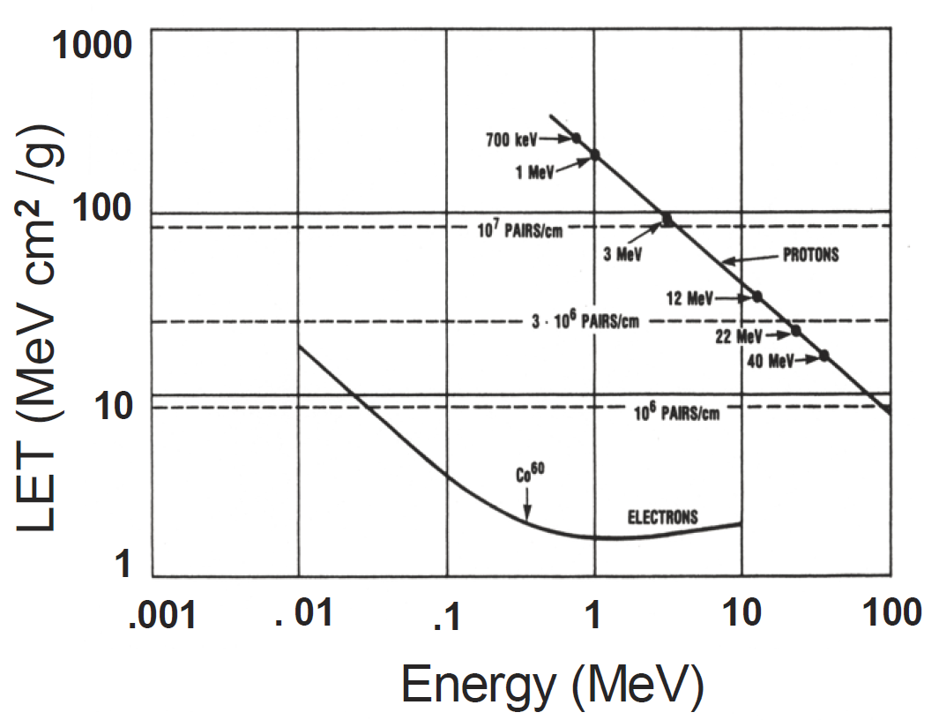
Figure 02 - The LET of protons and electrons in SiO₂ versus the particle's energy. “The effective LET of Co-60 is indicated in terms of an equivalent energetic electron” [8].

TID in MOSFET Devices
Radiation that strikes silicon may ionize it, creating ehps. However, the mobility of electrons and holes in silicon is high, $1350 {{cm}^{2}}/{Vs}$ and $480 {{cm}^{2}}/{Vs}$ respectively [11]. The ehps created from radiation recombine quickly. Silicon is still susceptible to displacement damage. The most important electrical effect of displacement damage in MOSFETs is mobility degradation.
A far more potent form of TID damage in MOSFETs is charge trapping in SiO₂. Figure 3 illustrates the process of charge trapping in a band diagram of an example MOSFET gate dielectric. If an electric field is placed across the SiO₂, electrons and holes of ehps are pulled in opposite directions by the field. The mobility of electrons in SiO₂ is much greater than that of holes ($μ_{n}\sim {20 {cm}^{2}}/{Vs}$ versus $μ_{p} \sim {10}^{-5} {{cm}^{2}}/{Vs}$) [12]. Because of their higher mobility, the electrons are quickly swept out of the material. This limits the time available for electrons and holes to recombine [8]. In addition, this illustrates the importance of device biasing during radiation testing. Usually, a maximum V_{GS} voltage is used during irradiation [13]. This ensures a worst-case test condition, because the electrons and holes are strongly pulled in opposite directions limiting recombinations.

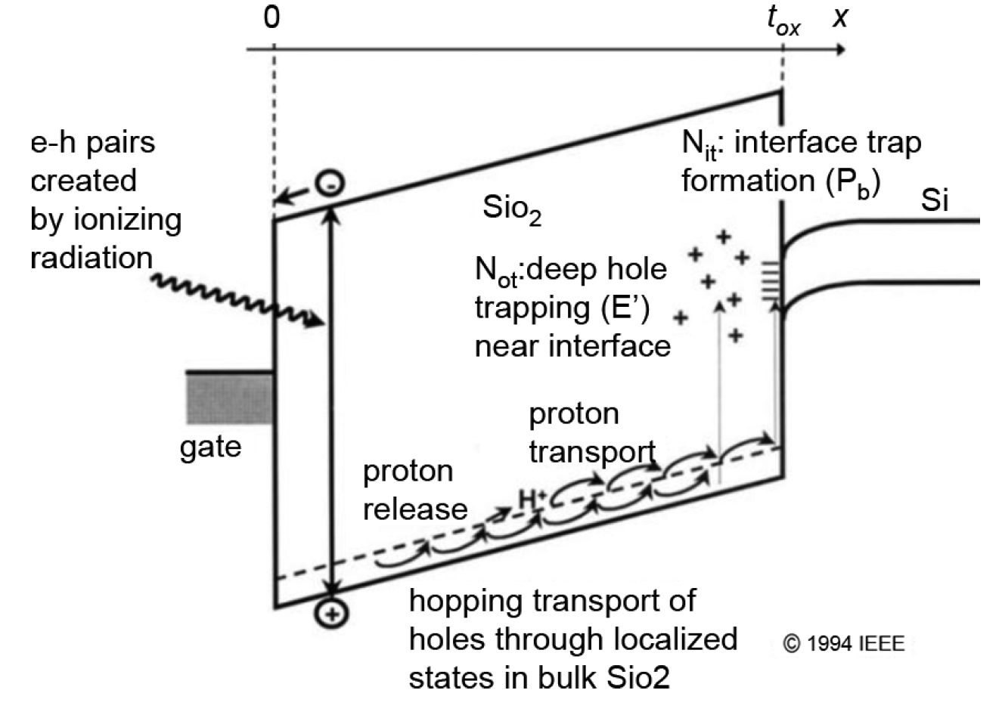
Figure 03 - Trapping mechanisms in gate oxide with a positively-biased gate node [10].

The holes created by TID within an oxide are divided into groups based on what energy level within the SiO₂ bandgap they are located and their proximity to the SiO₂/Si interface. Some are trapped deeply, >3 eV away from the valence band, and others are less than 1 eV [9]. The deep traps tend to remain immobile under normal operating conditions and may only be removed by annealing over a long period of time. The shallow-trapped holes tend to be more mobile and move toward the SiO₂/Si interface through polaron hopping transport (see [8] and [9]).
The closer the holes are to the SiO₂/Si interface, the more easily they may induce an electron to tunnel into the oxide to recombine with it [9]. Holes within approximately 5 nm of the interface strongly interact with electrons in the Si and are termed border traps. There are also traps (holes) located directly on the SiO₂/Si interface called interface traps. They are thought to be a byproduct of dangling bonds at this location (P_{b}) [9]. Because of their close proximity electrons in the Si, they interact strongly with them and can have significant effect MOSFET performance [9]. In summary, Figure 4 shows the location and electrical response of trapped charges within the oxide.

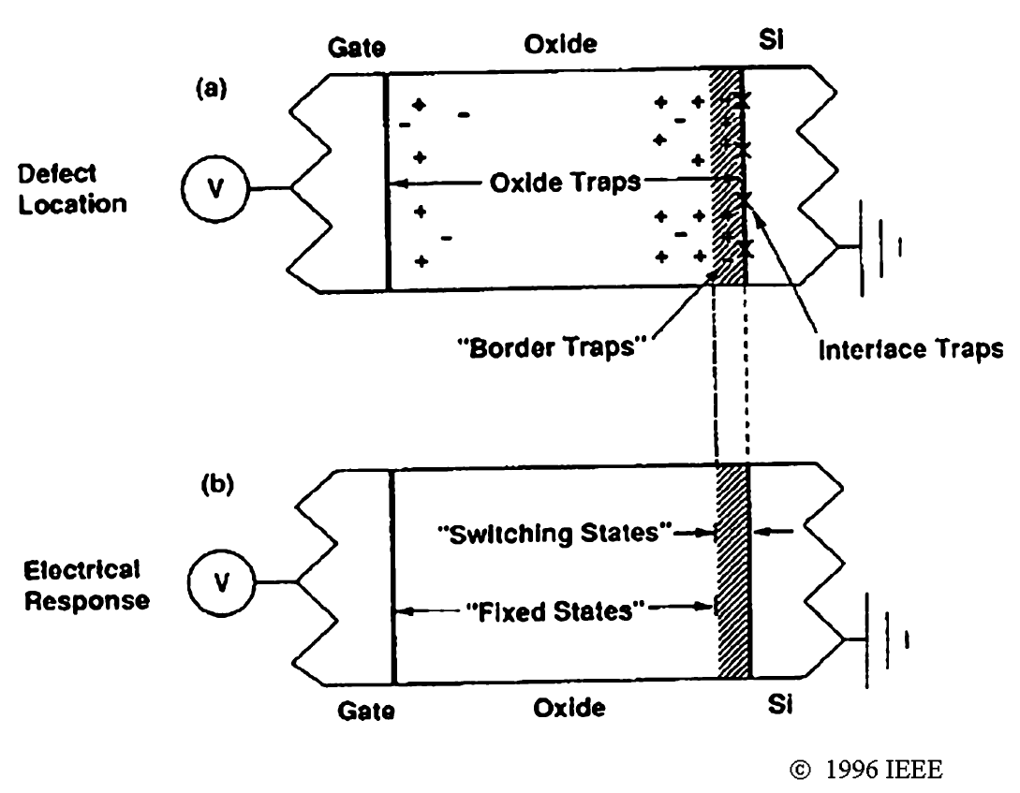
Figure 04 - The location and response of trapped charge within SiO₂ [9].

TID-Induced Performance Degradations in MOSFETs
SiO₂ is used as an insulating layer in IC fabrication. In bulk CMOS processes, it is used as the gate dielectric of a MOSFET (Figure 3) and as isolation between devices either LOCal Oxidation of Silicon (LOCOS) or shallow trench oxide (STI). Figure 5 shows a cross-sectional view of a typical NMOS transistor using STI with the TID-vulnerable oxides highlighted.

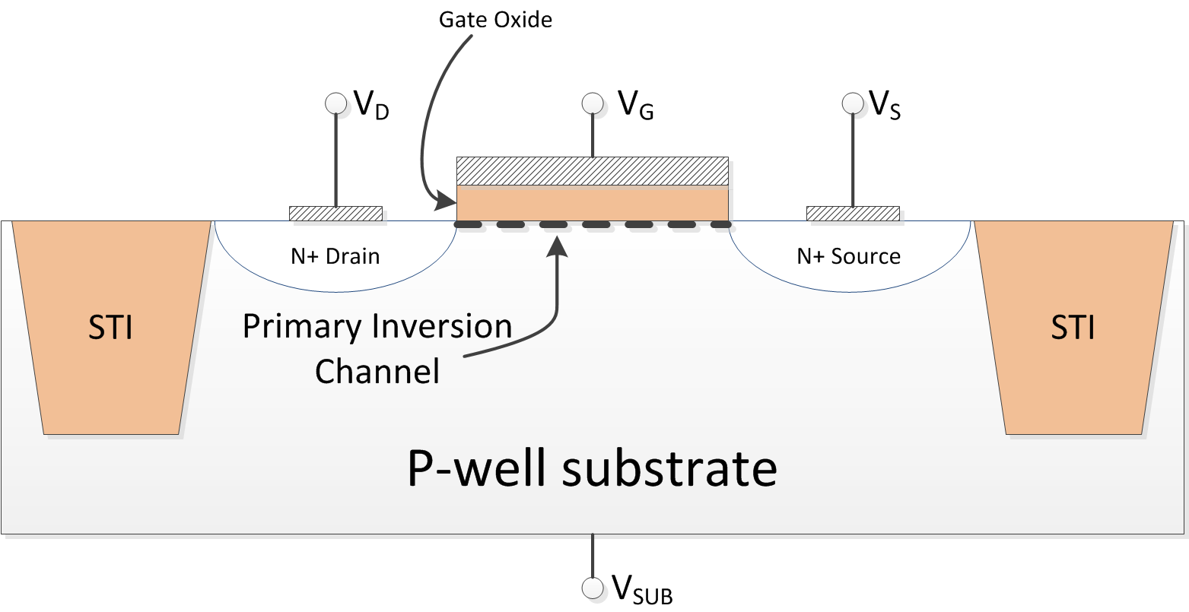
Figure 05 - Cross-sectional view of NMOS transistor in the channel length direction.

Thick-Gate Oxide Devices
MOSFETs that support a large V_{GS} voltage must have a gate oxide thick enough to prevent electric field breakdown. For older CMOS processes and high-voltage devices in newer processes, the gate oxide may be thicker than 5 nm to support the large V_{GS} voltages. There are regions in these gate oxides that may trap positive charges, which do not have a high probability of tunneling out of the oxide because they are too far from the interface. The largest effect of ionizing radiation in these “thick-gate oxide” MOSFETs is threshold voltage variation. As shown in Figure 6, the positive trapped charges decrease the threshold voltage of NMOS transistors while increasing the threshold voltage of PMOS transistors by an amount ΔV_{ot}. This may be calculated by
$$ΔV_{th}=∆V_{ot}=\frac{t_{ox}}{k_{ox}ε_{0}}q∆N_{ot}$$
where k_{ox} is the dielectric constant of the oxide and ε₀ is the permittivity of free space [9]. The most important failure mode of the MOSFETs in this case is the NMOS’s transition from an enhancement mode device to a depletion mode device [11]. In other words, the NMOS transistor is not turned off when V_{GS} = 0 V. The effects on the PMOS transistor are not as dire. It becomes harder to turn on the PMOS, but not substantially if it can still reach saturation. For 5 V CMOS devices with a 1 V threshold voltage, the NMOS transistor will fail as a switch when ΔV_{ot} = 1 V, but the PMOS will not fail until ΔV_{ot} = 4 V long after the NMOS has failed.

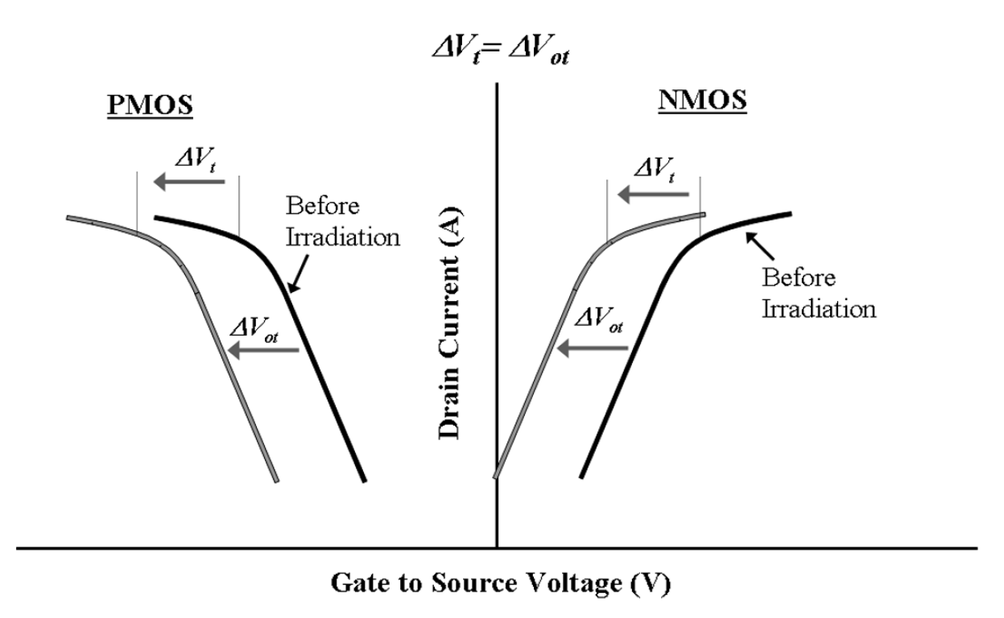
Figure 06 - Threshold voltage variation in PMOS and NMOS thick-gate oxide transistors via trapped charge (N_{ot}) [9].

There are many additional TID effects in thick-gate MOSFETs that do not contribute to device failure in digital CMOS applications. These secondary effects in thick-gate oxide MOSFETs are primarily caused by the interface traps on the SiO₂/Si interface. These traps cause increased sub-threshold swing, decreased carrier mobility and increased 1/f noise above 1 kHz [8] and [9]. Device annealing increases interface states, so these phenomena actually degrade further after annealing [8]. The 1/f noise above 1 kHz is increased because of interface traps, but 1/f noise below 100 Hz is increased as well but from border traps instead of interface traps (see Figure 4) [9]. Qualitatively, the border traps are further within the oxide and have a lower statistical chance interacting with electrons than interface traps does.

Thin-Gate Oxide Devices
As process scaling has continued, the gate oxide thickness of MOSFETs has continued to scale downward. From the equation above, the following relationship can be derived:
$$∆V_{th}∝{t_{ox}}^{2}$$
because ΔN_{ot} is proportional to the t_{ox}. As the gate oxide thickness shrinks below 5 nm which is the characteristic tunneling length for holes within SiO₂, the threshold voltage shift in MOSFET devices, ∆V_{th}, becomes negligible (less than 5 mV at a 30 Mrad dose) [5]. MOSFETs with a gate oxide thickness less than 8 nm are dubbed thin-gate oxide devices. These devices are usually found in advanced submicron processes with a feature length of 0.35 µm or less. Subthreshold leakage current is the dominate performance degradation in these processes.
Figure 5 shows the STI on either side of the drain and source of the NMOS transistor. The STI, in fact, surrounds the entire transistor [14]. Figure 7 shows a cross-sectional view of the same transistor however rotated by 90°, so the current flow direction is perpendicular to the page. The cross-section is cut between the source and drain. The STI oxide is much thicker than the gate oxide and can trap positive charges under TID. These trapped charges can invert the active area abutting the STI and create a parasitic sidewall transistor that causes leakage current to flow from source to drain [15].

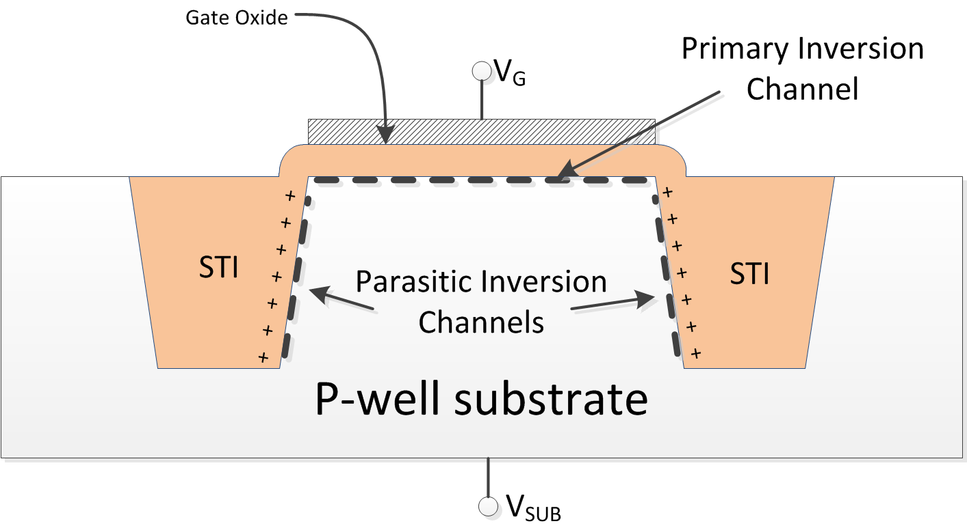
Figure 07 - Cross-sectional view of NMOS transistor in the channel width direction.

The leakage current is a function of vertical location along the STI edge [14] and [16]. As shown in Figure 8, the leakage current becomes worse further down in the STI. This is believed to be due to the positive gate bias during irradiation; the positive voltage repels the trapped holes pushing them further into the STI [16]. Because of the increased distance between the gate and the trapped charges, it is more difficult to control the transistor via the gate. Figure 9 shows a dramatic increase in sub-threshold current leakage for an NMOS transistor fabricated in a 0.18 µm process for increasing TID. Also, note there is no visible shift in threshold voltage, because of the thin-gate oxide.

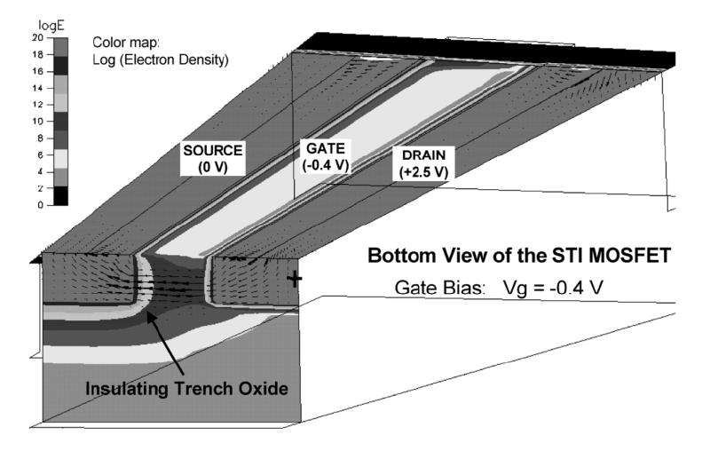
Figure 08 - 3D cross-section of 0.4 µm NMOS FET. Current density is calculated when a sheet charge is placed on the STI/Si interface. Results show leakage current density depends on depth in the channel with more current flowing deeper within the channel [16].

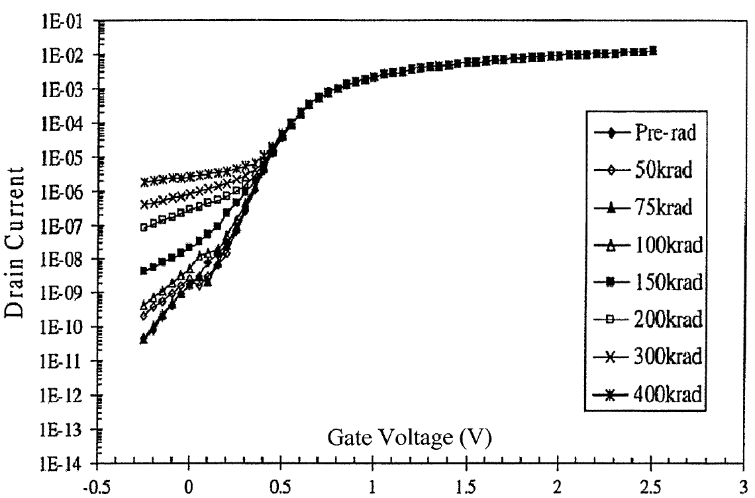
Figure 09 - Measured V_{GS} vs. I_{D} curve of an NMOS transistor fabricated in a 0.18 µm CMOS process for various TID [16].

Thin-gate oxide transistors isolated by STI exhibit another TID effect in addition to deep STI channel leakage. During initial TID exposure (up to 20 krad as described in [14]) the charges in the STI are located higher, near the STI corner. This means the gate is able to exert some control over the parasitic side-wall transistors. This effect, dubbed the subthreshold hump effect, is shown in the contrasting pre-rad and 20 krad curves of Figure 10. However, as TID increases this effect is washed out by deep leakage within the STI.

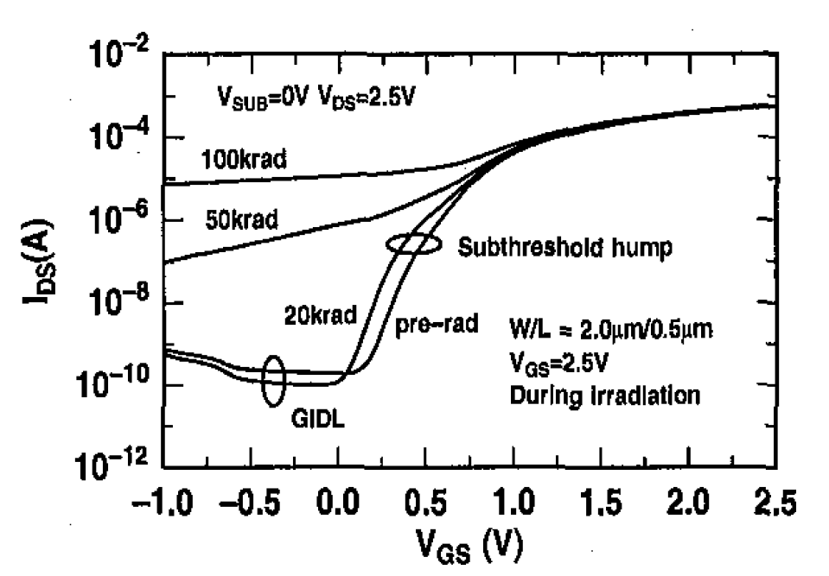
Figure 10 - Measured I_{D} vs. V_{GS} of NMOS in 0.35 µm BiCMOS process [14].

It has been shown that the subthreshold hump effect is highly dependent on the MOSFETs structure. Hu et al. characterized a high-voltage (HV), an I/O and a core NMOS transistor in a 0.18 µm process for various TID [17]. The HV NMOS shows the worst hump effect followed by the I/O NMOS which is finally followed by the core NMOS transistor. The authors postulate that the oxide thickness at the STI corners plays a large role in this result. Figure 11 shows a cross-sectional diagram of the STI corner of the three different NMOS devices. The authors state the thicker corner of the HV device allows more charge to be trapped pronouncing the subthreshold hump effect. As shown in Figure 10 the subthreshold hump almost appears to be a shift in the threshold voltage of the device. As will be discussed later, high-voltage devices with thick STI corners are an ideal candidate for the proposed HBD technique.

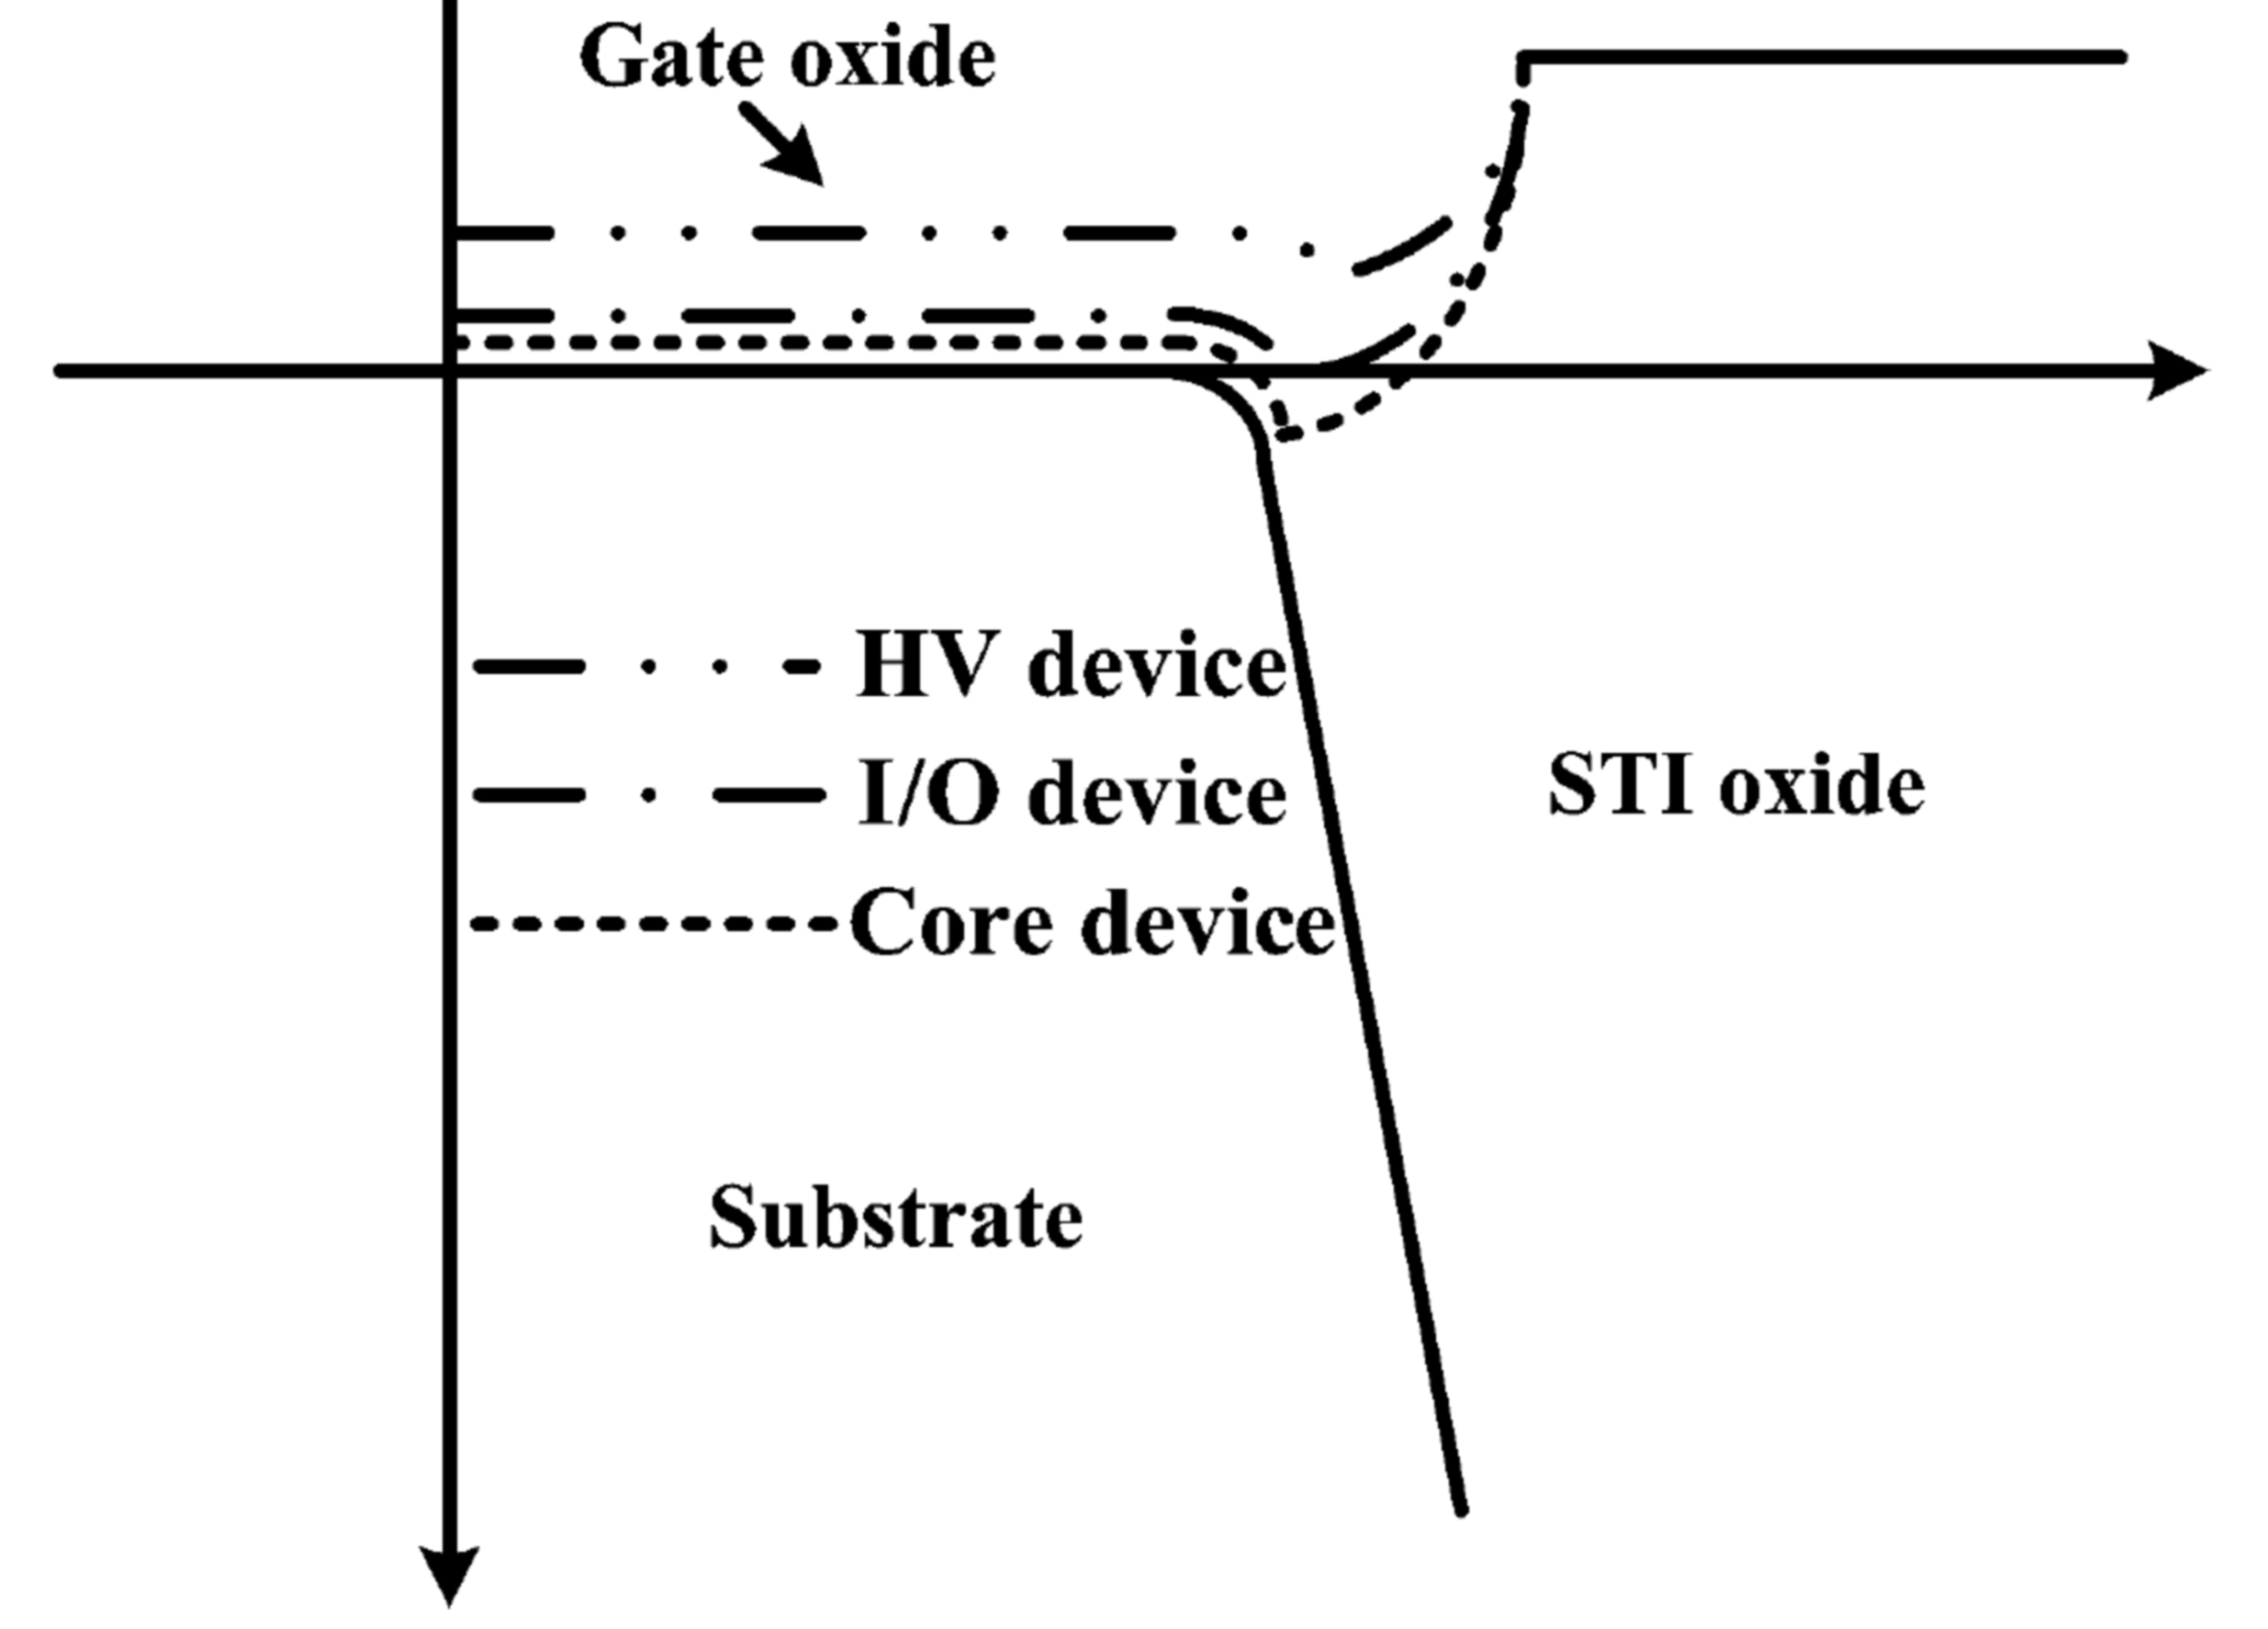
Figure 11 - Diagram of STI corner for three NMOS devices in a 0.18 µm CMOS process [17].

Inter-device leakage relies on charges trapped along the bottom of the STI. These trapped positive charges may invert n-type Si directly underneath them to form a leakage path between devices. However, recall that the electric field (eg. the gate voltage placed across the gate oxide) plays a large role in the susceptibility of charge trapping in the oxide. As the electric field increases, the number of ehp recombinations decreases, because the electrons and holes are pulled in opposite directions. There is a very low electric field at the bottom of the STI; therefore, charge trapping (and inter-device leakage) has been shown to not be as important of an effect as intra-device leakage [17].
There are a lot of effects. Reinforce primary effects and primary factors (gate oxide thickness, STI). The radiation effects in MOSFET devices vary substantially between processes even processes with the same feature length [12]. This means that accurate modeling of the specific process being used or experimental results are imperative in quantifying these effects.

The Traditional, Straight-Gate Inverter’s Shortcomings under TID
Figure 12 shows a typical CMOS inverter. As discussed previously, TID has various deleterious effects on MOSFETs, especially NMOS transistors. The most important of these effects limits the ability of the NMOS transistor to turn off. If the inverter has been exposed to a large amount of TID, when Vi is a logic ‘low’ or zero volts there will still be leakage current through NMOS transistor, N1, even though N1’s VGS is zero. This increases the static power dissipation of digital circuits.

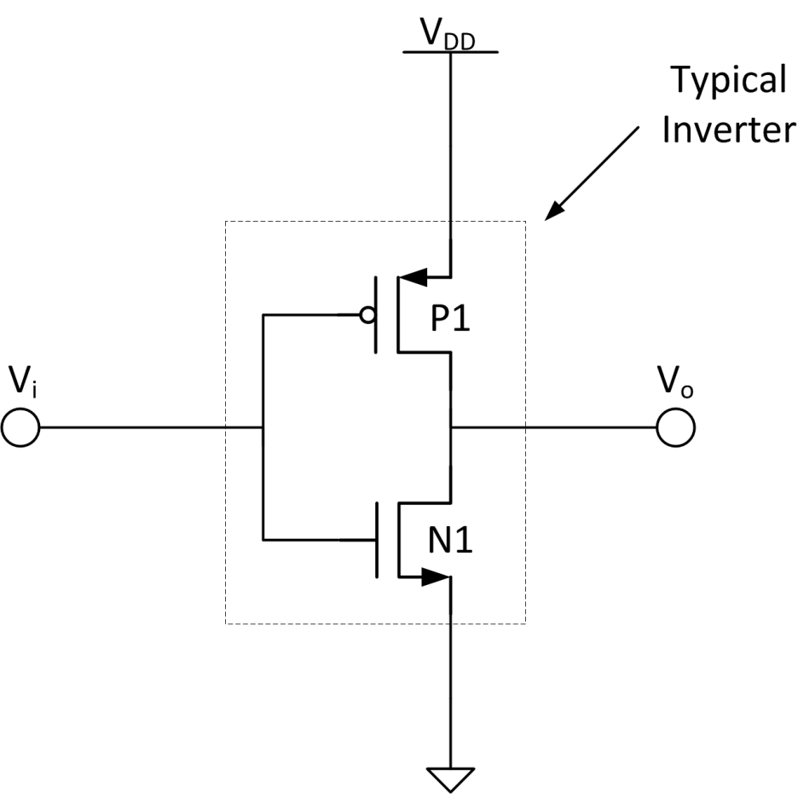
Figure 12 - Typical CMOS inverter.

In addition, further increasing TID may cause the logic gate to fail entirely. Figure 13 shows the equivalent DC model of an inverter with a logic ‘low’ input. The output, V_{o}, should be a logic ‘high’ or nearly V_{DD}. However as TID increases, the off-state resistance of the NMOS transistor decreases either through negative threshold voltage shift in thick-gate oxide NFETs or STI sidewall leakage in thin-gate oxide NFETs. Eventually, the output voltage will fall to a digitally-indeterminate value and the digital circuit will fail. Figure 14 shows this failure in the DC transfer function of an inverter.

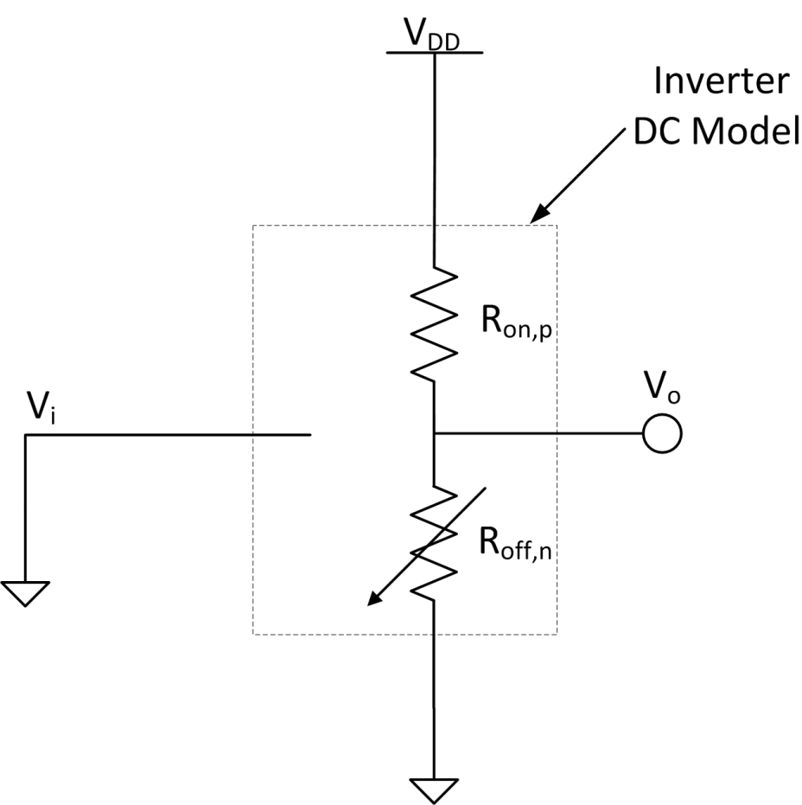
Figure 13 - CMOS inverter equivalent DC model with an input voltage of zero. As TID increases, the current through the NMOS transistor increases, modeled here as a decreasing resistance.

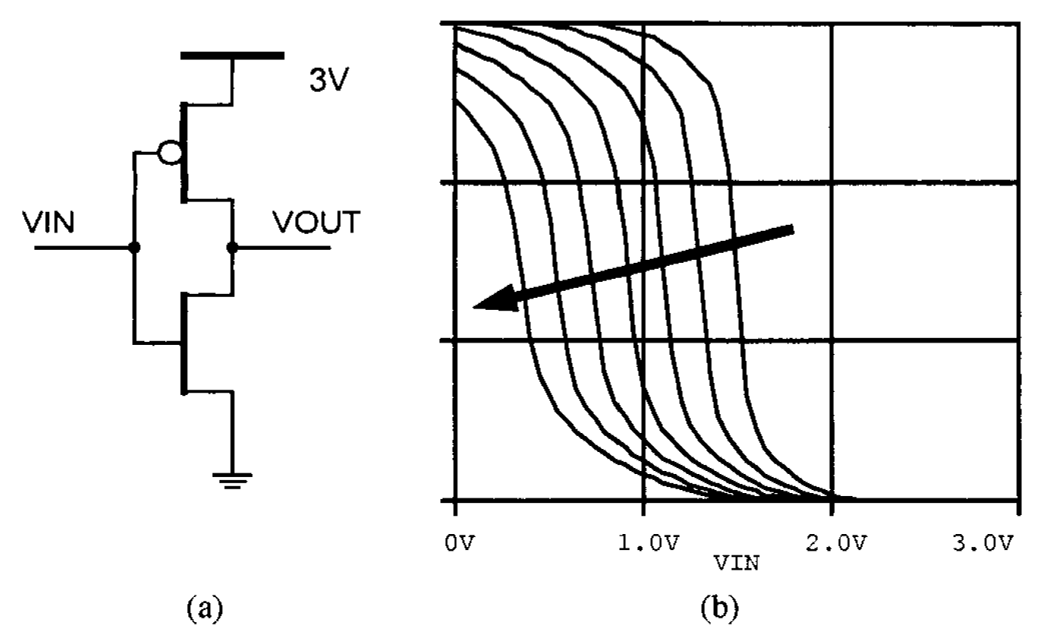
Figure 14 - An inverter (a) and its DC transfer function (b) showing output failure at high-TID levels [18].

Hardened-By-Design Layout Techniques

Annular Gate MOSFET
As discussed previously, the largest source of TID-induced leakage in new sub-micron, thin-gate oxide transistors is sub-threshold leakage caused by the STI edge between the source and drain. The annular gate MOSFET (shown in Figure 15b) removes the STI edge between the source and drain. This eliminates the possibility of inverting the channel along this edge. Annular gate MOSFET transistors are also known as edgeless transistors, re-entrant transistors, enclosed-layout transistors and closed-geometry transistors [8].

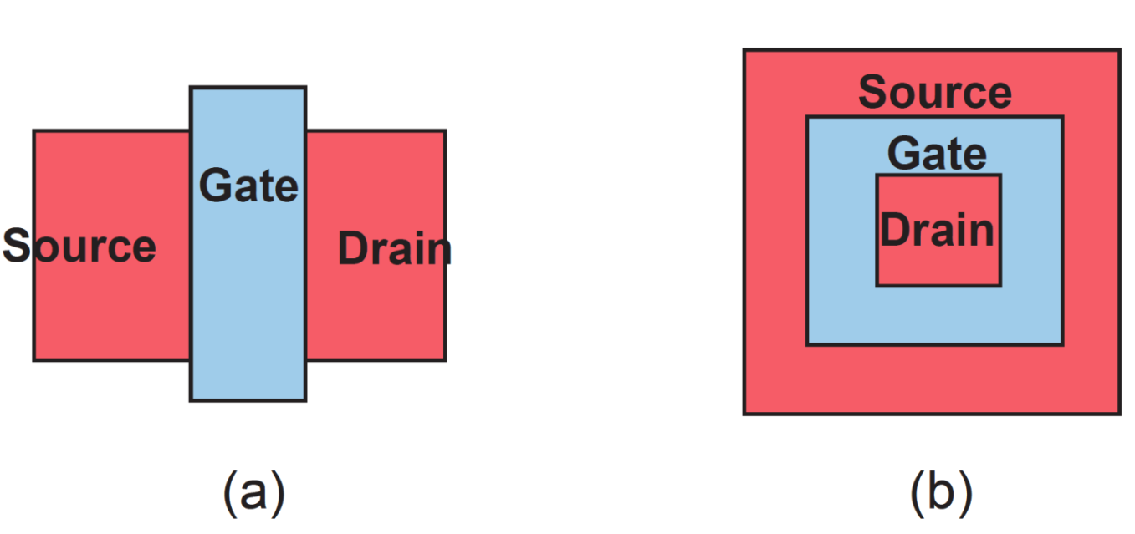
Figure 15 - Schematic diagram of (a) traditional, straight-gate MOSFET and (b) annular gate MOSFET [8].

Figure 16 displays the I_{D} vs. V_{G} curves of an annular NFET in the TSMC 0.25 µm process up to 2 Mrad. The annular gate MOSFET exhibits exceptional TID performance. By comparing it with the straight-gate transistor’s results (Figure 9), it is clear the annular NFET displays much better sub-threshold leakage performance. The straight-gate transistor displays at least four orders of magnitude increase in off-state leakage at 400 krad, while the annular displays less than one order of magnitude increase at 2 Mrad.

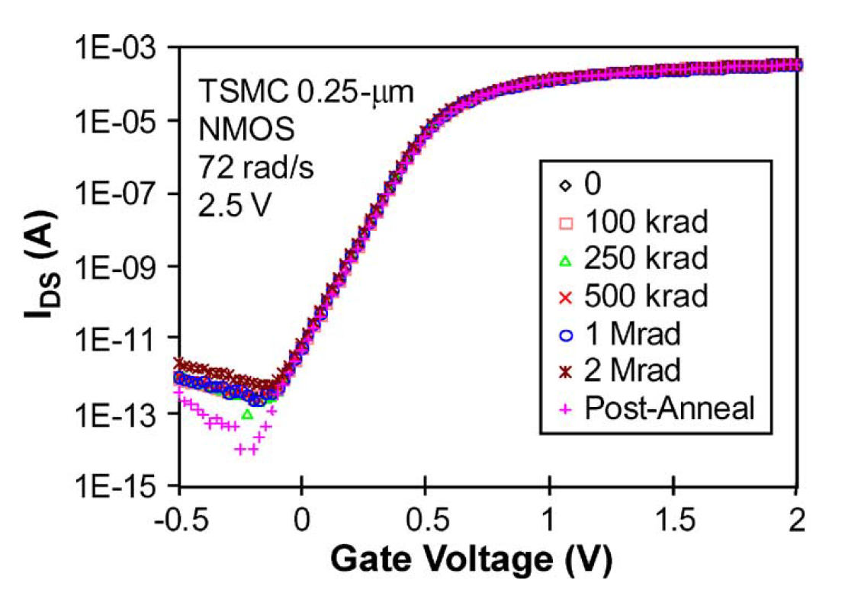
Figure 16 - I_{D} versus V_{G} curve for annular gate NFET fabricated in TSMC 0.25 µm process [5].

The annular gate transistor is not without its drawbacks, however. According to Lacoe, their implementation results in area, power and performance penalties. The minimum geometry size of the drain constrains the minimum W/L ratio. For minimum-L devices, the minimum W/L ratio is 12 compared with 2 for standard edge transistors. In a two-input NOR gate fabricated in a 0.18 µm process, the area penalty for using annular NFETs was 1.25x. In addition, annular devices have increased gate and source/drain capacitances. They are also not symmetric; swapping the source and drain changes the characteristics of the transistor. Generally, the drain connection is made to the inner ring of the device, because this has less capacitance to the substrate resulting in higher frequency performance. However, this configuration results in a device with higher output conductance than the reversed connection [8].
According to Lacoe, in the rectangular transistor shown above, the channel’s length varies around the edges as does the electric field. This makes modeling the annular gate transistor difficult [5]. Strained-Si substrates are sometimes used to increase carrier mobility in the strain direction. For full benefit of this, the channels of all the transistors on a chip must be fabricated in this direction. Annular gates have channel directions in all directions making it impossible to optimize their performance in strained-Si processes [13].

Enclosed-Source/Drain MOSFET
Figure 17 shows both an enclosed-source and an enclosed-drain transistor. These transistors have a channel that is nearly transverse like traditional, straight-gate transistors as opposed to the radial transistor [8]. These transistors don’t eliminate the transistor edge associated with STI leakage; however, the polysilicon surrounding the source/drain inserts an insulator between the terminal and the leakage path [19].

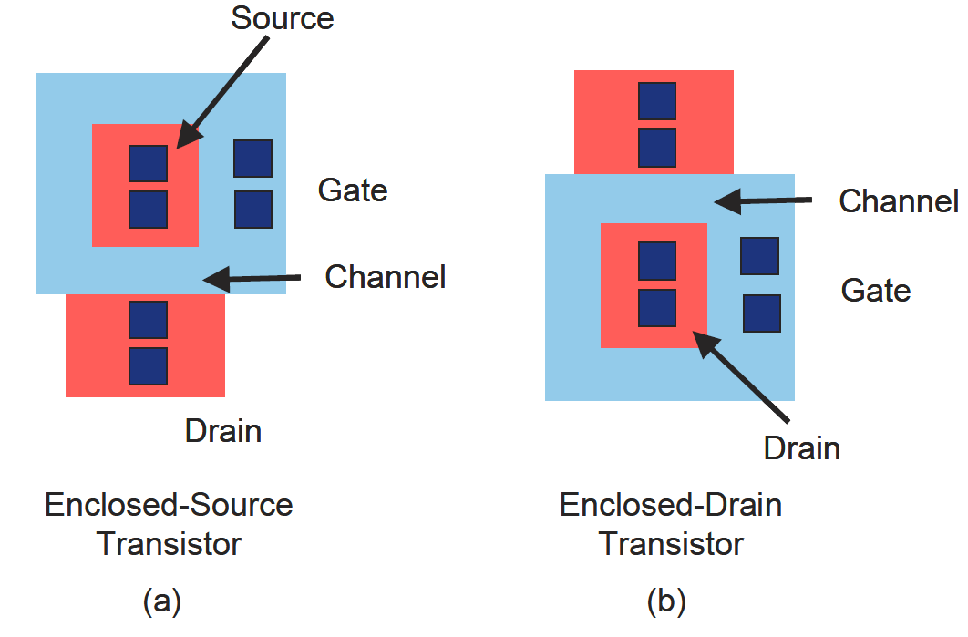
Figure 17 - Conceptual view of (a) enclosed-source transistor and (b) enclosed-drain transistor [8].

The enclosed-source/drain transistor exhibits exceptional TID performance like the annular gate transistors. Its advantage lies with its freedom from the large minimum W/L requirements imposed upon annular gate transistors [19]. In addition, its unidirectional channel lends itself to simpler modeling. However, enclosed-source/drain transistors have larger parasitic gate-to-source/gate-to-drain capacitance (whichever node is enclosed). This is because of the excess polysilicon used to enclose the source or drain. The long polysilicon runs also increase series-gate resistance. Like annular gate transistors, they are larger than straight-gate transistors and are not symmetric. Enclosed-drain transistors have higher Miller capacitance which can severally hamper device performance in amplifier and CMOS digital applications. Enclosed-source transistors offer better performance. But to reduce layout area in large designs, enclosed-source and enclosed-drain transistors may be alternated [19].
In summary the strengths and weaknesses the two presented HBD techniques better qualify the annular gate transistor for large W/L devices whereas small W/L devices may be better realized with

Methodology

The Inverted-Source Technique
The annular gate and enclosed-source/drain transistors are considered rad-hard techniques because of their excellent TID performance under high TID and high dose rate. Many times circuits need only be radiation tolerant (lower TID and low dose rate). This is especially true for space applications where low dose rates mean devices have time to anneal under irradiation and may withstand a higher total TID [20]. For these applications, the rad-hard layout methods may not be necessary and the hassles associated with implementing them as well as the performance penalties may outweigh any gains. A simpler solution would be to implement a circuit-level technique that uses traditional, straight-gate MOSFETs and provides adequate radiation tolerance.

How it Works
In their paper, “A Radiation-Hard Phase-Locked Loop,” Pan, et al. presents a circuit-level HBD technique to counteract threshold variation in the NMOS transistor [1]. Figure 18 demonstrates this hardening technique for a simple inverter, but the approach extends to other logic functions as well ( [1] ). Transistors P1 and N1 form the typical CMOS inverter. P2 and N2 form an additional inverter added as a hardening circuit. When V_{i} is a logic ‘high’, N1 and N2 drive the output to ground. However, when V_{i} is a logic ‘low’, the output of the additional hardening circuitry becomes ‘high’. In this case, device N1 has a negative V_{GS}. This ensures the transistor is more fully turned-off, reducing the leakage current induced by ionizing radiation.

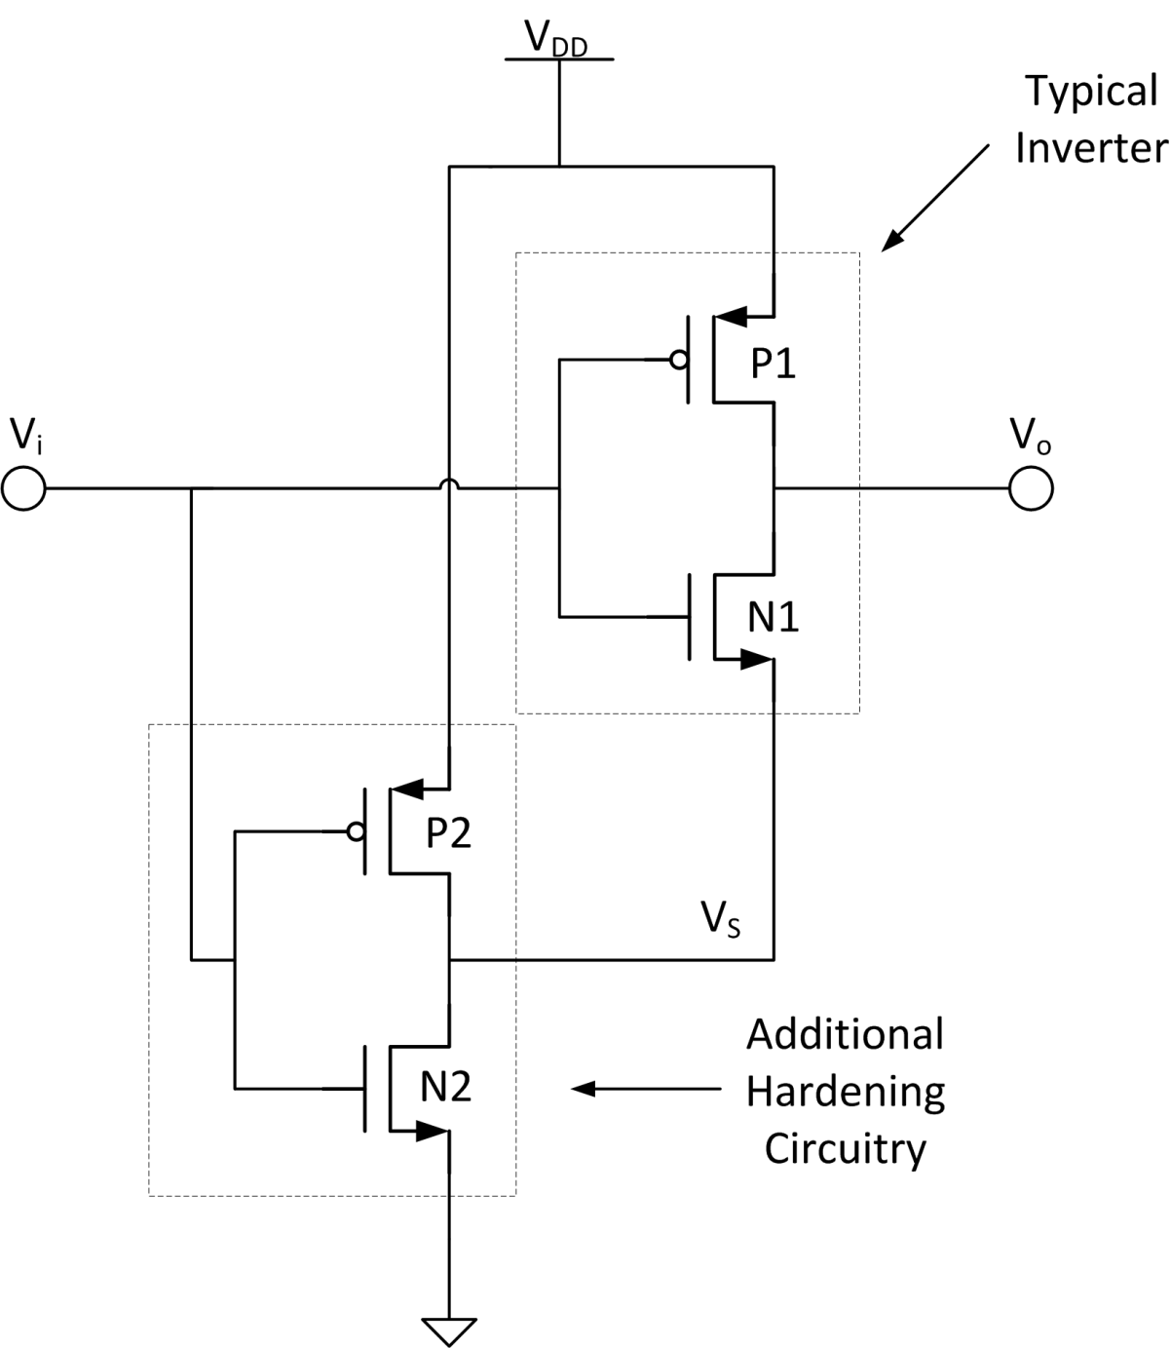
Figure 18 - Inverted-Source TID HBD technique.

A conceptual I_{D} vs. V_{GS} curve of an NMOS transistor under TID is shown in Figure 19 to help illustrate the hardening technique’s advantage. When the input to a traditional CMOS inverter is ‘low’ it has a V_{GS} of zero volts, indicated by point A on the V_{GS} axis. Under high-TID, the negative threshold voltage shift of the NMOS transistor may cause high currents and output voltage drop for V_{GS} = 0 V. N1 of the HBD inverter operates at a V_{GS} = -V_{DD} (point B) when the input is logic ‘low’ for pre-irradiated devices. As TID increases, this operating point moves to the right to point C, because N2 starts to become leaky as well and the source voltage on N1 (V_{S}) begins to drop. However, this point C will always be below ground, because the N2 will always have a finite resistance. In addition, P2 is turned-on and supplies current to N2 to help maintain V_{S}. The HBD inverter maintains a negative V_{GS} across N1 that reduces the drain current helping to preserve digital signal integrity.

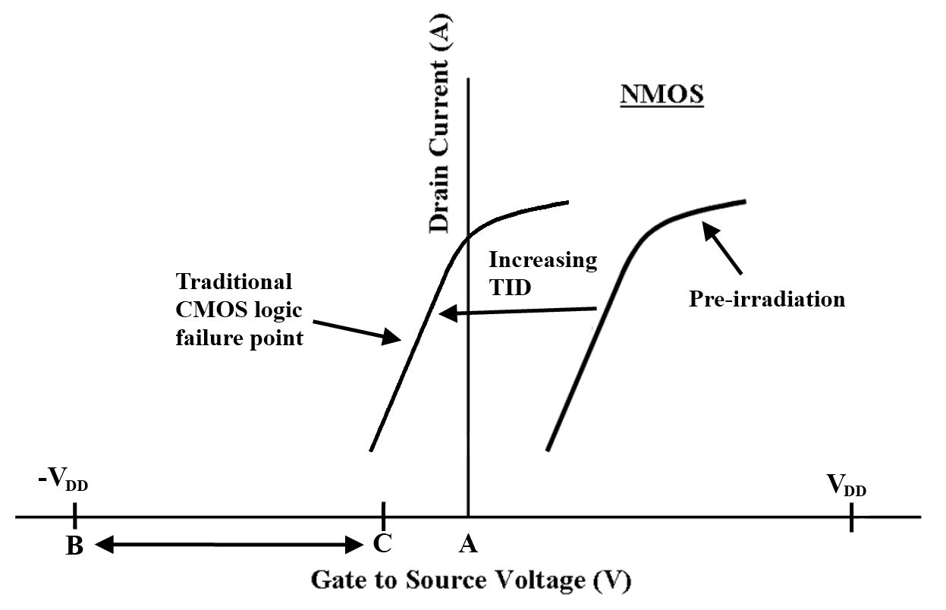
Figure 19 - Conceptual I_{D} vs. V_{GS} curves for thick-gate oxide NMOS transistor under TID. Point A shows the operating point of a traditional CMOS inverter, whereas the spectrum from B to C indicates the operating region of the HBD inverter over TID.

Potential TID Mitigation in Thin-Gate Oxide Devices
The question remains whether the HBD technique will provide any radiation hardening to thin-gate oxide transistors. Some thin-gate oxide NMOS transistors exhibit better gate control over sub-threshold STI leakage than others. This is believed to at least be partially a function of the STI corner thickness as discussed previously [17]. Figure 20 shows experimental I_{D} vs. V_{GS} curves for an NMOS transistor fabricated in an unnamed 0.18 µm process [16]. The 200 krad and 400 krad curves have been extrapolated to –V_{DD}. The positive slope indicates that the gate maintains some control over the current for V_{GS} < 0 V. It is impossible pinpoint exactly where point C (from Figure 19) lies on this graph, because the characteristics of the PMOS transistor are not known. However, these preliminary results indicate that for this process at least, the thin-gate oxide NMOS transistors sub-threshold leakage can be reduced through application of a negative gate voltage.

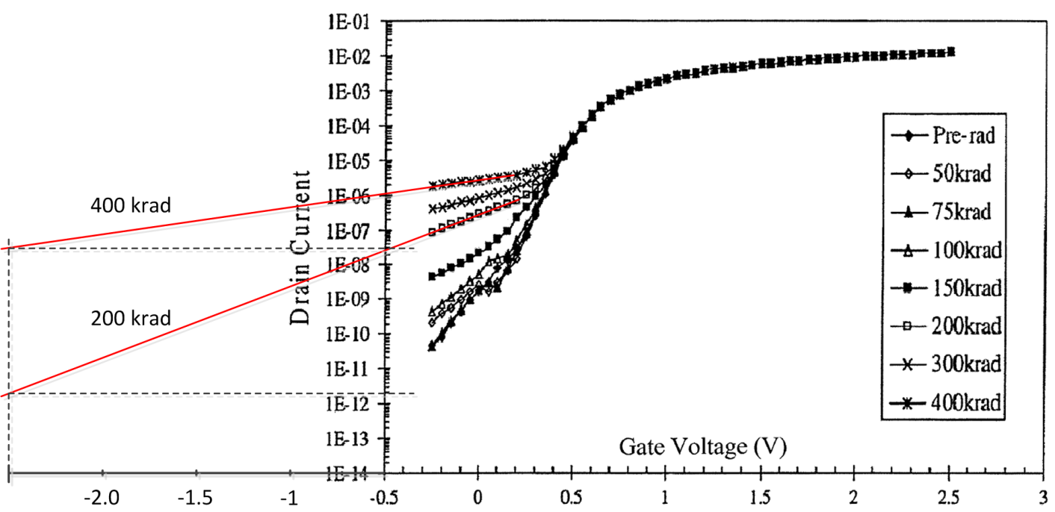
Figure 20 - V_{GS} vs. I_{D} curve for NMOS fabricated in a 0.18 µm CMOS technology [16]. Extrapolated curves indicate potential reduction in subthreshold leakage current if gate voltage is set below zero volts.

The Inverted-Source’s Limitations
It is clear that the HBD technique can provide some TID immunity to NMOS devices that are still capable of providing some gate control for V_{GS} < 0 V. Figure 21 shows the V_{GS} vs. I_{D} curve for an NMOS in the TSMC 0.18 µm CMOS process. Here, there is a smaller slope once the transistor is below its threshold voltage. Is there any advantage of using this technique in these devices that provide minimal control of the current for V_{GS} < 0 V?

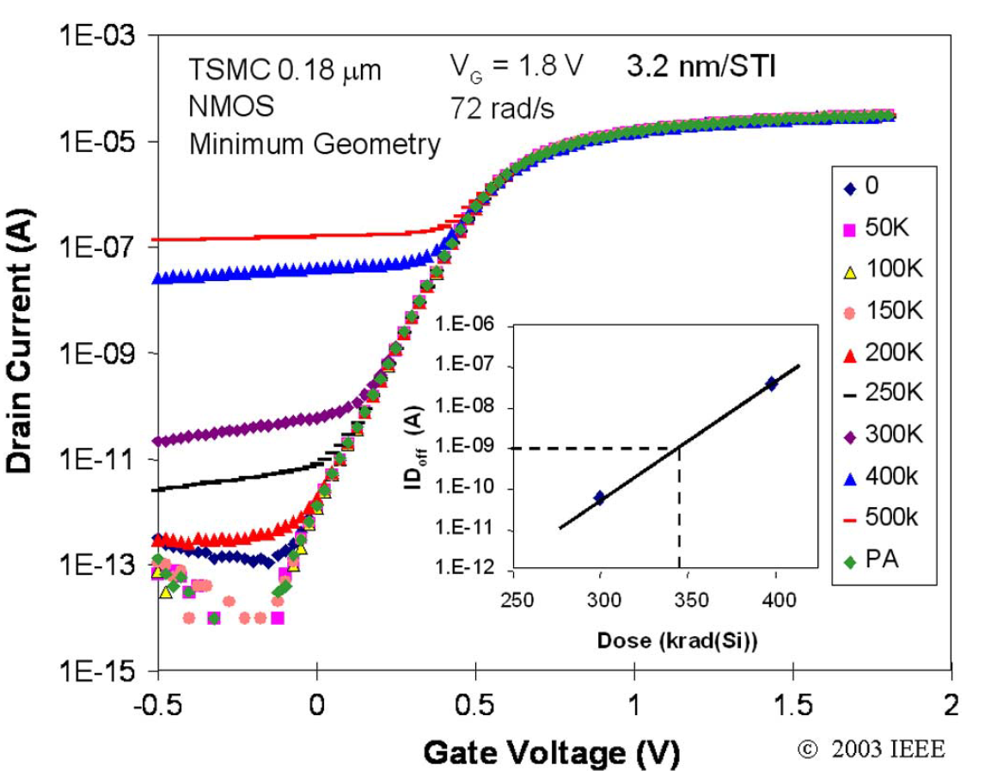
Figure 21 - Measured I_{D} vs. V_{GS} curves for various TID levels in the TSMC 0.18 µm process [8].

To help answer this question, a Matlab simulation was performed comparing the output voltage of the DC-equivalent non-HBD inverter and DC-equivalent HBD inverter (Figure 22) if the input voltage is zero. The ratio of the NMOS off-resistance (R_{off,n}) to the PMOS on-resistance (R_{on,p}) was reduced to simulate increasing TID. The HBD’s two NMOS transistors, R_{off,n} and R_{off,n2}, are set equal to simulate the case where the NMOS devices cannot provide current control for V_{GS} < 0 V (N2’s effective off-resistance will be the same as N1’s off-resistance, even though V_{GS,N2} = 0 V and V_{GS,N1} < 0 V). This simulation is shown in Figure 23. The results show that when${R_{off,n}}/{R_{on,p}}=10$, the HBD inverter is able to maintain an output voltage of 1.787 V while the non-HBD inverter has already fallen to 1.639 V. The results get better as the ratio of resistances continues to fall. For a 1:1 ratio, the HBD inverter has fallen to 1.448 V while the non-HBD inverter is at 0.9104 V or around mid-supply.

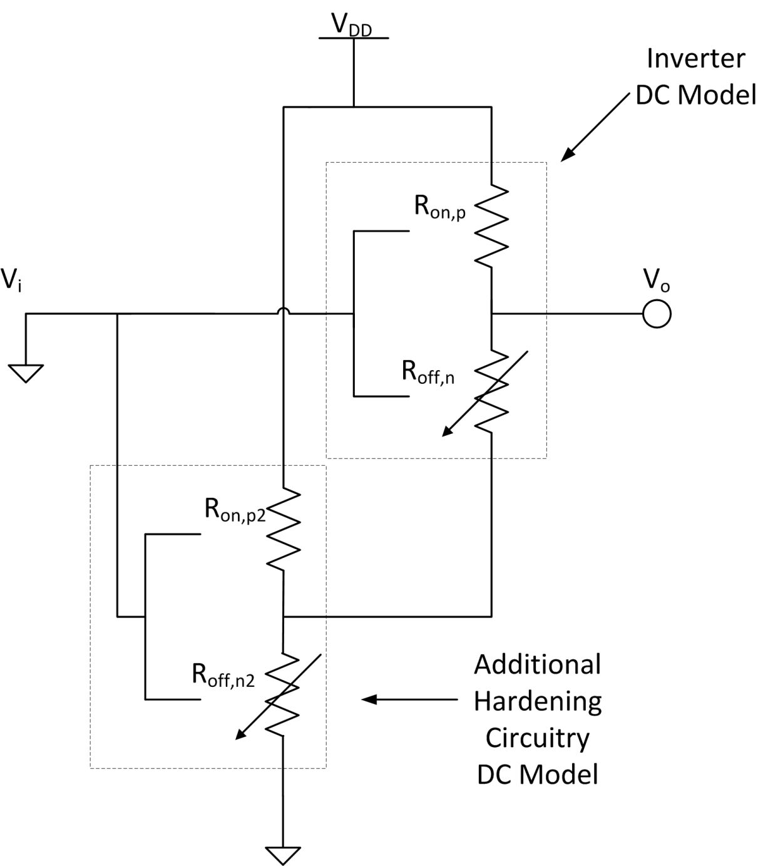
Figure 22 - DC-equivalent model of HBD inverter with a logic 'low' input.

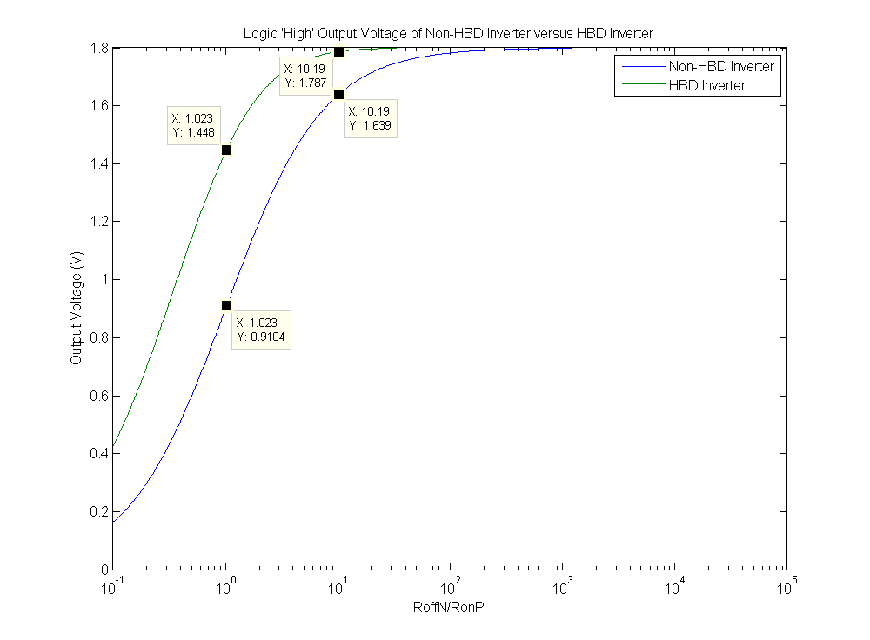
Figure 23 - Matlab simulation of DC-equivalent models of the traditional, non-HBD inverter (Figure 13) and the HBD inverter (Figure 22) of NMOS devices that exhibit no current control for V_{GS} < 0 V (i.e. worst-case scenario).

These results indicate the HBD technique hardens digital CMOS circuits even when the devices used have a thin-gate oxide and cannot exert gate control over the current for V_{GS} < 0 V. The reasons for this are two-fold. First, using two NMOS transistors in series will double the effective off-resistance. Second, P2, the hardening PMOS transistor, is fully turned-on working to keep V_{S} close to V_{DD}. This reduces the V_{DS} voltage across N1, reducing leakage current. However, these results should be considered in the scope of a real system. For example in a 1.8 V process if the PMOS has a channel resistance of a few kilo-ohms and the ${R_{off,n}}/{R_{on,p}}=10$, the static leakage current will be on the order of 10’s of micro-amps for a single gate. In a digital system, the supply may not be able to handle the leakage currents from thousands of logic gates and it will collapse. This means that the leakage current and not an indeterminate output voltage results in system failure. For this reason, it is postulated that the HBD technique will not be effective at mitigating TID in devices where gate control becomes ineffective for V_{GS} < 0 V.
An additional and perhaps more fundamental concern with the inverted-source technique revolves around the difference between applying a negative V_{GS} and a negative V_{GB}. Applying a negative V_{GS} to a thick-gate oxide transistor will prevent it from exceeding its threshold voltage and turning on under TID. The primary mechanism of off-state leakage is different for thin-gate oxide transistors. The leakage stems from bulk inversion along the STI edge, because of trapped positive charge in the STI. For this kind of leakage, will raising the source voltage of the transistor to create a negative V_{GS} aid in turning off the parasitic transistor? It may be that mitigation for this kind of device degradation requires a negative gate to bulk voltage instead.
A few performance drawbacks are expected with the HBD approach. First, there will be an approximate 2x speed penalty for using the inverted source technique. This is because each NMOS transistor must have a hardening inverter and the effective gate capacitance of logic circuits will double. This will also increase the layout area, though, not by 2x. The active area will double, but overhead from guard rings and metal routing will result in a less than 2x increase in layout area. The power consumption is expected to double as well.

Summary
When referring to HBD layout techniques, Lacoe asserts, “There is no easy way to design around gate-oxide threshold voltage shifts” [8]. However, the circuit-level HBD technique presents itself as a simple method to mitigate the issue. Thicker gate oxide transistors that are susceptible to TID-induced threshold voltage shift are still often used in modern processes on digital inputs and output buffers and high-voltage devices. These thicker gate oxides are needed to support higher voltages such as 3.3 V, 5 V or higher. The inverted source technique may be an ideal choice for these devices. In addition this technique may provide TID mitigation for thin-gate oxide devices that are capable of exerting some gate control over sub-threshold current leakage for V_{GS} < 0 V.

Thick-Gate Oxide Device Testing

The ALD1106 and ALD1107 Devices
The ALD1106 and ALD1107 are complementary MOSFET arrays fabricated by Advanced Linear Devices, Inc. (ALD). They are packaged in 14-pin DIP ICs. The ALD1106 is the NMOS part and the ALD1107 is the PMOS part. They each house four FET devices with drain, gate and source connections for each device and one body connection shared by all of the devices. These arrays represent good candidate thick-gate oxide devices for testing the inverted-source technique. An approximation of the gate-oxide thickness may be calculated from
$$t_{ox}≈\frac{V_{GS,max}×SM}{E_{BD,SiO_{2}}}$$
The devices have a V_{GS,max} voltage of 13.2 V [21]. According to Neaman, the breakdown voltage of silicon dioxide ($E_{BD,SiO_{2}}$) is around $6×{10}^{6} V/{cm}$. Also, there is generally a 3x safety margin (SM) in gate-oxide thickness, because defects in the oxide lower the breakdown field [22]. Therefore the oxide thickness of the ALD devices is estimated as
$$t_{ox}≈\frac{13.2 V×3}{6e6 V/{cm}}=66 nm$$
This thickness is much greater than the 5 nm quoted earlier as the distance at which electrons may easily tunnel into the oxide to cancel the trapped charge. Therefore it is expected the ALD devices will show significant threshold voltage shift under ionizing radiation, and they are a good candidate for experimentally verifying the inverted-source technique in a thick-gate oxide device. In addition, these devices are easily and cheaply sourced from the EECS parts store. The V_{DD} voltage used for these devices was selected to be 5 V. The threshold voltage is around 1 V for both chips and a 5 V supply is adequate to switch the devices. Additionally, most power supplies are capable of 5 V.

The Test Circuits
There are two test circuits designed to experimentally verify the inverted-source technique’s TID mitigation capabilities. Figure 24 shows the first test circuit, which is used to compute the V_{GS} vs. I_{D} curve of the NMOS transistor (ALD1106). This test shows the TID leakage mechanisms in the NMOS device, either threshold voltage shift or subthreshold leakage. The ammeter measures the drain current. The V_{G} and V_{S} voltage sources are programmed to sweep V_{GS} from –V_{DD} to V_{DD}. This technique of raising the source voltage above the body voltage emulates the inverted-source HBD technique.
The second test circuit is shown in Figure 25. This circuit utilizes both the ALD1106 and ALD1107 to create a standard CMOS inverter and an HBD inverter. These inverters share the input, V_{in}, that is swept from 0 V to V_{DD}. The output of each inverter is captured to create the DC transfer function of the inverters. This test enables the functionality of the CMOS inverters to be verified and compared.

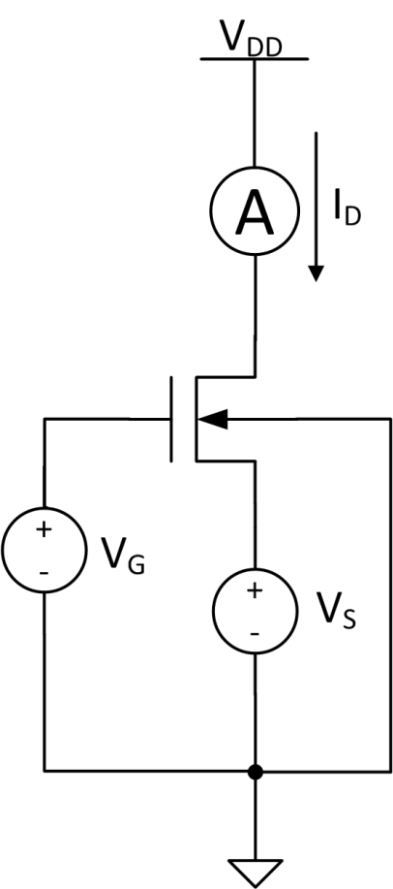
Figure 24 - V_{GS} vs. I_{D} test circuit, the 1st test circuit.

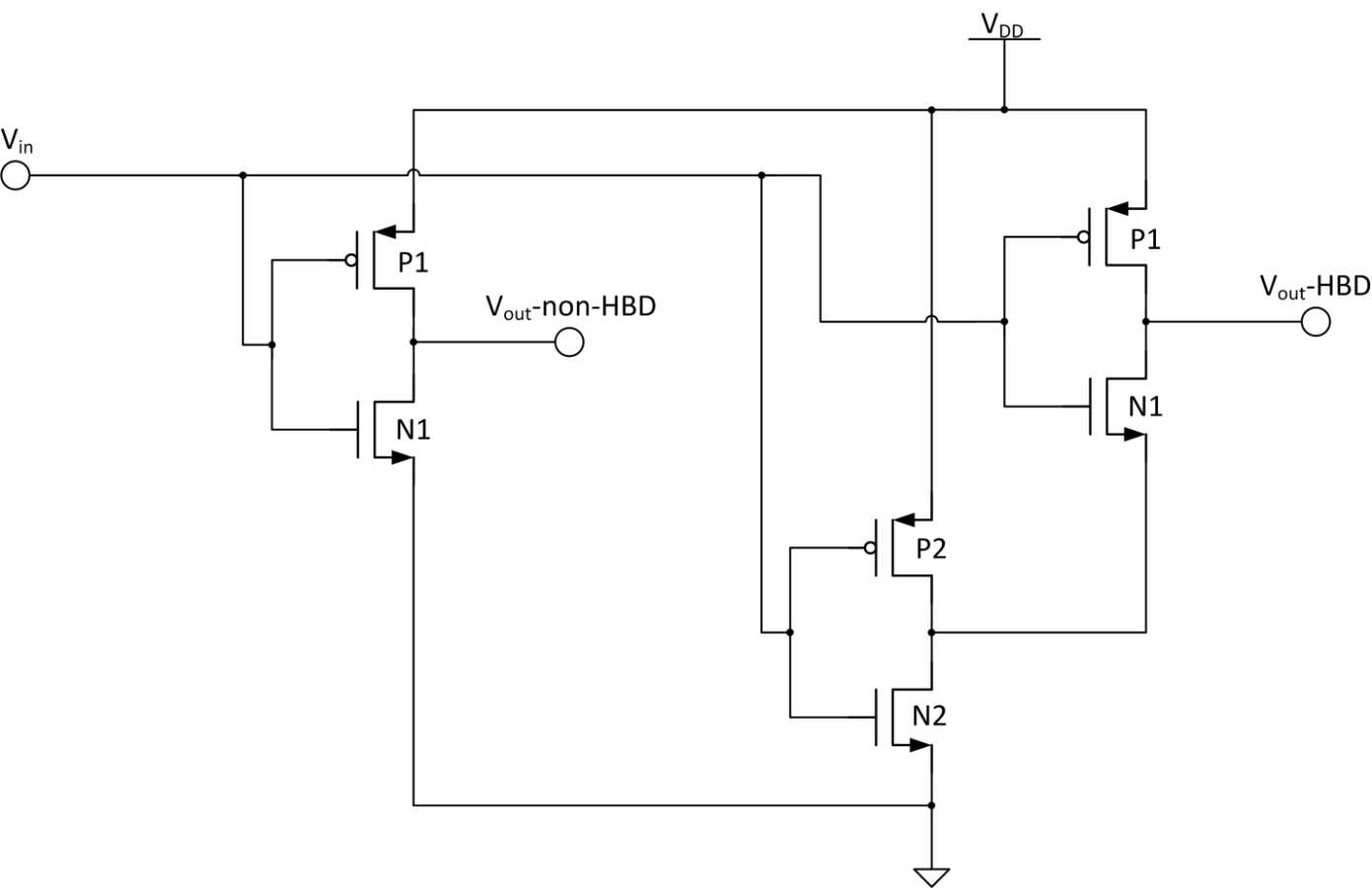
Figure 25 - Inverter DC transfer function test circuit, the 2nd test circuit.

In Situ Radiation Test Setup at Auburn
The thick-gate oxide test circuits were irradiated at the Auburn University radiation test facility. This facility has a Co-60 source. As it decays, Co-60 releases gamma ray photons with energy of 1.12 MeV. These photons are energetic enough to pass through the ALD1106/1107’s plastic packaging and ionize the IC wafer.
The source is safely stored at the bottom of a pool of heavy water in a designated room dubbed the vault. During irradiation the source is raised, irradiating the entire vault. The vault is sealed by a large cement door a few feet thick. The entire process of raising and lowering the source and closing and opening the door takes at least 15 minutes to complete. Also, Auburn charges a fee every time the door is opened. Therefore, in situ testing is desired in order to save both time and money.
The premise of in situ testing consists of taking the measurements while the test boards remain in place and requires no physical human presence in the chamber. This is accomplished through the use of a personal computer running Labview software. The computer interfaces with the desired lab equipment through a USB-GPIB connection or an external PCI-express connection depending on the equipment. A Labview Virtual Instrument (VI) program is written that enables control of this equipment. The VI is setup to perform the desired sweeps and display and store the results (Appendix A.2).
Now, the computer must be left close to the lab equipment making measurements, because of the maximum allowable cable length between them. This means the computer is left inside the test chamber. To gain control and visibility of the computer, a long VGA cable and a USB cable with repeaters is routed outside the chamber to a monitor, keyboard and mouse. In this way, the test equipment can be controlled and the results viewed immediately without having to open the test chamber doors. Not only does the in situ test strategy speed up testing and save money, it also helps prevent errors in reading measurements. The VI program can be thoroughly tested and debugged before the actual radiation testing date; therefore, the possibility of human error during measurements is reduced.
A picture of the test setup is shown in Figure 26. The pool of heavy water where the source is stored is shown at the bottom of the image in the center. During irradiation the source is raised by the elevator shown in the center of the picture. The testboard sits 25 cm from the center of the source (as close as practical). At this distance, the boards received a dose rate of 9.219 rad/s. The wires from the test board (carrying only analog DC measurements) are routed to the test equipment at the right of the image. The test equipment is shielded by cinder blocks and lead bricks. The computer is also here (not shown); the USB and VGA wires are strung up over the test setup and routed outside the chamber to the adjacent room with the monitor, keyboard and mouse.

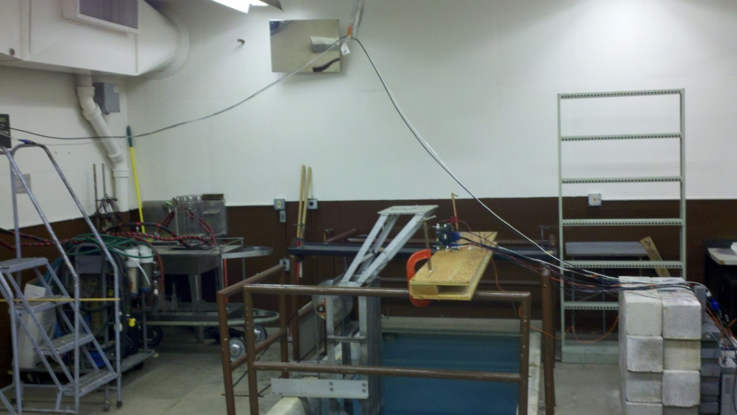
Figure 26 – Auburn’s Co-60 test room where the ALD1106 and ALD1107 chips were irradiated.

Test Methodology
During irradiation the devices were biased in a worst-case scenario. For the discrete NMOS devices, the full gate voltage of 5 V was applied and the drain voltage was set to zero; the inverters’ inputs had 5 V applied which biased the NMOS transistors in a similar fashion. By applying a full gate voltage, the ehps created from the gamma rays are pulled in opposite directions in the gate oxide. The electrons travel toward the gate electrode and escape the oxide, while the holes become trapped as described previously.
Radiation measurements were taken every 10 krad up to 60 krad. The dosage was measured by multiplying the dose rate by the time under irradiation (kept with a stopwatch). Radiation measurements were completed with two fresh sets of chips to verify repeatability. While not completely necessary, the source was raised and lowered each time before the radiation measurements were taken. This added a few minutes to each measurement, but provided security in case issues arose with the Labview VI and the measurements couldn’t be made immediately. Reaching 60 krad with one set of chips took two hours and 42 minutes.

Thin-Gate Oxide Device Testing

A Rad-Tolerant Frequency Synthesizer in the IBM 7WL Process
A radiation-tolerant, extreme environment capable frequency synthesizer has been proposed and designed. Funded by a NASA SBIR, the frequency synthesizer is designed to operate in the space environment. The IBM 7WL 0.18 µm BiCMOS process was the selected fabrication process. The bulk CMOS devices in this process are susceptible to TID radiation. Figure 27 shows the block diagram of the frequency synthesizer. The highlighted blocks represent CMOS circuits. There are a large number of CMOS blocks; therefore, it is critical that these blocks be tolerant of TID radiation.
The 7WL process has a 1.8 V core voltage; the core CMOS devices have a gate oxide thickness of 3.5 nm [23]. Therefore, the primary TID concern is STI-edge leakage. The STI characteristics of these devices are not known; it is not known whether the gate of these devices will exert discernible current control over the parasitic STI-edge transistors. So, the inverted-source technique is applied to various CMOS circuits used in the frequency synthesizer. Radiation measurements are taken to compare the HBD circuits with unhardened designs.

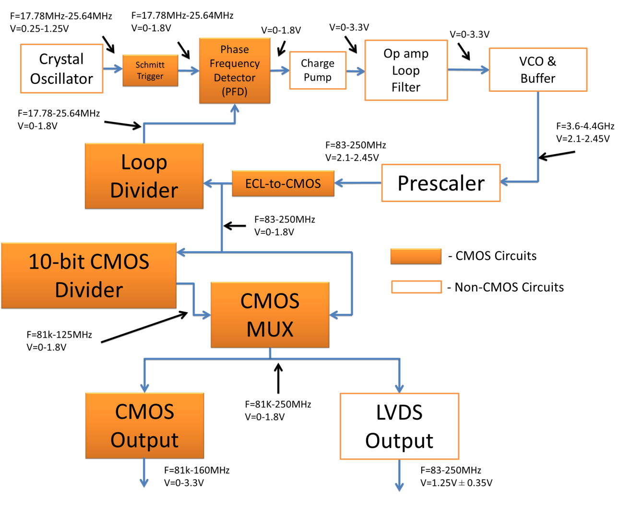
Figure 27 - Block diagram of frequency synthesizer.

The Test Circuits
The development of the frequency synthesizer was spread over two fabrication runs: the Cappadocia run and the Archelais run. On each of these runs, a couple test circuits were implemented that test the inverted-source HBD method.

Cappadocia Die
HBD and non-HBD test inverters were implemented on the Cappadocia fabrication run. The important design variables are the active devices’ width and length. The devices’ lengths were chosen to be 180 nm (minimum length) for maximum speed. The NMOS and PMOS widths were chosen to give approximately equal rise and fall times. P+ guard rings surround both the PMOS and NMOS device for inter-device isolation. Figure 28 shows the layout of the test inverters. The HBD inverter is approximately 64% larger than the standard inverter. Design. Device sizing, simulations, etc. switching point, input capacitance, speed. Table summarizing sizes.

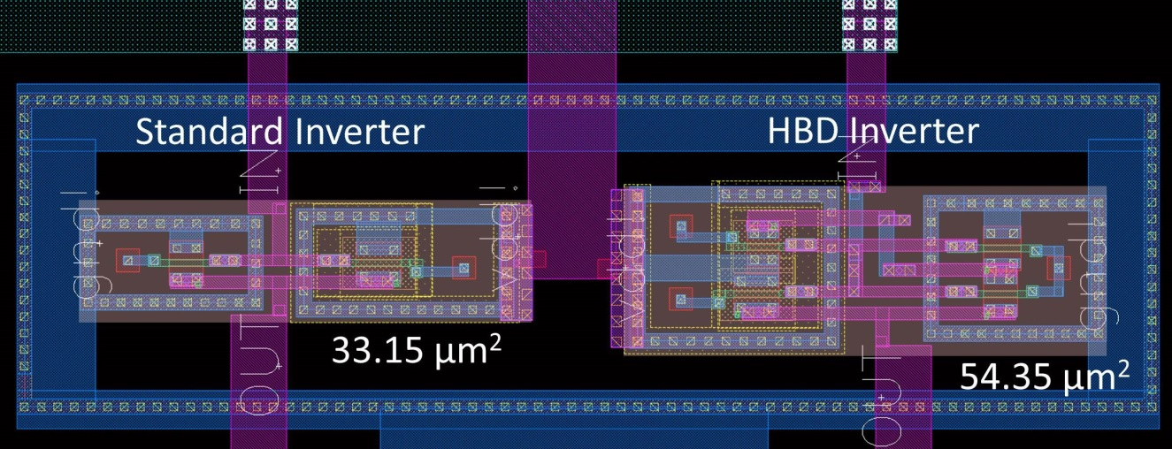
Figure 28 - Layout of 7WL test inverters.

Two thirty-one stage ring oscillators were designed from the test inverters. The ring oscillators are shown in Figure 29. The HBD ring oscillator is around 60% larger in area than the non-HBD inverter. The HBD oscillator is also slower than the non-HBD version. A simulation of the extracted-layout version of the oscillators showed the non-HBD version to oscillate at 160 MHz and the HBD version to oscillate at 74 MHz (room temperature and typical models).

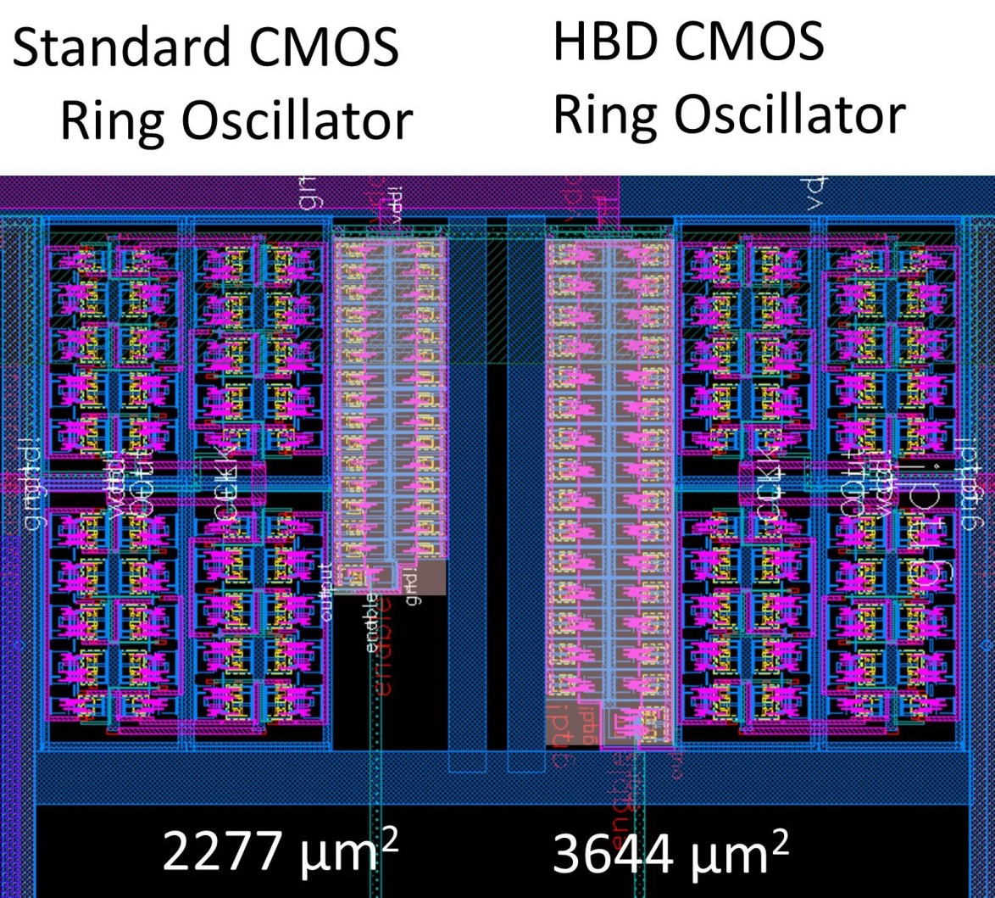
Figure 29 - Layout of 31-stage test ring oscillators.

Archelais Die
Design. Device sizing, simulations, etc.

In Situ Radiation Testing

Cappadocia Die Test Setup and Methodology
The ALD1106/1107 devices were irradiated at a dose rate of 9.219 rad/s by the Co-60 source. The dose rate of the Co-60 source cannot be easily increased unless the source is replenished or the devices moved closer to the source. Replenishing the source is not an option and the devices were as close as practical to the source. Thin-gate oxide transistors are largely immune to the catastrophic effects of threshold voltage shift, so the circuit effects of TID may not be seen until many 100’s of krad is reached. To reach 300 krad, the Auburn source would take over nine hours. To test multiple devices, the time commitment quickly rises into days of testing. A faster dose rate is desired.
It has been shown that irradiating MOSFET devices at higher dose rates decreases the annealing time available and therefore increases the TID damage for a certain dosage (SOURCE). If the MOSFET devices are able to survive to a certain dose at a high dose rate; they will be able to survive the same dose at a lower dose rate such as the rates seen in space applications. Vanderbilt University has an ARACOR 10 keV X-ray machine available for use. The X-ray source is capable of any dose rate between 83 rad/s and 517 rad/s.
In contrast to Auburn’s Co-60 source, the ARACOR machine (left side of Figure 30) does not require an entire room; the test setup does not need to be far from the machine. This eliminates the need for excessively long wires to control the PC; it and the rest of the test equipment are located beside the machine where they can be monitored and controlled directly.
The X-ray’s photons are much less powerful than in the gamma ray source; the lid of the test die was removed to expose the die directly to the beam. Otherwise the beam would be greatly attenuated.

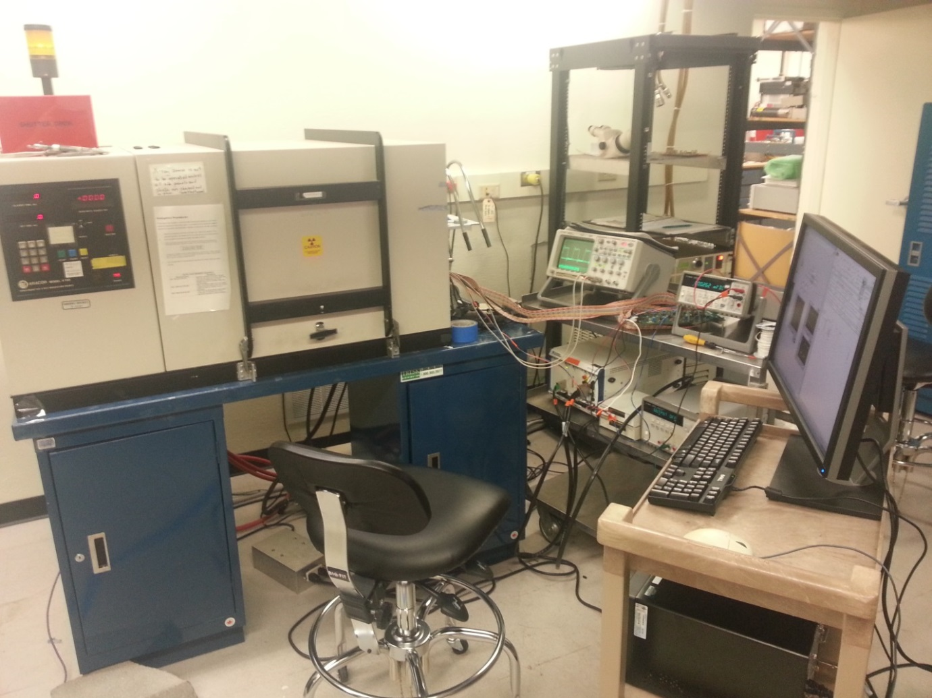
Figure 30 - Vanderbilt University's X-ray source (left) and the Cappadocia testing equipment (right).

Archelais Run

Summary

Table 1 - The radiation testing summary.
Test Devices | Test Circuits | Source | Dosage
ALD1106/1107 | Inverter DC TF | Cobalt-60 –  9.219 rad/s | 60 krad
ALD1106/1107 | NMOS I_{D} vs. V_{GS} | Cobalt-60 –  9.219 rad/s | 60 krad
IBM 7WL CMOS | Inverter DC TF | 10 keV X-ray –  270 rad/s | 1 Mrad
IBM 7WL CMOS | Ring Oscillator | 10 keV X-ray –  270 rad/s | 1 Mrad
IBM 7WL CMOS | NMOS I_{D} vs. V_{GS} | ? | ?
IBM 7WL CMOS | Phase Frequency Detectors (PFDs) | ? | ?

Results and Discussion

Thick-Gate Oxide Test Results

Thin-Gate Oxide Test Results
Inverter: Simulated Results
Inverter: Radiation Test Results
Inverter: Results Discussion
Ring Oscillator: Radiation Test Results
Dose rate results
?Circuit Performance Results

Conclusions and Recommendations
Does it work?
Practical ways to decrease leakage current in straight-gate CMOS logic
Use longer NMOS (also helps prevent hot carrier effects)
Use wider NMOS and PMOS? (this increases dynamic power consumption and static to some extent (though not as much as it saves static draw))
Use NAND over NOR logic (if NOR can be replaced by less than 4 NANDs)
Future Work
Substrate biasing?

References

[1] | Jet Propulsion Laboratory, "Mars Science Laboratory: Overview," [Online]. Available: http://marsprogram.jpl.nasa.gov/msl/mission/overview/. [Accessed 25 March 2013].
[2] | L. LeBlond, "Mars Curiosity rover back on track after memory glitch," redOrbit, 5 March 2013. [Online]. Available: http://www.redorbit.com/news/space/1112796512/mars-curiosity-back-on-track-memory-glitch-jpl-030513/. [Accessed 25 March 2013].
[3] | A. Khan, "Nasa Mars Curiosity rover bounces back after double-whammy glitches," Los Angeles Times, 19 March 2013. [Online]. Available: http://www.latimes.com/news/science/sciencenow/la-sci-sn-curiosity-mars-rover-glitch-recovered-20130319,0,1748140.story. [Accessed 25 March 2013].
[4] | L. T. Clark, K. E. Nielsen and K. E. Holbert, "Radiation hardened by design digital I/O for high SEE and TID immunity," IEEE TRansactions on Nuclear Science, vol. 56, no. 6, pp. 3408-3414, 2009.
[5] | R. C. Lacoe, "Improving integrated circuit performance through the applicaiton of hardness-by-design methodology," IEEE Trans. Nucl. Sci., vol. 55, no. 4, pp. 1903-1925, 2008.
[6] | D. Pan, H. W. Li and B. M. Wilamowski, "A Radiation-hard Phase-Locked Loop," IEEE International Symposium on Industrial Electronics, vol. 2, pp. 901-906, 9-11 June 2003.
[7] | A. Holmes-Siedle and L. Adams, Handbook of Radiation Effects, 2nd ed., New York: Oxford University Press, 2002.
[8] | R. Lacoe, "CMOS Scaling, Design Principles and Hardening-by-Design Methodologies," in IEEE NSREC, Monterey, 2003.
[9] | H. J. Barnaby, "Total-ionizing dose effects in modern CMOS technologies," IEEE Transactions on Nuclear Science, vol. 53, no. 6, pp. 3103-3121, 2006.
[10] | F. B. McLean and T. R. Oldham, "Basic Mechanisms of Radiation Effects in Electronic Materials and Devices," Harry Diamond Laboratories, Adelphi, 1987.
[11] | D. A. Neamen, Semiconductor Physics and Devices: Basic Principles, 4th ed., New York, NY: McGraw-Hill, 2012, pp. 496-498.
[12] | H. J. Barnaby, M. L. McLain, I. S. Esqueda and X. J. Chen, "Modeling Ionizing Radiation Effects in Solid State Materials and CMOS Devices," IEEE Trans. on Circuits and Systems-I: Regular Papers, vol. 56, no. 8, pp. 1870-1883, 2009.
[13] | B. Blalock, Interviewee, Personal Coorespondance with. [Interview].
[14] | G. Niu, S. J. Mathew, G. Banerjee, J. D. Cressler, S. D. Clark, M. J. Palmer and S. Subbanna, "Total Dose Effects on the Shallow-Trench Isolation Leakage Current Characteristics in a 0.35 um SiGe BiCMOS Technology," IEEE Trans. on Nuclear Science, vol. 46, no. 6, pp. 1841-1847, 1999.
[15] | M. R. Shaneyfelt, P. E. Dodd, B. L. Draper and R. S. Flores, "Challenges in Hardening Technologies Using Shallow-Trench Isolation," IEEE Trans. on Nuclear Science, vol. 45, no. 6, pp. 2584-2592, 1998.
[16] | M. Turowski, A. Raman and R. D. Schrimpf, "Nonuniform Total-Dose-Induced Charge Distribution in Shallow-Trench Isolation Oxides," IEEE, vol. 51, no. 6, pp. 3166-3171, Trans. on Nuclear Science.
[17] | Z. Hu, Z. Liu, Z. Zhang, B. Ning, M. Chen, D. Bi and S. Zou, "Comprehensive Study on the Total Dose Effects in a 180-nm CMOS Technology," IEEE Trans. on Nuclear Science, vol. 58, no. 3, pp. 1347-1354, 2011.
[18] | D. Pan, H. W. Li and B. M. Wilamowski, "A Radiation-Hard Phase-Locked Loop," IEEE International Symposium on Industrial Electronics, vol. 2, pp. 901-906, 9-11 June 2003.
[19] | N. Nowlin, J. Bailey, B. Turfler and D. Alexander, "A Total-Dose Hardening-by-design Approach for high-speed mixed-signal CMOS Integrated Circuits," Int. J. High Speed Electronic Systems, vol. 14, pp. 367-378, 2004.
[20] | P. S. Winokur, K. G. Kerris and L. Harper, "Predicting CMOS Inverter Response in Nuclear and Space Environments," IEEE Trans. on Nuclear Science, vol. 30, no. 6, pp. 4326-4332, 1983.
[21] | Advanced Linear Devices, Inc., "Quad/Dual N-Channel Matched MOSFET Array: ALD1106/ALD1116 Datasheet," Sunnyvale, CA, 1998.
[22] | D. A. Neamen, Semiconductor Physics and Devices: Basic Principles, 3rd ed., New York: McGraw-Hill, 2003, pp. 480,481,555-559.
[23] | Analog and Mixed Signal Technology Development IBM Microelectronics Division, "BiCMOS7WL Design Manual," Essex Junction, 2011.

Appendices

The Test Boards
A test board was designed to implement the two test circuits for the ALD1106/1107. Figure 31 shows this test board. The board is a four-layer FR4 PCB designed in the Eagle CAD software. The inner layers are V_{DD} and ground; bypass capacitors are used between these two nodes to lower noise from the supply. Most of the connections to exterior devices are made through banana plugs, because the measurements are at DC frequency and banana plug cables are cheap and easy to make any custom length. The top half of the board allows the V_{GS} vs. I_{D} test to be performed, and the bottom portion enables the inverter DC transfer functions to be captured. The Co-60 source used during radiation testing can be physically approximated as a line source of radiation; therefore to ensure even dosage the ALD1106 and ALD1107 are horizontally-centered on the board.

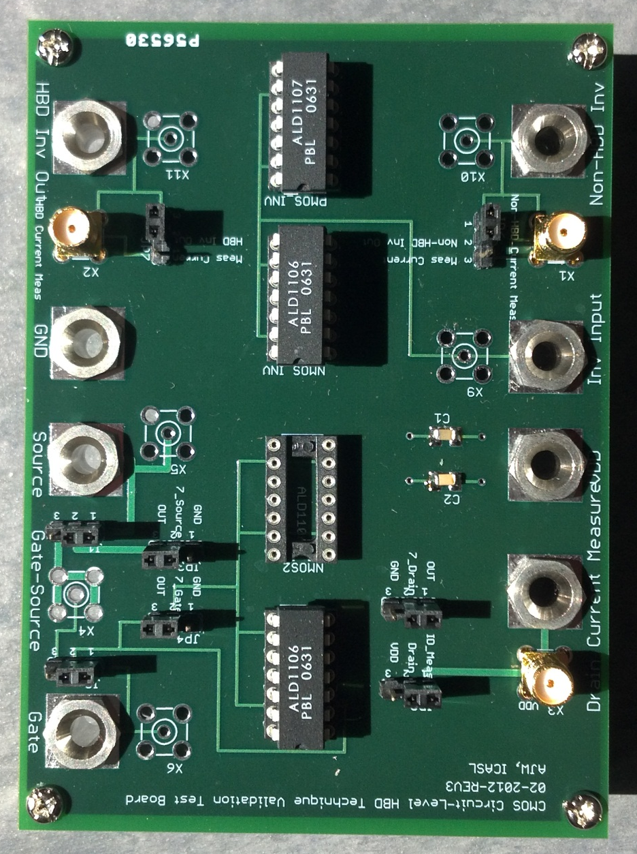
Figure 31 – Test board used for radiation testing of ALD1106 and ALD1107.

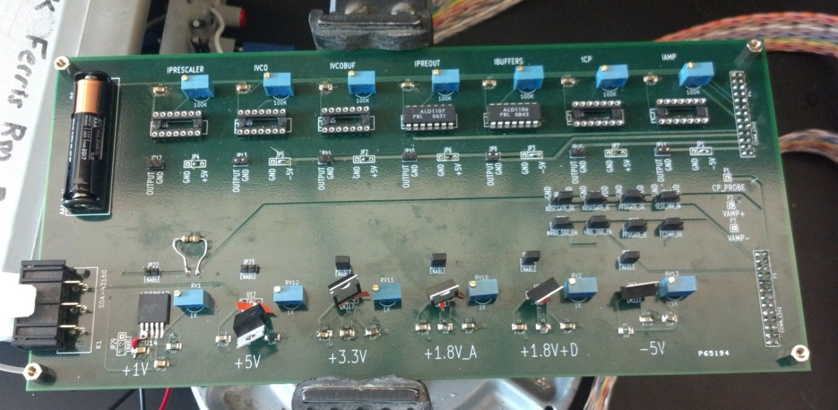
Figure 32 - Bias board for Cappadocia chips.

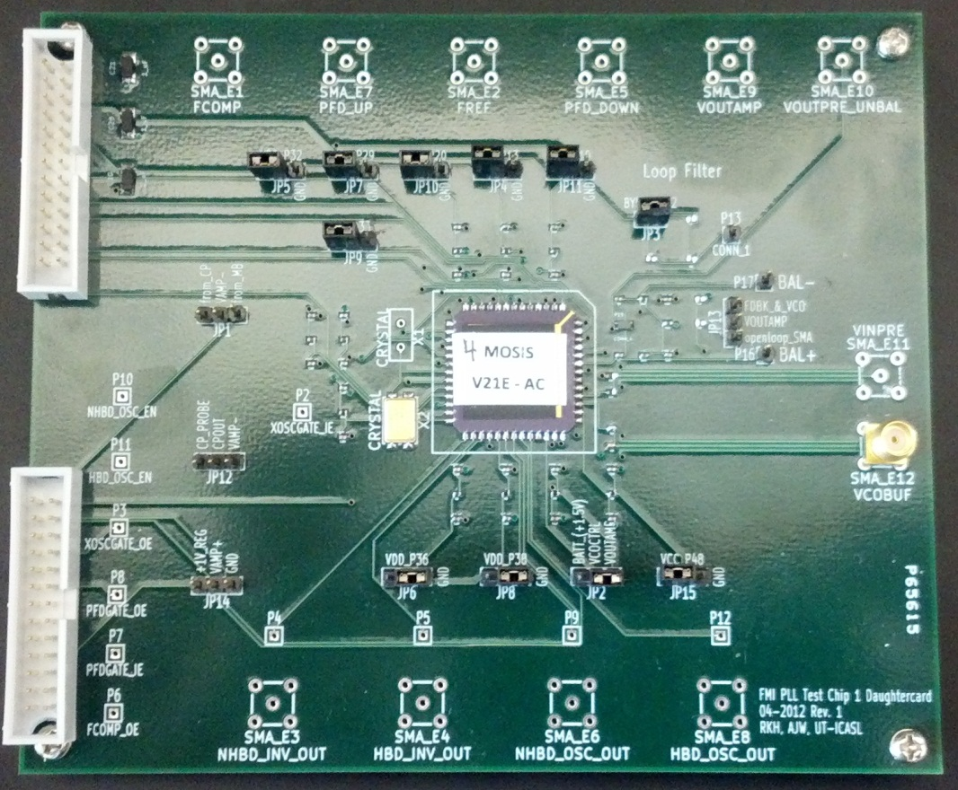
Figure 33 - Daughter card housing Cappadocia chips. Inverter and ring oscillator outputs are along the bottom of the board.

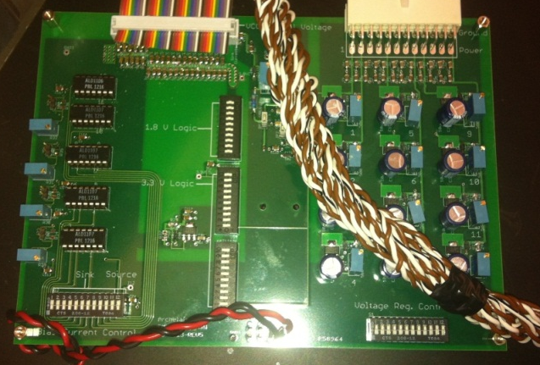
Figure 34 - Bias board for Archelais chips.

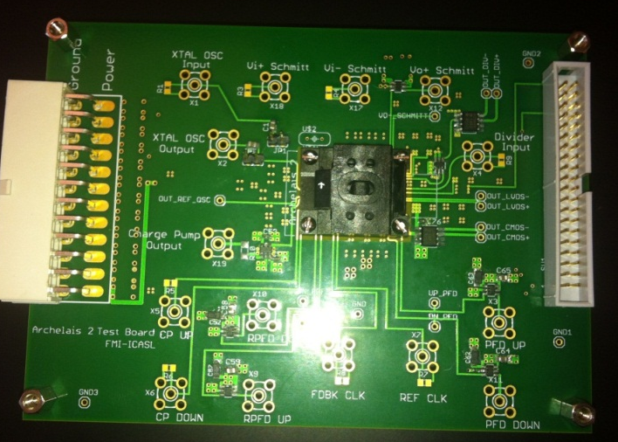
Figure 35 - Daughter card for Archelais chips.

The LabView Virtual Instruments (VIs)
Picture of front panel.
Program design.
Utilize Instrument’s pre-built VI’s (learn how to use them too)
Event Structure to handle execution (cite tutorial)
Sub VIs
Saving data (cite Jeremy’s thesis)

Vita
Austin J. Womac was born on December 17, 1988 in Knoxville, TN. He was raised in Alcoa, TN for most of his life. He attended Alcoa High School and graduated in 2007. He attended the University of Tennessee, Knoxville for his undergraduate studies and graduated in May 2011 with a Bachelor of Science in Electrical Engineering. He immediately joined the ICASL group and began his graduate studies under Professor Ben Blalock. The following summer he participated in an internship at Jet Propulsion Laboratory (JPL) in Pasadena, CA working under Dr. Mohammad Mojarradi. He graduated from the University of Tennessee, Knoxville with a Master of Science in Electrical Engineering in July 2013.

