CHAPTER-6
COMPARISON OF SEISMIC SURFACE WAVE DISPERSION RESULTS OBTAINED FROM CONVENTIONAL VERSUS RANDOM RECEIVER ARRAYS

ABSTRACT

Understanding the physical and engineering properties (e.g., Poisson’s ratio) within the upper 30 m of the lunar subsurface is critical for lunar exploration and deployment of large structures, particularly as landing of large spacecraft and mining on the surface becomes possible. Advances in both active and passive multi-channel seismic acquisition have greatly improved one’s ability to determine engineering properties of the shallow subsurface, especially when using the multi-channel analysis of surface waves (MASW) technique. Using randomly distributed geophones (likely deployed from a mortar-type device) instead of a conventional linear array is necessary for lunar exploration due to the logistical constraints in arranging a linear or circular array robotically. Results indicate that robust dispersion curves (and thus subsurface models of engineering properties) are obtained from the random array geometries. The goal of this study is to compare this newly developed technique with that of the conventional methods in order to evaluate for its accuracy. Multi-channel data is acquired using conventional arrays (e.g., linear, circular and cross-arrays) at the same location where random data was collected. The dispersion datasets, obtained using various conventional arrays, were consistent with data sets of the newly developed array. All array methods are closely evaluated for the frequency, phase velocity, and, shear wave velocity ranges; they all correlate well with one another. Random geometry is also evaluated for potential improvements in the resolution of the dispersion image and as a more accurate method for assessing azimuthal variations in the subsurface geology.

INTRODUCTION
Geophysical technique of MASW is increasingly being applied to geotechnical engineering for the measurements of dynamic properties, soil profiling, microzonation, and site response studies. This technique is particularly used in geotechnical engineering for the measurements of shear wave velocity, identification of material properties, their boundaries and special variations of ground etc. Being a non-invasive and less time consuming, the MASW method is used to evaluate material layer thickness, their shear wave velocity (1D and 2D), Poisson’s ratio and density. The Multi-channel Analysis of Surface wave method (park et al 1999) uses a multi-channel array, which makes it possible to distinguish the fundamental-mode from higher modes and body waves. Depending on the source used to generate surface waves, there are two types of MASW surveys: active method that utilizes a proper impact source like a sledge hammer and passive method, on the other hand, utilizes ambient noise such as traffic or tidal motion. The active method is considered to be the conventional mode of survey, collecting data in a roll-along mode using an active seismic source and a linear receiver array. The passive remote method utilizes ambient cultural noise such as traffic, thunder, tidal motion etc. and employs a two-dimensional receiver array such as a cross, circular, random etc. to record passive surface waves. Initial studies indicate that robust dispersion curves (and thus subsurface models of engineering properties) are obtained from the random array geometries. Using randomly distributed geophones (likely deployed from a mortar-type device) instead of a conventional linear array is necessary for lunar exploration due to the logistical constraints in arranging a linear or circular array robotically. It has been observed from preliminary experiments that reliable dispersion images, and 1-D shear wave velocity profiles, can be obtained by using random geophone arrangement.
However, a detailed study comparing each different type of array and its effect on dispersion analysis has not been reported yet. Therefore, this study is particularly focused on comparing different types of conventional arrays with the random array in order to evaluate for its accuracy.

SITE DESCRIPTION

The field Hydrology Teaching and Research Site is located at the University of Tennessee (UT) Plant Science Farm, alongside Highway approximately 2 miles south of the UT campus. It is located between the highway and the Tennessee River. Soil conditions across the site vary from residual soils developed directly on sedimentary bedrock near the highway, to loamy soils developed on a series of alluvial terraces at different elevations above the river. The bedrock is very fine-grained calcareous Ottossee Shale, with some limestone interbeds. The upper portion of the bedrock contains numerous weathered and stained fractures and can also be used as a low yield aquifer. The data was collected in a 10m×10m grid and 13 shot points were shot around the grid. The receiver array lengths varied depending on the array design but they all shared the same center point.

FIELD PROCEDURE
The MASW data was collected for linear, circular, cross and random arrays at the University of Tennessee agricultural field test site in eastern Tennessee USA, using 2, 24-channel Geometrics Geode seismograph with 40 Hz spike coupled geophones with spike firmly planted on the ground. The data was collected in SEG2 format with a recording time of 1000 ms and sample interval of 0.5ms. Other parameters like the source-receiver offset distance, total length of the array line and receiver spacing were all estimated depending upon the array type. Acoustic energy was generated by using a 10-lb sledge hammer and metal plate as the seismic source and the data were acquired at 13 different shot points around the 10 m × 10 m grid. No acquisition frequency filter was applied during the recording. To increase signal-to-noise ratio, three impacts at each station were vertically stacked. The dimensions and other parameters used for each type of receiver array are described in Table 1. Also the grid setup and the locations of the shot points are all portrayed in Figure 1.
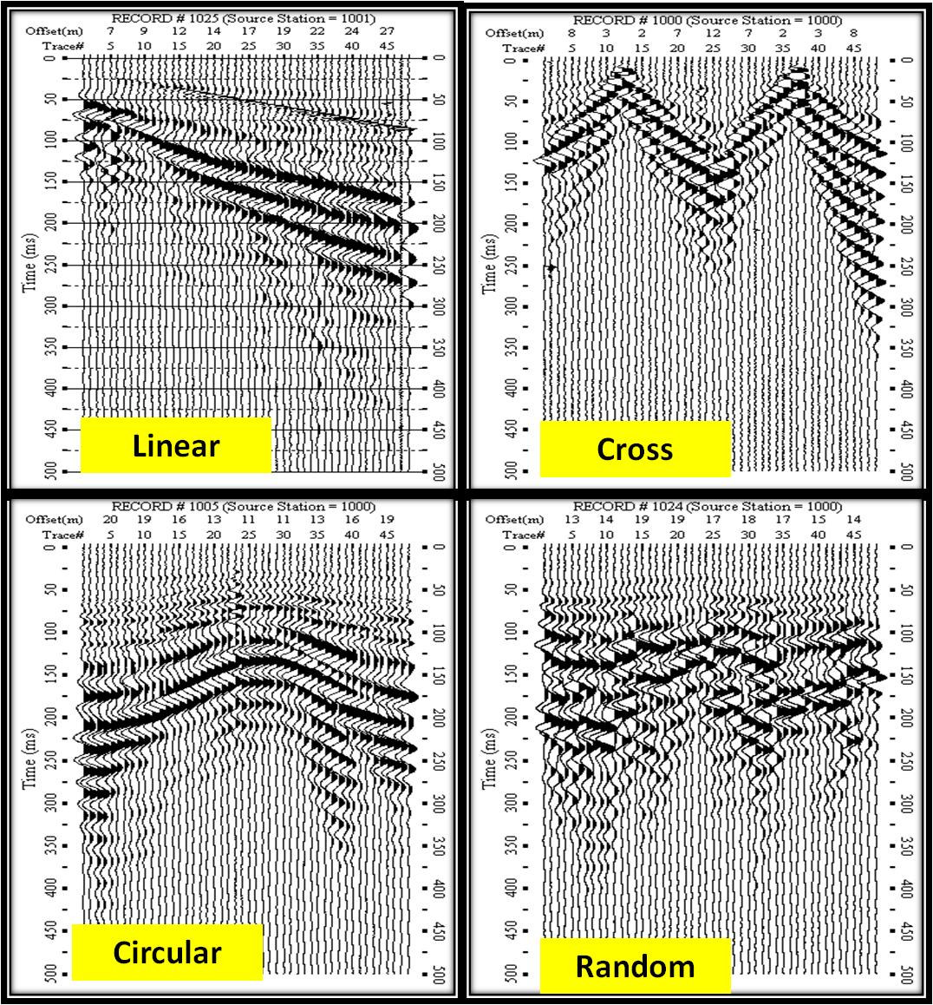
Figure 1: Shot gathers for various arrays. The x-axis represents offset (m) and trace numbers and y-axis represents time (ms). Data was collected for 1000ms but only the first 500ms is shown here.
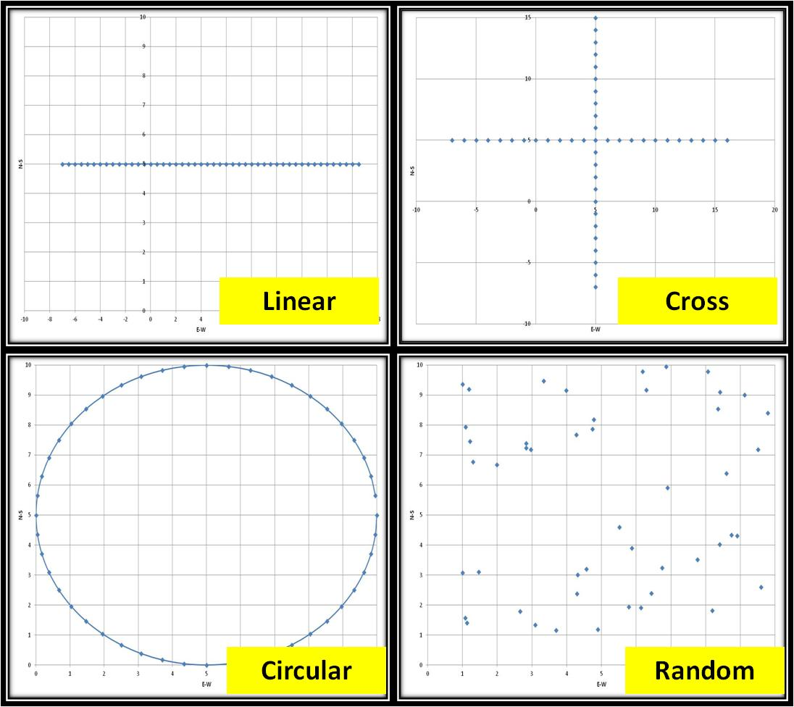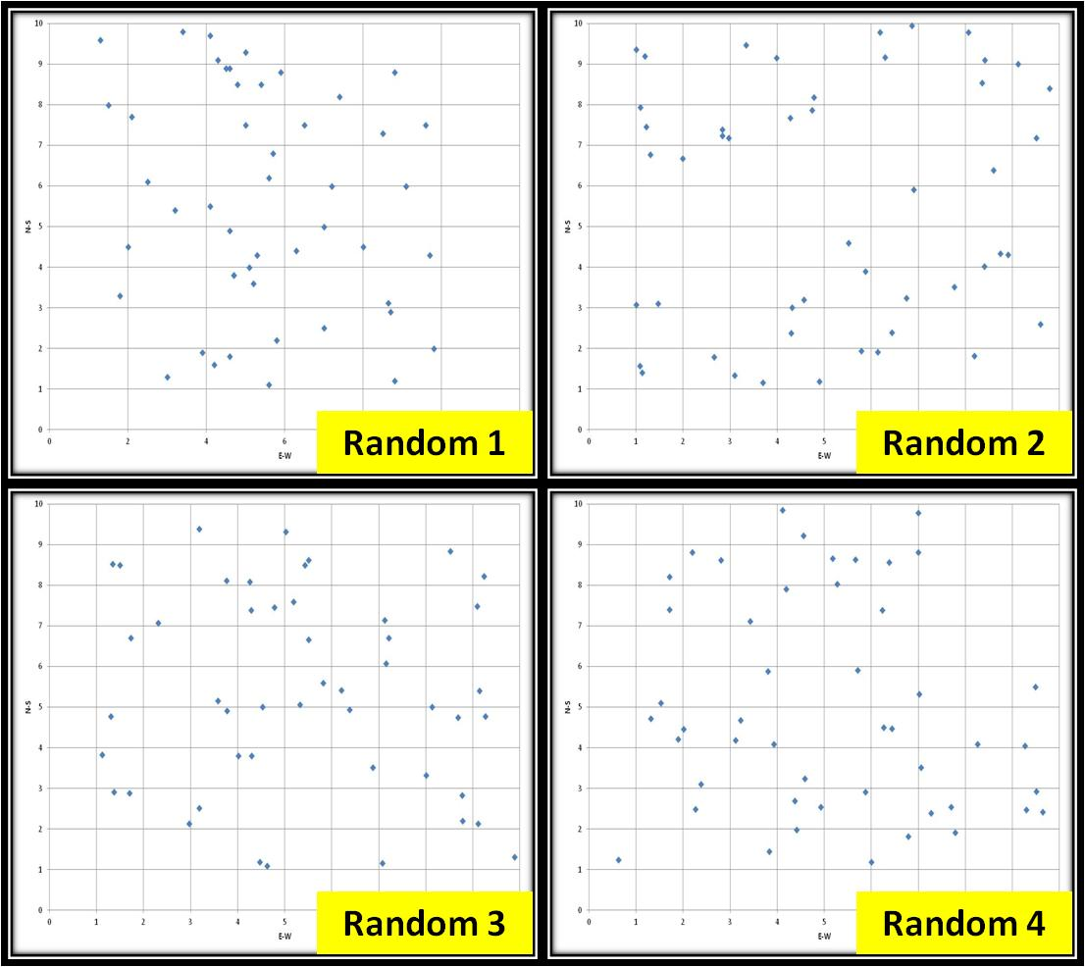
Figure 2: Schematic representation of various array designs as deployed in the field. The x-axis represents E-W and y-axis represents the N-S directions. Figure (a) represents conventional and random array and Figure (b) represents four different random arrays (different receiver spacings with different x and y coordinates).

For the MASW data collected, individual dispersion curves generated for various geophone arrays are shown in Figure 2. SURFSEIS software package (Kansas Geologic Survey) was used to process the MASW datasets. The fundamental modes can be clearly distinguished in the dispersion image.

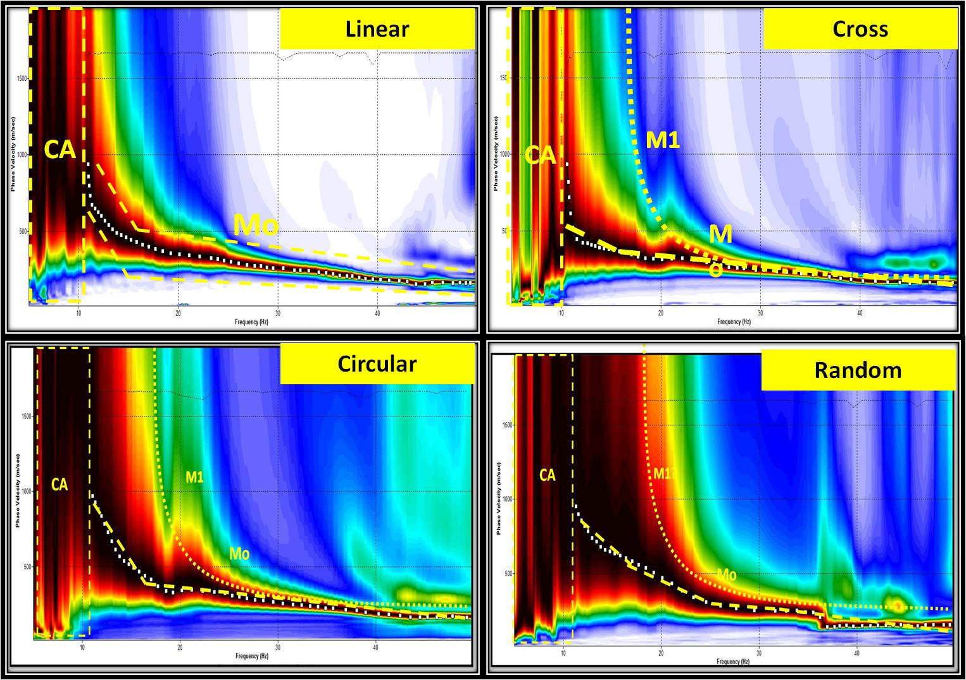
Figure 3 (a): Dispersion images for Linear, Cross, Circular and Random receiver arrays. The x-axis represents Frequency (Hz) and Y-axis represents Phase Velocity (m/s). The white dots represent the dispersion picks for each array. Also for each dispersion image the fundamental and higher modes are highlighted.
CA-Computational Artifacts; Mo-Fundamental Mode curve; M1-First higher mode.
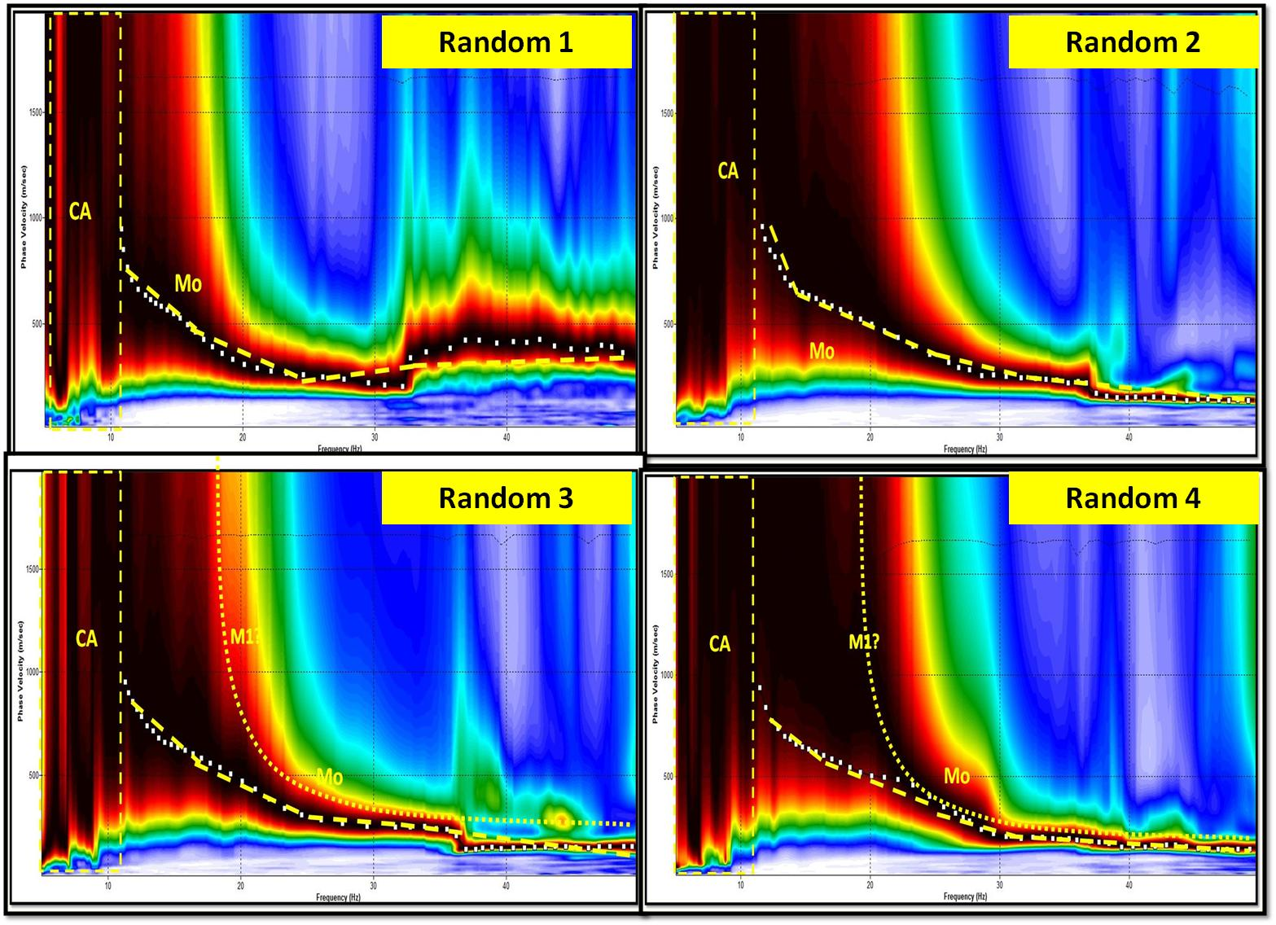
Figure 3(b): Dispersion images for different random receiver arrays. The x-axis represents Frequency (Hz) and Y-axis represents Phase Velocity (m/s). The white dots represent the dispersion picks for each array. Also for each dispersion image the fundamental and higher modes are highlighted.

COMPARISON

The dispersion images and inversion results obtained from various geophone arrays are all superimposed in figure 4. The frequency and velocity ranges obtained from fundamental modes all correlate well with one another, at frequencies and velocities.

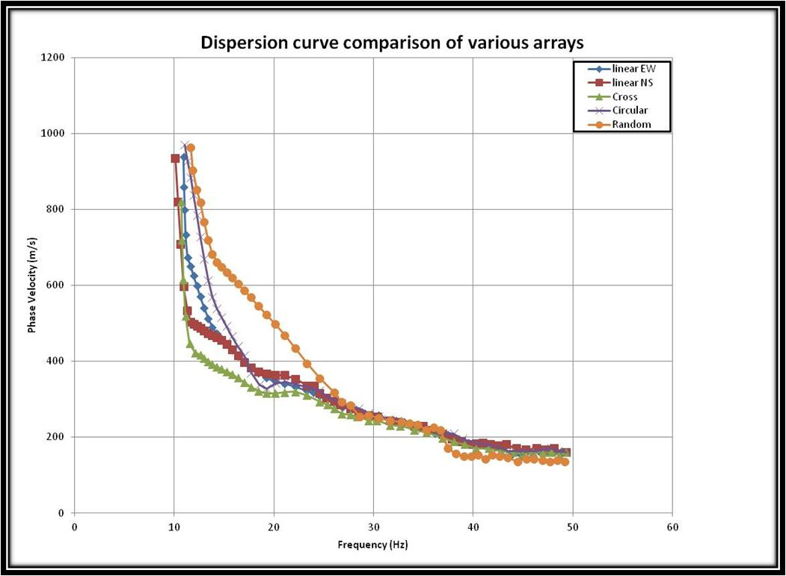
Figure 4: A graph representing dispersion curve comparison for four types of receiver arrays.
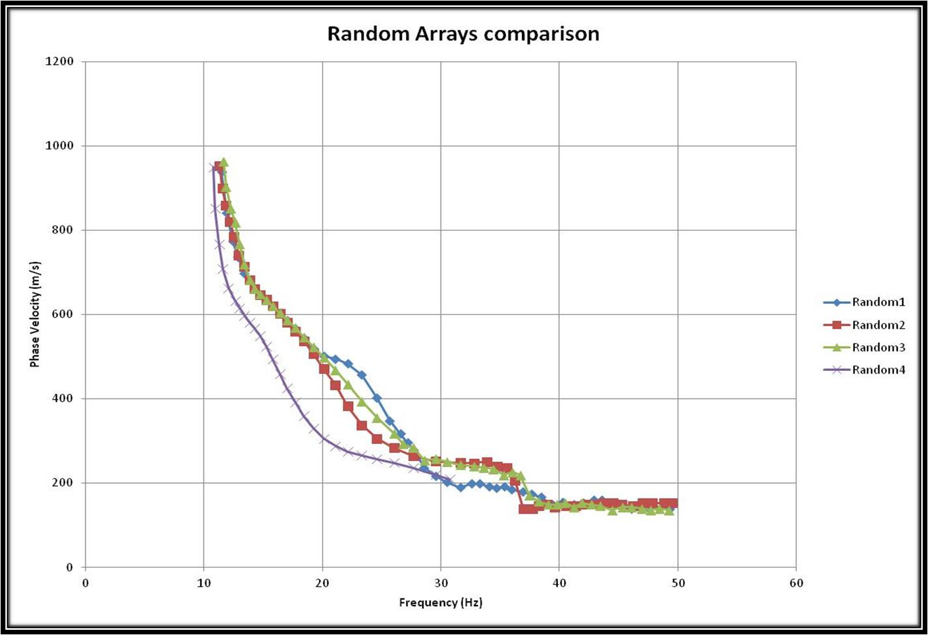
Figure 5: Comparison of dispersion curves for various random array distributions.
Table: 1 Parameters used in the field for different receiver arrays
Survey Type | Linear EW | Linear NS | Circular | Cross | Random-1 | Random-2 | Random-3 | Random-4
File Name | LinearNS_MASW.dat | LinearEW_MASW.dat | Circular_MASW.dat | Cross_MASW.dat | Random_MASW.dat | Random_MASW.dat | Random_MASW.dat | Random_MASW.dat
Survey purpose | 1-D Vs profiling | 1-D Vs profiling | 1-D Vs profiling | 1-D Vs profiling | 1-D Vs profiling | 1-D Vs profiling | 1-D Vs profiling | 1-D Vs profiling
Data format | SEG-2 | SEG-2 | SEG-2 | SEG-2 | SEG-2 | SEG-2 | SEG-2 | SEG-2
Acquisition | 48-channel | 48-channel | 48-channel | 48-channel | 48-channel | 48-channel | 48-channel | 48-channel
Seismic source | Sledge hammer | Sledge hammer | Sledge hammer | Sledge hammer | Sledge hammer | Sledge hammer | Sledge hammer | Sledge hammer
Receivers | 40 Hz | 40 Hz | 40 Hz | 40 Hz | 40 Hz | 40 Hz | 40 Hz | 40 Hz
Receiver array | Linear | Linear | Circular | Cross | Random | Random | Random | Random
Array dimensions | 24m | 24m | 10m diameter | 24m | 100 m (square) | 100 m (square) | 100 m (square) | 100 m (square)
Receiver spacing | 0.5 m | 0.5 m | 0.63 m | 1 m | Random | Random | Random | Random
Source offset | 5m | 5m | 10 m around the grid | 10 m around the grid | 10 m around the grid | 10 m around the grid | 10 m around the grid | 10 m around the grid
Sampling interval | 0.5 ms | 0.5 ms | 0.5 ms | 0.5 ms | 0.5 ms | 0.5 ms | 0.5 ms | 0.5 ms
Recording time | 1000 ms | 1000 ms | 1000 ms | 1000 ms | 1000 ms | 1000 ms | 1000 ms | 1000 ms
Record numbers | 1017-1024 | 1025-1033 | 1000-1012 | 1000-1013 | 1005-1017 | 1018-1030 | 1031-1045 | 1046-1058
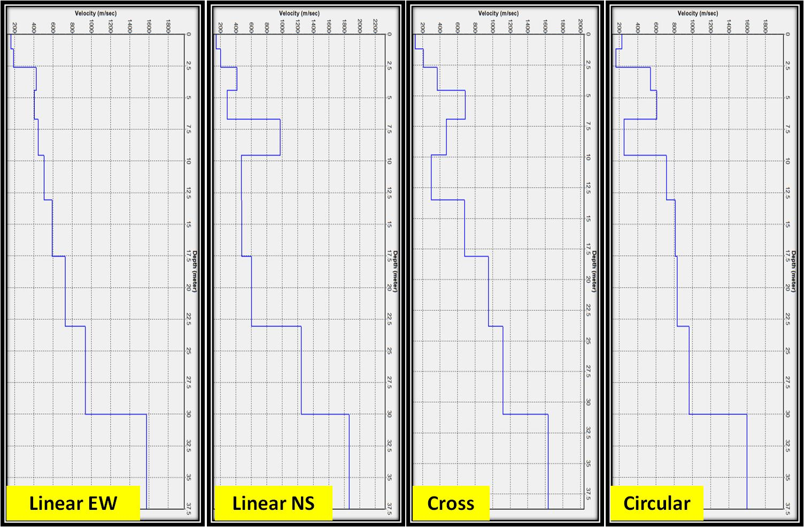

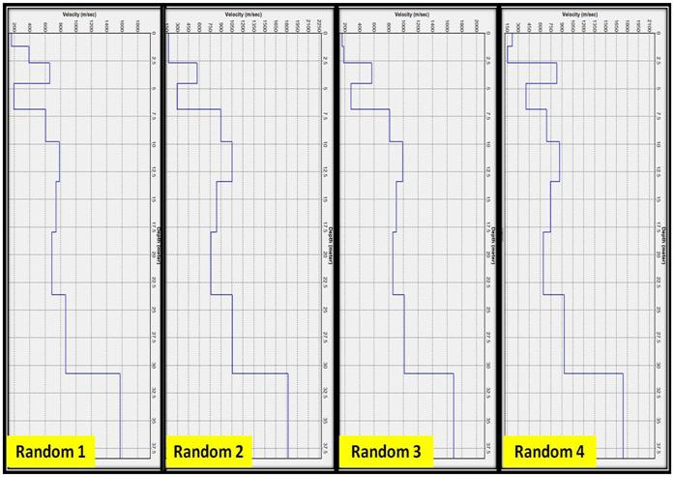

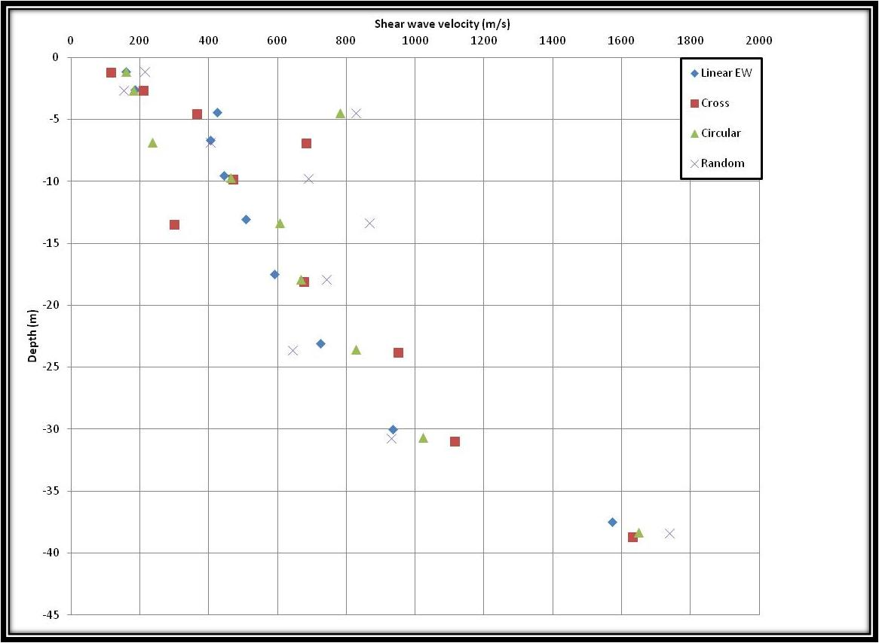

Figure 8: 1-D shear wave velocity profiles for various random arrays calculated from the dispersion curve picks.
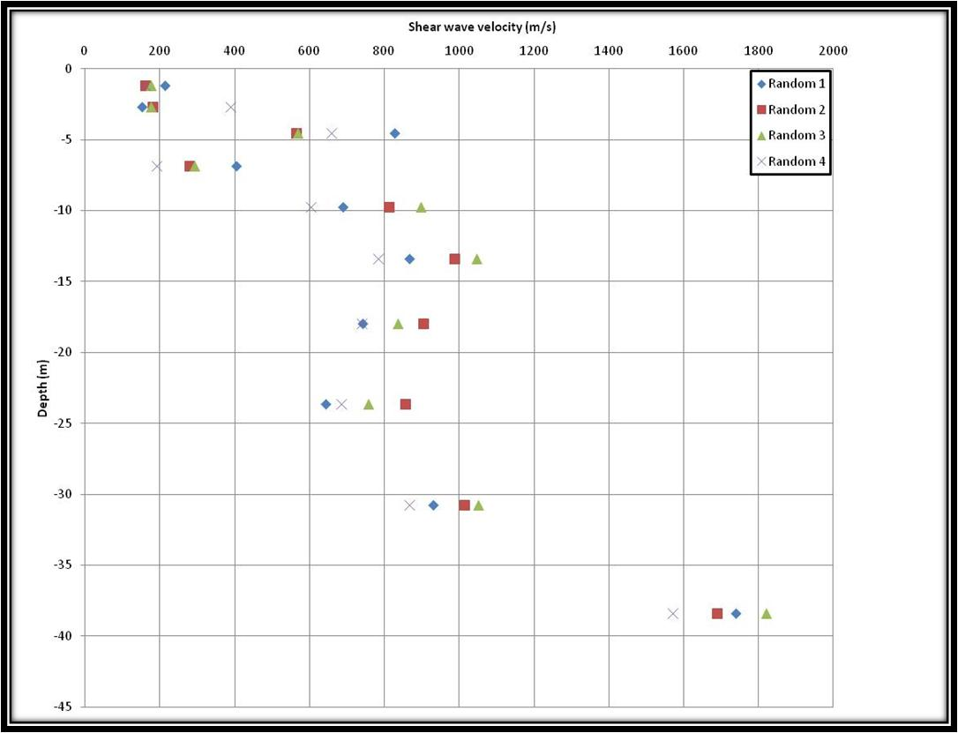
Figure 9: Graphical comparison of various 1-D Vs profiles.

