Design of a Neutron Detector Capable of Replacing Helium-3 Detectors Utilizing Thin Polymeric Films

A Thesis Presented for the
Master of Science
Degree
The University of Tennessee, Knoxville

Matthew J. Urffer
December 2012
Acknowledgements
I am very grateful for the assistance and guidance Dr. Miller has provided on this project. His frankness and practical experience as well as his in-depth knowledge have been invaluable. I would also like to extend my gratitude to my committee members, Dr. Pevey and Dr. Hayward for their efforts and suggestions. I would like to acknowledge the guidance that Dr. Penamadu and Dr. Melcher have provided. In addition, I would like to thank Andrew Mabe, John Auxier and Dr. Uppal for manufacturing the films used in this work. Finally, I would like to my parents (Micheal and Lisa) for their support and my siblings (Katie, Samuel, David, Isaac, Esther & Eli) for their encouragement, and the bakery for all of the snacks.

Abstract
There exists a significant need to develop a new neutron detection system which would reduce the dependency on the current ³He-based detectors for Domestic Nuclear Detection Office (DNDO) applications. One of the technologies being developed is the use of ⁶Li (thermal cross section of 940 barns) in scintillating polymeric thin films. The purpose of this research is to provide a framework for the characterization of thin polymeric films in terms of meeting the detection requirements set forth by the governing bodies, most notability a detector count rate of 2.5 cps/ng with and only misclassifying a neutron as a gamma once in a million. The performance of some of the best preforming fabricated films is simulated with a Monte Carlo transport code (MCNPX) as radiation portal monitors. It is determined that thin polymeric films would have a high enough interaction rate to satisfy the DHS-DNDO requirements while still maintaining the necessary gamma discrimination.

Table of Contents
1. Introduction 1
Detector Requirements 3
Outline of this Document 4
2. Methods 6
Instrumentation 6
Available Sources 7
Pulse Shape Discrimination 10
Measurement Protocols 12
Data Analysis 13
Measurement Repeatability 17
Intrinsic efficiency 19
Simulation of Designed Detector For Satisfying the Neutronic Requirements 27
Neutronic Calculations 29
3. Results 37
Performance of Selected Films 37
Performance of a detector in the DHS footprint 39
Single Film with varying Moderator and Reflector Thickness 40
Layered Detector in DHS-DNDO Footprint 42
Enhanced Discrimination through Pulse Shape Discrimination 60
Polystyrene Pulse Shape Discrimination 60
PEN Pulse Shape Discrimination 64
4. Conclusions 70
Measurement Protocols and Data Analysis 70
Modeling Ability 70
Detector Design 71
Future Work 71
Bibliography 72
Appendix A 75
GS20 Data 75
PEN Data 79
Operating Detector Configuration 83
Minimum Detectable Activity 86
Appendix B 91
MCNPX Inputs Decks 91
Miller_Config_GS20.mcnp 91
Gamma_Config_GS20.mcnp 94
Miller_Config_PS.mcnp 96
Gamma_Config_PS.mcnp 99
DHS-DNDO_Config_PS.mcnp 101
MATLAB Scripts 105
ImportSPE.m 105
ProcessSPE.m 108
NGDiscrim.m 110
Appendix C 119
Adding Folder to MATLAB PATH 119
Computing Neutron Gamma Efficicincies 121
Appendix D 127
Photons 127
Charged Particles 131
Appendix E 133
Introduction 133
Area Under The Curve (AUC) 136
Vita 137

List of Tables
Table 1 - Selected neutron absorption reactions and thermal cross sections [6] 2
Table 2 - Functional Specifications for Replacement RPM Neutron Detection Capabilities† [2] 3
Table 3 - Alpha sources available for characterization 7
Table 4 - Beta sources available for characterization 8
Table 5 - Pulse Shape Classification Classes 12
Table 6 - Variable declarations 17
Table 7 - Comparison of three different measurements of a stretched PEN film (49.5% LiF, 1% ADS156FS). 18
Table 8 - Gamma Irradiator Cell and Surface Cards for MCNPX Simulation 19
Table 9 - Validation of dose rate calculation from measurement 22
Table 10 - Photons crossing GS20 and a thin film in the gamma irradiator 23
Table 11 - Simple Spectra Count Rates 25
Table 12 - Simple Spectra Gamma Intrinsic Efficiency 25
Table 13 - Neutron reactions available in MCNPX [10]. 30
Table 14 - Average relative Difference of simulated interaction rate and analytical reaction rates for GS20 in a neutron beam. 34
Table 15 - Reaction rate of (n,t) reactions per cm³ per source particle in the detector cells 35
Table 16 - Comparison between simulated count rate and predicted (n,t) reaction rate 35
Table 17 - Number of Particles Crossing the detectors (MCNPX). 36
Table 18 – Summary of Detectors Discrimination performance. 38
Table 19 – Light yield of the selected films 38
Table 20 - Encasing detector material. Moderate improvements are made from the presence of a neutron multiplier. 42
Table 21 - Comparison Between vertical and Horizontal Films for a 30% LiF PS film with an efficiency of 30% above the gamma LLD. The cylinders where oriented vertically and horizontally, and are An indicator of the PMT’s needed. 58
Table 22 - Measurement repeatability. Effects of optical grease and Teflon tape. 75
Table 23 - Variation of Derived Quantities. The error (computed by the standard deviation) is at most 3% of average value. 77
Table 24 - Gamma Intrinsic Efficiency for GS20. Each column is a different intrinsic efficiency setting, and the rows below are at which channel the GS20 achieves that setting. 78
Table 25 - Comparison of three different measurements of a stretched PEN film (49.5% LiF, 1% ADS156FS). 81
Table 26 - Repeatability of a sample setting the LLD to be 1,000 channels and 1,800 channels. The highest the gamma LLD can be set is 1,900 channels. The total neutron count rate is not reported (nor is the fraction) because of the LLD setting. 83
Table 27 - Comparison between neutron performance utilizing the subtraction and the lead spectra. 85
Table 28 - Confidence limit and k-values of the normal distribution. Reproduced from [13]. 87
Table 29 - Maximum Energy of Secondary Electrons from ⁶⁰Co and ¹³⁷Cs 129
Table 30 136

List of Figures
Figure 1 - Radiation Portal Monitor Installed along the U.S. Border 1
Figure 2 - Total Neutron cross sections [8]. ⁶Li has a lower cross section, but has a higher Q-Value, making it an attractive absorber for replacement detector technologies. 2
Figure 3 – Instrument for spectral measurements 6
Figure 4 - Instrumentation for pulse shape discrimination 7
Figure 5 - Constructed Gamma Irradiator 8
Figure 6 – Cad rendering of the neutron irradiator. 9
Figure 7 - Source and Lead Pig for the ²⁵²Cf Source. The left is a CAD rendering, while the upper right is the actually ²⁵²Cf source and the lower right is the lead pig. 9
Figure 8 - Processing of a pulse. From left to right, the pulse is recorded from the oscilloscope, and then a region of interest is selected. From the ROI the charge ratio is computed. 10
Figure 9 - Example of the charge integration. The total charge is all of the area under the curve, while the slow charge is the area in the shaded region. 11
Figure 10 - False positive and true positives for a given threshold. The false negative rate and true positive rate is then used to determine the ROC curves. 12
Figure 11 –MCNPX model of the gamma irradiator 19
Figure 12 – Dose rate at various heights in the gamma irradiator. 22
Figure 13 - Gamma Flux Hand Calculation Geometry 24
Figure 14 - Sample calculation of intrinsic efficiency and count rate based on a simple spectra. 26
Figure 15 - Sample calculation of intrinsic efficiency and count rate based on a measured PEN spectrum 27
Figure 16 - Flowchart of steps needed to simulate a possible DHS detector based on a polymeric film 28
Figure 17 – Intrinsic Neutron Efficiency of 0.2 cm GS20 [9] 31
Figure 18 - Geometry of 0 degrees, 30 degrees, and 60 degrees 32
Figure 19 - Intrinsic Efficiency of 0.2 cm GS20, as dependent on energy and orientation in a beam 33
Figure 20 - MCNP Rendering of the Neutron Irradiator. The source is the red cylinder. 34
Figure 21 – Neutron flux incident upon a GS20 detector in the characterization laboratory irradiator 36
Figure 22 - ²⁵²Cf Watt Fission Spectra (black) and the moderated and shielded spectra (red) incident upon a detector in the RPM8 geometry 40
Figure 23 - Cross section of detector assembly. 40
Figure 24 - Parametric study of reflector and moderator thickness for a single film. Each curve represents a different thickness of the reflector, while the thickness of the moderator is shown on the abscissa. 41
Figure 25 - Neutron Spectra of Stacked PVT based LiF films. having four more films Increased the count rate from a single film, with little effect of the spacing between the films 43
Figure 26 - Intrinsic Efficiency of different configuration of films. The films separated by a non(weakly)-scintillating material did not experiance the increase a dramatic increase in intrisinic efficiency. 44
Figure 27 - Comparison of Neutron Response of GS20 and EJ-426 HD, both measured at 1,000V and 10 gain. There are 398.1 cps in the GS20 spectra, and 599.7 cps in the EJ-426HD. 45
Figure 28 - Neutron and Gamma Response of EJ-426 HD films 46
Figure 29 - Mounting of Single Horizontal Film 46
Figure 30 -Fabricated single wrapped sheet. 47
Figure 31 - Fabricated multiple films. 47
Figure 32 - Neutron Response of Horizontal LiFZnS:Ag sheet 48
Figure 33 - Comparison between the horizontal orientation and vertical orientation of a single PMMA film. The vertical film has a higher count rate because the horizontal count rate film will lose counts that occur on the side of the film farthest from the PMT. 49
Figure 34 - Gamma response of vertical and horizontal LiFZnS:Ag sheets 50
Figure 35 - Comparison of the neutron response of the 1.4" x 1.4" LiFZnS:Ag sheets. 51
Figure 36 - Gamma Response of 1.4" x 1.4" layered LiFZnS:Ag sheets 52
Figure 37 - Gamma Intrinsic efficiency of 1.4" x 1.4" LiFZnS:Ag sheets 52
Figure 38 - MCNPX Model of Layered PS films, rendered by material with cell numbers. 53
Figure 39 - Neutron spectra of particles incident upon different films (whose position is enumerated in the legend) in the layered DHS Detector. The Solid black line is the spectra of neutrons leaving the source Setup. 54
Figure 40 - (n,Triton) interactions as a function of location in the DHS-Detector for a PS Film. Over 30% of all of the interactions occur in the first five cm of the detector. 55
Figure 41 - Optimal Detector Thickness for a 30% LIF PS Film. 56
Figure 42 - MCNPX rendering of 5" Cylinder Films, shown as an x-y profile. 57
Figure 43 - MCNPX rendering of 16 horizontally stacked 5" cylinders shown as an x-z profile 57
Figure 44 - Geometry modeled for layer optimization 59
Figure 45 - Modeled interaction rate for the layered optimized detector 60
Figure 46 - Charge Distribution of 150 micron PS 61
Figure 47 - Charge Distribution of 150 micron PS loaded with LiF 61
Figure 48 - Charge distribution of 50 micron PS loaded with LiF 62
Figure 49 - Comparison of charge ratio classifier. 63
Figure 50 - Charge Ratio versus False Positive Rate 63
Figure 51 – Fraction of Alpha Counts as a function of the false positive rate 64
Figure 52 - Charge Ratio of Kapton 65
Figure 53 - PEN mounted on Kapton 66
Figure 54 - PEN (not mounted on anything) 67
Figure 55 - PEN with 15% PPO mounted on Kapton 68
Figure 56 - GS20 repeated neutron spectra from the lead well of the irradiator 76
Figure 57 - GS20 repeated gamma spectra from a ⁶⁰Co source 77
Figure 58 – Calculated Intrinsic Efficiencies for GS20 79
Figure 59 - Measured PEN Film 79
Figure 60 – Net neutron spectra of repeated PEN films. 80
Figure 61 - Comparison of Gamma Spectra for repeated films. 81
Figure 62 – Repeatability of gamma intrinsic efficiency for a stretched PEN film. 82
Figure 63 - Neutron Integral Count Rate as a function of channel number for a streached PEN film 83
Figure 64 - Comparison of the Lead Neutron Spectra. Spectra recorded at a higher LLD did not impact where the spectra ended. 84
Figure 65 - Comparison of the Gamma Spectra of the films. One spectra (May 22) is much higher than the rest, which results in a higher value for the gamma LLD, and is reflected in a lower count rate above the gamma LLD. 85
Figure 66 - L_{C} (labeled as CDL) with the confidence limits defined by alpha and beta. Figure from [13]. 87
Figure 67 - Minimum Detectable Activity of Stretched PEN (49.5% LiF, 1% ADS156FS). 89
Figure 68- MDA of Annealed PS (9.66% LiF, 4.58% PPO/POPOP 26um) Film. The L_{C} and N_{D} have different shapes from the PEN because the PEN was measured without the acrylic disc in the gamma irradiator. 90
Figure 69 - Range of Particles in a Plastic sCintillator (PVT Based). Data from NIST 127
Figure 70 - Photon Attenuation Coefficients in Water. τ is the contribution from the photoelectric effect, σ_{s} is the contribution from Compton Scattering, and κ is the contribution from photonuclear adsorptions. Figure from [6]. 128
Figure 71 - Illustration of Compton the scattering. The incoming photon, λ, is scattered off the electron. This imparts kinetic energy to the electron and causes a change in the wavelength and direction of the gamma. Figure from [14]. 128
Figure 72 - Energy Distribution of Recoil Electrons from a 1 MeV Photon. Figure from [6]. 129
Figure 73 - Gamma Spectra From thin (less than 100 micron) PEN films compared to 2,200 Micron GS20. The Compton Edge and PhotoPeak are Visiable on tHE GS20 but not the thin films 130
Figure 74 - Beta Endpoint of 5% PS samples according to the Sample Thickness. 131
Figure 75 - Single collision energy loss spectra for electrons and protons. Figure from [6]. 132
Figure 76 - Example Alpha Spectra of PEN Films. The Alpha peak is a good indication of the response of the film to charged particles. 132
Figure 77 - Example of an ROC Curve for two distributions. The threshold is shown by the vertical line below the green arrow. (Image from Wikipedia) 133
Figure 78 – Gaussian Distributions used to test the ROC Curves. Upper left is distributions A, upper right is distributions B, lower left is distributions C and lower right is distributions D. 135
Figure 79 - ROC Curves for Gaussian Distributions. 135

Introduction
Radiation Portal Monitors (RPMs) are passive radiation detection systems implemented at over a thousand of border crossings [1], designed to determine if cargo contains any special nuclear material in a safe, nondestructive, and effective manner. The existing technologies can be divided into two classes, gamma ray based detectors and neutron based detectors. Gamma ray detectors measure the photon energy spectra of the object in question and then compare it to a known database. Sodium iodide and germanium have been proposed as portal monitor detectors; however, the energy resolution of sodium iodide and the cryogenic requirement of the germanium limit the usefulness of these detectors [2]. Currently the standard for neutron detectors is proportional gas ³He detectors in which the ³He is mixed with an inert gas, usually argon with carbon dioxide as a quench gas. These detectors can obtain neutron efficiencies greater than 2.8 cps/ng ²⁵²Cf [3] while maintaining the necessary gamma discrimination. Due to the shortage of ³He [1], replacement technologies are being considered. These options include boron lined straw fibers [4], zinc sulfide paddle detector systems [5] and ⁶Li based systems [1].
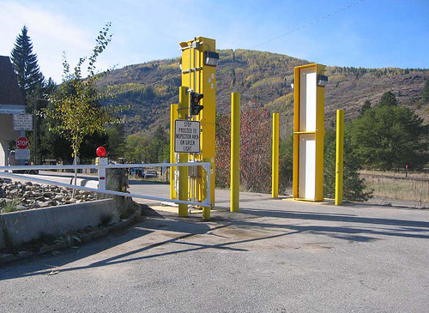
Figure 1 - Radiation Portal Monitor Installed along the U.S. Border
Neutron detectors register an event when a neutron interaction has occurred and when other conditions are satisfied. It is then desirable for an absorber to have a large cross section such that the interaction is likely to occur, and for the reaction products of the interaction to be highly energetic and easy to detect. Table 1 enumerates some of the more common absorber isotopes used in neutron detection. Of these ⁶Li releases the most energy upon absorption of a neutron (4.78 MeV) while still having an appreciable thermal cross section of 940 barns with the least pulse height deficit. The reaction products of ⁶Li(n,³H)⁴He are easily captured in common scintillator materials, contributing to the ⁶Li being more efficient than the other reactions at converting the energy from the charged particles into light.

Table 1 - Selected neutron absorption reactions and thermal cross sections [6]
Reaction | Q-Value (Mev) | Thermal Cross Section (barns) [7] | Application
$${}_{2}^{3}{He+n→p+{}_{1}^{3}H}$$ | 0.756 | 5,330 | Proportional counter gas
$${}_{3}^{6}{Li+n→{}_{1}^{3}H+{}_{2}^{4}{He}}$$ | 4.78 | 940 | Lithium glass scintillators
$${}_{5}^{10}{B+n→{}_{2}^{4}{He}+{}_{3}^{7}{Li}}$$ | 2.31 | 3,840
$${}_{64}^{157}{Gd+n→γ}$$ |  | 259,000

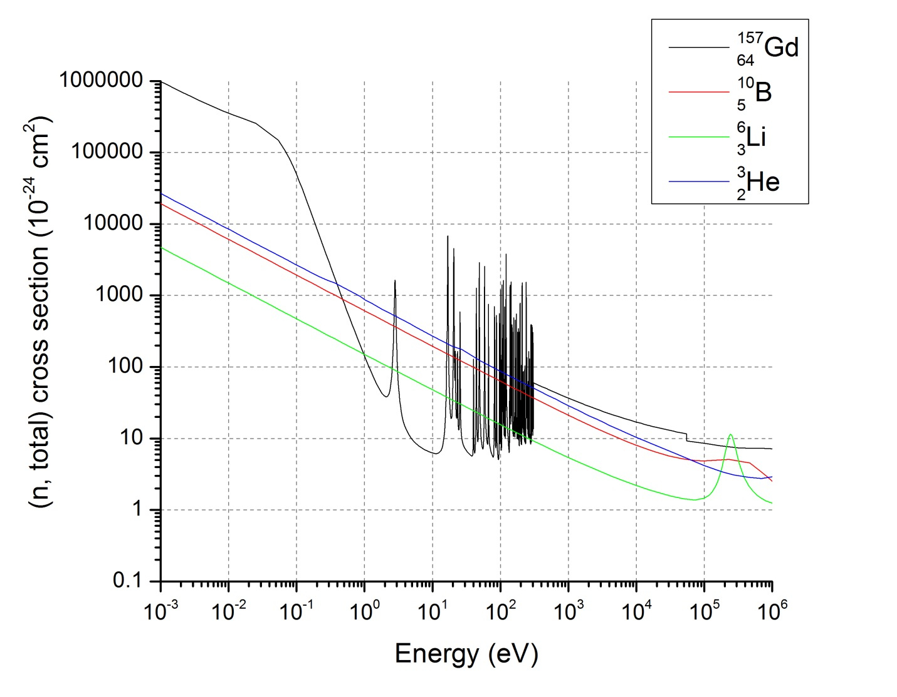
Figure 2 - Total Neutron cross sections [8]. ⁶Li has a lower cross section, but has a higher Q-Value, making it an attractive absorber for replacement detector technologies.

Detector Requirements
The Domestic Nuclear Detection Office within the Department of Homeland Security (DNDO/DHS) in conjunction with Pacific Northwest National Laboratory have outlined a set of criteria that must be met in order for a detector to be a functional replacement (Table 2).
Table 2 - Functional Specifications for Replacement RPM Neutron Detection Capabilities† [2]
Parameter | Specification
Absolute neutron detection efficiency | 2.5 cps/ng of ²⁵²Cf (in specified test configuration)
Intrinsic gamma-neutron detection  Efficiency | є_{int γn} ≤ 10⁻⁶
Gamma absolute rejection ratio for  neutrons (GARRn) | 0.9 ≤ GARRn ≤ 1.1 at 10 mR/h exposure
Cost | ~$30,000 per system
†Electronics and other performance criteria specified in ANSI 42-35

Absolute detection efficiency is defined as the number of counts observed by the detector divided by the quanta of radiation emitted[2] in a given test configuration, regardless of whether the emitted quanta crossed the detector. The DHS/DNDO criteria is 2.5 counts per second per ng ²⁵²Cf in the specified test configuration of the source (²⁵²Cf) surrounded by 0.5 cm of lead and moderated by 2.5 cm of HDPE with the midpoint of the detector located 2 meters away from the source.

$$ϵ_{abs}=\frac{\# Counts Observed}{\# Quanta of Radiation Emitted}$$

The intrinsic efficiency is defined as the number of counts registered by the detector, divided by the number of quanta of radiation that cross the detector [2]. For example, if 10 neutrons enter the detector and one count is registered the $ϵ_{int,n}=0.1$.

$$ϵ_{int}=\frac{\#Counts Observed }{\# Quanta of Radiation Crossing Detector}$$

The gamma absolute detection ratio for neutrons specifies that the performance of the detector should not increase or decrease by more than 10% in the presence of a strong gamma field (10mR/hr) [3]. The GARRn is measured by placing a ¹⁹²Ir or ⁶⁰Co source at an appropriate distance to produce a uniform exposure rate of 10 mR/hr across the detector face, with the same neutron source shall be placed at 2m as specified in the neutron configuration. The count rate is then measured and the change in count rate determined.

$$GARRn={ϵ_{γ,abs}}/{ϵ_{n,abs}}$$

In addition there are several other qualities that a scintillation detector should possess, as quoted from [2]:
- It should convert the kinetic energy of charged particles into detectable light with a high scintillation efficiency.
- This conversion should be linear – the light yield should be proportional to deposited energy over as wide as range as possible.
- The medium should be transparent to the wavelength of its own emission for good light collection.
- The decay time of the induced luminescence should be short so that fast signal pulses can be generated.
- The material should be of good optical quality and subject to manufacture in sizes large enough to be of interest as a practical detector.
- Its index of refraction should be near that of glass (~1.5) to permit efficient coupling of the scintillation light to a photomultiplier tube or other light sensor.

Outline of this Document
The focus of this project is the characterization and modeling of polymeric detectors capable of meeting the criteria described above. First the facilities available for spectral characterization are discussed (including a 100 uCi ⁶⁰Co source and a moderated ²⁵²Cf source), followed by facilities for pulse shape discrimination. A brief discussion of pulse shape discrimination follows, followed by an in depth analysis of utilizing a pulse height discriminator for neutron – gamma discrimination. The calculations necessary to compute the intrinsic gamma efficiency are introduced, as well as the necessary modeling and validation. The response of promising characterized films are shown as examples of what performance can be achieved. Finally detector designs capable of meeting the criteria are proposed, followed by suggestions for further efforts.

Methods
The performance of a given detector is characterized by measurement of its light yield and neutron sensitivity in the characterization laboratory, utilizing the instrumentation and sources present. Having established that a film has scintillation promise, further data analysis of the film is completed. This involves simulating the film in MCNPX in order to calculate the ⁶Li(n,t)α reaction rate and number of particles crossing the detector in the neutron and gamma irradiator. The response of the film is also simulated in a DHS configuration detector.

Instrumentation
Samples are characterized based on their pulse height spectra from a variety of sources. The samples are mounted to a Philips XP2202B 10 stage PMT with silicone based optical grease (Saint Gobain BC-630). The PMT is attached to a Canberra 2007P base, which also functions as a preamplifier. The PMT’s voltage is supplied by an Ortec 556 high voltage power supply, with the power being supplied to the Canberra 2007P pre amplifier base by the Ortec 571 amplifier. The output signal of the Canberra 2007P base feeds into an Ortec 572A amplifier for pulse shaping and amplification. The amplified signal is then inputted to an Ortec 926 MCB-ADC. The converted signal can then be read using the MAESTRO-32 software. Figure 3 is a schematic of the instrumentation setup used for spectral measurements.

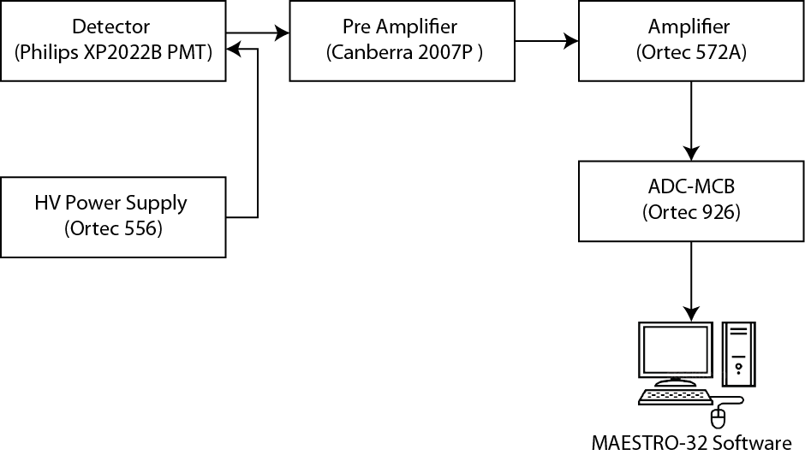
Figure 3 – Instrument for spectral measurements
Voltage pulses from a single radiation event (for pulse shape discrimination) are measured using a Philips XP2020 PMT in conjunction with a S563 base. The signal from the dynode of the S563 base is fed into a MSO-X 3034A Agilent Oscilloscope, triggered on the rising edge. The 2563 base output is attached to the oscilloscope with a T-couple, terminating one of the inputs with a 50 Ohm impedance to minimize impedance reflections. The capability exists for utilizing a fast digitizer coupled with a fast amplifier. A block diagram of the setup is shown in Figure 4.

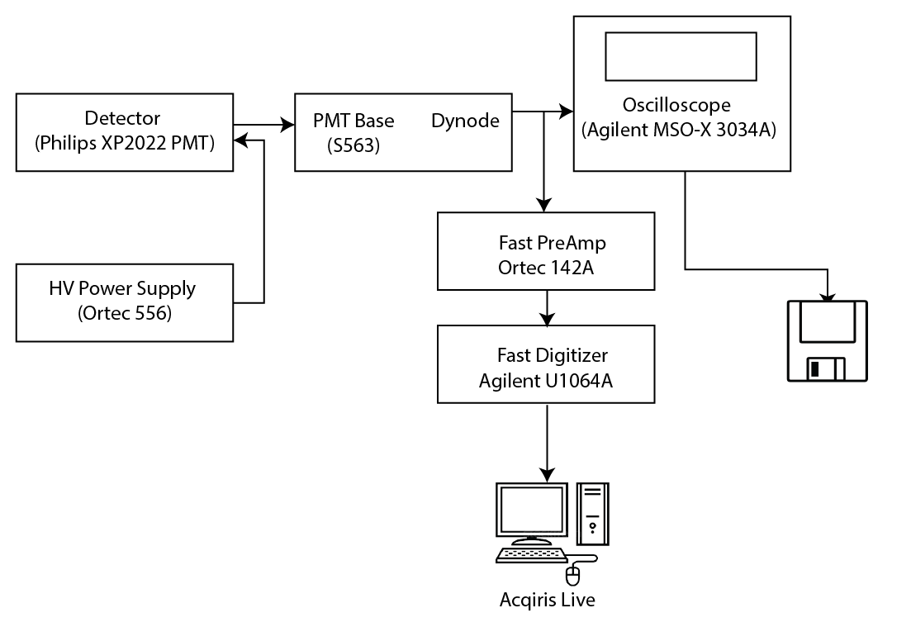
Figure 4 - Instrumentation for pulse shape discrimination

Available Sources
A variety of sources are available for characterization. Button sources exist for the characterization of detector response from alphas (Table 3), betas (Table 4) and button sources of ¹³⁷Cs and ⁶⁰Co. The alpha and beta particles have a limited range, and are then best used directly placed on the detector surface.
Table 3 - Alpha sources available for characterization
Source | Half-Life | Alpha Kinetic Energy (MeV)
²³²Th | 1.4 x 10¹⁰ y | 4.012
²⁴⁰Pu | 6.5 x 10³ y | 5.17 (76%), 5.12 (24%)
²⁴¹Am | 433 y | 5.48 (85%), 5.44 (12%)
Tri-Nuc (²³⁹Pu, ²⁴¹Am, ²⁴⁴Cm)

Table 4 - Beta sources available for characterization
Source | Half-Life | Endpoint Energy (MeV)
¹⁴C | 5,730 yr | 0.156
³⁶Cl | 3.08 x 10⁵ y | 0.714
⁶³Ni | 92 y | 0.067
⁹⁹Tc | 2.12 x 10⁵ y | 0.292

The gamma sources consist of button sources (¹³⁷Cs up to 10 μCi and ⁶⁰Co up to 1 μCi) as well as a gamma irradiator that produces a 10 mR/hr gamma field across the detector face. The irradiator consist of four 4”x8”x 2” lead bricks on the bottom with and additional four 4”x4”x2” lead bricks encased in an 1/8” metal box. The top four inches is HDPE. The overall dimensions of the detector are 14” by 12” by 12”. The source was purchased from Eckert & Ziegler, and was 95.79 µCi ⁶⁰Co on January 1st, 2012.
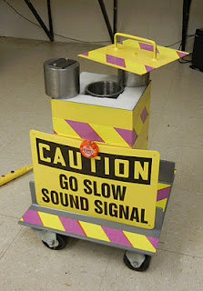
Figure 5 - Constructed Gamma Irradiator
The neutron irradiator is a custom built 0.59 μg ²⁵²Cf source encased in 2” blocks of high density polyethylene (HDPE). The HDPE box is approximately 20” long, 12” wide, and 14” tall (Figure 6). There are two detector 1/16” thick acrylic detectors wells, one surrounded by a 1/16” cadmium to shield out thermal neutrons, and the other surrounded by 1/16” of lead to shield out a similar amount of gammas as the cadmium well. The 0.59 μg ²⁵²Cf source is surrounded by stainless steel, which in turn is contained within a 2” diameter, ½” thick, 5 ¼” tall lead vessel.
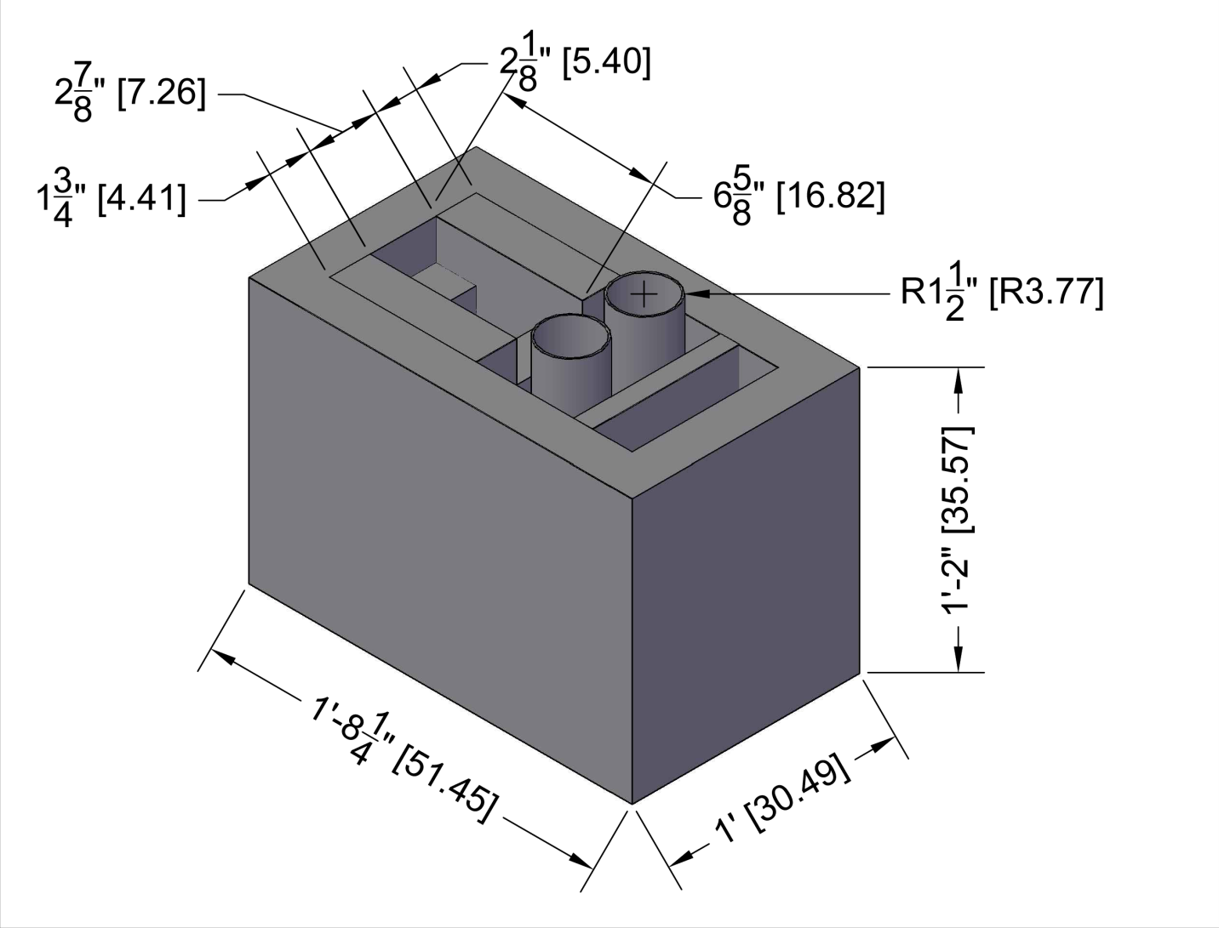
Figure 6 – Cad rendering of the neutron irradiator.
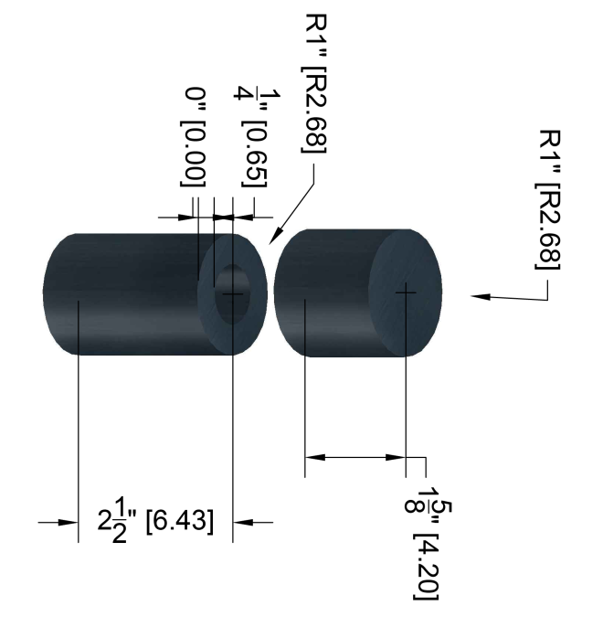 | 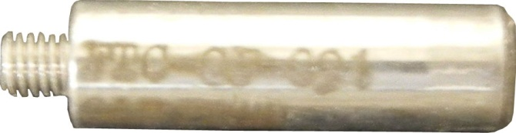
 | 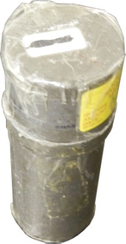
Figure 7 - Source and Lead Pig for the ²⁵²Cf Source. The left is a CAD rendering, while the upper right is the actually ²⁵²Cf source and the lower right is the lead pig.

Pulse Shape Discrimination
Pulse shape discrimination was explored as an alternative to a pulse height discriminator for neutron – gamma discrimination. Pulse shape discrimination utilizes the different pulses shapes from neutron and gammas to classify an unknown pulse into a gamma pulse or neutron pulse. An alpha source was used as a surrogate for a neutron source as the neutron irradiator does not supply a pure neutron source due to (n, $γ$) interactions in the HDPE and lead and cadmium wells. The gamma source was the ⁶⁰Co irradiator. The measurement of the pulses was completed using the setup described in Figure 4, where the data were saved for offline analysis. Scripts were written in the MATLAB environment in order to perform the pulse shape analysis. Post-processing of the spectra was completed in order to enhance the pulse shape analysis. This consisted of selecting a region of interest (determined from where the spectra falls by e⁻⁵ on the left of the peak and e⁻⁶ on the right of the peak) and band-pass filtering to smooth out high frequency noise.

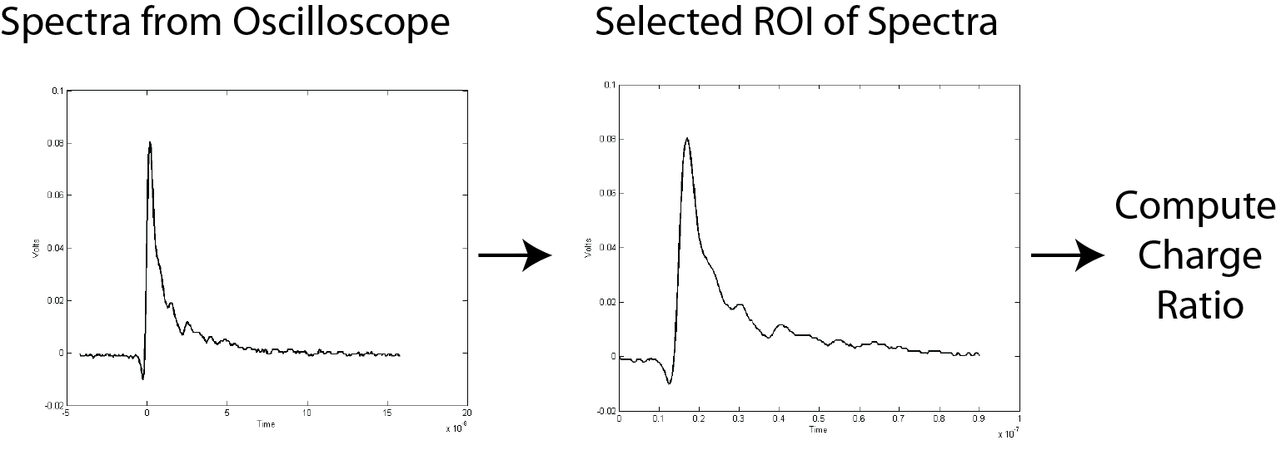
Figure 8 - Processing of a pulse. From left to right, the pulse is recorded from the oscilloscope, and then a region of interest is selected. From the ROI the charge ratio is computed.
The charge integration is performed for the total pulse as well as a slow portion (or tail) of the pulse. The start of the slow charge integration was based on the time location where the peak voltage has fallen by a factor of e⁻¹. The integral computation was performed in Matlab with the trapz function.

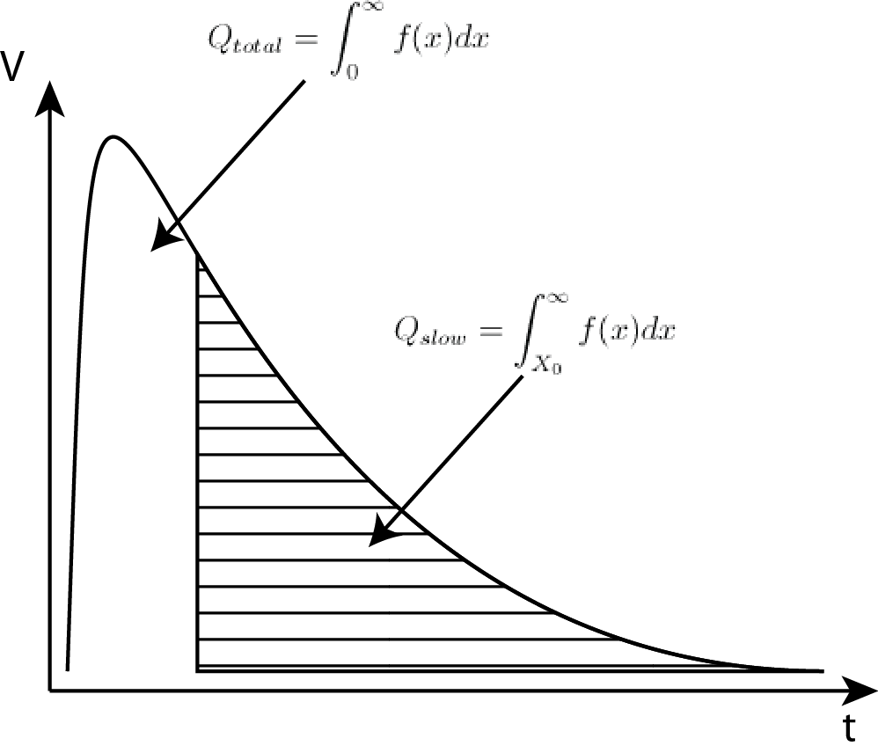
Figure 9 - Example of the charge integration. The total charge is all of the area under the curve, while the slow charge is the area in the shaded region.
The charge ratio (4) was then computed for each pulse. A distribution of charge ratios is then obtained for each class of incident radiation (alpha, gamma) and then pulses of unknown class can be classified by computing the charge ratio and computing which distribution the pulse is most likely to belong in.

$$R_{c}=\frac{Q_{slow}}{Q_{fast}}=\frac{\int_{X_{0}}^{∞}{f\left(x\right)dx}}{\int_{0}^{∞}{f\left(x\right)dx}}$$

where:
- $Q_{slow}$ is the charge from the slow pulse component,
- $Q_{fast}$ is the charge from the fast pulse component,
- $f(x)$ is the pulse trace,
- and $X_{0}$ is the start of the slow pulse integration.
The performance of a film to classify pulses based on the charge ratio was evaluated with Receiver Operator Characteristics (ROC) curves. ROC curves where generated using the built-in perfcurve function in Matlab, passing the charge ratio as the score and using the alpha’s as the positive class; i.e. testing if every pulse belongs to the alpha class.

Table 5 - Pulse Shape Classification Classes
 | True Class
Hypothesized Class |  | Alpha | Gamma
Hypothesized Class | Alpha | True Positive | False Positive  (Type I error)
Hypothesized Class | Gamma | False Negative  (Type II error) | True Negative

The false positive rate is then the probability of incorrectly classifying a gamma as an alpha, while the false negative rate is probability of incorrectly classifying an alpha as a gamma. The performance of a classifier can be compared utilizing an ROC curve, which computes the false positive rate versus true positive as a function of a score (or threshold). The score determines how much a given trial belongs to a given class; for example a low charge ratio score is indicative of a gamma event, while a larger charge ratio score is indicative of an alpha.

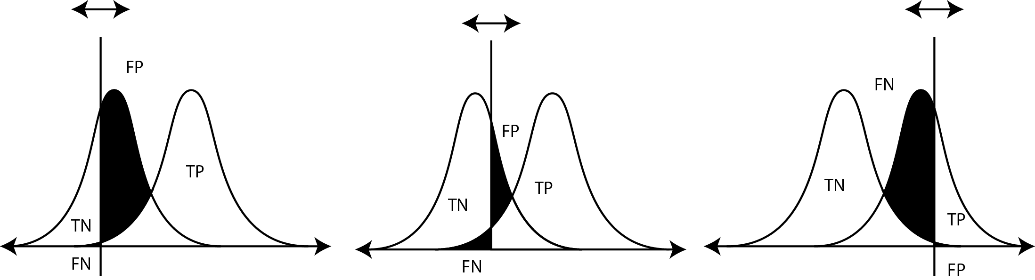
Figure 10 - False positive and true positives for a given threshold. The false negative rate and true positive rate is then used to determine the ROC curves.

Measurement Protocols
Systematic experimental techniques were developed for characterizing scintillation materials for optical and neutron response using a ²⁵²Cf neutron source. Several reference scintillation materials including ⁶Li-based glass (GS20) and boron based plastic scintillators (EJ-254) serve as benchmarks in assessing the performance of new materials when irradiated with neutrons and gamma rays under similar conditions. The general protocol for evaluating the neutron response for a given sample detector is:

- Verify that the instrumentation gains are stable by confirming that the GS20 neutron peak is in the same channel as for previous measurements. This is completed by setting the voltage and coarse gain to previously determined values, and then adjusting the fine gain until the peak of the lead spectra measurement occurs in the specified location,
- obtain a spectrum from an Am-241 alpha source,
- obtain a spectrum from a Cl-36 beta source,
- obtain a neutron spectrum from the Pb-shielded tube neutron irradiator,
- obtain a neutron spectrum from the Cd-shielded tube in the neutron irradiator,
- obtain a gamma spectrum in the gamma irradiator.

Data Analysis
Post processing of the spectra is completed in the MATLAB environment in order to calculate the intrinsic efficiency of a given detector. Integrating the resulting spectra as a function of mathematical pulse height discriminator setting (MLLD) and normalizing by the incident photon flux allows for the intrinsic efficiency of a detector to be calculated as a function of pulse height. The necessary mathematical pulse height setting for the gamma discrimination is then determined and the measured neutron spectra is integrated above this value. The steps are as follows:
- The absolute intrinsic efficiency for gammas is computed as a function of mathematical lower level discriminator, given the number of particles crossing the film from the MCNPX simulation.
- The MLLD level at which $ϵ_{int,γ}≤{10}^{-6}$ is calculated. This is found by just search the $ϵ_{int,γ}$values for the first value that is less than 10⁻⁶, and then a key-value lookup in order to find the corresponding channel.
- The count rate for neutrons above the gamma MLLD are calculated by summing the neutron spectra above the gamma MLLD.
The films are evaluated based on their neutron – gamma pulse height discrimination and light yield with the following parameters:
- Total Neutron Counts – provides a measure of how responsive the detector is to neutrons
- Total Neutron Count Rate Per mg Absorber – provides a measure of how well the fabricated detector utilizes the neutron absorber in it. Indirectly this can be a measure of the amount of absorber in the detector
- Gamma LLD – The position (in channel number) of where an LLD would have to be set in order to meet the criteria of $ϵ_{int,γ}≤1×{10}^{-6}$. This calculation is explained in more detail in the following paragrah and in GammaLLDAlgoReview.docx.
- Fraction of Total Neutron Count Rate Above the Gamma LLD – this is a measure of how effective the film would be with an LLD set in order to meet the $ϵ_{int,γ}.$This is calculated by summing the counts above the gamma LLD and dividing by the total counts.
- Alpha Peak – provides a clear indication of the light yield of the film from an alpha particle, which is one of the reaction products of the ⁶Li neutron interaction. The alpha peak is visible in thin films when other features may be lost (due to the range of the secondary electrons exceeding the thickness of the detector) because the range of the alpha is on the order of 30 microns.
- Beta Average – characterizes the response of the film to electrons, account for the possibility that a film may not have a clearly defined feature due to energy escaping. Electrons are generated in the film from scattering events of photon interactions.
- Alpha / Beta – characterizes the relative light yield of the detector from heavy charged particles to electrons.
- Photons per gamma and Photons per beta – a measure of the light yield of the film, or how many photons are produced per energy absorbed.
- Pulse Height Deficit – a measure the apparent energy loss (as seen from the pulse height) of a heavy charged ion compared to an electron. This is measured as the difference between the energy of the heavy ion and its apparent energy from the pulse height. It should be noted that this term closely resembles the phenomena described by pulse height defect as seen in semiconductors.
- Photons per Neutron – a measure of the light yield of the film, or how many photons are produced per energy absorbed.
The average channel number (weighted by the counts) of spectrum where calculated according to (5):
$$<μ> =\frac{\int_{0}^{∞ }{x f\left(x\right)dx}}{\int_{0}^{∞ }{f\left(x\right)dx}}$$
where:
- $f\left(x\right)$ is the spectrum,
- x is the channel number,
- and the limits of integration are all channels.
The intrinsic efficiency is defined as $ϵ_{γ,int}=\frac{Counts}{Particles Incident}$. For a given channel (acting as the MLLD) the intrinsic efficiency is:
$$ϵ_{γ,int}=\frac{\int_{MLLD}^{∞}{f\left(x\right)dx}}{Particles Incident}$$
where:
- $f\left(x\right)$ is the spectra,
- x is the channel number,
- the limits of integration is from a mathematical lower level discriminator (MLLD) to the highest channel,
- and Particles Incident are the particles incident upon the detector.
It is then possible to find the MLLD at which the intrinsic efficiency becomes below a given level, in this case 10⁻⁶ as set forth by the DHS/DNDO. The pulse height deficit (which determines the effectiveness of creating light for ions compared to electrons) for the neutrons can be calculated as follows:
$$PHD_{GS20}=\frac{{n_{Peak}}/{4.78 MeV}}{{CE_{γ}}/{1.038 MeV}}$$
where:
- $n_{peak}$ is the neutron peak (normalized by the reaction energy),
- and $CE_{γ}$ is the Compton edge (normalized by the average Compton edge).
This also provides a framework for evaluating the pulse height deficit of the samples:
$$PHD_{Sample}=PHD_{GS20}× \frac{<n>_{Sample}}{<n>_{GS20}}$$
where:
- $<n>_{Sample}$ is the average channel number of the neutron spectra of the sample (defined in (5)),
- and $<n>_{GS20}$ is the average channel number of the neutron spectra of GS20.
The light yield (amount of light emitted per unit energy loss of ionizing energy traveling through the material) of the films where measured relative to GS20, when the samples are measured under the same light collection circumstances. GS20 emits 3,800 photons per electron equivalent MeV [2]. The light yield of the various samples is then scaled by the light yield of GS20. Two quantities are computed; the light yield for a light ion (gamma producing electrons ($LY_{γ}$) or beta source ($LY_{β}$)) and the light yield per neutron ($LY_{n}$).

$${LY_{β},}_{Sample}=3,800\frac{Photons}{MeV}×\frac{<β>_{Sample}}{<β>_{GS20}}$$

$${LY_{γ},}_{Sample}=3,800\frac{Photons}{MeV}×\frac{<γ>_{Sample}}{<γ>_{GS20}}$$

where:
- $<β>_{Sample}$ is the average channel number of the beta spectrum of the sample (defined in (5)),
- $<β>_{GS20}$ is the average channel number of the beta spectrum of GS20,
- $<γ>_{Sample}$ is the average channel number of the gamma spectrum of the sample,
- $<γ>_{GS20}$ is the average channel number of the gamma spectrum of GS20,
- and 3,800 Photons per MeV is the light yield of GS20.
The light yield per neutron ($LY_{n}$) is calculated for GS20 by scaling the ratio of the neutron peak and Compton edge by the pulse height deficit (7):
$${LY_{N},}_{GS20}=3,800\frac{Photons}{MeV}×PHD_{N}×4.78MeV$$

$${LY_{n},}_{Sample}={LY_{N},}_{GS20}×\frac{<n>_{Sample}}{<n>_{GS20}}$$
where:
- $<n>_{Sample}$ is the average channel number of the neutron spectra of the sample (defined in (5)),
- $<n>_{GS20}$ is the average channel number of the neutron spectra of GS20,
- and $LY_{n,Sample}$ is the light yield per neutron of the sample.
The alpha over beta ratio was calculated using the measured ²⁴¹Am alpha peak (5.371 MeV) and the spectra-post processed average beta from ³⁶Cl (0.251 MeV). The alpha over average beta for GS20 was calculated to be between 0.23 and 0.20 which is in good agreement with the published value of 0.23 [9]. The published values, however, are from a ¹³⁷Cs source Compton edge which is a different measurement than what is expressed in (12).
$$\frac{α}{β}=\frac{{alphaPeak}/{5.371 MeV}}{{<β>}/{0.251 MeV}}$$
where:
- $alphaPeak$ is the peak of the alpha spectra from an ²⁴¹Am source (average energy of 5.371 MeV(5)),
- and $<β>$ is the average of the beta spectra from an ³⁶Cl source (average energy 0.251 MeV).
Table 6 provides a reference for the variables defined above.
Table 6 - Variable declarations
 | Description
$LY_{γ,i}$, $LY_{β,i}$, $LY_{N,i}$ | Light yield of gamma, beta, and neutrons of sample $i$, respectively
$<n>$,$<β>$,$<γ>$ | Weighted average channel number of the neutron, beta, and gamma spectra
$$ϵ_{int,γ}$$ | Intrinsic efficiency for gammas
$$PHD_{i}$$ | Pulse Height Deficit of sample $i$

Measurement Repeatability
The measurement repeatability was determined by analyzing the derived factors for six GS20 measurements and from three sets of measurements (by different users) on a thin PEN film. The experiments are described in depth in Appendix A . The neutron peak for GS20 had a variation of 1.4% around the average peak at 3,418 ± 49 channels. Published values of the light yield per neutron of GS20 range from 6,000 Photons per MeV to 7,000 Photons per MeV [9], while the calculated light yield of GS20 is on the low end at 6,252 ± 120 photons per neutron. However, the measurement is very stable as the standard deviation is 1.9% of the average. The gamma spectra position is slightly less stable, with the standard deviation being 2.4% of the average. The position of the gamma MLLD necessary to various achieve $ϵ_{int,γ}$ was calculated. The intrinsic efficiency is very stable (varying within 3% of the average value) until an intrinsic efficiency of 10⁻⁶ is approached, at which point standard deviation becomes 7.4% of the average value (MLLD 4,021 ± 296 channels).
A stretched PEN film was measured three separate times by two operators (Matthew Urffer and Rohit Uppal) in order to determine the repeatability of thin film measurements. Each of the trials were measured at 50 gain, with the voltage determined by setting the peak position of GS20. The spectra averages, count rate, and MLLD channels were computed and summarized in Table 25 in Appendix A . The third trial had a much higher average neutron spectra had a total count rate that was similar to Trial 1 (in fact they differed by 0.07 cps). The source of the discrepancy in the fraction of neutron counts above the gamma discriminator can be found by looking at the neutron integral spectra (Figure 63). While the spectra weighted average for the gamma’s are similar (and the gamma LLD’s fall within $2σ$ of each other), the considerable difference in the neutron count rate above the gamma LLD greatly impacted the fraction of neutron counts above the gamma LLD. Values reported in parentheses are $± 2σ$, which is roughly a 95% confidence interval ($1.96σ$ is 95% CI for a normal distribution).
Table 7 - Comparison of three different measurements of a stretched PEN film (49.5% LiF, 1% ADS156FS).
 | Gamma Spectra Average  (channel number) | Neutron Spectra Average  (channel number) | Total Neutron Count Rate  (cps) | Gamma LLD such that $ϵ_{int,γ}≤{10}^{-6}$  (channel number) | Neutron Count rate above $ϵ_{int,γ}≤{10}^{-6}$  (cps) | Fraction of neutron counts above $ϵ_{int,γ}≤{10}^{-6}$
Trial 1  (May 22) | 290 | 2,039 | 30.4 ± 0.02 | 3,192  (2,706 – 3,517) | 5.7  (8.5 - 4.2) | 0.19  (0.28 - 0.14)
Trial 2  (Jun 4 RU) | 259 | 2,095 | 37.1 ± 0.05 | 2,741  (2,500 – 3,561) | 11.3  (13 - 6.5) | 0.30  (0.35 - 0.17)
Trial 3  (Jun 4 MJU) | 252 | 2,782 | 30.4 ± 0.02 | 2,810  (2,682 – 3,031) | 12.8  (13.6 - 11.6) | 0.42  (0.45 - 0.38)

Intrinsic efficiency
MCNPX was used to determine the dose rate at the detector surface as well as the number of photons incident on the detector. The gamma irradiator was modeled as a thin steel outer box 14” x 12” x 12” (orange) which contains 4” x 8” x 2” lead bricks (light green). The ⁶⁰Co source (yellow) is contained in 2” of steel, with a 1/8” thick steel cap. The detector well is a 4” outer diameter 14” pipe that is ¼” thick. A mock up of the geometry is shown in Figure 11.
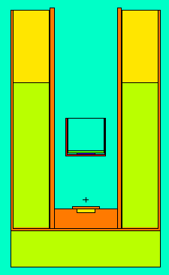
Figure 11 –MCNPX model of the gamma irradiator
The detector was simulated along with the PMT as its own universe which allowed for easy translations. The thickness of the detector is controlled by translation 602, while the position of the entire PMT (includes the detector) is controlled by translation 6. The cell and surface number is such that anything surface or cell with a ‘6’ as the first letter has to do with the PMT with a ‘5’ as part of the detector.
C ################################ Cell Cards ################################
c ---------------------------- Well PMT --------------------------------------
600 0 -602 trcl=6 fill=6
c ------------------------- PMT Subcells -------------------------------------
601 3 -1.18 -500 u=6 $ Detector cell
610 440 -1.023 -510 u=6 $ Arcylic Disc Backign
602 388 -2.23 -601 u=6 $ PMT Glass
603 468 -1.406 603 u=6 $ Plastic
604 4 -8.74 -604 605 u=6 $ Metal
605 204 -0.001225 #602 #601 #603 #604 #610 u=6 $Air

C ############################# SURFACE CARDS ################################
c --------------- Detector --------------------------------------------------
c TO CHANGE THE THICKNESS OF THE DETECTOR:
c a) Height of surface 500
c b) Starting position of surface 510
c c) tr602 (sum of height of surface 500 and height of surface 510)
500 rcc 0 0 0 0 0 0.0025 2.54 $ 25 microns thick, 2" Dimeter
510 rcc 0 0 0.0025 0 0 0.3175 2.54 $ 1/8" Aryclic Disc Backing
c --------------- PMT --------------------------------------------
601 602 rcc 0 0 0 0 0 0.3178 2.54 $ 2" Diamter, 1/8" Thick (Glass)
602 601 rcc 0 0 0 0 0 5.284 2.8030 $ Plastic Cap Outer
603 601 rcc 0 0 0.189 0 0 5.2651 2.6335 $ Plastic Cap Inner
604 602 rcc 0 0 0.3178 0 0 5 2.54 $ Mu Metal Outer
605 602 rcc 0 0 0.3178 0 0 5 2.535 $ Mu Metal Inner

C ################################ DATA CARDS ################################
*tr6 0 0 10.3 $ 7" From the top of the well
*tr601 0 0 -0.189 $ PMT Cap (thickness of cap)
*tr602 0 0 0.3200 $ PMT Glass (thickness of detector - 100um+1/8")

Photons and electrons were transported in this problem, but significant runtime reduction can be achieved by only transporting photons. Electrons are not born in the source, rather the physics options where set to generate electrons from Bremstrasslung, coherent (Thomspon) scattering, and Doppler energy broadening, with the lower level cutoff of 1x10⁻⁶ MeV. Upon runtime, however, the lower energy cut was raised to ecut min, 1 keV. Electrons are simulated with the MCNPX defaults which are an upper energy limit is 100 MeV, electron production from photons, and electron production of photon. Bremsstrahlung is treated with a tabular angular distribution, with the analog number of bremsstrahlung photons, as is x-ray production, knock-on electrons, and photon induced secondary electrons.
C ################################ DATA CARDS ################################
MODE P E
IMP:P,E 1 15R 0
PHYS:P 3j -1
CUT:P,E j 1E-6

The source is treated as a point source located in the middle of a plastic disc, sampling with equal frequency from the two energy distributions of the ⁶⁰Co.
C ################################ Cell Cards ################################
C ---------------------------- SOURCE ----------------------------------------
200 456 -0.93 -400

C ############################# SURFACE CARDS ################################
C ------------------------------- SOURCE ------------------------------------
200 RCC 0 0 2.2 0 0 0.5 1.27 $ Button Source in Metal

C ################################ DATA CARDS ################################
SDEF ERG=D1 PAR=p pos=0 0 2.6
SI1 L 1.173 1.332
SP1 D 1.0 1.0

The entire input file is available in the Appendix.

Dose Rate
The dose rate over the front of the detector surface was calculated using the dose card and flux to dose conversion factors described in [10], and expressed as an integral over the entire surface, energy range, and angle; where the tally is multiplied by the response function. The DE and DF cards described response function, $R(E)$. It should be noted that the resulting flux is not normalized by the source strength; this can either be accomplished by utilizing an energy multiplier card or by post processing.
$$F2=\frac{1}{A}\int_{A}{dA}\int_{E}{dE}\int_{4π}{dΩR\left(E\right)Φ(r,E,Ω)}$$
where:
- $A$ is the area of the detector,
- $R(E)$ is the response function,
- and $Φ(r,E,Ω)$ is the photon flux.

c Multiply each tally by 1000 mrem/rem * 100uCi * 3.7E10 Bq *2 photons / decay
FC12 Photon Flux over Front of Detector Surface
F12:P (500.2<600)
DE12 0.01 0.015 0.02 0.03 0.04 0.05 0.06 0.08 0.1 0.15 0.2 0.3 0.4 0.5 0.6
0.8 1 1.5
DF12 2.78E-6 1.11E-6 5.88E-7 2.56E-7 1.56E-7 1.20E-7 1.11E-7 1.20E-7 1.47E-7
2.38e-7 3.45E-7 5.56E-7 7.69E-7 9.09E-7 1.14E-6 1.47E-6 1.79E-6 2.44E-6

Using the translation cards a bash script was written to change the distance of the PMT from the source, run MCNPX, and then parse the output for the dose across the detector. The results are plotted in Figure 12, with a dose rate of a 10.07 mrem/hr achieved when the detector is located 10.3 cm from the origin, or 7 cm from the top of the source. The dose rate simulation was validated by measurements completed by the RSO.
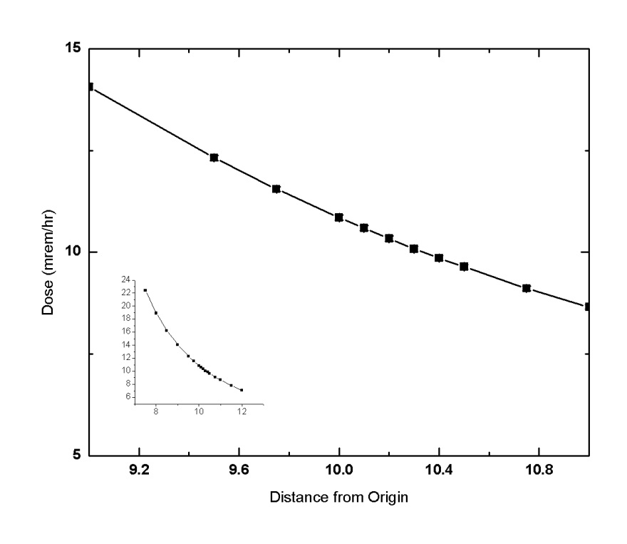
Figure 12 – Dose rate at various heights in the gamma irradiator.
Table 9 - Validation of dose rate calculation from measurement
Measured |  | Simulated
Distance | Dose Rate (mRem/hr) | Distance | Dose Rate (mRem/hr)
10.2 | 10 | 10.2 | 10.33
13 | 5.5 | 12.76 | 5.38
28 | 2 | 28 | 1.80
28.6 | 1.7

Photon Flux
The photon flux across the detector was calculated using a particle crossing tally. Cosine binning is invoked to divide the number crossing between the positive and negative surface sense to calculate the number of photons that enter the cell without including the number of photons that leave the surface. The surface current is tallied over the three sides of the cylinder, and the union is computed with the T signifier. Once again this tally needs to be normalized with post processing.
FC1 Photon Tallies Across Detector
F1:P (500.1<600) (500.2<600) (500.3<600) T
C1 0 1

The photon flux across a 2” detector and GS20 was calculated for the position necessary to produce a 10 mrem/hr dose rate on the detector.
Table 10 - Photons crossing GS20 and a thin film in the gamma irradiator
 | Photons Crossing Detector per Second
GS20 | 498,007
25 um | 586,970
50 um | 685,858

A hand calculation was completed in order to validate the photon flux. In general the photon flux crossing a surface can be found by the ratio of the solid angle that surface subtends to the entire 4π solid angle. An effect of the steel plate was included by simple mass attenuation (14) [2]. It was assumed that the source was 7.5 cm away from a 2.54 radius detector, with 1/8” of steel shielding the source (Figure 13). The mass attenuation coefficient was approximately 0.06 cm²/g for a 1 MeV gamma in iron (density 7.8 g/cm³). The flux calculation (evaluated in (15)) yielded a flux of 168,000 photons per second crossing the 2” diameter detector. While this is about three times lower than what was calculated in MCNPX, it is believed that the MCNPX calculation is higher due to the pipe effectively making a beam of photons and the inclusion of photons of lower energies.
$$Φ=S_{0}\left(\frac{Ω}{4π}\right)e^{-μt}$$
where:
- $S_{0}$ is the source strength,
- $Ω$ is the solid angle the detector subtends of the source,
- $μ$ is the mass attenuation coefficient of the shield,
- and $t$ is the thickness of the shield.

Evaluation yields
$$Φ=\left(2×100μCi×\frac{3.7×{10}^{10}Bq}{Ci}\right)\left(\frac{2π\left(1-\cos\left[\operatorname{atan}\left[\frac{2.54}{7.5}\right]\right]\right)}{4π}\right)e^{-\frac{0.06cm^{2}}{g}×7.8\frac{g}{cm^{3}}×0.31 cm}$$

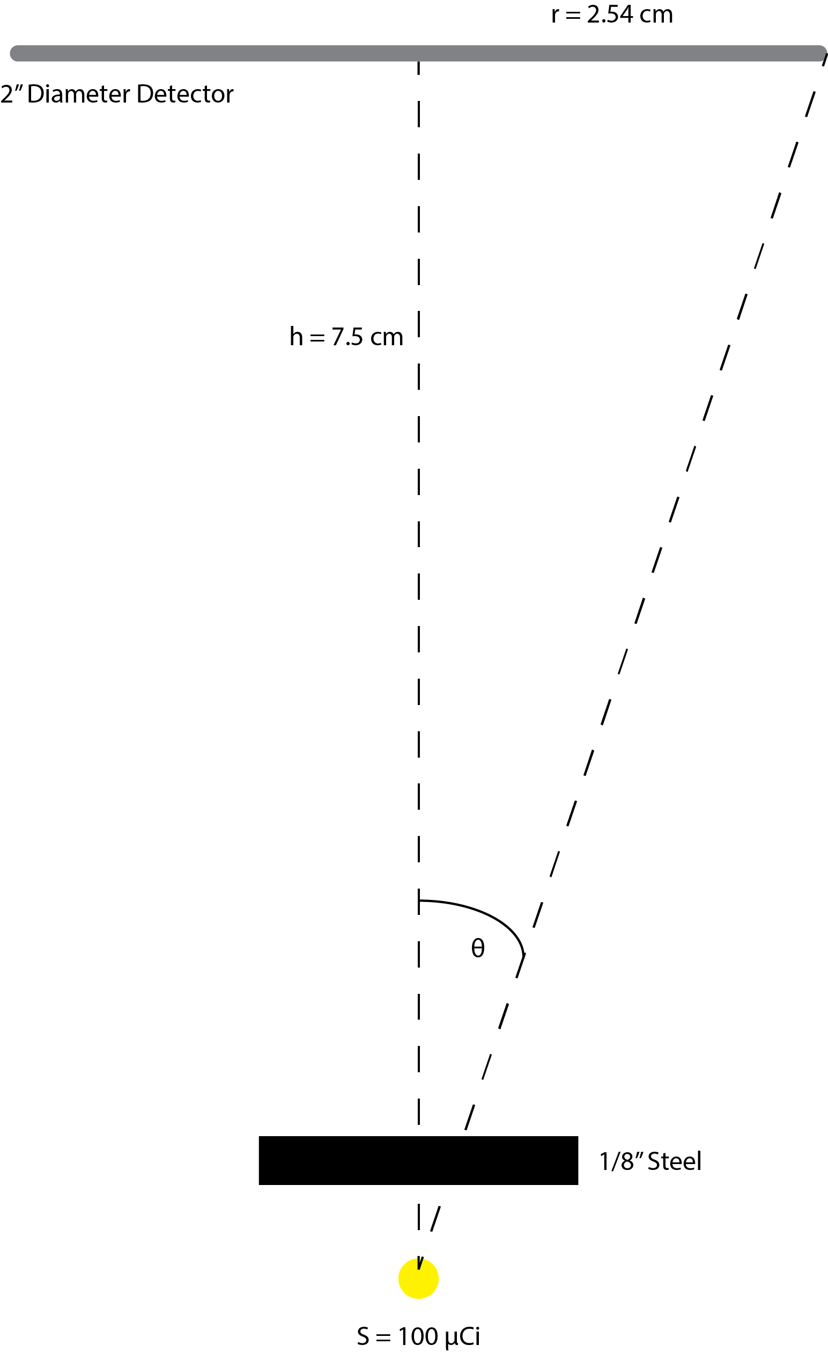
Figure 13 - Gamma Flux Hand Calculation Geometry

Example Gamma Intrinsic Efficiency Calculation
It is illustrative to tie the count rate and intrinsic efficiency computations together with two examples. Suppose a given sample has yielded the gamma and gamma spectra described in Table 11, with 1 million photons crossing the detector.

Table 11 - Simple Spectra Count Rates
Bin | Gamma Count Rate | Neutron Count Rate
0 | 16000 | 1
1 | 400 | 5
2 | 20 | 10
3 | 1 | 5
4 | 0 | 1

The gamma intrinsic efficiency is calculated as the integral above a mathematical lower level discriminator. Let the first MLLD equal the first bin, zero. The $\int_{MLLD=0}^{∞}{f\left(x\right)dx=16,421}$ , divided by the photon flux of 1 million yields an intrinsic efficiency of 0.0164. The next MLLD, bin 1, $\int_{MLLD=1}^{∞}{f\left(x\right)dx=421}$, yielding a an intrinsic efficiency of 0.00042. This process is repeated until the MLLD is equal to the last bin. The computed intrinsic efficiency values are displayed in Table 12.
Table 12 - Simple Spectra Gamma Intrinsic Efficiency
MLLD | Gamma Intrinsic Efficiency
0 | 0.016421
1 | 0.000421
2 | 0.000021
3 | 0.000001
4 | 0

The intrinsic efficiency of 1 in a million occurs at an MLLD equal to 3, so the neutron count rate above that channel is computed, which is the sum of the count rate of channel 3 and channel 4, 6. This process is summarized in Figure 14.
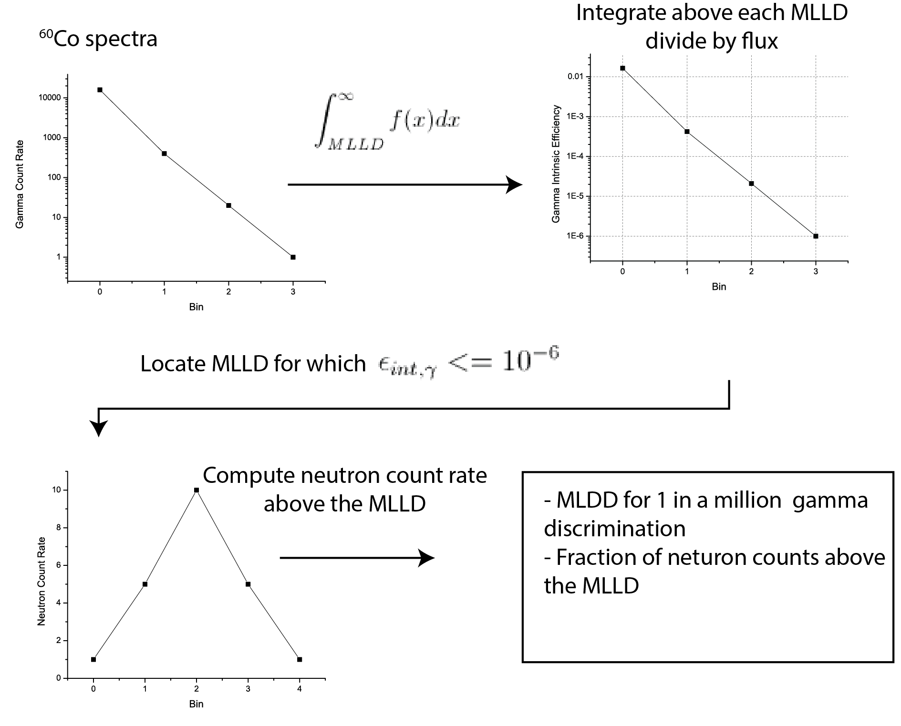
Figure 14 - Sample calculation of intrinsic efficiency and count rate based on a simple spectra.

Figure 15 shows this process applied to the stretched composite PEN film (Figure 59). A 2” diameter sample experiences a photon flux of 39,300 photons per second in the gamma irradiator. For each MLLD (ranging from zero to 8,192) the integral of the spectra is computed, starting at the channel number of the MLLD until the spectra end. This value is then divided by the count time and the photon flux of 39,300.

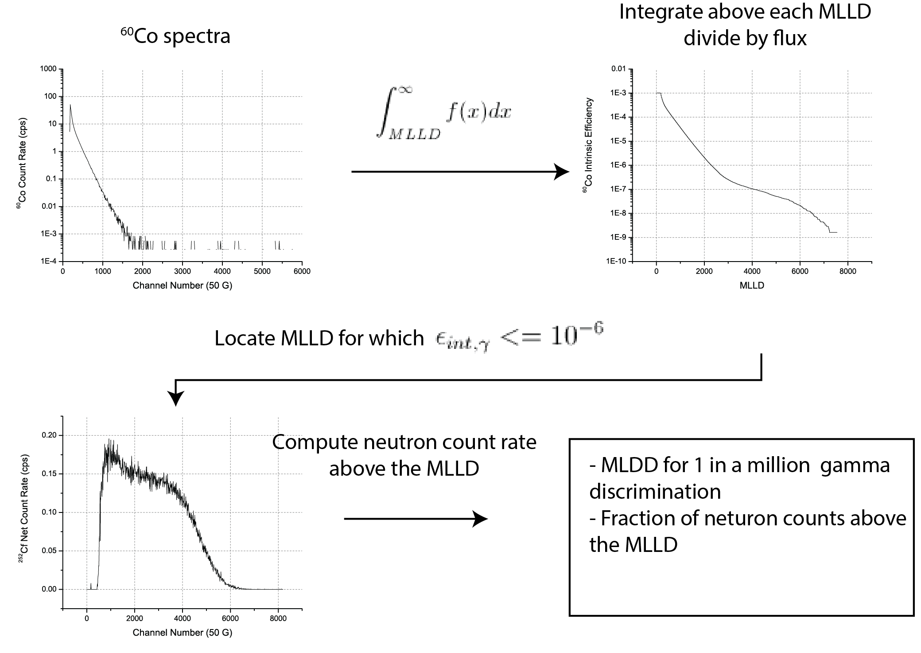
Figure 15 - Sample calculation of intrinsic efficiency and count rate based on a measured PEN spectrum

Simulation of Designed Detector For Satisfying the Neutronic Requirements
The evaluation of a detector in the DHS footprint was completed by simulation using MCNPX along with measured material scintillation properties. The basic outline of the simulation is as follows (and graphically in the following figure):
- A possible film has its gamma and neutron spectra recorded
- Intrinsic efficiencies are calculated
- Gamma MLLD is determined, and then the fraction of the counts that deposit energy above the gamma MLLD
- Film is simulated in a mock-up of a possible detector configuration in the DHS environment
- The count rate is computed for the detector in the DHS environment
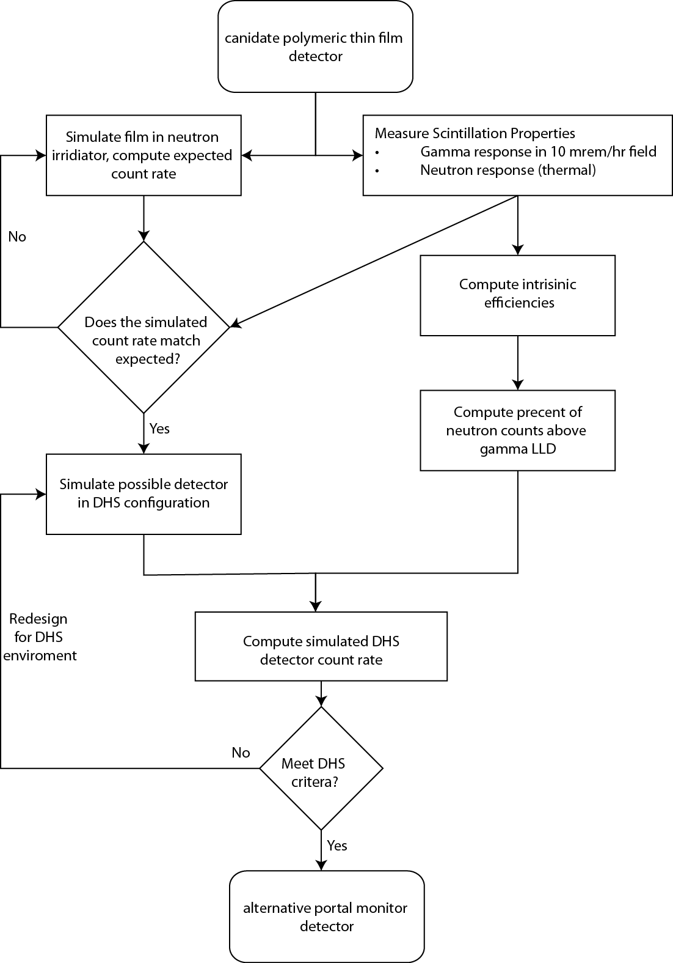
Figure 16 - Flowchart of steps needed to simulate a possible DHS detector based on a polymeric film
The absolute efficiency of a detector (given the same energy spectra of incident neutrons) can be computed from its intrinsic efficiency and the solid angle of the source it subtends. For example, consider what size a detector would have to be to record 2.5 cps/ng ²⁵²Cf that has an $ϵ_{int},_{n}=1.2x{10}^{-3}$, given than 10 ng ²⁵²Cf emits 2.3x10⁴ n/s [11]. The count rate c, can be expressed as follows:
$$c=\frac{S_{0}}{4πr^{2}}\left(A\right)\left(ϵ_{int,n}\right)$$

where:
- $S_{0}$ is the source strength,
- $r$ is the distance from the source to the film,
- $A$ is the area of the film,
- and $ϵ_{int,n}$ is intrinsic neutron efficiency of the film.
The size of a detector that captures all of the neutron that cross the surface can be estimated a simple flux based calculation. 1 ng ²⁵²Cf emits 2.3x10⁴ n/s. At a distance of 2 m, the flux is then 45.7 n/cm² s. To achieve a count rate of 2.5 cps you then need a detector area of 0.0546 m², or about the size of a 8 ½” by 11” sheet of paper. This allows for a bound to be calculated on the possible size of a detector. Evaluation yields A=45.5 m², which is the entire surface area of a 2m radius sphere. This establishes a lower bound on the intrinsic neutron efficiency; if $ϵ_{int},_{n}<1.2x{10}^{-3}$ it will be impossible to build a detector large enough to achieve 2.5 cps/ng ²⁵²Cf.
$$A=\frac{4πcr^{2}}{S_{0}\left(ϵ_{int,n}\right)}=45.5 m^{2}$$
Finally, this calculation can be run in reverse in order to determine the size of a detector with a non-unity efficiency; all that needs to be completed is to scale by the intrinsic efficiency. For example if a detector with an intrinsic efficiency need to be 0.055 m², then a detector with an intrinsic efficiency of around 1 in 1,000 (about the intrinsic efficiency of a thin film) needs to be 1,000 times bigger, or 55 m², which is clearly bigger than the sphere from which the flux was derived, so such a detector would not have the necessary count rate.

Neutronic Calculations
MCNPX was used to simulate the interaction rate of a detector in a neutron field. The interaction rate was calculated by multiplying the cell flux by the material cross section. As stated in [10], the tally multiplier card (FM), can be used to calculate any quantity of the form
$$Q=C\int{ϕ\left(E\right)R_{m}\left(E\right)dE}$$
Thus a F4 tally is modified with a FM card to record the interaction rate in a cell. The FM card was setup to include the correction from microscopic to macroscopic cross section of the material, and was only used for the cross sections of interest, several are reproduced in Table 13.

c -------------- Interaction Rate Tallies -----------------------
FC114 Total Neutrons Reactions in Detector in Pb Well
F114:n (601<610)
FM114 -1 3 1
FC154 (n,t) Reactions in Detector in Pb Well
F154:n (601<610)
FM154 -1 3 105
FC214 Total Neutron Reactions in Detector in Cd Well
F214:n (601<620)
FM214 -1 3 1
FC254 (n,t) Reactions in Detector in Cd Well
F254:n (601<620)
FM254 -1 3 105

Table 13 - Neutron reactions available in MCNPX [10].
Reaction Number (MT) | Reaction Type
101 | Sum of MT 102-117
102 | (n,γ)
103 | (n,p)
104 | (n,d)
105 | (n,t)
106 | (n,³He)
107 | (n,α)

The interaction rate was then multiplied by the detector cell volume and the source strength. The thermal neutron interaction rate is then the difference of the count rate of the lead well and the cadmium well. The source strength was calculated by applying radioactive decay (t_{1/2}=2.65 years) to the number of neutrons emitted per source mass. It was assumed the radiation characterization laboratory neutron source was 0.59 μCi on 1 August 2009.

$$S=\left(2.314×{10}^{6 }n/{s μg }\right) \left(mass Cf^{252}\right)e^{-λt}$$

Validation
Validation of the neutron simulation was completed by comparing the simulated interaction rates for a GS20 detector in a neutron beam of various energies (with various alignments of the beam and detector) and by direct comparison to the observed count rate of detectors. The direct comparison of the MCNPX simulation of a GS20 in a beam allowed for the comparison based on the published attenuation rates which allowed for the material composition and correct interpretation of the tallies to be verified. Simulating the interaction rate of a detector in the neutron irradiator allowed for the geometry of the irradiator to be verified, as well as providing a verified framework for allowing other detectors to be simulated.

GS20 Beam Configuration
There is sufficient information published about GS20 that makes it an ideal candidate to validate the simulation for simple geometries. There is a large cross section variation for GS20, as shown in Figure 17, and the thickness of the detector allows for the investigation of the interaction rate as it depends on cord length and beam energies ranging from 0.025 eV to 250 keV.
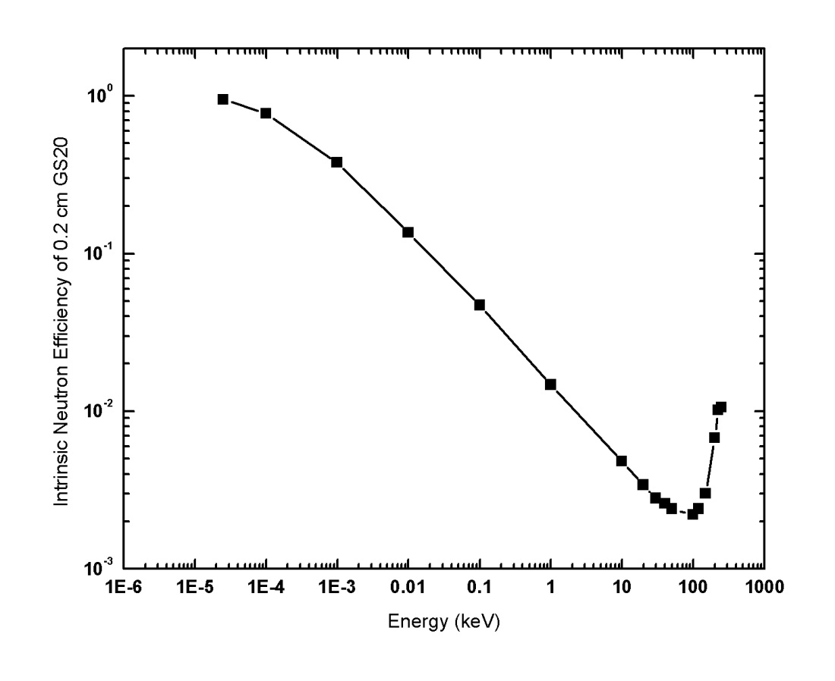
Figure 17 – Intrinsic Neutron Efficiency of 0.2 cm GS20 [9]
The GS20 beam study was arranged in three classes of simulations; the being being oriented 0 degrees from the detector normal, 30 degrees, and 60 degrees as depicted in Figure 18. The 0 degree orientation allowed for a true beam to be validated, while the 30 and 60 degree orientations provided a way to validate that in the irradiator, where the flux would be non-isotropic, that the interaction rate would increase due to the increased path length the neutron travels (20).

$$η=1-e^{-Σx}$$
$$x=x_{0}\cos{θ}$$
where:
- $η$ is the fraction of the beam attenuated,
- $Σ$ is the absorption cross section,
- and $x$ is the projected distance that the neutron travels.

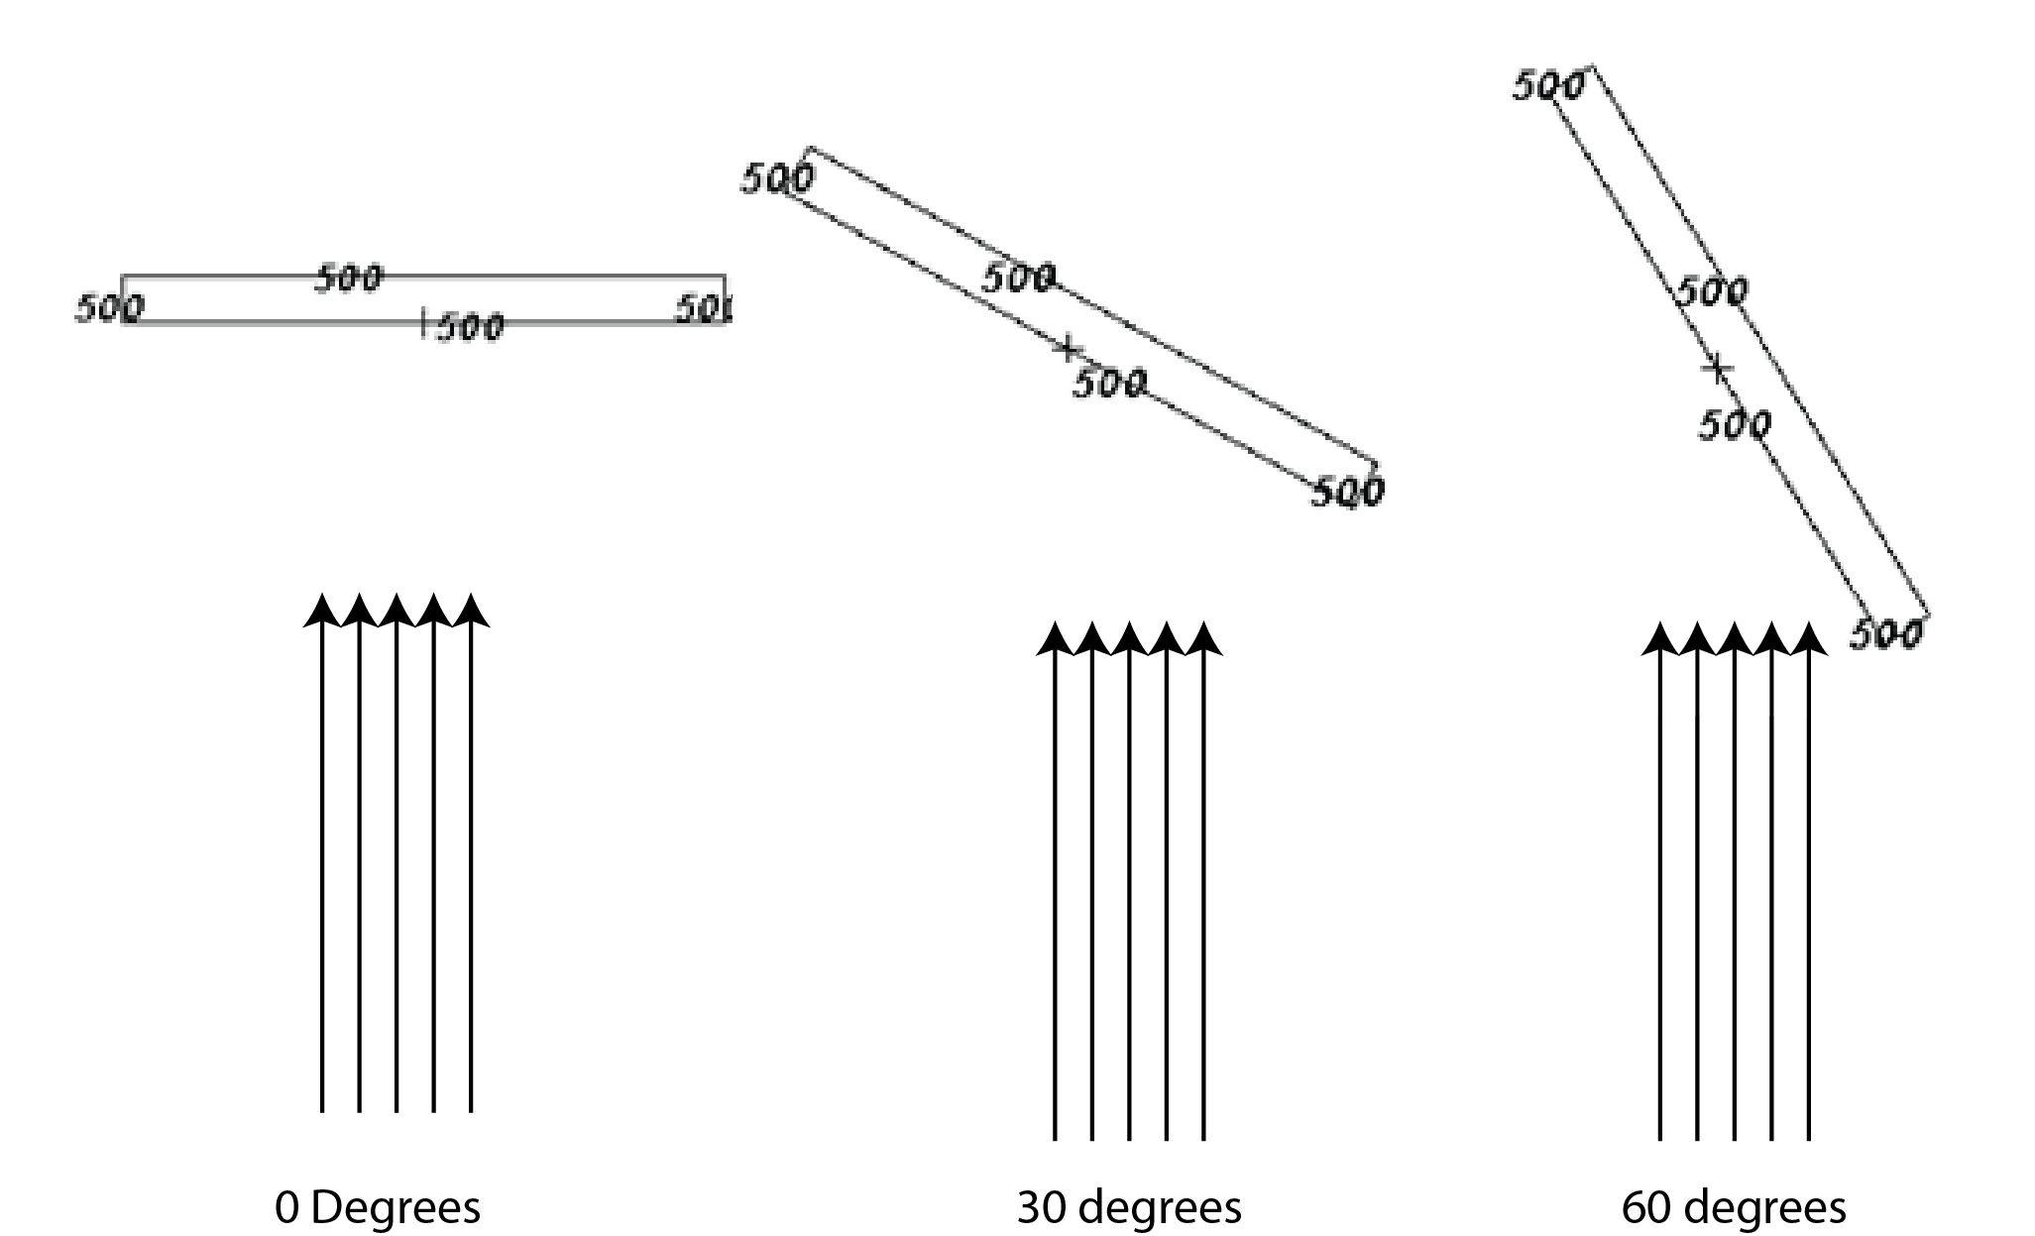
Figure 18 - Geometry of 0 degrees, 30 degrees, and 60 degrees
For very low neutron energies (less than 1 eV) there was very good agreement (less than 5% relative difference) between the analytical and simulated for all angles. At higher energies the error between the MCNPX simulation and the attenuation calculation grows to around 20%. In all cases the MCNPX simulation had a lower intrinsic efficiency. At larger angles with high energies the effect of the detector (or the orientation of the detector relative to the beam) becomes apparent; as shown in Figure 19 there is a doubling of the interactions from 0 degrees to 60 degrees in the 100 keV range. It should be noted that this only shows the increase in path length and not any effects of projected area as the beam consist of a single neutron vector.
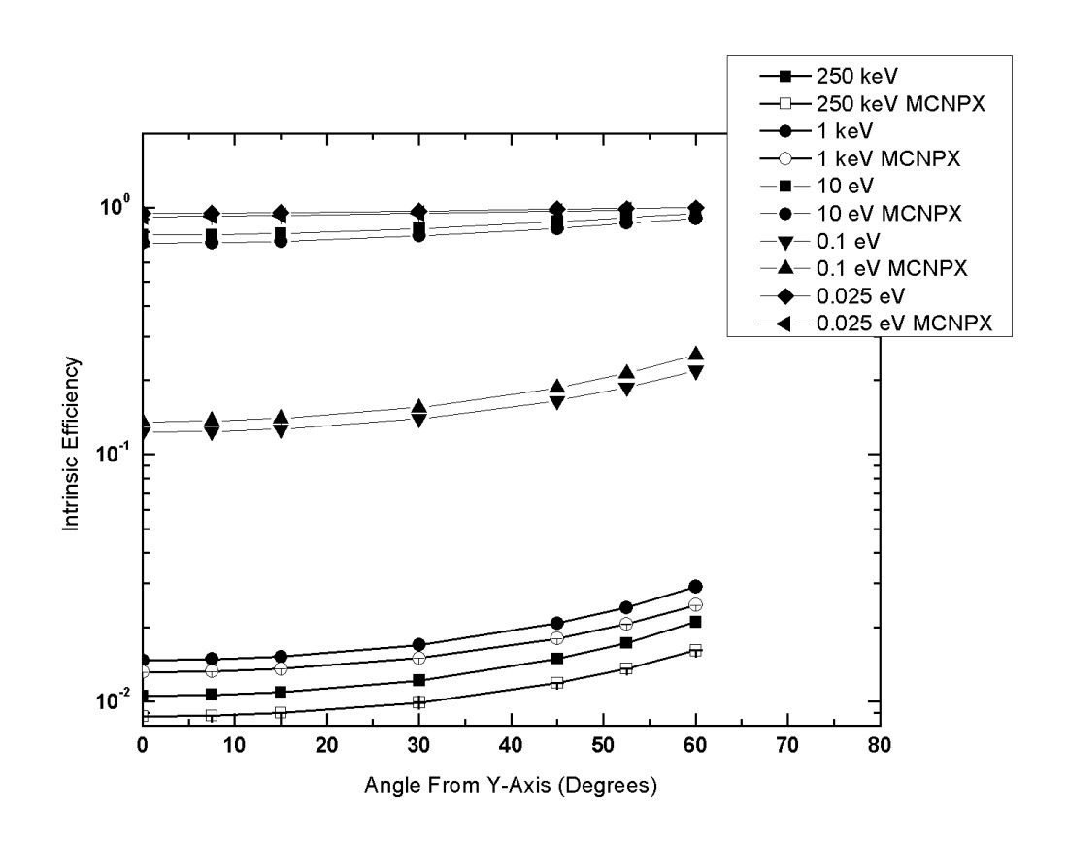
Figure 19 - Intrinsic Efficiency of 0.2 cm GS20, as dependent on energy and orientation in a beam
At low energies (eV range) GS20 has an attenuation coefficient about 100 times that at 1 MeV so varying the thickness of the detector by changing the angle of neutron incidence has very little effect; this is shown by the relative flatness of the curves in Figure 19. The relative difference ($σ_{rel}=\frac{Obs-Sim}{Sim}$) was calculated for each simulated error and averaged over all of the beam energies Table 14. For low energies there is excellent agreement, but for higher neutron energies the effects of the neutrons slowing down in the glass cause MCNPX to have a higher count rate than the analytical results.

Table 14 - Average relative Difference of simulated interaction rate and analytical reaction rates for GS20 in a neutron beam.
Beam Energy | Average Relative Difference
0.025 eV | 2.3%
0.1 eV | 6.3%
10 eV | 10.7%
1 keV | 12.6%
250 keV | 19.7%

Observed Count Rates of Films
The MCNPX simulation was validated by comparing the measured count rate to the simulated count rate for GS20, a PEN film, and a PS film measured in the neutron irradiator.
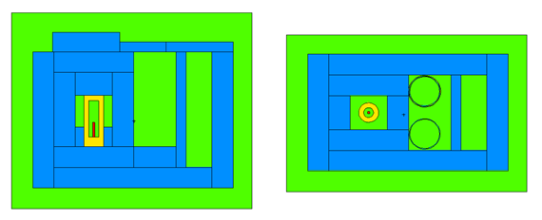
Figure 20 - MCNP Rendering of the Neutron Irradiator. The source is the red cylinder.
The simulated interactions rates (per source particle per cm³) of each of the films are presented in the following table. In general the reaction rate is dominated by the response in the lead well as the lead well contains thermal neutrons.

Table 15 - Reaction rate of (n,t) reactions per cm³ per source particle in the detector cells
Detector | Lead Well (x10⁻³) |  | Cadmium Well (x10⁻⁵) |  | Net Response (x10⁻³)
GS20 | 0.767 | 3.8% | 2.50 | 9.5% | 0.742 | 4.0%
PEN Film, 66 microns | 2.00 | 1.1% | 4.15 | 10.7% | 1.96 | 1.1%
PS Film, 25 Microns | 2.01 | 1.1% | 4.24 | 12.5% | 1.97 | 1.2%
PS Film, 50 Microns | 1.93 | 1.1% | 4.05 | 11.7% | 1.89 | 1.1%

The comparison between the simulated reaction rate and the observed count rate are presented in Table 16. The source strength was taken to be 0.5648 million neutrons per second.

Table 16 - Comparison between simulated count rate and predicted (n,t) reaction rate
Detector | Volume (cm³) | Simulated Count Rate |  | Observed Count Rate | Relative Difference  $$σ_{rel}={\left(obs-sim\right)}/{obs}$$
GS20 | 1.0130 | 424.82 | 3.97% | 428† | -0.7%
PEN Film, 66 microns | 0.1338 | 147.81 | 1.12%
PS Film, 25 Microns | 0.0507 | 56.23 | 1.19% | 51††† | 9.5%
PS Film, 50 Microns | 0.1013 | 108.10 | 1.14% | 96 | 12.6%
†Sample measured 1 December 2011, †††Sample measured 30 January 2012

The incident neutron spectrum was calculated by applying a F1 tally to the surfaces bounding the detector. The net number of particles crossing the detector was calculated by subtracting the number of particles that cross the cadmium well from the number that crossed the lead well.

Table 17 - Number of Particles Crossing the detectors (MCNPX).
Detector | Lead Well | Cadmium Well | Net Crossing
GS20 | 8.50x10² | 3.12 x10² | 5.37 x10²
PEN Film, 66 microns | 1.12 x10⁴ | 4.64 x10³ | 6.58 x10³
PS Film, 25 Microns | 1.12 x10⁴ | 4.65 x10³ | 6.59 x10³
PS Film, 50 Microns | 1.12 x10⁴ | 4.65 x10³ | 6.57 x10³
†Source strength is 0.56 million neutrons per second

At the time of measurement 537 neutrons were simulated crossing the GS20 detector in the net spectra (Table 17) and 430 observed counts for a detector efficiency of around 80%. As shown in Figure 17, GS20 can reach detector efficiencies above 80% when the incoming neutrons have energies below an eV. Figure 21 shows the neutron spectra incident upon a GS20 detector in the characterization laboratory’s neutron irradiator, where a large majority of the neutrons have been effectively thermalized.
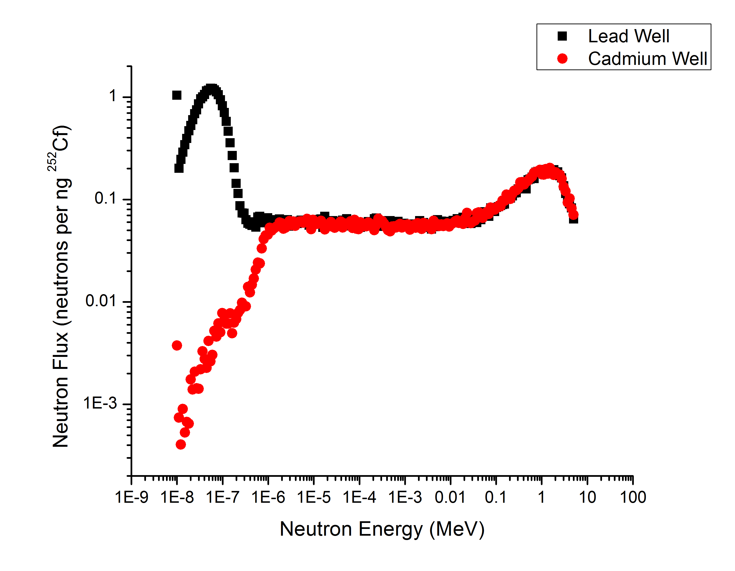
Figure 21 – Neutron flux incident upon a GS20 detector in the characterization laboratory irradiator

Results
Three detector materials capable of meeting the DHS-DNDO criteria were modeled; two films (a PEN composite film and a PS composite film) and LiF:ZnS. Three detector designs where examined – a 1mx1m film with varying thickness of moderator and reflector for preliminary design work, a single film in the existing ³He detectors footprint, and a layered film detector design in the ³He detector footprint. The detector material (PEN composite, PS composite and LiF:ZnS) where measured for their neutron count rate, gamma lower level discriminator setting, and counts above the gamma LLD.

Performance of Selected Films
The neutronic performance of five selected films is presented in Table 18 while Table 19 characterizes the light yield. Values reported in parentheses are Poisson counting statistics $± 2σ$ which is roughly a 95% confidence interval, while the repeatability of these measurements is 30%, based on the analysis of the repeatability (Appendix A ) The absorber mass is calculated based on the fraction of material that goes into the film. The actual amount of ⁶Li contained in the film may vary due to material losses in the casting process (in the case of PS films) or pellet grinding and heat pressing (in the case of PEN films). Generally the count rate per mg ⁶Li is around 6 cps per mg, but varies. It is thought the PEN films, with visible evidence of material domains, might be subject to significant neutron self-shielding. The neutron count rate at$ϵ_{int,γ}≤{10}^{-5}$ and $ϵ_{int,γ}≤{10}^{-6}$ is presented in order to provide an indicator of the shape of the neutron spectra. The light yield (Table 19) per neutron is expressed as a fraction of the calculated light yield per neutron of GS20 (6,250 Photons per MeV).

Table 18 – Summary of Detectors Discrimination performance.
 | Absorber mass (mg) | Total Neutron Count Rate  (cps) | Total Neutron Count Rate per mg Absorber  (cps/mg) | Gamma LLD such that $ϵ_{int,γ}≤1×{10}^{-6}$  (channel number) | Neutron Count rate above $ϵ_{int,γ}≤1×{10}^{-6}$  (cps) | Neutron Count rate above $ϵ_{int,γ}≤1×{10}^{-5}$  (cps)
PEN 50% LiF 1% ADS156FS Stretched | 9.10 | 53.04 | 5.89 | 3,192  (2,704 – 3,571) | 11.45  (9.72 - 14.52) | 23.81
PEN 70% LiF 25% PPO/POPOP 5%  158 um Annealed | 19.6 | 92.4 | 4.71 | 5,053  (5,105 – 5,245) | 21.2  (18.15 - 22.72) | 41.34
PS LiF 9.66% PPO/POPOP 4.58% 26um annealed | 1.37 | 8.25 | 6.02 | 2,899  (2,766 – 3,032) | 2.25  (1.93 - 2.6) | 4.33
PS LiF 29.9% PPO/POPOP 5.0%  50 um | 9.33 | 82.64 | 8.86 | 3,837  (3,264 – 3,961) | 1.01  (0.68 - 1.84) | 17.59
EJ-426 HD2 (⁶LiF in ZnS:Ag) | 105 | 568.3 | 5.41 | 3,514  (4,139 – 3,747) | 24.56  (17.05 - 30.27) | 208.10

Table 19 – Light yield of the selected films
 | Alpha Peak (²⁴¹Am) | Beta Average  (³⁶Cl) | $$α/{<β>}$$ | Photons per MeV  (Gamma) | Photons per MeV (Beta) | Photons per MeV Neutrons
PEN 50% LiF 1% ADS156FS Stretched | 2,592 | 355 | 0.34 | 500 | 916 | 1,560
PEN 70% LiF 25% PPO/POPOP 5%  158 um Annealed | 2,885 | 765 | 0.18 | 1,398 | 1,673 | 2,440
PS LiF 9.66% PPO/POPOP 4.58% 26um annealed | 4,074 | 345 | 0.55 | 1,354 | 1,540 | 1,500
PS LiF 29.9% PPO/POPOP 5.0%  50 um | 3,491 | 393 | 0.41 | 1,141 | 1,117 | 1,120
EJ-426 HD2 (⁶LiF in ZnS:Ag) | N/A | N/A | N/A | 19,745 | N/A | 26,900

It should be noted that the while the measurements have been repeated on the 26 micron annealed PS film, testing on a 25 micron annealed PS film fabricated later yielded poorer results. In addition, the stretched PEN film has not reproduced.

Performance of a detector in the DHS footprint
After determining the detector material response to neutrons and gammas the material was modeled (in MCNPX) in a RPM configuration. The source was modeled as a nano-gram sphere of ²⁵²Cf (2.5 micron radius) surrounded by 0.5 cm of lead, and moderator by 2.5 cm of HDPE. This source configuration conforms to the one described in [11]. The modeled detector assembly included four components: the neutron detecting thin film, the front moderator, the rear reflector, and the material encasing the detector. The interaction rate above a gamma intrinsic efficiency of one in a million of the simulated detector assembly was calculated by multiplying the (n,t) reaction rate by the volume of the detector and source strength of 1 ng ²⁵²Cf. The effect of a setting a gamma LLD was incorporated by multiplying the interaction rate per ng ²⁵²Cf by the fraction $η$ of the neutrons counts that are above the MLLD (21).

$$Detector Interaction Rate=\#(n,t)×V×\frac{2.3x{10}^{3}n/s}{1 ng Cf^{252}}η$$
where:
- $\#\left(n,t\right)$ is the number of (n,triton) interactions (per source particle per volume),
- $V$ is the volume of the detector,
- $\frac{2.3x{10}^{3}n/s}{1 ng Cf^{252}}$ is the source strength of 1 ng of ²⁵²Cf,
- And $η$ is the fraction of neutron counts that occur above the gamma MLLD, as determined from measurement.
Figure 22 shows the incident spectra upon the detector surface. The spectra is almost completely moderated before it is incident upon the portal monitor.
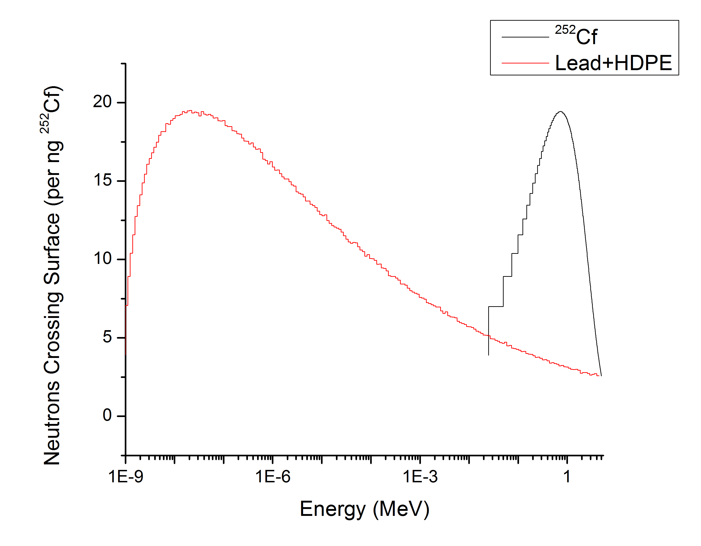
Figure 22 - ²⁵²Cf Watt Fission Spectra (black) and the moderated and shielded spectra (red) incident upon a detector in the RPM8 geometry

Single Film with varying Moderator and Reflector Thickness
The detector assembly was modeled as a 1m x 1m 50 micron 30% PS LiF film, with a varying thickness of moderator and reflector. The detector assembly was encased in 1/8” steel, but as shown later the encasing material (even if it is a neutron multiplier) makes little difference on the efficiency of the detector.
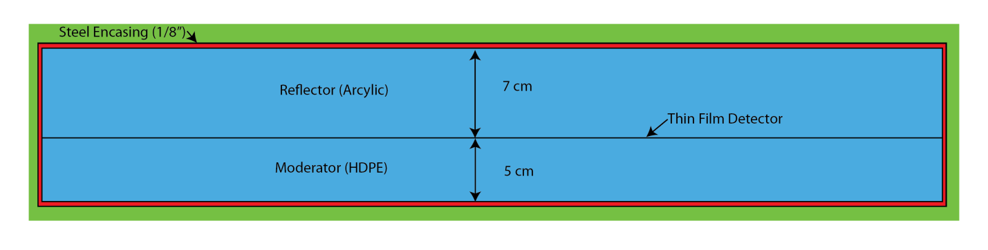
Figure 23 - Cross section of detector assembly.
A parametric study was completed to determine the optimal thickness of the moderator and the reflector. The moderator serves to slow down the neutron which increases the likelihood of a capture reaction, while the reflector serves to reflect neutrons that are exiting the detector back towards the film. Too thick of a moderator, however, and it will start to server as the reflector and the detector will see less neutrons.
The results of this study are shown in Figure 24. A reflector thickness greater than 7 cm provides little gain. The moderator needs to be at least 3 cm in order to reduce the neutron energy such that a capture reaction is likely, but past a thickness of 8 cm the presence of the moderator serves to impede the detector performance by reducing the neutron flux. A significant increase (over 60%) can be reached by increasing the reflector from 1 cm to 7 cm.
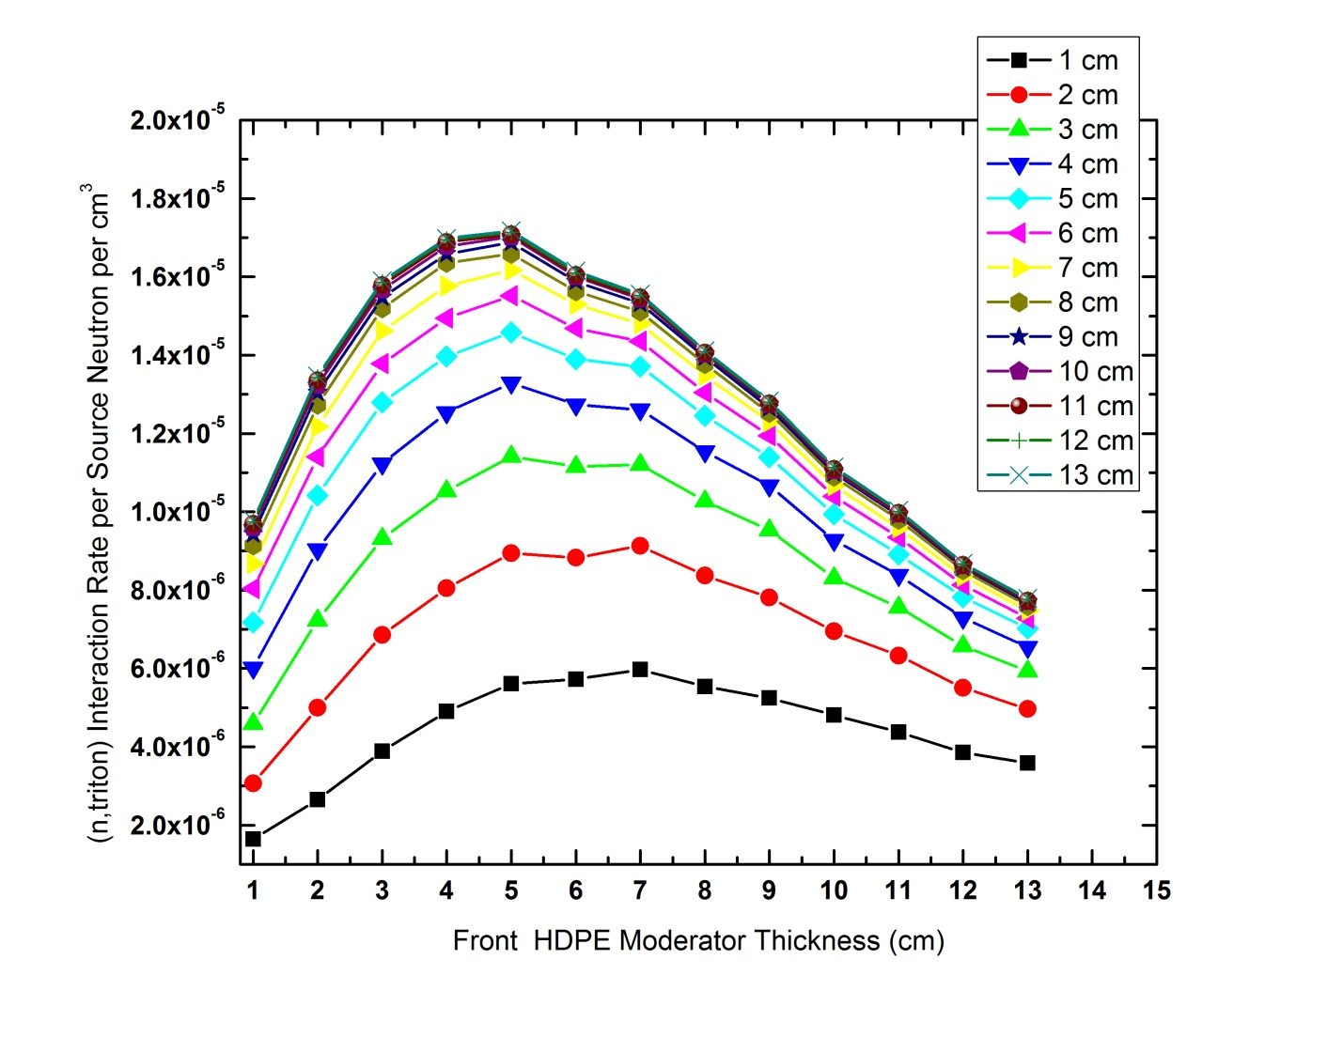
Figure 24 - Parametric study of reflector and moderator thickness for a single film. Each curve represents a different thickness of the reflector, while the thickness of the moderator is shown on the abscissa.
In addition to the moderator and reflector thickness, the material encasing the detector was investigated. If the detector was encased in a neutron amplifier then number of neutrons crossing the detector would be increased. Two promising amplifier materials are nickel or beryllium because of their (n,2n) reactions. Slight gains were made with Be, but it is thought that those gains do not outweigh the cost and hazards of Be. The results, reported in number of (n,triton) reactions per cm³ per source particle are summarized in Table 20 for a 1m x 1m single film with a 5cm moderator and 7 cm reflector. There is only moderate improvement over having no encasing material for the three materials investigated.

Table 20 - Encasing detector material. Moderate improvements are made from the presence of a neutron multiplier.
 | #(n,t) reactions per cm³ per source particle
Air (no encasing material) | 1.45
SS-316 | 1.46
Beryllium | 1.48
HEU | 1.96

While the modeled DHS detector assembly has a 63% higher intrinsic efficiency than the film modeled in the characterization laboratory irradiator. If implemented, however, it would have to have a size of 5.8 m², covering 70% of the solid angle in order to have a count rate of 2.5 cps/ng ²⁵²Cf.

Layered Detector in DHS-DNDO Footprint
Individual films do not possess intrinsic neutron efficiency high enough to satisfy all of the requirements of a DHS-DNDO detector. A layered detector of multiple films was investigated in order to increase the interaction rate. In order not to have prohibitive sacrifices in gamma discrimination the reaction products from a gamma interaction in one film must not create scintillation in another film; if this occurs the gamma LLD will shift to higher channel numbers and the potential benefit of layering multiple films will be outweighed by the hit taken on usable neutron counts.

Experimental Verification
To confirm the extent of this effect an experiment was completed in which four PVT based LiF films were stacked to different heights with different amounts of spacing. Figure 25 shows a significant increase in the neutron count rate, while the gamma spectra (Figure 26) only demonstrates a moderate increase in gamma spectra. Light collection then becomes an integral part of the detector; it was thought that the reason why the neutron count rate did not quadruple with four films relative to the single film was poor light transmission through the films. In the following detector designed it is assumed that the films are transparent to each other, i.e. there is perfect light transmission. This assumption was necessary in order to make the MCNPX model, and will be addressed in future work.

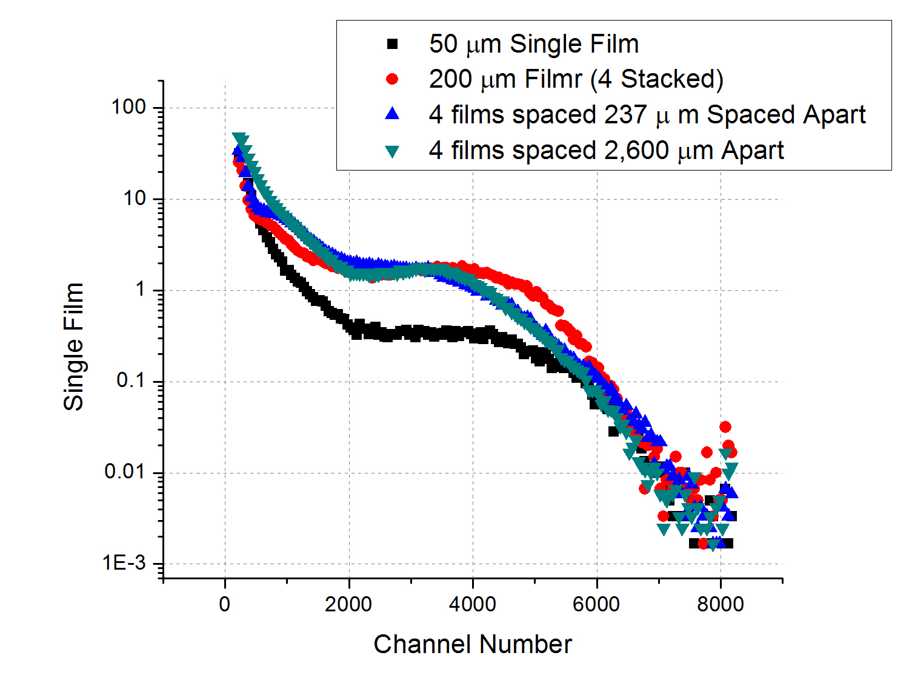
Figure 25 - Neutron Spectra of Stacked PVT based LiF films. having four more films Increased the count rate from a single film, with little effect of the spacing between the films
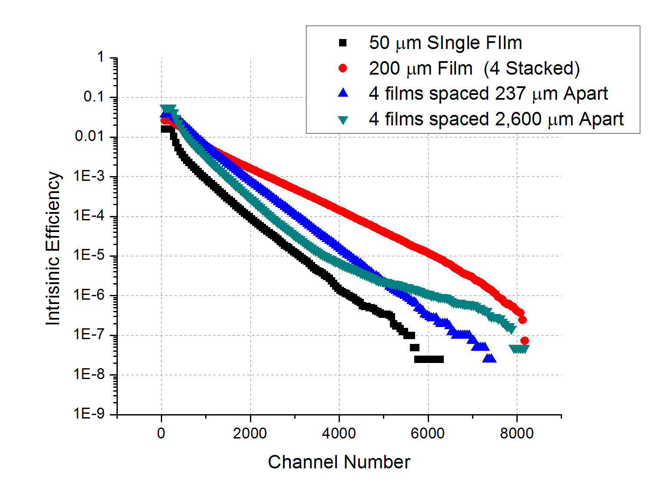
Figure 26 - Intrinsic Efficiency of different configuration of films. The films separated by a non(weakly)-scintillating material did not experiance the increase a dramatic increase in intrisinic efficiency.
LiFZnS:Ag has been evaluated for the film material in a layered detector design. A single EJ-426HD film provided by Dr. Penamadu and measured on 17 June 2012 had a net count rate of 568.3 cps (5.41 cps per mg ⁶Li), with a count rate of 24.56 cps above the necessary lower level discriminator to achieve 10⁻⁶ gamma intrinsic efficiency. The films high light yield (measured at 19,745 photons per electron equivalent MeV and 26,900 photons per neutron) made these films an attractive system to test the layered film concept.
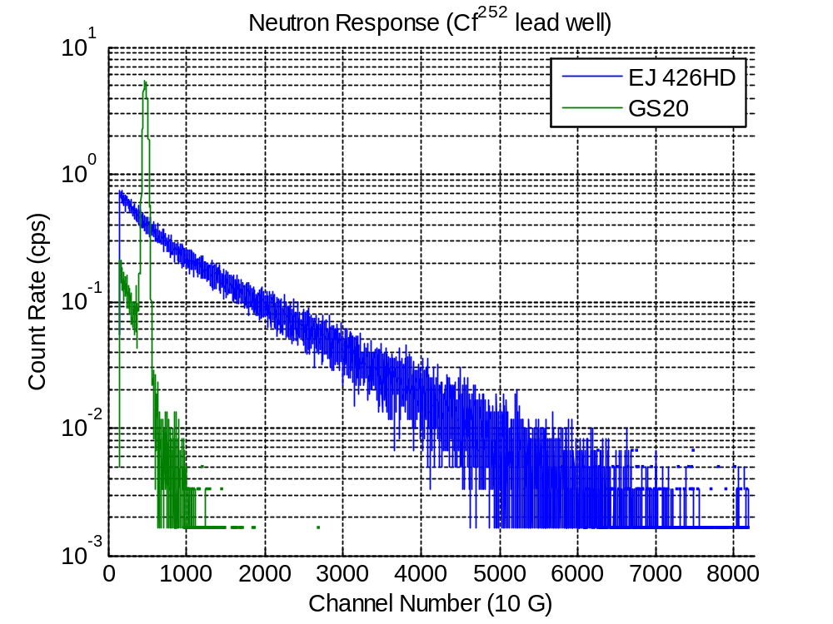
Figure 27 - Comparison of Neutron Response of GS20 and EJ-426 HD, both measured at 1,000V and 10 gain. There are 398.1 cps in the GS20 spectra, and 599.7 cps in the EJ-426HD.
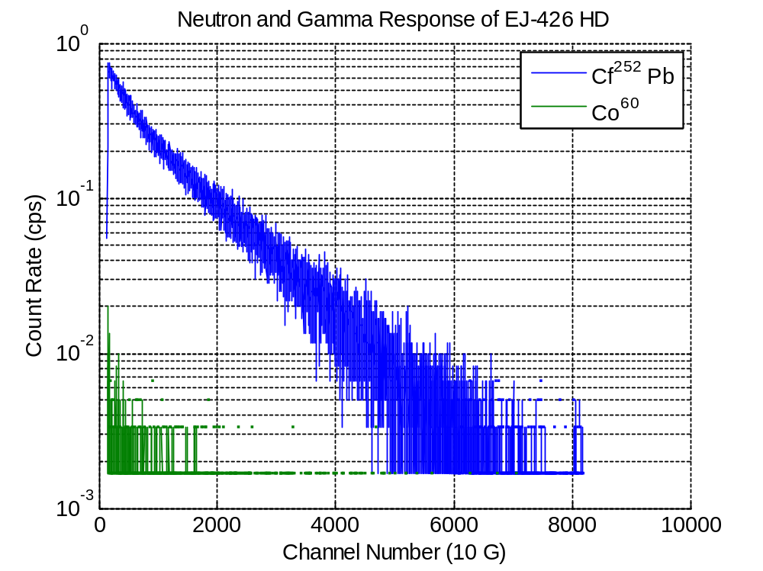
Figure 28 - Neutron and Gamma Response of EJ-426 HD films
EJ-426 HD PE screens were acquired from Eljen Technologies based in Sweetwater, Texas. Multiple screens of two sizes where acquired; 4” x 1.4” x 1 mm and 1.4” x 1.4” x 1 mm. PMMA slabs were also provided, measuring 4” x 1.4” x 0.1” and 1.4” x 1.4” x 0.1”. The performance of the single film was determined by sandwiching a single 1.4” x 1.4” sheet of EJ426 HD-PE between PMMA slabs atop of the PMT and mounting the slabs to the PMT with optical grease (Figure 29).

PMMA Sheets (2.54 mm )
EJ-426HD-PE (0.1 mm)
Optically mounted (optical grease)
PMT
Figure 29 - Mounting of Single Horizontal Film
Another configuration consisted of a single sheet vertically mounted onto a PMT by sandwiching the sheet between two slabs (either PMMA or glass) and wrapping with Teflon tape to increase light collection and then with gaffers tape to make the system light tight (Figure 30). The system was then optically mounted to the PMT using optical grease. Similarly, four of the EJ-426HD sheets were layered between PMMA slabs, as shown in Figure 31.
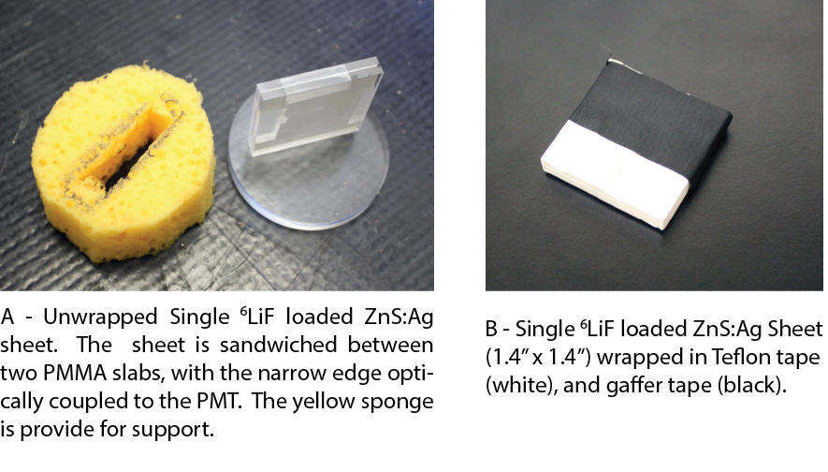
Figure 30 -Fabricated single wrapped sheet.
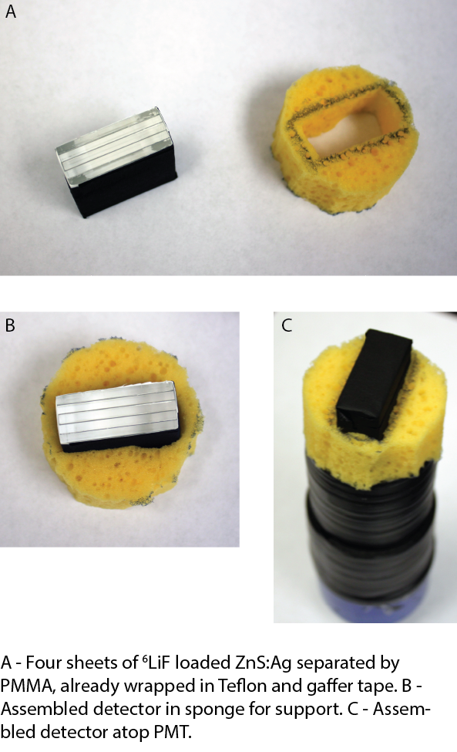
Figure 31 - Fabricated multiple films.
The single film (orientated horizontally on the PMT) had a higher neutron count when glass (about ¼” thick) was used to collect the light compared to the PMMA slabs (0.1” thick), but it also had a decline in the light yield. This is an indicator that the separating material could be optimized for increased light collection. The spectra were also the first spectra of LiFZnS:Ag that displayed a peak. Other LiFZnS:Ag films measured were either 0.32 mm or 0.5 mm; so it is hypothesized that the thicker LiFZnS:Ag films experience a light loss in the film. It should be noted that this does not suggest a preference of one material over the other, but rather there is room for further study.
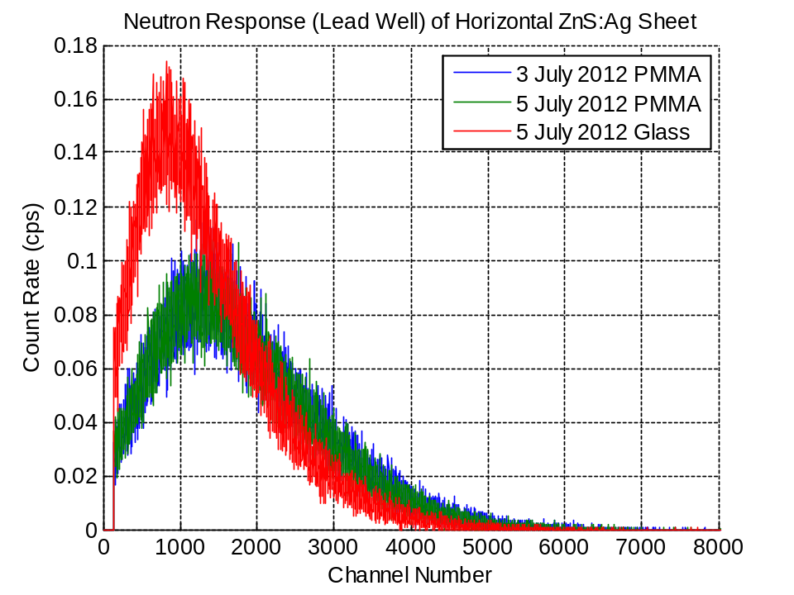
Figure 32 - Neutron Response of Horizontal LiFZnS:Ag sheet
The thickness of the glass plates made it difficult to orient vertically, so only the PMMA sandwiched films where oriented vertically (as shown in Figure 30). A comparison between the neutron performance of the horizontal sheet and vertical sheet is shown in Figure 33. A significant decrease in light output was observed in the vertically oriented sheet with the peak decreasing from 1,190 to 700 channels, while the count rate increased from 202 cps to 245 cps. The increase is due to contributions from the counts on the far side of the sheet in the horizontal orientation that are reflected back into the film instead of the PMT. Exposed to the gamma field the film oriented horizontally atop the PMT had larger amount of counts further out than the film oriented vertically.

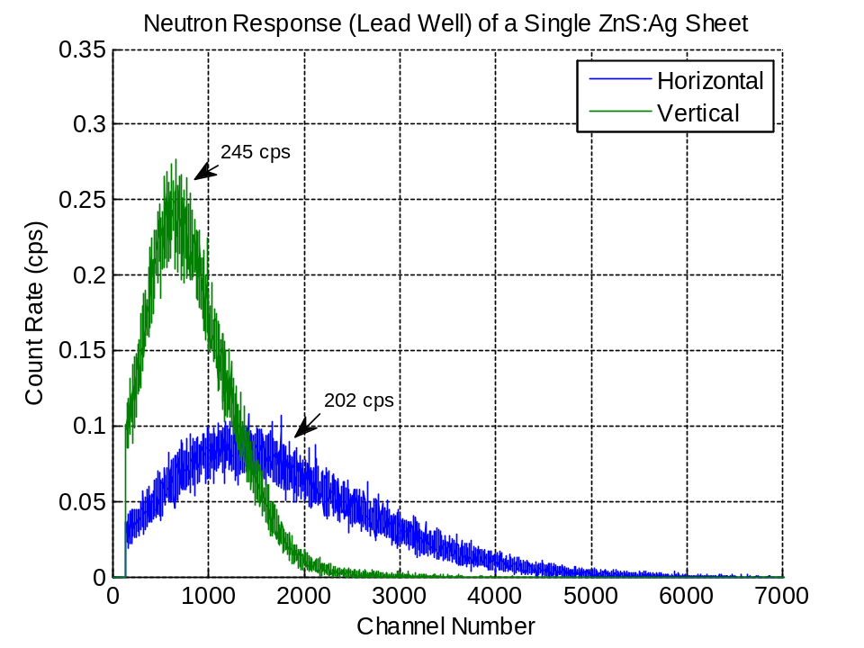
Figure 33 - Comparison between the horizontal orientation and vertical orientation of a single PMMA film. The vertical film has a higher count rate because the horizontal count rate film will lose counts that occur on the side of the film farthest from the PMT.
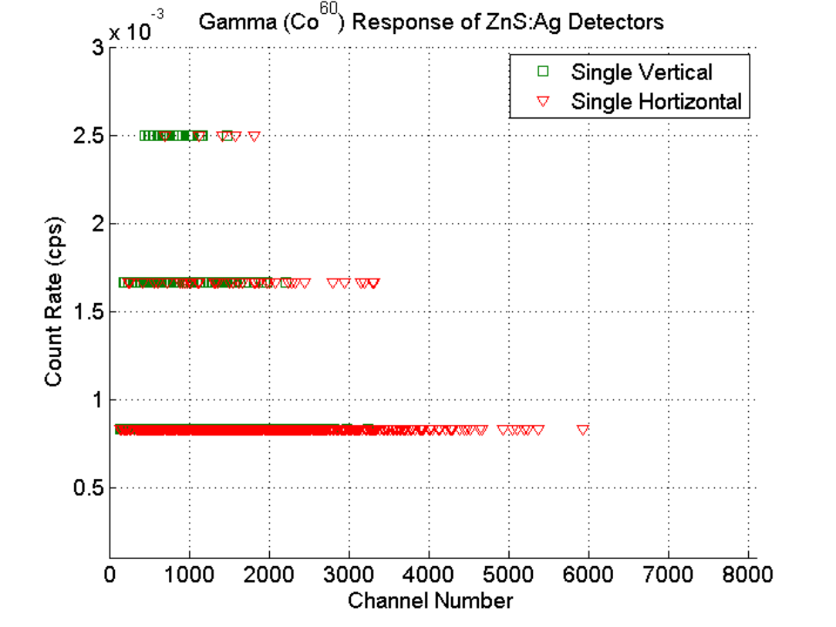
Figure 34 - Gamma response of vertical and horizontal LiFZnS:Ag sheets
The addition of three additional sheets (total of four sheets) each 1.4” x 1.4” in the vertical orientation (as described in Figure 31) showed an increase in the neutron count rate to 692 cps from 245 cps for a single film, with a small decrease in the peak position to 539 channels (the single film oriented vertically was 690 channels) which is attributed to light collection and mounting. It was expected that the count rate for the four films would be four times that of a single film (~980 counts total) but this was not observed and was attributed to self-shielding in the material.
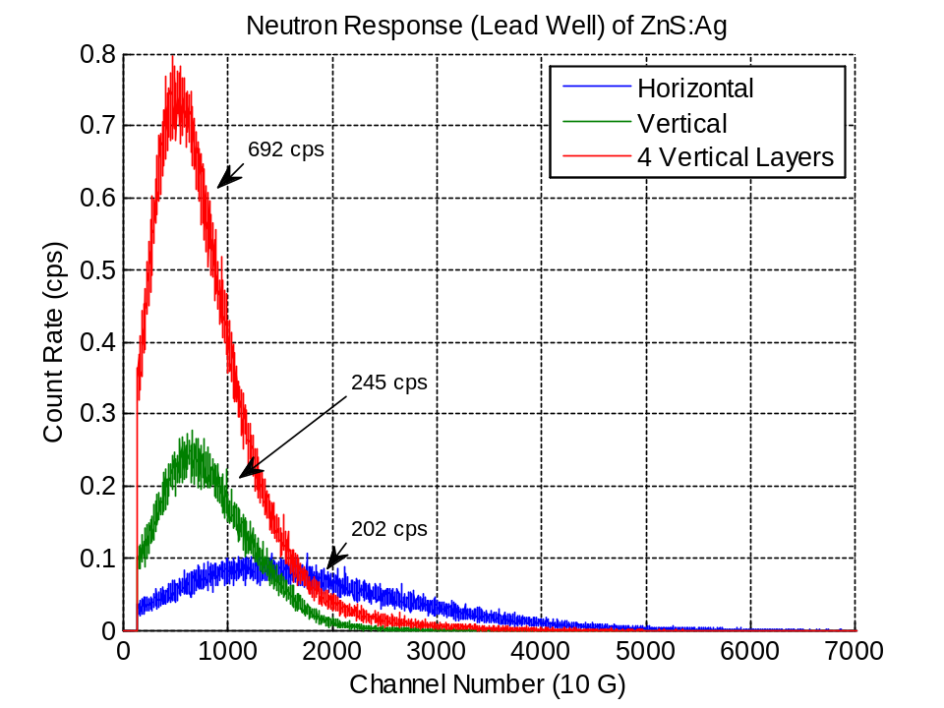
Figure 35 - Comparison of the neutron response of the 1.4" x 1.4" LiFZnS:Ag sheets.
The gamma response of the four layered sheets showed an increase in the count rate (especially at the low channels), with more counts in the higher channels than the single vertically oriented sheet, but fewer than the horizontal sheet (Figure 36 and Figure 37).
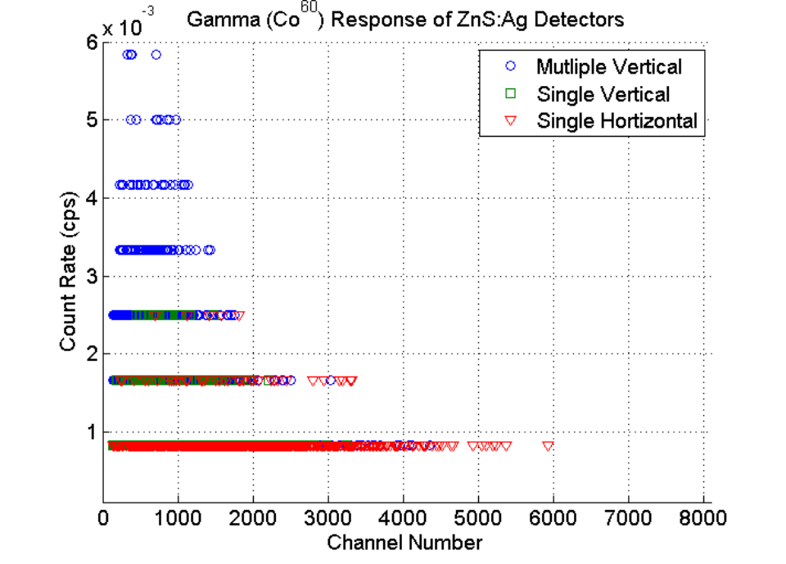
Figure 36 - Gamma Response of 1.4" x 1.4" layered LiFZnS:Ag sheets
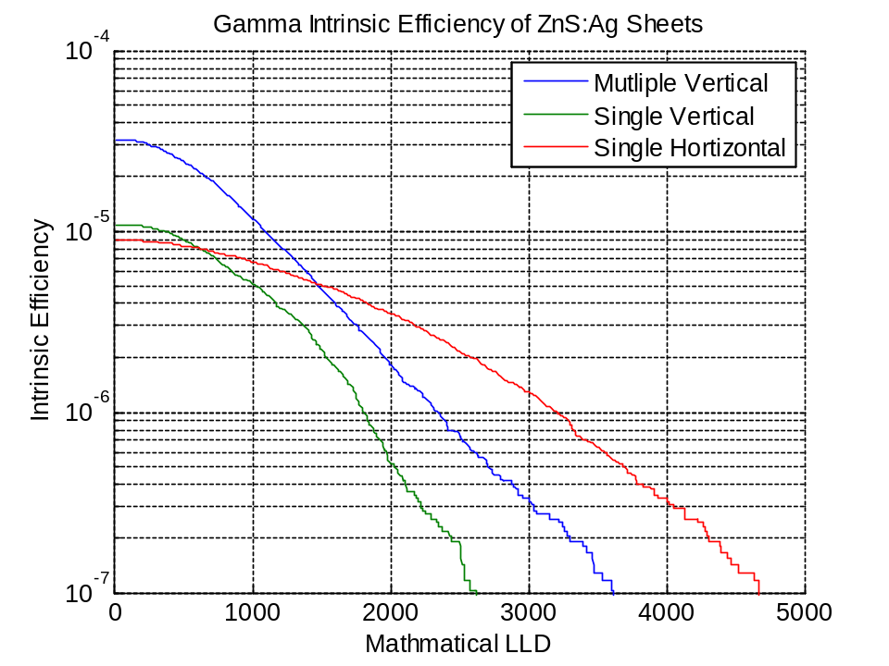
Figure 37 - Gamma Intrinsic efficiency of 1.4" x 1.4" LiFZnS:Ag sheets

Simulated Detector Performance
The layered detector model consists of films separated by acrylic, rendered by MCNPX in Figure 38. The thickness of the films varied to match the film measured, but the thickness of the acrylic was set at 1 mm. This distance was chosen so that most of the reaction products of gamma interactions would deposit their energy in the non-scintillating acrylic. The rendering shows the films oriented vertically, but horizontally oriented films were also investigated. It was concluded that horizontally oriented films had a 9% decrease in interaction rate, but this orientation could make for easier light collection.
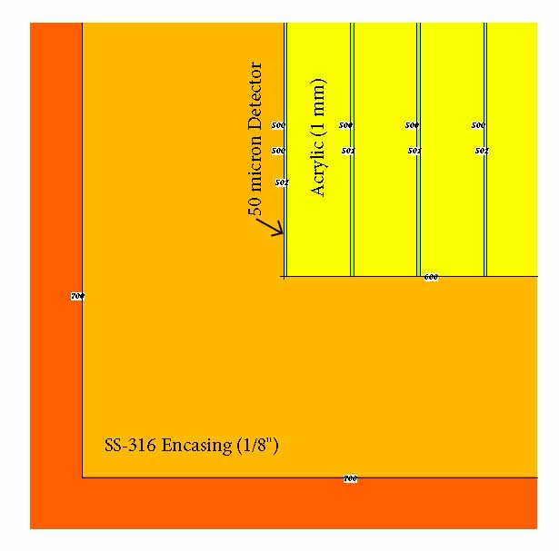
Figure 38 - MCNPX Model of Layered PS films, rendered by material with cell numbers.
The performance of the layered detector was investigated as a function of the layer of the in the detector in order to better understand the detectors performance. Figure 39 shows the neutron spectra for a selected number of films (from the first to the last) in the detector with the source neutron spectra superimposed. It should be recalled that the source spectra is a moderated ²⁵²Cf spectra, the difference between the two is shown in Figure 22. It is observed that after about half-way through the detector the neutron’s crossing the films have dropped and order to 10, and once they are crossing the last film (12.5 cm) they have dropped almost two magnitudes. It is also noted that the additional films to not serve to thermalize the spectra – as the spectra is already thermalized when it reaches the detector.
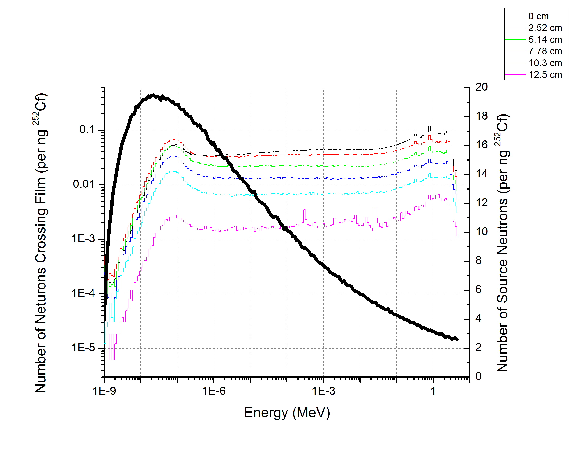
Figure 39 - Neutron spectra of particles incident upon different films (whose position is enumerated in the legend) in the layered DHS Detector. The Solid black line is the spectra of neutrons leaving the source Setup.
The numbers of reactions are plotted as a function of film position in Figure 40. Films farther away from the front of the detector see fewer neutrons (Figure 39) with little gain in spectra. In addition, as seen in the parameter study of a single film (Figure 24) a five cm thick moderator is a good compromise before neutrons are reflected. This implies that it would be a better use of the material to have the detector thinner and wider.
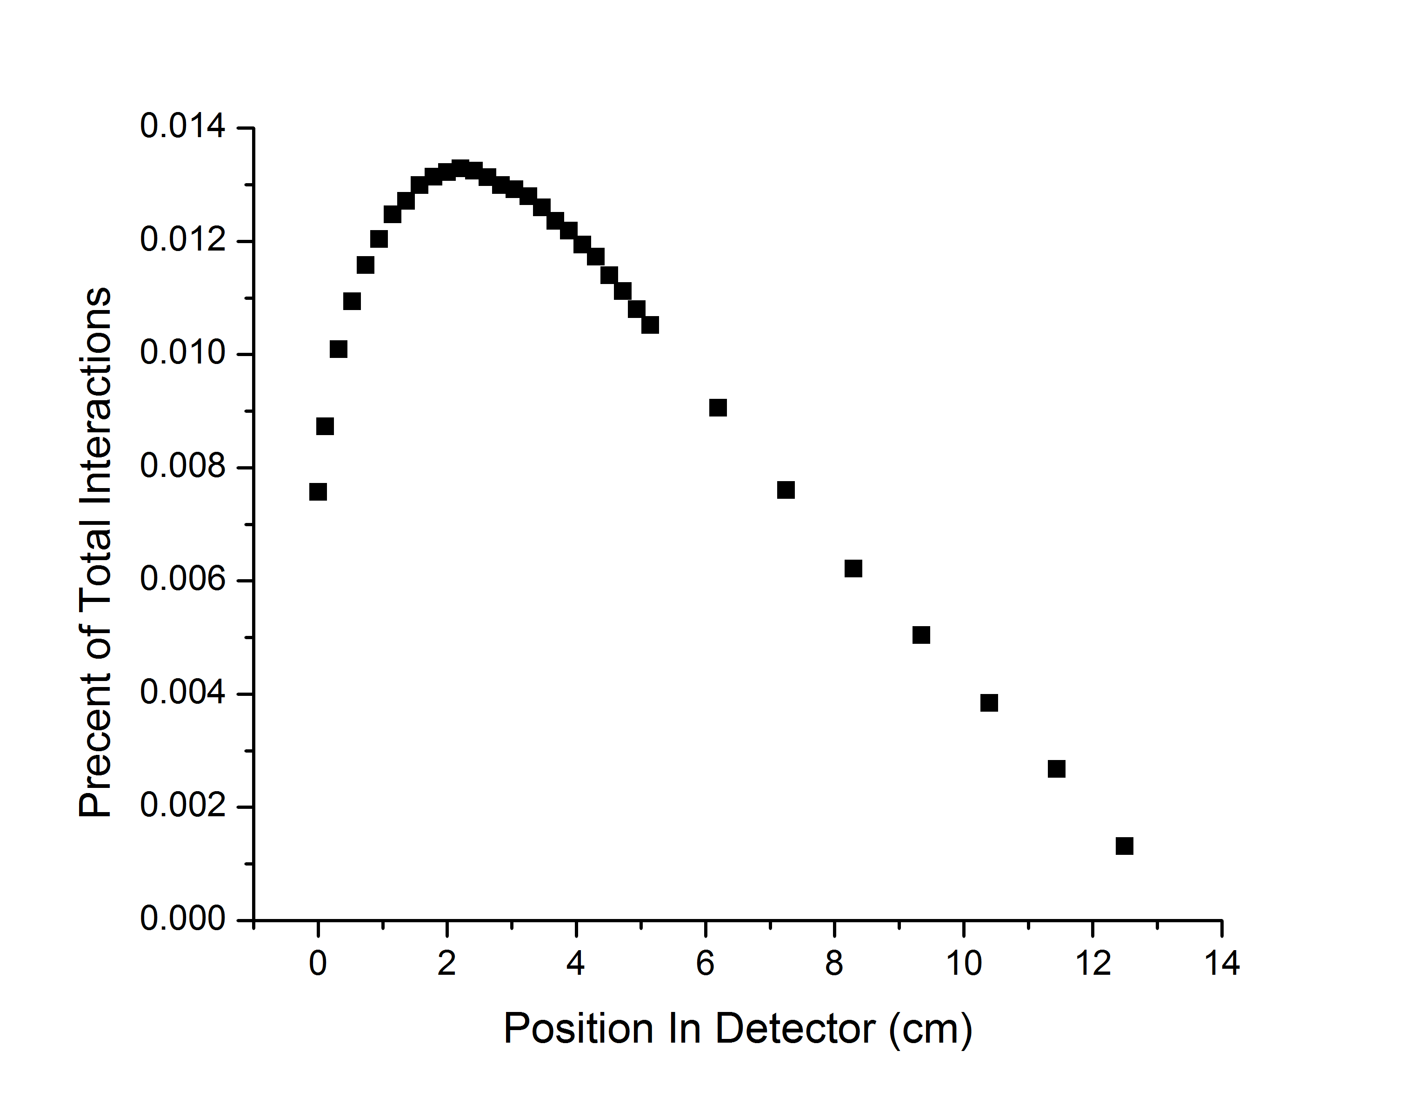
Figure 40 - (n,Triton) interactions as a function of location in the DHS-Detector for a PS Film. Over 30% of all of the interactions occur in the first five cm of the detector.
Holding the volume of the detector constant the total number of interactions as a function of detector thickness was investigated for a 30% LiF PS film in order to find the optimal use of the detector material. It was found that a 20% increase in the count rates could be achieved if the detector was 6 cm thick instead of 12.7 cm; this of course means that the detector would be 64 cm wide. This effect is due to the depression in flux caused by the absorption of previous layers. This can be best seen in Figure 41.

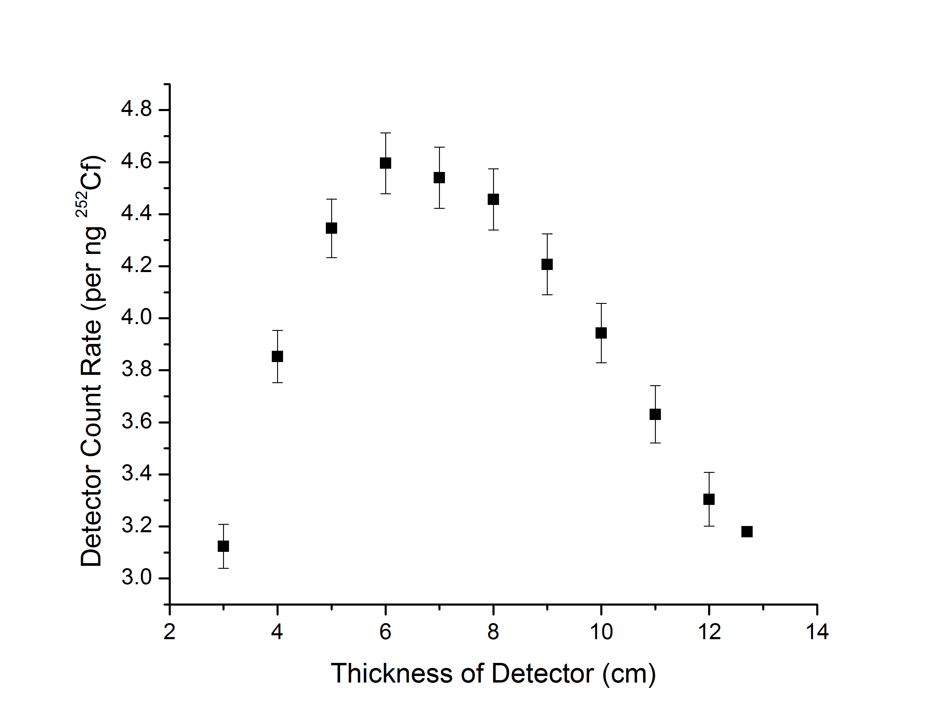
Figure 41 - Optimal Detector Thickness for a 30% LIF PS Film.

Wrapped Films (Cylinders)
One can imagine a detector fabricated by laying down a sheet of acrylic, layering a ⁶LiF PS or PEN film atop of it, and then rolling up the entire assembly into a cylinder. The PMT would be placed at either end of the cylinder, with the acrylic acting as a light guide for photons generated in the scintillating film. This geometry was modeled for a 5” PMT, which required that the cylinder had a 5” diameter. Two simulations were completed, one with two cylinders oriented vertically and another with 16 cylinders oriented horizontally.
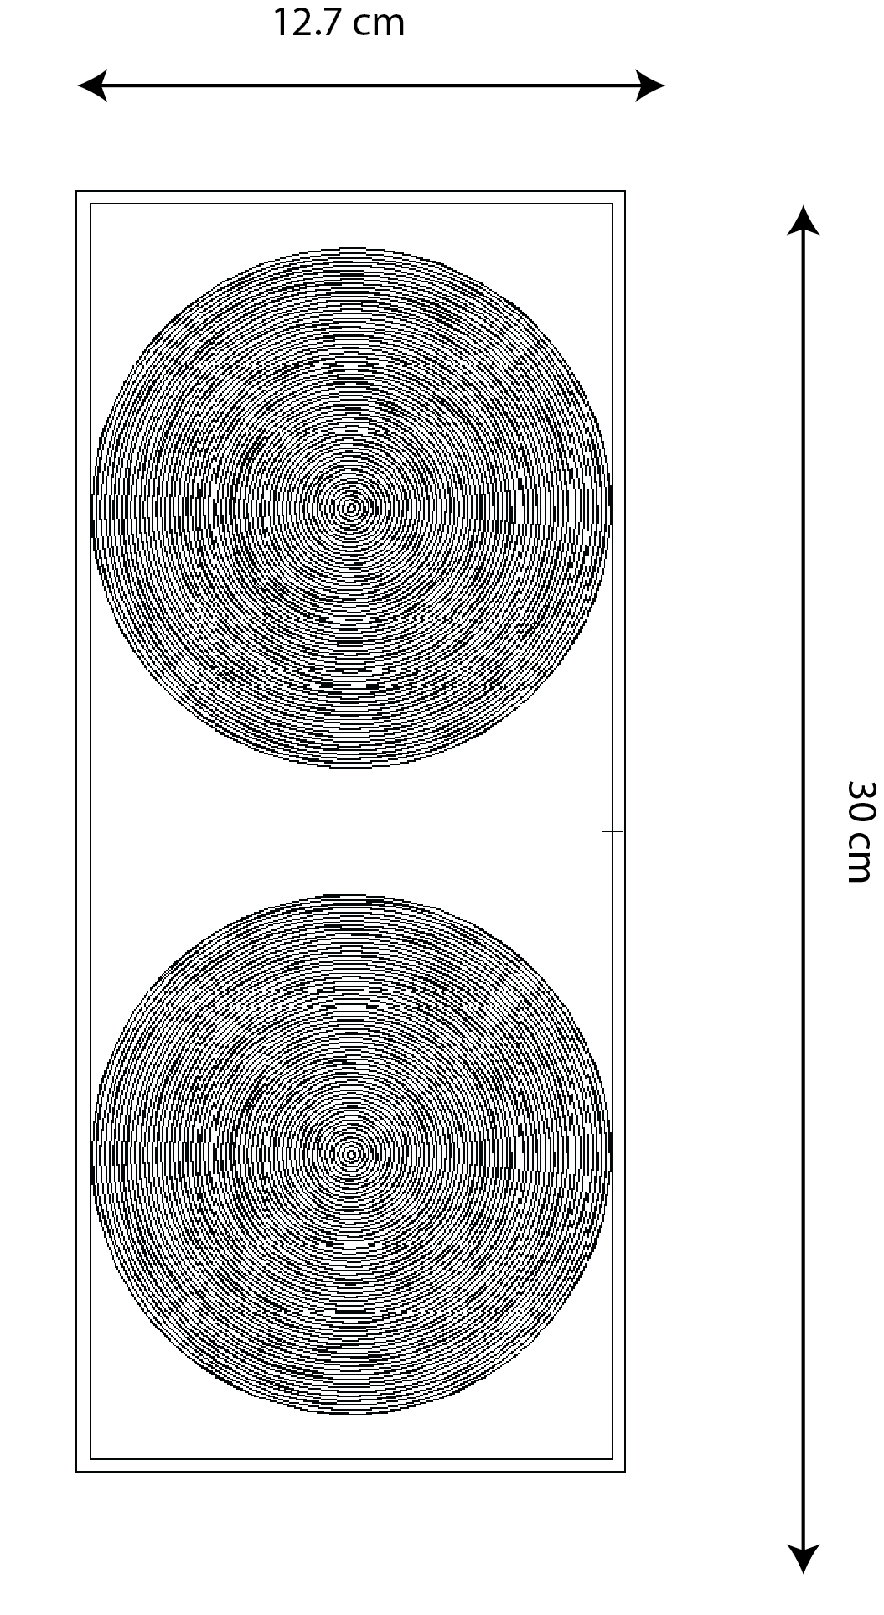
Figure 42 - MCNPX rendering of 5" Cylinder Films, shown as an x-y profile.
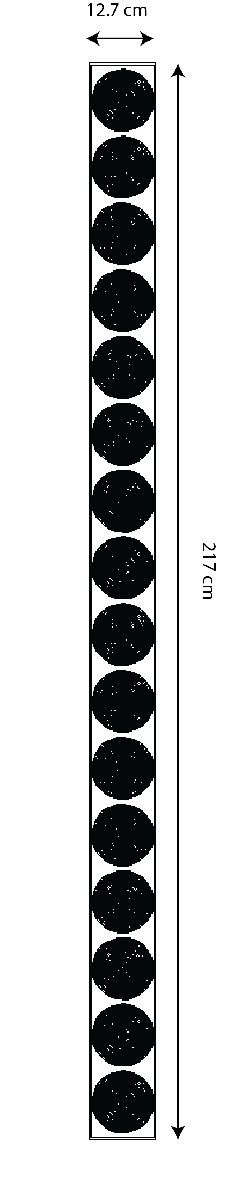
Figure 43 - MCNPX rendering of 16 horizontally stacked 5" cylinders shown as an x-z profile
The following table shows the simulated interaction rate in each of the assemblies (50 micron polystyrene films loaded with 30% LiF). Volume normalized the vertical detector almost had twice as many interactions, which is impart due the cylinders on the end of the horizontal configuration not receiving as much flux from the source compared to those in the center.

Table 21 - Comparison Between vertical and Horizontal Films for a 30% LiF PS film with an efficiency of 30% above the gamma LLD. The cylinders where oriented vertically and horizontally, and are An indicator of the PMT’s needed.
 | Number of Cylinders in Detector Volume | Volume of Absorber (cm³) | Count Rate per ng ²⁵²Cf for 30% LiF PS | Count Rate per ng ²⁵²Cf for 30% LiF PS per Detector Volume (cps per cm³)
Vertical | 2 | 2,630 | 2.69 | 1.02 x 10⁻³
Horizontal | 16 | 2,980 | 1.55 | 0.250 x 10⁻³
6 cm of layered films |  | 4,005 | 4.59 | 1.15 x 10⁻³

Improved Detector Design
Improved performance of the films (as well as unexpected light yield losses) lead to a small exploration of the parameter space in order to determine the fewest number of layers possible to achieve the necessary count rate (2.1 cps per ng ²⁵²Cf) while still maintaining the gamma discrimination. MCNPX was used to simulate films consisting of 120 layers to 5 layers. Having previously demonstrated the effects of a moderator and reflector for a single film, the geometry was modeled such that the remaining material in the RPM was set to be moderator up to a distance of 4 cm; past a moderator thickness of 4 cm the remaining material was set as the reflector (Figure 44). The results indicate that around 38 layers are needed for the LiF:ZnS films, while the composite PEN film requires 75 layers (Figure 45) for a detector that would fit into the existing RPM8 (12.7 cm x 30 cm x 217 cm).

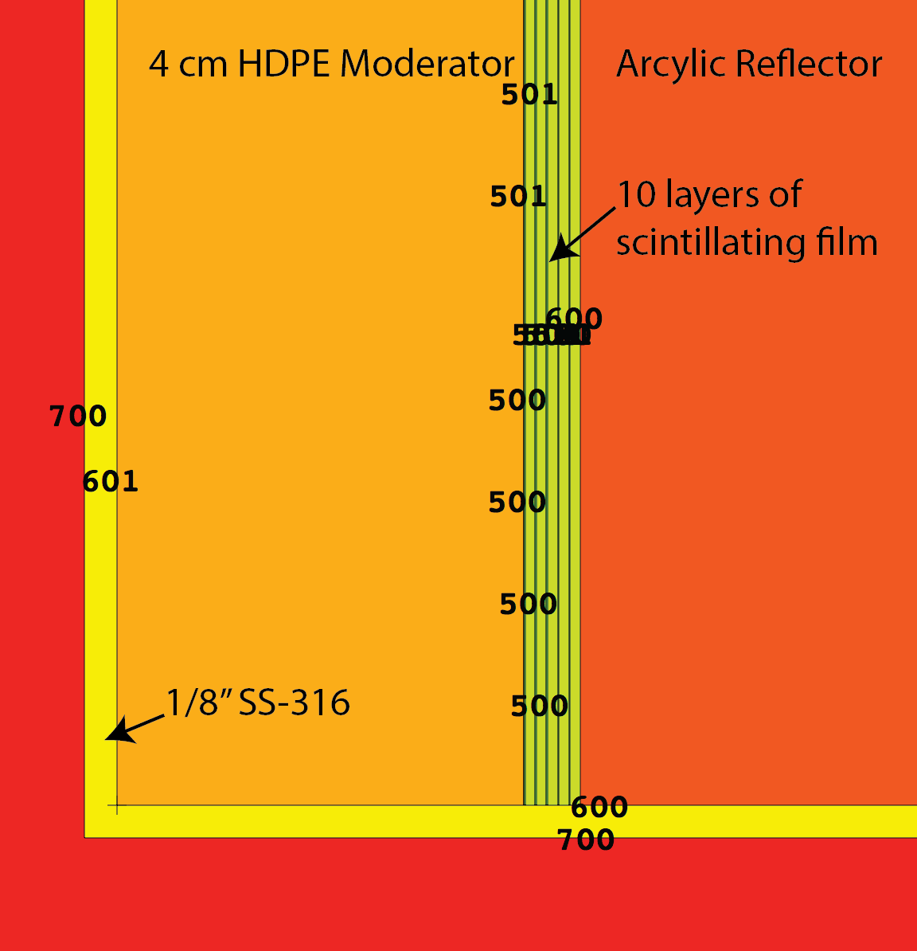
Figure 44 - Geometry modeled for layer optimization

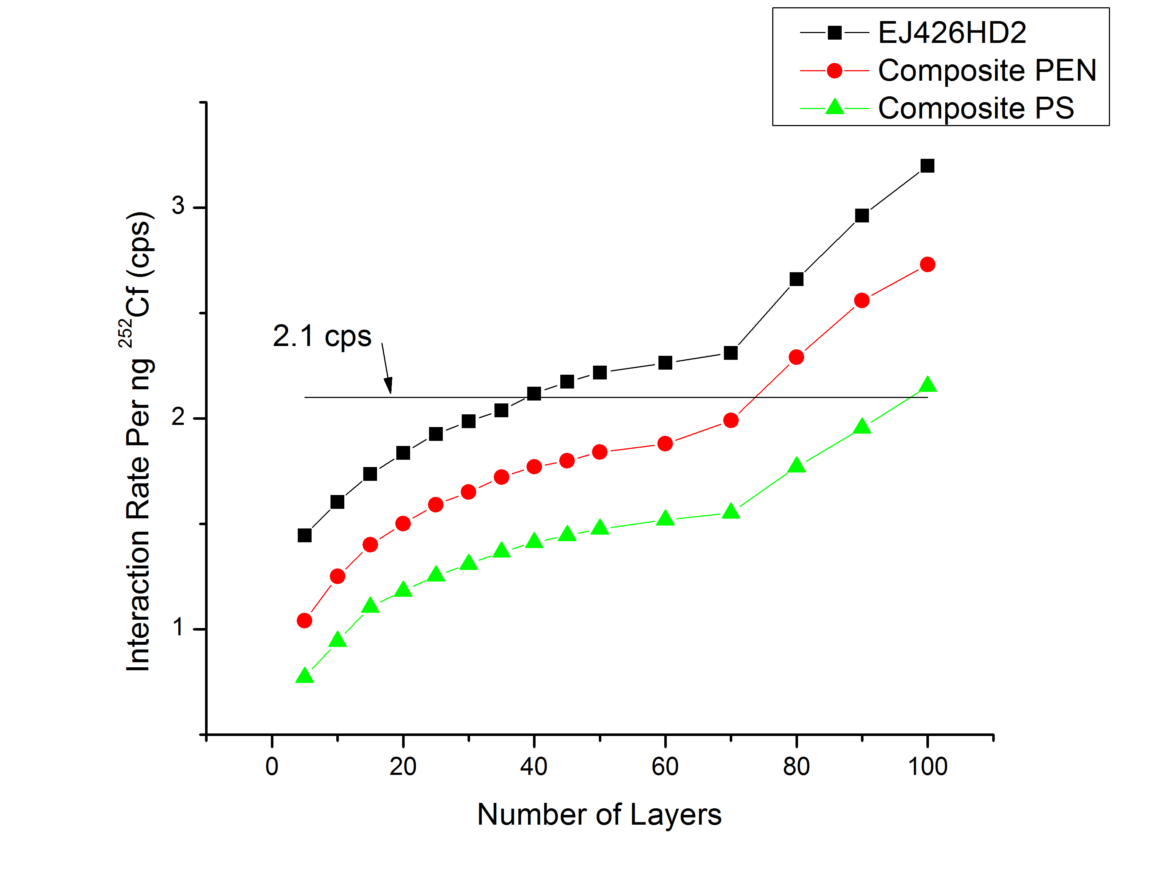
Figure 45 - Modeled interaction rate for the layered optimized detector

Enhanced Discrimination through Pulse Shape Discrimination
Pulse shape discrimination can be used to enhance the gamma discrimination by providing additional information for pulse classification. While the details of such a system have yet to be determined, the ability for polystyrene films to perform pulse shape discrimination exists[12], but experiments on PEN showed little ability. In the following experiments the materials used where previously existing films, and are not at all ideal for pulse shape discrimination [12]. Future work is to reproduce these measurements on films better suited for pulse shape discrimination.

Polystyrene Pulse Shape Discrimination
The distributions of charge ratios are shown for the alphas and gammas in the following three figures for the three films. The 150 micron PS film with 15% PPO displayed the largest separation between the gamma and alpha charge ratios (Figure 46). The addition of 15% of ⁶LiF, however, increased the tail of the gammas (Figure 48), leading to less separation in the pulse distributions. Finally having a thinner film (50 microns, loaded with ⁶LiF) caused complete overlap between the alpha and gamma charge ratio distributions (Figure 48).
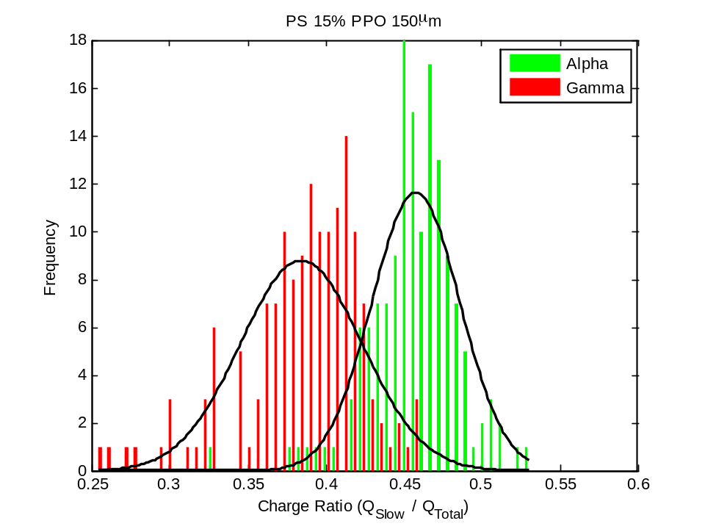
Figure 46 - Charge Distribution of 150 micron PS
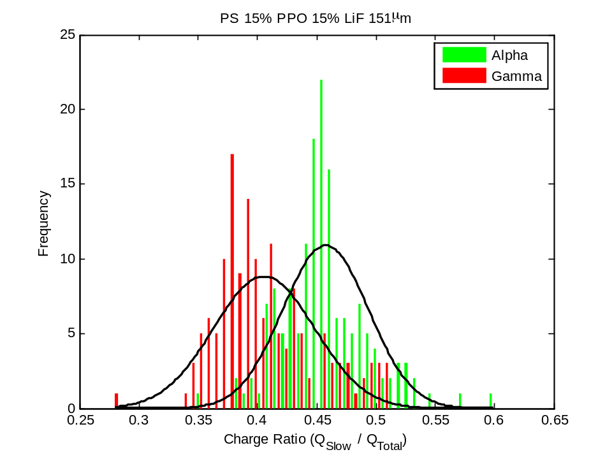
Figure 47 - Charge Distribution of 150 micron PS loaded with LiF

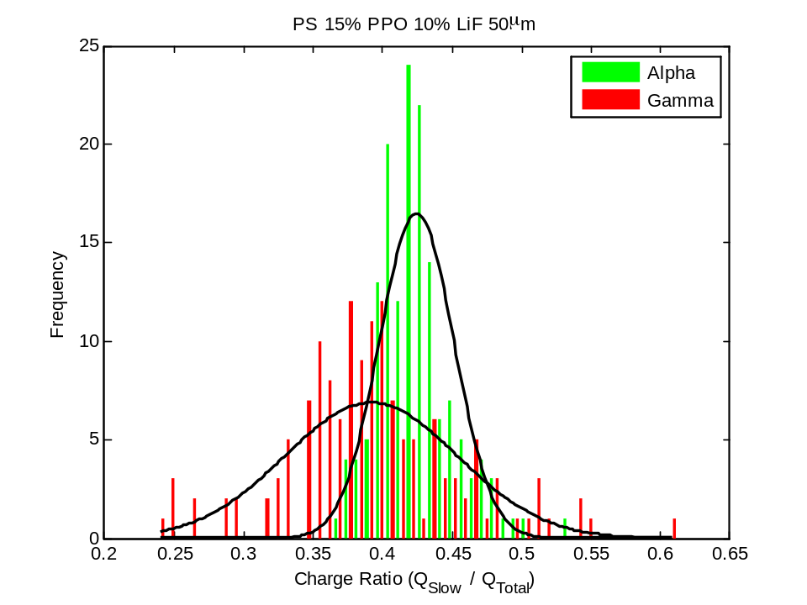
Figure 48 - Charge distribution of 50 micron PS loaded with LiF
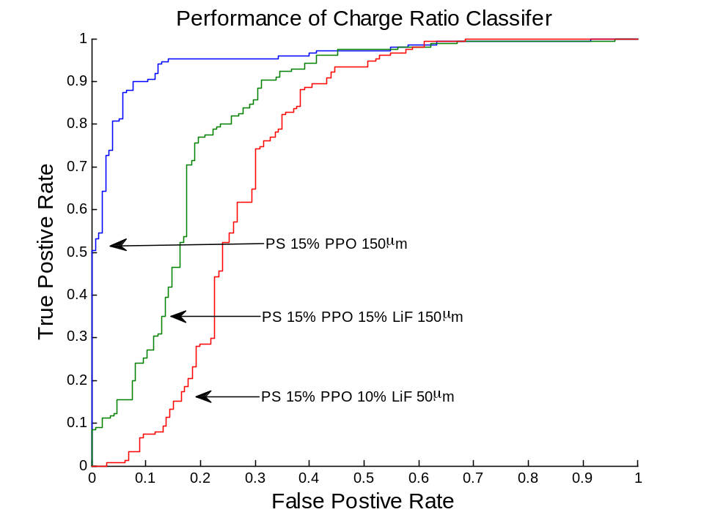
Figure 49 - Comparison of charge ratio classifier.
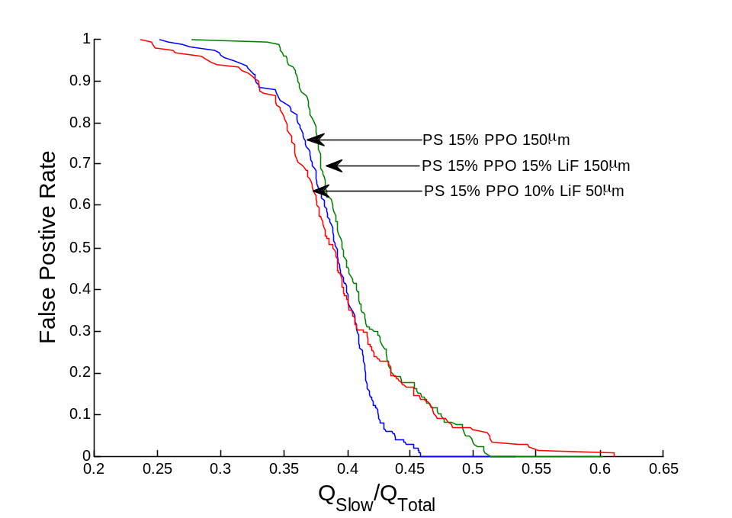
Figure 50 - Charge Ratio versus False Positive Rate
Initially the false positive rate (classifying a gamma as an alpha) is very high for the charge ratio because gamma’s have a lower charge ratio than alphas. After a charge ratio of 0.4 or so there is a knee in the curve and the false positive rate decreases rapidly. The flatness at the foot of the curve indicates the possibility to optimize the performance.

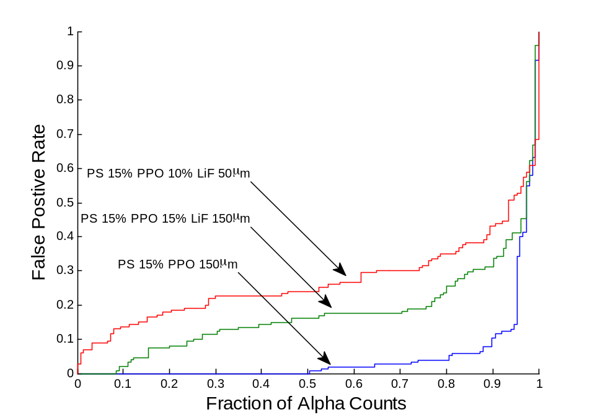
Figure 51 – Fraction of Alpha Counts as a function of the false positive rate
The performance of an actual detector system (with alphas as a surrogate for neutrons) can be seen in Figure 51. A very low false positive rate (associated with a high cost of misclassifying a gamma as a an alpha) dictates a prohibitively low fraction of the alpha counts, while allowing a high false positive rate allows for all of the alpha counts to be accepted.

PEN Pulse Shape Discrimination
The PEN films (expect for one PEN film) were provide mounted on Kapton as the films could not be removed. The Kapton was tested for scintillation properties by placing an alpha source on it and pulses where observed. Katpon by itself does not possess pulse shape discrimination using the charge ratio method, as evidenced in Figure 52. The scintillation of Kapton makes it difficult to determine if the films still mounted on Kapton have the capability for PSD; instead the capability is determined for the entire system. It is then noted that because of the large overlap between the classes PEN (as measured on Kapton) poses poor pulse shape discrimination.

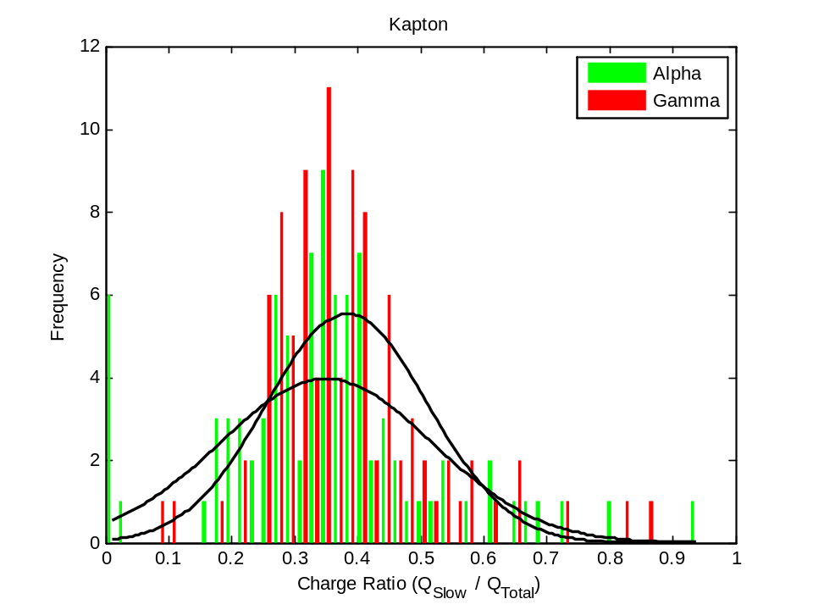
Figure 52 - Charge Ratio of Kapton
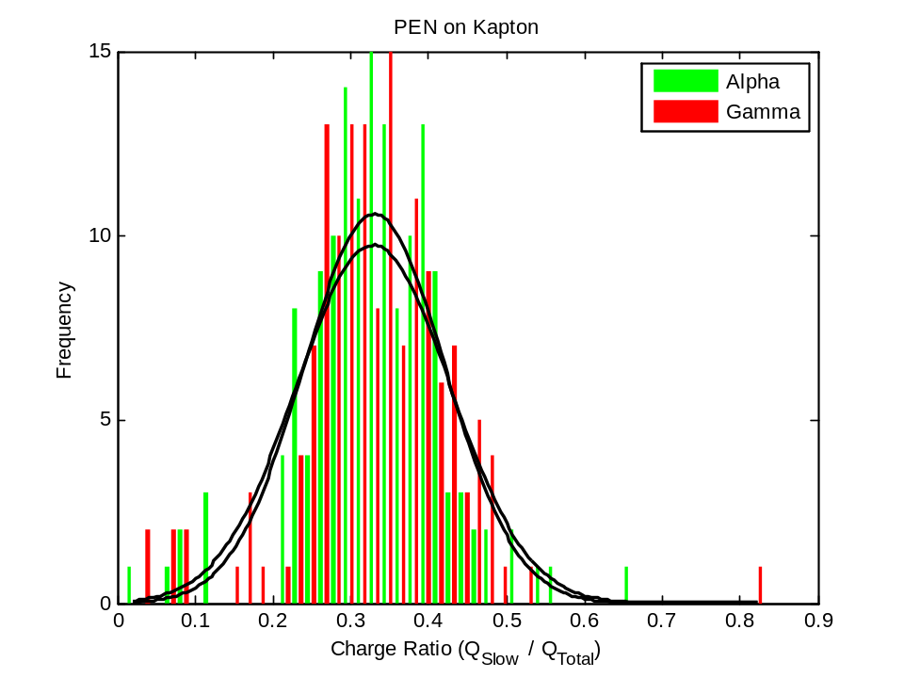
Figure 53 - PEN mounted on Kapton
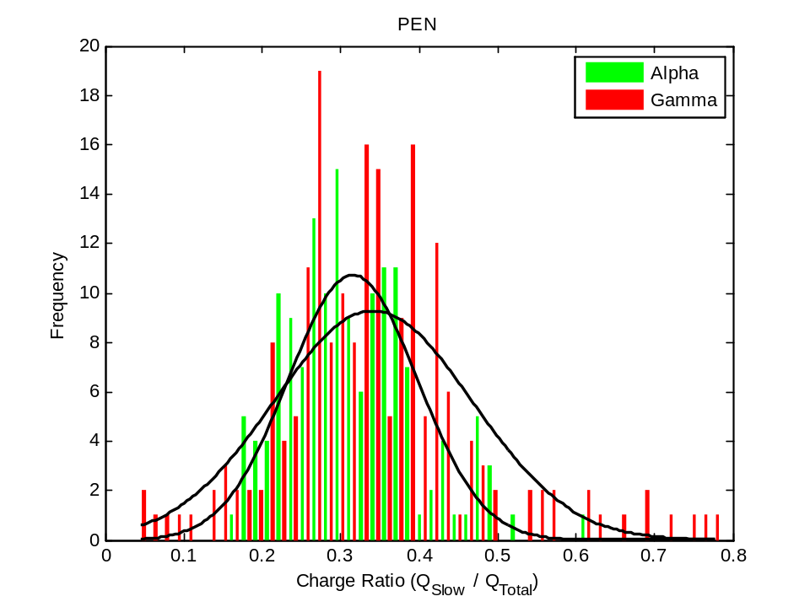
Figure 54 - PEN (not mounted on anything)
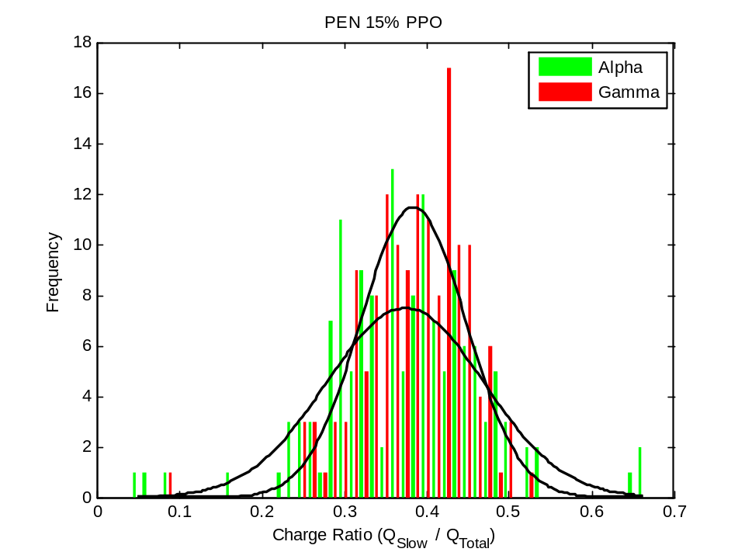
Figure 55 - PEN with 15% PPO mounted on Kapton
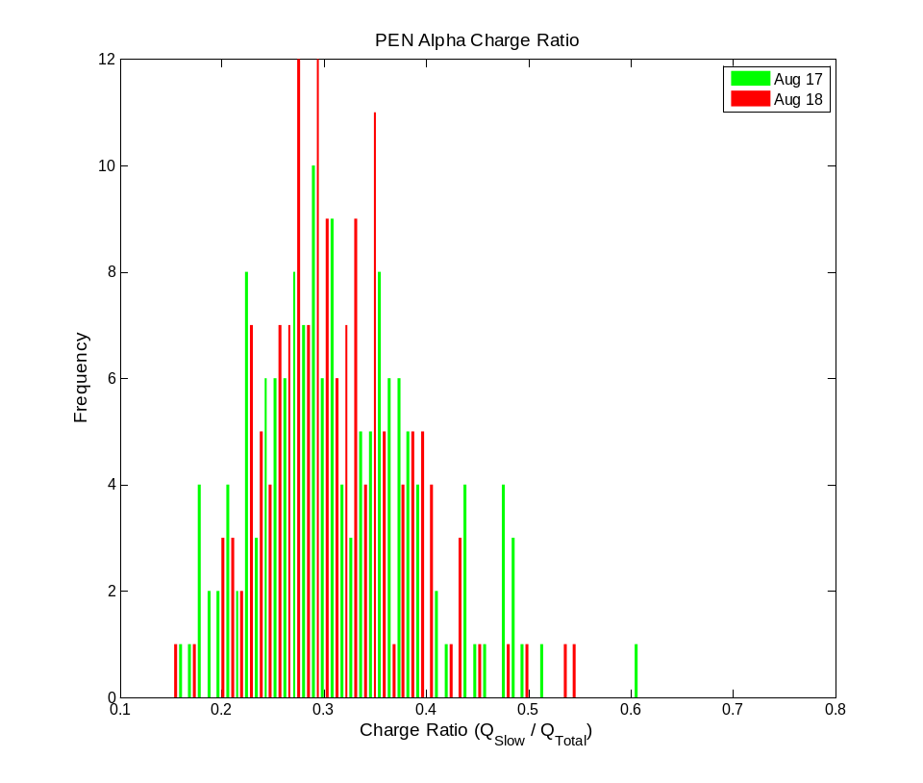

Conclusions
This work focused on designing a framework for determining replacement detector technologies for ³He based radiation portal monitor systems. In order to accomplish this protocols were developed for making repeatable measurements of a film’s neutron and gamma spectra. This was assisted by the fabrication of a neutron irradiator that results in the effective measurement of neutrons along with a gamma irradiator from a ⁶⁰Co source that produces a 10 mR/hr field necessary in order to determine if a film will meet the intrinsic gamma efficiency. Composite polymeric detectors where fabricated and their performance was characterized. Based on those measurements a replacement detector design was proposed and modeled in MCNPX. Optimization was performed on the MCNPX model of a single film system, but the low neutron count rate suggested that a multi-film system would be better suited for meeting the DHS-DNDO requirements. A small (four layer) multi-film system was tested for its gamma discrimination and neutronic properties, and these results where generalized to a multi-film (120 layers) MCNPX model. Basic optimization was performed on this model. If the light can be collected a multi-film system could be an alternative neutron detector. The following sections provide more depth to the topics mentioned above.

Measurement Protocols and Data Analysis
A protocol has been established that allows for repeatable measurements to be made. It includes:
- verification of the instrument gains,
- measurements of an alpha and beta spectra,
- neutron performance,
- and gamma spectrum in a 10 mR/hr field.
The light yield and alpha over beta ratio are then calculated, as well as the pulse height deficit. Finally, the gamma spectra is summed a function of mathematical lower level discriminator (MLLD) and normalized by the incident flux. The MLLD for an intrinsic efficiency of one in a million is determined, and then the neutron count rate above this value is computed.

Modeling Ability
Detectors materials are then modeled in a geometry that replicates the DHS/DNDO test criteria; namely a 1 ng ²⁵²Cf source surrounded by 0.5 cm of lead and 2.5 cm of HDPE, intersecting the detector at its midpoint. The interaction rate of the (n,triton) is computed in the MCNPX model, and this interaction rate is scaled by the fraction of counts that are above the MLLD determined from the measured neutron and gamma spectra. When possible these models have been validated by measurements in the lab to agreement within 15% for the neutron interactions, and 30% for the gamma interactions. This allows for the determination if a detector design will meet the DHS/DNDO criteria, purely on interaction rates.

Detector Design
A detector has been designed in which there would be enough neutronics interactions to pass the criteria set forth by the DHS/DNDO. This design consists of a layered polymeric film (either PEN or PS). For the PEN film the count rate would be around 6.1 cps per ng ²⁵²Cf, and for the 30% LiF PS film the count rate was 3.4 cps per ng ²⁵²Cf. The PS films where modeled rotated 90 degrees for easier light collection, but the count rate dropped 9% to 3.1 per ng ²⁵²Cf. The increase light collection, however, may still make this an option.

Future Work
Future modeling work can be completed on optimizing the MCNPX model. Different geometries (such as a wrapped cylinder) could be explored, as well as optimizing the amount of material by increasing the surface area of the detector while decreasing the depth in order to avoid the low detection per volume that occurs past 5 cm in the detector.
There is no assurance that the detectors designed based on interaction rate would be feasible to construct; due to their low light output and opaqueness collecting the light from scintillation events would be extremely difficult. Light transport modeling (possibly with Geant4) would provide a way to improve the design to insure adequate light collection for a signal. Advanced modeling could also provide insights into the nature of the secondary electrons. This could lead to detectors designed with an absorption center (such as a high light yield crystal) surrounding by a non-scintillating matrix (example is LYB in PMMA), or perhaps the optimal size of the LiF particles.

Bibliography
[1] R. T. Kouzes, J. H. Ely, L. E. Erikson, W. J. Kernan, A. T. Lintereur, E. R. Siciliano, D. L. Stephens, D. C. Stromswold, R. M. Van Ginhoven, and M. L. Woodring, “Neutron detection alternatives to 3He for national security applications,” Nuclear Instruments and Methods in Physics Research Section A: Accelerators, Spectrometers, Detectors and Associated Equipment, vol. 623, no. 3, pp. 1035–1045, Nov. 2010.
[2] G. F. Knoll, Radiation Detection and Measurement. New York: Wiley, 2009.
[3] R. Kouzes, J. Ely, A. Lintereur, and D. Stephens, “Neutron Detector Gamma Insenstivity Criteria,” PNNL 18903, 1999.
[4] L. Swiderski, M. Moszynski, D. Wolski, J. Iwanowska, T. Szczesniak, G. Pausch, C. Plettner, J. Stein, P. Schotanus, C. Hurlbut, and J. Szabelski, “Comparison of Neutron Detection Efficiency of a He-3 Counter and a Boron-10 Loaded Liquid Scintillator,” IEEE Transactions on Nuclear Science, vol. 57, no. 5, pp. 2857–2861, Oct. 2010.
[5] H. Rahmanian and J. I. W. Watterson, “Optimisation of light output from zinc sulphide scintillators for fast neutron radiography,” Nuclear Instruments and Methods in Physics Research Section B: Beam Interactions with Materials and Atoms, vol. 139, no. 1–4, pp. 466–470, 1998.
[6] R. T. Kouzes, “Detecting Illicit Nuclear Materials.,” American Scientist, vol. 93, no. 5, p. 422, Sep. 2005.
[7] NIST and NCNR, “Neutron scattering lengths and cross sections.” [Online]. Available: http://www.ncnr.nist.gov/resources/n-lengths/. [Accessed: 06-Apr-2012].
[8] “Cross Section Evaluation Working Group (ENDF/B-VII),” National Nuclear Data Center.
[9] Saint Gobain, “Lithium Glass Scintillators,” Glass Scintillator Data Sheet, 2008. [Online]. Available: http://www.detectors.saint-gobain.com/Lithium-Glass-Scintillator.aspx. [Accessed: 26-Jan-2012].
[10] D. B. Pelowitz, “MCNPX User’s Manual 2.6.0,” Los Alamos National Laboratory., vol. LA-CP-07–1473.
[11] R. Kouzes, J. Ely, L. Erikson, W. Kernan, A. Lintereur, E. Siciliano, D. Stromswold, and M. Woodring, “Alternative Neutron Detection Summary,” PNNL 19311, Apr. 2010.
[12] N. Zaitseva, B. L. Rupert, I. PaweŁczak, A. Glenn, H. P. Martinez, L. Carman, M. Faust, N. Cherepy, and S. Payne, “Plastic scintillators with efficient neutron/gamma pulse shape discrimination,” Nuclear Instruments and Methods in Physics Research Section A: Accelerators, Spectrometers, Detectors and Associated Equipment, vol. 668, pp. 88–93, Mar. 2012.
[13] N. Tsoulfanidis, Measurment and Detection of Radiation. Taylor and Francis.
[14] “Compton scattering - Wikipedia, the free encyclopedia.” [Online]. Available: http://en.wikipedia.org/wiki/Compton_scattering. [Accessed: 20-Feb-2012].
[15] J. E. Turner, Atoms, Radiation, and Radiation Protection. Hoboken, NJ, USA: Wiley-VCH, 2008.

Appendix A
While efforts are made to ensure that the instrument gains are stable, the effects of varying amounts of optical grease and Teflon tape where investigated by completing experiments in which the user applied an extreme amount and then by investigating the repeatability of random trials. For the first case, where the user applied an extreme amount, the spectra where recorded from a ¹³⁷Cs source was applied to a GS20 glass detector. The spectra endpoint (after 600s of counting time was recorded), showing that Teflon tape increases both the light output and the counts, while optical grease has a large effect on the light output and little effect on the count rate, as long as it is applied in a manner such that good optical coupling is achieved. It is then desirable to apply as little amount of optical grease as necessary in order to avoid shifting the light output through optical coupling.

Table 22 - Measurement repeatability. Effects of optical grease and Teflon tape.
Configuration | Spectra Endpoint  (¹³⁷Cs) | Total Counts (600s)
No optical grease, Teflon tape applied to entire detector | 1,930 | 1,140,000
No optical grease, Teflon tape applied only to top of detector (side’s free) | 1,370 | 1,160,000
No optical grease, no Teflon tape | 1,120 | 1,770,000
Copious amounts of optical grease with Teflon tape | 2,710 | 860,000
Spare application of optical grease with Teflon tape | 1,550 | 1,020,000
Copious amounts of optical grease, no Teflon tape | 1,720 | 1,050,000
Poor optical coupling, air bubbles visible between PMT and detector | 1,200 | 710,000
Good optical coupling | 1,830 | 1,070,000

GS20 Data
The repeatability of random trials was investigated by choosing six measurements of GS20 on different days and computing the derived parameters. The spectra are shown below (Figure 56 Figure 57).
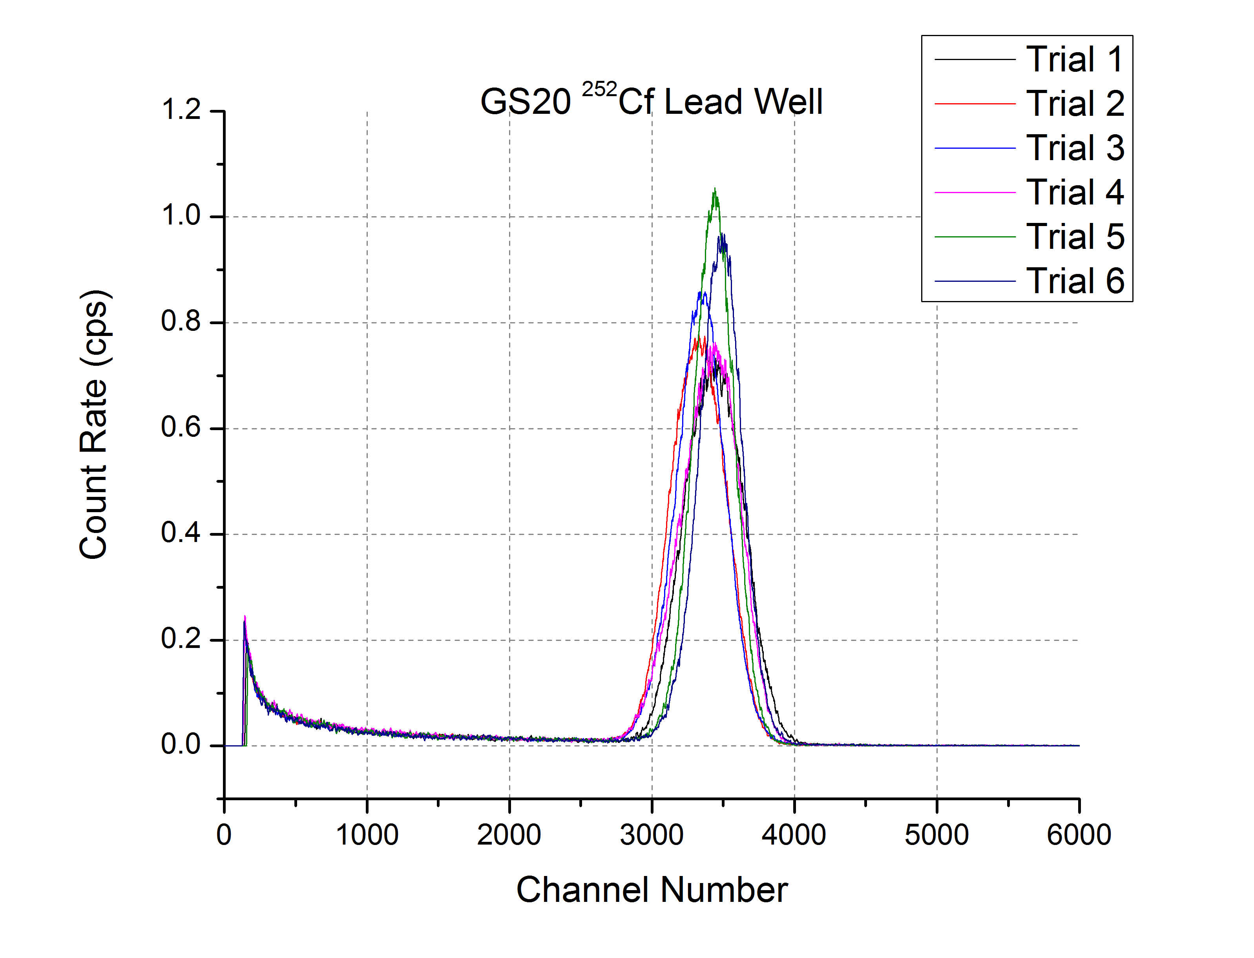
Figure 56 - GS20 repeated neutron spectra from the lead well of the irradiator

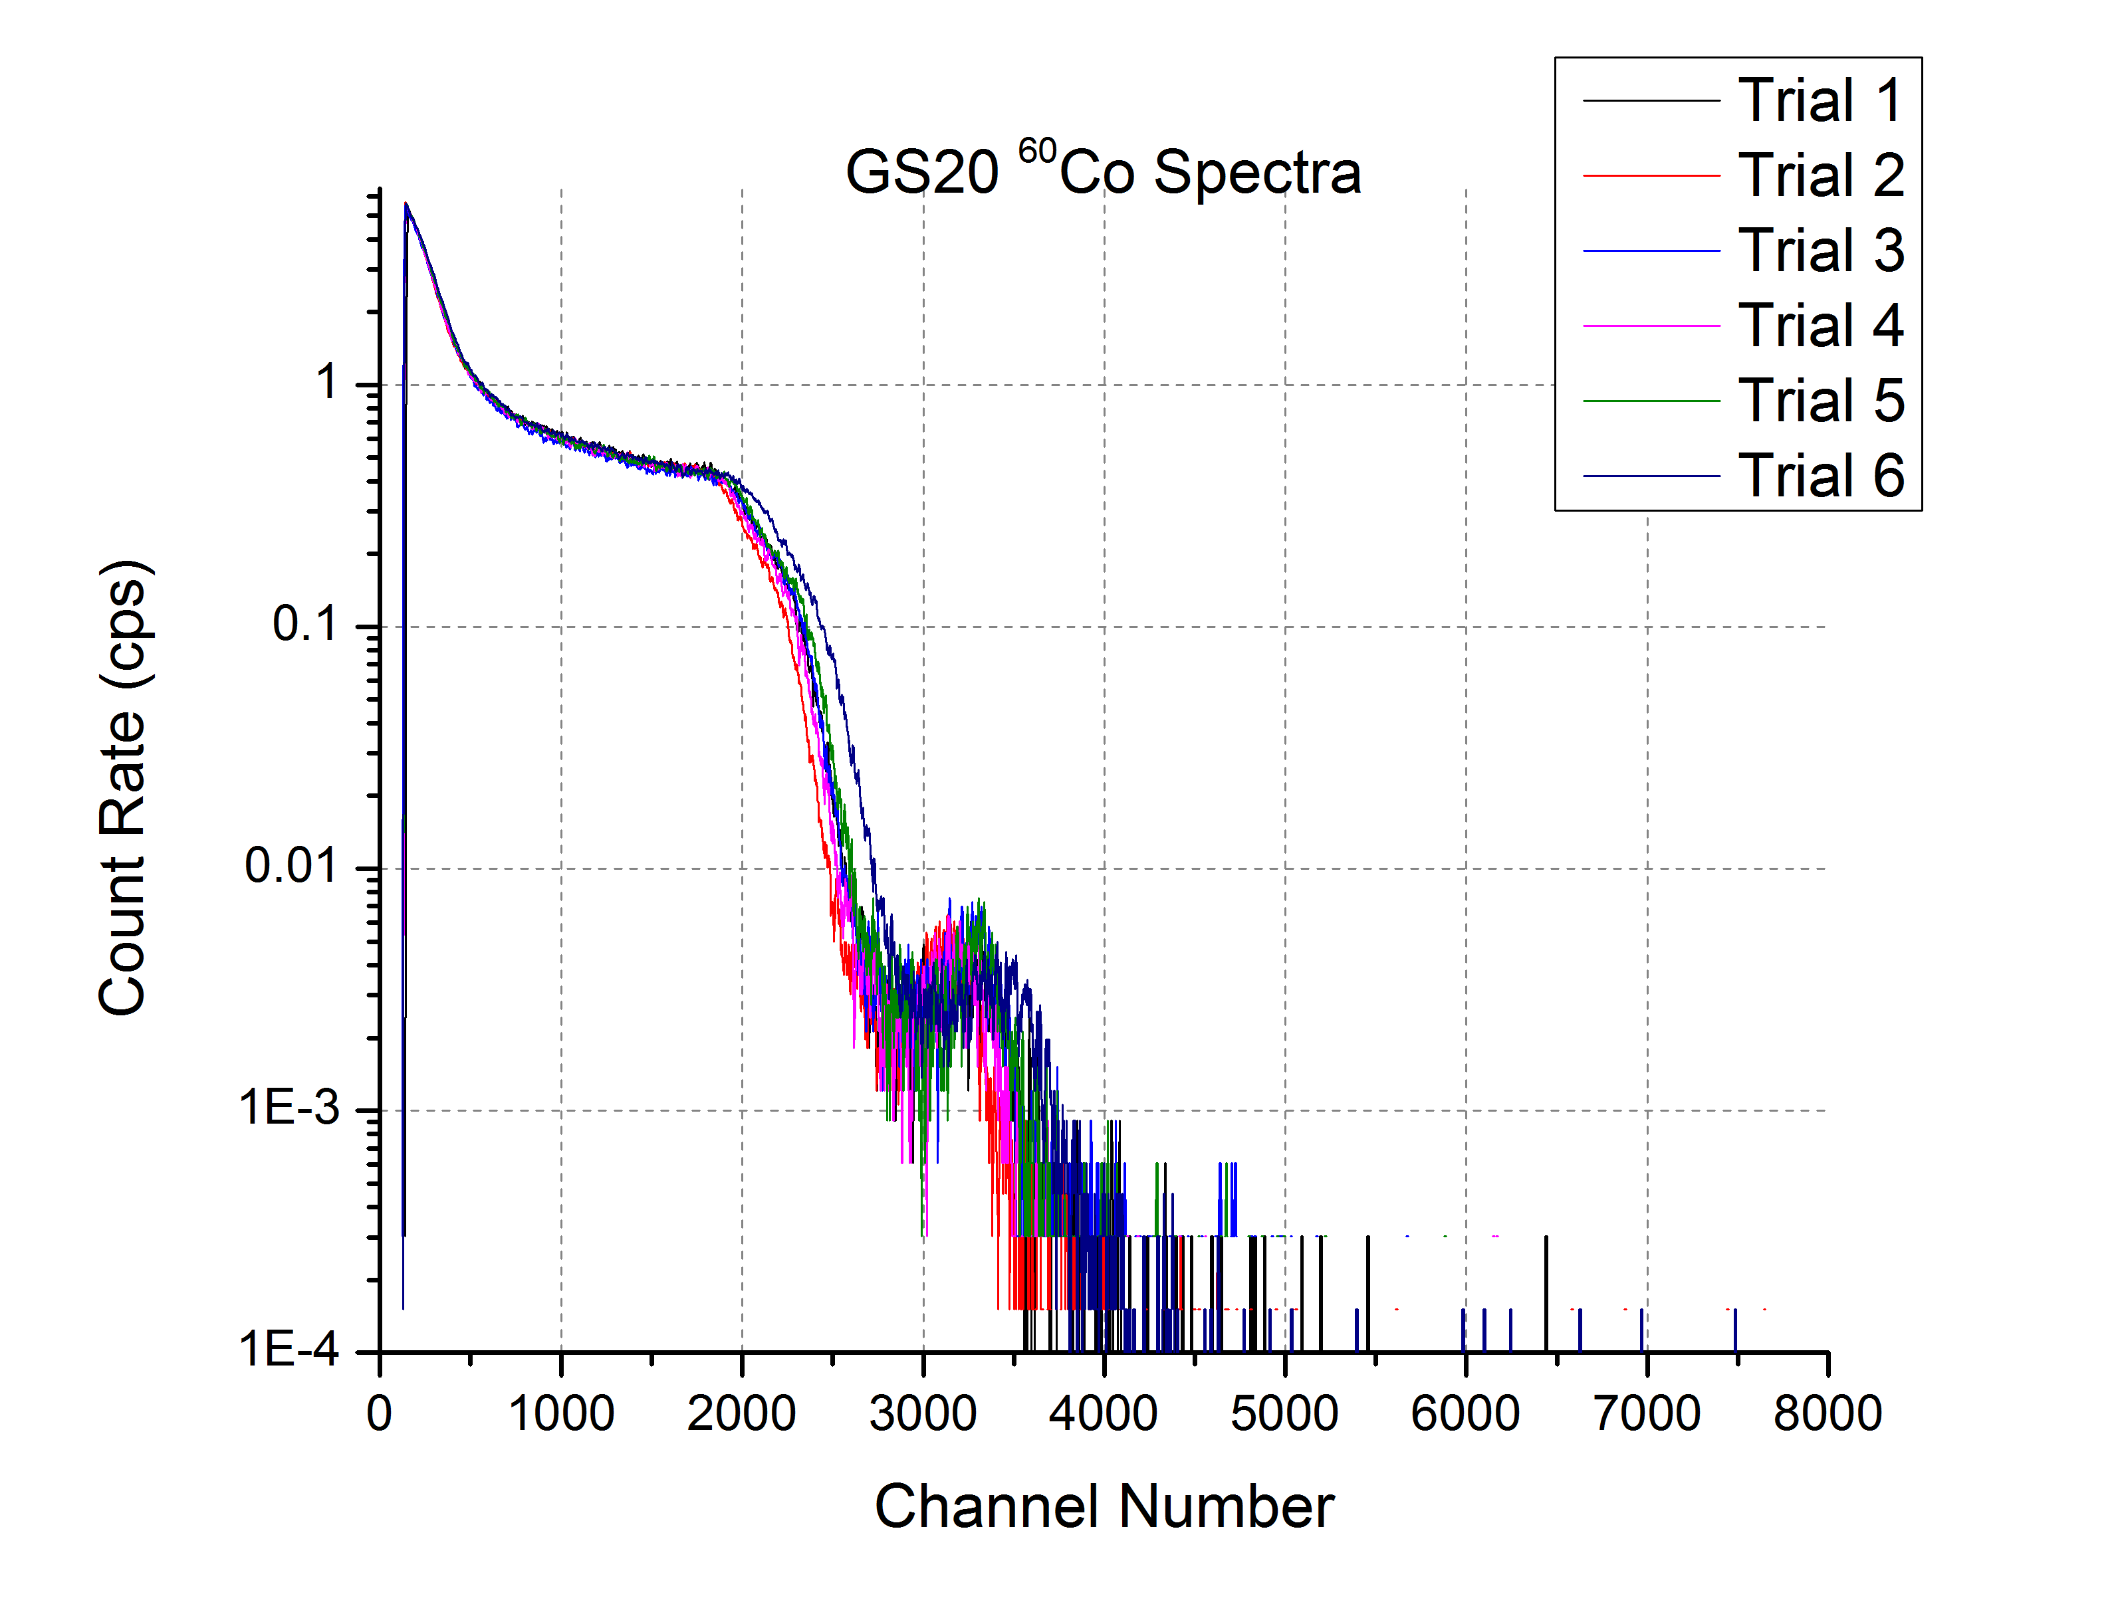
Figure 57 - GS20 repeated gamma spectra from a ⁶⁰Co source
The pulse height deficit (and corresponding light yield per neutron) where calculated for various GS20 measurements. The standard deviation was computed, and found to be at most 3% of the average. While the peak position was set to occur at 3,460 channels, there seems to be a slight discrepancy in where the final peak location is. This probably arises from the error associated in choosing where the peak occurs in noisy spectra. Published values of the light yield per neutron of GS20 range from 6,000 Photons per MeV to 7,000 Photons per MeV [9].

Table 23 - Variation of Derived Quantities. The error (computed by the standard deviation) is at most 3% of average value.
 | Average Neutron (Pb Spectra) | Neutron Peak (Pb Spectra) | Average Gamma | Average Gamma (above channel 750) | Compton Edge | Pulse Height Deficit | Light Yield per Neutron
Trial 1 | 3,020 | 3,476 | 754 | 1,406 | 2,188 | 1,311 | 6,266
Trial 2 | 2,909 | 3,334 | 708 | 1,377 | 2,071 | 1,328 | 6,350
Trial 3 | 2,922 | 3,380 | 725 | 1,418 | 2,117 | 1,317 | 6,298
Trial 4 | 2,985 | 3,411 | 723 | 1,397 | 2,115 | 1,331 | 6,361
Trial 5 | 2,958 | 3,454 | 735 | 1,422 | 2,186 | 1,304 | 6,232
Trial 6 | 3,003 | 3,451 | 758 | 1,455 | 2,268 | 1,256 | 6,002
Average | 2,966 ± 41 | 3,418 ± 49 | 734 ± 18 | 1,413± 24 | 2,158 ± 64 | 1,308 ± 25 | 6,252 ± 120
$$σ/μ$$ | 1.4% | 1.4% | 2.4% | 1.7% | 3.0% | 1.9% | 1.9%

The position of the gamma MLLD necessary to various achieve $ϵ_{int,γ}$ was calculated. The intrinsic efficiency is very stable (varying within 3% of the average value) until a very low intrinsic efficiency is approached, at which point standard deviation becomes 7.4% of the average value.

Table 24 - Gamma Intrinsic Efficiency for GS20. Each column is a different intrinsic efficiency setting, and the rows below are at which channel the GS20 achieves that setting.
 | 10⁻³ | 10⁻⁴ | 10⁻⁵ | 10⁻⁶
Trial 1 | 2,049 | 2,427 | 3,336 | 4,043
Trial 2 | 1,975 | 2,342 | 3,215 | 3,778
Trial 3 | 2,056 | 2,436 | 3,358 | 4,540
Trial 4 | 2,020 | 2,393 | 3,262 | 3,690
Trial 5 | 2,079 | 2,464 | 3,375 | 4,023
Trial 6 | 2,164 | 2,577 | 3,507 | 4,051
Average ($μ±σ)$ | 2,057 ± 63 | 2,440 ± 79 | 3,342 ± 101 | 4,021 ± 296
$$σ/μ$$ | 3.1% | 3.2% | 3.0% | 7.4%
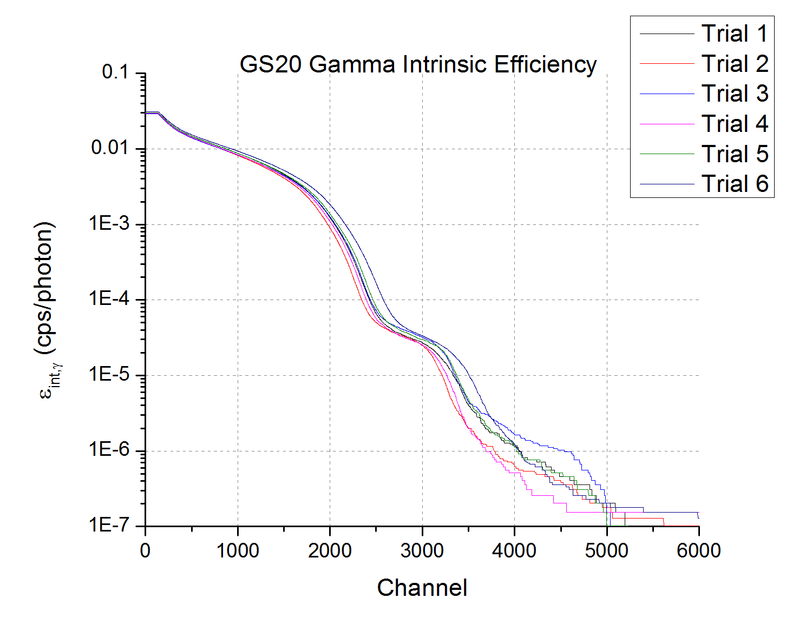
Figure 58 – Calculated Intrinsic Efficiencies for GS20

PEN Data
A stretched PEN film, shown below, was measured three separate times by two operators (Matthew Urffer and Rohit Uppal) in order to determine the repeatability of thin film measurements. Each of the trials were measured at 50 gain, with the voltage determined by setting the peak position of GS20.
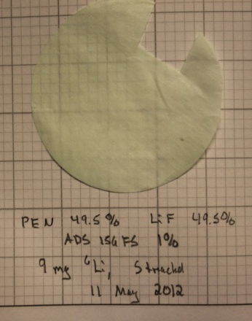
Figure 59 - Measured PEN Film
In Figure 59 and Figure 60,where the data has been rebinned in 25 bin increments, it is immediately evident that the neutron spectra have slightly different shapes, while the small gain variations seen in the GS20 gamma spectra (shifts in the photo-peak location) are more apparent. This suggest that a thin film, with smaller counts and lower energy resolution, are more susceptible to small variations in gain and optical mounting.
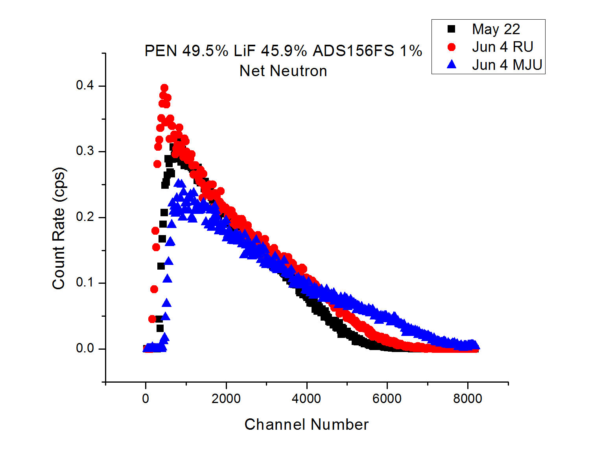
Figure 60 – Net neutron spectra of repeated PEN films.
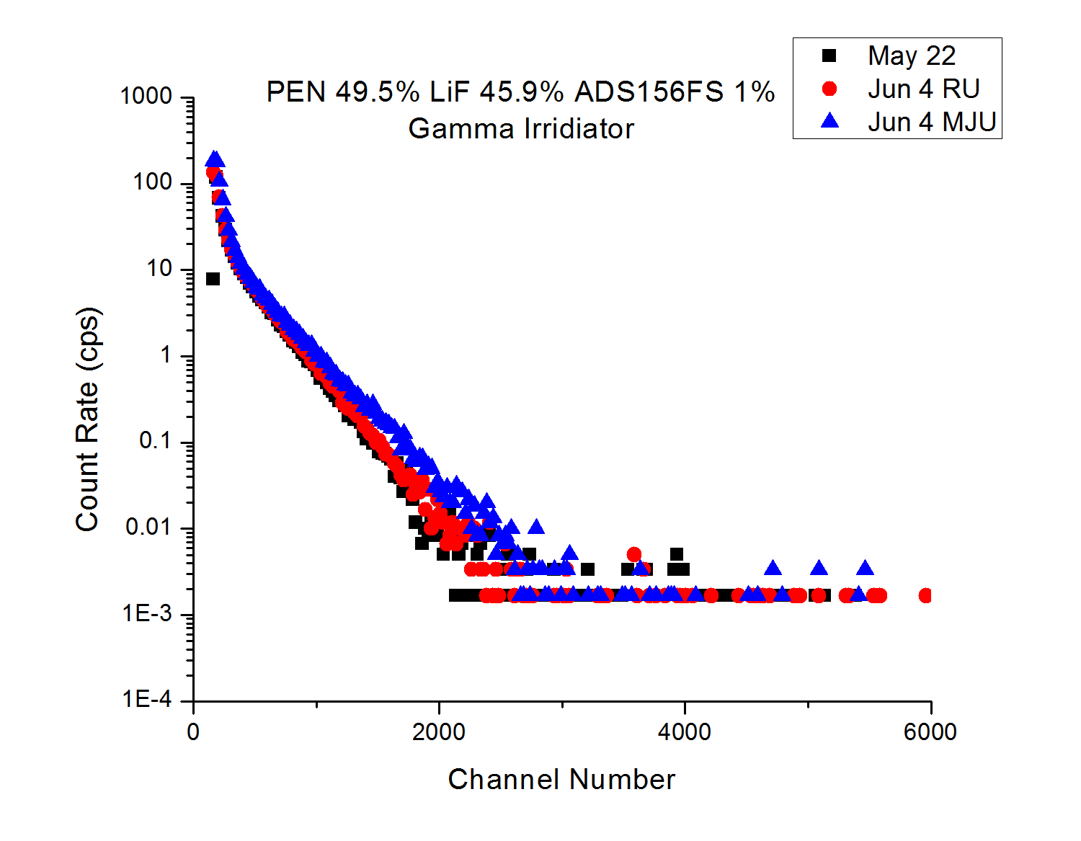

Figure 61 - Comparison of Gamma Spectra for repeated films.

The spectra averages, count rate, and MLLD channels were computed and summarized in Table 25. The third trial had a much higher average neutron spectra had a total count rate that was similar to Trial 1 (in fact they differed by 0.068 cps). The source of the discrepancy in the fraction of neutron counts above the gamma discriminator can be found by looking at the neutron integral spectra (Figure 63). While the spectra weighted average for the gamma’s are similar (and the gamma LLD’s fall within $2σ$ of each other), the considerable difference in the neutron count rate above the gamma LLD greatly impacted the fraction of neutron counts above the gamma LLD. Values reported in parentheses are $± 2σ$, which is roughly a 95% confidence interval ($1.96σ$ is 95% CI for a normal distribution).

Table 25 - Comparison of three different measurements of a stretched PEN film (49.5% LiF, 1% ADS156FS).
 | Gamma Spectra Average  (channel number) | Neutron Spectra Average  (channel number) | Total Neutron Count Rate  (cps) | Gamma LLD such that $ϵ_{int,γ}≤{10}^{-6}$  (channel number) | Neutron Count rate above $ϵ_{int,γ}≤{10}^{-6}$  (cps) | Fraction of neutron counts above $ϵ_{int,γ}≤{10}^{-6}$
Trial 1  (May 22) | 290 | 2,039 | 30.4 ± 0.02 | 3,192  (2,706 – 3,517) | 5.7  (8.5 - 4.2) | 0.19  (0.28 - 0.14)
Trial 2  (Jun 4 RU) | 259 | 2,095 | 37.1 ± 0.05 | 2,741  (2,500 – 3,561) | 11.3  (13 - 6.5) | 0.30  (0.35 - 0.17)
Trial 3  (Jun 4 MJU) | 252 | 2,782 | 30.4 ± 0.02 | 2,810  (2,682 – 3,031) | 12.8  (13.6 - 11.6) | 0.42  (0.45 - 0.38)

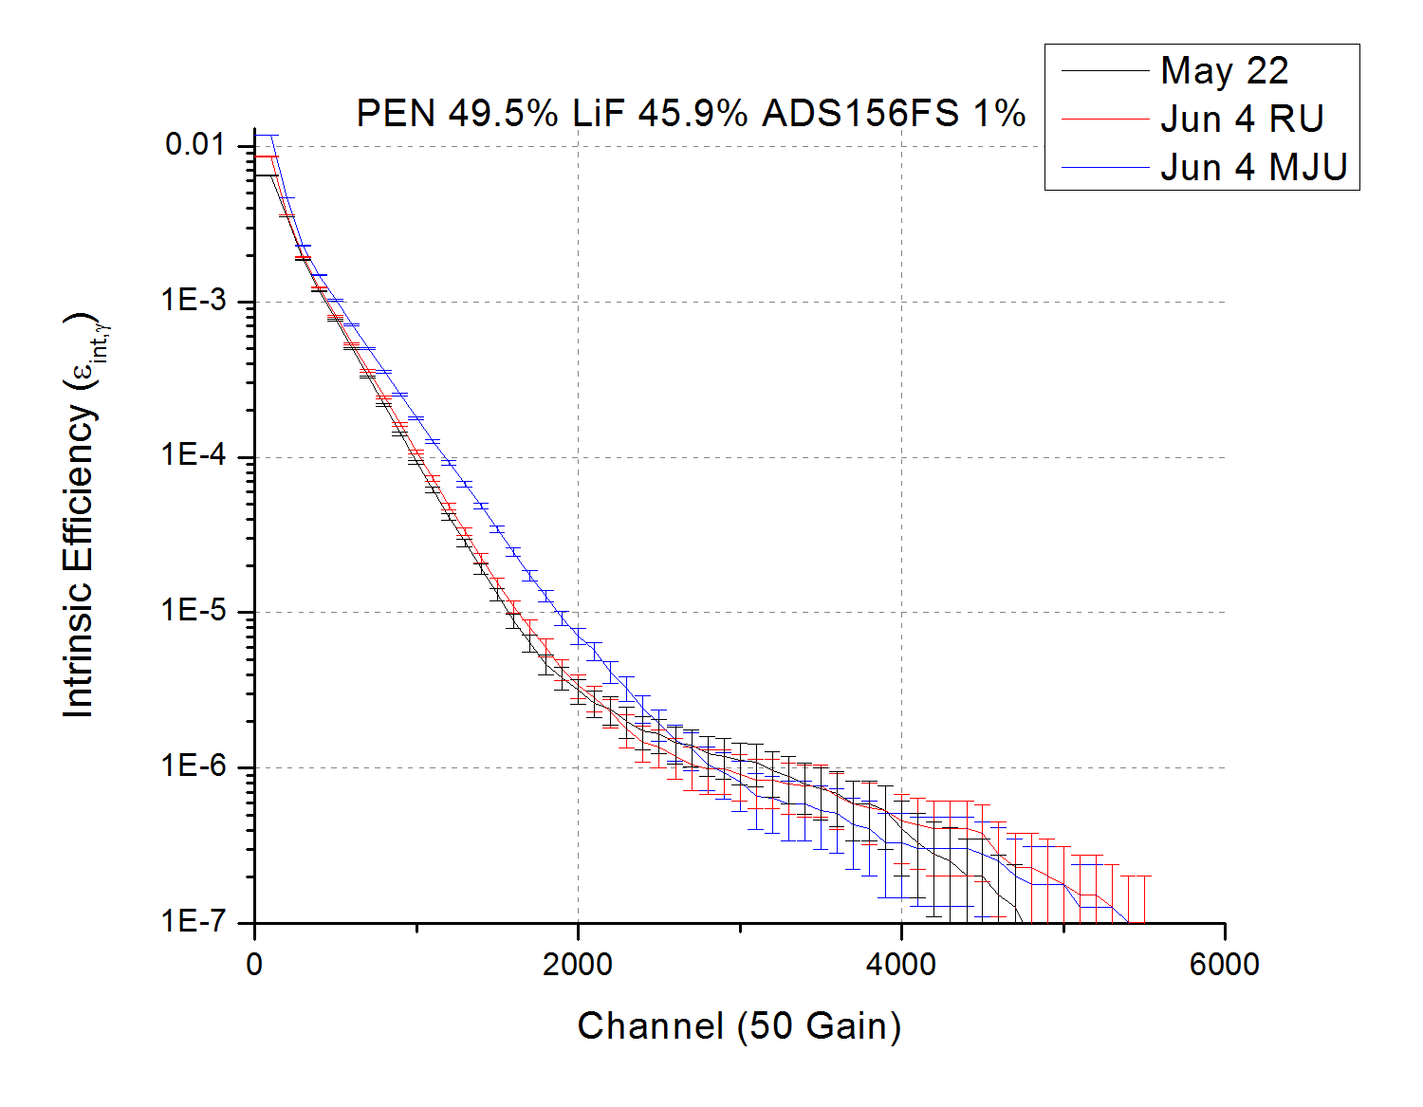
Figure 62 – Repeatability of gamma intrinsic efficiency for a stretched PEN film.
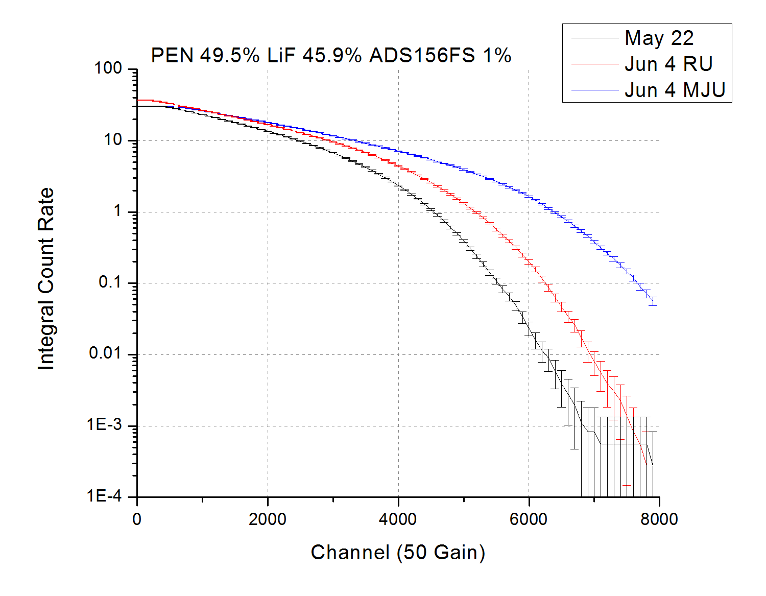
Figure 63 - Neutron Integral Count Rate as a function of channel number for a streached PEN film

Operating Detector Configuration
The response was measured of the film in the lead well can gamma irradiator physically setting the gamma LLD to be at 999 channels and 1,801 channels. The results of these trials (where only the lead well neutron response and gamma response was measured) is summarized below.
Table 26 - Repeatability of a sample setting the LLD to be 1,000 channels and 1,800 channels. The highest the gamma LLD can be set is 1,900 channels. The total neutron count rate is not reported (nor is the fraction) because of the LLD setting.
Physical LLD | Gamma LLD such that $ϵ_{int,γ}≤{10}^{-6}$  (channel number) | Neutron Count rate above $ϵ_{int,γ}≤{10}^{-6}$  (cps)
1,801 | 2,386  (2,103 – 2,721) | 12.37  (14.62 - 10.15)
999 | 2,495  (2,209 – 2,694) | 9.97  (12.01 - 8.75)
Trial 1  (May 22) | 3,192  (2,706 – 3,517) | 5.94  (8.8 - 4.3)
Trial 2  (Jun 4 RU) | 2,741  (2,500 – 3,561) | 11.61  (13.3 - 6.6)
Trial 3  (Jun 4 MJU) | 2,810  (2,682 – 3,031) | 13.28  (14.1 - 12)

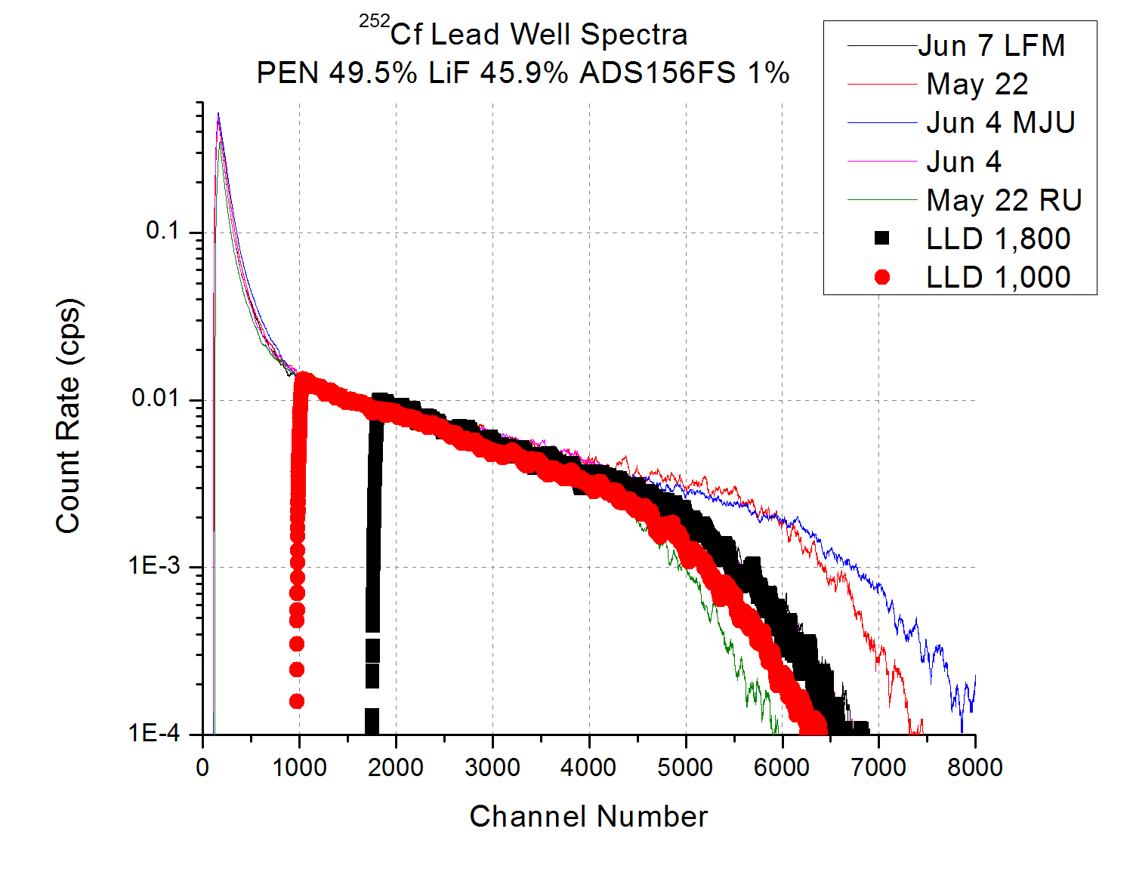
Figure 64 - Comparison of the Lead Neutron Spectra. Spectra recorded at a higher LLD did not impact where the spectra ended.
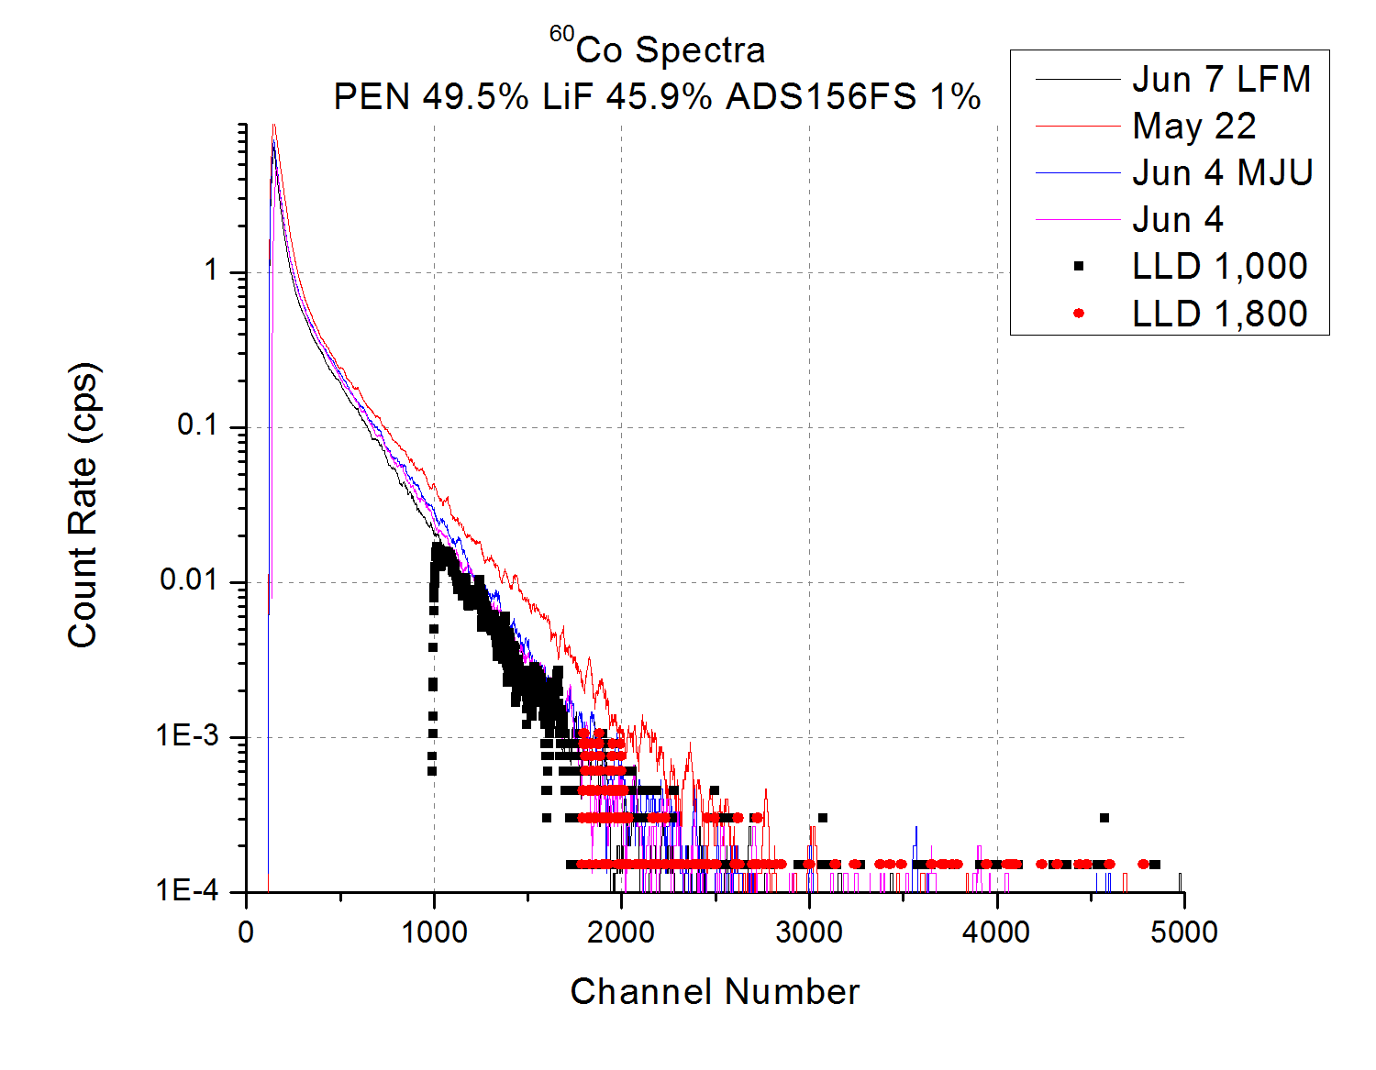
Figure 65 - Comparison of the Gamma Spectra of the films. One spectra (May 22) is much higher than the rest, which results in a higher value for the gamma LLD, and is reflected in a lower count rate above the gamma LLD.
In comparison between the lead well only and the net spectra it is observed that the neutron count rate above the gamma LLD does not change appreciably, due the cadmium well contributing to very few counts at the higher energies. It is the much higher total neutron count rate in the lead well the shifts the fraction of neutron counts below the gamma LLD down for the lead well compared to the subtracted thermal spectra.

Table 27 - Comparison between neutron performance utilizing the subtraction and the lead spectra.
 | Lead Well Only |  |  | Thermal Spectra (Subtraction)
 | Total Neutron Count Rate  (cps) | Neutron Count rate above $ϵ_{int,γ}≤{10}^{-6}$  (cps) | Fraction of neutron counts above $ϵ_{int,γ}≤{10}^{-6}$ | Total Neutron Count Rate  (cps) | Neutron Count rate above $ϵ_{int,γ}≤{10}^{-6}$  (cps) | Fraction of neutron counts above $ϵ_{int,γ}≤{10}^{-6}$
Trial 1  (May 22) | 77.9 ± 0.1 | 5.94  (8.8 - 4.3) | 0.076  (0.11 - 0.06) | 30.4 ± 0.02 | 5.7  (8.5 - 4.2) | 0.19  (0.28 - 0.14)
Trial 2  (Jun 4 RU) | 100.8 ± 0.2 | 11.61  (13.3 - 6.6) | 0.115  (0.13 - 0.07) | 37.1 ± 0.05 | 11.3  (13 - 6.5) | 0.30  (0.35 - 0.17)
Trial 3  (Jun 4 MJU) | 113.3 ± 0.2 | 13.28  (14.1 - 12) | 0.117  (0.12 - 0.11) | 30.4 ± 0.02 | 12.8  (13.6 - 11.6) | 0.42  (0.45 - 0.38)

Minimum Detectable Activity
The minimum detectable activity is the level at which it the source spectra has fallen statistically below the background (with a certain confidence). In the following figure (Figure 66) the top curve represents the distribution of net counts when only background is present (distribution is centered around zero), and the bottom curve when the source is present. The point at which the source spectra is statistically different from the background (to within confidence alpha and beta) is shown as the CDL.

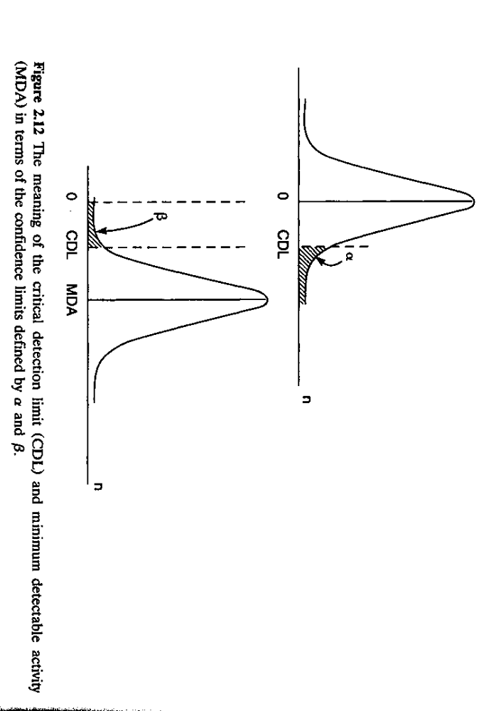
Figure 66 - L_{C} (labeled as CDL) with the confidence limits defined by alpha and beta. Figure from [13].
If $N_{s}=N_{T}-N_{B}$, where $N_{s}$ is the net spectra from subtraction, $N_{T}$ is the gross spectra (source and background), and $N_{B}$ is the background spectra. Assuming that the errors are independent, propagation of variance yields $σ_{N_{s}}^{2}=σ_{N_{T}}^{2}+σ_{N_{B}}^{2}$. Throughout this derivation $k$ will be used to represent the area under the normal distribution, which is representative of the confidences limits. A table of $k$ values is reproduced in Table 28.

Table 28 - Confidence limit and k-values of the normal distribution. Reproduced from [13].
$$\#σ (k)$$ | $$p\left(x>x_{a}\right)$$ | Confidence Limits
0.000 | 0.500 | 50.0
1.000 | 0.159 | 84.1
1.285 | 0.100 | 90.0
1.500 | 0.067 | 93.3
1.650 | 0.050 | 95.0
2.000 | 0.023 | 97.7
2.500 | 0.006 | 99.4
3.000 | 0.001 | 99.9

The analysis of the minimum detectable activity can be broken into two cases:

Case I: No Activity Present
If no activity is present then $N_{T}≈N_{B}$which implies $N_{S}≈0$. Then the error on $N_{S}$ is then $σ_{N_{S}}^{2}=2σ_{N_{B}}^{2}$. Setting a critical count level $L_{C}=k\sqrt{2}σ_{N_{B}}$ determines the lower level at which it is possible to be certain of a false positive rate. If $N_{s}<L_{c}$, then it is possible to say (with a false positive rate given by $k$) that no activity is present.

Case II: Activity is Present
Let $N_{D}$ represent the minimum amount of $N_{S}$ such that the false-negative rate is below a certain value (determined by $k$). It is then possible to relate $N_{D}$ to the error in the background count rate:
$$N_{D}=L_{C}+kσ_{N_{D}}$$
It is possible to relate $σ_{N_{D}}$to $σ_{N_{B}}$by $σ_{N_{D}}=\sqrt{2N_{B}+N_{D}}$. If $N_{D}≪N_{B}$ than an expansion can be carried out to equate $σ_{N_{D}}≈\sqrt{2}σ_{N_{b}}+k$.

The analysis was carried out in both cases for a the stretched PEN film analyzed in the measurement repeatability section. The following plot (Figure 67) shows the $N_{D}$and $L_{C}$ levels as a function of channel for the stretched PEN film. After channel 4,626 the net spectra falls below N_{D}, at which point the false negative rate is no longer assured to be less than 5%. It is then assured that the gamma counts in the tail end of the spectra are statistically significant.
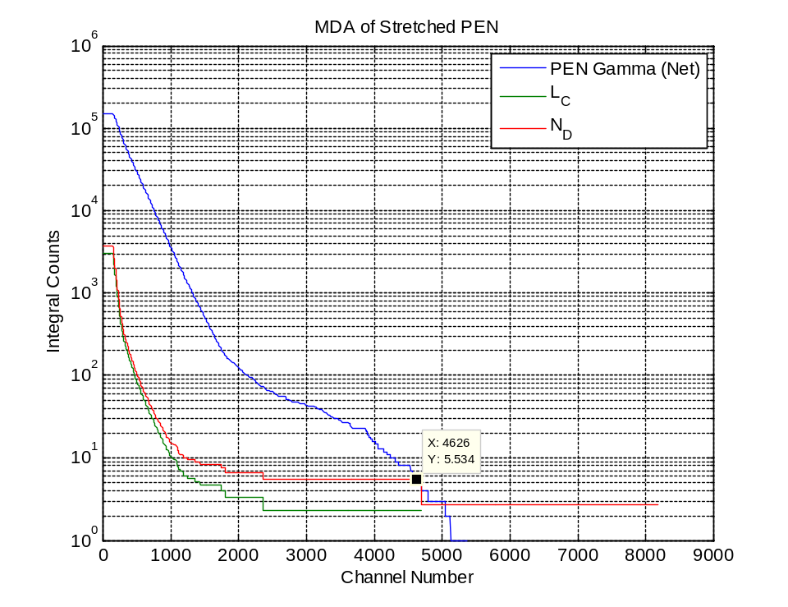
Figure 67 - Minimum Detectable Activity of Stretched PEN (49.5% LiF, 1% ADS156FS).
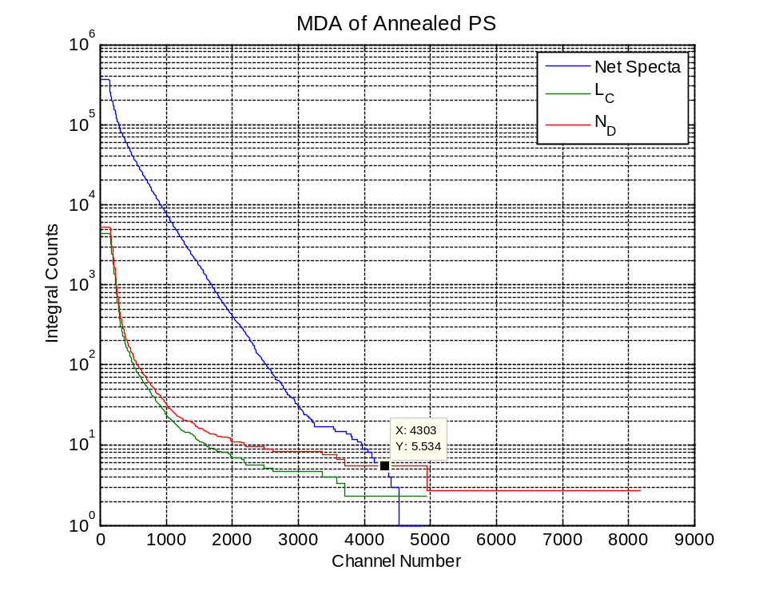
Figure 68- MDA of Annealed PS (9.66% LiF, 4.58% PPO/POPOP 26um) Film. The L_{C} and N_{D} have different shapes from the PEN because the PEN was measured without the acrylic disc in the gamma irradiator.

Appendix B

MCNPX Inputs Decks
Four MCNPX input decks for the measured material properties are presented here, along with two of the input decks used to simulate a polymeric film DHS-DNDO detector.

Miller_Config_GS20.mcnp
Miller's Poly Box with 0.59 ug (5.9E-7 gram) Cf-252 source
c ************************* Cell Cards ************************
c ------- Combined all of Martin's HDPE Cells into one --------
100 456 -0.93 -1 :-2 :-3 :-4 :-5 :-6 :-6 :-7 :-8 :-9 $ HDPE Sheilding
:-10 :-11 :-12 :-13 :-14 :-15 :-16 :-17 :-18
c ------- Creating a source universe --------------------------
200 0 -200 fill=3
201 1 -15.1 -210 u=3 $ Cf252 Spherical Source
202 488 -7.92 (-206 :-205 )210 u=3 $ Stainless Steel 316 Around Source
203 406 -11.35 -204 205 u=3 $ Lead Pig
204 456 -0.93 (-202 :-203 ) 204 u=3 $ HDPE around source
205 204 -0.001225 (210 202 203 204 ) u=3 $ Air until universe boundary
c ----------- Lead Detector Well ---------------------------
300 0 -302 #610 trcl=1 fill=1
302 204 -0.001225 -300 u=1 $ air
303 2 -1.18 -301 300 u=1 $ Plastic
304 406 -11.35 301 u=1 $ Lead
c ------------ Cadimium Detector Well ----------------------
400 0 -402 #620 trcl=2 fill=2
402 204 -0.001225 -400 u=2 $ air
403 2 -1.18 -401 400 u=2 $ Plastic
404 318 -8.65 401 u=2 $ cd
c ------------ Lead Well PMT -----------------------------------
610 0 -602 trcl=61 fill=6
c ------------ Cd Well PMT --------------------------------------
620 0 -602 trcl=62 fill=6
c ------------ PMT Subcells -------------------------------------
601 3 -2.5 -500 u=6 $ Detector cell
602 388 -2.23 -601 u=6 $ PMT Glass
603 468 -1.406 603 u=6 $ Plastic
604 4 -8.74 -604 605 u=6 $ Metal
605 204 -0.001225 #602 #601 #603 #604 u=6 $Air
c ------ outside world ----------------------------------------
1000 204 -0.001225 -1000 #100 #200 #300 #400 $ Air inside the world
#610 #620
1001 0 1000 $ Outside world

c ********************* Surface Cards ***************************
c --------------------- Outer HDPE Box --------------------------
1 rpp 5.3975 45.72 0 30.48 0 5.3975 $ Bottom Cente
2 rpp 45.72 51.1175 0 30.48 0 35.56 $ Right Side
3 rpp 0 5.3975 0 30.48 0 35.56 $ Left Side
4 rpp 5.3975 45.72 0 5.3975 5.3975 35.56 $ Front
5 rpp 5.3975 45.72 25.0825 30.48 5.3975 35.56 $ Back
6 rpp 5.3975 25.7175 5.3975 10.795 10.795 35.56 $ Source Cover
7 rpp 5.3975 25.7175 19.685 25.0825 10.795 35.56 $ Source Cover
8 rpp 5.3975 25.7175 10.795 19.685 30.1625 35.56 $ Source Cover
9 rpp 5.3975 25.7175 5.3975 25.0825 5.3975 10.795 $ Source Cover
10 rpp 5.3975 10.795 10.795 19.685 10.795 30.1625 $ Source Cover
11 rpp 20.32 25.7175 10.795 19.685 10.795 30.1625 $ Source Cover
12 rpp 25.7175 36.5125 5.3975 25.0825 5.3975 10.795 $ Detector/Cha
13 rpp 36.5125 39.0525 5.3975 25.0825 5.3975 35.56 $ Wall behind
14 rpp 5.08 22.2251 0 30.48 35.56 40.64 $ Block on top
15 rpp 34.1 51.1175 0 30.48 35.56 38.1 $ Block on top
16 rpp 22.2251 33.9727 0 5.08 35.56 38.1 $ Block on top
17 rpp 22.2251 33.9727 13.97 16.51 35.56 38.1 $ Block on top
18 rpp 22.2251 33.9727 25.4 30.48 35.56 38.1 $ Block on top
c ------------------ Universe for Inner Source Holder and Source
200 rpp 10.795 20.32 10.795 19.685 10.795 30.1625
c ------------------ Inner Source Holder HDPE -------------------
202 rpp 10.795 20.32 10.795 19.685 10.795 15.875 $ Block holdi
203 rpp 10.795 20.32 10.795 19.685 24.13 30.1625 $ Block above
c ----------------- Source Sheilding (Lead) ---------------------
204 rcc 15.5575 15.24 10.795 0 0 13.335 2.54 $ Lead Pig ou
205 rcc 15.5575 15.24 13.305 0 0 9.525 1.27 $ Lead Pig in
206 rcc 15.5575 15.24 13.305 0 0 3.81 0.3175 $ SS 316 Sour
210 s 15.5575 15.24 15.21 2.5914E-04 $ Spherical Point Source
c --------------- Lead Well -------------------------------------
300 rcc 0 0 0.439 0 0 27.726 3.564 $ Inner Well (ID Plastic)
301 rcc 0 0 0.439 0 0 27.726 3.7885 $ Plastic OD / Pb ID
302 rcc 0 0 0 0 0 27.94 4.0025 $ Pb OD
c --------------- Cadimium Well ----------------------------------
400 rcc 0 0 0.418 0 0 27.731 3.7765 $ Inner Well (ID Plastic)
401 rcc 0 0 0.418 0 0 27.731 3.933 $ Plastic OD / cd ID
402 rcc 0 0 0 0 0 27.94 4.142 $ Cd OD
c --------------- Detector --------------------------------------
500 rcc 0 0 1E-6 0 0 0.200 1.27 $ 2.01 thick, 1" Dimeter
c --------------- PMT --------------------------------------------
601 602 rcc 0 0 0 0 0 0.3178 2.54 $ 2" Diamter, 1/8" Thick (Glass)
602 601 rcc 0 0 0 0 0 5.284 2.8030 $ Plastic Cap Outer
603 601 rcc 0 0 0.189 0 0 5.2651 2.6335 $ Plastic Cap Inner
604 602 rcc 0 0 0.3178 0 0 5 2.54 $ Mu Metal Outer
605 602 rcc 0 0 0.3178 0 0 5 2.535 $ Mu Metal Inner
c --------------- World Boundary ---------------------------------
1000 rpp -10 60 -10 60 -10 60 $ An oversized box

c *********************** Data Cards ***************************
MODE N P A D E # $ Type of particles to transport: neutrons, photons, alphas, tritons, deuterons, & electrons
IMP:N,P,A,D,E,# 1 22r 0
PHYS:N 100 4j -1 2 $ Turned on fission multiplicity "FISM" (-1) and light ion recoil "NCIA" (2)
PHYS:P 3j -1
CUT:P,A,E,# j 0
CUT:N 2j 0 0 $ Analog Capture for Neutrons - 4th entry
c ------------------- Weight Windows for Neutrons --------------
c ------------------- Transformations --------------------------
*tr1 29.9 9.68375 10.795 $ Transformations for Wells
*tr2 29.86 20.79625 10.795
*tr601 0 0 -0.189 $ PMT Cap (thickness of cap)
*tr602 0 0 0.201 $ PMT Glass / Body (thickness of detector)
*tr61 29.9 9.68375 12.56 $ PMT Locations
*tr62 29.86 20.79625 12.56
c --------------- Source Defination -----------------------------
c Simulates the source as emitting spontanous fission particles of a Watt
c Fission Energy Spectrum, parameters from Appendix H, pg. 3 of the MCNP
c manual.
sdef cel=d1 pos=15.5575 15.24 15.21 rad=d2 par=SF vec=1 0 0 dir=d3
si1 L (201<200) $ Source is bounded by cell 201, inside universe cell 200
sp1 v
si2 0 2.5914E-04 $ Starting Position
sp2 -21 1
sb3 -31 2.0 $ Source bias in the +x direction
c -------------- Number of Particles to Simulate ----------------
nps 5E6
c -------------- Interaction Rate Tallies -----------------------
c Third bin is thermal to 10 eV. Fouth bin is 10 eV to 100 ev. Fifth bin is 100eV
c to 1keV. Sixth bin is 1keV to 1 MeV. Last Bin is 1 MeV to 10 MeV.
C E0 0 0.5E-6 3E-6 10E-6 100E-6 1E-3 1 10
E0 0 1E-9 5E-9 1E-8 5E-8 1E-7 5E-7 1E-6 5E-6
1E-5 5E-5 1E-4 1E-3 5E-3 1E-2 5E-2 1E-1 5E-1 1 10
FC114 Total Neutrons Reactions in Dectector in Pb Well
F114:n (601<610)
FM114 -1 3 1
FC124 Neutron Elastic Reactions in Detector in Pb Well
F124:n (601<610)
FM124 -1 3 2
FC134 (n,gamma) Radiative Capture Reactions in Detector in Pb Well
F134:n (601<610)
FM134 -1 3 102
FC154 (n,t) Reactions in Detector in Pb Well
F154:n (601<610)
FM154 -1 3 105
FC214 Total Neutron Reactions in Detector in Cd Well
F214:n (601<620)
FM214 -1 3 1
FC224 Neturon Elastic Reactions in Detector in Cd Well
F224:n (601<620)
FM224 -1 3 2
FC234 (n,gamma) Radiative Capture Reactions in Detector in Cd Well
F234:n (601<620)
FM234 -1 3 102
FC254 (n,t) Reactions in Detector in Cd Well
F254:n (601<620)
FM254 -1 3 105
c ------------- Source Tallies ------------------------------------
FC24 Neutron Flux over Source
F24:n 201
SD24 1 $ Equvilant to multiplying by volume
E24 0 200i 5
c ------------- Pb Well Tallies -----------------------------------
FC104 Neutron Flux over Detector in Pb Well (Second is Volume Normalzied)
F104:n (601<610) (601<610)
SD104 j 1
FC184 Photon Flux over Detector in Pb Well
F184:p (601<610)
E184 0 200i 2
c ------------- Cd Well Tallies -----------------------------------
FC204 Neutron Flux over Detector in Cd Well (Second is Volume Normalized)
F204:n (601<620) (601<620)
SD204 j 1
FC284 Photon Flux over Detector in Cd Well
F284:p (601<620)
E284 0 200i 2
c ------------- Particle Tallies -------------------------------
FC1 Neutron Particle Tallies (Source)
F1:n 210
C1 0 1
FC11 Neutron Particle Tallies (Pb Well)
F11:n (500.1<610) (500.2<610) (500.3<610) T
C11 0 1
FC31 Photon Particle Tally (Pb Well)
F31:p (500.1<610) (500.2<610) (500.3<610) T
C31 0 1
FC21 Neutron Particle Tallies (Cd Well)
F21:n (500.1<620) (500.2<620) (500.3<620) T
C21 0 1
FC41 Photon Particle Tallies (Cd Well)
F41:p (500.1<620) (500.2<620) (500.3<620) T
C41 0 1
c -------------- Output -----------------------------------------
PRDMP j j 1 $ Write a MCTAL File
c -------------- Material Definations ---------------------------
m1 98252 1 $ Cf-252 - rho = 15.1 g/cc - Wiki
c GS20 Detector
c Composition for Dr. Melcher, density from Saint Gobain
m3 3006 -0.0368 3007 -0.0019 8016 -0.2985
12025 -0.0241 13027 -0.0476 14000 -0.2617
58140 -0.0171
m2 6000 3.549E-02 $ Plexiglas - C5H8O2 - rho=1.18 - MCNP Primer
1001 5.678E-02
8016 1.420E-02
m204 7014.70c -0.755636 $air (US S. Atm at sea level) rho = 0.001225
8016.70c -0.231475 18036.70c -3.9e-005 18038.70c -8e-006
18040.70c -0.012842
m318 48106.70c -0.011777 $Cadmium rho = 8.65 g/cc,
48108.70c -0.008543 48110.70c -0.122116 48111.70c -0.126284
48112.70c -0.24021 48113.70c -0.122734 48114.70c -0.29111
48116.70c -0.077225
m406 82204.70c -0.013781 $Lead - rho = 11.32 g/cc
82206.70c -0.239557 82207.70c -0.220743 82208.70c -0.525919
m456 1001.70c -0.143716 $Polyethylene - rho = 0.93 g/cc
6000.70c -0.856284
m488 14028.70c -0.009187 $Steel, Stainless 316 rho = 7.92
14029.70c -0.000482 14030.70c -0.000331 24050.70c -0.007095
24052.70c -0.142291 24053.70c -0.016443 24054.70c -0.004171
25055.70c -0.02 26054.70c -0.037326 26056.70c -0.601748
26057.70c -0.014024 26058.70c -0.001903 28058.70c -0.080873
28060.70c -0.031984 28061.70c -0.001408 28062.70c -0.004546
28064.70c -0.001189 42092.70c -0.003554 42094.70c -0.002264
42095.70c -0.003937 42096.70c -0.004169 42097.70c -0.002412
42098.70c -0.006157 42100.70c -0.002507
C $Glass, Borosilicate (Pyrex),
m388 5011.70c -0.040066 8016.70c -0.539559 11023.70c -0.028191
13027.70c -0.011644 14028.70c -0.346565 14029.70c -0.018175
14030.70c -0.012481 19039.70c -0.003086 19041.70c -0.000234
m468 1001.70c -0.048382 $Polyvinyl Chloride,
6000.70c -0.384361 17035.70c -0.423941 17037.70c -0.143316
m4 6000.70c -0.0002 $Mu Meta
25055.70c -0.005 14000.60c -0.0035 28000.50c -0.8
42000.66c -0.42 26000.55c -0.1913

Gamma_Config_GS20.mcnp
Gamma Irridiator (100uCi 60Co) (Larry Miller, UTK)
C ################################ Cell Cards ################################
100 488 -7.92 -100 101 $ Stainless Steel Outer Box
110 406 -11.32 -101 200 -201 $ Pb Sheilding
120 456 -0.93 -101 200 201 $ HDPE Sheilding
130 406 -11.32 -210 $ Pb Sheilding
C -------------------- Source Holder and Detector Well -----------------------
300 488 -7.92 300 -301 -303 304 $ Detector Well
310 488 -7.92 300 -302 -304 400 $ Metal Source Holder
320 488 -7.92 -305 $ Source Cap
C ---------------------------- SOURCE ----------------------------------------
500 456 -0.93 -400
c ------------------------- Cd Well PMT --------------------------------------
600 0 -602 trcl=6 fill=6
c ------------------------- PMT Subcells -------------------------------------
601 3 -2.50 -500 u=6 $ Detector cell
602 388 -2.23 -601 u=6 $ PMT Glass
603 468 -1.406 603 u=6 $ Plastic
604 4 -8.74 -604 605 u=6 $ Metal
605 204 -0.001225 #602 #601 #603 #604 u=6 $Air
C ----------------------------- Outside World --------------------------------
1000 204 -0.001225 -1000 #100 #110 #120 #130 #300 #310 #320 #500 #600
1001 0 1000

C ############################# SURFACE CARDS ################################
C -------------------- HPDE BRICKS, BOX, AND LEAD BRICKS ---------------------
100 RPP -10.48 10.48 -10.48 10.48 -0.32 30.48 $ Outside metal (8.25x8.25x12")
101 RPP -10.16 10.16 -10.16 10.16 0 30.48 $ Inside metal (8x8x12")
200 RPP -5.1 5.1 -5.1 5.1 0 30.48
201 PZ 20.32 $ Plane dividing Pb and HDPE
210 rpp -10.48 10.48 -10.48 10.48 -5.4 -0.32 $ Pb bricks under metal
C ------------------- SOURCE HOLDER AND DETECTOR WELL -----------------------
300 PZ 0
301 PZ 30.71 $ Well 12" tall
302 PZ 2.7 $ 1" Solid Steel Block
303 CZ 5.0 $ Outer Radius
304 CZ 4.4 $ Inner Radius
305 RPP -1.9 1.9 -1.9 1.9 2.7 3.0175 $ Metal Source Cap (1/8")
C ------------------------------- SOURCE ------------------------------------
400 RCC 0 0 2.2 0 0 0.5 1.27 $ Button Source in Metal
c --------------- Detector --------------------------------------------------
500 rcc 0 0 0 0 0 0.2 1.271 $0.2 cm 1" Diamter
c --------------- PMT --------------------------------------------
601 602 rcc 0 0 0 0 0 0.3178 2.54 $ 2" Diamter, 1/8" Thick (Glass)
602 601 rcc 0 0 0 0 0 5.284 2.8030 $ Plastic Cap Outer
603 601 rcc 0 0 0.189 0 0 5.2651 2.6335 $ Plastic Cap Inner
604 602 rcc 0 0 0.3178 0 0 5 2.54 $ Mu Metal Outer
605 602 rcc 0 0 0.3178 0 0 5 2.535 $ Mu Metal Inner
C ------------------------------- OUTSIDE WORLD -----------------------------
1000 RPP -20 20 -20 20 -10 40 $ World Boundary

C ################################ DATA CARDS ################################
MODE P E
IMP:P,E 1 14R 0
PHYS:P 3j -1
CUT:P,E j 1E-6 $ Set low KE cutoff to 0 Mev for photons
NPS 1E8
SDEF ERG=D1 PAR=p pos=0 0 2.6
SI1 L 1.173 1.332
SP1 D 1.0 1.0
*tr6 0 0 10.3 $ 7" From the top of the well
*tr601 0 0 -0.189 $ PMT Cap (thickness of cap)
*tr602 0 0 0.2 $ PMT Glass (thickness of detector - 100um+1/8")
C ############################### TALLIES (YE HAW) ############################
c Multiply each tally by 1000 mrem/rem * 100uCi * 3.7E10 Bq *2 photons / decay
c em0 7.4E9 51r
FC12 Photon Flux over Front of Detector Surface
F12:P (500.2<600)
DE12 0.01 0.015 0.02 0.03 0.04 0.05 0.06 0.08 0.1 0.15 0.2 0.3 0.4 0.5 0.6
0.8 1 1.5
DF12 2.78E-6 1.11E-6 5.88E-7 2.56E-7 1.56E-7 1.20E-7 1.11E-7 1.20E-7 1.47E-7
2.38e-7 3.45E-7 5.56E-7 7.69E-7 9.09E-7 1.14E-6 1.47E-6 1.79E-6 2.44E-6
FC22 Photon Flux over Top of Detector Well
F22:p 301
DE22 0.01 0.015 0.02 0.03 0.04 0.05 0.06 0.08 0.1 0.15 0.2 0.3 0.4 0.5 0.6
0.8 1 1.5
DF22 2.78E-6 1.11E-6 5.88E-7 2.56E-7 1.56E-7 1.20E-7 1.11E-7 1.20E-7 1.47E-7
2.38e-7 3.45E-7 5.56E-7 7.69E-7 9.09E-7 1.14E-6 1.47E-6 1.79E-6 2.44E-6
FC1 Photon Tallies Across Detector
F1:P (500.1<600) (500.2<600) (500.3<600) T
C1 0 1
FC14 Total Photon Reactions in Detector
F14:p 601
FM14 -1 3 -5
E14 0 20i 0.2 1.5
FC18 Pulse Height Tally
F18:p,e 601
E18 0 200i 1.5
PRDMP j j 1
C ############################### MATERIAL CARDS ############################
c GS20 Detector
c Composition for Dr. Melcher, density from Saing Gobain
m3 3006 -0.0368 3007 -0.0019 8016 -0.2985
12025 -0.0241 13027 -0.0476 14000 -0.2617
58140 -0.0171
m4 6000.70c -0.0002 $Mu Meta
25055.70c -0.005 14000.60c -0.0035 28000.50c -0.8
42000.66c -0.42 26000.55c -0.1913
m204 7014.70c -0.755636 $air (US S. Atm at sea level) rho = 0.001225
8016.70c -0.231475 18036.70c -3.9e-005 18038.70c -8e-006
18040.70c -0.012842
m388 5011.70c -0.040066 $ Glass, Borosilicate (Pyrex)
8016.70c -0.539559 11023.70c -0.028191 13027.70c -0.011644
14028.70c -0.346565 14029.70c -0.018175 14030.70c -0.012481
19039.70c -0.003086 19041.70c -0.000234
m440 1001.70c -0.085 $Plastic Scintil, Vinyltoluene,
6000.70c -0.915
m406 82204.70c -0.013781 $Lead - rho = 11.32 g/cc
82206.70c -0.239557 82207.70c -0.220743 82208.70c -0.525919
m456 1001.70c -0.143716 $Polyethylene - rho = 0.93 g/cc
6000.70c -0.856284
m488 14028.70c -0.009187 $Steel, Stainless 316 rho = 7.92
14029.70c -0.000482 14030.70c -0.000331 24050.70c -0.007095
24052.70c -0.142291 24053.70c -0.016443 24054.70c -0.004171
25055.70c -0.02 26054.70c -0.037326 26056.70c -0.601748
26057.70c -0.014024 26058.70c -0.001903 28058.70c -0.080873
28060.70c -0.031984 28061.70c -0.001408 28062.70c -0.004546
28064.70c -0.001189 42092.70c -0.003554 42094.70c -0.002264
42095.70c -0.003937 42096.70c -0.004169 42097.70c -0.002412
42098.70c -0.006157 42100.70c -0.002507
m468 1001.70c -0.048382 $Polyvinyl Chloride,
6000.70c -0.384361 17035.70c -0.423941 17037.70c -0.143316

Miller_Config_PS.mcnp
Miller's Poly Box with 0.59 ug (5.9E-7 gram) Cf-252 source
c ************************* Cell Cards ************************
c ------- Combined all of Martin's HDPE Cells into one --------
100 456 -0.93 -1 :-2 :-3 :-4 :-5 :-6 :-6 :-7 :-8 :-9 $ HDPE Sheilding
:-10 :-11 :-12 :-13 :-14 :-15 :-16 :-17 :-18
c ------- Creating a source universe --------------------------
200 0 -200 fill=3
201 1 -15.1 -210 u=3 $ Cf252 Spherical Source
202 488 -7.92 (-206 :-205 )210 u=3 $ Stainless Steel 316 Around Source
203 406 -11.35 -204 205 u=3 $ Lead Pig
204 456 -0.93 (-202 :-203 ) 204 u=3 $ HDPE around source
205 204 -0.001225 (210 202 203 204 ) u=3 $ Air until universe boundary
c ----------- Lead Detector Well ---------------------------
300 0 -302 #610 trcl=1 fill=1
302 204 -0.001225 -300 u=1 $ air
303 2 -1.18 -301 300 u=1 $ Plastic
304 406 -11.35 301 u=1 $ Lead
c ------------ Cadimium Detector Well ----------------------
400 0 -402 #620 trcl=2 fill=2
402 204 -0.001225 -400 u=2 $ air
403 2 -1.18 -401 400 u=2 $ Plastic
404 318 -8.65 401 u=2 $ cd
c ------------ Lead Well PMT -----------------------------------
610 0 -602 trcl=61 fill=6
c ------------ Cd Well PMT --------------------------------------
620 0 -602 trcl=62 fill=6
c ------------ PMT Subcells -------------------------------------
601 3 -1.281 -500 u=6 $ Detector cell
602 388 -2.23 -601 u=6 $ PMT Glass
603 468 -1.406 603 u=6 $ Plastic
604 4 -8.74 -604 605 u=6 $ Metal
605 204 -0.001225 #602 #601 #603 #604 u=6 $Air
c ------ outside world ----------------------------------------
1000 204 -0.001225 -1000 #100 #200 #300 #400 $ Air inside the world
#610 #620
1001 0 1000 $ Outside world

c ********************* Surface Cards ***************************
c --------------------- Outer HDPE Box --------------------------
1 rpp 5.3975 45.72 0 30.48 0 5.3975 $ Bottom Cente
2 rpp 45.72 51.1175 0 30.48 0 35.56 $ Right Side
3 rpp 0 5.3975 0 30.48 0 35.56 $ Left Side
4 rpp 5.3975 45.72 0 5.3975 5.3975 35.56 $ Front
5 rpp 5.3975 45.72 25.0825 30.48 5.3975 35.56 $ Back
6 rpp 5.3975 25.7175 5.3975 10.795 10.795 35.56 $ Source Cover
7 rpp 5.3975 25.7175 19.685 25.0825 10.795 35.56 $ Source Cover
8 rpp 5.3975 25.7175 10.795 19.685 30.1625 35.56 $ Source Cover
9 rpp 5.3975 25.7175 5.3975 25.0825 5.3975 10.795 $ Source Cover
10 rpp 5.3975 10.795 10.795 19.685 10.795 30.1625 $ Source Cover
11 rpp 20.32 25.7175 10.795 19.685 10.795 30.1625 $ Source Cover
12 rpp 25.7175 36.5125 5.3975 25.0825 5.3975 10.795 $ Detector/Cha
13 rpp 36.5125 39.0525 5.3975 25.0825 5.3975 35.56 $ Wall behind
14 rpp 5.08 22.2251 0 30.48 35.56 40.64 $ Block on top
15 rpp 34.1 51.1175 0 30.48 35.56 38.1 $ Block on top
16 rpp 22.2251 33.9727 0 5.08 35.56 38.1 $ Block on top
17 rpp 22.2251 33.9727 13.97 16.51 35.56 38.1 $ Block on top
18 rpp 22.2251 33.9727 25.4 30.48 35.56 38.1 $ Block on top
c ------------------ Universe for Inner Source Holder and Source
200 rpp 10.795 20.32 10.795 19.685 10.795 30.1625
c ------------------ Inner Source Holder HDPE -------------------
202 rpp 10.795 20.32 10.795 19.685 10.795 15.875 $ Block holdi
203 rpp 10.795 20.32 10.795 19.685 24.13 30.1625 $ Block above
c ----------------- Source Sheilding (Lead) ---------------------
204 rcc 15.5575 15.24 10.795 0 0 13.335 2.54 $ Lead Pig ou
205 rcc 15.5575 15.24 13.305 0 0 9.525 1.27 $ Lead Pig in
206 rcc 15.5575 15.24 13.305 0 0 3.81 0.3175 $ SS 316 Sour
210 s 15.5575 15.24 15.21 2.5914E-04 $ Spherical Point Source
c --------------- Lead Well -------------------------------------
300 rcc 0 0 0.439 0 0 27.726 3.564 $ Inner Well (ID Plastic)
301 rcc 0 0 0.439 0 0 27.726 3.7885 $ Plastic OD / Pb ID
302 rcc 0 0 0 0 0 27.94 4.0025 $ Pb OD
c --------------- Cadimium Well ----------------------------------
400 rcc 0 0 0.418 0 0 27.731 3.7765 $ Inner Well (ID Plastic)
401 rcc 0 0 0.418 0 0 27.731 3.933 $ Plastic OD / cd ID
402 rcc 0 0 0 0 0 27.94 4.142 $ Cd OD
c --------------- Detector --------------------------------------
500 rcc 0 0 1E-6 0 0 0.005 2.54 $ 50 micron thick,2" Dimeter
c --------------- PMT --------------------------------------------
601 602 rcc 0 0 0 0 0 0.3178 2.54 $ 2" Diamter, 1/8" Thick (Glass)
602 601 rcc 0 0 0 0 0 5.284 2.8030 $ Plastic Cap Outer
603 601 rcc 0 0 0.189 0 0 5.2651 2.6335 $ Plastic Cap Inner
604 602 rcc 0 0 0.3178 0 0 5 2.54 $ Mu Metal Outer
605 602 rcc 0 0 0.3178 0 0 5 2.535 $ Mu Metal Inner
c --------------- World Boundary ---------------------------------
1000 rpp -10 60 -10 60 -10 60 $ An oversized box

c *********************** Data Cards ***************************
MODE N P A D E # $ Type of particles to transport: neutrons, photons, alphas, tritons, deuterons, & electrons
IMP:N,P,A,D,E,# 1 22r 0
PHYS:N 100 4j -1 2 $ Turned on fission multiplicity "FISM" (-1) and light ion recoil "NCIA" (2)
PHYS:P 3j -1
CUT:P,A,E,# j 0
CUT:N 2j 0 0 $ Analog Capture for Neutrons - 4th entry
c ------------------- Weight Windows for Neutrons --------------
c ------------------- Transformations --------------------------
*tr1 29.9 9.68375 10.795 $ Transformations for Wells
*tr2 29.86 20.79625 10.795
*tr601 0 0 -0.189 $ PMT Cap (thickness of cap)
*tr602 0 0 0.020 $ PMT Glass / Body (thickness of detector)
*tr61 29.9 9.68375 12.56 $ PMT Locations
*tr62 29.86 20.79625 12.56
c --------------- Source Defination -----------------------------
c Simulates the source as emitting spontanous fission particles of a Watt
c Fission Energy Spectrum, parameters from Appendix H, pg. 3 of the MCNP
c manual.
sdef cel=d1 pos=15.5575 15.24 15.21 rad=d2 par=SF vec=1 0 0 dir=d3
si1 L (201<200) $ Source is bounded by cell 201, inside universe cell 200
sp1 v
si2 0 2.5914E-04 $ Starting Position
sp2 -21 1
sb3 -31 2.0 $ Source bias in the +x direction
c -------------- Number of Particles to Simulate ----------------
nps 5E6
c -------------- Interaction Rate Tallies -----------------------
c Third bin is thermal to 10 eV. Fouth bin is 10 eV to 100 ev. Fifth bin is 100eV
c to 1keV. Sixth bin is 1keV to 1 MeV. Last Bin is 1 MeV to 10 MeV.
C E0 0 0.5E-6 3E-6 10E-6 100E-6 1E-3 1 10
E0 0 1E-9 5E-9 1E-8 5E-8 1E-7 5E-7 1E-6 5E-6
1E-5 5E-5 1E-4 1E-3 5E-3 1E-2 5E-2 1E-1 5E-1 1 10
FC114 Total Neutrons Reactions in Dectector in Pb Well
F114:n (601<610)
FM114 -1 3 1
FC124 Neutron Elastic Reactions in Detector in Pb Well
F124:n (601<610)
FM124 -1 3 2
FC134 (n,gamma) Radiative Capture Reactions in Detector in Pb Well
F134:n (601<610)
FM134 -1 3 102
FC154 (n,t) Reactions in Detector in Pb Well
F154:n (601<610)
FM154 -1 3 105
FC214 Total Neutron Reactions in Detector in Cd Well
F214:n (601<620)
FM214 -1 3 1
FC224 Neturon Elastic Reactions in Detector in Cd Well
F224:n (601<620)
FM224 -1 3 2
FC234 (n,gamma) Radiative Capture Reactions in Detector in Cd Well
F234:n (601<620)
FM234 -1 3 102
FC254 (n,t) Reactions in Detector in Cd Well
F254:n (601<620)
FM254 -1 3 105
c ------------- Source Tallies ------------------------------------
FC24 Neutron Flux over Source
F24:n 201
SD24 1 $ Equvilant to multiplying by volume
E24 0 200i 5
c ------------- Pb Well Tallies -----------------------------------
FC104 Neutron Flux over Detector in Pb Well (Second is Volume Normalzied)
F104:n (601<610) (601<610)
SD104 j 1
FC184 Photon Flux over Detector in Pb Well
F184:p (601<610)
E184 0 200i 2
FC194 Total Photon Interactions in Pb Well (MT 501)
F194:p (601<610)
FM194 -1 3 -5
c ------------- Cd Well Tallies -----------------------------------
FC204 Neutron Flux over Detector in Cd Well (Second is Volume Normalized)
F204:n (601<620) (601<620)
SD204 j 1
FC284 Photon Flux over Detector in Cd Well
F284:p (601<620)
E284 0 200i 2
FC294 Total Phont Intreactions in Cd Well (MT 501)
F294:p (601<620)
FM294 -1 3 -5
c ------------- Particle Tallies -------------------------------
FC1 Neutron Particle Tallies (Source)
F1:n 210
C1 0 1
FC11 Neutron Particle Tallies (Pb Well)
F11:n (500.1<610) (500.2<610) (500.3<610) T
C11 0 1
FC31 Electron Particle Tallies (Pb Well)
F31:e (500.1<610) (500.2<610) (500.3<610) T
C31 0 1
FC21 Neutron Particle Tallies (Cd Well)
F21:n (500.1<620) (500.2<620) (500.3<620) T
C21 0 1
FC41 Electron Particle Tallies (Cd Well)
F41:e (500.1<620) (500.2<620) (500.3<620) T
C41 0 1
c -------------- Output -----------------------------------------
PRDMP j j 1 $ Write a MCTAL File
c -------------- Material Definations ---------------------------
m1 98252 1 $ Cf-252 - rho = 15.1 g/cc - Wiki
m3 1001 -0.0566 $30% LiF, 65% PS, 5% PPO/POPOP
6000 -0.6912 7014 -0.0067 8016 -0.0076
3007 -0.0039 3006 -0.0543 9017 -0.2170
m2 6000 3.549E-02 $ Plexiglas - C5H8O2 - rho=1.18 - MCNP Primer
1001 5.678E-02
8016 1.420E-02
m4 6000.70c -0.0002 $Mu Meta
25055.70c -0.005 14000.60c -0.0035 28000.50c -0.8
42000.66c -0.42 26000.55c -0.1913
m204 7014.70c -0.755636 $air (US S. Atm at sea level) rho = 0.001225
8016.70c -0.231475 18036.70c -3.9e-005 18038.70c -8e-006
18040.70c -0.012842
m318 48106.70c -0.011777 $Cadmium rho = 8.65 g/cc,
48108.70c -0.008543 48110.70c -0.122116 48111.70c -0.126284
48112.70c -0.24021 48113.70c -0.122734 48114.70c -0.29111
48116.70c -0.077225
m406 82204.70c -0.013781 $Lead - rho = 11.32 g/cc
82206.70c -0.239557 82207.70c -0.220743 82208.70c -0.525919
m456 1001.70c -0.143716 $Polyethylene - rho = 0.93 g/cc
6000.70c -0.856284
m488 14028.70c -0.009187 $Steel, Stainless 316 rho = 7.92
14029.70c -0.000482 14030.70c -0.000331 24050.70c -0.007095
24052.70c -0.142291 24053.70c -0.016443 24054.70c -0.004171
25055.70c -0.02 26054.70c -0.037326 26056.70c -0.601748
26057.70c -0.014024 26058.70c -0.001903 28058.70c -0.080873
28060.70c -0.031984 28061.70c -0.001408 28062.70c -0.004546
28064.70c -0.001189 42092.70c -0.003554 42094.70c -0.002264
42095.70c -0.003937 42096.70c -0.004169 42097.70c -0.002412
42098.70c -0.006157 42100.70c -0.002507
C $Glass, Borosilicate (Pyrex),
m388 5011.70c -0.040066 8016.70c -0.539559 11023.70c -0.028191
13027.70c -0.011644 14028.70c -0.346565 14029.70c -0.018175
14030.70c -0.012481 19039.70c -0.003086 19041.70c -0.000234
m468 1001.70c -0.048382 $Polyvinyl Chloride,
6000.70c -0.384361 17035.70c -0.423941 17037.70c -0.143316

Gamma_Config_PS.mcnp
Gamma Irridiator (100uCi 60Co) (Larry Miller, UTK)
C ################################ Cell Cards ################################
100 488 -7.92 -100 101 $ Stainless Steel Outer Box
110 406 -11.32 -101 200 -201 $ Pb Sheilding
120 456 -0.93 -101 200 201 $ HDPE Sheilding
130 406 -11.32 -210 $ Pb Sheilding
C -------------------- Source Holder and Detector Well -----------------------
300 488 -7.92 300 -301 -303 304 $ Detector Well
310 488 -7.92 300 -302 -304 400 $ Metal Source Holder
320 488 -7.92 -305 $ Source Cap
C ---------------------------- SOURCE ----------------------------------------
500 456 -0.93 -400
c ------------------------- Cd Well PMT --------------------------------------
600 0 -602 trcl=6 fill=6
c ------------------------- PMT Subcells -------------------------------------
601 3 -1.18 -500 u=6 $ Detector cell
610 440 -1.023 -510 u=6 $ Arcylic Disc Backign
602 388 -2.23 -601 u=6 $ PMT Glass
603 468 -1.406 603 u=6 $ Plastic
604 4 -8.74 -604 605 u=6 $ Metal
605 204 -0.001225 #602 #601 #603 #604 #610 u=6 $Air
C ----------------------------- Outside World --------------------------------
1000 204 -0.001225 -1000 #100 #110 #120 #130 #300 #310 #320 #500 #600
1001 0 1000

C ############################# SURFACE CARDS ################################
C -------------------- HPDE BRICKS, BOX, AND LEAD BRICKS ---------------------
100 RPP -10.48 10.48 -10.48 10.48 -0.32 30.48 $ Outside metal (8.25x8.25x12")
101 RPP -10.16 10.16 -10.16 10.16 0 30.48 $ Inside metal (8x8x12")
200 RPP -5.1 5.1 -5.1 5.1 0 30.48
201 PZ 20.32 $ Plane dividing Pb and HDPE
210 rpp -10.48 10.48 -10.48 10.48 -5.4 -0.32 $ Pb bricks under metal
C ------------------- SOURCE HOLDER AND DETECTOR WELL -----------------------
300 PZ 0
301 PZ 30.71 $ Well 12" tall
302 PZ 2.7 $ 1" Solid Steel Block
303 CZ 5.0 $ Outer Radius
304 CZ 4.4 $ Inner Radius
305 RPP -1.9 1.9 -1.9 1.9 2.7 3.0175 $ Metal Source Cap (1/8")
C ------------------------------- SOURCE ------------------------------------
400 RCC 0 0 2.2 0 0 0.5 1.27 $ Button Source in Metal
c --------------- Detector --------------------------------------------------
c TO CHANGE THE THICKNESS OF THE DETECTOR:
c a) Height of surface 500
c b) Starting position of surface 510
c c) tr602 (sum of height of surface 500 and height of surface 510)
500 rcc 0 0 0 0 0 0.0025 2.54 $ 25 microns thick, 2" Dimeter
510 rcc 0 0 0.0025 0 0 0.3175 2.54 $ 1/8" Aryclic Disc Backing
c --------------- PMT --------------------------------------------
601 602 rcc 0 0 0 0 0 0.3178 2.54 $ 2" Diamter, 1/8" Thick (Glass)
602 601 rcc 0 0 0 0 0 5.284 2.8030 $ Plastic Cap Outer
603 601 rcc 0 0 0.189 0 0 5.2651 2.6335 $ Plastic Cap Inner
604 602 rcc 0 0 0.3178 0 0 5 2.54 $ Mu Metal Outer
605 602 rcc 0 0 0.3178 0 0 5 2.535 $ Mu Metal Inner
C ------------------------------- OUTSIDE WORLD -----------------------------
1000 RPP -20 20 -20 20 -10 40 $ World Boundary

C ################################ DATA CARDS ################################
MODE P E
IMP:P,E 1 15R 0
PHYS:P 3j -1
CUT:P,E j 1E-6
NPS 5E6
SDEF ERG=D1 PAR=p pos=0 0 2.6
SI1 L 1.173 1.332
SP1 D 1.0 1.0
*tr6 0 0 10.3 $ 7" From the top of the well
*tr601 0 0 -0.189 $ PMT Cap (thickness of cap)
*tr602 0 0 0.3200 $ PMT Glass (thickness of detector - 100um+1/8")
C ############################### TALLIES (YE HAW) ############################
c Multiply each tally by 1000 mrem/rem * 100uCi * 3.7E10 Bq *2 photons / decay
c em0 7.4E9 51r
FC12 Photon Flux over Front of Detector Surface
F12:P (500.2<600)
DE12 0.01 0.015 0.02 0.03 0.04 0.05 0.06 0.08 0.1 0.15 0.2 0.3 0.4 0.5 0.6
0.8 1 1.5
DF12 2.78E-6 1.11E-6 5.88E-7 2.56E-7 1.56E-7 1.20E-7 1.11E-7 1.20E-7 1.47E-7
2.38e-7 3.45E-7 5.56E-7 7.69E-7 9.09E-7 1.14E-6 1.47E-6 1.79E-6 2.44E-6
FC22 Photon Flux over Top of Detector Well
F22:p 301
DE22 0.01 0.015 0.02 0.03 0.04 0.05 0.06 0.08 0.1 0.15 0.2 0.3 0.4 0.5 0.6
0.8 1 1.5
DF22 2.78E-6 1.11E-6 5.88E-7 2.56E-7 1.56E-7 1.20E-7 1.11E-7 1.20E-7 1.47E-7
2.38e-7 3.45E-7 5.56E-7 7.69E-7 9.09E-7 1.14E-6 1.47E-6 1.79E-6 2.44E-6
FC1 Photon Tallies Across Detector
F1:P (500.1<600) (500.2<600) (500.3<600) T
C1 0 1
FC14 Total Photon Reactions in Detector
F14:p 601
FM14 -1 3 -5
E14 0 20i 0.2 1.5
FC18 Pulse Height Tally
F18:p,e 601
E18 0 200i 1.5
PRDMP j j 1
C ############################### MATERIAL CARDS ############################
m3 1001 -0.0556 $30% LiF, 65% PS, 5% PPO/POPOP
6000 -0.6800 7014 -0.0070 8016 -0.008
3007 -0.0036 3006 -0.0684 9017 -0.228
m4 6000.70c -0.0002 $Mu Meta
25055.70c -0.005 14000.60c -0.0035 28000.50c -0.8
42000.66c -0.42 26000.55c -0.1913
m204 7014.70c -0.755636 $air (US S. Atm at sea level) rho = 0.001225
8016.70c -0.231475 18036.70c -3.9e-005 18038.70c -8e-006
18040.70c -0.012842
m388 5011.70c -0.040066 $ Glass, Borosilicate (Pyrex)
8016.70c -0.539559 11023.70c -0.028191 13027.70c -0.011644
14028.70c -0.346565 14029.70c -0.018175 14030.70c -0.012481
19039.70c -0.003086 19041.70c -0.000234
m440 1001.70c -0.085 $Plastic Scintil, Vinyltoluene,
6000.70c -0.915
m406 82204.70c -0.013781 $Lead - rho = 11.32 g/cc
82206.70c -0.239557 82207.70c -0.220743 82208.70c -0.525919
m456 1001.70c -0.143716 $Polyethylene - rho = 0.93 g/cc
6000.70c -0.856284
m488 14028.70c -0.009187 $Steel, Stainless 316 rho = 7.92
14029.70c -0.000482 14030.70c -0.000331 24050.70c -0.007095
24052.70c -0.142291 24053.70c -0.016443 24054.70c -0.004171
25055.70c -0.02 26054.70c -0.037326 26056.70c -0.601748
26057.70c -0.014024 26058.70c -0.001903 28058.70c -0.080873
28060.70c -0.031984 28061.70c -0.001408 28062.70c -0.004546
28064.70c -0.001189 42092.70c -0.003554 42094.70c -0.002264
42095.70c -0.003937 42096.70c -0.004169 42097.70c -0.002412
42098.70c -0.006157 42100.70c -0.002507
m468 1001.70c -0.048382 $Polyvinyl Chloride,
6000.70c -0.384361 17035.70c -0.423941 17037.70c -0.143316

DHS-DNDO_Config_PS.mcnp
c --------------------------- Source -------------------------------------------
70 5 -15.1 -70 $ 252Cf source
71 406 -11.34 -71 70 $ Lead around source
72 456 -0.93 -72 71 $ Poly around source
c ------------------------------ Detector -------------------------------------

610 0 -600 fill=1 $ Stacked Detectors
600 0 -510 500 u=1 lat=1 fill=0:120 0:0 0:0
2 120r $ Filling with Universe 2
500 3 -1.281 500 -501 u=2 $ 50 Micron Film
501 10 -1.17 #500 u=2
700 488 -7.92 600 -700 $ SS-316 Encasing
c ---------------------------- Outside World -----------------------------------
1000 204 -0.001225 -1000 #610 #700 #70 #71 #72 $ Atmosphere
1001 0 1000

c ############################# Surface Cards #################################
c ----------------------- Encasing Bounds (Size of He3) ------------------------
600 rpp 0 12.7 -15.25 15.25 0 217.7 $ Detector Volume
c ------------------------ Detector Bounds ------------------------------------

500 px 0
501 px 0.005 $ Thickness of Detector
510 px 0.105 $ 1 mm of backing
c ------------------------ Encasing Material ----------------------------------
700 rpp -0.3175 13.018 -15.5675 15.5675 -0.3175 218.018
c -------------- Source --------------------------------------------------------
70 s -200 0 108.85 2.510E-04 $ Source
71 s -200 0 108.85 5.0025E-01 $ 0.5 cm lead surrounding source
72 s -200 0 108.85 3.00025 $ 2.5 cm poly surrounding source
c -------------- Outside World -------------------------------------------------
1000 so 250

c ------------------------------ Run Info --------------------------------------
nps 1E8
IMP:N,H,P,A,D,T,S,E,# 1 8R 0 $ Particle Importances within cells
c ------------------------------ Physics ---------------------------------------
MODE N H P A D T S E # $ Type of particles to transport: neutrons, photons, alphas, deuterons, electrons, & heavy
PHYS:N 100 4j -1 2 $ Turned on fission multiplicity "FISM" (-1) and light ion recoil "NCIA" (2)
PHYS:P 3j -1 $ Turn on photonuclear particle production - 4th entry
CUT:N 2j 0 0 $ Analog Capture for Neutrons - 4th entry
CUT:P,A,E,#,H,A,S,T j 0 $ Set low KE cutoff to 0 Mev for photons, tritons, alphas, electrons, & heavy - 2nd entry

c -------------------------- Source Defination ---------------------------------
c 1 nanogram Cf-252 source = 1E-9 grams = 6.623E-11 cc - modeled as sphere in SS
sdef pos=-200 0 108.85 cel=70 par=SF rad=d1 $ vec=1 0 0 dir=d2
si1 0 2.510E-04
sp1 -21 1
c ------------------------------------ Translations ---------------------------
*TR1 0 0 200 $ Distance from source to center of detector
c ------------------------- Tallies Yo! ----------------------------------------
C E0 0 1E-9 5E-9 1E-8 5E-8 1E-7 5E-7 1E-6 5E-6
C 1E-5 5E-5 1E-4 1E-3 5E-3 1E-2 5E-2 1E-1 5E-1 1 10
E0 0 200i 5
FC1 Neutron Crossing Source Cell
F1:n 70
C1 0 1
FC11 Neutrons Crossing HDPE Pig Around Source
F11:n 72
C11 0 1
FC31 Photons Crossing HDPE Pig around Source
F31:p 72
C31 0 1
FC41 Neutrons Crossing Detector Front
F41:n 500
C41 0 1
FC4 (n,t) Reactions in Thin Film (Neutron Detector)
F4:n (500<610)
SD4 1
FM4 -1 3 105
FC14 (n,t) Reactions in Selected Thin Films
F14:n (500<600[1]) (500<600[2]) (500<600[4]) (500<600[6]) (500<600[8])
(500<600[10]) (500<600[12]) (500<600[14]) (500<600[16]) (500<600[18])
(500<600[20]) (500<600[22]) (500<600[24]) (500<600[26]) (500<600[28])
(500<600[30]) (500<600[32]) (500<600[34]) (500<600[36]) (500<600[38])
(500<600[40]) (500<600[42]) (500<600[44]) (500<600[46]) (500<600[48])
(500<600[50]) (500<600[60]) (500<600[70]) (500<600[80]) (500<600[90])
(500<600[100]) (500<600[110]) (500<600[120]) T
SD14 1 33r
E14 0 10
FM14 -1 3 105
FC111 Neutrons Crossing Selected Thin Films
F111:n (500<600[1]) (500<600[25]) (500<600[50]) (500<600[75])
(500<600[100]) (500<600[120]) T
SD111 1 6r
C111 0 1
E111 0 1E-9 200ilog 5
c -------------- Output --------------------------------------------------------
PRDMP j j 1 $ Write a MCTAL File
c -------------------------- Material Cards ------------------------------------
m3 1001 -0.0566 $30% LiF, 65% PS, 5% PPO/POPOP
6000 -0.6912 7014 -0.0067 8016 -0.0076
3007 -0.0039 3006 -0.0543 9017 -0.2170
m10 1001 -0.080538 $Lucite (PMMA / Plexiglass) rho = 1.19 g/cc
6012 -0.599848 8016 -0.319614
m204 7014.70c -0.755636 $air (US S. Atm at sea level) rho = 0.001225
8016.70c -0.231475 18036.70c -3.9e-005 18038.70c -8e-006
18040.70c -0.012842
C Material 5 is Cf-252 - rho = 15.1 g/cc - Wiki
m5 98252.66c 1
m406 82204.70c -0.013781 $Lead,
82206.70c -0.239557 82207.70c -0.220743 82208.70c -0.525919
m456 1001.70c -0.143716 $Polyethylene - rho = 0.93 g/cc
6000.70c -0.856284
m488 14028.70c -0.009187 $Steel, Stainless 316 rho = 7.92
14029.70c -0.000482 14030.70c -0.000331 24050.70c -0.007095
24052.70c -0.142291 24053.70c -0.016443 24054.70c -0.004171
25055.70c -0.02 26054.70c -0.037326 26056.70c -0.601748
26057.70c -0.014024 26058.70c -0.001903 28058.70c -0.080873
28060.70c -0.031984 28061.70c -0.001408 28062.70c -0.004546
28064.70c -0.001189 42092.70c -0.003554 42094.70c -0.002264
42095.70c -0.003937 42096.70c -0.004169 42097.70c -0.002412
42098.70c -0.006157 42100.70c -0.002507
mt3 poly.01t
mt456 poly.01t
mt10 poly.01t

MATLAB Scripts
A toolkit was developed for MATLAB, and the user might find it useful to add a toolkit folder containing the following scripts to their MATLAB path if they intend to use the often; this allows the scripts to be executed out of their source directory. The scripts expect a certain type of input, and limited input error checking has been completed. The user should be aware of this and wary of utilizing the scripts outside of their intended purpose. Finally, in a future release of these scripts the spectra will we rewritten as a class object which will contain both the header and spectra data.
A Spectra class has been developed with static methods that allow for a spectra file to be plotted along with the calculation of a variety of derived properties. In addition two Matlab scripts were developed (along with a python script for file name processing) to allow for the comparison of different spectra. These files are SummerizeSpectra and SummerizeSpectraPb.

ImportSPE.m
function [header spectrum] = importSPE(varargin)
% [header spectrum] = importSPE(filename)
% Reads in SPE files. If no filename is given, prompts the user to enter a
% filename. If the user selects more than one file to be read, the result
% is returned as a cell array of file headers and spectrum.

%% Getting the Files
if nargin ~=1
% Prompt user for filenames
[filename, pathname] = uigetfile({'*'},'Choose Spectrum File','Multiselect','on');
% [filename, pathname] = uigetfile({'*.spe','*.Spe'},'Choose Spectrum File','Multiselect','on');
if ~iscell(filename)
file{1} = fullfile(pathname,filename);
elseif isequal(filename,0) || isequal(pathname,0)
error('User Pressed Cancel');
else
for i=1:numel(filename)
file{i} = fullfile(pathname, filename{i});
end
end
else
file{1} = varargin{1};
end

%% Allocating Storage
header = cell(1,numel(file));
spectrum = cell(1,numel(file));

%% Reading in the files
for i=1:numel(file)
fid = fopen(file{i},'r');
if (fid == -1)
fprintf(1,'Cannot read file %s\n',file{i});
else
[p f ext] = fileparts(file{i});
[header{i} spectrum{i}] = readSPE(fid,[f ext]);
fclose(fid);
end
end

%% Returning results
if numel(header) ==1
header = header{1};
spectrum = spectrum{1};
end

end

function [h data] = readSPE(fid,filename)
% Main function, where all of the parsing is done.

%% Parsing Constants
HEADERLINES = 12;

%% Calling Helpers
h = readHeader(fid,HEADERLINES,filename);
data = textscan(fid,'%f');

% Conveting into an x,y form
data = cell2mat(data);
data = [h.DATA_RANGE(1):h.DATA_RANGE(2); data'];
end

function h = readHeader(fid,HEADERLINES,filename)
% h = READHEADER(fid,HEADERLINES)
% Reads in number of HEADERLINES, returning a strucutre of the fields and
% values.

% Reading in header
c = cell(1,HEADERLINES);
for i=1:HEADERLINES
c{i} = fgetl(fid);
end

% Assigning Field and values
time = sscanf(c{10},'%f %f');
h = struct('FILENAME',filename,'SPEC_ID',c{2},'SPEC_REM',[c{4:6}],...
'DATE_MEA',c{8},'LIVE_TIME',time(1),'TOTAL_TIME',time(2),...
'DATA_RANGE',sscanf(c{12},'%d %d'));
end

ProcessSPE.m
function [h s dataMatrix] = processSPE(h,s,varargin)
% [h s dataMatrix] = processSPE(h,s,varagin)
% Takes in a header and spectrum structure returned from IMPORTSPE, and
% applies the option specified in varargin to the data, returning the
% modified spectrum and header. VARARGIN's are:
% 'CountRateScale' - use the count time in header to scale the coutns
% 'Plot' - Plots the data
% 'GainScale' - Scales each input by the scale factor specified in either a
% cell array for a multi spectrum case or value in the single spectrum
% case. The scale factor is DesiredGain/CurrentGain.
% For multiple spectrum the an example is below.
% gain = {20/50,50/20,1,100/10}
% [hScaled sScaled] = processSPE(h,s,'GainScale',gain);
% This would take the 4 spectrum in s and scale the first one t0 20 G when
% measured at 50 G, the second from 50G to 20G, the third no scaling, and
% the fifth from 10G to 100G.
% 'CountRate' - can take one or two arguments. 'CountRate' by itself
% calculates the counts over the entire spectrum. 'CountRate' [loc1 loc2]
% calculates the count rate over the spectrum between the two loations.
% 'Rebin',binSize - rebins the data using binSize

%% Checking User Input
if nargin <2
error('Need to input header and spectrum');
elseif nargin ==2
args{1} = 'CountRateScale';
args{2} = 'Plot';
fprintf('Applying the Standard Arguments\n');
disp(args);
else
args = varargin;
end

%% Turning to cells if single spectrum entered
if ~iscell(h) && ~iscell(s)
h{1} = h;
s{1} = s;
end

%% Processing Spectrum
argCount =1;
while argCount <= numel(args)
arg = args{argCount};

switch arg
case 'GainScale'
% Gain Scaling is defined as DesiredGain/CurrentGain
argCount = argCount+1;
gain = args{argCount};
for i=1:numel(h)
s{i}(2,:) = s{i}(2,:)/gain{i};
s{i}(1,:) = s{i}(1,:)*gain{i};
end
case 'CountRateScale'
for i=1:numel(h)
data = s{i};
data(2,:) = data(2,:)./h{i}.LIVE_TIME;
s{i} = data;
end

case 'CountRate'
bounds = zeros(numel(h),2);

if argCount+1 < numel(args) && ~ischar(args{argCount+1})

% Using user supplied bounds
argCount = argCount+1;
for i = 1:numel(h)
bounds(i,:) = args{argCount};
end
else
% Default Bounds are from 1 to end - entire spectrum
for i=1:numel(h)
bounds(i,:) = [1 length(s{i}(2,:))];
end
end

% Computing the sum
for i = 1:numel(h)
counts = sum(s{i}(2,bounds(i,1):bounds(i,2)));
fprintf('Sum of Spectrum %s is %f\n',h{i}.FILENAME,counts);
end

case 'Rebin'
% Rebinning for better statistics
argCount = argCount+1;
binSize = args{argCount};
for i = 1:numel(h)

% Creating a new bin structure
bins = floor(numel(s{i}(1,:))/binSize);
snew = zeros(2,bins);

% Itterating for the new bin structure
for j = 1:bins
snew(1,j) = j*binSize +binSize/2; % Channel
binBoundaries = [(j-1)*binSize+1,j*binSize];
snew(2,j) = sum(s{i}(2,binBoundaries(1):binBoundaries(2))); % Counts
end
s{i} = snew;
end
case 'Plot'
figure;
hold all;
leg = cell(1,numel(h));
for i=1:numel(h)
% scatter(s{i}(1,:),s{i}(2,:));
plot(s{i}(1,:),s{i}(2,:));
leg{i} = h{i}.FILENAME;
end
legend(leg);
hold off;
ylabel('Count Rate (cps)','fontsize',16);
xlabel('Channel Number','fontsize',16);
set(gca,'FontSize',16);
legend boxoff
otherwise
fprintf('Argument %s not recongized\n',arg);
end
argCount = argCount+1;
end

rows = numel(s{1}(1,:));
cols = numel(h) + 1;
dataMatrix = zeros(rows,cols);
dataMatrix(:,1) = s{1}(1,:)';
for i = 1:numel(s)
dataMatrix(:,i+1) = s{i}(2,:)';
end
%% Turning back to single spectrum if single spectrum entered
if numel(h)==1 && numel(s) ==1
h = h{1};
s = s{1};
end

NGDiscrim.m
function [perf PHDPerf discm PHD nIntEff gIntEff Ch nCounts gCounts] = NGDiscrim(n,g,t,varargin)
% [perf PHDPerf discm PHD nIntEff gIntEff Ch nCounts gCounts] = NGDiscrim(n,g,t,varargin)
% NGDISCRIM - Calculates the discrimination of a sample.
% n - the neutron spectra. Use importSPE, processSPE to generate spectra
% g - the gamma sepctra. Use importSPE, processSPE to generate spectra
% t - the name of the spectra. A cell array.
% If n,g,and t are cell arrays then the order of the cells must match; no
% internal checking is completed.
% displayFigures - if this string is present then the figures are displayed.
% saveFigures - if this string is present then the figures are saved.
% Returns several parameters the
% characterize the discrimination performance of the film.
% Format of PHDPerf is PHD Level, gEff at that level, nEfficency at that
% level.

% If the e_int,g is not meet, than the PHD is returned as the last value in
% the PHD

global displayFigures saveFigures;

if nargin > 3
for i=1:numel(varargin)
switch varargin{i}
case 'displayFigures'
displayFigures = true;
case 'saveFigures'
saveFigures = true;
otherwise
warning('Unrecongized option: %s\n',varargin{i});
end
end
else
end

% Prompt User For Files
if nargin == 0
displayFigures = true;
saveFigures = true;
% Prompt user for Neutron Spectra
[filename, pathname] = uigetfile({'*'},'Choose Neutron Spectrum File','Multiselect','off');
if isequal(filename,0)
error('User selected Cancel');
else
[hN sN] = importSPE(strcat(pathname,filename));
[~, n] = processSPE({hN},{sN},'Rebin',10,'CountRateScale');
end
% Prompt user for Gamma Spectra
[filename, pathname] = uigetfile({'*'},'Choose Gamma Spectrum File','Multiselect','off');
if isequal(filename,0)
error('User selected Cancel');
else
[hG sG] = importSPE(strcat(pathname,filename));
[~, g] = processSPE({hG},{sG},'Rebin',10,'CountRateScale');
end
t = input('Type', 's');
end
%% Input Checking
if numel(n) ~= numel(g) && numel(n) ~=numel(t)
error('Neutron spectrum, gamma spectrum, and titles should be of the same length\n.');
end

%% Turning Non Cell Arguments into cells
if ~iscell(n)
cellN{1} = n;
cellG{1} = g;
cellT{1} = t;

n = cellN;
g = cellG;
t = cellT;
end

%% Finding the discrimination of Each Input
% Setting up space
discm = cell(numel(n),1);
PHD = cell(numel(n),1);
nIntEff = cell(numel(n),1);
gIntEff = cell(numel(n),1);
Ch = cell(numel(n),1);
nCounts = cell(numel(n),1);
gCounts = cell(numel(n),1);
perf = cell(numel(n),1);
PHDPerf = cell(numel(n),1);

gammaPerfCriteria = [1E-1 1E-2 1E-3 1E-4 1E-5 1E-6];
PHDIntrest = [1 1000 2000 3000 4000 5000 6000];
for i = 1:numel(n)
% Calclating Intrisnic Efficency
[discm{i} Ch{i} nCounts{i} gCounts{i} PHD{i} nIntEff{i} gIntEff{i}] = Discrim(n{i},g{i},t{i});

% Calculating Performance for various gamma effincies values
perf{i} = CalculatePerformance(gIntEff{i},nIntEff{i},PHD{i},gammaPerfCriteria,n{i});
PHDPerf{i} = CalculatePHDPerformance(gIntEff{i},nIntEff{i},PHDIntrest);
end

%% Turning Arguments back
if numel(n) ==1
discm = discm{1};
PHD = PHD{1};
nIntEff = nIntEff{1};
gIntEff = gIntEff{1};
Ch = Ch{1};
nCounts = nCounts{1};
gCounts = gCounts{1};

end
end

function [PHDPerf] = CalculatePHDPerformance(gEff,nEff,PHDIntrest)
PHDPerf = zeros(numel(PHDIntrest),3);
for i=1:numel(PHDIntrest)
PHDPerf(i,:) = [PHDIntrest(i),gEff(PHDIntrest(i)),nEff(PHDIntrest(i))];
end
end

function [perf] = CalculatePerformance(gEff,nEff,PHD,criteria,nSpectra)

perf = zeros(numel(criteria),4);
i = 1;
for c = criteria

% Finding what PHD Level Satifies the criteria
[locG ~] = find(gEff<c,1,'first');
PHDSetting = PHD(locG);

% Getting the performance the PHDSetting exist
if ~isempty(PHDSetting) && PHDSetting < nSpectra(1,end)
if PHDSetting < nSpectra(1,1)
locN = 1;
else
locN = find(nSpectra(1,:)<PHDSetting,1,'last');
end
sumCountRate = sum(nSpectra(2,locN:end));

% Assinging values
perf(i,:) = [c,PHDSetting,nEff(locG),sumCountRate];

else
perf(i,:) = [0 0 0 0];
end
i = i+1;
end

end

function [discm Ch nCounts gCounts PHD gIntEff nIntEff] = Discrim(n,g,t)
global displayFigures saveFigures;

%% DHS Criteria
DHSGamma = 1E-6;
DHSNeutron = 1.2E-3;

%% Incident Radition
% This is calculated by taking the net neutrons crossing the detector
% (MCNPX simulation, the difference in the Lead and Cadmium Well F4
% Tallies) which in this case happens to be 6.23E-3 particles / (cm^2 src).
% We then multiply by the source strength (around 0.86 million neutrons per
% second), and finally by the area of the detector. IF YOU CHANGE THE AREA
% OF THE DETECTOR YOU WILL NEED TO REDO THE MCNPX CALCULATION!

%% Estimating source strength
% massMiller = 0.59; % Mass of Cf252 in micro grams, from Martin's Disseration
% ageMiller = daysact('01-Aug-2009',now)/365; % Recieved Source in Summer 2009 (Saying June 2009)
% sourceMiller = sourceStrength(massMiller,ageMiller);
% neutronsIncident = (1.98E-2-8.22E-3)*sourceMiller;
% photonsIncident = 687000;
neutronsIncident = particleCrossing('n');
photonsIncident = particleCrossing('p');

% 4.22057E-1 is photons crossing closest surface to source. Assuming a
% 5uCi source, gives 78,081 photons

%% Setting up Count Rate Variables
Ch = n(1,:);
nCounts = n(2,:)./neutronsIncident;
gCounts = g(2,:)./photonsIncident;

% Setting up the PHD
PHD = 1:8100;

% Setting up counts over PHD
nIntEff = zeros(numel(PHD),1);
gIntEff = zeros(numel(PHD),1);

% Finding the scaling factor such that the smallest value is one. We are
% essentially removing the count time scaleing, than reapplying it after it
% the count statastics.
[minGammaValue ~] = min(g(2,g(2,:)>0));
g(2,:) = g(2,:)./minGammaValue;
[minNeutronValue ~] = min(n(2,n(2,:)>0));
n(2,:) = n(2,:)./minNeutronValue;

for i=1:numel(PHD)
loc = find(n(1,:)>=PHD(i),1,'first');
nIntEff(i) = sum (n(2,loc:end)); % Normalized Neutron Spectrum
if (nIntEff(i) < 2*sqrt(nIntEff(i)))
nIntEff(i) = 0;
end

loc = find(g(1,:)>=PHD(i),1,'first');
gIntEff(i) = sum (g(2,loc:end)); % Normalized Gamma Spectrum
if( gIntEff(i) < 2*sqrt(gIntEff(i)) )
gIntEff(i) = 0;
end

end

gIntEff = gIntEff./photonsIncident.*minGammaValue;
nIntEff = nIntEff./neutronsIncident.*minNeutronValue;

% Output
[nDiscrim gDiscrim] = meetCriteria(DHSGamma, DHSNeutron, PHD, nIntEff,gIntEff);
outputDiscrimPoints(nDiscrim,gDiscrim,PHD,nIntEff,gIntEff,t);
discm = {nDiscrim gDiscrim};

%% Creating Plots of the spectrum
if ~displayFigures
figure('Visiable','Off');
end
figure;
plot(Ch,nCounts,'+');
hold all;
plot(Ch,gCounts,'.');
hold off;
title(sprintf('Radation Response: %s',char(t)),'fontsize',16);
ylabel('Count Rate per Incident Particle','fontsize',16);
xlabel('Channel Number (1200V, 50G)','fontsize',16);
legend('Neutron','Gamma');
set(gca,'YScale','log');
set(gca,'FontSize',16);
if saveFigures
print(gcf,'-dpng',regexprep(sprintf('Spectrum %s',char(t)), {'\','/'}, ''));
end
end

function outputDiscrimPoints(nDiscrim, gDiscrim,PHD,nCounts,gCounts,t)
% nDiscrim = struct('NeutronDisciminationLevel',DHSNeutron,'NeutronPHD',phdNLoc,...
% 'GammaEfficiency',gEfficiencyNeutron,'NeutronEfficiency',nEfficencyNeutron);
% gDiscrim = struct('GammaDiscriminationLevel',DHSGamma,'GammaPHD',phdLocGamma,...
% 'GammaEfficiency',gEfficencyGamma,'NeutronEfficiency',nEfficencyGamma);

global displayFigures saveFigures;
%% Plotting Neutron Counts per discrimination schemce
if ~displayFigures
figure('visiblity','off');
end
figure;
semilogy(PHD,nCounts,PHD,gCounts);
title(sprintf('%s',char(t)),'fontsize',16);
ylim([1E-6 1]);
ylabel('Intrinsinic Efficency','fontsize',16);
xlabel('PHD Setting (Channel Number)','fontsize',16);
legend('Neutron','Gamma');
set(gca,'FontSize',16);

%% Plotting the Gamma Discrimination Values
hold all;
plot(gDiscrim.GammaPHD,gDiscrim.GammaEfficiency...
,'h','MarkerEdgeColor','g','MarkerFaceColor','g','MarkerSize',10);
plot(gDiscrim.GammaPHD,gDiscrim.NeutronEfficiency...
,'h','MarkerEdgeColor','g','MarkerFaceColor','g','MarkerSize',10);
hold off;

%% Plotting the Neutron Discrimination Values
hold all;
plot(nDiscrim.NeutronPHD,nDiscrim.GammaEfficiency...
,'h','MarkerEdgeColor','b','MarkerFaceColor','b','MarkerSize',10);
plot(nDiscrim.NeutronPHD,nDiscrim.NeutronEfficiency...
,'h','MarkerEdgeColor','b','MarkerFaceColor','b','MarkerSize',10);
hold off;
if saveFigures
print(gcf,'-dpng',regexprep(sprintf('Discrimination %s',char(t)), {'\','/'}, ''));
end
%% Printing values
fprintf(1,'Discrimination Values for %s\n',char(t));
fprintf(1,'Gamma Discrimination:\n');
disp(gDiscrim);
fprintf(1,'Neutron Discrimination:\n');
disp(nDiscrim);

end

function [nDiscrim gDiscrim] = meetCriteria(DHSGamma, DHSNeutron, PHD, nCounts,gCounts)
% [nDscrim gDiscrim] = meetCriteria(DHSGamma, DHSNeutron, PHD, nCounts,gCounts)
% Finds the PHD setting where the spectrum meets the DHS criteria. If no
% data is available for the Gammas, an expontial fit (linear on a semilog
% scale) is applied and the value extpoplated. If not data is available
% for the neutrons, the values are not extropolated.
% Returns two strucutres:
% nDiscrim = struct('NeutronDisciminationLevel',DHSNeutron,'NeutronPHD',phdNLoc,...
% 'GammaEfficiency',gEfficiencyNeutron,'NeutronEfficiency',nEfficencyNeutron);
% gDiscrim = struct('GammaDiscriminationLevel',DHSGamma,'GammaPHD',phdLocGamma,...
% 'GammaEfficiency',gEfficencyGamma,'NeutronEfficiency',nEfficencyGamma);

%% Finding the PHD level that accomplished the DHS Criteria For Gamma
phdLocGamma = find((gCounts<DHSGamma),1,'first');

% Need to extropolate gamma instric effiecny curve
if isempty(phdLocGamma) || gCounts(phdLocGamma) == 0
if isempty(phdLocGamma)
phdLocGamma = numel(PHD);
end
% Function is in channel number space, not location space
gFit = fit(PHD(1:phdLocGamma)',gCounts(1:phdLocGamma),'exp1');
f = @(x) feval(gFit,x) - DHSGamma;
phdGamma = fzero(f,phdLocGamma*2);
gEfficencyGamma = feval(gFit,phdGamma);
phdSettingGamma = uint16(phdGamma);

if phdSettingGamma < PHD(end)
phdLocGamma = find(PHD==phdSettingGamma,1,'first');
end

else
gEfficencyGamma = gCounts(phdLocGamma);
phdSettingGamma = PHD(phdLocGamma);
end

% Finding the neutron intrsinic efficency at that setting

if phdSettingGamma < PHD(end) && nCounts(phdLocGamma) > 0
% Don't neeed to extropolate
nEfficencyGamma = nCounts(phdLocGamma);
else
% Need to extropolate (Using a multi nominal logistic regression.
% Since the data looks sigmoidal, and the sigmoidal is described by the
% logistic function, this looked like the best bet.

% Modifitying the data set to remove zero values
zeroNLocs = find(nCounts==0);
nonZeronCounts = nCounts;
nonZeronCounts(zeroNLocs) = [];
nonZeroPHD = PHD;
nonZeroPHD(zeroNLocs) = [];

% Doing the fit
nFit = fit(nonZeroPHD',nonZeronCounts,'poly1');
nEfficencyGamma = feval(nFit,phdGamma);

end

% Creating a structure to hold it all
gDiscrim = struct('GammaDiscriminationLevel',DHSGamma,'GammaPHD',phdSettingGamma,...
'GammaEfficiency',gEfficencyGamma,'NeutronEfficiency',nEfficencyGamma);

%% Finding the Level for which the DHS Neutron Criteria are met
% If a value does not exist, the PHD for the last point in the spectra is
% returned.
phdNLoc = find(nCounts<DHSNeutron,1,'first');

if ~isempty(phdNLoc) && nCounts(phdNLoc) > 0 % A nonzero value that satifies
phdSettingNeutron = PHD(phdNLoc);
nEfficencyNeutron = nCounts(phdNLoc);

% Getting the Gamma Discrimination at the Neutron PHD Setting
if gCounts(phdNLoc) == 0
% Extroplating out if value at the location is zero. Uses the fit
% cacluated previously.

% Function is in channel number space, not location space
gEfficiencyNeutron = PHD(end);

else % No need to extrpolate
gEfficiencyNeutron = gCounts(phdNLoc);
end
else
nEfficencyNeutron = 0;
gEfficiencyNeutron = 0;
end

nDiscrim = struct('NeutronDisciminationLevel',DHSNeutron,'NeutronPHD',phdSettingNeutron,...
'GammaEfficiency',gEfficiencyNeutron,'NeutronEfficiency',nEfficencyNeutron);

end
function [S] = sourceStrength(mass,t)
% Computes the source strength of Cf252 for a given mass in micro grams
% Data from: http://www.ornl.gov/~webworks/cpr/pres/102606.pdf

% 2.314E6 n per s per micro gram, so 2.314E3 n/s per nanogram
halfLife = 2.645; % years
S = 2.314E6*mass*exp(-t*log(2)/halfLife);
end

Appendix C

Adding Folder to MATLAB PATH
- Browse to location where the spectra toolbox is located
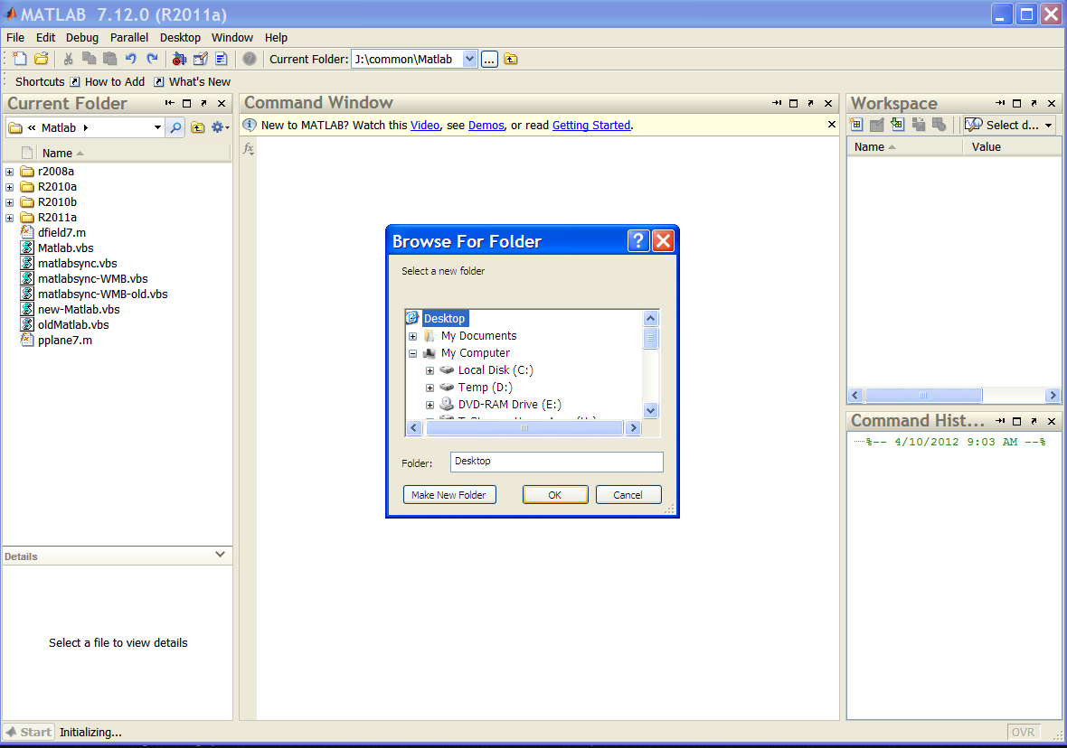
- Left click on folder, Select Add to Path, Selected Folders and Subfolders
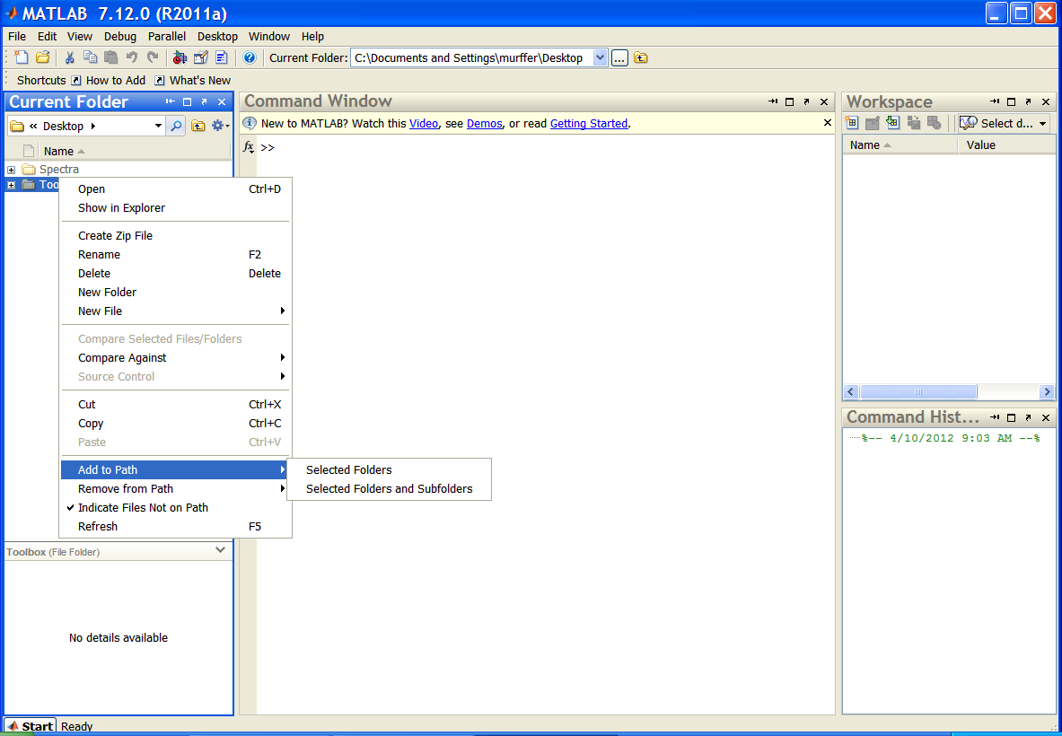
- After it has been added to the path the folder should no longer be grayed out.
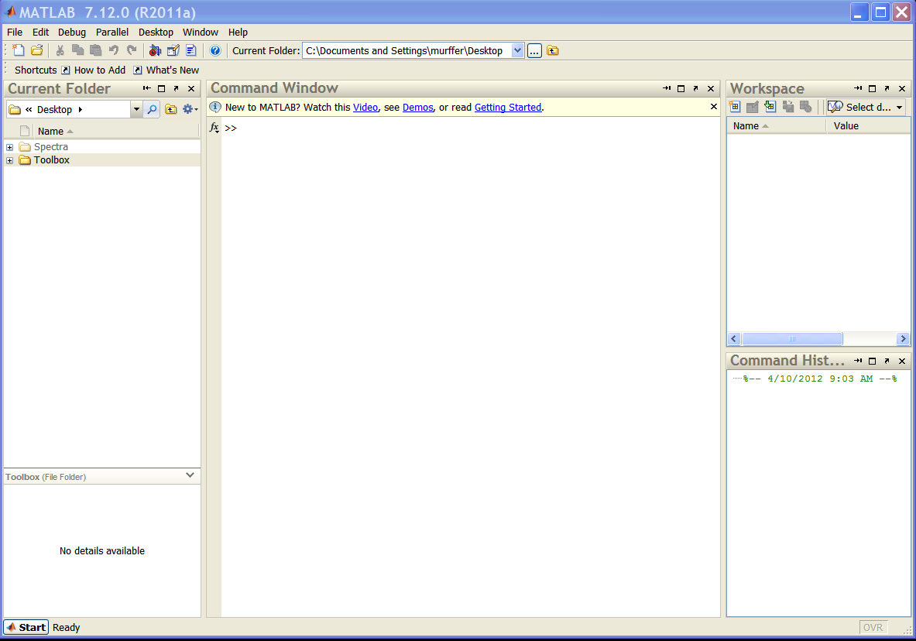

Computing Neutron Gamma Efficicincies
- Setup the path such that NGDiscrim.m (avilable in the spectra toolbox) is on the path
- Browse to the directory that contains the spectra (.spe files)
    - >cd Spectra\
- Find out about the NGDiscrim command and arguments with the help command
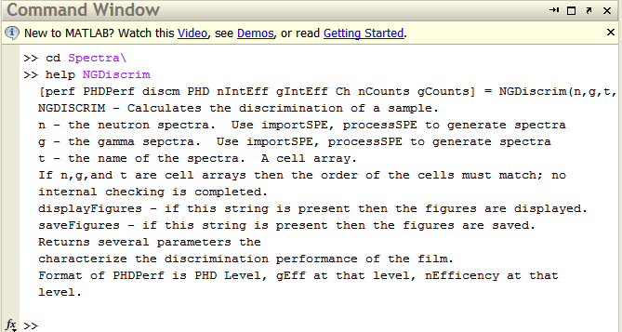
- Run NGDicrim without any input arguments.
- Select Neutron Spectra
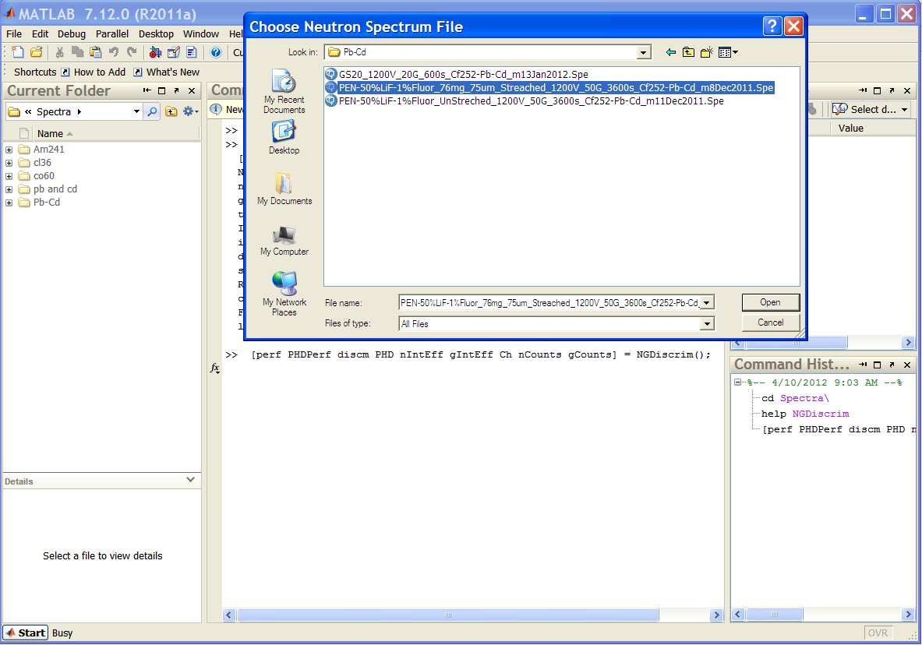
- Select Gamma Spectra
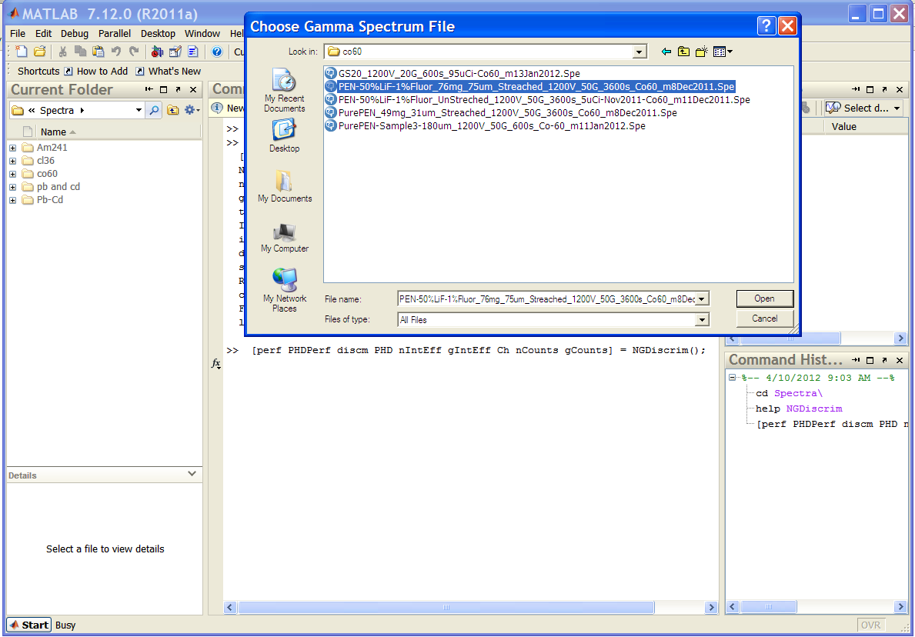
- Enter a short description of the film at the TYPE prompt in the command window
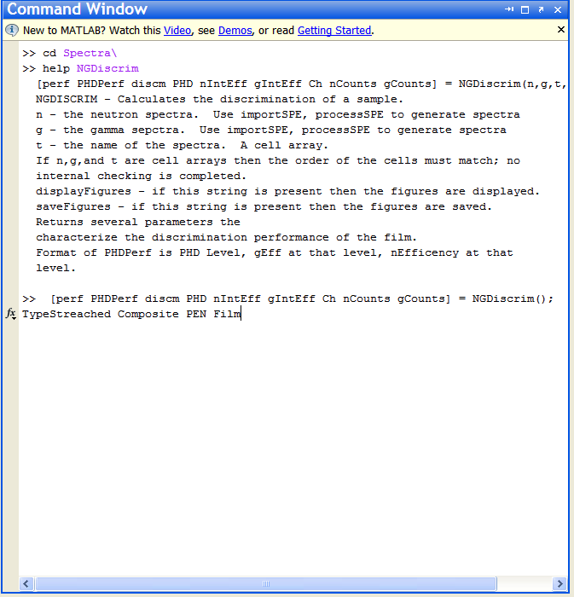
- Select the geometry type from the pop-up menu
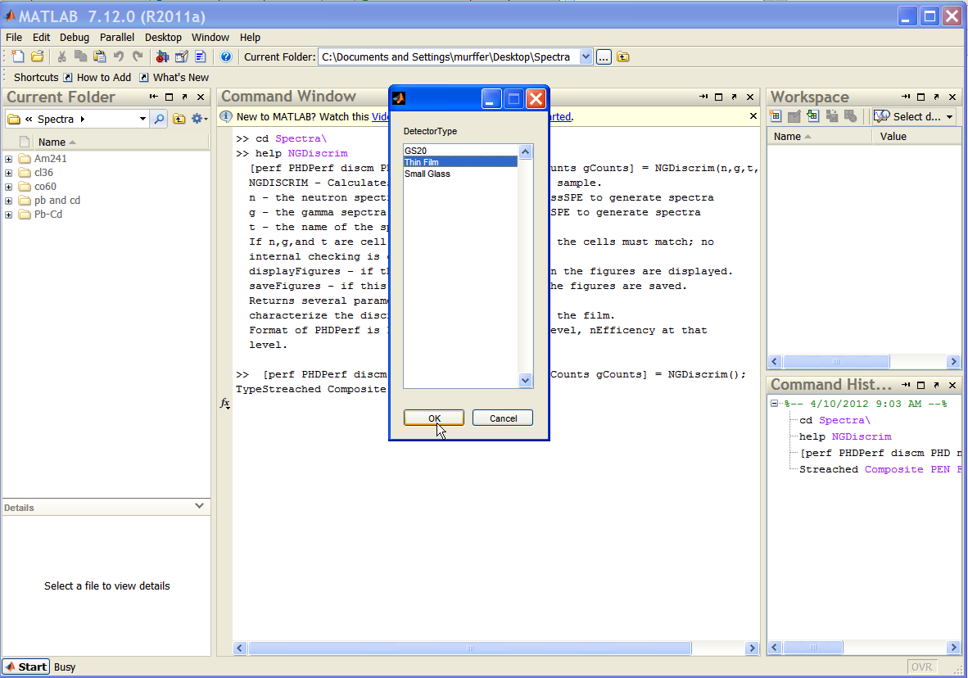
- MATLAB computes the efficiency values, plots the spectra, as well as saves the spectra as .png in the current directory
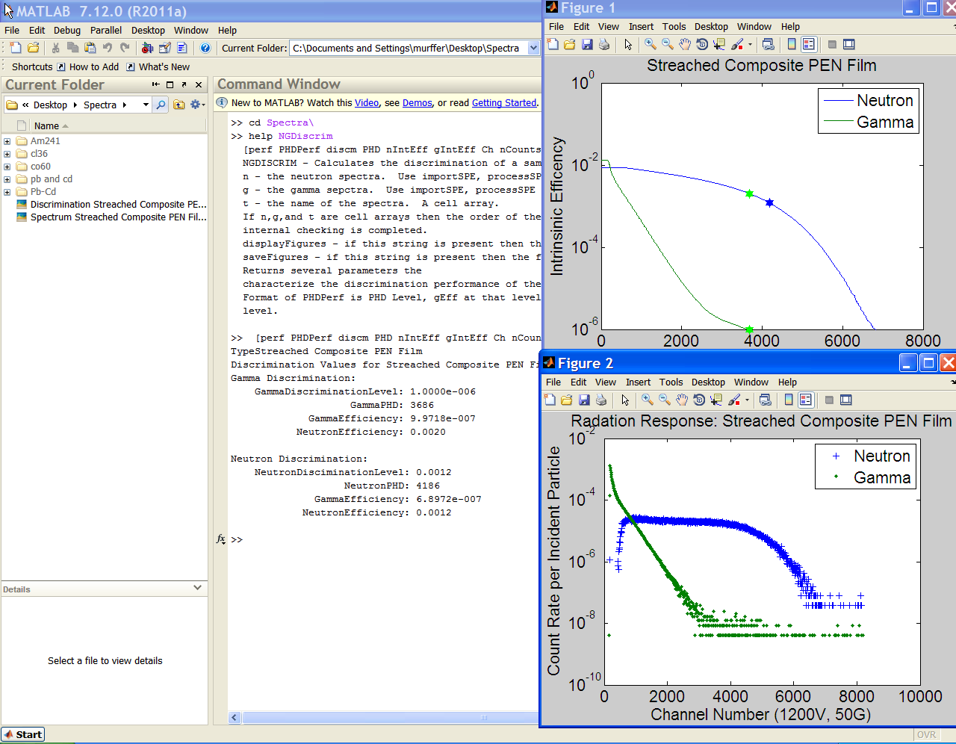

Appendix D
The interaction of charged particles with matter is important to design a detector because it determines how much energy (and where) will be imparted to the detector. One of the most useful parameters is the range of a particle in matter. In the following figure it is observed that the heavy charged particles (protons and alphas) travel about an order of magnitude less than an electron of a similar energy.
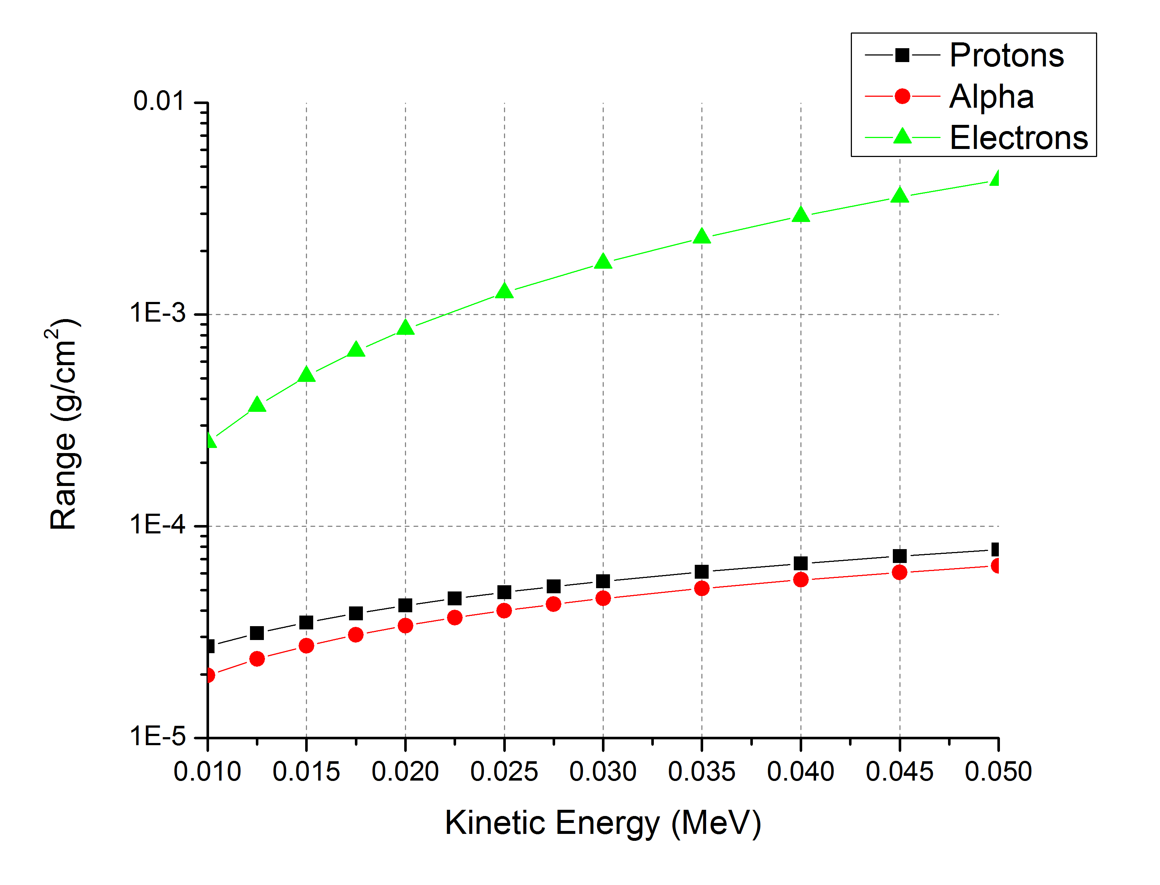
Figure 69 - Range of Particles in a Plastic sCintillator (PVT Based). Data from NIST

Photons
Photon interactions in matter can be divided into four classes: photoelectric effect, Compton effect, pair production, and photo nuclear absorptions. In general the photons of interest are on the 100’s of eV to MeV range, which is much greater than the eV range of the work functions associated with the photoelectric effect so the electrons can be considered at rest. Pair production and photonuclear absorptions can also be neglected because the photons of interest are typically below the range where these reactions are likely to occur. Of the four possible interactions, then, only Compton scattering will be discussed.
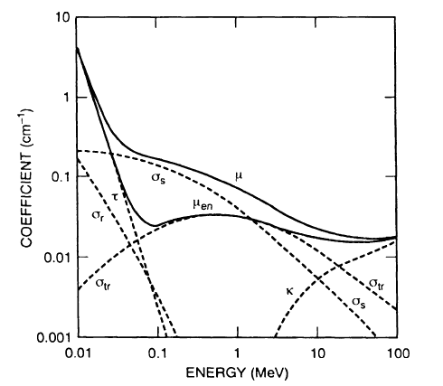
Figure 70 - Photon Attenuation Coefficients in Water. τ is the contribution from the photoelectric effect, σ_{s} is the contribution from Compton Scattering, and κ is the contribution from photonuclear adsorptions. Figure from [6].
Compton scattering occurs when a photon is incident on an electron (assumed to be free) and scatters off that electron, imparting energy to the electron. This is illustrated schematically in Figure 75.
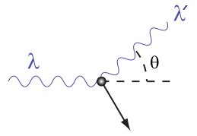
Figure 71 - Illustration of Compton the scattering. The incoming photon, λ, is scattered off the electron. This imparts kinetic energy to the electron and causes a change in the wavelength and direction of the gamma. Figure from [14].
There is then a range of kinetic energies $T$ that can be imparted to electron which depends on the scattering angle $θ$ and the photons initial energy $hν$.
$$T=\frac{1-\cos{θ}}{\frac{mc^{2}}{hν}+1-\cos{θ}}$$

The maximum possible kinetic energy that the scattered electron can have occurs at a scattering angle of 180 degrees; when the cosine is negative one. For photon energies $hν≫mc^{2}$the maximum energy of the scattered secondary electron approaches the incident photon energy.
$$T=\frac{2hν}{2+\frac{mc^{2}}{hν}}$$

Table 29 - Maximum Energy of Secondary Electrons from ⁶⁰Co and ¹³⁷Cs
 | Photon Energy | Maximum Compton Energy
¹³⁷Cs | 0.662 | 0.478
⁶⁰Co | 1.17, 1.33 | 0.960, 1.116

In general (described by the Klein-Nishina formula) electrons are more likely to have a higher recoil energy. This is shown in Figure 72.
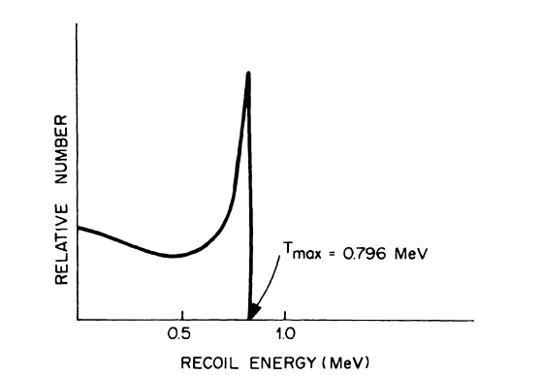
Figure 72 - Energy Distribution of Recoil Electrons from a 1 MeV Photon. Figure from [6].
All photon interactions of a film are then comparable to a charged particle (electron) interaction in that film (once an interaction has occurred), with the energy of the charged particle being on the order of the energy of the maximum Compton scattered electron.
Most of the samples looked at are very thin, with thickness in the 25-100 micron range. When an incoming photon Compton scatters the energy of the scattered electron is then in the 100’s of keV, where the range is around one twentieth of a centimeter; much farther than the thickness of the film. It is then expected that the film will lack a Compton edge, and this is observed in measurement.
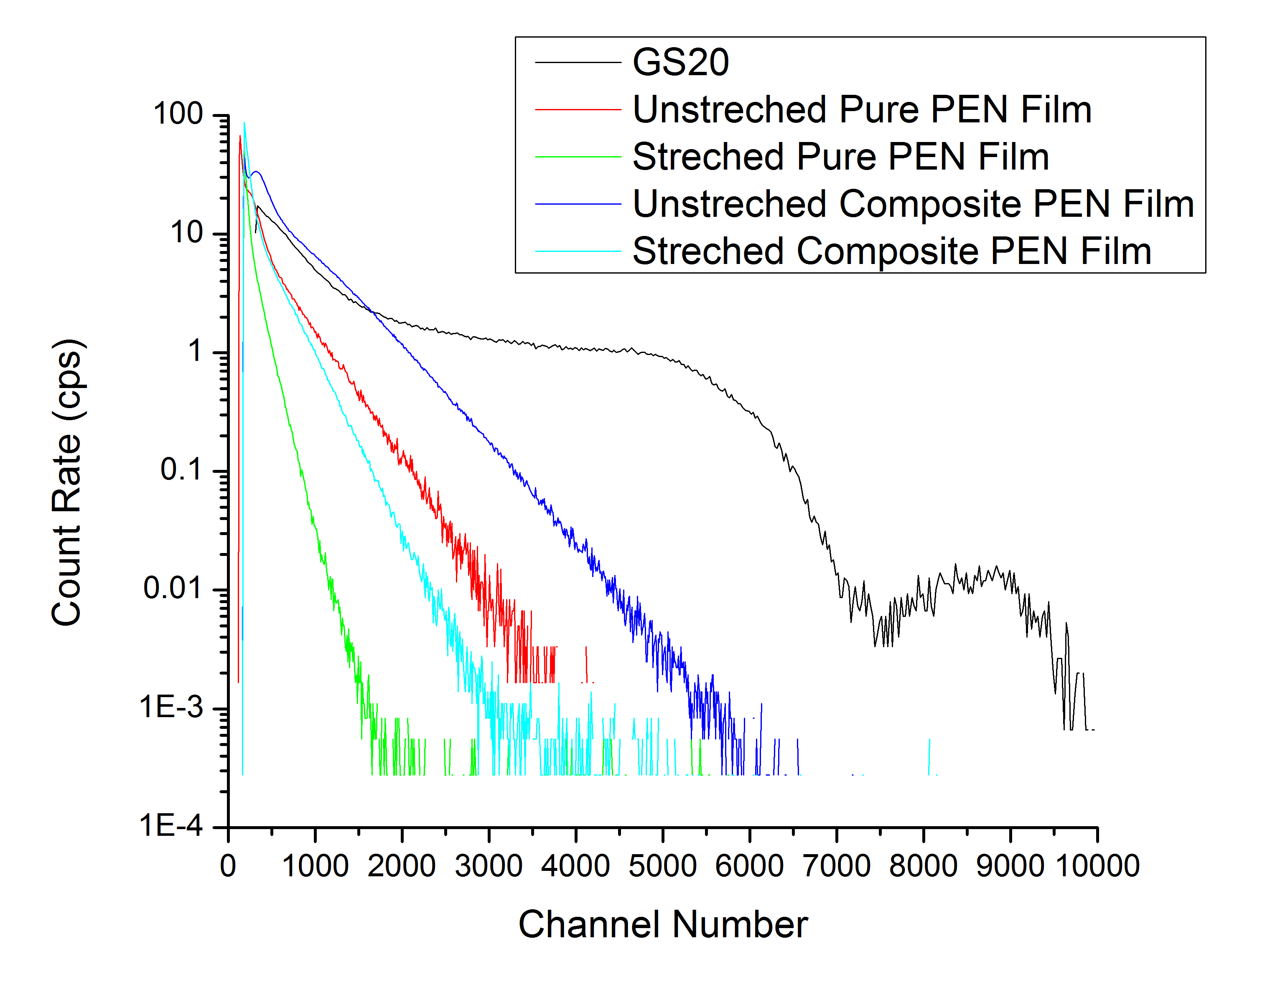
Figure 73 - Gamma Spectra From thin (less than 100 micron) PEN films compared to 2,200 Micron GS20. The Compton Edge and PhotoPeak are Visiable on tHE GS20 but not the thin films
In general the detector size determines how much energy is deposited in the film. In thick samples (samples much thicker than the range of the highest possible scattering event) the detector will absorbed most of the energy. In thin samples, however the sample will only absorb a fraction of the energy. This is shown in Figure 74.
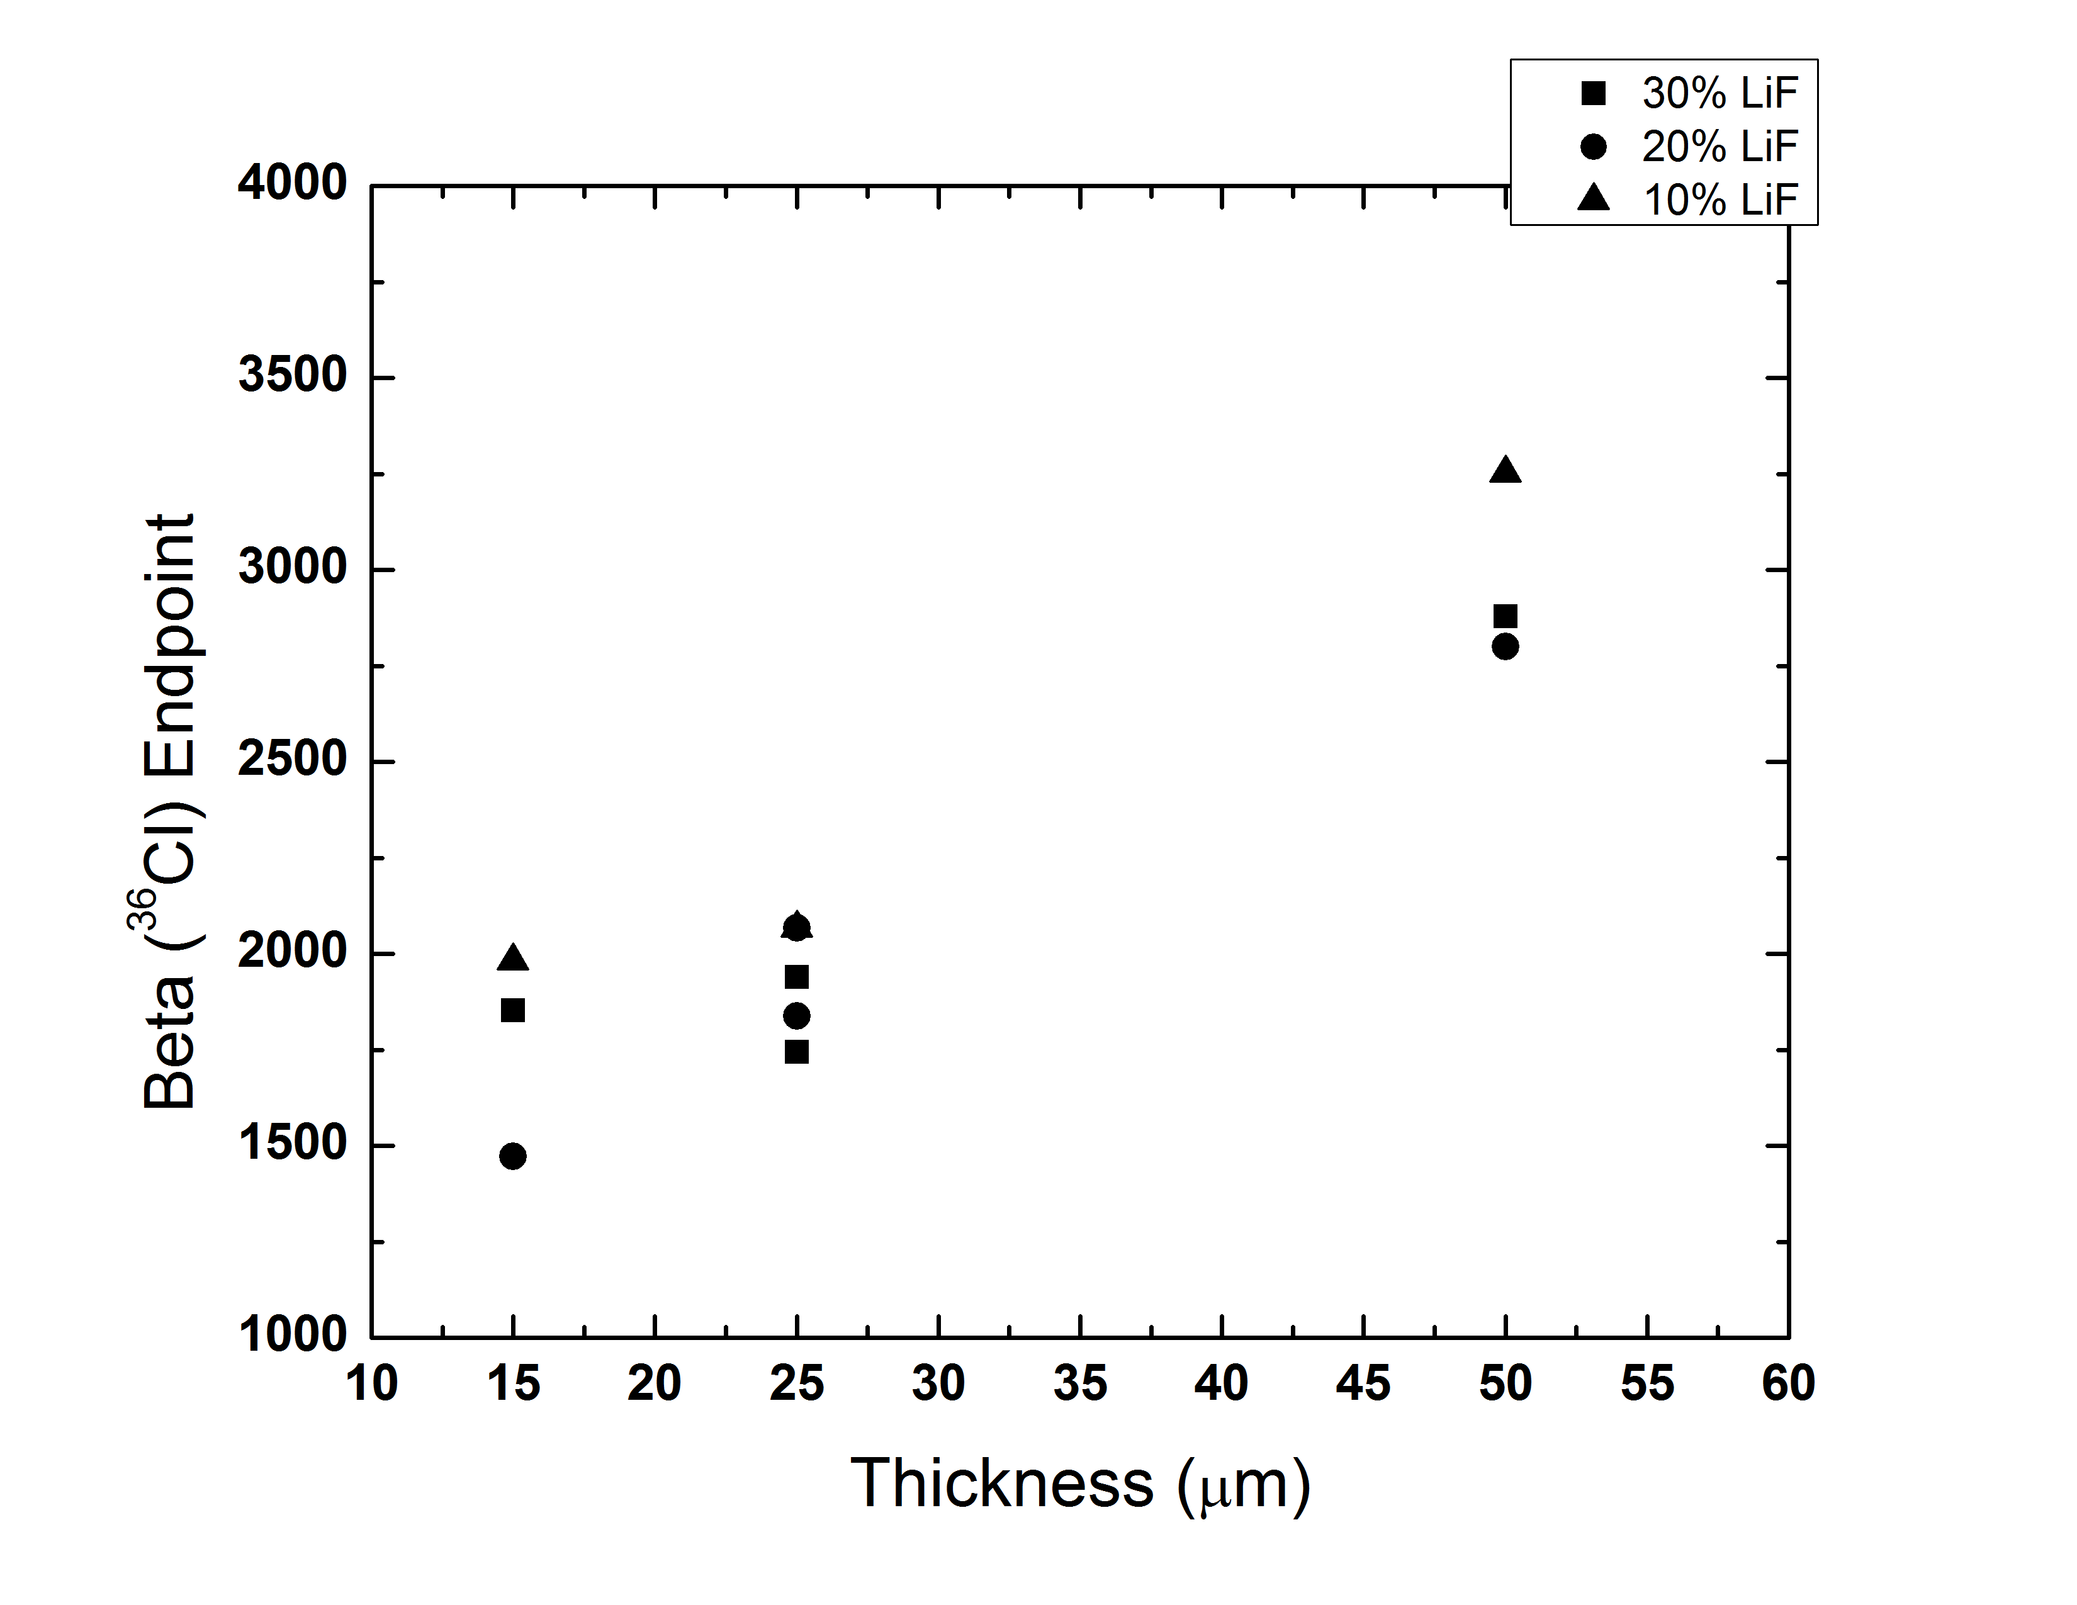
Figure 74 - Beta Endpoint of 5% PS samples according to the Sample Thickness.

Charged Particles
The maximum amount of energy any charged particle M of kinetic energy T can transfer in a single collision to a particle of mass m is the product of their masses and kinetic energy divided by the squared sum of masses. The non-relativistic result is given below (24). The only case in which a complete energy transfer could occur is if the incident particle scatters off a particle of the same mass; for example a positron scattering off of an electron.
$$Q_{max}=\frac{4mMT}{{\left(M+m\right)}^{2}}$$

The following figure describes the probability of single collision energy loss for 50 and 150 eV electrons and 1 MeV protons in water. For reference, a Compton scattered electron from a ¹³⁷Cs source would have a maximum energy of 478 keV, while ⁶⁰Co would have 1,116 keV. Turner writes that similar spectra for more energetic electrons lie almost on top of the 150 keV electrons [15].
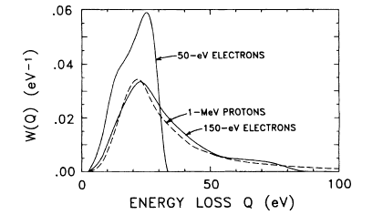
Figure 75 - Single collision energy loss spectra for electrons and protons. Figure from [6].
Thicker Samples absorb more of energy, thus having a higher endpoiNT.
In certain cases an alpha particle may be used to judge how a neutron might produce light in a film since the (n,triton) reaction in ⁶Li produces an alpha. The alpha response for four PEN films are shown below; are all typically of thin films. With a range of around 30 microns, most of the alpha’s energy will be absorbed in the film leading to the presence of an alpha peak.
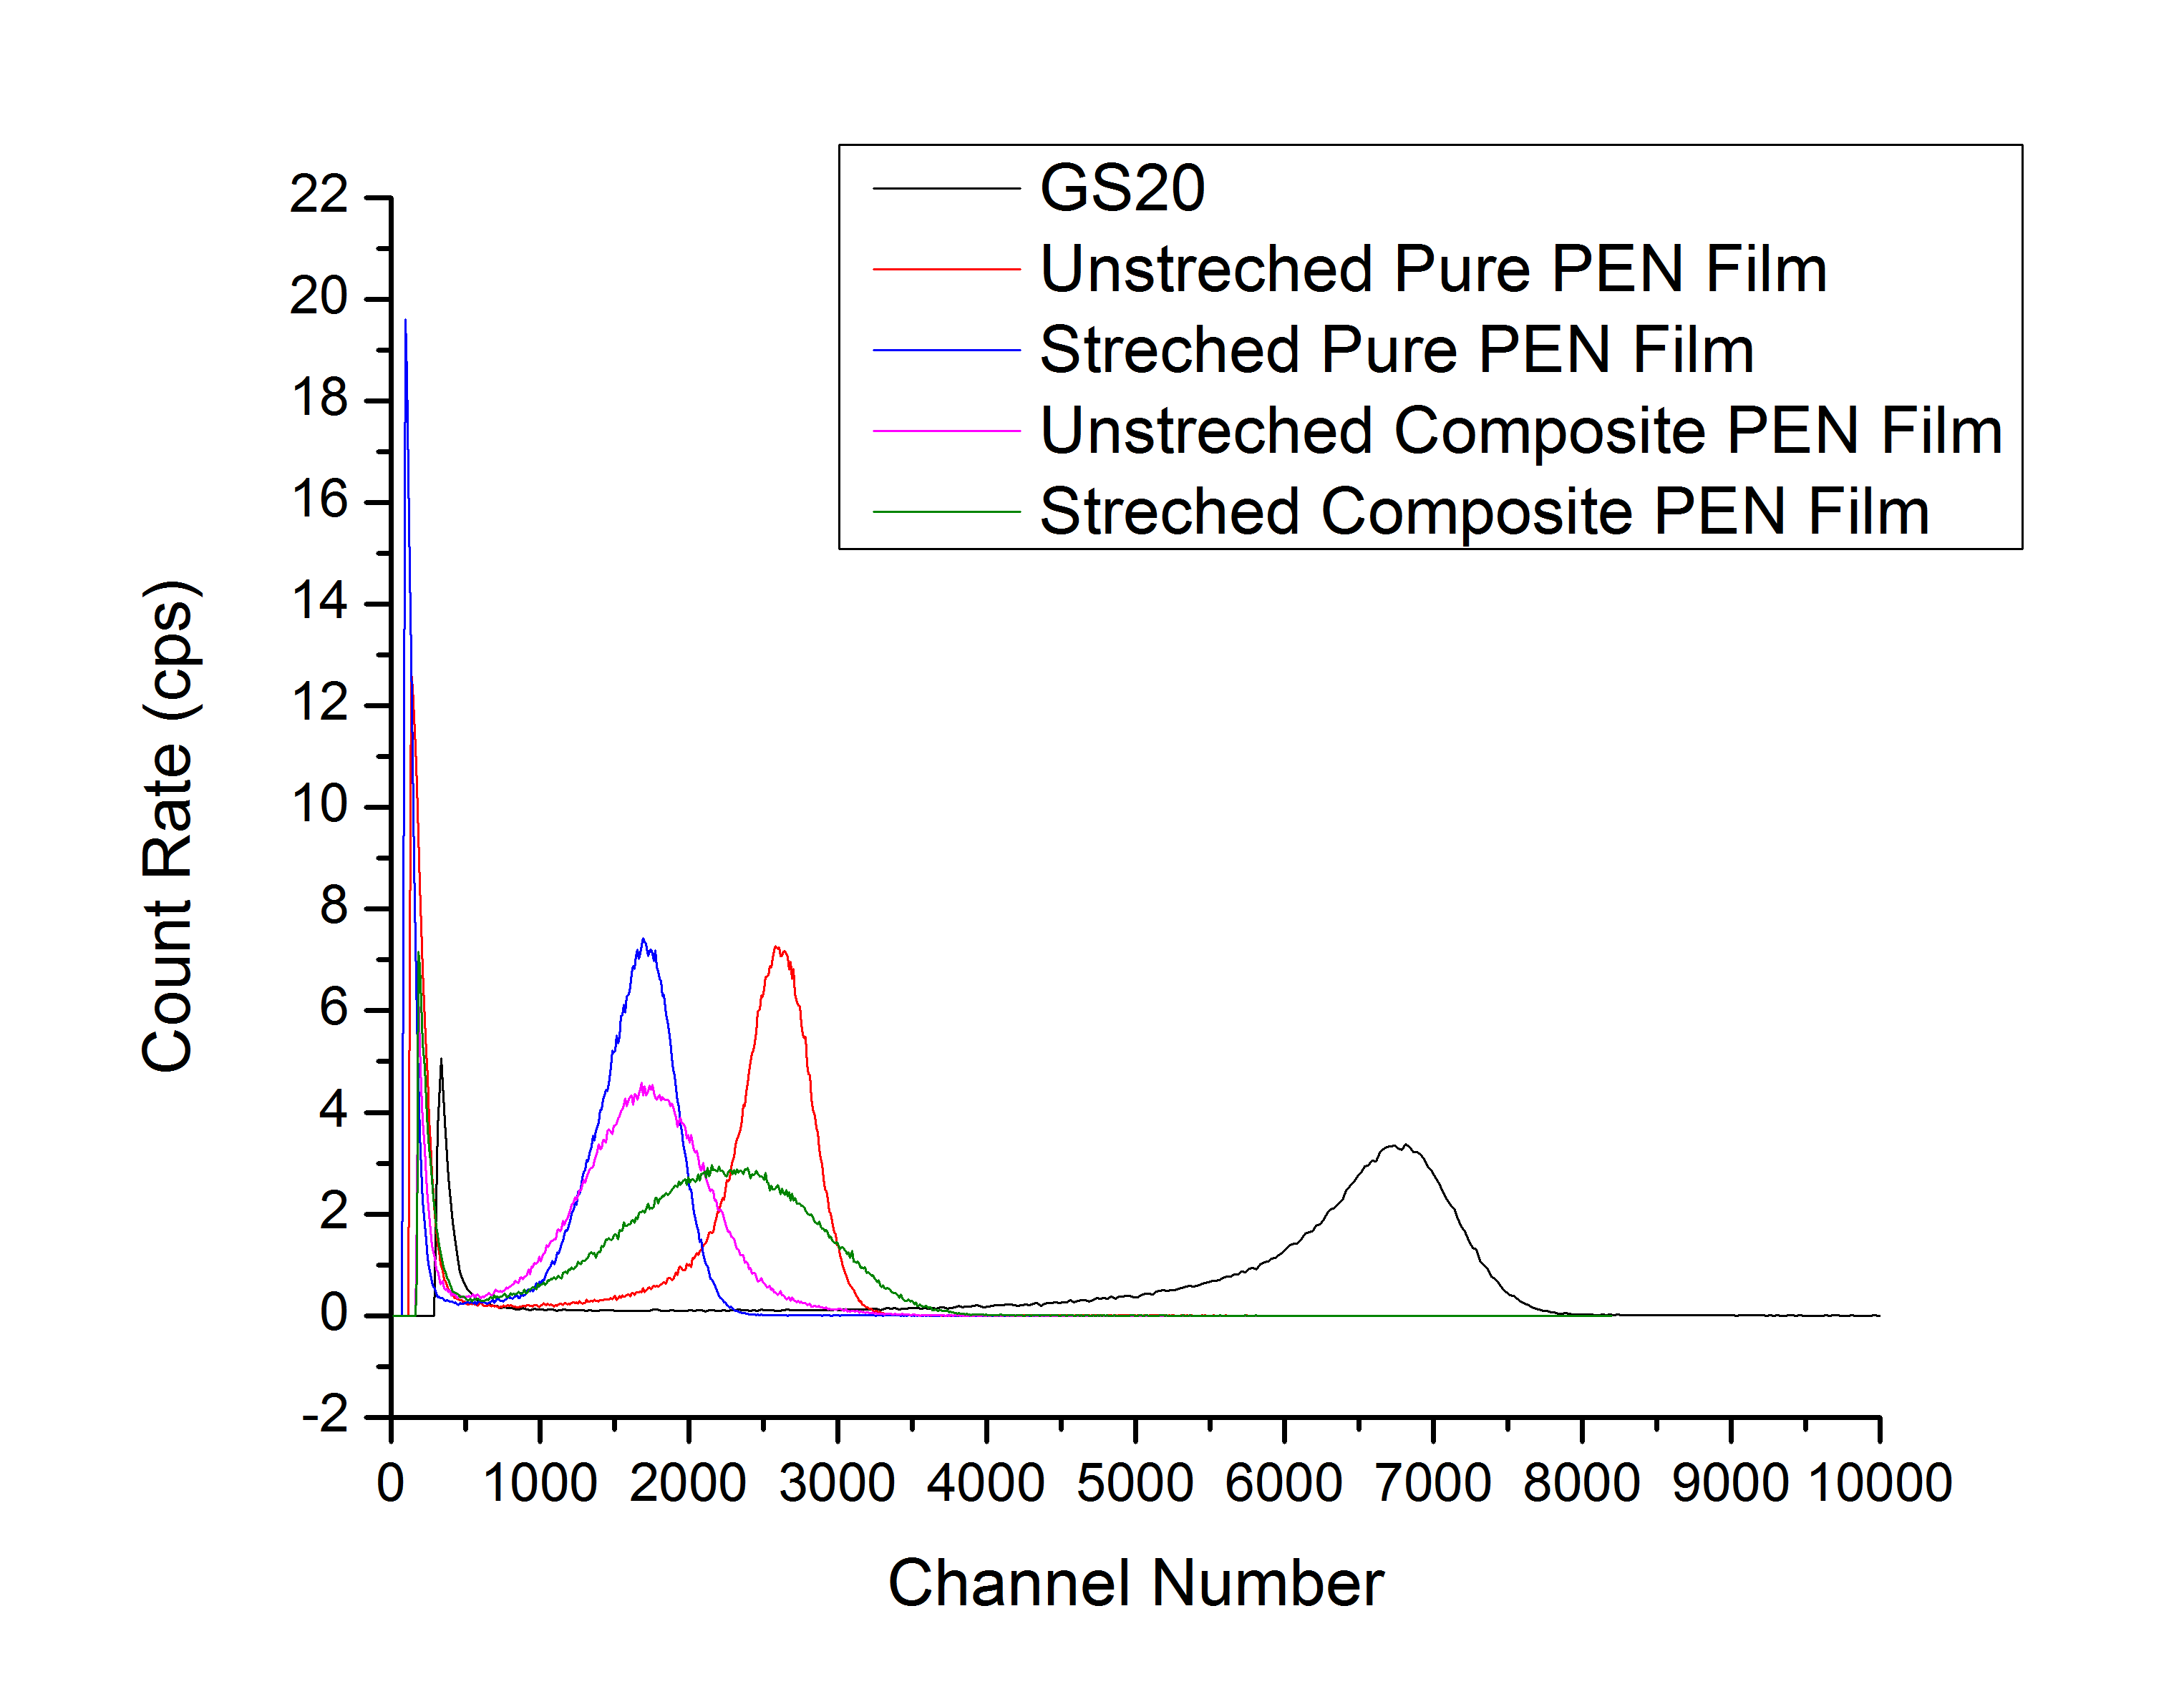
Figure 76 - Example Alpha Spectra of PEN Films. The Alpha peak is a good indication of the response of the film to charged particles.

Appendix E

Introduction
Receiver Operator Characteristic curve provides a method for judging how well a classifier performs. Each threshold on the classifiers score results in a particular true and false positive rates, as shown in Figure 77.
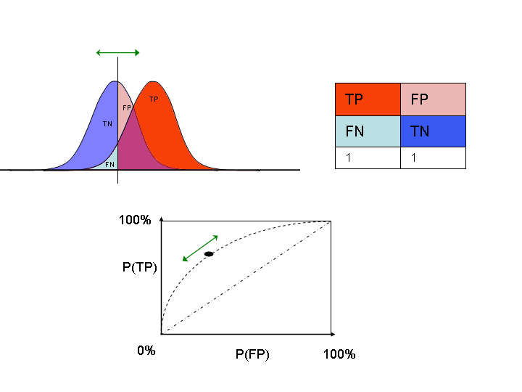
Figure 77 - Example of an ROC Curve for two distributions. The threshold is shown by the vertical line below the green arrow. (Image from Wikipedia)
ROC can also be used to compute the performance of a classifier. Given two classes, P and N, the following table describes the errors that the classifier could make [2].

 |  | True Class
Hypothesized Class |  | P (Alpha) | N (Gamma)
Hypothesized Class | Y | True Positive | False Positive  (Type I error)
Hypothesized Class | N (Gamma) | False Negative  (Type II error) | True Negative

The developed functions for calculating ROC curve where tested on four different Gaussian functions (Figure 78). The ROC curves for each of the distributions plotted are shown in Figure 79. Distributions D, with no appreciable cross over, showed perfect classification. As the distributions started to overlap (distributions A, B, and C) the performance of the classification based on score started to suffer. Distributions A, with a large amount of overlap, had the worst performance.

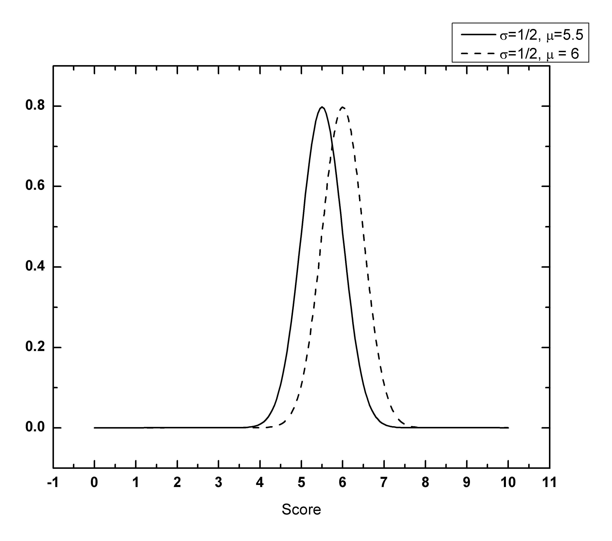 | 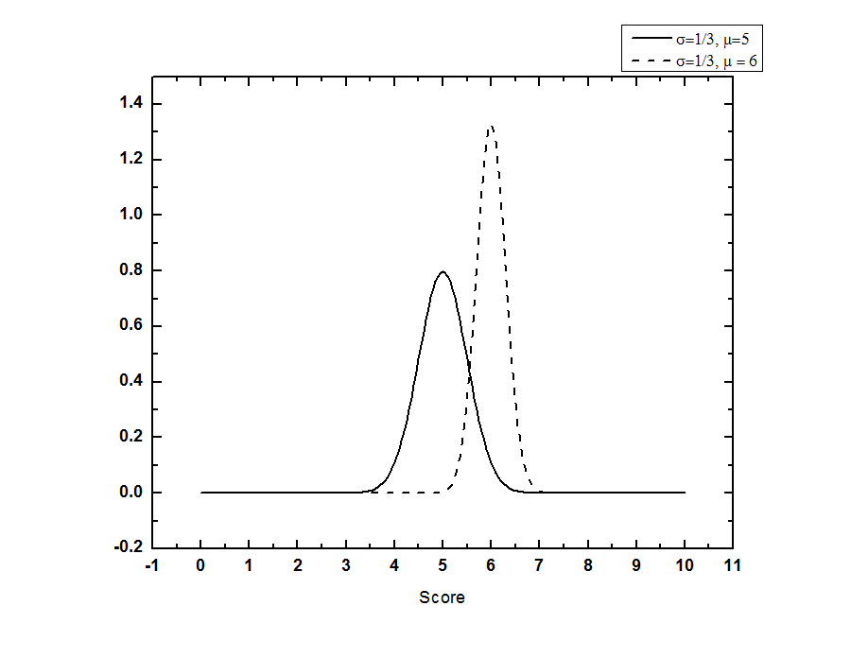
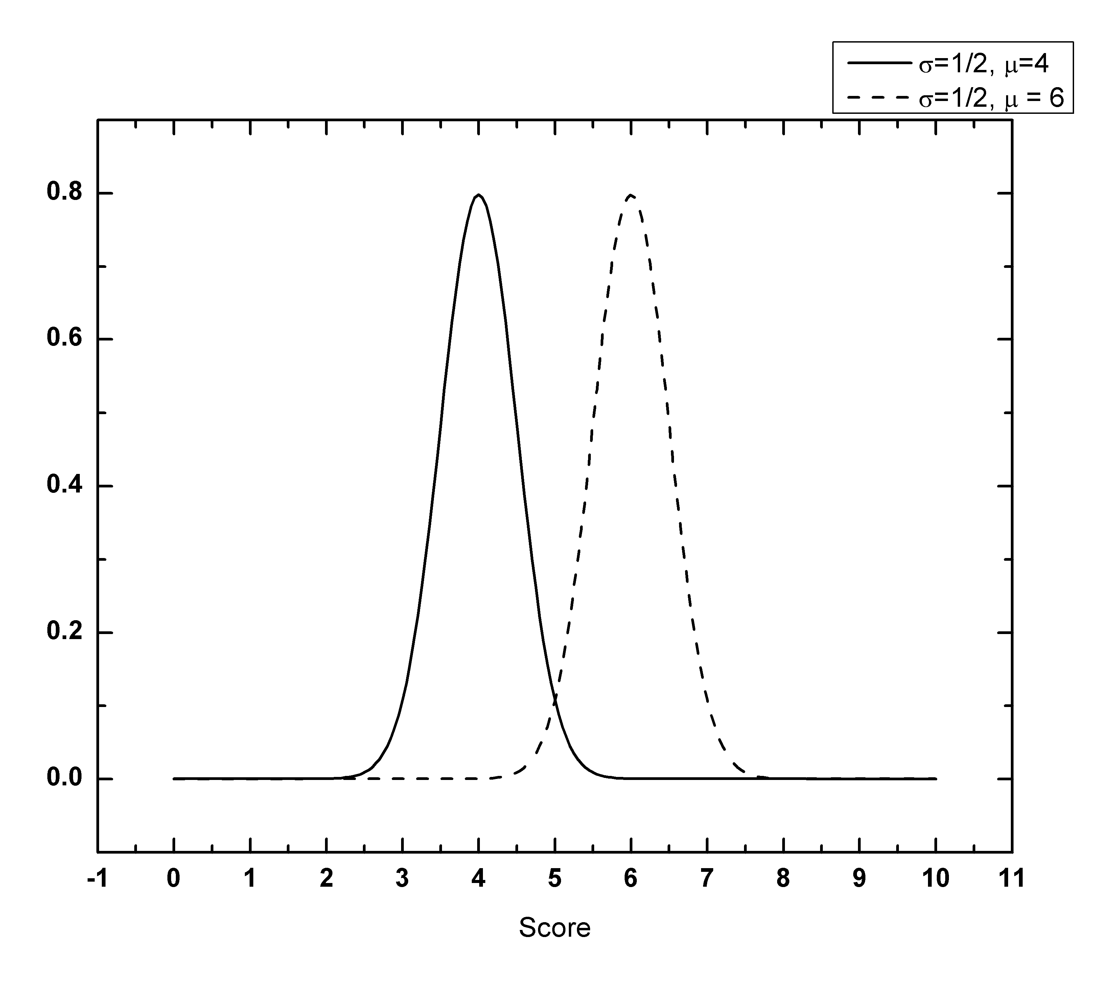 | 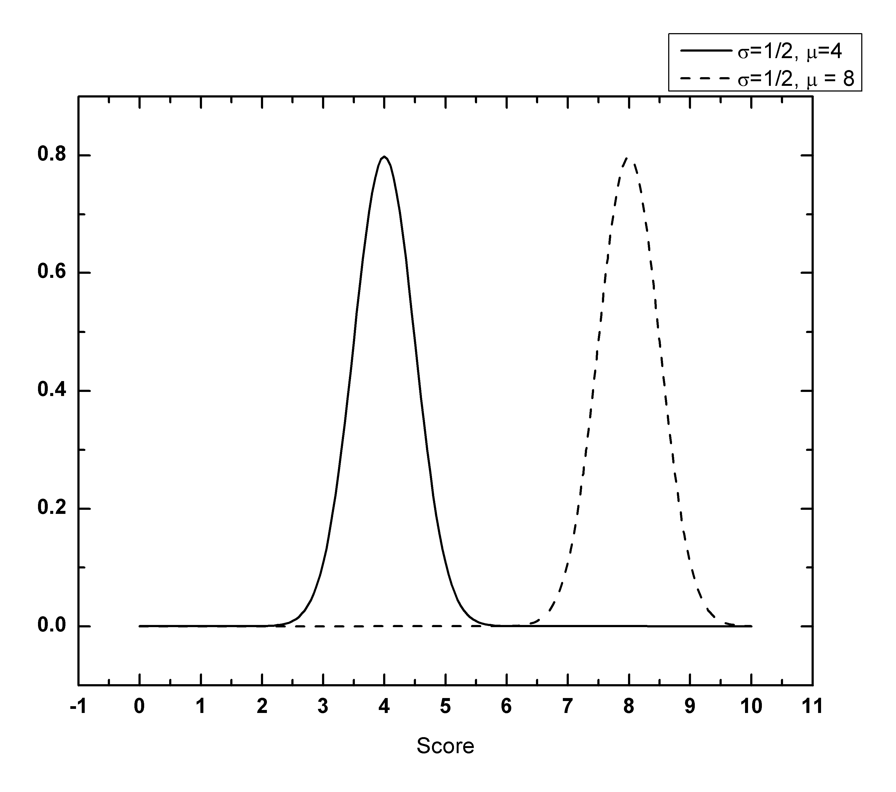
Figure 78 – Gaussian Distributions used to test the ROC Curves. Upper left is distributions A, upper right is distributions B, lower left is distributions C and lower right is distributions D.

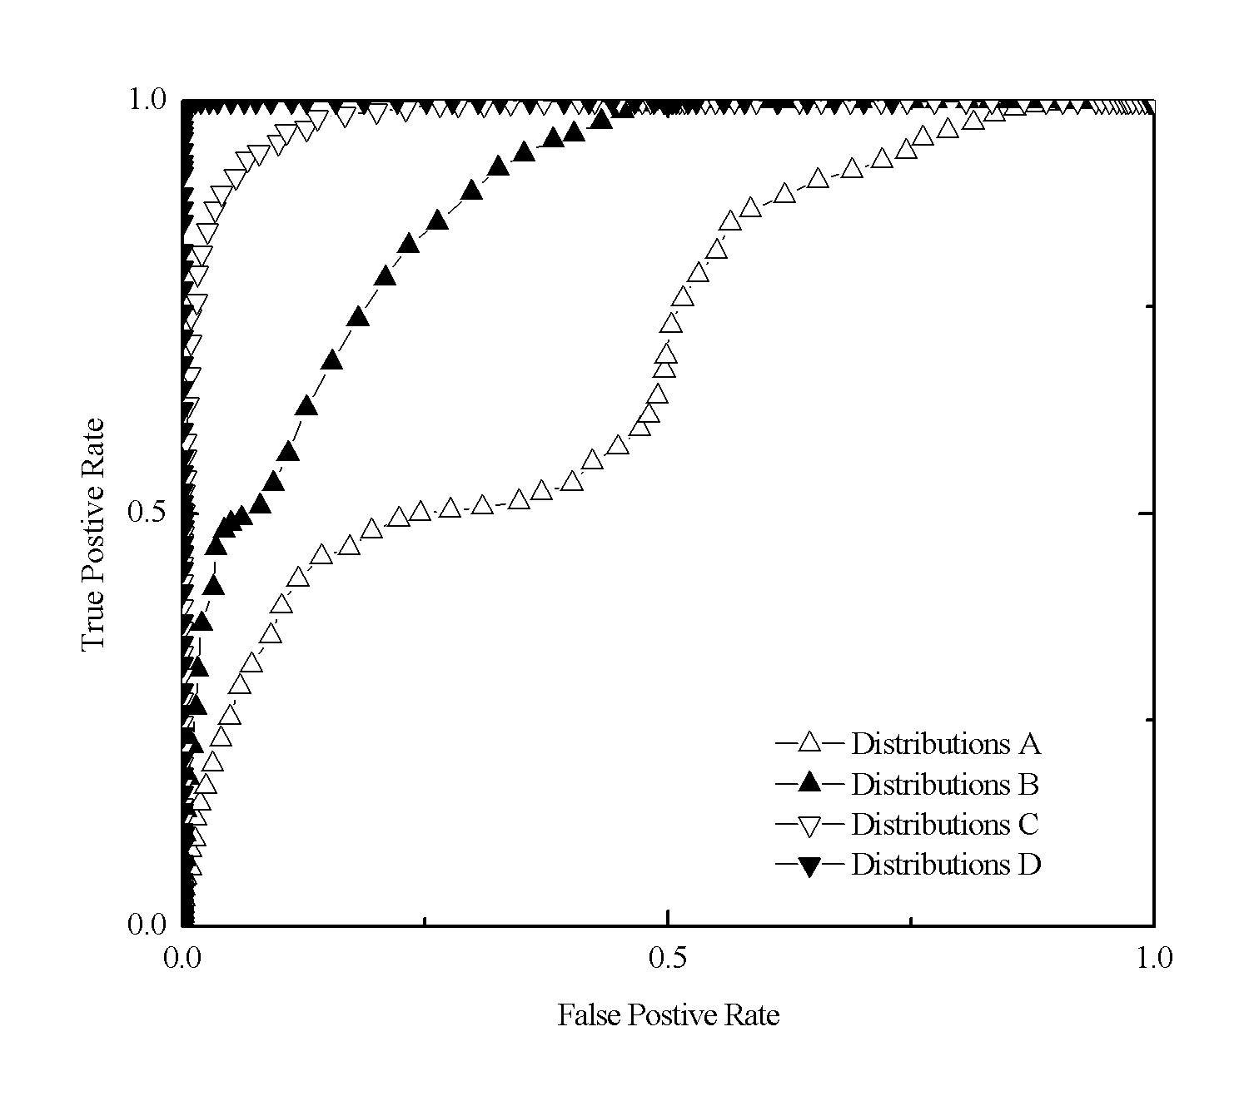
Figure 79 - ROC Curves for Gaussian Distributions.

Area Under The Curve (AUC)
The area under the curve (AUC) provides a statistical measure of how well a sample performs; the AUC is the expectation that a uniformly randomly drawn positive receives a higher score than a randomly drawn negative. In the case of Distributions D, there is a 100% expectation that a randomly drawn positive will have a score higher than a negative – this can be seen by because the scores from the distributions do not overlap. In the case of Distributions A, where there is some overlap, a randomly drawn positive score will only have a higher score then a negative one 70% of the time.

Table 30
 | AUC
Distributions A | 0.6966
Distributions B | 0.8687
Distributions C | 0.9855
Distributions D | 1.0

Vita
Matthew J. Urffer was born January, 29, 1988 on a small turkey farm in Coopersburg, Pa. He got his B.S. in physics from Carnegie Mellon University in Pittsburgh, PA. Upon graduation Matthew enrolled at the University of Tennessee, Knoxville where he is currently pursuing a doctorate in nuclear engineering.

In these trials the peak location was set to be 3,460 channels per the measurement protocol, but the subtraction of the cadmium spectra decreases the net spectra average peak location.

