Self-Learning License Plate Matching Algorithm:

Some Enhancements and Its Role in Travel Time Ground Truth Measurements

A Dissertation Presented for the

Doctorate of Science

Degree

The University of Tennessee, Knoxville

Stephanie R. Hargrove

March 2015

ACKNOWLEDGEMENTS
I would like o thank everyone who has encouraged and supported me during my time in the Doctorate program at the University of Tennessee. In special, I would like to thank my advisor Lee Han for the guidance and support. He is a creative person who knows very well how to explore the potential and skills of his students. I also want to thank and Dr. Christopher Cherry, Dr. William Seaver and Dr. Xueping Li for serving on my committee.
While some persons helped me with ideas and insight others spent their time to provide valuable insight for my research. In special, I am thankful to Hyeonsup Lim for assisting in field experiments and data management, and spent countless hours of code, providing valuable data which enriched my work and guided me to new directions. I am also grateful to Moraes de Oliveira-Neto for his hard work establishing the license plate matching algorithm and continued support of my research.
I would like to thank everyone in the transportation program: Dr. David Clarke, Deanna Flinchum, Dr. Stephen Richards, Dr. Assad Khattak, Dr. Shashi Nambisan, and my amazing lab mates, Ryan Overton, Qiang Yang, Wei Lu, Jianjiang Yang, Hongtai Yang, Shuguang Ji, Casey Langford, Taekwan Yoon, Sam Moss, Zane Pannell, Bryan Bartnik, Jun Liu, Amber Woodburn, Yang Zhang, Bumjoon Bae, Ziwen Ling, and so on.
ABSTRACT
This is a sample Word document that can be used as a template in formatting your multipart or manuscript thesis/dissertation. This abstract should cover all parts of your multi-part thesis or dissertation. This abstract must be 350 words or fewer If you are using special characters, you’ll want to spell them out between square brackets after each time you use them (this is in the abstract only. It’s not necessary elsewhere in the document, although use of special characters in the title is prohibited.)
For our purposes a special character is any character which cannot be found on your typical English language keyboard. Because of how your abstract is used in the cataloging process, you will want to tell people how to interpret your special character in case the character itself gets garbled. So, if I wanted to use the µ [micro] character in my abstract, I would have to tell people how to interpret it. Since you’re the expert, you decide how to best interpret that character. It could be µ [micro] or µ [mu], whichever would make the most sense if the symbol itself cannot be replicated

TABLE OF CONTENTS

CHAPTER 1. INTRODUCTION 1
CHAPTER 2. ENHANCEMENTS TO SELF LEARNING LICENSE PLATE MATCHINGNALGORITHM: STARTING ASSOCIATION MATRIX 2
2.1 Introduction 3
2.2 Conclusion 12
CHAPTER 3. MATCHING LICENSE PLATE USING DERIVED ASSOCIATION MATRICES 14
3.1 Introduction 16
3.2 Association Matrix 18
3.2.1 Definition 18
3.2.2 Estimation from Truth Matrices 19
3.2.3 Estimation from Matching Algorithm 20
3.2.4 Estimation from Self Learning Matching Algorithm 20
3.2.5 Determining a True Match using an Association Matrix 21
3.3 Deriving an Association Matrix 21
3.4 Simulated Experiment 21
3.4.1 Performance of Association Matrices 23
3.5 Application to Real Data 30
3.5.1 Data Sample 30
3.5.2 Performance of Association Matrices 30
3.6 Conclusion 31
CHAPTER 4. KEY CONSIDERATIONS FOR THE COMPARISION OF REAL-TIME TRAFFIC DATA 34
4.1 Introduction 36
4.2 Data Sources and Collection 38
4.2.1 Traffic Data Sources 38
4.2.2 Ground Truth 42
4.2.3 Study Route and Data Collection 43
4.3 Methodology 44
4.3.1 Data Preparation 44
4.3.2 Comparison of Ground Truth to Data Sources 45
4.3.3 Moving Average of Ground Truth 45
4.3.4 90% C.I. of Ground Truth 48
4.3.5 Outlier Elimination 49
4.4 Evaluation Measurements 49
4.4.1 Root Mean Square Error 49
4.4.2 Conversion of Data from Speed to Travel Time 50
4.4.3 Travel Time of Data Source / Travel Time of Ground Truth 51
4.4.4 Visual Investigation 51
4.5 Results 51
4.5.1 Investigation of Ground Truth Data 51
4.5.2 Comparison between Each Data Source vs Ground Truth 52
4.5.3 Summary of Results 56
4.6 Conclusions and Recommendations 61
CHAPTER 5. CONCLUSION 65

LIST OF TABLES

Table 3-1 Starting Association Matrices 5
Table 3-2 Percentage of Correctly Matched License Plates 8
Table 3-3 Percentage of False Matched License Plates 11
Table 5-1 Summary of Traffic Data Technologies and Selected Providers 40
Table 5-4 Travel Speed of Ground Truth Data on Segment ‘A to C’ 51
Table 5-8 Summary of Results (1/RMSE) 58

LIST OF FIGURES

Figure 3-1 Percentage of Correctly Matched License Plates vs. No. of Matched Plates for Algorithm 9
Figure 3-2 Percentage of False Matched License Plates vs. No. of Matched Plates for Algorithm 12
Figure 4-1 Differences between Association Matrices with Read Rate of 40% 25
Figure 4-2 Differences between Association Matrices with Read Rate of 50% 26
Figure 4-3 Differences between Association Matrices with Read Rate of 60% 27
Figure 4-4 Differences between Association Matrices with Read Rate of 70% 28
Figure 4-5. Allowable Number of Sample Size to use Derived Association Matrix 29
Figure 5-1Two Methods for Comparing Speed Data 45

INTRODUCTION
XXXX
XXXX
The dissertation is organized in journal article formats since each chapter is either published, submitted, or to be submitted to an academic journal. Following this chapter, the second chapter contains the enhancements to the self-learning license plate matching algorithm. The third chapter proposes the use of a derived association matrix as an alternative to the conventional association matrix in the matching algorithm. The fourth chapter discusses the use of LPR and the matching algorithm as optimal ground truth for travel time examination. Conclusions are drawn and future works are recommended in the fifth chapter.

ENHANCEMENTS TO SELF LEARNING LICENSE PLATE MATCHING ALGORITHM: STARTING ASSOCIATION MATRIX

This chapter presents a modified version of a research paper by Stephanie R Hargrove, Hyeonsup Lim, and Lee D. Han titled “Enhancements of Self-Learning License Plate Matching Algorithm”. This paper was submitted for publication to
The student must add a brief explanatory statement at the beginning of each article, stating how the article was revised and/or detailing the student’s involvement in the article. Any co-researchers should be identified and their role clarified as part of this statement.

Abstract
XXXX

Introduction
License Plate Recognition (LPR) has been a popular technology used by the transportation community. Applications include, but are not limited to, vehicle identification and tracking, speed enforcement, and automated tolling. In a perfect scenario a LPR station would 100% percent of all vehicles within its detection zone and read all license plates perfectly, but the technology is not perfect. The typical accuracy of LPR technology is around 60% or less depending on the model of camera, set-up (mobile or stationary), location (side of road or overpass), on-site calibration, diversity of captured license plates, and numerous other factors [1-3]. If one tries to match a correctly recognized license plate between two separate LPR stations, the accuracy drops further to 35% or below. ///Costly manual correction…
While many look to correct this problem by upgrading the hardware and software of LPR technology, this research focuses on the post processing of the recognized license plate text using a self-learning matching algorithm. //Value of character vs string matching…

(1) Apply the travel time window and matching method to find a set of matches from a sample of LPR data with the initial settings:
a. Assume initially that C = I, where I is 37 x 37 zero matrix;
b. Use 0 or 1 assignments to calculate ED;
c. Set a threshold τ such that if d(x, y) ≤ τ the string outcomes x and y may have come from the same truth string.
(2) From the set of matched plates obtained at step 1, tabulate the pair-wise character occurrences under a matrix format to obtain F, e.g. one cell of the matrix is for example the number of times a character “A”, read at Station g, happens to match the character “4”, read at Station h;
(3) Compute an updated approximation for the matrix C, where each cell will be the probability ) ˆ( | ˆ ij j i C = p y x ;
(4) Test if the updated matrix at the current iteration is similar to that one from previous iteration. If so, stop; otherwise go back to step 1 using as new input the updated matrix estimated in step 3 and the appropriate threshold value. Thus, at step 1 the ED with 0 or 1 weights is replaced by GED with weights calculated using the updated matrix.
The starting association matrix has a large influence on the learning speed and overall accuracy of matching.
It’s important to separate the starting association matrices into two categories; bias and unbias. A bias association matrix can be a past association matrix or a compilation of many. These past matrixes are valuable because they have already experienced learning and contain valuable information already learned from other LPR stations. This can be very helpful in increasing the learning speed, but damaging to the accuracy of the final matching rate. Using an association matrix
An unbias matrix; i.e., identity matrix; has no prior learning and is assumed to be a blank slate for the generation of an association matrix. But since it is a clean slate the learning process will be increased.
The examined unbias starting matrices
Table 3 lists the 9 tested starting AMs. AM1 is the above mentioned identity matrix, while AM3 and AM4 are similar with the number 100 and 1000, respectively, for the main diagonal instead of the number 1. AM2 is simply a matrix containing only zeros. AM5 is a matrix of random numbers multiplied by 1000. AM6 is an existing association matrix from 2010 that has already gone through the self-learning process.
Table 3-1 Starting Association Matrices
Notation | Definition | Bias Vs Unbias | Impact of Single Match
AM1 | Zero Matrix- all cells within the matrix are equal to zero. | Unbias | High
AM2 | Identity Matrix- the diagonal cells are equal to 1 and all off diagonals cells are zero. | Low Bias | High
AM3 | Identity Matrix x 100- All cells within the identity matrix are multiplied by 100. | Moderate Bias | Moderate
AM4 | Identity Matrix x 1000-All cells within the identity matrix are multiplied by 1,000. | Bias | Low
AM5 | Random Variable Matrix- all cells within the matrix are generated random variables. | Unbias | NA
AM6
AM7

The first attempt of this test contained the first 6 matrices in Table 3. While performing parallel tests on the edit distance threshold an assumption was made that the zeros within the starting association matrices may be causing the algorithm to assign infinite edit distances to correctly matched plates (this will be discussed in more detail in Section 3.6). To test this theory AM7-9 were included.
In order to examine the performance of each starting AM, a dataset that has been visually processed by humans is required. This allows verification of the exact number of matched and false-matched license plates. Visually processing plates is a costly and time consuming process; therefore, only one dataset is currently available to complete this analysis. The dataset is from the year 2010 for two locations on variable message boards in Knoxville, TN on Interstate 40 and 640. The dataset contains front license plates with 2,415 license plates captured upstream and 4,265 captured downstream. The total number of correctly matched license plates in the dataset is 581. During the matching process, 20,233 potential matches will be examined by the matching algorithm.
The accuracy of each starting AM is measured by the percentage of correctly matched plates, as shown in Table 4. It is assumed that the number of license plates needed to optimize the learning speed is dependent on the strength of the starting AM; therefore, increments of 25 license plates will be used to assess the heuristic text-mining algorithm’s ability to generate an AM for two LPR locations, as shown in the first column of Table 4. In Figure 9 the percentage of correctly matched license plates are illustrated. AM1 through AM4 exhibits an increase in match rate as the number of matches for the heuristic text-mining algorithm is increased. AM5 shows no signs of improvement. AM7 performs drastically better than its equivalent not including the addition of the number 1 to all the elements, AM4. AM6, AM8 and AM9 exhibit high match rates with minimal number of matches for the heuristic text-mining algorithm.

Table 3-2 Percentage of Correctly Matched License Plates
No. of Matches for Algorithm | AM1 | AM2 | AM3 | AM4 | AM5 | AM6 | AM7 | AM8 | AM9
25 | 45.4 | 47.8 | 47.7 | 47.2 | 0.2 | 92.4 | 82.3 | 96.4 | 97.4
50 | 50.6 | 56.6 | 56.3 | 54.0 | 0.2 | 92.8 | 82.3 | 96.2 | 97.1
75 | 55.8 | 67.1 | 66.3 | 62.1 | 0.2 | 93.1 | 86.2 | 96.6 | 97.2
100 | 58.0 | 70.7 | 70.2 | 65.2 | 0.2 | 93.1 | 87.4 | 96.4 | 97.2
125 | 64.9 | 76.9 | 76.1 | 70.7 | 0.3 | 93.5 | 88.6 | 96.4 | 97.4
150 | 65.7 | 77.6 | 76.8 | 72.1 | 0.9 | 93.6 | 89.3 | 96.4 | 97.4
175 | 73.3 | 78.7 | 77.6 | 72.8 | 0.5 | 93.5 | 89.5 | 96.4 | 97.4
200 | 76.6 | 81.1 | 80.0 | 74.9 | 0.7 | 93.8 | 90.0 | 96.4 | 97.4
225 | 71.3 | 82.6 | 81.6 | 77.1 | 0.2 | 93.8 | 90.4 | 96.6 | 97.4
250 | 70.1 | 83.8 | 83.1 | 78.5 | 0.2 | 94.0 | 90.5 | 96.6 | 97.4
275 | 82.6 | 85.9 | 85.0 | 80.9 | 0.7 | 94.3 | 91.4 | 96.4 | 97.6
300 | 76.2 | 86.6 | 85.7 | 81.8 | 0.3 | 94.5 | 91.6 | 96.6 | 97.4
325 | 78.7 | 87.3 | 86.4 | 82.3 | 0.2 | 94.8 | 91.6 | 96.4 | 97.6
350 | 87.3 | 88.1 | 87.4 | 83.3 | 0.3 | 95.0 | 91.6 | 96.7 | 97.4
375 | 88.5 | 89.5 | 89.0 | 84.2 | 0.7 | 95.2 | 91.6 | 96.7 | 97.4
400 | 87.4 | 90.4 | 89.7 | 85.0 | 0.5 | 95.4 | 91.7 | 96.7 | 97.4
425 | 88.5 | 91.6 | 90.5 | 85.7 | 0.3 | 95.7 | 91.9 | 96.6 | 97.4
450 | 86.7 | 91.6 | 90.7 | 85.9 | 0.2 | 95.7 | 91.9 | 96.7 | 97.4
475 | 88.1 | 92.6 | 91.7 | 86.7 | 0.3 | 95.9 | 91.7 | 96.7 | 97.6
500 | 88.8 | 93.1 | 91.9 | 87.1 | 0.3 | 95.9 | 91.9 | 96.7 | 97.2
524 | 91.2 | 93.3 | 92.3 | 87.4 | 0.2 | 96.0 | 92.3 | 96.7 | 97.4

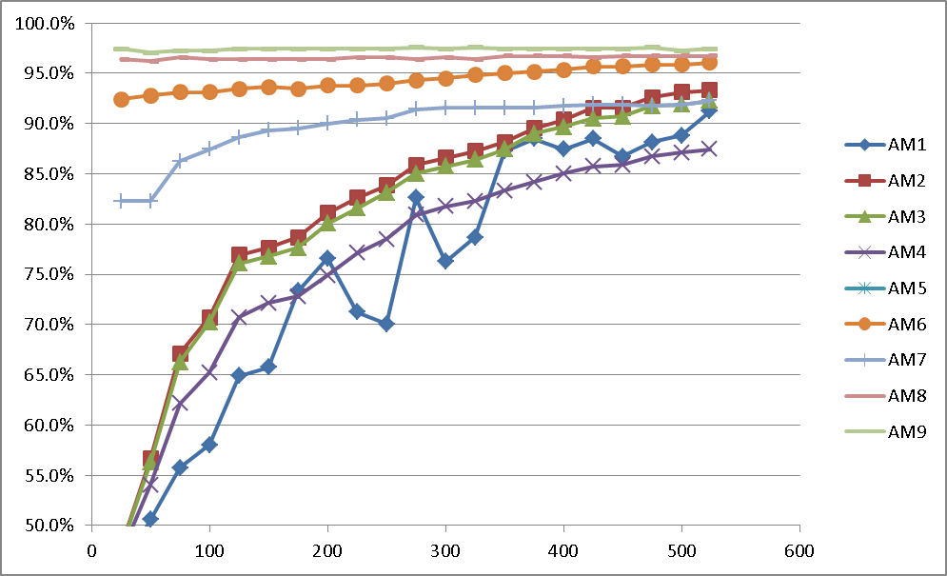
Figure 3-1 Percentage of Correctly Matched License Plates vs. No. of Matched Plates for Algorithm
Another measure of performance for AMs is the percentage of false matches, when two different license plates are matched. As seen in Table 5 and Figure 10, the current false matches range from 0.0 to 2.4 percent for all AMs except for AM5. It is clear that the use of a randomly generated AM, e.g. AM5, cannot be improved by the heuristic text-mining algorithm. AM5 never achieves over one percent matches while at the same time matching 20 to 80 percent of the false matches. AM1 was the only starting AM to capture a zero false matches, but was only capable of to match 45.4 percent of available matches at the same time, which is unacceptable. All of the AMs experience fluctuation in the percentage of false matches as the number of matches increase for the heuristic text-mining algorithm. A slight reduction of false matches is seen in a few (AM6, AM7 and AM9) as the number of plate matches increase. Overall, the best performing is AM7.
The preliminary results show that the optimal starting AM should be based off of an existing AM that has already gone through the heuristic text-mining algorithm and contain no elements with zeros.

Table 3-3 Percentage of False Matched License Plates
No. of Matches for Algorithm | AM1 | AM2 | AM3 | AM4 | AM5 | AM6 | AM7 | AM8 | AM9
25 | 0.0 | 0.4 | 0.4 | 0.4 | 80.0 | 2.2 | 1.4 | 1.4 | 2.2
50 | 1.3 | 1.5 | 1.5 | 0.3 | 80.0 | 2.0 | 1.0 | 1.2 | 2.3
75 | 1.2 | 1.3 | 1.0 | 0.3 | 80.0 | 2.2 | 1.0 | 1.4 | 2.2
100 | 1.7 | 1.7 | 0.5 | 0.5 | 75.0 | 2.2 | 1.0 | 1.4 | 2.2
125 | 1.3 | 1.8 | 0.9 | 1.0 | 50.0 | 2.2 | 1.0 | 1.6 | 2.2
150 | 1.5 | 2.0 | 0.9 | 0.9 | 37.5 | 2.3 | 1.0 | 1.6 | 2.2
175 | 1.6 | 1.9 | 1.1 | 1.2 | 66.7 | 2.3 | 1.0 | 1.6 | 2.2
200 | 1.5 | 1.7 | 1.1 | 1.1 | 50.0 | 2.0 | 0.9 | 1.6 | 2.2
225 | 1.7 | 1.4 | 1.0 | 1.1 | 50.0 | 2.2 | 0.9 | 1.6 | 2.2
250 | 1.2 | 1.6 | 1.0 | 1.1 | 75.0 | 2.2 | 0.9 | 1.4 | 2.2
275 | 2.2 | 2.3 | 1.4 | 1.1 | 42.9 | 2.1 | 0.9 | 1.6 | 2.2
300 | 2.4 | 2.3 | 1.4 | 1.0 | 60.0 | 2.1 | 0.9 | 1.8 | 2.1
325 | 2.4 | 2.3 | 1.2 | 1.0 | 80.0 | 2.0 | 0.9 | 1.8 | 2.1
350 | 2.1 | 2.1 | 1.0 | 1.0 | 50.0 | 2.0 | 0.9 | 1.4 | 2.1
375 | 2.1 | 2.1 | 1.0 | 1.0 | 20.0 | 2.0 | 0.9 | 1.4 | 2.1
400 | 1.9 | 1.7 | 1.0 | 1.0 | 25.0 | 1.9 | 0.9 | 1.4 | 2.1
425 | 1.9 | 1.7 | 0.9 | 1.0 | 66.7 | 1.9 | 0.9 | 1.4 | 2.1
450 | 1.4 | 1.5 | 0.9 | 1.0 | 66.7 | 1.9 | 0.9 | 1.4 | 2.1
475 | 1.3 | 1.5 | 0.9 | 1.0 | 66.7 | 1.8 | 0.9 | 1.4 | 2.1
500 | 1.3 | 1.5 | 0.9 | 1.0 | 33.3 | 1.8 | 0.9 | 1.6 | 2.1
524 | 1.7 | 1.5 | 0.9 | 1.0 | 66.7 | 1.8 | 0.9 | 1.4 | 2.1
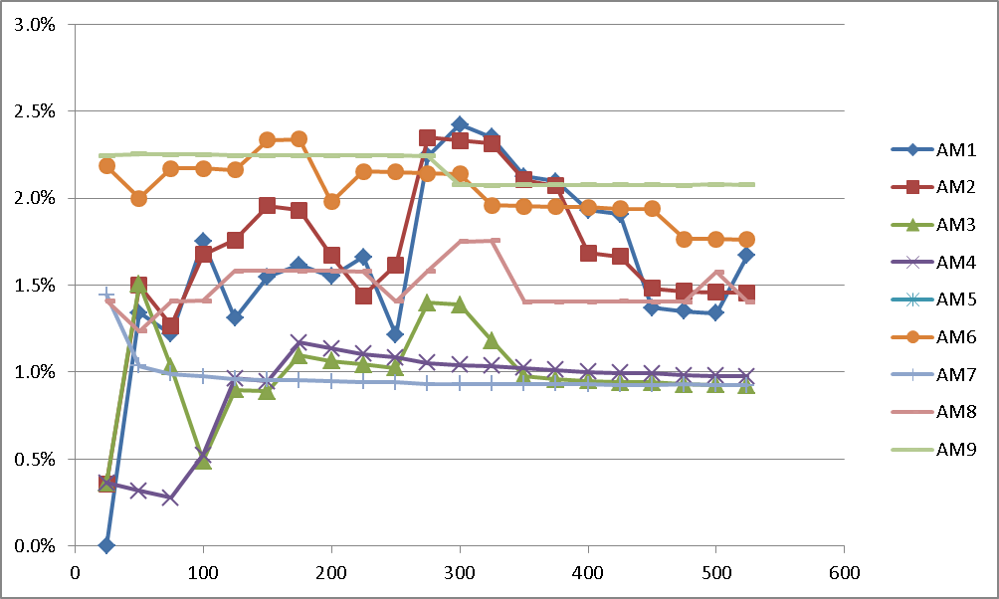
Figure 3-2 Percentage of False Matched License Plates vs. No. of Matched Plates for Algorithm

Conclusion

This is the starting point for determining how often an association matrix needs to be updated, after number of matches or days. It is important to also determine if the association matrix should be conditional; based on the time of day or flow of traffic.

References
1. Nakanishi, Y. and J. Western, Ensuring the Security of Transportation Facilities: Evaluation of Advanced Vehicle Identification Technologies. Transportation Research Record: Journal of the Transportation Research Board, 2005. 1938(-1): p. 9-16.
2. Oliveira-Neto, F.M., L.D. Han, and M.K. Jeong, Online license plate matching procedures using license-plate recognition machines and new weighted edit distance. Transportation research part C: emerging technologies, 2012. 21(1): p. 306-320.
3. Oliveira-Neto, F.M., L.D. Han, and M.K. Jeong, An Online Self-Learning Algorithm for License Plate Matching. IEEE Transactions on Intelligent Transportation Systems 2013. 14(4): p. 1806-1816.

MATCHING LICENSE PLATE USING DERIVED ASSOCIATION MATRICES

This chapter presents a modified version of a research paper by Stephanie R Hargrove, Hyeonsup Lim, and Lee D. Han titled “”. This paper was submitted for publication to

Abstract
Matching text misread by optical character recognition (OCR) to the same text captured, correctly or incorrectly, by a second optical recognition machine were tested on license plate recognition (LPR) technology and simulated OCR datasets. To perform the post-processing matching of license plates a self-learning matching algorithm is employed. The key component of this algorithm is an association matrix that represents the license plate patterns between two LPR stations that is estimated directly from a set of matched pairs. The self-learning matching algorithm employs two main techniques to automatically learn an association matrix for a pair of LPR cameras. The first is text mining to determine the least number of fundamental operations (edit distance) required to transform one license plate to another. The second technique determines an accepted travel time window, using mean and standard deviation of travel time, to increase the likelihood of true matches and reduce errors.
Conversely, the matching algorithm’s performance decreases as the distance between two LPR stations increases. This may be due to vehicles no longer travelling within an average travel time window and/or a low sample of vehicles travelling between the two LPR stations. This paper proposes deploying a third LPR station to generate additional information to derive a better association matrix for an existing pair of LPR station, thusly replacing the existing association matrix. The derived and existing association matrices were examined for license plate datasets both collected in the field and simulated. Analyses were performed to determine when and why a derived association matrix would be needed. As a result, derived association matrices are better for low traffic flows (small sample sizes) and/or poor LPR camera read rates.

Introduction
License Plate Recognition (LPR) technology has been utilized since the 1970s. Over the years, many changes and adaptions have been made to the technology that addresses license plate detection, character segmentation and character recognition [1-6] . LPR technology is a mature yet flawed technology used for automating speed enforcement, toll collection and the generation of travel times by matching the same license plate at two LPR stations. This paper does not address any advancements of LPR technology, but employs a self-learning license plate matching algorithm that relies on mistranslated Optical Character Recognition (OCR) text to match license plates, instead of waiting on the advancement of LPR technology to generate a perfect OCR text.
Matching license plate OCR text is far more complicated than matching traditional OCR datasets that have readily available dictionaries, i.e., the truth, to compare to and context to help determine the meaning of the OCR text []. When matching a license plate captured by OCR, we do not know what the true identity of the license plate string (sequence of characters) and a significant portion of license plates are recognized with errors. /////
Another common occurrence is when both LPR stations mistranslate a license plate in the same fashion; it has been read incorrectly but produces a perfect match. /////
LPR cameras each achieve different levels of accuracy depending on the hardware and software of a camera, set-up (mobile or stationary), location (side of road or overpass), on-site calibration, diversity of captured license plates, and numerous other factors. This accuracy is termed read rate; it is defined as the number of correctly read license plate strings divided by the number of captured license plate strings at one location. The read rates of LPR cameras are relatively low, usually around 60% or less without calibration [7-10] . Higher read rates have been experienced in countries other than the United States, this is because LPR can achieve higher accuracy with uniform license plates, yet has a harder time discerning between the more than 3,000 license plate varieties in the United States.
To utilize LPR technology for toll collection, speed enforcement and travel time generation a license plate must be matched at two or more locations. The accuracy of obtaining the same license plate at two or more locations is called the matching rate; this is defined as the total number of correctly matched license plates divided by the total number of license plates captured, whether correctly or incorrectly, at both locations. When only using OCR text to match license plates a matching rate of 35% or less is experienced when using two LPR cameras with a read rate of 60%. The current industry approach for correcting this poor rate is employing man power to identify the misread characters from the license plates.
If the string of a license plate is not read correctly the probability of ever being conventionally matched, using only OCR text, at another location is very minimal. If you have two captured strings and the difference between them is one character, it is likely that the two strings belong to the same license plate. When licenses plates are read incorrectly it is common for only one or two characters to be misread out of the entire plate string [10]. Since this is true, then it means the read rate of individual characters is much greater than the read rate of a license plate string. This is the foundation of the self-learning license plate matching algorithm- by using the individual characters within the license plate strings, a great deal of additional information is utilized to determine the likelihood of two seemingly different license plate strings being an actual match.
Oliveria et al. (2009) began exploring the use of Levenshtein edit distance (ED) technique [11] to improve the matching of license plates by employing a text-mining method./////

Association Matrix
The association matric is the key for the learning process of the license plate matching algorithm. If there is a poor association matrix in use, then the matching and updating of the AM may go the ‘wrong direction’ and/or the overall learning speed of the algorithm may be reduced. This section examines the heart of the algorithm and the current processes for estimating the association matrix.

Definition
The association matrix $A$ between two LPR station $(a, b)$ is an $N$ by$N$ square matrix whose elements are the conditional probabilities $p\left(c_{b} | c_{a}\right)$ of observing a character reading $c_{b}, c_{b}∈N$, in station $b$ for a given character reading $c_{a}, c_{a}∈N$, in station $a$ [9]. The element of the association matrix is denoted by:
 | $${\left(A_{ab}\right)}_{ij}=P\left(\left(c_{b}=N\left(j\right) | c_{a}=N\left(i\right)\right)\right)$$ | (1)
Where
${\left(A_{ab}\right)}_{ij}$ is the elements of row $i$ and column $j$ of association matrix from station $a$ to $b$
$c_{b}$ is the character captured at station $b$,$c_{b}∈N$
$c_{a}$ is the character captured at station $a$,$c_{a}∈N$
$N= \left\{0,1,2,…,9,A,B,…,Z,λ\right\}$ is the set of possible alpha-numeric characters ($λ$is null symbol)
$N\left(n\right)$ is the n^{th} character among the set of $N$.
When observing the association matrix, the probability of correctly reading a character is seen in the main diagonal elements and the misreading of a character is seen in the off-diagonal elements. Each row of $A$ refers to a given character recognition at station$a$, with the column being the associated reading at station$b$. The null symbol $λ$ can be more than just and unknown symbol, but also represent deletions and insertions in the plate string text.

Estimation from Truth Matrices
A truth matrix $T$ for a LPR station $a$ whose elements are the probabilities $p\left(c_{a} | c_{t}\right)$of each character’s interpretation; with the matrix’s row s representing the character reading $c_{a}, c_{a}∈N$ and the columns representing the true character reading${ c}_{t}, c_{t}∈N$. Oliveira-Neto et al.[9, 12] proposed estimating the $A$ using the following Bayesian expression:
 | $$p\left(c_{b} | c_{a}\right)=\sum_{t}{p\left(c_{b} | c_{t}\right) ∙p\left(c_{t} | c_{a}\right)}, t∈N$$ | (2)

In terms of the A and $T$ matrices, Equation ( 2 ) can be written as:
 | $$A_{ab}=T_{b}∙T_{a}^{tr}$$ | (3)
To make the matrix multiplication possible in (4), the $T_{a}$ is transposed. The process of estimating association matrices from truth matrices, though greatly improving the ability to match license plates, still has many downsides:
- It requires extensive man hours to extract and visually inspect the license plates to acquire the needed ground truth. This process is very costly and time consuming.
- Large sample sizes are also required to estimate a highly precise association matrix.
- The truth matrixes contain separated sets of readings; thus, observing unique plate patterns at each station. The ideal association matrix is estimated only using matches between the associated stations, not the full set of reading for each station. This could lead to ///

Estimation from Matching Algorithm
Oliveira-Neto et al [10] discusses a more efficient way of generating AMs using matched plates between two LPR stations that are identified with a heuristic text-mining algorithm.

Using plate matches allows for a more robust association matrix, though a LPR camera’ is always experiences different variations and noise, thus ever changing the read rate.

Estimation from Self Learning Matching Algorithm
The matching algorithm begins with a starting association matrix $A_{0}$ and generates an ‘optimal’ matrix $A_{k}$ by repeating the matching procedure. The repeating is achieved by completing multiple iterations $k$ of the matching algorithm to update a previous association matrix$A_{k-1}$. The algorithm is stopped when the difference between two successive estimates meets a stop criterion.

Oliveria-Neto et al show that the estimated AM approaches to the true AM as the iterations increase through simulation, even when the process begins with a very poor starting association matrix [10]. The starting association matrix is commonly comprised of zeros or an identity matrix, this allows for unbiased learning from the start.

Determining a True Match using an Association Matrix

Deriving an Association Matrix

Simulated Experiment
By simulating a license plate OCR dataset, the ability to examine a limitless number of characters is gained. This set of characters is generated using an existing association matrix; thus, allowing us to know the ‘ideal’ association matrix between two stations. In order to measure the degree of accuracy of the derived and calculated association matrices, it is essential to have the ideal existing association matrix for measurement. Simulation removes the need to manually identify all the text to. By also using an existing association matrix, the occurrence of a null symbol (missing, unidentifiable character) is achieved. The simulation is performed by generating one character at a time versus an entire license plate string. In doing this the reliance on the position or sequence of a character during recognition is removed. Matching and learning is simply completed by only referring to the characters captured directly before and after a true matched character.
- Generate a dataset of individual characters from an existing (theoretical) association matrix for a pair of LPR stations.
- Apply the matching algorithm to the generated dataset in Step 1 to find a set of matches with the initial settings:
  - Assume initially that $A_{ab}$ is a 37 x 37 zero matrix;
  - Use 0 or 1 assignments for non-matches and matches, respectively, to calculate ED;
  - Set a threshold $τ$ such that if $p\left(c_{b} | c_{a}\right)≤τ$ the characters $c_{b}$ and $c_{a}$ may have come from the same text string.
- From the set of matched plates obtained in Step 2, tabulate the pair-wise character occurrences to obtain the direct association matrix in count form.
- Compute an updated approximation for the matrix $A_{ab}$, where each cell will be the probability $A_{ab}=p\left(c_{b} | c_{a}\right)$
- Determine the difference between the theoretical and direct association matrix using equation 5.
- Repeat Steps 2-5 for multiple sample sizes of the generated dataset.
The following experimental conditions were used to evaluate the performance of the association matrices.
- The use of travel time is exempted from the matching process. Though travel time is an important procedure in the matching algorithm, it remains important to measure the performance of the self-learning matching without relying on a travel time window. As mentioned earlier, if the LPR stations are placed a great distance apart
- When determining read rate of LPR stations, the simulation assumes that all LPR cameras perform at the same level of accuracy. This is not common in the real world, but setting constant accuracy for each simulation run aides in a better understanding of the role of LPR read rates and sample sizes.
- The simulation reads one character at a time, versus capturing a whole license plate string. Meaning the simulation does not consider how many characters are in each plate, when an association matrix is updated based on character-basis. In doing this the reliance on the position or sequence of a character during recognition is removed.
- - accuracy: probability of reading a character as its original one (e.g., ‘a-a’, ‘b-b’)
- - number of sample size: number of characters matched by the algorithm (not necessarily saying that number of possible matches unless the capture rate of the algorithm is 100%)
- - accuracy is constant over sample size
In this Figure, the accuracy of each station is same. (We need to/will have the different accuracies)

Performance of Association Matrices

 | $$d=\frac{ \sum_{i=1}^{N}{\sum_{j=1}^{N}{|a_{ij}-b_{ij}|}}}{ \sum_{i=1}^{N}{\sum_{j=1}^{N}{|b_{ij}|}}}$$ | (5)
Where,
b_{ij} is the elements with row i and column j of the theoretical AM
a_{ij} is the elements with row i and column j of the compared AM

. 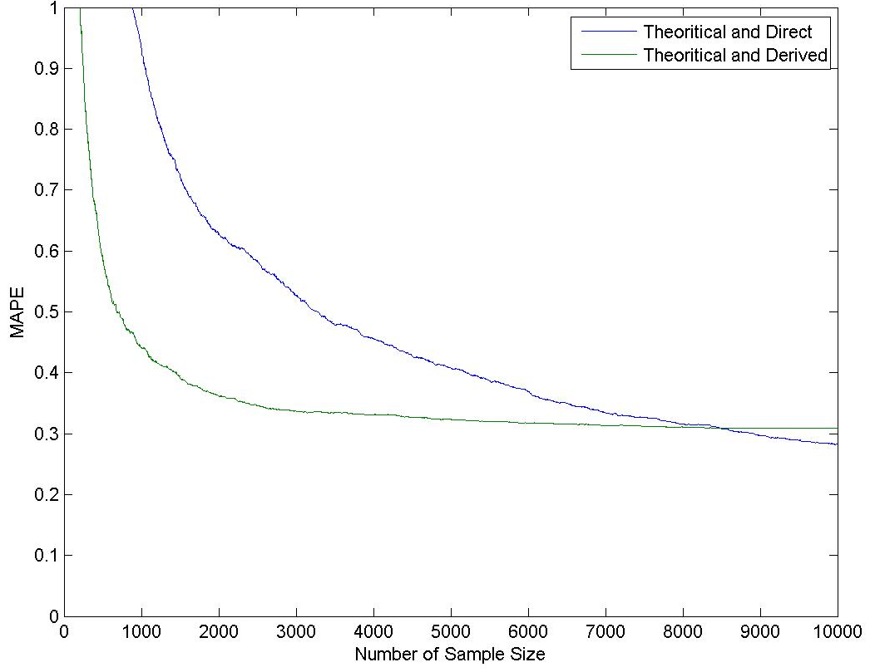
Figure 4-1 Differences between Association Matrices with Read Rate of 40%
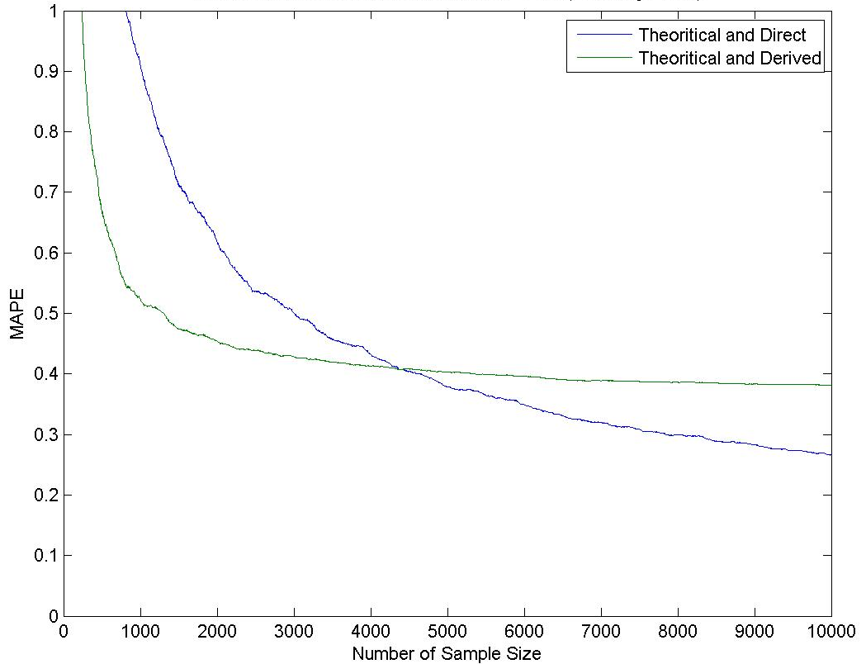
Figure 4-2 Differences between Association Matrices with Read Rate of 50%
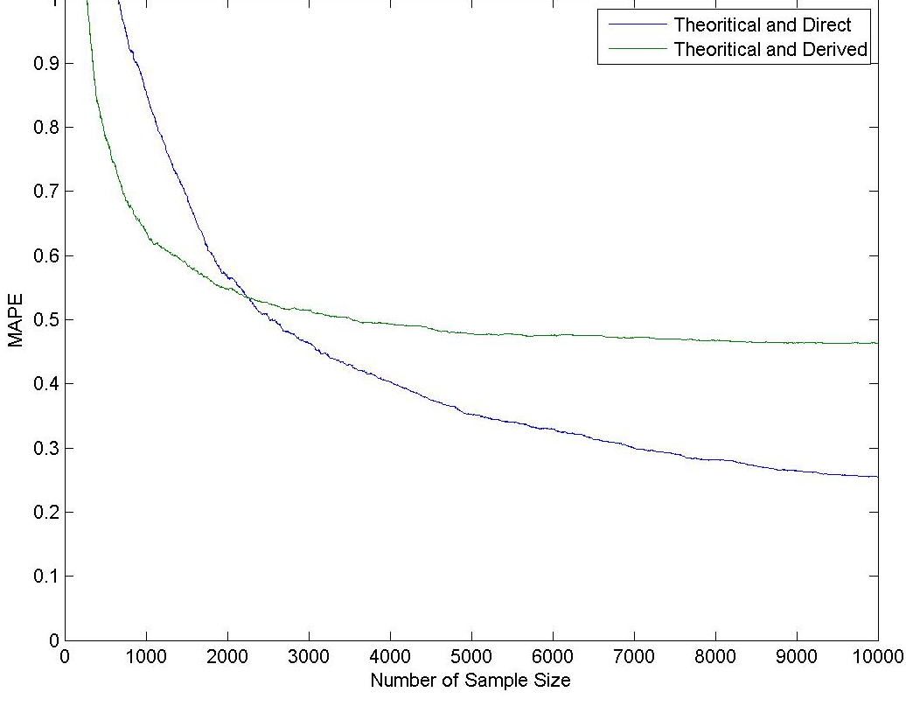
Figure 4-3 Differences between Association Matrices with Read Rate of 60%
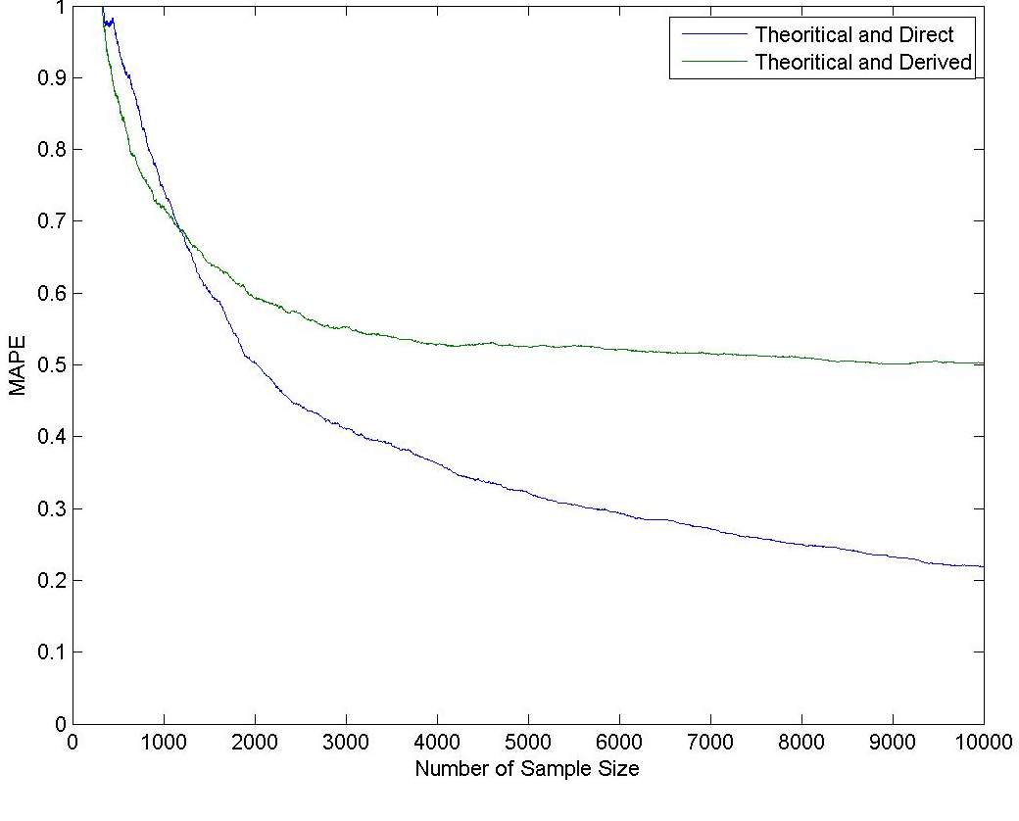
Figure 4-4 Differences between Association Matrices with Read Rate of 70%
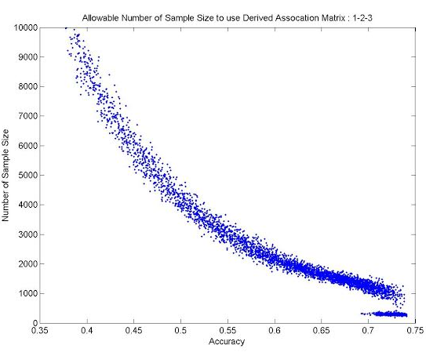
Figure 4-5. Allowable Number of Sample Size to use Derived Association Matrix

Sample Size and Impact of LPR accuracy
When there are many sources of variation, noise, affecting a LPR station, it would be necessary for a large amount of data to achieve a required error precision. So far the sample size of plates or number of characters in which each LPR machine were exposed in order to obtain the association matrix was defined arbitrary. Fortunately, it seems that the sample size used in past examinations was sufficient to give a good matching performance. However, it is important to know the needed amount of data to obtain an accurate estimate of the association matrix. Oliveria ‘s initial self-learning algorithm required approximately 60,000 characters to converge to an ideal association matrix [12]. Since then many advancements have been made been made to the self-learning algorithm and has resulted in a drastic reduction in sample size. The simulation is also a strong tool for examining the relationship between LPR camera accuracy and required sample size.
The amount of data needed to estimate the association matrix is highly correlated with the read rate of the LPR cameras. Therefore, the estimation procedures should vary with the changes in the LPR performance. Figure 4-1

Application to Real Data

Data Sample

Performance of Association Matrices

Conclusion

References
1. Anagnostopoulos, C., License Plate Recognition: A Brief Tutorial. Intelligent Transportation Systems Magazine, IEEE, 2014. 6(1): p. 59-67.
2. Du, S., Ibrahim, M., Shehata, M., & Badawy, W. , Automatic License Plate Recognition (ALPR): A State of the Art Review. 2013.
3. Gilly, D. and K. Raimond, A Survey on License Plate Recognition Systems. International Journal of Computer Applications, 2013. 61(6): p. 34-40.
4. Mansour, R., A Robust Method for Arabic Car Plates Recognition and Matching Using Chain Code. American Journal of Computational and Applied Mathematics, 2012. 2(3): p. 105-111.
5. Wang, J.-X., et al. The research and realization of vehicle license plate character segmentation and recognition technology. in Wavelet Analysis and Pattern Recognition (ICWAPR), 2010 International Conference on. 2010. IEEE.
6. Yang, J., et al. A license plate recognition system based on machine vision. in Service Operations and Logistics, and Informatics (SOLI), 2013 IEEE International Conference on. 2013. IEEE.
7. Nakanishi, Y. and J. Western, Ensuring the Security of Transportation Facilities: Evaluation of Advanced Vehicle Identification Technologies. Transportation Research Record: Journal of the Transportation Research Board, 2005. 1938(-1): p. 9-16.
8. Oliveira-Neto, F., L. Han, and M. Jeong, Tracking Large Trucks in Real Time with License Plate Recognition and Text-Mining Techniques. Transportation Research Record: Journal of the Transportation Research Board, 2009. 2121(-1): p. 121-127.
9. Oliveira-Neto, F.M., L.D. Han, and M.K. Jeong, Online license plate matching procedures using license-plate recognition machines and new weighted edit distance. Transportation research part C: emerging technologies, 2012. 21(1): p. 306-320.
10. Oliveira-Neto, F.M., L.D. Han, and M.K. Jeong, An Online Self-Learning Algorithm for License Plate Matching. IEEE Transactions on Intelligent Transportation Systems 2013. 14(4): p. 1806-1816.
11. Levenshtein, V.I. Binary codes capable of correcting deletions, insertions, and reversals. in Soviet physics doklady. 1966.
12. Oliveira Neto, F.M., Matching Vehicle License Plate Numbers Using License Plate Recognition and Text Mining Techniques. 2010.

KEY CONSIDERATIONS FOR THE COMPARISON OF REAL-TIME TRAFFIC DATA
This chapter presents a modified version of a research paper by Stephanie R Hargrove, Hyeonsup Lim, Lee D. Han, and Brad Freeze titled “Key Consideration for the Comparison of Real Time Traffic Data”. This paper was submitted for publication to

Abstract
Advancement in information technology in recent years enables some non-traditional ways for estimating travel time information through the use of large quantity of location data of various accuracy and availability. By repurposing or multi-purposing technologies such as Bluetooth, GPS, and ubiquitous cellular devices, innovative efforts have seen mixed success in aggregating data from a multitude of devices to derive travel time condition at different geometric resolutions. The challenge, though, is how the performance of these emerging technologies could be measured against a bona fide ground truth (of travel time) when the ground truth can be exceedingly costly and difficult to obtain. .
To this end, this study took advantage of a high-performing license plate recognition and matching system (98% matching rate with less than 1% false-positives) to establish high-accuracy travel time ground truth at four sites for 12 hours or so each. The sites were chosen where a handful of other technologies were also deployed so that concurrent data could be collected and compared.
By comparing the root-mean square errors of travel time estimated by various technologies, the study found the performance ranking are in the order of HERE, Bluetooth, INRIX, RTMS (remote traffic microwave sensors), and Google. Since most state agencies have already invested in RTMS type of technologies, some degrees of fusion of RTMS with other technologies may be beneficial in decision considerations.

Introduction
Delivering cost-effective, comprehensive travel information to motorists allows a better understanding of both current and near-future traffic conditions. Having better informed motorists can reduce congestion, fuel consumption and emissions, and may improve safety. To help improve the delivery, the Federal Highway Administration (FHWA) ruled that all States must have an established real-time information program for traffic and travel conditions covering all Interstate system highways by November 2014. This federal mandate comes from the Safe, Accountable, Flexible, Efficient Transportation Equity Act: A Legacy for Users (SAFETEA-LU) under the heading of Congestion Relief that requires the Secretary of Transportation to implement a Real-Time Management Information Program for all States [1]. The primacy of the rule is for each State to deliver travel data in real-time to the local governments and public. Most states already have established regional Intelligent Transportation Systems (ITS) to provide information to users and many states are in the final stages of obtaining the required traffic data for their roadway network.
The high cost to install and maintain roadside traffic sensors has limited the ability of state agencies to collect travel time data over entire roadway networks. The need for real-time travel information has caused many private companies to collect and distribute traffic data independently of government agencies. These private companies have marketed and sold their traffic data to Departments of Transportation (DOTs), who in turn report to the general public. The problem is that the private companies are quite about the individual data points collected and the aggregation process implemented to generate their reported traffic data. The individual data points are collected from various sources, including Global Positioning Systems (GPS), probe vehicles, cellphone location, historical data, and even social media. The aggregation of all these data sources to generate a single value for a single time increment is not a simple task, and leaves room to question the accuracy of these private companies.
Based on these concerns, an examination of available travel time technologies and private providers was conducted to determine what method could deliver the most comprehensive and accurate travel information to motorists in the State of Tennessee. Even though multiple studies have completed similar examinations of private providers [2-6], it is important to re-examine them across different locations. The individual traffic data collected by each private provider is unique to both the provider and the location. For example, some states make available real-time traffic data from the state-installed roadside sensors, thus increasing the accuracy of the private provider’s reported traffic data. The State of Tennessee, however, only makes their roadside sensor data available in five minutes time increments, while some other states have smaller time increments available. Thus, a five minute time period becomes more difficult to utilize than a 30 second time period when reporting in one minute increments.
The I-95 Coalition comparison of travel time technology is completed by performing five minute space mean speed validation across four states. The study separated the results into four speed bins and allowed maximum of 10 mph for the absolute speed error and 5 mph for the speed error bias [6].
With the increasing advancements of travel time technology and the vast amounts of data becoming accessible, the many needs for evaluation also increase. The challenge is, however, there is not one absolute solution until perfect ground truth is obtained with 100% accuracy including the whole roadway population. Though perfect ground truth may never be obtained, an acceptable error can be defined. Thus, within the limitation of data accessibility, the evaluation is performed using the best available resources and analysis metrics. This paper provides several key considerations for traffic data evaluation for general cases, rather than a definite and specific conclusion. The key items discussed in this paper includes: raw data quality, objects to compare, obtaining ground truth data, establishing time intervals and evaluation measurements.

Data Sources and Collection

Traffic Data Sources
To ensure a thorough examination of traffic data sources, the authors selected two private providers and two roadside technologies. The private providers are INRIX and HERE (formerly known as NAVTEQ). The roadside collection technologies include Bluetooth and Remote Traffic Microwave Sensors (RTMS) sensors.
INRIX and HERE are both private vendors that supply real-time travel speeds and times on a subscription basis. INRIX claims to have over 50 traffic-related data sources that are obtained and merged to generate the data reported to clients. The majority of the data comes from traditional probe vehicle data and roadway sensors, but there is a growing number of human-supplied observations, such as reports from drivers via their cellphones[7]. The majority of HERE’s traffic data is collected using in-vehicle GPS, while also observing state roadside sensor data. HERE’s data is used to power hundreds of applications, as examples Garmin, Microsoft, and Yahoo standardize on their map content. The company also dominates most of the automotive sector, with four in five cars using HERE’s maps, and 75% of traffic enabled cars using their traffic data [8]. Both providers report aggregated traffic data using the Traffic Message Channel’s (TMC) coded locations at one-minute increments. Many concerns arise about private providers because they lack the ability to share the data aggregation process and the raw data points used to determine the reported traffic data. By comparing the reported aggregate data to collected ground truth, the accuracy of each private provider will be examined in this paper.
If the State of Tennessee decides to independently collect real-time traffic data, or perform additional accuracy analysis of private providers, it will be important to establish the reliability of available technology to capture the needed data. Thus, Bluetooth and RTMS sensors were examined for this paper. Bluetooth sensors have become a common tool for collecting traffic data because they are cost-effective, easy to set-up, and require minimal knowledge of the technology to operate [2, 9-12]. The State of Tennessee already has RTMS sensors deployed on interstate highways in four major cities across the state. If RTMS sensors prove to be a reliable data source, then the state can confidently use the readily available data for real-time traffic data.
A Bluetooth sensor is capable of monitoring and measuring vehicular and pedestrian movement by identifying and comparing unique Media Access Control (MAC) addresses associated with Bluetooth-enabled electronic devices. These systems can be used to timestamp individual vehicles by sampling Bluetooth enabled devices and vehicles from the traffic stream of a predetermined route. By matching MAC addresses captured at two different locations using post-processing software, road speeds and travel times are derived. Each post-processing software application can yield unique results; Traffax’s BluSTATS software was employed for this study.
Bluetooth sensors are known to have common sources of error. The primary sources are spatial and temporal errors caused by the 300 foot detection zone radius of Bluetooth sensors [4, 6]. A vehicle can be detected multiple times anywhere within the detection zone, thus causing discrepancies in the data, especially for short roadway segments. Another concern is for sampling errors. First, multiple Bluetooth devices in the same vehicle are seen to represent multiple vehicles, causing the individual vehicle’s travel time to be duplicated in calculations [4]. Second, the number of Bluetooth devices in the traffic stream may be limited. States without a ban on hand held-electronics while driving show a reduction in the amount of MAC addresses captured. Sharifi et al. report that the average hourly sampling rate for Bluetooth is between 2.0% and 3.4% for Maryland and Delaware [13]. Both of these states ban hand-held electronics; therefore, causing an increase in the number of Bluetooth devices, allowing drivers the freedom to drive and use electronics simultaneously. The State of Tennessee does not have a ban on hand-held electronics, which could reduce the sample size obtained by Bluetooth receivers. These concerns influenced the decision to include Bluetooth sensors into the comparison.
RTMS sensors detect volume, occupancy, speed and vehicle classification for a cross-section of a roadway every 30 seconds. The sensors are installed road side at are aimed to capture all lanes of traffic. Over time, an RTMS sensor may become less accurate at capturing traffic data due to moving of sensors, damage from natural elements, and/or inconsistent maintenance. To measure the continued accuracy of RTMS sensors, the technology was added to the evaluation. Table 1 contains a summary of all evaluated traffic data technologies and providers.

Table 5-1 Summary of Traffic Data Technologies and Selected Providers
Column1 | Bluetooth | INRIX | HERE | RTMS
Data Format | Capture Time & Device Sensor Strength | Speed & Travel Time | Speed & Travel Time | Volume, Occupancy, Speed & Vehicle Classification
Data Type | Individual Data | Aggregated Data | Aggregated Data | Aggregated Data
Data Source | Cellular and in-vehicle Bluetooth devices | State installed sensors, probe vehicles, GPS, cellphone | State installed sensors, probe vehicles, GPS. | Roadside vehicle detectors
Time Increment | None; as captured. | 1 minute | 1 minute | 30 seconds
Accuracy Checks Performed | Post collection processing with filters. | Independently verified in large-scale testing. | Data checks prior to map matching. | None.

Ground Truth
To evaluate data accuracy, the ground truth data should be collected as a benchmark. The problem is that researchers may never obtain the ground truth unless some acceptable error is defined. To select the proper source that is close to ground truth, many things should be considered, such as measurement error, sample size, etc. Also, actual travel time and travel speed information must be independently collected for the data collection location to validate all data sources for more accurate comparisons. These methodologies may include floating cars, GPS logging, radar-based speed measuring, and license plate matching. For the purpose of this study, License Plate Recognition (LPR) technology is employed to collect ground truth. The ground truth traffic data is obtained using a pair of mobile LPR units to automatically acquire and record license plates at sequential locations along the study route. The acquired license plates are then matched automatically by means of a heuristic text-mining algorithm developed by the University of Tennessee [14, 15]. The travel time of a vehicle is then calculated by finding the difference between the timestamp of two matched license plates. Du et al. have completed a comprehensive review of the existing LPR technologies and applications [16].
License plate matching is chosen over other methods because the recognition technology’s small detection window results in a relatively small travel time error, especially at higher speeds [17]. LPR technology also allows a microscopic examination of the traffic flow by tracking vehicles within the road lanes.
The detection window is not the only possible source of error in the ground truth. Another could be the failure to perfectly match the ground truth’s examined roadway segment to the TMC segment for INRIX and HERE. This difference in segments is a common dilemma and results in the examination of travel speeds over travel times which are specific for each segment. An additional problem encountered during this study was time lag. The computers used to time stamp the data was operating with a constant time lag. This is a common error that is experienced by many different data collection processes. In order to fix the problem, the constant lag must be determined and used to correct all the time stamps.

Study Route and Data Collection
On October 18, 2013 a data collection was completed for numerous traffic data sources. The site location encompassed a 1,800 ft. stretch of roadway on I-40 in downtown Nashville, Tennessee, as shown in Figure 1. During the data collection, the segment a to c contained two RTMS sensors, two Bluetooth sensors, six LPR cameras, and two TMC sections containing traffic data for both INRIX and HERE. The Bluetooth sensors were mounted on light poles at stations a and c of the roadway segment. Two LPR cameras were set-up on each overpasses at stations a, b and c. The cameras caught the rear license plates of eastbound travelling vehicles on I-40. The two RTMS sensors are mounted along I-40, with the first at station a and the second located directly between stations b and c. The first observed TMC location for the INRIX and HERE, starts prior to station a and stops prior to station b. The second TMC location continues sequentially after the first TMC and stops after station c.

Methodology

Data Preparation
Before the evaluation process was conducted, several data composition and quality control techniques were implemented to verify the validity of the data collected. This step is completed by determining a procedure for comparing the ground truth data to the collected data source, establishing time periods, and eliminating outliers.

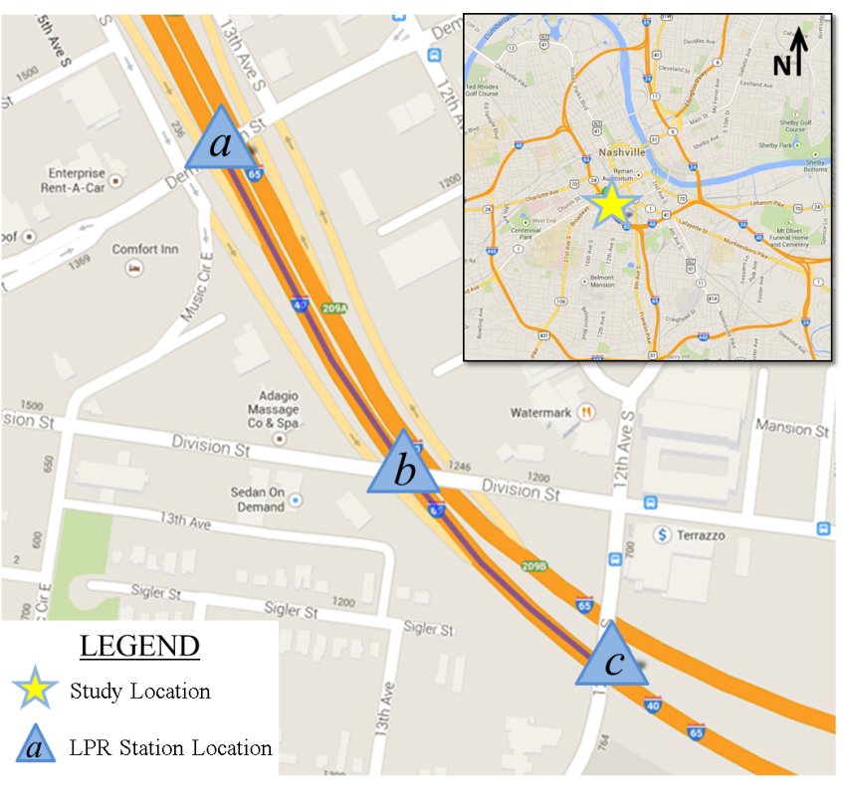
Figure 5-1 Study Route on I-40 in Nashville, TN

Comparison of Ground Truth to Data Sources
There are two methods to evaluate the travel speeds of collected data sources against ground truth: The first method assigns all data to a specific time period, e.g., one or five minutes, and calculates average speed for each period. The second method keeps all data in its original format (without changing the time period or generating average value). Figure 2 illustrates the two methods.
Averaging data in the first method establishes a simpler way to calculate deviations between more than two data sources since the paired comparison analysis will be based on single values for each time period of each data source. However, this method may produce incorrect data, which could be significantly different from the original data set. For example, if a determined time period is larger than the original data set’s period, the accuracy of the calculated average for the time period cannot be guaranteed unless the numbers of traffic counts for each time period are known in the original data set. Furthermore, if the determined time period starts or end at different times, the newly generated data may yield significantly inaccurate information, which is not identifiable unless all raw data is accessible.
Because LPR technology can observe individual vehicles, this study compared travel speeds between each vehicle captured with LPR and other data sources. For data sources with accessible raw data, such as Bluetooth and RTMS, the moving average of five minutes was calculated based on the time when each vehicle was identified.

Moving Average of Ground Truth
Moving average of ground truth data was calculated to compare with travel speeds of individual vehicles. The term moving is used because every time a new observation becomes available for the time series, it replaces the oldest observation in the equation, and a new average is computed. As a result, the average changes or moves as new observations become available.

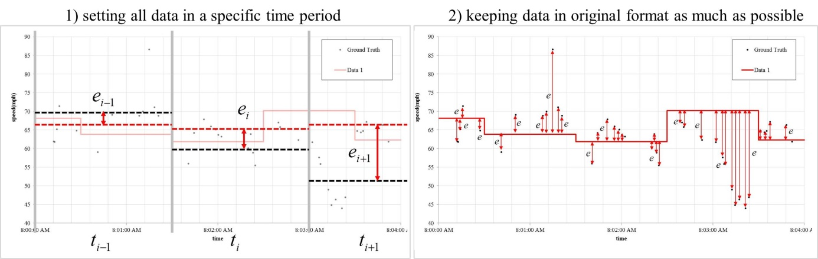
Figure 5-2Two Methods for Comparing Speed Data

To determine an appropriate time interval, it is crucial to have a realistic moving average. To achieve this, several trials examining different time intervals were implemented. It was determined that a five minute time interval provided an effective sample sizes while maintaining the characteristics of traffic flow at each time period.
The time period i was selected based on the time stamp of vehicle i identified, including two and a half minute intervals, before and after the identified time stamp. After selecting all vehicles within the five minute range at time period i, the Space Mean Speed (SMS), which is also known as the harmonic mean of speed, was calculated. The moving average of time period i is defined as:
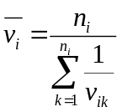
where
is the space mean speed at time period i
is the number of vehicles at time period i
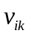 is the travel speed of k-th vehicle at time period i

90% C.I. of Ground Truth
Confidence intervals (C.I.) are used to test the significance of difference, or sometimes identify outliers, by investigating whether the travel speeds of each data source are within a boundary for time and space. If the distribution of the original data set is known, such as t distribution or normal distribution, the C.I. can be obtained with mean and standard deviation. However, since the distribution of travel speed is unknown and may vary at each time period, the confidence interval was calculated based on percentiles (5th to 95th).

Outlier Elimination
Eliminating outliers, like changing a time period, may yield different data set. Thus, no outlier was eliminated from the provided data to evaluate them as they provided.
In the matching procedure of LPR observations, however, there is a method to select certain candidates based on a time window, which is determined by mean and standard deviation of travel time at each time period. This procedure eliminates outliers. There is a slight chance of incorrect matches, but it is considered not significant because LPR technology has a higher accuracy, as discussed, and renders visual investigation of individual vehicles unnecessary.

Evaluation Measurements

Root Mean Square Error
The Mean Square Error (MSE) is “useful when we are concerned about large errors whose negative consequences are proportionately much bigger [sic] than equivalent smaller ones (e.g., a large error of 100 vs. two smaller ones of 50 each).”[18] Thus, using MSE rather than Mean Absolute Error (MAE) means that larger errors of travel speed are accounted for more than an equivalent amount of smaller errors.
The Root Mean Square Error (RMSE) is the square root of MSE yields, which has the advantage of having the same number of units as the quantity being estimated. The RMSE is defined as:
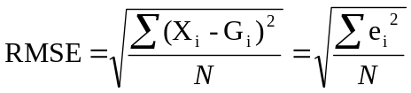
Where
X_{i} is the obtained data from other sources at time period i
G_{i} is the ground truth data at time period i
e_{i} is the difference(error) at time period i
N is the number of observations used in computing the RMSE.

Conversion of Data from Speed to Travel Time
Travel time is a measure of freeway service quality [19]. Travel time information is an indispensable part of travel information systems[20]. Thus, travel speed data were converted to travel time for an additional metric to show its potential impact on travel time estimation. For lower travel speeds travel time becomes more important, since the difference of travel time increases while the differences of travel speed remain the same.
The average section travel time (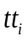), which can be considered as a “true” mean travel time of the temporal and spatial section, can be estimated from the unbiased estimate of the space-mean speed as [21]:
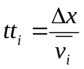
Where
is the average section travel time at period/vehicle i
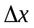 is the distance traveled
is the space mean speed at period/vehicle i.

Travel Time of Data Source / Travel Time of Ground Truth
Based on the converted travel time data, comparison of travel time between data sources and ground truth has been conducted. From this result, travel time reliability may be obtained if the acceptable time window could be defined for a certain propose.

Visual Investigation
Although several numerical metrics are provided for evaluation measurements, it is also important to investigate and interpret the figures visually to determine variations, patterns, and trends within the data. In a future study, additional metrics could be used to describe those patterns or trends.

Results

Investigation of Ground Truth Data
Prior to comparing travel speed between data source and ground truth, the authors investigated the ground truth data. With two LPR cameras installed in each location, four different flows were captured for one segment. For easier interpretation, lanes 1 and 2 are referred to as “Slow,” while lanes 3 and 4 are referred to as “Fast.” About 15 minutes of data, starting at 13:30, are missing due refueling power generators. The missing time periods were not included in the analysis.

Table 5-4 Travel Speed of Ground Truth Data on Segment ‘A to C’
As seen in Figure 5-3, the traffic flow “Fast to Fast” represents the highest speed along the study period. During PM peak, especially, there are two clearly separate flows along the same roadway. The first flow, “Fast to Fast” and “Fast to Slow”, is recovering to uncongested flow conditions, while the second flow, “Slow to Slow” and “Slow to Fast,” remains congested.

Comparison between Each Data Source vs Ground Truth
Four data sources are compared to the ground truth: Bluetooth, INRIX, HERE, and RTMS. In Figure 5-4, travel speed over time of each data source was plotted separately against the data of individual vehicles captured with LPR, along with the moving average and 90% C.I. boundary for the segments.

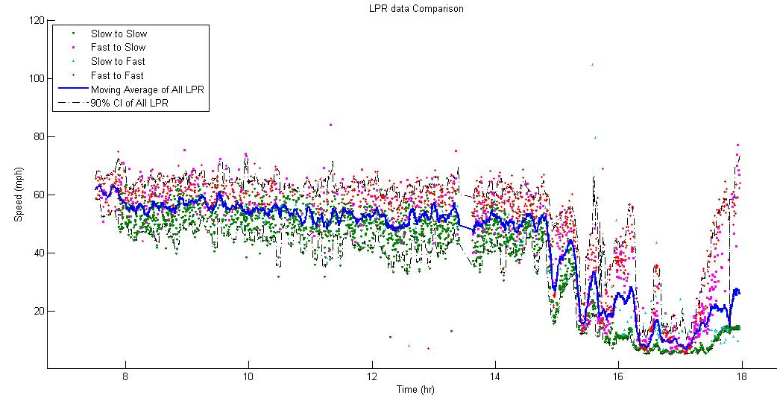
Figure 5-3 Travel Speed of Ground Truth Data on Segment ‘A to C’

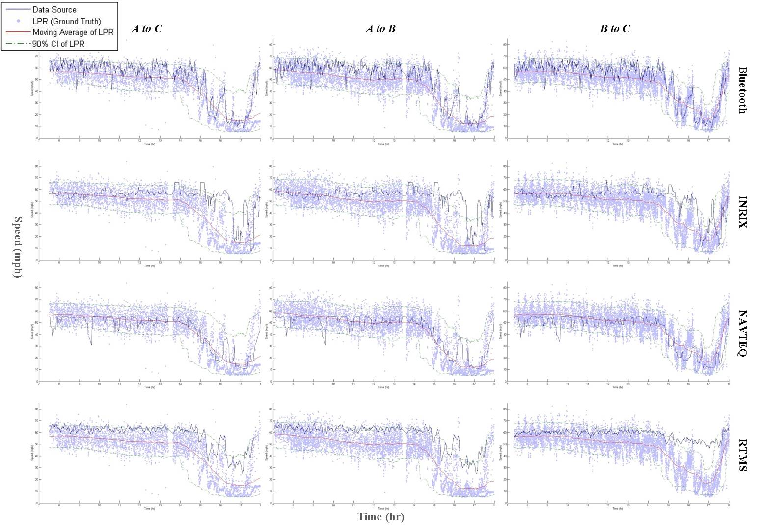
Figure 5-4 Comparison of Data Sources vs. Ground Truth Data (Travel Speed)

The travel speed of Bluetooth is, overall, slightly above the LPR. During PM peak, the travel speed of Bluetooth data seems to follow a fast flow along the two separate speed flows, except for segment B to C, which seems to show that congested flow recovers to free flow at the same time on the roadway. One possible cause of this tendency is that the embedded module of Bluetooth technology could tend to recognize low speed flows as outliers since high speed flows were counted more than low speed flows. There may be other reasons such as measurement errors of distance, time, biased sampling by strength of Bluetooth signal, and locations where the devices were installed, etc.
Travel speed of INRIX follows LPR relatively well during uncongested periods. Like Bluetooth, INRIX travel speed tends to be greater than LPR, which means travel speed provided by INRIX is higher than LPR most of the time. Also, during the PM peak, the travel speed of INRIX data seems to follow a fast flow along the two separate speed flows like all other data sources. Furthermore, the time when congested flow appears on INRIX data is later than LPR.
From overall visual investigation of Figure 3, travel speed of HERE data seems to be closest to LPR. The travel time of HERE is barely out of the boundary of 90% C.I. of LPR, except for the times of 7-8 and 9-10. There also seems to be relatively small time lag capturing the congested flow from the travel speed of HERE compared to the data of LPR.
The travel speed of RTMS data seems to be greater than the speed of LPR along the entire study period. It is very close to the upper boundary of 90% C.I. of LPR. This may be results of RTMS is usually more accurate in traffic counts [22], and the RTMS speed results varied depending on the mounting location [23].
Figure 5 illustrates the difference between using travel time and travel speed as an evaluation target. As travel time is obtained by the inverse of travel speed, variations increase at low speeds, as seen in PM peak. During the PM peak, some vehicles at low speed in the LPR data have longer travel times, over twice as long as the travel time recorded by Bluetooth.
Figure 6 shows the distribution of travel time of data sources divided by travel time of ground truth. Note that there is a mildly significant portion of vehicles with values less than 0.5, which means their actual travel times were twice or even longer than the travel times recorded, for all data sources. HERE seems to provide relatively more accurate data.

Summary of Results
Summary results show the overall accuracy of travel speed data using RMSE as the metric. In Figure 7, the inverse of RMSE was used for the z-axis unit, meaning that the higher (blue) bar represents better accuracy, and the values of RMSE were labeled accordingly.
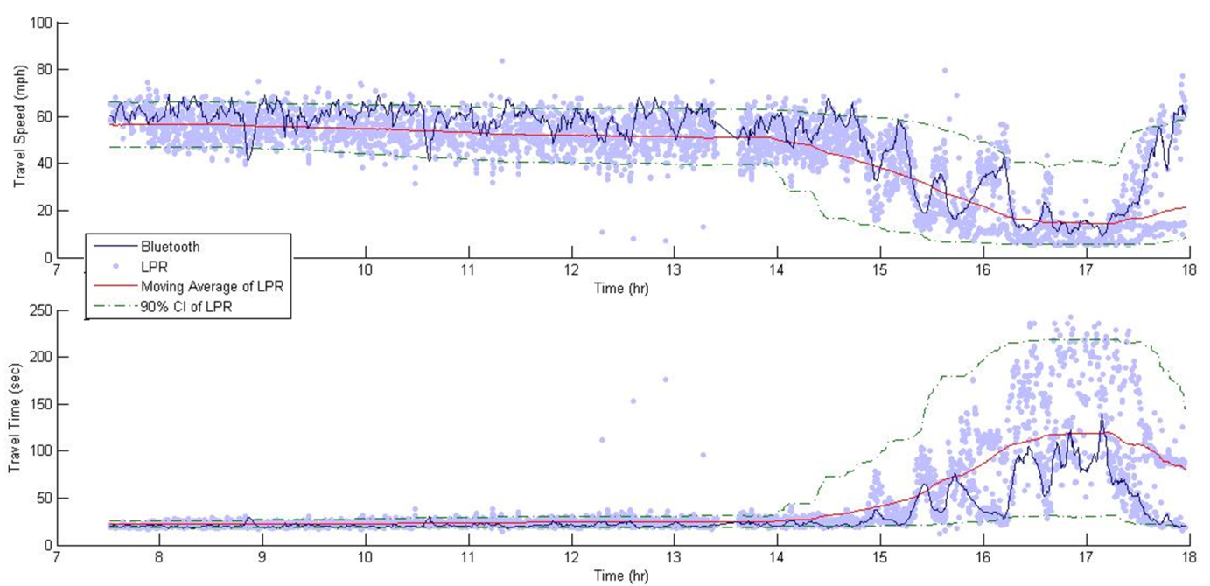
Figure 5-5 Comparison of Travel Time and Travel Speed for Bluetooth (Segment A to C)

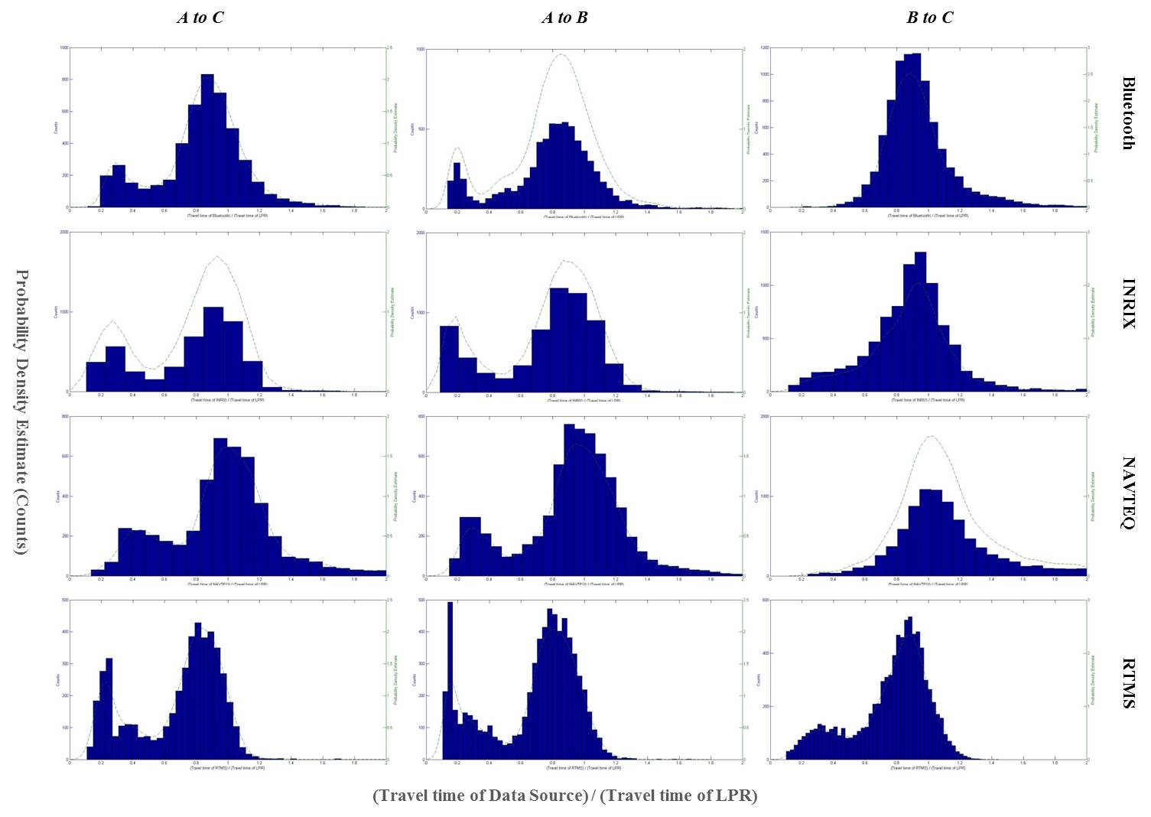
Figure 5-6 Distribution of ‘Travel Time of Data Source / Travel Time of Ground Truth’

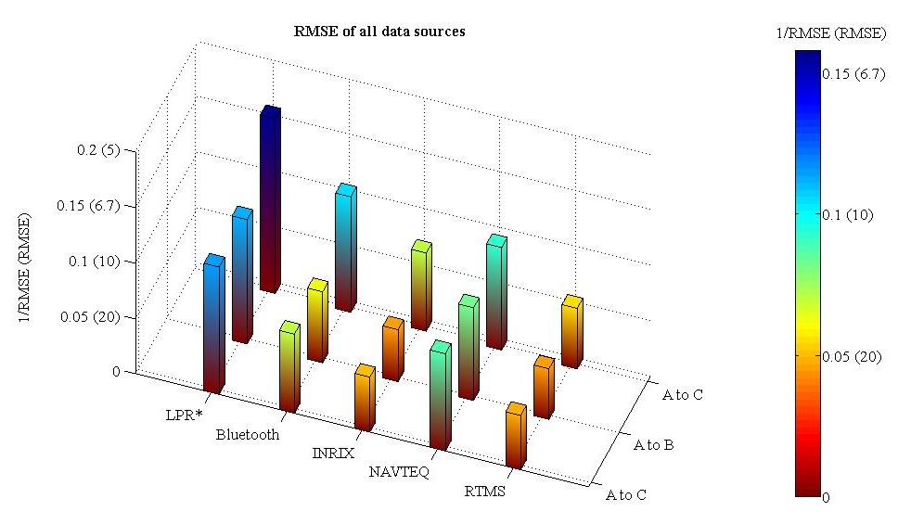
Table 5-8 Summary of Results (1/RMSE)

In summary, the travel speed data of HERE yields the most accurate results in terms of RMSE compared to LPR data, except segment B to C where Bluetooth has less RMSE. The segment B to C did not have two separate flows along the same roadway as other segments had. RTMS and INRIX data yield greater RMSEs, almost as twice as HERE’s for segments A to C and A to B.

Table 2: RMSE of Travel Speed and Travel Time for all Data Sources
RMSE of Travel Speed (mph) |  |  |  |  | RMSE of Travel Time (sec)
 | A to C | A to B | B to C |  |  | A to C | A to B | B to C
LPR* | 8.7 | 8.9 | 6.3 |  | LPR* | 24.7 | 16.2 | 5.7
Bluetooth | 14.0 | 15.6 | 9.6 |  | Bluetooth | 37.9 | 28.0 | 6.4
INRIX | 20.2 | 21.4 | 14.2 |  | INRIX | 50.7 | 32.7 | 10.9
HERE | 11.4 | 12.0 | 10.8 |  | HERE | 37.2 | 26.4 | 7.9
RTMS | 20.4 | 21.9 | 18.3 |  | RTMS | 52.1 | 34.0 | 12.4
LPR* : Individual data of LPR were compared to a five minute moving average of LPR data at each vehicle to see how much variation could be identified for individual data of ground truth from their moving average.

Conclusions and Recommendations
This study investigated multiple data sources to evaluate data accuracy as compared to LPR, which we assumed as a ground truth. The field survey was conducted for the three segments including two short continuous segments and one that includes both segments.
Since the study does not cover the data of the entire network, the results provide information for only selected segments and studied time periods. However, this study provides several considerations for how to evaluate the accuracy of travel speed data. The key considerations discussed in this study include:
- Determination of ground truth technology
- Evaluation measurements
- Conversion of data from travel speed to travel time
- Objects for comparison analysis (data retention of original source).
In order to precede forward with the evaluation of real-time traffic data and apply it in more applicable ways, more data is needed. Also, more investigation of ground truth, such as a range of measurement error and sample size, should be a key part of future study. Furthermore, to make decision of overall data accuracy and data quality, multi criteria decision making method could be used such as Analytic Hierarchy Process (AHP) or Simple Multi-Attribute Rating Technique (SMART) [2424].

References
1. Administration, F.H., Real-Time System Management Information Program, D.o.T.a.F.H. Administration, Editor 2010. p. 68418 -68429.
2. Haghani, A., et al., Data collection of freeway travel time ground truth with bluetooth sensors. Transportation Research Record: Journal of the Transportation Research Board, 2010. 2160(1): p. 60-68.
3. Lattimer, C. and G. Glotzbach. Evaluation of Third Party Travel Time Data. in ITS America 22nd Annual Meeting & Exposition. 2012.
4. Malinovskiy, Y., et al. Investigation of Bluetooth-based travel time estimation error on a short corridor. in Transportation Research Board 90th Annual Meeting. 2011.
5. Saunier, N. and C. Morency. Comparing data from mobile and static traffic sensors for travel time assessment. in 1st Congress of the Transportation and Development Institute of ASCE. 2011.
6. Haghani, A., M. Hamedi, and K.F. Sadabadi, I-95 Corridor Coalition Vehicle Probe Project: Validation of Inrix Data July-September 2008. Transportation Program, Civil Engineering Department, University of Maryland, College Park, 2009.
7. Chapman, C.H., et al., Determining road traffic conditions using data from multiple data sources, 2012, Google Patents.
8. Hangland, K., Intro: NAVTEQ | Univ. of TN, S. Hargrove, Editor 2014.
9. Ahmed, H., et al. Bluetooth-and Wi-Fi-based mesh network platform for traffic monitoring. in Transportation Research Board 87th Annual Meeting. 2008.
10. Saeedi, A., et al., Improving Accuracy and Precision of Travel Time Samples Collected at Signalized Arterial Roads with Bluetooth Sensors. Transportation Research Record: Journal of the Transportation Research Board, 2013. 2380(-1): p. 90-98.
11. Quayle, S.M., et al., Arterial Performance Measures with Media Access Control Readers. Transportation Research Record: Journal of the Transportation Research Board, 2010. 2192(1): p. 185-193.
12. Wasson, J.S., J.R. Sturdevant, and D.M. Bullock, Real-time travel time estimates using media access control address matching. ITE Journal, 2008. 78(6).
13. Sharifi, E., M. Hamedi, and A. Haghani. Vehicle detection rate for bluetooth travel time sensors: a case study in Maryland and Delaware. in Proceedings of the 89th Annual Meeting of the Transportation Research Board. 2010.
14. Oliveira-Neto, F.M., L.D. Han, and M.K. Jeong, Online license plate matching procedures using license-plate recognition machines and new weighted edit distance. Transportation research part C: emerging technologies, 2012. 21(1): p. 306-320.
15. Oliveira-Neto, F.M., L.D. Han, and M.K. Jeong, An Online Self-Learning Algorithm for License Plate Matching. IEEE Transactions on Intelligent Transportation Systems 2013. 14(4): p. 1806-1816.
16. Du, S., Ibrahim, M., Shehata, M., & Badawy, W. , Automatic License Plate Recognition (ALPR): A State of the Art Review. 2013.
17. Mizuta, K., Automated License Plate Readers Applied to Real-Time Arterial Performance: A Feasibility Study. Department of Civil & Environmental Engineering: University of Washington, 2007.
18. Makridakis, S. and M. Hibon, Evaluating accuracy (or error) measures. 1995: INSEAD.
19. Chen, C., A. Skabardonis, and P. Varaiya, Travel-Time Reliability as a Measure of Service. Transportation Research Record: Journal of the Transportation Research Board, 2003. 1855(-1): p. 74-79.
20. Lin, W.-H., A. Kulkarni, and P. Mirchandani, Short-Term Arterial Travel Time Prediction for Advanced Traveler Information Systems. Journal of Intelligent Transportation Systems, 2004. 8(3): p. 143-154.
21. Chu, L., S. Oh, and W. Recker. Adaptive Kalman filter based freeway travel time estimation. in 84th TRB Annual Meeting, Washington DC. 2005.
22. Middleton, D., D. Gopalakrishna, and M. Raman. Advances in traffic data collection and management. in One of three white papers that support a series of workshops on Data Quality, which were held in March. 2003.
23. Martin, P.T., Y. Feng, and X. Wang, Detector technology evaluation, 2003, Mountain-Plains Consortium.
24. Ho, W., X. Xu, and P.K. Dey, Multi-criteria decision making approaches for supplier evaluation and selection: A literature review. European Journal of Operational Research, 2010. 202(1): p. 16-24.

CONCLUSION
This dissertation compiled studies on enhancing a self-learning license plate matching algorithm and it’s utilization to capture ground truth travel times. The matching accuracy and learning speed efficiency of the algorithm are the major concern of this research. A series of simulations and field experiments were performed to support this research.
First, the beginning of the matching algorithm is examined to optimize learning speed and accuracy. It was found that an unbiased association matrix is needed to reach a theoretical association matrix. ////. A future study is recommended to consider combined matrixes, e.g. using an alternate association matrix until a certain sample size is obtained and then using an unbiased starting association matrix.
Second, the experiment was conducted on derived association matrices to simulate their need at LPR stations with experiencing poor matching using the self-learning matching algorithm. Analyses were performed to determine when and why a derived association matrix would be needed. As a result, derived association matrices are better for low traffic flows (small sample sizes) and/or poor LPR camera read rates. A future study is recommended to ///
Finally, and A case study on probe vehicle technology was performed at Nashville, TN. This study examined the use of LPR technology and the matching algorithm as an ideal way to establish ground truth travel times. A future study is recommended to scrutinize the process of calculating ground truth travel times and establish a ////.

VITA

Stephanie R. Hargrove was born and raised in New Smyrna Beach< Florida. She moved to Nashville, Tennessee at the age of sixteen where she graduated high School at the University of Tennessee. In 2001, she began her enrolled at the University of Tennessee, Knoxville to pursue a BS in Civil Engineering. During her senior year of college, she discovered her love for transportation and at the encouragement of Dr. Fred Wegman enrolled in the Master’s program for transportation. In 2006, Stephanie graduated wither Master’s degree and a these titled ‘Commercial Vehicle Enforcement using License Plate Recognition Technology.’ After graduation, Stephanie began work as a Transportation Engineer at Wilbur Smith and Associates.
In 2010, Stephanie decided to return to the University of Tennessee, Knoxville to enroll in the transportation doctorate program. While at the University, Stephanie has been project manager of numerous projects including the real-time commercial vehicle monitoring with license plate recognition and examination vehicle probe based travel information. Stephanie also worked as the surveying lab instructor for many semesters and completed research her last semester for the National Transportation Research Center.

