Do increases in fruit intake lead to substitutive eating patterns and decreases in overall energy intake in normal weight adults?

A Thesis Presented for the Master of Science Degree
The University of Tennessee, Knoxville

Shireen Amanda Sobhani
August 2015

Acknowledgements
To my major professor, Dr. Hollie Raynor, my sincere appreciation and gratitude for your continuous support, guidance, and patience through the years I have worked with you. I greatly appreciate your dedication to the mentorship of your students, myself included.
To my committee members, Dr. Sarah Colby and Dr. Melissa Hansen-Petrik, thank you for all your guidance throughout my undergraduate and graduate career and your feedback and suggestions for this project.
To the undergraduate and graduate students in the Healthy Eating and Activity Laboratory, specifically to Anna Augusta, Nethraja Rajaratnam, Whitney Powell, Cassidy Wilder, and Olivia Wooliver, for your help with project preparation and data collection, my utmost thanks! I would also like to thank Erin Norton, Seletha Poole, Kelsey Wallour, and Chelsi Wolz for your additional assistance and support.
To my family and friends, thank you for your encouragement and support. A very special thank you to my parents, Teresa Thorpe and Michael Sobhani, my sister, Aimee, and Thaddeus Cole for all your love and support throughout the years; this would not be possible without you and I am extremely thankful for all you have done for me.

Abstract
Background: It is suggested that increasing intake of fruits and vegetables may lead to decreased energy intake via substitution of higher energy dense foods such as snack foods (SF: i.e. candy, chips, cookies). This study investigated the impact of increasing fruit (F; grapes) intake, via increased portion size, had on SF (potato chips) intake and whether increases in F intake affected total energy intake, via reducing SF intake (substitutive eating), in normal-weight adults. A secondary objective investigated whether the relative reinforcing value (RRV) of SF was a moderator of the substitutive relationship between F and SF.
Methods: Using a 4X4 crossover design (between subjects factor of order [1, 2, 3, 4] and within subjects factors of meal condition [CONTROL, INCREASE, DECREASE, INCREASE+DECREASE]), 25 healthy-weight participants (22.3 + 1.9 kg/m² ,79% female, 22.5 ± 4.1 years of age) completed the study. As part of an ancillary project, this study focused on the unidirectional substitution relationship between CONTROL and INCREASE. In addition to two sandwiches, CONTROL contained 100 grams (g) each of F and SF, while INCREASE contained 150g of F and 100g of SF. A validated computer task was used to determine the RRV of SF.
Results: Analyses of variance found that participants consumed significantly more grams and energy of F in INCREASE (141.4 ± 21.8g, 65.2 ± 11.3kcal), as compared to CONTROL (94.5 ± 16.4g, 96.2 ± 16.0kcal), but there were no significant differences (grams or energy) in SF or total energy intake in INCREASE, as compared to CONTROL. Hierarchical regression analyses determined that increases in F intake were not significantly associated with changes in gram and energy intake of SF or changes in total energy intake from CONTROL to INCREASE. Hierarchical regression analyses also concluded the RRV of SF did not significantly moderate the relationship of SF intake from CONTROL to INCREASE.
Conclusion: Increasing F consumption did not contribute to significant decreases in SF intake or total energy intake, suggesting F does not act as substitute for SF. Recommendations encouraging individuals to increase F intake in order to decrease total energy intake may not achieve desired results.

Table of Contents
Chapter I: Literature Review 1
Background and Significance 2
Adult Obesity in the United States 2
Fruit and Vegetable Intake, Energy Intake, and Weight Status 3
Theoretical Framework 9
Behavioral Economics 10
Substitutive Eating 11
Substitutive Eating: FV and High-Energy-Dense Foods 13
Relative Reinforcing Value of Foods 15
Summary 17
CHAPTER II: MANUSCRIPT 20
INTRODUCTION 21
EXPERIMENTAL DESIGN AND METHODOLOGY 24
Study Design 24
Participants 25
Randomization 27
Procedures 27
Meal Description 29
Measures 30
Statistical Analysis 34
RESULTS 35
DISCUSSION 40
REFERENCES 44
APPENDICES 49
APPENDIX A: TABLES AND FIGURES 50
APPENDIX B: RECRUITMENT, FORMS, AND QUESTIONNAIRES 57
VITA 102

List of Tables
Table 1-Study design: 4X4 mixed factor design 57
Table 2-Description of foods per condition 57
Table 3-Participant characteristics at baseline 58
Table 4-Video and computer game usage by relative reinforcing value task game order (mean ± standard deviation) 58
Table 5-Dietary recall summary and hunger & fullness ratings (mean ± standard deviation) 59
Table 6-Gram and energy of foods consumed (mean ± standard deviation) 59
Table 7-Participants who were through with meal and were not through with meal in 20 minutes 60
Table 8-Hierarchical regressions of increased fruit related to change in snack food intake in grams and energy from CONTROL to INCREASE 60
Table 9-Hierarchical regression of increased fruit intake related to change in total energy intake from CONTROL to INCREASE 61
Table 10-Relative reinforcing value of fruit and snack food scores (mean ± standard deviation) 61
Table 11-Hierarchical regressions of relative reinforcing value of chips moderating changes in snack food intake from CONTROL to INCREASE 62

List of Figures
Figure 1-Participant flow chart for primary objective 64

Chapter I: Literature Review

Background and Significance

Adult Obesity in the United States
The obesity epidemic has leveled off since the early 2000’s (2003-2004) and late 2000s (2009-2010); however, the prevalence of obesity in the United States (US) remains high, particularly among women, middle-aged adults, and non-Hispanic black adults¹. Overweight health status is defined as having a body mass index (BMI) between 25.0 kg/m² and 29.9 kg/m², while obesity is defined as having a BMI of 30.0 kg/m² or above². According to data compiled from the National Health and Nutrition Examination Survey (NHANES), the prevalence of overweight and obesity among the adult population is 68.5%¹. Further, 34.9% of individuals are considered obese, and 6.4% are considered extremely obese (BMI ≥ 40 kg/m²)¹. Negative outcomes associated with overweight and obesity range from disease states such as cardiovascular disease and diabetes, to the financial burden of medical costs placed on the health care system in the US³.
As the prevalence of overweight and obesity persists as a public health priority⁴, it is necessary to develop strategies to help individuals achieve weight loss goals and combat the difficulties associated with weight maintenance. While many factors may contribute to an unhealthy weight status (defined by medical standards as having a BMI >24.9 kg/m²), the root cause of obesity is positive energy balance⁵. Positive energy balance results from overconsumption of energy in relation to energy expenditure. In order for weight loss to occur, a negative energy balance must be achieved by decreasing energy intake, expending energy through increased physical activity, or a combination of the two. A recommended strategy to achieve a healthy weight is to increase the amount of fruits and vegetables (FV) in the diet⁶. Increased intake of FV has been associated with reduced all-cause mortality risk, decreased risk of obesity-related diseases, such as diabetes and cardiovascular disease, and a healthier weight status⁷.

Fruit and Vegetable Intake, Energy Intake, and Weight Status
FV intake in the US falls below the recommended level of four-and-a-half cups of FVs per day (two cups from fruit [F] and two-and-a-half cups from vegetables [V])^{8,9}, with the average American consuming less than two cups of FV per day¹⁰. The World Health Organization (WHO) recommends individuals increase consumption of FV in the diet to reduce overweight and obesity¹¹. Current recommendations from the United States Department of Agriculture (USDA) and the United States Department of Health and Human Services suggest that individuals can achieve or maintain a healthy weight by focusing on increasing nutrient- dense foods in the diet, while consuming these foods within daily calorie needs, and consuming a minimum of two-and-a-half cups of FVs per day⁹. Although the recommendations encourage individuals to stay within daily calorie needs, the message often received by consumers is one of eating more FV, without reductions in intake of high-energy dense foods¹²; for instance, the USDA My Plate suggests individuals consume one-half a plate of FVs, while reductions in other foods is not highlighted¹². Further, while F and V contain similar nutritional benefits¹³, distinguishing characteristics between F and V are often not described and the two foods are often labeled as one entity (i.e. FV). Understanding the differences between F and V is beneficial when discussing the impact FV may have on energy intake and weight. Briefly, the major differences between F and V are as follows: 1) A higher percentage of individuals report strongly liking F over V¹⁴, 2) F may be a more preferred choice over energy-dense snacks such as cookies or chips, compared to V¹³, 3) V are more likely to be cooked or fried, compared to F¹³, and 4) V are more likely to be served with sauces or dips, compared to F¹³. For the purposes of this review, reporting of F and V and the effects F and V have on energy intake and weight status will be described as FV, unless individual intakes of F and V are noted; this information will be reported in addition to FV intake.
While it has been proposed that excessive positive energy balance may be altered with increased consumption of FV,^{15,16} observational studies report mixed associations between increased FV intake and reductions in energy intake¹⁷⁻¹⁹. The European Prospective Investigation into Cancer and Nutrition (EPIC) cohort study, for example, included 313,074 participants aged 40-85 years from eight European countries, and found that the highest FV intakes per day (≥8 servings of FV/day) were not associated with lower energy intake at baseline¹⁷. Other observational studies have reported an inverse association between energy intake and higher FV consumption^{18,19}. For instance, Davis et al. conducted a study of 104 normal and overweight or obese individuals, aged 19-69 years, and found that FV consumption (reported via a food frequency questionnaire) in normal weight adults is higher (1.6 servings of F, 3.7 servings of V) and associated with lower daily energy intake (1569 ± 581 kcal/day), as compared to overweight and obese adults who had lower FV consumption (0.9 servings/day of F, 3.7 servings/day of V) and higher mean energy intake (1,806 ± 723 kcal/day)¹⁹.
Little experimental research has examined FV intake and energy intake over time, and the research that has been conducted does not suggest that increasing FV intake decreases energy intake²⁰⁻²². A systematic review and meta-analysis of randomized controlled trials designed to increase FV intake, from Mytton et al, found no significant changes in energy intake in the eight studies reviewed²⁰. Investigations included in the review were randomized controlled trials with two or more arms, with at least one arm promoting intake of FV or providing FV to participants, and producing a minimum difference of 50 grams per day in FV consumption between control and intervention arms, with no dietary advice to replace FV for other foods or make any alterations to the diet²⁰. For the analysis, FV consumption was divided into two groups, with the intervention groups classified as those with “high FV intake” and the control groups classified as those with “low FV intake”²⁰. FV consumption ranged from 50 grams to 456 grams, with a mean difference of 133 grams between the groups. Results from the review found that there were no significant differences in daily energy intake between the intervention or control groups²⁰.
One experimental study from Lapointe and colleagues examined the impact of increasing FV intake on overall energy intake in 68 overweight-obese postmenopausal women, aged 45 to 68 years during a 6-month intervention²¹. Individuals were randomized to either a HIFV condition, which incorporated nonrestrictive messages promoting inclusion of FV and no advice on fat reduction, or the LOFAT condition which used a restrictive approach telling participants to limit high fat foods²¹. Each group was advised on food habits but no energy intake goal was given²¹. Participants in the HIFV group significantly increased their intake of FV at 6-months by a mean value of 2.5±2.7 servings/day (change of 1.0 ± 1.0 servings/day for F and 1.5 ± 2.4 servings/day for V), compared to baseline, and had significantly higher intakes of FV at 6-months (7.9 ± 2.5 FV servings/day; 2.9 ± 1.2 servings/day for F, and 5.0 ± 2.1 servings/day for V), compared to the LOFAT group (6.1 ± 2.0 FV servings/day, 2.4 ± 1.1 servings/day for F, and 3.6 ± 1.3 servings/day for V)²¹. Results from the study showed that energy intake in the LOFAT condition decreased at both three and six months (-415 kcal/day and -520 kcal/day, respectively), but no significant change occurred in energy intake for the HIFV group at either three or six months (-90 kcal/day and -152 kcal/day, respectively)²¹.
A 12-week study by Svendsen et al, of 138 overweight or obese individuals, aged 28-72 years, concluded that participants with sleep-related breathing disorders advised to increase FV intake by 400g/day for V and 300 g/day for F, did not have significant changes in total energy intake, compared to controls at 12-weeks. Results showed intakes of FV significantly increased in the intervention group (245 grams/day for V and 248 grams/day for F), compared to controls with no significant changes in FV intake for controls (12 grams/day for V and -4grams/day for F)²².
With regards to the association between FV intake and weight status, observational research is also mixed^{7,23-29}. Retrospective cohort studies suggest that overweight and obese adults have lower intakes of FV compared to individuals of a normal weight⁷, while prospective cohorts show either inverse associations between higher FV intake and less weight gain²³⁻²⁷ or find no significant associations between FV intake and weight status^{28,29}. For instance, in a study of 120,877 non-obese adults, Mozaffarian et al found that four year weight gains were inversely associated with increased intake of FV servings per day (i.e. increased consumption of FV contributed less to weight gain), with each increase in F serving per day contributing to 0.49 pounds less weight gain and each increase in V serving per day contribution to 0.22 pounds less weight gain²⁷. However, another study, including 89,432 individuals from five European countries from the EPIC project Diet, Obesity, and Genes (DiOGenes), found that 100 gram increases in FV intake (daily higher intake of 100 grams of FVs) are only weakly associated with less weight gain (14 gram smaller weight gain per year)²³. Another study from Schulz and colleagues investigated the effect different food groups have on weight gain or loss in 17,369 adults aged 19-70 years; consumption amounts were not provided, however, odds ratios were used to compare the association of food groups and weight change in men and women²⁸. Results showed that total FV consumption was not predictive of significant changes in weight gain or loss as odds ratios for weight loss and gain were similar, compared to weight stable groups²⁸.
Limited experimental research has shown the impact of increasing FV intake on changes in weight. The few experimental studies that have been completed primarily show no significant impact of increasing FV intake on reductions in weight^{12,21,30}. A recent systematic review and meta-analysis from Kaiser and colleagues, investigated the effectiveness of increasing FV intake on body weight¹². The review included seven studies, of which, two met the eligibility criteria of: “1) number of subjects randomly assigned per arm was ≥15, 2) had an eight-week intervention period, 3) the primary or secondary outcome of the study was weight or fat loss or prevention of weight or fat gain, 4) the stated goal of the intervention was weight or fat loss, 5) participants were provided or prescribed a variety of FV and the FV were minimally processed or not modified so that the FV could no longer be considered a part of the FV food groups, and 6) studies were published before June 1, 2013”; five studies met all criteria except one¹². The results of the review and meta-analysis found that increasing FV intake did not have a significant effect on weight loss; reductions in body weight for the studies that met all criteria explained ≤0.56% of the variance and as little as 0.04% of the variance for all seven studies included in the review¹².
One study from Lapointe, described above, found that while increased FV intake did not significantly change energy intake, weight loss was significant at six months for both the HIFV group, which lost 1.6 ± 2.9 kg, and the LOFAT group, which lost 3.5 ± 2.9 kg; however, weight loss in the HIFV group was significantly less compared to those in the LOFAT group²¹.
Experimental studies showing an effect of increased FV consumption and weight loss were identified in the systematic review and meta-analysis from Mytton et al, described above²⁰. The study found that increased FV intake led to small reductions in weight or less weight gain, compared to controls, with point estimates of effect size ranging from -0.39 kilograms to -0.85 kilograms; however, the mean weight change in intervention groups (classified as those with “high-FV intake”) was 0.68 kilograms less than the control groups (classified as those with “low-FV intake”)²⁰. These results suggest that while small reductions in weight were found in the groups, the intervention groups had less weight loss.
Other experimental studies showing that FV intake may assist with weight loss involve those that may not be generalizable to the population^{22,31}. For instance, the study by Svedsen, which found that increased FV intake was not associated with decreased energy intake concluded that participants who increased FV consumption lost more weight (3.0 ± 4.6%) compared to the control group (0.9 ± 4.3%) not advised to increase FV intake; however, the participants recruited for the study had sleep related breathing disorders, which may have influenced the observed results²². In a 12-week study, Fujioka et al. found that participants randomized to a condition in which they ate half of a grapefruit plus placebo capsules or eight ounces of grapefruit juice plus placebo capsules lost more weight (1.6kg and 1.5kg, respectively), than conditions where the participant took grapefruit or placebo capsules (1.1kg, 0.3kg, respectively)³¹. While these studies show FV may assist with weight loss, they may not be generalizable to the population as participants have conditions that may influence results or the interventions focus on the addition of one specific F^{22,31}.
Another study conducted by Houchins et al. concluded that increasing FV intake could cause weight gain in lean, overweight, and obese adults³². The 21-week crossover study included two, eight-week intervention periods and one, three-week washout, and investigated the effects of different food forms, solid FV and FV as beverages, on energy intake and weight in non-obese and obese adults³². During one intervention period, participants were required to consume a dietary load of 20% of their daily energy needs from solid FV, of which 10% of the load was made up of V ( broccoli, cauliflower, and carrots) and 90% of the load was made up of F (fresh or dried); all fresh FV were provided to the participants³². During the second intervention period, participants were required to consume a dietary load of 20% of their daily energy needs from juices, to which wheat dextrin was added to match the soluble fiber content in the solid FV arm³². Results of the study showed that both non-obese and obese participants gained weight, with lean individuals gaining more weight from beverage consumption (1.61 ± 0.44kg) and overweight and obese adults gaining weight from both beverages (2.22 ± 0.47kg) and solid FV intake (1.77 ± 0.32kg)³².
While observational research is mixed, intervention research suggests increases in FV intake, independent of other changes to the diet, may not influence energy intake enough to make significant changes in total energy intake²⁰⁻²² or weight status^{12,21,30}. Unless other dietary changes occur as FV intake increases, recommendations encouraging individuals to increase FV intake in order to achieve a healthy weight may not result in the desired effect of decreased energy intake and weight reduction.

Theoretical Framework
Increasing FV intake is thought to be an effective strategy for reducing energy intake and enhancing weight management because increased consumption of FV lowers the energy density of the diet. Energy density is the energy per gram of food (kcal/g) consumed in the diet³³. Low-energy-dense foods (FV) are high in water and fiber content and tend to have fewer calories, compared to high-energy-dense foods (potato chips, candy, and cookies) which tend to be high in fat and sugar content³⁴. While adding FV to the diet and keeping all other components of the diet identical will lower the energy density of the diet, consuming increased amounts of FV can only be an effective strategy for weight management if consumption of lower-energy-dense FV replaces consumption of other foods, particularly higher-energy-dense foods, in the diet. If no other dietary changes occur when FV are added to the diet, while the energy density of the diet decreases, individuals will consume a greater amount of energy than they had previously, which could lead to increased energy intake. However, if FV substitute for other higher-energy-dense foods (i.e., at lunch an apple substitutes for consumption of potato chips), then increasing FV intake could decrease overall energy intake, as lower-energy-dense foods are replacing higher-energy-dense foods³⁵. The theory of substitute choices (foods acting as substitutes for each other) comes from behavioral economics.

Behavioral Economics
Behavioral economics incorporates principles from economic theories and behavioral psychology to attempt to understand food choice in individuals³⁶. This approach can be used to understand how individuals make dietary choices and aims to use research findings to aid in predicting and controlling behaviors³⁷. Two measures, consumption and spending, are essential in order to predict behaviors³⁷. Consumption relates to the demand for a reinforcer (reward) and spending relates to the work an individual is willing to do to have the reinforcer³⁷. While a single reinforcer may function to influence consumption and spending patterns, it is more common for multiple reinforcers to exist within an environment. In a situation in which multiple reinforcers exist, the primary reinforcer and alternate reinforcers may be available at the same time³⁷. When both the primary reinforcer and the alternate reinforcer are available they will either compete with each other, and thus, are substitutes for each other, or they will act as complements to one another, with both either chosen or not chosen to engage in³⁷. Therefore, behavioral economics regarding food choice suggests that foods are either substitutes for or complements to each other³⁷. For example, increasing consumption of fat-free yogurt and decreasing consumption of full-fat yogurt indicates the two foods are substitutes. Consuming cereal and milk are often complementary behaviors because as cereal consumption increases, milk consumption also increases. Both substitutive and complementary relationships may be uni- or bi-directional. In the example of cereal and milk, the relationship is often considered unidirectional as increasing cereal consumption usually increases milk consumption (i.e., cereal is often paired with milk), but increasing milk consumption does not necessarily lead to an increase in cereal consumption (i.e., milk is often consumed alone). The example of fat-free and full-fat yogurt is often a bi-directional relationship, as those consuming fat-free yogurt are generally doing so for a variety of health reasons related to fat intake which full-fat yogurt does not help meet, while those consuming full-fat yogurt are generally not concerned about fat intake and prefer the taste of full-fat products over fat-free products. Thus, as fat-free yogurt consumption increases, full-fat yogurt consumption decreases, and vice versa. For the purpose of this review, we will focus on the unidirectional substitutive relationship between foods and their potential alternatives.

Substitutive Eating
The hypothesis that increasing FV in the diet may impact on consumption of non-FV sources of energy has been investigated in children³⁸⁻⁴⁰. One study from Bontrager-Yoder and Schoeller investigated the effects of increasing FV on energy intake and whether increasing FV led to reductions in non-FV energy intake³⁸. The study involved nine schools participating in the Farm to School program, which seeks to increase children’s access to FV in the school setting, and included children from third to fifth grade³⁸. Students’ school lunches were photographed before and after the lunch meal and the photographs were analyzed using food items, estimated food amounts served, estimated food amounts left after the meal, and estimated food amounts consumed; food items and amounts served were also verified using school measurement tools and usual serving sizes³⁸. Data were categorized into five groups based on FV intake (one group represented trays that did not include FV and the remaining four groups were quartiles of FV energy intake)³⁸. Results of the study showed that total energy intake across the groups did not decrease in groups with an increase in FV energy intake; however, non-FV energy intake significantly decreased across groups with high-FV energy intake³⁸. Results showed that trays with no FV consumed 536 kcals from non-FV sources, while trays with the most FV consumed 460 kcals from non-FV sources, suggesting FV may substitute for non-FV foods in the diet³⁸.
Based on findings that increasing portion sizes overwhelmingly increases intakes⁴¹⁻⁴⁵, manipulating portion sizes of FV has been examined as a method to increase FV consumption in children during basic eating studies. These types of studies provide the opportunity to examine how changes in FV intake may impact intake of other foods (i.e., substitute) served in the same eating bout. Kral et al. studied the effect of increasing the portion size of FVs served as side dishes in a meal³⁹. Forty-three children, aged five to six years, participated in a trial with a crossover design, whereby each child was served a control meal one week and a meal where FV side dishes were doubled the alternate week³⁹. The entrée meal consisted of pasta with tomato sauce, and side items were broccoli (75 grams), carrots (75 grams), and applesauce (122 grams); side items were doubled to 150 grams each for broccoli and carrots, and 244 grams for applesauce in the experimental condition³⁹. Results from the study indicated that doubling the portion size of the side dishes increased intake of applesauce by 43% but intake of the V side items was not affected³⁹. Furthermore, when portions were doubled, a significant decrease in energy intake (36 ±17 kcal) from the entrée meal was observed, but no difference in total intake between the two conditions was observed³⁹. The results from this study suggest that while fruit may substitute for pasta with tomato sauce (the main entrée), substitution did not decrease total energy intake³⁹.
Mathias and colleagues studied the effects of FV portion size on total energy intake during a meal in 30 children aged four to six years⁴⁰. The 2X2 within-subjects design manipulated portion sizes of FV while keeping the main entrée the same portion size; the entrée meal consisted of pasta and sauce, and the side dishes were broccoli and canned peaches⁴⁰. Portion sizes of FV were varied in four conditions with amounts being 75 grams, 150 grams, or combinations of the two⁴⁰. During the meal conditions when the F portion size was doubled (150 grams) or V portion size was doubled (150 grams), children consumed 70% more F and 37% more V, compared to control; however, total energy intakes did not vary among the conditions with children consuming approximately 368 ± 33 kcal in the control group, 366 ± 33 kcal in the increased V group, 383 ± 34 kcal in the increased F group, and 342 ± 34 kcal in the combination FV group (p= 0.39)⁴⁰. Further, similar to the study by Kral et al., which showed doubling portion sizes of side dishes led to a significant decrease in intake from the entrée meal, when side dish portion sizes were doubled, children ate significantly less from the main entrée (172 kcal compared to 217 kcal)⁴⁰.
Thus, these studies suggest that when FV are increased, some substitution occurs, with children eating less of an entrée or non-FV food sources when they consume more FV; however, the substitution does not cause a reduction in overall energy intake.
Few experimental studies have investigated how increasing FV in adults impacts energy consumption within an eating bout^{46,47}. Furthermore, within these investigations^{50,51} while overall energy intake is reported, substitution of FV intake for other types of food items, such as energy-dense, highly-palatable foods, has not been well reported. It is important to understand the effect that increasing FV has on consumption of other foods to determine whether or not FV can serve as substitutes for other foods in the diet and reduce overall energy intake.

Substitutive Eating: FV and High-Energy-Dense Foods
For FV to assist with reducing energy intake, it would be important to understand if FV substitute for high-energy-dense foods. For example, substituting a medium-sized apple for a serving of potato chips during a lunch meal would decrease energy intake during the meal. If the calories are not compensated elsewhere in the diet, the decreases in energy intake could lead to weight loss. Understanding if FV act as substitutes for other foods, such as snack foods (SF), is important in understanding the ability of increased FV consumption to assist with weight management.
One observational study has investigated the association between FV intake and SF consumption⁴⁸. Cohen et al. conducted a cross-sectional survey of 2,767 participants from Los Angeles County (LAC) and Southern Louisiana (SL) and estimated energy intake from F, V, SF (cookies, candy, and salty snacks), sweetened sodas, and alcohol over 24 hours⁴⁸. Results from the study showed that individuals did not meet FV targets established by the USDA, individuals consumed a higher amount of calories from F compared to V, and that individuals were more likely to consume calories from SF compared to FV⁴⁸. Most importantly, individuals who met or exceeded the recommended intake of FV over a 24-hour period (consuming approximately 325 calories from FV, 250 calories from F, and 75 calories from V) did not have lower intake of SF (325 calories consumed), showing a substitute relationship did not exist between the two foods⁴⁸.
A secondary data analysis by Looney and Raynor examined the relationship between changes in FV, SF, and energy intake in children participating in a family-based, behavioral childhood weight control program⁴⁹. The study explored changes across six months in dietary intake data from 80 overweight and obese children (BMI percentile of 92.2±2.0)⁴⁹. Results from the study concluded that changes in FV and SF consumption were not related⁴⁹ and that increases in FV intake were not associated with decreases in energy intake but decreases in SF intake were significantly related to decreases in energy intake⁴⁹. Thus, this study did not find a natural substitute relationship between FV and SF.
While observational studies report that a substitute relationship does not exist between these foods^{48,49} this has not been studied in an experimental setting. Thus, it is important to establish if a substitute relationship exists between FV and SF in an experimental setting and what impact the relationship between FV and SF has on energy intake.

Relative Reinforcing Value of Foods
The relationship between consumption of FV and other foods can be influenced by a variety of factors, with one factor being the relative reinforcing value (RRV) of food⁵⁰. The RRV of food can impact food choice and overall consumption⁵⁰. It is anticipated that foods of higher RRV would be more readily chosen and eaten than those foods of lower RRV. There are also individual differences in the reinforcing value of food⁵¹.
The RRV of a stimulus can be determined by how much work an individual is willing to complete in order to access the stimulus. A common way to measure RRV is by using a concurrent schedules task, in which participants must decide which reinforcer to work for when two choices are available and the value of the stimulus is defined by the number of responses (work) that are made to obtain the stimulus⁵⁰. A computer choice task is presented to an individual, and the individual may choose to work (press on a mouse button) for one of the choices available on the screen. As the schedules continue, the work required to obtain the most desired reinforcer increases. For instance, in schedule one, the reinforcers are of equal work value and participants choose which reinforcer to work towards. Subsequent schedules double the work required to gain access to the one reinforcer which is considered to have a higher reinforcing value (preferred choice), while the alternative choice (and the choice that is considered to have the lower reinforcing value) remains the same. As the workload required to access the preferred choice increases, the individual reaches a breakpoint, at which he or she begins to choose to work toward gaining access to the alternate choice. A higher breakpoint is indicative that the preferred choice has a higher reinforcing value⁵⁰.
As stated previously, different types of foods appear to vary in terms of reinforcing value. For example, a study conducted by Goldfield and Epstein examined the RRV of SF with the alternate choice being FV in 39 college-aged men and women⁵². A validated, computerized concurrent schedules task was used to determine the RRV of SF⁵². The schedules in the task to earn points for the food were progressive, meaning that each consecutive schedule required the participant to work harder (press the mouse button an increased number of times) to earn points for the SF⁵². Participants pressed a mouse button to earn points that could be exchanged for the available foods⁵². At the start of this experiment, a variable ratio of 2 (VR2) reinforcement schedule was used⁵². The VR2 reinforcement schedule required participants to press the mouse button, on average, twice to earn a point⁵². In proceeding schedules, participants were required to press the button, on average, 4, 8, and 16 times in order to earn one point for the SF, but the reinforcement schedule stayed at VR2 for FV. When the VR schedules were the same for the two choices, a VR2 schedule for FV and SF, results from the study showed that the RRV of SF was higher than the RRV of FV, as an average of 60% of points were earned for SF compared to 40% of points earned for FV⁵². This indicates that participants preferred to work to earn points for SF than FV.
In addition to types of foods, research has also found that there are individual differences in the reinforcing value of food^{53,54}. For example, Epstein et al. measured the RRV of foods in 45 non-obese and 29 obese men and women, aged 18 to 40 years⁵³. Participants completed a progressive concurrent scheduled task, with the choices of reinforcers being either food (i.e. potato chips or candy) or a sedentary activity (i.e. reading a newspaper)⁵³. Epstein’s experiment started with a variable ratio of four (VR4), in which participants were required to press the mouse button an average of four times to earn one point for the food or the sedentary activity⁵³. As the VR schedules increased, participants were required to press the mouse button an increased number of times, for instance an average of 8, 16, 32, 64, (and so forth) times to earn one point for the food⁵³. The VR schedule stayed the same for the sedentary activity throughout the game. Results showed that from VR 64 to VR 1024, obese individuals had a higher number of responses (pressed the mouse button an increased number of times) for food compared to non-obese adults; these findings suggest that obese individuals have higher food reinforcement, compared to those who are non-obese⁵³.
As there are individual differences in the RRV of food, there may be individual differences in the RRV of specific foods. For example, individuals who have a higher RRV for SF may be less likely to reduce consumption of SF when FV increases, meaning that a FV may be less likely to act as a substitute for SF. Thus, the RRV of SF may be an important moderator of the relationship between increasing FV intake and consumption and substitution of other foods.

Summary
Overweight and obesity rates in the US remain high at 68.8%, despite evidence that the obesity epidemic has leveled off in recent years². Recommendations from the USDA and WHO suggest that individuals increase FV intake in the diet to achieve a healthy weight^{9,11,55}. Research acknowledges that increasing FV in the diet may contribute to prevention of some diseases⁵⁶; however, research remains inconclusive on whether increases in FV lead to reductions in energy intake and subsequent changes in weight^{7,12,17-32}. For increased intake of FV to have an effect on energy intake, they must substitute for high-energy-dense foods, such as SF, in the diet. Few studies have investigated the substitutability of FV for other foods. Studies in children show that increasing FV at a meal decreases calories from a main entrée but does not significantly change energy intake.^{39,40}. Studies in adults show that increasing FV causes increases in overall FV intake and energy intake⁴⁷ but no basic eating study has examined the relationship between increasing FV and the effect this has on other meal components, such as high-energy-dense SF. The relationship between FV and SF is currently not well understood and needs to be studied to determine if substitution occurs between FV and SF, and if substitution leads to decreases in energy intake that may benefit weight management. Further, an individual’s motivation to eat SF, the RRV of SF, may affect food choice^{50,53}, meaning some individuals may be more or less susceptible to substituting FV for SF depending on how reinforcing SF is to the individual.
Therefore, the primary purpose of this basic eating study was to examine the unidirectional substitutability of F for high-energy SF, and the impact this substitutability has on energy intake in normal-weight, dietary unrestrained adults within a meal setting. The crossover study involved four different meal conditions (CONTROL, INCREASE, DECREASE, INCREASE +DECREASE) where portions of side dishes, F and SF, were manipulated, while the entrée item of the meal stayed the same throughout the conditions. Two of the manipulations, INCREASE and INCREASE +DECREASE involved serving increased portions of F in the meal, compared to CONTROL, and were ideal conditions to determine if increasing F can substitute consumption of SF. However, as this study was looking at the unidirectional substitution between F and SF, only individuals who increased F intake in the INCREASE condition, compared to CONTROL, were included in analyses looking at substitution. Additionally, analyses were only conducted for the unidirectional substitution relationship and no other analyses were completed. The primary dependent variables were gram and energy consumed for each of the foods and energy consumed for the whole meal. The specific aims were:
- To determine if increases (grams and energy) in F consumption from CONTROL to INCREASE would decrease (grams and energy) consumption of SF during a meal
- To determine if increases in energy from F from CONTROL to INCREASE would decrease energy intake during a meal
- To determine the extent to which the RRV of SF moderated SF intake

CHAPTER II: MANUSCRIPT

INTRODUCTION
Overweight and obesity status among Americans remains one of the nation’s top public health priorities⁴ despite numerous strategies to combat the issue. Current recommendations from the World Health Organization suggest that individuals seeking to prevent the onset of chronic diseases and reach a healthy weight increase consumption of fruits and vegetables (FV) in the diet⁵⁵. The United States Department of Agriculture and United States Department of Health and Human Services recommend individuals increase the nutrient density of the diet by consuming at least two-and-a-half servings of FV per day in order to achieve weight management^{9,57,58}.
While consumption of FV has been associated with lower all-cause mortality risk and lower risk of diabetes and cardiovascular disease⁷, current research is inconclusive about the role FV play in weight loss and weight maintenance. For instance, one cross-sectional study reported that higher FV consumption was associated with lower energy intake¹⁸, while a prospective cohort study found that higher FV intakes were not associated with reductions in energy intake¹⁷. One experimental study investigating the effects of increased consumption of FV on energy intake found that energy intake was not significantly affected by increased FV consumption²¹. A systematic review and meta-analysis on the effect increased FV consumption had on energy intake concluded similar results, indicating that increased FV intake does not significantly change daily energy intake²⁰. Studies have also looked at FV consumption and weight²³⁻²⁹. Some prospective cohort studies suggest that an inverse association exists between higher FV consumption and less weight gain²³⁻²⁷, while other prospective cohorts show no association between higher FV intakes and weight^{28,29}. The experimental research available regarding the role of FV intake in determining weight is extremely limited^{21,22,30}. Studies looking at the impact of increasing FV on weight conclude that FV consumption has no impact on reductions in weight^{21,30} or that individuals may gain weight^{32,59}. A systematic review and meta-analysis investigating the effect of increased FV intake on body weight from Kaiser et al found that increasing the amount of FV in the diet did not significantly contribute to weight changes ¹².
As a whole, the studies suggest that increases in FV intake, independent of other changes in the diet, may not significantly influence energy intake enough to make significant changes in weight status. Behavioral economics proposes a framework for why increases in FV intake may or may not cause changes in energy intake and weight. The theory suggests that two foods can either act as complements with each other or substitutes to each other^{36,37}. In the recommendations to increase FV consumption, it is hoped that individuals will substitute FV for other high-energy-dense foods, such as snack foods (SF; chips, cookies, candy, etc.) in the diet; for instance, eating an apple instead of potato chips with lunch. If FV were substitutes for higher energy-dense foods, a reduction in energy intake may occur, which could positively influence weight management. However, if FV are not substitutes for foods that are higher in energy density, when FV are increased, a reduction in overall energy intake may not occur, which would produce no impact on weight management. Experimental studies in children have shown that increasing FV consumption may produce substitution of intake from an entrée meal, causing decreased energy intake from the entrée meal; however, total energy intake in the meals did not significantly change ^{39,40}. While similar studies, to date, have not been conducted in adults, it is important to note that research in adults suggests that overconsumption of SF may be a primary contributor to total energy intake^{48,60}, making the substitutability between FV and SF important because individuals are more likely to consume calories from SF ⁴⁸. Thus, for the recommendations of increasing FV to assist with weight management, it is important to understand if FV intake substitutes for SF intake. Limited research has been completed to understand the relationship between FV and SF in adults. One observational study and one secondary data analysis report that a substitute relationship does not exist between these foods^{48,49}; however, this has not been studied in an experimental setting.
Additionally, individual characteristics may affect the substitution relationship between FV and SF. One characteristic, the relative reinforcing value (RRV) of foods, is a measure of an individual’s motivation to consume a food and has been shown to affect food choice, as well as energy consumption⁵⁰. Thus, the RRV of foods may play a role in an individual’s ability to substitute one food for another.
Therefore, the purpose of this study was to examine when fruit (F) intake is increased, does F substitute for SF, and investigate if the RRV of SF is a moderator in one’s ability to substitute F for SF. The manipulations involved in this study took place during four lunch sessions, in which participants were served meals (sandwiches, grapes, and potato chips) that contained different portions of grapes (F; either 100 or 150 grams) and potato chips (SF; either 50 or 100 grams). CONTROL contained 100 grams each of F and SF, INCREASE contained 150 grams of F and 100 grams of SF, DECREASE contained 100 grams of F and 50 grams of SF, and INCREASE + DECREASE contained 150 grams of F and 50 grams of SF. As no studies, to date, have established the relationship between SF and F in adults, a sample of normal-weight, dietary unrestrained adults was used to determine 1) if participants who increased intake of F consumption from CONTROL to INCREASE decreased consumption of SF from CONTROL to INCREASE; 2) if increased energy from F from CONTROL to INCREASE decreased total energy intake during the meal; and 3) if the RRV of SF moderated changes in intake of SF from CONTROL to INCREASE.

EXPERIMENTAL DESIGN AND METHODOLOGY

Study Design
The thesis project titled, “Do increases in fruit intake lead to substitutive eating patterns and decreases in overall energy intake in normal weight adults” is an ancillary project to a larger study with similar objectives of studying the impact of increasing F intake; however, the larger study looks at the bi-directional substitution relationship of F and SF, while the thesis looks at the unidirectional substitution relationship. The larger study has a 4X4 study design, with a between subjects factor of order (Orders 1, 2, 3, and 4) and within-subjects factors of meal condition (CONTROL, INCREASE, DECREASE, INCREASE+DECREASE) (see Appendix A, Table 1). For the thesis, only two meal conditions, CONTROL and INCREASE, were the primary focus in analyses. These conditions provided the manipulations necessary to test the effect of the unidirectional substitution relationship of F and SF, when F intake was increased.
Each meal, regardless of condition, included either 100 or150 grams of grapes, 50 or 100 grams of potato chips, and two sandwiches. To determine if increasing F intake caused substitution of F for SF, participants who increased intake of grapes in the INCREASE condition, compared to CONTROL, were identified for inclusion in analyses of substitution. In the analyses for the primary aim of the investigation, the dependent variables were the gram and energy intake consumed from each of the foods and total energy intake from the meal. Additionally, to examine the moderating effect of the RRV of SF on substitutability of F for SF, participants completed a computer choice task, which determined SF RRV. For this secondary aim, a hierarchical regression with an independent variable of SF RRV and a dependent variable of change in SF intake from CONTROL to INCREASE was used.

Participants
Twenty-five men and women completed and were included in analyses of this study. Nine of these participants were recruited from January 2013 to May 2013, and 16 of these participants were recruited from June 2014 to November 2014, for a research study investigating the effect of food portions on mood. Flyers were posted and passed out around the University of Tennessee, Knoxville (UTK) campus. Individuals interested in participating in the research study contacted the Healthy Eating and Activity Laboratory (HEAL) for more information and were phone screened for initial eligibility. In order to be eligible for the study participants met the following criteria:
- Between the ages of 18 and 35 years
- Body mass index (BMI) between 18.5 kg/m² and 24.9 kg/m²
- Reported no weight changes (± 2%) in the past 6 months
- Unrestrained eater (≤ 12 on the Three Factor Eating Questionnaire [TFEQ-R])
- Reported a favorable preference for foods served in the meal including potato chips, red grapes, and ham or turkey sandwich (preference of sandwich type was determined during initial phone screen); to be eligible participants must have rated each food item ≥ 3 during the phone screen and ≥50 on a visual analogue scale (VAS) during the initial screening session
- Regularly ate before 10 a.m.
- Were able to complete all sessions within eight weeks of the screening session
- Reported no allergies to foods used in the meal
- Reported being a non-smoker
- Were not taking medications that affect appetite; and
- Were not pregnant or breastfeeding
Participants were excluded based on affirmative responses to any of the following:
- Binge eating; and/or
- Athletes in training
To be included in analyses for the primary objective, participants must have increased F intake in the INCREASE condition, compared to CONTROL. An increase was defined as consuming greater than or equal to ten grams of grapes in the INCREASE condition, compared to CONTROL.
At the start of the study 106 participants were phone-screened, with 49 individuals eligible and enrolled. Of the 49 enrolled, 40 participants were randomized for participation in the study (see Appendix A, Figure 1 for a participant flow chart). Of the nine enrolled participants not randomized, five did not meet BMI criteria and four reported an unfavorable liking of at least one food item served during the lunch meals. Upon completion of the four lunch conditions, 25 participants were included in data analyses for the primary objective. Of the 15 participants not included in data analyses for the primary objective of the study, seven participants did not increase their intake of F in the INCREASE condition, compared to CONTROL, and two participants did not complete the study. Five participants ate all the foods served during the meal in at least one meal condition, introducing the ceiling effect. The ceiling effect occurs when the ability to measure the effect of the dependent variable on the independent variable is impacted⁶¹. Basic eating studies frequently eliminate these participants from inclusion in data analysis^{62,63}. Finally, one participant did not consume any SF in the CONTROL condition and was excluded because of regression to the mean confound issues⁶⁴.
Recruitment of participants included in the analyses of the secondary objective took place from June 2014 to November 2014. Fourteen participants were included in data analyses for the secondary objective. Although 25 participants completed the RRV computer task, two participants were excluded as a result of error in protocol, five participants did not increase their intake of fruit, one did not complete the study, and three ate all foods served during the study in at least one meal condition.

Randomization
Participants were randomized into one of four orders (Meal Order 1, 2, 3, or 4) after completion of the screening session. Participants eligible for randomization were placed into orders using the sequence “1, 2, 3, 4” (i.e. assigned to the next available condition, such that a participant who was eligible after the screening session would be placed in meal order “1,” the next eligible participant to complete the screening session was placed in meal order “2,” and so forth) until all four orders were filled. The next participant eligible after all four orders were filled would begin the sequence again, starting with “1.”

Procedures
Participants screened eligible for the study were invited to attend an initial screening session at the HEAL laboratory. During the initial screening session, informed consent was requested and eligibility criteria confirmed. Height and weight measurements were taken and BMI calculated to confirm the participant’s BMI met eligibility criteria. Individuals confirmed liking of the foods served in the study by taste testing each of the foods served during the meal and rating them using the validated visual analog scale (VAS)⁶⁵. During the initial session, participants taste–tested the sandwich with preferred condiments to ensure accurate assessment of liking of the sandwich they would be consuming in the study. Once participants confirmed liking of the sandwich, the same sandwich was served at each meal. This portion of the screening session lasted approximately 30 minutes. The next portion of the screening session involved a computerized task to determine the RRV of SF for the secondary objective of the study. The food reinforcement task lasted approximately 30 minutes, meaning the initial screening session lasted approximately one hour.
At the end of the screening session, participants were randomized to one of four orders and scheduled for four lunch appointments. Each lunch appointment lasted 30 minutes with participants scheduling the appointments between 11am and 3pm, Monday through Friday. Only one lunch appointment could be scheduled each week and participants were encouraged to schedule appointments on the same day or same time of the next week. Additionally, participants were asked to not change their regular eating habits for 24-hours prior to the meal session and were asked to eat the morning of the study but to refrain from eating at least three hours before the scheduled lunch appointment. Further, participants were asked to not engage in any physical activity for 24 hours prior to the scheduled lunch appointment. Moreover, participants must have completed all sessions within eight weeks of starting the screening session.
At the beginning of each lunch appointment, participants were asked to complete a dietary recall of foods and beverages consumed 24 hours prior to the start of the appointment and were asked about any physical activity that was completed in the past 24 hours. During the dietary and physical activity recall, if participants did not consume a morning meal or snack, consumed any other food or beverage (other than water) within three hours of the appointment, or completed any physical activity, the appointment was rescheduled. After recalls were completed, the participants were asked to rate current levels of hunger and fullness, and were then served a meal of red grapes, potato chips, and sandwiches. Participants were given 20 minutes to eat lunch and told to eat as much or as little of the meal as they wanted. After 20 minutes, the meal was removed from the room and participants were asked to rate their levels of hunger and fullness and complete a questionnaire regarding their current mood. At the end of each meal, for participants recruited from June 2014-November 2014, the researcher or research assistant noted whether or not participants were through eating the meal and recorded this information on a checklist. Once all sessions were completed and all questionnaires answered, the participants were thanked for their participation in the study and were given a $25 gift card compensation for their time.

Meal Description
The meal consisted of two sandwiches, cut in quarters, and included a Sara Lee © whole wheat roll, with a choice of either Oscar Meyer© turkey or ham, and a choice of condiments such as iceberg lettuce, tomatoes, and mustard; sandwiches were served on a paper plate. Depending on the condition, participants received a meal that contained different portions of red grapes and Lay’s ® original potato chips, in addition to the two sandwiches (see Appendix A, Table 2). CONTROL contained equal weights (100 grams [±3 grams served]) of grapes (F) and potato chips (SF), and two sandwiches. The INCREASE condition increased the amount of grapes by 50 grams (150 grams [±3] grams] served), while amounts of potato chips and sandwiches remained identical to CONTROL. The DECREASE condition decreased the amount of potato chips by 50 grams (50 grams [±3 grams] served), while amounts of grapes and sandwiches remained identical to CONTROL. The INCREASE +DECREASE condition increased the amount of grapes by 50 grams (150 grams [±3 grams] served) and decreased the amount of potato chips by 50 grams (50 grams [±3 grams] served), while the sandwich remained identical to CONTROL. Red grapes were served in a paper bowl and potato chips were served in a Styrofoam bowl.

Measures
Anthropometrics
Height and weight were assessed using a stadiometer and an electronic scale, respectively, using standard procedures, with participants wearing light clothing; participants were asked to remove their shoes, jackets, and any heavy items such as wallets, cell phones, and loose change from their person, prior to being weighed⁶⁶. BMI (kg/m²) was calculated from height and weight measures.
Demographics
At the initial screening session, basic demographic information (e.g. gender, age, race, ethnicity, and education level) was obtained via a questionnaire.
Dietary Restraint
Dietary restraint was determined during the phone screen using the Three Factor Eating Questionnaire-Restraint Scale (TFEQ-R), developed by Stunkard and Messick in 1985⁶⁷. The TFEQ-R is part of the Three Factor Eating Questionnaire (TFEQ), an assessment tool whose reliability and validity have been established⁶⁷. The 21 item TFEQ-R measures dietary restraint by allotting each question (either true of false, or likert scale [1-5]) one point⁶⁷. A score ≤ 12 categorizes the participant as an unrestrained eater, while a score > 12 categorizes the participant as a restrained eater.⁶⁷
Liking of Foods
Liking of foods was assessed using a 100mm VAS⁶⁵. The 100mm scale is a continuous 100mm line that has two endpoints, or anchors on which participants marked anywhere on the line, between the endpoints, how likable they found the foods.⁶⁵ When assessing liking of foods, an anchor of 0mm indicated the participant did not like the food at all, while an anchor of 100mm indicated the participant liked the food very much⁶⁵.
Relative Reinforcing Value of Foods
The RRV of foods can be measured by the number of responses a participant makes for a food during a concurrent scheduled task⁵⁴. Two screens (top and bottom) were displayed on a laptop computer; one screen allowed participants to play a game to earn points for chips and the other screen allowed participants to play a game to earn points for grapes. Each screen looked similar to that of a slot machine, with three boxes that were different shapes and colors⁵⁴. Every time the participant clicked on a box, the boxes rotated and the shapes and colors in the boxes changed⁵⁴. In order to earn a point, the shapes and colors in the three boxes had to be the same⁵⁴. For example, three red triangles earned the participant one point. Point values were displayed in the top right hand corner of each screen so the participants were able to see how many points they earned. A procedure adapted from Goldfield and Epstein⁵², which investigated the RRV of SF and F, was used. Participants were given one practice trial to become familiar with the task. During the practice trial, participants were given the opportunity to work for chips (SF) or grapes (F). After the participant confirmed he or she understood how to earn points, the researcher explained the points-to-food menu⁵². Similar to the study conducted by Goldfield and Epstein, for every 10 points earned for either the SF or F, the participant was able to exchange the points for 40 kcal of the food; participants were shown an example of 40 kcal of each of the foods (F and SF) in a clear plastic cup. After explanation of the menu and game was confirmed, the participant made choices about earning points for the SF or F over five trials. The game started with a variable ratio of 2 (VR2), meaning that for every two responses (on average), on the same screen, a point was earned. For each trial 20 points could be earned, with participants choosing how they wanted to earn points. The reinforcement schedule for the SF option progressively increased after each trial, starting with VR4 (session 2), VR8, VR16, and VR32 for the fifth and final trial. Each trial ended once a total of 20 points was earned between both screens. At the end of each session, participants were verbally told the total number of points that had been received for each food. There were a total of five trials, and thus, a total of 100 points could be earned and exchanged for 400 kcals of food (SF or F). Participants were not told how the schedules changed but before each trial were told that it would become more difficult to earn points for the SF⁵². Participants were counterbalanced as to which screen (grapes or chips) would appear on the top and bottom; participants were assigned to Order 1 (top screen grapes, bottom screen chips) or Order 2 (top screen chips, bottom screen grapes) after the phone screen. After completing all five trials, the participants received the food they had earned in the trials.
Video and Computer Game Usage
During the phone screen, individuals who were recruited from June 2014-November 2014 were asked how many hours per week were spent playing video or computer games to determine if excessive usage would influence the RRV computer task.
Dietary and Physical Activity Recall
A 24-hour dietary recall was administered at the beginning of each session, and participants were asked what time of day foods and beverages were consumed and were shown two-dimensional food shapes to help with estimating portion sizes. The Nutrition Data System for Research (NDSR) dietary software, developed by the Nutrition Coordinating Center, University of Minnesota, Minneapolis, Minnesota⁶⁸, was used to review the food recall and calculate total energy intake and percent of energy from carbohydrates, fat, and protein. The participant was also asked to report any physical activity completed in the past 24 hours, what time the physical activity was completed, and duration of the activity.
Hunger and Fullness
Participants were asked to rate their levels of hunger and fullness using a 100mm VAS⁶⁵. When assessing hunger, an anchor of 0mm indicated the participant was not hungry, while an anchor of 100mm indicated the participant was extremely hungry⁶⁵. When assessing fullness, an anchor of 0mm indicated not full, while an anchor of 100mm indicated the participant was extremely full⁶⁵.
Positive and Negative Affect Schedule Scale
At the end of each meal session, the participant was given the Positive and Negative Affect Schedule (PANAS) scale, which assessed feelings and emotions the participant was experiencing after the meal was completed. Developed in 1988 by Watson and Tellegan, the PANAS is a 20-item questionnaire that has 10 positive affect (PA) words and 10 negative affect (NA) words that describe feelings or emotions⁶⁹. The participant ranked each feeling or emotion from 1 to 5, where 1 indicated the feeling was very slight and 5 indicated the feeling was extreme.
Meal Completion
At the end of each meal session, for individuals recruited from June 2014-Novmeber 2014, the research or research assistant noted if individuals were through with the meal after 20 minutes by marking “yes” or “no” on a checklist.
Consumption
Before and after each lunch session, sandwich components (bread, turkey or ham, lettuce, tomato, mustard), potato chips, and grapes were weighed to the nearest tenth gram using an electronic food scale (Denver Instrument Co., Arvada, CO). The total number of grams of food consumed during the meal session was measured by subtracting the weight of food after the meal from the pre-meal weight measurement. Energy intake from the meal was calculated using information from food labels and total grams consumed of each food.

Statistical Analysis
Analyses were conducted with SPSS 22.0,⁷⁰ with the significance level (alpha) set at 0.05. A one way analysis of variance (ANOVA) and Chi-Square tests, with order as the between-subjects factor, was conducted to examine differences among the different orders on baseline characteristics for interval/ratio and nominal/ordinal data, respectively. Dietary recall data (energy intake and macronutrient composition) measured 24-hours prior to each session was examined with a 4X4 mixed ANOVA, with order as the between-subjects factor and meal condition as the within-subjects factor. To determine any significant differences between the four meal conditions in participants’ ratings of hunger and fullness before the meal and hours since the participant had last eaten, a 4X4 mixed factorial ANOVA, with a between-subjects factor of order and a within-subjects factor of meal condition, was used. Changes in hunger and fullness were examined using a 4X4X2 mixed factor ANOVA, with order as the between-subjects factor and meal condition and pre and post meal measures as the within-subjects factors. For the primary dependent variables of gram and energy consumed for each of the foods, a 4X4X3 mixed ANOVA was conducted, with order as the between-subjects factor and meal condition and food as the within-subjects factors. To analyze differences in total energy intake, a 4X4 mixed ANOVA was also used with a between subjects factor of order and a within subjects factor of meal condition. Where appropriate, Greenhouse-Geisser probability levels were used to adjust for sphericity. Significant outcomes (p<0.05) of analyses were followed up with pair-wise comparisons using Bonferroni corrections. The effect size for total energy consumed between the CONTROL and INCREASE conditions was calculated and power analyses were completed using G-Power⁷¹. Effect sizes were calculated as Cohen’s d using the variance explained by total energy intake and total variance. Effect sizes were classified as small (0.10), medium (0.25), and large (0.40)⁷².
To determine if increases (grams and energy) in F consumption from CONTROL to INCREASE were related to decreases (grams and energy) in consumption of SF from CONTROL to INCREASE, a hierarchical regression was used. The independent variable was the change in F consumption, and the dependent variable was the change in SF consumption. In the regression, meal order and CONTROL intakes were force entered into block one, with the independent variable entered forward stepwise into block two. To determine if the increases in energy from F from CONTROL to INCREASE were related to decreases in energy intake during the meal from CONTROL to INCREASE, a hierarchical regression was also used, with change in F intake as the independent variable and change in energy intake during the meal as the dependent variable. In the regression, meal order and CONTROL intakes were force entered into block one, with the independent variable entered forward stepwise into block two. Outcomes were considered significant at p<0.05.
A hierarchical regression was used to determine the extent to which the RRV of potato chips moderated changes in SF intake from CONTROL to INCREASE. The RRV of SF was the independent variable and the change in SF intake from CONTROL to INCREASE was the dependent variable; meal order and CONTROL intakes were force entered into block one with the independent variable entered forward stepwise into block two. Outcomes were considered significant at p <0.05.

RESULTS
Participant Characteristics at Baseline
Baseline characteristics of participants, by order, are listed in Appendix A, Table 3. The 25 participants included in the analyses for the primary objective of the study were 76% female and 24% male, 22.0 + 3.7 years of age, and predominately non-Hispanic or Latino, and white (96% and 64%, respectively). All participants were of a healthy weight status with an average BMI of 22.3 + 1.9 kg/m².
The 14 participants included in the analyses for the secondary objective of the study were 79% female and 21% male, 22.5 + 4.1 years of age, and predominantly non-Hispanic or Latino, and white (92.9% and 64.3%, respectively). All participants were of a healthy weight status with an average BMI of 22.7 kg/m² ± 2.1 kg/m². There were no significant differences between game order for number of hours of video or computer game usage (see Appendix A, Table 4).
Among the four orders, for both the primary and secondary objectives, no significant differences were found for age, BMI, restraint score, liking of foods used in the study (grapes, potato chips, and sandwich), sex, education level, marital status, race, or ethnicity.
Dietary Recall
Dietary recall data suggested no significant differences in hours since last intake, F (3, 63) =1.7, p= 0.178, in energy intake, F (3, 63) =0.7, p= 0.512, carbohydrate intake, F (3, 63) =1.2, p= 0.304, fat intake, F (3, 63) =0.6, p= 0.574, or protein intake, F (3, 63) = 1.1, p= 0.342, 24-hours prior to each meal condition. Among the four conditions, the mean hours since last intake was 4.0 ± 0.70 and intakes of energy, percent carbohydrate, percent fat, and percent protein were as follows: 1731 ± 734 kcal, 49.9 ± 7.4%, 32.9 ± 5.5%, and 15.4 ± 3.3%, respectively. Mean intakes for dietary recall data by meal condition are summarized in Appendix A, Table 5.
Hunger and Fullness
Results showed no significant differences in pre-meal hunger, F (3, 63) = 2.1, p= 0.117, or pre-meal fullness, F (3, 63) = 1.2, p= 0.306. For changes in pre- and post- meal hunger and fullness, analyses showed a main effect of time for both hunger (F [1, 21] =379.5, p= 0.000), and fullness (F [1, 21] =198.6, p= 0.000). Mean pre- and post-meal hunger ratings were 66.5 ± 12.8 mm and 6.9 ± 6.1 mm, respectively. Mean pre- and post- meal fullness ratings were 20.5 ± 12.4 mm and 74.6 ± 11.8 mm, respectively. Mean hunger and fullness ratings by meal condition are summarized in Appendix A, Table 5.
Grams of Food Consumed
Mean consumption of each food (grams) in each meal condition is summarized in Appendix A, Table 6. Analyses indicated a main effect of meal condition (F [3, 63] = 5.9, p= 0.002). Post hoc analyses for meal condition, using Bonferroni corrections, indicated participants consumed significantly fewer grams in DECREASE, compared to INCREASE (p= 0.047) and INCEASE + DECREASE (p= 0.024).
A main effect of food (F [2, 42] = 76.2, p= 0.000) was also found. Post hoc analyses for mean consumption of food indicated significant differences in gram intake for grapes, chips, and sandwich. Mean consumption of grapes, chips, and sandwich was 115.1 ± 3.1 grams, 42.6 ± 3.2 grams, and 225.0 ± 18.3.2 grams, respectively. Participants consumed significantly more grams of sandwich compared to grapes (p= 0.000) and chips (p= 0.000). Additionally, participants consumed significantly more grams of grapes compared to chips (p= 0.000).
Finally, an interaction of food by meal condition (F [6, 126] = 10.5, p= 0.000) was also found. Post hoc analyses for the interaction of food by meal condition indicated no significant differences for grams of sandwich consumed among the four conditions. Significant differences were found for consumption of F and SF among the four conditions. Participants consumed significantly more grams of F during INCREASE and INCREASE + DECREASE, compared to CONTROL (p= 0.000). Additionally, participants consumed significantly fewer grams of grapes in DECREASE, compared to INCREASE and INCREASE + DECREASE (p= 0.000).
Analyses for SF intake indicated that participants consumed significantly fewer grams of chips during DECREASE, compared to CONTROL (p= 0.011). Further, participants consumed significantly more chips during INCREASE, compared to INCREASE + DECREASE (p=0.046).
Energy from Food Consumed
Results for mean energy intake from each food (kcal) from each meal condition are shown in Appendix A, Table 6. Analyses indicated a significant main effect of food was found for energy consumed, F (2, 42) = 63.1, p= 0.000. Post hoc analyses, using Bonferroni corrections, revealed significant differences in energy intake of sandwich, grapes, and chips. Energy intake from sandwich, grapes, and chips, across meal conditions was 314.8 ± 21.7 kcal, 79.0 ± 2.2 kcal, and 243.1 ± 18.2 kcal, respectively. Participants consumed significantly more calories from sandwich, compared to grapes (p= 0.000) and chips (p= 0.026), and significantly more calories from chips, compared to grapes (p= 0.000).
An interaction of food by meal condition was also found for energy consumed, F (6, 126) = 7.9, p= 0.000. Post hoc analyses for energy from food by meal condition indicated that there were no significant differences in energy consumed from sandwich among the four conditions. Significant differences were found for energy from grapes and chips consumed among the four conditions. Participants consumed significantly more calories (p= 0.000) from grapes in INCREASE and INCREASE + DECREASE, compared to CONTROL (p= 0.000). Further, compared to DECREASE, participants consumed significantly more calories from grapes in INCREASE and INCREASE + DECREASE. (p= 0.000). For energy intake from SF, participants consumed significantly less energy from chips in DECREASE, compared to CONTROL (p= 0.011). Further, compared to INCREASE + DECREASE, participants consumed significantly more energy from chips in INCREASE (p= 0.046).
Analyses on total meal energy intake indicated no significant differences (F [3, 63] = 1.5, p= 0.224) for total energy intake among the four conditions. Appendix A, Table 6, summarizes mean total energy intake consumed in each meal condition.
Meal Completion
Appendix A, Table 7 displays information on meal completion among participants in each meal condition. The majority of participants were through with the meals after 20 minutes.
Substitution Analyses
Hierarchical regressions were used to determine if increases in F consumption (gram and energy) were related to decreases in SF consumption (gram and energy). The overall model was not significant for grams or energy consumed, F (3, 24) = 2.0, p= 0.151, suggesting increases (gram and energy) of F were not associated with changes in gram or energy consumption of SF (see Appendix A, Table 8). Additionally, the overall models for increases in energy from F from CONTROL to INCREASE and changes in energy intake during the meal were not significant, F (3, 24) =2.0, p= 0.142 (see Appendix A, Table 9).
Reinforcing Value and Substitution Analyses
The points by session and total points earned for grapes and potato chips from the computer task are shown in Appendix A, Table 10. Hierarchical regression analyses were also used to determine the moderating effect of the RRV of potato chips on changes in SF intake. Results of the overall models for both grams and energy intake were not significant (F [3, 13] = 2.6, p= 0.112), indicating that the RRV of SF was not associated with changes in SF intake from CONTROL to INCREASE for grams or energy consumed (see Appendix A, Table 11).

DISCUSSION
The purpose of this study was to examine the substitution relationship between F and SF intake by determining if increases in F intake decreased SF intake and if this substitutability influenced total energy intake during a meal in normal-weight, dietary unrestrained adults. Further, this study sought to identify potential moderators of the relationship between F and SF intake by examining if the RRV of SF affected changes in SF intake from CONTROL to INCREASE. As mentioned previously, the primary focus of this study was on the CONTROL and INCREASE meal conditions. Thus, while results were given for all four meal conditions, only results from CONTROL and INCREASE will be included in the discussion, as these analyses pertain to the focus of the thesis.
Results showed that increasing the portion size of F from CONTROL to INCREASE, significantly increased the gram and energy intake from F. This is expected as only those that increased F intake by at least 10 grams were included in the investigation. However, it is important to note that the majority of participants, who completed the investigation and did not consume all of the foods in any of the conditions, did increase F intake in INCREASE as compared to CONTROL (78.1%). These results, that increasing portion size increases intake, are consistent with previous research⁴¹⁻⁴⁵.
Despite the fact that there was a significant increase in gram and energy intake of F from CONTROL to INCREASE, results showed that there was no significant change in gram or energy intake of SF. To further examine if there was a substitution relationship between the increase in F consumption and changes in SF intake, hierarchical regressions were conducted, but these analyses also found no relationship between the intake of these two foods and gram and energy intake. The lack of substitution between these foods is consistent with observational research examining the relationship between FVs and SF^{48,49}. One study from Cohen et al assessed caloric intake from FV and SF and found that individuals who met or exceeded recommendations for FV consumption did not have lower intakes of SF, suggesting that a substitute relationship between the two foods did not exist⁴⁸. Further, a secondary data analysis from Looney and Raynor examining changes in FV, SF, and energy intake in children participating in a behavioral weight control program found that changes in FV and SF consumption were not related⁴⁹. To our knowledge, the current study is the first experimental study completed to determine if increasing F substitutes for SF.
This study also examined if increases in F intake during a meal decreased energy intake in the meal. Results that increases in F intake from CONTROL to INCREASE did not result in significant decreases in energy intake in a meal are also consistent with previous research. Studies in children have explored how an increased portion size of foods, which increased intakes of these foods, influences intakes of other foods and total energy intake during a meal^{39,40}. Kral and colleagues found that when portion sizes of FV were doubled during a meal, a significant increase in intake of F occurred and a significant decrease in intake from the entrée meal (pasta with tomato sauce) was found; however, total energy intake was not changed³⁹. Similarly, a study from Mathias and colleagues found that when portions of FV were doubled and the entrée meal (pasta and tomato sauce) remained the same, children ate more F and V and decreased energy intake from the entrée meal, but these decreases did not contribute to significant changes in total energy intake during the meal⁴⁰. One inconsistency with the current study, compared to previous studies, is that no significant decreases were found for the entrée item (sandwich). Combined with results showing increased F intakes did not substitute for SF intake, this indicates that increased F consumption did not substitute for any of the other meal components, which may be a reason why significant decreases in energy intake were not found. Another explanation for the lack of significant findings for total energy intake is the low amount of power in the study given the effect size found for overall meal energy intake between the CONTROL and INCREASE conditions. The effect size for energy consumed between CONTROL and INCREASE was d= 0.10, indicating a small effect size⁷². In order to detect significant differences in intake from CONTROL to INCREASE, a sample size of approximately 763 individuals would be needed to provide 80% power. However, it is important to note that the effect is not showing that increasing F intake in a meal decreases meal energy intake, but rather that increasing fruit intake in a meal increases meal energy intake.
These results have implications on the current health message being sent to consumers regarding the relationship between F intake and weight management. While recommendations to increase FV intake encourage individuals to stay within daily calorie needs, the message received by consumers is one of simply increasing FV, without other dietary changes¹². The results of this study suggest that if the only dietary change is to increase F intake, the impact on overall energy intake may not be helpful for weight management.
The results of this study support the proposition that reductions in other dietary sources must occur for individuals to see significant decreases in total energy intake when increases in F intake occur⁴⁸.
Finally, the study found that there was no difference in SF intake from CONTROL to INCREASE based on the RRV of SF, indicating the RRV of SF did not moderate intakes of SF in these two conditions. Previous research from Goldfield and Epstein indicated that SF may be more reinforcing to individuals, compared to FVs⁵², and that the RRV may influence overall consumption⁵⁰. Thus, it was thought that individuals with a higher RRV for SF may find it more difficult to substitute F for SF. The lack of finding a relationship between RRV of SF and substitutability may be a consequence of the overall lack of occurrence of substitutability between F and SF. The reduced occurrence of the substitutability reduced the variance in this relationship, which makes it challenging to find significance.
There are several limitations and strengths of this study. One limitation is the study was underpowered and thus, significant differences were not found between total energy intake in CONTROL and INCREASE. However, as mentioned previously, the effect does show that increasing F intake increases meal energy intake, rather than decreasing energy intake. Additionally, the majority of the sample included those who identified as white, non-Hispanic or Latino individuals and women which may underrepresent men and individuals from other racial and ethnic groups. Further, this study used F instead of V, which may have affected results. F and V have different characteristics, and while F has been identified as a potential substitute for high-fat SF¹³, this does not mean that V should be discounted as a potential substitute. V would be an ideal substitute, as many V, such as carrots or broccoli, are lower in energy density compared to F (such as a grapes)⁷³. Thus, if higher intakes of V were consumed and a substitution relationship exists between V and SF, this could potentially lead to decreases in energy intake during a meal; however, this has yet to be determined. Finally, this investigation looked at the effect of increasing F intake at one meal and not a longer period of time such as the whole day, weeks, or months. While the effect of large portion sizes on energy intake is known to be sustained over longer periods of time⁴⁷, it is unknown if individuals would continue to increase F consumption without substituting for SF or other meal components at consecutive meals or snacks. Strengths of this study include: 1) use of a cross-over study design, 2) collecting objective measures of food intake, 3) controlling for the total amount of foods served during the meals, 4) serving the same types of foods during each meal condition, and 5) allowing participants to eat as much or as little of the foods as they desired.
In conclusion, this study found that a unidirectional substitution relationship does not exist between F and SF within a meal, and that increasing F intake within a meal does not result in significant decreases in meal energy intake. Future studies looking to investigate the relationship between changes in FV and SF intake should consider using a V, rather than a F and investigate the relationship over multiple eating occasions. These studies would contribute to the further understanding of the relationship between FV and other foods, and their effects on total energy intake in adults.

REFERENCES
1. Ogden CL, Carroll MD, Kit BK, Flegal KM. Prevalence of childhood and adult obesity in the United States, 2011-2012. JAMA : the journal of the American Medical Association. Feb 26 2014;311(8):806-814.
2. Flegal KM, Carroll MD, Kit BK, Ogden CL. Prevalence of obesity and trends in the distribution of body mass index among US adults, 1999-2010. JAMA : the journal of the American Medical Association. Feb 1 2012;307(5):491-497.
3. Trust for America's Health TRWJF. F as in fat. How obesity policies are failing in America. Washington (DC): Trust for America's Health. 2012.
4. Health AoSoP. Publice Health Priorities for America-Executive Summary. 2009. Accessed October 29, 2013.
5. Overweight and Obesity. What Causes Overweight and Obesity 2012; http://www.cdc.gov/obesity/adult/causes/index.html. Accessed October 6, 2013.
6. Andreyeva T, Long MW, Henderson KE, Grode GM. Trying to lose weight: diet strategies among Americans with overweight or obesity in 1996 and 2003. Journal of the American Dietetic Association. Apr 2010;110(4):535-542.
7. Heo M, Kim RS, Wylie-Rosett J, Allison DB, Heymsfield SB, Faith MS. Inverse association between fruit and vegetable intake and BMI even after controlling for demographic, socioeconomic and lifestyle factors. Obesity facts. 2011;4(6):449-455.
8. Guenther PM, Dodd KW, Reedy J, Krebs-Smith SM. Most Americans eat much less than recommended amounts of fruits and vegetables. Journal of the American Dietetic Association. Sep 2006;106(9):1371-1379.
9. Agriculture USDoHaHSaUSDo. Dietary Guidelines for Americans 2010. 2010; http://www.health.gov/dietaryguidelines/dga2010/dietaryguidelines2010.pdf. Accessed October 7, 2013.
10. State of the Plate: 2010 Study on America’s Consumption of Fruits and Vegetables, http://www.pbhfoundation.org. PfBHFW.
11. Organization WH. Obesity and Overweight Fact Sheet. 2014; http://www.who.int/mediacentre/factsheets/fs311/en/. Accessed February 17, 2014.
12. Kaiser KA, Brown AW, Bohan Brown MM, Shikany JM, Mattes RD, Allison DB. Increased fruit and vegetable intake has no discernible effect on weight loss: a systematic review and meta-analysis. The American journal of clinical nutrition. Jun 25 2014;100(2):567-576.
13. Vergnaud AC, Norat T, Romaguera D, et al. Fruit and vegetable consumption and prospective weight change in participants of the European Prospective Investigation into Cancer and Nutrition-Physical Activity, Nutrition, Alcohol, Cessation of Smoking, Eating Out of Home, and Obesity study. The American journal of clinical nutrition. Jan 2012;95(1):184-193.
14. Krebs-Smith SM, Heimendinger J, Patterson BH, Subar AF, Kessler R, Pivonka E. Psychosocial factors associated with fruit and vegetable consumption. American journal of health promotion : AJHP. Nov-Dec 1995;10(2):98-104.
15. Prevention CfDCa. Can eating fruits and vegetables help people manage their weight? 2007; http://www.cdc.gov/nccdphp/dnpa/nutrition/pdf/rtp_practitioner_10_07.pdf. Accessed February 13, 2014.
16. Rolls BJ, Ello-Martin JA, Tohill BC. What can intervention studies tell us about the relationship between fruit and vegetable consumption and weight management? Nutrition reviews. Jan 2004;62(1):1-17.
17. Crowe FL, Roddam AW, Key TJ, et al. Fruit and vegetable intake and mortality from ischaemic heart disease: results from the European Prospective Investigation into Cancer and Nutrition (EPIC)-Heart study. European Heart Journal.2011;32(10):1235-1243.
18. Aljadani HM, Patterson A, Sibbritt D, Hutchesson MJ, Jensen ME, Collins CE. Diet quality, measured by fruit and vegetable intake, predicts weight change in young women. Journal of obesity. 2013;2013:525161.
19. Davis JN, Hodges VA, Gillham MB. Normal-weight adults consume more fiber and fruit than their age- and height-matched overweight/obese counterparts. Journal of the American Dietetic Association. Jun 2006;106(6):833-840.
20. Mytton OT, Nnoaham K, Eyles H, Scarborough P, Ni Mhurchu C. Systematic review and meta-analysis of the effect of increased vegetable and fruit consumption on body weight and energy intake. BMC public health. 2014;14:886.
21. Lapointe A, Weisnagel SJ, Provencher V, et al. Using restrictive messages to limit high-fat foods or nonrestrictive messages to increase fruit and vegetable intake: what works better for postmenopausal women? Eur J Clin Nutr. Feb 2010;64(2):194-202.
22. Svendsen M BR, Holme I, Tonstad S. The effect of an increased intake of vegetables and fruit on weight loss, blood pressure and antioxidant defense in subjects with sleep related breathing disorders. Eur J Clin Nutr. 2007;61(11):1301-11.
23. Buijsse B, Feskens EJ, Schulze MB, et al. Fruit and vegetable intakes and subsequent changes in body weight in European populations: results from the project on Diet, Obesity, and Genes (DiOGenes). The American journal of clinical nutrition. Jul 2009;90(1):202-209.
24. Drapeau V, Despres JP, Bouchard C, et al. Modifications in food-group consumption are related to long-term body-weight changes. The American journal of clinical nutrition. Jul 2004;80(1):29-37.
25. He K, Hu FB, Colditz GA, Manson JE, Willett WC, Liu S. Changes in intake of fruits and vegetables in relation to risk of obesity and weight gain among middle-aged women. International journal of obesity and related metabolic disorders : journal of the International Association for the Study of Obesity. Dec 2004;28(12):1569-1574.
26. Linde JA, Utter J, Jeffery RW, Sherwood NE, Pronk NP, Boyle RG. Specific food intake, fat and fiber intake, and behavioral correlates of BMI among overweight and obese members of a managed care organization. The international journal of behavioral nutrition and physical activity. 2006;3:42.
27. Mozaffarian D, Hao T, Rimm EB, Willett WC, Hu FB. Changes in diet and lifestyle and long-term weight gain in women and men. The New England journal of medicine. Jun 23 2011;364(25):2392-2404.
28. Schulz M, Kroke A, Liese AD, Hoffmann K, Bergmann MM, Boeing H. Food groups as predictors for short-term weight changes in men and women of the EPIC-Potsdam cohort. The Journal of nutrition. Jun 2002;132(6):1335-1340.
29. te Velde SJ, Twisk JW, Brug J. Tracking of fruit and vegetable consumption from adolescence into adulthood and its longitudinal association with overweight. The British journal of nutrition. Aug 2007;98(2):431-438.
30. Pierce JP, Natarajan L, Caan BJ, et al. Influence of a diet very high in vegetables, fruit, and fiber and low in fat on prognosis following treatment for breast cancer: the Women's Healthy Eating and Living (WHEL) randomized trial. JAMA : the journal of the American Medical Association. Jul 18 2007;298(3):289-298.
31. Fujioka K, Greenway F, Sheard J, Ying Y. The effects of grapefruit on weight and insulin resistance: relationship to the metabolic syndrome. Journal of medicinal food. Spring 2006;9(1):49-54.
32. Houchins JA, Burgess JR, Campbell WW, et al. Beverage vs. solid fruits and vegetables: effects on energy intake and body weight. Obesity (Silver Spring, Md.). Sep 2012;20(9):1844-1850.
33. Tanumihardjo SA, Valentine AR, Zhang Z, Whigham LD, Lai HJ, Atkinson RL. Strategies to increase vegetable or reduce energy and fat intake induce weight loss in adults. Experimental biology and medicine (Maywood, N.J.). May 2009;234(5):542-552.
34. Melanson KJ SA, Nguyen V, et al. Body composition, dietary composition, and components of metabolic syndrome in overweight and obese adults after a 12-week trial on dietary treatments focused on portion control, energy density, or glycemic index. Nutr J. 2012;11(1):57.
35. Alinia S, Hels O, Tetens I. The potential association between fruit intake and body weight--a review. Obesity reviews : an official journal of the International Association for the Study of Obesity. Nov 2009;10(6):639-647.
36. Lappalainen R, Epstein LH. A behavioral economics analysis of food choice in humans. Appetite. Apr 1990;14(2):81-93.
37. Madden GJ. A Behavioral Economics Primer. In: Bickel WK, Vuchinich RE, eds. Reframing Health Behavior Change with Behavioral Economics. Mahwah, New Jersey: Lawrence Erlbaum Assoiciates, Publishers; 2000:3-26.
38. Bontrager Yoder AB, Schoeller DA. Fruits and vegetables displace, but do not decrease, total energy in school lunches. Childhood obesity (Print). Aug 2014;10(4):357-364.
39. Kral TV, Kabay AC, Roe LS, Rolls BJ. Effects of doubling the portion size of fruit and vegetable side dishes on children's intake at a meal. Obesity (Silver Spring, Md.). Mar 2010;18(3):521-527.
40. Mathias KC, Rolls BJ, Birch LL, et al. Serving Larger Portions of Fruits and Vegetables Together at Dinner Promotes Intake of Both Foods among Young Children. Journal of the American Dietetic Association. Nov 21 2011.
41. Burger KS, Kern M, Coleman KJ. Characteristics of self-selected portion size in young adults. Journal of the American Dietetic Association. Apr 2007;107(4):611-618.
42. Jeffery RW, Rydell S, Dunn CL, et al. Effects of portion size on chronic energy intake. The international journal of behavioral nutrition and physical activity. 2007;4:27.
43. Levitsky DA, Youn T. The more food young adults are served, the more they overeat. The Journal of nutrition. Oct 2004;134(10):2546-2549.
44. Wansink B. Environmental factors that increase the food intake and consumption volume of unknowing consumers. Annual review of nutrition. 2004;24:455-479.
45. Rolls BJ, Morris EL, Roe LS. Portion size of food affects energy intake in normal-weight and overweight men and women. The American journal of clinical nutrition. Dec 2002;76(6):1207-1213.
46. Rolls BJ, Roe LS, Meengs JS. Larger portion sizes lead to a sustained increase in energy intake over 2 days. J. Am. Diet. Assoc. Apr 2006;106(4):543-549.
47. Rolls BJ, Roe LS, Meengs JS. The effect of large portion sizes on energy intake is sustained for 11 days. Obesity (Silver Spring, Md.). Jun 2007;15(6):1535-1543.
48. Cohen DA, Sturm R, Scott M, Farley TA, Bluthenthal R. Not enough fruit and vegetables or too many cookies, candies, salty snacks, and soft drinks? Public health reports (Washington, D.C. : 1974). Jan-Feb 2010;125(1):88-95.
49. Looney SM, Raynor HA. Are changes in consumption of "healthy" foods related to changes in consumption of "unhealthy" foods during pediatric obesity treatment? International journal of environmental research and public health. Apr 2012;9(4):1368-1378.
50. Epstein LH, Leddy JJ, Temple JL, Faith MS. Food reinforcement and eating: a multilevel analysis. Psychological bulletin. Sep 2007;133(5):884-906.
51. Epstein LH, Salvy SJ, Carr KA, Dearing KK, Bickel WK. Food reinforcement, delay discounting and obesity. Physiol. Behav. Jul 14 2010;100(5):438-445.
52. Goldfield GS, Epstein LH. Can fruits and vegetables and activities substitute for snack foods? Health psychology : official journal of the Division of Health Psychology, American Psychological Association. May 2002;21(3):299-303.
53. Epstein LH, Temple JL, Neaderhiser BJ, Salis RJ, Erbe RW, Leddy JJ. Food reinforcement, the dopamine D2 receptor genotype, and energy intake in obese and nonobese humans. Behavioral neuroscience. Oct 2007;121(5):877-886.
54. Epstein LH, Wright SM, Paluch RA, et al. Relation between food reinforcement and dopamine genotypes and its effect on food intake in smokers. The American journal of clinical nutrition. Jul 2004;80(1):82-88.
55. Organization WH. Global Strategy on Diet, Physical Activity, and Health. 2013; http://www.who.int/dietphysicalactivity/fruit/en/index2.html. Accessed November 28, 2013.
56. Boeing H, Bechthold A, Bub A, et al. Critical review: vegetables and fruit in the prevention of chronic diseases. Eur. J. Nutr. Sep 2012;51(6):637-663.
57. Agriculture USDo. How many vegetables are needed daily or weekly? http://www.choosemyplate.gov/printpages/MyPlateFoodGroups/Vegetables/food-groups.vegetables-amount.pdf. Accessed October 29, 2013.
58. Agriculture USDo. How much fruit is needed daily? http://www.choosemyplate.gov/printpages/MyPlateFoodGroups/Fruits/food-groups.fruits-amount.pdf. Accessed October 2013, 2013.
59. Greene LF, Malpede CZ, Henson CS, Hubbert KA, Heimburger DC, Ard JD. Weight maintenance 2 years after participation in a weight loss program promoting low-energy density foods. Obesity (Silver Spring, Md.). Oct 2006;14(10):1795-1801.
60. Huth PJ, Fulgoni VL, 3rd, Keast DR, Park K, Auestad N. Major food sources of calories, added sugars, and saturated fat and their contribution to essential nutrient intakes in the U.S. diet: data from the national health and nutrition examination survey (2003--2006). Nutr J. Aug 8 2013;12(1):116.
61. Wang L, Zhang Z, McArdle JJ, Salthouse TA. Investigating Ceiling Effects in Longitudinal Data Analysis. Multivariate behavioral research. 2009;43(3):476-496.
62. Rolls BJ, Roe LS, Meengs JS. Salad and satiety: energy density and portion size of a first-course salad affect energy intake at lunch. Journal of the American Dietetic Association. Oct 2004;104(10):1570-1576.
63. Williams RA, Roe LS, Rolls BJ. Assessment of satiety depends on the energy density and portion size of the test meal. Obesity (Silver Spring, Md.). Feb 2014;22(2):318-324.
64. Barnett AG, van der Pols JC, Dobson AJ. Regression to the mean: what it is and how to deal with it. International journal of epidemiology. Feb 2005;34(1):215-220.
65. Hill AJ, Magson LD, Blundell JE. Hunger and palatability: tracking ratings of subjective experience before, during and after the consumption of preferred and less preferred food. Appetite. Dec 1984;5(4):361-371.
66. TR L, AF R, R M. Anthropometric Standardization Reference Manual. Champaign, Illinois: Human Kinetics Books; 1988.
67. AJ S, S M. The Three-Factor Eating Questionnaire to measure dietary restraint, disinhibition, and hunger. Journal of Psychosomatic Research. 1985;29:71-83.
68. SF S. Maintaining a nutrient database in a changing marketplace: Keeping pace with changing food products - A research perspective. . J Food Comp and Anal. . 2001;14:315-322.
69. D W, L.A. C, A T. Development and validation of brief measures to positvie and negative affect: The PANAS scales. Journal of Personality and Social Psychology. 1988;54(6):1063-1070.
70. IBM Corp. Released 2012. IBM SPSS Statistics for Windows VA, NY: IBM Corp.
71. Faul F, Erdfelder E, Lang AG, Buchner A. G*Power 3: a flexible statistical power analysis program for the social, behavioral, and biomedical sciences. Behavior research methods. May 2007;39(2):175-191.
72. Cohen J. A power primer. Psychological bulletin. Jul 1992;112(1):155-159.
73. Gibson EL, Wardle J. Energy density predicts preferences for fruit and vegetables in 4-year-old children. Appetite. Aug 2003;41(1):97-98.

APPENDICES

APPENDIX A: TABLES AND FIGURES

Table 1-Study design: 4X4 mixed factor design
Order | Session 1 | Session 2 | Session 3 | Session 4 | Session 5
1 | Screening | CONTROL | INCREASE | DECREASE | INCREASE+DECREASE
2 | Screening | INCREASE | DECREASE | INCREASE+DECREASE | CONTROL
3 | Screening | DECREASE | INCREASE+DECREASE | CONTROL | INCREASE
4 | Screening | INCREASE+DECREASE | CONTROL | INCREASE | DECREASE

Table 2-Description of foods per condition
Food | Control |  | Increase |  | Decrease |  | Increase +Decrease
 | Grams | Kcal | Grams | Kcal | Grams | Kcal | Grams | Kcal
Sara Lee Roll | 74 | 210 | 74 | 210 | 74 | 210 | 74 | 210
Oscar Mayer Turkey | 51 | 45 | 51 | 45 | 51 | 45 | 51 | 45
Oscar Mayer Ham | 51 | 50 | 51 | 50 | 51 | 50 | 51 | 50
Mustard | 5 | 0 | 5 | 0 | 5 | 0 | 5 | 0
Lettuce | 10 | 1 | 10 | 1 | 10 | 1 | 10 | 1
Tomato | 60 | 11 | 60 | 11 | 60 | 11 | 60 | 11
Grapes | 100 | 69 | 150 | 103 | 100 | 69 | 150 | 103
Lay’s Potato Chips | 100 | 546 | 100 | 546 | 50 | 273 | 50 | 273
Total | 400 | 882/887 | 450 | 916/921 | 350 | 609/614 | 400 | 643/648

Table 3-Participant characteristics at baseline
 | Meal Order 1 | Meal Order 2 | Meal Order 3 | Meal Order 4
N=25 | N=9 | N=5 | N=6 | N=5
Age (y) $M±SD$ | 20.9 ± 2.4 | 22.0 ± 0.7 | 21.7 ± 4.0 | 24.4 ± 6.2
Height (in.) $M±SD$ | 66.3 ± 4.3 | 67.3 ± 3.3 | 64.6 ± 2.2 | 66.4 ± 3.0
Weight (lbs.) $M±SD$ | 139.0 ± 10.4 | 146.5 ± 20.6 | 126.2 ± 17.7 | 144.0 ± 20.3
BMI (kg/m²) $M±SD$ | 22.4 ± 1.8 | 22.7 ± 1.9 | 21.2 ± 2.1 | 23.0 ± 2.1
Restraint Score $M±SD$ | 6.7 ± 4.0 | 7.4 ± 4.5 | 6.8 ± 3.1 | 8.2 ± 1.6
Liking of Foods (mm)$M±SD$  Grapes  Chips  Sandwich | 78.48 ± 26.4  79.7 ± 8.8  78.1 ± 8.3 | 86.8 ± 8.9  77.2 ± 13.8  79.8 ± 20.4 | 86.7 ± 8.9  73.2 ± 12.0  77.3 ± 11.5 | 84.2 ± 10.8  84.2 ± 14.2  73.0 ± 8.6
Sex (%)  Male  Female | 44.4  55.6 | 20.0  80.0 | 0.0  100.0 | 20.0  80.0
Education (%)  Some College  College/University  Graduate/Professional | 67.7  22.2  11.1 | 80.0  20.0  0 | 66.7  33.3  0 | 40.0  40.0  20.0
Marital Status (%)  Married  Never Married  Not Married (Living with significant other) | 0.0  66.7  33.3 | 20.0  60.0  20.0 | 0.0  83.3  16.7 | 0.0  100  0.0
Race (%)  American-Indian and White  Asian  Asian and White  Black or African-American  White  White and Other  Other | 0.0  11.1  11.1  0.0  77.8  0.0  0.0 | 20.0  20.0  0.0  20.0  20.0  0.0  20.0 | 0.0  0.0  0.0  0.0  66.7  16.7  16.6 | 0.0  0.0  0.0  20  80  0.0  0.0
Ethnicity (%)  Hispanic or Latino  Not Hispanic or Latino | 0.0  100.0 | 0.0  100.0 | 16.7  83.3 | 0.0  100.0
Note -M±SD= Mean ± Standard Deviation, BMI= Body Mass Index, %= Percentage

Table 4-Video and computer game usage by relative reinforcing value task game order (mean ± standard deviation)
Game Order | N= | Hours Per Week of Video or Computer Game Usage
1 | 6 | 0.5 ± 1.2
2 | 8 | 1.0 ± 1.2
Note -Sample includes participants eligible for data analysis for the secondary objective, Sample size= 14
Table 5-Dietary recall summary and hunger & fullness ratings (mean ± standard deviation)
 | Control | Increase | Decrease | Increase +Decrease
N= 25
Recall Energy (kcals/day) | 1925 ± 968 | 1677 ± 778 | 1672 ± 931 | 1651 ± 931
Recall Carbohydrate (% energy) | 48.1 ± 10.5 | 50.9 ± 13.9 | 51.6 ± 9.8 | 49.0 ± 8.7
Recall Fat (% energy) | 33.1 ± 7.3 | 32.7 ± 11.4 | 32.0 ± 8.8 | 33.6 ± 8.2
Recall Protein (% energy) | 16.1 ± 5.8 | 15.1 ± 4.7 | 14.2 ± 4.6 | 16.0 ± 4.5
Hours Since Last Intake | 4.1 ± 1.0 | 4.1 ± 1.1 | 3.7 ± 0.7 | 4.1 ± 0.9
Pre-Meal Hunger¹(mm) | 67.7 ± 18.7 | 66.9 ± 15.8 | 70.0 ± 15.7 | 61.4 ± 22.4
Post-Meal Hunger(mm) | 9.6 ± 15.7 | 5.7± 5.9 | 6.4 ± 6.3 | 5.9 ± 5.5
Pre-Meal Fullness¹(mm) | 18.9 ± 21.5 | 25.2 ± 20.8 | 18.0 ± 13.0 | 20.0 ± 16.8
Post-Meal Fullness(mm) | 73.5 ± 20.5 | 74.9 ± 20.0 | 78.6 ± 8.7 | 71.3 ± 20.7
Note - %= Percentage, 1= Main effect of time was found, such that a significant difference was found for pre-meal vs. post-meal measures (p< 0.05)

Table 6-Gram and energy of foods consumed (mean ± standard deviation)
 | Control | Increase | Decrease | Increase + Decrease
N=25
Total Sandwich Grams Consumed | 224.1 ± 82.8 | 221.6 ± 96.2 | 229.6 ± 91.2 | 235.8 ± 96.9
Grapes Grams Consumed | 94.5 ± 16.4ª | 141.4 ± 21.8^{b} | 94.8 ± 11.1ª | 130.7 ± 27.1^{b}
Chips Grams Consumed | 46.6± 23.8^{ad} | 46.1 ± 22.9^{ab} | 34.9 ± 14.5^{bc} | 37.9 ± 13.5^{cd}
Sandwich Energy (kcal) Consumed | 315.6 ± 115.1 | 306.1 ± 125.3 | 330.1 ± 115.5 | 332.1 ± 123.7
Grapes Energy (kcal) Consumed | 65.2 ± 11.3ª | 96.2 ± 16.0^{b} | 65.4 ± 7.7ª | 90.2 ± 18.7^{b}
Chips Energy (kcal) Consumed | 265.9 ± 135.9^{ad} | 263.5 ± 130.9^{ab} | 199.1 ± 82.7^{bc} | 216.6 ± 77.4^{cd}
Total Energy (kcal) Consumed | 646.7 ± 184.5 | 665.8 ± 189.3 | 594.6 ± 155.9 | 638.9 ± 164.2
Note- Values marked with different superscript letters indicate significant differences among values in the same row (p< 0.05)

Table 7-Participants who were through with meal and were not through with meal in 20 minutes
Meal Condition | % Through With Meal in 20 Minutes | %* Not Through With Meal in 20 Minutes
Control | 94% | 6%
Increase | 100% | 0%
Decrease | 94% | 6%
Increase + Decrease | 94% | 6%
Note -%= Percent, *= Each participant who did not finish meal in 20 minutes was different, % rounded to nearest whole number, Sample includes participants eligible for data analysis for the primary objective from the second wave of recruitment, Sample size= 16

Table 8-Hierarchical regressions of increased fruit related to change in snack food intake in grams and energy from CONTROL to INCREASE
Block | Variables | B | Beta | R² | Adjusted R² | P-Value (Model)
I | Meal Order  Control Grapes (grams) Intake, Control Chips (grams) Intake | 1.476  0.198  -0.326 | 0.100  0.187  -0.448 | 0.219 | 0.107 | 0.151
II | Change in F Intake (grams) | *** | *** | *** | ***
Note -***= Does not significantly alter relationship B= Unstandardized coefficient, Beta= Standardized Coefficient

Block | Variables | B | Beta | R² | Adjusted R² | P-Value (Model)
I | Meal Order  Control Grapes (kcal) Intake, Control Chips (kcal) Intake | 8.426  1.642  -0.326 | 0.100  0.187  -0.448 | 0.219 | 0.107 | 0.151
II | Change in F Intake (kcal) | *** | *** | *** | ***
Note -***=- Does not significantly alter relationship, B= Unstandardized coefficient, Beta= Standardized Coefficient
Table 9-Hierarchical regression of increased fruit intake related to change in total energy intake from CONTROL to INCREASE
Block | Variables | B | Beta | R² | Adjusted R² | P-Value (Model)
I | Meal Order  Control Grapes (kcals) Intake,  Control Chips (kcals) Intake | 42.7  1.407  -0.563 | 0.324  0.103  -0.495 | 0.224 | 0.113 | 0.142
II | Change in F Intake (kcal) | *** | *** | *** | ***
Note -***= Does not significantly alter relationship B= Unstandardized coefficient, Beta= Standardized Coefficient

Table 10-Relative reinforcing value of fruit and snack food scores (mean ± standard deviation)
 | Points  Earned for Grapes Order 1 | Points Earned for Grapes Order 2 | Points Earned for Chips Order 1 | Points Earned for Chips Order 2
N=14 | N=6 | N=8 | N=6 | N=8
Trial One | 9.2 ± 4.8 | 11.8 ± 2.7 | 10.8 ± 4.8 | 8.3 ± 2.7
Trial Two | 13.7 ± 3.5 | 11.4 ± 4.3 | 6.3 ± 3.5 | 8.6 ± 4.3
Trial Three | 12.3 ± 6.6 | 8.0 ± 4.4 | 7.7 ± 6.6 | 12.0 ± 4.4
Trial Four | 16.5 ± 3.1 | 14.3 ± 3.7 | 3.5 ± 3.1 | 5.8 ± 3.7
Trial Five | 13.7 ± 7.1 | 14.3 ± 3.7 | 6.3 ± 7.1 | 5.8 ± 3.7
Total Points | 65.3 ± 14.8 | 61.4 ± 8.0 | 34.7 ± 14.8 | 38.6 ± 8.0
Note-Order 1= Top screen grapes, bottom screen chips; Order 2= Top screen chips, bottom screen grapes

Table 11-Hierarchical regressions of relative reinforcing value of chips moderating changes in snack food intake from CONTROL to INCREASE
Block | Variables | B | Beta | R² | Adjusted R² | P-Value (Model)
I | Meal Order  Control Grapes (grams) Intake,  Control Chips (grams) Intake | 3.026  0.438  -0.183 | 0.307  0.573  -0.327 | 0.436 | 0.267 | 0.112
II | RRV of SF | *** | *** | *** | ***
Note -***= Does not significantly alter relationship, B= Unstandardized coefficient, Beta= Standardized Coefficient

Block | Variables | B | Beta | R² | Adjusted R² | P-Value (Model)
I | Meal Order  Control Grapes (kcal) Intake,  Control Chips (kcal) Intake | 17.277  3.622  -0.183 | 0.307  0.573  -0.327 | 0.436 | 0.267 | 0.112
II | RRV of SF | *** | *** | *** | ***
Note -***= Does not significantly alter relationship, B= Unstandardized coefficient, Beta= Standardized Coefficient

APPENDIX B: RECRUITMENT, FORMS, AND QUESTIONNAIRES

Figure 1-Participant flow chart for primary objective
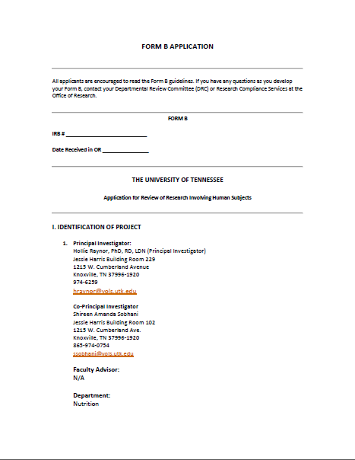


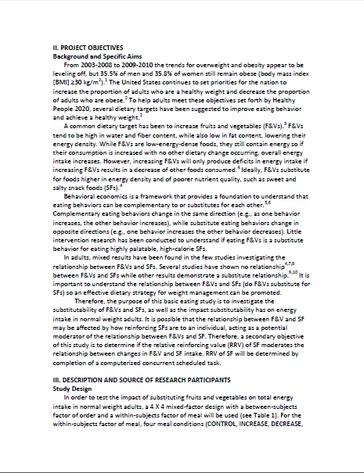
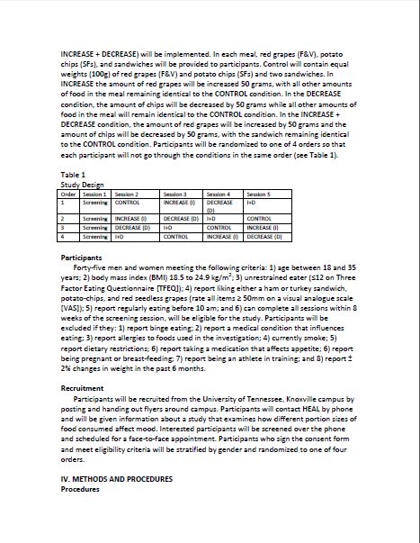
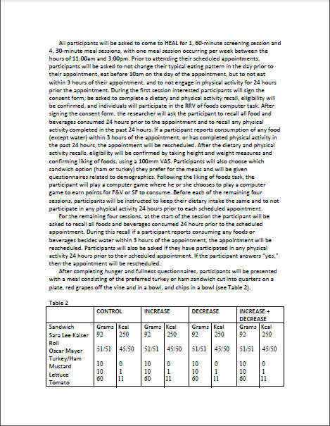
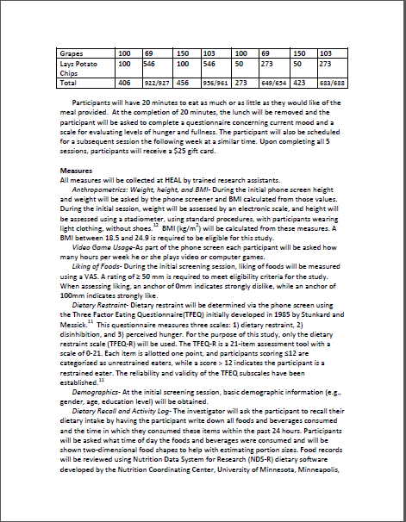
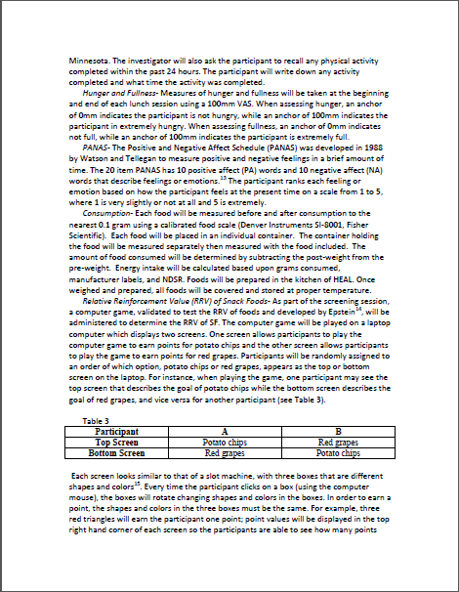
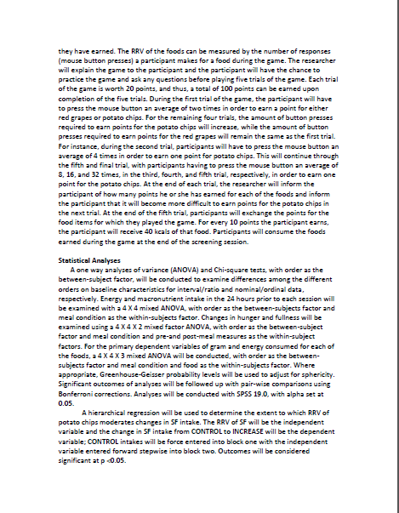
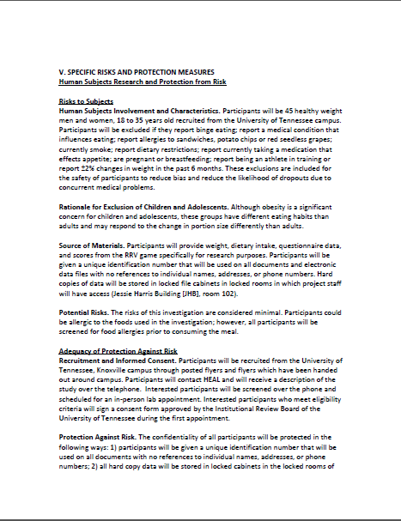
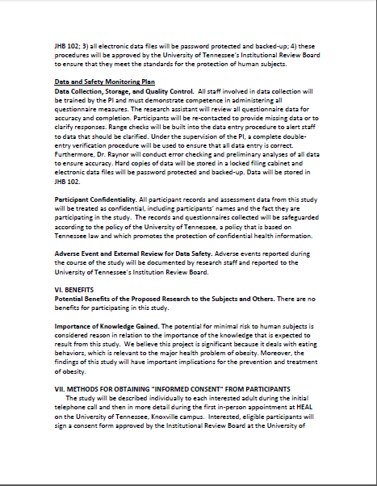
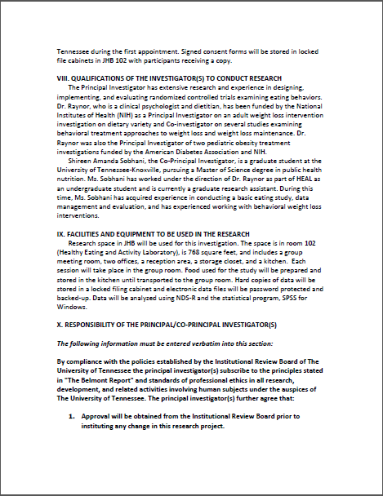

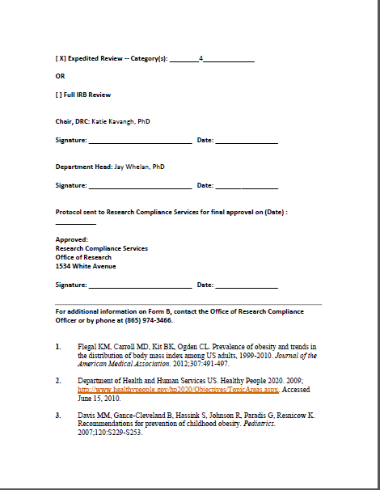
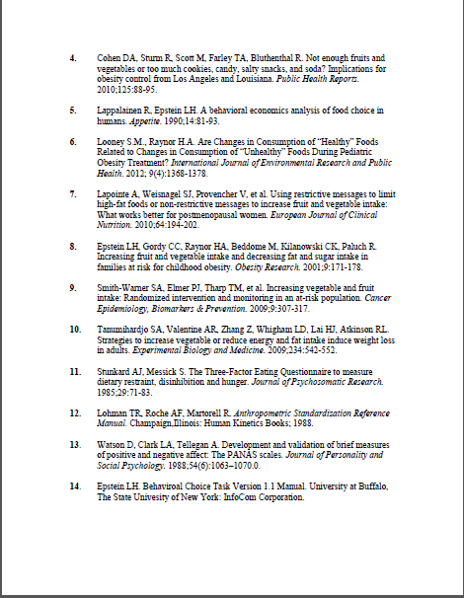


The PANAS Scale
This scale consists of a number of words that describe different feelings and emotions. Read each item and then mark the appropriate answer in the space next to that word. Fill out the following assessment based on how you feel in this moment. Use the following scale to record your answers.
1 very slightly or not at all 2 a little 3 moderately 4 quite a bit 5 extremely

___ Interested ___ Distressed
___ Excited ___Upset
___ Strong ___Guilty
___Scared ___ Hostile
___ Enthusiastic ___ Proud
___ Irritable ___ Alert
___ Ashamed ___ Inspired
___ Nervous ___ Determined
___ Attentive ___Jittery
___ Active ___Afraid

Office Use Only
Reference #:
Assessment #:
DATE ◻◻/◻◻/◻◻
M M D D Y Y

Demographic and Health History Information
1. AGE ◻◻
2. SEX: MALE FEMALE
(1) (2)
3. EDUCATION: Check years of school completed. (CHECK ONLY ONE ANSWER)

(1) Grade School (6 yrs or less)
(2) Junior High School (7-9 yrs)
(3) High School (10-12 yrs)
(4) Vocational Training (beyond High School)
(5) Some College (less than 4 yrs)
(6) College/University degree
(7) Graduate or Professional Education

4. MARITAL STATUS:
(1) Married
(2) Separated
(3) Divorced
(4) Widowed
(5) Never Married
(6) Not Married (living with significant other)
(7) Other (specify): _________________________

5. Which of the following best describes your racial heritage? (you may choose more than one)
- (1) American Indian or Alaskan Native
- (2) Asian
- (3) Black or African American
- (4) Native Hawaiian or other Pacific islander
- (5) White
- (6) Other ______________________________

6. Which of the following best describes your ethnic heritage?
(1) Hispanic or Latino
(2) Not Hispanic or Latino

Office Use Only
Reference #:
Assessment #:
DATE ◻◻/◻◻/◻◻
M M D D Y Y

Pre-Meal Hunger Scale

On the blank line provided, please draw a vertical line or an ‘X’ to rate how hungry you are right now, then answer question 2 on the bottom on the page. Also, please cross out and initial any mistakes.
EXAMPLE:

Not Hungry Extremely Hungry

Office Use Only:

Score: __________

How hungry did you feel right now?

HUNGER:

Not Hungry Extremely Hungry

Office Use Only
Reference #:
Assessment #:
DATE ◻◻/◻◻/◻◻
M M D D Y Y

Post-Meal Hunger Scale

On the line below, you will see an example for filling out this hunger scale. On the blank line at the bottom of this page, please draw a vertical line or an ‘X’ to rate how hungry you are right now.
EXAMPLE:

Not Hungry Extremely Hungry

Office Use Only:

Score: __________

How hungry did you feel right now?

HUNGER:

Not Hungry Extremely Hungry

Assessment #:
Reference #:
Office Use Only
DATE ◻◻/◻◻/◻◻
M M D D Y Y

Pre-Meal Scale of Fullness

On the line below, you will see an example for filling out this fullness scale. On the blank line at the bottom of this page, please draw a vertical line or an ‘X’ to rate how full you are right now.

EXAMPLE:

Not Full Extremely Full

Office Use Only:

Score: __________

On the blank line provided, please draw an ‘X’ to indicate your degree of fullness:

FULLNESS:

Not Full Extremely Full

DATE ◻◻/◻◻/◻◻
Reference #:
Office Use Only
Assessment #:
M M D D Y Y

Post-Meal Scale of Fullness

On the line below, you will see an example for filling out this fullness scale. On the blank line at the bottom of this page, please draw a vertical line or an ‘X’ to rate how full you are right now.

EXAMPLE:
Not Full Extremely Full

Office Use Only:

Score: __________

On the blank line provided, please draw an ‘X’ to indicate your degree of fullness:

FULLNESS:

Not Full Extremely Full

DATE ◻◻/◻◻/◻◻
Assessment #:
Office Use Only
Reference #:
M M D D Y Y

Scale of Food Liking
On the blank line provided, please draw an ‘X’ to indicate your degree of liking each food:

Example: Red Grapes

Strongly Dislike Strongly Like

Official Use Only:
Score: ___________

Ham Sandwich

Strongly Dislike Strongly Like
Official Use Only:
Score: ___________

Turkey Sandwich

Official Use Only:
Score: ___________
Strongly Dislike Strongly Like
Potato Chips

Strongly Dislike Strongly Like
Official Use Only:
Score: ___________
Red Grapes

Strongly Dislike Strongly Like

Office Use Only

DATE ◻◻/◻◻/◻◻
Reference #:

Assessment #:
M M D D Y Y

In the table below, please write down a description of what you ate and drank in the past 24 hours. In the description, include the time that you started eating and/or drinking each meal or snack, a description of each item that you ate or drank, and the amount of each item that you consumed. Try to be as specific with food names and amounts as possible.

Example: At breakfast (8:00 am), Tom ate an egg sandwich, an apple, and drank a cup of milk.
Meal  (B, L, D, S) | Time | Description of Food and Drink | Amount Consumed
L | 8:00 am | Egg sandwich
 |  | Whole Wheat Toast | 2 slices
 |  | Eggs | 2 whole eggs
 |  | American cheese | 1 slice
 |  | Mild Salsa | 2 tsp
 |  | Red apple | 1 medium
 |  | 2 % Milk | 8 oz

Enter your food and drink consumption from the past 24 hours below:
Meal | Time | Description of Food and Drink | Amount Consumed
Meal | Time | Description of Food and Drink | Amount Consumed
Meal | Time | Description of Food and Drink | Amount Consumed

Please write the physical activity you have engaged in over the past 24 hours. Include the amount of time and a description of the activity.
Time | Description

Date: __________________ PID #: ____________

Anthropometric Measures

Height: __________ inches

Weight: __________ pounds

BMI: __________ kg/m²



Portions and Mood Study Phone Script
Hello, this is ____________. Thanks for calling about the Portions and Mood Study. Let me tell you about the study so that you can decide if you are interested in participating. The purpose of this study is to evaluate different portion sizes of foods commonly eaten for lunch on mood. This study includes a screening appointment in the Healthy Eating and Activity Laboratory (HEAL) and four weekly lunch appointments in HEAL. The screening appointment will take approximately one hour and the lunch appointments will take 30 minutes; these appointments will need to be scheduled between 11 am and 3 pm Monday-Friday. Informed consent, a taste testing of each food item, and height and weight measurements will be taken during the screening appointment. Additionally, you will play a computer game where you will have the chance to earn points and trade in the points for potato chips and red grapes. At the end of the screening session you will be asked to eat the foods you earn during the computer game. At the start of each lunch appointment, participants will be asked to recall the foods eaten during the last 24 hours and will report hunger-fullness levels before and after the meal, eat lunch, and complete a questionnaire about mood. The meal will include either a turkey or ham sandwich (you choose what you prefer), potato chips, and red grapes. Upon completion of the four lunch appointments, participants will receive a $25 gift card. If you are interested in participating in this study, I have some questions to ask you to determine your initial eligibility. This will take about 10 minutes.
Go to Screening Form.
PORTIONS AND MOOD STUDY SCREENING FORM

1) Gender: F M
2) a) Age:_______________ b) Date of birth: ___/___/___ (must be between 18 and 35)
If age is not between 18 and 35: I am sorry, but the age range we’re recruiting for is 18-35. Since you are ____ yrs old, you are not eligible for this program. Thank you very much for your time.

3) a) Which of the following best describes your racial heritage? (You may choose more than one)
- American Indian or Alaskan Native
- Asian
- Black or African American
- Native Hawaiian or other Pacific islander
- White
- Other ______________________________

- Which of the following best describes your ethnic heritage?
Hispanic or Latino
Not Hispanic or Latino

4) a) Current weight:________lbs. b) Height: ____ft ______inches
c) Current BMI:_________ (must be between 18.5 and 24.9) BMI= kg/m² or (lbs/in²) x 703

If BMI is below 18.5 or above 24.9: I’m sorry, but because your height and weight are not within the range for this study, you aren’t eligible for this program. Thank you very much for your time.

5) How long have you been at your current weight?______________ (If at current weight for more than 6 months, proceed to question 6. If not, calculate percent change [(Previous weight-Current weight)/Previous weight X 100%]
a) Current weight:________lbs. b) Previous weight: ____lbs
b) Percent change:_________

If weight has changed by more than ± 2%: I’m sorry, but because your weight has not been stable for the past 6 months, you aren’t eligible for this program. Thank you very much for your time.
Now I have some health-related questions.
6) Do you smoke or use tobacco products?
No Yes (INELIGIBLE)
If YES to Q6: I am sorry, but due to the fact that you smoke/use tobacco products you are not eligible for this program. Thank you very much for your time.

7) Are you currently an athlete in training?
No Yes (INELIGIBLE)

If YES to Q7: I am sorry, but due to the fact that you are currently participating in athletic training you are not eligible for this program. Thank you very much for your time.
8) Are you currently pregnant or nursing?
No Yes (INELIGIBLE)

If YES to Q8: I am sorry, but due to the fact that you are currently pregnant/nursing you are not eligible for this program. Thank you very much for your time.
9) Do you have any food allergies or dietary restrictions?
No Yes → Explain ______________(INELIGIBLE if cereal proteins [wheat, rice, gluten], nuts, milk, or egg protein, fruit, sandwich meat, vegetarian)
If YES to Q9: I am sorry, but due to the fact that you are allergic to __________, (or are a vegetarian) you are not eligible for this program because the meal contains __________. Thank you for your time.

10) Have there been times when you have eaten a large amount of food in a short time and you had a sense of loss of control about your eating?
- No Yes (INELIGIBLE)

If yes, please describe the experience.
If YES to Q10: I am sorry, based on information you have provided, you are not eligible for this study. Thank you for your time.

11) Do you typically eat before 10 am?
- No (INELIGIBLE) Yes

If NO to Q11: I am sorry, but due to the fact that you do not eat before 10am, you are not eligible for this program. Thank you for your time.

12) Do you have a health condition that influences eating or requires a therapeutic diet?
- No Yes (INELIGIBLE)
If YES to Q12: I am sorry, but due to the fact that you have a health condition that influences eating, you are not eligible for this program. Thank you for your time.

13) Are you currently taking any type of medication that affects appetite?
- No Yes (INELIGIBLE)
If YES to Q13: I am sorry, but due to the fact that you are taking medication(s) that could potentially affect your appetite, you are not eligible for this program. Thank you for your time.
14) Would you be able to complete all the sessions required for this study within 8 weeks of starting the screening session?
- No (INELIGIBLE) Yes
If NO to Q14: I am sorry, but due to the fact that you would not be able to complete all sessions within 8 weeks of starting the screening sessions, you are not eligible for this program. Thank you for your time.
15 a) Please answer true or false to the following statements. (Give colored answer 1 pt)
Points
- When I have eaten my quota of calories, I am usually good about not eating any more. | T | F
- I deliberately take small helpings as a means of controlling my weight. | T | F
- Life is too short to worry about dieting. | T | F
- I have a pretty good idea of the number of calories in common food. | T | F
- While on a diet, if I eat food that is not allowed, I consciously eat less for a period of time to make up for it. | T | F
- I enjoy eating too much to spoil it by counting calories or watching my weight. | T | F
- I often stop eating when I am not really full as a conscious mean of limiting the amount that I eat. | T | F
- I consciously hold back at meals in order not to gain weight | T | F
- I eat anything I want, any time I want. | T | F
- I count calories as a conscious means of controlling my weight. | T | F
- I do not eat some foods because they make me fat. | T | F
- I pay a great deal of attention to changes in my figure. | T | F
Total Points
15 b) Please answer the following questions with one of the responses that is appropriate for you.
(Give colored answer 1 point.) Points
- How often are you dieting in a conscious effort to control your weight?
Rarely Sometimes Usually Always
- Would a weight fluctuation of 5 lbs affect the way you live your life?
Not at all Slightly Moderately Very Much
- Do your feelings of guilt about overeating help you to control your food intake?
Never Rarely Often Always
- How conscious are you of what you are eating?
Not at all Slightly Moderately Extremely
- How frequently do you avoid “stocking up” on tempting foods?
Almost never Seldom Usually Almost always
- How likely are you to shop for low calorie foods?
Unlikely Slightly unlikely Moderately likely Very likely
- How likely are you to consciously eat slowly in order to cut down on how much you eat?
Unlikely Slightly likely Moderately likely Very likely
- How likely are you to consciously eat less than you want?
Unlikely Slightly likely Moderately likely Very likely
- On a scale from 0-5, where 0 means no restraint in eating (eating whatever you want, whenever you want) and 5 means total restraint (constantly limiting food intake and never “giving in”), what number would you give yourself?
0 – eat whatever you want, whenever you want
1 – usually eat whatever you want, whenever you want
2 – often eat whatever you want, whenever you want
3 – often limit food intake, but often “give in”
4 – usually limit food intake, rarely “give in”
5 – constantly limiting foods intake, never “giving in”
Total Points
Total Points (15a + 15b):
If Total Points (15a + 15b) = greater than 12: I’m sorry, based on information you have provided, you are not eligible for this study. Thank you for your interest.

16) Please rate your liking of the foods included in the laboratory lunch meal using a scale of 1-5. 1 means you do not like this food and 5 means you like this food very much.
Sandwich:  Turkey or  Ham (with option of lettuce, tomato, and mustard) | Chips:  Classic potato chips | Fruit:  Red grapes
1 2 3 4 5 | 1 2 3 4 5 | 1 2 3 4 5

If any food is rated less than 3: I’m sorry, since you do not like _________ (food), you are ineligible for the study. Thank you for your interest.

17) On average, how many hours per week do you spend playing video or computer games?
_______________ hours

IF ELIGIBLE: Congratulations! I am happy to tell you that you meet the eligibility criteria for the Portions and Mood study. I’d like to schedule you for a screening session. We are scheduling appointments Monday-Friday, 11:00 am until 3:00 pm. For this appointment, we ask that you eat a typical breakfast but to not eat anything (except water) within three hours of the appointment. Additionally, we ask that you do not participate in physical activity for 24 hours prior to the appointment.

Which days and times work best for you? (Review schedule for available appointments.)
We have ---- (day), ---- (date) at ---- (time). Does that work for you?

Screening Session: M T W R F (circle day), _____________ (date) at ______________(time)
HEAL is located in the Jessie Harris Building, room 102. Do you know where that is?
(If no, provide directions. JHB is located on Cumberland Ave and 12th Ave, next to the 11th Ave parking garage. The UTK website has a building locator if needed.)

We have you scheduled for ----(day), ---- (date) at ----(time). Your appointment will take approximately one hour. Please arrive on time as we may have another appointment scheduled immediately after yours.
We will send you an email confirming the appointment. If for some reason you cannot keep your appointment please call our lab at 974-0754. Thanks for participating in our study!

First Name: ____________________________ Last Name: _________________________________

Mailing address:______________________________________________________________________
Email Address:_______________________________________________________________________

Day Phone:______________________________ mobile/home/other

Evening Phone:______________________________ mobile/home/other
Eligible: No Yes  If No, Reason:__________________________ | Screened by:______________________________  Date:____________________________________
Appointment Date: ___/___/___ Time: _______

Enter participant information on PTL
Randomize participant for RRV task.

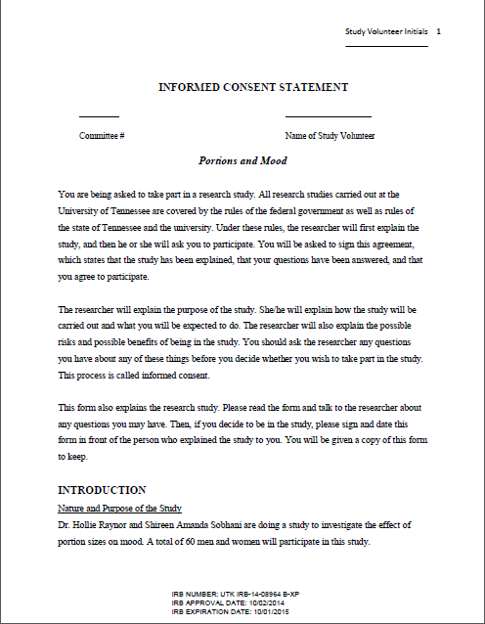

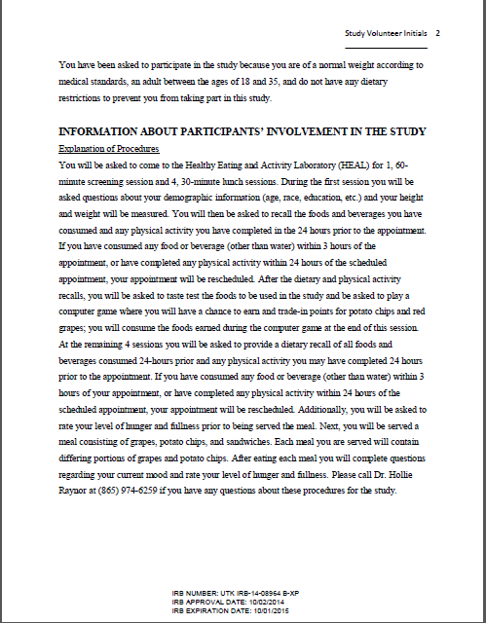


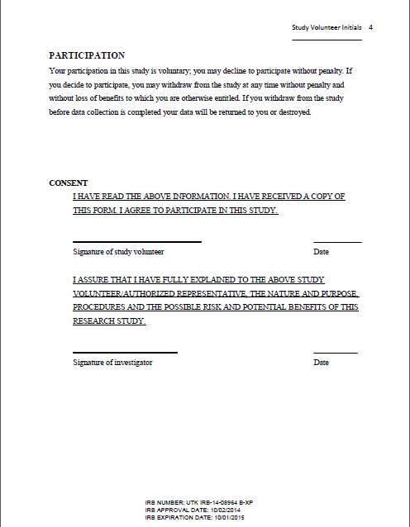

VITA
Shireen Amanda Sobhani was born and raised in Knoxville, TN. She received a Bachelor of Science degree in Nutrition from The University of Tennessee, Knoxville, in 2013. During her undergraduate career she worked as an undergraduate research assistant in the Healthy Eating and Activity Laboratory. Upon completion of her undergraduate studies, she pursued a Master of Science degree in public health nutrition at The University of Tennessee.
As a graduate student, Amanda worked as a graduate research assistant and expanded knowledge and skills related to behavioral weight loss interventions and research design and methodology. Further, she will complete a dietetic internship to receive the registered dietitian credential and will complete her Master’s degree and dietetic internship in Summer 2015. Long-term career goals include working to improve public health through further clinical training and addressing policy issues that affect public health nutrition and chronic disease prevention.

