Willingness to Adopt Best Management Practices by
Beef Cattle Producers in a Southeastern Tennessee Watershed

A Thesis Presented for the
Master of Science
Degree
The University of Tennessee, Knoxville

Alicia Marie Signore
August 2014
ACKNOWLEDGEMENT
This material is based upon work supported by the United States Department of Agriculture under Award No. 2009-51130-06047. Any opinions, findings, and conclusions or recommendations expressed in this publication are those of the authors and do not necessarily reflect the views of the United States Department of Agriculture.

ABSTRACT
Extensive beef cattle farming in the ridge and valley region of East Tennessee suggests that cattle producers could play an important role in improving water quality through the adoption of livestock best management practices (BMPs). This study examines factors influencing willingness to adopt four BMPs—rotational grazing, pasture improvement, stream water crossing, and water tank systems—by beef cattle operations in a southeast Tennessee watershed. Factors examined include farm and farmer characteristics, farmer attitudes, and a hypothetical incentive program encouraging adoption of these practices. Data was collected through a mail survey of 5,150 farmland owners in McMinn, Bradley, and Monroe Counties. Respondents were asked if they would be willing to adopt each of the four BMPs at a given cost share, with the cost share amounts ranging from 50% to 125% of the expected out-of-pocket costs of installation/annual management, and how many acres/units of the practice they would implement. Younger, more educated producers with higher income levels were more willing to adopt one or more of the BMPs. Higher cost share amounts appeared to have greater influence on adoption of stream crossings than on rotational grazing, water tanks, and pasture improvement. Pasture improvement showed the greatest level of overall adoption interest, although many would-be adopters had already taken steps to improve their pastures. Analysis suggests producers have the most interest in a bundle of BMPs that include rotational grazing, water tanks, and pasture improvements. The analysis also suggests a preference away from stream crossings and BMP bundles that included stream crossings, unless all four BMPs were concomitantly implemented. Factors influencing willingness to adopt were analyzed along with factors influencing adoption intensity using regression analysis. Cost-share incentives did not play a substantial role in explaining adoption, but the influence of other explanatory factors was similar to other results found in the BMP adoption literature.

TABLE OF CONTENTS
Chapter One: Problem Identification and Explanation 1
Problematic Situation 1
Research Problem 4
Research Objectives 7
Chapter Two: Literature Review 8
Pasture Improvements 8
Alternative Water Sources 8
Stream Crossings 10
Rotational Grazing 11
Willingness-to-Adopt Measures and Adoption of BMPs 11
Chapter Three: Methods and Conceptual Framework 16
Data Collection 16
Survey Instrument 19
Conceptual Framework 20
Factor Analysis Model 25
Model Variables and Hypotheses 29
The MIMIC Model of BMP Adoption 33
The Heckman Model of Adoption Intensity 38
The Heckman Ordered Probit Model 41
Chapter Four: Statistical Analysis 43
Statistical Results 43
Spearman Correlations 48
Chapter Five: Adoption Analysis 51
MIMIC Model Analysis 51
MIMIC Model Results 51
Propensity to Adopt 55
Chapter Six: Intensity of Adoption Analysis 62
Pasture Improvements 62
Stream Crossing 67
Water Tanks 67
Rotational Grazing 63
Chapter Seven: Conclusion 67
References 69
Appendix 75
Vita 85

LIST OF TABLES
Table 1: Cost Share Incentive Rates for BMPs 19
Table 2: Factor Analysis
Table 2a: Objectives 27
Table 2b: Decisions 27
Table 3: Variable Names, Descriptions, Mean Values, and Predicted Effects 31 - 32
Table 4: Statistical Analysis
Table 4a: Demographics 45
Table 4b: Farm Characteristics 46
Table 4c: Expense Factors of Adoption 46
Table 4d: Managerial Factors of Adoption 46
Table 5: Adoption Patterns of BMPs and BMP Bundles 48
Table 6: Spearman Correlations 60
Table 7: MIMIC Adoption
Table 76a: Rotational Grazing 51
Table 7b: Stream Crossing 52
Table 7c: Water Tanks 53
Table 7d: Pasture Improvement 54
Table 7e: Propensity to Adopt 61
Table 8: Intensity of Adoption
Table 8a: Pasture Improvement 65
Table 8b: Water Tanks 70 - 71
Table 8c: Rotational Grazing 64 - 65
Table 9: Adoption Intensity Comparison
Table 9a: Pasture Improvement Adoption Intensity 66
Table 9b: Rotational Grazing Adoption Intensity 66

LIST OF FIGURES
Figure 1a: Hiwassee Watershed within the Tennessee River Valley 5
Figure 1b: Watersheds of Tennessee 5
Figure 2: Survey Map
Figure 2a: Bradley, McMinn, and Monroe Counties 17
Figure 2b: Geospatial Location of Parcels on List-Frame 17
Figure 3: Analysis Procedure 25
Figure 4: MIMIC Model 37
Figure 5: Adoption Choice by Practice 47

CHAPTER ONE: PROBLEM IDENTIFICATION AND EXPLANATION
PROBLEMATIC SITUATION
The United States (U.S.) has been concerned with the degraded quality of the nation’s land and water resources for a number of years. In 1935, the federal government took action to encourage “better land management practices” by passing the Soil Conservation Act (Ice 2004, p. 684). This legislation was the first effort by the U.S. government to implement programs to help protect the nation’s land and water resources. However, the paramount law with regard to national surface water pollution is the Federal Water Pollution Control Act, more commonly known as the Clean Water Act. This law states that “the objective of this Act is to restore and maintain the …integrity of the Nation’s waters” (US Congress 2002, p. 3).
Enacted in 1948, this legislation has undergone drastic revision in the years since (Copeland 2010). In 1972, the Clean Water Act “constituted the primary federal law to address both point and nonpoint sources of pollution” (Rahelizatovo and Gillespie 2004, p. 233). Still, the changes enacted in 1972 were ambitious, creating programs of water quality improvement that continue to be expanded and implemented across industries (Copeland 2010). In the early stages of addressing water degradation, efforts focused primarily on point source pollution of water; however, amendments in 1987 switched the focus to include nonpoint sources (Copeland 2010).
Section 319 of the Clean Water Act addresses nonpoint source management programs directly. This section requires all states to identify surface waters that do not meet national quality standards, identify nonpoint sources and quantify their impacts, and identify and describe programs to improve water quality, as well as create a schedule of goals for improvement and annual program milestones (US Congress 2002).
Since implementation of the Clean Water Act, water quality has improved, primarily through reductions in pollutant loadings from point sources. Yet, nonpoint source pollution continues to impact the quality of surface waters and is the greatest cause of impairments in the United States today (US Congress 2002; Ribaudo, Horan, and Smith 1999; Hoorman and McCutcheon 2005).
Many studies of surface water pollution conclude that nonpoint source pollution from agriculture plays a dominant, if not primary, role in current levels of water quality impairment (e.g. Ribaudo, Horan, and Smith 1999; Wagner 2008; US EPA 2012, B; Giuliano 2009; Smith, Nejadhashemi, and Leatherman 2009). Nonpoint sources are difficult to identify and control, and it is difficult to hold individuals accountable for specific damages because of the diffuse nature of runoff pollution.
Congress identified best management practices (BMPs) as the most practical method to control nonpoint pollution sources (US Congress 2002; Ice 2004). BMPs have been defined as “a practice or combination of practices that are determined through problem assessment and appropriate public participation to be the most effective, practicable means of preventing/reducing the amount of pollution generated by nonpoint sources to a level compatible with water quality goals” (USDA 1980, p. 685). In other words, BMPs are technologies that minimize the impacts of operating decisions on water quality (Ice 2004).
BMPs are the heart of the programs identified and implemented as required by the Clean Water Act. These programs often offer assistance—monetary incentives, educational support, and technical assistance—to adopters, with extent of funding determined each fiscal year (US Congress 2002; Kim, Gillespie, and Paudel 2004; Cooper 1997; Cattaneo 2004). The Tennessee Department of Agriculture states that “up to 20% of the available grant funds assist water quality monitoring efforts in Tennessee streams, both in the state's 5-year watershed monitoring program, and also in performing before-and-after BMP installation, so that water quality improvements can be verified” (TN DOA 2014).
BMPs are the most accepted measure of control because they work in a proactive way: BMPs address issues and help prevent greater impairment rather than responding to fix past damages (Ice 2004; Rahelizatovo and Gillespie 2004). BMPs specifically target the source of water quality degradation identified by government assessments (Ice 2004). Implementation of BMPs on farms has the potential to reduce pathogens, nutrients, and sediment loading of the rivers, as well as improve the overall efficiency of farming operations.
Currently, farmers have the option to address these problems voluntarily, often through programs based on education efforts and monetary or economic incentives (Ice 2004; Cattaneo 2004; US EPA 2012, B). However, if water quality does not improve or worsens, mandatory regulations could be imposed (Redmon et al. 2008). Not only do mandatory, sweeping regulations have the potential to dampen the profit earning potential of agricultural operations, but regulatory programs imposing uniform standards or requirements are unlikely to be the best approach to improving water quality. A solution to pollution problems in one area many not be an advisable plan of action in another region because many different factors contribute to pollution levels of a watershed, and each watershed is unique. Also, many farmers are uncomfortable with deferring management decisions to a government that may not understand—and therefore may not design into programs—the idiosyncrasies of each farm situation (Smith, Nejadhashemi, and Leatherman 2009).
A better understanding of why, under which situation, and with what level of financial support farmers adopt BMPs would help to more efficiently leverage support provided by the government and reduce government spending. One solution is to allow leaders from local agricultural communities work together to develop practices that address local water quality issues (Ice 2004). Farmers then would adopt practices based on the suggestions of the local committees, subject to their own available resources (Ice 2004). Policy makers, conservationists, and extension officers can design these programs to encourage farmers to adopt them by making adoption cost-effective (Smith, Nejadhashemi, and Leatherman 2009; Panajopoulos, Makropoulos, and Mimikou 2011). Programs are cost-effective when adoption has a certain level of desired effect. In this case, adoption of BMPs is cost-effective if implementing the practices results in desired levels of improvements in water quality.
Evidence suggests that to promote adoption, monetary incentives may prove necessary because producers are predominantly concerned with changes in net returns from their operations when new management techniques are adopted (Cooper 1997; Ribaudo, Horan, and Smith 1999). Cost-share programs have been useful in encouraging farm adoption of BMPs. Before designing these programs, willingness-to-adopt (WTA) measures are useful for estimating the expected cost of inducing widespread adoption of BMPs (Cooper 1997; Kim, Gillespie, and Paudel 2004).
RESEARCH PROBLEM
The environmental status of the Oostanaula Creek Watershed (HUC: TN06020002083) was the impetus for this research. The Oostanaula Creek watershed is located in southeastern Tennessee and is part of the larger Hiwassee River Watershed (HUC: 06020002). Oostanaula Creek is a tributary of the Hiwassee River, which itself is a tributary of the Tennessee River (Figure 1a and Figure 1b). Ridge and valley geography describes the landscape of this watershed. Primary land uses in the watershed include forests and pasture-based beef cattle operations, although a central urban pocket also exists (Hagen and Walker 2007).
The Oostanaula Creek watershed fails to meet national water quality standards due to sediment, phosphorus, and pathogens—particularly fecal coliform bacteria (TDEC 2002; TDEC 2012; Hagen and Walker 2007). Total Maximum Daily Load (TMDL) limits have been established for Oostanaula Creek and require reductions of 54.4-72.2% for E-coli, 79.2% for phosphorus, and 59.4% for sediment for Oostanaula Creek to be removed from the 303(d) list (Hagen and Walker 2007).

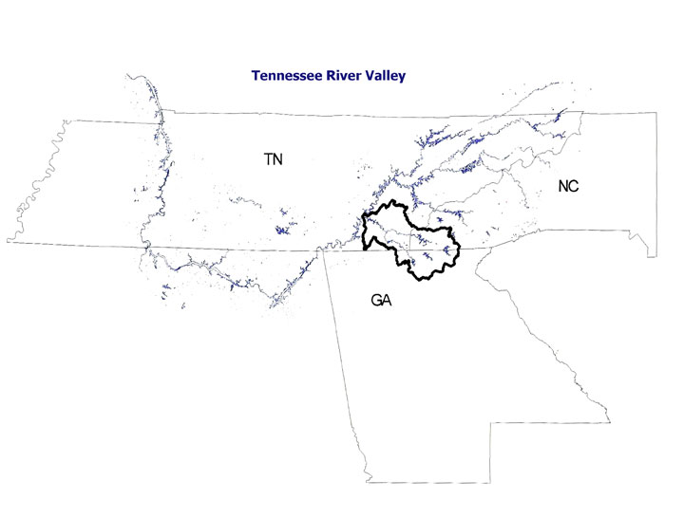
Figure 1a: Hiwassee Watershed within the Tennessee River Valley Basin

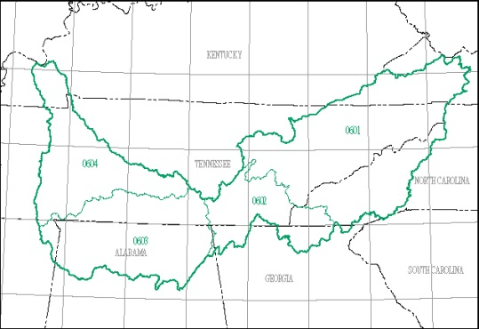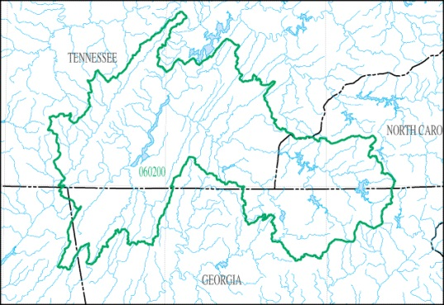
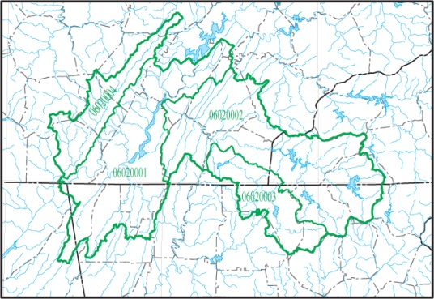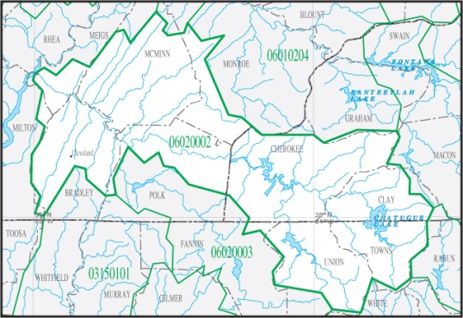

Figure 1b: Watersheds: Tennessee River with sub-watersheds, Hiwassee,
Hiwassee with sub-watersheds, Hiwassee with counties (USGS)

The Clean Water Act distinguishes between pollutant emissions from point sources—discrete conveyances—and nonpoint sources. The Clean Water Act requires point sources to possess and maintain National Pollutant Discharge Elimination System (NPDES) permits. The Athens’ Utility Board (AUB) Wastewater Treatment Facility has been identified as a point source of pollution in this watershed (Hagen and Walker 2007). Non-point sources of pathogens in this watershed include urban development, leaking septic systems, animal access to streams, agriculture and manure, livestock grazing, and wildlife (TDEC 2002). Studies using the Bacterial Source Tracking (BST) method have determined that a majority of fecal loads in the watershed (22-92% at various site locations) are of bovine origin (Hagen and Walker 2007). Much of the agricultural land in this watershed functions as pasture for grazing livestock, predominantly cattle. With regard to managing livestock grazing to reduce nonpoint source impacts on water quality, the EPA states:

Overgrazing exposes soils, increases erosion, encourages invasion by undesirable plants, destroys fish habitat, and reduces the filtration of sediment necessary for building stream banks, wet meadows, and floodplains. To reduce the impacts of grazing on water quality, farmers and ranchers can adjust grazing intensity, keep livestock out of sensitive areas, provide alternative sources of water and shade, and re-vegetate rangeland and pastureland (US EPA 2012, B).

Therefore, adoption of BMPs by cattle producers is a major focus of efforts to improve Oostanaula Creek water quality.
Both economic and environmental costs are typically considered when developing management plans to address water quality concerns (Smith, Nejadhashemi, and Leatherman 2009). The costs of subsidizing BMP adoption may be an important step toward determining the expected costs of improving water quality in the Oostanaula Creek watershed through BMP adoption. Information about producer willingness to accept a cost share for the adoption of BMPs may help analysts and decision-makers increase participation in BMP programs by providing a measure to more efficiently allocate limited funds supporting cost-share programs. Willingness to accept an incentive may also depend on farm and operator characteristics. Improved understanding of these relationships could also help outreach programs educate farmers and encourage BMP adoption.
A survey of cattle producers was conducted in 2011 to gather data to understand farmer adoption of four specific BMPs: pasture improvements, alternative water sources, stream crossings, and rotational grazing. An almost identical survey was sent to agricultural landowners in neighboring watersheds in the spring of 2013. The combined data collected from these two waves of surveys is used to estimate farmer WTA these BMPs. The results are relevant to efforts to create and implement programs to improve water quality in Oostanaula Creek and surrounding watersheds.
RESEARCH OBJECTIVES
This research estimates the WTA of cattle producers for the following BMPs: pasture improvement, watering tanks, stream crossings, and/or rotational grazing. This research also determines the influence of attitudes, awareness, farm/operator characteristics, and cost-share incentives on WTA measures of these BMPs.

CHAPTER TWO: LITERATURE REVIEW
Adoption of BMPs helps restore damaged waterways and protects the quality of surface water (Smith, Nejadhashemi, and Leatherman 2009). This study focuses on four specific BMPs: pasture improvements, alternative water sources, stream crossings, and rotational grazing. The following is a review of the literature specific to these BMPs.
PASTURE IMPROVEMENT
Pasture improvement helps minimize erosion caused by runoff (Ice 2004). Examples of improvement include planting shade and cover crops such as trees, shrubs and varieties of grasses, fertilization to improve cover growth, stream-bank stabilization, and weed control (Ice 2004; Adams 1994).
Pasture improvements can increase both the aesthetic and property value of the land through improvements in farm appearance (Hoorman and McCutcheon 2005). Soil quality and forage quantity also improve, providing better nutrition for livestock. Pasture improvement can also decrease nutrient and bacterial emissions from pastures as well as gully formation across pastureland. Efforts to stabilize the stream banks reduce erosion and trap contaminants carried by runoff to the stream (Hoorman and McCutcheon 2005; Undersander and Pillsbury 1999).
ALTERNATIVE WATER SOURCES
Alternative water sources (water tanks) provide livestock drinking water away from stream and rivers (US EPA 2012; George et al. 2008; Hoorman and McCutcheon 2005; Giuliano 2009; Adams 1994). Off-stream watering tanks or troughs reduce the time cattle spend in the riparian zone while ensuring continual access to clean drinking water (Hoorman and McCutcheon 2005).
Benefits of this BMP include greater flexibility in pasture management, a secure supply of clean drinking water, reduced injury risk to cattle along stream banks, and potential performance improvements to transitions of feeder calves from pastures to feedlots (Giuliano 2009; Adams 1994).
Alternative water sources entice cattle away from streams, thereby reducing the direct deposition of feces into the streams. Results from studies find that cattle activity near streams decreases when alternative water sources are present (Wagner et al. 2008; Redmon et al. 2008). For example, in a study conducted by Oregon State University, the amount of time cattle spend in a stream decreases from an average of 25.6 minutes per day to an average of 1.6 minutes per day (Adams 1994).
In a study conducted by Texas A&M, cattle were fitted with GPS collars and tracked over a 21-day period when water troughs were present and again when alternative water sources were not provided (Redmon et al. 2008). The data showed that cattle activity in the riparian zone decreased from 7% of the day to 1.75% of the day when alternative water sources were present (Redmon et al. 2008). As a result, extension specialists believe provision of educational programming, technical assistance, and cost-share programs to incentivize adoption of water tanks should be offered to farmers of operations with streams located on the property (Redmon et al. 2008).
To study the impact of installing water troughs on water quality, three cattle pastures in Virginia were monitored for four months (Sheffield et al. 1997). Similar to the previously discussed studies, the results from this study support that the availability of off-stream water sources leads to a reduction of time cattle spent in the water. Cattle activity in the stream decreased by 51% when the water troughs were present, leading to a 77% reduction in total stream bank erosion, 90% reduction in total suspended particles, 81% reduction in total phosphorous, and 54% reduction in total nitrogen in the stream (Sheffield et al. 1997). Sheffield et al. found this change in cattle behavior also resulted in a 51% reduction in the concentration of fecal coliform and a 77% reduction of fecal streptococci.
STREAM CROSSINGS
Stream crossings are single points in a stream that provide a stable way for livestock and vehicles to move between pastures separated by water (Undersander and Pillsbury 1999). Gravel, rock, or geo-textile is often used to line the bottom of a stream to provide a firm, stable footing for cattle or farm vehicles to cross without difficulty, reducing the risk of cattle injuries from crossing (Undersander and Pillsbury 1999). Fences and gates may be installed as an alley for the cattle to cross, but fencing is not necessary because cattle tend to use the easiest path for crossing (Adams 1994).
Benefits of this practice include cleaner drinking water for the cattle and a decreased risk of water-borne disease. Use of stream crossings decreases the risk of injury to the cattle caused by falling down eroded banks (Undersander and Pillsbury 1999). This BMP also decreases direct waste pollution into the water because cattle are discouraged from gathering and remaining in the stream; decreased time in or near streams reduced fecal bacteria pollution (Giuliano 2009; Hoorman and McCutcheon 2005; Redmon et al. 2008; Adams 1994).
In a study conducted by the Ohio State University, stream crossings resulted in a 50% reduction in total dissolved solids in the water, and natural ecosystem life increased by 70% (Hoorman and McCutcheon 2005).
ROTATIONAL GRAZING
Rotational grazing is a controlled access BMP in which fencing separates pasture into smaller sections called paddocks (UT AREC 2011; Wagner et al. 2008; US EPA 2012, B; Giuliano 2000; Buschermohle; NRCS 2006). This separation allows some acreage to rest and regenerate while another area is grazed. It is important to note that the availability of a water source (water tank) in all paddocks is important for this BMP to be successful. Therefore, rotational grazing is not commonly implemented without installation of water tanks.
With rotational grazing, the farmer controls the intensity—when, where, length of time—the livestock spends in each defined area (Hoorman and McCutcheon 2005). Many grazing issues are caused not by overstocking of animals but by uneven distribution of livestock over pasture land; this BMP makes it easier for farmers to change the distribution patterns of cattle to prevent any one area from excess trampling and erosion (George et al. 2008; White and Wolf 2009). With an increase in the number of paddocks used, the farmer gains greater flexibility and better grazing control; however, improvements can be seen if even one fence is installed (White and Wolf 2009).
Other benefits of rotational grazing include improved animal health, minimized soil compaction, better vegetative ground cover, enhanced habitat for wildlife, greater sequestration of atmospheric carbon, and improved water quality (NRCS 2006).

WILLINGNESS-TO-ADOPT MEASURES AND ADOPTION OF BMPS
Factors influencing the adoption of BMPs or other conservation practices by farmers have been extensively studied (Prokopy et al. 2008; Knowler and Bradshaw 2007; Kabii and Horwitz 2006; Baumgart-Getz, Prokopy, and Floress 2012; Pannel et al. 2006). In their meta-analysis of 55 different BMP studies, Prokopy et al. (2008) examine general adoption patterns as affected by farm characteristics and farmer capacity, awareness, and attitudes about BMPs. In general, Prokopy et al. find little evidence to suggest that farm income had a major influence on BMP adoption and mixed evidence on the effects of farmer experience and tenure on adoption. While their findings suggest that older farmers are less likely to change management practices than younger farmers, there is some evidence suggesting that some older beef cattle producers may farm “as a hobby and place high importance on the [health] of the land [and water]” (Prokopy et al. 2008, 307). Prokopy et al. find that time and effort required for installation and maintenance influenced adoption of most BMPs, but evidence for those regarding water or livestock management is unclear. Farmers managing operations with better soil quality were more willing to adopt BMPs, possibly because use of BMPs would conserve that resource. They also find that grain farms were more likely to adopt BMPs than livestock operations. In general, Prokopy et al. found that BMP adoption was significantly influenced by producer attitudes on such topics as risk, profit potential, cost-share programs, heritage, and environmental stewardship. Finally, Prokopy et al. (2008) note that the BMP adoption literature is focused on the relationship between soil quality, nutrient deficiencies, and pest management, and that the relationship between water quality concerns and BMP adoption is underrepresented. Much attention has been paid to BMP adoption, but additional research is needed to better understand water quality and livestock-related BMP adoption in particular.
In a similar review of studies from 1982 to 2007, Baumgart-Getz, Prokopy, and Floress (2012) focus on actual BMP adoption (instead of WTA measures) and the factors influencing adoption. They find that adoption is positively correlated with the importance a farmer places on water quality and the farmer’s perception of the profitability of the practice. However, they find that other attitudinal and environmental awareness questions asked in surveys are not as helpful in understanding adoption decisions. Questions regarding non-point pollutants were not specific enough, nor did the questions clearly define connections of BMP adoption to environmental and water quality improvements. They conclude that many questions pertaining to farmer attitudes and preferences were not specific enough to explain possible behaviors.
The factors influencing the adoption of new conservation practices by rural landowners are also analyzed in a review of literature conducted by Pannel et al. (2006). They find that BMPs are adopted only when the practice is perceived by the farmer to be beneficial, i.e., to help the farmer meet economic, social and environmental goals. They also find that ease of adoption, the simplicity of BMP operation, and the social and environmental benefits gained from the practice characterize BMPs with higher adoption levels. These results led the authors to conclude that the real challenge in promoting BMP adoption is identifying practices that are both better for the environment and economically superior to current management practices.
Studies also focus on the adoption of water-quality related BMPs by cattle producers. Gillespie, Kim, and Paudel analyze BMP adoption by Louisiana beef producers. They find that adoption was influenced by farm size, BMP type, and the labor needed to implement the practice. They find that the three BMPs with the highest adoption rates were waste management systems (83%), grazing management practices (80%), and prescribed grazing (72%). Other BMP adoption rates ranged from 19% to 75%, but “few producers had adopted BMPs with incentive or cost-share payments” (2007, p. 94). The most frequently adopted BMPs all had immediate economic benefits. Farmers more likely to adopt BMPs typically possessed greater capital and labor resources, faced highly erodible soil risks, and had been exposed to information from extension efforts. Gillespie, Kim, and Paudel (2007) conclude that extension and educational programs and outreach should provide both information on economic and environmental costs and benefits of BMP adoption to enable farmers to better calculate the cost and environmental effectiveness of the BMPs.
In a study on crop-related BMP adoption, Cooper (1997) estimates the WTA of farmers across four critical watersheds—eastern Iowa and Illinois basin, Albermarle-Pamlico basin in Virginia and North Carolina, Florida-Georgia coastal basin, and upper Snake River Basin in Washington, Idaho, and Oregon—using responses to a survey that included a hypothetical, dichotomous choice contingent valuation (CV) experiment. The sample frame consisted of farmers in the four watersheds not currently using the BMPs. The CV experiment provided bids per acre to track WTA at various cost-share amounts randomly assigned with equal probability across the sample (Cooper 1997). The study extends the results from the hypothetical WTA responses to include farmers who currently use these BMPs without a payment incentive, assuming the latter to be willing to adopt the BMP with a cost share of $0. The rationale for this assumption is that WTA measures provide a guide to creating cost-share programs, and minimum values are necessary to accurately estimate the optimal cost-share values to entice the largest number of participants.
Cooper found that this approach predicted higher adoption rates, as some farmers had implemented the practices without the monetary incentive. The results from the WTA estimation illustrate that an increase in the offered cost share from $0 to $10 predicts an approximate 2.5% increase in conservation tillage adoption, 13% increase in manure testing and legume crediting adoption, 8.5% increase in soil moisture testing, and a 2.4% increase in integrated pest management adoption.
Using data from the first part of this hypothetical market experiment, Lambert et al. (2014) finds rotational grazing and pasture improvement systems to be more popular among cattle owners than water tanks and stream crossings. The single most popular choice was to adopt cattle water tanks, rotational grazing and pasture improvement practices as a bundle. Producers who had already taken steps to improve their pastures were more willing to adopt cattle water tanks, stream crossings, and to make additional improvements to their pasture. Respondent WTA seemed to be positively influenced by the expanded cattle management options afforded by the BMPs and the possibility of improved cattle health and productivity associated with rotational grazing and pasture improvement. The amount of the cost share offered respondents seemed to have more influence on the adoption of cattle water tanks and pasture improvement systems than on stream crossings and rotational grazing.

CHAPTER THREE: METHODS AND CONCEPTUAL FRAMEWORK
DATA COLLECTION
For this research, a survey instrument was used to collect data from cattle farmers in the Oostanaula Creek and surrounding watersheds to estimate WTA four specific BMPs: pasture improvements, alternative water sources, stream crossings, and rotational grazing.
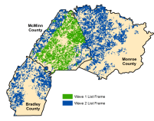
The survey list-frame was created using tax parcel information managed by three counties in Tennessee: McMinn, Bradley and Monroe (Figure 2a). The tax parcel information is publicly available and includes the physical addresses of land owners and classification of the parcels based on land use (Clark, Park, and Howell 2006). Parcels classified as either “agricultural” or “farm” were selected for this study, with the distinction between the agricultural and farm classifications being that parcels classified as agricultural are enrolled in Tennessee’s Greenbelt Program (Agricultural, Forest and Open Space Land Act of 1976), while those classified as farmland are not (Chervin, Gibson, and Green 2009). Prior to mailing, all identified parcels were reviewed and those with owners who were deemed unlikely to be actively engaged in farming (i.e. out-of-state land owners and land trust holdings) were removed from the review list. Parcel information was identified by unique owners; since individuals could more than one parcel of land, all names and addresses were compared to eliminate duplicates within the list-frame.

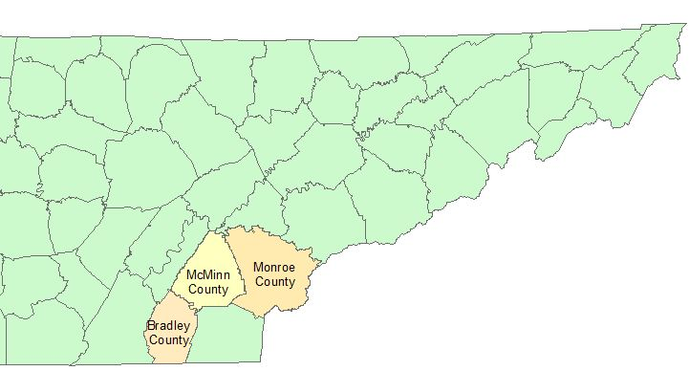

Figure 2a: Bradley, McMinn, and Monroe Counties

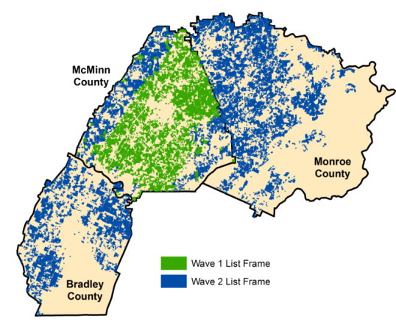

Figure 2b: Geospatial Location of Parcels
on List-Frame

Tax parcel records were used to construct the survey list-frame so that respondents could be geospatially located in the watershed because one purpose of the survey was to gather information for a biophysical model. One disadvantage of using tax parcel records to compile a list-frame is that no reliable way exists to identify and select only cattle producers from the individuals who owned parcels that were classified as either agricultural or farm. Thus, the entire population of agricultural and farmland owners was sampled without prior information about who owned cattle and who did not.
This sampling was accomplished in two different waves. The first wave was sent in March 2011 to 1,480 unique owners of 1,736 agricultural parcels located in the portions of Oostanaula Creek and five surrounding watersheds contained within McMinn County [i.e., Sweetwater (HUC TN 06020003100), Mouse Creek (HUC TN 0602000208), Middle Creek (HUC TN 060200020502), Pond Creek (HUC TN 06010201013) and Lower Chestuee Creek (HUC TN 0602000205)]. After collection of tax parcel data from Bradley and Monroe Counties, the second wave was sent in February 2013 to 3,678 unique owners of 4,720 agricultural parcels located in the parts of the Sweetwater (HUC TN 06020003100), Mouse Creek (HUC TN 0602000208), Middle Creek (HUC TN 060200020502), Pond Creek (HUC TN 06010201013) and Lower Chestuee Creek (HUC TN 0602000205, Hiwassee (HUC TN 06020002), Lower Little Tennessee (HUC TN 06010204) and Watts Bar Lake (HUC TN 06010201) watersheds contained within Bradley, McMinn, and Monroe Counties. The geographic location of the farm and agricultural parcels owned by individuals in the two samples is depicted by Figure 2b.
Both survey waves followed Dillman’s Tailored Design Method (Dillman 2000). A survey package including a cover letter, the survey, and a pre-paid return envelope was assembled and mailed by the University of Tennessee Institute of Agriculture Human Dimensions Research Lab (HDL) to all individuals on the list-frame. Reminder postcards were sent to those who had not responded approximately one week later. A second survey package was sent to non-responders approximately two weeks after the reminder postcards. All responses were mailed to HDL. HDL was responsible for coding and entering the survey responses into a single database for analysis.
SURVEY INSTRUMENT
The survey instruments used in each wave were similar, but not identical. In each wave of surveys there were 49 possible combinations of cost share amounts offered for the BMPs (Table 1). These cost shares were randomized among the BMPs and across respondents. The SAS statistical software package (SAS version 9.2) macro %MkTex was used to determine an optimal factorial design, which resulted in 49 versions of the survey. The versions were randomly distributed across respondents. An estimation of the cost to adopt (100% cost share) was given along with the cost share rate. These figures were estimated from XXXX.

Table 1: Cost Share Incentive Rates for BMPs
 | 50% | 63% | 75% | 88% | 100% | 112% | 125%
Pasture Improvements | $ 127 | $ 159 | $ 190 | $ 223 | $ 253 | $ 283 | $ 316
Water Tanks | $ 767 | $ 966 | $ 1,150 | $ 1,349 | $ 1,533 | $ 1,717 | $ 1,916
Stream Crossings | $ 1.94 | $ 2.44 | $ 3 | $ 3.41 | $ 3.87 | $ 4.33 | $ 4.84
Rotational Grazing | $ 16 | $ 20 | $ 24 | $ 28 | $ 32 | $ 36 | $ 40

The survey was comprised of four sections of questions. The first section, “Your Farm Operation,” included questions designed to identify characteristics of the farmer and their operation. This section also included a question on the importance to the farmer of various objectives related to the BMPs (e.g., improving forage quality, providing cattle access to a year-round supply of clean drinking water).
The second section, “Best Management Practices (BMPs),” began with questions about cattle owners’ experience with various BMPs. These questions were followed by a sub-section, “Description of Best Management Practices,” that provided respondents with descriptions of the four BMPs, explanations of the actions necessary to adopt each of the BMPs—including maintenance, materials that needed to be installed, and managerial activities—and the possible benefits to the farmer from adoption of the BMPs. Respondents were then asked if they would be willing to adopt each of the four practices, given a cost share, and, if so, how many units they would adopt at the given cost share incentive rate. The BMPs were presented in the same order to all respondents: pasture improvement, cattle water tanks, stream crossings, and rotational grazing. Before the adoption question, a set of questions involving previous experiences with BMPs was asked. Following the adoption question were questions concerning confidence of adoption under the provided cost-share amounts, factors affecting decisions, and importance of information sources.
The third section, “Your Opinions,” included questions probing respondent perceptions of local water quality and causes of water quality degradation. The fourth and final section, “Information About You,” contained demographic questions about the producer (e.g., total household income, off-farm income, age, gender, education, family size). Demographic information is a baseline used to compare factors that may influence adoption decision. The survey concluded with space for comments concerning the questionnaire.
A copy of the survey from the second wave of mailings can be found in the Appendix.
CONCEPTUAL FRAMEWORK
Analysis of WTA is based on the principle of utility maximization. Utility maximization suggests respondents use marginal benefit and marginal cost calculations when considering choices in discrete choice sets (Greene 1993, p. 642). In other words, when given a choice, respondents choose the option that provides them with the most utility. However, utility is not observed; only the choice from the choice set and various attributes of the respondent are observed. As a result, choices from a discrete set of choice options, such as whether or not to adopt a BMP, are often modeled using the random utility model (RUM), where utility (U) is a function of observed variables (x_{i})—such as farm and producer characteristics—and a random, unobserved component (ε):
U(x_{i}) + ε

Thus, the RUM “can be used to estimate preference parameters from observed individual choices” (Grafton et al. 2004, p. 485). For clarity, notational subscripts representing individual respondents are suppressed in the following discussion. This model helps illustrate utility gained by preference choices by comparing utility under different situations. For example, producers will accept a cost-share and adopt the BMP if the monetary amount provided and the benefit from adoption at least equals the utility of not adopting (Cooper 1997):

U₀ (w, X) +ε₀ ≤ U₁ (w + C, X) +ε₁

where U is the producer’s utility, C is the cost-share, 0 is the base state of the operation, 1 shows BMP adoption, w is the farmer’s income, X is a vector of explanatory variables, and ε is the unobserved, random component. However, a true measure of respondent utility cannot be estimated by this research because utility has some unobservable components. The observed portion of utility can be modeled as U*, the mean of random variable U (Cooper 1997). The observable utility function can then be estimated with the equation:

U* (w; X) = α + β X + μ
where, given an income constraint (w), utility (U*) can be estimated with intercept α, a vector of explanatory variables (X) and their coefficients (β when β ≠ 0), and a random error term (μ) to account for unobservable components of utility.
The hypothetical experiment contained in the survey follows the dichotomous choice contingent valuation method (DC-CVM), where respondents are asked for a yes or no answer to a monetary bid amount (in this case, a cost-share incentive rate) that varies across the surveys. DC-CVM simulates a “take-it-or-leave-it” marketplace situation that can help determine if a producer’s minimum WTA is met by the cost-share amount provided (Cooper 1997). Because the adoption choice is in a DC-CVM format, “it is possible to model the probability of adoption [of each BMP] as a function of the incentive payment” (Cooper 1997, p. 31), or:

Prob {WTA≤C} =Prob {U₀*+ ε₀≤ U₁*+ ε₁} =Prob {ε₀ – ε₁ ≤ U₁* – U₀*}

Given that the choice experiment included not one but four separate DC-CVM questions on the same page of the survey, there is some ambiguity as to how respondents interpreted and answered these questions. Respondents may have answered each adoption question independently of the others. In this case, each question could be treated as a separate DC-CVM exercise and analyzed accordingly. Another possibility is that respondents viewed the questions as representing a suite of BMPs from which they could choose to adopt any combination of BMPs they preferred. The survey text specifically encourages this interpretation:

Suppose you were offered the bundle of BMPs at the cost shares listed below. Which BMPs would you adopt? Assume that you may adopt as many as you would like. Please consider all costs and benefits, including the time required to establish and maintain each BMP. Estimated establishment costs are provided for each BMP. Your costs may be higher or lower.

Thus, the analysis of responses to the adoption questions assumes that respondents treated the choice set as a “buffet” from which they could choose a bundle of BMPs. The model for analyzing adoption must account for potential correlations of explanatory variables across adoption choices and among the BMPs.
The Multiple Indicators and Multiple Causes (MIMIC) model is used to analyze the adoption decision. This model combines observations into a latent variable term that helps explain the outcome. For this research, this latent variable describes an unobserved, underlying propensity to BMPs. In other words, observations from survey responses jointly contribute to an underlying propensity to adopt a practice. Along with the cost-share incentive rates offered for each BMP and a random component, this propensity to adopt will help explain adoption choices. The MIMIC model accounts for correlations of explanatory variables and correlation of BMP adoption by analyzing the model simultaneously for all four BMPs. This model also considers inter-relationships between the four BMPs, mirroring the “buffet” option from the survey choice set (Maddala and Trost 1981).
The adoption question also asked each adopter how many units (e.g. acres, water tanks, square feet) of each BMP they would adopt. Intensity of adoption of one practice may have impacted the intensity of adoption of another due to income constraints faced by adopters. However, this research treats adoption intensity of each BMP independently of the others and no attempt is made to analyze the correlation of error terms.
To explain intensity of adoption, Heckman sample selection models are used. This type of modeling is necessary because the entire population of cattle farmers would not be observed when analyzing adoption intensity of the BMPs, and the results would be biased towards adoption. In this model, the equation accounts for the entire cattle farmer population.
Sample selection bias is believed to be present in this analysis because adoption is endogenous to intensity, i.e. intensity is contingent on choosing to adopt a BMP. Heckman’s approach models both the underlying latent variable (adoption) and its observed counterpart (intensity). Using this sample selection model, the analysis accounts for the random components associated with the latent adoption variable when estimating adoption intensity. This approach uses a two-equation (sample selection and outcome) model that allows the unobservable components of adopting a practice (the random component or random error term associated with the sample selection model) and a set of explanatory variables, along with a random component associated with the outcome model, to help explain the outcome equation or quantity of a practice adopted.
Therefore, analysis of adoption decisions uses a three-staged procedure (Figure 3). The first stage separates cattle producers from responders without cattle. Respondents without cattle are excluded from the analysis, creating a population of only cattle producers. The second stage determines the bundle of BMPs current cattle producers would adopt given the provided cost-share amount (adoption). The third stage is contingent on a “yes” response from the second step, and shows the amount of the practice the producer is willing to adopt given the cost-share (intensity of adoption). Producers may choose to implement a BMP on part of their establishment or may choose to convert their entire farm to the practice.
The following analyses are conducted using STATA statistical software package: statistical comparison of means, factor analysis, adoption choice (MIMIC model), and intensity of adoption (Heckman and Heckman ordered probit).

Survey Respondent

Did Not Have Cattle

Had Cattle

Would Adopt BMP

Would Not Adopt BMP

Adoption Intensity

Cost Share Incentive

Accept

Decline

Figure 3: Analysis Procedure

FACTOR ANALYSIS MODEL
In addition to typical demographic/operation characteristic questions, the survey instrument also contained scalar questions probing the importance of various management objectives to the producer and the importance of a number of factors to the producer’s decision of whether to adopt the BMPs. Responses to these questions were explored using factor analysis.
Factor analysis examines relationships between variables given by questions and latent terms depicted by answers (Fabrigar et al. 1999). This type of analysis assumes that positive correlations among variables “can be accounted for by assuming a common base or factor” (Hammond 1942, p. 5). Factor analysis is used because of its ability to help simplify complexities found in correlated variables, helping to clarify important factors in large or complex data sets (Kline 1994). In other words, factor analysis is a method of simplifying correlated variables into factor variable sets that load (correlate) highly with a set of variables (Hammond 1942). Factor models do not have a single solution; rather, the researcher must choose a single solution using the following criteria: the subset variables defining the factor should “have large loadings relative to the other measured variables” and the subset variables should only load highly with one factor set (Fabrigar et al. 1999). A loading average value of 0.7 or higher is commonly used in practice to define the factor variables (Fabrigar et al. 1999), although Kline (1994) supports values of 0.6 or higher. The researcher then characterizes the factor variable using the components of the subset for guidance (Hammond 1942).
During preliminary analysis two multi-part questions on the survey had responses that were correlated (Appendix):

How important are each of the following objectives to you?
How important were each of the following on your decision to adopt the BMPs?

Factor analysis is preformed to examine and help clarify relationships between these questions and latent traits depicted by responses and combine correlated variables into factor sets. These factor sets are included as independent variables in the analysis instead of the independent variables contained in each of the factor sets.
The first factor loads highly with health-related producer objectives (clean drinking water for cattle, decreasing injuries to cattle crossing banks, improving drinking water quality for cattle, improving forage quality, and reducing cattle exposure to waterborne disease in Table 2a). Although decreasing injury to cattle crossing banks does not meet the typical 0.70 level, this variable is considered part of the factor because it loads highly compared to the other variables in the factor set. This factor is labeled “healthfact.” The second factor in this set loads highly with management-related producer objectives (reducing soil erosion, increasing stocking rate, increasing pasture management options in Table 2a). Although reducing soil erosion does not meet the typical 0.70 level, this variable is considered part of the factor because it loads highly compared to the other variables in the factor set. This factor is labeled “mngmtfact.”

Table 2a: Objectives
Variable | Factor 1 | Factor 2
Clean drinking water for cattle | 0.69 | 0.23
Decreasing injuries to cattle crossing banks | 0.59 | 0.40
Improving drinking water quality for cattle | 0.77 | 0.40
Improving forage quality | 0.64 | 0.49
Reducing cattle exposure to waterborne disease | 0.65 | 0.48
Reducing soil erosion | 0.50 | 0.58
Increasing stocking rate | 0.27 | 0.69
Increasing pasture management options | 0.41 | 0.73
bold shows variable loadings

Table 2b: Decisions
Variable | Factor 1 | Factor 2 | Factor 3 | Factor 4
Amount of the cost share | 0.56 | 0.54 | 0.20 | 0.20
Access to alternative water | 0.36 | 0.53 | 0.33 | 0.26
Effect on farm appearance | 0.29 | 0.81 | 0.24 | 0.22
Farm landscape | 0.35 | 0.79 | 0.17 | 0.19
Installation costs | 0.78 | 0.41 | 0.15 | 0.20
Maintenance costs | 0.83 | 0.31 | 0.18 | 0.21
Time needed for installation | 0.85 | 0.22 | 0.18 | 0.12
Time needed for maintenance | 0.89 | 0.16 | 0.19 | 0.13
Effect on cattle health and productivity | 0.55 | 0.51 | 0.30 | 0.27
Prior experience with cost share programs | 0.28 | 0.21 | 0.72 | 0.29
Prior experience with BMPs | 0.23 | 0.29 | 0.73 | 0.23
Funding source | 0.45 | 0.46 | 0.43 | 0.28
Opinions of other farmers | 0.28 | 0.30 | 0.32 | 0.68
Opinions of neighbors | 0.23 | 0.28 | 0.29 | 0.69
bold shows variable loadings

Factor analysis suggests the survey question asking importance of factors on decision to adopt any of the practices breaks down into four factors to explain correlations within the question responses. The first factor loads highly with associated economic costs of producer decisions to adopt (installation costs, maintenance costs, time needed for installation, time needed for maintenance in Table 2b). This factor is labeled “costfact.” The next factor loads highly with farm appearance related producer decisions to adopt (effect on farm appearance and farm landscape in Table 2b). This factor is labeled “appearfact.” The third factor loads highly with previous experience with BMPs related producer decisions to adopt (prior experience with cost share programs and prior experience with BMPs in Table 2b). This factor is labeled “experfact.” The last factor loads highly with the impact of the opinions of others on producer decisions to adopt (opinions of other farmers and opinions of neighbors Table 2b). These variables nearly meet the 0.70 level and are comparatively higher than the other variables in the set. This factor is labeled “opinionfact.”
One variable within these two questions is excluded from factor analysis. This variable is the importance of farm appearance (Appendix). Although this variable has no significant correlation with the other suggested variables, it was determined that the underlying question asked by the importance of farm appearance was answered by the other variables included in the factor analysis, and that multiple responses to a similar question may unnecessarily complicate the data. Farm appearance variables are contained within appearfact, thus the addition of another is not needed.
Variables explored in this factor analysis including the amount of the cost-share, access to alternative water sources, effect on cattle health, and the funding source are found not to load significantly into any one factor. These variables have smaller correlations with the other variables in the factor sets. Effects on cattle health and productivity can also be described by the healthfact variable, so it is not necessary to also include the effect on productivity variable. Along with the factor variables from this analysis, the funding source will be included as independent explanatory variables in regression analysis to explain adoption choice and intensity of adoption.
MODEL VARIABLES AND HYPOTHESES
The variables used in the analysis of BMP adoption and adoption intensity are summarized in Table 3.
The offered cost share amounts (p_rg, p_sc, p_wt, p_pi) are predicted to have positive impacts on the choice to adopt as well as the intensity adopted; a larger incentive is predicted to increase likelihood of both adoption and intensity. Total acres owned (acown) is also predicted to have a positive effect on both adoption and intensity; those with more land are rationalized to adopt more frequently and with greater intensity. Cost share incentive rates and total owned acres are predicted as the only observable explanatory powers on adoption intensity; it is believed the other variables will predict adoption, but the monetary amount and the available resource (i.e. land) to convert to the practice will be the independent variables explaining intensity of adoption.
The factor variables (healthfact, mngmtfact, costfact, experfact, opinionfact, appearfact) do not have directly interpretable means because of their creation using factor analysis. Increases in levels of importance for cattle health factors, management options, current use and experience factors, opinions of neighbors and other producers, and farm appearance factors are predicted to have a positive impact adoption. The factor of economic costs is predicted to have a negative impact on adoption.
Belief that urban runoff (urbrun) causes plays a major role in local water quality issues is predicted to have a negative impact on adoption. If the farmer believes he is contributing to the problem, he would be more likely to adopt than if he believed the problem was caused by the actions of others. Therefore, this research predicts runoff from cattle operations (cattlerun) and cropland (croprun) to have a positive impact on adoption if believed to play a role in concerns over local water quality.
This research has no aprior hypothesis for how source of funding for the cost shares (funding) will influence respondent choices.
Supplementing farm income with an off farm job (offwork) is predicted to have a negative impact on adoption. One explanation for this prediction assumes having a job away from the farm would decrease farm labor (if a family member to the primary farmer holds the off-farm job) or available farming time (if the primary farmer holds the off-farm job). Either of these scenarios would make adoption less likely, as adoption has both labor and time costs as well as monetary implementation and maintenance costs. Income levels (income) are predicted to positively influence adoption. Those with higher incomes may have more expendable funds to invest in their operations, and are predicted to have higher likelihoods of adoption.

Table 3: Variable Names, Description, Mean Values, and Predicted Effects
 |  |  |  | Predicted Effect
Variable | Description |  | Mean Value | Adoption |  |  | Intensity
Cost Share Incentives
p_rg | rotational grazing cost share |  | 28.06 | + |  |  | +
p_sc | stream crossing cost share |  | 3.37 | + |  |  | +
p_wt | water tank cost share |  | 1,365.58 | + |  |  | +
p_pi | pasture improvement cost share |  | 220.04 | + |  |  | +
Proptadopt | propensity to adopt |  | . | + |  |  | .
Factor Analysis Scores
healthfact* | variable of health related factors |  | . | + |  |  | .
mngmtfact* | variable of management decision related factors |  | . | + |  |  | .
costfact* | variable of economic cost realted factors |  | . | + |  |  | .
experfact* | variable of factors related to BMP experience |  | . | + |  |  | .
opinionfact* | variable of factors related to opinions of others about operation |  | . | + |  |  | .
appearfact* | variable of factors related to farm appearance |  | . | + |  |  | .
Pollution Source
runurb* | runoff from urban areas |  | 3.65 | - |  |  | .
runcattle* | runoff from cattle operations |  | 3.4 | + |  |  | .
runcrop* | runoff from crop operations |  | 3.31 | + |  |  | .
Demographics
offwork | having an off farm income (yes = 1) |  | 0.57 | - |  |  | .
age | age in years |  | 62.2 | - |  |  | .
male | male = 1 |  | 0.89 | + |  |  | .
college | has a college degree = 1 |  | 0.36 | + |  |  | .
hhsize | household size (number of family members living on farm, including respondent) |  | 2.62 | + |  |  | .
Income** | income level in $ |  | 3.65 | + |  |  | .
Passon | plan to pass farm to a family member |  | 0.86 | + |  |  | .
Farm Characteristics
acown | total acres owned |  | 143.07 | + |  |  | +
spast | pasture as share of total acres |  | 72.19 | + |  |  | .
stockden | stocking density (number of cattle per acre) |  | 1.11 | + |  |  | .
tenure | total acres owned ÷ total acres farmed |  | 1.39 | . |  |  | .
Table 3 con’t.
 |  |  |  |  | Predicted Effect
Variable | Description | Mean Value |  |  | Adoption | Intensity
Current use of BMPs
use_pi | current use of pasture improvement practices | 0.6 |  |  | + | .
use_sc | current use of stream crossings | 0.3 |  |  | + | .
use_rg | current use of rotational grazing | 0.58 |  |  | + | .
use_wt | current use of water tanks | 0.41 |  |  | + | .
funding | funding source | 3.03 |  |  | . | .
certainty*** | certainty of response to adoption choice | 3.01 |  |  | + | .
consequentiality**** | belief that opinions and answers matter and help shape policy | 2.52 |  |  | + | .
impact on water quality (1 = yes) | adoption of BMPs has notable impact on water quality improvement | 0.64 |  |  | + | .
*Likert scale: 1 = not at all important, 2 = somewhat important, 3 = important, 4 = very important, 5 = extremely important
**Likert scale of income: 1 = less than $10,000, 2 = $10,000 - $29,000, 3 = $30,000 – $49,000, 4 = $50,000 - $99,000, 5 = $100,000 - $149,999, 6 = $150,000 - $199,999, 7 = $2,000 - $499,999, 8 = $500,000 or more
***Likert scale: 1 = not at all certain, 2 = somewhat certain, 3 = certain, 4 = very certain, 5 = extremely certain
****Likert scale: 1 = not at all confident, 2 = somewhat confident, 3 = confident, 4 = very confident, 5 = extremely confident

Age (age) is predicted to have a negative effect on adoption while higher education (college) is expected to have a positive impact on adoption because younger, more educated farmers are more likely to adopt new practices while older, less educated farmers are less likely to change management practices (Prokopy et al. 2008). Gender (male) are predicted to have an influence on adoption choice, namely that males are predicted to be more willing to adopt than
women. Larger households (hhsize) and plans to pass the farm to a family member (passon) are predicted to have greater likelihoods of adoption.
Total acres owned (acown), share of pastureland to total acres (spast), and stocking density (stockden) are all predicted to have a positive impact on adoption because implementing these practices has the benefit of increasing productivity—more resources converted lead to potential for greater performance. No aprior hypothesis about the effect of farmed acreage as percentage of owned land (tenure) will have on WTA if proffered.
Current use of any of the BMPs (use_pi, use_sc, use_rg, use_wt) is predicted to have a positive impact on adoption. Those who have already reaped some benefit from adoption are predicted to have higher likelihoods to implement other similar practices on their operations because they value the benefits these BMPs provide.
Certainty of choice (certainty) is predicted to be highest for those willing to adopt. Consequentiality (consequentiality) is predicted to be higher for those who choose to adopt; producers are more likely to choose to respond and adopt if they believe their answers matter and help shape policy. This suggests a response bias towards farmers who support government programs. Lastly, the research predicts those who believe adoption of these practices will improve local water quality (impact on water quality) will have higher likelihoods of adoption. THE MIMIC MODEL OF BMP ADOPTION
The MIMIC model is used to analyze BMP adoption. The following equations define the MIMC model for the four BMPs of the study:

y_{k}* = Λ (β_{k} + Σ_{k} α_{k} p_{k} +η_{k} z*)
where Λ signifies logit regression, k stands for each individual BMP (rotational grazing, stream crossing water tanks, pasture improvement), y* is the adoption decision for each BMP (and equals one when adopted), β is the intercept, α is the coefficient for the cost-share incentives (p), η is the coefficient for the propensity to adopt (z*), and z* is defined as follows:

z* = Σ_{m} δ_{m} z_{m}

where the propensity to adopt (z*) is explained by a set (m) of the independent variables (z) and their coefficients (δ).
The data in this model can be analyzed by a number of methods (e.g. probit, logit, etc.), but this research will use a linear regression to define the latent (unobserved) propensity to adopt and logit regression analysis to determine adoption choice.
Using the MIMIC model, “one observes multiple indicators and multiple causes of a single latent variable” (Joreskog and Goldberger 1975, p. 631). For this research, these MIMIC terms are derived from responses to survey questions that define an underlying propensity to adopt BMPs. According to Maddala and Trost, MIMIC models are more useful than simultaneous equation models because of their treatment of “latent variables with observed discrete outcomes” (1981, p. 43). In the case of this research, the underlying propensity to adopt (the latent variable) helps explain adoption choices (the set of observed, discrete outcomes).
For this research, questions on the survey that were hypothesized to affect BMP adoption are regressed linearly to form a latent variable. This latent variable indicates an underlying propensity to adopt. This propensity to adopt variable is a purely “hypothetical construct” that is not observed directly, but is indicated by a set of observations (Joreskog and Goldberger 1974, p. 631). Put another way, there are observable traits that together indicate the latent propensity to adopt. Adoption propensity can be thought of first as an endogenous variable—determined by the explanatory variables in Figure 4—and an explanatory variable for hypothetical adoption of the individual BMPs. The variables representing the cost shares for each BMP were not included in the estimation of the latent variable because these variables are likely to affect adoption of each BMP differently. This propensity to adopt variable and the cost-share incentives are then treated as the independent variables (predictors of adoption) in the regression analysis to determine hypothetical WTA each individual BMP.
STATA programming is used to create a general structural equation model with a linear regression component to create a propensity to adopt variable (composed of opinion and operational objectives, respondent demographics, farm characteristics, famer experience with the BMPs, and respondent beliefs about the consequentiality of their adoption choices) and a logic regression component to illustrate the influence of cost-share incentive rates and this propensity to adopt variable on individual BMP adoption.
Similar to Maddala and Trost (1981), the underlying propensity to adopt in this research is unobservable and requires a “normalization rule” to allow the model to solve. This model restricts propensity to adopt as an indicator of adoption of the rotational grazing BMP to equal 1. Because of this restriction it is possible to test the significance of adoption propensity on the choice to adopt the other three BMPs, but not rotational grazing (Maddala and Trost 1981, p. 44).
Allison explains that in logistic regression, the probability of adoption (y_{k} = 1) is transformed to remove the upper and lower bounds (as probabilities are restricted between 0 and 1 while odds have no upper bounds); the logit model is simply a linear function of explanatory variables set equal to the log transformation of the probability (P) of the event happening, in this case, adoption, over the probability of the event not happening, or no adoption (1999):

ln $\frac{Pk }{1- Pk }$ = β_{k} + Σ_{k} α_{k} p_{k} +η_{k} z*

where P_{k} is the probability of adoption occurring (y_{k}= 1), β is the intercept, α is the coefficient for the cost-share incentives (p), and η is the coefficient for the propensity to adopt (z*),
In the logit model, odds ratio (OR) analysis is used to compare the relative odds of adoption with the given set of independent variables in the model. With OR, the influence of variables in the regression model on WTA can be determined. An understanding of odds of adoption using OR is as follows:

OR = 1; variable does not affect adoption
OR > 1; variable is associated with higher odds of adoption
OR < 1; variable is associated with lower odds of adoption

For example, in the case of a dichotomous explanatory variable (x₁) an OR of 1.75 suggests that the predicted odds of adoption are 1.75 times higher when x₁ = 1 than when x₁ = 0 (Allison 1999). If the explanatory variable is scalar or continuous, the percentage change in the odds for each one unit increase in the variable can be estimated. The OR is calculated as exp(β_{k}), and from this the change in percentage odds of adoption is found. To compute this percentage in change of odds, either 100*(e^{β} – 1) or (OR – 1) *100 can be used. Another approach would be to compare odds to probability, where the odds of BMP adoption equal the probability of adoption divided by the probability of non-adoption.
Analysis of OR is used to determine odds of adoption for each practice. The underlying propensity to adopt is predicted using linear regression on a set of observations from the survey and is explained using the marginal effects these variables have on adoption propensity.
A measure of goodness-of-fit of the model is also calculated using a likelihood ratio (LR) test. This analysis uses the log-likelihood values reported by the model to test the null hypothesis that the parameter estimates in the MIMIC model regression are not statistically significant from zero. LR is calculated as:

LR = 2 [ ln(L₁) – ln(L₀) ]

where ln(L₁) is the log-likelihood ratio of the unrestricted model and ln(L₀) is the log-likelihood ratio of the restricted model (Wooldridge 2006; Cameron and Trivedi 2005). The LR value is chi-square distributed and is tested at a 10%, 5%, and 1% level of significance.

certainty
consequentiality
water impact

waterfact

mngmtfact
costfact
experfact

opinionfact
appearfact
pointfact
nonpointfact

offwork
age
use of water tanks

male

college
household size
income

acres owned
share of pasture acres
pass on
stocking density

tenure
use of pasture improvement
use of stream crossing
use of rotational grazing

propensity to adopt
adopt rotational grazing

adopt stream crossing

adopt water tank

adopt pasture improvement

ε₄

ε₁

ε₅

ε₃

ε₂

cost share for water tanks
cost share for
rotational grazing
cost share for
stream crossings
cost share for
pasture improvement

Figure 4: MIMIC Model
THE HECKMAN MODEL OF ADOPTION INTENSITY
The last stage of analysis explains the intensity of hypothetical WTA for pasture improvement, rotational grazing, and water tanks. Similar to Maddala and Trost (1981), this research employs a two-equation model “with one continuous [(intensity)] and one dichotomous [(adoption)] [outcome] variable.” Use of this two-equation model helps capture the effect of adoption choice on adoption intensity (Maddala and Trost 1981).
For this research, choosing to adopt a practice is a precursor to adoption intensity. This means adoption intensity is not observed without the latent adoption choice occurring. Therefore, use of a selection model with this data can be justified because adoption is endogenous to adoption intensity (Maddala and Trost 1981). However, a concern that observations of intensity may not be random exists; if this subsample is not random, the results from analysis may have sample selection bias (Heckman 1976, p. 476). The Heckman model accounts for this concern by allowing correlation between error terms of the selection and outcome models. This technique relaxes the assumption that error terms are independent between the selection and outcome equations, and is one advantage of using this type of model (Heckman 1976; Wooldridge 2006).
In other words, in addition to observable explanatory variables, adoption and intensity each have an unobservable, random component that helps explain their respective outcomes. By analyzing only those who chose to adopt to understand intensity of adoption (i.e. coding non-adopters with zero in intensity regression), this research could be ignoring the effect of unobserved factors determining WTA (u₂) and the relationship these factors have with the unobserved explanatory factors of hypothetical adoption intensity (u₁). Heckman’s model accounts for the possibility of this type of relationship and captures the effect of adoption choice on adoption intensity (Maddala and Trost 1981). The Heckman sample selection model allows for correlation between the error terms of the selection model (adoption) and the outcome model (intensity), allowing the unobserved, random component explaining adoption to also explain intensity. If no correlation between the error terms exists, there is no sample selection bias; if the correlation between the error terms is null (ρ = 0) then “there is no evidence of a sample selection problem in estimating” the adoption intensity equation (Woodridge 2006, pg. 611).
Intensity of adoption is analyzed as a function of the cost-share incentive rate and the total owned acreage; the observation of intensity is endogenous to the practice being adopted, which is a function of the BMP’s cost-share incentive rate, operator and farm characteristics, current use of BMPs, a set of consequentiality questions, and factor variables of importance of objectives, decisions to adopt, and overall opinions of water quality issues in the local area. In other words, the selection equation was a probit. The inverse Mills ratio, or “selection hazard,” was used to take into account the possibility of selection bias, and ρ described the correlation between the unobserved, random error of selection and intensity analysis (u₂ and u₁).
As noted previously, Heckman analysis uses a two-step model. The first step is an equation that models the probability of a binary outcome, in this case adoption; second step is an equation that models the expected value of the outcome, in this case adoption intensity (Cameron and Trivedi 2009; Maddala and Trost 1981; Heckman 1976). The Heckman model uses the following regression equation to determine the dependent variable relationship (adoption intensity) with the independent variables:

y_{i} = β_{j} x_{j} + u_{1j}

where x_{j} is the set of independent variables, β_{j} are their coefficients, and u_{1j} is the random error. However, the dependent variable (y_{i} = adoption intensity) is only observed if the BMP (j) was adopted. BMP adoption is modeled as:

s_{j} = γ_{j} z_{j} + u_{2j}

where s_{j} = 1 if the BMP was adopted (zero otherwise), γ_{j} are the coefficients of the explanatory variables of the selection process (z_{j}), u_{2j} is the random error associated with selection, u₁ ~ N (0, σ), u₂ ~ N (0, 1), and corr (u₁, u₂) = ρ. This correlation suggests that the error terms associated with the choice to adopt are correlated with the error terms associated with the intensity of adoption. It is important in understanding the analysis also to note that x is a strict subset of z: any x_{j} variable must be some element of z_{j}, but some z_{j} variables will not be part of x_{j}.
Therefore, the expected level of the intensity of adoption (y_{i}) for the entire sample, given that s_{j} = 1, can be explained as a product of the explanatory variables of the subset (x_{j}) and their coefficients (β_{j}) plus the product of ρ (the correlation between the random error terms, u₁ and u₂), the non-selection hazard (inverse Mills ratio or λ), the explanatory variables z_{j}, and their coefficients (γ_{j}). This is modeled below as (Wooldridge 2006):

E (y │z, s = 1) = x β + ρ λ (z γ)

A measure of goodness-of-fit of the model is calculated using a Wald test (Cameron and Trivedi 2005). This analysis uses the Wald score reported by the model to test the null hypothesis that the parameter estimates in the model are not statistically significant from zero. The Wald score is chi-square distributed and is tested at a 10%, 5%, and 1% level of significance.
THE HECKMAN ORDERED PROBIT MODEL
The ordered probit model with Heckman sample selection similarly uses a sample selection and outcome equation. This model is used to analyze adoption intensity of water tanks instead of just an ordered probit to account for possible sample selection bias. Ordered probit, rather than linear regression, was necessary to analyze water tank adoption intensity because adopters had the choice to adopt 1, 2, 3, 4, or 5 water tanks, unlike intensity for rotational grazing or pasture improvements where respondents could adopt any positive acreage; ordered probit is used because water tank adoption intensity is inherently ordered (Greene 1993).
In this approach, the model uses y_{i}*, which is an underlying latent variable that describes ordinal responses to the adoption intensity question, denoted as y_{j} where j = [1, 5]:

y_{i}* = x_{i} β + u_{i}

where x_{j} describe the explanatory variables and their coefficients (β), and u_{i} is the random component. However, y_{i}* is unobserved and measures the closest fit to their true choice rank. Each ordinal ranking is thus observed as:

y_{i} = j if u_{i-1 <} y_{i}* ≤ u_{i}
meaning,
y_{i} = 0 if y_{i}* ≤ 0
y_{i} = 1 if 0 < y_{i}* ≤ u₁
y_{i} = 2 if u_{1 <} y_{i}* ≤ u₂
y_{i} = 3 if u_{2 <} y_{i}* ≤ u₃
…
y_{i} = j if u_{j-1 <} y_{i}* ≤ u_{j}

which is determined as unknown thresholds are passed, increasing the observed number of water tanks adopted from j = 1 up to j = 5 (Greene 1993).
Therefore, the following equation will provide the probability of adoption intensity for adopting water tanks within the range [1, 5], given the probability that observation of the case falls within the designated cut-points (Cameron and Trivedi 2005):

Pr (y_{j} = y_{i}*) = Pr (k_{h-1} < (x_{j} β + u_{3j}) ≤ k_{h})

where y_{j} is [1, 5], given by the observed outcome, y_{i}*, j is an integer [1, 5] depicting the number of water tanks adopted, k_{h} creates a selection cut-off for each case, described by (x_{j} β + u_{3j}) that shows the probability of adoption for a given intensity level (h).
The selection process for ordered probit is:

s_{j} = 1( z_{j} γ + u_{4j} > 0)

where s_{j} = 1 if y_{j} is observed, z_{j} is the covariate used to model the selection process, γ is the coefficient for the selection process, u_{4j} is the random error associated with selection, and 1 denotes the indicator function (Stata 2013). The error terms (u_{3j}, u_{4j}) have bivariate normal distribution with mean = 0 and correlation = ρ. Again, x is a subset of z.
A Wald test is also used for this model to measure of goodness-of-fit of the model (Cameron and Trivedi 2005). This analysis uses the Wald score reported by the model to test the null hypothesis that the parameter estimates in the model are not statistically significant from zero. The Wald score is chi-square distributed and is tested at a 10%, 5%, and 1% level of significance.

CHAPTER FOUR: STATISTICAL ANALYSIS
STATISTICAL RESULTS
Responses to the survey were analyzed using univariate statistics. The variables used in the analysis were defined and summarized using means and standard errors. Some respondent attributes are comparable across operations with and without cattle and across adopters and non-adopters, where adoption is defined as the threshold at which a respondent indicates that he or she would be willing to participate in a hypothetical program supporting the use of one or more of the BMPs. Since only those respondents who owned cattle were asked about their interest in adopting the BMPs, the distinction between adopters and non-adopters is relevant only for cattle owners. Thus, some attributes were only observed in the sub-group of respondents who owned cattle and, thus, only comparable across adopters and non-adopters. Group (with and without cattle; adopters and non-adopters) means were compared using t-tests assuming unequal variances between groups.
In terms of farm operator characteristics, those owning cattle were, on average, younger, more likely to be male, had larger households, were more likely to plan on passing on their farm to a family member, and were more likely to live on their farm than were those respondents who did not own cattle (Table 4a). In terms of farm characteristics, cattle owners generally farmed more acres, owned less of the land they farmed, and were more likely to have a stream on their operation (Table 4b).

Table 4a: Demographic Comparison of Means
 | Respondents without cattle | Cattle owners | Cattle owners/non-adopters | Cattle owners/BMP adopters
Respondent age (years) | 62.03a | 62.05a | 66.59a | 60.73a
 | (0.79) | (0.69) | (1.33) | (0.77)
Male (1 = yes) | 0.77 | 0.90 | 0.86 | 0.91
 | (0.03) | (0.02) | (0.04) | (0.02)
Respondent had college degree (1 = yes) | 0.46a | 0.37a | 0.23a | 0.42a
 | (0.03) | (0.03) | (0.05) | (0.03)
Household size (including respondent) | 2.51a | 2.66a | 2.42a | 2.74a
 | (0.08) | (0.08) | (0.14) | (0.09)
Income level (Likert, 1 - 8) | 3.58a | 3.65a | 3.42a | 3.77a
 | (0.09) | (0.08) | (0.18) | (0.08)
Pass on farm to family member(s) (1 = yes) | 0.79 | 0.86 | 0.78 | 0.87
 | (0.03) | (0.02) | (0.05) | (0.02)
Lived on farm (1 = yes) | 0.83 | 0.90 | 0.92 | 0.89
 | (0.02) | (0.02) | (0.03) | (0.02)
Observations | 248 | 338 | 64 | 247
Standard errors in parentheses
Means of variables sharing the same letter are different at the 10% level of statistical significance

Among cattle owners, those who were willing to adopt one or more of the BMPs were, on average, younger, more likely to have a college degree, had larger households, and earned higher incomes than those who were not willing to adopt any of the BMPs (Table 4a). Non-adopters owned more of the land they farmed and were less likely to have a stream on their operation (Table 4b). Adopters were more likely to have previously taken steps to improve their pasture (Table 4c). Adopters attached greater importance to improving drinking water for cattle, improving forage quality, reducing soil erosion, increasing their stocking rate, and improving their pasture management options than non-adopters (Table 4d). Adopters also attached greater importance to all of the expense factors included in the analysis (Table 4c), suggesting that non-adopters were not as concerned with the expenses associated with adoption.
Table 4b: Farm Characteristic Comparison of Means
 | Respondents without cattle | Cattle owners | Cattle owners/non-adopters | Cattle owners/BMP adopters
Total acres owned | 69.64 | 145.29 | 137.40 | 147.41
 | (7.19) | (11.31) | (25.90) | (11.96)
Acres farmed | 52.17 | 158.81 | 149.63 | 167.42
 | (7.49) | (12.12) | (34.04) | (13.48)
Tenure (farmed/owned acres) | 0.76b | 1.39b | 1.02b | 1.52b
 | (0.07) | (0.10) | (0.07) | (0.13)
Stream on operation (1 = yes) | 0.68b | 0.73b | 0.60b | 0.77b
 | (0.03) | (0.02) | (0.06) | (0.03)
Cattle, calves (number) |  | 69.39b | 46.04b | 75.98b
 |  | (9.07) | (10.03) | (11.55)
Observations | 273 | 367 | 72 | 265
Standard errors in parentheses
Means of variables sharing the same letter are different at the 10% level of statistical significance

Table 4c: Expense Objectives of Adoption Comparison of Means
 | Non-adopters | BMP Adopters
Amount of the cost share | 1.82c | 3.74c
Installation costs | 2.16c | 3.76c
Maintenance costs | 2.18c | 3.64c
Time needed for installation | 2.09c | 3.37c
Time needed for maintenance | 2.16c | 3.36c
Effect on cattle health and productivity | 2.07c | 3.88c
Prior experience with cost share programs | 1.69c | 2.83c
Observations | 55 | 234
Means of variables sharing the same letter are different at the 10% level of statistical significance

Table 4d: Managerial Objectives of Operation Comparison of Means
 | Non-adopters | BMP Adopters
Clean drinking water for cattle | 3.97 | 4.17
Decreasing injuries to cattle crossing banks | 3.20 | 3.49
Improving drinking water quality for cattle | 3.52d | 3.83d
Improving forage quality | 3.73d | 4.06d
Reducing cattle exposure to waterborne disease | 3.58d | 3.86d
Improving farm appearance | 3.59d | 3.81d
Reducing soil erosion | 3.64d | 4.02d
Increasing stocking rate | 2.74d | 3.40d
Increasing pasture management options | 3.20d | 3.76d
Improving water quality in local streams | 3.55 | 3.82
Observations | 66 | 255
Means of variables sharing the same letter are different at the 10% level of statistical significance

Of the 344 cattle farmers in the survey, 245 were willing to hypothetically adopt pasture improvements, 153 were willing to hypothetically adopt water tanks, 66 were willing to hypothetically adopt stream crossings, and 178 were willing to hypothetically adopt rotational grazing. Figure 5 compares adoption choice (adopt or would not adopt) for each practice.

Figure 5: Adoption Choice by Practice

The most frequently adopted BMP was pasture improvement, for which 71% of the cattle owners professed themselves willing to adopt, given the hypothetical cost share associated with adoption. The least popular was stream crossing, for which only 19% of the cattle owners were willing to adopt. This result is consistent with anecdotal evidence learned from Extension efforts in the watershed. This result may be due to their site-specificity (for example, steep banks or badly eroded drainage areas may require relatively more amendments), or the extra burden of clearing away debris and repairing fences. The most popular bundle of BMPs was the rotational grazing, water tank, pasture improvement combination, followed by a combination of rotational grazing and pasture improvement, pasture improvement only, and all four BMPs (Table 5).

Table 5: Adoption Patterns of BMPs and BMP Bundles
 |  |  |  |  | Adoption Patterns
Rotational Grazing | Stream Crossing | Water Tanks | Pasture Improvement | Overall Adoption Rate |  | All Cattle Producers | Adopters
X |  |  |  | 52% |  | 2% | 2%
 | X |  |  | 19% |  | 2% | 2%
 |  | X |  | 44% |  | 2% | 2%
 |  |  | X | 71% |  | 13% | 17%
X | X |  |  |  |  | 0% | 0%
X |  | X |  |  |  | 1% | 1%
X |  |  | X |  |  | 14% | 18%
 | X | X |  |  |  | 1% | 1%
 | X |  | X |  |  | 1% | 1%
 |  | X | X |  |  | 6% | 8%
X | X | X |  |  |  | 0% | 0%
X |  | X | X |  |  | 22% | 29%
X | X |  | X |  |  | 2% | 3%
 | X | X | X |  |  | 2% | 3%
X | X | X | X |  |  | 11% | 15%
 |  |  |  | 78%
N |  |  |  |  |  | 344 | 267

SPEARMAN CORRELATIONS
Analysis using Spearman correlations finds that cost shares are very weakly correlated with other cost shares and with adoption decisions, suggesting next to no rank relationship exists; however, moderate correlations exist among adoption choices (Table 6). These correlations between adoption practices help to explain adoption bundle preferences (Table 5).
Rotational grazing and pasture improvement have a correlation of 0.54, illustrating a moderate, positive relationship. This suggests that adoption of rotational grazing and pasture improvements are moderately correlated and supports the idea that producers would adopt these practices together as a bundle (Table 5).
Adoption of rotational grazing and water tanks also has a moderate, positive correlation (0.44). This result is not surprising because implementation of rotational grazing requires access to water in each paddock. Therefore, this result supports that water tanks and rotational grazing are complimentary practices.
The correlation between adopting water tanks and improvements to pastureland also has a moderate correlation of 0.44, suggesting a positive rank relationship exists and those who adopt water tanks are more likely to adopt pasture improvement as well. This event supports the preference for a bundle of water tanks, pasture improvement, and rotational grazing, as well as the bundle for all four BMPs.
The correlation between stream crossings and water tanks is moderately positive at 0.31, the correlation between stream crossings and rotational grazing is weakly positive at 0.20, and the correlation between stream crossings and pasture improvement is weakly positive at 0.17. These results suggest a preference away from adopting a bundle of practices that includes stream crossings, as supported by previous adoption preference measurements (Table 5).

Table 6: Spearman Correlations
Variable | Rotational grazing cost share | Stream crossing cost share | Water tank cost share | Pasture improvement cost share | Adopt rotational grazing | Adopt stream crossing | Adopt water tanks | Adopt  pasture improvement
Rotational grazing cost share | 1.00 | . | . | . | . | . | . | .
Stream crossing cost share | -0.01 | 1.00 | . | . | . | . | . | .
Water tank cost share | 0.02 | -0.03 | 1.00 | . | . | . | . | .
Pasture improvement cost share | 0.05 | 0.05 | 0.01 | 1.00 | . | . | . | .
Adopt rotational grazing | 0.10 | 0.07 | 0.05 | 0.05 | 1.00 | . | . | .
Adopt stream crossing | -0.01 | 0.16 | -0.02 | 0.03 | 0.20 | 1.00 | . | .
Adopt water tanks | 0.05 | 0.05 | 0.05 | 0.01 | 0.44 | 0.31 | 1.00 | .
Adopt pasture improvement | 0.02 | 0.05 | -0.01 | 0.06 | 0.54 | 0.17 | 0.44 | 1.00
Sample size: n = 343 cattle farmers
CHAPTER SEVEN: ADOPTION ANALYSIS
MIMIC MODEL ANALYSIS
A likelihood ratio test was performed on this model to test the null hypothesis that all parameters equal zero. The log-likelihood of the MIMC model with unrestricted parameters is -340.87 and the log-likelihood of the restricted model is -436.94, showing an LR = 192.14. This value allows the null hypothesis to be rejected at the 1% level of significance; there is sufficient evidence that the parameters of this model play a significant role in determining adoption choice.
MIMIC MODEL RESULTS
The odds of adoption of rotational grazing were not statistically significantly impacted by the cost-share amounts and cannot be explained by the latent variable term describing the underlying propensity to adopt because it was constrained for model creation (Table 7a).

Table 7a: Rotational Grazing
Dep. Variable | Indep. Variable | Coefficient | Change in % Odds of Adoption | Average Marginal Effect
Adopt Rotational Grazing
 | Rotational grazing cost share | 0.03 | 3.05 | 0.01
 | Stream crossing cost share | 0.04 | 4.08 | 0.01
 | Water tank cost share | -0.00 | 0.00 | -0.00
 | Pasture improvement cost share | 0.00 | 0.00 | 0.00
 | Propensity to adopt | 1 (constrained) | . | .
 | _cons | -2.16 | -88.47 | .
Significant at the 10% level (*), 5% level (**), and 1% level (***).
Sample size: n = 200 cattle farmers
Model fit: reject H₀: x_{i} = 0 at the 1% level of significance

Adoption odds of stream crossings were significantly impacted by both the underlying propensity to adopt and the offered cost-share incentive for adopting a stream crossing (Table 7b). This suggests that along with a set of latent variables, WTA for stream crossings was influenced by a monetary incentive—the higher the incentive, the greater the odds of adoption. The OR for Proptadopt was greater than 1 (exp(1.24) = 3.46), suggesting that the underlying propensity to adopt was associated with higher odds of hypothetical adoption of stream crossings; the predicted odds of adoption given the propensity to adopt variable is 245.56% higher than the odds of adoption without this latent variable term, [(exp(1.24) – 1)*100 = 245.56%]. The OR for the cost-share price for stream crossings was also greater than 1 (0.71), suggesting that higher incentive rates were associated with higher odds of hypothetical adoption. For each unit increase in incentive rate, there was a 103.40% change in the odds of adoption. No significant cross-price relationship occurred; the offered cost-share rates for rotational grazing, water tanks, and pasture improvements did not influence the WTA for stream crossings.

Table 7b: Stream Crossings
Dep. Variable | Indep. Variable | Coefficient | Change in % Odds of Adoption
Adopt Stream Crossing
 | Rotational grazing cost share | -0.01 | -1.00
 | Stream crossing cost share | 0.71*** | 103.40***
 | Water tank cost share | -0.00 | 0.00
 | Pasture improvement cost share | 0.00 | 0.00
 | Propensity to adopt | 1.24*** | 245.56
 | _cons | -6.01** | -99.75
Significant at the 10% level (*), 5% level (**), and 1% level (***).
Sample size: n = 200 cattle farmers
Model fit: Model fit: reject H₀: x_{i} = 0 at the 1% level of significance
The underlying tendency to adopt was the only variable with a significant impact on WTA odds for water tanks (Table 7c). The OR for Proptadopt was greater than 1 (1.57), suggesting that this underlying propensity to adopt was associated with higher odds of hypothetical adoption of water tanks; the predicted odds of adoption given the propensity to adopt variable is 380.66% higher than the odds of adoption without this latent variable term. Cost-share incentive rates (both for water tanks and the other BMPs) had no significant impact on odds of adoption. This suggests that some other unseen variables may be influencing the hypothetical WTA for water tanks. These explanatory variables explain the underlying adoption disposition and are discussed in detail later (Table 7e).

Table 7c: Water Tanks
Dep. Variable | Indep. Variable | Coefficient | Change in % Odds of Adoption
Adopt Water Tank
 | Rotational grazing cost share | 0.03 | 3.05
 | Stream crossing cost share | 0.20 | 22.14
 | Water tank cost share | -0.00 | 0.00
 | Pasture improvement cost share | 0.00 | 0.00
 | Propensity to adopt | 1.57*** | 380.66
 | _cons | -3.11 | -95.54
Significant at the 10% level (*), 5% level (**), and 1% level (***).
Sample size: n = 200 cattle farmers
Model fit: Model fit: reject H₀: x_{i} = 0 at the 1% level of significance

Analysis results show the odds of adoption of pasture improvements were influenced by the underlying propensity to adopt (Table 7d). The OR for Proptadopt was greater than 1 (1.44), suggesting that this underlying tendency to adopt was associated with higher odds of hypothetical adoption of pasture improvement; the predicted odds of adoption given the propensity to adopt variable is 322.07% higher than the odds of adoption without this latent variable term. The offered incentives for stream crossings and rotational grazing did not impact WTA odds, nor did the cost-share amount for pasture improvements. However, the cost-share incentive for water tanks was nearly significant (p-value = 0.11). These results suggest that producer odds of pasture improvement adoption are influenced by factors other than costs. These factors are described, in part, by the explanatory variables comprising the underlying natural inclination towards adoption.

Table 7d: Pasture Improvement
Dep. Variable | Indep. Variable | Coefficient | Change in % Odds of Adoption
Adopt Pasture Improvement
 | Rotational grazing cost share | -0.00 | 0.00
 | Stream crossing cost share | -0.10 | -9.52
 | Water tank cost share | -0.00 | 0.00
 | Pasture improvement cost share | 0.00 | 0.00
 | Propensity to adopt | 1.44*** | 322.07***
 | _cons | 2.46 | 1,072.48
Significant at the 10% level (*), 5% level (**), and 1% level (***).
Sample size: n = 200 cattle farmers
Model fit: Model fit: reject H₀: x_{i} = 0 at the 1% level of significance

Results suggest that, except for stream crossings, the offered incentives do not influence adoption choice. It is possible respondents from this research distrust the offered incentives, believing nothing is provided at zero cost and therefore disregard the cost shares entirely. This possible explanation comes from Carson and Groves who find:

The observed practice of asking agents in they want a good if it were free or cost only a very small amount may be problematic because…it cannot be provided at zero cost. This may explain why there is such a large fraction of the sample that typically indicates they do not want the good even though it seems desirable to have if cost of provision really was free (2007, p.185).

In the case of Carson and Groves (2007), those who wanted the good but would not have it for free stated they would not have the good; potentially in this research, producers would adopt these practices, but do not believe provision could be free.
Another possible explanation for this occurrence may be the existence of strong attitudes against government interference on respondents’ operations. Extension specialists in the region report some farmers distrust the government and government-sponsored programs, rejecting extension efforts. Results suggest respondents desire to adopt these practices, but the cost shares do not influence their decision. Possibly, farmers are interested in adopting these practices but simply do not want government intrusion on their operations. Although cost share incentives do not predict adoption, this does not mean costs associated with adoption are not important indicators of decisions. Discussed later in the analysis, an economic cost factor variable is statistically significant in explaining propensity to adopt. This suggests costs of adoption do play a role in adoption choice. Therefore, this paradox prompts the idea that although costs are important in explaining adoption choices, farmers would choose to adopt these BMPs with regard to their own financial state, without influence from monetary incentive provided by the government.
PROPENSITY TO ADOPT
A set of unobserved variables—described by Proptadopt in this analysis—was shown to have a positive impact on the odds of hypothetical adoption of all BMPs of this study. This latent variable describes an underlying propensity to adopt. Analysis suggests that this underlying natural inclination towards adoption can be explained with statistical significance by twelve variables from the survey: cattle health related factors of producer objectives, economic costs associated with adoption and maintenance of the BMP, previous experience with BMP and cost-share program, farm appearance related producer decisions to adopt, off-farm income, age, income level, acres owned, current use of pasture improvement on operation, certainty of adoption decision, consequentiality, and water quality impact from use of BMP (Table 7e).
Neither the management factor variable nor the factor variable of neighbor opinions statistically impacted the underlying propensity to adopt. The importance of management choices is not a trait that describes a respondent’s inclination towards adoption; tendency to adopt is not influenced directly by the opinions of other producers or neighbors to the farmer.
Valuing cattle health had a significant impact on adoption tendency. The healthfact variable was constructed with observation using the Liker scale to measure a level of importance: not at all important, somewhat important, important, very important, and extremely important (Appendix). The linear coefficient and for healthfact was negative, suggesting that respondents who placed greater importance on i.e. providing clean drinking water and improving forage quality had a lower underlying propensity to adopt. Marginally, for each degree increase in importance in cattle health, propensity to adopt decreased by 0.47 units. This result seems contradictory to expectation. One explanation may be that these farmers already employed pasture improvements on their operations (another variable that impact the propensity to adopt) and thus did not feel a need to adopt other practices to meet the health-related goals of their operations. Another explanation may be that these farmers do not believe adoption of management practices improves cattle health, or that other methods of ensuring cattle health are valued higher than the BMPs of this study (i.e. antibiotics, veterinary visits, etc.).
The economic cost-related factor variable had a significant impact on underlying tendency to adopt. The linear coefficient was positive, suggesting that respondents who placed higher value on economic costs of adoption had higher underlying propensities for adopting any of the BMPs. There was a 0.67 unit increase in adoption propensity for each increased degree of importance given to costfact. Therefore, we can surmise that farmers take into account economic costs associated with adoption and maintenance when making decisions to implement practices on their operations; higher value placed on economic costs of adoption had greater predictive power on the tendency towards adoption.
Having prior experience with BMPs and cost-share programs also had a significant impact on adoption tendency. The positive linear coefficient suggests that previous BMP and cost-share experience were associated with a greater disposition towards adoption. For every increase in degree of importance the respondent placed on experfact, propensity to adopt increased by 0.38 units. This result supports the idea that respondents who had previous experience with these practices or were a part of similar cost-share programs, or those who placed a greater value on having previous experience, are more inclined to adopt. The funding source was not statistically significant in explaining propensity to adopt; the origins of the cost-share incentive did not predict adoption propensity.
Another factor variable that had a positive impact on the underlying propensity to adopt was the appearance factor variable. The linear coefficient was positive, suggesting that responses illustrating higher value placed on farm/operation appearance were also show greater inclination toward adoption. Using the same process as the other scalar variables in this analysis, for every level increase in importance of farm appearance, the underlying propensity to adopt increases by 0.66 units. This result suggests that responders who value the appearance of their operations have a higher level of propensity towards adoption.
In this study, none of the explanatory variables on the underlying tendency to adopt involving beliefs of pollution origins (urban runoff, runoff from cattle operations, and runoff from cropland) were statistically significant in predicting adoption propensity; therefore, none of these variables explain the underlying propensity to adopt the BMPs of this study.
Similar to much of the literature surrounding BMP adoption, age was found to have had a negative impact on adoption inclination. The linear coefficient for age was negative, but only just, suggesting that ageing was associated with slightly lower levels of adoption propensity. Results suggest an average 0.03 unit decrease in propensity to adopt for every additional year in age the respondent claims. In other words, like many other studies, age in this region is a deterrent force on adoption tendency as older farmers are often less likely to implement these practices on their operations; however, some older farmers who farm as a hobby may have greater inclinations towards adoption than shown by the results from this variable.
The linear coefficient for income was positive, suggesting that higher incomes were associated with greater adoption propensities. The results show a predictive increase of 0.23 units in the underlying propensity to adopt for each rise in income level. Additionally, the underlying propensity to adopt was influenced by the presence of an off-farm income. However, the linear coefficient for off-farm income was negative, suggesting that operations supplemented by off-farm incomes were associated with lower adoption propensities. This estimates that having a job away from the farm operation decreases the propensity to adopt by 0.55 units. These results present an interesting paradox: higher incomes seem to be likely predictors of inclination towards adoption, but an increase in off-farm income decreases propensity to adopt.
Unlike many results presented by the literature, in this study neither gender (male) nor education (college) had a statistically significant impact on the underlying adoption tendency.
Acres owned by the respondent had a statistically significant influence on the underlying propensity to adopt, suggesting that farmers who owned more land were more likely to hypothetically adopt any of the BMPs. However, the linear coefficient for acown was zero, meaning that there is no change propensity to adopt when operation size increases by 1 acre. This result means that although acreage owned by the farmer is statistically significant in explaining the adoption propensity, actual acreage does not impact the producer’s underlying inclination to hypothetically adopt or not. Most likely, there is some latent variable(s) impacting acreage that this survey did not capture; acreage may just be a proponent of this unidentifiable, influential variable. Share of pasture acres, tenure (acres farmed/acres owned), and cattle stocking density did not have any significant impact on the underlying adoption tendency; therefore, they had no impact on WTA.
Neither household size nor planning to pass the farm to a family member statistically impacted the underlying propensity to adopt. Neither of these variables are traits that describe inclination towards adoption.
The underlying natural inclination to adopt was also influenced by respondents’ current use of pasture improvement. The linear coefficient was positive (0.96), suggesting that those who currently practice pasture improvements had a higher adoption propensity. Current pastureland improvements predict a 0.96 unit increase in propensity to adopt. Current use of the other BMPs of this study did not statistically explain the underlying adoption tendency. A possible explanation for these results include the economic costs of pasture improvement compared with the other BMPs: pasture improvements may be deemed simpler, require no additional installation of hardware (and thus minimal maintenance), and providing much aesthetic value to the farm compared with the possible eyesores of fences, water tanks, and stream crossing structures associated with the other BMPs. If a producer finds benefit from adopting this practice, he may be more inclined to adopt others.
The variable pertaining to certainty of adoption had a negative impact on the underlying propensity to adopt any of the BMPs. The coefficient was negative, suggesting that certainty of response to the WTA portion of the survey was associated with lower underlying adoption inclinations. For each degree increase in certainty of response for adoption, propensity to adopt decreased by 0.34 units. This result illustrates that respondents who were most certain about their WTA were those who were less likely to adopt any of the BMPs. This may suggest an unobserved attitude or prejudice against government interference on the farmers’ operation. According to local extension specialists, this may be because some farmers have expressed strong negative reactions to having governmental interference on their operations. These farmers have shown their distrust of the government vocally and through rejection of extension efforts in the region.
The consequentiality variable had a positive impact on the underlying tendency to adopt. The coefficient was positive, suggesting that higher confidence in design influence was associated with greater underlying adoption propensity. For each level increase in confidence, propensity to adopt increased by 0.38 units. This results supports the idea that respondents will have a greater inclination to adopt if they believe their response to the survey actually matter and play a role in designing policy.
Lastly, impact on water quality also positively impacted the underlying inclination towards adoption. The linear coefficient was positive, suggesting a “yes” response was associated with greater inclination towards adoption. “Yes” responses increased propensity to adopt by 1.16 units. This result illustrates that respondents who believe adoption of these BMPs would have a noticeable, positive impact on water quality in nearby streams were more likely to hypothetically adopt. Logically, if the BMP is ineffective there would be no incentive to adopt; therefore, those greater underlying propensity to adopt would believe the BMPs accomplish their stated water quality goals.

Table 7e: Propensity to Adopt
Dep. Variable | Indep. Variable | Marginal Effects
propensity to adopt
 | Healthfact | -0.47***
 | Mngmtfact | -0.15
 | Costfact | 0.67***
 | Experfact | 0.38*
 | Opinionfact | -0.06
 | Appearfact | 0.66***
 | Funding source | 0.17
 | Urban runoff | -0.11
 | Runoff from cattle operations | 0.02
 | Runoff from cropland | 0.14
 | Off farm income | -0.55*
 | Age | -0.03***
 | Male | 0.18
 | College degree | -0.33
 | Household size | -0.03
 | Income | 0.23*
 | Acres owned | 0.00***
 | Share of pas | -0.00
 | Plan to pass farm to family member | -0.25
 | Stocking density | -0.01
 | Tenure (farmed/owned acres) | -0.02
 | Current use of pasture improvement | 0.96***
 | Current use of stream crossing | 0.27
 | Current use of rotational grazing | -0.20
 | Current use of water tanks | -0.33
 | Certainty of response | -0.34***
 | Consequentiality | 0.38**
 | Impact on water quality | 1.16***
Var (e.Proptadopt) |  | 1.27
Significant at the 10% level (*), 5% level (**), and 1% level (***).
Sample size: n = 200 cattle farmers
Model fit: Model fit: reject H₀: x_{i} = 0 at the 1% level of significance

CHAPTER SIX: INTENSITY OF ADOPTION ANALYSIS
PASTURE IMPROVEMENT
A Wald test was performed on this model to test the null hypothesis that all parameters equal zero. The reported Wald value is 44.94 and is Χ² distributed with two degrees of freedom. This value allows the null hypothesis to be rejected at the 1% level of significance; there is sufficient evidence that the parameters of this model play a significant role in determining adoption choice.
Heckman analysis found that the intensity of hypothetical adoption of pasture improvements is influenced with statistical significance by only one variable, acres owned, but the selection equation sights six variables as statistically significant in determining if adoption occurs: management decision factors, economic factors of cost, farm appearance, acres farmed as percent of acres owned, current use of rotational grazing, and water quality impact. The cost-share incentive rate is found to have an insignificant influence on adoption as well as adoption intensity. The average expected value of pasture improvement adoption intensity, when adoption occurs, is estimated at log 3.60 acres. This value transforms to an average expected intensity value of 36.46 acres of pasture improvement adopted.
Results for the selection model show that hypothetical adoption of pasture improvement was influenced by factors of farm appearance. The coefficient was positive, suggesting that the more value the respondent placed on operation aesthetics, the more likely he was to adopt. Holding all other variables constant at their means, an increase on the Likert scale of one level of importance of farm appearance predicts a log 0.50 increase in acres of pasture improvement adopted (a 1.05 acre increase in intensity). Adoption was also influenced by management option factors; however, this coefficient was negative. Therefore, increasing importance of management options by one level decreased the likelihood of adoption and decreases acreage converted by log 0.04 acres (a 1.04 acre decrease in pasture improvement adoption intensity).
A surprising result from this analysis suggests that the incentive rate given for pasture improvement was not a predictor of adoption. Money did not seem to be a motivating factor in WTA. Income was not significantly related to adoption according to the selection model, nor did having a supplemental income impact WTA. However, economic cost factors did influence adoption; those who placed higher importance on these economic cost factors were more likely to adopt pasture improvements. A one level increase on the Likert scale in importance placed on cost factors explains a pasture improvement acreage increase by log 0.03 acres (a 1.03 acre increase). Plans to pass the farm to a family member also increased intensity by log 0.04 acres (a 1.04 acre increase in pasture improvement adoption intensity).
Age had no impact on hypothetical adoption of pasture improvement, nor did having a college degree. This contradicts much of the literature surrounding BMP adoption.
The amount of acres owned by a respondent was found have a slightly positive impact on hypothetical adoption intensity—the more land he owned, the more willing he was to improve his pastureland. This suggests that operations with more acreage typically converted more acres to pasture improvement: holding all other explanatory variables constant at their means, a 100 acre increase in acreage a farmer owns predicts that intensity of pasture improvement increases by log 0.20 acres (a 1.22 acre increase in adoption intensity). This result is not surprising, as those with more land have the ability to convert more acres. Acreage was not a significant indicator in the selection model. Similarly, neither share of pasture acres to total owned farmland nor stocking density explained the adoption choice. However, the tenure variable did influenced adoption, suggesting the more acres a producer farmed—compared to the total acres he owned—the more likely he was willing to hypothetically adopt. An example of this event would be a farmer who rents land from his neighbors to increase his pasture size. Pasture improvements might help this kind of producer improve the efficiency of his owned pastureland, allowing him to rent less land (decrease tenure). Holding all other variables constant at their means, a one-unit increase in tenure predicts an increase in adoption intensity of log 0.05 acres (1.05 acre increase in adoption).
Current use of rotational grazing had a negative impact on hypothetical adoption of pasture improvement. This means that operations with rotational grazing generally had a lower likelihood of adoption than operations not practicing the BMP. Currently using rotational grazing predicts log 0.07 less acres of pasture improvement adoption (adopt 1.07 fewer acres of pasture improvement). However, current use of stream crossings, water tanks, and pasture improvement was not significant. In other words, current use of these BMPs did not impact WTA for pasture improvement. This result is confirmed by the experfact variable: previous experience was not a significant predictor of greater hypothetical likelihood of adoption.
Neither certainty of adoption nor consequentiality of responses had a statistically significant impact. However, belief that the BMP would improve water quality was a strong predictor of adoption, increasing intensity of adoption by log 0.08 acres (an increase of 1.08 acres of pasture improvement adoption).

Table 8a: Pasture Improvement
Dep. Variable | Indep. Variable | Coefficient | Marginal Effect on Intensity
Adoption intensity of pasture improvement (log-normalized)

 | Pasture improvement cost share | -0.00 | -0.00
 | Acres owned | 0.00*** | 0.00
Adopt pasture improvement

 | Pasture improvement cost share | -0.00 | .
 | Healthfact | -0.16 | -0.01
 | Mngmtfact | -0.43* | -0.04
 | Costfact | 0.37** | 0.03
 | Experfact | 0.07 | 0.01
 | Opinionfact | 0.13 | 0.01
 | Appearfact | 0.55*** | 0.05
 | Funding source | 0.25 | 0.02
 | Urban runoff | -0.10 | -0.01
 | Runoff from cattle operations | 0.05 | 0.00
 | Runoff from cropland | 0.18 | 0.02
 | Off farm income | -0.34 | -0.03
 | Age | -0.01 | -0.00
 | Male | 0.41 | 0.04
 | College degree | -0.02 | -0.00
 | Household size | -0.08 | -0.01
 | Income | 0.04 | 0.00
 | Acres owned | 0.00 | .
 | Share of pasture land to total acres | -0.00 | -0.00
 | Plan to pass farm to family member | 0.37 | 0.04
 | Stocking density | 0.08 | 0.01
 | Tenure (farmed/owned acres) | 0.51** | 0.05
 | Current use of pasture improvement | 0.45 | 0.04
 | Current use of stream crossing | 0.06 | 0.01
 | Current use of rotational grazing | -0.94*** | -0.08
 | Current use of water tanks | 0.02 | 0.00
Table 8a con’t.
Dep. Variable | Indep. Variable | Coefficient | Marginal Effect on Intensity
 | Certainty of response | -0.16 | -0.01
 | Consequentiality | 0.24 | 0.02
 | Impact on water quality | 0.77*** | 0.08
λ |  | -0.34
ρ |  | -0.43 | .
σ |  | 0.78 | .
Significant at the 10% level (*), 5% level (**), and 1% level (***).
Sample size: n = 200 cattle farmers; 45 censored and 155 uncensored
Model fit: Wald test results reject H₀: x_{i} = 0

However, the selection hazard (inverse mills ratio, as shown by mills lambda) is not statistically significant, suggesting that “there is no evidence of a sample selection problem in estimating” the adoption intensity equation because we fail to reject that the correlation of errors between the selection model and the outcome model is zero (Wooldrigde 2006, 611). No large differences are seen between the estimated coefficients of the outcome equation in the Heckman model and the linear regression model without selection (Table 8a).
Therefore, this analysis suggests adoption intensity is best explained by total acres owned and a random, unobserved component. At the average, for an additional 100 acres of land owned, intensity of adoption increases by log 0.20 acres (an increase of 1.22 acres of pasture improvement adopted). This finding suggests that there is some random, unobservable component of owned acreage that influences adoption intensity, but that total owned land directly impacts intensity of adoption by only a very slight amount.

Table 9a: Pasture Improvement Adoption Intensity
Dep. Variable: Adoption Intensity of Pasture Improvement
 | Model
Indep. Variable | OLS | Heckman
 | Coefficient | Coefficient | Marginal Effect
Pasture improvement cost share | -0.00 | -0.00 | -0.00
Acres owned | 0.00*** | 0.00*** | 0.00
N | 200 | 245
Significant at the 10% level (*), 5% level (**), and 1% level (***).

STREAM CROSSINGS
Stream crossing intensity of adoption was not analyzed with the sample selection model like the other three BMPs. This decision was made due to the underlying belief that the intensity measurement (square feet) was not the primary concern for this BMP; rather, primary interest was to understand the factors of hypothetical adoption. Based on the literature, this research assumed an operation would adopt one stream crossing or none. Therefore, the data collected from the surveys on total sq. ft. for stream crossings (adoption intensity) would not illustrate greater willingness to implement the practice.
WATER TANKS
A Wald test was performed on this model to test the null hypothesis that all parameters equal zero. The reported Wald value is 3.55 and is Χ² distributed with two degrees of freedom. At this value, the null hypothesis cannot be rejected at the 10% level of significance; there is sufficient evidence that the parameters of this model do not play a significant role in determining adoption choice. This model is a poor fit for the data. However, statistically significant variables from the model will be discussed below.
The results from this analysis find that the intensity of hypothetical adoption of water tanks was influenced with statistical significance by one variable, the total acres the respondent owned. The selection model found that adoption was influenced with statistical significance by ten variables: economic costs associated with adoption, previous experience with BMPs and cost-share programs, age, total acres owned, stocking density, current use of pasture improvement, current use of water tanks, certainty of adoption, consequentiality, and the water quality impact variable.
The offered cost-share for water tanks did not predict adoption, nor was it a significant influence on adoption intensity. Similarly, neither income level nor having an off-farm job was an indicator to explain WTA. However, economic costs played a role in determining adoption of alternative water sources. The coefficient for costfact was positive, suggesting that farmers who placed greater value on economic costs associated with water tanks were more likely to adopt.
The management factor variable was found to have a no impact on adoption; water tank adoption was not influenced by respondents placing greater importance on management objectives such as reducing soil erosion increasing the stocking rate, and increasing pasture management options.
Likelihood of hypothetical adoption increased when respondents placed a greater value on the aesthetical appearance of their farm, as shown by the positive coefficient for appearfact.
Age had a negative impact on hypothetical WTA. This result is supported by much of the literature involving cattle-related BMP adoption. Older farmers are less likely to adopt new practice, for a variety of reasons.
Household size had a negative coefficient, suggesting that producers with larger families were less likely to adopt water tanks.
Neither gender nor possessing a college education impacted the likelihood of water tank adoption.
Respondents with more land had a higher likelihood to adopt than those with less land. This is explained by the small but very significant positive coefficient for total acres owned on adoption. Respondents with more land also typically adopted more water tanks, as suggested by the positive coefficient for acres owned on intensity. Neither the share of pastureland to total owned acreage, nor tenure, nor stocking density had any impact on adoption of water tanks.
Current use of pasture improvements and water tanks helped to explain adoption. However, current use of pasture improvement had a positive coefficient while current use of water tanks had a negative coefficient. This suggests that those who currently work to improve their pastureland were more likely to install water tanks, while those who already have water tanks were less likely to install another. The number of water tanks needed on an operation is a relatively fixed function of the number of cattle and the acreage of the farm, with greater numbers needed if rotational grazing is practiced on the operation (cattle must have access to water in all paddocks). Therefore, the results from use_wt are not surprising. Current use of stream crossings and rotational grazing did not impact the likelihood of adoption. Having experience with BMPs and cost-share programs, also predicted greater likelihood of hypothetical adoption of water tanks.
Neither certainty of adoption nor the belief that rotational grazing would improve water quality impacted the likelihood of adoption. However, the consequentiality of responses did have a positive impact; whether respondents believed their choices would help design policy or not was a predicting factor of water tank adoption intensity.
However, these results do not show evidence of a sample selection problem in estimating adoption intensity. A Wald test was conducted with the null hypothesis that ρ, the correlation between the random error component of the selection and outcome models, equals zero. Results reject the null hypothesis that these error terms are uncorrelated; sufficient data exists to support sample selection bias.

Table 8b: Water Tanks
Dep. Variable | Indep. Variable | Coefficient | Marginal Effect on Intensity
Adoption intensity of water tanks
 | Water tank cost share | 0.00 | -0.00
 | Acres owned | 0.00** | -0.00
Adopt water tanks
 | Water tank cost share | -0.00 | 0
 | Healthfact | -0.24 | 0
 | Mngmtfact | 0.12 | 0
 | Costfact | 0.45*** | 0
 | Experfact | 0.35* | 0
 | Opinionfact | -0.32 | 0
 | Appearfact | 0.31 | 0
 | Funding source | 0.09 | 0
 | Urban runoff | -0.13 | 0
Table 8b con’t.
Dep. Variable | Indep. Variable | Coefficient | Marginal Effect on Intensity
 | Runoff from cattle operations | -0.12 | 0
 | Runoff from cropland | 0.31 | 0
 | Off farm income | -0.21 | 0
 | Age | -0.04*** | 0
 | Male | -0.03 | 0
 | College degree | -0.27 | 0
 | Household size | -0.14 | 0
 | Income | 0.14 | 0
 | Acres owned | 0.00*** | 0
 | Share of pasture acre to total owned land | 0.01 | 0
 | Plan to pass farm to family member | -0.44 | 0
 | Stocking density | 0.51*** | 0
 | Tenure (farmed/owned acres) | 0.04 | 0
 | Current use of pasture improvement | 0.91*** | 0
 | Current use of stream crossing | 0.23 | 0
 | Current use of rotational grazing | 0.16 | 0
 | Current use of water tanks | -0.51* | 0
 | Certainty of response | -0.27** | 0
 | Consequentiality | 0.36** | 0
 | Impact on water quality | 0.54** | 0
 | Cut 1 | -0.23 | .
 | Cut 2 | 0.59 | .
 | Cut 3 | 1.00* | .
 | Cut 4 | 1.27** | .
ρ |  | -0.38 | .
Significant at the 10% level (*), 5% level (**), and 1% level (***).
Sample size: n = 200 cattle farmers; 93 censored and 107 uncensored
Model fit: Wald test results show model is a poor fit

Therefore, this analysis suggests adoption intensity of water tanks is best explained by total acres owned and a random, unobserved component. At the average, for every additional 100 acres of land owned, the farmer would adopt 0.04 fewer water tanks. This finding suggests that although statistically significant, acreage has only a slight, negative impact on the number of water tanks a farmer would adopt.
ROTATIONAL GRAZING
A Wald test was performed on this model to test the null hypothesis that all parameters equal zero. The reported Wald score is 41.22 and is Χ² distributed with two degrees of freedom. This value allows the null hypothesis to be rejected at the 1% level of significance; there is sufficient evidence that the parameters of this model play a significant role in determining adoption choice.
The results from this analysis find that the intensity of hypothetical adoption of rotational grazing is influenced with statistical significance by only one variable: acres owned. The selection equation describing adoption of rotational grazing is found to be influenced by six variables: health-related factors of operation, economic costs of adoption, appearance of operations, current use of pasture improvement, certainty of adoption, and water quality impact. Cost share incentives are found to have an insignificant explanatory influence on both adoption and adoption intensity (Table 6c).
Results for the selection model show that hypothetical adoption of rotational grazing was influenced by factors of cattle health and farm appearance. The coefficient for healthfact was negative, suggesting that the more value the respondent placed on cattle and farm health, the less likely he was to adopt. This result seems contradictory; however, one explanation could be that the farmer already has BMPs on his operation if he highly values the health of his animals and his farm and would therefore be less inclined to adopt further. However, calculation of marginal effects finds that a one-unit increase in the level of value of cattle health predicts log 0.02 more acres adopted (an increase of 1.02 acres of rotational grazing). Adoption was also influenced by appearance factors. The appearfact variable has a positive coefficient, suggesting that farmers who placed a greater value on the aesthetic appearance of their farms were more likely to adopt rotational grazing. However, calculation of marginal effects finds a one-unit increase in appearfact level predicts 0.03 fewer acres adopted (an increase of 1.03 acres of rotational grazing adoption).
Similar to results from pasture improvement, results from this analysis suggest that the incentive rate given for rotational grazing affected neither adoption nor adoption intensity of rotational grazing. This seems to suggest that money was not a motivating factor. Neither income level nor having an off-farm job was a significant predictor of adoption, although economic costs of adoption and maintenance did have a significant, positive influence. Those who valued the economic costs of adoption higher were more likely to adopt the BMP. However, at the average and holding all other variables constant, marginal effect calculations show an increase in level of importance for cost factors of adoption predicts log 0.02 fewer acres adopted (a decrease of 1.02 acres of rotational grazing adopted).
Plans to pass the farm to a family member did not influence the choice to adopt rotational grazing. Neither age nor education was predictors of adoption for rotational grazing. Total owned land, share of pastureland, and tenure were not significant in predicting adoption. Stocking density also played no role in the adoption choice.
Current use of pasture improvements predicted higher likelihood of adoption; however, currently practicing pasture improvement predicts a log 0.05 acre decrease in adoption of rotational grazing (a decrease of 1.05 acres of rotational grazing adopted). Current use of the other BMPs had no significant impact on the adoption decision. Another measure of previous experience with BMPs and cost-share programs also failed to predict greater hypothetical adoption of rotational grazing.
Certainty of adoption predicted a lesser likelihood of adoption, suggesting those who were most certain about their choice were respondents who chose not to adopt. Yet, holding all other explanatory variables constant at their means, an increase of log 0.02 acres (an increase of 1.02 acres of rotational grazing) adopted is predicted by a one level increase in certainty. Consequentiality of responses was not a significant predictor of adoption. The belief that rotational grazing would improve water quality had a statistically significant impact, suggesting those who believed the BMP improved water quality had a greater likelihood of adoption. However, holding all other variables constant at their means, this belief predicts a decrease of log 0.05 acres for adoption of rotational grazing (a decrease of 1.05 acres adopted).

Table 8c: Rotational Grazing
Dep. Variable | Indep. Variable | Coefficient | Marginal Effect on Intensity
Adoption intensity of rotational grazing (log-normalized)
 | Rotational grazing cost share | 0.01 | 0.01
 | Acres owned | 0.00*** | 0.00
Adopt rotational grazing
 | Rotational grazing cost share | 0.02 | .
 | Healthfact | -0.30** | 0.02
 | Mngmtfact | 0.02 | -0.00
 | Costfact | 0.26* | -0.01
 | Experfact | 0.03 | -0.00
 | Opinionfact | -0.06 | 0.00
 | Appearfact | 0.37** | -0.02
Table 8c con’t.
Dep. Variable | Indep. Variable | Coefficient | Marginal Effect on Intensity
 | Funding source | 0.16 | -0.01
 | Urban runoff | -0.08 | 0.00
 | Runoff from cattle operations | -0.02 | 0.00
 | Runoff from cropland | 0.16 | -0.01
 | Off farm income | -0.22 | 0.01
 | Age | -0.01 | 0.00
 | Male | -0.06 | 0.00
 | College degree | -0.16 | 0.01
 | Household size | 0.01 | -0.00
 | Income | -0.00 | 0.00
 | Acres owned | 0.00 | .
 | Share of pasture land to total acres | -0.01 | 0.00
 | Plan to pass farm to family member | -0.15 | 0.01
 | Stocking density | -0.03 | 0.00
 | Tenure (farmed/owned acres) | -0.04 | 0.00
 | Current use of pasture improvement | 0.61** | -0.03
 | Current use of stream crossing | 0.17 | -0.01
 | Current use of rotational grazing | 0.12 | -0.01
 | Current use of water tanks | -0.06 | 0.00
 | Certainty of response | -0.21* | 0.01
 | Consequentiality | 0.13 | -0.01
 | Impact on water quality | 0.62** | -0.03
λ |  | 0.13 | .
ρ |  | 0.17 | .
σ |  | 0.76 | .
Significant at the 10% level (*), 5% level (**), and 1% level (***).
Sample size: n = 195 cattle farmers; 85 censored, 110 uncensored
Model fit: Wald test results reject H₀: x_{i} = 0

However, like the Heckman model for pasture improvement adoption intensity, the results for this model do not show evidence of a sample selection problem in estimating adoption intensity. The reported ρ, the correlation between the random error component of the selection and outcome models, is not statistically different from zero. No large differences are seen between the estimated coefficients of the outcome equation in the Heckman sample selection model and linear regression model without sample selection (Table 7c).
Therefore, this analysis suggests adoption intensity of rotational grazing is best explained by total acres owned and a random, unobserved component. At the average and holding all other variables constant, for an additional 100 acres of land owned, the farmer would convert another log 0.23 – 0.25 acres (an increase of 1.26 – 1.28 acres) to rotational grazing. This finding suggests that acreage owned has a slight, positive impact on rotational grazing adoption intensity.

Table 9c: Rotational Grazing Adoption Intensity
Dep. Variable
(adoption intensity of rotational grazing)
 | Model
Indep. Variable | OLS |  | Heckman
 | Coefficient |  | Coefficient | Marginal Effect
Rotational grazing cost share | 0.0002 |  | 0.0112 | 0.0089
Acres owned | 0.0023*** |  | 0.0025*** | 0.0025
_cons
Significant at the 10% level (*), 5% level (**), and 1% level (***).

CHAPTER SEVEN: CONCLUSION
In an effort to explain factors that could help improve water quality through adoption of BMPs, this research has analyzed survey data from southeastern Tennessee. This analysis has included estimating the WTA of cattle producers for pasture improvements, water tanks, stream crossings, and/or rotational grazing. This research has also analyzed the influence of attitudes, awareness, farm/operator characteristics, and cost-share incentives on WTA measures of these BMPs.
Cattle farmers most likely to adopt any of the BMPs tended to be younger, more educated, and have higher incomes. Cost-share incentives did not seem to have a large explanatory role in BMP adoption, as had been the hypothesis of the research, although stream crossings adoption was more likely if higher incentives were offered. Other monetary and economic cost factors played a role in likelihood of adoption and adoption intensity. Acreage-related variables too, had impacts on adoption and adoption intensity. Factor variables of operation and cattle health, farm appearance, management options, and previous experience with BMPs and cost-share programs helped to explain responses.
Respondents were most interested in adopting pasture improvements, although many had already taken steps to improve their pastureland. The BMP with the least adoption interest was stream crossing. However, this result is not surprising given anecdotal evidence from extension efforts in the region. Lastly, analysis suggested many respondents would adopt these BMPs in bundles. Together, rotational grazing, water tanks, and pasture improvements was the most popular bundle of the study.
It was hoped that the analysis of the socio-economic data provided by the surveys could be combined with a biophysical model of the watershed (the Soil and Water Assessment Tool or SWAT Model) to examine trade-offs among producer costs for operation and pollution abatement attributed to BMP adoption. Models like SWAT are tools to estimate changes to water quality with varied degrees and locations of adoption of BMPs and BMP bundles. By linking WTA estimates provided by the surveys with the SWAT model for southeastern Tennessee, it was hoped that costs and local water quality benefits from BMP adoption could be estimated. This kind of analysis would have the potential to aid policy makers and producers alike in improving extension efforts to meet “environmental and ecological goals more cost-effectively” (Yang 2007, p. 432). However, due to the results from the analysis regarding the explanatory power of cost-share incentives on likelihood of adoption, this kind of exploration may not be beneficial after all.

REFERENCES

Adams, E. B. 1994. “Riparian Grazing.” Clean Water for Washington. Washington State University Cooperative Extensions and Washington State Dept. of Ecology.
Allison, P. 1991. Logistic Regression Using the SAS System: Theory and Application. Cary, NC: SAS Institute Inc.
Baumart-Getz, A., L. S. Prokopy, and K. Flores. 2012. “Why Farmers Adopt Best Management Practices in the United States: A Meta-analysis of the Adoption Literature.” Journal of Environmental Management 96:17-25.
Buckhouse, J. C. 2000. “Drinking Water from Forests and Grasslands: Part IV Effects of Grazing Animals, Birds, and Fish on Water Quality.” USDA Forest Service Technical Report SRS-39.
Buschermohle, M. J., J. B. Wills, W. W. Gill, C. D. Lane. “Planning and Building Fences on the Farm.” UT Extensions. PB-1541. The University of Tennessee Institute of Agriculture.
Cameron, A. C. and P. K. Trivedi. 2005. Microeconometrics: Methods and Applications. New York, NY: Cambridge University Press.
______. 2009. Microeconometrics Using Stata. College Station, TX: Stata Press.
Carson, R.T. and T. Groves. 2007. “Incentive and Informational Properties of Preference Questions.” Environ Resource Econ 37:181 – 210.
Cattaneo, A. 2004. “The Pursuit of Efficiency and Its Unintended Consequences: Contract Withdrawals in the Environmental Quality Incentive Program.” Review of Agricultural Economics 25(2): 449-469.
Chervin, S., T. Gibson, and H. A. Green. 2009. Greenbelt Revisited, Staff Report. Nashville, TN: The Tennessee Advisory Commission on Intergovernmental Relations.
Clark, C.D., W.M. Park, and J. Howell. 2006. “Tracking Farmland Conversion and Fragmentation Using Tax Parcel Data”. Journal of Soil and Water Conservation 61 (5): 243 –249.
Cooper, J. C. 1997. “Combining Actual and Contingent Behavior Data to Model Farmer Adoption of Water Quality Protection Practices.” Journal of Agricultural and Resource Economics 22(1):30-43.
Cooper, J. C. 2003. “A Joint Framework for Analysis of Agri-Environmental Payment Program.” American Journal of Agricultural Economics 85:976-987.
Copeland, C. 2010. Clean Water Act: A Summary of the Law. Congressional Research Service Report:7-5700 RL30030. http://crs. Ncseconline.org/nle/crsreports/10May/RL30030.pdf
Dissmeyer, G.E. 2000. “Drinking Water from Forests and Grasslands: Introduction.” USDA Forest Service Technical Report SRS-39.
Dillman, A. 2000. Mail and Internet Surveys: The Tailored Design Method. 2nd ed. New York: John Wiley & Sons, Inc.
Fabrigar, L. R., R. C. MacCallum, D. T. Wegener, and E. J. Strahan. 1999. “Evaluating the Use of Exploratory Factor Analysis in Psychological Research.” Psychological Methods 4(3): 272 – 299.
George, M. R., N. K. McDougald, W. A. Jensen, R. E. Larsen, D. C. Cao, and N. R. Harris. 2008. “Effectiveness of Nutrient Supplement Placement for Changing Beef Cow Distribution.” Journal of Soil and Water Conservation 63:11-17.
Gillespie, J., S-A. Kim, and K. Paudel. 2007. “Why Don’t Producers Adopt Best Management Practices? An Analysis of the Beef Cattle Industry.” Agricultural Economics 36:89-102.
Giuliano, W. M. 2009. “Fencing Pasture Streams, Ponds, and Wetlands.” Department of Wildlife Ecology and Conservation, Florida Cooperative Extension Services, IFAS Extension, University of Florida. WEC 210, May.
Grafton, R. Q., W. Adamowicz, D. DuPont, H. Nelson, R. J. Hill, and S. Renzetti. 2004. The Economics of the Environment and Natural Resources. Malden, MA: Blackwell Publishing Ltd. pp. 253-256, 284-286, 485
Greene, W.H. 1993. Econometric Analysis. 2nd ed. New York: MacMillan Publishing Company, MacMillian, Inc.
Hagen, J. and F. Walker. 2007. “Oostanaula Creek Watershed Restoration Plan.” Department of Biosystems Engineering and Soil Sciences, Extension, University of Tennessee. November.
Hammond, W. H., 1942. “An Application of Burt’s Multiple General Factor Analysis to the Delineation of Physical Types.” Man 42: 4-11.
Heckman, J.J. 1976. “The Common Structure of Statistical Models of Truncation, Sample Selection, and Limited Dependent Variables and a Simple Estimator for Such Models.” Annals of Economic and Social Measurement 5(4): 475 - 492
Hoorman, J. J., and McCutcheon, J. 2005. “Best Management Practices to Control the Effects of Livestock Grazing Riparian Areas.” Dept. Environmental and Natural Resources. LS-4-05. Ohio State University.
Ice, G. 2004. “History of Innovative Best Management Practice Development and its Role in Addressing Water Quality Limited Waterbodies.” Journal of Environmental Engineering 130:684-689.
Jha, M., S. Rabotyagov, and P. W. Gassman. 2009. “Optimal Placement of Conservation Practices Using Genetic Algorithm with SWAT.” Working paper, Center for Agriculture and Rural Development, Iowa State University, Seattle.
Jensen, K., C. D. Clark, P. Ellis, B. English, J. Menard, M. Walsch, D. T. Ugarte. 2007. “Farmer Willingness to Grow Switchgrass for Energy Production.” Biomass and Bioenergy April: 3-4.
Joreskog, K.G. and A. S. Goldberger. 1975. “Estimation of Model with Multiple Indicators and Multiple Causes of a Single Latent Variable.” Journal of the American Statistical Association 70 (351): 631 – 639. September.
Kabii, T., and P. Horowitz. 2006. “A Review of Landholder Motivations and Determinants for Participation in Conservation Covenanting Programmes.” Environmental Conservation 33(1): 11-20.
Kim, S-A., J. M. Gillespie, and K. P. Paudel. 2004. “The Effect of Economic Factors on the Adoption of Best Management Practices in Beef Cattle Production.” Paper presented at SAEA annual meeting, Tulsa OK, 18 February.
Kline, Paul. 1994. An Easy Guide to Factor Analysis. Abingdon, Oxon/New York, NY, Canada: Routledge.
Knowler, D., and B. Bradshaw. 2007. “Farmers’ Adoption of Conservation Agriculture: A Review and Synthesis of Recent Research.” Food Policy 32(1): 25-48.
Lambert, D., C.D. Clark, S. Hawkins, F. Walker, and A. Layton. 2014. “A Study of Cattle Producer Preferences for Best Management Practices in an East Tennessee Watershed.” Journal of Soil and Water Conservation 69(1): 41-53.
Maddala, G.S. and R. P. Trost. 1981. “Alternative Formulations of the Nervole-Press Models.” Journal of Econometrics 16: 35 – 49.
Miller, R. L., D. K. Benjamin, and D. C. North. 2008. “Smog Merchants.” The Economics of Public Issues. 15th ed. Boston: Pearson Education, Inc. pp. 178-182.
Natural Resource Conservation Service. 20067. “Conservation Practices that Save: Prescribed Grazing Systems.” USDA.
Panagopoulos, Y., C. Makropoulos, and M. Mimikou. 2011. “Reducing Surface Water Pollution Through the Assessment of the Cost-Effectiveness of BMPs at Different Spatial Scales.” Journal of Environmental Management 92:2823-2835.
Pannell, D. J., G. R. Marshall, N. Barr, A. Curtis, F. Vanclay, and R. Wilkinson. 2006. “Understanding and Promoting Adoption of Conservation Practices by Rural Landholders.” Australian Journal of Experimental Agriculture 46:1407-1424.
Perrot-Maitre, D. and P. Davis, Esq. 2001. Case Studies of Markets and Innovative Financial Mechanisms for Water Services from Forests. Paper presented at Developing Markets for Environmental Services Workshop at Katoomba Group meeting, Vancouver B.C., October 2000.
Prokopy, L. S. 2008. “Understanding Farmer Adoption of Agricultural Best Management Practices.” Journal of Soil and Water Conservation 63:1.
Prokopy, L. S., K. Floress, D. Klotthor-Weinkauf, and A. Baumgart-Getz. 2008. “Determinants of Agricultural Best Management Practice Adoption: Evidence from the Literature.” Journal of Soil and Water Conservation 60:300-311.
Rao, N. S., Z. M. Easton, E. M. Schneiderman, M. S. Zion, D. R. Lee, and T. S. Stennhuis. 2009. “Modeling Watershed-Scale Effectiveness of Agricultural Best Management Practices to Reduce Phosphorus Loading.” Journal of Environmental Management 90:1385-1395.
Rahelizatovo, N. C., and J. M. Gillespie. 2004. “The Adoption of Best-Management Practices by Louisiana Dairy Producers.” Journal of Agricultural and Applied Economics 36(1):229-240.
Redmon, L.A., K. L. Wagner, G. Norman, and A. Jones. 2008. “Reducing Bacteria in Texas Waterways.” Texas AgriLife Extension Services, Texas Water Resources Institute, Texas A&M.
Ribaudo, M. O., R. D. Horan, and M. E. Smith. 1999. Economics of Water Quality Protection From Nonpoint Sources: Theory and Practice. Washington, D.C.: U.S. Department of Agriculture, ESCS For. Agr. Econ. Rep. 782, November.
Sheffield, R. E., S. Mostaghimi, D.H. Vaughan, E. R. Collins Jr., V. G. Allen. 1997. “Off-Stream Water Sources for Grazing Cattle as a Stream Bank Stabilization and Water Quality BMP.” Transactions of the ASAE 40(3):595-604.
Stata Statistical Software, Version 13.0. Stata Structural Equation Modeling Reference Manual, Release 13. Stata Press Publication, StataCorp LP: College Station, TX.
Smith, C. M., A. P. Nejadhashemi, and J. C. Leatherman. 2009. “Using a BMP Auction as a Tool for the Implementation of Conservation Practices.” Journal of Extension 47(4):4FEA7.
Tennessee Department of Agriculture (TN DOA). 2014. Nonpoint Source Program: Monitoring Projects. Ellington Agricultural Center. Nashville, TN. http://www.tn.gov/agriculture/water/nps.html
Tennessee Department of Environment and Conservation (TDEC). 2002. Total Maximum Daily Load (TMDL) For Fecal Coliform In Oostanaula Creek Hiwassee River Watershed (HUC 06020002) McMinn & Monroe Counties, Tennessee. Division of Water Pollution Control.Nashville, May.
______. 2012. Proposed Final Year 2012 303 (d) List. Planning and Standards Section. Nashville, November.
Undersander, D. and B. Pillsbury. 1999. “Grazing Streamside Pastures.” Cooperative Extension. A3699. University of Wisconsin.
U.S. Congress, House of Representatives, Comm. on Transportation and Infrastructure, Senate, Comm. On Environment and Public Works. 2002. Federal Water Pollution Control Act. Washington, D.C. 107th Congr., 2nd sess., 27 November. www.epw.senate.gov/water.pdf
U.S. Environmental Protection Agency (EPA). 2012. 319 Nonpoint Source Program Success Story: Cooperative Watershed Management Reduces Bacteria in Kansas Big Creek. Office of Water, Wash., D.C., November.
_____. June 2012. Pasture, Rangeland, and Grazing Operations—Best Management Practices (BMPs): Nonpoint Source Pollution. Agricultural Center. http://www.epa.gov/agriculture/anprgbmp.html
U.S. Geological Survey (USGS). Science in Your Watershed: Locate Your Watershed. http://water.usgs.gov/wsc/map_index.html
University of Tennessee Agricultural & Natural Resource Economics Department (UT AREC). 2011. “Rural Landowner Survey.” Peer Reviewed, Dept. Agr. & Natural Resource Econ., Institute of Agriculture, University of Tennessee, Knoxville.
Wagner, K., L. Redmon, T. Gentry, D. Harmel, and A. Jones. 2008. “Environmental Management of Grazing Lands: Final Report.” Texas State Soil and Water Conservation Board, Texas Water Resources Institute, Technical Report No. TR-334, Texas A&M University, October.
White, H. E. and D. D. Wolf. 2009. “Controlled Grazing of Virginia’s Pastures.” Virginia Cooperative Extensions. 418-012. Virginia State Universtiy.
Wooldridge, J. 2006. Introductory Econometrics: A Modern Approach. Mason, OH; South-Western Cengage.
Yang, W., A. Rousseau, and P. Boxall. 2007. “An Integrated Economic-Hydraulic Modeling Framework for the Watershed Evaluation of Beneficial Management Practices.” Journal of Soil and Water Conservation 62(6):423-432. November-December.

APPENDIX

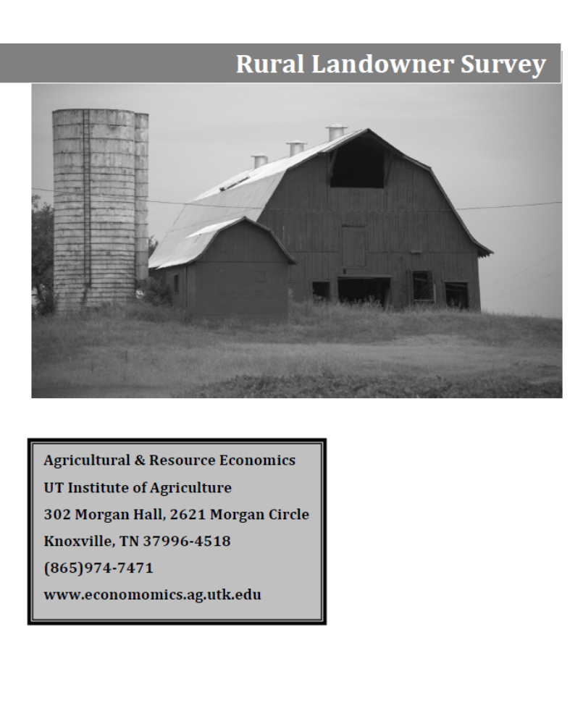

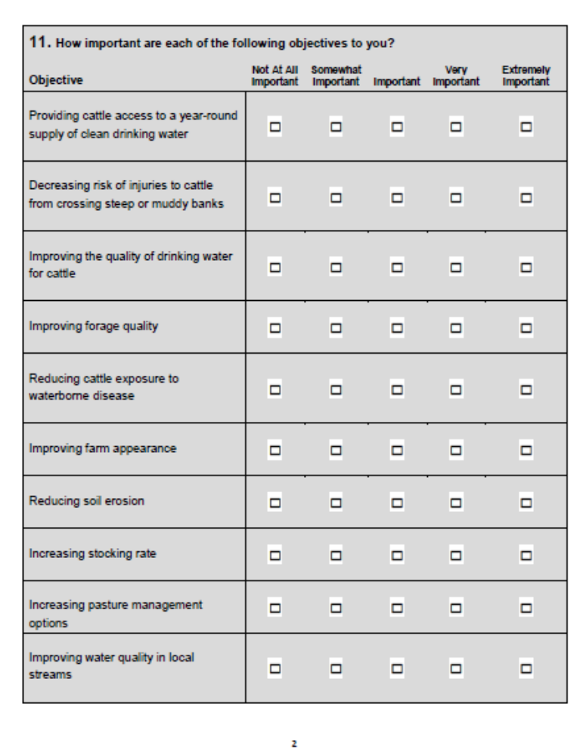

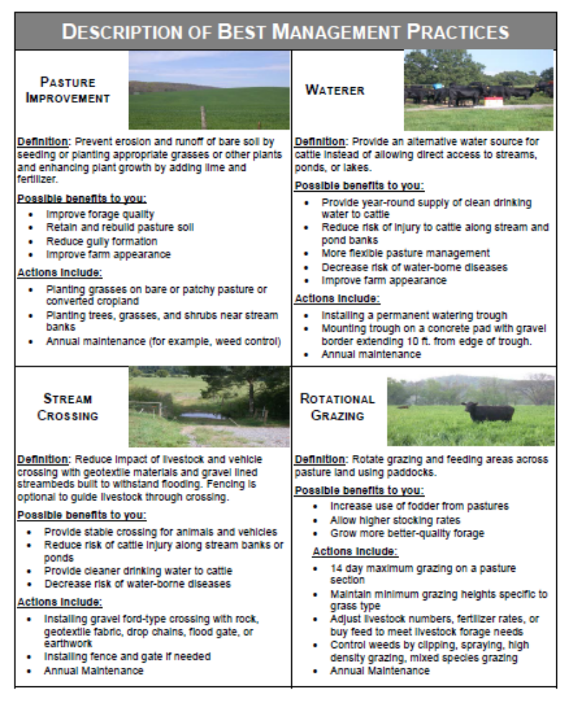
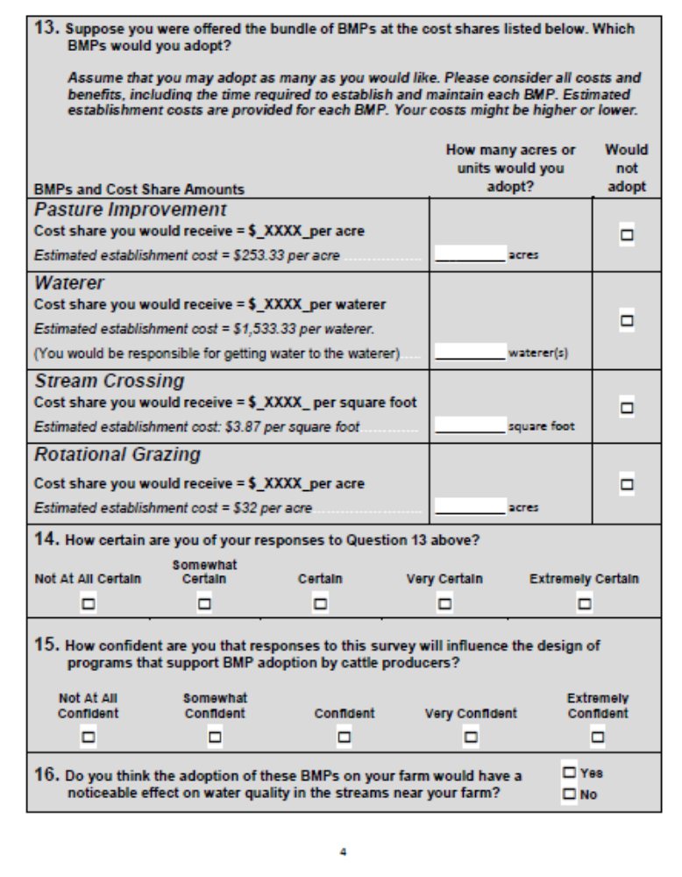
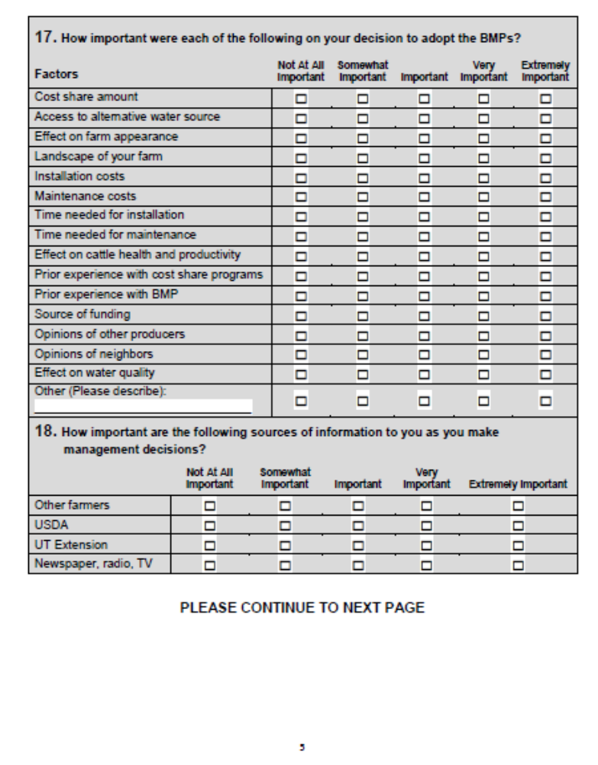


VITA

Alicia Marie Signore was born in Biloxi, MS, to parents Phillip Thomas and Mary Carol Kutz. She is the eldest of three children, followed by Andrew Phillip and Benjamin James Kutz. Alicia attended Dellwood Elementary and Rexford Longfellow Elementary schools in Clintonville, WI, Robinwood Elementary and Forest Park Middle schools in Franklin, WI, and Jackson Heights Middle and Oviedo High schools in Oviedo, FL. She graduated from high school in the “Top 10” of her class in 2008. Alicia completed her undergraduate course of study at The Florida State University in 2011, earning a Bachelor of Arts in International Affairs with focuses in both Religion and Political Science and a Bachelor of Arts in Applied Economics with a minor in Business and graduating magna cum laude. During her time in Tallahassee Alicia worked as a Resident Assistant in three different Residence Halls from the summer of 2009 to the spring of 2011. She interned at the Republican National Committee Finance Department Headquarters in Washington, D.C. during the fall of 2011. Alicia accepted a graduate research assistantship from the Agricultural and Natural Resource Economics Department at The University of Tennessee in the fall of 2012. She married Stephen Robert Signore in December, 2013. Alicia graduated from The University of Tennessee, cum laude, with a Master of Science degree in Natural Resource Economics and a minor in Watersheds in August, 2014.

The USDA Natural Resource Consultation Service (NRCS) often refers to rotational grazing as prescribed grazing, although for the purpose of this research, the terms are used interchangeably.
In contrast to this study, all studies included in the Prokopy et al. (2008) analysis were of actual, and not hypothetical, BMP adoption.

