Organization and Characterization of Nuclear Receptor Af1 Domain
A key component of hormone function in the body is the ability of the hormone to bind to its respective receptor. Mutations in a receptor can have serious repercussions on hormone function. With understanding of receptor structure and ways in it interacts with its ligand, better medical treatments can be developed. Mineralocorticoid receptors are vital in regulation of bodily fluid via binding with hormones cortisone and aldosterone. The amino-terminal domain is little understood, but it is thought to be a transactivation system with several domains for ligand binding. Before additional experiments like binding assays and hydropathy plots can be carried out, however, it is necessary to determine the best conditions under which to maximize protein production so that there is enough sample to actually conduct these experiments. The goal of this research was to determine favorable conditions for the production of proteins from the Af1 domain of the mineralocorticoid receptor.
Results

Transformation of Plasmids into Top 10 and BL21
Six plasmids received from the McEwan lab containing portions of the mineralocorticoid receptor amino-terminal domain were transformed into Top 10 E. coli cells via typical transformation procedures. The procedure was repeated for transformation into BL21 E. coli with a plasmid prep revealing plasmid concentration of the six transformants (Table 1).
Plasmid | Concentration (ng/μL)
pETAR-Af1 | 8.5
pETMR-Af1b | 6.2
pETAR-NTD-DBD₂ | 7.6
pGEXMR-Af1b | 7.7
pET-RAP74-CTD | 7.0
pET-IId-TBP | 9.0
Table 1: Concentration of plasmid in transformed BL21 cells.

Expression Screen of Plasmids
To determine expression of protein in the BL21 cells, a 5mL expression screen was conducted and run on a SDS-Page gel (Figure 1).
Figure 1: SDS-Page gel of 5mL expression screen. Gel order from left to right: Ladder, pET-IId-TBP pellet, pET-IId-TBP, pGEXMR-Af1b pellet, pGEXMR-Af1b, pETMR-Af1b pellet, pETMR-Af1b, pET-RAP74-CTD pellet, pET-RAP74-CTD, skipped, pETAR-NTD-DBD₂ pellet, pETAR-NTD-DBD₂, pETAR-Af1 pellet, pETAR-Af1, ladder.

100mL Prep of pETMR-Af1b, pGEXMR-Af1b, and pET-IId-TBP
With protein expression of each of the transformants confirmed, a 100mL prep of pETMR-Af1b, and pET-IId-TBP was completed utilizing sonification. A Bradford Protein Assay showed little protein captured during the prep (Table 2).
Protein | Concentration at 595nm (mg/mL)
pETMR-Af1b | 0.045
pDEXMR-Af1b | 0.013
pET-IId-TBP | 0.065
Table 2: Concentration of protein from 100mL prep of pETMR-Af1b, pGEXMR-Af1b, and pET-IId-TBP

500mL Prep of pETMR-Af1b and pET-IId-TBP
Suspecting that there were issues with the lysing of the cells, a larger scale 500mL prep of pETMR-Af1b, pGEXMR-Af1b, and pET-IId-TBP was attempted via French Press. Bradford Protein assay and SDS-Page were used to analyze the prep (Table 3 and Figure 2).
Protein | Concentration at 595nm (mg/mL)
pETMR-Af1b | 0.086
pET-IId-TBP | 0.366
Table 3: Concentration of protein from 500mL prep of pETMR-Af1b and pET-IId-TBP.
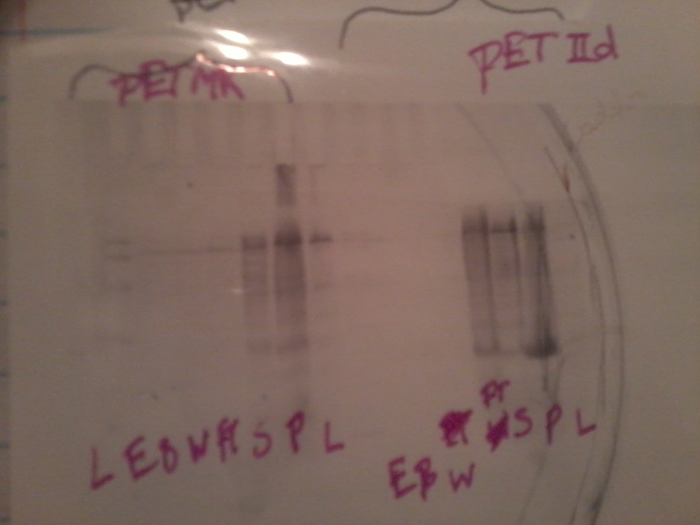
Figure 2: Figure 1: SDS-Page gel of 500mL preps of expression screen. Gel order from left to right: pETMR-Af1b Ladder, Elute, Beads, Wash, Flow-through, supernatant, pellet, skipped lane, pET-IId-TBP’s Elute, Beads, Wash, Flow-through, supernatant, pellet, and ladder.

Combined Prep of pGEXMR-Af1b and pET-IId-TBP
500mL growths of pGEXMR-Af1b and pET-IId-TBP were lysed and prepared together. Bradford Protein Assay showed improved protein expression (Table 4).
Protein | Concentration at 595nm (mg/mL)
pGEXMR-Af1b/pET-IId-TBP dimer | 1.722
Table 4: Concentration of dimer from concurrent pGEXMR-Af1b and pET-IId-TBP prep.

Use of BL21pLyss E. coli in Protein Preparation of pETAR-Af1b
Transformation of pETAR-Af1b plasmid into BL21pLyss was followed by preparation of a 500mL culture. A Bradford Protein assay of the elute showed increased protein expression (Table 5).
Protein | Concentration at 595nm (mg/mL)
pETAR-Af1b | 6.159
Table 5: Concentration of AR-Af1b protein from BL21pLyss E. coli Cells

Discussion
It was the goal of this research project to determine ways in which to increase expression of the of nuclear receptor Af1 domain proteins; previous work with the nuclear receptor Af1 domain proteins had only been attempted on a small scale. Such a scale was impractical for further experiments to elucidate nuclear receptor Af1 domain as well as interactions between the domain and its ligands. Discovery of methods and conditions by which to increase protein expression on a large scale will further facilitate experiments and understanding of this little researched portion of the mineralocorticoid receptor.
An expression screen of the six plasmids confirmed expression by all plasmids (Figure 1). However, small scale protein preparations showed little expression (Table 2). As these samples were lysed via sonification, it was proposed that lack of lysing of the cells caused much of the protein to be lost during the preparation. To test this theory, a larger 500mL protein preparation was attempted and lysed via French Press, but protein expression was still very low (Table 3).
Examination of SDS-Page gels from the 500mL protein preparation indicated that the majority of protein appeared to remain with the pellet. It was supposed that low expression could be a result of instability of the Af1 domain. The trauma of lysing the cells via sonification and French Pressing was perhaps causing the protein to denature, falling out of solution and thus being unable to adhere to Ni-NTA beads. A combined protein preparation of pGEXMR-Af1b and pET-IId-TBP was hoped to create a dimer which would stabilize the protein throughout the preparation. The increased elute concentration appears to support the theory that the low protein concentrations from the previous preparations was a result of protein instability (Table 4). Further attempts to reduce trauma to the protein through the use of BL21pLyss cells that lyse upon freezing and thawing also resulted in dramatically increased protein concentrations. Further experiments must be orchestrated to confirm the identity of the protein from these preparations. Should the use of BL21pLyss cells prove to be successful in maintaining protein production at satisfactory levels, further areas of research include protein binding assays and determining interactions between the Af1 domain and its ligands.

Materials and Methods
Transformation of Plasmid into Cell
Competent E. coli cells were thawed on ice for 10 minutes. 1.0μL of plasmid was added to each tube and incubated on ice 30 minutes. Cells were heat shocked for 45s at 42°C then placed on ice for 2 minutes. Lauria broth was added to each tube and allowed to incubate at 37°C for an hour. Cells were plated on LB plates of the right resistance.

Expression Screen
200μL LB pilots of E. coli containing plasmid were begun overnight at 37°C. A 1:100 dilution of the pilot was added to 5mL of LB. After three hours, IPTG was added. pGEX was allowed to incubate at 20°C overnight while all other cultures incubated at 37°C for approximately an hour. Cells were lysed via sonification (30s on, 30s off) and harvested at 4,000rpm for 30 minutes. 15μ of Ni-NTA beads was added to all pET vectors while GST bead were added to the pGEX vector. These beads were run on SDS-page gel to determine protein expression.
100mL Protein Preparation
Of each bacterial vector, a 5mL pilot was begun overnight and added in a 1:100 dilution to 100mL LB. Once an OD of 0.8 was reached, IPTG was added and the culture was allowed to grow another hour before it was harvested. Cells were resuspended in 100mL Lysis Buffer, lysed via sonification, and run through a Ni-NTA column with a bed-volume of 100μL.

500mL Protein Preparation
Of each bacterial vector, a 5mL pilot was begun overnight and added in a 1:100 dilution to 500mL LB. Once an OD of 0.8 was reached, IPTG was added and the culture was allowed to grow another hour before it was harvested. Cells were resuspended in 10mL Lysis Buffer, lysed via sonification, lysed via French Press, and run through a Ni-NTA column with a bed-volume of 100μL.

500mL Joint Preparation of pGEXMR-Af1b and pET-IId-TBP
Of pGEXMR-Af1b and pET-IId-TBP, a 5mL pilot was begun overnight and added in a 1:100 dilution to 500mL LB. Once an OD of 0.8 was reached, IPTG was added to each and the culture was allowed to grow another hour before it was harvested. Cells were resuspended in 10mL of Lysis Buffer, combined, then lysed together via French Press. The supernatant was and run through a Ni-NTA column with a bed-volume of 100μL.

500mL Preparation of BL21pLyss pETAR-Af1b
Of BL21pLyss pETAR-Af1b a 5mL pilot was begun overnight and added in a 1:100 dilution to 500mL LB. Once an OD of 0.8 was reached, IPTG was added to each and the culture was allowed to grow another hour before it was harvested. Cells were frozen, thawed, and then resuspended in 10mL of Lysis Buffer. The supernatant was and run through a Ni-NTA column with a bed-volume of 100μL.

Bradford Protein Assay
A blank is created via addition of 200μL reagent to 800μL of deionized water. Samples are analyzed via addition of 20μL of sample to 200μL of reagent and 780μL of deionized water.

References
Fischer, K., Kelly, S., Watt, K., Price, N., & McEwan, I. (2010). Conformation of the Mineralocorticoid Receptor N-Terminal Domain: Evidence for Induced and Stable Structure. Molecular Endocrinology , 1935-1948.

