
University of Tennessee, Knoxville
TRACE: Tennessee Research and Creative
Exchange

Doctoral Dissertations Graduate School

8-2023

High-Performance Intrinsic Self-Healable Polymers: Rational Design, Evaluation Methods, and Applications
Bingrui Li

Follow this and additional works at: https://trace.tennessee.edu/utk_graddiss  Part of the Polymer Chemistry Commons

To the Graduate Council:
I am submitting herewith a dissertation written by Bingrui Li entitled "High-Performance Intrinsic Self-Healable Polymers: Rational Design, Evaluation Methods, and Applications." I have examined the final electronic copy of this dissertation for form and content and recommend that it be accepted in partial fulfillment of the requirements for the degree of Doctor of Philosophy, with a major in Energy Science and Engineering.
Tomonori Saito, Major Professor
We have read this dissertation and recommend its acceptance:

Tomonori Saito, Alexei P. Sokolov, Amit Naskar, Brett Compton

Accepted for the Council: Dixie L. Thompson

Vice Provost and Dean of the Graduate School (Original signatures are on file with official student records.)

High-Performance Intrinsic Self-Healable Polymers: Rational Design, Evaluation Methods, and Applications

A Dissertation Presented for the Doctor of Philosophy
Degree
The University of Tennessee, Knoxville

Bingrui Li August 2023

ACKNOWLEDGEMENTS

I would like to express my sincere gratitude to my advisor, Dr. Tomonori Saito, for providing me with the opportunity to conduct research since 2016. Without his intellectual and financial support, none of my research accomplishments would have become a reality. I would like to thank Dr. Alexei P. Sokolov and Dr. Peng-Fei Cao for their guidance during my Ph.D. study. Their support and fruitful discussions between us during the past years helped me greatly to obtain this degree.
I am very thankful to my dissertation committee, Dr. Amit K. Naskar, and Dr. Brett G. Compton, for their valuable suggestions and ideas during the development of this dissertation.
I here express my gratefulness to my parents and other family members, for providing me with unconditional understanding and support during the past five years.
I thank all the current and previous group members and my friends during my graduate study, including the time when I was in Cleveland, Ohio, and currently in Knoxville, Tennessee.
Finally, I would like to thank the Bredesen Center of the University of Tennessee, Knoxville, and Oak Ridge National Laboratory for supporting me with the resources during the development of this dissertation. I thank the U.S. Department of Energy, Office of Science, Basic Energy Sciences, Materials Sciences and Engineering Division for sponsoring this research.

ABSTRACT

Self-healable polymers with rapid, room-temperature healing properties are especially attractive for various applications. Thus, systematic study of their structure-property relationship is demanded to obtain a better understanding of self-healing materials. The goal of this dissertation is to unravel the relationship between molecular structure, self-healing properties (healing rate and efficiency), and materials’ evaluation.
Controlling the H-bond density in a crosslinked poly(dimethyl siloxane) (PDMS) system allows to tailor their various physical properties and self-healing properties. In two studied systems, both the H-bond density and the chemical crosslink density were controlled individually, thus we can observe the impact of these two factors and elucidate the relationships on their chemical structure and fast, room-temperature self-healing properties. By precisely controlling the molar ratio between strong H-bond moiety and weak H-bond moiety, we obtained a series of self-healing materials with tunable rapid self-healing properties.
We aimed to develop self-healable polymers with high toughness since such material is not readily accessible today. We employed the thiourea structure to construct a resilient foundational component. PDMS was introduced to enhance the material's flexibility, the product exhibits high modulus and toughness, with switchable mechanical and healable properties under high humidity environment. Such polymer could perform fast room-temperature healing in an environment where humidity level is greater than 80%.
Moreover, a universal evaluation method for self-healing polymers is established and discussed, which is critical due to no available evaluation system currently. Through screening the key healing data (such as healing time and temperature) of a large quantity of published research, we revealed the trade-off between tensile strength and self-healing rate by constructing such evaluation method.
Finally, for future research perspectives, obtaining self-healing polymers with good performance from upcycled plastic waste to explore a better way to process plastic waste and lower the cost and carbon footprint of self-healing polymers. Poly(ethylene terephthalate) (PET) was selected as the original source for the upcycled self-healable polymer due to its accessibility and chemical versatility. After being deconstructed by aminolysis reaction, the deconstructed PET was transformed into self-healable polymers with tailored chemical structures.

TABLE OF CONTENTS

INTRODUCTION 1
CHAPTER I BACKGROUND: INTRINSIC POLYMERIC SELF-HEALABLE MATERIALS
3
ABSTRACT 4
INTRODUCTION 4
DYNAMIC BONDS AND CURRENT UNDERSTANDING OF SELF-HEALING MECHANISMS 9
DYNAMIC REVERSIBLE BONDS 9
MECHANISMS CONTROLLING DYNAMIC BONDS REARRANGEMENTS 11
MODELS DESCRIBING DYNAMIC BONDS AND SELF-HEALING PROCESSES 13
OTHER STIMULUS-ACCELERATED SELF-HEALING KINETICS 17
REPRESENTATIVE INTRINSIC SELF-HEALING POLYMERS 19
SELF-HEALING MATERIALS WITH NONCOVALENT DYNAMIC BONDS 19
SELF-HEALING MATERIALS WITH COVALENT DYNAMIC BONDS 21
COMBINING DIFFERENT DYNAMIC BONDS AND EMPLOYING SACRIFICIAL BONDS 28
CONCLUSIONS 29
CHAPTER II SUPERSTRETCHABLE, SELF-HEALING POLYMERIC ELASTOMERS WITH TUNABLE PROPERTIES 34
ABSTRACT 35
INTRODUCTION 35
EXPERIMENTAL 37
MATERIALS 37
POLYMER SYNTHESIS 37
POLYMER CHARACTERIAZATIONS 37
RESULTS AND DISCUSSION 40
FABRICATION OF POLYMERIC ELASTOMERS 40
MECHANICAL PROPERTY TEST 44
HEALABLE MECHANICAL PROPERTIES 46
RECOVERABLE GAS-SEPARATION PROPERTIES 46
CONCLUSIONS 55
CHAPTER III PUNCTURE-RESISTANT SELF-HEALING POLYMERS WITH MULTI-CYCLE ADHESION AND RAPID HEALABILITY 60
ABSTRACT 61
INTRODUCTION 61
EXPERIMENTAL 64
MATERIALS 64
SYNTHESIS OF THE U-PDMS-SPS 64
POLYMER CHARACTERIZATIONS 64
RESULTS AND DISCUSSION 65
SYNTHESIS OF PDMS-SPS 65
MECHANICAL PROPERTIES 69
SELF-HEALING PROPERTIES 70
PUNCTURE-RESISTANT AND ADHESION FUNCTIONALITIES 71
CONCLUSIONS 80
CHAPTER IV WELL-TUNABLE, 3D-PRINTABLE, AND FAST AUTONOMOUS SELF-HEALING ELASTOMERS 81
ABSTRACT 82
INTRODUCTION 82
EXPERIMENTAL 84
MATERIALS 84
POLYMER SYNTHESIS 84
POLYMER CHARACTERIZATIONS 85
RESULTS AND DISCUSSION 86
SYNTHESIS OF SELF-HEALING ELASTOMERS 86
MECHANICAL PROPERTIES EVALUATIONS 88
SELF-HEALING PERFORMANCE 91
DYNAMIC STUDIES FOR SELF-HEALING MECHANISM 97
CONCLUSIONS 100
CHAPTER V TOUGH SELF-HEALING POLYMERS WITH HUMIDITY CONTROLLED HEALING PROPERTIES 101
ABSTRACT 102
INTRODUCTION 102
EXPERIMENTAL 103
MATERIALS 103
POLYMER SYNTHESIS 103
POLYMER CHARACTERIZATIONS 103
RESULTS AND DISCUSSION 104
POLYMER SYNTHESIS 104
MECHANICAL PROPERTIES 104
SELF-HEALING PROPERTIES 107
FUTURE PERSPECTIVES 109
CONCLUSIONS 109
CHAPTER VI CHARACTERIZATION AND EVALUATION OF SELF-HEALING POLYMERS 111
ABSTRACT 112
INTRODUCTION 112
RESULTS AND DISCUSSION 116
DEVELOPING A GENERAL APPROACH TO STUDY SELF-HEALING 116
TRADE-OFF BETWEEN SELF-HEALING KINETICS AND MECHANICAL STRENGTH 118
EMPLOYING COMPLEX ARCHITECTURES AND COMBINATION OF DYNAMIC BONDS TO SURPASS THE MODULUS – SELF-HEALING RATE TRADE-OFF 120
NEEDS FOR IN SITU ANALYSIS OF SELF-HEALING 126
THEORETICAL AND MODELLING CHALLENGES 127
CONCLUSIONS 127
FUTURE PERSPECTIVES 129
CONCLUSION 133
REFERENCES 135
VITA 155

LIST OF TABLES
Table 1. Combined Young’s modulus, elongation, ultimate tensile strength, and toughness of U-PDMS-Es and U-PDMS5.0K-E after self-healing. 50
Table 2. Dimer system binding energies and average hydrogen bonding distances. 57
Table 3. CO₂ binding energy and physical bonding distance. 59
Table 4. Physical properties of U-PDMS-SPs with different compositions. 68
Table 5. Combined physical properties of Poly(BCOE) and Poly(BCOE-r-UPy)s. 89
Table 6. The molar ratio between CTA and each monomer, calculated molecular weight (based on RAFT polymerization), G', C_{x}, and C_{x} of Poly(BCOE) and Poly(BCOE-r-UPy)s. 90
Table 7. The molar ratio between thiol moiety and PDMS-NH₂, tensile properties of PETU and PETU-PDMSs.. 106
Table 8. List of the self-healing polymers presented in the Figure 69 with their parameters and references. Numbers in the Figure 69 correspond to the line number in the Table. 122

LIST OF FIGURES
Figure 1. (a) The number of publications per year on topics of self-healing polymers (data from the Web of Science, the search keyword is “self-healing polymer”). (b) Schematic of the material design of intrinsically self-healing polymers with spheres presenting dynamic reversible bonds. 5
Figure 2. Examples of intrinsically self-healing polymers with different dynamic bonds. (a) Chemical structures of Diels−Alder (DA) reaction moieties. (b) Stress−strain curves including the healed sample and the pristine sample. (c) Schematic illustration of the structures of the urea containing self-healable rubber. (d) Stress−strain curves of the healed samples at different healing time of the urea containing self-healable rubber. (e) Chemical structure of the pyrenemethyl end-capped hydrogen-bonding polymer. (f) Healing kinetic of the polyurethane samples. 8
Figure 3. Illustrations of the different dynamic bonds. (a) noncovalent bonds; (b,c) dynamic covalent bonds. 10
Figure 4. (a) Characteristic dissociation energy for different types of dynamic reveresible bonds. (b) Illustration of the critical energy parameters of bond rearrangement. 12
Figure 5. Different regimes of the self-healing process from anomalous diffusion (very fast) to hopping (relatively fast) and to adhesion (relatively slow) as the function of the dynamic bond strength ε = Edis = Ea.56 There are several important time scales, including segmental relaxation time τ0, rouse time τR, and bond dissociation time τb. The equilibration time τeq (thick black line) marks the crossover from healing to adhesion behavior. 12
Figure 6. (a) Schematic illustration of polymer structure with stickers forming individual pairs (dimers) or microphase separated clusters. (b) Demonstration of two potential pathways toward simultaneously enhancing the modulus and extensibility of polymers: incorporating hydrogen bonding networks (physical bonds) and introducing rationally designed clusters of hydrogen-bonding units. 16
Figure 7. Detailed analysis using rheology revealed that self-healing time is comparable to the terminal relaxation time of the polymer with dynamic bonds. The latter in this specific case is controlled by bond rearrangements between clusters of dynamic (hydrogen) bonds. 16
Figure 8. (a) Schematic illustration of the chemical structures of [Fe(Hpdca)2]⁺. (b) Stress−strain curves including the healed sample of the [Fe(Hpdca)2]⁺. (c) Schematic illustration of the structures of the bPEIx/PAA/PEO complex. (d) Stress−strain curves of the healed samples at different healing time of the bPEIx/PAA/PEO complex. 22
Figure 9. (a) Chemical structure of the PMMA-r-PnBA copolymers. (b) Healing kinetics observed by optical microscope of the PMMA-r-PnBA, MMA/nBA is 45/55. (c) Schematic illustration of the structures of the urea rich PDMS elastomer. (d) Stress−strain curves of the healed samples at different healing time of U-PDMS-5.0K-E. 26
Figure 10. (a) Chemical structure and photo of the dynamic polyurethane sample. (b) Healing efficiency at different healing time of the damaged PT-HM-U films. (c) Chemical structure and illustration of the assembly of poly(ether-thiourea) TUEG3. (d) Tensile properties of poly(ether-thiourea) TUEG3 and its reference polymers. (e) Percentage of mechanical properties recovery of TUEG3 and other polymers at different healing temperatures and time lengths. 27
Figure 11. (a) Schematic illustration of the chemical structures of PEAA₂M₃. (b) Strain−stress curves including the healed sample of PEAA₂M₃. (c) Chemical structure of the thiol cross-linked epoxy resin. (d) Stress−strain curves of the healed samples at different healing times of the thiol cross-linked epoxy resin. (e) Photo illustration of dynamic disulfide bond containing polyurethane during the healing test. (f) Chemical structure and photo demonstration of the dynamic-covalent boronic esters. 30
Figure 12. (a) Chemical structure of the crosslinker and 1,2-diolcontaining polycyclooctene. (b) Tensile data of pristine and healed polymers prepared by different crosslinkers. (c) Schematic illustration of p(AAEMA/MMA/nBA) covalently adaptive networks containing dynamic cross-links with MMA and nBA repeating units facilitated transamination exchange reactions. 31
Figure 13. (a) Schematic illustration of the structures of PAA/PEI-PYA complexes. (b) Strain−stress curves of the original and healed samples of PAA/PEI-PYA complexes at different healing time. (c) Illustration of the structures of the PU-BPY_{0.5}–Zn elastomer. (d) Stress−strain curves of the intact and healed samples at different healing times of the PU-BPY_{0.5}–Zn elastomer. 32
Figure 14. (a) Schematic illustration of the structures of ACON. (b) Stress-strain curves of ACON and control BACON. (c) Stress-strain curves of ACON at different healing time. (d) Schematic illustration of the structures of f-BNNS/clay/PNIPAM. (e) Stress-strain curves of the composite hydrogels with increasing f-BNNS content. (f) Demonstration of the self-healing property of f-BNNS/clay/PNIPAM. 33
Figure 15. Synthesis of U-PDMS-Es. 41
Figure 16. Synthesis of four arm diethylenetriamine-functionalized PDMS. 41
Figure 17. Possible chemical structure of the obtained U-PDMS-Es. 42
Figure 18. Comparative ¹H NMR spectra of anhydride terminated PDMS (SA-PDMS), tetra-acid terminated PDMS (TDA-PDMS) and tetra-diethylenetriamine terminated PDMS (TDA-PDMS). 43
Figure 19. (a) IR spectra of U-PDMS-Es with different molecular weights of PDMS after normalizing the absorption band corresponding to the C-Si bond at 1257 cm⁻¹; (b) Temperature-modulated differential scanning calorimetry (TM-DSC) cures of U-PDMS-Es. 47
Figure 20. Comparative IR spectra of anhydride terminated PDMS (SA-PDMS), tetra-acid terminated PDMS (TA-PDMS) and tetra-diethylenetriamine terminated PDMS (TDA-PDMS). 48
Figure 21. TGA analysis of U-PDMS-Es with different molecular-weight of PDMS. 48
Figure 22. DSC analysis of PDMS terminated with amine groups. 49
Figure 23. SAXS spectra of U-PDMS-Es. 49
Figure 24. (a) Temperature sweep of shear modulus on U-PDMS5.0K-E, (b) Tensile test of the U-PDMS-Es with PDMS of different molecular weights (molar ratio of TDA-PDMS /PDMS-NH₂ is fixed at 1:5), U-PDMS-E* means the molar ratio of TDA-PDMS /PDMS-NH₂=1:10, strain rate = 1 s⁻¹ , (c) ten successive loading-unloading cycles of the film prepared from U-PDMS-Es (C1:U-PDMS0.9K-E, C2: U-PDMS3.0K-E, C3: U-PDMS5.0K-E, C4:U-PDMS30K-E), red curve is the 1st hysteresis loop. 50
Figure 25. Shear modulus (G' and G") of U-PDMS5.0K-E. 51
Figure 26. Temperature sweep of shear modulus on U-PDMS-Es with molecular weight of PDMS 0.9K, 5.0K and 30K. 51
Figure 27. Picture of manual sideways stretching test of U-PDMS5.0K-E before elongation (a) and after 1,500% elongation (b): (a3)/(b3) and (a4)/(b4) are images of 2 seconds and 5 seconds, respectively, after releasing the manual stretching; (c) ten successive loading-unloading cycles (1,500%- 1,600%) of the film prepared from U-PDMS5.0K-E. 52
Figure 28. (a) Picture showing the healing process of polymer membranes made from U-PDMS5.0K-E; (b) Comparative tensile test of original polymer membrane and after cut and healing process (5 mins, 30 mins and 120 mins healing at 25 °C). 53
Figure 29. Image of U-PDMS5.0K-E before and during stretching. 53
Figure 30. Comparison result from both healing types: (I) healed by brought into contact (no overlap, film thickness ~1.5 mm), (II) healed by around 2 mm of overlap (film thickness ~0.5 mm). 54
Figure 31. (a) Pictures showing the gas-separation membranes with applied scratch and after healing at 40 °C for 30 mins; (b) Comparative gas separation performance of original polymer membranes (blue) and polymer membranes after cut and healing (orange), CO₂ permeability (up) and CO₂/N₂ selectivity (bottom). 57
Figure 32. Monomer Structures I-IV considered in the computational study. 58
Figure 33. Two-dimensional representation of hydrogen bonding between monomer units. 58
Figure 34. The most stable geometry for I-CO₂, II-CO₂, III-CO₂, and IV-CO₂. 58
Figure 35. (a) Schematic illustration of the chemical structures of the starting materials and the U-PDMS-SPs. (b) FT-IR spectra of U-PDMS-SPs with different ratios of reagents and PDMS starting materials after normalizing the absorption band corresponding to the C-Si bond at 1257 cm⁻¹. (c) Thermogravimetric analysis (TGA) data of U-PDMS-SPs. (d) DSC data of U-PDMS-SPs with different ratios of reagents. (e) Rheology test data curve of U-PDMS-SP4. 63
Figure 36. Illustration of potential chemical structures of U-PDMS-SPs after the synthesis. 66
Figure 37. (a) Tensile test data of U-PDMS-SPs at the rate of 1 mm/s. (b) Demonstration of the extensibility of U-PDMS-SP4 while the sample was stretched by hand. (c) Hysteresis test result of U-PDMS-SP4 at the rate of 1 mm/s for 10 cycles. (d) Tensile data of healed U-PDMS-SP4 at different healing time. (e) Toughness recovery percentage of U-PDMS-SP4 at different healing times. 68
Figure 38. ATR-FTIR data of U-PDMS-SPs at the range of 1490-1710 cm⁻¹. 72
Figure 39. (a) SAXS data of U-PDMS-SP4. (b) SAXS data of U-PDMS-SP5. (c) Combined SAXS/WAXS data of background. 72
Figure 40. (a) Pictures showing U-PDMS-SP4 being loaded on the puncture fixture, the sample diameter is 12 cm. (b) Force and displacement data during the puncture test. (c) Front view of U-PDMS-SP4 loaded on the fixture. (d) Sample punctured without breaking till the limit of the fixture. (e) Sample maintained integrity during the withdraw of the testing rod. (f) Comparison between the lap shear strength and work of debonding data of scotch double-side tape and U-PDMS-SP4, each sample was tested four times after being reassembled within 1 minute after each test. (g) Peel test data of three different adhesives following ASTM C794 standard on aluminium (Al) and Teflon (PTFE) surfaces. 73
Figure 41. (a) Rheology test data curve of U-PDMS-SP1. (b) Rheology test data curve of U-PDMS-SP2. (c) Rheology test data curve of U-PDMS-SP3. 76
Figure 42. (a) ASTM D5748 puncture test data of commercial food wrap film sample. (b) Customized sample-sized ASTM D5748 puncture test data of commercial food wrap film sample and U-PDMS-SP4. (c) Top view image of food wrap film after customized D5748 puncture test. Picture of U-PDMS-SP4 (d) before, (e, f) during, and (g) at the end of customized D5748 puncture test. (h) Sylgard 184 silicon elastomer sample after puncture test. 77
Figure 43. Photo of the front and side view of the lap shear test sample. 78
Figure 44. Lap shear test data of U-PDMS-SP4 (a) and scotch double-sided tape (b), the same specimen was tested four times. 78
Figure 45. (a) Photo of blue masking tape, post-it note, and U-PDMS-SP4 applied on aluminum surface for peel test. (b) Photo of U-PDMS-SP4 during the peel test on aluminum surface and aluminum surface after the removal of the U-PDMS-SP4. (c) Photo of blue masking tape, post-it note, and U-PDMS-SP4 applied on PTFE surface for peel test. (d) Side view of U-PDMS-SP4 during the lap shear test. 79
Figure 46. (a) Synthesis of room-temperature self-healable random copolymer Poly(BCOE-r-UPy)s. (b) Demonstration of the simplified structure and H-bonding interactions of Poly(BCOE-r-UPy). (c) Self-healing process of Poly(BCOE-r-UPy). 87
Figure 47. (a) ¹H NMR spectrum of MPA-UPy. (b) TGA data of Poly(BCOE), Poly(BCOE-r-UPy1), Poly(BCOE-r-UPy5), and Poly(BCOE-r-UPy10). 87
Figure 48. (a) ¹H NMR data of Poly(BCOE-r-UPy5). (b) ATR-FTIR spectra of Poly(BCOE-r-UPy)s with different molar ratios of MPA-UPy. (c) DSC data of Poly(BCOE-r-UPy)s. (d) Combined SAXS/WAXS spectra of Poly(BCOE) and Poly(BCOE-r-UPy)s with different molar ratios of MPA-UPy. 89
Figure 49. (a) Storage modulus (G', closed symbols) and loss modulus (G", open symbols) (reference temperature = 25 °C) of Poly(BCOE) and Poly(BCOE-r-UPy)s. (b) Tensile data of Poly(BCOE) and Poly(BCOE-r-UPy)s. (c) Photo of Poly(BCOE) during tensile test (>3,000% tensile strain). 90
Figure 50. (a) Photograph of damaged and healed (4h, 24h) Poly(BCOE-r-UPy1) sample at 20 °C. (b) Optical microscope images demonstrating the healing process of Poly(BCOE) and Poly(BCOE-r-UPy1) against cut by a razor blade. (c) Helium-ion microscope images, demonstrating the healing process of Poly(BCOE-r-UPy1) against cut by a razor blade. 93
Figure 51. (a) Tensile data of Poly(BCOE-r-UPy1) and cut sample with different healing time. (b) Healing efficiency of Poly(BCOE-r-UPy1) and Poly(BCOE-r-UPy5) at different healing time. (c) Photo demonstration of self-healability of Poly(BCOE-r-UPy1) at room temperature. (d) Pictures showing healing process of 3D-printed Poly(BCOE-r-UPy5) sample. 94
Figure 52. Room-temperature hysteresis test data of Poly(BCOE-r-UPy5) after 10 cycles at the rate of 1 mm/s. 94
Figure 53. (a) Comparison of the toughness recovery percentage and healing time of the Poly(BCOE-r-UPy1) with recently reported self-healable polymers. (1, ref. [34]; 2, ref. [116]; 3, ref. [98]; 4, ref. [136]; 5, ref. [241]; 6, ref. [269]). (b) Healing properties of Poly(BCOE-r-UPy1) at 313 K compared with other self-healing polymers. 95
Figure 54. Tensile properties recovery of Poly(BCOE-r-UPy1) sample under different healing times at 40 °C. 95
Figure 55. (a) $ε_{der}$ for Poly(BCOE-r-UPy5). (b) Activation plot of Poly(BCOE-r-UPy5) with $τ_{α}$and $τ_{C}$.. 98
Figure 56. Fitting of BDS spectra of Poly(BCOE-r-UPy5) sample. 98
Figure 57. Photo of (a) Poly(BCOE-r-UPy1) sample in pristine (bottom) and healed for 5 mins after complete cut (top) conditions. (b) Dye droplet applied to Poly(BCOE-r-UPy1) samples. (c) Side view focused on the pristine sample with dye droplet. (d) Side view focused on the healing sample with dye droplet. 99
Figure 58. Healing efficiency of Poly(BCOE-r-UPy1) and Poly(BCOE-r-UPy5) at different healing times (linear scale).. 99
Figure 59. Scheme of the synthesis process of PETU-PDMS. 105
Figure 60. ¹H NMR data of PETU and PETU-PDMSs. 105
Figure 61. ATR-FTIR data of PETU and PETU-PDMSs. 106
Figure 62. Tensile test data of PETU and PETU-PDMSs. 106
Figure 63. Tensile test data of pristine and 40 °C-healed PETU-PDMS_{0.2}. 108
Figure 64. Photo of (a) Dry PETU-PDMS_{0.2} being attached after break with water droplet added on top. (b) PETU-PDMS_{0.2} healed for 30 mins at 20 °C. (c) PETU-PDMS_{0.2} being cut and attached after stored at 40% RH. (d) PETU-PDMS_{0.2} healed for 30 mins at 20 °C, 40% RH. (e) Sample in image d after tensile test. (f) Pristine PETU-PDMS_{0.2} after stored at 80% RH. (g) Sample in image f after cut by razor blade. (h, i) Sample f, PETU-PDMS_{0.2} healed for 10 mins at 20 °C, 80% RH. (j) Sample in image d during tensile test. 108
Figure 65. TGA data of PETU-PDMS0.2 at different storing conditions. 110
Figure 66. Tensile test data of (a) pristine and 30 min healed PETU-PDMS_{0.2} at 20 °C, 40% RH. (b) pristine and 10 min healed PETU-PDMS_{0.2} at 20 °C, 80% RH. 110
Figure 67. (a) Schematic representation of the time dependence of strain and stress during the self-healing experiment. (b) Resulting normalized storage modulus during recovery for sample PIB14K-BA2 at different temperatures (25 °C, 20 °C, 15 °C, 10 °C, 5 °C) as a function of time t − t₂⁴³. 114
Figure 68. (a) Optical microscope images of self-healing materials from Urban⁹. (b) Optical microscope images of self-healing materials from Huang²⁸¹. 114
Figure 69. Diagram of the maximum tensile stress vs healing rate for intrinsically self-healing polymers. (a) Data for polymers healable at between 20 °C and 40 °C (red dots indicate gel samples). (b) polymers healable between 40 °C and 100 °C. The healing rate was chosen as an inverse time to reach at least 90% healing efficiency. Specific polymers, dynamic bonds and references to each presented data point are given in Table 8. Dashed lines present upper bound for the tensile strength self-healing rate trade-off. 121
Figure 70. (a) Example of rheology test at alternate small oscillation strain and large strain. (b) Illustration of the proposed in situ observation approach for self-healing. 121
Figure 71. (a) Proposed synthesis procedure for PET-based self-healable materials. (b) ¹H NMR spectrum of the product of PET aminolysis reaction 1 and 2. 131
Figure 72. Tensile properties of BAET-EDEA1 polymer. 132

INTRODUCTION

The self-healing feature of human skin can achieve regeneration of the tissue, providing multiple benefits to us against physical damage. Inspired by nature, the concept of self-healing material, a material that can heal over physical destruction and fully recover functionalities has drawn significant interests in research and application. Integrating self-healing capability in materials improves their adaptability and longevity in various applications. To fabricate synthetic self-healable materials, there are two different general approaches. One approach is to encapsulate two reactive chemicals individually under physical confinement, such as dual-component epoxy. When physical destruction occurs, the breakage of reactant encapsulation will result in fast chemical reactions between the two reactants, and a new compound will form and rapidly seal the void. Although this extrinsic approach is commercially accessible and is easy to operate, the key drawback is typically its one-time healing feature due to their irreversible chemical reactions. There are also concerns about the complexity of packaging, which requires optimum isolation between reactants. On the other hand, another approach uses the material to be integrated with reversal bonds that could reform upon physical damage, overcoming the drawbacks of the extrinsic pathway. It is categorized as the intrinsic self-healing mechanism. The intrinsic self-healing mechanism relies on the reversible bond formation that contains covalent bonds and non-covalent interactions.
Self-healing polymers with minimum healing requirements, especially ambient temperature healing capability are of great interest. The intrinsic approach provides the most viable solutions to such demand; thus, we focus on the understanding and development of self-healing polymers built with reversable bonds/interactions. We conducted our research targeting to resolve current issues on self-healing polymers. A self-healing system could be widely adopted with its wide range of operating window and fast healing process. In the meantime, the improvement in the accessibility of self-healing polymers is also important since a significant number of reported healable materials required complicated synthesis and fabrication procedures. Improving mechanical performance while maintaining the self-healing ability of self-healing materials will help surpass the boundary of current research due to the existence of mechanical strength-healing performance tradeoff. This tradeoff is identified by establishing a universal evaluation method that enables researchers to evaluate and cross-compare material’s performance with previous studies. The relationship between material performance and material composition initiates a new research aspect of self-healing materials and will facilitate rational selection of starting materials for future research.
The focus of this thesis consists of four parts: 1) understand the effect of hydrogen bonding density in crosslinked/non-crosslinked self-healing systems, 2) develop self-healing polymers that surpass mechanical strength-healing performance tradeoff, 3) fabricate self-healable polymers from recycled materials, and 4) establish a universal evaluation method to promote the development of high-performance self-healing polymers.

CHAPTER I
BACKGROUND: INTRINSIC POLYMERIC SELF-HEALABLE MATERIALS

A version of this chapter was published by Bingrui Li, Peng-Fei Cao, Tomonori Saito, and Alexei P. Sokolov “Intrinsically Self-Healing Polymers: From Mechanistic Insight to Current Challenges” accepted to Chemical Reviews, 10.1021/acs.chemrev.2c00575

Bingrui Li wrote the manuscript under the guidance of Tomonori Saito and Alexei P. Sokolov. Peng-Fei Cao, Tomonori Saito, and Alexei P. Sokolov both contributed to part of the writing and the revision of the manuscript. Tomonori Saito and Alexei P. Sokolov provided the overall direction and supervision.

Abstract
Self-healing materials open new prospects for more sustainable technologies with improved material performance and devices’ longevity. We present an overview of the recent developments in the field of intrinsically self-healing polymers, the broad class of materials based mostly on polymers with dynamic covalent and noncovalent bonds. We describe the current models of self-healing mechanisms and discuss several examples of systems with different types of dynamic bonds, from various hydrogen bonds to dynamic covalent bonds. Recent advances indicate that the most intriguing results are obtained on the systems that have combined different types of dynamic bonds. These materials demonstrate high toughness along with a relatively fast self-healing rate. There is a clear trade-off relationship between the rate of self-healing and mechanical modulus of the materials, and we propose design principles of polymers toward surpassing this trade-off. We also discuss various applications of intrinsically self-healing polymers in different technologies and summarize the current challenges in the field. This part intends to provide general introductions for intrinsic self-healing polymers.

Introduction
Self-healing materials are materials with the capability to repair physical damages and restore functionalities by themselves.¹⁻⁴ The interest to design self-healing materials grew substantially in the recent decade due to an expected increased longevity of materials and devices and hence improved sustainability.⁵⁻⁷ Self-healing is an intriguing function in biological systems, while they typically utilize a complex cascade multistep process. The healing mechanisms between plants and animals are different but include the same three general steps: immediate biochemical (e.g., inflammatory) response, wound closure, and then partial or full functionality recovery. Among them, our human skin is a familiar example, which starts with inflammatory response that triggers specific biochemical processes immediately after encountering minor physical damage like a small cut, then merges the gaps within hours, and fully recovers its original function and properties such as sensing capability and high elasticity, after a few days. Self-healing in synthetic systems also includes sealing phase (intermolecular diffusion) and some

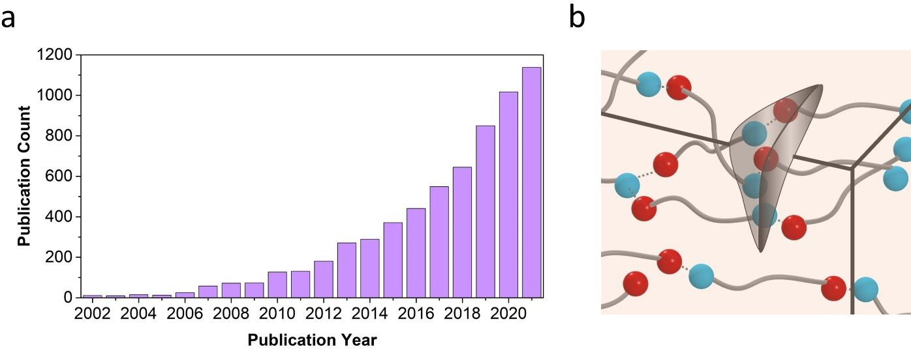

Figure 1. (a) The number of publications per year on topics of self-healing polymers (data from the Web of Science, the search keyword is “self-healing polymer”). (b) Schematic of the material design of intrinsically self-healing polymers with spheres presenting dynamic reversible bonds.⁸

systems and usually is much simpler with fewer steps to recover the functionality.⁹⁻¹¹ Yet, the understanding of self-healing mechanisms in synthetic systems remains limited that hinders the further development of facile design principles of materials with desirable self-healing properties. Polymers, metals, ceramics, and composites with self-healable properties have been developed during the past few decades. Metals are reusable after being melted, while the required energy to achieve melting point is extremely high due to their high melting temperature, Tm. Thus, metals with low Tm such as liquid metal are normally utilized as healable materials,^{12,13} and such examples include a liquid metal-based room-temperature self-healing anode material for lithium-ion batteries¹⁴ or an autonomously self-healable liquid metal based elastomer.¹⁵ Ceramics can also achieve self-healing by chemical reactions, e.g., oxidization, of the pre-incorporated healing agents upon exposure to high temperature or to the atmosphere.¹⁶ For example, locally doped MnO on the fracture path significantly accelerated the healing process, which can be adapted to structural ceramics such as turbine blades in aircraft engines.¹⁷ Polymers exhibit unique advantage among the self-healing materials due to their mechanical flexibility and structural adaptability. The backbone structure, molecular architecture, and functional groups of polymers could be tuned in a broad range to achieve desired self-healability. The self-healing mechanism varies from the recovery of dynamic bonds to the formation of new chemical bonds by different chemical precursors that were initially isolated.¹⁸ Furthermore, the versatility of polymers allows the integration of different functionalities in the same polymer.¹⁹ Currently, polymer-based self-healing systems occupy one of the major research directions in self-healable materials. The number of publications on the topic of self-healing polymers has grown exponentially in the recent decade (Figure 1a), increasing from below 100 per year before 2010 to over 1000 in the year 2021.

The incorporation of self-healing ability significantly prolongs the lifetime of materials against physical damage. It reduces material waste, replacement labor, and life cycle cost, providing a more sustainable path for a lower carbon cycle. For example, the carbon footprint of self-healing geopolymer concrete is estimated to be lower than ordinary Portland cement concrete even under the worst-case assumptions.²⁰ Developing self-healing polymers also addresses another global problem: reduction of the plastic pollution. Annual plastic production reaches 400 million metric tons (Mt),²¹ and combined with manufacturing energy inputs, commodity plastic alone is estimated to account for an annual 104 Mt CO2 equivalent of greenhouse gas (GHG) emissions just in the U.S.²² With the expected increase of plastic production to 1100 Mt by 2050,²³ extending the longevity of polymer materials is important,²⁴ in addition to developing paths for high recyclability as well as upcycling with closed-loop circularity.²⁵ Developing the intrinsically self-healing polymers provides one of the strategies to improve plastics circularity and reduce overall GHG emissions. The impact of improved longevity extends far beyond the polymer itself because the failure of the polymer often leads to the failure of the entire device or system. Thus,

the development of self-healing polymers is critical for enhancing sustainability of many technologies. There are two major strategies to achieve self-healing in polymers: the extrinsic and intrinsic approaches. The extrinsic approach typically involves two reactive chemicals under physical confinement, and fast chemical reactions between the two reactants upon physical damage rapidly seal the void.^{8,26} Different from conventional extrinsic approach, some polymer systems can also self-heal or self-repair using the atmospheric CO2 fixation by mimicking the photosynthesis of plants.^{27,28} On the other hand, the intrinsic approach is facilitated by the breaking and rebonding of dynamic (reversible) bonds and interdiffusion of polymer chains (Figure 1b). The first report of self-healing polymer by capsule-based approach was published in 2001,²⁹ where the capsules containing healing agent and catalyst particles were embedded into an epoxy matrix. Such structure achieved 75% recovery of toughness after a razor blade cut. Following those initial reports, the concept of microcapsules in self-healing has been well adopted by researchers for a wide range of applications.^{30,31} But this approach provides only one time healing and suffers from chemical leaks. Then vascular-based extrinsic self-healing approach was reported in 2007.³² The extrinsic self-healing polymers with a bioinspired microvascular network system significantly improved the repeatability of self-healing and overcame the shortcomings of the first-generation capsule-based materials. Yet, the complex structure of the vascular network and the same challenge of potential chemical leaks have prevented broad use of these self-healing systems. A unique strategy based on a polymer gel with embedded chloroplasts that can use the atmospheric CO2 was developed in 2018.²⁷ This enables the glucose containing poly(methacrylamide) based hydrogel to grow, strengthen, and self- repair. However, the chemical design is limited, the mechanical strength of the obtained hydrogel is relatively weak, and more importantly, the embedded chloroplast loses the bioactivity in a relatively short period, not suitable for long-term self-healability.
In contrast, the intrinsic (autonomous) approach relies on polymer diffusion and reversible bonds within the materials that could rebuild after a physical damage (Figure 1b). The main advantage of the intrinsic self-healing approach is the capability of repeated self-healing process. These polymeric systems could theoretically heal at the same spot repeatedly many times. The concept of intrinsic self-healing of polymer network was introduced in 2002, utilizing thermally reversible Diels−Alder (DA) reaction.³³ The authors developed a remendable polymer with the tensile strength of 68 MPa and elongation before breaks close to 3.2%, and such a polymer could undergo self-healing at a temperature above 120 °C, achieving healing efficiency of 41% at 120 °C and 50% at 150 °C, respectively (Figure 2a, b). A room-temperature self-healable elastomer utilizing hydrogen bonding (H-bonding) was reported in 2008.³⁴ The amidoethyl imidazolidone, di(amidoethyl) urea, and diamido tetraethyl triurea containing rubber exhibited a tensile strength of 3 MPa and extensibility of 600%, and the polymer could fully recover its mechanical properties within 3h at 20 °C (Figure 2c,d). This discovery inspired the research on room temperature self-healing polymeric materials and many other works have been reported.^{35,36}

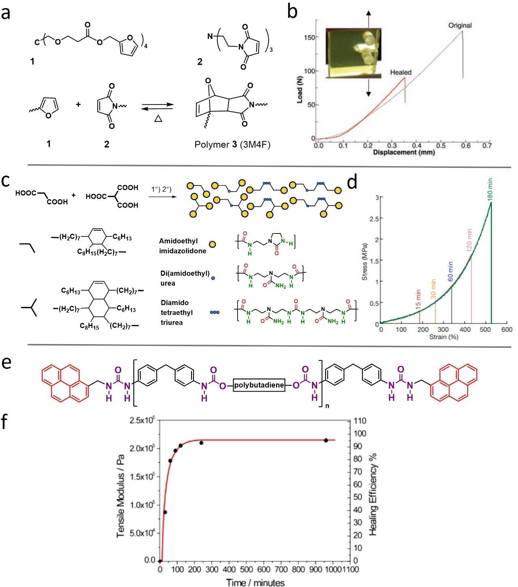

Figure 2. Examples of intrinsically self-healing polymers with different dynamic bonds. (a) Chemical structures of Diels−Alder (DA) reaction moieties. (b) Stress−strain curves including the healed sample and the pristine sample. (c) Schematic illustration of the structures of the urea containing self-healable rubber. (d) Stress−strain curves of the healed samples at different healing times of the urea containing self-healable rubber. (e) Chemical structure of the pyrenemethyl end-capped hydrogen-bonding polymer. (f) Healing kinetic of the polyurethane samples.

A self-healable polymer based on aromatic π−π stacking and hydrogen bonding interactions was reported in 2010.³⁷ The synergistic effect of π−π stacking interactions from chain-folding polyamide and hydrogen bonding interactions from telechelic polyurethane promoted a self- healable polymer capable of recovering 95%, 91%, and 77% of tensile modulus, elongation-at- break, and tensile toughness, respectively, at 100 °C healing (Figure 2e, f). Such a concept of
self-healing polymers combining several types of dynamic bonds is widely adopted currently.^{38,39}
Recently, self-healing polymers were categorized into four generations: capsule-based self- healing is the first generation, intrinsic self-healing is the second generation, vascular-based self- healing is named the third generation, while the polymer with combined self-healing mechanisms is the fourth generation.⁴ Because the method of generation assignment is based on the year of the first publication of a particular category, it does not necessarily imply the advancement of the technology. Self-healing materials based on all the above mechanisms are still in development, and there remain many challenges to be resolved. But in our view, intrinsic self-healing mechanisms based on various types of dynamic reversible bonds present the most promising avenue due to their relative simplicity and ability of multicycle healing. Even terminology remains not well-defined in this field. General term “dynamic polymers” usually refers to all polymers with dynamic reversible bonds, including covalent and physical (e.g., hydrogen bonding) ones. The “associating polymers” term usually refers to polymers with physical interactions, while the terms “dynamic covalent networks” or “covalent adaptive networks (CANs)” include only polymers with dynamic covalent bonds. We focus on intrinsically self-healing polymers with various dynamic bonds and corresponding self-healing mechanisms.

Dynamic Bonds and Current Understanding of Self-healing Mechanisms
- Dynamic Reversible Bonds
The intrinsic self-healing of polymers is generally achieved by (1) a flow of amorphous polymers at temperatures above their glass transition temperature (Tg), i.e., polymer chains interdiffusion, and (2) rearrangements of reversible bonds including dynamic covalent bonds and physical interactions. The polymer flow is usually driven by gains in cohesive energy and removal of surface tensions. Even simple van der Waals interactions will provide gains and drive self- healing process in this way, facilitating the formation of interdigitated structures.⁹ However, van der Waals interactions is similar to a self-healing of any liquid, while requiring a longer time due to very high viscosity of polymer melts. Flow of thermoplastics at temperatures above Tg of the hard blocks can be considered in the same way. If conventional thermoplastics are exposed to temperature significantly higher than their Tg, the viscosity will be lower, and a deformation or welding rather than healing occurs. However, these processes in liquid and thermoplastics are normally not termed as self-healing.

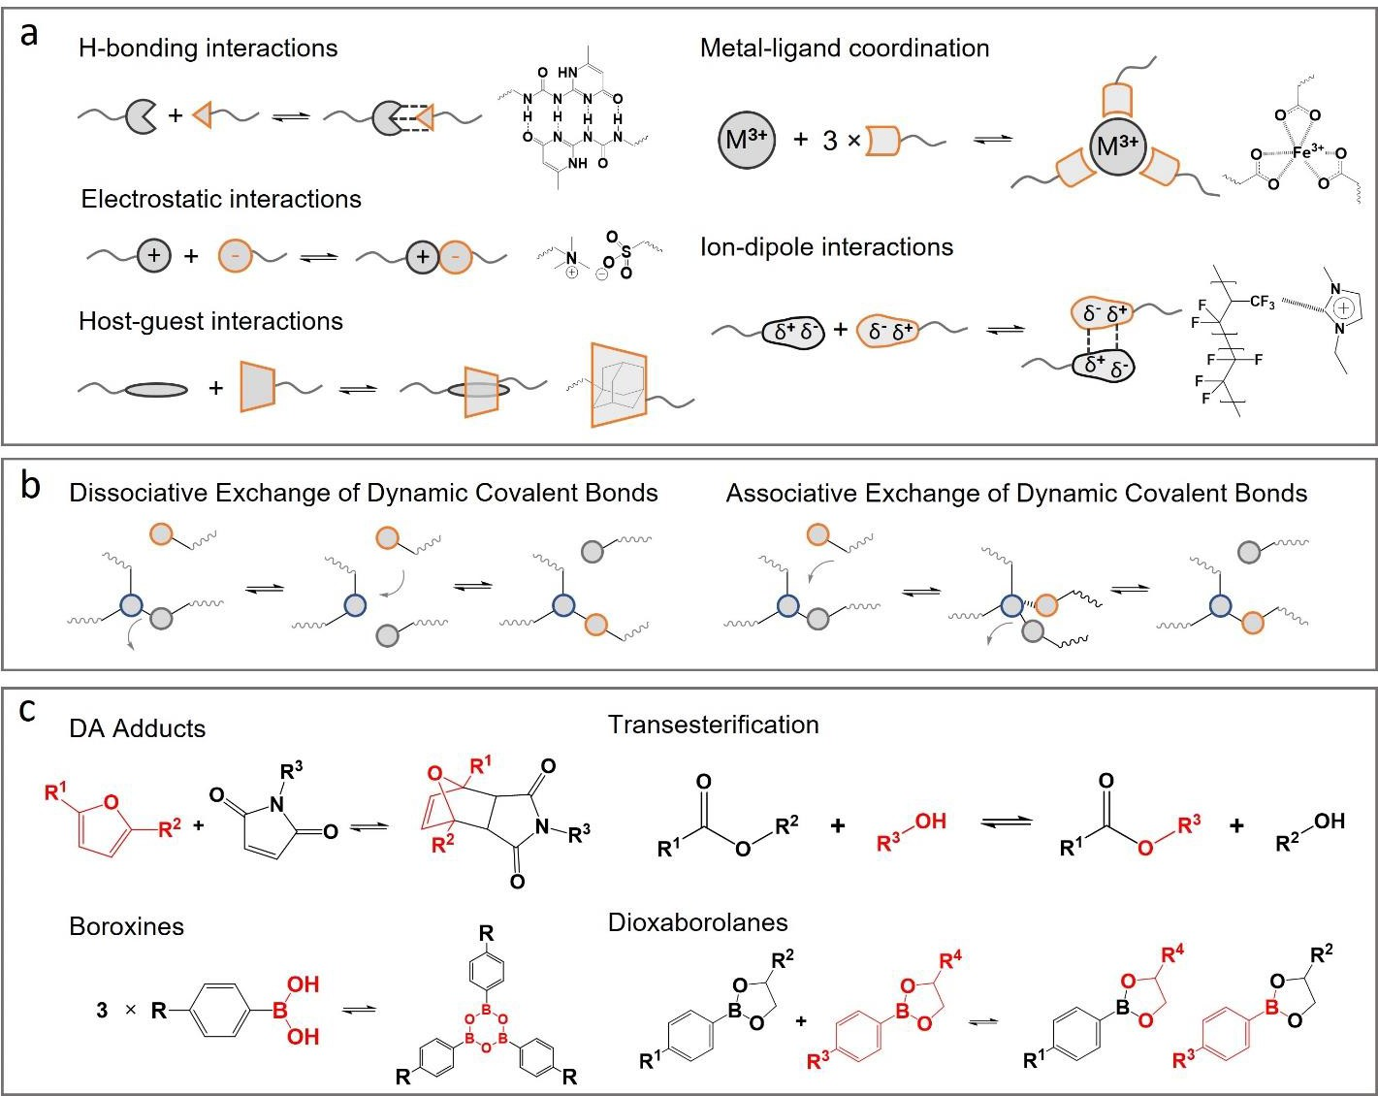

Figure 3. Illustrations of the different dynamic bonds. (a) noncovalent bonds; (b,c) dynamic covalent bonds.

The self-healing polymer networks with dynamic (reversible) bonds provide unique viscoelastic properties, and they can be readily tailored due to the compatibility and adaptability of polymer design, where functional groups could be inserted into the specific location of polymer backbone. There are many classes of dynamic bonds, including hydrogen and ionic bonding, π−π stacking, dynamic covalent bonds, guest−host interactions, and metal−ligand coordination (Figure 3).³⁹⁻⁴¹ All these bonds can be switched multiple times, enabling multiple healing processes. They differ by the energy of dissociations (Figure 4a) that controls the characteristic time of the bond rearrangements. In many cases, the bond rearrangement time is the longest relaxation time in the dynamic network and defines the terminal relaxation time that marks the beginning of the flow process.⁴²⁻⁴⁶ Recent nonlinear rheological studies revealed that the kinetics of self-healing process correlates well with the terminal relaxation time defined by dynamic bonds rearrangements.⁴³ Thus, the rearrangement time of dynamic bonds is a critical parameter for the self-healing rate, and before discussing self-healing mechanisms, we need to consider the mechanisms of bond rearrangements in typical dynamic polymers.
- Mechanisms Controlling Dynamic Bonds Rearrangements
The critical parameters for dynamic bond rearrangements are the binding energy, Ebind, defined as the difference in Gibbs free energy between associated (Eassoc) and dissociated (Ediss) states, and the energy barrier for bond dissociation E_{a}. (Figure 4b)⁴⁷ The two key parameters Ebind and Ea are often confused in literature. Although they might be connected (in the sense that high Ebind also means high Ea), these parameters have very different physical meanings. Ebind defines the population of dissociated bonds at equilibrium and will influence whether bond rearrangement at a given temperature will undergo a dissociative (relatively low Ebind/RT ∼ 1−3) or associative mechanism (Ebind/RT ≫ 1−3). Polymers with associative dynamic bonds are typically categorized as vitrimers, although some polymers with dissociative dynamic bonds show similar rheological behavior. In contrast, Ea defines the rate of bond dissociation at specific condition, i.e., viscoelastic properties of the material. In fact, the Ea can be high even if Ebind is relatively low. These energies can be strongly affected by the presence of catalysts or in the vicinity of other dynamic bonds.
Very often, Ea is calculated from the temperature dependence of viscoelastic properties (e.g., terminal relaxation obtained from rheology or stress relaxation from DMA).⁴⁸⁻⁵¹ This is inaccurate by two reasons.⁴⁷ First of all, temperature dependence of the bond dissociation is controlled not only by the energy barrier Ea but also by segmental mobility/dynamic of the polymer chain. If segments in the polymer are not moving (e.g., the sample is at temperatures much below Tg), no bond dissociation is possible. Thus, the characteristic bond dissociation time is also controlled by the segmental relaxation time τα(T) following the equation:^{47,52-55}
$τ_{dis}$ (T) = $τ_{α}$ (T) exp ($\frac{E_{a}}{RT}$) (1)

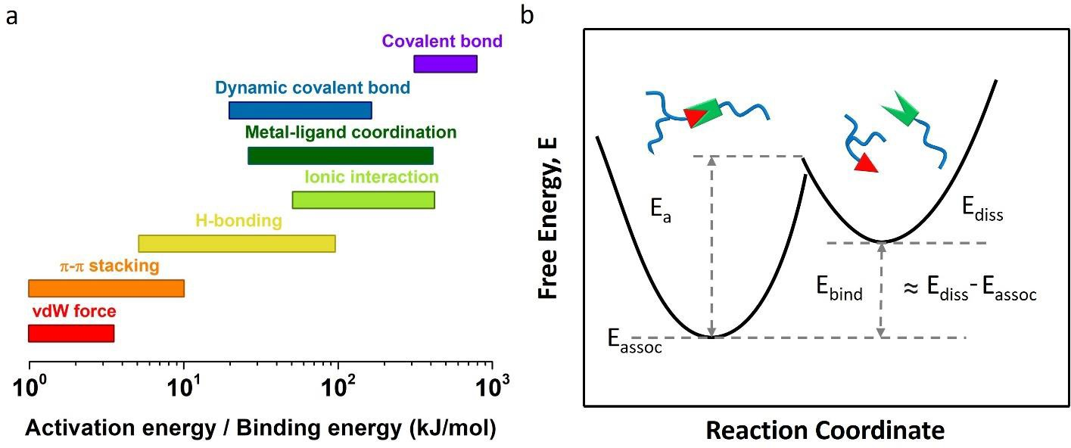

Figure 4. (a) Characteristic dissociation energy for different types of dynamic reversible bonds. (b) Illustration of the critical energy parameters of bond rearrangement.

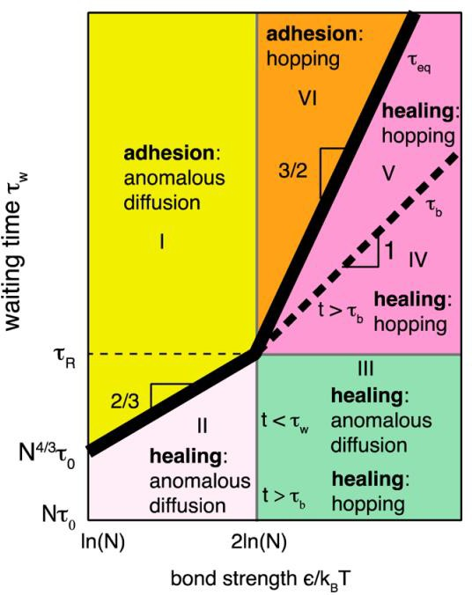

Figure 5. Different regimes of the self-healing process from anomalous diffusion (very fast) to hopping (relatively fast) and to adhesion (relatively slow) as the function of the dynamic bond strength ε = Edis = Ea.⁵⁶ There are several important time scales, including segmental relaxation time τ0, rouse time τR, and bond dissociation time τb. The equilibration time τeq (thick black line) marks the crossover from healing to adhesion behavior.

Second, the viscoelastic properties are defined by bond rearrangements and not by the bond dissociations.^{44,56,57} If the dissociated sticker (bond) reassociates back with the same partner, no changes are detected in mechanical or viscoelastic properties. Only when the stickers change partners, stress relaxation can occur. At the same time, bond dissociation can be measured by other experimental techniques, e.g., dielectric spectroscopy if the dipole moment is changing with actual bond dissociation.^{44,45} Direct comparison of bond dissociation time from dielectric spectroscopy to the bond rearrangement times measured by rheology revealed that in some cases they can differ by thousands of times,^{44,45,58} and such difference can be explained by the bond lifetime renormalization model⁵⁶ that will be discussed below.
Yet, most of the literature use the apparent activation energy estimated from mechanical properties as the energy of bond dissociations. As a result, there is a large difference of the dissociation energy estimates in literature for the same type of bond. For example, as one of the mostly utilized associative dynamic covalent bond, the activation energy (Ea) of bond exchange/dissociation for vinylogous urethane is normally calculated to be in the range from 55 to 65 kJ/mol.⁵⁹⁻⁶¹ However, based on the slope of the fitted Arrhenius curve, the activation energy of vinylogous urethane is calculated as 42 kJ/mol for a soft PDMS based elastic network,⁶² while 102 kJ/mol is obtained for a rigid PMMA based vitrimer with the same vinylogous urethane bond.⁶³ Analysis of literature presented in ref 49 demonstrates the estimates of the activation energy of imine exchange reaction bond vary from ∼48 kJ/mol to ∼157 kJ/mol.⁵³ The activation energy for disulfide based vitrimers was estimated to vary between 99 and 357 kJ/mol.⁶⁴ The role of segmental relaxation of a specific polymer backbone in the activation energy estimated from stress relaxation was revealed in the model analysis presented in recent research.⁵⁵ All of these data clearly demonstrate that the apparent activation energy does not provide reliable estimates of the energy barrier for the bond dissociation.
- Models Describing Dynamic Bonds and Self-Healing Processes
The existence of dynamic (reversible) bonds significantly affects the viscoelastic properties of polymers. These changes in chain dynamics have been described using sticky Rouse (for unentangled polymers) and sticky reptation (for entangled polymers) models.⁶⁵⁻⁶⁷ According to these models, stickers along the chain slow down only chain modes that involve part of the chain longer than the average distance between the stickers, and the characteristic relaxation time of these modes will be controlled by the stickers’ dissociation time. At the same time, the chain dynamics for the shorter part of the chain should remain unaffected by stickers. These models provide specific predictions for viscoelastic properties of chains with stickers.⁶⁵⁻⁶⁷ A good summary of the sticky Rouse and reptation models, as well as some other gelation models, was presented in the recent perspective article by Wu and Chen.⁶⁸ Recent studies revealed that stickers also slow down segmental dynamics and increase Tg of the polymers,^{54,69} and these changes can be described using statistical mechanical theory developed by Schweizer and co- workers.⁷⁰ These models and theories, however, do not address the self-healing mechanism in polymers.
The bond lifetime renormalization model developed by Rubinstein and co-workers⁵⁶ provides one of the most comprehensive analyses and description of the self-healing process in polymers with dynamic bonds (stickers). The model considers a branched chain with multiple stickers and analyzes three regimes of bond dissociation energy Ea (the model implicitly assumes Ea ≈ Ebind):
(i) weak association Ea < RT ln(N) (N is the number of segments between stickers), where stickers essentially play no significant role in viscoelastic properties. (ii) Intermediated regime RT ln(N) < Ea < 2RT ln(N). (iii) Strong association regime Ea > 2RT ln(N). In the case of the intermediate regime, there are many open stickers, and the rate of bond rearrangements is controlled by a diffusion of a sticker to find another partner. In most cases, the dissociated sticker will reassociate with the same initial partner and no stress relaxation occurs. Then the bond rearrangement time, τ_{r}, is defined by the bond dissociation time, τdis, multiplied by the number of returns to the initial partner J plus the time of diffusion to the new partner τ_{open}:⁵⁶
τr = J*τdis + τopen
This equation explains well why the bond rearrangement time estimated in rheology was found in many cases to be much longer than the bond dissociation time estimated from dielectric spectroscopy data.^{44,45,57} In the strong association regime, most of the stickers are associated, and the bond rearrangement happens by bond hopping (associative dynamic exchange), and it is defined by the bond dissociation time and τr ≈ τdis.⁵⁶ Detailed test of the model revealed that it indeed describes experimental data well even on a quantitative level.^{44,45,57}
To describe the self-healing process, another important parameter was introduced: the waiting time from the moment of physical damage until the beginning of the healing process, τ_{w}.⁵⁶ Sample damage (e.g., rupture or cut) creates a nonequilibrium state with many open stickers and deformed polymer chains. If the self-healing is initiated immediately after the damage, self- healing occurs in relatively fast time because most of the stickers in the interfacial region remain open/active, and they might not need to diffuse far to find another open sticker as a partner. The number of open stickers will decrease significantly with waiting time approaching a new equilibrium state. If the waiting time is longer than the equilibration time of the damaged surface, the healing process will be equal to a simple adhesion process (Figure 5).⁵⁶ The theory predicts various regimes of the self-healing process as a function of waiting time and the bond dissociation energy Ea (Figure 5).
Normally, before reaching the equilibrium state, the longer the waiting time is, the slower the self-healing process will be, and the black line in Figure 5 marks the bulk equilibration time. This time depends on bond dissociation energy (bond strength) and the length of the chain between stickers, denoted as N. Above this waiting time, the damaged parts reach a new equilibrium state that does not change with longer waiting time. In this case, the healing process of two equilibrated surfaces becomes an adhesion process, and this process does not depend on the waiting time (assuming no dust will interfere during the waiting time). Thus, overall, the self-healing kinetics in systems with dynamic bonds depends on the bond-rearrangement time and waiting time after the cut and before the start of healing. The former depends on the energy barrier for the bond dissociation (the strength of the dynamic bond), segmental relaxation time, and the length of the polymer chain between the dynamic bonds. Unfortunately, most of the papers do not report the waiting time between the sample cut or damage and the beginning of the self-healing process, which complicates the direct comparison of data obtained in different groups.
There are additional details that also affect the self-healing process efficiency and its rate. They include the roughness of the damaged surface, equilibrium concentration of stickers at the surface, and the effect of relatively faster segmental dynamics in the interfacial layer of the open surface in comparison with those inside of the bulk polymer (effect well-known for thin polymer films).^{71,72} If stickers prefer an open surface, they will have higher concentration at the interface, and this scenario should accelerate the self-healing process. In the opposite situation, when stickers prefer to stay in the bulk, concentration of stickers at the damaged surface will be lower and the self-healing process should be slower. Another interesting example is the shape-memory assisted self-healing mechanism.^{73,74} For example, cross-linked elastomer after local rupture will return to its initial equilibrium shape and close the damaged spot. With dynamic bonds, these materials will possess self-healing ability, which will be accelerated by this shape memory effect.
The model discussed above considers dynamics of the networks with binary interacting stickers (dimers). However, many dynamic bonds (e.g., ionic or hydrogen bonds) form microphase separated clusters (Figure 6a), which alter viscoelastic properties of the polymer drastically. The microphase separation of stickers happens due to their limited miscibility with the polymer matrix, which leads to a coexistence of binary stickers and their clusters (Figure 6a).⁶⁹ These systems have unique viscoelastic properties with relatively high modulus and extensibility, leading to exceptional toughness.^{69,75} Specific design of the elastic networks with microphase separated clusters even with the same concentration of dynamic bonds can further improve their modulus and toughness (Figure 6b).⁷⁵ In some sense, they are analogous to spider silk, where partially crystalline structures and strong hydrogen bonding also lead to extreme toughness.^{76,77}
At temperatures below Tg of the clusters, the systems with phase separating stickers will behave as a cross-linked rubber. In the case of crystalline clusters, melting temperature of the clusters Tm will be the critical parameter. However, at higher temperatures, once dynamic bonds in the clusters start dissociating and moving, rearrangements of the polymer networks are possible.^{46,58,69} It has been clearly demonstrated that structural relaxation in these clusters rather than the polymer segmental relaxation plays a critical role in viscosity and terminal relaxation of these systems.^{45,46} The detailed quantitative description of the mechanism of bond rearrangements in systems with phase separating stickers has not been developed yet.

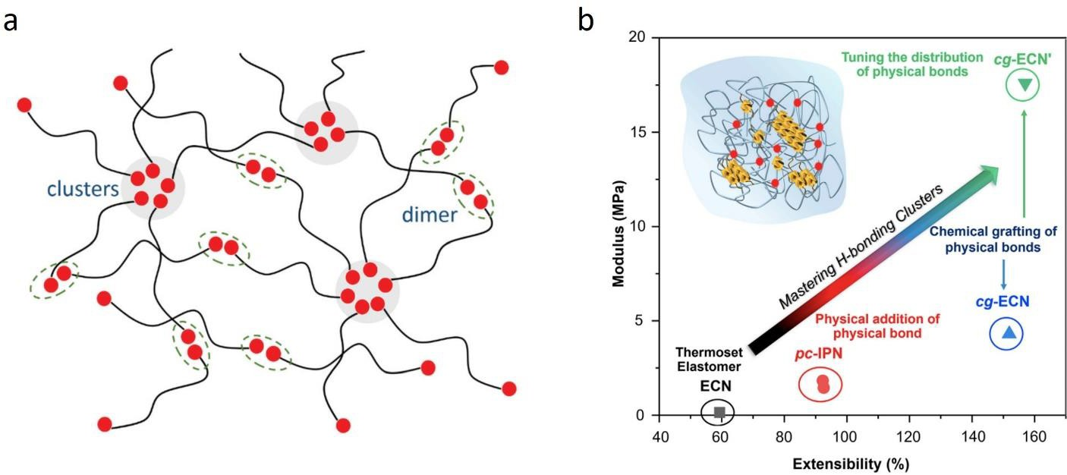

Figure 6. (a) Schematic illustration of polymer structure with stickers forming individual pairs (dimers) or microphase separated clusters. (b) Demonstration of two potential pathways toward simultaneously enhancing the modulus and extensibility of polymers: incorporating hydrogen bonding networks (physical bonds) and introducing rationally designed clusters of hydrogen- bonding units.

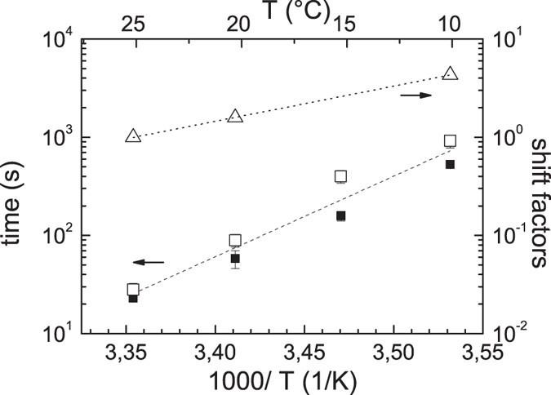
Figure 7. Detailed analysis using rheology revealed that self-healing time is comparable to the terminal relaxation time of the polymer with dynamic bonds. The latter in this specific case is controlled by bond rearrangements between clusters of dynamic (hydrogen) bonds.⁴³

Computational studies suggested that bond exchange should happen through fusion and separation of different clusters.⁷⁸ However, more recent experimental studies by NMR and rheological measurements questioned this mechanism.^{58,79} The recently developed model⁴⁶ proposed a very different qualitative scenario of mechanism controlling bond rearrangements in systems with clusters of stickers. According to this model, the bond rearrangement time is controlled by the time of pulling a sticker from a cluster. The time of pulling a sticker should follow eq 1, with structural relaxation time in the clusters instead of segmental relaxation time and with the energy barrier controlled by Flory−Huggins interaction parameter χ defined by miscibility of the functional group (sticker) and polymer matrix. This model was able to describe well rheological data in systems with phase separated stickers using structural relaxation time of clusters estimated from dielectric spectroscopy data.⁴⁶
Detailed rheological studies for systems with phase separated dynamic bonds revealed that self- healing time measured immediately after sample rupture correlates well with the bond rearrangement time of the samples (Figure 7). It is important to emphasize that the estimated self-healing time not only follows the temperature dependence of bond rearrangements time but also has very similar values (Figure 7). Thus, even in the systems with phase separated stickers, bond rearrangement time remains the most critical parameter controlling the self-healing kinetics.^{43,46} But in this case, the bond rearrangement time is not controlled by the segmental dynamics of the polymer backbone. It is defined by the characteristic time of structural relaxation in these clusters and by miscibility of stickers in the polymer matrix.⁴⁶
Another important observation in systems with phase separated dynamic bonds is unusually high elastic modulus.^{46,80-82} Already in 1990, it was proposed that an interfacial polymer layer with restricted segmental mobility and higher modulus can be formed around clusters of dynamic bonds.⁸⁰ It is analogous to the interfacial polymer layer formed around nanofillers in polymer nanocomposites.⁸³ This idea was developed and successfully applied to describe mechanical reinforcement in poly(dimethylsiloxane) (PDMS) with phase separated hydrogen bonding stickers.^{46,82} Thus, phase separation of dynamic bonds not only provides additional parameter controlling their viscosity and terminal relaxation but also enables mechanical reinforcement analogous to the one observed in polymer nanocomposites.
- Other Stimulus-Accelerated Self-Healing Kinetics
We considered thermal stimulations of the self-healing process in the discussion above. When the increase in temperature enables bond rearrangements, the higher the temperature is, the faster the self-healing process will be. This acceleration of self-healing kinetics is caused by two reasons (eq 1): faster segmental mobility τα(T), and faster over barrier process due to lower value of Ea/RT. Aside from heat, there are also other methods to enable or accelerate the self-healing process, including solvent, gas, and UV light. One approach is the use of specific solvents.

First, a solvent can work as a plasticizer and speed up the segmental relaxation process of the polymer. This will also speed up the bond rearrangements and shorten self-healing time. Some solvents can also affect the bond rearrangement process directly. For example, water accelerates bond rearrangements for boronic ester and imine bonds, leading to accelerated dissociation and rearrangements.⁸⁴ The facile dynamic exchange by the presence of water opens interesting opportunities where hydration of the surface speeds up the self-healing process, and the physical properties, like mechanical modulus, can be recovered upon further drying of the sample. Several examples of accelerated self-healing process for dynamic B−O bonds were reported in the presence of water or even at higher humidity.⁸⁵ Despite the sensitivity of these dynamic bonds to water, the samples remained intact even when they were immersed in water for several days.⁸⁶
This stability was ascribed to the hydrophobic nature of the polymer backbone that limited the water access to the dynamic bonds. Strong acceleration of self-healing process was further demonstrated by addition of methanol to polymers with ionic bonds.⁸⁷ Another interesting strategy is the utilization of CO2 gas to accelerate self-healing process in elastomers.⁸⁸ In PDMS-based elastomer containing ionic functional groups, the self-healing process occurs with the rearrangement of the ionic clusters. At ambient condition exposed to atmosphere, the rearrangement of ionic clusters renders slow self-healing process. Replacing air with CO2 atmosphere enables an accelerated (∼10 times) self-healing process at ambient pressure and temperature. The authors ascribed faster self-healing to softening (or plasticization) of the ionic clusters by CO2.⁸⁸ Acceleration of the self-healing process can be also achieved by adjusting the pH (mostly for H-bonding systems) or addition of special ions (mostly for ionic and metal coordinated systems).⁸⁹ Thus, adding small molecules whether in liquid or gas phase can significantly accelerate the self-healing kinetics.
Another promising way of accelerating self-healing process can be application of UV or visible light for polymer networks containing a light-sensitive dynamic bond. A variety of self-healing mechanisms were adopted in this approach, such as photo-cross-linking reaction, photo-triggered metathesis reaction, and photothermal effect triggered self-healing. Photo-triggered cross-linking reaction could be triggered by UV or visible light. For example, coumarin, a class of benzopyrone compound commonly discovered in natural materials, can undergo [2π + 2π] cycloaddition reaction to form a cyclobutane ring when exposed to light with a wavelength greater than 300 nm. The reaction could be reversed when the irradiation wavelength is below 260 nm. Therefore, utilizing coumarin-containing cross-linker, a series of light-responsive cross-linked polymers were synthesized from a range of acrylate monomers: butyl methacrylate (BMA), methyl acrylate (MA), hexyl methacrylate (HMA), and ethyl acrylate (EA).⁹⁰ When it is exposed to a razor blade cut (width: 40 μm), the healing process could be triggered by 254 nm UV light with an energy flux of 11.66 J cm⁻² to activate the photo cleavage process. Then visible light could trigger the crosslinking reaction that almost fully heals the crack without heating. Photoinduced metathesis reactions are also utilized for light-triggered self-healing polymers. Utilizing Zn²⁺ as an ion source and 2,6-bis(19-methylbenzimidazolyl) pyridine as ligand, self-healable supramolecular polymers under light were created.⁹¹ After being exposed to UV radiation with a wavelength of 320−390 nm and an intensity of 950 mW cm⁻², the damaged 3[Zn(NTf2)2]0.7 sample recovered completely after 30 s. The UV light can also induce disulfide metathesis to allow dynamic rearrangement of polymers, which can be used in intrinsically self-healing polymers.⁹² Another example, a cross- linked poly(n-butyl acrylate) with trithiocarbonate as chemical cross-linker was reported, in which the UV light triggered the breakage of trithiocarbonate bonds for self-healing process.⁹³ One drawback of such a process is normally requiring the inert atmosphere because the intermediate of carbon radical is reactive with oxygen or other gases. The light triggered self-healing process has the advantages of easily achieving remote activation, spatially controlled activation, and on- demand control by turning off or on the light triggers.⁹⁴

Representative Intrinsic Self-Healing Polymers

Self-Healing Materials with Noncovalent Dynamic Bonds
Noncovalent bonds based on physical interactions are important pathways to achieve intrinsic self-healing. Metal−ligand coordination, ionic interaction, and hydrogen bonding (H-bonding) are the most common physical interactions used in intrinsically self-healing polymers. Metal−ligand coordination bond describes the interaction between a metallic core with one or multiple π-donor ligand(s). The presence of an equilibrium state between the association and dissociation processes could be tuned to favor one process by changing the environment such as temperature and other stimuli and enables the utilization of metal−ligand coordination bonds for self-healing materials. For example, the ionic-based metal− ligand coordination was incorporated into elastic polymers as self-healing chemistry, in which a telechelic low molecular weight PDMS (Mn = 5000−7000 g/mol) functionalized with 2,6-pyridinedicarboxamide (H₂pdca) ligand was physically cross-linked with the Fe(III) (Figure 8a).³⁵ The H₂pdca ligands coordinate with Fe(III) through two different interactions: a strong pyridyl−iron, and two weaker carboxamido−iron with the nitrogen and oxygen atoms of the carboxamide groups. The [Fe(Hpdca)₂]⁺ can readily dissociate to [Fe(Hpdca)]²⁺, where the iron centers remain attached to the ligands through the stronger interaction with the pyridyl ring. The Fe(III) coordination can break and reform, allowing reversible unfolding and refolding of the chains. The reversible iron-coordination in a very soft PDMS matrix allows the polymer to possess a very high stretchability (10000% with lower amount of Fe-Hpdca, H₂pdca: PDMS = 1:6) and self-healing capability (complete recovery of original extensibility and tensile stress after 48 h) (Figure 8b).
Ionic (or electrostatic) interactions are physical bonds where two oppositely charged ionic species electrostatically attract each other, and the reversible nature of such ionic bond formation could also promote self-healing with high healing efficiency. For example, utilizing the ionic interactions between −COO⁻ and −NH⁺− groups as well as hydrogen bonding, the branched poly(ethylenimine) (bPEI)/poly(acrylic acid) (PAA)/poly(ethylene oxide) (named as bPEI_{x}/PAA/PEO) complex reached a tensile strength of 27.5 MPa and an extensibility of 770% and exhibited room temperature selfhealability. After healing at 90% relative humidity (RH) for 48h, the recovered maximum stress and elongation-at-break of the polymer reached 25.7 MPa and 750%, respectively (Figure 8c,d).⁹⁵
Self-healing even by van der Waals interactions was recently demonstrated.⁹⁶ The random copolymers of poly(methyl methacrylate)-r-poly(n-butyl acrylate) (PMMA-r-PnBA) achieved self-healing behavior in a narrow window of the copolymer composition from MMA/nBA = 45/55 to 50/50. PMMA-r-PnBA with MMA/nBA = 45/55 to 50/50 exhibited the tensile strength up to 10 MPa and 650% elongation at nbreak, and 90−100% recovery of the tensile property after 14 h of healing at room temperature (Figure 9a,b).⁹
Hydrogen bonding (H-bond) is one of the most studied pathways for design of intrinsically self-healing polymers. Dominated by the electrostatic force, hydrogen (H) atom could be attracted by a nearby atom or group with higher electronegativity, such as atoms of nitrogen (N), oxygen (O), or fluorine (F). An H-bond will form between these two atoms or groups once the pairing between the donor and acceptor occurs. The strength of H-bond (for example, N−H···:O ∼ 8 kJ/mol) is much lower than that of covalent bond. Lower bond strength results in faster bond breakage and formation, and this character of H-bond could help create a polymer system with fast molecular rearrangements.³⁴ Such fast molecular rearrangements of H-bonds were utilized to design a series of self-healing elastomers with capabilities for extreme stretchability, excellent energy damping, and intrinsic self-healing (Figure 9c,d).³⁶ Synthesized by urea functionalization of PDMS, the polymeric elastomer showed high elongation-at-break (from 984% to 5,600%). Adjusting the length of the PDMS chain enabled elastomers with desired mechanical strength, elasticity, and extensibility. The mechanical strength and gas-separation performance of the designed network were completely recovered within 2 h at ambient temperature, or 20 min at 40 °C after being cut by a razor blade.
While most of the reported intrinsic self-healable polymers have soft rubbery polymer components,^{6,34-36} there are several reports on more mechanically robust self-healing polymers.^{97,98} Such example includes the incorporation of 2-ureido-4[1H]-pyrimidinone (UPy) groups onto poly-(norbornene) to form ABA-triblock copolymer (M_{n} = 100000−150000 g/mol) that consists of A block of UPy-functionalized norbornene and B block of a long random copolymer consisting of UPy-functionalized norbornene and flexible dodecanyl norbornene.⁹⁹ The UPy-rich A blocks form hard domains driven by very strong hydrogen bonding that prevents macroscopic deformation, and the B blocks form a more flexible segment with sparse UPy interaction serving as sacrificial bonds. Their ABA-triblock copolymer exhibited high toughness of 62 MJ m⁻³, tensile stress of 17 MPa with a dissipated energy >27 MJ m⁻³ at room temperature. The scratch on the ABA-triblock copolymer film was healed after 3h at 50 °C. Furthermore, the utilization of urethane, urea, and UPy groups allowed preparation of hydrogen bonding facilitated tough self-healing polymers with a highest toughness of 345 MJ m⁻³ and a high tensile strength of 44 MPa.¹⁰⁰ A polyurethane-like prepolymer was prepared by the reaction between poly(tetramethylene ether glycol) (PTMEG) as soft segment and dicyclohexylmethylmethane-4,4′-diisocyanate (HMDI) as the hard segment, and the polymers were obtained after the introduction of 1,4-butanediol and UPy modified diol (U₂-diol). The high UPy loading sample PT-HM-U20 exhibited the highest healing efficiency of 90% after 48 h of healing at 80 °C or 24 h at 100 °C (Figure 10a,b). Combining covalent cross-links and reversible hydrogen-bonding networks also produced tough self-healing elastomers.⁹⁷ The elastomer exhibited high fracture energy of 13.5 kJ/m² and high tensile strength of 10−20 MPa. After 12 h of healing at room temperature, the elastomer exhibited a tensile strength close to 4 MPa, which is 30% of its original value. Furthermore, low molecular weight polymers with dense thiourea groups exhibited mechanical robustness with good repairability.⁹⁸ The tensile strength was as high as 40 MPa and their Young’s modulus was 1.0−1.9 GPa (Figure 10c-e). While these polymers did not exhibit autonomous self-healing, the compression allows repairing of the fractured surfaces. The thiourea polymers exhibited mostly recovered tensile strength and Young’s modulus after 1 h compression at temperature slightly above room temperature. The formation of zigzag hydrogen-bonded array by the presence of thiourea group in each repeat unit activates the exchange of hydrogen-bonded pairs and enables the healing by compression on the fracture.

Self-Healing Materials with Covalent Dynamic Bonds
Dynamic covalent bonds, including Diels−Alder (DA) reaction, reversible disulfide bond, boronic esters, and many others are widely explored and utilized for developing self-healing materials. Diels−Alder reaction is a type of thermally reversible covalent bond with dissociative mechanism in which a conjugated diene reacts with a dienophile. Hence upon application of physical damage, heat could be introduced to trigger the reverse Diels−Alder reaction to regenerate dienes and dienophiles, and these reactants could further react to reform chemical bonds to heal the damage. For example, thermally remendable epoxy resin having furan−maleimide adducts was reported.¹⁰¹ The cured epoxy exhibited tensile strength of 53 MPa and self-healing of cracks at 100−125 °C for 20 min, followed by 80 °C for 0−72 h treatment. While healing efficiency was limited, Diels−Alder reaction was used to provide the remendability of cross-linked rigid epoxy network. Polyurethane-urea based Diels−Alder adduct was synthesized from carbon dioxide and furfuryl amine.¹⁰²
Furfuryl amine was converted to diglycidyl furfurylamine, followed by the conversion to difunctional cyclic carbonate by reacting with CO₂. The dicyclic carbonates were reacted with diamine to form nonisocyanate polyurethane-urea, and then furan in the structure was reacted with 4,4-bismaleimidodiphenylmethane to produce the polyurethane-urea Diels−Alder adducts. It exhibited 15−18 MPa tensile strength and almost full recovery of the mechanical properties after healing at 120 °C for 10 min, followed by healing at 60 °C for 24 h.

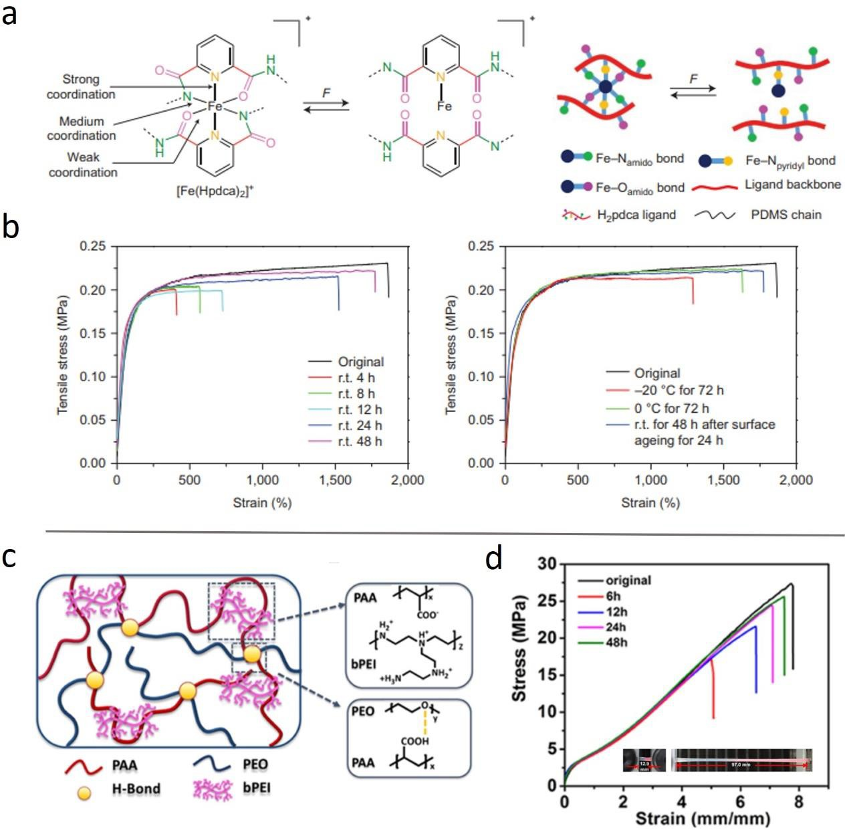

Figure 8. (a) Schematic illustration of the chemical structures of [Fe(Hpdca)2]⁺. (b) Stress−strain curves including the healed sample of the [Fe(Hpdca)2]⁺. (c) Schematic illustration of the structures of the bPEIx/PAA/PEO complex. (d) Stress−strain curves of the healed samples at different healing times of the bPEIx/PAA/PEO complex.

The Diels−Alder cycloaddition between anthryl-telechelic poly-(ethylene adipate) (PEAA₂) and tris-maleimide (M₃) enabled self-healing property of the PEAF₂M₃ polymer, which was able to restore 55% of the original tensile strength and 90% of the elongation-at-break after a 7-day healing process at 100 °C (Figure 11a,b).¹⁰³ The use of cyanodithioester (CDTE) compound and cyclopentadiene as DA reagents demonstrated that the healing condition of DA reaction could be less critical.¹⁰⁴ The polymer reached a maximum tensile stress of 1 MPa with 40% elongation-at-break, upon 10 min of heating at 120 °C under pressure of 1kN, the sample fully recovered its tensile properties.
Reversible disulfide bonds are also utilized for the design of self-healing materials due to the exchange reaction of S−S linkages, in which the bond exchange could occur and self-healing could be achieved when heated at elevated temperature.¹⁰⁵⁻¹⁰⁷ Autonomous healing after a cut of a covalently cross-linked rubber with disulfide takes place at 60 °C and leads to full recovery of mechanical properties over 60 min (Figure 11c,d).¹⁰⁸ Furthermore, a cross-linked polymer utilizing thiuram disulfide (TDS) as the main component achieved high-efficiency self-healing. The reshuffling reaction of TDS can be accelerated by visible light. The healing process occurred at room temperature under visible light, and 88% of the original toughness was recovered after 24 h of healing.¹⁰⁹ As a very stable sulfur radical, bis(hindered amino)disulfide-based thermally healable cross-linked polymer network was developed in refs ¹¹⁰ and ¹¹¹. Its incorporation into a polymer backbone such as polyurethane or polymethacrylate enables self-healing with over 85% efficiency at elevated temperature ∼120 °C for 24 h. Cross-linked polyurea elastomers based on aromatic disulfide metathesis exhibited room-temperature self-healing,¹¹² where the original material exhibited a tensile strength of 0.81 MPa and an elongation at break of 3100%. The mechanical properties were restored by 80% after 2 h healing at room temperature, while longer healing did not improve healing efficiency.
When dynamic disulfide bonds are embedded in the hard phase of polyurethane elastomers,¹¹³ the self-healing elastomer exhibits a maximum tensile stress of 25 MPa and a fracture strain of over 1600%. Over 85% self-healing efficiency was achieved at 6−24 h healing at 70 °C (Figure 11e). A series of thermoplastic polyurethane containing aromatic disulfide was also investigated.¹¹⁴ The poly(tetramethylene ether glycol) was used as a soft segment and bis(4-hydroxyphenyl) disulfide (SS) was used as the aromatic disulfide component embedded in the hard segments. Four diisocyanates were incorporated, including isophorone diisocyanate (IP), 4,4′-methylenebis-(cyclohexyl isocyanate), 4,4′-methylenebis(phenyl isocyanate), and hexamethylene diisocyanate. IP-SS thermoplastic polyurethane exhibited the highest mechanical properties among them, exhibiting tensile strength and toughness of 6.8 MPa and 26.9 MJ m⁻³, respectively. Furthermore, IP-SS polyurethane also provided the best self-healing efficiency. The healing of IPSS for 2 h at room temperature resulted in 88.2%, 99.6%, and 76.6% recovery of the tensile strength, elongation at break, and toughness values of the virgin IP−SS, respectively. More recently, self-healing polymers combining the disulfide bonds with other interactions, such as hydrogen bonding, have been developed.^{105-107,115} Compared with previous self-healing polymers with only disulfide bonds, the polymers from the hybrid approach exhibited multiple advantages. The synergistic effect of the disulfide bond and hydrogen bond enabled a mechanically strong copolymer (tensile strength = 20 MPa, strain = 1800%), yet self-healable at ambient temperature, with 92.76% stress recovery and full strain recovery after 48 h of healing at room temperature.¹⁰⁶ The incorporation of disulfide linkage in polyurethane elastomer also facilitated healable polymers with high stretchability, reaching a strain of 14000%,¹⁰⁵ that is highly suitable for applications such as ionic skins or conducting devices.¹⁰⁷
While various self-healing polyurethane and polyurea systems with disulfide bonds are reported, another mechanism to construct self-healable dynamic polymers is the incorporation of dynamic urea into the polymer. Hindered urea bonds can be utilized as dynamic bonds due to their dynamic exchange mechanism of reversible formation of linkages and isocyanate/hindered amine.⁷⁸ Diethylurea-based polyurethane exhibited a tensile strength of 0.6 MPa with 243% elongation at break and provided the best healing efficiency among them. The 12 h of self-healing at 37 °C of the polymer recovered 87% of strain, while healing at room temperature for 12 h was limited to 29% strain recovery.¹¹⁶ Dynamic urea without hindered amine was also utilized as a dynamic bond with the presence of Zn based catalyst.¹¹⁷ The urea-linked PDMS−Zn(OAc)₂ materials exhibited a tensile strength of 7.0 MPa and elongation-at-break over 600%, and the tensile stress and elongation at break can recover to about 90% after healing at 110 °C for 16 h.
The formation of boroxines from the dehydration of boronic acids is reversible upon hydrolysis (Figure 3c), which provides reversibility and enables a dynamic mechanism for self-healing applications.¹¹⁸ Boronic acid was incorporated into PDMS by end group functionalization, and subsequent dehydration fabricated a stiff but self-healable PDMS-boroxine network. The network exhibits tensile strength of 9.46 MPa, and its mechanical properties were completely recovered when healed at 70 °C for 12 h.¹¹⁹ It is also reported that combining boroxine with hydrogen bonding groups formed iminoboronate/boroxine-based polyurethane network¹²⁰ with tensile strength of 11 MPa and elongation-at-break of 3%. The polymer could fully recover its mechanical properties after healing for 12 h at 70 °C, or healing at room temperature with 70% RH for 12 h. In another study, the elongation of boroxine system was tuned by the incorporation of PDMS and dynamic imine bond.¹²¹ The combination of boroxine and imine bonds with flexible PDMS backbone achieved elongation at break of 4200% and tensile strength of 0.25 MPa, as well as self-healing at room temperature in 20 min. Similarly, self-healing polymers based on dynamic-covalent boronic esters exhibited facile reversibility of the networks and allowed intrinsic self-healing under ambient conditions.¹²² Highly efficient self-healing of these bulk materials was confirmed, where over 80% of original toughness was recovered after 3 days of healing at 85% RH (Figure 11f). High healing efficiency was reported in nitrogen-coordinated boroxines cross-linked 3D polymer networks containing poly(propylene glycol) (PPG) and poly(acrylic acid) (PAA), and the N-boroxine-PPG/PAA polymer samples with different PAA loading from 6% to 40%. N-Boroxine-PPG/PAA_{10%} showed a healing efficiency close to 100% after 6 h at room temperature. The tensile strength of these materials can be tuned in the range from 1.7 to 12.7 MPa with elongation-at-break from 659% to 182%.¹²³ 1,2-Diol containing poly(cyclooctene) (20%-diol) cross-linked with telechelic diboronic ester cross-linkers demonstrated efficient self-healing properties (Figure 12a).¹²⁴ Two kinetic variant diboronic esters were used as dynamic cross-linkers for self-healing, where the boronic ester design controls the rate of boronic ester transesterification. The cross-linker provided distinctively different self-healing. The faster exchanging linker showed nearly complete recovery of the mechanical property in 16 h healing at 50 °C, while the slower exchanging linker exhibited minimal healing in the same condition (Figure 12b). Boronic ester-containing dithiol was also utilized as a crosslinker in styrene−butadiene rubber (SBR)¹²⁵ or epoxidized natural rubber (ENR).¹²⁶ The mechanical property of the cross-linked SBR was ∼90% restored after 24 h healing at 80 °C, while the healing at room temperature reached ∼60% recovery. In the ENR with the boronic-ester dithiol crosslinker, the amount of cross-linker (1−10 wt %) significantly impacted the mechanical properties. Upon increase of the cross-linker from 1 wt % to 10 wt %, the tensile strength increased from 1.6 to 14.6 MPa, and the elongation at break decreased from 811 to 475%. The self-healing properties were optimum at 3−5 wt % boronic ester cross-linking that achieved nearly complete recovery of the mechanical properties upon healing at 80 °C for 24 h.
Vinylogous urethane is another associative dynamic bond, which is commonly incorporated into polymeric systems. There are several reports of intrinsic self-healing polymers with vinylogous urethane bonds.¹²⁷⁻¹²⁹ Among them, poly((2-acetoacetoxy)ethyl methacrylate/methyl methacrylate/n-butyl acrylate) P(AAEMA/MMA/nBA) copolymer networks show significant advancement (Figure 12c).¹²⁹ These networks are processable by compression molding at 120 °C and exhibit room temperature self-healing. P(AAEMA/MMA/nBA) copolymer exhibits the tensile strength of 25.7 MPa with the elongation-at-break of ∼215%. Upon self-healing at 22 °C, RH ∼ 34% after 24 h, the mechanical properties were recovered to 83% (tensile strength) and 91% (strain), respectively.

Combining Different Dynamic Bonds and Employing Sacrificial Bonds
An emerging strategy for design of intrinsically self-healing polymers during the past decade is a combination of different types of dynamic bonds in a single system. Different characteristics of dynamic bonds could be utilized synergistically through rational molecular design. Since the past decade, multiple studies adopted the strategy based on the combination of H-bonds with coordination bonds,^{35,38,130-132} H-bonds with electrostatic (or ionic) interactions,^{95,133-138} boronic esters with coordination bonds,¹²⁶ etc.

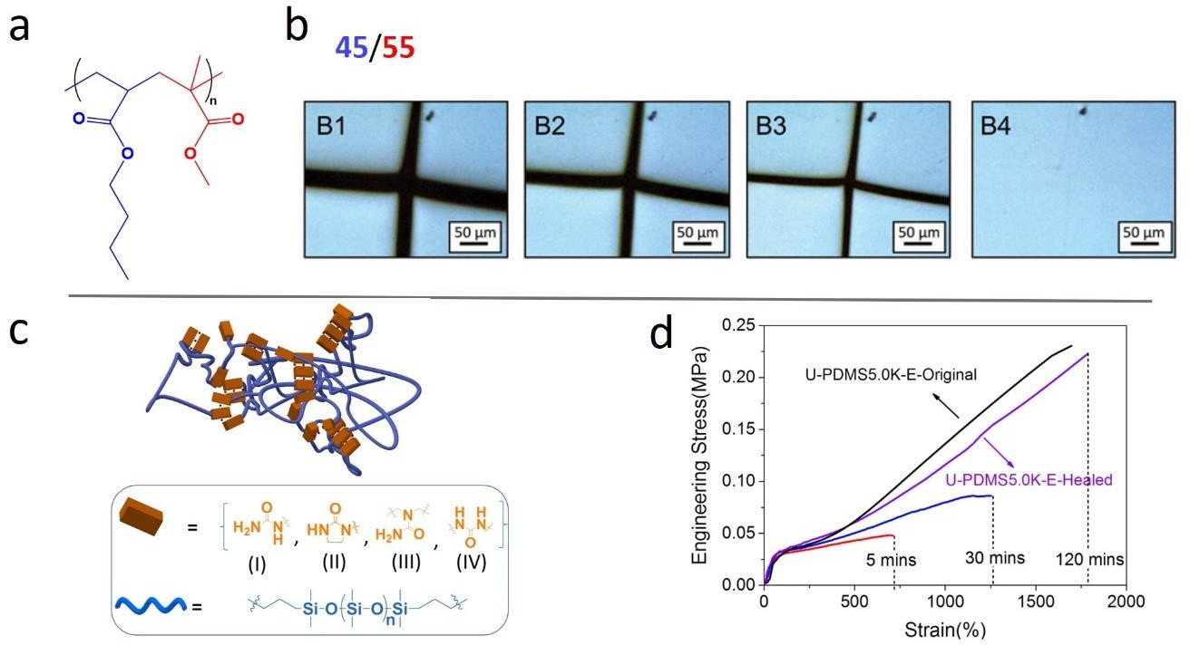

Figure 9. (a) Chemical structure of the PMMA-r-PnBA copolymers. (b) Healing kinetics observed by optical microscope of the PMMA-r-PnBA, MMA/nBA is 45/55. (c) Schematic illustration of the structures of the urea rich PDMS elastomer. (d) Stress−strain curves of the healed samples at different healing times of U-PDMS-5.0K-E.

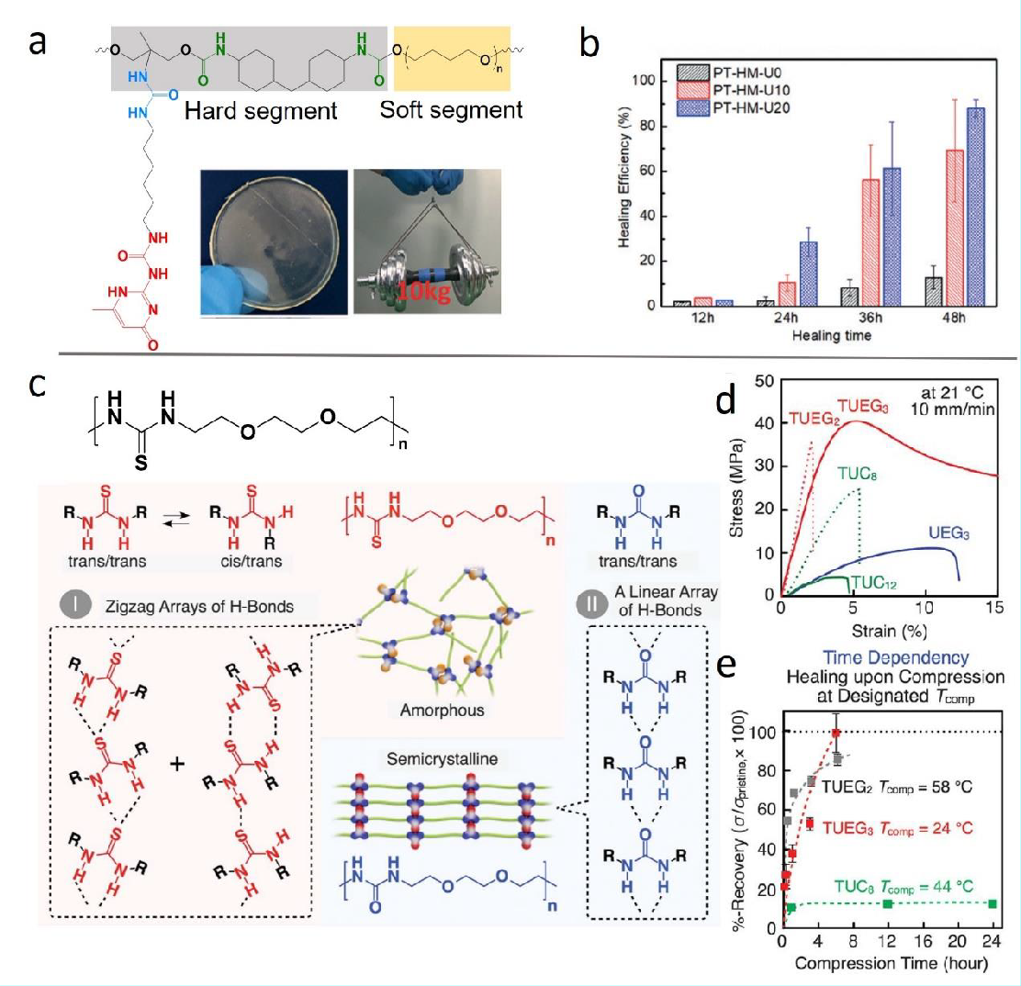

Figure 10. (a) Chemical structure and photo of the dynamic polyurethane sample. (b) Healing efficiency at different healing times of the damaged PT-HM-U films. (c) Chemical structure and illustration of the assembly of poly(ether-thiourea) TUEG3. (d) Tensile properties of poly(ether- thiourea) TUEG3 and its reference polymers. (e) Percentage of mechanical properties recovery of TUEG3 and other polymers at different healing temperatures and time lengths.

For example, a room temperature self-healable hydrogel was fabricated by combination of ionic and hydrogen bonding (Figure 13a,b).¹³⁶ Poly(acrylic acid) (PAA) and prefabricated complex PEI−PYA derived from mixing of branched poly(ethylenimine) (PEI) and 1-pyrenybutyric acid (PYA) were further mixed to generate PAA/PEI−PYA complexes, and the ionic and hydrogen bonding by the PYA moiety provided significantly enhanced mechanical properties of the PAA/PEI−PYA complexes, compared with the control sample PAA/PEI (tensile toughness 18.17 vs 3.77 MJ/m³). Meanwhile, the self-healing property was not compromised despite a significant increase in mechanical strength. The sample PAA/PEI−PYA_{2.1%} exhibited complete recovery of its mechanical properties after healing for 9 h at room temperature (Figure 13b). In addition, the noncovalent nature of these interactions enabled great recyclability of PAA/PEI−PYAs, where the hydrogel was ground and then healed to 87% of the original toughness. Utilizing similar electrostatic and hydrogen bonding interactions. A tough, self-healable hydrogel was synthesized by utilizing PAA and poly(ethylene glycol) (PEG) methacrylate as the main building block and PEI as the electrostatic interaction provider.¹³⁹ The hydrogel reached the highest toughness value of 32.6 MJ/m³ with 57.8 wt % water content, while maintaining good tensile recovery and shape memory properties. Hydrogen bonds were also combined with coordination bonds to obtain a series of tough self-healable polyurethane elastomers.¹³¹ Those elastomers exhibited exceptional tensile strength of 52.4 MPa and a toughness of 363.8 MJ m⁻³; the PU-BPY_{0.5}−Zn elastomer recovered nearly all of the original mechanical properties after being healed at 100 °C for 3 h (Figure 13c,d).
The combination of boronic ester cross-links with sacrificial weak Zn²⁺−O coordination interactions in a polymer network achieved significant improvement in mechanical properties without any loss in self-healing ability.¹²⁶ The highly healable sample reached an elongation-at-break of 650% and tensile strength of 9 MPa, along with nearly fully recovered mechanical properties within 24 h at 80 °C.
A few other notable strategies include the combination of multiple linkages in the intrinsically self-healing polymers, where permanent cross-links are combined with dynamic covalent and noncovalent bonds. Utilizing secondary amide side chains, dynamic energy dissipative hydrogen bonds were incorporated as sacrificial bonds into a self-healable network (Figure 14a),¹⁴⁰ and a significant improvement in the overall mechanical properties was achieved. Compared with the hydrogen-bond-blocked control network (BACON), the amide-containing network (ACON) with sacrificial bonds exhibited significantly increased mechanical properties in all aspects, e.g., the toughness increased from 1.51 MJ/m³ to 11.13 MJ/m³, and the elongation-at-break increased from 167% to 938%. The ACON recovered nearly 30% of toughness after 1 h healing and 90% of toughness after 3 h of healing at 50 °C (Figure 14b,c). A conductive 3D network hydrogel with sacrificial H-bonding groups was also reported. In this functionalized 2D boron nitride nanosheets/clay/poly(Nisopropylacrylamide) composite, the incorporation of H-bonding between the polymer and clay significantly enhanced its mechanical properties (Figure 14e) while maintaining good self-healing capability (Figure 14f).¹⁴¹
The concept of sacrificial bonds could also be utilized in systems with a single type of dynamic bonds by employing bonds with different strength.¹⁴² In this work, the supramolecular network consisted of strong and weak H-bonds, where the weak H-bonds act as sacrificial bonds that could absorb more energy during deformation and extend the elongation. The sample PDMS−MPU_{0.4}−IU_{0.6} (MPU stands for 4,4′-methylenebis (phenyl urea), IU stands for isophorone bisurea, and 0.4/0.6 represents their molar ratio) exhibited the highest tensile strength (1.5 MPa) with an elongation-at-break of 1670% and recovered 78% of its original toughness after 48h of room temperature healing. High stretchability and toughness of PDMS−MPU_{0.4}−IU_{0.6} was utilized to prepare a capacitive strain-sensing e-skin, which shows high toughness and mechanical robustness against physical damage.

Conclusions
Intrinsically self-healing polymers provide a unique and important function to soft materials with prolonged service lifetime. While self-healing is a regular process in biological systems, the development of synthetic intrinsically self-healing polymers has received significant attention only during the last two decades. Multiple chemical bonds and non-covalent interactions have been utilized to achieve self-healing. There are many recent exciting achievements in the field, including employment of more types of dynamic bonds that demonstrate great potential of self-healing polymers for various current and future technologies.

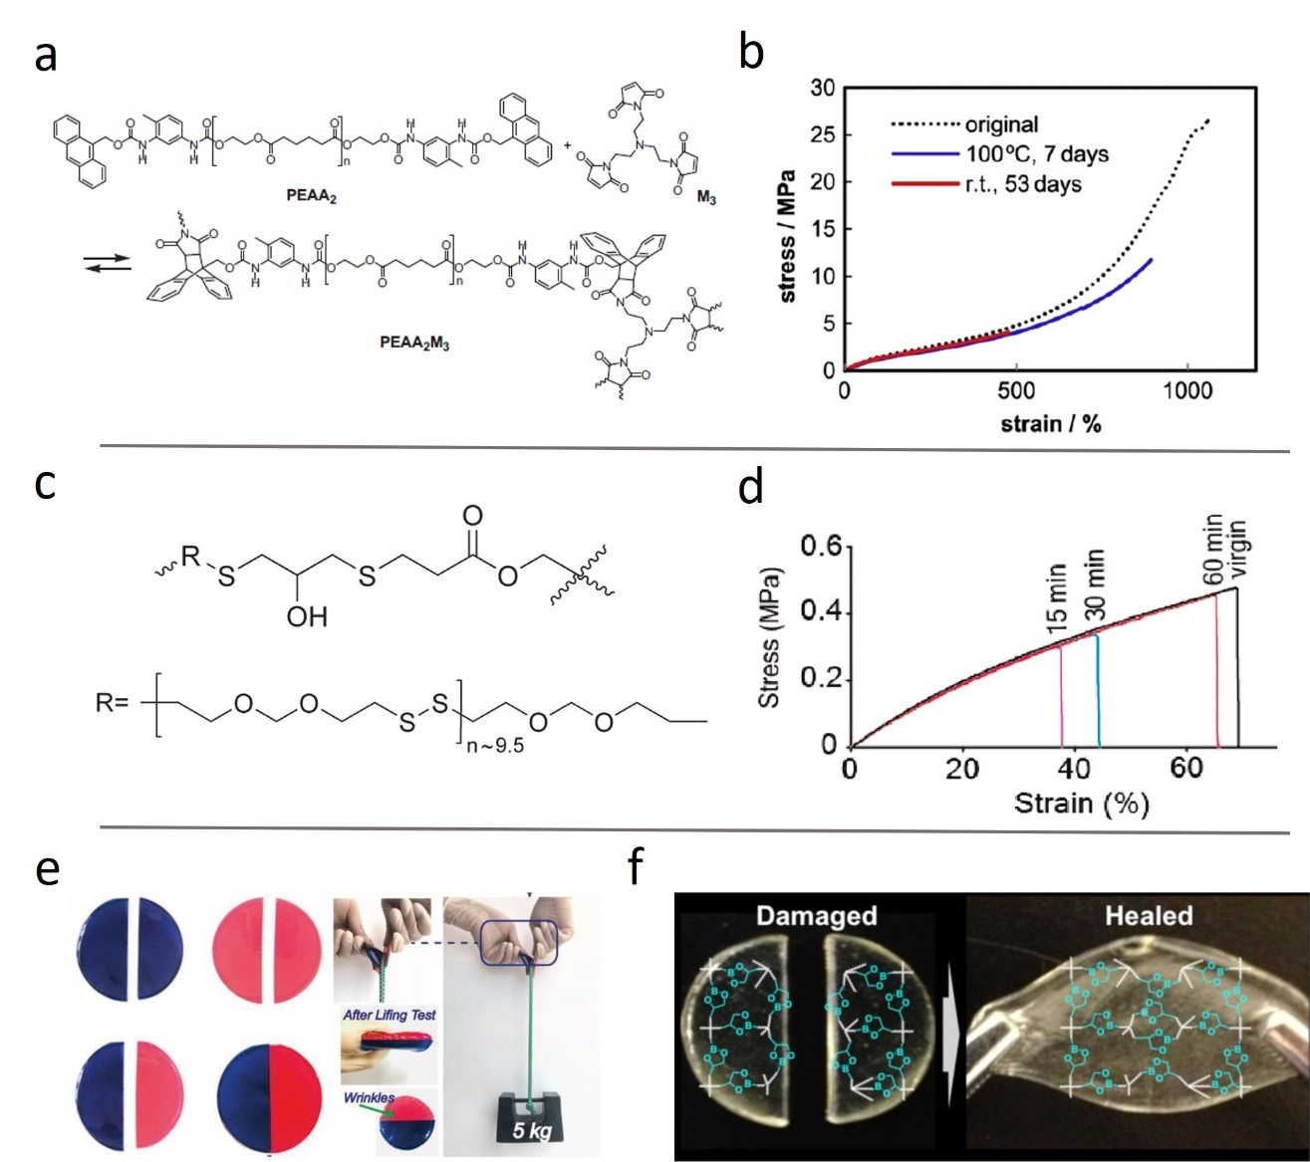
Figure 11. (a) Schematic illustration of the chemical structures of PEAA₂M₃. (b) Strain−stress curves including the healed sample of PEAA₂M₃. (c) Chemical structure of the thiol cross-linked epoxy resin. (d) Stress−strain curves of the healed samples at different healing times of the thiol cross-linked epoxy resin. (e) Photo illustration of dynamic disulfide bond containing polyurethane during the healing test. (f) Chemical structure and photo demonstration of the dynamic-covalent boronic esters.

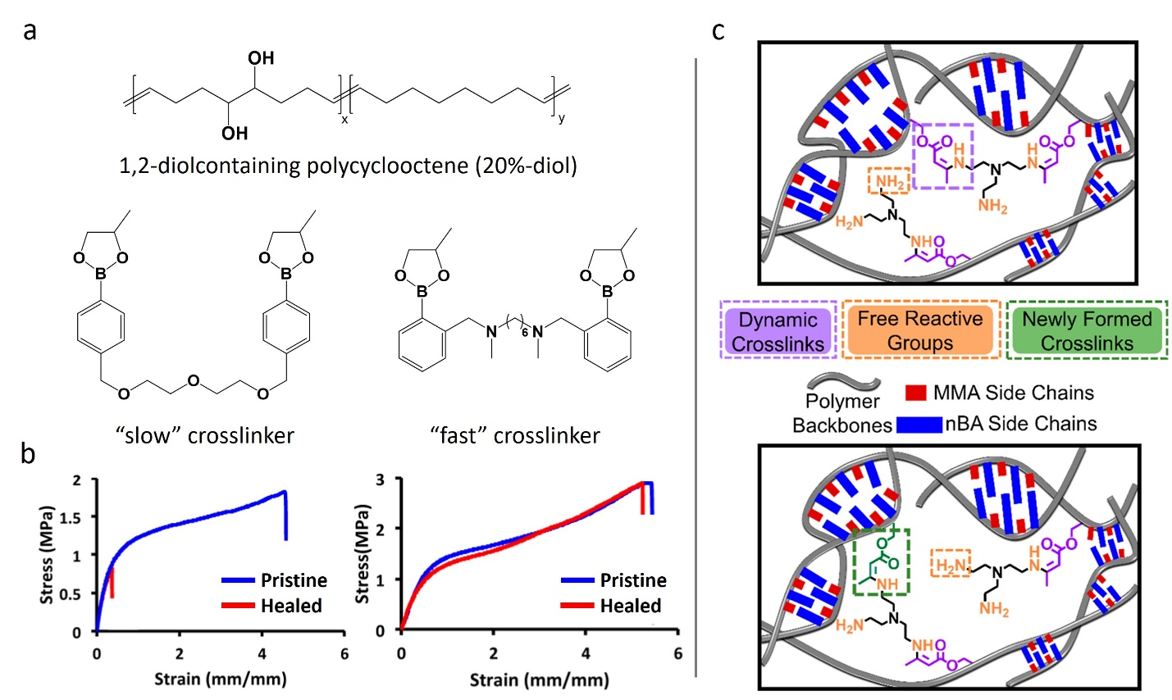
Figure 12. (a) Chemical structure of the crosslinker and 1,2-diolcontaining polycyclooctene. (b) Tensile data of pristine and healed polymers prepared by different crosslinkers. (c) Schematic illustration of p(AAEMA/MMA/nBA) covalently adaptive networks containing dynamic cross-links with MMA and nBA repeating units facilitated transamination exchange reactions.

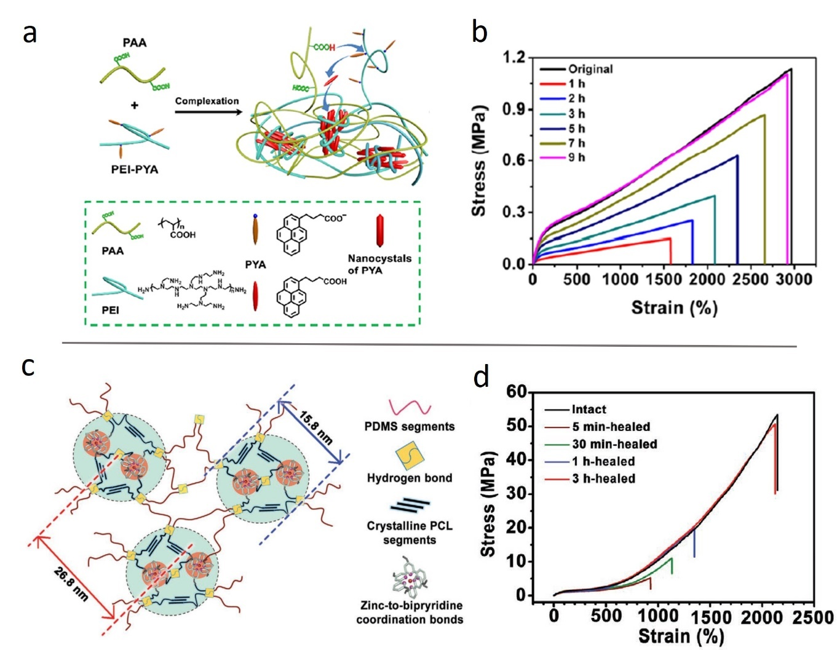
Figure 13. (a) Schematic illustration of the structures of PAA/PEI-PYA complexes. (b) Strain−stress curves of the original and healed samples of PAA/PEI-PYA complexes at different healing time. (c) Illustration of the structures of the PU-BPY_{0.5}–Zn elastomer. (d) Stress−strain curves of the intact and healed samples at different healing times of the PU-BPY_{0.5}–Zn elastomer.

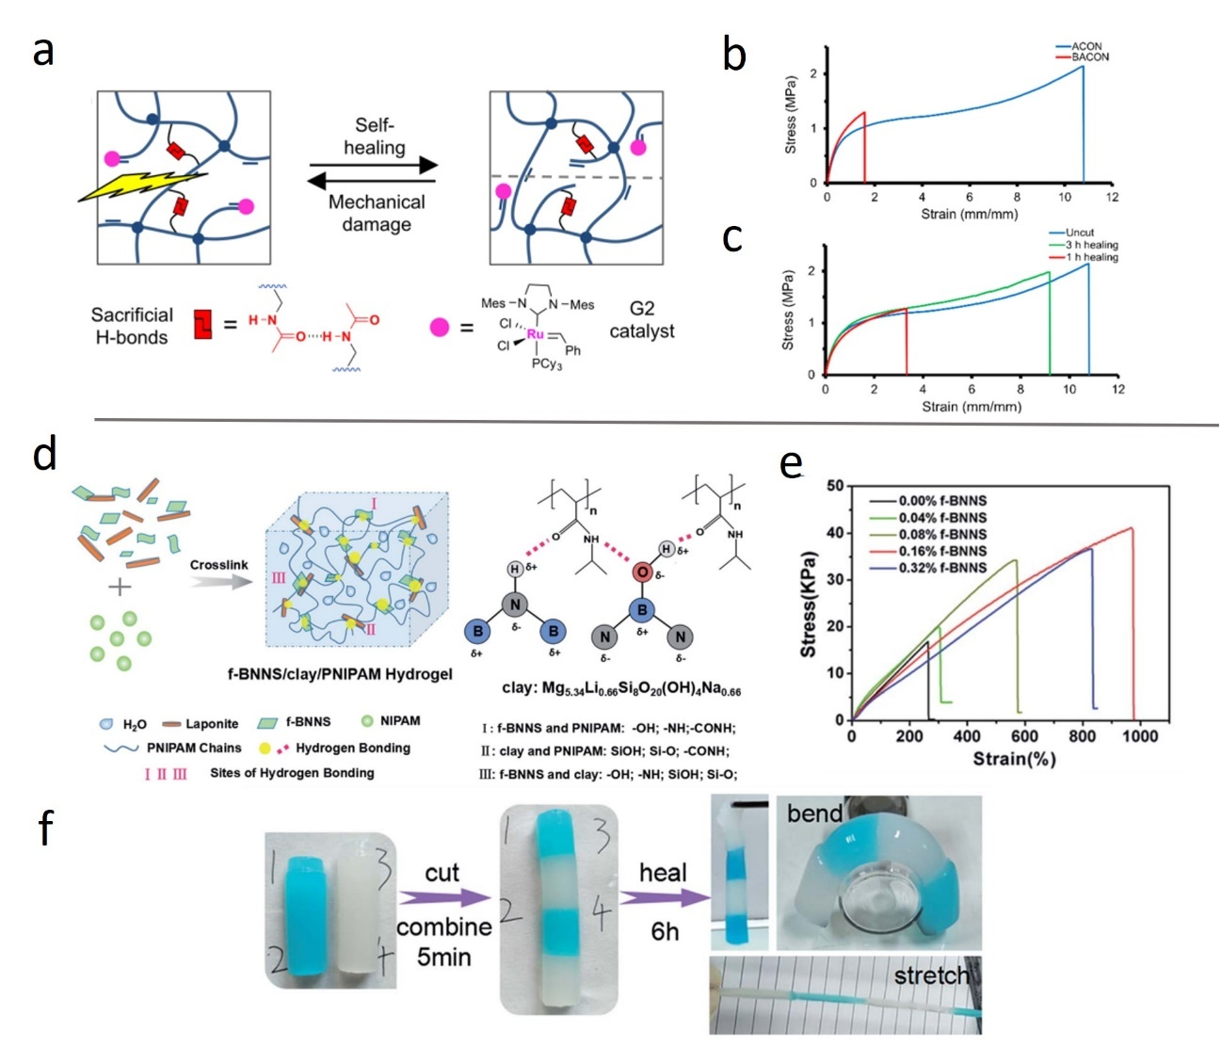
Figure 14. (a) Schematic illustration of the structures of ACON. (b) Stress-strain curves of ACON and control BACON. (c) Stress-strain curves of ACON at different healing time. (d) Schematic illustration of the structures of f-BNNS/clay/PNIPAM. (e) Stress-strain curves of the composite hydrogels with increasing f-BNNS content. (f) Demonstration of the self-healing property of f-BNNS/clay/PNIPAM.

CHAPTER II
SUPERSTRETCHABLE, SELF-HEALING POLYMERIC ELASTOMERS WITH TUNABLE PROPERTIES

A version of this chapter was published by Peng-Fei Cao, Bingrui Li, Tao Hong, Jacob Townsend, Zhe Qiang, Kunyue Xing, Konstantinos D. Vogiatzis, Yangyang Wang, Jimmy W. Mays, Alexei P. Sokolov, and Tomonori Saito. “Superstretchable, Self-Healing Polymeric Elastomers with Tunable Properties” Advanced Functional Materials, 2018, 28, 1800741

P.-F.C. and B.L. contributed equally to this work.
Peng-Fei Cao and Bingrui Li designed the experiments and contributed to the preparation of the manuscript, Bingrui Li, Tao Hong, Jacob Townsend, Zhe Qiang, Kunyue Xing, Yangyang Wang performed experiments, Konstantinos D. Vogiatzis, Jimmy W. Mays, Alexei P. Sokolov, and Tomonori Saito contributed to the discussion and revision of the manuscript.

Abstract
Utilization of self-healing chemistry to develop synthetic polymer materials that can heal themselves with restored mechanical performance and functionality is of great interest. Self-healable polymer elastomers with tunable mechanical properties are especially attractive for a variety of applications. Herein, a series of urea functionalized poly(dimethyl siloxane)-based elastomers (U-PDMS-Es) are reported with extremely high stretchability, self-healing mechanical properties, and recoverable gas-separation performance. Tailoring the molecular weights of poly(dimethyl siloxane) or weight ratio of elastic cross-linker offers tunable mechanical properties of the obtained U-PDMS-Es, such as ultimate elongation (from 984% to 5600%), Young's modulus, ultimate tensile strength, toughness, and elastic recovery. The U-PDMS-Es can serve as excellent acoustic and vibration damping materials over a broad range of temperatures (over 100 °C). The strain-dependent elastic recovery behavior of U-PDMS-Es is also studied. After mechanical damage, the U-PDMS-Es can be healed in 120 min at ambient temperature or in 20 min at 40 °C with completely restored mechanical performance. The U-PDMS-Es are also demonstrated to exhibit recoverable gas-separation functionality with retained permeability/selectivity after being damaged. This chapter answers the question of how to design readily healable, highly elongated polymers.

Introduction
The capability to heal mechanical fractures and resume active functions is critical for components of biological systems because it determines the longevity of their existence.¹ Human skin is one of the typical soft biomaterials which can retain their mechanical properties and sensing functionalities after healing the wound. Inspired by biological systems, developing synthetic polymer materials that can heal themselves with restored mechanical performance and functionality is of great interest, since such materials can extend the product lifetime and improve device performance.^{2,6,97} Polymeric materials with extrinsic healing mechanisms only allow limited healing cycles (typically once), whereas those with intrinsic mechanism afford self-repairing multiple times, like biological systems.⁹⁸ Self-healing chemistry with an intrinsic mechanism relies on reversible covalent bond formation including Diels–Alder reaction,^{143,144} dynamic hydrazone bond,^{145,146} and reversible disulfide¹⁰⁸ and noncovalent bonding, such as metal–ligand coordination,⁹¹ hydrogen bonding^{34,98,140} and hydrophobic interaction.¹⁴⁷ The fabricated self-healing materials are beneficial to a broad range of application fields, such as self-healable functional surfaces,^{148,149} recoverable electric/ionic conductors,¹⁵⁰ and different types of electronic devices including electronic skin,^{151,152} supercapacitors,¹⁵³ and strain/heat sensors.¹⁵⁴
Stretchable elastomers are useful platforms for fabricating comfortable epidermal devices that include wearable biosignal monitors,¹⁵⁵ strain/pressure/humidity/pulse/oxygenation sensors,¹⁵⁶⁻¹⁶² displays,¹⁶³ and lithium-ion batteries.¹⁶⁴ Developing stretchable elastomers with self-healing capabilities is very attractive due to their improved product performance.^{35,97,165-167} The urea functionalized fatty dimer acid reported by Cordier et al. is a typical example of a stretchable elastomer with self-healing capability.³⁴ The elastomer exhibits up to 500% elongation before breaking and mechanical properties can be completely recovered within 3 h. This material has been widely used as an excellent platform for self-healable device fabrications. For example, using a similar material as a polymer binder, Bao and co-workers reported a stable silicon microparticle-based anode for lithium-ion battery application.^{168,169} Cui and co-workers also obtained a stretchable lithium-ion battery based on the selfhealing elastomer-coated electrode.¹⁷⁰ Very recently, Aida and co-workers demonstrated another series of mechanically robust self-healable polymers with thiourea units as the repeating units.⁹⁸ The presence of a large number of H-bonding units and noncrystalline nature (due to the less ordered unit array) of the polymeric materials are key features that facilitate their selfhealing mechanism. Utilization of rubbery polymer segments instead of small molecules as the spacer between hydrogen bonding units would enable polymer elastomer with tunable hydrogen bonding density through molecular weight control, thus controlled extensibility, elasticity, modulus, self-healability, and separation performance. Such self-healing polymeric elastomers would facilitate various new applications.
Herein, we report a series of self-healable polymeric elastomers with tunable mechanical properties achieved through molecular weight control of rubbery polymer segments and demonstrate the recoverable gas-separation functionality of the obtained polymer membranes. The urea functionalized poly(dimethyl siloxane)-based elastomers (U-PDMS-Es) was synthesized by reacting urea with amine-terminated polydimethylsiloxane (PDMS). They show extremely high elongation at break (984%-5600%), and adjusting the chain length of poly(dimethyl siloxane) (PDMS) segments will afford polymeric elastomers with desired mechanical strength, elasticity, and extensibility. Completely recoverable mechanical strength and gas-separation performance within 2 h at ambient temperature or 20 min at 40 °C makes the material attractive for various applications including functional surfaces, electric/ionic conductors, and different types of electronic devices. Moreover, the U-PDMS-Es also exhibit strain-dependent elasticity (nearly perfect elastic recovery in a stretched state) along with excellent acoustic and vibration damping properties over a broad range of temperature (≈100 °C), a much wider temperature range than those of typical damping materials (≈60 °C).

Experimental

Materials
All chemicals excluding PDMS were obtained from Sigma-Aldrich. All PDMS products were purchased from Gelest, Inc.

Polymer Synthesis
Preparation of the TDA-PDMS
9.0 g of succinic anhydride terminated PDMS (12.9 mmol, from Gelest, Inc) in 20 mL tetrahydrofuran (THF) and 8.9 g (158.6 mmol) of potassium carbonate (K₂CO₃) in 5 mL deionized (DI) water were mixed in a 100 mL round bottom flask and stirred. After 12 h, the pH of solution was adjusted to 7 by addition of hydrochloric acid (HCl), when a white precipitate came out. The precipitate was collected and washed with DI water three times. The product was dried under vacuum overnight before characterization. 5.0 g of the tetra acid terminated PDMS (TDA-PDMS) (7.14 mmol) was mixed with 7.37 g of diethylenetriamine (71.4 mmol, from Sigma-Aldrich) in a 50 mL Schlenk tube. The mixture was heated at 120 °C for 2 h before the temperature was raised to 160 °C for 24 h under inert atmosphere. The product was purified by dialysis against mixed solvent [V(H₂O)/V(CH₃OH) = 1:1] (see Figure 18 for the ¹H NMR spectrum of the final product).
Synthesis of PDMS-Based Polymer Elastomers (U-PDMS-Es)
In a typical synthesis of U-PDMS0.9K-E, 1.8 g of amine-terminated PDMS (Mw = 900 g mol⁻¹, 2.0 mmol), 0.384 g (6.4 mmol) of urea and 0.44 g (0.4 mmol) of the four-arm PDMS amide were combined in a 25 mL Schlenk tube. The tube was heated up under continuous Ar flow, the temperature increase was 20 °C per 30 min until the oil bath reached 150 °C, and then the temperature was kept at 150 °C for 2 d to obtain the final product. After the reaction cooled, the product was washed with methanol three times to remove the unreacted impurities, then placed in the vacuum oven to remove solvent. The purified product can be swollen in organic solvent, such as acetone, THF, but cannot be completely dissolved. The U-PDMS-Es were processed by melt pressing at 160 °C to obtain homogeneous films for testing.

Polymer Characterizations
General Characterizations
¹H NMR spectra were recorded on a Bruker 400 MHz NMR spectrometer using DMSO-d6. IR spectra were recorded on a Cary 600 Series FT-IR Spectrometer (Agilent Technologies), and the scanning range was 4000–400 cm⁻¹. Approximately 10 mg of each sample was weighted out to test on TGA Q50, TA Instrument. The samples were heated up to 800 °C from room temperature at a heating rate of 20 °C min⁻¹ under a dry nitrogen atmosphere (flow rate: 40 mL min⁻¹). Thermal transitions of polymer films were observed using modulated DSC (TA Instruments Q1000). The heating procedure was set to modulate +/−1.00 °C every 60 s at the rate of 3 °C min⁻¹ from −160 to 90 °C.
Tensile Analysis
Rectangular stripes prepared by melt press at 160 °C, and films were cut into ≈7.0 × 5.0 × 0.5 mm specimens for tensile analysis using a TA Instruments RSA-G2 Solids Analyzer. Samples were elongated at the rate of 1 mm s⁻¹ till break. U-PDMS30K-E was measured by a TA Instruments HR-2 rheometer with the SER3 (Xpansion Instruments) Universal Testing Platform due to its ultrahigh elongation, the sample was stretched by two counterrotating drums with a constant angular velocity. The elongation results tested by both methods with the same strain rate are comparable. The reported tensile properties were an average of a minimum of three samples.
Dynamic Mechanical Analysis
Hysteresis analysis was performed on a TA Instruments RSA-G2 Solids Analyzer. Rectangular samples were prepared by melt press at 160 °C, and films were cut into ≈18.0 × 5.0 × 0.5 mm specimens. Samples were elongated to 100% strain then back to 0% strain at a constant rate of 0.1 mm s⁻¹. A total of ten cycles of testing were performed for all samples.
Rheology Measurements
Small-amplitude oscillatory shear measurements of membrane samples were carried out on an AR2000ex rheometer (TA Instruments) by using 8 mm plates with a parallelplate geometry. The temperature was controlled by an environmental test chamber filled with nitrogen. Prior to measurements, the sample was purged at 100 °C for 0.5 h under a nitrogen atmosphere to ensure thermal equilibrium was achieved. All samples were measured at 0.3% strain with a temperature sweep from −100 to 125 °C, with a heating rate of 3 °C min−1. Sample U-PDMS5.0K -E and its mixture of starting material were tested separately with frequency sweep from 100 to 0.01 rad s⁻¹ at 25 °C.
Gas Permeation Analysis
The gas permeability of the polymer network was measured by a custom-built constant volume-variable pressure test chamber and calculated using the Equation (1)
$P_{A}$ = $\frac{V_{c}l}{RTA_{m}∆P}$ $\frac{dP_{l}}{dt}$
where P_{A} is the permeability of the gas A, V_{c} is the permeation volume, l is the membrane thickness, R is the ideal gas constant, A_{m} is the membrane area that was measured using ImageJ software, ΔP is the pressure difference between the upstream and downstream, dP_{l}/dt is the increase rate of gas pressure on the permeation side. In a typical measurement, the parameters were set up as follows: V_{c} = 23.33 cm³, l = 140–190 μm, ΔP = 120–140 kPa. The gas selectivity was obtained by the ratio of CO₂ permeability to N₂ or CH₄ permeability.

Quantum Chemical Calculations
All calculations were performed with the hybrid PBE0 functional, the def2-TZVPP basis set, the resolution-of-identity for the computation of the two-electron integrals, Grimme’s D3 dispersion correction, and the Becke–Johnson damping function. Integral evaluations were performed with an ultrafine grid and tight convergence criteria in the TURBOMOLE 7.1 software package. Frequency calculations were performed to ensure optimized geometries are energy minima or saddle points of the potential energy surface.
Quantum chemical simulation was performed to evaluate the supramolecular interactions of polymeric elastomers and their binding energy with CO₂ molecules. All calculations were performed with the hybrid PBE0 functional, the def2-TZVPP basis set, the resolution-of-identity (RI) for the computation of the two-electron integrals, Grimme’s D3 dispersion correction, and the Becke-Johnson damping function. Integral evaluations were performed with an ultrafine grid and tight convergence criteria in the Turbomole 7.1 software package. Frequency calculations were performed to ensure optimized geometries are energy minima or saddle points of the potential energy surface. The interaction of monomer units I-IV forms a set of ten unique dimer structures: I-I, I-II, I-III, I-IV, II-II, II-III, II-IV, III-III, III-IV, and IV-IV due to the presence of all four associating units in the polymer elastomer system. For each dimer, the energetically most stable structure was determined after evaluating different possible conformers. The interaction energy of the monomers was computed using the following formula:
$${∆E}_{Dimer}=E_{Dimer XY }-E_{Monomer X}-E_{Monomer Y}$$
where X, Y = I, II, III, or IV.
As a next step, each dimer system was studied with CO₂ to produce a set of conformers representing stable dimer-CO₂ super-systems, henceforth referred to as I-I-CO₂, I-II-CO₂, etc. The most stable conformations were obtained and the binding energies of CO₂ to the dimer system were calculated using the formula:
$${∆E}_{{CO}_{2}}=E_{Dimer+{CO}_{2}}-E_{Dimer}-E_{{CO}_{2}}$$
The binding energies for the dimer systems and the average hydrogen bond distances are shown in Table 2, and ranged from approximately -16.5 to -18.2 kcal/mol. For all systems, the most stable structures contain two strong hydrogen bond interactions between the carbonyl oxygens and the amine hydrogens in a single plane. In monomers with multiple amines bonded to carbonyl groups, the most stable geometry was found not to involve the terminal amine in hydrogen bonding with the adjacent monomer. A correlation was found between hydrogen bonding and interaction strength. Systems with shorter, and thus stronger, hydrogen bonds tended toward greater binding energies.
The interaction of monomers I-IV and dimer pairs with CO₂ was also investigated by means of DFT. The electron deficient carbon of CO₂ (C_{CO2}) interacts with the oxygen of the C-O group of the monomers and a hydrogen bond is formed between the oxygen of CO₂ (O_{CO2}) and a hydrogen of a N-H group (Figure 32). A similar binding motif was found for the dimer pairs: the oxygen atoms of the dimer that interact with C_{CO2}, and the hydrogens of the dimer can form weak hydrogen bonds with O_{CO2}. Calculations were performed to find the most stable conformation of dimer systems and CO₂. The interaction strengths, as well as the closest O-C_{CO2} and H-O_{CO2} distances of the most stable CO₂-dimer supersystems are found in Table 3. The CO₂ binding energy for all systems ranges between -5.1 and -5.8 kcal/mol. The O-C_{CO2} interaction distance falls between 2.66-2.78 Å for all monomer-CO₂ and seven dimer-CO₂ supersystems. These supersystems have the CO₂ located adjacent to the plane of hydrogen bonding. The three systems with greater O-C_{CO2} bond distances (III-III-CO₂, III-IV-CO₂, and IV-IV-CO₂) have sterically bulky side chains, therefore the CO₂ is more stable above the plane of hydrogen bonding. These interactions are shown in the most stable configurations of II-III-CO₂ and III-IV-CO₂, shown in Figures 5 and 6. Introduction of CO₂ to the dimers distorts the plane of hydrogen bonding. When CO₂ is adjacent or diagonal to the hydrogen bond plane, the plane is only slightly shifted. However, when CO₂ is located directly above or below the plane of H-bonding dimers, the plane undergoes significant deformation.

Results and Discussion

Fabrication of Polymeric Elastomer
PDMS was selected as the polymer backbone because of its intrinsic high stretchability, good thermal/chemical stability, and low glass-transition temperature (T_{g} ≈ −123 °C).^{35,171,172} The low T_{g} is important to enable the chain mobility and maintain the self-healing properties of the elastomers obtained.³⁵ Instead of using pure amine terminated PDMS, a tetra-diethylenetriamine terminated PDMS (TDA-PDMS, Figure 15) serves as the cross-linker/branching point of the final polymeric elastomers as well as increases hydrogen bonding density. The amine terminated PDMS (PDMS-NH₂) with different molecular weights (0.9, 3.0, 5.0, and 30 kg mol⁻¹) was mixed with TDA-PDMS (Figure 16) and reacted with urea in the ratio of TDA-PDMS: PDMS-NH₂: Urea = 1:5:16 to form a series of U-PDMS-Es. As illustrated in Figure 15, there are four possible functional groups in the PDMS-based polymer elastomer that can associate via multiple hydrogen bonds. Several possible chemical structures of the obtained U-PDMS-Es are shown in Figure 17. Type I and type II are end groups, and type III and type IV are adjunction units (inset of Figure 15). The supramolecular physical interactions between the associating units in U-PDMS-Es play a vital role in their ultimate physical properties, especially self-healing properties.

Figure 15. Synthesis of U-PDMS-Es.

Figure 16. Synthesis of four arm diethylenetriamine-functionalized PDMS.

Figure 17. Possible chemical structure of the obtained U-PDMS-Es.
Figure 18. Comparative ¹H NMR spectra of anhydride terminated PDMS (SA-PDMS), tetra-acid terminated PDMS (TDA-PDMS) and tetra-diethylenetriamine terminated PDMS (TDA-PDMS).

Quantum chemical calculations were employed to estimate the interaction strength of polymeric elastomers (See Supporting Information for details). Among the four types of associating units, type I provides the strongest supramolecular interactions and shortest hydrogen bond length, whereas type II shows the weakest interactions, which is illustrated by their calculated interaction energies (−18.2 kcal mol⁻¹ for I–I dimer vs −16.4 kcal mol⁻¹ for II–II dimer from computational Density Functional Theory calculations) among all of the possible dimer combinations (Table 2). With the normalized Fourier transform-infrared (FT-IR) absorption band corresponding to the C-Si bond at 1257 cm⁻¹,¹⁷¹ significantly decreased intensity of the absorption bands lying at 3511–3120 cm⁻¹ (N-H stretching), 1740–1625 cm⁻¹ (C=O stretching), and 1561 cm⁻¹ (associated N-H bending) manifest the decreased intensity of the urea.³⁴ The U-PDMS-Es exhibit enhanced thermal stability with increased molecular weight of PDMS, and no significant weight loss was observed for U-PDMS5.0K-E up to 450 °C (Figure 21). Compared with one glass transition peak and one melting peak in the temperature modulated differential scanning calorimetry (TM-DSC) curve of PDMS3.0K-NH₂ (Figure 22), the DSC curve of U-PDMS3.0K-E only shows a single glass transition peak (Figure 19b). Two melting peaks were observed in the heating run of PDMS5.0K-NH₂ and PDMS30K-NH₂, whereas the U-PDMS5.0K-E and U-PDMS30K-E only show one small melting peak. The different thermal behavior of U-PDMSEs compared with that of PDMS-NH₂ should be attributed to the effect of chemical/physical cross-linking which limits the mobility of polymer chains and growth of crystalline structure.^{171,173} Moreover, the presence of only one T_{g} in the heating run of TM-DSC indicates no significant phase separation within the U-PDMS-Es. The absence of a periodic phase separated structure was also confirmed by the small-angle X-ray scattering spectra of U-PDMS-Es (Figure 23).¹⁷⁴

Mechanical Property Test
Compared with the completely liquid-like starting materials, the U-PDMS5.0K-E shows rubber-like properties (G′ > G′′ over the frequency range at ambient temperature, see Figure 25) due to the formation of a crosslinked network by chemical an physical interactions.^{34,168} The significant storage modulus (G′) increase of U-PDMS5.0K-E with frequency can be explained by considering that there is adequate time for entangled polymer chains to relax at low frequency, whereas there is less time for rearrangements to occur at high frequency.¹⁷⁵ The storage modulus (G′) of U-PDMSEs at ambient temperature (or at 0 °C) decreases with the molecular weight of PDMS segments. With tan δ ≥ 0.3 as the typical criterion for excellent damping properties of polymer materials,¹⁷⁶ a temperature sweep dynamic mechanical analysis showed that U-PDMS-Es can serve as acoustic and vibration damping materials over a broad temperature range. As shown in Figure 24a and Figure 26, U-PDMS0.9K-E, U-PDMS5.0K-E, and U-PDMS30K-E exhibit excellent damping properties from −48 to 48 °C, 17 to 119 °C and −39 to 100 °C, respectively which are much broader temperature ranges than the typical effective damping materials reported in the literature (the range of ≈60 °C).^{176,177} To evaluate the tensile behavior of U-PDMS-Es, polymer films with thickness of 0.15 mm and width of 3.5 mm were fabricated by melt press. The polymer film made from U-PDMS5.0K-E can be stretched from 1.5 to 18 cm by hand pulling (see picture in Figure 29 or tensile test in Figure 27b b0-b1). As illustrated in Figure 24b, all of the U-PDMS-Es showed extremely high elongation at break and relatively high tensile stress, which cannot be achieved by urea functionalized fatty dimer acid and other common polymeric elastomers, such as covalently cross-linked PDMS.^{34,178} The U-PDMS-Es with lower molecular weight of PDMS showed higher Young’s modulus and ultimate tensile strength, which is consistent with rheology data. It can be explained by the higher density of hydrogen bonding in the polymer network (see Table 1). The U-PDMS-Es with higher molecular weight of PDMS showed better extensibility (up to 5500%) due to the longer polymer segments between the physical/chemical crosslinking points. To study the effect of cross-linker ratio on the mechanical property of finalized product, U-PDMS5.0K-E* with the molar ratio of TDA-PDMS: PDMS-NH₂ = 1:10 was also synthesized and tested (Figure 24b and Table 1). As expected, with lower density of hydrogen bonding, U-PDMS5.0K-E* exhibited lower Young’s modulus and higher extensibility. Hysteresis of elastic recovery was also evaluated by applying 10 cycles of 100% strain on the U-PDMS-Es. As shown in Figure 24c, the U-PDMS-Es do not show perfect recovery. It can be seen that from the first loading–unloading cycle of U-PDMS5.0K-E (red curve in Figure 24c3), after tensile stress went back to 0, the residual strain is 18%. The tensile stress loss for the following loading–unloading cycles is slightly lower than those of previous cycles. The observed hysteresis can be partially attributed to the energy dissipation from the physical bonding dissociation,³⁵ which is consistent with its excellent damping properties. Moreover, lower molecular weights of PDMS segments can improve the elastic recovery of U-PDMSEs: residual strains with 8%, 11%, 18%, and 23% (when tensile stress back to 0) at the first loading–unloading cycles are observed for U-PDMS0.9K-E, U-PDMS3.0K-E, U-PDMS5.0K-E, and U-PDMS30K-E, respectively. Another intriguing phenomenon observed on the U-PDMS-Es is shown in Figure 27. After manual sideways stretching and releasing the film made from U-PDMS5.0K-E, it cannot recover perfectly (Figure 27 a1–a4), which is consistent with hysteresis data. When held at fixed 1500% elongation (from b0 to b1 in Figure 27), after further manual sideways stretching and release, the stretched sample recovers immediately like a rubber. This observation demonstrates the strain-dependent elasticity and nearly perfect recovery of U-PDMS-E in the stretched state. To further understand the elastic recovery in the stretched state, hysteresis test was also performed on the U-PDMS5.0K-E after 1500% elongation (see Figure 27c). When stretched at 1500% elongation, tensile stress of 160 kPa was detected, which is consistent with tensile test shown in Figure 24b. The high tensile stress (160–52 kPa) during the 1st hysteresis loop (1500%–1600% and back to 1500%) should be the reason of this elastic recovery process (from 1600% to 1500%) Significantly less tensile stress loss was observed for the following several loading–unloading cycles. Even after ten cycles, tensile stress of 3.5 kPa was still detected, which demonstrated the capacity of elastic recovery for several cycles in stretched state. The super-stretchability, along with their adjustable Young’s modulus, elasticity, and ultimate tensile strength through molecular weight control, make them attractive candidates for the fabrication of highly stretchable devices, and the systematic investigation presented here provides a design guide.^{159,179}

Healable Mechanical Properties
Extrinsic and intrinsic are the two categories of healing strategies, and intrinsic self-healing usually relies on dynamic physical linkage or reversible covalent bonding.^{1,180-183} As a supramolecular polymer network containing hydrogen bonding sites, U-PDMS5.0K-E was evaluated for its self-healing properties as shown in Figure 28a. After cutting a specimen (thickness ≈1.5 mm) into two pieces using a razor blade and brought into contact, the polymer membranes can be healed within 2 h at ambient temperature (25 °C); the healing time can be shortened by increasing the healing temperature (20 min at 40 °C). For polymer film with lower thickness (≈0.5 mm), around 2 mm of overlap is needed for complete healing process (see Figure 30 for results of both healing types). The low glass transition temperature of PDMS backbones (≈−123 °C) contributes to the low-temperature healing process.³⁵ As illustrated in Figure 28b, after 30 min at ambient temperature, the polymer film made from U-PDMS5.0K-E can retain 1260% strain with a healing efficiency of 69.5%. After 2 h, the mechanical performance of U-PDMS5.0K-E was restored, and nearly all of the mechanical parameters, that is, Young’s modulus, extensibility, ultimate tensile strength, and toughness are comparable with those before the specimen was cut. The completely recoverable mechanical performance, after the shorter healing period comparing with the notable systems,^{34,35,98} ensures the long lifetime of elastomeric products made from U-PDMS-Es.⁶ The simple self-healing process makes the material attractive for various applications including functional surfaces, electric/ionic conductors, and different types of electronic devices.^{6,148,150,184}

Recoverable Gas-Separation Functionality
Utilization of reversible chemical/physical bonding to heal mechanical fractures and recover functions, such as extensibility and separation capability, would be an effective solution to prolong the lifespan of polymer membranes.^{18,185} To demonstrate recoverable functionality of the polymer elastomer, the U-PDMS-Es were tested as gas-separation membranes where any type of defect will cause a complete loss of performance. The gas-separation performance of U-PDMS-Es was evaluated using a custom-built constant volume-variable pressure test chamber with the results shown in Figure 31b, and most of the U-PDMS-Es exhibit very high gas permeability (CO₂ permeability >1000 Barrer). A scratch (scratch width ≤150 μm for the membrane thickness ≈200 μm) was applied to U-PDMS-E-based membranes after initial gas-separation measurements.

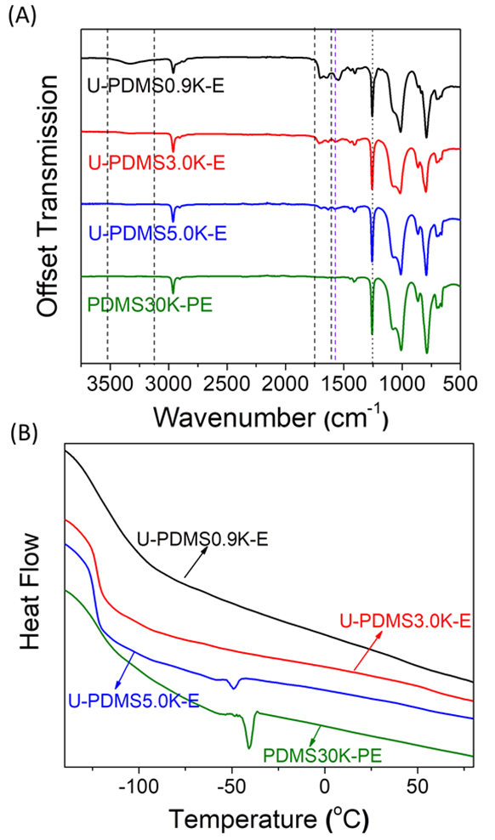
Figure 19. (a) IR spectra of U-PDMS-Es with different molecular weights of PDMS after normalizing the absorption band corresponding to the C-Si bond at 1257 cm⁻¹; (b) Temperature-modulated differential scanning calorimetry (TM-DSC) cures of U-PDMS-Es.

Figure 20. Comparative IR spectra of anhydride terminated PDMS (SA-PDMS), tetra-acid terminated PDMS (TA-PDMS) and tetra-diethylenetriamine terminated PDMS (TDA-PDMS).

Figure 21. TGA analysis of U-PDMS-Es with different molecular-weight of PDMS.

Figure 22. DSC analysis of PDMS terminated with amine groups.

Figure 23. SAXS spectra of U-PDMS-Es.

Figure 24. (a) Temperature sweep of shear modulus on U-PDMS5.0K-E, (b) Tensile test of the U-PDMS-Es with PDMS of different molecular weights (molar ratio of TDA-PDMS /PDMS-NH₂ is fixed at 1:5), U-PDMS-E* means the molar ratio of TDA-PDMS /PDMS-NH₂=1:10, strain rate = 1 s⁻¹ , (c) ten successive loading-unloading cycles of the film prepared from U-PDMS-Es (C1:U-PDMS0.9K-E, C2: U-PDMS3.0K-E, C3: U-PDMS5.0K-E, C4:U-PDMS30K-E), red curve is the 1st hysteresis loop.

Table 1. Combined Young’s modulus, elongation, ultimate tensile strength, and toughness of U-PDMS-Es and U-PDMS5.0K-E after self-healing.

Figure 25. Shear modulus (G' and G'') of U-PDMS5.0K-E.

Figure 26. Temperature sweep of shear modulus on U-PDMS-Es with molecular weight of PDMS 0.9K, 5.0K and 30K.

Figure 27. Picture of manual sideways stretching test of U-PDMS5.0K-E before elongation (a) and after 1,500% elongation (b): (a3)/(b3) and (a4)/(b4) are images of 2 seconds and 5 seconds, respectively, after releasing the manual stretching; (c) ten successive loading-unloading cycles (1,500%- 1,600%) of the film prepared from U-PDMS5.0K-E.

Figure 28. (a) Picture showing the healing process of polymer membranes made from U-PDMS5.0K-E; (b) Comparative tensile test of original polymer membrane and after cut and healing process (5 mins, 30 mins and 120 mins healing at 25 °C).

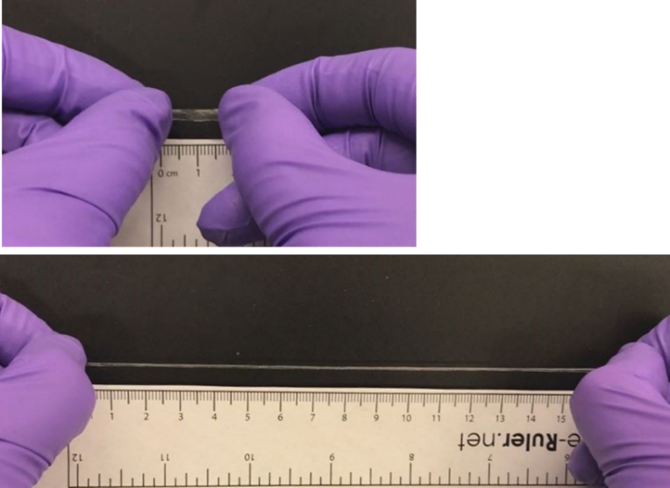

Figure 29. Image of U-PDMS5.0K-E before and during stretching.
Figure 30. Comparison result from both healing types: (I) healed by brought into contact (no overlap, film thickness ~1.5 mm), (II) healed by around 2 mm of overlap (film thickness ~0.5 mm).

After a 20 min (40 °C) healing process, the scratch was healed as shown in Figure 31a. The healed samples were then transferred back to the chamber for a repeated test. The membranes made from U-PDMS0.9K-E, U-PDMS3.0K-E, and U-PDMS5.0K-E exhibited complete recovery of gas-separation performance, and the gas permeability and selectivity (α (CO₂/N₂)) are both comparable with those of the original membranes (Figure 31b). This healable property, exhibited at near ambient temperature, allows for minimal loss of gas-separation performance even with membrane fracture and formation of pinholes. Only the membrane derived from U-PDMS30K-E could not be completely healed for gas-separation membranes, which may be due to its insufficient density of associating units. This indicates the critical role of supramolecular physical interactions in the self-healing process. Separation membranes would greatly benefit from recoverable functionality through self-healing chemistry because defects, fractures, and pinholes often ruin their separation performance.¹⁸⁶⁻¹⁹⁰ The incorporation of hydrogen bonding units also improves the gas selectivity of the obtained membranes. The four associating units discussed above (Figure 15) also contribute as CO₂-philic groups in two ways: the oxygen atoms in the associating units can interact with electron deficient carbon in CO₂ molecules, and the hydrogens may also form weak hydrogen bonds with the oxygens in CO₂ molecules (Figure 34). The binding energy between the CO₂ and the associating units varies between −5.0 and −5.9 kcal mol⁻¹ (see Table 3 for computational results), and they are still of the same order of magnitude after the associating units forming the dimers. It is worth noting that the interaction energies between the associating units responsible for the self-healing mechanism are about 3–4 times higher than the CO₂ binding energy, which ensures the retention of the supramolecular structure and the mechanical robustness of the polymer membranes during the gas-separation process. The observed trade-off between membrane selectivity and permeability corresponds to the degree of hydrogen bonding and CO₂-philicity.¹⁹⁰ In shorter PDMS polymer chains, the higher gas-selectivity α(CO₂/N₂) is attributed to the higher density of CO₂-philic groups, whereas lower permeability corresponds to the higher cross-linking density attributed to both chemical bonding and physical interactions. The design criteria for achieving self-healing functionality demonstrated in this work should be applicable to various membrane applications, not only for gas separation but also for fuel cells, flow batteries, desalination, and so on, where healable properties and functionality are highly desired.

Conclusions
A series of polymer elastomers (U-PDMS-Es) with super-stretchability, self-healing properties, and excellent damping properties was synthesized by urea functionalization of PDMS. With Tan δ ≥ 0.3 as the criterion, the U-PDMS-Es showed excellent acoustic and vibration damping properties over a broad temperature range (>100 °C). Increasing the chain length of PDMS improves the extensibility of the PDMS-PEs (from 984% to 5600%), whereas the shorter PDMS chain affords high Young’s modulus and ultimate tensile strength and improved elasticity. Lowering the weight ratio of elastic cross-linker was demonstrated as an alternative way to improve their extensibility. The U-PDMS-Es also exhibited strain-dependent elastic recovery and nearly perfect elastic recovery in a stretch state. The excellent self-healing capacity (2 h at ambient temperature or 20 min at 40 °C) with completely restored mechanical performance was demonstrated in U-PDMS-Es with molecular weight of PDMS segments up to 5.0 kg mol⁻¹. The comparable gas-separation performance in terms of both permeability and selectivity of the U-PDMS-Es after the healing process also demonstrates their recoverable functionality. Utilization of rubbery polymer segments as the spacer between hydrogen bonding units was demonstrated to be a useful strategy for the fabrication of polymeric elastomers with well-controlled properties. The super-stretchability, adjustable Young’s modulus, elasticity and ultimate tensile strength, along with completely recoverable mechanical performance and gas-separation capability makes the demonstrated U-PDMS-Es attractive platform candidates for the fabrication of many functional films, membranes, coatings, and devices with prolonged lifetime.

Figure 31. (a) Pictures showing the gas-separation membranes with applied scratch and after healing at 40 °C for 30 mins; (b) Comparative gas separation performance of original polymer membranes (blue) and polymer membranes after cut and healing (orange), CO₂ permeability (up) and CO₂/N₂ selectivity (bottom).

Table 2. Dimer system binding energies and average hydrogen bonding distances.

Dimer System | Binding Energy (kcal/mol) | Average Hydrogen Bond Distance (Angstrom)
I-I dimer | -18.2 | 1.80
I-II dimer | -17.2 | 1.80
I-III dimer | -17.5 | 1.78
I-IV dimer | -17.9 | 1.80
II-II dimer | -16.4 | 1.80
II-III dimer | -16.5 | 1.80
II-IV dimer | -17.0 | 1.80
III-III dimer | -16.5 | 1.81
III-IV dimer | -17.0 | 1.80
IV-IV dimer | -17.1 | 1.80

Figure 32. Monomer Structures I-IV considered in the computational study.

Figure 33. Two-dimensional representation of hydrogen bonding between monomer units.

Figure 34. The most stable geometry for I-CO₂, II-CO₂, III-CO₂, and IV-CO₂.
Table 3. CO₂ binding energy and physical bonding distance.

 | CO₂ Binding Energy (kcal/mol) | O-C_{CO2} distance (Angstrom) | H-O_{CO2} distance (Angstrom)
I | -5.2 | 2.74 | 2.23
II | -5.0 | 2.74 | 2.30
III | -5.7 | 2.72 | 2.25
IV | -5.4 | 2.73 | 2.24
I-I dimer | -5.4 | 2.77 | 2.26
I-II dimer | -5.9 | 2.66 | 2.38
I-III dimer | -5.3 | 2.66 | 2.34
I-IV dimer | -5.1 | 2.78 | 2.26
II-II dimer | -5.2 | 2.95 | 2.93
II-III dimer | -5.0 | 2.75 | 2.76
II-IV dimer | -5.3 | 2.95 | 2.93
III-III dimer | -5.8 | 3.09 | 3.10
III-IV dimer | -5.6 | 3.00 | 3.03
IV-IV dimer | -5.6 | 2.96 | 2.98

.

CHAPTER III
PUNCTURE-RESISTANT SELF-HEALING POLYMERS WITH MULTI-CYCLE ADHESION AND RAPID HEALABILITY
A version of this chapter was published by Bingrui Li, Sirui Ge, Sheng Zhao, Kunyue Xing, Alexei P. Sokolov, Peng-Fei Cao, and Tomonori Saito. “Puncture-Resistant Self-Healing Polymers with Multi-cycle Adhesion and Rapid Healability” Materials Horizons, 2023, accepted.
Bingrui Li, Peng-Fei Cao, and Tomonori Saito designed the experiments and contributed to the preparation of the manuscript, Bingrui Li, Sirui Ge, Sheng Zhao, and Kunyue Xing performed experiments, Alexei P. Sokolov contributed to the discussion and revision of the manuscript.

Abstract
The structural design of self-healing materials determines the ultimate performance of the product that can be used in a wide range of applications. Incorporating intrinsic self-healing moieties into puncture-resistant materials could significantly improve the failure resistance and product longevity, since their rapidly rebuilt bonds will provide additional recovery force to resist external force. Herein, we present a series of tailored urea-modified poly(dimethylsiloxane)-based self-healing polymers (U-PDMS-SPs) that exhibit excellent puncture-resistant properties, fast autonomous self-healing, multi-cycle adhesion capability, as well as well-tunable mechanical properties. Controlling the composition of chemical and physical cross-links enables the U-PDMS-SPs with an extensibility of 528% and toughness of 0.6 MJ/m³. U-PDMS-SPs exhibit fast autonomous self-healability with 25% strain recovery within 2 minutes of healing, and over 90% toughness recovery after 16 hours. We further demonstrate its puncture-resistance properties under ASTM D5748 standard with an unbreakable feature. Furthermore, the multi-cycle adhesive properties of U-PDMS-SPs are also revealed. High puncture resistance (>327 mJ) and facile adhesion with rapid autonomous self-healability will have a broad impact on the design of adhesives, roofing materials, and many other functional materials with enhanced longevity. This chapter demonstrates the exploration of self-healable polymers on practical applications beyond tensile properties.

Introduction
Autonomous self-healing materials are capable of repairing physical damage without any external stimuli or intervention. Such self-healing capability can be seen in living species, and human skin represents a pertinent example of self-healing materials, which can fully recover its functionalities after a minor cut. Developing self-healing materials is critically important since the healing functionality is highly beneficial in various applications. One representative example is wearable electronic devices,^{191,192} since those devices are constantly being operated under stretch and shrinkage with fluctuation, which may cause minor breakage. Incorporation of self-healing properties into materials could significantly improve the long-term performance of overall devices by extending the longevity of their functionalities.^{142,193} There are two general approaches to developing self-healing materials, i.e., extrinsic, and intrinsic. The extrinsic self-healing approach typically contains two isolated reactive chemicals such as dual-component epoxy with one of them being encapsulated in capsules.¹⁹⁴ Although this approach is simple, the design can only heal once and cannot heal the same spot repeatedly due to the irreversible nature of the healing mechanism. The intrinsic approach overcomes this shortcoming,6 where its self-healability relies on the formation of reversible bonds that could heal repeatedly under an appropriate environment.^{195,196} Intrinsic self-healing could be realized by utilizing a variety of reversible chemical bonds such as Diels–Alder reaction,^{143,144} disulfide bond,^{108,115} and boronic ester linkages,^{122,197} or noncovalent reversible interactions, such as metal–ligand coordination,⁹¹ hydrogen bonding (H-bonding),^{34,36,198,199} or multiple driving forces.^{200,201} Self-healable materials based on non-covalent interactions have been adopted widely over a broad range of applications including electronic devices,^{202,203} coatings,²⁰⁴ and functional films.²⁰⁵ Compared with the self-healing materials based on dynamic covalent bonds, non-covalent interactions are normally more adaptable to self-healing at ambient environment due to low activation energy of bond dissociation and association.²⁰⁶
Puncture-resistant materials are typically made with woven or nonwoven fabrics. For example, puncture-resistant gloves are typically made of strong fibers like Kevlar. Their high modulus and stiffness provide high resistance to deformation while the woven texture of the fibers could distribute (or dissipate) the puncturing energy throughout the surface and further reduce the pressure at the impact point. A highly flexible and extensible material also has puncture resistance since high energy is required for puncturing such material.²⁰⁷ Incorporation of self-healability with puncture resistance, the tolerance to damages can be further enhanced. For example, healing occurs when puncture force is applied, and self-healing capability could further improve the puncture-resistance property as well as overall longevity.²⁰⁷ While there have been a few reports on incorporating the self-healing concept into puncture-resistant polymeric materials,^{133,208-210} many challenges exist, such as requiring a complicated fabrication process due to composite structure,²⁰⁹ or elevated temperature for facilitating the healing process.^{208,210}
Herein, we report puncture-resistant autonomously self-healable polymers with tunable mechanical properties. The chemical and physical cross-link density of urea-functionalized poly(dimethylsiloxane) self-healing polymer (U-PDMS-SP) is controlled by tailoring the ratio of reactants in a facile and scalable one-pot synthesis. Moreover, this U-PDMS-SP exhibits high displacement during a lap shear adhesion test and demonstrates less than 5% adhesion energy decay even after four cycle tests. Such highly puncture-resistant self-healable polymers with multi-cycle adhesion capability will provide great potential to be used in various applications including functional adhesives, building materials, as well as electronic devices.

Figure 35. (a) Schematic illustration of the chemical structures of the starting materials and the U-PDMS-SPs. (b) FT-IR spectra of U-PDMS-SPs with different ratios of reagents and PDMS starting materials after normalizing the absorption band corresponding to the C-Si bond at 1257 cm⁻¹. (c) Thermogravimetric analysis (TGA) data of U-PDMS-SPs. (d) DSC data of U-PDMS-SPs with different ratios of reagents. (e) Rheology test data curve of U-PDMS-SP4.

Experimental
Materials
All PDMS materials were obtained from Gelest, Inc. All other chemicals were purchased from Sigma-Aldrich.
Synthesis of the U-PDMS-SPs
All U-PDMS-SPs were synthesized under the same procedure with different ratios of starting materials. We here use U-PDMS-SP3 as an example: 2.22 g of (4-5% aminopropylmethylsiloxane)-dimethylsiloxane copolymer (0.28 mmol, from Gelest, Inc), 5.0 g of aminopropyl terminated polydimethylsiloxane (5.6 mmol, from Gelest, Inc), 0.58 g of diethylenetriamine (5.6 mmol), and 1.77 g (29.4 mmol) of urea were added into a flame-dried 50 mL Schlenk tube with a magnetic stir bar inside. A rubber stopper was attached with a long needle punctured through the stopper. Continuous N₂ was purged during the entire reaction. The tube was heated in a 120 °C oil bath for 2 hours, then the temperature was elevated to 160 °C for 24 hours. The final product was obtained after washed by methanol under vortex and dried in a vacuum oven.
Polymer Characterizations
General Characterizations
Infrared (IR) spectra were obtained from a Nicolet iS50 FT-IR spectrometer (Thermo Scientific) with a scanning range was 4000 - 400 cm⁻¹. Approximately 10 mg of each sample was weighted out to test on TGA Q50, TA Instrument. The samples were heated up to 800 °C from room-temperature at a heating rate of 20 °C/ min under a dry nitrogen atmosphere (flow rate: 40 mL/min). Thermal transitions of polymer ﬁlms were observed using modulated DSC (TA Instruments DSC 2000). The heating procedure was set to modulate +/- 1.00 °C every 60 seconds at the rate of 3 °C/min from − 160 to 150 °C. The density of the samples was determined by AccuPyc™ II 1340 Gas Displacement Pycnometry System with sample chamber sizes of 1 cm³, following ASTM method D 6226. The samples were measured at 20 °C under Helium gas.
Tensile Analysis
Rectangular stripes prepared by melt-press at 120 °C, all films were cut into rectangular specimens with dimensions of approximately (50 × 4.0 × 0.4) mm for tensile tests utilizing an Instron 3343 universal testing system with a 50 N load cell. Samples were elongated at the rate of 1 mm/s till break. The reported tensile properties were an average of a minimum of three samples.

Dynamic mechanical analysis
Hysteresis analysis was performed on a TA Instruments RSA-G2 Solids Analyzer. Rectangular samples were prepared by melt-press at 120 °C, and films were cut into approximately (50.0 × 5.0 × 0.3) mm specimens. Samples were elongated to 100% strain then back to 0% strain at a constant rate of 1 mm/s. 10 cycles of testing were performed for all samples.
Rheology measurements
Small-amplitude oscillatory shear (SAOS) measurements of membrane samples were carried out on an AR2000ex rheometer (TA Instruments) by using 8 mm plates with a parallel-plate geometry. The temperature was controlled by an environmental test chamber filled with nitrogen. Prior to measurements, the sample was purged at 100 °C for 0.5 h under a nitrogen atmosphere to ensure thermal equilibrium was achieved. All samples were measured at 0.3 % strain with a temperature sweep from -100 °C to 125 °C, with a heating rate of 3 °C/min.
Adhesion analysis
Lap shear adhesion tests on the aluminum surface were conducted utilizing an Instron 3343 universal testing system with a 50 N load cell. Two aluminum bars are adhered by adhesives with an overlapped surface area of (12 mm × 12 mm) 144 mm², then the bars were loaded on the clamps of the tensile tester, and the top clamp was pulled against the bottom clamp following a modified version of ASTM D1002 at the rate of 2 mm/min. Peel tests on aluminum and polytetrafluoroethylene surfaces were conducted on the same tensile tester following the ASTM C794 standard, sample width was unified to 23.3 mm. The 180-degree reverted sample strips were elongated at the rate of 50 mm/min. The reported adhesion properties were an average of a minimum of three samples.

Results and Discussion

Synthesis of U-PDMS-SPs
Intrinsic self-healability at ambient conditions in polymers can be achieved by the combination of reversible bonds and fast segmental dynamics. The PDMS provides one of the fastest dynamics at room temperature due to low glass-transition temperature (T_{g} = -123 °C) and exhibits good chemical and thermal stability.³⁶ Herein, we select the commercially available amine functionalized branched PDMS (PDMS-NH₂-B, molecular weight = 8,000 g/mol, 5 mol% amine group) and telechelic amine functionalized linear PDMS (PDMS-NH₂-L, molecular weight = 900 g/mol) as the main building blocks for the synthesis of self-healing polymers. As depicted in Figure 35a, all reagents, i.e., PDMS-NH₂-B, PDMS-NH₂-L, urea, and diethylenetriamine (DETA), with the controlled molar ratio were mixed without solvent and reacted in one pot, affording the final products at a high yield over 85%.

Figure 36. Illustration of potential chemical structures of U-PDMS-SPs after the synthesis.

The single-step reaction will benefit future scale-up toward commercial adoption compared with multi-step synthesis, which is often required for synthesizing self-healing polymers.^{97,100,211-213}
Urea serves as the hydrogen-bonding-containing chemical linker, and DETA is added to increase the H-bonding density in the system. The potential chemical structures of the final products are shown in Figure 36.²¹⁴ Table 4 summarizes the molar ratio of each reactant, where the cross-link density is mainly controlled by the relative ratio of each reactant, where the cross-link density is mainly controlled by the relative ratio of PDMS-NH2-B, and the H-bonding density is well-tuned by the relative ratio of DETA addition. Between U-PDMS-SP2 and U-PDMS-SP1, U-PDMS-SP1 has a higher crosslink density than U-PDMS-SP2. Similarly, U-PDMS-SP3 has a higher crosslink density than U-PDMS-SP4, while the degree of H-bonding is comparable. Since urea is the only crosslinker in the system, the only difference between U-PDMS-SP4 and U-PDMS-SP5 is that U-PDMS-SP5 has a significantly increased H-bond density compared with U-PDMS-SP4.
Four possible H-bonding units could form during this urea-amine reaction³⁶ as illustrated in Figure 35a. The supramolecular interactions between the H-bonding units in U-PDMS-SPs contribute significantly to the self-healing capabilities. Since the final products are chemically cross-linked, they are insoluble in common deuterated solvents, which prevents us from using ¹H NMR spectroscopy for their structural analysis. As illustrated by the Fourier transform infrared (FT-IR) spectroscopy in Figure 35b, the normalized FT-IR absorption band corresponds to the C-Si bond at 1257 cm⁻¹,³⁶ and the absorption bands from 3511 cm⁻¹ to 3120 cm⁻¹ are attributed to the N-H stretching. The significantly increased intensity of these peaks in the U-PDMS-SPs compared with PDMS-NH₂-B and PDMS-NH₂-L indicates the formation of urea bonds in the final product. Meanwhile, the emerging new peaks at 1561 cm⁻¹ (N-H bending) and 1740-1625 cm⁻¹ (C=O stretching) also indicate the formation of carbonyl bonds.^{212,215} The peaks at 1632-1637 cm⁻¹ (Amide I) and 1572-1574 cm⁻¹ (Amide II) of U-PDMS-SPs represent amide bonds in the polymer (Figure 35a i, iii, iv).²¹⁶ Signals at 1687 cm⁻¹ indicate the presence of imidazolidone structure (Figure 35a ii).³⁴ The thermogravimetric analysis (TGA) (Figure 35c) of the U-PDMS-SPs indicates good thermal stability overall without significant weight loss below 250 °C for all the U-PDMS-SP samples (Table 4). The samples with a lower chemical cross-linking density such as U-PDMS-SP4 and U-PDMS-SP5 degraded faster than other samples, which shows a notable difference in their weight losses of over 50% at 400 °C in comparison to only 25% for U-PDMS-SP1. Temperature-modulated differential scanning calorimetry (TM-DSC) was utilized to reveal the thermal property of the U-PDMS-SPs, see Figure 35d. Only a single transition was observed in samples from U-PDMS-SP1 to U-PDMS-SP4, which corresponds to the T_{g} of PDMS moiety. In addition, U-PDMS-SP5 shows another broad transition peak at ~4 °C, and this additional transition could be attributed to the phase of high NH₂ group concentration that could facilitate physical cross-linking, in which similar

Figure 37. (a) Tensile test data of U-PDMS-SPs at the rate of 1 mm/s. (b) Demonstration of the extensibility of U-PDMS-SP4 while the sample was stretched by hand. (c) Hysteresis test result of U-PDMS-SP4 at the rate of 1 mm/s for 10 cycles. (d) Tensile data of healed U-PDMS-SP4 at different healing time. (e) Toughness recovery percentage of U-PDMS-SP4 at different healing times.
Table 4. Physical properties of U-PDMS-SPs with different compositions.

phenomenon is also observed in other H-bonding-rich PDMS polymers.²¹⁷ The high density of H-bonding could facilitate the formation of physical clusters, which would require more energy to dissociate the clusters. Overall, the presence of single T_{g} in U-PDMS-SPs indicates that there is no significant phase separation in U-PDMS-SPs, which is also confirmed by small-angle x-ray scattering (SAXS) analysis (Figure 39) in which no peaks were discovered at q < 5 nm⁻¹ in both U-PDMS-SP4 and U-PDMS-SP5.

Mechanical Properties
Rheology measurements were implemented to evaluate the viscoelastic property of the U-PDMS-SPs. As seen in Figure 35e and Figure 41, the U-PDMS-SPs show solid-like behavior with their storage modulus (G') higher than the loss modulus (G'') overall frequency range. The formation of numerous chemical and physical cross-links in the U-PDMS-SPs likely facilitates the transition from liquid-like starting materials to solid-like products. Comparing the G' of U-PDMS-SP1 and U-PDMS-SP2 (Figure 41a, b), we observed a one-order difference at the low-frequency range. The high G' of U-PDMS-SP1 could be explained by the higher ratio of branched PDMS (PDMS-NH₂-B) which serves as the junction points in U-PDMS-SP1, thus, forming higher cross-link density. Similarly, compared with U-PDMS-SP2, a higher G' is observed in U-PDMS-SP3. Although the PDMS-NH₂-B ratio is fixed, the addition of DETA introduces more H-bonding units into the U-PDMS-SP3 system. The additional H-bonding groups in U-PDMS-SP3 provide more physical interactions which afford a stronger material. In addition, by comparing U-PDMS-SP3 with U-PDMS-SP4, the lower chemical cross-linking density in U-PDMS-SP4 allows a reduction of the G'. In each U-PDMS-SP sample, we observed a plateau at the lower frequency region, which could be utilized to calculate the cross-link density by the following equation:
$c_{x}=\frac{2G'}{3RT }=\frac{2ρ}{{3M}_{x}}$
where c_{x} is the moles of cross-links per volume, G' is the plateau value of shear modulus, R is the gas constant, T is the temperature in Kelvin, ρ is polymer density, and M_{x} is the number-average molecular weight between the cross-links. As illustrated in Table 4, the U-PDMS-SP1 has higher chemical cross-linking density than U-PDMS-SP2, thus a shorter distance between crosslinks (M_{x} = 5.7 × 10⁴ g/mol for U-PDMS-SP1 versus M_{x} = 8.6 × 10⁵ g/mol for U-PDMS-SP2). U-PDMS-SP3 has more H-bonding units while having fewer chemical cross-links than U- PDMS-SP2, and the lower M_{x} in U-PDMS-SP3 (M_{x} = 1.5 × 10⁵ g/mol) indicates that the physical interaction (H-bonding) also contributes significantly to the overall cross-linking density of the sample.
The mechanical properties of U-PDMS-SPs by tensile tests correspond well to their crosslinking densities. Following the ASTM D1708 protocols, all samples were pressed at 140 °C, and sample strips with a size of 50 mm × 5 mm × 0.3 mm were prepared. The sample strips were stretched at a rate of 1 mm/s until break, and at least three specimens were tested for accurate evaluation. As illustrated by the tensile test data shown in Figure 37a and Table 4, the U-PDMS-SP1 exhibits high rigidity and less flexibility than U-PDMS-SP2 due to dense chemical cross-links (Table 4), which is consistent with rheology results. For example, U-PDMS-SP1 shows over 5 times higher in Young’s modulus (0.28 MPa versus 0.05 MPa) with a lower strain (112.5% versus 411.9%). The addition of DETA in U-PDMS-SP3 compared to U-PDMS-SP2 introduces more H-bonding-based physical cross-linking. The additional H-bonding units significantly improve Young’s modulus, tensile strength, and toughness, while sacrificing 25% of elongation-at-break. Meanwhile, consistent with the rheology result, the lack of chemical cross-links in U-PDMS-SP4 compared with U-PDMS-SP3 renders reduced Young’s modulus. The U-PDMS-SP4 exhibits the highest elongation-at-break among all the samples. The high extensibility of U-PDMS-SP4 stems from the high molecular weights of flexible PDMS chains between cross-link points (Table 4). As illustrated by the hand-pulling test in Figure 37b, the U-PDMS-SP4 shows good extensibility, i.e., over four times its original length. Overall, the U-PDMS-SP4 exhibits the highest mechanical toughness among all the U-PDMS-SPs. Control on the density of chemical and physical cross-links can rationally tune the mechanical properties of U-PDMS-SPs, and the high toughness can be obtained by increasing physical cross-linking while incorporating adequate chemical cross-linking. The tensile properties of U-PDMS-SPs are comparable to PDMS-based elastomers.^{36,105,218-220} Further improvement of the tensile properties could be achieved by replacing the PDMS-NH₂-B (5 mol% amine group) with PDMS containing a higher concentration of amine groups or incorporating other polymer matrixes or nanoparticles into U-PDMS-SPs. We also performed a hysteresis test to evaluate the elastic recovery of U-PDMS-SP4. As illustrated by the 10 cycles of hysteresis test in Figure 37c, the U-PDMS-SP4 exhibits good elastic recovery, 95.3% of the original stress remained after the first loading-unloading cycle, which is shown as the red curve in Figure 37c. The tensile stress loss for the following loading-unloading cycles is minimized, and the stress is maintained at 87.1% even after 10 cycles. The high elastic property of the U-PDMS-SP4 will facilitate other functionalities, such as the puncture-resistance property.

Self-Healing Properties
A supramolecular polymer network containing multiple hydrogen bonding sites with a flexible PDMS backbone exhibits exceptional self-healing potential.³⁶ The complex structure in the hydrogen bonding groups of U-PDMS-SPs resulted in a variety of binding energy between -16.4 and -18.2 kcal/mol.³⁶ Once the damaged parts were brought into physical contact, those hydrogen bonds with low binding energy at the interface could rapidly rearrange and form new bonds between the damaged parts.³⁴ The molecular design of U-PDMS-SPs with a high concentration of hydrogen bonding ensures sufficient hydrogen bonds could be formed rapidly to facilitate self-healing. The self-healing properties of U-PDMS-SP4 were evaluated due to its highest tensile strength and toughness among U-PDMS-SPs. U-PDMS-SP4 was prepared into specimens with similar geometry as the tensile test samples. After cutting the specimen into two separate pieces utilizing a razor blade, those pieces were brought into contact within 30 seconds, and the re-attached polymeric specimens were healed at 20 °C for different healing times. The healed specimens were tested by the same tensile test method (customized ASTM D1708). As seen in Figure 37d, U-PDMS-SP4 exhibits excellent room temperature self-healing properties, i.e., recovered strain value of 125% after only 2 minutes of healing from its original value of 528%. Such rapid self-healing is a synergistic effect of fast polymer dynamic from the soft PDMS backbone and rearrangement of hydrogen bonds. After 16 hours of healing at room temperature, U-PDMS-SP4 almost fully recovered its tensile stress and extensibility. The healing dynamics were assessed by the recovery of toughness, where the recovered toughness was compared with the original toughness value (Figure 37e). The room temperature fast healing character of U-PDMS-SP4 indicates its autonomous self-healing capability without the need for elevated temperature or prolonged time. This autonomous self-healing feature is critical for multiple applications such as smart coatings, films, sensing devices, 3D printing, etc., where repairing by active healing is not ideal during their operation.¹¹⁵

Puncture-resistance and Adhesive Functionalities
U-PDMS-SP4 further exhibits unique puncture-resistant properties during the puncture test. Following the ASTM D5748 method, the puncture resistance of stretch wrap film was measured by the crosshead speed of 250 mm/min. Following the ASTM D5748 standard, U-PDMS-SP4 was prepared into 200 μm thickness film with a diameter of 10 cm (Figure 40a), which covers the inner fitting of the fixture. As seen in Figure 40d, the U-PDMS-SP4 did not break during the puncture test since the crosshead reached its maximum travel distance. Furthermore, the sample was still maintained intact while the probe was disengaging. The energy of puncture was estimated based on the area of the curve, although the puncture of U-PDMS-SP4 film did not occur. The total energy to puncture is determined to be 327 mJ with a maximum force of 6.52 N at the probe travel distance of 14 cm (Figure 40b). The high energy value is due to the high displacement that dramatically increases the overall energy value. In terms of the energy to puncture, we compared it with the state-of-the-art result of tough polyurethane, where an extremely tough polyurethane exhibits energy to puncture of 532 mJ.²²¹ Our soft, readily healable polymer U-PDMS-SP4 demonstrates a much higher displacement (>140 mm versus 50.6 mm) without breaking the sample, exhibiting energy to puncture at 327 mJ. The puncture energy value is expected to be much higher and most likely to be comparable to that of tough polyurethane (532 mJ)²²¹ since the limitation is due to the testing apparatus. The other puncture-resistant self-healing materials report 216.4 mJ (tough polyurethane)²⁰⁸ and 69 mJ (soft conductive gel).¹³³
Figure 38. ATR-FTIR data of U-PDMS-SPs at the range of 1490-1710 cm⁻¹.

Figure 39. (a) SAXS data of U-PDMS-SP4. (b) SAXS data of U-PDMS-SP5. (c) Combined SAXS/WAXS data of background.

Figure 40. (a) Pictures showing U-PDMS-SP4 being loaded on the puncture fixture, the sample diameter is 12 cm. (b) Force and displacement data during the puncture test. (c) Front view of U-PDMS-SP4 loaded on the fixture. (d) Sample punctured without breaking till the limit of the fixture. (e) Sample maintained integrity during the withdraw of the testing rod. (f) Comparison between the lap shear strength and work of debonding data of scotch double-side tape and U-PDMS-SP4, each sample was tested four times after being reassembled within 1 minute after each test. (g) Peel test data of three different adhesives following ASTM C794 standard on aluminium (Al) and Teflon (PTFE) surfaces.

We also compared U-PDMS-SP4 with commercially available stretchable plastic food wrap film. U-PDMS-SP4 achieved nearly 75% of the puncture energy of the plastic food wrap film (443 mJ) while it broke early at a distance of 7 cm, which is half of U-PDMS-SP4 (Figure 42a). To obtain accurate values of the energy to puncture, we performed the same ASTM test on a customized sample holder with a sample diameter of 5 cm (see Figure 42c-g). As seen in Figure 42b, U-PDMS-SP4 was punctured after the probe reached the displacement of 14 cm (energy to puncture = 212 mJ). When compared with the food wrap film under the same testing conditions (energy to puncture = 215 mJ), the U-PDMS-SP4 demonstrated much higher displacement (140 mm versus 33 mm) and similar energy to puncture (212 mJ versus 215 mJ), although the maximum force is lower due to the reduced amount of polymer being utilized in the test. The great puncture-resistance property of U-PDMS-SP4 is facilitated by the synergistic effect of the high extensibility of the polymer chain and rapid self-healing properties. The formation of hydrogen bonds in U-PDMS-SP4 during the puncture test enhanced the resistance of puncture, which is beyond traditional polymer chain rearrangement. When U-PDMS-SP4 is compared with hydrogen-bond-free commercial Sylgard 184 silicon elastomer (tensile strength = 5 MPa, strain = 120%)¹⁷⁸ for puncture-resistance property, U-PDMS-SP4 film absorbed 78% of the Sylgard 184’s puncture energy as a much weaker polymer with only 10% of Sylgard 184’s tensile toughness (Figure 42b). The incorporation of self-healing properties to puncture-resistant materials could significantly improve the operating window of such materials. The improved displacement during the puncture and higher energy absorption of U-PDMS-SP4 enables its potential application for usage as puncture-resistant self-healing materials including roofing membranes, adhesive films, and flexible electronics.
Since U-PDMS-SPs possess a high concentration of H-bonds, we hypothesized that they would form H-bonds with hydroxyl-terminated surfaces and exhibit adhesive properties. We performed a lap shear adhesion test on aluminum (Al) surfaces with an overlapped surface area of (12 mm × 12 mm) 144 mm², following a modified version of ASTM D1002 at the rate of 2 mm/min to examine the adhesion property of U-PDMS-SP4 (Figure 43). Since the U-PDMS-SP4 was exposed to the indoor atmosphere for 6 months before testing, the presence of dust and other particles on the polymer surface was observed.²²² For comparison, we chose commercially available scotch double-sided tape, and the same test was conducted. As seen in Figure 40f, although the lap shear strength of U-PDMS-SP4 (6.81 kPa) is lower than that of scotch tape (17.08 kPa), the U-PDMS-SP4 exhibited a significantly higher extension (>37 mm) than the commercial double side tape (0.28 mm) (Figure 44). This phenomenon is expected since the tensile strain of U-PDMS-SP4 exceeds 500%. In addition to the high extensibility, U-PDMS-SP4 was able to maintain adhesion during the extension. Figure 45d demonstrates that U-PDMS-SP4 kept holding the Al bars even after the bars were completely separated. Another intriguing adhesion characteristic of U-PDMS-SP4 is that it can be applied repeatedly while maintaining a similar level of adhesion. We performed a lap shear test four times on the same sample. The separated Al bars were put together within 1 minute after each test, and gentle pressure of 10-15 N was applied by a hand for 1 second. Figure 40f demonstrates the lap shear adhesion data of each cycle, then the work of debonding values were calculated. The pristine sample showed a work of debonding value of 26.3 N⋅mm while the fourth test showed a value of 24.9 N⋅mm. In contrast, the commercial double-side tape lost 75% of the work of debonding value to 0.12 N⋅mm after four times of tests (Figure 44). The U-PDMS-SP4 demonstrates outstanding reusability while providing similar adhesion compared with commercial double-sided tape. The presence of multiple H-bonding with fast dynamics in U-PDMS-SP4 is the key characteristic facilitating fast adhesion recovery. The multi-cycle adhesive reusability through rebinding by hand pressure presents the characteristics of pressure-sensitive adhesives (PSA).
To evaluate the peel strength of U-PDMS-SP4 and compare it with other representative PSAs such as post-it notes and masking tapes, peel tests following the ASTM C794 standard on Al and polytetrafluoroethylene (PTFE) surfaces were performed (Figure 45). The U-PDMS-SP4 was completely removable after the test (Figure 45b). Figure 40g demonstrates the adhesion property comparison between the blue masking tape from 3M, post-it notes, and U-PDMS-SP4, where their adhesion strength is 0.13, 0.09, and 0.40 N/mm on the aluminum surface, and 0.08, 0.07, and 0.15 N/mm on PTFE surface, respectively. The self-healable adhesive, U-PDMS-SP4, exhibits 2-4 times higher peel strength on Al and PTFE surfaces than those of reusable low-force adhesives. Furthermore, the durability of U-PDMS-SP4 as PSAs is higher than those commercial adhesives, we observed the smallest distributions of data between samples on U-PDMS-SP4 (Figure 40g), this is due to its expected higher tolerance to dust, as we reported in the other self-healing polymers.¹⁰ This unique character of recoverable and high extension adhesion could be utilized for adhesives at the interfaces where there’re significant movements or locations requiring multi-cycle temporal adhesion. One potential application for the U-PDMS-SPs is that it could serve as an adhesive for insulation materials such as roofing materials. With relatively low adhesion, U-PDMS-SPs could facilitate the reusing and recycling of the roofing materials, while the self-healing and puncture-resistance properties could maintain insulation after nail puncture during the installation process.

Figure 41. (a) Rheology test data curve of U-PDMS-SP1. (b) Rheology test data curve of U-PDMS-SP2. (c) Rheology test data curve of U-PDMS-SP3.

Figure 42. (a) ASTM D5748 puncture test data of commercial food wrap film sample. (b) Customized sample-sized ASTM D5748 puncture test data of commercial food wrap film sample and U-PDMS-SP4. (c) Top view image of food wrap film after customized D5748 puncture test. Picture of U-PDMS-SP4 (d) before, (e, f) during, and (g) at the end of customized D5748 puncture test. (h) Sylgard 184 silicon elastomer sample after puncture test.
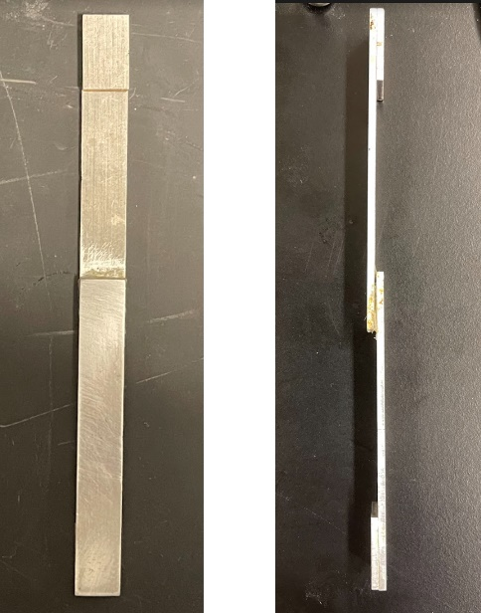
Figure 43. Photo of the front and side view of the lap shear test sample.

Figure 44. Lap shear test data of U-PDMS-SP4 (a) and scotch double-sided tape (b), the same specimen was tested four times.

Figure 45. (a) Photo of blue masking tape, post-it note, and U-PDMS-SP4 applied on aluminum surface for peel test. (b) Photo of U-PDMS-SP4 during the peel test on aluminum surface and aluminum surface after the removal of the U-PDMS-SP4. (c) Photo of blue masking tape, post-it note, and U-PDMS-SP4 applied on PTFE surface for peel test. (d) Side view of U-PDMS-SP4 during the lap shear test.

Conclusions
We developed a series of room temperature self-healable, mechanically tunable, puncture-resistant, and multi-cycle adhesive elastomers, which were successfully synthesized by scalable one-pot synthesis. Tuning the ratio of chemical and physical cross-links could tailor the mechanical properties of U-PDMS-SPs. The highly elastic U-PDMS-SP4 exhibited elongation-at-break over 500% and toughness of 0.6 MJ/m³ with 95.3% stress remaining after a hysteresis test of 10 cycles. Although U-PDMS-SP4 is considered a “soft” polymer due to relatively low tensile strength, its fast polymer dynamic enabled excellent room-temperature self-healing properties, exhibiting 24% of original strain recovery after being healed for only 2 minutes. After 16 hours of healing at room temperature, 90% of the original toughness was recovered. The U-PDMS-SP4 revealed excellent puncture-resistant properties, where it exhibited the highest displacement and comparable energy to puncture values compared with different types of commercial polymer films. The U-PDMS-SP4 further exhibited high displacement and maintenance of 95% adhesion energy after four cycles of lap shear tests. These designed self-healable polymers with high tunability, high elasticity, exceptional puncture resistance, and multi-cycle adhesion provide great potential for applications such as adhesive membranes, barrier membranes, self-healable coatings, or flexible devices with significantly improved lifetimes. For example, if the U-PDMS-SP is used as a self-healable adhesive for roofing shingles, it could be deployed at a wide temperature range simply by applying pressure, and its self-healability and puncture-resistance properties will minimize the damage against nails or the other physical objects during the installation process or over the course of life. The tunable design and versatility of the self-healing polymers in this study shed light on their wide usage in various applications, that require specific desirable functions such as puncture resistance or adhesion while providing a path for extended longevity of materials toward a sustainable society.

CHAPTER IV
WELL-TUNABLE, 3D-PRINTABLE, AND FAST AUTONOMOUS SELF-HEALING ELASTOMERS

A version of this chapter is submitted for publication by Bingrui Li, Sirui Ge, Xiao Zhao, Sheng Zhao, Qiyi Chen, Diana Hun, Alexei P. Sokolov, Tomonori Saito, and Peng-Fei Cao. “Well-Tunable, 3D-printable, and Fast Autonomous Self-Healing Elastomers” submitted to Macromolecules.

Bingrui Li conceived, performed experiments, and wrote the manuscript under the guidance of Peng-Fei Cao. Sirui Ge, Xiao Zhao, Sheng Zhao, Qiyi Chen contributed to experiments, Diana Hun and Alexei P. Sokolov provided discussions. Peng-Fei Cao and Tomonori Saito provided overall direction and supervision.

Abstract
Self-healing elastomers provide extended longevity of functional materials, due to their unique adaptability and durability. However, a major scientific challenge remains in developing materials with a rapid healing process combined with decent mechanical properties and a relatively simple synthesis approach. Herein, we report a versatile self-healing elastomer design by incorporating two different hydrogen bonding containing monomers, i.e., 2-[[(butylamino)carbonyl]oxy]ethyl acrylate (BCOE) and 2-ureido-4[1H]pyrimidinone (UPy) functionalized ethyl methacrylate. Poly(BCOE-r-UPy)s are synthesized by reversible addition−fragmentation chain-transfer (RAFT) polymerization, and controlling the ratio of two monomers enables well-tunable mechanical properties with tensile strength ranging from 0.04 to 6.3 MPa and tensile strain up to 3,000%. The characteristic dissociation energy is calculated from a temperature dependence of terminal relaxation followed by subtracting the segmental relaxation. The rapid autonomous self-healing is achieved when the molar composition of Poly(BCOE-r-UPy) is tailored to BCOE/UPy = 99/1. The self-healing process is monitored in situ by a helium-ion microscope, and its macroscopic study using tensile tests indicates that Poly(BCOE-r-UPy1) with 1% molar ratio of UPy recovers 70% of its original toughness at ambient temperature within 10 min. 3D printing of Poly(BCOE-r-UPy) affords a self-healable 3D structure, demonstrating the adaptability of Poly(BCOE-r-UPy) for on-demand fabrication. The chapter demonstrates how to utilize molecular design to obtain an optimum structure that facilitates fast room-temperature self-healing.

Introduction
The self-healing feature of human skin achieves restoration of functionalities within a few weeks, providing repeatable protection against injuries. Adopting the concept from nature, the integrated self-healability in synthetic polymers endows improved adaptability and longevity in various applications including coatings,²²³⁻²²⁵ electrodes,^{168,226,227} sensors,²²⁸⁻²³⁰ gas-separation membranes,^{36,231} and healable sealants,^{10,220} etc. There are two general approaches to achieve self-healability for polymeric materials. One approach typically introduces two reactive chemicals under physical confinement to the polymer matrix that could physically mix and react upon damage,²³² and the product of those rapid chemical reactions could seal the void.²³³ Although such an approach is more accessible due to its long development history, its key drawback is its one-time healing feature along with some concerns about the complexity of packaging, which requires optimum isolation between reactants. Another approach, where polymer materials rely on the dynamic reversible bonds and efficient chain dynamics internally, provides a distinctive advantage of repeated healing. Such design of self-healable polymers consists of a broad range of variables,^{195,196,234-236} including types of reversible covalent bonds such as Diels–Alder reaction,^{143,144} reversible disulfide bond,^{108,115} and boronic esters¹²² along with noncovalent bonds, such as metal-ligand coordination,⁹¹ ionic bond,²³⁷⁻²³⁹ and hydrogen bonding (H-bonding).^{34,36,115}
Stretchable materials provide good adaptability against mechanical deformation. Such high-performance stretchable materials enable the development of attachable devices, flexible electronics, personal protection devices as well as healable materials for building envelope.²⁴⁰ Integration of self-healing character to a stretchable material is especially beneficial since it could dramatically increase their ductility and reliability.^{10,36,136} The advancement of stretchable self-healing materials shows great potential under multiple scenarios such as conductive materials,^{151,241} sensing devices,^{242,243} coatings,²⁴⁴ supercapacitors,¹³⁴ sealants,¹⁰ and electronic skins,²⁴⁵ since self-healing materials could facilitate the recovery of functionalities by rebuilding physical contact between the damaged sections. Yet many reported materials still suffer from several drawbacks. Firstly, the low mechanical strength of most self-healing elastomers limits their utilization as a structural material.^{246,247} This is especially true for those autonomous self-healing elastomers that heal at ambient temperature, and their ultimate mechanical stress and modulus almost always reside in the range of kPa. On the other hand, mechanically robust self-healing elastomers typically require elevated temperatures or prolonged time at room temperature (RT) to achieve complete property recovery.^{98,223,248} Such trade-off between the rate of self-healing and mechanical strength deteriorates the product’s healing performance,¹⁹⁵ since temperature beyond ambient temperature may not be easily obtained in many scenarios, such as building roofs and sealants, aerospace, and deep-sea devices. Additionally, self-healing time is equally critical during the evaluation of self-healing polymers. Although many results demonstrated almost 100% property recovery in hours, polymers with adequate property recovery at less than 30 min of healing time are still rarely reported. Thus, developing a rapid, autonomous self-healable elastomer with improved mechanical performance is highly desirable for many applications.^{249,250}
Herein, we report a series of autonomous self-healable copolymer elastomers (ASCEs) with tunable mechanical properties via a facile copolymerization with monomers of different H-bond strengths, i.e., 2-[[(butylamino)carbonyl]oxy]ethyl acrylate (BCOE) and 2-(3-(6-methyl-4-oxo-1,4-dihydropyrimidin-2-yl)ureido)ethyl methacrylate (UPy). With abundant H-bonding units and fast segmental dynamics, the copolymer Poly(BCOE-r-UPy) exhibits rapid, autonomous self-healability at ambient temperature, i.e., recovery of 70% toughness in 10 min. The in-situ self-healing process of Poly(BCOE-r-UPy) is successfully visualized by a helium ion microscope at micrometer level. The self-healing kinetic and molecular-level healing mechanisms are revealed by tensile test and broadband dielectric spectroscopy, respectively. In addition, the additive manufacturing of Poly(BCOE-r-UPy) to 3D objects is also conducted, and rapid self-healing of the damaged printed objects is demonstrated.
Experimental
Materials
All monomers and other chemicals were purchased from Sigma-Aldrich, the monomers were purified by passing a column containing 6 layers of alternating stacked inhibitor remover and basic Al₂O₃ powder.
Polymer Synthesis
Synthesis of MPA-UPy
A flame-dried 100 mL round bottom flask with a magnetic stir bar was utilized, 54.80 g (0.35 mol) of 2-isocyanatoethyl methacrylate (contains ≤ 0.1% BHT as inhibitor), 40.18 g (0.32 mol) of 2-amino-4-hydroxy-6-methylpyrimidine, and 30 mL of anhydrous dimethyl sulfoxide were added into the flask. The round bottom flask was sealed by a rubber stopper and was purged with continuous N₂ flow during the reaction. The flask was submerged into a 140 °C oil bath for 25 minutes. After the reaction was completed, 100 mL of methanol was added into the flask, white solid-like precipitants were obtained. The white solid was collected and washed by 50 mL of methanol three times. The final product was obtained and dried under vacuum at 85 °C to remove all solvents.
Synthesis of the Poly(BCOE-r-UPy)
The inhibitors in the 2-[[(Butylamino)carbonyl]oxy]ethyl acrylate monomer was removed by passing the monomer through a basic Al₂O₃/inhibitor remover mixed column prior to the polymerization. Detailed synthesis procedures of PBCOE-MPAU1 is shown below as example: a flame-dried 100 mL Schlenk tube with a magnetic stir bar was utilized, 44.75 mg (0.188 mmol) 2-(Butylthiocarbonothioylthio)propanoic acid, 10.0 g (46.46 mmol) of 2-[[(Butylamino)carbonyl]oxy]ethyl acrylate, 131.73 mg (0.47 mmol) of MPA-UPy, and 7.70 mg (0.047 mmol) of recrystallized azobisisobutyronitrile were added into the tube followed by 30 mL of anhydrous dimethylformamide (DMF). The tube was sealed by a rubber stopper and N₂ was purged for 30 mins to remove the air inside the tube. Then, under continuous N₂ flow, the tube was submerged in a 65 °C oil bath for 24 hours. After the reaction was completed, the polymer was precipitated into 300 mL of water in a 500 mL beaker under stirring. The yellow solid was collected and dissolved by 50 mL of ethyl acetate. Then the solution was precipitated into 300 mL of diethyl ether, this procedure was repeated for an additional cycle. After the complete removal of monomers by dialysis, the final product was obtained and dried under vacuum at 85 °C to remove all solvents.
Polymer Characterizations
General Characterizations
¹H Nuclear magnetic resonance (NMR) spectra were recorded on a Bruker 400 MHz NMR spectrometer using CDCl₃. Infrared (IR) spectra were obtained from a Nicolet iS50 FT-IR spectrometer (Thermo Scientific), and the scanning range was 4000 - 400 cm⁻¹. Approximately 10 mg of each sample was weighted out to test on TGA Q50, TA Instrument. The samples were heated up to 800 °C from room-temperature at a heating rate of 20 °C/ min under a dry nitrogen atmosphere (flow rate: 40 mL/min). Thermal transitions of polymers were studied using modulated DSC (TA DSC 2500). The heating procedure was set to modulate +/- 1.00 °C every 60 seconds at the rate of 3 °C/min from − 30 to 150 °C.
Tensile analysis
Rectangular stripes prepared by melt-press at 160 °C, and films were cut into approximately (7.0 × 5.0 × 0.5) mm specimens for tensile analysis using an Instron 3343 Universal Testing System with 50 N load cell. Samples were elongated at the rate of 1 mm/s till break. The reported tensile properties were an average of a minimum of three samples. Hysteresis tests were conducted on a TA instrument DMA850 with similar sample specimens above. The sample was first elongated to 100% strain and then compressed to 0% strain at the same rate, 10 cycles were performed at the rate of 1 mm/s under ambient conditions.
Rheology measurement
Small-amplitude oscillatory shear (SAOS) measurements of membrane samples were carried out on an AR2000ex rheometer (TA Instruments) with an angular frequency range from 10⁻¹ to 10² rad/s using parallel plate geometry with a disk diameter of 4 mm. The temperature was controlled by an environmental test chamber filled with nitrogen. Prior to measurements, the sample was purged at 100 °C for 0.5 h under a nitrogen atmosphere to ensure thermal equilibrium was achieved. The samples were measured at a variety of temperatures ranging from T_{g} to 100 °C. The strain amplitude during the measurement was chosen to be in the range from 0.03% to 5% depending on the modulus level at different temperatures.
Dielectric measurement
Broadband Dielectric Spectroscopy (BDS) in the frequency range from 10⁻² to 10⁶ Hz were measured utilizing a Novocontrol system that includes an Alpha-A impedance analyzer and a Quatro Cryosystem temperature control unit. All samples were placed into a parallel plate dielectric cell made of sapphire and invar steel with an electrode diameter of 10 mm, and capacitance 3.3 pF with an electrode separation of 210 μm. The measurement started 10 K below the T_{g}. All the spectra were measured on heating. After each temperature increase, the samples were equilibrated for 10 min to reach thermal stabilization within 0.1 K.
Fittings of dielectric data
The $ε^{''}$ spectra were fit using one Havriliak-Ngami (HN) function plus conductivity, i.e.,
$ε^{''}\left(υ\right)=-Im\left\{\frac{Δε}{{\left[1+{\left(2πiυτ\right)}^{α}\right]}^{γ}}\right\}+\frac{σ}{2πυε_{0}}$ (1)
Here $Δε$ denotes the dielectric strength and $α$ and $γ$ are the shape parameters. $ε_{0}$ indicates the vacuum permittivity, σ indicates the conductivity, and $τ$ is HN relaxation time which is related to the relaxation time at the loss maximum ($τ_{max}$):
$τ_{max}=τ{\left[\sin\left(\frac{απ}{2+2γ}\right)\right]}^{-\frac{1}{α}}{\left[\sin\left(\frac{αγπ}{2+2γ}\right)\right]}^{\frac{1}{α}}$ (2)
$τ_{max}$ is widely used as the characteristic relaxation time in polymeric materials.

Results and Discussion

Synthesis of Self-healing Elastomers
Poly(2-[[(butylamino)carbonyl]oxy]ethyl acrylate) (Poly(BCOE)) is selected as the major polymer composition due to their weak and abundant hydrogen bonding, good thermal/chemical stability and sub-ambient glass-transition temperature (T_{g} ~ -3 ºC).¹⁰ The low T_{g} of the obtained elastomers is important to enable fast chain mobility and maintain self-healing performance. A monomer with quadruple H-bonds, i.e., 2-(3-(6-methyl-4-oxo-1,4-dihydropyrimidin-2-yl)ureido)ethyl methacrylate (MPA-UPy, Figure 46), is synthesized for copolymerization with BCOE, and its chemical structure is confirmed by ¹H nuclear magnetic resonance (¹H NMR) spectroscopy (Figure 47a).²⁵¹ As shown in Figure 46, monomers with different H-bonding strengths, BCOE and MPA-UPy, are copolymerized at different molar ratios, i.e., 100:0, 99:1, 95:5, and 90:10. Herein, the ASCEs are distinguished by the molar percentages of MPA-UPy in the copolymer. For example, Poly(BCOE-r-UPy5) indicates that BCOE is copolymerized with MPA-UPy at a molar ratio of 95:5.
As illustrated by the ¹H NMR spectrum of Poly(BCOE-r-UPy5), the characteristic peaks d and j in Figure 48a reveal the presence of both BCOE and MPA-UPy units, demonstrating a successful copolymerization process. The comparative integrations of peaks e and j are also utilized to determine the molar ratio of two monomer units in the obtained ASCE. As seen in Figure 48a, the ratio between peak e and j is 100:5, comparable with the feed ratio between BCOE and MPA-UPy of 95:5. The peak at 3388 cm⁻¹ in the attenuated total reflection Fourier-transform infrared (ATR-FTIR) spectra reflects the N−H stretching in the polymer, and the peak between 3000-2840 cm⁻¹ is the characteristic peak of C-H stretching.
Figure 46. (a) Synthesis of room-temperature self-healable random copolymer Poly(BCOE-r-UPy)s. (b) Demonstration of the simplified structure and H-bonding interactions of Poly(BCOE-r-UPy). (c) Self-healing process of Poly(BCOE-r-UPy).

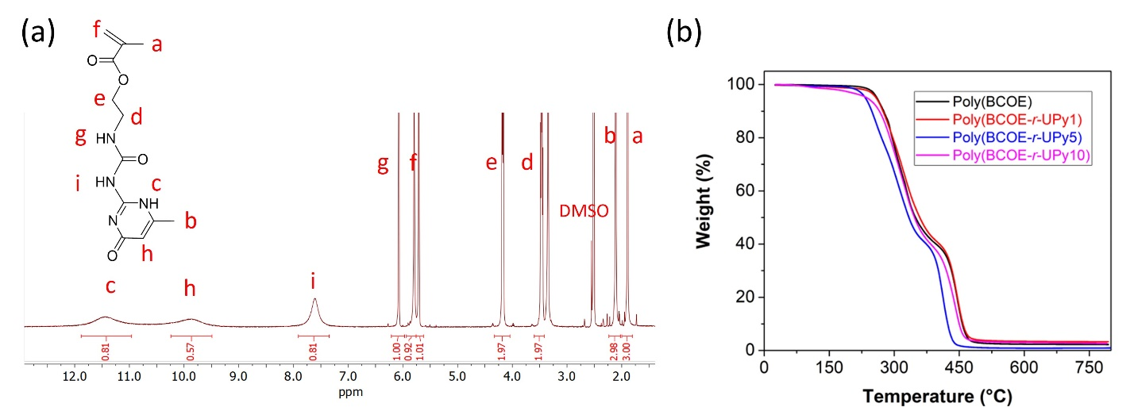
Figure 47. (a) ¹H NMR spectrum of MPA-UPy. (b) TGA data of Poly(BCOE), Poly(BCOE-r-UPy1), Poly(BCOE-r-UPy5), and Poly(BCOE-r-UPy10).
The peak at 1740-1625 cm⁻¹ is attributed to UPy’s urea carbonyl group, while the peak at 1570 cm⁻¹ is associated with C–N–H bending and C–N stretching of the amide II (1470–1570 cm⁻¹) band.^{252,253}
All of the Poly(BCOE-r-UPy) copolymers exhibit good thermal stability with less than 5% weight loss until 230 °C, as illustrated by the thermogravimetric analysis (TGA) (see Figure 47b). It is worth noting that the thermal stability of copolymers decreases slightly with an increased molar ratio of MPA-UPy, and the degradation temperature of Poly(BCOE-r-UPy10), which has the most UPy moiety among Poly(BCOE-r-UPy) copolymers, is comparable to the reported similar system.²⁵⁴ As illustrated by the differential scanning calorimetry (DSC) data in Figure 48c, all samples show a single glass transition temperature (T_{g}) ranging from -2.4 °C to 21.7 °C. Their low T_{g} values indicate high chain mobility at ambient temperature, benefiting autonomous self-healing capability along with stretchability. A higher concentration of MPA-UPy units renders the increase of T_{g} due to the higher density of quadruple H-bonds by UPy moieties that has significantly higher bond dissociation energy than typical H-bonding units (about 37.5 kJ mol⁻¹ for quadruple H-bonds in UPy vs. < 15 kJ mol⁻¹ for single hydrogen bonds).^{255,256} The increase in T_{g} is roughly proportional to the fraction of UPy units (Figure 48c), in agreement with the predictions of recent theoretical work on the role of stickers in associating polymers.⁷⁰ Moreover, showing no peak in the SAXS data (Figure 48d) indicates the absence of significant phase separation in all of the Poly(BCOE-r-UPy) samples.²⁵⁷ This is consistent with the absence of a second T_{g} in the DSC data (Figure 48c).

Mechanical Properties Evaluations
During the rheology tests, the storage modulus (G') and loss modulus (G") were measured with a frequency sweep applied to the samples. The master curves are obtained by combining the data at different temperatures using the temperature-frequency superposition (Figure 49a) with the reference temperature of 298 K (25 °C). Without UPy units, the Poly(BCOE) exhibits a usual solid-like behavior with G' higher than G" at higher frequencies, whereas it exhibits liquid-like behavior with G' lower than G" at lower frequencies. With the incorporation of UPy moiety, G" and G' spectra shift to lower frequency due to slower segmental dynamics, and a rubbery plateau develops due to the appearance of temporal UPy crosslinks (Figure 49a). The level of rubbery plateau G'_{r} could be utilized to calculate the cross-link density via the following equation²⁵⁸
$c_{x}=\frac{2{G'}_{r}}{3RT }=\frac{2ρ}{{3M}_{x}}$
where c_{x} is the moles of cross-links per volume (Figure 49a), R is the gas constant, T is the temperature in Kelvin, ρ is polymer density, and M_{x} is the number-average molecular weight between the cross-links. The calculated crosslink density C_{x} and M_{x} of Poly(BCOE-r-UPy5) and Poly(BCOE-r-UPy10) are listed in Table 6.

Figure 48. (a) ¹H NMR data of Poly(BCOE-r-UPy5). (b) ATR-FTIR spectra of Poly(BCOE-r-UPy)s with different molar ratios of MPA-UPy. (c) DSC data of Poly(BCOE-r-UPy)s. (d) Combined SAXS/WAXS spectra of Poly(BCOE) and Poly(BCOE-r-UPy)s with different molar ratios of MPA-UPy.

Table 5. Combined physical properties of Poly(BCOE) and Poly(BCOE-r-UPy)s.

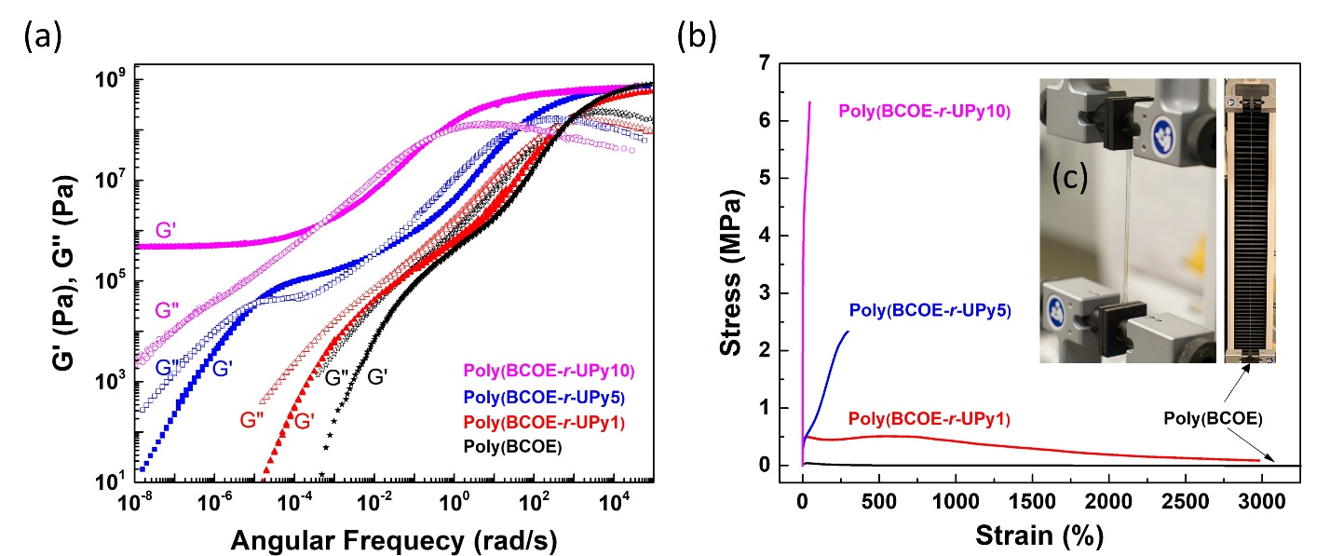
Figure 49. (a) Storage modulus (G', closed symbols) and loss modulus (G", open symbols) (reference temperature = 25 °C) of Poly(BCOE) and Poly(BCOE-r-UPy)s. (b) Tensile data of Poly(BCOE) and Poly(BCOE-r-UPy)s. (c) Photo of Poly(BCOE) during tensile test (>3,000% tensile strain).

Table 6. The molar ratio between CTA and each monomer, calculated molecular weight (based on RAFT polymerization), G', C_{x}, and C_{x} of Poly(BCOE) and Poly(BCOE-r-UPy)s.

Tensile tests of Poly(BCOE-r-UPy)s were performed by testing the dog-bone-shaped specimens following the ASTM D1708 method. As seen in Figure 2b, with an increase in MPA-UPy moiety ratio, the Poly(BCOE-r-UPy)s exhibit higher Young’s modulus and ultimate tensile stress while reducing the elongation-at-break. Consistent with the rheology result, Poly(BCOE) is extremely soft and ductile with Young’s modulus of only 300 Pa and elongation-at-break over 5,000%. With increased UPy fraction from 1 mol% to 10 mol%, Young’s modulus of Poly(BCOE-r-UPy)s increases from 0.3 MPa to 33.2 MPa (Table 5). The increase in Young’s modulus is contributed by the increase in crosslink density through more UPy units, and by slowing down of segmental relaxation (higher T_{g}, Table 5). Also, the reduced extensibility can be explained by the increased UPy moiety, rendering higher crosslink density with a slower bond rearrangement. Compared with H-bonding groups in BCOE units, the UPy bonds have higher resistance to dissociate and rearrangements due to their higher activation energy.²⁵⁹ Thus, a trade-off between the ultimate tensile stress, Young’s modulus, and elongation-at-break is observed for Poly(BCOE-r-UPy)s. For example, Poly(BCOE-r-UPy10) exhibits high rigidity and relatively low extensibility with Young’s modulus of 33 MPa, and elongation-at-break of 49.6%. The overall toughness of Poly(BCOE-r-UPy)s is not linearly related to the MPA-UPy ratio, and poly(BCOE-r-UPy1) exhibits the highest toughness of 9.0 MJ/m³. The mechanical properties of Poly(BCOE-r-UPy)s could be well-tuned to satisfy different demands by simple control of their composition by tailoring the feed ratio of MPA-UPy over BCOE.

Self-healing Performance
Since both BCOE and MPA-UPy units contain H-bonding and each individual component of the copolymer has been examined to possess self-healing properties,^{10,246,260} it is predictable that these polymers could undergo a self-healing process at certain conditions. During the mechanical testing, we observed that all samples showed some elastic recovery behavior during elongation process. The hysteresis data of Poly(BCOE-r-UPy5) also demonstrates 55% of remaining tensile stress after 10 successive loading-unloading cycles (see Figure 52). Considering the previous demonstration that cross-linked elastomer after local rupture could return to its initial equilibrium shape to facilitate self-healing process,^{74,261} we anticipate such elastic recovery behavior may also affect the self-healing properties of Poly(BCOE-r-UPy)s. The elastic recovery at ambient temperature is primarily contributed by the UPy moieties that introduce strong physical cross-links to the system, which is consistent with previous statement that stronger dynamic bonds is more responsible for elastic recovery at low strain values.^{201,262} An optical microscope was first utilized to examine the healing capability of Poly(BCOE-r-UPy)s. As illustrated in Figure 50a, the deep razor blade cut on Poly(BCOE-r-UPy1) sample was completely repaired after one day at room temperature (20 °C), demonstrating its rapid room-temperature self-healability. To compare the healing behavior between Poly(BCOE) and Poly(BCOE-r-UPy1), a razor blade was utilized to apply damage on the sample surfaces as shown in Figure 50b. The razor blade cut on Poly(BCOE-r-UPy1) almost diminishes after 5-minute healing at 30 °C, while the scratch remains with smoothed edges for sample Poly(BCOE), indicating a superior healing efficiency of Poly(BCOE-r-UPy1).
Helium ion microscope (HIM) is an imaging technology utilizing a scanning helium ion beam,^{263,264} and herein, it is utilized to conduct the in situ observation of the self-healing process of Poly(BCOE-r-UPy1). As illustrated in Figure 50c, a 15 μm × 30 μm cut was made by a razor blade on Poly(BCOE-r-UPy1) film, whose healing process is monitored continuously. The sample showed significant healing progress after 15 min, and the void disappeared completely in 60 minutes. The utilization of HIM to continuously monitor the self-healing process of elastic polymers at the micro-scale provided high-resolution tracking. Overall, Poly(BCOE-r-UPy1) is self-healable towards physical scratch with a scale from 15 μm to 1 cm within 15 min at ambient temperature.
Quantitative analysis of self-healing kinetics is conducted by comparing the tensile properties between the pristine sample and healed sample at different healing times. The mechanical properties evaluations were all performed at ambient temperature for fair comparison even for those examples healed at elevated temperatures.^{34,116} At room temperature, 18 h is required to obtain fully recovered mechanical properties, including Young’s modulus, elongation-at-break, ultimate tensile strength, and toughness (see Figure 51a). The self-healing kinetics of Poly(BCOE-r-UPy1) and Poly(BCOE-r-UPy5) are studied by calculating their comparative toughness with pristine samples, and a recovery percentage is obtained for each sample at different healing times (see Figure 51b). Poly(BCOE-r-UPy1) outperforms Poly(BCOE-r-UPy5) in terms of the healing efficiency at 20 °C: Poly(BCOE-r-UPy1) achieves more than 95% healing efficiency after 18 h, while Poly(BCOE-r-UPy5) achieves only 60% healing efficiency with the same time length. With much higher activation energy than single H-bonding units,²⁵⁹ UPy crosslinks require more energy and time to dissociate and rearrange. We also examined the self-healing properties of Poly(BCOE-r-UPy1) at 40 °C to unravel the healing properties at elevated temperatures. We discovered that Poly(BCOE-r-UPy1) recovered nearly 90% of its original toughness after 30 mins of healing (Figure 54), which has been significantly accelerated by faster segmental dynamics and UPy-bonds rearrangements. We noticed that although over 90% of the toughness was recovered after 30 mins of healing, the tensile strength and modulus were not fully recovered, the reason that while the healing was conducted at 40 °C, the tensile testing was still conducted at 20 °C immediately after healing due to instrumental limitation, thus, the residual heat introduced a softening effect to the mechanical properties. The sample with a higher concentration of UPy contents such as Poly(BCOE-r-UPy5) requires more time for mechanical recovery. Moreover, due to higher T_{g}, the segmental dynamics of Poly(BCOE-r-UPy5) at RT are significantly slower than that of Poly(BCOE-r-UPy1), also contributing to a slower self-healing rate at room temperature. Another aspect to interpret the self-healing behavior is to compare their flowability.

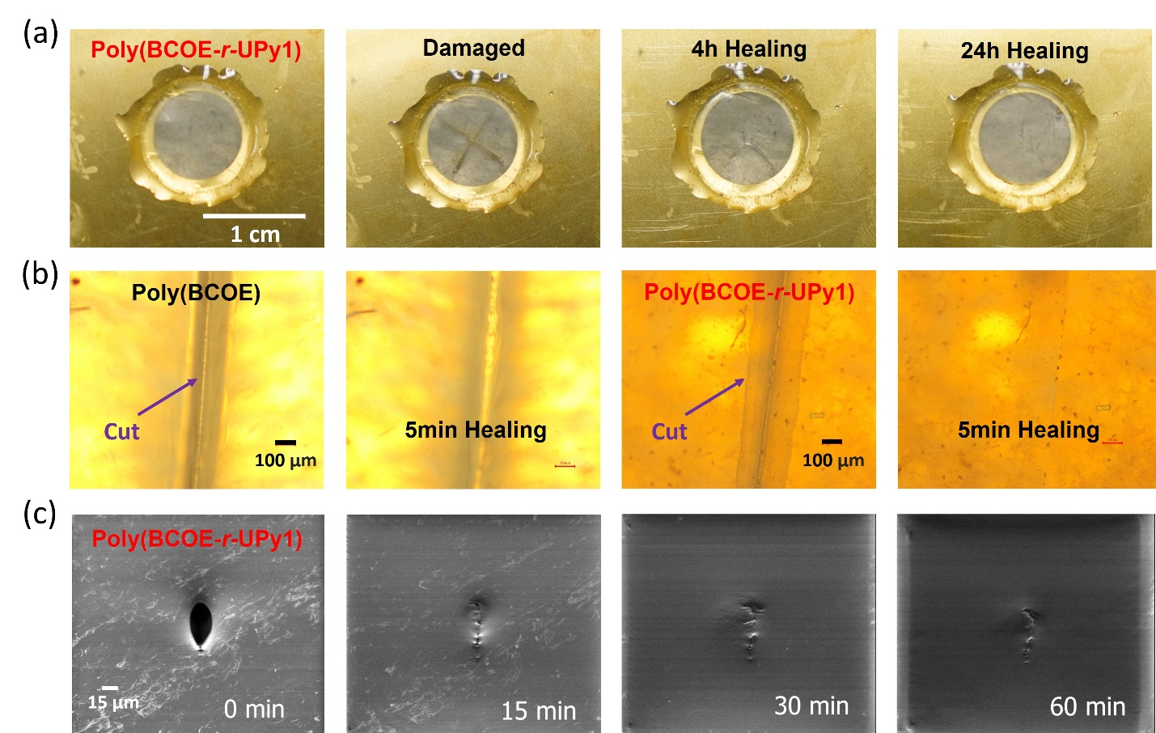
Figure 50. (a) Photograph of damaged and healed (4h, 24h) Poly(BCOE-r-UPy1) sample at 20 °C. (b) Optical microscope images demonstrating the healing process of Poly(BCOE) and Poly(BCOE-r-UPy1) against cut by a razor blade. (c) Helium-ion microscope images, demonstrating the healing process of Poly(BCOE-r-UPy1) against cut by a razor blade.

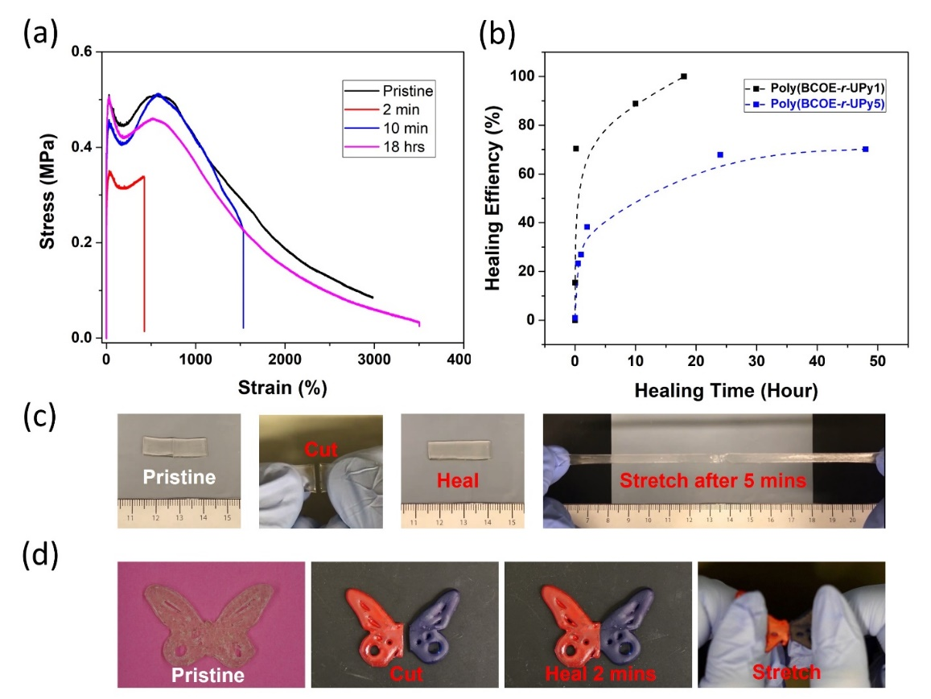
Figure 51. (a) Tensile data of Poly(BCOE-r-UPy1) and cut sample with different healing time. (b) Healing efficiency of Poly(BCOE-r-UPy1) and Poly(BCOE-r-UPy5) at different healing time. (c) Photo demonstration of self-healability of Poly(BCOE-r-UPy1) at room temperature. (d) Pictures showing the healing process of 3D-printed Poly(BCOE-r-UPy5) sample.

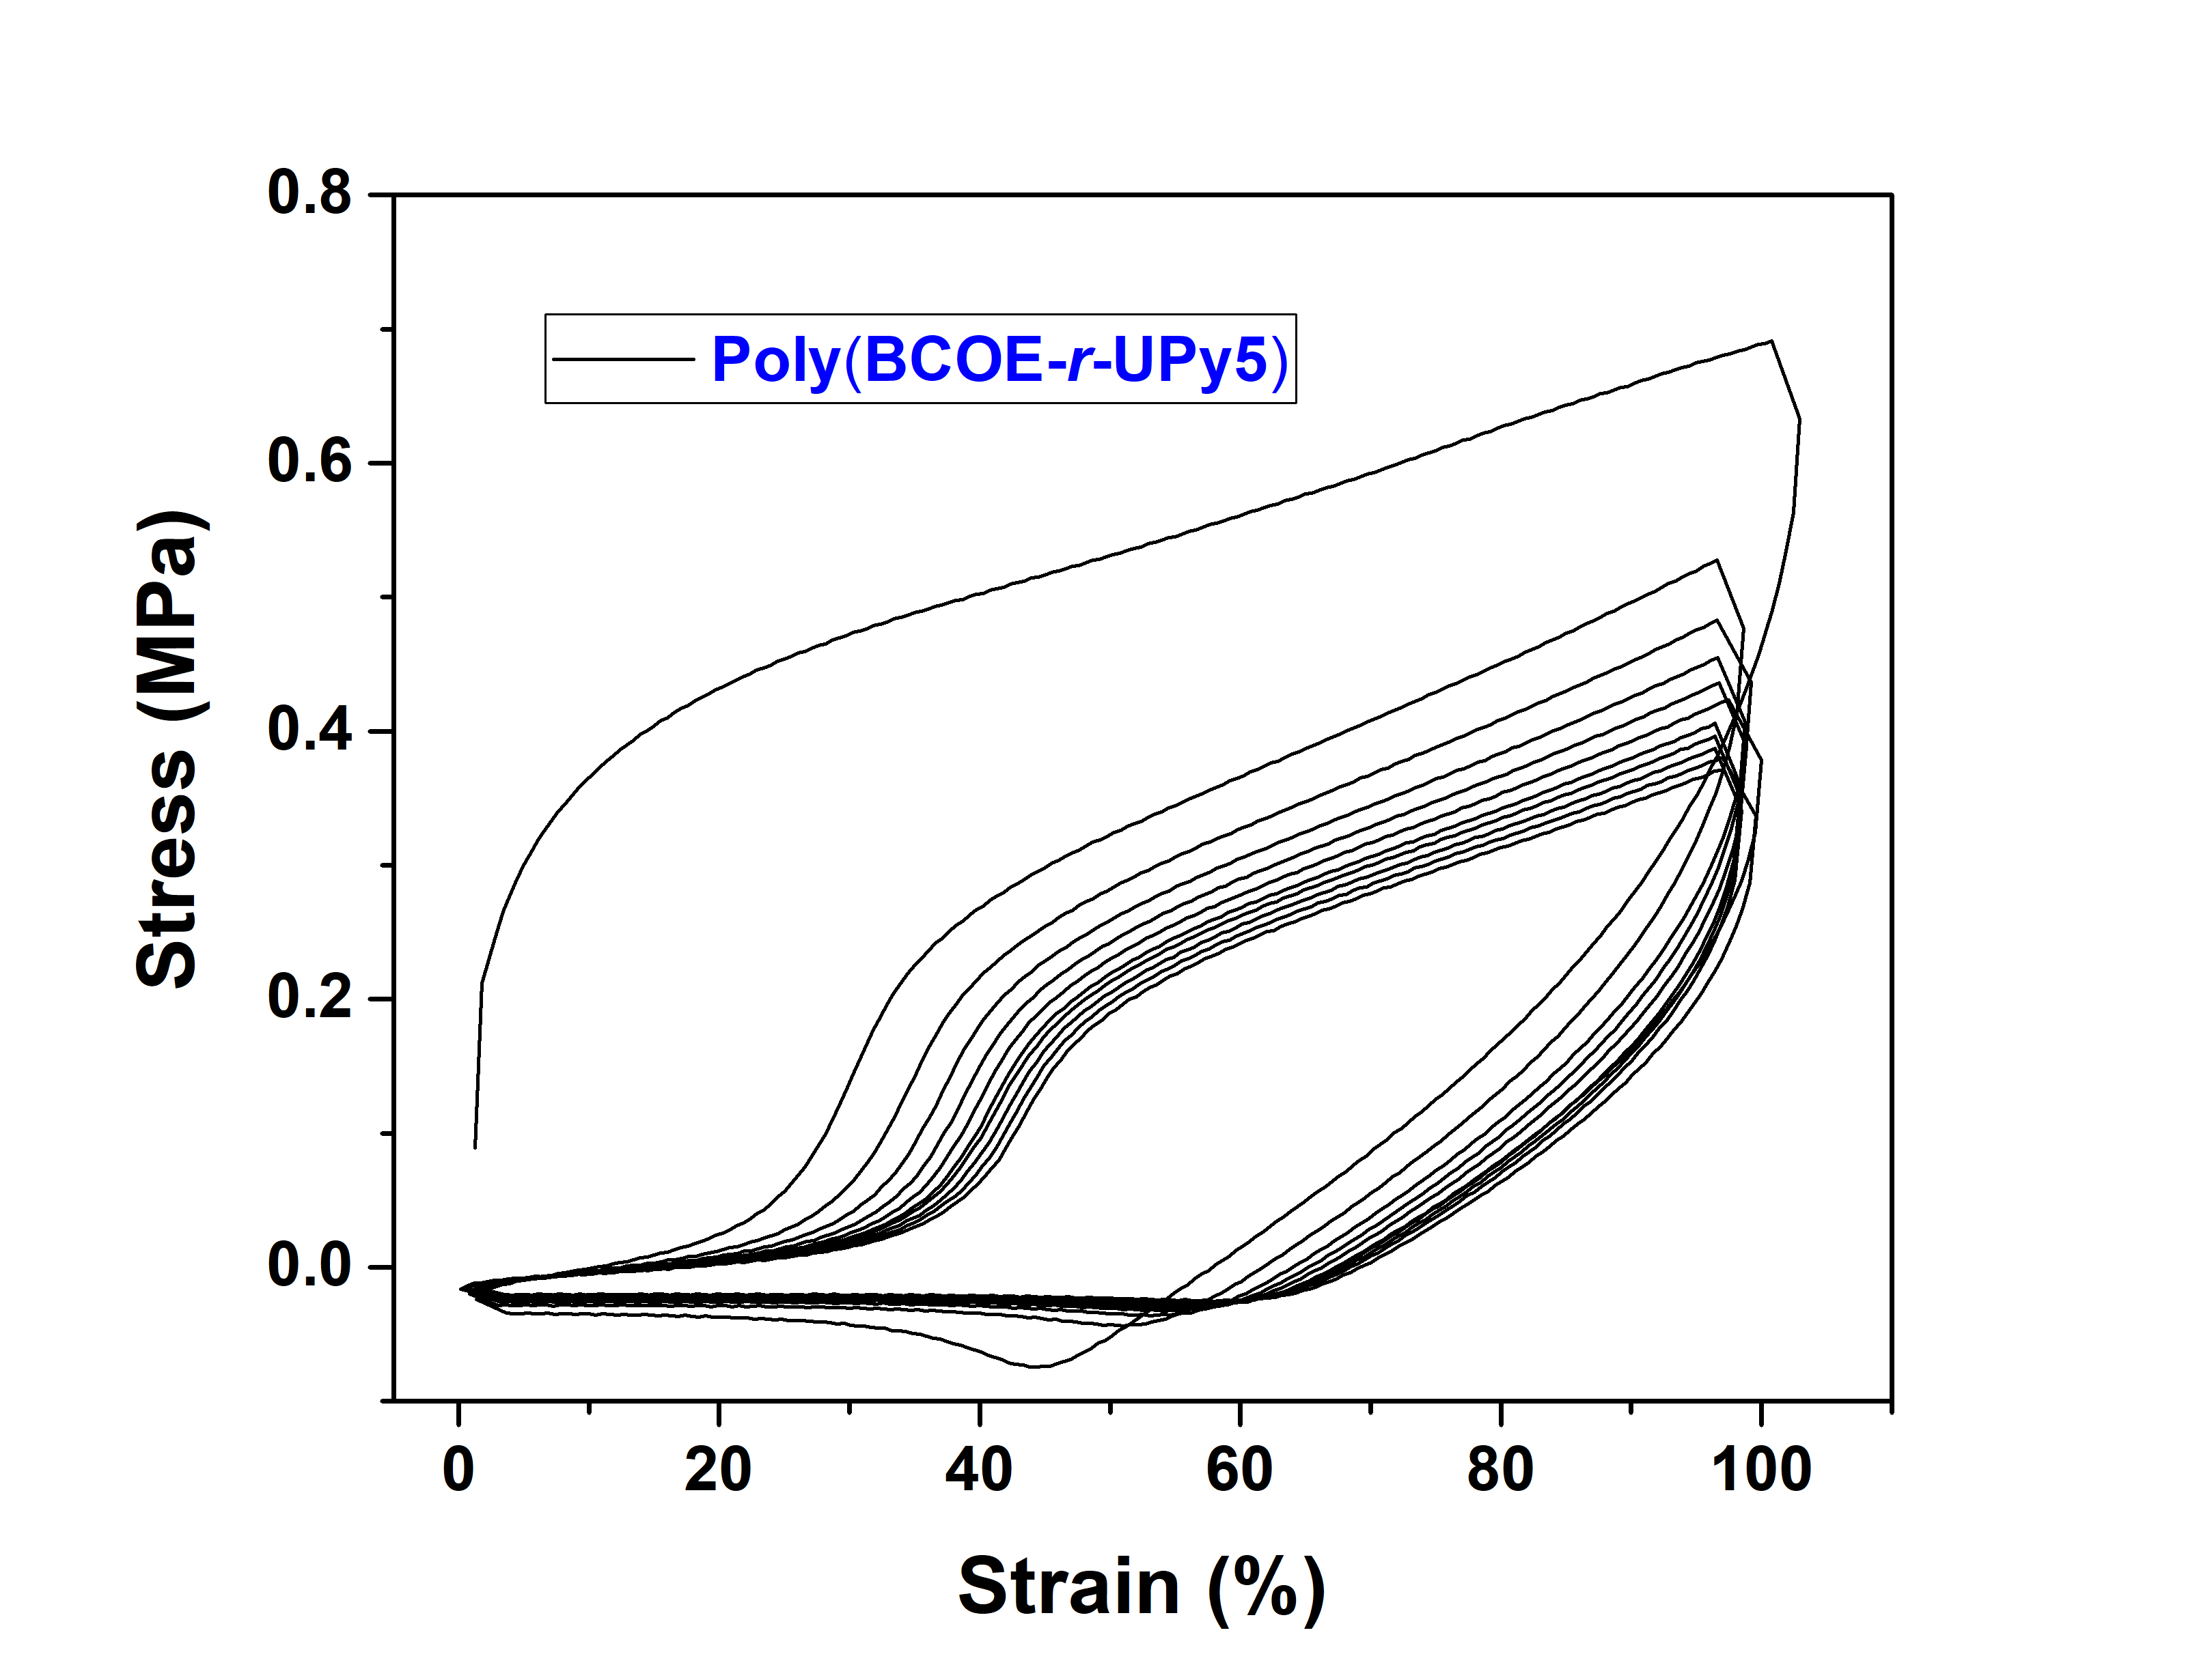
Figure 52. Room-temperature hysteresis test data of Poly(BCOE-r-UPy5) after 10 cycles at the rate of 1 mm/s.

Figure 53. (a) Comparison of the toughness recovery percentage and healing time of the Poly(BCOE-r-UPy1) with recently reported self-healable polymers. (1, ref. [34]; 2, ref. [116]; 3, ref. [98]; 4, ref. [136]; 5, ref. [241]; 6, ref. [269]). (b) Healing properties of Poly(BCOE-r-UPy1) at 313 K compared with other self-healing polymers.¹⁹⁵

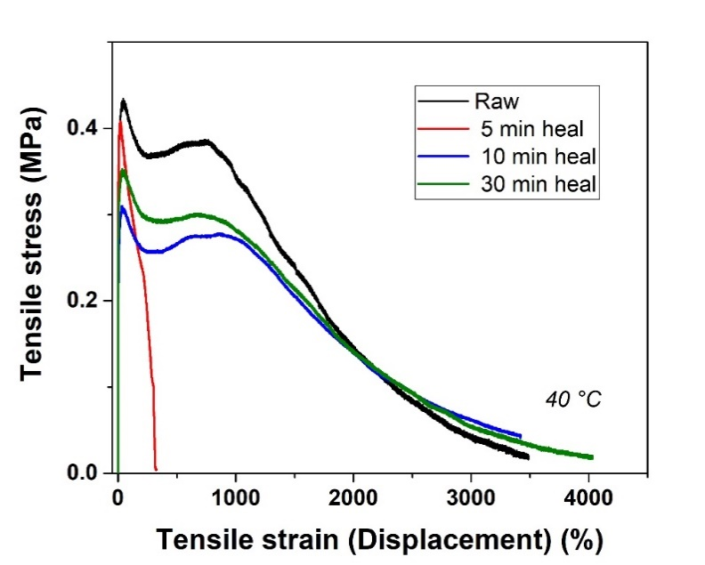
Figure 54. Tensile properties recovery of Poly(BCOE-r-UPy1) sample under different healing times at 40 °C.
As seen in Figure 49a, the terminal relaxation time differs ~1000 times between UPy1 and UPy5 systems, indicating a significantly higher flowability of Poly(BCOE-r-UPy1). At 20 °C, the Poly(BCOE-r-UPy1) exhibits superior self-healing performance than Poly(BCOE-r-UPy5) and Poly(BCOE-r-UPy10), because Poly(BCOE-r-UPy1) is below the gel point, while the Poly(BCOE-r-UPy5) and Poly(BCOE-r-UPy10) are above the gel point. The high flowability of Poly(BCOE-r-UPy1) enables such room-temperature self-healing performance. For Poly(BCOE-r-UPy5) and poly(BCOE-r-UPy10), since the polymer segments could not move sufficiently, they do not self-heal well at 20 °C. Higher flowability of the polymer has significant impact on the self-healing kinetics (Figure. 4b). Therefore, 70% recovery in Poly(BCOE-r-UPy1) is achieved and ~500 times faster than in Poly(BCOE-r-UPy5), which agrees with the comparative terminal relaxation time of these samples (~ 3 orders difference, Figure 49a). Aside from flowability of polymer chain, construction of efficient supramolecular network via addition of UPy moiety is also vital for self-healability considering the fact that the Poly(BCOE-r-UPy1) shows superior self-healability than Poly(BCOE).²⁶⁵ The self-dimerization of UPy occurs easily with a dimerization constant up to the level of 10⁷ M^{–1}.^{259,266,267} Such high association constant facilitates the healing process.^{213,268} By tuning the moiety ratio of UPy moieties that affects T_{g}, we obtained the samples with balanced self-healing ability and mechanical performance, i.e., Poly(BCOE-r-UPy1) and Poly(BCOE-r-UPy5).
The toughness recovery (%) against time (mins) of Poly(BCOE-r-UPy1) is compared with other reported self-healable polymers based on H-bonds (Figure 53).^{34,98,116,136,241,269} For example, Leibler and coworkers developed a self-healing elastomer with room-temperature healability, and it recovered 5.3% of original toughness in 15 minutes of healing and achieved almost full recovery after 3-hour healing.³⁴ Our Poly(BCOE-r-UPy1) exhibits exceptionally fast self-healing capability with more than 70% toughness recovery in 10 min, outperforming a series of recently reported H-bonding facilitated self-healable polymers that typically require 4-24 hours for 70% of toughness recovery at room temperature. This suggests that, in terms of healing efficiency, Poly(BCOE-r-UPy1) is one of the fastest H-bonding facilitated autonomous self-healable polymers. We also compared the healing properties of Poly(BCOE-r-UPy)s with other healable polymers in a log–log plot with over 90% of mechanical recovery.¹⁹⁵ As illustrated in Figure 53b, Poly(BCOE-r-UPy1) exhibits good balance between the tensile strength and healing rate, which is comparable or superior to other state-of-the-art (blue trend line) self-healing materials.
Additive manufacturing (AM) is an emerging technique due to its multiple advantages over traditional subtractive manufacturing such as computer numerical control (CNC) machining, customized on-demand manufacturing in a rapid manner from the design to finish as well as less waste. One of the most developed AM techniques is fused deposition modeling (FDM), where thermoplastics such as acrylonitrile butadiene styrene (ABS) and polylactic acid (PLA) are melted and extruded to obtain target objects.²⁷⁰ AM of dynamically crosslinked polymers is an emerging concept due to their mechanical robustness, solvent resistance, good recyclability, and self-healability.^{62,271-273} To investigate the potentials on printing a self-healable 3D object, we utilized Poly(BCOE-r-UPy5) for AM due to its good mechanical strength (ultimate tensile strength, 2.55 MPa) as well as high extensibility (strain, 232%) and flow behavior at high temperature. As shown in Figure 51d, an AM process is demonstrated with a butterfly-shaped product on the surface in a commercially available 3D printer. The completely cut sample exhibits a self-healing character after a 5-minute healing process at room temperature. The printing result indicates that the Poly(BCOE-r-UPy5) fits the criteria of FDM feed materials, which can be utilized in multiple 3D printing scenarios. The demonstration of FDM on readily self-healable elastomers sheds light on custom-designed intricate 3D objects possessing self-healing capability. With the characteristics demonstrated above, we anticipate this Poly(BCOE-r-UPy) copolymer could be well utilized as a sealant against water leakage, as it fits the criteria of room-temperature healability and fast mechanical recovery. A demonstration of such capabilities is shown in Figure 57, the Poly(BCOE-r-UPy1) sample healed for only 5 mins and exhibits similar sealing and protecting nature against the water droplet as the pristine sample.

Dynamic Studies for Self-healing Mechanism
The self-healing process is enabled by the formation of a bridge through reversible dynamic bonds across the interface of fracture, and such a process requires the transient network rearrangement with timescale controlled by the bond dissociation energy. Thus, it is of paramount importance to estimate and understand microscopic dynamics, i.e., how dynamic bond dissociation and its energy barrier result in the network rearrangement. When estimating bond dissociation energy, it is imperative to consider the segmental dynamics which provides the prerequisite for bond rearrangement.^{56,274} Thus, broadband dielectric spectroscopy (BDS) was employed to study the segmental dynamics of the Poly(BCOE-r-UPy5) as an example. Only one relaxation process was observed in the dielectric loss ($ε^{''}$) spectra, followed by the conductivity contribution at lower frequencies (Figure 55a). The fitting method is described in SI. The eq. S1 describes the spectra well, and example of the fit of $ε"$ spectra is shown in Figure 56. The so obtained $τ_{max}(T)$ was fit to the VFT equation,
$τ_{max}(T)=τ_{0}exp⁡(\frac{B}{T-T_{0}})$ (2)
in which $τ_{0}$, $B$ and $T_{0}$ are 3 free fit parameters. The temperature at which extrapolated $τ_{max}(T)$ reaches 100 s, agrees well with T_{g} measured by DSC, indicating that the measured dielectric process results from the segmental motion, i.e., α relaxation process.
The terminal relaxation time ($τ_{C}$) indicating network rearrangement is acquired from the crossover of G' and G" in the master curve of shear modulus (Figure 49a). The temperature dependence of $τ_{C}\left(T\right)$ was acquired in the limited temperature range when the crossover was in the measurable frequency window, still using time-temperature superposition (TTS) for higher accuracy.

Figure 55. (a) $ε_{der}$ for Poly(BCOE-r-UPy5). (b) Activation plot of Poly(BCOE-r-UPy5) with $τ_{α}$and $τ_{C}$.

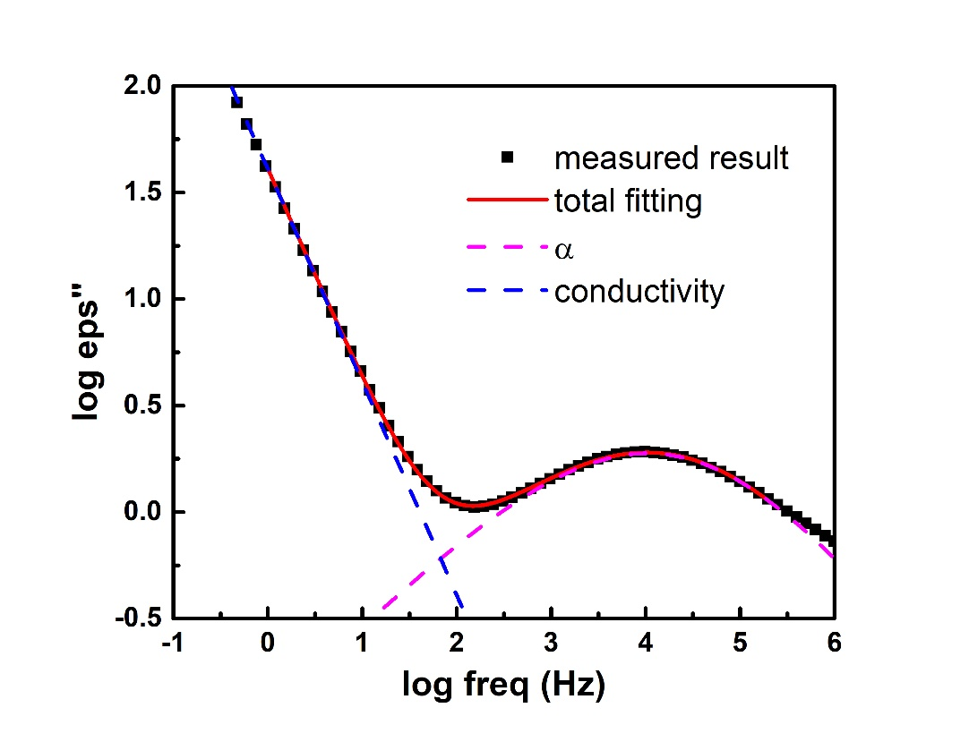
Figure 56. Fitting of BDS spectra of Poly(BCOE-r-UPy5) sample.

Figure 57. Photo of (a) Poly(BCOE-r-UPy1) sample in pristine (bottom) and healed for 5 mins after complete cut (top) conditions. (b) Dye droplet applied to Poly(BCOE-r-UPy1) samples. (c) Side view focused on the pristine sample with dye droplet. (d) Side view focused on the healing sample with dye droplet.

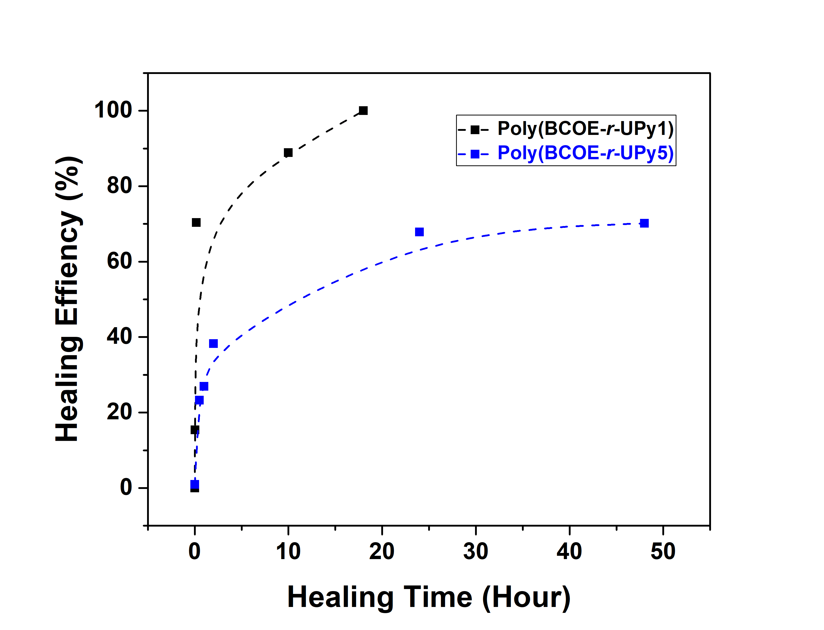
Figure 58. Healing efficiency of Poly(BCOE-r-UPy1) and Poly(BCOE-r-UPy5) at different healing times (linear scale).

To estimate the bond dissociation energy, $τ_{C}\left(T\right)$ was analyzed through the following equation by considering segmental $τ_{α}\left(T\right)$ as a pre-factor⁷⁷:
$τ_{C}\left(T\right)=τ_{α}\left(T\right)\exp\left(\frac{E_{a}}{RT}\right)=τ_{0}exp⁡(\frac{B}{T-T_{0}}+\frac{E_{a}}{RT})$ (3)
In the fitting, $τ_{0}$, $B$, $T_{0}$ were fixed based on the VFT fitting of the segmental relaxation (Figure 55b), and E_{a}, the activation energy, was the only free fit parameter. The fit to the eq.3 describes $τ_{C}\left(T\right)$ well (Figure 55b), indicating that both the segmental dynamic and the energy barrier from transient bond dissociation contribute to the bond dissociation process. The activation energy E_{a} was estimated at ~ 37.5 kJ/mol, which is a typical dissociation energy for UPy functional groups and roughly corresponds to the dissociation energy of four H-bonds.

Conclusions
A series of self-healing polymers, Poly(BCOE-r-UPy)s are developed by copolymerization of controlled ratios between BCOE and MPA-UPy monomer by RAFT polymerization. Tuning the ratio between the two different monomers in Poly(BCOE-r-UPy)s provides varied H-bonding forces and allows good control of the mechanical properties and self-healing capabilities. Both segmental dynamic and energy barrier from transient bond dissociation contribute to the bond dissociation process. The hydrogen-bonding units provide temporary crosslinks with characteristic dissociation energy ~37.5 kJ/mol, which is calculated from temperature dependence of terminal relaxation $τ_{C}$ (from the crossover of G' and G" in the master curve of shear modulus), followed by subtracting the segmental relaxation τ_{α} (obtained from BDS). Adjusting the T_{g} of copolymers through controlled concentration of UPy units, leads to Poly(BCOE-r-UPy)s with high chain mobility, which significantly improves the self-healing capability. In situ microscopy analysis by HIM confirmed the 15-min healability of Poly(BCOE-r-UPy) at a scale of 15 μm. The self-healing kinetics of Poly(BCOE-r-UPy)s are studied by calculating their toughness recovery in comparison to the pristine samples. The Poly(BCOE-r-UPy1) sample achieves an overall mechanical toughness recovery of 70% within 10 min of healing process, superior to the reported H-bonding facilitated self-healable polymers. The 3D printing capability of Poly(BCOE-r-UPy5) was also demonstrated, and the 3D printed object could undergo a room-temperature self-healing process.
The combination of different types of H-bonding units to facilitate self-healing is demonstrated to be a practical pathway to fabricate self-healable polymers with controllable properties. An insight into the structure-property relationship is delivered with rational physical analysis, which will provide important guidance for analyzing the dynamics of self-healing materials. The fast, room-temperature self-healable, 3D-printable Poly(BCOE-r-UPy)s exhibit important design parameters for future fabrication of functional membranes, sealants, coatings, and devices with repairable properties.

CHAPTER V
TOUGH SELF-HEALING POLYMERS WITH HUMIDITY CONTROLLED HEALING PROPERTIES
Abstract
The demand for readily repairable materials catalyzes the explorations of intrinsically self-healable polymers. Utilizing a variety of driving forces, intrinsic self-healable polymers could achieve on-demand and fast healing properties. Although achieving high toughness and fast recovery is still a challenging topic, many researchers have presented studies to achieve this goal. In this work, we report self-healing copolymers containing PDMS segments and thiourea segments, exhibiting switchable properties with humidity. The copolymer facilitates a tough self-healable polymer at moderate humidity level, while a fast healable polymer at high humidity level, where the reversible switchable properties are attained by controlling humidity level. The polymer PETU-PDMS_{0.2} exhibits a tensile strength of 12.6 MPa and a toughness of 65.8 MJ/m³. This polymer could maintain its mechanical properties at 40% RH. When the humidity increases to 80% RH, the polymer becomes soft and fast healable, where its mechanical properties can fully recover within 10 mins. When the RH value reverts to 40%, the mechanical properties recover to the original value. This chapter reveals a potential pathway to obtain polymers with high mechanical performance and fast self-healing simultaneously.

Introduction
Materials that possess the ability to repair themselves have been presented as important next-generation functional materials with extended longevity. Traditional materials, while serving their intended purposes admirably, often suffer from inherent weaknesses in their longevity. The occurrence of cracks, fractures, and damage due to external forces or environmental factors can compromise their structural integrity and limit their useful lifespan. Self-healable materials offer a transformative solution to these challenges by possessing the capability to autonomously repair and restore themselves, mitigating the need for costly and time-consuming repairs or replacements. These self-healable materials, inspired by nature's ability to mend itself, hold immense promise for a wide range of applications across various industries. From enhancing the longevity and durability of everyday objects to revolutionizing infrastructure and advancing cutting-edge technologies, there is a significant importance of developing strong self-healable materials.
The importance of self-healable materials becomes evident when considering their potential applications. In the aerospace industry, for instance, where safety and reliability are paramount, the ability of aircraft components to self-heal would significantly enhance their structural integrity and decrease the risk of catastrophic failures. Good mechanical properties and fast self-healing in a healable system are mostly two controversial aspects since there’s a tradeoff between these properties.¹⁹⁵ To obtain high toughness and fast healable properties, new polymer design is crucial. Herein, we report a self-healable copolymer with high toughness while maintaining its healability with the assistant of water vapor. Thiourea structure was utilized as the main building block for the polymer while PDMS was chosen to modify the chain rigidity of the polymer to facilitate high toughness. The concentration of PDMS significantly affects the polymer’s hydrogen bonding structure. Nevertheless, the introduction of PDMS ultimately changed the polymer’s sensitivity to water vapor, at certain relative humidity (RH) value, with less than 10wt% water absorption, the copolymer is dramatically softened and exhibits fast repair. While the environmental moisture level decreases, the polymer will recover its high mechanical toughness. Such switchable properties could fulfill the demand for high toughness polymers with rapid healing properties.

Experimental

Materials
Unless otherwise noted, all reagents were purchased from Aldrich and Tokyo Chemical Industry (TCI). Aminopropyl-terminated polydimethylsiloxane with labeled molecular weight (Mn) of 900 and 3000 g/mol were obtained from Gelest, Inc. All chemicals were used as received.

Polymer Synthesis
For PETU synthesis, 5 mL DMF was used to dissolve 2,2′-(Ethylenedioxy)bis(ethylamine) (3.1 g, 21 mmol), then a 5 mL DMF solution of 1,1′-thiocarbonyldiimidazole (3.56 g, 20 mmol) was added dropwise to the previous solution, the mixture was stirred for 24 h at 25 °C. 20 mL of chloroform was added to the solution to reduce the viscosity, then the mixture was poured into 300 mL of Et₂O. This procedure was repeated twice. The precipitation was collected by centrifugation, and the precipitate was dried in a vacuum oven at 100 °C for 24 h.
For PETU-PDMS_{0.2} synthesis, 5 mL DMF was used to dissolve 2,2′-(Ethylenedioxy)bis(ethylamine) (3.1 g, 21 mmol), 5 mL of CHCl₃ was used to dissolve PDMS-NH₂ (252 mg, 0.084 mmol), then the solution was mixed. After thoroughly mix the solution, a 5 mL DMF solution of 1,1′-thiocarbonyldiimidazole (3.56 g, 20 mmol) was added dropwise to the previous solution, the mixture was stirred for 24 h at 25 °C. 20 mL of chloroform was added to the solution to reduce the viscosity, then the mixture was poured into 300 mL of Et₂O. This procedure was repeated twice. The precipitation was collected by centrifugation, and the precipitate was dried in a vacuum oven at 100 °C for 24 h.
Polymer Characterizations
¹H Nuclear magnetic resonance (NMR) spectra were recorded on a Bruker 400 MHz NMR spectrometer using DMSO-d6. Infrared (IR) spectra were obtained from a Nicolet iS50 FT-IR spectrometer (Thermo Scientific), and the scanning range was 4000-400 cm⁻¹. For Thermogravimetric analysis, approximately 10 mg of each sample was weighted out to test on TGA Q50, TA Instrument. The samples were heated up to 800 °C from room-temperature at a heating rate of 20 °C/ min under a dry nitrogen atmosphere (flow rate: 40 mL/min). Thermal transitions of polymers were studied using modulated DSC (TA DSC 2500). The heating procedure was set to modulate +/- 1.00 °C every 60 seconds at the rate of 3 °C/min from − 30 to 150 °C. Tensile analysis was performed using an Instron 3343 Universal Testing System with 50 N load cell. The rectangular stripes were prepared by melt-press at 150 °C, and films were cut into approximately (7.0 × 5.0 × 0.5) mm specimens for samples were elongated at the rate of 1 mm/s till break.
Results and Discussion
Polymer Synthesis
Poly(Ether-thiourea) was selected as the main polymer component for the following reasons: Strong physical interactions between this polymer chains resulted in a polymer with strong mechanical properties (Stress = 40 MPa, Strain = 15%), this polymer exhibits amorphous despite containing a large number of thiourea units connected by hydrogen bonds. Amine-terminated polydimethylsiloxane (PDMS) is selected as the additional polymer composition due to its similar amine end-group with the amine compound that formed poly(Ether-thiourea), providing good compatibility with the existing system. PDMS also has good thermal/chemical stability and low glass-transition temperature (T_{g} ~ -123 °C),³⁶ and such low T_{g} enable high chain mobility and ultimately improve the self-healing performance of the polymer at ambient temperature. As shown in Scheme 1, building blocks, 2,2′-(ethylenedioxy)bis(ethylamine) (EDEA), an Aminopropyl-terminated polydimethylsiloxane (PDMS-NH₂), and 1,1′-thiocarbonyldiimidazole (TCDI), were copolymerized at different molar ratios, i.e., 105/100, 103.95/1.05/100, 101.85/3.15/100, and 99.75/5.25/100. For example, PETU-PDMS_{0.2} indicates that the molar concentration of PDMS-NH₂ is 0.2% among all molecules that contain amine groups.
As illustrated by the ¹H NMR spectrum (Figure 60): δ 2.80 (br, CH₂NH₂), 3.42–3.59 (br, CH₂O, C(S)NHCH₂), 7.50 (br, C(S)NH). The chemical structure of PETU is confirmed. For PETU-PDMS samples, the addition of signals at 0 ppm confirms the successful attachment of PDMS segments. The molar ratio of PDMS segments is determined by comparing the integration of peak at 7.5 ppm for N-H group and 0 ppm for Si-CH₃ group. The ATR-FTIR spectra in Figure 61 also confirms the insertion of PDMS blocks. The IR peaks at 792 cm⁻¹ refers to Si-C stretching in Si-CH₃, which is not shown in PETU spectrum.²⁷⁵ The broad vibrational bands at around 3300 and 3065 cm^{–1} are contributed by the N-H bond in the PETU and PETU-PDMS systems. The peak at 3300 cm^{–1} can be assigned to the N-H stretching signal, the peaks at 3065 cm^{–1} are from the N-H deformation vibration, which specifically belongs to nonlinear hydrogen bonds from thiourea units.
Mechanical Properties
Tensile properties of PETU and PETU-PDMS samples were examined by conducting tensile analysis following ASTM D1708 standard. All samples were prepared after being completely dried under vacuum. Data for each sample represents the average of at least three specimens. As seen in Figure 62, the sample PETU exhibits the highest modulus (779.8 MPa) and tensile strength (24.5 MPa). Such high modulus is due to two reasons: the high concentration of

Figure 59. Scheme of the synthesis process of PETU-PDMS.

Figure 60. ¹H NMR data of PETU and PETU-PDMSs.
Figure 61. ATR-FTIR data of PETU and PETU-PDMSs.

Figure 62. Tensile test data of PETU and PETU-PDMSs.

Table 7. The molar ratio between thiol moiety and PDMS-NH₂, tensile properties of PETU and PETU-PDMSs.
hydrogen bonds significantly increased the energy to deform the sample, and the zigzag hydrogen-bonded array formed by the thiourea structure that does not crystallize.⁹⁸ The introduction of PDMS-NH₂ segments made a clear impact on the mechanical properties of PETU. Only 0.2% of ether moiety replaced by PDMS, the PETU-PDMS_{0.2} has a reduced modulus (356.9 MPa) and tensile strength (12.6 MPa) compared to PETU. Such properties are anticipated since the introduction of PDMS has decreased the concentration of hydrogen bonds and increased the flexibility of the polymer backbone, thus, the deformation energy to overcome aligned hydrogen bonding also decreased. The addition of PDMS has a more noticeable impact on samples with higher PDMS concentrations. For example, PETU-PDMS_{0.4} only presents a modulus of 35.3 MPa and tensile strength of 2.4 MPa. In terms of extensibility, the incorporation of PDMS dramatically increased the extensibility of PETU, which corresponds with the flexible characteristics of PDMS. However, after the concentration of PDMS reached beyond 0.3%, the extensibility of PETU-PDMS is sabotaged by the relative high concentration of PDMS. During the elongation, polymer chains tend to rather slip, and they lack the formation of new hydrogen bonds pairs, leading to the decrease on extensibility. PETU-PDMS_{0.2} reached the highest toughness among all samples, 65.8 MJ/m³, which is over 80 times higher than that of the original PETU (0.8 MJ/m³). Such an increase indicates an optimized balance between high concentration of hydrogen bonds and flexible backbone material. Such a strategy is commonly utilized in preparation of tough polyurethane materials, yet the results are still surprising for such a small amount of PDMS could significantly improve the mechanical properties of PETU.
Self-healing Properties
In previous studies, the self-healing characteristics of PETU were examined after being compressed.⁹⁸ Herein, we managed to mend two polymer films directly at the damaged cross section. Upon testing, we noticed that for PETU-PDMS_{0.2} and PETU-PDMS_{0.3}, they were barely healable at room temperature when they were completely dry. Thus, we conducted the healing test for PETU-PDMS_{0.2} at 40 °C, and the results are shown in Figure 63. After 18 hours, PETU-PDMS_{0.2} almost fully recover its extensibility and 25% tensile strength without applying pressure. The hydrogen bonds in PETU-PDMS_{0.2} are the main driving factors for such self-healing behavior.
We discovered that the moisture content plays a significant role in the self-healing process for these PETU-PDMS materials. After the sample has been exposed to the high moisture environment, the tensile as well as self-healing properties of PETU-PDMS changed dramatically. We examined the mechanical properties and healing properties of PETU-PDMS_{0.2} at different RH. PETU-PDMS_{0.2} was stored in an environmental chamber at 20 °C with 40% RH and 80% RH for 2 days. The samples were then immediately measured for water uptake and tensile properties. At 20 °C with 40% RH, the water uptake of PETU-PDMS_{0.2} is less than 1 wt.%, indicating a minimum water uptake. Meanwhile, the mechanical properties of PETU-PDMS_{0.2} at 40% RH are also very similar to the dry sample. We also conducted a healing test of

Figure 63. Tensile test data of pristine and 40 °C-healed PETU-PDMS_{0.2}.

Figure 64. Photo of (a) Dry PETU-PDMS_{0.2} being attached after break with water droplet added on top. (b) PETU-PDMS_{0.2} healed for 30 mins at 20 °C. (c) PETU-PDMS_{0.2} being cut and attached after stored at 40% RH. (d) PETU-PDMS_{0.2} healed for 30 mins at 20 °C, 40% RH. (e) Sample in image d after tensile test. (f) Pristine PETU-PDMS_{0.2} after stored at 80% RH. (g) Sample in image f after cut by razor blade. (h, i) Sample f, PETU-PDMS_{0.2} healed for 10 mins at 20 °C, 80% RH. (j) Sample in image d during tensile test.
the sample at 40% RH, at 20 °C, 40% RH, the sample is barely healable (Figure 66a). Indicating that 40% RH almost has no effect on the tensile and healing properties of PETU-PDMS_{0.2}. When the RH increased to 80%, all those properties changed dramatically, the water uptake of PETU-PDMS_{0.2} increased to 8.75 wt.%, resulting in a significant decrease in mechanical properties (Figure 66b). The tensile strength has decreased to only 4 kPa and elongation-at-break is 1500%. The main reason for such decrease is most likely due to the water bonding with thiourea groups, disrupting its original H-bonding structure. In terms of self-healing, as water vapor has been absorbed, the healing rate is significantly increased. The cut sample fully recovered within 10 min at 80% RH (Figure 64f-j). The tensile test of the healed sample also demonstrated this phenomenon (Figure 66b). Moreover, once the moisture is removed, the sample fully recovers its mechanical properties although it’s low stress with high elongation. We anticipate this PETU-PDMS_{0.2} polymer could be utilized as coating material for surfaces, once physical damage occurs, spraying water or exposing the polymer to high RH value environment could rapidly heal the damage within minutes.
Future Perspectives
The explorations for PETU-PDMS are still ongoing while this dissertation is written, we here list a few aspects for future experiments.
- We’ll utilize a humidity chamber to saturate the polymer at 60% RH levels for self-healing. The humidity-affected tensile properties during healing should both be measured. We also need DSC data for those polymers at different RH.
- Utilizing rheometer to mimic self-healing process. After the sample is loaded on the rheometer, a cyclic test should be performed, containing high shear rate and low shear rate. The high shear rate is considered as the physical damage part and the low shear rate is regarded as the healing process, by monitoring the change of G', the self-healing process could be studied quantitatively.
- This material could be utilized as protective coating, when physical damage occurs, a small amount of water is applied to accelerate the healing process. Such a feature should be demonstrated. Tests for coating properties also need to be conducted.

Conclusions
The incorporation of PDMS and thiourea segments enabled high mechanical strength and toughness. PETU-PDMS_{0.2} demonstrates a tensile strength of 12.6 MPa and a toughness of 65.8 MJ/m³. This polymer shows slow self-healing at room temperature when it is dry. Once the polymer is exposed to high humidity environment, the healing against damage is significantly accelerated and it achieved full recovery in 10 mins. Furthermore, switchable mechanical properties are demonstrated when the decrease of the moisture level could recover the original polymer’s mechanical properties. Overall, we demonstrate a tough polymer with water-assisted self-healing that could be served as a healable protective coating.
Figure 65. TGA data of PETU-PDMS_{0.2} at different storing conditions.

Figure 66. Tensile test data of (a) pristine and 30 min healed PETU-PDMS_{0.2} at 20 °C, 40% RH. (b) pristine and 10 min healed PETU-PDMS_{0.2} at 20 °C, 80% RH.

CHAPTER VI
CHARACTERIZATION AND EVALUATION OF SELF-HEALING POLYMERS

A version of this chapter was published by Bingrui Li, Peng-Fei Cao, Tomonori Saito, and Alexei P. Sokolov “Intrinsically Self-Healing Polymers: From Mechanistic Insight to Current Challenges” accepted to Chemical Reviews, 10.1021/acs.chemrev.2c00575

Bingrui Li wrote most of the manuscript under the guidance of Tomonori Saito and Alexei P. Sokolov. Peng-Fei Cao, Tomonori Saito, and Alexei P. Sokolov both contributed to part of the writing and the revision of the manuscript. Tomonori Saito and Alexei P. Sokolov provided the overall direction and supervision.

Abstract
This chapter summarizes the current characterization methods for self-healing materials. We presented those methods with specific examples to demonstrate how those methods are utilized to quantify self-healing parameters. Beyond the summary and descriptions, we raised our discussions on the general research approach to characterize self-healing. Four major parameters were thoroughly discussed. Upon summarizing the data of multiple remarkable research, we developed a new presentation method for those data, where the trade-off relationship between mechanical strength and healing rate is revealed. Furthermore, we discussed the potential material development pathway that could lead to surpassing the current limit discovered from our summarizing work. We believe such discussions are important and intriguing for future research.

Introduction
Traditionally, the healing rate (i.e., some characteristic time) and the degree of a property recovery are the two major characteristics of the self-healing process. Both parameters depend strongly on the temperature used for self-healing and to a smaller degree on the pressure applied to the healing region. To quantitatively track the kinetics of self-healing process, multiple definitions of healing efficiency have been proposed by researchers.⁸ The most accepted definition of the healing efficiency (η) is the ratio of recovery in material properties:^{100,235,276}
$η=\frac{f_{Healed}}{f_{Pristine}}$ ,
where f is the physical property of interest (e.g., modulus, toughness). Most of the studies in intrinsically self-healing polymers analyze a recovery of mechanical properties. However, because mechanical properties include different parameters such as Young’s modulus, elongation-at-break, toughness, tensile strength etc., the choice of f varies among different papers, strongly limiting comprehensive comparisons among the data from different groups. For example, Burattini and co-workers selected three different properties as f, tensile modulus, elongation-at-break, and tensile toughness, and then the corresponding healing efficiency resulted in 95%, 91%, and 77%, respectively.³⁷ Thus, it is of great importance to clarify which particular property is being evaluated during the experiment.
Another important parameter is the temperature at which the self-healing process is performed, and in literature it varies from room temperatures to temperatures well above 100 °C. As we discussed in Chapter 1, the waiting time between the physical damage and the beginning of self-healing process also plays a role in self-healing rate, but it is not reported in majority of papers. All these parameters complicate a direct comparison of self-healing properties of different materials, especially the data obtained in different groups.
Currently, multiple characterization methods are utilized to study self-healing. Tensile properties are commonly reported in the study of self-healing polymers. ASTM standards such as ASTM D638 and ASTM D1708 methods are typically utilized to examine the tensile properties of polymers before and after self-healing, where the specimens are stretched in a single axial until break. It is worth noting that those ASTM standards have different testing rates available, and the rate of 1mm/s is the most often used. Different tensile behaviors can be expected at different elongation rates. The tensile properties of pristine self-healable polymers are generally tested first, and then the healed samples are tested under the same testing conditions after several healing times. By comparing the tensile properties of the pristine and healed sample such as Young’s modulus, tensile strength, elongation-at-break, and tensile toughness, the healing efficiency of a healable polymer is determined. The most common practice is: 1. Analysis of the tensile properties of self-healing materials at different healing times and a kinetic diagram can be expected;^{115,133,136} 2. Tensile studies at different healing conditions (e.g., temperature or pressure) are conducted.^{98,277}
Bending and compression loading have also been used to analyze the healing efficiency of self-healing carbon fiber/epoxy composites.²⁷⁸ Using the eq. 2, they introduce stiffness recovery ratio where the flexural stiffness defined as the property of 3-point bending was employed to evaluate self-healing behavior of modified DGEBA epoxy resin.²⁷⁹ The healing efficiency was determined by analysis of fracture toughness.⁷ Also, the tapered double cantilever beam geometry can be used for healing performance evaluation through analysis of the fracture toughness.²⁸⁰ Several other examples of mechanical analysis of self-healing process have also been described in the recent review.⁷
One of the most interesting studies on the evaluation of self-healing kinetics is application of non-linear rheology, where initial strong strain breaks the sample, and then recovery of the shear modulus can be monitored in situ as a function of time (Figure 67).⁴³ This approach provides detailed quantitative analysis of mechanical strength recovery with time and can be used in a broad temperature range accessible for rheology. The authors chose 90% recovery of the shear modulus as the characteristic time of self-healing. The estimated self-healing time in this way appears to be close to the terminal relaxation time defined by the bond rearrangements time in this system (Figure 7).⁴³
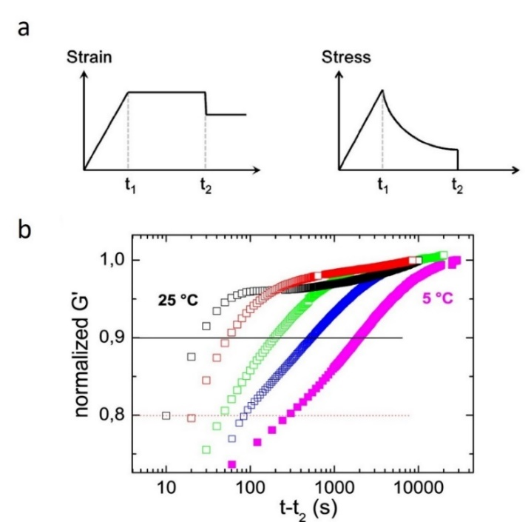
Figure 67: (a) Schematic representation of the time dependence of strain and stress during the self-healing experiment. (b) Resulting normalized storage modulus during recovery for sample PIB14K-BA2 at different temperatures (25 °C, 20 °C, 15 °C, 10 °C, 5 °C) as a function of time t − t₂.⁴³

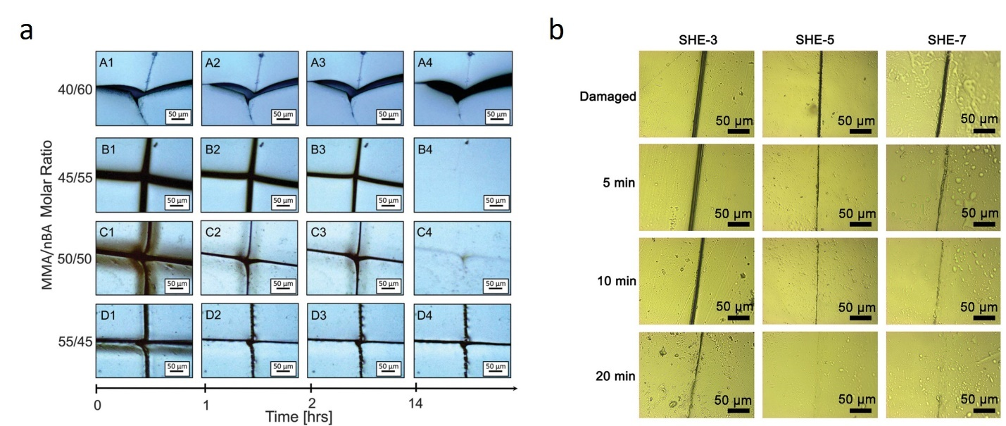
Figure 68. (a) Optical microscope images of self-healing materials from Urban⁹. (b) Optical microscope images of self-healing materials from Huang²⁸¹.
These studies revealed that there is an initial recovery of the shear modulus up to ~95% level, and then a much slower recovery process at longer times (Figure 67). One potential problem of this approach is the degree to which the sample is really broken in the initial strain. However, this approach provides in situ measure of self-healing process kinetics.
Optical microscopy are utilized to obtain visual information on their self-healing behavior, where visually tracing the healing process is a direct, but qualitative approach.⁹ The relationships between the area of damage and healing time or healing temperature are commonly studied, and qualitative analysis could be derived from these results.²⁸² Two good examples from ref 9, 281 are shown in Figure 68, where the optimum healing sample composition, temperature or the healing time were determined. Also, electron microscopy and atomic force microscopy imaging were employed to follow the self-healing kinetics.²⁸³⁻²⁸⁶ Recently, the diffusion process of polymer chain in self-healing hydrogel network with attached fluorescent molecules was visualized by fluorescence microscopy.²⁸⁷ Although the images are illustrative, the lack of quantitative data analysis to correlate their physical properties prevents further utilization of this method for self-healing kinetic studies.
The energy-dispersive x-ray (EDX) spectrum imaging in scanning transmission electron microscopy (STEM) has also been utilized to study the kinetics of self-healing process in a quantitative manner.²⁸⁸ After mending the two metallopolymer films containing different elements, i.e., europium-based and terbium-based, the authors were able to track the interdiffusion of both elements on time scale comparable to the self-healing time estimated using traditional tensile tests. The width of mixed interphase achieved surprisingly large size of 104 ± 35 nm at the time of full tensile property recovery.²⁸⁸ The authors noted that such large length scale can be in part related to the roughness of the surfaces. In any case, this result indicates that complete self-healing requires rather substantial interdiffusion of chains.
Several other properties and spectroscopy can be employed to monitor self-healing kinetics. For example, electrical conductivity measurements have been used to analyze self-healing properties of electrically conductive polymers.^{7,289,290} Essentially the change of the sample resistivity during the healing process can be monitored. Several spectroscopies such as infrared (IR), Raman or nuclear magnetic resonance (NMR) spectroscopy have been also utilized to characterize the intrinsic self-healing of polymers. Once the characteristic peaks of functional groups in a polymer are identified in the IR spectrum, IR could be utilized to continuously monitor the changes in the bonds of interest. For example, a series of strong and tough self-healing elastomers consisting of Diels-Alder crosslinks was developed,²⁸² IR was utilized to monitor the changes of the absorption peaks corresponding to Diels-Alder reaction and confirmed the formation of Diels-Alder crosslinks. Similarly, the use of Raman spectroscopy in analysis of various self-healing materials was also presented.²⁹¹ Most of the Raman studies were focused on the systems with microcapsules and 3D vascular systems to monitor release of chemicals and to follow the chemical reactions (see ref ^{292,293}). NMR was also employed to reveal the details of molecular evolution during the self-healing process. For example, NMR was utilized to confirm the reaction between the modified epoxy and bismaleimide in a Diels-Alder reaction facilitated self-healing system.²⁹⁴ Another example presented tracing the formation of a supramolecular self-healable hydrogel by monitoring the molar ratio between the host and guest moieties using NMR, and thus the optimum component ratio for the host-guest interaction inducted self-healable hydrogels was directly determined.²⁹⁵ NMR was also utilized to confirm the interaction between different moieties that facilitate self-healing process.^{296,297}

Results and Discussion
Developing a general approach to study self-healing
To advance the field of self-healing materials and enable better comparison of data obtained by different groups, a general approach for analysis of self-healing efficiency and kinetics should be developed. Below we formulate our suggestion for this general approach with the focus on four major parameters.
1. Mechanical properties
Mechanical properties, including tensile strength and extensibility, provide the best way to characterize integrity of the healed materials, and thus they are the most used to evaluate intrinsic self-healability.^{11,34,98,113,276} While tensile modulus, tensile strength, elongation-at-break, and tensile toughness are all important, the toughness value represents better an integrated healing efficiency of a typical polymer sample. Toughness characterizes the total energy required to deform and break a polymer sample, and higher toughness indicates a stronger resistance to mechanical failure of a sample. While only some of the reported studies evaluated self-healing efficiency by toughness, the percentage of recovered toughness upon self-healing reveals the efficacy of overall mechanical property recovery, rather than the stress or strain recovery alone. For example, one study of polyurethane/urea-based self-healable polymer reported self-healing efficiency by toughness,¹⁴² while another study of similar polymer structure only reported tensile strength and elongation at break upon self-healing.²⁹⁸ Due to lack of available data on toughness recovery upon self-healing, we could not compare all the references by toughness. Therefore, the researchers should be mindful of reporting toughness when evaluating self-healing efficacy by mechanical properties. While ASTM-type of standard does not exist for self-healing materials analysis, we propose that each paper should report tensile modulus, tensile strength, elongation-at-break, and tensile toughness when intrinsic self-healing polymers are evaluated as a function of time or temperature.

2. Self-healing time
The healing time of self-healing polymers will significantly affect their performance, and in general, a fast healable material is preferred. The faster the material could restore functionality the less service interruption would occur. However, this does not mean that materials with slow recovery are not suitable for specific applications. For example, a self-healable isolation membrane or anti-corrosion coating (see section 5.2) with fast response to physical damage but slow tensile recovery is still considered adequate since the tensile property recovery does not serve the main purpose of these materials. One of the critical characteristics of the self-healing process can be the time to recover 80-90% of the initial property, e.g., 80-90% of the toughness. When self-healing time is evaluated, the surrounding conditions including temperature, humidity, and gas atmosphere need to be carefully chosen. Some intrinsic self-healing polymers exhibit accelerated healing upon exposure to humidity⁹⁵ or certain gas, such as CO₂,⁸⁸ as discussed in section 2.4. Thus, we recommend all the paper should report not only temperature of self-healing process, but also atmospheric condition (air, average RH) as one data series as well as healing time with more specific condition.
3. Self-healing temperature
The healing temperature plays a pivotal role during the self-healing process. Since segmental and chain dynamics are faster, and dynamic bond rearrangement time is shorter at elevated temperatures, the self-healing process can be dramatically accelerated upon increasing the temperature. Self-healing is usually not achievable at temperatures below T_{g} of the polymer. To facilitate self-healing process, some materials with dynamic covalent bonds need a high temperature above 100 °C, which introduces extra complexity to achieve self-healing. In general, many applications prefer self-healable polymers with low healing temperatures, for example, room-temperature (20-25 °C) autonomous self-healing without extra heat. To achieve that, the polymer matrix should have T_{g} significantly below the room temperature. To provide a general approach for analysis of different self-healing polymers at temperatures above ambient, we suggest using temperature 10% or 20% above the matrix’s T_{g}. Several works reported healing efficiency at multiple temperatures, which enables more precise comparison and is highly encouraged.^{35,98,130,277} In case of the systems with phase separated dynamic bonds, it can be T_{g} of the dynamic bonds clusters instead of the polymer matrix T_{g}. Ideally, temperature dependence of self-healing kinetics should be studied.
4. Waiting time
Another important parameter that is usually not reported in publications is the waiting time between the sample damage and the starting point of the self-healing process. As was discussed in section 2.3, the waiting time can strongly affect the rate of self-healing. Leibler and co-workers provided a good illustration of this effect on example of a system with strong hydrogen bonding crosslinks.³⁴ In comparison to the self-healing process that starts immediately after physical damage (zero waiting time), waiting for 6 h decreased self-healing efficiency at the same healing time (e.g., 3 h) by ~50%, and waiting for 18 h decreased the self-healing efficiency at the same healing time by ~75%. Of course, if the sample was damaged and kept at temperatures below T_{g} of the matrix, the waiting time at this temperature does not play an important role because the chains cannot rearrange and reach new equilibrium. Thus, we suggest that only the waiting time at temperatures above T_{g} should be reported.
Trade-off between self-healing kinetics and mechanical strength
One of the major challenges in intrinsically self-healing polymers is a trade-off between mechanical strength and self-healing kinetics. For example, a material with high mechanical strength rarely has high healing efficiency at moderate temperature. This phenomenon could be explained by the facts that the high healing efficiency requires 1) fast segmental dynamics and 2) readily breakable/exchangeable dynamic bond, which normally comes at the price of soft polymer chains with low modulus and weak dynamic bonds. For example, with T_{g} around -123 °C, PDMS possesses the fastest segmental dynamics at ambient condition that facilitate the fast self-healing kinetics, but also results in relatively low modulus for those PDMS based elastomers.^{36,62}
To explore the trade-off relationship, we analyzed the data accumulated during the recent decade,^{105,201,208,213,298-325} and summarized them in Figure 69. The x-axis is the healing rate (1/healing time in hours) to achieve the healing efficiency of 90% or higher, and the y-axis is the maximum tensile stress of the materials. All tensile tests data were measured at room temperature, while the healing time was measured at different temperatures that strongly affect the healing rate. To overcome this problem, we split the data into two groups: Figure 69a presents the results of healing at temperatures close to ambient (20 °C - 40 °C), while Figure 69b presents the results obtained at elevated temperatures (40 °C - 100 °C). These plots demonstrate the known trend for self-healing polymers:³²⁶ the healing time increases with increase in tensile strength of the material. Specific information about the samples and the references for the data collected in Figure 69 are given in Table 8. We note that many important parameters affecting the healing rate (e.g., the waiting time, humidity, pressure used, etc.) are usually not reported in literature. This complicates detailed quantitative analysis and comparison of different systems. Nevertheless, the data presented in Figure 69 revealed some guidance for design of materials with fast self-healing rate and relatively high mechanical strength.
As seen in Figure 69a, achieving fast healing in mechanically strong material at moderate temperature is challenging. We found a few papers reporting almost full recovery of mechanical properties at room temperature for materials with tensile strength above 20 MPa (Figure 69a),^{41,87,95,325,327,328} and we found none with tensile strength above 40 MPa. For materials that exhibit high tensile strength up to 30 MPa, the shortest time for fully recovery is 12 h.³²⁷ These polymers have backbones with T_{g} slightly below room temperature that provides relatively high tensile strength, and hydrogen or ionic bonds that enable reasonable healing rate at ambient temperature. Moreover, the system with the highest tensile strength (#9 in Figure 69a) presents a composite material reinforced with layered WS₂ structures.³²⁷ Tannic acid (TA) was added to construct the interface between WS₂ nanosheets and the polyurethane (PU) matrix. Meanwhile, TA could also regulate and control the aggregation density of hydrogen bonds. Strong hydrogen bonding in the TA-WS₂/PU systems delivered composites with high toughness, mechanical strength, and outstanding self-healing capabilities. Mechanical reinforcement in another system (#36 in Figure 69a) was achieved through the formation of ionic clusters that also provide self-healing ability.⁸⁷ However, to achieve a good healing performance at room temperature, ethanol was used to wet the damaged surfaces, which strongly speeds up the process of bond rearrangements in ionic clusters. Almost all other data for self-healing around room temperature exhibit tensile strength below 10 MPa (Figure 69a). The fastest healing rate (healing time below 1 h) is achieved on polymer gel samples (red symbols), and most of them have tensile strength below 1 MPa (Figure 69a). An interesting example of very fast healing (~ 5 min) and decent tensile strength ~ 3MPa is demonstrated using block copolymer structure (#31 in Figure 69a).³²⁹ This unique combination of self-healing rate and mechanical strength was achieved by combining soft and hard segments in addition to crystalline nano-domains.
The same trade-off is observed for healing at higher temperatures (Figure 69b). In this case, the tensile strength measured at room temperatures can reach much higher values (close to 100 MPa) for materials with high temperature healing time of the order of hours or days. The best combination of the tensile strength and rate of self-healing (#53 in Figure 69b) is again demonstrated by a complex polymer structure combining hydrogen bonding and phase separated ionic clusters complemented by crystalline nano-domains.¹³¹
The trade-off relationship (Figure 69) is similar to the well-known Robeson plot (a trade-off between permeability and selectivity) for gas separation membranes.^{171,330,331} The Robeson plot traditionally presents a straight line touching the best performing data, the so-called “upper bond” line that indicates the limit of current technology. Utilizing this analogy, we also propose to introduce the “upper bond” line for these self-healing polymer data (dashed lines in Figures 69). This upper bound line provides some guidance of expected fastest healing rate for a material with the given tensile strength. Alternatively, it might suggest the maximum tensile strength achievable at the required healing rate. However, we want to emphasize that further understanding of the design principles for intrinsically self-healing polymers will enable us to surpass the current upper bound line in the future works.
The trade-off relationship here signifies the major current challenge of intrinsically self-healing polymers. Faster healing for any systems is desirable, but it usually can be achieved only in soft polymers and gels with relatively weak dynamic bonds. These fast self-healing polymers can satisfy the requirements for some sealants and stretchable substrates but are too weak for most applications.¹⁰ When mechanically robust polymers have dynamic bonds, their bond strength and T_{g} are typically too high to have efficient self-healing at the operating condition. To accelerate the self-healing process, applying heat on demand could provide the required healing rate. However, active heating to trigger the healing process is not preferred or even not possible in many applications. Use of specific solvents can also speed up the self-healing process of some materials in ambient conditions. Although this might be a bit simpler than applying heat, it is still not desirable for many applications. Thus, designing mechanically strong materials with sufficiently fast healing will be beneficial for many technologies. Below we formulate some potential approaches that might surpass the trade-off between the rate of self-healing and mechanical strength of the polymer materials.
Employing complex architectures and combination of dynamic bonds to surpass the modulus – self-healing rate trade-off
The presented analysis (Figures 69) demonstrates that breaking through the modulus – self-healing rate trade-off requires complex molecular design combining different dynamic bonds as well as polymer architecture to provide specific morphology. It is obvious that fast self-healing requires polymer with T_{g} below the targeted healing temperature and dynamic bonds with relatively low energy barrier for dissociation (e.g., hydrogen bonds). However, T_{g} of the polymer should not be very low to have a reasonable modulus, and the presence of hard domain (analog to spider silk) will provide additional reinforcement. These hard domains can be nano-fillers used in polymer nanocomposites with surface functionalized with dynamic bonds.²⁷⁷ They also could be crystalline domains or phase separated hard domains of the self-healing polymers.¹⁰⁰ It is well known that nanoparticles in a polymer matrix create nanoscale interfacial polymer layer with strongly enhanced mechanical properties, providing additional reinforcement in polymeric nanocomposites.^{83,332} Similar effect with interfacial shear modulus reaching ~100 MPa at temperatures much above the matrix’s T_{g} has been reported recently for polymers with hard clusters formed by phase separating hydrogen-bonding groups.^{46,82} Thus, the incorporation of hard domains (or nano-fillers) could provide substantial increase in the tensile strength without significant sacrifice in the rate of self-healing. These hard domains provide not only mechanical reinforcement that increases with their volume fraction, but also enhance mechanical properties of the interfacial layer surrounding them. The latter increases with the surface area of the hard domains and appears very efficient when domains have size of a few nanometers.^{46,82}

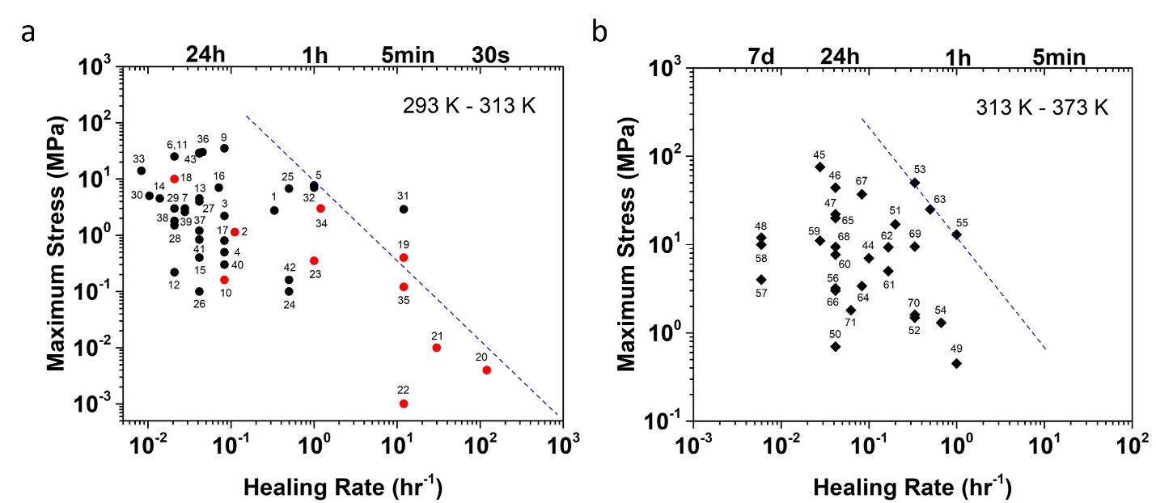
Figure 69. Diagram of the maximum tensile stress vs healing rate for intrinsically self-healing polymers. (a) Data for polymers healable at between 20 °C and 40 °C (red dots indicate gel samples). (b) polymers healable between 40 °C and 100 °C. The healing rate was chosen as an inverse time to reach at least 90% healing efficiency. Specific polymers, dynamic bonds and references to each presented data point are given in Table 8. Dashed lines present upper bound for the tensile strength self-healing rate trade-off.

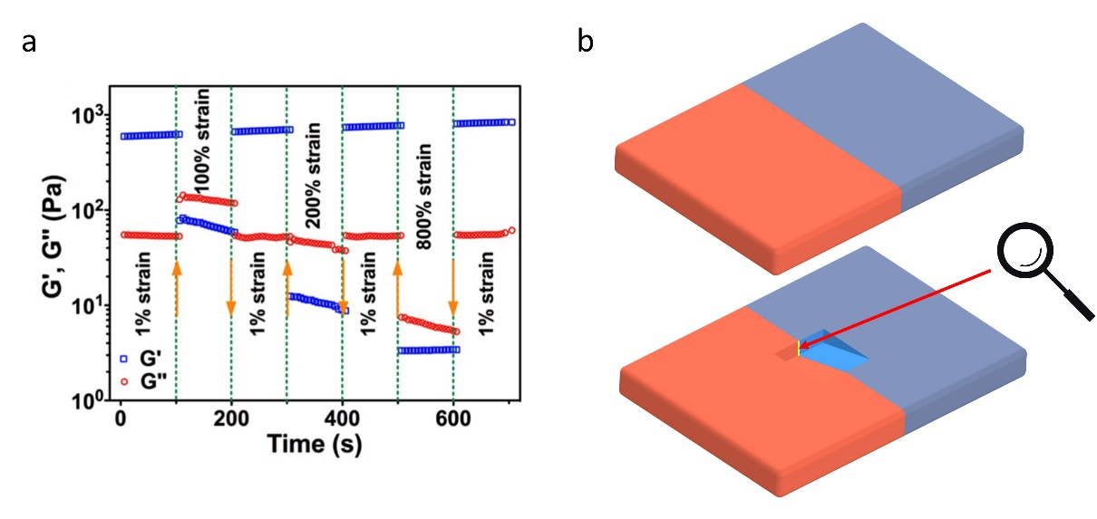
Figure 70. (a) Example of rheology test at alternate small oscillation strain and large strain. (b) Illustration of the proposed in situ observation approach for self-healing.
Table 8. List of the self-healing polymers presented in Figure 69 with their parameters and references. Numbers in Figure 69 correspond to the line number in the Table.
 | Backbone Material | Type of dynamic bonds | Maximum Stress (MPa) | Healing Time (h) | Healing Rate  (h⁻¹) | Healing Temp. (K)
1 | Polyurea³⁴ | Hydrogen bond | 2.75 | 3 | 0.333 | 293
2 | Poly(acrylic acid)¹³⁶ | Hydrogen bond and ionic bond | 1.13 | 9 | 0.111 | 298
3 | Poly(urea-urethane)²⁹⁹ | Dynamic exchange reactions | 2.2 | 12 | 0.083 | 313
4 | Poly(acrylamide)³⁰⁰ | Host–guest interactions | 0.5 | 12 | 0.083 | 298
5 | Polyurethane³⁰¹ | Hydrogen bond | 7.7 | 1 | 1.000 | 298
6 | Polyurethane³²⁸ | Hydrogen bond | 25 | 48 | 0.021 | 298
7 | PDMS³⁰² | Hydrogen bond and imine | 3 | 36 | 0.028 | 298
8 | PDMS³⁰³ | Hydrogen bond and imine | 0.4 | 24 | 0.042 | 298
9 | Polyurethane³²⁷ | Hydrogen bond | 35 | 12 | 0.083 | 298
10 | Poly(thioctic acid)¹³³ | Hydrogen bond and ionic bond | 0.16 | 12 | 0.083 | 298
11 | Poly(acrylic acid)⁹⁵ | Hydrogen bond and ionic bond | 25 | 48 | 0.021 | 298
12 | PDMS³⁵ | Metal–ligand coordination | 0.22 | 48 | 0.021 | 298
13 | Poly(butyl acrylate)¹³² | Hydrogen bond and Metal–ligand coordination | 4.5 | 24 | 0.042 | 298
14 | Boronic ester network¹²² | Boronic ester | 4.5 | 72 | 0.014 | 298
15 | Polyurethane¹⁰⁹ | Disulfide links | 0.4 | 24 | 0.042 | 298
16 | PMMA/P(n-butyl acrylate)⁹ | Van der Waals force | 7 | 14 | 0.071 | 269
17 | Tetra(ethylene glycol)¹¹⁶ | Hydrogen bond | 0.8 | 12 | 0.083 | 310
18 | PEI²³⁵ | Hydrogen bond | 10 | 48 | 0.021 | 298
19 | Poly(alpha lipoic acid)¹³⁰ | Hydrogen bond  and Metal–ligand coordination | 0.4 | 0.0833 | 12.005 | 293
Table 8 continued
20 | Poly(butyl acrylate)³⁰⁴ | Hydrogen bond | 0.004 | 0.00833 | 120.005 | 298
21 | Poly(acrylic acid)¹³⁸ | Hydrogen bond  and Metal–ligand coordination | 0.01 | 0.0333 | 30.030 | 298
22 | Poly (carboxymethyl chitosan)³⁰⁵ | Hydrogen bond | 0.001 | 0.0833 | 12.005 | 298
23 | Poly(acrylic acid)³⁰⁶ | Hydrogen bond | 0.35 | 1 | 1.000 | 298
24 | PDMS¹⁰⁵ | Hydrogen bond  and disulfide links | 0.1 | 2 | 0.500 | 298
25 | Thermoplastic polyurethane¹¹⁴ | Disulfide links | 6.76 | 2 | 0.500 | 298
26 | Poly(vinylidene fluoride-co-hexafluoropropylene)³⁰⁷ | Hydrogen bond  and coordination | 0.1 | 24 | 0.042 | 298
27 | PDMS³⁰⁸ | Metal-ligand Coordination | 4 | 24 | 0.042 | 298
28 | PDMS¹⁴² | Hydrogen bond | 1.5 | 48 | 0.021 | 298
29 | TEG¹¹ | Hydrogen bond | 3 | 48 | 0.021 | 298
30 | PDMS³⁰⁹ | Hydrogen bond | 5 | 96 | 0.010 | 293
31 | Polyethylene-co-poly propylene³²⁹ | Van der Waals force | 2.9 | 0.0833 | 12.005 | 298
32 | Polyethylene-co-poly propylene³²⁹ | Van der Waals force | 7 | 1 | 1.000 | 298
33 | Polyethylene-co-polypropylene³²⁹ | Van der Waals force | 14 | 120 | 0.008 | 298
34 | Poly(methacrylic acid)²⁷⁶ | Hydrogen bond  and imine | 3 | 0.8333 | 1.200 | 298
35 | poly(vinyl alcohol)³¹⁰ | Boronic ester and hydrogen bond | 0.12 | 0.0833 | 12.005 | 298
36 | Polyacrylate⁸⁷ | Ionic bond | 30 | 22 | 0.045 | 298
37 | Styrene butadiene rubber³¹¹ | Hydrogen bond  and ionic bond | 1.2 | 24 | 0.042 | 298
38 | Curcumin polymer block²⁰¹ | Hydrogen bond  and Metal–ligand coordination | 1.8 | 48 | 0.021 | 298
Table 8 continued
39 | PDMS³⁸ | Hydrogen bond  and Metal–ligand coordination | 2.6 | 36 | 0.028 | 298
40 | PDMS³¹² | Metal–ligand coordination and π-π stacking | 0.3 | 12 | 0.083 | 298
41 | Poly(urea-urethane)¹¹² | Hydrogen bond  and disulfide links | 0.84 | 24 | 0.042 | 298
42 | PDMS³¹³ | Hydrogen bond  and imine | 0.16 | 2 | 0.500 | 298
43 | Polyurethane³²⁵ | Hydrogen bond | 29 | 24 | 0.042 | 298
44 | Poly(tetramethylene) glycol²⁰⁸ | Hydrogen bond | 7 | 10 | 0.100 | 363
45 | Polytetramethylene²⁷⁷ | Hydrogen bond | 75.6 | 36 | 0.028 | 373
46 | Poly(urea-urethane) ¹⁰⁰ | Hydrogen bond | 44 | 24 | 0.042 | 373
47 | PPG¹¹³ | Hydrogen bond | 22 | 24 | 0.042 | 373
48 | Anthryl-telechelic poly(ethylene adipate)¹⁰³ | Disulfide links  and hydrogen bond | 12 | 168 | 0.006 | 343
49 | Epoxy resins¹⁰⁸ | Disulfide links | 0.45 | 1 | 1.000 | 373
50 | Polyurethane³¹⁴ | Bond exchange and hydrogen bond | 0.7 | 24 | 0.042 | 333
51 | Poly(vinyl alcohol)/Nafion¹³⁷ | Hydrogen bond | 17 | 5 | 0.200 | 323
52 | Poly(urea-urethane)¹³⁵ | Hydrogen bond  and ionic | 1.48 | 3 | 0.333 | 353
53 | PEG¹³¹ | Hydrogen bond  and ionic bond | 50 | 3 | 0.333 | 338
54 | PDMS¹⁴² | Hydrogen bond  and Metal–ligand coordination | 1.6 | 1.5 | 0.667 | 333
55 | PDMS²⁹⁸ | Hydrogen bond | 13 | 1 | 1.000 | 333
56 | Poly(3-caprolactone)²¹³ | Hydrogen bond | 3.2 | 24 | 0.042 | 348
Table 8 continued
57 | Polyacrylates²⁸² | Diels-Alder reaction and ionic bond | 4 | 168 | 0.006 | 333
58 | Polyacrylates²⁸² | Diels-Alder reaction and ionic bond | 10 | 168 | 0.006 | 333
59 | Polyurethane³¹⁵ | Hydrogen bond  and host-guest interaction | 11.07 | 36 | 0.028 | 373
60 | Poly(urea-urethane)³¹⁶ | Hydrogen bond and disulfide links | 7.7 | 24 | 0.042 | 333
61 | Polyurethane³¹⁷ | Hydrogen bond and disulfide links | 5 | 6 | 0.167 | 333
62 | ENR³¹⁸ | Hydrogen bond and disulfide links | 9.3 | 6 | 0.167 | 393
63 | Polyurethane³¹⁹ | Hydrogen bond and disulfide links | 25 | 2 | 0.500 | 373
64 | Polyurethane³³³ | Hydrogen bond and disulfide links | 3.39 | 12 | 0.083 | 353
65 | Polyurethane³²⁰ | Hydrogen bond and disulfide links | 20 | 24 | 0.042 | 363
66 | PDMS/Polyurethane³²¹ | Hydrogen bond and Diels-Alder reaction | 3 | 24 | 0.042 | 353
67 | Polyurethane³²² | Hydrogen bond and Diels-Alder reaction | 37.11 | 12 | 0.083 | 333
68 | Poly(urea-urethane)³²³ | Hydrogen bond and Metal–ligand coordination | 9.4 | 24 | 0.042 | 353
69 | Polyurethane³²⁴ | Metal–ligand coordination and Diels–Alder reaction | 9.5 | 3 | 0.333 | 338
70 | Polycyclooctene¹⁴⁰ | Hydrogen bond | 1.6 | 3 | 0.333 | 323
71 | Polycyclooctene¹²⁴ | Boronic ester | 1.8 | 16 | 0.063 | 323

Also, the combination of different types of dynamic bonds in a single polymer network show very promising results.^{35,38,95,136} The dynamic bonds with lower bond strength (sacrificial bonds) provide fast self-healing especially when combined with the backbone having faster segmental dynamics. The presence of stronger dynamic bonds such as ionic bonds or quadruple hydrogen bonds provide mechanical robustness while keeping self-healing ability. The strategy to combine several different dynamic bonds, such as the combination of weak and strong dynamic bonds, and inclusion of hard domains could lead to intrinsically self-healing polymers with superior toughness, high tensile strength, and fast self-healing.
Needs for in situ analysis of self-healing
As discussed in section IV, another major challenge in the field is the absence of a standard in experimental studies of self-healing kinetics. The standard would enable direct quantitative comparison of results obtained in different groups. Establishing a standardized method for evaluation of self-healing properties is critical for the field. An even more important task would be the development of experimental method that provides in situ characterization of the healing process kinetics. Example of these kinds of techniques is the non-linear rheology used in ref 43 (Figure 67). Direct monitoring of recovery of mechanical properties without sample destruction by the non-linear rheology will be instrumental in understanding self-healing process especially in systems with multiple types of dynamic bonds and hierarchical structures with hard and soft domains. These systems should exhibit multi-step healing processes due to several characteristic time scales of bond rearrangements. Several works utilized another non-linear rheology approach: continuous strain sweep with alternate low (1%) and high (100-500%) amplitude of strain oscillations to mimic the damage-healing process (Figure 70a).^{138,305} Test at each strain was conducted for 30 s or 100s. By monitoring the change in storage modulus (G') and loss modulus (G") of the sample, the repeatability and efficiency of sample’s self-healing property could be quantified.
As it was discussed in section 2.4, the optical or similar microscopy will provide images of in-situ healing. The traditional microscope could inspect samples at top-down view; however, it lacks tracking the healing process in depth. To obtain an image of the healing process, focused ion beam scanning electron microscope (FIB-SEM) can be utilized (Figure 70b). The starting stage of healing, and the cross-section will be exposed to the camera directly after the removal of materials by the ion beam. Such observation window enabled by material removal could provide direct, continuous monitoring of the self-healing process in depth of the sample. While these imaging techniques exhibit in-situ information, the obtained data may only represent visual kinetics. To comprehend self-healing system and correlate it quantifiable self-healing kinetics, one needs to complement with the other techniques, such as non-linear rheology, or ex-situ tests, such as tensile tests to determine toughness.
It will also be beneficial if tensile strength and self-healing kinetics are measured at the same temperature. For example, the data presented in Figure 69 can be easily shifted along the X-axis (healing rate) by changing the healing temperature, while the tensile strength of the sample measured at ambient conditions (Y-axis) will remain the same. For better comparison of different samples, the temperature range of self-healing studies should be scaled with T_{g} of the polymer matrix (or T_{g} of clusters of dynamic bonds). An even more definitive method will be analysis of the temperature dependence of the self-healing kinetics, although such process will be significantly more time consuming unless some direct in situ measurements are developed.
Theoretical and modelling challenges
The current model of self-healing polymers developed by Rubinstein and co-workers⁵⁶ considers a brunched homopolymers with a single type of dynamic bonds. As we have seen from the data analyses, the best performing self-healing materials present complex copolymers with combination of various dynamic bonds, including some sacrificial bonds, and even phase separated clusters of units containing dynamic bonds.^{87,95,131,327,328} Thus, rational design of efficient self-healing polymers requires more complex models considering a combination of the dynamic bonds with different dissociation energy, bond rearrangements between clusters of dynamic bonds and potential combination of backbones with various flexibility and molecular weight between the functional groups. The number of tunable parameters in the design of self-healing polymers is extremely broad, and this complexity hinders theoretical ability to provide any quantitative predictions for design of self-healing materials with desired properties. Computational studies with involvement of machine learning (ML) and artificial intelligence (AI) approaches might also be instrumental in the design of these complex molecular structures.

Conclusions
Current literature shows many examples of relatively fast self-healing materials even in ambient conditions. But all these materials are very soft and have rather low tensile strength. These results emphasize an important challenge in the field – the trade-off between the rate of self-healing and the mechanical strength of the material (Figure 69). Although this trade-off seems to be natural because softness of the material is usually coming with fast molecular rearrangements, smart design of materials with multiple types of dynamic bonds and hierarchical structures with hard and soft domains can potentially break through this trade-off. Additionally, a phase separation of dynamic bonds and multi-arm (or grafts) architectures may provide a promising approach to developing intrinsic self-healing polymers with desired mechanical properties and short healing time. We also want to emphasize that using the upper bound line in the tensile strength vs healing rate plot (Figure 69) provides a guidance for expectations of the fastest self-healing rate at the given mechanical modulus and can be instrumental in design of self-healing materials.
As demonstrated, the number of parameters that can be tuned to control the self-healing materials’ properties is extremely broad. It includes among others different types of dynamic bonds and their combinations (e.g., sacrificial bonds), chemical structure of the polymer backbone and its architecture, molecular weight between stickers, and their microphase separation. This complexity creates significant challenge for a predictive design of intrinsically self-healing polymers and requires developments of more sophisticated models and theory. Moreover, development of predictive models by computation especially utilizing AI and ML will also provide a critical guidance for the new design of intrinsically self-healing polymers.
Additional challenges in this field are also caused by the absence of a standard evaluation of self-healing efficiency and rate (such as, e.g., ASTM standard), and rather limited study of in situ kinetics of self-healing process. In most cases it is almost impossible to provide an accurate quantitative comparison of the results of studies performed by different research groups. We propose to measure self-healing efficacy by standardizing healing temperature, use of toughness recovery vs healing time as the major parameter, and other evaluation criteria. Moreover, further progress in the field requires more advanced characterization methods, especially the techniques able to quantitatively analyze the kinetics of the healing process.

FUTURE PERSPECTIVES

The development of intrinsic self-healing polymers has had a significant leap in the past two decades. Yet there’re many issues that still exist for self-healing polymers. The crucial part of the author’s perspective is how to fill the gap between laboratory explorations and field applications. We’ve seen some progress in flexible electronics, where the self-healing feature is well integrated into flexible sensors or artificial skins. However, we could still rarely see self-healable products in the common consumer market, and the obstacles are typically two major issues: cost and effectiveness. Thus, researchers need to develop new polymer structures that could achieve fast healing at a low cost. We anticipate new polymer structures with new driving forces for healing.
From the fundamental research perspective, we hope the simulation tool could be further developed to simulate molecule movement at a large scale. For example, by plugging in the basic molecular parameters, the self-healing process could be simulated and visualized, and other environmental parameters such as temperature could also be integrated. If successful, such prediction could serve in multiple application scenarios, especially on thin film applications where the thickness of the film may have a significant impact on the healing behavior.
For applications in our daily life, the crucial issue is not the specific performance, it is mostly the high cost of self-healing materials that prevent the introduction of self-healing features to various products. Most reported intrinsic healable polymers require multi-step synthesis, and the starting materials mostly contain fine chemicals where the cost is too high to be utilized on a big scale. To address this issue, we need to seek raw materials sourcing from low-cost materials. Plastic waste is an ideal resource since it contains multiple building blocks that are inherently polymeric, and the derivatives from those wastes exhibit a wide range of different properties. Decomposing discarded polymers into monomers to achieve a closed-loop recycling of chemical raw materials has been an important research goal in the field of recycling in recent years to meet the societal needs. Taking poly(ethylene terephthalate) (PET) as an example, many studies have focused on the catalytic deconstruction of PET. Then the deconstructed building blocks can be utilized to synthesize new polymers with new properties, while maintaining the recyclability, aiming to achieve a cycle from monomers to polymers. However, such deconstruction reactions generally require a relatively a long time (around 12 hours), and the research is limited to the repetitive generation of the same PET material. This method is less economically viable compared to conventional mechanical recycling to remanufacture products, since it still presents practical issues on energy consumption and economic efficiency. Furthermore, a significant number of polymer upcycling research focus on the mechanical property improvement only, while the functionality gain is still vague. Thus, we propose a new pathway to obtain self-healable polymers: utilizing the products from the deconstruction of PET with chemical modifications to prepare self-healable polymers directly by a one-step reaction. In detail, the aminolysis reaction is employed to facilitate the deconstruction of PET. While utilizing chemicals with amine groups as the reactant, the deconstruction products will all have -NH₂ group at the end groups. The presence of -NH₂ end groups enables more potential for chemical modifications, since it could form a variety of different products with hydrogen bonding potential. Herein, we propose a few synthesis pathways based on the newly developed PET aminolysis method. As seen in Figure 71a, three potential PET aminolysis pathways are designed to deliver building blocks for the synthesis of self-healing materials. Once the product 1-3 are obtained, those chemicals could be reacted with urea and other chain extenders to form self-healable polymer, which utilize the same reaction mechanism of Part 2 and 3. We anticipate a series of stronger self-healable polymers than the work in Part 2 and 3 since the phenyl group originated from PET could deliver higher chain rigidity than PDMS systems.
Preliminary results are shown below in the synthesis route 1 and 2. Both the deconstructed products are soluble in organic solvents, which could be tested by ¹H NMR. As seen in Figure 71b, successful deconstructions of PET are achieved. Then, the product 1, Bis(2-aminoethyl)terephthalamide (BAET) is reacted with 2,2′-(Ethylenedioxy)bis(ethylamine) (EDEA) and urea at a molar ratio of 1:1:4 with no solvent at 160 °C, the product is obtained after 24 hours, exhibiting an yellow elastomeric polymer with adhesive properties. The tensile properties of obtained polymer were examined by Instron 3343 tensile tester following ASTM D1708 method. The sample was elongated at a rate of 1 mm/s. Shown in Figure 72, the BAET-EDEA1 polymer demonstrates a tensile strength of 5.7 MPa and elongation-at-break of 50%. Such polymer properties have proved the viability of the proposed approach. In future perspectives, the self-healing properties of such polymers will be examined, and the chemical composition could be optimized to obtain polymers with higher mechanical and self-healing properties. Moreover, the deconstruction of the obtained self-healable polymers needs to be studied, if the BAET could be detected after the deconstruction, the close-loop utilization of PET waste material is achieved.
In general, the future development of intrinsic self-healing polymers should aim towards minimizing the gap between lab products and field applicable products, such as the uniformity of the product, easiness of operation, scale of application, cost of labor, and other related criteria.

(a)
(b)

Figure 71. (a) Proposed synthesis procedure for PET-based self-healable materials. (b) ¹H NMR spectrum of the product of PET aminolysis reaction 1 and 2.

Figure 72. Tensile properties of BAET-EDEA1 polymer.

CONCLUSION
Intrinsically self-healable polymers showed great potential for applications such as wearable electronics, energy storage devices, coating materials, and next-generation smart materials. It is more necessary than now to understand the structure-property relationship of self-healing materials systematically. This thesis has tackled this goal while presenting the following research aspects: first, we studied the effect of hydrogen bonding density in crosslinked/non-crosslinked self-healing systems, then the effort to develop self-healing polymers that surpass mechanical strength-healing performance tradeoff is succeeded by the incorporation of polymer upcycling concept with self-healing polymer synthesis. Finally, the establishment of a universal evaluation method to promote the development of high-performance self-healing polymers is demonstrated.
Utilizing PDMS with urea-promoted hydrogen bonding, we obtained two series of self-healable polymers with room-temperature self-healability. One series exhibited fast healing, high extensibility, and recoverable gas-separation properties, while the other series showed the properties such as easy to synthesize, fast room-temperature recovery, puncture-resistant, and reusable adhesion. With the understanding of hydrogen bonding density effect on these materials, we anticipate those intrinsic self-healable polymers are equipped with good application potentials.
Linear self-healing polymers have the advantage of good processability compared to crosslinked healable polymers. We prepared a copolymer system employing hydrogen bonding groups with different strengths. By tuning the chemical composition of the monomers, self-healable polymers with rapid healing were obtained, and the healing kinetic and mechanism study widened the understanding of the healing process beyond the traditional characterization method. This readily printable, fast-healable polymer intrigues future polymer designs for controlling self-healing properties.
The development of high-performance self-healing polymers could be divided into two parallel tasks, improving the mechanical properties, and achieving fast healing. We incorporated PDMS with polymers containing thiourea structures, creating a copolymer with high mechanical toughness and moisture-assisted healing properties. We hope the future development of this system could harvest self-healable polymers that could fulfill the demand for high-performance coatings.
In recent years, there has been significant attention given to the research of self-repairing materials based on various mechanisms. However, due to the lack of universal criteria for evaluating self-healing performance, these research efforts have been unable to compare self-healing performance under single-factor conditions. Additionally, most of the work has been limited to mechanical performance characterization, neglecting the study of self-repair mechanisms and related kinetics. This hinders further improvements in the performance of self-repairing materials. Based on these issues, through a systematic review of the development history of intrinsic self-repairing polymers and representative works on different self-repairing mechanisms, we proposed for the first time an evaluation system for self-repairing polymer materials. 71 different materials with varying self-repairing rates were divided into two temperature ranges, revealing a negative correlation between self-repairing rates and maximum tensile stress. This achievement defines high-performance self-repairing materials and compiles a large amount of data that facilitates the comparison of existing works, providing reference for future self-repairing materials. For future research, we also proposed a new pathway for constructing self-healable polymers from PET and other plastic wastes, which could achieve the upcycling of waste plastics and obtain self-healable polymers with closed-loop circularity.

REFERENCES

(1) Yang, Y.; Ding, X.; Urban, M. W. Chemical and Physical Aspects of Self-Healing Materials. Prog. Polym. Sci. 2015, 49-50, 34-59.
(2) Hillewaere, X. K. D.; Du Prez, F. E. Fifteen Chemistries for Autonomous External Self-Healing Polymers and Composites. Prog. Polym. Sci. 2015, 49-50, 121-153.
(3) Wang, S.; Urban, M. W. Self-Healing Polymers. Nat. Rev. Mater. 2020, 5, 562-583.
(4) Utrera-Barrios, S.; Verdejo, R.; López-Manchado, M. A.; Hernández Santana, M. Evolution of Self-Healing Elastomers, from Extrinsic to Combined Intrinsic Mechanisms: A Review. Mater. Horiz. 2020, 7, 2882-2902.
(5) Liu, X.; Li, Y.; Fang, X.; Zhang, Z.; Li, S.; Sun, J. Healable and Recyclable Polymeric Materials with High Mechanical Robustness. ACS Materials Lett. 2022, 4, 554-571.
(6) Huynh, T.-P.; Sonar, P.; Haick, H. Advanced Materials for Use in Soft Self-Healing Devices. Adv. Mater. 2017, 29, 1604973.
(7) Bekas, D. G.; Tsirka, K.; Baltzis, D.; Paipetis, A. S. Self-Healing Materials: A Review of Advances in Materials, Evaluation, Characterization and Monitoring Techniques. Compos. B: Eng. 2016, 87, 92-119.
(8) Blaiszik, B. J.; Kramer, S. L. B.; Olugebefola, S. C.; Moore, J. S.; Sottos, N. R.; White, S. R. Self-Healing Polymers and Composites. Annu. Rev. Mater. Res. 2010, 40, 179-211.
(9) Urban Marek, W.; Davydovich, D.; Yang, Y.; Demir, T.; Zhang, Y.; Casabianca, L. Key-and-Lock Commodity Self-Healing Copolymers. Science 2018, 362, 220-225.
(10) Zhang, Z.; Ghezawi, N.; Li, B.; Ge, S.; Zhao, S.; Saito, T.; Hun, D.; Cao, P.-F. Autonomous Self-Healing Elastomers with Unprecedented Adhesion Force. Adv. Funct. Mater. 2021, 31, 2006298.
(11) Yan, X.; Liu, Z.; Zhang, Q.; Lopez, J.; Wang, H.; Wu, H.-C.; Niu, S.; Yan, H.; Wang, S.; Lei, T.et al. Quadruple H-Bonding Cross-Linked Supramolecular Polymeric Materials as Substrates for Stretchable, Antitearing, and Self-Healable Thin Film Electrodes. J. Am. Chem. Soc. 2018, 140, 5280-5289.
(12) Chen, S.; Wang, H.-Z.; Zhao, R.-Q.; Rao, W.; Liu, J. Liquid Metal Composites. Matter 2020, 2, 1446-1480.
(13) Kim, H.; Boysen, D. A.; Newhouse, J. M.; Spatocco, B. L.; Chung, B.; Burke, P. J.; Bradwell, D. J.; Jiang, K.; Tomaszowska, A. A.; Wang, K.et al. Liquid Metal Batteries: Past, Present, and Future. Chem. Rev. 2013, 113, 2075-2099.
(14) Wu, Y.; Huang, L.; Huang, X.; Guo, X.; Liu, D.; Zheng, D.; Zhang, X.; Ren, R.; Qu, D.; Chen, J. A Room-Temperature Liquid Metal-Based Self-Healing Anode for Lithium-Ion Batteries with an Ultra-Long Cycle Life. Energy & Environmental Science 2017, 10, 1854-1861.
(15) Markvicka, E. J.; Bartlett, M. D.; Huang, X.; Majidi, C. An Autonomously Electrically Self-Healing Liquid Metal–Elastomer Composite for Robust Soft-Matter Robotics and Electronics. Nat. Mater. 2018, 17, 618-624.
(16) Nakao, W.; Abe, S. Enhancement of the Self-Healing Ability in Oxidation Induced Self-Healing Ceramic by Modifying the Healing Agent. Smart Mater. Struct. 2012, 21, 025002.
(17) Osada, T.; Kamoda, K.; Mitome, M.; Hara, T.; Abe, T.; Tamagawa, Y.; Nakao, W.; Ohmura, T. A Novel Design Approach for Self-Crack-Healing Structural Ceramics with 3d Networks of Healing Activator. Sci. Rep. 2017, 7, 17853.
(18) Zhang, P.; Li, G. Advances in Healing-on-Demand Polymers and Polymer Composites. Prog. Polym. Sci. 2016, 57, 32-63.
(19) Lei, Z.; Wu, P. A Supramolecular Biomimetic Skin Combining a Wide Spectrum of Mechanical Properties and Multiple Sensory Capabilities. Nat. Commun. 2018, 9, 1134.
(20) Garces, J. I. T.; Beltran, A. B.; Tan, R. R.; Ongpeng, J. M. C.; Promentilla, M. A. B. Carbon Footprint of Self-Healing Geopolymer Concrete with Variable Mix Model. Cleaner Chem. Eng. 2022, 2, 100027.
(21) Britt, P. F.; Coates, G. W.; Winey, K. I.; Byers, J.; Chen, E.; Coughlin, B.; Ellison, C.; Garcia, J.; Goldman, A.; Guzman, J.et al. “Report of the Basic Energy Sciences Roundtable on Chemical Upcycling of Polymers,” 2019.
(22) Nicholson, S. R.; Rorrer, N. A.; Carpenter, A. C.; Beckham, G. T. Manufacturing Energy and Greenhouse Gas Emissions Associated with Plastics Consumption. Joule 2021, 5, 673-686.
(23) Meys, R.; Kätelhön, A.; Bachmann, M.; Winter, B.; Zibunas, C.; Suh, S.; Bardow, A. Achieving Net-Zero Greenhouse Gas Emission Plastics by a Circular Carbon Economy. Science 2021, 374, 71-76.
(24) Luo, J.; Demchuk, Z.; Zhao, X.; Saito, T.; Tian, M.; Sokolov, A. P.; Cao, P.-F. Elastic Vitrimers: Beyond Thermoplastic and Thermoset Elastomers. Matter 2022, 5, 1391-1422.
(25) Korley, L. T. J.; Epps, T. H.; Helms, B. A.; Ryan, A. J. Toward Polymer Upcycling—Adding Value and Tackling Circularity. Science 2021, 373, 66-69.
(26) Zhu, D. Y.; Rong, M. Z.; Zhang, M. Q. Self-Healing Polymeric Materials Based on Microencapsulated Healing Agents: From Design to Preparation. Prog. Polym. Sci. 2015, 49-50, 175-220.
(27) Kwak, S.-Y.; Giraldo, J. P.; Lew, T. T. S.; Wong, M. H.; Liu, P.; Yang, Y. J.; Koman, V. B.; McGee, M. K.; Olsen, B. D.; Strano, M. S. Polymethacrylamide and Carbon Composites That Grow, Strengthen, and Self-Repair Using Ambient Carbon Dioxide Fixation. Adv. Mater. 2018, 30, 1804037.
(28) Yang, Y.; Urban, M. W. Self-Repairable Polyurethane Networks by Atmospheric Carbon Dioxide and Water. Angew. Chem., Int. Ed. 2014, 53, 12142-12147.
(29) White, S. R.; Sottos, N. R.; Geubelle, P. H.; Moore, J. S.; Kessler, M. R.; Sriram, S. R.; Brown, E. N.; Viswanathan, S. Autonomic Healing of Polymer Composites. Nature 2001, 409, 794-797.
(30) Kosarli, M.; Bekas, D. G.; Tsirka, K.; Baltzis, D.; Vaimakis-Tsogkas, D. Τ.; Orfanidis, S.; Papavassiliou, G.; Paipetis, A. S. Microcapsule-Based Self-Healing Materials: Healing Efficiency and Toughness Reduction Vs. Capsule Size. Compos. B: Eng. 2019, 171, 78-86.
(31) Kim, S.-R.; Getachew, B. A.; Park, S.-J.; Kwon, O.-S.; Ryu, W.-H.; Taylor, A. D.; Bae, J.; Kim, J.-H. Toward Microcapsule-Embedded Self-Healing Membranes. Environ. Sci. Technol. Lett. 2016, 3, 216-221.
(32) Toohey, K. S.; Sottos, N. R.; Lewis, J. A.; Moore, J. S.; White, S. R. Self-Healing Materials with Microvascular networks. Nat. Mater. 2007, 6, 581-585.
(33) Chen, X.; Dam Matheus, A.; Ono, K.; Mal, A.; Shen, H.; Nutt Steven, R.; Sheran, K.; Wudl, F. A Thermally Re-Mendable Cross-Linked Polymeric Material. Science 2002, 295, 1698-1702.
(34) Cordier, P.; Tournilhac, F.; Soulié-Ziakovic, C.; Leibler, L. Self-Healing and Thermoreversible Rubber from Supramolecular Assembly. Nature 2008, 451, 977-980.
(35) Li, C.-H.; Wang, C.; Keplinger, C.; Zuo, J.-L.; Jin, L.; Sun, Y.; Zheng, P.; Cao, Y.; Lissel, F.; Linder, C.et al. A Highly Stretchable Autonomous Self-Healing Elastomer. Nat. Chem. 2016, 8, 618-624.
(36) Cao, P.-F.; Li, B.; Hong, T.; Townsend, J.; Qiang, Z.; Xing, K.; Vogiatzis, K. D.; Wang, Y.; Mays, J. W.; Sokolov, A. P.et al. Superstretchable, Self-Healing Polymeric Elastomers with Tunable Properties. Adv. Funct. Mater. 2018, 28, 1800741.
(37) Burattini, S.; Greenland, B. W.; Merino, D. H.; Weng, W.; Seppala, J.; Colquhoun, H. M.; Hayes, W.; Mackay, M. E.; Hamley, I. W.; Rowan, S. J. A Healable Supramolecular Polymer Blend Based on Aromatic Π−Π Stacking and Hydrogen-Bonding Interactions. J. Am. Chem. Soc. 2010, 132, 12051-12058.
(38) Wu, X.; Wang, J.; Huang, J.; Yang, S. Robust, Stretchable, and Self-Healable Supramolecular Elastomers Synergistically Cross-Linked by Hydrogen Bonds and Coordination Bonds. ACS Appl. Mater. Interfaces 2019, 11, 7387-7396.
(39) Pan, Y.; Gao, S.; Sun, F.; Yang, H.; Cao, P.-F. Polymer Binders Constructed through Dynamic Noncovalent Bonds for High-Capacity Silicon-Based Anodes. Chem. – Eur. J. 2019, 25, 10976-10994.
(40) Li, C.-H.; Zuo, J.-L. Self-Healing Polymers Based on Coordination Bonds. Adv. Mater. 2020, 32, 1903762.
(41) Zheng, N.; Xu, Y.; Zhao, Q.; Xie, T. Dynamic Covalent Polymer Networks: A Molecular Platform for Designing Functions Beyond Chemical Recycling and Self-Healing. Chem. Rev. 2021, 121, 1716-1745.
(42) Jourdain, A.; Asbai, R.; Anaya, O.; Chehimi, M. M.; Drockenmuller, E.; Montarnal, D. Rheological Properties of Covalent Adaptable Networks with 1,2,3-Triazolium Cross-Links: The Missing Link between Vitrimers and Dissociative Networks. Macromolecules 2020, 53, 1884-1900.
(43) Yan, T.; Schröter, K.; Herbst, F.; Binder, W. H.; Thurn-Albrecht, T. Unveiling the Molecular Mechanism of Self-Healing in a Telechelic, Supramolecular Polymer Network. Sci. Rep. 2016, 6, 32356.
(44) Ge, S.; Tress, M.; Xing, K.; Cao, P.-F.; Saito, T.; Sokolov, A. P. Viscoelasticity in Associating Oligomers and Polymers: Experimental Test of the Bond Lifetime Renormalization Model. Soft Matter 2020, 16, 390-401.
(45) Tress, M.; Xing, K.; Ge, S.; Cao, P.; Saito, T.; Sokolov, A. What Dielectric Spectroscopy Can Tell Us About Supramolecular Networks⋆. Eur. Phys. J. E 2019, 42, 133.
(46) Ge, S.; Samanta, S.; Li, B.; Carden, G. P.; Cao, P.-F.; Sokolov, A. P. Unravelling the Mechanism of Viscoelasticity in Polymers with Phase-Separated Dynamic Bonds. ACS Nano 2022, 16, 4746-4755.
(47) Samanta, S.; Kim, S.; Saito, T.; Sokolov, A. P. Polymers with Dynamic Bonds: Adaptive Functional Materials for a Sustainable Future. J. Phys. Chem. B 2021, 125, 9389-9401.
(48) Matsumiya, Y.; Watanabe, H.; Urakawa, O.; Inoue, T. Experimental Test for Viscoelastic Relaxation of Polyisoprene Undergoing Monofunctional Head-to-Head Association and Dissociation. Macromolecules 2016, 49, 7088-7095.
(49) Kuang, X.; Liu, G.; Dong, X.; Wang, D. Correlation between Stress Relaxation Dynamics and Thermochemistry for Covalent Adaptive Networks Polymers. Mater. Chem. Front. 2017, 1, 111-118.
(50) Denissen, W.; De Baere, I.; Van Paepegem, W.; Leibler, L.; Winne, J.; Du Prez, F. E. Vinylogous Urea Vitrimers and Their Application in Fiber Reinforced Composites. Macromolecules 2018, 51, 2054-2064.
(51) Liu, Y.; Tang, Z.; Chen, J.; Xiong, J.; Wang, D.; Wang, S.; Wu, S.; Guo, B. Tuning the Mechanical and Dynamic Properties of Imine Bond Crosslinked Elastomeric Vitrimers by Manipulating the Crosslinking Degree. Polym. Chem. 2020, 11, 1348-1355.
(52) Zhang, Z.; Huang, C.; Weiss, R. A.; Chen, Q. Association Energy in Strongly Associative Polymers. J. Rheol. 2017, 61, 1199-1207.
(53) Zhang, Z.; Chen, Q.; Colby, R. H. Dynamics of Associative Polymers. Soft Matter 2018, 14, 2961-2977.
(54) Xing, K.; Tress, M.; Cao, P.-F.; Fan, F.; Cheng, S.; Saito, T.; Sokolov, A. P. The Role of Chain-End Association Lifetime in Segmental and Chain Dynamics of Telechelic Polymers. Macromolecules 2018, 51, 8561-8573.
(55) Ricarte, R. G.; Shanbhag, S. Unentangled Vitrimer Melts: Interplay between Chain Relaxation and Cross-Link Exchange Controls Linear Rheology. Macromolecules 2021, 54, 3304-3320.
(56) Stukalin, E. B.; Cai, L.-H.; Kumar, N. A.; Leibler, L.; Rubinstein, M. Self-Healing of Unentangled Polymer Networks with Reversible Bonds. Macromolecules 2013, 46, 7525-7541.
(57) Gold, B. J.; Hövelmann, C. H.; Lühmann, N.; Székely, N. K.; Pyckhout-Hintzen, W.; Wischnewski, A.; Richter, D. Importance of Compact Random Walks for the Rheology of Transient Networks. ACS Macro Lett. 2017, 6, 73-77.
(58) Mordvinkin, A.; Döhler, D.; Binder, W. H.; Colby, R. H.; Saalwächter, K. Rheology, Sticky Chain, and Sticker Dynamics of Supramolecular Elastomers Based on Cluster-Forming Telechelic Linear and Star Polymers. Macromolecules 2021, 54, 5065-5076.
(59) Denissen, W.; Rivero, G.; Nicolaÿ, R.; Leibler, L.; Winne, J. M.; Du Prez, F. E. Vinylogous Urethane Vitrimers. Adv. Funct. Mater. 2015, 25, 2451-2457.
(60) Spiesschaert, Y.; Danneels, J.; Van Herck, N.; Guerre, M.; Acke, G.; Winne, J.; Du Prez, F. Polyaddition Synthesis Using Alkyne Esters for the Design of Vinylogous Urethane Vitrimers. Macromolecules 2021, 54, 7931-7942.
(61) Haida, P.; Abetz, V. Acid-Mediated Autocatalysis in Vinylogous Urethane Vitrimers. Macromol. Rapid Commun. 2020, 41, 2000273.
(62) Niu, W.; Zhang, Z.; Chen, Q.; Cao, P.-F.; Advincula, R. C. Highly Recyclable, Mechanically Isotropic and Healable 3d-Printed Elastomers Via Polyurea Vitrimers. ACS Materials Lett. 2021, 3, 1095-1103.
(63) Lessard, J. J.; Garcia, L. F.; Easterling, C. P.; Sims, M. B.; Bentz, K. C.; Arencibia, S.; Savin, D. A.; Sumerlin, B. S. Catalyst-Free Vitrimers from Vinyl Polymers. Macromolecules 2019, 52, 2105-2111.
(64) Ruiz de Luzuriaga, A.; Solera, G.; Azcarate-Ascasua, I.; Boucher, V.; Grande, H.-J.; Rekondo, A. Chemical Control of the Aromatic Disulfide Exchange Kinetics for Tailor-Made Epoxy Vitrimers. Polymer 2022, 239, 124457.
(65) Rubinstein, M.; Semenov, A. N. Thermoreversible Gelation in Solutions of Associating Polymers. 2. Linear Dynamics. Macromolecules 1998, 31, 1386-1397.
(66) Rubinstein, M.; Semenov, A. N. Dynamics of Entangled Solutions of Associating Polymers. Macromolecules 2001, 34, 1058-1068.
(67) Zhang, X.; Vidavsky, Y.; Aharonovich, S.; Yang, S. J.; Buche, M. R.; Diesendruck, C. E.; Silberstein, M. N. Bridging Experiments and Theory: Isolating the Effects of Metal–Ligand Interactions on Viscoelasticity of Reversible Polymer Networks. Soft Matter 2020, 16, 8591-8601.
(68) Wu, S.; Chen, Q. Advances and New Opportunities in the Rheology of Physically and Chemically Reversible Polymers. Macromolecules 2022, 55, 697-714.
(69) Xing, K.; Tress, M.; Cao, P.; Cheng, S.; Saito, T.; Novikov, V. N.; Sokolov, A. P. Hydrogen-Bond Strength Changes Network Dynamics in Associating Telechelic Pdms. Soft Matter 2018, 14, 1235-1246.
(70) Ghosh, A.; Samanta, S.; Ge, S.; Sokolov, A. P.; Schweizer, K. S. Influence of Attractive Functional Groups on the Segmental Dynamics and Glass Transition in Associating Polymers. Macromolecules 2022, 55, 2345-2357.
(71) Napolitano, S.; Glynos, E.; Tito, N. B. Glass Transition of Polymers in Bulk, Confined Geometries, and near Interfaces. Rep. Prog. Phys. 2017, 80, 036602.
(72) Forrest, J. A.; Dalnoki-Veress, K. The Glass Transition in Thin Polymer Films. Adv. Colloid Interface Sci. 2001, 94, 167-195.
(73) Luo, X.; Mather, P. T. Shape Memory Assisted Self-Healing Coating. ACS Macro Lett. 2013, 2, 152-156.
(74) Yang, Y.; Urban, M. W. Self-Healing of Polymers Via Supramolecular Chemistry. Advanced Materials Interfaces 2018, 5, 1800384.
(75) Zhang, Z.; Luo, J.; Zhao, S.; Ge, S.; Carrillo, J.-M. Y.; Keum, J. K.; Do, C.; Cheng, S.; Wang, Y.; Sokolov, A. P.et al. Surpassing the Stiffness-Extensibility Trade-Off of Elastomers Via Mastering the Hydrogen-Bonding Clusters. Matter 2022, 5, 237-252.
(76) Gosline, J. M.; DeMont, M. E.; Denny, M. W. The Structure and Properties of Spider Silk. Endeavour 1986, 10, 37-43.
(77) Nova, A.; Keten, S.; Pugno, N. M.; Redaelli, A.; Buehler, M. J. Molecular and Nanostructural Mechanisms of Deformation, Strength and Toughness of Spider Silk Fibrils. Nano Lett. 2010, 10, 2626-2634.
(78) Amin, D.; Likhtman, A. E.; Wang, Z. Dynamics in Supramolecular Polymer Networks Formed by Associating Telechelic Chains. Macromolecules 2016, 49, 7510-7524.
(79) Mordvinkin, A.; Döhler, D.; Binder, W. H.; Colby, R. H.; Saalwächter, K. Terminal Flow of Cluster-Forming Supramolecular Polymer Networks: Single-Chain Relaxation or Micelle Reorganization? Phys. Rev. Lett. 2020, 125, 127801.
(80) Eisenberg, A.; Hird, B.; Moore, R. B. A New Multiplet-Cluster Model for the Morphology of Random Ionomers. Macromolecules 1990, 23, 4098-4107.
(81) Yan, T.; Schröter, K.; Herbst, F.; Binder, W. H.; Thurn-Albrecht, T. What Controls the Structure and the Linear and Nonlinear Rheological Properties of Dense, Dynamic Supramolecular Polymer Networks? Macromolecules 2017, 50, 2973-2985.
(82) Ge, S.; Samanta, S.; Tress, M.; Li, B.; Xing, K.; Dieudonné-George, P.; Genix, A.-C.; Cao, P.-F.; Dadmun, M.; Sokolov, A. P. Critical Role of the Interfacial Layer in Associating Polymers with Microphase Separation. Macromolecules 2021, 54, 4246-4256.
(83) Cheng, S.; Carroll, B.; Bocharova, V.; Carrillo, J.-M.; Sumpter, B. G.; Sokolov, A. P. Focus: Structure and Dynamics of the Interfacial Layer in Polymer Nanocomposites with Attractive Interactions. J. Chem. Phys. 2017, 146, 203201.
(84) Bapat, A. P.; Sumerlin, B. S.; Sutti, A. Bulk Network Polymers with Dynamic B–O Bonds: Healable and Reprocessable Materials. Mater. Horiz. 2020, 7, 694-714.
(85) Smithmyer, M. E.; Deng, C. C.; Cassel, S. E.; LeValley, P. J.; Sumerlin, B. S.; Kloxin, A. M. Self-Healing Boronic Acid-Based Hydrogels for 3d Co-Cultures. ACS Macro Lett. 2018, 7, 1105-1110.
(86) Cash, J. J.; Kubo, T.; Dobbins, D. J.; Sumerlin, B. S. Maximizing the Symbiosis of Static and Dynamic Bonds in Self-Healing Boronic Ester Networks. Polym. Chem. 2018, 9, 2011-2020.
(87) Peng, Y.; Zhao, L.; Yang, C.; Yang, Y.; Song, C.; Wu, Q.; Huang, G.; Wu, J. Super Tough and Strong Self-Healing Elastomers Based on Polyampholytes. J. Mater. Chem. A 2018, 6, 19066-19074.
(88) Miwa, Y.; Taira, K.; Kurachi, J.; Udagawa, T.; Kutsumizu, S. A Gas-Plastic Elastomer That Quickly Self-Heals Damage with the Aid of Co2 Gas. Nat. Commun. 2019, 10, 1828.
(89) Lu, L.; Tian, T.; Wu, S.; Xiang, T.; Zhou, S. A Ph-Induced Self-Healable Shape Memory Hydrogel with Metal-Coordination Cross-Links. Polym. Chem. 2019, 10, 1920-1929.
(90) Abdallh, M.; Hearn, M. T. W.; Simon, G. P.; Saito, K. Light Triggered Self-Healing of Polyacrylate Polymers Crosslinked with 7-Methacryloyoxycoumarin Crosslinker. Polym. Chem. 2017, 8, 5875-5883.
(91) Burnworth, M.; Tang, L.; Kumpfer, J. R.; Duncan, A. J.; Beyer, F. L.; Fiore, G. L.; Rowan, S. J.; Weder, C. Optically Healable Supramolecular Polymers. Nature 2011, 472, 334-337.
(92) Michal, B. T.; Jaye, C. A.; Spencer, E. J.; Rowan, S. J. Inherently Photohealable and Thermal Shape-Memory Polydisulfide Networks. ACS Macro Lett. 2013, 2, 694-699.
(93) Amamoto, Y.; Kamada, J.; Otsuka, H.; Takahara, A.; Matyjaszewski, K. Repeatable Photoinduced Self-Healing of Covalently Cross-Linked Polymers through Reshuffling of Trithiocarbonate Units. Angew. Chem., Int. Ed. 2011, 50, 1660-1663.
(94) Habault, D.; Zhang, H.; Zhao, Y. Light-Triggered Self-Healing and Shape-Memory Polymers. Chem. Soc. Rev. 2013, 42, 7244-7256.
(95) Guo, H.; Fang, X.; Zhang, L.; Sun, J. Facile Fabrication of Room-Temperature Self-Healing, Mechanically Robust, Highly Stretchable, and Tough Polymers Using Dual Dynamic Cross-Linked Polymer Complexes. ACS Appl. Mater. Interfaces 2019, 11, 33356-33363.
(96) Sumerlin Brent, S. Next-Generation Self-Healing Materials. Science 2018, 362, 150-151.
(97) Wu, J.; Cai, L.-H.; Weitz, D. A. Tough Self-Healing Elastomers by Molecular Enforced Integration of Covalent and Reversible Networks. Adv. Mater. 2017, 29, 1702616.
(98) Yanagisawa, Y.; Nan, Y.; Okuro, K.; Aida, T. Mechanically Robust, Readily Repairable Polymers Via Tailored Noncovalent Cross-Linking. Science 2018, 359, 72-76.
(99) Yoshida, S.; Ejima, H.; Yoshie, N. Tough Elastomers with Superior Self-Recoverability Induced by Bioinspired Multiphase Design. Adv. Funct. Mater. 2017, 27, 1701670.
(100) Song, Y.; Liu, Y.; Qi, T.; Li, G. L. Towards Dynamic but Supertough Healable Polymers through Biomimetic Hierarchical Hydrogen-Bonding Interactions. Angew. Chem., Int. Ed. 2018, 57, 13838-13842.
(101) Tian, Q.; Yuan, Y. C.; Rong, M. Z.; Zhang, M. Q. A Thermally Remendable Epoxy Resin. J. Mater. Chem. 2009, 19, 1289-1296.
(102) Wu, P.; Cheng, H.; Wang, X.; Shi, R.; Zhang, C.; Arai, M.; Zhao, F. A Self-Healing and Recyclable Polyurethane-Urea Diels–Alder Adduct Synthesized from Carbon Dioxide and Furfuryl Amine. Green Chemistry 2021, 23, 552-560.
(103) Yoshie, N.; Saito, S.; Oya, N. A Thermally-Stable Self-Mending Polymer Networked by Diels–Alder Cycloaddition. Polymer 2011, 52, 6074-6079.
(104) Oehlenschlaeger, K. K.; Mueller, J. O.; Brandt, J.; Hilf, S.; Lederer, A.; Wilhelm, M.; Graf, R.; Coote, M. L.; Schmidt, F. G.; Barner-Kowollik, C. Adaptable Hetero Diels–Alder Networks for Fast Self-Healing under Mild Conditions. Adv. Mater. 2014, 26, 3561-3566.
(105) Guo, H.; Han, Y.; Zhao, W.; Yang, J.; Zhang, L. Universally Autonomous Self-Healing Elastomer with High Stretchability. Nat. Commun. 2020, 11, 2037.
(106) Chen, J.; Gao, Y.; Shi, L.; Yu, W.; Sun, Z.; Zhou, Y.; Liu, S.; Mao, H.; Zhang, D.; Lu, T.et al. Phase-Locked Constructing Dynamic Supramolecular Ionic Conductive Elastomers with Superior Toughness, Autonomous Self-Healing and Recyclability. Nat. Commun. 2022, 13, 4868.
(107) Wang, J.; Wu, B.; Wei, P.; Sun, S.; Wu, P. Fatigue-Free Artificial Ionic Skin Toughened by Self-Healable Elastic Nanomesh. Nat. Commun. 2022, 13, 4411.
(108) Canadell, J.; Goossens, H.; Klumperman, B. Self-Healing Materials Based on Disulfide Links. Macromolecules 2011, 44, 2536-2541.
(109) Amamoto, Y.; Otsuka, H.; Takahara, A.; Matyjaszewski, K. Self-Healing of Covalently Cross-Linked Polymers by Reshuffling Thiuram Disulfide Moieties in Air under Visible Light. Adv. Mater. 2012, 24, 3975-3980.
(110) Takahashi, A.; Goseki, R.; Otsuka, H. Thermally Adjustable Dynamic Disulfide Linkages Mediated by Highly Air-Stable 2,2,6,6-Tetramethylpiperidine-1-Sulfanyl (Temps) Radicals. Angew. Chem., Int. Ed. 2017, 56, 2016-2021.
(111) Takahashi, A.; Goseki, R.; Ito, K.; Otsuka, H. Thermally Healable and Reprocessable Bis(Hindered Amino)Disulfide-Cross-Linked Polymethacrylate Networks. ACS Macro Lett. 2017, 6, 1280-1284.
(112) Rekondo, A.; Martin, R.; Ruiz de Luzuriaga, A.; Cabañero, G.; Grande, H. J.; Odriozola, I. Catalyst-Free Room-Temperature Self-Healing Elastomers Based on Aromatic Disulfide Metathesis. Mater. Horiz. 2014, 1, 237-240.
(113) Lai, Y.; Kuang, X.; Zhu, P.; Huang, M.; Dong, X.; Wang, D. Colorless, Transparent, Robust, and Fast Scratch-Self-Healing Elastomers Via a Phase-Locked Dynamic Bonds Design. Adv. Mater. 2018, 30, 1802556.
(114) Kim, S.-M.; Jeon, H.; Shin, S.-H.; Park, S.-A.; Jegal, J.; Hwang, S. Y.; Oh, D. X.; Park, J. Superior Toughness and Fast Self-Healing at Room Temperature Engineered by Transparent Elastomers. Adv. Mater. 2018, 30, 1705145.
(115) Zhu, J.; Zhao, S.; Luo, J.; Niu, W.; Damron Joshua, T.; Zhang, Z.; Rahman Md, A.; Arnould Mark, A.; Saito, T.; Advincula, R.et al. A Novel Dynamic Polymer Synthesis Via Chlorinated Solvent Quenched Depolymerization. CCS Chem. 2022, 0, 1-13.
(116) Ying, H.; Zhang, Y.; Cheng, J. Dynamic Urea Bond for the Design of Reversible and Self-Healing Polymers. Nat. Commun. 2014, 5, 3218.
(117) Wang, Z.; Gangarapu, S.; Escorihuela, J.; Fei, G.; Zuilhof, H.; Xia, H. Dynamic Covalent Urea Bonds and Their Potential for Development of Self-Healing Polymer Materials. J. Mater. Chem. A 2019, 7, 15933-15943.
(118) Korich, A. L.; Iovine, P. M. Boroxine Chemistry and Applications: A Perspective. Dalton Trans. 2010, 39, 1423-1431.
(119) Lai, J.-C.; Mei, J.-F.; Jia, X.-Y.; Li, C.-H.; You, X.-Z.; Bao, Z. A Stiff and Healable Polymer Based on Dynamic-Covalent Boroxine Bonds. Adv. Mater. 2016, 28, 8277-8282.
(120) Delpierre, S.; Willocq, B.; Manini, G.; Lemaur, V.; Goole, J.; Gerbaux, P.; Cornil, J.; Dubois, P.; Raquez, J.-M. Simple Approach for a Self-Healable and Stiff Polymer Network from Iminoboronate-Based Boroxine Chemistry. Chem. Mater. 2019, 31, 3736-3744.
(121) Wang, J.; Lai, J.; Jia, X. Highly Stretchable and Stretch-Induced Fluorescence Chromism Self-Healing Materials Based on Boroxine and Dynamic Imine Bond. J. Mater. Chem. C 2022, 10, 10895-10901.
(122) Cash, J. J.; Kubo, T.; Bapat, A. P.; Sumerlin, B. S. Room-Temperature Self-Healing Polymers Based on Dynamic-Covalent Boronic Esters. Macromolecules 2015, 48, 2098-2106.
(123) Bao, C.; Jiang, Y.-J.; Zhang, H.; Lu, X.; Sun, J. Room-Temperature Self-Healing and Recyclable Tough Polymer Composites Using Nitrogen-Coordinated Boroxines. Adv. Funct. Mater. 2018, 28, 1800560.
(124) Cromwell, O. R.; Chung, J.; Guan, Z. Malleable and Self-Healing Covalent Polymer Networks through Tunable Dynamic Boronic Ester Bonds. J. Am. Chem. Soc. 2015, 137, 6492-6495.
(125) Chen, Y.; Tang, Z.; Zhang, X.; Liu, Y.; Wu, S.; Guo, B. Covalently Cross-Linked Elastomers with Self-Healing and Malleable Abilities Enabled by Boronic Ester Bonds. ACS Appl. Mater. Interfaces 2018, 10, 24224-24231.
(126) Chen, Y.; Tang, Z.; Liu, Y.; Wu, S.; Guo, B. Mechanically Robust, Self-Healable, and Reprocessable Elastomers Enabled by Dynamic Dual Cross-Links. Macromolecules 2019, 52, 3805-3812.
(127) Zhang, Y.; Yuan, L.; Guan, Q.; Liang, G.; Gu, A. Developing Self-Healable and Antibacterial Polyacrylate Coatings with High Mechanical Strength through Crosslinking by Multi-Amine Hyperbranched Polysiloxane Via Dynamic Vinylogous Urethane. J. Mater. Chem. A 2017, 5, 16889-16897.
(128) Haida, P.; Signorato, G.; Abetz, V. Blended Vinylogous Urethane/Urea Vitrimers Derived from Aromatic Alcohols. Polym. Chem. 2022, 13, 946-958.
(129) Wang, S.; Li, L.; Liu, Q.; Urban, M. W. Self-Healable Acrylic-Based Covalently Adaptable Networks. Macromolecules 2022, 55, 4703-4709.
(130) Cheng, Y.; Chan, K. H.; Wang, X.-Q.; Ding, T.; Li, T.; Zhang, C.; Lu, W.; Zhou, Y.; Ho, G. W. A Fast Autonomous Healing Magnetic Elastomer for Instantly Recoverable, Modularly Programmable, and Thermorecyclable Soft Robots. Adv. Funct. Mater. 2021, 31, 2101825.
(131) Wang, X.; Zhan, S.; Lu, Z.; Li, J.; Yang, X.; Qiao, Y.; Men, Y.; Sun, J. Healable, Recyclable, and Mechanically Tough Polyurethane Elastomers with Exceptional Damage Tolerance. Adv. Mater. 2020, 32, 2005759.
(132) Li, J.; Ejima, H.; Yoshie, N. Seawater-Assisted Self-Healing of Catechol Polymers Via Hydrogen Bonding and Coordination Interactions. ACS Appl. Mater. Interfaces 2016, 8, 19047-19053.
(133) Hou, K.-X.; Zhao, S.-P.; Wang, D.-P.; Zhao, P.-C.; Li, C.-H.; Zuo, J.-L. A Puncture-Resistant and Self-Healing Conductive Gel for Multifunctional Electronic Skin. Adv. Funct. Mater. 2021, 31, 2107006.
(134) Huang, Y.; Zhong, M.; Huang, Y.; Zhu, M.; Pei, Z.; Wang, Z.; Xue, Q.; Xie, X.; Zhi, C. A Self-Healable and Highly Stretchable Supercapacitor Based on a Dual Crosslinked Polyelectrolyte. Nat. Commun. 2015, 6, 10310.
(135) Li, T.; Wang, Y.; Li, S.; Liu, X.; Sun, J. Mechanically Robust, Elastic, and Healable Ionogels for Highly Sensitive Ultra-Durable Ionic Skins. Adv. Mater. 2020, 32, 2002706.
(136) Yuan, T.; Qu, X.; Cui, X.; Sun, J. Self-Healing and Recyclable Hydrogels Reinforced with in Situ-Formed Organic Nanofibrils Exhibit Simultaneously Enhanced Mechanical Strength and Stretchability. ACS Appl. Mater. Interfaces 2019, 11, 32346-32353.
(137) Li, Y.; Liang, L.; Liu, C.; Li, Y.; Xing, W.; Sun, J. Self-Healing Proton-Exchange Membranes Composed of Nafion–Poly(Vinyl Alcohol) Complexes for Durable Direct Methanol Fuel Cells. Adv. Mater. 2018, 30, 1707146.
(138) Darabi, M. A.; Khosrozadeh, A.; Mbeleck, R.; Liu, Y.; Chang, Q.; Jiang, J.; Cai, J.; Wang, Q.; Luo, G.; Xing, M. Skin-Inspired Multifunctional Autonomic-Intrinsic Conductive Self-Healing Hydrogels with Pressure Sensitivity, Stretchability, and 3d Printability. Adv. Mater. 2017, 29, 1700533.
(139) Fang, X.; Sun, J. One-Step Synthesis of Healable Weak-Polyelectrolyte-Based Hydrogels with High Mechanical Strength, Toughness, and Excellent Self-Recovery. ACS Macro Lett. 2019, 8, 500-505.
(140) Neal, J. A.; Mozhdehi, D.; Guan, Z. Enhancing Mechanical Performance of a Covalent Self-Healing Material by Sacrificial Noncovalent Bonds. J. Am. Chem. Soc. 2015, 137, 4846-4850.
(141) Tong, X.; Du, L.; Xu, Q. Tough, Adhesive and Self-Healing Conductive 3d Network Hydrogel of Physically Linked Functionalized-Boron Nitride/Clay /Poly(N-Isopropylacrylamide). J. Mater. Chem. A 2018, 6, 3091-3099.
(142) Kang, J.; Son, D.; Wang, G.-J. N.; Liu, Y.; Lopez, J.; Kim, Y.; Oh, J. Y.; Katsumata, T.; Mun, J.; Lee, Y.et al. Tough and Water-Insensitive Self-Healing Elastomer for Robust Electronic Skin. Adv. Mater. 2018, 30, 1706846.
(143) Larsen, M. B.; Boydston, A. J. “Flex-Activated” Mechanophores: Using Polymer Mechanochemistry to Direct Bond Bending Activation. J. Am. Chem. Soc. 2013, 135, 8189-8192.
(144) Liu, Y.-L.; Chuo, T.-W. Self-Healing Polymers Based on Thermally Reversible Diels–Alder Chemistry. Polym. Chem. 2013, 4, 2194-2205.
(145) Deng, G.; Tang, C.; Li, F.; Jiang, H.; Chen, Y. Covalent Cross-Linked Polymer Gels with Reversible Sol−Gel Transition and Self-Healing Properties. Macromolecules 2010, 43, 1191-1194.
(146) Wang, P.; Deng, G.; Zhou, L.; Li, Z.; Chen, Y. Ultrastretchable, Self-Healable Hydrogels Based on Dynamic Covalent Bonding and Triblock Copolymer Micellization. ACS Macro Lett. 2017, 6, 881-886.
(147) Burattini, S.; Greenland, B. W.; Hayes, W.; Mackay, M. E.; Rowan, S. J.; Colquhoun, H. M. A Supramolecular Polymer Based on Tweezer-Type Π−Π Stacking Interactions: Molecular Design for Healability and Enhanced Toughness. Chem. Mater. 2011, 23, 6-8.
(148) Wong, T.-S.; Kang, S. H.; Tang, S. K. Y.; Smythe, E. J.; Hatton, B. D.; Grinthal, A.; Aizenberg, J. Bioinspired Self-Repairing Slippery Surfaces with Pressure-Stable Omniphobicity. Nature 2011, 477, 443-447.
(149) Li, Y.; Li, L.; Sun, J. Bioinspired Self-Healing Superhydrophobic Coatings. Angew. Chem., Int. Ed. 2010, 49, 6129-6133.
(150) Cao, Y.; Morrissey, T. G.; Acome, E.; Allec, S. I.; Wong, B. M.; Keplinger, C.; Wang, C. A Transparent, Self-Healing, Highly Stretchable Ionic Conductor. Adv. Mater. 2017, 29, 1605099.
(151) Tee, B. C. K.; Wang, C.; Allen, R.; Bao, Z. An Electrically and Mechanically Self-Healing Composite with Pressure- and Flexion-Sensitive Properties for Electronic Skin Applications. Nature Nanotechnology 2012, 7, 825-832.
(152) Lei, Z.; Wang, Q.; Sun, S.; Zhu, W.; Wu, P. A Bioinspired Mineral Hydrogel as a Self-Healable, Mechanically Adaptable Ionic Skin for Highly Sensitive Pressure Sensing. Adv. Mater. 2017, 29, 1700321.
(153) Wang, S.; Liu, N.; Su, J.; Li, L.; Long, F.; Zou, Z.; Jiang, X.; Gao, Y. Highly Stretchable and Self-Healable Supercapacitor with Reduced Graphene Oxide Based Fiber Springs. ACS Nano 2017, 11, 2066-2074.
(154) Liu, X.; Lu, C.; Wu, X.; Zhang, X. Self-Healing Strain Sensors Based on Nanostructured Supramolecular Conductive Elastomers. J. Mater. Chem. A 2017, 5, 9824-9832.
(155) Jeong, G. S.; Baek, D.-H.; Jung, H. C.; Song, J. H.; Moon, J. H.; Hong, S. W.; Kim, I. Y.; Lee, S.-H. Solderable and Electroplatable Flexible Electronic Circuit on a Porous Stretchable Elastomer. Nat. Commun. 2012, 3, 977.
(156) Son, D.; Bao, Z. Nanomaterials in Skin-Inspired Electronics: Toward Soft and Robust Skin-Like Electronic Nanosystems. ACS Nano 2018, 12, 11731-11739.
(157) Wang, Q.; Gossweiler, G. R.; Craig, S. L.; Zhao, X. Cephalopod-Inspired Design of Electro-Mechano-Chemically Responsive Elastomers for on-Demand Fluorescent Patterning. Nat. Commun. 2014, 5, 4899.
(158) Lochner, C. M.; Khan, Y.; Pierre, A.; Arias, A. C. All-Organic Optoelectronic Sensor for Pulse Oximetry. Nat. Commun. 2014, 5, 5745.
(159) Han, S.-T.; Peng, H.; Sun, Q.; Venkatesh, S.; Chung, K.-S.; Lau, S. C.; Zhou, Y.; Roy, V. A. L. An Overview of the Development of Flexible Sensors. Adv. Mater. 2017, 29, 1700375.
(160) Wang, X.; Gu, Y.; Xiong, Z.; Cui, Z.; Zhang, T. Silk-Molded Flexible, Ultrasensitive, and Highly Stable Electronic Skin for Monitoring Human Physiological Signals. Adv. Mater. 2014, 26, 1336-1342.
(161) Jeong, S. H.; Zhang, S.; Hjort, K.; Hilborn, J.; Wu, Z. Pdms-Based Elastomer Tuned Soft, Stretchable, and Sticky for Epidermal Electronics. Adv. Mater. 2016, 28, 5830-5836.
(162) Ma, R.; Tsukruk, V. V. Seriography-Guided Reduction of Graphene Oxide Biopapers for Wearable Sensory Electronics. Adv. Funct. Mater. 2017, 27, 1604802.
(163) Sekitani, T.; Nakajima, H.; Maeda, H.; Fukushima, T.; Aida, T.; Hata, K.; Someya, T. Stretchable Active-Matrix Organic Light-Emitting Diode Display Using Printable Elastic Conductors. Nat. Mater. 2009, 8, 494-499.
(164) Weng, W.; Sun, Q.; Zhang, Y.; He, S.; Wu, Q.; Deng, J.; Fang, X.; Guan, G.; Ren, J.; Peng, H. A Gum-Like Lithium-Ion Battery Based on a Novel Arched Structure. Adv. Mater. 2015, 27, 1363-1369.
(165) Benight, S. J.; Wang, C.; Tok, J. B. H.; Bao, Z. Stretchable and Self-Healing Polymers and Devices for Electronic Skin. Prog. Polym. Sci. 2013, 38, 1961-1977.
(166) Kavitha, A. A.; Singha, N. K. Smart “All Acrylate” Aba Triblock Copolymer Bearing Reactive Functionality Via Atom Transfer Radical Polymerization (Atrp): Demonstration of a “Click Reaction” in Thermoreversible Property. Macromolecules 2010, 43, 3193-3205.
(167) Jia, X.-Y.; Mei, J.-F.; Lai, J.-C.; Li, C.-H.; You, X.-Z. A Highly Stretchable Polymer That Can Be Thermally Healed at Mild Temperature. Macromol. Rapid Commun. 2016, 37, 952-956.
(168) Wang, C.; Wu, H.; Chen, Z.; McDowell, M. T.; Cui, Y.; Bao, Z. Self-Healing Chemistry Enables the Stable Operation of Silicon Microparticle Anodes for High-Energy Lithium-Ion Batteries. Nat. Chem. 2013, 5, 1042-1048.
(169) Lopez, J.; Chen, Z.; Wang, C.; Andrews, S. C.; Cui, Y.; Bao, Z. The Effects of Cross-Linking in a Supramolecular Binder on Cycle Life in Silicon Microparticle Anodes. ACS Appl. Mater. Interfaces 2016, 8, 2318-2324.
(170) Sun, Y.; Lopez, J.; Lee, H.-W.; Liu, N.; Zheng, G.; Wu, C.-L.; Sun, J.; Liu, W.; Chung, J. W.; Bao, Z.et al. A Stretchable Graphitic Carbon/Si Anode Enabled by Conformal Coating of a Self-Healing Elastic Polymer. Adv. Mater. 2016, 28, 2455-2461.
(171) Cao, P.-F.; Li, B.; Hong, T.; Xing, K.; Voylov, D. N.; Cheng, S.; Yin, P.; Kisliuk, A.; Mahurin, S. M.; Sokolov, A. P.et al. Robust and Elastic Polymer Membranes with Tunable Properties for Gas Separation. ACS Appl. Mater. Interfaces 2017, 9, 26483-26491.
(172) Cho, H.; Kim, J.; Park, H.; Won Bang, J.; Seop Hyun, M.; Bae, Y.; Ha, L.; Yoon Kim, D.; Min Kang, S.; Jung Park, T.et al. Replication of Flexible Polymer Membranes with Geometry-Controllable Nano-Apertures Via a Hierarchical Mould-Based Dewetting. Nat. Commun. 2014, 5, 3137.
(173) Hirschberg, J. H. K. K.; Beijer, F. H.; van Aert, H. A.; Magusin, P. C. M. M.; Sijbesma, R. P.; Meijer, E. W. Supramolecular Polymers from Linear Telechelic Siloxanes with Quadruple-Hydrogen-Bonded Units. Macromolecules 1999, 32, 2696-2705.
(174) Cao, P.-F.; Wojnarowska, Z.; Hong, T.; Carroll, B.; Li, B.; Feng, H.; Parsons, L.; Wang, W.; Lokitz, B. S.; Cheng, S.et al. A Star-Shaped Single Lithium-Ion Conducting Copolymer by Grafting a Poss Nanoparticle. Polymer 2017, 124, 117-127.
(175) Wang, W.; Wang, W.; Li, H.; Lu, X.; Chen, J.; Kang, N.-G.; Zhang, Q.; Mays, J. Synthesis and Characterization of Graft Copolymers Poly(Isoprene-G-Styrene) of High Molecular Weight by a Combination of Anionic Polymerization and Emulsion Polymerization. Ind. Eng. Chem. Res. 2015, 54, 1292-1300.
(176) Beniah, G.; Liu, K.; Heath, W. H.; Miller, M. D.; Scheidt, K. A.; Torkelson, J. M. Novel Thermoplastic Polyhydroxyurethane Elastomers as Effective Damping Materials over Broad Temperature Ranges. Eur. Polym. J. 2016, 84, 770-783.
(177) Leitsch, E. K.; Beniah, G.; Liu, K.; Lan, T.; Heath, W. H.; Scheidt, K. A.; Torkelson, J. M. Nonisocyanate Thermoplastic Polyhydroxyurethane Elastomers Via Cyclic Carbonate Aminolysis: Critical Role of Hydroxyl Groups in Controlling Nanophase Separation. ACS Macro Lett. 2016, 5, 424-429.
(178) Johnston, I. D.; McCluskey, D. K.; Tan, C. K. L.; Tracey, M. C. Mechanical Characterization of Bulk Sylgard 184 for Microfluidics and Microengineering. Journal of Micromechanics and Microengineering 2014, 24, 035017.
(179) Ma, Y.; Jang, K.-I.; Wang, L.; Jung, H. N.; Kwak, J. W.; Xue, Y.; Chen, H.; Yang, Y.; Shi, D.; Feng, X.et al. Design of Strain-Limiting Substrate Materials for Stretchable and Flexible Electronics. Adv. Funct. Mater. 2016, 26, 5345-5351.
(180) de Espinosa, L. M.; Fiore, G. L.; Weder, C.; Johan Foster, E.; Simon, Y. C. Healable Supramolecular Polymer Solids. Prog. Polym. Sci. 2015, 49-50, 60-78.
(181) Aida, T.; Meijer, E. W.; Stupp, S. I. Functional Supramolecular Polymers. Science 2012, 335, 813-817.
(182) Fox, J.; Wie, J. J.; Greenland, B. W.; Burattini, S.; Hayes, W.; Colquhoun, H. M.; Mackay, M. E.; Rowan, S. J. High-Strength, Healable, Supramolecular Polymer Nanocomposites. J. Am. Chem. Soc. 2012, 134, 5362-5368.
(183) Cao, P.-F.; Mangadlao, J. D.; Advincula, R. C. Stimuli-Responsive Polymers and Their Potential Applications in Oil-Gas Industry. Polym. Rev. 2015, 55, 706-733.
(184) Liang, J.; Li, L.; Niu, X.; Yu, Z.; Pei, Q. Elastomeric Polymer Light-Emitting Devices and Displays. Nat. Photonics 2013, 7, 817-824.
(185) van der Kooij, H. M.; Susa, A.; García, S. J.; van der Zwaag, S.; Sprakel, J. Imaging the Molecular Motions of Autonomous Repair in a Self-Healing Polymer. Adv. Mater. 2017, 29, 1701017.
(186) Yampolskii, Y. Polymeric Gas Separation Membranes. Macromolecules 2012, 45, 3298-3311.
(187) Rose, I.; Bezzu, C. G.; Carta, M.; Comesaña-Gándara, B.; Lasseuguette, E.; Ferrari, M. C.; Bernardo, P.; Clarizia, G.; Fuoco, A.; Jansen, J. C.et al. Polymer Ultrapermeability from the Inefficient Packing of 2d Chains. Nat. Mater. 2017, 16, 932-937.
(188) Wang, S.; Li, X.; Wu, H.; Tian, Z.; Xin, Q.; He, G.; Peng, D.; Chen, S.; Yin, Y.; Jiang, Z.et al. Advances in High Permeability Polymer-Based Membrane Materials for Co2 Separations. Energy & Environmental Science 2016, 9, 1863-1890.
(189) Wang, M.; Zhao, J.; Wang, X.; Liu, A.; Gleason, K. K. Recent Progress on Submicron Gas-Selective Polymeric Membranes. J. Mater. Chem. A 2017, 5, 8860-8886.
(190) Park, H. B.; Kamcev, J.; Robeson, L. M.; Elimelech, M.; Freeman, B. D. Maximizing the Right Stuff: The Trade-Off between Membrane Permeability and Selectivity. Science 2017, 356, eaab0530.
(191) Khatib, M.; Zohar, O.; Haick, H. Self-Healing Soft Sensors: From Material Design to Implementation. Adv. Mater. 2021, 33, 2004190.
(192) Zhang, G.-H.; Zhang, L.; Zhu, Q.-H.; Chen, H.; Yuan, W.-L.; Fu, J.; Wang, S.-L.; He, L.; Tao, G.-H. Self-Healable, Malleable, and Flexible Ionic Polyimine as an Environmental Sensor for Portable Exogenous Pollutant Detection. ACS Materials Lett. 2022, 4, 136-144.
(193) He, C.-L.; Liang, F.-C.; Veeramuthu, L.; Cho, C.-J.; Benas, J.-S.; Tzeng, Y.-R.; Tseng, Y.-L.; Chen, W.-C.; Rwei, A.; Kuo, C.-C. Super Tough and Spontaneous Water-Assisted Autonomous Self-Healing Elastomer for Underwater Wearable Electronics. Advanced Science 2021, 8, 2102275.
(194) Özer, H.; Kuzu, E.; Özada, Ç.; Ünal, M.; Yazıcı, M. The Self-Healing Sandwich Panel: Production of Epoxy Based Self-Healing Capsules, Self-Healable Sandwich Panel Development, and Experimental Measurement of Self-Healing Performance. Construction and Building Materials 2021, 310, 125303.
(195) Li, B.; Cao, P.-F.; Saito, T.; Sokolov, A. P. Intrinsically Self-Healing Polymers: From Mechanistic Insight to Current Challenges. Chem. Rev. 2023, 123, 701-735.
(196) Willocq, B.; Odent, J.; Dubois, P.; Raquez, J.-M. Advances in Intrinsic Self-Healing Polyurethanes and Related Composites. RSC Adv. 2020, 10, 13766-13782.
(197) Zhao, Z.-H.; Wang, D.-P.; Zuo, J.-L.; Li, C.-H. A Tough and Self-Healing Polymer Enabled by Promoting Bond Exchange in Boronic Esters with Neighboring Hydroxyl Groups. ACS Materials Lett. 2021, 3, 1328-1338.
(198) Zhang, L.; Liu, Z.; Wu, X.; Guan, Q.; Chen, S.; Sun, L.; Guo, Y.; Wang, S.; Song, J.; Jeffries, E. M.et al. A Highly Efficient Self-Healing Elastomer with Unprecedented Mechanical Properties. Adv. Mater. 2019, 31, 1901402.
(199) Jing, T.; Heng, X.; Jingqing, T.; Haozhe, L.; Li, L.; Pingyun, L.; Xiaode, G. A Novel, High Strength, Ultra-Fast Room Temperature Self-Healing Elastomers Via Structural Functional Region Optimization Strategy. Chem. Eng. J. 2023, 465, 142887.
(200) Yang, L.; Liu, Z.; Neisiany, R. E.; Lou, J.; Guo, Y.; Zhang, L.; Liu, H.; Chen, S.; Gu, S.; You, Z. A Topological Polymer Network with Cu(Ii)-Coordinated Reversible Imidazole-Urea Locked Unit Constructs an Ultra-Strong Self-Healing Elastomer. Science China Chemistry 2023, 66, 853-862.
(201) Zhang, Q.; Niu, S.; Wang, L.; Lopez, J.; Chen, S.; Cai, Y.; Du, R.; Liu, Y.; Lai, J.-C.; Liu, L.et al. An Elastic Autonomous Self-Healing Capacitive Sensor Based on a Dynamic Dual Crosslinked Chemical System. Adv. Mater. 2018, 30, 1801435.
(202) Kang, J.; Tok, J. B. H.; Bao, Z. Self-Healing Soft Electronics. Nat. Electron. 2019, 2, 144-150.
(203) Jeong, B.-Y.; Lee, S.; Shin, H. H.; Kwon, S.; Kim, S. H.; Ryu, J. H.; Yoon, S. M. Highly Conductive Self-Healable Rhenium Oxide–Polytetrahydrofuran Composite for Resilient Flexible Electrode. ACS Materials Lett. 2022, 4, 1944-1953.
(204) Li, Y.; Chen, S.; Wu, M.; Sun, J. All Spraying Processes for the Fabrication of Robust, Self-Healing, Superhydrophobic Coatings. Adv. Mater. 2014, 26, 3344-3348.
(205) Oh Jin, Y.; Son, D.; Katsumata, T.; Lee, Y.; Kim, Y.; Lopez, J.; Wu, H.-C.; Kang, J.; Park, J.; Gu, X.et al. Stretchable Self-Healable Semiconducting Polymer Film for Active-Matrix Strain-Sensing Array. Sci. Adv. 2019, 5, eaav3097.
(206) Zhang, L.; Liang, J.; Jiang, C.; Liu, Z.; Sun, L.; Chen, S.; Xuan, H.; Lei, D.; Guan, Q.; Ye, X.et al. Peptidoglycan-Inspired Autonomous Ultrafast Self-Healing Bio-Friendly Elastomers for Bio-Integrated Electronics. National Science Review 2021, 8, nwaa154.
(207) Liu, Z.; Zhang, L.; Guan, Q.; Guo, Y.; Lou, J.; Lei, D.; Wang, S.; Chen, S.; Sun, L.; Xuan, H.et al. Biomimetic Materials with Multiple Protective Functionalities. Adv. Funct. Mater. 2019, 29, 1901058.
(208) Chen, X.; Zhong, Q.; Cui, C.; Ma, L.; Liu, S.; Zhang, Q.; Wu, Y.; An, L.; Cheng, Y.; Ye, S.et al. Extremely Tough, Puncture-Resistant, Transparent, and Photoluminescent Polyurethane Elastomers for Crack Self-Diagnose and Healing Tracking. ACS Appl. Mater. Interfaces 2020, 12, 30847-30855.
(209) Li, T.-T.; Xing, M.; Gao, B.; Ren, H.-T.; Peng, H.-K.; Zhang, X.; Lin, J.-H.; Lou, C.-W. Construction of Synergistic Toughening, Self-Healing Puncture-Resistant Soft Composites by Using Fabric-Reinforced Pluronic/Pmea Hydrogel. Composites Part A: Applied Science and Manufacturing 2021, 145, 106388.
(210) Xu, K.; Chen, G.; Zhao, M.; He, W.; Hu, Q.; Pu, Y. Transparent, Self-Recoverable, Highly Tough, Puncture and Tear Resistant Polyurethane Supramolecular Elastomer with Fast Self-Healing Capacity Via “Hard–Soft” Hard Domain Design. RSC Adv. 2022, 12, 2712-2720.
(211) Du, J.; Li, Y.; Wang, J.; Wang, C.; Liu, D.; Wang, G.; Liu, S. Mechanically Robust, Self-Healing, Polymer Blends and Polymer/Small Molecule Blend Materials with High Antibacterial Activity. ACS Appl. Mater. Interfaces 2020, 12, 26966-26972.
(212) Wang, X.; Xu, J.; Zhang, X.; Yang, Z.; Zhang, Y.; Wang, T.; Wang, Q. Molecularly Engineered Unparalleled Strength and Supertoughness of Poly(Urea-Urethane) with Shape Memory and Clusterization-Triggered Emission. Adv. Mater. 2022, 34, 2205763.
(213) Wan, D.; Jiang, Q.; Song, Y.; Pan, J.; Qi, T.; Li, G. L. Biomimetic Tough Self-Healing Polymers Enhanced by Crystallization Nanostructures. ACS Applied Polymer Materials 2020, 2, 879-886.
(214) Guerrero-Alburquerque, N.; Zhao, S.; Rentsch, D.; Koebel, M. M.; Lattuada, M.; Malfait, W. J. In Polymers, 2021; Vol. 13.
(215) Liang, R.; Zhang, H.; Wang, Y.; Ye, J.; Guo, L.; He, L.; Li, X.; Qiu, T.; Tuo, X. Dual Dynamic Network System Constructed by Waterborne Polyurethane for Improved and Recoverable Performances. Chem. Eng. J. 2022, 442, 136204.
(216) Ji, Y.; Yang, X.; Ji, Z.; Zhu, L.; Ma, N.; Chen, D.; Jia, X.; Tang, J.; Cao, Y. Dft-Calculated Ir Spectrum Amide I, Ii, and Iii Band Contributions of N-Methylacetamide Fine Components. ACS Omega 2020, 5, 8572-8578.
(217) Lai, J.-C.; Li, L.; Wang, D.-P.; Zhang, M.-H.; Mo, S.-R.; Wang, X.; Zeng, K.-Y.; Li, C.-H.; Jiang, Q.; You, X.-Z.et al. A Rigid and Healable Polymer Cross-Linked by Weak but Abundant Zn(Ii)-Carboxylate Interactions. Nat. Commun. 2018, 9, 2725.
(218) Wang, P.; Yang, L.; Dai, B.; Yang, Z.; Guo, S.; Gao, G.; Xu, L.; Sun, M.; Yao, K.; Zhu, J. A Self-Healing Transparent Polydimethylsiloxane Elastomer Based on Imine Bonds. Eur. Polym. J. 2020, 123, 109382.
(219) Döhler, D.; Kang, J.; Cooper, C. B.; Tok, J. B. H.; Rupp, H.; Binder, W. H.; Bao, Z. Tuning the Self-Healing Response of Poly(Dimethylsiloxane)-Based Elastomers. ACS Applied Polymer Materials 2020, 2, 4127-4139.
(220) Wang, D.-P.; Zhao, Z.-H.; Li, C.-H.; Zuo, J.-L. An Ultrafast Self-Healing Polydimethylsiloxane Elastomer with Persistent Sealing Performance. Mater. Chem. Front. 2019, 3, 1411-1421.
(221) Guo, R.; Zhang, Q.; Wu, Y.; Chen, H.; Liu, Y.; Wang, J.; Duan, X.; Chen, Q.; Ge, Z.; Zhang, Y. Extremely Strong and Tough Biodegradable Poly(Urethane) Elastomers with Unprecedented Crack Tolerance Via Hierarchical Hydrogen-Bonding Interactions. Adv. Mater. 2023, 2212130.
(222) Rahman Md, A.; Bowland, C.; Ge, S.; Acharya Shree, R.; Kim, S.; Cooper Valentino, R.; Chen, X. C.; Irle, S.; Sokolov Alexei, P.; Savara, A.et al. Design of Tough Adhesive from Commodity Thermoplastics through Dynamic Crosslinking. Sci. Adv. 2021, 7, eabk2451.
(223) Wang, X.; Li, Y.; Qian, Y.; Qi, H.; Li, J.; Sun, J. Mechanically Robust Atomic Oxygen-Resistant Coatings Capable of Autonomously Healing Damage in Low Earth Orbit Space Environment. Adv. Mater. 2018, 30, 1803854.
(224) Wang, Q.; Wang, W.; Ji, X.; Hao, X.; Ma, C.; Hao, W.; Li, X.; Chen, S. Self-Healing Coatings Containing Core–Shell Nanofibers with Ph-Responsive Performance. ACS Appl. Mater. Interfaces 2021, 13, 3139-3152.
(225) Qian, H.; Xu, D.; Du, C.; Zhang, D.; Li, X.; Huang, L.; Deng, L.; Tu, Y.; Mol, J. M. C.; Terryn, H. A. Dual-Action Smart Coatings with a Self-Healing Superhydrophobic Surface and Anti-Corrosion Properties. J. Mater. Chem. A 2017, 5, 2355-2364.
(226) Sim, H. J.; Kim, H.; Jang, Y.; Spinks, G. M.; Gambhir, S.; Officer, D. L.; Wallace, G. G.; Kim, S. J. Self-Healing Electrode with High Electrical Conductivity and Mechanical Strength for Artificial Electronic Skin. ACS Appl. Mater. Interfaces 2019, 11, 46026-46033.
(227) Liu, S.; Chen, S.; Shi, W.; Peng, Z.; Luo, K.; Xing, S.; Li, J.; Liu, Z.; Liu, L. Self-Healing, Robust, and Stretchable Electrode by Direct Printing on Dynamic Polyurea Surface at Slightly Elevated Temperature. Adv. Funct. Mater. 2021, 31, 2102225.
(228) Guo, H.; Tan, Y. J.; Chen, G.; Wang, Z.; Susanto, G. J.; See, H. H.; Yang, Z.; Lim, Z. W.; Yang, L.; Tee, B. C. K. Artificially Innervated Self-Healing Foams as Synthetic Piezo-Impedance Sensor Skins. Nat. Commun. 2020, 11, 5747.
(229) Xu, J.; Guo, Z.; Chen, Y.; Luo, Y.; Xie, S.; Zhang, Y.; Tan, H.; Xu, L.; Zheng, J. Tough, Adhesive, Self-Healing, Fully Physical Crosslinked Κ-Cg-K+/Pheaa Double-Network Ionic Conductive Hydrogels for Wearable Sensors. Polymer 2021, 236, 124321.
(230) Bai, H.; Kim, Y. S.; Shepherd, R. F. Autonomous Self-Healing Optical Sensors for Damage Intelligent Soft-Bodied Systems. Sci. Adv. 8, eabq2104.
(231) Ramos-Saz, F.; Kang, C. S. M.; Forsyth, M.; Pringle, J. M. Highly Selective and Tunable Co2/N2 Separation Performance in Ammonium-Based Organic Ionic Plastic Crystal Composite Membranes with Self-Healing Properties. ACS Appl. Polym. Mater. 2022, 4, 1487-1496.
(232) Rong, M. Z.; Zhang, M. Q.; Zhang, W. A Novel Self-Healing Epoxy System with Microencapsulated Epoxy and Imidazole Curing Agent. Adv. Compos. Lett. 2007, 16, 096369350701600502.
(233) Biswas, K.; Gilmer, D.; Ghezawi, N.; Cao, P.-F.; Saito, T. Demonstration of Self-Healing Barrier Films for Vacuum Insulation Panels. Vacuum 2019, 164, 132-139.
(234) Thangavel, G.; Tan, M. W. M.; Lee, P. S. Advances in Self-Healing Supramolecular Soft Materials and Nanocomposites. Nano Converg. 2019, 6, 29.
(235) Wang, H.; Liu, H.; Cao, Z.; Li, W.; Huang, X.; Zhu, Y.; Ling, F.; Xu, H.; Wu, Q.; Peng, Y.et al. Room-Temperature Autonomous Self-Healing Glassy Polymers with Hyperbranched Structure. Proceedings of the National Academy of Sciences 2020, 117, 11299-11305.
(236) Zechel, S.; Geitner, R.; Abend, M.; Siegmann, M.; Enke, M.; Kuhl, N.; Klein, M.; Vitz, J.; Gräfe, S.; Dietzek, B.et al. Intrinsic Self-Healing Polymers with a High E-Modulus Based on Dynamic Reversible Urea Bonds. NPG Asia Mater. 2017, 9, e420-e420.
(237) Yu, S.; Zuo, H.; Xu, X.; Ning, N.; Yu, B.; Zhang, L.; Tian, M. Self-Healable Silicone Elastomer Based on the Synergistic Effect of the Coordination and Ionic Bonds. ACS Appl. Polym. Mater. 2021, 3, 2667-2677.
(238) Ding, F.; Ding, H.; Shen, Z.; Qian, L.; Ouyang, J.; Zeng, S.; Seery, T. A. P.; Li, J.; Wu, G.; Chavez, S. E.et al. Super Stretchable and Compressible Hydrogels Inspired by Hook-and-Loop Fasteners. Langmuir 2021, 37, 7760-7770.
(239) Fan, B.; Cui, N.; Xu, Z.; Chen, K.; Yin, P.; Yue, K.; Tang, W. Thermoresponsive and Self-Healing Hydrogel Based on Chitosan Derivatives and Polyoxometalate as an Antibacterial Coating. Biomacromolecules 2022, 22, 972-982.
(240) Wang, W.; Wang, S.; Rastak, R.; Ochiai, Y.; Niu, S.; Jiang, Y.; Arunachala, P. K.; Zheng, Y.; Xu, J.; Matsuhisa, N.et al. Strain-Insensitive Intrinsically Stretchable Transistors and Circuits. Nat. Electron. 2021, 4, 143-150.
(241) Xu, Z.; Chen, L.; Lu, L.; Du, R.; Ma, W.; Cai, Y.; An, X.; Wu, H.; Luo, Q.; Xu, Q.et al. A Highly-Adhesive and Self-Healing Elastomer for Bio-Interfacial Electrode. Adv. Funct. Mater. 2021, 31, 2006432.
(242) Huynh, T.-P.; Haick, H. Self-Healing, Fully Functional, and Multiparametric Flexible Sensing Platform. Adv. Mater. 2016, 28, 138-143.
(243) Zhang, D.; Tang, Y.; Zhang, Y.; Yang, F.; Liu, Y.; Wang, X.; Yang, J.; Gong, X.; Zheng, J. Highly Stretchable, Self-Adhesive, Biocompatible, Conductive Hydrogels as Fully Polymeric Strain Sensors. J. Mater. Chem. A 2020, 8, 20474-20485.
(244) Banerjee, S.; Tripathy, R.; Cozzens, D.; Nagy, T.; Keki, S.; Zsuga, M.; Faust, R. Photoinduced Smart, Self-Healing Polymer Sealant for Photovoltaics. ACS Appl. Mater. Interfaces 2015, 7, 2064-2072.
(245) Takei, K.; Takahashi, T.; Ho, J. C.; Ko, H.; Gillies, A. G.; Leu, P. W.; Fearing, R. S.; Javey, A. Nanowire Active-Matrix Circuitry for Low-Voltage Macroscale Artificial Skin. Nat. Mater 2010, 9, 821-826.
(246) Wu, Y.; Wang, L.; Zhao, X.; Hou, S.; Guo, B.; Ma, P. X. Self-Healing Supramolecular Bioelastomers with Shape Memory Property as a Multifunctional Platform for Biomedical Applications Via Modular Assembly. Biomaterials 2016, 104, 18-31.
(247) Yang, Z.; Wang, F.; Zhang, C.; Li, J.; Zhang, R.; Wu, Q.; Chen, T.; Sun, P. Bio-Inspired Self-Healing Polyurethanes with Multiple Stimulus Responsiveness. Polym. Chem. 2019, 10, 3362-3370.
(248) Du, R.; Xu, Z.; Zhu, C.; Jiang, Y.; Yan, H.; Wu, H.-C.; Vardoulis, O.; Cai, Y.; Zhu, X.; Bao, Z.et al. A Highly Stretchable and Self-Healing Supramolecular Elastomer Based on Sliding Crosslinks and Hydrogen Bonds. Adv. Funct. Mater. 2020, 30, 1907139.
(249) Yu, K.; Du, H.; Xin, A.; Lee, K. H.; Feng, Z.; Masri, S. F.; Chen, Y.; Huang, G.; Wang, Q. Healable, Memorizable, and Transformable Lattice Structures Made of Stiff Polymers. NPG Asia Mater. 2020, 12, 26.
(250) Qiu, X.; Cui, Q.; Guo, Q.; Zhou, T.; Zhang, X.; Tian, M. Strong, Healable, Stimulus-Responsive Fluorescent Elastomers Based on Assembled Borate Dynamic Nanostructures. Small 2022, 18, 2107164.
(251) Shabbir, A.; Javakhishvili, I.; Cerveny, S.; Hvilsted, S.; Skov, A. L.; Hassager, O.; Alvarez, N. J. Linear Viscoelastic and Dielectric Relaxation Response of Unentangled Upy-Based Supramolecular Networks. Macromolecules 2016, 49, 3899-3910.
(252) de Greef, T. F. A.; Nieuwenhuizen, M. M. L.; Sijbesma, R. P.; Meijer, E. W. Competitive Intramolecular Hydrogen Bonding in Oligo(Ethylene Oxide) Substituted Quadruple Hydrogen Bonded Systems. J. Org. Chem. 2010, 75, 598-610.
(253) Lewis, C. L.; Anthamatten, M. Synthesis, Swelling Behavior, and Viscoelastic Properties of Functional Poly(Hydroxyethyl Methacrylate) with Ureidopyrimidinone Side-Groups. Soft Matter 2013, 9, 4058-4066.
(254) Heinzmann, C.; Lamparth, I.; Rist, K.; Moszner, N.; Fiore, G. L.; Weder, C. Supramolecular Polymer Networks Made by Solvent-Free Copolymerization of a Liquid 2-Ureido-4[1h]-Pyrimidinone Methacrylamide. Macromolecules 2015, 48, 8128-8136.
(255) Schnell, I.; Langer, B.; Söntjens, S. H. M.; Sijbesma, R. P.; van Genderen, M. H. P.; Wolfgang Spiess, H. Quadruple Hydrogen Bonds of Ureido-Pyrimidinone Moieties Investigated in the Solid State by 1h Double-Quantum Mas Nmr Spectroscopy. Phys. Chem. Chem. Phys. 2002, 4, 3750-3758.
(256) Wendler, K.; Thar, J.; Zahn, S.; Kirchner, B. Estimating the Hydrogen Bond Energy. The Journal of Physical Chemistry A 2010, 114, 9529-9536.
(257) Golkaram, M.; Portale, G.; Mulder, P.; Maniar, D.; Faraji, S.; Loos, K. Order–Disorder Transition in Supramolecular Polymer Combs/Brushes with Polymeric Side Chains. Polym. Chem. 2020, 11, 2749-2760.
(258) Yamaguchi, M. Rheological Properties of Linear and Crosslinked Polymer Blends: Relation between Crosslink Density and Enhancement of Elongational Viscosity. Journal of Polymer Science Part B: Polymer Physics 2001, 39, 228-235.
(259) Söntjens, S. H. M.; Sijbesma, R. P.; van Genderen, M. H. P.; Meijer, E. W. Stability and Lifetime of Quadruply Hydrogen Bonded 2-Ureido-4[1h]-Pyrimidinone Dimers. J. Am. Chem. Soc. 2000, 122, 7487-7493.
(260) Cui, J.; Campo, A. d. Multivalent H-Bonds for Self-Healing Hydrogels. Chem. Commun. 2012, 48, 9302-9304.
(261) Hornat, C. C.; Urban, M. W. Shape Memory Effects in Self-Healing Polymers. Prog. Polym. Sci. 2020, 102, 101208.
(262) Yang, Y.; Urban, M. W. Self-Healing of Glucose-Modified Polyurethane Networks Facilitated by Damage-Induced Primary Amines. Polym. Chem. 2017, 8, 303-309.
(263) Iberi, V.; Vlassiouk, I.; Zhang, X. G.; Matola, B.; Linn, A.; Joy, D. C.; Rondinone, A. J. Maskless Lithography and in Situ Visualization of Conductivity of Graphene Using Helium Ion Microscopy. Sci. Rep. 2015, 5, 11952.
(264) Mitterreiter, E.; Liang, Y.; Golibrzuch, M.; McLaughlin, D.; Csoklich, C.; Bartl, J. D.; Holleitner, A.; Wurstbauer, U.; Bandarenka, A. S. In-Situ Visualization of Hydrogen Evolution Sites on Helium Ion Treated Molybdenum Dichalcogenides under Reaction Conditions. npj 2D Mater. Appl. 2019, 3, 25.
(265) van Gemert, G. M. L.; Peeters, J. W.; Söntjens, S. H. M.; Janssen, H. M.; Bosman, A. W. Self-Healing Supramolecular Polymers in Action. Macromol. Chem. Phys. 2012, 213, 234-242.
(266) Beijer, F. H.; Sijbesma, R. P.; Kooijman, H.; Spek, A. L.; Meijer, E. W. Strong Dimerization of Ureidopyrimidones Via Quadruple Hydrogen Bonding. J. Am. Chem. Soc. 1998, 120, 6761-6769.
(267) de Greef, T. F. A.; Ercolani, G.; Ligthart, G. B. W. L.; Meijer, E. W.; Sijbesma, R. P. Influence of Selectivity on the Supramolecular Polymerization of Ab-Type Polymers Capable of Both a·a and a·B Interactions. J. Am. Chem. Soc. 2008, 130, 13755-13764.
(268) Lin, X.; Xie, Q.; Ma, C.; Zhang, G. Self-Healing, Highly Elastic and Amphiphilic Silicone-Based Polyurethane for Antifouling Coatings. Journal of Materials Chemistry B 2021, 9, 1384-1394.
(269) Shao, C.; Wang, M.; Meng, L.; Chang, H.; Wang, B.; Xu, F.; Yang, J.; Wan, P. Mussel-Inspired Cellulose Nanocomposite Tough Hydrogels with Synergistic Self-Healing, Adhesive, and Strain-Sensitive Properties. Chem. Mater. 2018, 30, 3110-3121.
(270) Herzberger, J.; Sirrine, J. M.; Williams, C. B.; Long, T. E. Polymer Design for 3d Printing Elastomers: Recent Advances in Structure, Properties, and Printing. Prog. Polym. Sci. 2019, 97, 101144.
(271) Shi, Q.; Yu, K.; Kuang, X.; Mu, X.; Dunn, C. K.; Dunn, M. L.; Wang, T.; Jerry Qi, H. Recyclable 3d Printing of Vitrimer Epoxy. Mater. Horiz. 2017, 4, 598-607.
(272) Zhang, B.; Kowsari, K.; Serjouei, A.; Dunn, M. L.; Ge, Q. Reprocessable Thermosets for Sustainable Three-Dimensional Printing. Nat. Commun. 2018, 9, 1831.
(273) Kim, S.; Rahman Md, A.; Arifuzzaman, M.; Gilmer Dustin, B.; Li, B.; Wilt Jackson, K.; Lara-Curzio, E.; Saito, T. Closed-Loop Additive Manufacturing of Upcycled Commodity Plastic through Dynamic Cross-Linking. Sci. Adv. 2022, 8, eabn6006.
(274) Kremer, F., Andreas Schönhals Broadband Dielectric Spectroscopy; Springer Science & Business Media, 2002.
(275) Johnson, L. M.; Gao, L.; Shields Iv, C. W.; Smith, M.; Efimenko, K.; Cushing, K.; Genzer, J.; López, G. P. Elastomeric Microparticles for Acoustic Mediated Bioseparations. Journal of Nanobiotechnology 2013, 11, 22.
(276) Jiang, Z.; Diggle, B.; Shackleford, I. C. G.; Connal, L. A. Tough, Self-Healing Hydrogels Capable of Ultrafast Shape Changing. Adv. Mater. 2019, 31, 1904956.
(277) Li, Z.; Zhu, Y.-L.; Niu, W.; Yang, X.; Jiang, Z.; Lu, Z.-Y.; Liu, X.; Sun, J. Healable and Recyclable Elastomers with Record-High Mechanical Robustness, Unprecedented Crack Tolerance, and Superhigh Elastic Restorability. Adv. Mater. 2021, 33, 2101498.
(278) Li, G.; Zhang, P. A Self-Healing Particulate Composite Reinforced with Strain Hardened Short Shape Memory Polymer Fibers. Polymer 2013, 54, 5075-5086.
(279) Meure, S.; Varley, R. J.; Wu, D. Y.; Mayo, S.; Nairn, K.; Furman, S. Confirmation of the Healing Mechanism in a Mendable Emaa–Epoxy Resin. Eur. Polym. J. 2012, 48, 524-531.
(280) Guadagno, L.; Raimondo, M.; Naddeo, C.; Longo, P.; Mariconda, A.; Binder, W. H. Healing Efficiency and Dynamic Mechanical Properties of Self-Healing Epoxy Systems. Smart Mater. Struct. 2014, 23, 045001.
(281) Hu, Z.; Liu, Y.; Xu, X.; Yuan, W.; Yang, L.; Shao, Q.; Guo, Z.; Ding, T.; Huang, Y. Efficient Intrinsic Self-Healing Epoxy Acrylate Formed from Host-Guest Chemistry. Polymer 2019, 164, 79-85.
(282) Peng, Y.; Yang, Y.; Wu, Q.; Wang, S.; Huang, G.; Wu, J. Strong and Tough Self-Healing Elastomers Enabled by Dual Reversible Networks Formed by Ionic Interactions and Dynamic Covalent Bonds. Polymer 2018, 157, 172-179.
(283) Meure, S.; Wu, D. Y.; Furman, S. Polyethylene-Co-Methacrylic Acid Healing Agents for Mendable Epoxy Resins. Acta Mater. 2009, 57, 4312-4320.
(284) Hamilton, A. R.; Sottos, N. R.; White, S. R. Pressurized Vascular Systems for Self-Healing Materials. J. R. Soc. Interface 2012, 9, 1020-1028.
(285) Brancart, J.; Scheltjens, G.; Muselle, T.; Van Mele, B.; Terryn, H.; Van Assche, G. Atomic Force Microscopy–Based Study of Self-Healing Coatings Based on Reversible Polymer Network Systems. J. Intell. Mater. Syst. Struct. 2012, 25, 40-46.
(286) Faghihnejad, A.; Feldman, K. E.; Yu, J.; Tirrell, M. V.; Israelachvili, J. N.; Hawker, C. J.; Kramer, E. J.; Zeng, H. Adhesion and Surface Interactions of a Self-Healing Polymer with Multiple Hydrogen-Bonding Groups. Adv. Funct. Mater. 2014, 24, 2322-2333.
(287) Hai, M.; Zhang, Q.; Li, Z.; Cheng, M.; Kuehne, A. J. C.; Shi, F. Visualizing Polymer Diffusion in Hydrogel Self-Healing. Supramolecular Materials 2022, 1, 100009.
(288) Neumann, L. N.; Oveisi, E.; Petzold, A.; Style, R. W.; Thurn-Albrecht, T.; Weder, C.; Schrettl, S. Dynamics and Healing Behavior of Metallosupramolecular Polymers. Sci. Adv. 2021, 7, eabe4154.
(289) Blaiszik, B. J.; Kramer, S. L. B.; Grady, M. E.; McIlroy, D. A.; Moore, J. S.; Sottos, N. R.; White, S. R. Autonomic Restoration of Electrical Conductivity. Adv. Mater. 2012, 24, 398-401.
(290) Bailey, B. M.; Leterrier, Y.; Garcia, S. J.; van der Zwaag, S.; Michaud, V. Electrically Conductive Self-Healing Polymer Composite Coatings. Prog. Org. Coat. 2015, 85, 189-198.
(291) Zedler, L.; Hager, M. D.; Schubert, U. S.; Harrington, M. J.; Schmitt, M.; Popp, J.; Dietzek, B. Monitoring the Chemistry of Self-Healing by Vibrational Spectroscopy – Current State and Perspectives. Mater. Today 2014, 17, 57-69.
(292) Zhu, D. Y.; Rong, M. Z.; Zhang, M. Q. Preparation and Characterization of Multilayered Microcapsule-Like Microreactor for Self-Healing Polymers. Polymer 2013, 54, 4227-4236.
(293) Patrick, J. F.; Hart, K. R.; Krull, B. P.; Diesendruck, C. E.; Moore, J. S.; White, S. R.; Sottos, N. R. Continuous Self-Healing Life Cycle in Vascularized Structural Composites. Adv. Mater. 2014, 26, 4302-4308.
(294) Li, J.; Zhang, G.; Deng, L.; Jiang, K.; Zhao, S.; Gao, Y.; Sun, R.; Wong, C. Thermally Reversible and Self-Healing Novolac Epoxy Resins Based on Diels–Alder Chemistry. J. Appl. Polym. Sci. 2015, 132, 42167.
(295) Kakuta, T.; Takashima, Y.; Nakahata, M.; Otsubo, M.; Yamaguchi, H.; Harada, A. Preorganized Hydrogel: Self-Healing Properties of Supramolecular Hydrogels Formed by Polymerization of Host–Guest-Monomers That Contain Cyclodextrins and Hydrophobic Guest Groups. Adv. Mater. 2013, 25, 2849-2853.
(296) Sharma, M.; Mondal, D.; Mukesh, C.; Prasad, K. Self-Healing Guar Gum and Guar Gum-Multiwalled Carbon Nanotubes Nanocomposite Gels Prepared in an Ionic Liquid. Carbohydr. Polym. 2013, 98, 1025-1030.
(297) Zhang, M.; Xu, D.; Yan, X.; Chen, J.; Dong, S.; Zheng, B.; Huang, F. Self-Healing Supramolecular Gels Formed by Crown Ether Based Host–Guest Interactions. Angew. Chem., Int. Ed. 2012, 51, 7011-7015.
(298) Li, T.; Fang, X.; Pang, Q.; Huang, W.; Sun, J. Healable and Shape Editable Supercapacitors Based on Shape Memory Polyurethanes. J. Mater. Chem. A 2019, 7, 17456-17465.
(299) Wang, S.; Yang, Y.; Ying, H.; Jing, X.; Wang, B.; Zhang, Y.; Cheng, J. Recyclable, Self-Healable, and Highly Malleable Poly(Urethane-Urea)S with Improved Thermal and Mechanical Performances. ACS Appl. Mater. Interfaces 2020, 12, 35403-35414.
(300) Liu, J.; Tan, C. S. Y.; Yu, Z.; Li, N.; Abell, C.; Scherman, O. A. Tough Supramolecular Polymer Networks with Extreme Stretchability and Fast Room-Temperature Self-Healing. Adv. Mater. 2017, 29, 1605325.
(301) Xu, J.; Chen, J.; Zhang, Y.; Liu, T.; Fu, J. A Fast Room-Temperature Self-Healing Glassy Polyurethane. Angew. Chem., Int. Ed. 2021, 60, 7947-7955.
(302) Yang, Z.; Li, H.; Li, C.; Lai, X.; Zeng, X. Conductive and Room-Temperature Self-Healable Polydimethylsiloxane-Based Elastomer Film with Ridge-Like Microstructure for Piezoresistive Pressure Sensor. Chem. Eng. J. 2022, 430, 133103.
(303) Yang, Z.; Li, H.; Zhang, L.; Lai, X.; Zeng, X. Highly Stretchable, Transparent and Room-Temperature Self-Healable Polydimethylsiloxane Elastomer for Bending Sensor. J. Colloid Interface Sci. 2020, 570, 1-10.
(304) Jeon, I.; Cui, J.; Illeperuma, W. R. K.; Aizenberg, J.; Vlassak, J. J. Extremely Stretchable and Fast Self-Healing Hydrogels. Adv. Mater. 2016, 28, 4678-4683.
(305) Huang, W.; Wang, Y.; Huang, Z.; Wang, X.; Chen, L.; Zhang, Y.; Zhang, L. On-Demand Dissolvable Self-Healing Hydrogel Based on Carboxymethyl Chitosan and Cellulose Nanocrystal for Deep Partial Thickness Burn Wound Healing. ACS Appl. Mater. Interfaces 2018, 10, 41076-41088.
(306) Tamate, R.; Hashimoto, K.; Horii, T.; Hirasawa, M.; Li, X.; Shibayama, M.; Watanabe, M. Self-Healing Micellar Ion Gels Based on Multiple Hydrogen Bonding. Adv. Mater. 2018, 30, 1802792.
(307) Cao, Y.; Tan, Y. J.; Li, S.; Lee, W. W.; Guo, H.; Cai, Y.; Wang, C.; Tee, B. C. K. Self-Healing Electronic Skins for Aquatic Environments. Nat. Electron. 2019, 2, 75-82.
(308) Lai, J.-C.; Jia, X.-Y.; Wang, D.-P.; Deng, Y.-B.; Zheng, P.; Li, C.-H.; Zuo, J.-L.; Bao, Z. Thermodynamically Stable Whilst Kinetically Labile Coordination Bonds Lead to Strong and Tough Self-Healing Polymers. Nat. Commun. 2019, 10, 1164.
(309) Liu, M.; Liu, P.; Lu, G.; Xu, Z.; Yao, X. Multiphase-Assembly of Siloxane Oligomers with Improved Mechanical Strength and Water-Enhanced Healing. Angew. Chem., Int. Ed. 2018, 57, 11242-11246.
(310) Dai, S.; Wang, S.; Dong, X.; Xu, X.; Cao, X.; Chen, Y.; Zhou, X.; Ding, J.; Yuan, N. A Transparent, Tough Self-Healing Hydrogel Based on a Dual Physically and Chemically Triple Crosslinked Network. J. Mater. Chem. C 2019, 7, 14581-14587.
(311) Xu, C.; Nie, J.; Wu, W.; Fu, L.; Lin, B. Design of Self-Healable Supramolecular Hybrid Network Based on Carboxylated Styrene Butadiene Rubber and Nano-Chitosan. Carbohydr. Polym. 2019, 205, 410-419.
(312) Mei, J.-F.; Jia, X.-Y.; Lai, J.-C.; Sun, Y.; Li, C.-H.; Wu, J.-H.; Cao, Y.; You, X.-Z.; Bao, Z. A Highly Stretchable and Autonomous Self-Healing Polymer Based on Combination of Pt···Pt and Π–Π Interactions. Macromol. Rapid Commun. 2016, 37, 1667-1675.
(313) Yan, H.; Dai, S.; Chen, Y.; Ding, J.; Yuan, N. A High Stretchable and Self–Healing Silicone Rubber with Double Reversible Bonds. ChemistrySelect 2019, 4, 10719-10725.
(314) Imato, K.; Takahara, A.; Otsuka, H. Self-Healing of a Cross-Linked Polymer with Dynamic Covalent Linkages at Mild Temperature and Evaluation at Macroscopic and Molecular Levels. Macromolecules 2015, 48, 5632-5639.
(315) Xiao, L.; Shi, J.; Wu, K.; Lu, M. Self-Healing Supramolecular Waterborne Polyurethane Based on Host–Guest Interactions and Multiple Hydrogen Bonds. React. Funct. Polym. 2020, 148, 104482.
(316) Yang, Y.; Lu, X.; Wang, W. A Tough Polyurethane Elastomer with Self-Healing Ability. Mater. Des. 2017, 127, 30-36.
(317) Jian, X.; Hu, Y.; Zhou, W.; Xiao, L. Self-Healing Polyurethane Based on Disulfide Bond and Hydrogen Bond. Polym. Adv. Technol. 2018, 29, 463-469.
(318) Cheng, B.; Lu, X.; Zhou, J.; Qin, R.; Yang, Y. Dual Cross-Linked Self-Healing and Recyclable Epoxidized Natural Rubber Based on Multiple Reversible Effects. ACS Sustainable Chem. Eng. 2019, 7, 4443-4455.
(319) Hu, J.; Mo, R.; Jiang, X.; Sheng, X.; Zhang, X. Towards Mechanical Robust yet Self-Healing Polyurethane Elastomers Via Combination of Dynamic Main Chain and Dangling Quadruple Hydrogen Bonds. Polymer 2019, 183, 121912.
(320) Liu, M.; Zhong, J.; Li, Z.; Rong, J.; Yang, K.; Zhou, J.; Shen, L.; Gao, F.; Huang, X.; He, H. A High Stiffness and Self-Healable Polyurethane Based on Disulfide Bonds and Hydrogen Bonding. Eur. Polym. J. 2020, 124, 109475.
(321) Zhao, J.; Xu, R.; Luo, G.; Wu, J.; Xia, H. Self-Healing Poly(Siloxane-Urethane) Elastomers with Remoldability, Shape Memory and Biocompatibility. Polym. Chem. 2016, 7, 7278-7286.
(322) Yang, S.; Wang, S.; Du, X.; Du, Z.; Cheng, X.; Wang, H. Mechanically Robust Self-Healing and Recyclable Flame-Retarded Polyurethane Elastomer Based on Thermoreversible Crosslinking Network and Multiple Hydrogen Bonds. Chem. Eng. J. 2020, 391, 123544.
(323) Li, Y.-h.; Guo, W.-j.; Li, W.-j.; Liu, X.; Zhu, H.; Zhang, J.-p.; Liu, X.-j.; Wei, L.-h.; Sun, A.-l. Tuning Hard Phase Towards Synergistic Improvement of Toughness and Self-Healing Ability of Poly(Urethane Urea) by Dual Chain Extenders and Coordinative Bonds. Chem. Eng. J. 2020, 393, 124583.
(324) Lin, C.; Sheng, D.; Liu, X.; Xu, S.; Ji, F.; Dong, L.; Zhou, Y.; Yang, Y. Coordination Bonds and Diels–Alder Bonds Dual Crosslinked Polymer Networks of Self-Healing Polyurethane. J. Polym. Sci., Part A: Polym. Chem. 2019, 57, 2228-2234.
(325) Li, Y.; Li, W.; Sun, A.; Jing, M.; Liu, X.; Wei, L.; Wu, K.; Fu, Q. A Self-Reinforcing and Self-Healing Elastomer with High Strength, Unprecedented Toughness and Room-Temperature Reparability. Mater. Horiz. 2021, 8, 267-275.
(326) Campanella, A.; Döhler, D.; Binder, W. H. Self-Healing in Supramolecular Polymers. Macromol. Rapid Commun. 2018, 39, 1700739.
(327) Wang, Y.; Huang, X.; Zhang, X. Ultrarobust, Tough and Highly Stretchable Self-Healing Materials Based on Cartilage-Inspired Noncovalent Assembly Nanostructure. Nat. Commun. 2021, 12, 1291.
(328) Xia, L.; Tu, H.; Zeng, W.; Yang, X.; Zhou, M.; Li, L.; Guo, X. A Room-Temperature Self-Healing Elastomer with Ultra-High Strength and Toughness Fabricated Via Optimized Hierarchical Hydrogen-Bonding Interactions. J. Mater. Chem. A 2022, 10, 4344-4354.
(329) Yang, Y.; Wang, H.; Huang, L.; Nishiura, M.; Higaki, Y.; Hou, Z. Terpolymerization of Ethylene and Two Different Methoxyaryl-Substituted Propylenes by Scandium Catalyst Makes Tough and Fast Self-Healing Elastomers. Angew. Chem., Int. Ed. 2021, 60, 26192-26198.
(330) Robeson, L. M. Correlation of Separation Factor Versus Permeability for Polymeric Membranes. J. Membr. Sci. 1991, 62, 165-185.
(331) Robeson, L. M. The Upper Bound Revisited. J. Membr. Sci. 2008, 320, 390-400.
(332) Genix, A.-C.; Bocharova, V.; Kisliuk, A.; Carroll, B.; Zhao, S.; Oberdisse, J.; Sokolov, A. P. Enhancing the Mechanical Properties of Glassy Nanocomposites by Tuning Polymer Molecular Weight. ACS Appl. Mater. Interfaces 2018, 10, 33601-33610.
(333) Li, X.; Yu, R.; He, Y.; Zhang, Y.; Yang, X.; Zhao, X.; Huang, W. Self-Healing Polyurethane Elastomers Based on a Disulfide Bond by Digital Light Processing 3d Printing. ACS Macro Lett. 2019, 8, 1511-1516.

VITA

Bingrui Li entered the United States for graduate studies in 2014 after he graduated from Jilin University with a B.Eng. degree in Polymer Science and Engineering in 2012. He received his master’s degree in Polymer Science at Case Western Reserve University in 2016. Then, he joined the Oak Ridge National Laboratory as a research associate until 2018, when he entered the Ph.D. program in the University of Tennessee, Knoxville. Bingrui’s Ph.D. research is under the guidance of Dr. Tomonori Saito. His research interests focus on the development and application of intrinsic self- healing polymers and polymers for energy storage and transportation. Bingrui has published 30 peer reviewed publications.

