Localization of seismic signals by the fiddler crab, Uca pugilator

by

Thomas Miller Beazley

Jim C. Hall, Advisor

University of Tennessee, Knoxville

Knoxville, Tennessee

May 6, 2013
Localization of seismic signals by the fiddler crab, Uca pugilator

Thomas Miller Beazley
Undergraduate BCMB program, University of Tennessee, Knoxville, Tennessee 37916, USA

Abstract
Substrate vibration is used for both inter- and intra-specific communication by a large and diverse group of animals, from insects to elephants. These signals convey information about the presence of predators, prey or potential mates. It is a means of communication by which seismic signals are transferred through a medium such as sand, soil, a spider’s web, etc. While the behavioral significance of these signals has been studied extensively, much less is known about how they are detected and analyzed by the nervous system. Of particular interest, and the focus of this study, are the neural mechanisms operating within the central nervous system that provide information necessary for locating the source of behaviorally meaningful vibrational signals. In vivo, intracellular recordings from 23 vibration-sensitive neurons in the brain of fiddler crabs revealed a number of neurons that responded differentially to seismic stimuli presented at different sites around the animal: left (7 cells), right (3 cells), front (2 cells) and back (3 cells). The remaining 8 cells showed no preference for stimulus location. Based on these results, we hypothesize that fiddler crabs utilize an across-fiber coding scheme in which the output of an array of neurons encodes stimulus direction. Experiments to identify the mechanisms underlying the directional preferences of these neurons are ongoing.

Introduction

Until the 1970s conventional wisdom held that substrate-borne vibrations could not act as signals between animals except as an

indiscriminate alerting mechanism communicating that something had happened nearby (Schwartzkopff 1974). It was also thought that wavelengths were too long to be detected and that conduction velocities were too great. These claims were soon abandoned when it was determined that the ability of animals to detect substrate-borne vibrations predated their ability to ‘hear’, and the structural and functional mechanisms needed to receive and decode information in the form of vibrations appeared to be wide-spread throughout the animal kingdom (Hill 2009). Some estimates have determined that 150,000 described species of insects only use substrate borne vibrations to communicate with mates and family groups (Cocroft and Rodriguez 2005).
Animals that utilize vibrational signals for inter- and intra-specific communication share a common design feature; specifically, a spatially distributed array of vibration-sensitive receptors coupled to the substrate. These “biological arrays” are analogous to man-made seismic arrays, the output of which is used to calculate the magnitude and origin of earthquake activity.
Behavioral experiments in a number of species have shown that the salient cue for localizing the source of a vibrational signal is the relative timing of receptor activation within the sensory array. The sensory array in arthropods has been studied using the scorpion Paruroctonus mesaensis (Brownell and Farley 1979b). How differences in receptor activation time are represented by the activity of neurons in the central nervous system is poorly understood.
Towards this end, I have examined the response of central vibration-sensitive neurons to stimuli presented at different locations around the animal. The results suggest that differences in receptor activation time are represented by the directionally selective responses of an array of central neurons, the output of which, identifies stimulus direction.

Analogous Systems
The fiddler crab and related crab species like the ghost crab (genus, Ocypode) utilize substrate borne vibrations in courtship behaviors. In fiddler crabs calling activity coincides with the timing of ovarian ripening in females, but this significance of the female rhythm is not understood (Christy 1978). The vibrations in the sand that the crabs utilize are detected by a receptor called Barth’s myochordotonal organ (MCO). Early studies revealed this organ to be in ghost crabs (Horch 1971). Later, parallel studies illustrated that the same receptor was used by a certain species of fiddler crab Uca minax (Hall 1985a). The receptor is located in the merus of the walking legs in both genera. The MCO functions in a similar fashion to the tympanic membrane found in humans in that it converts mechanical disturbances found in the environment into electrophysiological pulses that are utilized in the crab’s neural network.
In order to understand the neural mechanism underlying the crab’s ability to recognize and process substrate-born signals it is important to understand related organism’s abilities to perform the same task. The nocturnal scorpion Paruroctonus mesaensis, uses its eight legs to detect the direction of vibrations from potential prey in the surrounding substrate. The orientation response of the scorpion is mediated in part by a mechanoreceptor called the basitarsal compound slit sensillum (BCSS) located on the tarsal leg segments. This receptor uses the vibrational information to determine the direction of the vibration source (Brownell and Farley 1979a). The scorpion uses the slight differences in arrival time of the substrate-borne signal across the eight BCSS receptors to make the determination of the direction of the stimulus. Ablation of the BCSS receptors in scorpions kept them from localizing the vibrations (Brownell and Farley 1979b). This spatial array of receptors is important in determining the direction of the vibration since it structurally allows for time differences to be generated. The metatarsal lyriform slit found in spiders functions in a similar fashion to the BCSS in detection of substrate-borne prey vibrations that may travel through the spider’s web (Brownwell and Farely 1979a). Reptiles such as snakes that lack outer ears and a tympanum are also known for utilizing substrate-borne vibrations that are underneath their heads. It is thought that the somatosensory receptors in this area are activated by high stimulus amplitudes in the substrate (Hartline 1971). Even humans are known to possess a level of substrate-borne vibration discrimination. Levanen et al. (1998) described that a congenitally deaf human subject could discriminate frequency differences between two vibrotactile stimuli delivered to the left hand. The widespread use of substrate-borne vibrational signaling in the animal kingdom and the existence of spatial arrays advocates that fiddler crabs could also use a similar system for localizing signals.
In order to state that an analogous system exists in fiddler crabs, a scientific study concerning the interactions among vibration-sensitive (VS) neurons in the brain is necessary. The focus of the present study was to identify the response of vibration-sensitive neurons in the central nervous system of the fiddler crab to behaviorally relevant vibrational stimuli presented at different locations around the animal. Prior studies have shown that VS neurons project to the dorso-medial tritocerebral neuropil within the brain (Hall 1985b), so our studies were directed at this area. I wanted to discern differences in the responses of VS neurons based on the side of the animal being stimulated. Stimulus loci were limited for the sake of simplicity to front only, right only, rear only, and left only. Simultaneous stimuli were not presented. The following questions were addressed. (1) Is there a population of cells that respond in a directional manner depending on the side of the crab that is stimulated? (2) Based on the responses from the neurons, what kind of coding scheme can be proposed for neurons involved in stimulus direction?

Materials and Methods
Subjects
Male and Female Uca pugilator were purchased from Gulf Specimen Marine Lab in Panacea, Fl and kept in tanks with sand and circulating seawater at the University of Tennessee, Knoxville.

Surgical procedure and animal positioning After the removal of both chelae, animals were glued to a Plexiglas rod and suspended over a sand-filled arena (positioned on a vibration-isolation table) such that all of their legs were in contact with the substrate (Figure 1). A small hole was made in the dorsal carapace so that a ground wire could be inserted. A saline drip was also positioned between the crab’s eyes in order to keep the brain wet with a saline solution throughout the duration of the experiment. This saline solution was made to the specifications outlined by Herreid and Mooney (1984). A piece of string was wrapped around the plexiglass rod to reduce the occurance of saline dripping down the crab’s legs and producing an additional vibration. Four sticks were placed 12 cm from the crab’s front, right, rear, and left sides. These sticks had markings that denoted a height of 8 cm.
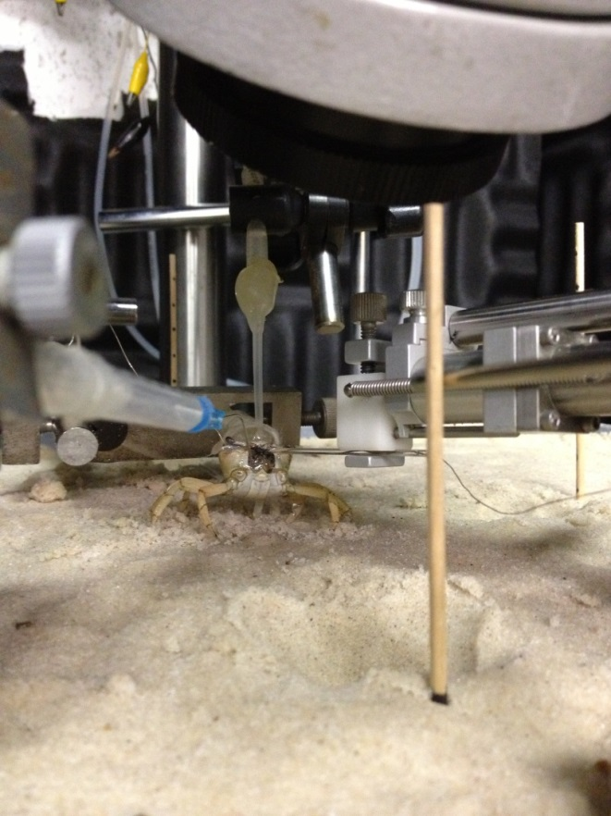
Figure 1. The crab was positioned so that its legs were resting on the sand with a saline drip directly above its eyes and flowing over the exposed brain.

Mouthparts were removed in order to expose the circumesophogeal connectives (CEC) and the brain. A tungsten hook inserted behind one connective was used to help stabilize the exposed brain.

Recording Techniques
Glass microelectrodes filled with 1M CH₃CO₂K and having a resistance of 10-30 M Ω were used to obtain intracellular recordings from individual vibration-sensitive neurons in the brain. A Kopf model 650 micropositioner was used to advance the microelectrodes following initial penetration of the outer layer of the brain (Fig. 3). All experiments were conducted at room temperature (20-22ºC). ADInstruments hardware and LabChart software were used for data collection, analysis, and visual representation of the neuron’s membrane potential.
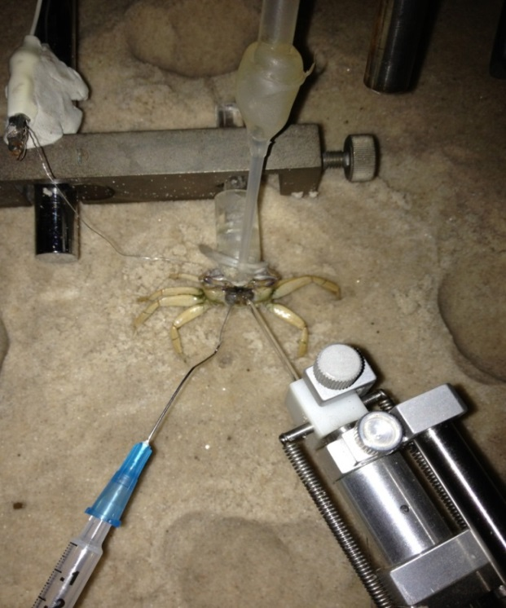
Figure 2. Above view of crab with tungsten hook (left) and microelectrode (right) inserted after mouthparts are removed.

Vibrational stimuli were generated by B&K 4810 mini-shakers controlled by custom-designed hardware and software, or by dropping a 40 g weight from a height of 8 cm. Stimulus amplitude was typically 1.5 – 2.5 m/s⁻². Upon encountering a VS neuron, the 40 g weight was dropped on each of the four sides of the crab: the front, right, rear, and left. Recordings were taken as the 40 g weights were dropped from the 8 cm mark on the sticks placed 12 cm from the four sides of the crab. It should be noted that the surface of the sand was kept moist with deionized water in order to keep the conditions as close to the natural environmental conditions.
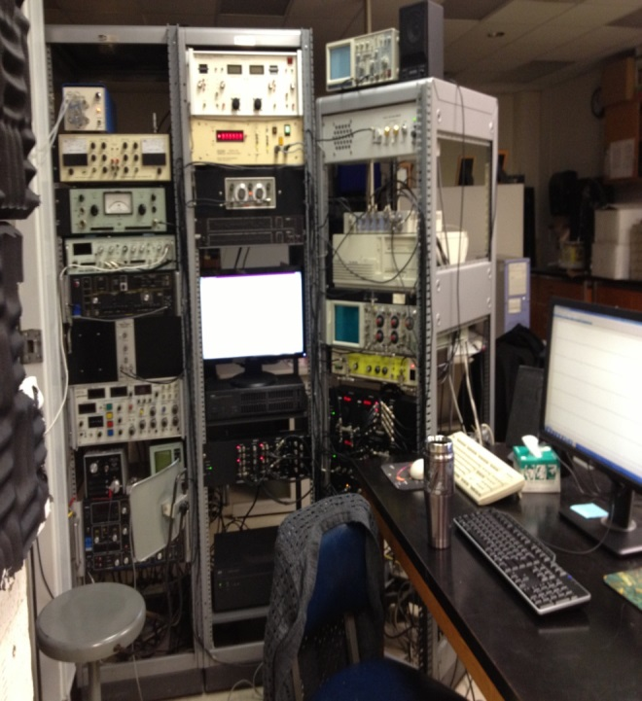

Figure 3. The Kopf model 650 micropositioner advanced the microelectrode through the brain. AD Instruments hardware and LabChart software were used to produce a visual representation of the neuron’s membrane potential.

Results

Intracellular recordings were taken from 23 VS neurons. Over half of the recorded neurons (~65%) showed directional selectivity based upon differences in firing rate elicited by stimuli presented at different sites around the animal (e.g. Figure 4, A-D). In addition to VS neurons that were directionally selective there were a number of VS neurons that were non-directional (Figure 6).

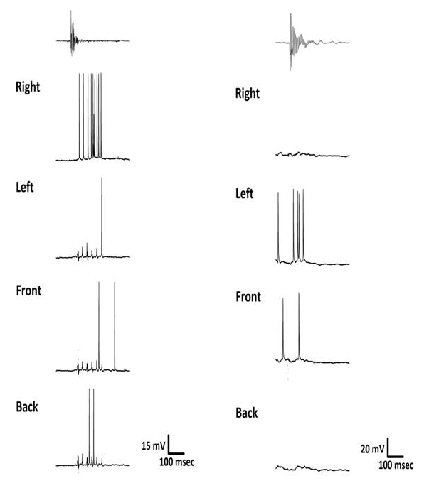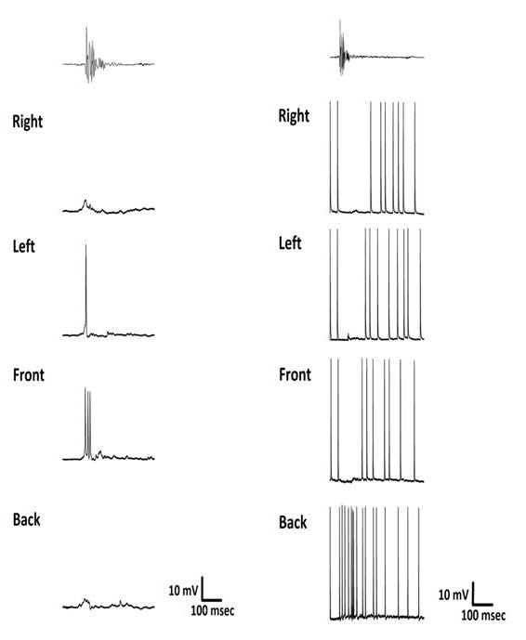
D
C
A
B

Figure 4. (A) Intracellular recording (bottom four rows) of the response from a directional VS neuron in the left side of the brain to a series of equal amplitude stimuli (top row) presented at each of the four sides. The neuron responds most robustly when the stimulus is applied to the right side only. The cell shows a much weaker response when stimulated on the remaining three sides. (B) Intracellular recording of the response from a directional VS neuron on the left side of the brain. This cell shows a response when stimulated on the left side only. The cell shows no response when stimulated on the right and back sides and a weak response when stimulated from the front. (C) Intracellular recording of the response from a directional VS neuron that responds most robustly to a stimulus from the front side. (D) Intracellular recording of the response from a directional VS neuron that responds to a stimulus from the back side. This recording demonstrates inhibition of the cell when stimulated on the right, left, and front sides. This directional VS neuron would tonically fire unless disturbed by a stimulus. In the case of the stimulus on the right, left, and front sides it would stop firing momentarily. When stimulated from the
back side the firing rate would increase.

Conclusion

The goal of this experiment was to answer the three questions asked in the beginning. (1) Is there a population of cells that respond in a directional manner depending on the side that is stimulated? The answer to this question is yes. It was seen in the recordings that a population of directional VS neurons does exist in the brain, and that this population includes different directional responses specific to a stimulus location.

(2) Based on the responses from the neurons, what kind of coding scheme can be

proposed for stimulus direction? It can be inferred from the data that input from all of the individual receptors is integrated in the CNS by a population of VS neurons having different directional selectivity. Hence, stimulus direction appears to be represented by an across-fiber coding scheme where the output of an array of neurons with different directional sensitivities varies in a systematic way with stimulus direction.
These findings have helped further our understanding of the neural mechanisms that mediate the localization of vibrational stimuli. Future research should focus on obtaining more data from fiddler crabs and should later incorporate additional organisms so that analogous systems can possibly reveal neural mechanisms. The studies should retain the set up used for this experiment, but could perhaps incorporate simultaneous stimuli from different sides of the crab or use varying intensities of stimuli to determine if the directionally selective VS neurons can be further characterized based on intensity thresholds and maximums. Such experiments would add to the understanding of neural mechanisms and arrays concerned with substrate-borne vibrations.

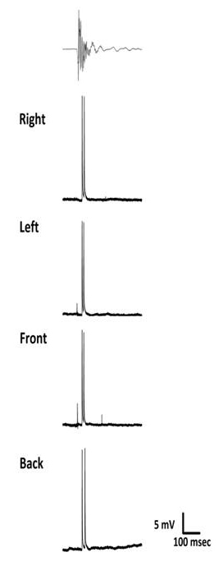

Figure 6. Intracellular recording from a non-directional VS neuron on the left side of the brain. This cell did not show any preference for stimulus direction.

References
Brownell, P. and Farley, R. D. (1979a). Detection of vibrations in sand by tarsal sense organs of the nocturnal scorpion, Paruroctonus mesaensis. J. Comp. Physiol. A 131, 23-30.
Brownell, P. and Farley, R. D. (1979b). Orientation to vibrations in sand by the nocturnal scorpion, Paruroctonus mesaensis: mechanism of target localization. J. Comp. Physiol. A 131, 31-38.
Christy, J.H. (1978). Adaptive significance of reproductive cycles in the fiddler crab, Uca pugilator; A hypothesis. Science 199, 453-455.
Cocroft, R.B. and Rodriguez, R.L. (2005). The behavioral ecology of insect vibrational communication. Bioscience 55, 323-334.
Hall, J. (1985a). Neuroanatomical and neurophysiological aspects of vibrational processing in the central nervous system of semi-terrestrial crabs: Vibration sensitive interneurons in the fiddler crab, Uca minax. J. Comp. Physiol. A 157, 91-104.
Hall, J. (1985b). Neuroanatomical and neurophysiological aspects of vibrational processing in the central nervous system of semi-terrestrial crabs: Comparative anatomical and physiological aspects of stimulus processing. J. Comp. Physiol. A 157, 105-113.
Hartline, P.H. (1971). Physiological basis for detection of sound and vibration in snakes. J. Exp. Biol. 54, 349-371.
Herreid, C.F. II and Mooney, S.A. (1984). Color change in exercising crabs: Evidence for a hormone. J. Comp. Physiol. B 154, 207-208.
Hill, P. S. M. (2009). How do animals use substrate-borne vibrations as an information source? Naturwissenschaften 96, 1355-1371.
Horch, K. (1971). An organ for hearing and vibrations sense in the ghost crab Ocypode. Z. vergl. Physiol. 71, 1-21.
Levanen, S. et al. (1998). Vibration-induced auditory-cortex activation in a congenitally deaf adult. Curr. Biol. 8, 869-872.
Swartzkopff, J. (1974). Mechanoreception. In: Rockstein M (ed). The Physiology of Insecta. 2, 273-352.

