DEVELOPMENT AND RECYCLING OF PAPER-FIBER REINFORCED COMPOSITES

A Dissertation Presented for the
Doctor of Philosophy
Degree
The University of Tennessee, Knoxville

Cecile A. Grubb
May 2025
Copyright © 2025 by Cecile A. Grubb
All rights reserved.

ACKNOWLEDGEMENTS
Thank you to Bode Dog Phillips. He is my only friend.

ABSTRACT
The automotive industry is currently under significant pressure to curb its greenhouse gas emissions as it becomes increasingly apparent the negative impacts that carbon dioxide and other human-made gases have on the environment and global warming. All the major original equipment manufacturers (OEMs) have made commitments to reduce their carbon emissions to net-zero by 2040/2050, with intermediate milestones varying by individual company. One of the major initial pushes has been toward the electrification of vehicles, as most of the carbon footprint of internal combustion engine (ICE) vehicles results from tailpipe emissions. For electric vehicles, the carbon footprint burden is shifted away from the tailpipe emissions and towards the manufacturing and materials used within the car. In existing cars, only 18% of emissions are attributed to the materials, however it is predicted that portion of emissions will increase to 60% by 2040. As such, there is significant interest within the automotive industry to develop new low-carbon footprint materials, as this will be needed to achieve carbon neutrality.
[Add more]

TABLE OF CONTENTS

Chapter 1 Introduction 1
1.1 Current State of Automotive Materials 2
1.1.1 Steel 2
1.1.2 Aluminum 2
1.1.3 Plastics and Composites 3
1.1.4 Other Materials 3
1.2 Current State of Automotive Materials 5
1.3 Life Cycle Analysis in the Automotive Industry 6
1.4 Sustainable Materials for the Automotive Industry 7
1.4.1 Natural Fibers and their Automotive Applications 8
1.4.2 “Green” Matrix Materials 10
1.5 Paper Fibers and Associated Composites 12
1.6 Research Objectives 13
Chapter 2 Paper Fiber-Reinforced Polypropylene Composites from Nonwoven Preforms: A Study on Compression Molding Optimization from a Manufacturing Perspective 14
Abstract 15
2.1 Introduction 15
2.2 Experimental 18
2.2.1 Materials 18
2.2.2 Composite Specimen Manufacturing 18
2.2.3 Density Measurement 21
2.2.4 Water Uptake Measurement 21
2.2.5 Flexural Testing 21
2.2.6 Izod Impact Testing 22
2.2.7 Experimental Design 22
2.3 Results and Discussion 22
2.3.1 Impact of Processing Parameters on Material Properties 22
2.3.2 Model Fit Comparison by Material Property 27
2.3.2 Manufacturing Cycle Optimization 29
2.4 Conclusions 35
Chapter 3 Development of an Automotive-Relevant Recycling Process for Paper Fiber-Reinforced Polypropylene Composites 36
Abstract 37
3.1 Introduction 38
3.2 Results and discussion 42
3.2.1 Recycling Process Development 42
3.2.2 Impact of Injection Molding Parameters on Composite Thermal Behavior 43
3.2.3 Impact of Injection Molding Parameters on Chemical Composition of Composites 48
3.2.4 Impact of Injection Molding Parameters on Composite Mechanical Behavior 51
3.2.5 Impact of Injection Molding Parameters on Composite Water Uptake Behavior 55
3.2.6 Correlation between Crystallinity and Mechanical Properties 57
3.2.7 Identification of Optimal Injection Molding Processing Conditions 59
3.3 Materials and Methods 61
3.3.1 Materials 61
3.3.2 Recyclate Manufacturing 61
3.3.4 Differential Scanning Calorimetry 62
3.3.5 Thermogravimetric Analysis 64
3.3.6 Fourier Transform Infrared Spectroscopy 64
3.3.7 Tensile Testing 64
3.3.8 Flexural Testing 64
3.3.9 Water Uptake Testing 66
3.3.10 Statistical Analysis 66
3.4 Conclusions 66
Chapter 4 Life Cycle Assessment of Paper-Based Composites as Replacement for an Injection Molded Polypropylene Automotive Door Component 68
Abstract 69
4.1 Introduction 69
4.2 Methodology 72
4.2.1 Goal and Scope of Study 72
4.2.2 Functional Unit 72
4.2.3 Scenario Analysis 74
4.2.3.1 Baseline, Green Energy, and Recycled Feedstock Scenarios 74
4.2.3.2 GHG Emissions and Associated Savings Through Lightweighting for Different Vehicle Types 75
4.2.4 Life Cycle Inventory Data 75
4.2.4.1 Raw Materials 75
4.2.4.2 PP-TD5 Door Panel Manufacturing 76
4.2.4.3 Paper Composite Panel Manufacturing 77
4.2.4.4 Energy Mixes 78
4.2.4.5 Transportation 78
4.2.4.6 Use-Phase 79
4.3 Results and Discussion 80
4.3.1 Cradle-to-gate GHG Emissions 80
4.3.2 Use-Phase GHG Emissions 85
4.3.3 Total Life-Cycle GHG Emissions 88
4.4 Conclusions 91
Refernces 94

LIST OF TABLES

LIST OF FIGURES

Chapter 1
Introduction

1.1 Current State of Automotive Materials
Modern cars are made of a wide variety of materials, ranging from the steel and aluminum used in the vehicle body and engine, to glass used in the windshield and windows, and plastics and composites used throughout the interior and exterior of the car. By weight, steel and ferrous materials make up 55-65% of a car's composition, aluminum 9%, plastics 10-15%, rubber 7%, glass 3%, with miscellaneous materials (varnishes, paints, wires, etc) making up the balance [1]. This composition has changed significantly over the past 50 years as car manufacturers have targeted improved fuel economy, with a focus on reducing the weight of the car by replacing steel components with other lighter materials [2].

1.1.1 Steel
Steel represents a significant portion of the weight of a car, due to its high density (7.86 g/cm³). The automotive industry has long targeted reducing the amount of steel in cars for this reason, however it remains the industry standard for the vehicle body due to its well understood crash performance and ability to absorb impact. It is also significantly less expensive than other viable materials (composites, aluminum). Beyond its use in vehicle bodies, steel is used in other applications requiring high strength and temperature resistance, such as the engine, chassis, and wheels. The major disadvantages of steel are its previously mentioned high density, as well as low corrosion resistance and limited service life [3]. Steel also has a relatively high carbon footprint, with an estimated 1.85 tons of CO2 produced for every ton of steel, accounting for approximately 8% of global CO2 emissions as of 2018 [4]. This can be significantly reduced through recycling, with an estimated reduction in CO2 by 1.5 tons for every ton of scrap steel used as feedstock rather than virgin [5].

1.1.2 Aluminum
Aluminum has increasingly been used as a replacement for steel because of its significantly lower density (2.70 g/cm³) and the associated weight savings. It is sometimes used in body-in-white applications, as its substitution for steel can produce up to a 50% weight savings for those components. However, due to the higher cost, its use is generally limited to more expensive car models. Aluminum has seen use in other automotive applications such as the powertrain, where it is used in the pistons, cylinder heads and intake manifolds, as well as the chassis (wheels, brackets, brake components, suspension), steering components, hoods, doors, and engine blocks. The disadvantages of using aluminum include its low reparability, higher cost than steel and the need for special equipment when manufacturing in place of steel [3]. Aluminum production also has a significantly higher carbon footprint than steel, with estimates of 7 – 14 ton CO2 produced for every ton of aluminum [6]. This can be significantly reduced by using end of life aluminum scrap as a feedstock and renewable energy during manufacturing. One aluminum supplier estimates that the carbon footprint can be reduced by as much as 33x by using 100% end of life scrap in conjunction with green energy [7].

1.1.3 Plastics and Composites
The use of plastics and composites in cars has significantly increased in the last 50 years from ~50 kg/car (1970) to ~160 kg/car (2010). By volume this increase is even more dramatic, with plastic materials making up ~50% of a modern car by volume [8]. Plastic materials have seen this drastic increase in use as they provide a number of advantages over traditional automotive materials including reduced weight from low densities, design flexibility, corrosion resistance, and wide variety of material properties based on composition. Because of this, plastics are used in a broad range of applications including exterior, interior and under the hood components. Although a wide variety of plastics are used in automotive applications, three polymers make up two thirds of the plastics used in cars: polypropylene (32%), polyurethane (17%), and polyvinyl chloride (16%) [9]. Table 1.1 details the types of plastics which are used in different applications.

1.1.4 Other Materials
Other materials used by the automotive industry include glass, rubber, magnesium, titanium, and copper. Glass is still used for the windshields and windows of passenger automobiles for safety reasons, as glass can more easily be broken for escape during emergencies than transparent plastics, such as PMMA or PC. Windshields are made of laminated glass, which contain a layer of polyvinylbutyral (PVB) sandwiched between two sheets of glass, while side windows are composed of tempered glass. Rubber is used for

Table 1.1 Automotive applications of commonly used plastic materials
Polymer | Automotive Applications [8,9]
Polypropylene (PP) | Bumper, dashboard, fuel system, body, under the hood, interior trim, electrical components, exterior trim, upholstery, liquid reservoirs
Polyurethane (PUR) | Foam seating, foam insulation panels, suspension bushings, cushions, upholstery
Polyvinyl Chloride (PVC) | Instrument panels, sheathing of electrical cables, floor protection, seating, interior trim, upholstery
Polycarbonate (PC) | Bumpers, headlamp lenses, dashboard, lighting
Acrylonitrile Butadiene Styrene (ABS) | Body parts, dashboards, wheel covers, seating, exterior trim, interior trim, bumpers
Nylon | Parts under the engine hood (typically reinforced with glass fiber), seating, electrical components, exterior trim, liquid reservoirs
Polystyrene (PS) | Bumpers, equipment housings, buttons, car fittings, display bases
Polyethylene (PE) | Car body (reinforced with glass fiber)
Polyoxymethylene (POM) | Interior and exterior trims, fuel systems
Polymethyl methacrylate (PMMA) | Displays, screens, lighting
Polybutylene Terephthalate (PBT) | Fog lamp housings and bezels, sunroof front parts, locking system housings, door handles, bumpers
Polyethylene Terephthalate (PET) | Wiper arm and gear housings, headlamp retainer, engine cover, connector housings
Acrylonitrile Styrene Acrylate (ASA) | Housings, profiles, interior parts, exterior trim

manufacturing automotive tires, as it has appropriate strength, modulus, and durability for continual rolling contact with the road during vehicle operation [2].
Magnesium is sometimes used in the automotive industry, as it offers significant weight savings over both aluminum and steel, with a density of 1.74 g/cm³. It has seen use in applications such as the gearbox, steering column, airbag housings, steering wheels, seat frames and fuel tank covers. However, the use of magnesium remains limited as it has reduced ultimate tensile strength, fatigue strength and creep strength when compared to aluminum, as well as a higher price than both steel and aluminum. Titanium also sees some limited use in the automotive industry in applications where both high temperature resistance and high strength are required, such as engine components and exhaust systems [3].

1.2 Current State of Automotive Materials
The automotive recycling industry is well-established in the United States, with estimates that 95% of cars within the US enter the recycling stream at the end of their lifecycle [10]. Within this, between 45 and 84% of a car (by mass) can either be recovered or recycled, rather than landfilled. Recovery of usable parts represents a major component of the automotive recycling industry, as most cars retain a large quantity of usable parts, even at the end of the vehicles useful life. These can include automotive fluids, batteries, wheels and tires, steering columns, radios, engines, transmissions, fenders, and other long-lasting components [10,11].
The end-of-life recycling process for cars is made up of four main steps: dismantling, crushing, shredding, and material separation and recovery. Usable parts are recovered during the dismantling stage of the recycling process. Some recyclable parts are also removed from the car at this stage, such as bumpers which can be directly recycled into new automotive components. Following this, the car is crushed and shredded into fist-sized pieces of material (shredder residue), during which it is decontaminated to remove hazardous materials. Finally, during the last stage of the recycling process, the shredder residue is separated using a number of technologies (magnetic, eddy current, laser and IR systems) to obtain high value materials. The majority of the focus of this step is on the recovery of metallic materials, as they can be more easily separated than plastics, which are often too heterogeneous for re-use [10,11].
The major obstacles to recycling plastic automotive components include a lack of market for the recyclates, lack of infrastructure to properly recover plastic materials, and heterogeneity of plastic automotive components. The heterogeneity of plastic automotive components and the lack of market for these materials are directly related. Many plastic parts contain two or more polymers that are integrated in such a fashion that they are not easily separated during recycling. Beyond this, essentially all commercially available plastic products contain one or more additives, further decreasing homogeneity, even in a seemingly uniform waste stream [12]. This lack of uniformity diminishes the value of the recyclate, as desirable material properties (mechanical, thermal performance) are decreased by contamination due to material incompatibilities. Most plastic materials used in vehicles are inexpensive even as virgin materials, which further reduces the economic viability of recycling at the end of the vehicle’s life cycle. The lack of infrastructure dedicated to separating and decontaminating plastics in the shredder residue further exacerbates this problem, as most automotive shredders do not have any equipment for separating plastics from other materials. This virtually guarantees plastic waste is sent to the landfill or incinerated at the end of life [11].

1.3 Life Cycle Analysis in the Automotive Industry
Life cycle analysis (LCA) can be used to quantify the environmental impacts of a product throughout the course of its life, starting with raw material extraction all the way through end of life disposal [13]. The environmental impact categories that LCAs are often used to assess include climate change, ozone depletion, acidification, nutrient enrichment, human toxicity, ecotoxicity and other resources [14]. Within the automotive industry, LCAs are often used for quantification of greenhouse gas (GHG) emissions and resource depletion, as these categories are significantly impacted by the manufacturing, use-phase and end-of-life of vehicles [15].
The standards that are most used to guide life cycle analysis are ISO standards 14040 and 14044. ISO 14040 outlines the principles and framework of life cycle analysis, while ISO 14044 outlines requirements and guidelines for performing life cycle analyses . Together, these two standards define the four main steps required for an LCA [13]:
- Identifying the goal of the LCA and defining the scope of analysis, including defining functional units, system boundaries and study limits
- Compiling a life cycle inventory (LCI) by measuring and recording all of the inputs and outputs of the system under study, in accordance with the defined functional unit
- Completing a life cycle impact assessment (LCIA) by translating the data collected in step 2 into actual environmental impacts (such as conversion of all greenhouse gas emissions into kg CO₂ equivalent)
- Interpreting the results of the study and determining conclusions, limitations, and study recommendations
Automotive original equipment manufacturers (OEMs) are increasingly using life cycle analysis as a tool to analyze their carbon footprints and make progress towards carbon neutrality goals. This is critical for the industry as regulation moves away from solely measuring tailpipe emissions towards a more holistic analysis of lifetime vehicle emissions. While this approach is necessary to understand the true environmental impacts of any vehicle, it is particularly important for BEVs, as they do not create emissions in the same way as an ICE vehicle. The environmental burdens are shifted away from the use phase of the vehicle and towards the manufacturing phase due to the energy intensive nature of battery production [16].

1.4 Sustainable Materials for the Automotive Industry
The automotive industry on the whole is targeting net-zero carbon emissions by 2040/2050, with individual automotive manufacturers targeting a range of milestones in the interim [17]. For example, Ford has set an ultimate goal of achieving carbon neutrality by 2050, with intermediate goals of 100% renewable energy for manufacturing by 2035, elimination of single use plastics by 2030 and immediate electrification of its most popular vehicles (Transit van, F-150 truck, etc) [18]. General Motors (GM) has set an ultimate goal of carbon neutrality by 2040, with intermediate goals of 0 emissions from light duty vehicles by 2035, 100% renewable energy in US facilities by 2025, and 40% of models sold in the US as battery electric vehicles (BEV) by 2025 [19]. The sponsor for this work, Volkswagen, has similar goals with ultimate carbon-neutrality by 2050, and intermediate goals of 70 BEV models on the market by 2030, reduction of greenhouse gas emissions (GHG) by 30% by 2030 (when compared to 2018 levels), and significant investments in public charging stations and battery cell manufacturing and recycling [20].
While much of the focus of carbon footprint reduction is on electrification of vehicles, as emissions during the use phase of an internal combustion engine (ICE) vehicle represent 65-80% of the total carbon footprint, development of low carbon footprint materials is critical to ultimately reach net-zero. Current estimates indicate that material production accounts for 18% of the life-cycle emissions of a vehicle, with this portion increasing up to 60% by 2040 as other electrification and use of renewable energy reduces other emissions associated with manufacturing, BEV charging, and ICE tail-pipe emissions [21]. As a result, there is significant interest in developing low-carbon footprint materials, specifically through use of bio-derived, renewable, or recycled products.

1.4.1 Natural Fibers and their Automotive Applications
The automotive industry has been interested in the use of natural fiber composites for multiple decades, dating back to the introduction of epoxy-jute door panels into the Mercedes-Benz E-class vehicles in 1996 [22]. Natural fibers offer some advantages over conventional fibers (carbon, glass), including their relatively low cost (10-30% lower than glass fibers), potential for weight reduction due to lower density, beneficial acoustic properties, wide global availability and decreased carbon footprint. A variety of natural fibers have been studied for use in automotive applications, but the most commonly used are abaca, kenaf, hemp, flax, sisal, and jute [23]. The advantages and disadvantages of common natural fibers are listed in the Table 1.2.
Although there is significant interest in natural fibers, some concerns must still be overcome before they can see large scale integration into the automotive industry. The properties of natural fibers are more inconsistent than conventional fibers, as they are dependent on a variety of conditions including the time of year at which the plant was
Table 1.2 Advantages and disadvantages of common natural fibers [22–27]
Fiber | Advantages | Disadvantages
Abaca | High tensile strength, flexural strength is similar to glass fiber | Manual extraction of fibers is very labor intensive, low production volume
Kenaf | Low cost, grows fast, good for paper making | High moisture absorption, requires a lot of water for farming, processing fibers is difficult
Hemp | Strong, grows fast, does not require pesticides | Labor intensive, farming is restricted in many countries
Flax | Relatively strong, good for fabric | Produces a lot of dust during fiber isolation process, low elasticity
Sisal | High specific strength, widely available, good sound absorption | Low production volume
Jute | Low cost, can be blended with synthetic fibers | Low crease resistance, low strength when wet
Wood | High production volume, low cost, no competition with food crops, no fertilizer inputs, preforms can be made using paper-making technologies, robust market, well developed supply, and distribution chain | Long growing cycle, extensive fiber preparation process, relatively short fibers
Bamboo | Large production volume, fast growing cycle, high specific strength, and stiffness | Highly hydrophilic, difficult fiber extraction process, fine and straight fibers

grown and harvested, the geographic location of the crop, the part of the plant from which fibers are taken, the maturity of the plant at harvest and the methods used for harvesting and preconditioning the fibers. This leads to significant variability, both between and within different batches of crops. Beyond this, natural fibers have high moisture sensitivity, low microbial resistance, and low degradation temperatures, due to the nature of the characteristics of the natural polymers from which the fibers are composed. The chemical composition of the natural fibers also leads to poor compatibility with many polymer matrices, particularly non-polar thermoplastics [23,24].
Despite these concerns, natural fiber composites have been used in the automotive industry in some limited interior and exterior applications. As previously mentioned, Mercedes-Benz has used epoxy-jute composites in their door panels. Other natural fiber-based door panels have included PUR-flax/sisal composites (Audi) and natural fiber-acrylic composites (BMW). Toyota has used PLA-kenaf composites in the spare tire cover of their 2003 Raum, while Ford has used wheat straw reinforced composites in storage bin applications and Mitsubishi has used polybutylene succinate (PBS)-bamboo composites in some interior components. Use of natural fiber composites in exterior applications has been more limited, however some use has been seen by Mercedes-Benz in their engine and transmission enclosures (polyester-flax composite) and Daimler-Chrysler in their spare tire well covers (PP-abaca fiber composites) [22]. Hybrid composites composed of a mix of natural and conventional fibers (typically glass) have also been explored for automotive applications, however this work has been mostly limited to academic research and has not seen integration into any production vehicles. Hybrid composites are more suited to applications requiring higher thermal and mechanical properties than pure natural fiber composites can achieve. Some applications which have been explored include brake pads, vehicle bumpers and antiroll bars [28].

1.4.2 “Green” Matrix Materials
There is significant interest in the use of “green” matrix materials when producing natural fiber composites, in order to further decrease the environmental impacts of the composite overall. Renewable, or bio-derived, matrices are typically considered green, however fossil-based materials that are either bio-degradable or recyclable are also sometimes considered in this category as well. Matrix materials can be broken down into 2 overall categories: thermoset (cross-linked network) and thermoplastic (re-meltable plastic). Thermosets are challenging to recycle, as they typically possess high thermal and chemical stability, although plant-based thermosets such as those polymerized from soybean or other vegetable oils are renewable, which lessens their environmental impacts. Some of these materials are also biodegradable; however, most are not. Bio-derived thermoplastic matrices include polylactic acid (PLA), poly-l-lactic acid (PLLA), polyhydroxybutyrate (PHB), and poly(3-hydroxybutyrate-co-3-hydroxyvalerate) (PHBV). These polymers have the additional benefit of both bio-degradability and recyclability, which offer multiple options for disposal at the composite’s end of life [22].
Unfortunately, there are some drawbacks associated with the use of bio-based resins (either thermoplastic or thermoset) as composite matrix materials. Bio-degradable matrices suffer from issues with surface finish throughout their use without the incorporation of surface treatment or coatings. Bio-derived resins are also typically more expensive than their fossil-based counterparts. Of the materials mentioned, PLA is the least expensive but is still 1.5 times more expensive than the frequently used fossil-based polymer polypropylene. Other issues with bio-derived matrix materials include brittleness, high crystallinity, poor UV stability, high moisture uptake, low heat deflection temperatures, and low melt viscosity which creates difficulty during composite processing. Finally, more analysis is needed to determine if these materials are truly more sustainable than conventional plastics [22,29].
Use of recycled thermoplastics or bio-derived versions of traditionally synthetic polymers offer a potential pathway for carbon footprint reduction without the drawbacks of the above described bio-polymers. The most frequently recycled plastics in the U.S. are high density polyethylene (HDPE) and polyethylene (PET), representing the majority of the market for post-consumer plastic waste [30]. There is also a growing market for recycled PP, although its recovery and recycling rate remains lower than either HDPE or PET [31]. Bio-derived versions of these three polymers have also been developed in recent years, wherein their monomers are produced via fermentation of glucose into bio-ethanol (bio-PE), bio-isobutanol (bio-PP), or bio-etholol (bio-PET) [32]. Due to the recent development of these materials and their limited commercial availability, the true carbon footprints of bio-derived PP, HDPE and PET are not well understood, although some research indicates they may not represent a significant improvement in sustainability [33–35].

1.5 Paper Fibers and Associated Composites
Paper is a natural fiber product that is manufactured from cellulose pulp derived from wood and other less common sources including wheat, rye, rice, bamboo, flax, hemp, cotton, abaca and sisal [36]. The production of paper fibers involves the following principal steps [37]:
- Growing and subsequent harvesting of wood (or other fiber source)
- Transport of harvested wood to pulp mill
- Raw material preparation, including cleaning, debarking and size reduction
- Pulp production, either through chemical or mechanical pulping processes
- Pulp washing to remove undesired soluble compounds
- Screening to remove large impurities, such as wood knots or shives (short fiber bundles)
- Pulp bleaching (if desired) to remove lignin and improve whiteness, brightness, and softness of fibers
Once paper fibers have been obtained, there are a variety of industrial processes for their conversion into sheets and other commercial products, although most use a similar process. Pulp is dispersed in water to form a slurry of approximately 0.5 – 1.0% fibers, then formed into a web of fibers on a thin screen. The web of fibers is pressed to increase the density of the sheet and finally dried to remove residual moisture. Other operations may be performed as desired, such as application of sizing to improve liquid resistance or coating of paper with specialized treatments, and physical processes such as calendaring or embossing to create preferred surface texture [37].
Paper fibers have been used as reinforcements in composite applications dating back to early research by Baekeland into phenolic reinforced paper sheets [38]. Other commercial paper composite products have included Richlite (paper/phenolic resin), Micarta (paper/epoxy or phenolic resin) and Ebonol (paper/phenolic resin). These materials have been applied to applications such as countertops, skateboard ramps, guitar fingerboards, and other commodity applications [39–41]

1.6 Research Objectives
[Add section outlining these for each chapter]

Chapter 2
Paper Fiber-Reinforced Polypropylene Composites from Nonwoven Preforms: A Study on Compression Molding Optimization from a Manufacturing Perspective

Note: This chapter is published in Journal of Composites Part A. Citation: C. Grubb, D. Keffer, C. Webb, M. Kardos, H. Mainka, & D. Harper. (2024). Paper fiber-reinforced polypropylene composites from nonwoven preforms: A study on compression molding optimization from a manufacturing perspective. Composites Part A: Applied Science and Manufacturing, 185, 108339. https://doi.org/10.1016/j.compositesa.2024.108339
(Reproduced with permission from Elsevier)

                - Abstract
This work optimizes compression molding manufacturing for wet-formed nonwoven paper and polypropylene fiber mats. A central composite designed experiment investigated the effects of fiber reinforcement concentration, compression molding temperature, pressure, and time on composite laminate performance. We assess the composites’ density, panel thickness, water uptake, flexural behavior, and Izod impact strength. Models predicted and optimized composite performance using objective function analysis with penalties applied for undesirable conditions, such as processing time or low reinforcement concentration. Paper fiber content has the largest impact on composite properties, followed by processing time, molding pressure, and temperature. Composite optimization depends on penalty conditions; low fiber content penalties favor low fiber content panels with short processing times, while high fiber content penalties favor high fiber content panels with long processing times. This work suggests that molding composites with a greater fraction of renewable feedstock requires a commensurate increase in processing intensity.

Keywords: A. Biocomposite, cellulose, natural fibers, polymer-matrix composites (PMCs), B. Mechanical properties, C. Analytical modelling, E. Compression moulding

                - 2.1 Introduction
Natural fiber composites have received significant attention by the automotive industry in recent years as all major original equipment manufacturers (OEMs) have released targets of net-zero carbon emissions by the mid-twenty first century [17–19]. Initial efforts by OEMs have focused on conversion from internal combustion engines to battery electric vehicles, as historically vehicles release the majority of associated carbon emissions during the use phase of the vehicle [42,43]. For electric vehicles however, the carbon footprint burden is shifted away from the tailpipe emissions and towards the manufacturing and materials used within the car [44]. In existing cars, only 18% of emissions are attributed to the materials, however it is predicted that this portion of emissions will increase to 60% by 2040 [21]. As such, there is significant interest within the automotive industry to develop new low-carbon footprint materials, as this will be needed to achieve carbon neutrality.
While the focus of the automotive industry on decreasing carbon footprint is a recent development, occurring over the past decade, the integration of natural fiber composites into the automotive sector traces dates back to the introduction of epoxy-jute door panels in Mercedes-Benz E-class vehicles in 1996 [22]. Natural fibers offer distinct advantages compared to traditional fibers like carbon and glass, including their cost-effectiveness (10-30% lower than glass fibers), potential for weight reduction due to lower density, favorable acoustic properties, global availability, and reduced carbon footprint [23,45–48]. Abaca, kenaf, hemp, flax, sisal, and jute are among the natural fibers most frequently explored for automotive applications [22–27].
Although there is significant interest in natural fibers, certain challenges must be addressed before components sourced from natural feedstocks can see large scale integration in the automotive industry. The properties of natural fibers are more inconsistent than conventional fibers, as they are dependent on a variety of conditions including season and location of plant growth, plant segment used, maturity at harvest, and the methods used for fiber harvesting and pre-conditioning [49–51]. This results in significant variability both within and among different batches of crops [52,53]. Moreover, natural fibers have high moisture sensitivity, low microbial resistance, and low degradation temperatures, due to characteristics of the natural polymers from which the fibers are composed [54–57]. The chemical composition of the natural fibers also leads to poor compatibility with many polymer matrices, particularly non-polar thermoplastics [58–60].
Paper fibers offer distinct benefits over the previously described natural fibers. These include substantial production volume (approximately 500 million tons estimated in 2020), global availability, lack of competition with food resources, uniform quality across seasons, and well established quality control standards [27,37,61,62]. A number of researchers have investigated using paper fibers, such as waste newspaper, filter paper, or office copy paper, as reinforcements in thermoplastic composites [63–67]. The majority of this research used either film stacking or injection molding as their manufacturing methods, with promising improvements in mechanical properties over the neat matrix material [68–70]. These manufacturing techniques offer some limitations from an industrial perspective; injection molding requires pre-compounding the paper fibers with the polymer matrix in a twin screw extruder which can cause fiber breakage, further decreasing the length of an already short fiber. Furthermore, injection molding limits the maximum fiber content to approximately 40-50%, as the injection molding compound must flow to properly pack out the part and prevent defects such as voids, weld lines and poor fiber dispersion [71,72]. Film stacking offers the ability to increase the fiber content to upwards of 70%, however previous research has shown that it is challenging to obtain good wetting of fibers while avoiding degradation, as polymer viscosity must be lowered through high temperatures to properly impregnate fiber layers [73].
This work studied the use of commingled nonwoven paper fiber-polypropylene performs as the feedstock for compression molding applications. Kraft market pulp fibers, herein referred to as paper fibers, were mixed with polypropylene fibers using papermaking techniques, then hot-pressed into laminates under a variety of processing conditions. The laminates were characterized for properties relevant to the automotive industry (panel thickness, flexural behavior, impact toughness, water uptake, and density). These results were used to develop models for composite property prediction. From this, optimal conditions were identified using objective functional analysis with a variety of scenarios representing emphasis on either manufacturing time minimization or sustainable content maximization.

                - 2.2 Experimental

2.2.1 Materials
The following materials were used as received: Domtar bleached hardwood kraft market pulp (MP) and MiniFibers precision cut 3 mm length, 15.3 μm diameter polypropylene (PP) fibers. A L&W Fiber Tester Plus was used to measure market pulp fiber dimensions. The mean fiber length was 1.004 mm and the mean width was 19.9 μm, both of which were calculated using a length-weighted technique. A histogram of measured fiber lengths is shown in Figure 2.1. A Micromeritics AccuPyc II 1340 gas pycnometer was used to measure the density of the market pulp, from which it was estimated to be 1.53 ± 0.05 g/cm³.

2.2.2 Composite Specimen Manufacturing
Composite preforms were produced using a wet-lay process in which paper fibers and polypropylene fibers were mixed using a Voith-Sulzer valley beater to create an aqueous suspension with a solids content of 13.3 g/L and then vacuum formed into 203 x 203 mm squares. No paper or polypropylene was lost during this process, as all of the suspended material was converted into preforms. The preforms were then placed in an oven and dried overnight at 103 °C to remove residual moisture. The moisture content of preforms after drying was measured using a VWR Moisture Analyzer (53M.H) and determined to be 2.97 ± 0.43 wt%. Following drying, the preforms were consolidated into composite panels using a Carver Laboratory heated hydraulic press (model: 3895.4PR1A00). The paper composite panels were manufactured with varying concentrations of paper fiber and varying processing conditions based on a central composite design (CCD) designed experiment, as described in section 2.7. All panels were cooled to 80 °C under the pressure that they were molded at before removing from press. A schematic of the manufacturing process, including images of intermediate and final products, is shown in Figure 2.2.
Water uptake, flexural, and Izod impact test specimens were cut from each panel using Snapmaker A350T laser cutter equipped with a 10 W High Power Laser Module. Sample dimensions and replicates are shown in Table 2.1.

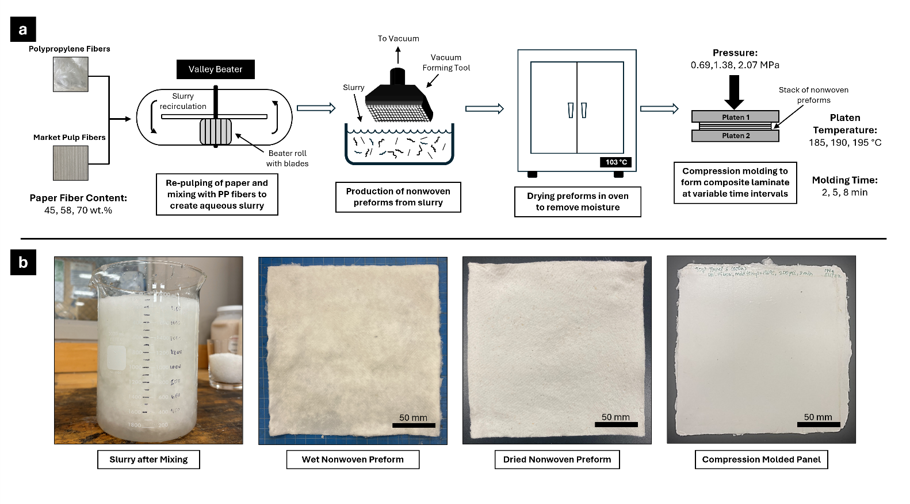
Figure 2.1. Histogram of kraft market pulp fiber length

Figure 2.2 Schematic of paper composite manufacturing process with designed experiment process values identified (a) and images of materials each stage of the process (b).

Sample Type | Dimensions (mm) | Replicates
Flexural Specimen | 60 x 12 x 3 | 5
Water Uptake Specimen | 76.2 x 25.4 x 3 | 3
Izod Impact Specimen | 63.5 x 12.7 x 3 w/45° rounded notch at midpoint | 6
Table 2.1 Sample types and associated dimensions for composite specimens studied in this work.

2.2.3 Density Measurement
Sample density was measured using a using Mettler Toledo analytical balance and density measurement kit. Sample weight was measured both in air and in water, and the density was calculated using the Archimedes method as shown Equation 2.1:
$$ρ=\frac{A}{A-B}\left(ρ_{0}-ρ_{L}\right)+ρ_{L}$$ | (2.1)
where ρ is the density of the sample, $A$ = sample weight in air, $B$ = sample weight in water, $ρ_{0}$ = density of water, and $ρ_{L}$ = density of air (0.0012 g/cm³). The water temperature during sample measurements was determined to be 20.8 °C (density = 0.998056 g/cm³).

2.2.4 Water Uptake Measurement
Water absorption tests were conducted in accordance with ASTM D570. The samples were dried under vacuum at 80 °C overnight to remove excess moisture. After conditioning, the samples were cooled within a desiccator and weighed using a precision analytical balance to establish their initial weight. Samples were then placed into a temperature-controlled water bath at 23 °C and mass was re-measured at 24 hours of submersion.

2.2.5 Flexural Testing
Flexural testing was conducted in accordance with ASTM D790. Prior to testing, samples were conditioned in a temperature and humidity-controlled environment at 25 °C and 65% RH for 88 hours. Samples were observed to reach equilibrium moisture content within this time period, with an average moisture content of 1.61 ± 0.06 wt.%, 3.85 ± 0.06 wt.%, and 3.82 ± 0.06 wt.% for the 45%, 58%, and 70% fiber samples, respectively. Flexural testing was performed using an Instron 5567 with a 3-point bend test fixture and 500 N load cell. The test span and rate were set to 45 mm and 1.125 mm/min, respectively. Samples were tested until 25% strain was reached. An Instron deflectometer was used to measure strain equipped with an extensometer with a 25 mm range.

2.2.6 Izod Impact Testing
Izod impact testing was conducted in accordance with ASTM D256. Samples were conditioned using the same procedure as described in the flexural testing section. Testing was performed using Tinius Olsen Model Impact 104 instrument equipped with a 25 J weight.

2.2.7 Experimental Design
The experimental design used in this work was a central composite design so as to allow for analysis of data using response surface methodology [74]. The factors and levels used in the CCD are shown in Table 2.2. The levels used were determined by preliminary experiments. Processing temperature needed to be high enough to allow for polypropylene fibers to melt and flow but low enough to limit degradation of market pulp. Likewise, compression molding pressure needed to be high enough to enable panel consolidation, while low enough to prevent melt fracture of the materials. Compression molding time was minimized to the lowest duration required to produce panels with integrity after leaving the press at different market pulp fiber loading levels.
The full CCD and experimental data for each set of processing parameters are shown in Table 2.3. Within the design the symbols ‘+’ and ‘-‘ correspond to the high and low levels of the factorial points, while the letters ‘A’ and ‘a’ correspond to the highest and lowest axial points, and finally, the ‘0’ represents the center point of the design [75]. Two center point runs (0000) were performed as an indicator of panel-to-panel variability. For each set of processing parameters, panel thickness, twenty-four-hour water uptake, density, flexural modulus, yield strength, and Izod impact strength were measured.

                - 2.3 Results and Discussion

2.3.1 Impact of Processing Parameters on Material Properties
In Table 2.3, the panel thickness, twenty-four-hour water uptake, density, flexural modulus, yield strength, and Izod impact strength are reported. The studied range of processing conditions resulted in significant variation in properties. The panel thickness
Table 2.2 Levels for each factor studied in the central composite design
Factor | Low | Center | High
Market Pulp Fiber Content (wt.%) | 45 | 58 | 70
Temperature (°C) | 185 | 190 | 195
Pressure (MPa) | 0.69 | 1.38 | 2.07
Molding Time (min) | 2 | 5 | 8

Table 2.3 Full central composite designed experiment and associated experimental data for each of the studied properties. Standard error was calculated using pooled variance and is reported for each data set is reported.
Panel Identification |  |  | Processing Parameters |  |  |  | Experimental Results
Serial No. | DOE Pattern | Run No. | Fiber Content | Temperature | Pressure | Time | Panel Thickness (SE = ±0.024,  n = 6) | Water Uptake  (SE = ± 2.9,  n = 3) | Density  (SE = ±0.020, n = 11) | Flexural Modulus  (SE = ±150,  n = 5) | Flexural Yield Strength  (SE = ±1.1,  n = 5) | Izod Impact Strength  (SE = ±0.3,  n = 6)
Serial No. | DOE Pattern | Run No. | (wt%) | (°C) | (MPa) | (min) | (mm) | (wt%) | (g/cm³) | (MPa) | (MPa) | (kJ/m²)
1 | -+-+ | 1 | 45 | 195 | 0.69 | 8 | 3.240 | 4.7 | 0.98 | 2210 | 20.5 | 12.2
2 | ---+ | 2 | 45 | 185 | 0.69 | 8 | 3.518 | 6.8 | 0.94 | 2460 | 18.7 | 25.8
3 | --++ | 6 | 45 | 185 | 2.07 | 8 | 3.242 | 5.7 | 1.01 | 1660 | 17.8 | 24.1
4 | -+-- | 10 | 45 | 195 | 0.69 | 2 | 3.538 | 5.6 | 0.96 | 2510 | 23.5 | 20.3
5 | -++- | 11 | 45 | 195 | 2.07 | 2 | 2.840 | 3.8 | 1.03 | 2150 | 20.0 | 14.4
6 | --+- | 15 | 45 | 185 | 2.07 | 2 | 3.338 | 10.3 | 0.95 | 2140 | 19.4 | 41.4
7 | ---- | 17 | 45 | 185 | 0.69 | 2 | 4.282 | 32.9 | 1.03 | 1600 | 10.9 | 33.6
8 | a000 | 21 | 45 | 190 | 1.38 | 5 | 3.373 | 3.5 | 0.76 | 1240 | 11.9 | 16.5
9 | -+++ | 25 | 45 | 195 | 2.07 | 8 | 2.722 | 5.2 | 1.05 | 3780 | 30.5 | 13.5
10 | 0000 | 3 | 58 | 190 | 1.38 | 5 | 3.487 | 12.7 | 0.97 | 2670 | 19.5 | 21.5
11 | 0A00 | 4 | 58 | 195 | 1.38 | 5 | 3.392 | 12.0 | 1.02 | 3410 | 25.2 | 17.9
12 | 00a0 | 9 | 58 | 190 | 0.69 | 5 | 3.680 | 19.5 | 0.91 | 2460 | 15.7 | 17.9
13 | 0a00 | 13 | 58 | 185 | 1.38 | 5 | 3.355 | 15.3 | 0.98 | 2890 | 20.4 | 22.7
14 | 000A | 14 | 58 | 190 | 1.38 | 8 | 3.258 | 11.5 | 1.03 | 2990 | 23.5 | 20.0
15 | 00A0 | 19 | 58 | 190 | 2.07 | 5 | 3.490 | 10.5 | 0.99 | 3030 | 22.3 | 18.2
16 | 0000 | 22 | 58 | 190 | 1.38 | 5 | 3.577 | 15.1 | 0.91 | 2620 | 18.5 | 24.2
17 | ++-- | 5 | 70 | 195 | 0.69 | 2 | 5.095 | 66.2 | 0.71 | 870 | 3.5 | 17.9
18 | +--- | 7 | 70 | 185 | 0.69 | 2 | 6.212 | 117.1 | 0.68 | 320 | 1.8 | 15.7
19 | +--+ | 8 | 70 | 185 | 0.69 | 8 | 4.563 | 23.7 | 0.71 | 1340 | 7.1 | 22.4
20 | ++++ | 12 | 70 | 195 | 2.07 | 8 | 3.302 | 16.7 | 1.03 | 2600 | 17.0 | 25.8
21 | +-+- | 16 | 70 | 185 | 2.07 | 2 | 4.033 | 89.0 | 0.78 | 760 | 4.2 | 27.9
22 | +++- | 18 | 70 | 195 | 2.07 | 2 | 3.263 | 33.3 | 0.96 | 1090 | 3.8 | 26.5
23 | A000 | 20 | 70 | 190 | 1.38 | 5 | 3.603 | 27.5 | 0.89 | 2010 | 7.9 | 27.1
24 | ++-+ | 23 | 70 | 195 | 0.69 | 8 | 3.815 | 30.6 | 0.83 | 1860 | 10.3 | 18.0
25 | +-++ | 24 | 70 | 185 | 2.07 | 8 | 3.500 | 21.9 | 0.76 | 2070 | 11.4 | 32.1

ranged from 2.722 to 6.212 mm. The density of the panel ranged from 0.68 to 1.05 g/cm³. The twenty-four-hour water uptake ranged from 4% to 117%. The flexural modulus ranged from 320 to 3800 MPa. The yield strength ranged from 1.8 to 30.5 MPa. The Izod impact strength ranged from 12.2 to 41.4 kJ/m². For all six measured properties, the measured range includes values that fall below and above acceptable thresholds for automotive applications. Thresholding will be discussed further in the optimization section.
In Table 2.4, we report the Pearson correlation coefficients between the four process variables and the five measured material properties. Pearson correlation coefficients range from -1 to 1, with values closer to |1| indicating a greater correlation between two variables. Positive correlation coefficients indicate a direct relationship, while negative coefficients indicate an inverse relationship [76]. For the majority of properties, fiber content has the largest correlation coefficient, indicating that has the greatest impact on those properties. The exception to this is Izod impact strength, for which temperature has the largest correlation coefficient. The correlation coefficients of the remaining three process variables are more challenging to compare, as they are very similar. The average correlation coefficients for temperature, time, and pressure are 0.34, 0.31, and 0.31, respectively. It should be noted however, that correlation coefficients in this range only indicate a low degree of linear correlation, which limits the ability to draw strong conclusions from this data alone [77].
Fiber content has the greatest impact on composite performance, considering that composite mechanical properties and water uptake are dominated by paper fibers rather than the matrix. Only the paper fibers provide mechanical reinforcement and absorb moisture given the hydrophobic nature of polypropylene. Density is also largely a function of the proportions of the two materials used, as paper fibers have a higher inherent density. The processing parameters dictate consolidation and resulting void volume during molding. The remaining composite properties depend largely on the relationship between polymer viscosity, time, temperature, and shear rate. These interactions are not captured by the individual correlation coefficients which convolutes the interpretation of this data. Time appears to have the largest impact on performance beyond fiber content. This arises from a wide processing range studied in comparison to pressure and temperature. Both the
Table 2.4 Pearson’s correlation coefficients for material properties vs process variables
Material Properties | Process Variables
Material Properties | Fiber  Content | Temperature | Pressure | Time
Panel Thickness | 0.4634 | -0.3201 | -0.5436 | -0.3791
Flexural Modulus | -0.3730 | 0.2963 | 0.2062 | 0.4313
Izod Impact Strength | 0.0773 | -0.5554 | 0.2828 | -0.1903
Density | -0.5555 | 0.2959 | 0.3379 | 0.1362
Water Uptake | 0.5981 | -0.2503 | -0.1965 | -0.4551
Average Correlation Coefficient | 0.41 | 0.34 | 0.31 | 0.31

temperature and shear range studied in this work were limited by the capabilities of the paper fibers, which will degrade under high temperature or shear conditions. The relationships between process variables will be described more in depth in the following section.

2.3.2 Model Fit Comparison by Material Property
To develop a model from which optimal processing parameters could be interpolated, the experimentally obtained material properties shown in Table 2.3 were investigated via two machine learning algorithms: regression and a neural network (NN). The application of a NN was motivated by the successful use of such a model for process optimization from response surface methodology [78]. For this work, the regression model provided a superior fit to the data regardless of the tuning parameters used in the NN. For this reason, in the discussion below, we only provide results based on the regression model.
The material properties were regressed using the least squares fit, from which model parameter estimates were obtained. The regression model contained linear terms for each of the four process variables (fiber content (F), compression molding pressure (P), compression molding temperature (T) and compression molding time (S)). The original regression model as proposed also contained quadratic terms for each pairwise combination of processing variables, including self-terms, e.g. F*F, and cross terms, e.g. S*F. In the final regression model, all terms with p-values greater than 0.05 were removed as they were not considered statistically significant. All linear terms were retained as were 7 of the 10 quadratic terms. The T*T, P*P and T*P terms were dropped. The results of this regression analysis are shown in Table 2.5. The table is arranged in terms of model parameter significance based on LogWorth.
The degree of importance of model parameters were compared using LogWorth, a statistical metric calculated from the -log₁₀ of the p-value, for which higher values are indicative of higher importance [79]. Overall, the regression model indicated that fiber content was the parameter with the highest impact on material parameters, as was the case with the Pearson correlation coefficients discussed in the previous section. Compression molding time had the second highest LogWorth value, likewise, indicating its high degree

Table 2.5 Regression coefficients from least squares fit model analysis
Model Information |  | Statistical Values |  | Model Parameters from Regression Analysis
Term | Units | LogWorth | P-value | Panel Thickness | Flexural Modulus | Flexural Yield Strength | Izod Impact Strength | Density | Water Uptake
Intercept | - | N/A | N/A | 13.1 | -7620 | -51.3 | 179 | -0.350 | 2.54
F | wt.%⁻¹ | 6.896 | >0.00000 | 3.13 | -3160 | -48.4 | 6.28 | -0.628 | 1.51
S | min⁻¹ | 5.364 | >0.00000 | -0.0960 | 133 | 0.999 | -0.458 | 0.00599 | -0.0472
P | MPa⁻¹ | 4.527 | 0.00003 | -0.00449 | 2.07 | 0.0194 | 0.0222 | 0.000460 | -0.000613
(F-0.58)*(S-5) | (wt.%*min)⁻¹ | 4.265 | 0.00005 | -0.358 | 519 | 3.16 | 7.47 | 0.0310 | -0.302
T | °C⁻¹ | 3.396 | 0.00040 | -0.0531 | 58.9 | 0.476 | -0.866 | 0.00817 | -0.0154
(T-190)*(S-5) | (°C*min)⁻¹ | 3.228 | 0.00059 | 0.00576 | 4.73 | 0.0365 | 0.189 | 0.00102 | 0.00579
(F-0.58)² | (wt.%)⁻² | 3.148 | 0.00071 | 10.6 | -67700 | -595 | 102 | -8.54 | 1.99
(F-0.58)*(T-190) | (wt.%* °C)⁻¹ | 2.427 | 0.00374 | -0.0770 | -83.3 | -1.76 | 5.48 | 0.0518 | -0.0685
(S-5)² | min⁻² | 1.859 | 0.01384 | 0.0157 | 6.85 | 0.304 | 0.137 | 0.00803 | .0148
(P-200)*(S-5) | (MPa*min)⁻¹ | 1.732 | 0.01852 | 0.000683 | 0.295 | 0.00257 | -0.00118 | 8.60e-6 | 0.000144
(F-0.58)*(P-200) | (wt.%*MPa)⁻¹ | 1.625 | 0.02374 | -0.0156 | 5.99 | -0.00222 | 0.183 | 0.00239 | -0.00254

of importance within the model. Beyond this, fiber content and molding time were the only parameters for which all secondary interactions containing their terms are statistically significant (e.g., F*S or F*P). Pressure ranked as the third most important processing parameter, while temperature was the fourth and least important parameter based upon these regression results. These results are relatively similar to those found using Pearson’s correlation coefficients in terms of ranking process variables in order of importance. However, as the model was able to account for the secondary interactions between process variables, it ultimately achieves a higher degree of correlation between the material properties and process variables.
The strength of the fit of the regression models described in the previous section varied between different material properties analyzed. Plots of the predicted vs actual values are shown below in Figure 2.3, with R-square values for the linear fit of the data shown on each graph. The regression model for water uptake had the best fit with an R-square of 0.9563, while Izod impact strength had the worst fit with an R-square of 0.7411. Some of this variation from model predictions can be explained by the variability of the raw data; for instance, the average relative standard deviation (RSD) of the water uptake data was 1.61%, indicating that there was very little variation between samples in a given data set. The Izod impact strength, on the other hand, had an RSD of 11.23%, indicating significant variability within panels. The intra-panel variation does not fully explain the model variability however, as the flexural modulus had the highest RSD at 12.93% but only the third lowest R-square, while flexural yield strength had an RSD of 8.36% with the second highest R-square and density had an RSD of 6.14% with the second lowest R-square value. This suggests other factors are affecting the model which are not considered by the regression model yet to be determined.

2.3.2 Manufacturing Cycle Optimization
The experimental data collected during from the central composite design was further analyzed using objective function minimization to determine the optimal set of processing parameters for automotive applications. Only panels for which all properties (flexural modulus, Izod impact strength, and water absorption) meet automotive

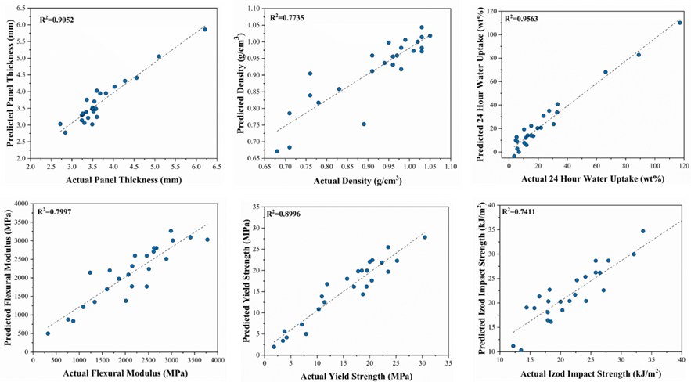

Figure 2.3 Model fit comparison between experimental and predicted values for studied composite properties

requirements were considered as part of this analysis. Threshold values are shown in Table 2.6 for flexural modulus, Izod impact strength, and water uptake. These values were based on FlexForm, a nonwoven bast fiber-based composite material intended for automotive applications. Multiple grades of FlexForm are commercially available, so a mid-point for each property was approximated from the available grades and used for this analysis. After thresholding was applied, 14 of the 25 panels were removed from the data set, leaving 11 for further analysis.
An objective function was developed to calculate a figure of merit for each panel based on its performance and processing conditions. The objective function is based on one previously published to which penalty functions have been added [80]. Panels produced with long processing times were penalized, as these are undesirable for the automotive industry. Likewise, panels with low paper fiber content were penalized as they are less desirable from a sustainability perspective. From that, the following objective function (Equation 2.2) was for defined for each sample:
$$f_{obj}\left(s_{j}\right)=\left(w_{T}\frac{T_{j}}{〈T_{j}〉}\right)+\left(w_{F}\frac{〈F_{j}〉}{F_{j}}\right)+\sum_{i=1}^{n_{prop}}{w_{i}{\left(\frac{p_{i,j}}{〈p_{i}〉}\right)}^{n_{i}}}$$ | (2.2)
where $n_{prop}$ is the number of properties ($n_{prop}=5$ in Table x), $p_{i,j}$ is the value of property $i$ for sample $j$, $〈p_{i}〉$ is the average value of property $i$ over all samples, $w_{i}$ is the relative weight of property $i$, and $n_{i}$ is the exponent for property $i$, which takes a value of $±1$. A positive value of $n_{i}$ is used with properties for which a lower value is desired (e.g. water absorption and density) and a negative value is used with properties for which a higher value is desired (e.g. yield strength and other mechanical properties). In this work, all weights, $w_{i}$, were set to unity. $T_{p}$ and $F_{p}$ represent penalties applied for processing time and fiber content, respectively. $w_{T}$ and $w_{F}$ were varied from 0.00001 to 10,000 at intervals of one order of magnitude. This is meant to represent increasing emphasis on either of those parameters in a manufacturing setting. The large range of penalty weights is intended to span the effect of process variable between two extreme asymptotes, no importance and extreme importance. Figure 2.4 shows the panel with the smallest figure of merit, or most optimal panel, evaluated at all the experimental combinations. The calculated figure of
Table 2.6 Threshold values used to remove panels prior to objective function analysis
Property | Threshold Value | Minimum or Maximum for Threshold
Flexural Modulus (MPa) | 2000 | Minimum
Izod (kJ/m²) | 15.0 | Minimum
Water Uptake (wt%) | 20.0 | Maximum

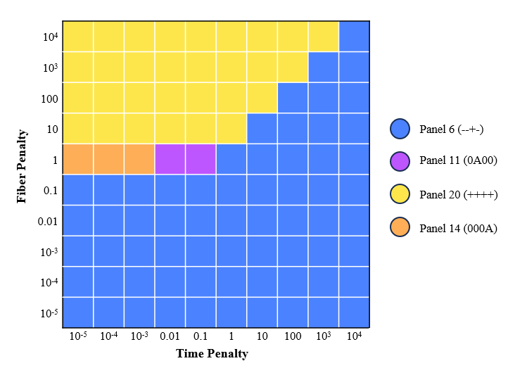

Figure 2.4 Model fit comparison between experimental and predicted values for studied composite properties
merit for each combination are shown in Table 2.7, as well as the second and third best panels for those conditions. It should be noted that figures of merit can only be compared at a given set of penalty conditions, as the penalties vary by many orders of magnitude, compared to the material properties. As a result, figures of merit also vary by orders of magnitude, which is apparent when examining the high penalty conditions.
For scenarios in which fiber content is considered less important, i.e., small fiber content penalties, then panel 6 (--+-) is the most optimal. This indicates that for low paper fiber concentration, optimal processing conditions involve a combination of low temperature and short processing time under high pressure conditions to achieve fiber wet- out, while preventing excessive polymer flow that ultimately negatively impacts composite performance. In contrast, for scenarios where high amounts of paper fiber are desired, panel 20 (++++) is the most optimal. This indicates that for high paper fiber concentrations, intense processing conditions (high time, temperature, and pressure) are required to achieve adequate composite consolidation, due to the reduction in polymer matrix available to wet-out fibers.
In addition to evaluating the objective function at all experimental conditions based on the experimentally measured properties, we also evaluated the objective function using the regression model described in the section above. Again, the motivation was to interpolate between processing variables to find optimal processing conditions. However, the ranking of the objective functions generated from the model predictions did not agree with the ranking obtained from the experimental measurements. Despite the relative goodness of the regression shown in Figure 3, those predicted properties led to poor estimates of the objective function. Because the model could not reproduce the ranking of best panels at the experimentally evaluated points, the attempt to use the model to interpolate between experimental processing conditions to find optimal parameters was necessarily abandoned. A comparison between the figures of merit calculated using the objective function from the experimental data versus model predictions is shown in Figure 2.5. No penalties were applied for this comparison. Of the four optimal panels in the optimization section above, three remain after thresholding, however panel 6 (--+-), the best short-time panel based on experimental measurements as shown in Figure 2.3, was
Table 2.7 Calculated figures of merit for best panels under various penalty conditions
Penalty Information |  |  | Optimal Panel |  | 2nd Best Panel |  | 3rd Best Panel
Penalty Condition | Fiber Penalty | Time Penalty | Panel No. (DOE ID) | Figure of Merit | Panel No. (DOE ID) | Figure of Merit | Panel No. (DOE ID) | Figure of Merit
Low F_{p} | 0.00001 | 0.00001 | 6 (--+-) | 3.71 | 4 (-+--) | 3.78 | 2 (---+) | 3.80
Inter. F_{p} + Low T_{p} | 1 | 0.0001 | 14 (000A) | 4.842 | 11 (0A00) | 4.843 | 15 (00A0) | 4.98
Inter. F_{p} + Inter. T_{p} | 1 | 0.1 | 11 (0A00) | 4.94 | 14 (000A) | 5.00 | 6 (--+-) | 5.03
High F_{p} | 10000 | 1000 | 20 (++++) | 9894 | 11 (0A00) | 11,003.84 | 15 (00A0) | 11,003.98

Figure 2.5 Comparison of figures of merit obtained from experimental data vs model calculations
removed from the set, as the flexural modulus predicted by the model fell outside of the acceptable threshold.
                - 2.4 Conclusions
In this study, paper fiber-based composite laminates were manufactured under a variety of compression molding conditions to better understand the effects of fiber reinforcement concentration, compression molding temperature, compression molding pressure and compression molding on composite density, panel thickness, water uptake behavior, flexural behavior and Izod impact strength. A central composite designed experiment was applied to understand the interaction effects between the processing parameters and develop regression models for comparison of the impacts of each parameter. Ultimately, this analysis indicated that paper fiber content played the largest role in composite performance, followed by processing time, compression molding pressure, and processing temperature in order of importance. Manufacturing cycle optimization was analyzed using objective function analysis with penalties applied for undesirable processing conditions, such as long cycle times or low fiber content. This analysis revealed that the optimum set of processing conditions is highly dependent on one’s priorities. If long processing times are unwanted but fiber content is unimportant, a 45 wt.% paper fiber panel produced with short cycle time and low temperature, but high compression molding pressure is favored. Likewise, if high paper fiber content is critical, then a panel with 70 wt.% paper fiber is favored, but it requires intense processing conditions to achieve adequate consolidation. These results can therefore be used to guide manufacturing decisions based on the priorities of the composite manufacturer.

Chapter 3
Development of an Automotive-Relevant Recycling Process for Paper Fiber-Reinforced Polypropylene Composites

Note: This chapter is published in recycling. Citation: C. Grubb, M. Mokhtarnejad, J. Greene, J. Misasi, D. Keffer, M. Kardos, H. Mainka, & D. Harper. (2024). Development of an automotive-relevant recycling process for paper fiber-reinforced polypropylene composites. Recycling, 9(6), 126. https://doi.org/10.3390/recycling9060126
(Reproduced with permission from MDPI)

                - Abstract
The automotive industry is under growing pressure from regulatory agencies to improve the recyclability of their plastic components. Simultaneously, manufacturers are adopting natural fiber composites in vehicles to reduce carbon footprints and decrease reliance on petroleum-based materials. This presents a challenge at vehicle end-of-life however, as natural fiber-reinforced polymers are substantially more difficult to recycle than their unreinforced counterparts. This study investigated the development of a mechanical recycling process for paper fiber-reinforced polypropylene composites, focusing on the impact of injection molding parameters—specifically, injection temperature and rate—on the thermal, mechanical, and water uptake properties of the composites. The results showed that processing temperature had a greater influence on composite performance than injection rate, with some limited interaction effects between the two. Higher processing intensity damaged the paper fibers, increasing the number of nucleation sites and resulting in greater polypropylene crystallinity. These structural changes reduced tensile properties at higher intensities, while flexural properties improved. Objective function analysis was applied to identify optimal processing conditions, balancing these competing trends. Overall, the findings demonstrate that paper fiber-reinforced polypropylene composites can be recycled into automotive relevant injection molding compounds using conventional plastic manufacturing techniques, though careful tuning of processing parameters is essential to achieve optimal performance.

Keywords: recycling, polypropylene, composites, paper fibers, injection molding, sustainability, automotive

                - 3.1 Introduction
The automotive industry has become increasingly interested in using natural fiber reinforced composites in recent years, as the industry moves toward a goal of net-zero carbon emissions by the mid-twenty first century. Natural fibers offer advantages over conventional reinforcement materials, such as glass or carbon, including comparatively low cost, low density, favorable acoustic properties, wide global availability and inherently low carbon footprint [22,45]. There are considerable disadvantages associated with natural fibers however, such as material variability, high moisture sensitivity, low micro-bial resistance, low degradation temperature, and limited compatibility with polymer matrices [50–52,55]. The low thermal stability of natural fibers in particular presents a problem for recycling, as reprocessing via standard polymer manufacturing techniques can lead to significant fiber degradation and poor material performance [81]. New European Union (EU) regulations require automotive manufacturers to increase the circularity of vehicle materials, with a specific focus on ensuring that plastic used in vehicles comes from recy-cled sources and is recyclable at a vehicle’s end-of-life (EoL) [82].
Our previous work studied the viability of paper-based composites for automotive applications [80]. For the automotive industry, paper fibers offer benefits over other commonly used natural fibers such as hemp, flax, or jute. Paper is produced at a substantially larger volume than these other fibers, at 500 million tons per year in 2020, as opposed to flax (830,000 tons/year), jute (2.5 million tons/year), and hemp (215,000 tons/year) [23,83]. The pulp and paper industry also has well-developed quality control standards and methods which alleviate the variability issues typically seen with natural fibers [62]. Our previous study demonstrated that paper composites composed of 60 wt% market pulp and 40% polypropylene exhibit promising material properties, including flexural strength, impact resistance, and water uptake suitable for automotive interior applications [25]. However, to ensure the successful commercialization of these composites, a comprehensive evaluation of EoL pathways and recycling feasibility is imperative. This is particularly true for automotive parts intended for the European market, given the EU’s forthcoming end-of-life vehicles (ELV) regulations, which require automotive companies to design vehicles for reuse and recycling [82].
As previously mentioned, natural fiber composites present unique recycling challenges due to their limited thermal stability. This is especially true when focusing on mechanical recycling methods like extrusion, injection molding or other techniques that involve melting and reforming the material, rather than chemically breaking down the polymer into monomers or other molecular components. Despite this, mechanical recycling remains the most studied type of recycling within the natural fiber composites community given its wide industrial applicability. A recent review from Zhao et al. describes the complex interplay of factors affecting recycled composite behavior, describing changes in properties such as mechanical behavior, thermal stability, crystallinity, hygroscopicity, durability during UV exposure, and rheological properties [84]. The general trends reported in the natural fiber recycling studies are presented in Table 3.1. It should be noted that different material systems can experience conflicting trends, as different polymers and fiber types can behave differently under identical conditions. For instance, Augier et al. report that a wood-filled PVC composite experiences an increase in glass transition temperature with mechanical recycling, likely due to polymer crosslinking, while other research shows that similar systems with different matrix materials, such as polypropylene (PP) or polylactide (PLA), instead display a decrease in glass transition temperature (T_{g}) due to chain scission during reprocessing [85]. As such, it is important to study the behavior of a specific natural fiber composite system during mechanical recycling, as behavior cannot be predicted from previous literature unless the material systems are identical.
This research aimed to develop an industrially relevant method for mechanically recycling the paper fiber-reinforced polypropylene composites that we previously developed into an injection molding compound with automotive relevant properties. Non-woven mats were produced from 60% market pulp and 40% polypropylene, then compression molded to produce composite laminates. These laminates were then size-reduced and compounded with additional polypropylene to produce an injection molding compound. This material was injection molded under various processing conditions to determine the bounds of the processing window. Thermal, mechanical, and moisture-uptake properties of the produced samples were studied to characterize trends in structure-property relationships of these composites. From this, processing conditions were
Table 3.1 Reported material property changes during mechanical recycling of natural fiber composites. Fiber types used in the respective studies are included for reference.
Property |  | Reported Changes During Mechanical Recycling | Fiber Type(s) | Reference
Mechanical | Tensile | Both increase and decrease possible, decrease in properties attributed to polymer degradation and loss of fiber length while increase attributed to improved dispersion, increased crystallinity | Wood fiber, wood flour | [86–88]
Mechanical | Flexural | Similar changes to tensile properties, although degradation and defects often had less of an impact | Bagasse, bamboo | [89,90]
Mechanical | Impact | Both increase or decrease in impact properties are possible; an increase attributed to the reduction in fiber length and increased ductility of the compound, a decrease attributed to increased crystallinity and associated brittleness | Bagasse, coriander straw, cellulose fiber | [89,91,92]
Thermal | Crystallization | Increase in crystallinity and shift to lower temperatures due to reduction in polymer chain length, increase in fiber surface area, increased nucleation, and oxidation of fibers | Wood flour, bagasse | [88,89]
Thermal | Glass  Transition | Both increase and decrease possible; decrease was attributed to reduced molecular weight from chain scission, while increase was attributed to increase in molecular weight through crosslinking | Wood fiber, flax | [85,93]
Thermal | Thermal  Stability | Both increase and decrease possible, increases attributed to crosslinking of polymer, reduction in hemicellulose, and increase crystallinity; Reduction in thermal stability attributed to polymer matrix degradation and fiber degradation | Wood fiber, bagasse | [85,86,89]
Other | Hygroscopicity | Both increase and decrease possible; decrease results from improved dispersion within the polymer matrix and reduction in hemicellulose with an increase in cellulose surface oxidation while increases attributed to increased moisture penetration pathways from defects at polymer/fiber interface | Wood fiber, wood flour, rice hulls, bagasse | [86,94]
Other | Rheological | Both increase and decrease are possible; a decrease in melt viscosity results from chain scission and a reduction in fiber length, increase is also possible due to an increase in surface area from fiber length reduction; Shear sensitivity may also increase | Wood fiber, wood flour | [86,88]

identified that balance achieving a high degree of polymer crystallinity in the samples while minimizing fiber degradation, the combination of which results in optimal mechanical properties. We anticipate these results will pave the way for future adoption of both the virgin composite laminates and their recycled counterparts within the automotive industry.

                - 3.2 REsults and discussion

3.2.1 Recycling Process Development
The goal of this work was to develop industrially viable recycling processes for paper-reinforced polypropylene composites and identify limitations and challenges along the way. This started with the size reduction of the composite laminates. The initial effort focused on the use of a Conair-Wortex granulator, a commonly used piece of equipment in the injection molding industry for regrinding production scrap to create post-industrial recyclate [95]. However, the resulting “fluffy” flake posed challenges in material feeding during extrusion process due to their size. To address this, we therefore added a second step, in which we used a knife mill to further reduce the size of the granulate to ~ 4.5 × 2.5 × 1 mm. At this point, the granulate was still low-bulk density, but it fed into the extruder without bridging or clogging issues seen in previous tests.
Following size reduction, the granulate was compounded with polypropylene pellets and maleic anhydride copolymer (MAPP), the latter of which acted as a coupling agent between the paper fibers and polypropylene matrix. We processed the material under the lowest possible temperature profile in the twin screw extruder, as detailed in Section 3.2. The reason for this was to minimize thermal degradation of paper fibers, while preventing excessive torque on extruder motor. The addition of MAPP was necessary to prevent severe “shark-skinning” of extrudate, a phenomenon that occurs due to melt fracture of the polymer when exiting the extruder die [96]. The extrudate was pelletized with an in-line unit, generating the feedstock for the subsequent injection molding stage.
As with extrusion, we aimed to injection mold the paper-polypropylene composite at the lowest possible temperature. This was ultimately determined to be 200 °C, as lower temperatures resulted in “short shots” – parts in which the material was unable to completely fill the mold cavity. From this baseline, we were able to investigate the different combinations of temperature and injection rate on the processability of the composite material, with the goal of identifying the upper limit of the processing window. The composite material processed well until we reached 240 °C, at which point we were only able to produce parts at injection rates of 32.8 – 49.2 ml/s (2 – 3 in³/s), as the material would not inject properly at either 16.4 or 65.6 ml/s (1 or 4 in³/s). The full recycling process is shown in Figure 3.1.

3.2.2 Impact of Injection Molding Parameters on Composite Thermal Behavior
The thermal properties of the injection molded specimens were measured using differential scanning calorimetry (DSC) and thermogravimetric analysis (TGA). DSC was used to study the melting and crystallization behavior, while TGA was used to characterize the thermal stability of the materials. Figure 3.2 shows the results of the DSC testing, with melt temperatures and enthalpies reported for both heating cycles, and crystallization temperatures and enthalpies reported for the sole cooling cycle. TGA data is reported in the appendix (Table XXX), as no statistical significance was seen within the results.
Overall, thermal analysis shows subtle correlations between the processing conditions and the resulting properties. The most notable analysis outcome is the positive correlation between the processing temperature and both recrystallization temperature and enthalpy, seen in Figures 3.2C and 3.2D. Likewise, it appears that both of the recrystallization properties are positively correlated with injection rate, although this is more difficult to visually detect. The impacts of processing parameters on the melting temperature and enthalpy during both the first and second heating cycles are not visually obvious. Regression analysis was employed to further elucidate the complex relationships between processing parameters and material properties. For this, we considered both linear (temperature, injection rate) and interactions between the two (temperature*injection rate) terms. The p-values for each term are presented in Table 3.2, where bold values indicate statistical significance at a level of p < 0.05. Additionally, Table 3.2 includes the direction of correlation (↑ for positive, ↓ for negative) for all statistically significant terms.

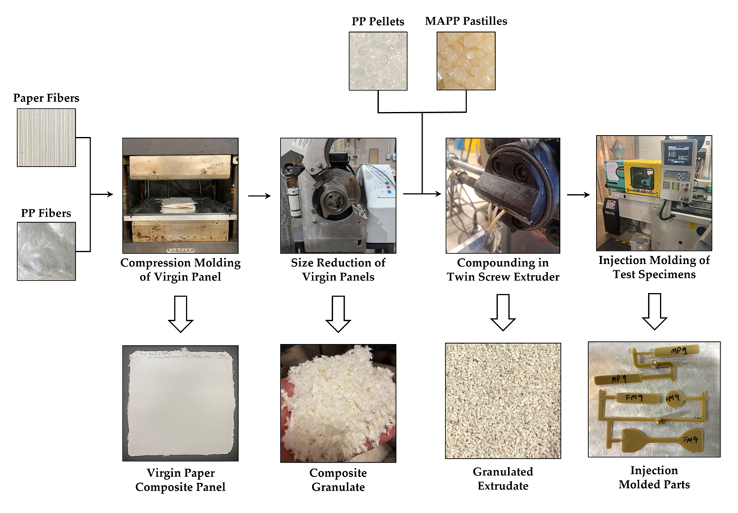

Figure 3.1 Overview of the manufacturing process used in this research. Step 1 represents production of virgin paper composites, while steps 2 – 4 represent recycling process.
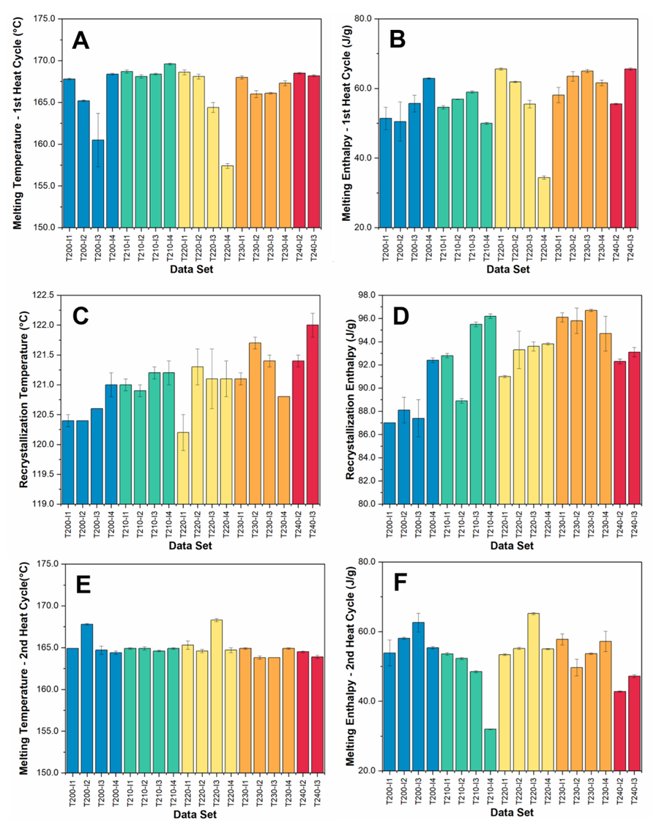

Figure 3.2 Thermal properties of injection molded samples: (A) Melting temperatures of the 1st heat cycle, (B) melting enthalpies for the 1st heating cycle, (C) recrystallization temperatures, (D) recrystallization enthalpies, (E) melting temperatures of the 2nd heat cycle, and (F) melting enthalpies for the 2nd heating cycle.
Table 3.2 P-values and correlation direction for the effects of temperature, injection rate, and their interaction on thermal properties.
 |  | P-Values |  |  | Correlation Direction
Test Method | Property | Temp. | Injection Rate | Temp.*  Injection Rate | Temp. | Injection  Rate | Temp.*  Injection Rate
DSC | T_{m} (1st Heat) | 0.59607 | 0.00972 | 0.25472 | - | ↓ | -
DSC | ΔH_{m} (1st Heat) | 0.02989 | 0.08279 | 0.08824 | ↑ | - | -
DSC | T_{m} (2nd Heat) | 0.04818 | 0.67182 | 0.33610 | ↓ | - | -
DSC | ΔH_{m} (2nd Heat) | 0.24570 | 0.29333 | 0.48744 | - | - | -
DSC | T_{c} | <0.0001 | 0.01404 | 0.25712 | ↑ | ↑ | -
DSC | ΔH_{c} | <0.0001 | 0.00612 | 0.02801 | ↑ | ↑ | ↑
TGA | T₅₀ | 0.34323 | 0.13614 | 0.54321 | - | - | -
TGA | Residual Mass | 0.21116 | 0.21116 | 0.38690 | - | - | -

Processing temperature has the most significant impact on melting and recrystallization behavior of the samples. Within the melting behavior, the processing temperature is positively correlated with the melting enthalpy on the first heat cycle and negatively correlated with the re-melting temperature on the second heat cycle. It is also positively correlated with both the recrystallization temperature and recrystallization enthalpy. ΔH_{m} (1st heat) corresponds with the thermal history from cooling the polymer in the injection molding tool. At higher processing temperatures, the polymer reaches a lower viscosity during injection molding. This improves the ability of the polymer to crystallize while cooling due to improved chain mobility with decreased viscosity [97].
The inverse correlation between processing temperature and with T_{m} (2nd heat) is likely due to a decrease in PP molecular weight from thermo-oxidative degradation. Previous literature has noted that that polypropylene molecular weight is relatively stable up to processing temperatures of 230 °C, however above this point, chain scission rises rapidly with increasing temperature [98]. These changes in molecular weight are not apparent in the first heating cycle as the effects are masked by the different temperature differentials ($ΔT{=T}_{process}-T_{room temperature}$) associated with different processing temperatures during injection molding, which leads to disparate cooling experiences between different processing conditions. Conversely, the cooling cycle in the DSC leads to uniform thermal histories and reveals the differences between melting temperatures during the second heating cycle. The positive correlation between processing temperature and recrystallization behavior (T_{c} and ΔH_{c}) is also likely due to this decreasing molecular weight, which allows for improved nucleation of PP crystals during cooling.
The injection rate shows less statistically significant impact on the thermal properties, however there are a few key relationships that can be observed. The injection rate is negatively correlated with T_{m} on the first heating cycle only, while it is positively correlated with both T_{c} and ΔH_{c}. The injection rate and associated shear likely have a greater impact on the reinforcing fibers than the polymer matrix and would be expected to decrease the fiber length, in turn increasing the number of nucleation sites available. The increasing shear rate also favors the formation of β-phase crystalline structure in the polypropylene matrix [99]. The combination of these two effects explains both the changes in melting temperature and recrystallization behavior. The increase in nucleation sites will improve nucleation efficiency, increasing the crystallization rate and resulting in the corresponding increase in crystallization temperature and enthalpy [100]. Likewise, the β-crystals of polypropylene are known to melt at a lower temperature than α-crystals, hence the depression of melt temperature [101]. This effect is only seen in the first heat cycle, however, as there are no shear forces during the DSC experiment to re-induce the β crystallite structure. It is also possible that the depression of the melting point is due to the formation of α-crystals with an imperfect crystal structure, as these defects will also reduce the melting temperature [102].

3.2.3 Impact of Injection Molding Parameters on Chemical Composition of Composites
Fourier Transform Infrared Spectroscopy (FTIR) was used to analyze the chemical changes in the injection molded samples. This technique measures the characteristic vibrational frequencies of molecules, allowing for identification of various functional groups present in the composites. The peaks of interest were identified as 3330 cm⁻¹ (O-H stretch), 2917 cm⁻¹ (C-CH₃ stretch), 1761 cm⁻¹ (C=O stretch), 1656 cm⁻¹ (enolic groups), 1456 cm⁻¹ (CH₂ bend), 1375 cm⁻¹ (CH₃ bend), 1033 cm-1 (C-O stretch) [103]. An example plot with these peaks highlighted is shown in Figure 3.3. We chose to normalize against the C-CH₃ peak at 2917 cm⁻¹ for further analysis, as it appears in all the raw materials and is not expected to change significantly with oxidation. The carbonyl index (CI), a measure of the relative amount of carbonyl groups (C=O) present in the material, was calculated for each sample using Equation 3.1.
$$CI=\frac{Intensity of 1761 cm^{-1}}{Intensity of 1456 cm^{-1}}$$ | (3.1)
The full results of both the normalization and CI calculations are included in the appendix; however Figure 3.4 shows the trends observed in the samples molded at 2 in³/s which are representative of the overall trends observed across all injection rates. Finally, as with the thermal analysis, regression analysis was used to determine the statistical impact of the processing parameters on studied peak intensities and CI. The p-values and correlation directions are shown in Table 3.3.

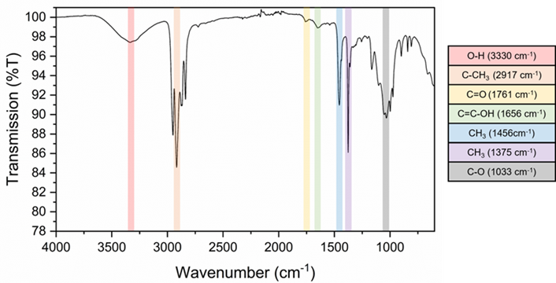

Figure 3.3 Example spectra of T230-I2 with relevant peaks identified.

Figure 3.4 Ratio of intensities of various peaks to intensity of C-CH3 peak at 2917 cm⁻¹. Trends are shown only for samples molded at an injection rate of 2 in³/s, as they are representative of other injection rates.
Table 3.3 P-values and correlation directions for the effects of temperature, injection rate, and their interaction on FTIR peak intensities.
 | P-Values |  |  | Correlation Directions
Peak Number | Temp. | Injection Rate | Temp.*  Injection Rate | Temp. | Injection  Rate | Temp.*  Injection Rate
1033 | 0.2827 | 0.6382 | 0.2174 | - | - | -
1375 | 0.0277 | 0.1243 | 0.3028 | ↑ | - | -
1456 | 0.0209 | 0.5179 | 0.7500 | ↑ | - | -
1656 | 0.0051 | 0.7285 | 0.7555 | ↑ | - | -
1761 | 0.0057 | 0.6360 | 0.7259 | ↑ | - | -
3330 | 0.4062 | 0.5064 | 0.2623 | - | - | -
Carbonyl Index | 0.0481 | 0.9432 | 0.9975 | ↑ | - | -

Overall, injection molding temperature was the only processing parameter that had a statistically significant impact on the chemical composition of the samples. Increasing injection molding temperature led to increases in all FTIR peaks associated with degradation, as well as a pronounced rise in the carbonyl index. The peak at 1761 cm⁻¹ is associated with the formation of carbonyl groups during oxidative degradation of both polypropylene and paper fibers [104,105]. The 1656 cm⁻¹ peak is associated with the formation of enolic or conjugated ketone groups during cellulose oxidative and hydrothermal degradation [106]. The peaks at 1465 and 1375 cm⁻¹ are associated with CH₂ scissoring and C-H bending in cellulose and are strongly correlated with cellulose crystallinity [107]. When the paper fibers are exposed to a thermo-oxidative environment, the amorphous regions of the cellulose will degrade at lower temperatures, leaving behind a larger portion of the crystalline cellulose, thus resulting in increases in the 1465 and 1375 cm⁻¹ peaks. Similar effects have been seen in wood degradation, although they were outsized in comparison to this study, as wood has a much higher lignin and hemi-cellulose content than the paper fibers used in this study [108]. Overall, the FTIR results suggest that the material experiences a higher degree of oxidative degradation with increased temperature, as would be expected. Furthermore, the results seem to suggest that the oxidative degradation primarily affects the paper fibers rather than the polypropylene matrix.

3.2.4 Impact of Injection Molding Parameters on Composite Mechanical Behavior
The mechanical behavior of the composites was studied using flexural and tensile analysis. For both methods, the modulus, strength, and strain at failure were recorded as these properties are critical for composite part performance in automotive applications. In particular, the moduli and strength are used as design criteria. The three measured properties are shown in Figure 3.5 for both tensile and flexural testing. The same method of regression analysis as previously described was used to determine statistical significance of processing parameters. The p-values for this analysis are reported in Table 3.4. One- way analysis of variance (ANOVA) was used to determine statistically different pairs via the Tukey-Kramer test, the results of which are included in Figure 3.5.
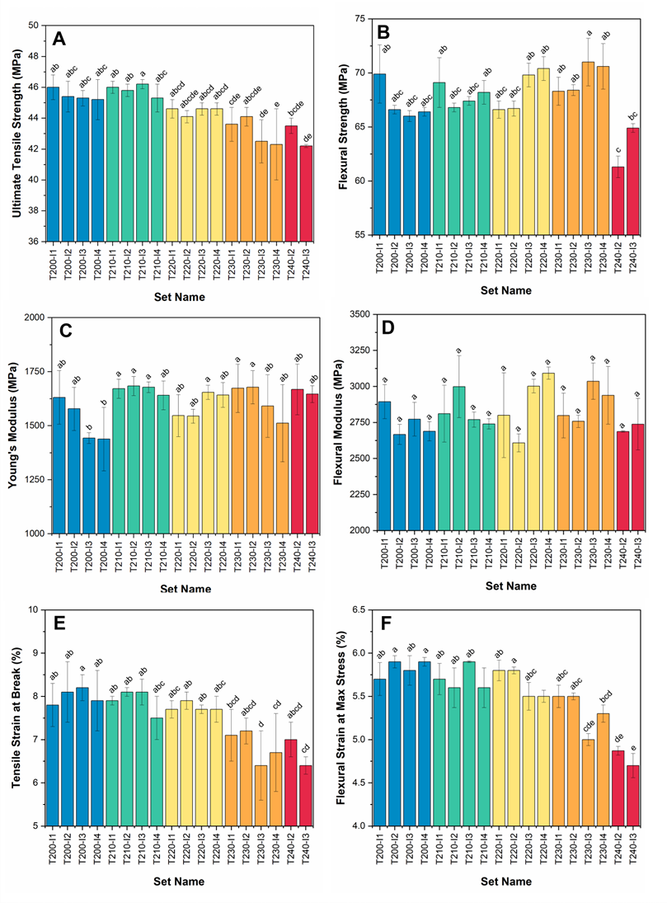

Figure 3.5 Mechanical properties of injection molded specimens: (A) ultimate tensile strength, (B) flexural strength (B) Young’s modulus, (D) flexural modulus, (E) tensile strain at break and (F) flexural strain at maximum stress. Different letters (i.e., a,b,c,d, and e) designate statistically different data sets at p < 0.05.
Table 3.4 P-values and correlation direction for the effects of temperature, injection rate, and their interaction on mechanical properties.
 |  | P-Values |  |  | Correlation Directions
Test Method | Property | Temp. | Injection Rate | Temp.*  Injection Rate | Temp. | Injection  Rate | Temp.*  Injection Rate
Tensile | Young’s Modulus | 0.02119 | 0.02684 | 0.30428 | ↑ | ↓ | -
Tensile | Ultimate Tensile Strength | <0.0001 | 0.00988 | 0.33631 | ↓ | ↓ | -
Tensile | Tensile Strain at Break | <0.0001 | 0.0901 | 0.1152 | ↓ | - | -
Flexural | Flexural Modulus | 0.4386 | 0.1216 | 0.0245 | - | - | ↑
Flexural | Flexural Strength | 0.7940 | 0.1203 | 0.0042 | - | - | ↑
Flexural | Flexural Strain at Max Stress | <0.0001 | 0.0533 | 0.0156 | ↓ | - | ↑

Both processing temperature and injection rate were statistically significant for the tensile strength and modulus the composites, while only temperature had a statistically significant effect on strain at break. Tensile modulus was positively correlated with temperature and negatively correlated with injection rate, while the tensile strength was negatively correlated with both parameters. It should be noted that the interaction term (temperature*injection rate) was not statistically significant, which indicates that these two variables do not interact with each other in a meaningful way. Tensile strain at break was also negatively correlated with temperature, similar to ultimate tensile strength.
The increase in tensile modulus with increasing temperature can likely be attributed to the increase in crystallinity, as PP crystallinity is well-known to correlate with Young’s modulus [109]. This is further corroborated by the thermal analysis data, indicating that increasing processing temperature led to higher crystallinity. Higher crystallinity within the matrix can also explain the observed decreases in tensile strength and strain at break.
This is a direct consequence of increased modulus for strain at break – as the composite becomes stiffer, it will also become more brittle [110]. The decrease in tensile strength with increasing temperature can also be associated with this increased crystallinity, as smaller and weaker amorphous fractions must account for most of the composite strain [111]. This ultimately leads to brittle failure at lower stress. The reduction in modulus and strength associated with increasing injection rate can also be attributed to fiber length reduced by increased shear forces during injection molding [92,112].
The trends observed in flexural properties were somewhat different than those seen in the tensile properties of the composite material. Only flexural strain at maximum stress was correlated with a primary factor – a negative correlation with processing temperature. Neither temperature nor injection rate was directly correlated to either flexural strength or modulus, however the interaction term was positively correlated with all three measured properties. In general, flexural strength appears to stay relatively constant with increasing temperature, however this trend abates once we reach a processing temperature of 240 °C, at which point the flexural strength drops significantly. This indicates that flexural strength is less sensitive to the degradation that is occurring until a threshold is reached, unlike tensile strength which drops off in a more linear fashion. These contrasting observations can be explained through the inherent differences between tensile and flexural testing. Tensile tests apply uniform stress throughout the cross-section of the materials, whereas flexural tests concentrate stress on the surfaces of the specimen. This also explains why flexural strengths are typically higher than tensile strengths for a given material [113]. The positive correlation between the interaction term (temp.*injection rate) is likely due to decreased viscosity of the polymer under more intense processing conditions. The improved flow of the polymer will lead to better surface properties thereby improving flexural strength, although at very intensive processing conditions the degradation to the fibers is more significant than these positive effects. This is likewise true for the flexural modulus; however, we do not observe a drop off in the stiffness of the material as this is less sensitive to defects in the bulk material than the strength. Flexural strain at maximum stress experiences similar trends to tensile strain at break and can again be attributed to increasing matrix crystallinity.
The analysis of variance between the different data sets revealed that although the processing conditions are having statistically significant effects on the trends within the material properties, the actual values of the mechanical properties do not change significantly throughout the processing window studied. This is particularly true for the stiffness of the material with all the flexural moduli falling within a statistically equal range and the tensile Young’s modulus only has a few data sets that are not statistically equivalent. From a manufacturing perspective, this suggests the recyclate is tolerant of a wide processing window, although there is an upper limit to the temperature that it can endure.

3.2.5 Impact of Injection Molding Parameters on Composite Water Uptake Behavior
The water absorption behavior of the injection molded samples was measured to assess their resistance to humid environments, a common challenge for natural fiber composites. The samples exhibited a low water uptake, with an average mass increase of 0.4 ± 0.2 wt.% after 24 hours of submersion and 0.7 ± 0.4 wt.% after 504 hours of submersion. The processing conditions had no statistically significant effect on water uptake behavior, as all the p-values were far greater than 0.05, as shown in Table 3.5. A
Table 3.5 P-values and correlation direction for the effects of temperature, injection rate, and their interaction on water uptake behavior.
Test Method | Property | Temp. | Injection Rate | Temp.*Injection Rate
Water Uptake | 24 Hour Water Uptake | 0.3451 | 0.3428 | 0.3804
Water Uptake | 504 Hour Water Uptake | 0.2491 | 0.6949 | 0.1681

significant degree of variability was observed, likely due to limitations of the resolution of the scale used for these measurements. Overall, these tests indicate that paper fibers were almost entirely encapsulated by the polypropylene matrix, thereby preventing moisture ingress into the fibers.

3.2.6 Correlation between Crystallinity and Mechanical Properties
Multivariate analysis was used to analyze the relationship between crystallinity and mechanical properties to understand underlying correlations. The Pearson’s correlation coefficient from this analysis are shown in Table 3.6, with associated p-values reported in the supplementary info. T_{m} (2nd heat) and ΔH_{m} (2nd heat) were not included in this analysis, as they do not correspond to the thermal history associated with processing the tested specimens. These relationships were analyzed and no correlations were observed. In general, Pearson’s correlation coefficients with an absoluate value between 0.00 – 0.09 are considered to have a negligible correlation, those from 0.10 – 0.39 are weakly correlated, 0.40 – 0.69 moderately correlated, 0.70 – 0.89 strongly correlated, and 0.90 – 1.00 very strongly correlated [114].
The majority of the correlation coefficients generated by the multivariate analysis fall in the negligible to weakly correlated range, however there are a number of notable exceptions. Ultimate tensile strength is very strongly correlated with tensile strain at break, strongly correlated with flexural strain at maximum stress, and moderately negatively correlated with ΔH_{m} (1st heat), T_{c} and ΔH_{c}. Tensile strain at break is also strongly correlated with flexural strain at maximum stress, and moderately negatively correlated with T_{c} and ΔH_{c.} Flexural modulus shows a moderate negative correlation with T_{m} (1st heat), while flexural strain at max stress shows a moderate positive correlation.
These correlations give further insight into the relationship between polymer morphology and mechanical behavior. In particular, these results support the conclusion that degree of crystallinity and type of crystal are having significant impacts on material strength and brittleness. Degree of crystallinity is directly measured by both ΔT_{c} and ΔH_{c.} The inverse correlation between these two properties and ultimate tensile strength further confirms the previously hypothesized relationship. Likewise, the inverse correlation

Table 3.6 Pearson’s correlation coefficients from multivariate analysis, with moderate or better correlation bolded for clarity.
 | Young's  Modulus | UTS | Tensile Strain | Flex.  Modulus | Flex. Strength | Flexural Strain | T_{m}  (1st heat) | ΔH_{m}  (1st heat) | T_{c} | ΔH_{c}
Young's  Modulus | 1 | 0.0714 | -0.1452 | 0.2315 | 0.0538 | -0.3114 | 0.186 | -0.2378 | 0.3715 | 0.2928
UTS | - | 1 | 0.9133 | -0.099 | 0.0158 | 0.8053 | -0.0166 | -0.4111 | -0.5236 | -0.4359
Tensile Strain |  | - | 1 | -0.1793 | -0.0814 | 0.8770 | -0.1767 | -0.3841 | -0.5601 | -0.5159
Flex. Modulus | - | - |  | 1 | 0.6753 | -0.2114 | -0.4532 | -0.3306 | -0.1093 | 0.1061
Flex. Strength | - | - |  | - | 1 | 0.1736 | -0.2695 | -0.2194 | -0.1716 | 0.3155
Flexural Strain |  |  |  |  |  | 1 | 0.5959 | -0.1966 | -0.6315 | -0.2987
T_{m} (1st heat) | - | - |  | - | - |  | 1 | 0.5959 | 0.1079 | 0.1637
ΔH_{m} (1st heat) | - | - |  | - | - |  | - | 1 | 0.2694 | 0.178
T_{c} | - | - |  | - | - |  | - | - | 1 | 0.6084
ΔH_{c} | - | - |  | - | - |  | - | - | - | 1
*UTS = Ultimate Tensile Strength. T_{m} = melt temperature, T_{c} = crystallization temperature, ΔH_{m}= melt enthalpy, ΔH_{c} = crystallization enthalpy

between tensile strain at break and both ΔT_{c} and ΔH_{c} further suggests that increasing polymer crystallinity is causing the composites to become more brittle. The relationships between melting temperature and both flexural modulus and flexural strain at maximum stress suggest that the increase in β crystalline regions within the polypropylene matrix is impacting the stiffness and brittleness of the composite. The β crystal morphology appears to have a negative impact on stiffness, while increasing the ductility of the material.

3.2.7 Identification of Optimal Injection Molding Processing Conditions
A set of optimal processing conditions was selected by comparing the mechanical properties (ultimate tensile strength, Young’s modulus, flexural strength, flexural modulus) associated with different processing conditions, as well as their standard deviations. This comparison was done using objective function minimization, which aligns with our previous work. The objective function was defined as:
$$f_{obj}\left(s_{j}\right)=\sum_{i=1}^{n_{prop}}{w_{i}{\left(\frac{p_{i,j}}{〈p_{i}〉}\right)}^{n_{i}}}$$ | (3.2)
where $n_{prop}$ is the number of properties ($n_{prop}=8$), $p_{i,j}$ is the value of property $i$ for sample $j$, $〈p_{i}〉$ is the average value of property $i$ over all samples, $w_{i}$ is the relative weight of property $i$, and $n_{i}$ is the exponent for property $i$, which is set to a value of $±1$. A positive value of $n_{i}$ was used for standard deviations, as it is desired to minimize the variability, while a negative value of $n_{i}$ was used for the studied mechanical properties as we would like to maximize mechanical performance. All weights, $w_{i}$, were set to 1 for this work, indicating that all properties were considered equally important. The samples produced at 240 °C were excluded from this analysis due to the processing challenges experienced at this temperature. The results of this optimization analysis are shown in Table 3.7, with results color-coded by processing temperature to match previous figures. We also compared the mechanical properties to literature values for talc-filled polypropylene. This is a material that is commonly used for injection molded automotive parts such as bumpers, instrument panels, door panels, and mirror housings [115]. We chose this as a point of comparison to determine if our recycled material has appropriate properties for automotive applications.
Table 7. Results of objective function analysis for injection molded specimens with color-coding to match previous figures (i.e. Figure 3.2). Comparison data for talc-filled polypropylene was obtained from work by Kant et al. [115]
Set Name | Young's  Modulus | Ultimate Tensile  Strength | Flexural  Modulus | Flexural  Strength | $$f_{obj}\left(s_{j}\right)$$
T210-I3 | 1680 ± 30 | 46.2 ± 0.3 | 2770 ± 50 | 67.4 ± 0.4 | 5.408
T210-I4 | 1640 ± 70 | 45.3 ± 0.9 | 2740 ± 40 | 68.2 ± 1.1 | 6.049
T210-I2 | 1680 ± 40 | 45.8 ± 0.4 | 3000 ± 220 | 66.8 ± 0.4 | 6.284
T230-I4 | 1510 ± 180 | 42.3 ± 2.3 | 2900 ± 200 | 70.6 ± 2.1 | 6.381
T220-I1 | 1550 ± 100 | 44.6 ± 0.6 | 2800 ± 300 | 66.6 ± 0.8 | 6.543
T200-I3 | 1440 ± 30 | 45.3 ± 0.5 | 2770 ± 120 | 66.0 ± 0.5 | 6.688
T230-I1 | 1670 ± 110 | 43.6 ± 1.1 | 2800 ± 160 | 68.3 ± 1.3 | 7.201
T230-I3 | 1590 ± 150 | 42.5 ± 1.4 | 3040 ± 130 | 71.0 ± 2.2 | 7.297
T220-I3 | 1650 ± 30 | 44.6 ± 0.4 | 3000 ± 50 | 69.8 ± 1.1 | 7.345
T200-I1 | 1630 ± 120 | 46.0 ± 0.8 | 2900 ± 120 | 69.9 ± 2.7 | 8.196
T210-I1 | 1670 ± 40 | 46.0 ± 0.4 | 2810 ± 200 | 69.1 ± 2.3 | 8.777
T230-I2 | 1680 ± 80 | 44.1 ± 0.6 | 2760 ± 40 | 68.4 ± 0.5 | 9.155
T200-I2 | 1580 ± 100 | 45.4 ± 1.0 | 2670 ± 70 | 66.6 ± 0.4 | 9.291
T220-I4 | 1640 ± 60 | 44.6 ± 0.4 | 3090 ± 40 | 70.4 ± 1.1 | 9.823
T220-I2 | 1540 ± 30 | 44.1 ± 0.4 | 2610 ± 60 | 66.7 ± 0.7 | 10.794
T200-I4 | 1440 ± 150 | 45.2 ± 1.3 | 2690 ± 70 | 66.4 ± 0.4 | 12.869
Unfilled PP | 447 | 26.6 | 2046 | 22.9 | N/A
10% Talc Filled PP | 489 | 25.3 | 1754 | 23.8 | N/A
20% Talc Filled PP | 599 | 25.3 | 2484 | 26.5 | N/A
50% Talc Filled PP | 946 | 23.5 | 7891 | 33.0 | N/A

Overall, our analysis shows that 210 °C is the best temperature for injection molding of paper composite material, producing samples with the highest mechanical properties and lowest standard deviations. Higher screw speeds also appear to produce better samples overall, although this is not consistent across the study. The comparison to talc-filled polypropylene also shows that even the “worst” of the injection molded paper composite samples are on par or better than a widely used automotive material. This suggests that even at sub-optimal processing conditions, the paper-polypropylene composite could be used in a wide variety of automotive applications.

                - 3.3 Materials and Methods

3.3.1 Materials
The following materials were used as received: Domtar bleached hardwood kraft market pulp (MP) and MiniFibers precision cut 3 mm length, 15.3 μm diameter polypropylene (PP) fibers, isotactic PP pellets with a melt flow index (MFI) of 35, Honeywell AC950 propylene maleic anhydride copolymer (MAPP). Market pulp fiber dimensions were measured using a L&W Fiber Tester Plus, revealing a mean fiber length was 1.004 mm and a mean fiber width was 19.9 μm. Market pulp density was estimated to be 1.53 ± 0.05 g/cm³ using a Micromeritics AccuPyc II 1340 gas pycnometer.

3.3.2 Recyclate Manufacturing
Recyclate was prepared for injection molding in such a way as to mimic an industrial process, aiming to achieve representative material properties. Composite laminates were produced from 60 wt.% market and 40 wt.% polypropylene fiber using the method described in our previous work [116]. These laminates are meant to represent the virgin composite that would be used in automotive interior applications such as door panels, dashboards, or interior trim parts. Following compression molding, the laminates were shredded into flakes using Conair-Wortex granulator (model number: 933001). The flake was further size reduced using Thomas Model 4 Wiley Mill to obtain a low bulk density granulate.
MAPP was included in the formulation to improve compatibility between the paper fibers and polypropylene matrix. Therefore, the paper composite granulate was manually blended with PP pellets and MAPP pastilles to achieve a final mixture with a composition of 4.7 wt.% MAPP, 28.6 wt.% market pulp fiber, and 66.7 wt.% polypropylene (nominally 30% paper fiber/70% PP). This mixture was compounded in a 27 mm Leistriz twin screw extruder and pelletized using a BT 25 Lab Series Pelletizer for use in the injection molding stage of this study. An overview of the recycling process is shown in Figure 3.1 and the extrusion processing parameters are shown in Table 3.8.
Specimens were injection molded using a custom three-cavity mold designed to produce flexural, tensile, and rheology test specimens. A 28-ton Arburg Allrounder machine, equipped with a hot-air desiccant dryer and a mold heating/cooling device, was employed for the injection molding process. Injection rate and temperature were varied as shown in Table 3.9, while all other processing parameters were kept constant. Specifically, the injection pressure was set at 86.2 MPa (12,500 psi), the shot size at 19.7 cm³ (1.2 in³), the packing pressure at 75.8 MPa (11,000 psi), the packing time at 0.5 seconds, the holding pressure at 55.2 MPa (8,000 psi), the holding time at 10 seconds, the cooling time at 15 seconds, and the mold temperature at 35 °C (95 °F). In this study, the term "injection temperature" refers to the barrel temperature at the nozzle. Detailed barrel temperature profiles can be found in the appendix in Table XXX. Injection rate and temperature were selected as the main focus of this study due to the well-documented shear and temperature sensitivity of natural fibers and their associated composites [117–120].

3.3.4 Differential Scanning Calorimetry
Differential scanning calorimetry was performed using a TA Q2000 to study the thermal behavior of the injection molded samples. Samples (5-10 mg) were cut from the injection molding runner system of the injection molded parts and subjected to a heating cycle from room temperature to 205 °C, followed by cooling to -25 °C, and a final heating cycle to 250 °C. All temperature scans were conducted at a rate of 5 °C/min under a nitrogen (N₂) atmosphere. The DSC data was analyzed to obtain melt temperatures (ΔT_{m}) and enthalpies (ΔH_{m}) reported for both heating cycles, and crystallization temperatures
Table 3.8 Extruder processing parameters used for compounding of paper composite granulate with MAPP and PP.
Extruder Temperature Profile (°C) |  |  |  |  |  |  |  |  |  | Other Information
Zone 1 | Zone 2 | Zone 3 | Zone 4 | Zone 5 | Zone 6 | Zone 7 | Zone 8 | Zone 9 | Zone 10 | Feed Rate (g/min) | Screw Speed  (RPM)
50 | 80 | 90 | 100 | 100 | 200 | 210 | 210 | 210 | 200 | 20 | 150

Table 3.9 Experimental conditions for different injection temperature and speed. Each set name represents a combination of injection temperature (°C) and injection rate (in³/s).
Set Name | Injection Temperature (°C) | Injection Rate (cm³/s)  (in³/s given in parentheses)
T200-I1 | 200 | 16.4 (1)
T200-I2 | 200 | 32.8 (2)
T200-I3 | 200 | 49.2 (3)
T200-I4 | 200 | 65.5 (4)
T210-I1 | 210 | 16.4 (1)
T210-I2 | 210 | 32.8 (2)
T210-I3 | 210 | 49.2 (3)
T210-I4 | 210 | 65.5 (4)
T220-I1 | 220 | 16.4 (1)
T220-I2 | 220 | 32.8 (2)
T220-I3 | 220 | 49.2 (3)
T220-I4 | 220 | 65.5 (4)
T230-I1 | 230 | 16.4 (1)
T230-I2 | 230 | 32.8 (2)
T230-I3 | 230 | 49.2 (3)
T230-I4 | 230 | 65.5 (4)
T240-I2 | 240 | 32.8 (2)
T240-I3 | 240 | 49.2 (3)
(ΔT_{c}) and enthalpies (ΔH_{c}) reported for the sole cooling cycle. A representative DSC curve is shown in Figure 3.6 to demonstrate method by which temperatures and enthalpies were obtained.

3.3.5 Thermogravimetric Analysis
Thermogravimetric analysis was performed using a TA Q50 instrument to evaluate the thermal stability of the injection molded materials. Samples were ramped from room temperature to 600 °C at 10 °C/min under a N₂ atmosphere. The sample size was approximately 10 mg for all tests. As with the DSC testing, samples were obtained from the injection molding runner system. The TGA data was analyzed to obtain temperature at which 50% mass loss occurred (T50) and residual mass.

3.3.6 Fourier Transform Infrared Spectroscopy
Attenuated Total Reflectance-Fourier Transform Infrared (ATR-FTIR) spectroscopy was performed using a PerkinElmer Spectrum Two FT-IR spectrometer to investigate the chemical composition and degradation of the injection molded parts. Testing was performed between 500 – 4000 cm⁻¹ at a resolution of 4 cm⁻¹ and 32 scans per spectrum. FTIR samples were prepared by slicing off thin pieces from the runner system using a precision utility knife.

3.3.7 Tensile Testing
Tensile testing was performed in accordance with ASTM D638 using Type IV specimens. The samples measured 115 mm in overall length, 6.4 mm in width in the gauge region, and 2.2 mm in thickness. They were conditioned at 25 °C and 65% relative humidity for 88 hours prior to testing. Tensile testing was performed using an Instron 5567 universal testing machine equipped with self-centering wedge grips and 30 kN load cell. The crosshead speed during testing was set to 5 mm/min and strain was measured using clip on extensometer.

3.3.8 Flexural Testing
Flexural testing was performed in accordance with ASTM D790. Samples were conditioned using the same procedure described in the tensile testing section. Flexural
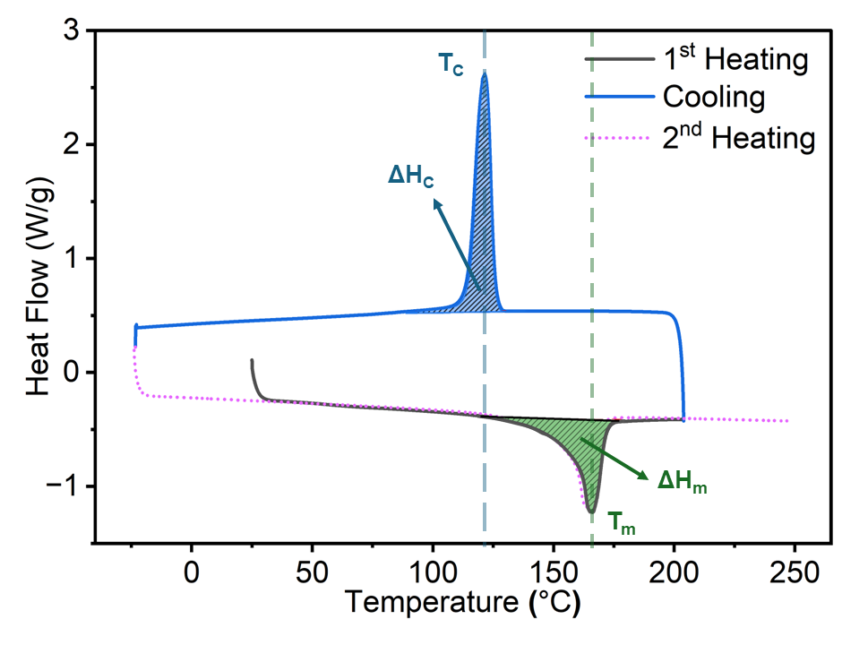

Figure 3.6 Example of DSC curve of paper-reinforced polypropylene composites to illustrate how enthalpies and temperatures were measured for each sample. The 2nd heating cycle is does not show the integration enthalpy for clarity.

testing measurements were taken using an Instron 5567 universal testing machine equipped with a 3-point bend test fixture and 500 N load cell. A test span of 45 mm and a test rate of 1.125 mm/min were used. Samples were tested until a 25% strain was reached. The Instron deflectometer used to measure strain was equipped with an extensometer with a 25 mm range. Flexural sample dimensions were approximately 60 × 12 × 3 mm.

3.3.9 Water Uptake Testing
Water uptake measurements were conducted using a modified ASTM D570 method, in which test specimens were 14 mm in length, 14 mm in width, and 2.4 mm in thickness, rather than standardized dimensions. Prior to testing, samples were dried overnight under vacuum at 80 °C to remove any excess moisture. Following the conditioning step, the samples were cooled in a desiccator unit and weighed using a precision analytical balance to establish an initial mass. For testing, samples were placed into a 23 °C water bath and mass was re-measured after 24 hours and 504 hours of submersion.

3.3.10 Statistical Analysis
All statistical analysis was performed in JMP Pro 16.0.0. Regression analysis was performed using Standard Least Squares fit with Effect Leverage emphasis. P-values were calculated from the t-statistic using a two-tailed test. A confidence level of 95% was used for all tests, corresponding to α = 0.05. One-way ANOVA was performed on mechanical properties data to identify statistically different data sets. The Tukey-Kramer test was used as the post-hoc analysis method. Multivariate analysis was performed to determine correlation coefficients between variable pairs.

                - 3.4 Conclusions
This research investigated the feasibility of mechanically recycling paper fiber-reinforced polypropylene composites using industrially relevant methods. Paper composite laminates were size-reduced and compounded with virgin polypropylene to produce an injection molding compound. This material was then injection molded under various processing conditions to explore the optimal processing parameter windows. The impact of these processing parameters on the thermal, mechanical, and water uptake properties of the resulting composites was studied. Our findings indicate that processing temperature has the most significant impact on the material properties. Higher processing temperatures increased crystallinity, potentially due to a decrease in polypropylene molecular weight through chain scission. Additionally, higher processing temperatures resulted in increased degradation of the paper fibers, negatively impacting the mechanical performance of the composite. The injection rate had a less significant impact on the material properties than processing temperature; however, increasing the injection rate did appear to damage the paper fibers via shear effects. Neither the composites' water uptake nor thermal stability changed as a function of processing conditions. The mechanical strength of the composite decreased with increasing processing temperature. However, the mechanism was different for tensile and flexural behavior. Tensile strength decreased linearly, while flexural strength remained constant until a temperature threshold was exceeded. Neither tensile nor flexural stiffness changed significantly as a function of processing conditions. Ultimately, the results of this research demonstrate a high potential for mechanical recycling of the paper fiber-reinforced polypropylene composites into an automotive grade injection molding compound and that the material system has a wide injection molding processing window. Under the optimal conditions identified in this work, the tensile strength, flexural strength, and tensile modulus of our recyclable paper fiber-reinforced polypropylene composites were 70% to 220% higher than for the unfilled PP or talc-filled PP.

Chapter 4
Life Cycle Assessment of Paper-Based Composites as Replacement for an Injection Molded Polypropylene Automotive Door Component

Note: This chapter is submitted for publication…? Citation: TBD

                - Abstract
This study investigated the life cycle greenhouse gas (GHG) emissions of paper fiber-reinforced polypropylene as an alternative to talc-reinforced polypropylene (PP-TD5) in automotive door panels. Cradle-to-gate scenarios included a baseline reflecting current U.S. manufacturing practices, as well as scenarios utilizing renewable energy and recycled feedstocks. In the baseline, paper-based composites reduced GHG emissions by 35-40% compared to PP-TD5 panels, with reductions reaching up to 74% when renewable energy was employed. Substituting recycled post-consumer polypropylene into PP-TD5 could make it competitive in emissions if renewable energy is not used. Extending the analysis to the vehicle use-phase showed paper composites can further reduce emissions through weight savings, particularly in internal combustion vehicles. However, over the full lifecycle, paper composites demonstrated greater GHG reduction potential in battery electric vehicles, where manufacturing emissions dominate. These results underscore the role of lightweighting, renewable materials, and green energy in reducing the automotive industry’s carbon footprint.
Keywords: Life cycle analysis (LCA), automotive, vehicle lightweighting, natural fiber composites

  - Introduction
The automotive industry faces growing pressure to curb greenhouse gas (GHG) emissions and reduce reliance on fossil fuels. Initial efforts to reduce carbon emissions have focused on vehicle electrification, as the use phase of internal combustion engine vehicles (ICEVs) has historically accounted for up to 90% of GHG emissions [121]. However, shifting vehicle fuel source alone cannot enable the net-zero carbon emissions goal of the automotive industry, as raw material production and energy consumption during vehicle manufacturing still account for a non-trivial amount of carbon dioxide (CO₂) production, currently estimated at 14% for ICEVs and 41% for battery electric vehicles (BEVs) [122]. This fraction of the carbon footprint is expected to increase dramatically, with raw materials alone projected to account for 60% of the carbon footprint of a vehicle by 2040, as the use-phase GHG emissions decrease [123]. Consequently, the industry faces a growing demand for low-carbon materials and manufacturing techniques to replace conventional options, helping reduce the overall lifecycle emissions of vehicles.
Much of the research into reducing vehicle carbon footprint has focused on lightweighting metal components in the structural elements of a car. These include the chassis, frame, door panels, hood, and other components that must meet stringent crashworthiness requirements [124,125]. These structures comprise up to 80% of a passenger vehicle’s mass and, therefore, play a major role in fuel consumption during use-phase [126,127]. Industry guidelines indicate that a 10% reduction in vehicle mass can improve fuel economy by 6% in ICEVs and increase driving range by 14% in BEVs [128]. Replacing steel with lighter materials like aluminum or magnesium can reduce vehicle weight while maintaining necessary mechanical properties. For instance, Bushi et al. (2019) found that redesigning a midsize sedan's door panel from a "mild steel-intensive" to an "aluminum-intensive" design reduced vehicle weight by 49.5 kg, with a corresponding reduction in global warming potential (GWP) of 1,511 kg CO₂-eq. over the vehicle’s lifecycle, assuming suitable powertrain adjustments. Similarly, Kim et al. (2011) reported that replacing mild steel with aluminum or high-strength steel could save between 1,920 and 9,026 kg CO₂-eq., depending on the amount of mild steel replaced. However, their study showed these replacements significantly increase vehicle manufacturing costs due to the added material and manufacturing expenses. They estimated that the cost of GHG savings ranges between $148 and $579 per metric ton of CO₂-eq., based on the degree of mild steel replacement.
A potentially more cost-efficient approach to reducing vehicle lifecycle GHG emissions is the use of natural fiber-reinforced composites (NFRCs). NFRCs offer high stiffness, good specific strength, and lower costs compared to traditional composite reinforcements like carbon or glass fiber [131,132]. As such, many automotive manufacturers have incorporated NFRCs into applications such as seat backs, door panels, dashboards, and boot liners [133,134]. Research by Boland et al. (2016) demonstrated that replacing a glass fiber-reinforced polypropylene semi-structural console substrate with an NFRC part could lower cradle-to-gate emissions from 20.2 to 10.4 kg CO₂-eq. per part and reduce total lifecycle vehicle emissions by up to 19% when use-phase is included. Likewise, Wötzel et al. (1999) reported that replacing an ABS side panel with a hemp fiber-based composite in an Audi A3 reduced the cumulative energy demand (CED) from 132 to 73 MJ for the cradle-to-gate, with further reductions during the use-phase due to a weight decrease from 1.125 to 0.820 kg.
Despite the environmental benefits of NFRCs, some research suggests that producing "greener" materials can result in higher environmental impacts than conventional counterparts [137,138]. For example, Roy (2020) found that a biocomposite produced from polypropylene (PP), miscanthus, and biochar had a GWP of 1.63 kg CO₂-eq./kg, slightly higher than conventional talc-reinforced PP (1.58 kg CO₂ eq./kg). Similarly, other research studies have shown that the carbon footprint of NFRCs depends heavily on the specific type of fiber used, as well as the farming practices involved in fiber production [139,140]. Therefore, careful evaluation of specific NFRC systems is critical to fully understanding their environmental impacts.
Our previous work studied the use of paper fiber-reinforced polypropylene composites for automotive applications. We demonstrated that these composites, manufactured using methods adapted from the pulp and paper industry techniques, possess material properties—such as flexural strength, impact resistance, and water uptake—that are appropriate for automotive applications from the technical and cost perspectives [116]. Our interest in using paper as a composite reinforcement stemmed from its abundance as a natural fiber feedstock, as well as its potential to reduce the carbon footprint when replacing injection-molded polypropylene parts. In this work, we estimated the lightweighting potential using a mass-index method reported by Deng et al. (2019), based on our previously measured mechanical properties, and assessed its impacts on the use-phase of the component in vehicles with different powertrains. Additionally, we explored potential carbon footprint reductions for both the conventional and novel paper composite parts by considering green energy use during manufacturing and utilization of recycled materials as feedstocks. We also evaluated the full life cycle of a vehicle to quantify the greenhouse gas emission reductions when transitioned from conventional materials to our novel composites.
                - 4.2 Methodology

4.2.1 Goal and Scope of Study
The objective of this study was to compare the carbon footprint of a compact crossover SUV door panel carrier made from a novel paper fiber-polypropylene composite with that of a conventional polypropylene door panel containing 5 wt.% talc powder filler (PP-TD5). The primary aim was to identify the main contributors to the carbon footprint and explore pathways to reduce GHG emissions associated with the cradle-to-gate production of the door panel. Additionally, we examined how weight differences between the door panels influence GHG emissions during the vehicle's use phase for both ICEV and BEV powertrains. The study analysis included scenarios that explore either using renewable energy or recycled feedstocks to assess how the carbon footprint of these components may evolve as manufacturing in the United States becomes more sustainable.
The system boundaries of this work included material production, transportation, part manufacturing, and the use-phase of the vehicle. We excluded an in-depth analysis of raw material production, instead using average values from the literature and available databases. Furthermore, we excluded the use of additives for both the paper composite and conventional PP-TD5 door panels due to the lack of publicly available information, though it is expected that both materials would require additives for flame retardancy, temperature stability, and UV resistance. Figure 4.1 shows an overview of the process steps and system boundaries, as well as the functional unit.

4.2.2 Functional Unit
The functional unit for this study was an automotive door panel with characteristics based on the 2021 Volkswagen ID.4 AWD Pro S door panel carrier. The original door panel carrier is made of PP-TD5, weighs 1.392 kg, and is manufactured using injection molding. The part is designed with attachment points for fasteners and clips to secure it to the overall door panel assembly.

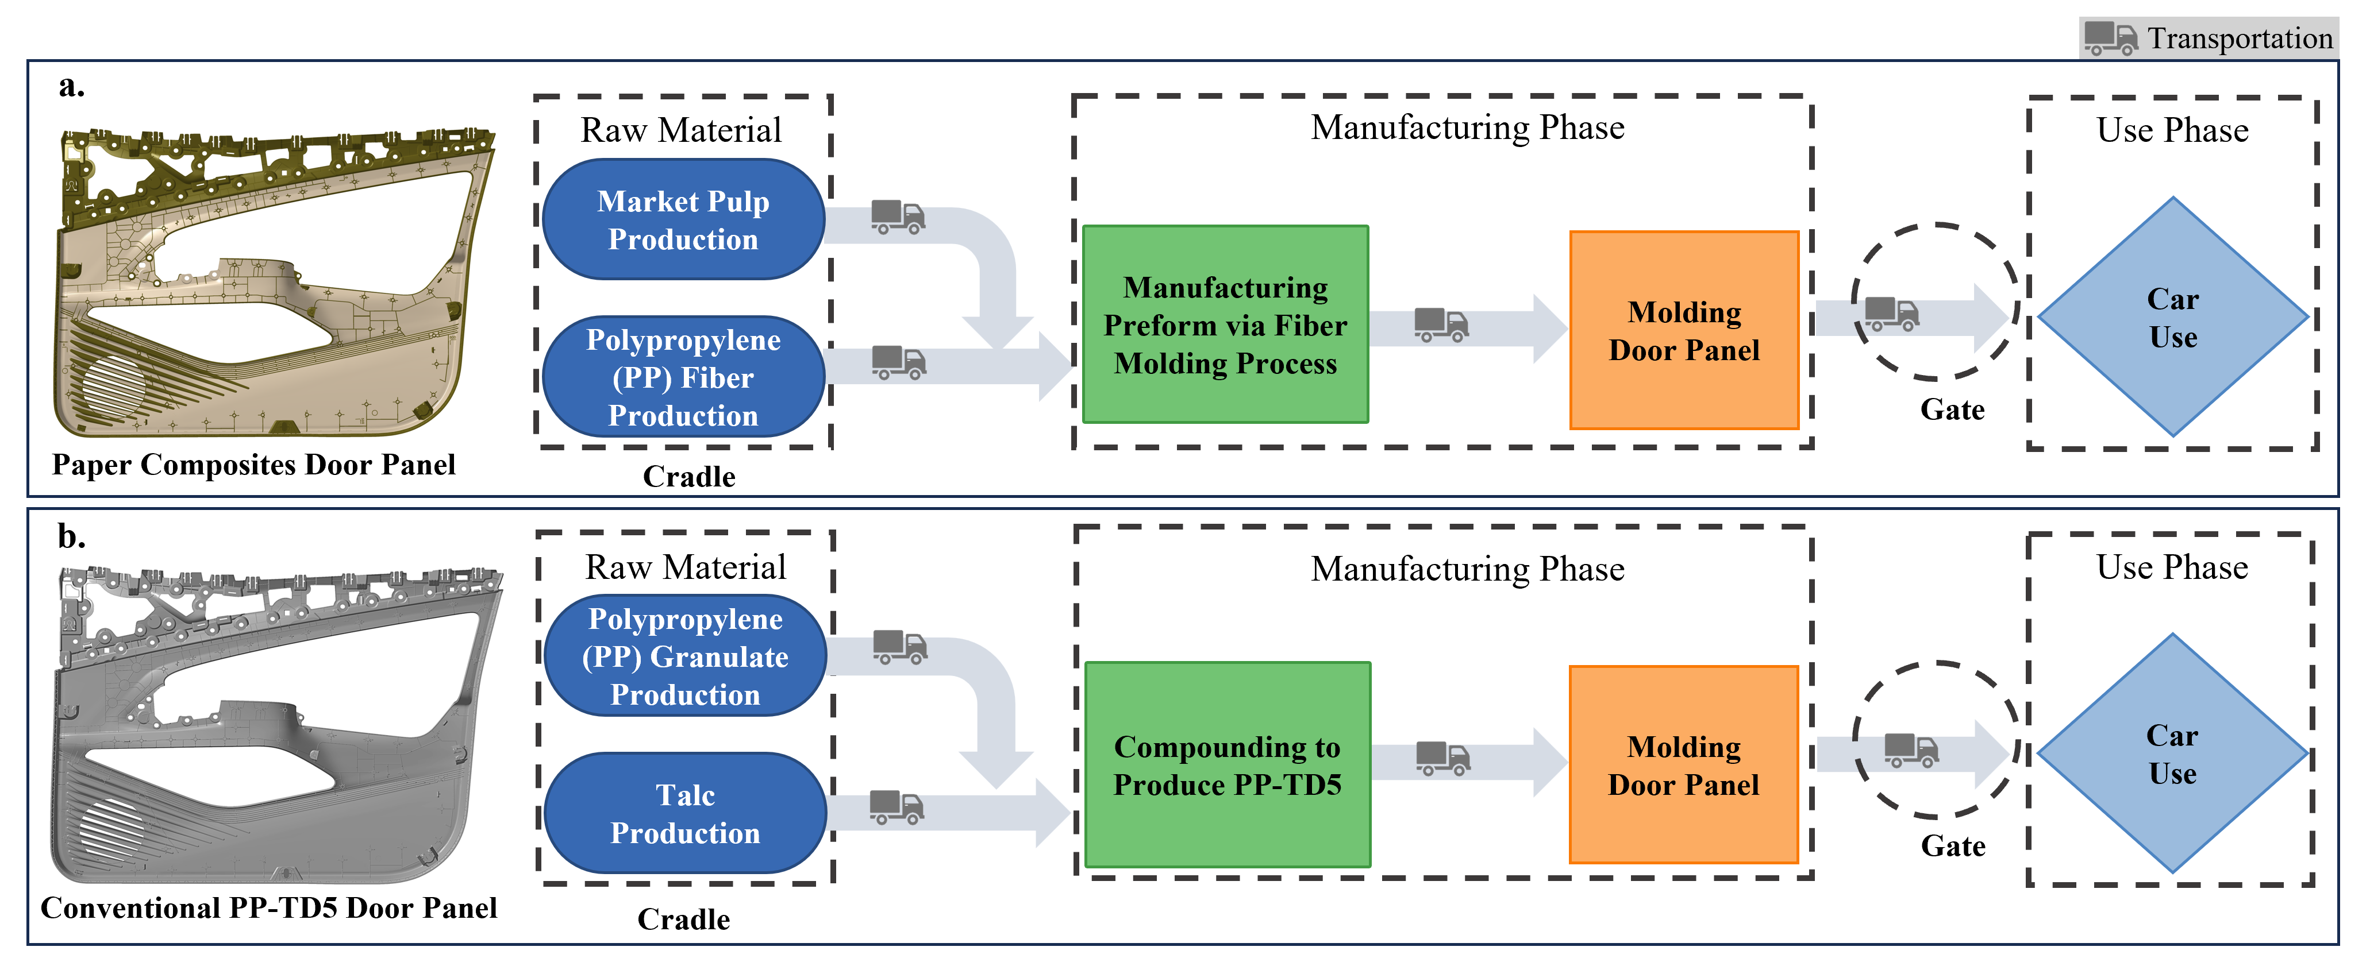
Figure 4.1 Overview of process steps and system boundaries for the production of door panel carrier for a. paper composite door panel and b. conventional injection molded PP-TD5 part.

Our previous research demonstrated that paper composites, consisting of 60% market pulp and 40% polypropylene, exhibit significantly higher stiffness than PP-TD5 but with slightly greater density, as shown in Table S1. However, these composites have limitations that prevent molding complex features, such as attachment points, directly into the composite. To address this, we proposed a theoretical design for the door panel carrier that uses paper composites for the bulk of the part, while plastic ribs and attachment points are injection molded onto the rear side to replicate the attachment points of the Volkswagen ID.4 door panel carrier. We estimated the mass of the paper composite door panel carrier for both strength- and stiffness-limited designs using material indices based on the method described by Deng et al. [141]. The full mass calculation details are provided in the appendix. We estimated that the mass would be 1.114 kg for the strength-limited design and 1.124 kg for the stiffness-limited design.

4.2.3 Scenario Analysis

4.2.3.1 Baseline, Green Energy, and Recycled Feedstock Scenarios
We conducted a baseline scenario calculation using inputs that we assumed reflect the current state of manufacturing in the United States. This scenario illustrates the potential GHG emission savings achievable by implementing paper composites as a replacement for conventional PP-TD5 materials in the near future. Additionally, we explored potential future scenarios in which the U.S. transitions to more sustainable energy mixes, as pledged for 2050. This analysis is essential to determine whether paper composites will remain a sustainable option as the world moves toward reducing CO₂ emissions to mitigate the impacts of anthropogenic climate change. Finally, we evaluated how replacing virgin feedstock materials (market pulp and polypropylene granulate) with recycled alternatives would affect the carbon footprint of both types of door carrier panels. In all scenarios, GHG emissions in CO₂-eq. were calculated using Sphera’s LCA for Experts Software using CML2001 baseline climate change method, which calculates GWP 100 years.

4.2.3.2 GHG Emissions and Associated Savings Through Lightweighting for Different Vehicle Types
We calculated the GHG emissions associated with the use-phase of the vehicle for the baseline case (PP-TD5 panel) and both paper composite cases (stiffness- and strength-limited designs). This analysis was conducted for both ICEV and BEV powertrains using the methodology described in section 2.4.6. To demonstrate how GHG savings evolve throughout the vehicle's lifecycle, we performed calculations at distances ranging from 50,000 to 300,000 km in intervals of 50,000 km. Kim and Wallington modeled the reduction in fuel consumption under two assumptions: 1) the powertrain is held constant for the lightweighted vehicle, and 2) the powertrain is resized to account for the vehicle's mass reduction [142]. They designate the fuel reduction value under the first assumption as FRV and the fuel reduction value under powertrain resizing as FRV+. For this study, we chose to analyze both cases. We used EPA data associated with the 2024 ID.4 and 2024 Tiguan to calculate MIF, FRV and FRV+ for our use-phase analyses. The calculated values are provided Table S5.

4.2.4 Life Cycle Inventory Data

4.2.4.1 Raw Materials
We considered three scenarios: the baseline, renewable energy, and recycled feedstock scenarios. The raw materials used in the production of the studied door panel carriers included polypropylene (in both granulate and fiber form), market pulp, and talc powder.
In the baseline scenario, the polypropylene was assumed to be derived from crude oil, which was cracked to form propene and then polymerized. Polypropylene fibers were assumed to be manufactured using a melt-spinning process. Talc powder was assumed to be sourced from underground mines in an alpine region, followed by grinding and purification to achieve a particle size of 1–15 microns. Data for market pulp was sourced from literature that assessed the average carbon footprint of various grades of pulp and paper in the United States, estimating an average of 0.855 kg CO₂-eq. per kg of pulp [143]. Additionally, we calculated the biogenic carbon storage potential of 1 kg of market pulp to be 1.62 kg CO₂, resulting in an overall carbon footprint of -0.765 kg CO₂-eq. per kg of market pulp. A detailed explanation of this calculation is provided in the supplementary information.
In the renewable energy scenario, we sought to use raw materials produced with renewable energy wherever possible. The Sphera database provided LCA data for polypropylene fiber and granulate data produced using renewable energy. However, no such information was available for either market pulp or talc powder. Polypropylene, in this scenario, was still derived from crude oil, but the manufacturing process utilized a green energy grid mix. This grid mix had the following composition: 63.05% wind, 19.43% photovoltaic, 10.97% hydro, 3.31% biomass, 2.10% biogas, 0.76% waste, 0.21% solar thermal, and 0.18% geothermal. This grid mix is designated as RER: Green electricity grid mix in Sphera’s database.
In the recycled feedstock scenario, we assumed that market pulp would be replaced with recycled paper pulp, and polypropylene granulate would be substituted with post-consumer PP recyclate. Data for recycled paper pulp was obtained from Laurijssen et al. which estimated the carbon footprint to be -1,100 kg CO₂-eq. per ton of recycled paper [144]. While this study focused on the paper recycling industry in the Netherlands, we considered the value appropriate, as it aligns with other findings indicating that recycled paper production emits approximately 30% fewer greenhouse gases than virgin paper [145]. For the recycled polypropylene granulate, we used data from the Sphera database (US: Polypropylene (PP) granulate secondary). This dataset assumes the recycled plastic originated from post-consumer waste and had a recycling efficiency of 90%. The energy used in recycling processes (washing, granulating, compounding, and pelletizing) was derived from a combination of thermal energy from natural gas and electricity. Recycled polypropylene fiber was not considered in this scenario, as producing high-quality fibers from post-consumer recycled feedstock is difficult due to contamination and inconsistencies in the material [146].

4.2.4.2 PP-TD5 Door Panel Manufacturing
The granulate required for producing the PP-TD5 door panels is typically produced by compounding talc powder with PP granulate using a twin-screw extruder. This process was modeled using the "GLO: Compounding" process in Sphera, which assumes an energy consumption rate of 1.73 MJ/kg and a water consumption rate of 0.636 L/kg. For the injection molding of the door panel, we used the DE: Plastic injection molding part (unspecific) process from Sphera. The energy consumption rate for compounding was assumed at 6.64 MJ/kg and a water consumption rate at 0.441 L/kg. Although this is a general process and is not limited to a specific type of polymer, it is suitable for modeling parts weighing between 0.2 and 2.0 kg, making it applicable for our study. A 2% scrap rate was assumed for both the compounding and injection molding processes.

4.2.4.3 Paper Composite Panel Manufacturing
The paper composite panels were manufactured in two stages: first, a non-woven preform was produced using a fiber molding process, followed by molding a stack of preforms to create a consolidated composite part. A detailed description of this process is available in previous work [116]. During the fiber molding stage, market pulp and polypropylene fibers are mixed to form a 1 wt.% slurry in water, with the water assumed to be tap water that is subsequently treated through the US municipal treatment system. The electricity required for fiber molding was estimated by the machine manufacturer to be 5.66 MJ/kg of molded material, which aligns relatively well with literature estimates ranging from 6.58 to 10.51 MJ/kg [147–149].
Natural fiber composites are often consolidated through a “one-shot” process, where compression and injection molding are performed simultaneously. In this combined process, the compression molding component melts the matrix polymer, allowing it to fully encapsulate the reinforcing fibers, which is essential for achieving the desired mechanical properties. At the same time, the injection molding component adds features like stiffening ribs or fastener attachment points, which are critical to the part's functionality. Since no published data exists on the energy consumption of this specific process, we modeled the two steps separately. The injection molding process was modeled as described previously, while the compression molding process was based on a literature value of 3.5 MJ/kg [150]. The water consumption rate for the molding process was assumed to be the same as for the PP-TD5 injection molding. A 2% scrap rate was also assumed for all paper composite manufacturing processes.

4.2.4.4 Energy Mixes
The baseline calculations were conducted under the assumption that manufacturing would occur in the greater Tennessee Valley. For these calculations, we utilized the Sphera dataset US: Electricity grid mix – SRTV, which is based on the eGRID2021 dataset from the US Environmental Protection Agency (EPA). The composition of this energy mix is detailed in Table S3 [151]. Calculations using green energy were based on the Sphera dataset US: Electricity grid mix (2050) (Announced Pledges APS). This dataset assumes that the US will transition to a sustainable energy grid mix in accordance with the pledges recorded by the International Energy Agency (IEA). This projects that the US grid mix will be primarily composed of solar and wind power (approximately 75%), with the remaining fraction coming from hydro power, biomass, natural gas, and nuclear energy [152].

4.2.4.5 Transportation
Transportation-related emissions were calculated using the Green Freight Handbook methodology [153]. For this study, we assumed that all raw materials and composite parts would be transported using a tractor-trailer truck equipped with a 12.2 m (40 ft) shipping container, which has a volume of 67.67 m³. According to US regulations, the maximum weight capacity for these trucks is 30,480 kg. Based on the densities of the raw materials, we calculated the quantities that could be accommodated in a 12.2 m shipping container. For polypropylene, a shipping container could contain 62,340 kg of material. For market pulp, a shipping container could contain 101,640 kg of material. Since both weights exceed the legal limit, we assumed that each truckload would carry 30,000 kg of material, which represents 98% of its total capacity.
A significant portion of the polypropylene manufactured in the United States is produced in the greater Houston, TX area. This includes facilities such as LyondellBasell’s Bayport Polymers Facility in Pasadena, TX, which produces polypropylene for the automotive industry [154]. Therefore, we assumed that both polypropylene granulate and fibers would be produced in Houston and then transported to manufacturing facilities. For the PP-TD5 door panel, we assumed that talc is sourced from a mine near Ennis, Montana, which is the largest talc mine in the United States and supplies over 50% of the talc used in the North American market [155]. We estimated that the talc would travel 2885 km to Houston, TX, where it would be compounded with polypropylene to create the PP-TD5 injection molding compound. The molding compound would then be transported 1310 km to Chattanooga, TN, where is a hub for many Tier 1 automotive injection molding companies. Finally, we assumed the parts would travel approximately 8 km from the Tier 1 company to the Volkswagen manufacturing facility for installation on the vehicle. For this final transportation leg, we estimated the truck would only be 50% full to allow for secure fixturing of parts to prevent damage during transit.
For the paper composite door panel, the polypropylene was assumed to travel approximately 1450 km from Houston, TX, to Vonore, TN. The market pulp used in our previous work was sourced from Domtar Corporation’s Kingsport mill; therefore, we estimated that the market pulp to produce paper composites would travel about 210 km from Kingsport, TN, to Vonore, TN. We assumed that the paper composite preforms would be manufactured in Vonore, TN, by a fiber molding company and then transported to Chattanooga, TN, located approximately 145 km away. In Chattanooga, we anticipated that the preforms would be consolidated as described in section 2.3.3 by an automotive Tier 1 molding company. Finally, we estimated that the parts would be transported around 8 km from the Tier 1 company to the Volkswagen manufacturing facility for installation on the vehicle. For the transport of the preforms, we assumed that the trucks would be 70% full to account for the stacking of preforms. Similar to the transportation of the PP-TD5 parts, we assumed that the trucks carrying the final components would be filled to 50% capacity. The distances that all materials and intermediates travel are summarized in the Table S4.

4.2.4.6 Use-Phase
To model the GHG emissions during the use-phase, we employed methods developed by Kim and Wallington to estimate changes in vehicle fuel consumption resulting from lightweighting [142]. Although the vehicle chosen for this study is a BEV, we also calculated the impact of part mass changes on fuel consumption and emissions for ICEVs, recognizing that most vehicles produced by Volkswagen are still not battery powered.
The baseline use-phase fuel consumption of a vehicle can be calculated using the following equation:
$$f=MIF×m_{part}×d$$ | (4.1)
where $MIF$ is the mass-induced fuel consumption, $m_{part}$ is the part mass, and $d$ is the distance traveled. This fuel consumption can then be converted into GHG emissions by multiplying by a well-to-wheel emission factor. For this, we used U.S. averages from the GREET model, which are 2.82 kg CO2-eq./L for gasoline-powered cars and 0.613 kg CO₂-eq./kWh for electric vehicles. We assumed that 1 L of gasoline is equivalent to 8.9 kWh, based on the GREET model [156].
Reduction in fuel consumption due to lightweighting can be calculated using the following equation:
$$f_{lightweighted}=f-FRV×\left(m_{part}-m_{lightweighted_{part}}\right)×d,$$ | (4.2)
where $f_{lightweighted}$ is the fuel consumption of a lightweighted vehicle, $FRV$ is the fuel reduction value, and $m_{lightweighted_part}$ is the mass of the lightweighted part. A detailed example of performed calculations is given in the supplementary information.
In the green energy scenario, we assumed that electric vehicles would be charged using the same energy mix as in the manufacturing calculations: the US: Electricity grid mix (2050) (Announced Pledges APS), with a carbon footprint of 0.0165 kg CO₂-eq./kWh. To assess the impact of not achieving these goals, we conducted a sensitivity analysis on use-phase emissions for BEVs. For this analysis, we considered two alternative energy scenarios US: Electricity grid mix (2040) (Announced Pledges APS) with a carbon footprint of 0.0483 kg CO₂-eq./kWh and the US: Electricity grid mix (2030) (Announced Pledges APS) with a carbon footprint of 0.19 kg CO₂-eq./kWh.

                - 4.3 Results and Discussion

4.3.1 Cradle-to-gate GHG Emissions
The cradle-to-gate GHG emissions for producing a door panel carrier are strongly influenced by design choices, the manufacturing energy mix, and raw material sources. Our study found emissions ranging from 0.78 kg CO₂-eq. to 4.93 kg CO₂-eq. per part, with sustainable energy and low-carbon material inputs significantly reducing emissions. Figure 4.2 illustrates these findings, presenting the total cradle-to-gate GHG emissions across all three scenarios, along with the emissions specifically attributed to raw materials.
Figure 2a illustrates the cradle-to-gate GHG emissions for the paper composite door panel carrier compared to the conventional injection-molded PP-TD5 part in the baseline scenario. Both stiffness-limited and strength-limited design cases for the paper composite panels are presented for comparison. The stiffness-limited design achieves a 35% reduction in GHG emissions, while the strength-limited design achieves a 40% reduction due to its slightly lower mass (1.14 kg vs. 1.24 kg). The emissions difference between PP-TD5 and paper composites is primarily driven by the carbon intensity of raw materials, as shown in Figures 2a and 2b. For the paper composites panels, raw materials account for 26% of the overall carbon footprint, a proportion that remains consistent for both design cases. In contrast, raw materials constitute over 61% of the overall footprint for the PP-TD5 part. Polypropylene is the primary contributor to the raw material footprint for both parts, whereas the market pulp in the paper composite contributes negatively through carbon sequestration. Talc's contribution to the overall carbon footprint is negligible, accounting for only ~0.6% of the raw material carbon footprint and ~0.4% of the total cradle-to-gate emissions.
The total GHG emissions associated with manufacturing the paper composite panels are 2.11 kg CO₂-eq./part and 1.94 CO₂-eq./part for the stiffness-limited and strength-limited designs, respectively. In both cases, this represents 65% of the overall cradle-to-gate carbon footprint. This is higher than the emissions from the conventional PP-TD5 part, where manufacturing processes account for only 34% of the emissions at 1.67 kg CO₂-eq./part. Additionally, the production of paper composite panels requires significantly more water than the PP-TD5 scenario; the wet preform manufacturing process consumes approximately 110 kg of water per part, while injection molding uses considerably less. Notably, around 85% of the emissions related to water usage and treatment arise from the wastewater treatment process, suggesting that recycling the fiber molding water instead of treating it as municipal wastewater could potentially mitigate
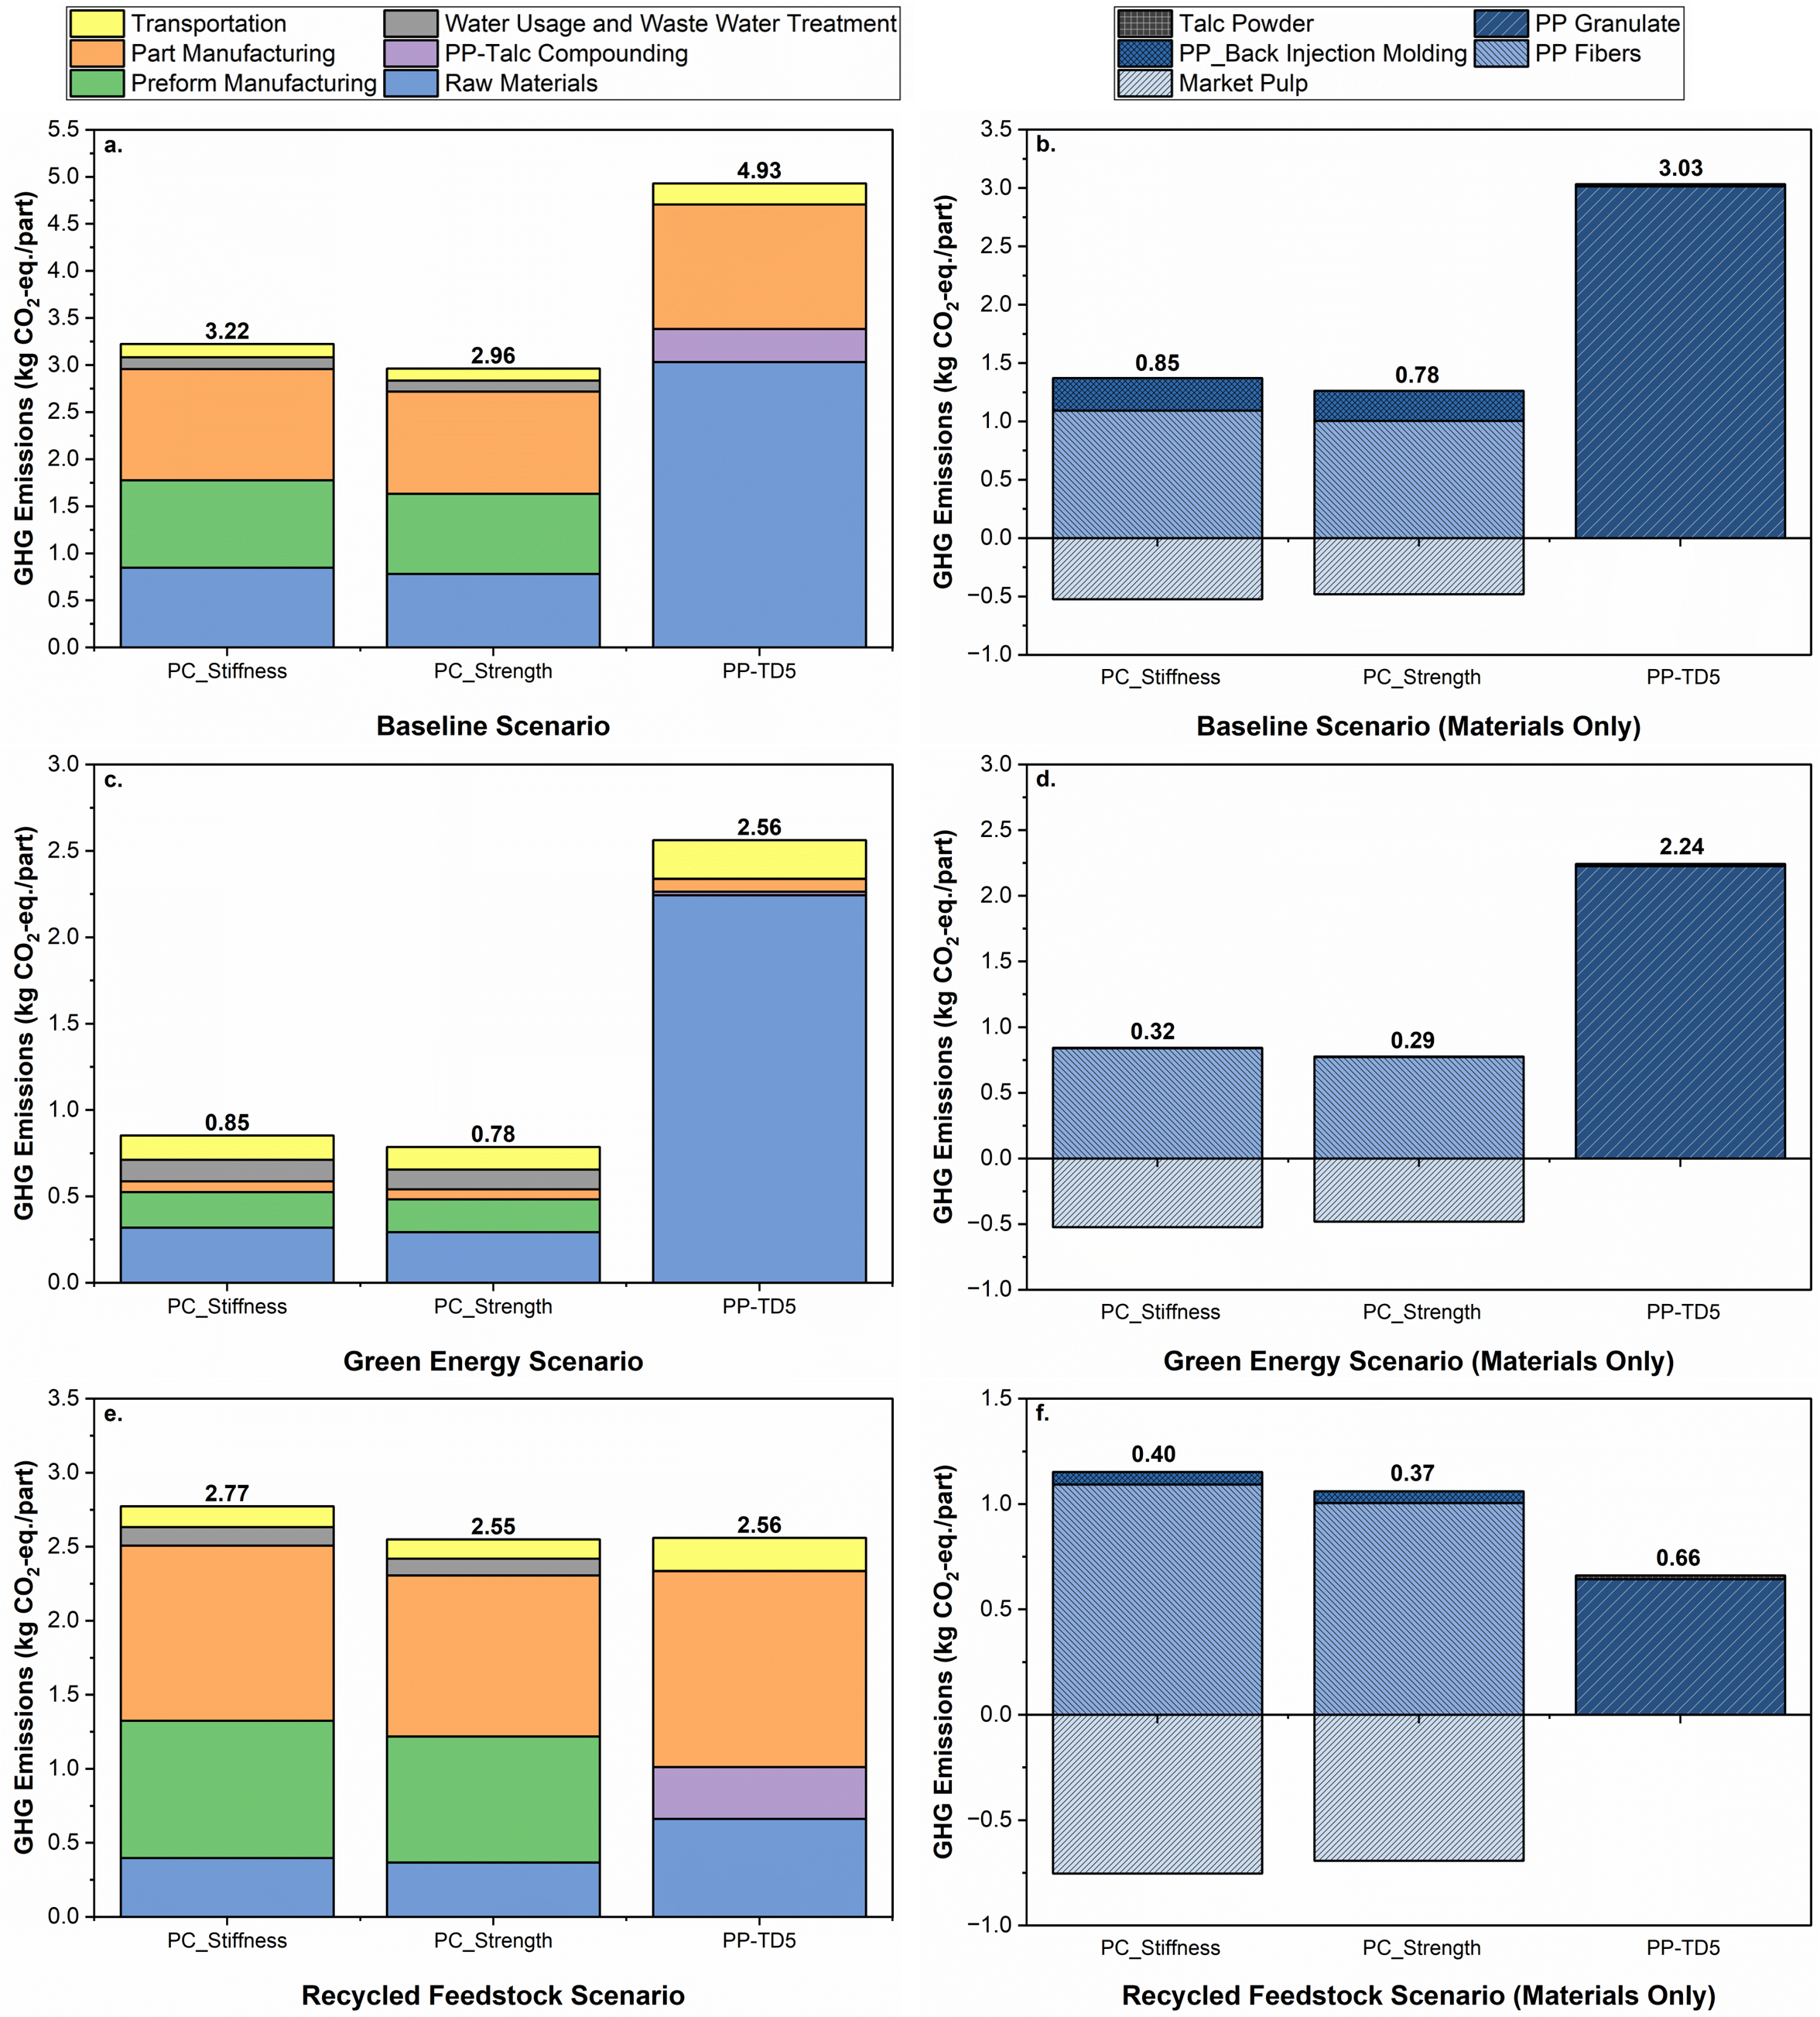
Figure 4.2 Cradle-to-gate GHG emissions for the paper composite door panel carrier compared to the conventional injection-molded PP-TD5 part under the three studio scenarios. a. GHG emissions for part in baseline scenario, b. GHG emissions for raw material inputs in baseline scenario, c. GHG emissions for part in green energy scenario, d. GHG emissions for raw material inputs in green energy scenario, e. Cradle-to-gate GHG emissions for part in recycled feedstock scenario, f. GHG emissions for raw material inputs in recycled feedstock scenario. PC_Stiffness = Paper composite door panel with stiffness limited design; PC_Strength = Paper composite door panel with strength limited design; PP-TD5 = conventional door panel molded from talc-filled polypropylene; Transportation = transportation of all raw materials, preforms and molded panels; water usage and wastewater treatment = all water used during manufacturing processes and its subsequent treatment; part manufacturing = compression and injection molding processes used to manufacture final door panel parts; PP-Talc compounding = manufacturing of PP-TD5 granulate using twin screw extrusion; preform manufacturing = fiber molding of paper composite preforms.

emissions. Transportation contributes approximately 4% of cradle-to-gate GHG emissions for the paper composite and 5% for the PP-TD5. There is potential to reduce transportation emissions by shipping raw materials via railcar instead of by semi-truck; however, such adjustments are unlikely to significantly impact the overall cradle-to-gate carbon footprint of either scenario. Overall, while the manufacturing processes for paper composite panels yield higher GHG emissions than those for the conventional PP-TD5 parts, the incorporation of a carbon-negative raw material such as market pulp significantly mitigates the overall carbon footprint of the part.
Figures 4.2c and 4.2d show the GHG emissions from producing paper composite and PP-TD5 panels using “green” energy mixes instead of the current energy sources used in the United States. This represents a scenario where the United States has fulfilled its sustainable energy pledges and transitioned away from fossil-based fuel sources. Analyzing this scenario is important to determine whether paper composite automotive parts will remain a viable sustainable option for the industry as the world transitions toward a more sustainable future. Our findings indicate that adopting green energy significantly reduces GHG emissions in the production of both PP-TD5 and paper composite door panel carriers. Specifically, GHG emissions associated with paper composites decrease by approximately 74%, while those for the PP-TD5 panel are reduced only by 48%. This disparity can be attributed to the higher energy consumption required for manufacturing paper composites compared to the conventional door panel. Additionally, substantial reductions are observed in the carbon footprints linked to the raw materials, with a decrease of around 48% for using the paper composite and around 26% for using PP-TD5. These reductions in GHG emissions are primarily due to the implementation of green energy mixes in producing polypropylene granulate and fiber raw materials utilized in both products. However, the ongoing reliance on crude oil as a feedstock for polypropylene production constrains the extent to which the overall environmental impacts can be mitigated. Thus, while the transition to green energy offers significant opportunities for reducing emissions, the choice and sourcing of raw materials remain critical factors in achieving sustainability goals in automotive manufacturing.
Figures 4.2e and 4.2f present the GHG emissions associated with the production of paper composite and PP-TD5 panels when utilizing recycled paper and recycled polypropylene granulate as feedstock. While both materials are currently available as commercial products, the supply of recycled polypropylene remains limited, with an estimated recycling rate of around 1% in the United States [157]. However, this rate is anticipated to increase over the next decade as the demand for recycled plastics rises and collection rates along with recycling capacities improve globally [158]. It is important to note that, as explained in the methodology section, the polypropylene fibers used in the paper composites are still assumed to come from virgin plastic, due to the technical challenges associated with manufacturing fibers from post-consumer materials and the absence of commercially available products. This scenario, therefore, illustrates the potential for near-term advancements in the production of the door panel carrier.
The results indicate that manufacturing the PP-TD5 panel with recycled polypropylene allows it to achieve a carbon footprint that is equal to or better than that of the paper composite panel. Notably, for the stiffness-limited design of the paper composite panel, the PP-TD5 panel exhibits a 7.6% lower carbon footprint compared to its paper composite counterpart. Although the paper composite door panel still has lower GHG emissions associated with its raw materials than the PP-TD5 panel, the larger manufacturing burden for the paper composite panels results in a slightly higher footprint overall. This scenario represents around a 14% reduction in carbon footprint for the paper composite panels and around a 48% reduction for the PP-TD5 panel compared to the baseline scenario. Despite these significant reductions, the GHG emissions remain markedly higher than those of the paper composite panels produced in the green energy scenario. This underscores the importance of incorporating both recycled materials and green energy to meet the automotive industry’s goal of achieving net-zero carbon emissions.

4.3.2 Use-Phase GHG Emissions
Figure 4.3 shows the GHG emissions associated with 100,000 km of vehicle use for the two vehicle types studied. As anticipated, ICEVs exhibit much higher GHG
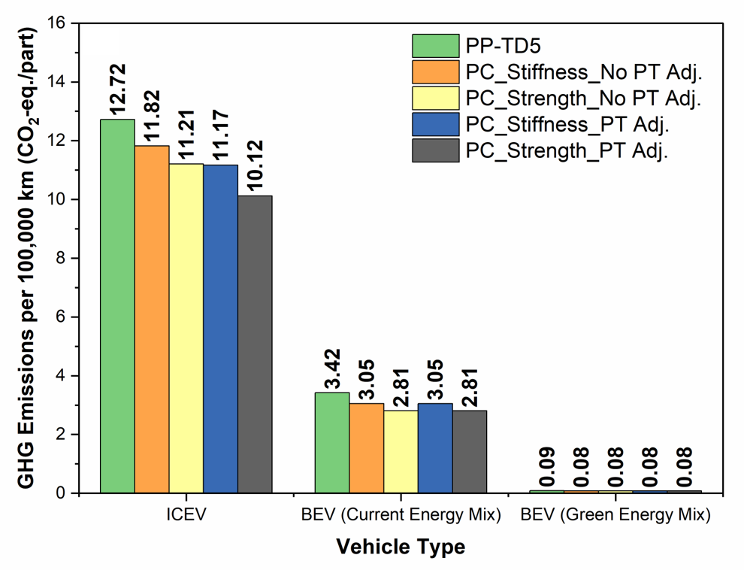

Figure 4.3 Cradle-to-gate GHG emissions per 100,000 km of vehicle use on a per part basis. PP-TD5 = conventional door panel molded from talc-filled polypropylene, PC_Stiffness_No PT Adj. = Paper composite door panel with stiffness limited design without powertrain resizing assumption, PC_Strength_No PT Adj.= Paper composite door panel with strength limited design without powertrain resizing assumption, PC_Stiffness_PT Adj. = Paper composite door panel with stiffness limited design with powertrain resizing, PC_Strength_PT Adj. = Paper composite door panel with strength limited design with powertrain resizing.

emissions than BEVs, particularly when green energy is used to charge the electric vehicles. In this context, switching to a paper composite door panel provides more substantial absolute reductions in GHG emissions for the ICEV. However, the relative reductions are comparable across vehicle types; the ICEV experiences decreases of 7.6% (stiffness-limited) and 12.8% (strength-limited) in scenarios without powertrain adjustment, and reductions of 11.7% (stiffness-limited) and 19.8% (strength-limited) when the powertrain is resized. In contrast, the BEV achieves decreases of 10.8% (stiffness-limited) and 17.9% (strength-limited), regardless of powertrain adjustments.
We also considered the cumulative reduction in GHG emissions over the vehicle’s entire use, assuming that all four door panels would be replaced with a paper composite alternative. In the case of ICEVs, across 300,000 km, the use of paper composite panels rather than PP-TD5 panels will result in avoided emissions of 10.82 kg CO₂-eq. for a stiffness-limited design and 18.13 kg CO₂-eq. for a strength-limited design. For electric vehicles, the avoided emissions for replacing PP-TD5 panels with paper composite ones are substantially smaller at 4.36 kg CO₂-eq. (stiffness-limited design) and 7.31 kg CO₂-eq. (strength-limited design) when vehicles are charged using current energy mixes. While these reductions may appear modest, they become substantial at scale. For instance, when applied to the total production of ID.4s (223,425) by Volkswagen in 2023, could translate into avoided emissions totaling approximately 974,000 kg CO2-eq. or 1.63 million kg CO₂-eq. across the lifetime of those vehicles (Volkswagen Group, 2024). Similarly, if paper composite door panels were employed in all 633,147 Tiguans produced in 2023—a Volkswagen ICEV comparable in size to the ID.4—the lifetime avoided emissions could reach up to 6.85 million kg CO2-eq. for the stiffness-limited scenario and 11.48 million kg CO₂-eq. for the strength-limited scenario. To put this in perspective, the average American drives about 21,700 km per year, emitting roughly 3,000 kg CO₂-eq. (United States Department of Transportation, 2022). Therefore, the BEV scenarios are comparable to removing between 324 and 543 people from the road for a year, while the ICEV scenario equates to as many as 3,826 people being taken off the road.
However, comparing different fuel sources (gasoline, conventional energy, and green energy) reveals that fuel type has a far greater impact on carbon emissions than lightweighting via design changes. For example, switching from an ICEV to a BEV (charged with the current energy mix) reduces emissions by 115.97–118.92 kg CO₂-eq. per vehicle, depending on the design case. The reduction is even more significant for BEVs charged with green energy, achieving 151.63–151.71 kg CO₂-eq. per vehicle. As such, if all previously considered Tiguans were replaced with ID.4s, this shift could avoid up to 33.9 million kg CO₂-eq. per year, highlighting the critical role of clean energy in reducing overall emissions.

4.3.3 Total Life-Cycle GHG Emissions
Figure 4.4 presents the full life cycle GHG emissions associated with conventional PP-TD5 door panel and the paper composite door panels across all three scenarios, assuming a use-phase driving distance of 300,000 km. In the baseline scenario, shown in Figure 4.4a, the transition from a PP-TD5 panel to a paper composite panel results in GHG emission reductions ranging from 10% to 15% for ICEVs and 18% to 25% for BEVs. The more significant relative improvement for the BEV can be attributed to the heightened impact of cradle-to-gate emissions on the overall carbon footprint. This trend is illustrated in Figure 4b, which delineates the relative contribution of each component to the total GHG emissions. For the ICEVs, the use-phase emissions account for 89-92% of the total carbon footprint, while they only account for 68-74% of the total for the BEVs.
These trends are similar in the recycled feedstock scenario, with use-phase emissions ranging from 77 to 94% depending on vehicle type and door panel design criteria. This is likewise true for the ICEV in the green energy scenario, where use-phase emissions range from ~94% for the PP-TD5 panel to ~98% for the paper composite panels. The major difference comes for the BEV in the green energy scenario, which only has 10-23% of its emissions coming from the use-phase. It should be noted however, that the total life cycle GHG emissions in this case are significantly lower than in any case we analyzed, at 1.01-1.1 kg CO₂-eq. for the paper composite panels and 2.84 kg CO₂-eq. for the PP-TD5 panel.
Given that the carbon intensity of the energy mix in the green energy scenario is based on the United States's pledges to transition to more sustainable energy sources, we
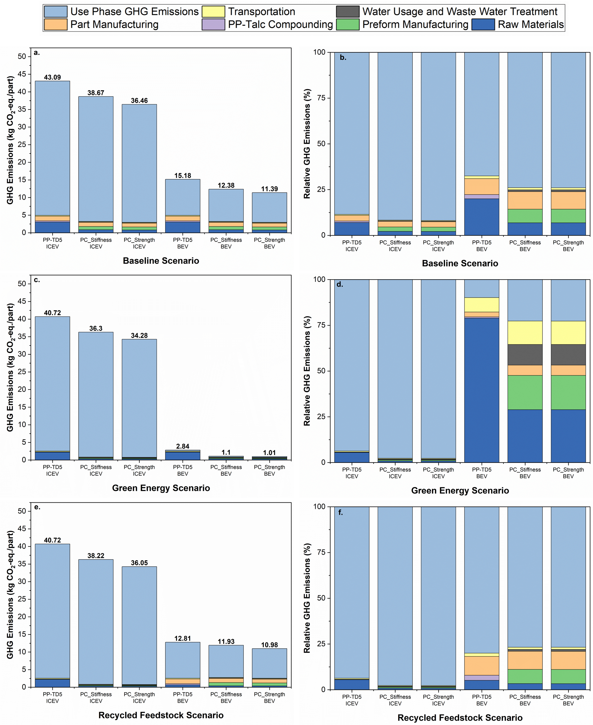
Figure 4. Total life-cycle emissions GHG emissions for the paper composite door panel carrier compared to the conventional injection-molded PP-TD5 part under the three studio scenarios. a. GHG emissions for part in baseline scenario, b. relative GHG emissions for raw material inputs in baseline scenario, c. GHG emissions for part in green energy scenario, d. relative GHG emissions for raw material inputs in green energy scenario, e. Cradle-to-gate GHG emissions for part in recycled feedstock scenario, f. relative GHG emissions for raw material inputs in recycled feedstock scenario. PP-TD5 ICEV = conventional PP-TD5 panel used in ICEV, PC_Stiffness ICEV = stiffness-limited design of paper composite panel used in ICEV, PC_Strength ICEV = strength-limited design of paper composite panel used in ICEV, PP-TD5 BEV = conventional PP-TD5 panel used in BEV, PC_Stiffness BEV = stiffness-limited design of paper composite panel used in BEV, PC_Strength BEV = strength-limited design of paper composite panel used in BEV
conducted a sensitivity analysis to evaluate how total life-cycle emissions would be affected if these goals are not fully achieved. The results of this analysis are shown in Figure 4.5. Unsurprisingly, the lifecycle GHG emissions are strongly dependent on the grid mix used to charge the vehicle, as is the portion of the carbon footprint that is associated with the use-phase. It should be noted that for 2040 PP-TD5, we find that 67% of the emissions are attributable to raw materials which is similar to previously mentioned predictions [123].
Overall, our results highlight the importance of component lightweighting, in conjunction with the adoption of renewable materials and green energy. For instance, for a BEV with PP-TD5 door panels, the switch from virgin PP to recycled PP only reduces life cycle GHG emissions from 15.18 to 12.81 kg CO₂-eq./part, which is less substantial than the reduction achieved by switching to paper composite panels in the baseline scenario. However, the switch to recycled polypropylene would likely be cost-prohibitive, as the high-quality recycles needed for the automotive industry are expected to continue to have substantial premiums over virgin material (up to 60%) until 2030 and beyond, due to the imbalance between supply and demand [159]. In contrast, the paper and pulp industry which is well-developed and relatively stable, already offers a lower-cost feedstock compared to polypropylene [160]. Consequently, adopting paper composites is projected to be more cost-effective and environmentally advantageous than relying on recycled feedstocks for the conventional PP-TD5 panel.

                - 4.4 Conclusions
This study demonstrates that replacing a talc-reinforced polypropylene automotive door panel with a paper-based composite can significantly reduce GHG emissions during both the production and use-phases. The paper composite exhibits superior mechanical properties compared to PP-TD5, which lends itself to lightweighting the functional unit. Specifically, the part weight could be reduced by approximately 11% when stiffness is used as the design criteria and by 18% when strength is prioritized instead. In a baseline cradle-to-gate scenario, replacing the PP-TD5 panel with a paper composite one results in a 35-40% reduction in GHG emissions, depending on the selected design criteria. The reduction
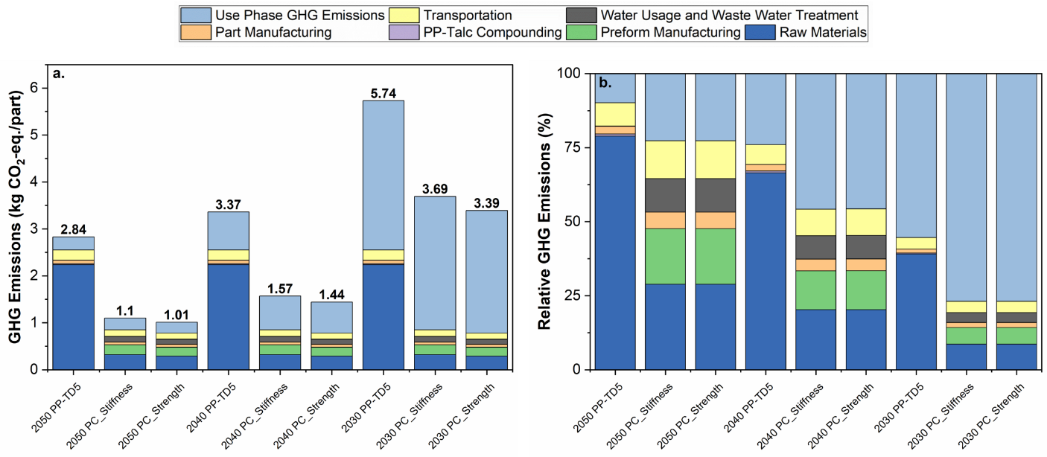
Figure 4.5 Sensitivity analysis for part used in BEV charging. a. GHG emissions for part in BEV produced using green energy, b. relative GHG emissions for part in BEV produced using green energy. 2050 PP-TD5 = conventional PP-TD5 panel used in BEV charged with predicted 2050 U.S. grid mix, 2050 PC_Stiffness = stiffness-limited design of paper composite panel used in BEV charged with predicted 2050 U.S. grid mix, 2050 PC_Strength = strength-limited design of paper composite panel used in BEV charged with predicted 2050 U.S. grid mix, 2040 PP-TD5 = conventional PP-TD5 panel used in BEV charged with predicted 2040 U.S. grid mix, 2040 PC_Stiffness = stiffness-limited design of paper composite panel used in BEV charged with predicted 2040 U.S. grid mix, 2040 PC_Strength = strength-limited design of paper composite panel used in BEV charged with predicted 2040 U.S. grid mix, 2030 PP-TD5 = conventional PP-TD5 panel used in BEV charged with predicted 2030 U.S. grid mix, 2030 PC_Stiffness = stiffness-limited design of paper composite panel used in BEV charged with predicted 2030 U.S. grid mix, 2030 PC_Strength = strength-limited design of paper composite panel used in BEV charged with predicted 2030 U.S. grid mix.

improves to about 74% when green energy sources are used for raw materials and manufacturing, representing a roughly 48% decrease compared to the baseline paper composite scenario. When recycled materials are used as feedstocks, the carbon footprint of the PP-TD5 panel becomes comparable to that of the strength-limited paper composite design and is approximately 8% lower than the stiffness-limited design. Therefore, the benefits of using recycled feedstock are less significant for the paper composite panel, as most of its emissions arise from energy consumed during the manufacturing process rather than from raw materials. Our findings demonstrate that part weight has a substantial impact during the use-phase, particularly for ICEVs. Nevertheless, when considering the entire vehicle lifecycle (excluding end-of-life considerations), the relative GHG reduction achieved by switching to paper composites is greater in BEVs than in ICEVs, due to the higher share of manufacturing-related emissions in the BEV scenario. Overall, this study shows that paper composite automotive parts significantly improve GHG emissions, by using sustainable feedstocks and effective lightweighting strategies.

                - Refernces
[1] Hovorun TP, Berladir KV, Pererva VI, Rudenko SG, Martynov AI. Modern materials for automotive industry. J Eng Sci 2017;4:f8–18. https://doi.org/10.21272/jes.2017.4(2).f8.
[2] Mishra A. Automotive Materials: An Overview 2020;07:6.
[3] Ghassemieh E. Materials in Automotive Application, State of the Art and Prospects. In: Chiaberge M, editor. New Trends Dev. Automot. Ind., InTech; 2011. https://doi.org/10.5772/13286.
[4] Hoffmann C, Van Hoey M, Zeumer B. Decarbonization challenge for steel. McKinsey Co 2020.
[5] Kamczyc A. World Steel Association releases paper on CO2 emission reduction. Recycl Today 2021.
[6] Peng T, Ou X, Yan X, Wang G. Life-cycle analysis of energy consumption and GHG emissions of aluminium production in China. Energy Procedia 2019;158:3937–43. https://doi.org/10.1016/j.egypro.2019.01.849.
[7] Tjotta S. Decarbonizing the Aluminum Value Chain 2022.
[8] Pradeep SA, Iyer RK, Kazan H, Pilla S. Automotive Applications of Plastics: Past, Present, and Future. Appl. Plast. Eng. Handb., Elsevier; 2017, p. 651–73. https://doi.org/10.1016/B978-0-323-39040-8.00031-6.
[9] Patil A, Patel A, Purohit R. An overview of Polymeric Materials for Automotive Applications. Mater Today Proc 2017;4:3807–15. https://doi.org/10.1016/j.matpr.2017.02.278.
[10] Mashek W. Automotive Recycling - Devalued is now Revalued 2016.
[11] Miller L, Soulliere K, Sawyer-Beaulieu S, Tseng S, Tam E. Challenges and Alternatives to Plastics Recycling in the Automotive Sector. Materials 2014;7:5883–902. https://doi.org/10.3390/ma7085883.
[12] Seay JR. Waste Plastic: Challenges and Opportunities for the Chemical Industry 2020:8.
[13] Ead AS, Appel R, Alex N, Ayranci C, Carey JP. Life cycle analysis for green composites: A review of literature including considerations for local and global agricultural use. J Eng Fibers Fabr 2021;16:155892502110269. https://doi.org/10.1177/15589250211026940.
[14] Analysis of Existing Envionmental Impact Assessment Metholdologies for use in Life Cycle Assessment 2010.
[15] Pero FD, Delogu M, Pierini M. Life Cycle Assessment in the automotive sector: a comparative case study of Internal Combustion Engine (ICE) and electric car. Procedia Struct Integr 2018;12:521–37. https://doi.org/10.1016/j.prostr.2018.11.066.
[16] Conway G. Life-Cycle Analysis for the Automotive Sector. In: Kalghatgi G, Agarwal AK, Leach F, Senecal K, editors. Engines Fuels Future Transp., Singapore: Springer Singapore; 2022, p. 103–31. https://doi.org/10.1007/978-981-16-8717-4_6.
[17] Fehrenbacher K. BMW, Ford, other automakers rev up carbon commitments 2020:2.
[18] Ford Expands Climate Change Goals, Sets Target to Become Cabon Neutral by 2050: Annual Sustainability Report. Ford Newsroom 2020. https://media.ford.com/content/fordmedia/fna/us/en/news/2020/06/24/ford-expands-climate-change-goals.html (accessed June 28, 2022).
[19] Jones D. General Motors Aims to Be Carbon Neutral By 2040. NPR 2021:14.
[20] How we become CO₂-neutral 2021. https://www.volkswagenag.com/en/news/stories/2020/10/29-climate-measures-of-the-volkswagen-group.html.
[21] Hannon E, Naucler T, Suneson A, Yuksel F. The zero-carbon car: Abating material emissions is next on the agenda. McKinsey Sustain 2020.
[22] Koronis G, Silva A, Fontul M. Green composites: A review of adequate materials for automotive applications. Compos Part B Eng 2013;44:120–7. https://doi.org/10.1016/j.compositesb.2012.07.004.
[23] Dunne R, Desai D, Sadiku R, Jayaramudu J. A review of natural fibres, their sustainability and automotive applications. J Reinf Plast Compos 2016;35:1041–50. https://doi.org/10.1177/0731684416633898.
[24] Mahmud S, Hasan KMF, Jahid MdA, Mohiuddin K, Zhang R, Zhu J. Comprehensive review on plant fiber-reinforced polymeric biocomposites. J Mater Sci 2021;56:7231–64. https://doi.org/10.1007/s10853-021-05774-9.
[25] Nurul Fazita MR, Jayaraman K, Bhattacharyya D, Mohamad Haafiz MK, Saurabh C, Hussin M, et al. Green Composites Made of Bamboo Fabric and Poly (Lactic) Acid for Packaging Applications—A Review. Materials 2016;9:435. https://doi.org/10.3390/ma9060435.
[26] Ababu M, Husen E, Awraris B, Bashawal N. Review of the Applications and Properties of Bamboo Fiber Reinforced Composite Materials 2021;9:9.
[27] Madsen B, Gamstedt EK. Wood versus Plant Fibers: Similarities and Differences in Composite Applications. Adv Mater Sci Eng 2013;2013:1–14. https://doi.org/10.1155/2013/564346.
[28] Chandgude S, Salunkhe S. In state of art: Mechanical behavior of natural fiber‐based hybrid polymeric composites for application of automobile components. Polym Compos 2021;42:2678–703. https://doi.org/10.1002/pc.26045.
[29] Olhan S, Khatkar V, Behera BK. Review: Textile-based natural fibre-reinforced polymeric composites in automotive lightweighting. J Mater Sci 2021;56:18867–910. https://doi.org/10.1007/s10853-021-06509-6.
[30] Hocevar J. Circular Claims Fall Flat: Comprehensive U.S. Survey of Plastics Recyclability. Greenpeace; n.d.
[31] The Growing Market for Recycled Polypropylene 2020.
[32] Siracusa V, Blanco I. Bio-Polyethylene (Bio-PE), Bio-Polypropylene (Bio-PP) and Bio-Poly(ethylene terephthalate) (Bio-PET): Recent Developments in Bio-Based Polymers Analogous to Petroleum-Derived Ones for Packaging and Engineering Applications. Polymers 2020;12:1641. https://doi.org/10.3390/polym12081641.
[33] Walker S, Rothman R. Life cycle assessment of bio-based and fossil-based plastic: A review. J Clean Prod 2020;261:121158. https://doi.org/10.1016/j.jclepro.2020.121158.
[34] Belboom S, Léonard A. Does biobased polymer achieve better environmental impacts than fossil polymer? Comparison of fossil HDPE and biobased HDPE produced from sugar beet and wheat. Biomass Bioenergy 2016;85:159–67. https://doi.org/10.1016/j.biombioe.2015.12.014.
[35] Chen L, Pelton REO, Smith TM. Comparative life cycle assessment of fossil and bio-based polyethylene terephthalate (PET) bottles. J Clean Prod 2016;137:667–76. https://doi.org/10.1016/j.jclepro.2016.07.094.
[36] Clark TF. Plant fibers in the paper industry. Econ Bot 1965;19:394–405. https://doi.org/10.1007/BF02904811.
[37] Bajpai P. Green Chemistry and Sustainability in Pulp and Paper Industry. Cham: Springer International Publishing; 2015. https://doi.org/10.1007/978-3-319-18744-0.
[38] Asim M, Saba N, Jawaid M, Nasir M, Pervaiz M, Alothman OY. A Review on Phenolic Resin and its Composites. Curr Anal Chem 2018;14:185–97. https://doi.org/10.2174/1573411013666171003154410.
[39] Micarta. Am Mach 1913;39:122.
[40] Ni W. Resol–Vegetable Fibers Composites. In: Khan A, editor. Mater. Res. Found., vol. 122. 1st ed., Materials Research Forum LLC; 2022, p. 154–98. https://doi.org/10.21741/9781644901854-7.
[41] Wilbur K. This Unlikely Material Could Be the Next Big Kitchen Counter Trend. Archit Dig 2018.
[42] Mock P, Diaz S. Pathways to decarbonization: The European passenger car market, 2021–2035. Berlin: International Council on Clean Transportation; 2021.
[43] Poschmann J, Bach V, Finkbeiner M. Decarbonization Potentials for Automotive Supply Chains: Emission-Intensity Pathways of Carbon-Intensive Hotspots of Battery Electric Vehicles. Sustainability 2023;15:11795. https://doi.org/10.3390/su151511795.
[44] Verma S, Dwivedi G, Verma P. Life cycle assessment of electric vehicles in comparison to combustion engine vehicles: A review. Mater Today Proc 2022;49:217–22. https://doi.org/10.1016/j.matpr.2021.01.666.
[45] Khalid MY, Al Rashid A, Arif ZU, Ahmed W, Arshad H, Zaidi AA. Natural fiber reinforced composites: Sustainable materials for emerging applications. Results Eng 2021;11:100263. https://doi.org/10.1016/j.rineng.2021.100263.
[46] Yang T, Hu L, Xiong X, Petrů M, Noman MT, Mishra R, et al. Sound Absorption Properties of Natural Fibers: A Review. Sustainability 2020;12:8477. https://doi.org/10.3390/su12208477.
[47] Joshi SV, Drzal LT, Mohanty AK, Arora S. Are natural fiber composites environmentally superior to glass fiber reinforced composites? Compos Part Appl Sci Manuf 2004;35:371–6. https://doi.org/10.1016/j.compositesa.2003.09.016.
[48] Boland CS, De Kleine R, Keoleian GA, Lee EC, Kim HC, Wallington TJ. Life Cycle Impacts of Natural Fiber Composites for Automotive Applications: Effects of Renewable Energy Content and Lightweighting: Life Cycle Impacts of Natural Fiber Composites. J Ind Ecol 2016;20:179–89. https://doi.org/10.1111/jiec.12286.
[49] Thyavihalli Girijappa YG, Mavinkere Rangappa S, Parameswaranpillai J, Siengchin S. Natural Fibers as Sustainable and Renewable Resource for Development of Eco-Friendly Composites: A Comprehensive Review. Front Mater 2019;6:226. https://doi.org/10.3389/fmats.2019.00226.
[50] Khan T, Hameed Sultan MTB, Ariffin AH. The challenges of natural fiber in manufacturing, material selection, and technology application: A review. J Reinf Plast Compos 2018;37:770–9. https://doi.org/10.1177/0731684418756762.
[51] Nassar MMA, Alzebdeh KI, Pervez T, Al‐Hinai N, Munam A. Progress and challenges in sustainability, compatibility, and production of eco‐composites : A state‐of‐art review. J Appl Polym Sci 2021;138:51284. https://doi.org/10.1002/app.51284.
[52] Haag K, Padovani J, Fita S, Trouvé J-P, Pineau C, Hawkins S, et al. Influence of flax fibre variety and year-to-year variability on composite properties. Ind Crops Prod 2017;98:1–9. https://doi.org/10.1016/j.indcrop.2016.12.028.
[53] Belkhir S, Koubaa A, Khadhri A, Ksontini M, Smiti S. Variations in the morphological characteristics of Stipa tenacissima fiber: The case of Tunisia. Ind Crops Prod 2012;37:200–6. https://doi.org/10.1016/j.indcrop.2011.11.021.
[54] Azwa ZN, Yousif BF, Manalo AC, Karunasena W. A review on the degradability of polymeric composites based on natural fibres. Mater Des 2013;47:424–42. https://doi.org/10.1016/j.matdes.2012.11.025.
[55] Naidu AL, Rao PR. A Review on Chemical Behavior of Natural Fiber Composites. Int J Chem Sci 2016;14:2223–38.
[56] Poletto M, Júnior HLO, Zattera AJ. Thermal Decomposition of Natural Fibers: Kinetics and Degradation Mechanisms. In: Tiwari A, Raj B, editors. React. Mech. Therm. Anal. Adv. Mater. 1st ed., Wiley; 2015, p. 515–45. https://doi.org/10.1002/9781119117711.ch21.
[57] Zwawi M. A Review on Natural Fiber Bio-Composites, Surface Modifications and Applications. Molecules 2021;26:404. https://doi.org/10.3390/molecules26020404.
[58] Malkapuram R, Kumar V, Yuvraj Singh Negi. Recent Development in Natural Fiber Reinforced Polypropylene Composites. J Reinf Plast Compos 2009;28:1169–89. https://doi.org/10.1177/0731684407087759.
[59] Verma D, Goh KL, Vimal V. Interfacial Studies of Natural Fiber-Reinforced Particulate Thermoplastic Composites and Their Mechanical Properties. J Nat Fibers 2022;19:2299–326. https://doi.org/10.1080/15440478.2020.1808147.
[60] Tran LQN, Fuentes CA, Dupont-Gillain C, Van Vuure AW, Verpoest I. Understanding the interfacial compatibility and adhesion of natural coir fibre thermoplastic composites. Compos Sci Technol 2013;80:23–30. https://doi.org/10.1016/j.compscitech.2013.03.004.
[61] Szabó L, Soria A, Forsström J, Keränen JT, Hytönen E. A world model of the pulp and paper industry: Demand, energy consumption and emission scenarios to 2030. Environ Sci Policy 2009;12:257–69. https://doi.org/10.1016/j.envsci.2009.01.011.
[62] Sithole BB. Pulp and Paper. Anal Chem 1995;67:87R-95R.
[63] Guan N, Hu C, Guan L, Zhang W, Yun H, Hu X. A Process Optimization and Performance Study of Environmentally Friendly Waste Newspaper/Polypropylene Film Layered Composites. Materials 2020;13:413. https://doi.org/10.3390/ma13020413.
[64] Hernández-Díaz D, Villar-Ribera R, Espinach FX, Julián F, Hernández-Abad V, Delgado-Aguilar M. Impact Properties and Water Uptake Behavior of Old Newspaper Recycled Fibers-Reinforced Polypropylene Composites. Materials 2020;13:1079. https://doi.org/10.3390/ma13051079.
[65] Graupner N, Prambauer M, Fröhlking T, Graf C, Becker JM, Meyer K, et al. Copy paper as a source of reinforcement for biodegradable composites – Influence of fibre loading, processing method and layer arrangement – An overview. Compos Part Appl Sci Manuf 2019;120:161–71. https://doi.org/10.1016/j.compositesa.2019.02.016.
[66] Prambauer M, Paulik C, Burgstaller C. The influence of paper type on the properties of structural paper – Polypropylene composites. Compos Part Appl Sci Manuf 2015;74:107–13. https://doi.org/10.1016/j.compositesa.2015.04.004.
[67] Prambauer M, Paulik C, Burgstaller C. Evaluation of the interfacial properties of polypropylene composite laminates, reinforced with paper sheets. Compos Part Appl Sci Manuf 2016;88:59–66. https://doi.org/10.1016/j.compositesa.2016.05.016.
[68] Prambauer M, Voronych O, Burgstaller C. Influence of the process method on the properties of paper-fiber-reinforced composites. Mater Today Proc 2020;31:S236–41. https://doi.org/10.1016/j.matpr.2019.11.231.
[69] Cioffi MGA, De Oliveira DM, De Bomfim ASC, De Carvalho Benini KCC, Cioffi MOH, Voorwald HJC. Thermo-Mechanical Properties of Polypropylene Composites Filled with Recycled Office Waste Paper. J Nat Fibers 2022;19:14089–101. https://doi.org/10.1080/15440478.2022.2116517.
[70] Valente M, Tirillò J, Quitadamo A, Santulli C. Paper fiber filled polymer. Mechanical evaluation and interfaces modification. Compos Part B Eng 2017;110:520–9. https://doi.org/10.1016/j.compositesb.2016.11.013.
[71] Thomason JL. The influence of fibre length and concentration on the properties of glass fibre reinforced polypropylene: 5. Injection moulded long and short fibre PP. Compos Part Appl Sci Manuf 2002;33:1641–52. https://doi.org/10.1016/S1359-835X(02)00179-3.
[72] Aditya R, Hwang S-J, Lee H-H. Observation of fiber orientation in injection molded long-fiber reinforced composites, Kelantan, Malaysia: 2019, p. 030029. https://doi.org/10.1063/1.5088287.
[73] Pickering KL, Efendy MGA, Le TM. A review of recent developments in natural fibre composites and their mechanical performance. Compos Part Appl Sci Manuf 2016;83:98–112. https://doi.org/10.1016/j.compositesa.2015.08.038.
[74] Raissi S, Farsani R-E. Statistical Process Optimization Through Multi-Response Surface Methodology 2009;3.
[75] Dean A, Morris M, Stufken J, Bingham D. Handbook of Design and Analysis of Experiments n.d.
[76] Kirch W, editor. Pearson’s Correlation Coefficient. Encycl. Public Health, Dordrecht: Springer Netherlands; 2008, p. 1090–1. https://doi.org/10.1007/978-1-4020-5614-7_2569.
[77] Asuero AG, Sayago A, González AG. The Correlation Coefficient: An Overview. Crit Rev Anal Chem 2006;36:41–59. https://doi.org/10.1080/10408340500526766.
[78] Esonye C, Onukwuli OD, Ofoefule AU. Optimization of methyl ester production from Prunus Amygdalus seed oil using response surface methodology and Artificial Neural Networks. Renew Energy 2019;130:61–72. https://doi.org/10.1016/j.renene.2018.06.036.
[79] Greenland S. Valid P -Values Behave Exactly as They Should: Some Misleading Criticisms of P -Values and Their Resolution With S -Values. Am Stat 2019;73:106–14. https://doi.org/10.1080/00031305.2018.1529625.
[80] Grubb CA, Kardos M, Webb C, Mainka H, Keffer DJ, Harper DP. Manufacturing and Characterization of Polypropylene-Paper Composites for Automotive Applications. SAMPE 2023, NA SAMPE; 2023. https://doi.org/10.33599/nasampe/s.23.0178.
[81] Thakur VK, Kessler MR, editors. Injection Molding of Natural Fiber Reinforced Composites. Green Biorenewable Biocomposites. 0 ed., Apple Academic Press; 2016, p. 293–308. https://doi.org/10.1201/b18092-14.
[82] Jahnz A, Dejond C. Circular economy: improving design and end-of-life management of cars for more resource-efficient automotive sector 2023.
[83] K. B, Cetecioglu Z, Ince O. Pollution Prevention in the Pulp and Paper Industries. In: Broniewicz E, editor. Environ. Manag. Pract., InTech; 2011. https://doi.org/10.5772/23709.
[84] Zhao X, Copenhaver K, Wang L, Korey M, Gardner DJ, Li K, et al. Recycling of natural fiber composites: Challenges and opportunities. Resour Conserv Recycl 2022;177:105962. https://doi.org/10.1016/j.resconrec.2021.105962.
[85] Augier L, Sperone G, Vaca-Garcia C, Borredon M-E. Influence of the wood fibre filler on the internal recycling of poly(vinyl chloride)-based composites. Polym Degrad Stab 2007;92:1169–76. https://doi.org/10.1016/j.polymdegradstab.2007.04.010.
[86] Beg MDH, Pickering KL. Reprocessing of wood fibre reinforced polypropylene composites. Part I: Effects on physical and mechanical properties. Compos Part Appl Sci Manuf 2008;39:1091–100. https://doi.org/10.1016/j.compositesa.2008.04.013.
[87] Nadali E, Layeghi M, Ebrahimi G, Naghdi R, Jonoobi M, Khorasani MM, et al. Effects of Multiple Extrusions on Structure-property Performance of Natural Fiber High-density Polyethylene Biocomposites. Mater Res 2018;21. https://doi.org/10.1590/1980-5373-mr-2017-0301.
[88] Soccalingame L, Perrin D, Bénézet J-C, Bergeret A. Reprocessing of UV-weathered wood flour reinforced polypropylene composites: Study of a natural outdoor exposure. Polym Degrad Stab 2016;133:389–98. https://doi.org/10.1016/j.polymdegradstab.2016.09.011.
[89] Correa-Aguirre JP, Luna-Vera F, Caicedo C, Vera-Mondragón B, Hidalgo-Salazar MA. The Effects of Reprocessing and Fiber Treatments on the Properties of Polypropylene-Sugarcane Bagasse Biocomposites. Polymers 2020;12:1440. https://doi.org/10.3390/polym12071440.
[90] Fazita MR, Jayaraman K, Bhattacharyya D, Hossain Md, Haafiz MK, H.P.S. A. Disposal Options of Bamboo Fabric-Reinforced Poly(Lactic) Acid Composites for Sustainable Packaging: Biodegradability and Recyclability. Polymers 2015;7:1476–96. https://doi.org/10.3390/polym7081465.
[91] Uitterhaegen E, Parinet J, Labonne L, Mérian T, Ballas S, Véronèse T, et al. Performance, durability and recycling of thermoplastic biocomposites reinforced with coriander straw. Compos Part Appl Sci Manuf 2018;113:254–63. https://doi.org/10.1016/j.compositesa.2018.07.038.
[92] Graupner N, Albrecht K, Ziegmann G, Enzler H, Muessig J. Influence of reprocessing on fibre length distribution, tensile strength and impact strength of injection moulded cellulose fibre-reinforced polylactide (PLA) composites. Express Polym Lett 2016;10:647–63. https://doi.org/10.3144/expresspolymlett.2016.59.
[93] Bourmaud A, Åkesson D, Beaugrand J, Le Duigou A, Skrifvars M, Baley C. Recycling of L-Poly-(lactide)-Poly-(butylene-succinate)-flax biocomposite. Polym Degrad Stab 2016;128:77–88. https://doi.org/10.1016/j.polymdegradstab.2016.03.018.
[94] Tajvidi M, Takemura A. Recycled Natural Fiber Polypropylene Composites: Water Absorption/Desorption Kinetics and Dimensional Stability. J Polym Environ 2010;18:500–9. https://doi.org/10.1007/s10924-010-0215-y.
[95] Litster J, Ennis B. The Science and Engineering of Granulation Processes. vol. 15. Dordrecht: Springer Netherlands; 2004. https://doi.org/10.1007/978-94-017-0546-2.
[96] Agassant J-F, Arda DR, Combeaud C, Merten A, Münstedt H, Mackley MR, et al. Polymer Processing Extrusion Instabilities and Methods for their Elimination or Minimisation. Int Polym Process 2006;21:239–55. https://doi.org/10.3139/217.0084.
[97] Zhang M, Guo B-H, Xu J. A Review on Polymer Crystallization Theories. Crystals 2016;7:4. https://doi.org/10.3390/cryst7010004.
[98] González-González VA, Neira-Velázquez G, Angulo-Sánchez JL. Polypropylene chain scissions and molecular weight changes in multiple extrusion. Polym Degrad Stab 1998;60:33–42. https://doi.org/10.1016/S0141-3910(96)00233-9.
[99] Zhang B, Chen J, Ji F, Zhang X, Zheng G, Shen C. Effects of melt structure on shear-induced β-cylindrites of isotactic polypropylene. Polymer 2012;53:1791–800. https://doi.org/10.1016/j.polymer.2012.02.023.
[100] Wang S, Zhang J. Effect of nucleating agent on the crystallization behavior, crystal form and solar reflectance of polypropylene. Sol Energy Mater Sol Cells 2013;117:577–84. https://doi.org/10.1016/j.solmat.2013.07.033.
[101] Bednarek WH, Paukszta D, Szostak M, Szymańska J. Fundamental studies on shear-induced nucleation and beta-phase formation in the isotactic polypropylene—effect of the temperature. J Polym Res 2021;28:439. https://doi.org/10.1007/s10965-021-02652-5.
[102] Androsch R, Monami A, Kucera J. Effect of an alpha-phase nucleating agent on the crystallization kinetics of a propylene/ethylene random copolymer at largely different supercooling. J Cryst Growth 2014;408:91–6. https://doi.org/10.1016/j.jcrysgro.2014.09.028.
[103] Jung MR, Horgen FD, Orski SV, Rodriguez C. V, Beers KL, Balazs GH, et al. Validation of ATR FT-IR to identify polymers of plastic marine debris, including those ingested by marine organisms. Mar Pollut Bull 2018;127:704–16. https://doi.org/10.1016/j.marpolbul.2017.12.061.
[104] Qian S, Igarashi T, Nitta K. Thermal degradation behavior of polypropylene in the melt state: molecular weight distribution changes and chain scission mechanism. Polym Bull 2011;67:1661–70. https://doi.org/10.1007/s00289-011-0560-6.
[105] Łojewska J, Miśkowiec P, Łojewski T, Proniewicz LM. Cellulose oxidative and hydrolytic degradation: In situ FTIR approach. Polym Degrad Stab 2005;88:512–20. https://doi.org/10.1016/j.polymdegradstab.2004.12.012.
[106] Łojewska J, Missori M, Lubańska A, Grimaldi P, Ziȩba K, Proniewicz LM, et al. Carbonyl groups development on degraded cellulose. Correlation between spectroscopic and chemical results. Appl Phys A 2007;89:883–7. https://doi.org/10.1007/s00339-007-4220-5.
[107] Chen Z, Hu TQ, Jang HF, Grant E. Multivariate Analysis of Hemicelluloses in Bleached Kraft Pulp Using Infrared Spectroscopy. Appl Spectrosc 2016;70:1981–93. https://doi.org/10.1177/0003702816675363.
[108] Lionetto F, Del Sole R, Cannoletta D, Vasapollo G, Maffezzoli A. Monitoring Wood Degradation during Weathering by Cellulose Crystallinity. Materials 2012;5:1910–22. https://doi.org/10.3390/ma5101910.
[109] Li J, Zhu Z, Li T, Peng X, Jiang S, Turng L. Quantification of the Young’s modulus for polypropylene: Influence of initial crystallinity and service temperature. J Appl Polym Sci 2020;137:48581. https://doi.org/10.1002/app.48581.
[110] Tsui NT, Paraskos AJ, Torun L, Swager TM, Thomas EL. Minimization of Internal Molecular Free Volume: A Mechanism for the Simultaneous Enhancement of Polymer Stiffness, Strength, and Ductility. Macromolecules 2006;39:3350–8. https://doi.org/10.1021/ma060047q.
[111] Schultz JM. Microstructural aspects of failure in semicrystalline polymers. Polym Eng Sci 1984;24:770–85. https://doi.org/10.1002/pen.760241007.
[112] Nugroho G, Budiyantoro C. Optimization of Fiber Factors on Flexural Properties for Carbon Fiber Reinforced Polypropylene. J Compos Sci 2022;6:160. https://doi.org/10.3390/jcs6060160.
[113] Leguillon D, Martin É, Lafarie-Frenot M-C. Flexural vs. tensile strength in brittle materials. Comptes Rendus Mécanique 2015;343:275–81. https://doi.org/10.1016/j.crme.2015.02.003.
[114] Schober P, Boer C, Schwarte LA. Correlation Coefficients: Appropriate Use and Interpretation. Anesth Analg 2018;126:1763–8. https://doi.org/10.1213/ANE.0000000000002864.
[115] Kant S, Urmila, Kumar J, Pundir G. Study of Talc Filled Polypropylene - A Concept for Improving Mechanical Properties of Polypropylene. Int J Res Eng Technol 2013;02:411–5. https://doi.org/10.15623/ijret.2013.0204001.
[116] Grubb CA, Keffer DJ, Webb CD, Kardos M, Mainka H, Harper DP. Paper fiber-reinforced polypropylene composites from nonwoven preforms: A study on compression molding optimization from a manufacturing perspective. Compos Part Appl Sci Manuf 2024;185:108339. https://doi.org/10.1016/j.compositesa.2024.108339.
[117] González-Sánchez C, Fonseca-Valero C, Ochoa-Mendoza A, Garriga-Meco A, Rodríguez-Hurtado E. Rheological behavior of original and recycled cellulose–polyolefin composite materials. Compos Part Appl Sci Manuf 2011;42:1075–83. https://doi.org/10.1016/j.compositesa.2011.04.012.
[118] Mohanty S, Nayak SK. Rheological characterization of HDPE/sisal fiber composites. Polym Eng Sci 2007;47:1634–42. https://doi.org/10.1002/pen.20847.
[119] Le Moigne N, Van Den Oever M, Budtova T. Dynamic and capillary shear rheology of natural fiber‐reinforced composites. Polym Eng Sci 2013;53:2582–93. https://doi.org/10.1002/pen.23521.
[120] Bouafif H, Koubaa A, Perre P, Cloutier A. Effects of Composite Processing Methods on Wood Particle Development and Length Distribution: Consequences on Mechanical Properties of Wood–Thermoplastic Com-posites. WOOD FIBER Sci 2010;42.
[121] Gonçalves M, Monteiro H, Iten M. Life Cycle Assessment studies on lightweight materials for automotive applications - An overview. Energy Rep 2022;8:338–45. https://doi.org/10.1016/j.egyr.2022.01.067.
[122] IEA. Comparative life-cycle greenhouse gas emissions of a mid-size BEV and ICE vehicle. Paris: IEA; 2021.
[123] Hannon E, Nauclér T, Suneson A, Yüksel F. The zero-carbon car: Abating material emissions is next on the agenda 2020.
[124] Ghassemieh E. Materials in Automotive Application, State of the Art and Prospects. In: Chiaberge M, editor. New Trends Dev. Automot. Ind., InTech; 2011. https://doi.org/10.5772/13286.
[125] Hovorun TP, Berladir KV, Pererva VI, Rudenko SG, Martynov AI. Modern materials for automotive industry. J Eng Sci 2017;4:f8–18. https://doi.org/10.21272/jes.2017.4(2).f8.
[126] Akhshik M, Panthapulakkal S, Tjong J, Sain M. A comparative life cycle assessment based evaluation of greenhouse gas emission and social study: natural fibre versus glass fibre reinforced plastic automotive parts. Int J Glob Warm 2018;15:350. https://doi.org/10.1504/IJGW.2018.093125.
[127] Orłowicz AW, Mróz M, Tupaj M, Trytek A. Materials Used in the Automotive Industry. Arch Foundry Eng 2015;15:75–8. https://doi.org/10.1515/afe-2015-0042.
[128] Robinson AL, Taub AI, Keoleian GA. Fuel efficiency drives the auto industry to reduce vehicle weight. MRS Bull 2019;44:920–3. https://doi.org/10.1557/mrs.2019.298.
[129] Bushi L, Skszek T, Reaburn T. New ultralight automotive door life cycle assessment. Int J Life Cycle Assess 2019;24:310–23. https://doi.org/10.1007/s11367-018-1515-z.
[130] Kim H-J, Keoleian GA, Skerlos SJ. Economic Assessment of Greenhouse Gas Emissions Reduction by Vehicle Lightweighting Using Aluminum and High-Strength Steel. J Ind Ecol 2011;15:64–80. https://doi.org/10.1111/j.1530-9290.2010.00288.x.
[131] Dua S, Khatri H, Naveen J, Jawaid M, Jayakrishna K, Norrrahim MNF, et al. Potential of natural fiber based polymeric composites for cleaner automotive component production -a comprehensive review. J Mater Res Technol 2023;25:1086–104. https://doi.org/10.1016/j.jmrt.2023.06.019.
[132] Puglia D, Biagiotti J, Kenny JM. A Review on Natural Fibre-Based Composites—Part II: Application of Natural Reinforcements in Composite Materials for Automotive Industry. J Nat Fibers 2005;1:23–65. https://doi.org/10.1300/J395v01n03_03.
[133] Hill K, Swiecki B, Creggar J. The Bio-Based Materials Automotive Value Chain. Ann Arbor, MI: Center for Automotive Research; 2012.
[134] Naik V, Kumar M, Kaup V. A Review on Natural Fiber Composite Material in Automotive Applications. Eng Sci 2021. https://doi.org/10.30919/es8d589.
[135] Boland CS, De Kleine R, Keoleian GA, Lee EC, Kim HC, Wallington TJ. Life Cycle Impacts of Natural Fiber Composites for Automotive Applications: Effects of Renewable Energy Content and Lightweighting. J Ind Ecol 2016;20:179–89. https://doi.org/10.1111/jiec.12286.
[136] Wötzel K, Wirth R, Flake M. Life cycle studies on hemp fibre reinforced components and ABS for automotive parts. Angew Makromol Chem 1999;272:121–7. https://doi.org/10.1002/(SICI)1522-9505(19991201)272:1<121::AID-APMC121>3.0.CO;2-T.
[137] Kelly JC, Sullivan JL, Burnham A, Elgowainy A. Impacts of Vehicle Weight Reduction via Material Substitution on Life-Cycle Greenhouse Gas Emissions. Environ Sci Technol 2015;49:12535–42. https://doi.org/10.1021/acs.est.5b03192.
[138] Roy P, Defersha F, Rodriguez-Uribe A, Misra M, Mohanty AK. Evaluation of the life cycle of an automotive component produced from biocomposite. J Clean Prod 2020;273:123051. https://doi.org/10.1016/j.jclepro.2020.123051.
[139] Barth M. Carbon Footprint and Sustainability of Different Natural Fibres for Biocomposites and Insulation Material 2015.
[140] Van Der Werf HMG. Life Cycle Analysis of field production of fibre hemp, the effect of production practices on environmental impacts. Euphytica 2004;140:13–23. https://doi.org/10.1007/s10681-004-4750-2.
[141] Deng Y, Guo Y, Wu P, Ingarao G. Optimal design of flax fiber reinforced polymer composite as a lightweight component for automobiles from a life cycle assessment perspective. J Ind Ecol 2019;23:986–97. https://doi.org/10.1111/jiec.12836.
[142] Kim HC, Wallington TJ. Life Cycle Assessment of Vehicle Lightweighting: A Physics-Based Model To Estimate Use-Phase Fuel Consumption of Electrified Vehicles. Environ Sci Technol 2016;50:11226–33. https://doi.org/10.1021/acs.est.6b02059.
[143] Tomberlin KE, Venditti R, Yao Y. Life cycle carbon footprint analysis of pulp and paper grades in the United States using production-line-based data and integration. BioResources 2020;15:3899–914. https://doi.org/10.15376/biores.15.2.3899-3914.
[144] Laurijssen J, Marsidi M, Westenbroek A, Worrell E, Faaij A. Paper and biomass for energy? Resour Conserv Recycl 2010;54:1208–18. https://doi.org/10.1016/j.resconrec.2010.03.016.
[145] Furszyfer Del Rio DD, Sovacool BK, Griffiths S, Bazilian M, Kim J, Foley AM, et al. Decarbonizing the pulp and paper industry: A critical and systematic review of sociotechnical developments and policy options. Renew Sustain Energy Rev 2022;167:112706. https://doi.org/10.1016/j.rser.2022.112706.
[146] Duhoux T, Maes E, Hirschnitz-Garbers M, Peeters K, Asscherickx L, Christis M, et al. Study on the technical, regulatory, economic and environmental effectiveness of textile fibres recycling: final report. Luxembourg: European Commission; 2021.
[147] Huo L, Saito K. Multidimensional life cycle assessment on various moulded pulp production systems. Packag Technol Sci 2009;22:261–73. https://doi.org/10.1002/pts.852.
[148] Lv Z, Jiang S, Wei L, Sun H, Liu Y, Cui J, et al. Carbon emissions analysis of the pulp molding industry: a comparison of dry-press and wet-press production processes. Nord Pulp Pap Res J 2023;38:573–82. https://doi.org/10.1515/npprj-2023-0032.
[149] Svensson A. Life Cycle Assessment of Take-Away Food Containers. Chalmers University of Technology, 2021.
[150] Hesser F, Mihalic M, Paichl BJ, Wagner M. Injection moulding unit process for LCA: Energy intensity of manufacturing different materials at different scales. J Reinf Plast Compos 2017;36:338–46. https://doi.org/10.1177/0731684416674565.
[151] United States Environmental Protection Agency (EPA). Emissions & Generation Resource Integrated Database (eGRID), 2021. Washington DC: Office of Atmospheric Protection, Clean Air Markets Division; 2023.
[152] IEA. Net Zero by 2050. Paris, France: International Energy Agency (IEA); 2021.
[153] Mathers J, Craft E, Norsworthy M, Wolfe C. The Green Freight Handbook 2019.
[154] LyondellBasell. Bayport Polymers Facility 2024. https://www.lyondellbasell.com/en/bayport-polymers-plant/ (accessed November 13, 2024).
[155] Magris Performance Materials. Magris Talc 2023. https://www.magrispm.com/magristalc (accessed November 13, 2024).
[156] Wang M, Elgowainy A, Lu Z, Baek K, Balchandani S, Benavides P, et al. Greenhouse gases, Regulated Emissions, and Energy use in Technologies Model ® (2023 .Net) 2023. https://doi.org/10.11578/GREET-NET-2023/DC.20230907.2.
[157] Jubinville D, Esmizadeh E, Tzoganakis C, Mekonnen T. Thermo-mechanical recycling of polypropylene for the facile and scalable fabrication of highly loaded wood plastic composites. Compos Part B Eng 2021;219:108873. https://doi.org/10.1016/j.compositesb.2021.108873.
[158] Plastic Recyclers Europe. HDPE & PP Market In Europe: State of Play. Brussels, Belgium: Plastics Recyclers Europe (PRE); 2020.
[159] Azevedo M, Moore A, Van den Heuvel C, Van Hoey M. Capturing the green-premium value from sustainable materials 2022.
[160] Maverengo H, Inambao FL, Ilupeju S. Pulp And Paper Industry: A Review. Tuijin JishuJournal Propuls Technol 2023;44:3594–602. https://doi.org/10.52783/tjjpt.v44.i5.3356.

