To the Graduate Council:

I am submitting herewith a thesis written by Louis Franklin Ali III entitled “A Call Center Simulation Study: Comparing the Reliability of Cross-Trained Agents to Specialized Agents.” I have examined the final paper copy of this thesis for form and content and recommend that it be accepted in partial fulfillment of the requirements for the degree of Master of Science, with a major in Industrial Engineering.

Joseph Wilck, Major Professor

We have read this thesis and
recommend its acceptance:

Rapinder Sawhney

Xueping Li

Accepted for the Council:

Carolyn R. Hodges____
Vice Provost and Dean of the
Graduate School

(Original signatures are on file with official student records.)
A CALL CENTER SIMULATION STUDY: COMPARING THE RELIABILITY OF CROSS-TRAINED AGENTS TO SPECIALIZED AGENTS

A Thesis
Presented for the
Masters of Science
Degree
The University of Tennessee, Knoxville

Louis Franklin Ali III
May 2010
DEDICATION
This thesis is dedicated to my mother, Tracey J. Ali and father, Franklin A. Ali for all their love and support, and to my brothers and sisters.

ACKNOWLEDGEMENTS
I would like to first and foremost thank Dr. Joseph H. Wilck IV for his mentoring and advising efforts and continued guidance and support throughout this process. I truly appreciate the opportunity to work under your tutelage and obtain a degree in higher education. Although words could never be enough to describe how truly grateful I am for your support, I thank you for all that you’ve done and truly appreciate you.

I would also like to thank Dr. Raphinder Sawhney for teaching me to see the gray between the black and white of Industrial Engineering and serving on my committee. I would like to thank Dr. Xueping Li for providing his simulation intellect and technical knowledge throughout the process and also for serving on my committee. I would like to thank my great friends, Carmen Wallace and Meagan Nalls for their support in helping me through this process, my aunt Damita Zweiback for her support and a special thank you to my sister Ngozi Ali, who has been a major source of continued support and encouragement.

Finally thanks to the Michigan State University’s Upward Bound Program and University of Tennessee’s Ronald McNair Post Baccalaureate Achievement Program for instilling the necessary foundation and preparing me for both undergraduate and graduate school, and thank you to all who have had a positive influence on me throughout this process.
ABSTRACT
Call centers are an important function of most companies’ day to day business activities. They are often the link between a company and its customers and hugely impact the customer’s perspective or point of view (POV) of a company. A call center in the most general sense is a place, representing a business, which receives inbound calls from customers and/or makes outbound calls to customers, the latter being most commonly referred to as telemarketing. There was a time when a typical call center strictly consisted of agents who handled inbound/outbound calls; these agents are considered specialized agents. Generally speaking, a specialized agent is one trained, in-depth, in a particular area of knowledge.

Most businesses have transgressed from your typical call center into contact centers. Contact centers operate essentially the same as a call center but interact with the customer in a variety of ways including, but not limited to: Phone, Mail, Fax, Email, and Internet (via online chat and instant messaging applications). The dynamics of these kinds of call centers has caused an increase in the need for agents to become more diverse in their talents and abilities to handle different types of calls. This has lead to specialized agents becoming general or “cross-trained” agents in which they are trained, broadly, over several areas of knowledge.
The purpose of this thesis is to compare specialized agents to cross-trained agents and through the use of simulation, determine which of the two are more efficient and reliable in their ability to service the customer. This thesis has three major components: Simulation, Reliability Analysis, and Comparison. The results indicate that a cross-trained model is more reliable and efficient than a specialized model. Performance metrics common to call center literature, simulation, and Lean reliability systems were used to determine the effectiveness and reliability of the two models.

TABLE OF CONTENTS
CHAPTER 1: INTRODUCTION 1
Importance 1
The Company 2
Thesis Contribution 3
CHAPTER 2: LITERATURE REVIEW 5
Reliability 5
Cross-Trained vs. Specialized Agents 8
Call Center Simulation Models 9
CHAPTER 3: MODELS 11
Model Explanation 11
Cross-Trained Model Layout Explanation 15
Specialized Model Layout Explanation 17
CHAPTER 4: RESULTS 19
CHAPTER 5: CONCLUSIONS 25
Contribution 25
Future Research 25
REFERENCES 26
APPENDIX 29
Call Center Layout 30
Cross-Trained Simulation Model 30
Cross-Trained Simulation Model Agent Work Schedule 31
Specialized Simulation Model Agent Work Schedule 31
Specialized Simulation Model – 1 32
Specialized Simulation Model – 2 32
VITA 33
LIST OF TABLES
Table 1 – Comparison of RPN and RAV* 7
Table 2 – Cross-Trained Skills Matrix 12
Table 3 – Specialized Skills Matrix 12
Table 4 – Schedule of Arrival of Calls Per Hour 13
Table 5 – Metrics 19
Table 6 – Agent Utilization 22
Table 7 – Comparison of Specialized Agents versus Cross-Trained Agents in Terms of Reliability Metrics 23

LIST OF FIGURES
Figure 1 – Flow of a Call 4
Figure 2 – Cross-Trained Model Explanation 15
Figure 3 – Cross-Trained Model Explanation 2 16
Figure 4 – Specialized Model Explanation 17
Figure 5 – Specialized Model Explanation 2 18
Figure 6 – Total Answered Calls vs. Total Abandoned Calls 20
Figure 7 – Total Average Wait Time 20
Figure 8 – Total Average Time In System 21
Figure 9 – Agent Utilization 24
Figure 10 – Supervisor Utilization 24

ABBREVIATIONS/DEFINITIONS
Abandoned call – An incoming call answered by the ACD, which is terminated by the person originating the call before it can be answered by an agent

Automatic Call Distributer (ACD) – An ACD answers a call, and puts the call in a pre-specified order in a line of waiting calls. Calls are ordered by first in, first out (FIFO) and presented to the agent who has been idle the longest

After Call Work (ACW) – The tasks done by an agent after the customer call has ended

Agent – Someone who handles telephone calls in a call center, also referred to as an operator or customer service representative

Average Handling Time (AHT) – How long, on average, an agent spends on each call

Average Speed of Answer (ASA) – How long the average caller waits on hold before the call is answered by an agent

Average Talk Time (ATT) – The average amount of time the agent spends talking to a caller, starting from time caller reaches an agent until the call is released
Escalations Team (ESC) – A team responsible for handling system-wide/company-wide issues, such as Power Outages, TV Outages, Internet Outages, etc

Interactive Voice Response (IVR) – An interactive telephone system used to aid in the routing of incoming calls through a series of prompts and caller interactions

Network Operations Center (NOC) – A team responsible for handling system-wide/company-wide issues such as Power Outages, TV outages, Internet Outages, etc

Peak Hour(s) – Determined as the time frame when the number of calls coming to a call center are at their highest level(s)

Schedule – A record specifying when an employee is supposed to be on duty to handle calls, includes start & stop times and break times and durations

Scheduling – Making the timetable of agent hours/shifts for a call center

Screen Pop – Presenting both a phone call and a screen of available information from originating call simultaneously

Skill Group – An agent group that is made up of agents qualified to handle calls based on abilities defined in the system

Skills-Based Routing – A method of routing incoming calls to the respective area or queue by matching calls to the type of skills required to handle the call

Spike – The sudden increase in the number of incoming calls

Trunk/Trunk Lines – A communication line between two switching systems. Determines how many callers are able to get into the call center whether it’s directly to an agent or through the call center’s IVR

CHAPTER 1: INTRODUCTION

Importance

The trend in our economy from manufacturing towards services is well documented. One notable facet of this transition towards services has been the explosion of the call center industry (Mehrotra & Fama, 2003). Call centers are an important function of most companies’ day to day business activities. They are often the link between a company and its customers and hugely impact the customer’s perspective or point of view (POV) of a company. A call center in the most general sense is a place, representing a business, which receives inbound calls from customers and/or makes outbound calls to customers, the latter usually being found in marketing and most commonly referred to as telemarketing. There was a time when a call center strictly consisted of agents who handled inbound and outbound calls; these agents are considered specialized agents. Generally speaking, a specialized agent is someone who is trained, in-depth, in a particular area of knowledge. Recently, over the past decade, the role of the call center has dramatically changed from simply handling calls into a complex, sophisticated environment, within many organizations and companies.

Call center research, while not as prevalent in earlier years, has grown in the past few years and has become a popular topic of discussion and research efforts in the industrial engineering and operations research fields. Common areas of call center research include:

- Queuing theory
- Arrival models
- Workforce Management (WFM) models
- Routing models (i.e. skills-based, etc)
- Simulation

Simulation usage, specifically computer simulation, in call center research has not been as popular as some of the other areas in earlier years but has recently become quite important in call center research. Simulation usage in call center research is important because call centers, even of the smallest of size, can be quite intricate and complicated when it comes to its inner workings. This is mostly due to the fact that call centers are using advanced technology such as automatic call distributors (ACDs), interactive voice response (IVRs) and computer telephony integration (CTIs) to help aid in answering incoming calls and/or routing both callers and caller information to available agents. CTI allows information to pass back and forth between the IVR and ACD. With that information, the system can orchestrate a screen pop, the simultaneous delivery of a call to an agent’s telephone and a screen of information to the same agent’s workstation (Robbins, Medeiros, & Dum, 2006). These types of technology are found, more often, in modern call centers also known as contact centers.

Most businesses have transgressed from your typical call center into contact centers. Contact centers operate under the same principle of a call center but interact with the customer in a variety of ways including, but not limited to: Phone, Mail, Fax, Email, and the Internet (via online chat and instant messaging applications). With this kind of progression, most call centers are experiencing an increase in call volume and customers are demanding/expecting better and faster service from call center agents. The dynamics of these kinds of call centers have caused an increase in the need for specialized agents to become more diverse in their talents and abilities to handle different types of calls. This has lead to many organizations employing cross-training strategies to transition these specialized agents into general or cross-trained agents. Cross-trained agents are trained, broadly, over several areas of knowledge in an effort to better service the customer. There has been some debate as to which type of agent (specialized or cross-trained) is more efficient in handling customers. Some argue that cross-trained agents are more efficient because they can handle a wider range of customers, while others argue that specialized agents are more efficient because they are more knowledgeable and therefore provide more accurate assistance to customers.

There are four layers to a call center; the Network layer, the Equipment layer, the Personnel layer, and the Report layer (Gable, 1993). Of these four layers, the personnel layer is one of the most expensive layers, compromising up to 45% of a call center’s operational costs (Gable, 1993). One topic of discussion on the rise in call center research is the debate between hiring all specialized agents as compared to hiring all cross-trained agents. There are some companies that operate with a staff of 100% specialized agents because the cost of training a specialized agent is lower than cross-training the agent. Specialized agents are most often seen in companies that provide multiple services each requiring a great deal of knowledge to properly address necessary issues, such as a cable company. There are companies that operate with a staff of 100% cross-trained agents because they can assist more customer and in a quicker fashion than specialized agents. Cross-trained agents are often seen in companies that provide one service, such as a cell phone company.

The Company

This thesis is based on the inbound call center of a technology based company which provides services within and to the trucking industry. It is a privately held corporation which specializes in what has traditionally been referred to as Truck Stop Electrification (TSE), except the services offered by this company are recognized as Advanced Travel Center Electrification (ATE).

The difference is where TSE’s only provide the basic ability to run electrical components without the need for idling or running your truck, an ATE offers those services in addition to controlled HVAC services, satellite TV, wired & wireless internet, local & long distance telephone service, as well as video on demand. The company’s service is available 24 hours a day, 365 days a year, and in over 130 locations across America, to professional over-the-road (OTR) long-haul truck drivers. The company’s call center operations, while in the Eastern Standard Time (EST) zone, takes calls from customers in all of the four major time zones (Eastern, Central, Mountain, and Pacific). This coupled with the fact that the services are available 24 hours a day, 7 days a week created the need for 24 hour customer support; hence, the 24 hour call center operation. The call center receives calls of six different call types: General Customer Support, Wireless, Reservations, Locations, Balance, and Pricing. Two of the call types (General Customer Support and Wireless) are routed directly in queue for an agent. The other call types are handled by the systems Interactive Voice Response (IVR) which also offers the option to speak with an agent.

Because of the types of calls handled and depth of knowledge required to properly service each call type, the company has decided to employ a 100% cross-trained staff. Within the call center each newly hired agent is trained to take one call type and is quickly cross-trained to handle other call types, creating what is referred to as “fully flexible” servers. A simulation model was created of this call center’s operations to compare the effects of having a 100% cross-trained staff to having a 100% specialized staff. This simulation model will also be used to help calculate the reliability of cross-trained agents, the reliability of specialized agents, and compare & contrast the two. Figure 1 is a representation of the general flow of a call through the call center.

Thesis Contribution

The novel research contribution of this thesis is a comparison of cross-trained agents versus specialty agents in a call center in regards to system reliability. This comparison is captured using simulation. The areas of reliability and simulation are significant research areas within industrial engineering and operations research.

The remainder of this thesis is organized as follows. Chapter 2 provides a Literature Review on simulation within call centers, reliability, and cross-trained versus specialty agents. Chapter 3 provides two models, one for the cross-trained agent call center and another for the specialty agent call center. Chapter 4 provides results with conclusions given in Chapter 5.

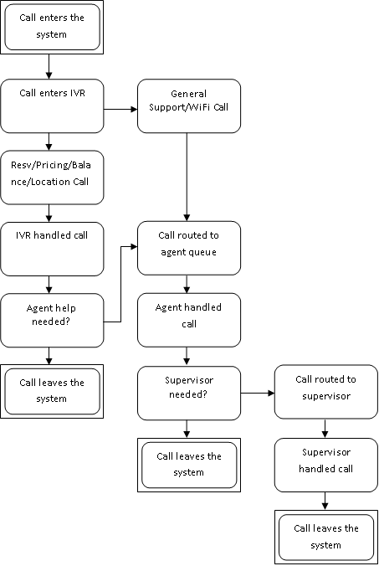
Figure 1 – Flow of a Call

CHAPTER 2: LITERATURE REVIEW
Previous research on call centers has focused mostly on staffing models, call arrival models, uncertainty models, queuing and routing models, or some combination of these. While most of these models utilized some form a mathematical model such as; Bayesian Networks, Erlang-C/A, or Markov Chains. More recently, the use of computer simulation has been incorporated into the research on call centers. Over the past several years, simulation has emerged to play an important role in the call center design and management arena (Mehrotra & Fama, 2003). However, there is a need for research in the area of reliability of cross-trained agents as compared to that of specialized agents through the use of simulation tools (no research exists in the literature to the author's knowledge). This thesis provides a comparison between cross-trained agents versus specialized agents in call centers with a focus on system reliability.

This chapter is organized as follows. The first section will consist of research done regarding reliability as it pertains to the call center environment; the second section will consist of research done regarding cross-trained versus specialized agents; and the final section will consist of research done regarding simulation usage in call center research.

Reliability

The Institute of Electrical and Electronic Engineers (IEEE) defines reliability as “the ability of a system or component to perform its required functions under stated conditions for a specified period of time” (IEEE, 1990). Recent research in the area of reliability has focused on Lean System Reliability.

The four critical resources required in Lean in terms of the basic requirements of reliability are outlined below based on work by Sawhney, et. al (Sawhney, Subburaman, Sonntag, Capizzi, & Rao, 2009). The requirement is that functions of a reliable Lean system are: materials, schedule, equipment, and personnel. The second requirement is that conditions of a reliable Lean system are: material availability and quality, schedule's ability to adapt, equipment performance is within specification, and personnel have the ability to withstand fluctuations in availability and performance. The third requirement outlines the cycle of a Lean system; which, is calculated based on the minimum span associated with material, scheduling, equipment, and personnel.

There exists three phases of tools to account for Lean and Reliability (Sawhney, Subburaman, Sonntag, Capizzi, & Rao, 2009). The first phase is Gap Analysis. Lean practitioners generally only consider optimal conditions when implementing Lean. However, Sawhney, et. al (Sawhney, Subburaman, Sonntag, Capizzi, & Rao, 2009) suggest that a Gap Analysis be completed to determine the difference between actual business conditions versus required business conditions. The second phase is the development of Hierarchical Tree Diagrams (HTD) for personnel, equipment, material, and schedule. The HTD allow practitioners to identify potential failures and root causes. The third phase is prioritizing Lean Reliability issues. Two quantification schemes are available: Risk Assessment Value (RAV) (Sawhney, Subburaman, Sonntag, Capizzi, & Rao, 2009) and Risk Priority Number (RPN) (Krasich, 2007). Both RAV and RPN are quantification approaches to Failure Mode and Effects Analysis (FMEA), and are described side-by-side in Table 1. More recently, a Risk Prioritization Lean Systems (RPLS) tool has been developed for a manufacturing setting (Subburaman, Wilck, Li, & Sawhney, 2010). The focus of this tool is to reduce risk with the focus of Lean implementation and prioritization based on reliability.

The focus of this thesis is reliability within a call center based on a comparison of cross-trained versus specialized agents; thus, the focus is only on the personnel and schedule. Equipment and materials will not be evaluated in this thesis. The previously mentioned reliability tools and implementations are focused towards manufacturing operations; however, there exists research that focused on cross-trained workers reliability.

Cross-trained workers represent flexible capacity. That is, workers can be shifted dynamically to where they are needed when they are needed. Hence, cross-trained workers should be able to achieve higher performance (or the same performance with a smaller workforce) than specialized workers. Cross-training workers and allocating them to tasks in dynamic ways can play an important role in supporting an organization’s strategy. Cross-training may facilitate learning, which enables workers to become faster, more regular, or more reliable over the long term (Hopp & Van Oyen, 2004). The primary focus of this thesis is call centers and their agents; more specifically, how reliable agents are when it comes to reaching the metrics set forth by the company.

Because of the way a large majority of call centers are designed and its ease of calculation, the most commonly used metric to gauge reliability is service level. Most call centers target a specific service level, defined as the percentage of callers who wait on hold for less than a particular period of time (Saltzman & Mehrotra, 2001). Through research it is assumed that this service level, while varying from company to company, is generally acceptable to be 80/20. This means that 80% of the incoming calls are answered in 20 seconds or less. A related measure often used to assess call center performance is the average time customers wait on hold, or average speed to answer (ASA). The ASA does not include the time a caller spends trying to get into a queue; it starts from the time a customer is entered into the appropriate queue to the time the call is actually answered by a live agent. This time frame is usually acknowledged by an IVR prompt similar to "All of our customer service representatives are currently busy assisting other customers, please wait and your call will be answered in the order it was received."

Table 1 – Comparison of RPN and RAV*
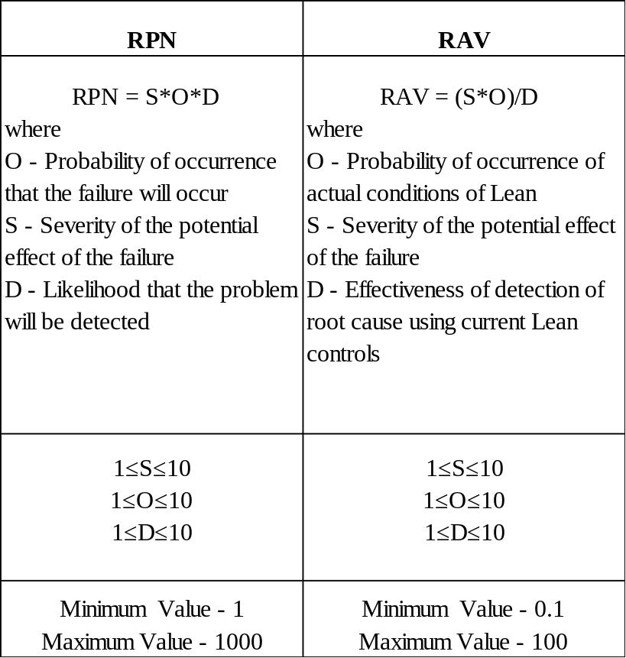
*From (Subburaman, Wilck, Li, & Sawhney, 2010).

Another key performance measure is the abandonment rate, defined as the percentage of callers who hang up while on hold before talking to an agent. Abandonment rates are highly variable as they are dependent mostly on the incoming caller’s patience. The maximum time a customer is willing to wait in queue is known as his patience time, also known as time-to-abandonment. In heavy traffic, even a small fraction of calls that abandon the queue can have a dramatic effect on system performance (Avramidis & Ecuyer, 2005). The proportion of calls that abandoned is known as the abandonment percentage and is a key metric in most call centers (Robbins, Medeiros, & Dum, 2006). It is well known throughout the call center industry that abandonment rates and customer waiting times are highly correlated (Saltzman & Mehrotra, 2001). Some other commonly used metrics in a call center are the following:

- Average handle time (AHT) – also highly variable as each caller requires a different level of customer service and each agent handles each call differently.
- Average talk time (ATT) – since this statistic is based on the time spent actually talking to a customer; it varies highly depending on the need of the current customer being serviced.
- Agent Utilization – within a cross-trained call center this statistic has low variability; however, within a specialized call center this statistic can have as high a variance as abandonment rates, especially during peak hours.

Cross-Trained vs. Specialized Agents

Call centers have found that careful attention to the management of the workforce can help avoid lost calls and reduce long waiting times (Iravani, Kolfal, & Van Oyen, 2007). Although previous research has shown that cross-training team members improve team performance, a number of questions remain concerning the nature of cross-training. Cross-training is defined as “an instructional strategy in which each team member is trained in the duties of his or her teammates” (Volpe, Cannon-Bowers, Salas, & Spector, 1996). The goal of this type of training is to provide team members with a clear understanding of the entire team function and how one’s particular task and responsibilities inter-relate with those of the other team members (Volpe, Cannon-Bowers, Salas, & Spector, 1996). Cross-training has been touted as contributing to team communication, coordination and controlled team regulation by encouraging members to understand the activities of those around them (Marks, Sabella, Burke, & Zaccaro, 2002).

Cross-training allows labor capacity to be dynamically relocated to the services required by customers as call volumes shift and the mix across service type’s changes (Iravani, Kolfal, & Van Oyen, 2007). With only specialized agents we cannot profit from the economies of scale that arise when we have only cross-trained agents. Specialized agents cost less in the sense of wages, training requirements, management becomes easier in certain aspects, and they provide scalability for the call center. On the other hand, multi-skill agents cost more, need more training, and are less efficient in each individual skill, but they provide more flexibility in dealing with different types of services required (Omari & Al-Zubaidy, 2005).

From the call center manager’s perspective having only specialized agents is the best as it costs the lowest, however those idle agents cannot serve customers who require a service different from the service the idle agent provides. This can result in many idle agents even when some queues are full of customers. Cross-trained agents, on the other hand could deal with all different service types requested so no customer will wait for a special kind of agent. This study concluded that the use of only specialized agents results in more waiting calls and very large average waiting times, however it costs less in terms of salaries. On the other hand, the use of all multi-skill agents enhances the overall service quality and increases the agent’s utilization. However, the overall cost also increases (Omari & Al-Zubaidy, 2005). The knowledge gained from training teaches members how to compensate for teammates’ limitations and cross-trained team members volunteer more information and perform better (Marks, Sabella, Burke, & Zaccaro, 2002). Specialist (specialized) agents may be faster service providers than generalist (cross-trained) who constantly switch between tasks of different types (Pinker & Shumsky, 2000). Note that in the presence of variability, some workers will occasionally be starved for work while others are overwhelmed and this may cause long queue lengths (Iravani, Kolfal, & Van Oyen, 2007). Within high workload and intense task-interdependence environments, cross-training is critical and improves team performance (Hollenbeck, DeRue, & Guzzo, 2004).

Call Center Simulation Models

A company’s call center is its most visible strategic weapon and with the importance of call centers on the rise, simulation technology is emerging as the best analysis tool to manage change within an increasingly complex environment (Bapat & Pruitte Jr., 1998). Simulation is a far superior modeling approach that overcomes many of the difficulties of analytical models and associated assumptions (Kungle, 1999). Call-center managers wish to improve call-center performance, and need powerful decision-making tools to visualize, analyze, and enhance call-center business processes. The best tools available today to perform these functions are simulation tools. The typical call center environment consists entirely of interactions between resources and entities.
A system’s resources can be the trunk lines, IVRs, agents, computer terminals used by agents, telephones, etc. An entity is simply the call or customer calling into the call center. These entities enter and navigate through the system seizing available resources as needed, often requiring several resources at a time, and eventually releasing the seized resources upon exiting the system. The most common type of model used in analyzing call centers involves some variation of Erlang calculations because they are relatively fast and easy to perform (Bapat & Pruitte Jr., 1998). Call centers have relied historically, on Erlang-C based estimation formulas to help determine number of agent positions and queue parameters however recent trends such as skill-based routing, electronic channels and interactive call handling demand more sophisticated techniques. Erlang-based calculations are also restrictive and sometimes incapable of analyzing business questions faced by call center analysts and managers. Simulation provides many advantages in call center modeling over analysis techniques such as:

- Simultaneous queuing
- Customer abandonment patterns
- Priority queuing
- Agent schedules

In most call center models, it is assumed that the system is in a steady state, but in reality call centers subject to highly variable arrival rates may rarely achieve steady state (Robbins, Medeiros, & Dum, 2006).

Additional research has shown that in highly specialized call centers that training a small pool of workers on the functions of a second project (e.g., job) is beneficial for a Telephone Service Factor of a Service Level Agreement of 80% of the calls are answered within 120 seconds (Robbins, Harrison, & Medeiros, 2007). A recent survey article on the status of call center research is provided by Gans, et al. (Gans, Koole, & Mandelbaum, 2003).

CHAPTER 3: MODELS

Model Explanation

Currently the call center has a staff of 12 agents and two supervisors. Each agent is trained to handle both wireless calls and general support calls, and in times of higher than normal call volume; a supervisor will get in the queue to receive calls. Calls continuously enter the system with a random unknown distribution and are independent of each other. Callers are presented with an IVR and are then routed via the ACD to its respective queue or IVR. Queue calls are routed to an agent and IVR calls are handled by the IVR with an option to speak to an agent. Once in queue for an agent, calls are served first in first out (FIFO), handled and disposed of by an agent unless escalated to a supervisor. If a supervisor is available the calls are served FIFO by a supervisor, handled and disposed, otherwise the caller is called back at a later time once a supervisor is available.

The company’s call center has been modeled both as a cross-trained call center, which is the current way the call center is operated, and as a specialized call center. The flow of a call is the same for the specialized call center but there are some major differences between the two models and their model design. Table 2 shows the skills matrix for the cross-trained model; notice that each agent is skilled in handling both call types. Table 3 shows the skills matrix for the specialized model; notice that one agent is cross-trained. For simulation purposes, this agent had to be cross-trained; otherwise one queue would reach capacity while never being attended. This would result in a higher variance and therefore less accurate model, then having the agent being specialized.

A Non-Stationary Poisson process was used to model the arrivals of calls based on a schedule with random exponential distribution. However, different times (of the 24 hour day) were more likely to receive calls. Thus, the model's call arrival schedule is depicted in Table 4.

Table 2 – Cross-Trained Skills Matrix
Worker/Skill | 1 | 2 | 3 | 4 | 5 | 6 | 7 | 8 | 9 | 10 | 11 | 12
General | X | X | X | X | X | X | X | X | X | X | X | X
Wireless | X | X | X | X | X | X | X | X | X | X | X | X

Table 3 – Specialized Skills Matrix
Worker/Skill | 1 | 2 | 3 | 4 | 5 | 6 | 7 | 8 | 9 | 10 | 11 | 12
General | X | X | X | X | X | X | X
Wireless |  |  |  |  |  |  | X | X | X | X | X | X
Table 4 – Schedule of Arrival of Calls Per Hour
Time | Calls per Hour
12:00am - 4:00am | 8
4:00am - 8:00am | 15
8:00am - 12:00pm | 22
12:00pm - 4:00pm | 31
4:00pm - 8:00pm | 27
8:00pm - 10:00pm | 16
10:00pm- 11:00pm | 12
11:00pm - 12:00am | 9

The software used to generate the simulation models is Rockwell’s Arena Simulation Software. Arena is a powerful simulation and automation GUI software that’s easy to use and navigate and yields informative statistics automatically. Arena is used by many major companies, such as GM, IBM, NIKE & UPS, for simulating business processes. Call center modeling is a highly variable system process to model as there are many uncontrollable factors involved. For this reason, the following assumptions were made for both models:

- Agents work a full eight or ten hour shift with random breaks in increments of 5, 15, or 30 minutes modeled as “failures.” If an agent is on a call during a random break, it will occur after the call is completed.
- Agents work for 3½ hrs before random breaks occur.
- After a random break occurs, an agent’s uptime is 1½ hrs before another random break occurs.
- Call handle times are assumed to be of a triangular distribution with a minimum of 2 minutes, a maximum of 15 minutes and a median of 7 minutes.
- After-call work is considered as part of the handle time.
- Abandonment rates are based on queue lengths, not the queue’s waiting time, or “customer patience time.”
- 1 replication is representative of a 7 day work week from Sunday to Saturday, each day lasting 24 hours.
- Calls continuously arrive from 12:00:00am to 11:59:59pm.
- The call center has an infinite number of trunk lines.
- Supervisors only take calls when its determined to be an escalated situation
- While idle, agents & supervisors work on back office issues such as customer call backs, emails, meetings, etc – this is not “modeled” in this simulation model.

The following call center metrics of importance for this simulation research are:

- Total answered calls
- Total abandoned calls
- Average wait time
- Average total time in system
- Agent utilization

The following figures 2-5 detail the layout of the cross-trained model and the specialized model.

Cross-Trained Model Layout Explanation

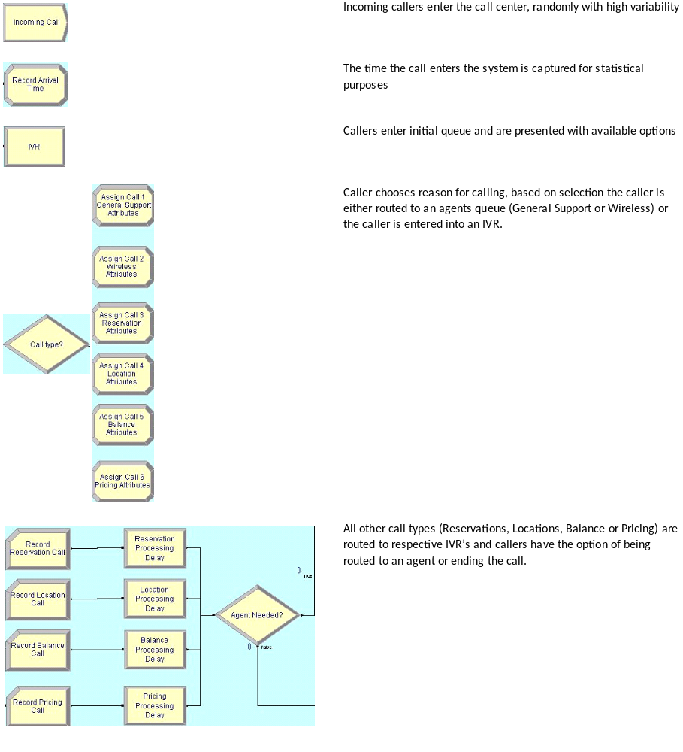

Figure 2 – Cross-Trained Model Explanation

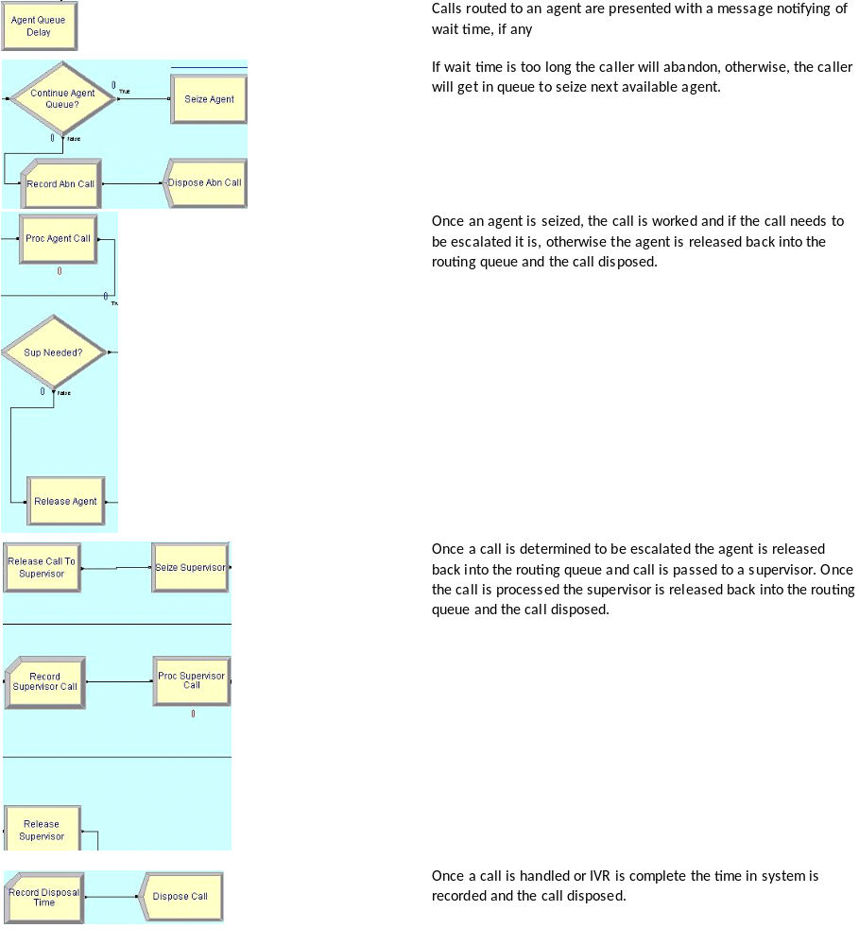

Figure 3 – Cross-Trained Model Explanation 2

Specialized Model Layout Explanation

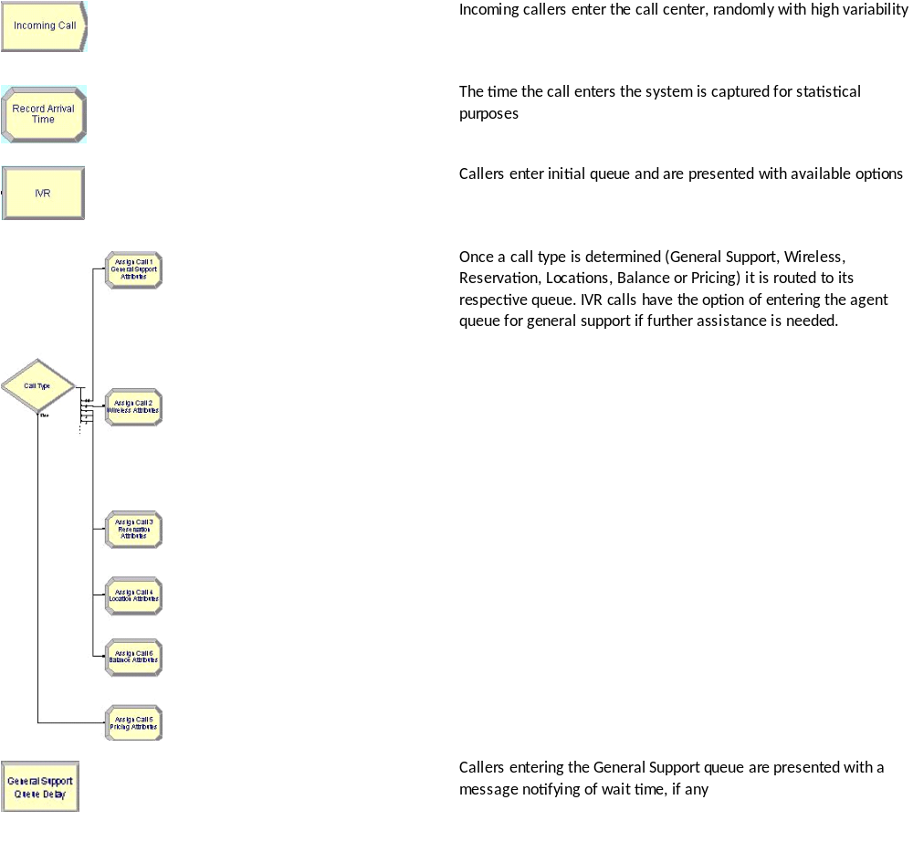

Figure 4 – Specialized Model Explanation
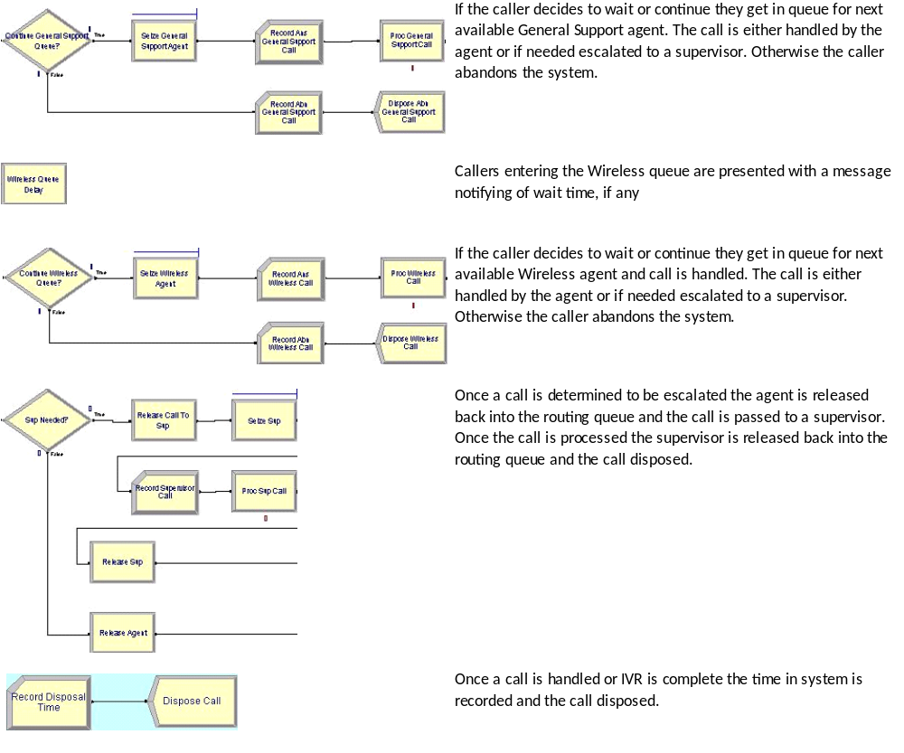

Figure 5 – Specialized Model Explanation 2

CHAPTER 4: RESULTS
The results contained in this thesis were gathered from Rockwell’s Arena Software. Each simulation model ran for a total of 100 replications. Since this is a 24 hour call center operation, for simplicity reasons, each replication represents 7 working days from Sunday 12:00:00 am to Saturday 11:59:59 pm. Statistics were generated directly from Arena’s output analyzer based on the results from the simulations. It’s important to note that these statistics are averages per replication, not cumulative of the 100 replications. For example, the average wait time for the Cross-Trained model in Table 5 is .8032; this is for 1 replication which represents 7 days. Therefore, .8032/7 = .1147 or about 12 minutes

Table 5 summarizes the results of the metrics being evaluated from each model. Based on the output in Table 5, it is determined that the cross-trained model out-performed in every metric compared to the specialized model. In the specialized model, abandonment rates are very high, over 4 times as high, compared to the abandonment rates in the cross-trained model as shown in Figure 2. The calls answered by the IVR (not shown) exhibited very little variation with the numbers ranging usually within ±3. As Table 5 indicates, both the overall time in system and the average wait time are lower in the cross-trained model versus the specialized model. Figure 3 shows that the total average wait time for the specialized model is nearly double the total average wait time in the cross-trained model. Figure 4 displays the total time in system for the cross-trained model as compared to the specialized model. This is due to the fact that within the cross-trained model each agent can assist both wireless and general customer support calls while in the specialized model customers have a longer wait time for specific agents depending on the desired queue.

Table 5 – Metrics
 | Cross-Trained Model | Specialized Model
Total answered calls | 2,207.80 | 2,024.25
Total abandoned calls | 664.59 | 758.40
Total average wait time | 0.8032 | 0.8209
Total average time in system | 0.9545 | 0.9205
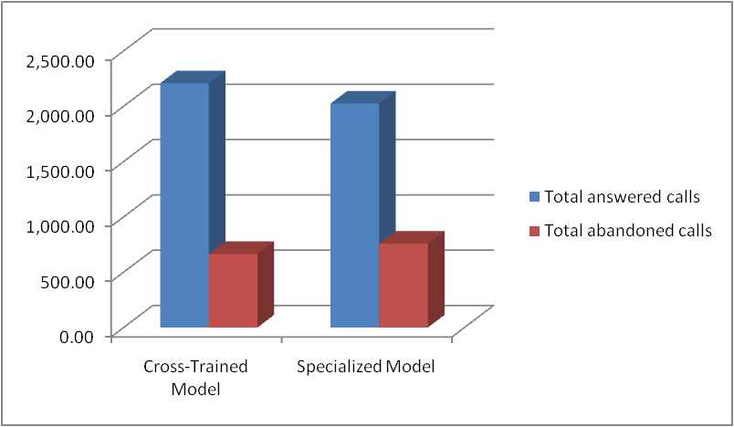

Figure 6 – Total Answered Calls vs. Total Abandoned Calls

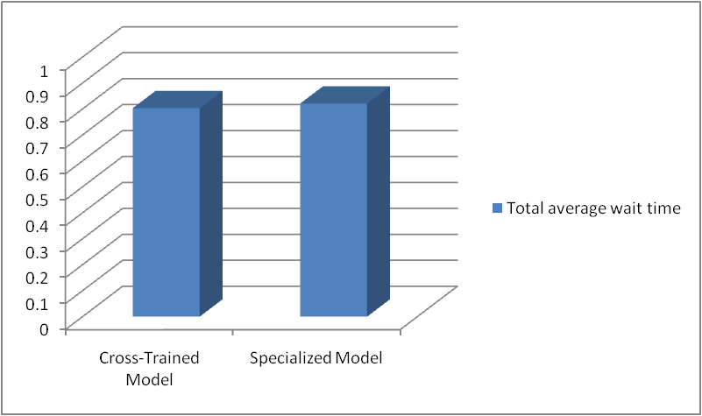

Figure 7 – Total Average Wait Time
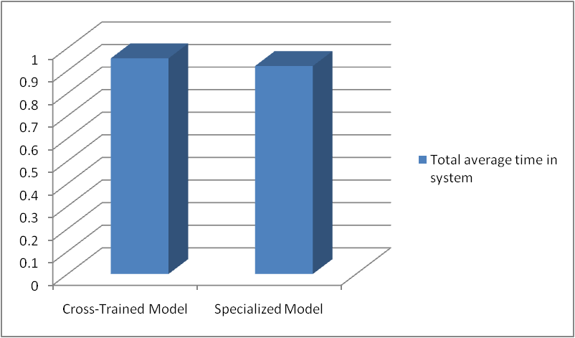

Figure 8 – Total Average Time In System

Agent Utilization is compared in Table 6 and graphically depicted in Figure’s 9 & 10, as you can see, with some agents the variation in agent utilization is smaller compared to other agents. The Cross-Trained model shows fairly consistent agent utilization and suggests that each agent is doing essentially the same amount of workload. The Specialized model, however, shows more variation in the agent utilization. Recall that, in the case of a call center staffed with 100% specialized agents, times of high call volume can result in some agents being idle while other agents are busy with increasing queues. For example, Agent 5’s utilization rate is 0.2056 in the cross-trained model, while in the specialized model their utilization increases to 0.2393. Likewise, Agent 2’s utilization rate in the cross-trained model is nearly 21%, while in the specialized model it is just around 2%.

The reliability of the system is further compounded by additional metrics RPN and RAV. Generally, these metrics are used when implementing Lean and reliability principles, once a Gap Analysis and Modified FMEA approach are completed. Recall, the parameters for RPN and RAV.

O = Probability of occurrence that the failure will occur
S = Severity of the potential effect of the failure
D = Likelihood that the problem will be detected

For comparison purposes, D is assumed to be equivalent in both a cross-training scenario and a specialized scenario; thus, D is assumed to be 1 since the problem will be detected effectively. Setting D to 1 will also make RAV and RPN equal. For S, we will assume the severity is equal to the average utilization of the workers and supervisors (normalized from a decimal to a 10-point scale). For O, we will let the probability of occurrence equal to the Total Abandoned Calls divided by Total Answered Calls plus Total Abandoned Calls (normalized from a decimal to a 10-point scale). The results follow in Table 7. The results indicate that Specialized Agents impose less risk since that model has a lower RAV and RPN. The Specialized Agents model had an RAV and RPN equal to 21.492; whereas, the Cross-Trained Agents model had an RAV and RPN equal to 27.669. This is due to the fact that the probability of a call being abandoned by the specialized model is less likely than the cross-trained model. This effect is dampened a bit by the severity of the potential effect being 1.517 times higher for the cross-trained model (due to their higher utilization rates). However, one could argue that the higher utilization rates are due to the fact that the model handled more calls. Note that this is irrelevant of the choice of D, provided the assumption that the likelihood of problem detection is equivalent for both the cross-trained agents and the specialized agents. Results regarding the probability of callbacks due to incorrect or incomplete service (on the original call) are not available.

Table 6 – Agent Utilization
 | Cross-Trained Model | Specialized Model
Agent 1 | 0.2413 | 0.1846
Supervisor 1 | 0.05520727 | 0.0304611
Agent 2 | 0.209 | 0.02061608
Agent 3 | 0.1868 | 0.221
Agent 4 | 0.2412 | 0.2149
Agent 5 | 0.2056 | 0.2393
Agent 6 | 0.1847 | 0.03319183
Agent 7 | 0.2212 | 0.2389
Agent 8 | 0.1977 | 0.1853
Agent 9 | 0.2107 | 0.02146279
Agent 10 | 0.1774 | 0.03461931
Supervisor 2 | 0.04369458 | 0.03322083
Agent 11 | 0.1634 | 0.217
Agent 12 | 0.2413 | 0.02615248

Table 7 – Comparison of Specialized Agents versus Cross-Trained Agents in Terms of Reliability Metrics
Model | Total Abandoned Calls | Total Answered Calls | Probability of Abandoned Call | O (Normalized) | Average Worker Utilization | S (Normalized) | D | RAV = S*O/D | RPN = S*O*D
Specialized Agents | 758.4 | 2,024.25 | 0.273 | 5.409 | 0.121 | 3.974 | 1 | 21.492 | 21.492
Cross-Trained | 664.59 | 2,207.80 | 0.231 | 4.591 | 0.184 | 6.026 | 1 | 27.669 | 27.669

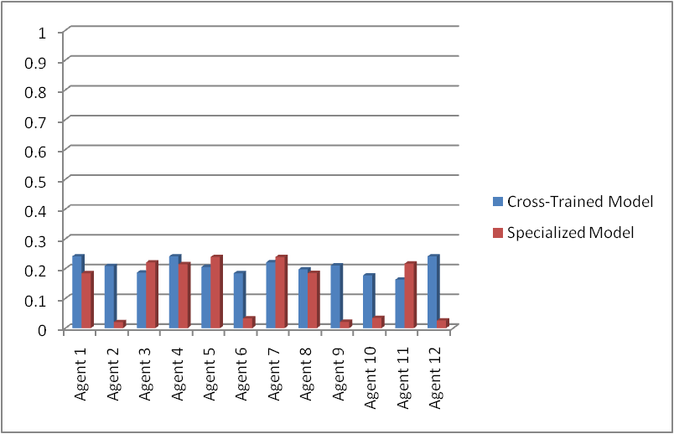

Figure 9 – Agent Utilization

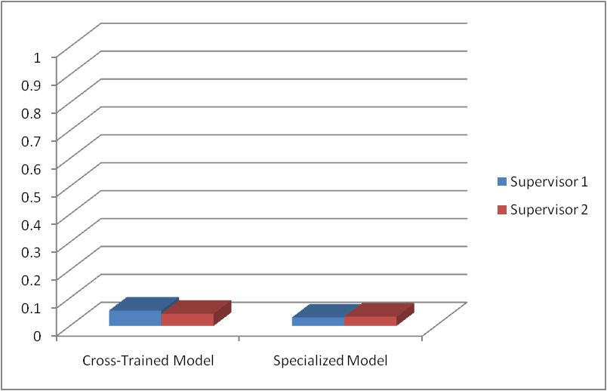

Figure 10 – Supervisor Utilization

CHAPTER 5: CONCLUSIONS
Call center research using computer simulation modeling is a growing trend in the industrial engineering and operations research fields. While traditional research on call centers have revolved around the use of mathematical models to help facilitate the research efforts, more recent research efforts have made use of available computer simulation tools, such as Rockwell’s Arena Software.

The results of this research study supported my hypothesis that cross-trained agents are more efficient and reliable than specialized agents. What this research does not take into account is the cost associated with implementing a 100% cross-trained staff or a 100% specialized staff. The main reason for this is the lack of available information since these costs are highly variable from company to company depending on the type of knowledge and training required.

Contribution

The novel research contribution of this thesis is a comparison of cross-trained agents versus specialty agents in a call center in regards to both system efficiency and reliability. This comparison is captured using simulation. The areas of reliability and simulation are significant research areas within industrial engineering and operations research. Applying reliability tools and metrics (e.g., RAV, RPN) to call centers is a novel approach.

Future Research

Computer simulation has come a long way in call center research and is still a growing trend. As with other methods used in previous call center research, computer simulation also has its limitations. Perhaps the greatest limitation in call center modeling is variability. Variability from the customer service representatives perspective with taking calls including the length of time it takes to answer a call, to the after call work required to wrap up a call and everything in between. Variability, also, from the customer’s perspective depending on what kind of customer is calling in, what kind of issue the customer has, etc. Due to these kinds of variance it’s hard to model a call center perfectly because variance can’t be model, only slightly simulated. For this reason a number of assumptions have to be made in order to facilitate the simulation, such as handle time, abandonment rates and/or outside factors contributing to abandonment rates, agent breaks and other downtime or idle time. The biggest assumption in most call center research is the call arrival rate, which is highly variable.

REFERENCES

Avramidis, A. N., & Ecuyer, P. L. (2005). Modeling and Simulation of Call Centers. Winter Simulation Conference, (pp. 144-152).

Bapat, V., & Pruitte Jr., E. B. (1998). Using Simulation In Call Centers. Winter Simulation Conference, (pp. 1395-1399).

Bodin, M., & Dawson, K. (1999). The Call Center Dictionary: The Complete Guide to Call Center and Help Desk Technology and Operations. Cmp Books.

Gable, R. A. (1993). Inbound Call Centers: Design, Implementation & Management. Artech House.

Gans, N., Koole, G., & Mandelbaum, A. (2003). Telephone call centers: Tutorial, review, and research prospects. Manufacturing & Service Operations Management , 5(2):79-141.

Hollenbeck, J. R., DeRue, D. S., & Guzzo, R. (2004). Bridging the Gap Between the I/O Research and HR Practice: Improving Team Composition, Team Training, and Team Task Design. Human Resource Management , 353-366.

Hopp, W. J., & Van Oyen, M. P. (2004). Agile Workforce Evaluation: A Framework for Cross-Training and Coordination. IIE Transactions , 1-32.

IEEE, I. o. (1990). Std 610.12-1990. IEEE Standard Glossary of Software Engineering Terminology .

Iravani, S. M., Kolfal, B., & Van Oyen, M. P. (2007). Call-Center Labor Cross-Training: Its a Small World After All. Management Science - INFORMS , 1102-1112.

Krasich, M. (2007). Can Failure Modes and Effects Analysis Assure a Reliable Product? IEE Xplore .

Kungle, R. (1999). Simulation of a Claims Call Center: A Success and a Failure. Winter Simulation Conference, (pp. 1648-1653).

Marks, M. A., Sabella, M. J., Burke, C. S., & Zaccaro, S. J. (2002). The Impact of Cross-Training on Team Effectiveness. Journal of Applied Psychology , 3-13.

Mehrotra, V., & Fama, J. (2003). Call Center Simulation Modeling: Methods, Challenges and Opportunities. Winter Simulation Conference, (pp. 135-143).

Omari, T., & Al-Zubaidy, H. (2005). Call Center Performance Evaluation. IEEE CCECE/CCGEI, (pp. 805-808). Saskatoon.
Pinker, E. J., & Shumsky, R. A. (2000). The Efﬁciency-Quality Trade-Off of Cross-Trained Workers. Manufactoring & Service Operations - INFORMS , 32-48.
Robbins, T. R., Harrison, T. P., & Medeiros, D. (2007). Partial Cross Training in Call Centers with Uncertain Arrivals and Global Service Level Agreements. Proceedings of the
2007 Winter Simulation Conference .

Robbins, T. R., Medeiros, D. J., & Dum, P. (2006). Evaluating Arrival Rate Uncertainty In Call Call Centers. Winter Simulation Conference.

Saltzman, R. M., & Mehrotra, V. (2001). A Call Center Uses Simulation To Drive Strategic Change. Interfaces , 87-101.

Sawhney, R., Subburaman, K., Sonntag, C., Capizzi, C., & Rao, P. (2009). A Modified FMEA Approach to Enhance Reliability of Lean Systems. International Journal of Quality and Reliability Management , Accepted.

Subburaman, K., Wilck, J., Li, X., & Sawhney, R. (2010). A Decision Making Framework Evaluating Reliability of Lean systems. Working Paper, The University of Tennessee .

Volpe, C. E., Cannon-Bowers, J. A., Salas, E., & Spector, P. E. (1996). The Impact of Cross Training on Team Functioning: An Empirical Investigation. Human Factors , 87-100.

APPENDIX

Call Center Layout

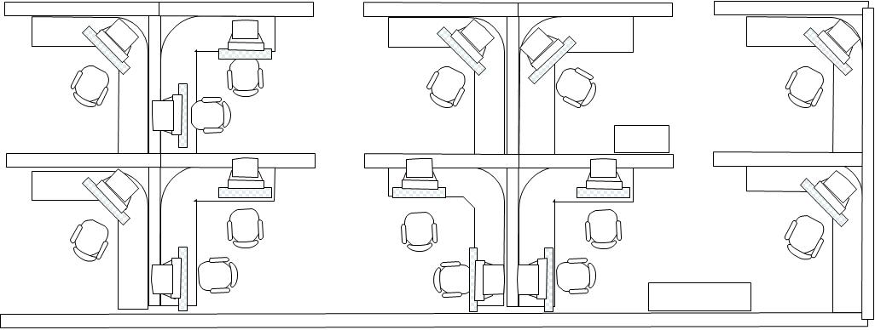

Cross-Trained Simulation Model

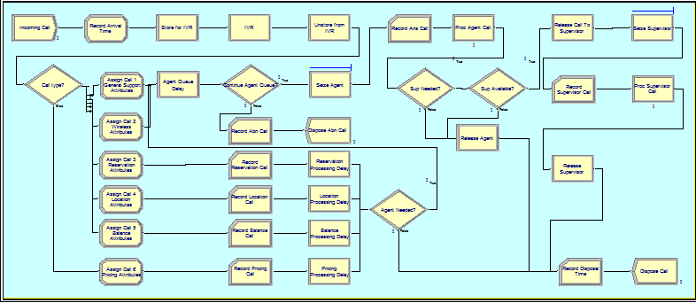

Cross-Trained Simulation Model Agent Work Schedule

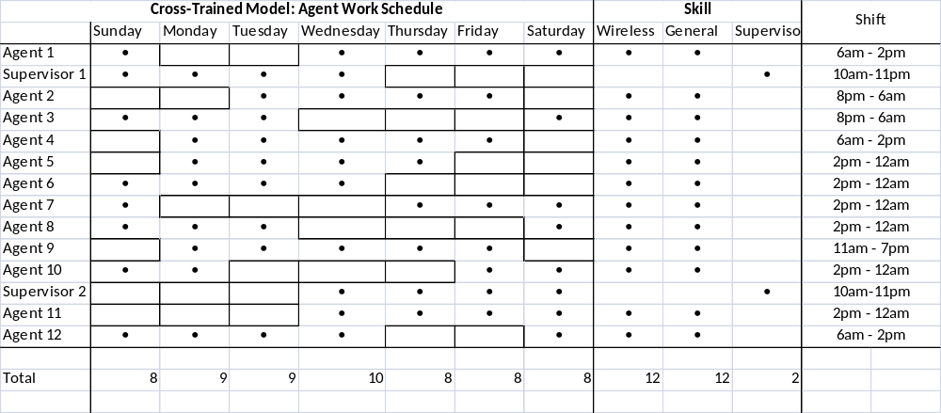

Specialized Simulation Model Agent Work Schedule

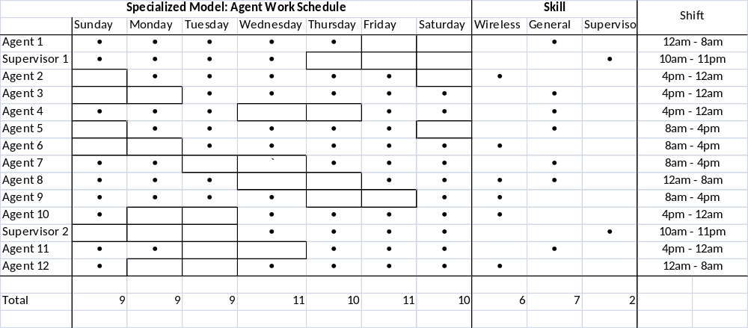

Specialized Simulation Model – 1

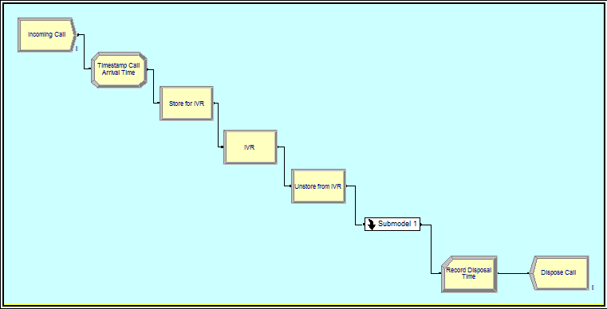

Specialized Simulation Model – 2
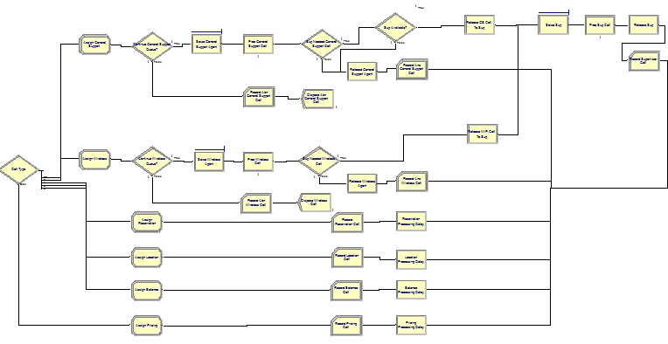

VITA
Louis Franklin Ali III was born July 13th 1984, in Detroit, MI and later moved to Lansing, MI and attended J. W. Sexton High School. After graduating in 2002, Louis attended Northwood University in Midland, MI where he obtained both his Associate’s Degree in Management Information Systems and Bachelors of Business Administration in Management, in May 2006. Next, Louis attended the University of Tennessee – Knoxville in the fall of 2007 and began working towards his Masters of Science in Industrial Engineering with a concentration in Information Engineering. He began working under the tutelage of Dr. Wilck in the fall of 2009. After graduation, Louis plans to stay in the southern part of the US and pursue a career in Information/Systems Engineering.

Some definitions obtained from (Bodin & Dawson, 1999)

