Ischiopubic Index: A Metric Approach to Estimating Sex in the Pelvic Region
Tripoli Mulvihill
University of Tennessee, Knoxville
Fall 2022

Table of Contents
Introduction……………………………………………………….…………………………..… 3
Growth and Development……………………………………………………………………… 3
Figure 1…………………………………………………………………………..……… 5
Figure 2…………………………………………………………………………..……… 7
Anatomical Significance…………………………………………………………….………… 10
Forensic Application……………………………………………………………...…………… 12
Figure 3………………………………………………………………………..……..… 14
Figure 4………………………………………………………………………..……..… 16
Figure 5………………………………………………………………………..……..… 17
Figure 6………………………………………………………………………..……..… 18
Figure 7………………………………………………………………………..……..… 19
Materials and Methods …………………………………………………………………..…… 20
Figure 8………………………………………………………………………..……..… 20
Figure 9………………………………………………………………………..……..… 21
Figure 10……………………………………………………..………………..……..… 22
Results …………………………………………………………………………….…………… 24
Table 1
Tables 2-4……………………………………………………………………..……...… 25
Tables 5-6……………………………………………………………………..……...… 26
Tables 7-8……………………………………………………………………..……...… 27
Tables 9-11…………………………………………………………………..…..…...… 28
Tables 12-13…………………………………………………………………..……...… 29
Tables 14-15…………………………………………………………………..……...… 30
Tables 16-17…………………………………………………………………..……...… 31
Table 18……………………………………………………………………..……......… 32
Discussion………………………………………………………………………………………. 33
Conclusion...…………………………………………………………………………………… 35
Works Cited…………………………………………………………………………..……...… 36
Appendix A………………………….………………………………………………..……...… 39

Abstract
The pelvis has long been known as the best indicator of sex in skeletal remains (Phenice, 1969). Parturition is the key factor in why the shape and size of the pelvis differs between sexes. There are a multitude of methods to establish the estimation, many relying on nonmetric trait analysis (Phenice 1969, Klales et al. 2012, Buikstra and Ubelaker 1994). While nonmetric traits can be useful and reliable, metric indicators can be helpful when attempting to estimate the sex of skeletal remains due to the potential of significant sexual dimorphism. The Daubert ruling also requires methods to be relevant and reliable which can be determined through its ability to be empirically tested and having an acceptable known or potential error rate (Fradella et al., 2004). This is much easier to substantiate with metric indicators. Pubis length and ischial length measurements were used to create a ratio, the ischiopubic index, which shows a significant difference in the size of this region of the skeleton between males and females.

Introduction
The pelvis, followed by long bones and the skull, is the most reliable region for an accurate estimation of biological sex, (Phenice, 1969). The pelvis is the most reliable area due to high sexual dimorphism that is present in this region related to the process of parturition, or childbirth. Modern estimation methods mainly center around the presence, or lack thereof, of nonmetric indicators (Phenice 1969, Klales et al.(2012). The use of nonmetric indicators also come along with the consequences of interobserver error and bias. Introducing a method that relies on metric indicators is useful in eliminating this error and bias by promoting strict measurement guidelines that can be used by everyone. Nonmetric indicators are subjective in their practice, while metric indicators are based in objective methods of measurement. The ratio of the ischial length and pubis length to create the ischiopubic index is an example of a metric indicator that can be used to eliminate interobserver error and bias while also creating a more objective way to estimate sex in the skeleton.

Growth and Development
The os coxae are some of the most important bones in the human skeleton. The pelvic girdle is comprised of the articulated os coxae and sacrum. The pelvic girdle connects the axial skeleton to the appendicular skeleton while also stabilizing most of the body’s weight to not overload the lower limbs. They also provide attachment sites for the muscles of the lower half of the body, including the hip adductors, and protect the organs that lie within the pelvic region (Wobser et al., 2022). The birth canal is also found within the pelvic girdle in females. While the os coxa may look like one complete bone, it is made up of three separate bones that fuse during maturation: the ilium, the ischium, and the pubis.
The pelvis forms by the process of perichondral and endochondral ossification. Perichondral ossification is the process of the internal and external surfaces of the cartilage are covered with bone cells (osteoblasts) without invading the cartilage that is present while endochondral ossification is where cartilaginous structures are gradually replaced by bone. Cartilage is formed when mesenchymal cells condense and are then perforated by groups of cells that establish the primary centers of ossification (Mackie et al., 2008). Since the pelvis is comprised of three separate regions, they each have their own primary center of ossification. See Figure 1.
In utero, the ilium is the first to set up a primary center of ossification. According to Verbruggen and Nowlan (2017), this typically appears around the beginning of the third month in utero. The center is in the area near the top of acetabulum, close to where the greater sciatic notch will later form. The ossification then spreads superiorly and laterally by the process of perichondral ossification. The ilium becomes recognizable around the end of the fourth to the beginning of the fifth month in utero, which is characterized by the upper border of the sciatic notch and upward radiating appearance.

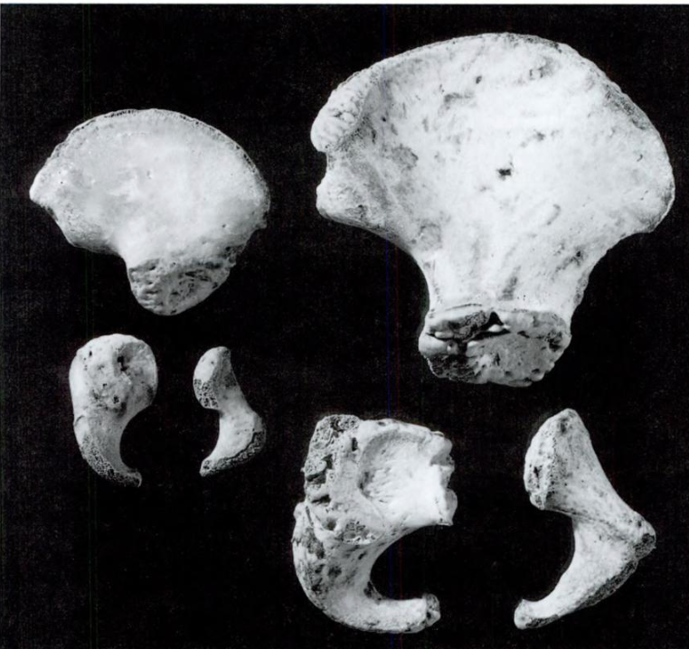
Figure 1: Disarticulated innominate showing the three regions, the ilium, the ischium, and the pubis, at one year old and 6 years old postnatal (White et al., 2011).

The ischium is the next to establish a primary center of ossification around four to five months (See Figure 1). Perichondral ossification happens first and is followed by endochondral ossification. The ischium is recognizable by the end of the sixth month in utero. The ischium can be easily pointed out by its “comma-like appearance.” The inner surface of the ischium is smooth as it protects the organs of the pelvic region (Verbruggen and Nowlan, 2017).
The pubis is the last to appear with its primary center of ossification established at five to six months in utero (See Figure 1). The center forms at the superior portion of the pubic ramus, anterior to the acetabulum. The pubis is the smallest and most fragile of the pelvic elements in ossification. According to Fazekas and Kosa (1978), the pubis is “dumbbell shaped” in the early stages of ossification.
Postnatally, the three primary centers of ossification of the separate elements rapidly ossify during the first three months after birth. They do not go through dramatic morphological change at this time, however. The rate of growth continues to decrease until about three years of age and becomes even slower after that until the person reaches the age of puberty where morphological sex-related changes start to occur. The fusion of the three separate elements of the pelvis begins much later during childhood. The fusion of the pubis and the ischium can begin at three years of age, but typically does not occur until the individual is between five and eight years old. Fusion starts at the ischiopubic ramus area and does not move into the acetabular region until puberty (Verbruggen and Nowlan, 2017).
The acetabulum, a feature shared by all three elements of the os coxa, is the most important of the secondary ossification sites. The articular cartilage lining of the socket-shaped acetabulum slowly ossifies throughout childhood to accommodate for the continuous growth of the femoral head it articulates with while the individual is maturing (Harrison, 1961). There are three secondary ossification centers for the acetabulum which is known as a triradiate unit (See Figure 2). This triradiate unit forms a Y-shape in the acetabular region (Grissom et al., 2018). The first of the triradiate unit to ossify is the os acetabuli (anterior acetabular epiphysis). The os acetabuli forms a triangle piece of bone between the pubis and the ilium around nine to ten years of age. The second of the triradiate unit ossifies around ten to eleven years of age forming the connection between the ilium and the ischium. The third epiphysis of the unit appears between twelve and fourteen years of age forming the upper rim of the acetabulum on the ilium (Verbruggen and Nowlan, 2017). The complete fusion of the triradiate unit and acetabulum occurs differently in males and females due to differences in mature age. Ossification is complete between eleven and fifteen years of age in females and fourteen to seventeen years of age in males (Stevenson, 1924).

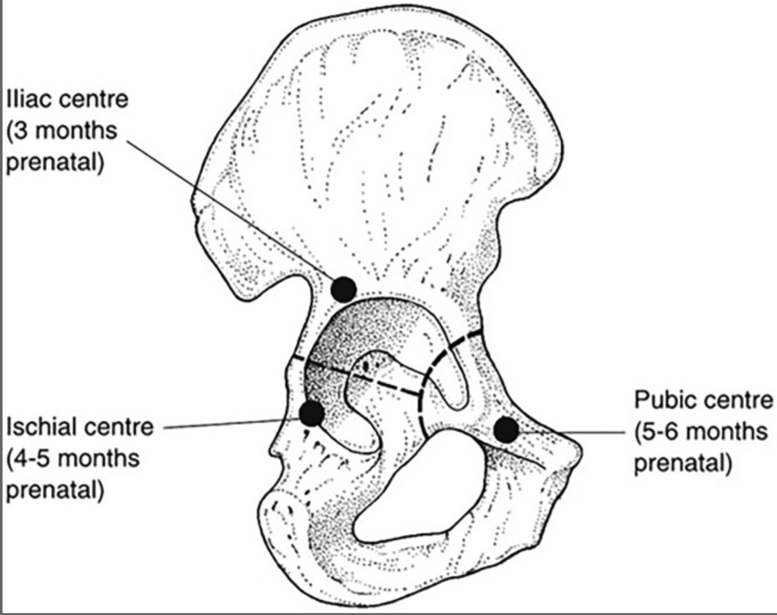
Figure 2: Depiction of the triradiate unit of the os coxa (Scheuer and Black, 2004).

The biggest of the three elements of the os coxa, the ilium, begins to form the secondary ossification sites first. The epiphysis of the anterior inferior iliac crest start ossifying around ten to thirteen years of age, but do not fully fuse until around twenty years (Francis, 1940). The iliac crest epiphysis has two secondary ossification centers, one forming the anterior superior iliac spine and the other forming the anterior portion of the crest. These two epiphyses meet at the highest point of the iliac crest. The crest begins to ossify around twelve to thirteen years of age in females and fourteen to fifteen years in males. The two secondary ossification centers of the crest fuse around fifteen to eighteen years in females and seventeen to twenty years in males (Cunningham et al., 2016). This is once again due to differences in the rate of skeletal maturity between males and females caused by hormones (Verbruggen and Nowlan, 2017).
The ischium’s center of secondary ossification begins at the ischial tuberosity, spreads across the surface of the tuberosity and continues along the ischial ramus towards the pubis. The ischial tuberosity is located on the inferior portion of the ischium. Fusion begins around sixteen to eighteen years of age and is fully complete by twenty-four years old in males and twenty-six years old in females (Cunningham et al., 2016). The complete fusion of the ischial ramus to the pubic ramus, however, does not happen until about twenty-three years of age (Scheuer and Black, 2004).
The maturation of the pubis is complex. Secondary ossification centers arise around the pubic symphysis, a cartilaginous joint that connects the two medial aspects of the pubis on the os coxae. These secondary ossification centers are typically seen starting around fourteen years of age in females and around sixteen years of age in males (Grissom et al., 2018). Around this time, bone is gradually laid down onto the dorsal surface of the pubic symphysis which smooths over the ridged surface. This may not be completed until the individual is twenty-three years of age (Katz and Suchey, 1986). This is due to the pubis being the most responsive part of the pelvic girdle to the action of female hormones (Washburn, 1948).
During puberty, the period of pelvic change in females is approximately eighteen months. This change in the shape of the pelvis is due to the growth of the sacrum, ilium, and pubis. The rapid growth that characterizes the pubis during this time is impacted by the hormonal changes that happen during puberty (Washburn, 1948). In early childhood, the growth of the pelvic girdle is slow and symmetrical compared the rapid growth during puberty of this area of the body, mainly impacting the subpubic concavity and the pelvic inlet, or birth canal. Puberty in girls is characterized by the growth of pubic hair, breasts, and signs of first menstruation. It has been observed that the changes in the skeletal structure of the pelvis consistently appear after these changes that are controlled by female hormones (Gruelich and Thoms, 1944).

Anatomical Significance
The pelvis is extremely important in terms of sex estimation due to the high degree of sexual dimorphism that characterizes this region of the human skeleton. It has been found to be that the pelvis is the most reliable area for sex estimation followed by the long bones and the skull. Parturition, the process of childbirth, is the main factor in the female sex which causes differences in the shape and function of the pelvis between sexes. Something of interest is the sexual dimorphism in the pelvis as compared to the sexual dimorphism of other parts of the body is that females have larger dimensions than males while the reverse is found for almost all other elements (DeSilva and Rosenberg, 2017). Females tend to have a wider, rounder pelvic inlet. The pelvic inlet refers to the space in the middle of the pelvis when the os coxae and sacrum are all articulated. A wider, rounder shape of the inlet provides more room for the child during pregnancy and childbirth. The typical female pelvic inlet was labeled as a “gynecoid” shape (Caldwell and Moloy, 1938). Since males do not participate in parturition, the typical male pelvic inlet is more “blunt heart-shaped.” This means that the inlet is smaller, narrower, and the sacrum tends to project farther anteriorly. This typical male pelvis shape is referred to as the “android” shape (Caldwell and Moloy, 1938).
The pelvic girdle also is adapted for bipedal locomotion. It has been known that females tend to have wider hips and shorter legs than males. The modern human female pelvis is an evolutionary result of a balance between locomotion and the morphology of childbirth (DeSilva and Rosenberg, 2017). According to Wall-Scheffler and Myers (2017), females, relative to their height, walk faster than men, have a lower center of mass, and have a longer stride than men relatively as they rotate through a greater angle when walking due to the width of the pelvis. The lower center of mass increases stability and decreases the load placed on the pelvis and lower limbs. Wall-Scheffler and Myers (2017) argue that the wider pelvis of females is not strictly due to the need for obstetric-based processes, but also an evolutionary advantage to locomotion. A wider pelvis skeletally manifests as having a rounder pelvic inlet which allows a baby to make its way through the birth canal.

Forensic Application
Forensic anthropologists need to be able to estimate the sex of skeletal remains. Understanding both nonmetric and morphometric methods to estimate sex is extremely important to the process of estimating the sex of an individual. The pelvis has been determined to be the bone to use to accurately estimate sex due to its highly dimorphic features and size. Having such a reliable bone at their disposal significantly increases the chance that the estimation of sex will be accurate.
Forensic anthropology is the application of estimating the biological profile for use in medicolegal contexts. Forensic anthropologists are needed in situations where an individual is highly decomposed to fully skeletonized where the bones are the only way to identify the individual. The analysis of the bones can relay information that pertains to the sex, age at death, stature, and, in some cases, ancestry of the individual (Krishan et al., 2016). This estimation of the biological profile can also be paired with analyses of possible pathology, trauma or taphonomy that may have impacted the individual before, during and/or after death. All this information put together can aid law enforcement and other agencies is identifying the individual(s) that they would otherwise not be able to because of the absence of soft tissue or other common identification techniques, such as driver’s license or DNA. This identification is only an estimation, as one never wants to make an absolute statement in their casework write up when there is no other evidence to back up their claim.
An important distinction that must be made here is that sex refers to the genotype of the individual at birth while gender is the phenotype that the individual decides to identify with during life (Krishan et al., 2016). In a forensic context, sex is the only attribute that can be estimated with only the presence of the bones at this time. Current methods are based on techniques to estimate biological sex.
The focus on the pelvis as a reliable area to estimate sex of human remains began with the work of Phenice (1969). The Phenice (1969) method uses three attributes of the os coxa to accurately estimate sex. See Figure 3. These three traits are the ventral arc, the subpubic concavity and medial aspect of the ischiopubic ramus. All three of these traits are categorized by either presence or absence. The presence of the traits indicate that the remains are female while males will typically have an absence of these three traits.
In the sample of 275 adult individuals from the Terry Skeletal Collection, only 11 had been incorrectly sexed giving this method a 96% accuracy rating. In the study, Phenice (1969) stresses that this technique should only be used to estimate sex of adult skeletons at it has been reported that the ventral arc and subpubic concavity specifically are not fully developed until a female has reached twenty years of age.

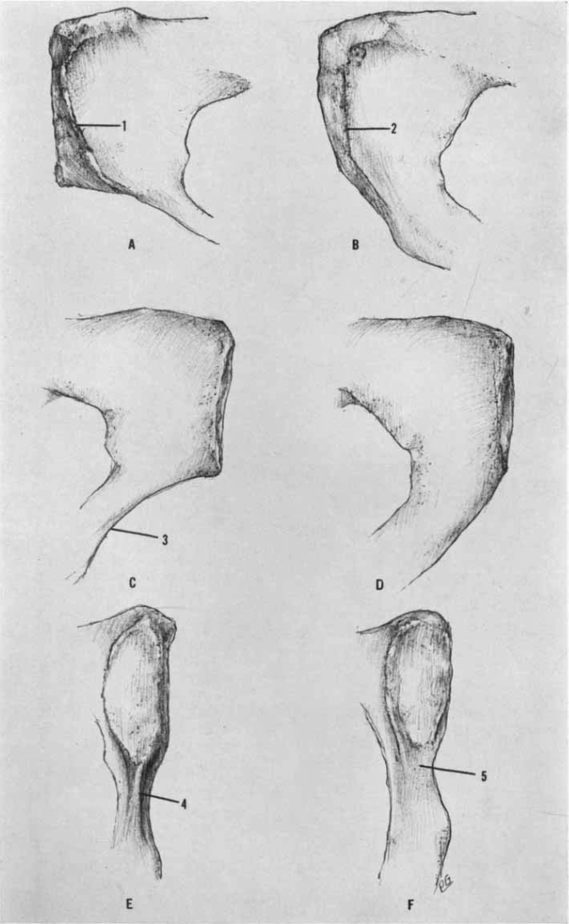
Figure 3: Ventral arc, subpubic concavity, and medial aspect of the ischiopubic ramus as pictured in Phenice (1969) from top to bottom. Female traits (A, C, E)are pictured on the left and male traits are pictured on the right.
In a revision of the Phenice (1969) technique, Klales and colleagues (2012) added a numerical rating to each of the three traits described. Since Phenice himself acknowledged that not every female or male will represent the perfect form in every trait, there needed to be a way to refine this technique to make it as accurate as possible. The Klales et al. (2012), method incorporates an ordinal scoring method to be able to evaluate variation in the degree of development of the qualities as opposed to presence or absence or the trait.
Each feature is scored on a scale from 1-5 (See Figure 4). For example, a score of a 1 would mean a very pronounced subpubic concavity while a score of a 5 would be the complete absence of it. Scores 2 through 4 are used to describe innominate bones that do not have the complete presence or absence of a trait but are still recognizable. Scoring a trait a 1 or a 2 would indicate a more female presenting condition, a 3 would mean it is intermediate, and scores of a 4 or 5 indicate a more male presenting form. The scores from all three traits can then be analyzed to estimate the sex.

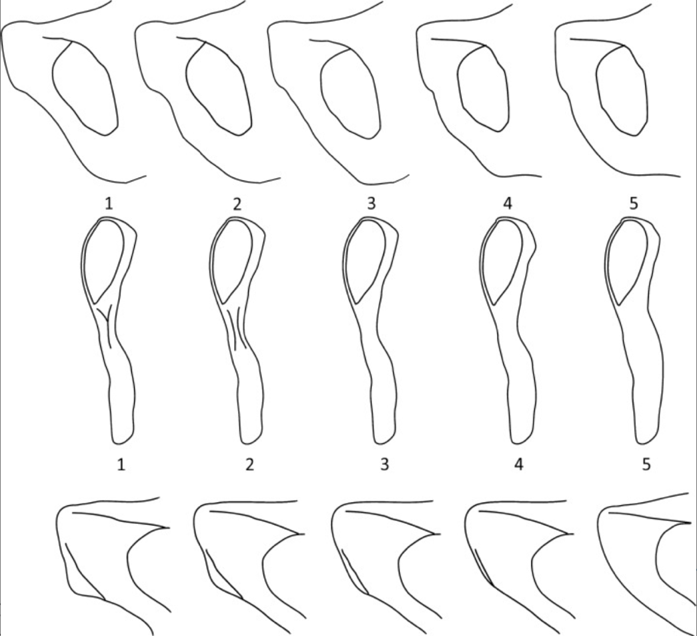
Figure 4: Ordinal scoring method for the subpubic concavity, medial ischiopubic ramus, and ventral arc (Klales et al., 2012).

Sub pubic concavity
One of the most prominent traits in sexing the human skeleton is the subpubic concavity or angle. Phenice (1969) refers to it as a concavity as his estimation was based on the presence or absence of the concave feature. The angle, as referred to by Rogers and Saunders (1994), considers the whole angle when both innominate bones are articulated. While referred to in different terms in this case, they are describing the same thing. The presence of a subpubic cavity also establishes a wide subpubic angle, and the absence of a concavity makes for a more acute angle. In females, this angle is more U-shaped, while males tend to have a more V-shape. This is associated with parturition.
The shape of the pubis also impacts the concavity, or lack thereof. According to Stewart (1979), females have a more rectangular shape of the superior pubis which in turn creates the concavity on the inferior, medial border. Males tend to have a more triangular shaped pubis which goes along with having a more convex inferior, medial border. Smith (1939) was the first to mention this difference in pubis shape.
Females need to have more space for the child to move between and out of the body while males do not (Klales, 2020). See Figure 5 for Klales depictions of the five states of development of this feature (Klales et al., 2012).

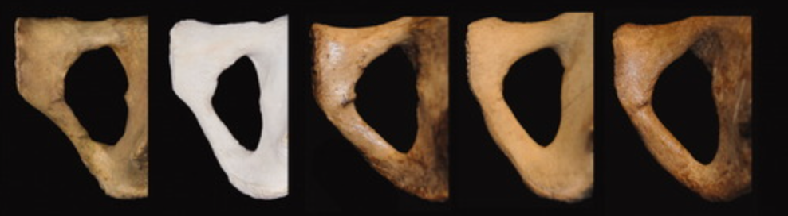
Figure 5: Examples of score 1 through 5 of the subpubic concavity (Klales et al., 2012)

Ventral arc
Another useful trait when attempting to estimate sex is the ventral arc. This trait was formally introduced by Phenice (1969) and has been further studied since. The ventral arc is the attachment site for the gracilis and the adductor brevis and magnus muscles (Todd, 1921). This means that the ventral arc should be present in both males and females, it is just more prominent in females. This is due to the wider pelvis of females, so the orientation and position of the attachment site is more noticeable (Klales, 2012). See Figure 6 for Klales depictions of the five states of development of this feature (Klales et al., 2012).

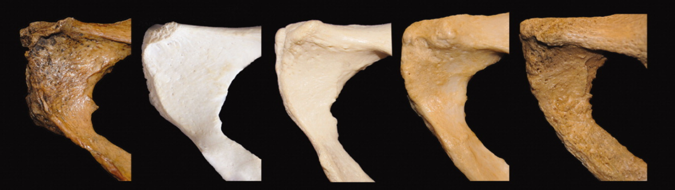
Figure 6: Examples of score 1 through 5 of the ventral arc (Klales et al., 2012).

Ischiopubic ramus
As described by Phenice (1969), the medial aspect of the ischiopubic ramus is another good way to estimate sex in the pelvis. In males, the portion of the ischiopubic ramus below the pubic symphysis is broad. In females, this same surface is more narrow and typically has a ridge present. Of the three traits described by Phenice, the medial aspect of the ischiopubic ramus should only be relied upon in conjunction with the other two traits. See Figure 7 for depictions of the five states of development of this feature (Klales et al., 2012).

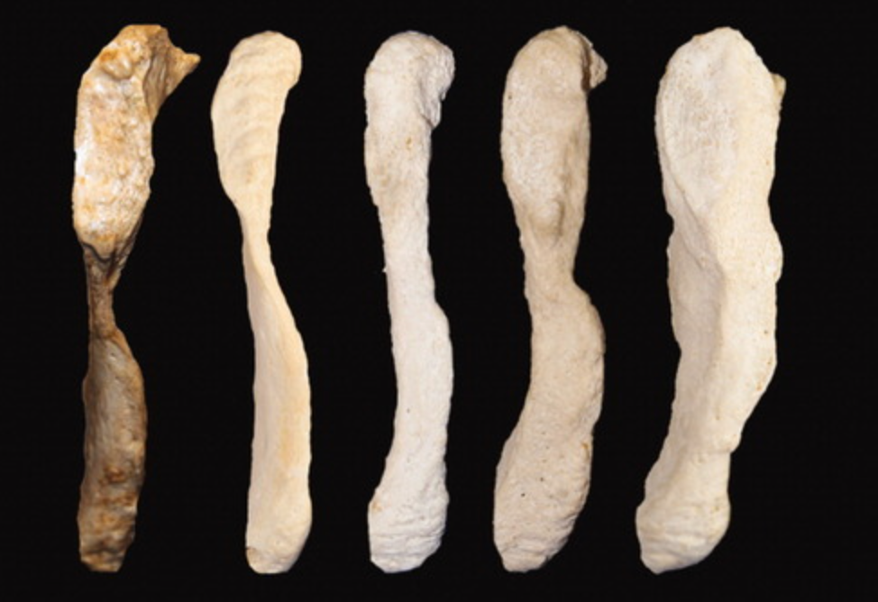
Figure 7: Examples of score 1 though 5 of the medial aspect of ischiopubic ramus (Klales et al., 2012).

Washburn (1942) noticed during a study on the skeletal proportions of monkeys that females’ pubic bones were much longer than their male counterparts. He then decided to see if this was the case in humans using the Schultz (1930) method. The pubis and ischium of 300 adult skeletons were measured. The pubis and the ischium were measured from the point at which they met the acetabulum. An index of the ischium length to the pubis length of each skeleton was then taken and compared. the results showed that females do have a longer pubic bone than males. It was concluded that the ischium-pubis index alone could correctly identify the sex of a skeleton 90% of the time (Washburn, 1948).
Materials and Methods
The purpose of the study is to attempt to develop a simple metric method of sex estimation of the anterior pelvis. Using data from the University of Tennessee’s Donated Skeletal Collection and Forensic Data Bank, measurements were analyzed and compared. An index developed to investigate if there was any significance when between males and females.
The os coxae were pulled from the University of Tennessee, Knoxville’s Donated Skeletal Collection. Individuals in this collection were mostly born after 1940 and throughout the 20th century. A sample size of 100 adults, 50 self-identified male and female, were chosen. The 50 individuals were randomly chosen by their age. Ten individuals from each decade of life spanning 30s, 40s, 50, 60s, and 70s were selected. Individuals who have damage to their pubis and surrounding areas were excluded from the sample. All individuals are of American White ancestry to assure that there are no variations within the sample population attributed to descent. All persons volunteered their body to the university for scientific purposes, so consent was given. Other than the measurements taken and the self-identified sex and age, all other donor information will remain anonymous.

Figure 8: Average age of individuals in the study separated by age.
The measurements that were used in this study were defined in the University of Tennessee, Knoxville’s Forensic Anthropology Center’s Data Collection Procedures for Forensic Skeletal Material 2.0 (the DCP). Maximum pubis length and ischial length were used.
Maximum Pubis Length (measurement 67) : The distance between symphysion (the most superior point on the symphyseal face) to the farthest point on the acetabular rim. There is also a note stating that the measurement is taken on the rim itself, not on the margins of the rim (See Figure 9).

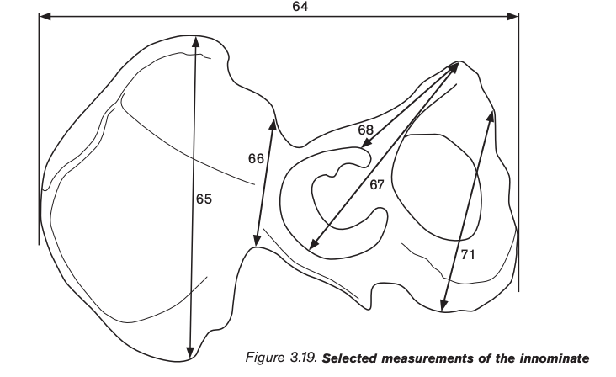
Figure 9: Maximum Pubis Length as illustrated in the DCP. This dimension is line 67.

Ischial Length (measurement 69). The distance from the point on the acetabular rim where the iliac blade meets the acetabulum to the most medial point on the epiphysis of the ischial tuberosity,” (See Figure 10).

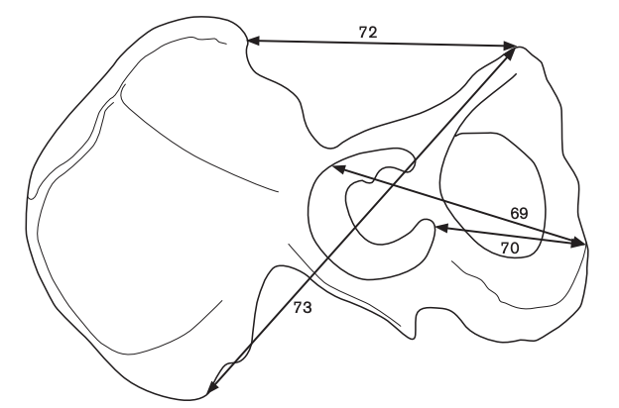

Figure 10: Ischial Length as illustrated in the DCP. This dimension is line 69.

For most of the individuals in this study, the measurements were previously recorded and stored in the Forensic Data Bank (FDB). All males and 36 of the 50 females had their measurements available in the FDB. Several os coxa were remeasured in order to compare to the measurements already recorded in the FDB to ensure accuracy in the measurements. For the remaining 14 females, ischial length and pubis length were taken and recorded manually by this investigator.
The right os coxa of the individual was measured first and then the left. Pubis length was taken from the most superior point of the pubic symphysis to the furthest point on the acetabular rim. Each individual had a slightly different shaped symphysis and acetabulum, so user discretion was used. Ischial length was then taken from the medial point of the ischial tuberosity to the point where the ilium meets the acetabulum. Once again, each individual showed difference in size and shape, so user discretion was used. After these measurements were taken, they were inputted into the database with the other measurements so an average could be taken for each individual and by sex.
The ratio of ischial length to pubis length was calculated for each individual’s right and left os coxae. The pubis length was divided by the ischial length. This is referred to as the ischiopubic index. This index was computed for each individual for both the left and right sides.
The ischiopubic index allows for the observer to understand the relative size of the inferior portion of the os coxa with a numerical backing instead of just having a visual representation. The ratio of the ischial length to the pubis length creates an index that tells the observer about the relative size of the inferior portion of the os coxa and, subsequently, whether the individual is male or female. Knowing the difference between the morphological traits and how they manifest differently in males and females is just another piece of information that can solidify a sex estimation after the measurements have been taken and the ischiopubic index determined.
Averages for both sexes in each age cohort were computed. This was done for both measurements and the index. The values were compared to determine if the dimensions are sexually dimorphic and whether this metric approach can yield significant results for sex estimation. Data were pooled by age and also analyzed within each of the five age cohorts.

Results
Using the measurements of ischial length and pubis length from 100 os coxae to establish a ratio of the ischiopubic index resulted in distinct, significant results. The metric data was taken and analyzed to establish the results. The data is comprised of representatives from both sexes and across a 50-year age range. A difference in ischiopubic index can be seen between the sexes, but there is also slight difference within the sexes when ages of the individuals is considered. For all tables, the average of the right and the left measurement of the os coxae are shown alongside the maximum and the minimum, which takes both the left and the right into account. All measurements are in millimeters.

Ischial Length

Sex | N | Mean (Right) | Mean (Left) | Maximum | Minimum
Male | 50 | 110.74 | 110.6 | 142 | 94
Female | 50 | 96.449 | 96.122 | 108 | 81
Table 1: Ischial Length measurements for 100 male and female subjects.

Table 1 shows the averages of the ischial length for both sexes along with the maximum and minimum. The ischial length is the relative size of the ischium of the os coxae measured from the midpoint of the ischial tuberosity to where the iliac blade meets the acetabulum. Overall, the males have a higher average for ischial length compared to females. The averages between the left and right ischial length within the same sex are relatively equal. The males have a larger range than females.

Sex | N | Mean (Right) | Mean (Left) | Maximum | Minimum
Male | 10 | 110.9 | 112.9 | 142 | 102
Female | 10 | 93.8 | 94.1 | 108 | 81
Table 2: Ischial Length measurements for 20 male and female subjects in their 30s.
When comparing the ischial length of males and females in their 30s, the males are larger than females. The maximums of the overall ischial length for both males and females come from an individual in their 30s. The minimum ischial length from a female in this data set also comes from an individual in their 30s. Both the right and the left for males and females are relatively similar with the left being slightly larger.

Sex | N | Mean (Right) | Mean (Left) | Maximum | Minimum
Male | 10 | 110.4 | 108.9 | 120 | 94
Female | 10 | 97 | 96.8 | 103 | 88
Table 3: Ischial Length measurements for 20 male and female subjects in their 40s.
For individuals in their 40s, the males do have a longer ischial length than females. The right ischial length is slightly longer than the left for both males and females. The minimum ischial length of a male in this data set comes from an individual in their 40s.

Sex | N | Mean (Right) | Mean (Left) | Maximum | Minimum
Male | 10 | 108.5 | 108.6 | 118 | 100
Female | 10 | 95.6 | 95.3 | 107 | 88
Table 4: Ischial Length measurements for 20 male and female subjects in their 50s.
Analyzing the data from individuals in their 50s shows that males have a larger ischial length than females. In this case, both the left and the right ischial length are almost equal with every little difference.

Sex | N | Mean (Right) | Mean (Left) | Maximum | Minimum
Male | 10 | 109.7 | 109.4 | 122 | 97
Female | 10 | 97.6 | 96.7 | 105 | 92
Table 5: Ischial Length measurements for 20 male and female subjects in their 60s.
Males have a larger ischial length than females when looking at individuals in their 60s. The male averages between the left and right ischial lengths are almost equal while the female averages have a slight difference between them.

Sex | N | Mean (Right) | Mean (Left) | Maximum | Minimum
Male | 10 | 114.2 | 113.2 | 134 | 105
Female | 10 | 97.4 | 97.1 | 106 | 93
Table 6: Ischial Length measurements for 20 male and female subjects in their 70s.
Comparing males and females in their 70s, males have a larger ischial length than females. For both males and females, the average of the right and the left ischial length is larger than the overall average taken from all the individuals included in this data set. The differences between the right and the left pubis lengths for both males and females are small and insignificant.

Maximum Pubis Length

Sex | N | Mean (Right) | Mean (Left) | Maximum | Minimum
Male | 50 | 124.18 | 123.84 | 141 | 111
Female | 50 | 122.306 | 120.02 | 139 | 107
Table 7: Pubis Length measurements for 100 male and female subjects.
Table 7 shows the averages of the right and left pubis length for both sexes along with the maximum and minimum. The pubis length is the relative length of the pubis of the os coxa measured from the top of the symphyseal surface to the furthest point on the rim of the acetabulum. The male average for pubis length is slightly larger than the female average. In this case, the right pubis length tends to be longer than the left for both sexes. The ranges of the averages of the pubis length are relatively equal for both sexes.

Sex | N | Mean (Right) | Mean (Left) | Maximum | Minimum
Male | 10 | 124.9 | 123.5 | 134 | 117
Female | 10 | 118.2 | 118.2 | 139 | 107
Table 8: Pubis Length measurements for 20 male and female subjects in their 30s.
When analyzing the pubis length of individuals in their 30s, males tend to be larger than females. The maximum and minimum pubis lengths for females included in this data set comes from individuals in their 30s. In this case, the right and left averages for pubis length in females were equal.

Sex | N | Mean (Right) | Mean (Left) | Maximum | Minimum
Male | 10 | 122.3 | 121.9 | 132 | 112
Female | 10 | 121.9 | 121.4 | 133 | 110
Table 9: Pubis Length measurements for 20 male and female subjects in their 40s.
Males have a larger pubis length than females when analyzing the individuals in their 40s. However, the males are only slightly larger than the females, especially when looking at the left side. In this case, the maximum pubis length for males (132) is less than the maximum for females (133).

Sex | N | Mean (Right) | Mean (Left) | Maximum | Minimum
Male | 10 | 122.4 | 122.9 | 131 | 113
Female | 10 | 118.5 | 118.3 | 132 | 111
Table 10: Pubis Length measurements for 20 male and female subjects in their 50s.
For individuals in their 50s, males have a larger pubis length than females. Both the left and the right pubis lengths within each sex are relatively equal with little difference. In this case, the maximum pubis length for males (131) is less than the maximum for females (132).

Sex | N | Mean (Right) | Mean (Left) | Maximum | Minimum
Male | 10 | 126.1 | 125.9 | 141 | 111
Female | 10 | 120.7 | 120.4 | 136 | 111
Table 11: Pubis Length measurements for 20 male and female subjects in their 60s.
When comparing individuals in their 50s, males have a longer pubis length than females with the right pubis length for both sexes being only slightly larger than the left. The maximum and minimum pubis length for males included in this data set comes from individuals in their 60s showing the range that can be seen in this measurement.

Sex | N | Mean (Right) | Mean (Left) | Maximum | Minimum
Male | 10 | 125.2 | 125 | 134 | 117
Female | 10 | 121 | 121.2 | 131 | 115
Table 12: Pubis Length measurements for 20 male and female subjects in their 70s.
Comparing males and females in their 70s, males have a larger pubis length than females. For both males and females, the average of the right and the left ischial length is larger than the overall average taken from all the individuals included in this data set. The differences between the right and the left pubis lengths for both males and females are small and insignificant.

Ischiopubic Index

Sex | N | Mean (Right) | Mean (Left) | Maximum | Minimum
Male | 50 | .892 | .893 | 1.06 | .825
Female | 50 | .795 | .801 | .866 | .748
Table 13: Average Ischiopubic Index for 100 male and female subjects.

Table 13 displays the averages for the ischiopubic index for both males and females along with the maximum and minimum for reference. The ischiopubic index is the ratio of the ischium length to the pubis length. The males have a significantly larger index than the females. Both the left and right indices of both sexes are relatively similar. A t-test was run to determine the significance of the difference between the male and female ischiopubic indices. To be considered significant, the p-value must be less than .05. In this case, the difference was significant (p-value<.05).

Sex | N | Mean (Right) | Mean (Left) | Maximum | Minimum
Male | 10 | .888 | .913 | 1.06 | .843
Female | 10 | .794 | .796 | .839 | .757
Table 14: Ischiopubic Index metrics for 20 male and female subjects in their 30s.
When comparing the ischiopubic indices of males and females in their 30s, males tend to be larger. In this case, the maximum for the males was over 1 and the minimum was the larger than the maximum for the females. The female average for both the right and the left were closer to the overall female average than the males are to the overall male average. The maximum male ischiopubic index from the males included in this data set comes from an individual in their 30s. When run through a t-test, the p-value was less than .05, deeming the difference between the ischiopubic indices of males and females significant.

Sex | N | Mean (Right) | Mean (Left) | Maximum | Minimum
Male | 10 | .903 | .894 | .983 | .825
Female | 10 | .796 | .798 | .844 | .748
Table 15: Ischiopubic Index metrics for 20 male and female subjects in their 40s.
For males and females in their 40s, the males have a larger average ischiopubic index than females. The minimum male ischiopubic index from the overall data set comes from an individual in their 40s. While the minimum for males in this decade of life is within the female range, the overall average is larger and the difference between males and females is significant as determined by a t-test in which the p-value was less than .05.

Sex | N | Mean (Right) | Mean (Left) | Maximum | Minimum
Male | 10 | .886 | .883 | .927 | .837
Female | 10 | .807 | .805 | .858 | .767
Table 16: Ischiopubic Index metrics for 20 male and female subjects in their 50s.
Comparing the ischiopubic index of males and females in their 50s, males have a larger index than females. The male averages (.866 and .883) are smaller than the overall male averages (.892 and .893), while the female averages (.807 and .805) are slightly larger than the overall female average (.795 and .801). While the minimum for males in this decade of life is within the female range, the male average is larger and the difference between males and females is significant as determined by the t-test where the p-value was less than .05.

Sex | N | Mean (Right) | Mean (Left) | Maximum | Minimum
Male | 10 | .87 | .869 | .938 | .808
Female | 10 | .808 | .805 | .866 | .748
Table 17: Ischiopubic Index metrics for 20 male and female subjects in their 60s.
For males and females in their 60s, the males have a larger average ischiopubic index than females. Both the maximum and minimum ischiopubic indices of females included in this data set comes from individuals in their 60s.While the minimum for males in this decade of life is within the female range, the overall average is larger and the difference between males and females is significant as determined by the t-test where the p-value was less than .05.

Sex | N | Mean (Right) | Mean (Left) | Maximum | Minimum
Male | 10 | .912 | .905 | 1 | .848
Female | 10 | .805 | .801 | .843 | .754
Table 18: Ischiopubic Index metrics for 20 male and female subjects in their 70s.
When comparing the ischiopubic indices of males and females in their 70s, males tend to be larger. In this case, the maximum for the males was equal to 1 and the minimum was the slightly larger than the maximum for the females. When run through a t-test, the p-value was less than .05, deeming the difference between the ischiopubic indices of males and females significant.

Discussion
The ischiopubic index shows the relative size of the inferior portion of the os coxa. Females tend to have a smaller ischiopubic area while males are larger as indicated by metrics of the ischiopubic index. Even with the varying sizes of the 50 individuals from each sex cohort, the ratio of the ischiopubic index hovered around .8 for females and .89 for males. This is consistent with the data showing that males tend to have a larger ischial length and pubis length than females, no matter the age. Values of less than .8 likely indicate the remains are those of a female, while a score that exceed .9 should be considered to represent a male.
Of note, individuals in their 70s displayed some of the largest averages overall, while individuals in their 60s were significantly smaller. At these points in life, an individual is not growing so this trend is likely due to the overall sizes of the individuals in these age cohorts.
While the relative size of the ischiopubic area of the os coxa can be seen visually when two sexes are being compared side by side, having the metric data can be helpful in solidifying an estimation of sex while also not having to rely on comparison data. Nonmetric traits have been the most reliable way to estimate the sex of a pelvic region of the skeleton, but one must always be cautious due of interobserver bias and variation. Having the specific measurements and guidelines when measuring the ischial and pubis lengths allow for standardization to this estimation method. The ratio will also stay consistent for males and females based on the individuals in this study. The ischiopubic index can give you an added layer to putting together the information one needs to estimate the sex of skeletal remains when the inferior portion of the os coxa is present. This method is also helpful because it only requires one os coxa without needing to be articulated to any other portion of the pelvic girdle. This avoids any issues with previous soft tissue or cartilage presence, confusion regarding postmortem changes to the bone and can still be used with fragmentary skeletal material (Washburn, 1948).

Conclusion
The ischiopubic index will allow for anthropologists to be more confident in their findings when estimating the sex of a skeleton. The measurements needed for the ischiopubic index, the ischial length and the pubis length, are simple to measure and calculate. Extensive anthropological knowledge and practice is not necessarily needed to calculate the ischiopubic index and estimate the sex of a skeleton using the results found. Having a metric method working in tandem with the reliable morphological traits used today will aid analysts. For this Ischiopubic index, values of less than .8 indicate the remains are those of a female, while a score that exceed .9 should be considered to represent a male. Using a metric method not only bases the results in numerical fact, but also brings a more objective way to estimate the sex of a skeleton to the table.
Works Cited
Buikstra, J. E., & Ubelaker, D. H. (1994). Standards for data collection from human skeletal remains. Arkansas Archeological Survey.
Caldwell, W. E., & Moloy, H. C. (1938). Anatomical variations in the female pelvis: Their classification and obstetrical significance. Proceedings of the Royal Society of Medicine, 32(1), 1–30. https://doi.org/10.1177/003591573803200101
Cunningham, C., Scheuer, L., & Black, S. (2016). The Pelvic Girdle. In Developmental juvenile osteology (pp. 351–384). essay, Elsevier Science.
DeSilva, J. M., & Rosenberg, K. R. (2017). Anatomy, development, and function of the human pelvis. The Anatomical Record, 300(4), 628–632. https://doi.org/10.1002/ar.23561
Fazekas, I. G., & Kósa, F. (1978). Forensic fetal osteology. Akadémiai Kiadó.
Francis, C. C. (1940). The appearance of centers of ossification from 6 to 15 years. American Journal of Physical Anthropology, 27(1), 127–138. https://doi.org/10.1002/ajpa.1330270132
Fradella, H. F., O'Neill, L., & Fogarty, A. (2003). The impact of daubert on forensic science . Pepperdine Law Review, 31(2), 323–362.
Greulich, W. W., & Thoms, H. (1944). The growth and development of the pelvis of individual girls before, during, and after puberty. Yale Journal of Biology and Medicine.
Grissom, L. E., Harty, M. P., Guo, G. W., & Kecskemethy, H. H. (2018). Maturation of pelvic ossification centers on computed tomography in normal children. Pediatric Radiology, 48(13), 1902–1914. https://doi.org/10.1007/s00247-018-4233-6
Harrison T. (1961). The influence of the femoral head on pelvic growth and acetabular form in the rat. Journal of Anatomy, 95(1), 12-24.
Katz, D., & Suchey, J. M. (1986). Age determination of the male os pubis. American Journal of Physical Anthropology, 69(4), 427–435. https://doi.org/10.1002/ajpa.1330690402
Klales, A. R., & Klales, A. R. (2020). Sex estimation using pelvis morphology. In Sex estimation of the human skeleton: History, methods, and emerging techniques (pp. 75–93). essay, Academic Press, an Imprint of Elsevier.
Klales, A. R., Ousley, S. D., & Vollner, J. M. (2012). A revised method of sexing the human innominate using Phenice's nonmetric traits and statistical methods. American Journal of Physical Anthropology, 149(1), 104–114. https://doi.org/10.1002/ajpa.22102
Krishan, K., Chatterjee, P. M., Kanchan, T., Kaur, S., Baryah, N., & Singh, R. K. (2016). A review of sex estimation techniques during examination of skeletal remains in forensic anthropology casework. Forensic Science International, 261, 165e.1–165e.8. https://doi.org/10.1016/j.forsciint.2016.02.007
Langley, N. R., Jantz, L. M., Ousley, S. D., Jantz, R. L., & Milner, G. (2016). Data Collection Procedures for Forensic Skeletal Material 2.0. Forensic Anthropology Center. Retrieved December 4, 2022, from https://fac.utk.edu/wp-content/uploads/2016/03/DCP20_webversion.pdf
Mackie, E. J., Ahmed, Y. A., Tatarczuch, L., Chen, K.-S., & Mirams, M. (2008). Endochondral ossification: How cartilage is converted into bone in the developing skeleton. The International Journal of Biochemistry & Cell Biology, 40(1), 46–62. https://doi.org/10.1016/j.biocel.2007.06.009
Phenice, T. W. (1969). A newly developed visual method of sexing the OS pubis. American Journal of Physical Anthropology, 30(2), 297–301. https://doi.org/10.1002/ajpa.1330300214
Rogers, T., & Saunders, S. (1994). Accuracy of sex determination using morphological traits of the human pelvis. Journal of Forensic Sciences, 39(4), 1047–1056. https://doi.org/10.1520/jfs13683j
Scheuer, L., & Black, S. M. (2004). The juvenile skeleton. Academic Press.
Schultz, A. H. (1930). The skeleton of the trunk and limbs of higher primates. Human Biology, 2(3), 303–438.
Smith, S. (1939). Studies in Identification. No. 3. The Police Journal, 274–285.
Stevenson, P. H. (1924). Age order of epiphyseal union in man. American Journal of Physical Anthropology, 7(1), 53–93. https://doi.org/10.1002/ajpa.1330070115
Stewart, T. D. (1979). Essentials of forensic anthropology: Especially as developed in the United States. Charles T Thomas.
Todd, T. W. (1921). Age changes in the pubic bone. American Journal of Physical Anthropology, 4(1), 1–70. https://doi.org/10.1002/ajpa.1330040102
Verbruggen, S. W., & Nowlan, N. C. (2017). Ontogeny of the human pelvis. The Anatomical Record, 300(4), 643–652. https://doi.org/10.1002/ar.23541
Wall-Scheffler, C. M., & Myers, M. J. (2017). The biomechanical and energetic advantages of a mediolaterally wide pelvis in women. The Anatomical Record, 300(4), 764–775. https://doi.org/10.1002/ar.23553
Warrener, A. G., Lewton, K. L., Pontzer, H., & Lieberman, D. E. (2015). A wider pelvis does not increase locomotor cost in humans, with implications for the evolution of childbirth. PLOS ONE, 10(3). https://doi.org/10.1371/journal.pone.0118903
Washburn, S. L. (1942). Skeletal proportions of adult langurs and macaques. Human Biology, 14(4), 444-472.
Washburn, S. L. (1948). Sex differences in the pubic bone. American Journal of Physical Anthropology, 6(2), 199–208. https://doi.org/10.1002/ajpa.1330060210
White, T. D., Black, M. T., & Folkens, P. A. (2011). Pelvic girdle: sacrum, coccyx, and os coxae. In Human osteology (pp. 217–230). essay, Academic Press.
Wobser, A. M., Adkins, Z., & Wobser R.W. (2022). Anatomy, abdomen and pelvis, bones (ilium, ischium, and pubis). StatPearls. Retrieved December 4, 2022, from https://www.ncbi.nlm.nih.gov/books/NBK519524/?report=reader

Appendix A

Sex | Race | Age | Pubis Length (L) | Pubis Length (R) | Ischial Length (L) | Ischial Length (R) | Ischiopubic Index (L) | Ischiopubic Index (R)
F | White | 30 | 114 | 110 | 90 | 88 | 0.789473684 | 0.8
F | White | 30 | 137 | 139 | 107 | 108 | 0.781021898 | 0.776978417
F | White | 31 | 107 | 107 | 81 | 82 | 0.757009346 | 0.76635514
F | White | 33 | 112 | 112 | 87 | 87 | 0.776785714 | 0.776785714
F | White | 34 | 125 | 126 | 100 | 97 | 0.8 | 0.76984127
F | White | 36 | 118 | 118 | 93 | 94 | 0.788135593 | 0.79661017
F | White | 36 | 107 | 107 | 89 | 88 | 0.831775701 | 0.822429907
F | White | 37 | 118 | 118 | 97 | 99 | 0.822033898 | 0.838983051
F | White | 38 | 125 | 127 | 103 | 100 | 0.824 | 0.787401575
F | White | 39 | 119 | 118 | 94 | 95 | 0.789915966 | 0.805084746
F | White | 40 | 116 | 119 | 93 | 93 | 0.801724138 | 0.781512605
F | White | 42 | 120 | 119 | 98 | 99 | 0.816666667 | 0.831932773
F | White | 44 | 122 | 122 | 103 | 100 | 0.844262295 | 0.819672131
F | White | 45 | 113 | 114 | 90 | 90 | 0.796460177 | 0.789473684
F | White | 45 | 117 | 120 | 97 | 96 | 0.829059829 | 0.8
F | White | 45 | 127 | 125 | 95 | 96 | 0.748031496 | 0.768
F | White | 46 | 110 | 110 | 88 | 90 | 0.8 | 0.818181818
F | White | 47 | 125 | 126 | 100 | 101 | 0.8 | 0.801587302
F | White | 47 | 132 | 131 | 101 | 102 | 0.765151515 | 0.778625954
F | White | 48 | 132 | 133 | 103 | 103 | 0.78030303 | 0.77443609
F | White | 52 | 114 | 112 | 88 | 90 | 0.771929825 | 0.803571429
F | White | 52 | 120 | 122 | 96 | 95 | 0.8 | 0.778688525
F | White | 53 | 115 | 116 | 93 | 89 | 0.808695652 | 0.767241379
F | White | 53 | 113 | 113 | 91 | 89 | 0.805309735 | 0.78761062
F | White | 54 | 120 | 119 | 95 | 97 | 0.791666667 | 0.81512605
F | White | 55 | 125 | 126 | 102 | 107 | 0.816 | 0.849206349
F | White | 56 | 120 | 119 | 103 | 101 | 0.858333333 | 0.848739496
F | White | 56 | 130 | 132 | 104 | 104 | 0.8 | 0.787878788
F | White | 56 | 115 | 115 | 91 | 95 | 0.791304348 | 0.826086957
F | White | 59 | 111 | 111 | 90 | 89 | 0.810810811 | 0.801801802
F | White | 61 | 136 | 135 | 104 | 105 | 0.764705882 | 0.777777778
F | White | 62 | 125 | 125 | 98 | 99 | 0.784 | 0.792
F | White | 63 | 118 | 122 | 94 | 101 | 0.79661017 | 0.81147541
F | White | 63 | 120 | 123 | 95 | 92 | 0.791666667 | 0.74796748
F | White | 64 | 116 | 112 | 93 | 94 | 0.801724138 | 0.839285714
F | White | 65 | 124 | 124 | 94 | 95 | 0.758064516 | 0.766129032
F | White | 66 | 119 | 120 | 102 | 101 | 0.857142857 | 0.841666667
F | White | 67 | 122 | 120 | 98 | 98 | 0.803278689 | 0.816666667
F | White | 68 | 111 | 112 | 96 | 97 | 0.864864865 | 0.866071429
F | White | 69 | 113 | 114 | 93 | 94 | 0.82300885 | 0.824561404
F | White | 70 | 119 | 120 | 97 | 99 | 0.81512605 | 0.825
F | White | 71 | 126 | 126 | 99 | 95 | 0.785714286 | 0.753968254
F | White | 72 | 117 | 117 | 94 | 93 | 0.803418803 | 0.794871795
F | White | 73 | 116 | 116 | 90 | 93 | 0.775862069 | 0.801724138
F | White | 74 | 120 | 120 | 97 | 98 | 0.808333333 | 0.816666667
F | White | 75 | 120 | 122 | 98 | 99 | 0.816666667 | 0.81147541
F | White | 76 | 116 | 115 | 96 | 97 | 0.827586207 | 0.843478261
F | White | 77 | 121 | 119 | 99 | 98 | 0.818181818 | 0.823529412
F | White | 79 | 126 | 126 | 96 | 96 | 0.761904762 | 0.761904762
F | White | 79 | 131 | 129 | 105 | 106 | 0.801526718 | 0.821705426
M | White | 30 | 118 | 120 | 102 | 104 | 0.86440678 | 0.866666667
M | White | 31 | 125 | 124 | 124 | 122 | 0.992 | 0.983870968
M | White | 36 | 123 | 129 | 107 | 111 | 0.869918699 | 0.860465116
M | White | 36 | 123 | 125 | 119 | 113 | 0.967479675 | 0.904
M | White | 36 | 118 | 118 | 103 | 106 | 0.872881356 | 0.898305085
M | White | 37 | 117 | 117 | 106 | 105 | 0.905982906 | 0.897435897
M | White | 37 | 121 | 122 | 102 | 105 | 0.842975207 | 0.860655738
M | White | 38 | 134 | 134 | 142 | 117 | 1.059701493 | 0.873134328
M | White | 39 | 128 | 130 | 111 | 111 | 0.8671875 | 0.853846154
M | White | 39 | 128 | 130 | 113 | 115 | 0.8828125 | 0.884615385
M | White | 42 | 114 | 112 | 94 | 96 | 0.824561404 | 0.857142857
M | White | 42 | 117 | 120 | 115 | 116 | 0.982905983 | 0.966666667
M | White | 43 | 127 | 127 | 111 | 114 | 0.874015748 | 0.897637795
M | White | 43 | 119 | 119 | 111 | 109 | 0.932773109 | 0.915966387
M | White | 44 | 114 | 114 | 103 | 103 | 0.903508772 | 0.903508772
M | White | 46 | 118 | 120 | 106 | 107 | 0.898305085 | 0.891666667
M | White | 46 | 126 | 127 | 112 | 112 | 0.888888889 | 0.881889764
M | White | 46 | 124 | 123 | 112 | 116 | 0.903225807 | 0.943089431
M | White | 47 | 132 | 131 | 116 | 120 | 0.878787879 | 0.916030534
M | White | 48 | 128 | 130 | 109 | 111 | 0.8515625 | 0.853846154
M | White | 50 | 118 | 120 | 104 | 106 | 0.881355932 | 0.883333333
M | White | 51 | 129 | 128 | 112 | 114 | 0.868217054 | 0.890625
M | White | 53 | 115 | 113 | 99 | 100 | 0.860869565 | 0.884955752
M | White | 54 | 122 | 121 | 108 | 107 | 0.885245902 | 0.884297521
M | White | 55 | 116 | 117 | 103 | 104 | 0.887931035 | 0.888888889
M | White | 55 | 123 | 123 | 103 | 103 | 0.837398374 | 0.837398374
M | White | 57 | 128 | 124 | 118 | 112 | 0.921875 | 0.903225807
M | White | 57 | 125 | 124 | 110 | 107 | 0.88 | 0.862903226
M | White | 59 | 124 | 123 | 114 | 114 | 0.919354839 | 0.926829268
M | White | 59 | 129 | 131 | 115 | 118 | 0.891472868 | 0.900763359
M | White | 61 | 122 | 123 | 111 | 115 | 0.909836066 | 0.93495935
M | White | 62 | 134 | 134 | 122 | 120 | 0.910447761 | 0.895522388
M | White | 64 | 122 | 122 | 101 | 102 | 0.827868853 | 0.836065574
M | White | 65 | 130 | 128 | 117 | 120 | 0.9 | 0.9375
M | White | 65 | 130 | 131 | 105 | 107 | 0.807692308 | 0.816793893
M | White | 66 | 113 | 111 | 97 | 98 | 0.85840708 | 0.882882883
M | White | 67 | 123 | 124 | 106 | 104 | 0.861788618 | 0.838709677
M | White | 67 | 124 | 125 | 110 | 109 | 0.887096774 | 0.872
M | White | 68 | 141 | 140 | 121 | 121 | 0.858156028 | 0.864285714
M | White | 69 | 120 | 123 | 104 | 101 | 0.866666667 | 0.821138211
M | White | 70 | 122 | 122 | 110 | 113 | 0.901639344 | 0.926229508
M | White | 73 | 120 | 117 | 113 | 112 | 0.941666667 | 0.957264957
M | White | 74 | 120 | 121 | 111 | 111 | 0.925 | 0.917355372
M | White | 74 | 124 | 125 | 108 | 106 | 0.870967742 | 0.848
M | White | 75 | 126 | 127 | 115 | 116 | 0.912698413 | 0.913385827
M | White | 75 | 133 | 134 | 133 | 134 | 1 | 1
M | White | 76 | 126 | 128 | 109 | 112 | 0.865079365 | 0.875
M | White | 77 | 121 | 121 | 106 | 105 | 0.876033058 | 0.867768595
M | White | 78 | 127 | 124 | 113 | 115 | 0.88976378 | 0.927419355
M | White | 79 | 131 | 133 | 114 | 118 | 0.870229008 | 0.887218045

