Science Education to the Rescue? Assessing The Relationship Between Scientific Literacy and Carbon Emissions

A Dissertation Presented for the
Doctor of Philosophy
Degree
The University of Tennessee, Knoxville

Anthony Schmidt
August 2022

DEDICATION
This work is dedicated to my wife, Arysteja, and my children, Molly and Lilly.

ABSTRACT
Human activities have radically changed the climate, negatively impacting all life on earth. The technical means to address this climate crisis exist, but there are major social and political hurdles that stand in the way. Education has been touted as one possible means for helping to move forward necessary action on climate change. A hybrid model of planned behavior and human capital helps explain how education can affect climate change. The current dissertation sought to assess what relationship may exist between changes in per capita carbon emissions and science education as measured by the Programme for International Student Achievement (PISA).
Results from multilevel growth models showed that countries with higher scientific literacy scores are significantly associated with higher CO₂ per capita, though this is likely driven by economics and not directly by education. There were no significant relationships between changes in scientific literacy within a country and changes in that country’s emissions. This suggests evidence for the effect of science education is undetermined.
Based on this research, it is suggested that shifts in educational policies and practices that emphasizes and integrates science and climate change education across the curricula may have a greater effect on emissions. In addition, science and climate education should be imbued with a focus on effective climate change actions that can foster the individual and systemic changes needed to avert a global catastrophe.

TABLE OF CONTENTS
CHAPTER ONE: Introduction 1
Politics and Climate Change 4
The Role of Education 7
Purpose of the Study 9
CHAPTER TWO: Literature Review 11
Conceptual Framework 11
Micro-Level Effects 17
What is the PISA? 19
What is Scientific Literacy? 20
Research on PISA and the Environment 29
Education and Climate Change Beliefs 36
Education and Climate Change Beliefs Among Youth 44
Family and Peer Influence on Climate Change Belief 49
Intergenerational Learning 51
Education and Climate Change Behavior 55
Macro-Level Effects 61
Carbon Intensity of Well-Being (CIWB) 61
Sociodemographic Impacts on Climate Change 62
Education and Climate Change 65
Research Questions 73
CHAPTER THREE: Research Design and Methods 75
Phase One: PISA Scientific Literacy Scores 75
Phase Two: PISA Scientific Literacy Scores and Emissions Over Time 78
Key Variables 80
Time-Varying (Level-1) Covariates 81
Time-Invariant (Level-2) Variables 90
Descriptive Statistics for Variables 95
Missing Data 95
Data Analysis and Model Building 101
CHAPTER FOUR: Results 105
Results 105
Variable Selection 105
Models 106
Male and Female Model Comparisons 121
Limitations 121
CHAPTER FIVE: Discussion and Conclusion 130
Discussion 130
Implications 139
Conclusion 142
REFERENCES 144
Appendices 180
Appendix A 180
Appendix B 189
Appendix C 194
Appendix D 198
VITA 202

LIST OF TABLES
Table 1: Applications from the PISA scientific literacy assessment that are relevant to climate change. 24
Table 2: Descriptive statistics for all data 98
Table 3: Variance inflation factors for independent variables. 108
Table 4: Fit statistics and likelihood ratio test results for Model 2. 111
Table 5: Table of results for initial multilevel growth models. 112
Table 6: Table of results for final multilevel growth models. 117
Table 7: Models for female and male scientific literacy scores. 122
Table 9: Integrated Values Survey Items Used in Factor Analysis 191
Table 10: Initial 4-Factor Solution 192
Table 11: Final 1-Factor Solution 193
Table 12: Gelman-Rubin Criterion for Convergence 196

LIST OF FIGURES
Figure 1: The theory of planned behavior model 14
Figure 2: The conceptual framework for the current dissertation research. 18
Figure 3: PISA Science Framework 23
Figure 4: An example item from the PISA Scientific Literacy assessment 25
Figure 5: CO₂ emissions per capita over time by region. 82
Figure 6: Overall Scientific Literacy score by country 83
Figure 7: A scatterplot of CO₂ emissions per capita and population 85
Figure 8: A scatterplot of CO₂ emissions per capita and GDP per capita 85
Figure 9: A scatterplot of CO₂ emissions per capita and exports/manufacturing as a percentage of GDP. 87
Figure 10: A scatterplot of CO₂ emissions per capita and Gini coefficients 87
Figure 11: A scatterplot of CO₂ emissions per capita and Left-Right Orientation 91
Figure 12: A scatterplot of CO₂ emissions per capita and Democracy Index, 92
Figure 13: A scatterplot of CO₂ emissions per capita and Political Corruption Index 93
Figure 14: A scatterplot of CO₂ emissions per capita and net enrollment in secondary education 93
Figure 15: A scatterplot of CO₂ emissions per capita and collectivism-individualism 96
Figure 16: A correlation table and correlation plot of all continuous variables 99
Figure 17: A missing values pairs plot showing complete and missingdata for each combination of variables. 102
Figure 18: Visual diagnostics to assess heterogeneity of variance and normality of residuals in Models 1 and 2. 111
Figure 19: Residuals plotted against fitted values to assess linearity and heterogeneity of variance for Model 3 and alternative models. 116
Figure 20: QQ plots for Model 3 and alternatives. 116
Figure 21: Multilevel regression diagnostics for Model 4 120
Figure 22: Map of countries included in sample 129
Figure 23: Number of countries by number of times they participated in the PISA 129
Figure 24: Within and between effects of scientific literacy on CO₂ 135
Figure 25: The relationships between CO₂, GDP, and scientific literacy. 136
Figure 26: Change in scientific literacy over time by region. 138
Figure 27: Percentage of climate change content in curricula by region 138
Figure 28: Traceplot of MCMC chains over 10,000 iterations 195
Figure 29: Plot of Monte Carlo sampling errors 197
Figure 30: Plot of posterior densitites 197

LIST OF ABBREVIATIONS
Abbreviation | Definition
CO₂ | carbon dioxide
CO₂e | carbon dioxide equivalent, a measure of greenhouse gases on a common scale (Gohar & Shine, 2007)
EKC | environmental Kuznet’s curve
GDP | Gross Domestic Product
GDP-PPP | Gross Domestic Product-Purchasing Power Parity
GHG | green house gases such as CO₂, CH₄ (methane), N₂O (nitrous oxide), and water vapor
HCT | Human Capital Theory
IPAT | A conceptual equation that estimates the human impact on the environment, Impact = Population x Affluence x Technology
IPCC | Intergovernmental Panel on Climate Change
IRT | Item Response Theory
OECD | Organisation for Economic Co-operation and Development
PISA | Programme for International Student Assessment
SDG | The United Nations’ Sustainable Development Goals
tCO₂ | metric tons of carbon dioxide
TPB | Theory of Planned Behavior

CHAPTER ONE: Introduction
When Swedish climate activist Greta Thunberg was sixteen years old, she addressed a TED Talk crowd with a phrase that poignantly summarizes the state of the current world amidst global climate change: “The climate crisis has already been solved. We already have all the facts and solutions. All we have to do is to wake up and change” (Thunberg, 2018, November). Science has demonstrated that climate change exists, how humans contribute to it, and its serious impacts (IPCC, 2014; Schmittner, 2018). We also know the solution to climate change is to stop emitting carbon dioxide (CO₂) and other greenhouse gases (GHGs). And, we possess the technical means to achieve this now through available solar, wind, and hydroelectric technologies (Jacobson et al., 2017). What is stopping us from solving the climate crisis is neither scientific nor technical but social in nature. Ehrhardt-Martinez et al. (2015) argue that “GHG emissions are firmly rooted in the current organization of economic and social systems” (p. 199). It is mostly political and ideological barriers that stand in the way of solutions. Climate change skepticism, which often falls along ideological divides, is known to be a major barrier that underlines the economic and social policies needed to successfully address climate change (Engels et al., 2013; Guy et al., 2014; Hornsey et al., 2016). Hence, Thunberg’s statement that society needs to “wake up and change.”
Society must address climate change now, not later. There is a broad scientific consensus that anthropogenic (human-caused) climate change poses a serious threat to human and ecological stability (Harper & Vinke, 2020, November; Oreskes, 2004; Schmittner, 2018). Some of these risks include species extinctions and ecosystem loss; increased extreme weather events; food and water insecurity; decreases in quality of life; increases in illness and disease; and other societal disruptions (IPCC, 2014, p. 65). These effects are occurring even now, at 1°C (Celsius) of global warming above pre-industrial levels. These impacts are only predicted to increase at 1.5°C of global warming above pre-industrial levels. This is the temperature goal the Intergovernmental Panel on Climate Change (IPCC) and other scientific bodies have determined global temperature increases need to be limited to. The effects of climate change intensify at higher levels of warming (Carbon Brief, 2018).
The primary cause of global warming is the emission of greenhouse gases, namely CO₂, due to the burning of fossil fuels (e.g., coal, oil, natural gas). This matter-of-fact explanation belies the huge economic, political, and social drivers that underlie climate change (Dietz, Rosa, et al., 2007; Rosa et al., 2015). According to Rosa et al. (2015), human impact on climate change is driven by a complex interaction between population, affluence, and technology, the latter term referring to “all other things, such as culture, institutional practices, and political processes” (p. 37). Rosa et al. (2015) summarize climate change using the IPAT equation:
$I_{mpact}=P_{opulation}×A_{ffluence}×T_{echnology}$.
Population and affluence have been identified as the greatest contributors to climate change, namely through increased production and consumption (Jorgenson & Birkholz, 2010; Jorgenson & Clark, 2010; York et al., 2003). There is not always a one-to-one relationship between the population, affluence, and emissions. Nations that experience rapid population growth without similar increases in affluence (i.e., the Global South) typically have lower GHG emissions. Western nations, on the other hand, with lower rates of population growth but massive amounts of consumption via affluence have largely driven global climate change due to their massive emissions.
While Rosa et al. (2015) include “technology” as a catch-all term to represent political forces and economic dispositions, as well as individual attitudes and behaviors, it is worth mentioning that the term has most often referred to literal technology, specifically “technology used to make the consumption possible” (Chertow, 2000, p. 16). It is possible that the social, cultural, political, and economic aspects of society make up an addition variable in the IPAT concept, as they certainly have a moderating effect on population and affluence (Rosa et al., 2015). For example, climate change research suggests that national political orientation and level of corruption have a relationship to emissions levels. Democratic societies with low levels of corruption emit fewer GHGs due to adoption and adherence to environmental policies when compared to democratic societies with high levels of corruption or authoritarian societies (Povitkina, 2018). This example highlights the moderating effect of non-corrupt social institutions.
In fact, A. Sharma (2012) argues that because “the fundamental causes of global climate change are social in nature…the most effective ways to counter the effects of global climate change would be social as well” (p. 35). To avoid the impacts of climate change, there is a serious need for action now in order to limit our warming to 1.5°C by 2050 (IPCC, 2018). Direct effects on population and affluence are rather difficult to equitably achieve and can be on a generational time scale too slow for the change that is required of humanity. As a result, more effort has been focused on the T of IPAT. Some of these solutions represent the literal interpretation of T for technology. Some propose geoengineering or carbon capture technologies as a solution to climate change. These technologies, however, are untested, expensive, and improbable on the timeline or scale needed to make a meaningful impact (IPCC, 2014, p. 89; Mann, 2021, pp. 150–164). In the case of geoengineering (injecting particles into the atmosphere to reflect the sun away from the Earth), the technology itself may put humanity in continued danger (Sovacool, 2021). Nevertheless, there are technologically feasible solutions. Jacobson et al. (2017, see also 2015) argue that we currently have the ability to meet all our energy needs with extant wind, water, and solar technologies, and could do so in an economically feasible way. Other proposed solutions of a non-technical nature have included the introduction of carbon pricing to facilitate a shift from fossil fuels (Green, 2021), ecological restoration (Bustamante et al., 2019), political reform toward more democratic leadership (Wynes et al., 2021), and changes in individual behaviors (Sparkman et al., 2021; Wynes et al., 2018; see also Ehrhardt-Martinez et al., 2015; Nielsen et al., 2021; United Nations Environment Programme, 2020).
Another way for society to address climate change is through education, which is at the crux of this dissertation. Education may be a powerful tool through which individuals, communities, and nations can move society toward the changes needed to thwart 1.5°C of warming or worse. The vital role of education has been recognized by many. The United Nations Education, Scientific, and Cultural Organization (UNESCO, 2015) states: “Education plays a paramount role in raising awareness and promoting behavioural change for climate change mitigation and adaption. It helps increase the climate change mitigation and adaptation capacity of communities by enabling individuals to make informed decisions” (p. 2). In considering the massive challenge that climate change poses, Kagawa & Selby (2010) suggests that education can have a major role to play in deciding what direction human society moves:
At such a moment of enormous human challenge, formal, nonformal, and informal education have a potentially crucial role to play. In both school age and adult learning communities, learners of all ages can be invited to take up the challenge of understanding and rethinking the world, of shattering assumptions, shibboleths and the taken-for-granted, of deliberating where to go at this critical fork in the road. (p. 5)

Politics and Climate Change
Kagawa & Selby (2010) recognize that mitigating climate disaster requires a shift in knowledge and perspective. This also suggests there is something to shift away from and that education may be one way to do it. This closely echoes Thunberg’s (2018) statement that the primary solution to climate change is to “wake up and change.” This implies something fundamental to the way one views the world needs to change. And, indeed, despite the overwhelming urgency for society to address climate change, it is the ideology that underlies society’s economic, political, and cultural institutions that remains a key impediment to effective mitigation.
Capitalist ideologies are deeply embedded in most modern societies. There are a number of socioeconomic concepts that explain how capitalism drives climate change. For example, the ecological treadmill of production (Rosa et al., 2015; Schnaiberg et al., 2002) posits that capitalism creates a cycle of ever-increasing production and consumption, and, thus, ever-increasing ecological exploitation. Natural resources serve as inputs and pollution in the form of GHG emissions, air and water contaminants, and waste, often toxic, serve as outputs. As the treadmill, driven primarily by the need for growth, increases in speed, so too does the need for ecological inputs and destructive outputs (Schnaiberg et al., 2002).
Research indicates that economic growth is a key economic factor driving climate change (Greiner & McGee, 2020; Jorgenson, 2014). While economic growth is often taken as a given, some research shows that at high levels, growth is associated with lower need satisfaction and higher energy usage (Vogel et al., 2021). Environmental justice movements have sprung up around the globe, specifically addressing economic growth and environmental destruction (Demaria et al., 2013; Martínez-Alier, 2012). These movements question the ideology of capitalism and its fixation on economic growth (see also Kallis, 2020). These movements see capitalism and unfettered growth as antithetical to a sustainable future. McCright (2011) argues that “dealing with climate change, even acknowledging its reality, poses a fundamental critique of our current industrial capitalist economic system still driven by fossil fuels” (p. 244). It is easy to see how addressing climate change threatens the ideology at the core of much of humanity.
Though capitalism is a pervasive ideology, it does not often manifest itself as what one would consider a personal worldview or set of values. Instead, it appears rather strongly through various similar mechanisms that all underlie what can be referred to as political conservatism. For example, political conservatives have proclivities toward system justification, which is a view that the current system is legitimate and should be preserved (Vainio & Paloniemi, 2011). This has also been referred to as a tendency to defend the “dominant social paradigm” and along with it “science and technology, support for economic growth, and faith in material abundance and future prosperity” (McCright & Dunlap, 2010, p. 107). Both of these mechanisms inextricably support a capitalist economic system.
Political conservatism has been indicted as one of the major barriers to instituting effective climate change policies and changes (Hornsey et al., 2016). McCright (2011) argues that conservative ideology generally serves to protect the status quo and defend capitalism. Since climate change is a major consequence of capitalist activity, conservative ideology naturally opposes climate science and its solutions, either through denial, skepticism, or inactivism (Mann, 2021). This leads to greater polarization of politicians and greater bias in the news media (McCright & Dunlap, 2010), which in turn, solidifies political ideology. According to McCright (2011), such ideological divisions have “serious ramifications for our society’s collective definition of reality” (p. 246).
Ideological divisions and polarization of politicians can lead to the stifling of mitigation efforts. Research by Fairbrother et al. (2019) on European support for carbon taxes found that support was tied to political ideology and trust in one’s politicians. More conservative individuals were less likely to support carbon taxes. Likewise, those with lower trust in politicians or their government were also less likely to support carbon taxes. Political ideology can have a measured influence on the environment, as well. For example, states with strong environmentalism, as measured by state legislatures’ support of environmental legislation, emit fewer greenhouse gases (Dietz et al., 2015).
While skepticism about climate change is decreasing (Fairbrother et al., 2019; Hamilton et al., 2015; Howe et al., 2015), there is still a concerted effort to treat climate change as a partisan issue in need of discussion rather than action (Mann, 2021). Although there is a strong scientific consensus regarding climate change (Lynas et al., 2021), McCright (2011) points out that climate change is often treated as a debate in political and media arenas, and that this “represents a major victory by forces of [conservative ideology] in their efforts to prevent a regulatory policy to deal with climate change” (p. 245-246).

The Role of Education
The ideological dimensions of climate change discussed above imply what society needs to wake up from and change. Education can help facilitate this. Indeed Lambeir & Ramaekers (2008) argue that it is not possible to discuss a social problem without connecting it to education: “The very understanding of something as a social problem already implies the intention to solve it, and this solution already also implies, in the current climate, some kind of learning” (p. 445). Bridges (2008) writes that “It is difficult to conceive of educational interventions disconnected from some sort of hope for social improvement” (p. 467). In fact, education has long been seen as an “effective instrument of social progress” (Dewey, 1897). As early as the 1900s, education had come to be conceived of as a way to “develop individuals for effectiveness in a social world” (DeBoer, 1991, p. 67). For instance, science education was thought of as invaluable in order to protect public health through sanitation and hygiene. Science education was later promoted as a means to boost national security and economic success (DeBoer, 1991; A. Sharma, 2012). Today, education among women is seen as a vital means to help slow population growth and improve life expectancy for themselves and their children (Baker et al., 2011; Liu & Raftery, 2020).
As a social institution with the potential to address social issues, it should come as no surprise that education should play an important role in lessening the effects of the climate crisis by fostering change at individual, community, and national levels. This is why UNESCO (2015) considers education “paramount” in fighting climate change and why it is included in numerous United Nations agreements, including the Paris Agreement (Reid, 2019). Education among adolescents may be especially poignant because their worldviews have not yet solidified, they can influence household behavior and values (Ballantyne et al., 1998; Lawson et al., 2019, 2018; Maddox et al., 2011), and they will make “behavioural choices that will structure the rest of their lives, and must grow up accustomed to a lifestyle” which aims to meet proposed climate targets (Wynes & Nicholas, 2017, p. 2).
Science education in particular will be important in advancing these changes. According to A. Sharma (2012), science education “should prepare students to play an active role as citizens in making the state as well as the society responsive to the issue in ways that are sustainable and evidence-based” (p. 48). Scientific literacy, which is the outcome of science education, therefore, gives humanity the tools it needs for understanding climate change and its solutions (McCaffrey & Rosenau, 2012).
Science education can make important shifts in knowledge. However, it can also cause important shifts in values, beliefs, and behavior. For example, science education has been found to positively influence climate change attitudes, even protecting against the effects of political orientation (List et al., 2020; K. T. Stevenson et al., 2014; van der Linden et al., 2018). Research has shown that science education can also promote positive environmental behaviors among adolescents (List et al., 2020; K. T. Stevenson et al., 2018). Education of youth can also affect parents’ climate change beliefs through intergenerational learning (Lawson et al., 2019, 2018). Micro-level changes such as these have been pointed to as potential catalysts of broader, macro-level changes needed to address a global issue (Ehrhardt-Martinez et al., 2015; United Nations Environment Programme, 2020, pp. 62–75).
The United Nations identified education as a key strategy for climate action many decades ago in 1992 (Reid, 2019). It is now 2021. Climate change education has been integrated into science curricula internationally for quite some time, heralded by such efforts as the UN’s Education for Sustainable Development program, among others. With all this effort and the urgency of the climate crisis itself, there needs to be some assessment of education’s effect on climate change. Only a handful of studies, however, have assessed the impact of education on climate change. The scant literature on this topic has considered education in terms of adult literacy (Jorgenson, 2003), secondary school enrollment (Jorgenson, 2005), educational spending (Mayer, 2013), college education levels (Jorgenson et al., 2018), and years of schooling (Ergas et al., 2021; Kelly, 2020). No prior research exists that examines educational performance, especially in science, and its possible broader impact on GHG emissions.

Purpose of the Study
The purpose of this dissertation is to assess the extent to which scientific literacy, as the primary outcome of science education, may have a measurable effect on a nation’s carbon emissions. This research would be the first to link trends in scientific literacy with such macro-level environmental impacts. The following research questions will be addressed: 1) what is the relationship between changes in scientific literacy and per-capita CO₂ emissions; 2) does the relationship differ when examining changes in male and female scientific literacy; and 3) do these relationships vary for developed and less-developed countries. To answer these questions, the research will analyze scientific literacy scores as measured by the Programme for International Student Assessment (PISA) and national carbon emissions over a twelve-year period. These findings will address a large gap in the research on climate change impacts of education. More importantly, this dissertation may bolster support of science education as an effective means of mitigating climate change. This increased focus on fostering scientific literacy in adolescents can shift national attitudes, behaviors, and policy support, necessary for furthering societal change to help mitigate climate change.

CHAPTER TWO: Literature Review
Education has long been considered a crucial element of social transformation (R. Desjardins, 2015), whether that be as part of the modernization process or more acutely as a way to ameliorate social issues (DeBoer, 1991; Liu & Raftery, 2020). The following literature review first presents a conceptual framework that outlines how science education and its derivatives may promote enough change at micro- and macro-levels to have a tangible impact on national carbon emissions.
Following the presentation of a conceptual model, the review summarizes interrelated yet distinct areas of literature relevant to the present research. It is divided into two broad sections, reflective of the conceptual mechanisms that drive this research: micro-level effects and macro-level effects. Because climate change and education are both social phenomena arising from complex relationships that span individuals, communities, nations, and the entire globe, these sections are organized to reflect these phenomena’s nested natures (Ehrhardt-Martinez et al., 2015). Research is first examined at the individual, or micro, level, drawing heavily on research in education and psychology. This section begins by discussing the PISA exam, science education, and the role education plays in affecting students’ environmental awareness and attitudes. It then further examines education and pro-environmental behavior. The second section focuses on the macro-level, reviewing literature related to the broader national or cross-national impacts of education, with literature coming mostly from sociology.

Conceptual Framework
The conceptual framework for explaining science education’s impact on climate change is primarily driven by human capital theory (HCT) and the theory of planned behavior (TPB). HCT views individuals as sources of “capital,” particularly their knowledge and skills. Within an HCT framework, this capital is seen as the “key means by which both the individual accrues material advantage and by which the economy as a whole progresses” (Gillies, 2017, p. 1053). Thus, HCT places great emphasis on education.
HCT posits that educational achievement leads to improved economic and social outcomes. It views education as instrumental and linear, with investments in learning made and social transformation returned (Gillies, 2017). The evidence for this model is strong. Historically, increases in education have been connected to a number of positive societal changes. These include increased economic growth (Hanushek, 2010), improved population health outcomes (Baker et al., 2011), and increased democracy (Aleman & Kim, 2015), among others.
It is possible to view climate change through an HCT lens and see numerous avenues for mitigation. For example, there has been research that finds human capital is linked to renewable energy consumption and reduced carbon emissions (Bano et al., 2018). The World Bank explicitly recognizes education’s potential impact on the climate crisis via a human capital framework, arguing not only that education in general is important, but also science education:
Education is an essential element of the global response to climate change. It can help people understand and address the impact of global warming; it also boosts their adaptive capacity and thus reduces vulnerability. STEM subjects in secondary education can help arm students with the skills to tackle climate change issues both now and in the future, while cutting-edge research in universities will be critical in delivering the climate-smart solutions of tomorrow. (Monslave & Watsa, 2020, May 12)
While HCT is a useful explanatory framework for understanding the macro-level effects on society, it is not without its criticisms. HCT is seen as reductionist in nature, reducing education to only its economic worth, and humans to only what they are able to achieve for the economy through this education (Gillies, 2017). Such views are certainly myopic. Furthermore, a focus on economic growth may not be in line with climate change mitigation. As discussed in Chapter 1, unfettered economic growth wrought by capitalism onto the natural environment is a major driver of climate change. Therefore, education in the present research is recognized as a diverse human experience influenced by varied social, economic, cultural, and political contexts. And, rather than seeing education as an economic input, it is acknowledged that education can exist separate from economics, with learning occurring from interactions with teachers, family, peers, and media.
Additionally, while the benefits of education are interpreted through a traditional HCT lens as a “public good,” this good is not necessarily seen in economic terms. Rather it is recast in terms of the fostering of sustainable living conditions at the societal level, with an emphasis on reducing greenhouse gas emissions. This falls in line with the notion that “returns on education investment are both personal and social,” (Gillies, 2017, p. 1055), as sustainable outcomes that mitigate climate change affect both.
An additional criticism is that the model of social change HCT offers is too simplistic. HCT presents a linear path from individual educational attainment to macro-level societal effects without a satisfactory mechanism that explains how such change occurs. However, since its inception, HCT has been associated with rational choice theory (Becker, 1993; Gillies, 2017). Rational choice theory essentially states that an individual makes decisions based on their preferences and beliefs (Satz & Ferejohn, 1994). A more modern version of this idea is the theory of planned action, which offers a robust explanatory mechanism to describe how micro-level changes have macro-level effects.

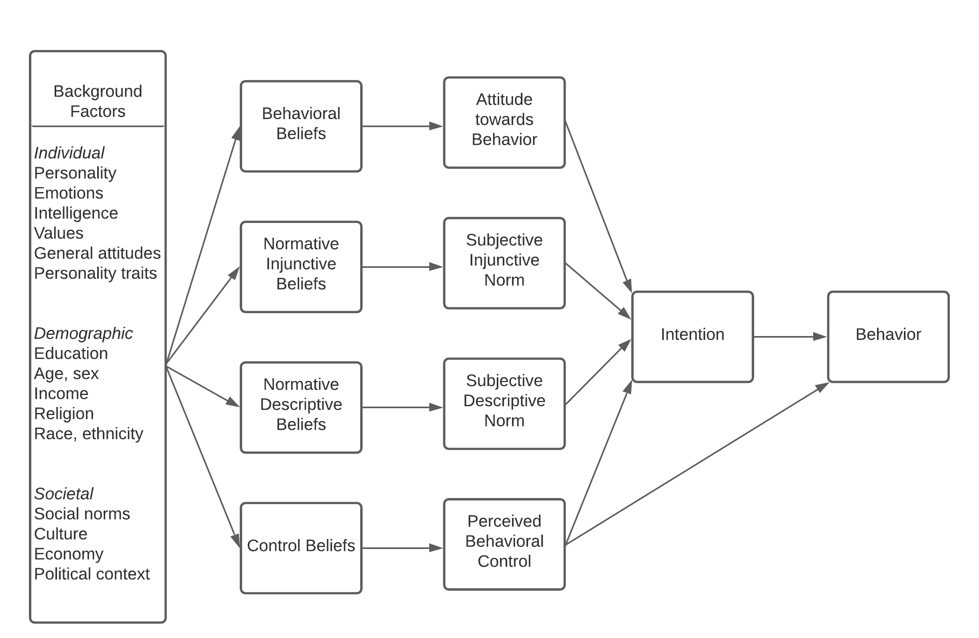
Figure 1: The theory of planned behavior model. Reproduced from de Leeuw et al., 2015, p. 130.

The theory of planned behavior (TPB) proposes a complex causal chain of psychosocial factors that results in a particular behavior (see Figure 1). Behavior is most directly driven by behavioral intention and perceived behavioral control. Perceived behavioral control reflects the extent to which one believes they can control a behavior. When this corresponds closely with actual control over a behavior, it has a direct influence on behavior. However, when it does not reflect actual control, it is considered more of a motivational mechanism that has an indirect effect on behavior through intention to act (Madden et al., 1992).
Intention to act is subsequently influenced by injunctive norms, descriptive norms, and attitude towards behavior. Both injunctive and descriptive norms refer to beliefs about others and can be construed as perceived social pressure to act (Newman & Fernandes, 2016). Injunctive norms concern approval - perceptions of how others may judge one’s behavior. Descriptive norms refer to the perception of others’ behavior. Each of these factors that lead to intention to act are themselves linked back to related sets of beliefs. Importantly, attitude towards behavior is linked to beliefs about the outcome of behavior (de Leeuw et al., 2015).
This entire system is influenced by numerous background factors that include education, gender, beliefs, attitudes, and concerns. TPB has been used as an explanatory framework in research on pro-environmental behaviors, with a special focus on beliefs, attitudes, and concerns and how they can drive action (Yuriev et al., 2020). While the effect of beliefs may arise earlier on the causal change toward behavior (see Figure 1), that does not diminish their impact. In fact, a parallel theory to TPD, the Value-Beliefs-Norm (VBN) theory also places great emphasis on beliefs as a driver of behavior (Dietz et al., 2005; Newman & Fernandes, 2016; P. C. Stern et al., 1999). Beliefs operate by guiding what actions we are willing to take and help us judge the outcomes of those actions.
In terms of climate change, numerous studies have identified climate change beliefs, especially concern about climate change, as an important predictor of climate change-related behaviors (Hornsey et al., 2016). In developing a model of climate change behavior among adolescents, K. T. Stevenson et al. (2018) demonstrate that climate change concern and hope influence behavior. In their model, climate change knowledge had an indirect effect on behavior, operating strongly through concern.
Given the background factors that influence behavior (de Leeuw et al., 2015), education plays an important role in TPD. As will be explained in detail below (see Micro-Level Effects), science education (including environmental and climate change education) has strong influences on beliefs, attitudes, concern, and risk perceptions. Likewise, science education can also have an influence on pro-environmental and climate change behavior (Busch et al., 2019; E. C. Cordero et al., 2020; Geiger et al., 2019; List et al., 2020). These behaviors may be lifestyle changes, such as choosing alternative travel, flying less, purchasing green energy, or eating a plant-based diet (Wynes et al., 2018). They may also be behaviors that promote systemic change through support of policies and voting (United Nations Environment Programme, 2020; Wynes et al., 2021).
Education’s effects do not stop at the individual. Increasing climate change concern via education is connected to both individual and collective action (K. T. Stevenson et al., 2019). There is evidence that science education can influence peer and family member beliefs and actions as well (e.g., Lawson et al., 2019; Spiteri, 2020). This moves the effects of knowledge and belief on behavior from the individual to the family, peer group, and beyond. Shifting behaviors and norms can act as a catalyst for wider change that influences the community (Bollinger & Gillingham, 2012; Carrico, 2021; Jachimowicz et al., 2018) and broader aspects of society, such as business and politics (Collins, 1988; Ehrhardt-Martinez et al., 2015; United Nations Environment Programme, 2020, p. 72). These wider shifts can feed back into the TPD model, strongly increasing normative tendencies toward climate action. This explains why education is deemed a necessary step in averting the climate crisis (Reid, 2019). This also intimates what is required to “wake up and change.”
To summarize the conceptual framework underlying the present dissertation (see Figure 2), this research draws on HCT to explain how, at the macro-level, scientific literacy may be associated with changes in national GHG emissions, namely CO₂. To explain how such a link is plausible, and provide a micro-to-macro mechanism, the research also draws upon TPD, which offers a causal chain of explanations through which increased science education may influence positive climate change behaviors. Understanding that CO₂ emissions are affected by much more than education, the HCT framework also incorporates the IPAT equation to consider other factors of influence (Yao et al., 2020). This conceptual model does not portend to suggest science education can solve the climate crisis or generate an impact greater than other social phenomena. Rather, the model considers science education a necessary but not sufficient factor on the path toward social climate change solutions.

Micro-Level Effects
According to Collins (1988), micro-level analyses are concerned with “how people interact as human bodies in sight, sound and smell of each other…[and how]…we understand the larger and more long-term patterns when we see how they are composed of such micro-situations” (p. 242). Learning, whether informally at home or formally in school, is a fundamental human activity that takes place in the context of interaction. Education informs individual and household decision-making, which can come to have a real bearing on the larger world. For example, Ehrhardt-Martinez et al. (2015) point out that decisions regarding fertility made at this level “add up, producing large aggregate impacts on national and global climate emissions” (p. 208). They argue that the micro-level agents play some role in
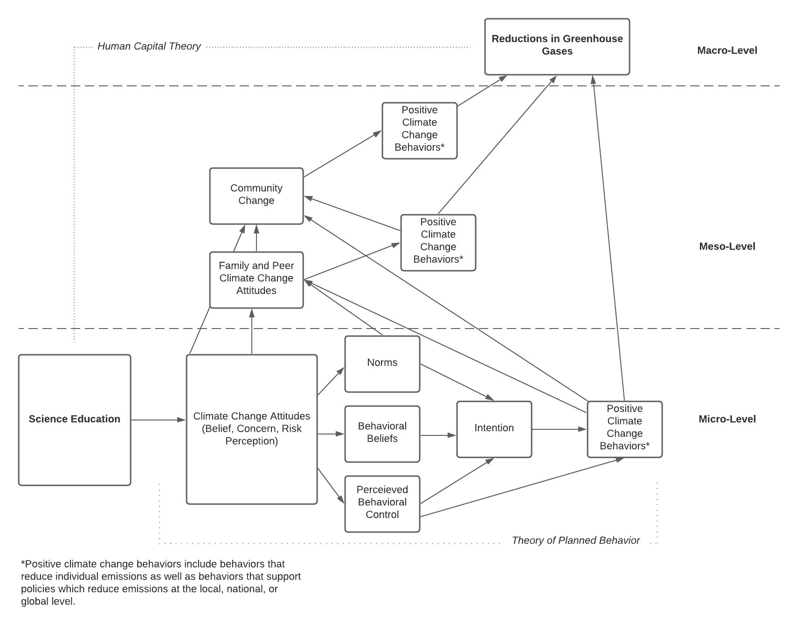
Figure 2: The conceptual framework for the current dissertation research.

determining their emissions and “can be mobilized in a variety of ways to leverage lower emissions” (p. 204). Decision-making such as this is done using the knowledge, beliefs, and attitudes (i.e., education) at one’s disposal. Thus, education forms the perfect context to begin examining micro-level effects on climate change.

What is the PISA?
The Programme for International Student Assessment (PISA) is an examination sponsored by the Organisation for Economic Cooperation and Development (OECD) that is designed “to measure how well 15-year-old students approaching the end of compulsory schooling are prepared to meet the challenges of today’s knowledge societies” (OECD, 2012, p. 16). It has been administered every three years since 2000. In 2000, 28 OECD countries and 4 non-OECD countries participated (OECD, 2001). In 2018, the last cycle that was administered, 37 OECD countries and 42 non-OECD countries participated (OECD, 2019b).
The PISA focuses on three core domains: reading literacy, mathematical literacy, and scientific literacy. For each test administration cycle, one of these domains is presented as the major domain on which the majority of questions are based. The other two domains are presented as minor domains, garnering fewer questions and less test time. Science literacy was a major domain in 2006 and 2015. It was a minor domain in 2000, 2003, 2009, 2012, and 2018.
What makes the PISA distinct from other exams is that it is not a measure of skills learned in a specific amount of time or outlined in a specific curriculum (local, national, or otherwise). Instead, it is an examination that measures cumulative learning over students’ lifetimes by asking them to apply their knowledge to personal, social, and global contexts. This learning is influenced not only by the formal and informal contexts a student has learned in but the education of previous generations as well as the socio-cultural-economic environments in which the students are raised (OECD, 2019b). Therefore, PISA results reflect the cumulative learning of a student and serve as a reflection of the society in which this learning has occurred.
To assess this learning, the PISA focuses on a continuum of literacy in the three broad domains mentioned above. Literacy is defined as “the knowledge, understanding and skills required for effective functioning in everyday life” (Organisation for Economic Co-operation and Development, 2000, p. 9). This literacy is seen as vital for full participation in society and reflects what students will do as future citizens (Bybee, 2008).

What is Scientific Literacy?
Scientific literacy is developed through science education. This type of literacy refers to the ability “to engage with science-related issues, and with the ideas of science, as a reflective citizen” (OECD, 2019a, p. 102). Bybee (2008) argues that “the understandings and abilities associated with scientific literacy empower citizens to make personal decisions and appropriately participate in the formulation of public policies that impact their lives” (p. 567). Scientific literacy is so important that Bybee (2008) goes on to argue that understanding science-related issues such as “ecological scarcity directly influences economic stability and social progress” (p. 568). The OECD itself establishes scientific literacy as extremely important, stating that “Scientific literacy matters at both the national and international levels as humanity faces major challenges in providing sufficient water and food, controlling diseases, generating sufficient energy and adapting to climate change” (OECD, 2017a, p. 20).
The PISA measures key cognitive abilities required to make informed decisions for interaction with science-related issues and for everyday life. According to the PISA science framework (OECD, 2019a, 2017a, 2006), scientific literacy is defined by three core competencies: explaining phenomena scientifically, developing questions that can be answered through science, and drawing conclusions from data and evidence. Each of these competencies requires the use of different forms of knowledge. Content knowledge refers to students’ understanding of ideas and information related to science and technology. Procedural knowledge refers to understanding the methods one would use to design enquiry and to obtain and analyze data. Epistemic knowledge involves the justification of scientific enquiry (including hypothesis building, advancing an argument) and judgment of evidence and conclusions.
These building blocks of scientific literacy are seen as crucial for making informed decisions that have local, national, and international consequences (OECD, 2017a). In fact, the PISA utilizes topics and issues at these levels to form assessment tasks. While the PISA includes climate change, sustainability, renewable energy, and similar topics on the exam, it does not necessarily measure knowledge of these directly. Rather, such topics are set within applications, five real-world areas which call for the application of scientific literacy: health and disease, natural resources, environmental quality, hazards, frontiers of science and technology. These applications are situated within three different contexts: personal, local/national, and global. These contexts represent “areas in which scientific literacy has particular value in enhancing and sustaining quality of life and in the development of public policy” (OECD, 2019b, p. 105). The combination of applications and contexts ensures items are relevant to students and capture the goal of the PISA’s science assessment, which is using scientific literacy to address real-world science issues.
PISA’s framework of scientific literacy and the relationships between competencies, knowledge, applications, and contexts are depicted in Figure 3. 1 depicts examples of contexts and applications that are specifically relevant to climate change. Finally, Figure 4 shows an example item from the PISA to illustrate the scientific literacy framework in action. This item assesses epistemic knowledge and requires the test-taker to demonstrate the competency of explaining phenomena scientifically. It is written at the global context level and requires application of scientific literacy to environmental quality.
Climate change is an important concept relevant to real-life at local, national, and global levels. It fits within a number of PISA applications and has been included in assessment items on the PISA. It is no leap of the imagination to see how having scientifically literate youth who can explain, interpret, and judge the science that informs climate change may have a bearing on the future of society. Furthermore, such an understanding is directly related to the original purpose of the PISA: “to measure how well 15-year-old students approaching the end of compulsory schooling are prepared to meet the challenges of today’s knowledge societies” (OECD, 2012, p. 16). There is arguably no greater societal challenge than climate change (UN, 2015, May). Therefore, scientific literacy may serve as an important measure of society’s ability to meet that challenge.
What is Environmental Literacy? At this point, it is important to briefly distinguish between scientific literacy, environmental literacy, and climate literacy. These three forms of literacy are not mutually exclusive and all of them may be borne from the broad field of science education or the related fields of environmental education and climate education. Environmental education is sometimes considered a subfield of science education; however, it is more often seen as distinct, with climate education often considered a subfield of environmental education.
There are two primary differences between science education, which has its roots stretching back to the 19th century (DeBoer, 1991), and environmental education, which begins roughly in the 1960s (Roth, 1992). First, whereas science education focuses on broad concepts and skills across a range of domains, environmental education is premised on an

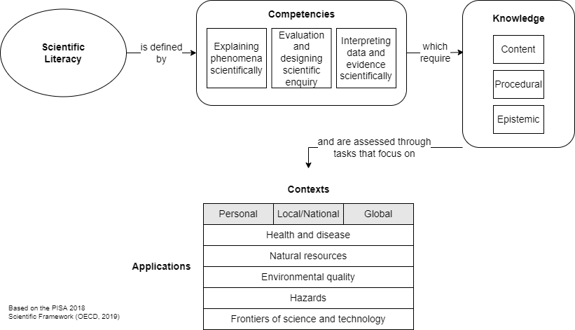
Figure 3: PISA Science Framework

Table 1: Applications from the PISA scientific literacy assessment that are relevant to climate change.
 | Personal | Local/National | Global
Environmental quality | Environmentally friendly actions, use and disposal of materials and devices | Population distribution, disposal of waste, environmental impact | Biodiversity, ecological sustainability, control of pollution,  production and loss of soil/biomass
Hazards | Risk assessments of lifestyle choices | Rapid changes (e.g., earthquakes, severe weather), slow and progressive changes (e.g., coastal erosion, sedimentation), risk assessment | Climate change, impact of modern communication
OECD (2019), p. 105

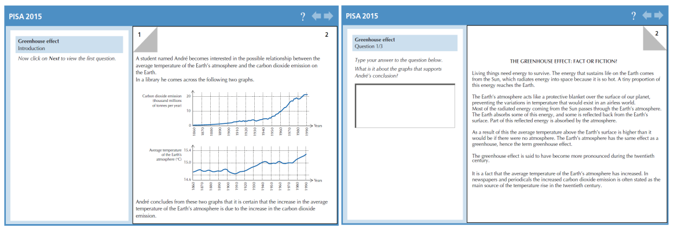
Figure 4: An example item from the PISA Scientific Literacy assessment. Images reproduced from OECD, 2017, p. 33-34.

ecological paradigm that focuses on environmental health and the role of human behavior (Roth, 1992). To that end, the second, perhaps larger difference, is that environmental education also involves the formation of pro-environmental values and behavior change to improve environmental health (Wals et al., 2014). Thus, there is a major attitudinal component to environmental education that science education generally lacks. Environmental literacy, therefore, can be seen as “the capacity to perceive and interpret the relative health of environmental systems and take appropriate action to maintain, restore, or improve the health of those systems” (Roth, 1992, p. 10).
To reiterate, scientific literacy and environmental literacy are not mutually exclusive. Kaya and Elster (2018) argue that environmental literacy is part of scientific literacy. Recall that one of the aims of scientific literacy is to ensure individuals can engage with science-related issues. Environmental literacy provides such a capacity - one focused on ecological health. Likewise, science education curricula often include environmental education. For example, in the United States, the semi-national Next Generation Science Standards (NGSS; adopted by 20 states) “make clear the argument that environmental education is not separate from mandated education priorities, but should be integral to them” (Simmons, 2015, p. 5). It also appears, to varying degrees, in other national curricula (e.g. Derman & Gurbuz, 2018).
Kaya & Elster (2018) also make the case that the PISA framework can provide some assessment of environmental literacy. The PISA includes questions on numerous environmental issues (recall the contexts and applications above). However, it does not assess it directly. Nevertheless, PISA 2006 and PISA 2015 included questions related to environmental awareness, concern, and responsibility, allowing for assessment of aspects of environmental literacy (OECD, 2017a). Relevant research is discussed below.
What is Climate Literacy? Though there is little empirical evidence directly correlating scientific literacy with climate literacy, the fact that they both independently correlate with climate change concern (research presented below) indirectly indicates an overlap. In addition, science education has been promoted by prominent science education policy organizations as a vehicle to introduce “social activism in students so that they become scientifically informed and socially responsible youth and adults” (cited in Skamp et al., 2013). There is no doubt climate change is part of this activism, as it is the most pressing environmental issue of the time.
As the youth climate movement rapidly spreads around the world (Nissen et al., 2021; Sabherwal et al., 2021), and as the effects of climate change are being felt now and recognized by more people, especially in the Global South, it would be difficult to escape any knowledge of it. This type of informal knowledge, learned from family, peers, and real-world experience, is captured by the PISA (Bybee, 2008). For these reasons, scientific literacy makes an excellent proxy for climate literacy.
A rough distinction can be made between climate education and climate change education. Climate education is more closely aligned with general science education, taking a mechanistic view of climate change and focusing on the physical processes through which the earth is warming. There is also a focus on how human activities are driving climate change and actions that can mitigate them (U.S. Global Change Research Program, 2009).
While there is evidence that this mechanistic knowledge of climate change can increase belief (Ranney & Clark, 2016; K. T. Stevenson et al., 2014; Zummo et al., 2021), others argue “Curricula with a purely scientific focus may not adequately convey to students how seemingly small temperature changes can have significant impacts on their lives” (Monroe et al., 2013, p. 5). Climate change education, like environmental education, has an attitudinal component. Given the existential crisis climate change presents, climate change education is also more action- and justice-oriented. Reid (2019) sees climate change education as one that moves beyond focusing on individual actions to actions that occur at the broader societal level. This includes examination of the root causes of climate change and helping students understand the paradigm shift needed to avoid it. This also includes a focus on climate justice. According to Reid (2019), climate change education means “not just knowing the facts about climate change…but rather, ensuring climate change education addresses people’s rights to be free of oppressions created by climate injustices, including being able to live lives…that will foster rather than inhibit sustainability, equity, and authenticity” (p. 12).
Climate literacy can be seen as based on both climate education and climate change education. This includes being able to explain climate change and interpret climate data (such as temperature observations) to make conclusions about climate change (Busch & Rom’an, 2017; U.S. Global Change Research Program, 2009). This closely reflects the definitions of scientific literacy and the ability to engage with science-related issues. In addition, it also includes an ethical, moral, and action component, which tend to cut across disciplines and incorporates multiple senses of literacy (Kagawa & Selby, 2009; Reid, 2019; R. Stevenson et al., 2017).
Like environmental literacy, climate literacy is not measured directly by the PISA. However, climate change is included among its contexts/applications framework and attitudinal questions on the PISA in the form of questions regarding awareness of greenhouse gases and their effects (OECD, 2017b).
One would be hard-pressed to identify a distinct climate change education course in any nation’s primary or secondary education school curriculum. In its most basic form, it is most often integrated within the science curriculum. Key aspects of climate literacy can be found within the curricula around the globe (e.g., ALLEA, 2020; Apollo & Mbah, 2021; Busch & Rom’an, 2017; Siemens Stiftung, n.d.; Wynes & Nicholas, 2019).
However, mere inclusion of climate change in the science education curriculum does not mean quality. A report by the National Center for Science Education and the Texas Freedom Network Education Fund (2020) graded each state’s inclusion of climate change in their state science standards (whether based on NGSS or another framework). They found that just 27 of 50 states earned a grade of B+ or higher, and 6 states earned an F. Among their criticisms of climate change’s inclusion in state science standards were the promotion of false debate, ignoring of climate change or related terminology, treating evidence regarding climate change as unresolved, and missing curricular chances to instill hope. While quality may vary, climate change is nevertheless a subject of emphasis in science curricula around the world, and alongside a rich body of practical research to transform climate change from a fact-based study of climate systems to one situated within effective constructivist teaching methods that include understanding human-caused climate change at local, personally meaningful levels (Azevedo & Marques, 2017; Hestness et al., 2014; Littledyke, 2008; Monroe et al., 2019).

Research on PISA and the Environment
A number of scholars have recognized the potential for the PISA to inform research on science literacy and issues of the environment. This has been particularly facilitated by additional attitudinal items related to science included on the PISA when science was its major domain. For the 2006 PISA exam, the student questionnaire (separate from the main test items) included attitudinal items regarding interest in science and how science is taught. Questions also concerned awareness and perception of environmental issues, environmental optimism, and responsibility for sustainable development (OECD, 2009a). In 2015, the student questionnaire again included questions regarding science and science instruction as well as environmental awareness and optimism (OECD, 2017b). In addition, the PISA includes a number of useful student-level variables (e.g., gender; immigrant status; economic, social, and cultural status [ESCS, an index measure of socioeconomic status based on family wealth, parental education, parental occupation status, home possessions, home educational resources]; teaching activities), and school-level variables (teaching activities, school resources, enrollment, class size, science staff, tracking, etc.), making a rich source of data for research.
Boeve-de Pauw & Van Petegem (2010) were among the first authors to take advantage of PISA 2006’s science-related attitudinal items. The authors focused on the individual- and country-level factors that might contribute to students’ environmental awareness. Theory and past research indicated that individual characteristics such as being young (age) and female (biological sex) are important predictors of positive environmental attitudes. In addition, socioeconomic status was also theorized to be a major factor. The authors draw first on Environmental Deprivation Theory (EDT), which argues that exposure to environmental issues leads to positive environmental attitudes. The authors also draw on Inglehart’s (1995; see also Gelissen, 2007) “objective problems, subject values” hypothesis, which is seen as an extension of EDT. Inglehart’s hypothesis states that individuals in more affluent countries have positive environmental attitudes because they are no longer concerned with economic survival and thus can dedicate more time and resources to “post-materialistic goals” such as environmental protection (Boeve-de Pauw & Van Petegem, 2010, p. 135). Conversely, those in less affluent societies develop positive environmental attitudes through interaction with local environmental issues. They also test whether scientific knowledge is related to positive attitudes, something of particular concern to the present research.
The authors specify a hierarchical linear model, with environmental awareness as the outcome variable, individual-level variables (science ability, biological sex, ESCS), and country-level contextual variables (Human Development Index, National Biodiversity Index, water quality, air quality, environmental health). The results indicated that the largest contributors to environmental awareness are associated with higher science ability scores, being female, being in a country with higher biodiversity, and exposure to poorer air quality or more environmental problems. While the latter findings support EDT, the results indicate no effect of the Human Development Index and only a small (but significant) effect of ESCS. Of particular interest here are that science ability scores have a large and positive effect on environmental awareness. The authors argue that because environmental issues “have roots reaching into different fields of science such as chemistry, physics, ecology, and math, it could be expected that performing well in science would result in positive attitudes towards the environment” (p. 141).
Coertjens et al. (2010) conduct similar research using PISA 2006 results, swapping out school-level variables for country-level variables. However, this research was focused specifically on results from Flanders (Belgium’s Dutch-speaking area). This study attempted to address a gap in the research concerning science abilities and awareness, and the role different school-level factors may play. Coertjens et al. (2010) estimated a multilevel model that contained two outcome variables (environmental awareness, environmental attitudes), student-level variables (science ability, enjoyment of science, biological sex, immigrant status, ESCS, and type of educational track) and school-level variables meant to serve as proxy measures for constructionist teaching methods, which are postulated to have a positive influence on environmental attitudes and knowledge.
The results of their analysis were similar to Boeve-de Pauw & Van Petegem (2010). They also found that girls had greater positive environmental attitudes than boys, though they have less environmental awareness. They also found that ESCS only had a small (but significant) effect on the outcomes. They found a strong, positive association between science abilities and both environmental awareness and attitudes. At the school level, of the different constructivist teaching methods included, only hands-on learning had a significant effect on environmental awareness, and this effect was quite small. They also found that the inclusion of activities for learning about the environment increased positive environmental attitudes to a small degree. These results taken together suggest that student-level characteristics, especially science ability, are important for explaining the environmental outcomes, but that schools do play some role as well.
Focusing on just the United States (U.S.) and Canada, Lin & Shi (2014) investigated environmental literacy, a subdomain of scientific literacy (Kaya & Elster, 2018), by examining PISA 2006 measures of scientific knowledge, environmental awareness, environmental concern (optimism), and environmental behavior (measured by PISA questions concerning environmental responsibility, with items such as “I am in favor of having laws that regulate factory emissions even if this would increase the price of products” [p. 82]). Similar to Boeve-de Pauw & Van Petegem (2010) and Coertjens et al. (2010), they looked at student-level characteristics of gender, immigrant status, and ESCS as well as school-level variables related to constructivist teaching methods and whether environmental education is a separate part of the curriculum or integrated with other subjects.
The authors found that female students in the U.S. and Canada had higher environmental concern and more pro-environmental behavior. However, girls had more environmental awareness in the U.S. whereas the opposite was true in Canada. The authors also found, similar to Boeve-de Pauw & Van Petegem (2010) and Coertjens et al. (2010), that ESCS played a small but significant role in environmental awareness, optimism, and behavior for U.S. and Canadian students, and a significant role in environmental concern for U.S. students. These results confirm previous findings that individual-level characteristic plays some role in influencing environmental literacy, though it may differ by country. School-level teaching methods vary in significance by environmental literacy domain and country, with curricular integration having no significant associations. The authors conclude that “strong environmental knowledge does promote more awareness and behaviors,” echoing previous findings (p. 93).
The PISA 2015 afforded additional analyses of environmental attitudes and the opportunity to investigate trends among students. List et al. (2020) use the 2015 results to examine the factors that contribute to environmental awareness at student-, school-, and country-levels. They draw on previous research by Boeve-de Pauw & Van Petegem (2010), Coertjens et al. (2010), Lin & Shi (2014), and others. They also compare the percentage of students who have high environmental awareness in 2006 and 2015, offering the first look at how environmental awareness has shifted over the decade between assessment cycles.
For the most part, List et al.’s (2020) findings corroborate past research. Most of the variation in environmental awareness occurs at the individual level. Enjoyment of science is a strong individual-level predictor of awareness. Like previous research, a small, positive effect was found for the relationship between socioeconomic status and awareness. No effect of sex was found, contrary to previous research. Furthermore, the authors did not find effects for HDI or environmental performance, contradicting previous research (i.e., Boeve-de Pauw & Van Petegem (2010)).
Scientific literacy continues to be the strongest positive predictor of environmental awareness. This was also true when examining school-level averages of scientific literacy scores, suggesting schools with higher scientific literacy have higher environmental awareness as well. Paradoxically, when examining mean country-level scientific literacy, it has a small but significant negative relationship with awareness. The authors suggest that there may be complex relationships with other factors, such as development, and these relationships need further investigation.
In terms of changes in environmental awareness, they find that for the countries that participated in both assessment cycles, a slightly larger proportion of students showed greater awareness in 2015, with the largest increases related to awareness of greenhouse gases in the atmosphere (from 57% to 65%) and the use of genetically modified organisms (both with a Cohen’s h of .17). The authors mention that the PISA 2006 assessment was given at the start of the United Nations’ Decade of Education for Sustainable Development while the 2015 assessment came at its end. This suggests a possible impetus for changes in awareness, as this UN initiative aimed to integrate “the principles and practices of sustainable development into all aspects of education and learning, to encourage changes in knowledge, values and attitudes with the vision of enabling a more sustainable and just society for all” (United Nations, 2014, p. 9). However, the authors rightly note that little can be drawn from a simple comparison of two time points. Still, it provides some evidence that environmental awareness, especially related to climate change, has been increasing.
Oliver & Adkins (2020) focused exclusively on the PISA’s ability to provide insight into climate change awareness. The authors recognized that climate change activism among youth has been becoming more widespread, citing Greta Thunberg and her Fridays for Future movement. While this is heartening, they also cite surveys of youth that show large variations in knowledge about climate change and climate action. Given the potential relationships between scientific knowledge, climate change knowledge, and climate change beliefs, the authors sought to investigate this at a cross-national level.
The authors selected PISA 2015’s attitudinal item “How informed are you about the increase of greenhouse gases in the atmosphere?” as a measure of awareness of climate change. Using Bayesian multilevel logistic regression models, the authors estimated the probability (and odds ratio) of students answering whether they have never heard of greenhouse gases, have heard about them but could not explain them, know something about them and could explain the general issue, or are familiar with them and could explain them well. The predictors include scientific achievement (science literacy PISA scores) sex, immigrant status, ESCS variables, enjoyment of science, interest in science, motivation for science, and CO₂ emissions per capita (at the country level).
The results showed, as in previous research, that scientific literacy is a major factor for awareness. Scientific literacy is the strongest predictor of being more informed about greenhouse gases, with one standard deviation above the average PISA score related to being 34.5% more likely to be informed. Interest and enjoyment in science were also large predictors at 8%, though far lower than scientific literacy.
Similar to previous research, the authors found that most variation in awareness is at the student level, with school- and country-level being responsible for a small percentage of variation. However, the authors note that there is quite a bit of variability between schools, arguing that schools play an important role, with unaccounted-for variation likely related to “school and subject leadership” (p. 5). Likewise, they noted variation in awareness by country, with some countries such as Sweden being more likely to have informed students while countries such as China have students at the lower end of being informed despite having high science scores. The authors cite countries’ rankings on the Climate Change Performance Index (CCPI; not included in models) to contextualize these findings. For example, Sweden has a high CCPI ranking whereas China does not. They also found that U.S. students had lower probabilities of being informed about climate change, which contradicts reports from the adult U.S. population (Howe et al., 2015; Leiserowtz et al., 2021, March).
Finally, the results showed female students were more likely to have lower awareness, even when they had higher achievement scores, suggesting a gender gap in awareness. They argue that “Girls’ education needs to be examined to ensure that they have equal access to the curriculum and that they feel more informed about environmental issues” (p. 7).

Education and Climate Change Beliefs
The above studies, drawn from research using the PISA, suggest a critical mass of evidence on the role youth scientific literacy plays in increasing environmental awareness and positive environmental attitudes, with less pronounced and more variable effects from SES, sex, and other individual indicators. This appears to support the so-called “deficit model” of climate change denial, in which increased education or information about climate change can help convince those who deny its reality (Drummond & Fischhoff, 2017; Suldovsky, 2017). However, this relationship between education and climate change belief (rather than just awareness) is more complex than it appears, a relationship that cannot be directly assessed from PISA. Nonetheless, understanding this relationship is important, as it explains a crucial mechanism for moving from knowledge to belief to action. Therefore, it is prudent to review the literature related to climate change beliefs.
A 2019 World Risk Poll by Llyod’s Register Foundation and Gallup found that 59% of people across 142 countries believed that climate change posed a serious or somewhat serious threat (Llyod’s Register Foundation, 2019). This percentage varied across regions, with Northern Africa having the lowest (60%) and Southern Europe having the highest (93%) percentage of beliefs that climate change is a threat. Overall, these percentages were also highest among those aged 15-29 and those with 16 or more years of education.
It is encouraging to know a majority of the world is concerned about climate change. It is also tempting to draw a direct link between education and climate change belief (and action). However, the relationship is complex. Hornsey et al. (2016) conducted a meta-analysis of 25 polls and 171 studies from 56 different countries which examined factors that are associated with climate change belief. The authors focused on determining the effect sizes of commonly-cited demographic and psychological variables. Sex, age, race, income, and education were all found to be significantly related to climate change belief, with small effect sizes. The authors paint the picture of someone who typically believes in climate change as young, well-educated, female, non-white, and likely to have a higher income. However, the effects of these demographic variables were negligible when compared to the effects of political affiliation, ideologies, and values. Republicans, conservatives, and those with individualistic and hierarchical values are far less likely to accept that climate change is real and is a threat. The authors suggest this is evidence of an ideological gulf, one which may pose a challenge to serious mitigation efforts.
McCright (2011) notes a similar trend, referring to the gulf as an increase in political polarization, especially by elites, and media balkanization. McCright argues that this division in the presentation of climate change to the public is directly related to political orientation’s moderating effect on education. McCright (2011), Hamilton (2011), and others note a shift from prior research that consistently found education can predict climate change belief. McCright (2011) identifies nine studies (from 2008-2011) that show that political orientation is now a strong moderator of education: liberals with higher education express a strong belief in or concern about climate change whereas conservations with higher education express less belief and concern.
Hamilton (2011) argues that an interaction effect for political affiliation “reflects the efficacy of media campaigns that provide scientific-sounding arguments against taking climate change seriously, which disproportionately reach educated but ideologically receptive audiences” (p 239-240). In other words, conservatives who consume contrarian media feel “informed” about climate change, though the knowledge they hold is likely biased against true scientific evidence. Similarly, McCright (2011) draws on information processing theory and the elite cues hypothesis to explain this phenomenon. Information processing theory postulates that political ideology acts as a filter to interpret information when knowledge on the issue is lacking. This would explain why education was such a strong predictor of climate change belief and concern prior to the pronounced balkanization of the media. As those with different political orientations increasingly rely on divergent media sources, they feel they have a good understanding of the issue, even if that understanding is the complete opposite of established science.
However, this explanation seems to only support the relationship between self-reported understanding of climate change and belief or concern, and not why education itself is moderated by ideology. McCright further posits that ideology may filter educational experiences, but this assertion is not sufficient. Hess & Maki (2019) offers deeper insight into this. Hess tested whether selective exposure bias, a type of confirmation bias, could explain conservatives’ lack of belief. In the case of university education, selective exposure bias manifests itself as the avoidance of taking courses that would present information at odds with students’ beliefs. This could explain why highly educated conservative adults still do not accept climate change. Results from their research confirm their hypothesis: conservative students avoided climate-related courses, especially students who had no shift in their beliefs during their college experience. They also tested resistance to belief change, which is the idea that “people may discount the new information in order to preserve their core values” (p. 1158). They found that, in general, taking a climate change course did not affect beliefs except for those who had the lowest beliefs. The results additionally showed that “Of conservatives who begin with a skeptical position and who took a climate-related course, more than twice as many showed an increase in their belief” in climate change as those who did not.” (p. 1164). In other words, there is some evidence for resistance to belief change, but it is not universal, even among conservative students.
Research by Kahan et al. (2012) comes to similar conclusions as the above authors. Unique to their study was the inclusion of a measure of scientific literacy (see also Drummond & Fischhoff, 2017) and their use of broader ideological constructs. The authors used four world views based on cultural cognition theory. There is a hierarchical-egalitarian dichotomy relating to beliefs about how the world should be structured, with hierarchical world views believing society should be stratified on characteristics such as race, gender, and the like. The other dimension, individualist-communitarian, is based on group relations, where individualists believe more in responsibility for one’s self. The hierarchical and individualist world views map closely with ideologically conservative or politically right affiliations.
While scientific literacy has a small positive correlation with concern about climate change risks for “egalitarian communitarians” (a liberal worldview), the opposite is true for “hierarchical individualists” (a conservative worldview; p.6). Besides adding to the evidence on the moderating effect of ideology, Kahan et al. offer an additional hypothesis to explain why educated conservatives do not perceive a risk from climate change. According to the authors, this stems from motivated reasoning, in which individuals seek out information that confirms their beliefs and values. Individuals with greater education levels are more adept at interpreting evidence in a way that fits their world views.
Guy et al. (2014) levy direct criticism of Kahan et al. (2012) and similar studies that use scientific literacy and perceived knowledge as a proxy for true knowledge about climate change. They argue that “it may be premature to dismiss the role of knowledge in shaping public opinion on an issue with such profound implications” (p. 421). The authors use a sample of Australian adults and measure their specific climate change knowledge, their beliefs on climate change (their acceptance of it, their acceptance of it having human origins, and their acceptance of its negative consequences), and their world views as defined by Kahan et al. (2012) and other authors.
They found that perceived knowledge and actual knowledge of climate change only had a small correlation (r = .23). They also found that specific knowledge of climate change had a different effect on belief, even when considering the moderating role (interaction) of world view. Overall, they found that perceived knowledge exacerbates the negative relationship between hierarchical worldviews and climate change belief, with higher perceived knowledge leading to less belief in climate change. They also found that when hierarchical individualists have higher specific knowledge of climate change, they are more likely to have stronger acceptance that it is real when compared to those who have low specific knowledge. These two findings are important. The former directly supports the authors’ assertion that self-reports and proxy measures of knowledge may not represent real knowledge about climate change, leading survey participants to base their beliefs on ideology instead of facts. The latter suggests that when there is a real understanding of climate change, it may prevent belief based on ideology.
One issue with Guy et al.’s (2014) study is that their measure of specific climate change knowledge may not be in-depth enough to make strong claims regarding climate literacy. Their measure relies on determining whether nine different causes were related to climate change (e.g. deforestation vs nuclear power). While this certainly measures one aspect of climate change, it does not give a sense of whether individuals understand the energy and climate systems of the earth, how these causes lead to climate change, or their differential impacts (Azevedo & Marques, 2017). In effect, while Guy et al.’s (2014) study is important, it is more a measure of the relationship between knowledge of climate change causes, ideology, and belief than a measure of climate literacy.
Ranney & Clark (2016) seems to preempt such issues, as they focused their series of experiments on mechanistic knowledge of climate change. The authors present two different types of climate change knowledge: evidential and mechanistic. Evidential knowledge, which they argue is more common, focuses on evidence about rising temperatures, melting ice, and data that includes uncertainties. Though this is legitimate evidence about climate change, it could be subject to debate with accusations of scientific bias (e.g. the claim that scientists supposedly earn a lot of grant money to confirm climate change) or differing interpretations by (conservative) media. Mechanistic knowledge, on the other hand, focuses on the how of climate change - the geochemical processes that underlie the greenhouse effect. Mechanistic knowledge does not contain “sides” and thus nothing is debatable. As utilized by the authors in their experiments, the mechanistic explanation for climate change is summed up in 35 words:
Earth transforms sunlight’s visible light energy into infrared light energy, which leaves Earth slowly because it is absorbed by greenhouse gases. When people produce greenhouse gases, energy leaves Earth even more slowly—raising Earth’s temperature. (p. 52)
In response to Kahan et al. (2012) and similar work, the authors disagreed with “the idea that one’s cultural context (e.g., political party) overwhelmingly dominates flexible learning from objective scientific information/regularities” (p.50). In a series of five quasi-experimental studies, the authors tested the assumption that mechanistic knowledge indeed plays an important role. In each experiment, they first measured mechanistic climate change knowledge and found poor understanding across their experiments. Each subsequent experiment presented mechanistic knowledge through different forms of interventions. Most of these experiments involved adults, though one included high school students.
The results of the experiments consistently demonstrate that increasing one’s mechanistic knowledge increases climate change acceptance. Though they did not assess an interaction between knowledge and ideology, they did find no correlations between conservatism and climate change belief increases. These findings give further support to Guy et al. (2014) and later work (e.g. van der Linden et al., 2018) that shows the relationship between knowledge, ideology, and beliefs is not always consistent. Importantly, these findings suggest that “informing people about climate science can/does indeed play an important role in mobilizing action to respond appropriately to, and mitigate, climate change” (p. 51).
One issue with many of the above studies (with the exception of Hornsey et al., 2016), is that they all base their analyses in the United States or English-speaking Western countries. Czarnek et al. (2021) argue that U.S.-centric analyses such as these are problematic for two primary reasons. First, such studies assume climate change is a politicized issue. However, the authors point out that climate change is more likely to be a politicized issue in nations that have higher per capita emissions and more fossil fuel dependence, such as the U.S. (Hornsey et al., 2018). In these cases, climate change beliefs may be more influenced by ideology, as climate change mitigation efforts typically threaten the status quo (dominant social paradigm), and those on the political right are more likely to have system justification tendencies to preserve society as is. Czarnek et al. (2021) therefore hypothesize that country-level factors, especially development levels, will play a role in the relationship between education, ideology, and climate change beliefs.
To test this, the authors examined three cross-national data sets representing a total of 64 countries. They examined three-way interactions between education (measured as years of education), left-right identification (as well as liberal-conservative identification), and the Human Development Index (HDI). For additional analyses, they replaced per capita carbon emissions for HDI to assay the relationship between emissions, education, and ideology as articulated by Hornsey et al. (2018). The dependent variables included whether climate change was occurring (from the 2016 European Social Survey, 22 countries), whether climate change was human-caused (2016 European Social Survey; 2016 data from Hornsey et al., 2018, p. 25 countries), how serious climate change is (2016 European Social Survey; 2015 World Value Survey, 58 countries), and climate change policy support (2016 European Social Survey).
While effects and relationships varied depending on outcome measure, several patterns emerged from the findings. The authors conclude that, cross-nationally, education does have a positive relationship with climate change beliefs, even at higher levels of development. However, it is at these higher levels of development that ideology begins to moderate this relationship, with lower or negative effects consistently occurring alongside conservative/right ideology. These results occurred for most, but not all, highly developed nations. They also found similar results when assessing per capita emissions rather than HDI for the World Values Survey data.
Czarnek et al.’s (2021) study also considers the underlying mechanisms behind these findings, especially concerning HDI and per capita emissions. They postulate that those at lower levels of development may be more threatened by climate change, and therefore climate change belief may be higher because of these risks. They also suggest that climate change may not be an issue in some of these countries because the nations are more concerned with physical and economic survival and do not have the resources needed to consider climate change mitigation. Thus, there is no reason to politicize climate change.
Interestingly, despite the authors’ critiques of most studies as being U.S.-based, Czarnek et al.’s (2021) study relies heavily on Eurocentric data sources for many of its analyses, suffering from the same criticism they levy: the results may not be representative of most nations. The inclusion of Hornsey et al.’s (2018) data and the World Values Survey still misses some of the poorest nations. Indeed, such research seems mostly absent. For example, a current search for research examining education and climate change beliefs among nations in sub-Saharan Africa turned up few results. Returning to the 2019 World Risk poll (Llyod’s Register Foundation, 2019), the findings suggest a majority of those surveyed in Southern Africa consider climate change a very serious threat (60%), ranking third-highest in concern among all regions. In examining the most skeptical nations, the authors of the report point to Ethiopia as an outlier, with only 39% of its population agreeing that climate change is a serious threat. They argue that this skepticism may be due to lower levels of education, as Ethiopia has one of the lowest education levels in the region (World Bank, 2021).
The paucity of research examining the role of education, climate change belief, and ideology among poorer nations may or may not be problematic. On the one hand, we do miss data on a large proportion of the world’s population, many of whom are either likely to experience the effects of climate change or are experiencing economic growth and may be increasing their own emissions, or both. On the other hand, data on medium- and highly- developed nations and subsequent policy implications may be more pertinent, as most emissions - historical and present - stem from these nations. Historically, Europe and the United States have been the largest contributors to global warming. The U.S. remains a major contributor alongside China, India, Russia, and Brazil (Ritchie, 2019, October 1). Nations such as these have a responsibility to lead climate action (Hultman & Gross, 2021, March 1).

Education and Climate Change Beliefs Among Youth
The evidence presented thus far reveals somewhat of an enigma in understanding the interaction between education, ideology, and climate change belief. Research using the PISA suggests higher scientific literacy is positively associated with positive environmental attitudes, though not necessarily climate change belief, as it cannot be assessed directly. However, additional research using other measures shows that ideology moderates education, with greater education positively associated with climate change beliefs for those with liberal ideologies and negatively associated for those with conservative ideologies. Yet, the latter research - which includes surveys and experiments alike - has relied on samples of adults (with the exception of Ranney & Clark (2016), who included high school students for one experiment).
Lee et al. (2020) provide an excellent overview of the state of knowledge on youth climate change perceptions. They examined 51 studies from 1993 to 2018 which focused on youth perceptions of climate change, climate change risk, and behaviors. Findings across the range of these studies vary based on a number of factors, including cultural and methodological ones. However, some trends were identified. In general, belief and concern in climate change decline with age, falling in late adolescence. The authors suggest that one reason for this may be that children and younger adolescents may be less influenced by cultural values. This same phenomenon occurs for behaviors and willingness to act. Belief also varied by a country’s development status, with middle-income countries having higher beliefs than high-income countries.
Unsurprisingly, climate change knowledge also increases with age. Yet, there was persistent evidence of climate change misconceptions. These misconceptions often involve conflating the climate crisis with the depletion of the ozone layer. The authors suspect misconceptions such as these are passed on from adults, who often hold the same misconceptions. Misconceptions about climate change solutions, such as reducing litter, avoiding chlorofluorocarbons (implicated in ozone depletion but no longer common), or using unleaded gas, were also common in the studies.
Additionally, there was a trend toward younger children being more willing to act. And, like belief, those in middle-income countries were also more willing to endorse climate change action. Being willing to take action was based on both its convenience and its perceived usefulness. For example, youth are more likely to choose convenient but less effective actions, such as turning off lights, rather than more effective but less convenient actions, such as buying less.
Lee et al. (2020) conclude by suggesting climate change education among youth may be the perfect time to introduce them to concepts that they will have to grapple with later in their life. Indeed, Harker-Schuch (2019) also argues that adolescence (ages 12-18 and especially early adolescence, ages 12-14) is the perfect time to teach about climate change and offers several mechanisms to explain why. During early adolescence, children are undergoing physiological, psychological, and social changes that prime them for being receptive to climate change literacy. For example, the intellectual development that occurs inside the brain at this time fosters scientific reasoning, abstract thinking, and the ability to process information regarding issues such as climate change. These mental changes foment consideration of ethical issues and the ability to take others’ perspectives, which can help students understand on a more visceral level the suffering of others that climate change may cause. Germane to the enigma above is the fact that adolescence also represents the period of time in which worldviews are still forming. The development of independent reasoning, social cognition, and identity formation suggest that adolescent worldviews may not be rigidly transmitted from parent to child but are the product of more complex learning environments. In other words, it is possible that age may play a role in attenuating the effect of ideology on climate change belief.
This suggestion is the exact thesis of K. T. Stevenson et al. (2014), who examined the relationship between climate change knowledge and ideology on belief in climate change using the same cultural cognition framework as Kahan et al. (2012) (hierarchy-egalitarianism, individualism-communitarianism). The authors suggested that because adolescent worldviews are “plastic,” the knowledge-ideology relationships that are found in the literature on adults may not hold in a K-12 context. In their survey sample of 378 middle schoolers (ages 11-15), they found a significant interaction between climate change knowledge and the individualism-communitarianism worldview. However, the relationships did not exhibit the typical opposing pattern of adults. While individualists with less knowledge were less likely to accept climate change, as knowledge increased, so did acceptance. The authors found no significant differences between individuals at higher levels of knowledge, regardless of their worldview. The authors argue that “Climate literacy efforts can overcome, worldview-driven skepticism among adolescents, making them a receptive audience for building climate change concern” (p. 302).
Similar findings were reported by Tranter & Skrbis (2014), who studied beliefs among 12 to 17 years olds in Queensland, Australia. Of note from their results is that, when compared to Australian adults, youth political affiliation exhibits more variation, with a larger percentage of youth aligning with the Green party. Moreover, in conservative Queensland, a majority of youth included in the analysis accept climate change. Belief, however, varied based on party affiliation, even though this affiliation did not match the affiliation of Queenslander adults. Labor and Green Party affiliations (reflecting liberal values) were more likely to accept climate change than more conservative Liberal (a center-right party) or National parties. These results suggest that, while worldview certainly affects climate change beliefs, this worldview is flexible and may be independently formed rather than simply passed down from parents and guardians.
Zummo et al. (2021) challenged Stevenson et al.’s (2014) findings that knowledge may overcome skepticism induced by worldview. Following Ranney and Clark’s (2016) focus on the ability of mechanistic climate change knowledge to increase acceptance of climate change, Zummo et al. (2021) implemented a randomized trial that included an educational intervention based on mechanistic knowledge, as well as measures of worldview and quantitative reasoning. The overall findings suggest “multiple influences on receptivity to climate change for adolescents” (p. 25). The results of their intervention offer a partial confirmation of Ranney & Clark (2016) and K. T. Stevenson et al. (2014) in that knowledge, in particular mechanistic knowledge, is significantly related to increases in climate change belief. However, the results suggested this relationship was weak, accounting for only 2.1% of variation in their models. On the other hand, the roles worldview, quantitative reasoning, and their interaction play is far stronger, accounting for 25% of variation. Their results were more reflective of Kahan et al. (2012) and similar research among adults than K. T. Stevenson et al. (2014). Students with high quantitative reasoning scores and hierarchical-individualist world views were less likely to accept climate change.
This evidence presents the argument that age may not attenuate ideology; rather, it suggests adolescents are as capable as adults at motivated reasoning. Despite this finding, most research demonstrates climate change belief and age have a negative correlation - the younger the person is, the more likely they are to believe in climate change, show more concern, and perceive the risk as greater (Corner et al., 2015; Hornsey et al., 2016). This suggests adolescents are likely less resistant to climate change attitudes than adults (K. T. Stevenson et al., 2019).
Zummo et al. (2021) also make the case that intervention time, or more generally, time spent learning about climate change in school may not be sufficient: “A 15-year-old student has spent far more time in their families, churches, community centers, and peer groups than they have in school science. They have spent far more time practicing and developing their worldviews than they spent learning about climate change in our 30-min computerized intervention” (p. 29).
This is a valid point. Time spent learning about science in general and climate change, in particular, may be another factor that alters the relationship between knowledge, belief, and ideology. No studies were found that looked at how long-term interventions specifically affect this relationship. However, since young people spend a lot of time in school in many nations, and because climate change is often part of the science curriculum, we can assume the effects Zummo et al. (2021) found are lessened, though not likely inexistent. Of course, it is important to recall Czarnek et al.’s (2021) criticism that ideology is more likely to play a role in nations where climate change has been politicized. Thus, the evidence that knowledge increases belief (K. T. Stevenson et al., 2014, 2018; Tranter & Skrbis, 2014) likely holds true in those nations.
Collectively, research has shown that increased knowledge of climate change, especially mechanistic knowledge, increases belief in climate change. This is an important step toward action. However, Zummo et al.’s (2021) point about time spent with families and peers warrants further understanding.

Family and Peer Influence on Climate Change Belief
There is a rich theoretical base for understanding how family and peers affect the psychosocial development of children and adolescents. Both consumer socialization theory and developmental psychology assert that parents wield great influence on their children by passing on values and behaviors (Gronhoj & Thogersen, 2012). Peers may also exert a similar kind of influence on individuals. The research on these sources of influence indicates that interaction and discussion play a major role (e.g., Dostie-Goulet, 2009). Furthermore, observation of others is another source of influence. Both family and peer behaviors influence individuals through descriptive norms, which are perceptions of the behavior of others. In other words, families and peers lead by example (Cialdini, 2007).
Peer and family influence on climate change-related factors has been extensively investigated. Mead et al. (2012) examined the climate change information-seeking behavior of adolescents (13-17 years old) and parents. Specifically, they looked at attitudes toward climate-friendly behaviors, beliefs about the effect of their actions (a.k.a., belief efficacy), their perceived risk of climate change, and family discussion about climate change. Responses to risk perception and efficacy belief questions were categorized into four groups based on a risk perception attitude framework (RPA): indifference (low risk, weak efficacy), proactive (low risk, strong efficacy), avoidance (high risk, weak efficacy), responsive (high risk, strong efficacy).
They found a significant association between parent and adolescent risk perception groups. In other words, many adolescents shared their parents’ views, especially those who fell into the indifference and responsive groups. However, the trend was not consistent with groups. For example, proactive parents were more likely to have indifferent adolescents while avoidance parents were more likely to have responsive adolescents. The correlation between parental and adolescent RPA group membership was found to be higher when climate change discussions happened more frequently.
The strongest predictors of adolescent information-seeking behavior were adolescent attitudes and family communication. Adolescents in the avoidance and responsive group were more likely to seek climate-change information. Parent RPA group membership was found to have only a weak association with information-seeking behavior of adolescents. Mead et al. (2012) conclude that adolescents typically mirror their parents, though regardless of risk perception, adolescents in families that discuss climate change are more likely to seek out information. Similar findings were also reported by Ojala (2015).
The thread running through the above research suggests that family influence is greater than peer influence, but the individual’s own knowledge and beliefs are also important. Indeed, these findings are consistent with more recent research by K. T. Stevenson et al. (2019), who examined climate change concern among 426 middle school students. They found discussions with peers and families positively predicted concern and student gender (i.e., being a girl) had roughly the same effect. The largest effect, consistent across their models, was personal student attitudes. The authors recognize the role peer and parental influence may have. However, given the results of this study and their previous research (K. T. Stevenson et al., 2014), they argue that such influences have a weakened effect on adolescents, likely due to the resistance to influence that appears during adolescent development (Harker-Schuch, 2019; Vollebergh et al., 2001).
The above research, being correlational in nature, cannot assess the direction of parental and adolescent influence. Indeed, Mead et al. (2012) bring up the same point: “we are unable to tell whether parental beliefs drive or are reflective of adolescents’ beliefs” (p. 45). Though they point to some evidence indicating parental belief precedes the beliefs of their children, this notion of a possible directional influence stemming from adolescents to parents introduces the concept of intergenerational learning, which has a potential major bearing of moving from individual knowledge to influential climate action.

Intergenerational Learning
Traditional lines of intergenerational learning (IGL) research have largely suggested that the direction of influence moves from parent to child (Axinn & Thornton, 1993; Davis-Kean, 2005). However, more recent research demonstrates child to parent IGL also occurs (LaSala, 2000), especially with conservation-related behaviors (Boudet et al., 2016; Maddox et al., 2011). Lawson et al. (2018) maintain that “children appear to be the ideal conduit for climate change communication to their parents, as they are capable of understanding and acting on the subject more effectively than parents and are more trusted by parents than other information sources” (p. 205).
Lawson et al. (2019) tested the assumption that IGL can promote climate change concern among parents. Teachers were randomly assigned to a control group and an experimental group which used a climate change curriculum designed with IGL in mind. Some of the IGL principles included in this curriculum involved local service-learning projects and student interviews with parents (see Lawson et al., 2018 for additional principles).
They found that for students (ages 10-14), the curriculum resulted in a significant increase in climate change concern. In addition, children successfully increased climate change concern among parents, with significant gains in concern among the experimental group. Most interestingly, the largest gains in concern were made among politically conservative parents. This suggests that not only are children resistant to polarization of climate change beliefs (K. T. Stevenson et al., 2014), but children’s climate change concern may attenuate the effect of ideology for adults. Lawson et al. (2019) posit that high levels of trust in children may leave parents more open to change. They also suggest the child-parent relationship may be more robust against the ideological threats that climate change concern implies.
There was also evidence of interesting effects for gender. Traditionally, males show less climate change concern than females (Hornsey et al., 2016). In Lawson et al.’s (2019) research, fathers made the greatest gains in concern compared to mothers, more than double their pre-test levels. Furthermore, past research has consistently found more climate change concern and positive attitudes among women and girls (Hornsey et al., 2016). In this research, daughters had a stronger effect on fostering climate change concern among parents than sons. The authors suggest this could point to girls being better communicators about climate change with parents.
Pro-environmental behavior changes such as energy conservation and recycling were observed in a small case study among Maltese children participating in an environmental education program at school (Spiteri, 2020). Among the small sample (12 children, 10 parents), child-to-parent IGL was observed for most parents. Several reasons were given as to why parents were influenced by their children. Many parents were receptive to their children’s ideas, thoughtfulness, assertiveness, and sense of self-efficacy. Parents wanted to encourage their children’s socio-psychological development, and many saw benefits in the behavior changes too. IGL among grandparents also occurred in this study. Some parents, however, were resistant and felt their children were trying to undermine their authority. The author concludes that the environmental education program was a success, with “environmental actions in schools…transferred to the home context and the wider community as well” (p. 72).
In this small case study, IGL was clearly evident. However, a similar small qualitative case study in a community in Zimbabwe found the opposite (Chineka & Yasukawa, 2020). While the study confirmed shifts in students’ attitudes and knowledge, parents’ did not see children’s experiences as applicable to the home. In essence, school learning belonged in school, not the household. It was secondary to the parents’ needs and seen as invalid in the face of the cultural practices and beliefs systems parents considered primary. The authors found that there were too many “cultural and historical barriers to children being able to influence their parents” (p. 589) and suggested that findings from the Global North (e.g. Lawson et al., 2019) may not generalize to the Global South.
Yet qualitative research such as the above studies is also not necessarily generalizable by the very nature of it being qualitative (Glesne, 2016). A more in-depth study of IGL borne from an environmental education program comes from Parth et al. (2020), who studied 14-year-olds in Austria and Germany (albeit the Global North). They examined changes to knowledge, attitudes, and actions among students and their parents. They found that IGL influences parental knowledge about climate change and the quality of climate change discussion, but no changes to parental attitudes or action were found. The so-called knowledge-action gap, wherein knowledge leads to (attitude change which) leads to action, was not detected. However, the authors argue that there is enough general evidence for this gap to suggest it does exist, albeit as a complex phenomenon. They maintain that this research affirms Lawson et al. (2019), even though it did not come to the same conclusions.
It seems there is enough evidence to suggest child-to-parent IGL exists and makes for an effective climate change education and climate change communication tool. IGL may lead to not only positive shifts in knowledge and attitudes but also behavior. Such behavior change may lead to shifts in household energy usage (Boudet et al., 2016), consumer choices (Isenhour, 2010; Lawlor & Prothero, 2011), conservation behaviors (Peterson et al., 2019), and possibly voting (Wynes et al., 2021). Lawson (2019) argues that IGL can “go beyond the call of increasing knowledge, and instead will increase the collective climate action needed to help mitigate the growing effects of climate change” (p. 10). However, Parth et al.’s (2020) argument that there exists a knowledge-action gap needs further attention.

Education and Climate Change Behavior
It is important to understand what the associations are between knowledge, attitudes, and action. Such an understanding is crucial for explaining the link between science education and real-world effects on GHGs. Enough compelling evidence has been presented above to be confident that increased knowledge leads to increased climate change attitudes (whether that be belief, concern, or risk perception). However, research related to climate change action still needs to be reviewed.
Climate action is often presented as a false dichotomy between individual (or lifestyle) change and systemic changes. Individual changes refer to the lifestyle changes necessary to mitigate climate change, such as energy conservation, eating a vegetarian or vegan diet, reducing consumption, using alternative transportation methods, avoiding flying, or having a smaller family (Wynes et al., 2018). In short, it includes any individual behavior change that keeps our personal carbon budgets roughly below 2.5 metric tons CO₂e per year in order to limit average global temperature rise to 1.5°C (Akenji et al., 2019). A sole focus on individual changes, however, is controversial. Historically, a focus on individual behavior has been used as a tool to shift responsibility from the polluter to the consumer (Dunaway, 2017, November 21; Mann, 2021). In addition, some suggest individual behavior changes amount to very little, citing the fact that most CO₂ emissions emanate from energy or other types of production; just 100 companies are responsible for 70% of the world’s emissions (Griffin, 2017), removing any sense of agency from consumers’ hands.
Systemic changes, on the other hand, refer to macro-level changes such as carbon taxes, climate-friendly policies, shifts in agricultural practices, mass installation of renewable energy infrastructure, increases in electric vehicle manufacturing, and so on. Those who argue that systemic changes should be at the focus of mitigation maintain that policies must target governments and corporations, noting the same facts above.
It should be quite clear, however, that both individual and systemic changes are needed. Sparkman et al. (2021) point out that “an estimated 80% of CO2 emissions occur because of consumer demand, highlighting that…companies have a large carbon footprint precisely because individuals are purchasing their goods or services” (p. 1). Effective climate change mitigation happens at the interplay of individual and systemic changes. For example, individual voting or donation behavior for pro-environment candidates is associated with real-world, downstream emissions reductions (Wynes et al., 2021). Likewise, Nielsen et al. (2021) argue individuals, especially those of high socioeconomic status (the global 1%, those who earn around ~$US109,000 per year or more), have the ability to instigate wider change “by leveraging the substantial financial and social resources associated with different components of their status.” The authors state that these individuals not only have an outsized impact on GHG generation through their consumption activities, but they also can have an outsized impact on mitigation through five key roles: consumer, investor, role model, organizational participant, and citizen.
One possible issue with a focus on individual behaviors is that there has been a consistent promotion of ineffective behaviors. Wynes & Nicholas (2017) examine Canadian high school textbooks and guides from Australia, Canada, the EU, and the United States. They find a common promotion of low- or moderate-impact behaviors such as recycling with little mention of high-impact practices such as having one fewer child, eating a plant-based diet, or living car-free.
This suggests education may be playing a role in directing individuals toward effective climate action. If education efforts are directing individuals toward less effective actions, it may be doing a disservice to both students and the planet. Some of this may be related to knowledge of emissions. Using a survey among college students, Wynes et al. (2020) found there was a general discordance between how actions were categorized (low, moderate, high) and their actual impacts. While car usage impacts were generally correctly classified, the impact of actions such as litter and plastic bag usage were overestimated. Conversely, the impact of meat consumption and air travel was often underestimated. This may be reflective of school and government materials that highlight ineffective actions (such as recycling) while rarely mentioning meat or air travel, leaving individuals to make estimates based on intuition or guessing (Wynes & Nicholas, 2017).
Though individuals may not always employ the most effective actions, individual action is still a necessary part of solving the climate crisis, especially as individual action may influence peers (Wolske et al., 2020), communities, movements (Sabherwal et al., 2021), and widespread policy support (Attari et al., 2019; Sparkman et al., 2021). Therefore, a strong understanding of the research on science education and pro-environmental behavior is necessary.
Behavior can be understood in many ways. The present research uses the theory of planned behavior (TPB; described above) as the theoretical framework to understand how education influences action (a synonym used interchangeably with behavior). Early research by O’Connor et al. (1999) examined the line between risk perceptions of climate change and willingness to act. While they did not examine behavior directly, they cite previous research and their own findings that actual behavior is highly correlated with willingness to act (intention). Their research indicated that both beliefs and risk perceptions were strong predictors of willingness to act and that risk perceptions act on this intention independently of beliefs. This suggests that increasing both is necessary to instigate behavior change. They also find that climate change knowledge is one of the more powerful indicators of risk perception. These findings reflect the causal mechanism that TPD suggests: knowledge drives belief and related perceptions (i.e. risk perceptions), which further drives action.
More recent research by Vainio & Paloniemi (2011) examined the mechanisms of engagement in climate change action by looking at how it is predicted by belief, post-materialist values, trust in politicians, and self-reported climate change knowledge. Like O’Connor et al. (1999), Vainio et al.’s (Vainio & Paloniemi, 2011) findings support a TPD-like framework wherein belief has a direct effect on positive climate actions. While the authors state that belief plays a key role in behavior, their models demonstrate that climate change knowledge indirectly affects behavior through belief. For any effective climate change action, they argue that, to address climate change “environmental awareness of citizens has to be improved, as well. It is worth noting that knowledge of climate change increased the climate-friendly action of citizens only when mediated by a belief in climate change” (p. 391). This relationship is exactly as TPD predicts and shows the important instigating role education plays in ultimately influencing positive environmental behaviors.
Skamp et al. (2013) importantly argue, as others previously cited have, that science education has a unique role to play in influencing climate change behavior. One reason for this is because science education, in its most recent permutations in the West, is seen as a vehicle for environmental and climate change activism, promoting responsible citizenship and behaviors that can mitigate climate change. That is, science education is charged not only with ensuring mechanistic knowledge about climate change but also promoting empowerment among students “to reduce individually, and corporately, the impact of [its] causes” (p. 193).
However, Skamp et al. (2013) question the extent to which education influences behavior change. The authors specifically looked at British and Australian secondary school students’ beliefs about the effectiveness of specific actions and their willingness to undertake those actions. The authors characterized actions as either direct (planting trees, using smaller cars, eating less meat) or indirect (voting-related actions). For both direct and indirect actions, the findings showed that in general, stronger beliefs in the effectiveness of an action did not necessarily relate to their willingness to undertake those actions. Students believed in and were willing to do things such as reduce electricity usage or eat less meat. However, they were unwilling to do things that they believed were effective such as voting or using public transport. While the authors argue that this discordance may be because youth in the West are not motivated to act or are pessimistic about their ability to act. However, it could be that students are unwilling to do things outside their sphere of control. Secondary students cannot vote and usually do not make decisions about transportation.
Nevertheless, the authors maintain that science education is still important and suggest that it may be more effective for specific behaviors. Based on their survey, they derived an index of the potential usefulness of education. They note that science education may be particularly useful at targeting more effective behaviors such as reducing meat consumption or using renewable energy. Science education offers opportunities to introduce students to concepts beyond carbon dioxide, such as the methane emissions related to animal husbandry.
Stevenson et al.’s (2018) work ties much of the above research together by looking specifically at how climate change education affects behavior. Using an experimental design, they test differences in climate change concern, hope, and behavior for treatment classes where students learn through a specially designed, wildlife-based climate change curriculum and control classes. Similar to Vainio & Paloniemi (2011), they find that climate change knowledge operates indirectly on climate change action, mediated by both concern and hope. They found that increases in knowledge increased concern and hope, and subsequently behavior. Knowledge was more strongly associated with concern, and hope was slightly more strongly associated with behavior. The findings are consistent with TPD and show the continued importance of education in driving concern (and belief) and action.
The above research focused on the relationship between education and either willingness to act or participation in climate-positive behaviors. Though we may know which of the behaviors students participate in have greater impacts, it is still difficult to quantify what those impacts are. E. C. Cordero et al. (2020) address this problem. They surveyed and interviewed graduates from a college-level climate change course (in the United States) five years or later after course completion. They ask graduates which, if any, climate actions they take could be attributed to the course. Then, they estimate the annual CO₂ reductions associated with these actions. They found that about a quarter of the 104 survey participants attributed behaviors to the climate change course. Most of these changes were related to transportation (using public transport, biking, carpooling) as well as food choices. The average reduction in CO₂ emissions was 3.54 metric tons per year. Given that the annual per capita emissions for the United States have hovered around 16 tons (Climate Watch, 2019), the emissions reduction attributable to Cordero et al.’s (2020) course represents around a 22% decrease in annual emissions.
Unfortunately, the authors only assessed individual changes, many of which are ineffective (e.g. recycling, composting), and did not include questions related to more effective measures (e.g., eating less meat, flying less) or voting/policy support. Still, their findings suggest a non-trivial reduction in emissions that can mostly be attributed to climate change education. While the research is descriptive in nature and the authors admit numerous influences could affect student behaviors, this is the first published research to assess the actual impact of climate change education on individual emissions. Such an attempt reflects the purpose of the present dissertation research, albeit at an individual level. Other research has examined education’s role in a much wider context: national carbon emissions. This, too, reflects the aims of the dissertation research and will be summarized next.

Macro-Level Effects
The macro-level effects of education on GHG emissions can be thought of as those explained by the broader framework of human capital theory (HCT). There is a rich body of literature in the field of environmental sociology that has examined education and its relationship to national GHG emissions. However, this body has also found that a multitude of social institutions and phenomena can have an effect on climate change, many of which intersect with education. It is thus necessary to briefly explore some of the major social factors that influence emissions before focusing on education.
As stated in the introduction, the interplay between population and affluence are major drivers of climate change. However, there are a number of societal factors that affect the extent to which they do so. These can be lumped into four non-mutually exclusive general categories: economics, race, gender, and politics. Research pertaining to each of these categories is summarized below. The outcome measures of this research are typically of two sorts: a natural metric, such as CO₂ emissions, and a derived metric, such as ecological footprint or the carbon intensity of well-being (CIWB). Since CIWB is used often in the environmental sociology literature, it deserves special description before moving to the summary of research.

Carbon Intensity of Well-Being (CIWB)
CIWB is a derived index that measures the ratio between a measure of anthropogenic carbon emissions and a measure of well-being following the formula:
$CIWB=\frac{CO_{2}+CV}{WB}x100$,
where CO₂ represents carbon emissions, carbon emissions per capita, or a similar measure; CV represents the coefficient of variation ($\frac{SD}{\overset{‾}{x}}$) used to reduce the undue influence of either the numerator or denominator in the ratio; and WB, a measure of well-being, typically life expectancy; multiplied by 100 to scale the ratio (Dietz et al., 2012; Givens, 2015; Jorgenson, 2015).
Higher carbon emissions or lower well-being measures lead to a high CIWB; conversely, lower carbon emissions and higher well-being, lead to a low CIWB (Kelly, 2020). The CIWB assesses the extent to which emissions and well-being are related. Or, put another way, the amount of emissions produced compared to the amount of well-being produced (Jorgenson et al., 2018). Kelly (2020) explains it more clearly: CIWB represents “the environmental cost of enhancing citizens’ wellbeing (sic)” (p. 187). According to Ergas et al. (2021), “a change in CIWB as a result of social structural dynamics can be best understood as a change in the relationship between a society’s rate of pollution, or the pace of emissions, and that society’s overall well-being” (p. 3). CIWB is often used when researchers focus on the drivers that affect this relationship or where there is a clear emphasis on well-being.

Sociodemographic Impacts on Climate Change
Recall that affluence (the A in IPAT) plays a major role in the impact on climate. Past research has indicated that economic development is positively associated with both increases in raw carbon emissions and increases in CIWB (Dietz et al., 2012; Hailemariam et al., 2020; Jorgenson, 2014, 2015; Liobikienė & Butkus, 2018; Pattison et al., 2014). Two interesting phenomena arise from this research. First, some authors find evidence of an environmental Kuznet’s curve (EKC) - an inverted U-shaped curve that suggests emissions increase with economic development to a certain extent, and then once a high level of development is reached, those emissions fall (Hailemariam et al., 2020; Pattison et al., 2014). One argument for why an EKC could exist is based on the idea that once income rises to meet most material needs, more focus can be placed on the environment (Dietz et al., 2012; D. I. Stern, 2004).
Evidence for the EKC is mixed. For example, Hailemariam et al. (2020) examined 17 OECD countries over the past 65 years and found evidence for an EKC based on national income. Examining county-level data in the United States, Pattison et al. (2014) found stronger evidence for an EKC on production-related emissions rather than consumption-related emissions. Dietz et al. (2012) tested the relationship between ecological intensity of well-being (EIWB; a precursor to CIWB) and GDP per capita for 58 nations over 42 years. They found no evidence for an EKC; in fact, they found the opposite: a U-shaped curve where EIWB is high at both low and high GDP levels and is concave between these levels. Stern (2004, 2017) presented evidence that the EKC is an artifact of certain statistical tests. In addition, he argued that evidence of developing nations addressing environmental concerns contradicts the theoretical basis for an EKC.
Pertinent to both the EKC literature cited above and the general literature on economic growth and climate change is the second phenomenon: economic inequality can drive emissions. Jorgenson (2015) looked at 63 nations (OECD and non-OECD) over an 18-year period and found that as inequality increases so does CIWB. Put another way, wealthier individuals generate more emissions than poorer individuals (within the same country) but do not receive any additional benefits to well-being from this (as indicated by higher CIWB values). Jorgenson (2015) concludes that “reducing inequality could lead to a reduction in CIWB, providing a pathway toward enhanced sustainability” (p.6).
Hailemariam et al.’s (2020) research uncovers a complex relationship between income inequality and carbon emissions. Their research finds a negative association between income inequality as measured by the Gini coefficient and emissions. That is, as inequality increases, emissions decrease. To explain this, they argue that the Gini coefficient better represents inequality between low- and middle-income households rather inequality stemming from those with the top income share in a nation. Increases in inequality as measured by the Gini, then, represent “a fall in demand by the poor for the energy-intensive goods due to lower incomes,” which in turn leads to lower emissions (p. 1155). Conversely, when income inequality decreases, the economic ability for the poor to consume goods and energy increases, thus increasing emissions.
Inequality’s impact on emissions is not only manifested in terms of economics. Several studies argue that increased emissions or CIWB can arise because of gender inequality, as well: “the trajectory of gender inequality alters the relationship between economic growth and environmental conditions” (McGee et al., 2020, p. 2). This is due to a number of factors that limit women’s education, labor force participation, and political decision-making. Political representation of women has been specifically studied in this context, finding that greater representation in government is associated with lower CO₂ emissions (Ergas & York, 2012), lower CIWB (Ergas et al., 2021), greater propensity toward environmental treaty ratification (Norgaard & York, 2005), and lower climate footprints (McKinney & Fulkerson, 2015). McGee et al. (2020) used the Gender Inequality Index (GII) to examine gender inequality and its relationships to CO₂ emissions for 140 nations. The GII measures gender inequality in terms of reproductive health, empowerment, and participation in the labor market.
The authors found that overall, gender inequality is associated with increases in emissions. When considering the relationship between gender inequality, GDP, and emissions, the authors found that as gender inequality increases, so do the relationships between GDP and emissions. At very low levels of inequality, there appears to be no effect on GDP and emissions, suggesting gender equality is decoupled from the environmental impacts of economic activity. Furthermore, only at high levels of GDP does inequality begin to have a direct impact on emissions, indicating the negative effects of gender inequality are greater in wealthier countries such as the United States, Canada, or those in Western Europe.
In addition to issues of economic and gender inequality, politics also affect emissions. We have seen how political ideology can influence belief at the individual level. Dietz et al. (2015) look at this from a more macro-level perspective, examining environmental voting records of United States congresspeople. This is seen as a measure of state environmentalism, which is also a reflection of political ideology. They find that increases in state environmentalism - that is, increased support of environmental legislation is not only negatively related to emissions, but is seen as “moderating the overall effect of population and affluence, and reducing greenhouse gas emissions below levels that would otherwise have occurred” (p. 8257).
Greenhouse emitting activities are influenced not only by local but also national political factors. These include corruption and level of democracy. With these factors in mind, Povitkina (2018) assessed the CO₂ emissions of 144 countries over a 41-year time span. Independently, democracy has a significant negative relationship with emissions whereas corruption has a significant positive relationship. Considering their interaction, the authors find at low levels of corruption, democratic nations emit less. At high levels of corruption, level of democracy does not have a great effect. Autocratic nations emit more, regardless of corruption levels. The authors conclude that democracies are more likely to make policies that mitigate climate change, but corruption can negate these efforts.

Education and Climate Change
Education can be seen as a further sociodemographic factor that influences climate change, tied up with affluence, politics, and inequality among others and thus an essential part of the T of the IPAT equation. However, significantly less research has considered education’s potential role in comparison to other similar factors. When it is considered, it is often treated as a mere statistical control with little examination or discussion (Kelly, 2020). The present section reviews the extant literature on GHG emissions that includes education as a statistical measure.
Perhaps the first article to include a measure of education is by Jorgenson (2003), who examined the structural causes of ecological footprints among 208 nations. While the focus of the article was on the effect of a nation’s world-system position (e.g., position within a core-periphery framework), education in the form of literacy rates was included as a measure of human capital. The authors argued that higher literacy rates signaled greater human capital, leading to increased consumption and a possible shift to more consumerist ideologies, which in turn, increases ecological impact. It was argued that a nation’s literacy rate would be related to its world-systems position. The path model the authors specified had literacy serving as a variable mediating world-system position, domestic income inequality, and urbanization.
Their hypothesis was confirmed, with education/literacy having a direct effect on ecological footprint and being a significant mediator for world-system position and urbanization. Education in this article was conceived of at its broadest level - whether the population over age 15 can read and write. This is no doubt important but in no way speaks to the quality of education or actual ability to think critically about science-related issues, something unique to this dissertation. Furthermore, the authors consider human capital in solely economic terms, with literacy leading to economic consumption. Yet, this dissertation has argued that human capital’s effects can have individual and social impacts beyond economic returns.
Jorgenson (2005) continued his examination of the structural causes of environmental degradation (vis-à-vis ecological footprints) among 72 nations, focusing on international power relations, especially economics, military, and export dependence - all of which were found to be significant predictors of ecological footprints. Education was again included as a control and proxy for human capital; however, in this instance, secondary school enrollment rather than literacy was included. In both the ordinary least squares (OLS) and path models specified, secondary education had a positive relationship with ecological footprint. Secondary education was treated as exogenous to ecological footprints but endogenous, serving as a mediator, to all other variables. For variables such as GDP per capita or inequality, such an endogenous relationship makes sense, but for variables such as military expenditures or exports, their relationship to education is unclear. Overall, it was implied (but never tacitly discussed) that increased education leads to consumption, increasing national ecological footprints.
Dietz, Rosa, et al. (2007) examined the human drivers of environmental impact for 128 nations. They employ a variation of the IPAT equation (STIRPAT, stochastic impacts by regression on population, affluence, and technology) to estimate the impact of population, GDP, urbanization, age, geography (land area, latitude), and well-being (life expectancy and education index [a measure of years of schooling]). Population has the largest impact on footprint followed by GDP per capita, which showed a curvilinear relationship where higher affluence produces larger impacts disproportionate to the impacts at lower levels. Education was not found to be a significant predictor of footprint, leading the authors to conclude “that while increasing affluence does drive impacts, it is possible to improve other aspects of human well-being without adverse environmental effects” (p. 16). This suggests a decoupling of well-being from ecological impact, something often accounted for by research using CIWB. Unfortunately, there is no further discussion of education or why it might not have an effect on ecological footprints. Like previous research, it is merely included as a control or an independent variable of non-interest.
Research by Kinda (2010) departs from the previous studies in several significant ways. First, Kinda (2010) is the first research article to consider education as its independent variable, meaning it is not levied solely as a statistical control. In addition, while recognizing previous research that sees education as a proxy for human capital (e.g. Jorgenson, 2003, 2005), the author frames education as an important factor for a citizenry to understand and demand environmental protections. They argue that rather than education driving consumption, education drives income, and “an increase of income generates the resources that are necessary for pollution abatement,” resulting in an environmental Kuznet’s curve (p.2). Rather than looking at school enrollment, Kinda (2010) examines education in terms of average years of school. Furthermore, they also examine the interaction between education and institutional quality (i.e., a -10 to +10 autocracy-democracy scale). Data is included for 85 countries from 1970 to 2004.
On a global level, the author finds no relationship between education and carbon emissions. However, examining emissions separately for developed and developing countries, they find a significant positive relationship for developed nations, suggesting education is related to increases in carbon emissions. No significant relationship was found for developing countries. Moreover, for developed countries, the positive association between emissions and education is altered once institutional quality is introduced. As institutional quality (or democracy) increases, emissions decrease. According to the author, the education level of people living in developed nations “will increase their preferences in favor of a higher level of environmental protection. They will reflect their preference through political institutions” (p. 7). They go on to argue that, in developing nations, education levels are low and political institutions are relatively weak, and, therefore, do not have an effect on carbon emissions.
Mayer (2013) highlights the paucity of research on the role education may play in national carbon emissions. Responding to this paucity, they implement two models that focus on education from 1998 to 2008. They look at how education relates to both CO₂ per capita as in previous research (103 nations) and the percentage of energy consumed that comes from fossil fuels (93 nations). They assess education in terms of tertiary enrollment rate and the percent of the GDP that is spent on educational expenditures. GDP per capita (and its squared form), democracy, and export intensity are also included as controls.
They find that both enrollment and expenditures are significantly positively associated with fossil fuel energy use. In addition, enrollment is significantly positively related to CO₂ emissions, while expenditures have a non-significant negative relationship. Overall, increased education is related to emissions, though, as they indicate, it has a minor effect when compared to factors such as economic growth. They also point out two interesting phenomena that have direct bearing on this dissertation. First, as a limitation, they noted that curricular content is not considered - different nations may place different levels of emphasis on environmental issues, and that those with increased emphasis could see greater environmental performance in the aggregate. The PISA and science education in general both often focus on environmental issues and are intimately connected to environmental and climate change education. Thus, this dissertation directly responds to Mayer’s (2013) call for future research. In addition, Mayer concludes that education presents a paradox where, at the individual level, education builds environmental concern, but at the national level, education increases environmental degradation. The emphasis on educational quality and achievement that is at the heart of this dissertation can hopefully address this paradox.
More recent research tends to find a more positive role for education on emissions. For example, Jorgenson et al. (2018) examined the effects of economic inequality in the United States on CIWB for males and females from 2000 to 2010. Included among their independent and control variables (state Gini, income share of the top 10% per state, percentage of population below poverty line per state, state fossil fuel production, GDP per state, and manufacturing as a percentage of state GDP, state environmentalism (see Dietz et al., 2015), they also included a measure of education: the percentage of the population with a 4-year college degree. While traditional economic measures (GDP) and inequality were found to increase CIWB, the authors found that male CIWB decreased as college education increased. This suggests that states with more highly educated populations produce more well-being with fewer carbon emissions. This variable was also found to have the largest effect, even more so than GDP or state environmentalism.
Why this effect appeared for males and not females is unclear. The authors suggest higher education may have more well-being benefits for men but provide no evidence for this assertion. It could also be the data. The percentage of college degree holders represented the entire population. Results may have been different if it were delineated for males and females in both CIWB estimations. Nevertheless, this is the first research article that indicates education may not have a negative effect on the environment or CIWB, at least for the United States and other developed nations.
Kelly (2020) also examined CIWB and placed education at the focus of her analysis. Like Kinda (2010) and Mayer (2013), Kelly (2020) takes a non-economic (non-human capital) viewpoint of education, seeing education as a driver of social (rather than economic) well-being. Kelly also draws on ecological modernization theory, which posits that as society modernizes, greater emphasis is placed on environmental issues. They examine the CIWB of 76 countries from 1960 to 2010, controlling for GDP as a means to decouple “economic growth from natural resource use and sustainable consumption and production patterns (p. 199). They also include an interaction between education and six world regions (advanced economies such as the United States, Canada, and the EU; East Asia and the Pacific; Latin America and the Caribbean; Middle East and North Africa; South Asia; Sub-Saharan Africa). Education is examined in terms of average years of schooling.
Overall, the results indicate that there is a negative association (what Kelly calls a “desirable” relationship [p. 190]) between education and CIWB except for advanced economies. Increased years of education in general are linked to decreases in CIWB. Overall, the greatest effect of education on CIWB occurred for the South Asian region, with a 1 percent increase in education being associated with a .4 percent decrease in CIWB. Advanced economies, on the other hand, had a .1 percent increase in CIWB for every 1% increase in per capita education. However, examining advanced economies separately and over time, negative associations between CIWB and education can be found. Kelly highlights the East Asian-Pacific region is a good case study for the potential of education, finding that it had the largest effects on CIWB from education, which mostly persisted over the 50-year period. They argue that East Asia underwent substantial social transformations during that time period, aided, in part, by education. The results suggest there were positive ecological outcomes in addition to positive human well-being outcomes. Each region traversed its own unique path over time, but overall, Kelly concludes that “gains in education have had positive spill-over effects into the sustainability of nations between 1960 and 2010” (p. 192).
The most recent research that looks at climate change and education is from Ergas et al. (2021). The authors examined the impact of gender inequality on the CIWB of 70 nations from 1995 to 2013. They specifically look at three structural factors of gender inequality, derived from the variables that compose the UN’s Gender Inequality Index: the percentage of women in parliament, the percentage of women with some secondary education, and the percentage of women in the labor force. In terms of education, previous research has indicated that women show higher belief in and concern about climate change (e.g., Hornsey et al., 2016) and other environmental issues. In addition, women’s education is related to numerous positive health outcomes (Liu & Raftery, 2020) and is associated with greater resilience to climate change-related disasters [e.g., floods or droughts; Frankenberg et al. (2013); Wheeler & Hammer (2011)].
The results indicate that across all nations, women’s education (measured by expected years of schooling) has a negative relationship to CIWB - as education increases, CIWB decreases. However, in examining CIWB separately for developed countries (DCs) and less developed countries (LDCs), this relationship only persists for DCs. This specific relationship also persists when examining CIWB’s constituent components separately: education is associated with a decrease in CO₂ and an increase in life expectancy for DCs. The associations between women in parliament and CIWB/CO₂ are similar to education, however, this effect only persists for LDCs. While labor force participation increased CIWB/CO₂ and decreases life expectancy, the moderating effect of women’s education on labor participation reduces its CIWB impact across all nation groupings (and among DCs when considering only CO₂ emissions).
Ergas et al.’s (2021) study demonstrates that sociodemographic impacts on the climate are complex but that improving gender equality can lead to improvements in both well-being and carbon intensity of generating that well-being. While women’s representation in government and women’s education operate somewhat differently depending on development status, both can lead to positive socio-ecological outcomes.
In summary, the conceptual model that underlies this research is informed broadly by human capital theory and draws on evidence that education can catalyze social transformation. More specifically, the conceptual model suggests emissions reductions as a result of increased educational understanding can occur at individual, familial, and community levels, and this is explained by the theory of planned behavior. Increased knowledge of, belief in, and concern for climate change can lead to increased pro-environmental and climate-positive behavior. These behaviors can come from the students themselves or they may influence peers or family members, the latter as a result of intergenerational learning. Whether at individual, peer, familiar, or community levels, real emissions reductions can occur through both individual behavior changes, support for systemic changes and other forms of climate action and activism.

Research Questions
The above literature review has provided a rich body of evidence that explains how individual impacts from education can manifest at the macro level. It has reinforced the IPAT conceptual model by showing the key drivers of climate change (i.e., population, GDP) while showing how education and other demographic factors may influence the overall equation. In particular, gender has been demonstrated again and again as a key factor of influence at both individual and societal levels. Likewise, development status also appears to be a major factor at the national level. These have important implications for the questions asked in this dissertation.
Additionally, the literature review has also exposed a large limitation in research on the macro-level impact of education: this research uses broad measures of education, such as literacy rates, expenditures, enrollment rates, or years of education. These measures may be adequate for frameworks that see education’s effect on the environment mainly in economic terms (e.g., an economics-focused HCT). However, analyses that consider the social and political impacts of education, such as the proposed dissertation, which draws on a non-economic form of HCT, require a better measure that may offer nuance into educational achievement (Mayer, 2013).
Therefore, the purpose of this dissertation is to assess the extent to which scientific literacy may have a measurable effect on a nation’s carbon emissions. The proposed dissertation will seek to expand on previous research by using longitudinal PISA scientific literacy scores. PISA scores not only offer a more nuanced approach to measuring educational attainment but specifically measure how adolescents use their knowledge to meet real-life challenges. There is no challenge as great as climate change, and no group more poised to have to deal with its effects than adolescents. To that end, the proposed dissertation will seek to answer the following research questions:
- What is the relationship between changes in scientific literacy as measured by the PISA and per capita CO₂ emissions?
- Do the above relationships vary for developed and less-developed countries?
- Does this relationship differ when examining changes in male and female scientific literacy rates?
The following chapter will explain the proposed methods to be used to answer these questions.

CHAPTER THREE: Research Design and Methods
This chapter draws on the conceptual framework and prior research to outline quantitative methods that will be used to answer the primary research questions. In order to answer these questions, the methods are divided into two phases, reflecting micro- and macro-level data. Phase one refers to the estimation of PISA scientific literacy scores per country per three-year cycle. Phase two refers to building a model to estimate CO₂ emissions over time.

Phase One: PISA Scientific Literacy Scores
In order to estimate scientific literacy scores accurately, the psychometric and testing properties of the PISA must be taken into account. Recall that the goal of the PISA is to measure the ability of 15-year-olds in applying their reading, math, and science literacy skills to real life, at an international scale. However, the PISA is not a measure of individual abilities. Instead, PISA results are meant to be representative of the nations and economies from which students are tested.
Because the OECD cannot assess every student in every country, the PISA generally employs a two-stage stratified sampling design where schools are sampled within a country and then students are sampled within schools (OECD, 2012, pp. 61–84). This ensures nationally representative samples from which inferences can be made. To aid in this analysis, the PISA provides student sampling weights, which scale the sample up to match the population size, and a set of 80 replicate weights to reduce sampling variance (OECD, 2012).
Just as the PISA cannot assess every student, it also cannot ask every question to the students it does assess. Within each assessment cycle, there are hundreds of questions drawn from the major and minor domains. Asking every question of every student would be unfeasible. Instead, students take a subset of questions during a two-hour test period. At the end of the assessment cycle, the PISA has generated a mix of observed values - questions students have answered - and missing data - questions students have not answered.
Using the data generated, the ability of students is modeled using Item Response Theory (IRT). IRT models assess the latent abilities of test-takers by estimating the probability of responding to an item correctly. This probability is derived from the relationships between student answers and various item parameters, such as item difficulty, item discrimination, and guessing. Item difficulty refers to the latent ability of an individual required to have a 50% chance of answering an item correctly. For example, an item with a difficulty of b = 0 means an individual with a latent ability of $θ=0$ (i.e., average ability) has a 50% chance of getting the item correct. Item discrimination refers to the ability of a test item to distinguish between individuals with low and high abilities. Guessing refers to the probability of an individual with a low ability ($θ<0$) getting an answer correct (C. D. Desjardins & Bulut, 2018; Furr & Bacharach, 2014).
Prior to 2015, the PISA employed two different IRT models: a Rasch model and a partial credit model (PCM). The Rasch model, which is used to estimate latent ability based on only item difficulty, was fit to dichotomous data. The PCM approach, an extension of the Rasch model, was fit to polytomous data (OECD, 2015). Since 2015, a hybrid approach has been used that first estimates responses using the Rasch and PCM approaches. During this stage, item fit is estimated and, if poor fit is detected, a model that includes item difficulty and item discrimination is used. For dichotomous data a two-parameter model (2PL) is used while a generalized partial credit model (GPCM) is used for polytomous data. These two models are considered more adept at handling the complexities of PISA data. Items are checked across countries to determine if they are functioning differently for that country (an indication of country differential item functioning [DIF]). If so, national item parameters specific to that country are used for estimation (OECD, 2017a).
The end result of this process is a model of student responses that can be used to estimate ability. However, recall that students do not answer all questions and there is inherent missingness to PISA data. What this means is that “student proficiencies (or measures) are not observed; they are missing data that must be inferred from the observed item responses” (OECD, 2009a, p. 153). Because of this, PISA scores are not meant to represent individual student abilities or to compare individual students but rather be a representative measure of large groups, such as nations (Jerrim et al., 2017).
Rather than a single ability score, students get a set of five to ten plausible values, which represent predicted proficiency. Plausible values are generated based on the item parameters and a latent regression population model that uses a combination of item response time and student background characteristics. These plausible values are then linearly transformed and placed on a common scale that can be linked across cycles, with a mean of 500 and a standard deviation of 100.
To calculate the final score of a country (or other grouping, e.g., scores for females or males within a country) for a particular PISA assessment, a weighted mean based on the product of plausible values and student weights is calculated. For example, scientific literacy plausible value 1 is multiplied by the full student weights to create a mean score for plausible value 1, ${\hat{μ}}_{1}$. This is then repeated for the remaining plausible values, ${\hat{μ}}_{2...n}$. These values are then averaged across the number of plausible values, n, to get the final estimated score: $\hat{μ}=\frac{1}{n}\left({\hat{μ}}_{1}+{\hat{μ}}_{2}...+{\hat{μ}}_{n}\right)$. To generate the error variance of the score requires a combination of the sum of the plausible values’ sampling variances and the imputation (measurement error) variance (see Caro & Biecek, 2017; OECD, 2009b for formulas). These scores can then be used in further cross-sectional or longitudinal analyses (Aloisi & Tymms, 2017; Campbell et al., 2021; Lam & Zhou, 2021; NCES, n.d.; Rowley et al., 2019).
Scientific literacy scores are estimated for each cycle following the methods outlined above and using the intsvy R package (Caro & Biecek, 2017). Scores are estimated for all students in each country, and then separately for males and females within each country.

Phase Two: PISA Scientific Literacy Scores and Emissions Over Time
The research questions suggest a longitudinal model that looks at the relationship between a set of variables over time. Furthermore, the nature of the independent variable, scientific literacy, is represented as repeated measures nested within countries. Therefore the research and data indicate that a multilevel growth model would be most appropriate to answer the key research questions. This method takes advantage of the nested and longitudinal nature of the data, allowing the estimation of fixed and random effects to model different types of change.
A multilevel growth model has several advantages over other longitudinal analyses. The ability to fit individual growth curves for each country allows estimation of a model that more closely reflects reality. The model allows for missing data and does not require every country to have participated in every measurement occasion (i.e., assessment cycle). In addition, these models can include both time-varying and time-invariant covariates, allowing for statistical control over the independent variable. Finally, growth models typically have higher statistical power than other methods (Hox et al., 2018, pp. 88–89).
In the multilevel growth modeling framework, a fixed effect refers to an estimate that is the same across countries. For example, in the models below, the fixed effect for the intercept represents the grand mean of CO₂ emissions across all countries. The fixed effect for time indicates a constant rate of change across all countries, where a one-unit increase in time corresponds to an increase in CO₂ emissions across all countries equal to the regression coefficient. Random effects allow intercepts and slopes to vary across upper-level units, meaning each country is allowed to have its own intercept and slope. In the multilevel growth model, this is indicated by a random effect variance for the intercept, which estimates between-country variation in CO₂, and a random effect for the slope, which indicates within-country variation in the rate of change. Furthermore, a correlation between the intercept and slope can also be estimated, allowing understanding of the relationship between CO₂ emissions and rate of change as well as their shape and direction. The addition of a random slope for scientific literacy allows estimation of its effects on CO₂ emissions for individual countries (Grimm et al., 2017; Hoffman, 2015).
Of particular importance for any multilevel model is proper interpretation of the intercept. All variables should be centered such that when the predictor equals zero it has a meaningful interpretation as part of the intercept. There are several common centering strategies for multilevel models. One strategy is grand-mean centering ($x-\overset{‾}{x}$) in which the intercept represents the mean outcome for countries with an average value for predictor x. Centering can also occur at a specific value ($x-C$) with an intercept interpretation of the mean outcome for countries with that value for the predictor.
A second strategy is country-mean centering (also known as group-mean centering or centering within cluster). This approach is especially suited for longitudinal data (Hoffman, 2015). With country-mean centering, the intercept is interpreted as the average outcome for each country. A country-mean centered variable is calculated as $x_{ti}-\overset{‾}{x_{i}}$, where the mean of country i is subtracted from the value for country i at time t. This represents the level-1 within-country effect of the variable but discards any between-country information. Thus, a level-2 predictor can also be included to represent between-country variation $\overset{‾}{x_{i}}$. The inclusion of both centered predictors in the model allows estimation of these predictors’ main effects separately at both levels.
The following section describes the variables that will be included in the growth model along with their centering strategies. 2 presents summary statistics for all continuous variables.

Key Variables
Dependent Variable. The dependent variable is tons of carbon dioxide (tCO₂, referred to simply as CO₂) emissions per capita for all countries included in the analysis. Data comes from the Global Carbon Atlas (http://www.globalcarbonatlas.org/), which provides the most recent data on CO₂ emissions (Andrew & Peters, 2021; Friedlingstein et al., 2021). Data is included for 2007, 2010, 2013, 2016, and 2019, representing a one-year lag from fall PISA administration dates. For China, the PISA has only been administered to either single cities (e.g., Shanghai in 2009 and 2012) or city/region groupings (e.g., Beijing, Shanghai, Jiangsu, and Zhejiang in 2018). Because city- and region-level emissions data is not readily available, data will be used for the whole of China. Kosovo has complete data for 2008-2018. Data for Kosovo for the years 2007 and 2019 data comes from the International Energy Agency. Figure 5 displays a time series of CO₂ per capita for individual countries by region, with average CO₂ per capita indicated by the same orange line in each panel. The panels show that over time, CO₂ per capita emissions are falling for most countries. In addition, a majority of countries have emissions below the average, with the Middle East and North Africa (MENA) and Western Nations (including the US and Western, Northern, and Southern Europe) having numerous countries above the average. In general, countries show a mostly linear decline in emissions, though a minority of countries show a slightly different pattern.
Independent Variable. The main independent variable of interest is PISA scientific literacy scores estimated as described in Phase One. For each assessment cycle, individual countries will have a scientific literacy score for all students combined, and separate scores for males and females. Country-mean centering, along with including the country mean at level-2, is used to estimate the pure within- and between-country effects. A level-1 variable of within-country scientific literacy is estimated as the difference between an assessment cycle and the level-2 country mean, $SL_{within}=sl_{ti}-\overset{‾}{sl_{i}}$. A level-2 variable representing the mean scientific literacy score across measurement cycles is estimated as $SL_{between}=\overset{‾}{sl_{i}}$. Thus, the intercept will refer to average CO₂ emissions for a country with an average scientific literacy score. Appendix A, 8 shows detailed information on total, female, and male scientific literacy score per country and cycle as well as the number of students who participated in each cycle. Figure 6 displays all countries and their overall PISA scientific literacy score for each year.
Time. The time metric includes the years 2006, 2009, 2012, 2015, and 2018, which reflects the triennial assessment cycles of the PISA. For meaningful interpretation of results, assessment cycle is included as a continuous measurement from 0 to 4, with 0 (and thus the intercept) representing the 2006 cycle (Grimm et al., 2017).

Time-Varying (Level-1) Covariates
In order to isolate the effects of education on CO₂ emissions, control variables are included to account for structural forces that have been found to contribute to climate change.
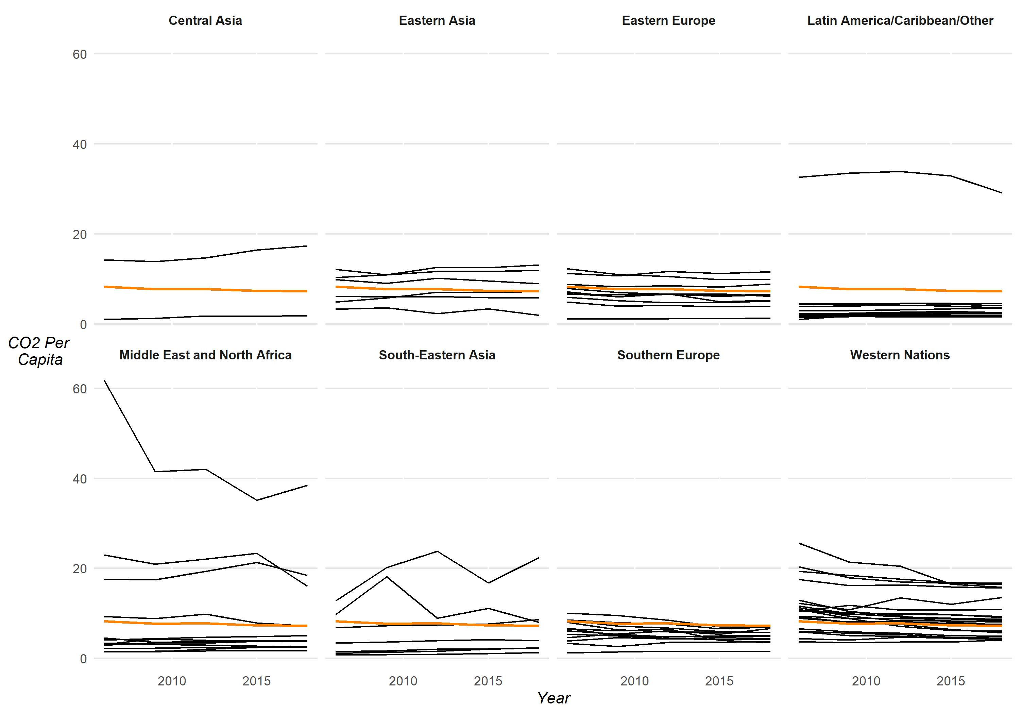
Figure 5: CO₂ emissions per capita over time by region. Each black line represents an individual country. The orange line represents the mean CO₂ emissions per capita. This line is the same in each panel.
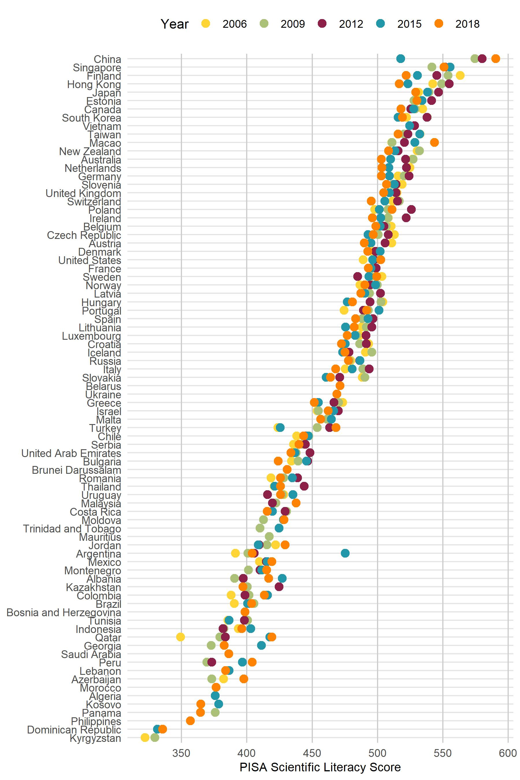
Figure 6: Overall Scientific Literacy score by country, colored by year
Population. Population is a key variable of the IPAT formula and a major factor in emissions. All population data comes from the World Bank. Data for Taiwan is based on mid-year (June) estimates provided by the Taiwan National Statistics Office (Republic of China (Taiwan), n.d.). Population data is scaled by 10 million and grand mean-centered. The intercept represents a country with average population.
GDP-PPP Per Capita. Gross domestic product (purchasing-power parity) per capita is used to control for the positive relationship between economic growth, education, and emissions. This data comes from the World Bank and is presented in 2015 US dollars. GDP per capita data for Taiwan is missing from the World Bank. Therefore, data from the Taiwanese government’s National Statistics office is used in its place (Republic of China (Taiwan), n.d.). This data is in US dollars (no date available). All GDP per capita data is time-varying. It is scaled by $10,000 dollars and grand-mean centered, with the intercept being interpreted as a country with average GDP per capita.
Exports and Manufacturing as a Percentage of GDP. Separate variables for exports as a percentage of GDP and manufacturing as a percentage of GDP serve as additional statistical controls for structural forces of carbon emissions. In particular, they are included as an attempt to control for the offloading of emission-intensive labor to less developed countries (Jorgenson et al., 2018; Jorgenson & Givens, 2013; Liobikienė & Butkus, 2018) This data comes from the World Bank. These time-varying variables will be grand-mean centered, with the intercept being interpreted as a country with average exports and manufacturing as a percentage of GDP.
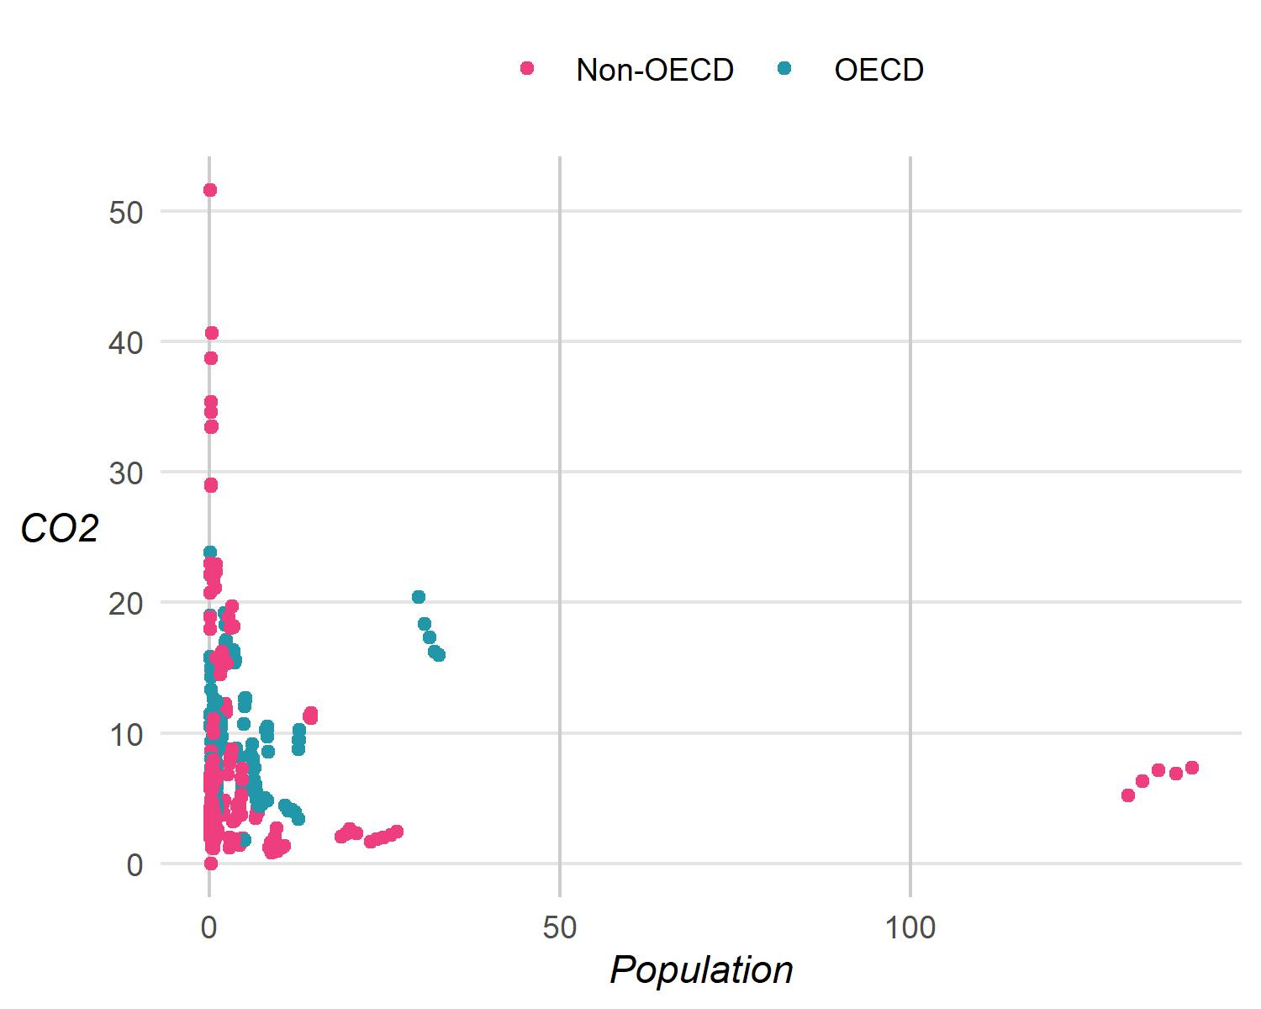
Figure 7: A scatterplot of CO₂ emissions per capita and population, colored by OECD.

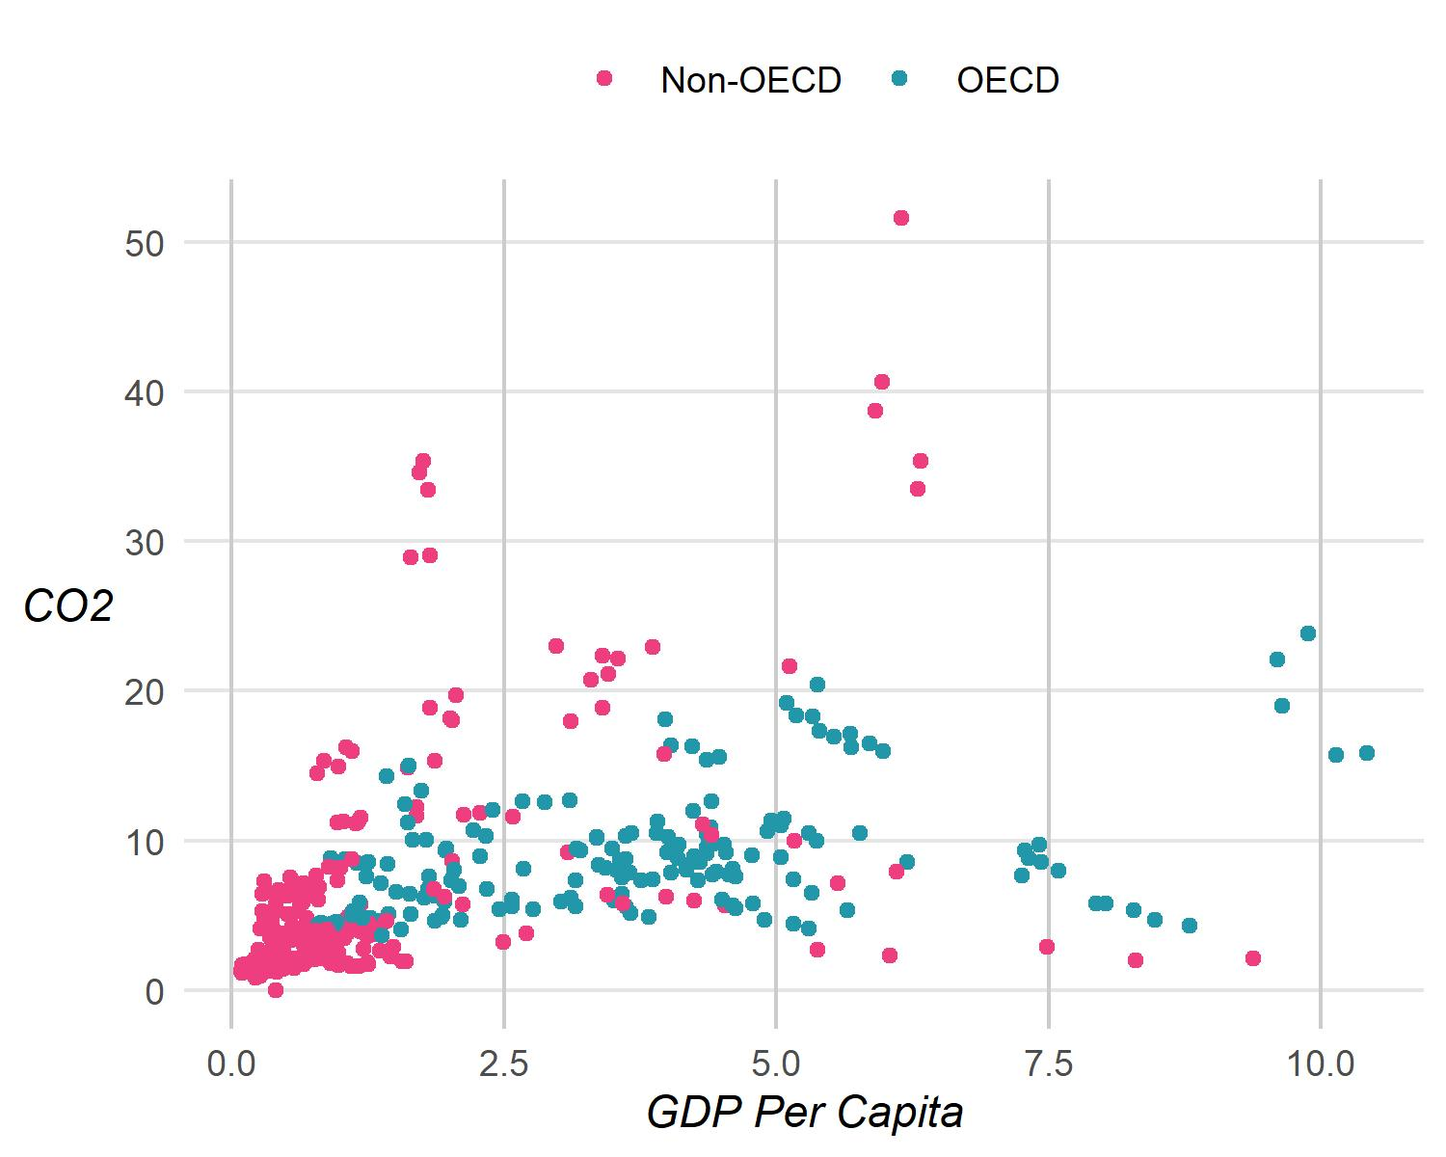
Figure 8: A scatterplot of CO₂ emissions per capita and GDP per capita, colored by OECD.

Gini. The Gini coefficient is used to measure wealth inequality, as inequality has a negative relationship with emissions where greater inequality is often associated with lower emissions due to the large gap between the rich and the poor and the number of poor households that emit less than those in wealthier household (Hailemariam, 2020). The Gini coefficient is measured on a scale from 0 (perfect equality) to 1 (maximal inequality). Data comes from the Standardized World Income Inequality Database [SWIID version 9.2; Solt (2020)]. It provides a standardized and globally comprehensive Gini coefficient that is comparable across time and countries. Time-varying Gini coefficients are grand-mean centered, indicating a country with average wealth inequality.
Left-Right Political Ideology. As the literature review highlighted, political ideology has a major influence on climate change beliefs, which can, in turn, affect voting behaviors, policy support, and pro-environemntal behaviors. All of these have the potential to affect carbon emissions. Thus, a measure of political ideology is included in the analysis. Following Czarnek et al.’s (2021) methods, data from the Integrated Values Survey (an integration of the European Values Survey and the World Values Survey) is used as a measure of ideology. For their analyses, Czarnek et al. (2021) used a single question that asked respondents to place themselves on the left-right scale. However, left-right scale placement questions may not be interpreted the same across countries and cultures (Zuell & Scholz, 2019). Czarnek et al. (2021) also constructed a scale on a group of questions related to cultural or economic values that could represent the left-right scale. However, no factor analysis was conducted to assess whether the chosen questions represented the same underlying construct.
In order to include a more valid left-right ideology index, the current research builds upon this past work. Eleven questions from the IVS were chosen that closely relate to political ideology, including questions selected by Czarnek et al. (2021). A series of factor analyses suggested that three questions loaded highly on a single factor that could represent left-right placement (see Appendix B for the details of this analysis).
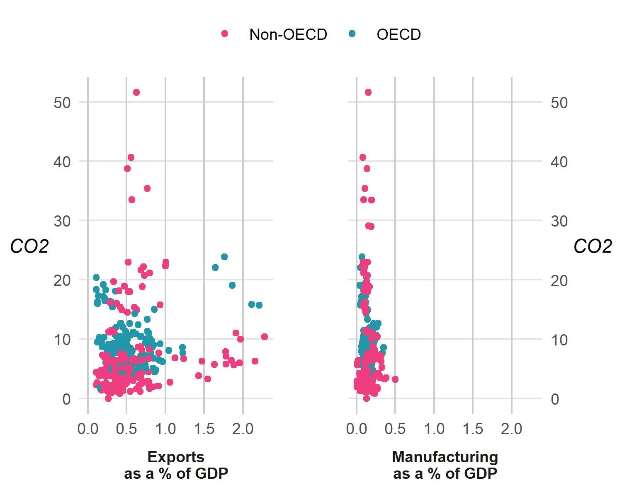
Figure 9: A scatterplot of CO₂ emissions per capita and exports/manufacturing as a percentage of GDP, colored by OECD.

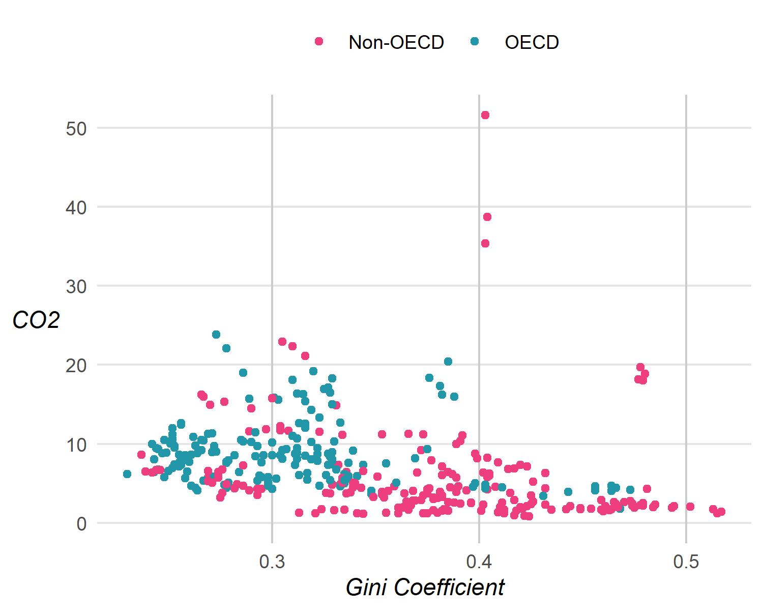
Figure 10: A scatterplot of CO₂ emissions per capita and Gini coefficients, colored by OECD.
These questions reflect beliefs about homosexuality, abortion, and women’s right to work. A factor score was constructed by first placing the individual items on a 0-1 scale following Czarnek et al.’s (2021) methods, averaging across these questions to get each respondent’s placement on the left-right scale. For the final data set, the mean of individuals per country per survey wave is calculated. The Values surveys gather responses from a country during a single year within multi-year waves. Therefore, there is missing data on years not surveyed during a particular wave. Missing data during a wave is filled based on the observation within that wave. For example, the value for a country surveyed in 2011 is applied for all years within the 2010-2014 wave. Their 2016 value would be used for the 2015-2019 wave, and so on. Finally, this variable is grand-mean centered, with the intercept referring to a country with average left-right ideology.
Democracy Index. A democracy index score from the Varieties of Democracies (V-Dem) Project (Coppedge et al., 2021a; Pemstein et al., 2021) is included to control for political effects on carbon emissions (Povitkina, 2018). Specifically, the data uses V-Dem’s electoral democracy index (polyarchy). This measure is seen as “an essential element of any other conception of representative democracy” (Coppedge et al., 2021b, p. 43) and thus the best underlying measure of democracy (Boese, 2019). It is an aggregate index comprised of measures of clean and fair elections, freedom of association (the ability to form and participate in political parties), freedom of expression, male and female suffrage, and weather the chief executive is elected via popular elections (directly or indirectly; Coppedge et al., 2021b). The index ranges from 0 to 1, indicating a range of low (or no) to high electoral democracy. Data is grand-mean centered, with the intercept referring to a country with an average democracy score.
Political Corruption Index. The Political Corruption Index also comes from the V-Dem Project and was cited as an influential variable in understanding the extent to which a government may influence emissions (Povitkina, 2018). This data is also time-varying and grand-mean centered.
Net Enrollment in Secondary Education. Net enrollment of secondary students refers to the ratio of secondary students enrolled to the population of secondary school-aged children. This data comes from both the World Bank and the PISA Coverage Index 3. The Coverage Index 3 refers to the percentage of the 15-year-old population within a country that is assessed by the PISA exam. Lower rates indicate a lower percentage of the population is enrolled in school (Gamboa & Waltenberg, 2015). Because both sources of net enrollment have extensive missing data (30% or higher), and because they are similar in definition and share a high correlation (r = .72, averaged across years), missing data from the PISA coverage index was replaced with World Bank net enrollment data. This provides a more complete data set with only 10% missing data. This time-varying variable is grand-mean centered, referring to countries with average net enrollment.
OECD. Past research has used various indicators to model or control for effects of a country’s development status (e.g., Czarnek et al., 2021; Kelly, 2020; Lee et al., 2020; McGee et al., 2020). Countries that are members of the OECD are typically more developed, higher-income countries in the Global North (OECD, n.d.). The PISA designates countries as OECD countries or as partner countries in order to represent their development status within their models and results (Bloem, 2013). Thus, OECD status in this research serves as a key measure of development. This variable indicates whether a country is a member of the OECD or not, as classified by the PISA. For a majority of countries included over this 12-year period, OECD has been time-invariant. However, several countries became OECD members during this period, especially in 2010. Therefore, OECD status is treated as time-varying. 8 in Appendix A lists each country’s OECD status.

Time-Invariant (Level-2) Variables
Country. In total, 98 countries have participated in the PISA at least once since 2006, 65 have participated at least three times, and 51 have participated in all five assessment cycles being analyzed. Hox et al. (2018) recommend keeping all cases with missing data, as this data can still contribute to the multilevel analysis (p. 97). Maximum effort has been taken to ensure as much complete data as possible is included in this analysis. The data set for this analysis is long, with each row representing a country within a particular year. If a country is missing data on the dependent variable, it will be removed for that year only. Countries are retained whether or not they are missing data on the independent variables. A total of 82 countries are retained for the models. The complete list of countries is available in Appendix A, Table 8.
Collectivism-Individualism. Previous research indicates ideology and worldview play an important role in influencing a number of climate-change-related issues: beliefs, behaviors, mitigation, and emissions (Czarnek et al., 2021; Dietz, Dan, et al., 2007; Guy et al., 2014; Hornsey et al., 2016; Kahan, 2013). While this research covers many permutations of ideology and worldview, most can be categorized as a continuum with the terms left, liberal, egalitarian, communitarian, collectivist on one end and right, conservative, hierarchical, individualist on the other. While similar to the left-right political ideology scale, the Collectivism-Individualism scale serves as a stable measure of a nation’s worldview beyond politics.
Hofstede’s cultural dimensions serve as a potential measure at this level. These dimensions form a framework for understanding cultural values.
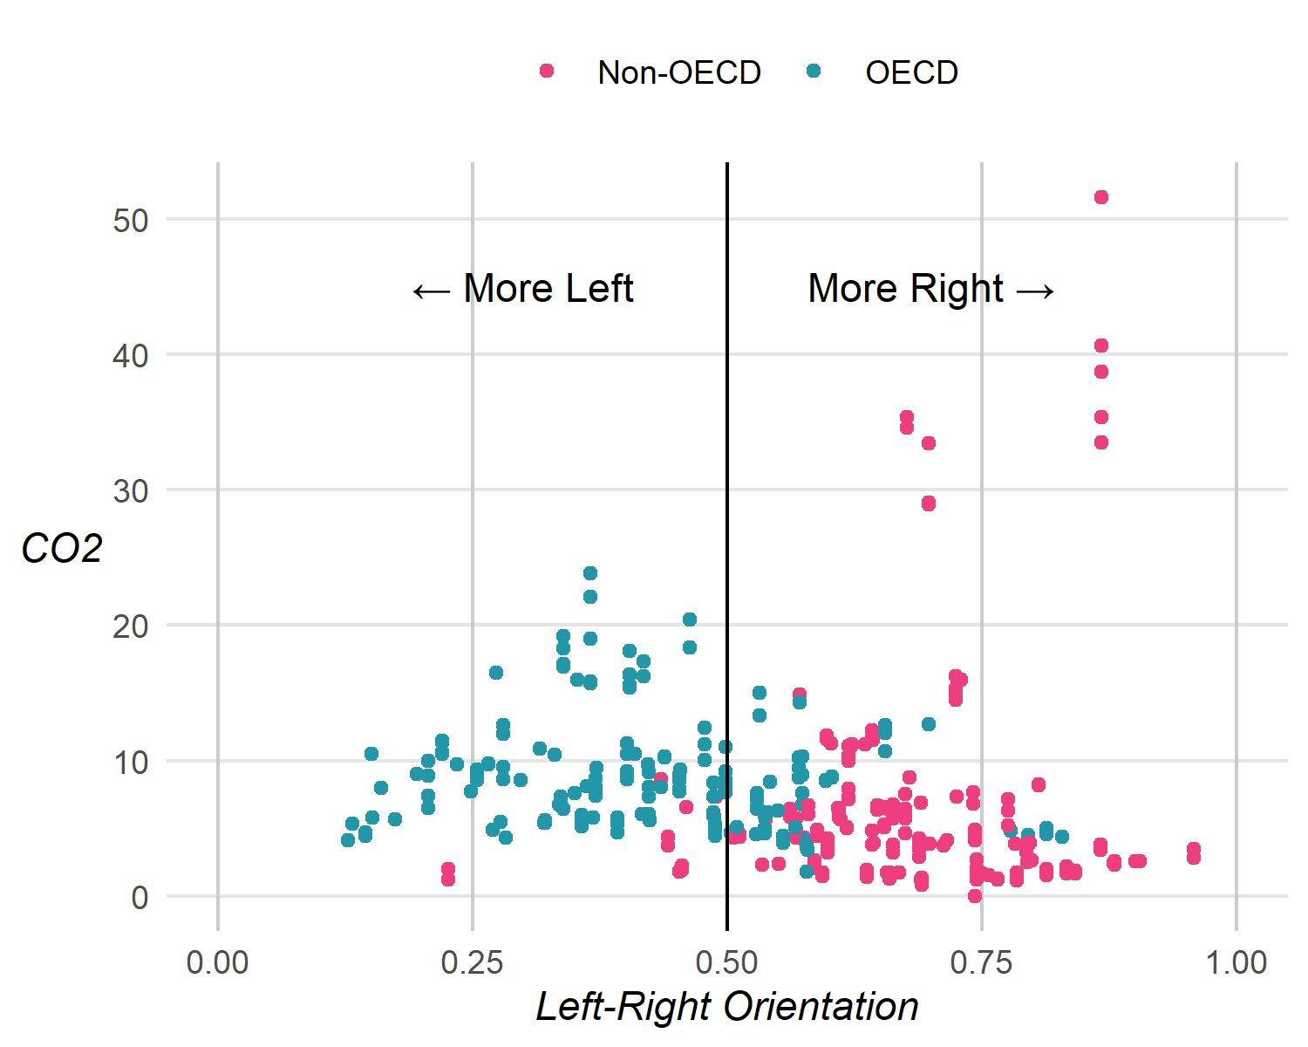
Figure 11: A scatterplot of CO₂ emissions per capita and Left-Right Orientation, colored by OECD.

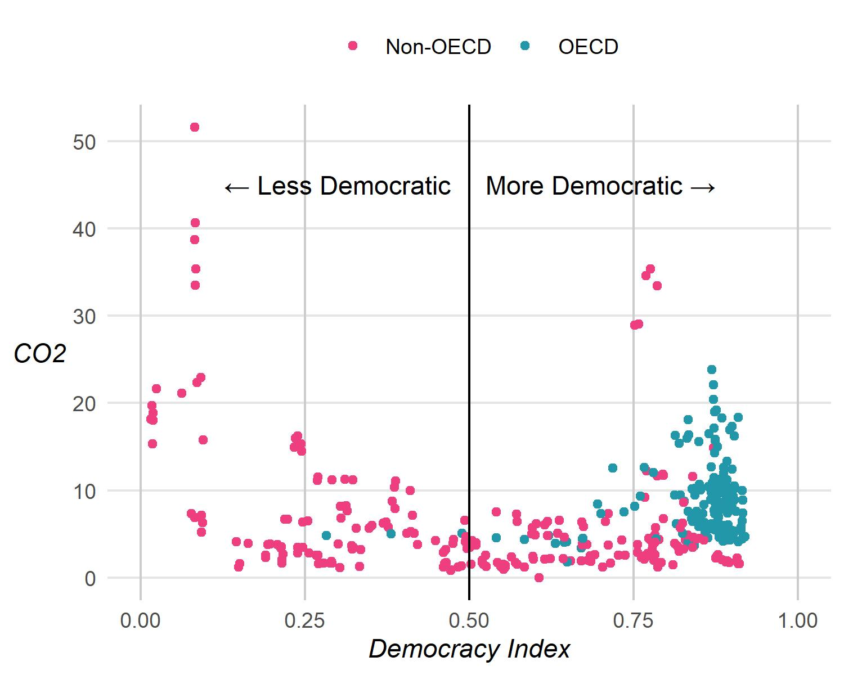
Figure 12: A scatterplot of CO₂ emissions per capita and Democracy Index, colored by OECD.

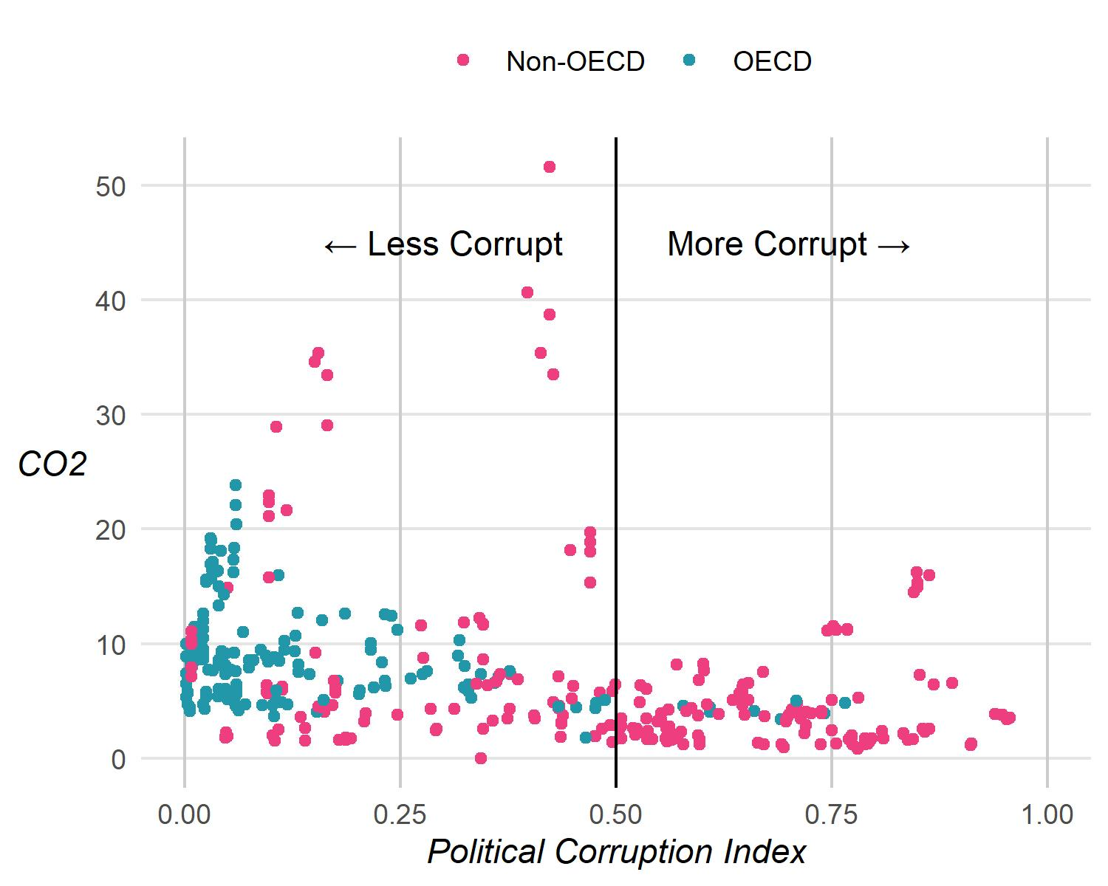
Figure 13: A scatterplot of CO₂ emissions per capita and Political Corruption Index, colored by OECD.

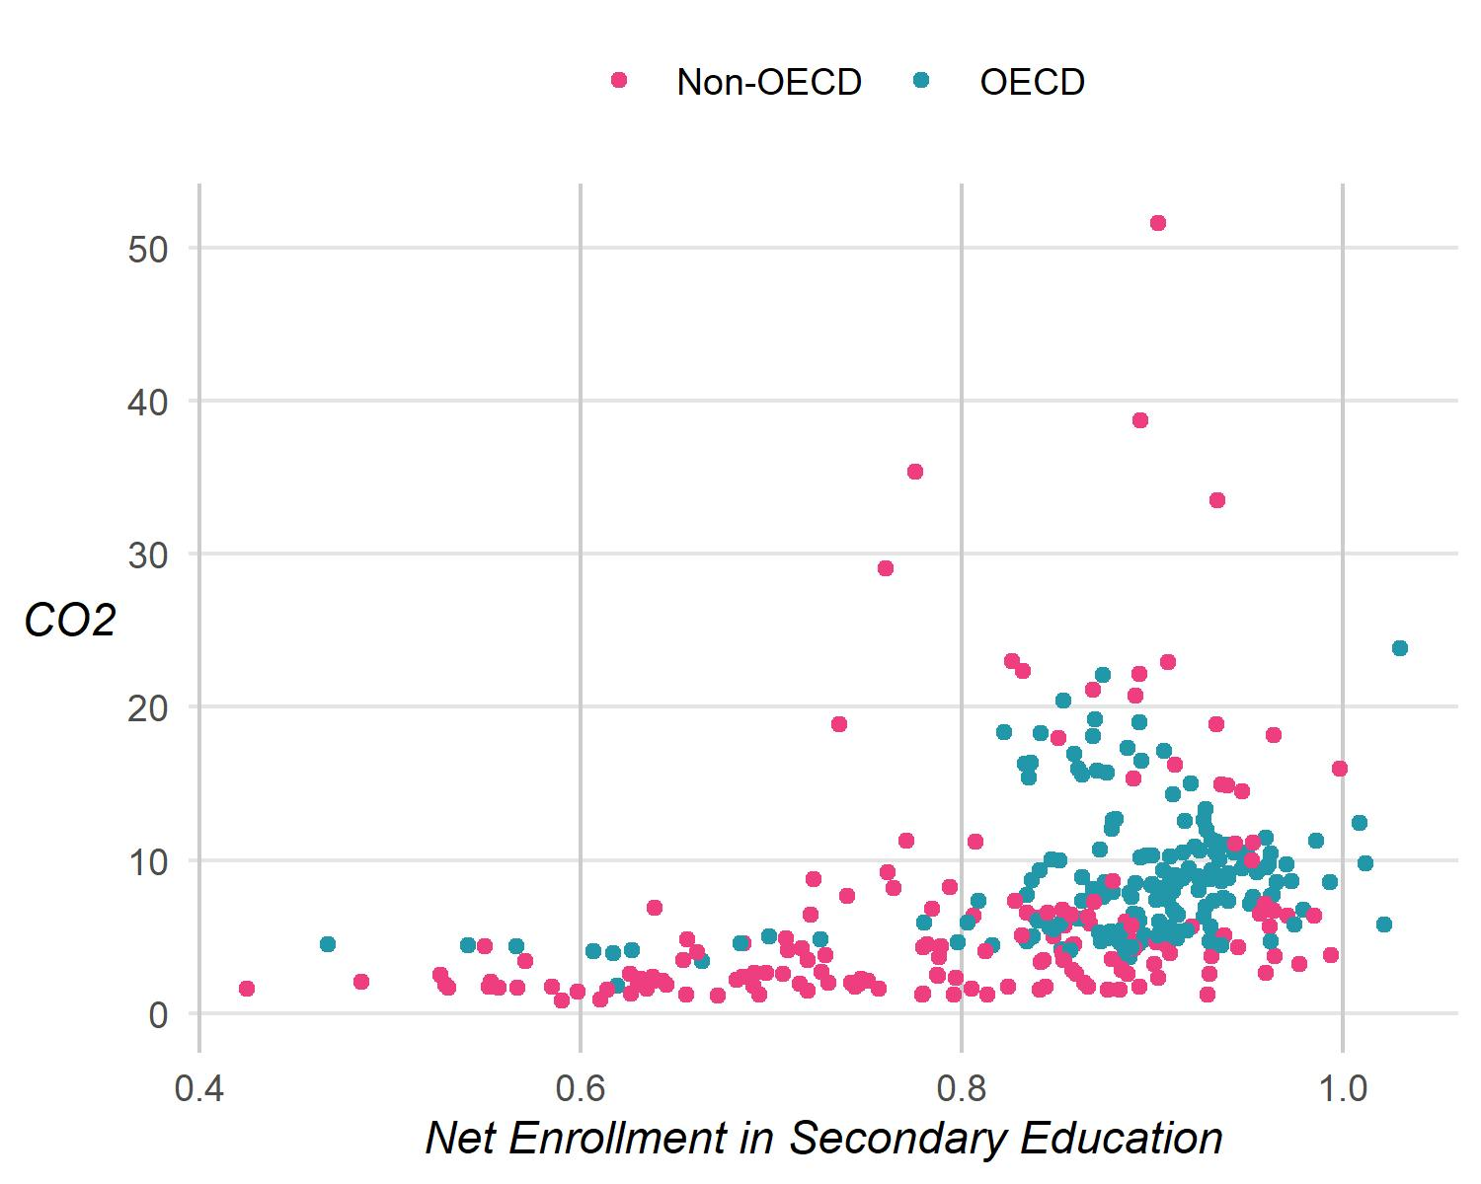
Figure 14: A scatterplot of CO₂ emissions per capita and net enrollment in secondary education, colored by OECD.

Of the six dimensions, the individualism-collectivism continuum has been found to relate the most with climate change, with those with more individualism having higher skepticism (Pelham, 2018), less concern (Shi et al., 2015), and less likely to adapt to natural hazards (Noll et al., 2020). Given the above, data for national individualism-collectivism will be used to control for worldview. Though Hofstede’s data (Hofstede, 2015) is a popular source, it is outdated (collected between the 1960s and 1970s) and its validity is lacking (Blodgett et al., 2008; Gerlach & Eriksson, 2021). A more recent dataset synthesizing Hofstede’s dimensions with others’ and validated using the World and European Values Surveys is used for this dissertation (Beugelsdijk & Welzel, 2018). The measure ranges from 0 to 100, with 0 being a completely collectivist society and 100 being a completely individualist society. Missing data for several countries (Costa Rica, Israel, Luxembourg, and Panama) is based on the collectivism-individualism index from the Hofstede 2015 data matrix (Hofstede, 2015). Missing data for other countries is imputed. Final data will be grand mean-centered, with the intercept reflecting a country with average individualism-collectivism. Because this data is cross-sectional, it is considered time-invariant.
Region. There is the possibility that countries located near each other may exhibit similar patterns in terms of either CO₂ emissions or scientific literacy scores. This may be due to shared culture, language, economic, or education systems. To control for this potential neighbor influence, countries are grouped into UN sub regions (UN, n.d.). Each country’s region is indicated in 8 in Appendix A.

Descriptive Statistics for Variables
2 shows key descriptive statistics for each variable selected for this dissertation. Statistics are calculated based on un-centered values in their original metrics. As indicated in the histogram column, most data is right- or left-skewed or otherwise non-normal in appearance. This is not an issue, as the normal distribution of data is not an assumption of multilevel models. Therefore, no further transformations of the data are necessary.
Correlation matrices were estimated separately per year and then averaged. Figure 16 shows a correlation plot for all continuous variables. Circles are depicted in the upper triangle of the correlation plot. Both the darkness of the color and size of the circle indicate the strength of the correlation. Purples indicate a positive correlation whereas browns indicate a negative correlation. Correlation values are indicated in the lower triangle.
CO₂ per capita shows a small correlation (.15) with scientific literacy. It has a moderate correlation with GDP (.55) and small to moderate correlations with Gini (-.21) and corruption (-.29). The largest correlations occur among covariates. Several variables show moderate to high correlations. For example, collectivism-individualism shows a high negative correlation with left-right orientation and moderate to high correlations with corruption, democracy, Gini, GDP, and scientific literacy. Corruption, democracy, and left-right orientation also indicate several moderate to high correlations. These high correlations indicate the possible presence of multicollinearity. This will be assessed in Chapter 4.

Missing Data
Missing data ranges from 2% to almost 10%. Neither CO₂ per capita nor scientific literacy have missing data. Most other variables are missing less than 3% of their values, which is usually not considered problematic (Garson, 2015). However, Gini coefficients, left-right orientation, and net enrollment have larger percentages of missing data.
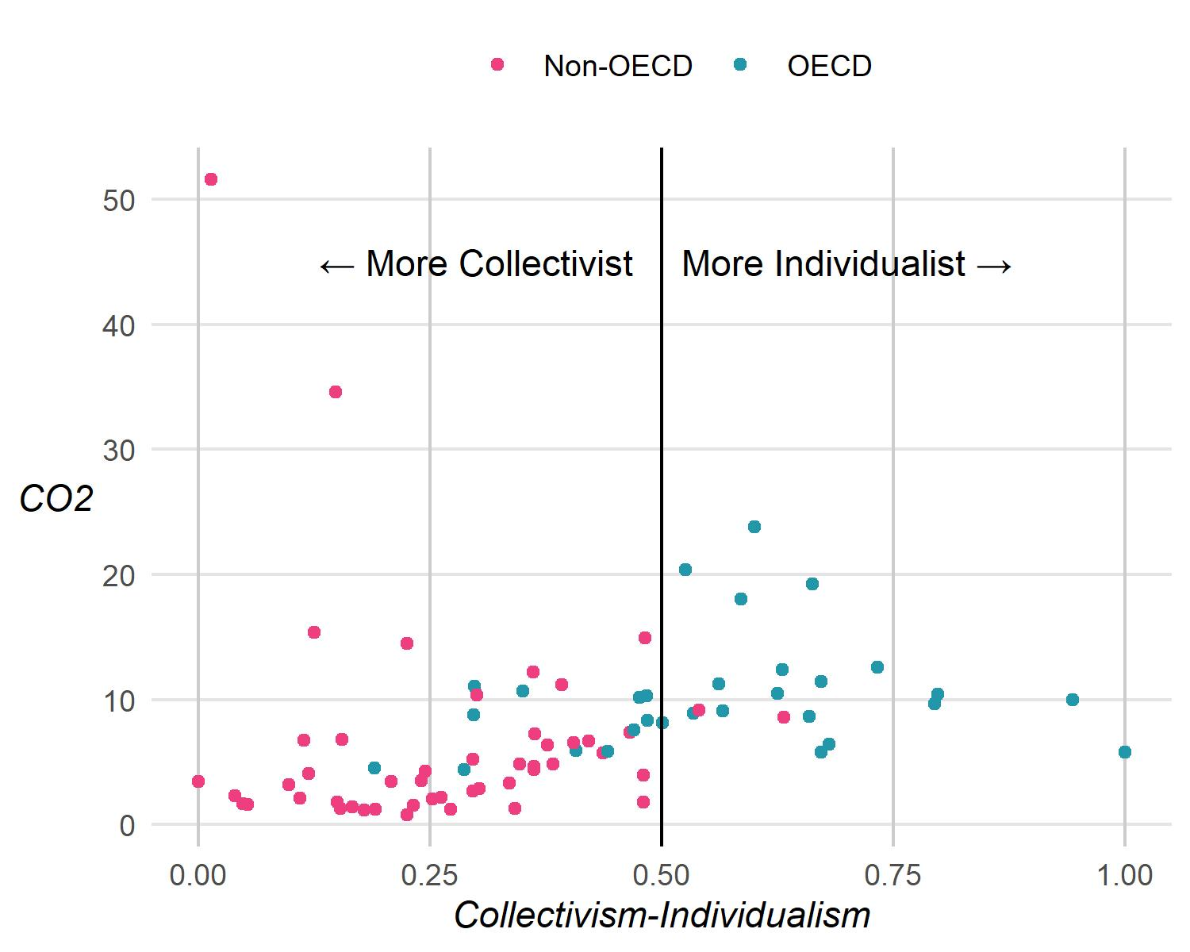
Figure 15: A scatterplot of CO₂ emissions per capita and collectivism-individualism, colored by OECD.

Due to the presence of missing data across a number of important covariates, missing data needs to be addressed.
There are three missing data mechanisms: missing completely at random (MCAR), missing at random (MAR), and missing not at random (MNAR). Data that is MCAR simply means the probability of missing data is neither dependent on the missing value nor on any of the observed or unobserved variables. MNAR, on the other hand, can be seen as the probability of missingness being related to the missing data itself. MCAR missingness is ignorable - or “treatable” - with listwise deletion, multiple imputation, and other methods. MNAR is nonignorable and requires more data collection or extreme caution regarding interpretation.
A third missing data mechanism, MAR, means that missingness is related to some of the observed variables and thus can be predicted. This is a very common type of missing data, especially since much of statistics deals with variables that are related. None of these missingness mechanisms can be empirically proven; rather, evidence must be gathered to make a strong case for one of them (Heymans & Eekhout, 2019; Schafer & Graham, 2002).
The missing data here are considered MAR. Figure 17 shows a missing values pair plot. This graphic allows the visual inspection of patterns between complete (blue) and missing (grey) data for each combination of variables. Box plots are used for continuous variable pairs and bar charts are used for factor-continuous pairs. Based on the visual, there is a clear relationship between OECD category and missingness, as the OECD column clearly shows Non-OECD countries tend to have more missing values. Many other continuous variable pairs share similar value distributions and/or median values when comparing missing and complete data. Some, such as Gini and Democracy Index or Gini and Left-Right orientation indicate drastically different values between complete and missing data.

Table 2: Descriptive statistics for all data
Variableª | Percent Missing | Mean | SD | Min | Median | Max | Histogram
Dependent Variable
CO₂ per capita (1 year lag) | 0% | 7.78 | 6.44 | 1.16 | 6.19 | 51.62 | ▇▁▁▁▁
Independent Variables
Scientific Literacy (All) | 0% | 468.20 | 52.88 | 322.03 | 484.80 | 590.45 | ▁▅▃▇▁
Scientific Literacy (Female) | 0% | 469.51 | 51.45 | 324.85 | 483.48 | 584.15 | ▁▅▅▇▂
Scientific Literacy (Male) | 0% | 466.89 | 54.77 | 318.45 | 483.53 | 596.21 | ▁▅▃▇▁
Control Variables
Population | 0% | 50,609,412.02 | 156,556,072.43 | 303,782.00 | 9,939,771.00 | 1,402,760,000.00 | ▇▁▁▁▁
GDP-PPP (US$2015) | 0% | 26,374.32 | 22,414.51 | 837.13 | 17,618.83 | 104,261.94 | ▇▂▃▁▁
Exports as % of GDP | 2% | 0.52 | 0.38 | 0.11 | 0.41 | 2.21 | ▇▃▁▁▁
Mfg. as % of GDP | 3% | 0.14 | 0.06 | 0.00 | 0.14 | 0.35 | ▂▇▆▁▁
Gini (income inequality) | 5% | 0.34 | 0.07 | 0.23 | 0.33 | 0.52 | ▅▇▅▃▂
Left-Right Orientation | 8% | 4.55 | 1.21 | 0.23 | 4.65 | 6.86 | ▁▂▆▇▅
Democracy Index | 2% | 0.70 | 0.25 | 0.02 | 0.83 | 0.92 | ▁▁▁▂▇
Corruption Index | 2% | 0.29 | 0.27 | 0.00 | 0.19 | 0.96 | ▇▂▂▂▁
Net Enrollment | 10% | 0.84 | 0.11 | 0.47 | 0.88 | 1.03 | ▁▂▂▇▅
Collectivism-Individualism | 2% | 0.42 | 0.22 | 0.00 | 0.41 | 1.00 | ▅▇▇▅▁
ªAll variables in this table are in their original metric. Variable transformations are discussed in Chapters 3 and 4.

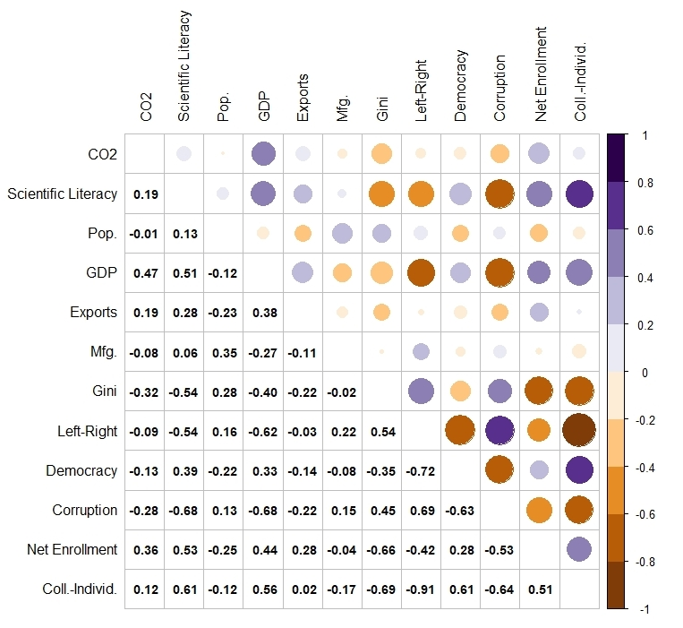
Figure 16: A correlation table (lower triangle) and correlation plot (upper triangle) of all continuous variables. Correlations are averaged over time.

However, as these values are moderately or highly correlated, it is likely there is an observed relationship between these variables. All of this evidence taken together strongly indicates the missingness mechanism is MAR and, thus, imputation can be safely undertaken.
Typically, this is done through multiple imputation. There are a variety of approaches to missing data appropriate for cross-sectional data. However, for longitudinal data, standard imputation methods may not be sufficient. Joint modeling has been found to produce the least biased results for data measured at regular intervals (Huque et al., 2018). Therefore, missing data will be imputed following a Bayesian joint modeling approach using the JointAI R package (Erler et al., 2021).
This approach imputes values one variable at a time, starting with the variable with the least amount of missing data. To predict these values, the joint distribution of all other variables in the model is used. These additional variables are specified as predictors in a submodel specified as a linear or non-linear model. All level-1 time-varying covariates are imputed using linear mixed models while level-2 country-level variables are imputed with a linear model. These models are estimated based on Markov Chain Monte Carlo (MCMC) sampling using 10 MCMC chains with 10,000 sampling iterations each. Convergence of the imputations was assessed by examining traceplots, Gelman-Rubin criterion estimates, and Monte Carlo error. Traceplots allow visual inspection of the convergence of individual chains at each iteration. Convergence is roughly determined when chains mix and follow a similar path (van Buuren, 2018). The Gelman-Rubin criterion assesses chain within- and between-chain variability, with values near 1 indicating convergence. The Monte Carlo error compares the Monte Carlo sampling error to the posterior sample’s standard error, the ratio of which should be less than 5% (Erler et al., 2021). The imputation using JointAI met all of the above criteria (see Appendix C for diagnostic information). Once imputation was assessed, imputed datasets were extracted by randomly sampling from 20 MCMC iterations and were used in subsequent analysis with mice (van Buuren & Groothuis-Oudshoorn, 2011) and mitml (Grund et al., 2021) R packages.

Data Analysis and Model Building
All data cleaning and analyses were conducted in R using various packages. Key packages are specified throughout chapters 3 and 4. For a complete list of packages used across this dissertation, please see Appendix D. All data and code for this dissertation are available at https://github.com/acircleda/dissertation.
Data analysis began with univariate data exploration, specifically data visualizations of growth over time for carbon emissions and scientific literacy. The purpose of these visualizations is to assess whether growth in scientific literacy is linear or takes on other shapes, such as quadratic or cubic. Any non-linear patterns will be accounted for and tested in the modeling process using likelihood ratio tests.
All modeling was completed using the lme4 (Bates, 2010) and lmerTest (Kuznetsova et al., 2017) R packages. Models using imputed data have their estimates pooled following Rubin’s rules using the mitml R package (Grund et al., 2021). All models are fit using maximum likelihood (ML) estimation, which is appropriate for comparing models fit with different fixed effects (Hoffman, 2015, p. 294; Peugh, 2010). A model-building process was followed in which a baseline model is fit followed by subsequent models of increasing complexity. Each model is tested against a previous model using likelihood ratio tests to ensure proper model fit. The intraclass correlation (ICC) is calculated before adding random effects in order to determine the percentage of variation in CO₂ between and within countries, controlling for time (Hoffman, 2015, p. 162). $R^{2}$ values are calculated, when appropriate, to assess the explantory power of some of the models. Interactions are probed based on estimated marginal means using the ggeffects R package (Lüdecke, 2018)
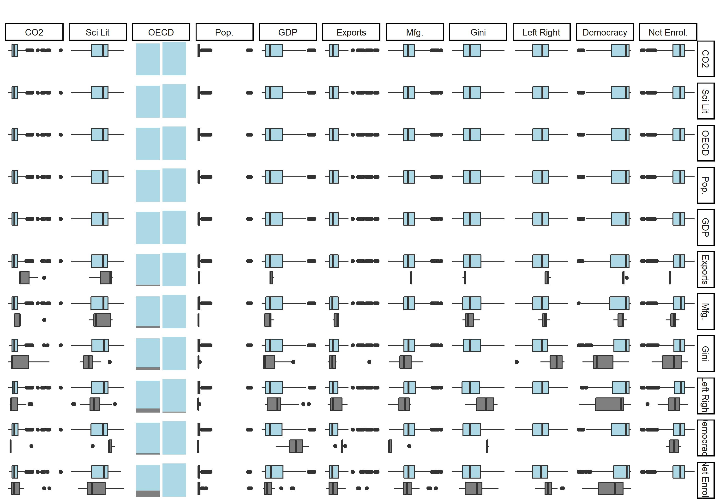
Figure 17: A missing values pairs plot showing complete (blue) and missing (grey) data for each combination of variable.
The goal of the model-building process is to arrive at a well-fitting conditional growth model with time-varying and time-invariant predictors that directly address the first two research questions. This model estimates 1) the relationship between scientific literacy and CO₂ emissions per capita, controlling for other factors; and 2) whether this relationship varies for developed and less-developed countries, which is assessed using an interaction effect between OECD and scientific literacy. This model, which includes a set of time-varying statistical controls, X, is initially specified as follows:
Level 1: $CO_{2}=β_{0i}+β_{1i}\left(TIME\right)+β_{2i}\left(SL_{within}\right)+e_{ti}$
Level 2: $β_{0i}=γ_{00}+γ_{01}\left(SL_{between}\right)+γ_{02}\left(OECD\right)+γ_{03}\left(OECD×SL_{within}\right)+γ_{4...n}\left(X\right)+U_{0i}$
$$β_{1i}=γ_{10}+U_{1i}\left(TIME\right)$$
$$β_{2i}=γ_{20}+U_{2i}\left(SL_{within}\right)$$
Composite: $CO_{2}=γ_{00}+γ_{10}\left(TIME\right)+γ_{20}\left(SL_{within}\right)+γ_{01}\left(SL_{between}\right)+γ_{02}\left(OECD\right)+γ_{03}\left(OECD×SL_{within}\right)+γ_{4...n}\left(X\right)+e_{ti}+U_{0i}+U_{1i}\left(TIME\right)+U_{2i}\left(SL_{within}\right)$.
Chapter 4 details the model building process and changes to the above model, as well as model results.
To address research question three regarding the effects of gender, two additional models (a male model and a female model) are estimated with gender-specific scientific literacy scores rather than overall country scores. These are based on the final models from the model building process. A formal Z-test for the equality of regression coefficients will be conducted to assess if there are any differential effects between male and female scientific literacy scores on CO₂ per capita holding all other variables constant (Clogg et al., 1995; Piquero et al., 2016). The Z-test will be specified as follows:
$Z=\frac{β_{slf}-β_{slm}}{\sqrt{SEβ_{slf}^{2}-SEβ_{slm}^{2}}}$,
where $β$ refers to the regression coefficient for female (slf) or male (slm) scientific literacy), and $SEβ$ refers to regression standard errors. This Z-test is based on recommendations in Piquero et al. (2016; equation 4).

CHAPTER FOUR: Results
This chapter begins with a detailed account of the model-building process and the interpretation of their results. Before further discussion of the results, the statistical and contextual limitations of their inference are first discussed in order to cast any necessary air of caution over the ensuing discussion. Following, model results are then used to provide insight into this dissertation’s research questions. Implications of these findings for future research, educators, and those interested in addressing the climate crisis concludes this chapter.

Results

Variable Selection
Before the model building process begins, it is necessary to examine a key requirement of general linear models: multicollinearity. If variables are highly correlated with each other, they may inflate standard errors and could lead to wayward interpretations of results. The variance inflation factor (VIF) is one method of assessing multicollinearity. The VIF estimates the increase in a standard error compared to if it were not correlated with other predictors. Using Darlington and Hayes’ (2017) example, if predictor x has a VIF of 2.5, the square root of the VIF ($\sqrt{2.5}=1.58$) indicates standard errors would be inflated 1.58 times higher than if the predictor were uncorrelated with other predictors.
To assess multicollinearity, a series of ordinary least squares regression models were estimated with the full, un-imputed data set ( Table 3). The VIF results of Model 1 indicate several variables with high VIFs: collectivism-individualism (8.00), corruption (5.55), left-right orientation (5.54). Several rules of thumb can be used to determine whether these VIFs should cause alarm, with VIFs below 10 typically considered acceptable. However, given the need to reduce standard error bias as much as possible, especially in the key independent variables of scientific literacy (3.93), it was decided to remove very high VIFs, beginning with removing collectivism-individualism. With this variable removed (Model 2), no change occurred in the corruption index and little occurred within scientific literacy. Model 3 retains collectivism and removes the corruption index. Here, collectivism is still high at 8. Whereas in Model 2 the left-right index was 3.11, in Model 3 it is increased to 5.52. However, the scientific literacy between VIF falls to 2.63, which is good. Model 4 removes both corruption and collectivism, finding that all VIFs have decreased again, in particular scientific literacy between. As suspected, the VIFs reflect what is depicted in Figure 16 - a number of these variables are highly correlated with each other. The multicollinearity analysis allows one to see the impact these high correlations could have on standard errors. It was decided to remove both collectivism-individualism and the corruption index from analyses.
As a final multicollinearity check, the region variable is included in Model 5. The inclusion of this model increases all VIFs once again and here large VIFs can be found for particular regions, especially Western Nations and Latin America/Caribbean/Other. As a single region of this variable cannot be removed because that would entail removing all other data associated with countries in that region, it was decided to remove region entirely from further modeling.

Models
Unconditional Model. Model results for the initial models are presented in Table 5. The first model fit was the unconditional model (Model 0), which serves as a baseline model that contains only time and a random intercept for each country. The intraclass correlation (ICC) serves as a measure of the variation of CO₂ within and between countries after controlling for time (Hoffman, 2015). The null model’s ICC of .965 indicates most of the variation (97%) of CO₂ is between countries. Conversely, this also indicates that only about 3% of the variation of CO₂ can be accounted for by within-country variation in CO₂ over time. In other words, CO₂ emissions per capita over the tweleve-year time span of this research do not vary much within each country.
Turning to the fixed parameter estimates for Model 0, the intercept indicates the average CO₂ emissions per capita for the 82 countries included was 8.56 tCO₂ in 2006. The estimate for time, $γ=-.397$, suggests that every three years, this estimate decreases by about .40 tCO₂, and this is statistically significant. In terms of the random effects, $σ^{2}$ represents the within-country variation of CO₂ per capita over time. $τ_{00}$ represents the variation in the intercept, which is CO₂ emissions in 2006. Compared to $τ_{00}=6.6$, the within-country variation ($σ=1.25$) is quite small.
$R^{2}$ is typically used in linear models to assess the percent of variation in the outcome variable that can be attributed to the predictors. However, $R^{2}$ does not have the same meaning for models with nested data and random effects. For multilevel models, several different pseudo-$R^{2}$ measures have been developed (LaHuis et al., 2014; Nakagawa et al., 2017; Peugh, 2010). To explain variance in these models, marginal $R_{1}^{2}$ is estimated using the performance R package (Lüdecke et al., 2021). Marginal $R^{2}$ represents the proportion of variance explained by the fixed effects of the model. A related metric, conditional $R^{2}$, explains the variance accounted for by both the fixed and random effects. However, as the random effects more or less stay the same for the following models, conditional $R^{2}$ (which is .97 or higher) does not provide much useful information in the way of model explanatory
Table 3: Variance inflation factors for independent variables.
Variables | Model 1: All Continuous Variables | Model 2: w/o Collectivism | Model 3: w/o Corruption | Model 4: w/o Corruption and Collectivism | Model 5: w/Region
Scientific Literacy (within) | 1.07 | 1.06 | 1.06 | 1.06 | 1.09
Scientific Literacy (between) | 3.93 | 3.73 | 2.63 | 2.46 | 3.97
Population | 1.68 | 1.67 | 1.65 | 1.64 | 1.81
GDP-PPP | 2.81 | 2.77 | 2.50 | 2.47 | 3.65
Exports | 1.73 | 1.67 | 1.73 | 1.67 | 1.98
Manufacturing | 1.41 | 1.25 | 1.38 | 1.22 | 1.82
Gini | 3.67 | 2.87 | 3.41 | 2.58 | 5.95
Left-Right Orientation | 5.54 | 3.11 | 5.52 | 3.10 | 4.20
Democracy Index | 3.09 | 3.06 | 2.20 | 2.18 | 3.17
Corruption Index | 5.55 | 5.55
Net Enrollment | 2.20 | 2.19 | 2.09 | 2.07 | 2.28
Collectivism-Individualism | 8.00 |  | 8.00
Latin America/ Caribbean/ Other |  |  |  |  | 5.36
Western Nations |  |  |  |  | 10.62
Eastern Europe |  |  |  |  | 4.01
Eastern Asia |  |  |  |  | 3.33
Southern Europe |  |  |  |  | 4.85
South-Eastern Asia |  |  |  |  | 2.73
Central Asia |  |  |  |  | 1.56

power. For Model 0, the fixed effect for time explains only .07% of the variance in CO₂ emissions.
Random Effect of Time. Model 1 adds a random effect for time, which allows the slope of the effect of time to vary for each country. Because of the addition of a random slope, ICC values should not be calculated (Hoffman, 2015, p. 164). Instead, the percentage of variation in CO₂ emissions attributed to the addition of the random slope for time can be estimated by dividing the variance of time (${\left(τ_{11}\right)}^{2}=0.27$) by the total variance of the model (${\left(τ_{00}\right)}^{2}+{\left(τ_{11}\right)}^{2}+σ^{2}+\left(COV_{01}×2\right)=53.78$). The proportion of variance attributed to the random effect only explains .5% of the random effect variance. This suggests rates of CO₂ change over time across countries are more or less stable, on average. This is not surprising as only a small percentage of variation in CO₂ per capita was due to within-country differences, as indicated by Model 0. Despite the small explanatory power of the random slopes for time, a likelihood ratio test indicates that Model 1 has a better model fit than Model 0, $χ^{2}\left(2\right)=93.72,p<.001$. The regression coefficient for fixed effect of time ($γ=.39$) remains practically unchanged from Model 0. The random effect for the intercept, $τ_{00}$, has increased to 7.76. Two additional parameters are estimated in this model. $τ_{11}$ represents the variation in the slope of time. $ρ_{01}$ represents the correlation between the random slope and the intercept, -.95. This correlation indicates that for countries with high levels of CO₂ per capita in 2006, the effect of time is weaker, meaning their emissions levels decline more slowly compared to countries with lower levels of CO₂ per capita.
Non-Linear Effect of Time. Model 2 adds quadratic fixed and random effects for time to assess whether time is linear. Although visual inspection of CO₂ per capita over time suggested linear change, Model 2 allows for a formal test via likelihood ratio and model fit statistics (Table 4). Based on the $χ^{2}$, AIC, and BIC values, Model 2 with a quadratic effect for time fits better than Model 1. However, the quadratic fixed effect for time is non-significant. While the likelihood ratio test suggests Model 2 may be a better fit, visual inspection of CO₂ over time (e.g., Figure 5) still suggests a prominent linear relationship. Diagnostic assessments of homogeneity of variance and normality (Figure 18) suggest that Model 2 does not improve fit enough to justify its further use. For these reasons as well as ease of interpretation and model parsimony, only linear effects are considered and Model 2 is rejected.
Conditional Growth Model. Model 3 adds fixed effects for scientific literacy as separate within- and between- variables. This is a common centering strategy in multilevel models used to separate out the two types of effects. In addition, a random slope for scientific literacy within was also added to assess whether the impact of scientific literacy on CO₂ emissions over time varies across countries. Unfortunately, this produced a singularity issue, meaning the linear effect of scientific literacy within on CO₂ was near zero. On a country-by-country basis, the effect of scientific literacy within ranges from -.07 to .01, a range of about .08, which is quite small. For Model 3, this suggests that the impact of scientific literacy within a country on CO₂ per capita does not vary considerably across countries. This was foreshadowed by the ICC in the unconditional model, suggesting 97% of the variance in CO₂ is between countries, leaving very little variation within countries. Model 3 was re-estimated without a random effect for scientific literacy, which produced no singularity issues (see Table 5).
Table 4: Fit statistics and likelihood ratio test results for Model 2.
Model | Parameters | AIC | BIC | Log-Likelihood | Deviance | Chisq | df | p
Model 1 | 6 | 1,391.383 | 1,414.231 | -689.691 | 1,379.383
Model 2 | 7 | 1,386.126 | 1,412.783 | -686.063 | 1,372.126 | 7.256 | 1 | 0.007

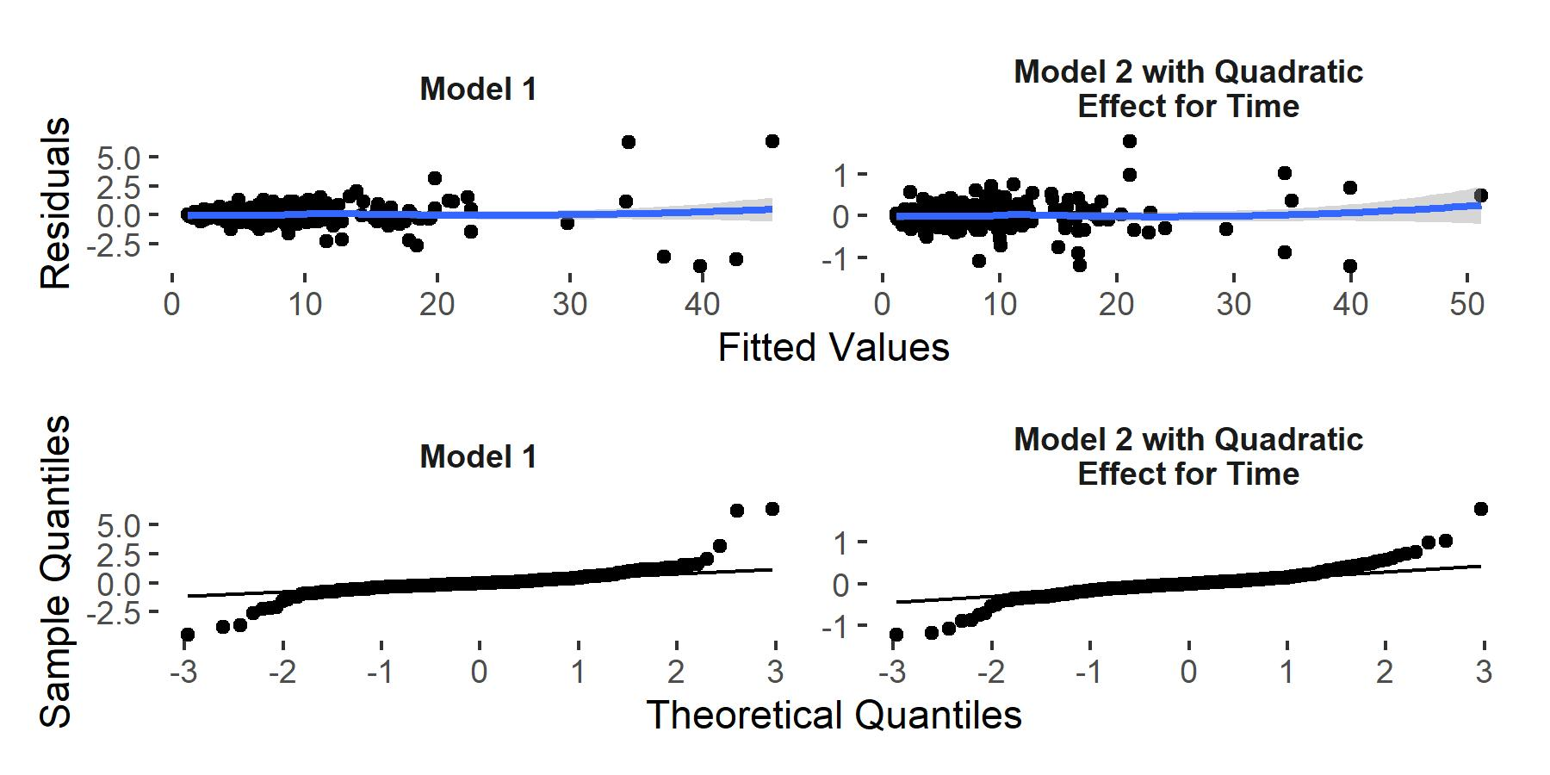
Figure 18: Visual diagnostics to assess heterogeneity of variance (top row) and normality of residuals (bottom row) in Models 1 and 2.

Table 5: Table of results for initial multilevel growth models.
 | Model 0: Unconditional Model |  |  | Model 1: Random Effect for Time |  |  | Model 2: Non-Linear Effect for Time |  |  | Model 3: Conditional Model
Variable | Estimate | SE | p | Estimate | SE | p | Estimate | SE | p | Estimate | SE | p
(Intercept) | 8.561 | 0.741 | < 0.001 | 8.551 | 0.866 | < 0.001 | 8.690 | 0.922 | < 0.001 | 6.133 | 4.381 | 0.165
Time | -0.397 | 0.051 | < 0.001 | -0.387 | 0.072 | < 0.001 | -0.740 | 0.268 | 0.008 | -0.393 | 0.073 | < 0.001
Time² |  |  |  |  |  |  | 0.089 | 0.054 | 0.105
Scientific Literacy (within) |  |  |  |  |  |  |  |  |  | -0.002 | 0.006 | 0.782
Scientific Literacy (between) |  |  |  |  |  |  |  |  |  | 0.005 | 0.009 | 0.575
τ₀₀ | 6.586 |  |  | 7.763 |  |  | 8.279 |  |  | 7.712
ρ₀₁ |  |  |  | -0.955 |  |  | -0.753 |  |  | -0.951
ρ₀₂ |  |  |  |  |  |  | 0.645
τ₁₁ |  |  |  | 0.523 |  |  | 2.216 |  |  | 0.523
ρ₁₂ |  |  |  |  |  |  | -0.976
τ₂₂ |  |  |  |  |  |  | 0.442
σ | 1.249 |  |  | 0.999 |  |  | 0.426 |  |  | 0.999
Marginal R² | 0.007 |  |  | 0.006 |  |  | 0.006 |  |  | 0.009
ICC | 0.965 |  |  | 0.979 |  |  | 0.996 |  |  | 0.978
Log Likelihood | -736.551 |  |  | -689.691 |  |  | -612.362 |  |  | -689.450
AIC | 1,481.102 |  |  | 1,391.383 |  |  | 1,244.725 |  |  | 1,394.900
BIC | 1,496.335 |  |  | 1,414.231 |  |  | 1,282.806 |  |  | 1,425.366
Observations | 333 |  |  | 333 |  |  | 333 |  |  | 333

This model produced no convergence issues. A likelihood ratio test indicated that the addition of fixed effects for scientific literacy did not significantly improve model fit, $χ^{2}\left(2\right)=.48,p=.786$. However, as scientific literacy is key to addressing the research questions, these variables are retained. In addition, adding fixed effects for scientific literacy increases the explanatory power of the model from $R^{2}=.006$ to $R^{2}=.009$, which, though minute, is a 29% increase.
According to the results of Model 3, a country with average scientific literacy scores in 2006 had per capita emissions of 6.13 tCO₂. The results for the estimate of time did not change (-.39). The results for scientific literacy between countries is .01, indicating a fractional increase in emissions over time for every increase in scientific literacy scores above average. Scientific literacy within a country is negative (-.002), suggesting a fractional decrease in emissions over time is associated with higher within-country scores. Both effects are near zero, and neither are statistically significant. Random effects in Model 3 do not differ substantially from Model 1.
Because Model 3 with a random effect for time is the primary growth model before covariates are added, it is important to fully assess model fit by examining model assumptions, including those of linearity, normality, homogeneity, and influence of outliers. Initial visual inspection suggested possible violations of normality of residuals and homogeneity of variance (i.e., indicating the presence of heteroskedasticity; see Figure 19 and Figure 20). There are several possible reasons for this, including the non-normal dependent variable (CO₂ is highly right-skewed), presence of outliers, or model misspecification. Examination of the residuals can suggest major differences between predicted and observed values. Qatar had the most extreme residuals with some as higher as or more than 6, while the next highest residual was around 3. Further outlier analysis using Cook’s d, which quantifies the influence a case has on all others by measuring what occurs when it is deleted (Darlington & Hayes, 2017). Cook’s d values also indicated that Qatar had extreme deviations from other values. Whereas all other countries had Cook’s distance values of less than .05, Qatar had three of its five values above .10 with one as high as .92. Qatar has the highest CO₂ emissions per capita, with values ranging from 33 tCO₂ to 52 tCO₂, all of which are between 3 to 5 standard deviations above average.
Several additional models were fit, one without Qatar and one with Qatar that included an additional dummy variable to attempt to control for Qatar’s influence. In addition, due to the non-normality of the dependent variable, a model was fit with the natural log of CO₂ per capita as the dependent variable. Inspection of model fit and diagnostics suggested that the model without Qatar had improved normality and homogeneity of variance. The model with the natural log of CO₂ for the dependent variable had similar normality as other models but much improved homogeneity of variance, as determined by the more random pattern of residuals. Given how atypical Qatar is from other countries in its CO₂ emissions per capita, and the poor predictability of it in the model, it was decided to remove Qatar from further analyses. Likewise, given the non-normality of CO₂ and the improvement in fit, a logged version CO₂ per capita was used.
To allow for cross-model comparison, Model 1 and 2 were re-estimated with Qatar removed and the dependent variable log-transformed (Table 6). A one-unit change in a predictor now represents the expected change in the log of CO₂ emissions. Because this value is difficult to interpret, exponentiated fixed effect coefficients are presented in the columns labeled $\%Δ$. $\%Δ$ is calculated as $\left(exp\left(γ\right)-1\right)×100$. Using this exponentiated value, a one-unit change in a predictor now represents the expected percentage change in CO₂ emissions. Returning to Model 3, we see that CO₂ emissions significantly decrease over time, about 3.5% every three years. The effect of scientific literacy within on CO₂ emissions is near-zero and non-significant. On the other hand, a one-unit increase in scientific literacy between countries is associated with a significant .45% increase in emissions. In other words, countries with higher average scientific literacy scores tend to have higher emissions per capita. Unlike the untransformed Models 1 and 3 (Table 5), Model 3 with the log-transformed dependent variable now fits better, $χ^{2}\left(2\right)=15.003,p<.001$. The addition of the fixed effects for scientific literacy raises the marginal $R^{2}$ of this model from .003 in Model 1 to .152 in Model 3, suggesting time and scientific literacy can explain about 15% of the total variance in CO₂ emissions over time.
Conditional Growth Model with Covariates. Model 4 uses 20 imputed datasets derived from joint modeling, the results of which are pooled following Rubin’s rules (van Buuren, 2018). The model includes all covariates (population, GDP, manufacturing as a percentage of GDP, exports as a percentage of GDP, Gini, left-right orientation, democracy, net enrollment, OECD category) as well as the interaction between scientific literacy (within a country) and OECD category. Like the re-estimated Models 1 and 3, Qatar is not included and the log of CO₂ emissions is used. To aid in interpretation of the model, all variables that range from 0-1 (manufacturing, exports, Gini, left-right orientation, democracy index, and net enrollment) were rescaled by 100 ($x×100$). Exponentiated values of fixed effect coefficients for these variables now represent the percentage change in CO₂ emissions for a 1% increase in the predictor, holding all other predictors constant.
In Model 4, time remains a significant predictor, indicating a decrease in CO₂ emissions per capita in time, similar to Model 3. Triannually, CO₂ emissions are expected to decrease around 3.5%. Likewise, scientific literacy between countries remains a significant
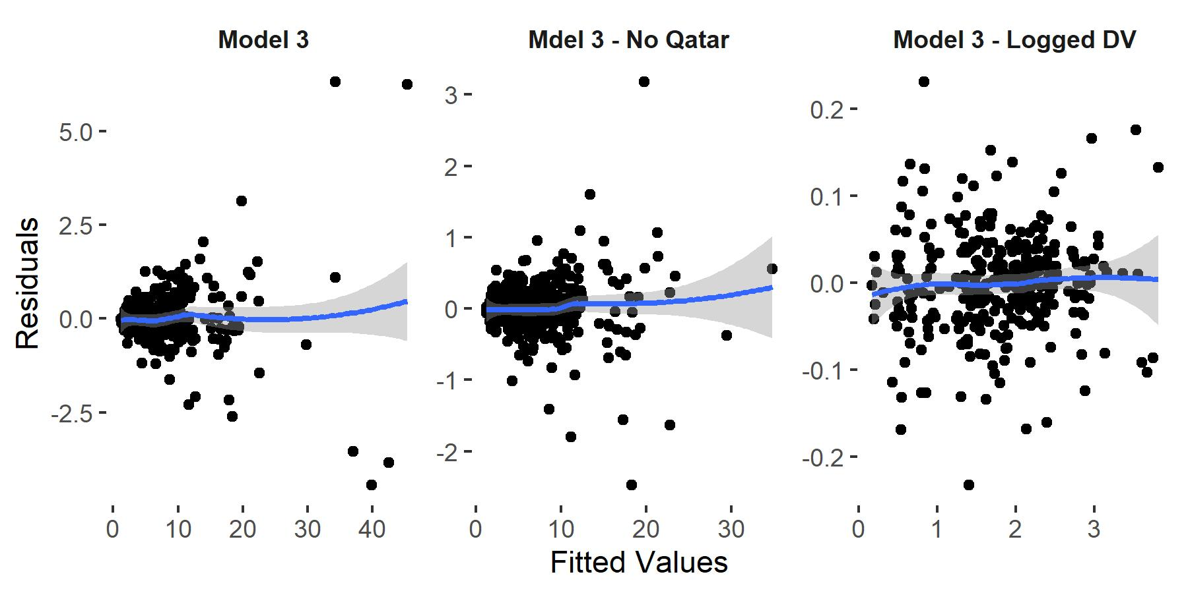
Figure 19: Residuals plotted against fitted values to assess linearity and heterogeneity of variance for Model 3 and alternative models.

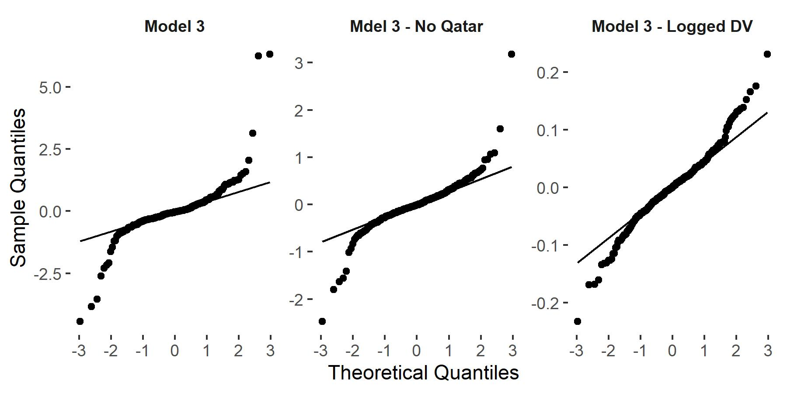
Figure 20: QQ plots for Model 3 and alternatives
Table 6: Table of results for final multilevel growth models.
 | Model 1: Random Effect for Time  (Log of CO₂) |  |  |  | Model 3: Conditional Model  (Log of CO₂) |  |  |  | Model 4: Conditional Model with Covariates (Log of CO₂)
Variable | Estimate | %Δ | SE | p | Estimate | %Δ | SE | p | Estimate | %Δ | SE | p
(Intercept) | 1.778 |  | 0.093 | < 0.001 | -0.643 |  | 0.556 | 0.251 | -0.259 |  | 0.672 | 0.7
Time | -0.030 | -2.99 | 0.007 | < 0.001 | -0.032 | -3.158 | 0.007 | < 0.001 | -0.036 | -3.552 | 0.008 | < 0.001
Scientific Literacy (within) |  |  |  |  | 0.000 | 0.029 | 0.001 | 0.567 | 0.001 | 0.054 | 0.001 | 0.384
Scientific Literacy (between) |  |  |  |  | 0.005 | 0.531 | 0.001 | < 0.001 | 0.004 | 0.447 | 0.001 | 0.002
Population |  |  |  |  |  |  |  |  | 0.002 | 0.191 | 0.004 | 0.657
GDP |  |  |  |  |  |  |  |  | 0.002 | 0.175 | 0.020 | 0.93
Manufacturing |  |  |  |  |  |  |  |  | 0.004 | 0.353 | 0.004 | 0.41
Exports |  |  |  |  |  |  |  |  | -0.001 | -0.050 | 0.001 | 0.572
Gini |  |  |  |  |  |  |  |  | -0.017 | -1.650 | 0.007 | 0.013
Left-Right Orientation |  |  |  |  |  |  |  |  | -0.001 | -0.089 | 0.002 | 0.592
Democracy Index |  |  |  |  |  |  |  |  | -0.002 | -0.156 | 0.001 | 0.178
Net Enrollment |  |  |  |  |  |  |  |  | 0.000 | 0.003 | 0.001 | 0.975
OECD |  |  |  |  |  |  |  |  | 0.037 | 3.742 | 0.039 | 0.345
Scientific Literacy (within) x OECD |  |  |  |  |  |  |  |  | 0.000 | -0.043 | 0.001 | 0.696
τ₀₀ | 0.827 |  |  |  | 0.710 |  |  |  | 0.682
τ₁₁ | 0.058 |  |  |  | 0.057 |  |  |  | 0.056
σ | 0.071 |  |  |  | 0.071 |  |  |  | 0.069
ρ₀₁ | -0.660 |  |  |  | -0.560 |  |  |  | -0.505ª
ICC | 0.991 |  |  |  | 0.988 |  |  |  | 0.995
MarginalR² | 0.003 |  |  |  | 0.152 |  |  |  | 0.165
Log Likelihood | 105.159 |  |  |  | 112.661 |  |  |  | 119.114^{b}
AIC | -198.319 |  |  |  | -209.322 |  |  |  | -202.228^{b}
BIC | -175.561 |  |  |  | -178.977 |  |  |  | -133.954^{b}
Observations | 328 |  |  |  | 328 |  |  |  | 328
Imputations |  |  |  |  |  |  |  |  | 20
ªThe correlation coefficient is based on mean across imputed models
^{b}Fit statistics based on mean across imputed models

predictor, with a one-unit increase in scientific literacy above average scientific literacy across countries associated with a .45% increase in CO₂ emissions, holding all other variables constant. With the interaction between scientific literacy within and OECD country status included in the model, the effect of scientific literacy within countries over time is now a conditional effect that represents scientific literacy for only non-OECD countries. This effect remains non-significant, though its effect rises above zero ($γ=.001$).
Nearly all additional covariates in the model are non-significant. Nevertheless, the effects will be interpreted so as to understand what they represent in terms of their potential associations with the CO₂ per capita. Increases in population, GDP, and manufacturing, are associated with increases in CO₂, as reflected in previous literature. The model estimates that an increase in population of 10,000,000 is associated with a .19% increase in CO₂ per capita. For every $10,000 increase in GDP, CO₂ is associated with an increase of .18%. There is a .35% increase associated with a 1% increase in manufacturing as a percentage of GDP.
Exports see a non-significant .05% decrease in CO₂ emissions per capita. In contrast to most other variables in the model, the Gini coefficient, representing income inequality, has a significant effect associated with it. The fixed effect indicates that for every one percent increase in the Gini coefficient toward greater income inequality, there is a significant 1.7% decrease in CO₂ emissions. These findings are in line with previous literature [e.g., mcgee2018; Hailemariam et al. (2020)].
A one-unit increase toward right-wing conservative political ideology among a country’s population is associated with a non-significant .09 decrease in emissions. Given the role of political ideology has in affecting beliefs and behavior (Hornsey et al., 2018), this finding would be surprising if it were larger and statistically significant. An increase toward a more democratic government, associated with a decrease of .16% in CO₂ for a 1% change in the index, does line up with previous literature (Czarnek et al., 2021), though the effect is not significant. Being an OECD country with average scientific literacy within scores is related to increased emissions at least 4% higher than non-OECD countries, but this is not significant. Similarly, the interaction between scientific literacy and OECD category is not significant.
Random effects show no substantial changes from Model 3 to Model 4. Between-country variance of CO₂ emissions over time remains quite high ($τ_{00}=.71$) while within-country variance remains low ($σ=.069$), consistent with the high ICC indicated in the initial models (Models 0 and 1). The correlation between the random slope and the intercept is lower and more reasonable ($ρ=-.505$) than the non-transformed Model 3 ($ρ=-.95$; see Table 5). However, the interpretation remains the same: for countries with higher CO₂ per capita, emissions levels decline more slowly compared to countries with lower levels.
A likelihood ratio test was conducted using the D3 method, which pools results of separate likelihood ratio tests and is necessary for working with multiply-imputed data (Meng & Rubin, 1992). The results indicated the fit of Model 4 was not significantly different than Model 3. Fit statistics in Table 6 slightly favor Model 3. Although this is the more parsimonious model, it is also the model without covariates. These covariates are needed to control for additional forces outside time and education that may affect CO₂. For this reason, Model 4 is the best model of the two. Model 4 also explains more variance than Model 3, though marginally so. About 17% of the variance is explained by the fixed effects, meaning 83% of the variance remains unexplained by fixed effects. This is still the highest of all six models fit. Model diagnostics indicate a well-fitting model with normally distributed residuals and no strong evidence of heteroskedasticity. Diagnostics were checked for individual imputations. Figure 21 shows example model diagnostics for the first imputation.
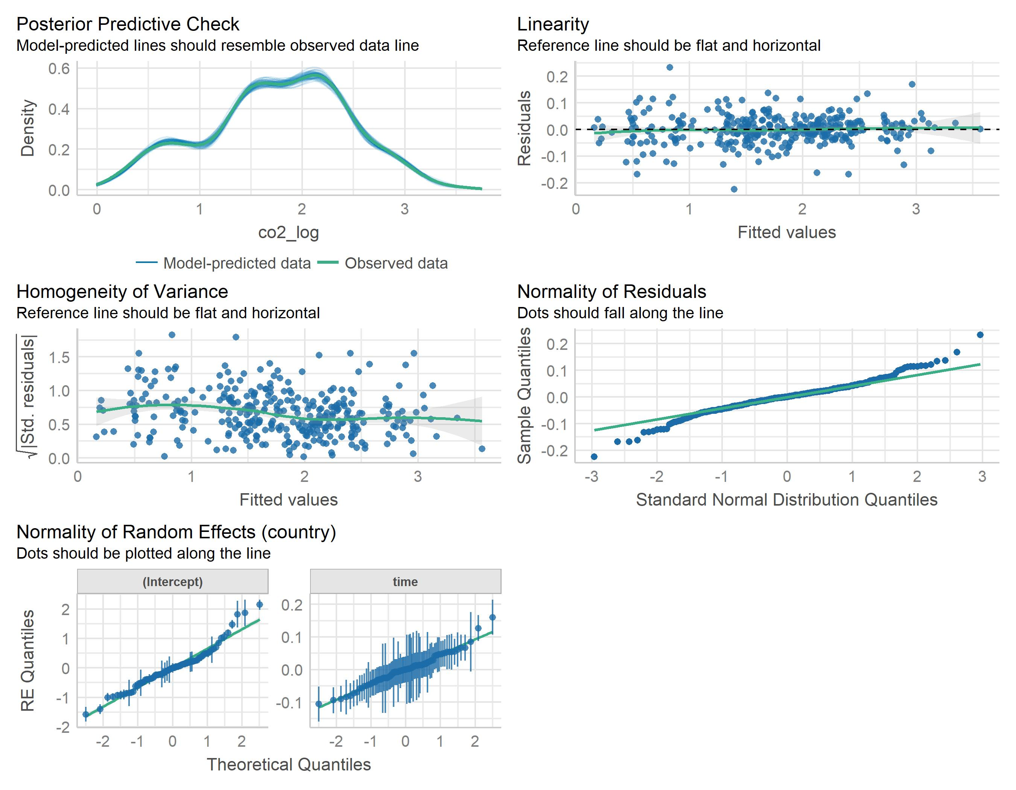
Figure 21: Multilevel regression diagnostics for Model 4. Figure made using the performance R package (Lüdecke et al., 2021).

Male and Female Model Comparisons
Model 4 tested the effect of scientific literacy for all students on CO₂ emissions per capita, controlling for other variables. Given prior research that showed differential effects of economic, social, and educational factors for males and females, research question three asked if scientific literacy for boys and girls differed in terms of its impact on CO₂. The models represented in Table 7 replace scientific literacy for all students with female and male students, respectively.
Overall, the statistical conclusions that can be drawn from the models are similar, though individual coefficient estimates vary. These models also reflect the same conclusions as Model 4, with the same significant predictors. A coefficient test of equality, which tests whether each variable’s effects significantly differ between the models, indicated no significant differences. Thus, Model 4 with all students’ scientific literacy scores combined is preferred over separate male and female models.

Limitations
As with any research, the present dissertation is not without its limitations. First, the scope of the research, while international, is not comprehensively global. That is, it does not consider every country - only those that have participated in the PISA, and even then, it only includes those participating countries for which CO₂ data was available. As indicated in Figure 22, there is still a large swath of the world that is not represented. In particular, major economies such as India and Pakistan are not included nor is almost the entire continent of Africa. These missing areas include rapidly developing economies, shifting carbon footprints, and changing education systems. Not having scientific literacy data for these countries leaves out important information about hundreds of millions of students. Additionally, any inferences that can be made from the statistical analyses of this research pertain to only those countries included. This limits the generalizability of the conclusions.

Table 7: Models for female and male scientific literacy scores.
 | Model for Female Students |  |  |  | Model for Male Students |  |  |  | Coefficient Tests of Equality
Variable | Estimate | %Δ | SE | p | Estimate | %Δ | SE | p | z | p
(Intercept) | -0.408 |  | 0.683 | 0.55 | -0.079 |  | 0.656 | 0.904 | -0.347 | 0.364
Time | -0.037 | -3.589 | 0.008 | < 0.001 | -0.036 | -3.533 | 0.008 | < 0.001 | -0.049 | 0.480
Scientific Literacy (within) | 0.001 | 0.058 | 0.001 | 0.353 | 0.000 | 0.046 | 0.001 | 0.437 | 0.141 | 0.556
Scientific Literacy (between) | 0.005 | 0.478 | 0.001 | 0.001 | 0.004 | 0.409 | 0.001 | 0.004 | 0.338 | 0.632
Population | 0.002 | 0.196 | 0.004 | 0.647 | 0.002 | 0.202 | 0.004 | 0.641 | -0.010 | 0.496
GDP | 0.001 | 0.081 | 0.020 | 0.967 | 0.003 | 0.319 | 0.020 | 0.872 | -0.085 | 0.466
Manufacturing | 0.003 | 0.312 | 0.004 | 0.472 | 0.004 | 0.364 | 0.004 | 0.391 | -0.086 | 0.466
Exports | 0.000 | -0.048 | 0.001 | 0.589 | -0.001 | -0.052 | 0.001 | 0.561 | 0.031 | 0.513
Gini | -0.016 | -1.630 | 0.007 | 0.014 | -0.017 | -1.683 | 0.007 | 0.011 | 0.057 | 0.523
Left-Right Orientation | -0.001 | -0.089 | 0.002 | 0.592 | -0.001 | -0.096 | 0.002 | 0.569 | 0.027 | 0.511
Democracy Index | -0.002 | -0.153 | 0.001 | 0.186 | -0.002 | -0.159 | 0.001 | 0.173 | 0.034 | 0.514
Net Enrollment | 0.000 | -0.001 | 0.001 | 0.99 | 0.000 | 0.006 | 0.001 | 0.944 | -0.058 | 0.477
OECD | 0.036 | 3.713 | 0.039 | 0.348 | 0.036 | 3.713 | 0.039 | 0.35 | 0.000 | 0.500
Scientific Literacy (within) x OECD | -0.001 | -0.091 | 0.001 | 0.41 | 0.000 | -0.001 | 0.001 | 0.992 | -0.593 | 0.276
τ₀₀ | 0.677 |  |  |  | 0.687
τ₁₁ | 0.056 |  |  |  | 0.055
σ | 0.069 |  |  |  | 0.070
ρ₀₁ª | -0.499 |  |  |  | -0.512
ICC | 0.995 |  |  |  | 0.995
MarginalR² | 0.178 |  |  |  | 0.152
Log Likelihood^{b} | 119.669 |  |  |  | 118.699
AIC^{b} | -203.337 |  |  |  | -201.398
BIC^{b} | -135.063 |  |  |  | -133.124
Observations | 328 |  |  |  | 328
Imputations | 20 |  |  |  | 20
ªThe correlation coefficient is based on mean across imputed models
^{b}Fit statistics based on mean across imputed models

For some countries, PISA is not representative of the entire country. For instance, in China, the PISA exam only includes large and comparatively wealthier cities or regions, which skews the PISA scores upwards. This does not give an accurate picture of China because it is biased toward these types of regions while ignoring poorer or more rural areas. Furthermore, as the regions have shifted over time, longitudinal comparisons within China may not be as valid. China is not the only country this has occurred in. For example, in Argentina in 2015, only Buenos Aires was included in the PISA exam. The effect of this selection can easily be seen in Figure 6, with the 2015 PISA score for Argentina standing out as a potential outlier.
Such issues can only be ameliorated by utilizing a measure of science education (or climate change education) that is more globally comprehensive. Unfortunately, the PISA exam seems to be the most globally comprehensive source of such a measure (Singer et al., 2018). Thus far, the PISA has not made many inroads into middle- and lower-income nations, especially sub-Saharan Africa. There are a large number of financial, technical, and contextual challenges (social, political, and cultural) that make implementing such an assessment difficult (Lockheed et al., 2015). Beyond the present research, a lack of internationally-comparable educational measurement efforts in Africa means that researchers must draw conclusions about education that ignores such an important part of the world (RISE, 2019, September 12).
The limited number of countries available also limits the statistical power of the present research. In fact, statistical power - the ability to detect an effect if there is indeed an effect - for this study is limited by at least three different data constraints. Firstly, the number of countries participating in the PISA since scientific literacy was introduced is 98. This serves as a baseline number of countries that can be included in this research. Secondly, this research encompasses five assessment cycles carried out from 2006 to 2018. However, not all countries have participated in each of these cycles, which limits the number of longitudinal data points each country can have. In addition, if any country is missing data on the CO₂ dependent variable for a year, that country-year combination must be removed from the analysis, though this issue is minimized due to comprehensive emissions databases. These restrictions meant only 82 countries could be included. In total, the final analysis has 328 observations spread across 82 countries, with each country having between 1 and 5 time points of data. While most (63%) of the sample participated five times, 30 countries participated in the PISA four or fewer times, with 9 countries only participating once (see Figure 23). For the latter countries, that means the analyses are based on only one time-point. While these countries contribute information to the model for the year of their inclusion, little can be said about these countries and the impact of scientific literacy on CO₂ emissions over time specifically (Hox et al., 2018). The total of 328 observations spread across 82 groups still presents a limitation to the statistical power of the models. Considering both issues above and barring either finding a new metric or new PISA participants, the only way to improve statistical power is to repeat this analysis after several more assessment cycles have passed. This ensures that the number of data points countries have increased.
While increased length of time examined would certainly improve statistical power of the model, another possible limitation is related to the PISA scores themselves. Recall that in 2015, the PISA shifted their IRT modeling process from a simple Rasch/PCM model to a more complex 2-PL/GPCM model to better account for the sophisticated nature of the test design and items. This suggests that scores prior to 2015 may not be fully compatible with scores estimated from 2015 onward. In other words, if scores prior to 2015 were re-estimated following the 2015 methods, the IRT models may produce slightly different final scores. This means PISA scores may not be completely comparable across years without some adjustment or re-estimation. In terms of the present research’s limitations, the possibility of longitudinal scores that are not completely comparable suggests there may be some minor levels of uncertainty in the independent variables, as scores for e.g., 2006 and 2015 may be different if they were scaled the same way. Robitzsch & Ludtke (2019) found that original and re-estimated scores often disagreed when examining 2006 and 2009 PISA data, though typically the disagreement was in the magnitude of the difference (e.g. 3 vs 9 points) rather than the direction of the difference (increase vs decrease.)
The PISA does offer a linking error to correct for variability of how items function over time. However, little to no guidance is offered on how to use this metric in complex models. Re-estimation of PISA scientific literacy scores is another way to address this issue. One could fit hybrid IRT models using all scientific literacy data from 2006 onwards. However, even with a close following of the PISA methods and related literature Robitzsch et al. (2020) such an attempt is difficult. One hurdle is computational power, as this analysis constitutes more than 2 million rows of information with around 400 columns of item data and hundreds more if one includes the supplementary data necessary to calculate covariates for the latent regression model. The PISA can take steps to make this easier by publishing re-estimated results following their newest procedure. This PISA 2015 technical report indicates this analysis has already been completed (OECD, 2017b). Furthermore, the estimation can be made more transparent by providing reproducible code needed to estimate models using modern and freely available software (e.g. R) as opposed to arcane packages with limited to no access or support.
Accounting for linking error could reduce measurement error that occurs as item difficulty shifts over time or through different subgroups. Similarly, error in the form of uncertainty of country scientific literacy scores themselves is not directly accounted for in the model. When working with student-level data, the PISA has recommended estimating models separately for each plausible value and pooling results as if a multiply imputed model were fit (i.e., using Rubin’s rules; Jerrim et al., 2017). This is one method to account for uncertainty, as the standard errors around each plausible value are estimated. The current model, however, estimates scores at the student level and includes weighted averages of plausible values rather than means and standard errors. The use of a metric that includes multiple plausible values accounts for some uncertainty error but perhaps not sufficiently (Jerrim et al., 2018).
Estimating a three-level model with scores over time nested within individuals who are nested within countries is one possible alternative to the model presently fit. However, this is not without its own missing data and interpretation problems. As the present analysis was concerned with measures at the country level, inclusion of a weighted mean of multiple plausible values seems the best approach. In addition, the weighted mean of plausible values has been shown to provide similar results as when all scores are used in the manner suggested by PISA (Aparicio et al., 2021).
A further limitation of the current research pertains to the research design itself. Figure 16 indicated the correlations between all the variables included in the research. The correlation between scientific literacy and CO₂ per capita was quite low, at $r=.19$. This suggests that there may be little detectable relationship between the two variables. This foreshadowed the non-significant and minor effects scientific literacy had in the models. One possibility for this is that there may be a longer lag effect than one year, as changes to CO₂ from individual behaviors can take a longer time to trickle up. Including a longer lag on CO₂, for example could better capture the long term effects of education. However, including longer lags introduces more confounders into the model, especially if the lag encompasses other PISA assessments. In this case, it would be difficult to disentangle the effects of one assessment from another. Likewise, it may be more difficult to associate any effect of education at age 15 with CO₂ levels 5, 10, or 15 years later. The age at which individuals can take more climate-informed actions is unclear and likely varies by country.
CO₂ per capita itself may not be the best measure to understand how individual choices impact carbon emissions. Even though CO₂ per capita is a per person measure, it is really a measure of an entire nation’s emission profile, including that of industry, divided by population (Andrew & Peters, 2021). That means it measures more than simply the carbon-generating activities of individuals.
Measures more sensitive to individual activities may be more successful at capturing the effect of education and how that translates into individual and community choices. One such measure could be ecological footprint. A focus on CO₂ emissions emphasizes the end product of activities, whereas ecological footprint serves as an indirect measure of the activities themselves, namely the land and water required to produce commodities that people consume (Dietz, Rosa, et al., 2007; Jorgenson, 2003). In other words, this measure may more closely represent individual consumption, which in turn can influence climate change as well as other ecological issues. Future research could use such a measure in its aggregated or disaggregated form and build an argument in which science education influences consumption behaviors. Research can focus on climate change, or, because ecological footprint is related to environmental issues broadly, other concerns such as deforestation or resource use. While carbon emissions are a more narrow metric, they also may be affected by non-consumption-based activities such as voting and policy support (Wynes et al., 2021) or may be reduced via a shift to sustainable energy consumption (R. Sharma et al., 2021).
The use of the IVS (Integrated Values Survey) to derive a left-right political orientation scale also poses a potential limitation for that particular variable. The use of this variable was based on Czarnek et al. (2021), who chose for their main analysis a single question from the IVS regarding self-placement on the left-right scale. This question, however, may not be comparable across countries and cultures, as the anchor terms “left” and “right” may have different meanings (Zuell & Scholz, 2019). For their supplementary analysis, Czarnek et al. (2021) chose a number of variables they thought were associated with different aspects of left-right ideology. The present dissertation utilized the same items, in addition to several others, and sought to derive a scale that was more empirically-based in the data. This was done through factor analysis. The final scale used three questions and had an Chronbach’s alpha of .61. This may be considered acceptable, but is quite low. The low alpha suggests a scale with more items that strongly-associated items would provide a better measure of political ideology (Furr & Bacharach (2014)). Establishing such a scale was beyond the scope of this dissertation. Future researchers, on the other hand, can better explore the IVS for additional items that form a highly-reliable unidimensional scale of ideology. Or, researchers can find a different source for ideological affiliation altogether, though few sources are as globally and temporally comprehensive as the IVS.
A final limitation is related to the internal validity of the research (Shadish et al., 2002). The study design is based on existing and non-manipulatable data. The design relies on detecting and quantifying the associations among the variables given the data. In other words, the study is correlational in nature. This means that the results can only be interpreted as relationships rather than cause and effect. In order to make causal claims, a research study would need to be designed such that it is entirely clear the temporal relationship between science education and carbon emissions. In addition, the design would need to ensure all variables that need to be included are so as to rule out alternative explanations. Using secondary data from international large -n statistical methods allow causal inference from non-experimental research (J. M. Cordero et al., 2018). However, causal inference from observational data is not appropriate for every research question. The conceptual framework of the current study (Figure 1), which encompasses individual, national, and international levels of analysis, may be too complex to lend itself to causal inference from observational data.
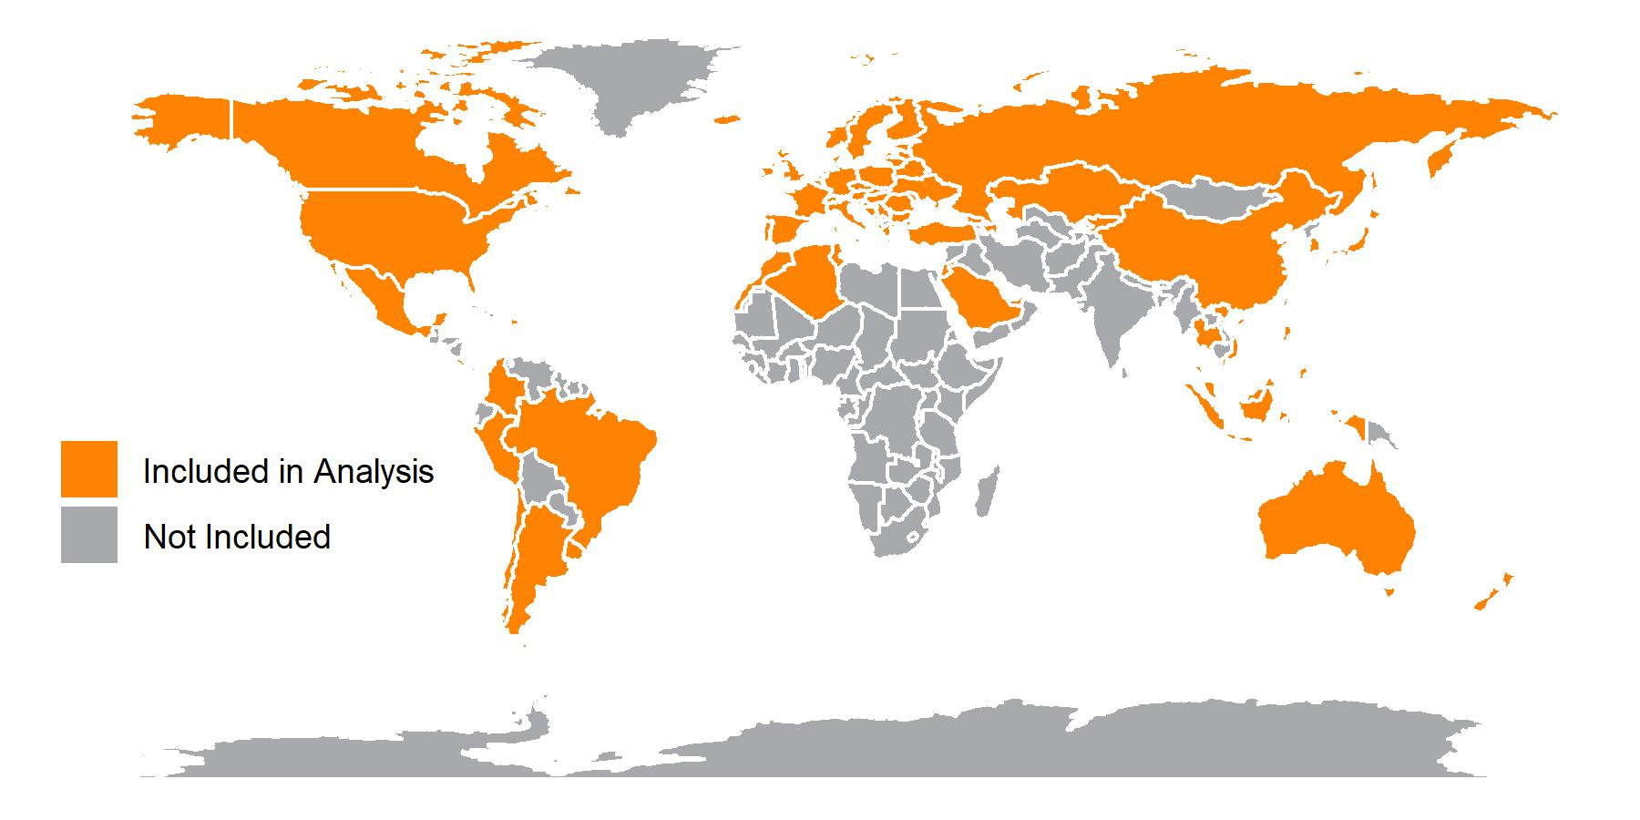
Figure 22: Map of countries included in sample.

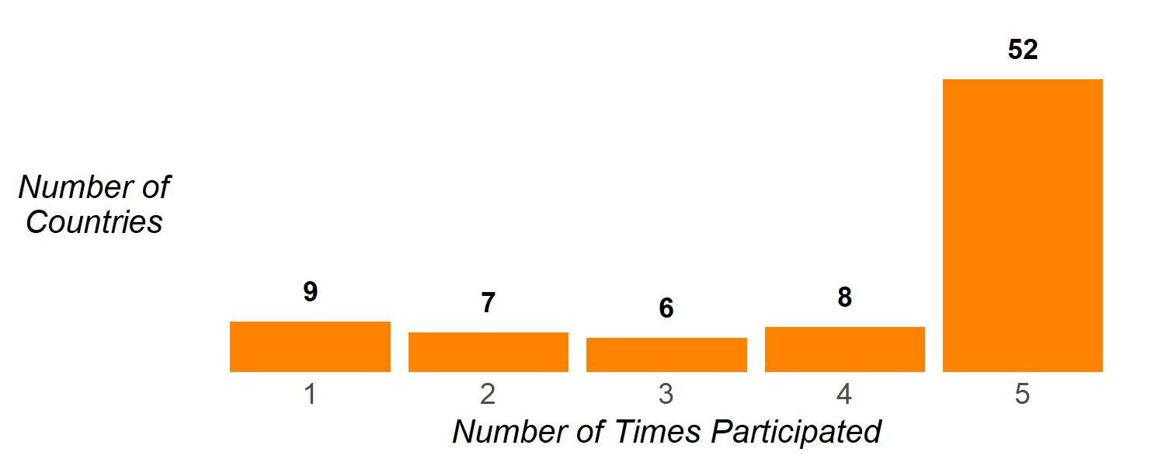
Figure 23: Number of countries by number of times they participated in the PISA

CHAPTER FIVE: Discussion and Conclusion
This final chapter focuses on interpreting the statistical results. In particular, results are explicitly connected back to the research questions the methods aimed to answer. Results are discussed within the context of the conceptual framework and the relevant literature base. Following the discussion, implications for policy and future research will be considered. Finally, the conclusion section condenses the previous chapters into a summary that provides an adroit climax to the whole project.

Discussion
The conceptual framework put forth in Chapters 2 and 3 detailed a “trickle-up” process by which changes in understanding climate change through increased scientific literacy can influence individual beliefs and behaviors. These individual changes can then go on to affect family and friends, community, and even one’s nation through shifts in behaviors, norms, and policy support. These shifts, in turn, can culminate in decreases in carbon emissions for a country. Based on prior literature and research, such a concept is realistic. Yet, no analysis has attempted to empirically assess it. The point of this dissertation was to measure these relationships and understand how they may differ by economic development status and gender, both of which have differential relationships to various aspects of climate change.
Research question one explored whether a relationship existed between changes in scientific literacy as measured by the PISA and per capita CO₂ emissions. The multilevel growth model that was estimated attempted to answer that question by examining the association between scientific literacy and CO₂, holding a number of theoretically determined variables constant as a means to isolate the effect of scientific literacy. Furthermore, scientific literacy itself was separated into two distinct measures in order to isolate the within-country and between-country effects. The within-country effects (scientific literacy within) allow examination of how a country’s fluctuations in scientific literacy scores are related to CO₂. The between-country effects (scientific literacy between) allow comparison of average CO₂ emissions per capita across countries. Figure 24 depicts this difference clearly. The colored lines represent the estimated effects for individual countries while the black line represents the effect for all countries.
Overall, the results indicated that there was a statistically significant relationship between scientific literacy and CO₂ per capita when comparing between countries. In particular, a 1-point increase in average scientific literacy is associated with a 0.45% increase in CO₂ per capita. By any measure, the effect of scientific literacy on CO₂ is negligible. Still, the effect is positive whereas the conceptual framework indicates it should be negative. One way to interpret the scientific literacy between effect is as an effect that indicates that countries with higher average scientific literacy have higher CO₂ emissions. When considered this way, it can be argued that what is driving CO₂ is not scientific literacy but a characteristic of these countries that have higher average scores. Indeed, this reflects findings by Jorgenson (2003; 2005) and Mayer (2013), who also found increases in education to be related to higher emissions. Jorgenson (2003) explains that higher education can lead to increased consumption via higher incomes, which in turn leads to higher emissions. In other words, affluence or economic growth can help explain the relationship between the scientific literacy scores across countries and those country’s emissions.
Figure 25 explains this further. On the vertical y-axis is CO₂ per capita. On the x-axis is scientific literacy scores. The dots represent individual countries. They are colored according to their region and sized based on their GDP per capita, with larger circles representing countries with higher GDP. The black vertical line represents average scientific literacy scores. The black horizontal line represents average CO₂ per capita. The plot is separated into OECD and Non-OECD panels. As depicted in the figure, most OECD nations have above-average scientific literacy scores and have above average CO₂ emissions. These nations also tend to have high GDPs. We can also see a number of middle-income nations. We also find that nations below average on these two measures typically have lower GDPs and lower scientific literacy scores. While there are nations that deviate, the overall pattern suggests that GDP drives emissions rather than scientific literacy. This is further evidenced by examining the correlations (Figure 16: GDP has a strong correlation to both scientific literacy (.51) and CO₂ per capita (.47) whereas scientific literacy has a weak correlation with CO₂ (.19).
That GDP is a major driver of emissions should not be surprising. It is a cornerstone of the $IPAT$ concept (GDP is a measure of affluence, A) and its significant relationship to emissions has been demonstrated multiple times (Dietz, Rosa, et al., 2007; Hailemariam et al., 2020; McGee & Greiner, 2018; Mitchell, 2012). Though not directly significant in the present research, its role, especially as it correlates to scientific literacy, is clear.
The current findings also echo previous research related to income inequality, as measured by the Gini coefficient. Aside from the effect of time and scientific literacy between countries, income inequality was the only other variable to have a significant relationship to per capita carbon emissions. A 1% increase in income inequality is associated with a 1.65% decrease in carbon emissions. That is, as income inequality grows, carbon emissions decrease. Like GDP, the current finding corroborates previous work by Hailemariam et al. (2020), Jorgenson et al. (2017), Jorgenson et al. (2018), McGee & Greiner (2018), and others.
In what ways does income inequality contribute to increased carbon emissions? McGee & Greiner (2018) argue that there is a significant interaction between GDP and Gini. For high Gini nations (those with higher inequality), emissions levels increase as GDP in those nations also increase. Similar findings can be seen in Hailemariam et al. (2020). They argue that inequality is driven by the consumption behaviors of the top income earners (e.g., the richest 10%) as well as the gap between low- and middle-income households, which the Gini coefficient is a better representation of. As inequality increases, the gap between low and middle-income households increases, with more low-income households than higher income. Thus, there are less emissions due to lower economic ability for consumption of goods and energy. Conversely, as inequality decreases and income across a nation increases, so too does carbon-intensive consumption.
Thus far, based on the results of the dissertation, a relationship between scientific literacy, economics, and carbon emissions across countries has been established. However, when controlling for these factors, how does the relationship within a country over time unfold? That is, are changes in scientific literacy for an individual country significantly related to changes in that individual country’s emissions, all else held constant?
The results of the analysis found no significant relationship between an individual country’s change in scientific literacy scores and their CO₂ per capita levels. Likewise, the results also found no significant differences for OECD and non-OECD nations (research question two) or for males and females (research question three). This was somewhat surprising. These relationships as explained in the conceptual model should exist, but were not found by this research. This points to an issue of undetermination (Schultz, 2018; Stanford, 2021). Undetermination refers to a “condition where the information available is insufficient for determining what we should believe” (Schultz, 2018, p. 55). In essence, the non-significant results do not suggest a rejection of the relationship between changes in scientific literacy and emissions. Rather, the results simply point to a lack of evidence for determining this relationship more fully. Assuming that the conceptual framework is accurate in suggesting that scientific literacy should affect emissions, there may be a number of reasons why such an effect was not detected. Chapter 4 already pointed out a number of statistical limitations that may have led to undetermination. However, there are several additional, education-related factors that should also be explored further.
Closer examination of scientific literacy’s change over time within countries shows many countries have relatively stable scores or scores that fluctuate wildly over time such that in one period there is marked growth while in the next period there is large decline (see Figure 26). In general, there is little variation in scientific literacy scores over time to find a clear association with CO₂ emissions. This is not a unique finding. The PISA points out (OECD, 2019b) that scientific literacy scores are relatively stable and when they do grow, it is by a small amount. Rowley et al. (2019) also found that during the 2006 to 2012 period, PISA scores of most individual countries typically did not significantly increase or change.
While we may assume, or at least hope, that scientific literacy increases over time, that is unfortunately not evident. In fact, the PISA argues that large improvements in a country’s performance should not be expected, as changes in educational policy and practice are incremental and can take a while to surface (OECD, 2019b, p. 121). This slow-to-surface phenomena may be one reason why a significant relationship between changes in a country’s CO₂ and changes in its scientific literacy scores were not found.
Undetermination may also be aided by other factors. For example, while scientific literacy as measured by the PISA may include climate change and related content, it is ultimately a test of science education in general rather than climate (change) education in particular. There is no guarantee of either the quantity or quality of climate change education students receive through their science education classwork. For example, Ranney & Clark (2016) have demonstrated that mechanistic climate knowledge can help shift individual understanding of climate change and the need for action. It is entirely plausible that students
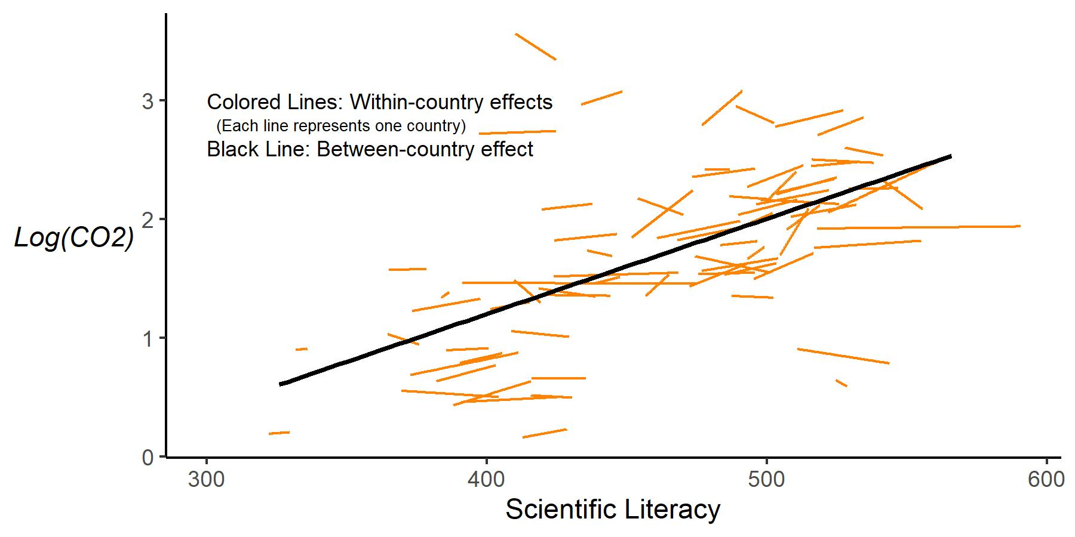
Figure 24: Within and between effects of scientific literacy on CO₂

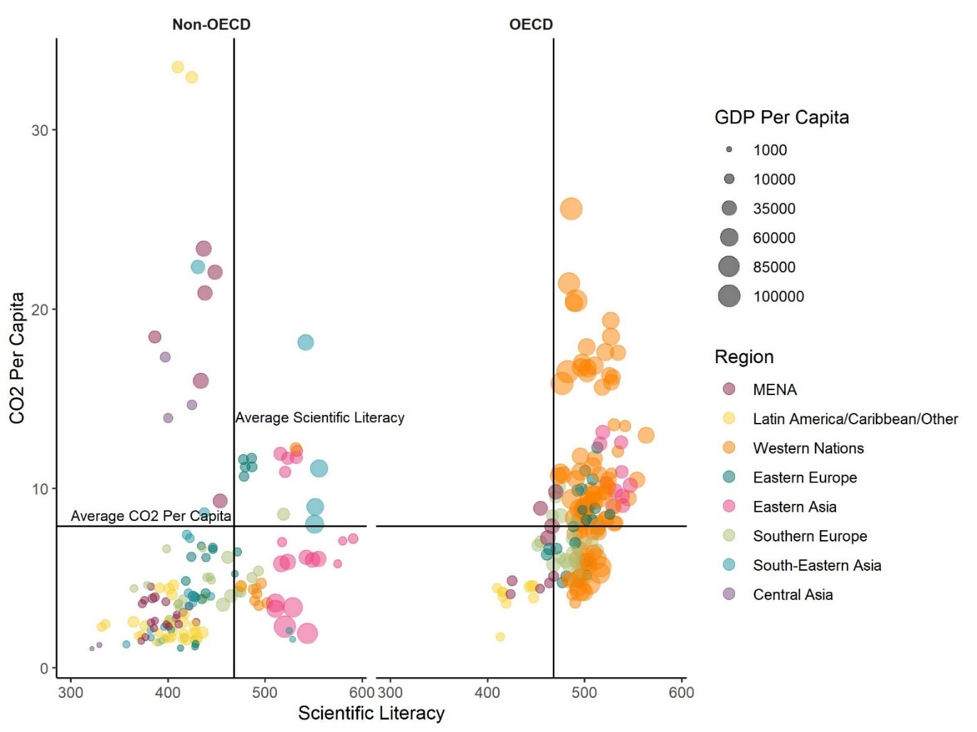
Figure 25: The relationships between CO₂, GDP, and scientific literacy.
are not given a strong mechanistic climate change foundation through their home education systems.
Indeed, though climate change education has been part of the United Nations’ sustainable development goals, which has an influence on educational content across the globe (Sinnes & Eriksen, 2016; United Nations, 2014), climate change may neither be the focus nor the norm of science education courses. Data on how climate change is integrated into national curricula is lacking. UNESCO (2021) offers perhaps the only source of cross-national information on this. In their survey of 129 documents from 100 countries, they found that just 53% of countries’ curricula mention climate change. For most of the countries surveyed, climate change accounts for about 10% or less of curricular content (Figure 27). Interestingly, sub-Saharan Africa has the largest percentage of climate change content - an area that is not assessed by the PISA and by extension is not part of this research.
While UNESCO’s brief does offer case studies of national integration for a few countries, their findings do not offer enough details as to either the depth or breadth of the way climate change is being taught. Even when national curricula do include climate change, implementation fidelity may vary widely or be completely lacking.
The United States offers an example of this variation. No national curriculum exists in the United States. However, many states have chosen to adopt a set of science standards called the Next Generation Science Standards (NGSS). Other states have modified versions of the NGSS while several others have homegrown sets of state standards. The NGSS was the first set of standards to place climate change explicitly in the curriculum. In fact, objection to climate change content (among other “controversial” content, such as evolution) is one of the reasons why states created modified or altogether new standards (Worth, 2021). A grading of these standards by National Center for Science Education & Texas Freedom Education Fund
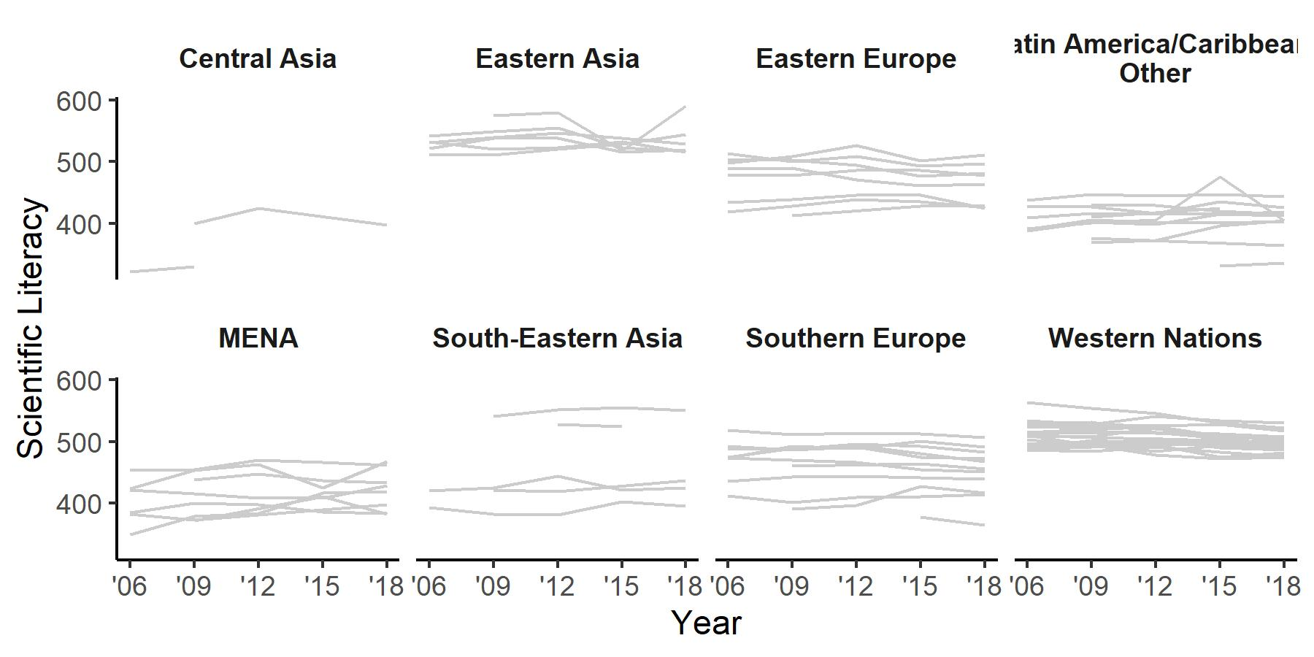
Figure 26: Change in scientific literacy over time by region.

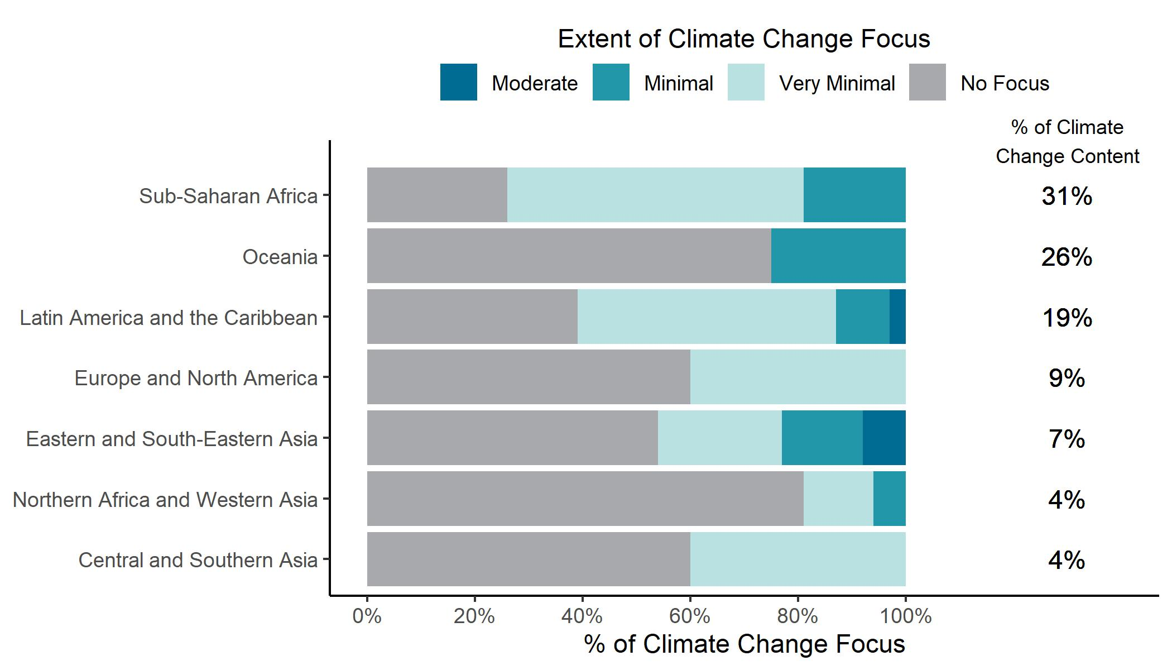
Figure 27: Percentage of climate change content in curricula by region. Figure reproduced from UNESCO (2021).

(2020) on an A-F scale for each state found that NGSS states and those who have modified NGSS standards typically have the highest grades in terms of how climate change is taught. States with homegrown standards typically have the lowest grades.
The implication of these various standards means that students in the same country can receive radically different climate (change) education, ranging from a few weeks to none at all. Perhaps worse is that what is taught about climate change may be factually incorrect or alienated from human activities. Such an example is likely in countries where climate change is seen as political or where there is a strong, well-funded climate change denial movement (Brulle, 2020; Mann, 2021), something more likely to occur in Western nations (Czarnek et al., 2021).
There are also a number of other plausible reasons for undetermination of the conceptual framework for this dissertation. For example, perhaps the climate education that does exist has a positive effect on individual beliefs, but lack of education on effective actions is an issue. K. T. Stevenson et al. (2018) also identified such a phenomenon, where teaching about climate change positively affected concern and hope but not behavior. It could also be that a focus on action is not emphasized. For example, Wynes & Nicholas (2019) found that most Canadian secondary school curricula emphasized mechanistic knowledge of climate change rather than effective actions. Possibly due in part to this, Wynes et al. (2020) also found that a general lack of understanding about what effective climate actions look like.

Implications
The undetermination of the results and the possible reasons why effects have thus far not been detected, coupled with the statistical limitations of the models, suggest a number of future research directions. In order to improve the statistical power of the model, the analysis could be redone after several additional PISA assessment cycles pass. This not only ensures a larger sample size to work with but the expanded time span may allow for the measuring of education effects of policy changes made a decade or more in the past.
Augmenting the statistical models to include measures of the quality or quantity of climate (change) education can also improve the insight derived from these models. While UNESCO (2021) provides a broad quantitative overview of how climate change is included in curricula around the world, the data are not publicly available. Currently, a robust, publicly available international data set of similar measures does not exist but would certainly be worth curating for future research. Including variables to capture misinformation or media bias may also shed light on interesting interactions with education and emissions Alternatively, the analysis can focus on a single country, where more localized variables can be included. For example, a model focusing on the United States could include science scores by state from the Trends in International Mathematics and Science Study [PISA scores do not have state information; Carnoy et al. (2015)]. It could look at state-level emissions and the interaction between science trends and climate (change) education quality from National Center for Science Education & Texas Freedom Education Fund (2020) on emissions. Measures of local and national governance could be included (Schmidt & Rocconi., 2021) as environmental voting records (e.g. data from the League of Conservation Voters). Rather than examining CO₂ emissions, utilizing another outcome may pick up on small shifts in behavior, such as policy support, ecological footprint, or fossil-fuel-based energy use may be viable alternatives to carbon emissions or serve as useful covariates.
Besides research implications, there are definite implications for education and policy. Education has been considered a crucial component in fighting climate change (UNESCO, 2015). Yet, just over half of curricula around the globe mention climate change. Few countries likely teach it with any depth that considers not only its mechanistic components but also effective actions that can be done to foster individual and systemic change. If science education (and, by extension, climate change education) is to have any effect on the climate crisis, the suggestions from UNESCO (2021, p. 12) are worth considering:
- Climate change education should be a core curriculum component in every country.
- Greater focus on climate change content is needed in the curricula of countries most responsible for climate change.
- Climate change education should be integrated across all levels and disciplines of learning.
- Teachers and school leaders need to be prepared to teach climate change.
- Climate change education must equally focus on ‘head,’ ‘heart’ and ‘hands’ – and teachers need to be ready.
- Climate change education should be woven into diverse aspects of countries’ policies and programmes.
- Ministries of Education and Environment can and should work together to boost climate change education.
To add to those suggestions, education must focus on increasing knowledge, raising concern, instilling hope, and fostering action (Nicholas, 2021; Steinberger, 2022). This may be particularly important for many countries with high scientific literacy rates, which are associated with higher carbon emissions. Nielsen et al. (2021) point out five roles that high-SES individuals can follow to have a meaningful effect on the climate: consumer, investor, citizen, organizational participant, and role model. Many of these can apply directly to adolescents or indirectly to their families. Adolescents (or any school-aged child) can follow and promote sustainable consumption, encourage their parents to invest in fossil-fuel-free portfolios, encourage climate-friendly candidate and policy support, promote sustainable changes at school (e.g., Lieberman, 2022), and become role models of sustainability to their larger community (see also Project Drawdown, 2020 for additional actions and their related emissions changes).
Knowledge is key for helping students understand the climate crisis. Teaching about hope and action is crucial for moving beyond knowledge. These are, however, admittedly large challenges, ones that may ask teachers to step out of their comfort zone. But in a world where nearly 60% of young people around the globe are experiencing some form of climate anxiety (Marks et al., 2021), there is a strong and well-funded climate denial movement Mann (2021), and literal time is running out (we are expected to exceed 1.5 degrees of warming by 2030), it seems time to, quoting Greta Thunberg (2018) again, “wake up and change.”

Conclusion
Human activities have radically changed the climate, negatively impacting most species of life on earth, people included. While technology has advanced to such a degree that we now posses most of the means of preventing further climate change, there are still major social and political hurdles that stand in the way. Education has been touted as one possible means for helping to move forward necessary action on climate change. A hybrid model of planned behavior and human capital helps explain how education can affect climate change. Essentially, increased knowledge about science and climate change can lead to increased beliefs and concern among adolescents, which can then go on to affect their behavior and the behavior of their friends, family, and community. Through increased belief in climate change, pro-environmental behavior, and policy support at local and national levels, there may be a “trickle-up” impact of education on national carbon emissions.
The current dissertation sought to assess this model and determine what, if any, relationship education may have on carbon emissions per capita. The PISA scientific literacy assessment was chosen as the key independent variable, as it attempts to measure the ability of fifteen-year-olds’ to use science knowledge in order to address the issues that they are facing. There is arguably no greater issue than climate change. A multilevel growth model was fit that examined changes in CO₂ per capita and PISA scientific literacy, holding a number of social, political, and economic variables constant.
The results indicated that, while increases in scientific literacy across all countries are significantly associated with an increase in CO₂ per capita, this is likely mostly driven by economics, namely GDP. There were no significant relationships between changes in scientific literacy within a country and that country’s emissions. This suggests evidence for the conceptual framework is undetermined, as there are a number of statistical and educational factors that may be attenuating any potential effect from education.
Based on this research, it is suggested that shifts in educational policies and practices that emphasize and integrates science and climate change education across the curricula may have a greater effect on emissions than is currently the case. In addition, science and climate education should be imbued with a focus on effective climate change actions that can foster the individual and systemic changes needed to avert a global catastrophe.

REFERENCES
Akenji, L., Lettenmeir, M., Toivio, V., Koide, R., & Amellina, A. (2019). 1.5-degree lifestyles.
Aleman, E., & Kim, Y. (2015). The democratizing effect of education. Research & Politics, 2(4), 2053168015613360. https://doi.org/10.1177/2053168015613360
ALLEA. (2020). A snapshot of climate change education initiatives in Europe. ALLEA.
Aloisi, C., & Tymms, P. (2017). PISA trends, social changes, and education reforms. Educational Research and Evaluation, 23(5-6), 180–220. https://doi.org/10.1080/13803611.2017.1455290
Andrew, R., & Peters, G. (2021). The Global Carbon Project’s fossil CO2 emissions dataset. https://doi.org/10.6084/m9.figshare.16729084.v1
Aparicio, J., Cordero, J. M., & Ortiz, L. (2021). Efficiency analysis with educational data: How to deal with plausible values from international large-scale assessments. Mathematics, 9(13), 1579.
Apollo, A., & Mbah, M. F. (2021). Challenges and opportunities for climate change education (CCE) in East Africa: A critical review. Climate, 9(6), 93. https://doi.org/10.3390/cli9060093
Attari, S. Z., Krantz, D. H., & Weber, E. U. (2019). Climate change communicators’ carbon footprints affect their audience’s policy support. Climatic Change, 154(3), 529–545. https://doi.org/10.1007/s10584-019-02463-0
Axinn, W. G., & Thornton, A. (1993). Mothers, children, and cohabitation: The intergenerational effects of attitudes and behavior. American Sociological Review, 58(2), 233–246. https://doi.org/10.2307/2095968
Azevedo, J., & Marques, M. (2017). Climate literacy: A systematic review and model integration. International Journal of Global Warming, 12, 414. https://doi.org/10.1504/IJGW.2017.084789
Baker, D. P., Leon, J., Greenaway, E. G. S., Collins, J., & Movit, M. (2011). The education effect on population health: A reassessment. Population and Development Review, 37(2), 307–332. https://doi.org/10.1111/j.1728-4457.2011.00412.x
Ballantyne, R., Connell, S., & Fien, J. (1998). Students as catalysts of environmental change: A framework for researching intergenerational influence through environmental education. Environmental Education Research, 4(3), 285–298. https://doi.org/10.1080/1350462980040304
Bano, S., Zhao, Y., Ahmad, A., Wang, S., & Liu, Y. (2018). Identifying the impacts of human capital on carbon emissions in Pakistan. Journal of Cleaner Production, 183, 1082–1092. https://doi.org/10.1016/j.jclepro.2018.02.008
Bates, D. M. (2010). Lme4: Mixed-effects modeling with R. Springer.
Becker, G. S. (1993). Nobel lecture: The economic way of looking at behavior. Journal of Political Economy, 101(3), 385–409. https://doi.org/10.1086/261880
Beugelsdijk, S., & Welzel, C. (2018). Dimensions and dynamics of national culture: Synthesizing Hofstede with Inglehart. Journal of Cross-Cultural Psychology, 49(10), 1469–1505. https://doi.org/10.1177/0022022118798505
Blodgett, J. G., Bakir, A., & Rose, G. M. (2008). A test of the validity of Hofstede’s cultural framework. Journal of Consumer Marketing, 25(6), 339–349. https://doi.org/10.1108/07363760810902477
Bloem, S. (2013). PISA in low and middle income countries. OECD. https://doi.org/10.1787/5k41tm2gx2vd-en
Boese, V. A. (2019). How (not) to measure democracy. International Area Studies Review, 22(2), 95–127. https://doi.org/10.1177/2233865918815571
Boeve-de Pauw, J., & Van Petegem, P. (2010). A cross-national perspective on youth environmental attitudes. The Environmentalist, 30(2), 133–144. https://doi.org/10.1007/s10669-009-9253-1
Bollinger, B., & Gillingham, K. (2012). Peer effects in the diffusion of solar photovoltaic panels. Marketing Science, 31(6), 900–912. https://doi.org/10.1287/mksc.1120.0727
Boudet, H., Ardoin, N. M., Flora, J., Armel, K. C., Desai, M., & Robinson, T. N. (2016). Effects of a behaviour change intervention for Girl Scouts on child and parent energy-saving behaviours. Nature Energy, 1(8), 16091. https://doi.org/10.1038/nenergy.2016.91
Bridges, D. (2008). Educationalization: On the appropriateness of asking educational institutions to solve social and economic problems. Educational Theory, 58(4), 461–474. https://doi.org/10.1111/j.1741-5446.2008.00300.x
Brulle, R. (2020). Denialism: Organized opposition to climate change action in the United States.
Busch, K. C., Ardoin, N., Gruehn, D., & Stevenson, K. (2019). Exploring a theoretical model of climate change action for youth. International Journal of Science Education, 41(17), 2389–2409. https://doi.org/10.1080/09500693.2019.1680903
Busch, K. C., & Rom’an, D. (2017). Fundamental Climate Literacy and the Promise of the Next Generation Science Standards. In D. P. Shepardson, A. Roychoudhury, & A. S. Hirsch (Eds.), Teaching and Learning About Climate Change (First, pp. 120–134). Routledge. https://doi.org/10.4324/9781315629841-9
Bustamante, M. M. C., Silva, J. S., Scariot, A., Sampaio, A. B., Mascia, D. L., Garcia, E., Sano, E., Fernandes, G. W., Durigan, G., Roitman, I., Figueiredo, I., Rodrigues, R. R., Pillar, V. D., de Oliveira, A. O., Malhado, A. C., Alencar, A., Vendramini, A., Padovezi, A., Carrascosa, H., … Nobre, C. (2019). Ecological restoration as a strategy for mitigating and adapting to climate change: Lessons and challenges from Brazil. Mitigation and Adaptation Strategies for Global Change, 24(7), 1249–1270. https://doi.org/10.1007/s11027-018-9837-5
Bybee, R. W. (2008). Scientific literacy, environmental issues, and PISA 2006: The 2008 Paul F. Brandwein lecture. Journal of Science Education and Technology, 17(6), 566–585. https://doi.org/10.1007/s10956-008-9124-4
Campbell, J. A., McIntyre, J., & Kucirkova, N. (2021). Gender equality, human development, and PISA results over time. Social Sciences, 10(12), 480. https://doi.org/10.3390/socsci10120480
Carbon Brief. (2018). Interactive: The impacts of climate change at 1.5C, 2C and beyond.
Carnoy, Garcia, E., & Khavenson, T. (2015). Bringing it back home: Why state comparisons are more useful than international comparisons for improving U.S. Education policy. In Economic Policy Institute.
Caro, D. H., & Biecek, P. (2017). Intsvy: An R package for analyzing international large-scale assessment data. Journal of Statistical Software, 81, 1–44. https://doi.org/10.18637/jss.v081.i07
Carrico, A. R. (2021). Climate change, behavior, and the possibility of spillover effects: Recent advances and future directions. Current Opinion in Behavioral Sciences, 42, 76–82. https://doi.org/10.1016/j.cobeha.2021.03.025
Carstensen, C. H. (2013). Linking PISA competencies over three cycles: Results from Germany. In M. Prenzel, M. Kobarg, K. Schöps, & S. Rönnebeck (Eds.), Research on PISA (pp. 199–213). Springer Netherlands. https://doi.org/10.1007/978-94-007-4458-5_12
Chertow, M. R. (2000). The IPAT equation and its variants. Journal of Industrial Ecology, 4(4), 13–29. https://doi.org/10.1162/10881980052541927
Chineka, R., & Yasukawa, K. (2020). Intergenerational learning in climate change adaptations; limitations and affordances. Environmental Education Research, 26(4), 577–593. https://doi.org/10.1080/13504622.2020.1733494
Cialdini, R. B. (2007). Descriptive social norms as underappreciated sources of social control. Psychometrika, 72(2), 263. https://doi.org/10.1007/s11336-006-1560-6
Climate Watch. (2019). Historical GHG emissions.
Clogg, C. C., Petkova, E., & Haritou, A. (1995). Statistical methods for comparing regression coefficients between models. American Journal of Sociology, 100(5), 1261–1293. https://doi.org/10.1086/230638
Coertjens, L., Boeve-de Pauw, J., De Maeyer, S., & Van Petegem, P. (2010). Do schools make a difference in their students’ environmental attitudes and awareness? Evidence from PISA 2006. International Journal of Science and Mathematics Education, 8(3), 497–522. https://doi.org/10.1007/s10763-010-9200-0
Collins, R. (1988). The micro contribution to macro sociology. Sociological Theory, 6(2), 242–253. https://doi.org/10.2307/202118
Coppedge, M., Gerring, J., Knutsen, C. H., Lindberg, S. I., Teorell, J., Alizada, N., Altman, D., Bernhard, M., Cornell, A., Fish, M. S., Gastaldi, L., Gjerløw, H., Glynn, A., Hicken, A., Hindle, G., Ilchenko, N., Krusell, J., Lührmann, A., Maerz, S. F., … Ziblatt, D. (2021a). V-dem country-year dataset V11.1. Varieties of Democracy (V-Dem) Project. https://doi.org/10.23696/vdemds21
Coppedge, Michael, Gerring, J., Knutsen, C. H., Lindberg, S. I., Teorell, J., Altman, D., Bernhard, M., Cornell, A., Fish, M. S., Gastaldi, L., Gjerløw, H., Glynn, A., Hicken, A., Lührmann, A., Maerz, S. F., Marquardt, K. L., McMann, K., Mechkova, V., … Ziblatt, D. (2021b). V-dem codebook V11.1. Varieties of Democracy (V-Dem) Project.
Cordero, E. C., Centeno, D., & Todd, A. M. (2020). The role of climate change education on individual lifetime carbon emissions. PLOS ONE, 15(2), e0206266. https://doi.org/10.1371/journal.pone.0206266
Cordero, J. M., Cristobal, V., & Santin, D. (2018). Causal inference on education policies: A survey of empirical studies using PISA, TIMSS and PIRLS: Causal inference on education policies. Journal of Economic Surveys, 32(3), 878–915. https://doi.org/10.1111/joes.12217
Corner, A., Roberts, O., Chiari, S., Völler, S., Mayrhuber, E. S., Mandl, S., & Monson, K. (2015). How do young people engage with climate change? The role of knowledge, values, message framing, and trusted communicators. WIREs Climate Change, 6(5), 523–534. https://doi.org/10.1002/wcc.353
Czarnek, G., Kossowska, M., & Szwed, P. (2021). Right-wing ideology reduces the effects of education on climate change beliefs in more developed countries. Nature Climate Change, 11(1), 9–13. https://doi.org/10.1038/s41558-020-00930-6
Darlington, R. B., & Hayes, A. F. (2017). Regression analysis and linear models: Concepts, applications, and implementation. The Guilford Press.
Davis-Kean, P. E. (2005). The Influence of Parent Education and Family Income on Child Achievement: The Indirect Role of Parental Expectations and the Home Environment. Journal of Family Psychology, 19(2), 294–304. https://doi.org/10.1037/0893-3200.19.2.294
de Leeuw, A., Valois, P., Ajzen, I., & Schmidt, P. (2015). Using the theory of planned behavior to identify key beliefs underlying pro-environmental behavior in high-school students: Implications for educational interventions. Journal of Environmental Psychology, 42, 128–138. https://doi.org/10.1016/j.jenvp.2015.03.005
DeBoer, G. E. (1991). A history of ideas in science education: Implications for practice. Teachers College Press.
Demaria, F., Schneider, F., Sekulova, F., & Martinez-Alier, J. (2013). What is degrowth? From an activist slogan to a social movement. Environmental Values, 22(2), 191–215. https://doi.org/10.3197/096327113X13581561725194
Derman, M., & Gurbuz, H. (2018). Environmental education in the science curriculum in different countries: Turkey, Australia, Singapore, Ireland, and Canada. Journal of Education in Science, Environment and Health, 129–141. https://doi.org/10.21891/jeseh.409495
Desjardins, C. D., & Bulut, O. (2018). Handbook of educational measurement and psychometrics using R.
Desjardins, R. (2015). Education and social transformation. European Journal of Education, 50(3), 239–244. https://doi.org/10.1111/ejed.12140
Dewey, J. (1897). My pedagogic creed. School Journal, 54, 77–80.
Dietz, T., Dan, A., & Shwom, R. (2007). Support for climate change policy: Social psychological and social structural influences*. Rural Sociology, 72(2), 185–214. https://doi.org/10.1526/003601107781170026
Dietz, T., Fitzgerald, A., & Shwom, R. (2005). Environmental values. Annual Review of Environment and Resources, 30(1), 335–372. https://doi.org/10.1146/annurev.energy.30.050504.144444
Dietz, T., Frank, K. A., Whitley, C. T., Kelly, J., & Kelly, R. (2015). Political influences on greenhouse gas emissions from US states. Proceedings of the National Academy of Sciences, 112(27), 8254–8259. https://doi.org/10.1073/pnas.1417806112
Dietz, T., Rosa, E. A., & York, R. (2012). Environmentally efficient well-being: Is there a Kuznets curve? Applied Geography, 32(1), 21–28. https://doi.org/10.1016/j.apgeog.2010.10.011
Dietz, T., Rosa, E. A., & York, R. (2007). Driving the human ecological footprint. Frontiers in Ecology and the Environment, 5(1), 13–18. https://doi.org/10.1890/1540-9295(2007)5[13:DTHEF]2.0.CO;2
Dostie-Goulet, E. (2009). Social networks and the development of political interest. Journal of Youth Studies, 12(4), 405–421. https://doi.org/10.1080/13676260902866512
Drummond, C., & Fischhoff, B. (2017). Individuals with greater science literacy and education have more polarized beliefs on controversial science topics. Proceedings of the National Academy of Sciences, 114(36), 9587–9592. https://doi.org/10.1073/pnas.1704882114
du Prel, J.-B., Hommel, G., Röhrig, B., & Blettner, M. (2009). Confidence interval or p-value? Deutsches Ärzteblatt International, 106(19), 335–339. https://doi.org/10.3238/arztebl.2009.0335
Dunaway, F. (2017, November 21). The ’Crying Indian’ ad that fooled the environmental movement. Chicago Tribune.
Ehrhardt-Martinez, K., Rudel, T. K., Norgaard, K. M., & Broadbent, J. (2015). Mitigating climate change. In R. E. Dunlap & R. J. Brulle (Eds.), Climate Change and Society: Sociological Perspectives (pp. 199–234). Oxford University Press.
Engels, A., Hüther, O., Schäfer, M., & Held, H. (2013). Public climate-change skepticism, energy preferences and political participation. Global Environmental Change, 23(5), 1018–1027. https://doi.org/10.1016/j.gloenvcha.2013.05.008
Ergas, C., Greiner, P. T., McGee, J. A., & Clement, M. T. (2021). Does gender climate influence climate change? The multidimensionality of gender equality and its countervailing effects on the carbon intensity of well-being. Sustainability, 13(7), 3956. https://doi.org/10.3390/su13073956
Ergas, C., & York, R. (2012). Women’s status and carbon dioxide emissions: A quantitative cross-national analysis. Social Science Research, 41(4), 965–976. https://doi.org/10.1016/j.ssresearch.2012.03.008
Erler, N. S., Rizopoulos, D., & Lesaffre, E. M. E. H. (2021). Jointai: Joint analysis and imputation of incomplete data in r. Journal of Statistical Software, 100, 1–56. https://doi.org/10.18637/jss.v100.i20
Fairbrother, M., Johansson Sevä, I., & Kulin, J. (2019). Political trust and the relationship between climate change beliefs and support for fossil fuel taxes: Evidence from a survey of 23 European countries. Global Environmental Change, 59, 102003. https://doi.org/10.1016/j.gloenvcha.2019.102003
Fox, J., & Dusa, A. (2022). Polycor: Polychoric and polyserial correlations.
Frankenberg, E., Sikoki, B., Sumantri, C., Suriastini, W., & Thomas, D. (2013). Education, vulnerability, and resilience after a natural disaster. Ecology and Society : A Journal of Integrative Science for Resilience and Sustainability, 18(2), 16. https://doi.org/10.5751/ES-05377-180216
Friedlingstein, P., Jones, M. W., O’Sullivan, M., Andrew, R. M., Bakker, D. C. E., Hauck, J., Le Qu’er’e, C., Peters, G. P., Peters, W., Pongratz, J., Sitch, S., Canadell, J. G., Ciais, P., Jackson, R. B., Alin, S. R., Anthoni, P., Bates, N. R., Becker, M., Bellouin, N., … Zen, J. (2021). Global Carbon Budget 2021. Earth System Science Data Discussions, 1–191. https://doi.org/10.5194/essd-2021-386
Furr, R. M., & Bacharach, V. R. (2014). Psychometrics: An introduction (Second edition). SAGE.
Gamboa, L. F., & Waltenberg, F. D. (2015). Measuring inequality of opportunity in education by combining information on coverage and achievement in PISA. Educational Assessment, 20(4), 320–337. https://doi.org/10.1080/10627197.2015.1093926
Garson, G. D. (2015). Missing values analysis & data imputation. Statistical Associates Publishing.
Geiger, S. M., Geiger, M., & Wilhelm, O. (2019). Environment-specific vs. General knowledge and their role in pro-environmental behavior. Frontiers in Psychology, 10, 718. https://doi.org/10.3389/fpsyg.2019.00718
Gelissen, J. (2007). Explaining popular support for environmental protection: A multilevel analysis of 50 nations. Environment and Behavior, 39(3), 392–415. https://doi.org/10.1177/0013916506292014
Gerlach, P., & Eriksson, K. (2021). Measuring cultural dimensions: External validity and internal consistency of Hofstede’s VSM 2013 scales. Frontiers in Psychology, 12, 1056. https://doi.org/10.3389/fpsyg.2021.662604
Gillies, D. (2017). Human capital theory in education. Encyclopedia of Educational Philosophy, 1053–1057.
Givens, J. E. (2015). Urbanization, slums, and the carbon intensity of well-being: Implications for sustainable development. Human Ecology Review, 22(1), 107–128.
Glesne, C. (2016). Becoming qualitative researchers: An introduction. Pearson.
Green, J. F. (2021). Does carbon pricing reduce emissions? A review of ex-post analyses. Environmental Research Letters, 16(4), 043004. https://doi.org/10.1088/1748-9326/abdae9
Greiner, P. T., & McGee, J. A. (2020). The asymmetry of economic growth and the carbon intensity of well-being. Environmental Sociology, 6(1), 95–106. https://doi.org/10.1080/23251042.2019.1675567
Griffin, P. (2017). The carbon majors database: CDP carbon majors report 2017 (p. 16). CDP.
Grimm, K. J., Ram, N., & Estabrook, R. (2017). Growth modeling: Structural equation and multilevel modeling approaches. Guilford Press.
Gronhoj, A., & Thogersen, J. (2012). Action speaks louder than words: The effect of personal attitudes and family norms on adolescents’ pro-Environmental behaviour. Journal of Economic Psychology, 33(1), 292–302. https://doi.org/10.1016/j.joep.2011.10.001
Grund, S., Robitzsch, A., & Luedtke, O. (2021). Mitml: Tools for multiple imputation in multilevel modeling.
Guy, S., Kashima, Y., Walker, I., & O’Neill, S. (2014). Investigating the effects of knowledge and ideology on climate change beliefs. European Journal of Social Psychology, 44(5), 421–429. https://doi.org/10.1002/ejsp.2039
Hailemariam, A., Dzhumashev, R., & Shahbaz, M. (2020). Carbon emissions, income inequality and economic development. Empirical Economics, 59(3), 1139–1159. https://doi.org/10.1007/s00181-019-01664-x
Hamilton, L. C. (2011). Education, politics and opinions about climate change evidence for interaction effects. Climatic Change, 104(2), 231–242. https://doi.org/10.1007/s10584-010-9957-8
Hamilton, L. C., Hartter, J., Lemcke-Stampone, M., Moore, D. W., & Safford, T. G. (2015). Tracking public beliefs about anthropogenic climate change. PLOS ONE, 10(9), e0138208. https://doi.org/10.1371/journal.pone.0138208
Hanushek, E. A. (2010). Education and economic growth. International Encyclopedia of Education, 2, 9.
Harker-Schuch, I. (2019). Why Is Early Adolescence So Pivotal in the Climate Change Communication and Education Arena? In W. Leal Filho & S. L. Hemstock (Eds.), Climate Change and the Role of Education (pp. 279–290). Springer International Publishing. https://doi.org/10.1007/978-3-030-32898-6_16
Harper, A., & Vinke, K. (2020, November). Climate change and the future of safe returns.
Hess, D. J., & Maki, A. (2019). Climate change belief, sustainability education, and political values: Assessing the need for higher-education curriculum reform. Journal of Cleaner Production, 228, 1157–1166. https://doi.org/10.1016/j.jclepro.2019.04.291
Hestness, E., McDonald, R. C., Breslyn, W., McGinnis, J. R., & Mouza, C. (2014). Science teacher professional development in climate change education informed by the Next Generation Science Standards. Journal of Geoscience Education, 62(3), 319–329. https://doi.org/10.5408/13-049.1
Heymans, M. W., & Eekhout, I. (2019). Applied missing data analysis with SPSS and RStudio.
Hoffman, L. (2015). Longitudinal analysis: Modeling within-person fluctuation and change.
Hofstede, G. J. (2015). Dimension data matrix. In Geert Hofstede. https://geerthofstede.com/research-and-vsm/dimension-data-matrix/.
Hornsey, M. J., Harris, E. A., Bain, P. G., & Fielding, K. S. (2016). Meta-analyses of the determinants and outcomes of belief in climate change. Nature Climate Change, 6(6), 622–626. https://doi.org/10.1038/nclimate2943
Hornsey, M. J., Harris, E. A., & Fielding, K. S. (2018). Relationships among conspiratorial beliefs, conservatism and climate scepticism across nations. Nature Climate Change, 8(7), 614–620. https://doi.org/10.1038/s41558-018-0157-2
Howe, P. D., Mildenberger, M., Marlon, J. R., & Leiserowitz, A. (2015). Geographic variation in opinions on climate change at state and local scales in the USA. Nature Climate Change, 5(6), 596–603. https://doi.org/10.1038/nclimate2583
Hox, J. J., Moerbeek, M., & van de Schoot, R. (2018). Multilevel analysis: Techniques and applications. Routledge.
Hultman, N., & Gross, S. (2021, March 1). How the United States can return to credible climate leadership. Brookings.
Huque, M. H., Carlin, J. B., Simpson, J. A., & Lee, K. J. (2018). A comparison of multiple imputation methods for missing data in longitudinal studies. BMC Medical Research Methodology, 18(1), 168. https://doi.org/10.1186/s12874-018-0615-6
Inglehart, R. (1995). Public support for environmental protection: Objective problems and subjective values in 43 societies. PS: Political Science and Politics, 28(1), 57–72. https://doi.org/10.2307/420583
Integrated Values Surveys (IVS) 1981-2021. (2021). In European Values Study. https://europeanvaluesstudy.eu/methodology-data-documentation/integrated-values-surveys-ivs-1981-2021/.
IPCC. (2014). Climate change 2014: Synthesis report. Contribution of working groups I, II and III to the fifth assessment report of the Intergovernmental Panel on Climate Change.
IPCC. (2018). Global warming of 1.5: An IPCC Special Report on the impacts of global warming of 1.5 above pre-industrial levels and related global greenhouse gas emission pathways, in the context of strengthening the global response to the threat of climate change, sustainable development, and efforts to eradicate poverty.
Isenhour, C. (2010). On conflicted Swedish consumers, the effort to stop shopping and neoliberal environmental governance. Journal of Consumer Behaviour, 9(6), 454–469. https://doi.org/10.1002/cb.336
Jachimowicz, J. M., Hauser, O. P., O’Brien, J. D., Sherman, E., & Galinsky, A. D. (2018). The critical role of second-order normative beliefs in predicting energy conservation. Nature Human Behaviour, 2(10), 757–764. https://doi.org/10.1038/s41562-018-0434-0
Jacobson, M. Z., Delucchi, M. A., Bauer, Z. A. F., Goodman, S. C., Chapman, W. E., Cameron, M. A., Bozonnat, C., Chobadi, L., Clonts, H. A., Enevoldsen, P., Erwin, J. R., Fobi, S. N., Goldstrom, O. K., Hennessy, E. M., Liu, J., Lo, J., Meyer, C. B., Morris, S. B., Moy, K. R., … Yachanin, A. S. (2017). 100% clean and renewable wind, water, and sunlight all-sector energy roadmaps for 139 countries of the world. Joule, 1(1), 108–121. https://doi.org/10.1016/j.joule.2017.07.005
Jacobson, M. Z., Delucchi, M. A., Bazouin, G., Bauer, Z. A. F., Heavey, C. C., Fisher, E., Morris, S. B., Piekutowski, D. J. Y., Vencill, T. A., & Yeskoo, T. W. (2015). 100% clean and renewable wind, water, and sunlight (wws) all-sector energy roadmaps for the 50 united states. Energy & Environmental Science, 8(7), 2093–2117. https://doi.org/10.1039/C5EE01283J
Jerrim, J., Lopez-Agudo, L. A., Marcenaro-Gutierrez, O. D., & Shure, N. (2017). What happens when econometrics and psychometrics collide? An example using the PISA data. Economics of Education Review, 61, 51–58. https://doi.org/10.1016/j.econedurev.2017.09.007
Jerrim, J., Parker, P., Choi, A., Chmielewski, A. K., Sälzer, C., & Shure, N. (2018). How robust are cross‐country comparisons of PISA scores to the scaling model used?. Educational Measurement: Issues and Practice, 37(4), 28-39.
Jorgenson, A. K. (2014). Economic development and the carbon intensity of human well-being. Nature Climate Change, 4(3), 186–189. https://doi.org/10.1038/nclimate2110
Jorgenson, A. K. (2003). Consumption and environmental degradation: A cross-national analysis of the ecological footprint. Social Problems, 50(3), 374–394. https://doi.org/10.1525/sp.2003.50.3.374
Jorgenson, A. K. (2005). Unpacking international power and the ecological footprints of nations: A quantitative cross-national study. Sociological Perspectives, 48(3), 383–402. https://doi.org/10.1525/sop.2005.48.3.383
Jorgenson, A. K. (2015). Inequality and the carbon intensity of human well-being. Journal of Environmental Studies and Sciences, 5(3), 277–282. https://doi.org/10.1007/s13412-015-0234-z
Jorgenson, A. K., & Birkholz, R. (2010). Assessing the causes of anthropogenic methane emissions in comparative perspective, 1990. Ecological Economics, 69(12), 2634–2643. https://doi.org/10.1016/j.ecolecon.2010.08.008
Jorgenson, A. K., & Clark, B. (2010). Assessing the temporal stability of the Population/Environment relationship in comparative perspective: A cross-national panel study of carbon dioxide emissions, 1960. Population and Environment, 32(1), 27–41. https://doi.org/10.1007/s11111-010-0117-x
Jorgenson, A. K., Dietz, T., & Kelly, O. (2018). Inequality, poverty, and the carbon intensity of human well-being in the United States: A sex-specific analysis. Sustainability Science, 13(4), 1167–1174. https://doi.org/10.1007/s11625-017-0517-2
Jorgenson, A. K., & Givens, J. E. (2013). The emergence of new world-systems perspectives on global environmental change. In S. Lockie (Ed.), Routledge international handbook of social and environmental change (First, pp. 31–44). Routledge. https://doi.org/10.4324/9780203814550
Jorgenson, A. K., Schor, J., & Huang, X. (2017). Income Inequality and Carbon Emissions in the United States: A State-Level Analysis, 1997. Ecological Economics, 134, 40–48. https://doi.org/10.1016/j.ecolecon.2016.12.016
Kagawa, F., & Selby, D. (2009). Climate change education: A critical agenda for interesting times. In F. Kagawa & D. Selby (Eds.), Education and climate change: Living and learning in interesting times (pp. 241–243).
Kagawa, F., & Selby, D. (Eds.). (2010). Education and climate change: Living and learning in interesting times. Routledge.
Kahan, D. M. (2013). Ideology, motivated reasoning, and cognitive reflection. Judgment and Decision Making, 8(4), 18.
Kahan, D. M., Peters, E., Wittlin, M., Slovic, P., Ouellette, L. L., Braman, D., & Mandel, G. (2012). The polarizing impact of science literacy and numeracy on perceived climate change risks. Nature Climate Change, 2(10), 732–735. https://doi.org/10.1038/nclimate1547
Kallis, G. (2020). The case for degrowth. Polity Press.
Kaya, V. H., & Elster, D. (2018). German students’ environmental literacy in science education based on PISA data. Science Education International, 29(2).
Kelly, O. (2020). The silver bullet? Assessing the role of education for sustainability. Social Forces, 99(1), 178–204. https://doi.org/10.1093/sf/soz144
Kelly, O., Thombs, R. P., & Jorgenson, A. K. (2021). The unsustainable state: Greenhouse gas emissions, inequality, and human well-being in the United States, 1913 to 2017. Socius : Sociological Research for a Dynamic World, 7, 23780231211020536. https://doi.org/10.1177/23780231211020536
Kinda, S. R. (2010). Does education really matter for environmental quality? Economics Bulletin, 30(4), 1–15. https://doi.org/10.2139/ssrn.2714320
Kuznetsova, A., Brockhoff, P. B., & Christensen, R. H. B. (2017). lmerTest package: Tests in linear mixed effects models. Journal of Statistical Software, 82, 1–26. https://doi.org/10.18637/jss.v082.i13
LaHuis, D. M., Hartman, M. J., Hakoyama, S., & Clark, P. C. (2014). Explained variance measures for multilevel models. Organizational Research Methods, 17(4), 433–451. https://doi.org/10.1177/1094428114541701
Lam, S. M., & Zhou, Y. (2021). SES-achievement gaps in East Asia: Evidence from PISA 2003. The Asia-Pacific Education Researcher. https://doi.org/10.1007/s40299-021-00620-7
Lambeir, B., & Ramaekers, S. (2008). Humanizing education and the educationalization of health. Educational Theory, 58(4), 435–446. https://doi.org/10.1111/j.1741-5446.2008.00298.x
LaSala, M. C. (2000). Lesbians, Gay Men, and Their Parents: Family Therapy for the Coming-Out Crisis*. Family Process, 39(1), 67–81. https://doi.org/10.1111/j.1545-5300.2000.39108.x
Lawlor, M.-A., & Prothero, A. (2011). Pester power A battle of wills between children and their parents. Journal of Marketing Management, 27(5-6), 561–581. https://doi.org/10.1080/0267257X.2010.495281
Lawson, D. F. (2019). Evaluating climate change behaviors and concern in the family context. Environmental Education Research, 25(5). https://doi.org/10.1080/13504622.2018.1564248
Lawson, D. F., Stevenson, K. T., Peterson, M. N., Carrier, S. J., L. Strnad, R., & Seekamp, E. (2019). Children can foster climate change concern among their parents. Nature Climate Change, 9(6), 458–462. https://doi.org/10.1038/s41558-019-0463-3
Lawson, D. F., Stevenson, K. T., Peterson, M. N., Carrier, S. J., Strnad, R., & Seekamp, E. (2018). Intergenerational learning: Are children key in spurring climate action? Global Environmental Change, 53, 204–208. https://doi.org/10.1016/j.gloenvcha.2018.10.002
Lee, K., Gjersoe, N., O’Neill, S., & Barnett, J. (2020). Youth perceptions of climate change: A narrative synthesis. WIREs Climate Change, 11(3), 1–24. https://doi.org/10.1002/wcc.641
Leiserowtz, A., Maibach, E., Rosenthal, S., Kotcher, J., Carman, J., Wang, X., Marlon, J., Lacroix, K., & Goldberg, M. (2021, March). Climate change in the American mind, March 2021. Yale University and George Mason University.
Lieberman, M. (2022). What schools can do to tackle climate change (hint: More than you think). In EducationWeek. https://www.edweek.org/leadership/what-schools-can-do-to-tackle-climate-change-hint-more-than-you-think/2022/05.
Lin, E., & Shi, Q. (2014). Exploring individual and school-related factors and environmental literacy: Comparing U.S. And Canada using PISA 2006. International Journal of Science and Mathematics Education, 12(1), 73–97. https://doi.org/10.1007/s10763-012-9396-2
Liobikienė, G., & Butkus, M. (2018). The challenges and opportunities of climate change policy under different stages of economic development. Science of The Total Environment, 642, 999–1007. https://doi.org/10.1016/j.scitotenv.2018.06.140
List, M. K., Schmidt, F. T. C., Mundt, D., & Föste-Eggers, D. (2020). Still green at fifteen? Investigating environmental awareness of the PISA 2015 population: Cross-national differences and correlates. Sustainability, 12(7), 2985. https://doi.org/10.3390/su12072985
Littledyke, M. (2008). Science education for environmental awareness: Approaches to integrating cognitive and affective domains. Environmental Education Research, 14(1), 1–17. https://doi.org/10.1080/13504620701843301
Liu, D. H., & Raftery, A. E. (2020). How do education and family planning accelerate fertility decline? Population and Development Review, 46(3), 409–441. https://doi.org/10.1111/padr.12347
Llyod’s Register Foundation. (2019). The Llyod’s Register Foundation world risk poll: Full report and analysis o f the 2019 poll.
Lockheed, M., Prokic-Bruer, T., & Shadrova, A. (2015). The experience of middle-income countries participating in pisa 2000-2015. OECD. https://doi.org/10.1787/9789264246195-en
Loy, A., & Hofmann, H. (2014). HLMdiag: A suite of diagnostics for hierarchical linear models in R. Journal of Statistical Software, 56, 1–28. https://doi.org/10.18637/jss.v056.i05
Lüdecke, D. (2018). Ggeffects: Tidy data frames of marginal effects from regression models. Journal of Open Source Software, 3(26), 772. https://doi.org/10.21105/joss.00772
Lüdecke, D., Ben-Shachar, M. S., Patil, I., Waggoner, P., & Makowski, D. (2021). Performance: An r package for assessment, comparison and testing of statistical models. Journal of Open Source Software, 6(60), 3139. https://doi.org/10.21105/joss.03139
Lynas, M., Houlton, B. Z., & Perry, S. (2021). Greater than 99% consensus on human caused climate change in the peer-reviewed scientific literature. 16(11), 114005. https://doi.org/10.1088/1748-9326/ac2966
Madden, T. J., Ellen, P. S., & Ajzen, I. (1992). A comparison of the theory of planned behavior and the theory of reasoned action. Personality and Social Psychology Bulletin, 18(1), 3–9. https://doi.org/10.1177/0146167292181001
Maddox, P., Doran, C., Williams, I. D., & Kus, M. (2011). The role of intergenerational influence in waste education programmes: The THAW project. Waste Management, 31(12), 2590–2600. https://doi.org/10.1016/j.wasman.2011.07.023
Mann, M. E. (2021). The new climate war: The fight to take back our planet (First edition). PublicAffairs.
Marks, E., Hickman, C., Pihkala, P., Clayton, S., Lewandowski, E. R., Mayall, E. E., Wray, B., Mellor, C., & van Susteren, L. (2021). Young people’s voices on climate anxiety, government betrayal and moral injury: A global phenomenon ({{SSRN Scholarly Paper}} No. 3918955). Social Science Research Network. https://doi.org/10.2139/ssrn.3918955
Martínez-Alier, J. (2012). Environmental Justice and Economic Degrowth: An Alliance between Two Movements. Capitalism Nature Socialism, 23(1), 51–73. https://doi.org/10.1080/10455752.2011.648839
Mayer, A. (2013). Education and the environment: An international study. International Journal of Sustainable Development & World Ecology, 20(6), 512–519. https://doi.org/10.1080/13504509.2013.830994
McCaffrey, M., & Rosenau, J. (2012). Science literacy still matters. Nature Climate Change, 2(9), 636–636. https://doi.org/10.1038/nclimate1644
McCright, A. M. (2011). Political orientation moderates Americans’ beliefs and concern about climate change: An editorial comment. Climatic Change, 104(2), 243–253. https://doi.org/10.1007/s10584-010-9946-y
McCright, A. M., & Dunlap, R. E. (2010). Anti-reflexivity. Theory, Culture & Society, 27(2-3), 100–133. https://doi.org/10.1177/0263276409356001
McGee, J. A., & Greiner, P. T. (2018). Can reducing income inequality decouple economic growth from CO2 emissions? Socius, 4, 2378023118772716. https://doi.org/10.1177/2378023118772716
McGee, J. A., Greiner, P. T., Christensen, M., Ergas, C., & Clement, M. T. (2020). Gender inequality, reproductive justice, and decoupling economic growth and emissions: A panel analysis of the moderating association of gender equality on the relationship between economic growth and CO2 emissions. Environmental Sociology, 6(3), 254–267. https://doi.org/10.1080/23251042.2020.1736364
McKinney, L. A., & Fulkerson, G. M. (2015). Gender equality and climate justice: A cross-national analysis. Social Justice Research, 28(3), 293–317. https://doi.org/10.1007/s11211-015-0241-y
Mead, E., Roser-Renouf, C., Rimal, R. N., Flora, J. A., Maibach, E. W., & Leiserowitz, A. (2012). Information seeking about global climate change among adolescents: The role of risk perceptions, efficacy beliefs, and parental influences. Atlantic Journal of Communication, 20(1), 31–52. https://doi.org/10.1080/15456870.2012.637027
Meng, X.-L., & Rubin, D. B. (1992). Performing likelihood ratio tests with multiply-imputed data sets. 9.
Mitchell, R. B. (2012). Technology is not enough: Climate change, population, affluence, and consumption. The Journal of Environment & Development, 21(1), 24–27. https://doi.org/10.1177/1070496511435670
Mitlin, D., & Satterthwaite, D. (2013). Urban poverty in the global south: Scale and nature. Routledge.
Monroe, M. C., Oxarart, A., & Plate, R. R. (2013). A role for environmental education in climate change for secondary science educators. Applied Environmental Education & Communication, 12(1), 4–18. https://doi.org/10.1080/1533015X.2013.795827
Monroe, M. C., Plate, R. R., Oxarart, A., Bowers, A., & Chaves, W. A. (2019). Identifying effective climate change education strategies: A systematic review of the research. Environmental Education Research, 25(6), 791–812. https://doi.org/10.1080/13504622.2017.1360842
Monslave, C., & Watsa, K. (2020, May 12). Human capital and climate action: Outcomes that deliver for people and planet.
Morice, C. P., Kennedy, J. J., Rayner, N. A., Winn, J. P., Hogan, E., Killick, R. E., Dunn, R. J. H., Osborn, T. J., Jones, P. D., & Simpson, I. R. (2021). An updated assessment of near-surface temperature change from 1850: The HadCRUT5 data set. Journal of Geophysical Research: Atmospheres, 126(3), e2019JD032361. https://doi.org/10.1029/2019JD032361
Nakagawa, S., Johnson, P. C. D., & Schielzeth, H. (2017). The coefficient of determination R2 and intra-class correlation coefficient from generalized linear mixed-effects models revisited and expanded. Journal of the Royal Society Interface, 11.
National Center for Science Education, & Texas Freedom Education Fund. (2020). Making the grade? How state public school science standards address climate change.
NCES. (n.d.). PISA 2018 science literacy results. https://nces.ed.gov/surveys/pisa/pisa2018/index.asp#/science/trends; National Center for Education Statistics.
Newman, T. P., & Fernandes, R. (2016). A re-assessment of factors associated with environmental concern and behavior using the 2010 General Social Survey. Environmental Education Research, 22(2), 153–175. https://doi.org/10.1080/13504622.2014.999227
Nicholas, K. (2021). Under the sky we make: How to be human in a warming world. G.P. Putnam’s Sons.
Nielsen, K. S., Nicholas, K. A., Creutzig, F., Dietz, T., & Stern, P. C. (2021). The role of high-socioeconomic-status people in locking in or rapidly reducing energy-driven greenhouse gas emissions. Nature Energy, 1–6. https://doi.org/10.1038/s41560-021-00900-y
Nissen, S., Wong, J. H. K., & Carlton, S. (2021). Children and young people’s climate crisis activism a perspective on long-term effects. Children’s Geographies, 19(3), 317–323. https://doi.org/10.1080/14733285.2020.1812535
Noll, B., Filatova, T., & Need, A. (2020). How does private adaptation motivation to climate change vary across cultures? Evidence from a meta-analysis. International Journal of Disaster Risk Reduction, 46, 101615. https://doi.org/10.1016/j.ijdrr.2020.101615
Norgaard, K., & York, R. (2005). Gender equality and state environmentalism. Gender & Society, 19(4), 506–522. https://doi.org/10.1177/0891243204273612
O’Connor, R. E., Bard, R. J., & Fisher, A. (1999). Risk Perceptions, General Environmental Beliefs, and Willingness to Address Climate Change. Risk Analysis, 19(3), 461–471. https://doi.org/10.1111/j.1539-6924.1999.tb00421.x
OECD. (n.d.). List of OECD Member countries. https://www.oecd.org/about/document/ratification-oecd-convention.htm.
OECD. (2012). PISA 2009 technical report. OECD. https://doi.org/10.1787/9789264167872-en
OECD. (2019a). PISA 2018 assessment and analytical framework. OECD. https://doi.org/10.1787/b25efab8-en
OECD. (2017a). PISA 2015 assessment and analytical framework: Science, reading, mathematic, financial literacy and collaborative problem solving. OECD. https://doi.org/10.1787/9789264281820-en
OECD. (2001). Knowledge and Skills for Life: First Results from PISA 2000. OECD. https://doi.org/10.1787/9789264195905-en
OECD. (2019b). PISA 2018 Results (Volume I): What Students Know and Can Do. OECD. https://doi.org/10.1787/5f07c754-en
OECD. (2006). Assessing scientific, reading and mathematical literacy: A framework for PISA 2006. OECD.
OECD (Ed.). (2009a). PISA 2006 Technical report. OECD.
OECD. (2009b). PISA data analysis manual. SPSS (2nd ed). OECD.
OECD. (2015). PISA 2012 technical report.
OECD. (2017b). PISA 2015 technical report. OECD.
Ojala, M. (2015). Climate change skepticism among adolescents. Journal of Youth Studies, 18(9), 1135–1153. https://doi.org/10.1080/13676261.2015.1020927
Oliver, M. C., & Adkins, M. J. (2020). “Hot-headed” students? Scientific literacy, perceptions and awareness of climate change in 15-year olds across 54 countries. Energy Research & Social Science, 70, 101641. https://doi.org/10.1016/j.erss.2020.101641
Oreskes, N. (2004). The scientific consensus on climate change. Science (New York, N.Y.), 306(5702), 1686–1686. https://doi.org/10.1126/science.1103618
Organisation for Economic Co-operation and Development (Ed.). (2000). Measuring student knowledge and skills: The PISA 2000 assessment of reading, mathematical and scientific literacy. Organisation for Economic Co-operation and Development.
Parth, S., Schickl, M., Keller, L., & Stoetter, J. (2020). Quality childparent relationships and their impact on intergenerational learning and multiplier effects in climate change education. Are we bridging the knowledgeaction gap? Sustainability, 12(17), 7030. https://doi.org/10.3390/su12177030
Pattison, A., Habans, R., & Clement, M. T. (2014). Ecological modernization or aristocratic conservation? Exploring the impact of affluence on carbon emissions at the local level. Society & Natural Resources, 27(8), 850–866. https://doi.org/10.1080/08941920.2014.911996
Pelham, B. W. (2018). Not in my back yard: Egocentrism and climate change skepticism across the globe. Environmental Science & Policy, 89, 421–429. https://doi.org/10.1016/j.envsci.2018.09.004
Pemstein, D., Marquardt, K. L., Tzelgov, E., Wang, Y., Medzihorsky, J., Krusell, J., Miri, F., & von Römer, J. (2021). The v-dem measurement model: Latent variable analysis for cross-national and cross-temporal expert-coded data. Varieties of Democracy Institute Working Paper, 21(6th Ed).
Peterson, M. N., Stevenson, K. T., & Lawson, D. F. (2019). Reviewing how intergenerational learning can help conservation biology face its greatest challenge. Biological Conservation, 235, 290–294. https://doi.org/10.1016/j.biocon.2019.05.013
Peugh, J. L. (2010). A practical guide to multilevel modeling. Journal of School Psychology, 48(1), 85–112. https://doi.org/10.1016/j.jsp.2009.09.002
Piquero, A. R., Paternoster, R., Brame, R., Mazerolle, P., & Piquero, A. (2016). Using the correct statistical test for the equality of regression coefficients.
Povitkina, M. (2018). The limits of democracy in tackling climate change. Environmental Politics, 27(3), 411–432. https://doi.org/10.1080/09644016.2018.1444723
Project Drawdown. (2020). Table of solutions. In Project Drawdown. https://drawdown.org/solutions/table-of-solutions.
Pustejovsky, J. E. (2017). Pooling clubSandwich results across multiple imputations. In James E. Pustejovsky.
Ranney, M. A., & Clark, D. (2016). Climate Change Conceptual Change: Scientific Information Can Transform Attitudes. Topics in Cognitive Science, 8(1), 49–75. https://doi.org/10.1111/tops.12187
Reid, A. (2019). Climate change education and research: Possibilities and potentials versus problems and perils? Environmental Education Research, 25(6), 767–790. https://doi.org/10.1080/13504622.2019.1664075
Republic of China (Taiwan). (n.d.). National statistics. https://eng.stat.gov.tw/point.asp?index=1.
RISE. (2019, September 12). For better learning, Africa needs better data. In RISE Programme. https://riseprogramme.org/blog/better_learning_better_data.
Ritchie, H. (2019, October 1). Who has contributed most to global CO2 emissions?
Robitzsch, A., & Ludtke, O. (2019). Linking errors in international large-scale assessments: Calculation of standard errors for trend estimation. Assessment in Education: Principles, Policy & Practice, 26(4), 444–465. https://doi.org/10.1080/0969594X.2018.1433633
Robitzsch, A., Lüdtke, O., Goldhammer, F., Kroehne, U., & Köller, O. (2020). Reanalysis of the German PISA data: A comparison of different approaches for trend estimation with a particular emphasis on mode effects. Frontiers in Psychology, 11, 884. https://doi.org/10.3389/fpsyg.2020.00884
Rosa, E. A., Rudel, T. K., York, R., Jorgenson, A. K., & Dietz, T. (2015). The human (anthropogenic) driving forces of global climate change. In R. E. Dunlap & R. J. Brulle (Eds.), Climate change and society: Sociological perspectives. Oxford University Press.
Roth, C. E. (1992). Environmental literacy: Its roots, evolution and directions in the 1990s (p. 51). ERIC Clearinghouse for Science, Mathematics, and Environmental Education.
Rowley, K. J., McNeill, S. M., Dufur, M. J., Edmunds, C., & Jarvis, J. A. (2019). Trends in international pisa scores over time: Which countries are actually improving? Social Sciences, 8(8), 231. https://doi.org/10.3390/socsci8080231
Sabherwal, A., Ballew, M. T., Linden, S., Gustafson, A., Goldberg, M. H., Maibach, E. W., Kotcher, J. E., Swim, J. K., Rosenthal, S. A., & Leiserowitz, A. (2021). The Greta Thunberg effect: Familiarity with Greta Thunberg predicts intentions to engage in climate activism in the United States. Journal of Applied Social Psychology, jasp.12737. https://doi.org/10.1111/jasp.12737
Satz, D., & Ferejohn, J. (1994). Rational choice and social theory. The Journal of Philosophy, 91(2), 71–87. https://doi.org/10.2307/2940928
Schafer, J. L., & Graham, J. W. (2002). Missing data: Our view of the state of the art. Psychological Methods, 7(2), 147–177. https://doi.org/10.1037/1082-989X.7.2.147
Schmidt, A., & Rocconi, L. (2021). STARS and stripes: Political and institutional factors that affect higher education sustainability ratings. EdArXiv. https://edarxiv.org/d5bku/
Schmittner, A. (2018). Introduction to climate science. Oregon State University.
Schnaiberg, A., Pellow, D. N., & Weinberg, A. (2002). The treadmill of production and the environmental state. In Research in Social Problems and Public Policy (Vol. 10, pp. 15–32). Emerald (MCB UP ). https://doi.org/10.1016/S0196-1152(02)80004-7
Schultz, M. (2018). The problem of underdetermination in model selection. Sociological Methodology, 48(1), 52–87. https://doi.org/10.1177/0081175018786762
Shadish, W. R., Cook, T. D., & Campbell, D. T. (2002). Experimental and quasi-experimental designs for generalized causal inference. Houghton Mifflin.
Sharma, A. (2012). Global climate change: What has science education got to do with it? Science & Education, 21(1), 33–53. https://doi.org/10.1007/s11191-011-9372-1
Sharma, R., Sinha, A., & Kautish, P. (2021). Does renewable energy consumption reduce ecological footprint? Evidence from eight developing countries of Asia. Journal of Cleaner Production, 285, 124867. https://doi.org/10.1016/j.jclepro.2020.124867
Shi, J., Visschers, V. H. M., & Siegrist, M. (2015). Public perception of climate change: The importance of knowledge and cultural worldviews: The importance of knowledge and cultural worldviews in climate change perception. Risk Analysis, 35(12), 2183–2201. https://doi.org/10.1111/risa.12406
Siemens Stiftung. (n.d.). Climate change education in Latin America.
Simmons, B. (2015). Linking environmental literacy and the Next Generation Science Standards: A tool for mapping an integrated curriculum. North American Association for Environmental Education.
Singer, J., Braun, H., & Chudowsky, N. (2018). International education assessments: Cautions, conundrums, and common sense. National Academy of Education. https://doi.org/10.31094/2018/1
Sinnes, A. T., & Eriksen, C. C. (2016). Education for sustainable development and international student assessments: Governing education in times of climate change. Global Policy, 7(1), 46–55. https://doi.org/10.1111/1758-5899.12256
Skamp, K., Boyes, E., & Stanisstreet, M. (2013). Beliefs and willingness to act about global warming: Where to focus science pedagogy? Science Education, 97(2), 191–217. https://doi.org/10.1002/sce.21050
Solt, F. (2020). Measuring income inequality across countries and over time: The Standardized World Income Inequality Database. Social Science Quarterly, 101(3), 1183–1199. https://doi.org/10.1111/ssqu.12795
Sovacool, B. K. (2021). Reckless or righteous? Reviewing the sociotechnical benefits and risks of climate change geoengineering. Energy Strategy Reviews, 35, 100656. https://doi.org/10.1016/j.esr.2021.100656
Sparkman, G., Attari, S. Z., & Weber, E. U. (2021). Moderating spillover: Focusing on personal sustainable behavior rarely hinders and can boost climate policy support. Energy Research & Social Science, 78, 102150. https://doi.org/10.1016/j.erss.2021.102150
Spiteri, J. (2020). Too young to know? A multiple case study of child-to-parent intergenerational learning in relation to environmental sustainability. Journal of Education for Sustainable Development, 14(1), 61–77. https://doi.org/10.1177/0973408220934649
Stanford, K. (2021). Underdetermination of scientific theory. In E. N. Zalta (Ed.), The Stanford Encyclopedia of Philosophy (Winter 2021 Edition). Metaphysics Research Lab, Stanford University.
Steinberger, J. (2022). The kids are not ok. In Julia Steinberger. https://jksteinberger.medium.com/the-kids-are-not-ok-c518fffb475.
Stern, D. I. (2004). The rise and fall of the environmental kuznets curve. World Development, 32(8), 1419–1439. https://doi.org/10.1016/j.worlddev.2004.03.004
Stern, P. C., Dietz, T., Abel, T., Guagnano, G. A., & Kalof, L. (1999). A value-belief-norm theory of support for social movements: The case of environmentalism. Human Ecology Review, 6(2), 81–97.
Stevenson, K. T., Nils Peterson, M., & Bondell, H. D. (2018). Developing a model of climate change behavior among adolescents. Climatic Change, 151(3-4), 589–603. https://doi.org/10.1007/s10584-018-2313-0
Stevenson, K. T., Peterson, M. N., & Bondell, H. D. (2019). The influence of personal beliefs, friends, and family in building climate change concern among adolescents. Environmental Education Research, 25(6), 832–845. https://doi.org/10.1080/13504622.2016.1177712
Stevenson, K. T., Peterson, M. N., Bondell, H. D., Moore, S. E., & Carrier, S. J. (2014). Overcoming skepticism with education: Interacting influences of worldview and climate change knowledge on perceived climate change risk among adolescents. Climatic Change, 126(3), 293–304. https://doi.org/10.1007/s10584-014-1228-7
Stevenson, R., Nicholls, J., & Whitehouse, H. (2017). What is climate change education? Curriculum Perspectives, 37. https://doi.org/10.1007/s41297-017-0015-9
Suldovsky, B. (2017). The information deficit model and climate change communication. https://doi.org/10.1093/acrefore/9780190228620.013.301
Thunberg, G. (2018, November). The disarming case to act right now on climate change.
Tranter, B., & Skrbis, Z. (2014). Political and social divisions over climate change among young queenslanders. Environment and Planning A: Economy and Space, 46(7), 1638–1651. https://doi.org/10.1068/a46285
UN. (n.d.). Regional groupings used in report and statistical annex. https://unstats.un.org/sdgs/indicators/regional-groups/.
UN. (2015, May). Climate change: An ’existential threat’ to humanity, UN chief warns global summit | | UN News. United Nations.
UNESCO. (2015). UNESCO, climate change education and COP21.
UNESCO. (2021). Getting every school climate-ready: How countries are integrating climate change issues in education.
United Nations. (2014). Shaping the future we want: UN decade of education for sustainable development; final report.
United Nations Environment Programme. (2020). The emissions gap report 2020.
U.S. Global Change Research Program. (2009). Climate literacy: The essential principles of climate science.
Vainio, A., & Paloniemi, R. (2011). Does belief matter in climate change action? Public Understanding of Science, 22(4), 382–395. https://doi.org/10.1177/0963662511410268
van Buuren, S. (2018). Flexible imputation of missing data.
van Buuren, S., & Groothuis-Oudshoorn, K. (2011). Mice: Multivariate imputation by chained equations in R. Journal of Statistical Software, 45, 1–67. https://doi.org/10.18637/jss.v045.i03
van der Linden, S., Leiserowitz, A., & Maibach, E. (2018). Scientific norms can neutralize the politicization of facts. Nature Human Behaviour, 2, 2–3.
Vogel, J., Steinberger, J. K., O’Neill, D. W., Lamb, W. F., & Krishnakumar, J. (2021). Socio-economic conditions for satisfying human needs at low energy use: An international analysis of social provisioning. Global Environmental Change, 102287. https://doi.org/10.1016/j.gloenvcha.2021.102287
Vollebergh, W. A. M., Iedema, J., & Raaijmakers, Q. A. W. (2001). Intergenerational transmission and the formation of cultural orientations in adolescence and young adulthood. Journal of Marriage and Family, 63(4), 1185–1198. https://doi.org/10.1111/j.1741-3737.2001.01185.x
Wals, A. E. J., Brody, M., Dillon, J., & Stevenson, R. B. (2014). Convergence between science and environmental education. Science (New York, N.Y.), 344(6184), 583–584. https://doi.org/10.1126/science.1250515
Wheeler, D., & Hammer, D. (2011). The economics of population policy for carbon emissions reduction in developing countries (Working Paper No. 229).
Wolske, K. S., Gillingham, K. T., & Schultz, P. W. (2020). Peer influence on household energy behaviours. Nature Energy, 5(3), 202–212. https://doi.org/10.1038/s41560-019-0541-9
World Bank. (2021). Education statistics: Education Attainment.
Worth, K. (2021). Miseducation: How climate change is taught in America. Columbia Global Reports.
Wynes, S., Motta, M., & Donner, S. D. (2021). Understanding the climate responsibility associated with elections. One Earth (Cambridge, Mass.), 4(3), 363–371. https://doi.org/10.1016/j.oneear.2021.02.008
Wynes, S., & Nicholas, K. A. (2017). The climate mitigation gap: Education and government recommendations miss the most effective individual actions. Environmental Research Letters, 12(7), 074024. https://doi.org/10.1088/1748-9326/aa7541
Wynes, S., & Nicholas, K. A. (2019). Climate science curricula in Canadian secondary schools focus on human warming, not scientific consensus, impacts or solutions. PLOS ONE, 14(7), e0218305. https://doi.org/10.1371/journal.pone.0218305
Wynes, S., Nicholas, K. A., Zhao, J., & Donner, S. D. (2018). Measuring what works: Quantifying greenhouse gas emission reductions of behavioural interventions to reduce driving, meat consumption, and household energy use. Environmental Research Letters, 13(11), 113002. https://doi.org/10.1088/1748-9326/aae5d7
Wynes, S., Zhao, J., & Donner, S. D. (2020). How well do people understand the climate impact of individual actions? Climatic Change, 162(3), 1521–1534. https://doi.org/10.1007/s10584-020-02811-5
Yao, Y., Ivanovski, K., Inekwe, J., & Smyth, R. (2020). Human capital and CO2 emissions in the long run. Energy Economics, 91, 104907. https://doi.org/10.1016/j.eneco.2020.104907
York, R., Rosa, E. A., & Dietz, T. (2003). STIRPAT, IPAT and ImPACT: Analytic tools for unpacking the driving forces of environmental impacts. Ecological Economics, 46(3), 351–365. https://doi.org/10.1016/S0921-8009(03)00188-5
Yuriev, A., Dahmen, M., Paill’e, P., Boiral, O., & Guillaumie, L. (2020). Pro-environmental behaviors through the lens of the theory of planned behavior: A scoping review. Resources, Conservation and Recycling, 155, 104660. https://doi.org/10.1016/j.resconrec.2019.104660
Zuell, C., & Scholz, E. (2019). Construct equivalence of left-right scale placement in a cross-national perspective. International Journal of Sociology, 49(1). https://doi.org/10.1080/00207659.2018.1560982
Zummo, L., Donovan, B., & Busch, K. C. (2021). Complex influences of mechanistic knowledge, worldview, and quantitative reasoning on climate change discourse: Evidence for ideologically motivated reasoning among youth. Journal of Research in Science Teaching, 58(1), 95–127. https://doi.org/10.1002/tea.21648

Appendices

Appendix A
Table 8: Number of Students and Mean Scientific Literacy Score by Country and PISA Assessment Year
 |  |  |  | Students / Scientific Literacy Score
Country | Regionª | OECD Status | Group | 2006 | 2009 | 2012 | 2015 | 2018
Albania | Southern Europe | Non-OECD | Total |  | 4,596 / 391 | 4,743 / 397 | 5,215 / 427 | 6,359 / 417
 |  |  | Female |  | 2,275 / 406 | 2,416 / 401 | 2,691 / 439 | 3,167 / 425
 |  |  | Male |  | 2,321 / 377 | 2,327 / 394 | 2,524 / 415 | 3,192 / 409
Algeria | MENA | Non-OECD | Total |  |  |  | 5,519 / 376
 |  |  | Female |  |  |  | 2,670 / 383
 |  |  | Male |  |  |  | 2,849 / 369
Argentina | Latin America/ Caribbean/ Other | Non-OECD | Total | 4,339 / 391 | 4,774 / 401 | 5,908 / 406 | 1,657 / 475 | 11,975 / 404
 |  |  | Female | 2,358 / 397 | 2,591 / 404 | 3,113 / 409 | 870 / 468 | 6,232 / 399
 |  |  | Male | 1,981 / 384 | 2,183 / 397 | 2,795 / 402 | 787 / 483 | 5,743 / 409
Australia | Western Nations | OECD | Total | 14,170 / 527 | 14,251 / 527 | 14,481 / 521 | 14,530 / 510 | 14,273 / 503
 |  |  | Female | 6,978 / 527 | 7,231 / 528 | 7,075 / 519 | 7,163 / 509 | 7,075 / 502
 |  |  | Male | 7,192 / 527 | 7,020 / 527 | 7,406 / 524 | 7,367 / 511 | 7,198 / 504
Austria |  | OECD | Total | 4,927 / 511 | 6,590 / 494 | 4,755 / 506 | 7,007 / 495 | 6,802 / 490
 |  |  | Female | 2,447 / 507 | 3,338 / 490 | 2,357 / 501 | 3,443 / 486 | 3,321 / 489
 |  |  | Male | 2,480 / 515 | 3,252 / 498 | 2,398 / 510 | 3,564 / 504 | 3,481 / 491
Azerbaijan | MENA | Non-OECD | Total | 5,184 / 382 | 4,691 / 373 |  |  | 6,827 / 398
 |  |  | Female | 2,499 / 386 | 2,248 / 377 |  |  | 3,262 / 400
 |  |  | Male | 2,685 / 379 | 2,443 / 370 |  |  | 3,565 / 395

Table 8 continued
 |  |  |  | Students / Scientific Literacy Score
Country | Regionª | OECD Status | Group | 2006 | 2009 | 2012 | 2015 | 2018
Belarus | Eastern Europe | Non-OECD | Total |  |  |  |  | 5,803 / 471
 |  |  | Female |  |  |  |  | 2,772 / 470
 |  |  | Male |  |  |  |  | 3,031 / 473
Belgium | Western Nations | OECD | Total | 8,857 / 510 | 8,501 / 507 | 8,597 / 505 | 9,651 / 502 | 8,475 / 499
 |  |  | Female | 4,231 / 510 | 4,156 / 503 | 4,287 / 503 | 4,752 / 496 | 4,271 / 496
 |  |  | Male | 4,626 / 511 | 4,345 / 510 | 4,310 / 507 | 4,899 / 508 | 4,204 / 501
Bosnia and Herzegovina | Southern Europe | Non-OECD | Total |  |  |  |  | 6,480 / 398
 |  |  | Female |  |  |  |  | 3,148 / 399
 |  |  | Male |  |  |  |  | 3,332 / 398
Brazil | Latin America/ Caribbean/ Other | Non-OECD | Total | 9,295 / 390 | 20,127 / 405 | 19,204 / 402 | 23,141 / 401 | 10,691 / 404
 |  |  | Female | 5,037 / 386 | 11,026 / 404 | 10,175 / 401 | 12,073 / 399 | 5,478 / 404
 |  |  | Male | 4,258 / 395 | 9,101 / 407 | 9,029 / 402 | 11,068 / 403 | 5,213 / 403
Brunei Darussalam | South-Eastern Asia | Non-OECD | Total |  |  |  |  | 6,828 / 431
 |  |  | Female |  |  |  |  | 3,383 / 435
 |  |  | Male |  |  |  |  | 3,445 / 427
Bulgaria | Eastern Europe | Non-OECD | Total | 4,498 / 434 | 4,507 / 439 | 5,282 / 446 | 5,928 / 446 | 5,294 / 424
 |  |  | Female | 2,178 / 443 | 2,276 / 450 | 2,578 / 457 | 2,823 / 454 | 2,533 / 432
 |  |  | Male | 2,320 / 426 | 2,231 / 430 | 2,704 / 437 | 3,105 / 438 | 2,761 / 417
Canada | Western Nations | OECD | Total | 22,646 / 534 | 23,207 / 529 | 21,544 / 525 | 20,058 / 528 | 22,653 / 518
 |  |  | Female | 11,542 / 532 | 11,776 / 526 | 10,943 / 524 | 10,022 / 527 | 11,307 / 520
 |  |  | Male | 11,104 / 536 | 11,431 / 531 | 10,601 / 527 | 10,036 / 528 | 11,344 / 516
Chile | Latin America/ Caribbean/ Other | Both | Total | 5,233 / 438 | 5,669 / 447 | 6,856 / 445 | 7,053 / 447 | 7,621 / 444
 |  |  | Female | 2,403 / 426 | 2,799 / 443 | 3,512 / 442 | 3,500 / 440 | 3,814 / 442
 |  |  | Male | 2,830 / 448 | 2,870 / 452 | 3,344 / 448 | 3,553 / 454 | 3,807 / 445
China^{b} | Eastern Asia | Non-OECD | Total |  | 5,115 / 575 | 5,177 / 580 | 9,841 / 518 | 12,058 / 590
 |  |  | Female |  | 2,587 / 575 | 2,637 / 578 | 4,682 / 513 | 5,775 / 584
 |  |  | Male |  | 2,528 / 574 | 2,540 / 583 | 5,159 / 522 | 6,283 / 596
Colombia | Latin America/ Caribbean/ Other | Both | Total | 4,478 / 388 | 7,921 / 402 | 9,073 / 399 | 11,795 / 416 | 7,522 / 413
 |  |  | Female | 2,435 / 384 | 4,210 / 392 | 4,807 / 390 | 6,158 / 411 | 3,857 / 407
 |  |  | Male | 2,043 / 393 | 3,711 / 413 | 4,266 / 408 | 5,637 / 421 | 3,665 / 420
Costa Rica |  | Non-OECD | Total |  | 4,578 / 430 | 4,602 / 429 | 6,866 / 420 | 7,221 / 416
 |  |  | Female |  | 2,436 / 423 | 2,460 / 424 | 3,494 / 411 | 3,618 / 411
 |  |  | Male |  | 2,142 / 439 | 2,142 / 436 | 3,372 / 429 | 3,603 / 420
Croatia | Southern Europe | Non-OECD | Total | 5,213 / 493 | 4,994 / 486 | 5,008 / 491 | 5,809 / 475 | 6,609 / 472
 |  |  | Female | 2,600 / 494 | 2,341 / 491 | 2,480 / 493 | 3,013 / 473 | 3,311 / 474
 |  |  | Male | 2,613 / 492 | 2,653 / 482 | 2,528 / 490 | 2,796 / 478 | 3,298 / 470
Czech Republic | Eastern Europe | OECD | Total | 5,932 / 513 | 6,064 / 500 | 5,327 / 508 | 6,894 / 493 | 7,019 / 497
 |  |  | Female | 2,786 / 510 | 2,949 / 503 | 2,680 / 508 | 3,422 / 488 | 3,518 / 498
 |  |  | Male | 3,146 / 515 | 3,115 / 498 | 2,647 / 509 | 3,472 / 497 | 3,501 / 496
Denmark | Western Nations | OECD | Total | 4,532 / 496 | 5,924 / 499 | 7,481 / 498 | 7,161 / 502 | 7,657 / 493
 |  |  | Female | 2,331 / 491 | 3,038 / 494 | 3,777 / 493 | 3,602 / 499 | 3,816 / 494
 |  |  | Male | 2,201 / 500 | 2,886 / 505 | 3,704 / 504 | 3,559 / 505 | 3,841 / 492
Dominican Republic | Latin America/ Caribbean/ Other | Non-OECD | Total |  |  |  | 4,740 / 332 | 5,674 / 336
 |  |  | Female |  |  |  | 2,474 / 331 | 2,890 / 340
 |  |  | Male |  |  |  | 2,266 / 332 | 2,784 / 331
Estonia | Western Nations | Both | Total | 4,865 / 531 | 4,727 / 528 | 4,779 / 541 | 5,587 / 534 | 5,316 / 530
 |  |  | Female | 2,386 / 533 | 2,297 / 528 | 2,409 / 543 | 2,788 / 533 | 2,651 / 533
 |  |  | Male | 2,479 / 530 | 2,430 / 527 | 2,370 / 540 | 2,799 / 536 | 2,665 / 528
Finland |  | OECD | Total | 4,714 / 563 | 5,810 / 554 | 8,829 / 545 | 5,882 / 531 | 5,649 / 522
 |  |  | Female | 2,385 / 565 | 2,954 / 562 | 4,370 / 554 | 2,863 / 541 | 2,772 / 534
 |  |  | Male | 2,329 / 562 | 2,856 / 546 | 4,459 / 537 | 3,019 / 521 | 2,877 / 510
France |  | OECD | Total | 4,716 / 495 | 4,298 / 498 | 4,613 / 499 | 6,108 / 495 | 6,308 / 493
 |  |  | Female | 2,424 / 494 | 2,211 / 497 | 2,375 / 500 | 3,111 / 494 | 3,078 / 493
 |  |  | Male | 2,292 / 497 | 2,087 / 500 | 2,238 / 498 | 2,997 / 496 | 3,230 / 493
Georgia | MENA | Non-OECD | Total |  | 4,646 / 373 |  | 5,316 / 411 | 5,572 / 383
 |  |  | Female |  | 2,351 / 383 |  | 2,557 / 420 | 2,682 / 390
 |  |  | Male |  | 2,295 / 363 |  | 2,759 / 404 | 2,890 / 376
Germany | Western Nations | OECD | Total | 4,891 / 516 | 4,979 / 520 | 5,001 / 524 | 6,504 / 509 | 5,451 / 503
 |  |  | Female | 2,400 / 512 | 2,434 / 518 | 2,462 / 524 | 3,197 / 504 | 2,525 / 504
 |  |  | Male | 2,491 / 519 | 2,545 / 523 | 2,539 / 524 | 3,307 / 514 | 2,926 / 502
Greece | Southern Europe | OECD | Total | 4,873 / 473 | 4,969 / 470 | 5,125 / 467 | 5,532 / 455 | 6,403 / 452
 |  |  | Female | 2,441 / 479 | 2,557 / 475 | 2,576 / 473 | 2,706 / 459 | 3,178 / 457
 |  |  | Male | 2,432 / 468 | 2,412 / 465 | 2,549 / 460 | 2,826 / 451 | 3,225 / 446
Hong Kong | Eastern Asia | Non-OECD | Total | 4,645 / 542 | 4,837 / 549 | 4,670 / 555 | 5,359 / 523 | 6,037 / 517
 |  |  | Female | 2,351 / 539 | 2,280 / 548 | 2,161 / 551 | 2,675 / 524 | 2,955 / 521
 |  |  | Male | 2,294 / 546 | 2,557 / 550 | 2,509 / 558 | 2,684 / 523 | 3,082 / 512
Hungary | Eastern Europe | OECD | Total | 4,490 / 504 | 4,605 / 503 | 4,810 / 494 | 5,658 / 477 | 5,132 / 481
 |  |  | Female | 2,204 / 501 | 2,311 / 503 | 2,529 / 493 | 2,850 / 475 | 2,605 / 478
 |  |  | Male | 2,286 / 507 | 2,294 / 503 | 2,281 / 496 | 2,808 / 478 | 2,527 / 484
Iceland | Western Nations | OECD | Total | 3,789 / 491 | 3,646 / 496 | 3,508 / 478 | 3,371 / 473 | 3,296 / 475
 |  |  | Female | 1,912 / 494 | 1,854 / 495 | 1,739 / 480 | 1,741 / 475 | 1,656 / 479
 |  |  | Male | 1,877 / 488 | 1,792 / 496 | 1,769 / 477 | 1,630 / 472 | 1,640 / 471
Indonesia | South-Eastern Asia | Non-OECD | Total | 10,647 / 393 | 5,136 / 383 | 5,622 / 382 | 6,513 / 403 | 12,098 / 396
 |  |  | Female | 5,356 / 387 | 2,602 / 387 | 2,860 / 383 | 3,343 / 405 | 6,240 / 399
 |  |  | Male | 5,291 / 399 | 2,534 / 378 | 2,762 / 380 | 3,170 / 401 | 5,858 / 393
Ireland | Western Nations | OECD | Total | 4,585 / 508 | 3,937 / 508 | 5,016 / 522 | 5,741 / 503 | 5,577 / 496
 |  |  | Female | 2,321 / 509 | 1,964 / 509 | 2,545 / 520 | 2,833 / 497 | 2,777 / 497
 |  |  | Male | 2,264 / 508 | 1,973 / 507 | 2,471 / 524 | 2,908 / 508 | 2,800 / 495
Israel | MENA | Both | Total | 4,584 / 454 | 5,761 / 455 | 5,055 / 470 | 6,598 / 467 | 6,623 / 462
 |  |  | Female | 2,380 / 452 | 3,113 / 456 | 2,825 / 470 | 3,667 / 464 | 3,544 / 471
 |  |  | Male | 2,204 / 456 | 2,648 / 453 | 2,230 / 470 | 2,931 / 469 | 3,079 / 452
Italy | Southern Europe | OECD | Total | 21,773 / 475 | 30,905 / 489 | 31,073 / 494 | 11,583 / 481 | 11,785 / 468
 |  |  | Female | 10,839 / 474 | 15,209 / 490 | 15,243 / 492 | 5,792 / 472 | 5,680 / 466
 |  |  | Male | 10,934 / 477 | 15,696 / 488 | 15,830 / 495 | 5,791 / 489 | 6,105 / 470
Japan | Eastern Asia | OECD | Total | 5,952 / 531 | 6,088 / 539 | 6,351 / 547 | 6,647 / 538 | 6,109 / 529
 |  |  | Female | 2,949 / 530 | 2,962 / 545 | 3,021 / 541 | 3,309 / 532 | 3,120 / 528
 |  |  | Male | 3,003 / 533 | 3,126 / 534 | 3,330 / 552 | 3,338 / 545 | 2,989 / 531
Jordan | MENA | Non-OECD | Total | 6,509 / 422 | 6,486 / 415 | 7,038 / 409 | 7,267 / 409 | 8,963 / 429
 |  |  | Female | 3,557 / 436 | 3,366 / 433 | 3,615 / 430 | 3,737 / 428 | 4,619 / 444
 |  |  | Male | 2,952 / 408 | 3,120 / 398 | 3,423 / 388 | 3,530 / 389 | 4,344 / 414
Kazakhstan | Central Asia | Non-OECD | Total |  | 5,412 / 400 | 5,808 / 425 |  | 19,507 / 397
 |  |  | Female |  | 2,689 / 405 | 2,931 / 429 |  | 9,576 / 401
 |  |  | Male |  | 2,723 / 396 | 2,877 / 420 |  | 9,931 / 394
Kosovo | Southern Europe | Non-OECD | Total |  |  |  | 4,826 / 378 | 5,058 / 365
 |  |  | Female |  |  |  | 2,278 / 383 | 2,457 / 368
 |  |  | Male |  |  |  | 2,548 / 374 | 2,601 / 362
Kyrgyzstan | Central Asia | Non-OECD | Total | 5,904 / 322 | 4,986 / 330
 |  |  | Female | 3,173 / 325 | 2,605 / 340
 |  |  | Male | 2,731 / 319 | 2,381 / 318
Latvia | Western Nations | Both | Total | 4,719 / 490 | 4,502 / 494 | 4,306 / 502 | 4,869 / 490 | 5,303 / 487
 |  |  | Female | 2,433 / 493 | 2,327 / 497 | 2,188 / 510 | 2,419 / 496 | 2,685 / 491
 |  |  | Male | 2,286 / 486 | 2,175 / 490 | 2,118 / 495 | 2,450 / 485 | 2,618 / 483
Lebanon | MENA | Non-OECD | Total |  |  |  | 4,546 / 386 | 5,614 / 384
 |  |  | Female |  |  |  | 2,451 / 386 | 3,079 / 386
 |  |  | Male |  |  |  | 2,095 / 388 | 2,535 / 381
Lithuania | Western Nations | Both | Total | 4,744 / 488 | 4,528 / 491 | 4,618 / 496 | 6,525 / 475 | 6,885 / 482
 |  |  | Female | 2,360 / 493 | 2,241 / 500 | 2,283 / 503 | 3,201 / 479 | 3,377 / 485
 |  |  | Male | 2,384 / 483 | 2,287 / 483 | 2,335 / 488 | 3,324 / 472 | 3,508 / 479
Luxembourg |  | OECD | Total | 4,567 / 486 | 4,622 / 484 | 5,258 / 491 | 5,299 / 483 | 5,230 / 477
 |  |  | Female | 2,261 / 482 | 2,303 / 480 | 2,581 / 483 | 2,683 / 479 | 2,594 / 479
 |  |  | Male | 2,306 / 491 | 2,319 / 487 | 2,677 / 499 | 2,616 / 487 | 2,636 / 475
Macao | Eastern Asia | Non-OECD | Total | 4,760 / 511 | 5,952 / 511 | 5,335 / 521 | 4,476 / 529 | 3,775 / 544
 |  |  | Female | 2,440 / 509 | 2,941 / 512 | 2,604 / 521 | 2,230 / 532 | 1,862 / 545
 |  |  | Male | 2,320 / 513 | 3,011 / 510 | 2,731 / 520 | 2,246 / 525 | 1,913 / 543
Malaysia | South-Eastern Asia | Non-OECD | Total |  | 4,999 / 422 | 5,197 / 420 |  | 6,111 / 438
 |  |  | Female |  | 2,579 / 427 | 2,745 / 425 |  | 3,131 / 441
 |  |  | Male |  | 2,420 / 417 | 2,452 / 414 |  | 2,980 / 434
Malta | Southern Europe | Non-OECD | Total |  | 3,453 / 461 |  | 3,634 / 465 | 3,363 / 457
 |  |  | Female |  | 1,839 / 478 |  | 1,790 / 470 | 1,612 / 468
 |  |  | Male |  | 1,614 / 444 |  | 1,844 / 460 | 1,751 / 447
Mauritius | Latin America/ Caribbean/ Other | Non-OECD | Total |  | 4,654 / 417
 |  |  | Female |  | 2,355 / 423
 |  |  | Male |  | 2,299 / 411
Mexico |  | OECD | Total | 30,971 / 410 | 38,250 / 416 | 33,806 / 415 | 7,568 / 416 | 7,299 / 419
 |  |  | Female | 16,783 / 406 | 20,041 / 413 | 17,553 / 412 | 3,803 / 412 | 3,826 / 415
 |  |  | Male | 14,188 / 413 | 18,209 / 419 | 16,253 / 418 | 3,765 / 420 | 3,473 / 424
Moldova | Eastern Europe | Non-OECD | Total |  | 5,194 / 413 |  | 5,325 / 428 | 5,367 / 428
 |  |  | Female |  | 2,536 / 420 |  | 2,634 / 431 | 2,621 / 434
 |  |  | Male |  | 2,658 / 406 |  | 2,691 / 425 | 2,746 / 423
Montenegro | Southern Europe | Non-OECD | Total | 4,455 / 412 | 4,825 / 401 | 4,744 / 410 | 5,665 / 411 | 6,666 / 415
 |  |  | Female | 2,125 / 413 | 2,382 / 408 | 2,373 / 419 | 2,771 / 414 | 3,240 / 418
 |  |  | Male | 2,330 / 411 | 2,443 / 395 | 2,371 / 402 | 2,894 / 409 | 3,426 / 413
Morocco | MENA | Non-OECD | Total |  |  |  |  | 6,814 / 377
 |  |  | Female |  |  |  |  | 3,262 / 381
 |  |  | Male |  |  |  |  | 3,552 / 372
Netherlands | Western Nations | OECD | Total | 4,871 / 525 | 4,760 / 522 | 4,460 / 522 | 5,385 / 509 | 4,765 / 503
 |  |  | Female | 2,370 / 521 | 2,412 / 520 | 2,145 / 520 | 2,700 / 507 | 2,330 / 508
 |  |  | Male | 2,501 / 528 | 2,348 / 524 | 2,315 / 524 | 2,685 / 511 | 2,435 / 499
New Zealand |  | OECD | Total | 4,823 / 530 | 4,643 / 532 | 4,291 / 516 | 4,520 / 513 | 6,173 / 508
 |  |  | Female | 2,473 / 532 | 2,247 / 535 | 2,131 / 513 | 2,257 / 511 | 3,154 / 508
 |  |  | Male | 2,350 / 528 | 2,396 / 529 | 2,160 / 518 | 2,263 / 516 | 3,019 / 509
Norway |  | OECD | Total | 4,692 / 487 | 4,660 / 500 | 4,686 / 495 | 5,456 / 498 | 5,813 / 490
 |  |  | Female | 2,277 / 489 | 2,285 / 502 | 2,291 / 496 | 2,706 / 497 | 2,880 / 496
 |  |  | Male | 2,415 / 484 | 2,375 / 498 | 2,395 / 493 | 2,750 / 500 | 2,933 / 485
Panama | Latin America/ Caribbean/ Other | Non-OECD | Total |  | 3,969 / 376 |  |  | 6,270 / 365
 |  |  | Female |  | 2,033 / 377 |  |  | 3,173 / 364
 |  |  | Male |  | 1,936 / 375 |  |  | 3,097 / 365
Peru |  | Non-OECD | Total |  | 5,985 / 369 | 6,035 / 373 | 6,971 / 397 | 6,086 / 404
 |  |  | Female |  | 2,985 / 367 | 3,118 / 370 | 3,460 / 392 | 3,000 / 397
 |  |  | Male |  | 3,000 / 372 | 2,917 / 376 | 3,511 / 402 | 3,086 / 411
Philippines | South-Eastern Asia | Non-OECD | Total |  |  |  |  | 7,233 / 357
 |  |  | Female |  |  |  |  | 3,868 / 359
 |  |  | Male |  |  |  |  | 3,365 / 355
Poland | Eastern Europe | OECD | Total | 5,547 / 498 | 4,917 / 508 | 4,607 / 526 | 4,478 / 501 | 5,625 / 511
 |  |  | Female | 2,828 / 496 | 2,474 / 511 | 2,388 / 527 | 2,209 / 498 | 2,857 / 511
 |  |  | Male | 2,719 / 500 | 2,443 / 505 | 2,219 / 524 | 2,269 / 504 | 2,768 / 511
Portugal | Southern Europe | OECD | Total | 5,109 / 474 | 6,298 / 493 | 5,722 / 489 | 7,325 / 501 | 5,932 / 492
 |  |  | Female | 2,684 / 472 | 3,278 / 495 | 2,853 / 490 | 3,651 / 496 | 2,944 / 489
 |  |  | Male | 2,425 / 477 | 3,020 / 491 | 2,869 / 488 | 3,674 / 506 | 2,988 / 494
Qatar | MENA | Non-OECD | Total | 6,265 / 349 | 9,078 / 379 | 10,966 / 384 | 12,083 / 418 | 13,828 / 419
 |  |  | Female | 3,225 / 365 | 4,568 / 393 | 5,305 / 402 | 6,034 / 429 | 6,954 / 439
 |  |  | Male | 3,040 / 334 | 4,510 / 366 | 5,661 / 367 | 6,049 / 406 | 6,874 / 400
Romania | Eastern Europe | Non-OECD | Total | 5,118 / 418 | 4,776 / 428 | 5,074 / 439 | 4,876 / 435 | 5,075 / 426
 |  |  | Female | 2,434 / 419 | 2,398 / 433 | 2,572 / 441 | 2,466 / 438 | 2,444 / 426
 |  |  | Male | 2,684 / 417 | 2,378 / 423 | 2,502 / 436 | 2,410 / 432 | 2,631 / 425
Russia |  | Non-OECD | Total | 5,799 / 479 | 5,308 / 478 | 5,231 / 486 | 6,036 / 487 | 7,608 / 478
 |  |  | Female | 3,000 / 478 | 2,685 / 480 | 2,614 / 489 | 3,107 / 485 | 3,861 / 478
 |  |  | Male | 2,799 / 481 | 2,623 / 477 | 2,617 / 484 | 2,929 / 489 | 3,747 / 477
Saudi Arabia | MENA | Non-OECD | Total |  |  |  |  | 6,136 / 386
 |  |  | Female |  |  |  |  | 2,992 / 401
 |  |  | Male |  |  |  |  | 3,144 / 372
Serbia | Southern Europe | Non-OECD | Total | 4,798 / 436 | 5,523 / 443 | 4,684 / 445 |  | 6,609 / 440
 |  |  | Female | 2,364 / 438 | 2,843 / 443 | 2,368 / 447 |  | 3,272 / 442
 |  |  | Male | 2,434 / 433 | 2,680 / 442 | 2,316 / 443 |  | 3,337 / 437
Singapore | South-Eastern Asia | Non-OECD | Total |  | 5,283 / 542 | 5,546 / 551 | 6,115 / 556 | 6,676 / 551
 |  |  | Female |  | 2,657 / 542 | 2,752 / 552 | 2,973 / 552 | 3,277 / 549
 |  |  | Male |  | 2,626 / 541 | 2,794 / 551 | 3,142 / 559 | 3,399 / 553
Slovakia | Eastern Europe | OECD | Total | 4,731 / 488 | 4,555 / 490 | 4,678 / 471 | 6,350 / 461 | 5,965 / 464
 |  |  | Female | 2,340 / 485 | 2,317 / 491 | 2,231 / 467 | 3,035 / 461 | 3,002 / 467
 |  |  | Male | 2,391 / 491 | 2,238 / 490 | 2,447 / 475 | 3,315 / 460 | 2,963 / 461
Slovenia | Southern Europe | Both | Total | 6,595 / 519 | 6,155 / 512 | 5,911 / 514 | 6,406 / 513 | 6,401 / 507
 |  |  | Female | 3,043 / 523 | 2,822 / 519 | 2,699 / 519 | 2,901 / 516 | 2,993 / 512
 |  |  | Male | 3,552 / 515 | 3,333 / 505 | 3,212 / 510 | 3,505 / 510 | 3,408 / 502
South Korea | Eastern Asia | OECD | Total | 5,176 / 522 | 4,989 / 538 | 5,033 / 538 | 5,581 / 516 | 6,650 / 519
 |  |  | Female | 2,563 / 523 | 2,399 / 539 | 2,342 / 536 | 2,669 / 521 | 3,191 / 517
 |  |  | Male | 2,613 / 521 | 2,590 / 537 | 2,691 / 539 | 2,912 / 511 | 3,459 / 521
Spain | Southern Europe | OECD | Total | 19,604 / 488 | 25,887 / 488 | 25,313 / 496 | 6,736 / 493 | 35,943 / 483
 |  |  | Female | 9,801 / 486 | 12,746 / 485 | 12,690 / 493 | 3,404 / 489 | 17,956 / 482
 |  |  | Male | 9,803 / 491 | 13,141 / 492 | 12,623 / 500 | 3,332 / 496 | 17,987 / 484
Sweden | Western Nations | OECD | Total | 4,443 / 503 | 4,567 / 495 | 4,736 / 485 | 5,458 / 493 | 5,504 / 499
 |  |  | Female | 2,161 / 503 | 2,256 / 497 | 2,378 / 489 | 2,731 / 496 | 2,763 / 503
 |  |  | Male | 2,282 / 504 | 2,311 / 493 | 2,358 / 481 | 2,727 / 491 | 2,741 / 496
Switzerland |  | OECD | Total | 12,192 / 512 | 11,812 / 517 | 11,229 / 515 | 5,860 / 506 | 5,822 / 495
 |  |  | Female | 5,943 / 509 | 5,790 / 512 | 5,579 / 512 | 2,807 / 502 | 2,789 / 495
 |  |  | Male | 6,249 / 514 | 6,020 / 520 | 5,650 / 518 | 3,053 / 508 | 3,033 / 495
Taiwan | Eastern Asia | Non-OECD | Total | 8,815 / 532 | 5,831 / 520 | 6,046 / 523 | 7,708 / 532 | 7,243 / 516
 |  |  | Female | 4,192 / 529 | 2,920 / 521 | 3,111 / 523 | 3,819 / 530 | 3,624 / 515
 |  |  | Male | 4,620 / 536 | 2,911 / 520 | 2,935 / 524 | 3,889 / 535 | 3,619 / 516
Thailand | South-Eastern Asia | Non-OECD | Total | 6,192 / 421 | 6,225 / 425 | 6,606 / 444 | 8,249 / 421 | 8,633 / 426
 |  |  | Female | 3,584 / 428 | 3,544 / 431 | 3,736 / 452 | 4,652 / 425 | 4,693 / 435
 |  |  | Male | 2,608 / 411 | 2,681 / 418 | 2,870 / 433 | 3,597 / 416 | 3,940 / 415
Trinidad and Tobago | Latin America/ Caribbean/ Other | Non-OECD | Total |  | 4,778 / 410 |  | 4,692 / 425
 |  |  | Female |  | 2,495 / 419 |  | 2,453 / 435
 |  |  | Male |  | 2,283 / 401 |  | 2,239 / 414
Tunisia | MENA | Non-OECD | Total | 4,640 / 386 | 4,955 / 401 | 4,407 / 398 | 5,375 / 386
 |  |  | Female | 2,450 / 388 | 2,596 / 400 | 2,390 / 398 | 2,969 / 385
 |  |  | Male | 2,190 / 383 | 2,359 / 401 | 2,017 / 399 | 2,406 / 388
Turkey |  | OECD | Total | 4,942 / 424 | 4,996 / 454 | 4,848 / 463 | 5,895 / 425 | 6,890 / 468
 |  |  | Female | 2,290 / 430 | 2,445 / 460 | 2,370 / 469 | 2,938 / 429 | 3,396 / 472
 |  |  | Male | 2,652 / 418 | 2,551 / 448 | 2,478 / 458 | 2,957 / 422 | 3,494 / 465
Ukraine | Eastern Europe | Non-OECD | Total |  |  |  |  | 5,998 / 469
 |  |  | Female |  |  |  |  | 2,857 / 468
 |  |  | Male |  |  |  |  | 3,141 / 470
United Arab Emirates | MENA | Non-OECD | Total |  | 10,867 / 438 | 11,500 / 448 | 14,167 / 437 | 19,277 / 434
 |  |  | Female |  | 5,313 / 454 | 5,792 / 462 | 7,115 / 449 | 9,380 / 447
 |  |  | Male |  | 5,554 / 422 | 5,708 / 434 | 7,052 / 424 | 9,897 / 420
United Kingdom | Western Nations | OECD | Total | 13,152 / 515 | 12,179 / 514 | 12,659 / 514 | 14,157 / 509 | 13,818 / 505
 |  |  | Female | 6,629 / 510 | 6,117 / 509 | 6,308 / 508 | 6,922 / 509 | 6,996 / 503
 |  |  | Male | 6,523 / 520 | 6,062 / 519 | 6,351 / 521 | 7,235 / 510 | 6,822 / 506
United States |  | OECD | Total | 5,611 / 489 | 5,233 / 502 | 4,978 / 497 | 5,712 / 496 | 4,838 / 502
 |  |  | Female | 2,771 / 489 | 2,546 / 495 | 2,453 / 498 | 2,854 / 493 | 2,376 / 502
 |  |  | Male | 2,839 / 489 | 2,687 / 509 | 2,525 / 497 | 2,858 / 500 | 2,462 / 503
Uruguay | Latin America/ Caribbean/ Other | Non-OECD | Total | 4,839 / 428 | 5,957 / 427 | 5,315 / 416 | 6,062 / 435 | 5,263 / 426
 |  |  | Female | 2,567 / 430 | 3,147 / 428 | 2,826 / 416 | 3,154 / 431 | 2,732 / 424
 |  |  | Male | 2,272 / 427 | 2,810 / 427 | 2,489 / 415 | 2,908 / 440 | 2,531 / 428
Vietnam | South-Eastern Asia | Non-OECD | Total |  |  | 4,959 / 528 | 5,826 / 525
 |  |  | Female |  |  | 2,648 / 528 | 3,040 / 526
 |  |  | Male |  |  | 2,311 / 529 | 2,786 / 523
ªSeveral countries changed from non-OECD to OECD during the 12-year study period: Chile (201), Estonia (2010), Israel (2010), Latvia (2016), Lithuania (2018), Slovenia (2010)
^{b}China refers to Shanghai (2009, 2012); Beijing, Shanghai, Jiangsu, and Guangdong (2015); and Beijing, Shanghai, Jiangsu, and Zhejiang (2018)

Appendix B
The following analysis extends the methods outlined by Czarnek et al. (2021) in developing a measure for Left-Right political orientation. Whereas their methods selects questions that seem related to political orientation, the following exploratory factor analysis seeks to identify items that likely measure left-right orientation as a valid psychological construct.
Data from the Integrated Values Survey (“Integrated Values Surveys (IVS) 1981-2021,” 2021) is used for this analysis. Questions selected by Czarnek et al. (2021) are included, as well as additional questions identified as possibly related to political orientation (Table 9). Items were reverse-coded or recoded as needed to ensure left-learning items are at the lower end of the scale and right-leaning items were on the higher end of the scale. Because of the multi-wave design of the survey, there is missing data for years within a wave a country was not surveyed. In order to conduct the factor analysis with missing data, a heterogenous correlation matrix based on pairwise complete observations were created using the polycor R package (Fox & Dusa, 2022).
A KMO value measuring sampling adequacy was .62. KMO values above .60 suggest proceeding with the factor analysis. Likewise, Bartlett’s test of sphericity was significant, indicating there are relationships among the variables and that factor analysis can proceed. An initial parallel analysis to determine the number of factors the item responses represented indicated four possible factors. An initial, unrotated factor solution suggested a single factor based on the number of eigenvalues greater than 1. To begin with, a four-factor solution was fit (Table 10). The results indicate a 3-item factor, two 2-item factors, and a one-item factor with a cross-loading on one of the 2-item factors. The results did not imply a strong model with a clear, underlying factor structure.
A second factor analysis was fit with one factor (Table 11). The solution suggested three items load onto a single factor, with two loading strongly and one with a somewhat weak loading. For the purposes of establishing a more valid measure of left-right political ideology than one that was based on mere questions only, the result was considered an adequate solution. Thus, left-right orientation for this research was comprised of questions regarding homosexuality, abortion, and women’s right to work (alpha = .61). Admittedly, this is not the strongest set of items. However, it is sufficient for the present purposes. Any further analysis is beyond the scope of the present research.

Table 9: Integrated Values Survey Items Used in Factor Analysis
Item | Item Description | Scale
E033 | Self positioning in political scale | 1 = Left, 10 = Right
F118 | Homosexuality | 1 = Never justifiable, 10 = Always justifiable
F120 | Abortion | 1 = Never justifiable, 10 = Always justifiable
C001 | When jobs are scarce, men have more right to a job than women | 1 = Agree, 2 = Disagree, 3 = Neither
E143 | Immigration policy | 1 = Let anyone come who wants to; 4 = Prohibit people coming here from other countries
E224 | Governments tax the rich and subsidize the poor | 0 = It is against democracy, 10 = An essential characteristic of democracy
E225 | Religious authorities interpret the laws | 0 = It is against democracy, 10 = An essential characteristic of democracy
E227 | People receive state aid for unemployment | 0 = It is against democracy, 10 = An essential characteristic of democracy
E233 | Women have the same rights as men | 0 = It is against democracy, 10 = An essential characteristic of democracy
E233A | The state makes people's incomes equal | 0 = It is against democracy, 10 = An essential characteristic of democracy
E035 | Income equality | 1 = Incomes should be made more equal, 10 =We need larger income differences as incentives
E036 | Private vs state ownership of business | 1 = Private ownership of business should be increased, 10 = Government ownership of business should be increased
E037 | Government responsibility | 1 = Individuals should take more responsibility for providing for themselves, 10 = The state should take more responsibility to ensure that everyone is provided for

Table 10: Initial 4-Factor Solution
Item | ML1 | ML2 | ML4 | ML3 | Communality
F118_revª | 0.809 |  |  |  | 0.674
F120_rev | 0.751 |  |  |  | 0.546
E227 |  | 0.638 |  |  | 0.421
E224_rev |  |  |  |  | 0.285
E233 |  | 0.395 | 0.382 |  | 0.349
C001_re^{b} |  |  |  |  | 0.301
E143 |  |  |  |  | 0.035
E036_rev |  |  |  |  | 0.044
E035 |  |  |  | 0.408 | 0.168
E033 |  |  |  | 0.352 | 0.148
E037_rev |  |  |  | 0.344 | 0.178
ª "rev" refers to a variable that has been reverse coded
^{b} "re" refers to a variable that was been recoded

Table 11: Final 1-Factor Solution
Item | ML1 | Communality
F118_revª | 0.825 | 0.681
F120_rev | 0.726 | 0.527
C001_re^{b} | 0.393 | 0.155
E233 |  | 0.039
E033 |  | 0.028
E037_rev |  | 0.018
E036_rev |  | 0.012
E143 |  | 0.010
E035 |  | 0.004
E227 |  | 0.002
E224_rev |  | 0.000
ª "rev" refers to a variable that has been reverse coded
^{b} "re" refers to a variable that was been recoded

Appendix C
All imputation analyses are derived from the JointAI package (Erler et al., 2021). Note that the initial analysis included region as a variable, and they are included in the output below. The traceplots (Figure 28) of each variable in the initial analysis suggests excellent mixing and convergence across all chains over 10,000 imputations. Gelman-Rubin critical values were all sufficient at around 1 (Table 12). Monte Carlo error of the samples were all below 5%. A plot of posterior densities (Figure 30) shows overlapping of chains across iterations, also suggesting adequate convergence.

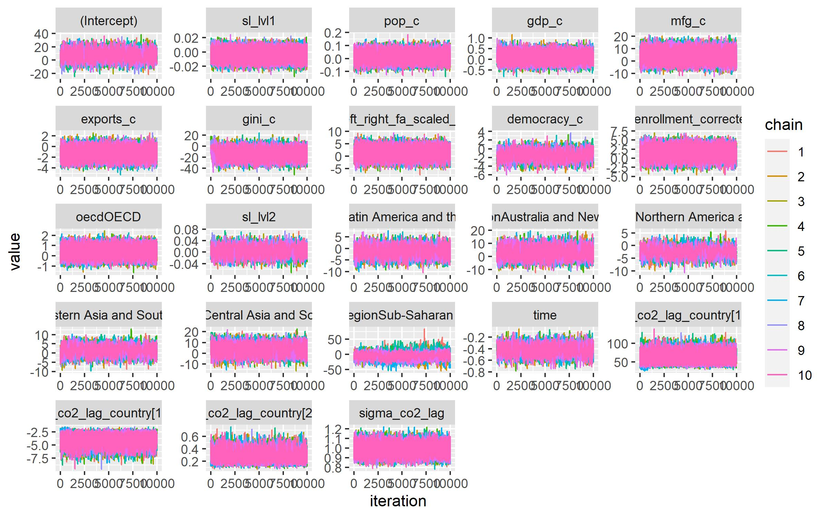
Figure 28: Traceplot of MCMC Chains Over 10,000 Iterations
Table 12: Gelman-Rubin Criterion for Convergence
Variable | Point est. | Upper C.I.
(Intercept) | 1.003631 | 1.007573
Scientific Literacy (within) | 1.003880 | 1.008050
Latin America and the Caribbean | 1.005929 | 1.012115
Australia and New Zealand | 1.004437 | 1.009263
Northern America and Europe | 1.008461 | 1.017145
Eastern Asia and South-eastern Asia | 1.005464 | 1.010753
Central Asia and Southern Asia | 1.003955 | 1.008249
Sub-Saharan Africa | 1.296873 | 1.566240
Time | 1.008397 | 1.017181
Scientific Literacy (Between) | 1.000632 | 1.001442
Population | 1.000233 | 1.000580
GDP | 1.001155 | 1.002509
Manufacturing | 1.001682 | 1.003625
Exports | 1.001108 | 1.002416
Gini | 1.001367 | 1.002915
Left-Right Orientation | 1.002405 | 1.004998
Democracy | 1.005748 | 1.011580
Net Enrollment | 1.005637 | 1.011907
OECD | 1.000510 | 1.001140
Sigma_co2_lag | 1.002108 | 1.004534
$$τ_{00}$$ | 1.000897 | 1.001950
$$τ_{01}$$ | 1.001807 | 1.003833
$$τ_{11}$$ | 1.005503 | 1.011445
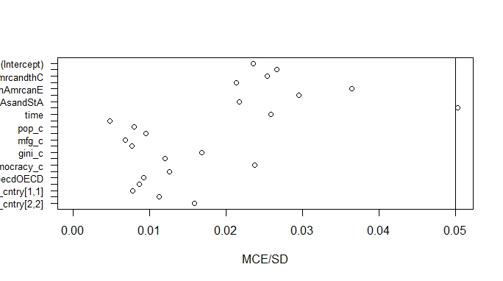
Figure 29: Plot of Monte Carlo Sampling Errors

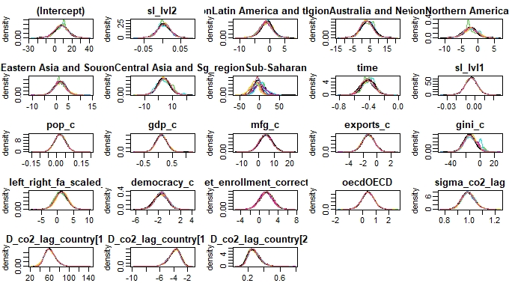
Figure 30: Plot of Posterior Densitites

Appendix D
A reference list of all R packages used for this dissertation:
Arel-Bundock, V. (2022). Modelsummary: Summary tables and plots for statistical models and data: Beautiful, customizable, and publication-ready [Manual]. https://CRAN.R-project.org/package=modelsummary
Bates, D., Mächler, M., Bolker, B., & Walker, S. (2015). Fitting linear mixed-effects models using lme4. Journal of Statistical Software, 67(1), 1–48. https://doi.org/10.18637/jss.v067.i01
Bolker, B., & Robinson, D. (2022). broom.mixed: Tidying methods for mixed models [Manual]. https://CRAN.R-project.org/package=broom.mixed
Caro, D. H., & Biecek, P. (2017). intsvy: An R package for analyzing international large-scale assessment data. Journal of Statistical Software, 81(7), 1–44. https://doi.org/10.18637/jss.v081.i07
Erler, N. S., Rizopoulos, D., & Lesaffre, E. M. E. H. (2021). JointAI: Joint analysis and imputation of incomplete data in R. Journal of Statistical Software, 100(20), 1–56. https://doi.org/10.18637/jss.v100.i20
Firke, S. (2021). janitor: Simple tools for examining and cleaning dirty data [Manual]. https://CRAN.R-project.org/package=janitor
Gohel, D. (2022a). flextable: Functions for tabular reporting [Manual]. https://CRAN.R-project.org/package=flextable
Gohel, D. (2022b). officer: Manipulation of microsoft word and PowerPoint documents [Manual]. https://CRAN.R-project.org/package=officer
Gohel, D., & Ross, N. (2022). officedown: Enhanced “R markdown” format for “word” and “PowerPoint” [Manual]. https://CRAN.R-project.org/package=officedown
Grund, S., Robitzsch, A., & Luedtke, O. (2021). mitml: Tools for multiple imputation in multilevel modeling [Manual]. https://CRAN.R-project.org/package=mitml
Harrell Jr, F. E. (2021). Hmisc: Harrell miscellaneous [Manual]. https://CRAN.R-project.org/package=Hmisc
Harrison, E., Drake, T., & Ots, R. (2021). finalfit: Quickly create elegant regression results tables and plots when modelling [Manual]. https://CRAN.R-project.org/package=finalfit
Koller, M. (2016). robustlmm: An R package for robust estimation of linear mixed-effects models. Journal of Statistical Software, 75(6), 1–24. https://doi.org/10.18637/jss.v075.i06
Kuhn, M., Jackson, S., & Cimentada, J. (2020). corrr: Correlations in R [Manual]. https://CRAN.R-project.org/package=corrr
Kuznetsova, A., Brockhoff, P. B., & Christensen, R. H. B. (2017). lmerTest package: Tests in linear mixed effects models. Journal of Statistical Software, 82(13), 1–26. https://doi.org/10.18637/jss.v082.i13
Loy, A., & Hofmann, H. (2014). HLMdiag: A suite of diagnostics for hierarchical linear models in R. Journal of Statistical Software, 56(5), 1–28.
Lüdecke, D. (2018). ggeffects: Tidy data frames of marginal effects from regression models. Journal of Open Source Software, 3(26), 772. https://doi.org/10.21105/joss.00772
Lüdecke, D. (2021). sjPlot: Data visualization for statistics in social science [Manual]. https://CRAN.R-project.org/package=sjPlot
Lüdecke, D., Ben-Shachar, M. S., Patil, I., Waggoner, P., & Makowski, D. (2021). performance: An R package for assessment, comparison and testing of statistical models. Journal of Open Source Software, 6(60), 3139. https://doi.org/10.21105/joss.03139
Neuwirth, E. (2022). RColorBrewer: ColorBrewer palettes [Manual]. https://CRAN.R-project.org/package=RColorBrewer
Pedersen, T. L. (2020). patchwork: The composer of plots [Manual]. https://CRAN.R-project.org/package=patchwork
Pustejovsky, J. (2022). clubSandwich: Cluster-robust (sandwich) variance estimators with small-sample corrections [Manual]. https://CRAN.R-project.org/package=clubSandwich
Revelle, W. (2022). psych: Procedures for psychological, psychometric, and personality research [Manual]. https://CRAN.R-project.org/package=psych
Rocconi, L., & Schmidt, A. (n.d.). mlmhelpr: Multilevel/Mixed model helper functions [Manual]. https://github.com/lrocconi/mlmhelpr
van Buuren, S., & Groothuis-Oudshoorn, K. (2011). mice: Multivariate imputation by chained equations in R. Journal of Statistical Software, 45(3), 1–67. https://doi.org/10.18637/jss.v045.i03
Wei, T., & Simko, V. (2021). R package “corrplot”: Visualization of a correlation matrix [Manual]. https://github.com/taiyun/corrplot
Wickham, H., Averick, M., Bryan, J., Chang, W., McGowan, L. D., François, R., Grolemund, G., Hayes, A., Henry, L., Hester, J., Kuhn, M., Pedersen, T. L., Miller, E., Bache, S. M., Müller, K., Ooms, J., Robinson, D., Seidel, D. P., Spinu, V., … Yutani, H. (2019). Welcome to the tidyverse. Journal of Open Source Software, 4(43), 1686. https://doi.org/10.21105/joss.01686
Wickham, H., & Bryan, J. (2022). readxl: Read excel files [Manual]. https://CRAN.R-project.org/package=readxl
Wickham, H., Miller, E., & Smith, D. (2022). haven: Import and export “SPSS”, “stata” and “SAS” files [Manual]. https://CRAN.R-project.org/package=haven
Xie, Y. (2014). knitr: A comprehensive tool for reproducible research in R. In V. Stodden, F. Leisch, & R. D. Peng (Eds.), Implementing reproducible computational research. Chapman and Hall/CRC. http://www.crcpress.com/product/isbn/9781466561595
Xie, Y. (2015). Dynamic documents with R and knitr (2nd ed.). Chapman and Hall/CRC. https://yihui.org/knitr/
Xie, Y. (2022). knitr: A general-purpose package for dynamic report generation in R [Manual]. https://yihui.org/knitr/
Yasumoto, A. (2022). ftExtra: Extensions for “flextable” [Manual]. https://CRAN.R-project.org/package=ftExtra

VITA
Anthony Schmidt was born in New York and raised in Florida. He earned a bachelor’s degree in anthropology from the University of South Florida in 2006. After graduating, Anthony moved to Busan, South Korea to teach English as a foreign language. There, he began a distance education Master’s program in language, literacy, and cultural education from Indiana University, Bloomington. Anthony taught middle school and eventually university courses at Pukyong National University before returning to the United States in 2014 to take a position at the University of Tennesee, Knoxville’s English Language Institute (ELI).
In 2018, while working full-time at the ELI, Anthony began graduate coursework in the College of Education, Health, and Human Sciences. He then applied and was admitted to the Evaluation, Statistics, and Methodology (then Measurement) program. In 2019, while continuing coursework, Anthony change careers and became a data visualization designer at the College and University Professional Association for Human Resources. In 2021, Anthony took a position as a data scientist at Amplify Education, where he currently works at the time of writing.

Data based on 2015 Wittgenstein Projection: Mean years of school. Age 25+. Total
Global South generally refers to low- and middle-income countries (as designated by the UN) in Africa, Asia, the Caribbean, and Latin America. It is seen as a more appropriate alternative for “Third World” and “less developed” country (Mitlin & Satterthwaite, 2013). The Global North would refer to higher income countries, such as the United States and most countries in Europe.
10 plausible values were generated for each student starting in 2015
https://www.iea.org/countries/kosovo. Note: For years in which both had data, valyes between the Global Carbon Atlas and International Energy Agency were fairly consistent
https://eng.stat.gov.tw/point.asp?index=9
Their code may be found at https://osf.io/6ebna/
Liechtenstein was removed from the analysis due to missing data for most World Bank-derived variables
These dimensions include: power distance, individualism vs. collectivism, uncertainty avoidance, masculinity vs. femininity, long-term vs. short-term orientation, and indulgence vs. restraint
Region was tested as covariate and possible level-3 grouping variable, with countries nested within regions. However, in both instances, its inclusion caused model convergence issues, lending further evidence that it is not appropriate for the current models.
Quadratic fixed and random effects were added to Models 3 and 4 as a form of sensitivity analysis. The results of these models do not change the statistical conclusions or interpretations. In addition, model diagnostics did not suggest an improvement in fit over Model 3, the conditional growth model. Thus, keeping the less well-fit model is further justified.
Calculated with the HLMdiag R package using the Empirical Bayes method (Loy & Hofmann, 2014)

