Helium Diffusion and Accumulation in Gd2Ti2O7 and Gd2Zr2O7

A Dissertation Presented for the
Doctor of Philosophy
Degree
The University of Tennessee, Knoxville

Caitlin Anne Taylor
December 2016

Copyright © 2016 by Caitlin Anne Taylor
All rights reserved.

Dedicated to my mom, Sandy, my dad, Mike, my sister, Meghan, my uncle, Bill, my boyfriend, Aaron, my cat, Albus, and my dog, Arya.

ACKNOWLEDGEMENTS

I would first like to express my gratitude to my advisor, Dr. William Weber, for his careful guidance and continuous support for my research endeavors throughout my graduate career. I also sincerely appreciate the thoughtful advice and experimental support provided by my Ph.D. thesis committee members, Dr. Maulik Patel, Dr. Yanwen Zhang, and Dr. Brian Wirth. Each member of my committee contributed to advising me on this work, which would not have been possible without their encouragement and support.

This work would not have been possible without the kind support of many collaborators. I am truly thankful to Dr. Miguel Crespillo, Dr. Haizhou Xue, and Dr. Yonqiang Wang for performing the irradiations utilized in this work. Dr. Jeffery Aguiar provided access to transmission electron microscopes, FIB sample preparation, and immeasurable guidance for which I am truly grateful. Thank you to Brittnee Mound and Erik Herbert for providing hardness measurement data. I am extremely appreciative of Dr. Xunxiang Hu, who performed thermal helium desorption measurements and provided many helpful discussions, which were extremely useful in elucidating helium migration properties in pyrochlores. I would like to thank my group members, lab-mates, and office-mates for helpful discussions throughout the years.

Finally, I would like to thank my family and friends for their continued support throughout my education and graduate school career. I am eternally grateful to my boyfriend, Aaron Kohnert, who has supported me throughout the years emotionally and educationally, and with whom I have had many helpful discussions on radiation effects.
ABSTRACT

The effects of helium accumulation on bubble formation and mechanical properties, as well as the fundamentals of helium diffusion in pyrochlores, are experimentally investigated in Gd₂Ti₂O₇ [gadolinium titanate] and Gd₂Zr₂O₇ [gadolinium zirconate]. We find that helium accumulation results in bubble formation at concentrations of 6 at.% in pre-damaged Gd₂Ti₂O₇ and 4.6 at.% in pre-damaged Gd₂Zr₂O₇. Lattice parameter, residual stress, and hardness changes due to helium accumulation were investigated in Gd₂Zr₂O₇, which remains crystalline after irradiation. Predicting the long-term behavior of helium requires a solid understanding of helium migration behavior in the pyrochlore lattice. Thermal helium desorption measurements suggest that helium binds to vacant lattice sites at room temperature. Helium-vacancy clusters likely formed in the sample implanted with higher helium implantation energy, which is likely a combination of the initial defect structure and implantation depth. A deeper implantation allows helium to desorb from small vacancy sites and re-trap into helium-vacancy clusters that form at high temperature. Voronoi volume calculations provide estimations of the lowest energy helium interstitial configurations, which were found to be the octahedral site in Gd₂Ti₂O₇ and the tetrahedral site in both pyrochlore and defect-fluorite Gd₂Zr₂O₇. Finally, based on helium trapping information, the critical concentration required for bubble formation was estimated and compared to the experimental transmission electron microscopy results.
TABLE OF CONTENTS
Chapter One INTRODUCTION 1
Chapter Two LITERATURE REVIEW OF IRRADIATION EFFECTS ON PYROCHLORES 4
Pyrochlore Structure and Phase Stability 4
Radiation Effects in Pyrochlores 5
Defect Properties and Diffusion Processes in Pyrochlores 11
Helium Behavior in Similar Materials 18
Chapter Three PYROCHLORE SYNTHESIS AND CHARACTERIZATION 22
Pyrochlore Sample Synthesis and Surface Preparation 22
Phase Confirmation 25
Grain Size and Porosity Measurements 28
Chapter Four EXPERIMENTAL METHODS 30
Ion Irradiations 30
Grazing-Incidence X-ray Diffraction 34
Transmission Electron Microscopy 36
Thermal Desorption Spectroscopy 40
Chapter Five HELIUM BUBBLE FORMATION IN Gd₂Ti₂O₇ 44
Introduction 44
Experimental Methods 44
Results 50
Discussion 54
Chapter Six HELIUM IMPLANTATION INDUCED BUBBLE FORMATION AND LATTICE PARAMETER CHANGES IN Gd₂Zr₂O₇ 56
Introduction 56
Experimental Methods 57
Results and Discussion 60
Chapter Seven MECHANICAL PROPERTY CHANGES DUE TO DEFECT AND HELIUM ACCUMULATION 69
Swelling due to Bubble Formation 69
Hardness Changes due to Helium Accumulation 70
Residual Stresses in Gd₂Zr₂O₇ 73
Chapter Eight HELIUM DIFFUSION IN Gd₂Ti₂O₇ AND Gd₂Zr₂O₇ 80
Experimental Methods 80
TDS Measurement Results 82
Dissociation Energy Calculation 84
Effect of Implantation Depth on Measured Release Temperatures 87
Preferred Helium Interstitial Sites 92
Helium Binding to Vacancies and Vacancy Clusters 97
Summary and Discussion 101
Chapter Nine CONCLUSIONS 104
LIST OF REFERENCES 108
APPENDIX 116
VITA 121

LIST OF TABLES

Table 3.1 Description of synthesis steps used to make the initial batches of Gd₂Ti₂O₇ and Gd₂Zr₂O₇ samples. Samples were pressed into pellets after each ball milling step. Sintering steps are provided in Procedure #s 2 & 4. In the end, these steps were only adopted for Gd₂Ti₂O₇ synthesis, because they did not produce high enough density Gd₂Zr₂O₇ samples. 23
Table 3.2 Description of synthesis steps used to make high density Gd₂Zr₂O₇ samples. Samples were pressed into pellets after each ball milling step. Sintering steps are provided in Procedure #s 2 & 4. 24
Table 4.1 Comparison of the total number of displacements calculated by the SRIM Kinchin-Pease (KP) and Full Cascade (FC) calculations. 31
Table 5.1 Summary of irradiation conditions utilized to simulate α-recoil damage and He accumulation in Gd₂Ti₂O₇. Irradiations identical to Samples 2-5, but implanted with 200 keV He⁺ to 2 × 10¹⁵ He/cm² (0.1 at.% He at the peak) instead of 2 × 10¹⁶ He/cm², were also performed. All pre-damage and He irradiations were performed at room temperature. Sample 7 was a FIB lift-out taken from the very edge of the sample, which was a region undamaged by during the Au irradiation. The right column states whether or not He bubbles were observed in TEM, and, if so, the mean bubble diameter. 45
Table 6.1 Experimental results from lattice swelling (∆a and ∆V). Lattice swelling in the pre-damaged (Au irradiated) sample was calculated relative to the half the lattice parameter of pristine sample. Swelling in 200 keV He⁺ implanted samples was calculated relative to the pre-damaged sample (all He implanted samples were first pre-damaged). Swelling results were calculated using the fluorite (311) peak by averaging over all incident x-ray angles. Peak He concentrations were determined using SRIM. 67
Table 7.1 Hardness and elastic modulus, measured by nanoindentation, averaged between depths of 500-800 nm (location of helium peak). 71
Table 7.2 Hardness and elastic moduli measured by nanoindentation (using a different indenter than Table 7.1) for helium implanted Gd₂Zr₂O₇ samples. Values were averaged between displacements 500-800 nm. 73
Table 8.1 Desorption peak temperatures and corresponding activation energies for helium dissociation, where E_{D} = E_{B} + E_{m}. 85
Table 8.2 Characteristic diffusion lengths, r, for a helium interstitial in Gd₂Ti₂O₇ or Gd₂Zr₂O₇ in 1 second, over relevant temperature range. Since the helium migration energy is unknown in both materials, distances were calculated using migration energies of 0.5 eV (He migration energy in Y₂Ti₂O₇) and 1.0 eV. 90
Table 8.3 Assuming E_{m} = 1.0 eV, estimated temperature of peaks measured in 10 keV implanted sample at greater helium implantation depths, where measured desorption temperature from the same defect is shifted due to a longer diffusion length. No temperature shift is expected for Peak 2 in either pyrochlore, because the calculated distance traveled in 1 s (1.1 μm) is larger than the 100 keV dpa peak depth (350 nm) at those temperatures (796 and 800 K). 91
Table 8.4 Estimated cation vacancy migration characteristic diffusion lengths at temperatures relevant to THDS. In this case, t = 200 s, or the time required to increase the temperature by 100 K when R = 0.5 K/s. Shaded areas indicate where vacancies are essentially immobile. 100

LIST OF FIGURES

Figure 2.1 Schematic showing (a) the full pyrochlore structure, and the similarity between (b) one eighth of the pyrochlore structure, and the (b) fluorite structure (e.g. UO₂). 5
Figure 3.1 Phase diagrams for (a) Gd₂O₃-TiO₂ [52], and (b) Gd₂O₃-ZrO₂ [53]. In (a), L-1:1 and H-1:1 are low and high forms, respectively, of Gd₂O₃-TiO₂; 1:2 is Gd₂O₃-2TiO₂; FCC is face centered cubic phase. In (b), F = fluorite structure; H = high temperature Gd₂O₃ structure; B = B-type rare earth oxide structure; C = C-type rare earth oxide structure (bixbyite); P = pyrochlore phase (Gd₂Zr₂O₇); M = monoclinic zirconia phase; T = tetragonal zirconia phase; A = a-type rare earth oxide phase; X = X-type rare earth oxide phase. 22
Figure 3.2 Thin Gd₂Ti₂O₇ pellets inside zirconia boat before 2nd sintering. 24
Figure 3.3 Image of the (a) PANalytical Empyrean diffractometer used for powder XRD measurements, which are performed in the (b) Bragg-Brentano geometry. 26
Figure 3.4 Indexed powder XRD patterns of as-synthesized (a) Gd₂Zr₂O₇ and (b) Gd₂Ti₂O₇ pellets. 27
Figure 3.5 Scanning electron microscope images of as-synthesized cracked (a) Gd₂Ti₂O₇ and (b) Gd₂Zr₂O₇ pellets after the first synthesis attempt. 28
Figure 4.1 Samples mounted for (a) room temperature and (b) high temperature irradiation at the UT-IBML. 33
Figure 4.2 Calibration curves for the high temperature stage utilized in these experiments, along with an image showing the location of thermocouples used for the calibration. 33
Figure 4.3 Image showing GXRD configuration in PANalytical X’Pert³ Pro MRD diffractometer. An irradiated Gd₂Zr₂O₇ sample is shown mounted on the sample stage. 34
Figure 4.4 Calculated X-ray penetration depth curve for Gd₂Zr₂O₇ as a function of grazing angle, ϕ. 35
Figure 4.5 TEM cross-section sample preparation for hand-polishing an irradiated pellet. Image shows TEM sample polished down to ~7 μm before being placed in the PIPS. 37
Figure 4.6 SRIM predicted damage and Ar concentration profiles due to ion milling a Gd₂Ti₂O₇ TEM cross-section. Calculations were done at an angle of 5.5° with respect to the sample surface. 38
Figure 4.7 SEM image showing a Gd₂Zr₂O₇ FIB lamella during the thinning process. This image also shows the porous Gd₂Zr₂O₇ structure. 39
Figure 4.8 TEM image of helium bubbles in Gd₂Zr₂O₇, overlaid with bubble outlines identified by ImageJ particle finder, which are shown in red. 40
Figure 4.9 Image showing the thermal desorption spectroscopy system at Oak Ridge National Laboratory. 42
Figure 5.1 Expected dose and He content in Gd₂Ti₂O₇ over geological time for different actinide concentrations [58, 64]. Gd₂Ti₂O₇ will be fully amorphous above the dose corresponding to the dashed line (3.1 × 10¹⁸ α-decays/g). 46
Figure 5.2 SRIM calculated damage and concentration profiles for (a) 7 MeV Au³⁺ irradiation to a fluence of 2.2 × 10¹⁵ ions/cm², (b) 200 keV He⁺ implantation to a fluence of 2 × 10¹⁶ ions/cm², and (c) 65 keV He⁺ implantation to a fluence of 2 × 10¹⁷ ions/cm². 47
Figure 5.3 GXRD patterns showing pristine Gd₂Ti₂O₇ (prior to any irradiation), and amorphous Au irradiated Gd₂Ti₂O_{7,} shown at grazing angles of ω = 0.75° and 8°. Crystalline peaks appear in the ω = 8° pattern, confirming amorphization in the surface layer. 48
Figure 5.4 TEM image showing the amorphous layer in Gd₂Ti₂O₇ irradiated with 7 MeV Au³⁺ to a fluence of 2.2 × 10¹⁵ ions/cm². TEM cross-section was prepared by hand-polishing. Measured amorphous layer thickness agrees well with SRIM predicted damage profile. Electron diffraction was used to confirm the location of the amorphous layer and crystalline-amorphous interface. 49
Figure 5.5 Schematic showing results of image analysis process, showing underfocused TEM images and bubble outlines determined by ImageJ for both (a) “pristine” implanted and (b) pre-damaged Gd₂Ti₂O₇. 50
Figure 5.6 TEM images shown at 250,000x (scale bar is equivalent for all images) with defocus values of ±1 μm obtained from all Gd₂Ti₂O₇ samples implanted with 200 keV He⁺ to a fluence of 2 × 10¹⁶ He/cm², and pre- or post- damaged with 7 MeV Au³⁺ to a fluence of 2.2 × 10¹⁵ Au/cm². 51
Figure 5.7 TEM image of the amorphous layer thickness in “pristine” implanted Gd₂Ti₂O₇. 52
Figure 5.8 TEM images showing helium bubbles in (a-b) “pristine” implanted and (c-d) pre-damaged Gd₂Ti₂O₇. Figures (a,c) show the underfocused (-1μm) imaging condition and figures (b,c) show the overfocused (+1μm) imaging condition. 53
Figure 5.9 Bubble size distributions calculated from TEM images of helium bubbles in the (a) “pristine” implanted and (b) pre-damaged Gd₂Ti₂O₇ samples implanted with 65 keV He⁺ to a fluence of 2 × 10¹⁷ ions/cm². 54
Figure 6.1 Dose and He accumulation in Gd₂Zr₂O₇ as a function of geological time for various waste loadings. Gd₂Zr₂O₇ will be fully transformed to the defect-fluorite structure above the dotted line. 58
Figure 6.2 SRIM calculated damage (dpa) and ion concentration profiles for Gd₂Zr₂O₇ (a) pre-damaged with 7 MeV Au³⁺ to 2.2 × 10¹⁵ Au/cm², (b) implanted with 65 keV He⁺ to 2 × 10¹⁷ He/cm², and (c) implanted with 200 keV He⁺ to 2 × 10¹⁷ He/cm² (2 × 10¹⁶ and 2 × 10¹⁵ He/cm² profiles are one and two orders of magnitude less, respectively). Dashed line indicates the He concentration at which bubbles were first observed (4.6 at.%) to aid the reader in comparing the nucleation depths for each 2 × 10¹⁷ He/cm² irradiation. 59
Figure 6.3 TEM images obtained from the Gd₂Zr₂O₇ sample irradiated with 7 MeV Au³⁺ to 2.2 × 10¹⁵ Au/cm² and then implanted with 200 keV He⁺ to 2 × 10¹⁶ He/cm² (1 at.% at He peak). He concentration and Au damage distribution ranges as determined by SRIM are compared to the overview image in (a). After imaging several locations near the He peak, no bubbles were observed in this sample. An example region on a grain boundary, where bubbles were expected to first nucleate, is shown at (b) -500 nm underfocus and (c) +500 nm overfocus. 61
Figure 6.4 TEM images for the Gd₂Zr₂O₇ sample irradiated with 7 MeV Au³⁺ to 2.2 × 10¹⁵ Au/cm² and then implanted with 65 keV He⁺ to 2 × 10¹⁷ He/cm² (12.7 at.% He at peak). He concentration and Au damage distribution ranges as determined by SRIM are compared to the overview image in (a). Images obtained at defocus values of ±1 µm are shown for (b) underfocus and (c) overfocus conditions. Helium bubbles clearly formed at the expected He peak location, in some cases forming chains 10 - 30 nm in length. Bubbles were observed to nucleate starting at a depth of 165 nm (dashed line), which corresponds to 4.6 at.% He in the SRIM calculated concentration profile. 62
Figure 6.5 Helium bubble size distribution in Gd₂Zr₂O₇ pre-damaged with 7 MeV Au³⁺ to a fluence of 2.2 × 10¹⁵ Au/cm² and implanted with 65 keV He⁺ to 2 × 10¹⁷ He/cm², which corresponds to a peak He concentration of 12.7 at.%. Bubbles formed chains several nm in length. Bubble diameters were calculated assuming a circular cross-sectional area, which largely approximates the shape of bubbles which formed chains. Chains of bubbles have the largest cross-sectional area and therefore the largest calculated diameters. An average bubble diameter of 1.5 ± 0.2 nm was determined by fitting with a log-normal distribution (shown), with the error estimated from the TEM image pixel size (0.15 nm). Inset shows outline of areas that ImageJ used to calculate the cross-sectional bubble area during image analysis, overlaid with the original underfocused TEM image shown in Fig 5 (b). 64
Figure 6.6 (a) GIXRD patterns obtained at an incident angle of ω = 6° (x-ray penetration depth of ~ 600 nm) from Gd₂Zr₂O₇ samples (from bottom to top): (1) pristine (unirradiated) Gd₂Zr₂O₇, (2) Gd₂Zr₂O₇ pre-damaged with 7 MeV Au³⁺ to 2.2 × 10¹⁵ Au/cm², and Gd₂Zr₂O₇ pre-damaged then 200 keV He⁺ implanted to fluences of (3) 2 × 10¹⁵, (4) 2 × 10¹⁶, and (5) 2 × 10¹⁷ He/cm². (b) A zoomed view of the (220) reflection shows a clear peak shift between each of the irradiation conditions, with a dotted line indicating the center position of the highest He fluence measured. Reflections are labeled with fluorite Miller indices. 65
Figure 6.7 Lattice parameters were calculated from the GIXRD data using the four highest intensity fluorite reflections for each grazing angle. Lattice parameters varied more between the different reflections in the He implanted samples (b-d) than in the Au irradiated sample (a), with the largest variation occurring in the sample implanted with 2 × 10¹⁶ He/cm² (c). Error bars represent the fractional error. 66
Figure 6.8 Experimentally determined lattice parameters for Gd₂Zr₂O₇ samples implanted with 200 keV He⁺ relative to the pre-damaged (Au irradiated) sample for various incident x-ray angles. Lattice parameters were calculated using the fluorite (311) reflection. Error bars represent the fractional error. 67
Figure 7.1 Diagrams relating the (a) unit cell coordinate system (L, primed) to the sample coordinate system (S, primed) [81], and (b) unit cell coordinate system to the sample coordinate system in terms of diffractometer angles, where the green dashed line indicates incident and diffracted x-ray beams and the blue line indicates the sample plane [82]. 74
Figure 7.2 Relationship between lattice strain, Δd/d_{o} and Sin²ψ for each irradiation condition, for an x-ray incident angle of ω = 8°. Dashed lines represent linear fits from which the biaxial residual stress is determined by the slope. 78
Figure 7.3 Calculated residual stress as a function of grazing angle for all irradiation fluences. 79
Figure 8.1 Polished 3 × 2.5 mm Gd₂Ti₂O₇ THDS sample in membrane holder. 81
Figure 8.2 SRIM calculated damage and concentration profiles for each implantation energy, (1) 1 MeV, (b) 100 keV, and (c) 10 keV. Gd₂Ti₂O₇ and Gd₂Zr₂O₇ profiles are almost identical so only Gd₂Ti₂O₇ profiles are shown. 81
Figure 8.3 Example of Gaussian fits used to determine helium desorption temperatures. Peaks are typically a deconvolution of desorption from multiple binding sites. The two sites identified in this peak (pink and green curves) are added to form the total peak (red curve). 82
Figure 8.4 Desorption spectra for the 10 keV He implanted (a) Gd₂Zr₂O₇ and (b) Gd₂Ti₂O₇ samples. Each plot contains measurements from samples that were not annealed after polishing and from samples that were annealed at 800°C for 36h after polishing. 83
Figure 8.5 Desorption spectra showing both THDS measurements on (a) Gd₂Ti₂O₇ and (b) Gd₂Zr₂O₇ implanted with 100 keV He, and (c) Gd₂Ti₂O₇ and (d) Gd₂Zr₂O₇ implanted with 1 MeV He. All samples were annealed at 800°C for 36h after polishing. 84
Figure 8.6 Powder x-ray diffraction showing no evidence of amorphization in 1 MeV helium implanted Gd₂Ti₂O₇. 88
Figure 8.7 Grazing incidence x-ray diffraction (ω = 5.5°) showing no evidence of amorphization in 100 keV helium implanted Gd₂Ti₂O₇. 88
Figure 8.8 Possible helium interstitial sites shown inside the lower 1/8th of the pyrochlore unit cell. Tetrahedral and octahedral interstitial sites are labeled by their Wyckoff positions, 8a and 32e, respectively. 93
Figure 8.9 Relationship between calculated helium interstitial defect formation energy [48] and interstitial site volume in Y₂Ti₂O₇. O-O, Ti-Ti, and Y-Y sites caused severe lattice deformation, and are considered unstable. 94
Figure 8.10 Calculated Voronoi volume for each interstitial site in Gd₂Ti₂O₇ and Gd₂Zr₂O₇. Voronoi volumes were also calculated for defect-fluorite Gd₂Zr₂O₇, because Gd₂Zr₂O₇ undergoes a pyrochlore to defect-fluorite (DF) transformation at ~0.4 dpa, which may be more relevant to higher fluence studies. In this work, Gd₂Zr₂O₇ remains pyrochlore. In DF Gd₂Zr₂O₇, the A-A and B-B site volumes are identical due to disordered A- and B-site cations. 95
Figure 8.11 Voro++ calculated Voronoi cells and n.n. atoms for the (a) octahedral and (b) tetrahedral pyrochlore interstitial sites, shown for Gd₂Zr₂O₇, but all pyrochlores have the same n.n. at both sites. Relative atomic sizes in this diagram are representative of relative ionic radii. 97
Figure 8.12 Arrhenius plots describing vacancy diffusion in (a) Gd₂Ti₂O₇ and (b) Gd₂Zr₂O₇. 99
Figure 9.1 Contour plot showing the critical helium concentration required for visible bubble formation as a function of interstitial sink strength, $S_{\text{i}}^{\text{tot}}$, and the interstitial migration energy, $E_{m}^{i}$. $S_{\text{i}}^{\text{tot}}$ and helium concentration are presented on a log₁₀ scale..... 106
Figure A.1 Average (a) hardness and (b) elastic modulus curves for pristine and irradiated Gd₂Zr₂O₇.................................................................................................................118
Figure A.2 Average (a) hardness and (b) elastic modulus curves for pristine and irradiated Gd₂Ti₂O₇..................................................................................................................118
Figure A.3 Δd/d_{o} vs. sin²ψ plots for (a) Au, (b) Au + 2 x 10¹⁵ He/cm², (c) Au + 2 x 10¹⁶ He/cm², (d) Au + 2 x 10¹⁷ He/cm² irradiated Gd₂Zr₂O₇. ........................................119
Figure A.4 Gaussian fits of desorption spectra for the 10 keV He implanted Gd₂Zr₂O₇ (a-b) and Gd₂Ti₂O₇ (c-d) samples. Spectra shown in (a) and (c) were taken from samples that were not annealed after polishing, and spectra shown in (b) and (d) were taken from samples that were annealed after polishing. Fits from annealed samples were used. .................................................................................................120
Figure A.5 Gaussian fits of desorption spectra for 100 keV He implanted (a) Gd₂Zr₂O₇ and (b) Gd₂Ti₂O₇, and 1 MeV He implanted (c) Gd₂Zr₂O₇ and (d) Gd₂Ti₂O₇.......121

INTRODUCTION

A typical nuclear power plant generates 20 metric tons of used nuclear fuel per year. Over the past four decades, the nuclear industry has produced 76,430 metric tons of used nuclear fuel [1], consisting of radioactive actinides such as, ²³⁷Np, ²⁴¹Am, ²⁴³Am, and ²⁴⁴Cm, in addition to plutonium and uranium. As nuclear reactors continue to dominate electrical power generation throughout the world, the eventual fate of radioactive nuclear waste will continue to pose a significant problem. Additionally, nuclear waste resulting from disassembled nuclear weapons requires a permanent storage solution. Nuclear waste contains radionuclides that remain radioactive for hundreds of thousands of years; the half-life of ²³⁹Pu is 24,100 years, ²³⁷Np has a half-life of 2.1 million years, and ²³³U has a half-life of 160,000 years [2]. For this reason, waste must be stored for geological timescales until the radioactive material has decayed to safe levels. Until a permanent disposal repository for spent nuclear fuel and nuclear waste forms is built in the United States, licensees must safely store spent fuel at their reactors, most of which is stored in spent fuel pools. Fuel may be stored at reactor sites in dry cask storage once pool capacity is reached. Reprocessing extracts isotopes from spent fuel that can be again used as reactor fuel. Commercial reprocessing is not currently practiced in the United States, although it has been allowed in the past. Significant quantities of high-level radioactive waste have been produced by the defense reprocessing programs at Department of Energy facilities (e.g. Hanford, WA and Savannah River, SC) [3]. The primary challenges regarding waste storage include 1) the engineering challenges involved in safely separating radionuclides from large volumes of bulk waste, 2) determining the safest and most economically feasible method for storing nuclear waste, and 3) predicting how the waste form will evolve while undergoing radioactive decay for hundreds of thousands of years. The most widely accepted method of radionuclide encapsulation involves melting radionuclides into a glass [4]. The Hanford Site is currently developing a Hanford Tank Waste Treatment and Immobilization Plant, called the Vit Plant, which will be the first program to use vitrification technology to stabilize large quantities of nuclear waste. Vitrification involves blending the waste with glass-forming materials and heating it to 1,149°C. The molten mixture is poured into stainless steel canisters to cool and solidify [5]. Another proposed mechanism for long-term nuclear waste storage involves separating radionuclides for synthesis into a complex ceramic structure. Because the radionuclides are ionically bonded within the structure, ceramic waste forms offer higher chemical durability (i.e. lower radioactive leach rates) than glass waste forms, but are much more difficult to manufacture on a large scale. Polycrstalline waste forms (e.g. SYNROC) generally consist of an assemblage of complex crystalline phases (e.g. monazite, pyrochlore, zirconolite), which allows encapsulation of a variety of actinides. Chemical durability remains a significant concern because waste forms will eventually be placed underground, with the potential for groundwater intrusion over geological timescales.
The principle radiation damage concern in a nuclear waste form is α-decay of actinides, which results in a damaging α-recoil nucleus (~100 keV), and an α-particle (~5 MeV), or He nucleus. In crystalline ceramic waste forms, radiation damage events produced by α-recoils will produce defects in the crystalline lattice. This work focuses on pyrochlore structures, specifically Gd₂Ti₂O₇, which amorphizes after a radiation damage dose of 0.2 displacements per atom (dpa) [6], and Gd₂Zr₂O₇, which undergoes an order-disorder transformation from pyrochlore to defect-fluorite after 0.4 dpa [7], but never amorphizes. Both phase transformations would occur within several hundred years of waste storage, depending on the actinide concentration. The defects produced by α-recoil damage and resulting phase transformations may alter the chemical properties of the waste form over geological time. For example, the leach rate of Gd and Ti ions from irradiated Gd₂Ti₂O₇ placed in 90°C nitric acid solution has been shown to increase by a factor of 15 due to irradiation-induced amorphization [8]. In this work, we explore the effects of helium accumulation in pyrochlore type waste form materials. Helium accumulation due to α-particle production during α-decay must be considered, as significant helium accumulation could result in mechanical property changes to the waste form, potentially resulting in cracks that might provide increased surface area for leaching of radioactive material into the groundwater during geological storage. Helium bubbles will form in most materials after significant helium accumulation, usually around several atomic percent in room temperature ceramics. Though no existing work has focused on helium accumulation and bubble formation in pyrochlores, bubbles have been observed after 2.8 at.% He in borosilicate glass [9], which might be compared to amorphous Gd₂Ti₂O₇. In fluorite structures, which might be compared to defect-fluorite Gd₂Zr₂O₇, 1.2 nm bubbles were observed after 0.29 at.% He in (U_{0.9}²³⁸Pu_{0.1})O₂ and 2.5 nm He bubbles were observed after 5 at.% He in (²³⁸Pu_{0.9}Pu_{0.1})O₂ [10].
The effects of helium accumulation on bubble formation and mechanical properties, as well as the fundamentals of helium diffusion in pyrochlores, are experimentally investigated in Gd₂Ti₂O₇ and Gd₂Zr₂O₇. We find that helium accumulation results in bubble formation at concentrations of 6 at.% in pristine and pre-damaged Gd₂Ti₂O₇ and 4.6 at.% in pre-damaged Gd₂Zr₂O₇. Lattice parameter, residual stress, and hardness changes due to helium accumulation were investigated in Gd₂Zr₂O₇, which remains crystalline after irradiation. Predicting the long-term behavior of helium requires a solid understanding of helium migration behavior in the pyrochlore lattice. Thermal helium desorption measurements suggest that helium binds to vacant lattice sites at room temperature. Helium-vacancy clusters likely form in the sample implanted with higher helium implantation energy, and their formation depends on the initial defect structure and implantation depth. A deeper implantation allows helium to desorb from small vacancy sites and re-trap into helium-vacancy clusters that form at high temperature. Voronoi volume calculations provide estimations of the lowest energy helium interstitial configurations, which were found to be the octahedral site in Gd₂Ti₂O₇ and the tetrahedral site in both pyrochlore and defect-fluorite Gd₂Zr₂O₇. Finally, based on helium trapping information, the critical concentration required for bubble formation was estimated and compared to the experimental transmission electron microscopy results.

LITERATURE REVIEW OF IRRADIATION EFFECTS ON PYROCHLORES

Pyrochlore Structure and Phase Stability
Pyrochlores (A₂B₂O₇) consist of A- and B-site cations (3+, 4+) and oxygen atoms, where A-site cations reside on the 16d Wyckoff position, B-site cations on the 16c position, and the oxygen atoms reside on the 48f and 8b sites. One eighth of the pyrochlore unit cell, which contains one formula unit, closely resembles the fluorite unit cell (Fig 2.1), except that 1/8th of the pyrochlore unit cell consists of one less oxygen atom than the fluorite unit cell. This structural oxygen vacancy, characteristic to all pyrochlores, is located at the 8a Wyckoff site, and results in 8 structural oxygen vacancies per pyrochlore unit cell. The position of the 48f oxygen atoms changes with each pyrochlore by an oxygen positional parameter, x. The phase stability varies between pyrochlores, and has been found to depend on the cation ionic radius ratio, r_{A}/r_{B}. Compounds with high cation radius ratio (large A-site cation, small B-site cation) more easily order into the pyrochlore structure [11]. Conversely, A₂B₂O₇ compounds with a small cation radius ratio will have more difficulty ordering into the pyrochlore structure. Compounds that do order into the pyrochlore structure, but lie on the edge of the pyrochlore stability range, are generally more stable under irradiation due to lower antisite defect formation energies, allowing them to readily transform to the defect-fluorite structure.
Pyrochlores will only form after sintering at high temperatures; sintering at lower temperatures will result in a partially ordered system, possibly consisting of all defect-fluorite structure or a mixture of pyrochlore and defect-fluorite. Gd₂Zr₂O₇ changes phase from defect-fluorite to disordered pyrochlore at temperatures higher than 1200°C prepared in static air environment [12]. Calcining at 1400°C results in more order than calcining at 1300°C. Above 1500°C, Gd₂Zr₂O₇ in pyrochlore phase can be thermally disordered into the defect-fluorite structure. Gd₂Ti₂O₇, on the other hand, readily forms the pyrochlore phase above 1600°C [13]. More information about pyrochlore synthesis is provided in Chapter 3.

Figure 2.1 Schematic showing (a) the full pyrochlore structure, and the similarity between (b) one eighth of the pyrochlore structure, and the (b) fluorite structure (e.g. UO₂).

In fcc structures, the dominant interstitial sites are tetrahedral and octahedral sites, which are at the 8a and 32e Wyckoff positions in the pyrochlore structure. The 8a site is located at the structural oxygen vacancy and the 32e site is located at the center of the oxygen sublattice. Coordination number changes for each atom [14]. Oxygen atoms located on the 48f site are 4-fold coordinated by two A-site and two B-site cations. Oxygen atoms located on the 8b site are 4-fold coordinated by four A-site cations. A-site cations are 8-fold coordinated, located in the center of a scalenohedron that consists of six equally spaced anions and two axial anions slightly shorter in distance. B-site cations are 6-fold coordinated, located within trigonal antiprisms formed by six oxygen atoms.

Radiation Effects in Pyrochlores
Radiation affects materials differently, and a material’s response to radiation damage must be quantified before considering the material for long-term nuclear waste immobilization. Pyrochlores, along with many other complex ceramics, have been found to exist in nature. Initial work on the long-term effects of radiation damage on ceramics, particularly dose rate effects, was done by examining natural minerals that contain radioactive isotopes. In studies of materials which contain radioactive isotopes, the α-decay dose is usually given in α-decays/m³ or α-decays/g. Literature values presented in α-decays/g can be converted to helium atomic percent using the atomic density (atoms/g), which is independent of irradiation-induced swelling. Nuclear magnetic resonance measurements were utilized to measure the amorphous fraction in natural zircon (ZrSiO₄) containing ²³⁸U and ²³²Th. Natural zircon showed damage similar to zircon doped with ²³⁹Pu at the same dose, indicating no significant dose rate effect on the damage process [15]. Lumpkin and Ewing [16] characterized a multitude of mineral pyrochlores from all over the world containing different UO₂ and ThO₂ concentrations. They estimated the damage dose, D, in mineral pyrochlores using Eq. 2.1, N₂₃₈ is the number of ²³⁸U atoms/mg, N₂₃₂ is the number of ²³²Th atoms/mg, τ₂₃₈ and τ₂₃₂ are the mean lives of ²³⁸U and ²³²Th, respectively, and t is the geological age. No consideration was given to the events resulting from the decay of ²³⁵U.
$D=8N_{238}\left(e^{\frac{t}{τ_{238}}}-1\right)+6N_{232}\left(e^{\frac{t}{τ_{232}}}-1\right)$ (2.1)
Corresponding dpa values were calculated using Eq. 2.2, assuming 1500 displacements per alpha-decay event, where N_{a} is Avogadro’s number, M is the molecular weight in mg units, and N_{f} is the number of atoms per formula unit.
$\text{dpa}=1500DM/N_{t}N_{a}$ (2.2)
The authors measured XRD intensities relative to crystalline pyrochlore standards, and used the intensity ratio I/I_{o} to determine the dose and dpa values for which pyrochlores become completely amorphous (often referred to as metamict by geologists). Alpha-decay damage is detectible when I/I_{o} = 0.8-1.0.
Krivokoneva and Sidorenko [17] have shown that the radial distribution function (RDF) of metamict pyrochlore has no periodicity beyond the second coordination sphere. The major peaks in the RDF are related to M—O (B—O = 0.21 nm, A—O = 0.25 nm) and M—M (0.37 nm) distances in the random network structure. Extended x-ray absorption fine structure (EXAFS) and x-ray absorption near edge structure (XANES) studies suggest that even the second coordination sphere is disrupted to some extent [18-20]. A comparison of the Fourier transforms of metamict and annealed pyrochlores reveals a single M—M peak at 0.34-0.37 nm in the annealed samples, while in metamict samples the M—M peak exhibits reduced intensity as well as minor to distinct peak splitting. The structure of the metamict state in pyrochlore can be envisioned as an aperiodic, random network structure of corner sharing B—O polyhedral. X-ray diffraction (XRD) and EXAFS/XANES data are consistent with a slight decrease in $〈B-O〉$ during the transition from the crystalline to the metamict state [16]. Furthermore, a reduction in coordination number to ~5.5 and increased distortion are indicated by EXAFS/XANES experiments [18, 20]. In order to explain the increase in macroscopic swelling of 5% (e.g. Weber and Matzke [21]), the B—O—B angles of the network structure must increase, leading to an increase in the $〈B-B〉$ distance of only 1-2%. Greegor et al. [20] observed a slight increase in the $〈Ta-Ta〉$ distance in metamict pyrochlore. In some cases, actinide-doped pyrochlores were utilized to study the effects of α-decay over a shorter decay period. Farnan et al. [15] utilized nuclear magnetic resonance (NMR) to study amorphous fraction in natural zircon containing ²³⁸U and ²³²Th, and observed damage similar to zircon doped with ²³⁹Pu at the same dose, indicating no significant dose rate effect due to the doping. Gd₂Ti₂O₇ doped with ²⁴⁴Cm was found to amorphize by overlap of amorphous α-recoil tracks [21]. Electron diffraction rings had a d-spacing of ~0.198 nm, in good agreement with the average Ti—O octahedral bond length (0.195 nm), suggesting that the radiation-induced amorphous state may consist of a random, corner-sharing network of TiO₆ octahedra. EXAFS showed that, for ²⁴¹Am₂Zr₂O_{7,} Am—O polyhedral had increasing disorder with higher dose, but the Zr—O polyhedral remained ordered [22].
In recent years, ion-irradiation has been utilized to study irradiation effects in pyrochlores, due to the much reduced timescale, along with the ability to specifically tune the ion beam to study phenomena of interest. In ion beam irradiations, the much higher dose rate is of significant concern when attempting to simulate α-decay damage. Despite six orders of magnitude difference in damage rates, good agreement between the amorphization doses near room temperature in Sm₂Ti₂O₇ under ion irradiation (0.6 MeV Bi⁺ and 1.0 MeV Au²⁺), and in Gd₂Ti₂O₇ due to ²⁴⁴Cm decay, confirms some degree of dose-rate independence below T_{c}, which provides some validation for using the results from ion irradiation studies in rare-earth titanates to predict long-term behavior due to α-decay [23]. In a study of 2 MeV Au²⁺ ion-irradiated titanate pyrochlores, A₂Ti₂O₇, where A = Gd, Sm, Lu, and Y, went fluorite in conjunction with amorphization [24]. The room-temperature amorphization dose (0.18 dpa) was the same for all four pyrochlores. Under irradiation at high temperatures, the amorphization dose gradually increased, continuing to remain the same within error for all pyrochlores. The critical temperature of amorphization, defined as the temperature where defect recovery rates become similar to the rate of amorphization, was determined to be around 900 K for all four pyrochlores. Above the critical amorphization temperature, T_{c}, the critical amorphization fluence increases to infinity and amorphization does not occur. Titanate pyrochlores, A₂Ti₂O₇, where A = Lu, Yb, Tm, Er, Ho, Y, Dy, Tb, Gd, Eu, and Sm, were also readily amorphized by 1 MeV Kr⁺ irradiation at room temperature [6]. The critical amorphization temperature was 1120 K in Gd₂Ti₂O₇, and T_{c} roughly increased with increasing cation radius. An ion irradiation induced order-disorder transformation was observed in all irradiated titanate pyrochlores. Again, the order-disorder transformation process occurred concurrently with amorphization in Gd₂Ti₂O_{7,} which completely amorphized at 0.18 dpa at room temperature. Wang et al. [7] observed similar behavior, with Ti-rich compositions of Gd₂(Zr_{x}Ti_{1-x})₂O₇ undergoing an irradiation-induced transformation from pyrochlore to defect-fluorite simultaneously with amorphization, followed by complete amorphization (at 0.2 dpa at room temperature for Gd₂Ti₂O₇). At higher ambient temperature, the entire cascade is fully recrystallized to a disordered-fluorite structure. In this case, the ion irradiation induced defect-fluorite structure is stable under further irradiation without amorphization. This demonstrates that the stability of defect-fluorite created by ion irradiation can be estimated by considering T_{c}. In general, pyrochlore compositions that are easily disordered to the defect-fluorite structure were found more resistant to amorphization. Since r_{A}/r_{B} determines phase stability, this is related to the A-site radius in titanates. In a nuclear reaction analysis (NRA) study [23] of 1.0 MeV Au⁺ irradiated Sm₂Ti₂O₇, ¹⁸O exchange significantly increased between 800-900 K due to an increase in the thermal mobility of oxygen vacancies. Because this increase in thermal mobility of O vacancies occurs just below the critical temperature, where higher defect mobility is required to balance the damage production rate, the ¹⁸O uptake results suggest a strong correlation between T_{c} and the mobility of oxygen vacancies. Cation interstitial or vacancy mobility may also increase near T_{c}, contributing to higher recovery rates.
In pyrochlores with composition Gd₂(Zr_{x}Ti_{2-x})O₇, where x = 0…2, 2 MeV Au²⁺ ion-irradiation induced amorphization resistance has been found to increase with increasing zirconium content [13]. Lian et al. [25] utilized in-situ transmission electron microscopy (TEM) measurements to follow the amorphization as a function of 1 MeV Kr⁺ dose in Er₂Ti₂O₇ (amorphous at 0.25 dpa), Lu₂Ti₂O₇ (amorphous at 0.51 dpa), and Gd₂Ti₂O₇ (amorphous at 0.23 dpa). Based on the disappearance of electron diffraction maxima (022) and (422) in the selected area electron diffraction (SAED) patterns at early irradiation stages, in addition to the amorphous halo, the authors believe the cation and anion disordering occurs independently, and that the anion disordering process precedes the cation disorder upon ion irradiation. Gd₂Zr₂O₇ undergoes an order-disorder transformation from pyrochlore to defect-fluorite, and has been shown to remain crystalline at very high doses (~100 dpa at room temperature). Other zirconate pyrochlores (Nd₂Zr₂O₇ and Sm₂Zr₂O₇) have also been shown to remain crystalline, assuming the defect-fluorite structure, under irradiation [26]. Zirconium-rich (x > 0.75) compositions of Gd₂(Zr_{x}Ti_{1-x})₂O₇ are difficult to amorphize even at cryogenic temperatures, where only partial amorphization has been observed in in-situ TEM. Gd₂Zr₂O₇ showed no evidence of amorphization after 15 dpa from 1.5 MeV Xe⁺ irradiation at room temperature. At low temperatures, in Zr-rich pyrochlores, the pyrochlore-to-fluorite structure transformation is complete after a dose of ~ 0.4 dpa. In Gd₂Zr₂O₇, the defect-fluorite produced by irradiation is structurally analogous to the defect-fluorite produced at high temperature [7]. The radiation stability of pyrochlores can be predicted using temperature-composition (T-C) diagrams [27]. In the ZrO₂-A₂O₃ phase diagram, for the largest A³⁺ cation (La³⁺), the 2:2:7 pyrochlore phase is stable to the melting temperature. Others, such as ZrO₂-Gd₂O₃, are stable until a particular temperature, where they transform to disordered fluorite. Compositions that more easily form disordered structures are shown to be more radiation tolerant. Molecular statics calculations have shown that the O-D defect reaction pair energy (the energy for both anion Frenkel formation and cation antisite formation to occur) decreases with increasing A-site ionic radius in the ZrO₂-A₂O₃ system; systems with larger A-site atoms will more easily form the disordered structure and be more radiation tolerant. If oxygen Frenkel pairs do not cost much energy, then the driving force for oxygen interstitials to join interstitial clusters, or oxygen vacancies to absorb at growing voids, is reduced.
Irradiation-induced defect formation can result in microstructural property changes, including swelling, bulk property changes, and changes in dissolution rates. Macroscopic swelling, measured by bulk density measurements, was accompanied by increased α-decay dose in ²⁴⁴Cm doped Gd₂Ti₂O₇ [21]. The fracture toughness increased by ~30% when the dose increased from 3.9 x 10²⁴ α-decays/m³ to 11.8 x 10²⁴ α-decays/m³. Dissolution rates of ²⁴⁴Cm and ²⁴⁰Pu increased by a factor of 20-50 between the crystalline and amorphous structures, possibly due to the more open structure or to the breaking of bonds. A leaching study [24] on A₂Ti₂O₇, where A = Gd, Lu, or Y, found that for samples placed in a nitric acid/DI water solution with pH 2.0, dissolution rates of A- and B-site cations increased after ion-beam induced amorphization by a factor of 15 in Gd₂Ti₂O₇, and by a factor of 3 in Lu₂Ti₂O₇, but only slightly for the B-site in Y₂Ti₂O₇. Leach testing was also performed [28] on a Gd_{1.935}Cm_{0.065}TiZrO₇ by suspending the sample on a platinum wire in the center of a Teflon container with a ground-in lid, and 25 ml of double-distilled water, at 90°C. Solution was replaced on the 3rd, 7th, and 14th days, with the sample kept in a hermetically sealed test tube for 24 h during analysis of the solution. Solutions had pH 4 after the leaching, which is considerably lower than the pH of water in air (6.5). This was caused by radiolysis of the solution in the course of self-irradiation. Ti and Zr content were below the detection limit. The leaching rate of ²⁴⁴Cm from the matrix was somewhat higher than that of Gd, and for both elements decreased with time. After amorphization, the leaching rate increased by a factor of approximately 3 for Cm and 2 for Gd (on the 14th day of the experiment), compared to the initial sample. Lattice parameter changes have also been measured. Belin et al. [22] found that the lattice parameter in ²⁴¹Am₂Zr₂O₇ decreased up to the pyrochlore to defect-fluorite phase transformation, then remained the same. Molecular dynamics simulations by Rushton et al. [29] predicted negative volume changes for some zirconate pyrochlores during the order-disorder transition.

Defect Properties and Diffusion Processes in Pyrochlores
Radiation damage produces a variety of defects within the crystalline lattice, which, in large enough concentrations, will affect the structural integrity of a waste form material. A thorough understanding of pyrochlore defect properties is essential for predicting the long-term stability of a pyrochlore waste form, and for understanding how helium will interact with pyrochlore lattice as damage accumulates over geological time. The energy required to actually displace an atom, or the threshold displacement energy, E_{d}, varies widely with direction in pyrochlores. Ab initio molecular dynamics (MD) calculations in Y₂Ti₂O₇ [30] found E_{d} to be larger for Y and Ti atoms than for oxygen atoms, and the defect generation mechanisms for Y and Ti atoms were relatively more complex. After energy recoil events for anions, vacant 8a sites are occupied by displaced oxygen atoms from either the 48f or 8b positions in all cases, resulting in no net increase of oxygen vacancies. Vacant 8a sites can also be occupied by displaced cations. In general, vacancy defect formation energies are significantly higher than interstitial defect formation energies in Y₂Ti₂O_{7.} Yttrium interstitials were only stable on the 8a (tetrahedral) interstitial site. The defect formation energy of the coupled cation antisite and anion disorder reaction O_{48f} V_{O48f} + O_{8a} resulted in a formation energy of 2.54 eV, only 0.22 eV larger than that for the antisite pair. Cation interstitial defect formation energies were small (e.g., 1.2 eV for Ti_{8a} and 2.2 eV for Y_{8a}). Cascades have been simulated in pyrochlores using molecular dynamics. MD simulations of displacement cascades in Gd₂Ti₂O₇ and Gd₂Zr₂O₇ [31], with varying PKA energies (ranging from 1 – 20 keV), resulted in a much larger number of defects in Gd₂Ti₂O₇ than in Gd₂Zr₂O₇. The cascade structure of Gd₂Zr₂O₇ was elongated (roughly cylindrical) and the displaced ions formed an ‘ordered’ structure. In Gd₂Ti₂O₇, the cascades were more ellipsoidal in shape, and were amorphous. The ratio of oxide to cation defects was different for the two compounds. In Gd₂Ti₂O₇, the ratio of defects was roughly in proportion to the stoichiometry (within a unit cell of 88 ions, there are 24 cations, i.e. ~27%). In contrast, only approximately 10% of defects in Gd₂Zr₂O₇ were cations; this effect was more pronounced at lower PKA energies, which indicates that the threshold displacement energy is lower for oxygen ions than cations. Gd₂Zr₂O₇ seemed generally more resistant to the creation of interstitial ions and vacancies than Gd₂Ti₂O₇. Molecular dynamics was also used to simulate a cascade produced by a 6 keV U ion in La₂Zr₂O₇ [32], which transforms to defect fluorite and then amorphizes at temperatures less than 310 K. Only point defects were produced during the cascade, where the highest number of displaced atoms was observed at approximately t₁ = 0.3 ps. Displacements followed threshold displacement energy calculations, with the mostly oxygen displacements ($〈E_{d}〉$ = 28 eV), followed by lanthanum ($〈E_{d}〉$ = 158 eV), and zirconium ($〈E_{d}〉$ = 188 eV) had the least amount of displacements. A fast recovery stage was observed between t₁ = 0.3 ps and t₂ = 0.9 ps, during which ~40% of the displacements return to their initial position or occupy equivalent lattice sites. A considerably slower evolution stage occurred from t₂ = 0.9 ps to t₃ = 3.0 ps, where mainly oxygen thermal annealing occurred. Roughly 10 % of oxygen atoms displaced to interstitial sites returned to crystallographic positions during this stage. Defect production depended on the U ion direction, with ~20% more atoms displaced in the [111] and [322] directions than along the [211] and [221] directions. In all cases, most displaced cations form antisite configurations or occupy an equivalent crystallographic site. Some displaced cations were found at interstitial positions, occupying the 32e (octahedral) interstitial site. Statics calculations indicated a much higher Frenkel pair defect formation energy than antisite defect formation energy. Considering only interstitial and antisite defects as relevant (not replacements), cation recovery was ~90% for all incident ion directions. Recovery of oxygen interstitials was also ~90%. Most oxygen interstitials were fixed at the 8a (tetrahedral) interstitial site, but if all 8a, 48f, and 8b sites were filled, then oxygen interstitials were found in the 32e (octahedral) interstitial site. Molecular dynamics simulations also show that antisite defect formation drives anion disorder [33]. If only antisite defects are placed into the simulation cell, and dynamics is run for 18 ps, the oxygen atoms disorder themselves in accordance with the antisite defects. Amorphization was shown to occur in La₂Zr₂O₇ only after a sufficiently high Frenkel pair concentration had been reached. Above T_{c}, the diffusion of cation vacancies or interstitials becomes activated, recombination takes place, and it becomes impossible to reach this critical Frenkel pair concentration. In other pyrochlores, diffusion and recombination processes may prevent amorphization. MD simulations of Gd₂Zr_{x}Ti_{2-x}O₇ [34] showed that radiation resistance is related to the B-site (Zr or Ti) interstitial configuration: Zr interstitials mainly remain in an isolated configuration (in the 32e octahedral interstitial site), and Ti-Ti interstitials exhibit a dumbbell configuration. Isolated interstitials are found to be prone recombination with the surrounding vacancies of any cation type, following the general patterns observed in fluorite structures. Recombination induces the formation of antisites and leads the material toward a defect-fluorite structure. Ti-Ti dumbbells are much more difficult to recombine with vacancies than isolated interstitials. The stability of Ti-Ti dumbbells leads to an accumulation of vacancies. Some structural disorder is needed to trigger the occurrence of Ti-Ti dumbbells; no dumbbells were seen in the initial stages of defect accumulation. Static calculations show that the Ti-Ti dumbbell is unfavorable in the B-site (Ti or Zr), but favorable in the A-site (Gd), with respect to the isolated interstitial configuration. Ti-Ti dumbbell is also favorable in fluorite, but by a smaller energy difference. The Zr dumbbell configuration has a higher energy than the isolated interstitial configuration in pyrochlore, and is mechanically unstable in fluorite. Thus, changes in amorphization resistance in Gd₂Zr_{x}Ti_{2-x}O₇ are due to changes in the ability of B-site interstitials to recombine. Isolated interstitials of any type (Ti, Zr, Gd) will spontaneously recombine with first neighbor vacancies; statics calculations show that recombination of Ti-Ti dumbbell with a first neighbor vacancy is thermally activated (0.25 eV).
Defect formation energies, which describe the most energetically favorable defect configurations in a material, have been calculated for a variety of pyrochlores using ab initio techniques. Density functional theory (DFT) calculations were used to investigate the energetic properties of titanate pyrochlores A₂Ti₂O₇, where A = Lu, Er, Y, Gd, Sm, Nd, and La [35]. As the A-site cation varies from Lu to La, the $〈\text{Ti}\text{-}{\text{O}}_{\text{48f}}〉$ bond lengths change slightly (from 1.966 to 2.006 Å), while the $〈\text{A-}{\text{O}}_{\text{48f}}〉$ bond lengths increase considerably more, suggesting that the $〈\text{A-}{\text{O}}_{\text{48f}}〉$interaction may have a more significant influence on the radiation resistance behavior of the titanate pyrochlores, although the $〈\text{Ti}\text{-}{\text{O}}_{\text{48f}}〉$ interactions are relatively stronger than the $〈\text{A-}{\text{O}}_{\text{48f}}〉$ interactions. The defect formation energies were not simple functions of the A-site cation radius. The formation energy of the cation antisite pair increased continuously as the A-site cation varied from Lu to Gd, then decreased continuously with the variation of A-site cation from Gd to La, in excellent agreement with the trend of radiation resistance behavior of titanate pyrochlores. Anion disorder defect formation energies increased as function of cation radius. Coupled antisite pair/anion disorder defect energies increased up to A = Gd, and then remained mostly constant, increasing slightly with A = Nd. DFT calculations showed that the presence of cation antisite pair reduces the defect formation energy for anion Frenkel defect formation, which indicates that the cation antisite pair defect may promote the formation of anion disorder. This agrees with molecular dynamics cascade simulations [32] but disagrees with an in-situ TEM experiment by Lian et al. [25], where the authors believed anion disorder preceded cation disorder. Nevertheless, there seems to be a link between disorder on the cation and anion sublattices. Other DFT calculations [36] on three pyrochlores, La₂Ti₂O₇, Gd₂Ti₂O₇, and Yb₂Ti₂O₇, showed that the formation energies of antisite defects are not linearly dependent on the cation radii ratio; Gd₂Ti₂O₇ had the highest cation antisite defect formation energy (2.1 eV). The density of states was similar in La₂Ti₂O₇ and Yb₂Ti₂O₇, but differed for Gd₂Ti₂O₇. In Gd₂Ti₂O₇, peaks were generally shifted downward in energy relative to the corresponding orbital peaks of La₂Ti₂O₇ and Yb₂Ti₂O₇, indicating a stronger interaction between oxygen and cations in Gd₂Ti₂O₇. The bands above the Fermi level in Gd₂Ti₂O₇ were composed of peaks with significant contributions from Gd 6s orbital, with small contributions from other orbitals, which strongly differed from the calculated La₂Ti₂O₇ and Yb₂Ti₂O₇ band structures. Interactions between the A cation and oxygen anions were more ionic in Gd₂Ti₂O₇ than the corresponding bonds in La₂Ti₂O₇ and Yb₂Ti₂O₇. Since Gd₂Ti₂O₇ is the most readily amorphized under certain irradiation conditions, the authors suggested that the electronic structures may have a significant effect on the irradiation response behavior.
Several studies have focused on the susceptibility of a pyrochlore to disordering. Atomistic simulations have shown that the cation antisite defect, A_{A} + B_{B} A_{B} + B_{A}, is the lowest-energy intrinsic disorder mechanism. Generally, a cation radius ratio argument is invoked to explain this stability range, but this relationship is not necessarily linear. Defect formation energies were calculated by Minervini et al. [11], and absolute values of cation antisite formation energies ranged from 0.0-6.0 eV per cation pair for the pyrochlores tested. The next most stable disorder mechanism is oxygen Frenkel formation, which consists of a vacancy on a 48f site and an interstitial on an 8a site. Anion Frenkel energies follow a similar trend to cation antisite energies. As an indicator of pyrochlore stability, the anion Frenkel and cation antisite energies are only marginally better than the cation radius ratio. Cation disorder has been shown to decrease the energy required to form an adjacent anion Frenkel [37]. Some A₂B₂O₇ compounds have negative defect energies, suggesting that they will never form the pyrochlore structure, always remaining disordered fluorites, because the introduction of defects via disorder processes is energetically favorable [11]. Pyrochlore susceptibility to disorder can be quantified using the disordering energy, ΔE_{disorder} [38]. A large ΔE_{disorder} indicates that the crystalline lattice does not disorder and its internal energy will quickly increase upon accumulation of irradiation-induced disordering point defects, giving rise to a thermodynamic driving force for the lattice to collapse into an amorphous structure. A small ΔE_{disorder} indicates that the structure is not highly disturbed by the introduction of lattice defects and exhibits strong radiation tolerance. For zirconate, hafnate, and stannate pyrochlores, ΔE_{disorder} increases nearly linearly with increasing A³⁺ size. Titanate pyrochlore disordering energies, however, exhibit a maximum at Gd₂Ti₂O₇ instead of monotonically increasing with A³⁺ size.
Oxygen diffusivity varies with the disorder in pyrochlores. According to MD simulations, disorder in pyrochlores leads to enhanced diffusion by liberating trapped vacancies and lowering their migration barriers [39]. Diffusivity relies mainly on structural carriers. Gd₂Ti₂O₇ exhibits strong ordering of the anion sublattice in the perfect pyrochlore structure, but rapidly loses this order with increasing disorder. Gd₂Zr₂O₇ is less ordered in the perfect material, and the disordering rate is slower. Oxygen diffusion is therefore possible in ordered Gd₂Zr₂O₇ at high temperatures, where oxygens are already detached to a certain degree, and not in Gd₂Ti₂O₇, where the oxygens are strongly bound to the cation sublattice. Vacancies and interstitials constitute intrinsic carriers, and may influence the diffusivity of oxygen within the material. Cation disorder affects the mobility of these intrinsic carriers. Oxygen vacancies increase diffusivity in both materials when ordered, but decrease the diffusivity with low levels of disorder because vacancies become trapped at antisite defects. The addition of an oxygen interstitial (O_{i}) result in a significant increase in the diffusivity of ordered Gd₂Zr₂O₇ and Gd₂Ti₂O₇. In Gd₂Ti₂O₇, O_{i} becomes the dominant, if not only, carrier, as the structural carriers are tied to the cations. In Gd₂Zr₂O₇, the diffusion is due to contribution of both the structural carriers and the interstitial, following a simple linear combination of both terms. Disorder allows the enhancement of the diffusivity through the increasing liberation of the structural vacancies. In Gd₂Ti₂O₇ the binding of O_{i} to the Ti_{Gd} antisites induces trapping, and the diffusivity is lowered at low levels of disorder. At high levels of disorder, the structural carriers in the defect-free compounds are almost all detached from the cation sublattice already, which enables their liberation. Thus, there is a high concentration of mobile structural carriers, which will dominate the diffusion process. The addition of a single defect can only have a marginal additional effect. At low levels of disorder, the structural vacancy has very little mobility, so the diffusivity is dominated by the addition of intrinsic defects (vacancies and interstitials).
MD simulations have also been used to study oxygen migration mechanisms in pyrochlores. Wilde and Catlow [37] used molecular statics calculations to determine vacancy defect formation and migration energies in ordered and disordered pyrochlores, suggested a 48f-48f hopping mechanism for oxygen migration. They concluded that cation disorder causes the environments of 48f and 8b oxygen ions to become more similar, which results in a decrease in anion Frenkel formation energies. Intrinsic defects were more easily created with disorder on the cation sublattice. Williford et al. [40] calculated defect formation energies of oxygen vacancies and Frenkel pairs in Gd₂Ti₂O₇ and concluded that anion defect formation and migration energies are sensitive to the amount and configuration of cation antisite disorder. They believe regions of local order and regions of local disorder are probably both needed to explain the experimentally observed ionic conduction behavior, which is consistent with the expectation of relatively dilute cation antisite disorder in the material at optimum ionic conductivity. In the vicinity of cation antisite disorder, their calculations showed that the most stable Frenkels were first, rather than second, near neighbor vacancy-interstitial pairs, which served as some confirmation of the intimate connection between cation and anion disorder. The 48f oxygen sublattice was found to control ion migration, while the 8a oxygen sublattice was considered involved in enabling the migration at low disorder and responsible for enabling migration at high disorder. Pirzada et al. [41] showed that, in many cases, the lowest energy configuration for a 48f vacancy is a single vacancy with a symmetric relaxation of neighboring ions (towards the vacancy for anions, away from the vacancy for cations). Some compounds exhibited a different lowest energy configuration, which is formed when a 48f oxygen ion adjacent to the vacancy relaxes considerably towards the unoccupied 8a site, referred to as a split vacancy. Their calculations showed that the interstitial ion never actually occupies the 8a site, but remains symmetrically displaced away from the 8a towards the two 48f sites. If the energy required to form a split vacancy is larger than the energy required to form a single 48f vacancy, then a single 48f vacancy will form. This was the case for A₂B₂O₇ compositions that are more stable in the pyrochlore phase than in the fluorite phase (e.g. Gd₂Ti₂O₇). If the energy required to form a split vacancy is smaller than the energy required to form a single vacancy, then a single vacancy will form. This was the case for A₂B₂O₇ compositions that are more stable in the fluorite phase (e.g. Gd₂Zr₂O₇). For compounds that did not exhibit split vacancy formation, oxygen migration was found to occur by the 48f-48f mechanism and all jumps will be in the $〈100〉$ direction. The 48f-48f hopping is more energetically favorable than the 48f-8b hopping due to the 48f-48f sites being more crystallographically similar. Compounds that exhibit the split vacancy will migrate oxygen by a different mechanism, where the split vacancy re-orients itself around a new 8a site. By this mechanism, a 48f oxygen vacancy hops into one of the 48f vacancies, causing the interstitial oxygen to pop into the other 48f vacancy. Since there is now a 48f vacancy adjacent to a different 8a site, an oxygen atom moves away from another 48f site (near the new 8a site, in the $〈110〉$ direction) and a new split vacancy forms. Oxygen migration energies are more correlated with the B-cation radius than the A-cation radius. In general, compounds with a low B-cation radius (e.g. Gd₂Ti₂O₇) have higher activation energies for oxygen diffusion than compounds with a high B-cation radius (e.g. Gd₂Zr₂O₇), although the relationship is complicated.

Helium Behavior in Similar Materials
Helium behavior in the pyrochlore lattice must be well understood to predict the long-term effects of actinide decay. While helium behavior has been thoroughly investigated in fluorite and vitreous materials, comparable to defect-fluorite and amorphous pyrochlore, very little work exists on helium migration and bubble formation in pyrochlores. Borosilicate glass has been experimentally determined to have a relatively high helium diffusivity, with an activation energy for diffusion of ~0.61 eV [42]. One experiment measured helium bubble nucleation and growth in glass samples prepared from SON68 cylindrical rods, then irradiated at an in-situ TEM facility with 6 keV He⁺ ions [43]. After implantation to 2.8 x 10¹⁶ He/cm² (2.8 at.% at the concentration profile peak), structures with bright contrast, around several nanometers in size, were observed in underfocused images, suggesting bubble nucleation. Bubbles were circular with a radius of around 3 nm; the density was low except in areas where small bubbles were grouped along lines. Bubble lines were thought to be due to local stress from the FIB sample preparation. Bubble density increased until a helium concentration of 3-4 at.% was reached; then bubble growth occurred. Once nucleated, the bubbles remained on fixed sites and continued to grow by the accumulation of implanted and diffusing helium. When two bubbles were close enough, coalescence occurs, inducing an evolution of the shape from circular to elongated. The glassy network may be able to accommodate very high helium concentrations (23 at.%) by forming large helium bubble networks without fracturing the material. TEM observations of AmO₂ [44] showed that larger grains had larger bubbles, and the smallest grains (around 5 nm) were free of defects/bubbles. Intermediate grain sizes (50-100 nm) showed bubbles of sizes between 2-5 nm. Lattice parameter saturation was reached after 100 days, saturating at ~0.2-0.3% increase in lattice parameter. Bubble sizes, concentration, and lattice swelling have been determined by Wiss et al. [10] for various UO₂ compositions using TEM images. (U_{0.9}²³⁸Pu_{0.1})O₂ had 1.2 nm helium bubbles after 1.7 x 10¹⁹ α-decays/g (~0.29 at.% He) and a bubble concentration of 1.5 x 10²² bubbles/m³, and lattice swelling of 1.3%. (²³⁸Pu_{0.9}Pu_{0.1})O₂ had 2.5 nm helium bubbles after 3.6 x 10²⁰ α-decays/g (~5 at.% He), a bubble concentration of 5 x 10²³ bubbles/m³, and lattice swelling of 2.2%. (U_{0.33}Th_{0.67})O_{2+y} had 3 nm He bubbles after 7.2 x 10²⁰ α-decays/g (~9.5 at.% He), a bubble concentration of 8 x 10²³ bubbles/m³, and lattice swelling of 1.5% [45]. Wiss et al. [46] determined activation enthalpies for diffusion in 1 MeV helium implanted Gd₂Ti₂O₇ and Gd₂Zr₂O₇ using thermal helium desorption spectroscopy (THDS). Gd₂Zr₂O₇ had a lower activation enthalpy for diffusion than Gd₂Ti₂O₇. In Gd₂Zr₂O₇, two desorption peaks occurred, one corresponding to 1.10 eV and one corresponding to 2.33 eV. In Gd₂Ti₂O₇, one peak occurred, corresponding to 2.10 eV.
Erhart [47] used density functional theory to determine trends in the helium interstitial defect formation energy for a variety of oxide materials. He found that the defect formation energies are lower for interstitial than substitutional helium in many oxides, but that helium does bind to substitutional sites. Erhart found that helium interstitial defect formation energies scale remarkably well with the Voronoi volume of the interstitial site; they do not, however, scale as well with other methods of calculating the interstitial site volume. The interstitial helium migration energies were found to be higher in oxides than in iron, and migration energies varied greatly between different oxides and migration directions, ranging from 0.29 eV for the [111] direction in Y₂O₃ to 3.86 eV for the [001] direction in Al₂O₃. In Y₂O₃, the [0$\overline{2}$1] direction has a migration barrier of 2.73 eV. He-He interactions in oxides were found to be much weaker than in iron, with the exception of MgO. In some cases, the interaction is repulsive. In iron, two helium atoms attract because the total strain energy is reduced when helium forms clusters, as opposed to the separation compressive stresses resulting from different helium atoms. Helium clusters were generally more strongly bound when the interstitial site density is higher.
DFT calculations have determined interstitial helium stability at various sites within the Y₂Ti₂O₇ crystal structure [48] in an attempt to elucidate an understanding of helium behavior at Fe- Y₂Ti₂O₇ nanoparticle interfaces in nanostructured ferritic alloys. A single helium atom was found to displace the Y₂Ti₂O₇ lattice the least when placed on tetrahedral interstitial site (0.0099 nm displacement), followed by the octahedral site (0.0237 nm displacement). Larger displacements occurred when a helium atom was placed at the midpoint between two atoms (Y-Y, Ti-Ti, or O-O sites). A helium interstitial placed in the Ti-Ti position relaxes into the tetrahedral location with nearly the same energy and volume change as the tetrahedral interstitial. Helium interstitials placed at Y-Y and O-O positions cause significant distortion of the lattice. The O-O position creates the largest distortion of surrounding sites. Solution energies were calculated using the formula E_{sol} = E_{Defect} – (E_{Perfect} + E_{He}), where E_{Defect}, E_{Perfect}, and E_{He} are the ground state energies of the system with an interstitial helium atom present, the perfect lattice and an isolated helium atom, respectively. The octahedral interstitial site had the lowest solution energy of 0.863 eV and was found to be the most stable helium interstitial site. The Y-Y interstitial was found the least stable with a solution energy of 1.593 eV. Another set of DFT calculations on helium in Y₂Ti₂O₇ [49], where the defect formation energy (equivalent to solution energy, above), was also found smallest for a helium interstitial in the octahedral site (~0.6 eV less than the tetrahedral site). The volumetric strain induced by helium in the octahedral site was ~0.53%. Formation energies were calculated for helium in different cluster configurations. At high concentrations, helium might cluster at octahedral sites, first tending to occupy individual interstitial sites to the degree possible, since a higher energy is always associated with forming a helium cluster. The formation energy for helium clusters is 0.5 – 2 eV higher than that required for separating the same amount of helium atoms at multiple individual interstitial sites. For a 3-helium cluster formed at one octahedral site, one helium atom was ejected from the octahedral site into a neighboring tetrahedron after relaxation. He-He self-interaction in Y₂Ti₂O₇ was found to be essentially repulsive; helium preferred to occupy individual interstitial sites as much as possible before forming small clusters. Charge transfer was found to occur between trapped helium and neighboring oxygen ions. A small fraction of the valence electrons can transfer from 1s-like state of He to the 2p_{z}-like orbitals of the three neighboring oxygen anions; the degree of such transfer apparently depends on the spatial separation of ions. A larger He-O separation corresponds to less electron transfer. No charge transfer was observed between He and its neighboring metal cations (Y or Ti). Overall, the chemical interaction of helium with Y₂Ti₂O₇ was found to be weak. All DFT work on Y₂Ti₂O₇ focused on the effects of helium located at interstitial sites, however, DFT work on zirconolite [50], another complex ceramic, suggests that helium prefers substitutional sites. Helium was found most strongly bound to the neutral 5-fold coordinated Ti vacancy, followed by the Ca vacancies. The neutral 5-fold coordinated Ti vacancy site is thought to be favored because the four holes associated with the defect reduce the charge on four of the five O ions surrounding the vacancy, which reduces the electron density around the vacancy. The calcium vacancy is favored because the site creates a large space within the lattice that easily accommodates helium. The doubly charged 3-coordinated bridging O was the only vacancy found unfavorable to trap helium, presumably because the presence of helium inhibits the vacancy relaxation to its ground state configuration. In all cases when multiple helium atoms were placed into a simulation cell, helium atoms were located in the favored interstitial sites and did not show any tendency to cluster. Helium atoms were shown to induce swelling, and swelling was enhanced when the helium atom was located in a Ti vacancy, as opposed to an interstitial site. This is because the free space of the channels in zirconolite crystal structure is greater than that associated with the vacancy site, therefore the substitutional helium displaces the surrounding atoms more than the interstitial helium.
DFT calculations [51] showed that the lowest energy helium migration path (0.5 eV) is from octahedral to neighboring octahedral, through the O-O position. The authors used the potential energy landscape to determine that the free volume in the crystal for helium diffusion is composed of a network of crossed tunnels, which corresponds to low potential energy regions in a high potential energy matrix. Even if the potential energy in the tunnels is low compared to the potential energy close to an O atom coordinated by 4-yttrium atoms, helium atoms cannot diffuse through these tunnels easily because of diffusion barriers within the 1-2 eV range. Potential energy minima exist at the octahedral sites.

PYROCHLORE SYNTHESIS AND CHARACTERIZATION

Pyrochlore Sample Synthesis and Surface Preparation
While some initial samples were obtained from collaborators (detailed in Chapter 6), most Gd₂Ti₂O₇ and Gd₂Zr₂O₇ samples were made by conventional solid-state synthesis. Sintering temperatures were determined using the pyrochlore phase diagrams (Fig 3.1), which show formation of pyrochlore phase below 1600°C. According to Fig 3.1, the Gd₂Ti₂O₇ melting point is ~1800°C and the Gd₂Zr₂O₇ melting point is ~2700°C. As shown in Fig 3.1 (b), Gd₂Zr₂O₇ is thermally disordered into the defect-fluorite structure at ~1500°C.

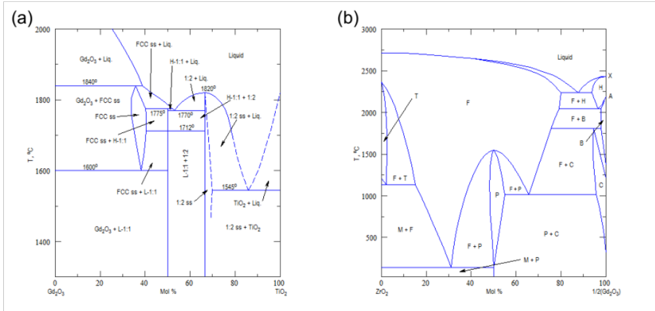
Figure 3.1 Phase diagrams for (a) Gd₂O₃-TiO₂ [52], and (b) Gd₂O₃-ZrO₂ [53]. In (a), L-1:1 and H-1:1 are low and high forms, respectively, of Gd₂O₃-TiO₂; 1:2 is Gd₂O₃-2TiO₂; FCC is face centered cubic phase. In (b), F = fluorite structure; H = high temperature Gd₂O₃ structure; B = B-type rare earth oxide structure; C = C-type rare earth oxide structure (bixbyite); P = pyrochlore phase (Gd₂Zr₂O₇); M = monoclinic zirconia phase; T = tetragonal zirconia phase; A = a-type rare earth oxide phase; X = X-type rare earth oxide phase.

Powders formed the pyrochlore structure under the following reactions:
Gd₂O₃ + 2 TiO₂ Gd₂Ti₂O₇
Gd₂O₃ + 2 ZrO₂ Gd₂Zr₂O₇
Powders were first calcined in a small furnace to remove any absorbed water, then mixed in stoichiometric ratios. Gd₂Ti₂O₇ and Gd₂Zr₂O₇ were initially synthesized using the same method (Table 3.1), which resulted in sufficiently high densities in Gd₂Ti₂O₇, ~94% theoretical density, but only ~87% theoretical density in Gd₂Zr₂O₇. A second procedure was developed for high-density Gd₂Zr₂O₇ synthesis, which resulted in ~95% theoretical density (Table 3.2). Samples were wet ball milled in isopropanol. After each ball milling step, samples were pressed into pellets at room temperature using a uniaxial press. Pellets were placed in zirconia boats containing small zirconia balls for sintering (Fig. 3.2).

Table 3.1 Description of synthesis steps used to make the initial batches of Gd₂Ti₂O₇ and Gd₂Zr₂O₇ samples. Samples were pressed into pellets after each ball milling step. Sintering steps are provided in Procedure #s 2 & 4. In the end, these steps were only adopted for Gd₂Ti₂O₇ synthesis, because they did not produce high enough density Gd₂Zr₂O₇ samples.
Procedure # | Synthesis Step
1 | Ball mill (12 h)
2 | HEAT 2°C/min  DWELL 1200°C for 48 h  COOL 2°C/min
3 | Ball mill (18 h)
4 | HEAT 5°C/min  DWELL 1000°C for 12 h  HEAT 5°C/min  DWELL 1600°C for 72 h  COOL 0.26°C/min

Table 3.2 Description of synthesis steps used to make high density Gd₂Zr₂O₇ samples. Samples were pressed into pellets after each ball milling step. Sintering steps are provided in Procedure #s 2 & 4.
Procedure # | Synthesis Step
1 | Ball mill (18 h)
2 | HEAT 2°C/min  DWELL 1100°C for 48 h  COOL 2°C/min
3 | Ball mill (12 h)
4 | HEAT 2°C/min  DWELL 1300°C for 48 h  COOL 2°C/min
5 | Ball mill (12 h)
6 | HEAT 5°C/min  DWELL 1000°C for 12 h  HEAT 5°C/min  DWELL 1600°C for 72 h  COOL 0.1°C/min

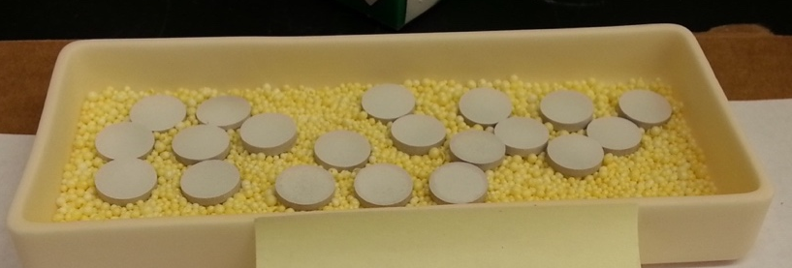
Figure 3.2 Thin Gd₂Ti₂O₇ pellets inside zirconia boat before 2nd sintering.

All samples, which were ~ 1 cm in diameter, were polished with diamond lapping film, starting with 30 μm grit and ending with 1 μm, then using 0.02 μm colloidal silica solution to remove residual damage after polishing. The surface was observed in an optical microscope to check for scratches after finishing each grit.

Phase Confirmation

Powder XRD was utilized for determining as-synthesized sample properties and can be performed using any polycrystalline sample. This allows for comparison with samples obtained from collaborators or with other experiments. Measurements were generally performed using the PANalytical Empyrean x-ray diffractometer in the JIAM x-ray diffraction facility at UTK. Diffractometers are typically configured in the Bragg-Brentano geometry for powder diffraction (Fig 3.3). In Bragg-Brentano geometry, the diffraction vector, S, is always perpendicular to the sample surface, and the tube angle, ω, is half of the detector angle 2θ. The tube and the detector move simultaneously during the measurement. Mask and slit combinations are selected so that the x-ray beam covers the entire sample. When bombarded with x-rays, planes in a crystalline material diffract the x-rays when Bragg’s law,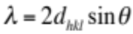, is satisfied, where λ is the x-ray wavelength (1.54 Å for Cu-Kα), d_{hkl} is the vector drawn from the origin of the unit cell to intersect the crystallographic plane (hkl) at a 90° angle, and θ is the Bragg angle. For a given x-ray wavelength, the diffraction occurs at a fixed angle θ for each (hkl) plane. Peak intensities are determined by the arrangement of atoms in the crystal and can be calculated using the structure factor, F_{hkl}, where I_{hkl} ∝ | F_{hkl}|². The structure factor is given by Eq. 3.1, where N_{j} is the fraction of every equivalent position occupied by atom j, f_{j} is the atomic scattering factor, which quantifies the efficiency of x-ray scattering at any angle by the electrons in a particular atom, and x_{j} y_{j} z_{j} are the fractional coordinates of each atom.
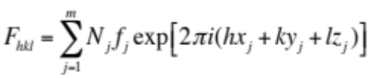 (3.1)
When scanning a single crystal sample, only one family of planes will satisfy the Bragg condition and appear in the diffraction pattern. Multiple planes satisfy the Bragg condition in polycrystalline samples, so multiple peaks appear in the diffraction pattern. If, however, the sample is textured, meaning the grains are oriented such that some planes satisfy the Bragg condition more frequently than others (preferred orientation), those peaks will have higher intensities and the intensities will differ from the theoretical values. To avoid this problem, samples are generally powdered using a mortar and pestle prior to scanning. In this work, a small piece was broken off each as-synthesized pyrochlore pellet and powdered using a zirconia mortar and pestle.

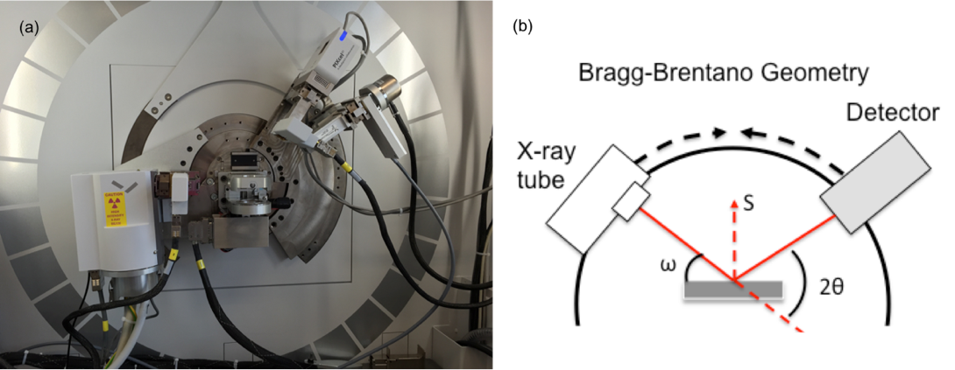
Figure 3.3 Image of the (a) PANalytical Empyrean diffractometer used for powder XRD measurements, which are performed in the (b) Bragg-Brentano geometry.

The powder was then dispersed evenly on the powder sample holder using a drop of isopropanol, which was allowed to dry before beginning the measurement. After the measurement, a LaB₆ NIST powder standard was measured using exactly the same measurement conditions. Powder XRD patterns for both as-synthesized materials are shown in Fig 3.4. The pyrochlore structure is identifiable by the presence of superstructure peaks, particularly the peak at ~15° 2θ in both materials. Superstructure peaks arise from the large pyrochlore unit cell, which can be thought of as being similar to 8 fluorite cells, each with a structural vacancy in a unique position. In a fluorite or defect-fluorite XRD pattern, the unit cell dimension is half that of the pyrochlore cell, and superstructure peaks are not present.
If material properties (e.g. crystallite size) needed to be extracted from XRD patterns, Reitveld refinement, a technique that fits the pattern with a physical model, was utilized. The General Structure Analysis System (GSAS) [54] program and EXPGUI [55] were employed for this analysis. GSAS requires approximate crystallographic atomic positions. Based on the atomic occupancy and positions, GSAS calculates the structure factor and intensity of each peak. Crystal information files (CIF) containing the approximate LaB₆ and pyrochlore atomic positions were obtained from the ICSD database. The LaB₆ was first refined and used to create an instrument parameter file, which describes the profile function for the diffractometer and optics used in the measurement.

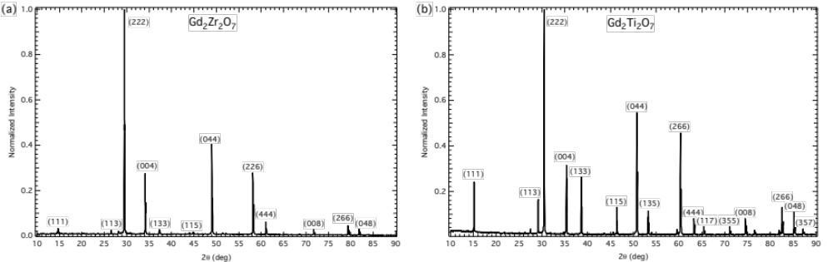
Figure 3.4 Indexed powder XRD patterns of as-synthesized (a) Gd₂Zr₂O₇ and (b) Gd₂Ti₂O₇ pellets.

GSAS uses the profile function contained in the instrument parameter file with the actual sample, refining the profile to account for features present in the sample. X-ray diffractometers inflict varying amounts of instrumental peak broadening depending on the particular optics used. This information is contained in the instrument parameter file, which GSAS uses during the actual sample refinement to separate the instrument broadening from particle size broadening.
Since Gd₂Zr₂O₇ lies on the boundary of pyrochlore phase stability, the A- and B- site positions and atomic occupancy were refined to account for any disorder present in the sample. The particle size (Å) was calculated from the refined isotropic Lorentzian broadening term, LX, using Eq. 3.2, where K is the Scherrer constant (≈1) and λ is the x-ray wavelength (Å), as discussed in the GSAS manual [54].
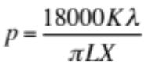 (3.2)
Crystallite sizes agreed with those measured using transmission electron microscopy in Gd₂Zr₂O₇.

Grain Size and Porosity Measurements

After the first synthesis attempt, Gd₂Ti₂O₇ pellets were 94% theoretical density and Gd₂Zr₂O₇ pellets were 87% theoretical density, as measured by the Archimedes method. A pellet of each material was cracked in half and observed in the scanning electron microscope (SEM) to determine the grain size. SEM images of the cracked surfaces are shown in Fig 3.5.

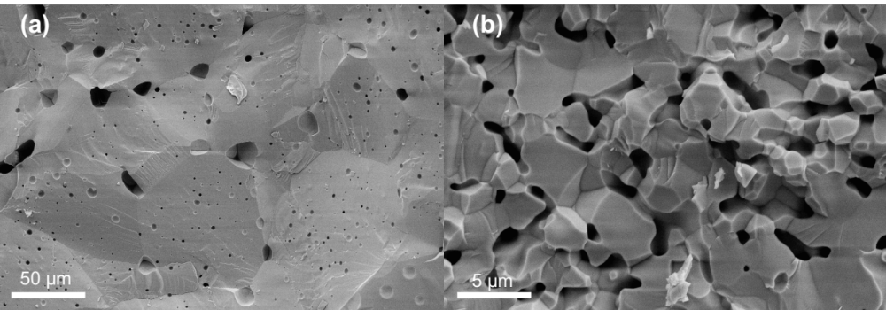
Figure 3.5 Scanning electron microscope images of as-synthesized cracked (a) Gd₂Ti₂O₇ and (b) Gd₂Zr₂O₇ pellets after the first synthesis attempt.

Gd₂Ti₂O₇ pellets had a typical grain size of 50-80 μm and Gd₂Zr₂O₇ pellets had a typical grain size of 1-4 μm. The percent porosity was estimated from the SEM images using image analysis techniques, and found to be 2.6% for Gd₂Ti₂O₇ pellets and 17.7% for Gd₂Zr₂O₇ pellets. These estimates roughly agree with the Archimedes density measurements. A second batch of Gd₂Zr₂O₇ pellets was synthesized in which ball-milling and heating times were adjusted, leading to the eventual achievement of 95% theoretical density in Gd₂Zr₂O₇ pellets. These pellets were also imaged in the SEM to determine the grain size, which was similar to the previously sintered pellets shown in Fig 3.5. An energy dispersive x-ray spectroscopy (EDXS) line scan of the cracked surface showed a Si impurity, which is likely from the furnace elements and is probably present in all synthesized samples.

EXPERIMENTAL METHODS

Ion Irradiations
Details about the specific irradiation conditions are provided in Chapters 5-8. This section serves to describe the irradiation damage and helium concentration calculations, and fluence and temperature calibrations. Ion accelerators were utilized in this work to simulate radiation damage processes occurring in real nuclear materials, which would normally occur over much longer timescales. Irradiations were performed at both the University of Tennessee Ion Beam Materials Laboratory (UT-IBML) [56] using a 3 MV tandem accelerator and the Los Alamos National Lab Ion Beam Materials Laboratory (LANL-IBML) using a 200 kV Danfysik Research Implanter. Experimental parameters were determined using a collection of software packages called The Stopping and Range of Ions in Matter (SRIM) [57]. SRIM can output stopping power, or energy loss per unit distance, tables for any ion/solid combination up to 2 GeV/amu, separated into electronic and nuclear stopping power components. SRIM also includes a Monte Carlo algorithm for estimating ion ranges and vacancy production in materials. Full Cascade mode was used for all SRIM calculations to facilitate easy comparisons with previous experiments, and to obtain the most accurate approximation of the damage depth. The threshold displacement energy was set to 50 eV for all atoms in all SRIM calculations [58], which were done to 20,000 ions, theoretical densities (6.575 and 6.904 g/cm³ for Gd₂Ti₂O₇ and Gd₂Zr₂O₇, respectively), and 2008 stopping powers. The output files VACANCY.txt, RANGE.txt and NOVAC.txt were used to calculate the damage dose in displacements per atom (dpa), Eq. 4.1, where one dpa is equivalent to each atom in the lattice being displaced an average of one time during the irradiation. In Eq. 4.1, ν is the number of displacements per cm-ion, obtained from the VACANCY.txt file in SRIM, ρ is the atomic density (atoms cm⁻³), φ is the irradiation flux (ions cm⁻²-s), and t is the irradiation time (s). The fluence is given by φ × t.
$\text{dpa}= \frac{υ(ϕt)}{ρ}$ (4.1)
Eq. 4.1 provides an estimate of the number of displacements created by the irradiation, but does not account for recombination, and is thus generally much larger than the number of defects remaining after the irradiation. It is important to note that the number of vacancies calculated using Full Cascade mode has been shown to differ from the Kinchin-Pease model by more than a factor of two [59]. To determine the extent of this discrepancy in pyrochlores irradiated with 7 MeV Au³⁺ and 200 keV He⁺, Quick Calculation mode was also used to calculate the number of displacements. For comparison purposes, the total number of displacements was calculated using the Norgett, Torrens and Robinson (NRT) formula, Eq. 4.2, which requires the damage energy, T_{dam}(E_{PKA}), and the threshold displacement energy, E_{d}.
$ν_{\text{NRT}}=0.8T_{\text{dam}}\left(E_{\text{PKA}}\right)/2E_{d}$ (4.2)
To remain fully consistent with the NRT formula, the lattice binding energy must be set to zero, thereby making the damage energy, T_{dam}(E_{PKA}), equivalent to the energy dissipated to phonons, which is also given by the initial ion energy minus the energy dissipated in ionization. The total number of displacements calculated by both methods are shown for both irradiation conditions in both pyrochlores in Table 4.1. The difference is much more apparent (8% in GZO, 12% in GTO) in the 7 MeV Au³⁺ irradiation where the energy transferred to recoils is higher.

Table 4.1 Comparison of the total number of displacements calculated by the SRIM Kinchin-Pease (KP) and Full Cascade (FC) calculations.
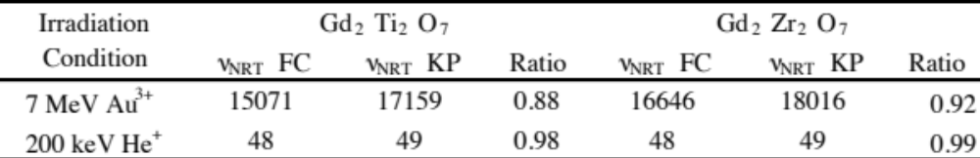

Samples utilized in this study were ~1 cm in diameter, requiring a 10 x 10 mm irradiation area, which was accomplished by rastering the ion beam at a frequency of 517 Hz in the x direction and 64 Hz in the y direction. Ion irradiation fluences and rastering uniformity are routinely and carefully calibrated by the UT-IBML team on all beamlines by irradiating silicon wafers and measuring the implanted fluence with Rutherford backscattering spectroscopy (RBS). Samples were mounted on different stages for room temperature and high temperature Au irradiations (Fig 4.1). For room temperature irradiations, samples were mounted in the accelerator sample chamber using carbon tape. Scintillating glass slides were taped around the sample to confirm the slits were opened to the correct width. For high temperature irradiations, carbon tape can be used to mount the samples, so samples must be carefully mounted using metal clips. In the case of high temperature irradiations, only one sample can be mounted at once. The temperature was controlled using a HRN (LPS-800-1) heater controller from Thermionics Northwest Inc. Room temperature 7 MeV Au³⁺ irradiations produced a beam heating of ~ 50 °C, as measured by a type K thermocouple at the sample surface. Thermocouples were fixed to the sample surface and to the sample holder. More details about the high temperature irradiation capability can be found in the description of the UT-IBML facility [18]. The beam heating was less than 35°C during the He implantations where active air cooling was applied to the sample stage. The high temperature stage was calibrated by measuring the temperature of a one-side polished Cu sample with three thermocouples and a pyrometer. The main thermocouple was located on the sample surface, the auxiliary thermocouple was located behind the sample, and the additional thermocouple was touching the side of the sample. Calibration curves and an image showing the locations of both thermocouples are shown in Fig 4.2. The main thermocouple had good agreement with the pyrometer values within the Cu emissivity range. The auxiliary thermocouple typically measures temperatures much higher than the main thermocouple because the temperature on the sample surface is lowered depending on the thermal conductivity of the sample and sample plate. Samples are cooled from high temperature to room temperature using LN₂ gas at a rate of 0.5 °C /2 min.

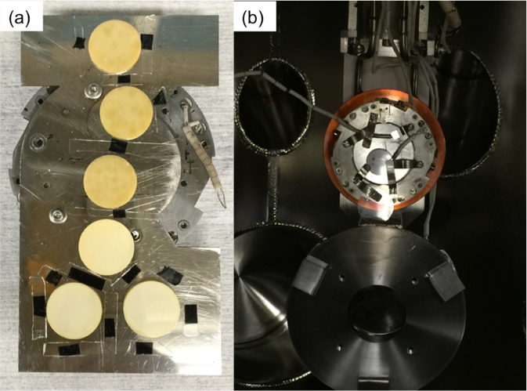
Figure 4.1 Samples mounted for (a) room temperature and (b) high temperature irradiation at the UT-IBML.

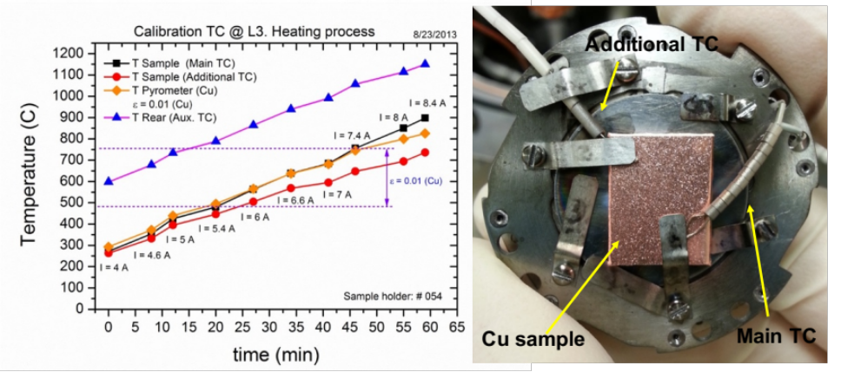
Figure 4.2 Calibration curves for the high temperature stage utilized in these experiments, along with an image showing the location of thermocouples used for the calibration.

Grazing-Incidence X-ray Diffraction
Grazing-incidence x-ray diffraction (GIXRD) is a surface analysis technique optimized for studying thin film multilayers, such as an irradiated layer, in a material. Irradiated Gd₂Ti₂O₇ and Gd₂Zr₂O₇ samples were characterized using GIXRD in Chapters 5-8. A PANalytical X’Pert³ Pro MRD diffractometer in the Joint Institute for Advanced Materials (JIAM) XRD facility at UTK was used for these measurements. In grazing-incidence mode, the tube is fixed at a grazing angle, ω, which fixes the maximum depth at which x-rays can penetrate into the material. The sample surface is aligned before each measurement using the x-ray beam. To prevent errors in sample displacement caused by discrepancies in the sample alignment and polishing quality, a parallel x-ray beam must be used. Based on the sample size, a combination of masks and slits were used to construct the correct beam size. A diagram showing the GIXRD configuration and components is shown in Fig 4.3.

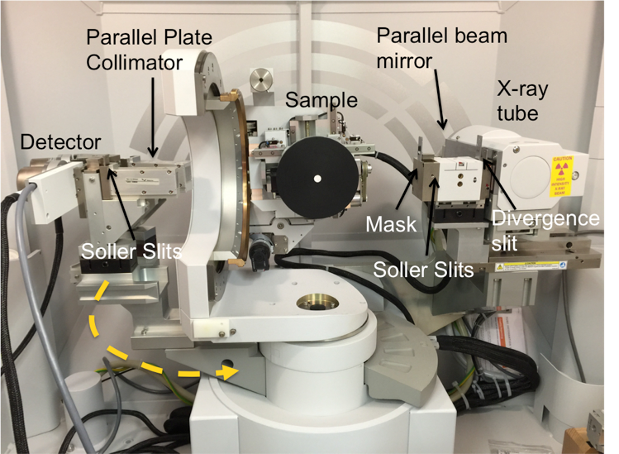
Figure 4.3 Image showing GXRD configuration in PANalytical X’Pert³ Pro MRD diffractometer. An irradiated Gd₂Zr₂O₇ sample is shown mounted on the sample stage.

Grazing angles are determined by calculating the x-ray penetration depth in a material. In this work, the x-ray penetration depth, D, was calculated based on the total external reflection theory (Eq. 4.1), where μ is the linear absorption coefficient, φ_{c} is the critical angle, Z is the average atomic number, A, is the average atomic mass, ρ is the mass density (g/cm³), and λ is the x-ray wavelength [60, 61]. Bulk density values were used for this calculation.
$D=\frac{λ\sqrt{2}}{4π{\left(\sqrt{{(∅^{2}-∅_{c}^{2})}^{2}+4δ_{i}^{2}}+∅_{c}^{2}-∅^{2}\right)}^{1/2}}$ (4.1)
$∅_{c}=\sqrt{2δ}$, $δ=\frac{Zeρ}{A}λ^{2}$, $δ_{i}=\frac{λμ}{4π}$
The penetration depth of x-rays in Gd₂Zr₂O₇ as a function of grazing angle is shown in Fig 4.4.

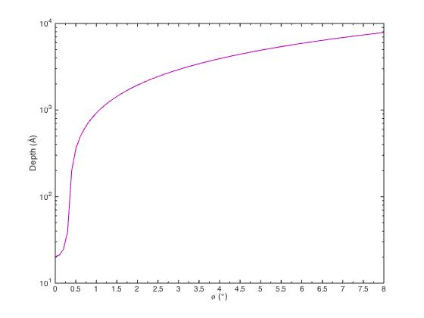
Figure 4.4 Calculated X-ray penetration depth curve for Gd₂Zr₂O₇ as a function of grazing angle, ϕ.

GIXRD peaks were fit using a pseudo-voigt curve, which is a combination of Gaussian and Lorentzian peak shapes. More information about specific diffractometer optics, peak fitting software and error propagation are provided in Chapters 5-8. In the thin film residual stress measurements discussed in Chapter 7, the same grazing-incidence diffractometer configuration shown in Fig 4.3 was used.

Transmission Electron Microscopy
Conventional TEM was utilized to identify and quantify gas bubbles in irradiated pyrochlores. TEM imaging was performed at the University of Tennessee JIAM microscopy center using a ZEISS Libra 200 HT MC high resolution TEM operating at 200 kV using a Gatan CCD camera and at the National Renewable Energy Laboratory (NREL) using an FEI Tecnai operating at 200-300 kV in TEM mode using a Gatan Osiris CCD camera. TEM samples were prepared by both hand-polishing cross-sections and by lifting out electron transparent lamellae using a focused ion beam (FIB) and SEM. Cross-section TEM samples were prepared by hand when possible because the FIB method utilizes Ga ions for thinning the lamella, which may produce additional radiation damage features during the sample preparation. FIB lamellae were prepared at NREL using an FEI Nova 200 Nanolab Dual Beam focused ion beam.
Most Gd₂Ti₂O₇ TEM samples were prepared by hand-polishing. When hand polishing cross-sections, irradiated pellets were ground from the back using 80 μm grit SiC paper to thin the sample to ~750 μm. This is necessary because the TEM grid opening, which must fit the entire sample sandwich described in the next few sentences, is only 2-3 mm wide. Two long sections were cut from the center of each pellet using a diamond saw. The polished (irradiated) surfaces of each section were glued together using MBond adhesive. A piece of silicon was glued to the back of each section to form a sandwich, shown in Fig 4.5. This sandwich was heated for 3 hours at 165°C to permanently cure the MBond. After curing, cross-sections were cut from the sandwich and polished using a tripod polishing system and 30, 15, 9, 6, 3 and 1 μm diamond lapping film, then finished using 0.5 μm colloidal silica solution. A TEM grid was glued to the polished sandwich using MBond, then cured for 1 hour at 165°C. After attaching a TEM grid, the cross-sections were ground from the back down to 10 μm thickness, at which point the silicon will turn red-orange when observed in transmission mode in an optical microscope.
Figure 4.5 TEM cross-section sample preparation for hand-polishing an irradiated pellet. Image shows TEM sample polished down to ~7 μm before being placed in the PIPS.

Thin samples were soaked overnight in acetone to remove the crystal wax used to mount the sample to the tripod polishing system. Ion milling was then performed using a Gatan Precision Ion Polishing System (PIPS) with 4 keV Ar⁺ ions at +5.5° with respect to the sample surface until a small hole was observed, at an ion current of 17 μA for ~90 min. Assuming ~2 × 2 mm irradiation area, the resulting fluence is 5 × 10¹¹ ions/cm². SRIM calculations predicted ~10 sputtered atoms per Ar⁺ ion, and a peak Ar concentration of only 7 × 10⁻⁴ at% (see Fig 4.6), much too low for bubble formation. The edges of the hole were then observed in the TEM. If no thin region was present, the sample was placed back in the PIPS for additional ion milling. This process was repeated until electron transparency was achieved, with care taken not to mill off any portion of the irradiated layer. Samples must be <100 nm in thickness for viewing in a TEM operating at 200 kV.
Some Gd₂Ti₂O₇ and all Gd₂Zr₂O₇ samples were prepared by the focused ion beam (FIB) method due to the higher level of precision and control, which allows for better sample preparation of porous material. In addition, the irradiated layer is easily identified by the presence of the platinum surface layer. In hand polished specimens, part of the surface layer may be milled off during Ar milling. Care was taken to minimize the ion beam interaction with the exposed surface throughout FIB lamella sample preparation. The sample surface was protected from ion beam damage by using a 5 keV electron beam and a gradually increasing current to deposit platinum multilayers of varying thickness on the sample surface of the implanted samples. Ion beam milling was performed at 30 kV and 93 pA followed by a final clean using a 5 kV Ga beam current of 12 pA to remove surface material deposited during FIB and to remove residual FIB milling damage. An image of a Gd₂Zr₂O₇ lamella being thinned is shown in Fig 4.7.

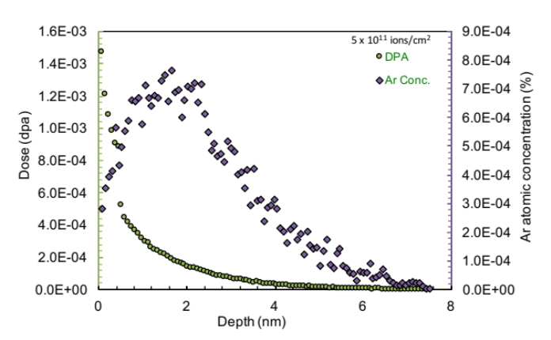
Figure 4.6 SRIM predicted damage and Ar concentration profiles due to ion milling a Gd₂Ti₂O₇ TEM cross-section. Calculations were done at an angle of 5.5° with respect to the sample surface.

Objective apertures 10-90 μm in diameter were used during the TEM observations to increase defect contrast. Even though an irradiated contrast band could usually be identified in the Gd₂Ti₂O₇ samples (see Fig 5.4), electron diffraction was utilized to confirm the irradiated region, where there is an irradiation-induced phase transformation from pyrochlore to amorphous structure. Due to extremely small crystallite sizes in Gd₂Zr₂O₇, the [110] zone axis, which is typically used to differentiate between a pyrochlore and defect-fluorite structure, could not be easily identified. In this case, FIB lamellae with a thick surface Pt layer were used, and the irradiated region was determined by measuring the distance from the surface, confirmed using the SRIM predicted damage depth. Bright field imaging conditions were used to image helium bubbles. Bubbles were imaged using the through-focusing technique, in which Fresnel contrast causes the bubbles to appear bright with a dark ring in underfocus and dark with a bright ring in overfocus. Bubbles are imaged off-zone, so the image was focused by maximizing the diameter of the Fourier transform.

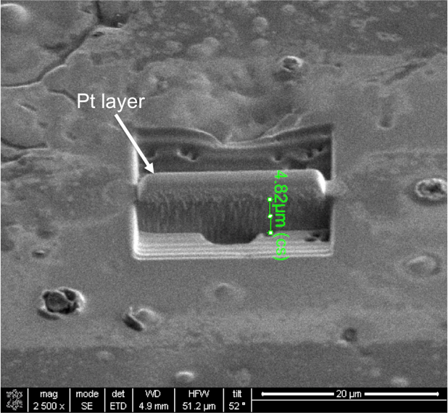
Figure 4.7 SEM image showing a Gd₂Zr₂O₇ FIB lamella during the thinning process. This image also shows the porous Gd₂Zr₂O₇ structure.

Defocus values have an error of about ±100 nm due to error in focusing the image. In samples containing bubbles, TEM images were analyzed to determine the size distribution, volume swelling and number density. Bubbles were quantified using the “Analyze Particle” feature in ImageJ [62]. TEM images were imported into ImageJ, where a standard procedure was developed for quantifying the total bubble cross-sectional area. Images were first color inverted, then passed through filters that increase the contrast between the bubbles and the background material. “Color Threshold” was then utilized to highlight the bubbles in red. After calibrating the image from pixels to nanometers using the scale bar, “Analyze Particles” was set to measure particle sizes of 10-100 nm² (this range changes depending on the image) with any range of circularity, as bubbles are not perfectly circular. An example of bubbles identified by ImageJ is shown in Fig. 4.8. ImageJ provides the cross-sectional area of each bubble in nanometers, which was then converted to bubble radius using a circular cross-sectional area approximation. The circular bubble approximation is not always true and can introduce additional error.

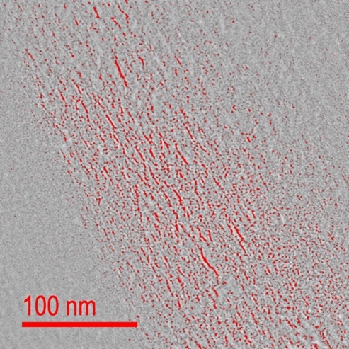
Figure 4.8 TEM image of helium bubbles in Gd₂Zr₂O₇, overlaid with bubble outlines identified by ImageJ particle finder, which are shown in red.

The bubble size distributions were plotted using Origin and then fitted with a log-normal distribution, which provides an average size and standard deviation. The same process was utilized for calculating the bubble number density and volume swelling, and specific details are provided in Chapters 5-7. Gatan DigitalMicrograph was utilized to adjust image brightness and contrast, recolor electron diffraction, and analyze electron diffraction.

Thermal Desorption Spectroscopy
Thermal helium desorption spectroscopy (THDS) has been employed to experimentally examine irradiation-induced structural defects and their interactions with He atoms in materials. In these experiments, helium is either infused into the sample, in which case only thermal defect concentrations are expected, or implanted into the sample, which produces irradiation-induced defects. The sample is then heated and the helium release measured using a quadrupole mass spectrometer. Immobile helium will reside in the lowest energy interstitial site, while mobile helium will become strongly trapped by vacancies. In ceramics, vacancies are immobile at room temperature and helium is likely trapped in single vacancy sites. At high temperatures, vacancies become mobile and may form vacancy clusters, to which helium will bind to form helium-vacancy complexes, He_{n}V_{m}, containing n He atoms and m vacancies. Measured desorption temperatures correspond to helium dissociation energies, $E_{D}=E_{m}+E_{B}$, where E_{m} and E_{B} are the migration and binding energies, respectively, from He-defect complexes inside the material. THDS experiments were performed at Oak Ridge National Laboratory. The THDS system is shown in Fig 4.9.
Pyrochlore samples were synthesized as described in Chapter 3, then ground by hand using SiC paper to ~ 1 mm thickness. Samples less than 2 x 2 mm, the maximum size that could fit in the THDS ion implantation chamber, were cut using a diamond saw. Small samples are generally desirable to reduce the heating power needed in the experiments. Both sides of the samples were polished using diamond lapping film down to 1 μm, and finished with 0.02 μm colloidal silica to remove polishing damage. Polishing the back side provides good contact with the heating stage, and polishing the surface reduces surface roughness effects during the ion implantation and desorption experiments. After polishing, samples were heated at 800°C for 36h to anneal away strain induced by sample preparation. Gd₂Ti₂O₇ and Gd₂Zr₂O₇ samples were implanted to a fluence of 1 x 10¹⁵ ions/cm² with 10 keV, 100 keV, or 1 MeV He so that the effects of implantation depth could be examined. 10 keV He implantations were performed using the in-situ 20 kV ion implantation gun inside the THDS system (Fig. 4.9), 100 keV implantations were performed using the 200 kV Danfysik Research Implanter at LANL-IBML, and 1 MeV implantations were performed using the 3 MV Tandem accelerator at the UT-IBML. After ion implantation inside the THDS system, a manipulator is used to move the sample from the ion implantation chamber into the heating chamber. Each chamber is equipped with a Pfeiffer turbo-drag pump, with the pre-vacuum obtained by the Varian TriScroll 600 oil-free dry scroll vacuum pump. The system target pressure is ~10⁻¹⁰ torr. The maximum temperature obtained from the heater is 1100°C.

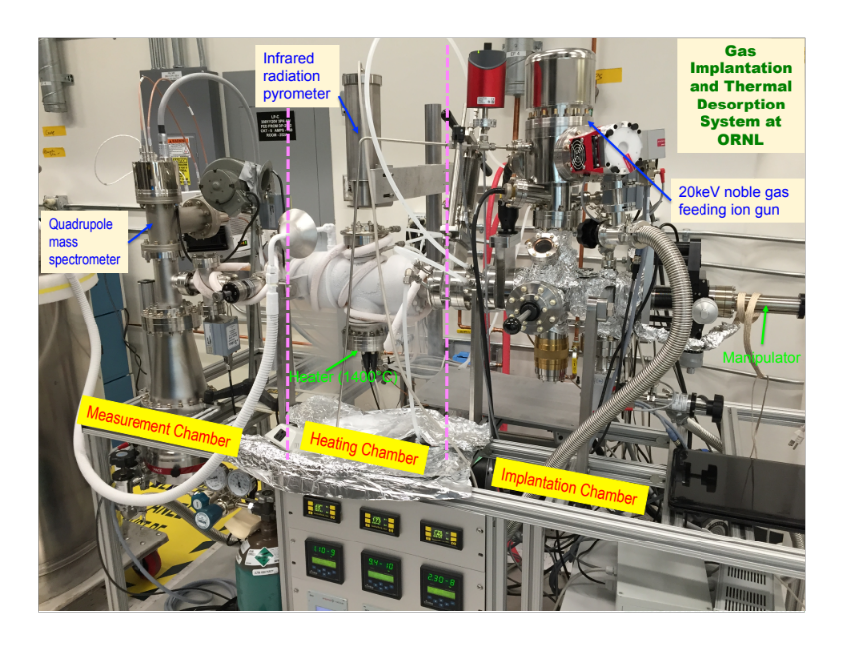
Figure 4.9 Image showing the thermal desorption spectroscopy system at Oak Ridge National Laboratory.

For these measurements, the temperature ramp rate was fixed at 0.5 K/s using programmable ramp software. A Heitronics infrared radiation pyrometer is used to acquire the accurate temperature of the samples during the desorption process. Desorbed gas is measured by a Pfeiffer HiQuad quadrupole mass spectrometer system inside the measurement chamber. A linear relationship exists between the ion current in the mass spectrometer and the helium partial pressure, given by Eq. 4.3.
$I\left(A\right)∝ P_{He}(\text{torr})$ (4.3)
The helium desorption rate from the sample is described by Eq. 4.4, where L(t) is the helium desorption rate, N is the number of helium atoms, P(t) is the helium partial pressure, S is the pumping speed (L/s), V is the chamber volume (L), and τ = V/S, the pumping time constant (s).
$L\left(t\right)= \frac{dN}{dt}=\frac{dP(t)}{dt}+\frac{S}{V}P\left(t\right)=\frac{dP(t)}{dt}+\frac{P(t)}{τ}$ (4.4)
The THDS system can operate in two modes, either static or dynamic mode. In static mode, the P(t)/ τ term in Eq. 4.4 is minimized, with no pumping on the sample holder chamber. In the dynamic mode, the dP(t)/dt term in Eq. 4.4 is minimized, and τ is adjusted by the value to the turbo-drag pump. These measurements were performed in dynamic mode.

HELIUM BUBBLE FORMATION IN Gd₂Ti₂O₇

A version of this chapter was originally published by Caitlin A. Taylor et. al.: C.A. Taylor, M.K. Patel, J.A. Aguiar, Y. Zhang, M.L. Crespillo, J. Wen, H. Xue, Y. Wang, W.J. Weber, Journal of Nuclear Materials 479 (2016) 542-547.[63]

Sample synthesis, surface preparation, TEM sample preparation by hand-polishing, experimental planning and analysis were done by C.A. Taylor. FIB sample preparation was done by J.A. Aguiar. Irradiations were performed by M.L. Crespillo, J. Wen, H. Xue, Y. Wang with advising by Y. Zhang. X-ray diffraction was by C.A. Taylor. TEM imaging was done by C.A. Taylor and J.A. Aguiar. Project was advised by W.J. Weber and M.K. Patel.

Introduction
Helium accumulation due to α-decay could eventually lead to helium bubble formation in a real pyrochlore waste form, but the helium concentration required to nucleate bubbles in pyrochlores was previously unknown. Helium bubble formation could have significant implications on a nuclear waste form due to the possibility of cracking, which would allow groundwater to enter the waste form, resulting in increased leaching of radioactive material. The critical helium concentration required to nucleate bubbles was determined for one of the principle pyrochlores under consideration, Gd₂Ti₂O₇, which amorphizes under irradiation at ~0.2 dpa. Due to the extremely long timescales and experimental restrictions required for studying actinide-doped pyrochlores, ion irradiations were utilized to simulate 1) α-recoil damage, and 2) helium accumulation. TEM was utilized for observing helium bubbles in irradiated samples.

Experimental Methods
Gd₂Ti₂O₇ samples were synthesized and polished as described in Chapter 3. Table 5.1 summarizes all irradiation conditions utilized in this work. All samples were pre-damaged
Table 5.1 Summary of irradiation conditions utilized to simulate α-recoil damage and He accumulation in Gd₂Ti₂O₇. Irradiations identical to Samples 2-5, but implanted with 200 keV He⁺ to 2 × 10¹⁵ He/cm² (0.1 at.% He at the peak) instead of 2 × 10¹⁶ He/cm², were also performed. All pre-damage and He irradiations were performed at room temperature. Sample 7 was a FIB lift-out taken from the very edge of the sample, which was a region undamaged by during the Au irradiation. The right column states whether or not He bubbles were observed in TEM, and, if so, the mean bubble diameter.
Sample # | Pre-damage | He implantation  (Peak He conc., at.%) | Post-damage | He Bubbles?
1 | 7 MeV Au³⁺  2.2 × 10¹⁵ ions/cm² |  |  | No
2 | 7 MeV Au³⁺  2.2 × 10¹⁵ ions/cm² | 200 keV He⁺  2 × 10¹⁶ ions/cm²  (1.0) |  | No
3 | 7 MeV Au³⁺  2.2 × 10¹⁵ ions/cm² | 200 keV He⁺  2 × 10¹⁶ ions/cm²  (1.0) | 7 MeV Au³⁺ (RT)  2.2 × 10¹⁵ ions/cm² | No
4 | 7 MeV Au³⁺  2.2 × 10¹⁵ ions/cm² | 200 keV He⁺  2 × 10¹⁶ ions/cm²  (1.0) | 7 MeV Au³⁺ (500 K)  2.2 × 10¹⁵ ions/cm² | No
5 | 7 MeV Au³⁺  2.2 × 10¹⁵ ions/cm² | 200 keV He⁺  2 × 10¹⁶ ions/cm²  (1.0) | 7 MeV Au³⁺ (700 K)  2.2 × 10¹⁵ ions/cm² | No
6 | 7 MeV Au³⁺  2.2 × 10¹⁵ ions/cm² | 65 keV He⁺  2 × 10¹⁷ ions/cm²  (12.0) |  | Yes, 1.6 nm diameter
7 |  | 65 keV He⁺  2 × 10¹⁷ ions/cm²  (12.0) |  | Yes, 2.2 nm diameter

with 7 MeV Au³⁺ to a fluence of 2.2 × 10¹⁵ Au/cm² (6 dpa at the damage peak) at the UT-IBML [56]. The ion flux was kept constant at 8.1 × 10¹¹ ions/cm²/s during the Au irradiation, which was done over an irradiated area of 10.2 × 10.2 mm to ensure a uniform irradiation over the majority of the pellet surface. Following He implantations (described below), some samples were further irradiated at 300, 500 and 700 K under the same 7 MeV Au³⁺ conditions. The Au irradiation dose in these samples exceeds that required for full amorphization and corresponds to the total damage accumulation expected over 50 to 1000 years in a waste form containing 5 wt% minor actinides and 1,000-10,000 years in a waste form containing 20 wt.% ²³⁹Pu [58, 64], as shown in Fig 5.1.

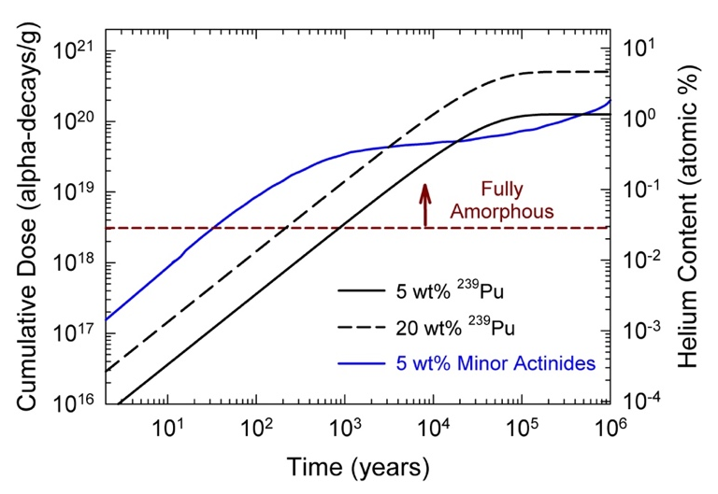
Figure 5.1 Expected dose and He content in Gd₂Ti₂O₇ over geological time for different actinide concentrations [58, 64]. Gd₂Ti₂O₇ will be fully amorphous above the dose corresponding to the dashed line (3.1 × 10¹⁸ α-decays/g).

This pre-damage step induces the pyrochlore to amorphous phase transformation that would occur due to α-recoil damage during interim or early storage times (several hundred to several thousand years); furthermore, this phase transformation will occur prior to any significant He accumulation in an actual nuclear waste form. Samples were implanted with either 200 keV He⁺ to fluences of 2 × 10¹⁵ and 2 × 10¹⁶ He/cm² (0.1 and 1.0 at.% He at the peak, projected range (R_{p} ~ 900 nm) or with 65 keV He⁺ to a fluence of 2 × 10¹⁷ He/cm² (12 at.% He at the peak, R_{p} ~ 450 nm) at LANL-IBML. The ion fluxes utilized for the He implantations were 1.1 × 10¹³ ions/cm²/s for the 200 keV implantations and 7.39 × 10¹² ions/cm²/s for the 65 keV implantations. Figure 5.2 shows SRIM calculated damage dose and helium concentration profiles. The Au and He irradiation energies were specifically chosen such that the 7 MeV Au³⁺ irradiation produced a thick amorphous layer that extended significantly deeper than the peak in He concentration. Moreover, the Au concentration peak (~ 1 μm from surface, ~ 0.06 at.%) is significantly deeper than the He concentration peak (~ 700 nm from surface for 200 keV He⁺), so as to preserve the chemical integrity near the He concentration peak where bubbles were expected to form.

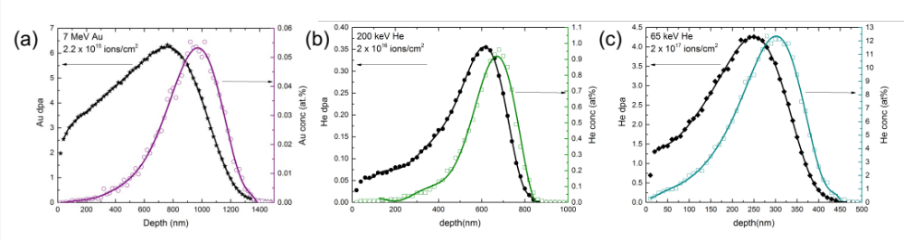
Figure 5.2 SRIM calculated damage and concentration profiles for (a) 7 MeV Au³⁺ irradiation to a fluence of 2.2 × 10¹⁵ ions/cm², (b) 200 keV He⁺ implantation to a fluence of 2 × 10¹⁶ ions/cm², and (c) 65 keV He⁺ implantation to a fluence of 2 × 10¹⁷ ions/cm².

It is worth noting that electronic stopping powers may be overestimated for heavy ions in a target containing light elements [65, 66], such as the case for Au ions in Gd₂Ti₂O₇ in this work. GIXRD was initially utilized to confirm amorphization prior the He implantation, and is included in Fig 5.3. The thickness of the amorphous layer was more accurately confirmed using TEM (Fig 5.4). Helium implanted samples were characterized using TEM to quantify the presence or absence of bubbles with the through-focus technique. Each sample was observed in the TEM while focused, and at all defocus values between -1 μm and +1 μm. Several magnifications were utilized to search for bubbles. The TEM image was focused by expanding the Fourier transform to

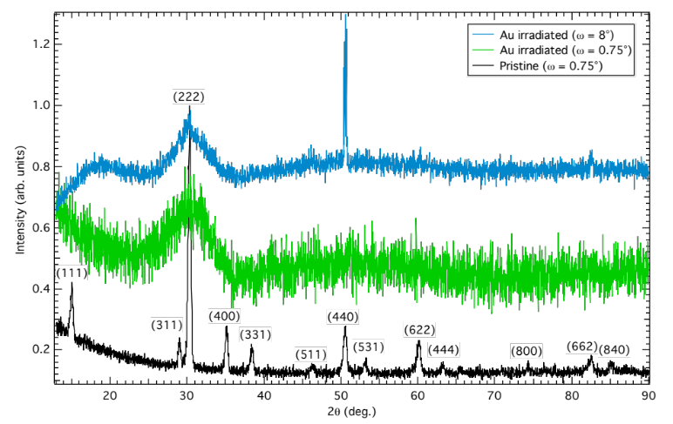
Figure 5.3 GXRD patterns showing pristine Gd₂Ti₂O₇ (prior to any irradiation), and amorphous Au irradiated Gd₂Ti₂O_{7,} shown at grazing angles of ω = 0.75° and 8°. Crystalline peaks appear in the ω = 8° pattern, confirming amorphization in the surface layer.

the largest possible diameter. In all TEM observations, the smallest possible objective aperture was utilized (ranging from 20-60 μm). The pre-damaged (Au irradiated) sample and all samples implanted with 2 × 10¹⁶ He/cm² were prepared by hand polishing cross-sections down to 5-10 μm thickness, and then final polished to electron transparency (< 100 nm thickness) using a PIPS with 4 keV Ar⁺. TEM imaging on the pre-damaged sample and all samples implanted with 2 × 10¹⁶ He/cm² was performed using a ZEISS Libra 200 MC at UTK. An FEI Nova 200 Nanolab Dual Beam FIB was utilized for preparing cross-sections of the samples implanted with 2 × 10¹⁷ He/cm². TEM imaging on the sample implanted with 2 × 10¹⁷ He/cm² was performed at NREL using an FEI Tecnai. Outlines of the features selected by ImageJ are provided in Fig 5.5. Since the low contrast between bubbles and the amorphous Gd₂Ti₂O₇ makes image analysis difficult, the image analysis is subjective and results should only be utilized as a qualitative guide for understanding bubble density and size. The bubble size distribution was fit with a log-normal distribution to determine the average diameter. The error in bubble diameter was estimated as 2 Å

Figure 5.4 TEM image showing the amorphous layer in Gd₂Ti₂O₇ irradiated with 7 MeV Au³⁺ to a fluence of 2.2 × 10¹⁵ ions/cm². TEM cross-section was prepared by hand-polishing. Measured amorphous layer thickness agrees well with SRIM predicted damage profile. Electron diffraction was used to confirm the location of the amorphous layer and crystalline-amorphous interface.

Figure 5.5 Schematic showing results of image analysis process, showing underfocused TEM images and bubble outlines determined by ImageJ for both (a) “pristine” implanted and (b) pre-damaged Gd₂Ti₂O₇.

based on the TEM image pixel size, which was 0.2 nm in both the pre-damaged + 2 × 10¹⁷ He/cm² images and the pristine + 2 × 10¹⁷ He/cm² images.

Results
As referenced above, Table 5.1 summarizes the irradiation conditions and TEM observation results. Helium bubbles were not observed in pre-damaged Gd₂Ti₂O₇ implanted with 2 × 10¹⁶ He/cm² (peak concentration of 1.0 at.%), even after additional post-implantation irradiation with 7 MeV Au³⁺ to 2.2 × 10¹⁵ Au/cm² at 300, 500 and 700 K, as shown in the defocused images in Fig 5.6. Post-implantation Au irradiations were utilized to see if ballistic mixing, combined with high temperature, might result in bubble formation at lower fluences. The irradiations at 500 and 700 K were intended to enhance the kinetics of bubble formation and mimic the kinetics occurring over a hundred thousand years. Based on these results, it is assumed that no bubbles are present at the lowest implantation fluence (2 × 10¹⁵ He/cm²), and these samples were not further characterized by TEM. A FIB lift-out was also taken from the very edge of the sample pre-damaged and implanted with 2 × 10¹⁷ He/cm². When observed in the TEM, the sample was found to be amorphous only up to the depth of the He damage range, and not the Au damage range, as found elsewhere in the sample.

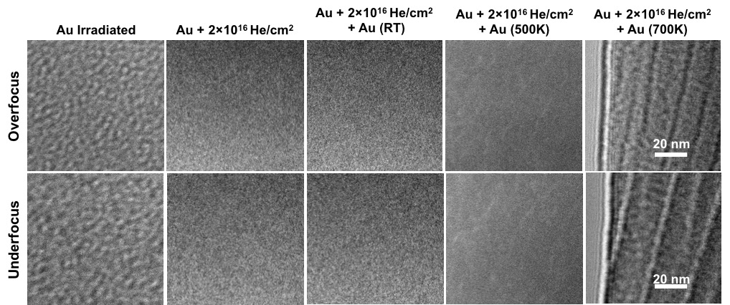
Figure 5.6 TEM images shown at 250,000x (scale bar is equivalent for all images) with defocus values of ±1 μm obtained from all Gd₂Ti₂O₇ samples implanted with 200 keV He⁺ to a fluence of 2 × 10¹⁶ He/cm², and pre- or post- damaged with 7 MeV Au³⁺ to a fluence of 2.2 × 10¹⁵ Au/cm².

This indicates that the very edge of the sample was not irradiated with Au, which is not unexpected under the irradiation conditions, but only implanted with He. SRIM simulations predict a He damage dose > 0.2 dpa, i.e., the dose required to amorphize Gd₂Ti₂O₇ [6], from the surface to a depth of ~ 400 nm, which agrees with the amorphous layer thickness observed in the TEM image in Fig 5.7. If the edge of the sample had been implanted with Au, the amorphous layer would correspond to the SRIM predicted Au damage profile thickness (~ 1.3 μm), as was the case for the pre-damaged samples discussed above and shown in Fig 5.4. It is therefore assumed that the very edge of the sample was not pre-damaged with Au, only implanted with He. In this TEM sample, which the authors consider as initially pristine pyrochlore Gd₂Ti₂O₇ implanted with 2 × 10¹⁷ He/cm², the bubbles are more clearly visible in the underfocused and overfocused imaging conditions, as shown in Fig 5.8. Bubbles are larger and of higher density than the pre-damaged (amorphous) Gd₂Ti₂O₇ sample implanted with the same He fluence.

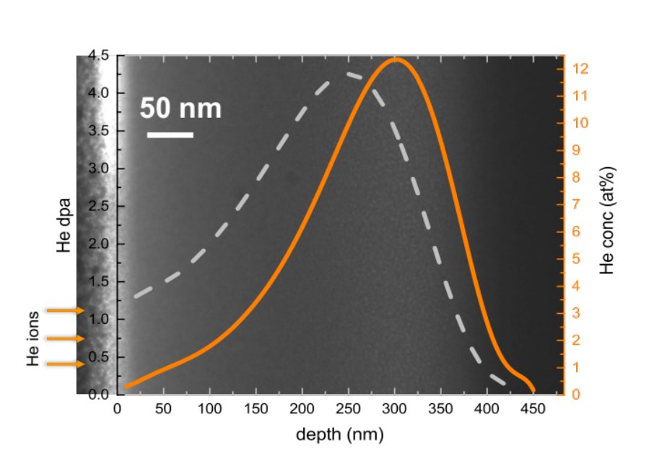
Figure 5.7 TEM image of the amorphous layer thickness in “pristine” implanted Gd₂Ti₂O₇.

Figure 5.8 shows TEM images of the pre-damaged and pristine Gd₂Ti₂O₇ samples implanted with 2 × 10¹⁷ He/cm² at the SRIM predicted He concentration peak region in both underfocused and overfocused conditions. The images indicate the presence of He bubbles near the resolution limit of the TEM (~ 1 nm in diameter) near the He concentration peak; the bubbles appear as small contrasting spots. Due to the amorphous background and instrument resolution limitations, bubbles were difficult to discern. At magnifications higher than those utilized in Fig 5.8 the visibility of bubbles in this material is even lower due to increased resolution of the noisy amorphous structure. Bubble size distributions for the pre-damaged and pristine samples implanted to 2 × 10¹⁷ He/cm² are provided in Fig 5.9. The mean bubble diameter is 1.6 nm in the pre-damaged implanted sample and 2.2 nm for the pristine implanted sample.

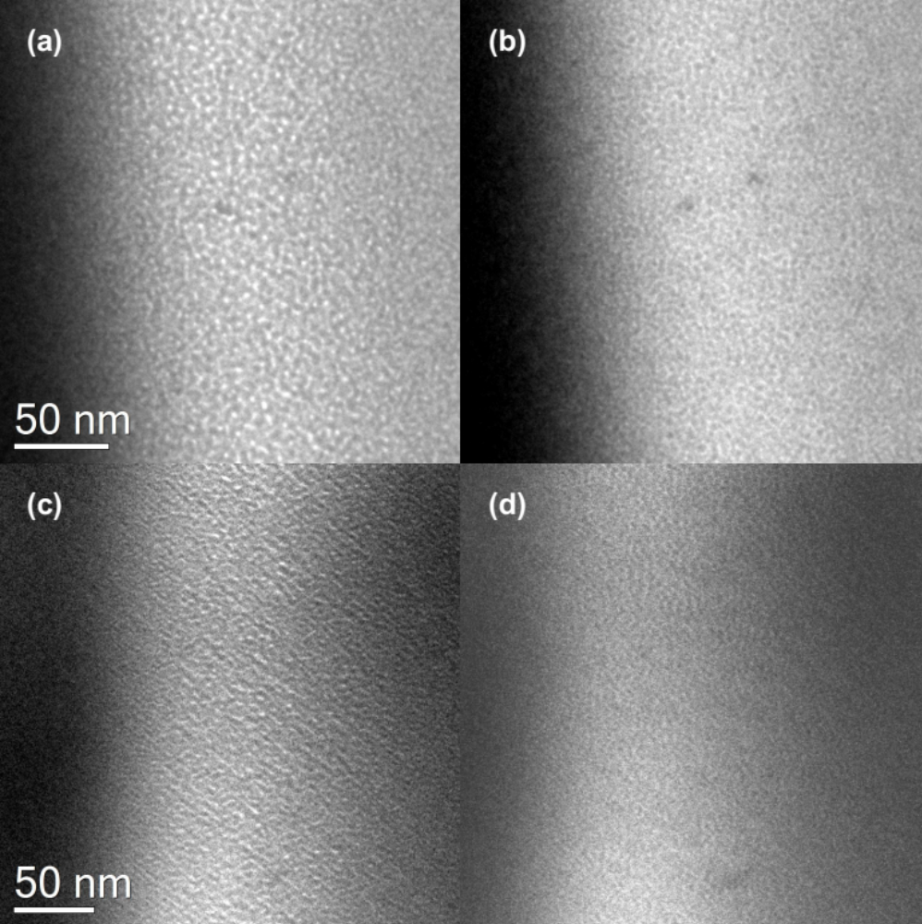
Figure 5.8 TEM images showing helium bubbles in (a-b) “pristine” implanted and (c-d) pre-damaged Gd₂Ti₂O₇. Figures (a,c) show the underfocused (-1μm) imaging condition and figures (b,c) show the overfocused (+1μm) imaging condition.

Figure 5.9 Bubble size distributions calculated from TEM images of helium bubbles in the (a) “pristine” implanted and (b) pre-damaged Gd₂Ti₂O₇ samples implanted with 65 keV He⁺ to a fluence of 2 × 10¹⁷ ions/cm².

In both samples, bubbles are first observed at a depth of ~ 200 nm, which corresponds to a He concentration of ~ 6 at.%, based on the SRIM predicted He profile. Bubble morphology appeared similar in both samples, consisting primarily of isolated bubbles that were largely spherical in shape.

Discussion
In this study, the He concentration (~ 6 at.%) required for observable bubble nucleation in both pristine and pre-damaged (amorphous) Gd₂Ti₂O₇ is about a factor of 2 larger than the critical He concentration of 3 at.% estimated for observable bubble formation in amorphous borosilicate glass [9]. While bubbles 1-2 nm in diameter have been observed at concentrations as low as 0.12 at.% in borosilicate glass [67], bubbles are not observed in pre-damaged Gd₂Ti₂O₇ implanted with 2 × 10¹⁶ He/cm² (peak He concentration of 1 at.%), even after subsequent post-implantation irradiation at 300, 500 and 700 K. Bubbles are barely visible in the sample pre-damaged and implanted with 2 × 10¹⁷ He/cm². Since bubbles are not observed in the sample pre-damaged, implanted with 2 × 10¹⁶ He/cm², and post-damaged at both room and high temperature, the additional irradiation damage does not appear to enhance He mobility or bubble nucleation in the pre-damaged Gd₂Ti₂O₇ containing up to 1 at.% He. Thermally induced He mobility in amorphous Gd₂Ti₂O₇ seems to remain low at 700 K, which agrees with the He desorption work performed by Wiss et al. on partially amorphous and fully amorphous Gd₂Ti₂O₇, where He release did not occur until a temperature of 900 K was reached [68]. The first desorption peak for the crystalline structures Gd₂Zr₂O₇ and Nd₂Zr₂O₇ occurred at 700 K, lower than the amorphous Gd₂Ti₂O₇ structure, which suggests a higher He mobility in crystalline pyrochlore than in amorphous pyrochlore. In this work, bubbles are larger and of higher density in pristine implanted Gd₂Ti₂O₇ than in amorphous implanted Gd₂Ti₂O₇, suggesting a higher He mobility in the pristine lattice. In the early stages (prior to amorphization) of He implantation into pristine Gd₂Ti₂O₇, the He may be more mobile than in amorphous Gd₂Ti₂O₇, leading to the formation of larger bubbles in the pristine implanted sample. Bubbles appeared circular in both samples implanted with 2 × 10¹⁷ He/cm², a morphology common to amorphous materials implanted with He.

HELIUM IMPLANTATION INDUCED BUBBLE FORMATION AND LATTICE PARAMETER CHANGES IN Gd₂Zr₂O₇

A version of this chapter was originally published by Caitlin A. Taylor et. al.: C.A. Taylor, M.K. Patel, J.A. Aguiar, Y. Zhang, M.L. Crespillo, J. Wen, H. Xue, Y. Wang, W.J. Weber, Acta Materialia 115 (2016) 115-122. [69]

Sample synthesis, surface preparation, TEM sample preparation by hand-polishing, experimental planning and analysis were done by C.A. Taylor. FIB sample preparation was done by J.A. Aguiar. Irradiations were performed by M.L. Crespillo, J. Wen, H. Xue, Y. Wang with advising by Y. Zhang. X-ray diffraction was by C.A. Taylor. TEM imaging was done by C.A. Taylor and J.A. Aguiar. Project was advised by W.J. Weber and M.K. Patel.

Introduction
Helium accumulation due to α-decay could eventually lead to helium bubble formation in a real pyrochlore waste form, but the helium concentration required to nucleate bubbles in pyrochlores was unknown. Helium bubble formation could have significant implications on a nuclear waste form due to the possibility of cracking, which would allow groundwater to enter the waste form, resulting in increased leaching of radioactive material. The critical helium concentration required to nucleate bubbles was determined for Gd₂Zr₂O₇, which undergoes an order-disorder transformation from pyrochlore to defect-fluorite under irradiation at ~0.4 dpa. Due to the extremely long timescales and experimental restrictions required for studying actinide-doped pyrochlores, ion irradiations were utilized to simulate 1) α-recoil damage, and 2) helium accumulation. TEM was utilized for imaging helium bubbles in irradiated samples. Lattice parameter changes due to damage and helium accumulation were quantified using GIXRD.

Experimental Methods
Two sets of polycrystalline Gd₂Zr₂O₇ samples were used in this work. Set #1 samples (5 × 10 mm), which were prepared by the sol-gel routine and sintered in a hot isotactic press as described in Nachimuthu et al [70], were approximately 97% of the theoretical density. Set #2 samples (10 mm in diameter) were prepared by conventional solid-state synthesis as discussed in Chapter 3. Powder XRD patterns were measured for both sets of samples using a PANalytical Empyrean x-ray diffractometer equipped with a Cu Kα x-ray tube, a fixed flat plate powder sample stage, 0.02 rad Soller slits, 1/8th divergence slit, 1/4th anti-scatter slits, a 10 mm mask, a Ni filter, and a PIXcel detector. Theoretical densities, lattice parameters and crystallite sizes were determined using the GSAS for Rietveld refinement of powder XRD patterns [54, 55]. Since the cation ionic radius ratio, r_{A}/r_{B}, of Gd₂Zr₂O₇ resides at the borderline of the phase stability between pyrochlore and defect-fluorite, the Gd and Zr atomic occupancy were refined due to the possibility of slight atomic disorder in the pyrochlore structure. The measured lattice parameter was 10.5318(1) Å for the Set #1 and 10.52515(6) Å for the Set #2 samples. Crystallite sizes were determined using the isotropic Lorentzian broadening due to the crystallite size term, LX, in GSAS (see Chapter 3), and were found to be similar for both sets of samples. The measured crystallite size was 208.76 nm for the Set #1 and 227.68 nm for the Set #2 samples. Au irradiations were performed at the UT-IBML [56] and He implantations were performed at the LANL-IBML. In order to simulate α-recoil damage and induce the pyrochlore to defect-fluorite phase transformation, all samples were pre-damaged with 7 MeV Au³⁺ to a total fluence of 2.2 × 10¹⁵ Au/cm², which corresponds to damage accumulation over several thousand years in a waste form containing 25 wt.% ²³⁹Pu (Fig 6.1). Set #1 samples were implanted with 200 keV He⁺ at 2 × 10¹⁵ and 2 × 10¹⁶ He/cm², corresponding to 0.1 and 1.0 at. % He, respectively, to observe swelling and search for evidence of He bubble nucleation during the first million years of waste form storage. Since He bubbles did not form at 1.0 at.% He, a third sample (Set #2) was implanted with a higher fluence to see if bubbles would form in Gd₂Zr₂O₇ at very high doses. This Set #2 sample was implanted with 65 keV He⁺ at 2 × 10¹⁷ He/cm², which corresponds to 12 at.% He at the peak. This sample was implanted at 65 keV to move the He peak closer to the surface, which enables easier TEM sample preparation of an already porous sample expected to contain a large quantity of bubbles that might induce cracking.

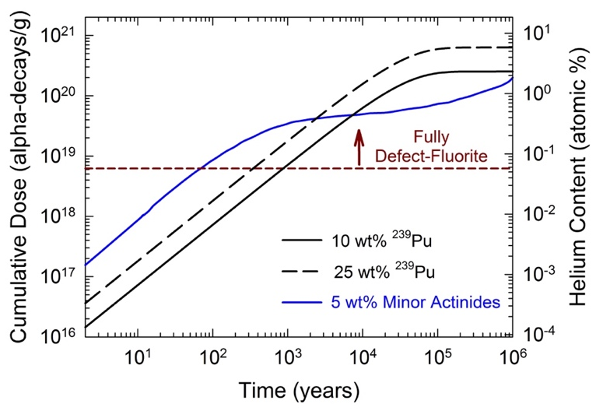
Figure 6.1 Dose and He accumulation in Gd₂Zr₂O₇ as a function of geological time for various waste loadings. Gd₂Zr₂O₇ will be fully transformed to the defect-fluorite structure above the dotted line.

For the GIXRD study, the Set #1 samples implanted with 200 keV He⁺ to 2 × 10¹⁵ and 2 × 10¹⁶ He/cm² and a Set #2 sample implanted with 200 keV He⁺ to 2 × 10¹⁷ He/cm² (10 at.% He at the peak, were utilized. The 200 keV He⁺ implants were done using a flux of 1.1 × 10¹³ He/cm²/s for the 2 × 10¹⁵ and 2 × 10¹⁶ He/cm² irradiations, and 2 × 10¹³ He/cm²/s for the 2 × 10¹⁷ He/cm² irradiation. The 65 keV He⁺ implantation was done using a flux of 7.39 × 10¹² He/cm²/s. SRIM calculated damage dose and He concentration profiles are shown in Fig. 6.2. The experiment was designed such that Au concentration peak was deeper than the He profile peak, preserving the chemical integrity of Gd₂Zr₂O₇ at the region of interest (the Au concentration is low, only 0.06 at.% at the peak). The peak Au dose was ~ 8 dpa, while the He dpa and concentration increase with He fluence. In the case of the 0.1 at.% He sample, the peak He dose was 0.035 dpa (200 keV implant), but significantly increased to 4.5 dpa at 12 at.% He (65 keV implant).

Figure 6.2 SRIM calculated damage (dpa) and ion concentration profiles for Gd₂Zr₂O₇ (a) pre-damaged with 7 MeV Au³⁺ to 2.2 × 10¹⁵ Au/cm², (b) implanted with 65 keV He⁺ to 2 × 10¹⁷ He/cm², and (c) implanted with 200 keV He⁺ to 2 × 10¹⁷ He/cm² (2 × 10¹⁶ and 2 × 10¹⁵ He/cm² profiles are one and two orders of magnitude less, respectively). Dashed line indicates the He concentration at which bubbles were first observed (4.6 at.%) to aid the reader in comparing the nucleation depths for each 2 × 10¹⁷ He/cm² irradiation.

The critical He concentration required for bubble formation, as well as details about bubble morphology, were determined using TEM. TEM samples 50 – 150 nm in thickness were prepared using an FEI Nova 200 Nanolab Dual Beam focused ion beam (FIB). The sample surface was protected from subsequent ion beam damage from the FIB by first depositing a thin layer (<500 nm) of Pt square over a 20 × 20 um area using a 5 keV electron beam. A 20 × 3 × 3.5 um Pt rectangular bar was then deposited over this square using a 30 kV ion beam with varying currents from 90 pA to 0.20 nA (varying Pt density from high to low). Focused ion beam milling was then performed at 30 kV and 93 pA, followed by a final clean using a 5 kV Ga beam with current of 12 pA to remove redeposited material on the surface during the milling process, and to remove residual milling damage. TEM imaging was performed at the NREL using an FEI Tecnai operating at 300 kV in TEM mode. Images were collected using a Gatan Osiris CCD camera. Samples were imaged using a 10-60 µm objective aperture, depending on sample thickness. Helium bubbles were imaged using the through-focusing technique, in which Fresnel contrast produces a white spot with a dark outer ring in the underfocused condition and a dark spot with a white ring at the same location in overfocused condition. The image was initially focused by expanding the Fourier transform to the largest possible diameter, then defocused in series from -1.5 to +1.5 µm at the SRIM predicted He peak location to confirm the presence or absence of He bubbles. Defocus values may vary by an estimated ± 100 nm due to error in finding the zero (focused) point. TEM images were noise filtered in Gatan Inc.’s Digital MicrographTM and brightness and contrast were adjusted to improve clarity. Helium bubbles were quantified using the ‘Analyze Particle’ feature in ImageJ [62] (Chapter 4). ImageJ provides the cross-sectional area of each bubble in nanometers, which was then converted to bubble radius using a circular cross-sectional area approximation. Since some bubbles formed chains, the circular approximation is not true in all cases.
A pristine (Set #2) pyrochlore sample, a Au irradiated defect-fluorite sample (Set #2), samples implanted with 200 keV He⁺ to 2 × 10¹⁵ and 2 × 10¹⁶ He/cm² (Set #1) and to 2 × 10¹⁷ He/cm² (Set #2) were measured using GIXRD. All GIXRD measurements were done using a PANalytical X’Pert³ x-ray diffractometer equipped with a 1/16th divergence slit, a parallel beam mirror, 0.02 rad Soller slits and a 4 mm mask on the incident beam side, and a 0.09 parallel plate collimator, 0.02 rad Soller slits and a Xe gas proportional detector on the diffracted side. X-ray penetration depths were calculated based on total external reflection theory using bulk density values [60, 61]. A plot of the x-ray penetration depth as a function of grazing angle is shown in Fig. 4.4. Peak positions (in degrees 2θ) were obtained by fitting with a pseudo-voigt function using the software CMPR [71] and were converted to lattice parameters using Bragg’s law. Unit cell strain and volume swelling errors were propagated from the standard deviation provided by the fit in CMPR.

Results and Discussion
An overview image showing the entire irradiated region for the Gd₂Zr₂O₇ sample pre-damaged and implanted with 200 keV He⁺ to 2 × 10¹⁶ He/cm² is shown in Fig 6.3 (a). Figure 6.3 (b) and (c) show under- and overfocused images, respectively, at a grain boundary near the He concentration peak, where bubbles would be expected to first nucleate. As exemplified in Fig 6.3 (b) and (c), no He bubbles were observed in the pre-damaged sample implanted with 2 × 10¹⁶ He/cm². It is therefore reasonable to conclude that bubbles are not present in the sample implanted with 200 keV He⁺ to a lower fluence of 2 × 10¹⁵ He/cm². Figure 6.4 (a) shows an overview of the He implanted region of the
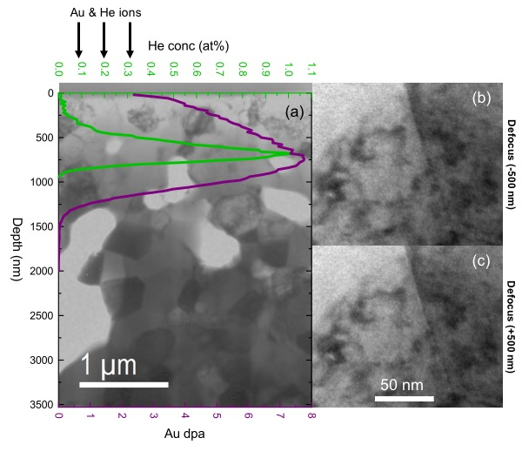
Figure 6.3 TEM images obtained from the Gd₂Zr₂O₇ sample irradiated with 7 MeV Au³⁺ to 2.2 × 10¹⁵ Au/cm² and then implanted with 200 keV He⁺ to 2 × 10¹⁶ He/cm² (1 at.% at He peak). He concentration and Au damage distribution ranges as determined by SRIM are compared to the overview image in (a). After imaging several locations near the He peak, no bubbles were observed in this sample. An example region on a grain boundary, where bubbles were expected to first nucleate, is shown at (b) -500 nm underfocus and (c) +500 nm overfocus.

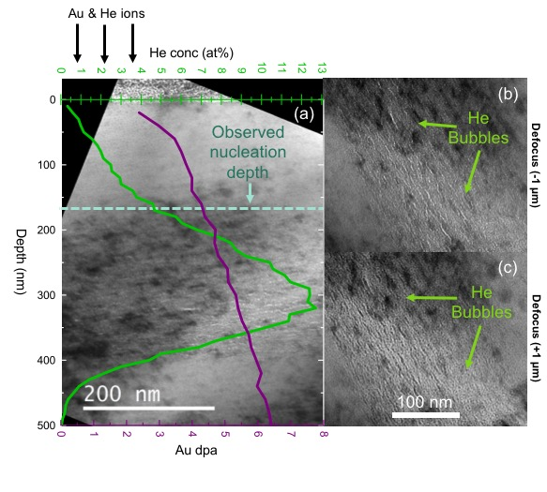
Figure 6.4 TEM images for the Gd₂Zr₂O₇ sample irradiated with 7 MeV Au³⁺ to 2.2 × 10¹⁵ Au/cm² and then implanted with 65 keV He⁺ to 2 × 10¹⁷ He/cm² (12.7 at.% He at peak). He concentration and Au damage distribution ranges as determined by SRIM are compared to the overview image in (a). Images obtained at defocus values of ±1 µm are shown for (b) underfocus and (c) overfocus conditions. Helium bubbles clearly formed at the expected He peak location, in some cases forming chains 10 - 30 nm in length. Bubbles were observed to nucleate starting at a depth of 165 nm (dashed line), which corresponds to 4.6 at.% He in the SRIM calculated concentration profile.

sample implanted with 65 keV He⁺ to 2 × 10¹⁷ He/cm². Figure 6.4 (b) and (c) clearly show He bubbles in the under- and overfocused images, respectively, at the He concentration peak. Individual bubbles were observed starting at ~ 165 nm from the surface, which corresponds to a concentration of 4.6 at.% He based on the SRIM calculated He concentration profile (Fig 6.4 (a)). Bubbles were 1-3 nm in diameter (Fig 6.5) and many formed chains 10-30 nm in length parallel to the surface.
Helium bubbles chains have been observed in other ceramics, including yttria-stabilized zirconia (YSZ) [72, 73], 4H-SiC [74], MAX phase [75], and LiNbO₃ [26]. Ofan et al. [76] summarized the physics governing He bubble sizes and spatial distributions in He irradiated materials, and concluded that the strain distribution can cause bubbles to arrange themselves in a pseudoperiodic order to reduce the strain field in the lattice. Helium bubbles were observed in yttria-stabilized zirconia (YSZ), which also assumes the defect-fluorite crystal structure, at the same fluence, 2 × 10¹⁷ He/cm², and were also observed to form chains parallel to the surface in both single and polycrystalline samples [72, 73]. Yang et al. [73] studied the effect of He irradiation on strain as a function of depth in He implanted YSZ single crystals by utilizing high resolution x-ray diffraction (HRXRD). At 1 × 10¹⁶ He/cm², point defect formation produced strain normal to the surface. At a higher fluence of 8 × 10¹⁶ He/cm², additional damage resulted in a larger strain normal to the surface. In the sample irradiated with 2 × 10¹⁷ He/cm², the fluence at which He bubbles and bubble chains formed, Yang et al. measured an almost complete elimination of strain normal to the surface.
Due to the difficulty of obtaining high quality Gd₂Zr₂O₇ single crystals for performing HRXRD measurements, polycrystalline Gd₂Zr₂O₇ samples were implanted with 200 keV He⁺ to 2 × 10¹⁵, 2 × 10¹⁶, and 2 × 10¹⁷ He/cm². Lattice parameter changes were measured using GIXRD to determine the effect of pre-damage, He irradiation damage, and He bubble chain formation on the strain in Gd₂Zr₂O₇. GIXRD differs from HRXRD in that data collected at each grazing angle are representative of all material up to the x-ray penetration depth; the strain cannot be explicitly determined at specific depths within the irradiated layer. Samples were measured at four grazing angles, ω = 1, 4, 6, and 8°, which correspond to ~ 100, 400, 600, and 800 nm x-ray penetration depths, respectively.

Figure 6.5 Helium bubble size distribution in Gd₂Zr₂O₇ pre-damaged with 7 MeV Au³⁺ to a fluence of 2.2 × 10¹⁵ Au/cm² and implanted with 65 keV He⁺ to 2 × 10¹⁷ He/cm², which corresponds to a peak He concentration of 12.7 at.%. Bubbles formed chains several nm in length. Bubble diameters were calculated assuming a circular cross-sectional area, which largely approximates the shape of bubbles which formed chains. Chains of bubbles have the largest cross-sectional area and therefore the largest calculated diameters. An average bubble diameter of 1.5 ± 0.2 nm was determined by fitting with a log-normal distribution (shown), with the error estimated from the TEM image pixel size (0.15 nm). Inset shows outline of areas that ImageJ used to calculate the cross-sectional bubble area during image analysis, overlaid with the original underfocused TEM image shown in Fig 5 (b).

Fig 6.2 (b) and (c) show a SRIM profile comparison between the 65 keV He⁺ implanted Gd₂Zr₂O₇ to a fluence of 2 × 10¹⁷ He/cm², utilized for TEM observations, and the 200 keV He⁺ implantation to the same fluence, utilized for GIXRD measurements. The dashed line in Fig 6.2 (b) and (c) represents the critical He concentration required for visible bubbles, 4.6 at.%, as determined from the TEM images. The four highest intensity fluorite reflections, (111), (200), (220), and (311), which were utilized for lattice parameter calculations, are shown for each irradiation condition in Fig 6.6 (a). A clear peak shift was observed for each irradiation condition, as shown in the zoomed (220) reflection in Fig 6.6 (b). Pre-damage, which converts the Gd₂Zr₂O₇ lattice from pyrochlore to defect-fluorite, caused a shift to lower 2θ, indicating a lattice expansion. Further shifts to lower 2θ were observed for the lower fluence He irradiations at 2 × 10¹⁵ and 2 × 10¹⁶ He/cm². A shift back to higher 2θ, however, was observed for the sample irradiated with 200 keV He⁺ to 2 × 10¹⁷ He/cm², the fluence at which He bubbles and bubble chains were observed.

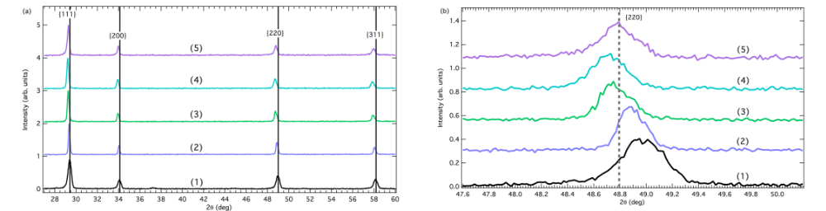
Figure 6.6 (a) GIXRD patterns obtained at an incident angle of ω = 6° (x-ray penetration depth of ~ 600 nm) from Gd₂Zr₂O₇ samples (from bottom to top): (1) pristine (unirradiated) Gd₂Zr₂O₇, (2) Gd₂Zr₂O₇ pre-damaged with 7 MeV Au³⁺ to 2.2 × 10¹⁵ Au/cm², and Gd₂Zr₂O₇ pre-damaged then 200 keV He⁺ implanted to fluences of (3) 2 × 10¹⁵, (4) 2 × 10¹⁶, and (5) 2 × 10¹⁷ He/cm². (b) A zoomed view of the (220) reflection shows a clear peak shift between each of the irradiation conditions, with a dotted line indicating the center position of the highest He fluence measured. Reflections are labeled with fluorite Miller indices.

Peak positions were converted to lattice parameters for each reflection and grazing angle and are compiled in Fig 6.7. Errors were propagated from the fit of each peak. The lattice parameters calculated for each reflection are more similar in the pre-damaged sample than in the He irradiated samples. Table 6.1 shows a comparison of the lattice parameter, change in lattice parameter (Δa), unit cell volume, and change in unit cell volume (ΔV) for each irradiation condition, as calculated using the (311) reflection by averaging over all incident angles. Changes in lattice parameter (Δa) and unit cell volume (ΔV) were calculated independently for each grazing angle, with respect to the defect-fluorite a and V values, then averaged over all grazing angles.

Figure 6.7 Lattice parameters were calculated from the GIXRD data using the four highest intensity fluorite reflections for each grazing angle. Lattice parameters varied more between the different reflections in the He implanted samples (b-d) than in the Au irradiated sample (a), with the largest variation occurring in the sample implanted with 2 × 10¹⁶ He/cm² (c). Error bars represent the fractional error.

Figure 6.8 shows a comparison of lattice parameters calculated for each irradiation condition using only the (311) reflection. General trends were identified, even though the He implanted lattice parameter remains unchanged within error. The lattice parameter

Table 6.1 Experimental results from lattice swelling (∆a and ∆V). Lattice swelling in the pre-damaged (Au irradiated) sample was calculated relative to the half the lattice parameter of pristine sample. Swelling in 200 keV He⁺ implanted samples was calculated relative to the pre-damaged sample (all He implanted samples were first pre-damaged). Swelling results were calculated using the fluorite (311) peak by averaging over all incident x-ray angles. Peak He concentrations were determined using SRIM.
Sample | Fluence  (ions/cm²) | Peak  He at.% | a (Å) | ∆a (Å) | V (Å³) | ∆V (Å³)
Pristine |  |  | 10.527(2) |  | 1166.6(7)
Au Irradiated | 2.2 × 10¹⁵ |  | 5.2668(7) | 0.0036(15) | 146.09(6) | 0.30(13)
Au + He | 2 × 10¹⁵ | 0.1 | 5.2784(12) | 0.0112(3) | 147.07(10) | 0.94(2)
Au + He | 2 × 10¹⁶ | 1 | 5.2834(10) | 0.0162(3) | 147.48(9) | 1.35(2)
Au + He | 2 × 10¹⁷ | 10 | 5.2768(10) | 0.0099(8) | 146.93(8) | 0.83(7)

Figure 6.8 Experimentally determined lattice parameters for Gd₂Zr₂O₇ samples implanted with 200 keV He⁺ relative to the pre-damaged (Au irradiated) sample for various incident x-ray angles. Lattice parameters were calculated using the fluorite (311) reflection. Error bars represent the fractional error.

increased at each grazing angle between the pre-damaged sample and the samples implanted with 200 keV He⁺ to fluences of 2 × 10¹⁵ and 2 × 10¹⁶ He/cm², with the 2 × 10¹⁶ He/cm² sample having the largest lattice parameter. In the sample implanted with 200 keV He⁺ to a fluence of 2 × 10¹⁷ He/cm², the lattice parameter decreased to approximately the 2 × 10¹⁵ He/cm² value for ω = 1° and 4°, and even below the 2 × 10¹⁵ He/cm² value for ω = 6° and 8°. A reduction in the lattice parameter occurred for all reflections (Fig. 6.7 (d)) after He implantation to 2 × 10¹⁷ He/cm². We suspect the experimentally determined decrease in unit cell swelling after implantation with 200 keV He⁺ to 2 × 10¹⁷ He/cm² is due to the formation of the He bubble chains that were observed at this fluence, as has been shown to occur in the other ceramics as discussed above. The fact that bubbles may be forming chains to reduce the total strain is significant, because this suggests that the observed bubble chain microstructure is an artifact of irradiating with ion beams, which typically produce a strain profile normal to the surface [77, 78]. In a real waste form, the radiation damage would occur in random directions, which will produce a non-uniform strain profile, making it more difficult for bubbles to arrange themselves in ways that reduce the total strain. For this reason, the bubble microstructure could differ in a Gd₂Zr₂O₇ waste form containing the same He concentration.

MECHANICAL PROPERTY CHANGES DUE TO DEFECT AND HELIUM ACCUMULATION

Quantification of the stress and strain produced by helium accumulation in pyrochlores is essential to determining their feasibility as a waste form material. Materials relieve high stress levels by cracking, which would result in increased leaching of radioactive material into the groundwater. Due to the artifacts of ion beam irradiation (e.g. bubble chains discussed in Chapter 6) observed in these samples, mechanical property measurements are probably not representative of changes that might occur in a real nuclear waste form. However, measurements of lattice strain, residual stress, swelling, and hardness are intended to provide a qualitative understanding of mechanical property changes occurring under specific helium accumulation conditions in these materials. TEM images were analyzed to obtain qualitative information about swelling due to bubble formation. Lattice strain and residual stresses due to damage and helium accumulation were measured in Gd₂Zr₂O₇, which remains crystalline after irradiation. Residual stresses were measured using the x-ray thin-film residual stress technique and complement the lattice parameter changes measured using GIXRD in Chapter 6. Nanoindentation measurements were used to determine hardness and elastic modulus changes due to different damage and helium irradiation conditions in Gd₂Ti₂O₇ and Gd₂Zr₂O₇.

Swelling due to Bubble Formation
TEM images (Fig 6.4) were analyzed to qualitatively determine the bubble density and swelling produced by 65 keV helium implantation. Bubble chains were observed in the Gd₂Zr₂O₇ sample implanted with 65 keV He to a fluence of 2 × 10¹⁷ He/cm², but may actually be bubble “rafts” penetrating tens of nanometers or more into the sample, parallel to the sample surface. Because the actual depth of bubble chains or rafts is unknown, the swelling and bubble density could not be precisely determined from TEM images alone. In Gd₂Ti₂O₇, the bubbles remain isolated spheres (Fig 5.8), and bubble swelling and number densities were calculated by assuming a TEM foil thickness of 100 nm. To quantify the volume swelling in Gd₂Zr₂O₇, six 50 × 50 nm regions at the helium peak were selected in an underfocused TEM image. The ImageJ [62] particle finder was again used to identify the total area consumed by bubbles in each 50 × 50 nm square. To determine the volume swelling, the cross-sectional area calculated by ImageJ was determined by the square area, Eq. 7.1. This assumes that bubble chains are actually rafts that penetrate throughout the entire TEM foil thickness. The volume swelling in Gd₂Zr₂O₇ was estimated to be 6.8 ± 0.4 % by averaging over the six regions.
$${∆V}/{V_{o}}=\frac{V-V_{o}}{V_{o}}=\frac{(V_{o}+V_{bubbles})-V_{o}}{V_{o}}$$
${∆V}/{V_{o}}=\frac{V_{bubbles}}{V_{o}}$ (7.1)
Bubbles were identified in Gd₂Ti₂O₇ using the same image analysis method as was applied to Gd₂Zr₂O₇, but proved much less accurate due to the low contrast between bubbles and amorphous material. Images from the pristine helium implanted Gd₂Ti₂O₇ liftout had higher contrast than images taken from the amorphous implanted liftout, even though both samples were amorphous during the imaging. Seven 50 × 50 nm regions were selected from an underfocused pristine + helium implanted Gd₂Ti₂O₇ image, which had an average estimated volume swelling of 0.17 ± 0.04 %. Seven 50 × 50 nm regions were also selected in pre-damaged + helium-implanted Gd₂Ti₂O₇, which had an estimated average volume swelling of 0.08 ± 0.2 %. Estimated volume swelling is larger in Gd₂Zr₂O₇ because bubble “chains” observed in cross-section were assumed to be “rafts” penetrating throughout the entire TEM foil thickness; in Gd₂Ti₂O₇, bubbles were assumed to be isolated spheres and the measured radii were used to calculate the total bubble volume. Of course, bubble “chains” observed in Gd₂Zr₂O₇ may not actually be “rafts,” which would make the volume swelling much smaller.

Hardness Changes due to Helium Accumulation
Preliminary hardness measurements were done on Gd₂Ti₂O₇ and Gd₂Zr₂O₇ samples irradiated with 7 MeV Au³⁺, plus 200 keV He⁺ irradiation at up to 2 × 10¹⁶ He/cm² and, in
some cases, post-irradiated with 7 MeV Au³⁺ to simulate the effects of radiation damage occurring after helium is already present in the sample. Experiments were performed using an Agilent Nanoindenter XP, a diamond Berkovich indenter, and the continuous stiffness measurement technique. For each specimen, the 10 measurements were performed in a 5 × 2 array with 30 μm spacing in the x and y directions. Error bars in figures represent one standard deviation from the mean. Average hardness and elastic modulus curves for Gd₂Zr₂O₇ and Gd₂Ti₂O₇ samples, respectively, are provided in Figs A.1 and A.2 of the Appendix. A summary of the average hardness and elastic modulus at the helium implantation peak, for the irradiation conditions studied, is provided in Table 7.1.

Table 7.1 Hardness and elastic modulus, measured by nanoindentation, averaged between depths of 500-800 nm (location of helium peak).
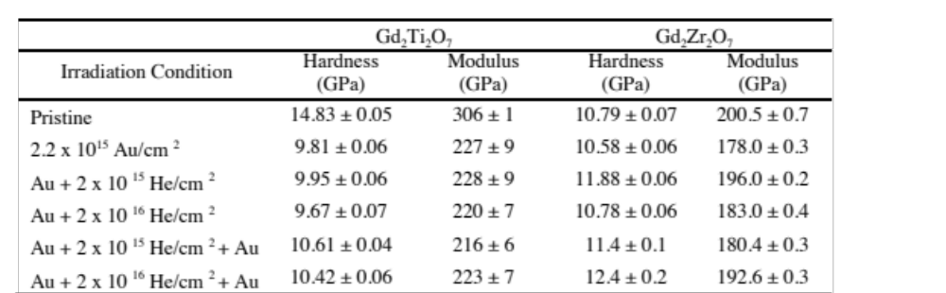

Hardness and elastic modulus were averaged over depths from 500 to 800 nm, the location of the helium implantation peak. Although this region may be influenced by the unirradiated material (Au irradiation depth is ~1.5 microns), the shallow indents could not be utilized due to large error associated with hand polishing and porosity (see Figs A.1 and A.2 in the Appendix). Due to the errors associated with these measurements, the hardness and modulus values are meant to provide qualitative differences between the irradiation conditions. Error was calculated using the standard deviation of the average and dividing by the square root of the number of data points. In general, the measured elastic modulus was ~100 GPa higher and the hardness ~4 GPa higher in pristine Gd₂Ti₂O₇ than in pristine Gd₂Zr₂O₇, which could be due to higher porosity in the Gd₂Zr₂O₇. This is expected considering that Gd₂Zr₂O₇ is more difficult to synthesize into dense pellets than Gd₂Ti₂O₇. In Gd₂Ti₂O₇, the modulus and hardness decreased significantly after irradiation with 7 MeV Au³⁺ to a fluence of 2.2 × 10¹⁵ ions/cm², during which the material undergoes a pyrochlore to amorphous phase transformation. Hardness and elastic modulus have been shown to decrease with increasing cumulative alpha-decay dose in ²⁴⁴Cm doped Gd₂Ti₂O₇ [79]. The modulus and hardness decreased to a lesser extent in Gd₂Zr₂O₇. Subsequent helium irradiation with 2 × 10¹⁵ He/cm² caused more hardening than irradiation with 2 × 10¹⁶ He/cm² in both materials. Post-helium implantation irradiation with 7 MeV Au³⁺ caused hardening in both materials; in Gd₂Ti₂O₇, the hardness was only moderately increased, but in Gd₂Zr₂O₇, the hardness increased beyond the pristine hardness value. The elastic modulus returned to almost the pristine value after Au + 2 × 10¹⁶ He/cm² + Au in Gd₂Zr₂O₇, but remained ~80 GPa below the pristine value in Gd₂Ti₂O₇. Literature values for hardness and elastic modulus as a function of Ar irradiation dose show a significant increase in hardness up to the dpa required for a pyrochlore to defect-fluorite phase transformation in Gd₂Zr₂O₇, followed by a decrease in hardness and elastic modulus as a function of irradiation dose for all fluences beyond that point [80]. The absolute values measured for hardness and elastic modulus in this experiment differ from literature values, which is likely due to variations in the porosity, so only general trends could be compared.
After bubbles were observed in Gd₂Zr₂O₇ that was pre-damaged and irradiated at 200 keV with 2 × 10¹⁷ He/cm² (Chapter 6), nanoindentation measurements were repeated on the pristine and He implanted Gd₂Zr₂O₇ samples. An iMicro Nanoindenter (Nanomechanics, Inc., Oak Ridge, TN) was used for all indentations. An InForce1000 actuator was used to reach loads beyond 50 mN. The indenter tip utilized was a diamond Berkovich. Before running the indentations on the samples, the area function of the tip was found after running a tip calibration on reference sample fused silica. The proper area function is needed to be confident that the elastic modulus and hardness results are accurate. Hardness and modulus were calculated by averaging over 100 indents, between depths of 500-800 nm. The new hardness and modulus values are given in Table 7.2. The measured hardness and moduli are close to those measured by a different indenter and shown in Table 7.1.
Table 7.2 Hardness and elastic moduli measured by nanoindentation (using a different indenter than Table 7.1) for helium implanted Gd₂Zr₂O₇ samples. Values were averaged between displacements 500-800 nm.
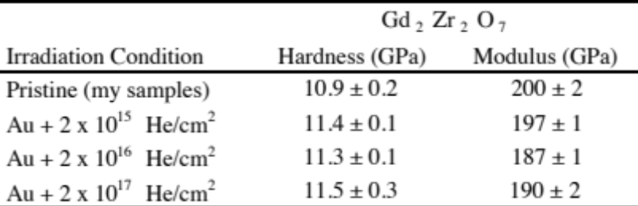

The hardness increases with respect to the pristine sample and the Au-irradated sample measured previously (Table 7.1), but remains constant between different helium fluences. Young’s modulus increases with respect to the Au-irradiated sample after implantation with 2 × 10¹⁵ He/cm², but decreases by 10 GPa after irradiation with 2 × 10¹⁶ He/cm² and remains constant after irradiation with 2 × 10¹⁷ He/cm². Young’s modulus, which is given by the slope of the stress vs. strain curve, describes a material’s ability to withstand elastic deformation. If a material has a higher elastic modulus, for a given load the sample will be strained less. If a material has a lower elastic modulus, given the same load, the sample will be strained more. A reduction in the elastic modulus between helium fluences of 2 × 10¹⁵ He/cm² and 2 × 10¹⁶ He/cm² indicates a reduction in the material’s ability to withstand elastic deformation, possibly due to the formation of larger helium clusters or bubbles, in the case of the sample irradiated with 2 × 10¹⁷ He/cm².

Residual Stresses in Gd₂Zr₂O₇
Residual stresses are imposed due to defect accumulation during irradiation, and can be measured using XRD techniques. Stresses (σ) are calculated from a measured lattice strain (ε), which is transformed from the unit cell coordinate system (L) to the sample coordinate system (S), shown in Fig 7.1 [81].

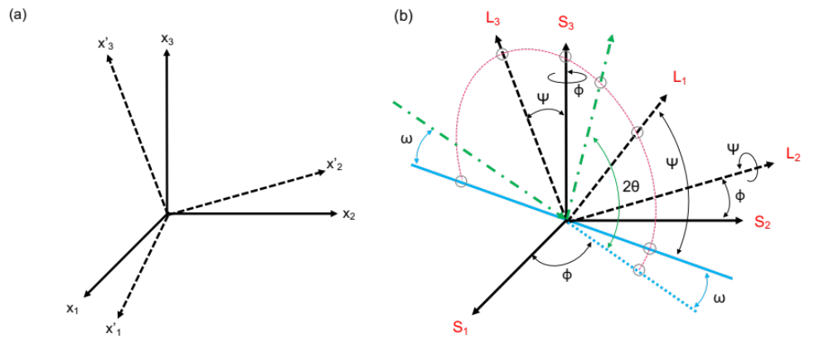
Figure 7.1 Diagrams relating the (a) unit cell coordinate system (L, primed) to the sample coordinate system (S, primed) [81], and (b) unit cell coordinate system to the sample coordinate system in terms of diffractometer angles, where the green dashed line indicates incident and diffracted x-ray beams and the blue line indicates the sample plane [82].

Direction cosines between the two reference frames are given below: 

A simplified notation for the direction cosines is given below: 
In Einstein notation, the stress transformation from the unit cell reference frame to the sample reference frame is given by Eq. 7.2.
$$σ_{ij}^{'}=a_{ik}a_{jl}σ_{kl}$$
$σ_{ij}^{'}=a_{i1}a_{j1}σ_{11}+a_{i1}a_{j2}σ_{12}+a_{i1}a_{j3}σ_{13}+a_{i2}a_{j1}σ_{21}+…$ (7.2)
Stresses can be converted to strain using Hooke’s law, Eq. 7.3, where ν is the Poisson ratio, E is the elastic modulus, δ_{ij} is a Dirac delta function and σ_{kk} is a summation over all k.
$ε_{ij}=\frac{1+ν}{E}σ_{ij}-δ_{ij}\frac{ν}{E}σ_{kk}$ (7.3)
In terms of lattice dilation, the strain measured by XRD is in the unit cell reference frame and is given by Eq. 7.4. The lattice strain varies with angles φ and ψ (shown in Fig 7.4), where d_{o} is the unstrained lattice spacing and d_{φψ} is the lattice spacing measured along several directions (φ, ψ).
${\left(ε_{33}^{'}\right)}_{∅φ}=\frac{d_{ϕψ}-d_{o}}{d_{o}}$ (7.4)
In cubic systems, d is calculated from Eq. 7.5.
$\frac{1}{d^{2}}=\frac{h^{2}+k^{2}+l^{2}}{a^{2}}$ (7.5)
The measured lattice strain can be transformed from the unit cell frame to the sample frame using the same direction cosines that were used to transform the stress, as given by Eq. 7.6.
${\left(ε_{33}^{'}\right)}_{∅φ}=a_{3k}a_{3l}ε_{kl}$ (7.6)
$${\left(ε_{33}^{'}\right)}_{∅φ}=a_{31}a_{31}ε_{11}+a_{31}a_{32}ε_{12}+a_{31}a_{33}ε_{13}+a_{32}a_{31}ε_{21}+a_{32}a_{32}ε_{22}+a_{32}a_{33}ε_{23}+a_{33}a_{31}ε_{31}+a_{33}a_{32}ε_{32}+a_{33}a_{33}ε_{33}$$
In this case, the direction cosines are given by:


Inserting the appropriate direction cosines and simplifying trigonometric terms leads to the expression in Eq. 7.7.
${\left(ε_{33}^{'}\right)}_{∅φ}=ε_{11}\cos^{2}{ϕ}\sin^{2}{ψ}+ε_{22}\sin^{2}{ϕ}\sin^{2}{ψ}+ε_{33}\cos^{2}{ψ}+ε_{12}\sin{2ϕ}\sin^{2}{ψ}+ε_{13}\cos{ϕ}\sin{2ψ}+ε_{23}\sin{ϕ}\sin{2ψ}$ (7.7)
Eq. 7.7 is considered the fundamental equation of x-ray strain determination. If the material is anisotropic, elastic constants must be transformed to the unit cell frame. If the material is isotropic, ε_{ij} values can be determined from Hooke’s law, Eq. 7.3, and substituted into the fundamental equation of x-ray strain, leading to Eq. 7.8 after some simplification.
${\left(ε_{33}^{'}\right)}_{∅φ}=\frac{1+ν}{E}\left[σ_{11}\cos^{2}{ϕ}+σ_{12}\sin{2ϕ}+σ_{22}\sin^{2}{ϕ}-σ_{33}\right]\sin^{2}{ψ}+\frac{1+ν}{E}σ_{33}-\frac{ν}{E}\left[σ_{11}+σ_{22}+σ_{33}\right]+\frac{1+ν}{E}\left[σ_{13}\cos{ϕ}+σ_{23}\sin{ϕ}\right]\sin{2ψ}$ (7.8)
A splitting in the Δd/d_{o} vs. sin²ψ plot indicates the presence of shear stress σ₁₃ and σ₂₃, due to the sin 2ψ term. In the case of purely biaxial stress (no stress normal to the surface), Eq. 7.8 becomes Eq. 7.9.
${\left(ε_{33}^{'}\right)}_{∅φ}=\frac{1+ν}{E}\left[σ_{11}\cos^{2}{ϕ}+σ_{12}\sin{2ϕ}+σ_{22}\sin^{2}{ϕ}\right]\sin^{2}{ψ}-\frac{ν}{E}\left[σ_{11}+σ_{22}\right]$ (7.9)
In grazing incidence mode, each diffraction peak corresponds to scattering from a different angle with respect to the surface normal, ψ = θ - ω, where θ is the Bragg angle and ω is the grazing angle [82, 83]. As a result, collecting diffraction data from several hkl reflections in grazing incidence mode allows for determination of residual stresses at a fixed x-ray penetration depth. This is often referred to as a thin film residual stress measurement because grazing angle fixes the x-ray penetration depth near the surface. Thin film residual stress differs from conventional residual stress, where symmetric θ-2θ scans are performed at various ψ angles, and the x-ray penetration depth widely varies during the measurement. In ion irradiated samples, stress and strain are biaxial and uniform across all φ angles, making σ₁₁ = σ₂₂ = σ, and σ₁₂ = 0, simplifying the strain equation, Eq. 7.10.
${\left(ε_{33}^{'}\right)}_{0φ}=\frac{1+ν}{E}σ\sin^{2}{ψ}-\frac{ν}{E}\left(2σ\right)$ (7.10)
When the strain, calculated by fitting each XRD peak using Eq. 7.4, is plotted against sin²ψ, a linear fit can be utilized to determine the slope, from which one may determine the biaxial stress, σ, Eq. 7.10. After determining the biaxial stress, σ, the strain normal to the surface can be determined using Hooke’s law, Eq. 7.3.
In this experiment, x-ray thin film residual stress measurements were performed to on Gd₂Zr₂O₇ samples irradiated with 7 MeV Au³⁺ to a fluence of 2.2 × 10¹⁵ ions/cm², and 200 keV He⁺ to fluences of 2 × 10¹⁵, 2 × 10¹⁶, and 2 × 10¹⁷ ions/cm² (dpa and helium concentration plots are provided in Fig 6.2. As detailed in the previous chapter, helium bubbles were only observed in the Au + 2 × 10¹⁷ He/cm² irradiated sample. X-ray thin film residual stress measurements were done in grazing-incidence mode, allowing specific x-ray penetration depths to be probed. Grazing angles of ω = 1 - 8° were used, which correspond to x-ray penetration depths of ~100-800 nm, with the x-ray penetration depth increasing by ~100 nm per degree (see Fig 4.4 for the penetration depth plot). Thin film residual stress measurements were performed on a PANalytical x-ray diffractometer in grazing-incidence mode equipped with a 0.04 rad Söller slits, a parallel beam mirror, appropriately sized mask and divergence slits, a 0.27° parallel plate collimator, and a Xe gas proportional counter detector. Measurements were performed using a 0.02° with the time per step varying depending on the diffraction peak (higher counting times were used on peaks with smaller theoretical intensity values, i.e. high angle peaks, to obtain adequate statistics). The initial lattice spacing, d_{o}, was determined based on Rietveld refinement of powder x-ray diffraction data taken from pure as-synthesized pyrochlore Gd₂Zr₂O₇ powder, for which the lattice parameter was 10.527 Å. Half this lattice parameter was utilized to determine the equivalent fluorite lattice spacing. Multiple hkl peaks were measured at each grazing angle to obtain a large spread of ψ values: (111), (002), (022), (113), (222), (004), (133), (024), (224), and (115). Measurements were done at φ = 0° (arbitrarily defined). Peaks were fit in Origin using a pseudo-voigt function and used to calculate Δd/d_{o}, which was plotted against sin²ψ. A linear fit was used to determine the slope of the Δd/d_{o} vs. sin²ψ plot for each grazing angle, which was then used to calculate the residual stress. Error was calculated from the standard error of the fit. The strain, Δd/d_{o}, was plotted against grazing angle by averaging over each hkl reflection; the error was calculated using the standard deviation.
All Δd/d_{o} vs. sin²ψ plots and linear fits are shown for the highest x-ray incident angle in Fig 7.2. Plots for each grazing angle and each irradiation condition are provided in the Appendix, Fig A.3. In general, strain is lowest near the surface where the damage and helium accumulation are lowest. Strain becomes more uniform as the x-ray penetration depth increases. Figure 7.2 clearly shows how the slope of the linear fit changes between irradiation conditions. All Δd/d_{o} vs. sin²ψ plots are linear, indicating the absence of shear stress in these samples. Figure 7.3 shows stress, calculated using the slope of the linear fit and Eq. 7.10, as a function of grazing angle for each irradiation fluence. The stress plots in Fig 7.3 follow the same trend as the slopes of the linear fits shown in Fig 7.2. The stress remains constant with x-ray penetration depth within error; at ω = 1°, the stress is slightly lower due to surface effects (e.g. strain induced by polishing). In the sample where He bubbles were observed, implanted with a fluence of 2 × 10¹⁷ He/cm², the stress seemed to decrease slightly with increasing x-ray incident angle, possibly due to additional compressive stress due to bubble chain or raft formation parallel to the surface.

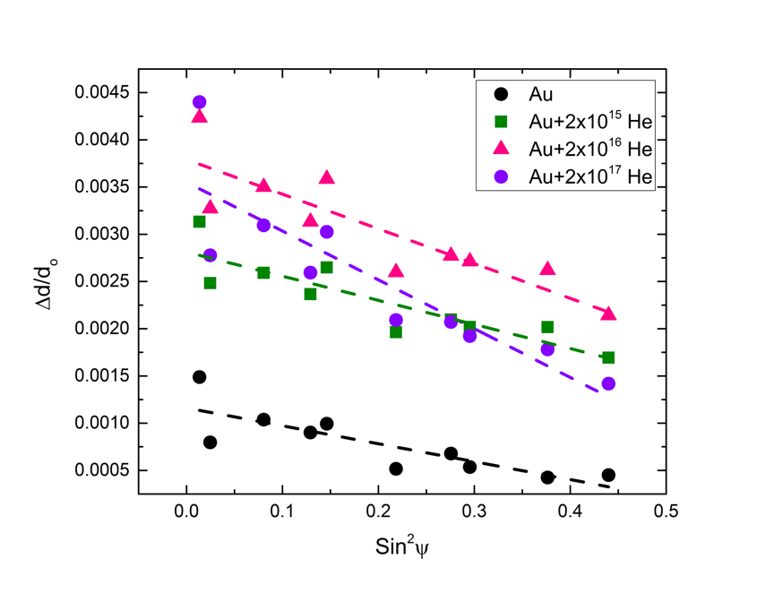
Figure 7.2 Relationship between lattice strain, Δd/d_{o} and Sin²ψ for each irradiation condition, for an x-ray incident angle of ω = 8°. Dashed lines represent linear fits from which the biaxial residual stress is determined by the slope.

Residual stress magnitudes are entirely dependent on the accuracy of the elastic constants. The residual stress shown in Fig 7.3 was calculated using the elastic moduli determined by nanoindentation (Tables 7.1 and 7.2) for each irradiation condition and using v = 0.27 [84]. In all irradiation conditions, the residual stress parallel to the surface is compressive. Residual stress was found to increase with increasing He fluence, which is likely due additional helium in the lattice causing more lattice miss-match throughout the irradiated region, and between the irradiated and unirradiated layers. The fact that bubbles were observed in the sample implanted with 2 x 10¹⁷ He/cm² did not have a large effect on the hardness or elastic modulus, but may have contributed to the increase in residual stress that was measured at higher x-ray penetration depths (Fig 7.3).

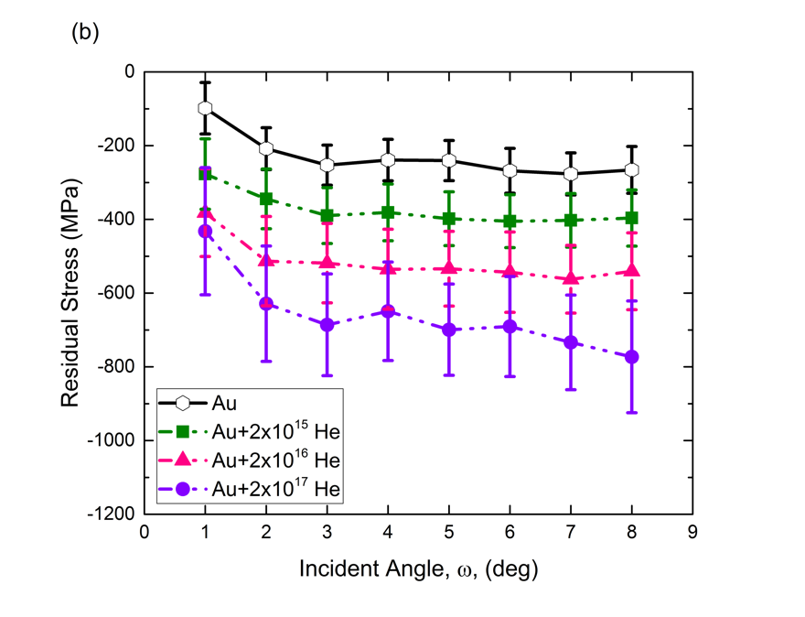
Figure 7.3 Calculated residual stress as a function of grazing angle for all irradiation fluences.

HELIUM DIFFUSION IN Gd₂Ti₂O₇ AND Gd₂Zr₂O₇

A fundamental understanding of helium behavior in a material is most important for predicting its long-term behavior and viability as a waste form. After ion implantation or α-decay, helium eventually resides in the lattice as a defect at the lowest energy configuration. Helium may migrate throughout the lattice, becoming trapped at certain sites (either interstitial or substitutional) if energetically favorable. In pyrochlores, the helium trapping site in a damaged lattice is unknown; some computational studies suggest helium prefers interstitial sites in ceramic oxides [47], while others suggest helium prefers substitutional sites [50]. In this chapter, thermal helium desorption spectroscopy (THDS) measurements were utilized to experimentally examine helium trapping in Gd₂Ti₂O₇ and Gd₂Zr₂O₇. Helium migration in a damaged crystal lattice is influenced by the binding energy of helium to various trapping sites (e.g. vacancies, vacancy clusters, interstitial sites). Thermal desorption temperatures directly correspond to the dissociation energy (migration energy + binding energy) required for helium to escape the trapping site and diffuse to the surface.

Experimental Methods
Gd₂Ti₂O₇ and Gd₂Zr₂O₇ samples were prepared by conventional solid state synthesis, described in Chapter 3, then cut into 3 × 2.5 mm sections, ground to 1 mm thickness using SiC paper, and polished on both sides using diamond lapping film. Residual polishing damage was removed using 0.02 μm colloidal silica solution. Polished samples were annealed at 800°C for 36 h to remove residual stresses produced during the sample fabrication processes. A polished sample is shown in Fig 8.1. Helium desorption was measured as a function of ion energy (each resulting in a different projected range, R_{p}) by implanting Gd₂Ti₂O₇ and Gd₂Zr₂O₇ samples with 10 keV (R_{p} ≈ 100 nm), 100 keV (R_{p} ≈ 600 nm), and 1 MeV He (R_{p} ≈ 3 μm) which resulted in different helium depth distributions and peak dpa/concentration values as determined by SRIM (Fig 8.2). All samples were irradiated to a fluence of 1 × 10¹⁵ He/cm² so that comparisons could be made to the available literature, discussed later. The damage energy, T_{dam}, and total number of displacements, ν_{NRT}, were calculated for each irradiation condition in Gd₂Ti₂O₇.

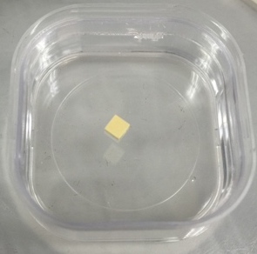
Figure 8.1 Polished 3 × 2.5 mm Gd₂Ti₂O₇ THDS sample in membrane holder.

In the 10 keV implantation, T_{dam} = 2517 eV and ν_{NRT} = 20 displacements. In the 100 keV implantation, T_{dam} = 5410 eV and ν_{NRT} = 43 displacements. Finally, in the 1 MeV implantation, T_{dam} = 7533 eV and ν_{NRT} = 60 displacements. The total number of displacements increases with ion implantation energy. Even after assuming 90% recombination, several vacancies would remain in the structure due to each implanted helium atom; 2 vacancies in the 10 keV implantation, 4 vacancies in the 100 keV implantation, and 6 vacancies per implanted helium in the 1 MeV implantation.

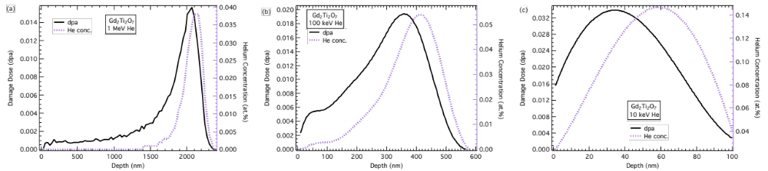
Figure 8.2 SRIM calculated damage and concentration profiles for each implantation energy, (1) 1 MeV, (b) 100 keV, and (c) 10 keV. Gd₂Ti₂O₇ and Gd₂Zr₂O₇ profiles are almost identical so only Gd₂Ti₂O₇ profiles are shown.

The 10 keV implantation was performed using an ion gun mounted in a high vacuum (10⁻⁸ Torr) chamber attached to the THDS measurement chamber (flux of 9.2 × 10¹¹ He/cm²/s), the 100 keV implantations were performed at the LANL-IBML (flux of 1 × 10¹² He/cm²/s), and the 1 MeV implantations were performed at the UT-IBML (flux of 6.94 × 10¹¹ He/cm²/s). During the THDS measurement, the temperature was increased using a fixed ramp rate, R, of 0.5 K/s. THDS spectra, which often contain the convolution of multiple desorption events, were de-convoluted by fitting overlapping Gaussian functions until the addition of all functions matched the overall peak shape. An example fit is shown in Fig 8.3, and all fits are provided in Figs A.4 and A.5 of the Appendix. The Gaussian function is given in Eq. 8.1, where I is the peak intensity and T_{m} is the peak temperature.
$I × e^{-\frac{{\left(T-T_{m}\right)}^{2}}{2\sqrt{2\ln\left(2\right)∆T^{2}}}}$ (8.1)

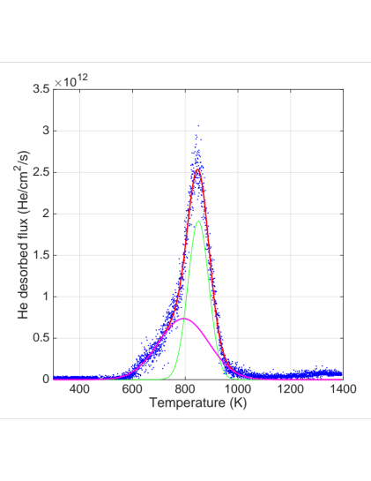
Figure 8.3 Example of Gaussian fits used to determine helium desorption temperatures. Peaks are typically a deconvolution of desorption from multiple binding sites. The two sites identified in this peak (pink and green curves) are added to form the total peak (red curve).

TDS Measurement Results

Measurement reproducibility was confirmed in the 100 keV and 1 MeV implanted samples by performing TDS on two different sets of samples. In the case of 10 keV implanted samples, desorption measurements were performed on as-polished and annealed after polishing (Fig 8.4). Desorption spectra differed between as-polished and annealed Gd₂Zr₂O₇ samples. After annealing, the Gd₂Zr₂O₇ release curve shape was more similar to Gd₂Ti₂O₇, with one large peak at ~600 K (Peak 1) and a smaller peak at ~800 K (Peak 2), although Peak 2 is much smaller in Gd₂Zr₂O₇. Sample preparation did not have a large effect on Gd₂Ti₂O₇, which has a higher measured hardness (Chapter 7) and is therefore less likely to be affected by polishing.

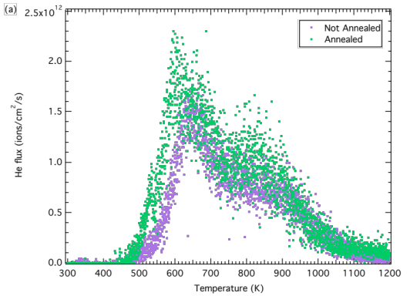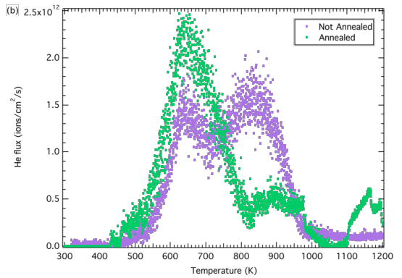
Figure 8.4 Desorption spectra for the 10 keV He implanted (a) Gd₂Zr₂O₇ and (b) Gd₂Ti₂O₇ samples. Each plot contains measurements from samples that were not annealed after polishing and from samples that were annealed at 800°C for 36h after polishing.

Desorption spectra for 100 keV and 1 MeV He implanted samples are shown in Fig 8.5. In all cases, one broad peak corresponding to the convolution of two smaller peaks was observed, similar to the spectra measured for the 10 keV implanted samples.
Figure 8.5 shows TDS spectra for both measurements of polished, annealed, and 100 keV or 1 MeV helium implanted Gd₂Ti₂O₇ and Gd₂Zr₂O₇. A comparison of the 10 and 100 keV release profiles indicates a shift to higher temperature in both Gd₂Ti₂O₇ and Gd₂Zr₂O₇ after the higher energy implantation. The observed shift was much larger in Gd₂Ti₂O₇. A comparison of the 100 keV and 1 MeV release profiles indicates yet another shift to higher temperature in both Gd₂Ti₂O₇ and Gd₂Zr₂O₇ after the 1 MeV implantation. The observed profile shift was again much larger in Gd₂Ti₂O₇. THDS profiles were largely reproducible between the two samples measured for each pyrochlore and implantation condition, but there was a slight shift (~50 K) in the overall release profile for Gd₂Zr₂O₇ implanted with 1 MeV He (Fig 8.5 (d)).

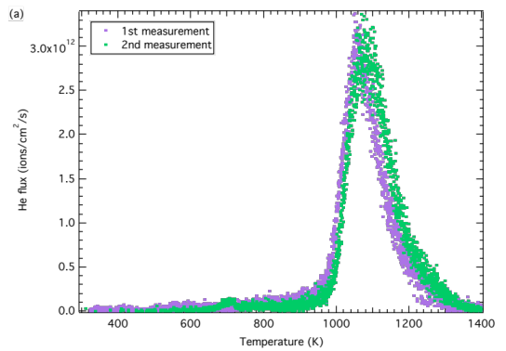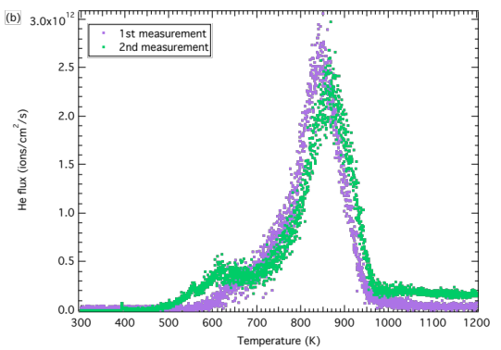
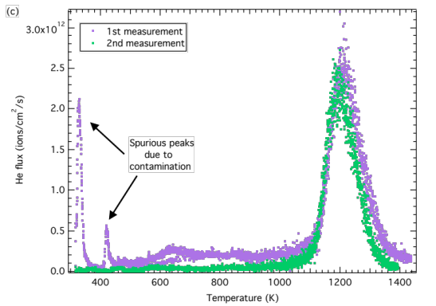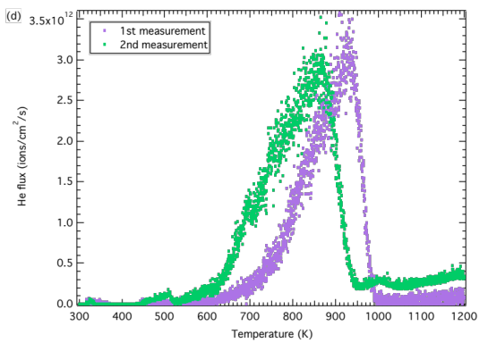
Figure 8.5 Desorption spectra showing both THDS measurements on (a) Gd₂Ti₂O₇ and (b) Gd₂Zr₂O₇ implanted with 100 keV He, and (c) Gd₂Ti₂O₇ and (d) Gd₂Zr₂O₇ implanted with 1 MeV He. All samples were annealed at 800°C for 36h after polishing.

Dissociation Energy Calculation

Dissociation energies, $E_{D}$, were determined from the peak positions obtained from Gaussian fits of the experimental desorption data, assuming a first order dissociation process, given by Eq. 8.6. $N$ is the number of helium atoms remaining inside the sample and $ν$ is the frequency factor (same as above, ~10¹³ s⁻¹) [85].
$\frac{dN}{dt}=-Nνe^{{-E_{D}}/{k_{B}T}}$ (8.6)
When heating at a constant rate, $R={dT}/{dt}$, Eq. 8.6 can be modified to obtain Eq. 8.7.
$\frac{dN}{dT}=-\frac{Nν}{R}e^{{-E_{D}}/{k_{B}T}}$ (8.7)
An expression for the peak desorption temperature, $T_{m}$, can be determined by setting the derivative of Eq. 8.7 equal to zero.
$$\frac{d^{2}N}{dT^{2}}=-\frac{ν}{R}\left(\frac{dN}{dT}\right)e^{{-E_{D}}/{k_{B}T}}-\frac{Nν}{R}\left(\frac{E_{D}}{k_{B}T^{2}}\right)e^{{-E_{D}}/{k_{B}T}}=0$$

$$\frac{ν}{R}\left(-\frac{Nν}{R}e^{{-D}/{k_{B}T_{m}}}\right)e^{{-E_{D}}/{k_{B}T_{m}}}=-\frac{Nν}{R}\left(\frac{E_{D}}{k_{B}T_{m}^{2}}\right)e^{{-E_{D}}/{k_{B}T_{m}}}$$

$$e^{{-E_{D}}/{k_{B}T_{m}}}=\frac{{RE}_{D}}{νk_{B}T_{m}^{2}}$$

$\ln\left(R/{T_{m}^{2}}\right)={-E_{D}}/{k_{B}T_{m}}+\ln\left({νk_{B}}/{E_{D}}\right)$ (8.8)
Table 8.1 contains all peak temperatures, T_{m}, and corresponding activation energies. The dissociation energy, E_{D}, results from the addition of the migration energy, E_{m}, and the binding energy, E_{B}, of helium to a specific trapping site.

Table 8.1 Desorption peak temperatures and corresponding activation energies for helium dissociation, where E_{D} = E_{B} + E_{m}.
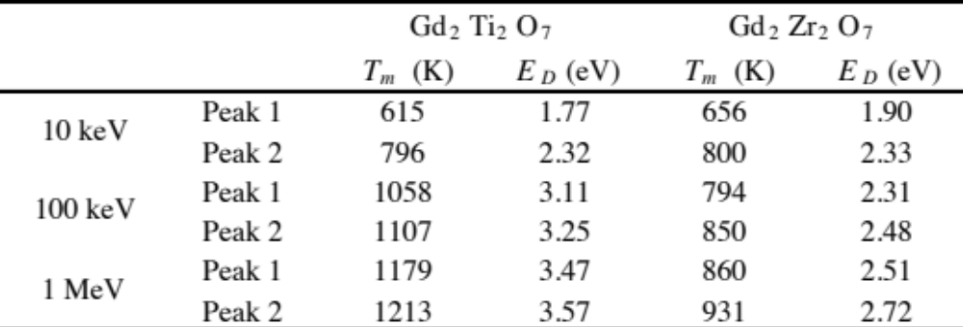

In 100 keV implanted Gd₂Ti₂O₇, Peak 1 is 443 K higher than Peak 1 in the 10 keV implant, and Peak 2 is 311 K higher than Peak 2 in the 10 keV implant. In 1 MeV implanted Gd₂Ti₂O₇, Peak 1 is 564 K higher than Peak 1 in the 10 keV implant, and Peak 2 is 417 K higher than Peak 2 in the 10 keV implant. In 100 keV implanted Gd₂Zr₂O₇, Peak 1 is 138 K higher than Peak 1 in the 10 keV implant, and Peak 2 is 50 K higher than Peak 2 in the 10 keV implant. In 1 MeV implanted Gd₂Zr₂O₇, Peak 1 is 204 K higher than Peak 1 in the 10 keV implant, and Peak 2 is 131 K higher than Peak 2 in the 10 keV implant. Of course, Peak 1 in the 1 MeV implantation could correspond to the same defect as Peak 2 in the 100 keV implantation, but these differences are only provided for comparison purposes, to show how much the temperature is shifted with increasing implantation energy. In general, desorption temperatures show a much stronger implantation energy dependence in Gd₂Ti₂O₇ than in Gd₂Zr₂O₇. In Gd₂Ti₂O₇, the dissociation energy difference between Peak 1 and Peak 2 is 0.55 eV in the 10 keV implant, 0.14 in the 100 keV implant, and 0.1 eV in the 1 MeV implant. In Gd₂Zr₂O₇, the dissociation energy difference between Peak 1 and Peak 2 is 0.43 in the 10 keV implant, 0.17 eV in the 100 keV implant, and 0.21 eV in the 1 MeV implant. The peaks measured in the 10 keV implant likely correspond to helium release from single vacancy sites, as the dissociation energies are similar in both pyrochlores. At higher implantation energies, vacancy clusters may form either (1) during the initial implantation process or (2) due to vacancy diffusion during the heating process in the TDS experiment, where helium would de-trap from single vacancy sites and re-trap in vacancy clusters. All helium was released from both pyrochlores by the maximum temperature of 1400 K, well below the melting points (~1800°C in Gd₂Ti₂O₇ and ~2700°C in Gd₂Zr₂O₇, see Chapter 3).
Wiss et al. [46] measured desorption from 1 MeV helium implanted and Cm doped pyrochlores using the same ramp rate of 0.5 K/s. They measured two helium release peaks at less than 1400 K in 1 MeV implanted Gd₂Zr₂O₇, one at ~650 K and one at ~1200 K. A third peak was measured at ~1600 K. They measured a higher helium release temperature in Gd₂Ti₂O₇ than the first release peak in Gd₂Zr₂O₇, with a broad peak at extending from ~800-1150 K. Although grain sizes were not provided by Wiss et al., temperature variations between our data and Wiss et al. are possibly due to differences in grain size. Once helium reaches a grain boundary, it is instantaneously released to the surface. The Gd₂Zr₂O₇ samples utilized in this work have grains 1-4 μm in diameter, which means de-trapped helium could easily reach a grain boundary before re-trapping inside a larger defect, such as a vacancy cluster, especially when the implantation depth is significantly larger than the grain size. Because Gd₂Ti₂O₇ easily amorphizes at around 0.2 dpa, the structure of Gd₂Ti₂O₇ samples implanted with 100 keV and 1 MeV helium was examined using both powder and grazing-incidence x-ray diffraction to confirm that no partial amorphization had occurred during the helium implantation, shown in Figs 8.6-8.7. Due to the large grain size in Gd₂Ti₂O₇ (50-80 μm) and small sample surface area, the material is highly textured and only some pyrochlore reflections are measured in the x-ray diffraction. Due to the texture, different reflections are measured at each grazing angle in Gd₂Ti₂O₇. Some peak shapes appear jagged, which is also believed to be a result of the highly textured material providing a smaller diffraction volume corresponding to each reflection than a powder sample. Diffraction measurements were performed on two different diffractometers to confirm that this peak shape effect is due to the nature of the sample, not experimental error. In addition, analogous measurements were performed on Gd₂Zr₂O₇, which has much smaller grains (1-4 μm), reducing the probability of preferred orientation, and no texture or peak shape effects were observed. In the powder XRD scan of the 1 MeV implanted samples, the x-ray penetration depth is greater than the helium implantation range of ~2.5 μm; the pristine unirradiated layer contributes to the pattern, but amorphization would still contribute an amorphous hump or broadening to the pattern. In the grazing-incidence XRD scan of the 100 keV implanted samples, the x-ray penetration depth is ~475 nm in Gd₂Ti₂O₇, penetrating just shallow of the implantation depth of ~600 nm.

Effect of Implantation Depth on Measured Release Temperatures

Depending on the activation energy for interstitial helium diffusion, implantation depth could result in an observed desorption peak temperature increase due to the extra time required for helium to reach the surface from larger depths. In ceramics, interstitial helium often diffuses much slower than in metals [47] (E_{m} = 0.11-2 eV as opposed to E_{m} = 60 meV in Fe, for example). The purpose of this section is to determine if, for helium release from the same defect at two different implantation depths, there would be a difference in the

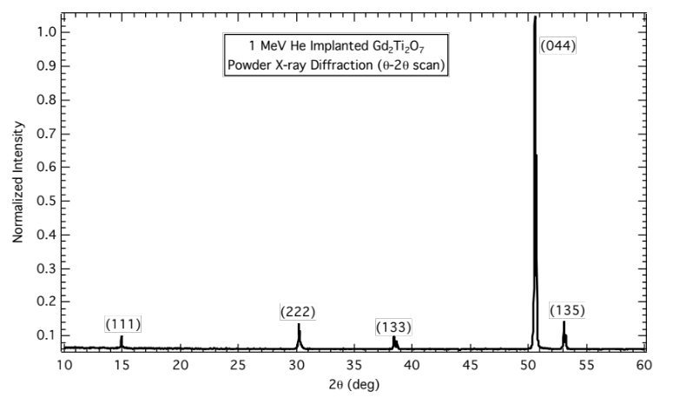
Figure 8.6 Powder x-ray diffraction showing no evidence of amorphization in 1 MeV helium implanted Gd₂Ti₂O₇.

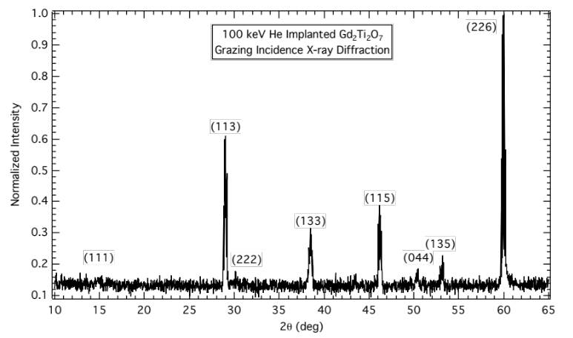
Figure 8.7 Grazing incidence x-ray diffraction (ω = 5.5°) showing no evidence of amorphization in 100 keV helium implanted Gd₂Ti₂O₇.

measured release temperature, simply due to the time it takes helium to reach the surface from the larger depth. To assess whether the measurement will be sensitive to this effect, the helium diffusivity was estimated. Interstitial helium diffusivity can be estimated using Eq. 8.2 [86].
$D=D_{o}e^{{-E_{m}}/{kT}}$ (8.2)
$$D_{o}=\frac{1}{6}λ^{2}fzve^{{{∆S}_{m}}/k}$$
In Eq. 8.2, λ is the jump distance, ν is the vibrational or attempt frequency (taken as 10¹³ s⁻¹), z is the coordination number, and f is the correlation factor (taken as 1), which describes the degree to which each jump is correlated with the previous jump. Assuming helium diffuses through interconnected octahedral interstitial sites in the pyrochlore structure, $E_{m}=0.5 \text{eV}$ was assumed based on DFT calculations on Y₂Ti₂O₇ [51]. The jump distance, λ, between adjacent octahedral sites is given by ${a_{F}}/{\sqrt{2}}$, where $a_{F}$ is the effective fluorite lattice parameter (half the pyrochlore lattice parameter). The coordination number, z, of each octahedral site with other octahedral sites is 12. $∆S_{m}$, the entropy of mixing, is given by Eq. 8.3, where $x_{i}$ is the vacancy fraction. As $x_{i}$ approaches zero, $∆S_{m}/k$, which maximizes at 0.7 when $x_{i}=0.5$, also approaches zero. Due to the low fluence of 1 x 10¹⁵ He/cm², $x_{i}≪0.5$ and thus $∆S_{m}$was taken as zero.
$∆S_{m}=-k\left[x_{i}\ln{x_{i}}+\left(1-x_{i}\right)\ln\left(1-x_{i}\right)\right]$ (8.3)
The diffusivity was used to estimate the characteristic diffusion length, r, by a helium interstitial in a given time, t, using Eq. 8.4.
$r=\sqrt{Dt}$ (8.4)
Characteristic diffusion lengths for t = 1 s, the time between each temperature step with a ramp rate, R, of 0.5 K/s, are compiled in Table 8.2. Because the helium migration energy is unknown for Gd₂Ti₂O₇ and Gd₂Zr₂O₇, diffusion lengths were calculated using two different migration energies, E_{m} = 0.5 eV, the DFT calculated migration energy for Y₂Ti₂O₇ [51], and E_{m} = 1 eV. As shown in Table 8.2, helium travels much longer distances when E_{m} = 0.5 eV than when E_{m} = 1 eV. Note that, according to Table 8.2, the distance traveled in t = 1 s will be greater than the implantation depth at 10 keV, even if E_{m} = 1 eV. This means that the temperature measured during desorption of the 10 keV sample was the actual release temperature because the implant range (Fig 8.2) was close enough to the surface. The characteristic diffusion length given in Eq. 8.4 can also be utilized to estimate the shift in measured desorption temperature, ΔT, due to helium implantation depth. Eq. 8.4 can be re-written in terms of t, the time required for He to diffusion to the surface from a given depth, r.

Table 8.2 Characteristic diffusion lengths, r, for a helium interstitial in Gd₂Ti₂O₇ or Gd₂Zr₂O₇ in 1 second, over relevant temperature range. Since the helium migration energy is unknown in both materials, distances were calculated using migration energies of 0.5 eV (He migration energy in Y₂Ti₂O₇) and 1.0 eV.
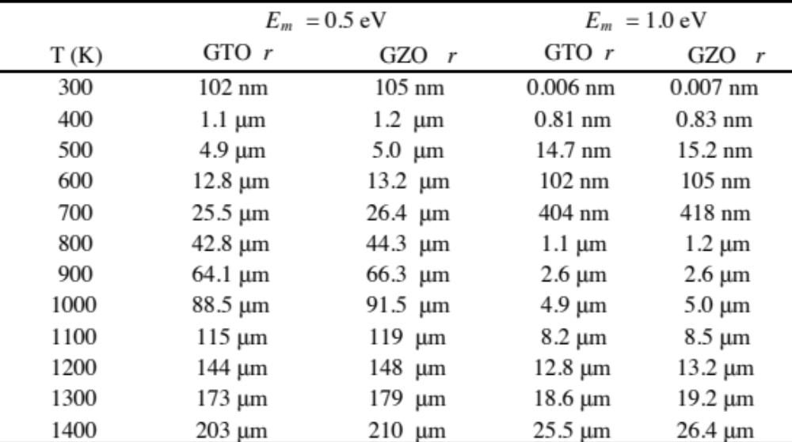

The difference between t₂, the time required for helium to diffuse from one depth, and t₁, the time required for helium to diffuse from another shallower depth, can be converted into a temperature shift, ΔT, using the ramp rate (Eq. 8.5).
$∆T=\frac{R}{D_{1}}\left(r_{2}^{2}-r_{1}^{2}\right)$ (8.5)
In Eq. 8.5, the diffusivity, D₁, should be calculated using the peak desorption temperature from the shallower implantation depth, which is less likely to be affected by the diffusion length. Using Eq. 8.5, the desorption temperatures measured in Gd₂Ti₂O₇ and Gd₂Zr₂O₇ implanted with 10 keV He were used to predict the desorption temperatures that would occur in the 100 keV He and 1 MeV implanted samples, if helium were being released from the same defect (Table 8.3). In these equations, r₁ = 35 nm and r₂ = 350 nm for the 100 keV implant, and 2 μm for the 1 MeV implant. Distances were approximated using the dpa peak, because this is where helium is most likely to become trapped, but the implantation and dpa peaks are at similar depths.

Table 8.3 Assuming E_{m} = 1.0 eV, estimated temperature of peaks measured in 10 keV implanted sample at greater helium implantation depths, where measured desorption temperature from the same defect is shifted due to a longer diffusion length. No temperature shift is expected for Peak 2 in either pyrochlore, because the calculated distance traveled in 1 s (1.1 μm) is larger than the 100 keV dpa peak depth (350 nm) at those temperatures (796 and 800 K).
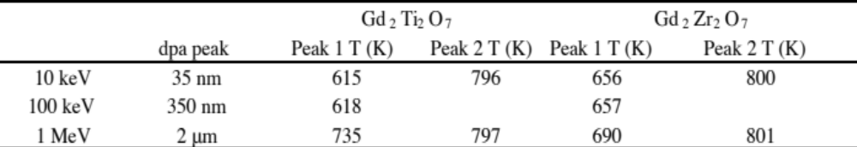

Table 8.3 shows that, if helium were being released from the same defect in all three irradiation conditions, there will not be a detectable shift in temperature between the 10 keV and 100 keV implanted samples, or between Peak 2 in the 10 keV and 1 MeV implanted samples. There would, however, be a detectable shift between the 10 keV and 1 MeV implanted samples for Peak 1. Calculating the temperature shift between the 100 keV and 1 MeV implanted samples, where r₁ = 350 nm and r₂ = 2 μm, resulted in no measureable temperature shift in either pyrochlore because the release temperatures measured in the 100 keV implanted samples were much higher than in the 10 keV implanted samples, and helium is more mobile at these higher temperatures. This calculation makes several assumptions. Because helium migrates in a random path, and this calculation assumes a linear trajectory from the implant peak to the surface, the actual time for helium to reach the surface will likely be longer, and this difference will increase with implantation depth. In addition, inward helium diffusion will result in longer diffusion times. Given the assumptions above, the temperature differences measured by THDS were much larger than those predicted just due to diffusion length alone, so a temperature shift is not expected to play a role in these results.

Preferred Helium Interstitial Sites
In a defect free material, helium will necessarily reside at interstitial positions, once thermally produced vacant lattice sites are occupied. Thermal helium desorption measurements can be performed on defect free material by infusing the helium into the lattice, instead of using ion implantation to inject the helium, which produces point defects. Nevertheless, preferred interstitial sites may be estimated based on site volume differences. Danielson et al. [48] used site volume calculations to determine that the most probable interstitial sites in the pyrochlore structure: between two A-site cations (A-A), between two B-site cations (B-B), between two oxygen atoms (O-O), in the structural vacancy (fcc tetrahedral site, 8a), and in the fcc octahedral site (32e). The authors then used density functional theory (DFT) to calculate defect formation energies for helium interstitials in each of these sites in Y₂Ti₂O₇, and found the octahedral site most favorable (defect formation energy of 0.863 eV). The A-A, B-B, and O-O sites all caused significant deformation of the lattice, and, in the case of the Ti-Ti interstitial, the helium atom moved to the tetrahedral interstitial site. Interstitial sites resulting in the least amount of helium displacement following lattice relaxation were the tetrahedral site (0.0099 nm) and the octahedral site (0.0237 nm). Despite the helium displacement, the octahedral site was more stable than the tetrahedral site by ~0.6 eV. Helium atoms in the Y-Y, Ti-Ti, and O-O site were displaced 0.0702, 0.118, and 0.0814 nm, respectively. Yang et al. [49] used DFT calculations to predict the propensity for helium clustering in Y₂Ti₂O₇. They also found the octahedral site to be more favorable than the tetrahedral site by ~0.6 eV. Yang showed that helium prefers to occupy individual octahedral sites as much as possible before cluster; a higher energy was always associated with forming a helium cluster than with having the same number of individual octahedral sites. In a separate paper, Danielson et al. [51] calculated the lowest energy helium migration path (0.5 eV), which is from octahedral to neighboring octahedral, through the O-O position. Moving from an octahedral site to another octahedral site through a tetrahedral site requires more energy; the migration energy from an octahedral tetrahedral site is 1.33 eV, then the migration energy from a tetrahedral octahedral site is 0.802 eV.
Erhart [47] found that, for several oxides, helium interstitial defect formation energies were lower when the Voronoi volume of the interstitial site was higher, and vice versa. Erhart did not find the same relationship with other methods for calculating site volume. Because helium interstitial defect formation energies have not been calculated for Gd₂Ti₂O₇ and Gd₂Zr₂O₇, the Voronoi volume was calculated for different interstitial sites (A-A, B-B, O-O, tetrahedral, and octahedral, shown in Fig 8.8) in an attempt to predict the most favorable site in each pyrochlore. Voronoi volumes were also calculated for Y₂Ti₂O₇ so that comparisons to DFT defect formation energy calculations could be made. Interstitial sites were taken from Danielson et al. [48], discussed above.

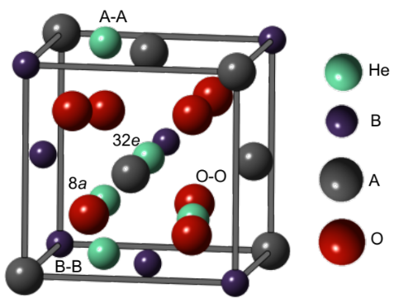
Figure 8.8 Possible helium interstitial sites shown inside the lower 1/8th of the pyrochlore unit cell. Tetrahedral and octahedral interstitial sites are labeled by their Wyckoff positions, 8a and 32e, respectively.

Voronoi volumes were calculated using the C++ library Voro++ [87] and crystal radii from the Shannon Radii database [88], which accounts for charge state and coordination number. Figure 8.9 shows literature helium interstitial defect formation energies as a function of Voronoi volume for Y₂Ti₂O₇. The O-O, Ti-Ti, and Y-Y interstitial sites caused significant lattice deformation, and the helium atom was displaced from the original interstitial site after relaxation, meaning the helium atom was not stable in the original interstitial site. Regardless of helium displacement from the interstitial site, the octahedral site has a much larger Voronoi volume and much lower defect formation energy than all other sites, and is clearly the most favorable interstitial site by both methods. Without considering unstable interstitial sites, the relationship between defect formation energy and the Voronoi volume of the interstitial site agrees with that determined by Erhart.

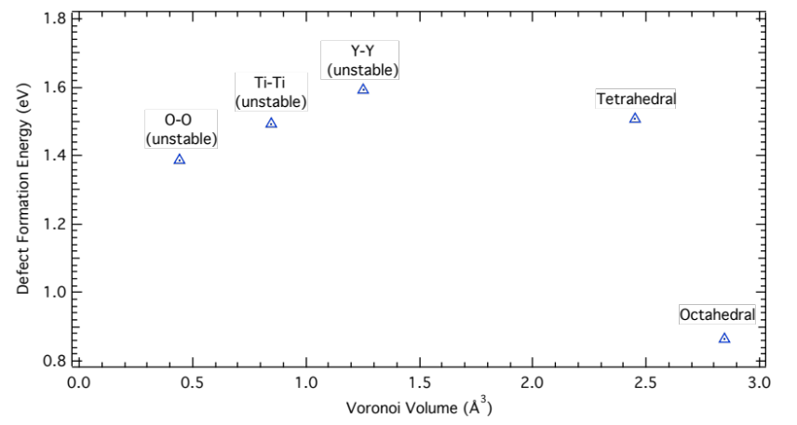
Figure 8.9 Relationship between calculated helium interstitial defect formation energy [48] and interstitial site volume in Y₂Ti₂O₇. O-O, Ti-Ti, and Y-Y sites caused severe lattice deformation, and are considered unstable.

Figure 8.10 shows the Voronoi volume for each interstitial site in Gd₂Ti₂O₇ and Gd₂Zr₂O₇. Site volumes are larger in Gd₂Zr₂O₇ because a = 10.525 Å, as opposed to a = 10.182 in Gd₂Ti₂O₇ [11]. Gd₂Ti₂O₇ behaved similarly to Y₂Ti₂O₇, with the octahedral site having the largest volume. In Gd₂Zr₂O₇, the tetrahedral site had a larger volume than the octahedral site, differing from the titanates. Gd₂Zr₂O₇ undergoes an order-disorder transformation from pyrochlore to defect-fluorite at ~0.4 dpa (in this work, Gd₂Zr₂O₇ remains pyrochlore), which may change the interstitial site volumes. For this reason, the interstitial site volumes were calculated for defect-fluorite Gd₂Zr₂O₇ and included in Fig 8.10. The lattice parameter was assumed to be half of the pyrochlore Gd₂Zr₂O₇ parameter and cations were randomly placed on 4a positions. In defect-fluorite Gd₂Zr₂O₇, where oxygen atoms sit on perfect fluorite lattice sites (8c), the volume difference between tetrahedral and octahedral sites widens.

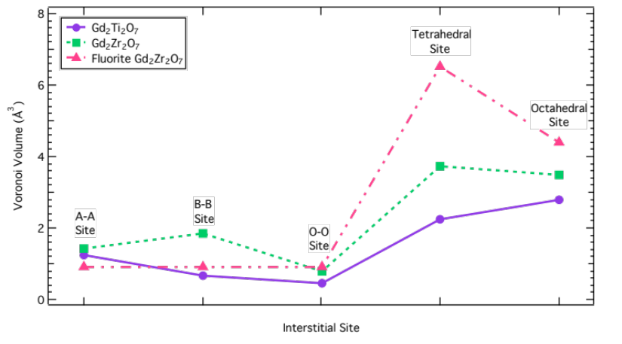
Figure 8.10 Calculated Voronoi volume for each interstitial site in Gd₂Ti₂O₇ and Gd₂Zr₂O₇. Voronoi volumes were also calculated for defect-fluorite Gd₂Zr₂O₇, because Gd₂Zr₂O₇ undergoes a pyrochlore to defect-fluorite (DF) transformation at ~0.4 dpa, which may be more relevant to higher fluence studies. In this work, Gd₂Zr₂O₇ remains pyrochlore. In DF Gd₂Zr₂O₇, the A-A and B-B site volumes are identical due to disordered A- and B-site cations.

Both pyrochlore and defect-fluorite Gd₂Zr₂O₇ have larger tetrahedral than octahedral site volumes, differing from the titanates studied, where the octahedral site volume exceeds that of the tetrahedral site. These differences are due to the oxygen atom configuration, which in pyrochlores is determined by the 48f Wyckoff site positional parameter, x. Literature findings report a wide range of values for the oxygen positional parameter. In general, x is larger in zirconates than titanates, as zirconates more easily form the fluorite structure, where x = 0.375 [89, 90]. In this work, x = 0.330, 0.327, and 0.3395 were used for Y₂Ti₂O₇, Gd₂Ti₂O₇ and Gd₂Zr₂O₇, respectively [6, 38]. If oxygen atoms are closer to the interstitial site, the Voronoi volume of the interstitial site becomes smaller because oxygen atoms occupy a larger fraction of the site. To compare the distances from the center of each interstitial site to the nearest neighbor oxygen atoms, distances were calculated assuming Gd₂Zr₂O₇ and Y₂Ti₂O₇ have the same lattice parameter as Gd₂Ti₂O₇ (10.182 Å). Each octahedral site is coordinated with 7 oxygen atoms and each tetrahedral site is coordinated with 6 oxygen atoms. In the case of identical lattice parameters, the average distance of an oxygen atom from the center of the octahedral site was 2.22, 2.23, and 2.24 Å for Gd₂Zr₂O₇, Y₂Ti₂O₇, and Gd₂Ti₂O₇, respectively. The distance from the tetrahedral site to nearest neighbor oxygen atoms was 2.18, 2.09, and 2.06 Å for Gd₂Zr₂O₇, Y₂Ti₂O₇, and Gd₂Ti₂O₇. Oxygen atom distances from the center of the octahedral site were slightly less for Gd₂Zr₂O₇ than the titanates, but distances from the center of the tetrahedral site were largest in Gd₂Zr₂O₇. In Gd₂Zr₂O₇, this results in a slightly larger portion of the octahedral site being occupied by oxygen atoms, and a slightly smaller portion of the tetrahedral site being occupied by oxygen atoms. These combined effects reduce the volume of the octahedral site and increase the volume of the tetrahedral site, relative to the titanates, when lattice parameters are assumed equal. This effect is magnified in defect-fluorite Gd₂Zr₂O₇, where x = 0.375; the distance from the octahedral site to nearest neighbor oxygen atoms is 2.204 Å and the distance from the tetrahedral site to nearest neighbor oxygen atoms is 2.546 Å. Because the disordered-fluorite lattice is half the size of the pyrochlore lattice, the defect-fluorite structure was assumed to have a = 5.091 Å when comparing oxygen distances. Defect-fluorite Gd₂Zr₂O₇ has a smaller distance between the octahedral site and nearest neighbor oxygen atoms, and a much larger distance between the tetrahedral site and nearest neighbor oxygen atoms, than all pyrochlores considered, explaining the significant increase in the tetrahedral/octahedral site volume ratio when pyrochlore Gd₂Zr₂O₇ transforms to defect-fluorite. To test the effect of cation atomic radii on the Voronoi volume of interstitial sites, the B-site cation in Gd₂Ti₂O₇ was changed from Ti (r = 0.745 Å) to Zr (r = 0.86 Å). In this case, the octahedral and tetrahedral site volumes were 2.794 and 2.218 Å³, respectively (V_{tetra}/V_{octa} = 0.79), compared to pure Gd₂Ti₂O₇ which had octahedral and tetrahedral site volumes of 2.794 and 2.232 Å³, respectively (V_{tetra}/V_{octa} = 0.80); the octahedral site is larger than the tetrahedral site, as was the case for the real Gd₂Ti₂O₇ in Fig 8.10. Changing the oxygen (r = 1.24 Å) positional parameter in Gd₂Ti₂O₇ from x = 0.327 to the Gd₂Zr₂O₇ value, x = 0. 3395, results in octahedral and tetrahedral site volumes of 2.882 and 3.143 Å³, respectively (V_{tetra}/V_{octa} = 1.09). The oxygen positional parameter, x, seems to have a much greater effect on the tetrahedral/octahedral site volume ratio than the B-site radius in these pyrochlores. If we plot the Voronoi cells and nearest neighbor atoms (Fig 8.11), we find that, because the calculation uses the ionic radii, Zr and Ti have much smaller radii than Y, Gd and O, resulting in 3 A-site and 7 oxygen nearest neighbor atoms at the octahedral site. There are 4 B-site cations and 6 oxygens are nearest neighbors at the tetrahedral site. This explains why the changing the B-site cation radius from Ti to Zr had no effect on the octahedral site volume, and very little effect on the tetrahedral site volume, in the calculations above.

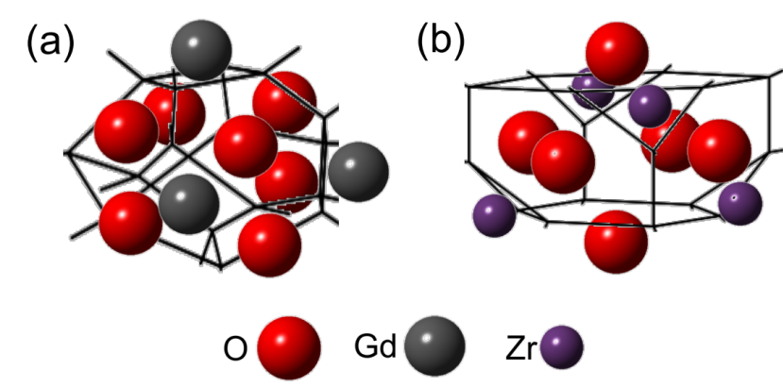
Figure 8.11 Voro++ calculated Voronoi cells and n.n. atoms for the (a) octahedral and (b) tetrahedral pyrochlore interstitial sites, shown for Gd₂Zr₂O₇, but all pyrochlores have the same n.n. at both sites. Relative atomic sizes in this diagram are representative of relative ionic radii.

Based on the interstitial site volume calculations, interstitial helium will likely favor the octahedral interstitial sites in Gd₂Ti₂O₇ and the tetrahedral sites in Gd₂Zr₂O₇. A large increase in the tetrahedral/octahedral interstitial site volume ratio in defect-fluorite compared to pyrochlore Gd₂Zr₂O₇ (Fig 8.10) signifies an even higher likelihood that helium will reside on the tetrahedral site as pyrochlore Gd₂Zr₂O₇ becomes disordered under irradiation.

Helium Binding to Vacancies and Vacancy Clusters
More modeling work is needed to definitively determine where helium resides in the lattice for each irradiation condition, but helium behavior can be qualitatively discussed. As discussed in section 8.1, helium release temperatures in the 100 keV and 1 MeV implanted samples were significantly higher than release temperatures measured in the samples implanted with 10 keV helium. Helium release temperatures measured in the 10 keV implanted samples were similar for Gd₂Ti₂O₇ and Gd₂Zr₂O₇, and are likely due to helium release from interstitial sites or single vacancies. Much higher desorption temperatures observed at higher helium implantation depths would then indicate release from more strongly bound defects, i.e. helium-vacancy clusters. Vacancy cluster formation could result from higher implantation energies, as more defects are produced per ion with a larger energy. Defects may be less likely to recombine in Gd₂Ti₂O₇, which amorphizes, than in Gd₂Zr₂O₇, which remains crystalline. This could lead to higher desorption energies in Gd₂Ti₂O₇.
This section mainly serves to address whether or not vacancy clusters could possibly form during the heating process of the THDS experiment. Because vacancy cluster formation has not been well studied in either pyrochlore, the probability of vacancy cluster formation was assessed by estimating the diffusion coefficient. Vacancy diffusion was calculated using Eq. 8.2, adjusting the jump distance, coordination number, and vacancy migration energies accordingly. All vacancy migration energies depend on the amount of disorder. Due to the low implantation fluence in this experiment, perfectly ordered migration energies were used. Oxygen vacancies typically migrate by a 48f-48f hopping mechanism, with oxygen vacancies migrating by a split vacancy mechanism in A₂B₂O₇ compositions that more easily form the fluorite structure (i.e. Gd₂Zr₂O₇). With increasing antisite disorder, oxygen sites become more similar and the energy required for hopping between 48f, 8b, and 8a sites is reduced [37]. Oxygen vacancy cluster formation is considered unlikely due to the presence of structural oxygen vacancies in the pyrochlore structure, which should facilitate easy oxygen Frenkel recombination. Oxygen migration energies were taken as an average of experimental and simulated values; in Gd₂Ti₂O₇, 1.23 eV was predicted by simulation, and 0.93 eV measured by experiment, while in Gd₂Zr₂O₇, 0.58 eV was predicted by simulation, and 0.73-0.9 eV were measured by experiment [41]. Cation vacancy migration energies have been calculated by Williford and Weber [91] using atomistic simulations. For perfectly ordered pyrochlore, Williford and Weber determined the lowest energy migration paths to be: (1) V_{Ti}V_{Gd} (1.38 eV) for Ti vacancies in Gd₂Ti₂O₇, (2) V_{Gd}V_{Gd} (4.25 eV) for Gd vacancies in Gd₂Ti₂O₇, (3) V_{Zr}V_{Gd} (1.93 eV) for Zr vacancies in Gd₂Zr₂O₇, and finally (4) V_{Gd}V_{Gd} (3.81 eV) for Gd vacancies in Gd₂Zr₂O₇. Overall, A-site cation (Gd) vacancies preferred to migrate to A-sites, and B-site cation (Ti, Zr) vacancies preferred to migrate to A-sites. Figure 8.12 shows Arrhenius plots of the diffusivity for both pyrochlores.

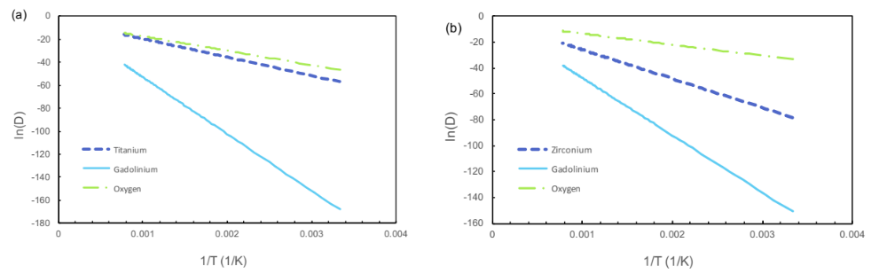
Figure 8.12 Arrhenius plots describing vacancy diffusion in (a) Gd₂Ti₂O₇ and (b) Gd₂Zr₂O₇.

Ti vacancies migrate almost as fast as oxygen vacancies in Gd₂Ti₂O₇, but Zr vacancies migrate slower than oxygen vacancies in Gd₂Zr₂O₇. Gd vacancies migrate much slower than oxygen and B-site cation vacancies in both materials. Table 8.4 gives a more tangible representation of vacancy migration in both pyrochlores by estimating the characteristic diffusion length as a function of temperature (using Eq. 8.4). As shown in Table 8.3, cation vacancies are immobile at room temperature, but oxygen vacancies may be mobile in Gd₂Zr₂O₇. At elevated temperatures, oxygen vacancies have a much larger characteristic diffusion length than cation vacancies. A-site cation (Gd) vacancies are immobile until temperatures > 1200 K. B-site cation (Ti, Zr) vacancies are mobile beginning at ~500 K in Gd₂Ti₂O₇, and at ~700 K in Gd₂Z₂O₇. In order for helium to bind to vacancy clusters forming during the 100 keV or 1 MeV (where helium is more deeply implanted) THDS experiments, clusters must form, and thus vacancies must be mobile, at a temperature lower than the earliest measured helium release temperature measured for the shallow 10 keV implant. The 10 keV implantation is very close to the surface (dpa peak is at ~35 nm deep), so helium would not have time to re-trap with more strongly bound defects, or does not encounter other defects, before reaching the surface.

Table 8.4 Estimated cation vacancy migration characteristic diffusion lengths at temperatures relevant to THDS. In this case, t = 200 s, or the time required to increase the temperature by 100 K when R = 0.5 K/s. Shaded areas indicate where vacancies are essentially immobile.
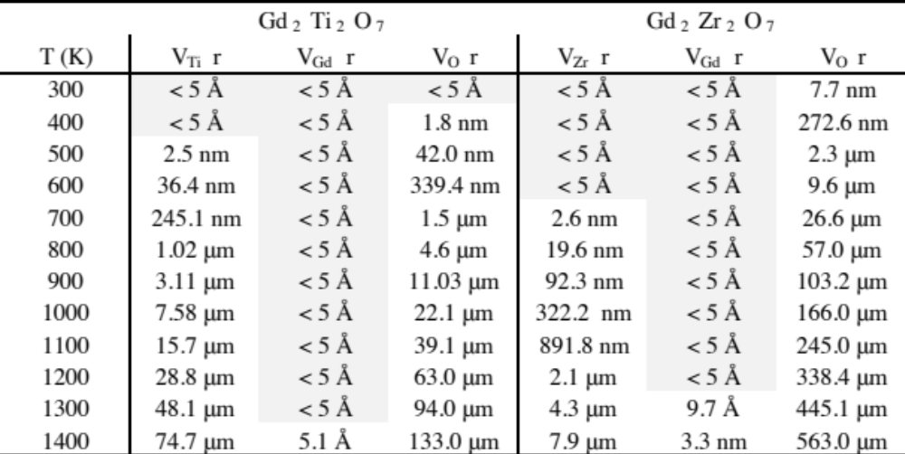

In addition, the surface acts as a sink for defects, which would inhibit near-surface cluster formation during the heating. For helium to bind to vacancy clusters that form during the heating of Gd₂Ti₂O₇ samples implanted with 100 keV or 1 MeV, the helium would have to re-trap after being released from the 600 and 800 K trapping sites. This means, in Gd₂Ti₂O₇, vacancies must be mobile at a temperature < 800 K in order for vacancy clusters to form prior to helium release from traps formed during the room temperature implantation. According to vacancy diffusivity estimates shown in Fig 8.12 and Table 8.4, both Ti and O vacancies are mobile at < 800 K. As discussed above, MD simulations have shown that O Frenkel pairs usually recombine, so O vacancies are not expected to form clusters. Thus, the increase in dissociation energy, E_{D}, measured in 100 keV and 1 MeV implanted Gd₂Ti₂O₇ could be due to helium binding to Ti vacancy clusters that form during the heating. Helium will be more strongly bound to larger vacancy clusters. In Gd₂Zr₂O₇, Zr and O vacancies are mobile at < 800 K, though a Zr vacancy will travel two orders of magnitude less distance than a Ti vacancy in 200 s (see Table 8.4). Because Zr vacancies are less mobile than Ti vacancies, Zr vacancy clusters are expected to be much smaller in size, and thus bind less strongly to helium. Slightly higher dissociation energies were measured in 100 keV implanted Gd₂Zr₂O₇, which, when combined with the diffusivity information, means helium could be bound to small Zr vacancy clusters that form during the heating. In the 1 MeV implanted samples, the helium concentration peak is ~1.7 μm deeper than in the 100 keV implantation, giving clusters more time to grow before helium reaches them. Since helium binds more strongly to larger He-vacancy clusters, this could possibly explain the higher dissociation energies measured in the 1 MeV implanted Gd₂Ti₂O₇ and Gd₂Zr₂O₇ samples.

Summary and Discussion
At room temperature, helium likely migrates throughout the pyrochlore lattice via interstitial diffusion between interlinked octahedral interstitial sites. DFT work by Danielson et al. [51] suggests a moderately low energy barrier for interstitial helium migration in Y₂Ti₂O₇ (~0.5 eV). If helium is mobile at room temperature, it will only occupy interstitial sites if all vacancy sites are filled and He-He interactions are repulsive. This would result in some measured helium release at low temperature. This was not observed, indicating that all helium was bound to vacant lattice sites, likely A- and B-sites, which resulted in two distinct desorption peaks in the 10 keV implanted samples. Even though the minimum energy interstitial configurations could not be experimentally determined, Voronoi volume calculations in this work predicted minimum energy interstitial sites at the tetrahedral (8a) position in Gd₂Zr₂O₇ and at the octahedral (32e) position in Gd₂Ti₂O₇. In a damaged pyrochlore, point defects are expected, providing vacancies, vacancy clusters, or more complicated defects at which helium may become trapped. As discussed above, the differences in binding energy measured for pyrochlores are too high to be due to implantation depth alone, and are likely due to helium re-trapping inside vacancy clusters that form during the experiment as the samples are heated, or due to helium diffusion by a vacancy assisted mechanism into helium-vacancy clusters. Oxygen vacancies have the lowest energy barrier for migration (~0.93 – 1.23 eV for Gd₂Ti₂O₇ and ~0.73-0.9 eV for Gd₂Zr₂O₇) [41], compared to B-site vacancy migration energies > 1.3 eV and A-site vacancy migration energies > 3.8 eV in both materials [91]. Oxygen interstitials will typically reside on the structural oxygen vacancy site (8a), allowing oxygen Frenkel pairs to easily recombine. For this reason, the formation of oxygen vacancy clusters is considered less likely than the formation of cation vacancy clusters. B-site vacancies are much more mobile than A-site vacancies, so vacancy clusters likely consist of B-site (Ti, Zr) vacancies. At elevated temperatures when vacancy diffusion is more active, helium may migrate by a vacancy-assisted mechanism, especially in Gd₂Zr₂O₇, where the lowest energy interstitial site is thought to be at the structural oxygen vacancy, especially once the structure undergoes enough damage to transform from pyrochlore to defect-fluorite. The grain size differences between both pyrochlores should also be considered; Gd₂Ti₂O₇ has grains on the order of 50 μm in diameter, which can be considered bulk for the purposes of this experiment, while Gd₂Zr₂O₇ grains are much smaller, closer to 1 μm in diameter. Once helium reaches the grain boundary, it will instantaneously travel to the surface. Some Gd₂Zr₂O₇ grains may be smaller than the helium implantation depth in the 1 MeV implantation, which could cause helium to evacuate the sample before re-trapping in larger vacancy clusters. Both pyrochlores will undergo phase transformations after significant damage accumulation; Gd₂Ti₂O₇ will undergo a pyrochlore to amorphous transformation at ~0.2 dpa [6] and Gd₂Zr₂O₇ will undergo a pyrochlore to defect-fluorite transformation at ~0.4 dpa [7]. Over geological timescales (e.g. 100,000 years), the diffusion processes will change in Gd₂Ti₂O₇ due to the amorphization. The activation energy for helium diffusion was found to be 0.61 eV in amorphous borosilicate glass [42], and is likely similar in amorphous Gd₂Ti₂O₇. In Gd₂Zr₂O₇, using Eq. 8.4, oxygen vacancies could be expected to migrate an estimated 965 μm over 100,000 years at room temperature, while Zr and Gd vacancy migration would be negligible. Over 1,000,000 years, oxygen vacancies could be expected to migrate an estimated 3 mm, with Zr and Gd vacancy migration continuing to remain negligible. Because cation vacancies are largely immobile at room temperature, cluster formation and annihilation of cation vacancies at grain boundaries is not expected to occur in a waste form. Oxygen vacancies could form clusters or annihilate at grain boundaries, if they do not recombine. While helium is likely binding to vacancy clusters during the desorption experiment, helium may be less likely to find clusters in a real waste form, which would result in binding to single vacancies.
In UO₂, which is fluorite (similar to the pyrochlore structure), accumulated radiation damage due to α-decay of ²³⁸Pu or ²³⁹Pu (helium accumulation and defect production) was found to enhance helium diffusion. Helium gas atoms have been experimentally shown to occupy octahedral interstitial sites in UO₂ [92], where, unlike pyrochlore, all fcc tetrahedral interstitial sites are occupied by oxygen atoms. Helium has been found to migrate by a vacancy-assisted mechanism in UO₂, but there is debate about the temperature range when this mechanism becomes active. Govers et al. [93] suggested an oxygen vacancy assisted diffusion mechanism at lower temperatures, which they found to have a lower activation energy than interstitial diffusion between octahedral sites. Yakub et al. [94] reported interstitial migration between octahedral sites as the main diffusion mechanism at low temperatures, while vacancy-assisted mechanisms become more important at higher temperatures. Based on this work, behavior similar to that predicted by Yakub et al. for helium in UO₂ seems to be most likely in pyrochlores.

CONCLUSIONS

Thermal helium desorption measurements in Chapter 8 suggested that helium binds to vacant lattice sites at room temperature, when vacancy diffusion is negligible and vacancy clusters are unlikely to form. Additional modeling is required to determine the exact location where helium binds in the pyrochlore lattice. For now, helium is assumed to bind to cation vacancies. Over geological timescales, e.g. 1,000,000 years, vacancy diffusivity estimates predicted oxygen vacancies in Gd₂Zr₂O₇, which remains crystalline under irradiation, could be expected to migrate ~3 mm, and Zr and Gd vacancy migration will likely remain negligible. Helium bubbles become visible in the TEM once they reach a diameter of about 1.5 nm. Bubbles observed in Chapters 5 and 6 are likely over-pressurized because the helium implantations were performed at room temperature. Eq. 9.1 [86] can be used to calculate the pressure of an equilibrium bubble of radius R, where γ is the bubble surface tension, estimated to be ~0.7 J/m² for pyrochlore [95].
$P=\frac{2γ}{R}$ (9.1)
If bubbles are at equilibrium, the bubble can be considered an ideal gas, and the ideal gas law can be used to arrive at Eq. 9.2, where k is Boltzmann’s constant and T is the temperature, which predicts the number of helium atoms, m, required to form a bubble of radius R.
$m=\frac{4}{3}πR^{2}\left(\frac{2γ}{kT}\right)$ (9.2)
Using Eq. 9.2, in a pyrochlore, ~798 helium atoms are contained within an equilibrium bubble formed at 298 K, which is large enough to be visible in the TEM. If more helium atoms are present within the same radius, the bubble becomes over-pressurized. Conversely, fewer helium atoms will result in an under-pressurized bubble. For bubbles to be visible in the TEM, Eq. 9.3 must be satisfied.
$\frac{\text{\# He atoms}}{\text{\# vacancy sites}}≥m$ (9.3)
Eq. 9.3 is equivalent to taking the ratio of the helium and vacancy densities (in atoms/cm³). The helium density can be calculated from the helium concentration. The vacancy density is more complicated because recombination rates differ depending on the irradiation conditions. The vacancy concentration was estimated using the point defect balance equations for interstitials (9.4) and vacancies (9.5) [86], where $S_{i}^{\text{tot}}=S_{i}^{C}+S_{i}^{d}$, the combination of cavity and dislocation sink strengths, and $S_{v}^{tot}=S_{v}^{C}+S_{v}^{d}$.
$\frac{∂C_{i}}{∂t}=g-k_{R}C_{i}C_{v}-D_{i}C_{i}S_{\text{i}}^{\text{tot}}$ (9.4)
$\frac{∂C_{v}}{∂t}=g-k_{R}C_{i}C_{v}-D_{v}C_{v}S_{\text{v}}^{\text{tot}}$ (9.5)
Vacancy and interstitial production rates, $g$, were assumed equal, and are expressed by $0.25v_{NRT}∅$, where v_{NRT} is the number of displacements, calculated using the damage energy obtained by running a Quick Calculation in SRIM (see Chapter 4) and φ is the flux. In a real waste form, the dose rate decreases from the 10⁻⁵-10⁻⁴ dpa/s used in ion irradiation conditions, to ~10⁻⁹ dpa/s [96]. The interstitial diffusivity, D_{i}, is estimated using equation (8.2). Cation vacancy mobility is negligible at room temperature, so D_{v} was set to zero, eliminating the $D_{v}C_{v}S_{\text{v}}^{\text{tot}}$ term in Eq. 9.5. Vacancy immobility also eliminates the cavity sink strength terms,$S_{v}^{C}$ and $S_{i}^{C}$. The diffusion limited recombination rate is expressed by $k_{R}=4πRD_{i}$, where R is the recombination radius, which was estimated to be the 2nd nearest neighbor distance (~7 Å). The point defect balance Eqs. (9.4) and (9.5) can be adjusted to more accurately represent ionic systems by adding terms for charged vacancies and interstitials. Because specific migration energies and sink strengths remain unknown, this was not done here [97]. Eqs. (9.4) and (9.5) can be numerically integrated to arrive at the vacancy and interstitial concentrations. The vacancy concentration can be used to estimate the helium concentration required for TEM visible bubble formation using Eq. 9.3. Figure 9.1 is a contour plot showing the helium concentration required for visible bubble formation in a pyrochlore, as a function of interstitial sink strength, $S_{\text{i}}^{\text{tot}}$, and the interstitial migration energy, $E_{m}^{i}$. The Gd₂Zr₂O₇ atomic density and 2nd nearest neighbor distance were utilized to calculate Fig 9.1. In complex oxides, $E_{m}^{i}$ differs between the oxygen and cation sublattices, and each cation diffuses differently. In some cases, cations will preferentially diffuse by vacancy diffusion, which is not typically activated at room temperature in ceramics. Typical cation interstitial migration energies are within the range of 0.4-1.5 eV [98-102]. Using this simplified model, the helium concentration required for bubble formation is >20 at.% with $E_{m}^{i}$ > 0.7 eV, so Fig 9.1 was created within the range of 0.4 – 0.7 eV.

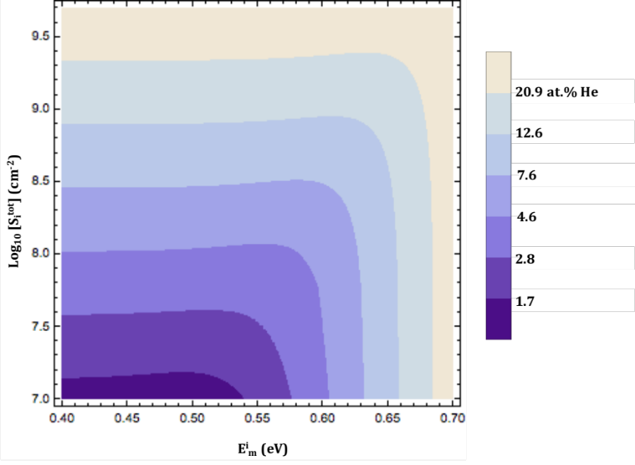
Figure 9.1 Contour plot showing the critical helium concentration required for visible bubble formation as a function of interstitial sink strength, $S_{\text{i}}^{\text{tot}}$, and the interstitial migration energy, $E_{m}^{i}$. $S_{\text{i}}^{\text{tot}}$ and helium concentration are presented on a log₁₀ scale.

In pyrochlores with a B-site cation interstitial, B_{i}, B_{i} will continue to migrate in systems with high r_{A}/r_{B} cation radius ratio. In systems with a low r_{A}/r_{B}, B_{i} usually forms an antisite defect, B_{A}, on the A-site, and an A-site cation interstitial, A_{i}, migrates through the lattice [102]. Oxygen atoms in pyrochlores migrate not by an interstitial mechanism, but by 48f-48f hopping with activation energies ranging from 0.5 – 1.5 eV. Pyrochlores with a high r_{A}/r_{B} cation radius ratio have larger oxygen migration energies [41]. The interstitial sink strength, $S_{\text{i}}^{\text{tot}}$, which is dependent on dislocation density, has not been well studied in pyrochlores, but the sink strength of network dislocations and dislocation loops is typically on the order of 5 x 10¹⁰ cm⁻² in binary metallic systems [103]. The interstitial sink strength was assumed to be lower in pyrochlore, as indicated by the range in Fig 9.1, but the actual dislocation density is not known. As shown in Fig 9.1, if $E_{m}^{i}$ is fixed, the helium concentration required to form bubbles 1.5 nm in diameter increases with increasing interstitial sink strength. As more interstitials become trapped by dislocations, fewer vacancies recombine, leaving more bubble nucleation sites. With more bubble nucleation sites, a higher helium concentration is required for visible bubble formation. If the interstitial sink strength is fixed, the helium concentration required for visible bubble formation remains fixed up to a critical interstitial migration energy, after which slower interstitial migration energies result in reduced vacancy-interstitial recombination rates, leaving more bubble nucleation sites.
Vacancy mobility is significantly higher in metals than in ceramics ($E_{m}^{v}$ ~ 0.7 eV [104], as opposed to $E_{m}^{v}$ > 1.3 eV for cation vacancies in pyrochlores [91]), resulting in vacancy cluster formation at much lower temperatures in metals. Vacancy cluster formation reduces the trap density in the system, which indicates that the critical helium concentration required for bubble formation will be lower in metals than in ceramics. In the case of helium binding to vacancy clusters instead of individual vacancies in metals, the vacancy to helium ratio will increase, as compared to in ceramics, where helium may trap in single vacancy sites, depending on, for example, the initial damage state, irradiation temperature, and dose rate. Note that, if helium was trapping at interstitial sites instead of vacancy sites, the trap site density would be much higher (there are 32 octahedral interstitial sites per pyrochlore unit cell). This would result in much higher helium concentrations required for visible bubble formation than those observed in Fig 9.1. The measured critical concentration for bubble formation was higher in Gd₂Ti₂O₇ (6 at.% He) than in Gd₂Zr₂O₇ (4.6 at.% He), which possibly indicates a higher trap density in the amorphous material than in crystalline pyrochlore. This is supported by measured decreases in Gd₂Ti₂O₇ density [21] and hardness (Chapter 7) following amorphization. Both critical concentrations for helium bubble formation agree reasonably well with the contour plot shown in Fig 9.1. Future work might focus on studying the behavior of interstitials and vacancies at higher temperatures to quantify loop and vacancy cluster formation kinetics, which would aid in predicting the defect state in pyrochlores over geological time.

LIST OF REFERENCES

[1] Institute, N. E. (2016). "On-site storage of nuclear waste: used nuclear fuel and high-level radioactive waste." from http://www.nei.org/Knowledge-Center/Nuclear-Statistics/On-Site-Storage-of-Nuclear-Waste.
[2] R.C. Ewing, W.J. Weber, J. Lian. Nuclear waste disposal--pyrochlore (A₂B₂O₇): Nuclear waste form for the immobilization of plutonium and "minor" actinides, Journal of Applied Physics 95 (2004) 5949-5971.
[3] Commission, U. S. N. R. (2016). "High-level waste." from http://www.nrc.gov/waste/high-level-waste.html.
[4] R.C. Ewing, W.J. Weber. Nuclear-waste management and disposal. Fundamentals of Materials for Energy and Enfironmental Sustainability. Cambridge University Press, Cambridge University Press, New York, 2012.
[5] Plant, H. V. (2016). "About the project." from http://www.hanfordvitplant.com/about-project.
[6] J. Lian, J. Chen, L.M. Wang, R.C. Ewing, J.M. Farmer, L.A. Boatner, K.B. Helean. Radiation-induced amorphization of rare-earth titanate pyrochlores, Physical Review B 68 (2003) 134107.
[7] S.X. Wang, B.D. Begg, L.M. Wang, R.C. Ewing, W.J. Weber, K.V. Govidan Kutty. Radiation stability of gadolinium zirconate: A waste form for plutonium disposition, Journal of Materials Research 14 (1999) 4470-4473.
[8] B.D.H. Begg, N J; Weber, W J; Devanathan, R; Icenhower, J P; Thevuthasan, S; McGrail, B P. Heavy-ion irradiation effects on structures and acid dissolution of pyrochlores, Journal of Nuclear Materials 288 (2001) 208-216.
[9] G. Gutierrez, S. Peuget, J.A. Hinks, G. Greaves, S.E. Donnelly, E. Oliviero, C. Jegou. Helium bubble formation in nuclear glass by in-situ TEM ion implantation, Journal of Nuclear Materials 452 (2014) 565-568.
[10] T. Wiss, J.-P. Hiernaut, D. Roudil, J.-Y. Colle, E. Maugeri, Z. Talip, A. Janssen, V. Rondinella, R.J.M. Konings, H.-J. Matzke, W.J. Weber. Evolution of spent nuclear fuel in dry storage conditions for millennia and beyond, Journal of Nuclear Materials 451 (2014) 198-206.
[11] L. Minervini, R.W. Grimes, K.E. Sickafus. Disorder in pyrochlore oxides, Journal of American Ceramic Society 83 (2000) 1873-1878.
[12] Y.H. Lee, H.S. Sheu, J.P. Deng, H.-C.I. Kao. Preparation and fluorite-pyrochlore phase transformation in Gd₂Zr₂O₇, Journal of Alloys and Compounds 487 (2009) 595-598.
[13] B.D. Begg, N.J. Hess, D.E. McCready, S. Thevuthasan, W.J. Weber. Heavy-ion irradiation effects in Gd₂(Ti_{2-x}Zr_{x})O₇ pyrochlores, Journal of Nuclear Materials 289 (2001) 188-193.
[14] M.A. Subramanian, G. Aravamudan, G.V.S. Rao. Oxide pyrochlores—a review, Progress in Solid State Chemistry 15 (1983) 55-143.
[15] I. Farnan, H. Cho, W.J. Weber. Quantification of actinide alpha-radiation damage in minerals and ceramics, Nature 445 (2007) 190-193.
[16] G.R. Lumpkin, R.C. Ewing. Alpha-decay damage in minerals of the pyrochlore group, Physics and Chemistry of Minerals 16 (1988) 2-20.
[17] G.K. Krovokoneva, G.A. Sidorenko. The essence of the metamict transformation in pyrochlores, Geochemistry International 8 (1971) 113-122.
[18] R.B. Greegor, F.W. Lytle, B.C. Chakoumakos, G.R. Lumpkin, R.C. Ewing. An investigation of metamict and anneald pyrochlores by x-ray absorption spectroscopy, MRS Proceedings (1985) 655-662.
[19] R.B. Greegor, F.W. Lytle, B.C. Chakoumakos, G.R. Lumpkin, R.C. Ewing. An investigation of uranium L-edges of metamict and annealed betafite, MRS Proceedings (1985) 387-392.
[20] R.B. Greegor, F.W. Lytle, B.C. Chakoumakos, G.R. Lumpkin, R.C. Ewing. An x-ray absorption spectroscopy invesgitagion of the Ta site in alpha-recoil damaged natural pyrochlores, MRS Proceedings (1987) 645-658.
[21] W.J. Weber, J.W. Wald, H. Matzke. Self-Radiation Damage in Gd₂Ti₂O₇, Materials Letters 3 (1985) 173-180.
[22] R.C. Belin, P.M. Martin, P.J. Valenza, A.C. Scheinost. Experimental Insight into the Radiation Resistance of Zirconia-Based Americium Ceramics, Inorganic Chemistry 48 (2009) 5376-5381.
[23] Y. Zhang, W.J. Weber, V. Shutthanandan, R. Devanathan, S. Thevuthasan. Damage evolution on Sm and O sublattices in Au-implanted samarium titanate pyrochlore, Journal of Applied Physics 95 (2004).
[24] B.D. Begg, N.J. Hess, W.J. Weber, R. Devanathan, J.P. Icenhower, S. Thevuthasan, B.P. McGrail. Heavy-ion irradiation effects on structures and acid dissolution of pyrochlores, Journal of Nuclear Materials 288 (2001) 208-216.
[25] J. Lian, L. Wang, J. Chen, K. Sun, R.C. Ewing, J.M. Farmer, L.A. Boatner. The order-disorder transition in ion-irradiated pyrochlore, Acta Materialia 51 (2003) 1493-1502.
[26] J. Lian, X.T. Zu, K.V.G. Kutty, J. Chen, L.M. Wang, R.C. Ewing. Ion-irradiation-induced amorphization of La₂Zr₂O₇ pyrochlore, Physical Review B 66 (2002).
[27] K.E. Sickafus, R.W. Grimes, J.A. Valdez, A. Cleave, M. Tang, M. Ishimaru, S.M. Corish, C.R. Stanek, B.P. Uberuaga. Radiation-induced amorphization resistance and radiation tolerance in structurally related oxides, Nature 6 (2007).
[28] N.P. Laverov, S.V. Yudintsev, V.I. Velichkin, A.N. Lukinykh, S.V. Tomilin, A.A. Lizin, S.V. Stefanovskii. Effect of Amorphization on Isolation Properties of Actinide Pyrochlore Matrix, Radiochemistry 51 (2009) 529-536.
[29] M.J.D. Rushton, C.R. Stanek, A.R. Cleave, B.P. Uberuaga, K.E. Sickafus, R.W. Grimes. Simulation of defects and defect processes in fluorite and fluorite related oxides: Implications for radiation tolerance, Nuclear Instruments and Methods in Physics Research B 255 (2007) 151-157.
[30] H.Y. Xiao, F. Gao, W.J. Weber. Threshold displacement energies and defect formation energies in Y₂Ti₂O₇, Journal of Physics: Condensed Matter 22 (2010) 415801.
[31] J.A. Purton, N.L. Allan. Displacement cascades in Gd₂Ti₂O₇ and Gd₂Zr₂O₇: a molecular dynamics study, Journal of Materials Chemistry 12 (2002) 2923-2926.
[32] A. Chartier, C. Meis, J.-P. Crocombette, L.R. Corrales, W.J. Weber. Atomistic modeling of displacement cascades in La₂Zr₂O₇ pyrochlore, Physical Review B 67 (2003) 174102.
[33] A. Chartier, C. Meis, J.-P. Crocombette, W.J. Weber, L.R. Corrales. Molecular dynamic simulation of disorder induced amorphization in pyrochlore, Physical Review Letters 94 (2005).
[34] A. Chartier, G. Catillon, J.-P. Crocombette. Key role of the cation interstitial structure in the radiation resistance of pyrochlores, Physical Review Letters 102 (2009).
[35] Z.L. Zhang, H.Y. Xiao, X.T. Zu, F. Gao, W.J. Weber. First-principles calculation of structural and energetic properties for A₂Ti₂O₇ (A=Lu, Er, Y, Gd, Sm, Nd, La), Journal of Materials Research 24 (2008) 1335-1341.
[36] H.Y. Xiao, L.M. Wang, X.T. Zu, J. Lian, R.C. Ewing. Theoretical investigation of structural, energetic and electronic properties of titanate pyrochlores, Journal of Physics: Condensed Matter 19 (2007) 346203.
[37] P.J. Wilde, C.R.A. Catlow. Defects and diffusion in pyrochlore structured oxides, Solid State Ionics 112 (1998) 173-183.
[38] C. Jiang, C.R. Stanek, K.E. Sickafus, B.P. Uberuaga. First-principles prediction of disordering tendencies in pyrochlore oxides, Physical Review B 79 (2009) 104203.
[39] R. Perriot, B.P. Uberuaga. Structural vs. intrinsic carriers: contrasting effects of cation chemistry and disorder on ionic conductivity in pyrochlores, Journal of Materials Chemistry A 3 (2015) 11554-11565.
[40] R.E. Williford, W.J. Weber, R. Devanathan, J.D. Gale. Effects of cation disorder on oxygen vacancy migration in Gd₂Ti₂O₇, Journal of Electroceramics 3 (1999) 409-424.
[41] M. Pirzada, R.W. Grimes, L. Minervini, J.F. Maguire, K.E. Sickafus. Oxygen migration in A₂B₂O₇ pyrochlores, Solid State Ionics 140 (2001) 201-208.
[42] R. Bès, T. Sauvage, S. Peuget, J. Haussy, F. Chamssedine, E. Oliviero, T. Fares, L. Vincent. Helium mobility in SON68 borosilicate nuclear glass: a nuclear reaction analysis approach, Journal of Nuclear Materials 443 (2013) 544-554.
[43] G. Gutierrez, S. Peuget, J.A. Hinks, G. Greaves, S.E. Donnelly, E. Oliviero, C. Jégou. Helium bubble formation in nuclear glass by in-situ TEM ion implantation, Journal of Nuclear Materials 452 (2014) 565-568.
[44] T. Wiss, O. Dieste-Blanco, A. Tacu, A. Janssen, A. Talip, J.-Y. Colle, P. Martin, R. Konings. TEM study of alpha-damage plutonium and americium dioxides, Journal of Materials Research 30 (2015) 1544.
[45] Z. Talip, T. Wiss, V. Di Marcello, A. Janssen, J.-Y. Colle, P. Van Uffelen, P. Raison, R.J.M. Konings. Thermal diffusion of helium in ²³⁸Pu-doped UO₂, Journal of Nuclear Materials 445 (2014) 117-127.
[46] T.A.G. Wiss, J.-P. Hiernaut, P.M.G. Damen, S. Lutique, R. Fromknecht, W.J. Weber. Helium behavior in waste conditioning matrices during thermal annealing, Journal of Nuclear Materials 352 (2006) 202-208.
[47] P. Erhart. A first-principles study of helium storage in oxides and at oxide-iron interfaces, Journal of Applied Physics 111 (2012) 113502.
[48] T. Danielson, C. Hin. Structural and electronic effects of helium interstitials in Y₂Ti₂O₇: A first-principles study, Journal of Nuclear Materials 452 (2014) 189-196.
[49] L. Yang, Y. Jiang, G.R. Odette, T. Yamamoto, Z. Liu, Y. Liu. Trapping helium in Y₂Ti₂O₇ compared to in matrix iron: A first principles study, Journal of Applied Physics 115 (2014) 143508.
[50] J. Mulroue, M. Watkins, A.J. Morris, D.M. Duffy. Trapping in He in intrinsic defects in zirconolite, Journal of Nuclear Materials 437 (2013) 261-266.
[51] T. Danielson, E. Tea, C. Hin. Ab initio investigation of helium in Y₂Ti₂O₇: Mobility and effects on mechanical properties, Journal of Nuclear Materials 477 (2016) 215-221.
[52] J.L. Warning, S.J. Schneider. Phase equilibrium relationships in thesystem Gd₂O₃–TiO₂, Journal of Research National Bureau Standards, Section A 69 (1965) 255-261.
[53] O. Fabrichnaya, C. Wang, M. Zinkevich, C.G. Levi, F. Aldinger. Phase equilibria and thermodynamic properties of the ZrO₂-GdO_{1.5}-YO_{1.5} system, Journal of Phase Equilibria and Diffusion 26 (2005) 591-604.
[54] A.C. Larson, R.B. Von Dreele. General Structure Analysis System (GSAS), Los Alamos National Laboratory Report LAUR (2004) 86-748.
[55] B.H. Toby. EXPGUI, a graphical user interface for GSAS, Journal of Applied Crystallography 34 (2001) 210-213.
[56] Y. Zhang, M.L. Crespillo, H. Xue, K. Jin, C.H. Chen, C.L. Fontana, J.T. Graham, W.J. Weber. New ion beam materials laboratory for materials modification and irradiation effects research, Nuclear Instruments and Methods in Physics Research Section B: Beam Interactions with Materials and Atoms 338 (2014) 19-30.
[57] J.F. Ziegler, J.P. Biersack, U. Littmark. The Stopping Range of Ions in Solids, (1985).
[58] R.C. Ewing, W.J. Weber, J. Lian. Nuclear waste disposal—pyrochlore (A₂B₂O₇): Nuclear waste form for the immobilization of plutonium and “minor” actinides, Journal of Applied Physics 95 (2004) 5949-5971.
[59] R.E. Stoller, Toloczko, M.B., Was, G.S., Certain, A.G., Dwaraknath, S., Garner, F.A. On the use of SRIM for computing radiation damage exposure, Nuclear Instruments and Methods in Physics Research B 310 (2013) 75-80.
[60] M.F. Toney, T.C. Huang, S. Brennan, Z. Rek. X-ray depth profiling of iron oxide thin films, Journal of Materials Research 3 (2011) 351-356.
[61] G. Renaud. Oxide surfaces and metal/oxide interfaces studied by grazing incidence x-ray scattering, Surface Science Reports 32 (1998) 5-90.
[62] W.S. Rasband, ImageJ, U.S. National Institutes of Health, Bethesda, Maryland, USA, http://imagej.nih.gov/ij/.
[63] C.A. Taylor, M.K. Patel, J.A. Aguiar, Y. Zhang, M.L. Crespillo, J. Wen, H. Xue, Y. Wang, W.J. Weber. Combined effects of radiation damage and He accumulation on bubble nucleation in Gd₂Ti₂O₇, Journal of Nuclear Materials 479 (2016) 542-547.
[64] W.J. Weber, R.C. Ewing, C.R.A. Catlow, T.D. De La Rubia, L.W. Hobbs, C. Kinoshita, H. Matzke, A.T. Motta, M. Nastasi, E.K.H. Salje. Radiation effects in crystalline ceramics for the immobilization of high-level nuclear waste and plutonium, Journal of Materials Research 13 (1998) 1434-1484.
[65] Y.B. Zhang, I.T.; Sun, K.; Wang, C.; Ishimaru, M.; Zhu, Z.; Jiang, W.; Weber, W.J. Damage profile and ion distribution of slow heavy ions in compounds, Journal of Applied Physics 105 (2009) 104901.
[66] K.Z. Jin, Y.; Zhu, Z.; Grove, D.A.; Xue, H.; Xue, J.; Weber, W.J. Electronic stopping powers for heavy ions in SiC and SiO₂, Journal of Applied Physics 115 (2014) 044903.
[67] R. Bes, T. Sauvage, S. Peuget, J. Haussy, F. Chamssedine, E. Oliviero, T. Fares, L. Vincent. Helium mobility in SON68 borosilicate nuclear glass: A nuclear reaction analysis approach, Journal of Nuclear Materials 443 (2013) 544-554.
[68] T. Wiss, O. Dieste-Blanco, A. Tacu, A. Janssen, Z. Talip, J.-Y. Colle, P. Martin, R. Konings. TEM study of alpha-damaged plutonium and americium dioxides, Journal of Materials Research 30 (2015) 1544-1554.
[69] C.A. Taylor, M.K. Patel, J.A. Aguiar, Y. Zhang, M.L. Crespillo, J. Wen, H. Xue, Y. Wang, W.J. Weber. Bubble formation and lattice parameter changes resulting from He irradiation of defect-fluorite Gd₂Zr₂O₇, Acta Materialia 115 (2016) 115-122.
[70] P. Nachimuthu, S. Thevuthasan, V. Shutthanandan, E.M. Adams, W.J. Weber, B.D. Begg, D.K. Shuh, D.W. Lindle, E.M. Gullikson, R.C. Perera. Near-Edge x-ray Absorption Fine Structure Study of Ion-beam-induced Phase Transformation in Gd₂(Ti_{1-y}Zr_{y})₂O₇, Journal of Applied Physics 97 (2005) 033518.
[71] B.H. Toby. CMPR - a powder diffraction toolkit, Journal of Applied Crystallography 38 (2005) 1040-1041.
[72] T. Yang, Taylor, C.A., Wang, C., Zhang, Y., Weber, W.J., Xiao, J., Xue, J., Yan, S., Wang, Y. Effects of He irradiation on Yttria-Stabilized Zirconia Ceramics, Journal of American Ceramic Society 98 (2015) 1314-1322.
[73] T.H. Yang, X; Gao, Y; Wang, C; Zhang, Y; Xue, J; Yan, S; Wang, Y. Damage evolution of yttria-stabilized zirconia induced by He irradiation, Journal of Nuclear Materials 420 (2012) 430-436.
[74] C.H.D. Zhang, S.E.; Vishnyakov, V.M.; Evans, J.H. Dose dependence of formation of nanoscale cavities in helium-implanted 4H-SiC, Journal of Applied Physics 94 (2003) 6017-6022.
[75] C.Y. Wang, T; Kong, S; Xiao, J; Xue, J; Wang, Q; Hu, C; Huang, Q; Wang, Y. Effects of He irradiation on Ti3AlC2: Damage evolution and behavior of He bubbles, Journal of Nuclear Materials 440 (2013) 606-611.
[76] A. Ofan, L. Zhang, O. Gaathon, S. Bakhru, H. Bakhru, Y. Zhu, D. Welch, R. Osgood. Spherical solid He nanometer bubbles in an anisotropic complex oxide, Physical Review B 82 (2010).
[77] A. Debelle, A. Decle my, XRD investigation of the strain/stress state of ion- irradiated crystals, Nucl. Instrum. Methods Phys. Res. B 268 (2010) 1460-1465.
[78] G. Sattonnay, S. Moll, M. Herbst-Ghysel, C. Legros, J.-M. Costantini, L. Thomé. Mechanical stresses induced in ceramic oxides by ion irradiation, Nuclear Instruments and Methods in Physics Research Section B: Beam Interactions with Materials and Atoms 266 (2008) 3052-3056.
[79] W.J. Weber, J.W. Wald, Hj. Matzke. Effects of self-radiation damage in Cm-doped Gd₂Ti₂O₇ and CaZrTi₂O₇, Journal of Nuclear Materials 138 (1986) 196-209.
[80] L. Kurpaska, J. Jagielski. Mechanical properties of irradiated Gd₂Zr₂O₇ pyrochlores as studied by nanoindentation technique--Effect of grains and grain boundaries, Nuclear Instruments and Methods in Physics Research B 379 (2016) 107-111.
[81] I.C. Noyan, J.B. Cohen. Residual Stress: Measurement by Diffraction and Interpretation, Springer, Germany, 1987.
[82] S.J. Skrzypek, A. Baczmanski, W. Ratuszek, E. Kusior. New approach to stress analysis based on grazing-incidence x-ray diffraction, Journal of Applied Crystallography 34 (2001) 427-435.
[83] U. Welzel, J. Ligot, P. Lamparter, A.C. Vermeulen, E.J. Mittemeijer. Stress analysis of polycrystalline thin films and surface regions by X-ray diffraction, Journal of Applied Crystallography 38 (2004) 1-29.
[84] G. Sattonnay, S. Moll, M. Herbst-Ghysel, C. Legros, J.-M. Costantini, L. Thomé. Mechanical stresses induced in ceramic oxides by ion irradiation, Nuclear Instruments and Methods in Physics Research B 266 (2008) 3052-3056.
[85] A. Van Veen, A. Warnaar, L.M. Caspers. Clustering of krypton in tungsten observed by helium desorption spectrometry, Vacuum 30 (1980) 109-115.
[86] G.S. Was. Fundamentals of Radiation Materials Science: Metals and Alloys, (2007).
[87] C.H. Rycroft. Voro++: A three-dimensional Voronoi cell library in C++, Chaos 19 (2009).
[88] R.D. Shannon. Revised effective ionic radii and systematic studies of interatomic distances in halides and chalcogenides, Acta Crystallographica A32 (1976) 751-767.
[89] T. Moriga, A. Yoshiasa, F. Kanamaru, K. Koto. Crystal structure analyses of the pyrochlore and fluorite type Zr₂Gd₂O₇ and anti-phase domain structure, Solid State Ionics 31 (1989) 319-328.
[90] Y. Tabira, R.L. Withers, L. Minervini, R.W. Grimes. Systematic structural change in selected rare earth oxide pyrochlores as determined by wide-angle CBED and a comparison with the results of atomistic computer simulation, Journal of Solid State Chemistry 153 (2000) 16-25.
[91] R.E. Williford, W.J. Weber. Cation vacancy energetics in the gadolinium titanate/zirconate system, Journal of American Ceramic Society 82 (1999) 3266-3268.
[92] F. Garrido, L. Nowicki, G. Sattonnay, T. Sauvage, L. Thomé. Lattice location of helium in uranium dioxide single crystals, Nuclear Instruments and Methods in Physics Research B 219-220 (2004) 196-199.
[93] K. Govers, S. Lemehov, M. Hou, M. Verwerft. Molecular dynamics simulation of helium and oxygen diffusion in UO_{2±x}, Journal of Nuclear Materials 395 (2009) 131-139.
[94] E. Yakub, C. Ronchi, D. Staicu. Diffusion of helium in non-stoichiometric uranium dioixide, Journal of Nuclear Materials 400 (2010) 189-195.
[95] S.A. Kukushkin, I.Y. Tentilova, I.P. Pronin. Mechanism of the phase transformation of pyrochlore phase into perovskite phase in lead zirconate titanate film on silicon substrates, Physics of the Solid State 54 (2012) 611-616.
[96] W.J. Weber, R.C. Ewing, L.-M. Wang. The radiation-induced crystalline-to-amorphous transition in zircon, Journal of Materials Research 9 (1994) 688-696.
[97] S.J. Zinkle. Fundamental radiation effects parameters in metals and ceramics, Radiation Effects and Defects in Solids 148 (1998) 447-477.
[98] A.D. Vita, M.J. Gillan, J.S. Lin, M.C. Payne, I. Stich, L.J. Clarke. Defect energetics in oxide materials from first principles, Physical Review Letters 68 (1992) 3319-3322.
[99] B.S. Thomas, N.A. Marks, B.D. Begg. Defects and threshold displacement energies in SrTiO₃ perovskite using atomistic computer simulations, Nuclear Instruments and Methods in Physics Research B 254 (2007) 211-218.
[100] B.P. Uberuaga, L.J. Vernon. Interstitial and vacancy mediated transport mechanisms in perovskites: A comparison of chemistry and potentisl, Solid State Ionics 253 (2013) 18-26.
[101] S.T. Murphy, B.P. Uberuaga, J.B. Ball, A.R. Cleave, K.E. Sickafus, R. Smith, R.W. Grimes. Cation diffusion in magnesium aluminate spinel, Solid State Ionics 180 (2009) 1-8.
[102] B.P. Uberuaga, R. Perriot. Insights into dynamic processes of cations in pyrochlores and other complex oxides, Physical Chemistry Chemical Physics 17 (2015) 24215-24223.
[103] R.E. Stoller. Preliminary model of radiaiton damage in ceramics, Journal of American Ceramic Society 73 (1990) 2446-2451.
[104] S.M. Foiles, M.I. Baskes, M.S. Daw. Embedded-atom-method functions for the fcc metals Cu, Ag, Au, Ni, Pd, Pt, and their alloys, Physical Review B 33 (1986) 7983-7991.

APPENDIX

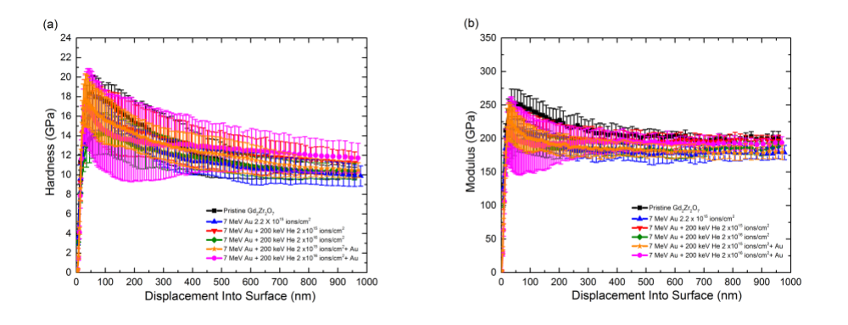
Figure A.1 Average (a) hardness and (b) elastic modulus curves for pristine and irradiated Gd₂Zr₂O₇.

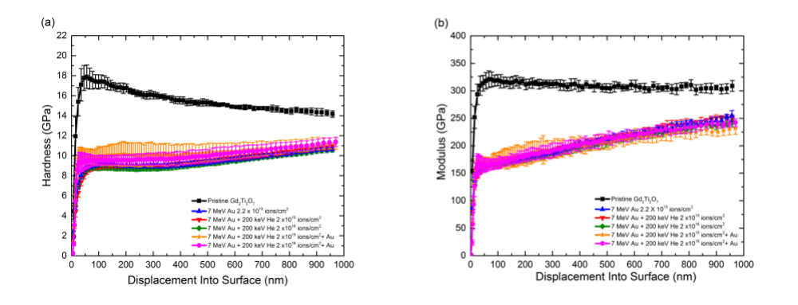
Figure A.2 Average (a) hardness and (b) elastic modulus curves for pristine and irradiated Gd₂Ti₂O₇.

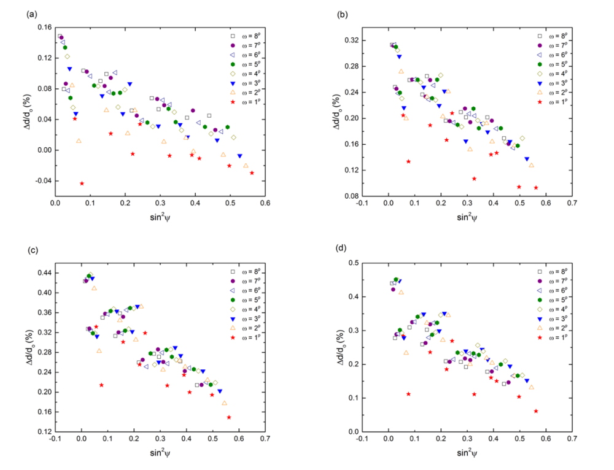
Figure A.3 Δd/d_{o} vs. sin²ψ plots for (a) Au, (b) Au + 2 x 10¹⁵ He/cm², (c) Au + 2 x 10¹⁶ He/cm², (d) Au + 2 x 10¹⁷ He/cm² irradiated Gd₂Zr₂O₇.

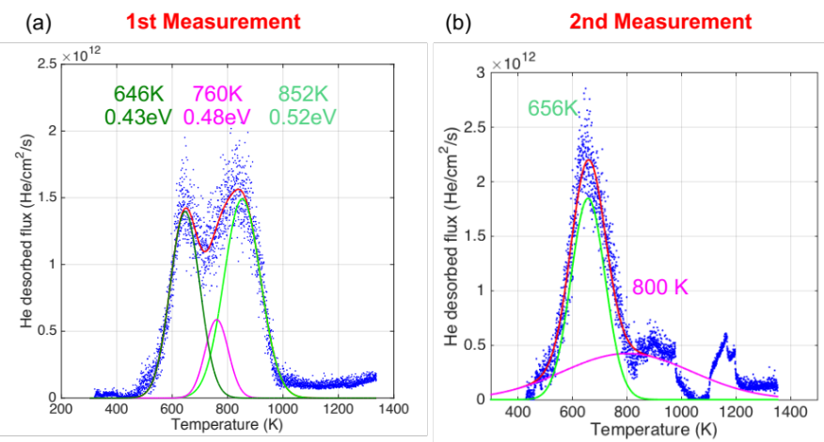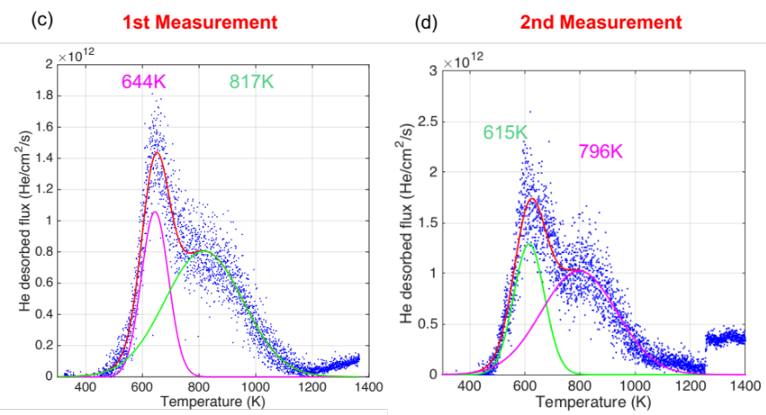
Figure A.4 Gaussian fits of desorption spectra for the 10 keV He implanted Gd₂Zr₂O₇ (a-b) and Gd₂Ti₂O₇ (c-d) samples. Spectra shown in (a) and (c) were taken from samples that were not annealed after polishing, and spectra shown in (b) and (d) were taken from samples that were annealed after polishing. Fits from annealed samples were used.

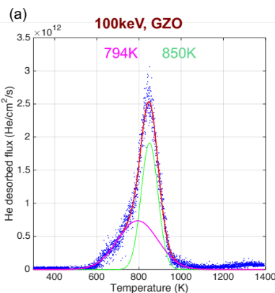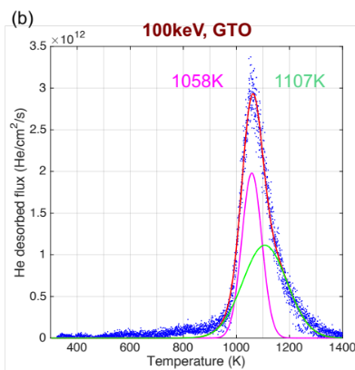
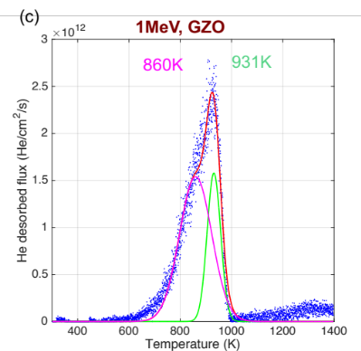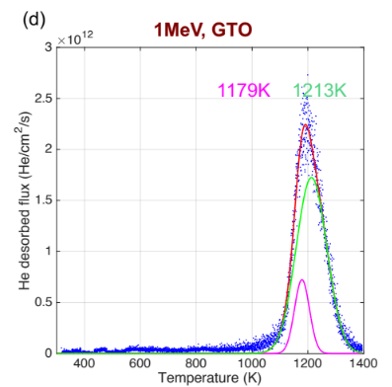
Figure A.5 Gaussian fits of desorption spectra for 100 keV He implanted (a) Gd₂Zr₂O₇ and (b) Gd₂Ti₂O₇, and 1 MeV He implanted (c) Gd₂Zr₂O₇ and (d) Gd₂Ti₂O₇.

VITA

Caitlin A. Taylor is originally from Portage, Michigan. She received an IB Diploma from Portage Central High School in 2008 and a B.S. in Physics from Hope College in Holland, MI in 2012. Caitlin joined the department of Materials Science and Engineering at the University of Tennessee, Knoxville, in June of 2012. During her Ph.D. studies, she focused her efforts on understanding the effects of helium accumulation and concomitant radiation damage in pyrochlore ceramics. She participated on several committees and student organizations at the University of Tennessee, including the Dean of Libraries Committee, Graduate Student Advisory Board, and the Materials Research Society student chapter. Caitlin was President of the Materials Research Society student chapter during the 2014-2015 school year. She has given oral presentations at several major conferences, received several awards, and has published several peer-reviewed journal articles during her stay at the University of Tennessee.

