The Impacts of Drinking Behavior on Growth and Reproduction during Development of Beef Bulls

A Thesis Presented for the
Master of Science
Degree
The University of Tennessee, Knoxville

Jake Thomas Watts
December 2023
Abstract
In the production of breeding bulls, growth and development are impacted by many nutritional, genetic, and environmental factors. Meeting the requirements needed to reach sexual maturity is critical to maximize production efficiency. Water is an essential, yet understudied component of these physiological requirements. By identifying potential differences in water drinking behaviors, we may better understand interactions between water intake and developmental efficiency. We hypothesized that drinking behaviors during development would differ between bulls and that these behaviors would be correlated to growth and reproductive traits. Beef bulls (n=71), on performance test, were group housed by breed and body weight (BW). Bulls were fed a single ration with ad libitum access to water and grass hay. Drinking behavior was monitored over a 112-day period to calculate the average number of visits per day (VPD) and total time per day (TPD). Additionally, daily visits and average time per visit per day was calculated on a weekly (W) and monthly (M) basis. A breeding soundness exam was conducted for each bull on day 112 where sperm motility (%MOT), morphologically correct sperm (%MOR), head defect (HD), midpiece defects (MD), tail defects (TD), and scrotal circumference (SC) were quantified. Linear mixed-effect models were used to determine differences in water consumption behavior between individual bulls, as well as any relationships between these behaviors and measurements of growth and reproductive development. SmartScale ID was included as a random effect to account for pen separation and breed differences. Bull to bull differences were found (P < 0.03) for all categories of VPD and TPD. A significant relationship was observed between VPD and average daily gain (ADG; P = 0.02), TPD and ADG (P = 0.04), as well as a tendency for VPD and BCS (P = 0.08). Additionally, a significant relationship existed between SC and final body weight (P = 0.01). No water use traits were significantly associated with reproductive traits. These results indicate differences in drinking behavior between bulls with correlations to growth and development. This suggests potential for water intake behavior to serve as an indicator for overall productivity in the development of breeding bulls.

Table Of Contents
Chapter 1 Introduction 1
Chapter 2 Literature Review 4
Nutritional Impact on Bull Development 4
Paternal Genetic Contribution and Role during Early Gestation 5
Development of the Male Reproductive Tract 6
Breeding Soundness Evaluation and Bull Testing 8
Summary and Conclusion 12
Literature Cited 14
Chapter 3 26
Differences in Water Intake Behavior and its Effect on Parameters Measuring Growth and Reproductive Ability in Developing Beef Bulls
Abstract 28
Introduction 30
Materials and Methods 32
Drinking Behavior 32
Reproductive Development 33
Statistical Analysis 34
Results 34
Discussion 35
Literature Cited 40
Appendix 45
Chapter 4: Summary and Conclusions 51
Vita 52

LIST OF FIGURES
Figure 1. Visits by Bull 45
Figure 2. Time by Bull 46
Figure 3. ADG by VPD 47
Figure 4. ADG by TPD 48
Figure 5. BCS by VPD 49
Figure 6. SC by OffW 50

Chapter 1: Introduction
As resources such as water become more at risk and threaten the global agriculture industry, it is imperative to ensure that the cattle industry progresses to maximize sustainability (Liu et al., 2022). Cattle make a positive contribution to food production through the consumption of low-quality energy and land resources not otherwise useful for food production (Gerber et al., 2015; Van Hal et al., 2019). Maximizing the output of beef production per unit of input is a key component of production efficiency (Gerber et al., 2015). Maximizing the production efficiency of a beef herd in an economically and environmentally sustainable way must include the utilization of best management practices (Broadhead et al., 2019). The bull is a crucial component of beef production and may be responsible for siring up to 30 progeny per breeding cycle. In a cow-calf operation that retains its own heifers, bull selection can be attributed to 87.5% of genetic improvement in the herd over three generations (Wagner et al., 1985). Bull management must ensure that nutrition, physical traits, reproductive fertility, and overall health are sufficient given environmental conditions and the stage of maturity. Performance testing is a tool used to evaluate these parameters in order to develop better understanding of an individual bull’s performance, as well as gain foresight of his genetic contribution to performance of future calf crops. Overall, appropriate bull management is critical to maximizing production efficiency on a beef cattle operation.
Nutrition is influential to bull productivity by affecting development and reproductive success in both young and mature bulls (Dance et al., 2015). Nutritional requirements in immature bulls primarily focuses on supplying sufficient nutrients for growth and reproductive maturation. A higher plane of nutrition during this time allows for a shorter period before the bull is capable of breeding (Barth et al., 2008). In the mature bull, nutrition during post breeding recovery should focus on regaining lost body weight (BW), returning to an ideal body condition score (BCS), all while adjusting to a recently reduced level of activity (Herd and Sprott, 1986). Insufficient nutrient intake has negative effects on bull health; however, excessive nutrient intake can have similar or even larger negative impacts, such as decreased semen quality (Skinner, 1981; Harrison et al., 2020). Thus, it is vital to provide feed in quantities sufficient for proper BW gain without causing obesity. If plane of nutrition is not carefully managed reproductive efficiency may be negatively impacted, as sperm production and seminal plasma composition can be detrimentally affected by fluctuating BCS throughout the year (Foote, 1978; Tabler Jr, 2004; Harrison et al., 2020). This can initiate a perpetual fluctuation in BW and BCS, which can cause persistent reductions in reproductive performance. Environmental stressors can change nutritional requirements resulting in BW loss, conformation issues, damage to reproductive organs, alterations in hormone balance, and other physiological changes. Many of these consequences can negatively influence reproductive soundness of bulls (Lee, 1993; Tilbrook et al., 2000). The best way to assess reproductive soundness is through a Breeding Soundness Exam (BSE). Some bulls who pass a BSE prior to the breeding season may fail one after due to the elevated levels of stress when breeding cows (Ellis et al., 2005). The stress from the breeding season can also initiate an immune response (Tilbrook et al., 2000), which can influence nutrient absorption, behavior, and the release of cytokines that could impact the reproductive efficiency of the bull (Colditz, 2002). Therefore, it is critical to ensure that nutritional requirements are met for a bull’s stage of maturity and environment.
Water is essential both as a nutrient and component of the body in maintaining homeostasis in mammals (Nicolaidis, 1998). Water intake levels are highly dependent on nutritional factors such as feed intake and gain (Winchester 1956; Brew, 2011). Similarly, increased water and feed intake is directly related to increased gain (Winchester, 1956; Ahlberg et al., 2019). In beef cattle, growth and efficiency are moderately heritable with traits such as birth weight, weaning weight, and gain on feed exhibiting heritability estimates of 0.53, 0.28, and 0.65 respectively (Knapp Jr and Nordskog, 1946; Knapp and Clark, 1950). Heritability is also exhibited in factors such as carcass quality (Crews Jr et al., 2003). A study by Ahlberg et al. (2019) reported heritability of water intake, water to gain ratio, and residual water intake in cattle with estimates of 0.39, 0.39, and 0.37 respectively. This exhibits potential similarities between water intake and feed intake as hereditary behaviors impacting production. It is reasonable to consider water intake behavior as a factor affecting growth and a development in beef cattle, however further research is required to determine these impacts. Therefore, the objectives of this thesis are to review the requirements of developing cattle and identify potential differences and correlations between water intake behaviors and development.

Chapter 2: Literature Review
Nutritional Impacts on Reproductive Development in Bulls
Most beef cattle in the United States are housed outdoors exposing them to seasonal weather patterns and extreme temperatures (Fogsgaard, 2018). Combined with extreme temperatures, the effects of evaporative loss and other environmental factors can quickly become detrimental to the bull by causing shifts in body temperature outside of the thermoneutral zone (Young, 1981; Schütz, 2010). Bulls that have not yet reached maturity are more sensitive to heat and cold stress (Vince, 2018). Energy requirements change when body temperature shifts outside of the thermoneutral zone (Kingma et al, 2012). During periods of extreme low temperatures energy requirements increase for the bull to maintain an appropriate internal temperature (Young, 1981). During periods of extreme heat nutrient requirements also change as intake falls alongside metabolic rate to promote heat loss (Turner and Taylor, 1983). Furthermore, environmental stress can be exacerbated by the combined effects of temperature and humidity, and has been correlated with decreased semen quality (Llamas-Luceno, 2020; Seifi-Jamadi, 2020). Alongside temperature, humidity and moisture are other environmental factors that can have negative impacts on the bull. Moisture can be an issue during times of heavy rainfall. High traffic areas such as waterers and feeders may become muddy and have a negative impact on the bull due to physical and environmental stress (Morrison, 1970). Stressors such as these influence changes in nutritional requirements, and can have a lasting effect on the development of young bulls.
An animal’s plane of nutrition is a major factor in the reproductive success of developing bulls (Dance, 2015). Bulls that are managed for more rapid development are typically reproductively capable at an younger age (Barth, 2008). During the development process it is vital to ensure that nutritional needs are met in order to maximize production efficiency and shorten the time to reach reproductive capabilities. A study by Brito and others (2009) exhibited a relationship between serum metabolic hormones, specifically, insulin-like growth factor 1 (IGF-1), and testicular development, potentially influencing gonadotropin secretion, in young bulls. This study reported that increased plane of nutrition had a direct effect on gonadotropin releasing hormone (GnRH) secreted by the hypothalamus, resulting in an increase of luteinizing hormone (LH) secretion and pulsatility. Immature bull calves on a higher plane of nutrition display an increase in metabolic activity which results in increased levels of IGF-1, stimulating GnRH release that induces the series of events necessary for puberty (Byrne et al., 2017). It has also been shown that bulls fed a higher plane of nutrition tend to have a greater percentage of normal, motile sperm (Bourgon et al., 2019). Increased nutrition can induce a greater LH pulse frequency, resulting in greater testosterone synthesis. This increase in testosterone can drive the proliferation of sperm cells during development, increasing viable sperm production at puberty (Wolf and Hale, 1965; Brito et al., 2007). Bulls maintained on a higher plane of nutrition also tend to exhibit increased scrotal circumference (Byrne et al., 2017). Though much of this difference is thought to be due to scrotal fat, studies still found an earlier onset of spermatogenesis in these bulls (Barth, 2008). Conversely, bulls on a low plane of nutrition exhibit decreased levels of IGF-1 and GnRH, as well as decreased scrotal circumference (Byrne et al., 2017). Therefore, pre-pubertal nutritional status in developing bulls is a major factor in driving a bull’s ability to reach sexual maturity as quickly and efficiently as possible. Pre-pubertal nutrition, however, is not a determinant of mature bull success, as it does not affect the number of harvestable sperm (Byrne et al., 2018). Overall, negative energy balance in developing bulls increases time to maturity and slows reproductive development, negatively impacting production efficiency.
Nutritional requirements can be used as an evaluator for production efficiency in developing bulls. Residual Feed Intake (RFI) is a comparison of expected feed intake requirements for growth and maintenance for an individual animal based on age and stage of development, compared to actual feed intake of that animal. Thus, providing a measure of feed efficiency in cattle (Arthur and Herd, 2008). Residual feed intake differs from other efficiency measurements in that it is independent from size and growth rate. However, RFI is influenced by multiple physiological factors such as intake, metabolism, activity, and thermoregulation, which potentially diminishes RFI’s effectiveness as an assessment tool of production efficiency in beef cattle (Herd and Arthur 2009). The physiological traits influencing residual feed intake are each heritable to a certain degree, implying that RFI could be potentially useful as a selection tool to improve genetic feed efficiency (Arthur et al., 2001). However, using RFI for selection has resulted in delayed sexual maturity (Fontoura et al., 2016; Wang et al., 2012), increased sperm defects, decreased sperm motility, and inhibition of testicular thermoregulation all of which can impact the reproductive potential of developing bulls (Johnson et al., 2019; Awda et al., 2013). Cattle that are more efficient (i.e., exhibiting high RFI) have a larger energy pool that may assist with earlier reproductive development when compared to cattle with low RFI (Awda et al., 2013).
At puberty, the nutritional requirements of the bull shift from development and growth to reproduction and recovery. During the breeding season, bulls undergo significant physical and physiological stress that can lead to undesirable changes in confirmation, negatively influencing health and reproductive ability. This stress can activate immune response pathways that influence the production efficiency of the bull by initiating the release of signaling proteins, specifically cytokines, causing negative overall changes in nutrient absorption (Colditz, 2002). Because of stressors during the breeding season, the bull becomes increasingly susceptible to negative energy balance. Combatting negative energy balance through supplementation may be necessary, however it is important to recognize that excessive nutrient intake can have similar or greater negative physiological impacts on the bull (Skinner, 1981). Improperly managing nutrient intake during and after the breeding season can result in the rise and fall of body condition throughout the year, causing negative impacts on factors such as sperm production. (Tabler, 2004; R. H. Foote, 1978).
Water is a nutrient and component of the body necessary to maintain cellular homeostasis and life as a whole in mammals (Nicolaidis, 1998). It is an essential nutrient driving cattle development, production, and survival (NRC, 2000). Water intake levels are highly dependent on feed intake, environment (Winchester, 1956), and gain (Brew, 2011). Cattle consuming more feed and water are likely to exhibit higher average daily gain despite having decreased feed conversion efficiency (Winchester, 1956; Ahlberg et al., 2019). Water intake fluctuates throughout the year but can be largely attributed to relative humidity, temperature, solar radiation, and wind speed (Ahlberg et al., 2018). Variation across breeds and individual animals may also affect water intake. A study by Ahlberg et al. (2019) reported differences in water intake, residual water intake, and water to gain ratio, highlighting the potential usefulness of water efficiency measurements and emphasizing the likelihood of genetic correlation to water efficiency. However, no studies, to the authors knowledge, have been conducted regarding relationships of drinking behavior with growth and development. These findings regarding water intake suggest potential for future studies to elucidate differences in water efficiency and how it may influence beef production.
Paternal Genetic Contribution and Role during Early Gestation
The sire is responsible for contributing 50% of the genetic makeup of the embryo, however the paternal contribution to embryonic development extends well beyond DNA alone. Following fertilization, the expression and inhibition of the paternal genome begins before the 2-cell stage of development (Park et al., 2007). Much of this contribution is affected by genomic imprinting, resulting in the expression of either the paternal or maternal genome alone (Kelsey and Feil, 2013). Paternal imprinting has shown to have a variety of impacts on embryo development and has potential future implications regarding fertility (Daigneault, 2021). Paternal gene expression is necessary for the formation of the trophectoderm and placental development, a critical component for maternal recognition of pregnancy (Wang et al., 2013). Specifically, the paternally expressed gene 3 (Peg3) must be expressed to achieve the appropriate number of endocrine cells present in the developing placenta (Creeth and John, 2020). The paternal genome is an important driver for growth in the developing neonate. A mutation in the Peg3 gene will result in suppression of fetal growth, as well as impair maternal behavior in the dam, likely resulting in death of the offspring (Li et al., 1999). This suggests that the paternal genome is a driver for fetal growth, despite the maternal genome limiting fetal growth to optimize fetal survival with maternal energy input (Ounsted et al., 1988).
Another contribution of the sperm to gestation is the ability to influence embryonic DNA repair by external stressors. The sperm has the ability in combination with the oocyte to utilize the base excision repair (BER) pathway to repair damages in DNA such as the spontaneous oxidation of guanine residues resulting in 8-hydroxy-2′-deoxyguanosine (8OHdG; Lord and Aitken, 2015; Bruner et. al, 2000). Oxidative lesions such as 8OhdG increase the likelihood of transversion mutations within the zygote and all subsequent cells formed during embryogenesis (Wood et al., 1992). This results in the increased possibility of irreversible gene expression altering in such a way that normal embryogenesis will not occur (Ohno et al., 2014). The sperm is responsible for a portion of this BER pathway for DNA repair. Specifically, the sperm possesses 8-oxoguanine glycosylase (OGG1) gene, encoded by the paternal genome. Increased expression of OGG1 gene by the sperm after fertilization is associated with the removal of damaged nucleotide bases creating an open site for further repair activity (Rashki Ghaleno et al., 2021; Lord and Aitken, 2015).
Development of the Male Reproductive Tract
Early development of the male reproductive is influenced by a series of organized events initiated by gonadal hormones. These fetal hormones are responsible for the early formation of sex dependent tissues and organs during time-sensitive periods of differentiation and development (Knickmeyer and Baron-Cohen, 2006). The initial development of the male reproductive tract begins with the activation of the Sry gene located on the Y chromosome, and its subsequent initiation of testicular differentiation (Grumbach, 1998). In order for differentiation of male tissues to occur, Anti-Müllerian hormone (AMH), also known as Müllerian inhibiting hormone, must be present. Anti-Müllerian hormone is a glycoprotein hormone belonging to the growth factor beta super family and is produced in the Sertoli cells of the testis (Blanchard and Josso, 1974; Vigier et al., 1984). Shortly thereafter, the Leydig cells within the testes begin to produce testosterone at approximately 42 days of development (Knickmeyer and Baron Cohen, 2006). The testosterone secreted by the Leydig cells is vital for the development of the mesonephric tubules into the efferent ducts, ductus epididymis, ductus deferens, and the vesicular glands of the male reproductive tract (Amann and Schanbacher, 1983). Testosterone is also converted to Dihydrotestosterone, by 5α-reductase, which influences the development of the bulbourethral gland and penis (Wilson and Siiteri, 1973). Further differentiation and development of the male reproductive tract includes regression of the Müllerian ducts, which would develop into the female oviducts, uterus, cervix, and parts of the vagina (Mullen and Behringer, 2014). These are critical steps for pre-natal male development and are a determining factor of the subsequent reproductive success of the male.
Despite these important events beginning in-utero, development of the male reproductive tract is a continual process through parturition and puberty before the animal reaches sexual maturity. Testicular development continues slowly from birth until puberty. Puberty has been defined as the time when the bull gains the ability to produce and ejaculate viable spermatozoa, exhibits a libido, and has increased sexual aggression (Foote, 1969). Further, sexual behavior has been described as a combination of libido and ability to copulate (Anderson, 1945). Hormonal changes that occur at puberty influence these steps towards reaching sexual maturity. As the bull calf approaches puberty, blood concentrations of LH and testosterone steadily increase (Lunstra et al., 1978). As postnatal development nears the onset of puberty, the seminiferous tubules begin to rapidly proliferate significantly impacting testicular size (Macmillan and Hafs, 1969; Curtis and Amann, 1981). Rapid proliferation of Sertoli cells begins shortly after birth with completion of differentiation and maturation occurring between 30 and 40 weeks of age (Abdel-Raouf, 1960; Curtis and Amann, 1981). Spermatogenesis begins in correlation with testicular development between weeks 16 and 24, gradually increasing the number of viable sperm produced through the first year of development (Amann and Almquist, 1976; Curtis and Amann, 1981). Production of viable sperm is dependent on appropriate testicular development. Proliferation of Sertoli cells in the testis is crucial, as the number of mature Sertoli cells present is positively correlated with the number of spermatogonia produced (Hochereau-de Reviers et al., 1978). Overall, appropriate development of the male reproductive tract is critical to ensure maximum fertility and reproductive output once bulls reach maturity.
Breeding Soundness Evaluations and the Importance of Performance Testing
Research has predicted that upwards of 40% of bulls have reduced fertility; therefore, a foundational component of bull development is ensuring fertility and conception capability prior to the breeding season (Chenoweth, 2000). Subfertility or infertility is detrimental to reproductive success and can delay conception, disrupting breeding strategies such as a defined calving season (Barth, 2018). Determining fertility and ability to breed can be done by performing a breeding soundness exam (BSE). This exam evaluates the sperm quality, physical condition, and structural integrity of an individual bull (Wiltbank and Parish, 1986). These qualities pertaining to fertility may be affected by various internal and external factors including, but not limited to, infection, disease, plane of nutrition, weather, and age (Skinner, 1981; Senger, 2002; Kastelic and Thundathil, 2008). If the bull meets or exceeds the minimum criteria of a BSE, he is considered an acceptable breeder. If the bull does not meet all requirements the bull may be rejected as “unacceptable” and not recommended for use as a breeding bull (Thundathil et al., 2016). Because factors impacting fertility are subject to change, it is important to perform a BSE at least 60 days prior to the breeding season. This allows for evaluation of the most current condition of the bull with consideration of the time needed to re-evaluate the individual or seek a replacement in the event of subfertility. Some factors affecting subfertility can be genetic which are generally irreversible. (Steffen, 1997). In some cases, genetic components impacting breeding, such as a persistent frenulum, may be physically altered for breeding to occur, but may still be passed along to offspring. Other, perhaps more common, factors affecting subfertility are result of environmental conditions, including plane of nutrition, maintaining an appropriate BCS, or disease, which have the potential for changing and recovery. This (Van Camp, 1997). Fertility can be recovered following these instances with careful management and treatment of bulls. These brief instances of environmentally onset of subfertility highlight the importance of re-testing following a failed BSE. Subfertility due to abnormal sperm can be due to environmental stress during the development of sperm during the seminiferous epithelium cycle, or in sperm storage and transport. One total spermatogenetic cycle in the bull takes about 61 days (Staub and Johnson, 2018). Therefore, it is recommended that a second BSE should occur 6 to 8 weeks following the initial, failed test of a mature bull (Sprott et al., 1998).
A BSE utilizes the evaluation of sperm motility and morphology. First, electro-ejaculation or rectal massage is used to collect a semen sample. A small portion of the semen sample is then mounted on a warmed slide and diluted with warm saline prior to evaluation via microscope. The sample is first evaluated for adequate motility, or sperm ability to move in a progressively forward manner. Sperm motility is considered adequate if 30% or greater of the sample exhibits this progressively forward movement (Chenoweth, 2015). Motility is an important indicator for fertility as spermatozoa must move to the site of fertilization and the oocyte. Motility is also important as it has been reported to be closely correlated with capacitation, which is vital for fertilization (Chamberland et al., 2001). Following evaluation of sperm motility, the sample is stained and inspected via oil immersion under a microscope to assess sperm morphology. This includes evaluation of the sperm head, midpiece, and tail for defects such as abnormally shaped heads, proximal droplets, and coiled tails. These defects have the ability to negatively impact sperm motility and survival (Thundathil et al., 2016). Sperm morphology is considered to be adequate if 70% or greater of the sperm sampled exhibit normal cell structure. Morphological defects may be associated with molecular changes in chromatin at times following stress, increasing the likelihood of reduced fertility (Evenson, 1999). Another measure of fertility included in a BSE is scrotal circumference. Appropriate scrotal circumference is an indicator of an animal’s ability to produce an adequate amount of viable sperm (Gipson et al., 1985). For a 15 month-old bull, scrotal circumference must measure at least 30 cm. This minimum increases by 1 cm every 3 months until 24 months of age. Bulls 24 months of age or older should have a scrotal circumference greater than 34 cm to pass a BSE (Chenoweth, 2015). Though only indicative as a predictor of long-term fertility, meeting these standards is critical to determining reproductive ability in the current state of a bull.
Physical analysis of the bull during a BSE includes internal assessment of accessory sex glands, and external assessment of physical condition and structural integrity. Internal examination of accessory sex glands includes palpation of the seminal vesicles, prostate, and inguinal rings. Vesicular glands are evaluated for size, as vasculitis (inflamed vesicle) is correlated with decreased fertility (Van Camp, 1997). Further palpation of the prostate gland provides further indication of internal tract health and ability to correctly copulate and ejaculate. Body condition scoring is used as an indicator of carcass composition and nutritional needs by classifying the animal on a scale from 1 (emaciated) to 9 (obese) based on fat indicators (Wagner et al., 1988). Body condition has also been shown to have an effect on sperm quality and quantity, with higher body condition correlating with greater sperm motility (Beran et al., 2011). These effects could be due to the effects of a positive energy balance and energy reserves of a higher BCS in the bull, however it is important to consider that excessive nutrient intake can also have negative impacts on overall health, including reproductive traits (Skinner, 1981). Further physical analysis includes the evaluation of a bull’s structural composition including feet, identifying abnormalities such as screw claw, and legs (Alexander, 2008). Foot and leg structure is an important component of reproductive function as a physical foundation for the bull to effectively copulate. Further physical examination of the scrotum, sheath, and penile shaft are also performed to account for defects such as penile warts. Physical abnormalities in these areas of the reproductive tract can result in the inability to effectively reproduce by negatively impacting copulatory behaviors.
Additional bull evaluation may include a performance test, which includes a growth trial as well as a BSE. Growth trials are used as an evaluation of growth by maximizing daily gain, which can be an indicator of progeny performance and overall value of these individuals as breeding sires. As the beef industry continues to pursue greater production efficiency, the time to first use as breeding sires is increasingly shortened. Bull testing and reproductive evaluation using these performance indicators is critical to determine whether or not breeding bulls are reproductively capable at these earlier ages, and gain further insight of a bull’s genetic makeup through measuring these expressed phenotypes. Factors influencing these performance indicators at the bull test also provide ample opportunity for extended research with the bull (Cain and Wilson, 1983). As precision livestock farming (PLF) technologies are incorporated into the industry, the potential to discover additional performance indicators, such as estimated water intake, is great. These indicators are likely to encompass visits to a water source and time spent there to summarize efficiency and may include actual water intake in the future. With the acquisition of such information, however, it is critical to maintain focus on information that is most useful to determining success in bull development. Thus, bull testing is likely to become increasingly important with the increased availability of PLF technologies, pending future research to determine relevance.
Summary and Conclusion
The bull’s contribution is a critical component of overall beef production and efficiency. A single bull capable of reproducing is responsible for 50% of the genetic makeup of up to 30 progeny per reproductive cycle (Wagner et al., 1985). Development to maturity is a foundational component of producing bulls that will serve as a sustainable contribution to the beef herd. Effectively developing bulls to sexual maturity requires appropriate nutrition, the monitoring of physical reproductive traits and fertility, and effective health management. Despite the information already available regarding these factors, there is very little for others such as water intake and behavior. This is largely due to the previous inability to collect water intake information in both confined and pasture-based settings. Future implementation of PLF technologies in research and the industry will likely help to develop a better understanding of how these factors development and increasing production efficiency. Effectively applying these techniques produces and develops reproductively capable bulls and maximizes production efficiency, thereby achieving sustainable, net positive beef production (Gerber et al., 2015).

Literature Cited
Abdel-Raouf, M. 1960. The postnatal development of the reproductive organs in bulls with special reference to puberty. European Journal of Endocrinology 34(2_Suppl):S9-S109.
Ahlberg, C. M., K. Allwardt, A. Broocks, K. Bruno, L. McPhillips, A. Taylor, C. R. Krehbiel, M. S. Calvo-Lorenzo, C. J. Richards, S. E. Place, U. DeSilva, D. L. VanOverbeke, R. G. Mateescu, L. A. Kuehn, R. L. Weaber, J. M. Bormann, and M. M. Rolf. 2018. Environmental effects on water intake and water intake prediction in growing beef cattle1,2. Journal of Animal Science 96(10):4368-4384. doi: 10.1093/jas/sky267
Ahlberg, C. M., K. Allwardt, A. Broocks, K. Bruno, A. Taylor, L. Mcphillips, C. R. Krehbiel, M. Calvo-Lorenzo, C. J. Richards, S. E. Place, U. Desilva, D. L. Vanoverbeke, R. G. Mateescu, L. A. Kuehn, R. Weaber, J. Bormann, and M. M. Rolf. 2019. Characterization of water intake and water efficiency in beef cattle1,2. Journal of Animal Science 97(12):4770-4782. doi: 10.1093/jas/skz354
Amann, R., and J. Almquist. 1976. Bull management to maximize sperm output. In: Proceedings of Technical Conference on Artificial Insemination and Reproduction
Amann, R. P., and B. D. Schanbacher. 1983. Physiology of Male Reproduction. Journal of Animal Science 57(suppl_2):380-403. doi: 10.2527/animalsci1983.57Supplement_2380x
Anderson, J. 1945. The semen of animals and its use for artificial insemination. The semen of animals and its use for artificial insemination.
Arthur, J. P., and R. Herd. 2008. Residual feed intake in beef cattle. Revista Brasileira de Zootecnia 37:269-279.
Arthur, P., J. Archer, D. Johnston, R. Herd, E. Richardson, and P. Parnell. 2001. Genetic and phenotypic variance and covariance components for feed intake, feed efficiency, and other postweaning traits in Angus cattle. Journal of animal science 79(11):2805-2811.
Awda, B., S. Miller, Y. Montanholi, G. V. Voort, T. Caldwell, M. Buhr, and K. Swanson. 2013. The relationship between feed efficiency traits and fertility in young beef bulls. Canadian Journal of Animal Science 93(2):185-192.
Barth, A. 2018. The use of bull breeding soundness evaluation to identify subfertile and infertile bulls. Animal 12(s1):s158-s164.
Barth, A., L. Brito, and J. Kastelic. 2008. The effect of nutrition on sexual development of bulls. Theriogenology 70(3):485-494.
Beran, J., L. Stádník, J. Ducháček, R. Toušová, F. Louda, and L. Štolc. 2011. Effect of bulls’ breed, age and body condition score on quantitative and qualitative traits of their semen. Acta Univ. Agric. et Silvic. Mendel. Brun 59(6):37-44.
Blanchard, M.-G., and N. Josso. 1974. Source of the anti-Müllerian hormone synthesized by the fetal testis: Müllerian-inhibiting activity of fetal bovine Sertoli cells in tissue culture. Pediatric research 8(12):968-971.
Bourgon, S., M. D. de Amorim, T. Chenier, M. Sargolzaei, S. Miller, J. Martell, and Y. Montanholi. 2018. Relationships of nutritional plane and feed efficiency with sexual development and fertility related measures in young beef bulls. Animal reproduction science 198:99-111.
Brew, M., R. Myer, M. Hersom, J. Carter, M. Elzo, G. Hansen, and D. Riley. 2011. Water intake and factors affecting water intake of growing beef cattle. Livestock Science 140(1-3):297-300.
Brito, L. F., A. D. Barth, N. C. Rawlings, R. E. Wilde, D. H. Crews Jr, P. S. Mir, and J. P. Kastelic. 2007. Effect of improved nutrition during calfhood on serum metabolic hormones, gonadotropins, and testosterone concentrations, and on testicular development in bulls. Domestic animal endocrinology 33(4):460-469.
Broadhead, D., J. T. Mulliniks, and R. N. Funston. 2019. Developmental programming in a beef production system. Veterinary Clinics: Food Animal Practice 35(2):379-390.
Bruner, S. D., D. P. Norman, and G. L. Verdine. 2000. Structural basis for recognition and repair of the endogenous mutagen 8-oxoguanine in DNA. nature 403(6772):859-866.
Byrne, C., S. Fair, A. English, M. Cirot, C. Staub, P. Lonergan, and D. Kenny. 2018. Plane of nutrition before and after 6 months of age in Holstein-Friesian bulls: I. Effects on performance, body composition, age at puberty, and postpubertal semen production. Journal of dairy science 101(4):3447-3459.
Byrne, C., S. Fair, A. English, C. Urh, H. Sauerwein, M. Crowe, P. Lonergan, and D. A. Kenny. 2017. Effect of breed, plane of nutrition and age on growth, scrotal development, metabolite concentrations and on systemic gonadotropin and testosterone concentrations following a GnRH challenge in young dairy bulls. Theriogenology 96:58-68.
Cain, M., and L. Wilson. 1983. Factors influencing individual bull performance in central test stations. Journal of Animal Science 57(5):1059-1066.
Carroll, J., N. Burdick, C. Chase Jr, S. Coleman, and D. Spiers. 2012. Influence of environmental temperature on the physiological, endocrine, and immune responses in livestock exposed to a provocative immune challenge. Domestic Animal Endocrinology 43(2):146-153.
Chamberland, A., V. Fournier, S. Tardif, M. Sirard, R. Sullivan, and J. Bailey. 2001. The effect of heparin on motility parameters and protein phosphorylation during bovine sperm capacitation. Theriogenology 55(3):823-835.
Chenoweth, P. 2015. Bull health and breeding soundness, Bovine medicine. Wiley Online Library. p. 246-261.
Chenoweth, P. J. 2000. Topics in bull fertility. Topics in bull fertility.
Colditz, I. 2002. Effects of the immune system on metabolism: implications for production and disease resistance in livestock. Livestock production science 75(3):257-268.
Curtis, S. K., and R. Amann. 1981. Testicular development and establishment of spermatogenesis in Holstein bulls. Journal of Animal Science 53(6):1645-1657.
Daigneault, B. W. 2021. Dynamics of paternal contributions to early embryo development in large animals. Biology of Reproduction 104(2):274-281.
Dance, A., J. Thundathil, R. Wilde, P. Blondin, and J. Kastelic. 2015. Enhanced early-life nutrition promotes hormone production and reproductive development in Holstein bulls. Journal of dairy science 98(2):987-998.
Ellis, R., G. P. Rupp, P. Chenoweth, L. Cundiff, and D. Lunstra. 2005. Fertility of yearling beef bulls during mating. Theriogenology 64(3):657-678.
Engelken, T. 2008. The development of beef breeding bulls. Theriogenology 70(3):573-575.
Evenson, D. 1999. Loss of livestock breeding efficiency due to uncompensable sperm nuclear defects. Reproduction, Fertility and Development 11(1):1-16.
Fogsgaard, K. K., and J. W. Christensen. 2018. Influence of space availability and weather conditions on shelter use by beef cattle during winter. Applied animal behaviour science 204:18-22.
Fontoura, A., Y. Montanholi, M. D. De Amorim, R. Foster, T. Chenier, and S. Miller. 2016. Associations between feed efficiency, sexual maturity and fertility-related measures in young beef bulls. animal 10(1):96-105.
Foote, R. 1969. Physiological aspects of artificial insemination, Reproduction in domestic animals. Elsevier. p. 313-353.
Foote, R. 1978. Factors influencing the quantity and quality of semen harvested from bulls, rams, boars and stallions. Journal of animal science 47(suppl_II):1-11.
Gerber, P. J., A. Mottet, C. I. Opio, A. Falcucci, and F. Teillard. 2015. Environmental impacts of beef production: Review of challenges and perspectives for durability. Meat science 109:2-12.
Gipson, T., D. Vogt, J. Massey, and M. Ellersieck. 1985. Associations of scrotal circumference with semen traits in young beef bulls. Theriogenology 24(2):217-225.
Grumbach, M. M. 1998. Williams textbook of endocrinology. Delayed Puberty and Sexual Infantilism. 1550
Harrison, T. D., E. M. Chaney, K. J. Brandt, T. B. Ault-Seay, R. Payton, L. G. Schneider, L. G. Strickland, F. N. Schrick, and K. J. McLean. 2023. The effects of nutritional level and body condition score on cytokines in seminal plasma of beef bulls. Frontiers in Animal Science 3:155.
Herd, D. B., and L. R. Sprott. 1986. Body condition, nutrition and reproduction of beef cows. Texas FARMER Collection
Herd, R., and P. Arthur. 2009. Physiological basis for residual feed intake. Journal of animal science 87(suppl_14):E64-E71.
Hochereau-de Reviers, M.-T., M. Courot, C. Perreau, and C. Pisselet. 1978. Sertoli cells and development of seminiferous epithelium. In: Annales de Biologie Animale Biochimie Biophysique. p 573-583.
Hultnäs, C. A. 1959. Studies on variation in mating behaviour and semen picture in young bulls of the Swedish Red and White breed and on causes of this variation. Scandinavian Agricultural Research Workers' Association and Royal Swedish ….
Johnson, C., C. Fitzsimmons, M. Colazo, C. Li, J. Kastelic, and J. Thundathil. 2019. Impacts of residual feed intake and pre-natal diet on reproductive potential of bulls. Animal Production Science 59(10):1827-1836.
Jost, A. 1953. Problems of fetal endocrinology: the gonadal and hypophyseal hormones. Recent Progr Hormon Res 8:379-413.
Kastelic, J., and J. Thundathil. 2008. Breeding soundness evaluation and semen analysis for predicting bull fertility. Reproduction in Domestic Animals 43:368-373.
Kelsey, G., and R. Feil. 2013. New insights into establishment and maintenance of DNA methylation imprints in mammals. Philosophical Transactions of the Royal Society B: Biological Sciences 368(1609):20110336.
Kingma, B., A. Frijns, and W. van Marken Lichtenbelt. 2012. The thermoneutral zone: implications for metabolic studies. Frontiers in Bioscience-Elite 4(5):1975-1985.
Knapp Jr, B., & Clark, R. T. 1950. Revised estimates of heritability of economic characteristics in beef cattle. Journal of animal science 9(4):582-587.
Knapp Jr, B., and A. W. Nordskog. 1946. Heritability of growth and efficiency in beef cattle. Journal of animal science 5(1):62-70.
Knickmeyer, R. C., and S. Baron-Cohen. 2006. Fetal testosterone and sex differences. Early human development 82(12):755-760.
Lee, C. 1993. Environmental stress effects on bovine reproduction. Veterinary Clinics of North America: Food Animal Practice 9(2):263-273.
Liu, X., W. Liu, Q. Tang, B. Liu, Y. Wada, and H. Yang. 2022. Global agricultural water scarcity assessment incorporating blue and green water availability under future climate change. Earth's Future 10(4):e2021EF002567.
Llamas-Luceño, N., M. Hostens, E. Mullaart, M. Broekhuijse, P. Lonergan, and A. Van Soom. 2020. High temperature-humidity index compromises sperm quality and fertility of Holstein bulls in temperate climates. Journal of dairy science 103(10):9502-9514.
Lord, T., and R. J. Aitken. 2015. Fertilization stimulates 8-hydroxy-2′-deoxyguanosine repair and antioxidant activity to prevent mutagenesis in the embryo. Developmental biology 406(1):1-13.
Lunstra, D., J. Ford, and S. Echternkamp. 1978. Puberty in beef bulls: hormone concentrations, growth, testicular development, sperm production and sexual aggressiveness in bulls of different breeds. Journal of Animal Science 46(4):1054-1062.
Macmillan, K., and H. Hafs. 1969. Reproductive tract of Holstein bulls from birth through puberty. Journal of Animal Science 28(2):233-239.
Morrison, S., R. Givens, W. Garrett, and T. Bond. 1970. Effects of mud-wind-rain on beef cattle performance in feed lot. California Agriculture 24(8):6-7.
Mullen, R. D., and R. R. Behringer. 2014. Molecular genetics of Müllerian duct formation, regression and differentiation. Sexual Development 8(5):281-296.
National Academies of Sciences, E., and Medicine. 2016. Nutrient requirements of beef cattle.
Nicolaidis, S. 1998. Hydration Throughout Life. John Libbey Eurotext.
Ohno, M., K. Sakumi, R. Fukumura, M. Furuichi, Y. Iwasaki, M. Hokama, T. Ikemura, T. Tsuzuki, Y. Gondo, and Y. Nakabeppu. 2014. 8-oxoguanine causes spontaneous de novo germline mutations in mice. Scientific reports 4(1):4689.
Ounsted, M., A. Scott, and V. Moar. 1988. Constrained and unconstrained fetal growth: associations with some biological and pathological factors. Annals of human biology 15(2):119-129.
Park, J. S., Y. S. Jeong, S. T. Shin, K. K. Lee, and Y. K. Kang. 2007. Dynamic DNA methylation reprogramming: active demethylation and immediate remethylation in the male pronucleus of bovine zygotes. Developmental dynamics: an official publication of the American Association of Anatomists 236(9):2523-2533.
Rashki Ghaleno, L., A. Alizadeh, J. R. Drevet, A. Shahverdi, and M. R. Valojerdi. 2021. Oxidation of sperm DNA and male infertility. Antioxidants 10(1):97.
Schütz, K., K. Clark, N. Cox, L. Matthews, and C. Tucker. 2010. Responses to short-term exposure to simulated rain and wind by dairy cattle: time budgets, shelter use, body temperature and feed intake. Animal Welfare 19(4):375.
Seifi-Jamadi, A., M. Zhandi, H. Kohram, N. L. Luceño, B. Leemans, E. Henrotte, C. Latour, K. Demeyere, E. Meyer, and A. Van Soom. 2020. Influence of seasonal differences on semen quality and subsequent embryo development of Belgian Blue bulls. Theriogenology 158:8-17.
Senger, P. 2002. Fertility Factors. In: American Association of Bovine Practitioners Proceedings of the Annual Conference. p 112-123.
Skinner, J. 1981. Nutrition and fertility in pedigree bulls, Environmental factors in mammal reproduction. Springer. p. 160-168.
Sprott, L. R., T. A. Thrift, and B. B. Carpenter. 1998. Breeding soundness of bulls. Texas FARMER Collection
Staub, C., and L. Johnson. 2018. Spermatogenesis in the bull. animal 12(s1):s27-s35.
Steffen, D. 1997. Genetic causes of bull infertility. The Veterinary Clinics of North America. Food Animal Practice 13(2):243-253.
Tabler Jr, G. T. 2004. Study of selected physical environmental factors on feed intake of performance-tested beef bulls. University of Arkansas.
Thundathil, J. C., A. L. Dance, and J. P. Kastelic. 2016. Fertility management of bulls to improve beef cattle productivity. Theriogenology 86(1):397-405.
Tilbrook, A. J., A. I. Turner, and I. J. Clarke. 2000. Effects of stress on reproduction in non-rodent mammals: the role of glucocorticoids and sex differences. Reviews of reproduction 5(2):105-113.
Van Camp, S. D. 1997. Common causes of infertility in the bull. The Veterinary Clinics of North America. Food Animal Practice 13(2):203-231.
Van Hal, O., I. De Boer, A. Muller, S. De Vries, K.-H. Erb, C. Schader, W. Gerrits, and H. Van Zanten. 2019. Upcycling food leftovers and grass resources through livestock: impact of livestock system and productivity. Journal of Cleaner Production 219:485-496.
Vigier, B., J.-Y. PICARD, D. TRAN, L. LEGEAI, and N. JOSSO. 1984. Production of anti-Müllerian hormone: another homology between Sertoli and granulosa cells. Endocrinology 114(4):1315-1320.
Vince, S., I. Ž. Žaja, M. Samardžija, I. M. Balić, M. Vilić, D. Đuričić, H. Valpotić, F. Marković, and S. Milinković-Tur. 2018. Age-related differences of semen quality, seminal plasma, and spermatozoa antioxidative and oxidative stress variables in bulls during cold and warm periods of the year. Animal 12(3):559-568.
Wagner, J., K. Lusby, J. Oltjen, J. Rakestraw, R. Wettemann, and L. Walters. 1988. Carcass composition in mature Hereford cows: Estimation and effect on daily metabolizable energy requirement during winter. Journal of animal science 66(3):603-612.
Wagner, W., J. Gibb, J. Farmer, and D. Strohbehn. 1985. Understanding and Using Sire Summaries. Leaflet/Texas Agricultural Extension Service; no. 2166.
Wang, X., D. C. Miller, R. Harman, D. F. Antczak, and A. G. Clark. 2013. Paternally expressed genes predominate in the placenta. Proceedings of the National Academy of Sciences 110(26):10705-10710.
Wang, Z., M. Colazo, J. Basarab, L. Goonewardene, D. Ambrose, E. Marques, G. Plastow, S. Miller, and S. Moore. 2012. Impact of selection for residual feed intake on breeding soundness and reproductive performance of bulls on pasture-based multisire mating. Journal of Animal Science 90(9):2963-2969.
WILSON, J. D., and P. K. SIITERI. 1973. Developmental pattern of testosterone synthesis in the fetal gonad of the rabbit. Endocrinology 92(4):1182-1191.
Wiltbank, J., and N. Parish. 1986. Pregnancy rate in cows and heifers bred to bulls selected for semen quality. Theriogenology 25(6):779-783.
Winchester, C., and M. Morris. 1956. Water intake rates of cattle. Journal of Animal Science 15(3):722-740.
Wolf, F., J. Almquist, and E. Hale. 1965. Prepuberal behavior and puberal characteristics of beef bulls on high nutrient allowance. Journal of animal science 24(3):761-765.
Wood, M. L., A. Esteve, M. L. Morningstar, G. M. Kuziemko, and J. M. Essigmann. 1992. Genetic effects of oxidative DNA damage: comparative mutagenesis of 7, 8-dihydro-8-oxoguanine and 7, 8-dihydro-8-oxoadenine in Escherichia coli. Nucleic acids research 20(22):6023-6032.
Young, B. 1981. Cold stress as it affects animal production. Journal of animal science 52(1):154-163.

Chapter 3: The Impacts of Drinking Behavior on Growth and Reproduction during Development of Beef Bulls

Running Title: Drinking Behavior in Developing Bulls
Jake T. Watts¹, Phillip R. Myer¹, Justin D. Rhinehart¹, Troy N. Rowan¹, and Kyle J. McLean^{1,2}

¹ Department of Animal Science, Institute of Agriculture, University of Tennessee, Knoxville, TN, 37996 USA

² Corresponding Author: Dr. Kyle McLean, PAS; kmclea10@utk.edu

Acknowledgements: The authors would like to thank Dr. Lew Strickland, Dr. Saulo Zoca, Wes Gilliam, Kevin Thompson, and the Middle Tennessee Research and Education Center of Spring Hill for help in animal care and sample collection, and Dr. Blair Downey for help in performing statistical analysis. Additionally, the authors would like to thank the state of Tennessee through UT AgResearch, the Department of Animal Science for providing funding and support for this research.

Abstract: Water is a crucial nutrient for survival, growth, and development in livestock. Water and nutrient requirements are heritable across breeds and differ between individuals. This suggests differences in water intake and behavior between animals could coincide with differences in growth and development. Therefore, we hypothesized that drinking behaviors during development would differ between bulls and that these behaviors would be phenotypically correlated to growth and reproductive traits. Beef bulls (n=71), on performance test, were group housed by breed and body weight (BW). Bulls were fed a single ration with ad libitum access to water and grass hay. Drinking behavior was monitored over a 112-day period to calculate the average number of visits per day (VPD) and total time at the waterer per day (TPD). Additionally, daily visits and total time spent at the waterer was calculated on a weekly (W) and monthly (M) basis. A breeding soundness exam was conducted for each bull on day 112 of the performance test, quantifying sperm motility (%MOT), morphologically correct sperm (%MOR), head defect (HD), midpiece defects (MD), tail defects (TD), and scrotal circumference (SC). Linear mixed-effect models were used to determine differences in water consumption behavior between individual bulls, as well as any relationships between these behaviors and measurements of growth and reproductive development. Individual animals were included as a random effect in our model to account for pen separation and breed differences. Between bull differences were found (P < 0.03) for all categories of VPD and TPD. A relationship was also observed between VPD and average daily gain (ADG; P = 0.02), TPD and average daily gain (ADG) (P = 0.04), as well as a tendency for VPD and body condition score (BCS) (P = 0.08). Additionally, parameters for reproductive development exhibited a relationship between SC and final body weight (P = 0.01). In conclusion, drinking behavior differs amongst bulls with correlations to growth, making them a valuable phenotype to collect during bull development and performance testing.
Keywords: Beef Cattle, Bull Development, Growth, Reproduction, Water Behavior

Introduction
Animal agriculture is considered to be a contributing factor to the depletion of natural water sources in the United States (Almas et al., 2004). It is estimated that about 8% of the global water supply is used for livestock production, largely associated with intensive feeding and management systems (Schlink et al., 2010). As water scarcity increasingly threatens global agriculture, it is imperative that the cattle industry aims for sustainable water use (Nardone et al., 2010; Liu et al., 2022). Water is a crucial nutrient driving the development, production, and survival of cattle (National Academies of Sciences and Medicine, 2016). Water intake is influenced by many factors such as feed intake, environment, and gain (Winchester and Morris, 1956; Brew et al., 2011). Additionally, water intake fluctuates throughout the year due to changes in relative humidity, temperature, and wind (Ahlberg et al., 2018). Drinking water serves as the primary source of water intake in cattle, however, there have been few studies regarding watering behavior and efficiency in cattle (Wright, 2007). Cattle exhibit differences in the number of visits to the feed bunk and water tank, but it is currently unknown if these behaviors are correlated with growth and development (Sowell et al., 1999). A study conducted by Ahlberg (2019) examined water intake from a genetic standpoint, this study reported that water intake was heritable with variation across breeds. Though water intake and drinking behavior have been the focus of few studies, these previously reported data suggest potential differences in water intake between animals could influence production parameters of both individuals and their offspring.
Reproductive and growth traits are a crucial component of beef production because a breeding bull can be responsible for siring up to 30 progeny per breeding cycle. In a cow-calf operation, which raises replacement heifers, bull selection can be attributed to 87.5% of genetic change in the herd over three generations (Wagner et al., 1985). With such a substantial contribution to production, it is imperative to ensure that these traits are maintained in a way that maximizes production efficiency. Methods of monitoring growth and development of bulls include performance evaluation and bull testing programs. Bull development and evaluation programs, like feeding trials, are designed to assess growth efficiency, reproductive development, and overall health of potential breeding bulls. This process includes the assessment of reproductive parameters including scrotal circumference, sperm motility and morphology, and accessory sex gland health, in addition to growth parameters such as average daily gain. Further understanding these growth and developmental traits also provides insight to the potential genetic contribution of bulls to progeny. Evaluation of parameters affecting growth and development is essential for assessing production traits that are most valuable when considering the ideal breeding bull. Thus, bull management during development of bulls needs to target appropriate feeding and watering behavior, maintain ideal health, and monitor reproductive traits, in order to maximize efficiency (Dance et al., 2015).
Due to the importance of water intake as a factor in growth and development, and the fact that it is heritable, it is critical to elucidate differences and impacts of drinking behavior in beef bulls. Therefore, the hypothesis of this study is that the amount of time spent at and the number of visits to a water source will differ between individuals and correlate with growth and reproductive parameters in developing beef bulls.

Materials and Methods
Bulls consigned to the University of Tennessee Bull Development and Evaluation Program over 2 consecutive years (Y1=2021; Y2=2022) were utilized to complete study objectives. Bulls were group (n = 8 per pen) housed in pens (2.44-m x 12.9-m). Bulls were provided ad libitum access to water and grass hay and 4.5 to 18 kg of grain (Crude Protein (CP) =13.0%-16.0%; Total Digestible Nutrients (TDN) =65.0%-70.0%; Tennessee Farmers’ Cooperative; La Vergne, TN), supplemented with monensin (20mg/kg) and a trace mineral blend (Cu=20ppm; Zn=90ppm; Mn=40ppm; Se=0.30ppm: Tennessee Farmers’ Cooperative; La Vergne, TN). Water intake behavior was monitored over a 112-day period in both Y1 and Y2. A growth trial was conducted during this period for each year on D0 to D84 with trial start and end body weight (BW) measurement. Average daily gain (ADG) was calculated from the BW at D0 (OnW) and BW at D84 (OffW) as an indicator for growth and productivity. Each test year was divided into 16 weeks (1W = 7 days) and four months (1M = 28 days) to assess average time per day (TPD) and average visits per day (VPD) for each bull across different time periods.
Drinking Behavior
Drinking behavior, including total time spent at the waterer each day (TT) and total visits taken to the waterer each day (TV), was measured in each pen on a second-by-second basis using a SmartScale (1 per pen; C-Lock Inc; Rapid City, South Dakota) in conjunction with a Ritchie 105.99L automatic waterer (Ritchie Industries Inc.; Conrad, Iowa) retrofitted for single side access and a radio frequency identification reader. Data from each unit provided BW and entry and exit time for each bull. A single visit was considered to be any period that a single bull entered and exited the SmartScale followed by at least 10 minutes of inactivity or identification of another bull entering the SmartScale. Visit duration was calculated in seconds as the difference between the entry and exit time. Drinking behaviors, TT and TV, were then used to determine time per visit (TPV), average number of visits per day (VPD), average time per day (TPD). The daily averages of drinking behaviors for each bull were calculated for the overall period, by week (W), and by month (M). Daily low (LT), high (HT), and average (AT) temperatures at the UT Bull Test Station were collected on site to account for environmental changes and determine potential correlations with weather.
Reproductive Development
For bulls included in Y2, a breeding soundness exam (BSE) was performed on each bull on D112 by a Diplomate of American College of Theriogenologists measuring sperm motility (%MOT) as the percentage of total sperm that exhibited progressive motility, the percentage of morphologically correct sperm (%MOR), sperm deformities including head defects (HD), midpiece defects (MD), tail defects (TD), scrotal circumference (SC), and accessory sex gland health. For each bull, a total of 100 sperm cells were examined to determine these results. Bulls considered reproductively sound had greater than 30% motile sperm, greater than 70% morphologically normal sperm, and a scrotal circumference of greater than 32cm. Body condition score (BCS) was visually collected at the time of the BSE using a 1 – 9 scale as described by Eversole et. al. (2005).

Statistical Analyses
A linear mixed-effect model was implemented using the “lme4” package in R 4.3.1 (Douglas Bates, 2015) to determine potential differences in drinking behavior as well as potential relationships between drinking behavior and parameters measuring growth and reproductive status in developing beef bulls. A linear mixed-effect model with ID as a fixed effect was used to assess differences in drinking behaviors between bulls. A linear mixed-effect models with TPD, VPD, and TPV as fixed effects was used to assess correlations between drinking behaviors and parameters measuring growth and reproductive development. SmartScale (pen) was included in each model as a random effect accounting for pen to pen and breed differences. Daily high, low, and average temperature were initially included as random effects, but were removed from the final model as there was no significant effect on bull to bull differences. Significance was determined by calculating a P – value using the Satterthwaite’s method of the “lmerTest” package (Alexandra Kuznetsova, 2017). The experimental unit was each individual bull. Means were considered different when P ≤ 0.05 with a tendency at P ≤ 0.10.
Results
Of the 128 total bulls initially enrolled in the study, 71 completed the bull test and were utilized for analysis (Y1, n = 47; Y2, n = 24). Of those 71 bulls, parameters measuring reproductive development were only recorded for Y2. Differences in TV (mean = 5.86, range = 1 – 30) were observed between individual bulls (P <0.001; Fig. 1A). Differences in VPD continued for each bull when visits were averaged by W (P < 0.001, mean = 5.95, range = 1.29 – 21.43; Fig. 1B), and by M (P = 0.03, mean = 6.09, range = 2.46 – 19.66; Fig. 1C). Differences in TT (mean = 1279.50, range = 4 – 11626) were observed between individual bulls (P < 0.001; Fig. 2A). Similar to number of visits, time differences in TPD also remained different for each bull when averaged by W (P <0.001, mean = 1290.13, range = 97.43 – 6720.29; Fig. 2B) and by M (P =0.02, mean 1316.61, range = 175.93 – 5229.66; Fig. 1C). Daily high, low, and average temperatures exhibited no significant impact on differences in drinking behavior from bull to bull.
A positive correlation was observed between VPD and ADG (P = 0.02, R = 0.373, y = 0.1370x + 3.950; Fig. 3). There was also positive correlation was observed between TPD and ADG (P = 0.04, R = 0.364, y = 0.0003x + 4.320; Fig. 4). Visits per day tended to be a positively correlated with BCS (P = 0.08, R2 = 0.253, y = 0.1450x + 6.880; Fig. 5). A positive correlation was observed between SC and OffW (P = 0.01, R2 = 0.345, y = 0.0094x + 25.62; Fig. 6). A correlation with TD were observed with TPD (P = 0.05), VPD (P = 0.03), and TPV (P = 0.07) when included as multiple fixed effects (data not shown due to limited observations of TD; n = 5). No other correlations were observed between drinking behavior and measures of reproductive development. Discussion
Growth and development are dominant areas of focus in the beef cattle industry, both as a component of performance and economics in reducing time to produce reproductively capable offspring. Weight accounts for the majority of variation in revenue when animals are sold on a live basis (Feuz, 1998). Additionally, high quality cattle subsidize prices by up to 30$/head when sold on live-weight basis by pen (Schroeder and Graff, 2000). Growth in cattle is affected by both environmental components and genetic components that are derived from the paternal and maternal genome (Knapp Jr and Nordskog, 1946). When considering the paternal contribution to growth, reproductive measures such as scrotal circumference show correlations to birthweight and shortened time to puberty. A study by Ahlberg (2019) reported the heritability of water drinking behaviors with differences actual intake among breed groups, similar to a study by Sowell (1999) depicting differences between cattle in the number of visits taken to a water source. Both of these studies are in line with our findings that water drinking behavior differs between individuals. Thus, heritable traits encompassing growth, and carcass traits therein, can be important factors for selection of sires who can produce high-quality offspring. Environmental factors are equally important for consideration of growth and development. Changes in temperature and humidity can begin to bring cattle out of the thermoneutral zone, increasing energy requirements, and causing stress and immune responses that prove to be detrimental to growth and reproductive performance (Carroll et al., 2012; Kingma et al., 2012). Though temperature had no effect on differences in drinking behavior, it is possible to observe an overall decrease in both number of visits and total time across all animals when averages are plotted in chronological order, in line with decreasing temperatures later in the trial period (Fig. 1; Fig. 2). This is consistent with previous findings suggesting temperature effect on water intake in cattle as a whole. Thus, adequate water intake is key to minimizing physiological stress and maximizing growth and development potential, strengthening potential for water drinking behavior is an indicator for efficiency.
An additional factor when increasing production through maximizing genetic potential and minimizing environmental stress, is appropriate nutrition. Nutritional plane is an important factor contribution to the reproductive success of developing bulls (Dance et al., 2015). Increased nutrition has shown to upregulate metabolic activity, resulting in increased secretion of insulin-like growth factor 1, thus stimulating the release of gonadotropin releasing hormone, inducing the series of events necessary for puberty (Brito et al., 2007; Byrne et al., 2017). Increased plane of nutrition can also induce a high frequency of luteinizing hormone (LH) pulsatility, resulting in the upregulation of testosterone, increasing sperm cell proliferation and increasing viable sperm production at maturity (Bourgon et al., 2018). This suggests that, despite few instances of sperm defects in our data, that water intake as a part of overall nutrient intake, may have a substantial impact on the production of morphologically correct sperm.
Cattle require water as a nutrient to meet requirements for growth and development, lactation, and to replenish that lost through urination and evaporative loss (Spencer et al., 2016). Water makes up 98% of the body in all mammals, including livestock species, and takes a vital role in most physiological components of life including growth, development, and reproduction (Schlink et al., 2010). Water intake is influenced largely by dry matter intake and temperature, therefore, providing ad libitum access to water year-round is imperative for all components of growth and development to take full physiological effect (Winchester and Morris, 1956; Wagner and Engle, 2021). Similarly, our data exhibit changes in drinking behavior across cattle as a group, in line with temperature decrease later in the trial period. Furthermore, there is a noticeable change in both the amount of time spent at the water source and number of visits taken to the water source across all animals at the end of the feeding trial (D84), when the growth maximizing feed ration was replaced with a maintenance ration. Perhaps one of the most important roles of water in in regard to growth is its role in metabolism. It is essential as a transporter in the absorption of nutrients and minerals, as well as metabolic waste and excretions (Fox et al., 2004). Water is also a key component in mitigating environmental stress. Specifically, heat stress has a negative impact on performance by an increase in evaporative loss and decrease dry matter intake resulting in negative energy balance (West, 1999). Therefore, adequate water intake is vital in maintaining a state of balance during times of stress on the animal or physical exertion by the animal. This importance of water as a nutrient establishes a clear need to better understand its role in production efficiency, especially as concerns for water availability continue to arise.
An important component of water intake for consideration in growth and development efficiency is drinking behavior, or the number of trips taken to a water source and the amount of time spent at a water source. Not only does our research suggest that these behaviors differ between bulls, they also have an impact on developmental factors pertaining to growth and reproductive ability. This dataset demonstrates that these differences also correspond with growth and reproductive development therein, in line with previous findings regarding the effects of increased nutrition on development (Dance et al., 2015; Byrne et al., 2017). Considering these differences, water drinking behavior also has potential impacts on breeding directly. Bulls that require more time at a water source may exhibit less drive to breed and more drive to drink, similar to previous findings of inadequate nutrition negatively impacting libido (Chenoweth, 1981). Therefore, water behavior could be a vital source of information in evaluating bull development and performance, and assist in selecting for more efficient cattle.
In summary, this research is a key step in determining potential applications regarding water intake and its relationship with production efficiency, and has many potential applications to the beef cattle industry. Despite the known importance of maintaining an adequate plain of nutrition in maximizing production, water as a nutrient has been largely understudied. These data highlight the potential impacts water intake on the efficiency of growth and development through drinking behavior alone. The impacts of actual water intake on production could lead to groundbreaking selection standards for efficiency in beef cattle. However, additional research is required to further elucidate relationships of drinking behavior with growth and development. As precision livestock farming technologies become more readily available, other factors of drinking behavior, such as actual water intake, may be included to clarify these relationships.

Literature Cited
Ahlberg, C. M., K. Allwardt, A. Broocks, K. Bruno, L. McPhillips, A. Taylor, C. R. Krehbiel, M. S. Calvo-Lorenzo, C. J. Richards, S. E. Place, U. DeSilva, D. L. VanOverbeke, R. G. Mateescu, L. A. Kuehn, R. L. Weaber, J. M. Bormann, and M. M. Rolf. 2018. Environmental effects on water intake and water intake prediction in growing beef cattle1,2. Journal of Animal Science 96(10):4368-4384. doi: 10.1093/jas/sky267
Ahlberg, C. M., K. Allwardt, A. Broocks, K. Bruno, A. Taylor, L. Mcphillips, C. R. Krehbiel, M. Calvo-Lorenzo, C. J. Richards, S. E. Place, U. Desilva, D. L. Vanoverbeke, R. G. Mateescu, L. A. Kuehn, R. Weaber, J. Bormann, and M. M. Rolf. 2019. Characterization of water intake and water efficiency in beef cattle1,2. Journal of Animal Science 97(12):4770-4782. doi: 10.1093/jas/skz354
Alexandra Kuznetsova, P. B. B., Rune H. B. Christensen. 2017. lmerTest Package: Tests in Linear Mixed Effects Models. Journal of Statistical Software 82:1-26. doi: 10.18637/jss.v082.i13
<https://doi.org/10.18637/jss.v082.i13>
Almas, L. K., W. A. Colette, and Z. Wu. 2004. Declining Ogallala Aquifer and Texas Panhandle Economy.
Association, A. A. 2017. Foot Score Guidlines. American Angus Association
Bourgon, S., M. D. de Amorim, T. Chenier, M. Sargolzaei, S. Miller, J. Martell, and Y. Montanholi. 2018. Relationships of nutritional plane and feed efficiency with sexual development and fertility related measures in young beef bulls. Animal reproduction science 198:99-111.
Brew, M., R. Myer, M. Hersom, J. Carter, M. Elzo, G. Hansen, and D. Riley. 2011. Water intake and factors affecting water intake of growing beef cattle. Livestock Science 140(1-3):297-300.
Brito, L. F., A. D. Barth, N. C. Rawlings, R. E. Wilde, D. H. Crews Jr, P. S. Mir, and J. P. Kastelic. 2007. Effect of improved nutrition during calfhood on serum metabolic hormones, gonadotropins, and testosterone concentrations, and on testicular development in bulls. Domestic animal endocrinology 33(4):460-469.
Byrne, C., S. Fair, A. English, C. Urh, H. Sauerwein, M. Crowe, P. Lonergan, and D. A. Kenny. 2017. Effect of breed, plane of nutrition and age on growth, scrotal development, metabolite concentrations and on systemic gonadotropin and testosterone concentrations following a GnRH challenge in young dairy bulls. Theriogenology 96:58-68.
Carroll, J., N. Burdick, C. Chase Jr, S. Coleman, and D. Spiers. 2012. Influence of environmental temperature on the physiological, endocrine, and immune responses in livestock exposed to a provocative immune challenge. Domestic Animal Endocrinology 43(2):146-153.
Chenoweth, P. 1981. Libido and mating behavior in bulls, boars and rams. A review. Theriogenology 16(2):155-177.
Crews Jr, D., E. Pollak, R. Weaber, R. Quaas, and R. Lipsey. 2003. Genetic parameters for carcass traits and their live animal indicators in Simmental cattle. Journal of Animal Science 81(6):1427-1433.
Dance, A., J. Thundathil, R. Wilde, P. Blondin, and J. Kastelic. 2015. Enhanced early-life nutrition promotes hormone production and reproductive development in Holstein bulls. Journal of dairy science 98(2):987-998.
Douglas Bates, M. M., Ben Bolker, Steve Walker. 2015. Fitting Linear Mixed-Effects Models Using lme4. Journal of Statistical Software 67 (1):1-48. doi: 10.18637/jss.v067.i01
Eversole, Dan Edward, Milyssa F. Browne, John B. Hall, and Richard E. Dietz. 2005. Body condition scoring beef cows. Virginia Cooperative Extension. Publication 400-791.Feuz, D. M. 1998. Economic implications of show list, pen level, and individual animal pricing of fed cattle.
Fox, D., L. Tedeschi, T. Tylutki, J. Russell, M. Van Amburgh, L. Chase, A. Pell, and T. Overton. 2004. The Cornell Net Carbohydrate and Protein System model for evaluating herd nutrition and nutrient excretion. Animal Feed Science and Technology 112(1-4):29-78.
Harrison, T. D., E. M. Chaney, K. J. Brandt, T. B. Ault-Seay, R. Payton, L. G. Schneider, L. G. Strickland, F. N. Schrick, and K. J. McLean. 2023. The effects of nutritional level and body condition score on cytokines in seminal plasma of beef bulls. Frontiers in Animal Science 3:155.
Knapp Jr, B., and A. W. Nordskog. 1946. Heritability of growth and efficiency in beef cattle. Journal of animal science 5(1):62-70.
Koch, R. M., L. A. Swiger, D. Chambers, and K. E. Gregory. 1963. Efficiency of feed use in beef cattle. Journal of animal science 22(2):486-494.
Liu, X., W. Liu, Q. Tang, B. Liu, Y. Wada, and H. Yang. 2022. Global agricultural water scarcity assessment incorporating blue and green water availability under future climate change. Earth's Future 10(4):e2021EF002567.
Nardone, A., B. Ronchi, N. Lacetera, M. S. Ranieri, and U. Bernabucci. 2010. Effects of climate changes on animal production and sustainability of livestock systems. Livestock Science 130(1-3):57-69.
National Academies of Sciences, E., and Medicine. 2016. Nutrient requirements of beef cattle.
Schlink, A., M. Nguyen, and G. Viljoen. 2010. Water requirements for livestock production: a global perspective. Rev. Sci. Tech 29(3):603-619.
Schroeder, T. C., and J. L. Graff. 2000. Estimated value of increased pricing accuracy for fed cattle. Applied Economic Perspectives and Policy 22(1):89-101.
Sowell, B., M. Branine, J. Bowman, M. Hubbert, H. Sherwood, and W. Quimby. 1999. Feeding and watering behavior of healthy and morbid steers in a commercial feedlot. Journal of animal science 77(5):1105-1112.
Spencer, C., D. Lalman, M. Rolf, and C. Richards. 2016. Estimating water requirements for mature beef cows, Oklahoma Cooperative Extension Service.
Wagner, W., J. Gibb, J. Farmer, and D. Strohbehn. 1985. Understanding and Using Sire Summaries. Leaflet/Texas Agricultural Extension Service; no. 2166.
West, J. W. 1999. Nutritional strategies for managing the heat-stressed dairy cow. Journal of animal science 77(suppl_2):21-35.
Winchester, C., and M. Morris. 1956. Water intake rates of cattle. Journal of Animal Science 15(3):722-740.
Wright, C. L. 2007. Management of water quality for beef cattle. Veterinary Clinics of North America: Food Animal Practice 23(1):91-103.

Appendix
A.
B.C.
Figure 1. Visits by Bull: A) Total number of visits to the waterer for each bull by day, pooled standard error = 1.81, B) Average number of visits to the waterer per day for each bull by week, pooled standard error = 1.34, and C) Average number of visits to the waterer per day for each bull by month, pooled standard error = 1.29

A.
B. C.
Figure 2. Time by Bull: A) Total amount of time in seconds spent at the waterer for each bull by day, pooled standard error = 626.86, B) Average amount of time in seconds spent at the waterer per day for each bull by week, pooled standard error = 424.04, and C) Average amount of time in seconds spent at the waterer per day for each bull by month, pooled standard error = 380.05

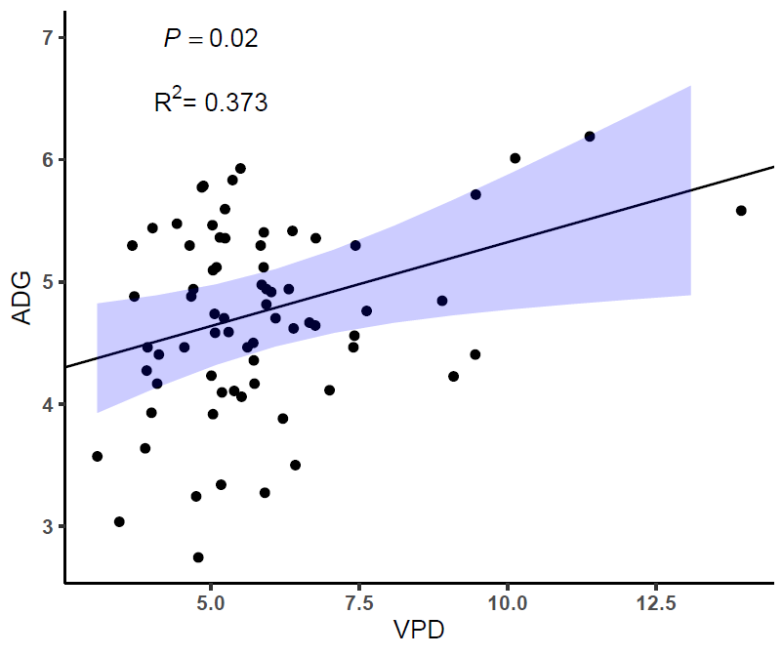
Figure 3. Average daily gain plotted as a function of visits per day: Average daily gain exhibits a positive correlation with the average number of visits to the waterer per day; y = 0.1370x + 3.950

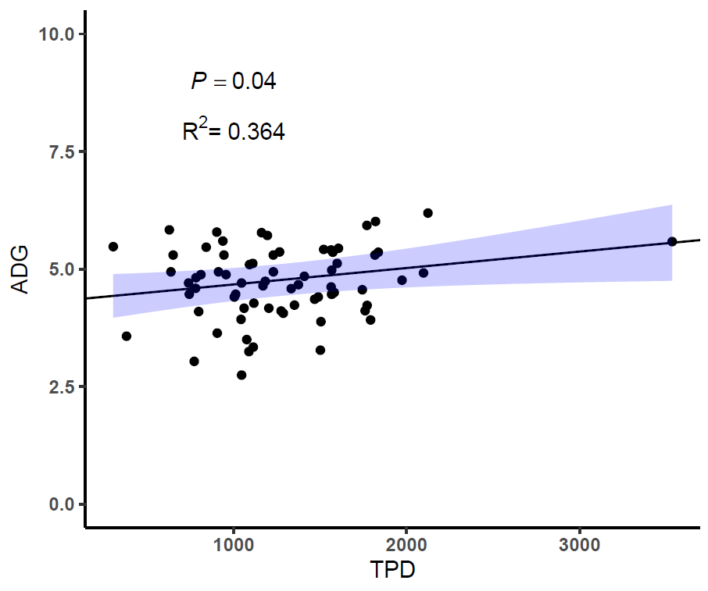
Figure 4. Average daily gain plotted as a function of time per day: Average daily gain exhibits a positive correlation with the average amount of time per day spent at the waterer; y = 0.0003x + 4.320

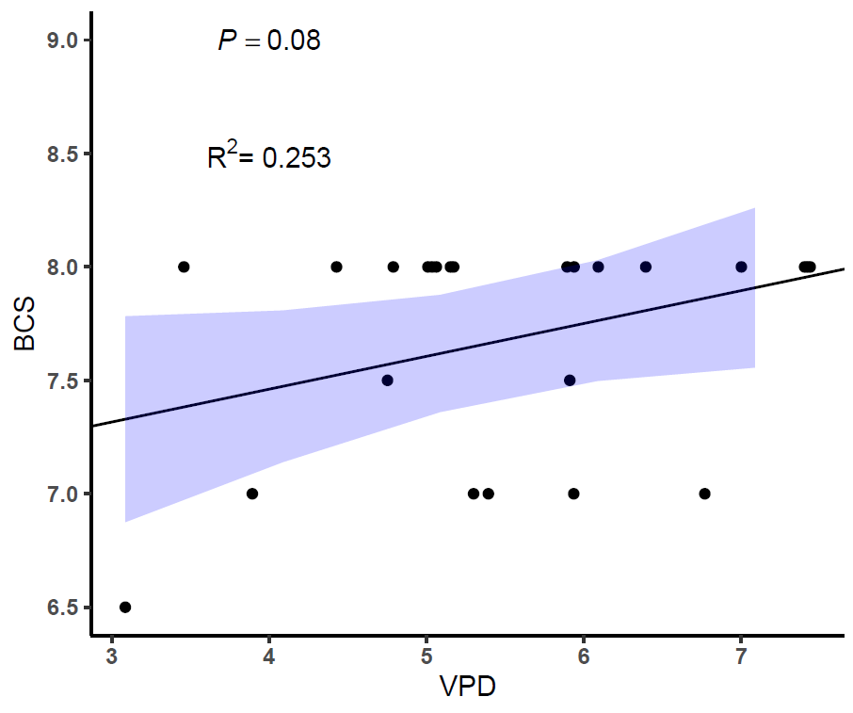
Figure 5. Body condition score plotted as a function of visits per day: Body condition score exhibits a positive correlation with the average number of visits to the waterer per day; y = 0.1450x + 6.880

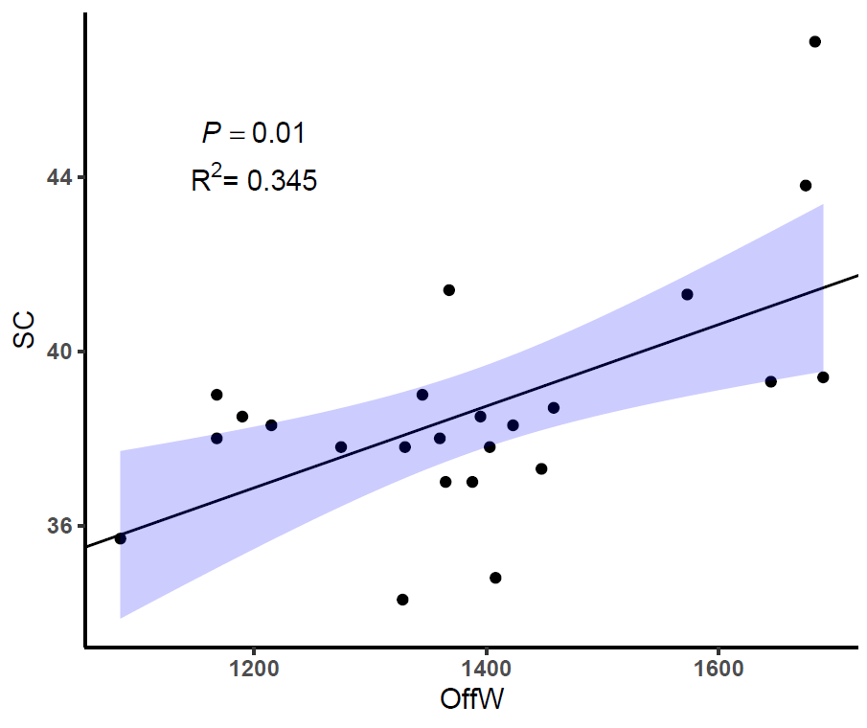
Figure 6. Scrotal circumference as a function of off-test weight: Scrotal circumference exhibits a positive correlation with off-test weight; y = 0.0094x + 25.62

Chapter 4: Summary and Conclusions
As water becomes more at risk and threatens the global agricultural industry, it is critical that the cattle industry progesses to maximize production effeciency and sustainability (Liu et al., 2022). Water is an essential nutrient for all physiological functions to occur and to sustain life in mammals (Nicolaidas, 1998). Cattle are no exception to this requirement, as water and feed intake has a direct correlation to gain and development (Winchester, 1956; Ahlberg et al., 2019). Both water and feed intake behaviors and efficiency have shown to be heritable in cattle, and stand as a vital compononent in animal selection (Knapp Jr and Nordskog, 1946; Ahlberg et al., 2019). Therefore, it is critical to grow our understanding of water intake behavior in cattle in order to maximize production efficiency. Our study recorded water intake behavior in developing beef bulls on a performance test. These data exhibited differences in water drinking behavior between bulls, as well as correlations between water drinking behavior and parameters of growth and reproductive development. Further research is required to further understand these relationships and determine methods of application to production. As precision livestock farming technologies advance and become more readily available, components could be included to this research, such as actual water intake. By understanding the relationships of water intake behavior with growth and development, we can develop a greater understanding of how to maximize production effeciency in the beef cattle industry.

Vita
Jake Thomas Watts was born on March 2, 1999 in Sweetwater, Tennessee where he was raised by David and Brenda Watts. Jake developed an early passion for the agricultural field, and found his way into the animal science industry after developing his own club lamb and custom hay operation. His interactions in agricultural lead him to pursue a Bachelor of Science in Animal Science from the University of Tennessee, Knoxville. During his time there, Jake realized an immense passion for reproductive physiology as his contribution to an ever-growing beef industry in need of rapid technological growth. Jake then chose to pursue a Master of Science degree in Reproductive Physiology with a focus on bull development from the University of Tennessee, Knoxville.

