Memory Response: Exposure history dependence of microbial mediated transformations of substrates in groundwater

A Dissertation Presented for the

Doctor of Philosophy

Degree

The University of Tennessee, Knoxville

Charles Joseph Paradis

December 2017

Dedication
This dissertation is dedicated to my lovely wife, Wendy, and my spirited daughter, Fabienne.

Acknowledgments
This dissertation would not have been possible without the help of numerous individuals and institutions. Funding was provided by ENIGMA- Ecosystems and Networks Integrated with Genes and Molecular Assemblies (http://enigma.lbl.gov), a Scientific Focus Area Program at Lawrence Berkeley National Laboratory is based upon work supported by the U.S. Department of Energy, Office of Science, Office of Biological & Environmental Research under contract number DE-AC02-05CH11231. Paul Adams, Adam Arkin, and Astrid Terry of ENIGMA provided excellent guidance and management of the scientific foci. The field, laboratory, and course work was supported by the staff at the Oak Ridge National Laboratory and the faculty, staff, and students at the University of Tennessee Knoxville and include the following: Benjamin Adams, Melody Branch, Lora Davis, Emma Dixon, Kim Drew, Dwyane Elias, Kathleen Fitzgerald, Leslie Fox, Eriko Gordon, Dominque Joyner, Dawn Klingeman, Kenneth Lowe, Nagissa Mahmoudi, Tonia Mehlhorn, Izaak Miller, Ji-Won Moon, Kaela O'Dell, Anthony Palumbo, Alex Patton, Edmund Perfect, Miguel Rodriguez, Angie Staley, David Watson, and Daniel Williams. Dr. Jack Istok of Oregon State University served as the technical advisor for the push-pull test method. Drs. Terry Hazen (advisor), Larry McKay (co-advisor), Andrew Steen, and Jack Parker of the University of Tennessee served as the oversight committee.

Abstract
The flow, transport, and reactivity of dissolved-phase constituents in an unconfined and shallow aquifer were characterized, in situ, by utilizing the single-well push-pull test method. In the first study, the re-oxidation/mobility of uranium, in the presence of nitrate oxidant, was shown to be mitigated by preferential oxidation/mobilization of solid-phase, reduced, sulfur-bearing species. These results indicated that establishing conditions conducive to uranium reduction and the formation of reduced sulfur-bearing species can increase the efficacy of sustained uranium reduction/immobility in the presence of re-mobilizing oxidants. In the second study, the analytical solution to describe the one-dimensional displacement of the center of mass of a tracer during a push-pull test was expanded to account for displacement during the injection phase. The expanded solution improved the theoretical description of the displacement of a tracer during a push-pull test and the in situ application demonstrated an improvement for the estimation of effective porosity. In the third study, an analytical model was developed to describe the breakthrough of a potentially reactive solute due to non-reactive mixing and was applied to an in situ data set. The analytical model accurately predicted the breakthrough curve of non-reactive solutes and allowed for quantifying the rate and extent of reactive solute mass transfer and transformation. In the fourth study, the exposure history dependence of microbial mediated ethanol transformation was demonstrated to last up to six weeks in the absence of ethanol injections with no apparent enrichment of a select microbial community. This suggested that the predominant mechanisms of adaptation may exist at the enzymatic- and/or genetic-levels. In conclusion, the single-well push-pull test method was utilized and improved to characterize hydraulic parameters and processes, and microbial mediated transformations of substrates in groundwater.
Table of Contents
Chapter 1: Introduction 1
Chapter 2: In situ mobility of uranium in the presence of nitrate following sulfate-reducing conditions 5
2.1. Abstract 7
2.2. Introduction 8
2.3. Materials and methods 11
2.3.1. Study site 11
2.3.2. Biostimulation and reoxidation tests 12
2.3.3. Laboratory analysis 16
2.3.4. Data analysis 16
2.4. Results and discussion 16
2.4.1. Push-pull tests: Uranium and sulfate reduction in control well 16
2.4.2. Push-pull tests: Uranium mobility in the presence of high nitrate 21
2.4.3. Push-pull tests: Uranium mobility in the presence of high nitrate and ethanol 23
2.4.4. Push-pull tests: Uranium mobility in the presence of low nitrate and ethanol 25
2.4.5. Thermodynamics 27
2.5. Conclusions 28
2.6. References 31
2.7. Appendix 40
Chapter 3: Push-pull tests for estimating effective porosity: expanded analytical solution and in situ application 41
3.1. Abstract 43
3.2. Introduction 44
3.3. Materials and methods 46
3.3.1. Theory 46
3.3.2. Study site 53
3.3.3. Hydraulic gradient 57
3.3.4. Hydraulic conductivity 58
3.3.5. Effective porosity 59
3.3.6. Uncertainty analysis 60
3.4. Results 60
3.4.1. Hydraulic gradient 60
3.4.2. Hydraulic conductivity 61
3.4.3. Effective porosity 63
3.4.4. Uncertainty analysis 67
3.5. Discussion 70
3.5.1. Hydraulic gradient 70
3.5.2. Hydraulic conductivity 70
3.5.3. Effective porosity 72
3.5.4. Uncertainty analysis 76
3.6. Conclusions 77
3.7. References 78
Chapter 4: Stepwise mixing model for quantifying solute mass transfer and transformation during push-pull tests 83
4.1. Abstract 85
4.2. Introduction 86
4.3. Theoretical development 90
4.4. Model validation 94
4.5. In situ application 98
4.6. Conclusions 106
4.6. References 107
Chapter 5: In situ demonstration of sustained adaptation of a natural microbial community to transform substrates 108
5.1. Abstract 110
5.2. Introduction 111
5.3. Materials and methods 112
5.3.1. Study site 112
5.3.2. Substrate exposure tests 116
5.3.3. Microbial community structure 119
5.4. Results and discussion 120
5.4.1. Substrate exposure tests 120
5.4.2. Microbial community structure 123
5.6. References 132
Chapter 6: Conclusions 139
Vita 141

List of Tables
Table 2.1 Summary of biostimulation and reoxidation test methodology. EtOH = ethanol 13
Table 2.2 Pre-test nitrate, U(VI), and sulfate concentrations and pH in source well (GW835) used for test injectate and in wells used for push-pull tests (FW218 through FW227 15
Table 2.3 Recovery factors for U(VI) and sulfate for control (FW224) and test well triplicates during push-pull test 4, average recovery factors ± one standard deviation are shown for triplicate test wells, NA = not applicable. EtOH = ethanol 20
Table 2.4 Standard-state (25°C, 1 atm, and unit molality) Gibbs free energies of uraninite (UO₂) and various reduced sulfur-bearing species (S⁰, FeS, FeS₂, MnS) reoxidized by nitrate (NO₃⁻) and nitrite (NO₂⁻), free energy values for the formation of reactants and products were obtained from Dean (1999) 29
Table 3.1 Hydraulic gradient (dh/dr) and hydraulic conductivity (K) for tests in this study (FW220 through FW225) and for tests from Hall et al. (1991) and Istok (2013) 62
Table 3.2 Results from single-well push-pull tests for this study (FW220 through FW225) and from Hall et al. (1991) and Istok (2013) 65
Table 3.3 Effective porosity calculated from the truncated and expanded solutions, (20) and (18), respectively, for tests in this study (FW220 through FW225) and for tests from Hall et al. (1991) and Istok (2013), n_{e1} from equation (18), n_{e2} from equation (20) 66
Table 3.4 Percent standard errors for input parameters for equation (18) for tests in this study (FW220 through FW224), test well FW225 is omitted due to invalid results 68
Table 4.1 Concentrations of non-reactive (bromide) and potentially reactive solutes (nitrate, nitrite, sulfate, and uranium) within the injection and aquifer fluids from a previously published study by Paradis et al. (2016) 100
Table 4.2 Recovery factors of uranium and sulfate from the dilution-adjusted and stepwise-mixing models, dilution-adjusted recovery factors are from Paradis et al. (2016) 105
Table 5.1 Physical and chemical characteristics from substrate treatment (FW222), and substrate control (FW224) wells from Paradis et al. (2016) and Paradis et al. (2017b). 115
Table 5.2 Experimental design of ethanol exposure tests for substrate treatment (FW222) and substrate control (FW224) wells, EtOH = ethanol. 118

List of Figures
Figure 2.1 Dilution-adjusted concentrations of ethanol, sulfate, and U(VI) in control well FW224 amended with 30 mM ethanol and 20 mM sulfate 18
Figure 2.2 Dilution-adjusted concentrations of nitrate and nitrite (a) and sulfate and U(VI) (b) in well FW220 amended with 120 mM nitrate 22
Figure 2.3 Dilution-adjusted concentrations of nitrate and nitrite (a) and sulfate and U(VI) (b) in well FW226 amended with 30 mM ethanol and 120 mM nitrate 24
Figure 2.4 Dilution-adjusted concentrations of nitrate and nitrite (a) and sulfate and U(VI) (b) in well FW222 amended with 30 mM ethanol and 2 mM nitrate 26
Figure 3.1 Plan-view depiction of the center of mass of a tracer at the end of the injection (1), drift (2), and extraction (3) phases, r_{i} = displacement due to injection, r_{a} = displacement due to ambient groundwater flow, r_{e} = displacement due to extraction 49
Figure 3.2 Plan-view maps of the study site, clockwise from upper left, country map showing study site location in the southeastern United States, area map showing study site location in Area 2 of the OR-IFRC, and study site map showing well locations, groundwater elevations, and groundwater elevation iso-contours, m amsl = meters above mean sea level 54
Figure 3.3 Vertical-view conceptual model of the shallow, unconfined, aquifer and construction details of a test well, horizontal exaggeration is 50-fold 55
Figure 3.4 Push-pull test data for all six test wells (FW220 through FW225) showing concentration of bromide (y axis) versus and time elapsed (x axis) during the pull phase of test, error bars represent the analytical uncertainty (± 4%) 64
Figure 3.5 Effective porosity (n_{e1}) per equation (18) for tests in this study (FW220 through FW224), test well FW225 is omitted due to invalid results, error bars represent the uncertainty 69
Figure 4.1 Dilution-adjusted breakthrough curves of synthetic data from equation (1) of a potentially reactive tracer at values of equation (3) ranging from 0.5 to 10, equation (1) is valid when equation (3) is equal to 1, equation (1) is invalid when equation (3) is not equal to one, the injection concentration of the potentially reactive solute is 100 mg/L and does not react. 89
Figure 4.2 Graphical depictions of the concentration of a non-reactive solute in the mixture of injection and aquifer fluids (C_{m}) versus the elapsed time (t); C_{i} is the concentration of the non-reactive solute in the injection fluid, C_{a} is the concentration of the non-reactive solute in the aquifer, C_{i} is greater than C_{a} in (a), C_{i} is less than C_{a} in (b). 92
Figure 4.3 Synthetic and predicted data for a potentially reactive solute, scenario one (a) shows synthetic data subject to non-reactive mixing only and predicted data which assumed non-reactive mixing only, scenario two (b) shows synthetic data subject to non-reactive mixing and removal from the aqueous phase and predicted data which assumed non-reactive mixing only 95
Figure 4.4 Synthetic and predicted data generated for scenario two from equation (12) and linear regression to determine the decay constant (k) 97
Figure 4.5 Breakthrough curves of nitrate and nitrite from the dilution-adjusted model (a), (c) and the stepwise-mixing model and measured data (b), (d) 101
Figure 4.6 Breakthrough curves of sulfate and uranium from the dilution-adjusted model (a), (c) and stepwise-mixing model and measured data (b), (d) 103
Figure 5.1 Plan-view maps of the study site from Paradis et al. (2017b), clockwise from upper left, country map showing study site location in the southeastern United States, area map showing study site location in Area 2 of the ORR, and study site map showing well locations, groundwater elevations, and groundwater elevation iso-contours, m amsl = meters above mean sea level, substrate treatment well is FW222, substrate control well is FW224. 114
Figure 5.2 Breakthrough curves of ethanol, acetate, nitrate, and sulfate for exposures 1, 2, 3, and 7 for the substrate treatment (STE1, STE2, STE3, STE7) and for exposure 1 for the substrate control (SCE1), open circles represent simulated data (model) for non-reactive mixing of the injection and aquifer fluids, closed circles represent field data (data), exposures 4, 5, and 6 for the substrate treatment are omitted due to rapid (within one hour) dilution of ethanol to levels below the minimum detection limit (≈20 mg/L). 122
Figure 5.3 Non-metric multi-dimensional scaling (NMDS) plots during the 14-week experiment (W01 through W14*) for the substrate control (SC) and substrate treatment (ST), *indicates post-ethanol exposure, G1, G2, G3, and G4 indicate distinct groupings, ellipses indicated 95% confidence intervals for weeks one through 14 (W01 through W14). 125
Figure 5.4 Hierarchical clustering analysis of operational taxonomic units (OTUs) during the 14-week experiment (W01 through W14*) for the substrate control (SC) and substrate treatment (ST), *indicates post-ethanol exposure, G1, G2, G3, and G4 indicate distinct groupings. 126
Figure 5.5 Relative abundance of microbial taxa at the phylum level during the 14-week experiment (W01 through W14) for the substrate control (SC) and substrate treatment (ST), *indicates post-ethanol exposure. 129

Introduction
The study of contaminant hydrogeology encompasses the fate, transport, and reactivity of contaminants in groundwater. The fate, transport, and reactivity of contaminants in groundwater are governed by physical, chemical, and biological processes. Therefore, contaminant hydrogeology is inherently inter-disciplinary. Contaminant hydrogeology can be studied at a wide range of spatial and temporal scales from micrometers to kilometers and seconds to millennia, respectively. Therefore, the scales at which studies are conducted are dependent on the objectives of the studies. The methods to study contaminant hydrogeology are also wide-ranging and broadly include empirical and theoretical approaches. Ideally, empirical-based studies should either follow an existing theory or lead to the development of a new theory. Finally, the type of study can be either applied or basic, with the former designed to solve a practical problem and the latter designed to answer a scientific question. This dissertation is comprised of four contaminant hydrogeology studies, each conducted in situ, at the spatial scale of meters, at the temporal scale of hours to months, and based on empirical data. Each study was conducted within a shallow, unconfined, and uranium-contaminated aquifer located at the Oak Ridge Reservation in Oak Ridge, Tennessee, United States of America. Studies one, two, and three were applied whereas study four was basic. All four studies were broadly designed to advance the understanding of the structure and function of natural microbial communities in groundwater.
In the first study, the in situ mobility of previously bio-reduced uranium was tested under variable redox conditions. The mobility of uranium (U) is highly dependent on its oxidative state with U(VI) being relatively soluble under oxidizing conditions and U(IV) being relatively insoluble under reducing conditions. Natural microbial communities can be stimulated to reduce and immobilize U(VI) to U(IV) by the addition of a suitable electron donor such as ethanol. However, U(IV) can be re-oxidized and re-mobilized to U(VI) by oxidants such as nitrate. Therefore, re-oxidation of previously bio-reduced uranium by nitrate oxidant is a practical problem for remediating uranium-contaminated groundwater. Theoretically, thermodynamics predicts that oxidization of reduced sulfur-bearing species, as opposed to reduced uranium-bearing species, by nitrate is energetically favorable. Empirically, laboratory-based studies have demonstrated that reduced sulfur-bearing species, as opposed to reduced uranium-bearing species, are preferentially oxidized by nitrate, thereby limiting the re-oxidation and re-mobilization of uranium. However, no field-based study has been conducted to validate the theoretical and empirical evidence. The objective of the first study was to test the in situ mobility of uranium in the presence of nitrate oxidant following ethanol-stimulated bio-reduction of uranium and sulfate and likely formation of reduced uranium- and sulfur-bearing species.
In the second study, the analytical solution to estimate the effective porosity of sediments based on data from a push-drift-pull test was theoretically expanded and applied to an in situ data set. The effective porosity of sediments is a measure of the void spaces through which a solute is transported by advection relative to the total volume of the void and solid spaces. A push-drift-pull test is a method which involves the forced-gradient injection (push), natural-gradient resting, (drift), and forced-gradient extraction (pull) of a non-reactive solute within a single groundwater well. The data from a push-drift-pull test can be analyzed to characterize various physical, chemical, and biological parameters and processes, including effective porosity. Natural microbial communities are periodically exposed to solutes, either naturally or anthropogenically, which can serve as sources of carbon, energy, or nutrients. Therefore, the effective porosity of sediments is also a measure of the void spaces through which natural microbial communities are exposed to dissolved-phase sources of carbon, energy, or nutrients which are transported by advection. The current analytical solution to estimate the effective porosity of sediments ignores the displacement of the center of mass of the non-reactive solute during the push phase of a push-drift-pull test. Theoretically, ignoring displacement during the push phase can lead to an underestimation of effective porosity and an inaccurate characterization of the physical space in which natural microbial communities inhabit. The objectives of the second study were to expand the current analytical solution to include displacement during the push phase and to better estimate the magnitude and spatial variability of effective porosity at the study site.
In the third study, an analytical model to describe the concentration versus time, or breakthrough curve, of a potentially reactive solute due to non-reactive mixing of the injection and aquifer fluids during the pull phase of a push-drift-pull test was theoretically developed and applied to an in situ data set. As previously noted, the data from a push-drift-pull test can be analyzed to characterize various physical, chemical, and biological parameters and processes. This includes the quantification of microbial-mediated solute mass transformation. When a potentially reactive solute is either added to the injection fluid or exists naturally within the aquifer fluid, analysis of the breakthrough curves of the non-reactive versus the potentially reactive solutes during the pull phase can allow for quantification microbial-mediated solute mass transformation. However, the current analytical model used to generate dilution-adjusted breakthrough curves of potentially reactive solutes assumes that the ratio of the concentrations of the non-reactive and potentially reactive solutes in the injection fluid versus the aquifer fluid are equal. If this assumption is not valid, the dilution-adjusted model may predict breakthrough curves which suggest microbial-mediated solute mass transformation occurred when in fact only non-reactive mixing occurred. The objective of third study was to develop and apply an analytical solution which predicts the breakthrough curve of a potentially reactive solute due to non-reactive mixing to account for any possible combination of non-reactive and potentially reactive solute concentrations within the injection and aquifer fluids.
In the fourth study, the exposure history dependence of microbial-mediated substrate transformation was tested. Prior exposure of a natural microbial community to a substrate can result in the increased potential of the community to transform the substrate. This phenomenon is known as adaptation. Adaptation is thought to play an important role in biogeochemical cycling at the ecosystem scale and has been demonstrated at the laboratory scale. However, in situ demonstrations of the magnitude and duration of adaptation are lacking. Moreover, the predominant, yet likely inter-related, mechanisms by which adaptation can occur are poorly understood. The objectives of the fourth study were to establish a natural microbial community adapted to transform a substrate, determine how long adaptation can last in the absence of the substrate, and elucidate the microbial mechanism(s) responsible for adaption. Studies one, two, and three directly informed the design of study four. In the first study, a natural microbial community was repeatedly exposed to and bio-transformed a substrate, i.e., ethanol. In the second study, the physical space through which an injected volume of a dissolved-phase substrate, e.g., ethanol, would travel by advection was estimated. In the third study, an analytical model was developed to more accurately quantify microbial-mediated substrate, e.g., ethanol, transformation during a push-drift-pull test. Finally, in the fourth study, a pair of wells, one ethanol treatment and one ethanol control, were utilized to demonstrate and elucidate the mechanism(s) of adaptation.

In situ mobility of uranium in the presence of nitrate following sulfate-reducing conditions

Chapter 2 was published in the Journal of Contaminant Hydrology.

Paradis, C. J., S. Jagadamma, D. B. Watson, L. D. McKay, T. C. Hazen, M. Park & J. D. Istok, 2016. In situ mobility of uranium in the presence of nitrate following sulfate-reducing conditions. Journal of contaminant hydrology 187:55-64 doi:10.1016/j.jconhyd.2016.02.002.

2.1. Abstract
Reoxidation and mobilization of previously reduced and immobilized uranium by dissolved-phase oxidants poses a significant challenge for remediating uranium-contaminated groundwater. Preferential oxidation of reduced sulfur-bearing species, as opposed to reduced uranium-bearing species, has been demonstrated to limit the mobility of uranium at the laboratory scale yet field-scale investigations are lacking. In this study, the mobility of uranium in the presence of nitrate oxidant was investigated in a shallow groundwater system after establishing conditions conducive to uranium reduction and the formation of reduced sulfur-bearing species. A series of three injections of groundwater (200 L) containing U(VI) (5 μM) and amended with ethanol (40 mM) and sulfate (20 mM) were conducted in ten test wells in order to stimulate microbial-mediated reduction of uranium and the formation of reduced sulfur-bearing species. Simultaneous push-pull tests were then conducted in triplicate well clusters to investigate the mobility of U(VI) under three conditions: 1) high nitrate (120 mM), 2) high nitrate (120 mM) with ethanol (30 mM), and 3) low nitrate (2 mM) with ethanol (30 mM). Dilution-adjusted breakthrough curves of ethanol, nitrate, nitrite, sulfate, and U(VI) suggested that nitrate reduction was predominantly coupled to the oxidation of reduced-sulfur bearing species, as opposed to the reoxidation of U(IV), under all three conditions for the duration of the 36-day tests. The amount of sulfate, but not U(VI), recovered during the push-pull tests was substantially more than injected, relative to bromide tracer, under all three conditions and further suggested that reduced sulfur-bearing species were preferentially oxidized under nitrate-reducing conditions. However, some reoxidation of U(IV) was observed under nitrate-reducing conditions and in the absence of detectable nitrate and/or nitrite which suggested that reduced sulfur-bearing species may not be fully effective at limiting the mobility of uranium in the presence of dissolved and/or solid-phase oxidants. The results of this field study confirmed those of previous laboratory studies which suggested that reoxidation of uranium under nitrate-reducing conditions can be substantially limited by preferential oxidation of reduced sulfur-bearing species.

2.2. Introduction
Uranium-contaminated groundwater is a human and environmental health concern due to releases associated with the mining, milling and processing of uranium ore as well as those from natural sources (Brugge et al. 2005). The mobility of uranium in groundwater is highly dependent on groundwater pH, redox potential and the mineralogy of the solid-phase subsurface media. In circumneutral pH groundwater, uranium primarily exists as soluble U(VI)-bearing species under oxidizing conditions or as less soluble U(IV)-bearing species under reducing conditions (Goodwin 1982; Grenthe et al. 1992; O'Loughlin et al. 2011). Under oxidizing conditions and circumneutral pH, U(VI)-bearing species can be immobilized by adsorption to iron-bearing minerals (Li and Kaplan 2012). Under reducing conditions, U(VI) can be reduced to immobile U(IV) chemically by reduced iron- or sulfur-bearing species (Chakraborty et al. 2010; Hyun et al. 2014; Hyun et al. 2012; Jeon et al. 2005) and/or biologically by native anaerobic microbial communities (Wall and Krumholz 2006). Microbial-mediated uranium reduction in particular, has been the predominant mechanism utilized for enhancing in situ uranium immobilization (Newsome et al. 2014). However, reoxidation of previously reduced uranium in the presence of dissolved- and/or solid-phase oxidants can result in remobilization of uranium, which poses a significant challenge for remediating uranium-contaminated groundwater (Singh et al. 2014).
Microbial-mediated reduction of uranium can be stimulated by the in situ addition of an electron donor such as ethanol, glucose, acetate, lactate, formate, or emulsified vegetable oil (Anderson et al. 2003; Campbell et al. 2011; Dullies et al. 2010; Istok et al. 2004; Senko et al. 2002; Sharp et al. 2011; Vrionis et al. 2005; Watson et al. 2013; Wu et al. 2006; Wu et al. 2007; Wu et al. 2010). In the presence of an added electron donor, uranium reduction can proceed following depletion of higher energy yielding terminal electron acceptors (TEAs) such as oxygen, nitrate, manganese, and concurrent with ferric-iron reduction (Newsome et al. 2014) which may result in the production of insoluble minerals such as uraninite (UO₂) (Wall and Krumholz 2006). However, natural recharge of dissolved-phase oxidants such as oxygen and nitrate into previously reduced groundwater zones can result in reoxidation and subsequent remobilization of uranium (Watson et al. 2013; Wu et al. 2007; Wu et al. 2010). Although the presence of solid-phase oxidants such as Mn(IV)-oxides and/or Fe(III)-oxides can also result in reoxidation of uranium, their abundance is likely limited following uranium-reducing conditions (Vrionis et al. 2005). In order to actively maintain uranium-reducing conditions, the continuous or periodic addition of an electron donor can effectively prevent uranium reoxidation (Watson et al. 2013; Wu et al. 2007; Wu et al. 2010). However, active remediation systems can also be expensive to design, build, and operate. Therefore, creating groundwater conditions which can sustain uranium-reducing conditions after in situ electron donor addition has been terminated and depleted is of critical interest to remediation practitioners.
The importance of reduced sulfur-bearing minerals, formed by sulfate-reducing bacteria, has been recognized as a predominant factor contributing to maintaining uranium-reducing conditions in natural uranium-rich groundwater systems (Arthur et al. 2006; Iwatsuki et al. 2004; Noseck et al. 2012). This is likely due, in part, to preferential oxidation of common reduced sulfur-bearing minerals such as pyrite (FeS₂), mackinawite (FeS_{0.9}) and alabandite (MnS) by oxygen and nitrate, which are thermodynamically favorable reductants when compared to uraninite (Dean 1999). This suggests that creating in situ groundwater conditions that are conducive to the formation of reduced sulfur-bearing minerals following uranium reduction may lead to greater stability of immobilized uranium in the presence of oxidants. The importance of preferential oxidation of reduced sulfur-bearing minerals following uranium reduction has been demonstrated experimentally in numerous laboratory studies (Abdelouas et al. 2000; Abdelouas et al. 1999; Bi and Hayes 2014a; Bi and Hayes 2014b; Bi et al. 2013; Carpenter et al. 2015; Luan et al. 2015; Moon et al. 2009; N'Guessan et al. 2010). For example, in a flow-through sediment column study, Moon et al. (2009) demonstrated that microbial-mediated uranium reduction followed by enhanced sulfate reduction resulted in the formation of iron sulfides which limited the extent of uranium reoxidation by oxygen and nitrate when compared to a previous study where uranium reduction was not followed by sulfate reduction (Moon et al. 2007). However, in both laboratory studies, the rate and extent of uranium reoxidation was greater when nitrate, as opposed to oxygen, was the oxidant. The relative importance of nitrate as a predominant oxidant for in situ uranium reoxidation has also been recognized at numerous uranium-contaminated sites where nitrate is a common co-contaminant due to activities associated with the processing of uranium ore (Lloyd and Renshaw 2005; Smith et al. 2015; Spain and Krumholz 2011). Although nitrate alone does not abiotically oxidize U(IV) to an appreciable extent, dissimilatory nitrate reduction intermediates, such as nitrite, nitric oxide, and nitrous oxide, as well as microbial-mediated nitrate-dependent U(IV) oxidation, have been shown to reoxidize uranium in numerous laboratory and in situ studies (Singh et al. 2014).
Despite the importance of nitrate as an oxidant under field conditions and sulfide-bearing minerals as reductants under laboratory conditions, relatively few studies to date have investigated uranium reoxidation by nitrate following sulfate-reducing conditions in the field. Therefore, a substantial knowledge gap currently exists as to the in situ feasibility of such an approach in terms of limiting the extent of uranium reoxidation. The objective of this study was to test the in situ mobility of uranium in the presence of nitrate following uranium- and sulfate-reducing conditions. Based on the results of previous studies and thermodynamics, we hypothesized that preferential oxidation of reduced sulfur-bearing species, as opposed to reduced uranium-bearing species, can substantially limit the extent of uranium mobilization in the presence of nitrate.

2.3. Materials and methods

2.3.1. Study site
The study site is located in Area 2 of the Oak Ridge Integrated Field Research Challenge (OR-IFRC) site in Oak Ridge, Tennessee. A typical geologic profile of Area 2 would consist of approximately 6 meters of reworked fill and saprolite at the surface underlain by 2 meters of intact saprolite with weathered bedrock below the saprolite (Watson et al. 2004). The study site contains ten shallow groundwater monitoring wells (FW218 through FW227) constructed of ¾-inch inside diameter schedule 80 polyvinyl chloride (PVC) pipe. The monitoring wells were installed by direct push and are screened from 3.5 to 6 meters below ground surface (mbgs). The shallow groundwater aquifer is unconfined and depth to groundwater is approximately 3.5 mbgs. The groundwater and sediments within Area 2 are contaminated with nitrate and uranium from the former S-3 Ponds which contained liquid waste derived from the processing of uranium ore (Spain and Krumholz 2011). The pH of groundwater at Area 2 tends to be between 6 and 7 with concentrations of uranium ranging from 3.8 to 7.1 μM (Moon et al. 2006) and concentrations of nitrate ranging from 1 to 4 mM (Spain and Krumholz 2011). The average groundwater redox potential is 170 mV and reduction of equilibrium-predicted U(VI)-bearing species (UO₂CO₃, UO₂(CO₃)₂²⁻, UO₂SO₄, UO₂(SO₄)₂²⁻, Ca₂UO₂(CO₃)₃, CaUO₂(CO₃)²⁻) is not energetically favorable in the absence of an added electron donor (Moon et al. 2006; Watson et al. 2013). The saprolite contains significant quantities of iron oxides and, to a lesser extent, manganese oxides which have a high capacity for U(VI) adsorption at circumneutral pH (Barnett et al. 2002). Concentrations of uranium (nitric-acid extractable) in saprolite from Area 2 range from 0.293 to 453 mg/kg (Moon et al. 2006). Microbial-mediated uranium reduction has been demonstrated in numerous laboratory studies utilizing Area 2 groundwater and/or sediments by the addition of a range of electron donors (Spain and Krumholz 2011) and under in situ conditions by the addition of ethanol (Fang et al. 2006) and emulsified vegetable oil (Watson et al. 2013). However, concurrent reoxidation of reduced sulfur-bearing species and U(IV) by nitrate following depletion of emulsified vegetable oil has also been observed in Area 2 (Watson et al. 2013). This suggests that the geochemistry of Area 2 is conducive to forming reduced sulfur-bearing species but that nitrate has the oxidative strength to remobilize uranium to background levels. The wells utilized in this study were not part of any previous studies and are likely not affected by previous or ongoing activities within Area 2.

2.3.2. Biostimulation and reoxidation tests
A series of four tests were conducted in wells FW218 through FW227. Three biostimulation tests (Tests 1, 2, and 3) were conducted in order to reduce and immobilize uranium and to precipitate sulfides (Table 2.1). The reoxidation test (Test 4) was conducted in order to investigate the mobility of uranium in the presence of nitrate (Table 2.1). Groundwater samples for all tests were collected and filtered (0.2 μm) in the field and stored at 4°C until analyzed. Groundwater used for test injectate was collected from nearby well GW835 which contained relatively low pre-test concentrations of nitrate (1 mM), U(VI) (5 μM) and sulfate (1

Table 2.1 Summary of biostimulation and reoxidation test methodology. EtOH = ethanol
Test # | Test Type | Method | Day(s) | Treatment ID | Well | Amendments
1 | Biostimulation | Injection Only | 0 | - | All Wells | 40mM EtOH, 20mM SO₄²⁻
2 | Biostimulation | Injection Only | 47 | - | All Wells | 40mM EtOH, 20mM SO₄²⁻
3 | Biostimulation | Injection Only | 84 | - | All Wells | 40mM EtOH, 20mM SO₄²⁻
4 | Reoxidation | Injection & Periodic Extraction | 139-176 | Control | FW224 | 30mM EtOH, 20mM SO₄²⁻
4 | Reoxidation | Injection & Periodic Extraction | 139-176 | Cluster 1 | FW219 | 120mM NO₃⁻
 |  |  |  |  | FW220 | 120mM NO₃⁻
 |  |  |  |  | FW225 | 120mM NO₃⁻
4 | Reoxidation | Injection & Periodic Extraction | 139-176 | Cluster 2 | FW218 | 30mM EtOH, 120mM NO₃⁻
 |  |  |  |  | FW226 | 30mM EtOH, 120mM NO₃⁻
 |  |  |  |  | FW227 | 30mM EtOH, 120mM NO₃⁻
4 | Reoxidation | Injection & Periodic Extraction | 139-176 | Cluster 3 | FW221 | 30mM EtOH, 2mM NO₃⁻
 |  |  |  |  | FW222 | 30mM EtOH, 2mM NO₃⁻
 |  |  |  |  | FW223 | 30mM EtOH, 2mM NO₃⁻

mM), and a circumneutral pH (6.5) (Table 2.2). The test wells contained roughly similar pre-test concentrations of nitrate (0.1 to 12.9 mM), U(VI) (0.1 to 3.9 μM) and sulfate (0.1 to 1.9 mM) and a circumneutral pH (6.6 to 8.0) (Table 2.2). Pre-test concentrations of ethanol were below the method detection limit from injectate well GW835 and test wells FW218 through FW227 (data not shown).
The biostimulation tests were conducted by injecting 200 liters of ethanol- and sulfate-amended injectate in all ten wells (Table 2.1). Immediately prior to injection, the injectate was amended with 40 mM ethanol (C₂H₆O) and 20 mM sulfate (Na₂SO₄) and then mixed with compressed 80%N₂:20%CO₂ gas. The injectate was then injected into each well using a siphon and was completed within a 24-hour time frame. Five samples of the injectate were collected during injection for analysis of amended ethanol and sulfate (data not shown) and were similar to the target concentrations (Table 2.1). Groundwater concentrations of ethanol and sulfate in test wells immediately prior to subsequent biostimulation tests (data not shown) were similar to pre-test concentrations (Table 2.2).
The reoxidation test was conducted using the single-well push-pull test method according to the methodology of Istok et al. (2004). The reoxidation test was conducted under three different conditions in triplicate well clusters: 1) high nitrate (cluster 1), 2) high nitrate with ethanol (cluster 2), and 3) low nitrate with ethanol (cluster 3) (Table 2.1). A push-pull test was conducted in a single well (FW224) under similar ethanol- and sulfate-amended conditions of the biostimulation tests to serve as a control (Table 2.1). Immediately prior to injection, the injectate was amended with 10 mM sodium bicarbonate (NaHCO₃) buffer, 1.3 mM bromide tracer (KBr), and ethanol (C₂H₆O), sulfate (Na₂SO₄) or nitrate (KNO₃), depending on the test condition (Table 2.1). The reoxidation test injectate volume, mixing and injection methodology, and injection time

Table 2.2 Pre-test nitrate, U(VI), and sulfate concentrations and pH in source well (GW835) used for test injectate and in wells used for push-pull tests (FW218 through FW227
Well | NO₃⁻ | U(VI) | SO₄²⁻ | pH
Well | (mM) | (μM) | (mM) | pH
GW835 | 1.0 | 5.0 | 1.0 | 6.5
FW218 | 12.9 | 0.1 | 0.4 | 7.0
FW219 | 0.4 | 3.9 | 0.6 | 7.4
FW220 | 0.2 | 0.1 | 0.1 | 7.7
FW221 | 1.2 | 0.1 | 0.2 | 7.5
FW222 | 0.1 | 0.1 | 0.1 | 7.8
FW223 | 0.1 | 0.1 | 0.1 | 8.0
FW224 | 0.1 | 0.1 | 0.1 | 7.7
FW225 | 0.7 | 0.2 | 0.1 | 7.5
FW226 | 1.2 | 0.2 | 1.9 | 7.2
FW227 | 0.3 | 0.1 | 0.5 | 6.6

frame were identical to the biostimulation tests. Five samples of the injectate were collected during the injection phase. Post-injection groundwater samples were collected by periodic extraction of the test wells for 36 days and analyzed for bromide, ethanol, nitrate, nitrite, U(VI), and sulfate.

2.3.3. Laboratory analysis
Bromide, nitrate, nitrite, and sulfate were measured by ion chromatography (Dionex, model DX-120). U(VI) was measured by a kinetic phosphorescence analyzer (Chemcheck, KPA-11). pH was measured by glass electrode (Accumet, model 25). Ethanol was measured by gas chromatography (Hewlett-Packard, model 5880) with flame ionization detection.

2.3.4. Data analysis
Dilution-adjusted concentrations were computed by dividing the measured concentration of the reactive tracer (ethanol, nitrate, nitrite, U(VI), and sulfate) by the relative concentration of the non-reactive tracer (bromide) (Istok 2013). Recovery factors of reactive tracers were computed by dividing the mass extracted from the well by the mass injected into the well which was then divided by the corresponding recovery factor of bromide (Senko et al. 2002). Recovery factors greater than one indicated that more reactive tracer was recovered relative to bromide. Recovery factors less than one indicated that less reactive tracer was recovered relative to bromide.

2.4. Results and discussion

2.4.1. Push-pull tests: Uranium and sulfate reduction in control well
Complete removal of ethanol occurred within 24 hours after injection and ethanol concentrations remained below the method detection limit for the duration of the 36-day test (Figure 2.1). U(VI) concentrations remained below injection levels (5 μM) for the first 13 days of the test (Figure 2.1). Complete removal of sulfate occurred within 3 days after injection and sulfate concentrations remained below pre-test levels (0.1 mM) for the first 15 days of the test (Figure 2.1). Nitrate and nitrite concentrations and pH remained at pre-test levels for the duration of the 36-day test (data not shown). The observed removal of ethanol and sequential removal of U(VI) and sulfate suggested that microbial-mediated U(VI) and sulfate reduction occurred in the control well for the first 15 days of the test. Although ferrous iron was not measured, it is likely that ferric-iron reduction also occurred based on previous studies in Area 2 where the classic sequence of TEAs were observed in ethanol-amended tests with nitrate reduction, ferric-iron reduction, sulfate reduction, and methanogenesis proceeding in sequence (Fang et al. 2006; Mohanty et al. 2008). These results suggested that groundwater conditions conducive to U(VI) reduction/immobilization and precipitation of reduced sulfur-bearing species were likely established in the first three biostimulation tests (Table 2.2). Although the valence state and chemical speciation of uranium and sulfur in sediments was not determined, it is likely that U(VI) was reduced to U(IV) in the form of uraninite and/or as U(IV) adsorbed to Fe/Mn minerals and that sulfate was reduced to S²⁻ in the form of ferrous sulfide (FeS), based on previous ethanol-amended tests at the OR-IFRC site (Kelly et al. 2008; Kelly et al. 2010).
Sulfate and U(VI) concentrations increased steadily after 15 days and approached or slightly exceeded injection levels of 20 mM and 5 μM, respectively, by the end of the 36-day test (Figure 2.1). The increase of sulfate and U(VI) levels suggested that reoxidation of reduced sulfur-bearing species and U(IV) and/or desorption of sulfate and U(VI) may have occurred. Although sulfate-reducing conditions were clearly established during the first 15 days of the test and nitrate and nitrite concentrations remained at pre-test levels, it is possible that solid-phase oxidants such as Fe(III)-oxides and/or Mn(IV)-oxides were present due to incomplete reduction
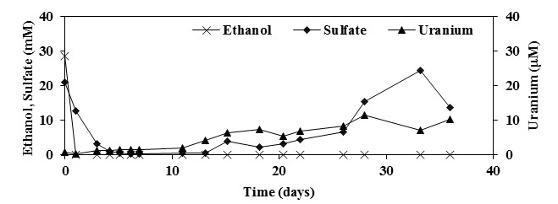

Figure 2.1 Dilution-adjusted concentrations of ethanol, sulfate, and U(VI) in control well FW224 amended with 30 mM ethanol and 20 mM sulfate

and were responsible for reoxidation of reduced sulfur-bearing species and U(IV). For example, in a flow-through sediment column study utilizing sediment from Area 2, Wan et al. (2005) provided several lines of evidence which suggested that despite constant electron donor (lactate) addition and strongly methanogenic conditions, Fe(III) and possibly Mn(IV) persisted as oxidants responsible for U(IV) reoxidation. Thermodynamically, any oxidant of U(IV) would be expected to oxidize sulfides preferentially and complete oxidation of FeS and FeS2 to sulfate by MnO2 has been observed in marine sediments (Aller and Rude 1988; Schippers and Jorgensen 2001). Although there is slight or no evidence for complete FeS or FeS2 oxidation by Fe(III)-oxides (Aller and Rude 1988; Schippers and Jorgensen 2001; Schippers and Jorgensen 2002), intermediate oxidation products such as elemental sulfur (S0) and thiosulfate (S2O32-) can be completely oxidized to sulfate by microbes which utilize Fe(III)-oxides as TEAs (Finster et al. 1998; Thamdrup et al. 1993). Although desorption of sulfate and/or U(VI) may have also occurred after 15 days it is unlikely due to relatively little change in pH (data not shown) (Barnett et al. 2002; Rose and Ghazi 1997).
Recovery factors for U(VI) and sulfate were computed in order to quantify the extent of U(VI) and sulfate immobilization/mobilization for duration of the 36-day tests (Table 2.3). Recovery factors for U(VI) and sulfate were 0.2 and 0.5, respectively, for the control-well test (Table 2.3). Although both immobilization (0 to 15 days) and mobilization (15 to 36 days) of U(VI) and sulfate were observed (Figure 2.1), the recovery factor results suggested that a net removal (recovery factor <1) of U(VI) and sulfate from groundwater occurred over the full duration of the test (Table 2.3). Therefore, it is likely that a net removal of U(VI) and sulfate from groundwater by microbial-mediated reduction also occurred during the first three biostimulation tests (Table 2.1).

Table 2.3 Recovery factors for U(VI) and sulfate for control (FW224) and test well triplicates during push-pull test 4, average recovery factors ± one standard deviation are shown for triplicate test wells, NA = not applicable. EtOH = ethanol
Treatment ID | Well | Amendments | U(VI) | SO₄²⁻ | Avg. U(VI) ± 1 S.D. | Avg. SO₄²⁻ ± 1 S.D.
Control | FW224 | 30mM EtOH, 20mM SO₄²⁻ | 0.2 | 0.5 | NA | NA
Cluster 1 | FW219 | 120mM NO₃⁻ | 1.0 | 14.4 | 1.3±0.3 | 12±3
Cluster 1 | FW220 | 120mM NO₃⁻ | 1.5 | 8.6 | 1.3±0.3 | 12±3
Cluster 1 | FW225 | 120mM NO₃⁻ | 1.5 | 13.0 | 1.3±0.3 | 12±3
Cluster 2 | FW218 | 30mM EtOH, 120mM NO₃⁻ | 0.9 | 9.8 | 1.3±0.4 | 14±5
Cluster 2 | FW226 | 30mM EtOH, 120mM NO₃⁻ | 1.8 | 13.2 | 1.3±0.4 | 14±5
Cluster 2 | FW227 | 30mM EtOH, 120mM NO₃⁻ | 1.2 | 20.2 | 1.3±0.4 | 14±5
Cluster 3 | FW221 | 30mM EtOH, 2mM NO₃⁻ | 0.5 | 4.2 | 0.7±0.5 | 5.5±1.3
Cluster 3 | FW222 | 30mM EtOH, 2mM NO₃⁻ | 1.3 | 5.6 | 0.7±0.5 | 5.5±1.3
Cluster 3 | FW223 | 30mM EtOH, 2mM NO₃⁻ | 0.4 | 6.8 | 0.7±0.5 | 5.5±1.3

2.4.2. Push-pull tests: Uranium mobility in the presence of high nitrate
Complete removal of high nitrate (170 mM) in the absence of ethanol was concurrent with a steady increase in sulfate concentrations above injection levels (up to 25 mM) and a transient increase in nitrite concentrations (up to 2mM) in well FW220 (Figure 2.2). U(VI) concentrations remained near injection levels (5 μM) for the first 28 days of the test and then increased to 20 μM by the end of the 36-day test (Figure 2.2). The increase in U(VI) concentrations above injection levels occurred in the absence of detectable nitrate or nitrite (Figure 2.2). The pH in well FW220 remained at pre-test levels for the duration of the test (data not shown). Similar results were observed in replicate wells FW219 and FW225 (Appendix) which suggested that despite the high level of aquifer heterogeneity in Area 2 (Watson et al. 2004), the biogeochemical processes were not spatially-biased under test conditions. These results suggested that nitrate reduction was predominantly coupled to reduced sulfur oxidation and that U(IV) oxidation was negligible during this process. These results were expected because preferential oxidation of common reduced sulfur-bearing species such as pyrite, mackinawite, alabandite and elemental sulfur by nitrate or nitrite are thermodynamically favorable when compared to uraninite (Dean 1999). Although we did not determine the extent at which this process was either abiotic or microbial-mediated, it is important to note that the microbial species Thiobacillus denitrificans has been shown to perform nitrate reduction coupled to reduced sulfur oxidation (Kelly and Wood 2000) and that the Thiobacillus genus has been broadly detected at the OR-IFRC site in both groundwater and sediments (Spain and Krumholz 2011). However, these results also suggested that solid-phase oxidants such as Fe(III)-oxides and/or Mn(IV)-oxides may have been responsible for reoxidation of reduced sulfur-bearing species and U(IV) during the later stages of the tests when nitrate and nitrite concentrations were
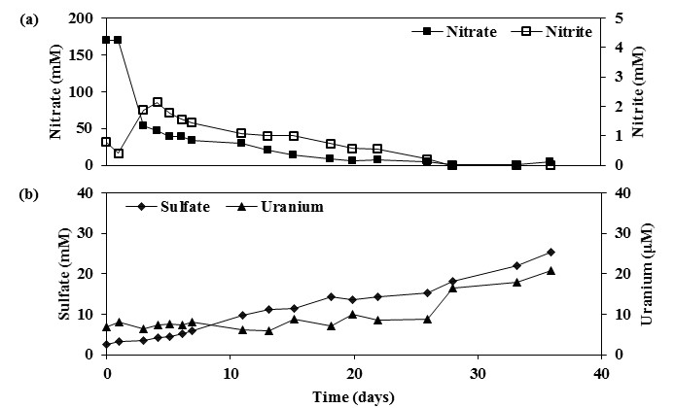

Figure 2.2 Dilution-adjusted concentrations of nitrate and nitrite (a) and sulfate and U(VI) (b) in well FW220 amended with 120 mM nitrate

below the method detection limit (Appendix). Similar results were observed in the control well (Figure 2.1) and were discussed in the previous section.
Average recovery factors, plus or minus one standard deviation, for U(VI) and sulfate in the triplicate well cluster 1 were 1.3±0.3 and 12±3, respectively (Table 2.3). These results demonstrated that substantially more sulfate, but not U(VI), was recovered relative to bromide. The calculated recovery factors for sulfate and U(VI) (Table 2.3) and the observed nitrate removal and concurrent sulfate production (Appendix) strongly suggested that reoxidation of uranium under nitrate-reducing conditions was substantially limited by preferential oxidation of reduced sulfur-bearing species.

2.4.3. Push-pull tests: Uranium mobility in the presence of high nitrate and ethanol
Removal of high nitrate (140 mM) and ethanol (30 mM) was concurrent with a sharp increase in nitrite concentrations (up to 4 mM) in well FW226 for the first 7 days of the test (Figure 2.3). During this time, sulfate concentrations increased steadily (up to 10 mM) while U(VI) concentrations varied but were relatively close to injection levels (5 μM) (Figure 2.3). The results for the first 7 days suggested that nitrate reduction was coupled to both ethanol and sulfur oxidation and that U(IV) oxidation was negligible during this process. Sulfur oxidation by nitrate was expected because nitrate was added in excess (≈1.5-fold) of the stoichiometric demand for ethanol oxidation (Table 2.1). After day 7, concentrations of sulfate remained well above injection levels (up to 18 mM) while U(VI) concentrations were only slightly above injection levels (up to 10 μM) until day 28 (Figure 2.3). During this time, concentrations of nitrate and nitrite were relatively low but detectable (Figure 2.3). The results between days 7 and 28 suggested that a substantial amount of reduced sulfur-bearing species were oxidized to sulfate under nitrate-reducing conditions and that reoxidation of U(IV) was negligible.
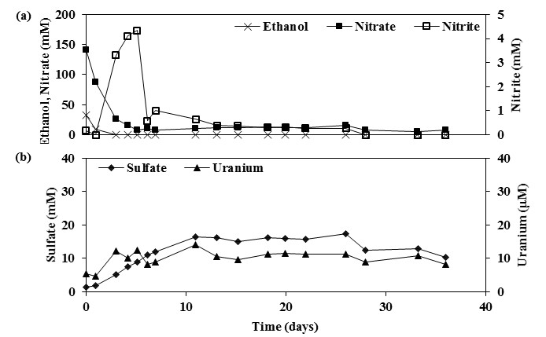

Figure 2.3 Dilution-adjusted concentrations of nitrate and nitrite (a) and sulfate and U(VI) (b) in well FW226 amended with 30 mM ethanol and 120 mM nitrate

The concentrations of nitrate and nitrite between days 28 and 36 decreased to below the method detection limit, during which time, concentrations of sulfate and U(VI) also decreased (Figure 2.3). These results suggested that oxidation of reduced sulfur-bearing species and U(IV) was nitrate dependent. The pH in well FW226 remained at pre-test levels for the duration of the test (data not shown). Similar results were observed in replicate wells FW218 and FW227 (Appendix).
Average recovery factors, plus or minus one standard deviation, for U(VI) and sulfate in the triplicate well cluster 2 were 1.3±0.4 and 14±5, respectively (Table 2.3). These results demonstrated that substantially more sulfate, but not U(VI), was recovered relative to bromide. However, these results also suggested that adding ethanol had a negligible effect on limiting the oxidation of sulfur and/or U(IV) by high nitrate as made evident by the similar recovery factors for sulfate and U(VI) in the high nitrate (cluster 1) and high nitrate with ethanol (cluster 2) treatments (Table 2.3). Nevertheless, the calculated recovery factors for sulfate and U(VI) (Table 2.3) and the observed nitrate removal and concurrent sulfate production (Appendix) strongly suggested that reoxidation of uranium under nitrate-reducing conditions was substantially limited by preferential oxidation of reduced sulfur-bearing species.

2.4.4. Push-pull tests: Uranium mobility in the presence of low nitrate and ethanol
Removal of low nitrate (2 mM) and ethanol (30 mM) was concurrent with a sharp increase in nitrite concentrations (up to 2 mM) in well FW222 for the first 3 days of the test (Figure 2.4). During this time, sulfate and U(VI) concentrations increased sharply (up to 30 mM and 30 μM, respectively) (Figure 2.4). These results suggested that nitrate reduction was coupled to ethanol, sulfur and U(IV) oxidation. Sulfur and U(IV) oxidation by nitrate was not expected
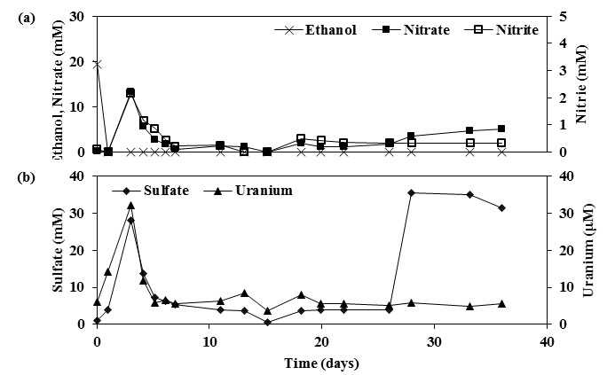

Figure 2.4 Dilution-adjusted concentrations of nitrate and nitrite (a) and sulfate and U(VI) (b) in well FW222 amended with 30 mM ethanol and 2 mM nitrate

because ethanol was added in excess (40-fold) of the stoichiometric demand for nitrate reduction (Table 2.1). After day 3, nitrate, nitrite, sulfate and U(VI) concentrations decreased sharply and remained low until day 26 (Figure 2.4). After day 26, sulfate concentrations increased sharply (up to 35 mM) in the presence of relatively low nitrate and nitrite while U(VI) concentrations remained near injection levels (5 μM) (Figure 2.4). These results suggested that preferential reoxidation of reduced sulfur-bearing species, as opposed to reoxidation of U(IV), occurred after day 26 in well FW222. However, sulfate and U(VI) concentrations increased to levels which greatly exceeded injection concentrations in the presence of relatively low nitrate and nitrite during later stages of the test in the replicate wells FW221 and FW223 (Appendix). These results suggested that concurrent reoxidation of reduced sulfur-bearing species and U(IV) occurred after day 26 wells FW221 and FW223 and indicated that an oxidant in addition to nitrate and nitrite may be have been present. The pH in well cluster 3 remained at pre-test levels for the duration of the tests (data not shown).
Average recovery factors, plus or minus one standard deviation, for U(VI) and sulfate in the triplicate well cluster 3 were 0.7±0.5 and 5.5±1.3, respectively (Table 2.3). These results demonstrated that substantially more sulfate, but not U(VI), was recovered relative to bromide. These results also suggested that low nitrate had a noticeable effect on limiting the oxidation of sulfur and/or U(IV) as evident by the higher recovery factors for sulfate and U(VI) in the high nitrate (cluster 1) and high nitrate with ethanol (cluster 2) treatments (Table 2.3).

2.4.5. Thermodynamics
The standard-state Gibbs free energies of several simple redox reactions that may have occurred during the reoxidation tests were computed (Table 2.4) in order to compare to the experimental data from the reoxidation tests. It is important to recognize that standard-state conditions (25°C, 1atm, and unit molality) may yield Gibbs free energies that are different than those calculated under system-specific conditions. The energetics of nitrate oxidation of reduced sulfur-bearing species that were likely formed during the biostimulation tests (S⁰, FeS, FeS₂, MnS,) were substantially more favorable than for the oxidation of uraninite (Table 2.4). Similar energetics were calculated for nitrite as the oxidant (Table 2.4). The energetics of the predicted reoxidation reactions were comparable to the computed recovery factors for sulfate and U(VI) under nitrate-reducing conditions as evident by substantially more sulfate recovered when compared to U(VI) during all three reoxidation tests (Table 2.3). This comparison further suggested that preferential oxidation of reduced sulfur-bearing species by nitrate and/or nitrite, as predicted thermodynamically, was also observed in this study under in situ conditions. However, the in situ data also suggested that concurrent reoxidation of reduced sulfur-bearing species and U(IV) did occur under both nitrate-reducing conditions and conditions in which nitrate and/or nitrite concentrations were not detectable (Figure 2.2, Figure 2.3, Figure 2.4); although to a much lesser extent for U(IV) (Table 2.3), which does not fully agree with the energetics (Table 2.4). This suggested that the system-specific conditions may yield different energetics and/or that we did not identify all of the predominant redox reactions (Table 2.4).

2.5. Conclusions
The results of this study suggested that the in situ mobility of uranium under nitrate-reducing conditions can be substantially limited by preferential oxidation of reduced sulfur-bearing species. This study also suggested that the addition of ethanol can result in less reoxidation of uranium by nitrate if added in substantial excess of the stoichiometric demand of nitrate as an electron acceptor. The thermodynamics of the predicted reoxidation reactions were supported by the in situ data and suggested that thermodynamically-favorable oxidation of

Table 2.4 Standard-state (25°C, 1 atm, and unit molality) Gibbs free energies of uraninite (UO₂) and various reduced sulfur-bearing species (S⁰, FeS, FeS₂, MnS) reoxidized by nitrate (NO₃⁻) and nitrite (NO₂⁻), free energy values for the formation of reactants and products were obtained from Dean (1999)
Reaction # | Reaction Stoichiometery | ΔG_{r}º  (kJ)
 | Nitrate as Oxidant
1 | UO₂ + 0.4NO₃⁻ + 2.4H⁺ → UO₂²⁺ + 0.2N₂ + 1.2H₂O | -162
2 | S⁰ + 1.2NO₃⁻ + 0.4H₂O → SO₄²⁻ + 0.6N₂ + 0.8H⁺ | -516
3 | FeS + 1.6NO₃⁻ + 1.6H⁺ → SO₄²⁻ + 0.8N₂ + Fe²⁺ + 0.8H₂O | -735
4 | FeS₂ + 2.8NO₃⁻ + 0.8H⁺ → 2SO₄²⁻ + 1.4N₂ + Fe²⁺ + 0.4H₂O | -1184
5 | MnS + 1.6NO₃⁻ + 1.6H⁺ → SO₄²⁻ + 0.8N₂ + Mn²⁺ + 0.8H₂O | -766
 | Nitrite as Oxidant
6 | UO₂ + 0.7NO₂⁻ + 2.7H⁺ → UO₂²⁺ + 0.3N₂ + 1.3H₂O | -216
7 | S⁰ + 2NO₂⁻ → SO₄²⁻ + N₂ | -680
8 | FeS + 2.7NO₂⁻ + 2.8H⁺ → SO₄²⁻ + 1.35N₂ + Fe²⁺ + 1.4H₂O | -968
9 | FeS₂ + 4.7NO₂⁻ + 2.8H⁺ → 2SO₄²⁻ 2.35N₂ + Fe²⁺ + 1.4H₂O | -1582
10 | MnS + 2.7NO₂⁻ + 2.8H⁺ → SO₄²⁻ + 1.35N₂ + Mn²⁺ + 1.4H₂O | -999

common reduced sulfur-bearing minerals by nitrate and/or nitrite, as opposed to oxidation of uraninite, likely occurred. However, concurrent oxidation of reduced sulfur-bearing species and to a much lesser extent, U(IV), was also observed under nitrate-reducing conditions and in the absence of detectable nitrate and/or nitrite. This suggested that reduced sulfur-bearing species were not fully effective at limiting the mobility of uranium in the presence of dissolved and/or solid-phase oxidants. Therefore, future in situ studies designed to test the effectiveness and long-term sustainability of this approach under natural-gradient conditions and to elucidate the predominant redox reactions are needed. Nevertheless, this in situ study confirmed the results of previous laboratory studies and demonstrated that establishing sulfate-reducing conditions following U(VI) reduction can substantially limit the extent of uranium mobility in the presence of nitrate oxidant.

2.6. References
Abdelouas, A., W. Lutze, W. L. Gong, E. H. Nuttall, B. A. Strietelmeier & B. J. Travis, 2000. Biological reduction of uranium in groundwater and subsurface soil. Sci Total Environ 250(1-3):21-35 doi:10.1016/s0048-9697(99)00549-5.
Abdelouas, A., W. Lutze & H. E. Nuttall, 1999. Oxidative dissolution of uraninite precipitated on Navajo sandstone. J Contam Hydrol 36(3-4):353-375 doi:10.1016/s0169-7722(98)00151-x.
Aller, R. C. & P. D. Rude, 1988. Complete oxidation of solid-phase sulfides by manganese and bacteria in anoxic marine-sediments. Geochim Cosmochim Ac 52(3):751-765 doi:10.1016/0016-7037(88)90335-3.
Anderson, R. T., H. A. Vrionis, I. Ortiz-Bernad, C. T. Resch, P. E. Long, R. Dayvault, K. Karp, S. Marutzky, D. R. Metzler, A. Peacock, D. C. White, M. Lowe & D. R. Lovley, 2003. Stimulating the in situ activity of Geobacter species to remove uranium from the groundwater of a uranium-contaminated aquifer. Appl Environ Microb 69(10):5884-5891 doi:10.1128/aem.69.10.5884-5891.2003.
Arthur, R. C., T. Iwatsuki, E. Sasao, R. Metcalfe, K. Amano & K. Ota, 2006. Geochemical constraints on the origin and stability of the Tono Uranium Deposit, Japan. Geochem-Explor Env A 6:33-48 doi:10.1144/1467-7873/05-081.
Barnett, M. O., P. M. Jardine & S. C. Brooks, 2002. U(VI) adsorption to heterogeneous subsurface media: Application of a surface complexation model. Environ Sci Technol 36(5):937-942 doi:Doi 10.1021/Es010846i.
Bi, Y. Q. & K. F. Hayes, 2014a. Nano-FeS Inhibits UO2 Reoxidation under Varied Oxic Conditions. Environ Sci Technol 48(1):632-640 doi:10.1021/es4043353.
Bi, Y. Q. & K. F. Hayes, 2014b. Surface Passivation Limited UO2 Oxidative Dissolution in the Presence of FeS. Environ Sci Technol 48(22):13402-13411 doi:10.1021/es5041392.
Bi, Y. Q., S. P. Hyun, R. K. Kukkadapu & K. F. Hayes, 2013. Oxidative dissolution of UO2 in a simulated groundwater containing synthetic nanocrystalline mackinawite. Geochim Cosmochim Ac 102:175-190 doi:10.1016/j.gca.2012.10.032.
Brugge, D., J. L. de Lemos & B. Oldmixon, 2005. Exposure pathways and health effects associated with chemical and radiological toxicity of natural uranium: A review. Reviews on Environmental Health 20(3):177-193.
Campbell, K. M., H. Veeramani, K. U. Urich, L. Y. Blue, D. E. Giammar, R. Bernier-Latmani, J. E. Stubbs, E. Suvorova, S. Yabusaki, J. S. Lezama-Pacheco, A. Mehta, P. E. Long & J. R. Bargar, 2011. Oxidative Dissolution of Biogenic Uraninite in Groundwater at Old Rifle, CO. Environ Sci Technol 45(20):8748-8754 doi:10.1021/es200482f.
Carpenter, J., Y. Q. Bi & K. F. Hayes, 2015. Influence of Iron Sulfides on Abiotic Oxidation of UO2 by Nitrite and Dissolved Oxygen in Natural Sediments. Environ Sci Technol 49(2):1078-1085 doi:10.1021/es504481n.
Chakraborty, S., F. Favre, D. Banerjee, A. C. Scheinost, M. Mullet, J.-J. Ehrhardt, J. Brendle, L. Vidal & L. Charlet, 2010. U(VI) Sorption and Reduction by Fe(II) Sorbed on Montmorillonite. Environ Sci Technol 44(10):3779-3785 doi:10.1021/es903493n.
Dean, J. A., 1999. Lange's Handbook of Chemistry, Fifteenth edn. McGRAW-HILL, INC.
Dullies, F., W. Lutze, W. L. Gong & H. E. Nuttall, 2010. Biological reduction of uranium-From the laboratory to the field. Sci Total Environ 408(24):6260-6271 doi:10.1016/j.scitotenv.2010.08.018.
Fang, Y., T. D. Scheibe, E. E. Roden, W. Kamolpornwijit & S. C. Brooks, 3D Field-Scale Reactive Transport Modeling of in situ Immobilization of Uranium in Structured Porous Media via Biostimulation. In: CMWR-XVI Copenhagen, Denmark, 2006.
Finster, K., W. Liesack & B. Thamdrup, 1998. Elemental sulfur and thiosulfate disproportionation by Desulfocapsa sulfoexigens sp nov, a new anaerobic bacterium isolated from marine surface sediment. Appl Environ Microb 64(1):119-125.
Goodwin, B., 1982. Calculated Uranium Solubility in Groundwater - Implications for Nuclear-Fuel Waste-Disposal. Can J Chem 60(13):1759-1766 doi:10.1139/v82-241.
Grenthe, I. J., R. J. M. Fuger, R. J. Konings, A. B. Lemire, C. Muller, Nguyen-Trung & H. Wanner, 1992. Chemical Thermodynamics of Uranium. Nuclear Energy Agency, North-Holland NY.
Hyun, S. P., J. A. Davis & K. F. Hayes, 2014. Abiotic U(VI) reduction by aqueous sulfide. Appl Geochem 50:7-15 doi:10.1016/j.apgeochem.2014.07.021.
Hyun, S. P., J. A. Davis, K. Sun & K. F. Hayes, 2012. Uranium(VI) Reduction by Iron(II) Monosulfide Mackinawite. Environ Sci Technol 46(6):3369-3376 doi:10.1021/es203786p.
Istok, J. D., 2013. Push-Pull Tests for Site Characterization, vol 144. Springer-Verlag Berlin Heidelberg.
Istok, J. D., J. M. Senko, L. R. Krumholz, D. Watson, M. A. Bogle, A. Peacock, Y. J. Chang & D. C. White, 2004. In situ bioreduction of technetium and uranium in a nitrate-contaminated aquifer. Environ Sci Technol 38(2):468-475 doi:Doi 10.1021/Es034639p.
Iwatsuki, T., R. Arthur, K. Ota & R. Metcalfe, 2004. Solubility constraints on uranium concentrations in groundwaters of the Tono uranium deposit, Japan. Radiochim Acta 92(9-11):789-796 doi:10.1524/ract.92.9.789.54986.
Jeon, B. H., B. A. Dempsey, W. D. Burgos, M. O. Barnett & E. E. Roden, 2005. Chemical reduction of U(VI) by Fe(II) at the solid-water interface using natural and synthetic Fe(III) oxides. Environ Sci Technol 39(15):5642-5649 doi:10.1021/es0487527.
Kelly, D. P. & A. P. Wood, 2000. Confirmation of Thiobacillus denitrificans as a species of the genus Thiobacillus, in the beta-subclass of the Proteobacteria, with strain NCIMB 9548 as the type strain. International Journal of Systematic and Evolutionary Microbiology 50:547-550.
Kelly, S. D., K. M. Kemner, J. Carley, C. Criddle, P. M. Jardine, T. L. Marsh, D. Phillips, D. Watson & W.-M. Wu, 2008. Speciation of uranium in sediments before and after in situ biostimulation. Environ Sci Technol 42(5):1558-1564 doi:10.1021/es071764i.
Kelly, S. D., W.-M. Wu, F. Yang, C. S. Criddle, T. L. Marsh, E. J. O'Loughlin, B. Ravel, D. Watson, P. M. Jardine & K. M. Kemner, 2010. Uranium Transformations in Static Microcosms. Environ Sci Technol 44(1):236-242 doi:10.1021/es902191s.
Li, D. & D. I. Kaplan, 2012. Sorption coefficients and molecular mechanisms of Pu, U, Np, Am and Tc to Fe (hydr)oxides: A review. J Hazard Mater 243:1-18 doi:10.1016/j.jhazmat.2012.09.011.
Lloyd, J. R. & J. C. Renshaw, 2005. Bioremediation of radioactive waste: radionuclide-microbe interactions in laboratory and field-scale studies. Curr Opin Biotech 16(3):254-260 doi:10.1016/j.copbio.2005.04.012.
Luan, F. B., G. X. Zhang, J. M. Senko & W. D. Burgos, 2015. Effects of supplemental organic carbon on long-term reduction and reoxidation of uranium. Rsc Advances 5(41):32210-32216 doi:10.1039/c5ra02550h.
Mohanty, S. R., B. Kollah, D. B. Hedrick, A. D. Peacock, R. K. Kukkadapu & E. E. Roden, 2008. Biogeochemical processes in ethanol stimulated uranium-contaminated subsurface sediments. Environ Sci Technol 42(12):4384-4390 doi:10.1021/es703082v.
Moon, H. S., J. Komlos & P. R. Jaffe, 2007. Uranium reoxidation in previously bioreduced sediment by dissolved oxygen and nitrate. Environ Sci Technol 41(13):4587-4592 doi:10.1021/es063063b.
Moon, H. S., J. Komlos & P. R. Jaffe, 2009. Biogenic U(IV) oxidation by dissolved oxygen and nitrate in sediment after prolonged U(VI)/Fe(III)/SO42- reduction. J Contam Hydrol 105(1-2):18-27 doi:10.1016/j.jconhyd.2008.10.014.
Moon, J.-W., Y. Roh, T. J. Phelps, D. H. Phillips, D. B. Watson, Y.-J. Kim & S. C. Brooks, 2006. Physicochemical and mineralogical characterization of soil-saprolite cores from a field research site, Tennessee. J Environ Qual 35(5):1731-1741 doi:10.2134/jeq2005.0123.
N'Guessan, A. L., H. S. Moon, A. D. Peacock, H. Tan, M. Sinha, P. E. Long & P. R. Jaffe, 2010. Postbiostimulation microbial community structure changes that control the reoxidation of uranium. Fems Microbiol Ecol 74(1):184-195 doi:10.1111/j.1574-6941.2010.00933.x.
Newsome, L., K. Morris & J. R. Lloyd, 2014. The biogeochemistry and bioremediation of uranium and other priority radionuclides. Chem Geol 363:164-184 doi:10.1016/j.chemgeo.2013.10.034.
Noseck, U., E.-L. Tullborg, J. Suksi, M. Laaksoharju, V. Havlova, M. A. Denecke & G. Buckau, 2012. Real system analyses/natural analogues. Appl Geochem 27(2):490-500 doi:10.1016/j.apgeochem.2011.09.017.
O'Loughlin, E. J., M. I. Boyanov, D. A. Antonopoulos & K. M. Kemner, 2011. Redox Processes Affecting the Speciation of Technetium, Uranium, Neptunium, and Plutonium in Aquatic and Terrestrial Environments. In Tratnyek, P. G., T. J. Grundl & S. B. Haderlein (eds) Aquatic Redox Chemistry. ACS Symposium Series, vol 1071, 477-517.
Rose, S. & A. M. Ghazi, 1997. Release of sorbed sulfate from iron oxyhydroxides precipitated from acid mine drainage associated with coal mining. Environ Sci Technol 31(7):2136-2140 doi:10.1021/es960970f.
Schippers, A. & B. B. Jorgensen, 2001. Oxidation of pyrite and iron sulfide by manganese dioxide in marine sediments. Geochim Cosmochim Ac 65(6):915-922 doi:10.1016/s0016-7037(00)00589-5.
Schippers, A. & B. B. Jorgensen, 2002. Biogeochemistry of pyrite and iron sulfide oxidation in marine sediments. Geochim Cosmochim Ac 66(1):85-92 doi:10.1016/s0016-7037(01)00745-1.
Senko, J. M., J. D. Istok, J. M. Suflita & L. R. Krumholz, 2002. In-situ evidence for uranium immobilization and remobilization. Environ Sci Technol 36(7):1491-1496 doi:10.1021/es011240x.
Sharp, J. O., J. S. Lezama-Pacheco, E. J. Schofield, P. Junier, K.-U. Ulrich, S. Chinni, H. Veeramani, C. Margot-Roquier, S. M. Webb, B. M. Tebo, D. E. Giammar, J. R. Bargar & R. Bernier-Latmani, 2011. Uranium speciation and stability after reductive immobilization in aquifer sediments. Geochim Cosmochim Ac 75(21):6497-6510 doi:10.1016/j.gca.2011.08.022.
Singh, G., S. S. Sengor, A. Bhalla, S. Kumar, J. De, B. Stewart, N. Spycher, T. M. Ginn, B. M. Peyton & R. K. Sani, 2014. Reoxidation of Biogenic Reduced Uranium: A Challenge Toward Bioremediation. Critical Reviews in Environmental Science and Technology 44(4):391-415 doi:10.1080/10643389.2012.728522.
Smith, M. B., A. M. Rocha, C. S. Smillie, S. W. Olesen, C. Paradis, L. Wu, J. H. Campbell, J. L. Fortney, T. L. Mehlhorn, K. A. Lowe, J. E. Earles, J. Phillips, S. M. Techtmann, D. C. Joyner, D. A. Elias, K. L. Bailey, R. A. Hurt, Jr., S. P. Preheim, M. C. Sanders, J. Yang, M. A. Mueller, S. Brooks, D. B. Watson, P. Zhang, Z. He, E. A. Dubinsky, P. D. Adams, A. P. Arkin, M. W. Fields, J. Zhou, E. J. Alm & T. C. Hazen, 2015. Natural Bacterial Communities Serve as Quantitative Geochemical Biosensors. Mbio 6(3) doi:10.1128/mBio.00326-15.
Spain, A. M. & L. R. Krumholz, 2011. Nitrate-Reducing Bacteria at the Nitrate and Radionuclide Contaminated Oak Ridge Integrated Field Research Challenge Site: A Review. Geomicrobiol J 28(5-6):418-429 doi:10.1080/01490451.2010.507642.
Thamdrup, B., K. Finster, J. W. Hansen & F. Bak, 1993. Bacterial disproportionation of elemental sulfur coupled to chemical-reduction of iron or manganese. Appl Environ Microb 59(1):101-108.
Vrionis, H. A., R. T. Anderson, I. Ortiz-Bernad, K. R. O'Neill, C. T. Resch, A. D. Peacock, R. Dayvault, D. C. White, P. E. Long & D. R. Lovley, 2005. Microbiological and geochemical heterogeneity in an in situ uranium bioremediation field site. Appl Environ Microb 71(10):6308-6318 doi:Doi 10.1128/Aem.71.10.6308-6318.2005.
Wall, J. D. & L. R. Krumholz, 2006. Uranium reduction Annu Rev Microbiol. Annual Review of Microbiology, vol 60, 149-166.
Wan, J. M., T. K. Tokunaga, E. Brodie, Z. M. Wang, Z. P. Zheng, D. Herman, T. C. Hazen, M. K. Firestone & S. R. Sutton, 2005. Reoxidation of bioreduced uranium under reducing conditions. Environ Sci Technol 39(16):6162-6169 doi:10.1021/es048236g.
Watson, D. B., J. E. Kostka, M. W. Fields & P. M. Jardine, 2004. The Oak Ridge Field Research Center Conceptual Model. In: Energy, U. S. D. o. (ed). United States Department of Energy, Oak Ridge, TN.
Watson, D. B., W. M. Wu, T. Mehlhorn, G. P. Tang, J. Earles, K. Lowe, T. M. Gihring, G. X. Zhang, J. Phillips, M. I. Boyanov, B. P. Spalding, C. Schadt, K. M. Kemner, C. S. Criddle, P. M. Jardine & S. C. Brooks, 2013. In situ Bioremediation of Uranium with Emulsified Vegetable Oil as the Electron Donor. Environmental Science & Technology 47(12):6440-6448 doi:10.1021/es3033555.
Wu, W.-M., J. Carley, T. Gentry, M. A. Ginder-Vogel, M. Fienen, T. Mehlhorn, H. Yan, S. Caroll, M. N. Pace, J. Nyman, J. Luo, M. E. Gentile, M. W. Fields, R. F. Hickey, B. Gu, D. Watson, O. A. Cirpka, J. Zhou, S. Fendorf, P. K. Kitanidis, P. M. Jardine & C. S. Criddle, 2006. Pilot-scale in situ bioremedation of uranium in a highly contaminated aquifer. 2. Reduction of U(VI) and geochemical control of U(VI) bioavailability. Environ Sci Technol 40(12):3986-3995 doi:10.1021/es051960u.
Wu, W.-M., J. Carley, J. Luo, M. A. Ginder-Vogel, E. Cardenas, M. B. Leigh, C. Hwang, S. D. Kelly, C. Ruan, L. Wu, J. Van Nostrand, T. Gentry, K. Lowe, T. Mehlhorn, S. Carroll, W. Luo, M. W. Fields, B. Gu, D. Watson, K. M. Kemner, T. Marsh, J. Tiedje, J. Zhou, S. Fendorf, P. K. Kitanidis, P. M. Jardine & C. S. Criddle, 2007. In situ bioreduction of uranium (VI) to submicromolar levels and reoxidation by dissolved oxygen. Environ Sci Technol 41(16):5716-5723 doi:10.1021/es062657b.
Wu, W. M., J. Carley, S. J. Green, J. Luo, S. D. Kelly, J. Van Nostrand, K. Lowe, T. Mehlhorn, S. Carroll, B. Boonchayanant, F. E. Lofller, D. Watson, K. M. Kemner, J. Z. Zhou, P. K. Kitanidis, J. E. Kostka, P. M. Jardine & C. S. Criddle, 2010. Effects of Nitrate on the Stability of Uranium in a Bioreduced Region of the Subsurface. Environ Sci Technol 44(13):5104-5111 doi:10.1021/es1000837.

2.7. Appendix
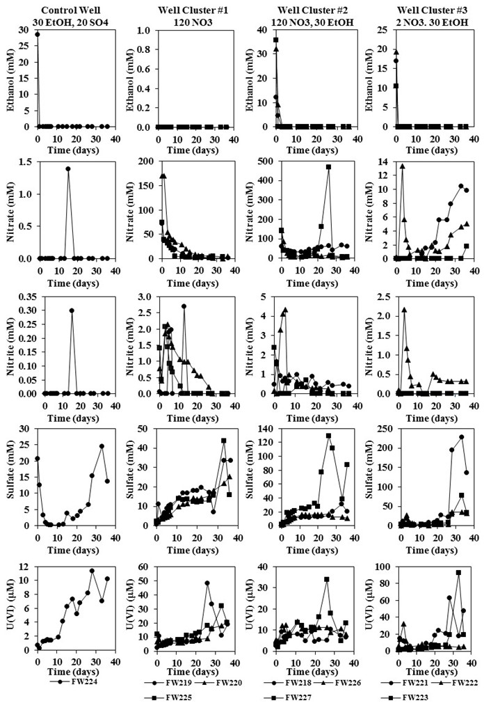

Push-pull tests for estimating effective porosity: expanded analytical solution and in situ application

Chapter 3 was published in Hydrogeology Journal.

Paradis, C. J., L. D. McKay, E. Perfect, J. D. Istok & T. C. Hazen, 2017. Push-pull tests for estimating effective porosity: expanded analytical solution and in situ application. Hydrogeology Journal doi:10.1007/s10040-017-1672-3.

3.1. Abstract
The analytical solution to describe the one-dimensional displacement of the center of mass of a tracer during an injection, drift, and extraction test (push-pull test) was expanded to account for displacement during the injection phase to improve the in situ estimation of effective porosity. The truncated equation, which assumes displacement during the injection phase is negligible, may theoretically lead to an underestimation of the true value of effective porosity. In order to experimentally compare the expanded and truncated equations, single-well push-pull tests were conducted among six test wells within a shallow and unconfined aquifer comprised of unconsolidated and heterogeneous silty and clayey fill materials. The push-pull tests were conducted by injecting bromide tracer, followed by a non-pumping period, and subsequent extraction of groundwater. The values of effective porosity from the expanded equation (0.6% to 5.0%) were substantially greater than those from the truncated equation (0.1% to 1.3%). The expanded and truncated equations were compared to data from previous push-pull studies in the literature and demonstrated that displacement during the injection phase may or may not be negligible, depending on the aquifer properties and the push-pull test parameters. The results of the tests presented here also demonstrated that: (1) the spatial variability of effective porosity, within a relatively small study site, can be substantial and (2) the error-propagated uncertainty of effective porosity can be mitigated to a reasonable level (< ± 1%). In conclusion, the expanded analytical solution improved the theoretical description of the displacement of a tracer during a push-pull test and the in situ application demonstrated an improvement for the estimation of effective porosity.

3.2. Introduction
The effective porosity of saturated porous media is a fundamental hydrogeological parameter for modeling the fate and transport of dissolved-phase contaminants in the subsurface. Reliable modeling is highly dependent on accurate characterization of effective porosity. Field-scale tracer-based methods are particularly attractive to estimate effective porosity because they directly measure the in situ transport of a dissolved-phase constituent. The single-well push-pull test method has been developed to estimate effective porosity and has been successfully applied in situ. However, the current analytical model assumes the transport of the tracer during the push phase is negligible, which may or may not be an appropriate assumption in all cases. Theoretically, neglecting to account for the transport of the tracer during the push phase may lead to an underestimation of effective porosity. In this study, the analytical solution to describe the displacement of a tracer during a push-pull test was expanded to account for the push phase and then applied in situ to estimate the effective porosity among six test wells within a shallow and unconfined aquifer.
Effective porosity can be qualitatively defined as the volume of the void spaces through which water or other fluids can travel (by advection) in a rock or sediment divided by the total volume of the rock or sediment (Fetter 2001). Domenico and Schwartz (1998) explained that effective porosity implies some connectivity through the porous medium and is more closely related to permeability than is total porosity. The definition and conceptualization of effective porosity has led to the use of more descriptive terms such as: mobile porosity, kinematic porosity, and dynamic porosity. Determining the appropriate value of effective porosity for groundwater models can be challenging, due in part, to the spatial heterogeneity of porous media. Field-scale tracer-based studies have shown that effective porosity in granular porous media can range from 40% (alluvial sediments; fine sands, and glacial till) to 0.4% (layered medium sand) and in fractured porous media from 60% (fractured dolomite and limestone) to 0.5% (fractured chalk) (Gelhar et al. 1992). There is also increasing evidence that effective porosity is dependent on the scale at which it is assessed, i.e., effective porosity tends to decrease with increasing scale (Li 1995; Stephens et al. 1998).
Methods to estimate effective porosity typically rely on calculating proxy parameters such as specific yield (Meinzer 1923a) or correlating grain-size distribution and soil-water characteristic curves to representative values of specific yield (Meinzer 1923b). Estimation-based methods have the disadvantage of being indirect but are relatively simple to conduct. Methods to calculate effective porosity typically rely on conducting tracer-based tests and interpretation of subsequent breakthrough curves (Stephens et al. 1998). Tracer-based methods have the advantage of being direct but can be relatively difficult to conduct, especially at the field scale. Moreover, the interpretation of breakthrough curves requires careful consideration of the properties of the tracer and the porous media. For example, tracer mass transport mechanisms such as: (1) sorption to the porous media, (2) diffusion from mobile to immobile pore water, (3) volatilization to the unsaturated zone, and (4) degradation or transformation are not truly representative of the void spaces through which water can travel by advection, i.e., effective porosity (Davis et al. 1980; Turnadge and Smerdon 2014).
Hall et al. (1991) developed a relatively simple tracer-based method to calculate effective porosity based on conducting and interpreting the data from a single-well push-pull test. A single-well push-pull test is conducted by injecting (push phase) a volume of water containing a tracer into a single well, followed by a non-pumping period (drift phase), and subsequent extraction (pull phase) of groundwater from the same well in order to generate a breakthrough curve (Istok 2013). A single-well push-pull test has the threefold advantage of being direct, simple, and field scale. The Hall et al. (1991) method was theoretically developed for a confined, homogeneous, and isotropic aquifer but was experimentally validated at the field scale in an unconfined, heterogeneous, and sandy aquifer. Hall et al. (1991) compared the effective porosity calculated from a single-well push-pull test to a dual-well natural-gradient test and found that both tests yielded similar values. However, the Hall et al. (1991) method assumed that: (1) the transport of the tracer during the push phase was negligible and (2) the uncertainty in the calculation of effective porosity was negligible. Moreover, the Hall et al. (1991) application was limited to a single well. Although the assumptions and spatially limited application by Hall et al. (1991) may have been valid and appropriate, respectively, in their case study, such assumptions and application may not be appropriate at other sites with variable aquifer properties, push-pull test parameters, and study objectives.
The purpose of this study was to utilize the single-well push-pull test method to characterize the magnitude and spatial variability of effective porosity within an unconfined and uranium-contaminated aquifer. The novelty of this study was threefold: (1) the expansion of the Hall et al. (1991) analytical solution to include the transport of the tracer during the push phase, (2) the performing of an uncertainty analysis for the calculation of effective porosity, and (3) the assessment of the spatial variability of effective porosity within a study site.

3.3. Materials and methods

3.3.1. Theory
The volume of water injected into, or extracted from, an aquifer at a constant pumping rate, is given by:
$$\begin{aligned}V=\left|Q\right|t\#(1)\end{aligned}$$
where:
V = volume of water [L³]
Q = constant pumping rate [L³/T]
t = elapsed time during pumping [T]
By convention, the pumping rate (Q) is positive during injection and negative during extraction. If the aquifer is confined, homogeneous, and isotropic, and if the ambient groundwater flow is negligible, the cylindrical volume of water injected into, or extracted from, a fully-penetrating well, is given by:
$$\begin{aligned}V=πr^{2}bn_{e}\#(2)\end{aligned}$$
where:
r = radius of water [L]
b = saturated aquifer thickness [L]
n_{e} = effective porosity [dimensionless]
If the saturated aquifer thickness is constant, equating (1) and (2), and rearranging gives:
$$\begin{aligned}r={\left(\frac{\left|Q\right|t}{πbn_{e}}\right)}^{1/2}\#(3)\end{aligned}$$
Equation (3) describes the leading- or trailing-edge position of a particle of water within an expanding or contracting cylindrical volume of water as it is injected into, or extracted from, an aquifer.
Darcy’s law can be written to include effective porosity as:
$$\begin{aligned}v=\frac{-K\frac{dh}{dr}}{n_{e}}\#(4)\end{aligned}$$
where:
v = average linear groundwater velocity [L/T]
K = hydraulic conductivity [L/T]
dh/dr = hydraulic gradient [L/L]
Equation (4) describes the average linear velocity of a particle of water within an aquifer due to ambient groundwater flow.
Velocity, in general terms, is given by:
$$\begin{aligned}v=\frac{∆r}{∆t}\#(5)\end{aligned}$$
where:
Δr = traveled distance [L]
Δt = elapsed time [T]
Equation (5) can be rearranged to give:
$$\begin{aligned}Δr=vΔt\#(6)\end{aligned}$$
Equation (6) describes the average position of a particle of water within an aquifer due to ambient groundwater flow. The one-dimensional displacement of the center of mass of a tracer, after completion of the injection, drift, and extraction phases of a push-pull test, is zero (Figure 3.1). The displacement of the center of mass of the tracer is given by:
$$\begin{aligned}r_{1} {+ r}_{2}+r_{3}=0\#(7)\end{aligned}$$
where:
r₁ = displacement during injection [L]
r₂ = displacement during drift [L]
r₃ = displacement during extraction [L]

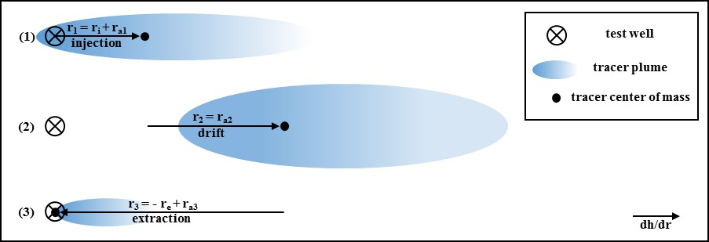

Figure 3.1 Plan-view depiction of the center of mass of a tracer at the end of the injection (1), drift (2), and extraction (3) phases, r_{i} = displacement due to injection, r_{a} = displacement due to ambient groundwater flow, r_{e} = displacement due to extraction

The displacement of the tracer during: (1) the injection phase, is due to injection pumping (r_{i}) and ambient groundwater flow (r_{a1}), (2) the drift phase, is due to ambient groundwater flow (r_{a2}), and (3) the extraction phase, is due to extraction pumping (-r_{e}) and ambient groundwater flow (r_{a3}) (Figure 3.1). The components of the displacement of the center of mass of the tracer during the push-pull test can be substituted in equation (7) to give:
$$\begin{aligned}\left(r_{i}{+ r}_{a1}\right)+ \left(r_{a2}\right) + \left({-r}_{e}{+ r}_{a3}\right)=0\#(8)\end{aligned}$$
where:
r_{i} = displacement due to injection pumping [L]
r_{a1} = displacement due to ambient groundwater flow [L]
r_{a2} = displacement due to ambient groundwater flow [L]
r_{e} = displacement due to extraction pumping [L]
r_{a3} = displacement due to ambient groundwater flow [L]
The components in (8) can be substituted by their corresponding equations given in (3) and (6) to give:
$$\begin{aligned}\left({\left(\frac{\left|Q_{i}\right|t_{i}}{πbn_{e}}\right)}^{1/2}{+ v∆t}_{a1}\right)+ \left({v∆t}_{a2}\right) + \left({-\left(\frac{\left|Q_{e}\right|t_{e}}{πbn_{e}}\right)}^{1/2}{+ v∆t}_{a3}\right)=0\#(9)\end{aligned}$$
The components in (9), due to injection (first term) and extraction (fourth term), represent the leading- or trailing-edge position of the tracer within an expanding or contracting cylindrical volume of water, whereas the components due to ambient groundwater flow (vΔt_{a1}, vΔt_{a2}, and vΔt_{a3}), represent the average displacement of the tracer. The average displacement of the tracer, due to injection, occurs when one-half of the mass of the tracer has been injected, and is given by:
$$\begin{aligned}\left|Q_{i}\right|ṫ_{i}=\frac{\left|Q_{i}\right|t_{i}}{2}\#(10)\end{aligned}$$
where:
Q_{i} = injection rate [L³/T]
ṫ_{i} = time elapsed from the start of water injection until the center of mass of the tracer is released [T]
In volumetric terms, (10) can be rewritten to give:
$$\begin{aligned}Ѷ_{i}=\left|Q_{i}\right|ṫ_{i}\#(11)\end{aligned}$$
where:
Ѷ_{i} = volume of water injected until the center of mass of the tracer is released [L³]
The average displacement of the tracer, due to extraction, occurs when one-half of the mass of the tracer has been recovered, and is given by integration of the concentration versus volume data, i.e., the breakthrough curve, as:
$$\begin{aligned}M_{e}=\frac{1}{2}\int_{V_{0}}^{V_{1}}{C(V)dV}\#(12)\end{aligned}$$
where:
M_{e} = one-half of the mass of the recovered tracer [M]
V_{o} = volume of water recovered at the start of extraction pumping [L³]
V₁ = volume of water recovered at the end of extraction pumping [L³]
C(V) = concentration of the tracer (C) [M/L³] as a function of the volume (V) [L³] of water extracted
The corresponding volume at which one-half of the mass of the tracer has been recovered is given by evaluating the solution to (12) at M_{e} by:
$$\begin{aligned}M_{e}=M(Ѷ_{e})\#(13)\end{aligned}$$
where:
M(Ѷ_{e}) = mass of the tracer (M) [M] as a function of volume (Ѷ_{e}) [L³] at which one-half of the mass of the tracer has been recovered
It is important to note that the solution to (12) can be estimated numerically, as opposed to solved analytically, and doing so would allow for estimating Ѷ_{e}. The corresponding times at which Ѷ_{i} and Ѷ_{e} occur are given as:
$$\begin{aligned}ṫ_{i}=\frac{Ѷ}{\left|Q_{i}\right|}\#(14)\end{aligned}$$
$$\begin{aligned}ṫ_{e}=\frac{Ѷ_{e}}{\left|Q_{e}\right|}\#(15)\end{aligned}$$
Substituting Ѷ_{i} in (11), Ѷ_{e} in (13), ṫ_{i} in (14), and ṫ_{e} in (15) for Q_{i}t_{i}, Q_{e}t_{e}, Δt_{a1}, and Δt_{a3} in (9), respectively, gives:
$$\begin{aligned}{\left(\frac{Ѷ_{i}-Ѷ_{e}}{πbn_{e}}\right)}^{1/2}+v\left(ṫ_{i}+t_{d}{+ ṫ}_{e}\right) =0\#(16)\end{aligned}$$
where:
t_{d} = Δt_{a2} (time elapsed from the end of water injection until the start of water extraction) [T]
Equation (16) describes the average position of the center of mass of the tracer during the injection, drift, and extraction phases. Rearranging (16) to solve for average linear groundwater velocity gives:
$$\begin{aligned}v =\frac{{\left(\frac{Ѷ_{e}-Ѷ_{i}}{πbn_{e}}\right)}^{1/2}}{\left(ṫ_{i}+t_{d}{ + ṫ}_{e}\right)}\#(17)\end{aligned}$$
Equating (17) and (4), and solving for effective porosity (n_{e}) gives:
$$\begin{aligned}n_{e1}=\frac{πbK^{2}{\left(\frac{dh}{dr}\right)}^{2}{\left(ṫ_{i}+t_{d}{ + ṫ}_{e}\right)}^{2}}{Ѷ_{e}-Ѷ_{i}}\#(18)\end{aligned}$$
Equation (18) describes effective porosity (n_{e1}) as a function of the aquifer properties, e.g., saturated thickness (b), hydraulic conductivity (K), and hydraulic gradient (dh/dr), and the transport of the center of mass of the tracer during the injection (Ѷ_{i}, ṫ_{i}), drift (t_{d}), and extraction (Ѷ_{e}, ṫ_{e}) phases. Equations (17) and (18) are very similar to the Leap and Kaplan (1988) and Hall et al. (1991) equations, respectively.
From Leap and Kaplan (1988):
$$\begin{aligned}v =\frac{{\left(\frac{Ѷ_{e}}{πbn_{e}}\right)}^{1/2}}{\left(t_{d}{ + ṫ}_{e}\right)}\#(19)\end{aligned}$$
From Hall et al. (1991):
$$\begin{aligned}n_{e2}=\frac{πbK^{2}{\left(\frac{dh}{dr}\right)}^{2}{\left(t_{d}{ + ṫ}_{e}\right)}^{2}}{Ѷ_{e}}\#(20)\end{aligned}$$
However, (17) and (18) account for the transport of tracer during the injection phase (Ѷ_{i}, ṫ_{i}), whereas (19) and (20) do not. If the transport of the tracer during the injection phase is truly negligible, then Ѷ_{i} and ṫ_{i} are equal to zero, and (17) and (18) are equivalent to (19) and (20), respectively. If the transport of the tracer during the injection phase is not truly negligible, then Ѷ_{i} and ṫ_{i} are greater than zero, and (17) will yield lower values of average linear groundwater velocity than (19), and (18) will yield higher values of effective porosity than (20).

3.3.2. Study site
The study site is in Area 2 of the Oak Ridge Integrated Field Research Challenge (OR-IFRC) site in Oak Ridge, Tennessee, United States of America (Figure 3.2). A typical geologic profile of Area 2 consists of approximately 6 meters of unconsolidated and heterogeneous materials comprised of silty and clayey fill (soil, limestone, and clay-rich residuum), related to historical construction activities, underlain by undisturbed and clay-rich weathered bedrock
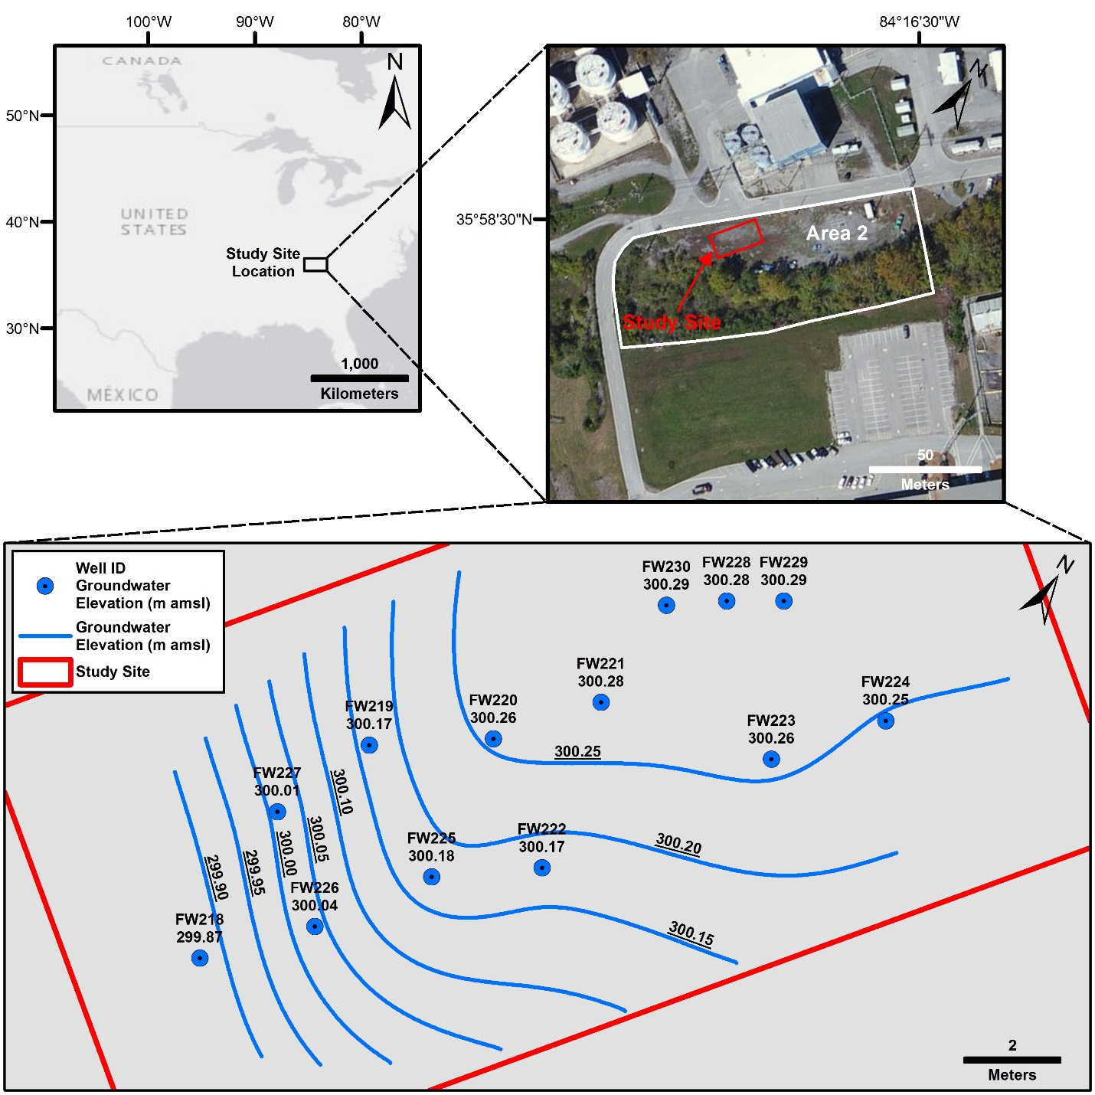

Figure 3.2 Plan-view maps of the study site, clockwise from upper left, country map showing study site location in the southeastern United States, area map showing study site location in Area 2 of the OR-IFRC, and study site map showing well locations, groundwater elevations, and groundwater elevation iso-contours, m amsl = meters above mean sea level

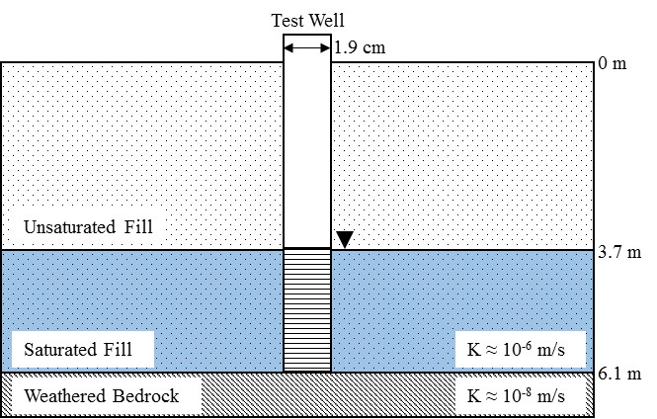

Figure 3.3 Vertical-view conceptual model of the shallow, unconfined, aquifer and construction details of a test well, horizontal exaggeration is 50-fold

(Moon et al. 2006; Watson et al. 2004) (Figure 3.3). Slug tests indicated that the hydraulic conductivity of the fill materials was approximately two orders of magnitude greater than the weathered bedrock, e.g., 10⁻⁶ m/s versus 10⁻⁸ m/s, respectively (Figure 3.3). The study site contains 13 monitoring wells (FW218 through FW230), six of which were used as test wells (FW220 through FW225), and one of which was used as a source well (FW229) for groundwater injectate for the single-well push-pull tests, as discussed in Section 2.5. (Figure 3.2). The test wells were installed by direct push coupled with continuous electrical resistivity profiling. The test wells are constructed of 1.9-cm inside diameter schedule-80 polyvinyl chloride (PVC) pipe and are screened from 3.7 to 6.1 meters below ground surface (mbgs) (Figure 3.3). The test wells are screened within the fill materials and were vertically terminated at contact with the undisturbed weathered bedrock; the contact with undisturbed weathered bedrock was determined by substantial difficulty in advancing the direct-push drill string and a concomitant and notable increase in electrical resistivity (Figure 3.3). The source well is constructed of 5.1-cm inside diameter schedule-40 PVC pipe and is screened from 3 to 7.5 mbgs. The shallow groundwater aquifer is unconfined and the depth to groundwater is approximately 3.5 mbgs (Figure 3.3). The site-wide average magnitude and direction of the hydraulic gradient, as determined graphically, is approximately -0.045 m/m and to the south/southwest, respectively (Figure 3.2).
The physical properties of the fill materials, in which the test wells are screened, are poorly characterized compared to those at other study sites located within Area 2. This is due, in part, to the lack of: (1) core samples from the direct-push test wells and (2) in situ hydraulic testing. However, there is no evidence to suggest that the fill materials at the study site are not representative of those known to exist within Area 2, i.e., unconsolidated and heterogeneous materials comprised of silty and clayey fill. It should be noted that the chemical and biological properties of the groundwater system at the study site are better characterized. More specially, a previous study by Paradis et al. (2016) reported that despite the high level of aquifer heterogeneity within Area 2, the biogeochemical processes associated with the reduction and oxidation of uranium within the study site wells (FW218 through FW227) were spatially consistent. Nevertheless, the spatial variability of the physical properties of the fill materials, e.g., hydraulic conductivity and effective porosity, were unknown at the time of this study.

3.3.3. Hydraulic gradient
The hydraulic gradient, within the vicinity of each test well, was estimated using ArcMap (version 10.5) software. The depth to groundwater, relative to the top of the casing (surveyed to 0.3-cm above mean sea level) of each site well, was measured using an electronic water level indicator (Solinst®) immediately prior to conducting single-well pumping and push-pull tests. The depth to groundwater measurements were converted to meters above mean sea level (m amsl) and uploaded to ArcMap, along with the coordinates (latitude and longitude) of each site well, to create a point shape file. The groundwater elevation data was interpolated, using the spline tool, to create a digital elevation model (raster file) of the water table (cell size = 0.15 meters, weight = 0, all other parameters set at default). The slope of the water table was calculated using the slope tool (z-factor = 1.171x10⁻⁵, based on latitude of study site). The average slope, within a 1-meter radius about each test well, was calculated using the zonal statistics tool. The rationale for a 1-meter radius, as representative of the hydraulic conditions within the vicinity of each test well, was based on equation (3) which describes the leading-edge position of a particle of water within an expanding cylindrical volume of water as it is injected into an aquifer, i.e., the maximum frontal position of bromide tracer during the injection phase of a push-pull test. We assumed, a priori, an effective porosity of 5%. For a 20-liter injection volume and a saturated aquifer thickness of 2.5 meters, the radius in equation (3) would be approximately 0.25 meters. It is important to note that equation (3) ignores heterogeneity and the drift phase of the push-pull tests which would lead to an underestimation of radius. Therefore, a 1-meter radius was assumed. The slope at each test well was converted from degrees to hydraulic gradient values and inputted into equations (18) and (20) to estimate effective porosity.

3.3.4. Hydraulic conductivity
The hydraulic conductivity, within the vicinity of each test well, was estimated by conducting single-well pumping tests. Single-well pumping tests were conducted according to the methodology of Robbins et al. (2009) and Aragon-Jose and Robbins (2011). In brief, groundwater was pumped from each test well at a constant discharge rate using a peristaltic pump (Geotech GeopumpTM) and stored in a 208-liter plastic drum. The discharge rate was measured using a graduated cylinder and a stop watch. The depth to groundwater was measured using an electronic water level indicator (Solinst®). The discharge rate and depth to groundwater were measured sequentially until steady-state conditions were achieved; steady-state conditions were defined as a change in drawdown less than 1.2 cm over the course of 15 minutes during a constant discharge rate.
Single-well pumping test data were analyzed according to the general methodology of Robbins et al. (2009) and Aragon-Jose and Robbins (2011). In brief, the steady-state discharge and drawdown values, along with the construction details of the test wells, e.g., saturated screen length and radius of well, were used to calculate the hydraulic conductivity using the half-ellipsoid flow equation, described analytically by Dachler (1936).

3.3.5. Effective porosity
The effective porosity, within the vicinity of each test well, was estimated by conducting single-well push-pull tests. Single-well push-pull tests were conducted according to the general methodology of Istok (2013). In brief, 23 liters of groundwater (injectate) were collected from the up-gradient well FW229 (Figure 3.2) using a peristaltic pump and stored in a plastic carboy. Three grams of potassium bromide (KBr) (Sigma-Aldrich) were then added to 20 liters of the injectate and mixed by re-circulation using a peristaltic pump for a target concentration of 100 mg/L bromide. During mixing of the injectate, 3 samples were collected in 20-mL scintillation vials and were analyzed for bromide. The concentration of bromide was determined in the field using a bromide ion selective half-cell electrode (Thermo Scientific Cat. No. 9435BN) coupled with a double junction reference electrode (Thermo Scientific Cat. No. 900200). The minimum detection limit for bromide was 1 mg/L. The reproducibility of bromide measurements was ± 2%. Immediately prior to injection, 1 liter of groundwater was purged from the test well (approximately 2 test well volumes) and 3 samples were collected and analyzed for the background concentration of bromide. The push phase of the test consisted of low-flow (approximately 250 to 400 mL/min) injection of the 20-liter bromide-amended injectate followed immediately by the injection of 3 liters of non-amended injectate (herein referred to as the “chase”) using a peristaltic pump. The injection of the chase was conducted to clear the test well volume (approximately 0.5 liters) of the bromide-amended injectate. The total push time (tracer plus chase) ranged from approximately 1 to 1.5 hours. The injectate was then left to drift in the groundwater system under non-pumping conditions for up to 2 hours. The pull phase of the test consisted of low-flow extraction (approximately 100 to 300 mL/min) of up to 65 liters of groundwater and sequential collection of 20-mL samples which were analyzed for bromide.
Single-well push-pull test data were analyzed according to the general methodology of Istok (2013). In brief, the time (ṫ_{i}) and volume (Ѷ_{i}) at which the center of mass of bromide was released were calculated by evaluating equations (10) and (11), respectively. The concentration of bromide versus the volume and time elapsed during the pull phase of the tests were generated to calculate the volume (Ѷ_{e}) and time (ṫ_{e}) at which the center of mass of bromide was recovered. Ѷ_{e} and ṫ_{e} were calculated by numerical integration of the bromide versus time data (Thomas Jr. et al. 2008). Ѷ_{e} and ṫ_{e} were concomitant with one half of the region between the bromide and volume/time data.

3.3.6. Uncertainty analysis
The uncertainty in the measured parameters, e.g., volume injected/extracted, pumping rate, drawdown, elapsed time, etc. and the propagated error in the calculated parameters, e.g., hydraulic gradient, hydraulic conductivity, and effective porosity, were analyzed according to the Data Analysis Toolkit #5: Uncertainty Analysis and Error Propagation, by Kirchner (2001). More specifically, the simple rules for sums and differences, and for products and ratios, were used.

3.4. Results

3.4.1. Hydraulic gradient
The static water table was relatively stable immediately prior to, and after, conducting the single-well pumping and push-pull tests (data not shown). The site-wide average magnitude and direction of the static hydraulic gradient was similar to pre-test conditions, e.g., -0.045 (Figure 3.2). The near-well (1-meter radius) hydraulic gradient at each test well, immediately prior to conducing the push-pull tests, ranged from a low of -0.020 in test well FW224 to a high of -0.085 in test well FW221 (Table 3.1). The range of hydraulic gradient values were notably greater than those previously reported at other test sites by Hall et al. (1991) and Istok (2013).

3.4.2. Hydraulic conductivity
During the single-well pumping tests, steady-state discharge and drawdown conditions were achieved within a few minutes after the tests began and were maintained for approximately 1 hour (data not shown). The drawdown was typically less than 10% of the static saturated screen length (data not shown). Static water levels were stable prior to initiating the pumping tests and recharge to near-static water levels generally occurred within 0.5 hours after pumping stopped (data not shown). The hydraulic conductivity for each test well was then calculated by inputting the steady-state discharge and drawdown values, along with the saturated well screen length and radius, into the half-ellipsoid flow equation (Dachler 1936). The hydraulic conductivity ranged from a low of 2.1x10⁻⁶ m/s in test well FW225 to a high of 1.8x10⁻⁵ m/s in test well FW224 (Table 3.1). The range of hydraulic conductivity values were within those representative of silts and fine sands (Domenico and Schwartz 1998) and notably less than those previously reported at other test sites by Hall et al. (1991) and Istok (2013) (Table 3.1).

Table 3.1 Hydraulic gradient (dh/dr) and hydraulic conductivity (K) for tests in this study (FW220 through FW225) and for tests from Hall et al. (1991) and Istok (2013)
Test | dh/dr | K
Well/Study | (m/m) | (m/s)
FW220 | -0.036 | 4.1x10⁻⁶
FW221 | -0.085 | 5.0x10⁻⁶
FW222 | -0.033 | 6.9x10⁻⁶
FW223 | -0.028 | 7.0x10⁻⁶
FW224 | -0.020 | 1.8x10⁻⁵
FW225 | -0.063 | 2.1x10⁻⁶
Hall et al. (1991) | -0.005 | 1.4x10⁻⁴
Istok (2013) | -0.015 | 2.8x10⁻⁵

3.4.3. Effective porosity
The breakthrough curves of bromide, during the pull phase of the tests, showed sharp and short-lived increases followed by gradual and non-linear decreases (Figure 3.4). It is important to note that the concentrations of bromide in the test wells prior to injection were below the minimum detection limit (≈1 mg/L) and that the concentration of bromide in the injectate was near the target concentration (≈100 mg/L) (data not shown). The time (ṫ_{e}) from the start of pull phase until the center of mass of bromide was recovered ranged from a low of 0.85 hours (3,077 s) in test well FW223 to a high of 1.14 hours (4,087 s) in test well FW222 (Figure 3.4 and Table 3.2). The corresponding volume (Ѷ_{e}), at which the center of mass of bromide was recovered ranged from a low of 6 liters (0.006 m³) in test well FW225 to a high of 15 liters (0.015 m³) in test well FW221 (Figure 3.4 and Table 3.2). The saturated aquifer thickness (≈2.4 m) was similar among all test wells (Table 3.2). The drift times (t_{d}) were similar among five of the six wells (≈1.8 hours) whereas the drift time in test well FW225 was notably short (≈0.5 hours) (Table 3.2). The percent mass recovery of bromide ranged from a low of 41% in test well FW225 to a high of 71% in test well FW221 (data not shown). In general, the experimental design, aquifer properties (Table 3.1), and results of the push-pull tests (Table 3.2) for this study were more similar to those from Istok (2013) than from Hall et al. (1991). However, it should be noted that the drift times (t_{d}) for this study were substantially less than Istok (2013).
The effective porosity (n_{e}) for each test well was calculated by inputting the parameters from Tables 1 and 2 into the expanded and truncated equations, (18) and (20), respectively. The effective porosity (n_{e1}), per equation (18), ranged from a low of 0.6% in test well FW220 to a high of 5.5% in test well FW221 (Table 3.3). It should be noted that the negative value of n_{e1} (-0.1%) in test well FW225 indicated that one or more input parameters for equation (18) was not
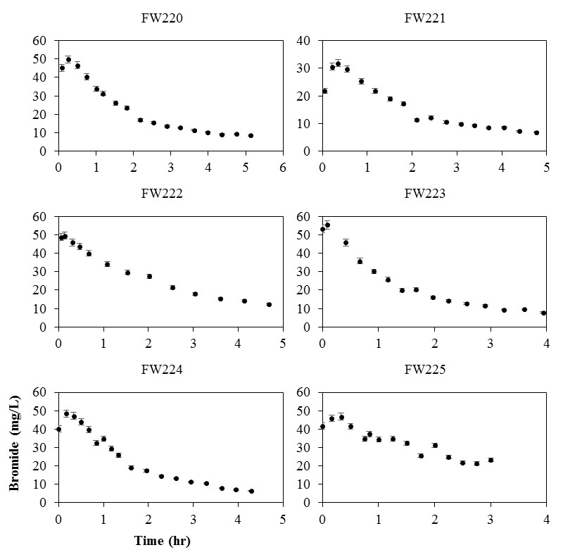

Figure 3.4 Push-pull test data for all six test wells (FW220 through FW225) showing concentration of bromide (y axis) versus and time elapsed (x axis) during the pull phase of test, error bars represent the analytical uncertainty (± 4%)

Table 3.2 Results from single-well push-pull tests for this study (FW220 through FW225) and from Hall et al. (1991) and Istok (2013)
Test | b | ṫ_{i} | Ѷ_{i} | t_{d} | ṫ_{e} | Ѷ_{e}
Well/Study | (m) | (s) | (m³) | (s) | (s) | (m³)
FW220 | 2.34 | 1800 | 0.010 | 6600 | 3948 | 0.014
FW221 | 2.60 | 1740 | 0.010 | 7320 | 3984 | 0.015
FW222 | 2.31 | 1890 | 0.010 | 7200 | 4087 | 0.012
FW223 | 2.33 | 1950 | 0.010 | 4980 | 3077 | 0.011
FW224 | 2.24 | 1410 | 0.010 | 6600 | 3349 | 0.014
FW225 | 2.42 | 810 | 0.010 | 1740 | 3496 | 0.006
Hall et al. (1991) | 15.24 | 1200 | 0.30 | 225600 | 5460 | 20.67
Istok (2013) | 2.93 | 3000 | 0.10 | 108000 | 5220 | 0.16

Table 3.3 Effective porosity calculated from the truncated and expanded solutions, (20) and (18), respectively, for tests in this study (FW220 through FW225) and for tests from Hall et al. (1991) and Istok (2013), n_{e1} from equation (18), n_{e2} from equation (20)
Test | n_{e1} | n_{e2}
Well/Study | (%) | (%)
FW220 | 0.6 | 0.1
FW221 | 5.0 | 1.3
FW222 | 3.3 | 0.4
FW223 | 2.8 | 0.2
FW224 | 2.9 | 0.6
FW225 | -0.1 | 0.1
Hall et al. (1991) | 6.3 | 6.2
Istok (2013) | 38 | 13

valid; this issue is discussed in Section 4.3. The effective porosity (n_{e2}), per equation (20), ranged from a low of 0.1% in test well FW225 to a high of 1.3% in test well FW221 (Table 3.3). The effective porosity, per equation (18), which accounts for the transport of tracer during the injection phase, was substantially larger than that of equation (20), which does not account for the transport of tracer during the injection phase (Table 3.3). The range of effective porosity, per equation (18), was representative of the lower end of those calculated from field-scale tracer-based studies conducted in granular porous media whereas per equation (20), was representative of those conducted in fractured porous media (Gelhar et al. 1992). The effective porosity from Hall et al. (1991), per equations (18) and (20), were almost identical (6.3% versus 6.2%, respectively) whereas from Istok (2013) they were notably different, i.e., the expanded equation (n_{e1}) yielded substantially higher effective porosity than the truncated equation (n_{e2}) (38% versus 13%) (Table 3.3).

3.4.4. Uncertainty analysis
The percent standard errors of the hydraulic gradient (dh/dr), hydraulic conductivity (K) and drift time (t_{d}) were typically less than ± 2% (Table 3.4). The percent standard errors of the remaining parameters, e.g., saturated aquifer thickness (b) and the times (ṫ_{i}, ṫ_{e}) and volumes (Ѷ_{i}, Ѷ_{e}) at which the center of mass of bromide was released and recovered, were typically greater than ± 2% but less than ± 5% (Table 3.4). The error-propagated uncertainty in effective porosity (n_{e1}) was less than ± 0.5% (percent standard error ≈ ± 7%) (Figure 3.5). It should be noted that an uncertainly analysis of effective porosity for the studies by Hall et al. (1991) and Istok (2013) was not possible due to the lack of available data on the uncertainty of pumping rates, volumes injected/extracted, etc.

Table 3.4 Percent standard errors for input parameters for equation (18) for tests in this study (FW220 through FW224), test well FW225 is omitted due to invalid results
Test | dh/dr | K | b | ṫ_{i} | Ѷ_{i} | t_{d} | ṫ_{e} | Ѷ_{e}
Well | (± %) | (± %) | (± %) | (± %) | (± %) | (± %) | (± %) | (± %)
FW220 | 1.2 | 1.6 | 5.0 | 2.5 | 2.5 | 1.1 | 3.0 | 3.9
FW221 | 1.0 | 0.7 | 5.0 | 2.5 | 2.5 | 0.4 | 1.1 | 2.1
FW222 | 1.7 | 1.7 | 5.0 | 2.5 | 2.5 | 0.4 | 1.1 | 5.4
FW223 | 1.1 | 0.6 | 5.0 | 2.5 | 2.5 | 0.5 | 1.4 | 3.6
FW224 | 0.6 | 0.8 | 5.0 | 2.5 | 2.5 | 0.9 | 2.8 | 2.8

Figure 3.5 Effective porosity (n_{e1}) per equation (18) for tests in this study (FW220 through FW224), test well FW225 is omitted due to invalid results, error bars represent the uncertainty

3.5. Discussion

3.5.1. Hydraulic gradient
The range of the near-well hydraulic gradient (-0.020 m/m to -0.085 m/m) in the test wells was relatively small (within a single order of magnitude) and representative of the site-wide average (-0.045 m/m). The spatial variability of the hydraulic gradient was expected due to the high level of aquifer heterogeneity within Area 2 (Moon et al. 2006; Watson et al. 2004). However, it must be noted that the near-well hydraulic gradient was not measured directly, i.e., graphically, rather it was estimated based on a digital elevation model as discussed in Section 2.3. Therefore, there is a level of uncertainty in the near-well hydraulic gradient that must be recognized. Nevertheless, the model-generated values of the near-well hydraulic gradient are likely much more representative of the near-well conditions than the graphically-determined values at the site-wide scale.

3.5.2. Hydraulic conductivity
The steady-state discharge and drawdown conditions among the test wells were consistent with the methodology of Robbins et al. (2009) and Aragon-Jose and Robbins (2011). It should be noted that the Robbins et al. (2009) study was conducted in a confined aquifer comprised of fine sands, whereas this study was conducted in an unconfined aquifer comprised of silty and clayey fill. However, Aragon-Jose and Robbins (2011) demonstrated the validity of the Robbins et al. (2009) method in an unconfined aquifer comprised of sandy till and within test wells whose screens crossed the water table; these hydrogeologic and test well conditions were very similar to those in this study. Aragon-Jose and Robbins (2011) recommended that a valid application of the Robbins et al. (2009) method in unconfined aquifers required minimal drawdown with respect to the static saturated well screen length. The drawdown in this study was typically less than 10% of the static saturated screen length and was within the general range of the percent drawdown reported by Aragon-Jose and Robbins (2011) (≈ 8% to 12%).
There is a level of uncertainty in the measured drawdown within the test wells that must be recognized. The total drawdown within a well during pumping may due to a number of components, including: (1) aquifer loss, (2) skin layer loss, (3) gravel pack loss, (4) well screen loss, (5) up-flow loss in well interior, (6) partial penetration of well screen, and (7) seepage face (Houben 2015a; Houben 2015b). As previously discussed in Section 2.2., the well screens fully penetrate the unconfined aquifer and were installed without a gravel pack, i.e., the well screens are in direct contact with the fill materials. The wells are also routinely developed by mechanical means, i.e., surge and purge, to limit skin layer loss. The pump intake was set at mid-screen, i.e., 50% of the screen length, to limit up-flow loss in the well interior (Houben and Hauschild 2011). Therefore, it is likely that the drawdown during pumping, in order of importance, was attributed to: (1) the aquifer and (2) seepage face. Seepage face would lead to overestimating drawdown during pumping and underestimating hydraulic conductivity. Underestimating hydraulic conductivity would also lead to underestimating effective porosity. Nevertheless, the presence and extent of seepage face during pumping was not known. However, by limiting the drawdown to approximately less than 10% of the static saturated screen length, the effects of seepage face were likely mitigated.
The range of hydraulic conductivity (2.1x10⁻⁶ m/s to 1.8x10⁻⁵ m/s) in the test wells was relatively small (within a single order of magnitude) and within the lower and upper method detection limits (≈10⁻⁸ m/s to 10⁻⁴ m/s) (Robbins et al. 2009); the range of hydraulic conductivity was also within that representative of silts and fine sands (Domenico and Schwartz 1998). However, Watson et al. (2013) reported that the hydraulic conductivity of the fill material, in Area 2 test wells immediately east of the study site, was approximately 3.8x10⁻⁴ m/s. Therefore, the range of hydraulic conductivity reported in this study was notably less (up to two orders of magnitude) than to the value previously reported. It is important to note that Watson et al. (2013), and others (Phillips et al. 2008), also reported that the fill material was gravelly, whereas no gravel component is known to exist within the area of this study site. Therefore, the lack of a gravel component in the fill material within the study site may explain the lower values of hydraulic conductivity. In summary, the single-well pumping test data and analysis suggested that the variability in the hydraulic conductivity of the fill material was relatively low and within that representative of silts and fine sands.

3.5.3. Effective porosity
The breakthrough curve for a non-reactive tracer released from an instantaneous point source, as it passes a fixed point of observation, should resemble a bell-shaped curve when its transport is governed by advection and dispersion during steady-state groundwater flow in a homogeneous and an isotropic granular porous medium (Baetsle 1969). The breakthrough curves for bromide, observed during the pull phase of the tests, resembled bell-shaped curves that were truncated at the leading edges (early time) and possibly skewed towards the following edges (late time). The truncation at the leading edge indicated that the full spatial extent of the injectate did not move beyond the test wells during the drift phase. Ideally, the entire injectate should drift beyond the test wells under natural-gradient (non-pumping) conditions and then the entire injectate should be pumped back to the test wells under forced-gradient (extraction pumping) conditions (Leap and Kaplan 1988). However, if the injectate drifts too far from the test wells it may only partially return during the pull phase and lead to a low mass recovery of the tracer. Although it may be tempting to suggest that the drift times in this study were too short, it must be noted that the average percent mass recovery of the tracer (bromide) was far less than 100% (60 ± 10%, data not shown). Therefore, an increase in the drift time would have likely resulted in a lower mass recovery of bromide and thus a weaker signal for analysis. In addition to advective mass transport, diffusive mass transport of bromide from mobile to immobile pore water may partially explain the low mass recovery of bromide; mobile to immobile diffusive mass transport is well documented and described at the OR-IFRC site and at the nearby west Beak Creek Valley site (Luo et al. 2005; Mayes et al. 2003; McKay et al. 2000; Reedy et al. 1996). The extent of sorption or degradation of bromide was likely negligible based on previous batch and column studies which demonstrated that mass recoveries of bromide from OR-IFRC soils and sediments are nearly 100% under acidic to neutral pH (≈ 4.5 to 7) (Hu and Moran 2005; McCarthy et al. 2000); the pH at the study site ranges from approximately 6.5 to 8 (Paradis et al. 2016).
With regard to the possible skewness of the breakthrough curves towards the following edge, this suggested that mass transport mechanisms in addition to advection and dispersion and/or anisotropy and heterogeneity of the porous media were present. The likelihood that the fill materials were packed in the vertical direction suggests that permeable media at the site were anisotropic. The variability in the magnitude of the hydraulic conductivity among the test wells (2.1x10⁻⁶ m/s to 1.8x10⁻⁵ m/s) also indicates a certain amount of heterogeneity. Although a thorough investigation of advection, dispersion, and other mass transport mechanisms was not an objective of this study, the skewness of the breakthrough curves towards the following edge may be attributed to numerous small-scale heterogeneities in aquifer hydraulic properties during radially convergent flow to a well (Pedretti et al. 2013). In summary, the breakthrough curves suggested that the injectate drifted some distance beyond the test wells under natural-gradient conditions and that an adequate amount of tracer (bromide) was recovered during the pull phase to accurately calculate effective porosity using equations (18) and (20).
The effective porosity values from the expanded equation (0.6% to 5.0%) were substantially larger than those from the truncated equation (0.1% to 1.3%) which indicated that the transport of the tracer during the injection phase was not truly negligible. From Hall et al. (1991), the effective porosity values were almost identical (6.3% versus 6.2%) which indicated that the transport of the tracer during the injection phase of was truly negligible. From Istok (2013), the effective porosity values were notably different (38% versus 13%), as in the tests presented here, which indicated that the transport of the tracer during the injection phase was not truly negligible. Therefore, the agreement, or lack thereof, of effective porosity from the expanded versus the truncated equation can clearly identify and quantify the relative importance of accounting for the transport of tracer during the injection phase, as shown in the tests presented here and in those from the literature (Hall et al. 1991; Istok 2013).
The negative value of effective porosity (-0.1%), using the expanded equation for test well FW225, suggested that the volume of water extracted until the center of mass of the tracer was recovered (Ѷ_{e}) was less than the volume of water injected until the center of mass of the tracer was released (Ѷ_{i}); this is impossible due to the law of conservation of mass. An inspection of the breakthrough curve of bromide for test well FW225 shows that pumping stopped despite bromide concentrations greater than 20 mg/L, whereas pumping stopped in the remaining five test wells at bromide concentrations less than 10 mg/L. Therefore, it is likely that the total pump-back time in test well FW225 was too short to return an adequate volume of water representative of the true center of mass of bromide. As expected, this error in the application and data analysis of the push-pull test goes unrecognized when using the truncated equation, as shown by a positive value of effective porosity (0.1%) for test well FW225.
The effective porosity values from the expanded equation (0.6% to 5.0%) were more similar to those calculated from field-scale tracer-based studies conducted in unconsolidated, heterogeneous, and fine-grained granular porous media whereas those from the truncated equation (0.1% to 1.3%) were more similar to those from fractured porous media (Gelhar et al. 1992; Hall et al. 1991; Stephens et al. 1998). Based on the hydrogeology of the study site, i.e., silty and clayey fill, the effective porosity values from the expanded equation are likely more accurate than those from the truncated equation. Moreover, the push-pull tests by Istok (2013) were conducted in a gravel and sand aquifer, which also suggests that the effective porosity of 38% from the expanded equation is likely more accurate than the 13% from the truncated equation. However, it must be emphasized that values of effective porosity are dependent on the type of tracer and the nature of the porous media. For example, in column experiments by van der Kamp et al. (1996), values of effective porosity were equal to or far less than the total porosity, depending on the type of solute tracer. van der Kamp et al. (1996) attributed these findings to phenomena such as: (1) ion exclusion, (2) enclosed pores, and (3) bound water. At the nearby west Beak Creek Valley site, McKay et al. (2000) conducted a multi-well natural-gradient tracer study and demonstrated that the mean arrival times of colloidal tracers were up to 500 times faster than those reported for solute tracers from previous tests at the site conducted by Lee et al. (1992). McKay et al. (2000) attributed these findings to greater diffusive mass transport of the solute tracers, as opposed to the colloidal tracers, into immobile pore water within fine-grained matrix between advection-dominated fractures. Therefore, the magnitude of the effective porosities calculated in this study, may not be truly representative of the void spaces through which water can flow.
Lastly, and perhaps most importantly, it must be recognized that both the expanded and truncated equations were theoretically developed for confined aquifers as opposed to unconfined aquifers. However, the only in situ study to experimentally test the validity of the truncated equation was by Hall et al. (1991). Hall et al. (1991) arrived at similar values of effective porosity (≈ 6%) from both single-well push-pull and dual-well natural-gradient tests which were conducted in an unconfined, heterogeneous, and sandy aquifer. Therefore, there is clearly a need to theoretically develop and experimentally test both the expanded and truncated solutions for the unconfined case.

3.5.4. Uncertainty analysis
The error-propagated uncertainty in the calculated values of effective porosity was relatively small (< ± 1%), due in part, to the careful consideration for the precise determination of the aquifer properties, e.g., hydraulic gradient, hydraulic conductivity, and saturated aquifer thickness, and the push-pull test parameters, e.g., the times and volumes at which the center of mass of bromide was released and recovered. However, the uncertainty analysis failed to capture the effects of: (1) the presence and extent of seepage face during extraction pumping and (2) applying an analytical solution developed for a confined aquifer to an unconfined aquifer. The presence and extent of seepage face could have been determined using a down-well device with video capability during extraction pumping. However, this was not possible due to the small diameter (1.9 cm) of the wells and the presence of down-well tubing (0.64 cm diameter) which limited the physical space to deploy such a device. The effects of applying an analytical solution developed for a confined aquifer to the unconfined aquifer in this study was not known. However, as previously discussed in Section 4.3., Hall et al. (1991) demonstrated the validity of the truncated analytical solution, developed for a confined aquifer, as applied to an unconfined, heterogeneous, and sandy aquifer.

3.6. Conclusions
We conclude that: (1) the analytical solution to describe the displacement of the center of mass of a tracer during a push-pull test can be expanded to account for displacement during the injection phase, (2) the transport of a tracer during the injection phase of a push-pull test may not be truly negligible, (3) the failure to account for displacement during the injection phase may lead to a substantial underestimation of the magnitude of effective porosity, (4) single-well push-pull tests can be readily applied to multiple wells within a study site to assess the spatial variability of effective porosity, and (5) the error-propagated uncertainty in the value of effective porosity can be mitigated to a reasonable level by careful consideration for the precise determination of the aquifer properties and the push-pull test parameters. Finally, it must be recognized that there is a need to theoretically develop and experimentally test the expanded solution presented here for the case of an unconfined aquifer.

3.7. References
Aragon-Jose, A. T. & G. A. Robbins, 2011. Low-Flow Hydraulic Conductivity Tests at Wells that Cross the Water Table. Ground Water 49(3):426-431 doi:10.1111/j.1745-6584.2010.00742.x.
Baetsle, L. H., 1969. Migration of radionuclides in porous media. In Duhamel, A. M. F. (ed) Progress in Nuclear Energy. Health Physics, Series XII edn. Pergamon Press, Elmsford, New York, 707-730.
Dachler, R., 1936. Grundwasserstromung (Flow of Ground-water). Julius Springer, Wien (Vienna), Austria.
Davis, S. N., G. M. Thompson, H. W. Bentley & G. Stiles, 1980. Ground-Water Tracers - A Short Review. Ground Water 18(1):14-23 doi:10.1111/j.1745-6584.1980.tb03366.x.
Domenico, P. A. & F. W. Schwartz, 1998. Physical and Chemical Hydrogeology, Second edn. John Wiley & Sons, Inc., New York, NY.
Fetter, C. W., 2001. Applied Hydrogeology, Fourth edn. Prentice Hall, Upper Saddle River, New Jersey.
Gelhar, L. W., C. Welty & K. R. Rehfeldt, 1992. A Critical-Review of Data on Field-Scale Dispersion in Aquifers. Water Resources Research 28(7):1955-1974 doi:10.1029/92wr00607.
Hall, S. H., S. P. Luttrell & W. E. Cronin, 1991. A method for estimating effective porosity and groundwater velocity. Ground Water 29(2):171-174 doi:10.1111/j.1745-6584.1991.tb00506.x.
Houben, G. J., 2015a. Review: Hydraulics of water wells-flow laws and influence of geometry. Hydrogeology Journal 23(8):1633-1657 doi:10.1007/s10040-015-1312-8.
Houben, G. J., 2015b. Review: Hydraulics of water wells-head losses of individual components. Hydrogeology Journal 23(8):1659-1675 doi:10.1007/s10040-015-1313-7.
Houben, G. J. & S. Hauschild, 2011. Numerical Modeling of the Near-Field Hydraulics of Water Wells. Ground Water 49(4):570-575 doi:10.1111/j.1745-6584.2010.00760.x.
Hu, Q. H. & J. E. Moran, 2005. Simultaneous analyses and applications of multiple fluorobenzoate and halide tracers in hydrologic studies. Hydrological Processes 19(14):2671-2687 doi:10.1002/hyp.5780.
Istok, J. D., 2013. Push-Pull Tests for Site Characterization. Springer, Corvaillis, OR, USA.
Kirchner, J., 2001. Analysis of Environmental Data. In: University of California Berkeley. http://seismo.berkeley.edu/~kirchner/eps_120/EPSToolkits.htm.
Leap, D. I. & P. G. Kaplan, 1988. A single-well tracing method for estimating regional advective velocity in a confined aquifer - theory and preliminary laboratory verification Water Resources Research 24(7):993-998 doi:10.1029/WR024i007p00993.
Lee, R. R., R. H. Ketelle, J. M. Bownds & T. A. Rizk, 1992. Aquifer Analysis and Modeling in a Fractured, Heterogeneous Medium. Ground Water 30(4):589-597 doi:10.1111/j.1745-6584.1992.tb01535.x.
Li, H., 1995. Effective porosity and longitudinal dispersivity of sedimentary-rocks determined by laboratory and field tracer tests. Environmental Geology 25(2):71-85.
Luo, J., O. A. Cirpka, W. M. Wu, M. N. Fienen, P. M. Jardine, T. L. Mehlhorn, D. B. Watson, C. S. Criddle & P. K. Kitanidis, 2005. Mass-transfer limitations for nitrate removal in a uranium-contaminated aquifer. Environmental Science & Technology 39(21):8453-8459 doi:10.1021/es050195g.
Mayes, M. A., P. M. Jardine, T. L. Mehlhorn, B. N. Bjornstad, T. Ladd & J. M. Zachara, 2003. Transport of multiple tracers in variably saturated humid region structured soils and semi-arid region laminated sediments. Journal of Hydrology 275(3-4):141-161 doi:10.1016/s0022-1694(03)00039-8.
McCarthy, J. F., K. M. Howard & L. D. McKay, 2000. Effect of pH on sorption and transport of fluorobenzoic acid ground water tracers. Journal of Environmental Quality 29(6):1806-1813.
McKay, L. D., W. E. Sanford & J. M. Strong, 2000. Field-scale migration of colloidal tracers in a fractured shale saprolite. Ground Water 38(1):139-147 doi:10.1111/j.1745-6584.2000.tb00211.x.
Meinzer, O. E., 1923a. Outline of Ground-Water Hydrology, with definitions. United States Geological Survey, Washington, D.C.
Meinzer, O. E., 1923b. The Occurrence of Ground Water in the United States, with a discussion of principles. United States Geological Survey, Washington, D.C.
Moon, J. W., Y. Roh, T. J. Phelps, D. H. Phillips, D. B. Watson, Y. J. Kim & S. C. Brooks, 2006. Physicochemical and mineralogical characterization of soil-saprolite cores from a field research site, Tennessee. Journal of Environmental Quality 35(5):1731-1741 doi:10.2134/jeq2005.0123.
Paradis, C. J., S. Jagadamma, D. B. Watson, L. D. McKay, T. C. Hazen, M. Park & J. D. Istok, 2016. In situ mobility of uranium in the presence of nitrate following sulfate-reducing conditions. Journal of Contaminant Hydrology 187:55-64 doi:10.1016/j.jconhyd.2016.02.002.
Pedretti, D., D. Fernandez-Garcia, D. Bolster & X. Sanchez-Vila, 2013. On the formation of breakthrough curves tailing during convergent flow tracer tests in three-dimensional heterogeneous aquifers. Water Resources Research 49(7):4157-4173 doi:10.1002/wrcr.20330.
Phillips, D. H., D. B. Watson, S. D. Kelly, B. Ravel & K. M. Kemner, 2008. Deposition of uranium precipitates in dolomitic gravel fill. Environmental Science & Technology 42(19):7104-7110 doi:10.1021/es8001579.
Reedy, O. C., P. M. Jardine, G. V. Wilson & H. M. Selim, 1996. Quantifying the diffusive mass transfer of nonreactive solutes in columns of fractured saprolite using flow interruption. Soil Science Society of America Journal 60(5):1376-1384.
Robbins, G. A., A. T. Aragon-Jose & A. Romero, 2009. Determining Hydraulic Conductivity Using Pumping Data from Low-Flow Sampling. Ground Water 47(2):271-276 doi:10.1111/j.1745-6584.2008.00519.x.
Stephens, D. B., K. C. Hsu, M. A. Prieksat, M. D. Ankeny, N. Blandford, T. L. Roth, J. A. Kelsey & J. R. Whitworth, 1998. A comparison of estimated and calculated effective porosity. Hydrogeology Journal 6(1):156-165 doi:10.1007/s100400050141.
Thomas Jr., G. B., M. D. Weir, J. Hass & F. R. Giordano, 2008. Numerical Integration Thomas' Calculus. Eleventh edn. Pearson Education, Inc., United States of America, 603-619.
Turnadge, C. & B. D. Smerdon, 2014. A review of methods for modelling environmental tracers in groundwater: Advantages of tracer concentration simulation. Journal of Hydrology 519:3674-3689 doi:10.1016/j.jhydrol.2014.10.056.
van der Kamp, G., D. R. van Stempvoort & L. I. Wassenaar, 1996. The radial diffusion method .1. Using intact cores to determine isotopic composition, chemistry, and effective porosities for groundwater in aquitards. Water Resources Research 32(6):1815-1822 doi:10.1029/95wr03719.
Watson, D. B., J. E. Kostka, M. W. Fields & P. M. Jardine 2004. The Oak Ridge Field Research Center Conceptual Model. United States Department of Energy, Oak Ridge, TN, USA.
Watson, D. B., W. M. Wu, T. Mehlhorn, G. P. Tang, J. Earles, K. Lowe, T. M. Gihring, G. X. Zhang, J. Phillips, M. I. Boyanov, B. P. Spalding, C. Schadt, K. M. Kemner, C. S. Criddle, P. M. Jardine & S. C. Brooks, 2013. In situ Bioremediation of Uranium with Emulsified Vegetable Oil as the Electron Donor. Environmental Science & Technology 47(12):6440-6448 doi:10.1021/es3033555.

Stepwise mixing model for quantifying solute mass transfer and transformation during push-pull tests

Chapter 4 is slated for submission for publication in Water Resources Research.

Paradis, C. J., E.R. Dixon, L.M. Lui, A.P. Arkin, E. Perfect, J.D. Istok, L. D. McKay, & T. C. Hazen, 2017. Stepwise mixing model for quantifying solute mass transfer and transformation during push-pull tests (slated for submission).

4.1. Abstract
The dilution-adjusted breakthrough curve obtained from a single-well push-pull test can be analyzed to quantify the rate and extent of mass transfer and transformation of a solute within an aquifer. The dilution-adjusted model assumes that the ratio of the concentrations of the non-reactive and potentially reactive solutes in the injection fluid versus the aquifer fluid are equal. If this assumption is not valid, the dilution-adjusted model may predict breakthrough curves which suggest solute mass transfer and transformation occurred when in fact only non-reactive mixing occurred. In this study, an analytical solution which predicts the breakthrough curve of a potentially reactive solute due to non-reactive mixing was theoretically developed to account for any possible combination of non-reactive and potentially reactive solute concentrations within the injection and aquifer fluids. The analytical solution was demonstrated to be valid for a synthetic data set by correctly predicting the rate and extent of solute mass transfer and transformation by accurately accounting for non-reactive mixing. The analytical solution was further demonstrated to be applicable to a measured data set from a previously published study which utilized the push-pull test method. The stepwise mixing model (SWiMM) presented here makes no assumptions regarding the concentrations of the non-reactive and potentially reactive solutes in the injection and aquifer fluids and allows for a direct comparison of the predicted versus measured breakthrough curves.

4.2. Introduction
The push-pull test is a powerful site characterization method and has been applied in a wide range of hydrological settings including saturated and unsaturated soils and sediments and surface water bodies (Istok 2013). In a groundwater setting, a push-pull test is conducted by injecting (push phase) a volume of water containing one or more non-reactive and potentially reactive solutes into a single well, followed by a non-pumping period (drift phase), and subsequent extraction (pull phase) of groundwater from the same well. The extracted groundwater is comprised of a mixture between the injection and aquifer fluids. The concentration of the potentially reactive solute in the mixture of the injection and aquifer fluids can be adjusted for dilution to generate a concentration versus time profile (breakthrough curve) as given by Istok (2013):
$$\begin{aligned}C_{m}^{2*}=C_{m}^{2}\left[\frac{C_{i}^{1}}{C_{m}^{1}}\right]\#(1)\end{aligned}$$
where:
C_{i}¹ = concentration of the non-reactive solute in the injection fluid [M/L³]
C_{m}¹ = concentration of the non-reactive solute in the mixture of the injection and aquifer fluids [M/L³]
C_{m}² = concentration of the potentially reactive solute in the mixture of the injection and aquifer fluids [M/L³]
C_{m}^{2*} = dilution-adjusted concentration of the potentially reactive solute in the mixture of the injection and aquifer fluids [M/L³]
Analysis of the dilution-adjusted breakthrough curve from equation (1) can be utilized to quantify the net rate and mass of removal, or production, of a potentially reactive solute.
Equation (1) assumes that the ratio of the concentrations of the non-reactive and potentially reactive solutes in the injection fluid versus the aquifer fluid are equal as given by:
$$\begin{aligned}\frac{C_{i}^{1}}{C_{a}^{1}}=\frac{C_{i}^{2}}{C_{a}^{2}}\#(2)\end{aligned}$$
where:
C_{a}¹ = concentration of the non-reactive solute in the aquifer fluid [M/L3]
C_{i}² = concentration of the potentially reactive solute in the injection fluid [M/L3]
C_{a}² = concentration of the potentially reactive solute in the aquifer fluid [M/L3]
Equation (2) can be rearranged as given by:
$$\begin{aligned}\left[\frac{C_{i}^{1}}{C_{a}^{1}}\right]\left[\frac{C_{a}^{2}}{C_{i}^{2}}\right]=1\#(3)\end{aligned}$$
Equation (3) demonstrates that the product of the ratio of the concentrations of the non-reactive solute in the injection fluid versus the aquifer fluid and the ratio of the concentration of the potentially reactive solute in the aquifer fluid versus the injection fluid is equal to one. Therefore, the validity of equation (1) is dependent on equation (3) being equal to one. For example, bromide is often added to the injection fluid as a non-reactive solute at a concentration ten times greater than within the aquifer fluid. If a potentially reactive tracer, such as ethanol, is also added to the injection fluid at a concentration ten times greater than within the aquifer fluid, and does not react, then equation (1) will yield a dilution-adjusted breakthrough curve of ethanol equal to the injection concentration, because the assumptions in equation (3) are valid (Figure 4.1). However, if the assumptions in equation (3) are not valid, then equation (1) will yield a dilution-adjusted breakthrough curve of ethanol not equal to the injection concentration (Figure 4.1). This can result in dilution-adjusted breakthrough curves of potentially reactive tracers which suggest either net removal or net production occurred when in fact only non-reactive mixing occurred (Figure 4.1). These effects can be compounded with time and can lead to erroneous conclusions regarding the reactivity of a potentially reactive solute (Figure 4.1). Presumably, the assumptions associated with equation (1), as shown in equation (3), were either valid, or computational adjustments were made to achieve a reasonable level of validity, in the many previously published studies which have utilized the push-pull test method (Istok 2013). However, no study to date has clearly established an analytical solution to account for dilution of any potentially reactive solute when the ratio of the concentrations of the non-reactive and potentially reactive solutes in the injection fluid versus the aquifer fluid are not equal.
The objectives of this study were the following: (1) theoretically develop an analytical solution which predicts the breakthrough curve of any potentially reactive solute when the ratio of the concentrations of the non-reactive and potentially reactive solutes in the injection fluid versus the aquifer fluid are not equal and (2) apply, compare, and contrast the newly developed analytical solution with the existing dilution-adjusted solution using a data set from a previously published study which utilized the push-pull test method.

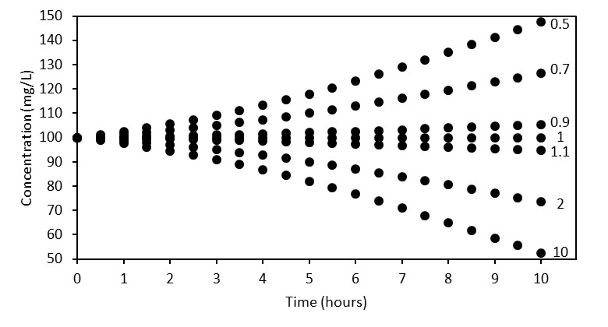

Figure 4.1 Dilution-adjusted breakthrough curves of synthetic data from equation (1) of a potentially reactive tracer at values of equation (3) ranging from 0.5 to 10, equation (1) is valid when equation (3) is equal to 1, equation (1) is invalid when equation (3) is not equal to one, the injection concentration of the potentially reactive solute is 100 mg/L and does not react.

4.3. Theoretical development
During the push phase of a push-pull test, a finite volume of fluid (Vi) which contains a known mass of a non-reactive solute (Mi) is injected into an aquifer. The aquifer consists of an infinite volume of fluid which contains a known concentration of the non-reactive solute (Ca). During the pull phase, the concentration of the mixture of both fluids (Cm) is periodically sampled over time (t) as given by:
$\begin{aligned}C_{m}=f\left(V_{i},M_{i},C_{a}, t\right) \#(4)\end{aligned}$
where:
V_{i} = volume of the injection fluid [L³]
M_{i} = mass of the non-reactive solute in the injection fluid [M]
C_{a} = concentration of the non-reactive solute in the aquifer fluid [M/L³]
C_{m} = concentration of the non-reactive solute in the mixture of the injection and aquifer fluids [M/L³]
t = time elapsed from the beginning of pull phase [T]
Equation (4) can be simplified as given by:
$$\begin{aligned}C_{m}=f\left(C_{i},C_{a}, t\right) \#(5)\end{aligned}$$
where:
C_{i} = concentration of the injection fluid or M_{i} divided by V_{i} [M/L³]
The concentration of the non-reactive solute in the mixture of both fluids (C_{m}) will approach that of the aquifer (C_{a}) as time (t) approaches infinity as given by:
$$\begin{aligned}\lim_{t→∞}{C_{m}\left(C_{i},C_{a}, t\right)}=C_{a} \#(6)\end{aligned}$$
Equation (6) assumes that C_{i} and C_{a} are constant and that only C_{m} and t are variable. If the concentration of the non-reactive solute in the injection fluid (C_{i}) is either greater than or less than the concentration of the non-reactive solute in the aquifer fluid (C_{a}), equation (6) can be depicted graphically as either a decreasing or increasing function, respectively (Fig. 2).
The initial condition at time equal to zero for C_{m} (Fig. 2) is given by:
$$\begin{aligned}C_{m}\left(t=0\right)=C_{i} \#(7)\end{aligned}$$
The final condition as time approaches infinity for C_{m} (Fig. 2) is given by:
$$\begin{aligned}C_{m}\left(t→∞\right)=C_{a} \#(8)\end{aligned}$$
Equation (6) can be solved by using a modified first-order decay equation to satisfy the initial and final conditions in (7) and (8), respectively, as given by:
$$\begin{aligned}C_{m}\left(t\right)=\left[C_{i}-C_{a}\right]e^{-kt}+C_{a} \#(9)\end{aligned}$$
where:
k = decay constant 1/[T]
An inspection of equation (9) at time equal to zero yields C_{m} equal to C_{i} and as time approaches infinity yields C_{m} equal to C_{a}. If C_{i} is greater than C_{a}, equation (9) yields C_{m} as a decreasing variable. If C_{a} is greater than C_{i}, equation (9) yields C_{m} as an increasing variable. Therefore, equation (9) can describe the breakthrough curve of a non-reactive solute in the mixture of the injection and aquifer fluids. Equation (9) can be rearranged as given by:
$$\begin{aligned}\frac{\left[C_{m}\left(t\right)- C_{a}\right]}{\left[C_{i}-C_{a}\right]}=e^{-kt} \#(10)\end{aligned}$$
Equation (10) describes the ratio of non-reactive mixing between the injection fluid (numerator) and the aquifer fluid (denominator) as a function of the rate at which the two fluids mix. If the rate at which the non-reactive tracer mixes with the aquifer is equal to the rate at which the potentially reactive tracer mixes with the aquifer then equation (10) can be written as:

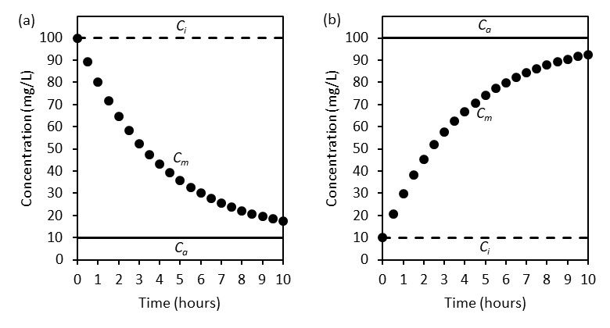

Figure 4.2 Graphical depictions of the concentration of a non-reactive solute in the mixture of injection and aquifer fluids (C_{m}) versus the elapsed time (t); C_{i} is the concentration of the non-reactive solute in the injection fluid, C_{a} is the concentration of the non-reactive solute in the aquifer, C_{i} is greater than C_{a} in (a), C_{i} is less than C_{a} in (b).

$$\begin{aligned}\frac{\left[C_{m}\left(t\right)- C_{a}\right]}{\left[C_{i}-C_{a}\right]}=e^{-kt} \#(10)\end{aligned}$$
Equation (10) describes the ratio of non-reactive mixing between the injection fluid (numerator) and the aquifer fluid (denominator) as a function of the rate at which the two fluids mix. If the rate at which the non-reactive tracer mixes with the aquifer is equal to the rate at which the potentially reactive tracer mixes with the aquifer then equation (10) can be written as:
$$\begin{aligned}\frac{\left[C_{m}^{1}-C_{a}^{1}\right]}{\left[C_{i}^{1}- C_{a}^{1}\right]}{= \frac{\left[C_{m}^{2}-C_{a}^{2}\right]}{\left[C_{i}^{2}- C_{a}^{2}\right]}} \#(11)\end{aligned}$$
Equation (11) can be rearranged to solve for the concentration of a potentially reactive solute in the mixture of the injection and aquifer fluids as given by:
$$\begin{aligned}C_{m}^{2}=\left(\frac{\left[C_{m}^{1}-C_{a}^{1}\right]}{\left[C_{i}^{1}- C_{a}^{1}\right]}\right)\left.\left[C_{i}^{2}- C_{a}^{2}\right]\right. + C_{a}^{2} \#(12)\end{aligned}$$
Equation (12) predicts the concentration of a potentially reactive solute in the mixture of the injection and aquifer fluids. Equation (12) assumes the following: (1) the concentrations of both solutes are equal to their injection concentrations at time equal to zero, (2) the concentrations of both solutes are equal to their aquifer concentrations as time approaches infinity, and (3) the mass transport mechanisms of both solutes, e.g., advection, mechanical dispersion, molecular diffusion, sorption, solubility, etc. are no different. It is important to note that equation (12) does not necessarily assume first-order decay. Rather, equation (12) assumes that equation (6) is valid and bounded by the initial condition in equation (7) and final condition in equation (8) and that both solutes are non-reactive and have identical transport properties. Therefore, any number of solutions are possible for equation (6) and all of which arrive at equation (12).
During a push-pull test each variable in equation (12) is measured. Therefore, equation (12) can be used to compare the predicted concentration of a potentially reactive solute to the measured concentration of a potentially reactive solute. Any difference between the two concentrations can be attributed to mass transport and/or mass transformation processes other than non-reactive mixing, e.g., advection, mechanical dispersion, molecular diffusion, sorption, solubility, degradation, etc. Equation (12), unlike equation (1), makes no assumptions about the ratio of the concentrations of the non-reactive and potentially reactive solutes in the injection fluid versus the aquifer fluid. Rather, equation (12) accounts for such differences and allows for a direct comparison of the predicted versus measured breakthrough curves.

4.4. Model validation
To validate equation (12), a synthetic data set was generated for two scenarios. Scenario one assumed that the potentially reactive solute underwent non-reactive mixing between the injection and aquifer fluids whereas scenario two assumed that the potentially reactive solute underwent non-reactive mixing plus removal from the aqueous phase. For both scenarios, the modified first-order decay solution, shown in equation (9), was used to generate the synthetic data. For scenario one, the decay constant (k) was equal to 0.25 for both the non-reactive and the potentially reactive solute. For scenario two, k was equal to 0.25 for the non-reactive solute and 0.5 for the potentially reactive solute. For both scenarios, C_{i} and C_{a} of the non-reactive solute were 100 and 10 mg/L, respectively, and C_{i} and C_{a} of the potentially reactive solute were 50 and 5 mg/L, respectively. Equation (12) was used to predict the concentration of the potentially reactive solute in the mixture of the injection and aquifer fluids. For scenario one, both the synthetic and predicted data for the potentially reactive solute were identical (Figure 4.3). These results were expected because k was equal to 0.25 for both the non-reactive and the potentially
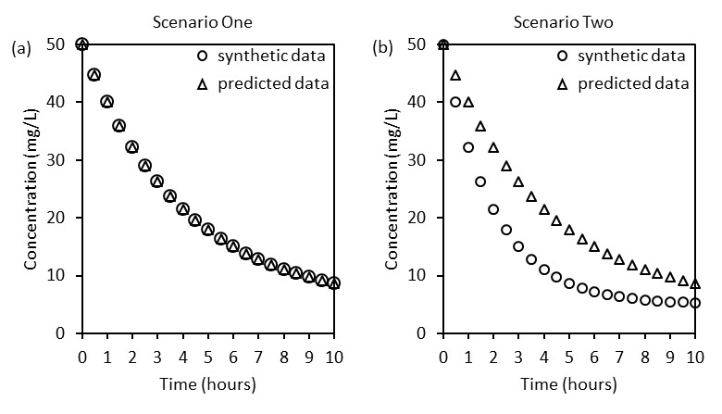

Figure 4.3 Synthetic and predicted data for a potentially reactive solute, scenario one (a) shows synthetic data subject to non-reactive mixing only and predicted data which assumed non-reactive mixing only, scenario two (b) shows synthetic data subject to non-reactive mixing and removal from the aqueous phase and predicted data which assumed non-reactive mixing only

reactive solute. For scenario two, the synthetic data was substantially lower in magnitude as compared to the predicated data (Figure 4.3). These results were expected because k was equal to 0.25 for the non-reactive and 0.5 for the potentially reactive solute. Therefore, equation (12) was clearly able to identify that mass transport and/or mass transformation processes other than non-reactive mixing were occurring in scenario two and not occurring in scenario one.
The stepwise-mixing model, or SWiMM, presented here can also be utilized to quantify the net rate and mass of removal, or production, of a potentially reactive solute. For example, from equation (9), the synthetic and predicted data generated for scenario two can be plotted as a linear function as given by:
$$\begin{aligned}ln\left(\frac{\left[C_{m}-C_{a}\right]}{\left[C_{i}-C_{a}\right]}\right)={-kt} \#(13)\end{aligned}$$
A graph of equation (13) yields a straight line where the slope of the linear regression is equal to the decay constant k (Figure 4.4). As expected, the decay constant (k₁) for the predicted data was 0.25 h⁻¹ and the decay constant (k₂) for the synthetic data was -0.5 h⁻¹ (Figure 4.4). Therefore, the net rate of removal was simply k₂ minus k₁ or 0.25 h⁻¹ (Figure 4.4).
The net mass of removal can be calculated by first integrating the area under the concentration versus time data for the synthetic and predicted data (Figure 4.3) as given by:
$$\begin{aligned}M=\frac{∆V}{∆T}\int_{t_{0}}^{t_{n}}{C(t)dt}\#(14)\end{aligned}$$
where:
ΔV = total volume of fluid extracted during periodic sampling [L³]
ΔT = total elapsed time during periodic sampling [T]
t₀ = time at the start of extraction pumping [T]
t_{n} = time at the end of extraction pumping [T]
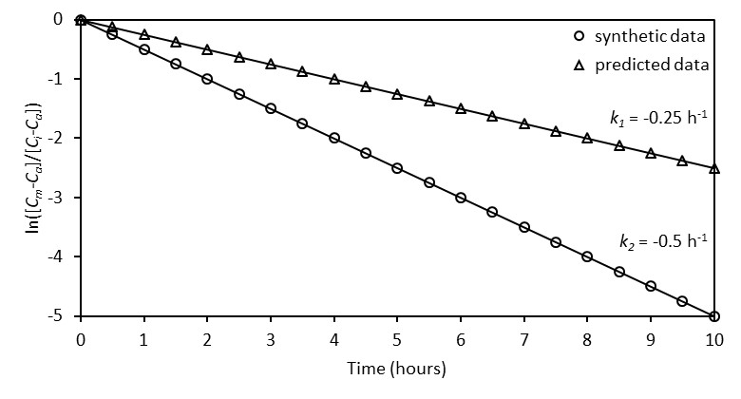

Figure 4.4 Synthetic and predicted data generated for scenario two from equation (12) and linear regression to determine the decay constant (k)

The solution to equation (14) can be approximated numerically, as opposed to solved analytically. The area under the concentration versus time data (Figure 4.3) was approximated numerically using the trapezoidal rule as given by:
$$\begin{aligned}M=\left[\frac{∆V}{∆T}\right]\left[\left(t_{1}-t_{0}\right)\left(\frac{C_{1}+C_{0}}{2}\right)+\left(t_{2}-t_{1}\right)\left(\frac{C_{2}+C_{1}}{2}\right)+…+\left(t_{n}-t_{n-1}\right)\left(\frac{C_{n}+C_{n-1}}{2}\right)\right] \#(15)\end{aligned}$$
The area under the concentration versus time data (Figure 4.3) for the synthetic and predicted data were approximately 140 and 215 mg, respectively, assuming a total volume of 10 liters was extracted over 10 hours. Therefore, the net mass of removal was approximately 75 mg. Equation (12) clearly allowed for valid and quantitative analysis to estimate the net rate and mass of solute removal.

4.5. In situ application
The stepwise-mixing model presented here was applied to a previously published study by Paradis et al. (2016) and the results were compared and contrasted to those from the dilution-adjusted model (equation 1). Paradis et al. (2016) utilized the push-pull test method to investigate the mobility of reduced and immobilized uranium in the presence of nitrate oxidant and analyzed the data using the dilution-adjusted model (equation 1). Paradis et al. (2016) concluded that reduced sulfur-bearing species, as opposed to reduced uranium-bearing species, were preferentially oxidized and mobilized. This conclusion was based on the following: (1) analyzing the magnitudes and trends of the dilution-adjusted breakthrough curves of nitrate, nitrite, sulfate, and uranium and (2) quantifying the mass of uranium and sulfate recovered during the pull phase relative to bromide, i.e., recovery factors. Recovery factors greater than one indicated that more uranium or sulfate was recovered relative to bromide. Recovery factors less than one indicated that less sulfate or uranium was recovered relative to bromide.
In the Paradis et al. (2016) study, bromide and nitrate were added as non-reactive and reactive solutes, respectively, to a 200-liter injection fluid at concentrations much greater than within the aquifer fluid (Table 4.1). The injection fluid also contained uranium at a concentration much greater than within the aquifer fluid (Table 4.1). The concentrations of nitrite and sulfate within the injection fluid were only slightly greater than within the aquifer fluid (Table 4.1). The 200-liter fluid was injected by siphon into a test well constructed within a shallow, unconfined groundwater system primarily comprised of reworked fill materials. Groundwater was periodically extracted from the test well the following day and continued for approximately 40 days.
The dilution-adjusted breakthrough curve of nitrate from equation (1) showed a notable decrease from approximately 170 to less than 10 mM by day 20 Figure 4.5). When considering that the concentration of nitrate in the injection fluid was approximately 95 mM (Table 4.1) and that nitrate reduction was expected to occur, it seems unlikely that the concentration of nitrate would increase almost twofold. The stepwise-mixing breakthrough curve of nitrate from equation (16) suggested that mixing of nitrate would result in a decrease from approximately 40 to 20 mM by day 20 (Figure 4.5). It seems more likely that the concentration of nitrate would decrease, as predicted by the stepwise-mixing model, rather than increase, as predicted by the dilution-adjusted model, to concentrations below the injection fluid in the first few days after injection (Figure 4.5 and Table 4.1). The measured breakthrough curve for nitrate indicated a decrease from approximately 75 to 1 mM by day 20 (Figure 4.5). Therefore, the stepwise-mixing model correctly predicted that nitrate would initially breakthrough at a concentration less than injected (Figure 4.5). The measured breakthrough curve of nitrate was notably less than the stepwise-mixing curve for all time points

Table 4.1 Concentrations of non-reactive (bromide) and potentially reactive solutes (nitrate, nitrite, sulfate, and uranium) within the injection and aquifer fluids from a previously published study by Paradis et al. (2016)
Fluid | Bromide | Nitrate | Nitrite | Sulfate | Uranium
(-) | (mM) | (mM) | (mM) | (mM) | (µM)
Injection (C_{i}) | 0.5157 | 93.8 | 0.0024 | 1.0 | 5.4
Aquifer (C_{a}) | 0.0001 | 0.1 | 0.0004 | 0.3 | 0.2

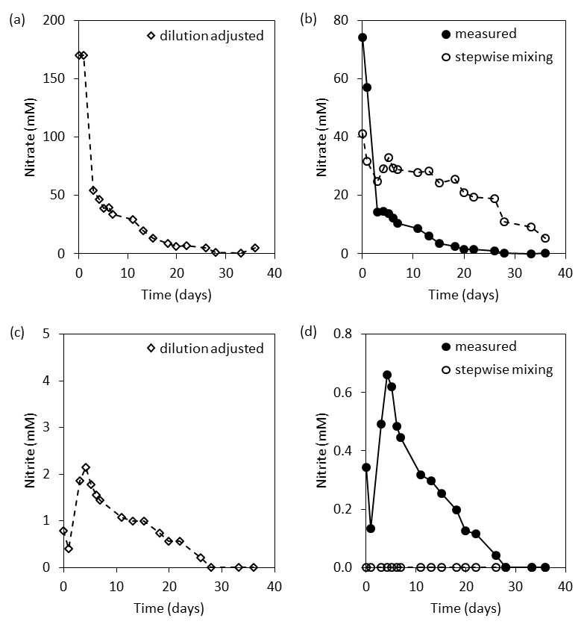

Figure 4.5 Breakthrough curves of nitrate and nitrite from the dilution-adjusted model (a), (c) and the stepwise-mixing model and measured data (b), (d)

except for the first two (Figure 4.5). This suggested that nitrate was either removed from the aqueous phase or transformed to another dissolved-phase species. As mentioned previously, nitrate reduction to nitrite and other reduced nitrogen-bearing species was expected to occur. A benefit of the stepwise-mixing model is that the measured data of the potentially reactive solute can be directly compared to the predicted data which assumes only non-reactive mixing occurred (Figure 4.5).
Both models suggested that nitrite was produced during the first 28 days and showed similar trends (Figure 4.5). However, the dilution-adjusted model suggested that nitrite concentrations peaked at approximately 2 mM at day 4 (Figure 4.5) whereas the measured data peaked at approximately 0.6 mM at day 4 (Figure 4.5). This discrepancy could simply be due to dilution. When considering that the concentrations of nitrite in the injection and aquifer fluids were similar and relatively low (0.0024 and 0.0004 mM, respectively) compared to those measured in the extraction fluid (up to 0.6 mM) it seems unlikely that dilution was a substantial factor. Another benefit of the step-wise mixing model is that the potential effect of dilution can be directly visualized when comparing the measured and predicted breakthrough curves. For the case of nitrite, it seems unlikely that dilution had any notable effect on the measured concentration (Figure 4.5).
The dilution-adjusted breakthrough curve of sulfate showed a notable and sustained increase from approximately 2 to 25 mM by day 36 (Figure 4.6). The stepwise-mixing breakthrough curve of sulfate suggested that mixing of sulfate would result in a negligible decrease from approximately 0.6 to 0.4 mM by day 36 (Figure 4.6). When considering that the concentrations of sulfate in the injection and aquifer fluids were 1.0 and 0.3 mM, respectively (Table 4.1), it seems unlikely that the effects of dilution would be considerable.
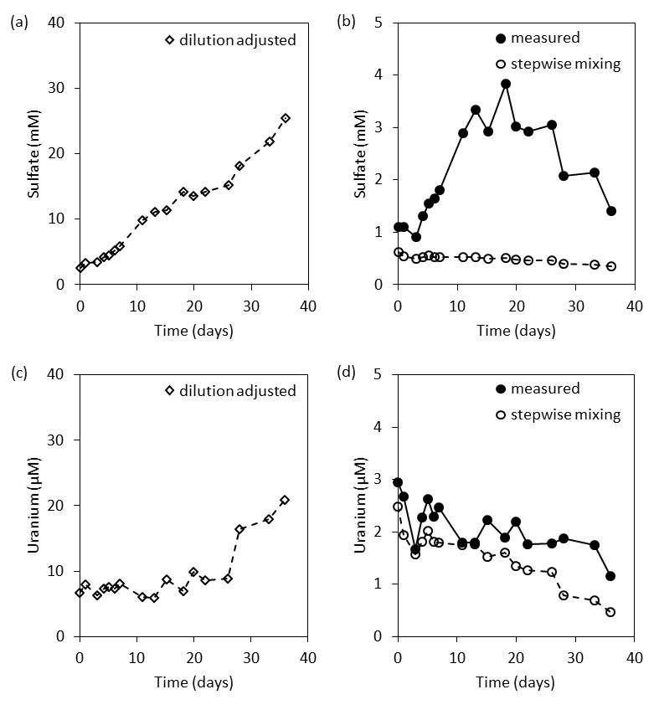

Figure 4.6 Breakthrough curves of sulfate and uranium from the dilution-adjusted model (a), (c) and stepwise-mixing model and measured data (b), (d)

The measured breakthrough curve of sulfate showed an increase up to approximately 4 mM by day 18 followed by a decrease down to approximately 1 mM by day 36 (Figure 4.6). Therefore, both the trends and magnitudes of the dilution-adjusted and measured concentrations of sulfate were notably different (Figure 4.6). If the effect of dilution was indeed negligible for sulfate, which the step-wise mixing model strongly suggested, then the breakthrough curve of the measured data (Figure 4.6) was likely more accurate than the breakthrough curve of the dilution-adjusted model (Figure 4.6). This further suggests that analysis of the dilution-adjusted breakthrough curve to quantify the net rate and mass of production of sulfate would be inaccurate. Although Paradis et al. (2016) did not quantify the net rate of production of sulfate, the mass of production of sulfate, relative to bromide, was quantified using the dilution-adjusted model in the form of a recovery factor (Table 4.2). An analogous calculation was conducted in this study using the stepwise-mixing model according to equation (14). Using equation (15), the area under the measured breakthrough curve was divided by the area under the stepwise-mixing breakthrough curve (Figure 4.6). As expected, the recovery factor of sulfate using the dilution-adjusted model was notably greater than the from the stepwise-mixing model (8.6 versus 5.1, respectively, Table 4.2). The dilution-adjusted breakthrough curve of uranium showed a sustained concentration of approximately 7 µM until day 26 followed by a notable increase to approximately 20 µM by day 36 (Figure 4.6). When considering that the concentrations of uranium in the injection and aquifer fluids were 5.4 and 0.2 µM, respectively (Table 4.1), it seems likely that the effects of dilution would be considerable and should be accounted for. Therefore, the dilution-adjusted breakthrough curve of uranium suggested that uranium was not produced at a concentration above the level of the injection fluid until day 28 (Figure 4.6).

Table 4.2 Recovery factors of uranium and sulfate from the dilution-adjusted and stepwise-mixing models, dilution-adjusted recovery factors are from Paradis et al. (2016)
Model | Uranium | Sulfate
(-) | (Recovery Factor) | (Recovery Factor)
Dilution Adjusted | 1.5 | 8.6
Stepwise Mixing | 1.4 | 5.1

The stepwise-mixing breakthrough curve of uranium suggested that mixing of uranium would result in a slight and sustained decrease from approximately 2.5 to 0.5 µM by day 36 (Figure 4.6). The measured breakthrough curve of uranium was similar in trend and only slightly higher in magnitude than the stepwise-mixing breakthrough curve (Figure 4.6). Therefore, the stepwise-mixing and measured breakthrough curves suggested that uranium was steadily produced at a concentration only slightly higher than mixing could account for (Figure 4.6). These results were notably different than the dilution-adjusted breakthrough curve which suggested that substantial uranium was produced between days 28 and 36 (Figure 4.6). The recovery factors of uranium using the dilution-adjusted and stepwise-mixing models were similar (1.5 versus 1.4, respectively, Table 4.2). However, the stepwise-mixing model suggested that uranium was produced steadily over the course of the entire experiment whereas the dilution-adjusted model suggested that uranium was primarily produced between days 28 and 36 (Figure 4.6).

4.6. Conclusions
An analytical solution which predicts the breakthrough curve of a potentially reactive solute due to non-reactive mixing during a single-well push-pull test was theoretically developed to account for the concentrations of both the non-reactive and potentially reactive solutes in the injection and aquifer fluids. The analytical solution was demonstrated to be valid for a synthetic data set by correctly predicting the net rate and extent of reactive solute mass transfer and transformation by accurately accounting for non-reactive mixing. The analytical solutions were further demonstrated to be applicable to a measured data set from a previously published study by Paradis et al. (2016) which utilized the single-well push-pull test method.

4.6. References
Istok, J. D., 2013. Push-Pull Tests for Site Characterization. doi:10.1007/978-3-642-13920-8.
Paradis, C. J., S. Jagadamma, D. B. Watson, L. D. McKay, T. C. Hazen, M. Park & J. D. Istok, 2016. In situ mobility of uranium in the presence of nitrate following sulfate-reducing conditions. Journal of Contaminant Hydrology 187:55-64 doi:10.1016/j.jconhyd.2016.02.002.

In situ demonstration of sustained adaptation of a natural microbial community to transform substrates

Chapter 5 is slated for submission for publication in Environmental Science and Technology.

Paradis, C. J., J. I. Miller, J. W. Moon, J. D. Van Nostrand, D. M. Klingeman, M. J. Rodriguez, L. D. McKay, A. P. Arkin, P. D. Adams, J. Zhou, E. J. Alm & T. C. Hazen, 2017. In situ demonstration of sustained adaptation of a natural microbial community to transform substrates in groundwater. Environmental Science & Technology (slated for submission).

5.1. Abstract
Prior exposure of a natural microbial community to a substrate can result in the increased potential of the community to transform the substrate; this phenomenon is known as adaptation. Adaptation is thought to play an important role in biogeochemical cycling at the ecosystem scale and has been demonstrated at the laboratory scale. However, in situ demonstrations of the magnitude and duration of adaptation are lacking. Ethanol was used as a substrate and was injected into a groundwater well (substrate treatment) for six consecutive weeks to establish adaptation. A second well (substrate control) was not injected with ethanol during this time. The substrate treatment demonstrated adaptation for microbial-mediated oxidation of ethanol to acetate and reduction of nitrate and sulfate. Both wells were then monitored for six additional weeks under natural conditions. During the final week, ethanol was injected into both wells. The substrate treatment demonstrated sustained adaptation whereas the substrate control did not. Surprisingly, the substrate treatment did not indicate a sustained and selective enrichment of a microbial community, as revealed by analysis of planktonic DNA. These results demonstrated that adaptation can be induced and sustained with no apparent enrichment of a select microbial community. This suggests that the predominant mechanisms of adaptation may exist at the enzymatic- and/or genetic-levels.

5.2. Introduction
Natural microbial communities play a critical role in biogeochemical cycling at a wide range of temporal and spatial scales and under highly variable environmental conditions (Torsvik and Ovreas 2002; Zhang and Xu 2008). Microbial communities can utilize a vast array of natural and anthropogenic chemicals in the environment as substrates to harness energy for cell maintenance and reproduction (Holmstrup et al. 2010). Microbial-mediated transformations of toxic substrates to non-toxic byproducts has long been recognized as highly beneficial to the environment and society (Essaid et al. 2015; Singh et al. 2017). It has also been recognized that prior exposure of a natural microbial community to a substrate can result in the increased potential of the community to transform the substrate; this phenomenon is known as adaptation (Leahy and Colwell 1990).
Adaptation has been observed in the field based on characterization studies and has been demonstrated in the laboratory based on experimental studies (Koskella and Vos 2015). For example, in the field, Pernthaler and Pernthaler (2005) observed adaptation of a marine planktonic microbial community in response to naturally fluctuating substrate availability over the course of a single day. In the laboratory, Pernthaler et al. (2001) demonstrated that adaptation of two marine planktonic isolates was dependent on the frequency of substrate addition, e.g., one species out-competed the other during a single substrate addition whereas the other species performed best during hourly substrate additions. Leahy and Colwell (1990) summarized the predominant, yet inter-related, mechanisms by which adaptation can occur: (1) induction and/or depression of specific enzymes, (2) genetic changes which result in new metabolic capabilities, and (3) selective enrichment of microbes able to transform the substrate of interest. More recently, Oh et al. (2013) demonstrated the inter-related mechanisms of adaptation of a river sediment microbial community to transform a toxic substrate. In the laboratory, exposure of the microbial community to benzalkonium chlorides (BAC) resulted in both the selective enrichment of Pseudomonas species and genetic changes via BAC-related amino acid substitutions and horizontal gene transfer.
These observations, demonstrations, and mechanistic insights of adaptation are only a small fraction of those in the vast literature (Koskella and Vos 2015) yet they clearly illustrate the importance and highlight the current understanding of the topic. Nevertheless, there is undoubtedly a need to bridge the knowledge gap between field observations and laboratory demonstrations of adaptation. More specifically, there is a need to design and conduct highly controlled field experiments with the proper controls to both demonstrate adaptation and elucidate its mechanisms. The objectives of this study were to: (1) establish a natural microbial community adapted to transform a substrate within an environmental setting, (2) determine how long adaptation can last in the absence of the substrate, and (3) elucidate the microbial mechanism(s) responsible for adaption.

5.3. Materials and methods

5.3.1. Study site
The study site is in Area 2 of the Y-12 S-3 pond field site which is a part of the Oak Ridge Reservation (ORR) and in Oak Ridge, Tennessee, USA (Figure 5.1). The hydrogeology of the study site has been previously described (Paradis et al. 2016; Paradis et al. 2017b). The subsurface consists of approximately 6 meters of unconsolidated and heterogeneous materials comprised of silty and clayey fill underlain by undisturbed and clay-rich weathered bedrock. The study site contains 13 monitoring wells (FW218 through FW230), two of which were used as test wells (FW222 and FW224), and one of which was used as a source well (FW229) for groundwater injectate for the exposure tests, as discussed in Section 2.5. (Figure 5.1). The test wells are constructed of 1.9-cm inside diameter schedule-80 polyvinyl chloride (PVC) pipe and are screened from 3.7 to 6.1 m below ground surface (mbgs). The test wells are screened within the fill materials and were vertically terminated at contact with the undisturbed weathered bedrock. The shallow groundwater aquifer is unconfined and the depth to groundwater is approximately 3.5 mbgs. The physical and chemical properties of the fill materials, in which the test wells are screened, have been previously described (Paradis et al. 2016; Paradis et al. 2017b) (Table 5.1). The test wells are separated by approximately 6 m of horizontal distance and oriented nearly perpendicular to the direction of groundwater flow (Figure 5.1).

Figure 5.1 Plan-view maps of the study site from Paradis et al. (2017b), clockwise from upper left, country map showing study site location in the southeastern United States, area map showing study site location in Area 2 of the ORR, and study site map showing well locations, groundwater elevations, and groundwater elevation iso-contours, m amsl = meters above mean sea level, substrate treatment well is FW222, substrate control well is FW224.

Table 5.1 Physical and chemical characteristics from substrate treatment (FW222), and substrate control (FW224) wells from Paradis et al. (2016) and Paradis et al. (2017b).
Test  Well | Hydraulic Conductivity | Effective  Porosity | Nitrate | Sulfate
(ID) | (m/s) | (%) | (mg/L) | (mg/L)
FW222 | 6.9x10⁻⁶ | 3.3 | 6.2 | 9.6
FW224 | 1.8x10⁻⁵ | 2.9 | 6.2 | 9.6

5.3.2. Substrate exposure tests
Exposure tests were conducted using the single-well push-pull test method (Istok 2013). During a push-pull test, a volume of water which contains a known mass of one or more non-reactive and reactive tracers is injected into and then extracted from a single groundwater monitoring well. The concentrations of the tracers and potential byproducts are then analyzed versus the volume extracted and/or time elapsed, i.e., breakthrough curves, to characterize the fate, transport, and reactivity processes within the groundwater system. The stepwise mixing model (SWiMM) by Paradis et al. (2017a) can be used to compare the model-derived breakthrough curves, as predicted by non-reactive mixing of the injection and aquifer fluids, versus the data-derived breakthrough curves. The comparison of the predicted versus the measured breakthrough curves can characterize the microbial-mediated activity. The single-well push-pull test method and analysis described here has been successfully utilized at the study site in previous studies (Paradis et al. 2017a; Paradis et al. 2016; Paradis et al. 2017b).
For this study, a volume of groundwater (5 to 40 L) was collected from up-gradient well FW229 (Figure 5.1) using a peristaltic pump and stored in a plastic carboy. A mass of potassium bromide (KBr) (Sigma-Aldrich) and ethanol (C2H6O) (Sigma-Aldrich) was added to the injection solution and mixed by re-circulation using a peristaltic pump for a target concentration of 200 mg/L bromide and 200 mg/L ethanol. Bromide was added as a non-reactive tracer whereas ethanol was added as a reactive tracer. The addition of ethanol at the study site was previously shown to serve as a substrate, i.e., a carbon and electron donor source, to stimulate microbial-mediated transformations, i.e., reduction, of nitrate, uranium, and sulfate (Paradis et al. 2016). The injection solution was then injected into the test well, followed by a 20-min resting period, and then periodically sampled over the course of four hours. Immediately prior to, and after mixing of the injection solution, three samples were collected, filtered (0.2 μm filter), stored in 20 mL scintillation vials, preserved at 4°C, and promptly analyzed for bromide, nitrate, sulfate, and acetate by ion chromatography (Dionex ICS-5000+) and for ethanol by gas chromatography (Agilent 6890). Acetate was previously shown to be the predominant metabolite of microbial-mediated oxidation of ethanol under anaerobic conditions from sediments collected within Area 2 at the OR-IFRC (Jin and Roden 2011). Three samples were also collected from the injection well immediately prior to injection and analyzed.
A series of seven exposure tests were conducted in test well FW222 (substrate treatment) and one exposure test was conducted in test well FW224 (substrate control) (Table 5.2). The treatment was exposed to ethanol for six consecutive weeks (weeks two through seven) followed by six consecutive weeks (weeks eight through thirteen) of no exposure to ethanol (Table 5.2). During week fourteen, both the substrate treatment and substrate control were exposed to ethanol (Table 5.2). The exposure tests allowed for comparing the effects of exposure history (substrate treatment) versus no exposure history (substrate control) in terms of microbial mediated transformations of substrates, e.g., ethanol, nitrate, and sulfate, in groundwater. The breakthrough curves of bromide, ethanol, acetate, nitrate, and sulfate, were analyzed according to the methodology of Paradis et al. (2017a) to characterize the microbial-mediated activity within the groundwater system.

Table 5.2 Experimental design of ethanol exposure tests for substrate treatment (FW222) and substrate control (FW224) wells, EtOH = ethanol.
Week | FW222 | FW224
01 | DNA | DNA
02 | EtOH 1 | -
03 | EtOH 2 | -
04 | EtOH 3, DNA | DNA
05 | EtOH 4 | -
06 | EtOH 5 | -
07 | EtOH 6, DNA | DNA
08 | DNA | DNA
09 | DNA | DNA
10 | DNA | DNA
11 | - | -
12 | - | -
13 | - | -
14 | DNA, EtOH 7, DNA | DNA, EtOH 1, DNA

5.3.3. Microbial community structure
The test wells were sampled for microbial community structure according to the general methodology of Smith et al. (2015). A volume of groundwater (5 to 10 L) was collected from the wells prior to and following the exposure tests. The groundwater was filtered, in series, through a 10 µm and a 0.2 µm filter, and preserved at -80°C. Microbial DNA was extracted from the 0.2 µm filter using a modified Miller method (Hazen et al. 2010; Miller et al. 1999; Smith et al. 2015) and shipped to the Institute for Environmental Genomics (Norman, OK, USA) for analysis of microbial DNA.
Extracted DNA was amplified as described in Wu et al. (2015). DNA was PCR amplified using a two-step PCR. In the first step, 16S rDNA was amplified for 10 cycles using primers 515F and 806R. In the second step, product from the first step was amplified for an additional 20 cycles using primers containing spacers to increase base diversity, barcodes, Illumina adaptor and sequencing primers, and the target primers, 515F and 806R. Amplification efficiency was evaluated by agarose gel electrophoresis. PCR products were pooled in equal molality and purified. Sequencing libraries were prepared according to the MiSeqTM Reagent Kit Preparation Guide (Illumina, San Diego, CA, USA) (Caporaso et al. 2012). Sequencing was performed for 251, 12, and 251 cycles for forward, index, and reverse reads, respectively, on an Illumina MiSeq using a 500-cycle v2 MiSeq reagent cartridge.
The resulting DNA sequences were analyzed according to the general methodology of Techtmann et al. (2015). DNA sequences were analyzed using the QIIME version 1.8.0-dev pipeline (Caporaso et al. 2012) and paired-end raw reads were assembled using fastq-join (Aronesty 2015). The assembled sequences were demultiplexed and quality filtered in QIIME to remove reads with phred scores below 20. Chimera detection was then performed on assembled reads using UCHIME (Edgar 2010; Edgar et al. 2011). Assembled, quality-filtered and chimera-checked sequences were deposited at MG-RAST. Sequences were clustered into operational taxonomic units (OTUs, 97% similarity) with UCLUST (Edgar 2010) using the open reference clustering protocol. The resulting representative sequences were aligned using PyNAST (Caporaso et al. 2010) and given a taxonomic assignment using RDP (Wang et al. 2007) retrained with the May 2013 Greengenes release. The resulting OTU table was filtered to keep OTUs that were present at greater than 0.005%, and then rarified to 13,753 sequences per sample (the minimum number of remaining sequences in the samples).
To test the hypothesis that exposure to ethanol influenced community structure, non-metric multi-dimensional scaling (NMDS) and hierarchical clustering analysis (HCA) were performed. A Bray-Curtis dissimilarity matrix was constructed using the scipy.spatial.distance methods from the SciPy library (Jones et al. 2001) in Python (Python 2017) and used as input for NMDS and HCA. NMDS was performed using the sklearn.manifold methods from the Scikit-learn library (Pedregosa et al. 2011). HCA was performed with the scipy.cluster.hierarchy methods using the average linkage method. The number of dimensions was increased starting from two to identify the minimum number of dimensions necessary to achieve a reasonable stress value. A breakpoint was identified at three dimensions, above which ordination stress did not decrease substantially.

5.4. Results and discussion

5.4.1. Substrate exposure tests
The treatment was exposed to ethanol once per week for six consecutive weeks (Table 5.2) to establish a natural microbial community adapted to transform substrates within the groundwater system. The substrate control was not exposed to ethanol during this time (Table 5.2). The breakthrough curves of ethanol, acetate, nitrate, and sulfate for exposure one in the treatment indicated that processes in addition to non-reactive mixing occurred, as evident by notable differences in the predicted versus measured data (Figure 5.2). Although the breakthrough curves of ethanol were nearly identical, those for acetate clearly indicated a net production and those for nitrate and sulfate a net removal that non-reactive mixing could not account for (Figure 5.2). Therefore, it is likely that some extent of microbial-mediated transformations of ethanol, nitrate, and sulfate occurred during exposure one. Microbial-mediated oxidation of ethanol to acetate and reduction of nitrate and sulfate has been well documented at the study site (Wu et al. 2006; Wu et al. 2007) and abroad (Feris et al. 2008; Rodriguez-Escales et al. 2016; Vidal-Gavilan et al. 2014). The breakthrough curves for exposures two and three demonstrated much stronger evidence of microbial activity as shown by substantial and sustained production of acetate and removal of ethanol, nitrate, and sulfate (Figure 5.2). The relative increase in microbial activity during subsequent exposures to ethanol, i.e., adaptation, was expected based on previous studies (Kline et al. 2011). The breakthrough curves for exposures four, five, and six showed relatively rapid non-reactive mixing of ethanol to concentrations below the minimum detection limit (≈20 mg/L) within one hour (data not shown). The relatively rapid non-reactive mixing during exposures four, five, and six was due to an unexpected and sustained increase in groundwater flow which resulted in a substantial increase in dilution of the injection fluid. Therefore, it was not possible to analyze the breakthrough curves for exposures four, five, and six. However, it is most certain that ethanol was added to the treatment and rapidly diluted during exposures four, five, and six.
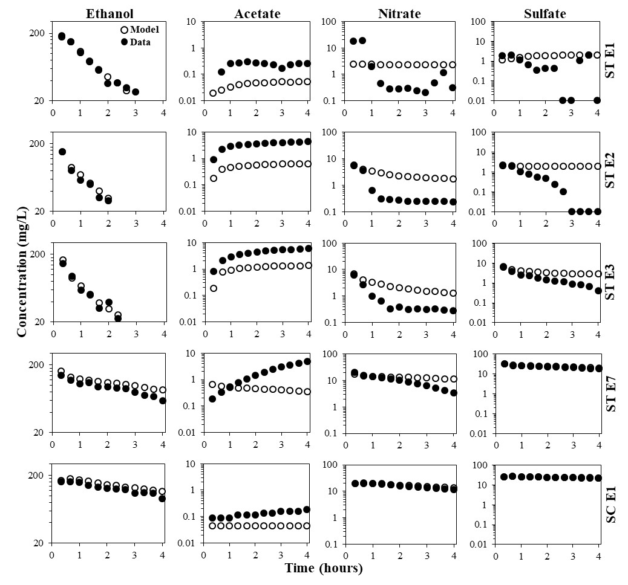

Figure 5.2 Breakthrough curves of ethanol, acetate, nitrate, and sulfate for exposures 1, 2, 3, and 7 for the substrate treatment (STE1, STE2, STE3, STE7) and for exposure 1 for the substrate control (SCE1), open circles represent simulated data (model) for non-reactive mixing of the injection and aquifer fluids, closed circles represent field data (data), exposures 4, 5, and 6 for the substrate treatment are omitted due to rapid (within one hour) dilution of ethanol to levels below the minimum detection limit (≈20 mg/L).

The treatment was not exposed to ethanol for six additional weeks (Table 5.2) to constrain the duration of adaptation. The substrate control was also not exposed to ethanol during this time (Table 5.2). Both the substrate treatment and substrate control were exposed to ethanol during week 14 to compare the activities of previously adapted versus non-adapted natural microbial communities (Table 5.2). The breakthrough curves for exposure seven (week 14) in the treatment indicated a net removal of ethanol and nitrate and a net production of acetate (Figure 5.2). The breakthrough curves for exposure one (week 14) in the substrate control also indicated a net removal of ethanol and a net production of acetate (Figure 5.2). However, the extent of ethanol removal and acetate production was substantially greater in the substrate treatment as compared to the substrate control (Figure 5.2). Moreover, nitrate removal occurred in the substrate treatment whereas nitrate removal did not occur in the substrate control (Figure 5.2). These results strongly suggested that the substrate treatment sustained its adaptation for ethanol-induced microbial activity. The results of the substrate exposure tests clearly established a natural microbial community adapted to transform substrates within a groundwater system and constrained the duration of adaptation to at least six weeks in the absence of the substrate. It is conceivable that the duration of adaptation could have lasted much longer than six weeks in the absence of the substrate. Therefore, additional in situ studies are needed to constrain an upper limit on the duration of adaptation.

5.4.2. Microbial community structure
The substrate treatment and substrate control were periodically sampled throughout the 14-week experiment (Table 5.2) to assess the changes in the structure of the microbial communities. NMDS was conducted to assess the similarity of the natural microbial communities at the level of operational taxonomical unit (OTU) (Figure 5.3). The number of dimensions was increased from two to three at which the ordination stress decreased from approximately 4 to 0.5 and remained below 0.5 up to at least seven dimensions (screen plot not shown). The NMDS plots showed that the substrate control clustered more closely as compared to substrate treatment (Figure 5.3). These results suggested that exposure to ethanol caused a notable shift in the microbial community as compared to no exposure to ethanol. The microbial community in the substrate control at week four (W04) and after exposure to ethanol at week 14 (W14*) were notably dissimilar to the other time points (Figure 5.3). These results suggested that the microbial community shifted in response to no substrate (W04) and added substrate (W14*) conditions. However, the microbial communities in both the substrate treatment and substrate control were notably similar at weeks 14 (W14) and one (W01) (Figure 5.3). These results suggested that by week 14 (W14) both microbial communities shifted back to a structure that was notably similar to their initial condition at week one (W01). These results were particularly surprising when considering that the substrate treatment was exposed to six consecutive weeks of ethanol whereas the substrate treatment was not.
HCA was conducted to further assess the similarity of the natural microbial communities at the level of OTU (Figure 5.4). The communities clustered into four distinct groups (G1 through G4) (Figure 5.4). Group 1 consisted entirely of the substrate control whereas groups 2, 3, and 4 consisted entirely of the substrate treatment (Figure 5.4). Within the substrate control (G1), the community after exposure to ethanol (W14*) was most dissimilar as indicated by the dendrogram (Figure 5.4). This result was expected based on the NMDS plots (Figure 5.3). Group 2 consisted of the substrate treatment at weeks one (W01) and the beginning of week 14 (W14), which were more similar to each other than they were any other time points across both substrate
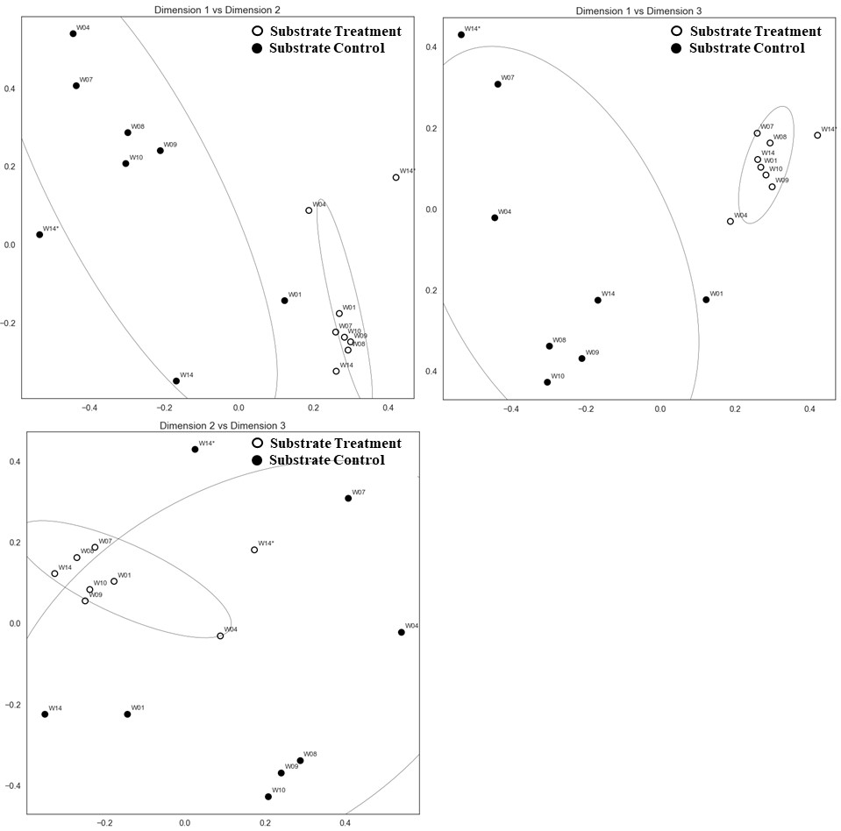

Figure 5.3 Non-metric multi-dimensional scaling (NMDS) plots during the 14-week experiment (W01 through W14*) for the substrate control (SC) and substrate treatment (ST), *indicates post-ethanol exposure, G1, G2, G3, and G4 indicate distinct groupings, ellipses indicated 95% confidence intervals for weeks one through 14 (W01 through W14).

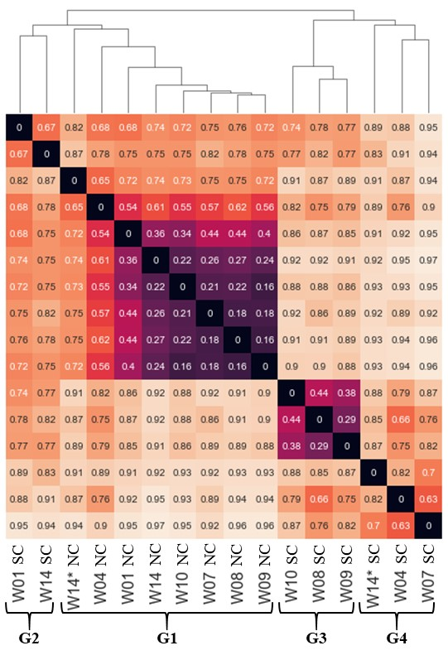

Figure 5.4 Hierarchical clustering analysis of operational taxonomic units (OTUs) during the 14-week experiment (W01 through W14*) for the substrate control (SC) and substrate treatment (ST), *indicates post-ethanol exposure, G1, G2, G3, and G4 indicate distinct groupings.

treatment and substrate control (Figure 5.4). This result was also expected based on the NMDS plots (Figure 5.3). However, the HCA quantified the similarity as 0.67 on a scale of zero being most similar and one being least similar (Figure 5.4). Therefore, both the NMDS and the HCA suggested that the microbial community in the substrate treatment did not sustain its adaptation in response to exposure to ethanol (Figure 5.3 and Figure 5.4). This was particularly surprising when considering that the breakthrough curves in the substrate treatment strongly suggested that the community sustained its adaptation for ethanol-induced substrate activity (Figure 5.2). Group 3 consisted of the substrate treatment at weeks eight, nine, and ten whereas group 4 consisted of the substrate treatment at weeks four, seven, and week 14* (Figure 5.4). In terms of timing with respect to ethanol exposure, group 3 coincided with the six-week period of no exposure to ethanol whereas group 4 coincided with the initial and final exposure to ethanol (Figure 5.4 and Table 5.2). These results were expected based on the timing of ethanol exposures.
The most surprising result was the relatively high similarity of the community structures of the substrate treatment at week one (W01) and the beginning of week 14 (W14) (Figure 5.3 and Figure 5.4). Although the breakthrough curves in the substrate treatment strongly suggested that the community sustained its adaptation for ethanol-induced substrate activity (Figure 5.2), the NMDS plots and HCA indicated that the community structure at the beginning of week 14 (W14) was notably similar to week one (W01) (Figure 5.3 and Figure 5.4). It is possible that the sessile microbial community adapted and sustained its adaptation but this is not known due to lack of sediment samples. It is also possible that genetic adaptations, rather than persistent changes to the community structure, were the primary mechanism that allowed the substrate treatment to respond rapidly to ethanol exposure (W14*).
Relative abundance analysis was conducted to assess the shifts in particular taxa at the level of phylum (Figure 5.5). The microbial community of the substrate control was dominated by Proteobacteria for weeks one through the beginning of 14 but showed considerable variability (Figure 5.5). The relative abundance of other taxa in the substrate control, such as Nitrospirae, Firmicutes, and Woesearchaeota were also notable for weeks one through the beginning of 14 and showed considerable variability (Figure 5.5). During this time, the substrate control was not exposed to ethanol (Table 5.2). Therefore, the temporal changes in taxa in the substrate control for weeks one through 14 were representative of natural conditions. The high relative abundance and temporal variability of Proteobacteria, Nitrospirae, and Firmicutes under natural conditions was expected based on a recent study at the ORR by King et al. (2017). King et al. (2017) demonstrated similar results from in situ above ground bioreactors and noted that such taxa are associated with low dissolved oxygen and/or representative of nitrate reducers. Both low dissolved oxygen and the presence of nitrate are characteristic of the dissolved-phase chemistry at the study site (Paradis et al. 2016). The substrate control was exposed to ethanol during the middle of week 14 (W14) and sampled for microbial community structure at the end of week 14 (W14*) (Table 5.2). After exposure to ethanol (W14*), Acidobacteria substantially increased in relative abundance, replacing Proteobacteria as the dominant phylum (Figure 5.5). These results were not expected when considering that previous studies at the ORR showed increases of Proteobacteria and decreases of Acidobacteria after exposure to ethanol (Cardenas et al. 2008; Spain et al. 2007). However, previous studies characterized the microbial communities associated with sediment (sessile) and after prolonged (three weeks to two years) exposures of
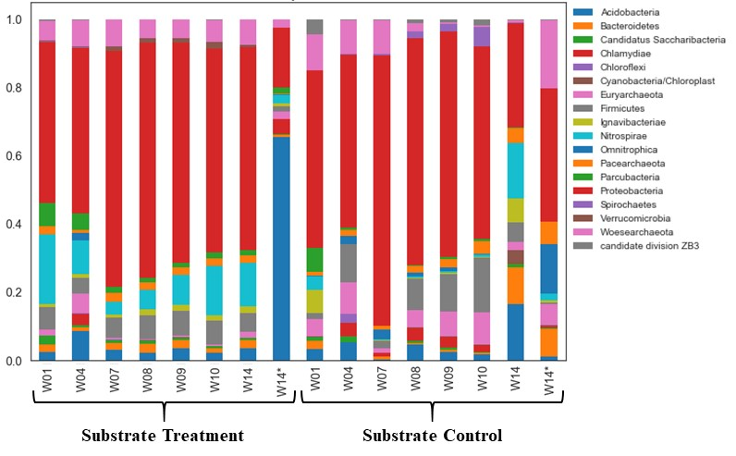

Figure 5.5 Relative abundance of microbial taxa at the phylum level during the 14-week experiment (W01 through W14) for the substrate control (SC) and substrate treatment (ST), *indicates post-ethanol exposure.

ethanol (Cardenas et al. 2008; Spain et al. 2007) whereas this study characterized microbial communities associated with groundwater (planktonic) and after a brief (less than four hours) exposure of ethanol. It is possible that the sessile microbial community adapted in a manner consistent with previous studies, but this is not known due to lack of sediment samples. It is also possible that duration of exposure to the substrate, i.e., prolonged versus brief, had a notable effect on the relative abundance of taxa as previously demonstrated by Pernthaler et al. (2001). Nevertheless, these results demonstrated that the planktonic microbial community in the substrate control was relatively stable under natural conditions but rapidly changed after exposure to ethanol.
The substrate treatment was dominated by Proteobacteria for weeks one through 10 but varied considerably more than the substrate control (Figure 5.5). The relative abundance of other taxa in the treatment, such as Firmicutes and Woesearchaeota were also notable for weeks one through 10 and showed considerable variability (Figure 5.5). Compared to the substrate control during this time, the community in the treatment by week 10 was notably different than week one (Figure 5.5). A notable change in the community in the treatment was expected because by week 10 the treatment had been exposed to six consecutive weeks of ethanol whereas the substrate control had not been exposed to ethanol (Table 5.2). By the beginning of week 14, the substrate treatment had been exposed to ethanol for six consecutive weeks followed by six consecutive weeks without exposure to ethanol (Table 5.2). As compared to the substrate control, the community in the substrate treatment by week 14 was notably different than week one (Figure 5.5). Therefore, if the microbial community in the treatment adapted to, and sustained its adaptation for, ethanol-induced transformation of substrates, which the breakthrough curves strongly suggested (Figure 5.2), then the community at the beginning of week 14 (W14) may be representative of an adapted community (Figure 5.5). Likewise, if the microbial community in the substrate control was not adapted for ethanol-induced transformation of substrates, which the breakthrough curves strongly suggested (Figure 5.2), then the community at the beginning of week 14 (W14) may be representative of a non-adapted community (Figure 5.5). The relative abundance of taxa in the substrate treatment after its final exposure to ethanol (W14*) was notably different than before its final exposure to ethanol (W14) as indicated by the increase of Woesearchaeota and decrease of Nitrospirae (Figure 5.5). These results demonstrated that the microbial community in the substrate treatment adapted upon exposure to ethanol and sustained a level of adaptation in the absence of exposure to ethanol. As previously noted, it is also possible that genetic adaptations, rather than persistent changes to the community structure, were the primary mechanism that allowed the substrate treatment to respond rapidly to ethanol exposure (W14*). Therefore, future in situ studies of adaptation should attempt to characterize the sessile community as well as investigate the genetic adaptations to ethanol exposure.

5.6. References
Aronesty, E., 2015. Command-line tools for processing biological sequencing data. In. https://code.google.com/p/ea-utils/.
Caporaso, J. G., K. Bittinger, F. D. Bushman, T. Z. DeSantis, G. L. Andersen & R. Knight, 2010. PyNAST: a flexible tool for aligning sequences to a template alignment. Bioinformatics 26(2):266-267 doi:10.1093/bioinformatics/btp636.
Caporaso, J. G., C. L. Lauber, W. A. Walters, D. Berg-Lyons, J. Huntley, N. Fierer, S. M. Owens, J. Betley, L. Fraser, M. Bauer, N. Gormley, J. A. Gilbert, G. Smith & R. Knight, 2012. Ultra-high-throughput microbial community analysis on the Illumina HiSeq and MiSeq platforms. Isme Journal 6(8):1621-1624 doi:10.1038/ismej.2012.8.
Cardenas, E., W. M. Wu, M. B. Leigh, J. Carley, S. Carroll, T. Gentry, J. Luo, D. Watson, B. Gu, M. Ginder-Vogel, P. K. Kitanidis, P. M. Jardine, J. Zhou, C. S. Criddle, T. L. Marsh & J. A. Tiedje, 2008. Microbial communities in contaminated sediments, associated with bioremediation of uranium to submicromolar levels. Applied and Environmental Microbiology 74(12):3718-3729 doi:10.1128/aem.02308-07.
Edgar, R. C., 2010. Search and clustering orders of magnitude faster than BLAST. Bioinformatics 26(19):2460-2461 doi:10.1093/bioinformatics/btq461.
Edgar, R. C., B. J. Haas, J. C. Clemente, C. Quince & R. Knight, 2011. UCHIME improves sensitivity and speed of chimera detection. Bioinformatics 27(16):2194-2200 doi:10.1093/bioinformatics/btr381.
Essaid, H. I., B. A. Bekins & I. M. Cozzarelli, 2015. Organic contaminant transport and fate in the subsurface: Evolution of knowledge and understanding. Water Resources Research 51(7):4861-4902 doi:10.1002/2015wr017121.
Feris, K., D. Mackay, N. de Sieyes, I. Chakraborty, M. Einarson, K. Hristova & K. Scow, 2008. Effect of ethanol on microbial community structure and function during natural attenuation of benzene, toluene, and o-xylene in a sulfate-reducing aquifer. Environmental Science & Technology 42(7):2289-2294 doi:10.1021/es702603q.
Hazen, T. C., E. A. Dubinsky, T. Z. DeSantis, G. L. Andersen, Y. M. Piceno, N. Singh, J. K. Jansson, A. Probst, S. E. Borglin, J. L. Fortney, W. T. Stringfellow, M. Bill, M. E. Conrad, L. M. Tom, K. L. Chavarria, T. R. Alusi, R. Lamendella, D. C. Joyner, C. Spier, J. Baelum, M. Auer, M. L. Zemla, R. Chakraborty, E. L. Sonnenthal, P. D'Haeseleer, H. Y. N. Holman, S. Osman, Z. M. Lu, J. D. Van Nostrand, Y. Deng, J. Z. Zhou & O. U. Mason, 2010. Deep-Sea Oil Plume Enriches Indigenous Oil-Degrading Bacteria. Science 330(6001):204-208 doi:10.1126/science.1195979.
Holmstrup, M., A. M. Bindesbol, G. J. Oostingh, A. Duschl, V. Scheil, H. R. Kohler, S. Loureiro, A. Soares, A. L. G. Ferreira, C. Kienle, A. Gerhardt, R. Laskowski, P. E. Kramarz, M. Bayley, C. Svendsen & D. J. Spurgeon, 2010. Interactions between effects of environmental chemicals and natural stressors: A review. Science of the Total Environment 408(18):3746-3762 doi:10.1016/j.scitotenv.2009.10.067.
Istok, J. D., 2013. Push-Pull Tests for Site Characterization. doi:10.1007/978-3-642-13920-8.
Jin, Q. S. & E. E. Roden, 2011. Microbial physiology-based model of ethanol metabolism in subsurface sediments. Journal of Contaminant Hydrology 125(1-4):1-12 doi:10.1016/j.jconhyd.2011.04.002.
Jones, E., T. Oliphant & P. Peterson, 2001. SciPy: Open source scientific tools for Python. In. https://scipy.org/citing.html.
King, A. J., S. P. Preheim, K. L. Bailey, M. S. Robeson, T. R. Chowdhury, B. R. Crable, R. A. Hurt, T. Mehlhorn, K. A. Lowe, T. J. Phelps, A. V. Palumbo, C. C. Brandt, S. D. Brown, M. Podar, P. Zhang, W. A. Lancaster, F. Poole, D. B. Watson, M. W. Fields, J. M. Chandonia, E. J. Alm, J. Z. Zhou, M. W. W. Adams, T. C. Hazen, A. P. Arkin & D. A. Elias, 2017. Temporal Dynamics of In-Field Bioreactor Populations Reflect the Groundwater System and Respond Predictably to Perturbation. Environmental Science & Technology 51(5):2879-2889 doi:10.1021/acs.est.6b04751.
Kline, K. R., J. F. Clark, L. Rastegarzadeh, Y. M. Nelson & D. M. Mackay, 2011. Importance of Exposure History When Using Single Well Push-Pull Tests to Quantify in situ Ethanol Biodegradation Rates. Ground Water Monit R 31(3):103-110 doi:10.1111/j1745-6592.2011.01347.x.
Koskella, B. & M. Vos, 2015. Adaptation in Natural Microbial Populations. In Futuyma, D. J. (ed) Annual Review of Ecology, Evolution, and Systematics, Vol 46. Annual Review of Ecology Evolution and Systematics, vol 46, 503-522.
Leahy, J. G. & R. R. Colwell, 1990. Microbial-degradation of hydrocarbons in the environment. Microbiological Reviews 54(3):305-315.
Miller, D. N., J. E. Bryant, E. L. Madsen & W. C. Ghiorse, 1999. Evaluation and optimization of DNA extraction and purification procedures for soil and sediment samples. Applied and Environmental Microbiology 65(11):4715-4724.
Oh, S., M. Tandukar, S. G. Pavlostathis, P. S. G. Chain & K. T. Konstantinidis, 2013. Microbial community adaptation to quaternary ammonium biocides as revealed by metagenomics. Environ Microbiol 15(10):2850-2864 doi:10.1111/1462-2920.12154.
Paradis, C. J., E. R. Dixon, L. M. Lui, A. P. Arkin, E. Perfect, L. D. McKay, J. D. Istok & T. C. Hazen, 2017a. Stepwise mixing model for quantifying solute mass transfer and transformation during push-pull tests. Water Resources Research (In Preparation).
Paradis, C. J., S. Jagadamma, D. B. Watson, L. D. McKay, T. C. Hazen, M. Park & J. D. Istok, 2016. In situ mobility of uranium in the presence of nitrate following sulfate-reducing conditions. Journal of Contaminant Hydrology 187:55-64 doi:10.1016/j.jconhyd.2016.02.002.
Paradis, C. J., L. D. McKay, E. Perfect, J. D. Istok & T. C. Hazen, 2017b. Push-pull tests for estimating effective porosity: expanded analytical solution and in situ application. Hydrogeology Journal doi:10.1007/s10040-017-1672-3.
Pedregosa, F., G. Varoquaux, A. Gramfort, V. Michel, B. Thirion, O. Grisel, M. Blondel, P. Prettenhofer, R. Weiss, V. Dubourg, J. Vanderplas, A. Passos, D. Cournapeau, M. Brucher, M. Perrot & E. Duchesnay, 2011. Scikit-learn: Machine Learning in Python. Journal of Machine Learning Research 12:2825-2830.
Pernthaler, A. & J. Pernthaler, 2005. Diurnal variation of cell proliferation in three bacterial taxa from coastal North Sea waters. Applied and Environmental Microbiology 71(8):4638-4644 doi:10.1128/aem.71.8.4638-4644.2005.
Pernthaler, A., J. Pernthaler, H. Eilers & R. Amann, 2001. Growth patterns of two marine isolates: Adaptations to substrate patchiness? Applied and Environmental Microbiology 67(9):4077-4083 doi:10.1128/aem.67.9.4077-4083.2001.
Python, 2017. In. http://www.python.org.
Rodriguez-Escales, P., A. Folch, G. Vidal-Gavilan & B. M. van Breukelen, 2016. Modeling biogeochemical processes and isotope fractionation of enhanced in situ biodenitrification in a fractured aquifer. Chemical Geology 425:52-64 doi:10.1016/j.chemgeo.2016.01.019.
Singh, P., R. Jain, N. Srivastava, A. Borthakur, D. B. Pal, R. Singh, S. Madhav, P. Srivastava, D. Tiwary & P. K. Mishra, 2017. Current and emerging trends in bioremediation of petrochemical waste: A review. Critical Reviews in Environmental Science and Technology 47(3):155-201 doi:10.1080/10643389.2017.1318616.
Smith, M. B., A. M. Rocha, C. S. Smillie, S. W. Olesen, C. Paradis, L. Wu, J. H. Campbell, J. L. Fortney, T. L. Mehlhorn, K. A. Lowe, J. E. Earles, J. Phillips, S. M. Techtmann, D. C. Joyner, D. A. Elias, K. L. Bailey, R. A. Hurt, Jr., S. P. Preheim, M. C. Sanders, J. Yang, M. A. Mueller, S. Brooks, D. B. Watson, P. Zhang, Z. He, E. A. Dubinsky, P. D. Adams, A. P. Arkin, M. W. Fields, J. Zhou, E. J. Alm & T. C. Hazen, 2015. Natural Bacterial Communities Serve as Quantitative Geochemical Biosensors. Mbio 6(3) doi:10.1128/mBio.00326-15.
Spain, A. M., A. D. Peacock, J. D. Istok, M. S. Elshahed, F. Z. Najar, B. A. Roe, D. C. White & L. R. Krumholz, 2007. Identification and isolation of a Castellaniella species important during biostimulation of an acidic nitrate- and uranium-contaminated aquifer. Applied and Environmental Microbiology 73(15):4892-4904 doi:10.1128/aem.00331-07.
Techtmann, S. M., J. L. Fortney, K. A. Ayers, D. C. Joyner, T. D. Linley, S. M. Pfiffner & T. C. Hazen, 2015. The Unique Chemistry of Eastern Mediterranean Water Masses Selects for Distinct Microbial Communities by Depth. Plos One 10(3) doi:10.1371/journal.pone.0120605.
Torsvik, V. & L. Ovreas, 2002. Microbial diversity and function in soil: from genes to ecosystems. Current Opinion in Microbiology 5(3):240-245 doi:10.1016/s1369-5274(02)00324-7.
Vidal-Gavilan, G., R. Carrey, A. Solanas & A. Soler, 2014. Feeding strategies for groundwater enhanced biodenitrification in an alluvial aquifer: Chemical, microbial and isotope assessment of a 1D flow-through experiment. Science of the Total Environment 494:241-251 doi:10.1016/j.scitotenv.2014.06.100.
Wang, Q., G. M. Garrity, J. M. Tiedje & J. R. Cole, 2007. Naive Bayesian classifier for rapid assignment of rRNA sequences into the new bacterial taxonomy. Applied and Environmental Microbiology 73(16):5261-5267 doi:10.1128/aem.00062-07.
Wu, L. Y., C. Q. Wen, Y. J. Qin, H. Q. Yin, Q. C. Tu, J. D. Van Nostrand, T. Yuan, M. T. Yuan, Y. Deng & J. Z. Zhou, 2015. Phasing amplicon sequencing on Illumina MiSeq for robust environmental microbial community analysis. Bmc Microbiology 15 doi:10.1186/s12866-015-0450-4.
Wu, W. M., J. Carley, T. Gentry, M. A. Ginder-Vogel, M. Fienen, T. Mehlhorn, H. Yan, S. Caroll, M. N. Pace, J. Nyman, J. Luo, M. E. Gentile, M. W. Fields, R. F. Hickey, B. H. Gu, D. Watson, O. A. Cirpka, J. Z. Zhou, S. Fendorf, P. K. Kitanidis, P. M. Jardine & C. S. Criddle, 2006. Pilot-scale in situ bioremediation of uranium in a highly contaminated aquifer. 2. Reduction of U(VI) and geochemical control of U(VI) bioavailability. Environmental Science & Technology 40(12):3986-3995 doi:10.1021/es051960u.
Wu, W. M., J. Carley, J. Luo, M. A. Ginder-Vogel, E. Cardenas, M. B. Leigh, C. C. Hwang, S. D. Kelly, C. M. Ruan, L. Y. Wu, J. Van Nostrand, T. Gentry, K. Lowe, T. Mehlhorn, S. Carroll, W. S. Luo, M. W. Fields, B. H. Gu, D. Watson, K. M. Kemner, T. Marsh, J. Tiedje, J. Z. Zhou, S. Fendorf, P. K. Kitanidis, P. M. Jardine & C. S. Criddle, 2007. In situ bioreduction of uranium (VI) to submicromolar levels and reoxidation by dissolved oxygen. Environmental Science & Technology 41(16):5716-5723 doi:10.1021/es062657b.
Zhang, L. & Z. Xu, 2008. Assessing bacterial diversity in soil. Journal of Soils and Sediments 8(6):379-388 doi:10.1007/s11368-008-0043-z.

Conclusions
The conclusions of the four contaminant hydrogeology studies presented in this dissertation advanced the understanding of the structure and function of natural microbial communities in groundwater. In the first study, in situ oxidation/mobilization of previously bio-reduced/bio-immobilized uranium in the presence of nitrate oxidant was demonstrated to be mitigated by preferential oxidation/mobilization of reduced sulfur-bearing species as opposed to reduced uranium-bearing species. The first study confirmed the results of previous laboratory studies and suggested that establishing sulfate-reducing conditions following bio-reduction of uranium can substantially limit the extent of uranium mobility in the presence of nitrate oxidant. In the second study, the analytical solution for describing the center of mass of a non-reactive solute during a push-drift-pull test was expanded to account for the push-phase. The second study demonstrated that failure to account for the push-phase may lead to underestimating the magnitude of effective porosity and the expanded solution allowed for a better estimation of the physical space through which an injected volume of a dissolved-phase microbial substrate would travel by advection. In the third study, the breakthrough curve of a potentially reactive solute due to non-reactive mixing of the injection and aquifer fluids during a push-drift-pull test was described analytically to account for any possible combination of non-reactive and potentially reactive solute concentrations within the injection and aquifer fluids. The third study demonstrated that accounting for any possible combination of concentrations yielded a more accurate quantification of microbial-mediated solute mass transformation. In the fourth study, in situ adaptation of a natural microbial community was induced and sustained for up to six weeks in the absence of ethanol substrate with no apparent enrichment of a select planktonic microbial community. The fourth study suggested that the predominant mechanisms of adaptation may exist at the enzymatic- and/or genetic-levels. Therefore, future in situ studies of the exposure history dependence of microbial mediated transformations of substrates in groundwater should attempt to characterize the sessile community as well as investigate the genetic adaptations to substrate exposure.

Vita
Charles (“Charlie”) Joseph Paradis was born in San Francisco, California and raised in the East Bay. Charlie holds a bachelor of arts degree in geology from the University of California Berkeley and a master of science degree in hydrology from the University of California Davis. Charlie held the position of associate geologist for Parsons Corporation prior to his doctoral studies at the University of Tennessee Knoxville. Charlie plans to continue making significant scientific contributions to the broad field of contaminant hydrogeology.

