To the Graduate Council:
I am submitting herewith a thesis written by Lindsey Lanee´ Cope entitled “The Power of Three in Dan Forrest’s Requiem for the Living.” I have examined the final electronic copy of this thesis for form and content and recommend that it be accepted in partial fulfillment of the requirements for the degree of Master of Music, with a major in Theory.
Barbara Murphy, Major Professor
We have read this thesis and recommend its acceptance:
Brendan McConville, Gene Peterson
Accepted for the Council:
Carolyn R. Hodges
Vice Provost and Dean of the Graduate School
(Original signatures are on file with official student records.)

The Power of Three in
Dan Forrest’s Requiem for the Living

A Thesis Presented for the
Master of Music
Degree
The University of Tennessee, Knoxville

Lindsey Lanee´ Cope
August 2015

Copyright © 2015 by Lindsey Laneé Cope

All rights reserved.

DEDICATION

This thesis is dedicated to my parents, Kenneth and Priscilla Cope, who have always been supportive and encouraging. I would not be who I am today without your nurturing guidance throughout my life. Thank you for all you sacrificed to help me get here. I love you both so much!

I also dedicate this thesis to my best friend, Elizabeth Seastrunk, who has been my rock through thick and thin. Your wisdom and positivity has helped guide me through the tough times and kept a smile on my face. I thank God for placing you in my life!

ACKNOWLEDGEMENTS

I would like to acknowledge my advisor, Dr. Barbara Murphy, who has guided me through this process with professionalism and wisdom. She has pushed me to be a better thinker, writer, and theorist. Her knowledge and guidance has made the difficult process of organizing my thoughts and analyses into a coherent paper bearable. She has always been personable, approachable, and even willing to work with me via Skype on her summer break.

I also want to acknowledge Dr. Brendan McConville who has pushed me to be a well-rounded theorist. I respect him for ensuring my theory education is thorough. He is a fine instructor and definitely one of my favorite professors.

ABSTRACT

Dan Forrest’s Requiem for the Living is a recent composition that is quickly gaining attention in the choral world. The work exhibits unique aspects of Forrest’s compositional voice in his Requiem, including his textual changes from an original Requiem, formal designs and overall organization, melodic and rhythmic motivic development, and harmonic transformations. Through comprehensive analysis and discussion, this thesis will argue that the primary three-note motive in the Requiem serves as the cornerstone for analytical departure. The number three is the main component of the formal, motivic, and harmonic structure of the Requiem for the Living. The framework for discussion extracts the importance of the number three in the primary motive and draws connections to other aspects of the work that utilize three as an organizing mechanism. Schenkerian analysis and Neo-Riemannian Theory will assist in understanding the melodic and harmonic relationships.

TABLE OF CONTENTS

CHAPTER 1: Introduction 1
Background 2
Textual Analysis of Forrest’s Requiem 4
CHAPTER 2: Form and Overall Organization 12
Introit-Kyrie 12
Vanitas Vanitatum 15
Agnus Dei 17
Sanctus 20
Lux Aeterna 24
CHAPTER 3: Motives 30
Motive A 30
Variations of Motive A 35
Movement Motives 39
Agnus Dei Motive 40
Sanctus Motive 41
Lux Aeterna Motive 42
Rhythmic Motives 46
CHAPTER 4: Harmonic Analysis 51
Neo-Riemannian Analytical Approach 52
Tracing Chord Transformations in the Requiem 61
Extended Tertian Harmonies 61
Suspensions 62
Mediant Relationships 64
CHAPTER 5: Conclusion 70
LIST OF REFERENCES 72
VITA 75

LIST OF TABLES

Table 1: Parts of the Roman Catholic Mass, Requiem Mass, Forrest's Requiem 6
Table 2: Original Introit-Kyrie Text, Forrest Introit-Kyrie Text, English Translation 8
Table 3: Forrest Vanitas Vanitatum Text, English Translation 8
Table 4: Original Agnus Dei Text, Forrest Agnus Dei Text, English Translation 9
Table 5: Original Sanctus Text, Forrest Sanctus Text, English Translation 10
Table 6: Original Lux Aeterna Text, Forrest Lux Aeterna Text, English Translation 10
Table 7: Overall Organization of Requiem for the Living 29
Table 8: Motive A Statements in Introit-Kyrie 32
Table 9: Key Relationships in Requiem Mostly Minor Thirds 51

LIST OF FIGURES

Figure 1: Introit-Kyrie Ternary Design 12
Figure 2: Motive A in Violin II in Introit-Kyrie, mm. 1-5 13
Figure 3: RM1 in Introit-Kyrie mm. 66-67 13
Figure 4: Sigh Motive in Introit-Kyrie, mm. 77-78 14
Figure 5: Vanitas Vanitatum Overall Form 15
Figure 6: Section a/b Including Vanitas Vanitatum Text with Pie Jesu Text mm. 47-49 16
Figure 7: B-Section with Longer Note Values and Slower Tempo in Vanitas Vanitatum, mm. 84-87 16
Figure 8: Agnus Dei Overall Form 17
Figure 9: “Agnus Dei” Motive in Boy Solo, mm. 9-10 18
Figure 10: B-Section Tonal Shift to Db Major in Agnus Dei, m. 38 18
Figure 11: Ambigious Tonal Shift in Agnus Dei mm. 55-61 19
Figure 12: Sanctus Overall Form 20
Figure 13: Hubble Ultra-Deep Field Image 20
Figure 14: High Registers in Harp and Glockenspiel Parts in Sanctus, m. 1-6 21
Figure 15: B-Section, Key Change to D Major, and Tempo Change in Sanctus, mm. 45-47 22
Figure 16: C-section Tempo Change and Sixteenth Notes in Sanctus, mm. 104-105 22
Figure 17: Ending dynamic (fff) of Sanctus, mm. 169-171 23
Figure 18: Lux Aeterna Overall Form 24
Figure 19: Intentional Overlap of Tenor Solo "Rest" with Choir "Requiem" in Lux Aeterna, m. 69-70 24
Figure 20: Lux Aeterna Motive Soprano Solo Part, mm. 18-19 25
Figure 21: Chromatic Alterations and English Text in B-Section of Lux Aeterna mm. 57-68 26
Figure 22: Elision with Second Inversion Chord in Introit-Kyrie, mm. 148-153 into Vanitas Vanitatum, mm. 1-2 27
Figure 23: Elision from Vanitas Vanitatum, mm. 181-183 to Agnus Dei, mm. 1-2 27
Figure 24: End of Agnus Dei, mm. 95-97 and Beginning of Sanctus, mm. 1-3 28
Figure 25: Elision from Sanctus, mm. 169-171 and Lux Aeterna, mm. 1-3 28
Figure 26: Motive A in Introit-Kyrie and Schenkerian Analysis, mm. 3-5 30
Figure 27: Motive A at Choir's First Entrance with Violin I in Introit-Kyrie mm. 36-37 31
Figure 28: Motive A in Choir Parts in Vanitas Vanitatum, mm. 144-145 32
Figure 29: Motive A Transposed in Soprano Part in Vanitas Vanitatum, mm. 62-63 33
Figure 30: Motive A Changes to F Major in Sanctus, mm. 1-4 33
Figure 31: Motive A Transposed in Agnus Dei, m. 17 34
Figure 32: Motive A Transposed in Soprano, Flute, and Oboe Parts in Lux Aeterna, mm. 89-93 34
Figure 33: Infrapolation of Motive A in Soprano and Alto Parts and Schekerian Analysis in Introit-Kyrie, mm. 49-50 35
Figure 34: Ultrapolation of Motive A in Alto and Tenor Parts in Introit-Kyrie, mm. 103-105 36
Figure 35: Ultrapolation of Motive A Transposed in Soprano in Introit-Kyrie, mm. 131-132 37
Figure 36: Ultrapolation and Transposition of Motive A and Schenkerian Analysis in Vanitas Vanitatum, mm. 85-86 37
Figure 37: Ultrapolation Motive A in Alto and Schenkerian Analysis in Vanitas Vanitatum, mm. 103-104 38
Figure 38: Agnus Dei Motive and Schenkerian Analysis, mm.1-6 39
Figure 39: Agnus Dei Motive Transposed Solo Part, mm. 74-75 39
Figure 40: Agnus Dei Motive in Oboe Part in Lux Aeterna, mm. 110-112 40
Figure 41: Sanctus Motive Soprano and Alto Parts and Schenkerian Analysis, mm. 10-14 40
Figure 43: Sanctus Motive in Flute Part in Lux Aeterna, mm. 113-116 41
Figure 44: Lux Aeterna Motive, mm.18-19 42
Figure 45: Infrapolation of Lux Aeterna Motive, mm. 20-21 42
Figure 46: Introit-Kyrie Motive A in Lux Aeterna and Schenkerian Analysis, mm.105-106 43
Figure 47: Lux Aeterna Motive in Cello Part, mm. 117-118 43
Figure 48: Motive A Transposed Retrograde in Lux Aeterna and Schenkerian Analysis, mm.123-128 44
Figure 49: RM1 in Alto and Bass Parts in Introit-Kyrie, mm. 64-65 45
Figure 50: RM1 in Introit-Kyrie, mm. 66-67 45
Figure 51: RM2 in Choir in Vanitas Vanitatum, mm. 21-24 46
Figure 52: RM2 in Vanitas Vanitatum Overall Form 46
Figure 53: RM3 Polymeter Between Harp and Glockenspiel in Sanctus mm. 7-10 47
Figure 54: Segment of RM3 in Sanctus, m. 33 47
Figure 55: RM3 Segment in Sanctus, mm. 40-41 48
Figure 56: Hyer's Tonnetz 51
Figure 57: Parallel Transformation, Block Chords, and NRT Diagram in Vanitas Vanitatum, mm. 152-154 52
Figure 58: Leading Tone Transformation, Block Chords, and NRT Diagram in Sanctus, mm. 66-68 53
Figure 59: Relative Transformation and NRT Diagram in Introit-Kyrie, mm. 84-85 54
Figure 60: Compound Transformation (LR) = Dominant and NRT Diagram 55
Figure 61: Compound Transformation (PRL), Block Chords, and NRT Diagram in Introit-Kyrie, mm. 29-33 56
Figure 62: NRT Diagram of Compound Transformation (LRP) in Introit-Kyrie 56
Figure 63: C^{maj7} is Two Triads: C Major and E minor 57
Figure 64: Capuzzo's Inclusion and Exclusion Symbols 58
Figure 65: Extended Harmony and Voice Leading Parsimony in Introit-Kyrie, mm. 46-49 59
Figure 66: Extended Tertian Harmonies in Sanctus, mm. 48-50 59
Figure 67: Suspension in Harp and Glockenspiel Parts and Block Chords in Sanctus, mm. 17-19 60
Figure 68: Suspension in Harp, Strings, and Alto Parts in Sanctus, mm. 36-3 60
Figure 69: Mediant Chord Relationships, Block Chords, and NRT Diagram in Introit-Kyrie, mm. 63-67 62
Figure 70: Mediant Chord Relationships, Block Chords, and NRT Diagram in Sanctus, mm. 106-108 62
Figure 71: Mediant Chord Relationships, Block Chords, and NRT Diagram in Introit-Kyrie, mm. 92-96 63
Figure 72: Mediant Chord Relationships, Block Chords, and NRT Diagram in Agnus Dei, mm. 9-14, 64
Figure 73: Mediant Relationship, Block Chords, and NRT Diagram in Introit-Kyrie, mm. 48-49 65
Figure 74: Non-Traditional Change from D minor to F major and NRT Diagram in Vanitas Vanitatum, mm. 59-61 65

CHAPTER 1: Introduction

Dan Forrest, a world-renowned composer and arranger, is quickly gaining popularity for his choral, instrumental, orchestral, and solo music. Since his first publication in 2001, his pieces have become “firmly established in the repertoire of choirs in the U.S. and abroad.” His largest and favorite composition to date is his Requiem for the Living, which is one of his most performed pieces. Music critic John W. Lambert said of Forrest’s Requiem, “There are many great Requiems in the active repertory of our important choral organizations and this one will most assuredly be counted among that number.”
An organizing mechanism for the Requiem for the Living is the number three. This number is evident in the range of the motive, the three-part design of each movement, the motives, the numerous mediant harmonic relationships, and the extended tertian harmonies.
This thesis will provide an analysis of these elements showing how the number three is an important component of the Requiem. A brief biography and a description of a Requiem text will be presented in Chapter 1. Chapter 2 includes a discussion of each movement’s three-part form and the overall organization of Forrest’s Requiem. Chapter 3 presents the melodic and rhythmic motives and their use and development throughout the composition. This chapter also explains how each motive is a variation of the main three-note motive (F-E-D) of the Requiem. Chapter 4 includes a brief explanation of Neo-Riemannian Theory, the analytical technique used to explain harmonic transformations in the Requiem, and how it can be used to analyze the Requiem. Chapter 5 draws conclusions about the use of the number three throughout the Requiem based on the analyses presented.

Background

Dan Forrest (b.1978), a world-renowned pianist and composer, was born in Elmira, New York. He began piano lessons in the fourth grade and served as a pianist at his church in the sixth grade. While in high school, he composed and arranged several songs for piano; however, only when he discovered choral music in college did he become serious about composing. He attended Bob Jones University where he received a Bachelor of Music in Piano Performance in 1999 and a Master of Music degree in Piano Performance in 2001. It was during his college years that Forrest became “infatuated with recordings of choral music” and what a choir could do musically. In 2007, he earned his Doctorate of Musical Arts degree in Composition from the University of Kansas. From 2007-2012, he served as a professor and Chairman of the Music Theory and Composition area at Bob Jones University. As his compositions and arrangements became increasingly popular, he left his academic post to become a full-time composer. Forrest’s compositions include choral, instrumental, orchestral and wind band works published by Beckenhorst, where he works as assistant editor. His works are also published by Hinshaw Publishing, Hal Leonard Publishing, and Shawnee Press.
Forrest has received numerous compositional awards including the American Society of Composers, Authors, and Publishers (ASCAP) Foundation Morton Gould Young Composer’s Award in 2006 for selected movements of Words From Paradise. He received the Raabe Prize for In Paradisum in 2009, and the Donald Sutherland Endowment for his setting of All People That on Earth Do Dwell in 2007. His commissioned works have been performed in major venues around the world, including Carnegie Hall in New York City, the Kennedy Center in Washington D.C., the Lincoln Center, and the Izumi Hall in Osaka, Japan.
Forrest, whom I found to be very humble, seeks the opportunity to give people beautiful music and minister to them spiritually through his compositions. Forrest’s music is based on his belief that “all good things, including any beauty that we encounter, are from God, through God, and ultimately to God.” Forrest glorifies God by creating music that invokes a spiritual experience for the listener. One of these pieces is his Requiem for the Living.
The Requiem for the Living was commissioned by the Hickory, North Carolina Choral Society for their 35th anniversary season “as part of their ongoing commitment to commissioning new major works for the choral repertoire.” Don Coleman, Director of the Hickory Choral Society, said they chose Forrest to write the piece since their group performed one of his earlier extended works, In Paradisum, and were impressed with his style of writing.
The Requiem for the Living is scored for full orchestra including a boy soprano solo and soprano solo. Other instrumental accompaniment options include a chamber ensemble or a keyboard reduction. The piece received an overwhelming reception at its premiere in March 2013. John W. Lambert, a music critic in Hickory, NC, said Forrest's Requiem has “vibrant rhythms, a very strong sense of forward motion, and a certain inevitability that keeps listeners ever alert to its unfolding wonders.” He also said the composition is “one of the most beautiful and moving” Requiems he has heard, and the work “embraces the listeners in warmth, peacefulness, radiance, and comfort.”
Many great composers have set the Requiem text to music. The text of Forrest’s Requiem for the Living is slightly changed from the traditional Requiem text. The next section presents the text of this Requiem and explains the changes Forrest makes to the text.

Textual Analysis of Forrest’s Requiem

A Requiem is a Catholic Mass honoring the dead; it is a “prayer for rest - traditionally, for the deceased.” The name comes from the Introit of the Latin Mass, which begins, “requiem aeternam dona eis, Domine” (Grant them eternal rest, O Lord).
A Requiem Mass has parts that are the same and different from a Roman Catholic Mass. The order of a Mass includes four main rites: Introductory Rites, Liturgy of the Word, Liturgy of the Eucharist, and Concluding Rites, all of which include scriptural and musical parts (see Table 1). The Introductory Rites contain the entrance chant/song (greeting/Introit) followed by the Confiteor, a prayer of confession. After the Confiteor is the Kyrie and Gloria, sections of the Mass Ordinary normally set by composers. The Introductory Rite ends with the Collect, a short general prayer.
The next section of the Mass is the Liturgy of the Word where “Christians come together to thank God for His gifts.” This rite is made up of readings from Scripture, the high point of which is the reading of the Gospel. The Liturgy of the Word concludes with the Credo, another section of the Ordinary of the Mass often set by composers.
The Liturgy of the Eucharist begins with the offertory and is followed by the Sanctus. The Eucharistic Prayer is the high point of the Liturgy of the Eucharist since it contains the transubstantiation. The transubstantiation is the “conversion of one substance into another,” the conversion of the bread and the wine into the body and blood of Jesus. Next is the Lord’s Prayer, followed by the Agnus Dei, another musical section of the Ordinary. The final part of the Liturgy of the Eucharist is Holy Communion.
The Concluding Rites “focus upon the sending forth of the community” where Christians are “transformed and nourished in the sacraments to become sacraments to the world,” and are dismissed from the Mass (Ite missa est).
All parts of the Roman Catholic Mass, a traditional Requiem Mass, and Forrest’s Requiem are shown in Table 1. This table highlights the similarities and differences of these Masses. The Requiem Mass contains the Introit, Kyrie, Sanctus, and Agnus Dei, but not the
Table 1: Parts of the Roman Catholic Mass, Requiem Mass, Forrest's Requiem
Roman Catholic Mass | Requiem Mass | Forrest’s Requiem
INTRODUCTORY RITES

Greeting | Introit | Introit-(Kyrie)
Confiteor
Penitential Act/Kyrie | Kyrie | (Introit)-Kyrie
Gloria
Collect
LITURGY OF THE WORD

First Reading | First Reading | (Vanitas Vanitatum)
Responsorial Psalm | Psalm
Second Reading | Second Reading
Alleluia
Sequence:
Dies Irae (Lacrimosa)
Gospel | Gospel
Homily
Credo/Profession of Faith
General Intercessions
LITURGY OF THE EURCHARIST

Presentation of Gifts/Preparation of Altar | Offertory
Prayer Over Offerings | Preface
Sanctus | Sanctus | (Sanctus – see below)
Eucharistic Prayer | Canon
Lord’s Prayer
Agnus Dei | Agnus Dei | Agnus Dei
 |  | Sanctus
Communion | Communion/Lux Aeterna | Lux Aeterna
Pie Jesu
Libera Me

CONCLUDING RITES

Blessing | In Paradisum
Dismissal | Requiescant in Peace (rest in peace)
 | Procession to the Place of Committal
*The normally set musical sections of each mass are indicated in italics.
Gloria or Credo. The Requiem Mass includes parts that are not included in the current Mass such as the Dies Irae, Pie Jesu, Libera Me, and In Paradisum, all of which refer to the after life and the divine judgment. Forrest’s Requiem contains the Introit, Kyrie, Sanctus, and Agnus Dei from the Mass, and the Lux Aeterna from the Requiem Mass. In addition, Forrest creates his own second movement, Vanitas Vanitatum, which replaces the traditional Dies Irae sequence and sets texts from the books of Ecclesiastes and Job.
Forrest’s five movements form a narrative of people’s “own struggle with pain and sorrow.” The opening movement, Introit-Kyrie, is a plea for rest and mercy. The second movement, Vanitas Vanitatum, speaks of “the turmoil and sorrow which face humanity, while invoking musical and textual allusions to the Dies Irae” (day of wrath). The third movement, Agnus Dei, is a “plea for deliverance,” with texts that ask the Lamb of God
for mercy and rest. The fourth movement, Sanctus, is “a response to redemption” and offers “three different glimpses of the ‘heavens and earth, full of Thy glory.’” The closing movement, Lux Aeterna, “portrays light, peace, and rest - for both the deceased and the living.”
Each movement’s text is changed from the original Requiem text. A comparison of the texts is shown in Table 2 through Table 6. Each table contains the original text, Forrest’s text, and the English translation of the Latin for the respective portion of the Mass. Italics are used to indicate parts of the Requiem that are omitted from Forrest’s Requiem text. Brackets are used to indicate text interpolated from other sources.
The Introit-Kyrie in Forrest’s Requiem contains the two sections from the Mass of the same name. The original Introit text from a Requiem Mass is the first six lines of the text in Table 2 while the Kyrie is only the last line. Forrest’s Requiem does not include lines 3-4 of the original text, “Te decet hymnus Deus in Sion et tibi reddetur votum in Jerusalem” (see Table 2).

Table 2: Original Introit-Kyrie Text, Forrest Introit-Kyrie Text, English Translation
Original Introit-Kyrie Text | Forrest Introit-Kyrie Text | English Translation
Requiem aeternam dona eis Domine | Requiem aeternam dona eis, Domine | Grant them eternal rest, O Lord
Et lux perpetua luceat eis | Et lux perpetua luceat eis | and let perpetual light shine upon them
Te decet hymnus Deus in Sion |  | To You, God is a hymn giver in Sion
Et tibi reddetur votum in Jerusalem |  | and to You we have vowed in Jerusalem
Exaudi orationem meam | Exaudi orationem meam | Hear my prayer,
ad te omnis caro veniet. Requiem | ad te omnis caro veniet. Requiem | for unto thee all flesh shall come
Kyrie eleison, Christe eleison,  Kyrie Eleison | Kyrie eleison, Christe eleison,  Kyrie Eleison | Lord have mercy, Christ have mercy,  Lord have mercy

The Vanitas Vanitatum from Forrest’s Requiem is not part of a Roman Catholic Requiem Mass. Forrest takes the text of this movement from three sources (see Table 3). Forrest uses text from Ecclesiastes, Job and the Dies Irae, which deal with the turmoil of life. The text “vanitas vanitatum, omnia vanitas” (vanity of vanity, all is vanity) is from Ecclesiastes 1:12. “Pie Jesu Domine, dona eis requiem” (merciful Lord Jesus, grant them rest) is from Ecclesiastes 12:8. The text “Lacrimosa” (full of tears) is part of the Dies Irae from the Requiem. The text “Et locutus est, pereat dies in qua natus sum” (He said, let the day perish wherein I was born) is from Job 3:2-3.

Table 3: Forrest Vanitas Vanitatum Text, English Translation
Original Text | Forrest Vanitas Vanitatum Text | English Translation and Source
 | [Vanitas vanitatum, omnia vanitas] | Vanity of vanities, all is vanity [Ecc. 1:12]
 | [Pie Jesu Domine, dona eis requiem] | Merciful Lord Jesus, grant them rest [Ecc. 12:8]
 | [Lacrimosa] | Full of tears [from Dies Irae]
 | [Et Locutus est,] | He said, Let the day perish [Job 3:2]
 | [pereat dies in qua natus sum.] | Wherein I was born [Job 3:3]

Forrest’s order places the Agnus Dei before the Sanctus, a departure from the usual liturgical order. Forrest changes the order because he feels “it is not time to claim ‘Holy is the Lord’ (Sanctus) until after a plea for deliverance” (Agnus Dei). The Agnus Dei text contains interpolated or repeated text (see Table 4). The interpolated text “miserere nobis” (have mercy on us) and “dona nobis pacem” (grant us peace) are present in a normal Mass, but not usually in a Requiem Mass. The last word, “sempiternam” (everlasting) from the traditional Requiem is omitted from Forrest’s Requiem text because Forrest focuses on the word “rest,” the word that ends his third movement.

Table 4: Original Agnus Dei Text, Forrest Agnus Dei Text, English Translation

Original Requiem Text | Forrest Requiem Text | English Translation
Agnus Dei, | Agnus Dei, | Lamb of God
qui tolis peccata mundi | qui tolis peccata mundi | who takes away the sins of the world
[Miserere nobis] | [Miserere nobis] | [have mercy on us;]
Dona eis requiem | Dona eis requiem | grant them rest
Sempiternam |  | Everlasting
 | Agnus Dei, | Lamb of God
 | qui tolis peccata mundi | who takes away the sins of the world
 | [Dona nobis pacem,] | [grant us peace,]
 | [Miserere nobis,] | [have mercy on us]
 | Dona eis requiem | grant them rest

Forrest’s Sanctus text omits the words “benedictus qui venit in nomine Domini” (Blessed is He who comes in the name of the Lord) (see Table 5).

Table 5: Original Sanctus Text, Forrest Sanctus Text, English Translation
Original Sanctus Text | Forrest Sanctus Text | English Translation
Sanctus, Sanctus, Sanctus | Sanctus, Sanctus, Sanctus | Holy, Holy, Holy
Dominus Deus Sabbaoth | Dominus Deus Sabbaoth | Lord God of Hosts
Pleni sunt caeli et terra gloria tua | Pleni sunt caeli et terra gloria tua | Heaven and earth are full of Thy glory
Hosanna in excelsis | Hosanna in excelsis | Hosanna in the highest
Benedictus qui venit in nomine |  | Blessed is He who comes in the name of
Domini |  | the Lord
Hosanna in excelsis |  | Hosanna in the highest

The final movement, Lux Aeterna, includes interpolated, repeated, and added text. The text “et lux perpetua luceat eis” (let perpetual light shine on them) is reordered such that it appears after “quia pius es” (for Thou art merciful) instead of after “requiem aeternam dona eis Domine” (rest eternal grant to them, O Lord). Forrest interpolates scriptural text from Matthew 11:28 “Come unto me all ye who labor and I will give you rest” in the middle of the movement. This text, unlike all the other text, is to be sung in the vernacular language of the region of the performance.
Some text from the traditional Requiem is omitted from Forrest’s Lux Aeterna text (indicated by italics in column 1-2). The texts “cum sanctis tuis in aeternam” (in the company of thy saints forever) and “quia pius es” (for Thou art merciful) finish the Lux Aeterna in a traditional Requiem, but Forrest ends the movement and the entire Requiem with “dona nobis pacem” (grant us peace) from the Agnus Dei in a Roman Catholic Mass, ending the work with a feeling of tranquility and hope.

Table 6: Original Lux Aeterna Text, Forrest Lux Aeterna Text, English Translation
Original Lux Aeterna Text | Forrest Lux Aeterna Text | English Translation
Lux aeterna luceat eis, Domine | Lux aeterna luceat eis, Domine | May eternal light shine upon them, O Lord
Cum sanctis tuis in aeternum | Cum sanctis tuis in aeternum | in the company of thy saints forever
Quia pius es | Quia pius es | for Thou art merciful
 | [Et lux perpetua luceat eis] | [Let perpetual light shine on them]
 | [Come unto me, all ye who labor and I will give you rest] | [Matthew 11:28]
Requiem aeternam dona eis Domine | Requiem aeternam dona eis Domine | Grant them eternal rest, O Lord
Et lux perpetua luceat eis | Et lux perpetua luceat eis | and let perpetual light shine upon them
 | [Dona nobis pacem] | [Grant us peace.]
Cum sanctis tuis in aeternum |  | in the company of thy saints forever
Quia pius es |  | for Thou art merciful

Forrest makes choices to keep certain texts or interpolate text from other sources. These choices make his Requiem for the Living unique. He prioritizes aspects of the text, deleting text he feels detract from the meaning. Forrest brings attention to the text through formal design, motivic development, and harmonic transformations. In the next chapter, I will discuss the form of each movement and the overall organization of the Requiem for the Living.

CHAPTER 2: Form and Overall Organization

The Requiem for the Living is based on the number three, and this chapter will concentrate on the element of form and how the number three influences the design of each movement. This chapter also presents an explanation of the overall organization of Forrest’s Requiem.

Introit-Kyrie

The Introit-Kyrie has three contrasting sections (ABC) reinforced by the keys, motives, and text used (see Figure 1). The last section is labeled C and not A’ because the presence of particular motives and the text determine the difference between the A and C-sections. First, the tonal plan for the movement assists in defining the formal design. Section A begins in D minor, Section B combines both D minor and B minor, and Section C returns to D minor.

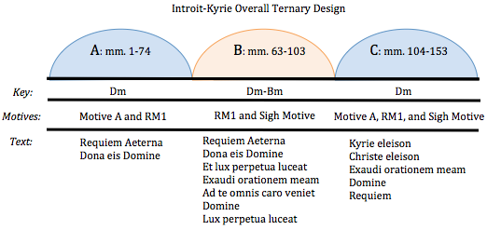

Figure 1: Introit-Kyrie Ternary Design

Forrest’s use of three motives throughout the Introit-Kyrie reinforces the ternary form of the Introit-Kyrie, and provides contrast between the first and last sections. Motive A is the main three-note motive (F-E-D) and consists of a descending third. This motive occurs in the opening notes of the Introit-Kyrie (see Figure 2). Motive A is found throughout the A-section, occurring eighteen times, and in the C-section ten times, but not in the B-section.

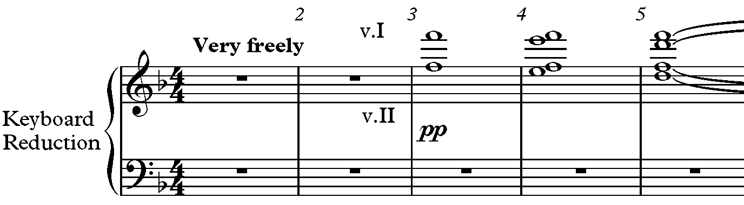
Figure 2: Motive A in Violin II in Introit-Kyrie, mm. 1-5

Rhythmic Motive 1 (RM1) is found in all three sections, but not equally. The distinguishing characteristic of RM1 is an eighth-note triplet figure. RM1 is first introduced in m. 64 and occurs two more times (mm. 66, 68) at the end of the A-section. RM1 is found throughout the B-section seven times and twice in the C-section (mm. 132, 134) of Introit-Kyrie (see Figure 3).

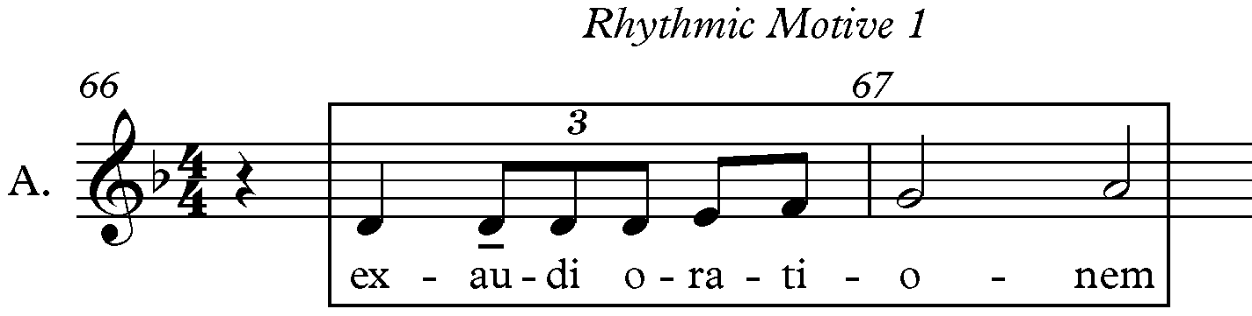
Figure 3: RM1 in Introit-Kyrie mm. 66-67

The characteristics of a sigh motive include a two-note stepwise slur that may be extended to include larger motivic units, light initiatory accent, smooth follow-through, and unaccented release. The third motive used in the Introit-Kyrie is a sigh motive. The Sigh Motive in this piece is eight eighth notes descending in groups of two where every second eighth-note anticipates the next note, suggesting a strong downbeat and weak upbeat. The Sigh Motive is found throughout the B and C-sections of the Introit-Kyrie. The Sigh Motive is first introduced in the B-section in m. 77, and is found seven times in the B-section and five times in the C-section.

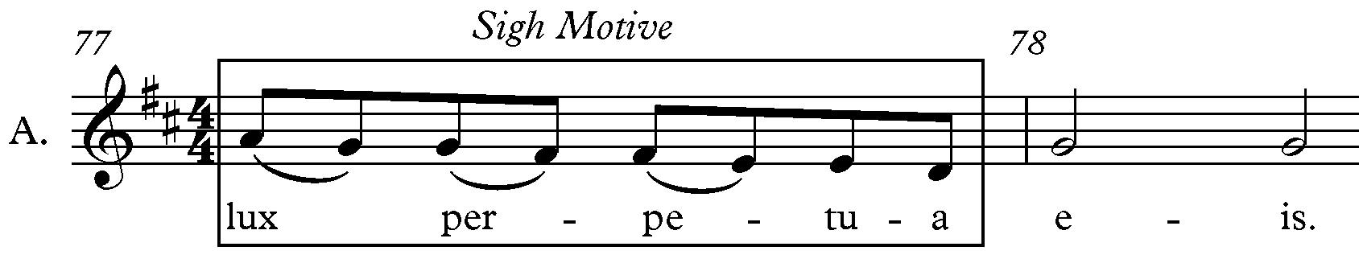
Figure 4: Sigh Motive in Introit-Kyrie, mm. 77-78

The text also contributes to the form in the Introit-Kyrie. The text in the first and last sections is completely different. The words “Requiem aeterna dona eis requiem” appear in the A-section, and the words “Kyrie eleison, Christe eleison, exaudi orationem meam Domine Requiem” are found in the C-section. The differences in the text and presence of motives determines the designation C rather than A’ in the last section. The B-section includes the same text as the A-section but adds “et lux perpetua luceat, exaudi orationem meam ad te omnis caro veniet Domine lux perpetua luceat.”

Vanitas Vanitatum

The second movement, Vanitas Vanitatum, is also ternary form, but in this case the sections are ABA’, not ABC. The form is reinforced by the organization of the text, tempi, and rhythmic activity (see Figure 5). The A-sections are divided into four sub-sections based on text. The A and A’-sections contain text from Ecclesiastes, as well as the Pie Jesu.
The first sub-section (a) in mm. 1-46 contains the “vanitas vanitatum” text. The second sub-section (a/b) in mm. 47-54 contains the same text, “vanitas vanitatum,” (a) in the alto, tenor and bass parts, and the “pie Jesu” text (b) in the soprano (see Figure 6). The third sub-section, (b), has the text “pie Jesu dona eis requiem” in mm. 55-64 in the choir, and in the fourth sub-section (a), the choir returns to the “vanitas vanitatum” text in mm. 65-83. The sub-sections (a, a/b, b, a) of the A-section are similar to the sub-sections in the A’-section (a, a/d, b, a), except the second sub-section (a/d) contains the “Kyrie” text (d) rather than the “pie Jesu” (b).

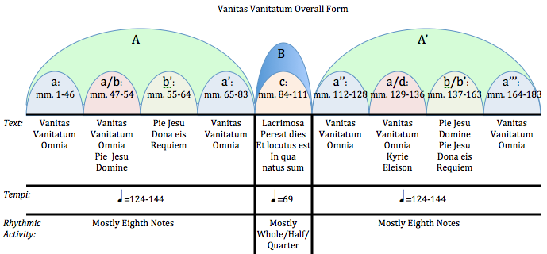

Figure 5: Vanitas Vanitatum Overall Form
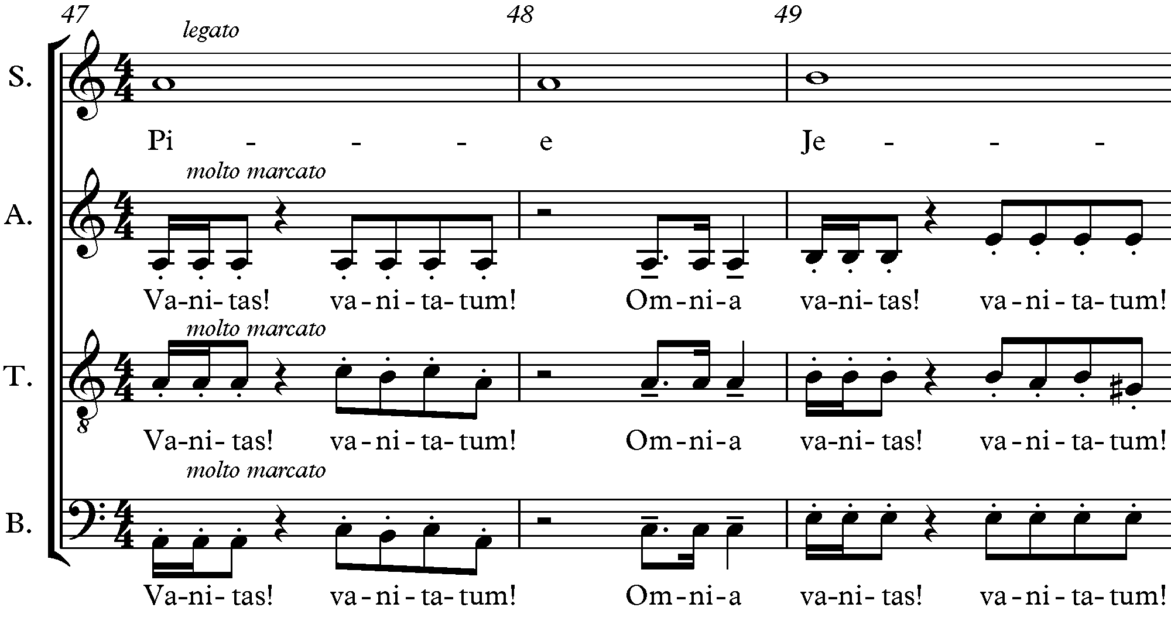
Figure 6: Section a/b Including Vanitas Vanitatum Text with Pie Jesu Text mm. 47-49

The text “lacrimosa, pereat dies in qua natus sum et locutus est” (c) from the Dies Irae and the book of Job is only found in the B-section. The middle sub-section (c) is the “Lacrimosa” text inserted from the Dies Irae (see Figure 7). As a result, the textual divisions create a symmetrical overall ABA’ formal design.

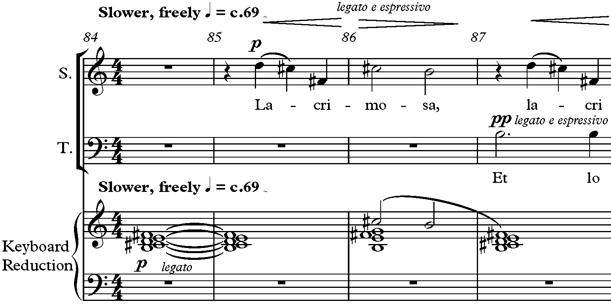
Figure 7: B-Section with Longer Note Values and Slower Tempo in Vanitas Vanitatum, mm. 84-87

The tempi and rhythmic activity divide the movement into ternary form as well. The tempi of the A and A’-sections are fast (q = 124-144) with mostly eighth-notes, which add to the fast feel of the sections. The middle section is almost twice as slow (q = c. 69) with mostly longer note values like whole, half, and quarter notes, emphasizing the slowness of the B-section (see Figure 7).

Agnus Dei

The third movement, Agnus Dei, is also ternary form (ABC) (see Figure 8). The occurrence of the Agnus Dei Motive (see Figure 9), the presence of the Agnus Dei text, and changes in the tonal center provide contrast between the sections. The main motive in this movement is accompanied by the Agnus Dei text when sung. The Agnus Dei Motive is played by the oboe and first violin in the accompaniment, and only appears in the A and A’-sections. The Agnus Dei Motive appears in the A-section in mm. 3 and 5 in the oboe, mm. 9 and 11 in the boy solo, and mm. 25-27 in the choir. The Agnus Dei Motive appears in the A’-section in mm. 65 and 73 in the oboe, in mm. 70 and 72 in the soprano and first violin, in mm. 74, 89, and 91 in the boy solo, and m. 78 in the soprano and alto parts. Neither the Agnus Dei text nor the Agnus Dei Motive is found in the B-section.

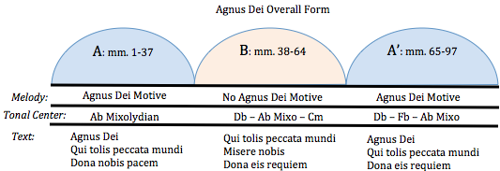

Figure 8: Agnus Dei Overall Form

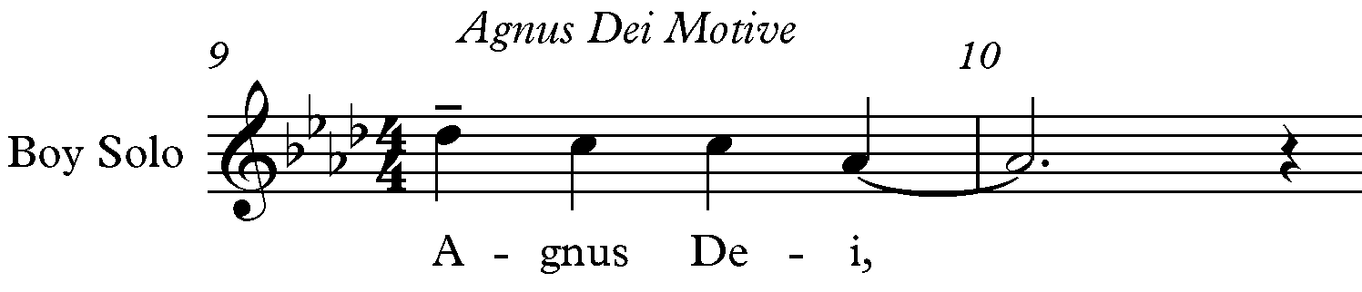
Figure 9: “Agnus Dei” Motive in Boy Solo, mm. 9-10

The tonal center of the Agnus Dei is Ab in the A-section, and fluctuates between Db, Ab, and C in the B-section, and Db, Fb, and Ab in the A’-section. Although the key signature indicates Ab major, Forrest includes Gb’s throughout the A-section, which makes the music sound in the mixolydian mode. The tonal center in the middle section shifts between Db, Ab, and C. For example, the Gb to the Db chord in mm. 37-38 sounds like a plagal cadence at the section break where the B-section arrives, and the same chord progression happens again in m. 40 (see Figure 10).
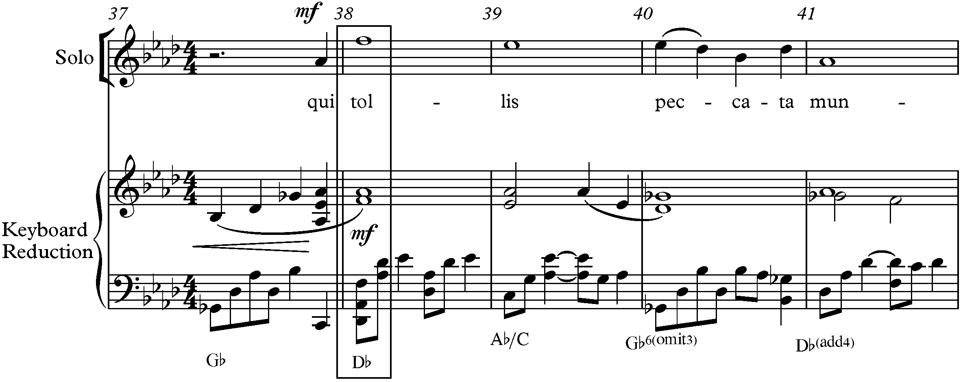
Figure 10: B-Section Tonal Shift to Db Major in Agnus Dei, m. 38

The tonal center shifts between Db and Ab until m. 55 of the B-section where the key becomes ambiguous. Forrest includes shifts between the notes G and Gb in mm. 55-60, keeping the tonal center uncertain (see Figure 11). The tonal center eventually returns to Db in m. 65, the beginning of the A’-section. The tonal center shifts to Cb in m. 74 and returns again to Ab in m. 86 in the A’-section.

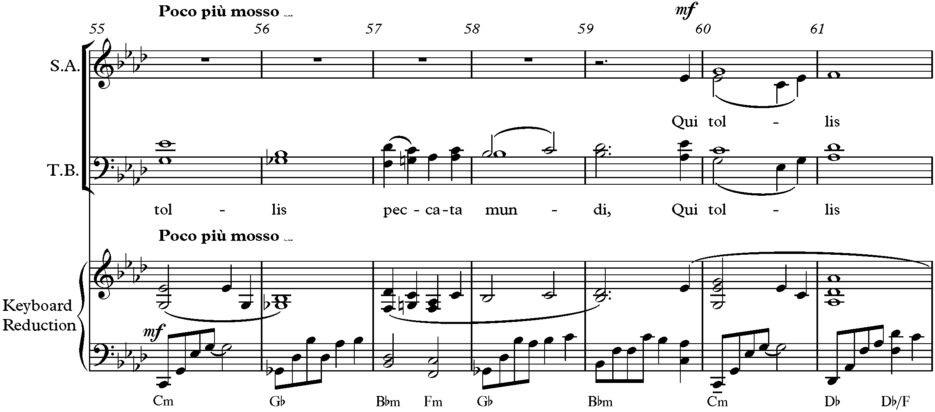
Figure 11: Ambigious Tonal Shift in Agnus Dei mm. 55-61

Sanctus

The Sanctus is also in ternary form (ABC) (see Figure 12). Changes in key and tempo provide dissimilarities between sections. The key in the first section is F major in the A-section and changes to D major in m. 46 where the B-section begins. In m.76, just prior to the C-section, the key changes to Db major and returns to D major in m.100 and remains in D major throughout the remainder of the movement.

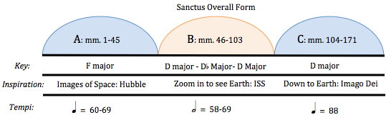

Figure 12: Sanctus Overall Form

Forrest says the music in the Sanctus is inspired by images of space. The first two sections are inspired by images of space from the Hubble Telescope, and images of Earth from the International Space Station respectively. The last section is inspired by people who reflect the image of God. The Sanctus contains an “ethereal opening section inspired by images of space from the Hubble Space Telescope.” The picture behind Forrest’s inspiration for the A-section is the Hubble Ultra-Deep Field image, which contains approximately 10,000 galaxies (see Figure

Figure 13: Hubble Ultra-Deep Field Image

13). The ethereal quality of this opening section is reflected by the tempo indication “Tranquil, ethereal q = c. 60” and the high timbral quality of treble clef instruments used in this section (harp, glockenspiel, flute, soprano, alto, first and second violin and viola). The harp and glockenspiel begin the A-section playing softly, as if from a distance, to invoke the feeling of looking deep into space (see Figure 14).

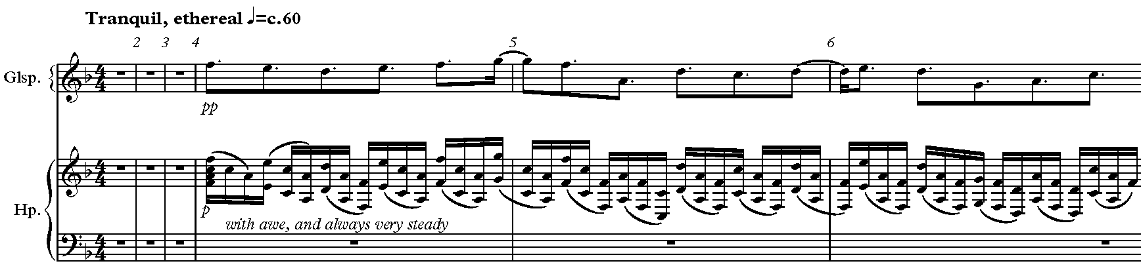
Figure 14: High Registers in Harp and Glockenspiel Parts in Sanctus, m. 1-6

The B-section of the Sanctus (mm. 46-103) is inspired by “images of our own planet as viewed from the International Space Station,” specifically time-lapse videos of earth. The B-section begins in m. 46 with a tempo change to “Piu Mosso h = c. 60” (see Figure 15). The pulse
does not change from the A to the B-section.

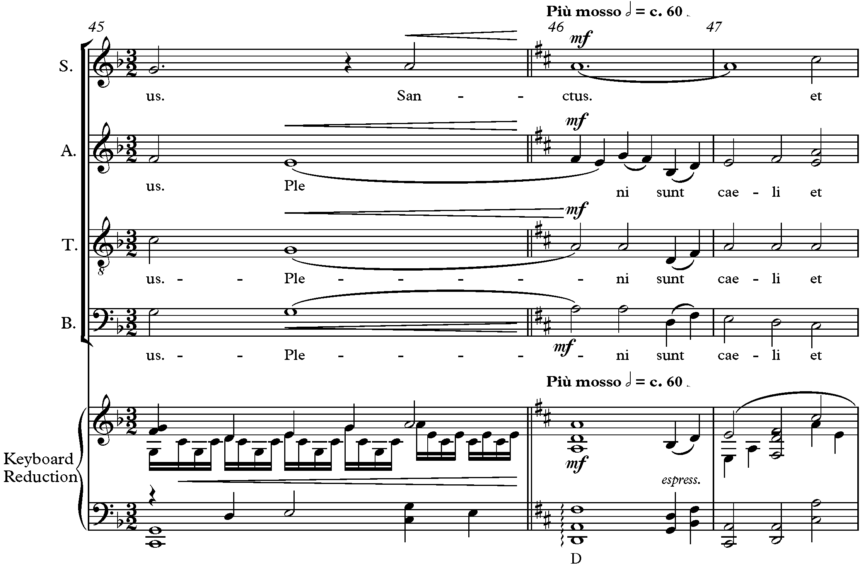
Figure 15: B-Section, Key Change to D Major, and Tempo Change in Sanctus, mm. 45-47

The C-section “brings the listener down to Earth, where cities teem with the energy of humanity.” The tempo increases in this section (mm. 104-171) changing to “with ecstatic energy q = c. 88” (see Figure 16). The faster tempo is reinforced by the constant sixteenth

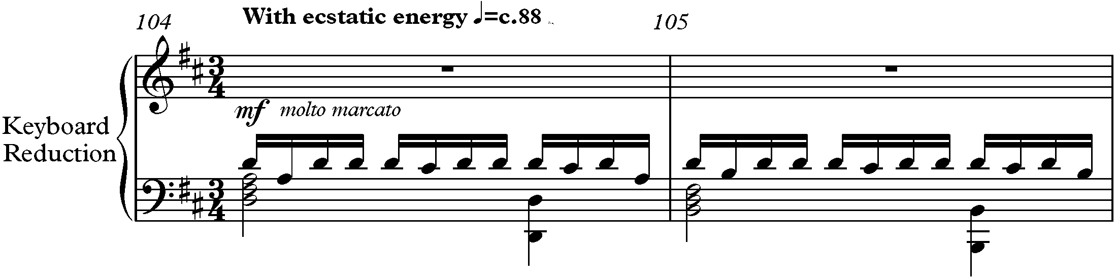
Figure 16: C-section Tempo Change and Sixteenth Notes in Sanctus, mm. 104-105

notes in the first and second violins and the dynamic crescendo to ff by m. 138. The growing texture from strings and Bb clarinet to all instruments contributes to the dynamic growth throughout the C-section, which ends fff in m. 169 (see Figure 17).

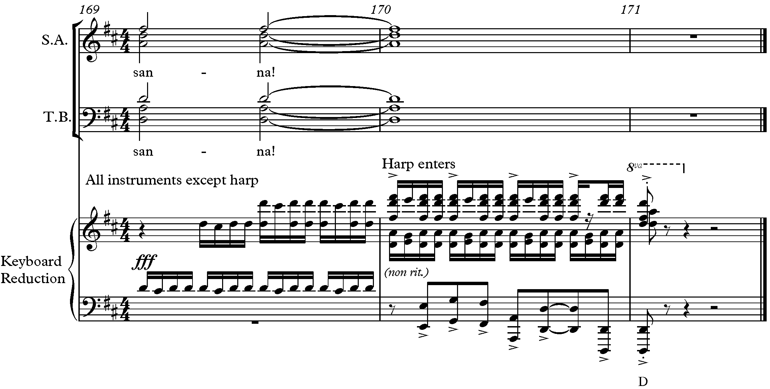
Figure 17: Ending dynamic (fff) of Sanctus, mm. 169-171

Lux Aeterna

The final movement, Lux Aeterna, is also ternary form (ABA’), with variations in text, the presence of the Lux Aeterna Motive, and harmony helping to distinguish the sections (see Figure 18). The formal design is also reinforced by the Latin text in the A and A’-sections, and the use of vernacular text from Matthew 11:28 is used in the B-section. The text “Lux aeterna luceat eis, Domine cum santis tuis in aeternum: quia pius es. Et lux perpetua luceat eis” is found in the
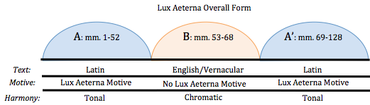
Figure 18: Lux Aeterna Overall Form

A-section. The B-section’s text is “Come unto me, all ye who labor and I will give you rest.” Forrest intentionally elides the word “rest” that finishes the B-section, and the Latin word “requiem” (rest) that begins the final section, to reinforce this word in the A’-section (see Figure 19). The A’-section text is “requiem aeternam dona eis Domine, et lux perpetua luceat eis. Dona nobis pacem,” which is similar to the A-section.

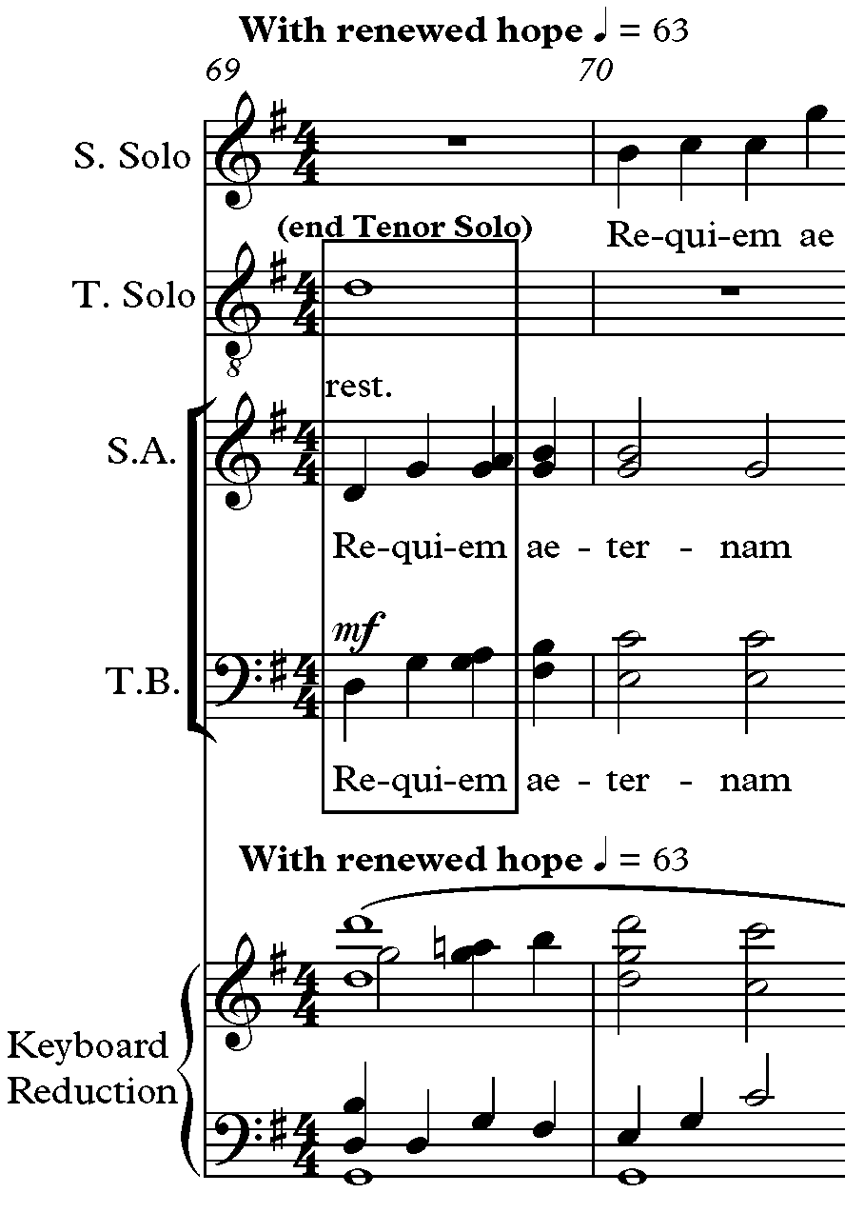
Figure 19: Intentional Overlap of Tenor Solo "Rest" with Choir "Requiem" in Lux Aeterna, m. 69-70
The Lux Aeterna uses its own motive, whose presence reinforces the formal design of the movement (see Figure 20). The Lux Aeterna Motive occurs in the A-section (mm. 17, 20, 31, 33) and the A’-section (mm. 69, 71, 79, 81, 117), but not in the B-section.

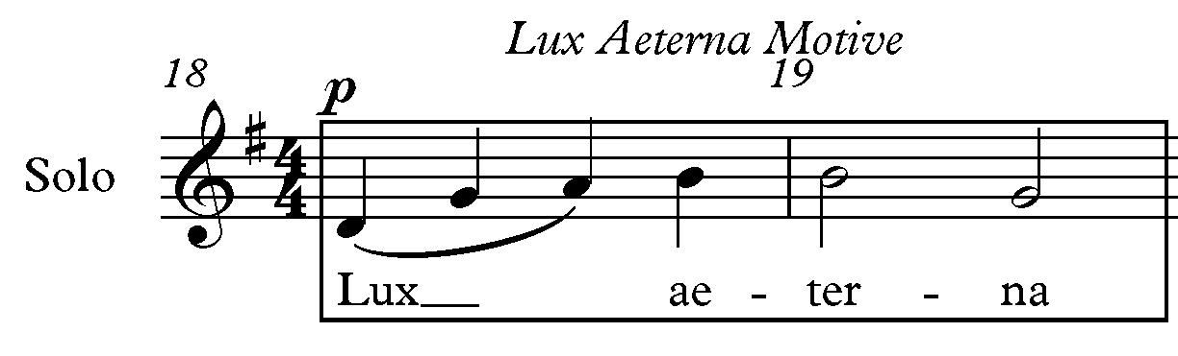
Figure 20: Lux Aeterna Motive Soprano Solo Part, mm. 18-19

The form is also reinforced by the harmony. The harmony in the first and last sections is diatonic, but the B-section contains many chromatic alterations that affect the key center. In mm. 57-63 (see Figure 21), the altered C#, D# and G# suggest the key of B major, and B major chord is found in mm. 57-59. The next chord is G# minor in mm. 60-61 belongs in the key of B, but the following chord is A major (m. 63), which is not diatonic to B major. Beginning in m. 64, the altered notes are flats and naturals (Ab, Bb, Db, Eb, F, Gb), suggesting the key of Db major. The last chord in the B-section is Ab major, which resolves chromatically by half step to G major, the first chord in the A’-section.
The Lux Aeterna also contains motives brought back from the other movements in its final measures. These reminders of all the motives create a cyclic formal design that brings finality to the work. The presence of Motive A throughout the piece and the two measures of rest that begin and end the Requiem create the cyclic design of the work.

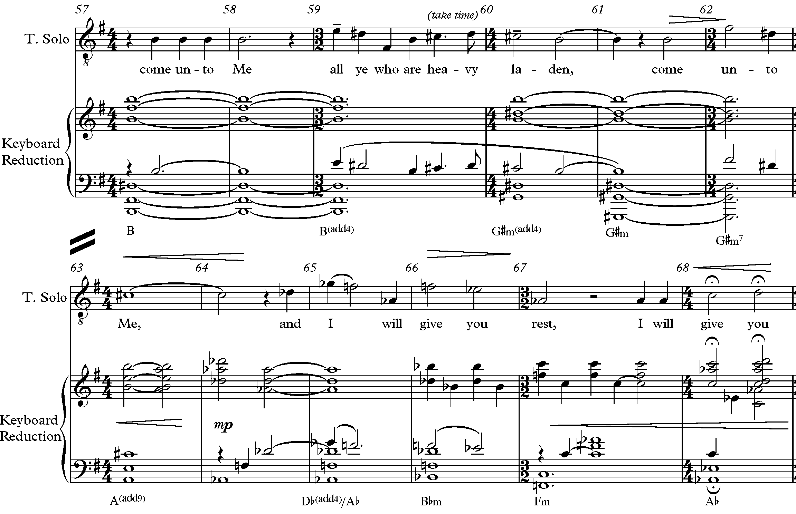
Figure 21: Chromatic Alterations and English Text in B-Section of Lux Aeterna mm. 57-68

Each movement transitions into the next by common tones, pivot chords, or a cymbal scrape. Forrest ends the first movement on a second inversion G^{(add9)}/D chord that creates an elision into the second movement (marked “attaca no. 2”), and the second movement focuses on the tonal center D (see Figure 22).
Forrest ends the second movement with two types of elision into the third movement. The first is an enharmonic common tone, C#, that changes enharmonically to Db in the next movement. Forrest includes instructions in the score that the C# sung by the altos and basses in the last measure (182) of the Vanitas Vanitatum is meant to aurally connect to the Db in the Agnus Dei (see Figure 23). The second elision included in Forrest’s instructions is a cymbal scrape in m. 183 meant to fade while the third movement begins.

Introit-Kyrie
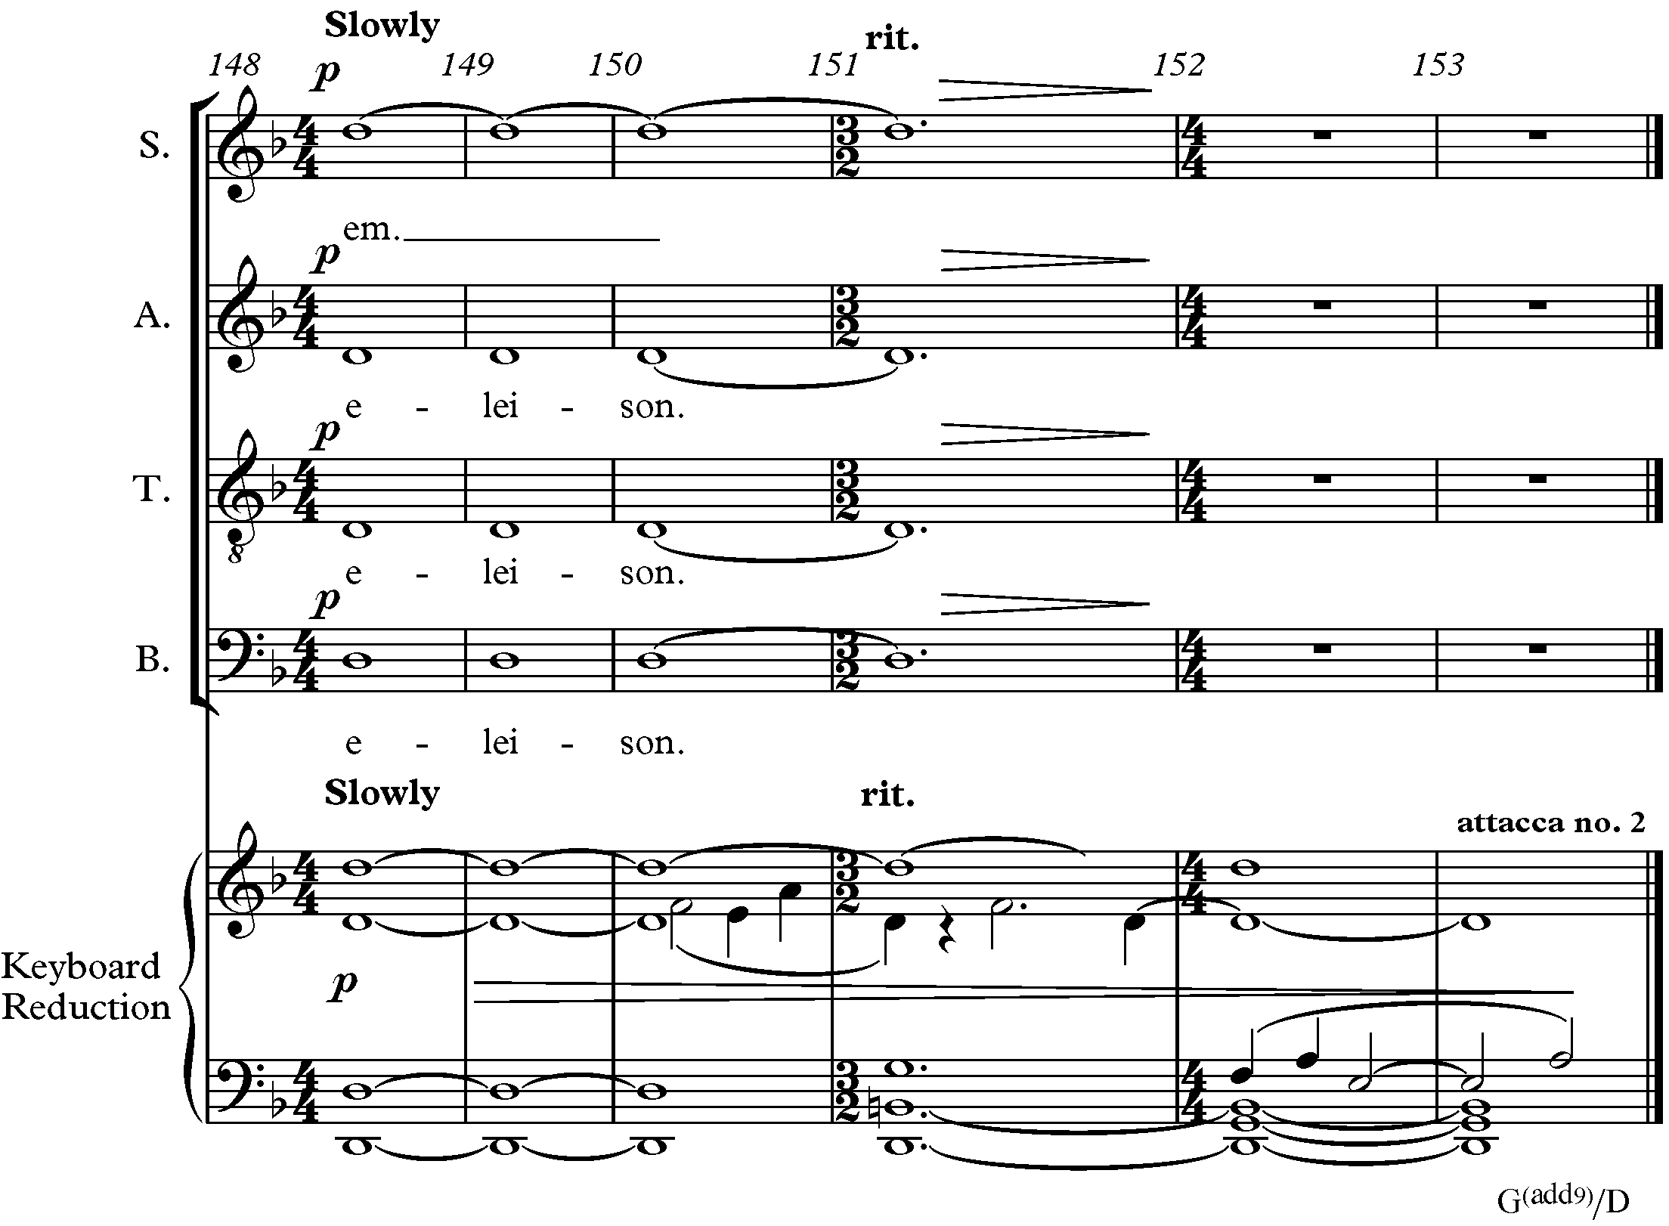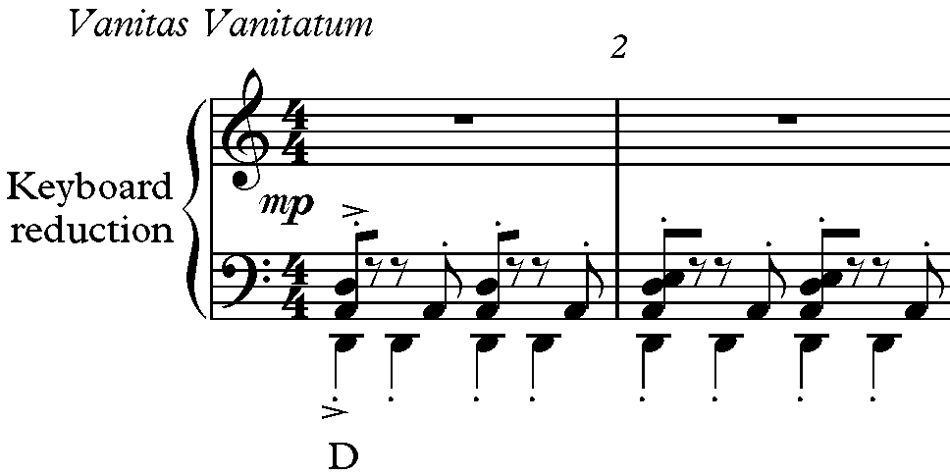
Figure 22: Elision with Second Inversion Chord in Introit-Kyrie, mm. 148-153 into Vanitas Vanitatum, mm. 1-2

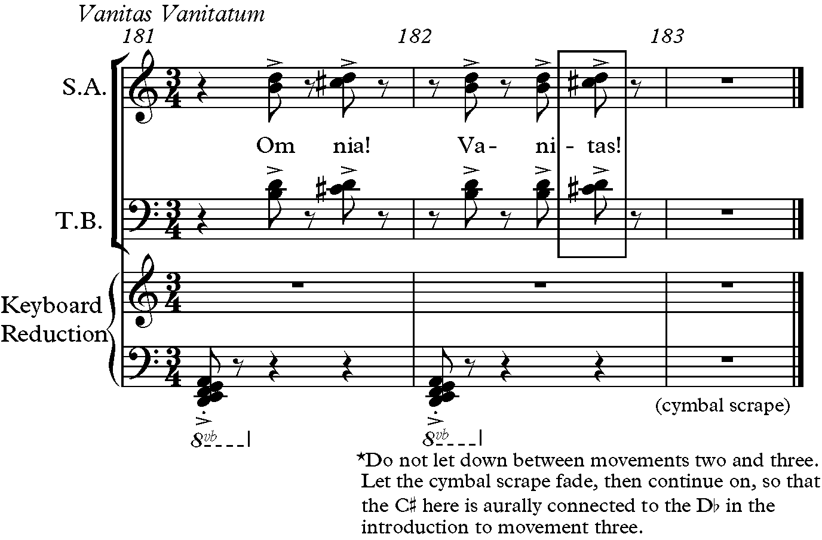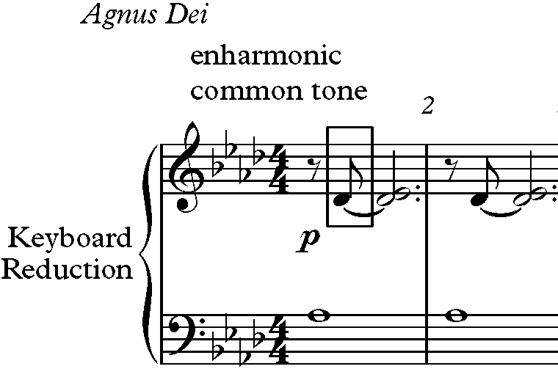

Figure 23: Elision from Vanitas Vanitatum, mm. 181-183 to Agnus Dei, mm. 1-2

The Agnus Dei ends with Ab and Eb open fifth in the strings and harp, leaving the listener wondering if the chord is major or minor, and transitions into the fourth movement with Motive A in the key of F major, a minor third from Ab (see Figure 24).

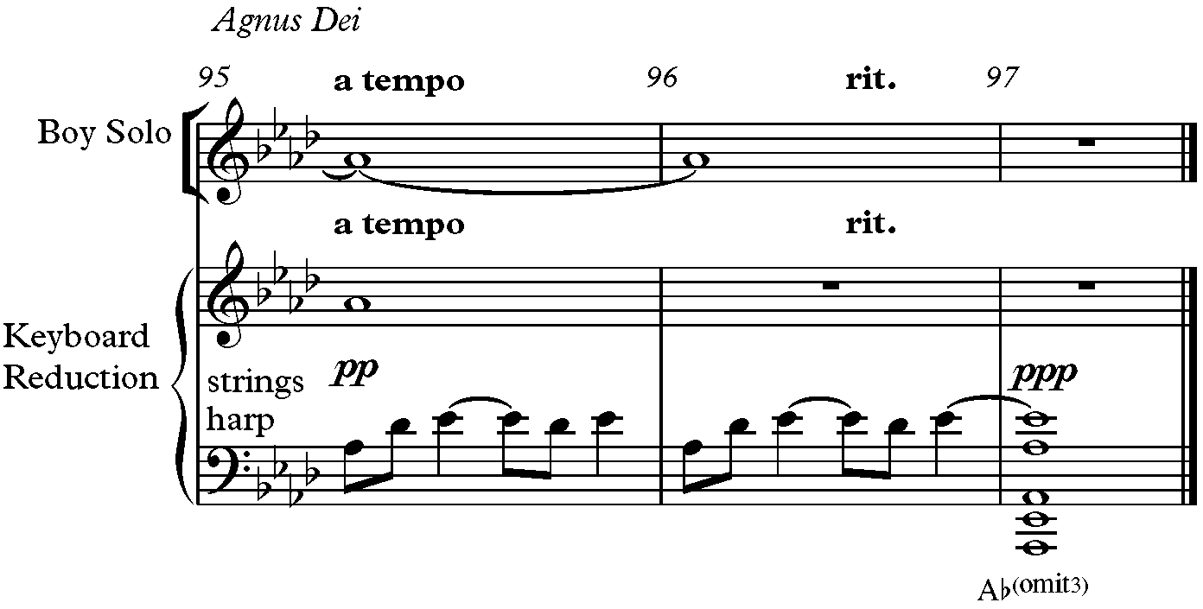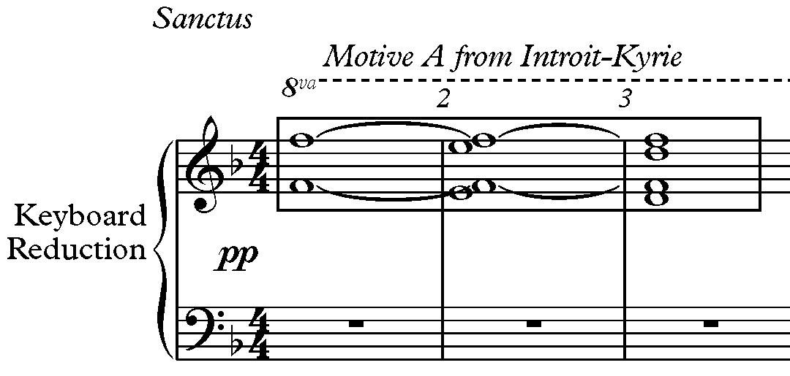
Figure 24: End of Agnus Dei, mm. 95-97 and Beginning of Sanctus, mm. 1-3

The final chord of the Sanctus provides an elision to the Lux Aeterna. The D major chord is the dominant of G, the key of the next movement which begins on the note D (see Figure
25).
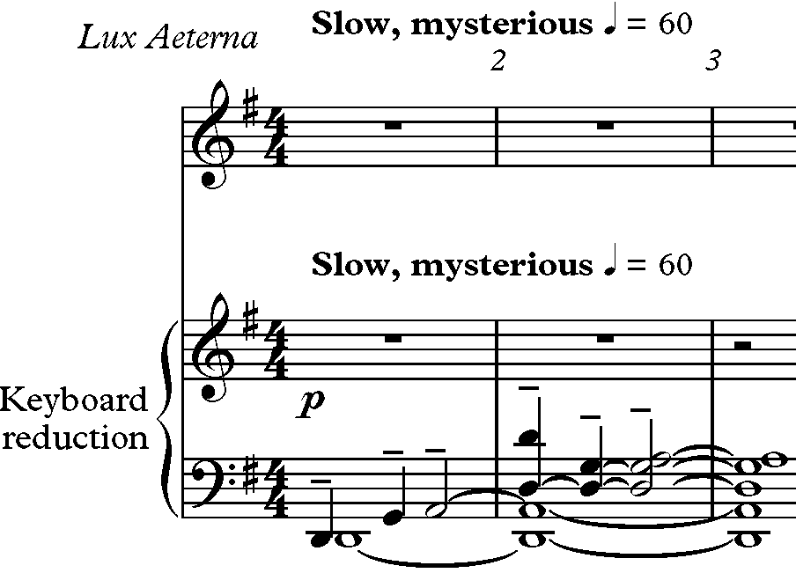
Figure 25: Elision from Sanctus, mm. 169-171 and Lux Aeterna, mm. 1-3

The number three is prominent in the Requiem and can been seen in the three-part form of each movement. Elements such as key, melody, harmony, rhythm, tempi, dynamics, and text provide contrast between sections. Each movement also ends with something that assists in an elision to the next movement (see Table 7).

Table 7: Overall Organization of Requiem for the Living
Movement | I. Introit-Kyrie |  | II. Vanitas Vanitatum |  | III. Agnus Dei |  | IV. Sanctus |  | V. Lux  Aeterna
Elision Between Movements | Begins with 2 m. of rest | Ends with G^{(add9)}/D  Elision to next mvmt’s tonal center, D | Begins with tonal center  D | Ends with  cymbal scrape fade, C# common tone next mvmt | Begins with common tone Db in first chord  (Ab^{(add4)}) | Ends with Ab/Eb open 5th | Begins with same material from Introit-Kyrie mm.1-3 | Ends with D Major Chord, next mvmt starts on note D | Begins in G Major,  Ends with return of motives from other mvmts/  Ends with 2 m. of rest

The motives are also influenced by the number three. The next chapter will discuss the motivic development from each movement in detail and show the relationship of the ancillary motives to the main motive.

CHAPTER 3: Motives

The Requiem for the Living is based on the number three, and one of the most notable characteristics is the motive of a falling third. The development of this simple motive is found throughout the entire work in various forms. These forms extend the original motive by the addition of pitches, or use of the motive in retrograde or in transposition. Three rhythmic motives are also present in Forrest’s Requiem. This chapter will trace these prominent motives through the piece.

Motive A

The main motive is made up of three notes that make the interval of a falling minor third.
The descending motive consists of scale degrees 3-2-1 (F-E-D) in D minor. It is first seen in the

Introit-Kyrie in mm. 3-5 [second violin]. This motive is referred to as Motive A (see Figure 26).

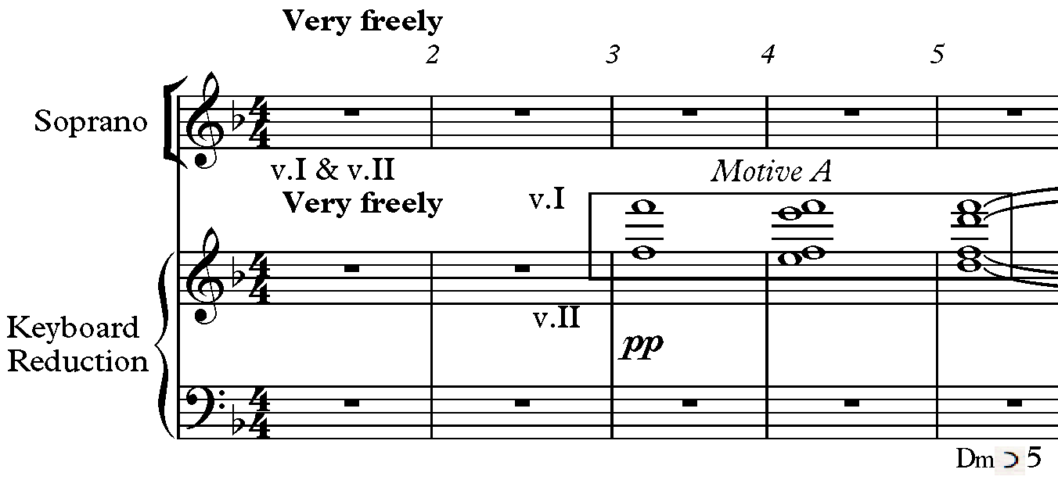
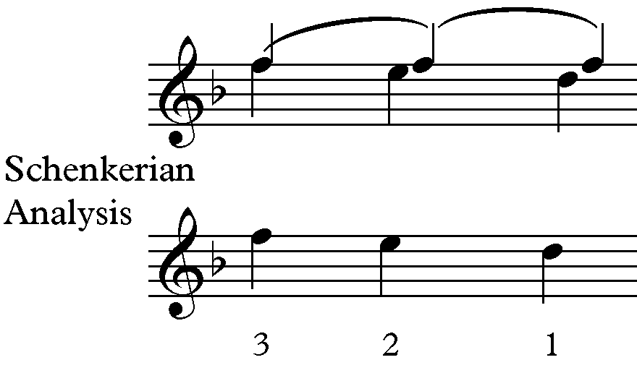
Figure 26: Motive A in Introit-Kyrie and Schenkerian Analysis, mm. 3-5

The first statement of the motive is heard against a pedal F in the first violin. The E passing note creates a dissonant second with the pedal. The motive is seen again in the first entrance of the choir and first violin in mm. 36-37 (see Figure 27). Here the pedal F is not present; instead there is a pedal D in the supporting harmony, Am^{(add4)}, creating the same secundal dissonance.

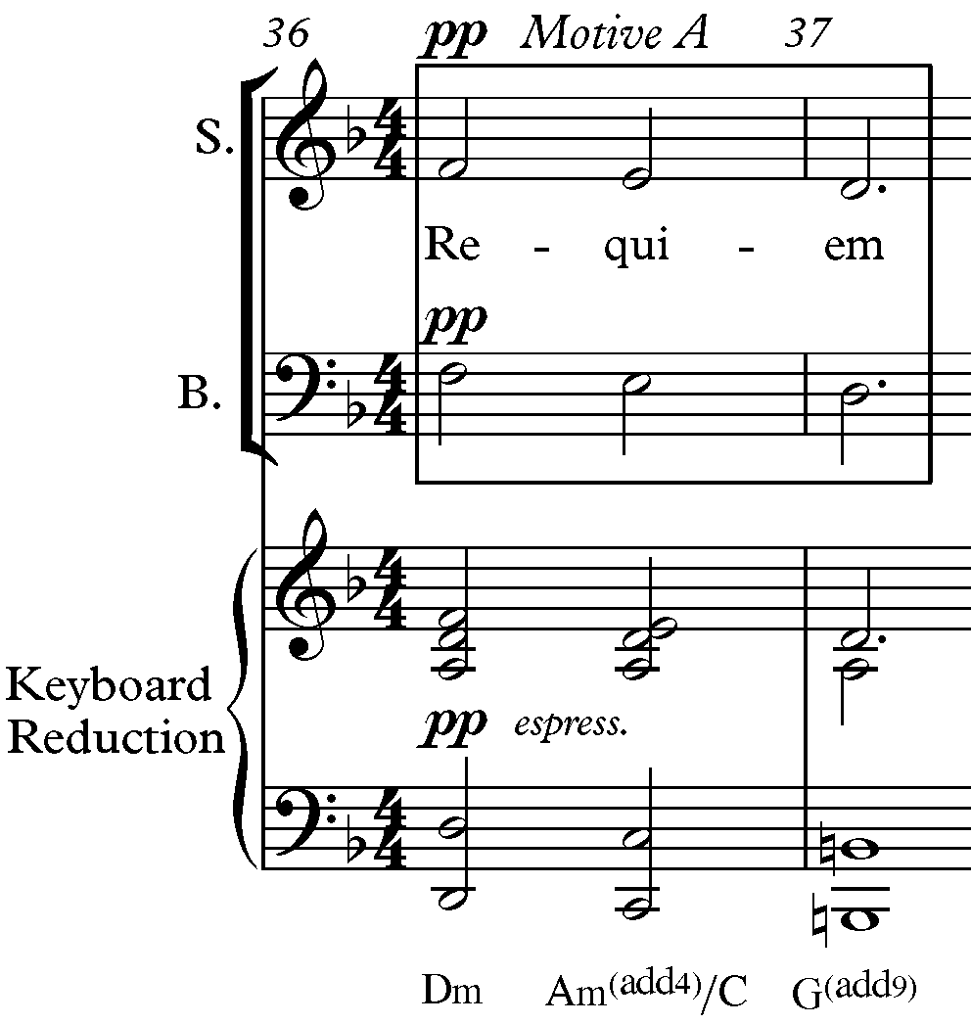

Figure 27: Motive A at Choir's First Entrance with Violin I in Introit-Kyrie mm. 36-37

There are twenty-one statements of Motive A in its original form in the A and the C-sections of Introit-Kyrie. The measure numbers and instruments that play Motive A are shown in Table 8.
Motive A is also found in all the other movements of the Requiem. In the second movement, Vanitas Vanitatum, Motive A appears in all vocal parts as a closing gesture of another melody line in m. 144-145 (see Figure 28). Also in the Vanitas Vanitatum, Motive A
begins on C in the soprano voice in mm. 62-63 (see Figure 29). In this example, the key is unstable, but Forrest provides some stability by including Motive A, a familiar sound to the listener.
Table 8: Motive A Statements in Introit-Kyrie

A-section
Measure # | 3-5 | 12-14 | 20 | 22 | 23 | 24 | 30-31 | 36-37 | 38-39
Instruments | Violin II | Violin II | Violin II | Violin I | Horn | Oboe I  Violin I/II | Cello | SATB  Violin I | Violin I

Measure # | 41 | 41 | 43 | 45 | 49-50 | 51-52 | 63-64 | 65-66
Instruments | Violin I/II | Violin I/II | Violin I/II | Violin I/II | Violin I  Viola | Violin I | Horn  Cello I | Cello

C-section

Measure # | 104-105 | 106-107 | 112-114 | 115-116 | 131-132 | 133-134 | 135
Instruments | Bb Clarinet  Bassoon II  Viola  Cello II | Bb Clarinet | Flute I  Bb Clarinet I  Horn | Flute I  Tenor | Flute  Oboe I  Soprano Violin I  Cello | Oboe I  Bassoon II | Flute I  Flute II  Soprano  Violin I  Cello I

Measure # | 137 | 139-140 | 150-151
Instruments | Flute I/II  Soprano  Violin I  Cello I | Flute I  Oboe I  Soprano | Violin II

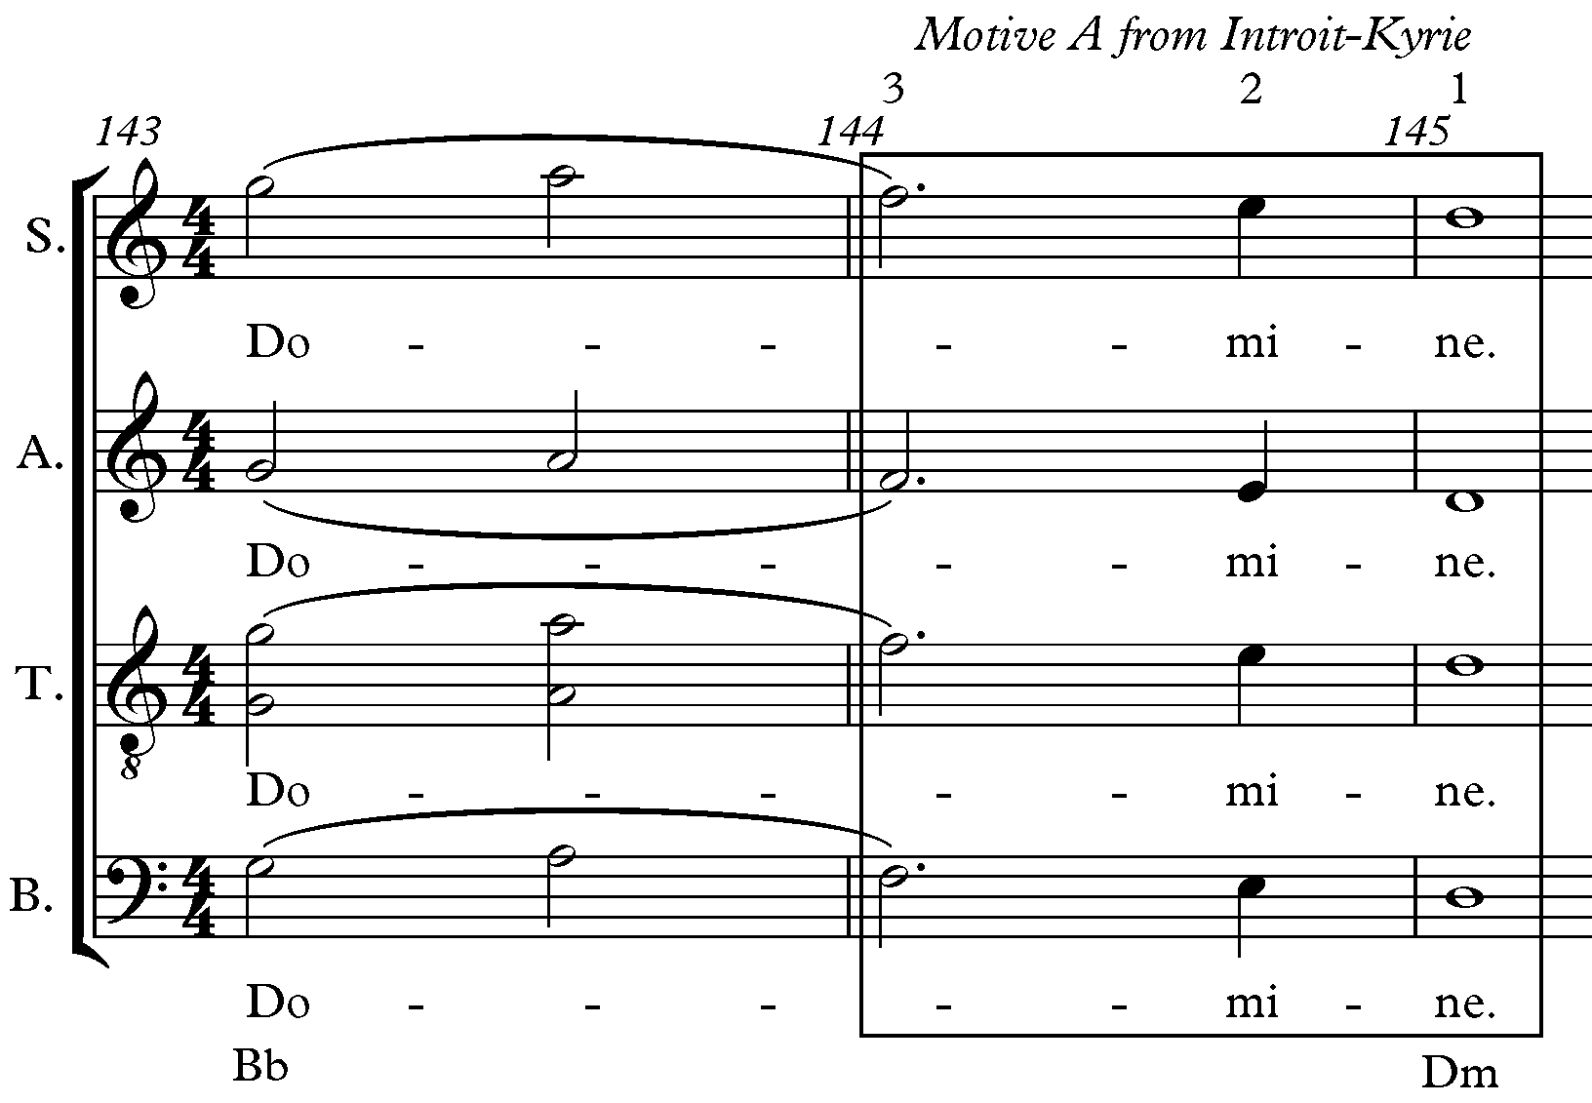

Figure 28: Motive A in Choir Parts in Vanitas Vanitatum, mm. 144-145

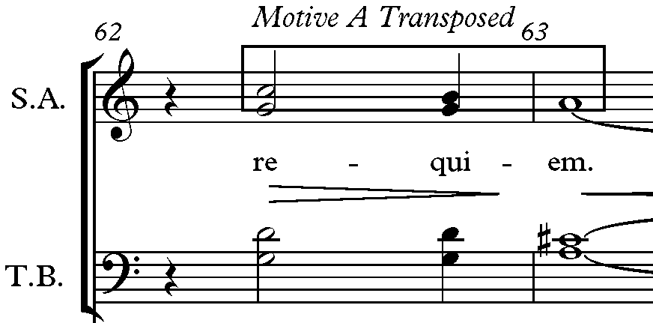

Figure 29: Motive A Transposed in Soprano Part in Vanitas Vanitatum, mm. 62-63

The fourth movement, Sanctus, begins with Motive A as in the first movement, but

unlike the Introit-Kyrie, the movement is in the key of F major rather than the original D minor
(see Figure 30). The motive thus changes from scale degrees 3-2-1 in D minor to scale
degrees 8-7-6 in F major; therefore, Forrest uses this motive to hold invariance. This mediant

reinterpretation is a pivotal moment in the Requiem, when turmoil and sorrow turns to hope and

praise because the text is declaring “Holy, Holy, Holy, Lord, God of Hosts.”

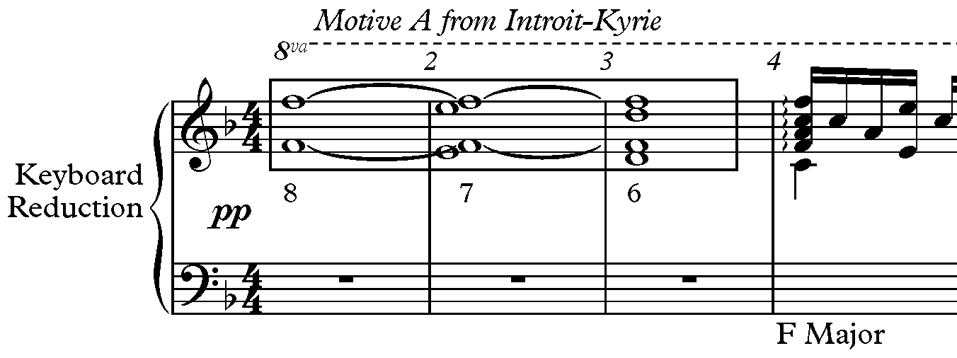

Figure 30: Motive A Changes to F Major in Sanctus, mm. 1-4

Motive A is sometimes found within longer motives. While a descending third can happen anywhere, Forrest alludes to Motive A by placing descending the minor third on the strongest beat of the measure. For example, in the Agnus Dei, Motive A is transposed to Db-C-
Bb and found embedded within the melodic line in mm. 17 in the solo (see Figure 31). In the final movement, the Lux Aeterna, Motive A is found on beat one in mm. 90, 92, 95 transposed to G-F#-E in the soprano, flute, and oboe parts (see Figure 32).

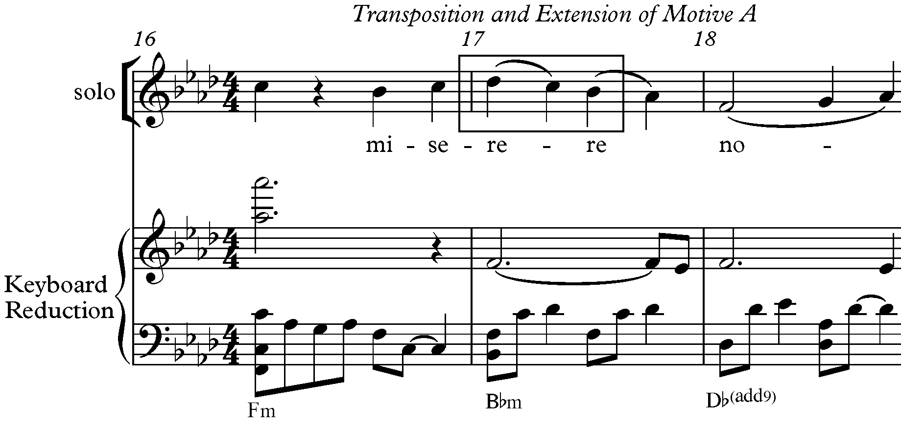
Figure 31: Motive A Transposed in Agnus Dei, m. 17

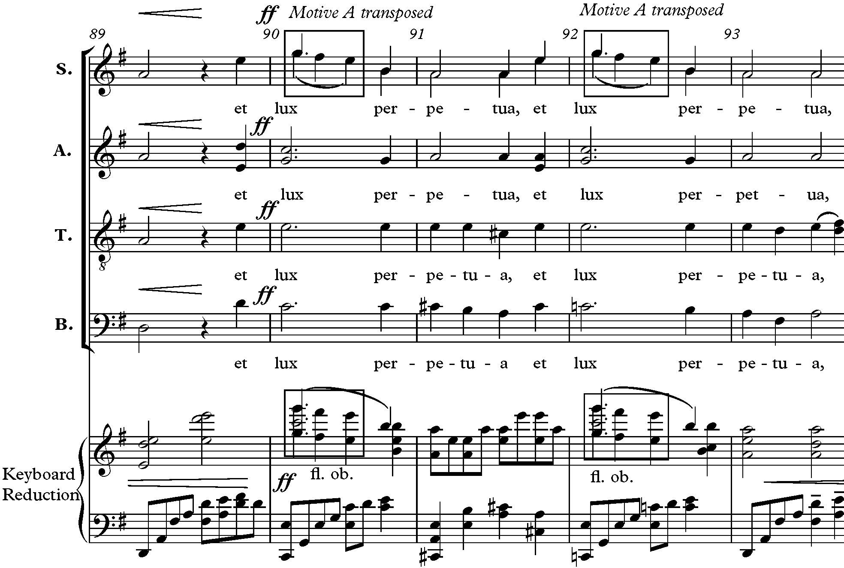
Figure 32: Motive A Transposed in Soprano, Flute, and Oboe Parts in Lux Aeterna, mm. 89-93

Variations of Motive A

Nicolas Slominsky defines interpolation as the insertion of one or several notes between the principal tones. He also talks about the addition of pitches above the principal tones, which he calls infrapolation, and the addition of pitches below the principal tones, called an ultrapolation. Forrest transforms Motive A by interpolating pitches between the three notes.
In the Introit-Kyrie, the motive is transformed by the addition of an A4 between the E and D. This infrapolation of Motive A is found in the soprano and alto parts in mm. 49-50 (see Figure 33). The supporting harmony is an Am with C in the bass, making the A4 a consonant skip from the E. Also in this example, Motive A occurs in the first violin and viola parts.

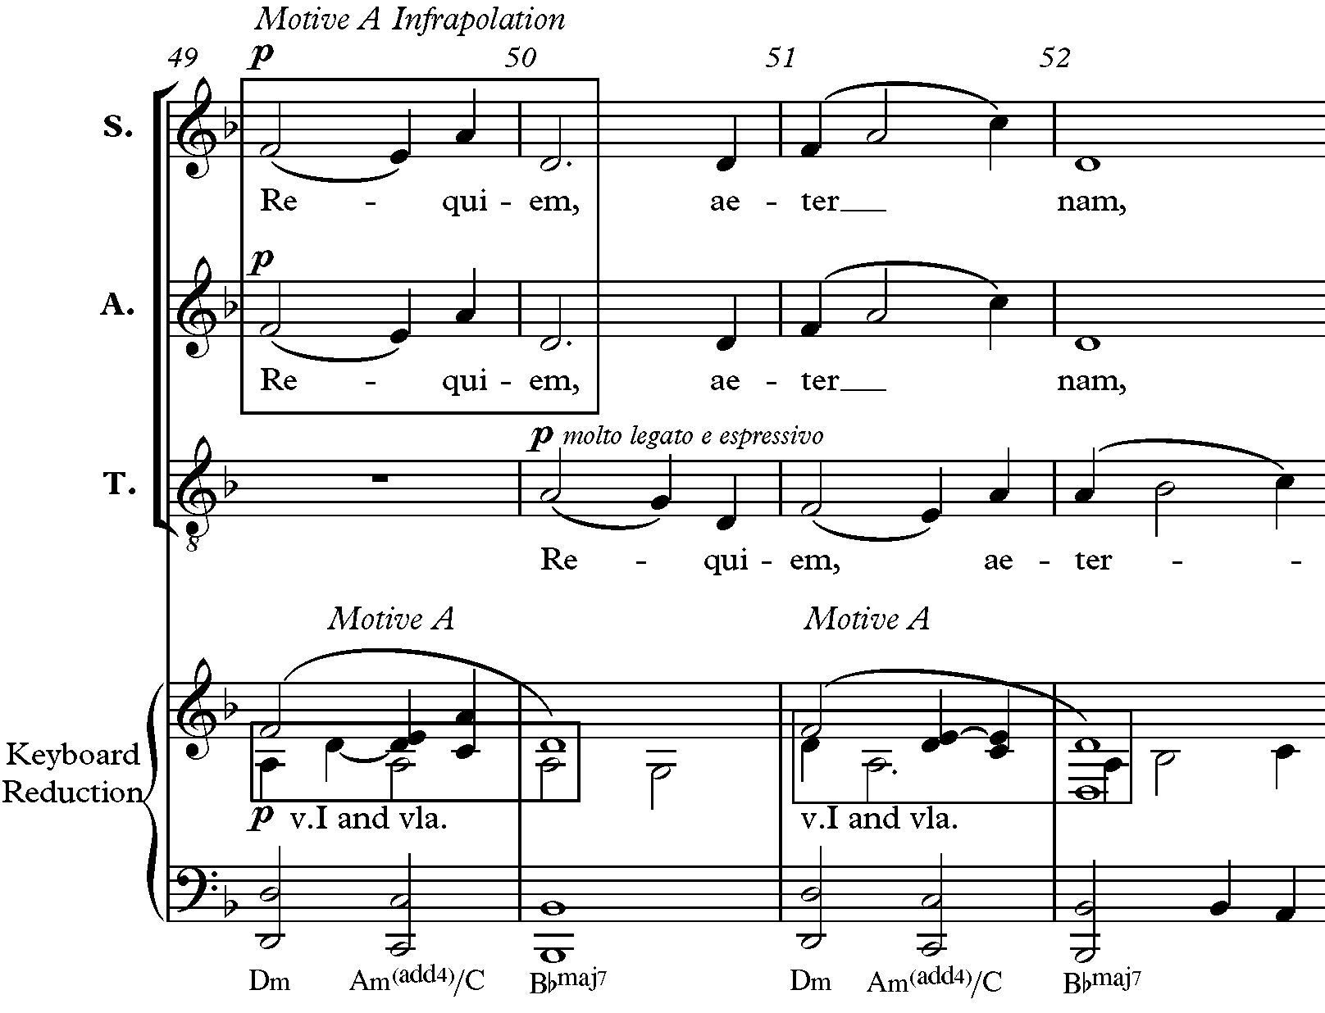
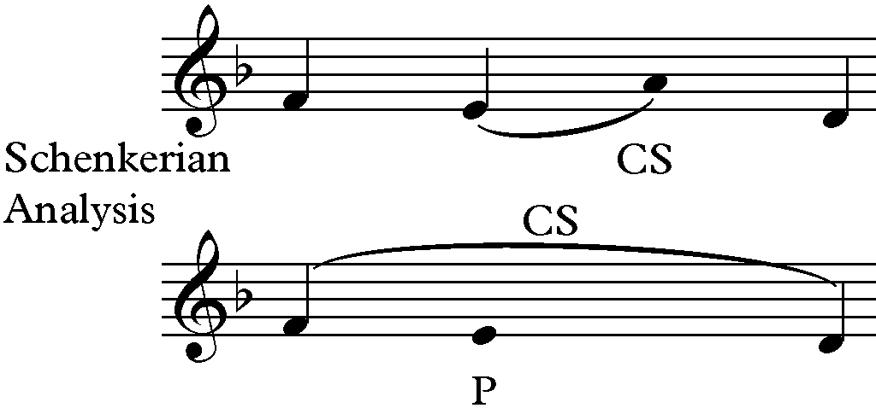
Figure 33: Infrapolation of Motive A in Soprano and Alto Parts and Schekerian Analysis in Introit-Kyrie, mm. 49-50
An ultrapolation of Motive A occurs in the alto and tenor voices in mm. 103-105 in the Introit-Kyrie because the A4 is below the motive (see Figure 34). Motive A is also found in the Bb clarinet, second bassoon, viola, and second cello. An ultrapolation of Motive A occurs again transposed to G-F#-B-E in the soprano voice in the final section of the Introit-Kyrie in mm. 131-132 (see Figure 35).

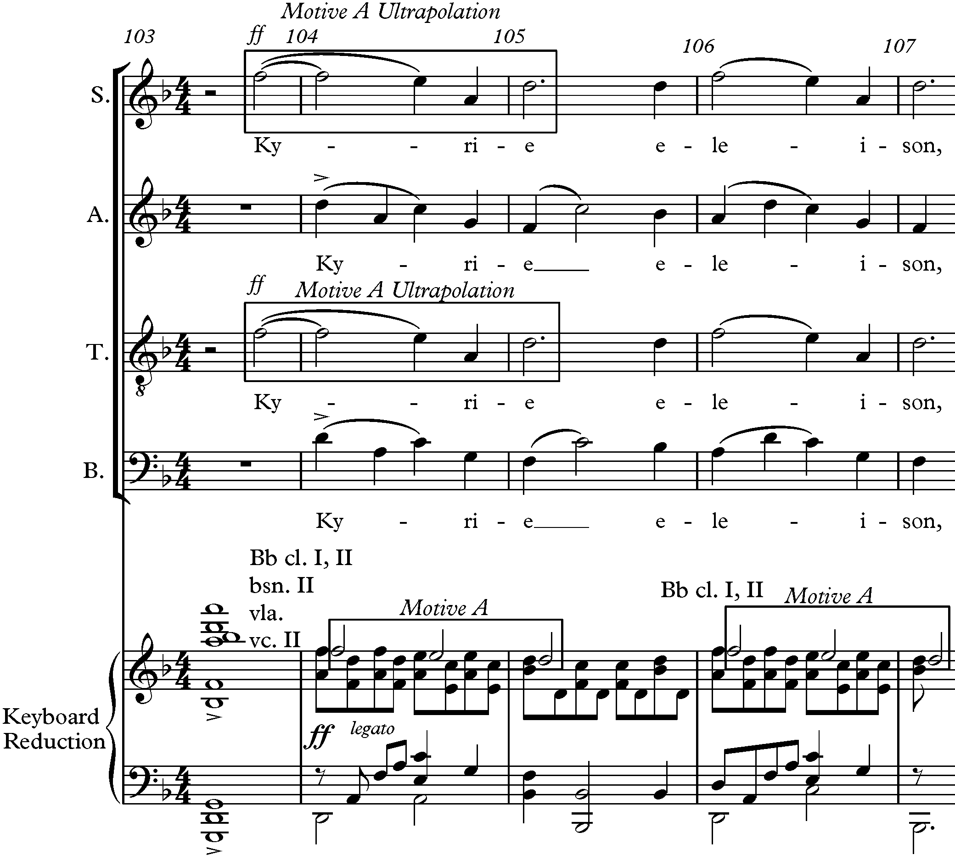

Figure 34: Ultrapolation of Motive A in Alto and Tenor Parts in Introit-Kyrie, mm. 103-105
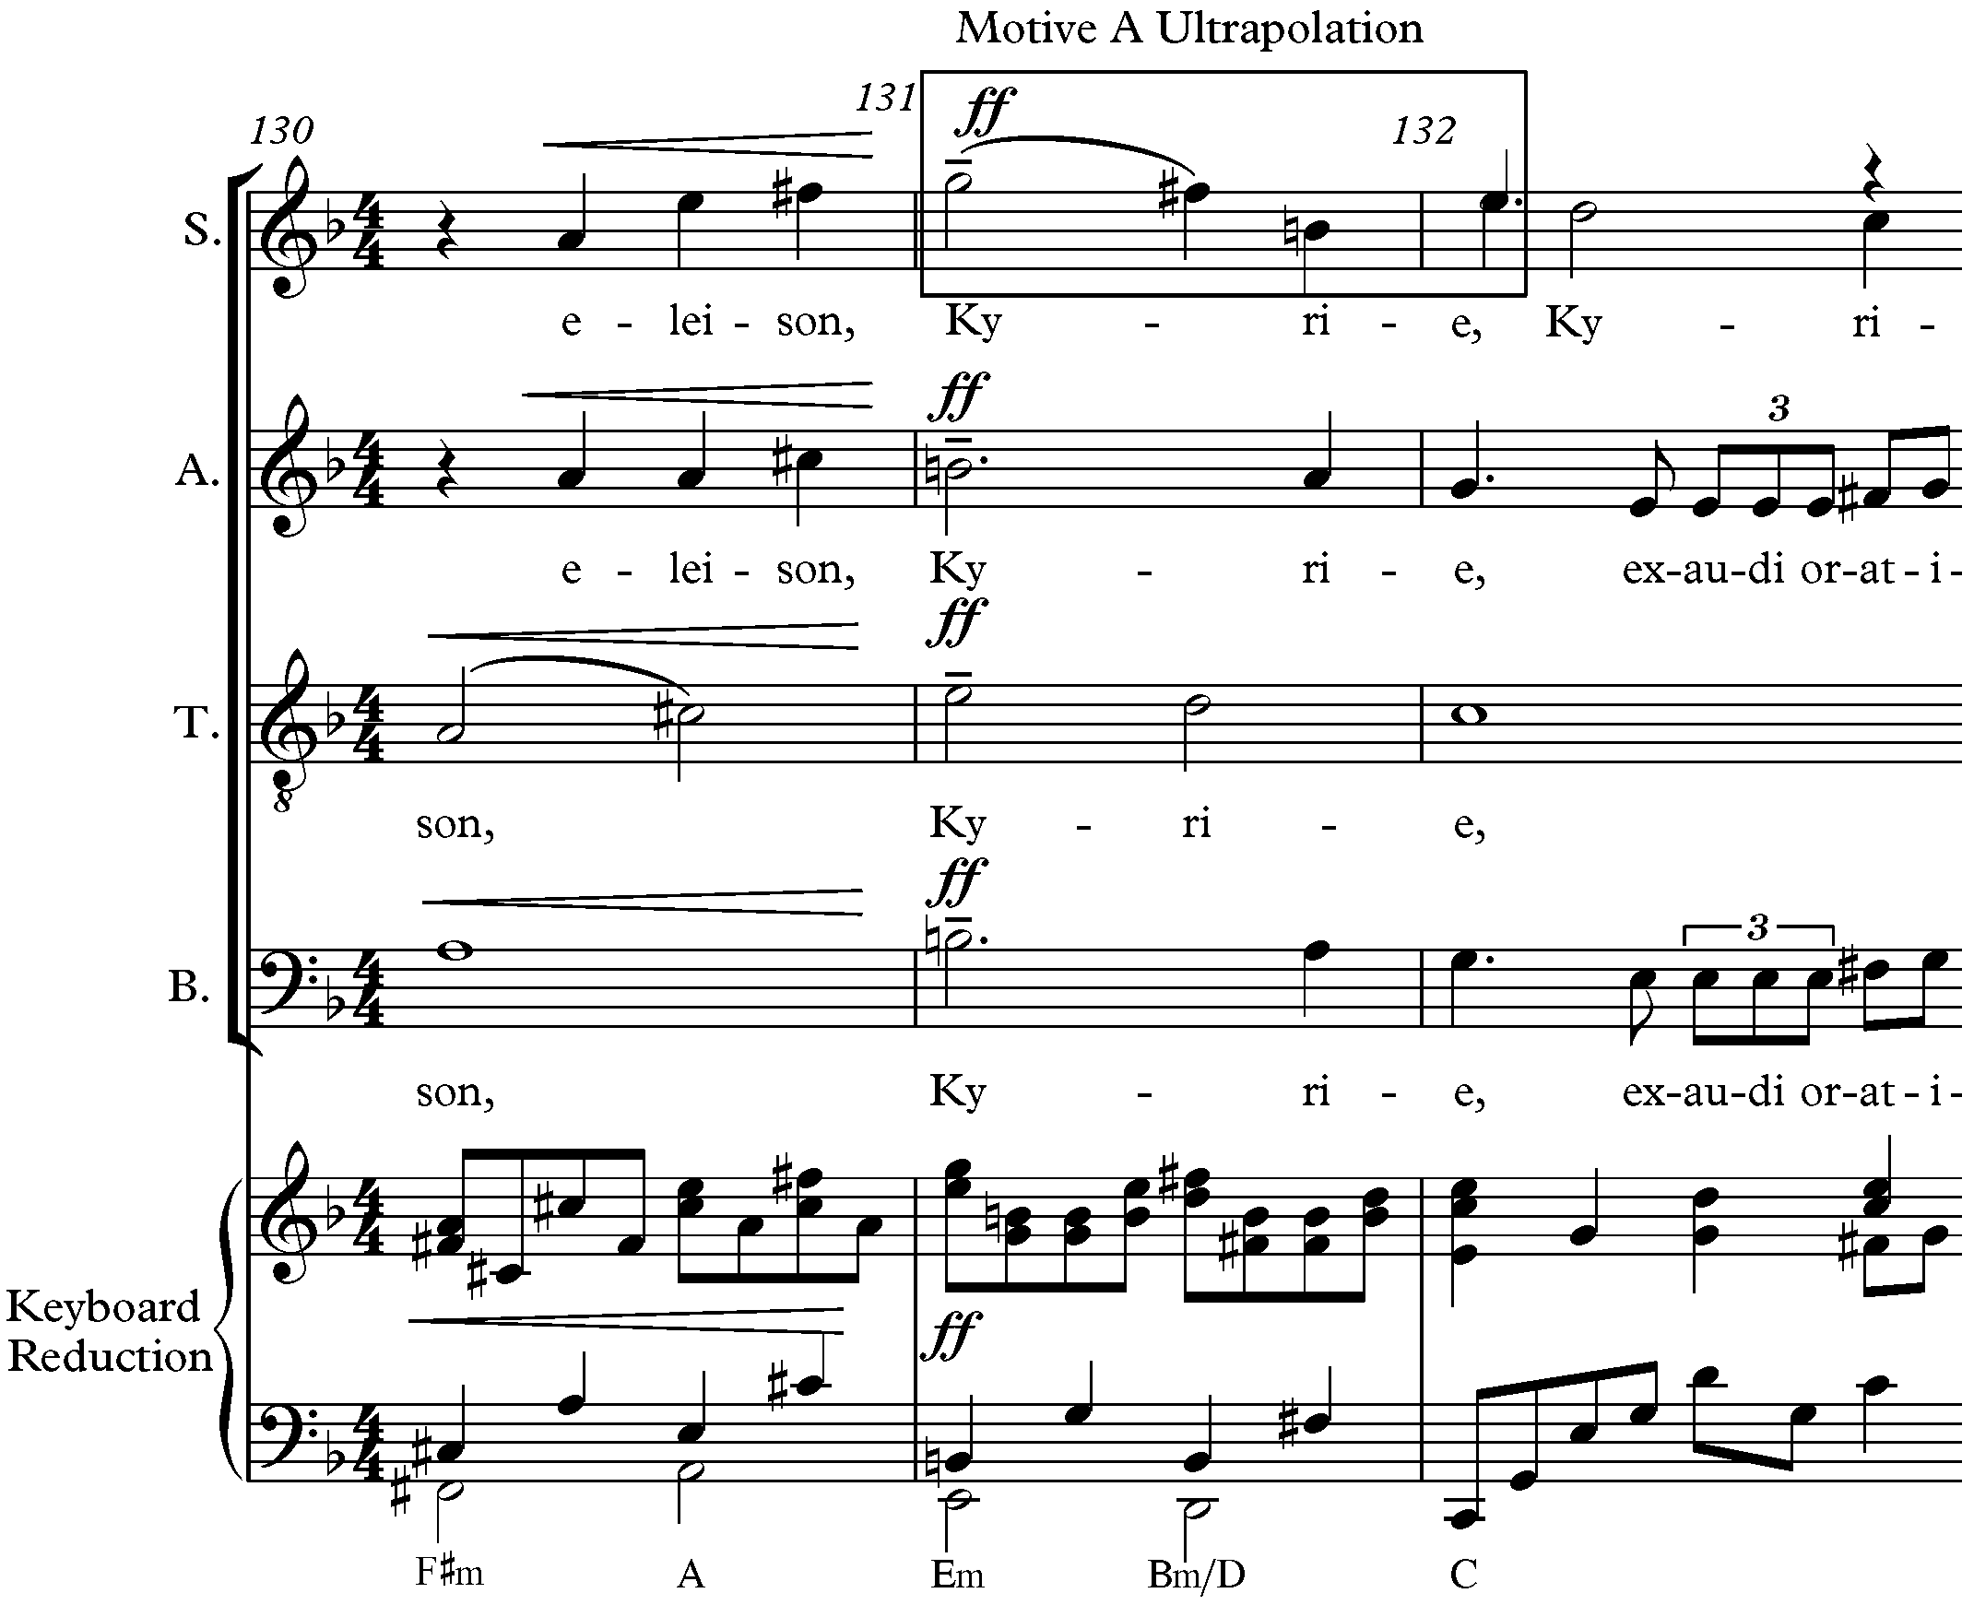
Figure 35: Ultrapolation of Motive A Transposed in Soprano in Introit-Kyrie, mm. 131-132

In the Vanitas Vanitatum, the melody in the B-section is an ultrapolation with repetition,
or prolongation of 2 (C#) starting on D instead of F [soprano, mm. 85-86] (see Figure 36). The

same ultrapolation with repetition of Motive A is found in mm. 103-104 transposed down a half-

step (see Figure 37).

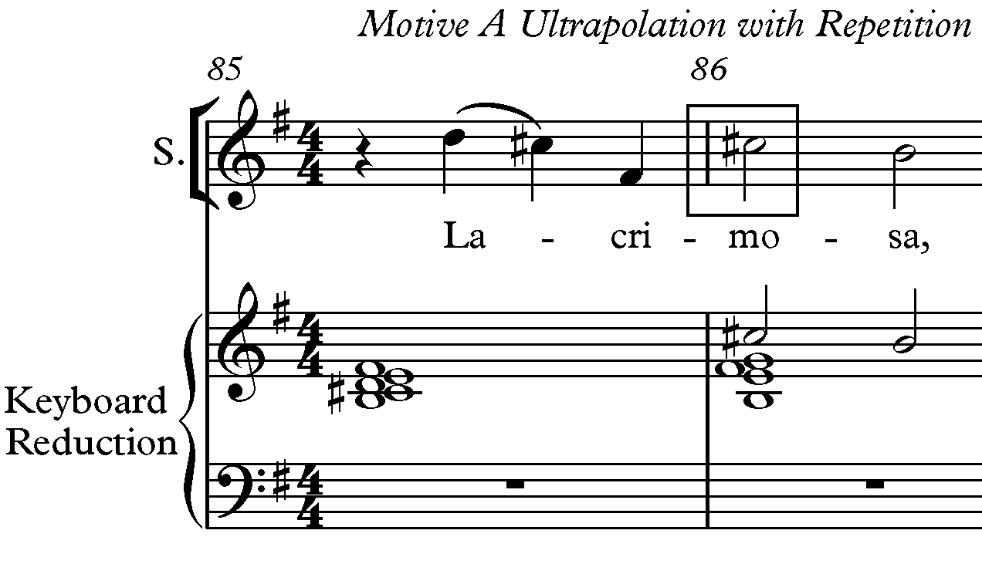
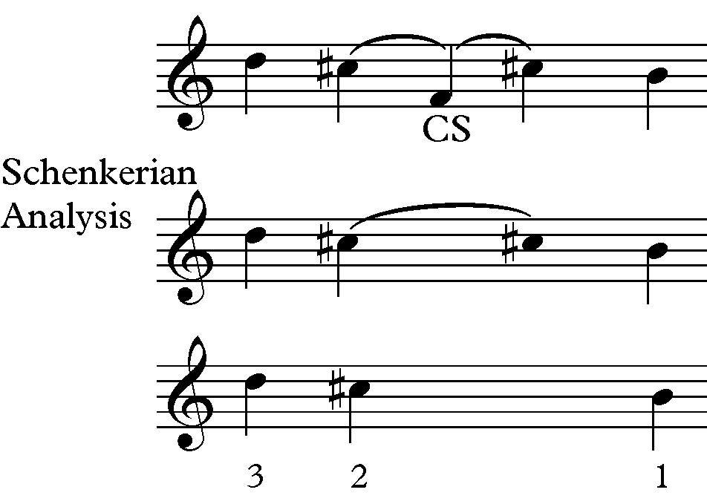
Figure 36: Ultrapolation and Transposition of Motive A and Schenkerian Analysis in Vanitas Vanitatum, mm. 85-86
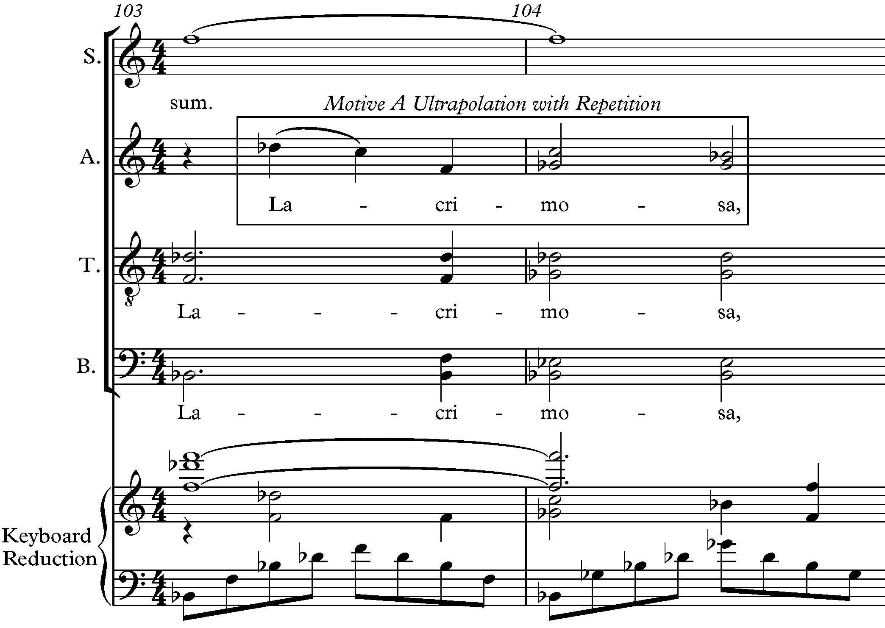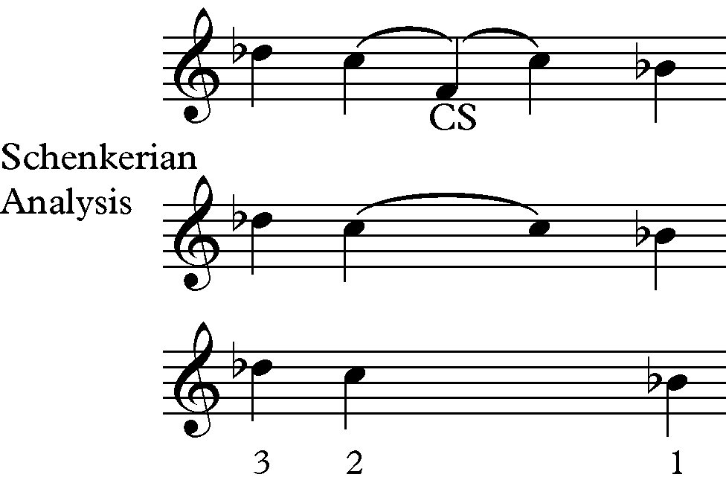

Figure 37: Ultrapolation Motive A in Alto and Schenkerian Analysis in Vanitas Vanitatum, mm. 103-104

Movement Motives

Three other movements (Agnus Dei, Sanctus, and Lux Aeterna) in the Requiem have their own unique melodic motive that relates to the three-note Motive A.

Agnus Dei Motive

The Agnus Dei Motive is an extension of Motive A by starting the motive on scale degree 4 followed by a descending major third through an implied passing tone [scale degree 2] (see Figure 38). The Agnus Dei Motive is found throughout the A and the C-sections of the

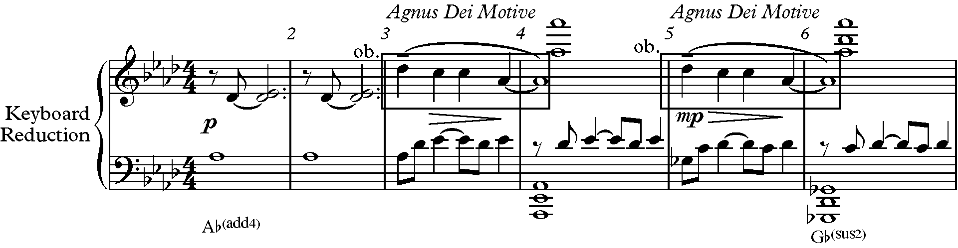
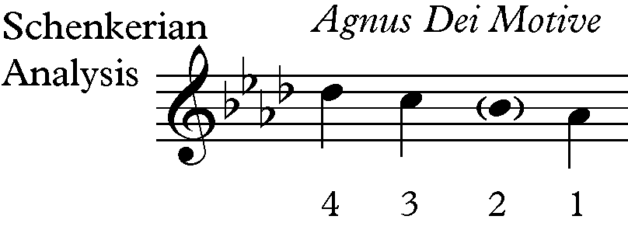

Figure 38: Agnus Dei Motive and Schenkerian Analysis, mm.1-6

third movement in the solo and the choir. Figure 39 shows a transposition of the original Agnus Dei Motive to Fb-Eb-Eb-Cb in the solo [mm. 74-75]. Forrest also quotes the original Agnus Dei

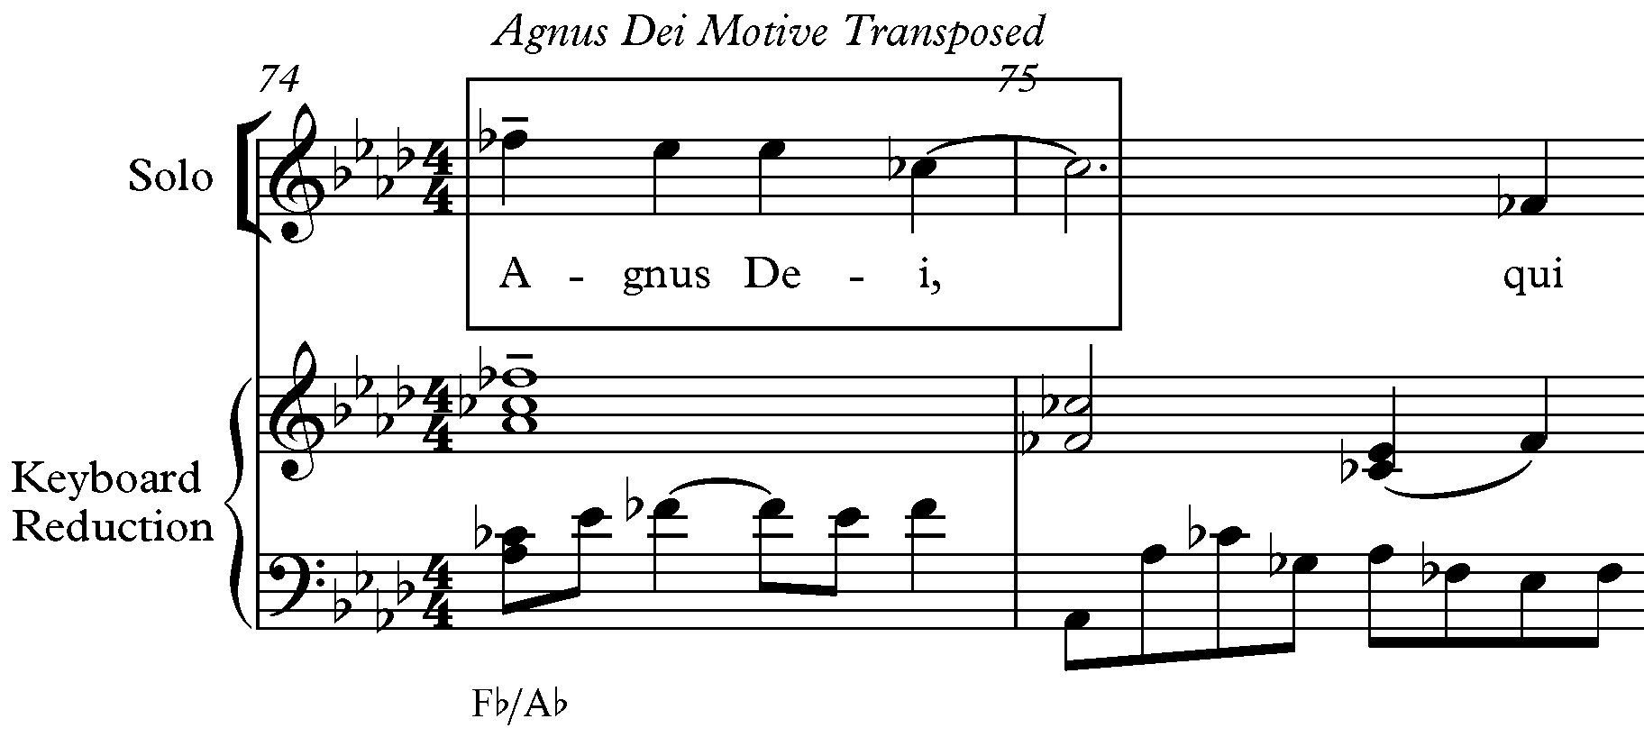

Figure 39: Agnus Dei Motive Transposed Solo Part, mm. 74-75

Motive at the end of his final movement, Lux Aeterna. In the Lux Aeterna, the Agnus Dei Motive is transposed to E major in the oboe part in mm. 110-112 (see Figure 40). The presence of the motive at the end of the work contributes to the cyclic nature of the Requiem.

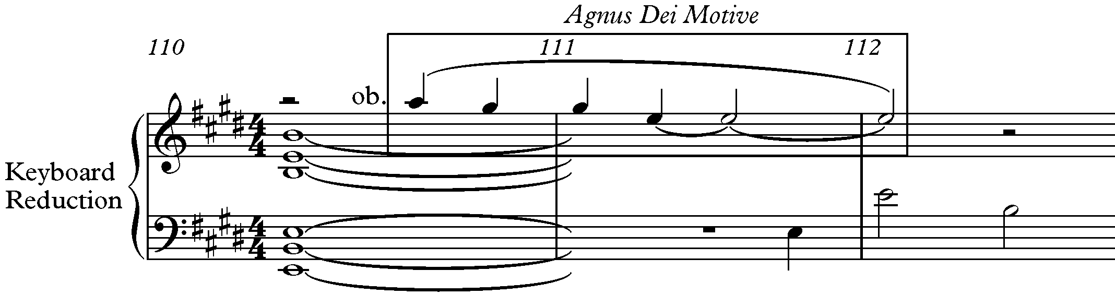

Figure 40: Agnus Dei Motive in Oboe Part in Lux Aeterna, mm. 110-112

Sanctus Motive

The Sanctus Motive is based on Motive A and first appears in the soprano and alto in mm. 10-14 (see Figure 41). Although the G in m. 12 is not part of the supporting harmony, it is on the strongest beat of the measure and sounds like the most important note in the measure. Like the second pitch of Motive A, the G in the Sanctus Motive is a dissonant pitch against the supporting harmony. The A in m. 12 is a neighbor to the G and the C is a register-transferred neighbor to the D in m. 13. The Bb major chord in m. 13 includes the note F, which can be implied in Level 3 of the analysis, completing the descending third.

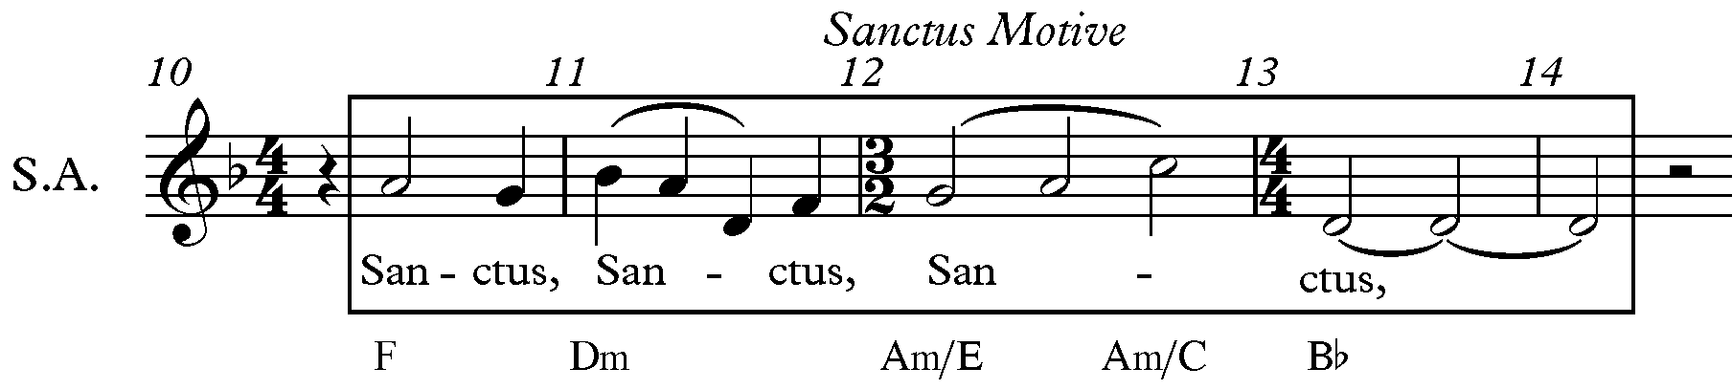
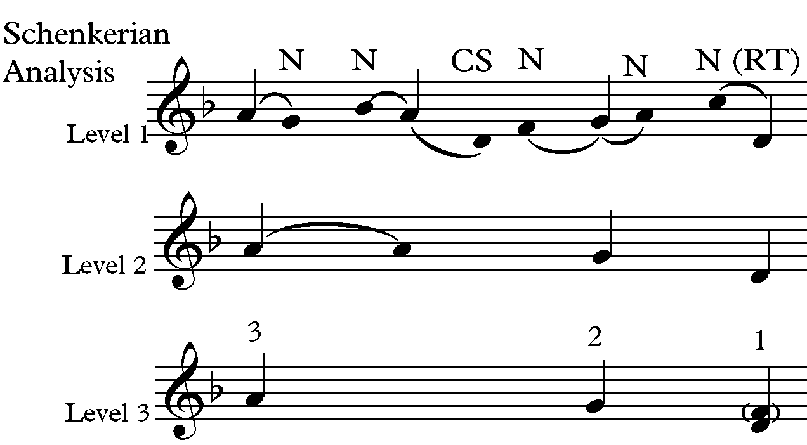
Figure 41: Sanctus Motive Soprano and Alto Parts and Schenkerian Analysis, mm. 10-14
Forrest quotes the Sanctus Motive at the end of his final movement, Lux Aeterna, in the flute part in mm. 113-116 transposed to E Major (see Figure 43). The presence of this motive at the end of the work contributes to the cyclic nature of the Requiem.

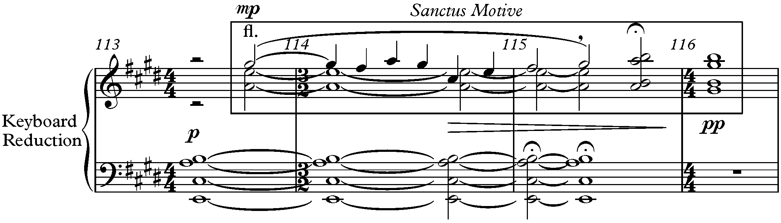

Figure 43: Sanctus Motive in Flute Part in Lux Aeterna, mm. 113-116

Lux Aeterna Motive

The Lux Aeterna Motive is found in mm. 18-19 in the solo part (see Figure 44).
The Lux Aeterna Motive contains an ascending third (1-2-3) within an arpeggiation of G major

triad. The Lux Aeterna Motive is also typically accompanied by Motive A in other parts,

specifically the bass part. Forrest changes the Lux Aeterna Motive with an infrapolation of C to

provide contrast in mm. 21 in the boy solo (see Figure 45). Again, Motive A is found in the bass below the Lux Aeterna Motive.
As stated before, the Lux Aeterna ends with quotes of the motives from the other
movements (except the Vanitas Vanitatum), making the piece cyclic in nature of the Requiem. The quote from the Introit-Kyrie is transposed to E major in mm. 106-107 in the harp (see Figure 46). The two B’s in the top line are a pedal with the main motive below. Forrest quotes the Agnus Dei Motive in mm. 110-112 (oboe) at the end of his final movement transposed to E

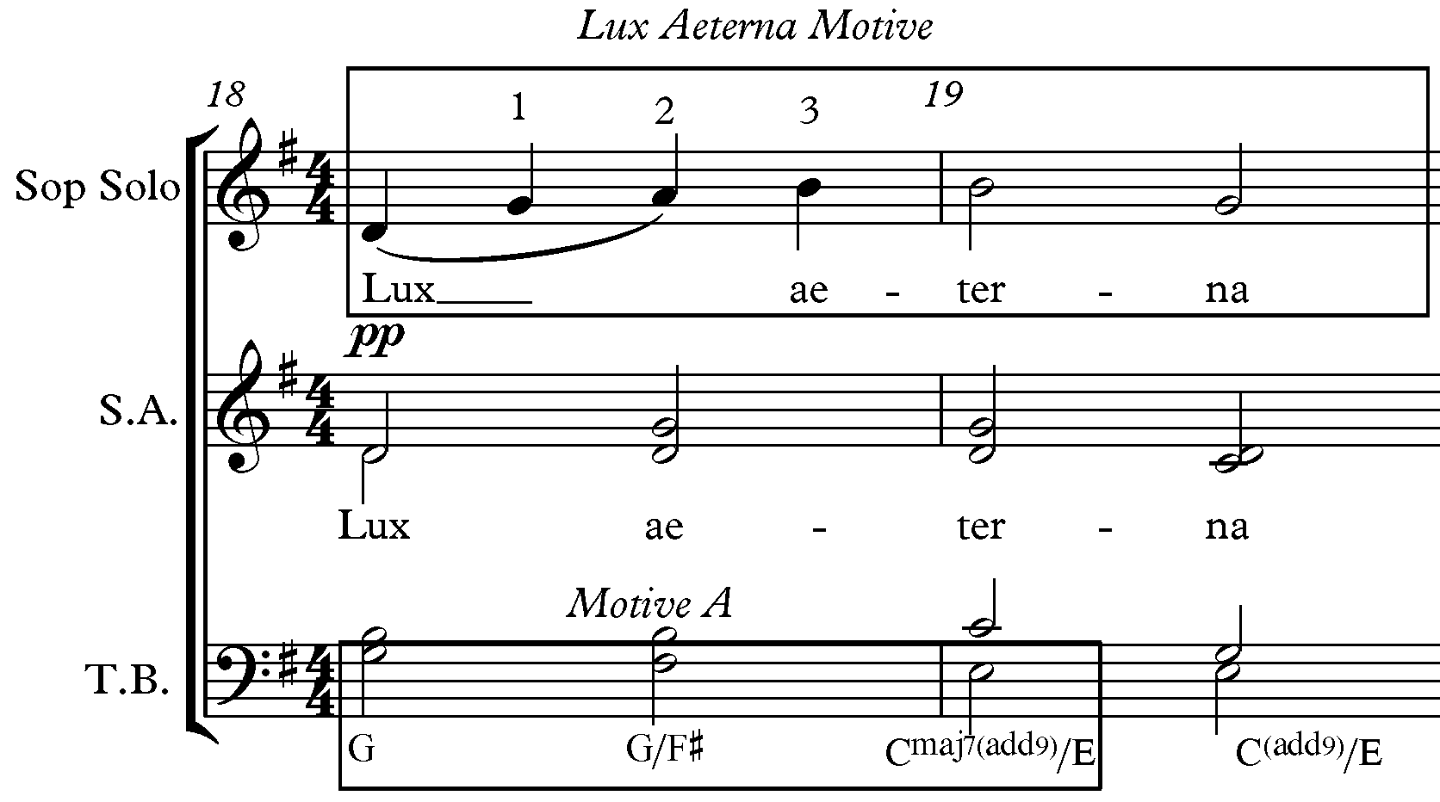

Figure 44: Lux Aeterna Motive, mm.18-19

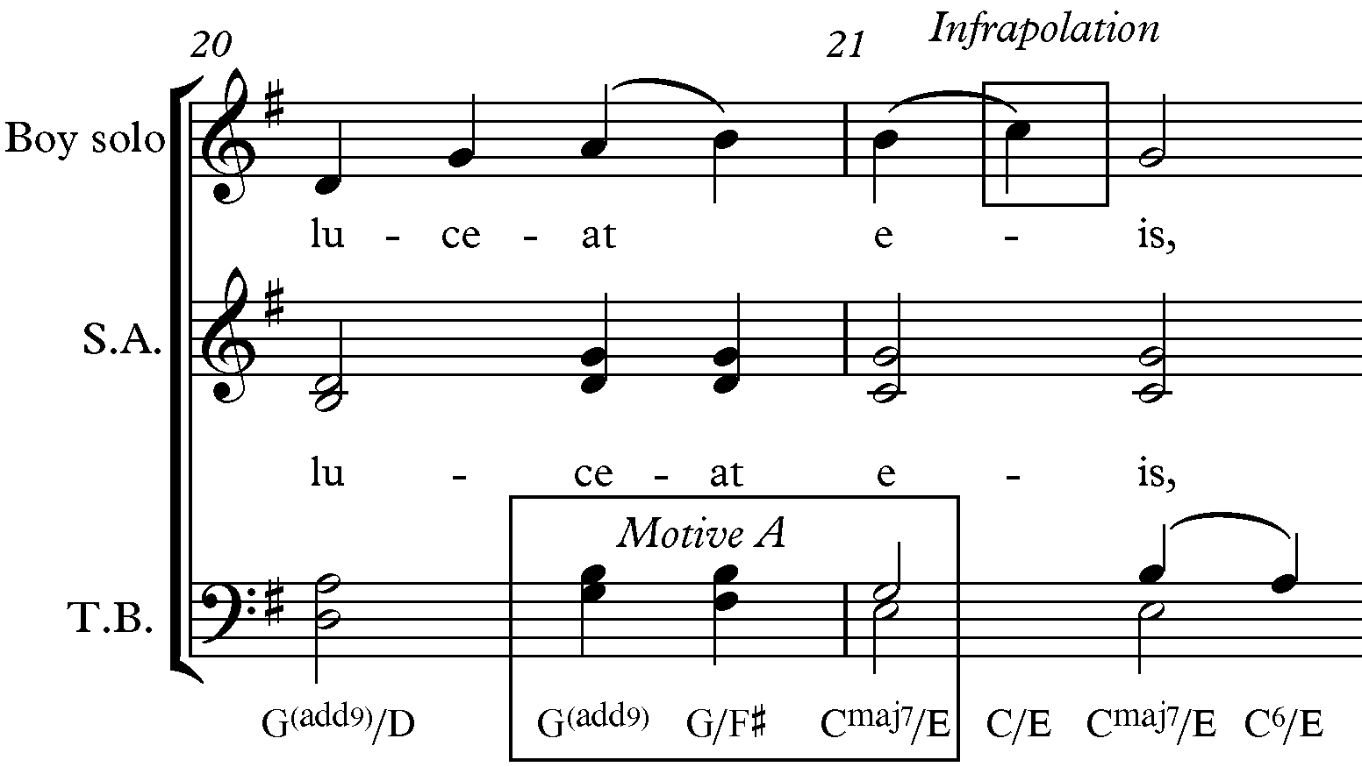

Figure 45: Infrapolation of Lux Aeterna Motive, mm. 20-21

major. However, the motive begins on beat three of m. 110 instead of beat one like the motive usually appears (see Figure 40 above). Forrest also subtly quotes the Sanctus Motive at the end of Lux Aeterna in mm. 114-116 in the flute (see Figure 43 above). Finally, the Lux Aeterna Motive is quoted again in mm. 117-118 in the cello (see Figure 47).

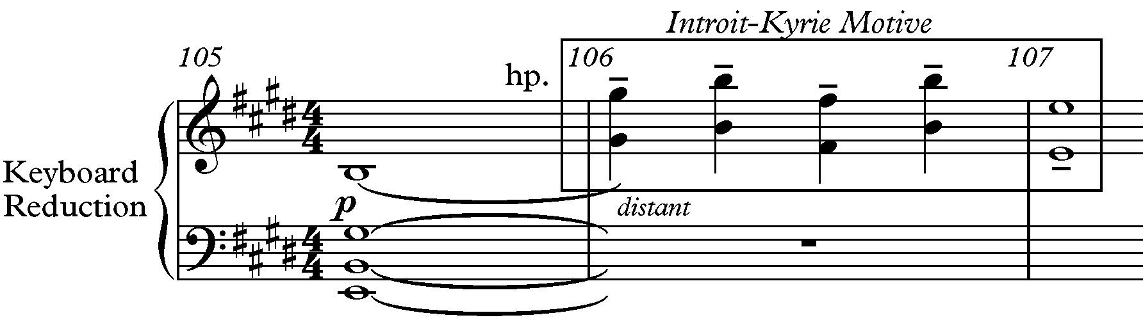

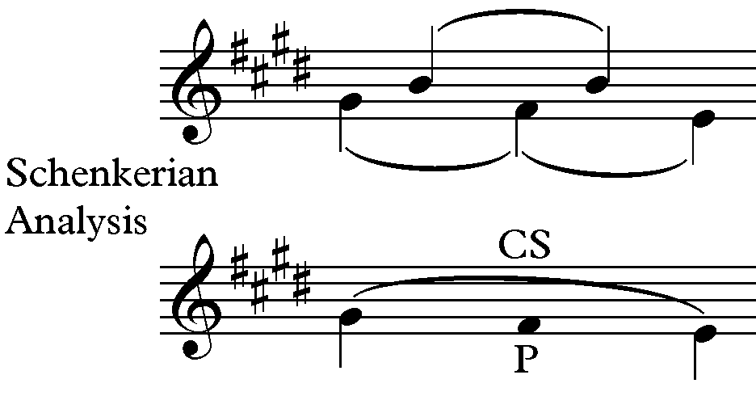

Figure 46: Introit-Kyrie Motive A in Lux Aeterna and Schenkerian Analysis, mm.105-106

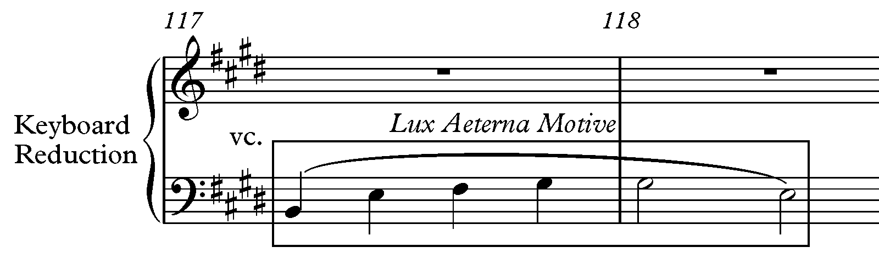

Figure 47: Lux Aeterna Motive in Cello Part, mm. 117-118

The entire work begins and ends with Motive A. The final three pitches of the work invert Motive A and ascend “as if reaching the heavens” (see Figure 48). Forrest also begins and ends the Requiem with two measures of rest, which symbolize the meaning of a Requiem (rest).

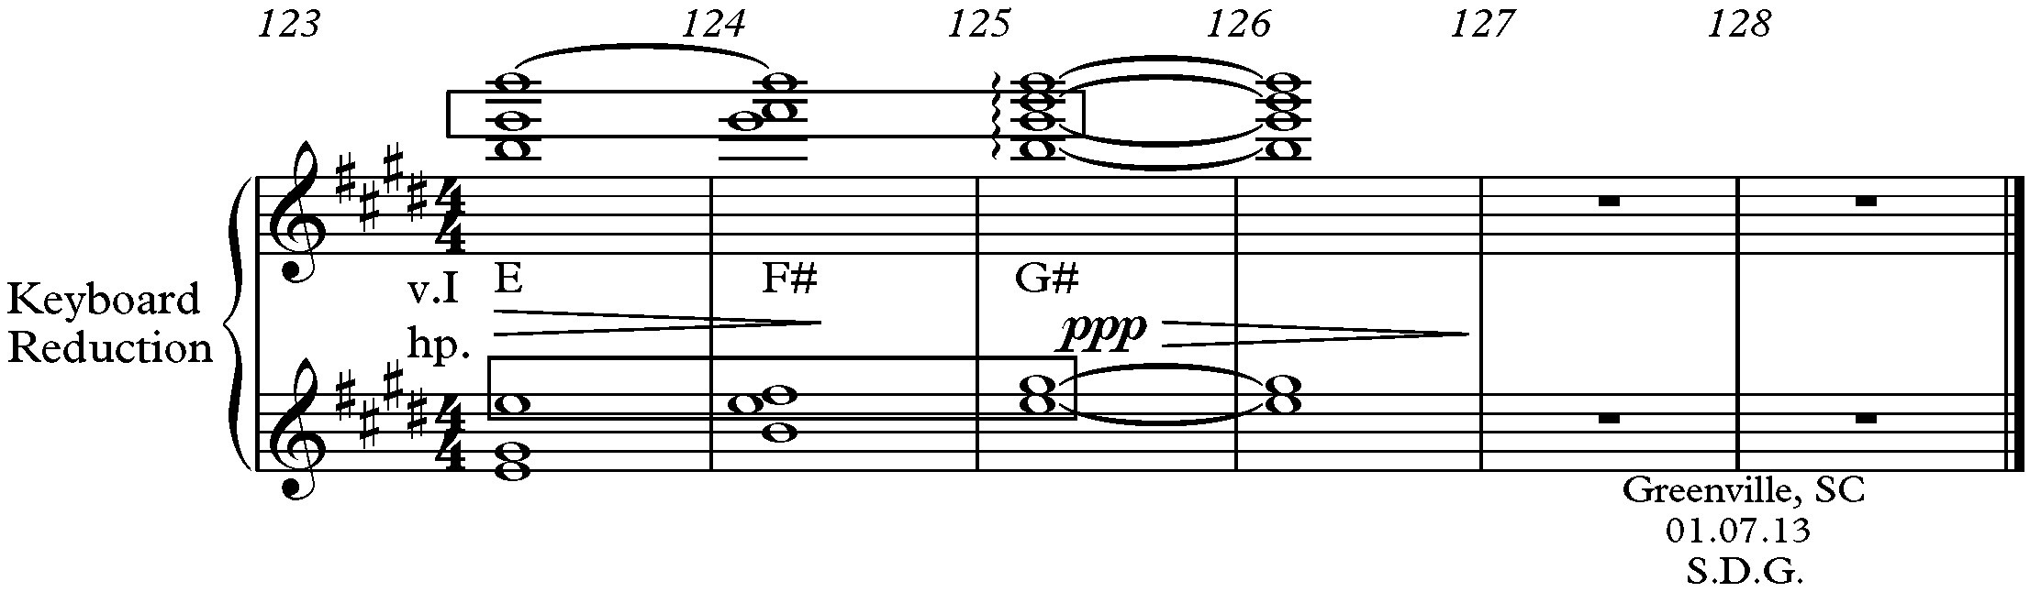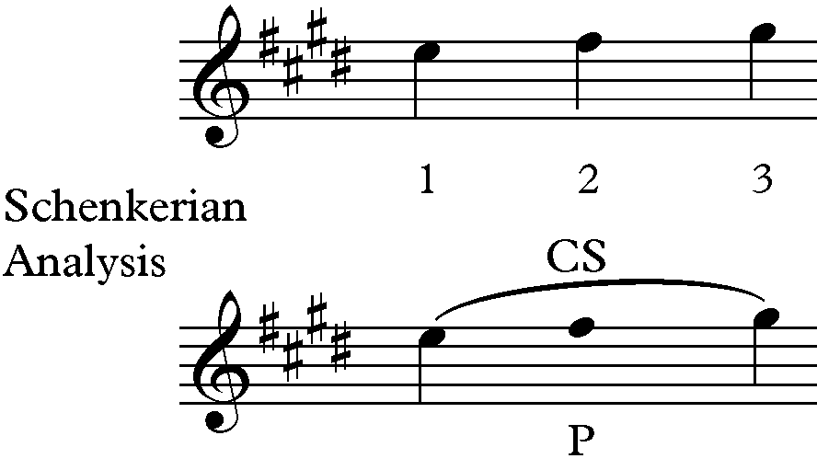
Figure 48: Motive A Transposed Retrograde in Lux Aeterna and Schenkerian Analysis, mm.123-128

Rhythmic Motives

Three rhythmic motives are found in the Requiem and they all contain an element of three. Some of the rhythmic motives also contribute in contextualizing formal ternary divisions. The first rhythmic motive is eighth notes with a triplet in the Introit-Kyrie. This motive is referred to as Rhythmic Motive 1 (RM1). RM1 is first introduced in mm. 64 in the alto and bass parts (see Figure 49), and occurs again in mm. 66-67 in the alto and bass where it starts on beat two rather than the “and” of beat one like Figure 52 (see Figure 50).
Two other rhythmic motives are found in the Vanitas Vanitatum, and Sanctus. The Vanitas Vanitatum is the most rhythmically driven movement in the Requiem, containing rhythms that are percussive, with metric shifts that keep the listener off balance. The text’s hard, percussive consonants drive the rhythm and “hit you in the gut.” Rhythmic Motive 2 (RM2) in
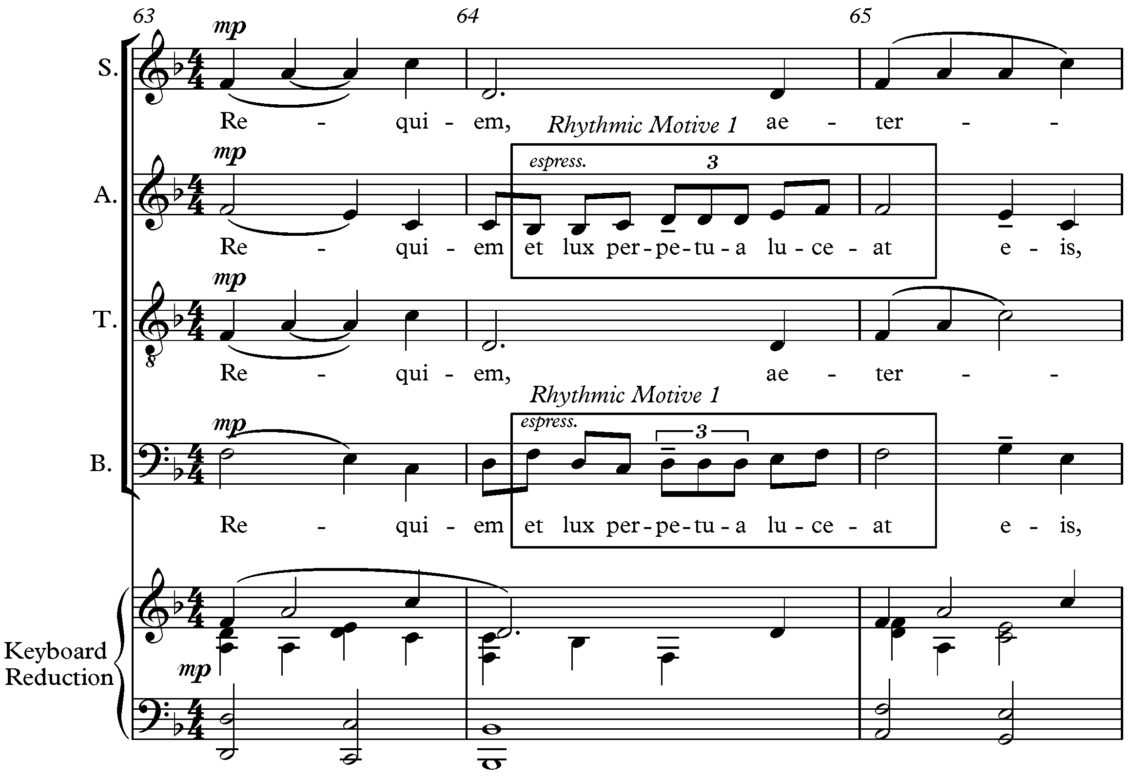
Figure 49: RM1 in Alto and Bass Parts in Introit-Kyrie, mm. 64-65

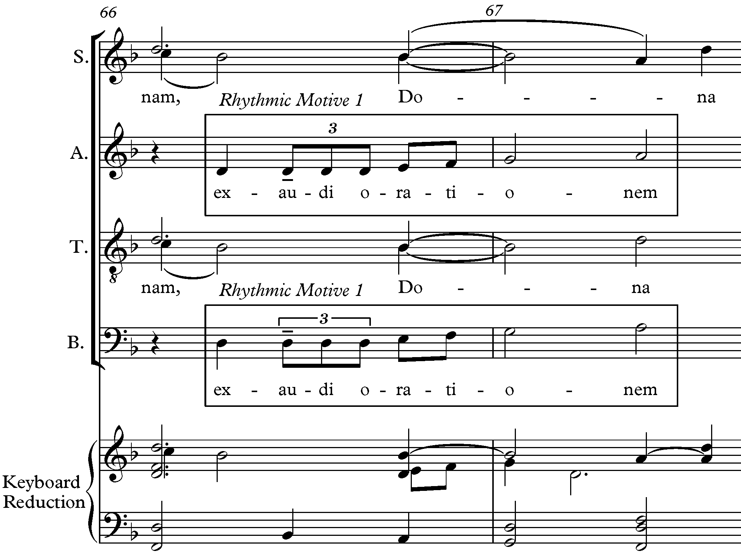
Figure 50: RM1 in Introit-Kyrie, mm. 66-67

the Vanitas Vanitatum has three parts: 1) a dotted eighth, sixteenth, and quarter note, 2) a combination of two sixteenth notes and an eighth note and 3) eighth-notes. RM2 is found in mm. 22-23 [choir] (see Figure 51).

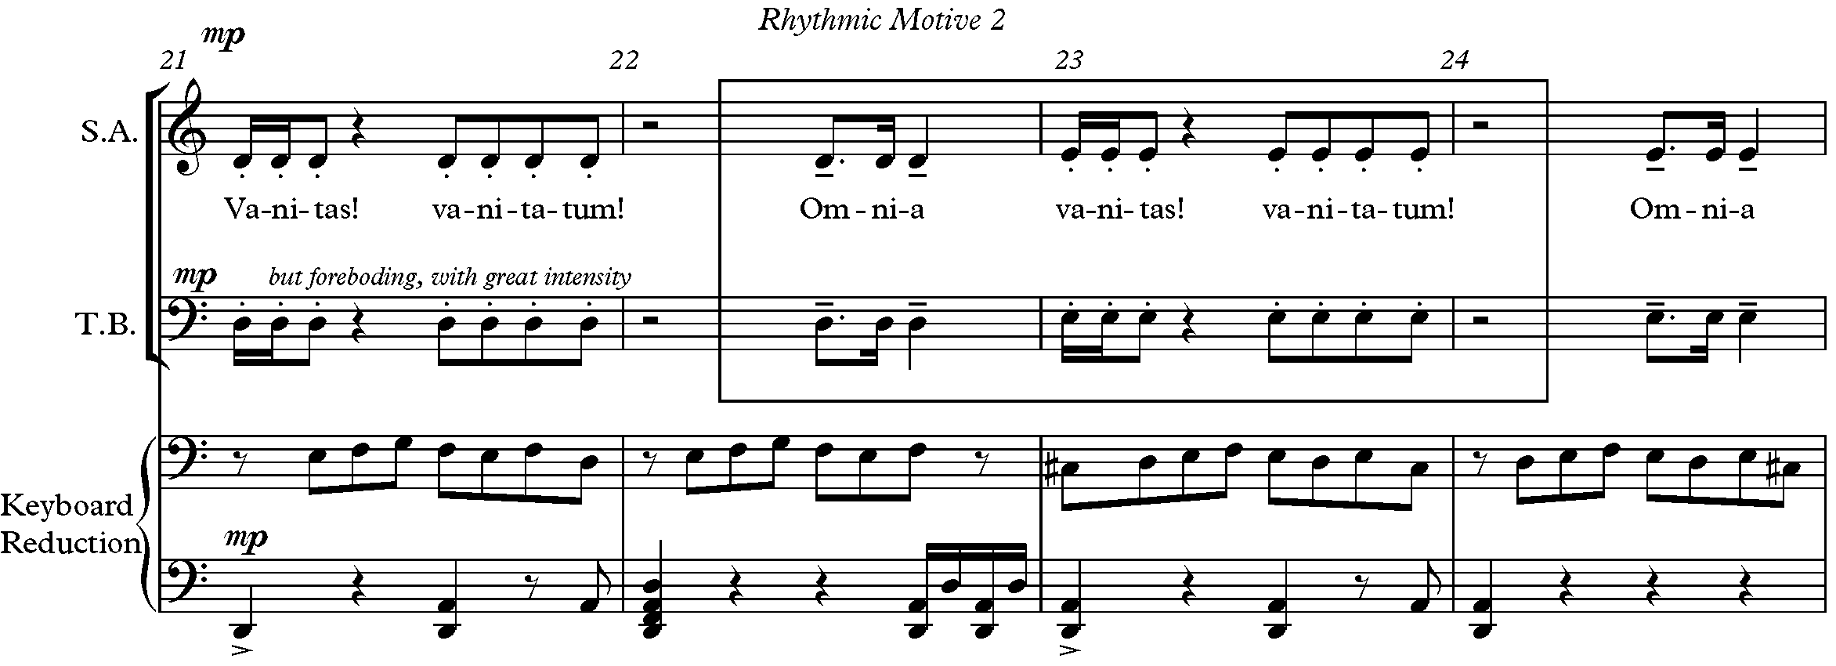
Figure 51: RM2 in Choir in Vanitas Vanitatum, mm. 21-24

As mentioned in Chapter 2, the presence of RM2 in the Vanitas Vanitatum helps define the ternary form. This rhythmic motive is found throughout the A and A’-section but not in the B-section (see Figure 53). Each section has a unique combination of this rhythmic motive.

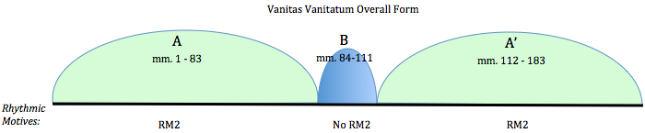
Figure 52: RM2 in Vanitas Vanitatum Overall Form

Rhythmic Motive 3 (RM3) is a distinctive rhythmic pattern found in the first section of the Sanctus between the harp and glockenspiel. Forrest plays with hemiola at the beginning of the Sanctus; the time signature is 4/4 with steady sixteenth notes, but every third sixteenth note is articulated with a tenuto, creating a triple feel (see Figure 53). The syncopated three against two pattern of RM3 repeats every three measures on beat one (see m.10 Figure 53). RM3

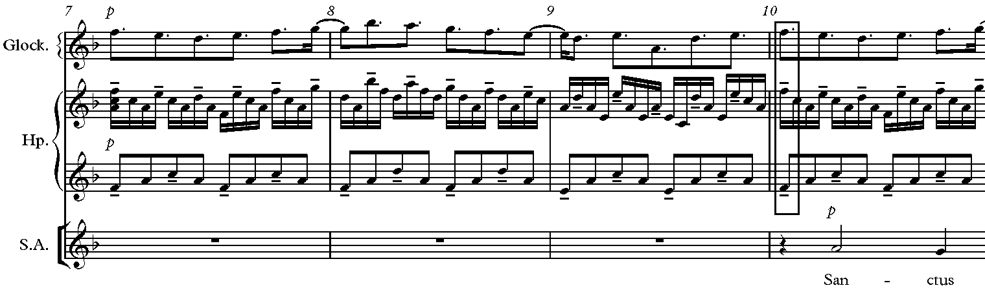
Figure 53: RM3 Polymeter Between Harp and Glockenspiel in Sanctus mm. 7-10

appears only in the first section of the Sanctus (mm. 1-45), consistently from mm. 3-29 and twice in small segments in m. 33 (see Figure 54) and mm. 40-41 (see Figure 55).

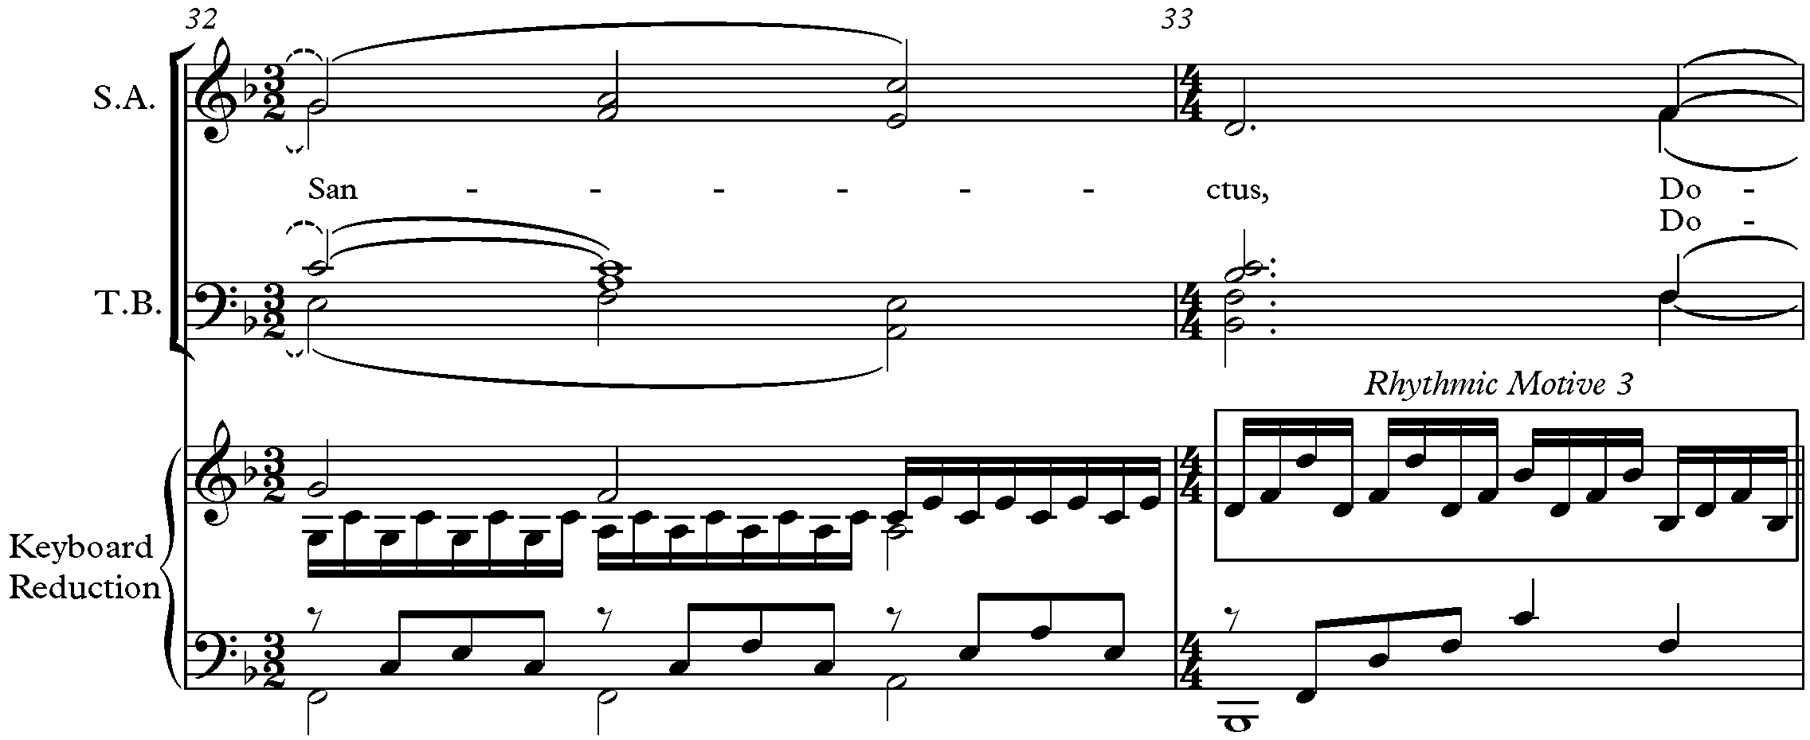
Figure 54: Segment of RM3 in Sanctus, m. 33

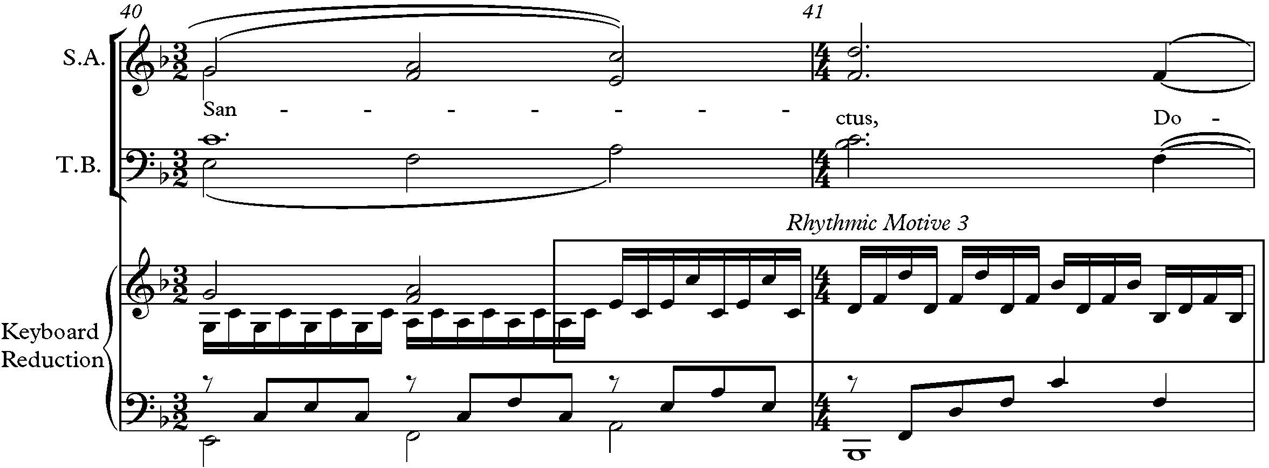
Figure 55: RM3 Segment in Sanctus, mm. 40-41

Forrest’s Requiem is motivically driven by melodic motives, all of which relate to the three-note Motive A, and three rhythmic motives, which all also relate to the number three. Motive A reappears in many different transformations and transpositions throughout the Requiem. Forrest alters his motives by interpolating pitches, transposing, or inverting Motive A. Forrest also alters chords by adding pitches to triads, creating extended tertian harmonies. He also utilizes mediant relationships between chords. The three-note motive is even included prolonged in the key structure, which will be discussed in the next chapter.

CHAPTER 4: Harmonic Analysis

This chapter focuses on the harmonic relationships unified by the number three by highlighting the mediant relationships between chords and key centers, and the use of extended tertian harmonies in the Requiem. Forrest avoids tonic-dominant relationships by substituting mediant chord relationships throughout the Requiem. The overall tonal plan of his Requiem consists of minor third relationships between the tonal centers across the movements.
The motivic pervasiveness of the minor third influences the keys visited. Forrest utilizes mediant-related tonal centers in each movement (see Table 9). As mentioned earlier, the main key and tonal center of the Introit-Kyrie is D minor, but the tonality shifts to B minor and then back to D minor, a minor third relationship. The tonal center of Vanitas Vanitatum is D with an internal key fluctuation to B major, a minor third below, and back to the pitch center D. The tonal center of the Agnus Dei is Ab, which is a tritone, or two minor thirds, from D in movement II. The Sanctus begins in F major, a minor third from movement III’s key of Ab, and changes to D major, a minor third from F. The Lux Aeterna begins in G major, a perfect fourth from the final key of the Sanctus, D, and modulates to E major, a minor third from G. Forrest avoids keys with dominant relationships with the exception of the Sanctus, which ends in D, the dominant of G, the key of the last movement, Lux Aeterna.

Table 9: Key Relationships in Requiem Mostly Minor Thirds
Movement | I. Introit-Kyrie |  | II. Vanitas Vanitatum |  | III. Agnus Dei |  | IV. Sanctus |  | V. Lux  Aeterna
Key/Tonal Center | d–b–d  \/ \/ |  | D-B-D  \/ \/ |  | Ab |  | F–D  \/ |  | G–E  \/
Interval Between Keys | m3 m3 |  | m3 m3 |  |  |  | m3 |  | m3
Interval Between Keys |  | same |  | tritone |  | m3 |  | P4
Forrest’s music is mostly tonal, but his music is triadic with extended tertian chords
(added 7^{ths}, 9^{ths}, 11^{ths}) and 4-3 suspensions, which emphasize scale degree 3. In this chapter, the

chordal shifts in Forrest’s Requiem will be analyzed using Neo-Riemannian analysis. Neo-Riemannian theory (NRT), a theory of chord relationships, is fundamentally based on triadic transformations and common-tone maximization. A short discussion of NRT and the concepts used to analyze harmonic transformations will precede the discussion of the harmonic relationships used in the Requiem.

Neo-Riemannian Analytical Approach

Hugo Riemann (1849-1919) was a German music theorist, musicologist, and composer, whose many writings reveal his extensive research and his “original, often revolutionary, thinking” in regards to music science and theory. Riemann is perhaps best known today for his dissertation, Musiklexikon (1882), in which he proposed a system of harmonic transformations of major and minor triads. Riemann’s theory provides an easy way to understand relationships between major and minor triads by considering three ways to relate two triads that share two pitches. His three transformations help in contextualizing tonal music that is not necessarily diatonic in a traditional way, and maximizing parsimonious voice leading.
More recently, American theorist David Lewin’s interpretation of Riemann’s ideas provides a transformational approach to triadic relations. Lewin first adapted Riemann’s system of harmonic transformations, though other theorists such as Brian Hyer and Richard Cohn have helped develop Riemann’s ideas into an analytical theory. The approaches are “grouped together under the name Neo-Riemannian theory.”
In order to visualize the harmonic transformations in NRT, a graphic tool called the Tonnetz is used to show transformations between major and minor triads (see Figure 56). According to Cohn, “versions of the Tonnetz appeared in German harmonic treatises throughout the nineteenth-century, beginning with Weber’s ‘Table of the Relationship of Keys’ from 1817-1821.” Riemann’s Tonnetz was written in German and does not indicate which pitches are in the chords. The Tonnetz fell out of common use in theory scholarship in the early 1900s because it was difficult to understand. Bryan Hyer created a much easier to read Tonnetz that includes pitch names where each triangle is a major or minor chord (see Figure 56). The notes in the top

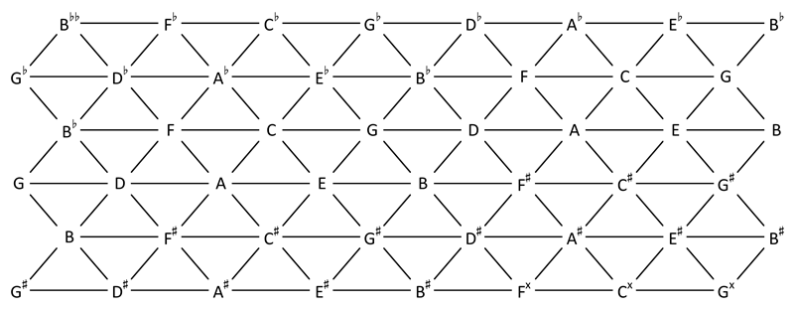
Figure 56: Hyer's Tonnetz
two horizontal lines of the Tonnetz combine to create all minor triads, the second and third lines combine to create all major triads, the third and fourth lines combine to create all minor triads, etc. Each of the three harmonic transformations inverts a triangle (triad) around one of the triangle’s edges (two notes), placing it onto an edge-adjacent triangle on the Tonnetz.
In NRT, there are three types of basic triadic transformations, parallel (P), leading tone (L), and relative (R). A parallel (P) transformation changes a major triad to a minor triad (or vice versa) with the same root; in this relationship the third of the chord moves by one half step. An example of a P relationship occurs in the Vanitas Vanitatum, mm. 153-154, where a G major triad (G, B, D) is transformed into a G minor triad (G, Bb, D). G major to G minor is a P relationship, which inverts around a horizontal (perfect fifth G - D) edge on the Tonnetz (see Figure 57).

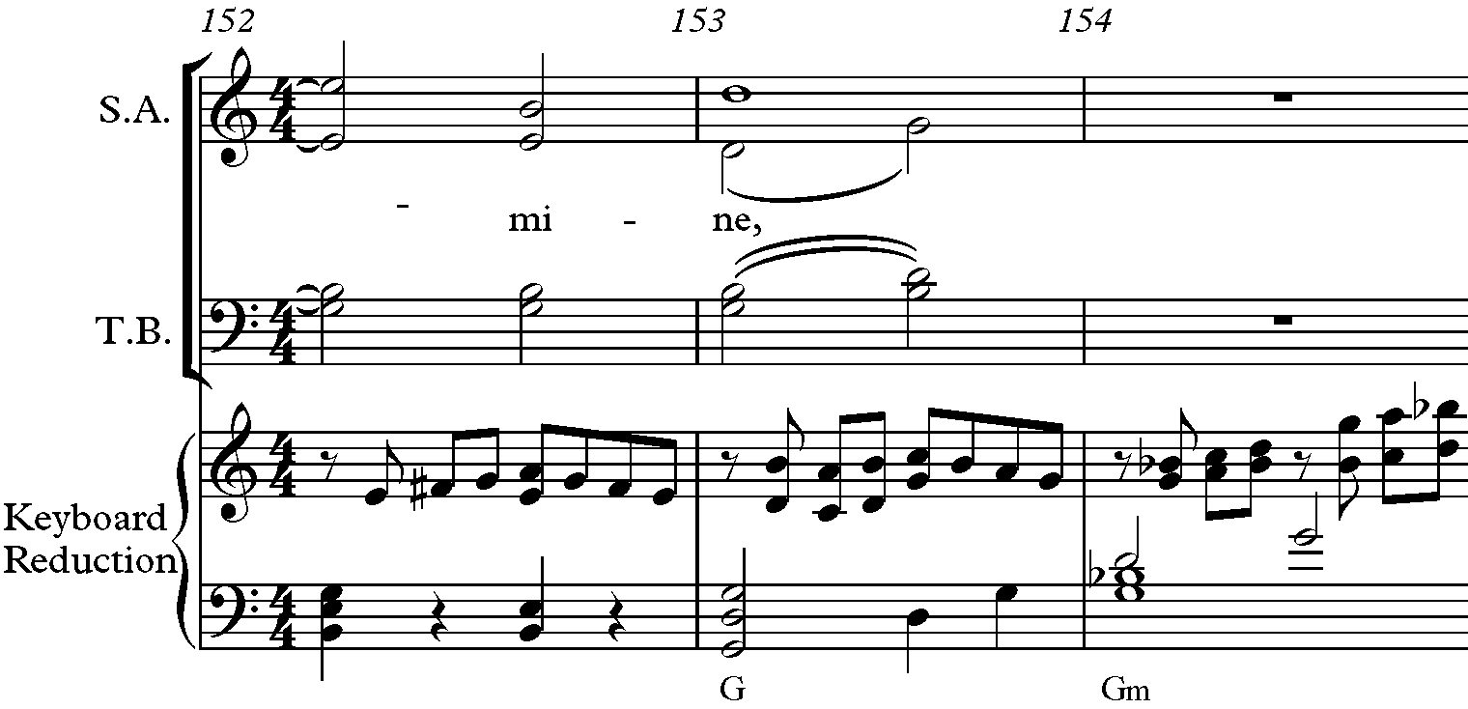
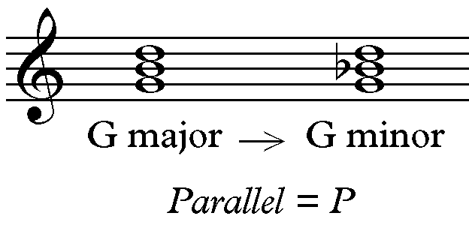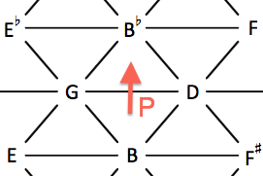

Figure 57: Parallel Transformation, Block Chords, and NRT Diagram in Vanitas Vanitatum, mm. 152-154
A leading tone transformation (L) changes a major triad to a minor triad by maintaining two common tones and moving the other note by half step (leading tone to root or vise versa). The L transformation inverts the triangle around a minor third diagonal. An example of a L transformation is found in Forrest’s Sanctus in mm. 67-68 where the C major (C, E, G)
changes to B, which is one half step below and the leading tone. This transformation can be seen on the Tonnetz in its movement downward to the left (see Figure 58).

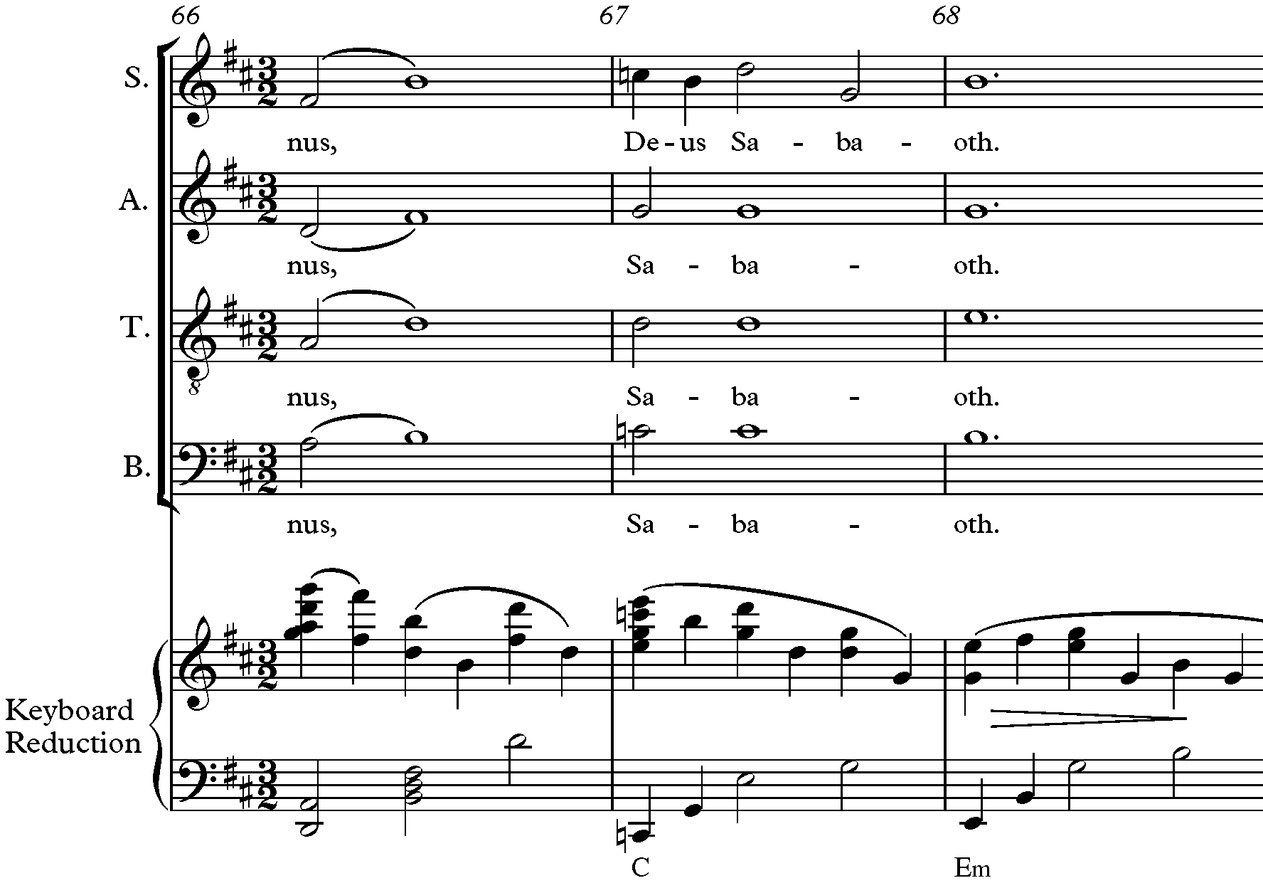
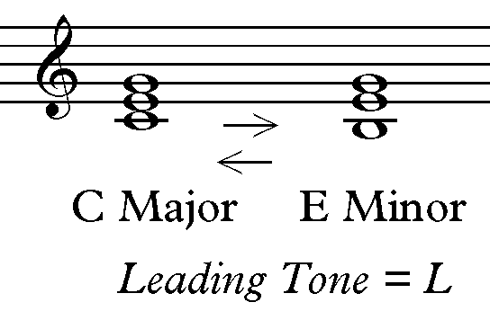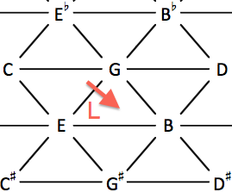
Figure 58: Leading Tone Transformation, Block Chords, and NRT Diagram in Sanctus, mm. 66-68

A relative transformation (R) changes a major triad to a minor triad by maintaining two common tones and moving the other note up by whole step. This movement creates two triads that are relative major and minor chords. An example of a relative transformation can be found in the second section of Forrest’s Introit-Kyrie in mm. 84-85 between D Major chord (D, F#, A) and B minor chord (B, D, F#) (see Figure 59). The common tones D and F# are maintained and the third tone G moves up a whole step to A. The R transformation inverts around a major third diagonal.

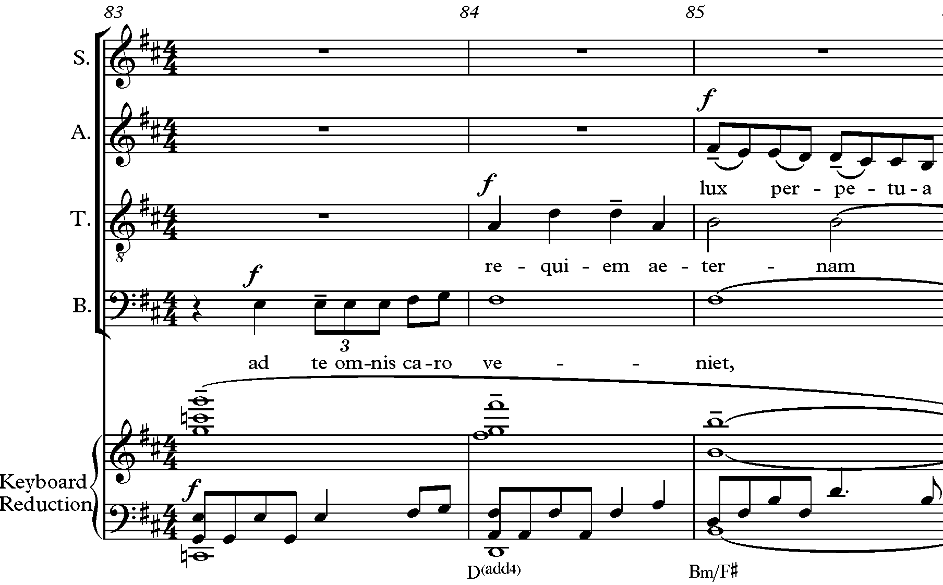
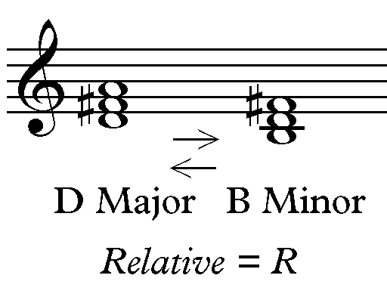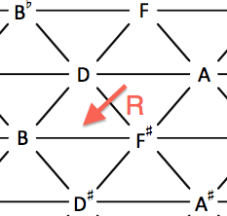

Figure 59: Relative Transformation and NRT Diagram in Introit-Kyrie, mm. 84-85

The relationship between all major or minor chords may not be able to be explained as a P, R, or L. Some chord relationships may require two or more transformations, called compound transformations. Such compound relationships are between non-adjacent chords/triangles on the Tonnetz. For example, in the Introit-Kyrie (mm. 59-60) the relationship between the Eb Major (Eb, G, Bb) and Bb Major (Bb, D, F) triad cannot be explained as a simple P, R, or L. Instead, both an L and R transformation are required to diagram the relationship between these two chords on the Tonnetz (see Figure 60). The LR (or its inverse RL) is so common that Lewin calls this relationship dominant (D), and includes it as a primary transformation.

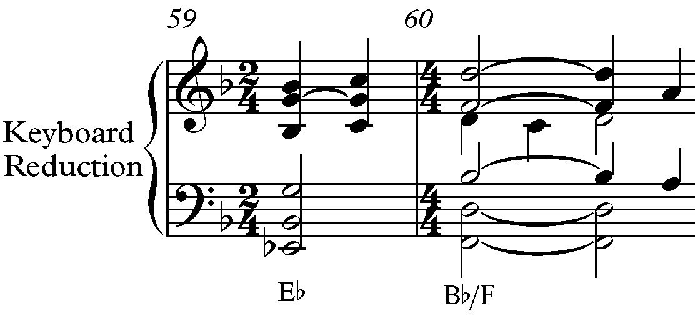
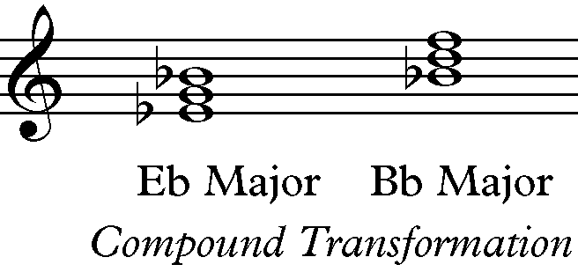
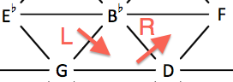
Figure 60: Compound Transformation (LR) = Dominant and NRT Diagram

Forrest’s Requiem contains many compound transformations. One example is a PRL compound transformation found in Introit-Kyrie in mm. 32-33 with a change from D minor (D, F, A) to G Major (G, B, D) (see Figure 61). This compound transformation can also be explained by navigating the opposite direction on the Tonnetz: LRP (see Figure 62). In transformations such as this, either annotation works as long as R is the central transformation, surrounded by P and L.

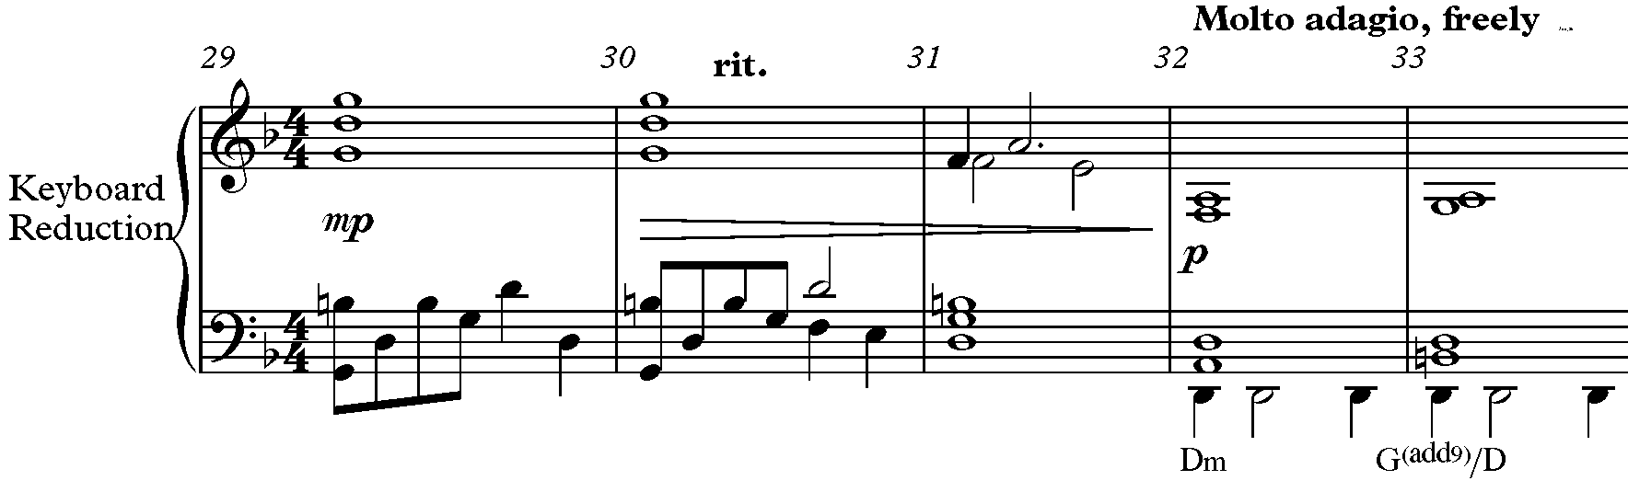
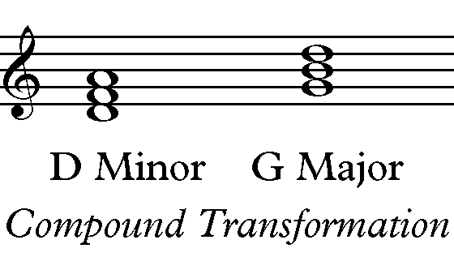
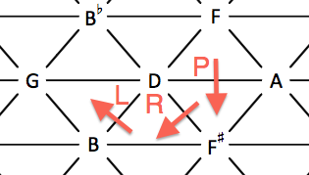
Figure 61: Compound Transformation (PRL), Block Chords, and NRT Diagram in Introit-Kyrie, mm. 29-33

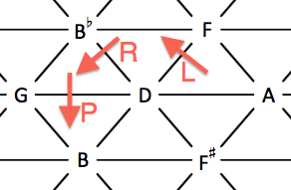
Figure 62: NRT Diagram of Compound Transformation (LRP) in Introit-Kyrie
One limitation with NRT is that only major and minor triads are included in the Tonnetz. Since music contains other types and qualities of chords, other theorists have expanded NRT to include other chords. Guy Capuzzo expanded NRT to include extended tertian harmonies (e.g., added 7^{ths}, 9^{ths}, 11^{ths}, etc). Capuzzo explains how extended tertian harmonies are basically overlapping triads. For example, a C^{maj7} chord consists of two triads, C major and E minor (see Figure 63). Capuzzo suggests added pitches like sevenths sometimes “act non-functionally as colorations of triads,” and can be explained without always referring to L, R, or P relationships.

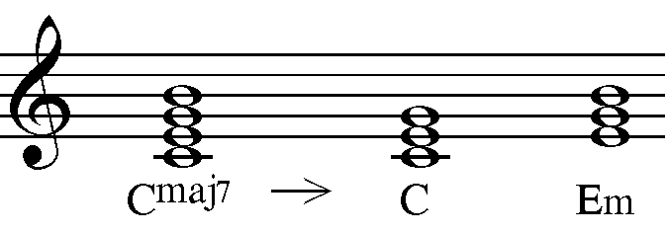
Figure 63: C^{maj7} is Two Triads: C Major and E minor

Capuzzo created two symbols that allow extra pitches to be added to a triad. Capuzzo claims that the chords with an “inclusion” symbol adds extra notes to the triad, and chords that eliminate a note of the triad, the fifth for instance, are indicated with an “exclusion” symbol (see Figure 64). For example, a D major triad (D, F#, A) with an added seventh (C) is indicated with an inclusion symbol, and a D major chord without the fifth (A) is indicated with an exclusion symbol.

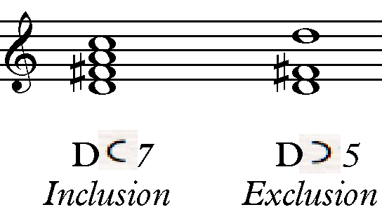
Figure 64: Capuzzo's Inclusion and Exclusion Symbols

In tonal music, dominant harmonies are prevalent and can be explained with traditional Roman numeral analysis, but Forrest avoids the tonic-dominant relationship in his Requiem, and includes mediant relationships instead, as well as harmonies that create color without traditional function. Capuzzo says Neo-Riemannian operations “are useful tools in analyzing progressions that lack structural dominant harmonies, and that lack leading tones that might carry dominant function.” As a result, NRT is very useful in explaining Forrest’s harmonic relationships, which lack dominant harmonies, but contain extended tertian harmonies and compound transformations.

Tracing Chord Transformations in the Requiem

Forrest’s music is diatonic with contemporary elements such as extended tertian chords (added 7^{ths}, 9^{ths}, etc.), suspensions, mediant relationships between chords and keys, and parsimonious voice leading. Many of Forrest’s harmonies create color, but have no traditional function. The three-note motive is prolonged in the key structure within Forrest’s formal designs, as well as mediant relationships and extended tertian harmonies.

Extended Tertian Harmonies

Extended tertian harmonies are found throughout the Requiem. One type of a chord Forrest often includes in this work is a major chord with an added ninth, such as the C major added D, which is found in mm. 47, 54, 56, 58, 68 in the Introit-Kyrie. The D, the added ninth, indicated in parenthesis, is a common tone in the Gm, C^{(add9)}, D minor, and Am^{(sus4)} progression (see Figure 65). Another example of chords with the added ninth is found in the Sanctus mm. 48-50 (see Figure 66).

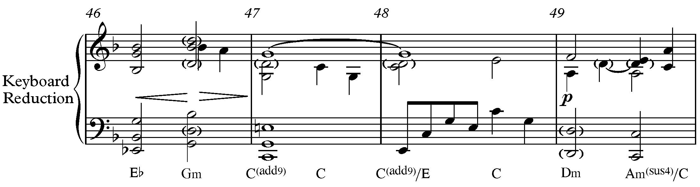

Figure 65: Extended Harmony and Voice Leading Parsimony in Introit-Kyrie, mm. 46-49

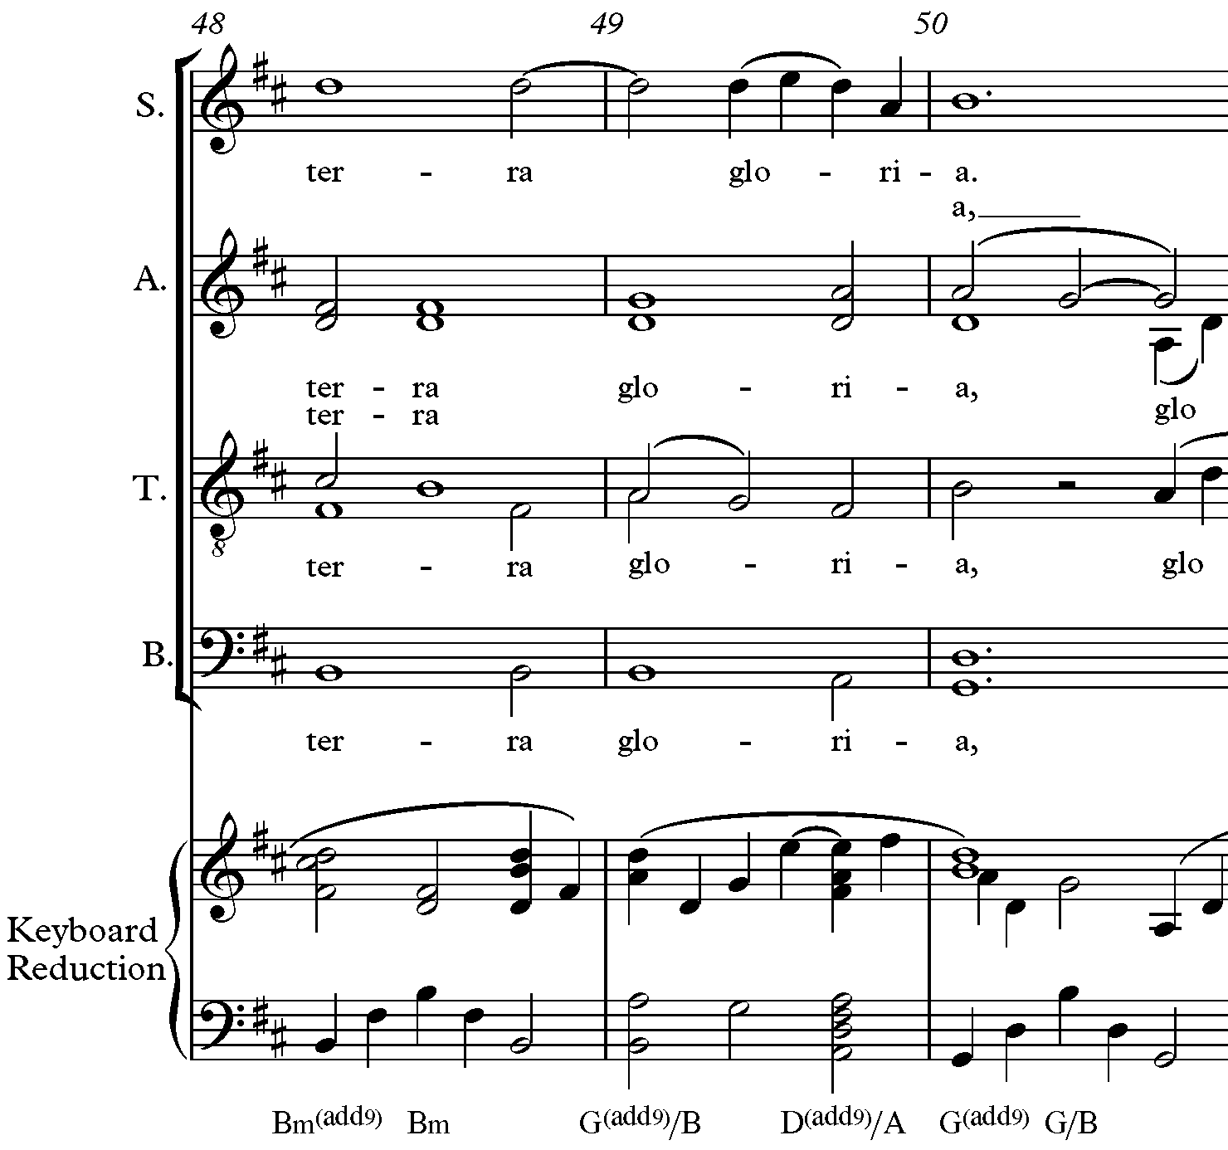

Figure 66: Extended Tertian Harmonies in Sanctus, mm. 48-50

Suspensions

Forrest places added emphasis on scale degree three by including numerous 4-3 suspensions throughout his Requiem. One example is in the Sanctus in mm. 17-19 (see Figure 67). The F from the Bb triad in m. 17 is suspended to the F in the C^{(sus4)} in m. 18, which resolves to E in the C major chord in m. 19. The same progression is found later in the Sanctus in mm. 36-37, but here the altos sing the suspension and its resolution (see Figure 68).

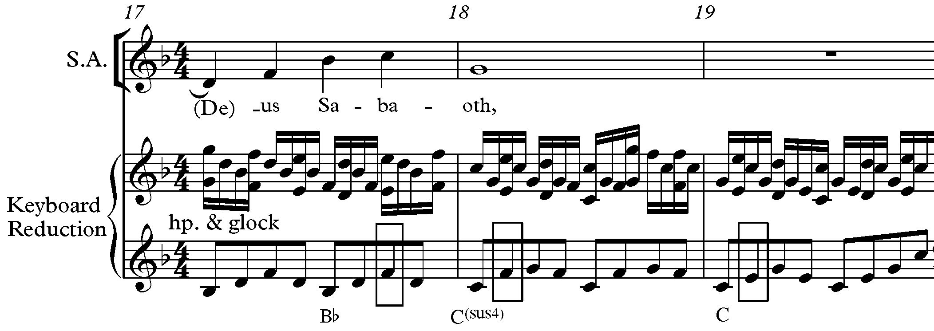
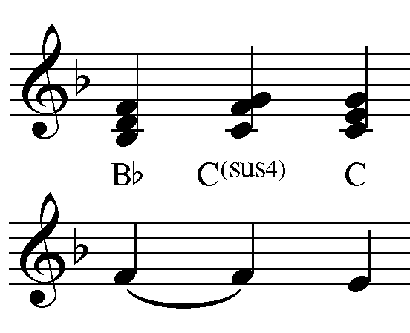
Figure 67: Suspension in Harp and Glockenspiel Parts and Block Chords in Sanctus, mm. 17-19

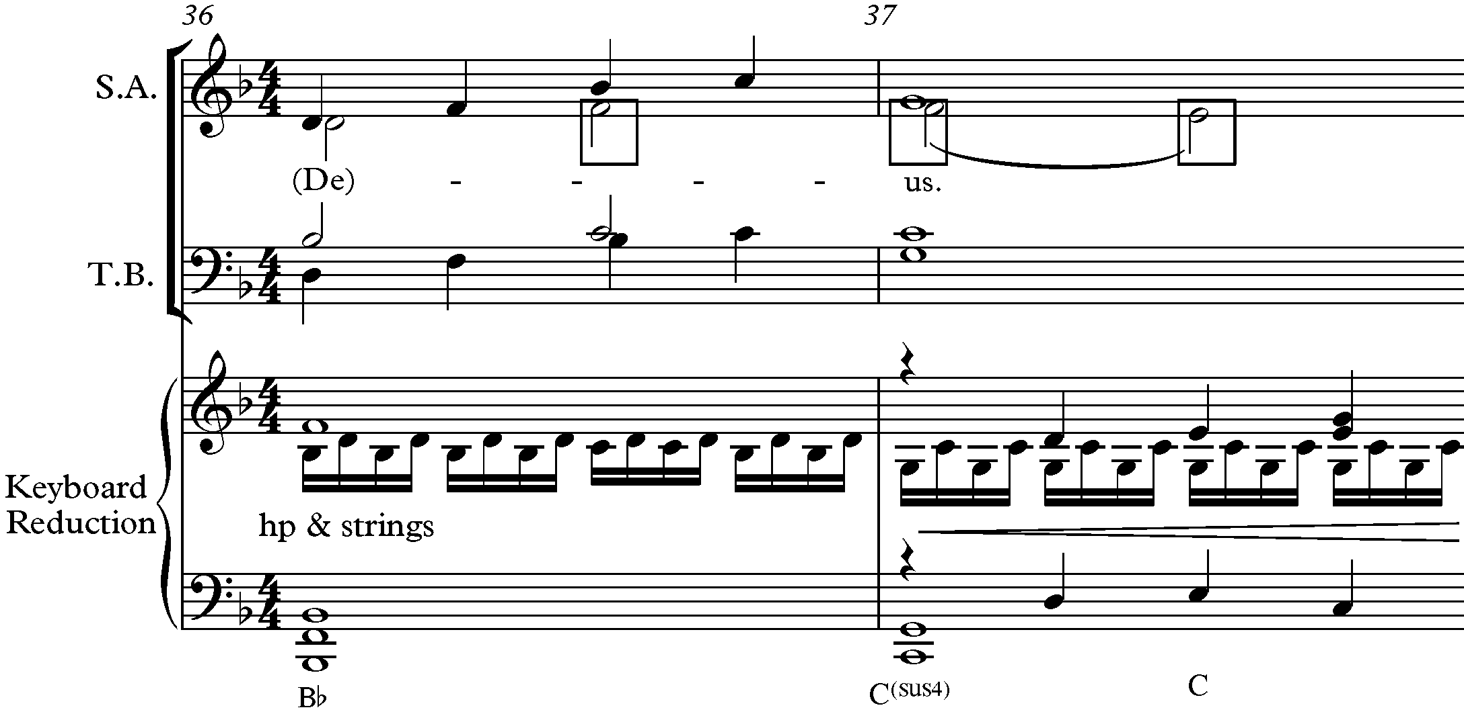
Figure 68: Suspension in Harp, Strings, and Alto Parts in Sanctus, mm. 36-3

Mediant Relationships

NRT is useful in analyzing mediant relationships like those in Forrest’s Requiem. Mediants often make use of common-tone maximization. In the Introit-Kyrie, chord progressions in thirds occur between D minor, Bb major, and G minor chords, all of which share the common
tone D, in mm. 63-67 (see Figure 69). The D minor and Bb also share the common tone F and the Bb and G share the common tone Bb. The Dm – Bb and vice versa are L transformations, and the Bb – Gm is an R transformation.
A similar progression with mediant transformations is found in the Sanctus mm. 106-109 (see Figure 70). The roots of the chords, D – B and B – G, are a third apart. The D major – B minor is an R transformation and the B minor – G major is an L transformation. The common tone between all three chords is D, the D – Bm also share the common tone F#, and the Bm – B share the common tone B. The same progression D major – B minor – G major is found throughout the last C-section of the Sanctus.
Another example of a mediant chord transformation is found in the Introit-Kyrie mm. 92-96. The transformations are compound (PL, RP, PR, and RP) because all of the chords are major and only share one common tone, E (see Figure 71). The E to C major chord is a PL transformation, the C to A major is an RP, and the A to C major is a PR transformation.

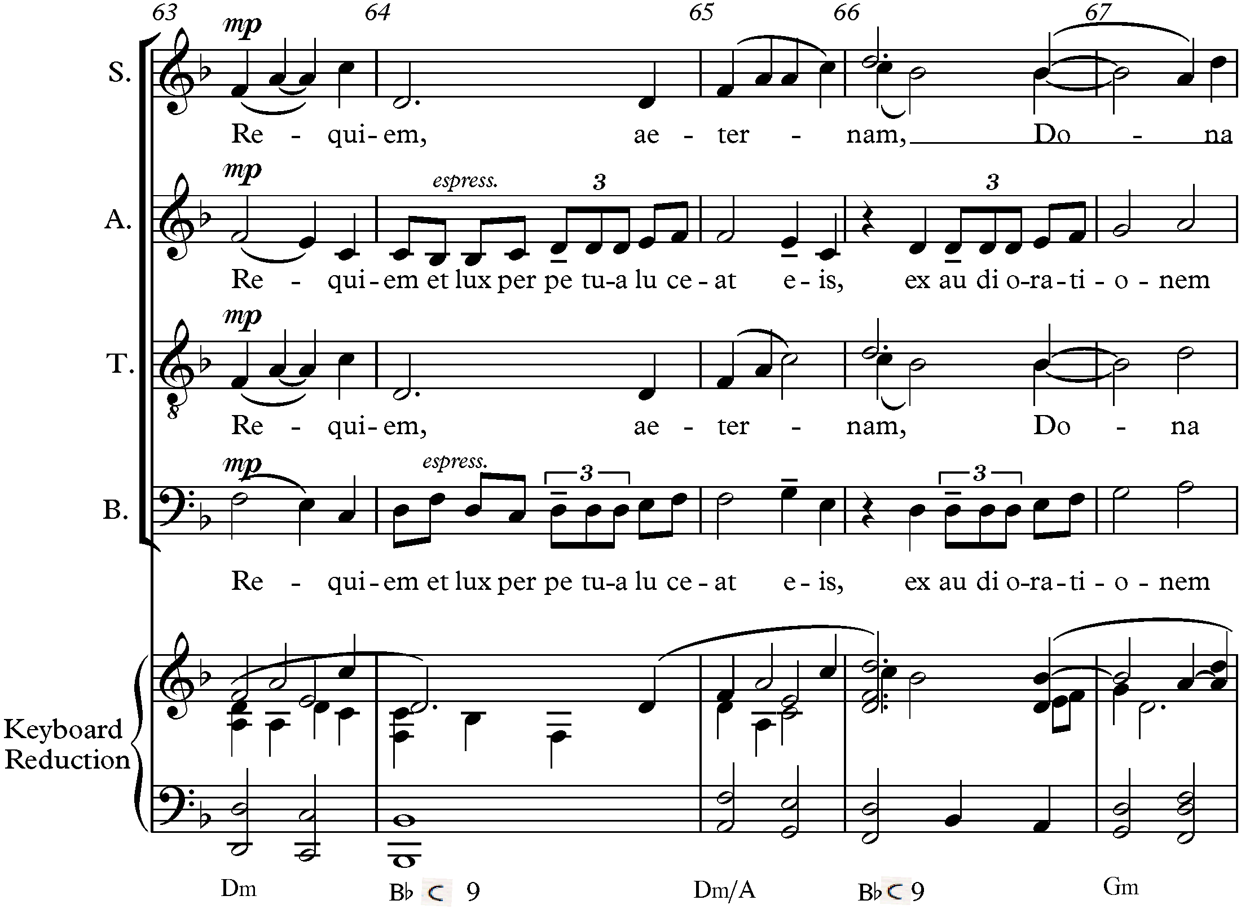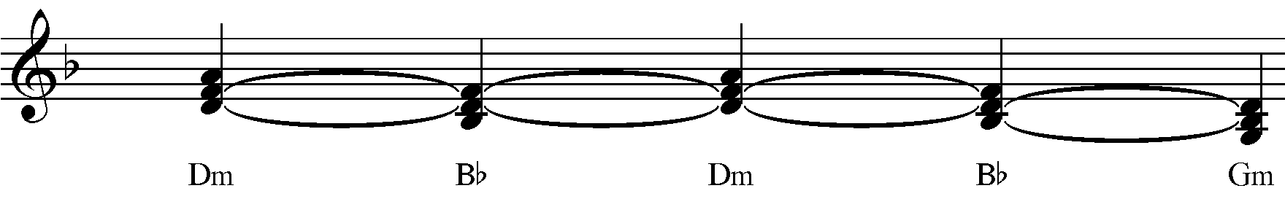
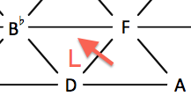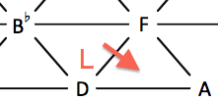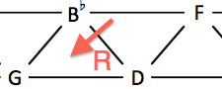
Figure 69: Mediant Chord Relationships, Block Chords, and NRT Diagram in Introit-Kyrie, mm. 63-67

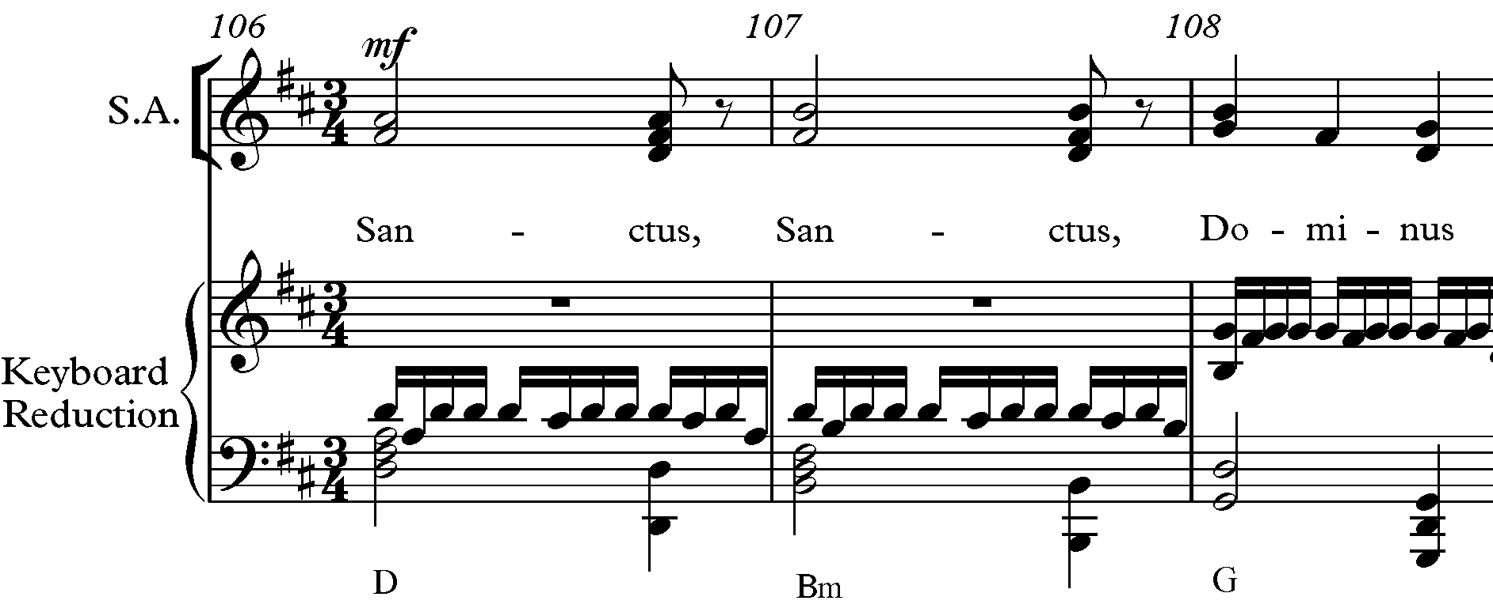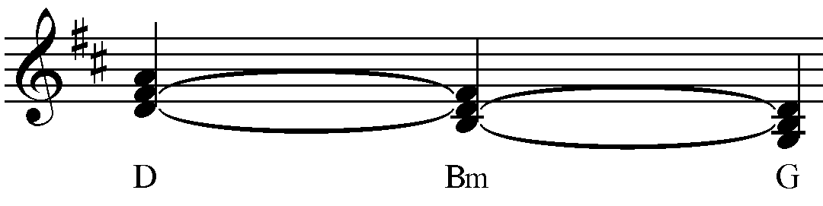
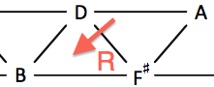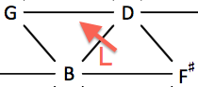
Figure 70: Mediant Chord Relationships, Block Chords, and NRT Diagram in Sanctus, mm. 106-108
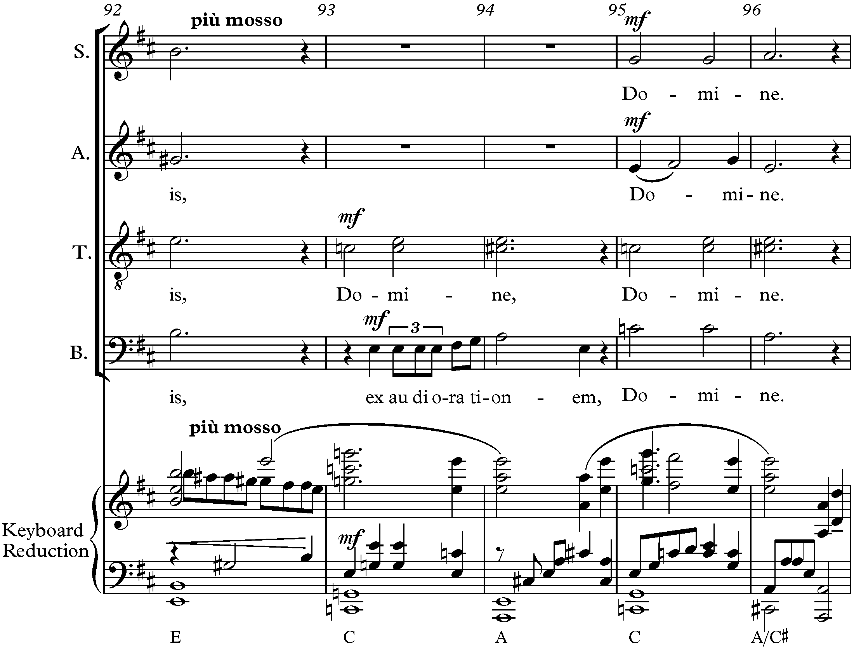
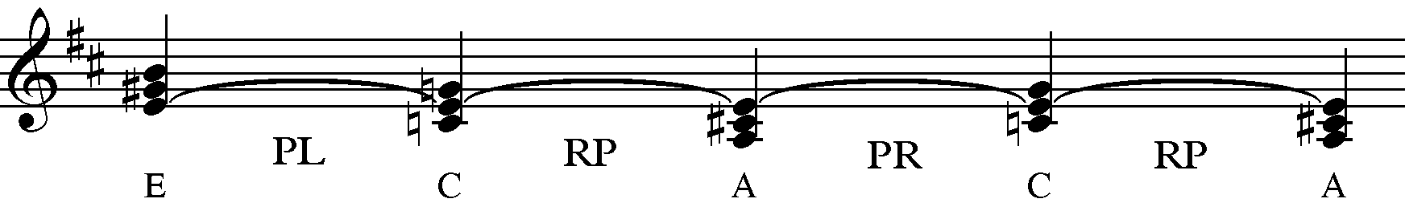
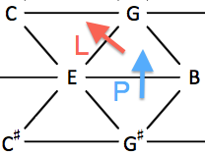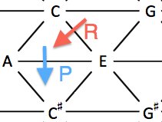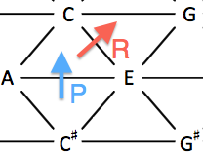
Figure 71: Mediant Chord Relationships, Block Chords, and NRT Diagram in Introit-Kyrie, mm. 92-96

A combination of R and L transformations and an RP compound transformation are found in the mediant chord relationships in the Agnus Dei in mm. 9-14 (see Figure 72). The roots of the chords are Ab, F, Db, and Bb, all thirds apart. The Ab – Fm is an R relationship, Fm – Db is an L relationship, and Db – Bb is a compound RP relationship.
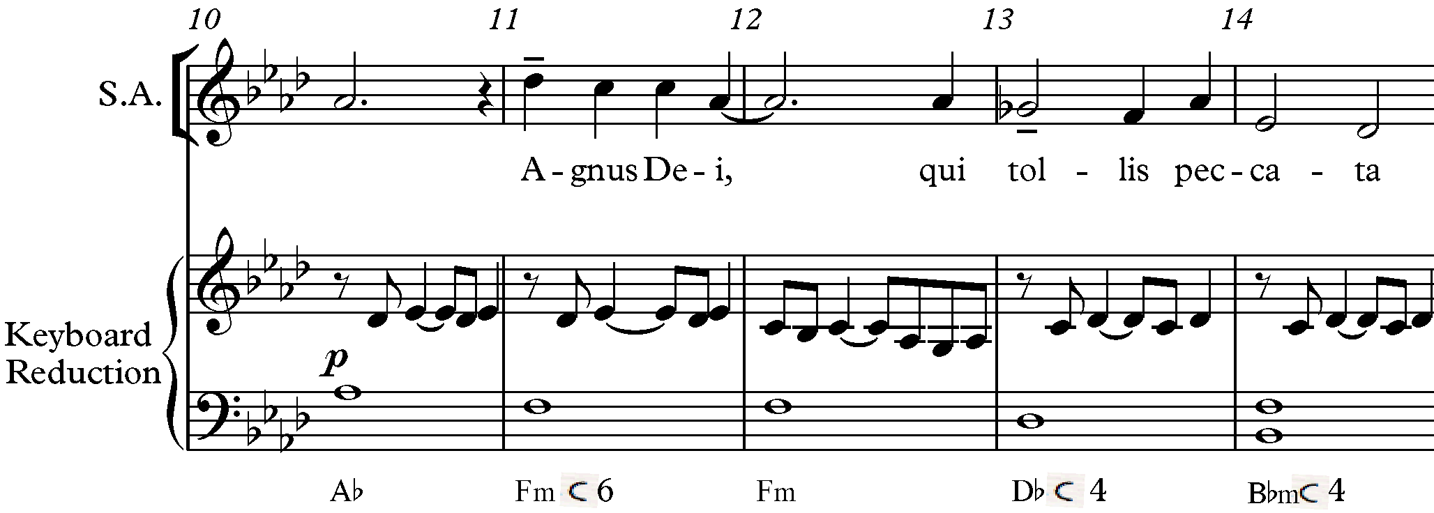
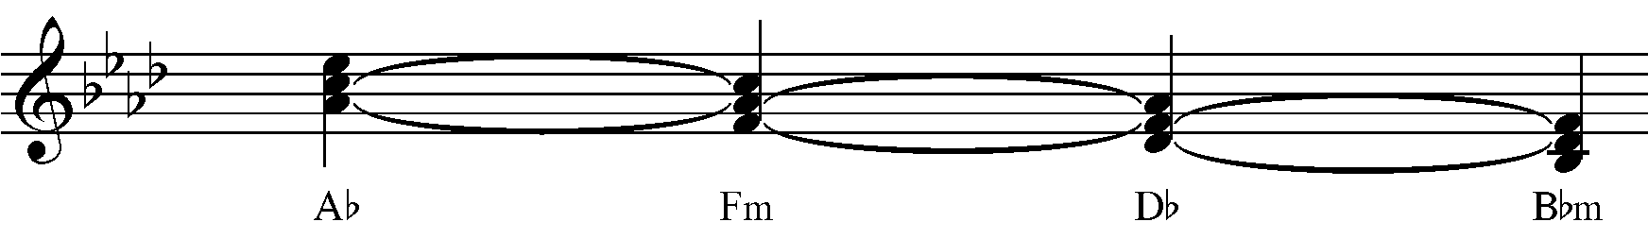
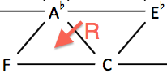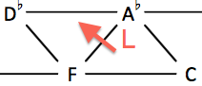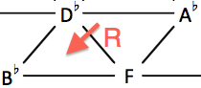
Figure 72: Mediant Chord Relationships, Block Chords, and NRT Diagram in Agnus Dei, mm. 9-14,

Forrest brings attention to the text in the Introit-Kyrie by including an Eb major chord in m. 46 at the first mention of “Domine” (God) (see Figure 73). An Eb major chord in the key of D minor suggests D Phrygian mode and changes the diatonic sound of the Introit-Kyrie. The chord transformations before and after Eb major chord are also mediant relationships sharing the common tone G. The C major to Eb major chord is a PR transformation and the Eb major to G minor chord is an L transformation and share another common tone, Bb.
Vanitas Vanitatum offers a helpful example of how Forrest uses a mediant relationship to resolve chords differently than expected. One common chord progression that is seen throughout the movement is exemplified in mm. 59-61 when all voices are singing the Pie Jesu and Forrest
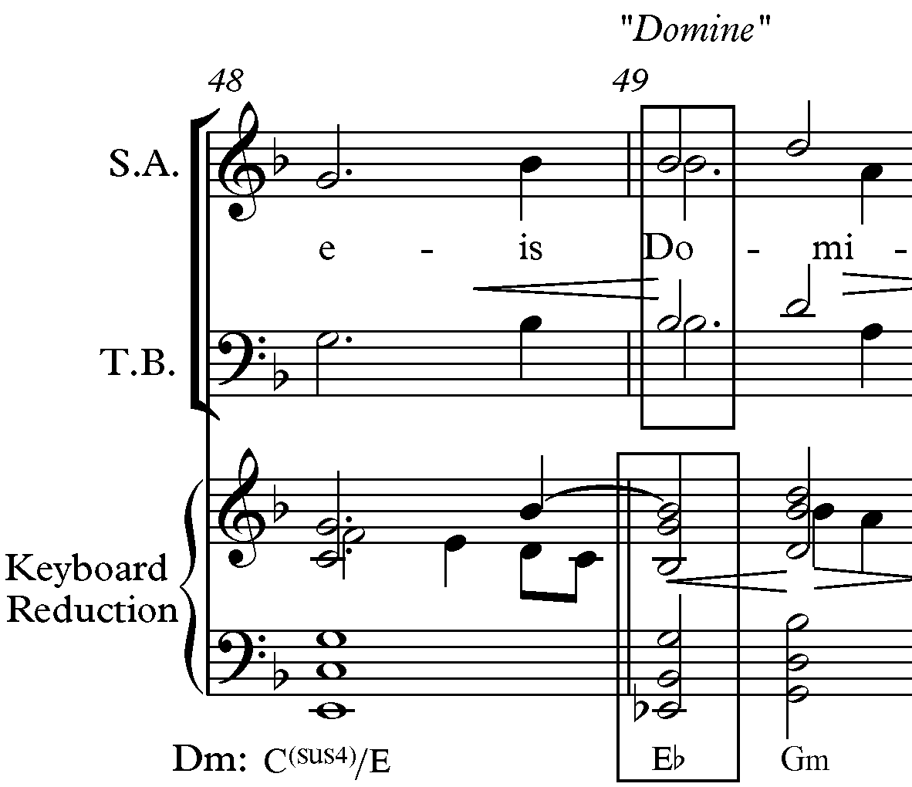
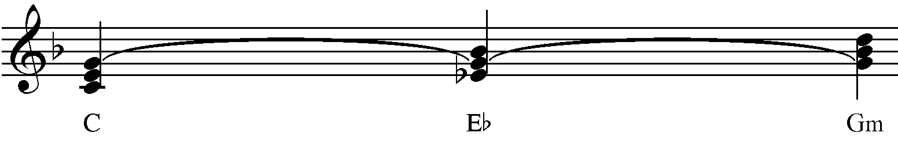
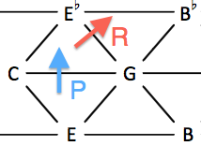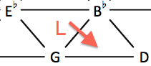
Figure 73: Mediant Relationship, Block Chords, and NRT Diagram in Introit-Kyrie, mm. 48-49

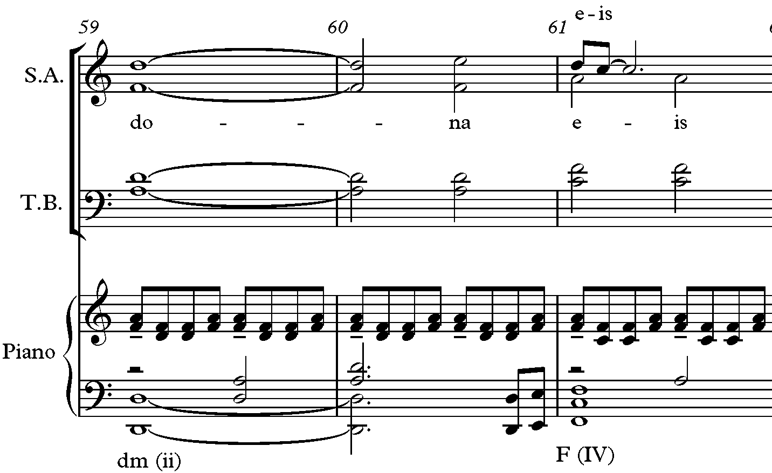
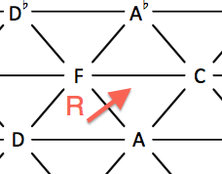
Figure 74: Non-Traditional Change from D minor to F major and NRT Diagram in Vanitas Vanitatum, mm. 59-61
uses a D minor chord and changes to F major, a relative transformation. Traditionally, the F major (IV) changes to the D minor chord (ii) (see Figure 74).
The number three is a commonality in Forrest’s extended tertian chords, suspensions emphasizing scale degree three, and numerous mediant relationships in his Requiem for the Living. The main three-note motive is included prolonged in the tonal structure within Forrest’s formal designs, as well as the numerous mediant relationships between chords.

CHAPTER 5: Conclusion

The purpose of this research was to show the pervasiveness of the number three in the formal, motivic, and harmonic structure of Forrest’s Requiem for the Living. Through comprehensive analysis and discussion, this thesis showed that the primary three-note motive in the Requiem serves as the basis for analytical departure. The framework for discussion extracted the importance of the number three in the primary motive and drew connections to other aspects of the work that utilized three as an organizing mechanism. The range of the motive, the three-part design of each movement, the numerous mediant relationships between chords, extended tertian harmonies, and the overall tonal structure all related to the number three.
The pervasiveness of Motive A and the number three related to the tenary design of each movement. Each movement had a three-part formal design and elements such as key, melody, harmony, rhythm, tempi, and text provided contrast between sections.
The Requiem was based on motives, most notably the motive descending a minor third. Motive A, a primary component of the composition, was found throughout the entire work in various forms. Schenkerian Analysis assisted in revealing how these forms of the motives took the shape of the original motive in three ways: by the interpolation of pitches (including infrapolation and ultrapolation), retrograde, and/or transposition. Three rhythmic motives were also present in Forrest’s Requiem and assisted in building the momentum within the movements.
The range of Motive A, the minor third, was a reflection of most of the tonal centers used in the overall tonal plan of the Requiem. The harmonic analysis and overall structure of pitch centers showed how Forrest avoids tonic-dominant relationships and instead used mostly mediant relationships between keys and chords. The mediant relationships between chords and key centers reflected the number three. Forrest’s music was tonal with contemporary elements such as extended tertian chords and 4-3 suspensions.
Forrest’s Requiem for the Living is gaining popularity, having been performed all over the world including performances in Canada, South America, Europe, Africa, Asia, and North America. Hinshaw Music reported that the Requiem had well over thirty-two full performances in 2014 alone and continues to be performed today. Forrest’s Requiem for the Living will be part of the choral repertoire for years come and his work deserves recognition. Forrest states the following in the Requiem program notes:
It’s a daunting task to set these ancient texts in a modern setting. I strove to write something appropriate to their gravity, and something that would make a lasting impression. I hope the end result does, indeed, profoundly affect the listeners- and performers as well.
After completing his Requiem for the Living on his 35th birthday, Forrest was concerned about writing a Requiem at his young age since most composers wait until later in life. Forrest jokes he “at least got further than Mozart” since Mozart never finished his Requiem.

LIST OF REFERENCES

ALCM. ALCM Raabe Prize for Excellence in Sacred Composition. http://www.alcm.org/news-events/raabe-
prize/prize-winners/ (accessed September 29, 2014).

Bishops, US Conference of Catholic. US Conference of Catholic Bishops. http://www.usccb.org/ (accessed
February 20, 2015).

Capuzzo, Guy. "Neo-Riemannian Theory and the Analysis of Pop-Rock Music." Music Theory Spectrum, 2004:
177-200.

Childs, Adrian P. "Moving Beyond Neo-Riemannian Triads: Exploring a Transformational Model for Seventh
Chords." Journal of Music Theory, 1998: 181-193.

Cohn, Richard. "Introduction to Neo-Riemannian Theory: A Survey and a Historical Perspective." Journal of
Music Theory, 1998: 167-180.

Coleman, Don, interview by Lindsey Cope. Email Interview, March 7, 2014.

Company, The Catholic Web. Order of the Funeral Mass. http://www.olmctempe.com/funeral-order-mass.php
(accessed January 9, 2015).

Dewey, Kevin G. Vanguard Voices. http://www.vanguardvoices.org/composers2004-6.html (accessed August
25, 2014).

Forrest, Dan. Facebook. https://www.facebook.com/DanForrestMusic (accessed September 8, 2014).

Forrest, Dan. Forrest Works: The Music of Dan Forrest. http://www.danforrest.com/ (accessed March 9, 2014).

Forrest, Dan, interview by Lindsey Cope. Personal interview. Jefferson, TN, November 15, 2014.

Forrest, Dan. Requiem for the Living. Chapel Hill, NC: Hinshaw Music Company, 2013.

Gollin, Edward, and Alexander Rehding. The Oxford Handbook of Neo-Riemannian Music Theories. New
York: Oxford University Press, 2011.

Gritten, Anthony, and Elaine King. Music and Gesture. Burlington: Ashgate Publishing Company, 2006.

Henry, Hugh (1911). The Catholic Encyclopedia. http://www.newadvent.org/cathen/10001a.htm (accessed
November 6, 2014).

Hyer, Brian. "Reimag(in)ing Riemann." Journal of Music Theory, 1995: 101-138.

Lambert, John W. CVNC: An Online Arts Journal in North Carolina. http://cvnc.org/article.cfm?articleId=6118
(accessed November 6, 2014).

LaRue, Jan. Guidelines For Style Analysis. Expanded 2nd Edition. Edited by Marian Green LaRue. Sterling
Heights, MI: Harmonie Park Press, 2011.

Mason, Laura. Trace: Tennessee Research and Creative Exchange.
http://trace.tennessee.edu/utk_gradthes/1646 (accessed August 29, 2014).

McKee, Wendy. J.W. Pepper Blog. http://blogs.jwpepper.com/?p=2495 (accessed November 6, 2014).

Moroney, James Patrick. General Instruction of the Roman Missal. Washington, 2003.

Rehding, Alexander. Hugo Riemann and Birth of Modern Musical Thought.
http://catdir.loc.gov/catdir/samples/cam033/2002031364.pdf (accessed October 9, 2014).

Riemann, Hugo. "Ideas for a Study "On the Imagination of Tone"." Journal of Music Theory, 1992: 81-117.

Safra, Jacob E. Britannica Academic Edition. http://www.britannica.com/EBchecked/topic/498939/requiem-
mass (accessed August 29, 2014).

Siciliano, Michael. "Two Neo-Riemannian Analyses." College Music Symposium, 2005: 81-107.

Slonimsky, Nicolas. Baker's Borgraphical Dictionary of Musicians. 8th. New York: Schirmer Books, 1992.

Slominsky, Nicolas. Thesaurus of Scales and Melodic Patterns. New York: Schirmer Books, 1947.

Solesmes, Ed. The Benedictines of. The Liber Usualis. New York, NY: Desclee Company, 1963.

Tellez, Jose. American Choral Directors Association. http://acda.org/page.asp?page=brockstudent (accessed
September 29, 2014).

VITA

Lindsey Cope is from Andrews, North Carolina. She attended Mars Hill College in North Carolina where she earned her Bachelor of Music Education with a Choral Emphasis, graduating Magna Cum Laude. She taught general music grades K-4 and middle school chorus grades 5-6 for ten years in Clay County, North Carolina. She earned her National Board Teaching Certification in 2010 and was selected Teacher of the Year at Hayesville Middle School in 2011. She entered graduate school at the University of Tennessee, Knoxville in 2012 to begin working on her Master of Music in Theory. While attending the University of Tennessee, Knoxville, Miss Cope taught ear-training and music theory courses as part of a Graduate Teaching Assistantship, and added a second Master of Music in Choral Conducting. She starts her Doctorate in Choral Conducting in the fall of 2015 at the University of South Carolina, Columbia, awarded a Graduate Teaching Assistantship in music theory.

Forrest, D. (2014, January 3). Forrest Works: The Music of Dan Forrest. Retrieved January 16, 2015, from http://www.danforrest.com/
Interview with Dan Forrest on November 15, 2014.
Forrest, D. (2014, January 3). Forrest Works: The Music of Dan Forrest. Retrieved January 16, 2015, from http://www.danforrest.com/
Mckee, (2011, May 23). J.W. Pepper Blog. Retrieved June 11, 2014, from http://blogs.jwpepper.com/?p=2495
Ibid.
Interview with Dan Forrest on November 15, 2014.
Ibid.
Forrest, D. (2014, January 3). Forrest Works: The Music of Dan Forrest. Retrieved September 3, 2014, from http://www.danforrest.com/
Dewey, (2014, January 3). Vangard Voices. Retrieved August 25, 2014, from http://www.vanguardvoices.org/composers2004-6.html
ACLM, 2012. ALCM Raabe Prize for Excellence in Sacred Composition. Retrieved Septemer 29, 2014, from http://www.alcm.org/news-events/raabe-prize/prize-winners/.
Forrest, D. (2014, January 3). Forrest Works: The Music of Dan Forrest. Retrieved September 3, 2014, from http://www.danforrest.com/
Ibid.
Mckee, (2011, May 23). J.W. Pepper Blog. Retrieved June 11, 2014, from http://blogs.jwpepper.com/?p=2495
Ibid.
Forrest, D. (2014, January 3). Forrest Works: The Music of Dan Forrest. Retrieved September 3, 2014, from http://www.danforrest.com/
Interview with Don Coleman 2014.
Ibid.
Full Orchestra includes: 1, 2 Flute, 1, 2 Oboe, 1, 2 Bb Clarinet, 1, 2 Bassoon, 1, 2 (or 4) F Horn, 1, 2 Bb Trumpet, 1, 2 Trombone, Bass Trombone, Tuba, Percussion (1), Timpani (3) one player, Harp, Strings, Soprano, Alto, Tenor, Bass, Boy Solo, Soprano Solo
Chamber Orchestra includes: Flute, Oboe, F Horn (optional), Combined Percussion (one player), Harp, Violin, Cello, Organ
Interview with Don Coleman 2014.
Ibid.
Lambert, CVNC: An Online Arts Journal in North Carolina, 2013.
Forrest Works: The Music of Dan Forrest. January 3, 2014. Retrieved September 3, 2014 from http://www.danforrest.com.
US Conference of Catholic Bishops, 2015. Retrieved February 20, 2015 from http://www.usccb.org/
Ibid.
Free Dictionary, 2015. Retrieved March 30, 2015 from http://www.thefreedictionary.com.
Ibid.
Free Dictionary, 2015. Retrieved March 30, 2015 from http://www.thefreedictionary.com.
Order of the Funeral Mass, 2015. Retrieved January 9, 2015 from http://www.olmctempe.com/funeral-order- mass.php
The Christian faith believes all people will face God for divine judgment when they die: Dies Irae (Day of Wrath), Libera Me (Deliver Me), Pie Jesu (Pious Jesus), In Paradisum (into Paradise)
Order of the Funeral Mass, 2015. Retrieved January 9, 2015 from http://www.olmctempe.com/funeral-order- mass.php
D. Forrest Program Notes, 2013.
Ibid.
Ibid.
Ibid.
Ibid.
Ibid.
D. Forrest Program Notes, 2013.
Interview with Dan Forrest on November 15, 2014.
Specific analysis of Motivic content and variations will be discussed in detail in Chapter 3.
Motive A in the A-section is found in mm. 3, 6, 12, 15, 20, 22, 23, 24, 30, 36, 38, 41, 43, 45, 49, 51, 63, 65.
Motive A in the C-section is found in mm. 104, 106, 112, 115, 131, 133, 135, 137, 139, 150.
RM1 in the B section is found in mm. 75, 76, 79, 80, 83, 87, 93.
Gritten, Anthony and Elaine King. Music and Gesture 2006.
The sigh motive is found in the B-section in mm. 81, 85, 86, 89, 90, 91, 92.
The sigh motive is found in the C-section in mm. 114, 125, 127, 136, 138.
D. Forrest Program Notes.
Ibid.
Interview with Dan Forrest on November 15, 2014.
D. Forrest Score, 2013.
D. Forrest Program Notes.
Interview with Dan Forrest on November 15, 2014.
D. Forrest Program Notes.
Ibid.
Harp is the only instrument not present until it enters in the last two measures (170-171).
D. Forrest Program Notes.
Rhythm is not analyzed in the Schenkerian Analysis diagrams
The change in key/tonality will be discussed further in Chapter 4.
Slominsky, Nicolas. Thesaurus of Scales and Melodic Patterns. 1947.
D. Forrest Program Notes.
S.D.G is the Latin abbreviation “Soli Deo Gloria,” translated “Glory to God Alone.” Some composers, such as Bach and Handel, placed this abbreviation on their scores to signify that the work was produced for the sake of praising God.
Ibid.
Cohn, “Introduction to Neo-Riemannian Theory: A Survey and a Historical Perspective.” Journal of Music Theory, 42, no. 2, Neo-Riemannian Theory (Fall, 1998), p 169.
Slonimsky, Baker’s Biographical Dictionary of Musicians, 1992, p.1512.
Gollin and Rehding 2011, Oxford Handbook preface.
Cohn, “Introduction to Neo-Riemannian Theory: A Survey and a Historical Perspective.” Journal of Music Theory, 42, no. 2, Neo-Riemannian Theory (Fall, 1998), p. 169.
Ibid, p. 170.
Gollin and Rehding 2011, Oxford Handbook preface.
Ibid.
Cohn, “Introduction to Neo-Riemannian Theory: A Survey and a Historical Perspective.” Journal of Music Theory, 42, no. 2, Neo-Riemannian Theory (Fall, 1998), pp.171-72.
Ibid, p.171.
Cohn, “Introduction to Neo-Riemannian Theory: A Survey and a Historical Perspective.” Journal of Music Theory, 42, no. 2, Neo-Riemannian Theory (Fall, 1998), 172.
Cohn, “Introduction to Neo-Riemannian Theory: A Survey and a Historical Perspective.” Journal of Music Theory, 42, no. 2, Neo-Riemannian Theory (Fall, 1998), 172.
Capuzzo, 2004, p.191
Ibid.
Capuzzo, 2004, p.181
Voice leading parsimony is indicated with ties in the block chord figures below.

