Early Warning Solar Storm Prediction
Project Design Report

Marvin Joshi (EE), Matthew Smalley (EE), Aiden Rutter (CS), Ben Klein (CS), Ian Lumsden (CS)





COSC/ECE 402
Dr. Icove
24 April 2020

Executive Summary
This project seeks to provide better predictions about the timing and intensity of potentially disastrous solar flares and solar events. Advancements in computational power and machine learning techniques offer new and powerful means to accomplish this. Building on the work of past research, this senior design team seeks to implement a novel magnetic loop antenna designed specifically for collection of scientific data regarding our sun. We anticipate $512.68 in costs associated with deploying this radio solar telescope. Secondly, we intend to implement an advanced machine learning algorithm that employs historic and experimental data to provide improved predictions on the timing and intensity of these solar maxima. In our concept design, we found two main designs for the antenna, either a dipole antenna or a magnetic loop antenna. From our research, we were able to find the magnetic loop antenna was the best choice. For the algorithms, we decided to consider Gradient Boosting (GBT) and deep learning. However, due to their similarity in the factors considered, we decided that the best algorithmic solution would be to combine both algorithms as an ensemble.

Table of Contents
Problem Definition & Background 1
Requirement Specification 1
Technical Approach 2
Design Concepts, Evaluation & Selection 3
Embodiment Design 4
Test Plan 10
Deliverables 11
Project Management 11
Budget 12
Gantt Chart 14
Test Plan Matrix 19
References 19
Client Sign-off 20
Figures & Tables
Table I. Prioritized Requirements 1
Table II. Engineering Characteristics 2
Figure 1. Block Diagram of Solar Storm Prediction System 3
Table III. Weighted Decision Matrix 4
Figure 2. Magnetic Loop Radiation Pattern 6
Figure 3. Efficiency vs. Frequency Plot 6
Figure 4. 7
Figure 5. 8
Table IV. Project Milestones 9
Table V. Planned Expenditures 10
Table VI. Radio JOVE Antenna Kit Contents 11

Problem Definition & Background
Every 11 years, the sun goes through what is known as a solar cycle. Each cycle represents a maxima in solar activity that marks an increase of solar flares and hotspots [1]. These solar events have the potential to jeopardize operations of our military, satellites, electrical utilities. Predicting the timing and intensity of these solar maxima could help us prepare for these potentially catastrophic events. Developing a model which can accurately make these predictions has largely eluded scientists. However, advancements in computing, a large availability of experimental and historical data, and improving machine learning techniques may hold the key to predicting these solar events.
There are currently magnetic loop antennas that are available out in the market, but some, if not most, do not have a large enough bandwidth in order to read accurate data. A university in Columbia was able to read accurate data from Jupiter, but they also ran into problems with having a limited bandwidth [2]. By combining the design made by the Columbian university with magnetic loop antennas that have a large bandwidth, we can make it possible to create a model that will be able to read much more accurate data from the sun.
Requirement Specification
Table I. Prioritized Requirements
Priority | Requirement
1 | Develop algorithm for solar storm prediction using Graph Theory
2 | Design and prototype a Magnetic Loop Antenna which is solar-sensitive
3 | Prototype and integrate prediction system using software defined radio (SDR)
The primary requirement is to develop an algorithm capable of predicting solar storms accurately. This will be performed through application of advanced graph theory algorithms which have already been developed by UT. In order to quantify the sun’s emissions for the algorithms, a Magnetic Loop antenna will be required. This antenna should be designed such that it achieves high sensitivity to solar emissions and a wide bandwidth. A magnetic loop antenna configuration has previously been demonstrated for detection of Jovian radio waves [2], which will serve as a basis in developing a solar-sensitive antenna. Finally, the algorithm and the Magnetic Loop antenna will be integrated using software defined radio (SDR) to achieve a complete solar storm prediction system.

Table II. Engineering Characteristics
Priority | EC
1 | Algorithm for solar storm prediction
2 | Magnetic Loop antenna with wide bandwidth (~20 MHz) and high accuracy
3 | Integration with software defined radio
These engineering characteristics (ECs) are currently loose objectives without set specifications. The goals are set, but potential constraints for all parameters are not fully known at this time.
Technical Approach
As a first step, a Radio JOVE Kit from the NASA sponsored Radio JOVE project will be acquired and assembled. This kit includes a receiver and two dipole antennas, amongst other necessary parts, and is intended for observation of radio emissions from sources such as the sun and Jupiter. The kit will be initially tested using a single dipole antenna, in order to become familiar with solar observation and data collection using the kit and the associated Radio-SkyPipe and Radio Jupiter Pro software. This process is well documented as part of the Radio JOVE project and will serve as the initial starting point. A suitable location for setting up the kit and dipole antenna for testing will have to be determined in order to get good results. An open area that is not surrounded by power lines or other electrical devices is ideal. An extensive literature review will also be performed early on, in order to achieve an understanding of the state-of-the-art research which has already been performed in related topics. This will provide a good baseline of understanding which can later be built and innovated upon for the purposes of this project.
To begin the development of the Solar Storm Prediction algorithm, historic data collected by Radio JOVE participants will be used. Looking through this data will also allow for understanding of solar events in the past and how they are shown in the data that was collected. Later, self-gathered, real-time data will also be incorporated to further expand the algorithm. A Magnetic Loop Antenna will also be designed and developed for use with the JOVE kit, as a replacement to the initial dipole antenna. The magnetic loop configuration allows for a much reduced size compared to the dipole, as well as reduced sensitivity to electrical noise, which would correspond to an increased accuracy and ease of use added to the overall system. A block diagram of the proposed system is shown in Figure 1.
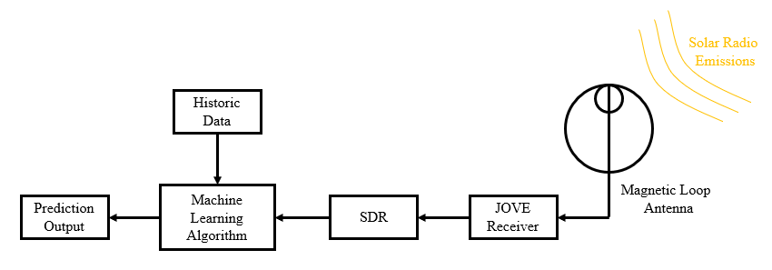
Figure 1. Block Diagram of Solar Storm Prediction System
The primary design considerations for this project include determining what type of algorithm to employ for the Solar Storm prediction model, and how best to receive the information that the sun emits (i.e. dipole antenna or magnetic loop).
Design Concepts, Evaluation & Selection
When looking at designing the antenna, we have two main designs that we can choose, either a dipole antenna or a magnetic loop antenna. We are given a dipole antenna in the JOVE kit, so we plan to do the base testing from there. But the dipole antennas have some problems. Notably, they are large in size, and they can only be used in open areas due to noise interference. From this, we were able to see that a magnetic loop antenna will be a better choice in the long run because a magnetic loop antenna is much smaller in size than the dipole antenna. Additionally, it is less affected by electrical noise. This means that during testing, we will not have to be in an open area, which allows us to test locally. A magnetic loop antenna also has a higher accuracy than the dipole antenna, as well as it allows us to reach our bandwidth target of 20 MHz.
For developing a model to predict the timing and intensity of solar storms, we intend to incorporate the data from our antenna with publicly available historical datasets. Two algorithms we have considered for making these predictions are gradient boosting (GBT) and deep reinforcement learning. Both choices have shown promise in previous work but have unique requirements. Gradient boosting is an ensemble algorithm that takes weak learning models (like Random Forest) and applies some “boosting” operation to improve the performance of sequentially generated models. Compared to the weak learning model, GBT can produce more accurate results, but training takes longer. Additionally, GBT is more prone to overfitting when trained with noisy data. We are also considering applying deep learning, which applies many layers of artificial neural networks to a problem. This represents a more computationally complex model that captures abstract features via intermediate hidden layers. However, deep learning requires more computational power, and larger datasets to be effective. A third option is combining the strengths of GBT and deep learning through an ensemble. This would be more computationally complex, but ultimately would achieve the best results.

Table III. Weighted Decision Matrix
Weighted Decision Matrix
Criteria | Weighting | Dipole Antenna & GBT |  | Magnetic Loop & GBT |  | Dipole Antenna & Deep Learning |  | Magnetic Loop & Deep Learning
 |  | Score | Total | Score | Total | Score | Total | Score | Total
Antenna accuracy | 4 | 3 | 12 | 4 | 16 | 3 | 12 | 4 | 16
Antenna cost | 2 | 4 | 8 | 4 | 8 | 4 | 8 | 4 | 8
Antenna ease-of-use | 3 | 2 | 6 | 5 | 15 | 2 | 6 | 5 | 15
Algorithm accuracy | 4 | 3 | 12 | 3 | 12 | 4 | 16 | 4 | 16
Algorithm training time | 1 | 4 | 4 | 4 | 4 | 3 | 3 | 3 | 3
Algorithm hardware requirements | 2 | 4 | 8 | 4 | 8 | 2 | 4 | 2 | 4
 | Total: |  | 50 |  | 63 |  | 49 |  | 62
Embodiment Design
For the antenna side of our project, we originally were going to go with a dipole antenna that was given to us in the JOVE Kit. The antenna is built into a short-wave receiver that is made to pick-up radio signals from the Sun. The receiver is broken into 5 modules: the Antenna, RF BandPass Filter and Preamplifier, Local Oscillator, Low Pass Filter (LPF), and an audio amplifier. Looking at the dipole antenna, it is designed to intercept some of the weak electromagnetic waves from the Sun, and when they hit the antenna, the signal is delivered to the receiver by a coaxial transmission line. The RF Bandpass Filter is designed to filter out and reject strong interference signals. Once the signals are rejected, they are then amplified using a junction field effect transistor (JFET). At this point, we have the desired signals, that are of radio frequency. The next step is for us to down convert these radio signals to the range of audio frequencies. To do this, the receiver uses a local oscillator and mixer. The local oscillator will generate a sinusoidal wave that is around the frequency of 20.1 MHZ, but can be adjusted using the knobs that are on the front panel of the receiver, The mixer will then take in the amplifier RF signal from before and the local oscillator signal, and will develop and output a new signal, which has a frequency that is the arithmetic difference between the Local Oscillator and the RF amplified signal. For example, if the RF signal has a frequency of 20.2 MHz and the Local Oscillator has a frequency of 20.1 MHz, the output signal of the mixer will have a signal frequency of 20.2-20.1 = 0.1 MHz. The method of converting a RF signal to an audio signal is known as a direct conversion receiver. The next step is passing the signal through a Low Pass Filter, which will pass audio frequencies around 3.5 kHz and will attenuate the higher frequency signals. The purpose of the Low Pass Filter is to eliminate any interfering frequencies from stations nearby. A Low Pass Filter will allow signals that are within a range of a few kilohertz from the center frequency. The other higher frequencies, that are much higher than the center frequency, may contain interfering signals, so those are then eliminated. The last step is for us to amplify the audio signals that are outputted from the Low Pass Filter. The circuit is designed to amplify signals enough that they are able to drive either a set of headphones, or an external amplified speaker.
Another antenna that we are designing is the magnetic loop antenna. The purpose for designing a magnetic loop antenna is to reduce the amount of noise that will be picked up, as well as make the antenna a much more portable item. With the magnetic loop antenna, we were able to simulate the basic design using software such as CST. While CST is a 3D simulation of an antenna, we first began the design by using a 2D simulator called 4Nec2, which has been used in many research papers that involved designing a magnetic loop antenna. We originally had a design for a magnetic loop antenna that had a radius of about 5.1 ft. While this was a good start, we decided to find a way to make the radius smaller, which will also help with the portability factor of the magnetic loop antenna. We were then able to decrease the radius of the magnetic loop to 4.75 ft. From here we were able to see that the magnetic loop has an efficiency of 36%, which was a good starting point, and that we were able to tune the magnetic loop from a range of 10 MHz -30.1 MHz.
After the base simulation had been done using CST, we then realized that the material we were using was with the preset ideal metal. That means we were doing base simulation using a material that had no loss, which meant that we had to redo our 2D analysis, and then go to 3D analysis from there. Looking at the 2D analysis, we tried to change the radius of the magnetic, to see if we could get better results. From there, we saw that a magnetic loop antenna with a diameter of 2.75 feet was allowed for having a radiation pattern that represented that of a magnetic loop antenna. The radiation pattern can be seen below. The same program, 4Nec2, was used, and looking at the radiation pattern, we see that the radiation pattern main beam was not centered and is off by 5 degrees. It was possible to steer this main beams angle, but since it would not make that big of a difference in our results, we left that problem alone. We also were able to see that the maximum gain that we could get from the magnetic loop antenna was only 0.71 dBi. Typically, the gain for a small magnetic loop antenna is 1.5 dBi. But after discussing our results with our customer Bobbie Williams, he said that this is a good value to start with initial testing. The second figure shown represents the Efficiency vs. Frequency of the magnetic loop. When you look at this graph, this shows that at the frequency that we want, 20.1 MHz, we are theoretically able to have an efficiency of -3.46 dB, or 46%. Once again, we discussed this result with our customer, Bobbie Williams, and he said that this is good value to start from, and while there is room for improvement, the simulated magnetic loop should be enough to use in our project. Also, since the magnetic loop will include extra length in the diameter, we will be able to tune the magnetic loop if we needed to adjust the antenna as needed.
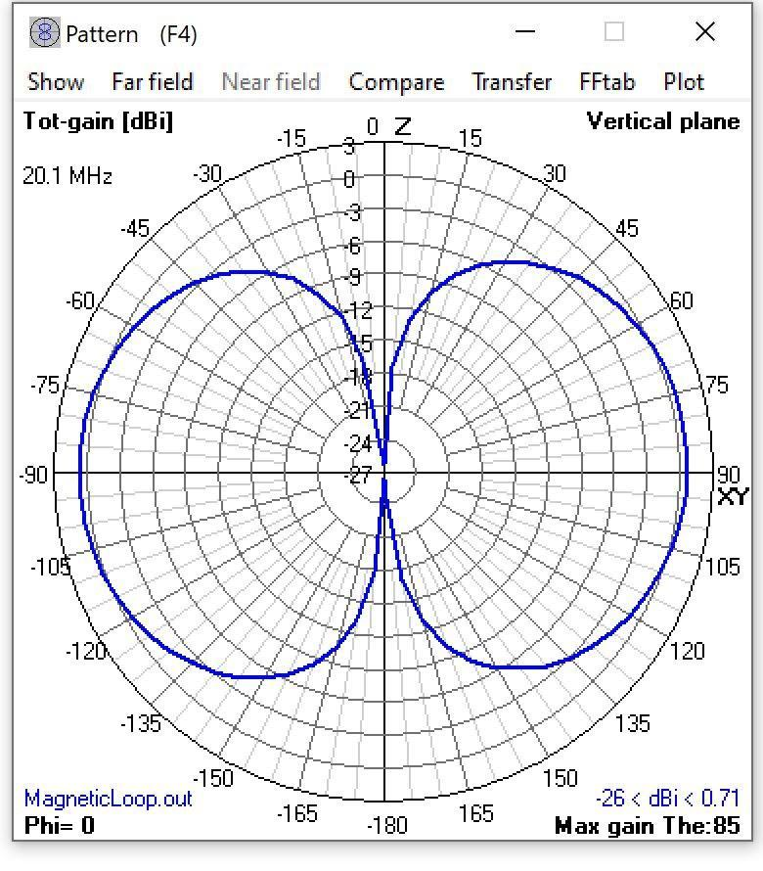
Figure 2. Magnetic Loop Radiation Pattern

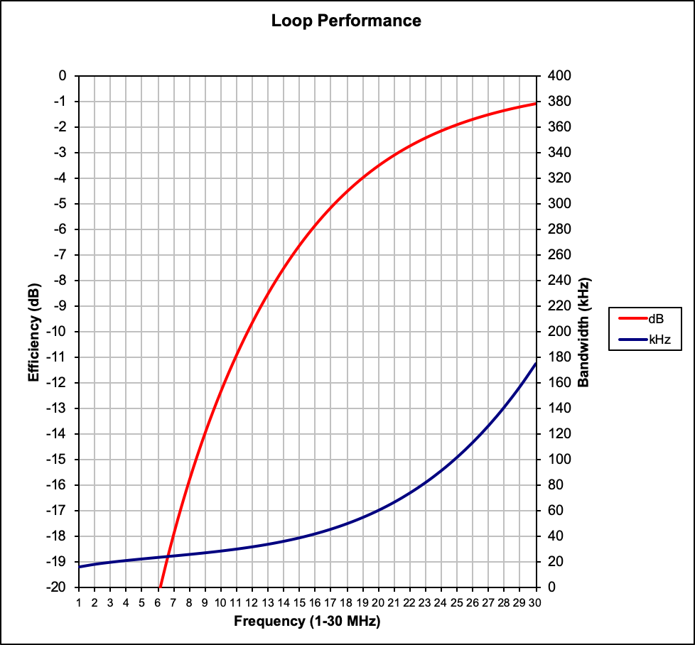
Figure 3. Efficiency vs. Frequency Plot
In terms of developing a predictive machine learning model, several historical data sources have been identified for use by the model. NOAA has a large amount of publicly available information about solar activity, including radio flux and information about sunspots. We will informally refer to this data as ‘NOAA indices.’ Additionally, NOAA’s GOES dataset provides information about Coronal Mass Ejections (CMEs) and solar flares that will be used to train the model. The Solar Dynamics Observatory (SDO) publishes radio telescope images multiple times an hour. We have developed methods to programmatically retrieve this data and store this data as a pandas dataframe and as a plottable time series. Using the tool Jupyter notebook, we have developed scripts that help us visualize and manipulate these data sources. Furthermore, we have successfully retrieved publicly available solar flux recordings from the Radio Jove project and converted it to an easily retrievable file format. We have secured an IBM power-9 compute cluster and installed a list of dependencies deemed necessary. A naive keras model has been implemented to test performance on our historical data using recurrent neural networks specifically, Long Short-Term Memory (LSTMs).
To develop a predictive model, we assessed various solutions to perform analysis on our data. Because of availability of computing resources and access to a large amount of historic data, we decided to prioritize a deep learning model to perform analysis. Deep learning is a field which employs multi-layered perceptrons (MLP) to approximate functions. In supervised learning, the output of this network is compared to the result, and the loss is calculated through a global loss function at the end of the forward propagation. To train these networks, the gradient of the network is calculated through a process known as ‘backpropagation’. Backpropagation leverages the chain rule applied to partial derivatives to iteratively solve for the gradient. Once this gradient is determined, we can iteratively perform gradient descent on our loss function. A recurrent unit expands on this foundation and adds memory to the network by passing itself inputs from previous timesteps as input. Long Short-Term Memory (LSTMs), a relatively new type of recurrent unit, have proven powerful sequence processors. A traditional recurrent unit has a practically short-term memory due to vanishing gradients while unrolling timesteps during backpropagation, but an LSTM has a greater memory through the addition of a cell state, forget, and input gate. Because our data is time sequenced, a recurrent network architecture was considered. A Keras model has been implemented to test performance on our historical data using recurrent neural networks specifically, Long Short-Term Memory (LSTMs). This model used the NOAA indices to perform categorical prediction of solar radiation storm classifications (Figure 7). Because the NOAA indices were from a month-to-month basis, the model could not forecast effectively or with the level of granularity desired. See Figure 6.
Instead, we plan on creating a model that leverages the data from the SDO. The next architecture will use convolutional neural networks (CNNs), which are widespread used in image processing tasks. Because we are looking for relationships across both the spatial space of the image as well as across timesteps, a three-dimensional convolutional neural network is being considered alongside a 2-dimensional convolutional neural network. A convolutional neural network works by employing numerous kernels, informally referred to as feature detectors, which share weights among themselves versus a fully connected model which maps inputs and weights 1:1. Each one of these inputs are mapped across the input space using a sliding door technique. This results in less parameters and more localized relationships between perceptrons. ‘Pooling layers’, reduce the dimensionality of the input further by selecting one element of a given window.
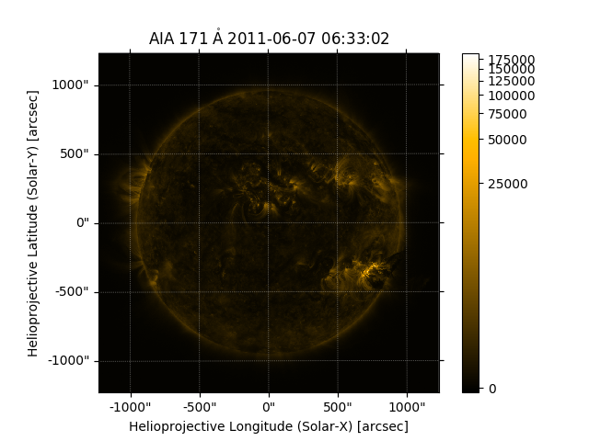
Figure 4.
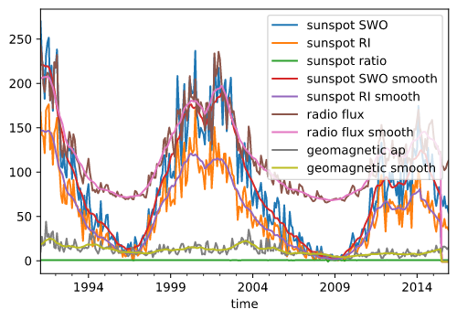
Figure 5.
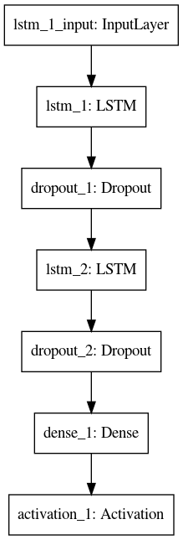
Figure 6. Recurrent model for NOAA indices
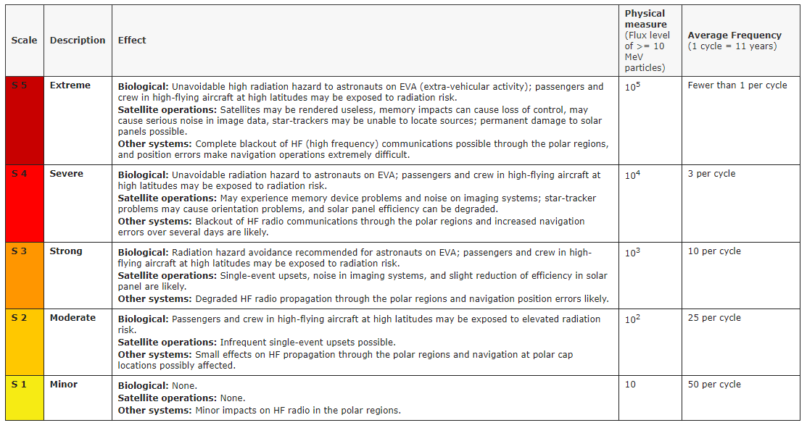
Figure 7. NOAA Solar Radiation Space Weather Scale (https://www.swpc.noaa.gov/noaa-scales-explanation)
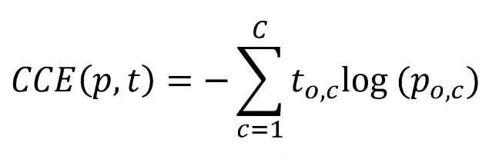
Test Plan
For the electrical side, the focus in testing will be setting up the JOVE Kit receiver using both of the antennas mentioned previously in this report and collecting data from the sun. The dipole antenna is intended for observation of solar radio emissions in the JOVE Kit and is known to be a valid method to receive these solar emissions. As such, the dipole will serve as a baseline comparison. The magnetic loop antenna which is being designed is intended to function the same as the dipole antenna, but with a reduced sensitivity to noise and a smaller size. The magnetic loop antenna will be used with the JOVE receiver and the performance will be compared to the standard dipole antenna used with the kit. Since the same frequency of 20.1 MHz and the same function is required, testing will primarily focus on functional operation of both antennas (i.e. being able to observe solar radio emissions), gain comparison, and noise sensitivity comparisons. The built magnetic loop antenna will also be compared to the simulations performed in design, in order to ensure it is functioning as intended. A consumer, portable and tunable magnetic loop antenna may also be used initially in testing with the receiver to observe solar emissions. The performance of this magnetic loop would also be compared to the designed magnetic loop as well as the dipole antenna.
Algorithms: Loss function; validation-training split; true positive false positive etc.
Deliverables
- A new Magnetic Loop Antenna that is more sensitive to solar emissions
- A model that will be able to predict future solar maximums using historical data and data recorded from the Magnetic Loop Antenna
  - Ideal goal is to achieve prediction 24 hours before event
Project Management
Table IV. Project Milestones
Milestone | Estimated Completion Date
Acquire Radio JOVE Kit | January 8, 2020
Locate suitable site for antenna | January 8, 2020
Perform literature review | January 8, 2020
Prototype of magnetic loop antenna | March 13, 2020
Implement Software Defined Radio | March 13, 2020
Implement Predictive Algorithms | March 13, 2020
Implement Data Visualization | March 27, 2020
Testing and Debugging | April 10, 2020
Detail Design Report and Presentation | April 17, 2020
Complete COSC/ECE 402 End of Term Status Memorandum | April 24, 2020

The project will be divided into three primary components: antenna design, algorithm development, and SDR integration. The two electrical engineers will focus on designing the magnetic loop antenna, while the computer scientists will focus on the algorithm development and data analysis. The SDR integration will be a joint effort between EE and CS members. Table III. shows a tentative schedule for projected milestones.

Budget
Tables IV and V show the planned budget. This budget accounts for the materials required to create a support structure for the dipole antenna that we intend to deploy to retrieve experimental data and test our antenna. This structure will be variable in height for best reception. These supplies are readily available through stores such as Home Depot and Lowes. The copper tubing will be used to prototype our specialized magnetic loop antenna.
The Radio Jove Kit provides a collection of components used to develop a radio telescope. Additionally, the kit comes with software licenses (Radio-SkyPipe, and Radio-Jupiter Pro) that will be useful for collecting and processing data. Use of the Radio Jove kit means that we can avoid mistakes and follow a well-defined process for creating our radio telescope. An RF-2080 Calibrator is absolutely essential for obtaining useful calibrated charts. Without calibration a chart indicates only relative signal strengths. A calibrated chart will indicate received Antenna Temperatures in Kelvin that is essential for scientific analysis.
Table V. Planned Expenditures
Item | Unit Cost | # | Total cost
Radio Jove Kit | $295.00 | 1 | $295.00
RF2080 Calibrator/Filter | $100.00 | 1 | $100.00
3/8in copper tubing | $25.00 | 1 | $25.00
300 ft. (30.48 m) x 3/16 in. Nylon Rope | $12.00 | 1 | $12.00
10 ft. (3.048 m) x 1 in. PVC Sch40 pipes (White) | $4.00 | 4 | $16.00
10 ft. (3.048 m) x 1¼ in. Non-metallic Conduit pipes | $6.00 | 4 | $24.00
1¼ in. Non-metallic Conduit End Caps | $11.68 | 1 | $11.68
4 in. x ¼ in. Eye Bolts | $0.54 | 12 | $6.48
4 in. x ¼ in. regular Bolts (Stop Bolts) | $0.31 | 4 | $1.24
¼ in. Nuts/Lock washers | $0.80 | 16 | $12.80
4 in. x 3/8 in. Bolts (for end caps) | $1.59 | 4 | $6.36
3/8 in. Nuts, Flat Washers, and Lock Washers | $0.53 | 4 | $2.12
Total | $512.68

Table VI. Radio JOVE Antenna Kit Contents
 | Parts included in the Radio JOVE Antenna Kit
# | Description
1 | 50 ft. (15.24 m) #14 Gauge Bare Copper Wire (7-stranded)
1 | 95 ft. (29 m) RG59U Coaxial Cable (Belden 8241)
6 | Insulators
6 | Twist-on F-connectors
1 | Coaxial cable coupler
1 | Power combiner / splitter (2-to-1)
6 | Ferrite toroid cores
4 | Black plastic tie-wraps

Gantt Chart

 | WBS NUMBER |  | 1.1 | 1.2 | 1.3 | 1.4 | 1.5 | 2.1 | 2.2 | 2.3 | 2.4 | 2.5 | 2.6 | 2.7 | 2.8
 | TASK TITLE |  | Research | Build Antenna | Test Antenna | Costruct Magnetic Loop Antenna | Test Magnetic Loop Antenna | Perform academic review | Secure access to compute cluster | Identify/evaluate dataset(s) for solar flares | Identify/evaluate dataset(s) for model inputs | Programmatically ingest data for training | Develop predictive model(s) | Incorporate inputs from Magnetic Loop Antenna | Evaluate model accuracy
 | TASK OWNER |  | EE's | EE's | EE's | EE's | EE's | CS | Ian | CS | CS | CS | CS | CS | CS
 | START DATE |  | 1/8/20 | 1/27/20 | 2/6/20 | 2/3/20 | 2/19/20 | 1/8/20 | 1/8/20 | 1/22/20 | 1/25/20 | 2/13/20 | 2/29/20 | 3/20/20 | 3/27/20
 | DUE DATE |  | 1/31/20 | 2/5/20 | 2/13/20 | 2/17/20 | 2/26/20 | 1/31/20 | 1/31/20 | 2/5/20 | 2/12/20 | 2/27/20 | 3/25/20 | 3/27/20 | 4/10/20
 | DURATION |  | 23 | 8 | 7 | 14 | 7 | 23 | 23 | 13 | 17 | 14 | 25 | 7 | 13
 | PCT OF TASK COMPLETE |  | 65% | 0% | 0% | 0% | 0% | 90% | 100% | 80% | 20% | 0% | 0% | 0% | 0%
6 | WEEK 1 | M |  |  |  |  |  |  |  |  |  |  |  |  |  | 6
7 | WEEK 1 | T |  |  |  |  |  |  |  |  |  |  |  |  |  | 7
8 | WEEK 1 | W |  |  |  |  |  |  |  |  |  |  |  |  |  | 8
9 | WEEK 1 | R |  |  |  |  |  |  |  |  |  |  |  |  |  | 9
10 | WEEK 1 | F |  |  |  |  |  |  |  |  |  |  |  |  |  | 10
13 | WEEK 2 | M |  |  |  |  |  |  |  |  |  |  |  |  |  | 13
14 | WEEK 2 | T |  |  |  |  |  |  |  |  |  |  |  |  |  | 14
15 | WEEK 2 | W |  |  |  |  |  |  |  |  |  |  |  |  |  | 15
16 | WEEK 2 | R |  |  |  |  |  |  |  |  |  |  |  |  |  | 16
17 | WEEK 2 | F |  |  |  |  |  |  |  |  |  |  |  |  |  | 17
20 | WEEK 3 | M |  |  |  |  |  |  |  |  |  |  |  |  |  | 20
21 | WEEK 3 | T |  |  |  |  |  |  |  |  |  |  |  |  |  | 21
22 | WEEK 3 | W |  |  |  |  |  |  |  |  |  |  |  |  |  | 22
23 | WEEK 3 | R |  |  |  |  |  |  |  |  |  |  |  |  |  | 23
24 | WEEK 3 | F |  |  |  |  |  |  |  |  |  |  |  |  |  | 24
27 | WEEK 4 | M |  |  |  |  |  |  |  |  |  |  |  |  |  | 27
28 | WEEK 4 | T |  |  |  |  |  |  |  |  |  |  |  |  |  | 28
29 | WEEK 4 | W |  |  |  |  |  |  |  |  |  |  |  |  |  | 29
30 | WEEK 4 | R |  |  |  |  |  |  |  |  |  |  |  |  |  | 30
31 | WEEK 4 | F |  |  |  |  |  |  |  |  |  |  |  |  |  | 31
3 | WEEK 5 | M |  |  |  |  |  |  |  |  |  |  |  |  |  | 3
4 | WEEK 5 | T |  |  |  |  |  |  |  |  |  |  |  |  |  | 4
5 | WEEK 5 | W |  |  |  |  |  |  |  |  |  |  |  |  |  | 5
6 | WEEK 5 | R |  |  |  |  |  |  |  |  |  |  |  |  |  | 6
7 | WEEK 5 | F |  |  |  |  |  |  |  |  |  |  |  |  |  | 7
10 | WEEK 6 | M |  |  |  |  |  |  |  |  |  |  |  |  |  | 10
11 | WEEK 6 | T |  |  |  |  |  |  |  |  |  |  |  |  |  | 11
12 | WEEK 6 | W |  |  |  |  |  |  |  |  |  |  |  |  |  | 12
13 | WEEK 6 | R |  |  |  |  |  |  |  |  |  |  |  |  |  | 13
14 | WEEK 6 | F |  |  |  |  |  |  |  |  |  |  |  |  |  | 14
17 | WEEK 7 | M |  |  |  |  |  |  |  |  |  |  |  |  |  | 17
18 | WEEK 7 | T |  |  |  |  |  |  |  |  |  |  |  |  |  | 18
19 | WEEK 7 | W |  |  |  |  |  |  |  |  |  |  |  |  |  | 19
20 | WEEK 7 | R |  |  |  |  |  |  |  |  |  |  |  |  |  | 20
21 | WEEK 7 | F |  |  |  |  |  |  |  |  |  |  |  |  |  | 21
24 | WEEK 8 | M |  |  |  |  |  |  |  |  |  |  |  |  |  | 24
25 | WEEK 8 | T |  |  |  |  |  |  |  |  |  |  |  |  |  | 25
26 | WEEK 8 | W |  |  |  |  |  |  |  |  |  |  |  |  |  | 26
27 | WEEK 8 | R |  |  |  |  |  |  |  |  |  |  |  |  |  | 27
28 | WEEK 8 | F |  |  |  |  |  |  |  |  |  |  |  |  |  | 28
2 | WEEK 9 | M |  |  |  |  |  |  |  |  |  |  |  |  |  | 2
3 | WEEK 9 | T |  |  |  |  |  |  |  |  |  |  |  |  |  | 3
4 | WEEK 9 | W |  |  |  |  |  |  |  |  |  |  |  |  |  | 4
5 | WEEK 9 | R |  |  |  |  |  |  |  |  |  |  |  |  |  | 5
6 | WEEK 9 | F |  |  |  |  |  |  |  |  |  |  |  |  |  | 6
9 | WEEK 10 | M |  |  |  |  |  |  |  |  |  |  |  |  |  | 9
10 | WEEK 10 | T |  |  |  |  |  |  |  |  |  |  |  |  |  | 10
11 | WEEK 10 | W |  |  |  |  |  |  |  |  |  |  |  |  |  | 11
12 | WEEK 10 | R |  |  |  |  |  |  |  |  |  |  |  |  |  | 12
13 | WEEK 10 | F |  |  |  |  |  |  |  |  |  |  |  |  |  | 13
16 | WEEK 11 | M |  |  |  |  |  |  |  |  |  |  |  |  |  | 16
17 | WEEK 11 | T |  |  |  |  |  |  |  |  |  |  |  |  |  | 17
18 | WEEK 11 | W |  |  |  |  |  |  |  |  |  |  |  |  |  | 18
19 | WEEK 11 | R |  |  |  |  |  |  |  |  |  |  |  |  |  | 19
20 | WEEK 11 | F |  |  |  |  |  |  |  |  |  |  |  |  |  | 20
23 | WEEK 12 | M |  |  |  |  |  |  |  |  |  |  |  |  |  | 23
24 | WEEK 12 | T |  |  |  |  |  |  |  |  |  |  |  |  |  | 24
25 | WEEK 12 | W |  |  |  |  |  |  |  |  |  |  |  |  |  | 25
26 | WEEK 12 | R |  |  |  |  |  |  |  |  |  |  |  |  |  | 26
27 | WEEK 12 | F |  |  |  |  |  |  |  |  |  |  |  |  |  | 27
30 | WEEK 13 | M |  |  |  |  |  |  |  |  |  |  |  |  |  | 30
31 | WEEK 13 | T |  |  |  |  |  |  |  |  |  |  |  |  |  | 31
1 | WEEK 13 | W |  |  |  |  |  |  |  |  |  |  |  |  |  | 1
2 | WEEK 13 | R |  |  |  |  |  |  |  |  |  |  |  |  |  | 2
3 | WEEK 13 | F |  |  |  |  |  |  |  |  |  |  |  |  |  | 3
6 | WEEK 14 | M |  |  |  |  |  |  |  |  |  |  |  |  |  | 6
7 | WEEK 14 | T |  |  |  |  |  |  |  |  |  |  |  |  |  | 7
8 | WEEK 14 | W |  |  |  |  |  |  |  |  |  |  |  |  |  | 8
9 | WEEK 14 | R |  |  |  |  |  |  |  |  |  |  |  |  |  | 9
10 | WEEK 14 | F |  |  |  |  |  |  |  |  |  |  |  |  |  | 10
13 | WEEK 15 | M |  |  |  |  |  |  |  |  |  |  |  |  |  | 13
14 | WEEK 15 | T |  |  |  |  |  |  |  |  |  |  |  |  |  | 14
15 | WEEK 15 | W |  |  |  |  |  |  |  |  |  |  |  |  |  | 15
16 | WEEK 15 | R |  |  |  |  |  |  |  |  |  |  |  |  |  | 16
17 | WEEK 15 | F |  |  |  |  |  |  |  |  |  |  |  |  |  | 17
20 | WEEK 16 | M |  |  |  |  |  |  |  |  |  |  |  |  |  | 20
21 | WEEK 16 | T |  |  |  |  |  |  |  |  |  |  |  |  |  | 21
22 | WEEK 16 | W |  |  |  |  |  |  |  |  |  |  |  |  |  | 22
23 | WEEK 16 | R |  |  |  |  |  |  |  |  |  |  |  |  |  | 23
24 | WEEK 16 | F |  |  |  |  |  |  |  |  |  |  |  |  |  | 24

Test Plan Matrix
Test | Target E.C. | Expected Result | Result | Remarks
Initial Magnetic Loop Design | 2nd EC | Magnetic Loop with frequency of 20.1 MHz | Magnetic Loop Antenna with a high center frequency | Improve dimensions of magnetic loop and using better simulation tools
2nd Magnetic Loop Antenna | 2nd EC | Magnetic Loop with frequency of 20.1 MHz | Magnetic Loop Antenna at 20 MHz | Using a 3D simulation showed the faults of our original design
Initial Dipole Testing | 1st and 2nd EC | Initial Data Capture | Solar readings are not being read accurately at the time | Have to use pre existing data given to us online

References
[1] S. Scoles, “The Calm Before the Storms,” AAAS Science, vol. 364, no. 6443, pp. 818-821, May 2019
[2] H. D. G. Rodríguez, E. A. Q. Salazar, and L. F. C. Torres, “Development of a Magnetic Loop
Antenna for the Detection of Jovian Radiowaves at 20.1 MHz,” TECCIENCIA, vol. 11, no. 20, pp. 41-46, 2016.

Client Sign-off

Client Approval
Signature: ____________________________________________

Requested changes, amendments, new customer requirements, etc.:
1.
2.
3.
4.
5.
6.
7.
8.
9.
10.

EARLY WARNING SOLAR STORM PREDICTION
Marvin Joshi, Matthew Smalley, Aiden Rutter, Ben Klein, Ian Lumsden

ABSTRACT
A method for predicting solar storm events which can cause interference and blackouts with communications equipment and the power grid. The system includes a magnetic loop antenna sensitive to solar emissions and a receiver to record solar data. Machine learning algorithms act as the prediction mechanism using historically collected data as well as data collected in real-time from the magnetic loop antenna and receiver. Software defined radio is used as the interface between the radio data and the computer modeling. The model uses previous solar activity and historical events to predict future events based on current data.
DRAWINGS

Fig. 1 System Block Diagram
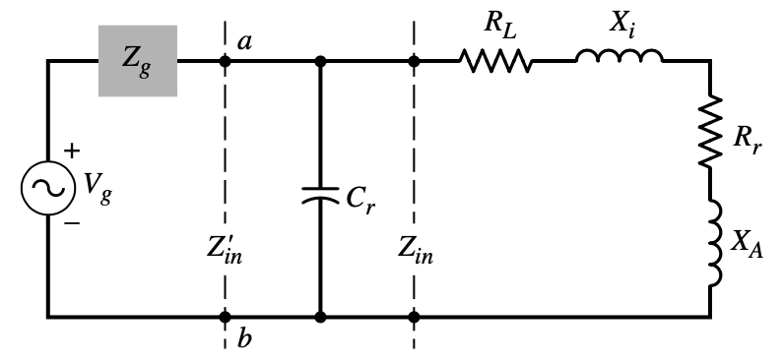
Fig. 2: Loop Antenna Circuit in Transmitting Mode

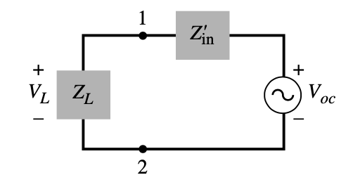
Fig. 3: Loop Antenna Circuit in Receiving Mode
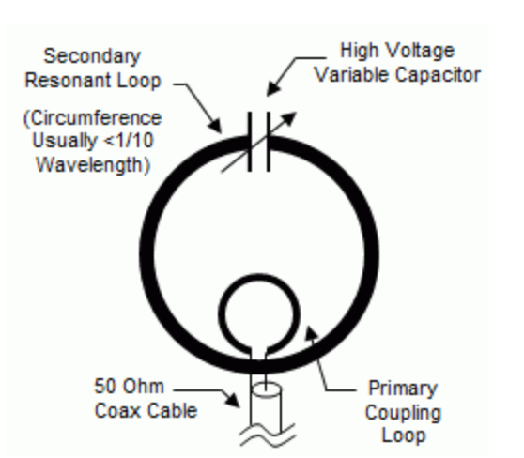
Fig. 4: Magnetic Loop Antenna Diagram

BACKGROUND
Every 11 years, the sun goes through what is known as a solar cycle. This cycle represents reaching a maxima in solar activity which marks an increase of solar flares and hotspots. These solar events have the potential to interfere and jeopardize operations of military, satelites, and electrical utilities. A prediction system for the timing and intensity of these solar maximas and the associated solar storms is beneficial in helping to prepare for potentially catastrophic disruptions to these systems. In order to predict future solar events, a solar sensitive antenna can be used to collect data on solar activity. Solar activity data can then be used to create a model using sophisticated algorithms and machine learning to create a prediction model for future solar events.

BRIEF SUMMARY
In order to create a prediction model system, a solar-sensitive antenna is implemented for a frequency of 20 MHz and connected to a receiver which can transmit data to a PC. This allows for real-time data collection of solar activity, which can then be stored. Typically, dipole antennas are used as solar radio antennas, though they require being set up in a relatively large amount of space in an electrically quiet area. For this system, a magnetic loop antenna is implemented as a replacement to the dipole, in order to increase accuracy and portability. This is possible since a loop antenna is much smaller in size and is less susceptible to electrical noise as compared to a dipole. This real-time data is then used in tandem with historically gathered solar data which is publicly available. All of this data is used to implement and train the predictive algorithms driving the model, using machine learning and feature correlation techniques. The historic data is useful for initial training of the model and correlating specific data points to observed solar storm incidents observed on earth in the past. The real-time collected data is useful for continuous training of the model such that the solar cycle can be tracked and predicted. Software-defined radio (SDR) is used as the intermediary to seamlessly connect the data collection system with the computer model.

BRIEF DESCRIPTION OF THE SEVERAL VIEWS OF THE DRAWINGS
Fig. 1 is a block diagram that shows how the magnetic loop antenna would interact with the receiver, which would then be used for the Solar Storm Prediction Model. Fig. 2 represents the equivalent circuit that magnetic loop antenna acts as during its transmitting mode. Fig. 3 represents the equivalent circuit that magnetic loop antenna acts as during its receiving mode. Fig.4 shows the physical representation of the magnetic loop antenna.

DETAILED DESCRIPTION
Fig. 2 represents the equivalent circuit that magnetic loop antenna acts as during its transmitting mode. Since the magnetic loop antenna will be a relatively small loop, as well as being primarily inductive, its equivalent circuit can be represented by the lumped element circuit. The variables are represented below:
Rr = radiation resistance as given by
RL = loss resistance of loop conductor
XA = external inductive reactance of loop antenna = ωLA
Xi = internal high-frequency reactance of loop conductor = ωLi

From this equivalent circuit, we are able to see that the Capacitor C_{r} is in parallel with Z_{in}, and this capacitor is used to resonate the antenna at the correct frequency that we want. The physical representation of this equivalent circuit can be seen in Fig. 4. It is made up of four main parts: the primary loop, secondary loop, a variable capacitor, and an input feed, such as a coax cable. The magnetic loop antenna can have any shape for the loops, such as circles or squares, but the circle loop was used since it tends to be more efficient that others. The primary loop takes in the electromagnetic signal that we are detecting. When looking at the loop itself, it can be thought of as a large inductor that can be tuned to the correct frequency. The secondary loop acts like an inductor that is winded only once and has its terminals connected directly to the tuning variable capacitor. The material used for the loops will be copper, because it is more efficient than others, such as aluminum. The main purpose of the tuning capacitor is to help tune the magnetic loop to resonance. When the tuning capacitor is increased, the resonance will be brought down to a lower frequency. When the tuning capacitor is decreased, the resonance will be brought down to a higher frequency. When deciding on the type of antenna, the magnetic loop antenna is one that reduces the amount of noise that it picks up, as well as limits the physical size of the entire antenna.
While this antenna may look similar to that of a loop antenna, there is a difference due to size. Typically, magnetic loop antennas are known as small loop antennas. The diameter of the magnetic loop antennas, which is the size of the smaller secondary loop, is one way of defining the correct frequency that the antenna needs to be operating at and the type of antenna. There are two main ways of defining the loop antennas. Antennas with a secondary loop circumference of λ are considered to be electrically large, while antennas with secondary loop circumference of less than 0.1λ are considered to be electrically small. For our design of the loop antenna, we are using an electrically small antenna built with a loop diameter of 2.75 ft.

