Development and Validation of a Cross Correlation Function Based Indirect Flow Measurement Technique

A Dissertation Presented for the
Doctor of Philosophy
Degree
The University of Tennessee, Knoxville

Xiong Gao
Sept 2020
Abstract

Nuclear Power Plants (NPPs) require the accurate measurement of mass flow rates. Advanced flow meters have been invented and widely applied in several current industries; however, the operation environment in nuclear power plants is especially harsh due to high temperature, high radiation and extremely corrosive conditions.. Several of the advanced reactor designs, such as liquid sodium pool reactors and integral small modular reactors, do not have conventional primary piping systems. These designs necessitate alternative methods to accurately measure primary flow.

Cross Correlation Function (CCF) flow estimation, which was proposed in the 1980s, can estimate the flow velocity indirectly without any specific instruments for flow measurement. Target flow rate is derived by the delay time between two sensors located close to each other along the flow direction. Temperature sensors are one of the general choices because they are reliable, economical and widely used in various industries. The delay time is inferred by applying the cross correlation function to the signals collected from two or more sensors. CCF flow estimation can be performed in any structure of the flow region, not limited to pipes.

One challenge for the CCF flow estimation is that the accuracy of the flow measurement is mainly determined by the inherent local process variation, which is small compared to the uncorrelated noise. To differentiate the process variations from the uncorrelated noise, this research implements periodic fluid injection of a different temperature before the sensors to amplify process variation. The feasibility and accuracy of this method have been investigated through both physical flow loop experiments and Computational Fluid Dynamics (CFD) simulations. The flow loop experiment was designed to verify the CCF flow estimation using water injection. Several parameters must be selected when designing the water injection CCF measurement system such as the distance between the water injection site and the sensors, the injection period, injection flow rate, and others. A series of tests were conducted to investigate whether these parameters were related to the accuracy of the CCF flow estimation, and what the optimized values for these parameters would be for different flow regimes. Then, a CFD simulation model was developed to verify the CCF flow estimation with the optimized configuration. The results obtained from the physical flow loop show that the CCF flow estimation with water injection provides better accuracy. Some parameters such as the injection period don’t affect the CCF flow estimation accuracy. Some parameters are crucial, like the distance between the sensors and the injection pipe, especially when the target flow rate is large. Furthermore, a CFD study is carried out to perform a grid search on the optimal location of the sensor pairs under different flow rate. From the perspective of the experiment and CFD simulation, this research developed a new improved CCF flow estimation and provided a guidance for the implementation under a variety of different target flow rate.

Table of Contents
Chapter One Introduction 1
Problem Statement 2
Original Contributions 4
Structure of the Proposal 5
Chapter Two Literature Survey 6
Flow Measurement Techniques 6
Cross Correlation Flow Estimation 10
Single phase 14
Two phase 17
Cross Correlation Applications in nuclear fields 19
Those reactor types benefited from CCF flow estimation 21
Summary of the Literature Survey 33
Chapter Three Methodology 34
Cross Correlation Method 34
Synthetic Signal Correlation Simulation 39
Feasibility of CCF estimation 39
Influence of correlated and uncorrelated noise on CCF 43
Fluid injection Implementation 47
Chapter Four Investigation on Water Injection Implementation 50
Early CFD study 50
Experiment Flow loop 53
Experiment Results 59
Sample Rate and Linear Interpolation 59
Thermocouple Response Time 64
Flow Orientation 66
Investigation of Critical Parameters (injection time and separate distances) 66
Chapter Five CFD simulations to Verify the Developed CCF Method 72
Computational Domain 72
Geometry 73
Boundary and Initial Conditions 74
Meshing (Domain Discretization) 77
Computational Solver Framework 91
CFD Results Study 96
CFD Solution Validation 97
Flow Rate Validation using CCF Method 103
Optimal temperature sensor location investigation 104
Chapter Six Conclusion 117
Research Conclusions 117
Recommendations for Future Work 118
List of References 119
Vita 127

List of Figures

Figure 3.1. A brief scheme of the general CCF method 34
Figure 3.2. Sensor X and Sensor Y signals versus time 35
Figure 3.3. Cross Correlation between Sensor X and Sensor Y signals 37
Figure 3.4. Synthetic signals only with a true signal value 40
Figure 3.5. Synthetic signals with process signal 41
Figure 3.6. The complete Synthetic signals 42
Figure 3.7. Cross correlation R_{xy} versus time lag τ 43
Figure 3.8. Cross Correlation Curve with 4 different SNR (0.1, 0.2, 0.3, 0.4) 45
Figure 3.9. Average RMSE versus the SNR 47
Figure 3.10. Proposed CCF flow estimation 48
Figure 3.11. Injection flow versus Time 49
Figure 4.1. The scheme of the physical flow loop 54
Figure 4.2. A detailed image of the horizontal test section 55
Figure 4.3. Injected water package control system 56
Figure 4.4. A detailed image of the vertical test section 58
Figure 4.5. Dyed water injected into the vertical test section 59
Figure 4.6. Representative Temperature signals and R_{xy} curve with periodic water injection 61
Figure 4.7. Representative Temperature signals and R_{xy} curve with periodic water injection 62
Figure 4.8. Comparison of the CCF flow estimation between with LI and without LI 63
Figure 4.9. Comparison of Cross Correlation Curve with and without LI 64
Figure 4.10. Response time study of two TCs 65
Figure 4.11. CCF flow estimation in horizontal and vertical direction 66
Figure 4.12. CCF flow estimation with different injection period (D₁ = 2, D₂ = 4) 67
Figure 4.13. CCF performance under different separation distance 68
Figure 4.14. Further examination on D2 with larger target flow rate 69
Figure 4.15. Different injection flow rate 70
Figure 4.16. CCF flow estimation (The optimal configuration based on experiment setup) 71
Figure 5.1. Computational Domain used for the CCF flow estimation with water injection 73
Figure 5.2. Boundary conditions for the CFD simulation 74
Figure 5.3. One injection period for the injection pipe boundary condition in CFD simulation 76
Figure 5.4. One example of meshing model for low flow rate simulation 77
Figure 5.5. Detailed meshing around injection pipe 78
Figure 5.6. Four meshing model evaluation 80
Figure 5.7. Area-weighted average temperature traces at five different cross sections 81
Figure 5.8. Two local temperature at the star location in Figure 5.5 82
Figure 5.9. Area-weighted average velocity traces at five different cross sections 84
Figure 5.10. Two local velocity at the star location in Figure 5.5 85
Figure 5.11. One example of 3D velocity distribution of fully developed turbulent pipe flow 86
Figure 5.12. Absolute percentage errors between the meshing (Area-weighted average velocity) 87
Figure 5.13. Absolute percentage errors of two local velocity 88
Figure 5.14. $u+$ vs. $y+$ relationship based on G1, G2, G3 meshing model 90
Figure 5.15.The relationship between $u+$ and $y+$ 95
Figure 5.16. Temperature distribution when target flow rate at 178.3 GPM (Highest flow rate) 97
Figure 5.17. Temperature comparison under lower flow rate (~ 40 GPM) 98
Figure 5.18. Temperature comparison under medium flow rate (~133 GPM) 98
Figure 5.19. Temperature comparison under higher flow rate (~170 GPM) 99
Figure 5.20. Velocity distribution under low flow rate after water injection 100
Figure 5.21. Local flow rate change along the two sensor path under the low flow rate 101
Figure 5.22. Velocity distribution under high flow rate after water injection 102
Figure 5.23. Local flow rate change along the two sensor path under the high flow rate 102
Figure 5.24. CCF flow estimation (x axis is the flow rate measured from the flow meter in the test facility) 103
Figure 5.25. Candidate sensor locations 105
Figure 5.26. Top 10 temperature sensor pairs for 39.52 GPM with an injection pressure of 80 psi 106
Figure 5.27. Top 10 temperature sensor pairs for 39.52 GPM with an injection pressure of 30 psi 107
Figure 5.28. Top 10 temperature sensor pairs for 123.84 GPM with an injection pressure of 80 psi 107
Figure 5.29. Top 10 temperature sensor pairs for 123.84 GPM with an injection pressure of 30 psi 108
Figure 5.30. Top 10 temperature sensor pairs for 178.30 GPM with an injection pressure of 80 psi 109
Figure 5.31. Top 10 temperature sensor pairs for 178.30 GPM with an injection pressure of 30 psi 109
Figure 5.32. 3D histogram of the weighted x location under low flow rate (High injection pressure) 111
Figure 5.33. 2D heat map of the weighted x location under low flow rate (High injection pressure) 112
Figure 5.34. 2D heat map of the weighted x location under low flow rate (Low injection pressure) 113
Figure 5.35. 2D heat map of the weighted x location under medium flow rate (High injection pressure) 113
Figure 5.36. 2D heat map of the weighted x location under medium flow rate (Low injection pressure) 114
Figure 5.37. 2D heat map of the weighted x location under a high flow rate (High injection pressure) 114
Figure 5.38. 2D heat map of the weighted x location under a high flow rate (Low injection pressure) 115

List of Tables

Table 2-1. Flow Meters Types and their Main Characteristics (Reproduced from [18]) 8
Table 2-2. Literature Review on previous representative works of the CCF flow measurement (From 2018 to 2000) 11
Table 2-3. A brief overview of these representative reactors [90][91][92][93][94][95][96][97] 23
Table 3-1. SNR Results for Time Domain Synthetic Signals 46
Table 3-2. Six variables to be investigated for CCF flow estimation 48
Table 4-1. CCF method results (Sampling Frequency (f) = 100Hz, Hot injection flow) 50
Table 4-2. Results based on the configuration of Case 3 with a different main flow rate 52
Table 4-3. Same Table as Table 4-2 with SI unit 52
Table 4-4. Estimation of volume of the injected water package 56
Table 5-1. Four meshing detail settings for three regions shown in Figure 5.4 79
Table 5-2. Three different meshing models 89
Table 5-3. Average distance between two sensors based on the top 10 pairs under different mean flow and injection pressure 108

Introduction

Many instrumentation and control challenges arise with the advent of newer and safer integral nuclear reactor designs. One of the challenging tasks is flow estimation, especially for the reactor coolant flow in the Nuclear Steam Supply System (NSSS). The reactor coolant flow rate is one of the most important parameters for the power control and reactor safety because the accuracy of the reactor power rate is related to the accuracy of the main flow estimation. The power rate is estimated from the sum of the enthalpy change of the NSSS. With the knowledge of the temperature for the primary and secondary flow, the power rate can be determined from the flow rate based on the energy balance equation. Additionally, accurate flow estimation can not only monitor the NSSS operation appropriately and control nuclear power rate more economically, but also have more confidence when making safety decisions based on the power ratio.

Flow estimation plays an important role in the new advanced reactor with more safety systems, and some reactors face the flow estimation challenges that the traditional reactor designs have never met. The old generations cannot satisfy the demand for safety and economy. In the last four decades, three severe nuclear power plant accidents caused disasters for human society. The accidents happened in Three Mile Island NPP [1], Chernobyl NPP [2], and Fukushima NPP [3]. Such disastrous consequences show that the old nuclear fleets have potential safety issues. It is necessary to develop a new design of the reactor with a more comprehensive safety system. In late 2002, six innovative reactor designs were announced and categorized as the Generation IV reactors in Generation IV International Forum (GIF) [4]. Although the Gen IV reactors are more reliable and economical compared with old reactors, these new reactor designs bring great challenges, especially for the instrumentations and control [5]. Among these Gen IV reactors, some reactor vessels are pool-type designs to eliminating the primary reactor pipe. The reason for eliminating the primary pipe is that the pool reactor vessel design enhances safety by removing the possibility of the loss of coolant accidents caused by primary pipeline breaking. However, due to no pipelines in the primary loop, the conventional pipeline-based flowmeters like the Venturi flow meter is not able to measure the flow rate very well. The same flow measurement issues happen in some smaller modular reactors, such as NuScale’s Integral Pressurized Water Reactor (iPWR). There are no pipelines designed in these reactors, and all the working fluid is enclosed in the entire vessels. Another general issue for the instrumentations implemented in nuclear industries is the harsh working environment. The internal operating condition is high-temperature, corrosive, and radioactive inside the reactor. The operating condition is even worse when the working fluid is liquid metal, such as the mercury. The property of the mercury is high density, high electrical and thermal conductivity, opacity, high temperature, toxicity, oxides and contaminants presence, chemical activity and other electromagnetic issues[6]. Such special properties of the working fluid preclude some conventional flow techniques, such as the common intrusive flowmeters not be reliable for the long-term operation.

Therefore, one inferential flow measurement is needed for the flow rate estimation in these types of reactors [7] to deal with the above issues happening during flow estimation. One inferential flow measurement is based on the Cross Correlation Function (CCF). The main idea of the original CCF estimation is to infer the flow rate by the delay time calculated by the CCF of two adjacent sensors. For the first issue of estimating the flow under no pipeline conditions, the CCF flow estimation does not depend on the pipeline geometry. Instead, it is carried out only based on the given two adjacent sensors, so CCF flow estimation can be applied in pool-type reactors as well as the integral reactors. For the second issue of measuring flow rate in a harsh operating environment, CCF flow estimation does not depend on any specific flowmeters. Thus, any reliable sensors in the harsh environment can be selected as the signal source for CCF flow estimation. Usually, the temperature sensor can be served as the signal source for CCF because it is convenient, robust, and reliable. It can suffer a more harsh measurement environment compared with the general flowmeters. Besides, for one of the indirect flow estimation techniques, the nonintrusive electromagnetic flow rate measurement technology, Moazzeni et al. suggested that it also suffered the long-term corrosions of the contact resistance at the liquid-wall boundary, leading to the measurement errors[8]. The above distinguishing features of CCF flow estimation can help the flow measurement in nuclear industries, especially for those advanced reactors. However, the original CCF flow estimation has some disadvantages, such as the signals heavily contaminated by the uncorrelated noise. Therefore, developing a new CCF flow estimation with higher accuracy and a larger target flow rate is the main motivation for this research work.

Problem Statement

The CCF flow estimation is an indirect approach of measuring the flow rate by using process signal correlation. The CCF method was firstly applied to flow estimation in 1966, proposed by Bentley et al. [9]. The target flow rate can be derived from the transit time between the two sensors parallel located along the flow direction. The transit time is calculated by performing the cross-correlation on the signals collected from these two sensors, and the target flow rate can be inferred by the distance between two sensors divided by the calculated transit time. It is reasonable to use the temperature as the signal source for CCF because the profile of the temperature fluctuations can follow the profile of the flow rate [10]. A unique characteristic of the CCF flow estimation is that the target flow does not need to be measured in the pipeline structure. There is no restrictions for the geometry of the measurement section because the transmission of the signals collected for CCF is independent of the geometry of the flowing area [10]. This meets the demand of the flow measurement in the no pipeline structure, like in a pool-type reactor. Another advantage of the CCF flow estimation is that it measures the bulk flow rate, instead of the local flow rate. The bulk flow movement is dominated by the pressure gradient, and the local flow is dominated by the local turbulence or the random motion of individual eddies. With a suitable distance between the two sensors, the CCF estimation measures the bulk flow rate, which is usually the main concern in nuclear industry applications.

The CCF flow estimation was first introduced to the NPP applications in 1982 [11][12]. F. J. Sweeney et al. inferred the flow rate by performing CCF on the cross-power spectral density phases of the core exit thermocouple temperature sensors and the in-core neutron signals because the neutron detector and thermocouple noise signals were cross-correlated. Some test flow measurements are carried out in both the test facility and a commercial PWR. Results showed the cross-correlated relationship between these signals can be used to infer the in-core coolant flow rate. An NRC document (NUREG/CR-5501) [13] performed a series of tests to illustrate the feasibility of the CCF flow estimation with the synthetic data. Produced by the electronic signal generators, variable frequency sine wave, and white noise signals were then applied to one or two time delay filters. CCF was performed on these signals to calculate the delay time which was close to the input value in the delay filter. This document also demonstrated some experimental tests on a physical flow loop to identify the best types of sensors for the accurate CCF flow estimation. Results showed that the temperature sensor signals, Resistance Temperature Detectors (RTD), and Thermocouples (TC) had suitable sensitivity to the thermal hydraulic fluctuations for CCF compared with pressure and other types of signals. Besides, this document summarized three main factors that influenced the CCF flow estimation:

- The response time of the sensors and instrumentation channels for CCF
- Smaller sensor uncorrelated noise compared with the correlated signals
- The time or frequency resolution of the measurement system

This research work attempts to develop a new CCF flow estimation by investigating the above three factors. For the response time issue, use thermocouple as the CCF working sensors with higher response time signals compared with RTDs. For the uncorrelated noise issue, inject the additional perturbation to differentiate the correlated noise from the uncorrelated noise. For the sensor resolution, apply the linear interpolation on the raw collected signals to manually increase the sampling frequency for better CCF estimation.

Firstly, Thermocouple (TC) is selected as the temperature signal sensor for CCF flow estimation. Response time is a crucial parameter because with a smaller response time, sensors are more sensitive to the perturbation transmitted along the flow direction and capture the perturbation fast and correctly with a higher correlation between each other. The response time of a bare wire TC is generally smaller than that of an RTD [14]. It is reasonable to select TC as the signal source for the CCF flow estimation. Another issue is the response time difference between the two working sensors [13]. The first CCF flow estimation in NPP[11], [12] implemented the CCF between two different types of sensors, the neutron detector, and the core exit thermocouples. The response time of these two sensors was slightly different from each other. This research work uses the same type and brand of thermocouples to alleviate the influence of such a response time difference caused by the sensor type. However, even for the same type and brand of the TCs, each individual has slightly different response times from each other caused by the manufacturing and operating. Such a tiny difference can cause a constant bias for the flow estimation especially when the target flow rate is great. Thus, before performing the CCF flow estimation, the response time difference between the two working sensors has to be evaluated, which is used to correct the CCF flow estimation.

To decrease the sensor uncorrelated noise compared with the correlated signals, this research work proposes injecting the additional perturbation before the sensors to increase the magnitude of the correlated signals, which alleviates the influence of the uncorrelated noise. There are several ways to introduce additional correlated perturbation into the main flow. One way implemented in this research work is to inject the fluid package right before the temperature sensors with different temperature from the main flow. The extra fluid package injected into the main flow can add the perturbation into the main flow and increase the correlated noise, which differentiates the correlated noise from the uncorrelated noise. The temperature perturbation transmitted along the flow direction is caught by the sequential temperature sensors with higher coherence, which is helpful when inferring the transit time by CCF.

Lastly, the time or frequency resolution is generally restricted by the physical measurement system. Higher frequency resolution can let the sensors capture the perturbation more precisely. The sensor frequency resolution depends on the physical property of the instrumentation and once the sensors are chosen and installed, it is hard to improve the sampling frequency during the data collection. However, there is an alternative way to increase the number of samples per second during the data post processing to improve the accuracy of the CCF estimation, which can be regarded as the benefit of increasing the sampling frequency. Before performing CCF, the raw sensor data are applied by the linear interpolation. The linear interpolation can’t introduce new information, but it can produce more samples given a certain range of time. Such manipulation can yield more samples in the fixed time delay between the two sensors compared with the original one, and it improves the CCF estimation. The linear interpolation method is illustrated in the methodology section and the experiment results show linear interpolation can improve the CCF flow estimation.

This research work develops the new CCF flow estimation and validates it in a physical flow loop and a CFD simulation. A series of flow measurement tests are performed and data with different configurations are collected from the flow loop, constructed in the University of Tennessee, Knoxville. After that, a CFD simulation work was built in FLUENT, ANSYS. The simulation can be used to obtain the CCF flow estimation results from previous experiments, and optimize the configuration more efficiently.

Original Contributions

This research develops a new CCF flow estimation technique for flow rate estimation validated and verified in the flow loop experiments and CFD simulation, which includes original contributions to the nuclear instrumentation field. These contributions are listed below:

- Quantify the relationship between the Signal to Noise Ratio (SNR) and the CCF estimation uncertainty. The SNR is the ratio between the measurement signal and the correlated noise. Larger SNR leads to better CCF accuracy based on the simulated signal tests.
- Develop a new CCF flow estimation method by periodically injecting fluid package into the main flow before the sensors. The injected fluid package adds a temperature perturbation increasing the SNR, which improves the CCF flow estimation.
- Evaluate this new CCF flow estimation technique performed using a water-based physical flow loop. The target water flow rate ranges from 39.52 GPM (0.00249 m3/s) up to 178.3 GPM (0.01125 m3/s).
- Develop optimal CCF implementation guidelines for different flow rates using computational fluid dynamics simulations and validated on the physical flow loop. The optimized variables include the locations of the sensors and injection pipe, the injection period, and the injection flow rate. The experimental results show that under different target flow rates, the optimized variables are different, which could serve as a reference for the implementation in practice.

Structure of the Proposal

Chapter Two provides a survey of the literature related to this research, including a brief review of the general flowmeters and the CCF flow estimation in different fields. Chapter Three presents the CCF methodology, which consists of three sections. The first section illustrates how CCF works for flow estimation in detail. Next, the definition of the SNR is introduced with the synthetic data simulated in Matlab and explains why increasing the correlated noise could increase the accuracy of the CCF flow estimation. The idea of increasing the correlated noise brings up the water injection implementation, which will be discussed in the last part of the methodology chapter. Following the methodology, the next chapter describes the physical flow loop and illustrates how to implement the water injection. The related results are discussed as well. Then, a CFD simulation model is built and discussed to verify the experiment results from the flow loop, after that, a more comprehensive optimization for how the sensor and injection instrumentation are setup is conducted. The overall discussion and conclusion about both physical and CFD simulation results will be presented in the last conclusion Chapter Six.

Literature Survey

This chapter will give an overview of the research works related to the CCF flow estimation. The first section aims to review the flow measurement and related techniques currently developed and applied in industries. Usually, the flow measurement mechanism can be classified into two ways: direct measurement and indirect measurement. The main topic in this research work is CCF flow estimation, which is one of the indirect flow measurement. There are other indirect flow measurement techniques, and they are briefly introduced as well. After the overview of the various kinds of the general flow measurement techniques, the following section is focused on state-of-the-art research works and related applications based on the CCF flow estimation technique. Some papers investigate how to improve the CCF flow measurement, which is discussed as well.

Flow Measurement Techniques

In industries, it is essential to monitor the current status of the working fluid in all mechanic systems, including both the important primary flow loop and some auxiliary minor systems. There are many parameters to characterize the working fluid, such as the phase, temperature, pressure, viscosity, heat capacity, void fraction based on the property of the working fluid. No matter what the property of the working fluid is, as far as it is flowing inside the system, the most important parameter is the flow rate. Accurate flow rate measurement can benefit the whole system operations safely and economically. Take the NPP operation for example. For a conventional NPP, the operating thermal power level is indicated and controlled by the feedwater flow rate directly [15]. Accurate flow rate estimation leads to accurate thermal power indication and correct plant operation and management both in normal conditions as well as the emergent conditions. Other than the safety issue, accurate flow estimation makes NNP run more efficiently and economically. Hashemian [16] showed a table about the estimated gains per operating cycle from the implementation of an online monitoring system at the Sizewell B plant in the United Kingdom. The online monitoring system was able to reduce the uncertainty for different parameters, such as the flow rate, pressure, water level, and so on. The most gain in the system was the reduction of Feedwater Flow uncertainty, 24 million dollars. The second most gain was the online calibration monitoring of pressure, level, and flow transmitters, 15.7 million dollars. It is noticed that this is also related to the flow measurement. These two gains accounted for almost 70 % of the total expected gains suggesting how important the accurate flow measurement to the NPP economical operation. Thus, accurate flow measurement can aid the NPP operation safely, efficiently, and economically.

It is not practical to have one specific flow measurement method suitable for all kinds of flow measurement applications. Different measurement environments are filled with different kinds of noise and vibrations. Even the dirt in some specific system areas can cause some flow measurement instruments with great errors, or the worst case that it damages the instrument itself. Besides choosing the flow measurement techniques based on the operation conditions, even under the same measurement environment, the Reynold number of the target fluid is the key factor when selecting the type of the flowmeters[17]. Other than that, there are plenty of other conditions that need to be considered when selecting the instrument for the flow measurement. Pereira [18] summarized the major flow measurement techniques currently used in industries, described by the working principles, major applications, advantages, disadvantages, and related variants shown in Table 2-1.

Table 2-1. Flow Meters Types and their Main Characteristics (Reproduced from [18])
Flow Meter Type | Primary Working Principle | Quantity Measured | Advantages | Disadvantages | Meter Name
Differential pressure | Pressure drop caused by pipe’s restriction | Volume  (versatile – almost all gases and low viscosity liquids) | Low-cost, versatile, robustness, variety of versions | Square root dependence, affected by pressure and density changes, high  pressure drop (exception for nozzles) | Orifice, Nozzle venture, Elbow, V-cone,  Pitot tube, Annubar
Turbine | Rotating device | Volume (lubricating fluids) | No supply power  requirements, extreme temperatures and pressures, certified for gases | Only for low viscosity, moving parts, sensitive to contamination and vibration | Single rotor, Dual rotor,  Paddle wheel, Propeller, Tangential
Variable Area | Dynamic balance (impulsion, weight and dragging) | Volume  (liquid and gas applications with enough density) | Low-cost, no supply power requirements, simplicity, versatile | Vertical installation, constant  pressure loss (inaccuracy low fluid’s flow), affected  by density and temperature changes | Rotameters-  different variants of float designs and sensing systems
Magnetic | Electromagnetic induction | Volume (almost all  measurements as long as the conductivity is above a minimal value) | No moving parts, non  invasive, no pressure loss, no dependence of flow regime, not affected by temperature, density, conductivity and concentration changes | Only liquids applications, lower conductivity limit (0.05 µS/cm) | Magnetic DC- no electrodes two-wire partially full
Oscillatory | Coand effect | Volume  (application to a large variety of liquids as long as RN  is above a minimal value) | No moving parts, robustness, suitable for different fluid  types (gas, liquid, steam), linear  relation between measurement and fluid flow | Fluids that exceed a minimum velocity  RN restriction, fluids with  viscosity above a minimal value, complex signal’s conditioning | Fluidic vortex
Target | Force of the fluid in a fixed body (target) | Volume  (clean fluids, minimum movement quantity) | Low-cost, good performance in large pipes | Restrictions on RN, fluid’s velocity, material of  construction, low accuracy, almost impossible calibration | Target
Positive Displacement | Measurement of fixed fluid’s volume per rotation | Volume  (clean and non-abrasive liquids) | High accuracy, no supply power requirements,  bidirectional operation, no RN restrictions | Only for liquids, high  pressure drop, moving parts, sensitivity to contamination and overloading | Helical gear, nutating disc, oscillating piston, oval gear, rotary
Ultrasonic | Acoustic waves or vibrations | Volume  (clean liquids and some gases, but problematic for the last) | No moving parts, it could be non-invasive (transducers are outside the pipe), no pressure drop, linear relation between measurement and fluid’s flow, on line calibration | Good accuracy only for  liquids, error due to deposits, errors caused by gas bubbles, affected by sound, velocity, temperature, concentration, and density changes | Doppler transit time  pulse repetition
Insertion | Measurement of fluid’s velocity in critical positions (e.g.: pipe’s axis) | Volume  (liquids, gas, and steam in large pipes) | Depends on transducer types because it can be implemented using almost all flow meter’s working principles | Only large pipes, requirement of data  processing for acceptable values of accuracy, RN  restriction (turbulent flow regime), large pressure drop | one for each type of transducer  (metering principle)
Correlation | Correlation of  measurement data captured in different positions | Volume  (depend on flow meter type use for correlation purposes) | Typically non-invasive measurement method | (depend on flow meter type use for correlation purposes) | one for each type of transducer  (metering principle)
Open Channel | Sheet of fluid above a  crested dam or variable height in a restriction (Parshall) | Volume (liquid flow  measurements usually in irrigation, drains and water works systems) | Unique solution for measurements in open channels (e.g.: irrigation systems, river flows) | Pressure loss, not versatile | Weirs Parshall flume
Coriollis | Conservation of angular momentum  Thermal | Mass  (measurement of: liquids, gases with restrictions, harsh chemicals, density) | True mass measurement, no RN restrictions, high accuracy, unaffected by pressure, temperature and density | Acceptable accuracy only for liquids, vibration sensitivity, large size limitations | Coriollis  Hydraulic Wheatstone bridge  Hot
Thermal | Thermal properties of materials | Mass (measurement of gases) | True mass measurement,  robustness for industrial and vehicle applications, large flow range | Only for gases, non-linear inference measurement of mass, non-linear output signal, bubbles sensitivity | Hot Wire Anemometer
Note:
- The Quantity Measured was classified as volumetric, independent of the meter’s working principle (real volumetric-e.g. positive displacement, velocity-e.g. ultrasonic, or inferential-e.g. differential pressure).
- RN: Reynolds Number

Based on the different working principles shown in Table 2-1, Spitzer [19] classified the flow measurement techniques into four main groups as below:
- Flowmeters with wetted moving parts: turbine flowmeter
- Flowmeters with no wetted moving parts: orifice plate flowmeters
- Obstructionless flowmeters (a subset of group 2): magnetic flowmeter
- Flowmeters with sensors mounted external to the pipe (a subset of group 3): ultrasonic flowmeter, inferential flow measurement (e.g. CCF flow estimation)

For the first two groups of the flowmeters, one major disadvantage is the pressure head loss during the operation. In long term, it will cause great economical loss. Additionally, there are some issues for the first three groups specifically applied in the NPP system. The long-term operation in the high radiative and corrosive working environment causes heavy wear and damage to the moving parts. The clogging leads to measurement errors. Besides, pipeline-based flow measurement techniques do not work very well in the pool type reactors. Group 4 flow measurement techniques offer considerable promise in effecting flow measurement with successful applications [19]. For group 4, the ultrasonic flowmeter also suffers from the corrosion issues no matter wetted or no wetted transducers used [20], especially in some advanced liquid metal reactors. Although the head loss for the ultrasonic flowmeter and the magnetic flowmeter is relatively smaller, the total annual maintenance cost is relatively high. For the ultrasonic flowmeter, it costs around 1,755 $ per year while most other flowmeters cost less than 1,000 $ per year [21]. The typical lifetime for the ultrasonic meter in continuous use is five to six years and the magnetic meter is approximately 10 years [21]. It is not very durable, and even not applicable in some certain reactors. For example, some Small Modular Reactors are designed with no refueling property and have approximately 30 year core lifetime, which is far longer than the lifetime of the ultrasonic flowmeter or the magnetic flowmeter.

Instead of the instrumentations specifically designed for flow measurement, inferential flow measurement techniques are based on other more durable and reliable sensors, such as nuclear-grade temperature sensors [22]. Currently, general inferential flow measurement techniques include three methods. They are Pump motor current signature analysis and calorimetric analysis, and CCF technique. The CCF techniques will be discussed in detail in the next section. For the pump motor current signature analysis [23], the flow rate of the system is linearly related to the power of the pump over a certain range, which can be indicated by the measured current and voltage. Another inferential method is Calorimetric Analysis. The power rate in NPP can be estimated by the neutron measurement instrumentation as well, and with the heat energy change and temperature at the inlet and outlet known, the main coolant flow rate can be estimated based on the energy balance equation and calibrated with the existing flowmeters [24].

Cross Correlation Flow Estimation

In this section, a broader literature review on the CCF flow estimation technique, including the applications in nuclear industries [25] as well as other fields. Besides, the type of signal used for CCF flow estimation can be not only the temperature but also other types, such as voltage [26], capacitance [27], etc. The flow to be measured in this research work is the water under the normal condition. However, CCF flow estimation can be applied to different kinds of fluid, like the liquid metal [6], liquid-gas flow [27], even debris flow [28] in Earth science, and yogurt flow [29] in food industries. Table 2-2 gives an overview of the works related to the CCF flow estimation published in recent 20 years, including the first author, published year, the type of the target flow to be measured, the range of the target flow, experiment pipe diameter if available, the type of the signals used in CCF, and the experimental conditions or the potential future applications.

Table 2-2. Literature Review on previous representative works of the CCF flow measurement (From 2018 to 2000)
Reference | Publish Year | Main Flow Property | Range of Main Flow | Pipe Diameter | Signal type for CCF | Experiment/Future Applications
R. Drury [27] | 2018 | Oil and nitrogen gas (two phase) | liquid: 1 - 3 m/s; Gas: 0.4 - 3 m/s (Slug Flow) | 10.2 cm | Voltage (ECT) | General Multi-phase flow measurement in industries
I.A. Belyaev [6] | 2017 | Mercury | 0.02 - 0.3 m/s | 19 mm | Temperature (Thermocouple) | Liquid Metal Reactor
A. Saoud [30] | 2017 | Solid and air (Swirl flow) | 1 - 7 rad/s for swirl flow | 50 mm | Voltage (ECT) | Swirl flow
H. Shaban [26] | 2016 | Water and air | Air: 0.04 m/s - 20 m/s, Water: 0.13 - 3 m/s | 32.5 mm | Voltage | Gas flow estimation in two phase flow
D. R. Cadel [31], [32] | 2015, 2016 | Iodine vapor (Simulation) | 5 - 500 m/s | Open space | Transmission ratio | non-intrusive, spatially resolved flow field measurements
M. W. Munir [33] | 2013 | Fly ash and air | 1.25 - 5 m/s | 40 mm | electrostatic sensor (Voltage) | Gas-solid flow, Pulverized coal flow
L. S. Zhai [34] | 2014 | Oil and water | Oil: 0.106-2.579 m/s, Water: 0.111-2.210 m/s | 20 mm | Capacitance probe | Petroleum industry
R. Hanus [35] | 2014 | Ceramic nodules and Water | Solid velocity: ~1.865 m/s | 150 mm | Scintillation probe (Gamma-ray absorption) | Liquid and Solid flow, deep-sea mining of polymetallic nodules
Table 2-2 Continued
Y. Zhou [36] | 2013 | Bovine/mouse Blood flow velocity | 0-16 mm/s | 0.3 mm | Photoacoustic amplitude profile (Red blood cells) | Blood flow velocity
E. Alidoosti [37], T. Moazzeni [8], [20], [38] | 2009, 2011, 2013, 2014 | Water | 0.1 - 4 GPM | 0.5/1 inch | Temperature (Thermocouple) | The harsh environment, like the nuclear reactor
E. J. Avilan [39] | 2013 | Simulated data | Inferred by delay time: 7 s up to 25 s | Not Mentioned | Simulated data | General water/oil flow measurement
J. J. Charonko [40] | 2013 | Synthetic, water | 10 cm/s | 0.61 m x 0.61 m (square) | Particle image | Particle image velocimetry (PIV) for non-invasive fluid velocity measurements
H. Seraj [41] | 2013 | air and plastic bead | ~3.1295 m/s | unknown | electrostatic sensor (Voltage) | Coal particle velocity in mining industries
J. B. Gajewski [42] | 2013 | air and aluminosilicate powder | 0.03-0.18 kg/s | 80/100/150 mm | electrostatic sensor (Voltage) | Gas-solid flow, non-contact, non- intrusive measurement
J. Brunker [43], [44] | 2010, 2012 | red cell (simulated by microscale absorbers) | 0.15 - 1.5 m/s | 2 cm | Acoustic waveform (detected by Ultrasound receiver) | Blood flow velocity
C. Tan [45] | 2010 | Oil and water | ~0.7 - 2 m/s | 50 mm | Voltage | Two phase, Petroleum and chemical industry
T. J. Arbour [46] | 2010 | Water | 0 - 12000 mm/s | 300x300 \mu m2 | fluorescence detector | Micro fluid flow
F. Zhang [47] | 2010 | Air and water | 0.92 - 2.85 m/s | 50 mm | Voltage | Two phase, Gas-liquid
Table 2-2 Continued
C. W. Fernandes [48] | 2010 | Air | 2.1 - 4.2 m/s | Not mentioned | Laser beam photon detector | Human respiratory flow
S. Jung [49] | 2009 | Nitrogen and water | 15-40 m3/hr | 8 cm | Gamma radioisotope detector | Petrochemical and refinery industries
J. Kortbek [50] | 2006 | Blood-mimicking fluid | <0.3 m/s | 6.4 mm | Ultrasound signals | Blood flow velocity
M. Henningsson [29] | 2006 | Yogurt-like flow | 0.05-0.25 m /s | 60 mm | Conductivity (Electrical resistance tomography) | Yogurt and other fermented milk industries
M. Arattano [28] | 2005 | Debris flow | ~4-9 m/s | Open space | Seismic and ultrasonic sensors | debris flow
E. Reis [51] | 2005 | Air and water | Air: 3-6 m/s Water: 0.08-0.8 m/s | 34 mm | Voltage | Slug flow
S. Sisbot [52] | 2005 | Blood-mimicking fluid | 100-450 ml/min | Not mentioned | Ultrasound signals | Blood flow velocity
D. Ruan [53]–[55] | 2002, 2003, 2004 | Water | 19-34 m3/h | Not mentioned | Temperature (RTD) | General water flow
B. Gurau [56] | 2004 | Air and water | 0.4 - 1.4 m/s | Not mentioned | Hot film anemometry voltage | Gas-liquid flow
G. Por [7] | 2003 | Water | ~2.15 m/s | Pool | Temperature (Thermocouple) | Pool type reactor
D. Lumma [57] | 2003 | Water | < 0.1 m/s | Not mentioned | fluorescence detector | Micro fluid flow profile near the wall
J. K. H. Karlsson [58] | 2003 | Water | 0.15 - 0.35 m/s | 3 mm | Temperature (Thermocouple) | Flow measure in Fuel Rod Boiling Capsule
Table 2-2 Continued
F. Schneider [59] | 2003 | Water | 5 - 35 m/s | 100 mm | Ultrasound signals | General water flow
S. Ibrahim [60] | 2002 | Air bubble and water | ~0.26 m/s | Not mentioned | Voltage (Analog flow noise signal) | The bubble flow rate in the water
G.P. Lucas [61], [62] | 2001 | Oil and water | Water: 0.25 - 0.579 m/s | 42.86 mm | Voltage (Resistance sensor) | Oil industry
G. V. Arkadov [25] | 2001 | Water | ~ 3.8 m/s | Not mentioned | Neutron sensor | Reactor vessel coolant flow measurement
P. Benes [63] | 2000 | Dust and air | 1-12 l/s | 4 mm | Piezoelectric sensor | Solid gas flow measurement
H. Kawanabe [64] | 2000 | Nitrogen | ~5 m/s | Open space | Particle image (With laser) | Gas flow measurement
K. Tsukada [65] | 2000 | Rat mesentery blood | 5 - 10 mm/s | 50e-6 m | Flow image | Blood flow velocity

The researches listed in Table 2-2 cover different research fields and fluids. Based on the phase of the target flow, these works can be generally classified as single-phase flow and two-phase flow. Each will be discussed by several representatives works in the following.

Single-phase
In industries, single-phase flow is the most common fluid to be investigated and measured, especially the liquid phase of the water due to its physical properties suitable for many applications. Two papers are applying CCF on gas phased flow estimation discussed below as well.

Gas flow
C. W. Fernandes et al. [48] measured the airflow rate by performing CCF on two series of laser beam photon signals. The potential application was to measure human respiratory flow. One He-Ne laser worked as the photon source and some mirrors were used to separate the He-Ne laser beam into two beams, detected by the devices as the input signals for the CCF. The results showed it measured the laser-transparent gases with 0.1 % errors.

D. R. Cadel et al. [31], [32] applied Cross Correlation Doppler Global Velocimetry (CC-DGV) to measure the velocity of the iodine vapor. The CC-DGV inferred the transit time between two filtered intensity signals by estimating the Doppler frequency shift of scattered light. The velocity of the iodine vapor to be measured ranged from 5 m/s up to 500 m/s with the peak errors of ±0.61 m/s.

Liquid Flow
I. A. Belyaev et al. [6] applied the CCF techniques on the liquid metal flow measurement in the micro-scale with the pipe diameter of 19 mm. The micro thermocouple sensors were used to measure the temperature waveforms and served as the input signals for CCF to estimate the average longitudinal velocity in the mercury flow simultaneously. It was found that the CCF flow estimation worked well with magnetic fields up to 1 T.

Y. Zhou et al. [36] attempted to measure the blood flow rate by the CCF techniques with the signals of the photoacoustic amplitude profile on the red blood cells traveling inside the blood. The experiment results showed that the CCF flow estimation was independent of the particle size along with the flow, which shows no calibration is needed for blood flow measurement. It showed the CCF flow estimation could accurately quantify the blood velocity.

E. Alidoosti et al. [37], T. Moazzeni et al. [8], [20], [38] built up a physical loop and measured the water flow rate ranging from 0.1 to 4 GPM. Both physical and CFD simulated model was used to verify the measurement results. Thermocouples were selected as the signal source for the CCF flow estimation. Two different improvements in CCF flow estimation were applied to increase the performance. One was to add the heater before the two thermocouples. The additional heater tried to amplify the perturbations of the temperature signals, which provided the same purpose as the water injection technique proposed by this research work. Another one was a by-pass design. The by-pass design aimed to apply the CCF flow estimation on the by-pass flow with a smaller velocity to infer the larger main flow rate. The results show that the CCF could handle the smaller main flow rate but did not work fairly well when the main flow rate was large.

E. J. Avilan et al. [39] attempted to improve and compare the original CCF flow measurement by three different modifications on the input signals for CCF: direct, relay, and polarity. The direct mode was the original CCF technique as the baseline. The Relay mode was to polarize one signal of two to the binary form according to the signal deviation with respect to the mean value and another signal won’t be changed. The polarity mode implemented the above polarization on both two signals. The paper compared and verifies three modifications by the simulated Gaussian and no-Gaussian signals, and results showed the direct mode provided better estimation accuracy.

J. J. Charonko et al. [40] demonstrated a new way to estimate the uncertainty bounds of the particle image velocimetry (PIV). PIV was a robust method by detecting the displacements in digital images captured by CCF. Both synthetic data and physical flow experimental data were evaluated. The uncertainty analysis showed that the resulting errors computed from several synthetic data and physical flow data were close to the predicted uncertainties, which benefits the PIV in both engineering and CFD areas.

J. Brunker et al. [43], [44] measured the blood-mimic flow rate by the cross-correlation between the photoacoustic waveform pairs generated by the light pulse. The waveform pairs were captured by the PZT ultrasound transducers with a given sampling frequency. The results showed the CCF flow estimation worked well under certain ranges of the flow rate. To measure the maximum velocity accurately, the pulse separation and the width of the ultrasound transducers were the two crucial parameters that need to be carefully optimized.

C. Tan et al. [45] used a dual-plane electrical resistance tomography to collect a pair of parallel mounted sensors on the flow pipe to perform CCF to estimate the mixture flow rate of the water and oil. Dual-plane electrical resistance tomography could obtain 208 voltage values for one cross section along the flow direction. This paper also proposed that only selected segments of the signals were used to perform CCF based on the standard deviations of the collected signals. The CCF estimation results showed the oil and water velocity structure was close to the drift flux model and compared to the oil flow, the water flow affected the CCF flow estimation on the entire mixture velocity. F. Zhang et al. [47] and F. Dong et al. [66] measured the gas-liquid flow using CCF techniques on the same experiment loop. The measurements showed the CCF techniques work well with a mixed velocity range of 0.92 – 2.85 m/s.

T. J. Arbour et al. [46] applied the Dual-focus fluorescence correlation spectroscopy and used the laser beam as the signal source for the CCF to measure the microfluidic flow velocity. The proposed method took advantage of the intentional overlap of the two detection regions. It yielded the absolute value of the hydrodynamic properties without the calibration of the micro fluid.

J. Kortbek et al. [50] proposed a modified CCF flow estimation to measure the blood flow rate as well as its flow direction. The signal used for CCF was the ultrasound signals. The flow direction was determined by the maximum correlations between the target flow signals and a bunch of given signals with different flow angles. Both simulations and experiments were performed, showing the flow direction estimation was accurate.

M. Henningsson et al. [29] applied the CCF flow estimation on the yogurt flow measurement ranging from 0.05 to 0.25 m/s. The CCF signals were the conductivity based on the Electrical Resistance Tomography (ERT). The measurement results showed the experiment yogurt flow was close to the plug flow based on the CCF flow estimation.

S. Sisbot et al. [52] applied the CCF on the blood flow rate estimation verified from experiments and simulations. One Matlab Simulink model was presented to verify that the CCF measurement was not affected by the independent measurement noise. The distance between the two ultrasonic sensors should be as small as the physical structure allows, especially when the target flow rate was not very large.

D. Ruan et al. [54], [55], [53] integrated the Artificial Neural Network with the CCF flow estimation to produce better accuracy. The temperature signals obtained by the RTDs were served as the inputs to the CCF to produce the estimation of the flow rate. These estimations without neural networks are significantly lower than the reference values collected from the ultrasonic flowmeters. Then, a three-layer Artificial Neural Network was trained. The input variables included the CCF flow estimations, other processing parameters collected during the estimations, like the pressure and valve position. The output of the neural network was the flow rate to be predicted. The flow rate calibrated by the Neural Network was closer to the true value.

L. S. Zhai et al. [34] applied the CCF flow estimation on the oil water flow existing in the current petroleum industry. The parallel-wire capacitance probe (PWCP) is used as the signals for the CCF flow estimation. The oil water flow structure was the main issue for the PWCP CCF flow estimation. The measurement results showed the velocities based on CCF were less dependent on the flow pattern. Another kinematic wave model was proposed to predict the homogeneous velocity for the oil-water flow patterns.

G. Por et al. [7] positioned three thermocouples at the top of the fuel assembly in a training pool-type reactor to measure the coolant flow rate by CCF. In this paper, the CCF regarded as a convolution function was transferred into a multiplication in the frequency domain to estimate the flow rate. The measurement was performed under both the natural circulation conditions and the forced pump operation, but the CCF flow estimation was only verified under the condition with the forced pump because there were no other flowmeters in the training reactor, and the CCF estimation matched well with the true value inferred from the pump rate.

Two-phase
Two-phase flow estimation is more difficult than the single-phase flow estimation due to the complex and unpredictable fluid dynamics between the two phases. There are three different types of two-phase flow in practice. They are gas-solid, gas-liquid, and liquid-solid. The interaction between the two phases is quite different among each other, but CCF flow estimation can be successfully applied in these three types of target flow and provide competitive measurements compared with other measurement techniques. The following is going to discuss the CCF applications in these three different two-phase flow respectively.

Gas-solid
A. Saoud et al. [30] worked on the two-phase flow measurement of water and air in the swirl flow condition. The authors used the Electrical Capacitance Tomography as the signal sources for the CCF to measure the angular velocity in a physical cylinder model, instead of measuring the linear velocity. The results showed the CCF could be applied in the angular velocity measurement.

M. W. Munir et al. [33] determined the velocity of the gas-solid two-phase flow by two separate ring-shaped electrostatic sensors based on the CCF flow estimation. One physical flow loop was built to verify the solid-gas flow measurement. The mixed flow rate was compared by the transit delay time between the electrostatic sensors, and results showed the great equivalence between the CCF estimations and the true values.

H. Seraj et al. [41] implemented the electrostatic sensors as the signal inputs to the CCF flow estimation to measure the air-solid flow rate. The perturbations caused by the plastic beads in the experiment were captured by the electrostatic sensors. Only if the peak was detected in the signals, the CCF would be performed within a fixed small window. This aimed to avoid the influence caused by the measurement noise when there were no perturbations. The influence of the different distances between the sensors was investigated as well and the results showed this distance had no influences on the CCF estimations.

J. B. Gajewski et al. [42] investigated the accuracy of the CCF flow estimation in two-phase gas-solid flow. The flow to be measured was the air mixed with the aluminosilicate powder. The electrostatic sensors captured the perturbation caused by the powders to measure the flow rate based on CCF. The different distances between the sensors and the different sampling frequencies for the sensors were investigated respectively. The results showed that the optimum distance was dependent on the target flow rate and sampling frequency. About the optimum sampling frequency, it concluded that too high a sampling frequency won’t provide better correlation and accurate measurement. The reason was that the signals with higher sampling frequency above twice the Nyquist frequency were in oversampling and were correlated without time delay.

Gas-liquid
R. Drury et al. [27] proposed an accurate CCF flow estimation on the oil and gas slug flow. The Electrical Capacitance Tomography was the signal sources for the CCF. This paper addressed the main issue that happened in slug flow measurement, that the measurement was dominated by the motion of interfaces rather than the bulk fluid. The results showed CCF provided a competitive flow estimation compared with the intrusive measurement techniques such as the optical fiber probes.

H. Shaban et al. [26] presented an assessment of the gas flow rate in the gas-liquid pipe flow by CCF dual wire-mesh voltage sensor signals. The gas flow rate in different flow regimes was analyzed in both analytical and physical ways. The results showed that the measurement was susceptible to significant systematic errors and only accurate under the narrow range.

S. Jung et al. [49] installed two parallel located sealed gamma radioisotope sources along the flow pipe to generate two series of time-delayed gamma signals as the inputs to the CCF to measure the mixture flow rate of the nitrogen and water. It was concluded that the CCF flow estimation performance was affected by the main flow rate, the distance between two detectors, and the sampling frequency. Smaller distance and large sampling frequency could yield better flow estimation.

E. Reis et al. [51] measured the slug flow based on the air-water flow pattern map with CCF techniques. The CCF input signals were collected from two thin electrodes mounted on the external surface of a dielectric pipe. The target flow was focused on the slug flow region on the flow pattern map, and results showed that within the region, the CCF worked well while discordance was only captured near the transition regions.

B. Gurau et al. [56] presented a CCF based flow estimation on pure water flow and air-water two-phase flow. Hot-film anemometry served as the signal inputs to CCF and captured the interfacial pattern between the two phases. The liquid flow rate was accurately estimated from the cross-correlation between the voltage signals obtained from two series of the Hot-film anemometry meters. An extra filter was applied to remove the influence on the flow estimation from the gas phase.

Liquid-Solid
R. Hanus et al. [35] applied the CCF based flow estimation to measure the solid phase velocity in the solid-liquid flow. The potential application was the polymetallic nodules velocity measurement in deep-sea mining. The isotope adoption was used to generate the signals transferred to CCF. Specifically, one sealed Am-241 isotopes emit gamma radiation of 59.5 keV, which was captured by the two scintillation probes located along with the flow direction. The collected count rate signals were applied by CCF to determine the solid phase flow rate.

M. Arattano et al. [28] determined the debris flow rate by the CCF of the seismic sensors. A pair of ultrasonic flowmeters were placed at a known distance from each other along a torrent, working as the flow measurement as well as the debris flow alert. Two debris flow accidents happened and they were measured by CCF provided with two types of signals, seismic and ultrasonic signals. Results showed the velocity estimated by CCF matched those measured by the standard techniques.

Cross Correlation Applications in nuclear fields

Other than the flow estimation, the CCF technique has been studied for a long time in nuclear fields. Process dynamic analysis of the nuclear power system is the first potential field for CCF techniques. In 1961, J. Douglas Balcomb proposed a cross-correlation method with pseudo-random signals for the study of the small signal response of nuclear reactor systems [67]. Other than that, the cross-correlation used for noise analysis is widely studied in NPP applications [68], including response time measurement, vibration monitoring, loose part monitoring, and core surveillance [69]. Several representative publications related to the CCF techniques in NPP applications are briefly reviewed and discussed below.

T. Bergquist et al. [70] improved the original Cross Correlation technique for causality detection in the industrial process, which can be used to validate the design of the Multilevel Flow Models [71]. A new improved cross-correlation method is proposed, called Multiple Local Property Correlation, which considers extra information from original signals, including the local maximum value, local minimum value, a local change in the variance, and local maximum change in the difference of two consecutive samples. This newly proposed cross-correlation method can detect the causal connections well in the industrial process, especially when dealing with the small changes.

A. Sang et al. [72] performed the cross-correlation between the heated optical fiber and the unheated reference one to estimate the temperature. There is a spectral shift of the intrinsic Rayleigh backscatter signal between the optical fibers, which can be converted to the temperature. The results show this method provides a robust and high spatial resolution temperature estimation in a radiation environment.

Y. Chang et al. [73] improved the cross-correlation performance for the signal comparison in nuclear power plant monitoring systems. Monitoring and comparing many signals in the control room is crucial to operate the reactor and make the right decision. Instead of the raw signals, the authors proposed that interval means of the signals can discover the correlation easily in some cases. Another advantage is that the interval means calculation is simpler compared with using interval median and safer from outlier effects.

G. Por et al. [74] applied the auto-correlation and cross-correlation in the spectral analysis to improve the noise analysis of the Moderator Temperature Coefficient of reactivity (MTC) monitoring studied by J. Thie [75]. J. Thie proposed the MTC can be estimated by the root mean square values of the temperature noise and reactivity noise. G. Por performed the cross-correlation between different parameters and the moderator temperature fluctuations to remove those parameters independent to the moderator temperature fluctuations with zero cross-correlation. Removing these unrelated noises helped the MTC estimation. C. Demaziere et al. [76] found that the MTC is systematically underestimated by a factor of 2 to 5, and authors proposed a modified MTC estimation and it provided accurate MTC estimation [77]. T. Andersson et al. [78] validated the above MTC estimation in the Ringhals PWRs, and the preliminary result shows that it serves as a potential accurate method to determine the MTC as well as the core flow.

P. Murray et al. [79] developed an automated video capture technique collecting the visual information inside the reactor core to help to evaluate the current health status of the reactor. It is not practical to capture one image for the entire huge structure of the internal reactor. The raw data are collected based on the video format. One challenge is to convert the time series video data into a series of the static images and stitch together into an image of the whole structure, which involves some issues need to be solved, including considering the motion of the camera, the distance between the camera and the surface to be examined. For stitching the image, the Cross-Correlation method is used to identify the edge image in the video sequence which is used to align the edge between the two images forming the entire structure. The images in the video sequence are overlaid with each other nearby, and the cross-correlation function is applied on these successive frames to identify the edge image by computing the maximum value in the correlation output. The same threshold is set up to select the edge image for all the frames of the video data. The comparison between before and after cross-correlation stitching shows the good capability of this method.

Cross-correlation method can be used in leaking detection [80]. Early in the 1980s, H. F. Brinckmann et al. [81] analyzed the pressure vessel vibrations of a PWR with the cross-correlation to detect the leakage on the steam generator. Besides, S. Shimanskiy et al.[82] [83] detected the leak location based on the cross-correlation for the inlet piping of the Fugen nuclear power plant. There are six microphones placed near the potential leaking locations to collect the acoustic signals caused by the leakage. With a constant speed of sound, the time delay calculated by the cross-correlation function can be used to infer the distance difference between the microphones and the leakage location. The authors also stated that there are two major issues when applying this leakage detection method in real. One is the low SNR caused by the large background acoustic noise. Another is the non-stationary signals in practice. Same research team proposed a new cross correlation of signal spectral components to deal with non-stationary leak signals and analyzed by the Joint Time Frequency Analysis [84]. A wavelet decomposition technique is also applied to extract the short term spectral fluctuation to alleviate the influence caused by the low SNR.

J. Talonen et al. [85] investigated the process signal forecasting for the boiling water reactor. It shows that the input signal delay analysis during the preprocessing is crucial before the prediction in the neural network. The paper stated that it won’t be expected to have the delay between the signals for the signal forecasting. The Cross Correlation function is applied to investigate the potential delay among the signals to identify them before the neural network [86]. The results showed that the cross-correlation function provided valuable information on the input signals, which benefited the later signal forecasting.

J. Wang et al. [87] analysis the degradation of the electric cables in NPP with Joint Time Frequency Domain Reflectometry (JTFDR). After collecting the signals reflected by defects in the cable, JTFDR performed the cross-correlation between the reflected signal and the reference signal, which is constructed by applying a Gaussian envelope to a linear chirp signal. The peak of the cross-correlation curve indicates the defects and their locations. The result also shows that the magnitude of the peak is closely related to the severity of the defect.

Those reactor types benefited from CCF flow estimation

The main motivation to develop a new CCF flow estimation aims to resolve the flow estimation issues in those nuclear reactors where the conventional pipe-based flow measurement techniques face challenges [5]. Most flowmeter techniques applied in nuclear industries are pipeline based, which do not work very well for those reactors which have no pipelines in the primary loop, such as the pool type reactors, or the integral modular reactors. According to the PRIS (Power Reactor Information System) [88] and RRDB (Research Reactor Database) [89] published by IAEA, currently, the commercially operating reactors in the world are dominated by the pipeline based PWRs and BWRs (372 out of 451 in total), even not including other pipe based reactors like PHWR (Pressurized Heavy-Water Moderated and Cooled Reactor). In contrast, for the operated research reactors, 71 out of 224 are regarded as the pool or tank type reactors, and 12 out of 23 the reactors currently planned to be built are the pool type reactors either currently under construction or planned to be built in the future. More attentions are paid on the pool type reactor in the next few decades. Another trend of the reactor development is that the reactor becomes small and integral to be more economical and easier to be transported and constructed. The major difference compared to the traditional reactor is that it removes the primary loop and include all the essential structure and components into one large vessel constructed by several major modules. Another challenge of the flow estimation is the property of the working fluid. Most current flow measurements are widely used in water, and they might not work well when the working fluid is not water, such as liquid sodium. The high radiative, temperature, and corrosive working liquid is hard to be estimated by direct flow estimation method [20].

Therefore, these reactors can be generally categorized by three labels based on the reason how it benefits from the CCF flow estimation. The label 1 is for the large scale pool-type reactor. The label 2 is for the small integral modular type reactor with no specific primary loop. The label 3 is for 0the reactor with corrosive liquid phase working coolant. However, one reactor design may have more than one label, such as Sodium cooled Fast Reactor with liquid metal as the coolant and the pool vessel design, which has label 1 and 2, or, small modular reactor with liquid metal as the working coolant, which has both label 2 and 3. Another issue that needs to be clarified for the reactor review is the target coolant flow should be a liquid phase. Although the gas phase flow can be estimated by the CCF technique [31], [32], [48], since this research work improves the CCF estimation based on liquid phase flow under the current stage, the review of the reactors with gas phase coolant is not included. A brief overview of these representative reactors with three labels is summarized in Table 2-3, including the currently operated commercial and experiment reactors, and the newly designed reactors.

Table 2-3. A brief overview of these representative reactors [90][91][92][93][94][95][96][97]
Name | Label | Type | Neutron Spectrum | Country | Power | Working fluid | Status
4S [98] | 1,2,3 | Integral | Fast | Japan | 10 MWe, 30 MWt | Sodium | Under design, Super-Safe, Small and Simple, 30 years refuel cycle
ABV series [99] | 2 | Integral | Thermal | Russia | 4-18 MWe, 18-45 MWt | Light water | Marine derivative PWR, ABV-6 under detailed design
ALFRED [100] | 1,3 | Pool | Fast | Euro/Italy | 125 MWe, 300 MWt | Lead | Demonstrator reactor for European LFR, design completed in 2013, completed around 2025
ARC-100 [101] | 1, 2, 3 | Integral | Fast | US | 100 MWe, 260 MWt | Sodium | Feature based on EBR-II, explore the potential deployment in 2018
ASTRID [102] | 1, 3 | Pool | Fast | France | 600 MWe | Sodium | Under design
Table 2-3 Continued
BN-600 (BN-Series [103] [104]) | 1, 3 | Pool | Fast | Russia | 600 MWe, 1470 MWt | Sodium | BN-series, being operated since 1980, the following series BN-800 [103] connected to the grid in 2016, BN-1200 [104] under design
BREST-OD-300 [105] | 1,2,3 | Pool | Fast | Russia | 300 MWe, 700 MWt | Lead | Prototype medium-sized reactor, planned to be developed around 2020
CAREM-25 [106] | 2 | Integral | Thermal | Argentina | 27 MWe, 100 MWt | Light water | CAREM prototype waiting for the construction permit
CEFR [107] | 1, 3 | Pool | Fast | China | 20 MWe, 65 MWt | Sodium | Research purpose for CFR-600, connected to the grid in 2011
Table 2-3 Continued
CFR-600 [108] | 1, 3 | Pool | Fast | China | 600 MWe, 1500 MWt | Sodium | Industry demonstration reactor based on CEFR, planned to be completed in 2023 [108]
CHTR [109] | 2, 3 | Integral | Fast | India | 100 kWt | Lead–Bismuth Eutectic | Natural circulation, the successor IHTR proposed as well
CLEAR-I [110] | 1, 3 | Pool | Fast | China | 10 MWt | Lead–Bismuth Eutectic | Research reactor based on experiment loop KYLIN-II, natural circulation, to be operated around 2023
ELECTRA [111] | 1,2,3 | Integral | Fast | Sweden | 0.5 MWt | Lead | Training reactor, under design, natural circulation, construction may start in 2020
Table 2-3 Continued
ELFR [100] | 1, 3 | Pool | Fast | Euro/Italy | 630 MWe, 1500 MWt | Lead | Under design based on ALFRED and ELSY [112] research, the estimated completion date is around 2040-2050
ENHS [113] | 2, 3 | Integral | Fast | US | 50 MWe, 125 MWt | Lead | Concept reactor developed for STAR reactor, 100% natural circulation
FBNR [114] | 2 | Integral | Thermal | Brazil | 70 MWe, 134 MWt | Light water | Under early conceptual design
FBR-1,2 | 1, 3 | Pool | Fast | India | 500 MWe, 1250 MWt | Sodium | Under design, planned to be launched in 2023
FBTR [115] | 3 | Loop | Fast | India | 13 MWe, 40 MWt | Sodium | Research purpose, reach critical in 1985, operated up to now
FFTF [116] | 3 | Loop | Fast | US | 0 MWe, 400 MWt | Sodium | Research purpose, no electric generation, operation start in 1974
Table 2-3 Continued
FHR [117][118] | 1, 3 | Pool | Thermal | US | 100 MWe, 236 MWt | Fluoride salt | Test reactor, the reactor design combined MSR with VHTR
Flexblue [119] | 2 | Integral | Thermal | France | 160 MWe, 530 MWt | Light water | Derived from submarine power plants NP-300
FUJI [120] | 3 | Loop | Thermal | Japan | 160 MWe, 350 MWt | Molten salt | Under design, one section of the THORIMS-NES, has several variations, FUJI-U3, FUJI-Pu, Mini-FUJI, Super-FUJI
G4M | 3 | Loop | Fast | US | 15 MWe, 70 MWt | Lead–Bismuth Eutectic | Under design, originally name of ‘Hyperion’, natural circulation, planned to be installed below ground level
Table 2-3 Continued
IMR [121] | 2 | Integral | Thermal | Japan | 350 MWe, 1000 MWt | Light water | Natural circulation, under design, start licensing around 2020
IMSR [122] | 2,3 | Integral | Thermal | Canada | 194 MWe, 400 MWt | Molten salt | Under design, expected to come online in the 2020s
IRIS [123] | 2 | Integral | Thermal | International | 335 MWe | Light water | Under basic design, designed by international teams from 11 countries
JOYO (MK-III) [124] | 1, 3 | Pool | Fast | Japan | 140MWt | Sodium | Research purpose, upgraded from MK-I, MK-II to MK-III in 2003
JSFR [125] [126] | 3 | Loop | Fast | Japan | 1500 MWe, 3530 MWt | Sodium | Under design, plan to be operated in 2025
KALIMER-600 [127] | 2, 3 | Integral | Fast | Korea | 600 MWe, 1523.4 MWt | Sodium | Based on previous KALIMER-150 development, standard design is completed
Table 2-3 Continued
KLT-40S [128] | 2 | Integral | Thermal | Russia | 35 MWe, 73 MWt | Light water | Under construction,
LFTR [129] | 3 | Loop | Thermal | US | 250 MWe, 600 MWt | Molten salt | Under pre conceptual design, the goal is for commercial operation
LSPR [130] | 2, 3 | Integral | Fast | Japan | 53 MWe, 150 MWt | Lead–Bismuth Eutectic | Under development in Japan
MBIR [131] | 3 | Loop | Fast | Russia | 60 MWe, 150 MWt | Sodium | Under design, research purpose, replace the old BOR-60
MOSART [132] | 3 | Loop | Fast | Russia | 2400 MWt | Molten salt | Research purpose, as a foundation for the future commercial MSR
MSFR | 3 | Loop | Fast | France | 1500 MWe, 3000 MWt | Molten Salt | Under design, deployment may be after 2050
MSTW [133] | 2, 3 | Integral | Thermal | Denmark | 115 MWe, 270 MWt | Molten salt | Under design, mainly deal with the spent fuel from LWR
Table 2-3 Continued
MYRRHA [134] | 1, 3 | Pool | Fast | Belgium | 100 MWt | Lead–Bismuth Eutectic | Research multipurpose ADS (Accelerator Driven System), natural circulation, planned to be completed in 2023
NuScale [135] | 2 | Integral | Thermal | US | 45 MWe, 160 MWt | Light water | Waiting for the license
PEACER [136] | 3 | Loop | Fast | Korea | 300 MWe, 850 MWt | Lead–Bismuth Eutectic | Under design, two support test loops HELIOS [137] and PASCAR [138] built to demonstrate PEACER design goal
PFBR [139] | 1, 3 | Pool | Fast | India | 500 MWe, 1250 MWt | Sodium | Prototype reactor based on the FBTR, waiting for the commission license
PGSFR [140] | 1, 3 | Pool | Fast | Korea | 100~200MWe [141] | Sodium | Under design, planned to be built in 2028
Table 2-3 Continued
PRISM [142] | 1,2,3 | Integral | Fast | US | 311 MWe | Sodium | Successor to EBR-II and FFTF test reactors, breeder reactor dealing with disposition management, still waiting for the license
RAPID-L [143] | 2, 3 | Integral | Fast | Japan | 200 kWe, 5000 kWt | Lithium | A larger version RAPID is developed as well with 1 MWe and sodium coolant
SCOR-600 [144] | 2 | Integral | Thermal | France | 600 MWe, 2000 MWt | Light water | A scaled version SCOR-F is proposed
SmAHTR [145] | 2,3 | Integral | Thermal | US | 125 MWt | Molten salt | Under pre conceptual design, for demonstration
SMART [146] | 2 | Integral | Thermal | Korea | 100 MWe, 330 MWt | Light water | First license advance integral reactor, first two units to be deployed in Saudi Arabia
Table 2-3 Continued
SSR-U | 1, 3 | Pool | Thermal | UK | 300 MWe, 750 MWt | Molten salt | Under design, preparing license pack
SSTAR [147] | 1, 2, 3 | Integral | Fast | US | 20 MWe | Lead | Smaller version of STAR, 100 % natural circulation
SVBR-100 [148] | 1, 2, 3 | Integral | Fast | Russia | 100 MWe, 280 MWt | Lead–Bismuth Eutectic | Under design, the combination of the Pb-Bi coolant, integral design and fast reactor
ThorCon [149] | 3 | Loop | Thermal | International Consortium | 250 MWe, 557 MWt | Molten salt | Under design, estimated commercial operation around 2022
TMSR [150] | 1, 3 | Pool | Thermal | China | Various based on the fuel type | Molten salt | Under design, two variations: one TMSR with Solid Fuel (FHR type), another TMSR with Liquid Fuel (MSR type)
TWR-P [151] | 1, 3 | Pool | Fast | US | 600 MWe, 1475 MWt | Sodium | Wait for license and will be constructed in early 2020s
UNITHERM [152] | 2 | Integral | Thermal | Russia | 6.6 MWe, 30 MWt | Light water | Conceptual design
Table 2-3 Continued
VBER-150 [153] | 2 | Integral | Thermal | Russia | 110 MWe, 350 MWt | Light water | Well developed, waiting for deployment, VBER-300 under development as well

Summary of the Literature Survey

This section reviews three topics related to CCF flow estimation. One is about the research works of the CCF flow estimation applied to different types of flow in different industry fields. It reveals that the CCF technique is broadly studied in recent years, covering many flow estimation applications. The application is mostly studied is the single-phase liquid flow. There are many papers offering improvements on the CCF from different perspectives, including the signal processing and physical structures. There are various types of signals used for CCF. The second topic is the application of the CCF techniques in nuclear fields other than the flow estimation. Although the CCF technique has been introduced to nuclear fields in the 1960s, it has been widely investigated up to now, including leak location detection, Moderator Temperature Coefficient detection, and other applications. The third topic is focused on the reactors that might benefit from applying CCF flow estimation. The main advantage of the CCF technique is that such indirect measurement does not depend on the pipe system. In other words, it might be a better choice for those pool type and integral reactors. Another advantage is that the CCF technique is more durable under the corrosive, radiative environment. The CCF measurement lifetime depends on the chosen sensors. Usually, the temperature sensor is a good choice, and in most cases, the temperature sensors have a longer lifetime and more reliable compared with the traditional flowmeters under the harsh environment, especially in the liquid metal coolant reactors. Such reactors can benefit from the indirect CCF flow estimation, and some representative reactors are included in Table 2-3. In this work, to illustrate the newly developed CCF flow estimation, the flow to be studied is the subcooled liquid phase water and the CCF signals are the temperature obtained from two parallel located thermocouples along the flow direction. One innovation of this new CCF flow estimation is to introduce the extra perturbation with the additional water packages before two thermocouples. The additional perturbation brought by the water package can benefit the flow estimation. The reason will be illustrated in the following Methodology chapter.

Methodology
This chapter introduces the original CCF based flow estimation method and state why the original CCF method needs to be improved. The explanation is illustrated with the simulated signals, which is a good example to show the potential ways to improve the method. Additionally, the Signal to Noise Ratio (SNR) is introduced as well to serve as a reference metric when optimizing the CCF method. SNR provides the evaluation metrics for the latter improvement.

Cross Correlation Method
Although the CCF technique has been widely used to estimate various types of flow in different industry fields discussed above, the fundamental ideas behind the technique are the same. Firstly, it infers the transport time of the flow passing the two adjacent sensors along the flow direction. When the transport time is known, the flow rate is calculated by dividing the distance between two sensors by the transport time. The transport time is the key value in CCF flow estimation. The transport time can be estimated by performing the CCF on the signals collected from two sensors. A brief scheme of the general CCF flow estimation is shown below.

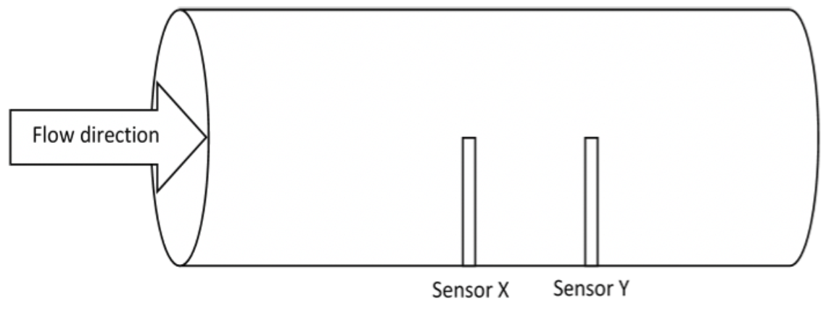
Figure 3.1. A brief scheme of the general CCF method

The target flow goes from left to right, passing two sensors, Sensor X and Sensor Y sequentially. Although Figure 3.1 shows the flow traveling inside the pipe, the CCF technique can measure the flow in free-shear like environments, such as the downcomer in the pool type reactor. Another point that needs to be clarified in Figure 3.1 is the flow direction. In real applications, the flow direction will not be limited to the horizontal direction shown in Figure 3.1. The CCF technique is equally suitable for all the target flow directions, which is regarded as another advantage.

Although some early works applied CCF with two different types of sensors [11][6][53] such as the in-core self-powered neutron noise and core exit temperature noise in [11], later CCF researches with the same type of sensors have better correlation results. There are various sensors selected as the signal sources for the CCF measurement. Researches related to the nuclear industries [7] majorly select the temperature sensor as the signal source because the temperature sensor is more durable, which is the additional advantage of CCF estimation applied in the harsh operating environment. Additionally, thermocouple (TC) is more preferable due to its small response time. Smaller response time is more sensitive to the temperature change which benefits the CCF flow estimation.

When there is a stream of water passing these two temperature sensors, Sensor X and Sensor Y, two sensors will measure the temperature continuously. Figure 3.2 shows two series of simulated signals versus time.

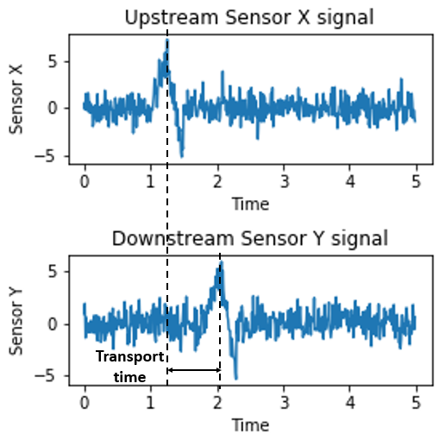
Figure 3.2. Sensor X and Sensor Y signals versus time

Figure 3.2 implies that both two sensors detect some disturbance during this period, and such perturbation might be caused by the normal flow perturbations or any other unexpected correlated noise. The difference is the time step of detecting the perturbation that upstream Sensor X detects the perturbation first at time t₁ and the downstream Sensor Y observes it later at time t₂ due to their geometry locations. As a first guess, the transport time of the perturbation t_{d} could be roughly estimated by the difference between t₁ and t₂:
 | $$t_{d}=t_{2}-t_{1}$$ | (1)
Above Equation (1) can only produce an approximate estimation of the transport time. To obtain more precise transport time, the CCF method is introduced and widely studied in the flow measurement as well as other fields. CCF is based on the correlated signals between the upstream and downstream sensors, which is defined as, z(t). Generally speaking, the correlated signal z(t) contains the true process signal and the correlated noise. The process signal is the signal patterns collected continuously and shared by the two sensors. Taking the temperature sensor as an example, the process signal is equal to the current bulk temperature of the flow measured by this specific sensor. After a certain amount of time, the same temperature pattern will be collected in the downstream sensor. Though those two true signals won’t be the same due to the energy loss, the overall pattern would be equivalent serving as one of the most essential bases for the CCF measurement. On the other hand, the correlated noise describes any other phenomenon than the temperature data which can be accidentally collected as part of the correlated signals and be transported along with the flow just like the process signal. One ideal example in the flow is some small local flow perturbations. Such perturbations could affect the temperature change due to the fluid dynamics, but it is generated randomly and unpredictable. This uncertainty indicates sometimes such correlated noise can contribute to the CCF estimation, sometimes it can’t. In the long run, the major contribution to the CCF flow estimation is the true signal value, and the unpredictable noise mentioned above only has a limited impact on the CCF flow estimation. The next paragraph will discuss the correlated and uncorrelated signals in detail.

In addition to the portion of the correlated signal captured by both of the sensors, each sensor also collects some unique individual signals, which are defined as the uncorrelated noise, n(t). This portion is usually contributed by the individual measurement noise. Specifically, for the Sensor X and Sensor Y shown in Figure 3.2, their signals can be divided into two parts, correlated portion z(t), and uncorrelated portion n(t):
 | $$x\left(t\right)= z\left(t\right)+ n_{x}\left(t\right)$$ | (2)
 | $$y\left(t\right)= c*z\left(t-t_{d}\right)+n_{y}(t)$$ | (3)
In Equation (2) and (3), z(t) is the correlated portion containing both process signal and the correlated noise transporting along the flow direction. c represents a certain amount of loss for the correlated signals due to the transportation between Sensor X and Sensor Y. t_{d} indicates the signal transport time between Sensor X and Sensor Y. n_{x}(t), n_{y}(t) represent each uncorrelated portion with different subscripts. To figure out the real t_{d}, the cross-correlation between x(t) and y(t), R_{xy}(τ), is calculated according to the next Equation (4),

 | $$R_{xy}\left(τ\right)=\frac{1}{T}\int_{0}^{T}{x\left(t\right)y(t+τ)dt}$$ | (4)
T is a certain amount of time large enough to cover the transport time t_{d}. τ is defined as the time lag, which should be great enough to find true transport time. R_{xy}(τ) is CCF value between x(t) and y(t) with transport time τ. Substitute the Equation (3) into the above Equation (4) and eliminate the uncorrelated portion, n_{x}(t) and n_{y}(t) when calculating R_{xy}(τ). The simplified form of R_{xy} is shown below (5):

 | $$R_{xy}\left(τ\right)=\frac{1}{T}\int_{0}^{T}{z\left(t\right)z\left(t-t_{d}+τ\right)dt=R_{zz}(τ-t_{d})}$$ | (5)

In the above Equation (5), R_{xy} is a function that is only based on the z(t), the combination of the process signal and correlated noise, and the true transport time t_{d}. The simplified R_{xy} can be regarded as the autocorrelation function of z(t) that also incorporates the delay time t_{d}. In other words, R_{xy} reaches the maximum when the term (τ – t_{d}) is equal to zero. The relationship between the R_{xy} and time lag τ is plotted in Figure 3.3 for the simulated data in Figure 3.2. The R_{xy} curve is used to estimate the target t_{d} by searching for the maximum of R_{xy}. Later, using synthetic data simulation, the feasibility of the CCF estimation is evaluated as well.

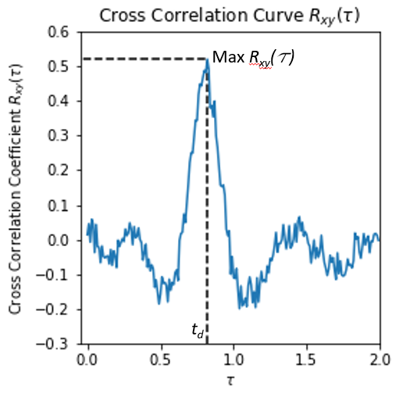
Figure 3.3. Cross Correlation between Sensor X and Sensor Y signals

One major issue for the CCF flow estimation is that the peak of the R_{xy} curve is not very obvious in practice. The main reason is that the unnecessary uncorrelated noise contaminates Equation (5). How to avoid this and improve the CCF estimation will be discussed in detail using synthetic data in the next Synthetic Signal Correlation Simulation section. The investigating of fluid injection is motivated by the ability to be better to identify peaks in the R_{xy} curve.

Another point that needs to be examined is that the resolution of the R_{xy} curve. The unit of the time lag τ in above Figure 3.3 has already been represented by the time unit just to illustrate how the CCF estimation works. Actually, the raw R_{xy} curve versus the time lag τ is a series of discrete data calculated from the separate sensor signals, and its time lag τ between the two sensors is represented by the number of samples collected within that given time lag τ. The estimation of the maximum value of the R_{xy} curve is restricted by the sampling frequency of the sensors. The larger the sampling frequency is, the more samples are collected within the fixed time duration and the higher accuracy the t_{d} is. The t_{d} is given by Equation (6).
 | $$t_{d}=\frac{n_{sample}}{f}$$ | (6)
where, n_{sample} is the number of samples which are successfully collected within the time t_{d}, and f is the sampling frequency of the sensor. Although reference[42] points out that the sampling frequency of the signals as the variables to the CCF should not be too large due to the oversampling issues, most researchers ([6], [32], [41], [42], [48]) suggest that the large sampling frequency could yield better transport time t_{d} estimation. One possible way to increase the sampling frequency is to apply the linear interpolation on the raw sensor signals by Equation (7):

 | $$T_{new}=T_{0}+(t_{new}-t_{0})\frac{T_{1}-T_{0}}{t_{1}-t_{0}}$$ | (7)

Where, T₀ and T₁ are the original sensor signals at time t₀ and t₁ respectively, t_{new} is the time of the new interpolated signal, manually selected from the time interval (t₀, t₁), T_{new} is the new linear interpolation signal. The increased sample rate of the new signal depends on how many segments are manually divided within (t₀, t₁). Later results show that linear interpolation benefits the CCF flow estimation.

After obtaining the transport time t_{d}, the target volumetric flow rate $\dot{V}$ is calculated by the known distance D₂ between the two sensors divided by t_{d} as follows:

 | $$\dot{V}=\frac{D_{2}A}{t_{d}}$$ | (8)
In Equation (8), ρ is the flow density, D₂ is the distance between the two sensors, A is the cross section area of the flow region. The distance D₂ between the two sensors is one important parameter for the CCF technique. Many papers have already discussed how the D₂ influences the accuracy of the CCF technique. Some papers suggest the distance D₂ should not too large or too small [6] [42]. Sisbot [52] concluded that the distance D₂ should be as small as the physical structure allows, especially when the target flow rate is small. The optimal distance D₂ for CCF flow estimation varies among the different types of the process flow, the flow rate, the pipe diameter or the geometry structure, and other factors. The parameters to be optimized include the distance D₂ as well as other parameters to be discussed in detail in the experiment and CFD simulation chapters.

Before investigating those parameters, a further investigation on the signal itself is needed to explore why the uncorrelated noise affects the CCF estimation and how to resolve this issue. A series of Synthetic data are simulated to reveal this explicitly next.

Synthetic Signal Correlation Simulation

The signal is composed of two major parts, the correlated portion, and uncorrelated portion. And Equation (5) indicates that the calculated R_{xy} eliminates the uncorrelated portion and it is only related to the process signal and correlated noise in the analytical inference. Given that the process signal is usually stable during the normal operation, stronger correlated noise benefits the CCF flow estimation. However, in practice, the uncorrelated noise of the two sensors is not completely independent and there is some unnecessary correlation randomly existed due to the flow behavior, which introduces unexpected errors when calculating the R_{xy}. Therefore, larger correlated noise and smaller uncorrelated noise are the two major methods to improve the CCF technique based on the above statement. The following will illustrate and verify it by the synthetic signal data simulation.

Feasibility of CCF estimation
Before verifying the relationship between the CCF estimation and the correlated noise and uncorrelated noise, the feasibility of CCF estimation needs to be evaluated as well. Firstly, two synthetic signals SS1 and SS2 are generated based on Equations (9) and (10):

 | $$SS1 = 0.5×sin(7t)+n_{p} (t)+n_{1}$$ | (9)
 | $$SS2 = 0.5×sin\left(7(t+0.6)\right)+n_{p}(t+0.6)+n_{2}$$ | (10)
The above two synthetic signals are composed of three parts:
- Process signal: a sine wave$sin(7t)$
- Correlated noise: represented by n_{p}, suggesting some random process noise is transporting along with the flow
- Uncorrelated noise: represented by n₁ and n₂ respectively for SS1 and SS2.

n_{p}, n₁, and n₂ are generated from a normal distribution with different mean and variance indicating how noisy they are and used to be compared and evaluated later. The transport time t_{d} in Equation (6) is 0.6. The sampling frequency for the synthetic data is 1000 Hz and the simulation runs for 3 seconds. Next Figure 3.4 shows the synthetic data with true signal value only.

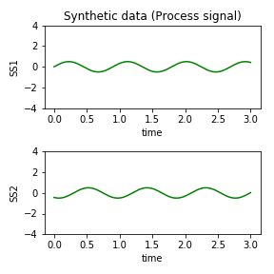
Figure 3.4. Synthetic signals only with a true signal value

Comparing SS1 and SS2 could state that SS2 follows SS1 clearly with transport time around 0.5 s. Figure 3.5 shows the signals with additional correlated noise.

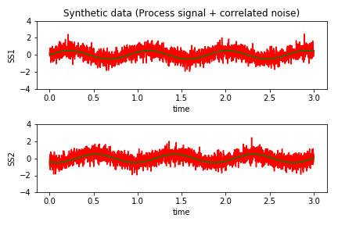
Figure 3.5. Synthetic signals with process signal

Figure 3.5 shows the original clean signals combined with the generated correlated noise. A similar signal trend could still be observed, but not very clear as the one shown before. The final plot shows the signal with all the three parts in Figure 3.6.

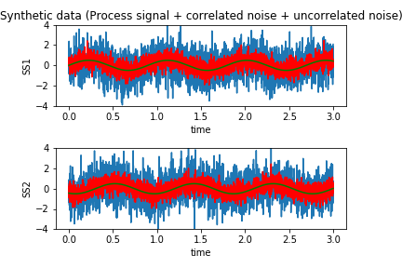
Figure 3.6. The complete Synthetic signals

Compared with the previous two Figure 3.4 and Figure 3.5, Figure 3.6 suggests it is a bit hard to discriminate the transport pattern between the sensors. The correlated and uncorrelated noise in these two figures is generated from a normal distribution with a mean of 0 and a variance of 1.

According to Equation (5), finding the maximum value of the CCF curve same as Figure 3.3 is to identify the transport time shown in Figure 3.7.

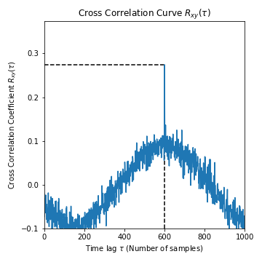
Figure 3.7. Cross-correlation R_{xy} versus time lag τ

There is significant maximum value on the CCF R_{xy} curve at the time lag of 600 samples. Recall Equation (6), the time lag is inferred by the number of samples that could be collected during this period. Given the sampling frequency of 1000 Hz, it is easy to infer that the time lag is 0.6 s, which correctly matches the value in Equation (10).

The above results verify the feasibility of the CCF on estimating the transport time. The next study is focused on the relationship between the CCF estimation and the correlated noise and uncorrelated noise.

Influence of correlated and uncorrelated noise on CCF
Before investigating how the correlated and uncorrelated noise affects CCF, Signal to Noise Ratio (SNR) is defined in the below Equation (11):

 | $$Signal To Noise Ratio=\frac{Correlated portion}{Uncorrelated Noise}$$ | (11)
The SNR is equal to the magnitude of the correlated portion divided by the uncorrelated noise. The previous statement based on the Equation (5) is that smaller uncorrelated noise and larger correlated noise give better CCF estimation. In terms of the SNR, the larger SNR gives a better CCF estimation. Implementation of the synthetic data reveals this relationship between the SNR and CCF estimation.

The magnitude of the correlated noise and uncorrelated noise is identified by the variance of the normal distribution used for the noise generation. Larger variance suggests more fluctuation noise added to the signals. The same synthetic signals as the previous one shown in Equation (9) and (10) are applied here, with the simulated sampling frequency of 1000 Hz and the transport time of 0.6 s (t_{true}). Each case repeats for 1,000 trails to alleviate the variance influence. Below Figure 3.8 shows the cross-correlation curve with 4 different SNR.

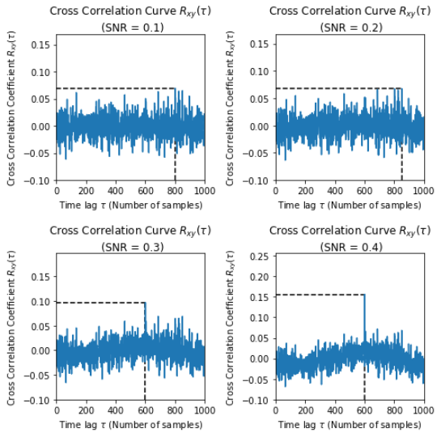
Figure 3.8. Cross Correlation Curve with 4 different SNR (0.1, 0.2, 0.3, 0.4)

When the SNR is small (first two cases), there is no obvious peaks observed from the figure, so the estimated sample number is not the true value (600). With the increment of the SNR, the peak of the cross-correlation curve get easier to be observed. The true delay time can be correctly estimated.

Besides the above 4 cases, a series study with a wide range of SNR is conducted, that the SNR is increased from 0 to 1. The metric used to evaluate the accuracy of the CCF estimation is the RMSE (Root Mean Square Error) in Equation (12),

 | RMSEMAPE=11000i=11,000(tpredi-ttrue)2i=11,000|tpredi-ttrue|ttrue | (12)

where $t_{pred}^{\left(i\right)}$is the transport time predicted by the CCF flow estimation in i^{th} trial, while t_{true} is the true transport time of 0.6 seconds. Table 3-1 and Figure 3.9 give the CCF performance of each case with different SNR. The results show that an increase in the SNR produces a smaller RMSE. Figure 3.9 shows the RMSE decreases dramatically once the SNR increases above 0.3. Although the SNR is estimated based on the variance of the noise, which is not strictly correct in practice, it reveals the relationship between the SNR and the CCF estimation performance. It is reasonable to expect that the smaller uncorrelated noise or the larger correlated signal can produce a better CCF flow rate estimation.

Table 3-1. SNR Results for Time Domain Synthetic Signals
SNR (Process/Measure) | Average Time Estimate*  (seconds) | RMSE*  (seconds)
0 | 0.697 | 0.198
0.1 | 0.651 | 0.225
0.2 | 0.733 | 0.192
0.3 | 0.604 | 0.051
0.4 | 0.599 | 0
0.5 | 0.6 | 0
0.6 | 0.6 | 0
0.7 | 0.6 | 0
0.8 | 0.6 | 0
0.9 | 0.6 | 0
* Each range or average is the result of 1,000 trials.

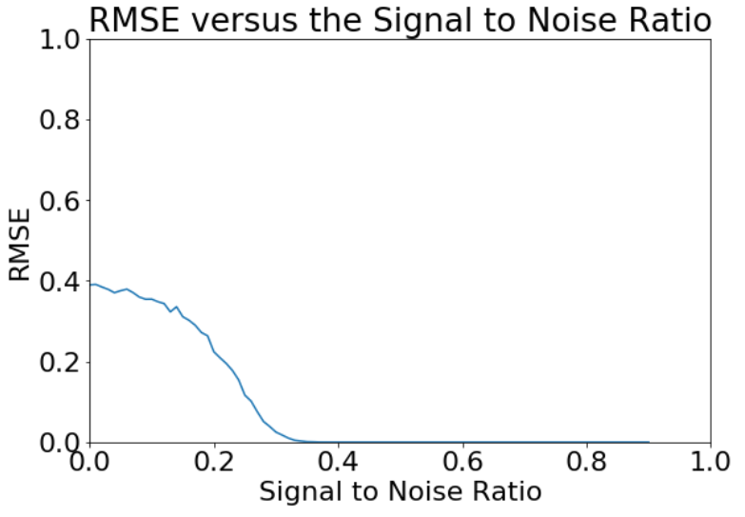
Figure 3.9. Average RMSE versus the SNR

There are two ways to increase the SNR: one is to decrease the uncorrelated noise, and another is to increase the correlated noise. The uncorrelated noise is determined by the sensor’s measurement instrumentation, which is usually restricted by its brand type and manufacturing. The uncorrelated noise is generally not easily reduced once the sensors are installed. On the other hand, the correlated noise represents some perturbation traveling along the flow direction. The correlated noise originally is formed by the randomly generated disturbance, such as small perturbation transported along with the flow. Such arbitrary perturbation is not reliable and won’t contribute a lot to the CCF estimation. Thus, it is natural to introduce the extra perturbation into the flow to increase the correlated noise term such as a flow injection. One paper implemented an additional heater to change the flow temperature before the temperature sensor to increase the magnitude of the correlated noise [8]. This heater implementation works well and their results show that with less than 10 % normalized mean square error when the target flow rate is low around 0.5 GPM. However, when the target flow rate is increased up to 3 GPM, the normalized mean square error goes nearly up to 20 %. This implementation does not work well under the larger flow. For broader applications, this research proposes a new CCF based technique with the fluid injection to improve flow estimation during various flow velocities. The volumetric flow rate is linearly related to the flow velocity given the same cross section area. Therefore, the estimation target is the volumetric flow rate, ranging from 40 GPM to 170 GPM (approximately 2.5 x 10⁻³ m³/s to 1.1 x 10⁻² m³/s).

Fluid injection Implementation

This research work proposes an innovative method to introduce extra correlated noise into the original signals by implementing the heated water injection before two sensors. The implementation is briefly shown in Figure 3.10, which shows there is a new injection pipe D₁ distance away from the first Sensor X, and an amount of higher temperature water is periodically injected in the main flow of the pipe. With the perturbation due to the flow injection, the following Sensor X and Sensor Y would collect significantly correlated noise for CCF flow estimation. The raw correlated noise only contains the arbitrary temperature change caused by the internal flow. Additional periodically injected water package could increase the magnitude of the correlated noise, and it makes the process signals more observable and controllable. Compared with the heater implementation in [8], the injected amount of water could have a greater impact on local temperature distribution in the pipe. The injected fluid can directly pass the two sensors, which will be observed experimentally with colored injected dye. Besides the injection flow rate, other variables are investigated and optimized to improve the CCF flow estimation, summarized in Table 3-2:

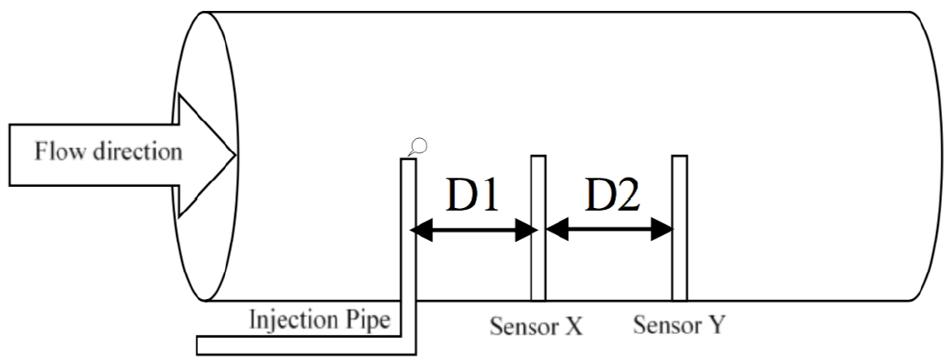
Figure 3.10. Proposed CCF flow estimation

Table 3-2. Six variables to be investigated for CCF flow estimation
 | 6 variables to be optimized | Units (SI unit)
D₁ | Distance between the injection pipe and the 1st sensor | Inch (m)
D₂ | Distance between two sensors | Inch (m)
P_{inj} | Injection pressure | PSI (Pa)
T_{inj} | The temperature of the infection flow | °F (K)
t_{off} | Injection-off time in one period | s
t_{on} | Injection-on time in one period | s

D₁ indicates how far the injection pipe is away from the first sensor X. A large D₁ would let the injected fluid gain momentum and reach the same speed as the fluid stream, but may allow too much mixing, potentially diminishing the correlated signal component seen by the sensors. D₂ is the distance between the two sensors. Xiaodong, Zhenxi, and Jijun [154] suggested that the optimized D₂ should be three times the diameter of the pipeline in the pipe based system. The following experiment results match this statement. P_{inj} and T_{inj} are the injection pressure and the temperature of the injected fluid, both affecting the magnitude of the correlated signal injected into the flow stream. Larger injection pressure will produce higher injection flow, which can introduce more perturbation. In the physical experiment, the volume of the injected fluid package is controlled by the injection pressure P_{inj} and categorized by three pressure levels: high, medium, and low. Figure 3.11 shows the last two parameters t_{off} and t_{on} for the period of the injection flow. t_{off} indicates how long each period is without injection, and t_{on} indicates how long the fluid is injected during each period. t_{off} and t_{on} form an entire injection period t_{period}.

 | $$t_{period}=t_{off}+t_{on}$$ | (13)
A longer t_{off} with fixed t_{on} suggests a longer interval between each injection. A longer t_{on} means more fluid is injected for each injection period.

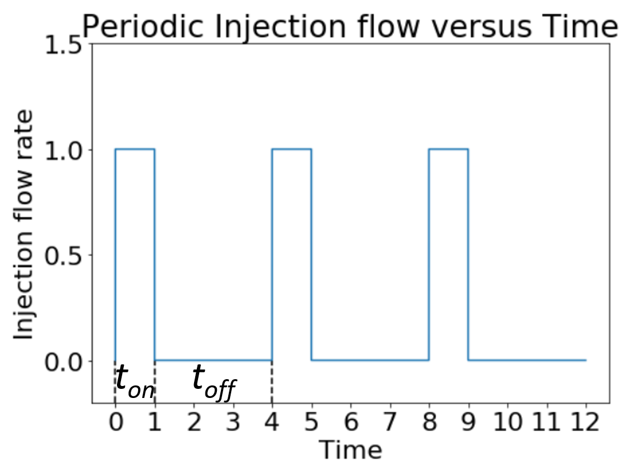
Figure 3.11. Injection flow versus Time

Investigation on Water Injection Implementation

Based on the SNR analysis of the synthetic data, increasing the correlated noise could benefit the CCF flow estimation. Injecting heated water before the sensors to increase the system correlated noise is proposed in this research work. Before implementing the CCF flow estimation in a real physical flow loop, an early study based on the CFD simulation campaign is needed to guide how to set up the flow measurement. It is expensive and time-consuming to evaluate all the 6 variables purposed in Table 3-2 in the experiment flow loop. It is possible to identify what variables are not sensitivity variables through the CFD simulations. The following section is introducing this early CFD study in detail.

Early CFD study

To determine which of the six variables listed in Table 3-2 influences the overall accuracy of the CCF method the most and which configuration could give a relatively precise measurement, several CFD models were developed in Autodesk CFD software [155]. These separate models use different combinations of the defined variables. For each model, one of these dependent parameters is varied while the other five are held constant. This procedure is used to determine if varying these independent variables has any effect on the efficacy of the CCF method. After these different configurations are set up into each developed model, a transient event with a specific flow rate is applied for five injection periods. The sampling frequency used for all cases is 100 Hz since the sampling frequency of the temperature sensors available for the flow loop is 100 Hz as well.

The flow section shown in Figure 3.10 was simulated using the Autodesk CFD software under ideal conditions with the main flow temperature set to 80 °F (300 K) and at 1 atm pressure (101325 Pa).
nsample,true=D2AfVtrue

Simulations have been carried out for both cold and hot injection water studies. For brevity, the hot injection results are shown due to the results are identical whatever the hot or cold injection is selected. The results are listed in Table 4-1.

Table 4-1. CCF method results (Sampling Frequency (f) = 100Hz, Hot injection flow)
Case | D₁ | D₂ | m_{inj} | t_{off} | t_{on} | T_{inj} | True flow | CCF flow
 | Inch | Inch | GPM | s | s | F | GPM | GPM
1 | 0.5 | 2 | 0.05 | 3 | 1 | 100 | 52.46 | 52.46
2 | 1 | 2 | 0.05 | 3 | 1 | 100 | 52.46 | 52.46
3 | 2 | 2 | 0.05 | 3 | 1 | 100 | 52.46 | 52.46
4 | 3 | 2 | 0.05 | 3 | 1 | 100 | 52.46 | 52.46
5 | 4 | 2 | 0.05 | 3 | 1 | 100 | 52.46 | 61.20
6 | 5 | 2 | 0.05 | 3 | 1 | 100 | 52.46 | 52.46
7 | 6 | 2 | 0.05 | 3 | 1 | 100 | 52.46 | 91.80
8 | 2 | 0.5 | 0.05 | 3 | 1 | 100 | 13.11 | 11.47
9 | 2 | 1 | 0.05 | 3 | 1 | 100 | 26.23 | 26.23
10 | 2 | 2 | 0.05 | 3 | 1 | 100 | 52.46 | 52.46
11 | 2 | 3 | 0.05 | 3 | 1 | 100 | 78.69 | 91.80
12 | 2 | 2 | 0.02 | 3 | 1 | 100 | 52.46 | 61.20
13 | 2 | 2 | 0.05 | 3 | 1 | 100 | 52.46 | 52.46
14 | 2 | 2 | 0.08 | 3 | 1 | 100 | 52.46 | 52.46
15 | 2 | 2 | 0.05 | 2 | 1 | 100 | 52.46 | 52.46
16 | 2 | 2 | 0.05 | 3 | 1 | 100 | 52.46 | 52.46
17 | 2 | 2 | 0.05 | 4 | 1 | 100 | 52.46 | 52.46
18 | 2 | 2 | 0.05 | 3.5 | 0.5 | 100 | 52.46 | 52.46
19 | 2 | 2 | 0.05 | 3 | 1 | 100 | 52.46 | 52.46
20 | 2 | 2 | 0.05 | 2.5 | 1.5 | 100 | 52.46 | 52.46
21 | 2 | 2 | 0.05 | 3 | 1 | 90 | 52.46 | 52.46
22 | 2 | 2 | 0.05 | 3 | 1 | 100 | 52.46 | 52.46
23 | 2 | 2 | 0.05 | 3 | 1 | 110 | 52.46 | 52.46

In cases 1 to 7, D₁ varies from 0.5 to 6 inches. Recall that this variable is the distance from the injection point to the first sensor. Models with small values of D₁ indicate that the CCF was accurate in obtaining flow measurement. The likely reason is due to the more heat loss with larger D₁ corresponding to an attenuation of the injected flow’s signal. Losing too much heat means less correlated noise adding to the main flow, causing the poor CCF flow estimation. Next, D₂ is a critical variable because the calculation of the flow rate using the CCF is directly related to D₂. In cases 8 to 11, D₂ is varied, and the results indicate that sensors placed very close or far apart will yield poor flow estimates using the CCF method. In cases 12 to 14, the results show that a small volume of the water injected would return unreliable flow estimates. It is due to a smaller perturbation added to the main flow to increase enough correlated noise for accurate CCF flow estimation. Last, cases 15 to 23 indicate that varying the parameters t_{off}, t_{on}, and T_{inj} did not impact the CCF results. Based on these results, further physical experiments should be carried out that vary the distances between injection point, sensor location, and the volume of water injected.

Next, case 3 in Table 4-1 is chosen for this further analysis by varying the true main flow rate while keeping all other simulation parameters constant. The n_{sample,true} was determined using Equation (6) and (8). This step is performed to determine if sensors, injection points, and volumes are fixed, what ranges of flow rates can be accurately estimated by the CCF technique, shown in Table 4-2.

Table 4-2. Results based on the configuration of Case 3 with a different main flow rate
Case | D₁ | D₂ | m_{inj} | t_{off} | t_{on} | T_{inj} | True flow |  | CCF flow
 | Inch | Inch | GPM | s | s | F | GPM | GPM
1 | 2 | 2 | 0.05 | 3 | 1 | 100 | 91.800 | 91.800
2 | 2 | 2 | 0.05 | 3 | 1 | 100 | 73.440 | 73.440
3 | 2 | 2 | 0.05 | 3 | 1 | 100 | 61.200 | 61.200
4 | 2 | 2 | 0.05 | 3 | 1 | 100 | 52.457 | 52.457
5 | 2 | 2 | 0.05 | 3 | 1 | 100 | 45.900 | 45.900
6 | 2 | 2 | 0.05 | 3 | 1 | 100 | 40.800 | 45.900
7 | 2 | 2 | 0.05 | 3 | 1 | 100 | 36.720 | 40.800
8 | 2 | 2 | 0.05 | 3 | 1 | 100 | 33.382 | 36.720
9 | 2 | 2 | 0.05 | 3 | 1 | 100 | 30.600 | 33.382
10 | 2 | 2 | 0.05 | 3 | 1 | 100 | 28.246 | 30.600

Table 4-3. Same Table as Table 4-2 with SI unit
Case | D₁ | D₂ | m_{inj} | t_{off} | t_{on} | T_{inj} | True flow | CCF flow
 | Inch | Inch | m³/s | s | s | K | m³/s | m³/s
1 | 0.0508 | 0.0508 | 3.15x10⁻⁶ | 3 | 1 | 310 | 5.79x10⁻³ | 5.79 x10⁻³
2 | 0.0508 | 0.0508 | 3.15x10⁻⁶ | 3 | 1 | 310 | 4.63 x10⁻³ | 4.63 x10⁻³
3 | 0.0508 | 0.0508 | 3.15x10⁻⁶ | 3 | 1 | 310 | 3.86 x10⁻³ | 3.86 x10⁻³
4 | 0.0508 | 0.0508 | 3.15x10⁻⁶ | 3 | 1 | 310 | 3.31 x10⁻³ | 3.31 x10⁻³
5 | 0.0508 | 0.0508 | 3.15x10⁻⁶ | 3 | 1 | 310 | 2.90 x10⁻³ | 2.90 x10⁻³
6 | 0.0508 | 0.0508 | 3.15x10⁻⁶ | 3 | 1 | 310 | 2.57 x10⁻³ | 2.90 x10⁻³
7 | 0.0508 | 0.0508 | 3.15x10⁻⁶ | 3 | 1 | 310 | 2.32 x10⁻³ | 2.57 x10⁻³
8 | 0.0508 | 0.0508 | 3.15x10⁻⁶ | 3 | 1 | 310 | 2.11 x10⁻³ | 2.32 x10⁻³
9 | 0.0508 | 0.0508 | 3.15x10⁻⁶ | 3 | 1 | 310 | 1.93 x10⁻³ | 2.11 x10⁻³
10 | 0.0508 | 0.0508 | 3.15x10⁻⁶ | 3 | 1 | 310 | 1.78 x10⁻³ | 1.93 x10⁻³

In Table 4-2, 10 separate cases are simulated using different flow rates ranging from 30 GPM up to 91 GPM. In cases 1 to 5, the CCF method can accurately estimate the true flow rate, which ranged from 45.9 to 91.8 GPM. However, for flow rates below 40 GPM, the CCF is unable to arrive at the correct flow rate. For example, case 6 used an actual flow rate of 40.8 GPM and the CCF method returned a value of 45.9 GPM, a difference of 5.1 GPM. While the difference of 5.1 GPM may not seem like a large error, actions taken in the NPP that are based on this error would cause a loss of efficiency. A possible reason for the deviation of these five cases is that the flow rate is too slow and maybe mixing occurs and reduces the temperature variations. Another reason could be that all the flow in Table 4-2 are turbulent flow and local eddies introduce random turbulence, which impacts the transport time estimation by CCF. . Possibly, sensors that have a higher sensitivity to temperature changes, such as RTDs, can be used instead of thermocouples to determine if these sensors provide better information for the CCF method. However, the faster response time of thermocouples would be more important than sensitivity to temperature changes. With fast response time, the thermocouples could collect more potential intricate perturbation beneficial to increasing the correlated noise. In later experiments, the thermocouples are selected as the working sensors for the CCF flow estimation.

As mentioned previously, one issue seen in the CCF method is that only integer values of time lag τ can be used to arrive at flow estimation. For some flow regimes or rates, this can lead to very inaccurate answers. This also means that only limited flow cases can use the CCF method. For example, for a 50 GPM flow rate, the correct delay sampling number calculated from Eqn. (4) is 7.34. The CCF estimate for this flow rate can only produce 7, which returns a flow rate of 52.46 GPM, a noticeable difference from the actual value. A faster sampling rate would result in better flow resolution. Later the linear interpolation method is applied to the raw signals collected from an experiment flow loop to increase the sampling frequency and alleviate this issue.

Above Autodesk CFD simulations can be used as early-stage guidance for designing CCF–based inferential flow measurement experiments. The most relevant variables found to influence the CCF method were the distance from the injection pipe to the first sensor (D₁), the distance between sensors (D₂), and the volume of water injected (m_{inj}). Initial results show that injection points placed too close or at a relatively large distance away from the first sensor would cause the CCF method to return inaccurate flow rate values. Also, the distance between sensors was found to be important, as sensors located at larger distances provided no useful information for the CCF method. This indicates that the transient caused by the injection activities has been masked by the fluid dynamics once it reaches the second sensor and therefore provided an unreasonable or unattainable value for the transport time. Finally, the volume of water injected was also an important variable, as low volume injections would be "lost" or attenuated in the main flow before being observed by the first temperature sensor.

Experiment Flow loop

The CFD simulation results [156] provide a preliminary guideline for the physical flow loop setup. To support this study, a forced circulated flow loop was developed and is shown in Figure 4.1. The flow loop is mainly constructed of 3-inch diameter PVC piping. The pump located in the lower middle of Figure 4.1 is a 7.5 horsepower Bell and Gossett pump. This 7.5 HP pump is controlled by a Schneider Electric Variable Frequency Drive (VFD), located adjacent to the pump. The VFD adjusts the pump speed from 15 Hz up to 60 Hz, which covers flow rates ranging from 80 GPM to 160 GPM. The water is driven by the pump through the flow loop and can be controlled even further by a control valve located at the pump output. The manual control valve is used to decrease the main flow rate to values smaller than 80 GPM, to around 38 GPM in this research. After passing through the control valve, the water flows through a repetitive U-turn section of piping. This section aims to reabsorb most air bubbles generated by pump cavitation when the flow rate is relatively high. After the U-turn section, the flow goes into the horizontal test section where fluid injection and sensors are located.

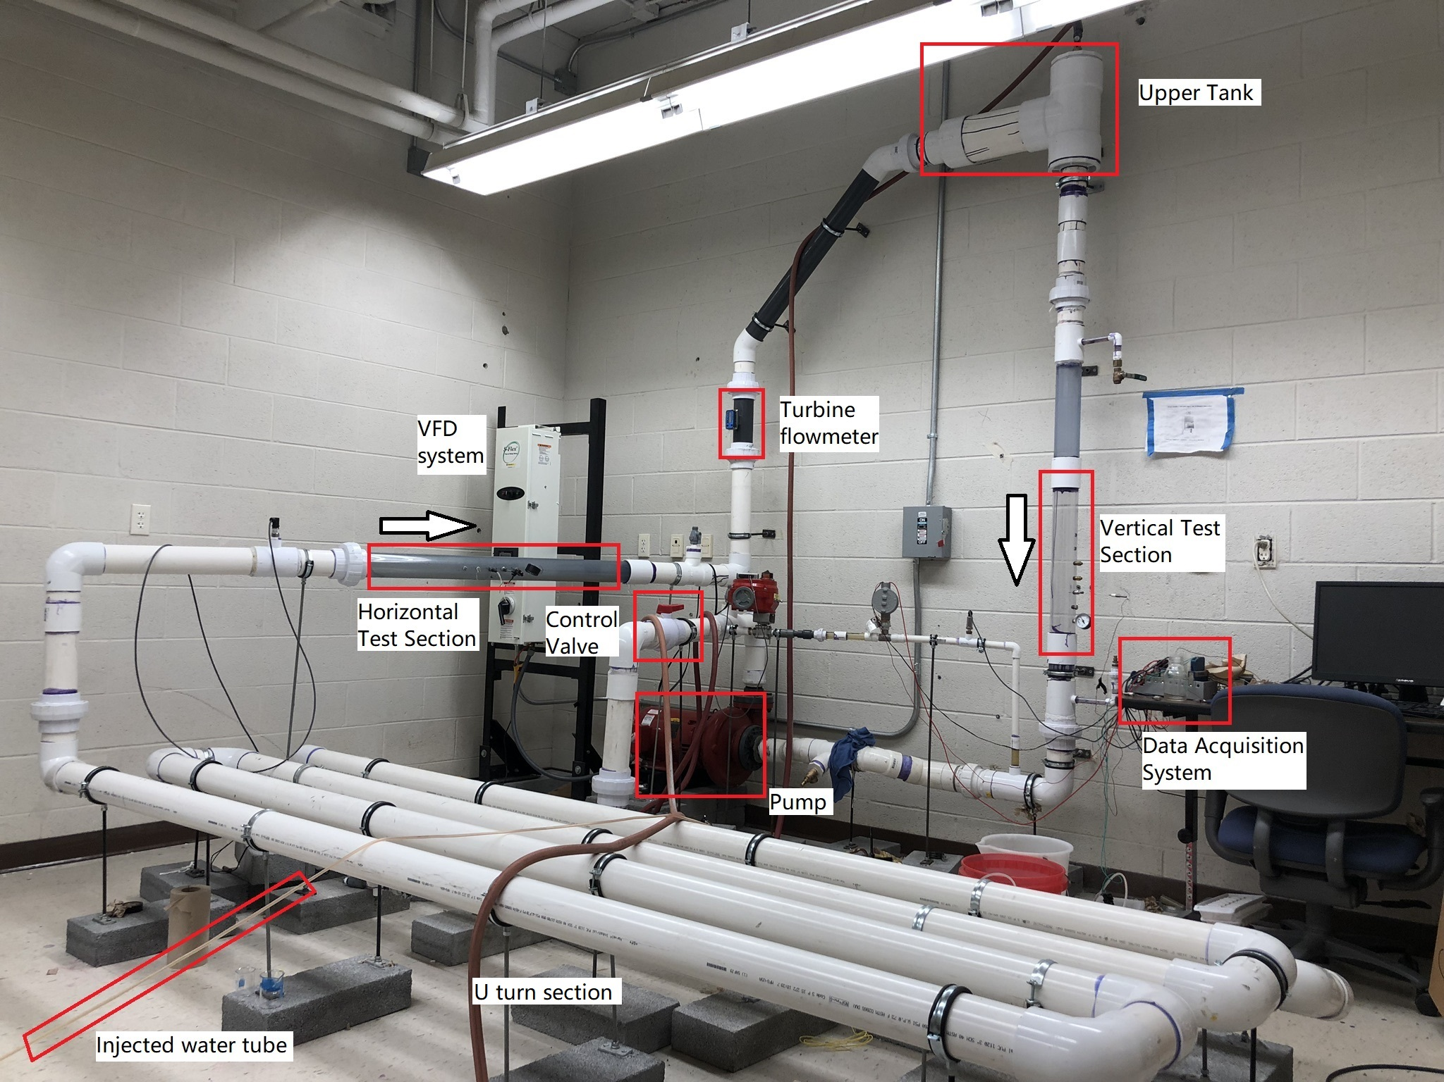
Figure 4.1. The scheme of the physical flow loop

Figure 4.2 shows the CCF flow sensor implementation along the horizontal pipe. The flow direction is horizontal from right to left. The first penetration along the flow direction is for the fluid injection. After the fluid injection, there are five potential locations used for the temperature sensor installment. These five locations are evenly distributed with a distance of 2 inches allowing for many combinations of D₁ and D₂. Following the five temperature sensor locations, there is a pressure gauge indicating the internal pressure to make sure the flow loop does not become over pressured due to injecting additional fluid into the system.

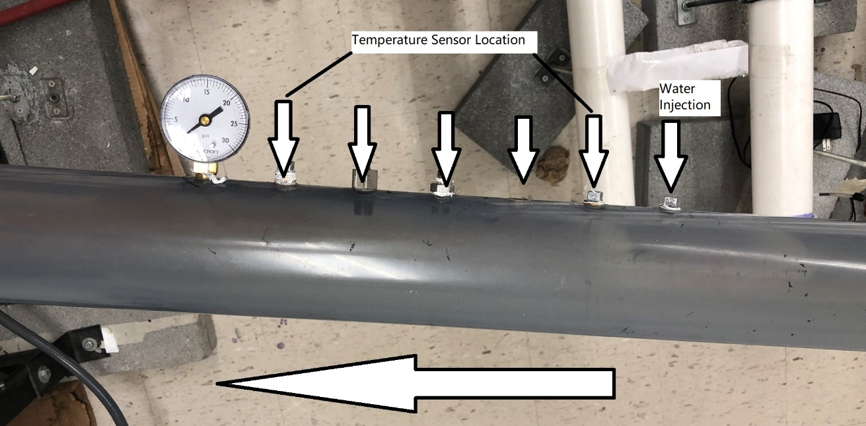
Figure 4.2. A detailed image of the horizontal test section

To control the volume of the injected water and differentiate the temperature from the main flow, a pressure control valve and a copper coil heat exchanger are installed as shown in Figure 4.3. The red bucket is filled with ice cubes and the copper coil heat exchanger cools the injected water as it flows to the injection site. The temperature of the injected volume of water is nominally around 12 °C. The volume of the injected water is regulated by a manually operated pressure control valve located downstream of the copper coil heat exchanger. The pressure control valve is used regulate the injected volume of water to three levels: high, medium, and low, indicated by the pressure estimated in Table 4-4. These injection volumes are determined by the difference between the injection pressure and the system pressures shown on the gauge in Figure 4.3. The injected flow velocity is inferred by averaging the volume of the 4 injections.

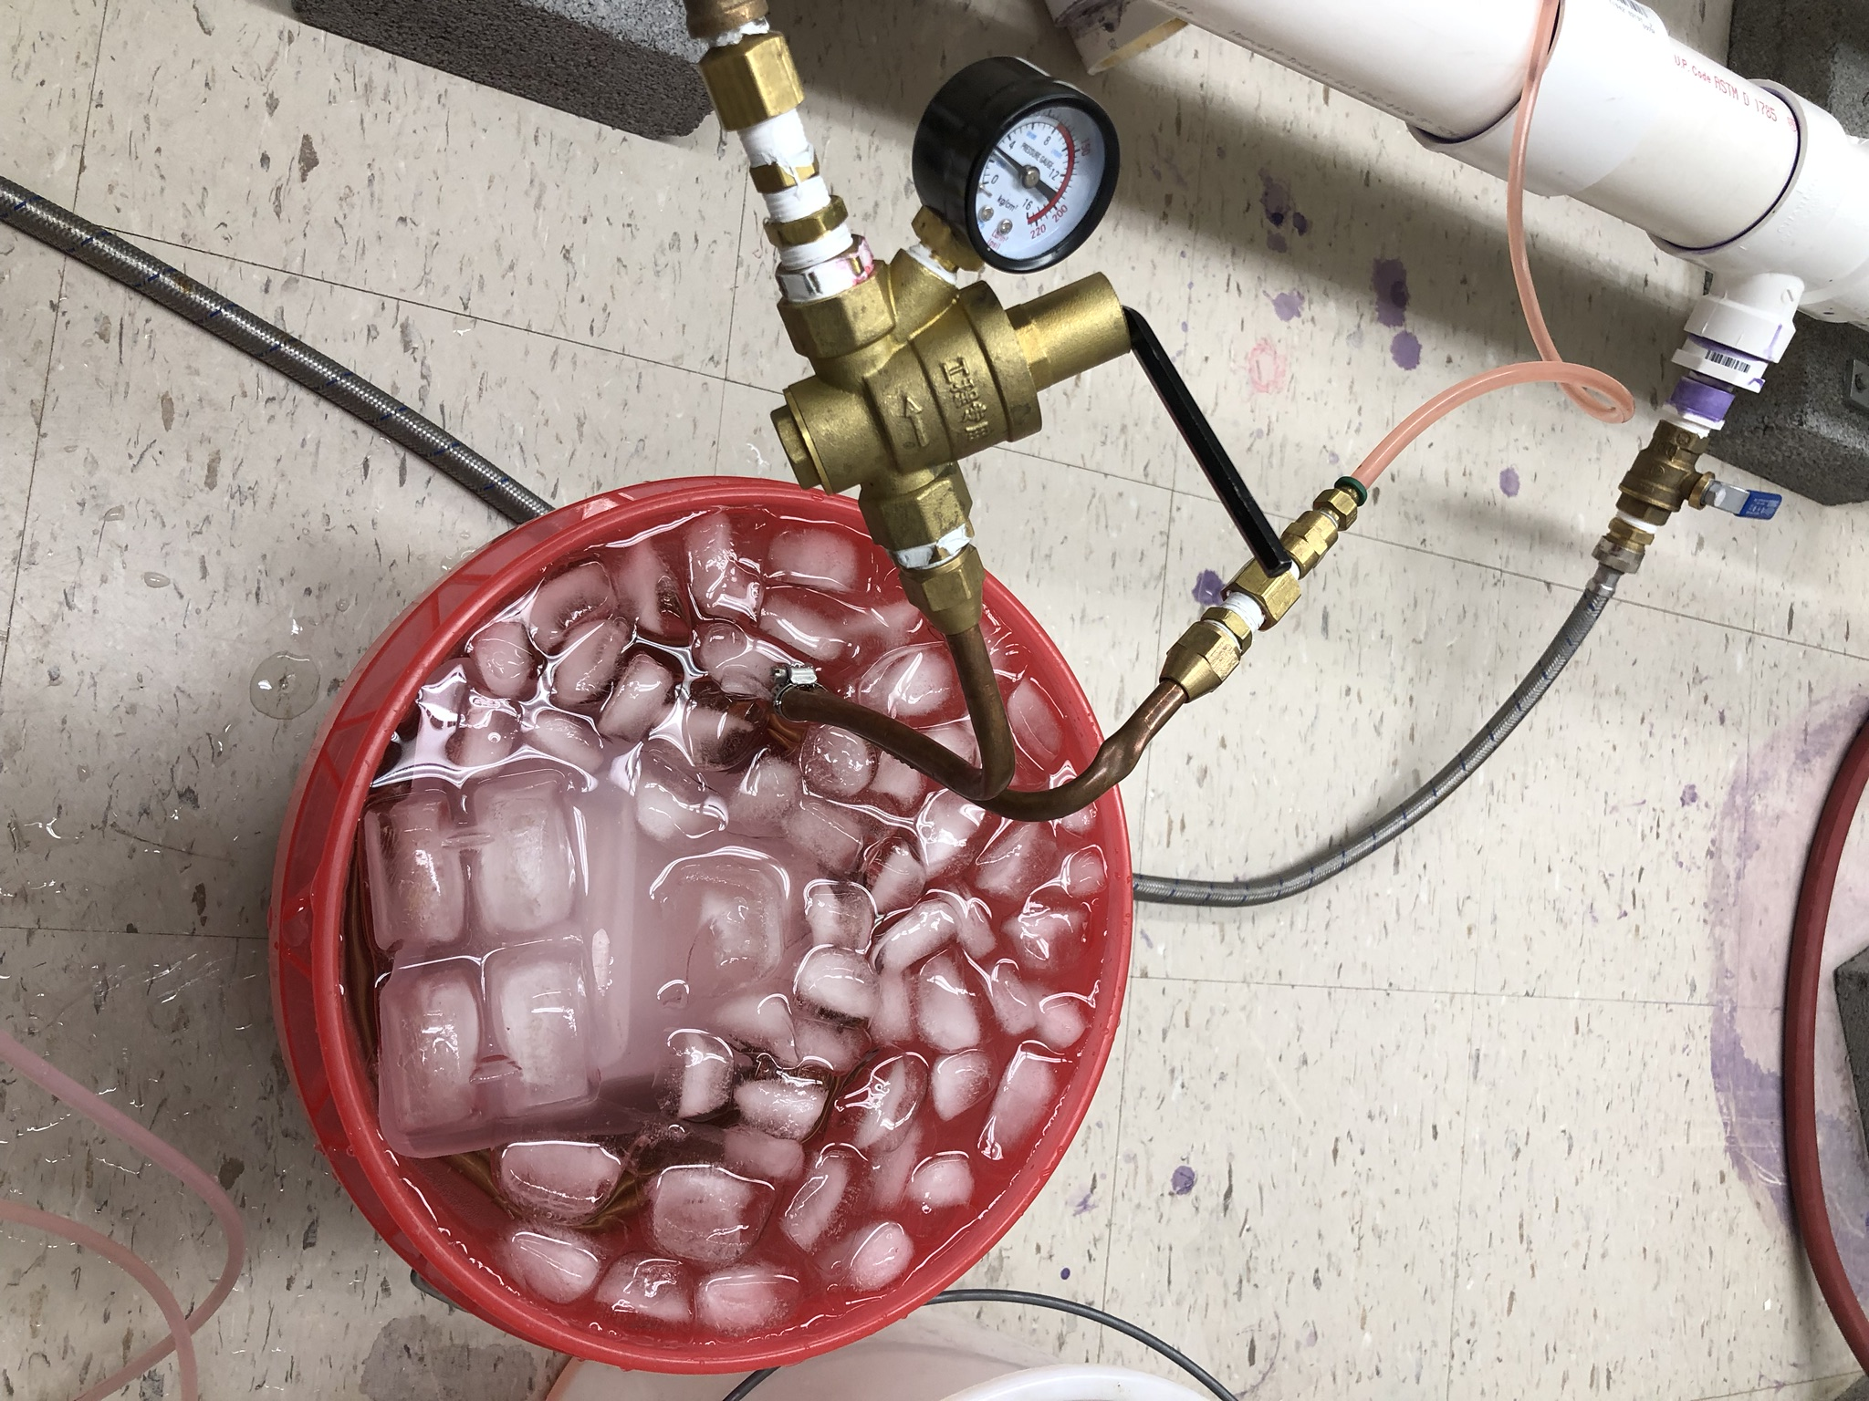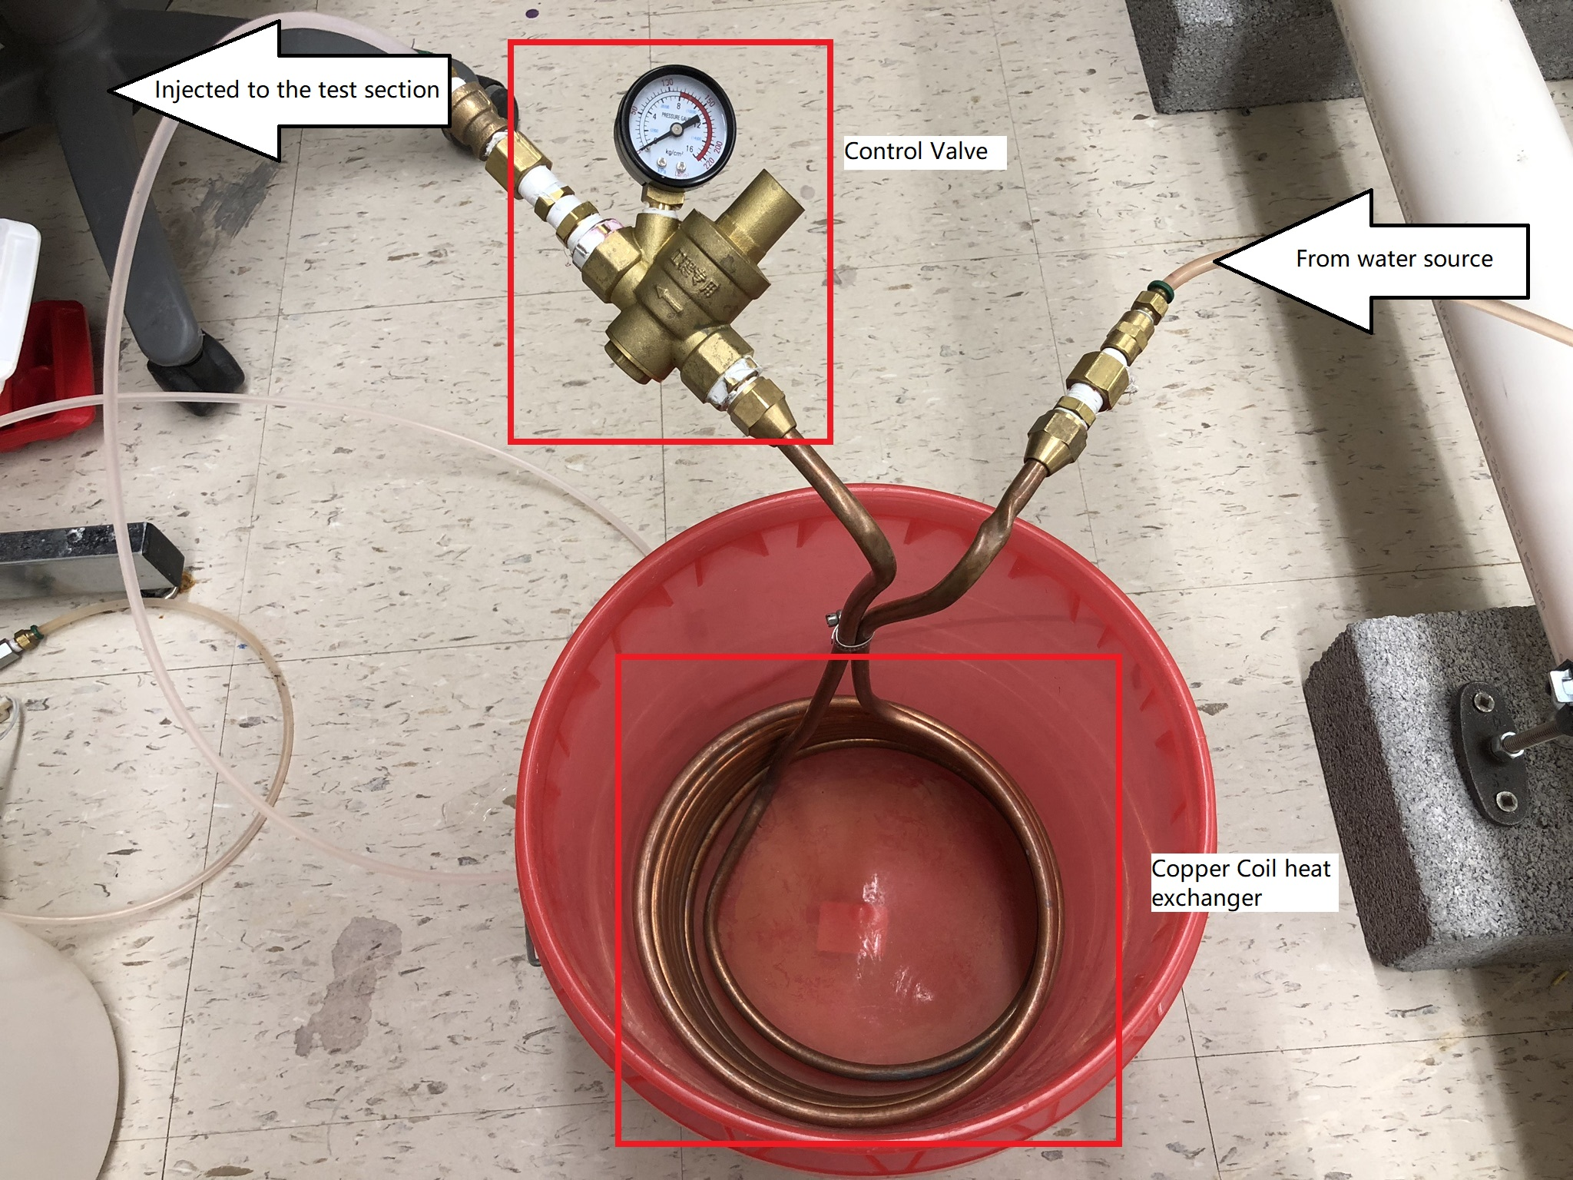
Figure 4.3. Injected water package control system

Table 4-4. Estimation of volume of the injected water package
 | High (70~80 psi) | Medium (40~50 psi) | Low (20~30 psi)
Volume for 4 injections (cm³) | 185 ± 5 % | 165 ± 5 % | 100 ±5 %
Average volume for each injections (cm³) | 46.25 | 41.25 | 25
Velocity (m/s) | 0.920 | 0.821 | 0.497
Note: The instrument error of the graduated cylinder used is ± 5%

Three levels are directly determined by the pressure shown on the gauge in Figure 4.3. The schedule for the injection period for the estimation of the water package is injecting the water for 1 second and off for 3 seconds. The schedule of the injection period could be controlled as well, which is also another variable to be explored whether it influences the CCF flow estimation or not. The 4 injections last for 16 seconds. The average volume for each injection is calculated by dividing the previous results by 4. Since each injection lasts 1 second, this average volume is the volumetric flow rate. Based on this volumetric flow rate, the injection velocity could also be estimated with the diameter of the injection tube known. The velocity is served as the boundary conditions for the later CFD simulations.

After the water injection, there are five potential locations used for the temperature sensor installment. The reason for these five locations is to investigate how D₁ and D₂ described in Figure 3.10 and Table 3-2 affect the CCF flow estimation. These five locations are evenly distributed with a distance of 2 inches and the D₁ and D₂ could be 2, 4, 6 inches separately.

About what types of temperature sensors are chosen, two general types of temperature sensors, RTD and TC are widely used in industries and researches. RTD could measure the temperature with higher accuracy and stability. On the other hand, a TC is less accurate than an RTD, but it has a faster response time. Table 2-2 summarizes the researches related to CCF flow estimation after 2000, and within the paper using the temperature sensor as the signal source for CCF single-phase liquid flow estimation, four ([6]–[8], [58]) select TC as the working sensor, while only one ([54]) select RTD. Besides, [13] suggests the response time is one of the three factors crucial to the CCF flow estimation as well. Therefore, TC is chosen as the temperature data source for the CCF estimation. Data are collected by a LabVIEW based data acquisition system and stored in a desktop shown in Figure 4.1.

Following the five temperature sensor locations, there is a pressure gauge indicating the pressure level simultaneously during the experiment to make sure the flow loop is operated within pressure limits.

Referring back to Figure 4.1, an Omega turbine Flowmeter right located after the horizontal test section serves as the reference flow rate to verify the CCF flow estimation. The working flow rate covers the entire flow rate performed in this research. Before reaching the vertical test section, an upper tank and a flow straightener following the upper tank are needed to regulate the flow just like the function of the previous U-turn section as well. When the flow passes through the previous two 135 degree turn and the 90-degree bend after the turbine flowmeter, there will be vortexes generated due to the flow separation in the curved pipe sections. These vortexes (Dean Vortexes) distort the incoming velocity profile to the vertical test section and could impact the temperature field as well. The temperature distribution would not have a potential lower correlation at the two sensor locations causing CCF estimation errors. The upper tank redistributes the flow profile and makes sure there is no velocity field on the cross section caused by the upstream turns. The redistributed flow goes into the vertical test region shown in Figure 4.4.

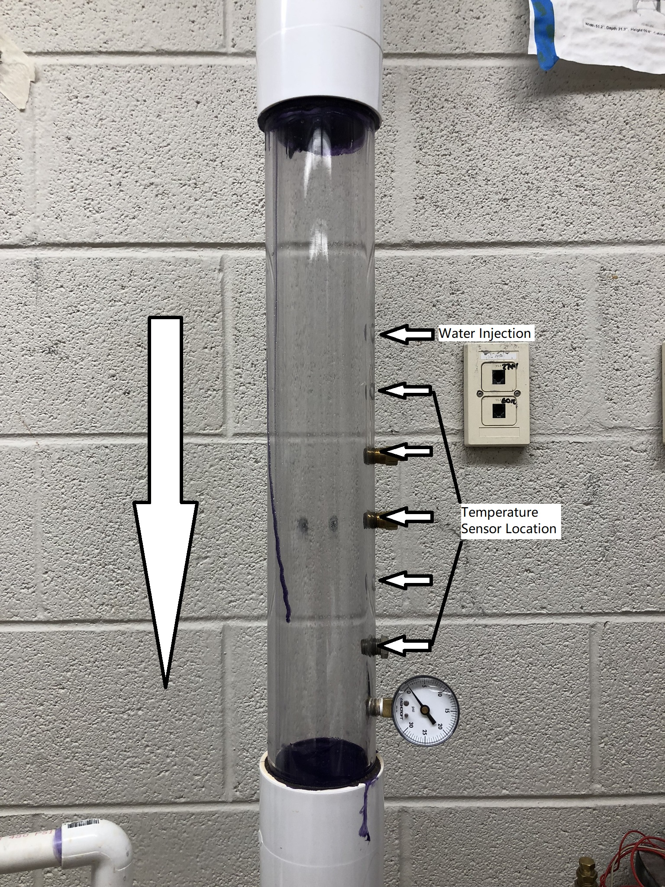
Figure 4.4. A detailed image of the vertical test section

Figure 4.4 shows almost the same structure of the horizontal test section in Figure 4.2. The water flows vertically downward and the volume of water is injected first before encountering the five temperature sensor locations and the pressure gauge. Besides the flow direction, another difference is the pipe clearance. The vertical test section is made of polycarbonate plastic, which is clearer than the horizontal section. With such a clear pipe, it is possible to inject some dye ink to observe how the injected water passes the following sensors with different volumes of water package. The water finally flows back to the pump after the vertical test section.

Experiment Results

The first investigation is to visually evaluate the fluid inject process by mixing dye into the injection fluid with the goal being to determine if the injection fluid passes by the sensors. Figure 4.5 shows the pink injection water as it mixes with the main flow. The dye injection test is only conducted in the vertical test section, where the main flow is downward. The two sensors are located 2” and 8” from the injection pipe, respectively, giving D₁ equal to 2” and D₂ equal to 6”. Four images are shown at critical stages: when the injected water reaches the first temperature sensor, reaches the second temperature sensor, leaves the first one, and leaves the second one, from left to right. The image shows that the injected water directly passes the two sensors with some delay time.

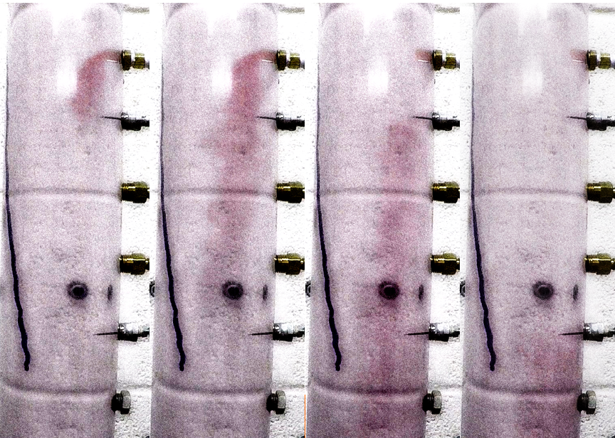
Figure 4.5. Dyed water injected into the vertical test section

Sample Rate and Linear Interpolation
Figure 4.6 shows an example of the measured temperatures without water injection. The lower plot shows that the cross-correlation peak is near zero indicating that no useful correlation signals is passing the two sensors. This shows that the normal temperature deviations in the process are not large enough to predict the flow velocity. Figure 4.7 shows the CCF flow estimation with periodic injection. The results clearly show that the injection allows the CCF method to determine the delay time and therefore estimate the flow velocity. The top plot in Figure 4.7 shows the two series of temperature signals collected from two TCs located along the flow direction. TC1 (signal in blue) is located upstream of TC2 (in orange). The observed temperature perturbations are caused by fluid injection indicated by the green rectangular wave. The two bottom subplots show the calculated R_{xy} plots. The left one is the raw R_{xy} curve. It is fairly noisy and shows several peaks near the central region of the cross-correlation curve. Although the second maximum peak does not affect the maximum calculation in this case, it might deviate the maximum from the true value and affect the global maximum estimation in other cases. In these cases, the true maximum peak might be buried in other peaks nearby, which produces the wrong delay time. To avoid this, the Local Weighted Scatterplot Smoothing (LOWESS) [157] is implemented to smooth the CCF curve. The LOWESS is based on the moving average and polynomial regression. The weighted function used is the traditional tri-cure weight function shown in Equation (14).

 | wx=1-d33 | (14)

In Equation (14), d is the distance between the given data point and the point to be fitted ranging from 0 to 1. Therefore, the closer points have higher weights and contribute a lot to the fitted points. The estimated peak of the original CCF curve without smoothing was at 81 samples, which converts to a flow rate of 45.3 GPM. The peak of the smoothed curve was at 90.0 samples, which converts to a flow rate of 40.8 GPM. The reference flow rate is 40.35 GPM collected by the turbo flowmeter. All the following reference flow values in the experiment loop are based on the average of 10 consecutive data collections from the same turbo flowmeter. Thus, the peak estimation after smoothing produces a flow rate estimate closer to the reference value, and the percentage error is reduced from 12.3 % to 1 %.

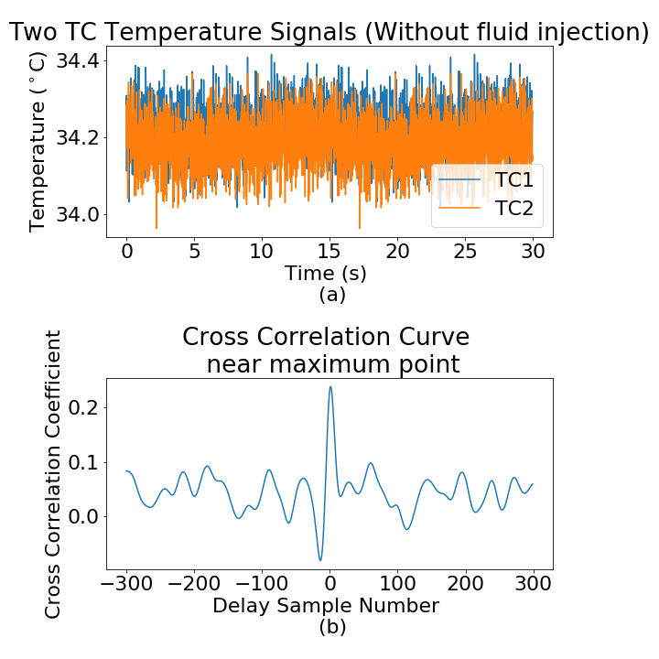
Figure 4.6. Representative Temperature signals and R_{xy} curve with periodic water injection

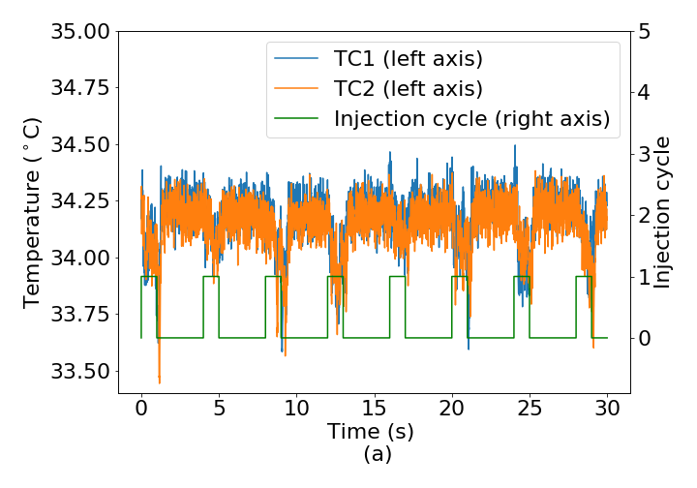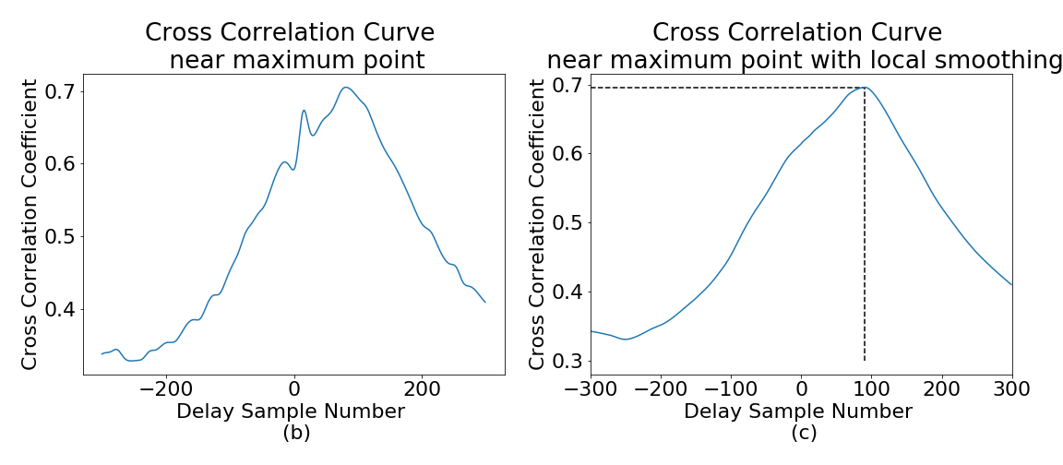
Figure 4.7. Representative Temperature signals and R_{xy} curve with periodic water injection

A major issue encountered with the application of this method relates to the sampling rate. A higher sample frequency has smaller time intervals between the two adjacent measurements, which leads to a CCF estimate with higher resolution. One appropriate post processing technique is to increase the number of data points by performing linear interpolation between the collected samples. This method artificially increases the sample rate from the original 100 Hz up to 1000 Hz and has shown improved CCF estimate results in our experiments.
Figure 4.8 shows the CCF flow estimation using the same temperature data without Linear Interpolation (LI) and with LI. Figure 4.9 shows a more detailed comparison of the cross-correlation curve.
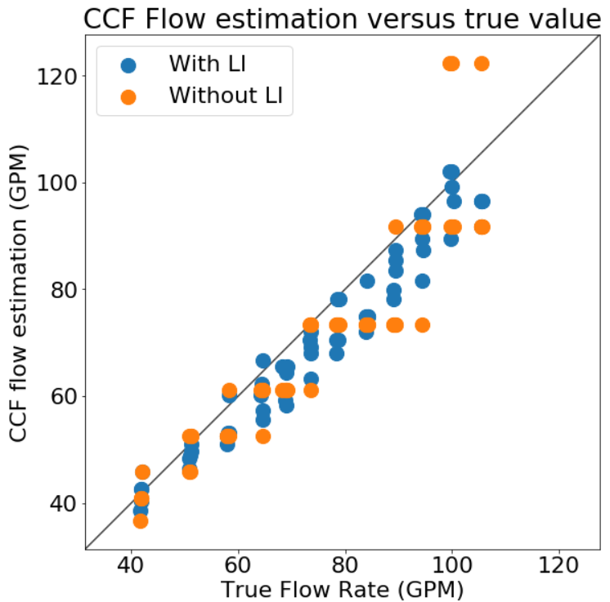
Figure 4.8. Comparison of the CCF flow estimation between with LI and without LI

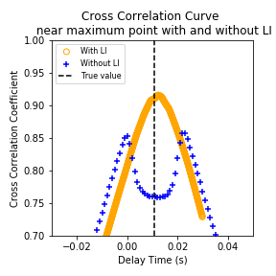
Figure 4.9. Comparison of Cross Correlation Curve with and without LI

The flow rates predicted using the raw data are limited to the low resolution of CCF due to the fairly slow maximum sample rate of the LabVIEW data acquisition module (100 Hz in this experiment). Smaller sampling frequency has a large time interval between two samples, which biases the CCF time delay estimation from the true value. After linear interpolation (Equation (7)), CCF flow estimation has a higher resolution and the predicted flow rate can attain a more accurate value. In some cases, it can combine the wrong two peaks into one true maximum peak shown in Figure 4.9. This results in more accurate LI CCF estimation values. The resulting RMSE is calculated to compare the results with different configurations. For the data shown in
Figure 4.8. Comparison of the CCF flow estimation between with LI and without LI
, the RMSE is reduced from 9.4 to 6.5 seconds. This example illustrates the CCF flow estimation improvement through the use of LI.

Thermocouple Response Time

Another common issue that requires attention is the potential difference in the TC response times. If there is a difference in the response times of the two thermocouples, it will bias the measured transport time and shift the maximum of the CCF. The solution is to measure the TC response times using a concurrent plunge test where a pair of sensors are plunged into warm water at the same time. The plunge test is repeated 10 times for each TC to provide reduce uncertainty and provide a more consistent result. Figure 4.10 shows the results of five sequential plunge tests and the resulting CCF curve indicating the difference in the sensor response time. It is difficult to differentiate the two sensor outputs by the naked eye since the response time difference is quite small. However, the lower plot shows that the slight differences in response times result in a biased CCF maximum. The dashed line marks the maximum CCF value with its delay sample number, which represents the response time difference. The average response time difference based on 10 repetitive plunge tests was found to be 0.014 seconds, which means there is a 0.014 second difference between the responses of the two TCs. In the example shown in Figure 4.10, this time difference converts to a 5 percent bias in the lowest predicted 40 GPM. When the predicted flow rate reaches 100 GPM, the bias grows to 14 percent. Each of the following CCF flow estimation examples uses these same two TCs, so a response time correction is used to eliminate the bias in the flow predictions.

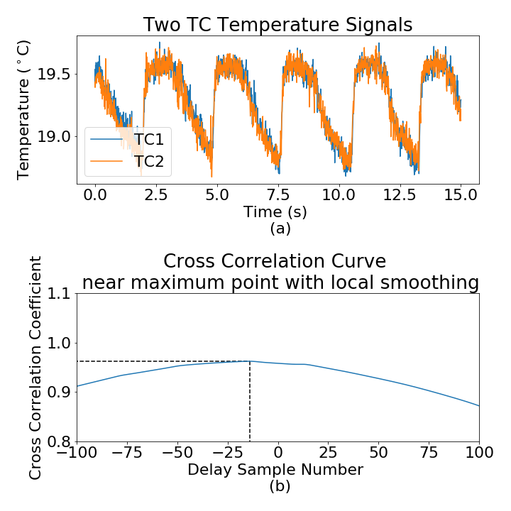

Figure 4.10. Response time study of two TCs

Flow Orientation
To investigate whether the CCF flow estimation performs differently between the vertical and horizontal directions, data are collected in the horizontal and vertical test section under similar flow conditions. The target flow rates range from around 40 GPM to 100 GPM. The results are summarized in Figure 4.11, which shows that the RMSE of the flow rate predictions in both directions is similar. For the horizontal section, the RMSE is 5.4 GPM, and for the vertical section, RMSE is 6.9 GPM. Generally, the CCF estimated flow rate is slightly smaller than the true value. The estimations in the vertical direction have a slightly larger variance, but overall the CCF estimations in two directions seem similar.

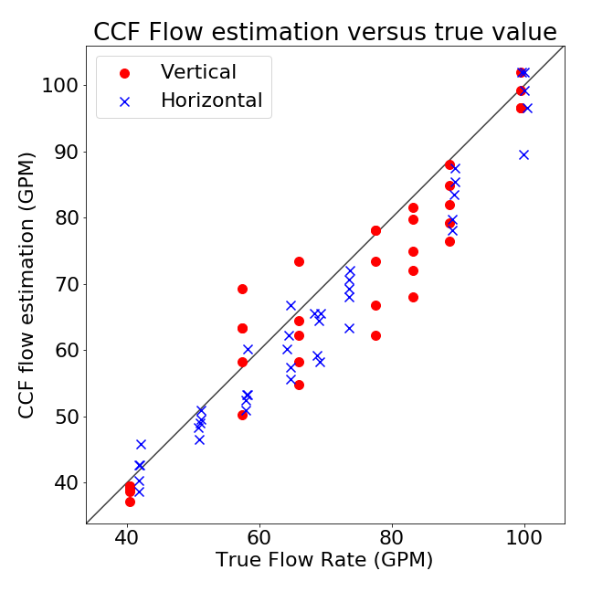
Figure 4.11. CCF flow estimation in the horizontal and vertical direction

Investigation of Critical Parameters (injection time and separate distances)
The CCF flow estimation is investigated for sensitivity to water injection period in this study. Figure 4.12 shows five different water injection period configurations based on the cases of D₁ = 2 inch (0.0508 m) and D₂ = 4 inches (0.1016 m); that is, the first sensor is located two inches from the fluid injection and the second sensor is a further four inches (six total inches from the fluid injection point). Most points are clustered together with no significant differences; however, the performance uniformly degrades for larger flow rates with this measurement set-up. Therefore, the conclusion is that the injection period is not strongly related to CCF flow estimation performance.

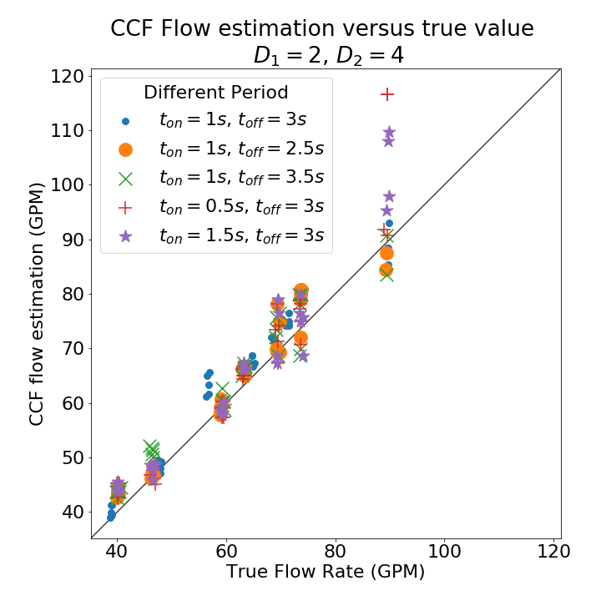
Figure 4.12. CCF flow estimation with different injection period (D₁ = 2, D₂ = 4)

Figure 4.13 and Figure 4.14 illustrate the CCF flow rate estimation comparison with different distances between the injection pipe and the two TCs. The worst performing cases in Figure 4.13 mainly come from the case of D₁ = 4 inches (0.1016 m) and D₂ = 2 inches (0.0508 m), which CCF flow estimations with higher errors. The configuration with D₁ = 4 inch (0.1016 m) had the largest errors due to the larger distance between the injection pipe and the first TC. This large D₁ causes more convective mixing and the temperature concentration are probably quite damped out before they reach the TC. Another finding is that the case of D₁ = 2 inch (0.0508 m), D₂ = 2 inch (0.0508 m) consistently underestimates the true flow rate. It appears that the case with D₁ = 2 inches (0.0508 m), D₂ = 4 inches (0.1016 m) provide more stable results than the other two configurations. Even when the target flow rate reaches around 90 GPM, it could have a better estimation with smaller D₁ and large D₂. Smaller D₁ lets the injected perturbation reach the two TCs faster, and a larger D₂ has a larger delay when the flow rate is large. A more specific examination of the effects of D₂ is provided in Figure 4.14. Figure 4.14 shows the CCF flow rate estimations under larger flow rates of 80 GPM to 170 GPM when D₂ is large at 6 inches (0.1524 m). Figure 4.14 shows that the case with D₂ = 6 inches (0.1524 m) could estimate the flow rate when the flow rate is high. For the other two cases with relatively smaller D₂, the averaged CCF estimation is smaller than the true value. The possible reason might be the local flow rate speed is not the same as the flow rate in other flow regions. The lower speed might be caused by the two closer sensor physical geometries. The flow slows down when passing by the two close sensors. Therefore, a longer distance between the two sensors can alleviate this situation.
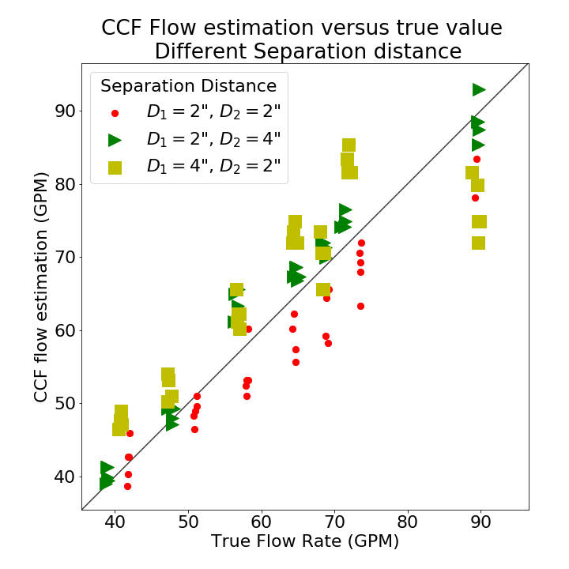
Figure 4.13. CCF performance under different separation distance

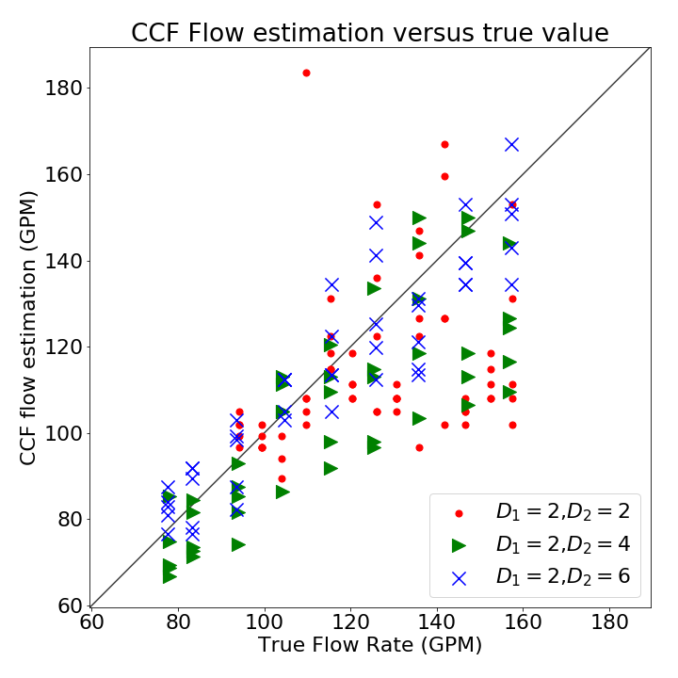
Figure 4.14. Further examination on D2 with the larger target flow rate

The injected water flow rate, controlled by the injection pressures of the low, medium, and high values, is another key parameter in CCF flow estimation performance. For the relatively smaller flow rate cases, a different injection flow does not make much difference. However, when the flow rate gets higher, relatively greater than 80 GPM, the difference starts to be observed. According to the previous results, a large D₂ performs better when the flow rate is large. A series of experiments with three different injection water flow rates are conducted to verify whether the injection water flow rate affects the CCF flow estimation. The estimation versus true value results shown in Figure 4.15 confirms that a higher injection rate is useful for higher flow rates. When the flow rate is high, the cases with low or medium injection flow have larger RMSE compared with the cases with a higher flow rate. It also shows that at the lower flow rates the injection flow rates do not produce significantly different performance. The cases with low and medium injection flow rate usually underestimate the true flow even when the flow rate is not large. A larger injection flow rate causes a larger variance of the CCF flow rate estimated values. This could be due to larger perturbation caused by larger injection rates.

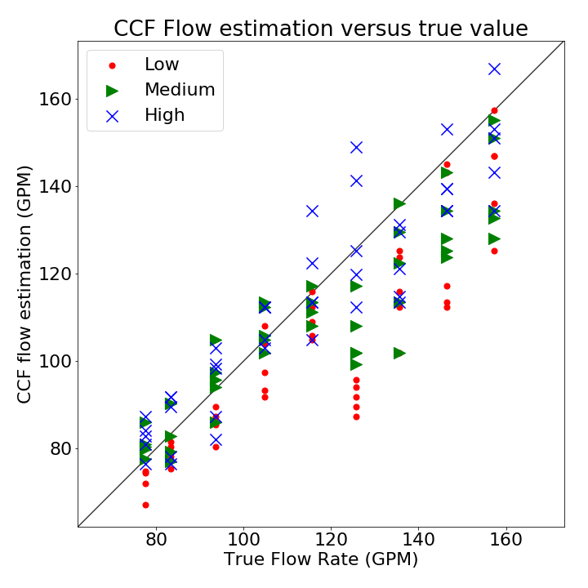
Figure 4.15. Different injection flow rate

In summary, the CCF flow rate estimation performance is independent of the injection period variables. The injection flow rate should be large enough for the TCs to detect the perturbations though it might increase a bit variance due to potential perturbations. The distance from the injection point to the first sensor, D₁, should not be large because of temperature mixing, but the distance between sensors, D₂, should be related to the expected flow rate. Low flow rates benefit from a small distance between the two sensors so that both sensors see the temperature perturbation before significant mixing occurs; high flow rates benefit from the larger distance between sensors because of limitations of sampling frequency. The above discussed variables are likely all inter-related. This can cause challenges when systems operate under a large range of normal flow rates, and multiple sensors may be needed to reliably estimate the full range of values.

One setup was chosen to quantify the flow injection method performance over a large range of flow rates from 0 to 160 GPM since the lower flow rate cases do not have many errors compared with higher flow rate cases. This configuration is with D₁= 2 inch, D₂ = 6 inches; an injection period of 1 second on and 3 seconds off; and a high-level injection flow rate. This case is repeated fifteen times for each flow rate so that the repeatability can be analyzed. The results in Figure 4.16 show the CCF flow rate estimation performance with two standard deviation error bars. The CCF performance is quite stable and fairly accurate when the main flow rate is below 90 GPM shown in Figure 4.13, and the average percentage of RMSE is 5.3 %. The error bars get larger when the main flow rate is above 90 GPM mainly due to the increased turbulence of the main flow, and the average percentage RMSE is 9.2%.

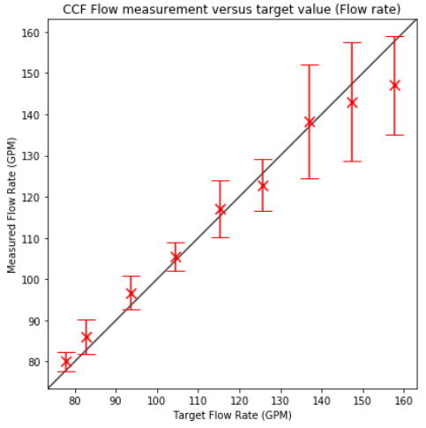
Figure 4.16. CCF flow estimation (The optimal configuration based on experiment setup)

CFD simulations to Verify the Developed CCF Method

This chapter is focused on verifying the previous flow loop experiment results and optimizing the injection configurations using Computational Fluid Dynamics (CFD) simulations. During the flow loop experiments, a series of flow measurements were conducted with different setups on the sensor and injection pipe locations. However, these configurations can only provide limited temperature data at specific locations and CFD simulations have the potential to provide a larger data set to investigate sensitivities of the CCF measurement method. To improve the CCF flow estimation under different flow rates of the mean flow, it is necessary to collect the temperature and velocity distribution along the mean flow to observe how the injected flow spreads out in the pipe and how to determine the best locations for the sensors. This application of CFD aims to simulate the experimental conditions to collect the temperature and other relevant data, such as velocity distribution. The preliminary CFD simulation was performed using Autodesk CFD software based on the finite element method discussed in the Early CFD study section in Chapter Four. Further studies were done using ANSYS Fluent, v19.3.0 [158] due to the complexity of the follow-on simulations. The first study aims to verify and validate the ability to simulate the flow (velocity and pressure fields) and heat transfer (temperature fields) behavior of the experiments using the CFD. The second and most important study is the optimization of sensor pair locations in the mean flow based on the flow rate estimation using the CCF method. The optimization study was conducted for a range of flow rates for the mean flow and injected flow. The resulting information from the second CFD simulations will enable a more detailed study on the impact of sensors’ location on the accuracy of the CCF method. This chapter is divided into three sections. The first section discusses the basic theory behind the numerical methods applied in the CFD simulations. The second section introduces how the simulation model is developed. The last section shows the results.

dmsystemdt=0

msystem=systemρdV

dmsystemdt=∂∂tcvρdV+csρV ∙ndA=0

∂∂tcvρdV+csρV ∙ndA=0

∂ρ∂t+∂∂xρau+∂∂yρvb+∂∂zρwc=0

ΣF=ddtsysvρdV=∂∂tcvvρdV+csvρv ∙ndA

∂∂tρv+∂∂xρav+∂∂xρbv+∂∂xρcv
=v∂ρ∂t+∂∂xρa+∂∂yρb+∂∂zρc+ρ(∂v∂t+a∂v∂x+b∂v∂y+c∂v∂z)

ΣF=ρdvdtdxdydz

dG=ρgdxdydz

dFx,surface=∂∂xσxx+∂∂yσyx+∂∂zσzxdxdydz
dFy,surface=∂∂xσxy+∂∂yσyy+∂∂zσzydxdydz
dFz,surface=∂∂xσxz+∂∂yσyz+∂∂zσzzdxdydz

ρgx-∂p∂x+∂τxx∂x+∂τyx∂y+∂τzx∂z=ρ(∂a∂t+a∂a∂x+b∂a∂y+c∂a∂z)
ρgy-∂p∂y+∂τxy∂x+∂τyy∂y+∂τzy∂z=ρ(∂b∂t+a∂b∂x+b∂b∂y+c∂b∂z)
ρgz-∂p∂z+∂τxz∂x+∂τyz∂y+∂τzz∂z=ρ(∂c∂t+a∂c∂x+b∂c∂y+c∂c∂z)

τxx=2μ∂a∂x
τyy=2μ∂b∂y
τzz=2μ∂c∂z

τxy=τyx=μ(∂a∂y+∂b∂x)
τxz=τzx=μ(∂c∂x+∂a∂z)
τyz=τzy=μ(∂a∂z+∂c∂y)

ρgx-∂p∂x+μ(∂2a∂x2+∂2a∂y2+∂2a∂z2)=ρ∂a∂t
ρgy-∂p∂y+μ(∂2b∂x2+∂2b∂y2+∂2b∂z2)=ρ∂b∂t
ρgz-∂p∂z+μ(∂2c∂x2+∂2c∂y2+∂2c∂z2)=ρ∂c∂t

ΔE=∂∂tcveρdV+cs(e+pρ)ρv ∙ndA

ΔE=∂∂tρe+∂∂xρae+ap+∂∂yρbe+bp+∂∂zρce+cp

ΔE=Q-W

∂ρ∂t+∂∂xρa+∂∂yρb+∂∂zρc=0
ρgx-∂p∂x+μ(∂2a∂x2+∂2a∂y2+∂2a∂z2)=ρ∂a∂t
ρgy-∂p∂y+μ(∂2b∂x2+∂2b∂y2+∂2b∂z2)=ρ∂b∂t
ρgz-∂p∂z+μ(∂2c∂x2+∂2c∂y2+∂2c∂z2)=ρ∂c∂t
ΔE=∂∂tρe+∂∂xρae+ap+∂∂yρbe+bp+∂∂zρce+cp

∂ρ∂t+∂∂xρa+∂∂yρb+∂∂zρc=0
ρgx-∂p∂x+μ(∂2a∂x2+∂2a∂y2+∂2a∂z2)=ρ∂a∂t
ρgy-∂p∂y+μ(∂2b∂x2+∂2b∂y2+∂2b∂z2)=ρ∂b∂t
ρgz-∂p∂z+μ(∂2c∂x2+∂2c∂y2+∂2c∂z2)=ρ∂c∂t
ΔE=∂∂tρe+∂∂xρae+ap+∂∂yρbe+bp+∂∂zρce+cp

Computational Domain
This section is mainly divided into two parts. This section introduces the computational domain of the CFD simulation model, including geometry, boundary and initial condition, meshing, and the computational solver framework.

Geometry
The geometry to be simulated in Fluent is a sample of the pipeline where the sensors are implemented. Figure 5.1 shows the geometry for the CFD simulation for the experiment setup.

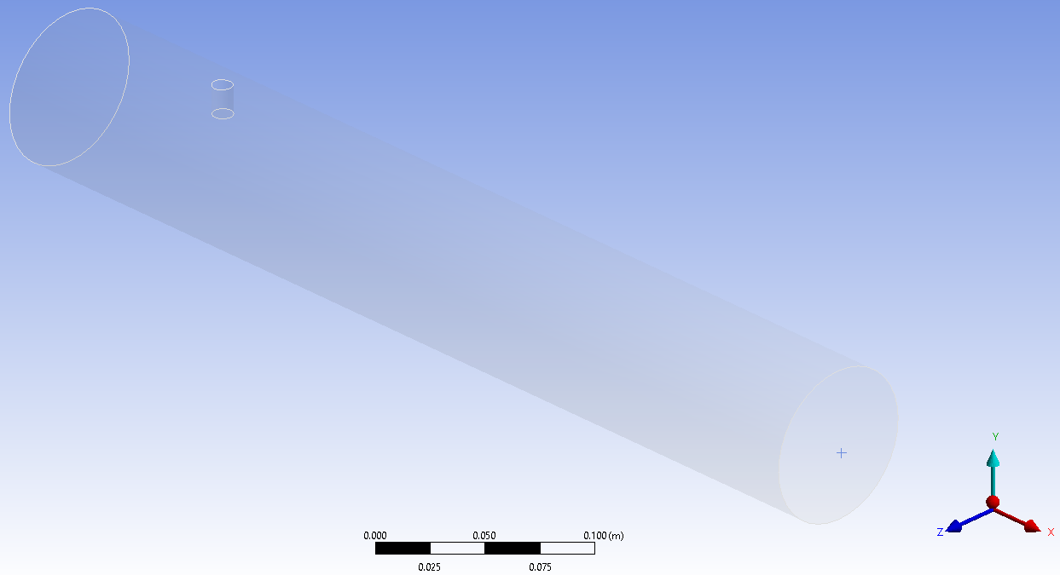
Flow direction
The region for the temperature sensor
Injection pipe
Figure 5.1. Computational Domain used for the CCF flow estimation with water injection

In Figure 5.1, the pipe is a 0.0762 m (3 inches) diameter cylinder based on the dimensions of the experimental configuration. The entire simulated length of the main pipe is 0.5 m (1.97 inches). The water flows from left to right, past the injection pipe, and two temperature sensors. The injection pipe is located 0.1 m away from the inlet of the domain. Periodically throughout the simulation, cooler water is injected from the injection pipe that has a diameter of 0.01 m (0.39 inches). The injection pipe geometry is created using a cut-out cylinder in the domain and has been marked with the white rectangle in Figure 5.1. The geometry of the injection pipe is important because it affects the velocity distribution. However, the geometry of the two sensors is not implemented in the computational model. The temperature sensors are not explicitly modeled due to the low impact on the flow distribution in the mean flow with and without injection. This is due to the small size of temperature sensors and the flow distribution already being perturbed by the larger injection pipe [159]. Another reason for not modeling the sensor geometry is to reduce the total degree of freedom. Each simulation is needed for a large number of cases run. The simulation model without sensor geometry reduces the computational time greatly. This is based on the minimal accuracy increase from including the sensor geometry. Further, the wake caused by the injection pipe already strongly perturbates the flow. Therefore, the CFD model without having to model the geometry of the sensors can allow for temperature traces to be acquired at any point in the wake of the injected fluid and speed up for the data collection. To simulate the sensor at a different location, the temperature data can be obtained directly based on the coordinates

u+=1κlny++C

y+=yuτν
u+=uuτ

Boundary and Initial Conditions
The boundary conditions for the CFD model are shown in Figure 5.2.

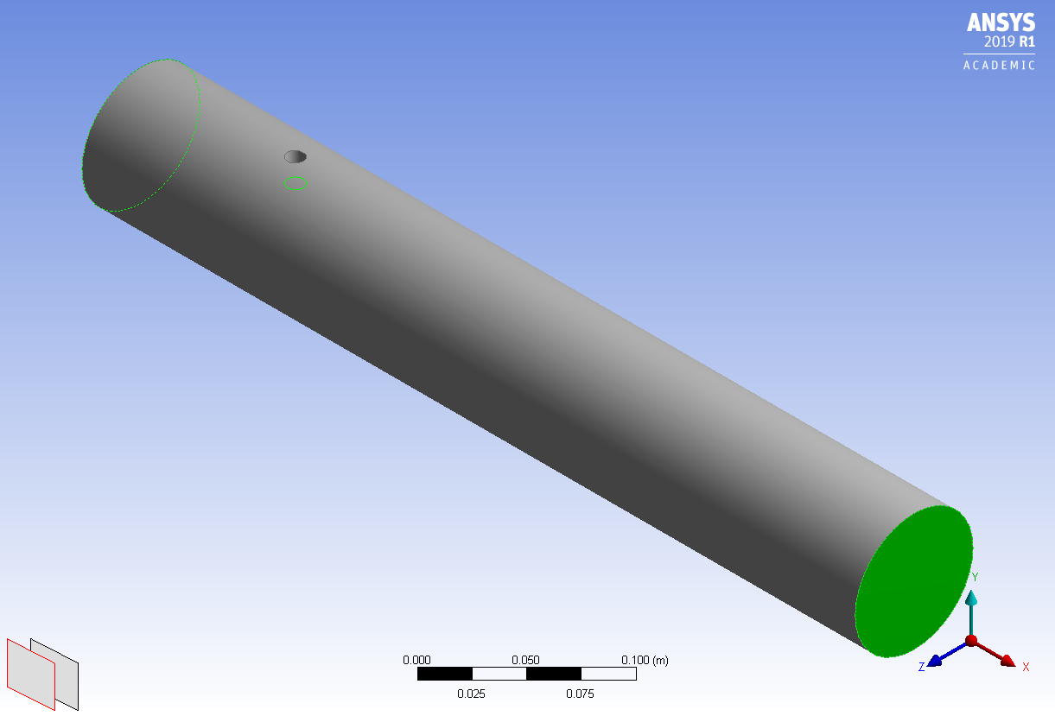
Main Velocity Inlet

Flow direction
Injection Velocity Inlet
Pressure Outlet
Figure 5.2. Boundary conditions for the CFD simulation

For the main flow inlet, a fully developed velocity profile is used as the actual boundary condition at the entrance of the pipe. The fully developed velocity profile of different main flow rates was achieved by a series of precursor steady-state simulations, which has a longer pipe with the same diameter. The uniform distributed flow was applied and its outlet velocity profile was collected and saved for the fully developed velocity profile. Using this fully developed velocity profile at the inlet can avoid the entrance effect and allows for shortening the inlet region that in turn reduces the mesh count/computational requirements. There are 12 different main flow rate used in the CFD simulation. They are divided into three groups for three different meshing models. The inlet boundary condition for the low flow rate meshing model contains 39.52 GPM (0.00249 m³/s), 65.13 GPM (0.00411 m³/s), 75.82 GPM (0.00478 m³/s), 93.53 GPM (0.00590 m³/s). The inlet boundary condition for the medium flow rate meshing model is 101.95 GPM (0.00643 m³/s), 114.2 GPM (0.00720 m³/s), 123.84 GPM (0.00781 m³/s), 133.51 GPM (0.00842 m³/s). The inlet boundary condition for the high flow rate meshing model is 145.83 GPM (0.00920 m³/s), 156.42 GPM (0.00987 m³/s), 167.61 GPM (0.01057 m³/s), and 178.3 GPM (0.01125 m³/s). Reynold Number ranges from 5.8×10⁴ to 2.6×10⁵, so all the cases are with the turbulent regime of flow. The temperature of the main flow rate is set to 308 K (~95 ºF).

For the injection pipe boundary conditions, the water is injected into the main flow periodically with time-dependent velocity and temperature. The theoretical injection period is simulated by the strict step function shown in Figure 3.11 in the Methodology Chapter. However, in practice, the injected water flow won’t reach the maximum immediately. A quickly ramped step function is applied shown in Figure 5.3.

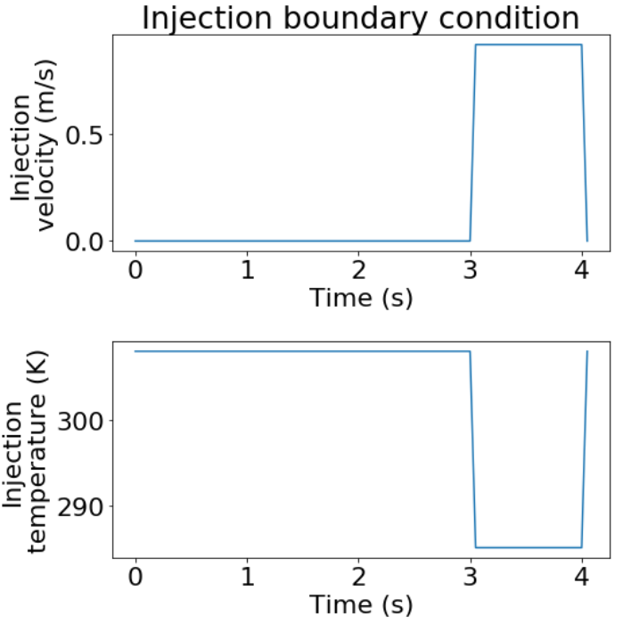
Figure 5.3. One injection period for the injection pipe boundary condition in CFD simulation

Like the experiment setup, the total injection period is 4.0 s, there is 1.0 second for fluid injection, and 3.0 seconds for waiting for the next injection. Figure 5.3 shows that firstly wait three seconds from the previous injection, then injection the fluid for 1.0 seconds. Additionally, referring to Table 4-4, there are three different injection flow rates investigated in the experiment section. They are 0.920 m/s, 0.821 m/s, and 0.497 m/s, respectively representing the high, medium, and low level of injected water in the experiment. Here, these three different injection flow rates are applied individually and compared with each other under different main flow rates to discover whether the injection flow rate is related to the optimal setup for the flow estimation under different flow rates. This three-injection flow rate has the same injected fluid temperature, 285 K (~53 ºF). The injection temperature is 23 K lower than the temperature of the main flow to introduce additional perturbations and increase the SNR, which benefits the CCF flow estimation.

The remaining boundaries are set as a no-slip wall boundary condition. The computational domain is initialized based on the inlet condition that the flow in the entire pipe is fully developed at the given flow rate and with a constant initial temperature of 308 K.

Meshing (Domain Discretization)

The meshes used were created in ANSYS ICEM [160]. The meshing elements should be carefully drawn according to the demands of different flow regions. The whole pipe model is divided into three sub-regions: the inlet region, the injection region, and the temperature collection region shown in Figure 5.4.

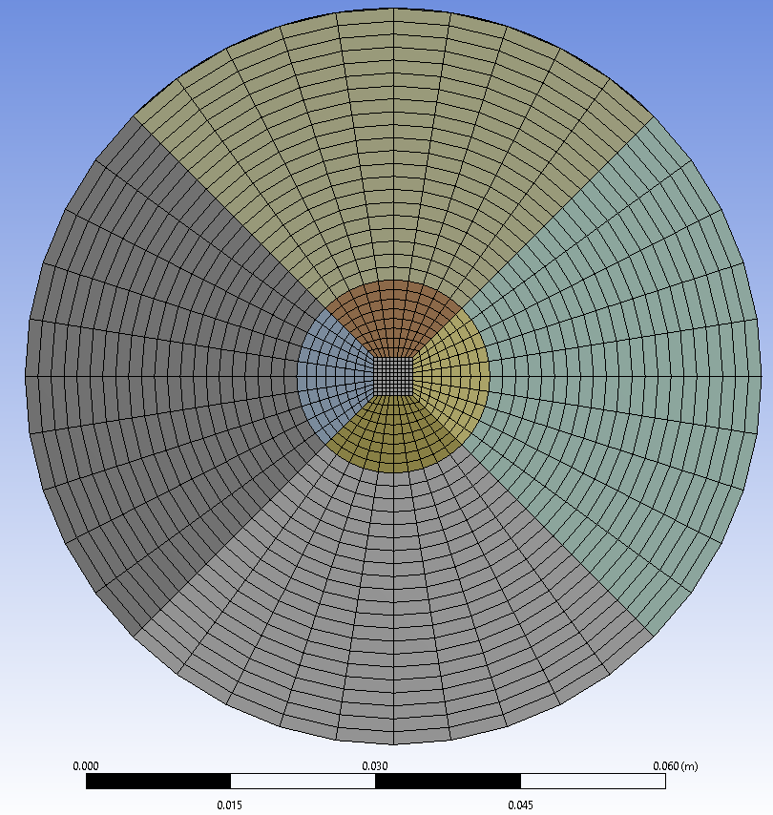
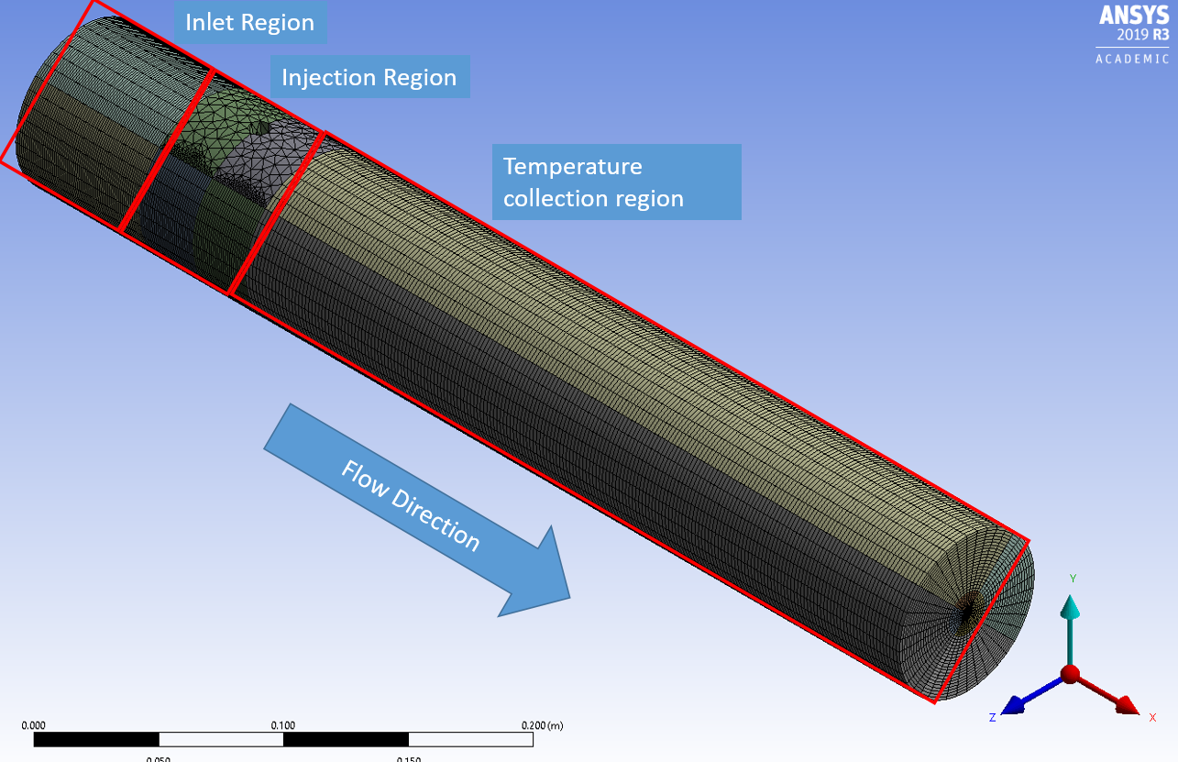
Figure 5.4. One example of a meshing model for low flow rate simulation

The overall flow region is a cylinder-shaped 3D model. To mesh the cylinder, the meshing is gradually transitioned along the radial direction with three separate sections shown in the right top of Figure 5.4. The most inner geometry has a square cross section, and the medium and outer geometries are the cylinder with the same meshing ratio. The same meshing ratio can guarantee the size of meshing can be smoothly transitioned from inner to outer. A detailed meshing setting will be shown in Table 5-1.

The inlet region is located near the inlet, which does not need to include the entrance length since the fully developed turbulent flow is applied as the inlet boundary condition. The injection region is around the injection pipe. Because there is likely vortex shedding and a wake forming as the mean flow passes the injection pipe cylinder, careful consideration has to be made on the meshing in this region. Detailed meshing near the injection pipe is shown in Figure 5.5.

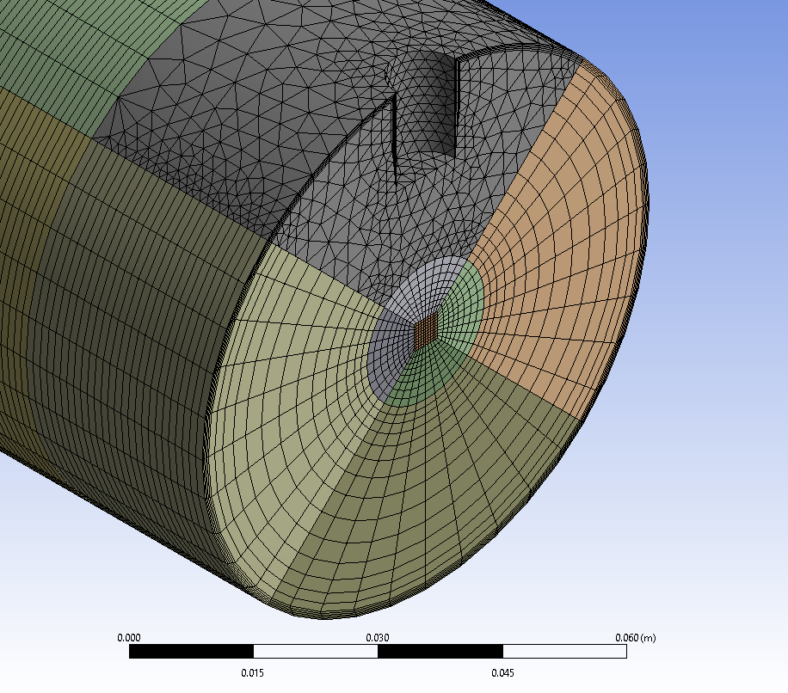
Figure 5.5. Detailed meshing around the injection pipe

Since there is an inserted cylinder representing the injection pipe here, the hexahedral meshing is not easy to handle this irregular geometry. Instead, the tetrahedral meshing is applied specifically in this region shown in Figure 5.5. The third region is the piping after the injection region and the mesh has to be sufficiently resolved to accurately represent the temperature response in the sensors.

The first meshing task was focused on how the general density and mesh element sizing in the mean flow. When meshing the computational domain, the main concern is the balance between accuracy and meshing density that translates to computational resource requirements (total cores and physical time). Generally speaking, a higher density mesh (fine mesh) will likely give resolved and accurate results but this density increases the simulation/physical time dramatically. Besides, due to the consequence of discretizing the domain, a mesh sensitivity on the number of mesh elements/degrees of freedom is needed to ensure the results are not highly sensitive to the number of elements used. Therefore, a mesh sensitivity study is conducted to select appropriate mesh element sizes that balance the accuracy of results with acceptable simulation/physical time requirements.

The general idea behind mesh sensitivity studies is to create multiple meshes with different density, from coarse to fine. The boundary conditions and initial conditions are the same for each mesh to ensure a proper comparison. Based on the results from each mesh using a meaningful quantity of interest (QoI), the mesh with a sufficient density to accurately resolve the behavior should be selected. Generally, the mesh comparisons are done using a baseline against a significantly finer mesh than the rest as a stand in for an “analytical” solution.

There are a total of 4 meshing models from the most coarse to the finest one, which will be compared with each other. The number of the meshing nodes for these 4 meshing models is ~2.4e5, ~3.1e5, ~4.0e5, and ~5.0e5, labeled as M1, M2, M3, and M4 respectively. Detailed meshing parameters for these 4 meshing models are summarized in Table 5-1.

Table 5-1. Four meshing detail settings for three regions shown in Figure 5.4
 | M1 | M2 | M3 | M4
Number of circular divisions | 40
Number of radial divisions (Outer cylinder) | 14
Number of radial divisions (Medium cylinder) | 10
Element size for the Inner rectangular (m) | 4e-4
Number of division for the Inner rectangular | 10
Inlet region length (m) | 0.07
Injection region length (m) | 0.06
Temperature collection region length (m) | 0.37
Number of divisions in inlet region in the axial direction | 40 | 50 | 65 | 80
Number of divisions in the injection region in the axial direction | 28 | 40 | 52 | 60
Number of divisions in temperature collection region in the axial direction | 114 | 150 | 200 | 250

To compare among these four meshing models, the same injection scenario is applied and the overall simulation lasts for 10 seconds with two water injections and an injection flow velocity of 0.545 m/s. To compare among these four meshing models, the area-weighted average temperature and velocity traces at five different cross sections and the temperature and velocity traces at two local positions are selected shown in Figure 5.6.

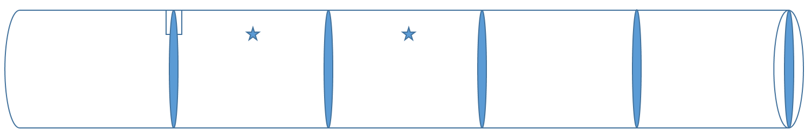
Figure 5.6. Four meshing model evaluation
Figure 5.6 shows the five cross sections with the blue solid region and two local points with the blue star. Both the temperature and velocity are plotted at different locations, including 5 locations equally distributed along the flow direction, and the 2 sensor locations. Figure 5.7 shows the area-weighted average temperature traces at five different cross sections in Figure 5.6. Figure 5.8 shows the two local temperature traces at the two star-shaped locations in Figure 5.6.
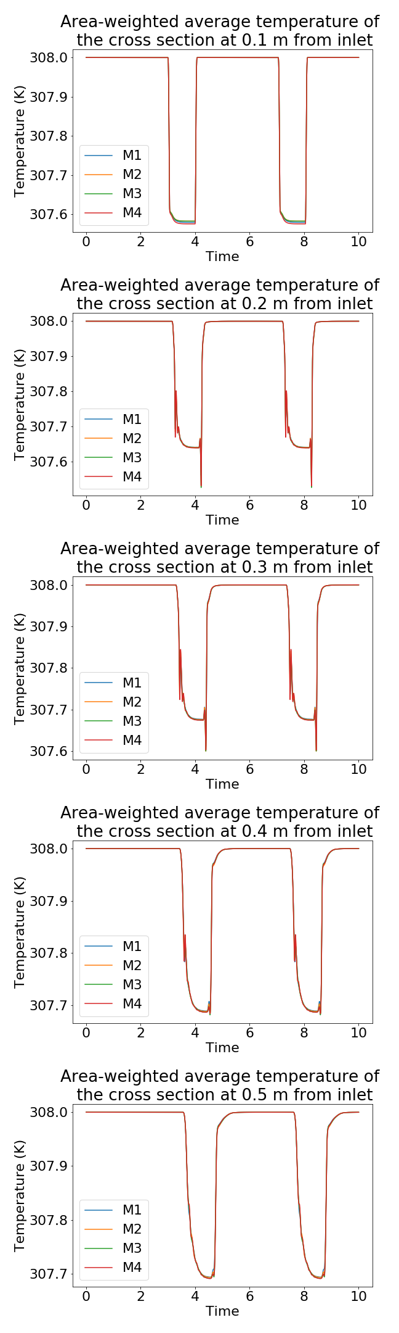
Figure 5.7. Area-weighted average temperature traces at five different cross sections

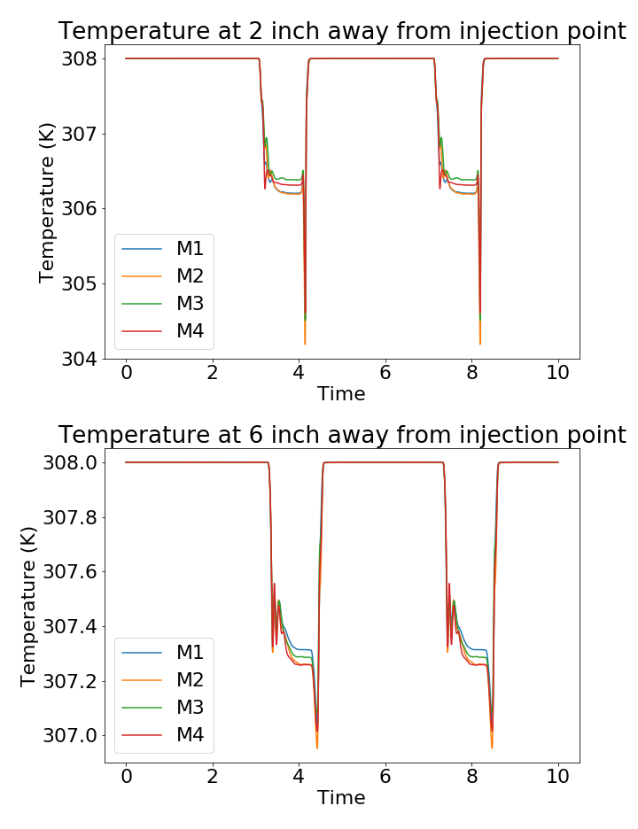
Figure 5.8. Two local temperature at the star-shaped location in Figure 5.6

Figure 5.7 shows the area-weighted average temperature of the cross-section evenly distributed along the flow direction. The five average temperature comparisons have almost the same trend, and the two local temperature comparisons at 2 and 6 inch away from the injection point in Figure 5.8 shows there is some variation existed during the injection period. This difference is around 0.2 – 0.4 ˚C which is relatively small when compared with the experimental temperature sensor uncertainty in the experiment flow loop. Comparing among different meshing models, the number of meshing nodes does not affect the temperature distribution significantly. So velocity needs to be compared among the four meshes to select the suitable model since the velocity data is more sensitive to the meshing density.

For the velocity comparison, the same cross sections and two local points are selected as well shown in Figure 5.9 and Figure 5.10 respectively.

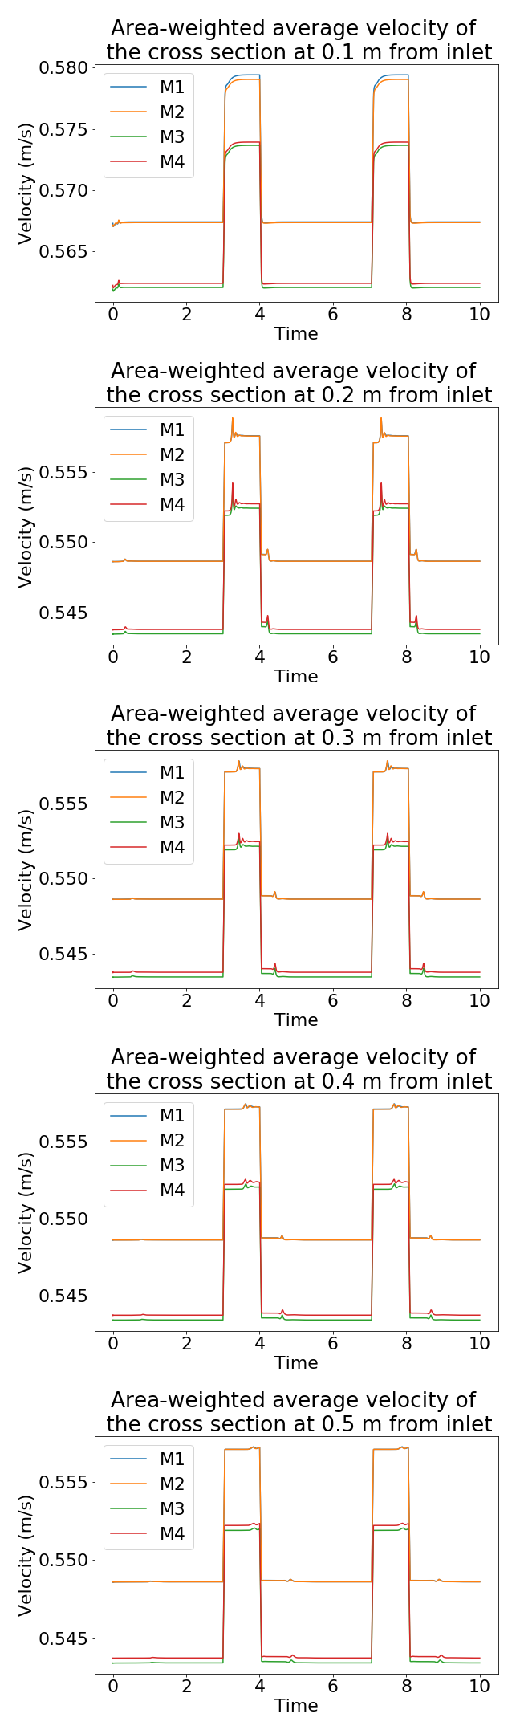
Figure 5.9. Area-weighted average velocity traces at five different cross sections

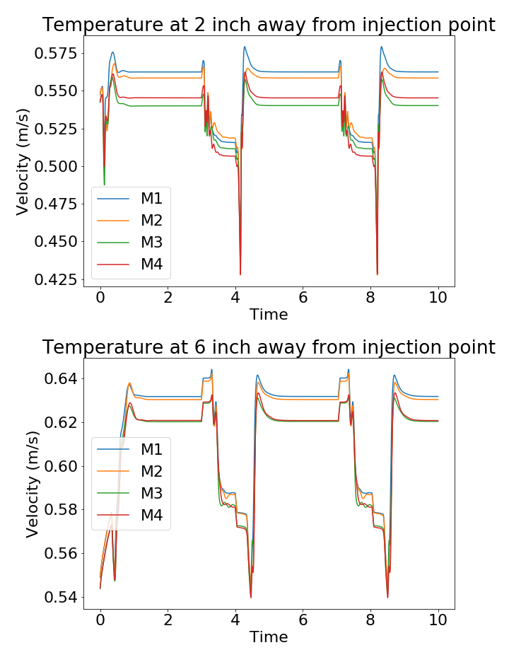
Figure 5.10. Two local velocities at the star-shaped location in Figure 5.6

Figure 5.9 and Figure 5.10 show that the M1 and M2 generate the velocity greater than M3 and M4 do, and the average velocity data from M1 and M2 are not sufficiently resolved when compared with M3 and M4 meshes. Excluding for the injection period, the mesh with a more meshing model can have better resolutions. Figure 5.10 shows the overall local velocity is greater than the average value. The reason is that the velocity distribution is not uniformly distributed at the cross-section. One example of the 3D velocity distribution of the fully developed turbulent flow is shown in Figure 5.11.

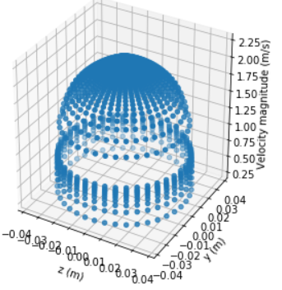
Figure 5.11. One example of 3D velocity distribution of fully developed turbulent pipe flow

Figure 5.11 shows that the velocity is not uniformly distributed in the cross section. The endpoint of the temperature sensor location is close to the wall, where the local velocity is relatively smaller than the average velocity. Figure 5.10 suggests the same conclusion that the model with larger mesh count or degrees of freedom has a smaller velocity just like the previous average velocity plots. To further examine how the M1, M2, and M3 meshes resolve the velocity compared with the M4, that has the most density mesh, the absolute percentage error for both average and local velocity between M4 and the other three meshes are calculated and shown in Figure 5.12 and Figure 5.13.

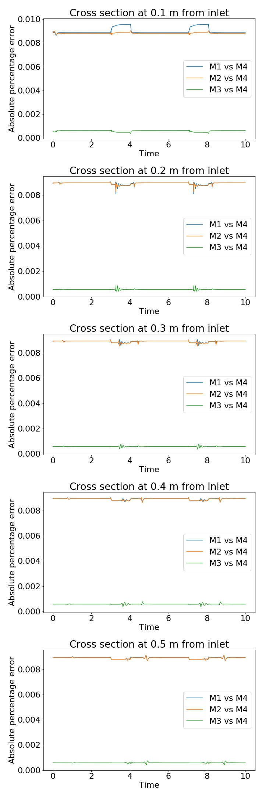
Figure 5.12. Absolute percentage errors between the meshing (Area-weighted average velocity)

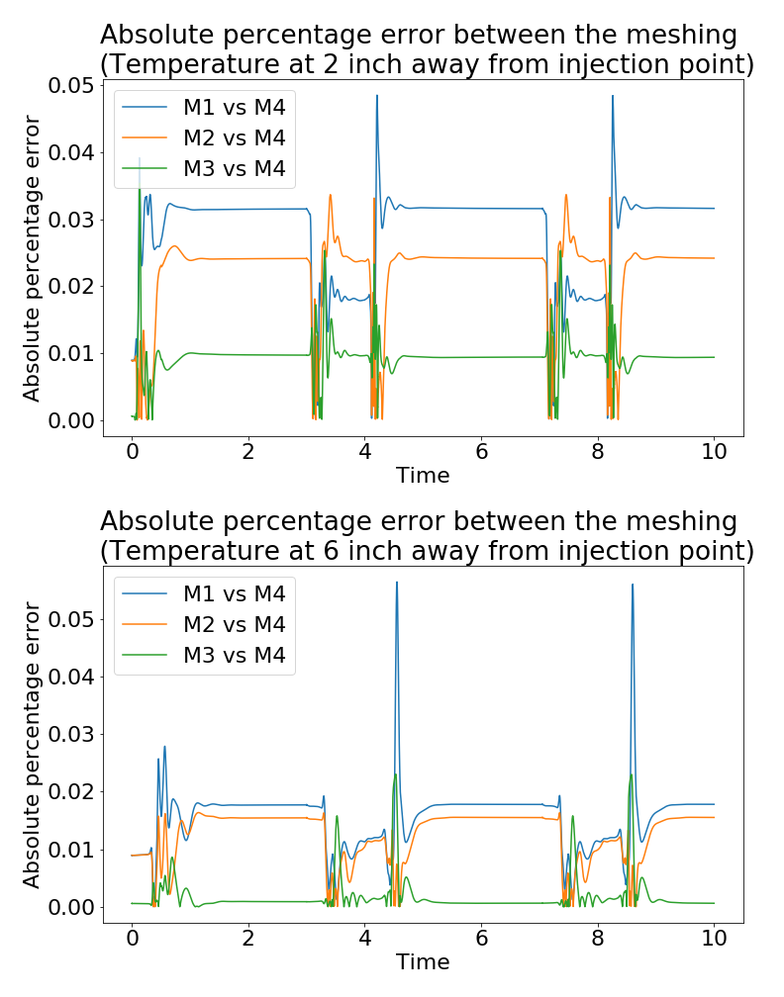
Figure 5.13. Absolute percentage errors of two local velocity

Both Figure 5.12 and Figure 5.13 show that the difference between M1, M2, and M4 can be observed, while the absolute percentage error between M3 and M4 is close to zero. It shows that M3 is sufficient to be used due to the lack of huge velocity differences between the M3 and M4. Therefore, M3 is chosen as the base meshing model.

The M3 mesh is used as the base mesh for ensuring the good quality of temperature and velocity simulation, and the wall region meshing refinement is further researched, and the $u^{+}$ vs. $y^{+}$ the plot is used as the reference to judge whether the wall region is simulated correctly. After several simulations, it is found that no one meshing model sufficient for all the flow rate cases with the suitable $y^{+}$ values. The main reason is that the range of the mean flow is quite large, from around 40 GPM up to 170 GPM (approximately 2.5 x 10⁻³ m³/s to 1.1 x 10⁻² m³/s) with Reynold number from 5.7 x 10⁴ to 2.5 x 10⁵. One meshing schema might better resolve the flow at a lower flow rate but won’t work well for a higher flow rate. To solve this problem caused by the wide flow rate range and achieve better accuracy, these flow rate cases are divided into three subgroups, low flow rate group, medium flow rate group, and higher flow rate group. Each group has a unique mesh serving a specific range of flow rates. The details of the three different meshing models (G1, G2, G3) are summarized in Table 5-2.

Table 5-2. Three different meshing models
 | Low flow rate group (G1) | Medium flow rate group (G2) | High flow rate group (G3)
Flow rate (GPM) | 39.52 ~ 93.53 | 101.95 ~ 133.51 | 145.83 ~ 178.30
First Cell Height (m) | 1.4 x 10⁻³ | 6.0 x 10⁻⁴ | 4.3 x 10⁻⁴
Nodes | 406818 | 362198 | 374494
Elements | 459890 | 408016 | 421176

The first cell height is slightly different to guarantee that the $y^{+}$ value meets the requirement. And the $u^{+}$ vs. $y^{+}$ plots based on all the three groups are shown in Figure 5.14.

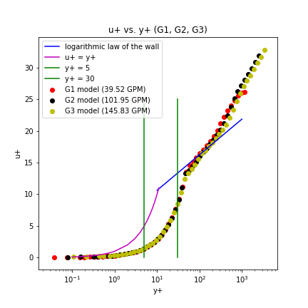
Figure 5.14. $u^{+}$ vs. $y^{+}$ relationship based on G1, G2, G3 meshing model

In Figure 5.7, the scatter plots with different colors represent different flow rate cases from low to high. It shows that except the region near the buffer layer, the $u^{+}$ follows the curve in most regions which is expected when using the standard wall treatment discussed in the previous Wall Treatment section. The three different meshing models can provide relatively the same simulation performance, and all the following results are based on these three meshes according to the mean flow rate. Additionally, the following CFD simulation results will assume that these 3 group division treatment won’t meaningfully affect the CCF performance analysis. Detailed robust sensitivity analysis on the grouping strategy should be conducted in future work.

Computational Solver Framework
Computational Fluid Dynamics (CFD) can simulate the flow and heat transfer behavior in fluids to solve problems in the engineering systems. Compared with the physical experiment, the CFD simulation has many advantages. The experiment setup is time-consuming and will cost a lot compared with CFD simulation. Additionally, the scale of the fluid problem is flexible and there are no risks when dealing with some critical problems in CFD. CFD can collect and analyze any information and data at the given location, but sometimes the data collection locations are limited by the physical structure in the real experiment flow loop. The CFD results can serve as a good guideline for the experiment setup as well as the real industrial applications. The CFD simulation has been widely applied in nuclear, aerospace, automotive, power generation, medical, and many other fields. A reliable CFD model needs a better understanding of the fluid dynamics and related numerical methods. The continuum fluid dynamics is governed by the Navier-Stokes equations [160]. The Navier-Stokes equations can describe the behavior of the incompressible flow with the second-order nonlinear partial differential equations [161]. Other than the Navier-Stokes equations, mass and energy equations are also the fundamental fluid equations. They are based on the mass and energy conservation laws respectively [162]. This section will briefly introduce the turbulent model and wall treatment applied in this research.

The overall conservation equations for the Newtonian fluid contain continuity, momentum, and energy equations summarized below Equation (15).

 | ∂ρ∂t+∂∂xρu+∂∂yρv+∂∂zρw=0  ρgx-∂p∂x+μ(∂2u∂x2+∂2u∂y2+∂2u∂z2)=ρ∂u∂t  ρgy-∂p∂y+μ(∂2v∂x2+∂2v∂y2+∂2v∂z2)=ρ∂v∂t  ρgz-∂p∂z+μ(∂2w∂x2+∂2w∂y2+∂2w∂z2)=ρ∂w∂t  ΔE=∂∂tρe+∂∂xρue+up+∂∂yρve+vp+∂∂zρwe+wp | (15)

Among all the conservation equations in Equation (15), the most important one is the Navier Stokes equations, the momentum equations. The momentum equations describe the overall velocity distribution. The velocity distribution changes rapidly and the overall scale of the fluctuation would be very small especially when the flow velocity is high. It is computationally expensive to discretize and iteratively calculate the momentum equation directly. One alternative way is to average each small scale into a large chunk to resolve the new average momentum conservation equations more efficiently. This is the Reynolds Averaged Navier Stokes (RANS) equation. One popular and widely used RANS model is the standard $k-ϵ$ model, which is also selected as the turbulence model in this research.

For the actual equations applied in Fluent [163], the Reynold Averaging method is used. The solution variables in Equation (15) are decomposed into the mean and the fluctuating components. For example, the velocity

 | ui=ui+ui' | (16)

Above, $\overline{u_{i}}$ is the mean velocity and $u_{i}^{'}$ is the fluctuating velocity. For other scalar parameters, the same decomposition can be performed like Equation (16) as well. Thus the continuity and momentum equations shown in (15) can be transferred into Equation (17), (18).

 | ∂ρ∂t+∂∂xiρui=0 | (17)

 | ∂∂tρui+∂∂xjpuiuj=-∂p∂xi+∂∂xjμ∂ui∂xj+∂uj∂xi-23δij∂ui∂xi+∂∂xj(-ρui'uj') | (18)

Equation (17) and (18) are called Reynolds Averaged Navier Stokes equations. Compared with Equation (16), three directions are combined with one representative direction. The velocity and other variables now are the ensemble-averaged values instead. The additional term ∂∂xj-ρui'uj' in the momentum equation (18) describes the effects of the turbulence caused by the fluatuation term in (16).

This research uses the pressure-based segregated algorithm [160] to solve the RANS Equation in (17) and (18). Since Equation (17) and (18) are nonlinear differential equations, they are determined to be solved iteratively until meeting the convergence criteria. The pressure-based segregated algorithm is based on the SIMPLE pressure solver [163], which is applied in this research.

Turbulent Model

The standard $k-ϵ$ model was proposed by Launder and Spalding in 1972 [164] and it uses two separate transport equations to calculate the velocity and turbulent length scales. The $k-ϵ$ model is a semi-empirical model and it is a robust, relatively accurate and less computational expensive that it is widely studied in the CFD simulations. The near-wall treatment used was a standard wall function, which simulates the high Reynolds number wall-bounded flow reasonably accurately for appropriate scenarios. The $k$ represents the turbulence kinetic energy. The $ϵ$ represents the dissipation rate. Both parameters are derived from the RANS equations and both use semi-empirical determined constants. To obtain $ϵ$, the main assumption is made that the flow is fully turbulent developed and the molecular viscosity is negligible. Based on the fully developed flow used in these simulations, it is believed the standard $k-ϵ$ model is appropriately applied.

The two transport equations for the standard $k-ϵ$ model [160] are shown below,

 | ∂∂tρk+∂∂xiρkui=∂∂xjμ+μtσk∂k∂xj+Gk+Gb+ρϵ-YM+Sk | (19)

 | ∂∂tρe+∂∂xiρϵui=∂∂xjμ+μtσk∂ϵ∂xj+C1ϵϵkGk+C3ϵGb-C2ϵρϵ2k+Sϵ | (20)

Above,$u_{i}$ represents one flow direction in a 3D coordinate system. $G_{k}$ is the generation of turbulent kinetic energy due to the mean velocity gradients. $G_{b}$ is the generation of turbulence kinetic energy due to the buoyancy. $Y_{M}$ is the contribution of the fluctuation dilatation incompressible turbulence to the overall dissipate rate. $S_{k}$ and $S_{ϵ}$ are the source terms applied depending on the specific simulation (not used in these simulations). C1ϵ, $C_{2ϵ}$, $C_{3ϵ}$ are constants, and $σ_{k}$, $σ_{ϵ}$ are the turbulent Prandtl numbers for $k$ and $ϵ$. Based on the $k$ and $ϵ$, the turbulent viscosity $μ_{t}$ can be derived by:

 | μt=ρCμk2ϵ | (21)

Above, $C_{μ}$ is the constant. The original paper of $k-ϵ$ model [164] gives the reference values for the $C_{1ϵ}$, $C_{2ϵ}$, $C_{μ}$, $σ_{k}$, $σ_{ϵ}$ based on a series of air and water flow experiments:

 | C1ϵ=1.44, $C_{2ϵ}=1.92$, $C_{μ}=0.09$, $σ_{k}=1.0$, $σ_{ϵ}=1.3$ | (22)

These constants have been widely applied and been proved that they work decently well for a wide range of wall-bounded flow [160]. This research applies these constants without any changes. The models applied in Fluent are the variants, the Re-Normalization Group (RNG) $k-ϵ$ model [165] and the realizable $k-ϵ$ model [166]. RNG $k-ϵ$ model uses the “Re-Normalization Group” (RNG) on the Navier-Stokes equations to obtain the analytical solutions with the constants different from the standard $k-ϵ$ models. Several assumptions have been made to improve the accuracy and be applied in wider flow conditions. More detailed discussion on the RNG $k-ϵ$ model can be found in [167]. This research uses the standard $k-ϵ$ model to describe and simulate the turbulence flow. Detailed CFD results validation will be discussed in the following result section.

Wall Treatment

For the CFD simulations, one of the most important tasks is determining how to mesh the region close to the wall (near the wall region). The behavior of the fluid is described by “the law of the wall”. The law of the wall provides a mathematical description of generic velocity profiles for wall-bounded flows. The velocity profile for wall-bounded flows consist of three regions that are represented by the following Equation (23),
 | u+=1κlny++C | (23)
Above, $u^{+}$ is the dimensionless velocity and $y^{+}$ is the dimensionless wall distance, $κ$ is the von Karman’s constant ($≈0.41$), $C$ is the constant ($≈5.1$) [168]. For $u^{+}$ and $y^{+}$, they can be estimated by:
 | y+=yuτν  u+=uuτ | (24)

Above, where $y$ is the distance to the wall, $u_{τ}$ is the friction velocity and calculated based on $u_{τ}=\sqrt{\frac{τ_{w}}{ρ}}$, where $τ_{w}$ is the wall shear stress, $ρ$ is the fluid density, $ν$ is the dynamic viscosity, $u$ is the velocity parallel to the wall at the location $y$ distance to the wall.

Since the law of the wall described the generic relationship for the wall-bounded flows, the goal of the CFD simulation is to simulate the flow behavior close to the law of the wall. The law of the wall is made of three regions, viscous sublayer, buffer layer region, and the logarithmic region [169]. Figure 5.15 briefly shows the relationship between $u^{+}$ and $y^{+}$ near the wall region. When the $y^{+}$ is below 5, the $u^{+}$is linearly proportional to the $y^{+}$, where is refer as the viscous sublayer. The linear relationship in the viscous sublayer is plotted in pink. The region between 5 and 30 is usually called a buffer layer region, where the relationship is transferred from linear to the logarithm relationship. These critical boundaries ($y^{+}=5$ and $y^{+}=30$) are plotted in green vertical line. When $y^{+}$ is greater than 30, where usually is regarded as the logarithmic region, the relationship between $u^{+}$ and $y^{+}$ is the logarithm, which is plotted in blue.

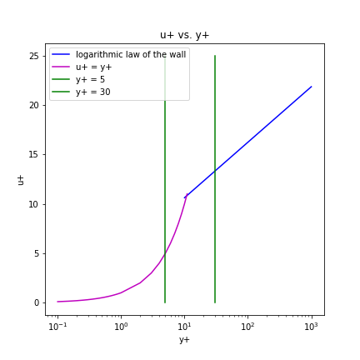
Figure 5.15.The relationship between $u^{+}$ and $y^{+}$
Since the turbulent flow model is encountered in this research, the standard $k-ϵ$ turbulence model for capturing the turbulence and the standard wall function (wall treatment) is selected for the near-wall region in Fluent. The standard wall function is based on [170] and it almost follows the previous the law of the wall theory, except the $y^{+}$ definition is slightly different. Instead of $y^{+}$, the alternative $y^{*}$ is applied for the numerical calculation purpose, and the respective law of the wall relationship is shown in Equation (25) [163]

 | u*=1κln⁡(Ey*) | (25)

In Equation (25), $κ$ is the same von Karman constant and $E$ is the empirical constant (= 9.793), $u^{*}$ is the dimensionless velocity. $y^{*}$ and $u^{*}$ are represented respectively in Equation (26)

 | y*=ρCμ14kP12yPμ  u*=upCμ14kP12τwρ | (26)

In Equation (26), $k_{P}$ is the turbulence kinetic energy at the node $P$ near the wall, $y_{P}$ is the distance between the node $P$ and the wall, $u_{P}$ is the mean velocity of the fluid at the node $P$ near the wall.

The reason to use $y^{*}$ instead of $y^{+}$ is that the $y^{+}$ has to be evaluated iteratively in numerical calculation while $y^{*}$ is an approximate estimation of $y^{+}$ and can be obtained easily without iteration. The ANSYS Fluent manual suggests that the dimensionless parameter $y^{+}$ should be greater than 30 and less than 300 [158]. In terms of $y^{*}$, $y^{*}$ is greater than 11.225 where reaching the logarithmic region. FLUENT provides $y^{+}$ as well as $y^{*}$ when evaluating the near wall region performance. Although the actual simulation is calculated based on $y^{*}$, $y^{+}$ is selected in the later meshing analysis as a good reference value to suggest whether the simulation follows the law of the wall and the flow near the wall region is properly modeled or not.

∂∂tρk+∂∂xiρkai=∂∂xjμ+μtσk∂k∂xj+Gk+Gb+ρϵ-YM+Sk

∂∂tρe+∂∂xiρϵai=∂∂xjμ+μtσk∂ϵ∂xj+C1ϵϵkGk+C3ϵGb-C2ϵρϵ2k+Sϵ

μt=ρCμk2ϵ

C1ϵ=1.44

The simulation lasts for 5.0 s, with a fixed time step size of 0.001 s. The event scenario is almost like Figure 5.3 with an additional 1.0 second waiting after the injection. More specifically, one simulation is to run the without injection for the first 3.0 seconds and water injection occurs from 3 seconds to 4 seconds, then another 1.0 second is simulated. The convergence criteria are 1×10⁻³ for the continuity, x velocity, y velocity, z velocity, turbulence kinetic energy (k), dissipation rate (ϵ), and 1×10⁻⁶ for the energy. The max iteration number for each time step is set to 10 to avoid reduce the total time required to run the simulation with minimum impact on convergence for each time step. Constant fluid properties are used for the water, with a density of 994.08 kg/m3, the dynamic viscosity of 7.2147×10⁻⁴ kg/m-s, and thermal conductivity of 0.6231 W/m-K.

CFD Results Study
The first section is focused on the CFD model validation with experiment data discussed in detail in Chapter FourThe validation comparison between the experiments and CFD simulation covers all the twelve flow rate cases applied in the experiment flow loop, ranging from 39.52 GPM up to 178.30 GPM. The second section is focused on the investigation of the optimal temperature locations under different flow rates.

u+=1κlny++C

y+=yuτν
u+=uuτ

CFD Solution Validation
The CFD simulations require validation against relevant experimental data based on the same boundary and initial conditions The CFD simulation can show how the temperature distribution of the entire flow region changes after the injection. Below Figure 5.16 shows how the temperature distribution looks during the injection of colder liquid.

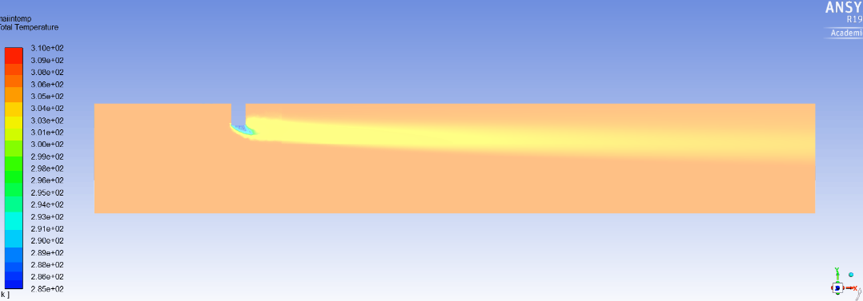
Figure 5.16. Temperature distribution when target flow rate at 178.3 GPM (Highest flow rate)

Figure 5.16 shows the temperature distribution after injecting lower temperature water under the 178.3 GPM. It shows that the temperature field is being perturbed by the injection. The closer to the injection pipe the temperature sensor is, the higher the signal that can be collected.

The CFD temperature data at the two sensor locations from the experiment flow loop are collected and compared to corresponding experimental data. Since the absolute value is slightly different, the amount of the relative perturbation is the main variable to be compared. Therefore, the percentage of perturbation has been calculated and used in the comparison based on the below equation:
 | $$T=T_{raw}-T_{steady}$$ | (27)
 | $Percentage Temperature change=\frac{T-T_{min} }{T_{max}-T_{min}}$ | (28)

$T_{raw}$ is the raw temperature directly collected from experiments and CFD simulation. $T_{steady}$ is the pre-injection temperature when there is no fluid injection in the flow region. The Equation (28 evaluates the temperature perturbation with the percentage of the max range. Below Figure 5.17, Figure 5.18, Figure 5.19 shows the temperature comparison at the sensor location under three different flow rates. The temperature data of the CFD model is collected as close to the same location as the experiment flow loop as possible.

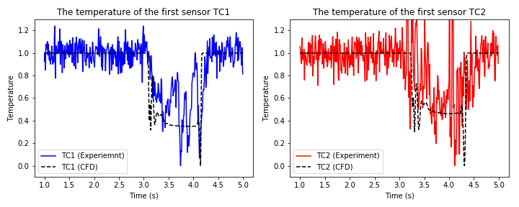
Figure 5.17. Temperature comparison under lower flow rate (~ 40 GPM)

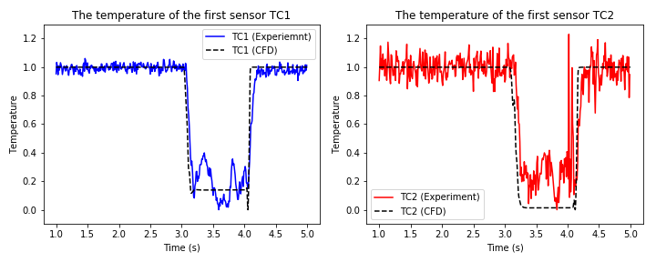
Figure 5.18. Temperature comparison under medium flow rate (~133 GPM)

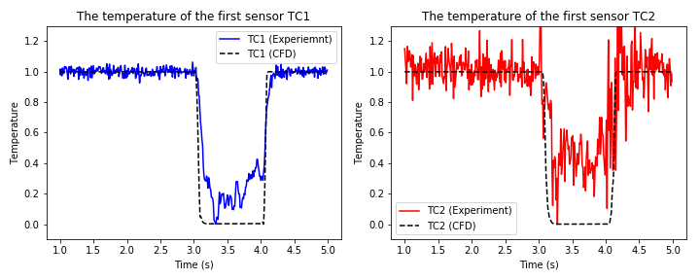
Figure 5.19. Temperature comparison under higher flow rate (~170 GPM)

The above three temperature comparison figures contain one injection within a 4.0 second range. TC1 is the sensor closest to the injection pipe. TC2 is the sensor next to the TC1 separate by a distance of 6 inches. From these three figures, the author is able to conclude the CFD simulations are able to simulate the temperature change at the two sensor locations. A few observations can also be made, the first observation is that the temperature data from the experiment is quite fluctuated. One major reason is that the average Navier-Stokes $k-ϵ$ turbulent model is applied that results in small scale and large scale fluctuations unrelated to injection to be averaged out. Another minor reason is that the physical sensor geometry is not modeled in the CFD model which won’t introduce any local turbulence likely caused by passing the sensor's physical body. Another issue is the timestamp of when the temperature started to change, and the above figures show the experiment temperature drop is slightly later than the CFD results when the injection happens. The main reason is that the CFD simulation collects the temperature instantaneously (no minimum read time) while the temperature sensor installed in the flow loop has the response time issue, which causes the temperature data slightly delay a bit. For the lower flow rate, the percentage temperature change is not very large as the higher flow rate cases. One possible reason is that the flow is relatively slow, and the cold injected water has been warmed up before measured by the temperature sensor. This phenomenon can be both observed in experiments and CFD simulation. It is more obvious for TC2 because TC2 is farther away from the water injection source which has a smaller temperature difference from the main flow. This can also be supported in the temperature distribution in Figure 5.16. One possible solution is to inject much cooler flow to introduce relatively more powerful perturbation. Another observation from the above is that the temperature of TC2 is relatively noisy. The main reason might be the flow is more perturbated after passing the injection pipe and the first temperature sensor. This is expected because it’s further out in the wake of the injected pipe perturbations.

After comparing the temperature between the CFD and experiments, the velocity distribution is examined in CFD simulation. The flow region after the injection pipe is the concerning section because the CCF flow estimation infers the flow based on the temperature sensors installed in this region. Below Figure 5.20, show how the velocity distribution looks like after the water injection under a low flow rate (39.52 GPM).

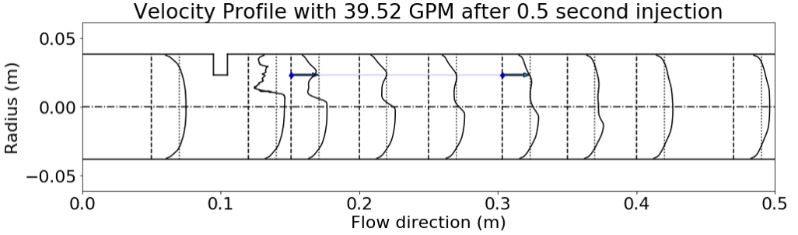
Figure 5.20. Velocity distribution under low flow rate after water injection

Figure 5.20 shows the velocity distribution of the cross-section at different locations along the flow direction under the flow rate after 0.5 second injection. The pipe centerline is marked with the dotted dashed line ($- ∙-∙-$). And the two sensor locations are marked with blue points and black arrows indicating the flow direction. Each examined cross-section is marked with a dashed line ($- --$), and for each velocity distribution, the average main flow rate is marked with the dotted line ($∙∙∙∙∙$). The selected cross-sections roughly cover the most important locations in the flow pipe, including the region before the injection pipe, the exact two sensor locations, and some other randomly chosen locations.

Before the injection pipe, the velocity profile has the U shape curve, which is the general form in the pipe flow. It has a higher local velocity near the centerline, and it has the highest gradient towards zero near the wall. The injected water package disturbed the U shape velocity profile shown in Figure 5.20.

After passing the injection pipe, the flow is affected by the physical structure of the injection pipe and the flow distribution reflects that the upper flow rate sharply decreases and gets recovered later. Then, the flow rate passes two sensor locations sequentially. The transit time is determined by the flow rate along the path from the first sensor to the second sensor (marked as light blue in Figure 5.20), but it is hard to examine how flow rate changes along the path. Therefore, a more detailed flow rate distribution along this specific light blue path is shown in Figure 5.21.
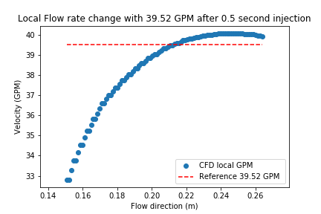
Figure 5.21. Local flow rate change along the two sensor path under the low flow rate

Above, the blue scattered dots is the flow rate discretely collected along the two sensor paths from the CFD simulation for the lowest flow rate. The red dashed line is the reference average flow mentioned previously. The x-axis only covers the horizontal range within the two sensors. It shows that when the flow reaches the first sensor, the flow rate is lower since it does not fully recover from flow disturbance caused by being blocked by the injection pipe. When a flow is traveling forward, it gradually gets recovered and finally goes backed to the normal flow rate, which is roughly equal to the reference flow rate in this case.

It is quite a different story when the main flow rate is large. Below two figures, Figure 5.22, Figure 5.23 shows the same flow rate distribution plots as above two except the main flow rate is high (178.9 GPM).

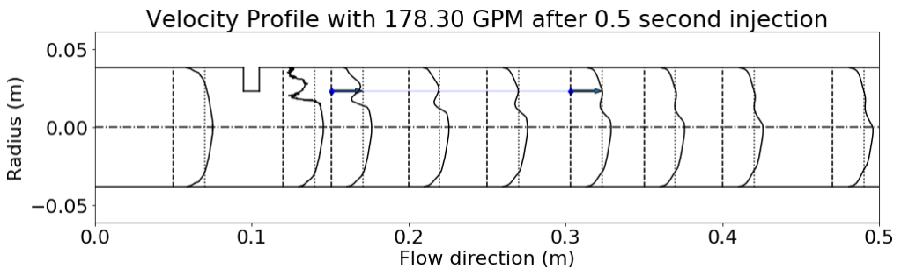
Figure 5.22. Velocity distribution under high flow rate after water injection

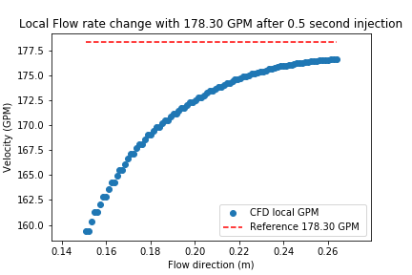
Figure 5.23. Local flow rate change along the two sensor path under the high flow rate
By comparing different flow rate cases, it is found that both two suffer from being blocked by the injection pipe. However, the low flow rate case has around 14 % decrement, while the high flow rate has around 10 % decrement. One possible reason might be that the high flow rate can recover quicker than the low flow rate can. When comparing Figure 5.21 with Figure 5.23, another issue is noticed that the high flow rate case does not go back to the average flow rate even after passing the second sensor. Although the flow rate is not decreased too much like the lower flow rate case, the transit time between the two sensors is much shorter since the flow rate grows higher. Therefore, it is reasonable to increase the distance between the sensors to generate better flow estimation when the flow rate grows higher. This is one of the motivations for the latter section, the optimal temperature sensor location investigations.

Flow Rate Validation using CCF Method

After validating the temperature and velocity quantities of interest for the low and high flow rate, the final step is to try to validate the flow rate estimated by the CCF method from the CFD simulation and compare to the experimental estimation and against the flow meter in the test facility. Figure 5.24 shows the CCF flow estimation based on the previous experimental results and the CFD simulation model.
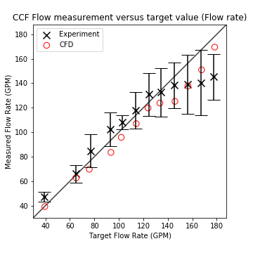
Figure 5.24. CCF flow estimation (x-axis is the flow rate measured from the flow meter in the test facility)

The experiment data use the black “x” to indicate the averaged CCF flow estimation value among 5 repetitions, and the error bar is drawn with 2 standard deviations based on 5 repetitions. The CFD results are marked with the red ”o”. The overall CFD results are lower than the true flow rate. The main reason is that the CFD results measure the local flow rate near the wall while the true flow rate is the average flow rate marked with the dashed line shown in Figure 5.20 and Figure 5.22. The temperature is collected at the exact location as the endpoint of the two sensors near the wall in the experiment flow loop. It has smaller local flow rate than the true flow rate. Additionally, recall Figure 4.16, it covers the flow rate only up to 160 GPM. Figure 5.24 includes an additional two flow rate cases up to 180 GPM. It shows the CCF estimated flow rate in the experiment is much lower than the true value, and for the highest flow rate case, even the 2 standard error bar can’t reach the one-one line. With the main flow rate increases, the local turbulence gets stronger. Comparing Figure 5.21 with Figure 5.23, the flow with a higher flow rate has less time to recover from being blocked by the injection pipe in the CFD simulation. It should be noticed that the two sensor geometries are not built. Therefore, when coming to the experiment side, both injection pipe and sensors might introduce extra local perturbations, this is not regarded as a good source of correlated process signal because such local disturbance changes the local velocity distribution rapidly. It will disappear quickly, and won’t travel along the flow path caught by the second sensor. This only happens during the high flow rate mainly because during the lower flow rate, such local perturbation won’t dominate the correlated process signal and the flow has more time to recover from being blocked. The potential future work is to measure the flow rate at the same location as the two sensors do, instead of measuring the averaged mean flow rate. The tighter controls on the flow rate measurements will be helpful especially when the flow rate is large.

Optimal temperature sensor location investigation
The previous section verifies whether CFD simulations can actually predict flow and heat transfer behavior in the experiment flow loop. Recalling Figure 5.20 and Figure 5.22, the local velocity depends on how far it is away from the centerline. Since the sensor locations are close to the wall, the CCF flow estimation measures the local velocity instead of the mean flow rate. The difference between the CCF flow estimation and the mean flow rate gets larger when the mean flow rate is larger. It is reasonable to research whether the sensor location affects the CCF flow estimation performance, and how to select the relatively better sensor location under different flow rate. This section aims to use these CFD simulations to answer these questions. To investigate all the potential sensor locations, it has to cover the most flow regions after the injection pipe. Below Figure 5.25 shows the candidate sensor locations in CFD simulations.

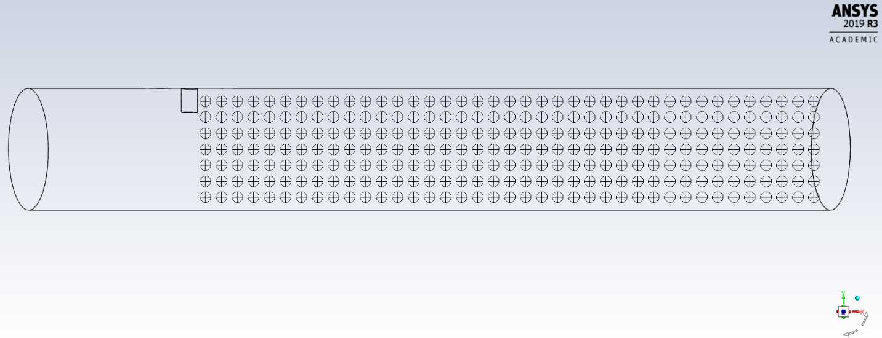
Figure 5.25. Candidate sensor locations

Figure 5.25 shows all the candidate sensor locations along the flow direction. For every cross-section along the flow direction, there are 7 candidate locations. These 7 candidates are 0.01 m away from each other along the radial direction. These 7 candidates form a group at each cross-section, and there are 39 groups uniformly distributed along the horizontal flow direction. Each group is 0.01 m away from the another. Thus, there are a total of 273 locations (39 x 7) where the temperature is collected under different flow rates. Two locations are selected for the sensor pairs, thus the total number of the sensor pair location candidates is 36,309 pairs. It roughly covers all the flow region after the injection pipe.

After collecting all the temperature at these locations, the CCF is applied to every possible pair and investigate the relationship between the pair locations and the performance of CCF flow estimation. For each main flow rate, the top 10 sensor location pairs are selected and plotted on the temperature distribution plot shown in Figure 5.26.

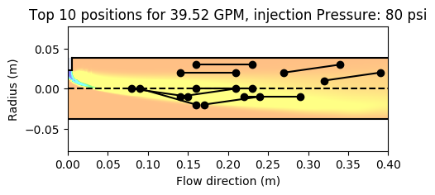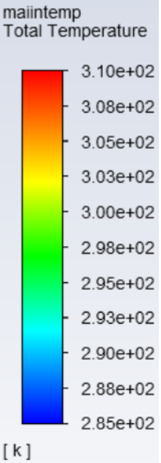
Figure 5.26. Top 10 temperature sensor pairs for 39.52 GPM with an injection pressure of 80 psi

Figure 5.26 shows the sensor pairs with the top 10 CCF flow estimation plotted on the temperature contour of the main cross-section after 0.5-second water injection. Top 10 accuracy means these 10 pairs produce the top 10 smallest RMSE of CCF flow estimation. The background contour shows the temperature distribution after the colder water has been injected. Since the injected water is colder than the main flow, the major yellow region shown in the plot implies the cool region. Such temperature differences introduce the perturbation into the main flow, which benefits the CCF flow estimation. The distance between the two sensors among these top 10 pairs does not vary significantly, and it is roughly around 0.7 m on average. Another observation is that Figure 5.26 studies the case under the highest injection pressure (with the largest injection flow of 0.920 m/s). The highest injection flow rate introduces strong perturbations and diffuses a broader region especially when the mean flow rate is low. This is one reason that these top 10 pairs are not clustered within the cooler region along the pipe, where the color is yellow and has a temperature of 303 K approximately shown in Figure 5.26. Another major reason is the RANS equation cannot simulate the local eddy motions and only models this behavior. The temperature fluctuations might impact a larger region due to diffusion and convection. Therefore, in this CFD simulation study, it will exist that there might be some sensor pairs existed outside the temperature region and having better CCF flow estimation performance. Later CFD simulation results have these issues as well.

To narrow down the temperature perturbation region under the low flow rate, it is reasonable to reduce the injection flow to check if there are any changes. Below Figure 5.27 shows the same conditions except reducing the injection pressure to 30 psi.

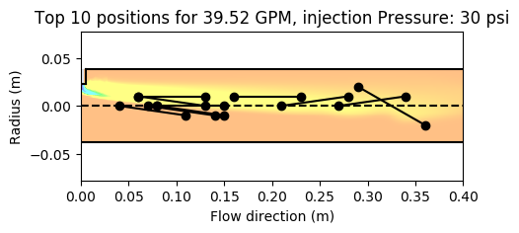
Figure 5.27. Top 10 temperature sensor pairs for 39.52 GPM with an injection pressure of 30 psi

Figure 5.27 shows that the yellow region with a smaller temperature is relatively narrower than the region in Figure 5.26. Thus, these 10 pairs are better clustered inside the perturbation region, which is closer to the centerline. Among these 10 pairs, the RMSE ranges from 0.036 to 0.037 GPM, which means there is no much performance difference among these top 10 pairs. Smaller injection flow rate would be more helpful under the lower main flow rate since the temperature fluctuation region (a yellow region with relatively smaller temperature shown in Figure 5.27) is smaller and the sensor location is easier to choose.

When increasing the flow rate to around 120 GPM (0.00781 m³/s) with Reynold number of 1.8 x 10⁵ (the range of Reynold number is from 5.8×10⁴ to 2.6×10⁵), the same top 10 sensor pairs with temperature contour are investigated as well and below Figure 5.28 shows it is under high injection pressure and Figure 5.29 shows it is under low injection pressure.

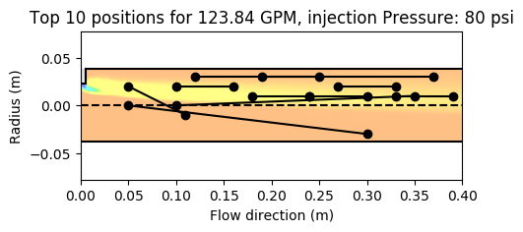
Figure 5.28. Top 10 temperature sensor pairs for 123.84 GPM with an injection pressure of 80 psi

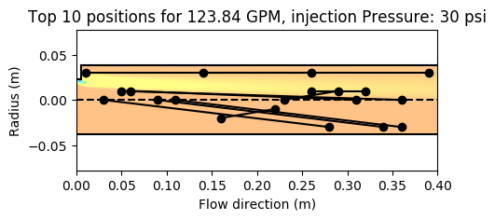
Figure 5.29. Top 10 temperature sensor pairs for 123.84 GPM with an injection pressure of 30 psi

The first observation in these two figures is that the average distance between the top 10 sensor pairs is larger than those under the lower main flow rate. The detailed average distance between the two sensors based on the top 10 pairs under different mean flow and injection pressure are shown in Table 5-3.

Table 5-3. Average distance between two sensors based on the top 10 pairs under different mean flow and injection pressure
The average distance between the two sensors (m) |  | Mean flow rate (GPM)
 |  | 39.52 | 123.84 | 178.30
Injection pressure(psi) | 80 psi | 0.07 | 0.12 | 0.22
Injection pressure(psi) | 30 psi | 0.07 | 0.20 | 0.20
Another founding in Table 5-3 is that when the injection pressure at 30 psi, the average distance does not change too much when the mean flow rate is greater than 120 GPM. Referenced Figure 5.29 and Figure 5.31, this might be the temperature fluctuation is not strong enough to be helpful for the CCF estimation under the large mean flow.

Additionally, for the higher injection pressure, the top 10 sensor pairs are mainly located within the temperature fluctuation region, while the sensor pairs are located more separately under the low injection pressure. The higher injection pressure with 80 psi is preferable. One reason is that the top 10 sensor pairs are almost located within the temperature perturbation region which means the time delay calculated within this region is more stable and easily controlled. The next two figures show the same plots under the highest main flow rate.

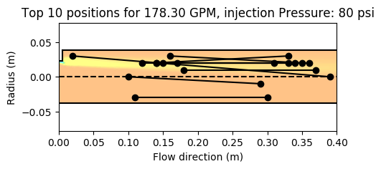
Figure 5.30. Top 10 temperature sensor pairs for 178.30 GPM with an injection pressure of 80 psi

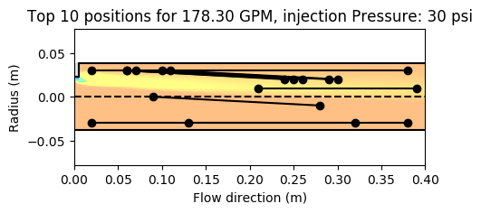
Figure 5.31. Top 10 temperature sensor pairs for 178.30 GPM with an injection pressure of 30 psi

Under the high main flow rate, the injection flow rate is more important. Compared with Figure 5.30 and Figure 5.31, the area of the temperature perturbation region depends on the injection pressure. Figure 5.30 shows that the temperature perturbation region is larger when the injection pressure is high and the top 10 sensor pairs are mostly located within the temperature perturbation region due to the high injection pressure. Therefore, for the higher main flow rate, the higher injection flow is necessary to perform more accurate CCF flow estimation.

Figures from Figure 5.26 to Figure 5.31 only include the top 10 pairs, and it is not easy to figure out the relationship between the horizontal distance among the injection pipe and sensors and the CCF flow estimation performance. One main observation shown in Table 5-3 is that the top 10 pairs have a larger distance between the two sensors when the main flow rate is high. Given the mean flow rate, larger distance means a longer delay time between two sensors. The delay time should be large enough to be detected to infer the CCF flow estimation. This is more critical when the mean flow rate is large. The distance from the injection pipe to the first sensor and the distance between the two sensors might have some relationship. Detailed examinations on the correlation between two distances are done below.
Instead of selecting the top 10 pairs, the first 1,000 smallest RMSE sensor pairs are collected. For each sensor pair, only the flow direction coordinate (regarded as x-direction) is considered. All these 1,000 pairs of the first sensor and second sensor x location are plotted in a 3D histogram, weighted with the inverse of RMSE.

 | nx1,x2, weighted=1RMSEx1,x2nx1,x2 | (29)

In Equation (29), x1,x2 represents the first sensor location and seconde second sensor location along the flow direction. $n_{x_{1},x_{2}}$ represented the frequency of the case with the first sensor location at $x_{1}$ and the second sensor location at $x_{2}$. Here $n_{x_{1},x_{2}}$ is equals to 1 because every combination is run with one time. RMSEx1,x2 represented the RMSE under current distance setup with $x_{1},x_{2}$. Thus, the nx1,x2, weighted will be large if the $RMSE_{x_{1},x_{2}}$ is small. The 3D histogram aims to count the frequency of each x location pairs among these 1,000 data. The data weighted with the inverse of RMSE is to consider the CCF flow estimation performance. In other words, if one pair has a higher RMSE, the location pairs will be less weighted. The overall plot can show the weighted x location relationship between the two sensors. Figure 5.32 shows this 3D histogram under the low flow rate case.

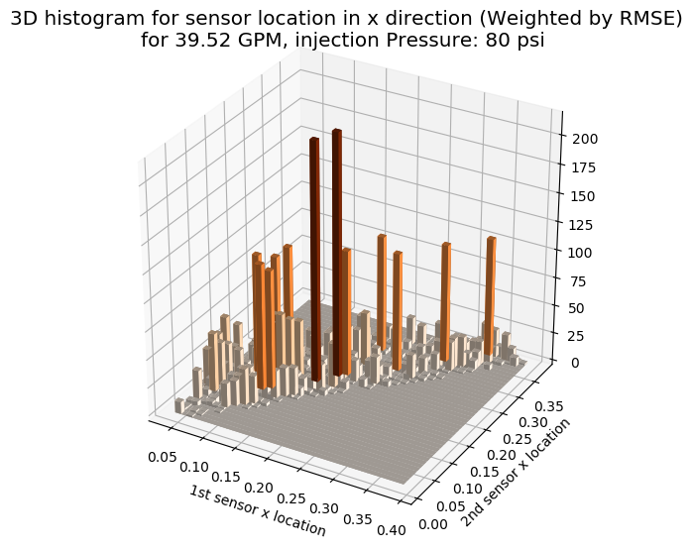
Figure 5.32. 3D histogram of the weighted x location under low flow rate (High injection pressure)

Figure 5.32 shows the x location relationship between the first and second sensors. A darker red bar means this location pair has more weights, which means better CCF flow estimation with smaller RMSE. The top two pairs can be easily recognized with the first sensor location at 0.15 m on the 1st sensor x location axis and second sensor location at 0.2 m on the 2nd sensor x location axis. Besides, most sensor pairs with large weights reveal some linear relationship between the first and sensor location. To show this linear relationship more clearly, the 3D histogram is transferred to a 2D heat map displayed in Figure 5.33.

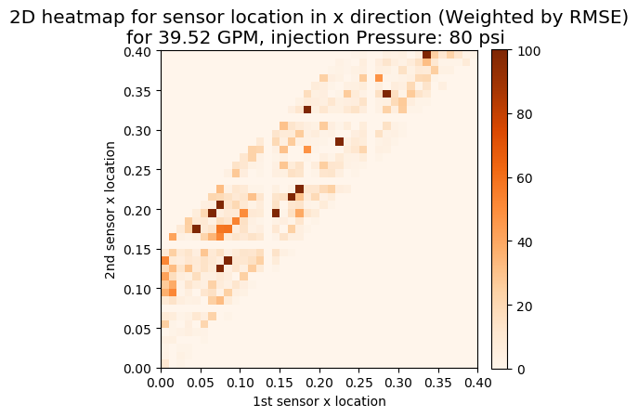
Figure 5.33. 2D heat map of the weighted x location under low flow rate (High injection pressure)

Figure 5.33 can also be regarded as a squeezed 3D histogram, but the different color scale is applied here. The reason for using a smaller color scale is to compare with other flow rate cases under the same color scale and the average weight is much smaller especially when the flow rate is high. It is easy to recognize there is a red linear belt existed. This belt can be roughly estimated with the slope of 1 and the intercept of 0.05 m, which indicates the second temperature sensor should be around 0.05 m away from the first sensor no matter where the first sensor is. The first sensor location should be around 0.15 to 0.2 m to the injection pipe. Next, the same heat map with different main flow rates and different injection flow are separately plotted from Figure 5.34 to Figure 5.38.

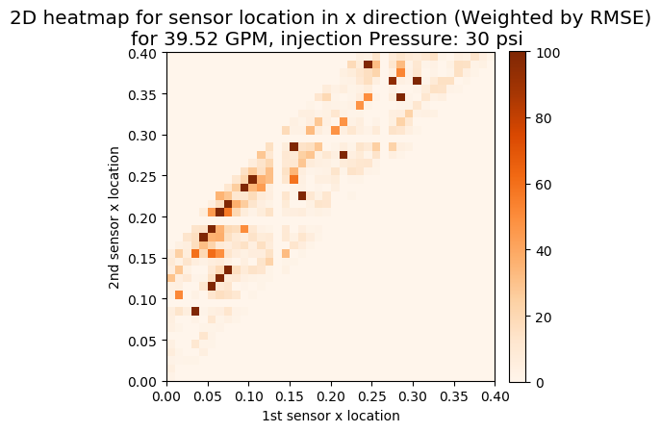
Figure 5.34. 2D heat map of the weighted x location under low flow rate (Low injection pressure)
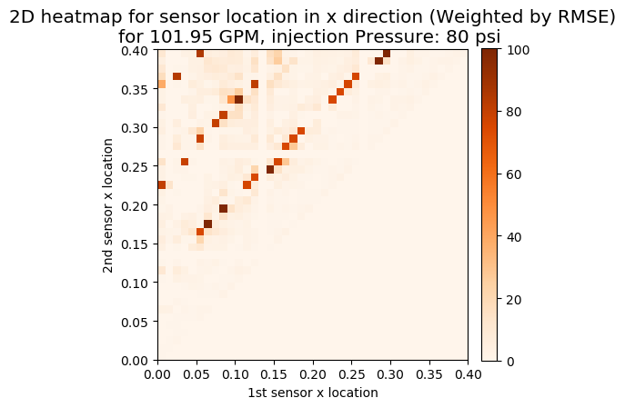
Figure 5.35. 2D heat map of the weighted x location under medium flow rate (High injection pressure)
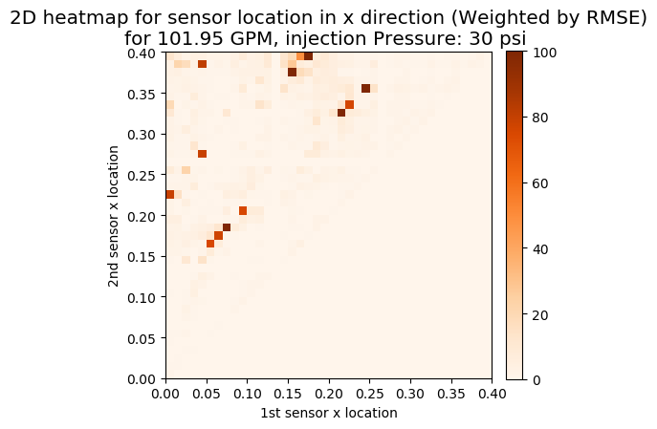
Figure 5.36. 2D heat map of the weighted x location under medium flow rate (Low injection pressure)
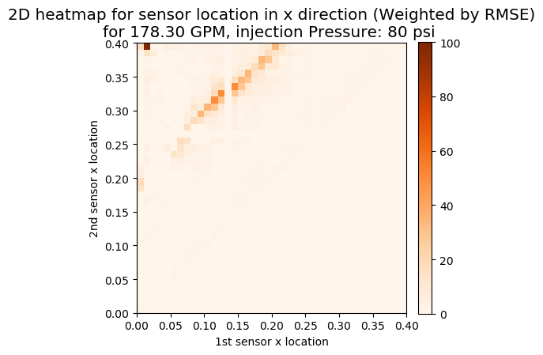
Figure 5.37. 2D heat map of the weighted x location under a high flow rate (High injection pressure)
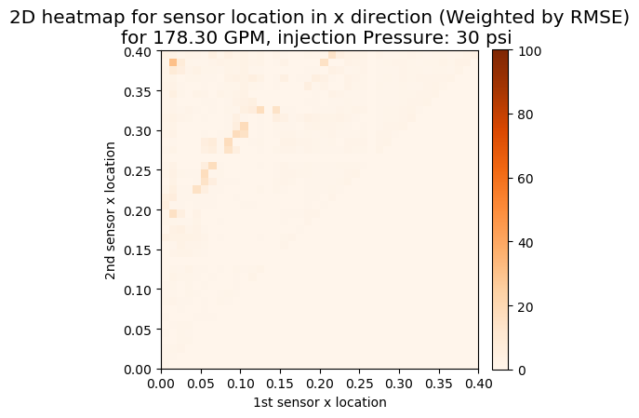
Figure 5.38. 2D heat map of the weighted x location under a high flow rate (Low injection pressure)

From Figure 5.33 to Figure 5.38, six figures combine three different main flow rate (from low to high) and two different injection flow. Firstly, when the main flow rate is low, how much the fluid is injected does not play a very important role in the sensor location distribution. Recall the experiment results and the two CFD temperature distribution plots shown in Figure 5.26 and Figure 5.27, the experiment results do not show the strong relationship between the injection flow and the performance of the CCF flow estimation, and Figure 5.26 and Figure 5.27 shows although the RMSE is close between different injection flow rate, the case with lower injection flow is easier to choose the sensor location.

When increasing the main flow to the medium range, the sensor location distribution changes, there is not a concentrated belt existed, the width of the belt seems growing and there are three lines formed instead. The slope of these lines are still the same as the lower flow rate, but the intercept is different. There are three possible intercepts: 0.11 m, 0.23 m, and 0.35 m, which are all greater than that of the case with a low main flow rate. This can be interpreted as follows: if the same first sensor location is selected, the second sensor location should be further away from the first sensor when the flow rate is increasing, and the proper distance between the two sensors might have three options laid on these three lines respectively. Additionally, the injection flow rate starts influencing the performance of the CCF flow estimation. Comparing Figure 5.35 and Figure 5.36 shows that some sensor location candidates do not exist under the low injection flow, thus it agrees with the previous experimental results that usually high injection pressure is a good option when the main flow rate is high.

Finally, when the main flow rate increases to the maximum flow rate in this research, the sensor location distribution gets worse, which matches the worse performance of the experiment results under the high main flow rate. When compared with the cases ranging from lower flow to the high flow, the sensor location distribution expands and moves upwards. The average color gets lighter which reflects the CCF flow estimation performance does not work very well at the high flow rate. Even though the color is light, the slope of the sensor location distribution can be observed which is still the same. The unchanged slope among all the flow rates implies that the distance between the injection pipe and the first sensor does not depend on the distance between the two sensors. Another observation when comparing Figure 5.37 and Figure 5.38 is that the injection flow should be large under the high main flow.

Conclusion
This chapter summarizes the dissertation contributions and then list a few recommendations for future work.

Research Conclusions
This research was focused on an indirect flow measurement technique based on the CCF. The technique is explicitly developed and verified from both experiments and CFD simulations. The basic theory for CCF flow estimation is to perform cross-correlation on the signals collected from the two adjacent sensors along the flow direction. The calculated delay time and the distance between these two sensors are used to infer the flow rate. The CCF flow estimation has been widely studied in nuclear fields, and the property of the indirect measurement can perform better than the conventional pipe-based flowmeters when there is no pipe available for flow measurement, such as the pool-type reactor. However, the original CCF technique faces an issue that the important correlated noise for inferring the delay time is usually buried by the uncorrelated noise, which causes the delay time to be difficult to recognize, especially under large flow rates. Such a situation can be interpreted as a low SNR harms the CCF flow estimation. The verification of the relationship between the SNR and the CCF flow estimation performance is conducted based on the synthetic signals. The results shown in Table 3-1 confirms that the key to increasing CCF flow estimation accuracy is to increase the SNR. This research work proposed a practical approach to enhancing the CCF flow estimation by increasing the signal portion of the SNR with an injected fluid package.

To verify the method’s performance, an early-stage CFD simulation was developed in Autodesk CFD and used to design the physical test flow loop. A test flow loop was constructed to verify the water injection performance improvement for both horizontal and vertical flow direction. The results indicate that the newly developed CCF method measures larger flow rates more accurately than the original method. Another issue affecting the CCF performance is the sensor itself. A higher sampling frequency can provide higher resolution signals for the delay time inference. However, when the sensors are restricted by a low sampling frequency, an alternative method to increase resolution is to perform the linear interpolation on the collected signals. A comparison of the results shows the CCF flow estimation works better after performing the linear interpolation. Additionally, the measurement accuracy under different flow rates is affected by relative locations between the injection pipe and sensors shown in experiment measurement.

Because of the restriction of the sensor installation locations in the flow loop, a higher fidelity CFD simulation model is developed for further investigation of the optimal sensor locations under different main flow rates. The 3D CFD model was constructed and compared with the experimental flow loop to confirm that the CFD can simulate the experiment flow loop accurately. The verification results show that the CFD model can simulate the overall temperature and velocity distribution. A detailed grid search on the sensor pair locations has been performed to identify optimal placement. The first finding is that the sensor location is more likely to be placed within the region where the temperature changes greatly caused by the injected water package. Besides, the distance between the sensor pairs is related to the flow rate. A larger flow rate should have the sensors spaced further apart because the flow delay time should be large enough to be detected by the CCF curve. In addition to the sensor locations, the water package injects method is an important factor. The injection flow rate influences the flow velocity estimate. The CFD results show that a lower flow rate may perform better with a smaller injection flow because the small perturbation is enough for the two sensors to infer the delay time; but for the higher flow rate cases, a larger injection flow rate is required to inject a stronger perturbation which won’t be concealed by the more turbulent main flow rate.

Overall, this research is focused on a new improved flow estimation method based on the Cross Correlation Function. Both experiments and CFD simulations have been performed to verify the performance and optimize several parameters to improve flow estimation at different flow rate conditions.

Recommendations for Future Work
Several issues could be studied to further improve the CFD flow estimation technique’s performance and move it towards commercialization. One issue is the shape of the injection pipe, which is related to the shape of the velocity and temperature perturbation region after injection and has an influence on where the sensors should optimally be placed. A more detailed study on the injection period is necessary as well, especially for the smaller injection timing. In addition to each parameter, there is some correlation between them, like the injection period and D₁ and D₂. Another potential interest is to develop this method further within a pool-like experiment instead of the pipe system. This could expand the functionality of the technique and increase its potential application to pool-type reactors. Besides the flow loop experiment, there will be some further researches on CFD simulation as well. The three group division based on the main flow is not verified by the detailed meshing sensitivity across all the flow rate cases with each meshing model. Another potential topic is how the recovery of the velocity profile after the injection is correlated with the separation distance and velocity of the mean flow. When the mean flow is high, it needs more distance between the two sensors to get recovered.

List of References

[1] J. M. Broughton, P. Kuan, D. A. Petti, and E. L. Tolman, “A Scenario of the Three Mile Island Unit 2 Accident,” Nucl. Technol., vol. 87, no. 1, pp. 34–53, Sep. 1989.
[2] M. Ishikawa, S. Shiozawa, T. Wakabayashi, N. Ohnishi, and H. Mochizuki, “An examination of the accident scenario in the Chernobyl Nuclear Power Station,” Nucl. Saf., vol. 28, no. 4, pp. 448–454, 1987.
[3] R. Gauntt et al., “Fukushima Daiichi Accident Study (Status as of April 2012),” Sandia Natl. Lab. Report, SAND2012-6173, Albuquerque, NM, no. July, 2012.
[4] OECD/NEA, “Technology Roadmap Update for Generation IV Nuclear Energy Systems: Preparing Today for Tomorrow’s Energy Needs,” p. 7, 2014.
[5] G. Bignan, J. F. Villard, C. Destouches, P. Baeten, L. Vermeeren, and S. Michiels, “The key-role of instrumentation for the new generation of research reactors,” ANIMMA 2011 - Proc. 2nd Int. Conf. Adv. Nucl. Instrumentation, Meas. Methods their Appl., 2011.
[6] I. A. Belyaev, N. G. Razuvanov, V. G. Sviridov, and V. S. Zagorsky, “Temperature correlation velocimetry technique in liquid metals,” Flow Meas. Instrum., vol. 55, no. December 2015, pp. 37–43, 2017.
[7] G. Por, M. Berta, and M. Csuvar, “Measurement of the Coolant Flow Rate Using Correlation of Temperature Fluctuation,” Prog. Nucl. Energy, vol. 43, no. 1–4, pp. 281–288, 2003.
[8] T. Moazzeni, J. Ma, and Y. Jiang, “Measurement and Calibration of Thermal Cross-Correlation-Based Flowmeter Operating In Harsh Environment,” IEEE Trans. Instrum. Meas., vol. 62, no. 8, pp. 2280–2285, 2013.
[9] P. G. Bentley and D. G. Dawson, “Fluid flow measurement by transit time analysis of temperature fluctuations,” Trans. Soc. Instrum. Technol., vol. 18, no. 3, p. 183, 1966.
[10] M. S. Beck and A. Plaskowski, “Inferential measurement of fluid flow from the cross-correlation of temperature fluctuations in the system,” Electron. Lett., vol. 3, no. 4, pp. 169–171, 1967.
[11] F. J. Sweeney and B. R. Upadhyaya, “Measurement of core coolant flow velocities in PWRs using temperature: neutron noise cross correlation,” Oak Ridge Natl. Lab, vol. No. CONF-8, 1982.
[12] F. J. Sweeney, B. R. Upadhyaya, and D. J. Shieh, “In-core coolant flow monitoring of pressurized water reactors using temperature and neutron noise,” Prog. Nucl. Energy, vol. 15, pp. 201–208, 1985.
[13] H. M. Hashemian et al., “Advanced Instrumentation and Maintenance Techonologies for Nuclear Power Plants,” US Nucl. Regul. Comm., vol. NUREG/CR-5, 1998.
[14] H. M. Hashemian, J. A. Thie, B. R. Upadhyaya, and K. E. Holbert, “Sensor response time monitoring using noise analysis,” Prog. Nucl. Energy, vol. 21, no. C, pp. 583–592, 1988.
[15] J. A. Regan and H. Estrada Jr, “Control system for a nuclear steam power plant.” Google Patents, 04-Dec-1990.
[16] H. M. Hashemian, “On-line monitoring applications in nuclear power plants,” Prog. Nucl. Energy, vol. 53, no. 2, pp. 167–181, 2011.
[17] OMEGA, “Flow & Level Measurement,” Trans. Meas. Control, vol. 4.
[18] M. Pereira, “Flow meters: part 1,” IEEE Instrum. Meas. Mag., vol. 12, no. 1, pp. 18–26, 2009.
[19] D. W. Spitzer, Industrial Flow Measurement, 3rd Editio. International Society of Automation, 2005.
[20] T. Moazzeni, J. Ma, Y. Jiang, and N. Li, “Flow rate measurement in a high-temperature, radioactive, and corrosive environment,” IEEE Trans. Instrum. Meas., vol. 60, no. 6, pp. 2062–2069, 2011.
[21] J. B. Prettyman, M. C. Johnson, and S. L. Barfuss, “Comparison of selected differential-producing, ultrasonic, and magnetic flow meters,” J. Am. Water Works Assoc., vol. 108, no. 1, pp. E39–E49, 2016.
[22] H. M. Hashemian and J. Jiang, “Nuclear plant temperature instrumentation,” Nucl. Eng. Des., vol. 239, no. 12, pp. 3132–3141, 2009.
[23] B. Upadhyaya et al., “In-situ Condition Monitoring of Components in Small Modular Reactors Using Process and Electrical Signature Analysis. Final report, volume 1. Development of experimental flow control loop, data analysis and plant monitoring,” U.S. Department of Energy, 2014.
[24] A. Z. Mesquita, H. C. Rezende, and R. Souza, “Thermal power calibrations of the IPR-R1 TRIGA nuclear reactor,” in Proceedings of the 20th International Congress of Mechanical Engineering, COBEM, 2009, pp. 15–20.
[25] G. V. Arkadov, O. V. Ovcharov, V. I. Pavelko, A. I. Usanov, P. Liptak, and R. Slovak, “MEASUREMENT OF THE COOLANT FLOW RATE THROUGH A VVÉR-440 FUEL CHANNEL ON THE BASIS OF FLUCTUATIONS OF DIRECT-CHARGE SENSOR SIGNALS,” At. Energy, vol. 91, no. 3, pp. 167–174, 2001.
[26] H. Shaban and S. Tavoularis, “On the accuracy of gas flow rate measurements in gas-liquid pipe flows by cross-correlating dual wire-mesh sensor signals,” Int. J. Multiph. Flow, vol. 78, pp. 70–74, 2016.
[27] R. Drury, A. Hunt, and J. Brusey, “Identification of horizontal slug flow structures for application in selective cross-correlation metering,” Flow Meas. Instrum., vol. 66, no. December 2018, pp. 141–149, 2018.
[28] M. Arattano and L. Marchi, “Measurements of debris flow velocity through cross-correlation of instrumentation data,” Nat. Hazards Earth Syst. Sci., vol. 5, no. 1, pp. 137–142, 2005.
[29] M. Henningsson, K. Östergren, and P. Dejmek, “Plug flow of yoghurt in piping as determined by cross-correlated dual-plane electrical resistance tomography,” J. Food Eng., vol. 76, no. 2, pp. 163–168, 2006.
[30] A. Saoud, V. Mosorov, and K. Grudzien, “Measurement of velocity of gas/solid swirl flow using Electrical Capacitance Tomography and cross correlation technique,” Flow Meas. Instrum., vol. 53, pp. 133–140, 2017.
[31] D. R. Cadel and K. T. Lowe, “Cross-correlation Doppler global velocimetry (CC-DGV),” Opt. Lasers Eng., vol. 71, pp. 51–61, 2015.
[32] D. R. Cadel and K. T. Lowe, “Investigation of measurement sensitivities in cross-correlation Doppler global velocimetry,” Opt. Lasers Eng., vol. 86, pp. 44–52, 2016.
[33] M. Waqas Munir and B. A. Khalil, “Suggested Reference Cross Correlation Velocity Measurement of Multiphase Flow,” Int. J. Sci. Res. Int. J. Sci. Res. ISSN (Online Index Copernicus Value Impact Factor, vol. 4, no. 2, pp. 802–807, 2013.
[34] L. S. Zhai, N. D. Jin, Z. K. Gao, A. Zhao, and L. Zhu, “Cross-correlation velocity measurement of horizontal oil–water two-phase flow by using parallel–wire capacitance probe,” Exp. Therm. Fluid Sci., vol. 53, pp. 277–289, 2014.
[35] R. Hanus, L. Petryka, and M. Zych, “Velocity measurement of the liquid-solid flow in a vertical pipeline using gamma-ray absorption and weighted cross-correlation,” Flow Meas. Instrum., vol. 40, pp. 58–63, 2014.
[36] Y. Zhou, J. Liang, K. I. Maslov, and L. V. Wang, “Calibration-free in vivo transverse blood flowmetry based on cross correlation of slow time profiles from photoacoustic microscopy,” Opt. Lett., vol. 38, no. 19, p. 3882, 2013.
[37] E. Alidoosti, “Simulation of Thermal Transit-Time Flow Meter for High Temperature, Corrosive and Irradiation Environment,” University of Nevada, Las Vegas, 2014.
[38] T. Moazzeni, J. Ma, Y. Jiang, and N. Li, “Real-time algorithm for the measurement of liquid metal coolant flow velocity with correlated thermal signals,” Int. Congr. Adv. Nucl. Power Plants 2009, ICAPP 2009, vol. 2, pp. 802–806, 2009.
[39] E. J. Avilán, V. Reis, L. E. Barreira, and C. M. Salgado, “EVALUATION OF CROSS CORRELATION TECHNIQUE TO MEASURE FLOW IN PIPES OF THE OIL INDUSTRY,” in 2013 International Nuclear Atlantic Conference - INAC 2013, 2013.
[40] J. J. Charonko and P. P. Vlachos, “Estimation of uncertainty bounds for individual particle image velocimetry measurements from cross-correlation peak ratio,” Meas. Sci. Technol., vol. 24, no. 6, 2013.
[41] H. Seraj, M. F. Rahmat, and M. Khalid, “Measurement of velocity of solid/air two phase fluid using electrostatic sensors and cross correlation technique,” Sci. Iran., vol. 20, no. 3, pp. 786–792, 2013.
[42] J. B. Gajewski, “Accuracy of cross correlation velocity measurements in two-phase gas-solid flows,” Flow Meas. Instrum., vol. 30, pp. 133–137, 2013.
[43] J. Brunker and P. Beard, “Pulsed photoacoustic Doppler flowmetry using a cross correlation method,” Photons Plus Ultrasound Imaging Sens. 2010, vol. 7564, no. February 2010, p. 756426, 2010.
[44] J. Brunker and P. Beard, “Pulsed photoacoustic Doppler flowmetry using time-domain cross-correlation: Accuracy, resolution and scalability,” J. Acoust. Soc. Am., vol. 132, no. 3, pp. 1780–1791, 2012.
[45] C. Tan and F. Dong, “Cross correlation velocity of oil-water two-phase flow by a Dual-plane Electrical Resistance Tomography system,” 2010 IEEE Int. Instrum. Meas. Technol. Conf. I2MTC 2010 - Proc., no. 50776063, pp. 766–770, 2010.
[46] T. J. Arbour and J. Enderlein, “Application of dual-focus fluorescence correlation spectroscopy to microfluidic flow-velocity measurement,” Lab Chip, vol. 10, no. 10, pp. 1286–1292, 2010.
[47] F. Zhang and F. Dong, “A measurement method of slug flow velocity of gas-liquid two-phase flow in horizontal pipe,” in 2010 IEEE Instrumentation & Measurement Technology Conference Proceedings, 2010, pp. 250–254.
[48] C. W. Fernandes, M. D. Bellar, and M. M. Werneck, “Cross-correlation-based optical flowmeter,” IEEE Trans. Instrum. Meas., vol. 59, no. 4, pp. 840–846, 2010.
[49] S. H. Jung, J. S. Kim, J. B. Kim, and T. Y. Kwon, “Flow-rate measurements of a dual-phase pipe flow by cross-correlation technique of transmitted radiation signals,” Appl. Radiat. Isot., vol. 67, no. 7–8, pp. 1254–1258, 2009.
[50] J. Kortbek and J. A. Jensen, “Estimation of Velocity Vector Angles Using the Directional Cross-Correlation Method,” ieee Trans. Ultrason. Ferroelectr. Freq. Control, vol. 53, no. 11, pp. 2036–2049, 2006.
[51] E. dos Reis and L. G. Jr., “A non-intrusive probe for bubble profile and velocity measurement in horizontal slug flows,” Flow Meas. Instrum., vol. 16, no. 4, pp. 229–239, 2005.
[52] S. Sisbot, “A cross-correlation technique as a system evaluation tool; application to blood flow measurement in extra-corporeal circuits,” Flow Meas. Instrum., vol. 16, no. 1, pp. 27–34, 2005.
[53] D. Ruan, D. Roverso, P. F. Fantoni, J. I. Sanabrias, J. A. Carrasco, and L. Fernandez, “Feedwater flow measurements: Challenges, Current solutions, and ‘Soft’ Developments,” 2002.
[54] D. Ruan, D. Roverso, P. F. Fantoni, J. I. Sanabrias, J. A. Carrasco, and L. Fernandez, “Integrating cross-correlation techniques and neural networks for feedwater flow measurement,” Prog. Nucl. Energy, vol. 43, no. 1–4, pp. 267–274, 2003.
[55] D. Roverso and D. Ruan, “Enhancing Cross-Correlation Analysis with Artificial Neural Networks for Nuclear Power Plant Feedwater Flow Measurement,” Real-Time Syst., vol. 27, no. 1, pp. 85–96, 2004.
[56] B. Gurau, P. Vassallo, and K. Keller, “Measurement of gas and liquid velocities in an air-water two-phase flow using cross-correlation of signals from a double sensor hot-film probe,” Exp. Therm. Fluid Sci., vol. 28, no. 6, pp. 495–504, 2004.
[57] D. Lumma, A. Best, A. Gansen, F. Feuillebois, J. O. Rädler, and O. I. Vinogradova, “Flow profile near a wall measured by double-focus fluorescence cross-correlation,” Phys. Rev. E - Stat. Physics, Plasmas, Fluids, Relat. Interdiscip. Top., vol. 67, no. 056313, p. 10, 2003.
[58] J. K. H. Karlsson, M. Morén, B. Jonsson, H. Tomani, and B. G. Bergdahl, “Flow measurements by noise analysis of thermocouple signals from the BOCA experiment at the Studsvik R2 reactor,” Prog. Nucl. Energy, vol. 43, no. 1–4, pp. 289–296, 2003.
[59] F. Schneider, F. Peters, and W. Merzkirch, “Quantitative analysis of the cross-correlation ultrasonic flow meter by means of system theory,” Meas. Sci. Technol., vol. 14, no. 5, pp. 573–582, 2003.
[60] S. Ibrahim and R. G. Green, “Velocity measurement using optical sensors,” ICONIP ’02. Proc. 9th Int. Conf. Neural Inf. Process. Comput. Intell. E-Age (IEEE Cat. No.02EX575), pp. 126–129, 2002.
[61] G. P. Lucas and N. D. Jin, “Measurement of the homogeneous velocity of inclined oil-in-water flows using a resistance cross correlation flow meter,” Meas. Sci. Technol., vol. 12, no. 9, pp. 1529–1537, 2001.
[62] G. P. Lucas and N. D. Jin, “A new kinematic wave model for interpreting cross correlation velocity measurements in vertically upward, bubbly oil-in-water flows,” Meas. Sci. Technol., vol. 12, no. 9, pp. 1538–1545, 2001.
[63] P. Beneš and K. Zehnula, “New design of the two-phase flowmeters,” Sensors Actuators, A Phys., vol. 86, no. 3, pp. 220–225, 2000.
[64] H. Kawanabe, K. Kawasaki, and M. Shioji, “Gas-flow measurements in a jet flame using cross-correlation of high-speed-particle images,” Meas. Sci. Technol., vol. 11, no. 6, pp. 627–632, 2000.
[65] K. Tsukada, H. Minamitani, E. Sekizuka, and C. Oshio, “Image correlation method for measuring blood flow velocity in microcirculation: Correlation ‘window’ simulation and in vivo image analysis,” Physiol. Meas., vol. 21, no. 4, pp. 459–471, 2000.
[66] F. Dong, Y. B. Xu, L. J. Xu, L. Hua, and X. T. Qiao, “Application of dual-plane ERT system and cross-correlation technique to measure gas–liquid flows in vertical upward pipe,” Flow Meas. Instrum., vol. 16, no. 2–3, pp. 191–197, 2005.
[67] J. D. Balcomb, H. B. Demuth, and E. P. Gyftopoulos, “A Crosscorrelation Method for Measuring the Impulse Response of Reactor Systems,” Nucl. Sci. Eng., vol. 11, no. 2, pp. 159–166, Oct. 1961.
[68] G. Kosály, “Noise investigations in boiling-water and pressurized-water reactors,” Prog. Nucl. Energy, vol. 5, no. 2, pp. 145–199, 1980.
[69] J. Ma and J. Jiang, “Applications of fault diagnosis in nuclear power plants: an introductory survey,” IFAC Proc. Vol., vol. 42, no. 8, pp. 1150–1161, 2009.
[70] T. Bergquist, J. Ahnlund, J. E. Larsson, and L. Spaanenburg, “Using correlation in MFM model design and validation,” in Proceedings AILS-04 Workshop, 2004, p. 1e7.
[71] M. Lind, “Representing Goals And Functions of Complex Systems-An Introduction to Multilevel Flow Modeling; Institute of Automatic Control Systems,” Tech. Univ. Denmark, 1990.
[72] A. K. Sang, M. E. Froggatt, D. K. Gifford, S. T. Kreger, and B. D. Dickerson, “One centimeter spatial resolution temperature measurements in a nuclear reactor using Rayleigh scatter in optical fiber,” IEEE Sens. J., vol. 8, no. 7, pp. 1375–1380, 2008.
[73] Y.-W. Chang and P.-H. Seong, “A signal pattern matching and verification method using interval means cross correlation and eigenvalues in the nuclear power plant monitoring systems,” Ann. Nucl. Energy, vol. 29, no. 15, pp. 1795–1807, 2002.
[74] G. Por, E. Izsák, and J. Valkó, “Some results of noise measurements in a PWR NPP,” Prog. Nucl. Energy, vol. 15, pp. 387–393, 1985.
[75] J. A. Thie, “Neutron noise sources in PWR’s,” in Reactor noise-SMORN II. Proceedings of the 2. specialists meeting on reactor noise, Gatlinburg, Tennessee, USA 19-23 September 1977, 1977.
[76] C. Demazière and I. Pázsit, “Development of a method for measuring the moderator temperature coefficient by noise analysis and its experimental verification in Ringhals-2,” Nucl. Sci. Eng., vol. 148, no. 1, pp. 1–29, 2004.
[77] C. Demazière, “Development of a noise-based method for the determination of the moderator temperature coefficient of reactivity (MTC) in pressurized water reactors (PWRs),” 2002.
[78] T. Andersson, C. Demazière, A. Nagy, U. Sandberg, N. S. Garis, and I. Pázsit, “Development and application of core diagnostics and monitoring for the Ringhals PWRs,” Prog. Nucl. Energy, vol. 43, no. 1–4, pp. 35–41, 2003.
[79] P. Murray, G. West, S. Marshall, and S. McArthur, “Automated in-core image generation from video to aid visual inspection of nuclear power plant cores,” Nucl. Eng. Des., vol. 300, pp. 57–66, 2016.
[80] N. F. Adnan, M. F. Ghazali, M. M. Amin, and A. M. A. Hamat, “Leak detection in gas pipeline by acoustic and signal processing-A review,” in IOP Conference Series: Materials Science and Engineering, 2015, vol. 100, no. 1, p. 12013.
[81] H. F. Brinckmann, S. Collatz, P. Liewers, E. Pridoehl, and D. Ziegenbein, “Process surveillance in nuclear plants by methods using dynamic signals,” in Current nuclear power plant safety issues, 1981.
[82] Y. Kasai, S. Shimanskiy, Y. Naoi, and J. Kanazawa, “Leak detection in the primary reactor coolant piping of nuclear power plant by applying beam-microphone technology,” J. Nucl. Sci. Technol., vol. 41, no. 3, pp. 359–366, 2004.
[83] S. B. Shimanskii, “Cross-correlation detection of nonstationary signals due to a leak in the first loop of a nuclear power plant,” At. Energy, vol. 102, no. 3, pp. 223–231, 2007.
[84] S. Shimanskiy, T. Iijima, and Y. Naoi, “Development of acoustic leak detection and localization methods for inlet piping of Fugen nuclear power plant,” J. Nucl. Sci. Technol., vol. 41, no. 2, pp. 183–195, 2004.
[85] J. Talonen, M. Sirola, and E. Augilius, “Modelling power output at nuclear power plant by neural networks,” in International Conference on Artificial Neural Networks, 2010, pp. 46–49.
[86] J. Talonen, “Fault detection by adaptive process modeling for nuclear power plant.” Master’s thesis, Helsinki University of Technology, 2007.
[87] J. Wang, P. Crapse, Y.-J. Shin, and R. Dougal, “Diagnostics and prognostics of electric cables in nuclear power plants via joint time-frequency domain reflectometry,” in Conference Record of the 2008 IEEE International Symposium on Electrical Insulation, 2008, pp. 24–27.
[88] IAEA, “Power reactor information system.” 2018.
[89] IAEA, “Research Reactor Database.” 2018.
[90] D. G. Cacuci, Handbook of Nuclear Engineering: Vol. 1: Nuclear Engineering Fundamentals; Vol. 2: Reactor Design; Vol. 3: Reactor Analysis; Vol. 4: Reactors of Generations III and IV; Vol. 5: Fuel Cycles, Decommissioning, Waste Disposal and Safeguards, vol. 1. Springer Science & Business Media, 2010.
[91] K. Aoto et al., “A summary of sodium-cooled fast reactor development,” Prog. Nucl. Energy, vol. 77, pp. 247–265, 2014.
[92] I. A. E. AGENCY, “REFERENCE DATA SERIES No. 1 2012 Edition,” Ref. Data Ser. No. 2, no. 1, 2018.
[93] D. T. Ingersoll, “Deliberately small reactors and the second nuclear era,” Prog. Nucl. energy, vol. 51, no. 4–5, pp. 589–603, 2009.
[94] IAEA, “STATUS OF INNOVATIVE FAST REACTOR DESIGNS AND CONCEPTS,” 2013. [Online]. Available: https://aris.iaea.org/Publications/booklet-fr-2013.pdf.
[95] IAEA, “Advanced Reactors Information System(ARIS).” [Online]. Available: https://aris.iaea.org/sites/overview.html.
[96] M. K. Rowinski, T. J. White, and J. Zhao, “Small and medium sized reactors (SMR): A review of technology,” Renew. Sustain. Energy Rev., vol. 44, pp. 643–656, 2015.
[97] World.Nuclear.Association, “Nuclear Power Reactors (Updated May 2019).” [Online]. Available: https://www.world-nuclear.org/information-library/nuclear-fuel-cycle/nuclear-power-reactors.aspx.
[98] Y. Tsuboi, K. Arie, N. Ueda, T. Grenci, and A. M. Yacout, “Design of the 4S Reactor,” Nucl. Technol., vol. 178, no. 2, pp. 201–217, 2012.
[99] Y. Panov, V. Polunichev, and K. Zverev, “Use of reactor plants of enhanced safety for sea water desalination, industrial and district heating,” 1997.
[100] M. Frogheri, A. Alemberti, and L. Mansani, “The lead fast reactor: demonstrator (ALFRED) and ELFR design,” in International Conference on Fast Reactors and Related Fuel Cycles: Safe Technologies and Sustainable Scenarios (FR13), Paris, France, 2013.
[101] D. C. Wade, “ARC-100: A modular nuclear plant and symbiotic fuel cycle,” in Proceedings of the 4th Asia Pacific Forum on Small and Medium Reactors: Benefits and Challenges, Berkeley, CA, USA, 2010, pp. 18–19.
[102] T. Beck et al., “Conceptual design of ASTRID fuel sub-assemblies,” Nucl. Eng. Des., vol. 315, pp. 51–60, 2017.
[103] O. M. Saraev et al., “BN-800 design validation and construction status,” At. energy, vol. 108, no. 4, pp. 248–253, 2010.
[104] V. I. Rachkov et al., “Concept of an advanced power-generating unit with a BN-1200 sodium-cooled fast reactor,” At. energy, vol. 108, no. 4, pp. 254–259, 2010.
[105] Y. G. Dragunov, V. V Lemekhov, V. S. Smirnov, and N. G. Chernetsov, “Technical solutions and development stages for the BREST-OD-300 reactor unit,” At. Energy, pp. 1–8, 2012.
[106] H. B. Magan et al., “CAREM project status,” Sci. Technol. Nucl. Install., vol. 2011, 2011.
[107] X. Mi, “Chinese fast reactor technology development,” Res. Dev., vol. 2050, no. 1200, p. 240, 1999.
[108] D. Zhang, “Fast Reactor Development Strategy in China,” 2013.
[109] I. V Dulera, R. K. Sinha, A. R. Rao, and R. J. Patel, “High temperature reactor technology development in India,” Prog. Nucl. Energy, vol. 101, pp. 82–99, 2017.
[110] Y. Wu, Y. Bai, and Y. Song, “Conceptual design of China lead-based research reactor CLEAR-I,” Chinese J. Nucl. Sci. Eng., vol. 34, no. 2, pp. 201–208, 2014.
[111] J. Wallenius, E. Suvdantsetseg, and A. Fokau, “ELECTRA: European lead-cooled training reactor,” Nucl. Technol., vol. 177, no. 3, pp. 303–313, 2012.
[112] A. Alemberti et al., “European lead fast reactor—ELSY,” Nucl. Eng. Des., vol. 241, no. 9, pp. 3470–3480, 2011.
[113] S. G. Hong, E. Greenspan, and Y. Il Kim, “The encapsulated nuclear heat source (ENHS) reactor core design,” Nucl. Technol., vol. 149, no. 1, pp. 22–48, 2005.
[114] S. Şahin, H. M. Şahin, T. A. Al‐Kusayer, and F. Sefidvash, “An innovative nuclear reactor for electricity and desalination,” Int. J. Energy Res., vol. 35, no. 2, pp. 96–102, 2011.
[115] G. Srinivasan, K. V. S. Kumar, B. Rajendran, and P. V Ramalingam, “The fast breeder test reactor—design and operating experiences,” Nucl. Eng. Des., vol. 236, no. 7–8, pp. 796–811, 2006.
[116] W. HÄÄfele, D. Faude, E. A. Fischer, and H. J. Laue, “Fast breeder reactors,” Annu. Rev. Nucl. Sci., vol. 20, no. 1, pp. 393–434, 1970.
[117] R. O. Scarlat et al., “Design and licensing strategies for the fluoride-salt-cooled, high-temperature reactor (FHR) technology,” Prog. Nucl. Energy, vol. 77, pp. 406–420, 2014.
[118] R. O. Scarlat and P. F. Peterson, “The current status of fluoride salt cooled high temperature reactor (FHR) technology and its overlap with HIF target chamber concepts,” Nucl. Instruments Methods Phys. Res. Sect. A Accel. Spectrometers, Detect. Assoc. Equip., vol. 733, pp. 57–64, 2014.
[119] G. Haratyk and V. Gourmel, “Preliminary accident analysis of Flexblue® underwater reactor,” EPJ Nucl. Sci. Technol., vol. 1, p. 6, 2015.
[120] K. Furukawa, E. D. Greaves, L. B. Erbay, M. Hron, and Y. Kato, “New sustainable secure nuclear industry based on thorium molten-salt nuclear energy synergetics (THORiMS-NES),” Nucl. POWER–DEPLOYMENT, Oper. Sustain., vol. 407, 2011.
[121] K. Hibi, H. Ono, and T. Kanagawa, “Integrated modular water reactor (IMR) design,” Nucl. Eng. Des., vol. 230, no. 1–3, pp. 253–266, 2004.
[122] D. LeBlanc and C. Rodenburg, “Integral molten salt reactor,” in Molten Salt Reactors and Thorium Energy, Elsevier, 2017, pp. 541–556.
[123] M. D. Carelli et al., “The design and safety features of the IRIS reactor,” Nucl. Eng. Des., vol. 230, no. 1–3, pp. 151–167, 2004.
[124] T. Aoyama et al., “Core performance tests for the JOYO MK-III upgrade,” Nucl. Eng. Des., vol. 237, no. 4, pp. 353–368, 2007.
[125] K. Aoto, “Enhancement of JSFR safety design and criteria for gen. IV reactor,” 2013.
[126] K. Aoto, N. Uto, Y. Sakamoto, T. Ito, M. Toda, and S. Kotake, “Design study and R&D progress on Japan sodium-cooled fast reactor,” J. Nucl. Sci. Technol., vol. 48, no. 4, pp. 463–471, 2011.
[127] D. H. Hahn, Y. Il Kim, and Y. G. Kim, “KALIMER-600 conceptual design report,” Korea Atomic Energy Research Institute, 2007.
[128] V. I. Kostin, Y. K. Panov, V. I. Polunichev, and I. E. Shamanin, “Floating power-generating unit with a KLT-40S reactor system for desalinating sea water,” At. Energy, vol. 102, no. 1, pp. 31–35, 2007.
[129] R. Hargraves and R. Moir, “Liquid Fluoride Thorium Reactors: An old idea in nuclear power gets reexamined,” Am. Sci., vol. 98, no. 4, pp. 304–313, 2010.
[130] H. Sekimoto, S. Makino, K. Nakamura, Y. Kamishima, and T. Kawakita, “A long-life small reactor for developing countries,’LSPR’,” 2001.
[131] Y. Dragunov et al., “Experimental Potentialities of the MBIR Reactor,” in Fast Reactors and Related Fuel Cycles: Safe Technologies and Sustainable Scenarios (FR13). COMPANION CD-ROM. Proceedings of an International Conference, 2015.
[132] V. Ignatiev et al., “Progress in development of Li, Be, Na/F molten salt actinide recycler & transmuter concept,” in Proceedings of the ICAPP, 2007, vol. 2007, pp. 13–18.
[133] T. Schønfeldt and E. Klinkby, “Molten salt thermal wasteburner,” in Molten Salt Reactors and Thorium Energy, Elsevier, 2017, pp. 609–618.
[134] H. A. Abderrahim, P. Baeten, D. De Bruyn, and R. Fernandez, “MYRRHA–A multi-purpose fast spectrum research reactor,” Energy Convers. Manag., vol. 63, pp. 4–10, 2012.
[135] D. T. Ingersoll, Z. J. Houghton, R. Bromm, and C. Desportes, “NuScale small modular reactor for Co-generation of electricity and water,” Desalination, vol. 340, pp. 84–93, 2014.
[136] I. S. Hwang, S. H. Jeong, B. G. Park, W. S. Yang, K. Y. Suh, and C. H. Kim, “The concept of proliferation-resistant, environment-friendly, accident-tolerant, continual and economical reactor (PEACER),” Prog. Nucl. Energy, vol. 37, no. 1–4, pp. 217–222, 2000.
[137] S. H. Jeong et al., “Operation Experience of LBE loop: HELIOS,” Proceeding of ICAPP06, 2006.
[138] S. Choi et al., “PASCAR: Long burning small modular reactor based on natural circulation,” Nucl. Eng. Des., vol. 241, no. 5, pp. 1486–1499, 2011.
[139] T. S. Mathews, M. Ramakrishnan, U. Parthasarathy, A. J. Arul, and C. S. Kumar, “Functional reliability analysis of safety grade decay heat removal system of Indian 500 MWe PFBR,” Nucl. Eng. Des., vol. 238, no. 9, pp. 2369–2376, 2008.
[140] D. Hartanto and Y. Kim, “Conceptual Study of a Long-Life Prototype Gen-IV Sodium-Cooled Fast Reactor (PGSFR),” PHYSOR 2014, 2014.
[141] Y. Kim, “Status of SFR development in Korea,” 2013.
[142] W. Kwant et al., “PRISM reactor design and development,” in Proceedings of the international topical meeting on safety of next generation power reactors, 1988.
[143] M. Kambe, H. Tsunoda, K. Mishima, and T. Iwamura, “RAPID-L operator-free fast reactor concept without any control rods,” Nucl. Technol., vol. 143, no. 1, pp. 11–21, 2003.
[144] S. Nisan, S. Dardour, Y. Dumont, and N. Reguigui, “Inter-regional collaborative nuclear desalination studies by France and Tunisia; the TUNDESAL project,” Int. J. Nucl. Desalin., vol. 1, no. 3, pp. 308–324, 2004.
[145] S. R. Greene et al., “Pre-Conceptual Design of a Fluoride-Salt-Cooled Small Modular Advanced High-Temperature Reactor (SmAHTR),” Oak Ridge Natl. Lab. Oak Ridge, TN, Rep. No. ORNL/TM-2010/199, Fig, pp. 1–8, 2010.
[146] K. K. Kim, W. Lee, S. Choi, H. R. Kim, and J. Ha, “SMART: the first licensed advanced integral reactor,” J. Energy Power Eng., vol. 8, no. 1, p. 94, 2014.
[147] C. F. Smith, W. G. Halsey, N. W. Brown, J. J. Sienicki, A. Moisseytsev, and D. C. Wade, “SSTAR: The US lead-cooled fast reactor (LFR),” J. Nucl. Mater., vol. 376, no. 3, pp. 255–259, 2008.
[148] A. V Zrodnikov, G. I. Toshinsky, O. G. Komlev, V. S. Stepanov, and N. N. Klimov, “SVBR-100 module-type fast reactor of the IV generation for regional power industry,” J. Nucl. Mater., vol. 415, no. 3, pp. 237–244, 2011.
[149] L. Jorgensen, “ThorCon reactor,” in Molten Salt Reactors and Thorium Energy, Elsevier, 2017, pp. 557–564.
[150] M. H. Jiang, H. J. Xu, and Z. M. Dai, “Advanced fission energy program-TMSR nuclear energy system,” Bull. Chin. Acad. Sci, vol. 27, no. 3, pp. 366–374, 2012.
[151] P. Hejzlar et al., “TerraPower, LLC traveling wave reactor development program overview,” Nucl. Eng. Technol., vol. 45, no. 6, pp. 731–744, 2013.
[152] A. E. Saltanov, B. I. Pioro, and C. P. Lang, “Three Russian designs of small reactors: Unitherm, KLT-40S, and SVBR-10.”
[153] V. I. Kostin, V. V Petrunin, O. B. Samoilov, and A. V Kurachenkov, “VBER-300 reactor system and power-generating units for regional nuclear power production,” At. Energy, vol. 102, no. 1, pp. 36–41, 2007.
[154] S. Xiaodong, D. Zhenxi, and X. Jijun, “A prototype of on-line digital flow rate meter based on cross-correlation principle,” in Proceedings of fifth international topical meeting on nuclear thermal hydraulics, operations and safety, 1997.
[155] Autodesk, “Autodesk CFD User’s Guide.” 2016.
[156] X. Gao, A. C. Hines, J. B. Coble, J. W. Hines, and B. R. Upadhyaya, “Improving the cross correlation method of indirect flow measuremnt by water injection and modeling,” in NPIC & HMIT proceeding, 2017, pp. 1068–1079.
[157] W. S. Cleveland, “LOWESS: A program for smoothing scatterplots by robust locally weighted regression,” Am. Stat., vol. 35, no. 1, p. 54, 1981.
[158] A. Fluent, “12.0 User’s guide,” Ansys Inc, vol. 6, 2009.
[159] K. Tetuya, T. Hideo, and K. Kunio, “Computation of high Reynolds number flow around a circular cylinder with surface roughness,” Fluid Dyn. Res., vol. 1, no. 2, p. 145, 1986.
[160] A. Fluent, “Ansys fluent theory guide,” ANSYS Inc., USA, vol. 15317, pp. 724–746, 2011.
[161] V. L. Streeter and E. B. Wylie, “Fluid mechanics (seventh ed.).,” 1979.
[162] B. R. Munson, D. F. Young, T. H. Okiishi, and W. W. Huebsch, Fundamentals of fluid mechanics. 2009.
[163] A. Fluent, “12.0 Theory Guide,” Ansys Inc, vol. 5, no. 5, p. 15, 2009.
[164] B. E. Launder and D. B. Spalding, Mathematical models of turbulence, no. BOOK. Academic press, 1972.
[165] V. Yakhot and S. A. Orszag, “Renormalization group analysis of turbulence. I. Basic theory,” J. Sci. Comput., vol. 1, no. 1, pp. 3–51, 1986.
[166] T.-H. Shih, W. W. Liou, A. Shabbir, Z. Yang, and J. Zhu, “A new k-epsilon eddy viscosity model for high Reynolds number turbulent flows: Model development and validation,” 1994.
[167] S. A. Orszag, “Renormalisation group modelling and turbulence simulations,” Near-wall Turbul. flows, 1993.
[168] H. Schlichting, Boundary layer theory, vol. 960. Springer, 1968.
[169] S. B. Pope, “Turbulent flows.” IOP Publishing, 2001.
[170] B. E. Launder and D. B. Spalding, “The Numerical Computation of Turbulent Flows,” Comput. Methods Appl. Mech. Eng., vol. 3, pp. 269–289, 1974.

Vita
Xiong Gao was born in China. He got his Bachelor degree in Shanghai Jiao Tong University. He got his Master degree in Taiwan Tsing Hua University. Now he wrote this dissertation and was pursuing the PhD degree. And, …

