CFD Analysis of Viscosity Effects on Turbine Flow Meter Performance and Calibration

A Thesis Presented for the

Master of Science

Degree

The University of Tennessee, Knoxville

Carl Tegtmeier
May 2015
ACKNOWLEDGEMENTS

I wish to thank all the people who helped me complete my Master of Science in Mechanical Engineering. Thanks to James Winchester for starting this effort. This work was carried out as part of a US Army metrology R&D effort sponsored by PD TMDE Redstone Arsenal, AL. Thanks to Danny Catalano for building the flow meter sketches. A special thanks to Dr. Phuriwat Anutsoni-Inthra for serving as my advisor. Thanks to Dr. Trevor Moeller and Dr. Ahmad Vakili for serving on my committee.
I would also like to thank my parents for their dedication and support throughout the years. And last but certainly not least, to my wife for her support through long hours of study- thank you. I could not have done it without you.
This work was performed on in conjunction with work on contract with the United State Army and is cleared for public release. Distribution is unlimited.

ABSTRACT
In this research turbine flow meters were studied, using computational fluid dynamics (CFD) modeling to the study effects of viscosity on the flow meters, across a wide range of operation, to improve our understanding and their performance. A three-dimensional computational model was created for a typical flow meter geometry. The work began with a steady state model to provide an acceptable initial condition for further simulations. These results were input into a transient model that has a rotating zone around the rotor to provide insight into the interaction between static and rotational structures. In order to automatically adjust the rotor speed based on the torque imparted on the rotor by the flow, a fluid-structure interaction simulation was employed by treating the rotor as a rigid structure that could freely rotate about its own axis of rotation. This means simulation is better able to match the equilibrium rotor speed and the transient response approaches the true transient response to changing flow rates.
A parametric analysis was performed using these models in order to create multiple calibration curves that show the response of the flow meter under various conditions. Each calibration curve consists of running a series of simulations at a range of flow rates for a particular fluid. The calibration curves for a variety of viscosities are assembled to form a Universal Calibration Curve for the meter. This model produced a calibration results that mimics the response seen from experimentation and extensive calibration. The model produces a calibration curve that matches the shape of the curve from the manufacturer’s data. This simulation can be used to model variations in fluids used or changes in the geometry of the flow meter. As the fluid viscosity increases, the average meter factor and linearity decreases. When the kinematic viscosity increase from 1 cSt to 788 cSt the average meter factor decreases from 2227 pulses/ gal to 1390 pulses/gal. This provides a greater understanding of the effects of different fluids on the accuracy of turbine flow meters.

TABLE OF CONTENTS
CHAPTER I INTRODUCTION 1
Introduction 1
Turbine Flow Meter Operation 1
Calibration and Accuracy 1
Objectives 3
CHAPTER II BACKGROUND 4
General Types of Flow Meters 4
General Principles 4
Operating Principles 5
Mechanical Design 6
Universal Viscosity Calibration 10
Calibration 12
CHAPTER III LITERATURE REVIEW 14
Future Prospects for Turbine Flow Meters 14
Ceramic Ball Bearings 14
Electronics in Turbine Flow Meters 14
Calibration with Surrogate Fluids 15
Turbine Flow Meter Modeling Approaches 17
NIST Extended Lee Model 17
Winchester Computational Model 18
CFD Simulation from Tianjin University 20
Focus of the Current Work 20
CHAPTER IV APPROACH 22
Meshing 25
Cases 27
Solver Settings 28
CHAPTER V RESULTS AND DISCUSSION 30
Grid Convergence 30
Steady State Moving Reference Frame (MRF) 31
Transient Moving Reference Frame (MRF) 32
Hydrocarbon Simulation Case Summary 34
Hydrocarbon Velocity Profiles 39
PG+W Simulation Case Summary 42
PG+W Flow Profile 45
Straight Fence Simulation Results 47
Straight Fence Calibration Curve 47
Straight Fence Flow Profile 48
CHAPTER VI CONCLUSION 50
Future Work 51
BIBLIOGRAPHY 53
APPENDICES 56
Appendix I: Flow Meter Drawings 57
Appendix II: CFD Simulation Data Tables 60
Appendix III: Individual Calibration Curves 69
VITA 77

LIST OF TABLES

Table 1: Volumetric flow rate to Inlet Velocity 23
Table 2: Location of Planes and Lines for Analysis 25
Table 3: Case Input Summary 28
Table 4: Mesh Convergence Study Data 31
Table 5: Case Results Summary 35
Table 6: 788 cSt Hydrocarbon Data Table 60
Table 7: 148 cSt Hydrocarbon Data Table 61
Table 8: 28 cSt Hydrocarbon Data Table 61
Table 9: 5.6 cSt Hydrocarbon Data Table 62
Table 10: 1.09 cSt Hydrocarbon Data Table 63
Table 11: 28 cSt Hydrocarbon Straight Fence Data Table 64
Table 12: 28 cSt PG+W Data Table 65
Table 13: 5.6 cSt PG+W Data Table 66
Table 14: 1.09 cSt PG+W Data Table 67

LIST OF FIGURES
Figure 1: Basic Turbine Flow Meter Design 2
Figure 2: Flow Meter Internal Parts [4] 7
Figure 3: Example Rotors (Left: Flat Blades; Right: Helical Blades) [4] 8
Figure 4: Similar Flow Meters [4] 9
Figure 5: Notional Linear Calibration. 10
Figure 6: Notional Universal Viscosity Curve (UVC) Curve. 11
Figure 7: Typical Turbine Flow Meter Calibration 20 L Piston Prover Bench Setup at NIST [18] 12
Figure 8: NIST Extended Lee Model Calibration Curve [3] 18
Figure 9: Theoretical Fully Developed Axial Velocity Profiles used in the Winchester Model [4] 19
Figure 10: Calibration Curve from Winchester Computational Model [4] 19
Figure 11: Basic Flow Meter Geometry 22
Figure 12: ANSYS Solid Model 24
Figure 13: Planes Locations for Analysis 24
Figure 14: Cut Cell Assembly Mesh 26
Figure 15: Close-up of Blade Tip Mesh for a fine grid (28M Cells) & course grid (7M Cells) 26
Figure 16: Final Grid with 12M cells 27
Figure 17: Mesh Convergence Study Curve 30
Figure 18: Steady State Results from Fluent 31
Figure 19: Rotor Speed vs Moment from Steady State Simulation 32
Figure 20: Example of Transient Flow Velocity Field and Pressure on Structures 33
Figure 21: Pressure Contour for Torque Unbalanced Rotor Early in Transient Simulation 34
Figure 22: Pressure Contour for Torque Balanced Rotor at the End of the Transient Simulation 34
Figure 23: Calibration Curve Data from Manufacturer [6] 35
Figure 24: Calibration Curves from Model and Manufacturer for Hydrocarbon Fluids. 36
Figure 25: Flow Velocity Profile for 1 cSt Hydrocarbon Solution at 10 ft/s Inlet Condition (Time = 0 sec) 37
Figure 26: Flow Velocity Profile for 1 cSt Hydrocarbon Solution at 10 ft/s Inlet Condition (Time = 0.0078 sec) 37
Figure 27: Flow Velocity Profile for 1 cSt Hydrocarbon Solution at 30 ft/s Inlet Condition (Time = 0 sec) 38
Figure 28: Flow Velocity Profile for 1 cSt Hydrocarbon Solution at 30 ft/s Inlet Condition (Time = 0.0026 sec) 38
Figure 29: Flow Velocity Profile for 1 cSt Hydrocarbon Solution at 30 ft/s Inlet Condition (Time = 0.052 sec) 39
Figure 30: Flow Velocity Profile for 1 cSt Hydrocarbon Solution at 30 ft/s Inlet Condition (Time = 0.0078 sec) 39
Figure 31: Inlet Fence Velocity profiles for 28 cSt Hydrocarbon Solution at 10 ft/s Inlet Condition 40
Figure 32: Rotor Velocity profiles for 28 cSt Hydrocarbon Solution at 10 ft/s Inlet Condition 41
Figure 33: Outlet Fence Velocity profiles for 28 cSt Hydrocarbon Solution at 10 ft/s Inlet Condition 41
Figure 34: Calibration Curves from Model and Manufacturer for Hydrocarbon Fluids. 42
Figure 35: Flow Velocity Profile for 28 cSt PG+W Solution at 10 ft/s Inlet Condition (Time = 0 sec) 43
Figure 36: Flow Velocity Profile for 28 cSt PG+W Solution at 10 ft/s Inlet Condition (Time = 0.0032 sec) 43
Figure 37: Flow Velocity Profile for 28 cSt PG+W Solution at 10 ft/s Inlet Condition (Time = 0.0064 sec) 44
Figure 38: Flow Velocity Profile for 28 cSt PG+W Solution at 10 ft/s Inlet Condition (Time = 0.0095 sec) 44
Figure 39: Flow Velocity Profile for 28 cSt PG+W Solution at 10 ft/s Inlet Condition (Time = 0.0127 sec) 45
Figure 40: Inlet Fence Velocity profiles for 28 cSt PG+W Solution at 10 ft/s Inlet Condition 46
Figure 41: Rotor Velocity profiles for 28 cSt PG+W Solution at 10 ft/s Inlet Condition 46
Figure 42: Outlet Fence Velocity profiles for 28 cSt PG+W Solution at 10 ft/s Inlet Condition 47
Figure 43: Straight Fence Calibration Curve for 28 cSt Hydrocarbon Fluid 48
Figure 44: Flow Velocity Profile Straight Fence 28 cSt Solution at 10 ft/s Inlet Condition (Time = 0 sec) 49
Figure 45: Flow Velocity Profile Straight Fence 28 cSt Solution at 10 ft/s Inlet Condition (Time = 0.0085 sec) 49
Figure 46: Flow Meter Assembly Exploded View 57
Figure 47: Flow Meter Assembly 57
Figure 48: Straight Fence Drawing 58
Figure 49: Bent Fence Drawing 58
Figure 50: Rotor Drawing 59
Figure 51: Calibration Curves from Model and Manufacturer for 1 cSt Hydrocarbon Fluids 69
Figure 52: Calibration Curves from Model and Manufacturer for 5.6 cSt Hydrocarbon Fluids 70
Figure 53: Calibration Curves from Model and Manufacturer for 28 cSt Hydrocarbon Fluids 71
Figure 54: Calibration Curves from Model and Manufacturer for 148 cSt Hydrocarbon Fluids 72
Figure 55: Calibration Curves from Model and Manufacturer for 778 cSt Hydrocarbon Fluids 73
Figure 56: PG+W Calibration Curve for 1 cSt Fluid 74
Figure 57: PG+W Calibration Curve for 5.6 1 cSt Fluid 75
Figure 58: PG+W Calibration Curve for 28 cSt Fluid 76

NOMENCLATURE

$T_{dr}$ = rotor driving torque on the rotor blades
$T_{b}$ = bearing torque
$T_{h}$ = rotor hub torque due to fluid drag
$T_{m}$ = torque caused by attractive force of pickup magnet
$T_{t}$ = blade tip clearance drag torque
J = the rotational inertia of the rotor
$ω$ = the rotational speed of the rotor
K = meter factor
K_{f} = specific meter factor
f = frequency (Hz)
ν = kinematic viscosity (cSt)
Q = volumetric flow rate
N = Number of rotor blades
St = Strouhal Number
Ro = Roshko Number
d = inner diameter of the pipe
Re = Reynolds Number
PG+W = propylene glycol and water solution

CHAPTER I
INTRODUCTION

Introduction
Turbine flow meters are very reliable and commonly used to measure flow of valuable fluids. The frequency at which the blades turn represents a given flow because each blade sweeps out a fixed volume of liquid. These fluids include natural gas, fossil fuels, and hydraulic fluids. These devices have experienced many changes and improvements over the years since the first axial vanned flow meter was used by Reinhard Woltman in 1790 to measure water flow [1]. Today, these meters are considered to be dependable and in stable conditions can obtain accuracies of in the order of 0.1% for liquids and 0.25% for gasses [2].
The increased development of jet engines and liquid propellant rockets in the 1960s produced a need for a more reliable and responsive meter that could be used with a variety of fluids in a variety of extreme environments. The turbine flow meter met this need and was applied to these new developments, as well as, increased use in industrial setting due to the ever growing need for accurate measurements to improve processes.

Turbine Flow Meter Operation
A turbine flow meter is a volumetric flow measuring device. Turbine meters have three primary subassemblies that make up its simple design. These include the housing, the internal assembly, and the pulse pickup. The housing is the outer casing. The inner assembly consists of a rotor and bearing assembly on a shaft that is supported by a stator or fence. Fluid passes through the pipe and into the flowmeter housing. This causes the rotor to spin at a rate that is directly proportional to the volume of the fluid that is passing through. A magnetic or modulated carrier radio frequency pick-off sensor is used to detect each blade as it passes by the sensor. This generates the frequency output of the meter. This output can then be sent to other electronics for further processing. Figure 1 shows the basic design of a turbine flow meter.

Calibration and Accuracy
Proper calibration is critical for measurement accuracy in all applications. A shortcoming in this area can lead to major setbacks over time through waste, lost efficiency, and reduced performance of a given system. Each turbine flow meter must be calibrated periodically for this reason. Depending on the application, the procedure commonly involves using a surrogate fluid with properties consistent with the primary fluid to be measured. For many hydrocarbon flow meter calibrations, the standard Stoddard solvent has been used, but this calibration fluid is volatile and poses an environmental and health risk to those performing the calibrations [3]. Other safer calibration fluids, such as a mixture of propylene glycol and water have the same kinematic viscosity as volatile fluids so they may be acceptable alternatives. However, the density of propylene glycol and water is about 20% higher than hydrocarbon fluids [4].

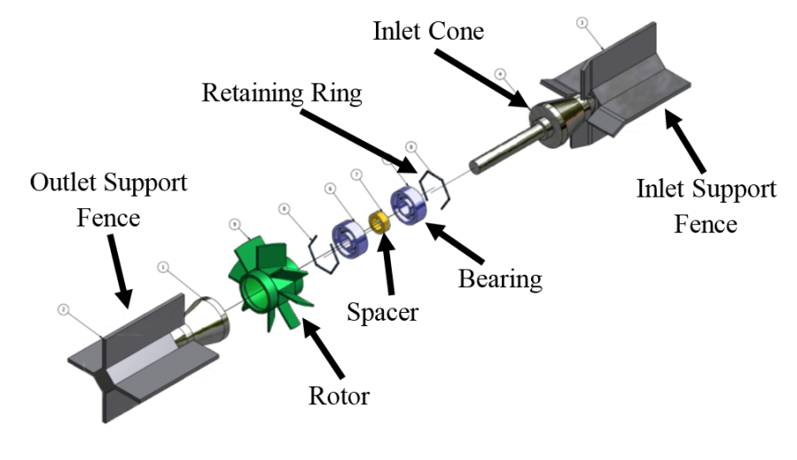
Flow Direction
Figure 1: Basic Turbine Flow Meter Design

The viscosity of the fluid is one of the major factors that affect the performance of turbine flow meter. For fluids with low viscosity (water: 1 cSt and below), the meter response is linearly dependent on flow rate. However, for fluids with high viscosity (hydraulic fluid: 50 to 100 cSt), meter response is highly nonlinear [3]. Although lots of efforts have been made, the fluid dynamics mechanism of the viscosity effect on turbine flow meter performance is still not fully understood. No validated physical model exists that adequately explains the meter response and the shape of the turbine meter calibration curve. In many cases, meters are calibrated and applied to fluids with different kinematic viscosity values or the fluid property in the meter application varies over time due to temperature variation. Unfortunately, there is inadequate understanding of the differences in kinematic viscosity due to temperature effect turbine meter calibrations. Physical models for the turbine meter calibration curve based on momentum and airfoil approaches have been published in the past, but these models are supplemented with experimental correction factors to improve accuracy [5].

Objectives
In this research, CFD models of turbine flow meters were developed to simulate flow meters across the range of operation. Comparisons of the accuracy of the calibrations using different fluids at various volumetric flow rates were examined. This provided a greater understanding of the effects of different fluids on the accuracy of turbine flow meters. It is expected that the proposed work may improve the physical understanding of the effects of the calibration fluid on the overall accuracy of turbine flow meters. This may also aid in the future development of turbine flow meters whose accuracy is minimally affected by the type of calibration fluid.
The first primary objective of this work is to develop CFD models to simulate flow across a broad range of operation. The next objective is to build a calibration response curve over varied flow rates, viscosities, and densities. This provides a greater understanding of the effects of different fluids on the performance of a turbine flow meter. This ultimately improves the knowledge base to understand the impact of calibration fluids on the overall accuracy.

CHAPTER II
BACKGROUND

The modern turbine flow meter, when appropriately selected, calibrated, and installed, can be an extremely reliable device that is capable of providing the highest accuracies attainable by any flow sensor. Turbine flow meters can obtain accuracies of in the order of 0.1% for liquids and 0.25% for gasses [1]. In ideal flow conditions, the accuracy of up to 0.02% can be achieved on individual high accuracy meters [6]. There are numerous designs for specific applications in the chemical, petrochemical, food, defense, automotive, and aerospace industries. Proper calibration and accuracy are critical in all of these applications. A shortcoming in this area can lead to massive setbacks over time through waste, lost efficiency, and reduced performance of a given system.

General Types of Flow Meters
There are two general categories of fluid flow meters. These are either positive displacement or interference type meters [7]. Positive displacement (PD) flow meters measure the volumetric flow directly by precisely isolating the flow into discrete volume packets and counting the number of packets that pass through. An example of this is a gear flow meter. These are used only in cases where the accuracy needs to be extremely precise and at low flow rates.
Inference meters infer the whole volumetric flow rate by measuring a dynamic property of the fluid as it passes through the meter. This group includes turbine flow meters because they measure the velocity of the liquid. Other examples of inference meters include orifice plates, Coriolis mass meters, vortex shedding meters and ultrasonic flow meters. This category of flow meter has a wide variety of uses for almost any applications. These meters are inherently less precise than the positive displacement meters but improving technology and calibration bring the accuracy to a comparable level.

General Principles
The general working principles of a turbine flow meter are quite straightforward. Turbine flow meters extract a small fraction of kinetic energy from the flowing fluid to spin a bladed rotor suspended in the flow stream [8]. Blades set at an angle relative to the fluid direction of flow are driven to produce torque that results in rotation about the primary axis [1]. The rotor spins on small low friction ball bearings [6]. When the fluid moves faster (higher axial velocity), the rotor spins faster. Fluid axial velocity is proportional to volumetric flow rate [1]. The rotational speed of the rotor blades also respond to changes in fluid viscosity [9]. Viscosity affects the blade tip clearance drag, rotor hub viscous drag, bearing drag and blade primary surface viscous drag. Viscosity difference also affects fluid axial velocity profile for a given flow rate as determined by the Reynolds number.
There are several major advantages of using a turbine to measure the flow [8]. These include:
- Good accuracy with liquids – especially for low viscosity fluids (10 cSt to 100 cSt)
- Easy to install and maintain
- Small and relatively light weight
- The output is pulse train/frequency for easy processing
- Excellent dynamic response
- Suitable for clean, conditioned, & steady flow

There are also several limitations of using a turbine flow meter [8]. These include:
- Delicate Internal Moving Parts
  - Small Thin Blades on Rotor
  - Small Spindle Axis
  - Fragile Roller Bearings
- Sensitive to Fluid Viscosity Changes
  - Affected by Flow Perturbing Installation Effects
  - Long Straight Pipe Approaching Inlet Recommended
- Swirl Removing Flow Conditioner Required (built in)
- Usable for Clean Liquids and Gases Only
- Significant Pressure Drop at Higher Flow Rates

Operating Principles
For a constant volumetric flow rate, the rotor reaches an equilibrium rotational speed where the driving and retarding torques on the rotor are equal. The equilibrium rotational speed for a given flow rate occurs when the angular acceleration is zero. This means that the torque is balanced across the rotor. The torque balance equation is shown below [9].

$T_{dr}-T_{v}-T_{t}-T_{m}-T_{b}=J\frac{dω}{dt}$ = 0 (1)

The rotor driving torque on the rotor blades is $T_{dr}$. This is the primary driving component on the rotor. $T_{v}$ is the viscous drag torque. This is the primary retarding torque on the rotor and is sensitive to changes in fluid viscosity. The blade tip clearance drag torque $T_{t}$ is the torque generated from the interaction of the blade tips and the case of the flow meter. $T_{m}$ is torque caused by attractive force of pickup magnet. This term is often very small and can be neglected for most turbine flow meter models [4]. The bearing torque $T_{b}$ is the force created by the friction of the bearings. This term can become significant at very low flow rates. The terms $T_{m}$ and $T_{b}$ are not included in the CFD model in this work.
The overall accuracy of the flow meter is based on two major assumptions that the flow area remains constant and that the rotor velocity accurately represents the average fluid velocity [10].
Since the housing for the flow meter is constant, the first assumption is easily satisfied but can be affected by the number of reasons. Erosion, corrosion, and deposits can have a significant impact on the performance of a turbine flow meter. Even a small build-up of about a thousandth of an inch on the surfaces of a four inch rotor will decrease the flow through the rotor and increase the calibration factor by about 0.5% [11]. At low viscosities, boundary layer thickness is relatively thin and insignificant. At higher viscosities, the boundary layer thickness reduces the effective flow area and can have a significant impact on performance [2]. Cavitation is the local vaporization of the fluid and can have a substantial effect on the flow area through the rotor and will quickly increase the rotor velocity and the calibration factor [12].
The assumption that the rotor velocity accurately represents the average fluid velocity can also be affected by a number of reasons. Rotor blade angle, rotor stability, and bearing friction can experience substantial changes through wear over time. Variations in velocity profile or fluid swirl are common causes of measurement errors that can be minimized by proper installation and use of flow conditioners. The density of the fluid and the square of the fluid velocity are directly proportional to the rotor driving torque available to overcome the rotor drag forces. This means that as the fluid density increases, the driving torque increases causing an erroneous increase in rotational speed at low flow rates.
The primary performance characteristics for a turbine flow meter are the turndown ratio and the accuracy. It is vital to understand and correctly apply these features to any turbine flow meter application. The turndown ratio is the range over which the meter can provide an accurate measurement. The most typical turndown ratios are in the range of 10:1 [2]. The accuracy of a turbine flow meter is the difference between the meters indicated measurement to the actual measurement. Repeatability and linearity are the primary terms used when describing accuracy. Repeatability is the ability of the meter to reproduce the same number of pulses for a set of conditions such as flow rate, temperature, viscosity, density, and pressure [1]. Linearity is the ability of the turbine flow meter to maintaining a meter factor throughout the stated operational range [1].

Mechanical Design
There is a wide variety of turbine flow meters tailored to many applications. Many companies make flow meter designs that have variations that are individually tailored and calibrated for their applications. The primary goal is to optimize the balance between mechanical durability and excellent reliability. There are constraints on performance and manufacturing that drive the design of every component. The basic internal parts a turbine flow meter can be seen in Fig 2.

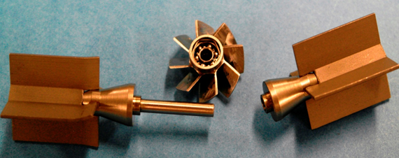
Figure 2: Flow Meter Internal Parts [4]

The rotor is the central part to the turbine flow meter (see Fig 3). This is what gives the device its name. If the flow meter has a small diameter of less than 2 inches, the blades tend to be flat [1]. This is easier to manufacture. Small meters can use flat blades because the ratio of the absolute velocity at the hub to the absolute velocity at the tip is relatively low. Blade count for these meters tends to be in the range of 2 to 10 blades [1].
The angle of the blades or the pitch angle, is the primary factor that determines the rotor speed. In general the pitch angle ranges from 30°–45°, depending on the application [13]. For some low-density gas applications, the angle may be much smaller. This angle defines the operational range of the flow meter. Higher blade angles results in the meter spinning faster at low flow rates [14]. The thickness of the rotor blades is determined by the maximum torque loads that are exerted on the rotor. Flow meters that are pushed past the upper flow range regularly have cracked or broken rotor blades.
Larger flow meters, above 2 inches in diameter, tend to have twisted or helical blades since the ratio between the hub radius and tip radius is much greater than in smaller flow meters. The pitch angle at the hub is greater than the angle at the tip to compensate for the change in velocity between the hub and the tip. These flow meters can have anywhere from 6 to 20 blades [15]. These meters tend to have a shroud around the outer radius of the rotor for enhanced mechanical stability.

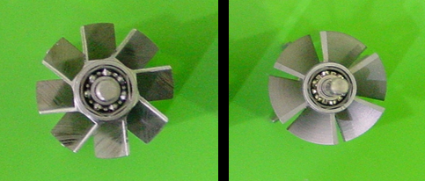
Figure 3: Example Rotors (Left: Flat Blades; Right: Helical Blades) [4]

The type of bearings chosen for a particular meter depends on a few factors. Typically, turbine flow meters use stainless steel ball bearings. The lubricity of the fluid determines whether the bearings are open to the measured fluid flow or closed to it [16]. Open bearings allow the measured fluid to move through the bearings to act as a lubricant. Closed bearings do not allow the measured fluid to flow through. The designed flow rate determines the loads that are placed on the rotor. Flow meters with high lateral loads use thrust bearings [1]. Bearing friction becomes more significant at low flow rates. Bearing friction for the type of flow meter used in the current work is on the order of 10E-7 in-lbf [4]. At higher flow rates within the design range, the bearing friction is negligible compared to the total torque on the rotor [2]. Bearing friction it is not included in this work.
The rotation sensor of the turbine flow meter is known as a pickup. Common types of pickups are modulated carrier, magnetic and mechanical [15]. Some specialized flow meters use optical, electrical resistance, or capacitive rotations sensors. Mechanical pickups have been used in remote applications because they have a high resolution and require no electrical power but the drag tends to be high for these pickups [1]. For magnetic inductance pickups, one of the blades carries a magnetic insert, and signals are induced in the pickup coil by the moving magnetic field. In magnetic reluctance pickups, the coil is wrapped around a permanent magnet which is mounted next to a high magnetic permeability bladed rotor. As the turbine rotates, the reluctance of the magnetic circuit varies and produced a signal in the coil. In more expensive types, the coil is a component in an RF oscillator circuit, and the proximity of the rotor blades changes the circuit impedance which creates a modulation at a lower frequency. This type has a lower drag and higher signal level at the low end of the flow regime. This is the type of pickup used in the meter in this work. The drag created by this pickup is negligible.
Flow straighteners can be referred to as stators, flow conditioners, or fences. These structures also hold the rotor in place. The lengths and shapes can be modified to the application. Slight bends in the stators can be added to improve linearity in lower flow range [11]. Fig 4 shows some examples of turbine flow meters that are similar to the one used in the model in this work. The structure also contains a cone that leads up to the rotor. This cone causes partially developed annular flow before the rotor.

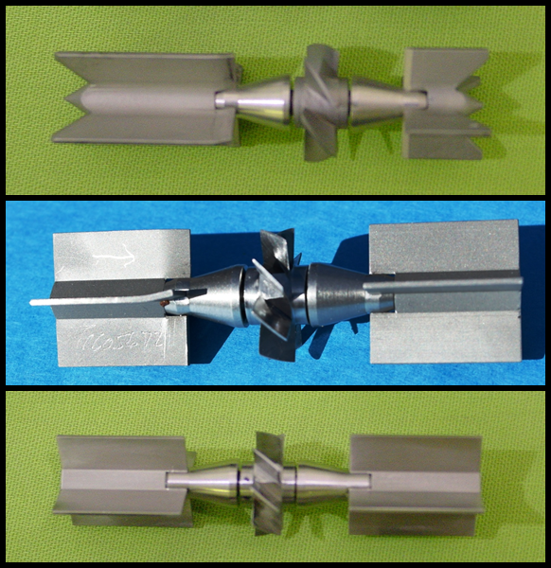
(c)
(a)
(b)
Figure 4: Similar Flow Meters [4]
(a) Helical Blades with Bend in inlet Fence; (b) Flat Blades with Bend in inlet Fence;
(c) Flat Blades without Bend in Inlet Fence)

Universal Viscosity Calibration
Proper calibration of turbine flow meters is vital. This involves recording the output frequency of the meter for specific rates of flow [17]. This can be done using a well-calibrated piston to move a well-defined amount of fluid at a particular flow rate. The result of this calibration is a linear curve as illustrated in Fig 5. The problem is that this curve is valid only for fluids with a kinematic viscosity that are very close to the calibration fluid.
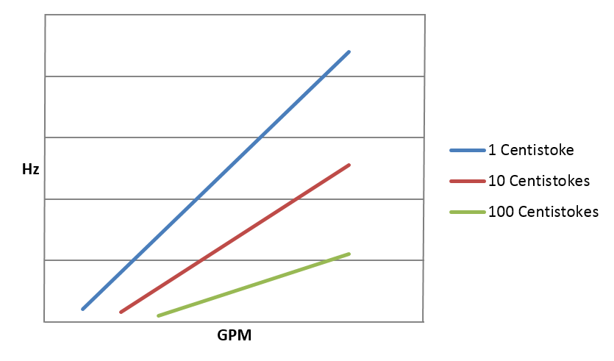
For higher viscosity fluids, the curve will have less slope and a positive shift along the GPM axis. This form for the calibration data is not practical except for single, constant viscosity operation because a different curve results for every viscosity. [17].
Figure 5: Notional Linear Calibration.

A more usable form for the calibration data is called a Universal Viscosity Curve (UVC) [17] as illustrated in Fig 6. The UVC is obtained by ploting the calibration data in a different form that colapses the individual calibration curves (Fig 5) into one curve (Fig 6). This is a semi-log plot of the sensitivity of the meter as a function of the ratio of the output frequency to the kinematic viscosity. The K factor is the number of pulses the meter will produce for each gallon of fluid which flows through it (see Eq 2) [17]. This is shown on the y-axis of Fig 6. For most calibrations, a K factor based on a frequency output by the passage of each rotor blade is used (K_{f}) (see Eq 3) [17]. The Hz/ν is used on the x-axis because it is directly proportional to the Reynolds Number for the flow through the meter. The Universal Viscosity Curve is essentially a plot of meter sensitivity vs. Reynolds Number. The UVC combines effects of velocity, density and absolute viscosity acting on the meter [6].

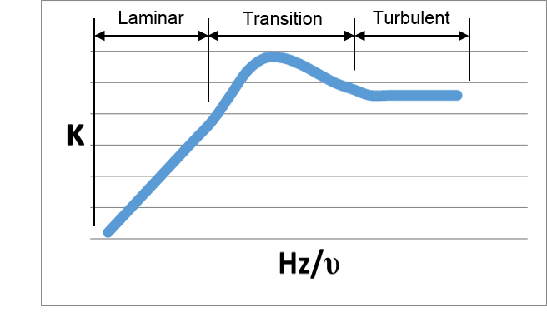
Figure 6: Notional Universal Viscosity Curve (UVC) Curve.

It is common to use the dimensionless numbers, Strouhal (St) and Roshko (Ro), for the y and x-axes. St is a dimensionless form of the K factor that only acts as a scalar of the K factor (see Eq 4). Ro is a dimensionless form of Hz/ν.

$K=Hz*60/GPM$ (2)

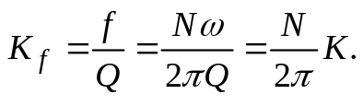 (3)

$St= K_{f}πd^{3}/4$ (4)

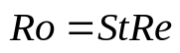 (5)
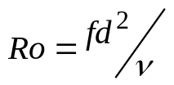 (6)

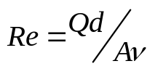 (7)

The Universal Viscosity Curve is formed by plotting K vs. Hz/v for every calibration data point. Once this is done, the K factor may be determined for any flow rate in the fluid of any viscosity as long as the ratio Hz/v is within the range of values covered by the graph.

Calibration
Proper calibrations are critical to any application of turbine flow meters. Most of the body of knowledge on turbine flow meters has been obtained through testing on calibration benches. Figure 7 shows a typical setup for calibration of turbine flow meters. The upper end of the flow regime is determined by the mechanical design, structure loading limits, and maximum allowable pressure drop [7]. The lower end of the flow regime is determined by static friction of the bearing, design of the rotor, and the linearity specification. Due to manufacturing variability, calibration curves are unique to individual meters. The manufacturer normally provides these calibrations. Figure 8 shows a typical calibration curve that would be supplied by the manufacturer with K factor vs. flow rate. The vertical axis thus represents the linearity error as a percentage of flow rate; a K factor expressed in terms of the number of pulses from the rotation sensor output per volume of fluid [6]. The horizontal axis may be expressed in terms of flow rate in volume units/time, Reynolds number, or pulse frequency (from the rotation sensor for non mechanical) divided by kinematic viscosity, in units of Hz per cSt and where kinematic viscosity is the ratio of absolute viscosity to density [1].

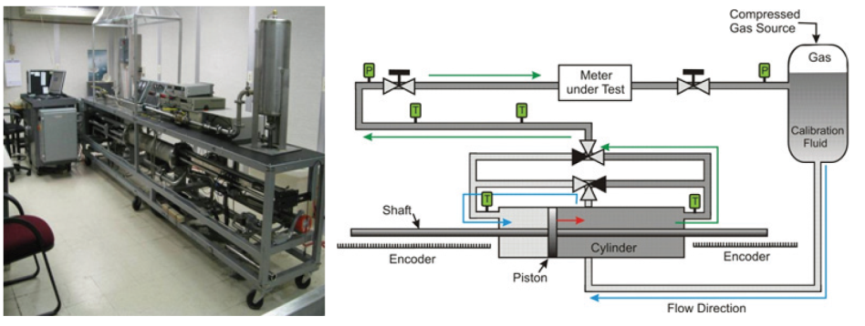
Figure 7: Typical Turbine Flow Meter Calibration 20 L Piston Prover Bench Setup at NIST [18]

Unconditioned flow, such as swirl, causes a significant drop in accuracy for turbine flow meters. Most calibration installations incorporate flow conditioners with specific upstream and downstream straight pipe lengths of about 10 times the diameter or more [6]. Some axial turbine flowmeters have additional large flow straighteners in front of the flow meter that further condition the flow. Flow velocity pulsations also produce errors, especially in gas installations, but counteracting this source of error is difficult and often involves addressing the entire system [10]. Periodic maintenance, testing, and recalibration are required because the calibration shifts over time due to wear, damage, or contamination [1]. For certain applications, especially those with the transfer of valuable hydrocarbons, there are national and international standards that specify the minimum requirements on these issues for turbine meters [1].
Traceability is an important factor to consider when evaluating a calibration. Traceability of a calibration facility means that performance testing has been done on the facility. The results are quantified with respect to the reference standards. This needs to be completed regularly so that the resulting database provides confidence that the measurements are accurate [11].
The calibration data can determine precision error, but systematic error must be found by tracing back to the NIST "golden ruler" [1]. This is why systematic error is unknown to the consumer without traceability. Both precision and systematic error are difficult to eliminate. Precision error can be removed only with the use of the right instrumentation. Systematic error can be eliminated only through direct traceability to NIST standards.

CHAPTER III
LITERATURE REVIEW

Future Prospects for Turbine Flow Meters
The turbine flow meter market has not changed very much in the last decade [15]. During that time, other flow meter types have grown substantially due to new developments in computer control [15]. Coriolis, ultrasonic, and magnetic flowmeter markets have been growing quickly.
The turbine flow meter is in the area of research and development where there has been little progress in the last decade [15]. However, some companies are very active in researching and introducing new features and products to the market. Some examples of this type of development are different bearing types such as ceramic, different rotor designs such as more complex shapes, dual rotors, and a bi-directional capability [15]. The use of turbine flow meters could expand, but the market is growing more competitive.

Ceramic Ball Bearings
An example of innovation is the use of ceramic ball bearing. These provide superior performance & corrosion resistance over traditional stainless steel and journal bearings in process applications [15]. Ceramic ball bearings offer higher corrosion resistance and perform better in low lubricating fluids [19]. The ceramic balls have a lower density than steel balls, which lowers the centrifugal loading allowing the bearing to operate at higher speeds with dramatically less friction. In standard 440C ball bearings, adhesive wear occurs when microscopic peaks on the ball and race make contact and briefly weld together [19]. As the bearing turns, the micro-weld is pulled apart. The continuous cycling of micro welds is forming and pulling apart causes the bearing to run at a higher temperature, and greater friction, and this decreases the life of the bearing [19]. Ceramic bearings cannot micro-weld, so they run at cooler temperatures with less friction and longer bearing life [6].

Electronics in Turbine Flow Meters
Modern turbine flowmeters are utilizing state-of-the-art electronics to enhance the advantages they have traditionally enjoyed in industrial, aerospace, automotive, and pharmaceutical markets. With their ability to withstand high g-forces, turbine flowmeters have played a key role in the development of sophisticated fighter and surveillance airplanes, helicopters, cruise missiles and drones [14]. Since they are fundamentally digital devices, turbine flowmeters can straightforwardly be used with powerful microprocessors to offer a host of advantages. These electronics are comparable to those used in magnetic, differential pressure and ultrasonic flowmeters [20].
Lately, manufacturers have started designing "smart" turbine meters which incorporate an integrally-mounted electronic pickup. This performs all temperature compensation, linearization and signal conditioning [21]. Typical flowmeters are sensitive to changes in kinematic viscosity. This causes major shifts in K-factor as temperature changes. Smart turbine meters compensate for these standard viscosity effects. A sensor records the temperature inputs. The flow frequency is divided by viscosity (f/µ) to find the actual K-factor using a table lookup methodology [6].
A unique feature of the smart turbine flowmeter is its ability, by linearizing within ±0.1%, to operate across the entire usable flow range. By extending the turndown range to 100:1, the smart turbine flowmeter also removes the need for multiple flow-meters. A repeatability of less than.05% and accuracies better than .25% can be achieved. This occurs without the necessity for supplementary external temperature sensors [11].
Another advantage of the smart turbine flowmeter is that its scalable pulse outputs allow any number of meters to have the same output per unit of volume [21]. This allows for complete interchangeability of units and prevents the common problem of scaling associated electronics incorrectly [1].
Furthermore, smart turbine flowmeters can be field programmed to change pulse output, unit of volume, flow range, and to provide a calibration history while maintaining the same pulses per unit of measured output [21]. The smart turbine flowmeter's ability to compensate for viscosity and density changes in a known liquid provides an accurate, continuously updated K factor that represents the actual flow volume and mass [11]. A typical sequence for a smart turbine flow meter is as follows [21].

- Measure temperature of the liquid
- Determine actual kinematic viscosity by calculating kinematic viscosity vs. temperature
- Measure flowmeter frequency (Hz)
- Calculate frequency per kinematic viscosity (Hz/cSt)
- Determine K factor versus Hz/cSt
- Calculate: flow rate = frequency x actual K factor
- Determine liquid density by comparing density vs. temperature
- Calculate mass flow rate = volumetric flow rate x actual density

Calibration with Surrogate Fluids
Most of the time, turbine flow meters are calibrated using surrogate fluids rather than the fluids they measures in the planned application. The surrogate fluid has the same kinematic viscosity as the intended liquid [22]. Since there is not an adequate understanding of how the kinematic viscosity affects turbine meter calibrations many additional calibrations are performed to characterize the calibration curve fully for a given meter. A turbine meter is re-calibrated in the field each time the product in the line changes in hydrocarbon transfer situations [20].
Flow measurements over an extensive range of kinematic viscosities require a calibration under conditions that match intended use. In order to accomplish this, calibration laboratories use three primary approaches [3].

- Changing the fluids in their calibration standards
- Maintaining multiple calibration standards with different fluids.
- Varying the temperature of the calibration fluid.

Many hydrocarbon calibration labs use a surrogate fluid called Stoddard solvent that is a light mineral oil with a kinematic viscosity of about 1.2 cSt at 20 °C [23]. The Stoddard solvent is less flammable and less toxic than jet fuel, but there are still health concerns with handling it and prolonged exposure. Arnold Air Force Base calibration laboratories and NIST began using propylene glycol and water (PG+W) mixtures in 2006. These solutions are biologically and environmentally friendly [22]. Changing calibration fluids reduced risk to technicians and removes the danger of fire. At Arnold AFB, a fire truck had to standby when calibrations were done using the Stoddard solvent [22].
A 1% molar mixture of PG+W matches the kinematic viscosity of jet fuel and pure PG has a kinematic viscosity of approximately 50 cSt, which is in the middle of the range of hydraulic oils at 20 °C [22]. PG+W mixtures provide the benefit of a lower volumetric thermal expansion coefficient and a lower heat capacity than Stoddard solvent resulting in lower storage effect errors and reduced uncertainty [22]. PG is so safe that it is used in many products that people put on or in their bodies. PG breaks down in the body after about 48 hours [18]. Calibration laboratories are interested in utilizing PG+W mixtures to:

- Decrease the cost of maintaining multiple standards with fluids of various kinematic viscosities
- Reduce pollution and provide a biologically benign environment for workers
- Reduce the danger associated with maintaining multiple standards that require the involvement of the fire department during the use of flammable fuels
- Decrease the expense and risk of disposal of the harmful substances [3]

NIST performed a comparison between twelve calibrations laboratories using PG+W fluid as a calibration medium. The results of this showed agreement with the uncertainty among all of the labs. Unfortunately, the uncertainties related to the transfer standard were proved to be as big as 0.2% [18]. This is greater than four times as large as the uncertainties achieved by nine of the twelve laboratories. This shows the need for additional work to understand the difference between the use of the Stoddard solvent and a PG+W solution [18].

Turbine Flow Meter Modeling Approaches
Various researchers have worked to model turbine flow meter performance. The models explore ways to account for the shape of the turbine flow meter calibration curve. These models vary on their approach and the relevant factors considered. More recent attempts to understand the behavior of turbine flow meters use numerical methods to compute the flow field in a turbine flow meter [2]. This section explores some of the approaches that are relevant to the model presented in this work.
Two primary methods to model turbine flow meter performance are the momentum method and the airfoil method [2]. The airfoil method derives the driving torque on the rotor by using airfoil theory to compute the coefficient of lift of the individual rotor blade [1]. This requires detailed knowledge of the geometry of a turbine flow meter. This level of detail can be difficult to obtain due to manufacturing variation even in the same model of flow meter [3]. The momentum approach uses the integral momentum equation to calculate the driving torque on the rotor. The downside to this approach is that uniform flow tangential to the rotor blades at the rotor outlet is assumed [2].

NIST Extended Lee Model
The National Institute of Standards and Technology (NIST) has developed and validated a physical model for turbine flow meters dubbed the “extended Lee model”. This is named after the model that was developed by Lee and Karby in 1960 [5]. Lee set the groundwork by ascertaining the drag terms via the momentum approach, but the Lee approach simplified the effects of bearing drag terms because gas was the working fluid. This assumed that viscosity changes were negligible [5]. This model uses the momentum approach and uses the following three significant correction terms [3]:
- Fluid drag on the rotor
- Bearing static drag
- Bearing viscous drag
The goal of the NIST model is to explain the shape of the turbine flow meter calibration curve, especially how the calibration curves fan out at low Reynolds number flows. Their work did not aim to improve the design of turbine flow meters but to study the whole Reynolds number range that a turbine responds [3]. Then the model provides answers to why changes in viscosity of a liquid would cause fanning in a meters calibration curve at very low Reynolds numbers [3]. See Fig 8 for an illustration of the fanning at low Reynolds numbers for varying viscosities. In this flow range, bearing terms are significant.
NIST demonstrated, through experimentation that turbine flow meters within the viscosity independent range of the calibration curve give the same results with PG+W solutions and the Stoddard solvent. The model showed that using a turbine meter at low Reynolds number flows have large errors unless the temperature dependent bearing drag is accounted for [3]. These results also focused on a small, dual-rotor turbine flow meter. Further work using meters of varying sizes and dimensions is needed in order to learn if this model can be generalized.

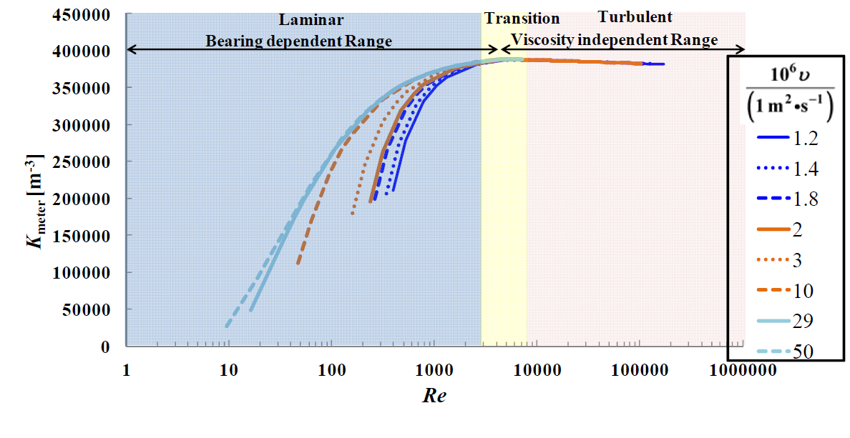
Figure 8: NIST Extended Lee Model Calibration Curve [3]

Winchester Computational Model
The US Army Primary Standards Laboratory in Huntsville, AL conducted tests between hydrocarbon based calibration fluids and the aqueous based propylene glycol and water solution. A wide variety of turbine flow meters was tested. The purpose of this test was to determine the difference between the calibration curves of these different calibration fluids. For lower viscosities, the agreement between the fluids was superb. For high viscosities, the differences grew and eventually exceeded meter specification limits [4].
Winchester at Arnold Engineering and Development Complex (AEDC) worked with the Primary Standards Lab to develop software based computational modeling routine to find the source of the differences found in the test data [4]. This model calculates the balance in the driving and retarding torques from the fluid. This model incorporates bearing friction by using the rotational speed to produce the torque balance for a given fluid [4]. This uses fully developed annular flow for the velocity profile of the flow entering the rotor [4].
The Winchester model uses the method of segmenting the blades and fluid velocity profiles into discrete radial segments and calculating the drive and drag for each segment [4]. The total torque is calculated by integrating the sectional torque from the hub to the tip [4]. The rotor speed is adjusted up or down based on the remaining torque until the residual is below a specified value. This model has produced results that fall within ~2% of the test data (see Fig 9 & 10).

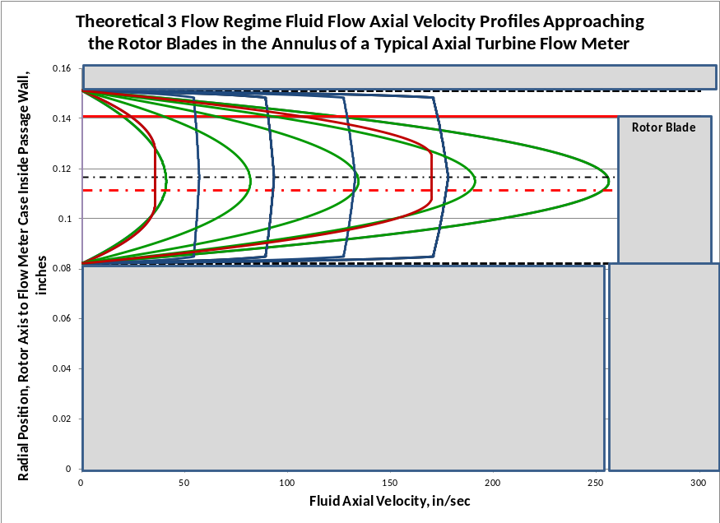
Figure 9: Theoretical Fully Developed Axial Velocity Profiles used in the Winchester Model [4]

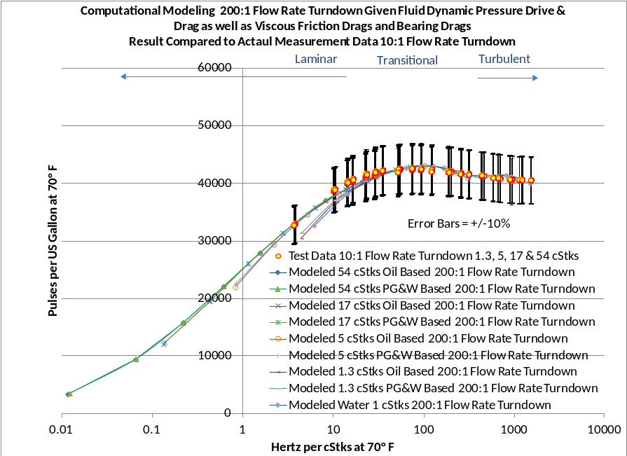
Figure 10: Calibration Curve from Winchester Computational Model [4]

The effort was the starting point for the work presented in this thesis. In order to improve the calculations, details could be obtained through CFD such as improved knowledge of the fluid flow velocity profiles. The flow profile at the rotor was assumed to be fully developed annular flow but, due to the inlet fence and inlet cone, the flow profile at the blades will be partially developed annular flow that is dependent on flow conditions. Also, the bends on the inlet flow straightener also have an effect on the flow that could be added to the Winchester model based on the CFD results presented here.

CFD Simulation from Tianjin University
Some models have been built over the years to model turbine flow meters, but few are based on CFD simulations. Recently, a CFD model for a turbine flow meter was developed at Tianjin University in China [9]. The goal of that work was to analyze viscosity effects on flowmeter performance. The calibration curves were developed for various viscosities using experimental results and ANSYS Fluent. The work was based on a three bladed turbine flow meter. The viscosities tested ranged from 1 to 112 cSt [9].
The CFD simulation consisted of three zones. Two stationary zones containing the flow straighteners on either side of the rotor zone [9]. The zone around the rotor was set as a Moving Reference Frame (MRF) simulation [9]. The simulations were run, and the torque was checked. If the torque on the rotor were not zero, the rotor speed would be adjusted up or down to compensate. They used constant adjustments to ω to obtain zero torque condition [9].
The conclusion of this work was that viscosity changes lead to changes of the wake flow behind the upstream flow conditioner and the flow velocity profile before entering the rotor. This affected the distribution of pressure on the rotor blades and impacted the performance of the turbine flow meter.
This model provided useful results but has some areas that can be improved upon. The simulation was a MRF model so the motion term was added to the CFD calculation. There was no movement of the rotor relative to the stationary inlet fences. This means that the interaction between the static and the moving structures was not captured. The simulation was steady state only so transient wake effects were not included. The pipe wall around the rotor was moving at the same rate as the rotor so the interaction between the blades and pipe wall was not included.

Focus of the Current Work
The work presented in this thesis goes a few steps further. A three-dimensional mesh was created using geometry from a typical flow meter used in fuel transfer applications. This was input into a series of models. The work began with a steady state model to provide an acceptable initial condition for further simulations. This step was very similar to the work completed in the CFD simulation at Tianjin University as described above.
These results were input into a transient model. This model had a rotating zone around the rotor to provide insight into the interaction between static and rotational structures. This simulation produced improved initial conditions for the next simulation.
In order to automatically adjust the rotor speed based on the torque imparted on the rotor by the flow, a 6DoF simulation was employed. This means that the simulation is better able to match the equilibrium rotor speed. The transient response approaches the true transient response to changing flow rates.
A parametric analysis was performed using these models in order to create multiple calibration curves that show the response of the flow meter under various conditions. Each calibration curve consists of running a series of simulations at a range of flow rates for a particular fluid. The calibration curves for a variety of viscosities are assembled to form a Universal Calibration Curve for the meter.
This model produced a calibration results that mimics the response seen from experimentation and extensive calibration. The simulation produced full flow field visualizations. Accurate velocity curves were produced that more accurately represent the profile that enters the rotor due to the flow conditions and the geometry of the meter. This can provide some useful insights that may aid in calibration and design of turbine flow meters.

CHAPTER IV
APPROACH

For this research, a turbine flow meter with basic geometry was chosen. The analysis and simulations were performed primarily using ANSYS FLUENT software for CFD simulations, as well as ANSYS Meshing and Autodesk Inventor for meshing and 3D modeling, respectively. These tools were used to assemble models for calculating turbine flow meter performance. A parametric analysis was performed using these models in order to create multiple calibration curves that show the response of the flow meter under various conditions. The following sections describe this approach.

Geometry
The geometry was based on a single rotor flow meter, the FT-16, produced by Flow Technologies Inc. [1]. It is designed for hydrocarbon measurement and used on a one inch pipe. It consists of a single flat-bladed turbine. The standard model of this flow meter has eight blades on the rotor. Other versions of this meter use different rotors with anywhere from three to nine blades with varying thickness and angles of attack. The diverse specifications are for use in many applications. The flow range of this meter is 5 – 50 gallons per minute (GPM). This meter uses ball bearings to support the rotor. A radio frequency pickup is used in order to read the frequency of the rotor rotation. This type of pickup does not cause extra drag on the rotor. There are two flow straighteners at either end of the rotor. The inlet flow straightener has a turning vane that give the flow a favorable swirl before it reaches the turbine blade.

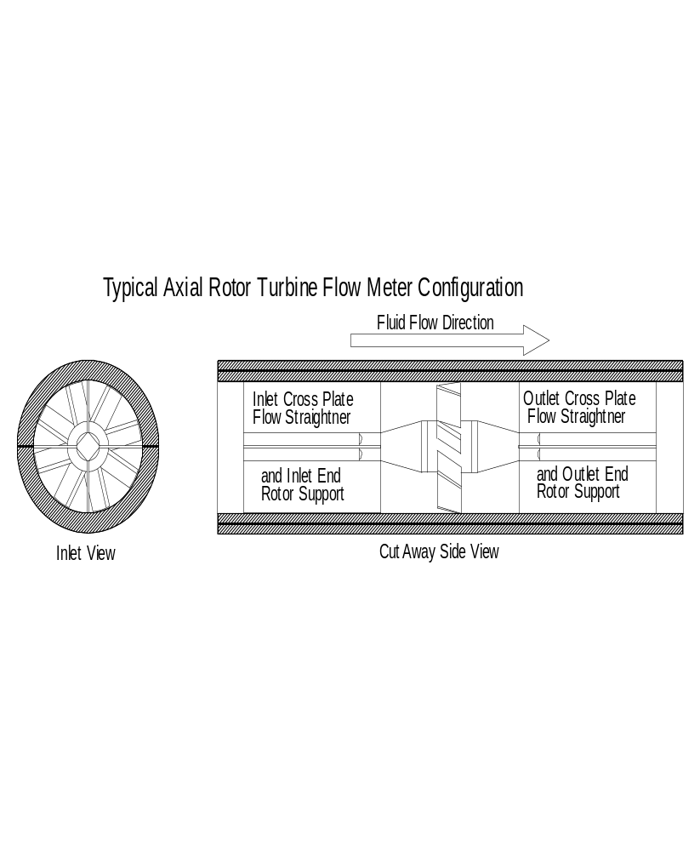
Figure 11: Basic Flow Meter Geometry

This particular flow meter design was chosen for a few reasons. First and foremost, the basic geometry is easier to model. It is used in many different applications and it representative of many different flow meters used across the field. Previous and ongoing work has been performed using this particular flow meter, so there is ample data to compare to the results of this work. Table 1 shows the volumetric flow rate and inlet velocity over the design range of the meter used in this simulation [6].

Table 1: Volumetric flow rate to Inlet Velocity
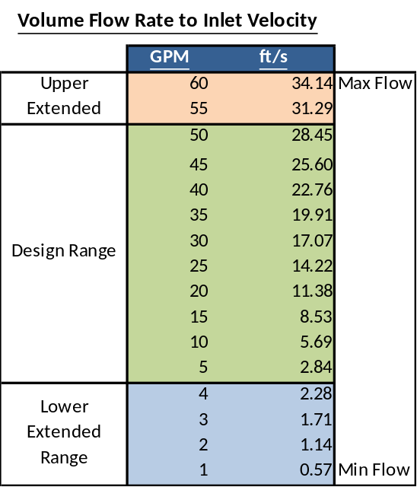

The geometry was built using Autodesk Inventor. The relevant features were exported to a STEP file to be loaded into the mesh generation software. A simplified view of the meter can be seen in the Fig 11 and the solid surface model is shown in Fig 12. In most of the models used, the inlet fence had a slight bend before the rotor. This bend creates a favorable swirl for the rotor. A similar geometry was also built without the bend in the inlet fence. In this model, the outlet fence and the inlet fence are identical geometries. A more detailed drawing of the geometry can be found in Appendix I.

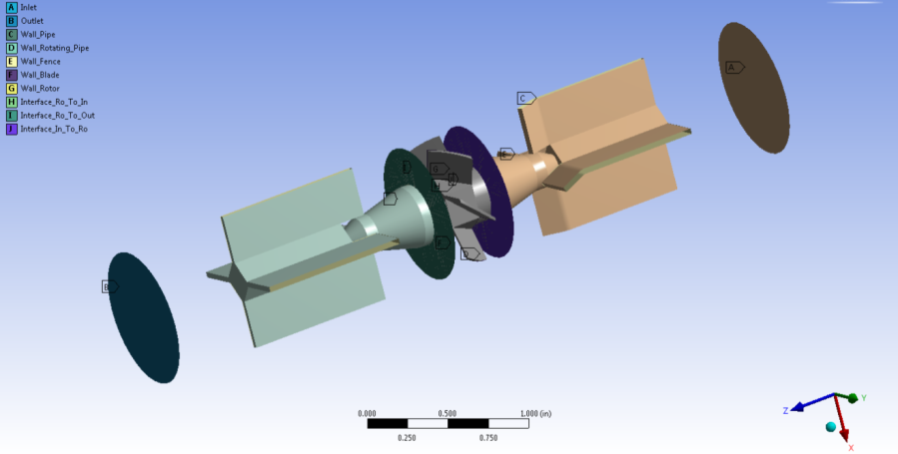
Flow Direction
Figure 12: ANSYS Solid Model

In order to prepare for an uniform post-simulation analysis, a series of planes and lines are set up at various locations. Three planes are used to view the velocity profile for each of the primary solid structures: the inlet fence (stator), the rotor, and the outlet fence (stator). Lines were also placed at the same locations as the planes for velocity flow profile data. These lines are oriented at a 45-degree angle relative to the inlet and outlet fences. Finally, a surface of revolution was used to provide an overall view of the flow as it passes through the meter (see Fig 13). Table 2 shows the location of the planes used for analysis.

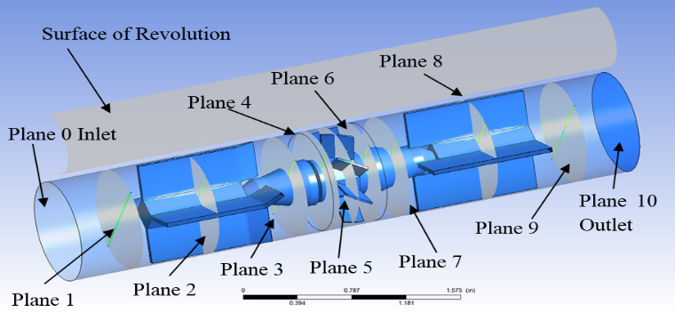
Flow Direction
Figure 13: Planes Locations for Analysis

Table 2: Location of Planes and Lines for Analysis
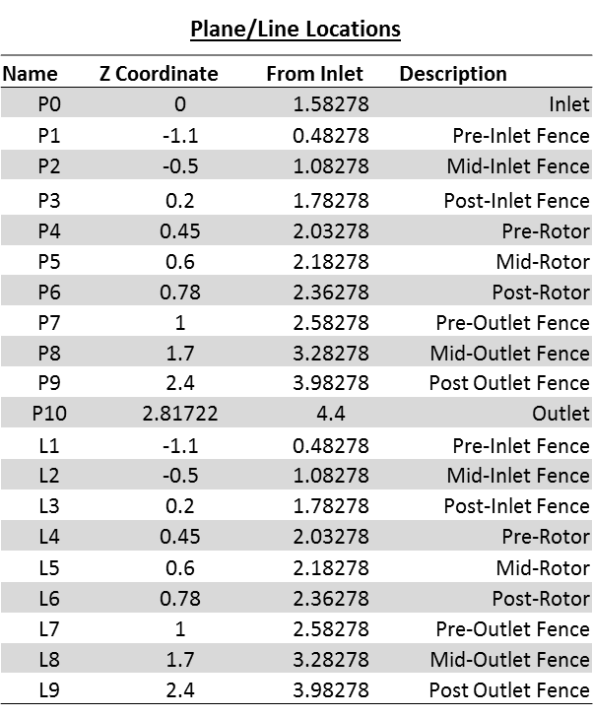

Meshing
This geometry was imported into ANSYS CFD Meshing to create a mesh. The mesh consists of two major regions. One region is the rotating zone around the turbine. The second region is the non-rotating zone around the stationary flow straighteners. The stationary zone completely surrounds the rotating zone. Unstructured grids were used for all zones.
The initial meshes were built in ANSYS Meshing using the assembly meshing methods, cut cell and tetrahedrons. These meshes were generated quickly and easily to provide initial setup and results. The cut cell method primarily produced hexahedral cells that have exceptional orthogonal quality (0.97 Avg) but it does not adequately resolve the angled geometry. The tetrahedrons assembly meshing resolved the geometry but at a loss of average orthogonal quality (0.89 Avg) (see Figs 14-16).

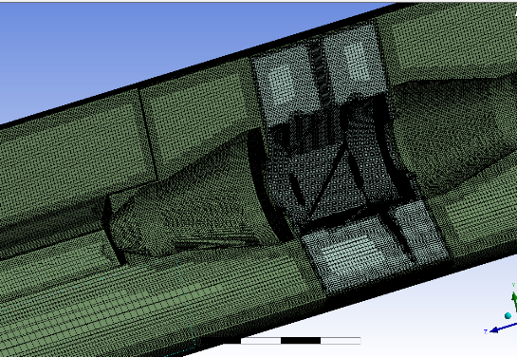
Figure 14: Cut Cell Assembly Mesh

The final set of meshes was built in ANSYS CFD Meshing. These meshes were designed with higher resolution in the areas of interest and inflation zones to capture the boundary layer effects on the rotor. This set was used to build a grid convergence study of this problem to determine the optimal mesh to minimize run time while maintaining accuracy. Primary mesh was a tetrahedral mesh with 12 million cells designed for the viscous case as seen in Fig 16. Extra care was taken to ensure a high-quality mesh around the blades and especially the blade tips.

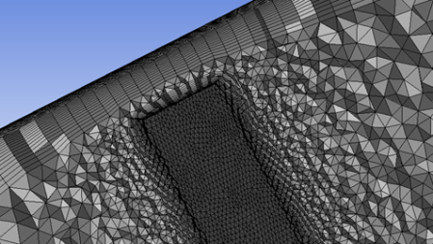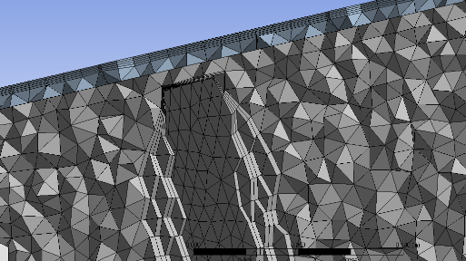
Figure 15: Close-up of Blade Tip Mesh for a fine grid (28M Cells) & course grid (7M Cells)

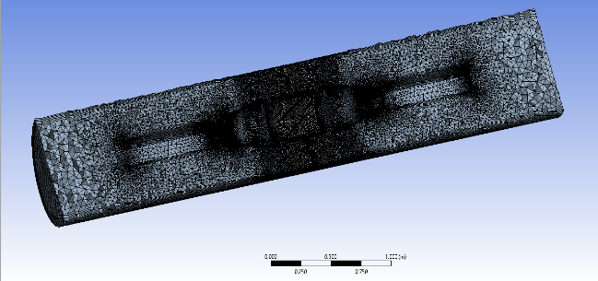
Figure 16: Final Grid with 12M cells

Cases
A variety of cases was run in order to explore the full operational range of the flow meter and to build a complete calibration curve. The first five cases seen in Table 3 were chosen based on calibration data for the same type of flow meter. These show a variety of kinematic viscosities using hydrocarbon fluids. The flow rates are based on the capabilities of the meter. For each fluid type, seven to ten flow rates were examined. Replications were taken at each data point, and the results from these replications were averaged to obtain a calibration curve.
The sixth case (Case F) was run using a different mesh with a straight inlet fence; that is, one without the swirl inducing bend seen in most meters of this type. This case was run to demonstrate the effect of minor geometry changes in the calibration of the flow meter.
The final three cases were run with fluids to match the characteristics of a propylene glycol and water (PG+W) calibration solution. This solution is becoming more popular as a calibration fluid because it is less volatile and safer to use compared to other calibration fluids [3]. The kinematic viscosity for these fluids matched that of the previous cases, but the density was chosen to match that of propylene glycol and water. The highest kinematic viscosities were not repeated with propylene glycol and water since this solution has a maximum kinematic viscosity that cannot be obtained due to the viscosity of pure propylene glycol at room temperature.

Table 3: Case Input Summary
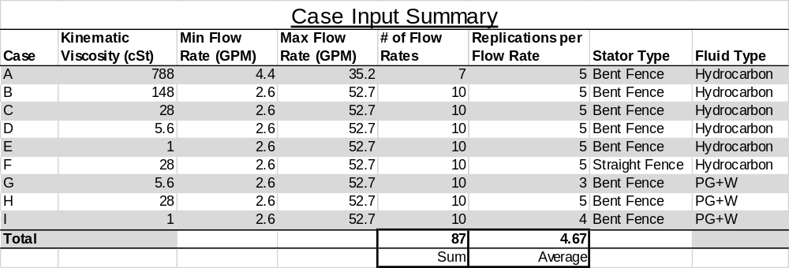

Solver Settings
The computational domain was divided into three parts, the region of upstream straight pipe and upstream flow conditioner, the area of the rotor, the region of downstream straight pipe and downstream flow conditioner. The motion type in the region of the rotor was set to the Moving Reference Frame (MRF), and the two remaining regions were set to stationary. The rotational Region and stationary regions are connected with two matching, sliding interfaces. The turbulence model that was used was the k-epsilon (2 eqn) solver with standard wall functions.
The basic setup and boundary conditions are the same for all cases. The velocity at the inlet was set to match the flow rate at the middle of the operational range of the flow meter. The outlet is just specified as outflow. The outlet could also be set for a specified pressure drop to match experimental results. The rotor speed is initially set to approximate the experimentally obtained rotational speed. The torque on the rotor is saved as an output in order to ensure that the system reaches an equilibrium state with zero torques by adjusting the rotor speed. The rotor speed was manually adjusted to minimize the moment.
The results of the steady state models were used to initialize the transient models which were built to better show the interaction of the moving rotor with the stationary flow straightener fences and to model the transient effects of the flow. This was set up using a sliding reference frame.

Constrained Six Degree of Freedom (6DoF) Setup
In an effort to capture, both the transient interaction of the structures and to bring the rotor automatically to a steady state speed, a constrained 6DoF user defined function (UDF) was employed in Fluent. Motion was restricted so that the rotor was not allowed to translate in any direction and was only permitted to rotate about the z axis. The mass moment of inertia of the rotor was obtained by using the functions available in ANSYS. The turbulence model was changed to a transition SST (4 eqn) solver.
The time step size was set to match general ANSYS turbomachinery guidelines. The time step size for a given rotational velocity is given in the equation below.

$∆t=\frac{1}{10}\frac{N}{ω}$ (8)

Below is the UDF used to define the 6DoF simulation.
- <<TFM-J.c>>
- #include "udf.h"
- DEFINE_SDOF_PROPERTIES (TFM, prop, dt, time, dtime)
- {
- prop[SDOF_MASS] = 0.01259774;
- prop[SDOF_IXX] = .000010;
- prop[SDOF_IYY] = .000010;
- prop[SDOF_IZZ] = .0000003178545;
- prop[SDOF_ZERO_TRANS_X] = TRUE;
- prop[SDOF_ZERO_TRANS_Y] = TRUE;
- prop[SDOF_ZERO_TRANS_Z] = TRUE;
- prop[SDOF_ZERO_ROT_X] = TRUE;
- prop[SDOF_ZERO_ROT_Y] = TRUE;
- Message("\n 2d : Updated 6DOF properties. Version J.\n");
- }

CHAPTER V
RESULTS AND DISCUSSION

Grid Convergence
A grid convergence study was performed in order to determine the top performing mesh. The mesh needed to produce low simulation error while using a reasonable amount of computational resources. A variety of meshes was used from about 300 thousand cells to over 28 million cells. These meshes were run at the mid-range of the flow meter (17 GPM) at a viscosity of 28 cSt. The results from these runs were compared to the calibration data for this flow meter. The grid with about 12 million cells was selected due to the relatively low error and cell count. This grid was used in most of the following sections. A grid with similar characteristics was used for the straight inlet fence case. The results can be seen in Fig 17 and Table 4. A curve was fit to the data The dashed lines show the grid that was chosen.

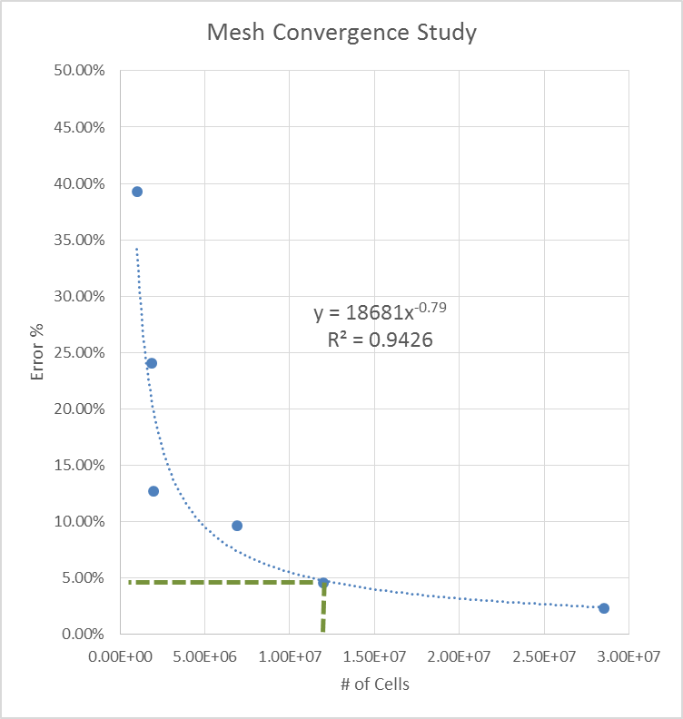
Figure 17: Mesh Convergence Study Curve

Table 4: Mesh Convergence Study Data
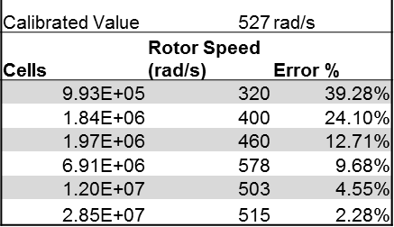

Steady State Moving Reference Frame (MRF)

A steady state ANSYS Fluent simulation was run using the tetrahedron assembly mesh. A visual inspection shows that the flow behaves as expected. Figure 18 shows the velocity in the stationary frame. This flow field intuitively appears to be correct. Wakes can be seen forming after the static structures. The inlet fence turns the flow into the rotor to increase the angle of attack of the flow. This may extend the operational range of the flow meter especially in the low flow region.
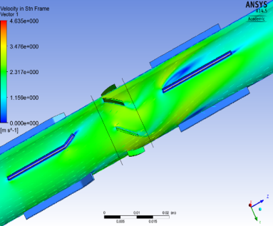
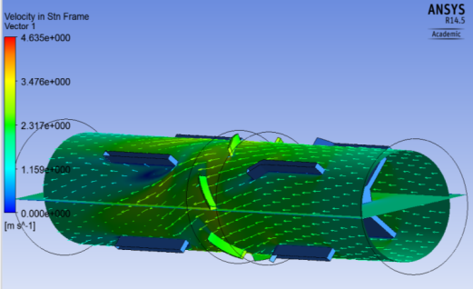
Flow Direction
Flow Direction
Figure 18: Steady State Results from Fluent

The rotor speed was manually varied over a small range to obtain the rotor speed vs. moment curve shown in Fig 19. The rotor speed was changed, and the model was run until a converged solution was obtained. This was done for a range of rotor speeds around the expected value for the rotor speed. This shows where the moment reaches zero at a rotor speed of 354 rad/s or 56 Hz. The rotor speed required to produce zero torque is close to the experimentally measured value of 50 Hz.

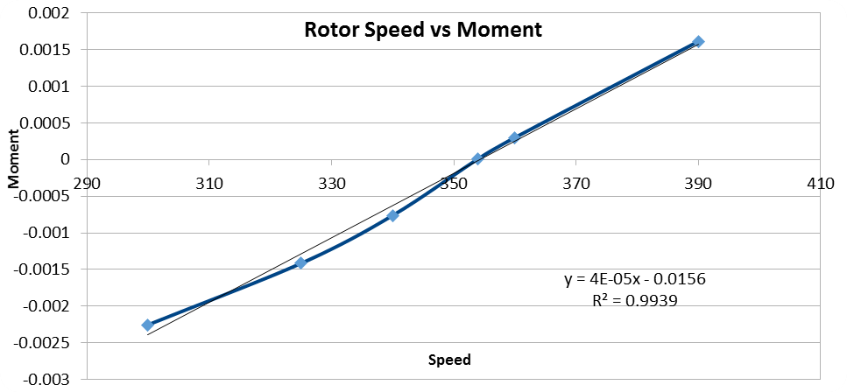
Figure 19: Rotor Speed vs Moment from Steady State Simulation

Transient Moving Reference Frame (MRF)
This process was repeated using a transient solver. The results were very similar to the steady state solver for the flow conditions that were used. However, the transient wakes from the static structures could be observed by adding an element of time. Due to the transient effects of these wakes, the resulting moment across the rotor was more varied than in the steady state case. It was clear that a moving mesh would be needed in order better to understand the transient interaction of the rotor on the static flow fences. The transient simulation results can be seen in Fig 20.
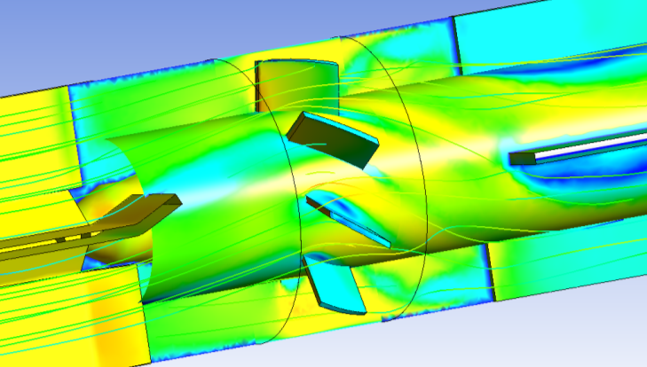
Flow Direction
Figure 20: Example of Transient Flow Velocity Field and Pressure on Structures

In an effort to capture both the transient interaction of the structures and to automatically bring the rotor to a steady state speed, a constrained 6DoF UDF was used. This simulation was able to solve automatically for the steady state rotor speed. The transient interactions of the structures could also be observed. As the solver approaches the steady state rotor speed, the pressure contour on each side of the blades. If the rotor were spinning too quickly or slowly, higher pressure regions could be seen on the upstream or downstream side of the blade. At a steady state speed, the two sides of the blades showed very similar pressure contours. Figures 21 and 22 display the pressure on the rotor early in the simulation and in the end. It is clear that the torque on the rotor is uneven early in the simulation but equalizes by the end of the simulation.
When the flow rate was changed, a few spikes in the rotor moment could be seen. This observation is expected since the solver adjusts the solution to fit the new conditions. The rotor speed would then slowly adjust over many time steps. The moment would approach zero but not cross zero. The moment would converge to a small positive or negative value due to the way the 6DoF solver calculates the rotor speed for the next time step. This accounts for some of the variation in the results that made it necessary to take replicates at each set point.
By obtaining the equilibrium flow rate over a range of flow rates, a calibration curve was constructed. This curve is shown with the manufacturer’s standard calibration curve. For most of the flow range, the results obtained from the model follow the trend as in the experimentally obtained manufacturer’s curve.

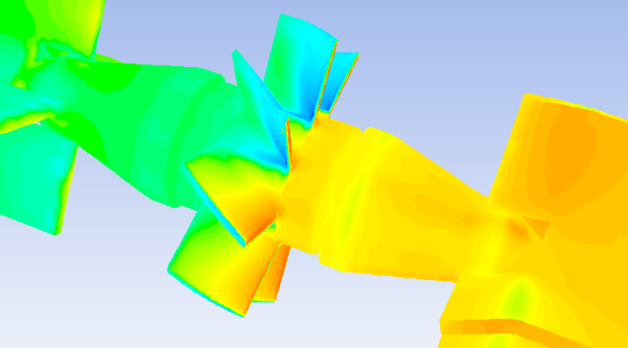
Flow Direction
Figure 21: Pressure Contour for Torque Unbalanced Rotor Early in Transient Simulation

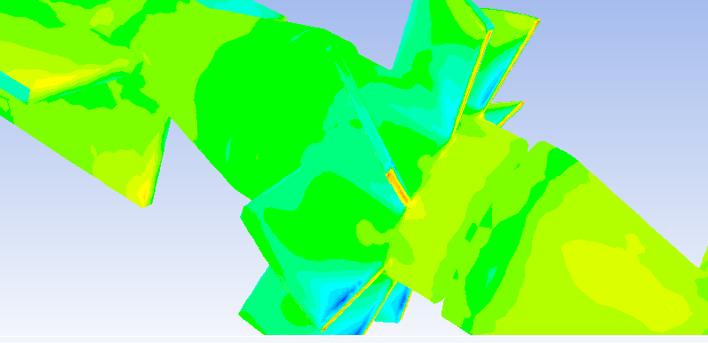
Flow Direction
Figure 22: Pressure Contour for Torque Balanced Rotor at the End of the Transient Simulation

Hydrocarbon Simulation Case Summary
The first five cases (A thru E) shown in Table 5, are for the hydrocarbon fluids. The equilibrium rotor speeds were averaged for the set of repetitions at each set point. This resulted in an average error of about +/- 5%. The average values at each point produced a calibration curve that matches the trend of the calibration data (see Fig 23). The data from each of the simulations can be found in Appendix II.
Table 5: Case Results Summary
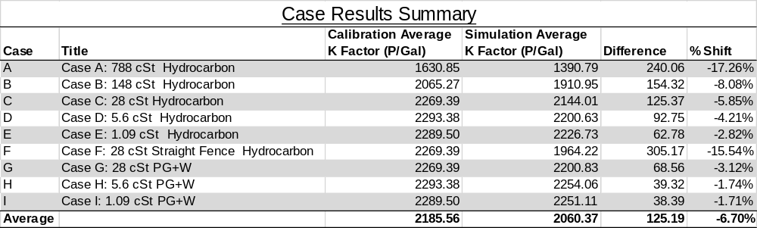

For each fluid simulation, the average K factor was compared to that of the calibration K factor. The % shift in the K factor is the difference between the new and old K factor divided by the new K factor. This is used to compare flow meters between calibrations [6]. This shift is the error between the old calibration and the new calibration. Generally, this shift is less than 1% for a particular flow meter when it is calibrated over time. The % shift lowers as the viscosity is lowered. The error between the calibration and the model is greater for the higher viscosities. Fig 23 shows the calibration data obtained from the manufacturer.

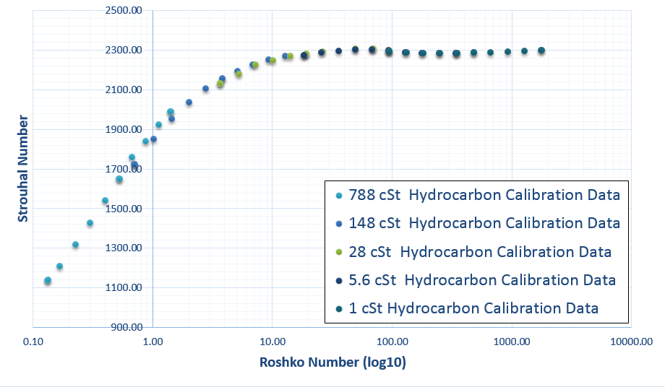
Figure 23: Calibration Curve Data from Manufacturer [6]

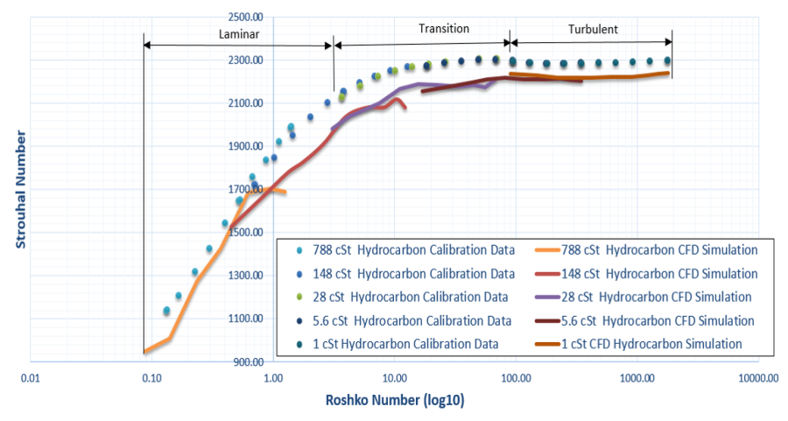
Figure 24: Calibration Curves from Model and Manufacturer for Hydrocarbon Fluids.

The results from the hydrocarbon simulation data for each viscosity form a full calibration curve that characterizes the performance of the turbine flow meter. This can be seen in Fig 24. The calibration curve shown uses the non-dimensional Strouhal and Roshko numbers. The Laminar, transition, and turbulent regions are the approximate conditions of the flow as it encounters the rotor. Individual calibration curves for each viscosity can be found in Appendix III. The flow in the transient and turbulent regions is relatively linear with a constant K factor. The flow in the laminar region is not linear because the K factor changes with flow rate. An variation of about 5% was seen in the replicates of the CFD data at each set point. This variation accounts for some of the erratic shapes of the calibration curves.

Hydrocarbon Flow Profiles
The velocity profiles, seen in Fig 25-30, provide additional insight into the inner workings of the turbine flow meter. The effects of the bends in the inlet fence can be plainly observed to turn the flow to increase the angle of attack on the rotor. This causes an increased response especially at low end of the flow meter’s range. This is the laminar region of the calibration curve.
The interaction between the stationary structure and the rotor can also be observed. As the rotor turns the blades pass through the wake of the inlet flow straightener. This creates slight variations in the torque on the rotor due to the non-uniform flow.

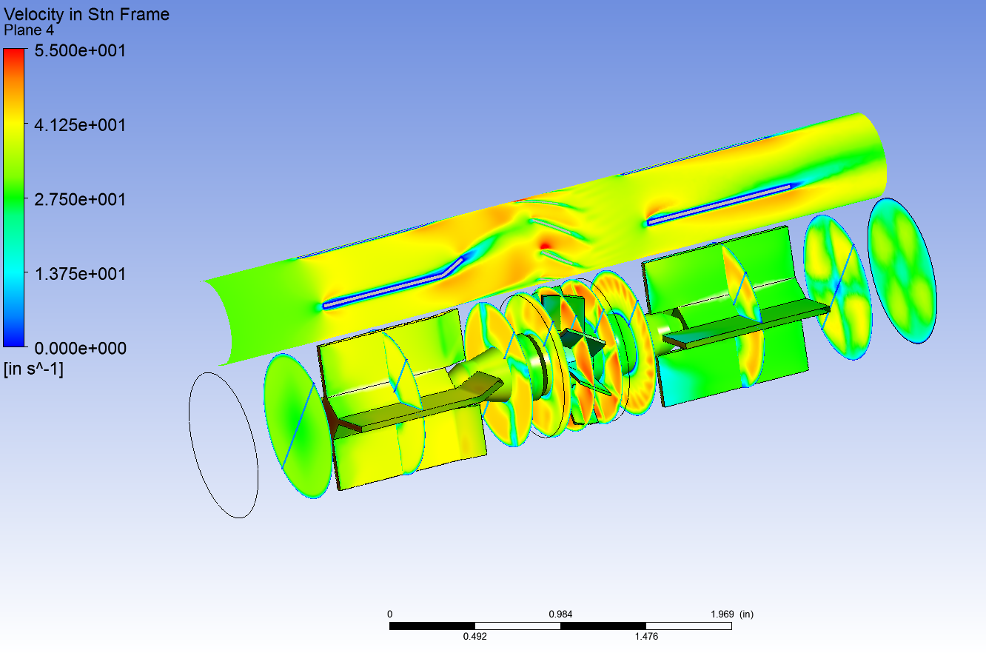
Flow Direction
Figure 25: Flow Velocity Profile for 1 cSt Hydrocarbon Solution at 10 ft/s Inlet Condition
(Time = 0 sec)

Flow Direction
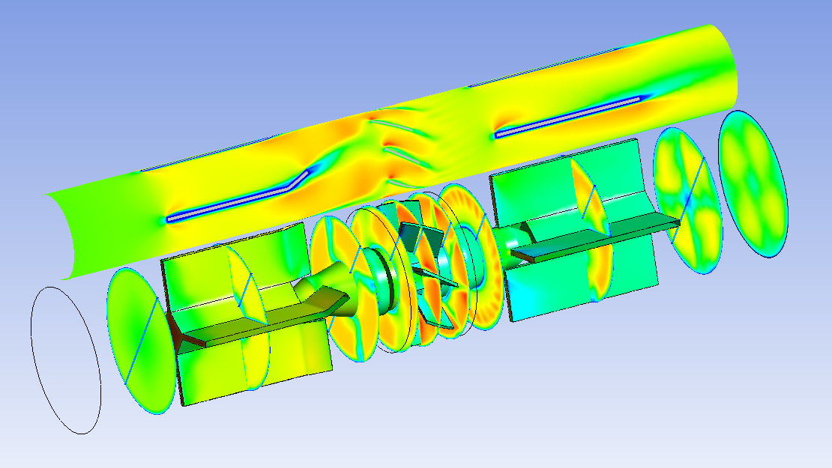
Figure 26: Flow Velocity Profile for 1 cSt Hydrocarbon Solution at 10 ft/s Inlet Condition
(Time = 0.0078 sec)

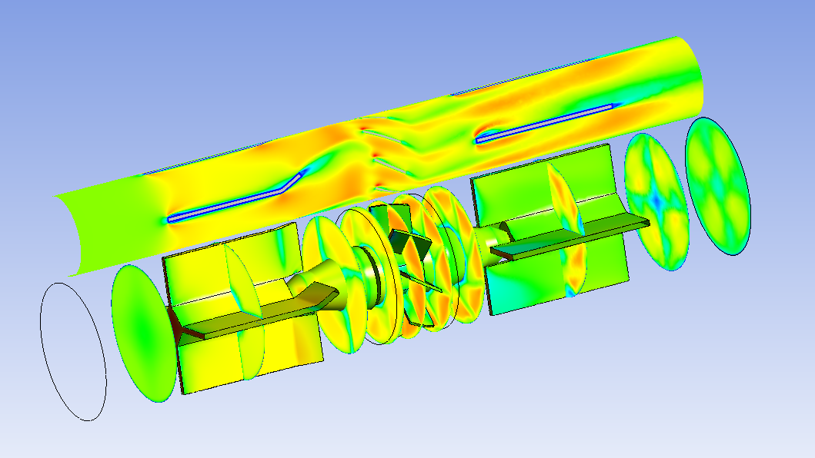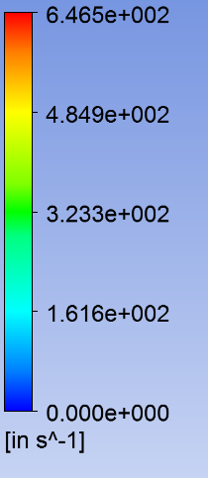
Flow Direction
Figure 27: Flow Velocity Profile for 1 cSt Hydrocarbon Solution at 30 ft/s Inlet Condition
(Time = 0 sec)

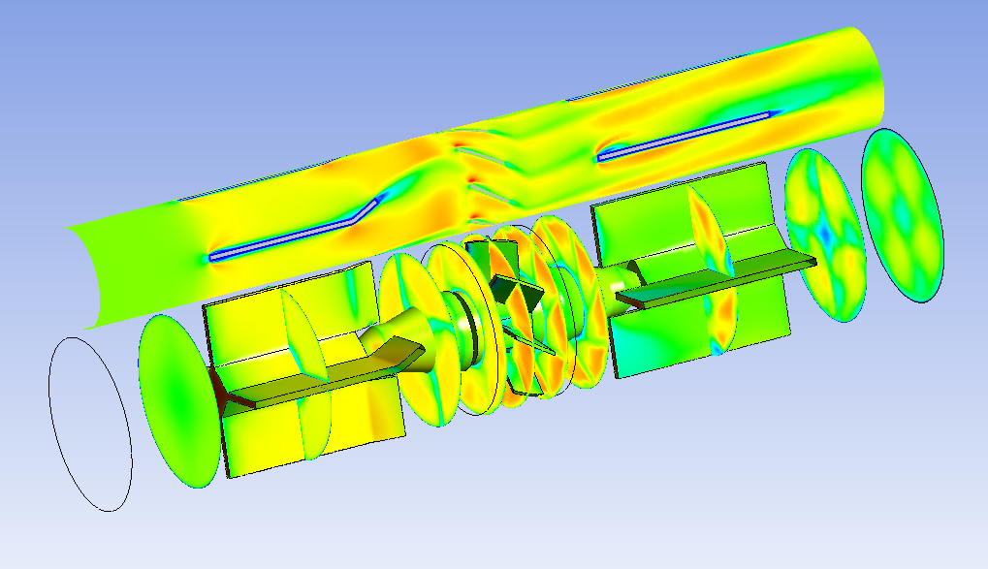
Flow Direction
Figure 28: Flow Velocity Profile for 1 cSt Hydrocarbon Solution at 30 ft/s Inlet Condition
(Time = 0.0026 sec)

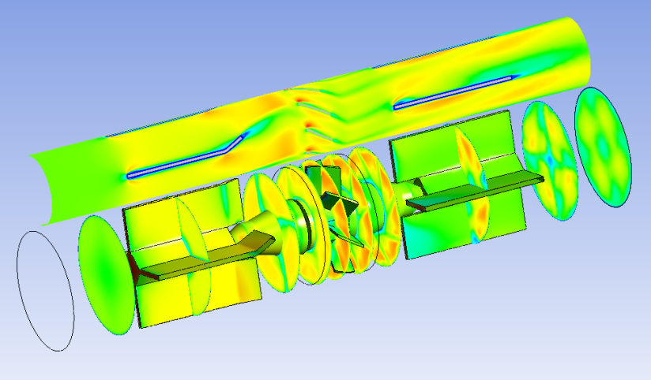
Flow Direction
Figure 29: Flow Velocity Profile for 1 cSt Hydrocarbon Solution at 30 ft/s Inlet Condition
(Time = 0.052 sec)

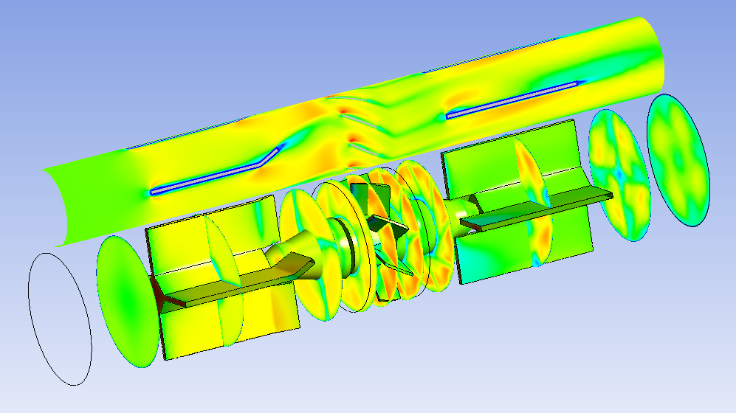
Flow Direction
Figure 30: Flow Velocity Profile for 1 cSt Hydrocarbon Solution at 30 ft/s Inlet Condition
(Time = 0.0078 sec)

Hydrocarbon Velocity Profiles
The static structure ahead of the rotor has a major effect on the flow profile. The flow profile that meets the rotor has a substantial impact on the calibration curve [9]. The change in fluid viscosity affects the flow velocity profile which affects the pressure distribution on the rotor blades. This changes the rotational velocity of the rotor. The velocity profiles from each case provide data that can be input into other computational models like the Winchester model.
The velocity profiles shown in Fig 31-33 are not uniform or fully developed annular flow. The flow is partially developed and affected by the wake flow coming from the inlet fence. This flow profile also shows that the radial flow velocity will not match the rotational velocity of the at corresponding radial location. This means that the center zone of the blade experiences the pressure drive and areas near the blade hub and tip experiences pressure drag [4].
For sampling line locations, refer to Fig 13 and Table 2.

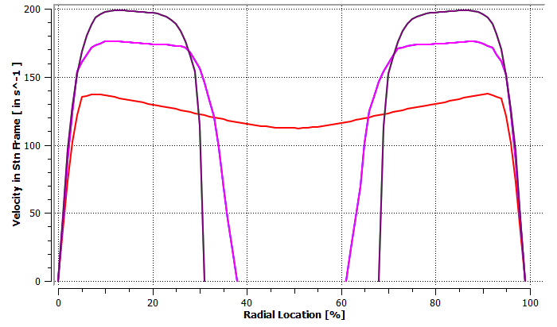
L1
L2
L3
Figure 31: Inlet Fence Velocity profiles for 28 cSt Hydrocarbon Solution at 10 ft/s Inlet Condition

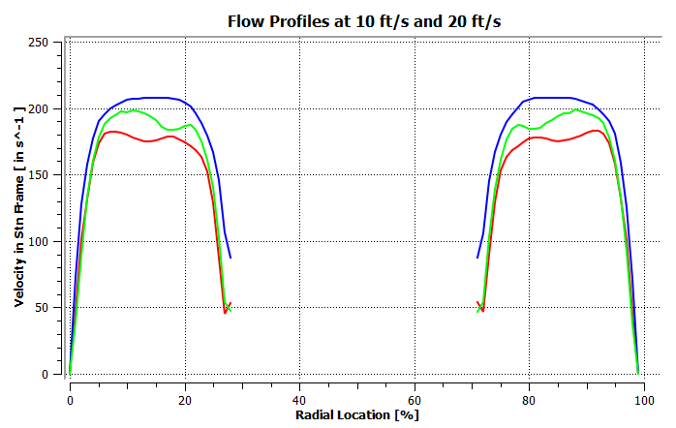
L5
L4
L6
Figure 32: Rotor Velocity profiles for 28 cSt Hydrocarbon Solution at 10 ft/s Inlet Condition

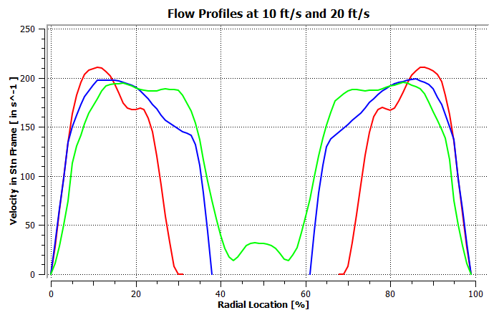
L9
L8
L7
Figure 33: Outlet Fence Velocity profiles for 28 cSt Hydrocarbon Solution at 10 ft/s Inlet Condition

PG+W Simulation Case Summary
The results from the propylene glycol and water solution simulation also follow the trend of the manufacturer data. These fluids have the same kinematic viscosity as the hydrocarbon simulations, but the density has been changed to match the density of the propylene glycol and water solution. This fluid is about 15% denser than the hydrocarbon fluids.

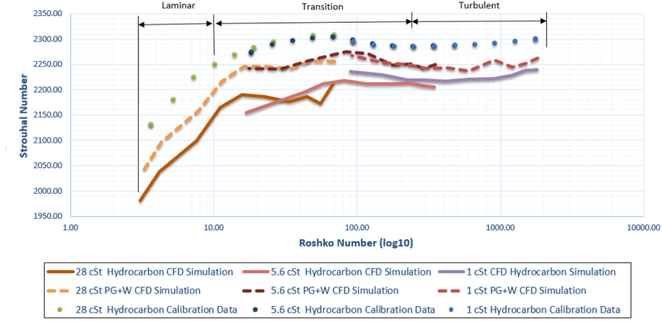
Figure 34: Calibration Curves from Model and Manufacturer for Hydrocarbon Fluids.
The curves on the top are the calibration data from the manufacturer. The middle curves are the PG+W solution simulations. The bottom is the calibration obtained from the hydrocarbon simulations.

The calibration curve of the PG+W solution, seen in Fig 34, lies in-between the results from the hydrocarbon simulation and the calibration test data. There is an upward shift in the Strouhal number for these simulations. The meter factor for these cases is higher than that seen in the hydrocarbon cases. The cause of this shift is still undetermined. The shift is still within the observed error of the model. This change may be reduced through further improvements to the model. This may be due to the slightly higher density of the PG+W solution imparting additional momentum on the rotor.
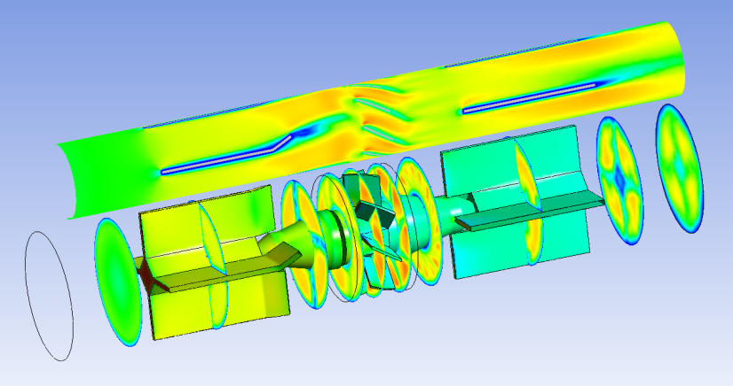
Flow Direction
Figure 35: Flow Velocity Profile for 28 cSt PG+W Solution at 10 ft/s Inlet Condition
(Time = 0 sec)

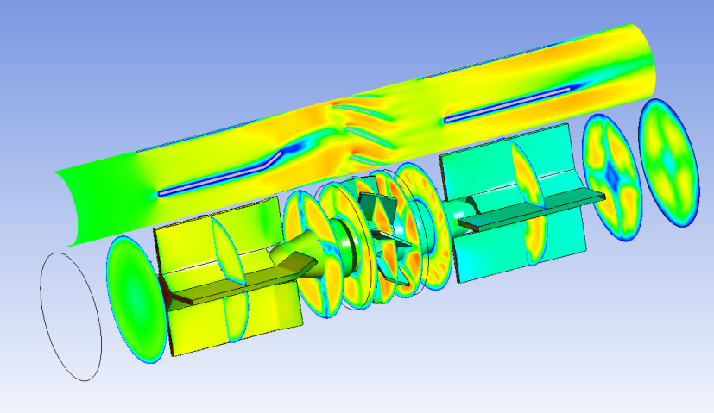
Flow Direction
Figure 36: Flow Velocity Profile for 28 cSt PG+W Solution at 10 ft/s Inlet Condition
(Time = 0.0032 sec)

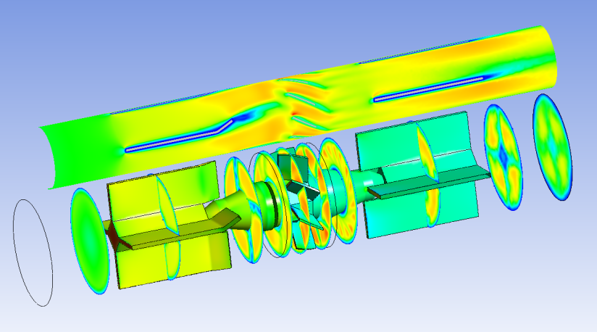
Flow Direction
Figure 37: Flow Velocity Profile for 28 cSt PG+W Solution at 10 ft/s Inlet Condition
(Time = 0.0064 sec)

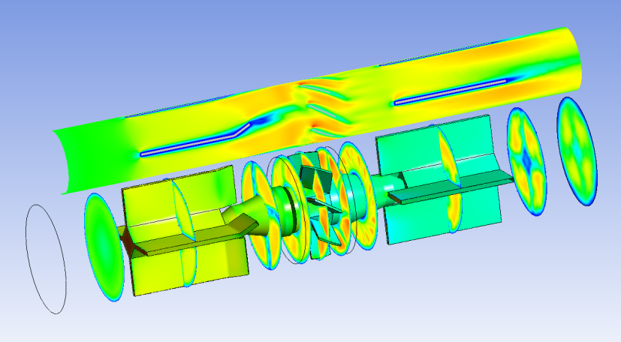
Flow Direction
Figure 38: Flow Velocity Profile for 28 cSt PG+W Solution at 10 ft/s Inlet Condition
(Time = 0.0095 sec)

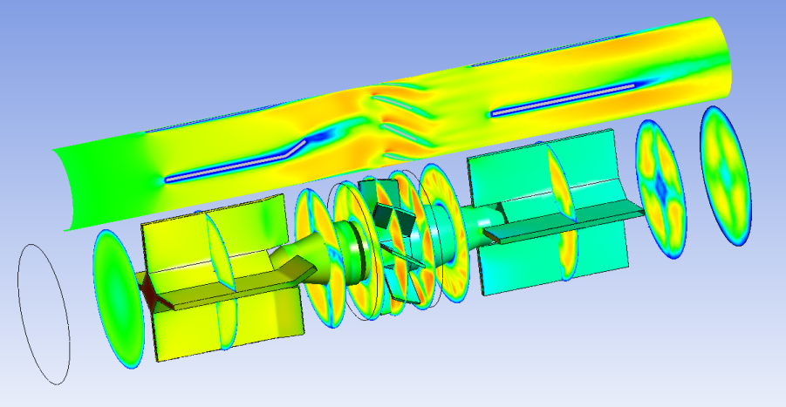
Flow Direction
Figure 39: Flow Velocity Profile for 28 cSt PG+W Solution at 10 ft/s Inlet Condition
(Time = 0.0127 sec)

PG+W Flow Profile
The velocity flow profiles for the PG+W solution (Figs 35-39) are nearly identical to the corresponding hydrocarbon cases. The dissimilarities that are observed are likely due to random, time-based variation in the model. When averaged over time, the differences in the wakes are indistinguishable.

PG+W Velocity Profiles
The velocity profiles for the propylene glycol and water solution (Figs 40-42) are also very similar to the hydrocarbon cases. When compared to the corresponding hydrocarbon cases, there is a less than 1% difference in the velocity profile of the fluid before it encounters the rotor.

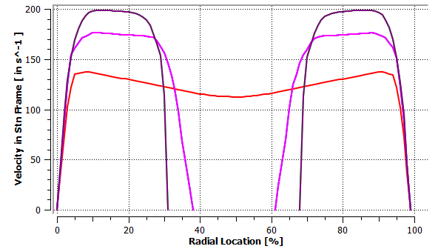
L3
L2
L1
Figure 40: Inlet Fence Velocity profiles for 28 cSt PG+W Solution at 10 ft/s Inlet Condition

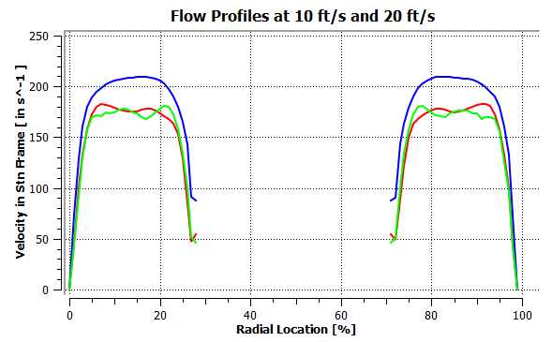
L4
L6
L5
Figure 41: Rotor Velocity profiles for 28 cSt PG+W Solution at 10 ft/s Inlet Condition

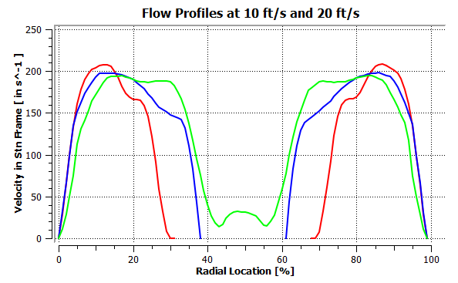
L9
L7
L8
Figure 42: Outlet Fence Velocity profiles for 28 cSt PG+W Solution at 10 ft/s Inlet Condition

Straight Fence Simulation Results

Straight Fence Calibration Curve
The straight fence simulation had the bend in the inlet fence removed, so there is not a favorable incident flow approaching the rotor. This bend is added during initial calibration to improve the response of the flow meter in the low flow regime [6]. The amount of bend can vary from one flow meter to another depending on that initial calibration. This case was added to demonstrate the ability of the model to show the effects of changes in geometry for the flow meter. Only one viscosity was used for this simulation.
The calibration curve for this case is similar to previous cases except that there is a significant drop-off in response at the lowest end of the flow regime as seen in Fig 43. This confirms the reasoning to add the bend in the inlet fence to improve the performance of the meter. The rest of the calibration curve is still lower than the previous hydrocarbon simulation. This is due to the lack of additional swirl to drive the rotor to a higher K factor.

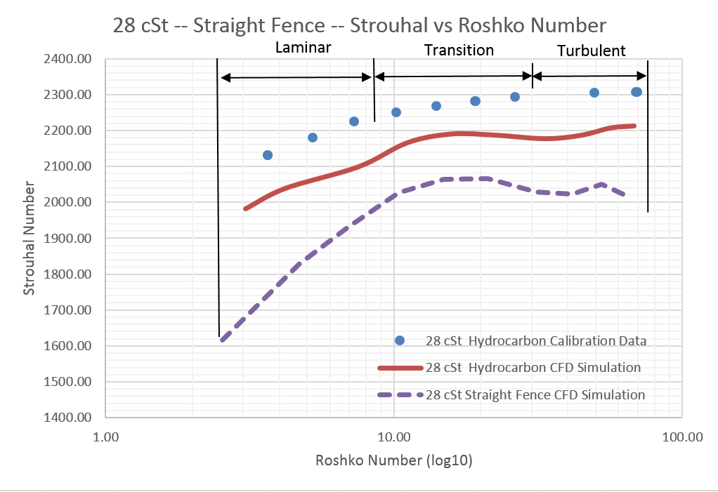
Figure 43: Straight Fence Calibration Curve for 28 cSt Hydrocarbon Fluid

Straight Fence Flow Profile
The velocity profiles of the straight fence shows that the flow moves through the inlet fence and arrives at the rotor with a lower angle of attack. This lower angle of attack accounts for some of the reduced rotor speed. There is a region of higher velocity flow along the leading edge of the blades.
The wakes coming from the inlet fence are smaller in this type of flow meter since there is less to disturb the flow. The angled inlet fence caused a relatively large wake of low velocity fluid. This likely means that the interaction between the static structure and the rotor will be less in the straight fence case versus the angled inlet fence. The torque on the rotor is more uniform over the full rotation of the turbine due to the uniformity of the flow (see Figs 44 & 45).

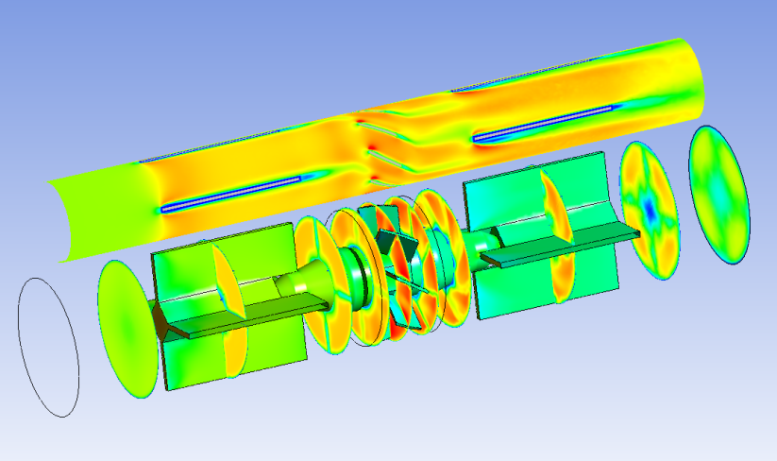
Flow Direction
Figure 44: Flow Velocity Profile Straight Fence 28 cSt Solution at 10 ft/s Inlet Condition
(Time = 0 sec)

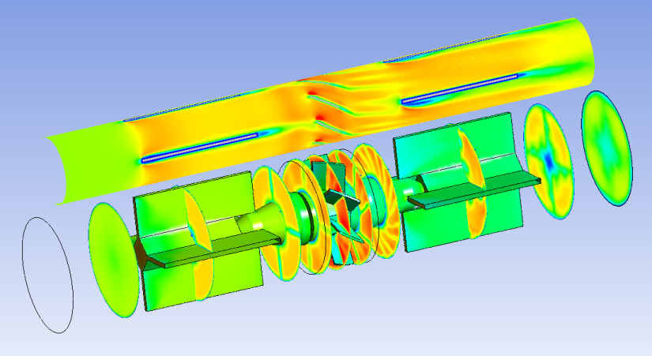
Flow Direction
Figure 45: Flow Velocity Profile Straight Fence 28 cSt Solution at 10 ft/s Inlet Condition
(Time = 0.0085 sec)

CHAPTER VI
CONCLUSION

This thesis is focused on computational modeling of turbine flow meters to simulate flow and rotor response of the meters across a wide range of their operation, with environmentally safe fluids at improved accuracies.
Proper calibration for flow meters is critical for measurement accuracy in all applications. For many hydrocarbon flow meter calibrations, the standard Stoddard solvent has been used but this calibration fluid is volatile and poses an environmental and health risk to those performing the calibrations. Other safer calibration fluids, such as a mixture of propylene glycol and water have the same kinematic viscosity as volatile fluids so they can be used as acceptable alternatives but there are concerns about the effects on accuracy by using these alternative calibration fluids.
Although many efforts have been conducted, the fluid dynamics mechanism of the viscosity effect on turbine flow meter performance is still not fully understood. No accurate physical model validated with experimental data exists that adequately explains the meter response and the shape of the turbine meter calibration curve. Also, there is inadequate understanding of how differences in kinematic viscosity due to temperature affect turbine meter calibrations. Physical models for the turbine meter calibration curve based on momentum and airfoil approaches have been published in the past, but these models are supplemented with experimental correction factors to improve accuracy.
In this research turbine flow meters were studied, using computational fluid dynamics (CFD) modeling to study effects of viscosity on the flow meters, across a wide range of operation, to improve our understanding and their performance. A three-dimensional computational model was created for a typical flow meter geometry. The CFD model has a mesh that moves over time so the interaction between the static and rotation structures can be seen by viewing the flow field. This model was used to characterize the calibration of a turbine flow meter by varying flow rate, viscosity, and density of the fluid and obtain a steady state rotor speed as the response. The work began with a steady state model to provide an acceptable initial condition for further simulations. These results were input into a transient model. Transient model had a rotating zone around the rotor to provide insight into the interaction between the static and rotational structures. This simulation produced improved initial conditions for the next simulation. In order to automatically adjust the rotor speed based on the torque imparted on the rotor by the flow, a fluid structure interaction simulation was employed by treating the rotor as a rigid structure that could freely rotate about its own axis of rotation. This means simulation is better able to match the equilibrium rotor speed and the transient response approaches the true transient response to changing flow rates. Accuracy of the calibrations with different fluids at various volumetric flow rates were examined. This provided a greater understanding of the effects of different fluids on the accuracy of turbine flow meters.
A parametric analysis was performed using these models in order to create multiple calibration curves that show the response of the flow meter under various conditions. Each calibration curve consists of running a series of simulations at a range of flow rates for a particular fluid. The calibration curves for a variety of viscosities are assembled to form a Universal Calibration Curve for the meter. This model produced a calibration results that mimics the response seen from experimentation and extensive calibration. The simulation produced full flow field visualizations. The model produces a calibration curve that matches the shape of the curve from the manufacturer’s data. This simulation can be used to model variations in fluids used or changes in the geometry of the flow meter. As the fluid viscosity increases, the average meter factor and linearity decreases. When the kinematic viscosity increase from 1 cSt to 788 cSt the average meter factor decreases from 2227 pulses/ gal to 1390 pulses/gal.
A parametric analysis was performed using these models in order to create multiple calibration curves that show the response of the flow meter under various conditions. Each calibration curve consists of running a series of simulations at a range of flow rates for a particular fluid. The calibration curves for a variety of viscosities are assembled to form a Universal Calibration Curve for the meter.
The wake flow from the inlet flow straightener has significant effects on the velocity distribution of the turbine and the performance of the meter. When the viscosity increases or the flow rate decreases to the laminar region of the flow regime, the effect of this wake flow become more pronounced. The flow profile entering the rotor is not uniform or fully developed annular flow, rather it is partially developed flow and this has a major effect on the rotor speed. The flow meter sensitivity, especially in the laminar flow region, could be reduced significantly if the inlet flow straightener was not optimally set.
Results from this model may prove useful for future turbine flow meter designs and future modeling.

Future Work
There are aspects of this model that can be improved to provide even a deeper understanding of turbine flow meters. The bearing drag model should be added to the simulation. This would provide additional accuracy especially at the low ends of the flow regime.
If time accurate transient test data is obtained, the data from the transient simulation could be compared to determine if the 6DoF simulation accurately depicts the time accurate solution. A time accurate CFD simulation can provide insights not available in an experimental setup. This could lead to improvements in design to improve response time of a turbine flow meter.
Improvements could be also made to the mesh. These would be so that better capture boundary layers in areas of interest by increasing the number of inflation layers around the rotor and rotor wall. Additional points could be added to better capture the wake flow. Coarsening the grid in location of uninteresting flow and improving quality will optimize for solution efficiency. The effects of other geometry changes could be investigated in order to explore new designs. The next model should better help provide some useful insights that may aid in calibration and design of turbine flow meters.

BIBLIOGRAPHY

[1] | D. Wadlow, "Turbine Flow Meters, Part I: Details of the Basic Axial Flow Meter," 1999.
[2] | P. W. Stoltenkamp, "Dynamics of Turbine Flow Meters," Eindhoven University of Technology, Eindhoven, Netherlands, 2007.
[3] | J. G. Pope, J. D. Wright, A. N. Johnson and M. R. Moldover, "Extended Lee Model for the Turbine Meter and Calibrations with Surrogate Fluids," Flow Measurement and Instrumentation, no. 224, pp. 71-82, 2012.
[4] | J. Winchester, "Fundamentals for Computational Modeling of Axial Rotor Turbine Flow Meter Response To Fluid Flow Rate, Density, and Viscosity," Tullahoma, TN, 2014.
[5] | W. Lee and H. Evans, "Density Effect and Reynolds Number Effect on Gas Turbine Flowmeters," Journal of Basic Engineering, pp. 239-248, 1965.
[6] | Flow Technology Inc, "FT Series Turbine Flowmeters: Installation, Operation, and Maintenance Manual," Flow Technology Inc., Tempe, AZ, 2011.
[7] | E. L. Upp and P. J. LaNasa, Fluid Flow Measurement: A Practical Guide to Accuate Flow Measurement, Woburn, MA: Gulf Professional Publishing, 2002.
[8] | G. Mattingly, Turbine Flow Meter: Primary Fuel Flow Rate Measurement Device at AEDC, Tullahoma, TN, 2006.
[9] | S. Guo, L. Sun, T. Zhang, W. Yang and Z. Yang, "Analysis of viscosity effect on turbine flowmeter performance based on experiments and CFD simulations," Flow Measurement and Instrumentation, no. 34, pp. 42-52, 2013.
[10] | G. Carpelli, "TURBINE FLOW METER FOR USE IN FUEL DISPENSING ENVIRONMENTS". Italy Patent 8,096,446, 17 November 2008.
[11] | Flow Technology Inc, "FTO Turbine Flowmeter: Installation, Operation, and Maintenance Manual," Flow Technology Inc., Tempe, AZ, 2011.
[12] | B. G. Liptak, Process Measurement and Analysis: Volume I, Boca Raton, Florida: CRC Press, 1995.
[13] | Omega Press LLC, Transactions in Measurement and Control Vol 4: Fluid & Level Measurement, Stamford, CT: Putnam Publishing, 2001.
[14] | R. Assudani, "Computational Fluid Dynamics Simulations of Jet Fuel Flow Near the Freeze Point Temperature," University of Dayton, Dayton, OH, 2006.
[15] | J. Yoder, "Flowmeter Spin: History and evolution of turbine flow measurement," Flow Control, pp. 26-30, February 2012.
[16] | R. Thompson and J. Grey, "Turbine Flowmeter Performance Model," Journal of Basic Engineering, Transactions of the ASME, vol. 4, no. 92, pp. 712-723, 1970.
[17] | Flow Technology Inc, "Universal Viscosity Curve Theory," Flow Technology, 2013. [Online]. Available: http://ftimeters.com/tech_library/flowmeter_viscosity.htm. [Accessed 29 September 2013].
[18] | J. D. Wright, "A Comparison of 12 US Liquid Hydrocarbon Flow Standards and the Transition to Safer Calibration Liquids," Cal Lab: The International Journal of Metrology, pp. 30-38, 2011.
[19] | Flow Technology Inc, "Technical Bulletin: Ceramic Ball Bearings," Flow Technology Inc, Tempe, AZ, 2010.
[20] | J. Yoder, "Flowmeters and Their Apps: An Overview," The World Market for Flowmeters, February 2003.
[21] | R. Madison, "Modern Electronics Meet Turbine Flowmeters," Measurements & Control, April 1995.
[22] | J. G. Pope, J. D. Wright and S. D. Sheckels, "Tests of the Extended Lee Model Using Three Different Turbine Meters," in 8th ISFFM, Colorado Springs, CO, 2012.
[23] | US Department of Defense, Military Specification: Fluid Flowmeter MIL-F-24259A, Washington DC: US Department of Defense, 1987.
[24] | J. Smith, "Application of Turbine Meters in Liquid Measurement," FMC Technologies, Erie, PA, 2006.

APPENDICES

Appendix I: Flow Meter Drawings
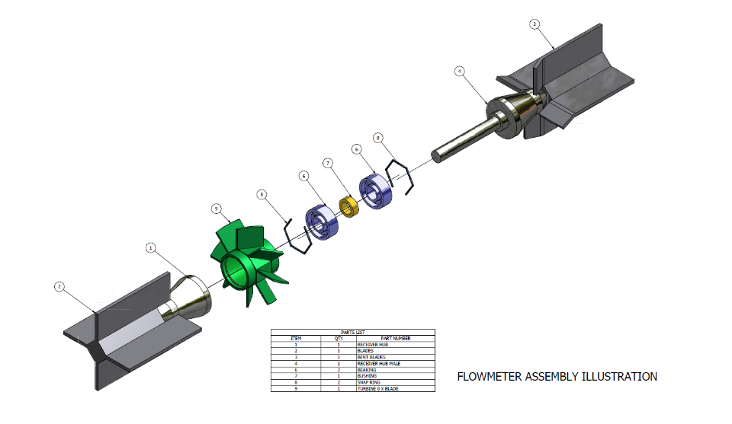
Figure 46: Flow Meter Assembly Exploded View

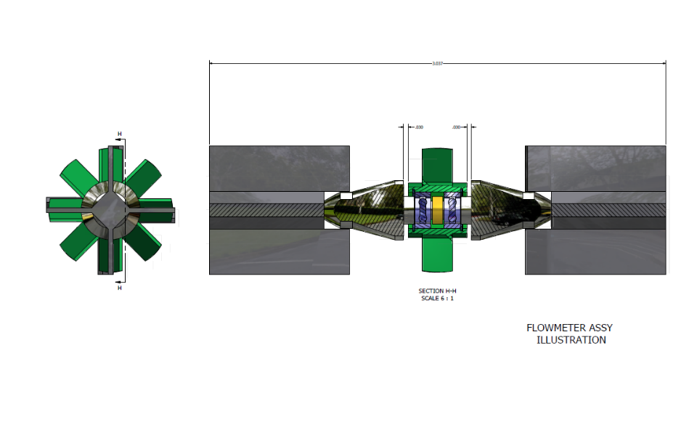
Figure 47: Flow Meter Assembly
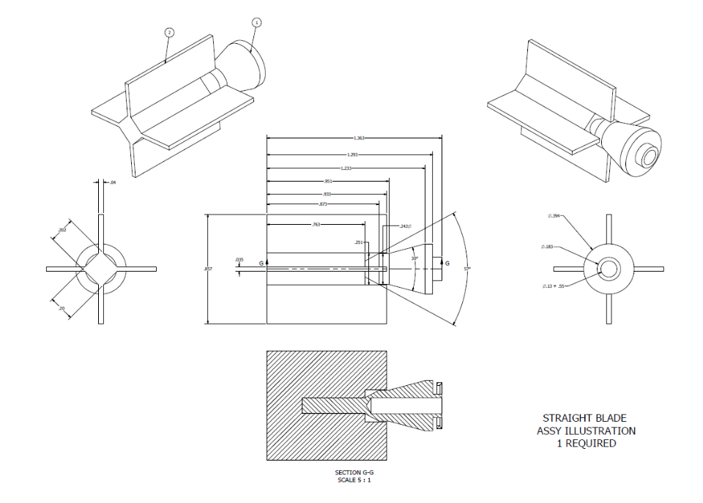
Figure 48: Straight Fence Drawing
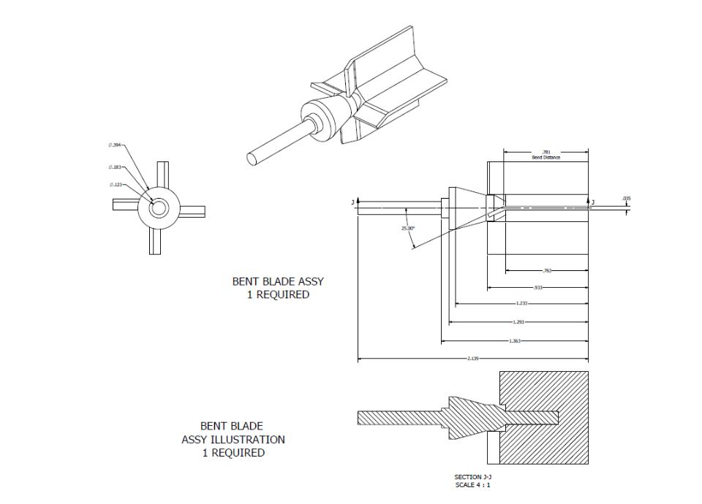
Figure 49: Bent Fence Drawing

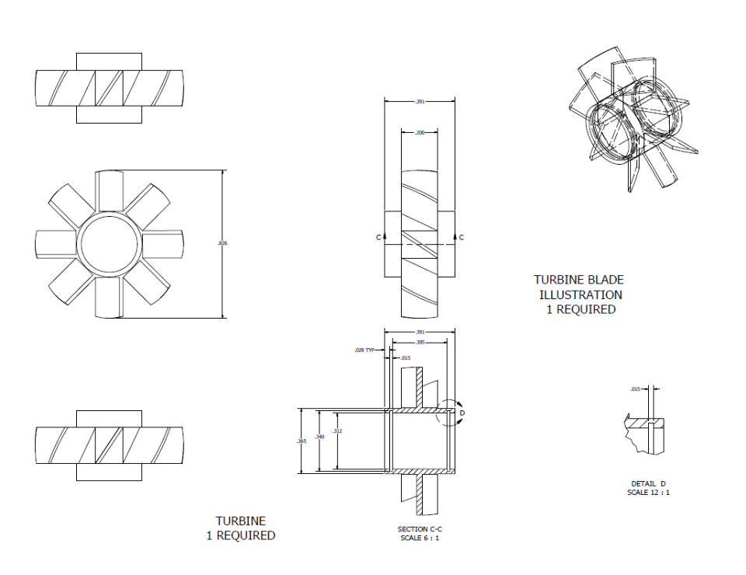
Figure 50: Rotor Drawing

Appendix II: CFD Simulation Data Tables
Table 6: 788 cSt Hydrocarbon Data Table
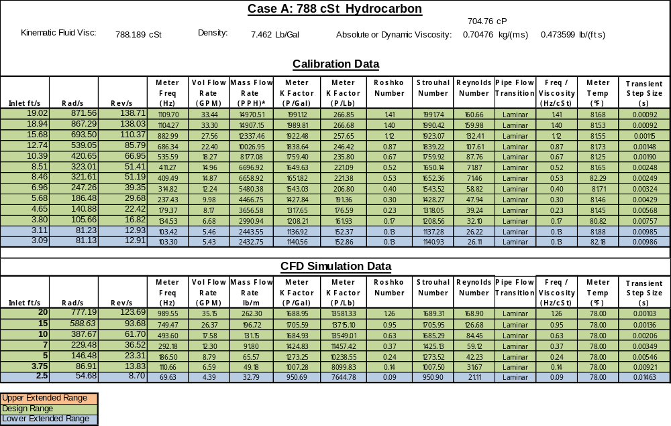
Table 7: 148 cSt Hydrocarbon Data Table
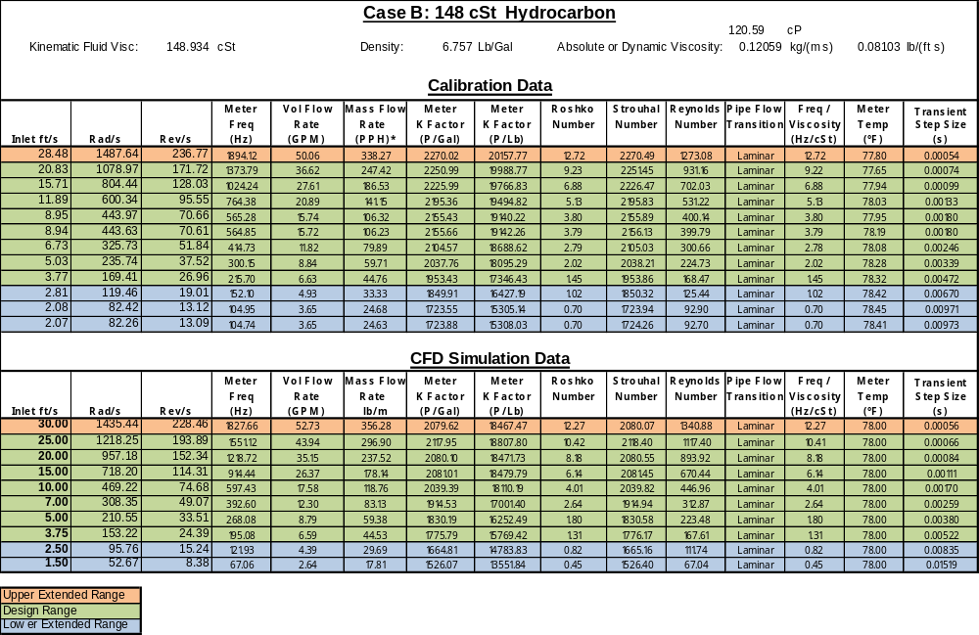

Table 8: 28 cSt Hydrocarbon Data Table
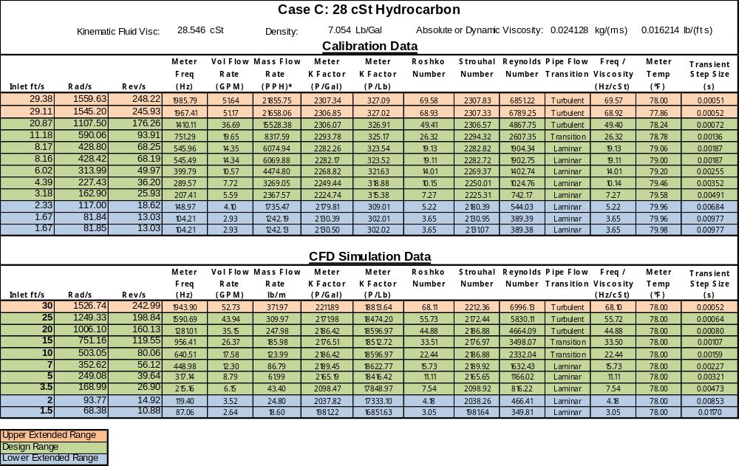

Table 9: 5.6 cSt Hydrocarbon Data Table
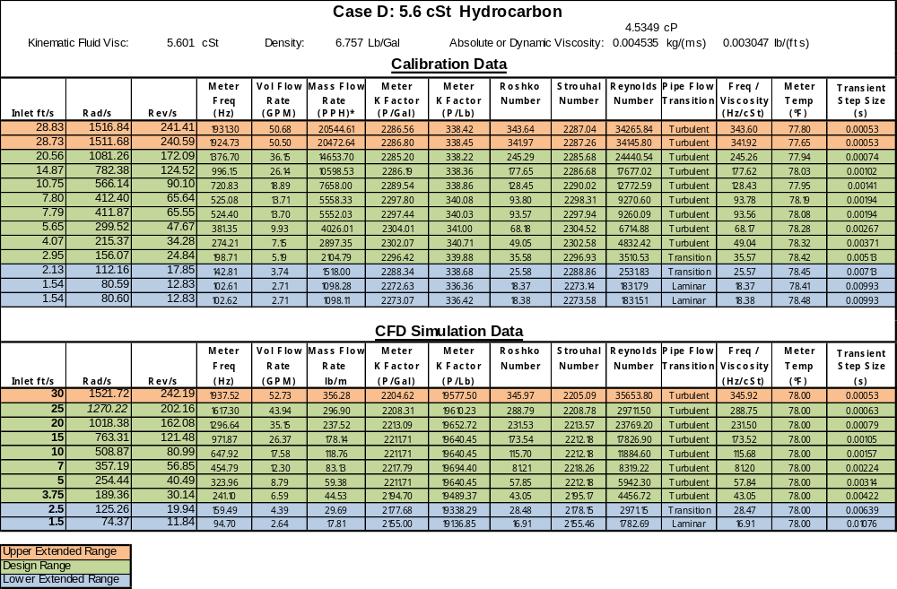

Table 10: 1.09 cSt Hydrocarbon Data Table
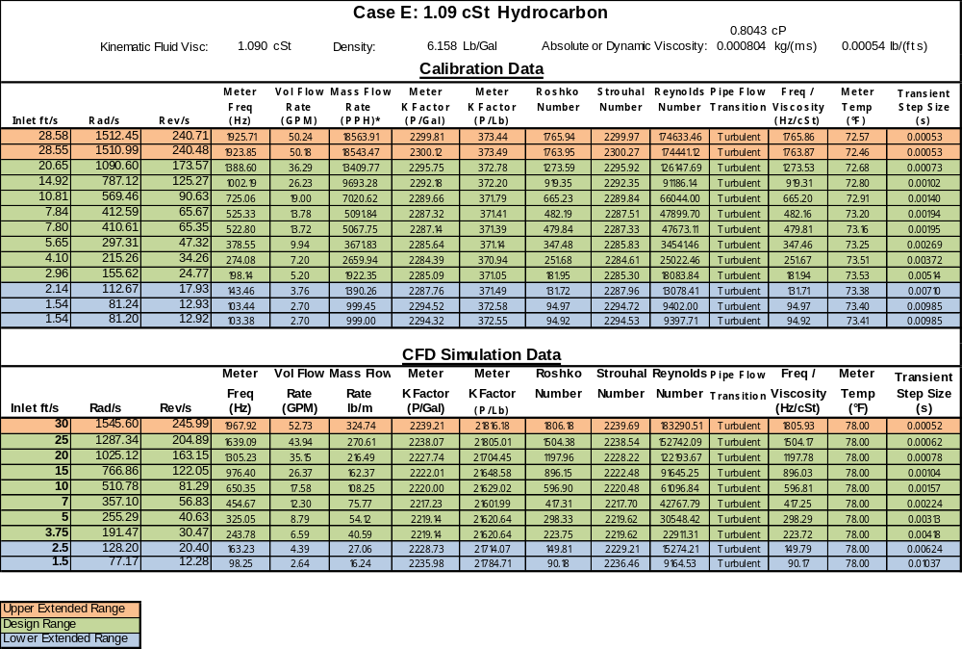

Table 11: 28 cSt Hydrocarbon Straight Fence Data Table
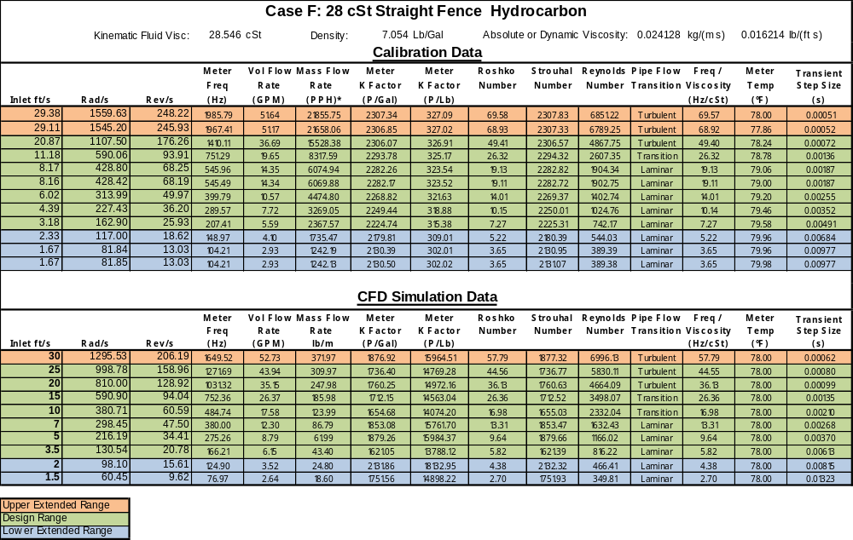

Table 12: 28 cSt PG+W Data Table
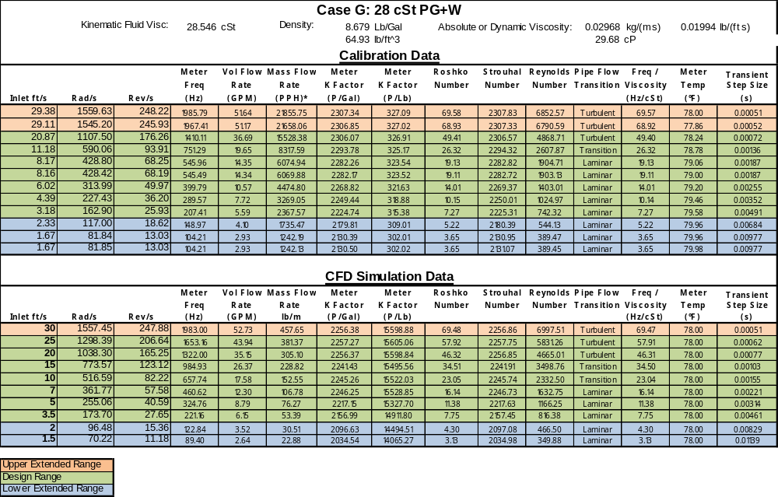

Table 13: 5.6 cSt PG+W Data Table
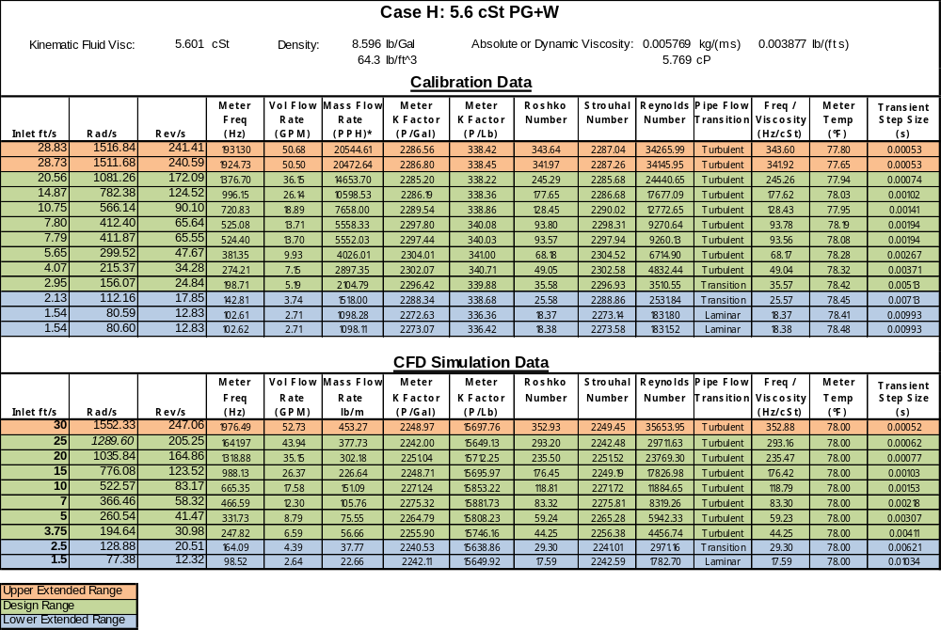
Table 14: 1.09 cSt PG+W Data Table
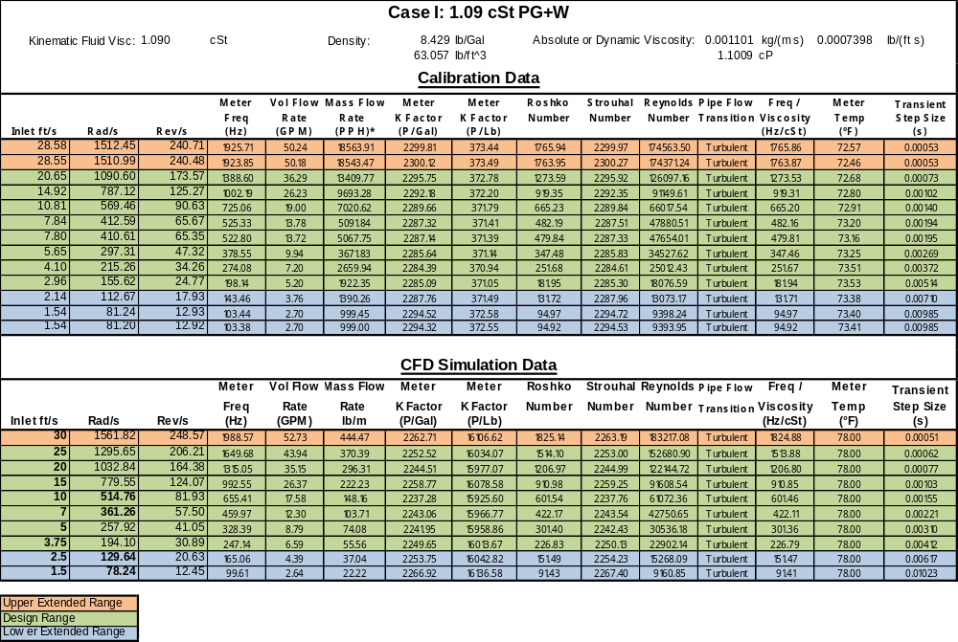

Appendix III: Individual Calibration Curves
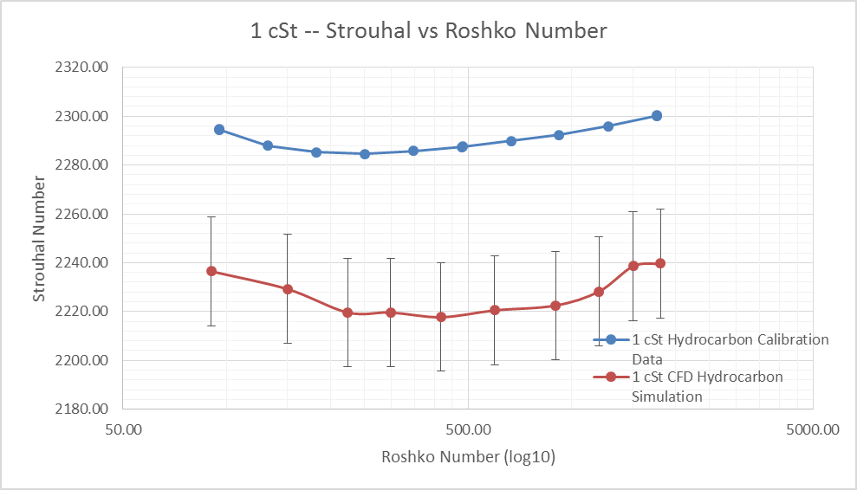
Figure 51: Calibration Curves from Model and Manufacturer for 1 cSt Hydrocarbon Fluids

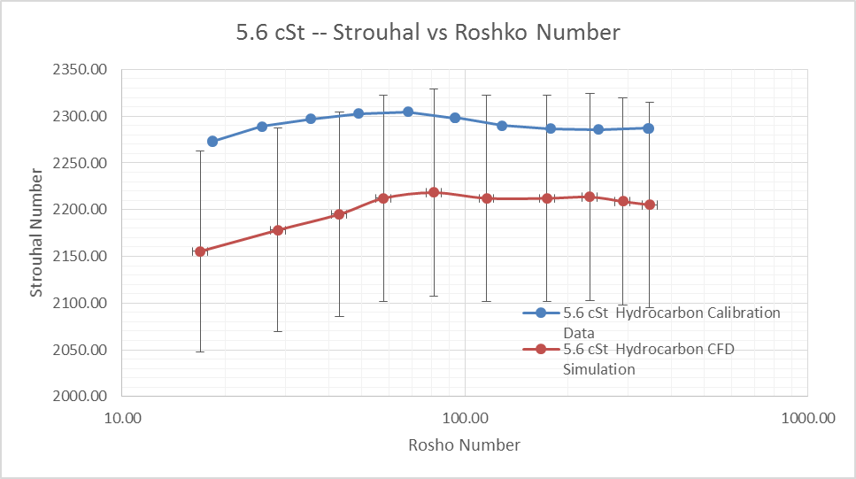
Figure 52: Calibration Curves from Model and Manufacturer for 5.6 cSt Hydrocarbon Fluids

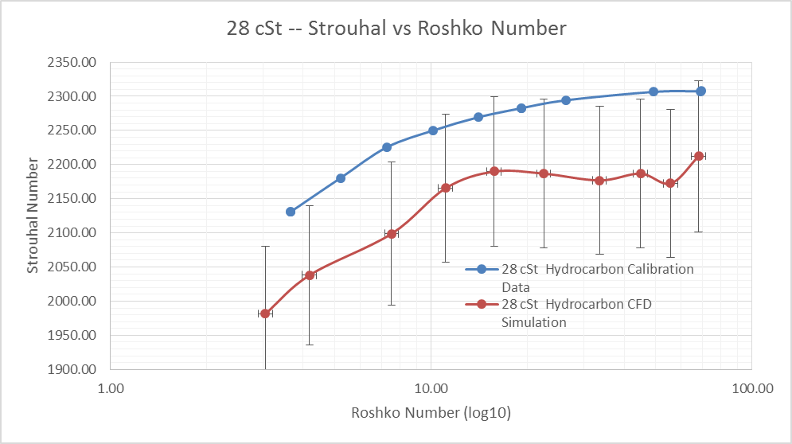
Figure 53: Calibration Curves from Model and Manufacturer for 28 cSt Hydrocarbon Fluids
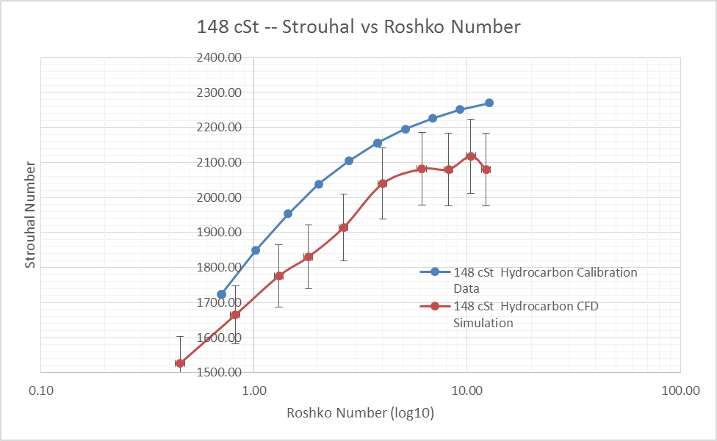
Figure 54: Calibration Curves from Model and Manufacturer for 148 cSt Hydrocarbon Fluids
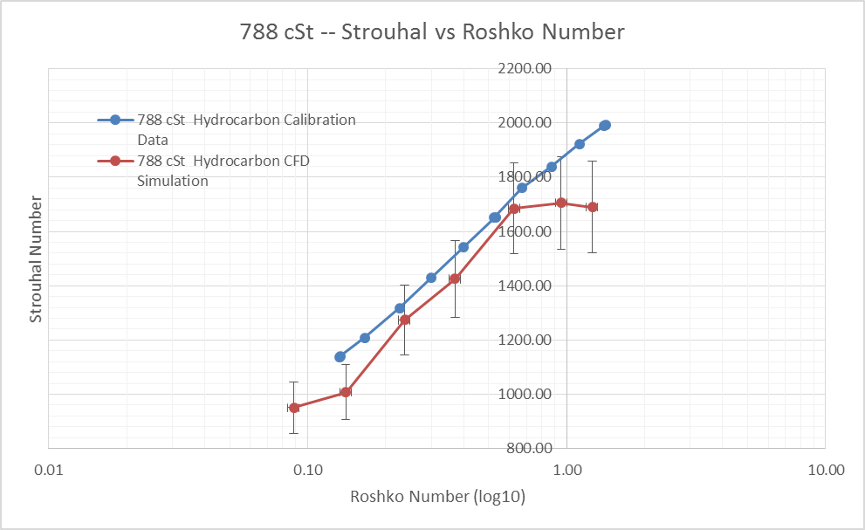
Figure 55: Calibration Curves from Model and Manufacturer for 778 cSt Hydrocarbon Fluids

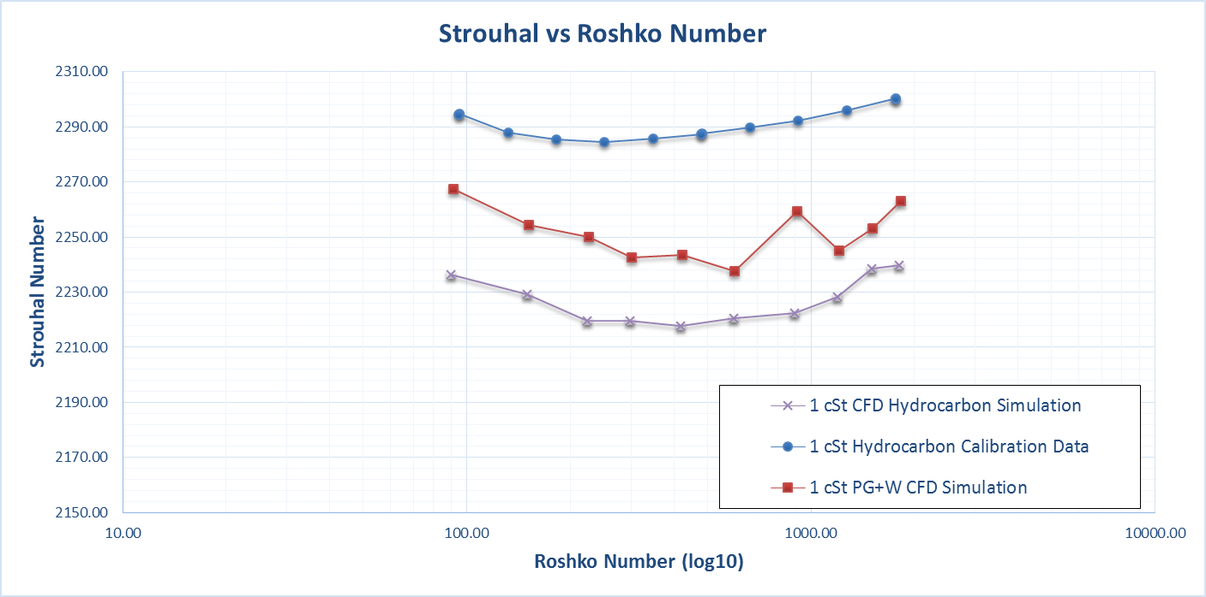
Figure 56: PG+W Calibration Curve for 1 cSt Fluid

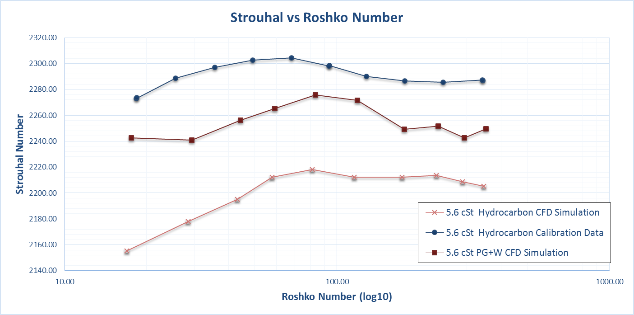
Figure 57: PG+W Calibration Curve for 5.6 1 cSt Fluid

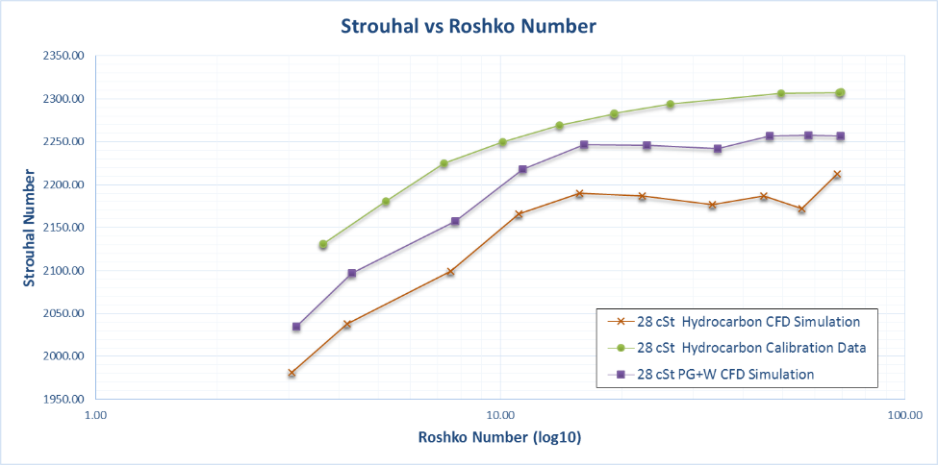
Figure 58: PG+W Calibration Curve for 28 cSt Fluid

VITA

Carl Tegtmeier was born in Fargo, North Dakota on May 12, 1987. He grew up in Fargo and Hunter ND and graduated from high school at Northern Cass HS in 2006 and during the same year he began undergraduate studies at North Dakota State University. During his undergraduate studies, he went through the Air Force ROTC program. Carl completed his Bachelors of Science degree in Mechanical Engineering at North Dakota State University in December 2010. After graduation, he commissioned as a second lieutenant in the United States Air Force and began his professional career at the Arnold Engineering Development Center while completing his Master’s degree in Mechanical Engineering part time at the University of Tennessee Space Institute. Carl is currently employed by the United States Air Force.

