CHAPTER-5

EXPLORING MULTI-CHANNEL ANALYSIS OF SEISMIC SURFACE WAVES WITH RANDOM RECEIVER ARRAYS FOR POTENTIAL LUNAR EXPLORATION

ABSTRACT
Understanding the physical and engineering properties within the upper 30 meters of the lunar subsurface will be critical as lunar exploration advances and deployment of large structures, landing of large spacecraft, and excavating for mining or human habitation on the moon becomes necessary. Advances in multi-channel seismic acquisition, either active or passive, in acquiring reliable 1-D or 2-D shear wave velocity profiles have greatly improved our ability to determine the engineering properties (e.g., Poisson’s ratio) of Earth’s shallow subsurface, especially when using the seismic multi-channel analysis of surface waves (MASW) technique. A new scheme of using randomly distributed geophones that would be deployed from a mortar-type device, instead of a conventional linear array, is necessary for lunar exploration because of the substantial logistical challenges associated with arranging an accurate linear or circular array robotically. Results indicate that robust dispersion curves and thus subsurface models of engineering properties can be obtained using random array geometry. Based on the extreme logistics imposed by lunar exploration and the anticipated engineering needs of lunar exploration, information obtained on the Moon (e.g., V₃₀) using this technique should prove to be a critical component of data acquisition. This study focuses on testing the effectiveness of a random receiver array judged by the accuracy of the dispersion curve processed from the random-array data. For the purpose of comparison, the effectiveness of the dispersion curves obtained from the newly developed method will be compared with the conventional linear array data that was collected at the same site.

- INTRODUCTION
The geology of Earth’s Moon has been studied via Earth-based telescopic observations (e.g., Kuiper, 1960), orbiting-spacecraft readings (Apollo, Luna missions), Lunar samples (also returned from Apollo and Luna missions), and geophysical data (e.g., Khan et al., 2000; Khan et al., 2007). The physical properties of Lunar soils and rocks have been determined in situ by robots and astronauts at depths varying from a few micrometers to a few tens of meters of the subsurface, in the laboratory on returned samples, from remote sensing, and from Lunar orbit (Carrier et al., 1991; Mitchell et al., 1973; 1974). Geotechnical properties (the properties of a planetary surface needed to evaluate the engineering problems) of the interior as well as the mechanical properties of soil and rock, and the electric/electromagnetic properties are critical in understanding the complexities of the lunar surface. Seismic signals were incorporated into many of the experiments performed by astronauts during the Apollo missions with the objective to map the deep Lunar interior (Nakamura et al., 1973). However, using seismic signals to determine the engineering properties (e.g., Poisson’s ratio) of the shallowest layers (upper 30 m) of the Lunar subsurface has not been attempted in any lunar mission. The shear wave velocities of near surface materials (such as soils) are of fundamental interest on Earth in many environmental and engineering studies and in construction safety (e.g., Park et al., 1999). For example, the average shear-wave velocity of the upper 30 m of the subsurface (V₃₀) plays a key role in soil classification and is one of the critical parameters in the construction industry and earthquake safety (Xia et al., 2007). The V₃₀ parameter is also a critical parameter in slope-stability analysis. Understanding the physical properties within the upper 30 m of the Lunar subsurface is important as lunar exploration advances. The physical properties will be critical when building large structures, landing large crafts, mining for resources, and tunneling for human habitation. A prior knowledge of the load-bearing capacities and structural integrity of the surface layers will become important for future lunar exploration.
The multi-channel analysis of surface waves (MASW) seismic method (Park et al., 1999) utilizes a multi-channel seismic recording system to estimate near-surface S-wave velocity from dispersion property of high-frequency (>2 Hz) Rayleigh waves (Fig. 1a). The method has been steadily gaining popularity and attention from the near-surface geophysical and engineering communities, and has been successfully applied to various near-surface problems, such as mapping bedrock (Miller et al., 1999), studying pavement structures (e.g., Ryden et al., 2006) and liquefaction studies (e.g., Nazarian et al., 1983). The MASW uses a multi-channel array, which makes it possible to distinguish the fundamental-mode from higher modes and body waves. Depending on the source used to generate surface waves, there are two types of MASW surveys: the active method that utilizes a controlled impact source like a sledge hammer, and the passive method that utilizes ambient noise such as vehicle traffic or tidal motion. The active method is considered to be the conventional mode of survey, collecting data in a roll-along mode using an active seismic source and a linear receiver array. The passive remote method utilizes ambient cultural noise such as traffic, thunder, tidal motion, etc., and employs a 2-D surface receiver array such as a cross, circular, or random array to record passive surface waves.
A new scheme of using randomly distributed geophones that would be deployed from a mortar-type device instead of a conventional linear array is necessary for lunar exploration because of the substantial logistical challenges associated with arranging an accurate linear or circular array robotically. For example, rovers that are used to move around on lunar surfaces cannot easily move in a linear fashion or in a symmetrical circular motion to arrange the geophones due to constraints imposed by surface clutter such as rocks and boulders. Therefore it is difficult to arrange the geophones in an organized manner on a lunar surface. The principle objective of this study is to assess our ability to obtain accurate dispersion properties that can help determine engineering properties for the upper 30 m of the subsurface by using the 1-D shear wave profiles obtained using random array of geophone placement.

- OVERVIEW OF MASW METHOD
In order to acquire typical MASW data, multiple receivers (usually 24 or more) are deployed with even spacing along a linear array with all the receivers connected to a single recording device (seismograph) (Figure 1a). Each channel is dedicated to recording vibrations from one receiver. Each multi channel record, also known as a shot gather, consists of multiple number of time series (called traces) from all the receivers in an ordered manner. The recorded shot gather can have various patterns depending on the type of receiver array used. A typical shot gather for a linear array is shown in Figure 1a.
The data processing usually consists of three steps (Figure 1b): the first step involves converting the acquired SEG-2 format data into KGS format, and then sorting data by applying field geometry based on source and geophone locations. The second step is dispersion analysis which involves extracting dispersion curves (one for each record). One of the unique features of surface waves is that they are dispersive, that is, the phase velocity of surface waves in a vertically heterogeneous medium is dependent on frequency. This property of surface waves is known as dispersion. This is the key element in surface waves allowing them to be used to determine the variation of material properties with depth.
Generating a good dispersion curve is a critical step, since the final result of a MASW survey (either a 1-D shear wave velocity profile or a 2-D shear wave velocity map) depends on the frequency- phase velocity relationship analyzed in this step. This process is achieved by first converting the data from the time-space domain to frequency-phase velocity domain by using a suitable mathematical transformation process like the pi-omega transform (McMechan and Yedlin, 1981) or the phase-shift method (Park et al., 1998). This type of 2-D (i.e., time and space) transformation generates image of dispersion patterns in both fundamental and higher modes through successive energy accumulations, instead of calculating individual phase velocities one by one. Among multiple modes of dispersion possibly recorded, we are particularly interested in the fundamental mode dispersion curve, the one that is at the lowest velocity range. The last step of the MASW data processing involves inverting the surface wave dispersion data in order to obtain a 1-D seismic shear wave velocity profile. The inversion process involves back-calculating shear wave velocity variation with depth that yields the best fit between theoretical and measured dispersion curves (e.g., Xia et al., 2003).

- MASW DATA COLLECTED FOR RANDOM RECEIVER ARRAYS
Multichannel seismic data were acquired on the University of Tennessee agricultural field test site in eastern Tennessee USA using two 24-channel Geometrics Geode seismographs with 40 Hz vertical geophones. The seismic source was the Thunderbolt™ impact source, which produces results similar to a sledge hammer. The receivers were spread randomly within a 10 m × 10 m grid and data were acquired at 13 shot points around the grid (Fig. 2). Using a random number generator, forty eight X-Y coordinate pairs (between zero and ten) were generated for the random array. Corresponding X and Y coordinates were then mapped on the ground (inside the 10 m × 10 m grid) using a tape measure. A time sampling interval of 0.5 ms and a total recording time of 1000 ms were used during data acquisition. No acquisition frequency filter was applied during the recording. To increase signal-to-noise ratio, data from three impacts at the same impact station were vertically stacked. The acquired data (Fig. 3) were processed using SURFSEIS software (developed by the Kansas Geologic Survey). The various fundamental mode frequencies measured during this experiment range from 10-50 Hz; the phase velocities range from 100-2000 ft/sec.

- MASW DATA ACQUIRED FROM LINEAR RECEIVER ARRAYS
The acquisition of the “active” Rayleigh wave (surface wave) data was relatively straightforward. Essentially, forty eight low-frequency (40 Hz) vertical geophones were placed at 0.5 m spacing along a 24 m spread. Seismic energy was generated at an offset (distance to nearest geophone) of 5 m using a 10 lb sledge hammer and a metal impact plate. The generated Rayleigh wave data was recorded at eight shot point locations along the line. At each “station” location, Rayleigh wave data was generated and recorded. We collected linear data in both East-West and North-South directions for accuracy.
The acquired Rayleigh wave data were processed using SURFSEIS (Figure 4a and 4b). Each set of Rayleigh wave data (48 channel data set for each impact station location) was transformed from the time domain into the frequency domain using Fast Fourier Transform (FFT) techniques. These data sets were used to generate site-specific dispersion curve for each station location.

- COMPARISON OF THE DISPERSION RESULTS
The comparison of dispersion curves from linear and random measurements are shown in Figure 5. The two methods show a fair extent of agreement in the frequency and phase velocity ranges up to (approximately) 30 Hz and 650 m/s, respectively. The agreement appears to be best in relatively low frequencies of 21-24 Hz, and then the random-array curve starts to deviate due to over-estimated phase velocities, which is a typical phenomenon caused by dominating energy from higher modes (Park et al., 1999). This comparison indicates a strong potential that reliable dispersion curves can be obtained using random geophone arrays.

DISCUSSIONS AND CONCLUSIONS
This study has introduced a new configuration of randomly-distributed receivers for estimating the S-wave velocity profile of subsurface soils. Our results thus far indicate that the random array MASW data can be used to generate reasonable dispersion curves and thus, the 1-D shear wave profiles. The dispersion results indicate that the random array data correlates fairly well with that of the conventional linear-array data. Some variations pertaining to the dispersion data could be due to azimuthal variations in the subsurface materials that may have resulted in slightly different dispersion characteristics including different amount of higher modes energy. In addition, different effects of computational artifacts from each type of array may also have contributed to the variation to a certain degree. Study pertaining to further compare this newly developed technique with other conventional receiver arrays like circular and cross will be performed in near future by using both field and synthetic experiments. Such comparison will be useful to further study about the computational artifacts and then ultimately about the effectiveness of the random array over the conventional arrays.

References
Carrier, W.D., Olhoeft, G.R., and Mendell, W., 1991, Physical Properties of the Lunar Surface, Lunar Sourcebook, Heiken, G., Vaniman, D., and French, B.M, eds., Cambridge University Press, 475-594.
Khan, A., Connolly, J.A.D., Maclennan, J., and Mosegaard, K, 2007, Joint inversion of seismic and gravity data for lunar composition and thermal state: Geophysical Journal International, 168, 243-58.
Khan, A., Mosegaard, K., and Rasmussen, K.L, 2000, A new seismic velocity model for the Moon from a Monte Carlo inversion of the Apollo Lunar seismic data: Geophysical Research Letters, 27, 1591-1594.
Kuiper, G.P., ed., 1960, Photographic Lunar Atlas: University of Chicago.
McMechan, G. A., and Yedlin, M. J., 1981, Analysis of dispersive waves by wave field transformation: Geophysics, 46, 869-874.
Miller, R.D., Xia, J., Park, C.B., and Ivanov, J., 1999, Multichannel analysis of surface waves to map bedrock, The Leading Edge, 18, no. 12, 1392-1396.
Mitchell, J.K., Carrier, W.D., Costes, N.C., Houston, W.N., Scott, R.F., and Hovland, H.J., 1973, Soil Mechanics: Apollo 17 Preliminary Science Report, NASA SP-330.
Mitchell, J.K., Houston, W.N., Carrier, W.D., and Costes, N.C., 1974, Apollo Soil Mechanics Experiment S-200, Final report NASA Contract NAS 9-11266, Space Sciences Laboratory Series 15, no. 7, University of California.
Nakamura, Y., Lammlein, D., Latham, G., Ewing, M., Dorman, J., Press, F., and Toksoz, N., 1973, New Seismic Data on the State of the Deep Lunar Interior: Science, 181, 49-51.
Nazararian, S., Stokoe II, K.H., and Hudson, W.R., 1983, Use of spectral analysis of surface waves method for determination of moduli and thickness of pavement systems: Transportation Research Record No. 930, 38-45.
Park, C.B., Miller, R.D., and Xia, J., 1998, Imaging dispersion curves of surface waves on multi-channel record: [Expanded Abstract]: Soc. Explor. Geophys., 1377-1380.
Park, C.B., Miller, R.D., and Xia, J., 1999, Multichannel analysis of surface waves (MASW): Geophysics, 64, 800-808.
Xia, J., R.D. Miller, C.B. Park, and G. Tian, 2003, Inversion of high frequency surface waves with fundamental and higher modes: Journal of Applied Geophysics, 52, no. 1, 45-57.
Xia, Jhianghai., Xu, Yixian, Miller, R.D., 2007, Generating an image of Dispersive Energy by Frequency Decomposition and slant Stacking: Pure and Applied Geophysics, 164, 1-16.

Table 1: Summary of data acquisition parameters
Survey Type | Random | Linear
File name | “Random_MASW.dat” | Linear_MASW.dat
Survey purpose | 1-D Vs profiling | 1-D Vs profiling
Data format | SEG-2 | SEG-2
Acquisition | 48-channel | 48-channel
Seismic Source | 10 lb Sledge hammer | 10 lb Sledge hammer
Receivers | 40 Hz | 40 Hz
Receiver Array | Random | Linear
Array Dimension | 100 m (Square) | 24 m
Receiver Spacing | Random | 0.5 m
Source Offset | 10 m around the grid | 5 m along the line
Sampling Interval | 0.5 ms | 0.5 ms
Recording Time | 1000 ms | 1000 ms
Record numbers | 1000-1012 | 1017-1024 (N-S)  1025-1032 (E-W)

(a)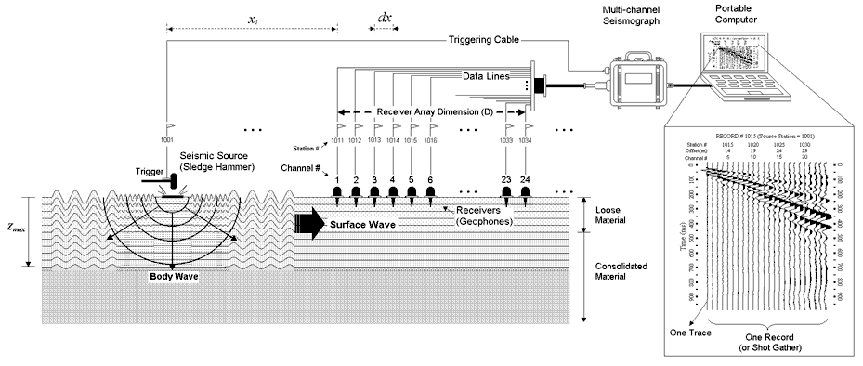

(b)

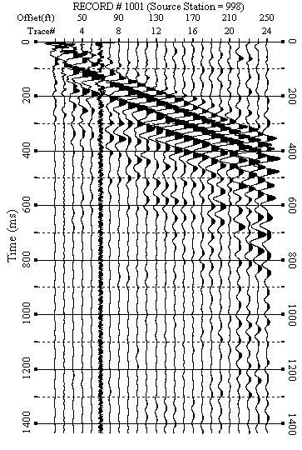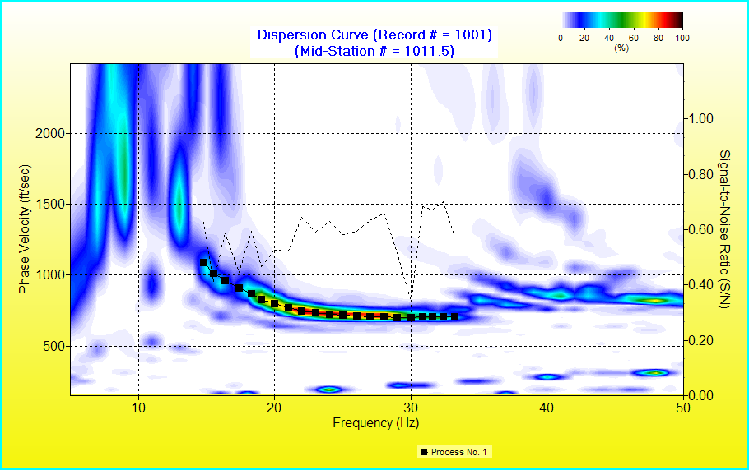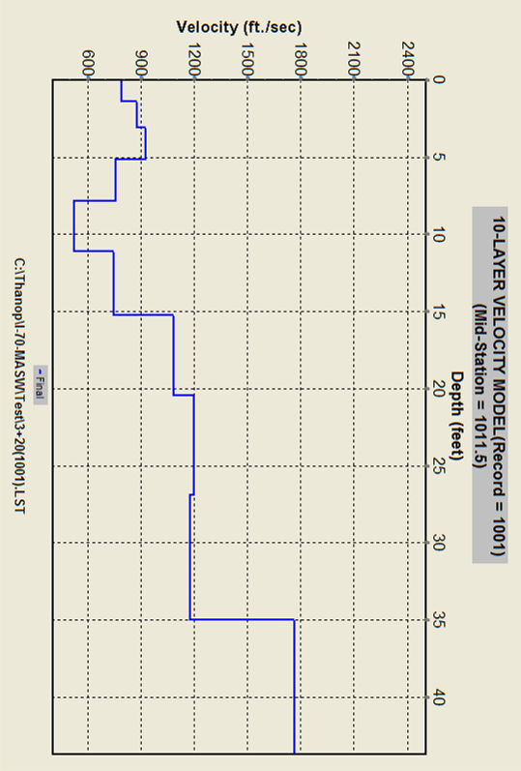
Acquisition
Dispersion curve Extraction
Inversion
Time-Space
Frequency-Phase Velocity
Depth-Vs
Figure 1. (a) Typical multichannel seismic surface-wave experiment setup, and (b) MASW data processing procedure (modified from Park et al., 1999)

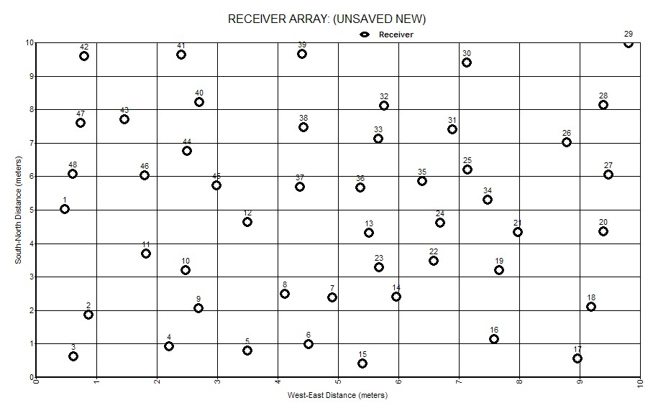

Figure 2: The figure on the left represents the shot point locations as deployed on the ground. There are total 13 shot points from which data was collected. The distance between each shot point location is 10 m. The figure on the right represents the random arrangement of geophones (small circles) inside a 10 m×10 m grid.

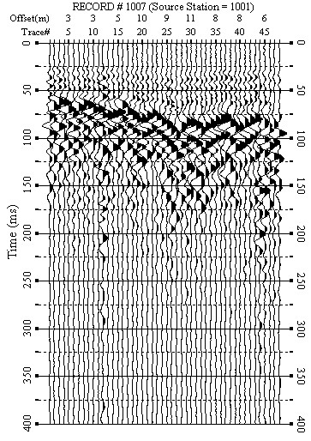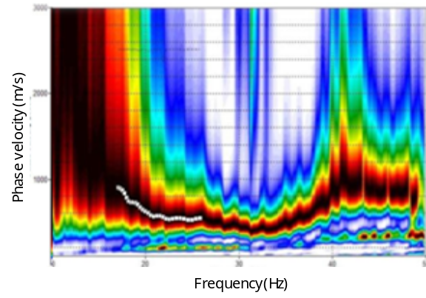

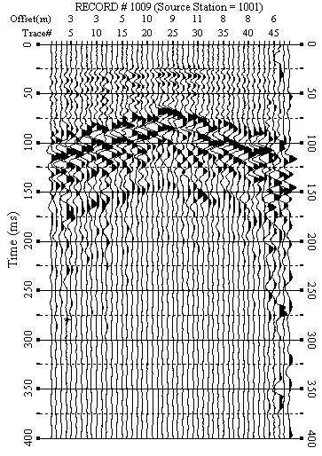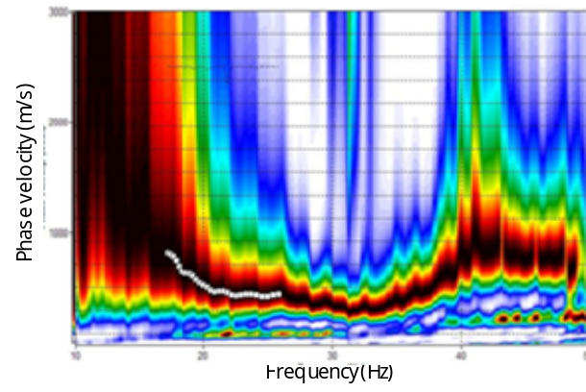

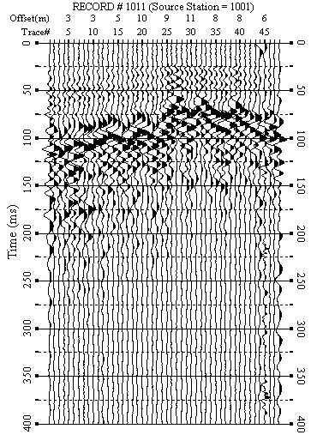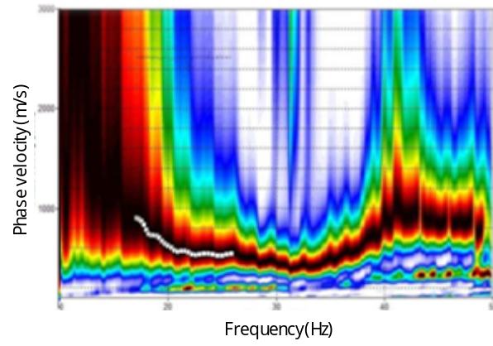

Figure 3: Selected data (shot gathers) acquired from a field test site in the University of Tennessee agricultural center, Knoxville, Tennessee, with 48-channel system and their corresponding dispersion images.

(a)

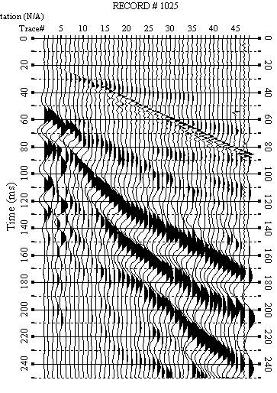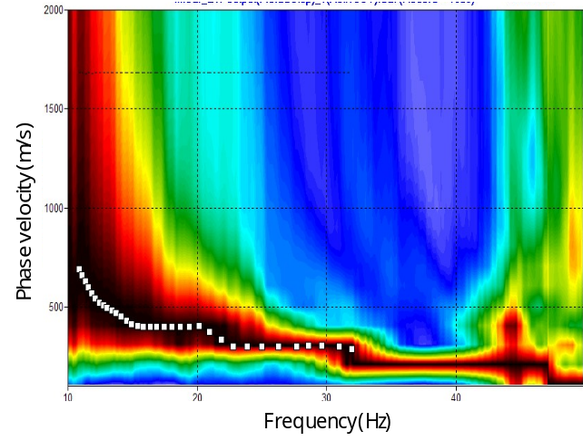

(b)
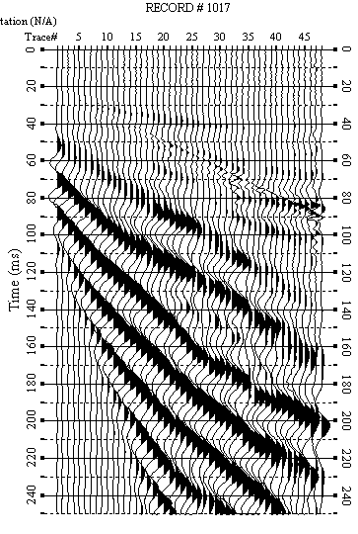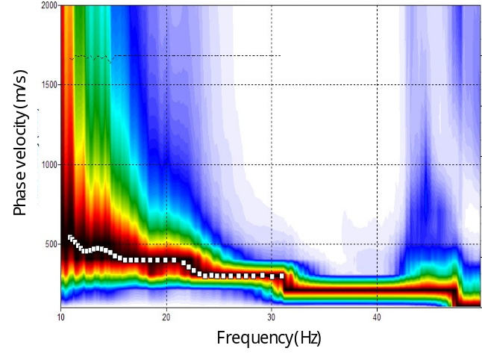

Figure 4. (a) Selected data (shot gathers) acquired from the same field site as above using linear receiver array configuration in East-West direction. The initial data was collected for 1000 ms but only the first 250 ms exhibits dominant surface waves. (b) Selected data (shot gathers) acquired from the same field site as above using linear receiver array configuration in North-South direction. The initial data was collected for 1000 ms but only the first 250 ms exhibits dominant surface waves.

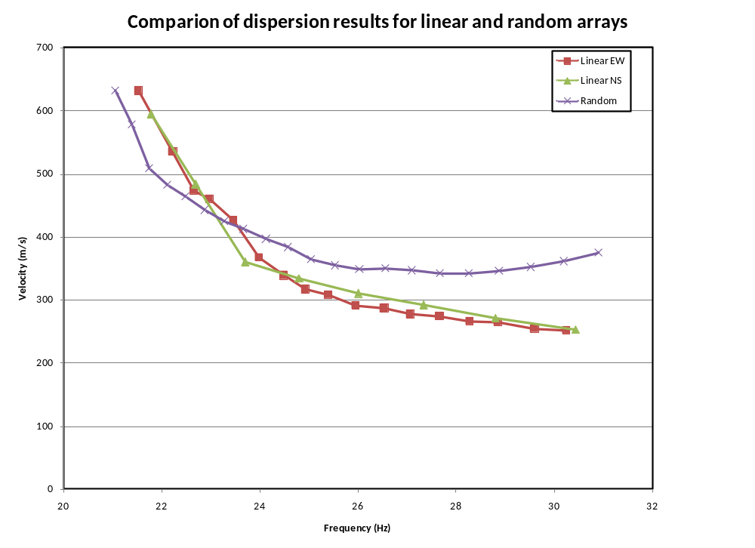

Figure 5: Comparison of dispersion relation from linear and random receiver array measurements.

Figure captions

Figure 1. (a) Typical multichannel seismic surface-wave experiment setup, and (b) MASW data processing procedure (modified from Park et al., 1999).

Figure 2: The figure on the left represents the shot point locations as deployed on the ground. There are total 13 shot points from which data was collected. The distance between each shot point location is 10 m. The figure on the right represents the random arrangement of geophones (small circles) inside a 10 m×10 m grid.

Figure 3: Selected data (shot gathers) acquired from a field test site in the University of Tennessee agricultural center, Knoxville, Tennessee, with 48-channel system and their corresponding dispersion images.

Figure 4. (a) Selected data (shot gathers) acquired from the same field site as above using linear receiver array configuration in East-West direction. The initial data was collected for 1000 ms but only the first 250 ms exhibits dominant surface waves. (b) Selected data (shot gathers) acquired from the same field site as above using linear receiver array configuration in North-South direction. The initial data was collected for 1000 ms but only the first 250 ms exhibits dominant surface waves.

Figure 5: Comparison of dispersion relation from linear and random receiver array measurements.

