Essential Neo-Riemannian Theory for Today’s Musician

A Thesis Presented for the
Master of Music
Degree
The University of Tennessee, Knoxville

Laura Felicity Mason
May 2013

Copyright © 2013 by Laura Felicity Mason

All rights reserved.

To my parents
Mark and Terry Mason

and my siblings
Samuel, Alyssa, and Beverly

for all of their love and support
ACKNOWLEDGEMENTS

I must first thank my family for their love and continuous support. Without them, this would have been impossible. I would also like to thank Mark and Barb Dittig, who have supported me during the pursuit of my Master’s degree.
I must extend many special thanks to my piano teachers: first of all, to Dr. Eugene Flemm, who was patient with me throughout my undergraduate career and has always been a dear friend; to Mrs. Teresa-Falk, who encouraged and motivated me to continue my musical journey and whose musicality has always inspired me; and finally to Dr. David Northington, who believed in me when I did not believe in myself. To each of them, I extend my sincere gratitude and admiration. Without their guidance, instruction, and edification, this would not have been possible.
I would also like to thank my friends, professors, and colleagues for their continuous support in this process. Some brought me coffee; some critiqued my ideas and provided invaluable feedback. All contributed to my work, and I am thankful for each contribution. Of those, I would especially like to thank Glenn Kahler and Nick Powell for being my sounding boards.
Finally, I would like express my deep gratitude to Dr. Brendan McConville, my thesis advisor, who tactfully guided me through this process. The careful consideration of my ideas, guidance and direction he provided have been indispensable.

ABSTRACT

This thesis will build upon the foundation set by Engebretsen and Broman in Transformational Theory in the Undergraduate Curriculum: A Case for Teaching the Neo-Riemannian Approach (Journal of Music Theory Pedagogy 21) and Roig-Francoli’s Harmony in Context (McGraw-Hill) by justifying the inclusion of Neo-Riemannian Theory (NRT) in the undergraduate music theory curricula and creating a text for use by undergraduates to supplement a typical theory curriculum. While Engebretsen and Broman introduce the notion of NRT inclusion, and Roig-Francolí dedicates several pages in Harmony to its discussion, NRT remains uncommon in an undergraduate curriculum. NRT, an emerging and relevant analytical system, lends itself to bridging the transition from the chromatic harmony of the nineteenth century to the varied techniques of the twentieth century. NRT’s flexibility assists comprehension of passages from various genres of music, old and new. In an effort to communicate the concepts of NRT to as many undergraduates as possible, examples and assignments should feature musical works of the Common Practice Period, such as those of Beethoven and Liszt, as well as those drawn from the Rock-Pop Era from artists such as Ozzy Osbourne and The Beatles. This thesis addresses the application of NRT through various written, aural, and keyboard assignments that can be easily utilized in most undergraduate curricula. Through the use of written assignments, including examples for analysis as well as composition-exercises, students will achieve an understanding of NRT at the Analytical and Synthesis levels of Bloom’s Taxonomy.
Because this thesis serves two purposes, master’s thesis and introductory text, the reader will find more scholarly quotes in this thesis than would be found in the traditional undergraduate text.

PREFACE

To the Teacher
Music is constantly evolving. As music changes, music theory must evolve to define and catalog each adaptation with accuracy. To produce responsible theorists and musicians in general, the pedagogy and curriculum must be constantly updated to reflect the changes made in music.
While the traditional written tonal music theory curriculum, including aspects of harmony, counterpoint, part-writing, form, etc., is indispensable, the well-rounded musician cannot limit himself/herself to these practices alone. With this in mind, many music theory curricula include twentieth century analytical techniques into the last semester of undergraduate study. This semester generally covers topics such as pitch class analysis, twelve tone methodology, serialism, and aleatoric music. Generally, textbooks covering twentieth century analysis do not dedicate substantial time to new theories of tonal analysis, such as neo-Riemannian theory.
The introduction of neo-Riemannian theory to an undergraduate curriculum following a basic study of pitch class analysis will offer reinforcement to concepts learned and will introduce another explanatory system into each musician’s supply of analytical tools. Therefore, the purpose of this text is two-fold. First, this supplement (to a standard theory sequence text) will introduce basic NRT (also referred to as transformational theory of which it is a faction) to the undergraduate curriculum, reinforcing concepts already learned in a twentieth century theoretical techniques course. Second, this text is meant to be a useful analytical tool for undergraduate students studying music of the Neo-Romantic, Minimalist, and Pop-Rock genres, which have largely diatonic yet not classically-functioning progressions. Theorist Richard Cohn states, “Neo-Riemannian theory strips these concepts [triadic transformations, common-tone maximization, voice-leading parsimony, dual inversion, enharmonic equivalence, and the ‘Table of Tonal Relations’’] of their tonally centric and dualistic residues, integrates them, and binds them within a framework already erected for the study of the atonal repertories of our own century.” Therefore, introducing NRT in undergraduate courses provides a much-needed update to today’s curriculum.
The material of this text should be introduced after a basic study of pitch class analysis. For instance, the author recommends introducing this material after completing Chapter 4 of Miguel Roig-Francolí’s Understanding Post-Tonal Music, Chapter 5 of Stefan Kostka’s Materials and Techniques of Post-Tonal Music, 4th ed., or as a supplement to Chapter 4 of Joseph Straus’s Introduction to Post-Tonal Theory, 3rd ed.

Table of Contents

PREFACE vii
Table of Contents ix
LIST OF TABLES x
List of Figures xi
Terms for Review 1
Chapter One: History and Introduction 4
Why Study Neo-Riemannian Theory? 4
General Background 6
Terminology and Initial Transformations 8
Basic NRT Transformations 12
The Tonnetz 15
Navigating the Tonnetz 19
Terms to Know 25
Further Reading on Neo-Riemannian Theory 25
Further Reading on Pitch Classes and Pitch Class Sets 29
Chapter Two: Cycles and Compound Transformations 37
The Cyclic Nature of the NRT Transformations 37
The LP/PL Cycle 38
The PR/RP Cycle 43
The LR/RL Cycle 44
Compound Transformations 50
Performing Compound Transformations 50
An Example Compound: PRL 55
Lewin’s DOM Transformation 57
Terms to Know 60
Further Reading on NRT Cycles 60
Further Reading on Compound Transformations 60
In Conclusion: Transformational Theory 73
Further Reading 74
Index 75
Bibliography 79
Vita 87

LIST OF TABLES

Table 1: Terms for Review 1
Table 2: The Standard PC Integer Notation System Utilized in This Text 3

List of Figures
Figure 1: The Circle of Fifths illustrates the DOM transformation 10
Figure 2: Lewin’s chart demonstrating DOM and MED transformations 10
Figure 3: MED and MED’ transformations and the NRT REL transformation 11
Figure 4: Richard Cohn’s reduction of Brahms’ Concerto for Violin and ‘Cello, first movement, mm.268-79 11
Figure 5: Richard Plotkin’s Possible Stepwise Transformations in a Triad 12
Figure 6: NRT transformations performed on a C major triad. Note each transformation is an involution 14
Figure 7: The Pitch Name Tonnetz 15
Figure 8: Euler’s Tonnetz 16
Figure 9: Riemann’s Tonnetz 17
Figure 10: The Pitch Class Set Tonnetz 17
Figure 11: the chickenwire Tonnetz 18
Figure 12: a region of Edward Gollin’s 3D Tonnetz 19
Figure 13: The basic transformations 20
Figure 14: Transformations of triads and their involutions 20
Figure 15: Prokofiev, Fugitive Visions, Op. 22, No. 4, mm. 40-49 21
Figure 16: The Tonnetz representation of Prokofiev, Fugitive Visions, Op. 22, No. 4, mm. 40-49 22
Figure 17: The sample progression charted 23
Figure 18: mm. 1-8 of Christian Sinding’s Rustle of Spring, Op. 32, No. 3 34
Figure 19: mm. 4-8 of Erik Satie’s Le Piccadilly 35
Figure 20: Cohn’s reduction of Brahms’ Concerto for Violin and ‘Cello, first movement, mm.268-79 38
Figure 21: The charted Tonnetz for Brahms’ Concerto for Violin and ‘Cello, first movement. 38
Figure 22:The PL cycles 40
Figure 23: Richard Cohn’s Illustration of The Hyper-hexatonic System 42
Figure 24: Adjacent LP transformations of Forte class 3-11 on the Tonnetz 43
Figure 25: The PR cycles 44
Figure 26: Sample RP cycle 44
Figure 27: The RL cycle 45
Figure 28: Wagner’s Parsifal, Act I, mm. 39-41 45
Figure 29: Beethoven’s Ninth Symphony 47
Figure 30:Roig-Francolí’s reduction of Beethoven’s Ninth Symphony 48
Figure 31: Roig-Francolí’s diagram of Beethoven’s Ninth Symphony 48
Figure 32: Roig-Francolí’s reduction of Beethoven’s Ninth Symphony 48
Figure 33: Capuzzo Analysis of Schubert, Sonata in B-flat Major (1828), IV, mm. 119-130 49
Figure 34: Capuzzo Reduction of Schubert, Sonata in B-flat Major with parsimonious voice-leading 49
Figure 35: John Lennon and Paul McCartney’s All My Loving from the album With the Beatles 50
Figure 36: John Lennon and Paul McCartney’s All My Loving from the album With the Beatles 51
Figure 37: The RP transformation is not an involution 52
Figure 38: Capuzzo’s analysis and reduction of Ozzy Osbourne’s “Flying High Again” 53
Figure 39: Capuzzo’s analysis and reduction of Ozzy Osbourne’s “Flying High Again” 53
Figure 40: Capuzzo’s analysis and reduction of Ozzy Osbourne’s “Flying High Again” 53
Figure 41: The progression from Bob Dylan’s “Lay, Lady, Lay” 54
Figure 42: The charted progression from Bob Dylan’s “Lay, Lady, Lay” 54
Figure 43: The compound transformation of (C,+) to (G,-). 55
Figure 44: The LRP transformation of (C,+) to (G,-) 56
Figure 45: The Involution of the PRL compound transformation 57
Figure 46: The DOM and DOM’ transformations shown as compound transformations 58
Figure 47: Sergei Rachmaninoff’s Prelude Op. 32, No. 4, mm. 37-43 58
Figure 48: Rachmaninoff’s Prelude Op. 32, No. 4, mm. 37-43 shown on the Tonnetz 59
Figure 49: mm. 1-3 of Charlie Rutlage by Charles Ives 62
Figure 50: Schubert’s Overture to Die Zauberharfe, opening Andante (as reduced by Richard Cohn). 64
Figure 51: mm. 34-38 of Ernest Bloch’s Poems of the Sea, II. Chanty 69
Figure 52: Erik Satie’s Gnossienne No. 4 70
Figure 53: mm. 64-68 of Dmitri Kabalevsky’s Sonatina in C Major, Op.13, No.1 71

Terms for Review

Students should review the following terms before beginning Chapter One.

Table 1: Terms for Review
Term | Definition
enharmonic | In modern tuning, notes are considered enharmonic if they are the same pitch although notated with different note names (e.g. A sharp and B flat or E and F flat).
Forte class | The classification given to a pitch class (pc) set by Allen Forte. The first number indicates the cardinality and the second the ordinal position in Forte’s list. See Further reading for locations of Allen Forte’s set class listing.
hexachord | A general collection of six pitches.
hexatonic | A scalar arrangement of six pitches within the same octave. A common example is the whole tone scale.
normal form | The unordered pitch class set, notated by [ ] in this text.
pitch class (pc)  Pl: pitch classes (pcs) | Any group of pitches with the same name, which may occur in any octave, which are generally indicated by an integer (as seen in Figure X).
Table 1 Continued: Terms for Review
pitch class set (pc set)  Pl: pitch class sets (pc sets) | Any unordered amalgamation of pitch classes. For instance, in a tonal work we may find the pitches C (0), E (4), and G (7) together. This creates the common pc set [047].
prime form | The numerical representation of a set class, notated with  ( ) in this text.
octave equivalency | Two pitches of the same name are considered one pc regardless of the octave in which the pitch occurs, reducing the number of pitches to twelve (0-11, notated 0-B).
modulo 12 (mod-12) arithmetic | Any integer larger than 11 is reduced to its equivalent within 0-11.
Set class | The collection of equivalent normal form forms, through T_{n}/T_{n}I is called a set class
T_{n} | Transposition, where n represents the number of ascending half steps
T_{n}I | T represents transposition by half steps n, and I represents Inversion, or a pc set’s mod-12 complement.

Table 2: The Standard PC Integer Notation System Utilized in This Text
Pitch Name | Pitch Class
C | 0
C#/Db | 1
D | 2
D#/Eb | 3
E/Fb | 4
F | 5
F#/Gb | 6
G | 7
G#/Ab | 8
A | 9
A#/Bb | A  (or T for Ten)
B | B  (or E for Eleven)

Chapter One: History and Introduction

Why Study Neo-Riemannian Theory?

The mid to late nineteenth century gave rise to chromatic progressions heralded by passing motion and triadic progressions that divided the octave by thirds. “. . . These changes were frequently expressed by means of bold modulations, innovative chord progressions, dissonance and resolutions and, in general, much less preparation for abrupt changes. These radical transformations gave rise, in music, to postromanticism and, finally, to atonality.” While this music is aurally aesthetic, it is non-functional according to traditional tonal harmony. The best way to describe these chords using traditional harmony is to say that they are “coloristic” chords or that they are modally borrowed. The traditional system of roman numeral analysis does not adequately contextualize the transformations from one harmony to the next. Theorist Richard Cohn states the problem this way: “. . . The diatonic indeterminacy of triadic progression in late Romantic music often limits the efficacy of these diatonically based models. These limitations leap most rapidly into view in the familiar case of triadic progressions whose roots divide the octave into equal parts.”
Transformational Theory addresses these chord successions through mathematical group theory. “Group Theory extracts the essential characteristics of diverse situations in which some type of symmetry or transformation appears. Given a non-empty set, a binary operation is defined on it such that certain axioms hold, that is, it possesses a structure (the group structure).” More generally, theorist David Lewin’s work on transformational theory continues the tradition of Milton Babbitt and Allen Forte by using mathematical discipline to show the relationship between the structure of intervals. Lewin demonstrates the relationship of musical elements through geometrical means from the perspective of various orientations. By performing group transformations, the musician can see meaningful relationships within these triadic progressions, just as prime forms of sets show us meaningful information about various sets.
Neo-Riemannian theory (NRT) is a segment of Transformational Theory. Nora Engebretsen states, “Neo-Riemannian analyses aim to reveal underlying order by showing how these structural relationships are drawn into configurations specific to the works or passages being examined.” Joe Agentino parallels Engebretsen’s quote by saying, “The development of neo-Riemannian theory arose in order to address particular types of triadic chromatic passages often associated with late nineteenth-century compositions that are not altogether tonally unified.” Thus, NRT seeks to address triadic progressions in a meaningful way through the use of transformational theory, which is inspired by the general principles of group theory.

General Background

Hugo Riemann (1849-1919), music theorist and musicologist, is considered the founder of modern music theory thought. He wrote the treatise Handbuch der Harmonielehre outlining harmonic function defined by root-interval structures rather than the scalar-based structures of the Common Practice Period to which we have become accustomed. In 1987, Lewin introduced Riemann’s diatonic functions in a way in which they functioned outside of a diatonic key structure. Lewin’s interpretation of Riemann’s transformations provided a technique to interpret music that was triadic, yet not necessarily functional according to traditional scalar practices. Lewin’s work has been summarized: “In David Lewin’s transformational approach to triadic relations, . . . he explores classes of contextual transformations that, following Riemann and Hauptmann, act upon consonant triads whose constituent pitches are arranged in a line of alternating minor and major thirds (transformations that largely comprise incremental shifts along this line that change one triad into another).” Essentially, Lewin’s application of (mathematical) group theory to music sought to show triadic relationships through intervallic relationships rather than traditionally defined diatonic ones.
In 1989, Brian Hyer published his dissertation Tonal Intuitions in "Tristan und Isolde" in which he substantiated the use of three of Lewin’s contextual inversions (Parallel, Leading-tone Exchange, and Relative) and one transposition (Dominant), which he represented solely by first letter (P,L, or R) instead of Lewin’s shortened titles (such as DOM or MED). Hyer’s chosen contextual inversions would become the basis of NRT transformations as would the use of the geometrical Tonnetz, which Hyer also revived from nineteenth century theory.
In response to Lewin and Brian Hyer’s transformational views of the Handbuch der Harmonielehre, Henry Klumpenhouwer wrote “Some Remarks on the Use of Riemann Transformations” detailing the deficiencies that he found with Hyer and Lewin’s works. While Klumpenhouwer intended to refute Lewin’s methodology, Klumpenhouwer’s argument, based upon the Schritt/Wechsel system, became wedded to Lewin’s ideas in Transformational Theory as a whole, thus affecting the future of NRT. (For the purpose of this text, Klumpenhouwer’s work will not be detailed; however, further information may be found in the Further Reading portion of this chapter.)

Terminology and Initial Transformations

In NRT, triads are considered ordered pc sets and are referred to as Klangs. Lewin states, “Each Klang is an ordered pair (p, sign), where p is a pitch class and sign takes on the values + and – for major and minor respectively. The Klang models a harmonic object with p as root or tonic, an object whose modality is determined by the sign.” In NRT chords are not arranged and weighted in the traditional tonal hierarchy. Cohn states, “In assuming the a priori status of consonant triads, neo-Riemannian theory leaves unaddressed the reasons that late nineteenth-century composers continued to favour triads as harmonic objects. Indeed, the adoption of a group-theoretic approach to relations between triads suggests that the internal structure of the individual triads might also be viewed group-theoretically, as a complex of equal weighted pitch-classes and intervals.” Per Broman states the concept this way: “The abandonment of diatonic context allows neo-Riemannian theory to model non-diatonic relationships among triads: any consonant triad can be connected to any other through some combination of the P, L, and R transformations.” The term Klang and its notation system were adopted to remove the stigmatism of the diatonic key. For the purpose of this text, we will refer to Klangs simply as “triads,” although we will adopt the Klang notation system.
Lewin determined several basic transformations. Each transformation was the result of voice-leading that maintained at least one pitch between triads. His initial transformation was the DOM transformation, which connects two triads where the former is the dominant of the latter in a diatonic sense. This transformation maintains only one pitch between triads, and when performed on a triad, the result is the original triad becoming the dominant of the resulting triad, i.e. (G, +) DOM = (C,+). The DOM function does not work if applied to the resulting triad, i.e. (C,+) DOM ≠ (G, +); (C,+) DOM = (F, +). Notice that the triads only share the pitch C. (See Figure 1.)
Lewin’s second transformation is the MED transformation, in which the triads share two pitches. An MED transformation performed on a triad results in that triad becoming the mediant of the resulting triad, i.e. (C,+) MED = (A,-). The MED’ transformation is the opposite of the MED transformation. Hyer combined the MED and MED’ transformations into one transformation which we use in NRT: the Relative (R) transformation. (See Figure 3.) The R transformation transforms a triad to its relative major or minor triad.
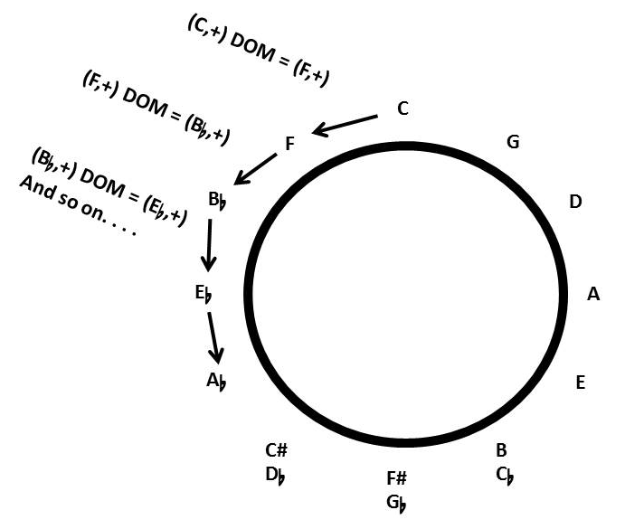
Figure 1: The Circle of Fifths illustrates the DOM transformation

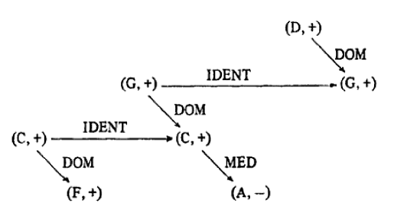
Figure 2: Lewin’s chart demonstrating DOM and MED transformations

Figure 3

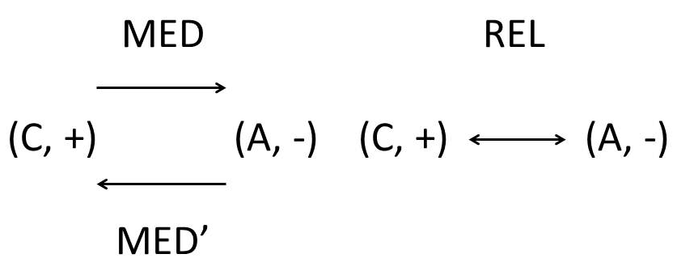
Figure 4: MED and MED’ transformations and the NRT REL transformation

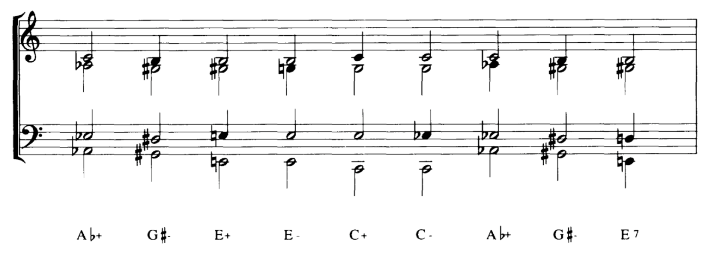
Figure 5: Richard Cohn’s reduction of Brahms’ Concerto for Violin and ‘Cello, first movement, mm.268-79

In 1997, Cohn published the article, “Neo-Riemannian Operations, Parsimonious Trichords, and Their "Tonnetz," in which he introduced the term parsimony. (Two chords are parsimonious if they share two pitches.) Skinner states, “Cohn’s definition of generalized parsimonious voice-leading between triads requires two conditions: (1) two voices are retained as common tones, and (2) the third voice proceeds by an interval no greater than twice the smallest available interval in a given tuning.” In the case equal temperament, the smallest interval available is the half-step/semitone. Notice in Figure 4 above, that Brahms maintains two pitches between triads as indicated by the open noteheads. From that time, parsimonious voice-leading is considered directly relational to NRT. Figure 4 gives examples of parsimonious voice leading among pc sets, where a “step” can be that of a half or a whole.

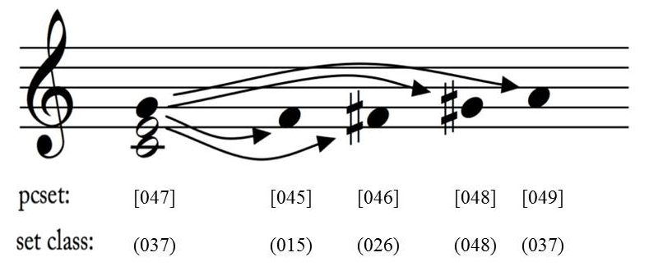
Figure 6: Richard Plotkin’s Possible Stepwise Transformations in a Triad

Basic NRT Transformations

Lewin’s DOM and MED transformations are not considered Neo-Riemannian transformations because they are not involutions. Involutions in mathematics are defined as an operation, which, when applied to its result, returns the original number. In music, a transformation applied a second time returns the transformed chord to the original chord, which is the first common characteristic of the basic transformations.
Neo-Riemannian theory consists of three basic parsimonious transformations: parallel (P), relative (R), and leading-tone exchange (L, also called Leittonwechsel). (See Figure 6 below.) A parallel transformation converts a major triad to the minor and vice versa by moving the third by half-step. (These chords are parsimonious because they share the root and the fifth.) A relative transformation converts a major triad to a minor triad by moving the fifth a whole-step up and vice versa, moves a minor triad to a major triad by moving the root down by whole-step. The leading-tone exchange transformation converts a major triad to a minor triad by moving the root down by half-step, and vice versa, from minor to major by moving the fifth up a half-step to become the root of the resulting triad.
If the transformations were described according to the rules of traditional harmony (with key contexts), a parallel transformation converts a major triad to its parallel minor and vice versa. A relative transformation converts a triad to its relative major or minor. The leading-tone exchange transformation converts a triad to its iii (if the original is major) or VI (if the original chord is minor).
Cohn gives the characteristics of each transformation: “The three transformations share several properties: each is an involution; each is mode-altering (it maps a triad to its pitch-class inversion); and each transformation preserves two common tones, replacing the third with a pc a semitone away (in the case of P and L) or a whole tone away (in the case of R). This last property is particularly significant for the analysis of late Romantic music, where common-tone preservation and smooth voice-leading are characteristic stylistic features.” Mode-altering can be thought of as the inversion of the triad; thus, [047] becomes [037] or vice versa. To visualize common-tone preservation, view Figure 6 below. Also, notice that they are involutions as performing the transformation to the resulting triad returns it to the original.

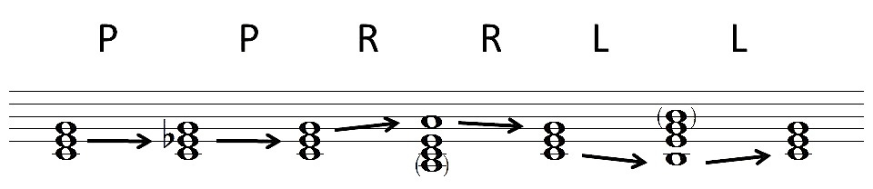
Figure 7: NRT transformations performed on a C major triad. Note each transformation is an involution

The Tonnetz

Joe Argentino states, “The Tonnetz or “tone-network,” is a two-dimensional graph in which the axes represent the three intervals of a trichord (traditionally major and minor chords).” Because the transformations are involutions, the Tonnetz features only major and minor triads, while augmented and diminished triads have not been included in the basic transformations. Engebretsen and Broman state, “In more formal terms, the Tonnetz constitutes the geometry for the mathematical group associated with the action of the LPR transformations on the consonant triads—a group structurally analogous to the standard T_{n} / T_{n}I group of atonal geometry in a visual that makes set theory.” In other words, the Tonnetz links neo-Riemannian theory

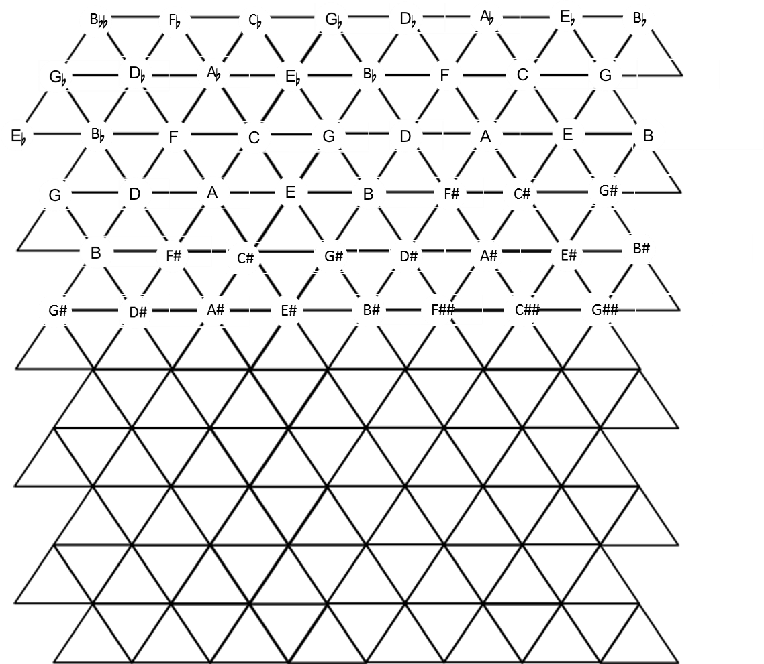
Figure 8: The Pitch Name Tonnetz

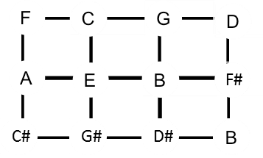
Figure 9: Euler’s Tonnetz

transformations easier to perceive.
Under equal temperament, each pitch should appear only once on the Tonnetz, and the Tonnetz should wrap around on itself. Due to the use of two dimensions (on paper), our Tonnetz will feature repeated pitches in the order that they would appear if the Tonnetz wrapped around on itself (three-dimensional figure).
The first Tonnetz was created in 1739 by Leonhard Euler. (See Figure 8.) Ottakar Hostinský introduced the angled Tonnetz in 1879 and Riemann adapted it in 1880. Riemmann’s Tonnetz is shown in Figure 9.
Modern theorists Lewin, Hyer, and Cohn have updated and modified the Tonnetz to fit their needs. One such update was the use of pitch classes. As discussed earlier, the use of pcs eliminates the need to use enharmonics. Dmitri Tymockzo
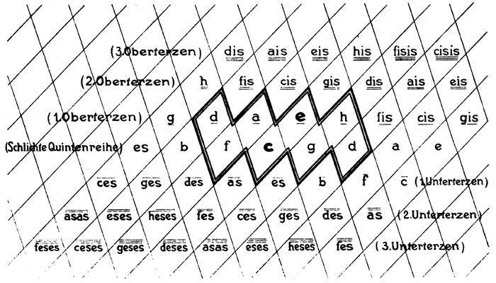
Figure 10: Riemann’s Tonnetz
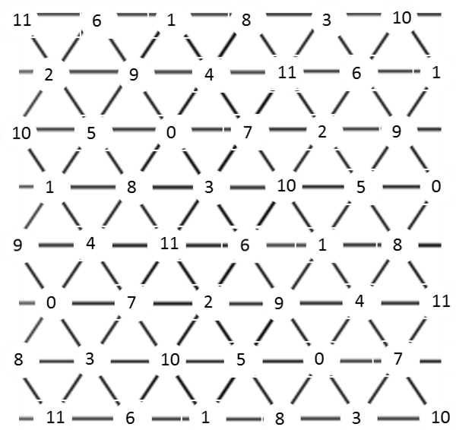
Figure 11: The Pitch Class Set Tonnetz

states, “Ultimately, pitch classes are important because they provide a language for making generalizations about pitches.” Because NRT translations do not function within a key, reducing triads to pc sets makes their translation much easier.
Another such modification was Jack Douthett and Peter Steinbach’s chickenwire Tonnetz. (See Figure 11.) The chickenwire Tonnetz uses chords instead of pitches. Uppercase letters indicate major chords while lowercase letters trace minor chords. As shown by the key, solid lines represent the parallel transformation of chords, dashed lines represent the relative transformation of chords, and dotted lines represent leading-tone exchange transformations.

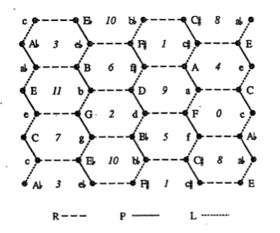

Figure 12: the chickenwire Tonnetz

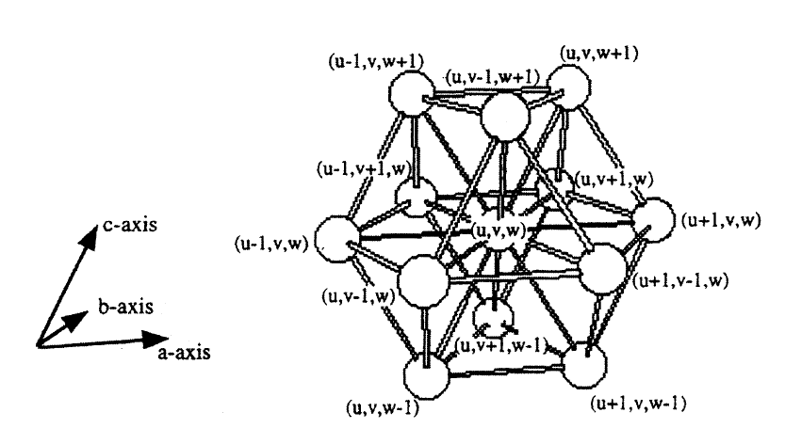
Figure 13: a region of Edward Gollin’s 3D Tonnetz

In 1998, Edward Gollin introduced the 3D tonnetz, pictured below (Figure 12). While further expansions, like Gollin’s, have been made to the Tonnetz and others have
created Tonnetze of their own, we will use the Riemann/Hyers Tonnetz (both with pitch names and pcs).

Navigating the Tonnetz

To navigate the Tonnetz, first realize that chords are transformed by changing one pitch at a time. When (G,+) is transformed to (G,-) via the parallel transformation, think of the edge of the triangle resting on B being flipped over onto Bb. When (G,+) is transformed to (E,-) via the relative transformation, think of the edge of the triangle resting on D being flipped over onto E. When (G,+) is transformed to (B,-) via the leading-tone exchange transformation, think of the edge of the triangle resting on G being flipped over onto F#. When (G,+) is transformed to (G,-) via the parallel transformation, think of the edge of the triangle resting on B being flipped over onto Bb.
R
L

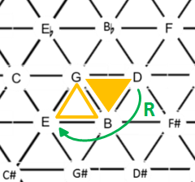
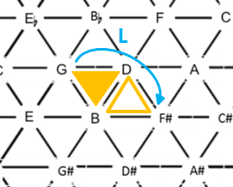
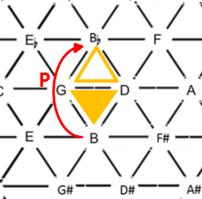
Figure 14: The basic transformations

Because all of the transformations are involutions, repeating the transformation will return the triad to the original triad. Therefore, the transformations can be undone by performing the same motions in reverse. (See Figure X.
Figure 15: Transformations of triads and their involutions
P
R
L

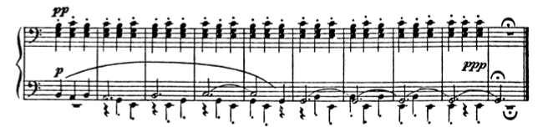
Figure 16: Prokofiev, Fugitive Visions, Op. 22, No. 4, mm. 40-49

To chart the opening of any progression:
- Identify the triads and their progression.
- Mark the first triangle in an identifying manner.
- Use arrows to show the progression on the Tonnetz.
- Identify the transformations with the appropriate indicators (P, L, or R).

Take for example, mm. 40-49 of Prokofiev’s Fugitive Visions, Op. 22, No. 4 (Figure 15).
Following the steps given above, the process would be:
- Identify the triads and their progression:
(E,-) (C,+) (E,-) (C,=) and so on. . .
- Mark the first triangle in an identifying manner.
For this exercise, a solid triangle will be used. (See Figure 16 below.)
- Use arrows to show the progression on the Tonnetz.
Done in green below.

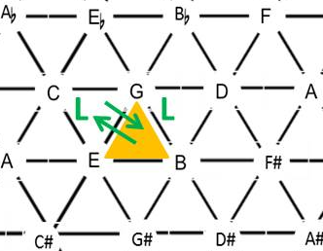

Figure 17: The Tonnetz representation of Prokofiev, Fugitive Visions, Op. 22, No. 4, mm. 40-49

- Identify the transformations with the appropriate indicators (P, L, or R).
Shown in green below.

- Learning Activity 1: Navigating the Tonnetz
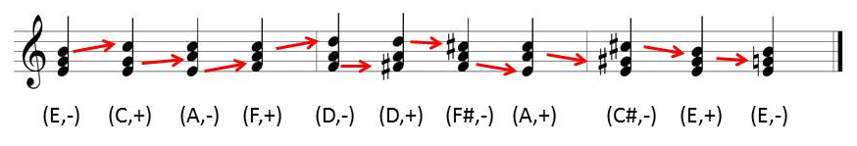
Repeat the steps given above for the progression below on the Tonnetz below.

Which transformations result? Is there anything unique about the results?

Your resulting navigation should look like that in Figure 17 below. Notice that the progression LRLRP is performed twice to return to the original triad.
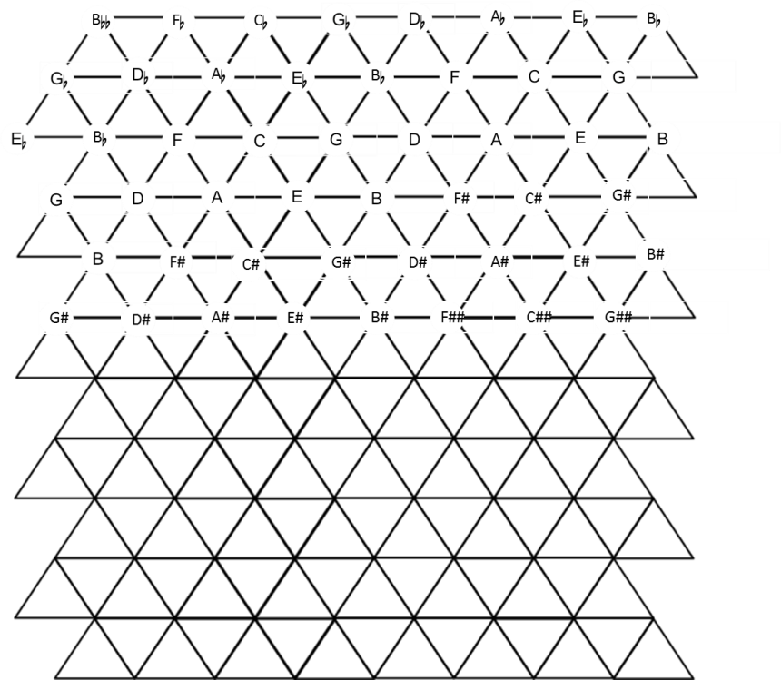

P
L
R
P
L
L
L
R
R
R

Figure 18: The sample progression charted
In recent years, many other music theorists have added to this theory and begun to build upon the foundations laid for them. A bibliography offering readings on the history and fundamentals of NRT is given in the Further Reading portions at the end of each chapter.

Terms to Know

Circle of Fifths
Enharmonic
Involution
Klang
Leittonwechsel
Mod-12
Mode-altering
Octave equivalency
Parsimony
Pitch Class
Pitch Class Set
Tonnetz(e)

Further Reading on Neo-Riemannian Theory

Cohn, Richard. “Introduction to Neo-Riemannian Theory: A Survey and a Historical
Perspective.” Journal of Music Theory 42, no. 2, Neo-Riemannian Theory
(Autumn, 1998): 167-180.
Cohn, Richard. "Maximally Smooth Cycles, Hexatonic Systems, and the Analysis of Late-
Romantic Triadic Progressions." Music Analysis 15, no. 1 (1996): 9-40. Read
Section I.
Cohn, Richard “Neo-Riemannian Operations, Parsimonious Trichords, and Their
‘Tonnetz’ Representations.” Journal of Music Theory, 41, no. 1 (Spring 1997): 1-
66.
Gollin, Edward, and Alexander RehdingThe Oxford Handbook of Neo-Riemannian Music
Theories. New York: Oxford University Press, 2011.
Kidd, Milan. An Introduction to the Practical Use of Music-Mathematics.
http://www.math.uchicago.edu/%7Emay/VIGRE/VIGRE2006/PAPERS/Kidd.pdf Read all.
Klumpenhouwer, Henry. Klumpenhouwer, Henry. “Some Remarks on the Use of Riemann
Transformations.” Music Theory Online 0, 9 (July 1994).
Lewin, David. Generalized Musical Intervals and Transformations. Yale University Press:
New Haven, CT, 1987; reprint Oxford University Press, 2007.
Skinner, Myles Leigh. “Toward a Quarter-Tone Syntax: Analyses of Selected Works by
Blackwood, Haba, Ives, and Wyschnegradsky.” PhD diss., State University of New
York at Buffalo, 2006. Read the section “Conventional Neo-Riemannian
Transformations,” 196-199.

Further Reading on Pitch Classes and Pitch Class Sets

Roig-Francolí, Miguel A. "Introduction to Pitch-Class Set Theory." in Understanding Post
-Tonal Music. Boston: McGraw-Hill, 2008. Read pp. 69-104.
Straus, Joseph. “Centricity, Referential Collections, and Triadic Post-Tonality.” in
Introduction to Post-Tonal Theory, 3rd ed. Upper Saddle River, NJ: Prentice Hall, 2004. Read pp. 130- 181.
Whittall, Arnold. The Cambridge Introduction to Serialism. UK: Cambridge University
Press, 2008. Read pp. 1-3.

Suggestion for the Teacher: Exercises may be completed during the class period as part of the lesson or given as homework.
Δ Written Exercises
- Choose a chord on the Tonnetz and chart a P transformation, followed by an L transformation, followed by an R transformation.

- On the Tonnetz, chart the transformations of the following chord progression:
C-a-F-d-Bb-g-Eb. Does a pattern emerge from these transformations?

Suggestion for the Teacher: Students may also complete the same task using any set of your choosing.

- Perform each NRT transformation on PC set [047]. Which PC sets result? What is the relationship of the resulting sets?
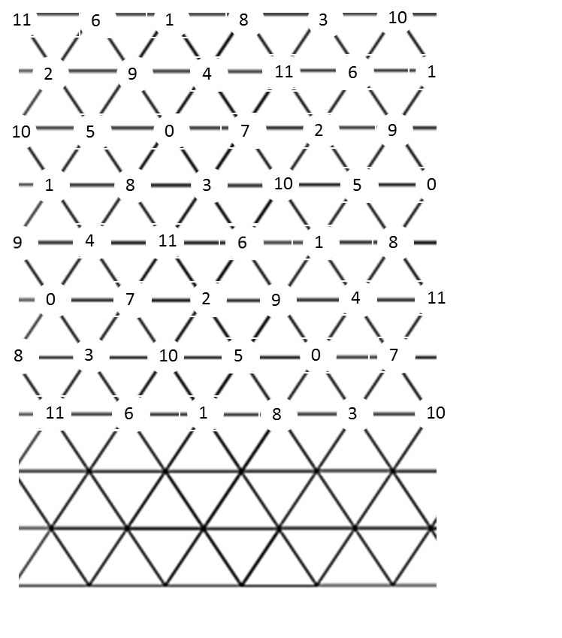

- On the Tonnetz, identify the transformations that must be made to progress from (D,+) to (Gb,+).
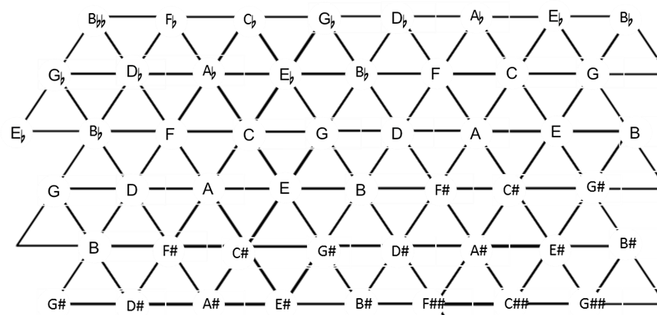

- Analyze mm. 1-8 of Christian Sinding’s Rustle of Spring, Op. 32, No. 3 by tracing NRT transformations.

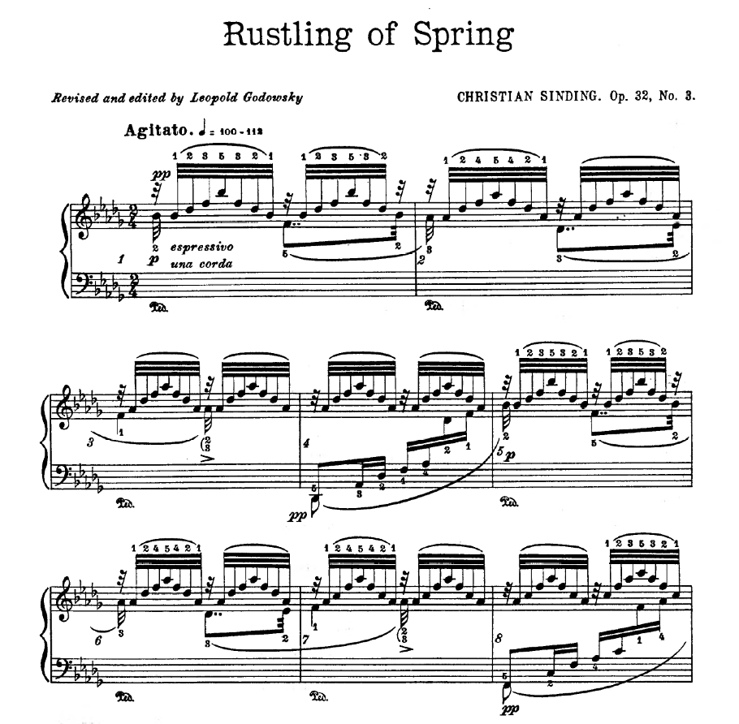
Figure 19: mm. 1-8 of Christian Sinding’s Rustle of Spring, Op. 32, No. 3

- Analyze mm. 4-8 of Erik Satie’s Le Piccadilly by tracing NRT transformations.

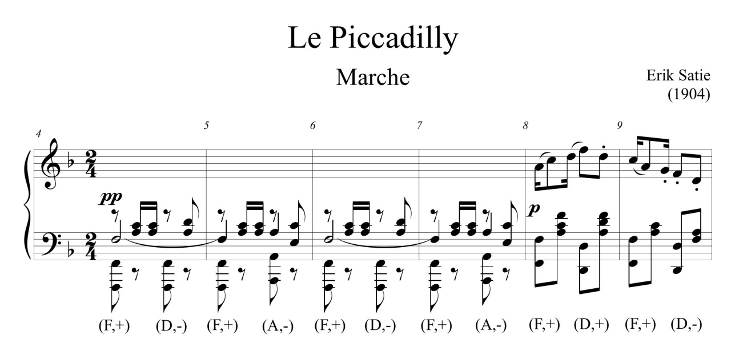
Figure 20: mm. 4-8 of Erik Satie’s Le Piccadilly

Δ Keyboard Exercise
- Play the progression from Written Exercise #4 using SATB parsimonious voice leading.

Δ Composition Exercises
- Write an 8 bar progression using P, L, R transformations. After you have decided on a progression, add rhythmic values and create a melodic line, including non-chord tones.
- Write a short composition with ABA’ form where A modulates to B through 3 transformations and where B modulates to A’ through 3 transformations.

Δ Aural Skills Exercises (Instructions for the Teacher)
- Break the class into 3 parts: SAB. Have each section move one voice at a time to create PLR transformations. Ask students to identify the transformations.
- Break the class into 3 parts: SAB. Ask students to complete transformations without identifying which voice should move, i.e. say “parallel.” The voice singing $\hat{3}$ would move to b$\hat{3}.$
- Play the progression (C,+) (a,-) (F,+) (d,-) (Bb,+)(g,-) (G,+) (C,+). Have students identify the changing voice and chart the transformations on the Tonnetz. (Other listening exercises may be conducted in the same manner.)
- Listen to the first 12 measures of Richard Strauss’s Also Sprach Zarathustra and ask students to identify the two transformations that occur.

Chapter Two: Cycles and Compound Transformations

The Cyclic Nature of the NRT Transformations

Often times an NRT analysis includes a cycle, which is a series of repeated NRT transformations. In 1996, Lewin wrote the article “Cohn Functions” detailing Cohn’s work that uses mod-12 when considering the construction of non-trivial cycles of pitch class sets. Non-trivial cycles are cycles of triads that at least 3 pc sets long.
In the same year, Cohn wrote “Maximally Smooth Cycles, Hexatonic Systems, and the Analysis of Late-Romantic Triadic Progressions,” detailing his theory of maximally smooth cycles. Maximally smooth cycles are constructed by any pc set in the cycle becoming another pc set in the cycle by moving a single note by a half-step. The most famous of these cycles is the circle of fifths, which is considered maximally smooth due to the change of one pitch of the scale to create another scale. For instance, C Major becomes G Major when F is raised to become F#.)
In Figure 20, Cohn has reduced mm. 268-79 of Brahms’ Concerto for Violin and ‘Cello, first movement to show the maximally smooth cycle that Brahms wrote. Notice that the changing notes have filled-in noteheads. Also, note that the open noteheads show the two maintained pitches. Realize that this progression is maximally smooth because the pitches that move do so by half-step.

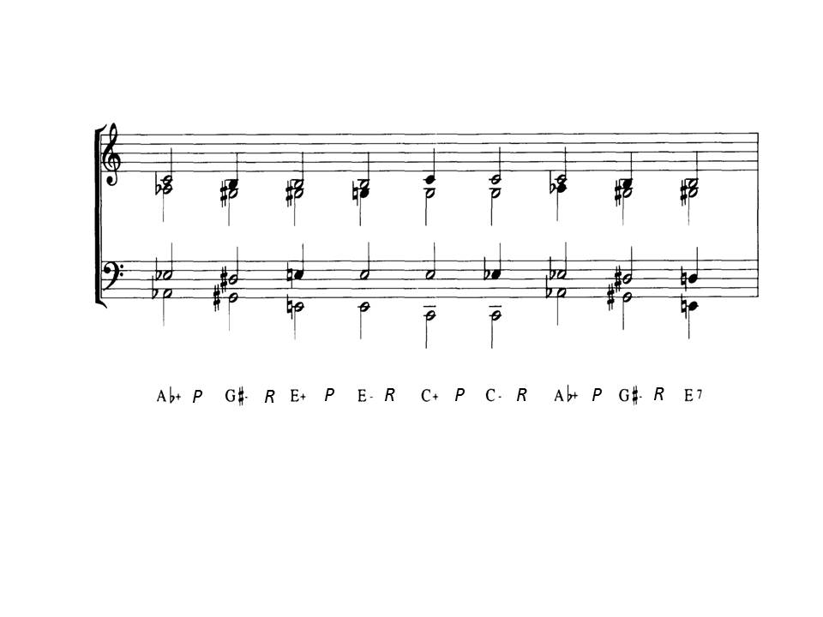

Figure 21: Cohn’s reduction of Brahms’ Concerto for Violin and ‘Cello, first movement, mm.268-79

The LP/PL Cycle

One type of cycle that is frequently found in literature is the LP/PL cycle. Brahms’ Concerto charted on the Tonnetz below serves as a nice example of this cycle type. (See Figure 21.) Note that the Tonnetz should be three-dimensional and would continuing rolling on itself; in which case, the progression would start exactly where it began.

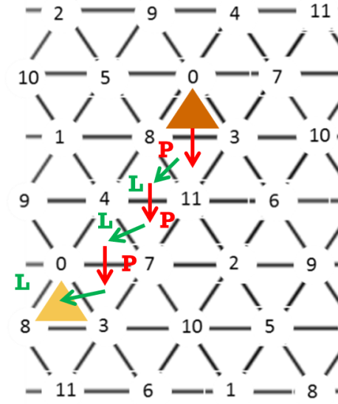

Figure 22: The charted Tonnetz for Brahms’ Concerto for Violin and ‘Cello, first movement,
mm.268-79

While speaking of the development of NRT, Joe Argentino states, “The characteristic trait of hexatonic passages is the disappearance of tonally driven triadic progressions (directed fifth motions), replaced by, as an example, symmetrical divisions of the octave (major third motions), where motion from one chord to the next is frequently characterized by efficient, smooth voice-leading and an abundance of common tones.” Brahms’s progression is one such progression: it is an LP cycle.
LP and PL cycles are the same cycle only in reverse. For example:
LP: (C,+) L = (E,-) P = (E,+) L = (G#,-) P = (Ab,+) L = (C,-) P = (C,+)
PL: (C,+) P = (C,-) L = (Ab,+) P = (G#,-) L = (E,+) P = (E,-) L = (C,+)
There are four hexachords that result from the aggregate pcs involved in four distinct triadic starting points for LP/PL cycles. See Figure 22. Notice that there are no shared triads between hexachords, because each of the four hexachords is a closed cycle. If the pcs are taken from each of the resulting triads and combined, the repeated pitches are cancelled, and then the hexachord results.
(C,+) (E,-) (E,+) (G#,-) (A,+) (C,-) (C,+)
[047] [47B] [48B] [8B3] [803] [037] [047] = [03478B]

Performing either PL or LP three times will result in the original triad (as seen above). Engebretsen and Broman state, “These cycles are often referred to as a hexatonic cycles [sic] because each engages all and only those pitch-classes forming a hexatonic collection.” Skinner states, “The conventional PL cycle . . . is a significant compositional resource for late Romantic composers such as Wagner, Franck, Liszt, Mahler, and Richard Strauss.”

 | P |  | L |  | P |  | L |  | P |  | L
C,+ |  | C,- |  | Ab,+ |  | Ab,- |  | E,+ |  | E,- |  | C,+ | [3478B0]
Db,+ |  | Cb,- |  | A,+ |  | A,- |  | F,+ |  | F,- |  | Db,+ | [014589]
D,+ |  | D,- |  | Bb,+ |  | Bb,- |  | Gb,+ |  | Gb,- |  | D,+ | [12569A]
Eb,+ |  | Eb, - |  | B,+ |  | B,- |  | G,+ |  | G,- |  | Eb,+ | [2367AB]
Figure 23:The PL cycles

∇ Learning Activity 1: Charting a Cycle on the Tonnetz
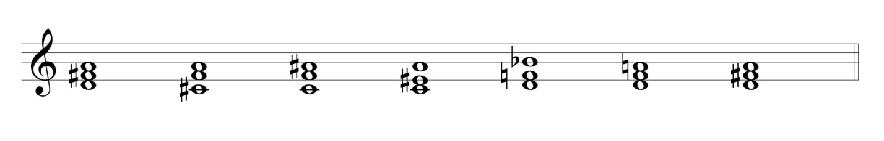
Following the instructions from Chapter One, chart the cycle above on the
Tonnetz just as you would a non-cyclic progression.
(First, spell the triads using integers.)
.
Notice that the LP hexachords divide up the twenty-four major and minor chords into four distinct tonal regions, and all are all members of the 3-11 set class. Richard Cohn states, “. . . What is unique about set-class 3-11, together with its nine-note complement, is the capacity of its member sets to form an ordered set of maximally smooth successions that is long enough to be perceived as a cycle . . . yet short enough that it does not exhaust all the members of its set-class.” In other words, each of the hexatonic cycles come from set class 3-11 and form short cycles, which each utilize only six of the 24 triads within the set-class.
“’Hexatonic’ is a nickname for set-class 6-20, whose prime form is (0, 1, 4, 5, 8, 9). As one of the all-combinatorial hexachords, 6-20 maps itself under three distinct transpositions and three distinct inversions. Consequently, there are only four distinct pc sets, each of which
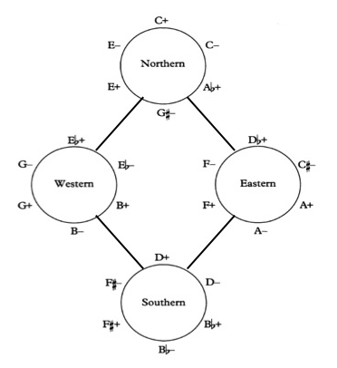
Figure 24: Richard Cohn’s Illustration of The Hyper-hexatonic System

supplies the fund of pcs from which the triads in a single hexatonic system are drawn.” Each of the hexachords in Figure 23 have regional names given by Cohn. The cycles are related to each other through the R transformation and form Cohn’s Hyper-hexatonic system (see Figure 23). The (Ab,+) of the Northern cycle is transformed by R to (F,-) of the Eastern cycle. Likewise the (F,+) of the Eastern cycle is transformed by R to (D,-) of the Southern cycle and so forth. Figure 24 shows the adjacent cycles as they would appear on the Tonnetz. When read from left to right, Figure 24 shows portions of the LR cycle.

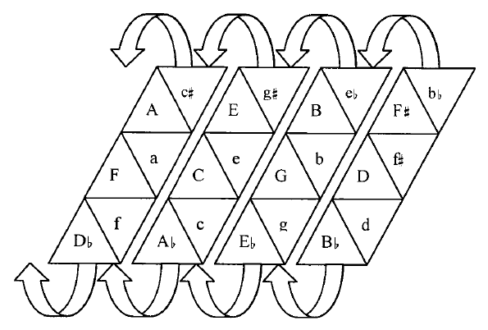
Figure 25: Adjacent LP transformations of Forte class 3-11 on the Tonnetz

The PR/RP Cycle

Unlike the hexatonic LP/PL cycle, the PR/RP cycle creates a series of triads whose pcs break down into an octatonic collection. Figure 25 shows a PR cycle. In the case of the top row of the chart, we can see that when the pcs are taken from each of the resulting triads and combined, the repeated pitches are cancelled, and then the octatonic collection results. Notice the PR/RP cycle yields only three different set classes.

(C,+) (C,-) (E,+) (E,-) (G,+) (G,-) (A,+) (A,-)
[047] [037] [37A] [36A] [6A1] [691] [914] [904] = [0134679A]

 | P |  | R |  | P |  | R |  | P |  | R |  | P |  | R
C,+ |  | C,- |  | E,+ |  | E,- |  | G,+ |  | G,- |  | A,+ |  | A,- |  | (C,+) | [0134679A]
D,+ |  | D,- |  | F,+ |  | F,- |  | A,+ |  | A,- |  | B,+ |  | B,- |  | (D,+) | [235689B0]
D,+ |  | D,- |  | E,+ |  | E,- |  | G,+ |  | G,- |  | B,+ |  | B,- |  | (D,+) | [124578AB]
Figure 26: The PR cycles

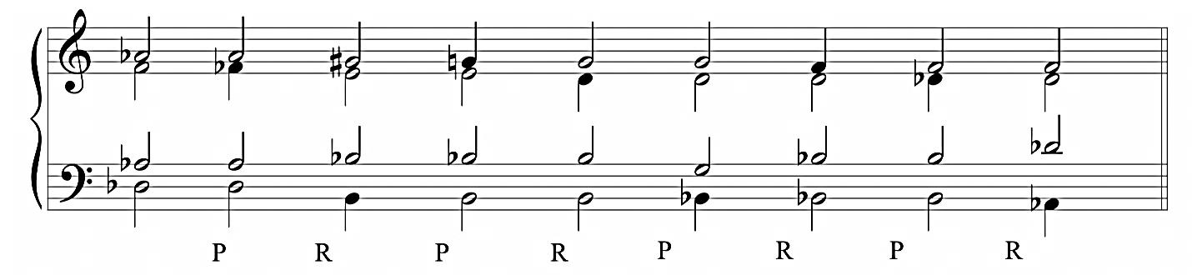
Figure 27: Sample RP cycle

The LR/RL Cycle

The complete LR cycle starting on (C,+) may be seen in Figure 27. Notice that the LR cycle goes through the entire series of consonant triads. Engebretsen and Broman state, “The LR cycle, which moves along the horizontals of the Tonnetz, differs from the LP and PR cycles in that it progresses through all twenty-four consonant cycles, rather than partitioning them into shorter cycles.” Richard Cohn states, “The complete <LR> cycle is too long to sustain compositional interest under normal circumstances.”

(C,+) | R | = | (A,-) |  | (A,-) | L | - | (F,+)
(F,+) | R | = | (D,-) |  | (D,-) | L | = | (Bb,+)
(Bb,+) | R | = | (G,-) |  | (G,-) | L | = | (Eb,+)
(Eb,+) | R | = | (C,-) |  | (C,-) | L | = | (Ab,+)
(Ab,+) | R | = | (F,-) |  | (F,-) | L | = | (Db,+)
(Db,+) | R | = | (Bb,-) |  | (Bb,-) | L | = | (Gb,+)
(Gb,+) | R | = | (Eb,-) |  | (Eb,-) | L | = | (B,+)
(B,+) | R | = | (G#,-) |  | (G#,-) | L | = | (E,+)
(E,+) | R | = | (C#,-) |  | (C#,-) | L | = | (A,+)
(A,+) | R | = | (F#,-) |  | (F#,-) | L | = | (D,+)
(D,+) | R | = | (B,-) |  | (B,-) | L | = | (G,+)
(G,+) | R | = | (E,-) |  | (E,-) | L | = | (C,+)

Figure 28: The RL cycle

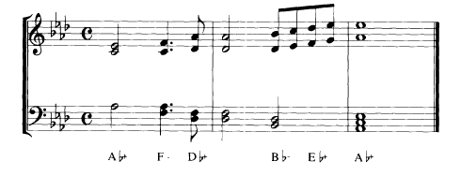

Figure 29: Wagner’s Parsifal, Act I, mm. 39-41

While the complete RL/LR cycle is too long to use in composition, it is possibly the most common translation chain found in literature. RL cycles can be found in diatonic and non-diatonic settings. A diatonic setting can be seen below in mm. 39-41 of Wagner’s Parsifal, Act I. (See Figure 28.)
Another famous example of an RL cycle is Ludwig van Beethoven’s Ninth Symphony. (See Figure 29.) The reduction of Beethoven’s progression is shown in Figure 30 below. In Figure 31 below, the progression is charted on the Tonnetz. In Figure 32, Roig-Francolí gives a more detailed reduction of the second half of the chain. Notice that a shows the progression with the temporary tonicizations of each triad, while b eliminates the dominant triads of the dominant tonic progressions to show the RL cycle that unifies the progression.
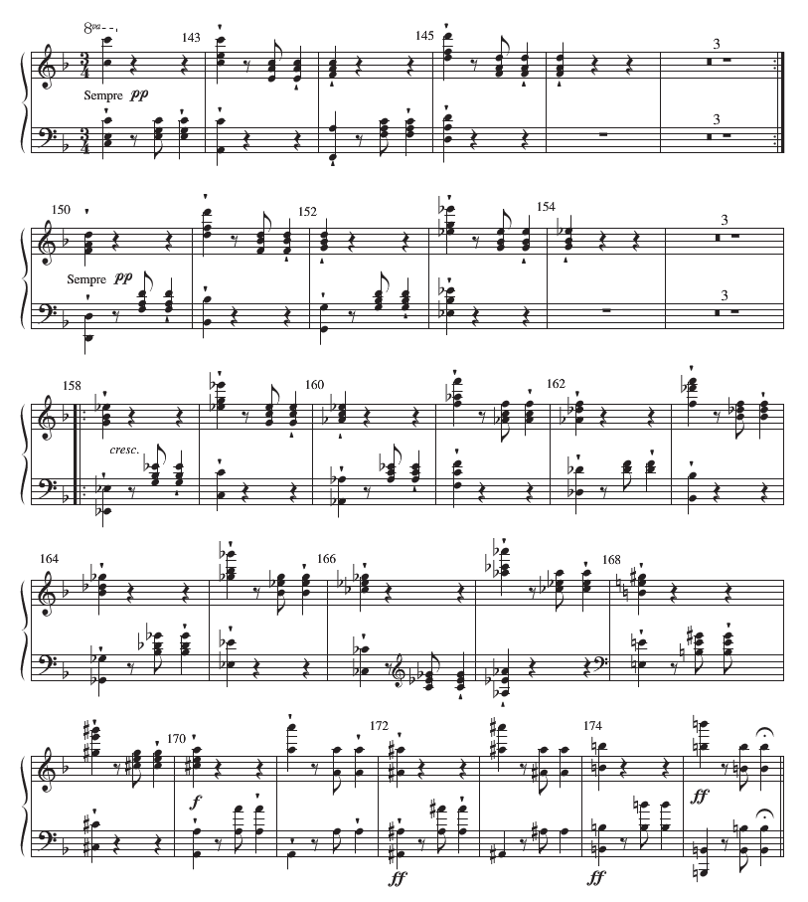
Figure 30: Beethoven’s Ninth Symphony

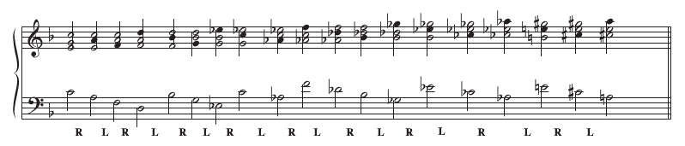
Figure 31:Roig-Francolí’s reduction of Beethoven’s Ninth Symphony

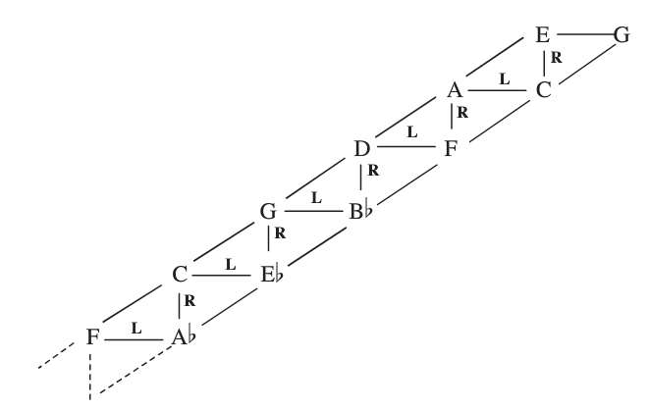
Figure 32: Roig-Francolí’s diagram of Beethoven’s Ninth Symphony
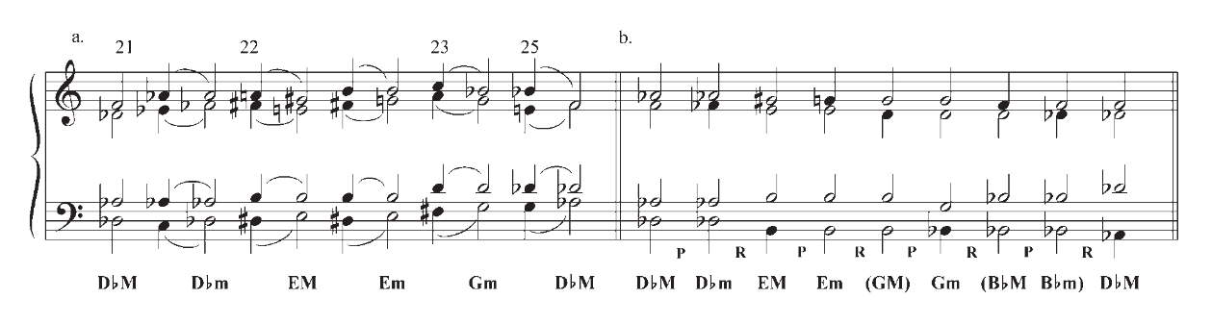

Figure 33: Roig-Francolí’s reduction of Beethoven’s Ninth Symphony
Another example of the RL cycle is that of Schubert’s Sonata in B-flat Major, fourth movement, mm. 119-130. (See Figure 33.) In Figure 34, Guy Capuzzo has reduced the texture of the sonata to show the underlying parsimonious voice-leading. Notice that Schubert interrupts the cycle with P in m. 123 but immediately returns to utilizing an RL cycle.

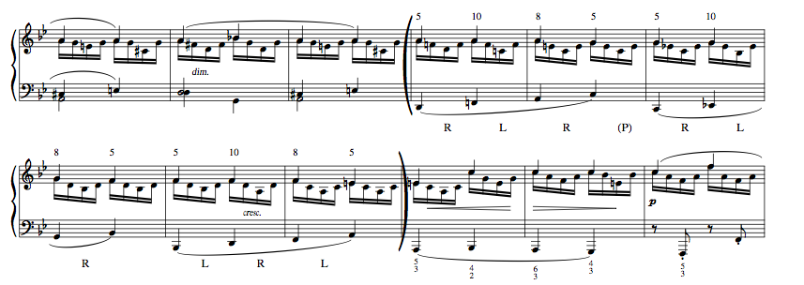
Figure 34: Capuzzo Analysis of Schubert, Sonata in B-flat Major (1828), IV, mm. 119-130

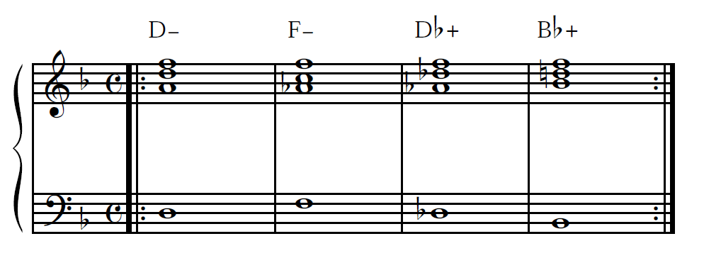
Figure 35: Capuzzo Reduction of Schubert, Sonata in B-flat Major with parsimonious voice-leading

Compound Transformations

Performing Compound Transformations

The NRT transformations P, L, and R were introduced in chapter one. Each of those transformations performed individually results in a new triad. Compound transformations are a combination of two or more individual transformations performed in succession to produce the new triad. While cycles have their place in literature, compound transformations can be found in many genres, including Pop-Rock music. In Figure 35, Lennon and McCartney have started an RL cycle in All My Loving, which they dismiss with the compound transformation RP, (D,+) (B,+).
To perform compound transformations, take the nearest movement on the Tonnetz first and follow in logical route, using the shortest route possible. In the case of the RP transformation in All My Loving, (D,+) R = (B,-) P = (B,+).

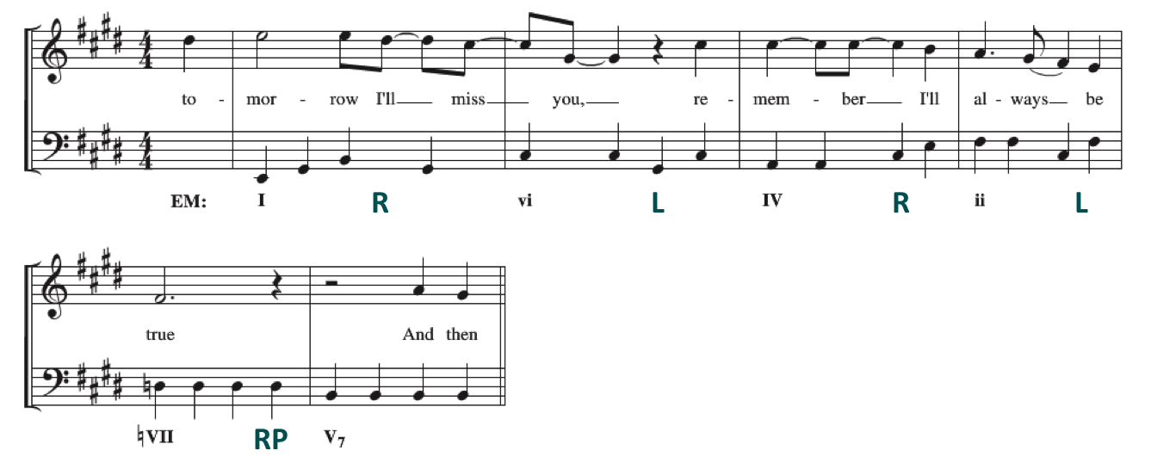
Figure 36: John Lennon and Paul McCartney’s All My Loving from the album With the Beatles

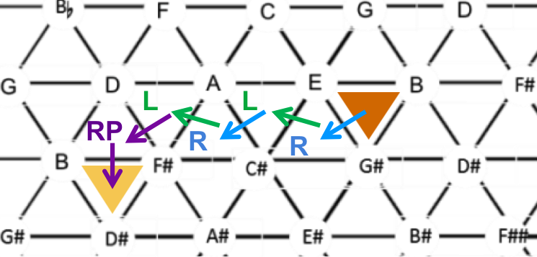

Figure 37: John Lennon and Paul McCartney’s All My Loving from the album With the Beatles

∇ Learning Activity #2: Compound Transformations
Start on (C#,-) and perform PR. Perform PR on the resulting triad. What is the final result?
(C#,-) PR = PR =

Figure 37 shows the progression (C#,-) (E,-) (G,-), which is the sollution to the activity above. Notice that unlike the individual transformations, compound transformations
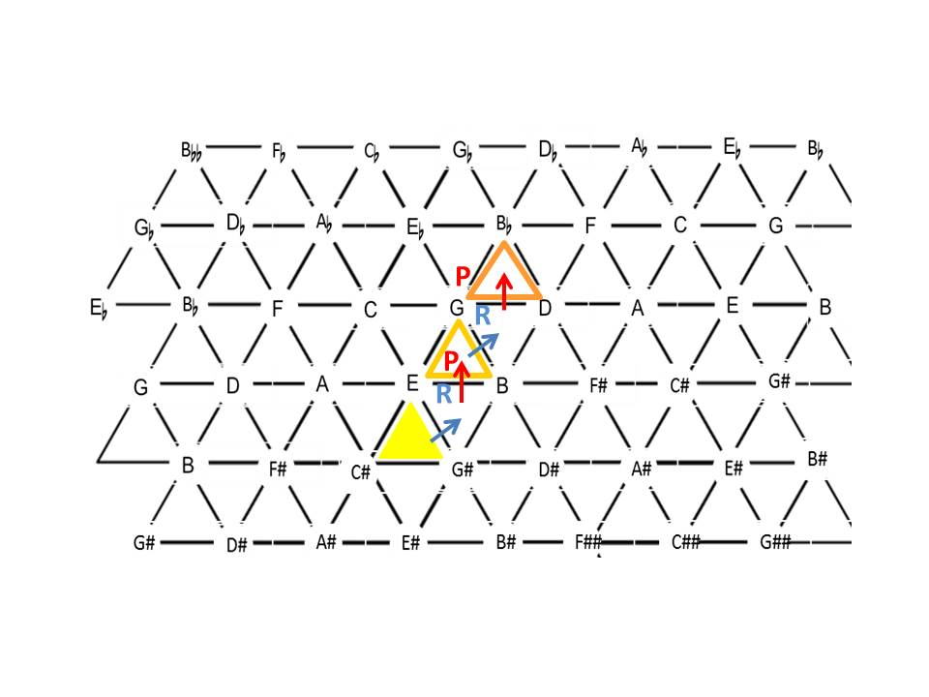
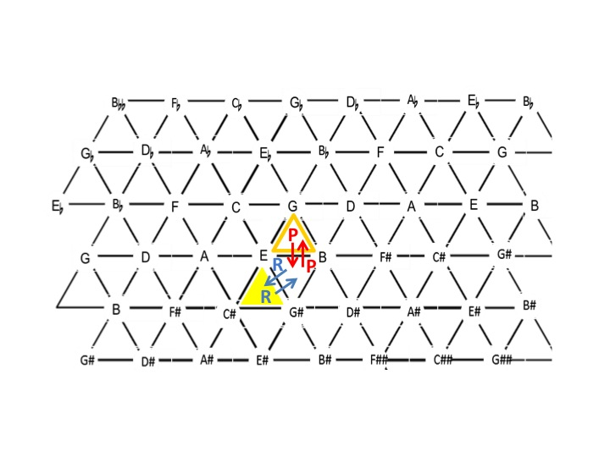
Figure 38: The RP transformation is not an involution

are not involutions. To return to the original triad, one must perform the opposite compound transformation. (C#,-) RP = (E,-) while (E,-) PR = (C#,-)
In the article “Neo-Riemannian Theory and the Analysis of Pop-Rock Music,” Capuzzo successfully demonstrates the usefulness of NRT in describing the non-traditional progressions that are often found in popular music written within the last 60 years. One such piece that Capuzzo uses to demonstrate NRT’s effectiveness is Ozzy Osbourne’s “Flying High Again.” In Figure 38, Capuzzo has written out the guitar line in both standard notation and tablature, demonstrating the voice-leading parsimony. In Figure 39, Capuzzo reduces the progression to triads and shows first the compound transformations performed above the chords and then demonstrates the progression (PL RP PL) is transposed (i.e. T₇) the second time. Or if related by transformation, the chords are the result of an RL transformation. [i.e. (A,+) RL (E,+) and so on.] Therefore, the entire progression can be shifted on the Tonnetz by RL, which shifts their placement over two triangles to the right.

Figure 39: Capuzzo’s analysis and reduction of Ozzy Osbourne’s “Flying High Again”

Figure 40: Capuzzo’s analysis and reduction of Ozzy Osbourne’s “Flying High Again”

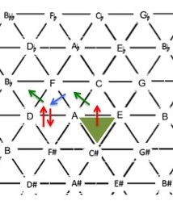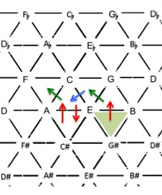
Figure 41: Capuzzo’s analysis and reduction of Ozzy Osbourne’s “Flying High Again”

Another rock song that utilizes compound transformations is Bob Dylan’s “Lay, Lady, Lay.” Figure 41 shows both occurrences of the progression: first as the original and second by the transposition T_{n} of seven. Figure 42 shows both instances charted on the Tonnetz. Like Osbourne’s “Flying High Again,” the chords while transposed by seven are the result of an RL transformation [i.e. (A,-) RL (E,-)].

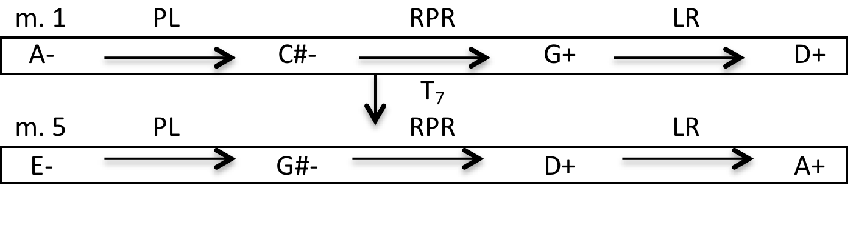
Figure 42: The progression from Bob Dylan’s “Lay, Lady, Lay”

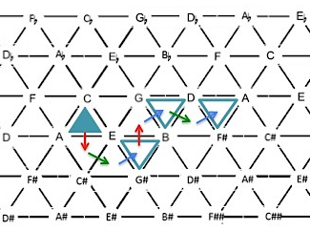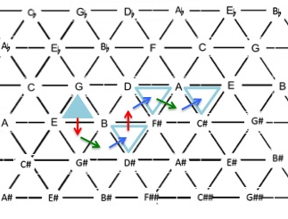
Figure 43: The charted progression from Bob Dylan’s “Lay, Lady, Lay”

An Example Compound: PRL

One example of a compound transformation is when (C,+) becomes (G,-), and its NRT progression could be mapped as follows: (C,+) P = (C,-) R = (Eb, +) L = (G,-). Thus, the compound transformation (C,+) PRL = (G,-). (See Figure 43.)
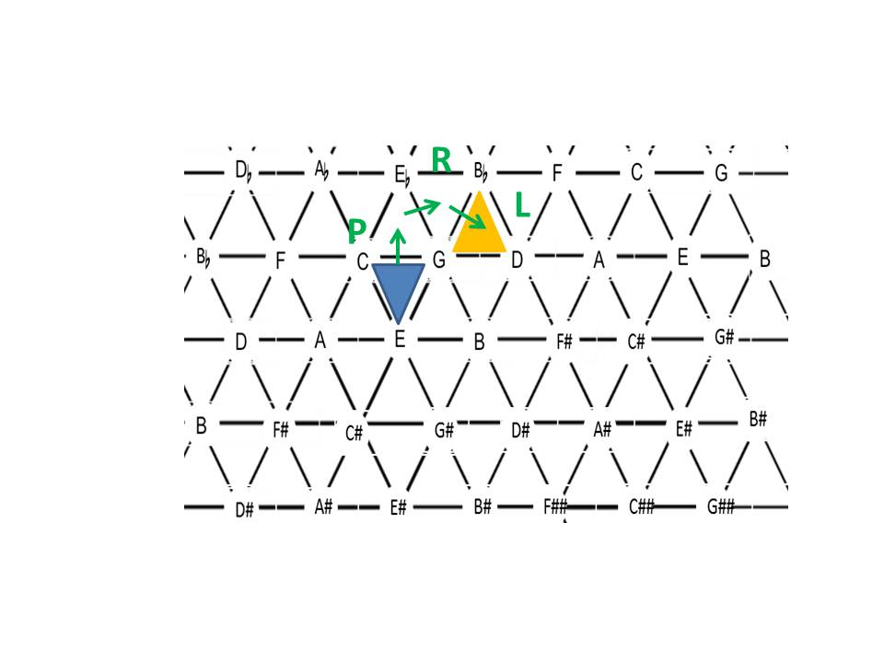
Figure 44: The compound transformation of (C,+) to (G,-).

If we reverse the progression, we arrive at the same triad?. (C,+) L = (E, -) R = (G,+) P = (G,-). The compound transformation would be (C,+) LRP = (G,-). See Figure 44.
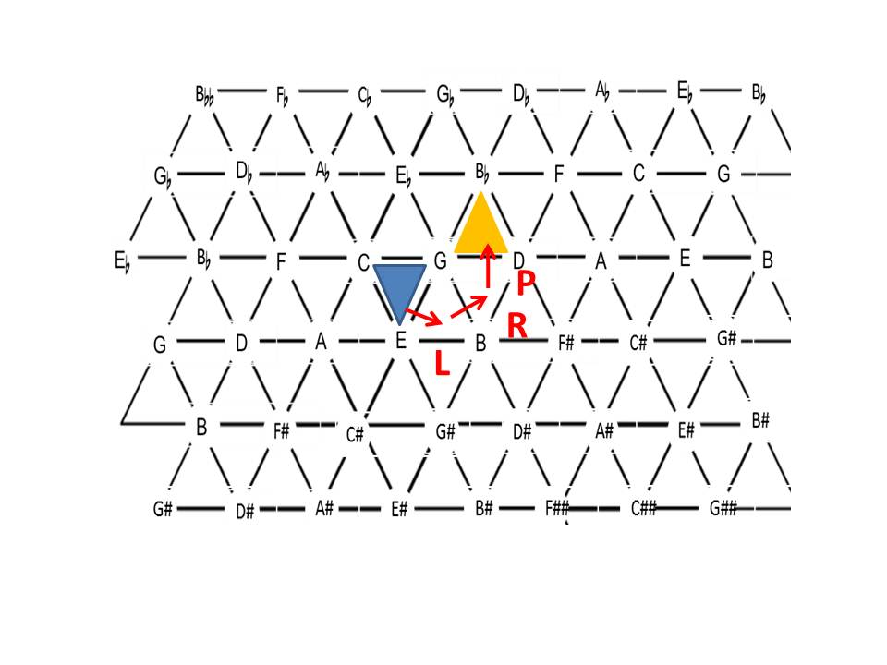
Figure 45: The LRP transformation of (C,+) to (G,-)

∇ Learning Activity #3: Compound Transformations
Complete the first compound transformation:
(C,+) PRL = (G,-), which performed in steps looks like
(C,+) P = (C,-) R = (Eb, +) L = (G,-)
and perform it a second time, starting with (G,-)
(G,-) PRL =
(G,-) P = R = L =

Notice also that the compound transformation PRL is an involution just as a single transformation is an involution even though other compound transformations are not involutions. (G,-) P = (G,+) R (E,-) L = (C, +). See Figure 45 below, which illustrates the involution. Likewise, the compound transformation LRP is an involution.
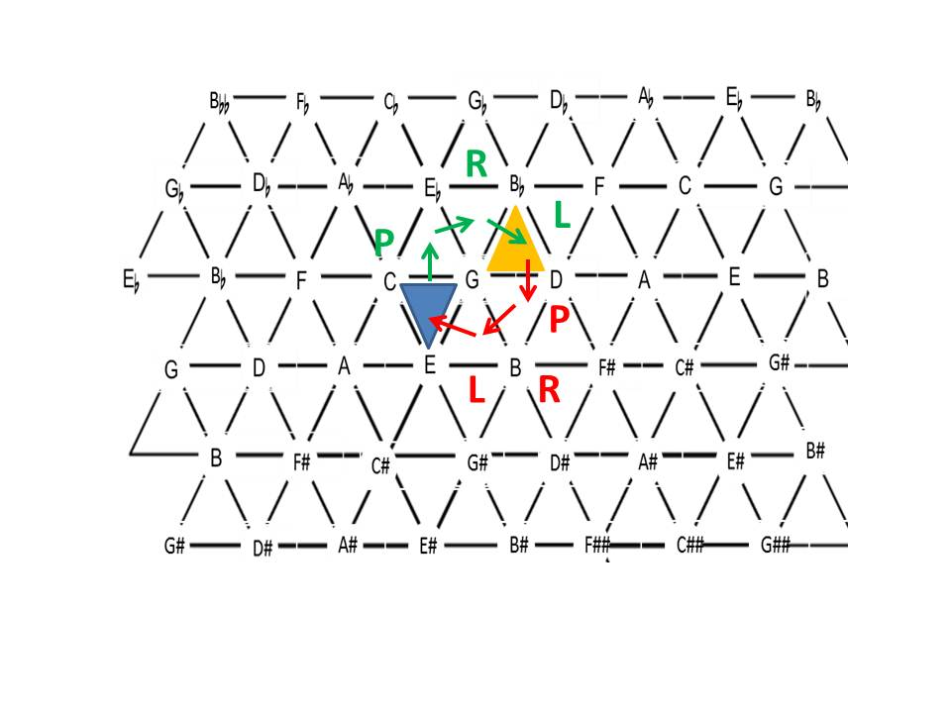
Figure 46: The Involution of the PRL compound transformation

Lewin’s DOM Transformation

Lewin’s DOM transformation (see Chapter One) is not considered a single NRT transformation for the fact that it is not an involution, but is also not an NRT transformation because the DOM transformation is a compound transformation (RL). Likewise, DOM’ (the opposite of the DOM transformation) is the compound transformation (LR). (See Figure 46.) An example of the DOM/compound RL transformation is mm. 37-43 of Rachmaninoff’s Prelude Op.32, No. 4. (See Figures 47.) In Figure 47, Rachmaninoff begins an LR cycle, but dismisses it by performing a double transformation (RL) to move from (G,-) to (D,-) and then performs the double transformation again to move from (D,-) to (A,-). After passing between the triads for two measures, Rachmaninoff performs a P transformation.

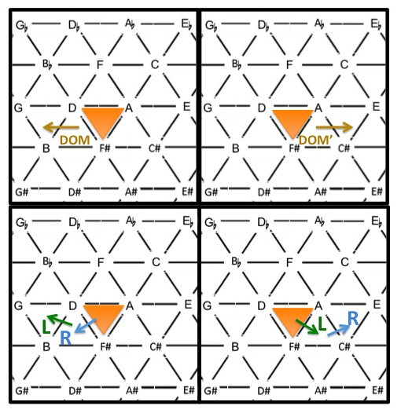

Figure 47: The DOM and DOM’ transformations shown as compound transformations
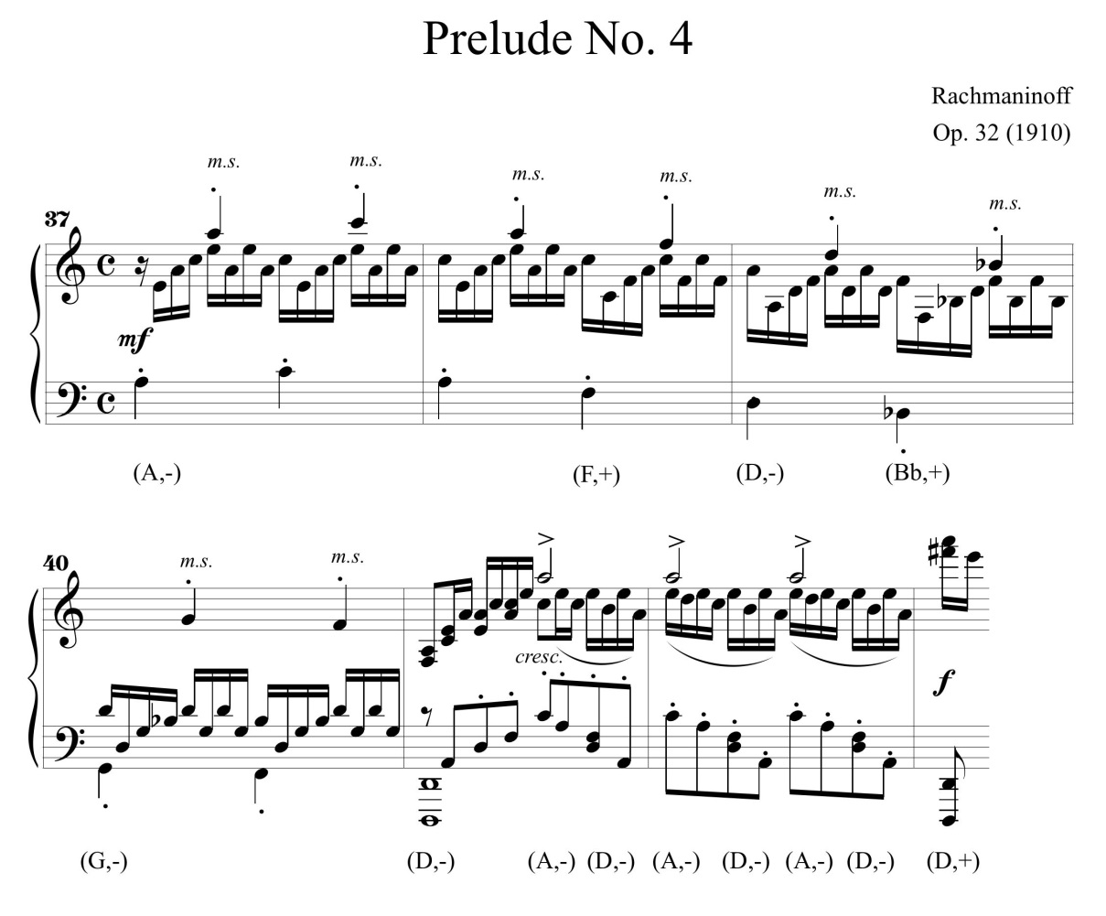

Figure 48: Sergei Rachmaninoff’s Prelude Op. 32, No. 4, mm. 37-43
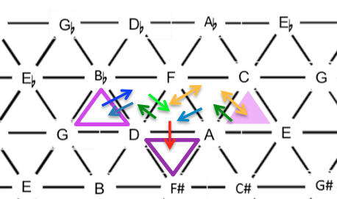
Figure 49: Rachmaninoff’s Prelude Op. 32, No. 4, mm. 37-43 shown on the Tonnetz

Terms to Know

Circle of Fifths
Compound transformation
Maximally Smooth Cycle
Mod-12
Non-Trivial Cycles

Further Reading on NRT Cycles

Clugh, John, Nora Engebretsen, and Jonathan Kochavi. "Scales, Sets, and Interval Cycles:
A Taxonomy." Music Theory Spectrum 21, no. 1, (Spring 1999): 74-104.
Cohn, Richard Lawrence. Audacious Euphony: Chromaticism and the Consonant Triad's
Second Nature. New York: Oxford University Press, 2012. Read Chapter 2.
Cohn, Richard. "Maximally Smooth Cycles, Hexatonic Systems, and
the Analysis of Late-Romantic Triadic Progressions." Music Analysis 15, no. 1
(1996): 9-40. Read Section I.
Douthett, Jack M., Martha M. Hyde, Charles J. Smith, and John Clough. "Filtered Point-
Symmetry and Dynamical Voice-Leading." In Music Theory and Mathematics:
Chords, Collections, and Transformations. (Rochester, NY: University of
Rochester Press, 2008), 72-106. Read pp. 72-77.

Further Reading on Compound Transformations
Capuzzo, Guy. "Neo-Riemannian Theory and the Analysis of Pop-Rock Music." Music Theory
Spectrum 26, no. 2 (2004): 177-200. Read All.
Cohn, Richard. "Maximally Smooth Cycles, Hexatonic Systems, and the
Analysis of Late-Romantic Triadic Progressions." Music Analysis 15, no. 1 (1996): 9-40.
Read Section I.
Kidd, Milan. An Introduction to the Practical Use of Music-Mathematics.
http://www.math.uchicago.edu/%7Emay/VIGRE/VIGRE2006/PAPERS/Kidd.pdf. Read all.

Δ Written Exercises
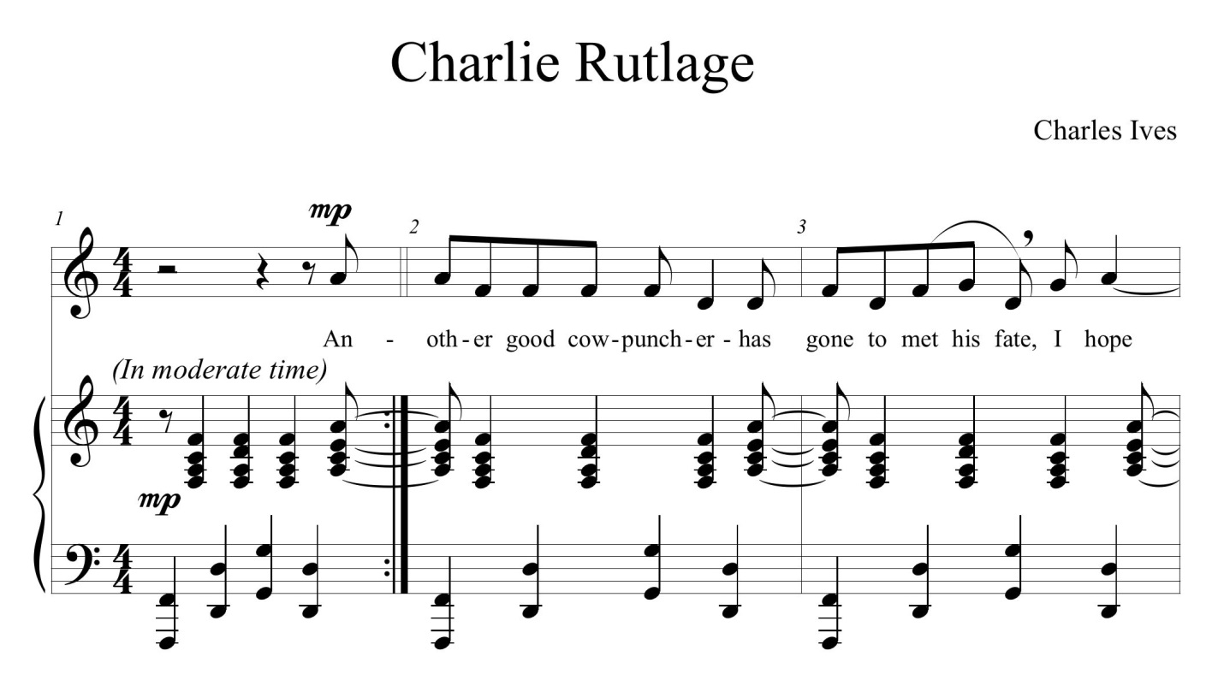
- Describe the relationship of the chords in the treble clef of the piano accompaniment of mm. 1-3 of Charlie Rutlage by Charles Ives by using NRT transformations. Does a cycle occur?
Figure 50: mm. 1-3 of Charlie Rutlage by Charles Ives

- Identify the cycle, beginning on (E,-).

- Chart the progression on the Tonnetz and identify the cycle of Schubert’s Overture to Die Zauberharfe, opening Andante (as reduced by Richard Cohn).
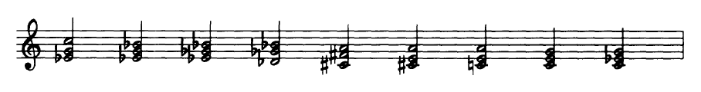
Figure 51: Schubert’s Overture to Die Zauberharfe, opening Andante (as reduced by Richard Cohn).

- Navigate the following two cycles on the Tonnetz.
Starting on (B,-): P R L P R L
Starting on (F#,+): L P R L P R
Which pitches are shared by the two cycles? Which Triads are shared by the two cycles?

- Complete a full PLR cycle on pc set [269]. Give the Tn/TnI relationships for each pc set to the original.

- Perform the following compound transformations, identifying and marking each resulting Triad on the Tonnetz, starting with (A,+).
RP RL RL PR LR

- Perform the following compound transformations, identifying and marking each resulting Triad on the Tonnetz, starting with [058].
RP RL RL PR LR
Which pcs are shared the most shared? What pc set do they create?

- Analyze mm. 34-38 of Ernest Bloch’s Poems of the Sea, II. Chanty using NRT transformations.

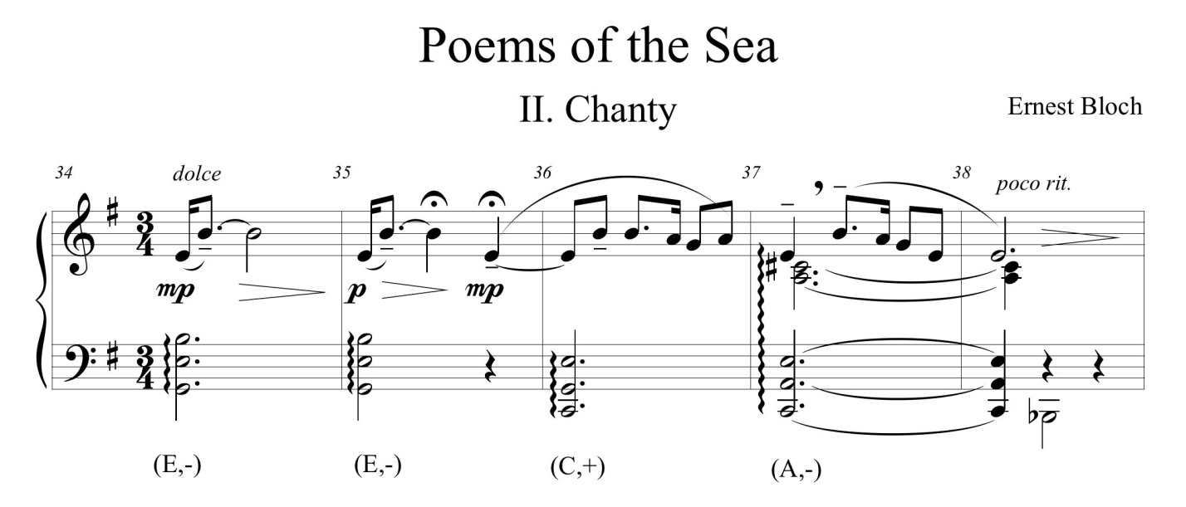
Figure 52: mm. 34-38 of Ernest Bloch’s Poems of the Sea, II. Chanty

- Analyze the selection from Erik Satie’s Gnossienne No. 4 using NRT transformations.
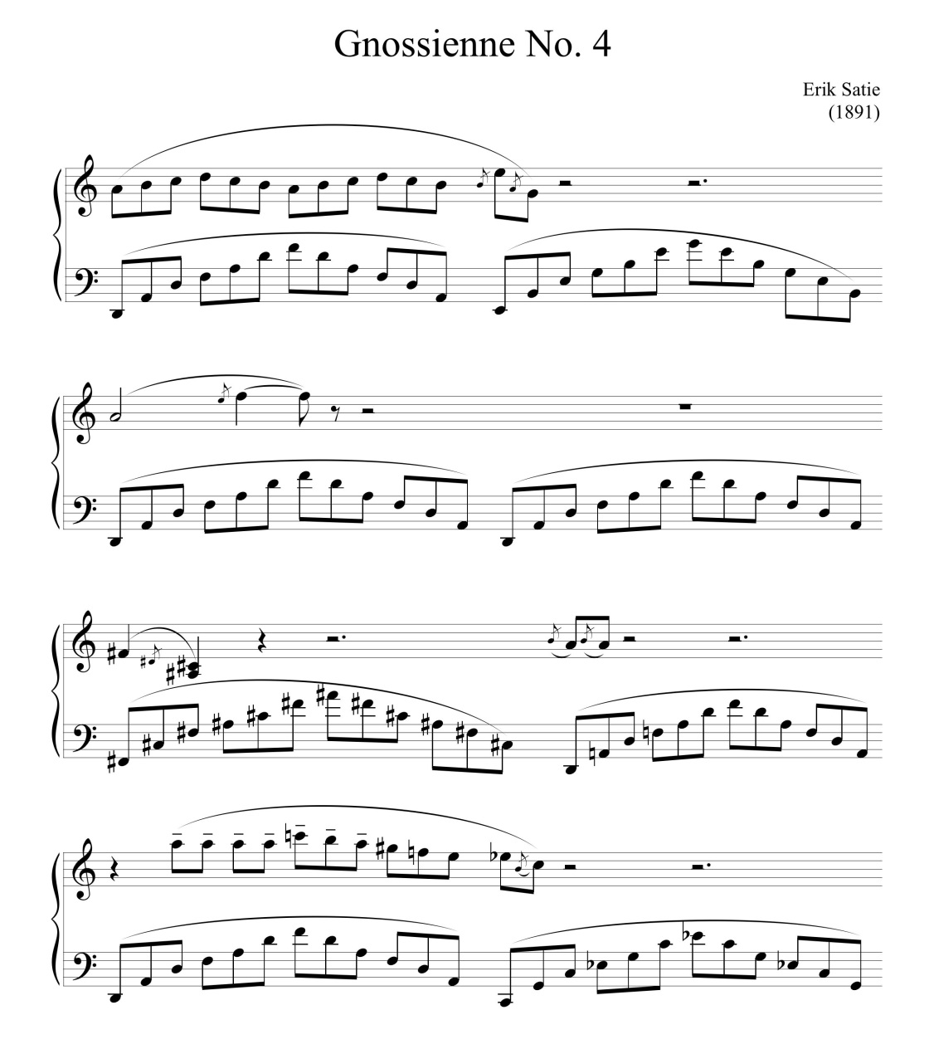

Figure 53: Erik Satie’s Gnossienne No. 4

- Analyze the selection from Dmitri Kabalevsky’s Sonatina in C Major, Op.13, No.1 using NRT transformations.

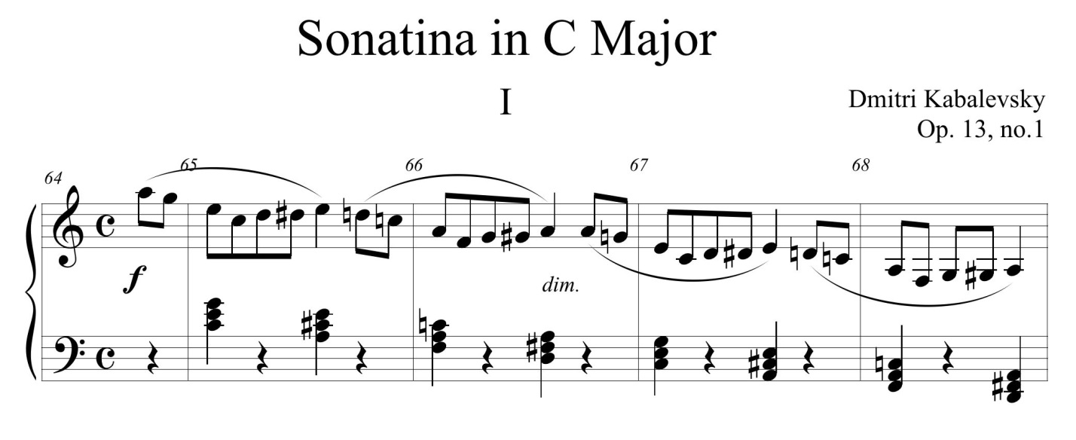
Figure 54: mm. 64-68 of Dmitri Kabalevsky’s Sonatina in C Major, Op.13, No.1

Δ Composition Exercise
- Complete an 8-bar composition, using only the pitches from the cycle in Written Exercise #1.

- Complete a composition of at least 8 bars containing at least 2 compound transformations.

Δ Keyboard Exercise
- Play the progression (Db,+) (Bb,-) (G,-) (E,-) with parsimonious voice-leading.

In Conclusion: Transformational Theory

Neo-Riemannian theory is a faction of a much larger theory, transformational theory. As an infant theory, transformational theory continues to develop. In recent years, many improvements have been made in several areas, including additional transformations, seventh chords, and pc sets that do not have major and minor sonorities or are larger than triads. Transformational theory has added partial transformations, some of which may not be reversible, and transformations performed on augmented triads, a chord commonly found between parsimonious major and minor triads of late-Romantic progressions. With each advance of the theory, changes are made to the Tonnetz and new Tonnetze are created.
The benefits of such an analytical system are numerous. Transformational theory as a whole allows for the analysis of many genres, including late Romantic works, Impressionism, aleatoric, Neo-Romantic, Minimalist, and Pop-Rock. Transformational theory allows the theorist to analyze music in concrete mathematical terms, defining relationships that are not seemingly present when analyzed with traditional Roman numeral analysis. When combined with digital technologies, Tonnetze and new representations of progressions will give clarity and structure to passages that appeared to have none.
While there are still musical areas to be hypothesized and explored within transformational theory, distinguishing works are abundant. I suggest those who are interested in further study familiarize themselves with the following pieces of literature.

Further Reading

Biamonte, Nicole. “Augmented-Sixth Chords vs. Tritone Substitutes.” Music Theory
Online, 14, no. 2 (June 2008).
Cohn, Richard. “Square Dances with Cubes.” Journal of Music Theory 42, No. 2, Neo-
Riemannian Theory (Autumn, 1998): 283-296.
Cohn, Richard. "Weitzmann's Regions, My Cycles, and Douthett's Dancing Cubes." Music
Theory Spectrum 22, no. 1, Spring (2000): 89-103.
Kopp, David. Chromatic Transformations in Nineteenth-Century Music. Cambridge:
CambridgeUniversity Press, 2002.
Popoff, Alexandre. "Towards A Categorical Approach of Transformational Music
Theory."
ArXive-prints (April 2012). http://adsabs.harvard.edu/abs/2012arXiv1204.3216P.
Roeder, John, and Scott Alexander Cook. “Triadic Transformation and Parsimonious
Voice Leading in Some Interesting Passages by Gavin Bryars.” Intégral, 20 (2006):
43-67.
Taylor, Benedict. “Modal Four-Note Pitch Collections in the Music of Dvořák’s American
Period.” Music Theory Spectrum, 32, no. 1 (Spring 2010): 44-59.

INDEX
“
“Neo-Riemannian Operations, Parsimonious XE "parsimony" Trichords, and Their "Tonnetz", 11
A
Agentino, Joe, 5
aleatoric, vii
Argentino, Joe, 15, 39
B
Babbitt, Milton, 5
Beethoven, Ludwig van, 46, 47, 48; Ninth Symphony, 47, 48
Beethoven, Luwig van: Ninth Symphony, 48
Bloch, Ernest, 69; Poems of the Sea, 69
Brahms, Johannes, 11, 12, 37, 38, 39; Concerto for Violin and ‘Cello, 11, 37, 38; Concerto for Violin and 'Cello, 38
Broman, Per, 8, 15, 39, 44
C
Capuzzo, Guy, 49, 52, 53
Circle of Fifths, 25, 37, 60
Cohn, Richard, viii, 4, 8, 11, 14, 16, 37, 38, 41, 42, 44, 60, 61
Common Practice Period, 6
common tones, 11, 14, 39
common-tone, 14
common-tone maximization, viii
counterpoint, vii
cycle: maximally smooth, 37; non-trivial, 37
cycle, 37
cycle: LP/PL, 39
cycle: closed, 39
cycle: hexatonic, 39
cycle: LP/PL, 40
cycle: LP/PL, 40
cycle: maximally smooth, 41
cycle: hexatonic, 41
cycle: LR/RL, 42
cycle: LP/PL, 43
cycle: PR/RP, 43
cycle: PR/RP, 43
cycle: PR/RP, 44
cycle: PR/RP, 44
cycle: LR/RL, 44
cycle: LR/RL, 44
cycle: LR/RL, 44
cycle: LR/RL, 44
cycle: LP/PL, 44
cycle: PR/RP, 44
cycle: LR/RL, 44
cycle: LR/RL, 45
cycle: LR/RL, 45
cycle: LR/RL, 46
cycle: LR/RL, 46
cycle: LR/RL, 49
cycle: LR/RL, 49
cycle: LR/RL, 50
cycle: LR/RL, 57
cycle: maximally smooth, 60
cycle: non-trivial, 60
Cycle, 40; LP/PL, 38
cycles: LP/PL, 39
D
Douthett, Jack, 18
Dylan, Bob, 54; Lay, Lady, Lay, 54
E
Engebretsen, Nora, 5, 15, 39, 44
enharmonic, 1, 16, 25
enharmonic equivalence, viii
equal temperament, 12, 16
Euler, Leonhard, 16
F
Forte, Allen, 1, 5, 43
Franck, Cesar, 40
G
Gollin, Edward, 19, 82
group theory, 5, 6, 7
H
half-step, 12
Handbuch der Harmonielehre, 6, 7
Hauptmann, Moritz, 6
hexachord, 1, 41
hexatonic, 1, 39
Hostinský, Ottakar, 16
Hyer, Brian, 7, 9, 16, 19
Hyper-hexatonic system, 42
I
Introduction to Post-Tonal Theory, viii, 29
inversion, 41
involution, 12, 13, 14, 15, 20, 25, 52, 56, 57
Ives, Charles, 62; Charlie Rutlage, 62
K
Kabalevsky, Dmitri, 71
Kabalevsky,. Dmitri: Sonatina in C Major, Op.13, No.1, 71
Kidd, Milan, 18, 40, 61, 82
klang, 20
Klang, 8, 9, 25
Klangs, 8
Klumpenhouwer, Henry, 7, 8, 29, 82
Kostka, Stefan, viii
L
Lennon, John, 50, 51; All My Loving, 50, 51
Lewin, David, 5, 6, 7, 8, 9, 10, 12, 16, 37, 57
Liszt, Franz, 40
M
Mahler, Gustav, 40
Materials and Techniques of Post-Tonal Music, viii
McCartney, Paul, 50, 51; All My Loving, 50, 51
Minimalist, viii
mode-altering, 14
Mode-altering, 14
modulo 12 arethmetic, 37
modulo 12 arithmetic, 2, 25, 60
N
neo-Riemannian theory, 5, 8
neo-Riemannian Theory, 4
Neo-Riemannian theory, 11
neo-Riemannian theory (NRT), vii, viii, 5, 6, 7, 8, 9, 11, 12, 13, 14, 15, 18, 39, 52, 55, 57, 69, 70, 71, 73
Neo-Riemannian theory (NRT), 12
Neo-Romantic, viii
normal form, 2
O
octatonic, 43
octave equivalency, 2
Octave equivalency, 25
Osbourne, Ozzy, 52, 53, 54; Flying High Again, 52, 53, 54
P
parsimonious voice leading, 12
parsimonious voice-leading, 12
parsimony, 11, 25
PC Integer Notation, x, 3
pc sets, 73
pitch class, 8, 14, 16, 25, 39
pitch class (pc), 1, 16, 18, 19, 39, 43
pitch class (pc) set, 1, 17, 37, 41
pitch class (pc) sets, 37
pitch class (pc)set, 37
pitch class analysis, vii, viii
pitch class set, 25
pitch class set (pc set), 2
pitch class sets, 8
pitch classes (pcs), 42
pitch-class inversion, 14
Plotkin, Richard, 12
Pop-Rock, viii
prime form, 2, 5, 41
Prokofiev, Sergei, 21, 22; Fugitive Visions, Op. 22, No. 4, 21, 22
R
Rachmaninoff, Sergei, 57, 58, 59; Prelude Op. 32, No. 4, 58, 59
Rehding , Alexander, 82
Riemann, Hugo, 6, 7, 16, 17, 19
Riemmann, Hugo, 16
Roig-Francolí, Miguel, viii, 46, 48
S
Satie, Erik, 35, 70; Gnossienne No. 4, 70; Le Piccadilly, 35
Schritt/Wechsel system, 7
Schubert, Franz, 49, 64; Die Zauberharfe, 64; Sonata in B-flat Major, 49
semitone, 12
serialism, vii
set class, 1, 2, 41; 3-11, 41, 43; 6-20, 41
set theory, 15
set-class, 41
seventh chords, 73
Sinding, Christian, 34; Rustle of Spring, Op. 32, No. 3, 34
Skinner, Myles, 11, 40
Steinbach, Peter, 18
Straus, Joseph, viii
Strauss, Richard, 36, 40; Also Sprach Zarathustra, 36
T
Table of Tonal Relations, viii
T_{n}, 2, 15
T_{n}I, 2, 15
Tonal Intuitions in "Tristan und Isolde", 7
tonnetz, 11
Tonnetz, 7, 15, 16, 17, 19, 21, 22, 25, 38, 40, 42, 43, 44, 46, 50, 52, 54, 64, 73; chickenwire, 18, See; three-dimensional, 19
tranformation: parallel (P), 13
transformation: DOM, 12; MED, 12; MED’, 11
transformation, 4, 5, 7, 9; DOM, 9, 10; leading-tone exchange, 9; MED, 9, 10, 11; MED’, 9; parallel, 9; relative, 9
transformation: relative, 11
transformation, 12
transformation, 13
transformation, 13
transformation: relative (r), 13
transformation: leading-tone exchange. See Leittonwechsel
transformation: Leittonwechsel. See leading-tone exchange
transformation: parallel, 13
transformation: relative, 13
transformation: leading-tone exchange, 13
transformation, 13
transformation: parallel, 13
transformation: relative, 13
transformation: leading-tone exchange, 13
transformation, 14
transformation, 14
transformation, 14
transformation: parallel, 14
transformation: leading-tone exchange. See Leittonwechsel
transformation: relative, 14
transformation, 14
transformation, 14
transformation, 14
transformation, 15
transformation, 15
transformation, 15
transformation, 16
transformation, 18
transformation: relative, 18
transformation: leading tone exchange, 18
transformation: parallel, 19
transformation: relative, 19
transformation: leading-tone exchange. See Leittonwechsel
transformation: parallel, 20
transformation, 20
transformation, 21
transformation, 22
transformation, 23
transformation: parallel, 23
transformation: leading-tone exchange, 23
transformation: Leittonwechsel. See leading-tone exchange
transformation, 37
transformation: relative, 42
transformation: leading tone exchange, 43
transformation: parallel, 43
transformation: compound, 50
transformation: parallel, 50
transformation: relative, 50
transformation: leading-tone exchange, 50
transformation, 50
transformation: compound, 50
transformation, 50
transformation, 50
transformation: compound, 50
transformation: compound, 50
transformation, 50
transformation: compound, 51
transformation, 51
transformation: compound, 51
transformation: compound, 52
transformation: compound, 52
transformation: compound, 52
transformation, 52
transformation: compound, 52
transformation: compound, 54
transformation, 54
transformation: compound, 55
transformation: compound, 55
transformation: compound, 55
transformation: compound, 55
transformation: compound, 55
transformation: compound, 56
transformation: compound, 56
transformation: compound, 56
transformation: compound, 56
transformation, 56
transformation: compound, 56
transformation: compound, 56
transformation: DOM, 57
transformation: DOM, 57
transformation, 57
transformation, 57
transformation: DOM, 57
transformation: compound, 57
transformation: DOM’, 57
transformation: DOM, 57
transformation: compound, 57
transformation: DOM, 57
transformation: compound, 57
transformation: compound, 57
transformation: copmound, 57
transformation: parallel, 57
transformation: DOM, 58
transformation: DOM', 58
transformation: compound, 58
transformation: compound, 60
transformation, 69
transformation, 70
transformation, 71
transformation, 73
transformation, 73
transformation, 73
Transformation, 12, 20, 37
transformational theory, viii, 5, 6, 7, 73
transformations, 13, 20; compound, 50; relative, 9
translation, 18, 45
transposition, 41
transposition (T_{n}), 54
trichord, 15
twelve tone, vii
Tymockzo, Dmitri, 16
U
Understanding Post-Tonal Music, viii
V
voice-leading, 11
voice-leading parsimony, viii
W
Wagner, Richard, 40, 45, 46; Parsifal, 45, 46

Bibliography
Aceff-Sánchez,Flor, Octavio A. Agustín-Aquino, Janine du Plessis, Emilio Lluis-Puebla, Mariana
Montiel. “An Introduction to Group Theory with Applications in Mathematical Music
Theory.” Publicaciones Electrὀnicas Sociedad Matemática Mexicana 15 (2012).
http://bookboon.com/en/textbooks/mathematics/an-introduction-to-group-theory.
Accessed March 1, 2013.

Argentino, Joe R. “Transformations and Hexatonic Tonnetz Spaces in Late Works of
Schoenberg.” PhD diss., The University of Western Ontario, 2010.

Bass, Richard. "Enharmonic Position Finding and the Resolution of Seventh Chords in
Chromatic Music." Music Theory Spectrum 29, no. 1 (2007): 73-100. http://www.jstor.org/stable/10.1525/mts.2007.29.1.73. Accessed August 24, 2012.

Bass, Richard. "Half-Diminished Functions and Transformations in Late Romantic Music."
Music Theory Spectrum 23, no. 1 (2001): 41-60.. http://www.jstor.org/stable/10.1525/mts.2001.23.1.41 Accessed September 15, 2012.

Becker, Thomas Robert. “Analytical Perspectives on Three Groundbreaking Composers for
Guitar: Villa-Lobos, Martin, and Britten.” (PhD diss., University of Kansas, 2012). kuscholarworks.ku.edu/.../Becker_ku_0099D_12131_DATA_1.pdf. Accessed September 5, 2012.

Biamonte, Nicole. “Augmented-Sixth Chords vs. Tritone Substitutes.” Music Theory Online, 14,
no. 2 (June 2008). http://www.mtosmt.org/issues/mto.08.14.2/mto.08.14.2.biamonte.html. October 10, 2012.

Biamonte, Nicole. “Triadic Modal and Pentatonic Patterns in Rock Music,” Music Theory
Spectrum , Vol. 32, No. 2 (Fall 2010): 95-110, DOI: 10.1525/mts.2010.32.2.95. Accessed
February 10, 2012.

Bribitzer-Stull, Matthew. “The Ab-C-E Compex: The Origin and Function of Chromatic Major
Third Collections in Nineteenth-Century Music.” Music Theory Spectrum 28, no. 2 (Fall 2006), 167-190. http://www.jstor.org/stable/10.1525/mts.2006.28.2.167. Accessed September 5, 2012.

Broman, Per F. "Reger and Riemann: Some Analytical and Pedagogical Prospects." Svensk
Tidskrift för Musikforskning (2002): 13-25. http://www.musikforskning.se/stm/STM2002/STM2002Broman.pdf. Accessed September 5, 2012.

Callender, Clifton. “Voice-Leading Parsimony in the Music of Alexander Scriabin.” Journal of
Music Theory, 42, no. 2, Neo-Riemannian Theory (Autumn, 1998), 219-233. http://www.jstor.org/stable/843875. Accessed August 6, 2012.

Capuzzo, Guy. “Pat Martino’s The Nature of the Guitar: An Intersection of Jazz Theory and
Neo-Riemannian Theory.” Music Theory Online, 12, no. 1 (February 2006). http://www.mtosmt.org/issues/mto.06.12.1/mto.06.12.1.capuzzo.pdf. Accessed September 5, 2012).

Capuzzo, Guy. "Neo-Riemannian Theory and the Analysis of Pop-Rock Music." Music Theory
Spectrum 26, no. 2 (2004): 177-200. http://www.jstor.org/stable/10.1525/mts.2004.26.2.177. Accessed August 24, 2012).

Capuzzo, Guy. “Sectional Tonality and Sectional Centricity in Rock Music.” Music Theory
Spectrum 31, no. 1 (Spring 2009), 157-174. http://www.jstor.org/stable/10.1525/mts.2009.31.1.157. Accessed September 5, 2012.

Childs, Adrian P. “Moving Beyond Neo-Riemannian Triads: Exploring a Transformational
Model for Seventh Chords.” Journal of Music Theory, 42, no. 2, Neo-Riemannian Theory (Autumn 1998), 181-193. http://www.jstor.org/stable/843872. Accessed August 23, 2012.

Clifton, Thomas. “Training in Music Theory: Process and Product.” Journal of Music Theory
13, no. 1 (Spring 1969): 38-65. http://www.jstor.org/stable/843214. Accessed
September 9, 2012.

Cohn, Richard Lawrence. Audacious Euphony: Chromaticism and the Consonant Triad's Second
Nature. New York: Oxford University Press, 2012.

Cohn, Richard. “Introduction to Neo-Riemannian Theory: A Survey and a Historical
Perspective.” Journal of Music Theory, 42, no. 2, Neo-Riemannian Theory (Autumn,
1998), 167-180. http://www.jstor.org/stable/843871. Accessed September 12, 2011.

Cohn, Richard. "Maximally Smooth Cycles, Hexatonic Systems, and the Analysis of Late-
Romantic Triadic Progressions." Music Analysis 15, no. 1 (1996): 9-40. http://www.jstor.org/stable/854168. Accessed September 15, 2012.

Cohn, Richard. “Neo-Riemannian Operations, Parsimonious Trichords, and Their ‘Tonnetz’
Representations.” Journal of Music Theory, 41, no. 1 (Spring 1997), 1-66. https://links.jstor.org/sici=0022-2909%28199721%2941%3A1%3C1%ANOPTAT%3E2.0.CO%3B2-M
Accessed July 19, 2012.

Cohn, Richard. “Square Dances with Cubes.” Journal of Music Theory 42, No. 2, Neo-
Riemannian Theory (Autumn, 1998), 283-296. http://www.jstor.org/stable/843879. Accessed September 16, 2012.

Cohn, Richard. "Weitzmann's Regions, My Cycles, and Douthett's Dancing Cubes." Music
Theory Spectrum 22, no. 1, Spring (2000): 89-103. http://www.jstor.org/stable/745854.
Accessed Aug 30, 2012.

Clugh, John, Nora Engebretsen, and Jonathan Kochavi. "Scales, Sets, and Interval Cycles: A
Taxonomy." Music Theory Spectrum 21, no. 1, (Spring 1999): 74-104. http://www.jstor.org/stable/745921. Accessed Sep 15, 2012.

Crans, Alissa S., Thomas M. Fiore, and Ramon Satyendra. “Musical Actions of Dihedral Groups.”
The Mathematical Association of America, Monthly 116 (June–July 2009), 479-495.
http://www-personal.umd.umich.edu/~tmfiore/1/CransFioreSatyendra.pdf. Accessed
October 30, 2012.

Day-O’Connell, Jeremy. “The Rise of 6 in the Nineteenth Century.” Music Theory
Spectrum 24, no. 1 (Spring 2002), 35-67.
http://www.jstor.org/stable/10.1525/mts.2002.24.1.35. Accessed September 5,
2012.

Doll, Christopher. "Transformation in Rock Harmony: An Explanatory Strategy," Gamut: Online
Journal of the Music Theory Society of the Mid-Atlantic, 2, no. 1, (2009).
http://trace.tennessee.edu/gamut/vol2/iss1/1. Accessed September 5, 2012.

Douthett, Jack M., Martha M. Hyde, Charles J. Smith, and John Clough. "Introduction." In
Music Theory and Mathematics: Chords, Collections, and Transformations.
Rochester, NY: University of Rochester Press, 2008. 1-8.

Douthett, Jack M., Martha M. Hyde, Charles J. Smith, and John Clough. "Filtered Point-
Symmetry and Dynamical Voice-Leading." In Music Theory and Mathematics:
Chords, Collections, and Transformations. (Rochester, NY: University of
Rochester Press, 2008), 72-106.

Ell, Todd A., and Stephen J. Sangwine. “Quaterion Involutions and anti-involutions.” In
Computers and Mathematics with Applications, 53, no. 1, (2007). 137–143. http://ac.els-cdn.com/S0898122107001836/1-s2.0-S0898122107001836-main.pdf?_tid=f81b9518-92ea-11e2-ab3000000aab0f02&acdnat=1363955045_08b764d3e9cf0db23f e32f782a23 b376 . Accessed March 22, 2013.

Engebretsen, Nora. “Neo-Riemannian Perspectives on the Harmonieschritte, with a Translation
of Riemann’s Systemtaik der Harmonieschritte.” in The Oxford Handbook of Neo-
Riemannian Music Theories, ed. Gollin and Rehding (New York: Oxford University Press,
2011), 351-381.

Engebretsen, Nora, and Per F. Broman. "Transformational Theory in the Undergraduate
Curriculum: A Case for Teaching the Neo-Riemannian Approach." Journal of Music Theory Pedagogy 21 (2007): 35-65.

Fiore, Thomas M., Thomas Noll, and Ramon Satyendra. “Incorporating Voice Permutations into
the Theory of Neo-Riemannian Groups and Lewinian Duality.” eprint arXiv:1301.4136 (January 2013).

Gollin, Edward. “Some Aspects of Three-Dimensional ‘Tonnetze’.” Journal of Music Theory,
42, no. 2, Neo-Riemannian Theory (Autumn, 1998), pp. 195-206.
<http://www.jstor.org.proxy.lib.utk.edu:90/stable/10.2307/843873> (accessed September 15, 2012).

Gollin, Edward, and Alexander Rehding. The Oxford Handbook of Neo-Riemannian Music
Theories. New York: Oxford University Press, 2011.

Hall, Rachel Wells. The Sound of Numbers: A Tour of Mathematical Music Theory. Book in
preparation for Princeton University Press. http://people.sju.edu/~rhall/proposal.pdf.
Accessed September 15, 2012.

Harrison, Daniel. "Supplement to the Theory of Augmented-Sixth Chords." Music Theory
Spectrum 17, no. 2 (1995): 170-195. http://www.jstor.org/stable/745870. Accessed
September 15, 2012.

Hasty, C. F. “Learning in time.” Visions of Research in Music Education, 20 (2012). http://www-
usr.rider.edu/vrme~/. Accessed September 12, 2012.

Hook, Julian. “Uniform Triadic Transformations.” Journal of Music Theory, 46, no. 1/2 (Spring-
Autumn, 2002), 57-126. http://www.jstor.org/stable/4147678. Accessed September 15, 2012.

Kidd, Milan. An Introduction to the Practical Use of Music-Mathematics.
http://www.math.uchicago.edu/%7Emay/VIGRE/VIGRE2006/PAPERS/Kidd.pdf.
Accessed September 12, 2012.

Klumpenhouwer, Henry. “Dualist Tonal Space and Transformation in Nineteenth-Century
Musical Thought.” in The Cambridge History of Western Music Theory, ed. Thomas
Christenden (Cambridge: Cambridge University Press, 2002), 456-76.

Klumpenhouwer, Henry. “Some Remarks on the Use of Riemann Transformations.” Music
Theory Online 0, 9 (July 1994).
http://www.mtosmt.org/issues/mto.94.0.9/mto.94.0.9.klumpenhouwer.art

Koozin, Timothy. “Guitar Voicing in Pop-Rock Music: A Performance-Based Analytical
Approach.” Music Theory Online, 17, no. 3 (October 2011).
http://www.mtosmt.org/issues/mto.11.17.3/mto.11.17.3.koozin.html. Accessed September 5, 2012.

Kopp, David. Chromatic Transformations in Nineteenth-Century Music. Cambridge: Cambridge
University Press, 2002.

Lerdahl, Fred. Tonal pitch space. New York: Oxford University Press, 2001.

Lewin, David. Generalized Musical Intervals and Transformations. Yale University Press: New
Haven, CT, 1987; reprint Oxford University Press, 2007.

London, Justin. “Some Non-Isomorphisms Between Pitch and Time.” (April 2001.)
http://www.people.carleton.edu/~jlondon/some_non-isomorphisms.htm. Accessed March 1, 2013.

Oshita, Kenneth. “The Hexatonic Systems Under Reo-Riemannian Theory: An Exploration of the
Mathematical Analysis of Music.” http://www.math.uchicago.edu/~may/VIGRE/VIGRE2009/REUPapers/Oshita.pdf. Accessed February 10, 2012.

Plamondon, Jim, Andrew J. Milne, and William Sethares. “Sight-Reading Music Theory: A
Thought Experiment on Improving Pedagogical Efficiency.”
http://www.igetitmusic.com/papers/JIMS.pdf. Accessed September 12, 2012.

Plotkin, Richard James. “Transforming Transformational Analysis: Applications of Filtered Point-
Symmetry.” PhD diss., The University of Chicago, 2010.

Popoff, Alexandre. “Building Generalized Neo-Riemannian Groups of Musical Transformations
as Extensions.” ArXiv e-prints (November 2011). http://arxiv.org/pdf/1111.4451v4.pdf.
Accessed September 14, 2012.

Popoff, Alexandre. "Towards A Categorical Approach of Transformational Music Theory."
ArXiv e-prints (April 2012) http://adsabs.harvard.edu/abs/2012arXiv1204.3216P. Accessed September 15, 2012.

Rehding, Alexander, Hugo Riemann and the Birth of Modern Musical Thought. Cambridge
University Press: Cambridge, 2003.

Roeder, John, and Scott Alexander Cook. "Triadic Transformation and Parsimonious Voice
Leading in Some Interesting Passages by Gavin Bryars.” Intégral, 20 (2006), 43-67.
http://www.jstor.org/stable/40214028. Accessed August 6, 2012.

Rogers, Michael R. Teaching Approaches in Music Theory, Second Edition: An Overview of
Pedagogical Philosophies 2nd Edition. Southern Illinois University Press Paperback. Carbondale. 2004.

Roig-Francolí, Miguel A. Harmony in Context 2nd Edition. McGraw-Hill Companies, Inc.: NY.
2011.

Roig-Francolí, Miguel A. Understanding Post-Tonal Music. Boston: McGraw-Hill,
2008.

Skinner, Myles Leigh. “Toward a Quarter-Tone Syntax: Analyses of Selected Works by
Blackwood, Haba, Ives, and Wyschnegradsky.” PhD diss., State University of New York at
Buffalo, 2006.

Silliman, A. Cutler. “Comprehensive Musicianship: Some Cautionary Words.” College Music
Symposium 20, no. 2 (Fall, 1980), 125-129. http://www.jstor.org/stable/40374084.
Accessed September 5, 2012.

Straus, Joseph N. “Contextual-Inversion Spaces.” Journal of Music Theory, Vol. 55, No. 1 (Spring
2011), pp. 43-88. http://www.jstor.org/stable/41300124. Accessed February 10, 2013.
Taylor, Benedict. “Modal Four-Note Pitch Collections in the Music of Dvořák’s American
Period.” Music Theory Spectrum, 32, no. 1 (Spring 2010), 44-59.
http://www.jstor.org/stable/10.1525/mts.2010.32.1.44. Accessed May 9, 2012.

Tymoczko, Dmitri. "Discrete Voice-Leading Lattices." In A Geometry of Music: Harmony and
Counterpoint in the Extended Common Practice. New York: Oxford University Press,
2011. 412-17.

Tymoczko, Dmitri. "Harmony and Voice-Leading." In A Geometry of Music: Harmony and
Counterpoint in the Extended Common Practice. New York: Oxford University Press,
2011. 28-64.

Tymoczko, Dmitri. “The Geometry of Musical Chords.” Science 313 no. 5783 (July 2006), 72-
74. http://www.sciencemag.org/content/313/5783/72.abstract. Accessed September 6,
2012.

Whittall, Arnold. The Cambridge introduction to serialism. New York: Cambridge University
Press, 2008.

Vita

Laura Felicity Mason received her Bachelor’s degree in Music Education from Clearwater Christian College with a proficiency in piano. While at the University of Tennessee, Knoxville, she studied Music Theory. Laura holds a graduate teaching assistantship in the School of Music, where she teaches aural skills and music theory. She has special interests in Music Theory Pedagogy, Grundgestalt, and neo-Riemannian Theory. In addition to her responsibilities at the University, Laura enjoys working as a church pianist and teaching private piano and theory lessons.

Two exceptions are Joseph Straus’s introduction of Neo-Riemannian Theory under “Triadic Post-Tonality” in his third edition of Introduction to Post-Tonal Theory (2005) and Miguel Roig-Francolí’s introduction in Harmony in Context, 2nd ed..
Nora Engebretsen, and Per F. Broman. "Transformational Theory in the Undergraduate Curriculum: A Case for Teaching the Neo-Riemannian Approach." Journal of Music Theory Pedagogy 21 (2007), 40.
Richard Cohn. “Introduction to Neo-Riemannian Theory: A Survey and a Historical Perspective.” Journal of Music Theory, 42, no. 2, Neo-Riemannian Theory (Autumn, 1998), 169.
Ibid., 70.
Flor Aceff-Sánchez, et al., “An Introduction to Group Theory with Applications in Mathematical Music Theory,” Publicaciones Electrὀnicas Sociedad Matemática Mexicana 15 (2012), 12.
Richard Cohn, "Maximally Smooth Cycles, Hexatonic Systems, and the Analysis of Late-Romantic Triadic Progressions." Music Analysis 15, no. 1 (1996): 9.
Flor Aceff-Sánchez, et al., “An Introduction,” 7.
Nora Engebretsen,“Neo-Riemannian Perspectives on the Harmonieschritte, with a Translation of Riemann’s Systemtaik der Harmonieschritte.” in The Oxford Handbook of Neo-Riemannian Music Theories, ed. Gollin and Rehding (New York: Oxford University Press, 2011), 361.
Joe R. Argentino, “Transformations and Hexatonic Tonnetz Spaces in Late Works of Schoenberg.” PhD diss., The University of Western Ontario, 2010, 1.
Alexander Rehding, Hugo Riemann and the Birth of Modern Musical Thought. Cambridge University Press: Cambridge, 2003.
David Lewin, Generalized Musical Intervals and Transformations. Yale University Press: New Haven, CT, 1987; reprint Oxford University Press, 2007.
Douthett, Jack M., Martha M. Hyde, Charles J. Smith, and John Clough. "Introduction." In Music Theory and Mathematics: Chords, Collections, and Transformations. (Rochester, NY: University of Rochester Press, 2008), 4.
Cohn, “Introduction,” 171.
Nora Engebretsen,“Neo-Riemannian Perspectives,” 353.
Ibid., 353.
Lewin, David. Generalized Musical, 175-76.
Cohn, “Maximally,” 12.
Broman, “Reger,” 16.
Ibid., 177
Ibid., 176.
Ibid., 176.
Douthett, Jack M., et al. "Introduction," 5.
Myles Leigh Skinner, “Toward a Quarter-Tone Syntax: Analyses of Selected Works by Blackwood, Haba, Ives, and Wyschnegradsky.” PhD diss., (State University of New York at Buffalo, 2006), 198.
Todd A. Ell and Stephen J. Sangwine. “Quaterion Involutions and anti-involutions.” In Computers and Mathematics with Applications, 53, no. 1, (2007). 137-138 .
Richard Cohn, “Neo-Riemannian Operations, Parsimonious Trichords, and Their ‘Tonnetz’ Representations.” Journal of Music Theory, 41, no. 1 (Spring 1997), 1.
Richard Cohn, "Maximally Smooth Cycles," 12.
Joe R. Argentino, “Transformation,” 1.
Richard Cohn, "Maximally Smooth Cycles," 13.
Nora Engebretsen, and Per F. Broman. "Transformational Theory," 44.
http://people.sju.edu/~rhall/Bridges/london.pdf
Engebretsen and Broman, "Transformational Theory," 45.
A scrolling tonnetz may be accessed at http://en.wikipedia.org/wiki/File:TonnetzTorus.gif.
Richard Cohn, Audacious Euphony Chromaticism and the Consonant Triad's Second Nature. (New York: Oxford University Press, 2012), 28.
http://creativetech.inn.leedsmet.ac.uk/publications/2010_NOVA_MusicEducation_Behringer.pdf
Dmitri Tymoczko. "Discrete Voice-Leading Lattices." In A Geometry of Music: Harmony and Counterpoint in the Extended Common Practice. (New York: Oxford University Press, 2011), 412.
Alissa S. Crans, Thomas M. Fiore, and Ramon Satyendra. “Musical Actions of Dihedral Groups.” The Mathematical Association of America, Monthly 116 (June–July 2009), 488.
Notes are considered enharmonic if they are the same in pitch (in modern tuning) though bearing different names (e.g. F sharp and G flat or B and C flat).
Justin London. “Some Non-Isomorphisms Between Pitch and Time.” (April 2001.) http://www.people.carleton.edu/~jlondon/some_non-isomorphisms.htm.
Dmitri Tymockzo. "Harmony and Voice-Leading." In A Geometry of Music: Harmony and Counterpoint in the Extended Common Practice. (New York: Oxford University Press, 2011), 31.
Dmitri Tymockzo. “The Generalized Tonnet,” 2.
Milan Kidd. An Introduction to the Practical Use of Music-Mathematics, 5. http://www.math.uchicago.edu/%7Emay/VIGRE/VIGRE2006/PAPERS/Kidd.pdf.
Edward Gollin, “Some Aspects of Three-Dimensional ‘Tonnetze’.” Journal of Music Theory, 42, no. 2, Neo-Riemannian Theory (Autumn, 1998), 202.
Douthett, et al. "Introduction,” 4.
Douthett, et al. "Filtered Point-Symmetry," 76.
Douthett, et al. "Introduction,” 4.
Myles Leigh Skinner, “Toward a Quarter-Tone Syntax,”158.
Argentino, “Transformation,” 1.
Engebretsen and Broman, "Transformational Theory,” 48.
Skinner, “Quarter-Tone Syntax,” 223.
Kidd, Milan. An Introduction,4.
Cohn, “Maximally,” 17.
Richard Cohn, “Introduction to Neo-Riemannian Theory: A Survey and a Historical Perspective.” Journal of Music Theory, 42, no. 2, Neo-Riemannian Theory (Autumn, 1998), 175.
Argentino, “Transformations,” 7.
Engebretsen and Broman, "Transformational Theory,” 49.
Ibid., 50.
Engebretsen and Broman, “Transformational Theory," 49.
Cohn, “Neo-Riemannian Operations”, 36.
Cohn, “Maximally” p. 33.
Miguel A. Roig-Francolí, Harmony in Context 2nd Editio,. McGraw-Hill Companies, Inc.: NY, 2011, 735.
Roig-Francoli, Harmony in Context, 735.
Ibid., 735.
Ibid., 735.
Capuzzo, Guy. "Neo-Riemannian Theory and the Analysis of Pop-Rock Music." Music Theory Spectrum 26, no. 2 (2004): 182.
Ibid., 182.
Ibid., 184.
Ibid., 184.
Capuzzo, “Neo,” 188.
Capuzzo, “Neo,” 188.
Cohn, “Operations,” 35.
Popoff, Alexandre. "Towards A Categorical Approach of Transformational Music Theory." ArXive-prints (April 2012):18.

