Size Exclusion Chromatography Based Liposomal Protein Extraction (SELPE)
Carolyn Barnes
Chemistry 408
Dr. Michael Best

Abstract
Size exclusion chromatography based liposomal protein extraction (SELPE) is a technique that has been developed to identify peripheral binding proteins. The lipid membrane of cells is largely composed of lipids that give shape and protection. The various lipids of the membrane are not catalytically involved in cellular processes. Peripheral membrane proteins are important because they are involved in membrane trafficking and signal transduction, which have important physiological consequences. Liposomes have become one of the most common ways to study lipid-protein interactions. Incubation of liposomes that contain various probes in cellular environments allows peripheral membrane proteins to be captured. Captured proteins can be fluorescently tagged and isolated using a size exclusion column. The exact protocol for SELPE is still being optimized. This paper describes investigations into SELPE procedures for tagging and separating peripheral membrane proteins. The most successful trials thus far have used generic lipid probes with diazirine or benzophenone photocrosslinking groups or a (diacylglycerol) DAG-based probe with a diazirine crosslinker. Benzophenone probes have shown success in capturing greater concentrations of proteins, though lipomimetic and lipospecific assays that utilize a diazirine cross-linking mechanism show lower amounts of background labeling. Probes may also have clickable moieties for further enrichment of extracted proteins. Utilization of click reactions allows for fluorescence reporting to be used in determining success of protein labeling.

I. Introduction
Lipids are one of the main components found in biological systems and are one of the primary components of cellular membranes.¹ Lipids are unique amphiphiles containing both a polar hydrophilic head group and a nonpolar fatty acid tail (Figure 1).¹ This structure is very important in assembling cell membrane because lipids spontaneously organize into bilayers. This assembly is thermodynamically favored as it maximizes favorable interactions and minimizes polar – nonpolar interactions between the hydrophobic fatty acid tail and aqueous environments in and outside of cells. Due to the cylindrical shape of phospholipids from two fatty acid tails rather than one and their amphipathic nature, they self-assemble into bilayers. These bilayers are stabilized by hydrogen bonding between the polar head groups that are exposed to aqueous media and van der Waals forces between the fatty acid tails.²
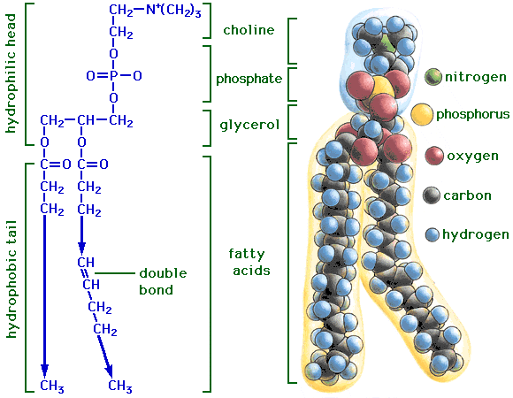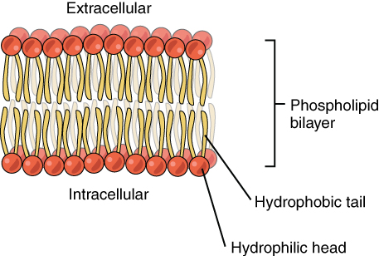
Figure 1. This figure shows phosphatidylcholine, the most abundant phospholipid in eukaryotic cell membranes. Phospholipids assemble into bilayers, shown on the right.³

Many different types of phospholipids make up a cellular membrane. This includes phosphatidylcholine (PC) (the most abundant), phosphatidylethanolamine (PE), phosphatidylserine (PS), phosphatidic acid (PA), sphingomyelin and more (Figure 2).⁴ Each phospholipid follows the general structure with varied polar head groups.
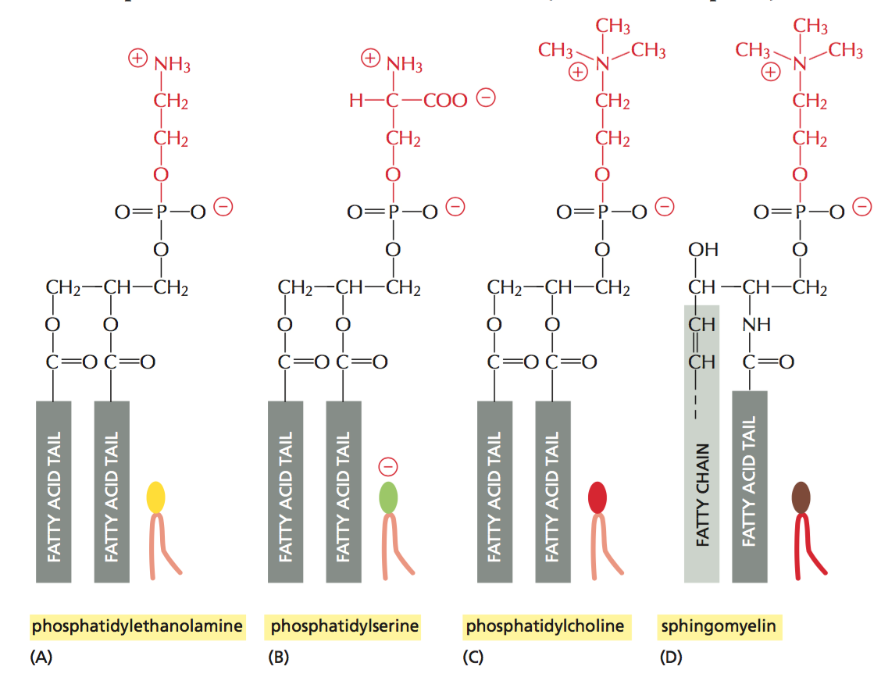
Figure 2. This figure shows the structures of the most common phospholipids.
The lipid membrane is made up of much more than only phospholipids, though. There are also different types of lipids such as cholesterol and glycerolipids, and many proteins also reside in the cell membrane (Figure 3). Many proteins traverse the entire membrane and are called integral membrane proteins.¹ Proteins that have glycan moieties are also found in all membranes, and each part of the membrane plays a role in helping the cell communicate with its surroundings.
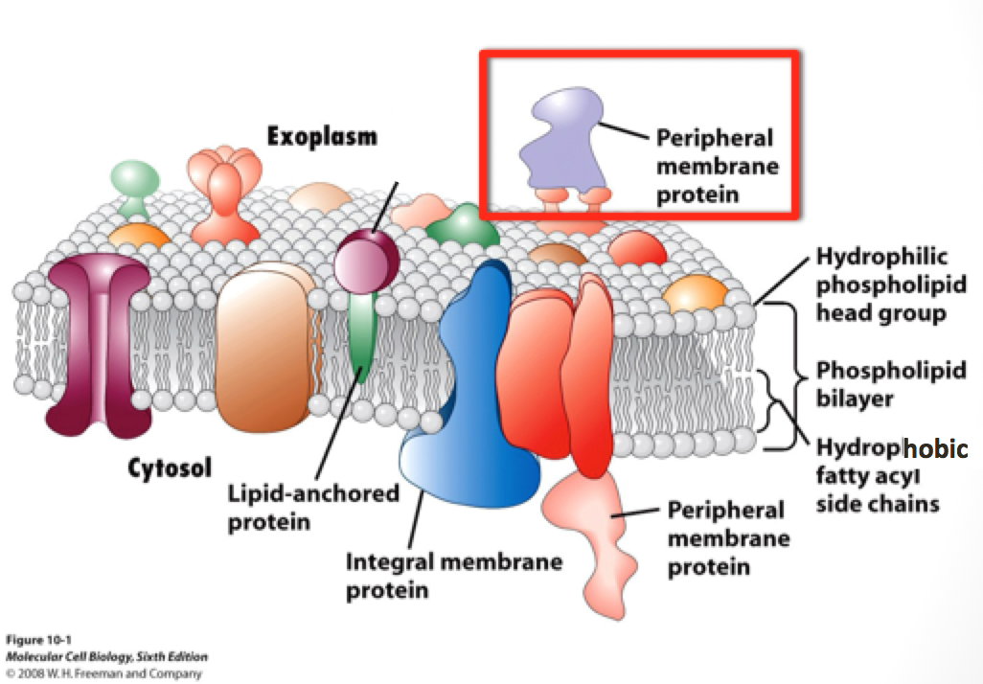
Figure 3. This figure shows the lipid membrane and the many different macromolecules that may also be found there with a specific focus on peripheral membrane proteins.

Phospholipids create a barrier between the external environment and the interior of the cell, making them and the lipid membrane important in many cellular processes such as cellular signaling, signal transduction, and membrane trafficking.^{1, 5} The binding of proteins to phospholipids or external protein receptors is often one of the first steps of internal signal cascades that are important to cell function. Proteins that form reversible binding interactions with cellular membranes are known as peripheral membrane proteins. If protein-lipid interactions are dysregulated, this can affect internal signal cascades and how healthy the cell is. By identifying peripheral membrane proteins and tracking their potential change in expression levels, researchers may be able to target them with potential therapeutic agents such as protein inhibitors. The signaling pathway in Figure 4 shows the series of events that follow the activation of a G-protein coupled receptor (GPCR), the largest family of cell-surface receptors.¹ Once the GPCR is activated, a number of other proteins are also activated, including the protein phospholipase C-β (PLCβ). PLCβ interacts with phosphatidylinositol 4,5-bisphosphate [PI(4,5)P₂], a phospholipid that includes a phosphorylated inositol group.
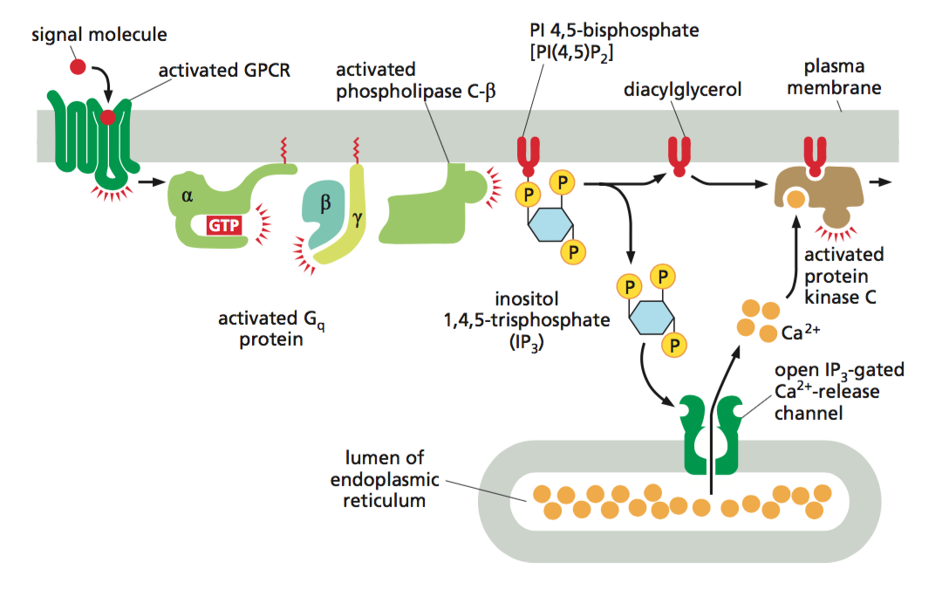
Figure 4. This figure shows the signal cascade of G-protein coupled receptors and the direct involvement of the membrane lipid diacylglycerol (DAG).¹

PLCβ is responsible for cleaving the inositol group off of the phospholipid, generating two products: inositol 1,4,5-triphosphate (IP₃) and diacylglycerol (DAG) (Figure 5).
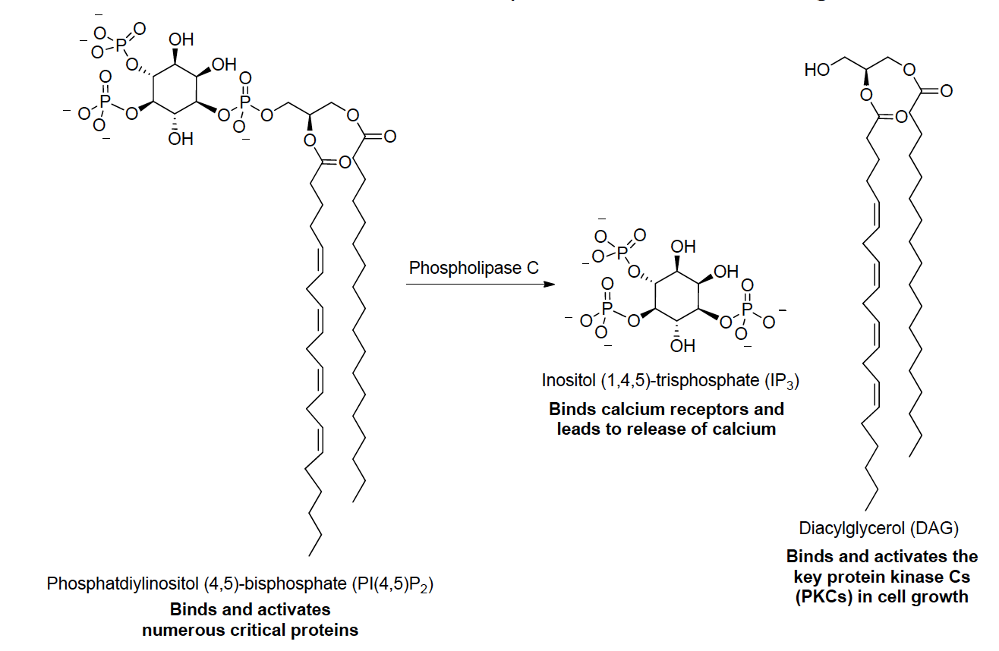
Figure 5. The chemical conversion of phosphatidylinositol (4,5)-bisphophate to inositol (1,4,5)-triphosphate and diacylglycerol.

IP₃ is then free to travel through the cytosol of the cell and activate gated calcium channels. This rise in intracellular calcium causes protein kinase C (PKC) to bind to DAG, which has remained in membrane. Once PKC is bound to DAG and a calcium ion, it can become activated leading to the initiation of other pathways, including cell growth pathways. Dysregulation may lead to, for example, the inability to deactivate a GPCR causing the cell begin uncontrollably growing and replicating leading to tumor growth.
While lipids are essential for cellular membrane structure and environment, they do not show any biochemical catalytic activity like proteins.⁶ The different types of membrane proteins and the amount of each is essential in determining what a cell’s role may be. This is why understanding membrane proteins and their roles becomes much more important. As proteins associate with the lipid membrane, these interactions bring about changes inside and outside of the cell. The SELPE protocol could allow researchers to detect differences between various cellular systems. Such knowledge of diseases or disorders may lead to breakthroughs including selectively targeting specific cellular environments or discovering new drug targets.
Many protocols have been developed to isolate peripheral membrane proteins. The cell membrane acts as a scaffold for the presentation of cell-surface ligands or other moieties that proteins interact with.⁷ Studying protein-membrane binding interactions is challenging though. Many different assays, such as isothermal titration calorimetry (ITC), membrane penetration, and surface plasmon resonance (SPR), have been tested, however high-throughput methods for larger-scale analysis in these studies would be useful.^{7, 8} One of the most common strategies involves the use of liposomes. Liposomes are vesicular structures made of phospholipids that self-assemble in aqueous solutions.⁴ They were first discovered in the 1960s and are their compositions may be varied widely. Liposomes are an ideal platform from which to develop systems that mimic cellular membrane environments.⁹
In the work described here, we explore the incorporation of probes that can capture peripheral membrane binding proteins that associate with liposomal surfaces. Previous protocols have used liposomes that contain probes to interact with peripheral membrane proteins and selectively bind to them. The bound protein is then labeled with biotin through a click chemistry reaction. These proteins can then be isolated through an affinity chromatography column and later digested for determination via spectrometry or in-gel imaging.¹⁰
Probes or liposome composition may be varied to identify proteins with particular lipid affinities. Generic or lipomimetic probes are non-specific, allowing the liposome to deduce changes in protein binding due to alterations in natural lipid content. Specific or lipospecific probes, on the other hand, have their crosslinking and clickable functionalities built into natural lipid architectures. They are useful for investigating protein interactions with the headgroup of whichever lipid the probe mimics. The three probes most used in the following investigations included a nonclickable benzophenone probe (1), a generic probe (2) with a diazirine cross-linker and twin azide tails (for click reporting), and a DAG-specific probe (3) functionalized similarly to the generic probe, as seen in Figure 6.¹¹ The probes were synthesized by Adam Carr of the Best group.

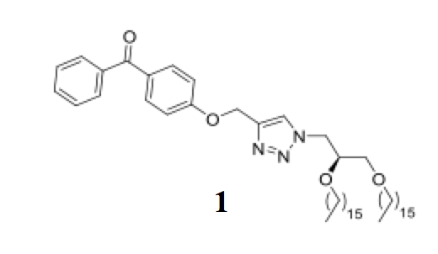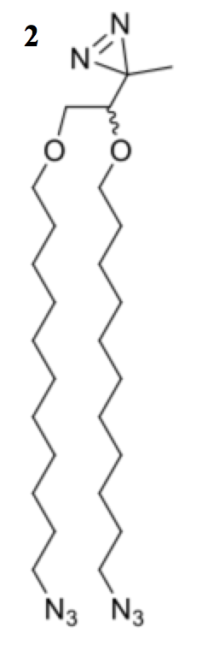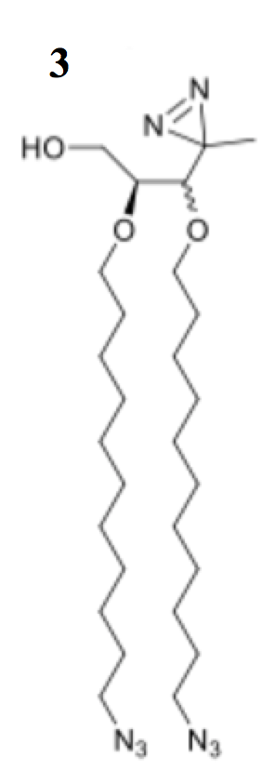

Figure 6. Compound 1 is the benzophenone (BP) probe. Compound 2 is the generic probe (Gdz). Compound 3 is the DAG-specific probe (Ddz).
To learn more about peripheral-binding proteins, liposomes containing probes were incubated with cellular extracts or lysates, which allows proteins of a particular cell line or type to bind to the liposomes. These attached proteins can then be selectively cross-linked to the probe molecule in the system via UV irradiation to trap the protein. The cross-linking mechanism of the benzophenone (1) probe utilizes the formation of a diradical, which reacts with a protein forming a covalent bond between them. The lipomimetic and lipospecific probes attach to proteins through the creation of a carbene that is formed after the release of a molecule of nitrogen gas, N₂. These mechanisms are illustrated in Figure 7.
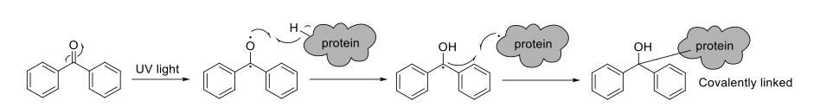(1)
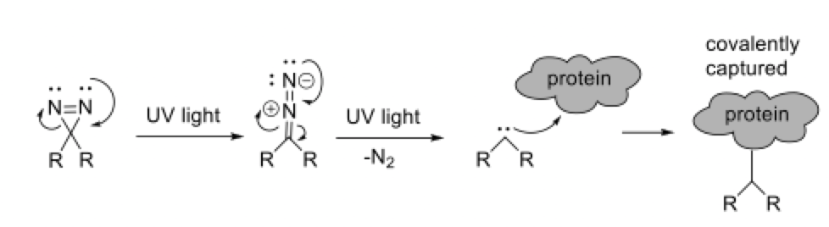(2)
Figure 7. This figure shows the two different mechanisms used by the lipid probes to covalently capture peripheral membrane proteins. Reaction (1) shows the mechanism for the benzophenone probe. Reaction (2) shows the mechanism for the lipomimetic and lipospecific probes.

The probes can also undergo a click chemistry reaction use bioorthogonal chemistry to introduce a fluorescence reporter onto labeled proteins. The hallmark of click chemistry and bioorthogonal labeling is the selective reactivity that can be achieved within the complex environment of living cells and organisms while avoiding avoiding reacting with other naturally reactive functional groups.^{10, 12} In the experiments here, a copper-catalyzed click reaction was used to link an alkyne fluorescence reporter to the azide tails that are found on the lipomimetic and lipospecific probes (Figure 8).

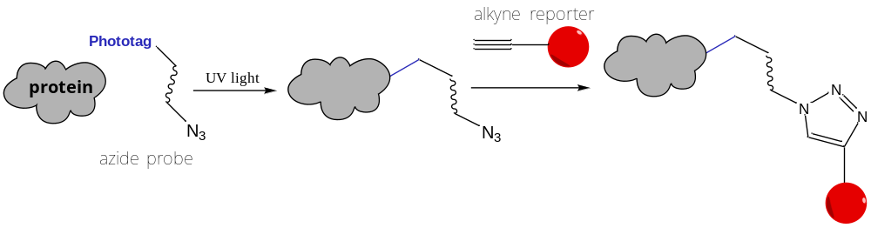
Figure 8. This figure shows how click chemistry is used to attach a fluorescence reporter (red circle) to cross-linked proteins through the formation of a heterocyclic ring from the azide tail that reacts with the alkyne functional group of the reporter.

One technique that is currently being tested is the separation of liposomes through size exclusion chromatography (SEC). Size exclusion chromatography is used to separate various macromolecules by size. SEC has been shown to successfully separate free molecules from liposome-encapsulated molecules.¹³ The idea behind SELPE is to use this principle to isolate liposomes with bound membrane proteins and expedite protein discovery processing by cutting out additional avidin purification steps, which is a more traditional protocol for protein purification and enrichment.¹¹ One problem that has been seen with liposomal SEC columns is liposome retention.^{13, 14} Through the use of fluorescent liposomes, it has been shown that liposomes may be retained between and on polymer beads of the matrix, reaching to loss of lipid material up to 40%.¹⁵ After the use of scanning electron microscopy, researchers were able to determine that aggregates of fused liposomes were retained on Sephadex beads.¹³ This problem can be eliminated by pre-saturating the column media with control liposomes.¹³ Additionally, the smallest possible column size should be used, as liposome retention is proportional to column volume. The SEC fractions collected are free of extra click reagents and, theoretically, any non-labeled proteins, which would allow the fractions to be prepared directly from the gel and tested via mass spectrometry. The protein can be identified then by subtracting background labeling (hits) of generic probe-only liposomes from protein hits. Regarding lipid-specific probes, protein hits from generic probe liposomes will be subtracted from lipid-specific probe (DAG probe) liposomes.
The SELPE project was envisaged to separate proteins that had formed bonds with liposomes and then use mass spectrometry to identify said proteins. SELPE is able to isolate protein fractions that are unique to liposomes and their composition. After various protocols were tested, the most promising results were found using the following steps.
II. Protocol Overview
Liposomes were made using the liposome ratio sheet, seen in Figure 9. Four different types of liposomes are made: control with no probe (C in column 1, Figure 9), benzophenone probe (8% BP, Figure 9), a probe with a diazirine crosslinker and twin azide tails (8 GPC = Gdz, Figure 9), and a probe with a diazirine crosslinker and a DAG headgroup (8% DdzP = Ddz, Figure 9). The solutions of the lipid mixture are then vortexed and solvent is removed using a rotary evaporator. After all visible solvent is gone, the liposomes are put under vacuum for 2-12 hours. The lipid films are then hydrated with 100 μL of 1x phosphate buffered saline (PBS). The liposomes go through two freeze-thaw cycles with an acetone-dry ice bath and a hot water bath set to 50°C.
The G-200 Sephadex beads were swelled in 1x phosphate buffered saline (PBS) and pre-saturated with a total concentration of 3 μM/L of PC-only liposomes the night before beginning the size exclusion chromatography. Twenty microliters of liposomes are incubated in 40 μL T24 cell extract and 20 μL of milliQ H₂O. The liposome samples are split between UV and non-UV 96-well plates. The plates were allowed to incubate in the dark for 20 minutes at room temperature. Following the incubation period, the plates are set on ice. The UV plate is placed on an ice pack and set in the Rayonet UV photochemical reactor and irradiated for 10 minutes at 350 nm. Following the irradiation, the click mix (see Materials and Methods) is prepared and added to each sample. This facilitates the link between the added fluorescence reporter, cy-3-alkyne, and the azide tail of the appropriate probe.
The plates are then placed in the 4°C fridge and prepared for the size exclusion chromatography. The columns used are 1 mL microcolumns. Each column is filled with 1 mL of the Sephadex beads and then rinsed with 1 mL of 1x PBS. The liposomal sample is added on top of the column and the first fraction is collected and immediately frozen on dry ice. Four fractions are collected in total by running 1x PBS through the column and each is frozen on dry ice. The fractions are then run on an SDS-PAGE gel. This separates the proteins in each fraction by size. Gel results are viewed with a fluorescence scanner and the appropriate fractions are sent for mass spectrometry.
III. Materials and Methods
Liposome preparation
The first step in liposome preparation requires the formation of lipid films. Initially, the liposomes mainly consisted of a polymerizable form of phosphatidylcholine called DAPC (1,2-bis(10,12-tricosadiynoyl)-sn-glycero-3-phosphocholine) with 5% PA, 5% DAG, and 5% cholesterol. Polymerizable PC was the polymerization of the liposomes could be used to keep liposomes in tact as they pass through SECs. The polymerization of PC under UV irradiation would have allowed cross-linked proteins to be linked to large polymer conglomerates, making them more easily isolated. Two different liposome types were made both with and without a benzophenone (1) probe. The benzophenone concentration in the liposome was 10%. The stock lipids were combined in 1-dram vials with the following concentrations: 65 mM PC, 2.6 mM PA, 2.6 mM DAG, and 15 mM cholesterol.
The liposomal make-up was varied and the most successful combination included phosphatidylcholine (PC), phosphatidylserine (PS), cholesterol and the appropriate probe. These liposomes were composed as such:
- Control: PC, PS, Cholesterol
- Benzophenone: PC, PS, Cholesterol, Benzophenone probe (1)
- General Probe: PC, PS, Cholesterol, diazirene crosslinking probe (2) with twin azide tails (Gdz)
- Diazirene Probe: PC, PS, Cholesterol, diazirine crosslinking probe (3) with DAG head group (Ddz)
To make the initial lipid films, stock solutions of each liposome (PC (12.7 mM), PS (10 mM), and cholesterol (10 mM) in chloroform (CHCl₃) were combined in the appropriate amounts according to a spreadsheet calculator in 1-dram glass vials. The calculator was used to determine the amounts of each liposomal component to be added by using stock concentrations, membrane composition by molar percentage, total desired moles of the lipid, and the final concentration of lipid molecules in solution to return the volume amount of organic lipid stock solution to be added. The volume to be added for hydration of the lipid film is also given.
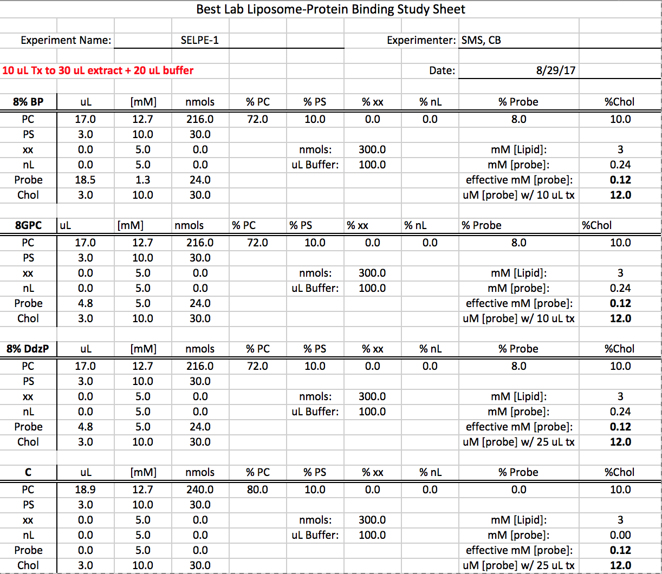
Figure 9. The liposomal calculator Excel spreadsheet used to create lipid films with the required amount of each component to be added. BP = benzophenone (1); 8GPC = general probe (2 in Figure 6); 8% DdzP = DAG specific probe (3 in Figure 6); C = control liposome (no probe); PC = phosphatidylcholine; PS = phosphatidylserine; xx = variable lipid; Probe = probe added; Chol = cholesterol

Studies can be recreated to target different proteins by varying phospholipid and probe concentrations.
The appropriate volume of each stock solution was added using pipet tips that have been approved for use with non-fluorinated organic solvents. The stock solutions were combined and mixed thoroughly. Solvents dichloromethane and chloroform were removed through rotary evaporation to maintain homogeneity in the composition of the lipid film. Samples were kept out of UV light for as much as possible to avoid premature excitation of the crosslinking species in the probes. Once any visible solvent was evaporated, the vials were put under vacuum for up to 24 hours to remove any residual solvent. The vials were then removed from vacuum and hydrated with 1x PBS. The specified value from the spreadsheet was added to the vial, which was then vortexed thoroughly.
Liposome size was modified through two procedures. The size of the liposomes was determined using a dynamic light scattering (DLS) instrument. Initially, the liposome samples underwent one freeze-thaw cycle and were then placed in a sonication bath for five minutes. DLS measurements showed that the vesicles were consistently 500 nm. The sonicator bath broke and we were unable to use it in further experiments.
Multiple freeze-thaw cycles were then performed to reduce the size of the liposomes. The samples were frozen in an acetone/dry ice bath (-78°C) in a Dewar flask and thawed in a hot water bath at 40°C. Different numbers of freeze-thaw cycles were performed, beginning with 10, which created liposomes that were 150 nm in diameter. These liposomes were found to not label well and were therefore too small for the intended purpose of the investigation. Four freeze-thaw cycles were performed with half of the samples being extruded through 800 nm pores to select for liposomes smaller than 800 nm. The other half was not extruded. Extrusion was found to make no significant difference as the liposomes were already small enough to pass through unaffected. Liposomes were between 300-500 nm were created, but could not be labeled in the click study. The most recent trial compared the effectiveness of one, two, or four freeze-thaw cycles. Two freeze-thaw cycles was determined to produce the best results with 600 nm liposomes.
Currently, two freeze-thaw cycles without extrusion and sonication are done to prepare the liposomes.
Incubation procedure
Liposomes were incubated with cell-extracts in a 96-well plate. Initially, the liposomes were incubated in both smooth muscle and endothelial cell extracts and yeast cell extracts prepared by members of the Best lab or the Barerra lab of UTK. The human cell extracts were incubated with 5 mM benzophenone or control liposomes in a 1:6 ratio by volume of liposomes to extracts. The yeast cell extracts were incubated with 1 mM benzophenone or control liposomes in a 1:2 ratio by volume of liposomes to extracts. Twenty microliters of protease inhibitor was added to each well, which held 250 μL of the liposome. The plates were placed in the dark at room temperature for 10 minutes.
A protocol later developed involved incubating the liposomes in T24 cell lysates, which were prepared from human bladder cancer tissue cultures from the Barerra research group and were used at a 2 mg/mL protein content. Each SELPE study was done alongside a negative control such that one set of liposomes received UV radiation (Set A) and the other set did not (Set B). In a 96-well plate, 20 μL of liposomes were added followed by 40 μL of the cell extract and 20 μL of PBS. The protease inhibitor was no longer included. The solution in each well was mixed vigorously to ensure homogenous solution. Both plates were covered in aluminum foil and put in the dark for one hour.
Currently, liposomes are incubated with A375 cell extracts. The A375 cell line comes from a human malignant melanoma. The liposome volume for incubation is varied between 5, 10 and 15 uL followed by 20 uL of cell extract.
Photocrosslinking
Following incubation, the plates were subjected to UV irradiation. UV irradiation is used to covalently cross-link proteins in the cell extract that associate with the probe in the liposome. In the initial protocol, the plate was irradiated under long-range UV light (365 nm) on ice for 20 minutes to allow for the cross-linking of the benzophenone with peripheral proteins. This was followed by polymerization of the liposomal bilayer on ice for seven hours.
Later, the protocol was changed so that plate A was placed on an ice pack covered in foil and irradiated under long range UV with a Rayonet photolysis reactor that has two 8 watt UV lamps for 10 minutes while plate B was kept in the 4°C refrigerator. The Rayonet was found to give better overall radiation of the samples.
Click reaction
After photocrosslinking, a click mix was added to samples that had probes [probes (2) and (3)] with azide tails that react to add a fluorescence reporter to captured proteins. The click mix included cy-3-alkyne, tris(benzyltriazolylmethyl)amine (TBTA), copper sulfate (CuSO₄), and tris(2-carboxyethyl)phosphine hydrochloride (TCEP). Cy-3-alkyne acts as the fluorescence reporter that reacts with the azide tails of the lipid probe. Copper sulfate provides the copper catalyst with TBTA acting as a ligand. Depending on the final volume of the liposome-cell extract mixture, 3-4 μL of the click mix was added to each sample. The click mix included the following reagents in the following volume ratio:
Reagent | Concentration | Mix Ratio
TBTA | 5 mM | 3
CuSO₄ | 50 mM | 1
Cy-3-alkyne | 50 mM | 1
TCEP | 1.7 mM | 1
Table 1. Click reagents concentrations and volumetric ratios.
The click mix was prepared by adding each reagent in the correct ratio. Copper sulfate and TCEP were weighed out first and hydrated with water to the appropriate concentration. The click mixture was created and then added to each sample. The samples were mixed well and placed in the dark for one hour. Afterward the samples were placed in the 4°C refrigerator until they were run on the gel.
Size-exclusion chromatography
The liposomes that had been incubated, irradiated and clicked were then analyzed using size-exclusion chromatography. A one-mL microcolumn was used. Initially, G-20 or G-50 beads were used but it was found that they were too small to successfully filter liposomes and the bound proteins. The columns were later set-up using Sephadex G-200 beads that had been swelled in 1x PBS and pre-treated with PC-only liposomes. The concentration of control liposomes was normally around 0.004mM. These control liposomes added to the Sephadex beads to prevent liposome retention were 600 nm following one freeze-thaw cycle. One milliliter of the bead-liposome mix was added to each column after each column had been prepared with cotton at the tip of the chromatography column. One milliliter of 1x PBS was then run through the column. The appropriate liposome sample incubated with cell-extract was then added to the column. This volume usually totaled 80-100 μL. Fractions were collected using the same volume of 1x PBS that had been added to the liposomes. Four to five fractions were collected, and each fraction was immediately frozen on dry ice.
Gel loading and running
The collected samples were run on an SDS-PAGE gel. First, 4x gel loading buffer was added to each sample in a 1:4 ratio by volume. The components of the 4x loading buffer included 4 mL 100% glycerol, 2.4 mL 1M Tris/HCl pH 6.8, 0.8 g SDS, 4 mg bromophenol blue, 0.5 mL β-mercaptoethanol, and 3.1 mL H₂O. The samples and gel-loading buffer were mixed and allowed to stand for 10 minutes before loading them onto the Invitrogen™ Novex™ 8-16% Tris-Glycine Midi protein gels. The gels were run at 120 mV for 120 minutes.
Fluorescent imaging and staining
The gels were imaged using the Typhoon fluorescent imager. They were then stained using Pageblue protein staining solution (Coomassie) by soaking the gels overnight and destaining them overnight in water followed by several rinses. The Coomassie staining solution labels proteins blue by binding to them in the polyacrylamide gel but does not bind to the gel itself. Coomassie staining was done as a second confirmation of the presence of protein on the gels, regardless of when fluorescence imaging was done.
IV. Data and Analysis
Initial results of SELPE were promising. Gel results have shown reasonable amounts of protein concentration in later fractions collected from SEC. When quantified, these results have shown greater protein concentrations in fractions two or three, though more trials will be run to confirm this.
Figures 10 and 11 show gel results from a recent protocol. The gels have been labeled. Samples from each fraction are loaded into a column. The labeling is seen in these images as darker, stained bands. Fractions 3 and 4 of the Gdz and Ddz UV liposomes showed the greatest protein concentrations, which can be seen in Figure 10.
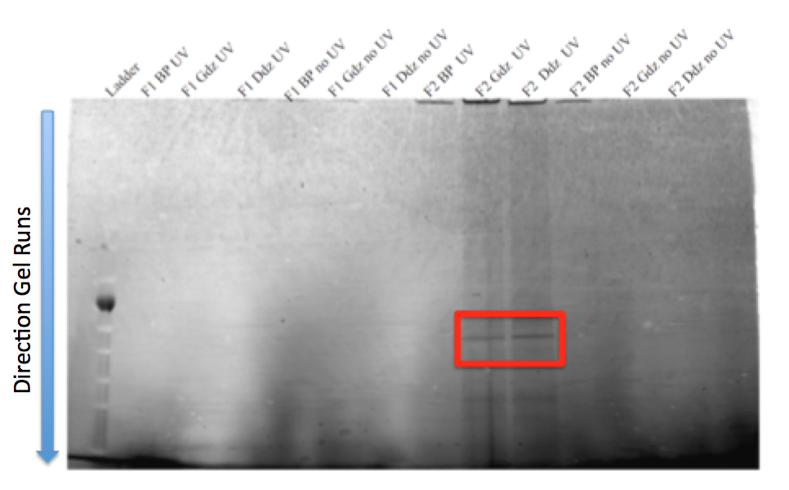
Figure 10. Preliminary gel results. This shows fractions 1 and 2 from the SEC which have much lower protein content than later fractions. From left to right: Ladder – standard protein ladder that contains protein with standard molecular weights; F1 BP UV – fraction one of SEC column that was run for a liposome with a benzophenone probe (1) and received UV irradiation; F1 Gdz UV – fraction one of SEC column that was run for a liposome with lipomimetic probe (2) and received UV irradiation; F1 Ddz UV – fraction one of SEC column that was run for a liposome with a lipospecific DAG probe (3) and received UV irradiation; F1 BP no UV – fraction one of SEC column that was run for a liposome with a benzophenone probe (1) and did not receive UV irradiation; F1 Gdz no UV – fraction one of SEC column that was run for a liposome with lipomimetic probe (2) and did not receive UV irradiation; F1 Ddz no UV – fraction one of SEC column that was run for a liposome with lipospecific DAG probe probe (3) and did not received UV irradiation. The rest of the labels follow in this fashion.

Figure 10 shows the imaged gel that had fractions 1 and 2 collected from the size exclusion column. Only two columns, F2 Gdz UV and F2 Ddz UV, show protein labeling and low amounts labeling are seen. Fraction 2 for liposomes with the lipomimetic probe (Gdz) and the DAG specific probe (Ddz) had protein labeling around 50 kilaDalton (kDa) (shown by the red box). No protein labeling was seen in Fraction 1 so it can be assumed that liposomes with bound proteins had not been eluted yet. Fractions 3 and 4 were also run on a gel and imaged. This can be seen in Figure 11.

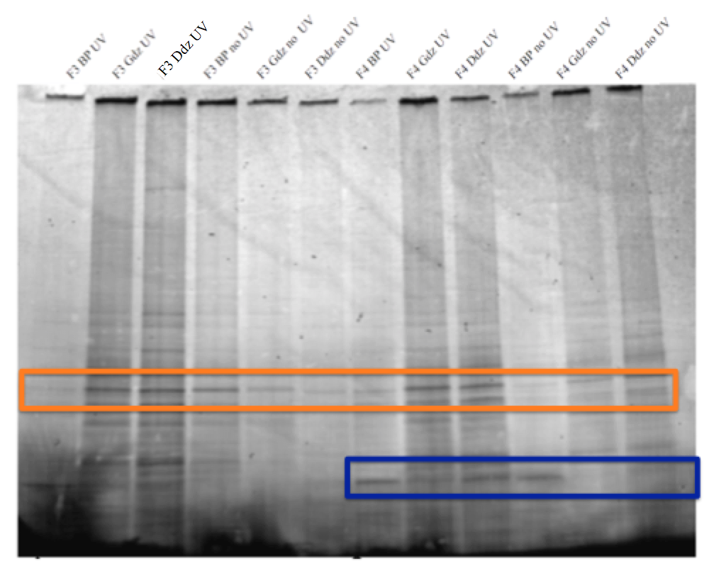
Figure 11. Representative gel results. This shows fractions 3 and 4 from the SEC.
The gel in Figure 11 shows successful protein labeling. The band that is highlighted by the orange box shows that evidence of a protein is observed in both fractions and successful labeling was seen in both UV and non-UV irradiated samples. Much better protein labeling can be seen in the samples that were irradiated, however. No-UV controls are of particular importance given that our experimental design is aimed at capturing proteins associated at the membranes periphery. Coomassie stained gels, though not shown here, were used when developing SELPE to qualify total protein content among SEC fractions.
Successful labeling can be seen in fraction 3 using the DAG specific probe in samples that received irradiation. The fraction 3 lipomimetic probe also showed successful labeling following UV irradiation. The column of fraction 4 with the DAG specific probe and irradiation also shows almost equally successful labeling. From this, it can be assumed that this protein interacts with DAG, though more work should be done to confirm this. The blue box highlights a band of proteins that can be seen in fraction 4. The best labeling was seen in the DAG specific probe again.
Initially, trials were done to test the difference between a polymerizeable phosphatidylcholine (PC) and regular PC. The polymerizeable PC was found to have lower concentrations of bound protein than regular PC so regular PC was used from then on in the trials.
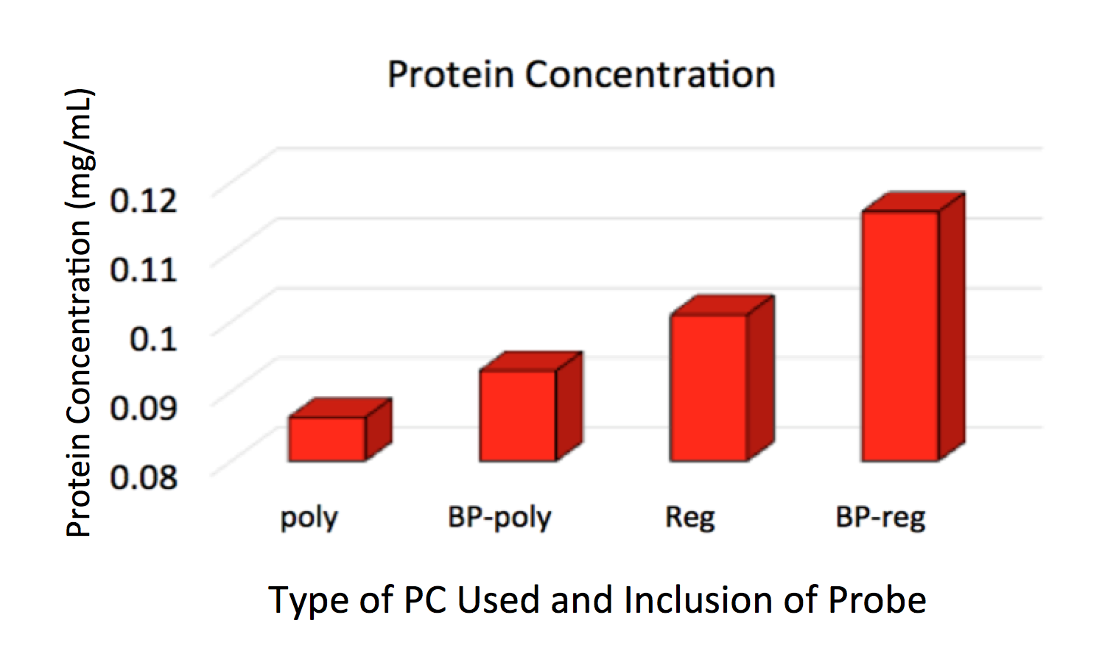
Figure 12. Protein concentration comparing liposomes made with regular PC and polymer PC. Key: poly – liposome containing only polymerizable PC; BP-poly – liposome containing polymerizable PC and a benzophenone probe; Reg – liposome containing natural PC; BP – liposome containing natural PC and a benzophenone probe.
Figure 12 shows quantitatively how liposomes with regular PC and a benzophenone probe (1) had the highest concentrations of bound protein, around 0.12 mg/mL. Liposomes that contained the polymerizable PC showed that they were unable to capture proteins as successfully as liposomes that contained natural PC. Initially, the system was envisioned to crosslink the protein while the liposomes polymerized causing the labeled proteins to be effectively huge and able to be isolated by SEC. Also, we were curious to see if polymerized liposomes showed increased integrity and therefore better protein retention after SEC enrichment. However, irradiation times required for complete polymerization are very long and potentially damaging to associated proteins. We observed decreased protein concentrations in liposomes that contained polymerizable PC as can be seen in Figure 12. The polymerizable PC liposomes that included a benzophenone probe had protein labeling at a concentration of about 0.09 mg/mL. Though the liposomes made with regular PC
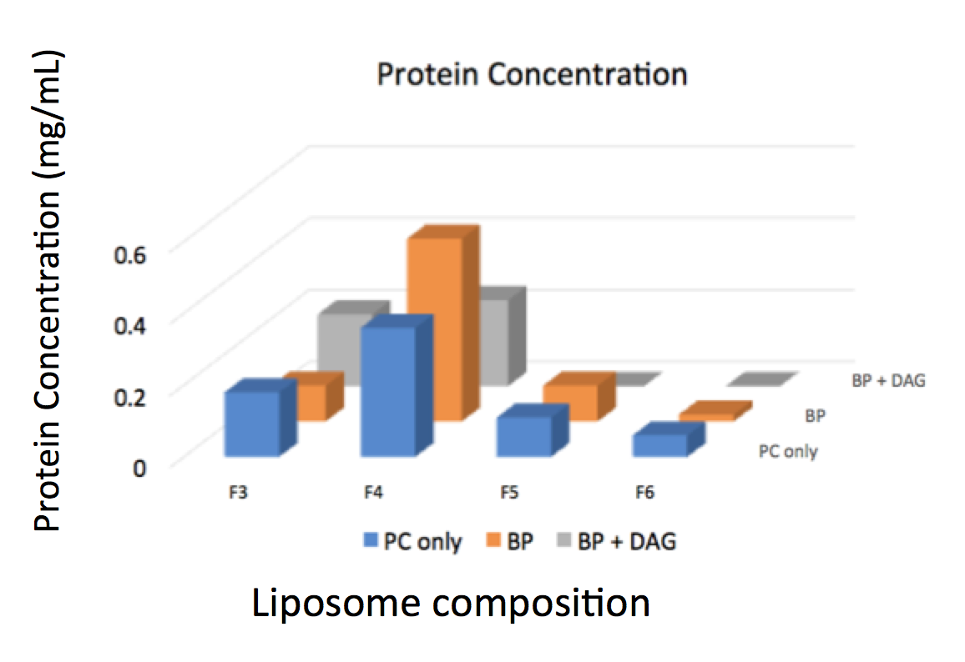
Figure 13. Protein concentration of liposomes comparing various probes.
Figure 13 shows the results of another study done where liposomes with benzophenone (1) or benzophenone plus DAG were incubated in cell extracts. The liposome with only benzophenone (1) showed the highest protein labeling, around 0.6 mg/mL in fraction 4. Fraction 4 had the highest amount of protein labeling among the four fractions shown here. The inclusion of diacylglycerol (DAG) in the protein did not attract any variable proteins that may be specific to DAG in this lipomimetic study.
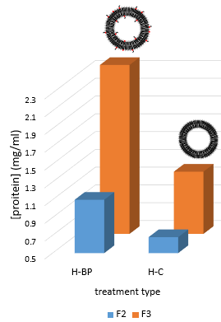
Figure 14. Shows protein concentrations of fractions 2 and 3 taken from the size exclusion column. The liposomes that contained 4% benzophenone probe (left) had a much higher protein content than liposomes with no lipid probes. (right)

In Figure 14, two fractions collected from a SEC are compared. In blue, fraction 2 shows low protein labeling even with the probe (left column). Fraction 3 shows much higher protein concentrations than fraction 2. The protein concentration of liposomes with a benzophenone probe (1) showed much high labeling than liposomes that included no probe. This provides a positive control that probes are useful in capturing larger amounts of protein than liposomes themselves.
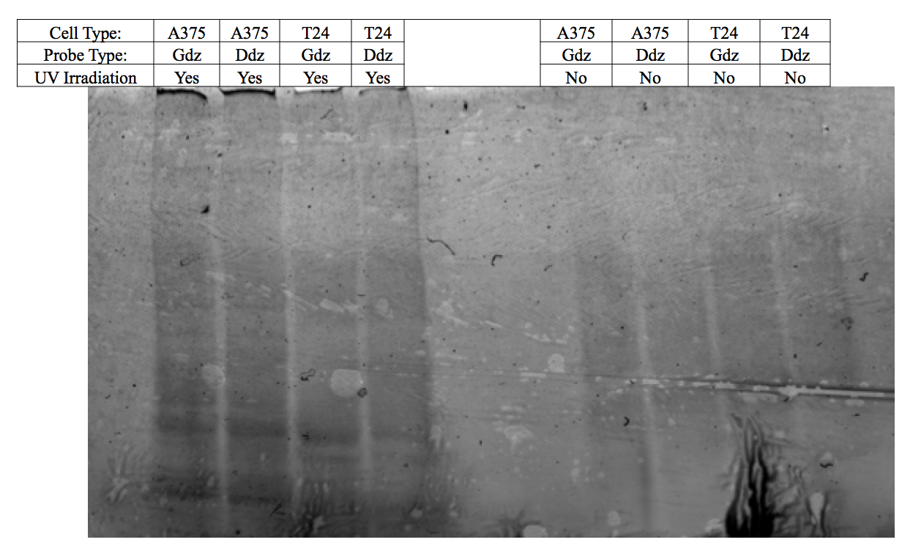
Figure 15. Fluorescence image of a study done that excludes the SEC. Successful protein labeling was seen in samples that received UV irradiation.
Recent studies have tested the effectiveness of the protocol following the removal of the size exclusion column. The gel image from the Typhoon fluorescence scanner in Figure 15 shows successful fluorescence labeling of proteins. This means the click reaction was successful in labeling proteins that had been capturing during the photocrosslinking step. The inclusion of the click reaction provides evidence as to whether cross-linking was successful because the azide involved in the click reaction is found on the tail of the probe. The headgroup of the probe is what covalently captures peripheral proteins. With a successful SELPE protocol, the samples will not require an additional click reaction step to confirm protein crosslinking.
V. Conclusions and Future Work
Investigations into SELPE protocols have shown promising initial results. The utilization of a size exclusion column allows for the successful separation of liposomes that have captured proteins from liposomes with no bound protein. Proteins of different sizes can also be separated out into different fractions following the size exclusion column. This leads to greater enrichment of the proteins. Liposomes containing probes that can be bioorthogonally labeled using an azide tail that is linked to a fluorescent alkyne reporter also show success in capturing proteins. The benzophenone probe has had the best results for capturing the largest concentrations of proteins. The protocol will continue to be optimized to hopefully create another successful and reproducible technique for identifying peripheral membrane binding proteins. Recent protocols have also shown success when the size exclusion column was removed. Protein labeling was still seen even without the separation into fractions.
One of the most important protocol changes for SELPE involved the addition of liposomes that contained no probes to the size exclusion matrix. Initial results showed low amounts of labeling, most likely due to the retention of liposomes in the matrix. With the incubation of uniform (PC only) liposomes in the column media during SEC bead swelling, protein labeling showed increases and better results.
In previous work done by the Best group, the diazirine cross-linking probe showed considerably less background and more sensitivity to changes in liposomal environment, as compared to the benzophenone probe. Probe architectures with benzophenones generally produced higher amounts of background labeling, making them insensitive to alterations in liposome composition.
Future work based on this protocol involves the identification of peripheral membrane proteins through methods such as mass spectrometry or MALDI-TOF spectrometry. This could allow for more specific treatments in various diseases or disorder where the healthy cellular composition is no longer seen and the problem can be more directly targeted. If successful, SELPE may also eventually be applied to other signaling lipids and the binding of other compounds, such as carbohydrates.

References
1. Alberts B, J. A., Lewis J, et al. Molecular Biology of the Cell. In 4th ed.; Garland Science: New York, 2002.
2. Lis, L. J.; McAlister, M.; Fuller, N.; Rand, R. P.; Parsegian, V. A. Interactions between neutral phospholipid bilayer membranes. Biophysical Journal 1982, 37, 657-665.
3. OpenStax, Anatomy & Physiology. OpenStax CNX. Apr 9, 2018 http://cnx.org/contents/14fb4ad7-39a1-4eee-ab6e-3ef2482e3e22@9.1. In.
4. Monteiro, N.; Martins, A.; Reis, R. L.; Neves, N. M. Liposomes in tissue engineering and regenerative medicine. Journal of the Royal Society Interface 2014, 11, 20140459.
5. Dowhan, W. The role of phospholipids in cell function. In Advances in Lipobiology, Gross, R. W., Ed. JAI: 1997; Vol. 2, pp 79-107.
6. Stillwell, W. Chapter 6 - Membrane Proteins. In An Introduction to Biological Membranes (Second Edition), Elsevier: 2016; pp 89-110.
7. Losey, E. A.; Smith, M. D.; Meng, M.; Best, M. D. Microplate-Based Analysis of Protein−Membrane Binding Interactions via Immobilization of Whole Liposomes Containing a Biotinylated Anchor. Bioconjugate Chemistry 2009, 20, 376-383.
8. Cho, W.; Bittova, L.; Stahelin, R. V. Membrane Binding Assays for Peripheral Proteins. Analytical Biochemistry 2001, 296, 153-161.
9. Bangham, A. D.; Standish, M. M.; Watkins, J. C. Diffusion of univalent ions across the lamellae of swollen phospholipids. Journal of Molecular Biology 1965, 13, 238-IN27.
10. Best, M. D.; Rowland, M. M.; Bostic, H. E. Exploiting Bioorthogonal Chemistry to Elucidate Protein–Lipid Binding Interactions and Other Biological Roles of Phospholipids. Accounts of Chemical Research 2011, 44, 686-698.
11. Mattern-Shain, S. Liposomal discovery of diacylglycerol (DAG)-binding proteins and the use of signaling lipids to improve nanodrug delivery. University of Tennesee, Knoxville, 2017.
12. Sletten, E. M.; Bertozzi, C. R. Bioorthogonal Chemistry: Fishing for Selectivity in a Sea of Functionality. Angewandte Chemie International Edition 2009, 48, 6974-6998.
13. Ruysschaert, T.; Marque, A.; Duteyrat, J.-L.; Lesieur, S.; Winterhalter, M.; Fournier, D. Liposome retention in size exclusion chromatography. BMC Biotechnology 2005, 5, 11.
14. van Renswoude, A. J. B. M.; Blumenthal, R.; Weinstein, J. N. Thin-layer chromatography with agarose gels: A quick, simple method for evaluating liposome size. Biochimica et Biophysica Acta (BBA) - Biomembranes 1980, 595, 151-156.
15. Schurtenberger, P.; Hauser, H. Characterization of the size distribution of unilamellar vesicles by gel filtration, quasi-elastic light scattering and electron microscopy. Biochimica et Biophysica Acta (BBA) - Biomembranes 1984, 778, 470-480.

