"AI-Enhanced ERP Systems: An Investigation into the Impact on Organizational Processes and Employee Behavior in Large Enterprises"

A Dissertation Presented for the
Doctor of Philosophy
Degree
The University of Tennessee, Knoxville

Habibi Mamone
May 2025

Copyright © 2025 by Habibi Mamone.
All rights reserved.

ACKNOWLEDGEMENTS
I would like to express my heartfelt gratitude to those who have supported me throughout my PhD journey. First and foremost, I extend my deepest thanks to my dissertation chair, Dr. Suzanne Allard, for her invaluable guidance and unwavering support. I am also grateful to my committee members: Dr. Abeba Rorissa, Dr. Wade Bishop, and Dr. Harry Dahms. Your insights and encouragement have been instrumental in shaping my research and academic growth.
I would like to acknowledge the individuals I interviewed who generously shared their expertise and perspectives: Richard Linder, Tommy Shephard, Mark Frissora, Lewis Campbell and Senator Joe Manchin and his staff. Your contributions have significantly enriched my research.
A special thank you goes to my husband, Tony Mamone, whose patience and understanding have made this journey possible. Thank you for enduring the countless days, hours, and minutes I dedicated to my research.
A thank you to my daughters Krystal and Bianca who have been both supportive and encouraging throughout this process.
Lastly, I want to acknowledge the companionship of my dogs, Noey and Vida, who sat by me day and night, providing comfort during long hours of study. Your presence has brought joy and warmth to this demanding process.
Thank you all for being part of this significant chapter in my life.

ABSTRACT
This dissertation examines the integration of artificial intelligence (AI) within enterprise resource planning (ERP) systems, addressing key challenges in adoption and optimization to enhance operational efficiency, decision making, and competitive advantage in large-scale enterprises. By exploring AI-driven improvements in knowledge management, business process re-engineering, and organizational alignment, this study highlights AI’s role in transforming ERP systems into more adaptive, user-centric, and strategically valuable tools.
Using a mixed-methods approach, the research combines qualitative insights from interviews with business executives experienced in AI-ERP implementations, and quantitative data from employee surveys. This dual approach provides a comprehensive understanding of organizational processes, employee perceptions, and behavioral dynamics throughout the visioning, planning, and implementation stages of AI-integrated ERP systems.
Findings indicate that AI enhances ERP efficiency by automating tasks, optimizing workflows, and leveraging advanced analytics for predictive decision-making. Additionally, AI-driven ERP systems enable personalized user experiences, improve supply chain management, facilitate natural language interactions, ensure continuous system adaptation, and enhance security. A key insight underscores the critical role of communication and stakeholder engagement in fostering a supportive environment for successful technological change.
These results suggest that while AI integration significantly optimizes ERP functionality, its success depends on strategic change management and a strong organizational culture to ensure user acceptance. The research emphasizes the importance of comprehensive communication strategies and employee involvement throughout the AI-ERP implementation process, offering insights to drive innovation and long-term business success.
Keywords: Enterprise Resource Planning (ERP), Artificial Intelligence (AI), Business Process Reengineering (BPR), Supply Chain Management, Organizational Culture, Implementation Strategies, Change Management.

TABLE OF CONTENTS
Chapter 1: Introduction and General Information 1
Chapter 2: Literature Review 11
Chapter 3: Methods 76
Chapter 4: Results and Discussion 106
Chapter 5: Conclusions, Findings and Recommendations 138
References 164
Appendices 176
Vita 186

LIST OF TABLES
Table 1. Pilot Information: Interview and Survey Questions from IRB: UTK IRB-23-07929-XM and UTK IRB-23-07808-XM. 122
Table 2. Research Dissertation Information: Interview Questions from IRB: UTK IRB-23-07929-XM and UTK IRB-23-07808-XM. 125
Table 3. Representation of the KPIs for measuring AI implementation in ERP systems. 153
Table 4. Summary table covering key aspects of the findings, recommendations, theoretical frameworks, and limitations. 162

LIST OF FIGURES
Figure 1: Thematic Analysis and Coding Process. 88
Figure 2: questions contained in the survey for both the pilot and dissertation research. 96
Figure 3: questions contained in the survey for both the pilot and dissertation research. 97
Figure 4: questions contained in the survey for both the pilot and dissertation research. 98
Figure 5: questions contained in the survey for both the pilot and dissertation research. 98
Figure 6: questions contained in the survey for both the pilot and dissertation research. 99
Figure 7: statements contained in the survey for both the pilot and dissertation research. 99
Figure 8: results from feedback from the business leaders. 120
Figure 9. A summary of the descriptive statistics for the Awareness component. 128
Figure 10. A summary of the descriptive statistics for the Desire component. 130
Figure 11. A summary of the descriptive statistics for the Knowledge component. 132
Figure 12. A summary of the descriptive statistics for the Ability component. 133
Figure 13. A summary of the descriptive statistics for the Reinforcement component. 135
Figure 14. A summary of overall ADKAR. 137
Figure 15. key insights from the interviews on ERP implementation and AI integration……...148
Figure 16. The key themes—Challenges, AI Integration, and Success Factors—along with their associated codes. 148
Figure 17. AI-ERP Integration: Vision, Planning, and Implementation. 163

Chapter 1: Introduction and General Information
All businesses face ubiquitous challenges arising from the complexity and uncertainty of economic competition. Technology has long played a role in providing opportunities for gaining competitive advantages and increasing efficiency. Enterprise resource planning (ERP) systems are comprehensive software platforms designed to integrate and manage all of the major functions of a business. They serve as the backbone of a company's operations, centralizing data and processes across various departments to facilitate streamlined, efficient, and informed decision making. For companies of all sizes, ERP systems play a crucial role in daily operations, strategic planning, and long-term growth (Bradley, 2024).
ERP is the integrated management of main business processes, often in real time and mediated by software and technology (Wikipedia). Business process reengineering (BPR) is typically defined as a strategic management approach that involves the radical redesign of core business processes to achieve dramatic improvements in productivity, cycle times, quality, and customer satisfaction (Martin & Cheung, 2005). Supply chain management involves all activities and processes, including planning, coordination, operation, control, and optimization of the whole supply chain system (Li, 2011).
Key performance indicators (KPIs) are widely used across organizations to quantify and track progress toward meeting goals. Effective and creative approaches to measuring and managing performance are crucial for all organizations, regardless of their scale or sector. The process of evaluating and overseeing performance at various levels—individual, team, or departmental—helps leadership align their strategic objectives by providing insights into employee and organizational effectiveness. This approach also enables the identification of areas that require attention, correction, and enhancement (Camilleri, 2024).
Business performance is not solely driven by quantifiable metrics like financial outcomes or operational efficiency; subjective human factors, such as organizational culture, play a pivotal role in shaping how employees behave and interact within the workplace. The concept of organizational culture highlights how the attitudes, values, and shared norms of an organization's members significantly influence its overall functioning and success (Vveinhardt, 2018). The concept of organizational culture reveals that the behavior of people in organizations is highly influenced by the established attitudes and values of their members, and objective characteristics of organizational culture (Vveinhardt, 2018). Business enterprise is the activity of providing goods and services involving financial and commercial and industrial aspects (Vocabulary.com, n.d.).
AI in ERP systems is the integration of machine capabilities that perform tasks typically requiring human intelligence, such as learning, reasoning, and decision-making, to enhance the functionality and efficiency of ERP software. AI in ERP systems automates workflows and functions based on data, improving productivity, accuracy, and decision making through predictive analysis and automation of routine tasks. This integration helps businesses manage complex operations, reduce labor costs, and provide in-depth insights for strategic decision making (Kunduru, 2023). AI technologies such as Machine learning (ML) involves training computers to learn and improve autonomously over time by processing data and real-world interactions (Emerj Artificial Intelligence Research, 2020). Natural language processing (NLP) is a field within AI and computer science that focuses on enabling computers to understand and communicate using human language through machine learning techniques (IBM, 2021). Generative AI uses artificial intelligence systems to create original content like text, images, or videos in response to user prompts (Scribbr, 2024). Machine learning (ML), natural language processing (NLP), and generative AI (AI) are used in ERP Systems, which collectively contribute to more intelligent and adaptive ERP solutions that can manage dynamic business needs and improve overall operational efficiency. Artificial intelligence data poisoning may involve incorporating deceptive, erroneous, or antagonistic information into the AI's learning process. The intention is to subtly or explicitly compromise the model's precision and dependability (Eddy, 2024).
Integrating AI into ERP systems enhances knowledge management, streamlines business process re-engineering, and aligns with corporate culture. This integration is revolutionizing how businesses operate and make decisions. AI-driven ERP systems dramatically improve operational efficiency and decision-making processes (Godbole, 2023). By automating processes, optimizing workflows, and providing advanced data analytics, these systems enable businesses to make more informed decisions and leverage predictive capabilities. This results in smoother operations and more strategic business choices. Incorporating AI into ERP systems also offers businesses a strategic advantage and fosters innovation. These advanced systems provide competitive edges through personalized user experiences, enhanced supply chain management, natural language interactions, and continuous system adaptation. These benefits allow businesses to stay ahead in an increasingly competitive marketplace.
These are examples of areas where AI can be adopted in the ERP processes:
Automation:
- AI can enhance ERP systems by automating complex, repetitive tasks.
- Machine learning algorithms identify patterns and improve processes over time.
- Automation reduces human error and increases efficiency in various business processes.

Predictive Modeling:
- AI-powered ERP systems rapidly analyze historical data to forecast future trends.
- AI-enhanced predictive analytics improve demand forecasting, inventory management, and resource allocation.
- This improved capability enables proactive decision-making and risk mitigation.
AI-powered ERP systems leverage predictive modeling to transform how businesses anticipate and respond to future trends. By rapidly analyzing historical data, these systems provide accurate forecasts that enhance critical functions such as demand planning, inventory management, and resource allocation. This advanced capability not only improves operational efficiency but also empowers organizations to make proactive decisions, mitigate risks, and adapt to changing market conditions with greater agility. As a result, predictive modeling becomes a key driver of strategic decision-making in modern business environments.
Data Analytics:
- AI processes and analyzes large volumes of data with unprecedented speed compared to traditional methods.
- Advanced analytics reveal hidden insights and intricate patterns within business data.
- Real-time analytics enable more precise and timely decision making for organizations.
AI-driven data analytics revolutionize how organizations process and interpret large volumes of information by uncovering hidden insights, identifying complex patterns, and enabling real-time, data-informed decision-making with unmatched speed and precision.
Alignment with Company Culture:
- AI tailors ERP interfaces and workflows to align precisely with company-specific processes.
- AI facilitates personalized user experiences that enhance employee engagement and satisfaction.
- AI-driven insights enable leadership to understand and adapt better to organizational needs.
Reducing Resistance to and Increasing Adoption of Technologies:
- AI delivers intuitive, user-friendly interfaces that simplify complex ERP functions.
- Intelligent chatbots and virtual assistants enable real-time support for users.
- AI-powered training modules generate personalized learning experiences for employees.
Business leaders are using AI driven integration in ERP systems for knowledge management, finance, supply chain management, customer relationship management (CRM), human resource management (HRM), operations and manufacturing, sales and marketing, project management and data services.
Knowledge Management
- AI enhances the management of both structured and unstructured knowledge, automating workflows, improving search capabilities, and uncovering insights to drive strategic decisions.
Finance
- ERP systems integrated with AI optimize financial processes such as accounts payable/receivable, reconciliations, financial reporting, and forecasting.
Supply Chain Management
- AI supports supply chain planning, inventory management, supplier scheduling, and logistics, ensuring smooth operations and reducing costs.

Customer Relationship Management (CRM)
- AI-powered ERP improves customer interactions by tracking communications, managing leads, and enhancing customer service through predictive analytics and automation.
Human Resource Management (HRM)
- AI streamlines HR processes such as employee records management, workforce trend analysis, and performance tracking.
Operations and Manufacturing
- AI integration enables better resource planning, production scheduling, and quality control in manufacturing processes.
Sales and Marketing
- Systems with AI analyze sales trends, automate marketing campaigns, and provide insights into targeted strategies.
Project Management
- AI enhances project planning, resource allocation, cost management, and performance tracking within ERP systems.
Data Services
- Self-service portals powered by AI improve accessibility for employees, suppliers, or customers by providing real-time insights and automating routine queries.
This study investigates how attitudes and behaviors within large-scale organizations influence the transformation of ERP systems through AI integration, resulting in more powerful, user-friendly, and adaptive tools aligned with organizational needs. Vision, planning, and implementation are key stages in integrating AI into ERP systems. Here are their definitions for the purposes of this study:
Vision
Vision refers to the conceptual stage where organizations identify the potential benefits and opportunities of integrating AI into their ERP systems. Vision involves understanding how AI can enhance knowledge management, improve business processes, and align with organizational culture. This stage focuses on setting goals and objectives for AI integration, such as improving data analytics, automating complex tasks, and enhancing decision-making capabilities.
Planning
Planning is the strategic phase where organizations develop a detailed roadmap for integrating AI into their ERP systems. This stage involves assessing current ERP systems and identifying areas for AI enhancement. Specific focal areas in the planning stage might include:
- Designing AI-powered solutions for specific business processes.
- Developing strategies for data management and analytics.
- Creating timelines and allocating resources for implementation.
- Addressing potential challenges and risks associated with AI integration.
- Re-engineering current business processes
Implementation
Implementation is the execution phase where organizations actively integrate AI technologies into their ERP systems.
This stage involves:
- Deploying AI-powered modules and features within the ERP system.
- Training employees in new AI-enhanced functionalities.
- Monitoring and optimizing AI performance.
- Addressing technical issues and user feedback.
- Ensuring alignment with organizational culture and processes.
The interviews and survey questions employed by this study assess employees' attitudes, behaviors, and practices across these stages, focusing on awareness, desire, knowledge, ability, and reinforcement aspects of the change management process related to AI integration in ERP systems.
This study delves into the multifaceted landscape of AI integration within ERP systems in large-scale enterprises. The research explores the attitudes, behaviors, and practices of both organizations and their employees as they navigate the implementation of artificial intelligence in ERP systems. By examining these aspects, the study uncovers insights into how companies perceive and approach AI integration, the specific attitudes held by employees towards this technological shift, and the concrete behaviors and practices exhibited during the implementation process. This comprehensive investigation sheds light on the challenges, opportunities, and strategies employed by large-scale enterprises as they adapt to and leverage AI-enhanced ERP systems, providing valuable insights for both academic understanding and practical application in the rapidly evolving field of enterprise technology.
Research Problem
The integration of AI into ERP systems holds considerable promise for enhancing organizational efficiency and strategic decision-making. However, successful implementation requires a deep understanding of how organizations and their employees adapt to these technological changes. A crucial gap exists in current research regarding the human and organizational factors influencing AI-ERP adoption. Therefore, the central problem this research addresses is: What are the attitudes, behaviors, and practices of organizations and their workforce during the process of implementing AI in ERP systems?
This study explores this central question across the visioning, planning, and implementation stages of AI-ERP integration. It examines how organizational leadership envisions and plans for AI integration, how employees perceive and respond to these changes, and what insights about practices emerge during implementation that either facilitate or hinder the process. By investigating both the strategic organizational perspective and the lived experiences of personnel involved with successful AI-ERP adoption, the study identifies strategies for overcoming potential challenges.
Significance
This research addresses a significant gap in the understanding of intelligent ERP systems by focusing on the human and organizational dimensions of AI integration. While the technical aspects of AI-ERP systems have received attention, the attitudes, behaviors, and practices of organizations and their workforce during implementation remain underexplored. This research is significant because it directly investigates these factors, providing valuable insights for both academics and practitioners. The findings of this study offer practical guidance for organizations seeking to implement AI in their ERP systems. By identifying the attitudes and behaviors that promote successful adoption, organizations can develop targeted management strategies, improve communication, and foster a culture of acceptance and innovation.
Furthermore, this research contributes to the academic literature on ERP systems, organizational behavior, and technology adoption by providing empirical evidence of the complex interplay between AI, organizational processes, and employee attitudes. As AI becomes increasingly prevalent in ERP systems, this research will serve as a valuable resource for organizations and researchers seeking to understand and navigate the challenges and opportunities of this technological transformation.

Chapter 2: Literature Review
This chapter presents a literature review, employing a structured approach to analyze and synthesize existing research. The subject headings serve as a framework to organize the diverse bodies of knowledge that inform this research. The "Theoretical Framework: Vision" section forms the foundation of this analysis, incorporating key theories such as Rogers' Diffusion of Innovation, Kuhlthau's Information Search Process Model, and Schumpeter's concept of creative destruction. These theories provide a lens through which to examine the complexities of AI-ERP integration. "Business ERP: Implementation" focuses on critical success factors and challenges in ERP deployment, while the "Education: Vision" content explores the role of training and knowledge management. The "Sociological: Vision" heading brings together cogent literature on organizational culture and change management aspects. "Review of Related Studies: Planning" synthesizes findings from various sources to provide a comprehensive overview of AI-ERP planning strategies. Finally, "Economics: Planning" delves into the economic implications of AI-ERP adoption, drawing on theories like Schumpeter's to analyze industry restructuring and competitive dynamics.
This structured approach allows for a thorough examination of AI-ERP integration from multiple perspectives, addressing key gaps in current research. This research explores the integration of AI in ERP systems within large-scale enterprises, focusing on attitudes, behaviors, and practices across the vision, planning, and implementation stages. In the visioning phase, the study examines how organizations conceptualize AI's potential benefits in ERP, including improved data analytics, automation, and decision-making capabilities. During planning, the research investigates how companies develop strategies for AI integration, including assessing current systems, designing AI-powered solutions, and addressing potential challenges. In the implementation stage, the study analyzes the execution of AI integration, including employee training, system deployment, and alignment with organizational culture. By examining these distinct stages, the research provides a comprehensive understanding of how attitudes, behaviors, and practices evolve throughout the AI-ERP integration process, offering insights for both academic understanding and practical application in enterprise technology.
Theoretical Framework: Vision
The integration of Enterprise Resource Planning (ERP) systems and Artificial Intelligence (AI) can be understood through multiple theoretical lenses. Rogers' Diffusion of Innovation Theory provides insight into how organizations adopt and implement new technologies (in this case, ERP systems), emphasizing key adoption factors, including relative advantage and compatibility, which will be discussed further below (Rogers, 2010). Building on this esteemed foundation, recent research has explored the economic implications of AI integration in enterprise systems. Notably, Acemoglu and Restrepo (2020) propose that, while automation can displace workers, it simultaneously creates new labor-intensive tasks—a phenomenon termed the "reinstatement effect." Their research suggests that balanced technological advancement, rather than excessive focus on automation, is crucial for sustainable economic growth and labor market stability. This balanced approach is particularly important given concerns about automation's potential contribution to wage inequality and the declining share of labor in national income (Acemoglu & Restrepo, 2020).
As we move through 2025 and beyond, the integration of AI in ERP systems is expected to become even more sophisticated. Predictive analytics, machine learning, and natural language processing will continue to evolve, offering businesses unprecedented capabilities in forecasting, process optimization, and personalized customer experiences. However, as these technologies advance, it will be crucial for organizations to balance the benefits of AI-enhanced ERP systems with ethical considerations and potential societal impacts.
AI algorithms integrated into ERP systems can analyze vast amounts of historical and real-time data to identify patterns and trends. This capability enables businesses to make more informed decisions and anticipate future market dynamics. Predictive analytics is valuable in inventory management, demand forecasting, and risk assessment (Kunduru, 2023).
This study emphasizes how AI enhances sales automation within ERP systems. By leveraging narrow AI algorithms, businesses can analyze market trends, consumer behavior, and pricing dynamics more effectively. This leads to more accurate sales forecasts, identification of potential sales opportunities, and optimization of pricing strategies, ultimately maximizing return on investment (Kunduru, 2023).
This ties into Diffusion of Innovation (DOI) theory because ERP systems represent a major technological innovation. According to DOI, the adoption of innovations depends on factors such as complexity, compatibility, and relative advantage. The challenges mentioned—managing tacit knowledge and integrating process-based knowledge—directly relate to these factors, as they influence how easily ERP systems can be adopted and integrated into existing organizational structures. By addressing these challenges, organizations can improve the diffusion process, ensuring that ERP systems are not only implemented but also effectively utilized to enhance performance and resilience (Rogers, 2010).
Everett Rogers' Diffusion of Innovations theory, first published in 1962, is a seminal work that explains how, why, and at what rate new ideas and technologies spread through societies and cultures. The theory has been widely applied across various disciplines, including sociology, communications, marketing, and public health (Rogers, 1962).
At its core, Rogers defines diffusion as the process by which an innovation is communicated through certain channels over time among the members of a social system. The theory posits that adopting new ideas or technologies is not instantaneous but rather occurs through a series of stages and is influenced by various factors. Rogers identifies five main elements that influence the spread of a new idea: the innovation itself, adopters, communication channels, time, and a social system. The adoption process occurs through a five-step decision-making process: knowledge, persuasion, decision, implementation, and confirmation. One of the key contributions of Rogers' theory is the categorization of adopters based on their inclination towards innovativeness.
He proposes five adopter categories: innovators, early adopters, early majority, late majority, and laggards. Each category has distinct characteristics and plays a different role in the diffusion process. The first group to adopt an innovation is known as Innovators, comprising 2.5% of the population. These individuals are adventurous, open to taking risks, and eager to explore new ideas and technologies. Innovators are often well-educated, have access to financial resources, and maintain close connections with scientific or technical communities. Their willingness to embrace uncertainty and experiment with unproven innovations makes them essential for initiating the diffusion process (Rogers, 1962).
Following the innovators are the Early Adopters, who represent 13.5% of the population. Early adopters are influential opinion leaders within their social networks and are often respected for their insight and forward-thinking attitudes. They adopt innovations early but after careful consideration, serving as role models for others. By sharing their experiences and evaluations, early adopters help reduce uncertainty about innovation, encouraging others to follow suit (Rogers, 1962).
The Early Majority makes up 34% of the population and adopts innovations after a longer deliberation period compared to innovators and early adopters. Members of this group are pragmatic and cautious, preferring to see evidence of an innovation’s success before committing. They rely on recommendations from trusted peers who have already adopted the innovation. While not leaders themselves, the early majority plays a critical role in driving an innovation toward widespread acceptance (Rogers, 1962).
Similarly sized at 34%, the Late Majority adopts innovations later than the average participant in a social system. This group is more skeptical of change and requires significant reassurance or peer pressure before adopting an innovation. Late majority members often face financial or social constraints that make them hesitant to take risks. They typically adopt only after the innovation has become widely accepted and proven successful by others (Rogers, 1962).
Finally, Laggards represent the last 16% of adopters. These individuals are highly resistant to change and tend to prioritize tradition over innovation. Laggards often lack exposure to broader social networks and rely heavily on close family or friends for information rather than external influences. They adopt innovations only when they become absolutely necessary—such as when traditional alternatives are no longer available—making them the slowest group to embrace new ideas (Rogers, 1962).
These five adopter categories describe how different groups within a population respond to innovations over time, illustrating the gradual process by which new ideas spread through society. For example, innovators are the most venturesome and willing to take risks, while laggards are more conservative and skeptical of change. The theory also introduces the concept of the "S-curve" of adoption, which illustrates how innovations typically spread slowly at first, then experience a period of rapid adoption, before finally leveling off. This pattern is influenced by the different adopter categories and their respective adoption rates. Rogers emphasizes the importance of social networks and interpersonal communication in the diffusion process. He argues that most individuals do not evaluate an innovation based on scientific studies, but rather depend on subjective evaluations from other individuals who have already adopted the innovation.
The Diffusion of Innovations theory has significant implications for various fields, particularly in marketing and public health. In marketing, it helps companies develop strategies for introducing new products and gaining market share. In public health, it can be used to encourage the adoption of new, healthy behaviors among populations. While the theory has been widely influential, it's important to note that the diffusion process can vary depending on the nature of the innovation, the characteristics of the social system, and other contextual factors. Rogers' work provides a framework for understanding these complex processes and continues to be a foundational theory in studying how new ideas and technologies spread through societies (Rogers, 1962).
The theory highlights variables such as relative advantages, compatibility, complexity, trialability, and observability, which are crucial for successful ERP implementation. This synthesized framework provides a holistic view of ERP implementation, addressing key aspects such as user behavior, organizational culture, process optimization, and its diffusion as an innovative technology. By considering these diverse perspectives, organizations can better navigate the challenges of ERP implementation and maximize the potential benefits of integrating AI into their ERP systems.

In the context of this dissertation research, I have applied this theory in several ways:
Innovation Characteristics: I have analyzed how the perceived attributes of AI-enhanced ERP systems (such as relative advantage, compatibility, complexity, trialability, and observability) influence their adoption rate within organizations.
Communication Channels: I have examined how information about AI-ERP integration is disseminated through both formal and informal channels within the organization, and how this affects adoption.
Time: The theory's concept of the innovation-decision process was applied to understand the stages organizations go through, in progressing from first knowledge of AI-ERP integration to its implementation and confirmation.
Social System: I have investigated how the structure and norms of the organization impact the diffusion of AI-enhanced ERP systems.
Change Agents: I considered the role of key individuals or groups in facilitating the adoption of AI-ERP systems.
By applying this theoretical framework, I gained deeper insights into the communication processes that underpin successful AI integration in ERP systems, and how these processes can be optimized to enhance adoption and maximize strategic benefits across various organizational domains.
This organizational knowledge management perspective intersects interestingly with Nissenbaum's (2010) contextual integrity framework for privacy. Her approach, which emphasizes appropriate information flow within specific contexts rather than absolute control or secrecy, provides valuable insights for ERP implementation. When considered together, these perspectives suggest that successful ERP implementation must balance efficient information sharing with context-appropriate information flow, ensuring that both organizational knowledge management and privacy concerns are adequately addressed.
Nissenbaum's (2010) work carries significant implications for both technology design and policymaking. She contends that new technologies should be evaluated based on whether they infringe upon context-specific informational norms and, if so, whether such violations are justified by technology’s benefits. This approach offers a more adaptable and nuanced method of privacy protection, compared to blanket rules or individual consent models. By highlighting the importance of social context in privacy considerations, Nissenbaum provides a pathway for safeguarding privacy while permitting beneficial information flows in our increasingly interconnected world.
The evolving intersection of technology and human behavior presents significant challenges for both team dynamics and organizational performance. As digital tools and communication platforms become more advanced, they enable new forms of dissimulation, where individuals in an organization can mask vulnerabilities and distort outcomes by projecting artificial competence. This technological amplification of deception undermines genuine collaboration and complicates traditional trust-building mechanisms within teams (Lencioni, 2002). Leaders must adapt to these shifts by developing strategies that foster transparency, accountability, and authentic engagement. Detecting and mitigating technology-enabled deception will become an essential leadership skill for maintaining team effectiveness in increasingly digital work environments. The potential consequences of such dissimulation extend beyond individual interactions, as subtle acts of deception can cumulatively erode team dynamics and organizational performance. In complex, interconnected workplaces, the ability to anticipate and address these challenges is critical. Frameworks like Lencioni’s model of team dysfunctions offer valuable insights into understanding these emerging issues and can guide the development of resilient, high-functioning teams capable of navigating the complexities of modern collaboration (Lencioni, 2002). Compounding these challenges is the vulnerability of AI and machine learning (ML) systems to cybersecurity threats such as data poisoning. Kondamani (2024) highlights how generative AI models are particularly susceptible to attacks during their training phase, where deliberate manipulation of training data can corrupt AI behavior. These attacks result in biased or false outputs, compromising the system’s future performance. The risks posed by data poisoning underscore the broader implications of technology’s dual role as both a tool for innovation and a potential enabler of disruption. Synthesizing these insights reveals an urgent need for interdisciplinary approaches that address both human and technological vulnerabilities. Leaders must not only cultivate trust and transparency within teams, but also safeguard AI systems against emerging cybersecurity threats. By combining frameworks for understanding team dynamics with robust strategies for securing AI systems, organizations can better navigate the challenges posed by advanced technologies in the digital age.
This study’s integrated approach addresses gaps in existing literature and offers insights into managing tacit knowledge, aligning with organizational culture, and leveraging AI to enhance ERP systems. Carol Kuhlthau's Information Search Process Model s applied to ERP selection and implementation, emphasizing the importance of users' cognitive and affective aspects (Kuhlthau, 2004). Kulthau’s model highlights the need to consider users' information needs, coping mechanisms, and uncertainties throughout the process. The framework, as identified in the literature, incorporates organizational culture and leadership concepts, highlighting their critical role in shaping ERP adoption and success. Business process re-engineering (BPR) is presented in the literature as a vital component for optimizing ERP integration, emphasizing that re-engineering processes to align organizational needs with ERP systems is essential for enhancing output and data accuracy. This approach aligns with the concept of streamlined workflow integration, where BPR initiates a critical analysis of existing business processes, identifying inefficiencies and redundancies. Martinko, Henry, and Zmud (1996) developed User Resistance Theory, which explains how individuals react to technological change based on interaction-oriented, system-oriented, and people-oriented factors (Martinko et al., 1996). User Resistance Theory has informed this study by providing foundational insights into understanding and mitigating resistance to ERP systems, incorporating these three perspectives. This theory helps to address the challenges of user adoption, which is crucial for ERP success (Martinko et al., 1996). User Resistance Theory has informed this study by providing foundational insights into understanding and mitigating resistance to ERP systems, incorporating interaction-oriented, system-oriented, and people-oriented perspectives. This theory helps to address the challenges of user adoption, which is crucial for ERP success. Organizational memory refers to the accumulated knowledge, experiences, and processes that shape decision-making and efficiency within a company, influencing how it adapts to new technologies (Stein & Zwass, 1995). The framework also considers the concept of organizational memory, examining how ERP systems impact it and the importance of managing this aspect during ERP implementation. This approach helps in managing process-based organizational knowledge and implicit information. Everett Rogers' Diffusion of Innovation theory complements this integrated framework by describing how new technologies or ideas spread within a social system. The theory highlights variables such as relative advantages, compatibility, complexity, trialability, and observability, which are crucial for successful ERP implementation. This synthesized framework provides a holistic view of ERP implementation, addressing key aspects such as user behavior, organizational culture, process optimization, and its diffusion as an innovative technology. By considering these diverse perspectives, organizations can better navigate the challenges of ERP implementation and maximize the potential benefits of integrating AI into their ERP systems.
The integration of Carol Kuhlthau's Information Search Process (ISP) model and Joseph Schumpeter's theories on innovation and his concept of creative destruction, provides a robust framework for understanding the complexities of AI-ERP implementation. These perspectives highlight the interplay between user behavior, organizational dynamics, and technological disruption, offering valuable insights for managing change and fostering innovation (Schumpeter, 2023). Kuhlthau's ISP model outlines the cognitive and emotional phases individuals experience during information seeking, which is particularly relevant to the selection and implementation of ERP systems. Effective change management strategies must address users' information needs, uncertainties, and coping mechanisms throughout this process. By incorporating iterative learning, a continuous process of refining understanding through repetition and feedback (Kuhlthau, 1991), organizations can better support users as they navigate the challenges of adopting new technologies. The ISP model also emphasizes focus formulation, a stage in which users clarify their information needs and refine their approach based on exploration and learning (Kuhlthau, 1993), which can guide organizations in tailoring ERP implementations to meet specific user and organizational requirements. Schumpeter's concept of creative destruction complements this user-centric approach by providing a macro-level perspective on how innovation disrupts existing structures to create new opportunities. In the context of AI-ERP integration, Schumpeter’s theories illuminate how AI technologies transform traditional ERP functionalities by automating processes, enhancing decision-making, and improving efficiency. This transformation aligns with Schumpeter’s idea that economic progress is driven by cycles of innovation that replace outdated methods with more advanced systems. Together, these frameworks underscore the importance of addressing both human and technological dimensions in AI-ERP adoption. Schumpeter’s focus on fostering an innovation culture can inform strategies to mitigate resistance to technological evolutions, and encourage entrepreneurship within organizations. Additionally, his emphasis on long-term economic impacts highlights the need to assess how AI-ERP systems reshape industry structures and competitive dynamics. By synthesizing Kuhlthau’s insights on user behavior with Schumpeter’s theories on innovation, this integrated approach provides a comprehensive understanding of the challenges and opportunities associated with AI-ERP implementation. It emphasizes the need for adaptive change management strategies that align with user needs, while leveraging AI’s potential to drive efficiency and innovation across industries. This dual focus on individual experiences and systemic transformation positions organizations to navigate the complexities of digital transformation effectively.
The study underscores the critical role of effective change management strategies in mitigating user resistance and ensuring successful ERP implementations. Haddara and Moen advocate for clear communication of the ERP system's benefits, involving employees in the design and implementation process, providing comprehensive training and ongoing support, addressing usability concerns, and reassuring employees about their job security. By focusing on these areas, organizations can create a more positive environment for ERP adoption, ultimately leading to improved user acceptance and a higher likelihood of realizing the full benefits of the new system (Haddara & Moen, 2017).
Ke and Wei (2008) present a comprehensive theoretical framework that explores the critical role of organizational culture and leadership in the successful implementation of ERP systems. Their research emphasizes that ERP implementation is not merely a technological change, but is also a complex organizational transformation that requires careful consideration of cultural and leadership factors. The authors argue that certain organizational cultural traits, such as learning and development, participative decision-making, power sharing, support and collaboration, and tolerance for risk and conflicts, are particularly conducive to successful ERP implementation. They posit that these cultural dimensions can significantly influence the organization's ability to adapt to the changes brought about by ERP systems.
Furthermore, Ke and Wei (2008) highlight the pivotal role of leadership in shaping organizational culture and driving ERP implementation success. They propose that transformational leadership behaviors can foster a culture that is more receptive to ERP systems by promoting innovation, encouraging open communication, and managing conflicts effectively. The study suggests that leaders can cultivate desired cultural traits through various mechanisms, including charismatic role modeling, motivating employees to embrace change, and providing individualized support. By aligning leadership practices with the cultural requirements of ERP implementation, organizations can create an environment that is more conducive to overcoming the challenges associated with such complex technological adoptions. This research provides valuable insights for both academics and practitioners, offering a theoretical foundation for understanding the interplay between organizational culture, leadership, and ERP implementation success (Ke & Wei, 2008).
Knowledge management also plays an important role in ERP implementations, which requires the transfer of both explicit and tacit knowledge across different organizational units. Explicit knowledge, which is easily codified and transferred, includes technical specifications and documented procedures. Tacit knowledge, on the other hand, is more difficult to articulate and transfer, encompassing employees' experiences, insights, and best practices (Vandaie, 2008). Vandaie suggests that organizations must develop strategies to capture, share, and utilize both types of knowledge effectively throughout the ERP implementation process. This study highlights several key areas where knowledge management contributes substantially to successful ERP implementations, including requirements gathering, system configuration, and user training. It also discusses the importance of creating a knowledge-sharing culture within the organization to facilitate the exchange of information and expertise among team members. Vandaie concludes that organizations that prioritize knowledge management in their ERP implementation projects are more likely to achieve successful outcomes and to realize the full benefits of their ERP systems (Vandaie, 2008).
The concept of creative destruction, popularized by Joseph Schumpeter, was found to have a significant positive effect on product and process innovation within the studied firms. By dismantling outdated practices and technologies, companies were able to introduce new, more efficient methods and products (Alam et al., 2022). The study revealed that embracing creative destruction fosters an entrepreneurial mindset among employees. This orientation towards innovation and risk-taking is essential for identifying and pursuing new business opportunities (Alam et al., 2022). This research highlights the importance of creative destruction as a catalyst for corporate entrepreneurship. By systematically challenging the status quo and replacing outdated elements, firms can maintain their competitive edge and drive continuous innovation.
However, the study also notes that implementing creative destruction requires careful management. Firms must balance the need for innovation with the potential disruption to existing operations. Effective leadership and a supportive organizational culture are crucial for successfully navigating this process (Alam et al., 2022).
Creative destruction is a fundamental process in capitalist economies that drives innovation and economic growth. Holcombe's research explores how this process enables firms to get ahead and maintain their competitive advantage in the market (Holcombe, 2020). Creative destruction involves the continuous replacement of existing products, processes, and business models with newer, more efficient ones. This process is not merely about destroying the old, but also entails creating new value that surpasses what came before. Holcombe argues that this mechanism is crucial for economic progress and the long-term success of firms (Holcombe, 2020).
The study emphasizes that innovation is the primary means by which firms can gain a competitive edge. By introducing novel products or more efficient production methods, companies can temporarily establish market dominance. However, this advantage is often short-lived due to the ongoing nature of creative destruction (Holcombe, 2020). Holcombe's research also suggests that to stay ahead, firms must continually innovate. This constant innovation is necessary because competitors will eventually catch up or surpass any single innovation. Successful companies are those that can maintain a consistent stream of innovations, effectively "running faster" than their competitors (Holcombe, 2020).
The high failure rate of IT projects has prompted stakeholders to reconsider factors previously deemed less important in the face of technological advancements. These factors include agile methodologies, reduced project documentation, effective prototyping, information asymmetry between project parties, and improved communication and knowledge transfer among team members (Wachnik et al., 2021). Current research adopts a holistic approach to IT projects, viewing them as complex systems with specific patterns that cannot be understood by examining individual components in isolation (Wachnik et al., 2021). AI delves into the synergy between smart computing and conventional business practices, highlighting how this fusion can drive productivity, profitability, and overall success (Birdie, 2023).
In the context of this dissertation research, the theories and findings of this entire body of research were applied in several ways:
- Innovation Characteristics: I have analyzed how the perceived attributes of AI-enhanced ERP systems (such as relative advantage, compatibility, complexity, trialability, and observability) influence their adoption rate within organizations.
- Communication Channels: I examined how information about AI-ERP integration is disseminated through both formal and informal channels within the organization, and how this affects adoption.
- Time: The theory's concept of the innovation-decision process was applied to understand the stages organizations go through from first knowledge of AI-ERP integration to its implementation and confirmation.
- Social System: I have investigated how the structure and norms of the organization impact the diffusion of AI-enhanced ERP systems.
- Change Agents: The role of key individuals or groups in facilitating the adoption of AI-ERP systems was explored.
By applying this theoretical framework, my goal was to gain deeper insights into the communication processes that underpin successful AI integration in ERP systems, and how these processes can be optimized to enhance adoption and maximize strategic benefits across various organizational domains.
The integration of artificial intelligence (AI) into Enterprise Resource Planning (ERP) systems represents a critical area of research with far-reaching implications for modern business practices and organizational effectiveness. AI-driven ERP systems have the potential to dramatically improve operational efficiency and decision-making processes. By automating processes, optimizing workflows, and providing advanced data analytics, these systems enable businesses to make more informed decisions and leverage predictive capabilities. This results in smoother operations and more strategic business choices, which are vital in today’s fast-paced and competitive business environment.
One of the key findings of the study is the identification of specific AI technologies that are being applied to warehouse digital twins. These include machine learning algorithms for predictive maintenance, computer vision for inventory management, and natural language processing for human-machine interfaces. The authors argue that these technologies have the potential to significantly enhance the capabilities of digital twins, allowing for more accurate simulations and real-time optimization of warehouse operations (Drissi Elbouzidi et al., 2023).
The authors stress the importance of a holistic approach to implementation, where technological adoption is accompanied by organizational change and a data-driven culture. They also point to future research directions, such as the need for more empirical studies on the long-term impact of these technologies on supply chain performance and the exploration of emerging technologies like blockchain and the Internet of Things (IoT) in conjunction with BDA and ML (Barzizza et al., 2023).
A key finding of the study is the emphasis on the interconnectedness of various technological components within the Industry 4.0 framework. The authors argue that the synergistic application of machine learning, robotics, and cyber-physical systems can lead to significant improvements in production flexibility, quality control, and resource optimization for SMEs. Moreover, the research points to the potential of these technologies in enabling predictive maintenance, real-time decision making, and adaptive manufacturing processes, which are particularly valuable for SMEs operating in dynamic market environments. The study also addresses the challenges SMEs face in implementing these advanced technologies, including issues related to cost, technical expertise, and organizational change management, providing insights into potential strategies for overcoming these barriers (Nagy et al., 2023).
The research by Allard explores the effects of ETD-DLs on universities and their communities, examining how this technology changes the way academic institutions manage and disseminate knowledge (Allard, 2003).
Business ERP: Implementation
Generative AI, which creates new content based on learned patterns, plays a crucial role in software testing by generating test cases, objects, and scenarios tailored to the complexities of ERP systems (Garg & Sharma, 2023). Nestell and Associates (2023) highlight AI’s transformative impact on ERP, extending beyond back-office functions to enhance front-end operations like sales, marketing, and e-commerce. By leveraging AI algorithms and historical data, businesses can gain strategic insights into market dynamics, allowing them to anticipate changes and adapt their strategies effectively.
AI integration in ERP systems enhances predictive analysis, automates complex tasks, and enables real-time data processing, leading to improved decision-making and operational efficiency. Both Nestell and Associates and Kunduru (2023) highlight AI’s transformative impact, from optimizing business functions to revolutionizing customer service with AI-driven chatbots and natural language processing (Kunduru, 2023). Additionally, the rise of no-code tools empowers non-technical users to customize ERP systems, making AI-driven ERP solutions more accessible. However, Crawford (2021) cautions that AI is not neutral, as it can reinforce existing power structures and inequalities. Overall, AI in ERP represents a game-changing development, streamlining operations, fostering innovation, and providing businesses with a competitive edge.
AI integration in ERP systems enables businesses to analyze vast amounts of historical and real-time data, identifying patterns and trends to enhance decision-making. Predictive analytics plays a crucial role in optimizing inventory management, demand forecasting, and risk assessment, allowing companies to anticipate market fluctuations and adjust their strategies accordingly (Kunduru, 2023). By leveraging AI-driven insights, organizations can make proactive business decisions that improve efficiency and competitiveness.
Beyond data analysis, AI enhances sales automation within ERP systems by utilizing narrow AI algorithms to assess market trends, consumer behavior, and pricing dynamics. This capability leads to more precise sales forecasting ,the identification of new opportunities, and optimized pricing strategies, benefits which ultimately maximize return on investment. AI-powered ERP solutions transform traditional sales processes, enabling businesses to respond swiftly to changing market conditions and improve their overall profitability (Kunduru, 2023).
The integration of AI in ERP is not just about automating tasks, but also about fundamentally reshaping business operations, decision-making, and customer interactions. Kunduru (2023) highlights AI’s potential to enhance efficiency and reduce errors, while Garg and Sharma (2023) emphasize the role of generative AI in chatbot development for ERP applications. Their study demonstrates how AI-driven chatbots can generate test cases, process queries efficiently, and provide tailored solutions using Python and API integrations. As AI continues to evolve, its integration with ERP systems will drive innovation, streamline operations, and provide businesses with a competitive edge in an increasingly dynamic market.
There are identified gaps in the integration of AI and ERP systems. . For example, chatbots are not integrated with generative AI, limiting their capability to generate compelling test scenarios for ERP systems. Existing training data for chatbots needs to be correctly curated or biased, affecting the performance and accuracy of the chatbot. The advantages of integrating generative AI with chatbots for ERP software testing must be clearly communicated, which could otherwise hinder stakeholder buy-in. The methodology for developing high-quality, unbiased training data tailored to ERP software testing needs to be clearly detailed and communicated. More real-world examples or case studies need to be conducted to demonstrate the successful implementation and benefits of the integrated chatbot in practical scenarios (Garg & Sharma, 2023).
Because of their integration into fundamental company processes or strategies, enterprise resource planning (ERP) systems are classified as category III information systems (IS) advancements and have a significant strategic influence. Category III Information Systems are ERP systems that play a big role in shaping a company’s overall strategy and success. These systems are deeply connected to the company’s core processes, like managing resources, improving workflows, and making better decisions based on data. They don’t just help with everyday tasks but also support long-term goals, such as improving efficiency and aligning business operations with the company’s bigger plans. This can have a direct impact on the performance of businesses. To maximize their operations, numerous firms have devised strategies that primarily depend on ERP systems. ERP systems require a significant financial investment; estimates suggest that businesses devote 1.5% to 6.0% of their yearly revenue to ERP deployment. Only 10% to 15% of companies report achieving the expected performance improvements from ERP implementation, which is a dangerously low success rate, given the hefty investment. Most businesses report huge gaps between their ERP operations' goals and actual results. This highlights how urgent it is for academics to identify the key variables that determine successful ERP implementation, and to explain the benefit realization process in ERP adoption (Ke & Wei, 2008).
The successful implementation of enterprise resource planning (ERP) systems is deeply influenced by the alignment between organizational culture and the ERP solution. Research underscores that when there is a mismatch between the two, resistance behaviors such as system rejection, sabotage, or modifications to fit preexisting cultural norms can emerge (Ke & Wei, 2008). This highlights the critical importance of fostering a culture that supports ERP adoption. Leadership plays a pivotal role in shaping and influencing organizational culture, with transformational leadership styles being particularly effective in creating a culture conducive to ERP success. Leaders who emphasize strategic vision, innovation, and employee support can drive cultural shifts that align with ERP implementation goals, thereby reducing resistance and enhancing adoption outcomes (Nestell & Associates, 2023). In addition to cultural alignment, business process re-engineering (BPR) is essential for achieving successful ERP integration. BPR involves fundamentally rethinking and redesigning business processes to eliminate inefficiencies, reduce waste, and improve performance in areas such as cost, quality, service, and speed (Subramoniam et al., 2009). Given that ERP systems often provide only an 80% fit with an organization’s existing workflows, re-engineering processes are necessary to bridge this gap and tailor the system to the company’s unique requirements. By aligning redesigned processes with ERP functionalities, organizations can optimize their operations and fully realize the benefits of their ERP investment. The interplay between leadership, culture, and process redesign is critical for ERP success. Transformational leaders not only guide cultural change but also facilitate cross-functional collaboration during BPR efforts. This ensures that process redesign initiatives are aligned with organizational goals and are supported by employees at all levels. Furthermore, assessing organizational culture prior to ERP implementation can help identify potential barriers to change and provide actionable insights for fostering a culture that supports both BPR and ERP adoption (Nestell & Associates; Ke & Wei, 2008). Ultimately, the integration of cultural alignment and process re-engineering into ERP implementation strategies provides a holistic approach to overcoming challenges associated with large-scale organizational change. By leveraging leadership to shape culture and employing BPR to tailor processes to ERP systems, organizations can enhance their readiness for transformation and achieve sustainable improvements in efficiency, innovation, and competitiveness. This integrated approach not only addresses the technical aspects of ERP implementation but also acknowledges the human and cultural dimensions that are critical for long-term success.
The integration of artificial intelligence in enterprise resource planning systems is revolutionizing business operations across various sectors. Kunduru (2023) explores this synergy, highlighting its transformative impact on business functions, and focusing on three key areas where AI enhances ERP capabilities. One of the most significant areas of impact is customer service, where AI-powered chatbots and natural language processing technologies are efficiently handling customer inquiries, providing quick and accurate responses. This not only improves customer satisfaction but also reduces the workload for human support staff.
The impact of AI on ERP systems extends beyond customer service. AI enhances data management capabilities, enabling deeper insights and better decision making. It can uncover hidden patterns, predict trends, and analyze vast data sets to provide valuable insights for strategic planning. Furthermore, AI-driven ERP systems can automate routine tasks, optimize supply chain management, and improve financial forecasting, leading to increased operational efficiency and cost reduction.
However, it's crucial to consider the broader implications of AI integration in ERP systems. While the benefits are numerous, Crawford (2021) argues that AI systems may reinforce existing power structures and exacerbate inequality, rather than being neutral or objective technologies. This perspective highlights the need for careful consideration of ethical implications and potential biases in AI-ERP implementations.
AI algorithms integrated into ERP systems can analyze vast amounts of historical and real-time data to identify patterns and trends. This capability enables businesses to make more informed decisions and anticipate future market dynamics. Predictive analytics is valuable in inventory management, demand forecasting, and risk assessment (Kunduru, 2023).
This study emphasizes how AI enhances sales automation within ERP systems. By leveraging narrow AI algorithms, businesses can analyze market trends, consumer behavior, and pricing dynamics more effectively. This leads to more accurate sales forecasts, identification of potential sales opportunities, and optimization of pricing strategies, ultimately maximizing return on investment (Kunduru, 2023).
Kunduru's research underscores that the integration of AI in ERP systems is not only about automating tasks but also about transforming how businesses operate, make decisions, and interact with customers. The author suggests that this synergy between AI and ERP has the potential to significantly boost operational efficiency, reduce errors, and provide businesses with a competitive edge in the modern marketplace. (Kunduru, 2023).
However, the training can be insufficient or biased because generative AI is not coupled with existing chatbots. Complementing Kunduru's findings, Garg and Sharma's study focuses on addressing the limitations of existing AI implementations in ERP systems, particularly in the realm of chatbots. They propose a solution that integrates generative AI with chatbots to provide more tailored and efficient responses. The goal of this study is to provide training data suited for the user's needs and to develop a chatbot integrated with a generative AI framework. The method makes use of Python to generate prompts and completions, Postman API to handle API queries, and OpenAI's API for integration. The end product is a chatbot that can create test cases and scenarios, handle queries efficiently, and use Python to provide the required prompts and completions (Garg & Sharma, 2023).
In addition to cultural alignment, business process re-engineering (BPR) is essential for optimizing ERP system benefits. Since ERP solutions typically align with about 80% of an organization's existing workflows, process redesign is necessary to bridge the remaining gap and ensure a tailored fit. BPR focuses on rethinking and restructuring business processes to improve key factors such as cost, quality, service, and efficiency, ultimately enhancing ERP implementation outcomes (Subramoniam et al., 2009). By combining leadership-driven cultural adaptation with BPR strategies, organizations can create an environment conducive to ERP success, while maximizing its strategic advantages.
To ensure a successful ERP implementation, organizations must align reengineered business processes with the ERP system to enhance productivity, data accuracy, and overall performance. Various BPR methodologies, such as process mapping, workflow analysis, and process redesign, help eliminate inefficiencies and tailor ERP systems to an organization's operational needs (Subramoniam et al., 2009).
Beyond leadership concerns, communication preferences varied by task and medium. Face-to-face interactions were widely preferred across stakeholder groups, particularly for user training, while email was seen as effective for package selection updates. These insights highlight the importance of aligning communication strategies with stakeholder needs to improve engagement and system adoption (Finney, 2021). Effective ERP integration not only enhances communication but also streamlines business processes, improves data management, and drives overall efficiency and productivity (Naqi et al., 2021). Addressing communication gaps is therefore essential to realizing the full benefits of ERP systems.
As AI continues to reshape workplaces, employees are developing strategies to resist algorithmic control and maintain collective power in response to AI-driven exploitation (Moore & Woodcock, 2021). However, AI integration is also seen as an opportunity, particularly in project management, where it is expected to automate up to 80% of traditional tasks—such as data collection, tracking, and reporting—by 2030. Rather than replacing project managers, AI is anticipated to enhance their roles by allowing them to focus on high-value activities, including leadership, stakeholder engagement, and strategic decision-making. This shift is expected to improve outcomes, reduce errors, and increase project success, highlighting the need for managers to adapt and collaborate with AI to maximize its benefits (Taylor, 2021).
This study’s integrated approach addresses gaps in existing literature and offers insights into managing tacit knowledge, aligning with organizational culture, and leveraging AI to enhance ERP systems. Carol Kuhlthau's Information Search Process Model’s applied to ERP selection and implementation, emphasizing the importance of users' cognitive and affective aspects (Kuhlthau, 2004). Kulthau’s model highlights the need to consider users' information needs, coping mechanisms, and uncertainties throughout the process. The framework, as identified in the literature, incorporates organizational culture and leadership concepts, highlighting their critical role in shaping ERP adoption and success. Business process re-engineering (BPR) is presented in the literature as a vital component for optimizing ERP integration, emphasizing that re-engineering processes to align organizational needs with ERP systems is essential for enhancing output and data accuracy. This approach aligns with the concept of streamlined workflow integration, where BPR initiates a critical analysis of existing business processes, identifying inefficiencies and redundancies. Martinko, Henry, and Zmud (1996) developed User Resistance Theory, which explains how individuals react to technological change based on interaction-oriented, system-oriented, and people-oriented factors (Martinko et al., 1996). User Resistance Theory has informed this study by providing foundational insights into understanding and mitigating resistance to ERP systems, incorporating these three perspectives. This theory helps to address the challenges of user adoption, which is crucial for ERP success (Martinko et al., 1996). User Resistance Theory has informed this study by providing foundational insights into understanding and mitigating resistance to ERP systems, incorporating interaction-oriented, system-oriented, and people-oriented perspectives. This theory helps to address the challenges of user adoption, which is crucial for ERP success. Organizational memory refers to the accumulated knowledge, experiences, and processes that shape decision-making and efficiency within a company, influencing how it adapts to new technologies (Stein & Zwass, 1995). The framework also considers the concept of organizational memory, examining how ERP systems impact it and the importance of managing this aspect during ERP implementation. This approach helps in managing process-based organizational knowledge and implicit information. Everett Rogers' Diffusion of Innovation theory complements this integrated framework by describing how new technologies or ideas spread within a social system. The theory highlights variables such as relative advantages, compatibility, complexity, trialability, and observability, which are crucial for successful ERP implementation. This synthesized framework provides a holistic view of ERP implementation, addressing key aspects such as user behavior, organizational culture, process optimization, and its diffusion as an innovative technology. By considering these diverse perspectives, organizations can better navigate the challenges of ERP implementation and maximize the potential benefits of integrating AI into their ERP systems.
AI has the potential to revolutionize business process re-engineering (BPR) within ERP systems. This is important because it ensures that ERP solutions are tailored to meet the specific operational needs of businesses. By optimizing BPR processes, organizations can achieve greater responsiveness, cost-effectiveness, and operational efficiency, which are critical factors for success in the modern business landscape.
Research into how AI can facilitate better alignment between ERP systems and organizational culture is crucial. Employee and even some management personnel’s resistance to change and low adoption rates are common challenges in ERP implementation (Ultra Consultants, 2025). By exploring how AI can help bridge this gap, this research addresses a significant barrier to successful ERP deployment, potentially leading to higher acceptance rates and more effective utilization of these systems across organizations.
Incorporating AI into ERP systems offers businesses a strategic advantage and fosters innovation. These advanced systems provide competitive edges through personalized user experiences, enhanced supply chain management, natural language interactions, and continuous system adaptation (Ultra Consultants, 2025). In an increasingly competitive marketplace, such innovations can be the difference between thriving and merely surviving.
The emphasis on effective communication strategies in AI-ERP integration is vital. Communication plays a critical role in enabling the successful acceptance and implementation of these advancements. By focusing on this aspect, this research addresses an often-overlooked yet crucial component of technological adoption in organizations.
This research topic is significant because it addresses key challenges and opportunities in modern business operations. It has the potential to provide insights that could transform how organizations manage their resources, make decisions, and compete in the global marketplace. The findings from this study could guide businesses in successfully leveraging AI-enhanced ERP systems to achieve greater efficiency, innovation, and strategic advantage.
Sarferaz (2024) proposed the scalable architecture for integrating AI into ERP systems, which includes two main approaches: embedded AI for simpler scenarios and the side-by-side approach for more complex cases. The side-by-side approach refers to running both the old and new systems concurrently during the transition phase, providing a safety net by allowing direct comparisons and ensuring business continuity while minimizing risks (Sabre Limited, 2024). This framework builds on established ERP reference processes and application patterns but highlights the need for systematic methodologies to fully embed AI into ERP software (Sarferaz, 2024).
Beyond ERP, AI is also transforming supply chain and information systems management by enhancing resilience and efficiency. Existing research has highlighted AI’s potential to improve supply chain operations, helping businesses navigate disruptions in an increasingly volatile global market (e.g., Singh et al., 2023). As AI continues to evolve, organizations must adopt strategic frameworks that ensure seamless integration into both ERP and supply chain systems, maximizing the potential for operational success.
ERP systems are essential to company strategies and operations. Companies spend a lot of money (between 1.5% and 6.0% of annual revenue) implementing ERP (Biel, 2021). Nonetheless, only ten to fifteen percent of companies achieve anticipated increases in performance. For ERP adoption to be successful and benefits to be realized, academics need to investigate critical factors (Biel, 2021).
ERP systems and organizational culture must be in sync. If they are not aligned, the result may be undesirable change or personnel opposition (e.g., rejection or sabotage). Culture-shaping leadership is essential to promoting ERP adoption (Nestell & Associates, 2024).
Business process re-engineering (BPR) is a technique that improves ERP optimization and integration. Re-engineering procedures match organizational needs with ERP systems. Process mapping and workflow analysis are two techniques that raise output and accuracy of data (Nestell & Associates, 2024).
The integration of artificial intelligence and social data analysis can significantly enhance enterprise management processes. The proposed AI-based approach helps to overcome traditional challenges in enterprise resource planning, implementation, and optimization. The model presented in the study combines deep learning techniques with traditional enterprise management methods to better utilize social data (Zhang, 2022). "Techniques" refers to the specific methods or approaches used in deep learning to process and analyze data.
Davidson et al. (2022) acknowledge the extensive body of research that has already examined the technical and operational aspects of ERP implementation in large enterprises. Their study highlights an important issue in the ERP landscape: the initial design of ERP solutions was tailored for larger corporations, creating a significant mismatch when smaller firms attempt to adopt these systems. Furthermore, the research suggests that large corporations typically possess greater resources and the depth of expertise required to manage ERP implementations effectively (Davidson et al., 2022).
Enterprise resource planning (ERP) implementations often face significant failure rates. While existing literature has identified numerous critical success factors that contribute to effective ERP implementations, there remains a lack of understanding regarding how the intricate internal subsystems interact to influence these successes (Offor & Cleveland, 2018). Successfully managing risks throughout the various phases of a project, while placing equal emphasis on effective project management, organizational transformation, and IT adoption, is essential for achieving success in ERP implementation (Dey, Clegg, & Bennett, 2021).
The integration of AI into ERP systems can significantly enhance knowledge management practices, particularly in managing process-based organizational and tacit knowledge. This is crucial for organizations, as effective knowledge management is fundamental to maintaining competitiveness and efficiency. By improving the capture, storage, and utilization of organizational knowledge, AI-enhanced ERP systems can foster continuous learning and innovation within the organization.
Research into how AI can facilitate better alignment between ERP systems and organizational culture is crucial. Resistance to change and low adoption rates are common challenges in ERP implementation. By exploring how AI can help bridge this gap, the research addresses a significant barrier to successful ERP deployment, potentially leading to higher acceptance rates and more effective utilization of these systems across organizations.
The article also discusses the challenges associated with implementing AI-enhanced digital twins in warehouses. These include issues related to data quality and integration, the need for specialized expertise, and concerns about cybersecurity and privacy. The authors suggest that addressing these challenges will be crucial for the widespread adoption of these technologies in the warehouse industry (Drissi Elbouzidi et al., 2023).
The article "A Methodology to Bridge Information Gap in ERP Implementation Life Cycle," by Tripti Negi and Veena Bansal addresses the complexity of ERP packages. It focuses on two critical knowledge phases in ERP implementation: Requirements Engineering (RE) and Configuration. The authors propose a methodology to bridge the information gap that often occurs during these phases, aiming to improve the alignment between business processes and ERP system functionality (Negi & Bansal, 2013).
The proposed method emphasizes the importance of thorough requirements analysis and business process modeling throughout the ERP implementation lifecycle. It suggests a hybrid approach that combines process-driven and technology-driven strategies for requirements engineering, highlighting the need for early correlation between business process requirements and ERP system functionality. By addressing these aspects, the methodology seeks to enhance the effectiveness of gap analysis, streamline the requirements-gathering process, and facilitate better decision-making during the configuration phase, ultimately increasing the likelihood of successful ERP adoption within organizations (Negi & Bansal, 2013).
The paper aims to provide an overview of these factors, their rankings, and how they interact with ERP processes and failure modes. It identifies issues such as lack of management support, poor project planning, user resistance, data quality problems, and misalignment with organizational needs. These findings are organized into a classification schema to guide practitioners, researchers, and project managers in understanding and addressing ERP implementation challenges. The study emphasizes the low success rates of ERP projects despite extensive research and technological advancements (Coşkun et al., 2022).
Education: Vision
Land grant universities like the University of Tennessee (UT) and Texas A&M increasingly utilize AI to advance their research, education, and community engagement missions, with significant business implications. Land grant universities are at the forefront of AI research and development. For example, UT's AI Tennessee Initiative focuses on advancing cutting-edge research across various disciplines and economic sectors. This research often translates into practical applications businesses can adopt to improve their operations and competitiveness (“AI Tennessee Initiative,” 2024).
These universities are preparing students for AI-enabled jobs, recognizing the growing demand for AI skills. UT is expanding its AI education offerings, including new courses, and is working towards an applied AI degree. This ensures businesses have access to a skilled workforce capable of implementing and managing AI technologies.
Land grant universities actively engage with industry partners to leverage AI benefits across various economic sectors. The AI Tennessee Initiative, for instance, collaborates with academic, industry, and community partners to apply AI in areas such as smart manufacturing, climate-smart agriculture, precision health, and future mobility. These partnerships help businesses stay at the forefront of technological advancements (“AI Tennessee Initiative,” 2024).
By positioning their states as leaders in the data-intensive knowledge economy, these universities contribute to creating an ecosystem that attracts AI-focused businesses and startups. This can lead to increased economic activity and job creation in AI-related fields.
Land grant universities have a long history of addressing practical challenges through research and community engagement. They are applying this approach to AI, working on solutions that can help businesses tackle complex issues such as climate change, supply chain optimization, and public health. The AI initiatives at these universities often take a transdisciplinary approach, combining expertise from various fields. This holistic perspective can lead to innovative AI applications that businesses might have yet to consider, opening up new opportunities for growth and efficiency.
Universities like UT are providing seed funding for AI research and team building, which can result in new technologies and methodologies that businesses can leverage. They also offer access to high-performance computing resources, enabling advanced AI research that many companies might not be able to conduct independently. By focusing on these areas, land grant universities are advancing the field of AI and creating a supportive ecosystem for businesses to adopt and benefit from AI technologies. This approach helps ensure that the economic benefits of AI are distributed across various sectors and regions, contributing to overall economic growth and competitiveness.
The implementation of ERP systems presents organizations with complex challenges that extend beyond technical considerations. While ERP systems are designed to enhance organizational efficiency through improved information and knowledge sharing, successful implementation requires a robust foundation for information exchange (Vandaie, 2008). Two critical challenges emerge in this context: the management of tacit knowledge and the integration of process-based organizational knowledge. Tacit knowledge, representing the vast uncodified expertise within organizations, proves particularly challenging to transfer during ERP implementation. Similarly, the process-based knowledge embedded in organizational routines requires careful consideration to ensure seamless integration with new ERP workflows (Vandaie, 2008). This can also fit under both the Education: Vision section and Theoretical Framework: Vision section. It highlights the foundational challenges and considerations for ERP implementation, particularly focusing on knowledge management. This aligns with the vision of creating a robust framework for understanding and addressing these challenges to ensure successful ERP adoption. The emphasis on tacit knowledge and process-based organizational knowledge reflects the need to integrate human expertise and organizational routines into ERP systems effectively.
A prime example of a service that promotes integrating AI into ERP systems is SAP's innovations for SAP S/4HANA, unveiled in May 2019. SAP introduced over 100 out-of-the-box AI and robotic process automation capabilities, aiming to automate 50% of manual tasks within three years. These advancements included intelligent accruals management, automated defect code proposals, and financial journal entry automation. By leveraging these features, SAP sought to transform companies into "intelligent enterprises," enabling new business models, accelerating product design, facilitating personalized product development, and reducing time-to-market for product variants. Among the new AI features were intelligent accruals management, automated defect code proposal, and financial journal entry automation. These advancements aim to transform companies into "intelligent enterprises" by enabling new business models, accelerating product design and market introduction, facilitating personalized product development, and reducing time-to-market for product variants (SAP Extends Its Leadership, 2019). SAP is an ERP system which stands for "Systems, Applications, and Products in Data Processing." SAP's new AI features—intelligent accruals management, automated defect code proposal, and financial journal entry automation—streamline financial and quality management processes by automating repetitive tasks, improving accuracy, and enhancing decision-making efficiency.
SAP's innovations are designed to help businesses adapt to changing market demands and improve operational efficiency. The announcement also highlighted SAP's commitment to cloud flexibility and migration. SAP S/4HANA now offers full support for cloud migration with hybrid scenarios, allowing companies to transition at their own pace. Plans for monthly releases of SAP S/4HANA Cloud in 2020 were unveiled, along with an increased service-level agreement to 99.9% uptime (SAP Extends Its Leadership, 2019). "Cloud" refers to the use of cloud computing technology, where SAP S/4HANA is hosted on remote servers and accessed via the internet. This allows companies to leverage scalable resources, reduce on-premises infrastructure costs, and benefit from continuous updates and innovations provided by SAP. "Hybrid" refers to a deployment model that combines both cloud-based and on-premises systems. In this scenario, some components of SAP S/4HANA are hosted in the cloud, while others remain on a company's local servers. This approach provides flexibility, allowing businesses to transition to the cloud at their own pace while retaining control over sensitive data or critical processes that may need to stay on-premises.
Furthermore, SAP outlined plans to expand cloud platform support to multiple providers, including Google Cloud, Alibaba Cloud, AWS, and Microsoft Azure, enhancing customer choice and flexibility. This aims to streamline the development of extensions and integrations for SAP solutions (SAP Extends Its Leadership, 2019).
SAP’s advancements in AI and intelligent technologies highlight its commitment to enhancing business operations through digital transformation. By integrating advanced AI capabilities, cloud flexibility, and strong developer support, SAP has positioned itself as a leader in the intelligent ERP market, enabling businesses to adapt and thrive in an increasingly digital environment (SAP Extends Its Leadership, 2019). By 2025, SAP has further solidified its leadership in the intelligent ERP market by expanding its AI capabilities, such as the integration of Joule across more than 80% of commonly used tasks, and enhancing tools like SAP S/4HANA Cloud and SAP Business Technology Platform. These advancements have enabled businesses to leverage AI for predictive analytics, supply chain optimization, and real-time decision-making, positioning SAP as a key enabler of digital transformation in a rapidly evolving technological landscape (Ultra Consultants, 2025).
For AI to be successfully adopted in ERP systems, it must be deeply integrated into business processes and user interfaces. However, there is no universal method for AI integration, as different use cases require tailored approaches. A scalable architecture has been proposed to address this challenge—using embedded AI for simple scenarios and a side-by-side approach for more complex cases. This framework is built on established ERP reference processes and application patterns, though current research still lacks systematic methodologies for embedding AI into ERP software (Sarferaz, 2024).
Certain research highlights the importance of training and support in adopting new data management practices, which could potentially be applied to other contexts of technological implementation in organizations. The results of this research indicate a need for more training to meet the expectations of data sharing (Meyer et al., 2024)
Sociological: Vision
AI integration across industries presents both opportunities and challenges, influencing organizational dynamics, communication, and employee engagement. Effective implementation strategies and continuous evaluation are crucial to maximizing AI’s benefits while addressing potential workplace challenges (Gabelaia et al., 2024).
As AI technology advances, it continues to transform communication and problem-solving. Natural language processing is enhancing human-AI interactions, making them more intuitive and seamless. Generative AI, working behind the scenes, can personalize coaching communications and create more inclusive, effective interactions. The rapid evolution of AI opens new possibilities for innovation in the workplace, shaping a technology-driven future of work that is more dynamic and adaptive than ever before (Cook, 2024). By strategically integrating AI while prioritizing human collaboration, organizations can harness its full potential to improve operational efficiency and workforce engagement.
Successful ERP implementation depends not only on technological alignment but also on the integration of ERP systems within an organization’s culture. When there is a disconnect between the two, resistance behaviors—such as system rejection, sabotage, or modifications to fit preexisting cultural norms—can emerge, hindering ERP adoption (Ke & Wei, 2008). However, leadership plays a crucial role in shaping organizational culture, and strategic and tactical actions by top management can foster a culture that supports ERP success (Ke & Wei, 2008).
Complementing these findings, Lencioni's (2002) model of team dysfunctions provides a valuable framework for examining the interpersonal challenges that arise during ERP implementations, especially in increasingly digital work environments. The model emphasizes how dissimulation—when individuals conceal their true intentions or feelings—can become increasingly complex as technological advancements transform workplace communication. This perspective offers insights into the potential interpersonal barriers that may hinder successful ERP implementations in the evolving digital landscape. Synthesizing these insights reveals a multifaceted challenge in ERP implementations: the need for clearer change management strategies, more inclusive stakeholder engagement, and a deeper understanding of team dynamics in digital contexts. Future research and practical applications should focus on developing more precise definitions of change management in ERP contexts, incorporating diverse stakeholder perspectives, and addressing the complexities of team interactions in technology-driven environments. Building upon these insights, this research directly addresses the gaps in change management strategies, stakeholder engagement, and team dynamics in AI-ERP implementations. While prior studies highlight the importance of user perceptions and technical feasibility, my study delves deeper into the human and organizational dimensions that influence AI adoption.
The evolving intersection of technology and human behavior presents significant challenges for both team dynamics and organizational performance. As digital tools and communication platforms become more advanced, they enable new forms of dissimulation, where individuals in an organization can mask vulnerabilities and distort outcomes by projecting artificial competence. This technological amplification of deception undermines genuine collaboration and complicates traditional trust-building mechanisms within teams (Lencioni, 2002). Leaders must adapt to these shifts by developing strategies that foster transparency, accountability, and authentic engagement. Detecting and mitigating technology-enabled deception will become an essential leadership skill for maintaining team effectiveness in increasingly digital work environments. The potential consequences of such dissimulation extend beyond individual interactions, as subtle acts of deception can cumulatively erode team dynamics and organizational performance. In complex, interconnected workplaces, the ability to anticipate and address these challenges is critical. Frameworks like Lencioni’s model of team dysfunctions offer valuable insights into understanding these emerging issues and can guide the development of resilient, high-functioning teams capable of navigating the complexities of modern collaboration (Lencioni, 2002). Compounding these challenges is the vulnerability of AI and machine learning (ML) systems to cybersecurity threats such as data poisoning. Kondamani (2024) highlights how generative AI models are particularly susceptible to attacks during their training phase, where deliberate manipulation of training data can corrupt AI behavior. These attacks result in biased or false outputs, compromising the system’s future performance. The risks posed by data poisoning underscore the broader implications of technology’s dual role as both a tool for innovation and a potential enabler of disruption. Synthesizing these insights reveals an urgent need for interdisciplinary approaches that address both human and technological vulnerabilities. Leaders must not only cultivate trust and transparency within teams, but also safeguard AI systems against emerging cybersecurity threats. By combining frameworks for understanding team dynamics with robust strategies for securing AI systems, organizations can better navigate the challenges posed by advanced technologies in the digital age.
User resistance is a significant challenge in ERP implementation, often leading to budget overruns, project delays, and suboptimal system utilization. Unlike general resistance to change, user resistance in ERP adoption is more focused on system interactions and can stem from both internal factors, such as personal characteristics, and external factors, such as system performance. Theoretical perspectives on resistance include interaction-oriented, system-oriented, and people-oriented views, with the interaction perspective emphasizing changes in power structures and social dynamics as key contributors to resistance (Haddara & Moen, 2017).
To mitigate resistance, effective communication and a deep understanding of user concerns are essential. Additionally, the integration of AI into organizational structures introduces further challenges, including workforce adaptation, psychological impacts, and evolving communication patterns. Insights from professionals across various industries—including IT, healthcare, banking, education, retail, and hospitality—highlight the broad impact of AI on organizational change. Participants with diverse levels of experience, ranging from less than a year to over two decades, provide a comprehensive perspective on how organizations navigate these transitions (Gabelaia et al., 2024). Addressing both ERP-related resistance and AI-driven organizational shifts requires strategic planning, clear communication, and a focus on aligning new systems with user expectations.
The integration of AI into organizational structures raises critical concerns about employee engagement, team dynamics, and overall workplace effectiveness. In a survey assessing workplace priorities in this circumstance, "workplace adaptation" (41%) and "psychological impact" (42.8%) emerged as key concerns, highlighting the challenges employees face amid technological shifts. Meanwhile, aspects such as "communication patterns" and "employee engagement" were ranked lower in importance by respondents. Perspectives on AI’s influence varied—while 52% agreed that AI affects organizational behavior dynamics, opinions were divided regarding its impact on employee perceptions (21.1% strongly disagreed vs. 22.1% strongly agreed) and organizational productivity (31.7% disagreed vs. 33.7% agreed). However, 64% of respondents acknowledged AI’s effect on interpersonal communication, underscoring its widespread influence. Additionally, 37.2% supported a deeper understanding of AI’s implications, emphasizing the need for a balanced and adaptive workplace strategy (Gabelaia et al., 2024).
As AI continues to reshape workplaces, employees are developing strategies to resist algorithmic control and maintain collective power in response to AI-driven exploitation (Moore & Woodcock, 2021). However, AI integration is also seen as an opportunity, particularly in project management, where it is expected to automate up to 80% of traditional tasks—such as data collection, tracking, and reporting—by 2030. Rather than replacing project managers, AI is anticipated to enhance their roles by allowing them to focus on high-value activities, including leadership, stakeholder engagement, and strategic decision-making. This shift is expected to improve outcomes, reduce errors, and increase project success, highlighting the need for managers to adapt and collaborate with AI to maximize its benefits (Taylor, 2021).
Despite these advantages, concerns persist regarding AI’s ethical implications, particularly in areas such as privacy, data security, and the potential misuse of emotion recognition technology. Addressing these issues will be essential to ensure AI integration supports both organizational efficiency and worker rights (Hosseini, 2021). By balancing AI-driven efficiencies with human oversight and ethical considerations, organizations can foster a more sustainable and effective approach to AI adoption.
Additionally, generative AI is transforming organizational communication, both internally and externally, by automating routine tasks, improving message clarity, and personalizing content. The technology streamlines the creation of emails, reports, and meeting summaries, allowing employees to focus on more strategic work. It accelerates production times, boosts output, and helps non-expert communicators express ideas more clearly (Cook, 2024).
Cook emphasizes that, while generative AI offers substantial benefits in streamlining communication processes, it is essential for organizations to approach its implementation thoughtfully. This includes providing clear training data, demonstrating real-world applications, and addressing potential security risks associated with AI-generated content.
Gabelaia et al. (2024) conducted a comprehensive study exploring the intersections of artificial intelligence (AI), organizational behavior, and communication dynamics in modern workplaces. Using a mixed-method approach, they combined surveys across various industries with in-depth interviews of key stakeholders to examine the complex interactions between these elements. The research revealed both apprehension and enthusiasm among employees regarding AI integration. While many viewed AI as a tool for enhancing efficiency and innovation, others expressed concerns about potential job shifts and loss of autonomy. The study highlighted the importance of understanding these diverse perspectives to create a positive organizational ecosystem for AI adoption (Gabelaia et al., 2024).
The authors emphasized that, as organizations navigate the integration of AI into their structures, it is crucial to ensure that human values and well-being remain at the forefront of organizational evolution. This research provides valuable insights for organizations seeking to leverage AI technologies while maintaining effective organizational behavior and communication dynamics, in the rapidly evolving modern workplace engaging in adoption (Gabelaia et al., 2024).
The integration of AI into ERP systems has profound societal implications, reshaping the workforce, economy, and global business dynamics. AI-powered ERP systems enhance productivity and innovation across industries such as manufacturing, supply chain, and finance, driving economic growth and creating high-quality jobs (e.g., Forbes Business Development Council, 2024; Adastra Resource Group, 2024). By enabling small and medium-sized enterprises (SMEs) to compete with larger organizations through improved efficiency and cost-effectiveness, these systems democratize access to advanced technologies, fostering a more inclusive economy (e.g., NetSuite, 2024). Furthermore, the automation of routine tasks allows employees to focus on strategic decision-making and creative problem-solving, emphasizing the need for reskilling programs to prepare workers for evolving roles in the workplace (e.g., Ekepler, 2024).
Beyond economic benefits, AI-driven ERP systems play a key role in transforming workplace culture and global labor dynamics. By breaking down information silos, these systems promote transparency and collaboration, empowering employees at all levels to make informed decisions (e.g., Ekepler, 2024). Additionally, they enable businesses to adopt flexible working models, such as remote work and decentralized decision-making, which improve work-life balance and broaden the talent pool (e.g., Adastra Resource Group, 2024). On a global scale, ERP systems integrated with AI support seamless cross-border operations by optimizing supply chains and ensuring compliance with international regulations. However, this globalization raises concerns about job displacement in certain regions. To address these challenges responsibly, businesses must invest in reskilling initiatives and ensure equitable distribution of benefits across stakeholders (e.g., Forbes Business Development Council, 2024; ERP Today, 2024).
Review of Related Studies: Planning
Despite their strategic importance in business operations, enterprise resource planning (ERP) systems often fail to deliver expected performance improvements, with only 10% to 15% of companies achieving their desired outcomes (Ke & Wei, 2008). Given that businesses invest between 1.5% to 6.0% of their annual revenue in ERP deployment, addressing gaps in ERP implementation and optimization is critical. One such gap lies in software testing, where chatbots are increasingly used but remain constrained by their lack of integration with generative AI, limiting their ability to generate effective test scenarios (Garg & Sharma, 2023).
Moreover, biases or inadequate curation of chatbot training data affect their accuracy and performance, which further hampers their effectiveness in ERP software testing. The advantages of integrating generative AI with chatbots must be effectively communicated to stakeholders to ensure broader adoption. Additionally, the development of high-quality, unbiased training data tailored specifically for ERP testing requires greater methodological clarity. More empirical evidence, such as real-world case studies, is necessary to demonstrate the practical benefits of AI-enhanced chatbots in ERP environments (Garg & Sharma, 2023). Given the substantial investments in ERP systems and the gaps between expectations and outcomes, further research is essential to identify the key factors influencing successful ERP implementation and value realization (Ke & Wei, 2008).
Business process re-engineering (BPR) is a technique that improves ERP optimization and integration. Re-engineering procedures match organizational needs with ERP systems. Process mapping and workflow analysis are two techniques that raise output and accuracy of data (Nestell & Associates, 2024).
In a related discourse, the article "Core problems in information systems implementation: An analytical review and implications for AI systems" by Yi, Choi, and Kim (2024), addresses the significant challenges faced during the implementation of information systems, particularly those related to artificial intelligence (AI) systems. The authors conducted a comprehensive analytical review to identify and categorize these core challenges, which include technology adoption hurdles, user resistance, complexities in system integration, and issues related to organizational culture. They elaborate on how these obstacles can obstruct the successful deployment of AI systems within organizations. Additionally, the article discusses the implications of these challenges for future AI implementations (Yi et al., 2024).
The literature review reveals significant gaps in our understanding of ERP implementation success factors, particularly concerning change management and stakeholder engagement. Finney & Corbett (2007) highlight the ambiguity surrounding change management in ERP implementations, despite its frequent citation as a critical success factor (CSF). This ambiguity is compounded by a lack of detailed information on specific implementation tactics, underscoring the need for clearer definitions and practical guidance. The research also points to a crucial gap in incorporating diverse stakeholder perspectives into ERP implementation studies. This oversight suggests a pressing need for more inclusive research that considers the views of various key players involved in ERP projects. Addressing these knowledge gaps could improve both the understanding and success rates of ERP implementations in organizations.
Existing research highlights how AI can significantly enhance ERP systems by boosting data analytics, automating processes, and enabling predictive modeling (e.g., Zhang, 2022; Khaing & Htike, 2024). Aligning AI-driven ERP solutions with corporate culture is essential to minimize resistance and improve user acceptance (e.g., Panorama Consulting, 2024; Agile Brand Guide, 2025). Effective communication plays a critical role in fostering stakeholder engagement and creating a supportive environment for technological progress (e.g., Jamison, 2023; ATD, 2024). This AI-driven approach not only optimizes operational efficiency but also enhances decision-making and gives businesses a competitive edge in the digital age (e.g., IJFMR, 2024; SSRN, 2024).
The core of Nissenbaum's (2010) theory lies in the concept that all areas of life are governed by context-specific informational norms. She posits that privacy is maintained when these norms are respected and is violated when they are breached. This framework advances beyond the traditional public-private dichotomy that has long influenced privacy discussions. Nissenbaum identifies four key parameters of information flow: the actors involved (senders, recipients, subjects), the attributes (types of information), the transmission principles (constraints on information flow), and the contexts (social settings with specific norms and values).
However, the integration of generative AI also presents challenges. There are concerns about the quality and bias of training data, which can affect the performance of AI-driven chatbots and communication tools. Additionally, organizations must be mindful of ethical considerations related to AI usage and ensure that generated content is accurate and aligned with company values (Cook, 2024).
Haddara and Moen's (2017) literature review on user resistance in ERP implementations provides valuable insights into the challenges organizations face when adopting new enterprise systems. The authors identify several key factors contributing to user resistance, including fear of change, lack of involvement in the implementation process, inadequate training, usability issues, and concerns about job security. Their research emphasizes that resistance often stems from employees' comfort with existing processes and apprehension about learning new technologies, highlighting the importance of addressing both technical and human aspects of ERP adoption.
Petter and colleagues identified research gaps and provided recommendations for future studies, particularly emphasizing the need for more research at the organizational level of analysis. They also discussed challenges in measuring information systems (IS) success and highlighted the importance of contextual factors when applying the model. This comprehensive review serves as a valuable resource for researchers and practitioners in the field of information systems, providing insights into the complexities of evaluating IS success and offering directions for future research (Petter, DeLone, & McLean, 2008).
The chapter by Subramoniam et al. (2009) provides a comprehensive overview of ERP systems, tracing their evolution from early origins to their current state. It examines the historical development, present capabilities, and limitations of ERP systems, while also exploring emerging trends and potential future developments in ERP technology. The authors delve into how ERP systems are expanding beyond their traditional scope, incorporating new functionalities and integrating with other emerging technologies to enhance their capabilities.
This work is significant for researchers and practitioners in the field of enterprise systems and business information technology, offering valuable insights into the ongoing evolution of ERP systems. It discusses how businesses can leverage ERP technology for improved operational efficiency, and explores potential future directions for ERP development and implementation. As part of a comprehensive handbook on enterprise systems, this chapter underscores the relevance of ERP in the broader context of business information systems and organizational management (Subramoniam et al., 2009).
This research provides valuable guidance for organizations planning ERP implementations, emphasizing the importance of considering user perspectives in the process. It contributes to the body of knowledge on ERP implementation success factors and offers a foundation for further research in this critical area of business technology management (Reitsma & Hilletofth, 2018). The study also contributes to a broader gap in ERP implementation literature. Scholars have previously noted that existing research often falls short in providing practical guidance to organizations undertaking ERP implementations, particularly in terms of analyzing and managing implementation outcomes (Nandi & Kumar, 2016). By offering insights into the structural factors that influence ERP success, this study takes a step towards filling this gap. It provides organizations with a more nuanced understanding of how different types of centralization can affect their ERP implementation efforts, thus offering more actionable insights for practitioners (Nandi & Kumar, 2016).
Jones' (2005) study on tacit knowledge sharing during ERP implementation provides critical insights into the factors that facilitate knowledge sharing and highlights key gaps in the existing literature. This research, conducted as a multi-site case study across three firms, identifies social relations, organizational culture, and knowledge management initiatives as significant facilitators of tacit knowledge sharing. These factors are essential for successful ERP implementation, as they enable the transfer of embedded, experience-based knowledge that is difficult to articulate or document (Jones, 2005).
The study also emphasizes that tacit knowledge sharing in ERP projects is unique, because of the way ERP systems redefine job roles and blur traditional organizational boundaries. Furthermore, it identifies three types of knowledge critical to ERP implementation: software-specific, business process-specific, and organization-specific knowledge. The study addresses a notable gap in the existing literature by focusing specifically on tacit knowledge sharing during ERP implementation, an area that had received only limited attention previously (Jones, 2005).
While earlier research explored general knowledge sharing, few studies examined the challenges and mechanisms of transferring tacit knowledge in the context of ERP projects. Additionally, Jones (2005) highlights a broader gap in ERP implementation research, noting that organizations often lack sufficient guidance on managing tacit knowledge sharing effectively during these complex projects..The findings also reveal a need for further exploration of how tacit knowledge is transferred between external consultants and internal project team members, as well as between project teams and system users. This aspect is critical because consultants typically depart after implementation, leaving internal teams to manage and retain the transferred knowledge. The study suggests that future research should investigate these mechanisms more deeply to provide actionable strategies for overcoming challenges in tacit knowledge sharing during ERP implementations (Jones, 2005).
Beyond process optimization, an organization's ability to internalize and integrate newly adopted processes with existing knowledge frameworks is critical. This alignment not only facilitates a smoother ERP adoption but also ensures that the system harmonizes with the organizational culture. Effective integration maximizes ERP benefits, ultimately providing a competitive advantage (Vandaie, 2008). By strategically managing both process redesign and cultural adaptation, organizations can achieve greater efficiency and long-term ERP success.
Beyond AI's role in shaping workplace interactions, successful ERP implementation relies on several critical factors, including strong top management support, effective project management teams, and clear communication. However, research in this area predominantly focuses on the implementation phase, leaving gaps in understanding the pre- and post-implementation stages. Moreover, there is currently no standardized industry methodology for ERP deployment, highlighting the need for further research and framework development to enhance implementation success (Ali & Miller, 2017). Addressing these challenges requires a comprehensive approach that considers both technological integration and the human factors influencing organizational adaptation.
Effective communication is a critical factor in ERP implementation, yet significant discrepancies exist in how different stakeholders perceive its effectiveness. Preliminary interviews and a quantitative survey revealed that both users and IT staff desired more communication across multiple channels. Users, in particular, expressed strong dissatisfaction, reflected in low scores on communication measures, while managers also ranked among the least satisfied groups. In contrast, consultants reported a higher level of agreement on communication effectiveness, indicating a disconnect between various stakeholders (Finney, 2021).
One key divergence emerged regarding the role of senior management in communication. Managers were less likely to support the idea that initial communications should come from senior leadership, raising concerns about their perceived credibility among employees. This reluctance, coupled with consultants' emphasis on the need for structured communication plans, suggests that some managers may have struggled with their communication responsibilities during ERP implementation. If managers felt ineffective or viewed communication as outside their role, they may not have executed communication strategies as expected (Finney, 2021).
The synthesis of research on AI implementation and ERP critical success factors reveals important insights for organizations navigating technological transitions. Yi et al. (2024) emphasize the need for effective change management, stakeholder engagement, and tailored training programs to overcome barriers in AI-enhanced information systems implementation. They advocate for a shift in perspective, viewing AI as a tool to amplify human potential, rather than as a dominating force. This approach aligns with their proposed guiding principles for AI decision making, design, and implementation. In the context of ERP implementation, Finney and Corbett (2007) identified a significant gap in the literature regarding critical success factors (CSFs). Their research highlighted the absence of studies that examine CSFs from key stakeholders' perspectives, indicating that this is a crucial area for further investigation. This finding underscores the importance of incorporating diverse viewpoints in understanding and achieving successful ERP implementations.
Both studies emphasize the significance of stakeholder involvement and comprehensive change management strategies in successful technology implementations. The integration of stakeholder perspectives, as noted by Finney and Corbett (2007), could potentially address some of the barriers to adoption identified in AI implementation (Yi et al., 2024). By combining these insights, organizations can develop more holistic approaches to implementing complex information systems, whether AI-enhanced or ERP-based, ensuring better alignment with stakeholder needs and smoother technological transitions.
Reitsma and Hilletofth (2018) revealed in their study that users considered 11 out of 13 critical success factors identified in the literature as important for ERP implementation. From the user perspective, seven factors emerged as the most critical: project team, technical possibilities, strategic decision-making, training and education, minimum customization, software testing, and performance measurement. Interestingly, users did not view organizational change management and top management involvement as significant factors, which contrasts with findings from some previous research (Reitsma & Hilletofth, 2018).
By highlighting the importance of user views, the research suggests that project teams may benefit from incorporating these insights into their implementation strategies. This user-centric approach could potentially lead to more effective ERP systems, smoother implementations, and more efficient operations (Reitsma & Hilletofth, 2018).
Some research in this area highlights the increasing adoption of ERP systems by small and medium-sized enterprises (SMEs) and the growing emphasis on sustainability in business operations. It underscores the challenges faced by SMEs in aligning their operations with sustainable practices because of resource constraints. One author suggests future research directions, including investigating the long-term impact of sustainable ERP adoption on SME performance and resilience, examining the effectiveness of government policies in supporting sustainable ERP adoption, and exploring the actual environmental impact of ERP systems for SMEs (Pérez Estébanez, 2024).
The research methodology employed by Drissi Elbouzidi and colleagues’ study is particularly robust. The authors conducted a systematic literature review, analyzing a wide range of academic publications to identify trends, challenges, and opportunities in the application of AI to warehouse digital twins. This approach provides a solid foundation for understanding the current state of the field and identifying areas for future research (Drissi Elbouzidi et al., 2023). Digital twins" refers to virtual replicas of physical warehouse environments, systems, and processes. These digital models are designed to mirror the real-world counterpart accurately, incorporating real-time data to provide enhanced visibility, predictive capabilities, and operational efficiency. Digital twins enable warehouse managers to simulate scenarios, optimize workflows, monitor operations, and make informed decisions based on dynamic data inputs.
The advent of Industry 4.0 has ushered in a new era for supply chain management, characterized by the integration of advanced technologies such as Big Data Analytics (BDA) and Machine Learning (ML). This literature review provides a comprehensive overview of how these technologies are transforming Supply Chain 4.0, offering unprecedented opportunities for optimization, forecasting, and decision-making. The authors emphasize that BDA and ML are not merely add-ons, but instead are fundamental components that are reshaping the entire supply chain ecosystem, from procurement to last-mile delivery (Barzizza et al., 2023).
One of the key findings of Barzizza and colleagues’ review is the wide range of applications for BDA and ML across various supply chain functions. In demand forecasting, for instance, these technologies enable more accurate predictions by analyzing vast amounts of historical data alongside real-time market trends. In inventory management, ML algorithms can optimize stock levels, reducing carrying costs while minimizing stockouts. The study also emphasizes the role of these technologies in enhancing supply chain visibility, risk management, and sustainability efforts, demonstrating their potential to create more resilient and environmentally responsible supply chains (Barzizza et al., 2023).
The study by Nagy et al. (2023) provides a comprehensive examination of the integration of machine intelligence and autonomous robotic technologies within the context of SMEs. The authors highlight the transformative potential of deep learning algorithms, virtual simulation technologies, and cyber-physical production networks in revolutionizing manufacturing processes for SMEs. This research underscores the critical role of Industry 4.0 technologies in enhancing operational efficiency, productivity, and competitiveness for smaller businesses, which have traditionally lagged behind larger corporations in technological adoption (Nagy et al., 2023).
The article "ERP Failure: A Systematic Mapping of the Literature" by Evren Coşkun et al. (2022) presents a systematic literature mapping (SLM) focusing on factors contributing to the failure of ERP system implementations. The study compiles and categorizes insights from 353 initial articles, narrowing down to 72 technical publications that detail Critical Failure Factors (CFFs) (Coşkun et al., 2022).

Economics: Planning
Literature explored in this category addresses the economic side of the adoption of AI and AI-enhanced ERP systems. While the capabilities of integrated AI-ERP systems can be strong incentives for organizations to adopt them, economic factors at both organization and industry levels, must be conducive to their adoption rather than barriers. The literature in this category examines the financial implications of adopting AI-enhanced ERP systems. It highlights how the potential benefits of these systems, such as increased efficiency and competitive advantage, must be weighed against the economic challenges organizations face, including upfront costs, long-term return on investment, and industry-specific financial constraints. A successful adoption requires not only technological readiness but also an economic environment that supports innovation rather than hinders it.
Nouriel Roubini's 2024 article "Artificial Intelligence vs. Human Stupidity" offers a critical perspective on the hype surrounding AI and its potential impact on productivity and economic growth. Roubini argues that, while AI technologies hold promise, the world is currently dominated more by human shortcomings than by AI advancements. The author highlights the proliferation of "megathreats" that pose significant risks to our future, including climate change, failed states, pandemics, geopolitical rivalries, and rising income inequality.
Roubini contends that these challenges are exacerbated by dysfunctional politics and misguided policies, which hinder our ability to address even the most obvious threats. He emphasizes that the same AI technologies that could contribute to growth and human welfare also have destructive potential, such as their use in spreading disinformation, manipulating elections, and developing autonomous weapons. Roubini suggests that the focus on generative AI at events like the World Economic Forum (WEF) may be misplaced. He argues that future AI technologies and industries will extend far beyond current models, encompassing advancements in robotics, biotechnology, quantum computing, and other fields. The author also discusses potential revolutions in energy, financial services, materials science, and space exploration, emphasizing that these technologies could positively transform the world, if their negative side effects are managed effectively.
Roubini expresses hope that artificial intelligence may someday overcome human “stupidity.” However, he cautions that this potential will never be realized if we destroy ourselves first through our inability to address the pressing challenges facing humanity. This article serves as a sobering reminder of the need to balance technological optimism with a realistic assessment of our current global predicaments (Roubini, 2024).
Economist Roubini presents a cautionary perspective on the potential impact of artificial intelligence (AI) on the job market. Roubini, known for his often-pessimistic economic forecasts, warns that AI could lead to "permanent technological unemployment," a scenario where job displacement due to technological advancements becomes a long-term, structural issue rather than a temporary phenomenon (Yahoo Finance, 2023).
Roubini's argument likely centers on the idea that AI's capabilities are fundamentally different from previous technological innovations. Unlike past technological shifts that primarily automated physical or routine cognitive tasks, AI has the potential to perform a wide range of complex cognitive tasks across various industries. This broad applicability of AI could lead to widespread job displacement across multiple sectors simultaneously, potentially outpacing the economy's ability to create new jobs or retrain workers (Yahoo Finance, 2023).
The concept of "permanent technological unemployment" challenges the historical pattern where new technologies have typically created new jobs to replace those they eliminated. Roubini's warning suggests that the rapid advancement and adoption of AI could disrupt labor markets more profoundly and permanently than previous technological revolutions. This perspective raises important questions about the future of work, the need for new economic models, and the potential societal impacts of widespread AI-driven job displacement (Yahoo Finance, 2023).
AI-powered systems improve customer experiences through personalization, and as industries adapt to AI integration, job roles are being redefined to focus on skills that complement AI capabilities. This leads to a more dynamic workforce and potential competitive advantages for early adopters. Ultimately, the widespread adoption of AI across industries has the potential to drive overall economic growth by increasing productivity and creating new opportunities (Brynjolfsson et al, 2018).
Looking towards the future, the study identifies several promising research directions. These include the development of more sophisticated AI algorithms specifically tailored for warehouse operations, the integration of digital twins with other emerging technologies such as the Internet of Things (IoT) and blockchain, and the exploration of new use cases for AI-enhanced digital twins in areas such as sustainability and supply chain resilience (Drissi Elbouzidi et al., 2023). This literature review provides a valuable resource for researchers and practitioners interested in the intersection of AI, digital twins, and warehouse management. Its comprehensive nature and focus on emerging trends make it a useful reference point for understanding the current state of the field and identifying opportunities for future innovation and research (Drissi Elbouzidi et al., 2023).
Guy Standing reflects on the reactions to his influential work The Precariat: The New Dangerous Class. Standing delves into his characterization of the “precariat,” a growing social class marked by job insecurity, lack of community, and vulnerability within the labor market. He argues that this group faces not only economic instability but also identity issues and social exclusion, exacerbated by globalized labor markets and eroding welfare states. (Standing, 2012).
In the review response, Standing addresses critiques and misunderstandings of his work, defending the precariat as a distinct class—not just a temporary condition of hardship. He also highlights the need for policy reforms to protect and support this group, including the importance of stable income and opportunities for meaningful work, as opposed to precarious, short-term employment. Standing’s response underscores the urgency of his call for a social movement to combat the marginalization of the precariat and to bring about a more fair, more inclusive economic system (Standing, 2012).
Entrepreneurs are the driving force behind innovation, identifying new opportunities and bringing novel ideas to market. Their actions not only benefit their own firms but also contribute to overall economic growth and efficiency. Holcombe's work has important implications for economic policy. It suggests that policies should focus on creating an environment conducive to entrepreneurship and innovation, rather than protecting existing industries. This approach can foster a more dynamic and prosperous economy (Holcombe, 2020).
The research also highlights the importance of economic calculation in the process of creative destruction, as described by Joseph Schumpeter. Forward-looking or prospective calculation is particularly significant in this context. Entrepreneurs use this type of calculation to evaluate potential innovations and their expected future benefits against current market prices. This comparison enables entrepreneurs to make informed decisions about investments in new technologies or business models that could disrupt existing markets (Braun & Follert, 2024).
Braun and Follert argue that the Austrian School of Economics provides a robust framework for integrating the concepts of entrepreneurship and economic calculation. They suggest that this integration offers a more comprehensive understanding of how entrepreneurs function in real-world markets. The authors emphasize that both retrospective and prospective economic calculation are essential for entrepreneurial decision-making (Braun & Follert, 2024).
Braun and Follert's research highlights the symbiotic relationship between economic calculation and entrepreneurship. Their work demonstrates how calculation serves as a critical tool for entrepreneurs in both identifying market opportunities and driving innovation through creative destruction. This perspective offers a more nuanced understanding of entrepreneurial processes and their role in shaping market economies (Braun & Follert, 2024).
Gaps in the Literature
It is still unclear how to handle the exchange of implicit knowledge when using ERP. It is crucial to explore further how businesses gather, share, and use implicit information. ERP systems affect organizational memory; it’s critical to comprehend how process-based knowledge—captured in ERP—influences judgment. Theoretical frameworks, organizational culture, BPR, and filling in the gaps in implicit knowledge and organizational memory are all necessary for a successful implementation of ERP.
This dissertation fills a crucial knowledge gap by investigating how organizations and their employees respond to and handle the integration of AI into ERP systems. By focusing on large enterprises, the research offers valuable perspectives on how major industry players view and tackle AI adoption, providing a thorough overview of the opportunities and challenges associated with this technological advancement. The study's comprehensive approach, examining the entire process from vision and planning to implementation of AI-ERP integration, is particularly significant. This holistic view enables a deeper understanding of the complexities involved at each stage, from initial concept to final execution.
A consistent theme emerging from the literature review is the notable absence of extensive, longitudinal empirical studies examining the practical implementation and long-term impacts of advanced technologies, particularly artificial intelligence and enterprise resource planning systems, in real-world business environments. This gap is especially pronounced in the context of small and medium-sized enterprises. To bridge this gap, in-depth interviews with top business leaders who have successfully implemented these technologies provide valuable insights and real-world perspectives.
The absence of comprehensive empirical studies also affects an understanding of the broader economic and societal impacts of these technologies. Engaging with thought leaders provides diverse perspectives on how AI and ERP systems contribute to economic growth, productivity, and innovation in the long term. Their contrasting views on AI's potential and risks enrich the discussion and highlight areas requiring further research. Addressing this research gap requires a concerted effort to conduct longitudinal studies that follow businesses, particularly SMEs, through their journey of implementing and utilizing AI and ERP systems. Complementing these studies with ongoing interviews of business leaders who are at the forefront of technology adoption provides a dynamic and evolving understanding of the challenges, benefits, and long-term impacts of these technologies. This approach offers a more nuanced and realistic view of how AI and ERP systems perform in diverse business contexts over extended periods.
The five dysfunctions of a team, as identified by Patrick Lencioni (2002), can significantly influence the adoption and implementation of AI in ERP systems. These dysfunctions, which are absence of trust, fear of conflict, lack of commitment, avoidance of accountability, and inattention to results, may profoundly affect how organizations navigate the stages of innovation diffusion when integrating AI into their ERP systems.
In the context of AI implementation in ERP systems, the absence of trust could hinder the essential knowledge sharing and collaboration required for successful integration. Trust is fundamental for teams to discuss openly their challenges and to share the data necessary for AI implementation. Fear of conflict may impede constructive debates about the potential risks and benefits of AI in ERP, leading to suboptimal decision-making during the implementation process. Without full commitment, teams might not dedicate the necessary resources and effort to implement AI in ERP systems successfully, potentially slowing down the diffusion of innovation process (Lencioni, 2002).
The avoidance of accountability could result in unclear responsibilities during AI implementation, leading to delays and inefficiencies in the adoption process. Lastly, inattention to results may cause teams to fail to focus on the tangible benefits of AI in ERP, such as improved efficiency and decision-making, potentially hampering the innovation's perceived relative advantage. A notable gap exists in the current literature regarding the intersection of team dynamics, AI implementation in ERP systems, and the diffusion of innovation theory. While research has been conducted on ERP implementation challenges and the benefits of AI in ERP systems, there has been only limited exploration of how team dysfunctions specifically impact the diffusion of AI innovations in ERP contexts.
This gap presents an opportunity for future research to investigate how team dysfunctions influence each stage of the innovation diffusion process for AI in ERP systems, strategies to overcome these dysfunctions to facilitate smoother AI adoption in ERP implementations, and the role of team dynamics in the success or failure of AI-enabled ERP projects (Lencioni, 2002).
Addressing this gap could provide valuable insights for organizations seeking to implement AI in their ERP systems, potentially improving adoption rates and the overall success of these innovative projects. By understanding the interplay between team dynamics and the diffusion of AI innovations in ERP systems, organizations can better prepare for and navigate the challenges associated with such implementations, ultimately leading to more successful outcomes and realizing the full potential of AI-enhanced ERP systems (Lencioni, 2002).
The concept of dissimulation is subtly woven into Lencioni's model through various team dysfunctions. In the absence of trust, team members may conceal their vulnerabilities and shortcomings, projecting an artificial image of flawlessness. When fear of conflict prevails, individuals might suppress their genuine thoughts and apprehensions, feigning agreement to sidestep confrontation. A lack of commitment can manifest as team members’ outwardly supporting decisions while harboring internal disagreement or intentions not to follow through. Dissimulation in the context of accountability avoidance might involve deflecting blame or fabricating excuses to obscure one's true performance or contribution. Regarding inattention to results, team members may distort or conceal actual outcomes, prioritizing personal objectives while maintaining an appearance of team focus (Lencioni, 2002).
These manifestations of dissimulation can significantly undermine team dynamics, eroding trust, impeding open communication, and compromising overall team effectiveness as outlined in Lencioni's framework. By masking true intentions, feelings, and actions, dissimulation creates barriers to authentic collaboration and hinders the development of a high-functioning team environment (Lencioni, 2002).
Dissimulation in contemporary society focuses on its intersection with technology and conflict. Moreover, how modern technological advancements facilitate or amplify deceptive practices across various domains, including military, political, corporate, and social spheres in our increasingly complex and interconnected world. Advanced technologies are enabling new forms of deception or making existing deceptive practices more effective (King, 2020).
Machine learning models are susceptible to various types of attacks that exploit their vulnerabilities. Input manipulation attacks involve altering input data to deceive the model into producing incorrect outputs. Model poisoning occurs when malicious data is introduced during the training process, intentionally biasing the model's predictions. Similarly, model stealing attacks allow attackers to extract a model’s functionality or sensitive data by probing its outputs, potentially replicating or misusing the model. Lastly, membership inference attacks aim to determine whether specific data points were part of a model’s training dataset by analyzing its responses, raising significant privacy concerns (Vassilev et al., 2024). These threats highlight the need for robust security measures to protect machine learning systems. In order to defend against these attacks, researchers have proposed various techniques such as adversarial training, input preprocessing, and model robustness evaluation (Liu et al., 2025)
Key performance indicators (KPIs) tell management how the organization is performing regarding their critical success factors and, by monitoring them, management is able to increase performance dramatically (Parmenter, 2015). A KPI will affect a number of the organization’s critical success factors. In other words, when the CEO, management, and staff focus on the KPI, the organization scores goals in many directions. A KPI can be used to measure the success of AI being implemented in ERP systems (Parmenter, 2015). This includes the application of AI as an important trend in performance measurement and management (Camilleri, 2024).
A comprehensive report by experts from various prestigious institutions and organizations forecasts a significant surge in cybercrime and drone misuse over the coming decade. The study also predicts an unprecedented increase in the use of bots to manipulate elections, news agendas, and social media platforms (Simmons, 2025). In light of these projections, the report urges governments and corporations worldwide to address the potential dangers associated with the diverse applications of artificial intelligence. The report's co-authors represent a wide range of disciplines and organizations, including renowned academic institutions like Oxford University's Future of Humanity Institute and Cambridge University's Centre for the Study of Existential Risk.
Other contributors include OpenAI, a leading non-profit AI research company; the Electronic Frontier Foundation, an international digital rights group; and the Center for a New American Security, a U.S.-based bipartisan national security think tank. These experts anticipate the emergence of novel cyber-attacks leveraging advanced technologies. Such attacks may include automated hacking, the use of speech synthesis for target impersonation, and highly targeted spam emails crafted using information scraped from social media platforms. Additionally, the authors warn of potential exploits targeting vulnerabilities in AI systems themselves (Barracuda, 2024).
Data poisoning is a serious cybersecurity threat targeting AI and ML systems, particularly generative AI models. It involves deliberately manipulating training data to corrupt AI behavior, potentially leading to biased or false outputs. This attack typically occurs during the model's training phase, compromising its future performance (Kondamani, 2024).
There are two main types of data poisoning attacks. Insider threats, also known as white box attacks, are conducted by internal actors like employees who have knowledge of the model and the organization's cybersecurity protocols. External threats, or black box attacks, are carried out by external adversaries without access to internal information. Attackers use various methods to poison data, including mislabeling samples (label flipping attacks), introducing noisy data points, and inserting backdoor patterns. The objectives of data poisoning can be either targeted, influencing specific inputs, or untargeted, disturbing overall performance (Kondamani, 2024).
Successful attacks rely on stealth, efficacy, and consistency in the poisoned model. As generative AI becomes more prevalent in daily use and enterprise applications, understanding and mitigating data poisoning attacks is crucial for maintaining the reliability and security of these systems. The growing importance of AI in various sectors makes it imperative to develop robust defenses against such sophisticated threats to ensure the integrity and trustworthiness of AI-driven solutions (Kondamani, 2024).
The most significant challenge for generative AI models may not stem from deliberate human interference, but rather from the proliferation of flawed data produced by other AI systems. Large Language Models (LLMs) are prone to generating inaccurate information, a phenomenon known as hallucination. As LLM-generated content increasingly finds its way into training datasets, the probability of further inaccuracies is likely to escalate (Moss, 2024).
These AI applications are designed to learn from their own outputs and those of other models, creating a potentially dangerous feedback loop. This self-reinforcing cycle could lead to inadvertent contamination of their own and each other's training data through regular use. Paradoxically, as AI-generated content becomes more widespread and popular, the risk of these models becoming unreliable or dysfunctional increases. Given these challenges, the long-term viability and reliability of generative AI remain uncertain (Moss, 2024).
This review of the literature has identified several gaps in the literature on ERP implementation and AI integration that can be identified as follows:
- A lack of research on critical success factors from key stakeholders' perspectives.
- Ambiguity surrounding change management in ERP implementations, including a lack of detailed information on specific implementation tactics.
- A limited understanding of how to manage tacit knowledge during ERP implementation.
- Insufficient research on aligning ERP systems with organizational culture.
- A lack of studies on the potential role of AI in enhancing ERP systems.
- Limited research on how digital communication technologies may facilitate concealment and deception in team dynamics during ERP implementation.
- Insufficient understanding of how to detect and mitigate technology-enabled deception for maintaining team effectiveness during ERP projects.
- Limited research on the impact of data poisoning on AI-enhanced ERP systems.
- A lack of studies on the long-term economic and social impacts of widespread AI adoption in ERP systems.
- Insufficient research on how AI in ERP systems reshapes industry structures and competitive dynamics.These gaps highlight areas where further research could significantly contribute to the understanding and successful implementation of AI-enhanced ERP systems.

Chapter 3: Methods
The complex nature of organizational change and technology implementation, particularly in the context of Enterprise Resource Planning (ERP) systems, necessitates a comprehensive research approach. To capture both the breadth and depth of this multifaceted phenomenon, a mixed methods design was chosen, combining the strengths of both qualitative and quantitative methodologies. This approach allows for a more nuanced understanding of the challenges and success factors in ERP implementation from multiple perspectives.
One of the unique aspects of this study is its focus on high-level business leaders and executives who have successfully navigated major organizational changes. Access to such a specialized population presents both opportunities and challenges for researchers. While these individuals offer invaluable insights based on their extensive experience, their limited availability and the sensitive nature of their positions require careful consideration in the research design. The following sections detail how these challenges were addressed and how the research methodology was tailored to maximize the value of this rare access to top-tier organizational leadership.
Research Design
This research used a mixed method approach, consisting of both qualitative and quantitative measures. This chapter details the methods used, the procedures employed for data collection, the rationale for the sampling approach, and the bimodal process of data analysis, that provided both quantitative and qualitative insights. The chapter concludes with a discussion of the limitations of this study, as well as comments on its validity and reliability.

Qualitative Methods
A qualitative literature review is a well-established method for integrating research findings and assessing cumulative knowledge within a domain. This method allows researchers to analyze and evaluate qualitative literature to draw conclusions about the state of the field (Oliver, 1987). In this study, the qualitative analysis involved coding the content of the interviews to identify patterns and themes emerging from the participants' responses. This approach allows for a systematic examination of the rich data collected from the business leaders. A qualitative literature review is a well-established method for integrating research findings and assessing cumulative knowledge within a domain. This method allows researchers to analyze and evaluate qualitative literature to draw conclusions about the state of the field. By systematically coding each question and its responses, researchers can identify recurring themes and patterns related to their responses, providing a deeper understanding of the research topic. By systematically coding each question and its responses, researchers can identify recurring themes and patterns related to their responses, providing a deeper understanding of the research topic.
Some scholars perceive qualitative literature reviews to be subjective and lacking in “hard evidence” to support findings (Petter et al., 2008). However, applying interpretive qualitative methods to non-numerical data is regarded as an appropriate, fruitful and frequently used epistemology to gain meaningful insights, by qualitative researchers (Babbie, 2020).
Sampling Approach
The sampling approach used in this study was a combination of purposive and judgmental sampling. Purposive sampling, like judgmental sampling, is a non-probability sampling technique employed in this research to select participants deliberately based on their possessing specific criteria relevant to the study's objectives. In this case, successful business leaders, who have demonstrated experience in implementing new processes and ERP systems, were chosen to be interviewed. This allowed for targeting individuals with specific expertise in organizational change and technology implementation. (Babbie, 2020).
Purposive sampling was also used for selecting survey respondents. The survey targeted 23 employees who held positions in administration, manufacturing, or ordering departments, and were chosen for their relevance to the ERP implementation process (Babbie, 2020). These specific roles were chosen because they were directly impacted by the ERP implementation and process changes. The employees work for a manufacturing company with a presence in all 50 states. This sampling criterion was chosen because it allows for targeting employees with relevant experience and knowledge of the ERP implementation process. It facilitated the inclusion of a diverse range of employees across critical functional areas affected by the ERP system (Babbie, 2020).
Business Leaders
Successful business leaders were defined as individuals with at least ten years of leadership experience, and a track record of implementing major ERP systems or significant process changes, while holding C-suite or director-level positions in organizations with 100 or more employees. Qualitative indicators such as industry recognition demonstrated change management success, and positive post-ERP implementation outcomes were also considered. The interview sampling frame included leaders meeting these criteria who were directly involved in ERP implementation decision-making and willing to participate, while excluding those from companies without ERP implementation or with less than three years of post-implementation experience.

Survey
The employee survey targeted full-time workers in administration, manufacturing, and ordering departments, who had been employed for at least six months pre-implementation, and were directly impacted by the ERP system, excluding part-time staff and those with limited system experience.
Pilot and Dissertation Research Information
The development of the questions for this study was guided by several foundational elements. First, the research questions shaped the focus of inquiry, ensuring alignment with the study’s objectives to understand the impact of AI integration into ERP systems on organizational processes and employee behavior. The theoretical framework, rooted in change management principles, provided a lens to explore critical aspects such as communication, stakeholder engagement, and employee involvement during technological transitions. Additionally, insights from the literature review on ERP systems, AI integration, business process reengineering, and organizational culture informed the design of questions that address both technical and human dimensions of AI-ERP adoption. The mixed-methods approach required questions capable of eliciting both qualitative insights from executive interviews and quantitative data from employee surveys, to offer a comprehensive understanding of the phenomena under investigation. Together, these elements ensured that the questions were relevant, robust, and capable of addressing the complexities of AI-ERP integration.
This research design consisted of interviews with successful business leaders, identified here as Interviewee 1, Interviewee 2, Interviewee 3, Interviewee 4 and Interviewee 5. These five interviews served as both pilot study and an integral part of the full dissertation research. Additional questions were incorporated into the interview protocol following insights gained from the pilot study. These were one-on-one in-person interviews with each participant. The interviews included open-ended questions that explored their leadership styles, challenges, decision-making processes, and strategies for success. The interviews were beneficial in exploring both attitudes and behaviors. The interviews were supplemented by reviews of collections of relevant documents, such as articles and annual reports related to their leadership roles. These documents provided additional context and insights.
Interviewee 1 is a seasoned executive with extensive experience in the hospitality, entertainment, and automotive industries. His career has spanned several decades, during which he has held leadership roles in some of the world's most prominent companies. Interviewee 1’s career highlights are with Hertz Global Holdings, Inc. where he was Chairman and Chief Executive Officer between 2006 – 2014. Under his leadership, Hertz experienced significant growth and expansion. He led the company through its acquisition of Dollar Thrifty Automotive Group, which positioned Hertz as one of the largest car rental companies globally. He also spearheaded efforts to enhance operational efficiency and customer service. Interviewee 1 was also President and Chief Executive Officer of Caesars Entertainment Corporation between 2015 -2019. He oversaw the company during a crucial period, focusing on driving innovation, improving guest experience, and expanding Caesars' presence in the global gaming and hospitality market. He played a key role in restructuring the company, enhancing its financial performance, and positioning it for future growth.
Interviewee 1’s career reflects a deep understanding of the dynamics of the hospitality and entertainment sectors. His expertise includes strategic planning, operational management, and business transformation. He is known for his ability to lead organizations through change, drive profitability, and implement customer-centric strategies. Interviewee 1 holds a bachelor’s degree from The Ohio State University. His education, combined with his extensive professional experience, has equipped him with the skills necessary to navigate complex business environments and achieve sustainable growth. Interviewee 1 is recognized for his strategic vision and ability to inspire and motivate teams. Interviewee 1's extensive experience in leading major organizational changes, particularly his role in overseeing significant acquisitions and restructuring efforts at Hertz and Caesars Entertainment, made him an ideal candidate for this study on ERP implementation and organizational change.
Interviewee 2 is a distinguished sports executive with a notable career in basketball management. He is known for his strategic acumen and his ability to build and manage successful teams in the highly competitive world of professional sports. Interviewee 2 was recently with the Washington Wizards of the NBA as General Manager and Executive Vice President of Basketball Operations between 2019 - 2023 As the General Manager of the Washington Wizards, he played a crucial role in shaping the team's roster and overall strategy. He was responsible for key player acquisitions, trades, and draft selections that aimed to improve the team's competitive edge. His tenure saw the Wizards navigate various challenges and strive for playoff contention. He also held the role with the Washington Wizards as Vice President of Basketball Operations. Before becoming the General Manager, Interviewee 2 held several positions within the Wizards organization. He was instrumental in player development, scouting, and overall team strategy. His deep knowledge of the game and keen eye for talent helped the team make significant strides.
Prior to his tenure with the Wizards, he spent several years with the Denver Nuggets. His roles involved player management, logistics, and team operations, contributing to the Nuggets' organizational success. Interviewee 2’s career reflects a profound understanding of the basketball industry, from player evaluation and development to team management and strategic planning. His experience spans multiple facets of basketball operations, making him a well-rounded executive. Interviewee 2 holds a bachelor’s degree from New Mexico State University. His educational background, combined with his extensive experience in sports management, has equipped him with the skills necessary to excel in the dynamic environment of professional basketball. He is known for his collaborative and innovative leadership style. He emphasizes the importance of building strong relationships with players, coaches, and staff, fostering a culture of teamwork and mutual respect. His strategic thinking and ability to adapt to changing circumstances have been key to his success. Throughout his career, he has been involved in various community and youth development programs. He has a strong commitment to using the platform of professional sports to make a positive impact on society.
Interviewee 3 is a seasoned executive with a distinguished career in the technology and electronics industry. With over four decades of experience at Westinghouse Electronics, he has made significant contributions to the field, particularly in the transition from analog to digital technologies. Interviewee 3 was President and CEO of Westinghouse Electronics. He served for 39 years, including 19 years as CEO. As President and CEO of Westinghouse Electronics, He oversaw the company's strategic direction and operational management. His leadership was pivotal during a critical period of technological transformation, guiding the company through the shift from analog to digital systems. His tenure is marked by his emphasis on innovation, efficiency, and technological advancement.
During the 1960s and 1970s, Interviewee 3 played a crucial role in Westinghouse's shift to digital technologies. This transition included developing and implementing digital signal processing in radar systems, which enabled advanced signal analysis and data processing capabilities (Westinghouse, Our History, n.d.). He was involved in early AI applications, such as automated decision-making systems in radar technology. His work in integrating computers for data visualization and analysis laid the groundwork for future advancements in automation and AI within the industry. Interviewee 3 pursued an Electrical Engineering degree and later obtained a master’s degree from the University of Pittsburgh. His academic background provided a strong foundation for his technical expertise and leadership in the electronics industry.
He is known for his forward-thinking and inclusive leadership approach. He emphasized the importance of securing employee buy-in during technological transitions, advocating for comprehensive training and education programs to facilitate the adoption of new technologies. His focus on team collaboration and continuous learning helped foster a culture of innovation at Westinghouse. Throughout his career, he has been recognized for his contributions to the electronics industry. His work in digital technology and AI integration has had a lasting impact, influencing how modern electronic systems are designed and operated. His leadership during a pivotal era in technology has left a legacy of innovation and progress.
His commitment to professional development extended beyond his direct work at Westinghouse. He was actively involved in industry groups and educational initiatives, sharing his knowledge and expertise to help shape the future of the electronics field. His leadership at Westinghouse Electronics, particularly during the critical transition from analog to digital technologies, has had a profound impact on the field. His dedication to innovation, employee development, and industry advancement has solidified his legacy as a pioneering executive in electronics and technology.
Interviewee 4 is a distinguished business executive known for leadership in various high-profile companies. His career spans several industries, including aerospace, automotive manufacturing, and technology. Interviewee 4 holds a Bachelor of Science degree in Mechanical Engineering from Duke University. He began his career at General Motors, holding various engineering and executive positions. During his tenure at GM, he contributed to the company's manufacturing and operational strategies, which laid the foundation for his future leadership roles.
Interviewee 4 was Chairman, President, and CEO of Textron, Inc. (1998-2009). He led Textron, a multi-industry company known for its globally recognized brands such as Bell Helicopter, Cessna Aircraft, and E-Z-GO. Under his leadership, Textron saw significant growth and expansion, with a focus on innovation and operational excellence.
He implemented strategic initiatives that improved the company's financial performance and market position. He was Interim CEO at Navistar International Corporation (2012-2013). As interim CEO, he was brought in to stabilize the company during a challenging period. He focused on restructuring efforts and improving operational efficiency to steer Navistar back on track.
Interviewee 4 has served on the boards of several prominent companies and organizations. His experience and insights have been invaluable to these entities' governance and strategic direction. Known for his strategic vision and operational expertise, his leadership style is characterized by a focus on innovation, efficiency, and growth. He has a reputation for steering companies through challenging times with a steady hand and a clear strategic direction. Significant improvements in financial performance, operational efficiency, and market competitiveness mark his impact on the companies he led. His legacy includes fostering a culture of innovation and excellence. He is recognized for his contributions to the aerospace, automotive, and technology sectors. His insights and leadership have been instrumental in driving industry advancements and fostering a culture of innovation.
Interviewee 5 is a seasoned American politician who has served as the senior U.S. senator from West Virginia since 2010. A member of the Democratic Party, he is known for his centrist and bipartisan approach to legislation. He graduated from West Virginia University in 1970 with a degree in business administration. Interviewee 5 began his political career as a member of the West Virginia House of Delegates, where he developed a reputation for his practical approach to governance. A member of the Democratic Party, he is known for his centrist and bipartisan approach to legislation.
He continued his legislative work in the West Virginia Senate, focusing on economic development and infrastructure between 1986-1996. As secretary of state during 2001-2005, Interviewee 5 improved election processes and increased transparency in government operations. As governor during 2005-2010, he focused on job creation, education, and healthcare reform. He was known for his pragmatic approach to policy and his efforts to improve the state's fiscal health. As a U.S. Senator from 2010-present, he has served on several key committees, including the Senate Energy and Natural Resources Committee and the Senate Appropriations Committee. He is known for his focus on energy policy, veterans' affairs, and healthcare.
Interviewee 5 has shown interest in the implications of AI for national security, economic development, and public policy. His knowledge of AI stems from his legislative work and his role on various Senate committees.
He has been involved in discussions about the role of AI in enhancing national security. This includes exploring how AI can be used to improve cybersecurity, defense systems, and intelligence operations. His position on the Senate Armed Services Committee allows him to stay informed about advancements in AI and their potential impact on national defense. He recognizes the potential of AI to drive economic growth and innovation. He has supported initiatives to foster technological advancement and attract tech companies to invest in West Virginia. He advocates for workforce development programs that include training in AI and other emerging technologies to prepare the state's workforce for future job opportunities. Interviewee 5 has participated in legislative efforts to address AI's ethical and regulatory challenges. This includes ensuring that AI development aligns with privacy standards, ethical considerations, and equitable access. He supports balanced regulations that promote innovation while protecting public interests.
He has shown interest in how AI can improve healthcare services, particularly for veterans. His insights into AI's potential in healthcare, as well as his broader perspectives on AI policy, were gathered from publicly available records and statements, reflecting his legislative priorities and committee work. AI applications in healthcare, such as predictive analytics and personalized medicine, can potentially enhance treatment outcomes and operational efficiency in healthcare facilities, including those serving veterans. His centrist position allows him to work across the aisle on AI-related issues, fostering collaboration and balanced policy-making. He supports educational initiatives incorporating AI and technology training, ensuring that the future workforce has the necessary skills. He advocates integrating AI into infrastructure projects to enhance efficiency and effectiveness in public services (Biographical Directory of the United States Congress, 2025).
Data Analysis
Thematic Analysis – The analysis explored recurring themes, patterns, and key concepts. In addition, commonalities and differences across participants were detailed. The data analysis for the qualitative portion of this study centered on thematic analysis, which was conducted to identify recurring themes, patterns, and key concepts within the interviews. Commonalities and differences across participants were detailed to provide a comprehensive understanding of the leadership experiences related to ERP implementation and AI integration. This analysis was gleaned directly from the interviews of the five business leaders.
As illustrated in Figure 1, the thematic analysis and coding process for the ERP interviews was structured around several key stages:
Initial Coding: The coding process began with a detailed reading of each interview to identify initial codes related to the research questions. This involved labeling segments of text with descriptive codes that captured the essence of the participants' experiences, challenges, and strategies.
- Theme Development: The initial codes were then organized into broader, higher-level themes that reflected the overarching patterns in the data. This involved identifying relationships between the codes and grouping them into categories that captured the essence of the participants' experiences. Themes were categorized as related to either AI Integration, Challenges, or Success Factors.
- Theme Refinement: The themes were iteratively refined as new insights emerged from the data. This involved revisiting the interview transcripts to ensure that the themes were representative of the participants' experiences and that no important aspects were overlooked.
- Single coder: Since this was a small-scale study a single coder was used. There was transparency about the potential limitations of this study. In addition, the coding scheme

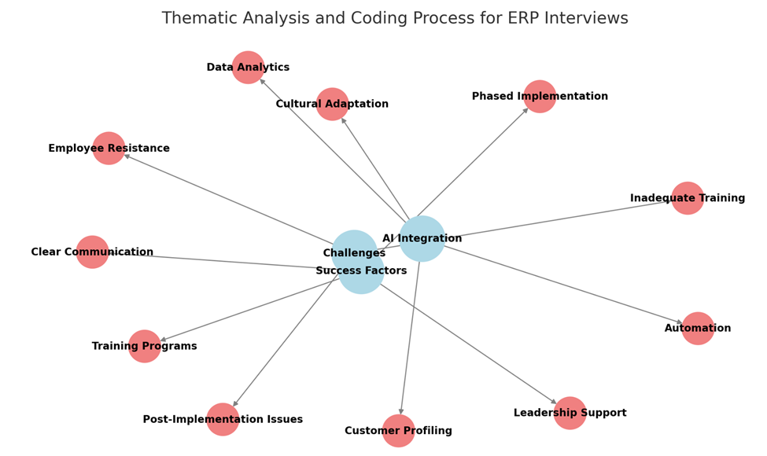
Figure 1: Thematic Analysis and Coding Process.

- was extremely well-defined and the data was straightforward, allowing a high level of consistency text with descriptive codes that captured the essence of the participants' experiences, challenges, and strategies.
- Theme Development: The initial codes were then organized into broader, higher-level themes that reflected the overarching patterns in the data. This involved identifying relationships between the codes and grouping them into categories that captured the essence of the participants' experiences. Themes were categorized as related to either AI Integration, Challenges, or Success Factors.
- Theme Refinement: The themes were iteratively refined as new insights emerged from the data. This involved revisiting the interview transcripts to ensure that the themes were representative of the participants' experiences and that no important aspects were overlooked.
- Single coder: Since this was a small-scale study a single coder was used. There was transparency about the potential limitations of this study. In addition, the coding scheme was extremely well-defined and the data was straightforward, allowing a high level of consistency.
Pilot Interview Questions
The key questions asked during each of the interviews were as follows:
- How long were you in a leadership position?
- During your time in your position did you implement any business systems? If so, which ones?
- Did the Systems include Artificial Intelligence? If so, what functionalities?
- Would you have done anything differently regarding the implementation?
- What are your thoughts on the communication plan for the implementation?
- Do you think you had the buy-in of your management?
- Do you think you had the buy-in of the end-users
- Was the implementation successful? Can you elaborate on your yes or no answer?
- Did the systems provide you with the reporting needed?
- Is there any other information you would like to add that I may not have asked?
Research Questions
- How can AI be effectively integrated into ERP systems to enhance knowledge management practices, specifically in managing process-based organizational and tacit knowledge?
- What are the potential improvements in business process re-engineering (BPR) procedures within ERP systems facilitated by AI, and how can these improvements ensure customization to meet unique operational requirements?
- How can integrating AI enhance ERP systems' automation, predictive modeling, and data analytics capabilities, and how can these enhancements contribute to operational efficiency and competitive advantage?
- How can AI contribute to better alignment between ERP systems and organizational culture, reducing resistance to ERP adoption and increasing employee acceptance?
- What role does effective communication play in enabling the integration of AI into ERP systems, and how can communication strategies be optimized to support successful AI implementation and adoption?

Unit of Analysis
The unit of analysis for this qualitative study is individual business leaders, focusing on their leadership experiences, decision-making processes, and perspectives on ERP implementation, AI integration, and organizational change. This study centers on prominent leaders—Interviewee 1, Interviewee 2, Interviewee 3, Interviewee 4, and Interviewee 5, through one-on-one interviews that delve into their leadership roles, experiences, and strategies. The interviews are supplemented with organizational documents, such as annual reports, to provide additional insights into their leadership contexts and decisions, enhancing the depth of analysis.
The research identified recurring themes and patterns related to AI integration, ERP implementation, leadership dynamics, and communication strategies, within the scope of these leaders' professional experiences. By systematically analyzing the collected data, the study uncovered insights into the challenges and strategies associated with these themes.
Furthermore, the interview questions were designed to explore individual-level perspectives of AI in ERP systems and how it impacts organizational processes and employee attitudes and behaviors in enterprises. This approach reflects the study's emphasis on personal and professional experiences as units of analysis.
Through this lens, the research provides a nuanced understanding of how these leaders perceive and implement AI and ERP systems, navigate challenges, and align their decisions with broader organizational and technological trends.
The development of the survey questions and questionnaire was informed by several critical elements. The research questions played a central role, ensuring that the survey items were aligned with the study’s objectives to explore employee attitudes, behaviors, and practices during the visioning, planning, and implementation stages of AI integration into ERP systems. Additionally, the theoretical framework, grounded in change management principles, guided the formulation of questions to assess aspects such as awareness, desire, knowledge, ability, and reinforcement, in relation to technological change. Insights from relevant literature on ERP systems, AI integration, and organizational culture further shaped the questionnaire by highlighting key constructs and variables, such as employee engagement, resistance to change, and process optimization. This combination of research questions, theoretical underpinnings, and existing literature ensured that the survey questions were robust and capable of capturing both technical and human dimensions of AI-ERP adoption.
Pilot Survey
A survey was conducted with 20 employees who recently implemented an ERP system, which provided valuable insights into the effectiveness of the organizational change process. Using the ADKAR model (Awareness, Desire, Knowledge, Ability, and Reinforcement), the survey assessed various aspects of the change implementation. Responses were measured, using a five-point Likert scale.
Dissertation Survey
The survey later received an additional three responses. Participants responded to questions using a five-point Likert scale, providing a nuanced understanding of how effectively the organization navigated this significant technological transition. This expanded sample size enhanced the reliability and representativeness of the study's findings. It has contributed to the body of knowledge on ERP implementation success factors and offers a foundation for further research in this critical area of business technology management.

Content Analysis of Documents
The content analysis examined pertinent materials for themes pertaining to decision-making, organizational tactics, and leadership. These "pertinent materials" included publicly available documents such as annual reports, company newsletters, press releases, and articles featuring or about the business leaders. The selection criteria prioritized documents that provided insights into the leaders' strategic decisions, their approach to organizational change, and their leadership styles, particularly in the context of technology implementations and ERP systems. Documents were excluded if they were purely promotional or lacked substantive information related to the research questions.
The process of comparing the document content analysis results with the interview results involved a triangulation approach (Creswell & Plano Clark, 2017). First, key themes and patterns were identified in both the documents and the interview transcripts. Then, the themes were compared to identify areas of convergence and divergence. Convergence indicated that the leaders' actions and decisions, as portrayed in public documents, aligned with their self-reported experiences and perspectives. Divergence, on the other hand, prompted further investigation to understand potential discrepancies or nuances in their leadership approaches. This iterative process enhanced the validity and depth of the analysis, providing a more comprehensive understanding of the leaders' experiences. It compared information from the documents with the results of the interviews.
A structured survey was conducted with 23 employees who had recently implemented an ERP system, to obtain quantitative data that would provide valuable insights into the effectiveness of the organizational change process. Using the ADKAR model (Awareness, Desire, Knowledge, Ability, and Reinforcement), the survey assessed various aspects of the change implementation, using a five-point Likert scale (Hiatt, 2006). Likert-scale questions allow respondents to rate their level of agreement or disagreement with each provided statement, thereby revealing their perceptions of the concepts represented by each statement. For example, survey respondents indicated their understanding of the business reasons for the ERP transition, their perceived risks of non-adoption of the ERP, their motivation to embrace the change, and the support they received from supervisors and peers. This approach provided measurable data on participant sentiments across key management dimensions, supporting the identification of trends and statistical insights.
The approach described in this research aligns well with several key principles and methodologies outlined in Earl Babbie's "The Practice of Social Research" 15th edition (2020). This method employs a comparative analysis, which Babbie discusses as a valuable method for examining differences between groups. The study employed judgmental sampling by categorizing survey responses based on employee role and workplace site type, allowing for analysis of perspectives from those with relevant experiences in AI-ERP implementation. The use of a Likert scale in the survey measures attitudes and perceptions. The survey emphasizes the value of standardized measurement tools like Likert scales for quantifying complex social phenomena. By using a five-point scale (1 - Strongly Disagree to 5 - Strongly Agree) this design provides a clear and consistent way to gauge employee attitudes towards the ERP implementation (Babbie, 2020).
Data Analysis
The comparative analysis approach taken, examining differences across organizational levels and functions, reflects the importance of looking for patterns and relationships in the data. This method allows for the identification of specific groups that may require additional support, as a practical application of research findings (Babbie, 2020).
By integrating both quantitative and qualitative data, the study was positioned to develop a comprehensive view of the organizational change experience among employees. Data analysis for the quantitative component involved descriptive statistics to assess average scores, variances, and patterns in the responses, with a focus on identifying areas of strong agreement or resistance across the ADKAR categories. The qualitative data were analyzed thematically to extract recurring themes related to implementation challenges, support systems, and training effectiveness. These themes were coded and analyzed in relation to the quantitative findings to provide a multidimensional view of how change management elements influenced the ERP adoption success.
This survey (Figures 2-7) used a Likert scale (1 - Strongly Disagree to 5 - Strongly Agree) to measure participant responses to these various questions. The data gathered help to gauge employees' readiness, motivation, and support systems for the ERP change across these critical areas.
The unit of analysis for this research is the individual employee. This choice is fundamental to the study's design and reflects its focus on understanding the personal dimensions of organizational change during an ERP implementation. At the core of the data collection process is this survey administered to individual respondents, providing a quantifiable measure of their perceptions and attitudes. The questions in the survey were crafted to assess each individual's understanding, motivation, and experiences with the ERP transition, emphasizing the personal nature of the data being collected.

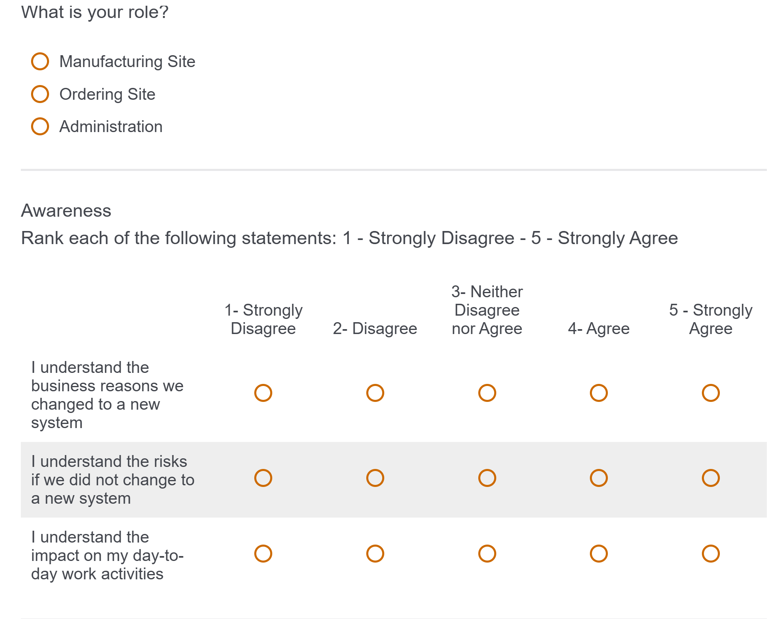
Figure 2: questions contained in the survey for both the pilot and dissertation research.
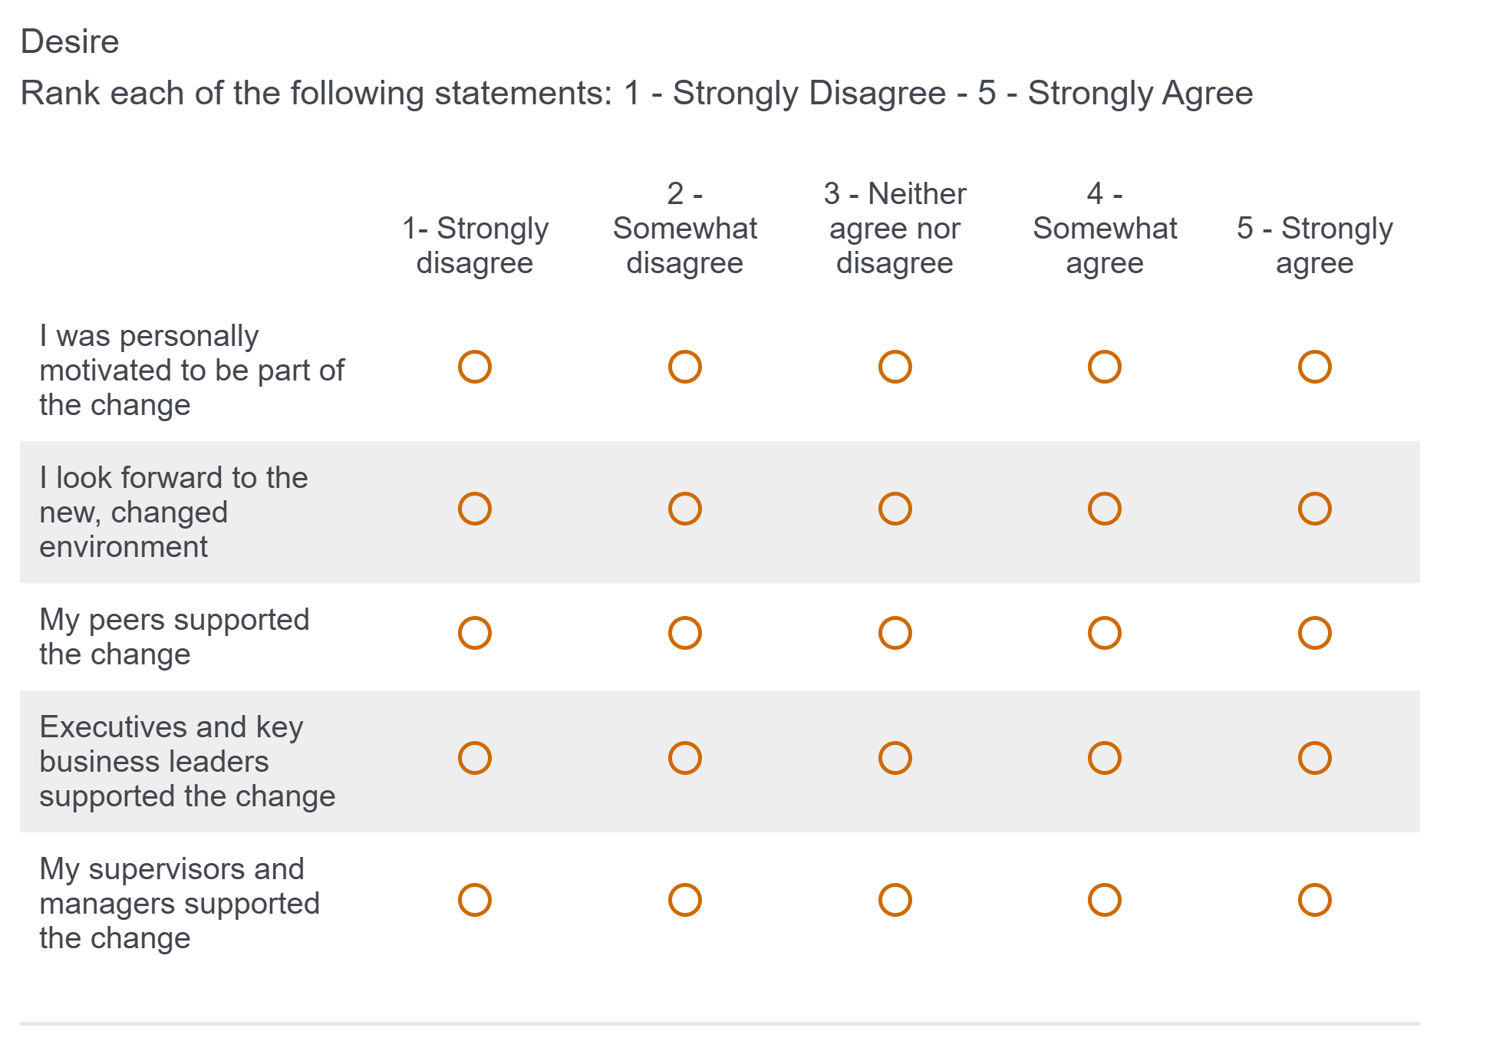
Figure 3: questions contained in the survey for both the pilot and dissertation research.

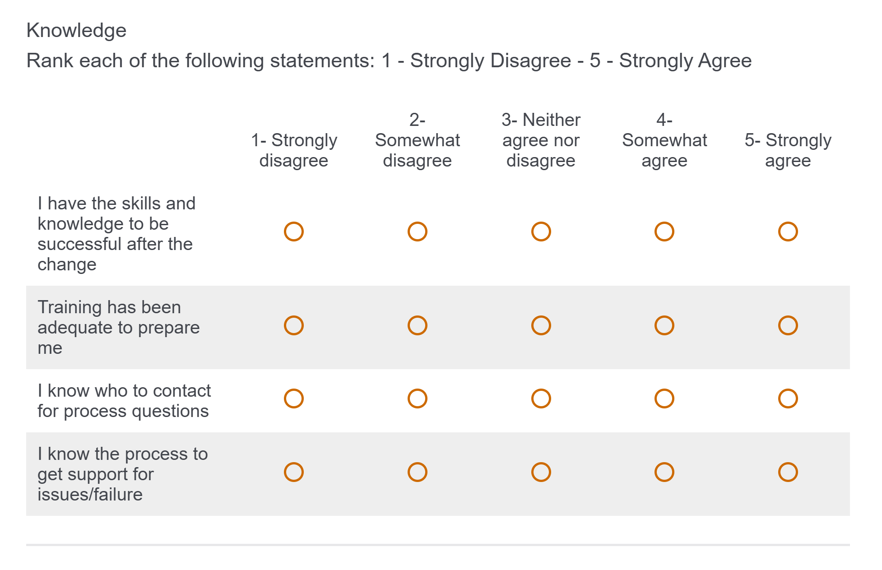
Figure 4: questions contained in the survey for both the pilot and dissertation research.
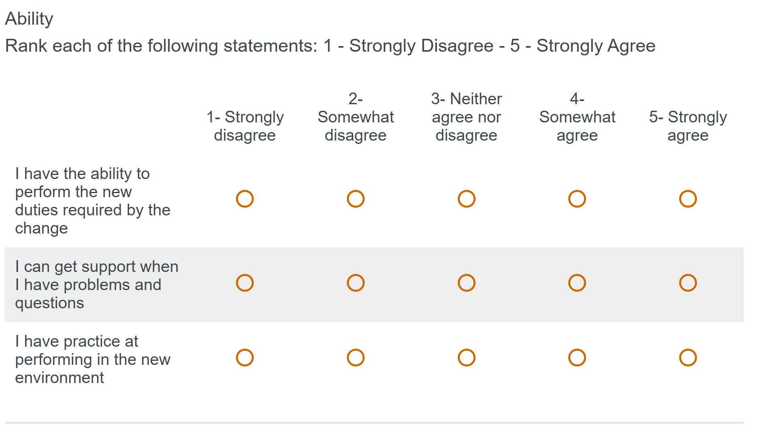
Figure 5: questions contained in the survey for both the pilot and dissertation research.
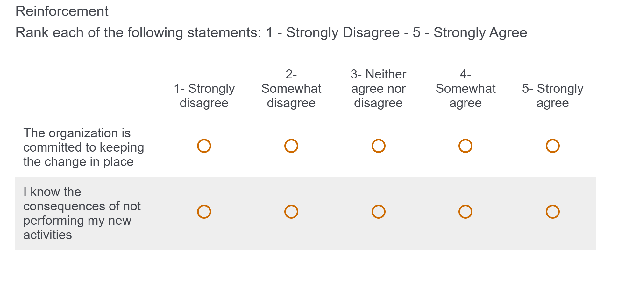
Figure 6: questions contained in the survey for both the pilot and dissertation research.


Figure 7: statements contained in the survey for both the pilot and dissertation research.

The study's use of the ADKAR model (Hiatt 2006) further reinforces the individual as the unit of analysis. This model, which stands for Awareness, Desire, Knowledge, Ability, and Reinforcement, is predicated on the idea that organizational change is fundamentally driven by changes at the individual level. By applying this model, the research acknowledges that each employee's journey through the change process is unique and worthy of individual consideration. While the study does employ comparative analysis, examining differences across organizational roles and site types, it is important to note that these comparisons are built upon data collected from individuals.
The primary data points that form the basis of these comparisons are the responses of individual employees, maintaining the individual as the central unit of analysis even in broader comparisons. Using a Likert scale in the survey is particularly suited to measuring individual attitudes and perceptions. This standardized measurement tool allows for the quantification of complex personal feelings and opinions about the ERP implementation, providing a consistent way to gauge each employee's stance on various aspects of the change. In addition to the quantitative data, the study includes a qualitative component that further emphasizes the individual as the unit of analysis.
This aspect of the research examines individual experiences and perspectives on implementation challenges and support systems, providing rich, personal insights to complement the quantitative data. By focusing on individual employees as the unit of analysis, this research design allows for a nuanced understanding of personal readiness for change. It identifies specific areas where individuals may need additional support and provides insight into how individual experiences collectively contribute to the overall success of the ERP implementation across the organization. This approach recognizes that organizational change, while often discussed at a macro level, is ultimately realized through the collective adaptation of individuals within the organization.
Ethical Considerations
Ethical considerations, including obtaining IRB approval and informed consent forms from participants, were used for this research. IRB approval stresses the importance of protecting human subjects and ensuring voluntary participation in social research (Babbie, 2021).
Institutional Review Board (IRB) approval was obtained to interview these individuals and informed consents from each participant were obtained before the interviews were conducted.
For ease of understanding the various components of this study, the following outline summarizes the structure of its mixed-method design, combining both qualitative and quantitative methods. By leveraging the strengths of each approach​, this design has yielded results that provide a more holistic view of the individuals and circumstances that were the focus of this research.
Data Collection Outline
- Interviews:
  - Conducted with five business leaders (e.g., Interviewee 1, Interviewee 2, Interviewee 3, Interviewee 4 and Interviewee 5).
  - One-on-one, in-person interviews with open-ended questions.
  - Supplemental documents, such as annual reports and articles, were also analyzed to provide context​.
- Surveys:
  - Administered to 23 employees involved in ERP implementation.
  - A structured survey with a 5-point Likert scale (1 = Strongly Disagree to 5 = Strongly Agree) was used.
  - Focused on measuring attitudes toward ERP implementation using the ADKAR model (Awareness, Desire, Knowledge, Ability, and Reinforcement)​​.
- Data Analysis
  - Quantitative
    - Descriptive statistics were used to evaluate average scores, variances, and patterns in responses.
    - Data patterns were analyzed to identify trends and areas requiring additional support​​.
- Qualitative
    - Thematic analysis was conducted on interview data to identify recurring themes.
    - Responses were coded and analyzed in relation to the quantitative data to provide a comprehensive view​.
- Limitations of the Study
  - Interviews
    - A small sample size (five business leaders) may not represent the broader population.
    - The results are susceptible to bias resulting from subjective interpretations and variability in responses.
    - Leaders’ perspectives might not fully capture the complexities of AI integration​​.
  - Surveys
    - There is a potential for response bias in Likert-scale surveys, such as central tendency or extreme responses.
    - Limited depth, as they do not capture the underlying reasons for responses.
    - Small and homogenous sample size could limit the generalizability of findings​.
- Validity and Reliability
  - Interviews
    - Triangulation was used to integrate interview insights with document analysis to enhance reliability​.
    - Questions were open-ended to allow for diverse, in-depth responses​.
  - Surveys
    - The standardized Likert scale ensures consistency in measuring attitudes and perceptions.
    - Comparative analysis strengthens validity by examining differences across organizational roles and site types​​.
To summarize, the study employed a mixed-method approach that combines both qualitative and quantitative methodologies. The qualitative component included a literature review and interviews with business leaders to identify recurring themes related to leadership experiences, ERP implementation, and AI integration. The quantitative component consisted of surveys administered to employees impacted by ERP systems, utilizing the ADKAR change management model to measure perceptions and adoption levels.
For the sampling approach, purposive sampling was used to select business leaders based on their expertise in ERP implementation and leadership roles. This technique ensured that insights were gathered from individuals with direct experience in overseeing such transitions. Survey sampling targeted employees in administration, manufacturing, and ordering departments, as these individuals were directly involved in the ERP implementation and its associated processes.
Data collection involved multiple sources. Interviews were conducted with five leaders from diverse industries, including automotive, sports, electronics, and politics. In addition to interviews, surveys were distributed to 23 employees, employing a Likert scale to assess their perceptions of ERP adoption. To further enhance the research, a document analysis was conducted, reviewing annual reports and articles to provide additional context and background.
The study's data analysis incorporated both qualitative and quantitative techniques. Qualitative analysis utilized thematic analysis to identify patterns and trends that emerged from interview responses. Quantitative analysis involved descriptive statistics derived from the Likert-scale survey responses to assess trends and insights related to ERP implementation. This dual approach ensured a more comprehensive understanding of the organizational change process.
The research also sought to answer several key questions, including how AI enhances ERP systems and business process efficiency, how AI aligns with organizational culture to reduce resistance, and the role of communication in facilitating AI-ERP integration. These questions helped to uncover the broader impact of AI on ERP adoption and effectiveness within organizations as referenced in Figure 15.
Ethical considerations were a crucial part of the study. Institutional Review Board (IRB) approval was obtained to ensure compliance with ethical guidelines. Additionally, informed consent was secured from all participants before their involvement in interviews or surveys. These measures were taken to protect the rights and privacy of participants.
Despite its structured methodology, the study faced certain limitations. The small sample size for the interviews may restrict the generalizability of those findings. Additionally, the surveys carried a potential risk of response bias, which could influence the accuracy of the results. Lastly, the ability to generalize the findings beyond the specific organizational settings that were studied remains a question.

Chapter 4: Results and Discussion
This chapter contains two major sections. The first addresses the insights gleaned from the qualitative interviews with the five business leaders. The second portion presents the results of the quantitative survey administered to the employees who had experienced ERP-AI system implementation.
Trust is a critical element in the successful adoption of new technologies within an organization. Defined as “…The willingness of a party to be vulnerable to the actions of another party based on the expectation that the other will perform a particular action important to the trustor, irrespective of the ability to monitor or control that other party” (Mayer et al., 1995), trust influences how employees perceive and interact with AI-integrated ERP systems. In this study, the role of trust emerged as particularly significant. When employees trusted in the AI-driven processes and their leadership's vision for AI integration, they were more likely to embrace the changes, actively participate in training, and provide valuable feedback, thereby enhancing the overall success of the implementation.
Insights from Industry Leaders
Interviewee 1 provides critical insights into ERP system implementation and AI integration across multiple organizations. His experiences at Tenneco, Hertz, and Caesars Entertainment reveal significant challenges with, and strategies for, technological transformation. At Tenneco, he implemented SAP's ERP system, encountering substantial implementation difficulties. The primary challenge was inadequate user training, which hindered system adoption and effectiveness. He emphasized that successful ERP implementation requires comprehensive user education and engagement.
Hertz's ERP implementation presented even more complex challenges. For four months after go-live, the company experienced double-counted costs and payroll complications. However, the system ultimately helped standardize accounting processes across their extensive network, consolidating disparate regional accounting systems into a unified platform.
His experience at Caesars Entertainment represented his most sophisticated technological integration. The organization pioneered AI and data analytics, employing data experts to develop advanced customer engagement strategies. They used AI to create detailed customer profiles, particularly focusing on high-value gamblers, and developed personalized marketing approaches based on behavioral patterns.
The interview highlights critical lessons for successful technological implementation: comprehensive user training, senior management commitment, systematic testing, and a focus on change management. Interviewee 1 consistently stressed that technological transformation is fundamentally about managing human resistance to change, not just implementing new systems. His experiences demonstrate that successful ERP and AI integration requires a holistic approach that balances technological capabilities with human factors, organizational culture, and strategic objectives.
His experiences across multiple organizations provide valuable insights into the impact of AI-integrated ERP systems on organizational processes and employee attitudes in large enterprises. The implementation of these advanced systems has led to significant changes in operational efficiency, decision-making processes, and employee roles. Interviewee 1 consistently emphasized that technological transformation is fundamentally about managing human resistance to change. This insight indicates that employee attitudes can be a significant barrier to the successful implementation of AI-integrated ERP systems.
His experiences at Tenneco highlight the critical importance of comprehensive user training. Inadequate training can lead to negative employee attitudes and hinder system adoption and effectiveness. The implementation of AI has led to changes in employee roles. This shift can lead to both positive and negative attitudes, depending on how it is managed. His experiences underscore the importance of top-level support for successful implementation. Thorough testing of the system before full implementation is crucial to avoid issues like those experienced at Hertz. A holistic approach that balances technological capabilities with human factors and organizational culture is essential for successful integration.
At Caesars Entertainment, the move to cloud-based systems was planned in stages, with 60% digitization achieved by a certain date and full cloud implementation by 2020. This gradual approach can help in managing employee attitudes and organizational changes. While AI-integrated ERP systems can significantly enhance organizational processes, their impact on employee attitudes and behaviors is complex. Successful implementation requires careful management of human factors alongside technological considerations.
Interviewee 1 provided valuable insights into his experience with ERP implementations across multiple companies. He highlighted several challenges encountered during ERP system deployments at Hertz, Tenneco, and Caesars. At Tenneco, issues arose because of insufficient user training, which impeded full adoption. Hertz faced a significant glitch post-implementation, where costs doubled for several months, revealing the critical need for accurate data handling. At Caesars, they successfully applied lessons learned from previous experiences, such as intensive training and testing, to ensure a smoother deployment.
Interviewee 1 discussed how Caesars utilized AI to analyze customer behavior and customize offers, particularly in the context of their rewards program. This targeted approach aimed at optimizing marketing expenditure, although it posed challenges such as over-incentivizing customers. AI and data analytics helped Caesars create detailed customer profiles, allowing for personalized experiences aimed at increasing customer engagement. He stressed the importance of executive engagement and transparent communication during ERP implementations. He advocated for regular updates from key executives and emphasized the need for leaders to communicate the purpose and progress of ERP projects clearly to employees. According to him, direct involvement from senior leadership and regular progress reporting were essential to maintaining accountability and addressing issues promptly.
Interviewee 1 emphasized fostering a positive company culture, especially during times of significant change, such as ERP implementation. He implemented tools like the "mood elevator" and created a culture where employees felt comfortable raising issues early. The "mood elevator" is a multifaceted tool designed to enhance workplace positivity and employee engagement. It serves as a structured method for employees to express their feelings and concerns, enabling management to address issues promptly. This tool incorporates various activities or exercises aimed at elevating mood and fostering a more positive work environment. As part of a broader strategy, the "mood elevator" contributes to creating an open culture where employees feel comfortable raising issues early.
Additionally, it complements other morale-boosting initiatives, such as celebrations and recognition of milestones, to create a comprehensive approach to employee well-being and organizational culture. Celebrations and recognition of milestones were also used to enhance team morale and reinforce the importance of ERP system adoption across the organization.
Interviewee 2, a former General Manager of the Washington Wizards, provides profound insights into the implementation of AI technologies in professional basketball. During his tenure, he explored machine learning and artificial intelligence as powerful tools for understanding player performance and potential. He emphasized the importance of strategic data collection, focusing on two primary areas of AI application: physiological tracking and performance analysis. The organization utilized player tracking technologies to monitor athletes' health, fatigue risks, and on-court performance. By implementing AI-driven systems, they could generate overlay videos showing ideal play execution and compare actual team performance against theoretical perfect plays.
This interview highlighted the nuanced approach to AI integration, recognizing both its capabilities and limitations. He noted that while AI can provide extensive data and visual analytics, it cannot fully capture intangible human qualities like courage, heart, and mental resilience. This perspective underscores the importance of combining AI with human judgment in both sports and enterprise environments. Organizations implementing AI in ERP systems must recognize the value of human expertise and ensure that AI complements, rather than replaces, human decision making.
Employee attitudes and generational differences play a crucial role in the successful adoption of AI. Interestingly, Interviewee 2 observed that younger athletes are more receptive to technological integration, having grown up with advanced gaming and tracking technologies. This generational comfort with technology facilitates smoother AI adoption in sports environments. Similarly, enterprises must consider employee demographics and provide targeted training programs to foster acceptance and engagement with AI-enabled ERP systems, minimizing resistance and enhancing usability.
The discussion also touched on broader implications of technology’s role in talent identification, suggesting that AI can help overcome traditional biases in player evaluation by providing more comprehensive, data-driven insights into an athlete's potential and developmental trajectory. He stressed the importance of understanding not just physical capabilities but also intellectual potential in athlete development.
The implementation of AI in ERP systems significantly impacts organizational processes and employee attitudes, as illustrated by his innovative use of AI technologies in professional basketball. During his tenure with the Wizards, he embraced AI-driven solutions to enhance decision-making processes and optimize team performance. These insights offer valuable parallels for large-scale enterprises adopting AI in ERP systems. By utilizing AI systems, the organization could monitor players' health, predict fatigue risks, and evaluate in-game performance with remarkable precision. Similarly, in ERP systems, AI facilitates predictive analytics and process automation, improving organizational efficiency and resource allocation. This capability mirrors the application of AI in ERP systems, where intelligent algorithms can reduce subjectivity in decision-making and uncover hidden opportunities for process optimization and workforce development. By leveraging AI’s objectivity, organizations can make more equitable and informed decisions.
AI integration into ERP systems offers transformative benefits for organizational processes, including enhanced analytics, predictive modeling, and operational efficiency. However, as his experiences demonstrate, successful adoption requires a balanced approach that acknowledges AI’s limitations, emphasizes human collaboration, and accounts for employee receptivity. By addressing these factors, large-scale enterprises can harness the full potential of AI while fostering a culture of innovation and inclusivity.
Interviewee 2, the former Washington Wizards executive, discussed his experience integrating AI and analytics into sports operations. He highlights how AI-driven technologies like player tracking and "ghost teams" aid in performance analysis by overlaying ideal plays onto real gameplay for comparison. Interviewee 2 emphasized the importance of balancing vast data insights with practical application, avoiding "data drowning" by focusing on specific performance indicators, especially player health and on-court outcomes.
He also discusses the complexities of integrating analytics with coaching, stressing the need for a "code talker" who can translate data into actionable coaching strategies. Although younger coaches embrace analytics, challenges remain in harmonizing this data-centric approach with traditional coaching methods.
On the topic of player mental health, he expresses concern over the influence of social media and gambling on athletes, linking these factors to increased stress and mental health challenges. He shares anecdotes about athletes who, despite immense external pressures, manage to perform at high levels due to compartmentalization and resilience. Lastly, Interviewee 2 touches on the role of ownership, suggesting that while many sports team owners support AI integration because of their tech backgrounds, it is essential to remember that athletes are human beings, not machines, and that this human aspect should guide AI applications in sports.
Interviewee 3, the former President of Westinghouse Electronics, offers valuable insights into the early development of AI-like systems in the defense industry. His work on advanced digital systems in the 1960s, such as the Norfolk Sound radar ship, showcased AI-like capabilities, including automatic tracking of multiple targets, threat categorization, and implementation of countermeasures without human intervention. Westinghouse led the transition from analog to digital systems in defense electronics, with the Norfolk Sound project being one of the first large-scale digital systems. This groundbreaking project incorporated self-repair capabilities and automated decision-making, setting a new standard for defense technology.
Interviewee 3 argues that AI, in its basic form, has been present in defense systems for decades. He points to systems like the F-16 fighter jet and AWACS planes, which incorporated intelligent decision-making capabilities long before the current AI boom. This perspective challenges the notion that AI is a purely modern phenomenon. The interview highlights the rapid pace of innovation in electronics during the 1960s-1970s. This period saw significant transitions, including the shift from vacuum tubes to transistors and the development of digital computing in military applications. These advancements laid the groundwork for modern AI systems. Interviewee 3 describes how Westinghouse managed the transition from analog to digital technologies. The company implemented retraining programs for employees and maintained open communication with unions to ensure a smooth transition. This approach to change management was crucial in adapting to new technologies. This proactive change management approach minimized resistance and facilitated the smooth adoption of new technologies, offering valuable lessons for modern organizations integrating AI into ERP systems.
The story of "Herbie," an early mail-delivery robot at Westinghouse, demonstrates an early attempt at integrating robotics into the workplace. This anecdote illustrates how the company managed employee acceptance of new technologies, providing valuable insights into human-robot interaction in its early stages. This interview provides essential historical context for the development of AI-like systems in defense electronics. It illustrates that many core concepts of AI have been in practical use for decades, long before the current AI boom, offering a valuable perspective on the evolution of artificial intelligence in real-world applications.
The implementation of AI in ERP systems significantly impacts organizational processes and employee attitudes, as evidenced by the insights from Interviewee 3, the former President of Westinghouse Electronics. His experience highlights how AI-like systems have influenced large-scale enterprises, particularly in the transition from analog to digital systems and the early adoption of intelligent technologies in defense electronics.
He recalls the groundbreaking Norfolk Sound radar ship project, which featured advanced AI-like capabilities such as automatic target tracking, threat categorization, and autonomous countermeasure implementation. These innovations demonstrated the transformative potential of AI systems in streamlining complex processes and reducing the need for human intervention. This early example illustrates how integrating intelligent systems into organizational workflows can significantly enhance operational efficiency and decision-making capabilities.
His anecdote about "Herbie," the early mail-delivery robot at Westinghouse, provides insights into employee attitudes toward automation. By addressing concerns and fostering acceptance through demonstration and communication, Westinghouse exemplified how enterprises can mitigate resistance to technological change. This approach underscores the importance of aligning AI adoption with organizational culture and ensuring that employees feel included in the transformation process.
Furthermore, he challenges the perception of AI as a purely modern phenomenon, emphasizing that many AI principles, such as intelligent decision-making and automation, have been in use for decades. This historical perspective highlights the enduring role of AI-like systems in driving innovation and improving organizational processes. It also underscores the importance of understanding AI's evolution to appreciate its current and future potential in ERP systems.
In large-scale enterprises, integrating AI into ERP systems has the potential to enhance automation, predictive modeling, and data analytics, ultimately improving operational efficiency and competitive advantage. However, as his experiences demonstrate, the success of such implementations depends on effective communication, employee engagement, and strategic change management. By drawing on lessons from historical examples like those at Westinghouse, modern organizations can navigate the challenges of AI adoption and realize its transformative benefits.
Interviewee 4 joined Textron, a global conglomerate, as Executive Vice President and Chief Operating Officer. He later became President, CEO and Chairman. During his tenure. Interviewee 4 transformed Textron into a $10 billion company with prominent subsidiaries like Bell Helicopter and Cessna Aircraft. He implemented a leadership style focused on cultural change, job design, and management philosophy to revitalize the Textron. His approach emphasized the need for flexibility in leadership structures to meet the evolving needs of the organization and its shareholders. Interviewee 4 drew on both practical examples and theoretical insights to equip the organization for effective management in a complex environment, which included a focus on strategic frameworks such as competitive advantage and core competence, which are essential for navigating challenges in the business landscape.
During his tenure, Interviewee 4 faced challenges in finding a system that could effectively interface with its order management and CRM systems, indicating a history of difficulties in implementing integrated technology solutions. His business style aligns with AI being used in ERP systems in several ways. He focused on return on invested capital as a key financial metric, moving away from sole earnings per share. This approach aligns with AI-powered ERP systems that can analyze vast amounts of data to provide insights for better decision making.
Interviewee 4 implemented a company-wide restructuring program to increase efficiency, consolidate manufacturing facilities, and outsource non-core production. He transformed Textron into a "networked enterprise," facilitating the operation of strong, unique brands while sharing business infrastructure resources.
He implemented Six Sigma, a company-wide continuous improvement program, and developed a vision to become a premier multi-industry company recognized for strong local brands, powerful enterprise processes, and talented people. His business style demonstrates principles that align well with the potential benefits of AI in modern ERP systems.
Interviewee 4 was asked about how AI can contribute to better alignment between ERP systems and organizational culture, reducing resistance to ERP adoption and increasing employee acceptance. His response was “Because an AI based ERP system offers a unique ability for the system to more accurately manage tasks, analyze data and optimize processes. Basically, the more successful the implementation is, the more likely it is for the employees to accept the benefits of the new system.”
Interviewee 4 stated that “Frequent detailed communications meetings are critical to having all employees truly understand the various phases of implementation. The concept of AI alone will be very new to them, so a strategic communication plan is critical to minimize the risks of having the new system miss deadlines, budgets or desired benefits.”
Interviewee 4 suggests that successful AI implementation in ERP systems can lead to increased employee acceptance and reduced resistance. This is primarily due to the system's ability to manage tasks, analyze data, and optimize processes more accurately. However, the implementation process may also impact employees in that employees may need to acquire new skills to work effectively with AI-integrated ERP systems, potentially leading to both challenges and opportunities for professional growth. As AI automates routine tasks, employee roles may shift towards more strategic, analytical, and creative work. There may be initial resistance to change, requiring careful change management strategies and clear communication about the benefits of the new system.
Interviewee 5 is a seasoned American politician who served as the senior U.S. Senator from West Virginia from 2010 to 2025. A centrist Democrat known for his bipartisan approach, he focused on energy policy, veterans' affairs, and healthcare during his tenure. Interviewee 5 highlights the strategic importance of AI and data management within both the federal and private sectors. His role and related initiatives emphasize a balanced approach to integrating AI technologies while ensuring responsible oversight and coordination with private industries. Key insights include the necessity for effective workforce training, robust data management, and secure algorithms. Federal efforts, like those led by the Defense Advanced Research Projects Agency (DARPA) and the Veterans Administration, aim to create AI-driven applications, such as wearable biometric data devices, which enhance healthcare efficiency. These innovations underscore the value of clean, accessible data and collaboration between government and industry.
The discussion also addressed AI's role in business, highlighting its ability to shift employee roles, requiring organizations to gain employee buy-in to ensure successful system implementation. Practical examples, such as federal contracts’ incentivizing cybersecurity improvements only after enduring financial repercussions, demonstrate lessons learned in implementing and scaling AI responsibly across industries.
The integration of AI in both federal and private sectors is a critical area of focus, as highlighted in the insights shared by Interviewee 5 and his team. His perspectives underscore the strategic importance of striking a balance between technological innovation, responsible oversight, and effective collaboration between public and private entities. This balanced approach ensures that AI technologies are implemented in ways that drive efficiency, while addressing ethical and security concerns.
One of the key takeaways from Interviewee 5’s insights is the necessity of workforce training in AI integration. As AI technologies continue to reshape industries, a well-prepared workforce becomes essential for leveraging these tools effectively. Training programs must be designed to equip employees with the skills to operate and adapt to AI-driven systems, reducing resistance to change and fostering acceptance of new technologies.
He also emphasized the importance of robust data management and secure algorithms in AI implementation. In the federal sector, these factors are particularly vital, as sensitive data often underpins AI-driven applications. Secure algorithms and stringent data management protocols ensure that AI systems operate reliably and ethically, maintaining public trust. The collaboration between government and private industry plays a crucial role in achieving these objectives, as evidenced by initiatives that incentivize cybersecurity improvements. These efforts highlight the lessons learned from implementing AI on a scale and the importance of proactive measures to safeguard data and systems.
In the private sector, Interviewee 5 highlighted the transformative impact of AI on organizational roles and processes. By automating routine tasks and generating actionable insights, AI shifts employee responsibilities, requiring businesses to manage this transition effectively. Organizations must prioritize employee engagement and buy-in to ensure successful system implementation. His reference to federal contracts that incentivize cybersecurity improvements only after financial repercussions illustrates a broader lesson: the importance of aligning AI implementation with accountability mechanisms to encourage responsible adoption.
His insights provide a roadmap for integrating AI in ways that balance innovation with responsibility. Effective workforce training, robust data management, secure algorithms, and collaboration between sectors are essential components of successful AI implementation. As organizations and governments continue to adopt AI technologies, these principles offer a framework for achieving efficiency, security, and trust, ensuring that AI drives sustainable progress across industries.
Figure 8 contains the results from feedback from the business leaders. This data suggests that, while organizations are successful in implementing ERP systems with management support, they face challenges in user adoption and AI integration.
Definitions or descriptions for the requested terms based on the interviews conducted with the business leaders:
- AI functionality uses artificial intelligence and algorithms to analyze customer behavior patterns, such as gambling frequency and spending, to create personalized offers and marketing campaigns. For example, Caesars Entertainment used AI to profile high-value customers and develop customized programs to retain them. Westinghouse was using this technology as early as the 1960s.
- Adequate reporting involves having a standardized and consolidated reporting system that provides accurate and timely financial information. This contrasts with decentralized systems, which may rely on manual processes and lead to inefficiencies, as seen in Hertz’s transition to a new ERP system.
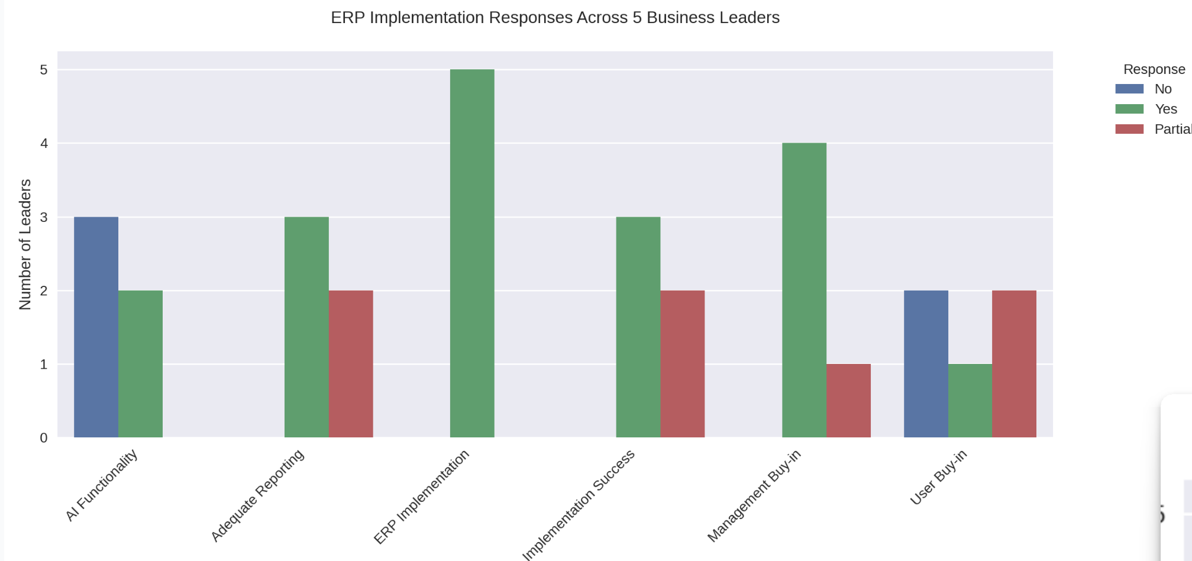
Figure 8: results from feedback from the business leaders.

- ERP implementation refers to the process of deploying an Enterprise Resource Planning system to integrate and streamline business processes. Challenges such as user training,
management oversight, and system accuracy are critical factors, as highlighted in Tenneco's SAP ERP implementation.
- Implementation success is defined as achieving a project's desired goals, such as improved reporting accuracy, system consolidation, and data leveraging for decision-making. Effective change management, user training, and management support are key contributors to success.
- Management buy-in is the active support and involvement of senior management in a project. It ensures that the new system is prioritized, and users are encouraged to adopt it, preventing resistance and reversion to old processes.
- User buy-in refers to the acceptance and adoption of a new system by its end-users. Proper training and demonstrating the system's value are essential to overcoming resistance and ensuring successful implementation.
Key Patterns:
- Strongest Agreement: ERP Implementation (100% yes)
- Most Challenging Area: User Buy-in (most varied responses)
- Most Common Challenge: AI Functionality (75%)
- Generally Positive: Implementation Success, Management Buy-in, and Adequate Reporting all showed a majority of positive responses
Pilot information was gathered through interviews and surveys and further information, including specific performance metrics and operational data, can be found in Figures 9 and 10. Both Table 1 and 2 present the information for the research study, encompassing interview and
Table 1. Pilot Information: Interview and Survey Questions from IRB: UTK IRB-23-07929-XM and UTK IRB-23-07808-XM.
Questions | Attitude, Behavior or Practice | Vision | Planning | Implementation
How long were you CEO? | Interviewee 1, 2, 3, 4, 5  Practice | Interviewee 1, 2, 3, 4, 5 | Interviewee 1, 2, 3, 4, 5 | Interviewee 1, 2, 3, 4, 5
During your time with the company did you implement any ERP systems? If so, which ones? | Interviewee 1, 2, 3, 4, 5  Attitude, Behavior | Interviewee 1, 2, 3, 4, 5 | Interviewee 1, 2, 3, 4, 5 | Interviewee 1, 2, 3, 4, 5
Did the ERP Systems include Artificial Intelligence? If so, what functionalities? | Interviewee 1, 2, 3, 4, 5  Practice | Interviewee 1, 2, 3, 4, 5 | Interviewee 1, 2, 3, 4, 5 | Interviewee 1, 2, 3, 4, 5
Would you have done anything differently regarding the implementation? | Interviewee 1, 2, 3, 4, 5  Behavior | Interviewee 1, 2, 3, 4, 5 | Interviewee 1, 2, 3, 4, 5 | Interviewee 1, 2, 3, 4, 5
What are your thoughts on the communication plan for the implementation? | Interviewee 1, 2, 3, 4, 5  Attitude  Behavior | Interviewee 1, 2, 3, 4, 5 | Interviewee 1, 2, 3, 4, 5 | Interviewee 1, 2, 3, 4, 5
Do you think you had the buy-in of your management? | Interviewee 1, 2, 3, 4, 5  Attitude  Behavior  Practice | Interviewee 1, 2, 3, 4, 5 | Interviewee 1, 2, 3, 4, 5 | Interviewee 1, 2, 3, 4, 5
Do you think you had the buy-in of the end-users? | Interviewee 1, 2, 3, 4, 5  Attitude  Behavior  Practice | Interviewee 1, 2, 3, 4, 5 | Interviewee 1, 2, 3, 4, 5 | Interviewee 1, 2, 3, 4, 5
Was the implementation successful? Can you elaborate on your yes or no answer? | Interviewee 1, 2, 3, 4, 5  Behavior  Practice | Interviewee 1, 2, 3, 4, 5 | Interviewee 1, 2, 3, 4, 5 | Interviewee 1, 2, 3, 4, 5

Table 1 Continued.
Questions | Attitude, Behavior or Practice | Vision | Planning | Implementation
Did the ERP system provide you the reporting needed? | Interviewee 1, 2, 3, 4, 5  Practice | Interviewee 1, 2, 3, 4, 5 | Interviewee 1, 2, 3, 4, 5 | Interviewee 1, 2, 3, 4, 5
Is there any other information you would like to add that I may not have asked? | Interviewee 1, 2, 3, 4, 5  Attitude  Behavior  Practice | Interviewee 1, 2, 3, 4, 5 | Interviewee 1, 2, 3, 4, 5 | Interviewee 1, 2, 3, 4, 5
Awareness-I understand the business reasons we changed to a new system | Attitude  Behavior  Practice |  |  | Respondent 1-20
Awareness - I understand the risks if we did not change to a new system | Attitude  Behavior  Practice |  |  | Respondent 1-20
Awareness- I understand the impact on my day-to-day work activities | Attitude  Behavior  Practice |  |  | Respondent 1-20
Desire-I was personally motivated to be part of the change | Attitude  Behavior  Practice |  |  | Respondent 1-20
Desire-I look forward to the new, changed environment | Attitude  Behavior  Practice |  |  | Respondent 1-20
Desire-My peers supported the change | Attitude  Behavior  Practice |  |  | Respondent 1-20
Desire-My supervisors and managers supported the change | Attitude  Behavior  Practice |  |  | Respondent 1-20
Desire-Executives and key business leaders supported the change | Attitude  Behavior  Practice |  |  | Respondent 1-20
Knowledge-I have the skills and knowledge to be successful after the change | Attitude  Behavior  Practice |  |  | Respondent 1-20

Table 1 Continued.

Questions | Attitude, Behavior or Practice | Vision | Planning | Implementation
Knowledge-Training has been adequate to prepare me | Attitude  Behavior  Practice |  |  | Respondent 1-20
Knowledge-I know who to contact for process questions | Attitude  Behavior  Practice |  |  | Respondent 1-20
Knowledge-I know the process to get application support through the ticket system for issues/failure | Attitude  Behavior  Practice |  |  | Respondent 1-20
Ability-I have the ability to perform the new duties required by the change | Attitude  Behavior  Practice |  |  | Respondent 1-20
Ability-I can get support when I have problems and questions | Attitude  Behavior  Practice |  |  | Respondent 1-20
Ability-I have practice at performing in the new environment | Attitude  Behavior  Practice |  |  | Respondent 1-20
Reinforcement-The organization is committed to keeping the change in place | Attitude  Behavior  Practice |  |  | Respondent 1-20
Reinforcement-I know the consequences of not performing my new activities | Attitude  Behavior  Practice |  |  | Respondent 1-20

Table 2. Research Dissertation Information: Interview Questions from IRB: UTK IRB-23-07929-XM and UTK IRB-23-07808-XM.
Questions | Attitude, Behavior or Practice | Vision | Planning | Implementation
How can AI be effectively integrated into ERP systems to enhance knowledge management practices, specifically in managing process-based organizational and tacit knowledge? | Interviewee 1, 2, 3, 4  Attitude  Behavior  Practice | Interviewee 1, 2, 3, 4 | Interviewee 1, 2, 3, 4 | Interviewee  1, 2, 3, 4
What are the potential improvements in Business Process Re-engineering (BPR) procedures within ERP systems facilitated by AI, and how can these improvements ensure customization to meet unique operational requirements? | Interviewee 1, 2, 3, 4  Attitude  Behavior  Practice | Interviewee 1, 2, 3, 4 | Interviewee 1, 2, 3, 4 | Interviewee  1, 2, 3, 4
How can integrating AI enhance ERP systems' automation, predictive modeling, and data analytics capabilities, and how can these enhancements contribute to operational efficiency and competitive advantage? | Interviewee 1, 2, 3, 4  Attitude  Behavior  Practice | Interviewee 1, 2, 3, 4 | Interviewee 1, 2, 3, 4 | Interviewee  1, 2, 3, 4
How can AI contribute to better alignment between ERP systems and organizational culture, reducing resistance to ERP adoption and increasing employee acceptance? | Interviewee 1, 2, 3, 4  Attitude  Behavior  Practice | Interviewee 1, 2, 3, 4 | Interviewee 1, 2, 3, 4 | Interviewee  1, 2, 3, 4
What role does effective communication play in enabling the integration of AI into ERP systems, and how can communication strategies be optimized to support successful AI implementation and adoption? | Attitude  Behavior  Practice | Interviewee 1, 2, 3, 4 | Interviewee 1, 2, 3, 4 | Interviewee 1, 2, 3, 4
Awareness-I understand the business reasons we changed to a new system | Attitude  Behavior  Practice |  |  | Respondent 21-23
Awareness - I understand the risks if we did not change to a new system | Attitude  Behavior  Practice |  |  | Respondent 21-23
Table 2 Continued.
Questions | Attitude, Behavior or Practice | Vision | Planning | Implementation
Awareness- I understand the impact on my day-to-day work activities | Attitude  Behavior  Practice |  |  | Respondent 21-23
Desire-I was personally motivated to be part of the change | Attitude  Behavior  Practice |  |  | Respondent 21-23
Desire-I look forward to the new, changed environment | Attitude  Behavior  Practice |  |  | Respondent 21-23
Desire-My peers supported the change | Attitude  Behavior  Practice |  |  | Respondent 21-23
Desire-My supervisors and managers supported the change | Attitude  Behavior  Practice |  |  | Respondent 21-23
Desire-Executives and key business leaders supported the change | Attitude  Behavior  Practice |  |  | Respondent 21-23
Knowledge-I have the skills and knowledge to be successful after the change | Attitude  Behavior  Practice |  |  | Respondent 21-23
Knowledge-Training has been adequate to prepare me | Attitude  Behavior  Practice |  |  | Respondent 21-23
Knowledge-I know who to contact for process questions | Attitude  Behavior  Practice |  |  | Respondent 21-23
Knowledge-I know the process to get application support through the ticket system for issues/failure | Attitude  Behavior  Practice |  |  | Respondent 21-23
Ability-I have the ability to perform the new duties required by the change | Attitude  Behavior  Practice |  |  | Respondent 21-23
Ability-I can get support when I have problems and questions | Attitude  Behavior  Practice |  |  | Respondent 21-23
Table 2 Continued.
Questions | Attitude, Behavior or Practice | Vision | Planning | Implementation
Ability-I have practice at performing in the new environment | Attitude  Behavior  Practice |  |  | Respondent 21-23
Reinforcement-The organization is committed to keeping the change in place | Attitude  Behavior  Practice |  |  | Respondent 21-23
Reinforcement-I know the consequences of not performing my new activities | Attitude  Behavior  Practice |  |  | Respondent 21-23

- Max Score: 5.00
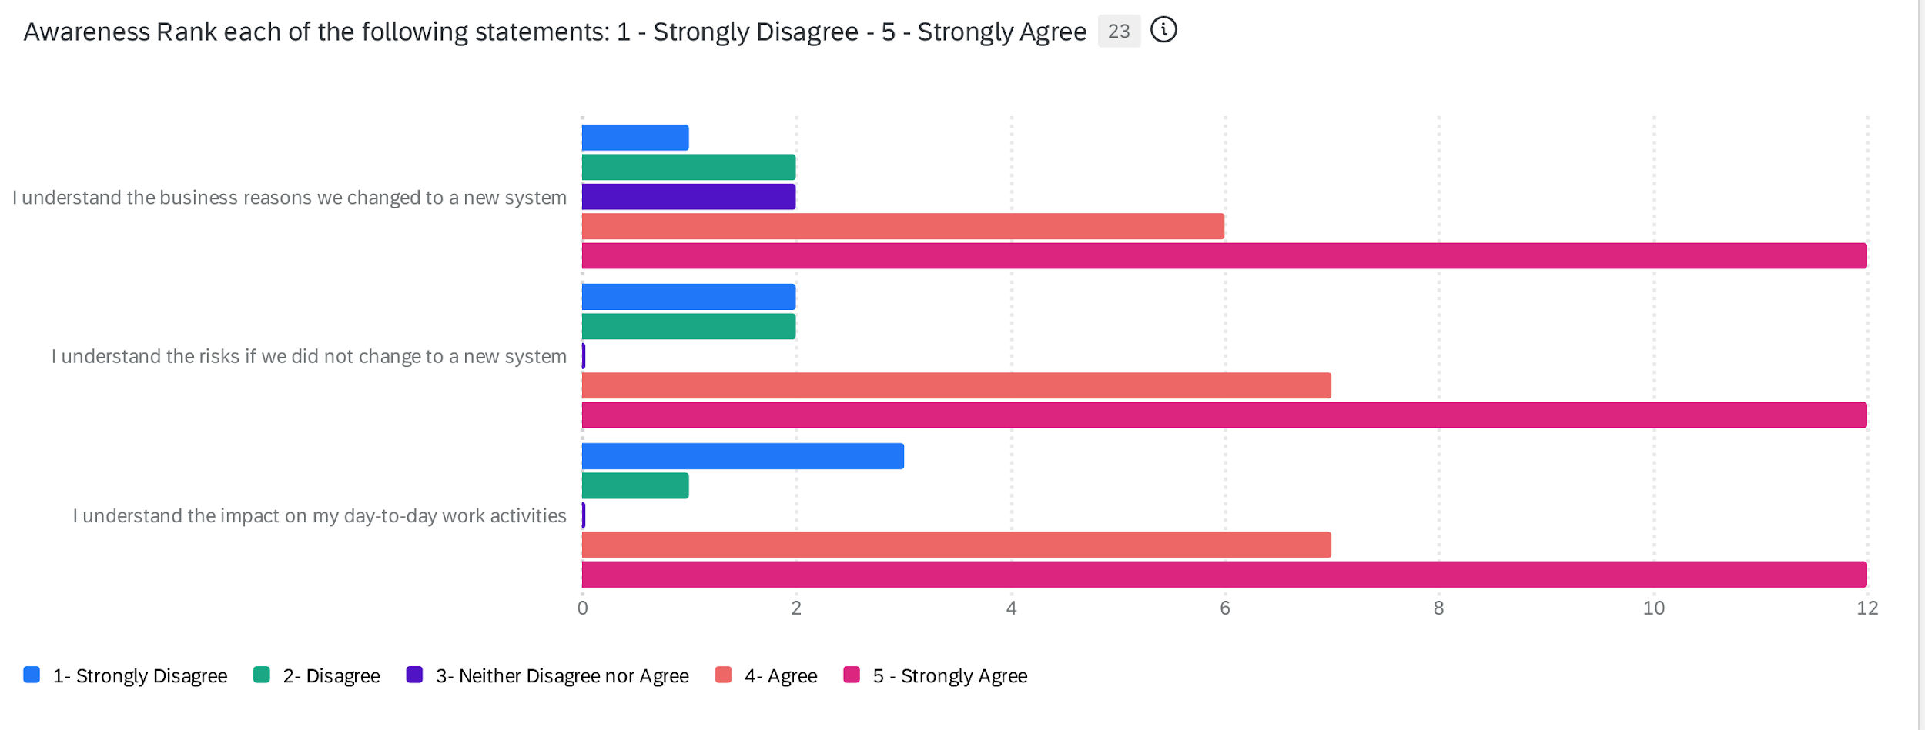
Figure 9. A summary of the descriptive statistics for the Awareness component.

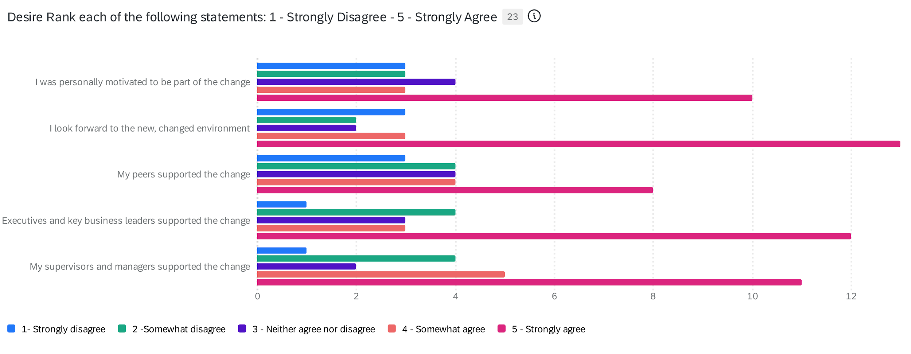
Figure 10. A summary of the descriptive statistics for the Desire component.

survey questions approved by the UTK IRB (IRB-23-07929-XM and IRB-23-07808-XM). These comprehensive figures serve as a guide, detailing questions for both interviewees and survey respondents. The figures are structured to list various questions related to ERP system implementation, AI integration, and organizational change. For each question, it specifies which interviewees (1, 2, 3, 4, 5) the question applies to, whether it relates to Attitude, Behavior, or Practice, and which phase of the process it addresses (Vision, Planning, Implementation).
Results from the Employee Survey
In addition to the interview questions, the figures include the results for the survey questions posed to respondents 1-23. These questions cover a range of topics crucial to understanding the ERP implementation process. They explore areas such as awareness of the change and its impacts, their desire for and support of the change, the knowledge and skills related to the new system, the ability to perform in the new environment, and reinforcement of the change. By categorizing the questions according to their focus and relevance to different aspects of the ERP implementation process, the figures provide a structured approach to gathering data. It ensures that the study captures a comprehensive view of the implementation process, from the perspectives of both leadership and end-users.
Descriptive Statistics on the Survey
Following the initial pilot survey, an additional ten participants were invited to participate, resulting in three more responses, bringing the total number of survey respondents to 23.
Awareness (Qualtrics, 2024)
Awareness
- Mean Scores: 4.04 – 4.13
- Min Score: 1.00
- Figure 9 Key Takeaway: Employees generally understand the business reasons, risks, and impact of the change, with most responses leaning toward agreement. However, some employees (minimum score of 1) may still lack awareness, indicating a need for further communication. While the mean scores (4.04–4.13) suggest that employees generally understand the business reasons, risks, and impact of the change, the presence of a minimum score of 1.00 highlights a critical gap in awareness among some individuals. This discrepancy indicates that while many employees are aligned with the organization's communication efforts, a subset may either be disengaged or lack access to clear and consistent messaging. Addressing this gap is essential to ensure that all employees are equipped with the knowledge needed to navigate organizational changes effectively.
understanding but also the emotional and practical aspects of the transition, ensuring that all employees are fully equipped and motivated to embrace the new way of working.
To bridge this awareness gap, organizations should adopt targeted communication strategies that prioritize transparency and inclusivity. For example, implementing two-way communication channels can allow employees to voice their concerns and seek clarification on change-related matters. Additionally, leveraging centralized communication platforms ensures that critical updates reach all employees uniformly, reducing the risk of information silos. By fostering an environment where employees feel informed and valued, organizations can enhance overall engagement, minimize resistance to change, and align their workforce with strategic goals.
Desire (Qualtrics, 2024)
- Mean Scores: 3.43 – 3.91
- Min Score: 1.00
- Max Score: 5.00
- Figure 10 Key Takeaway: Motivation to embrace the change and support from peers, executives, and managers show moderate agreement. The slightly lower scores suggest some resistance or lack of enthusiasm among employees, which could impact adoption. The moderate mean scores (3.43–3.91) indicate that while there is some motivation among employees to embrace the change, enthusiasm and commitment may not be universally strong. The minimum score of 1.00 highlights that certain individuals may feel disconnected or resistant, which could hinder the overall adoption and success of the change initiative. This resistance might stem from unclear benefits, lack of personal alignment with the change goals, or insufficient support from peers and leadership. Addressing these concerns is crucial to fostering a stronger desire across the organization.
To enhance employee motivation and reduce resistance, organizations should focus on creating a compelling narrative around why the change is necessary and beneficial. Leaders must clearly articulate the "what's in it for me" factor for employees, showing how the change aligns with their personal and professional aspirations. Engaging employees early in the process, involving them in decision-making, and providing opportunities for feedback can build a sense of ownership and investment in the change. Additionally, recognizing early adopters and celebrating successes can further incentivize participation and boost morale.
Knowledge (Qualtrics, 2024)
- Mean Scores: 4.09 – 4.36
- Min Score: 1.00 (one instance: 2.00)
- Max Score: 5.00
- Figure 11 Key Takeaway: Employees feel well-prepared with skills and knowledge, with relatively high agreement that training was adequate. However, a few individuals feel unprepared, as reflected by low minimum scores. The relatively high mean scores (4.09–4.36) indicate that most employees feel well-prepared with the necessary skills and knowledge to adapt to organizational changes, reflecting positively on the adequacy of training provided. However, the presence of low minimum scores (1.00, with one instance at 2.00) suggests that a small subset of employees feels unprepared, which could lead to challenges in achieving consistent performance across the organization. These outliers may arise from gaps in training accessibility, content relevance, or individual learning needs, underscoring the importance of tailoring training programs to address diverse employee requirements.
To address these gaps and ensure all employees feel confident in their preparedness, organizations should conduct thorough training needs assessments at multiple levels—organizational, operational, and individual. This approach helps identify specific skill and
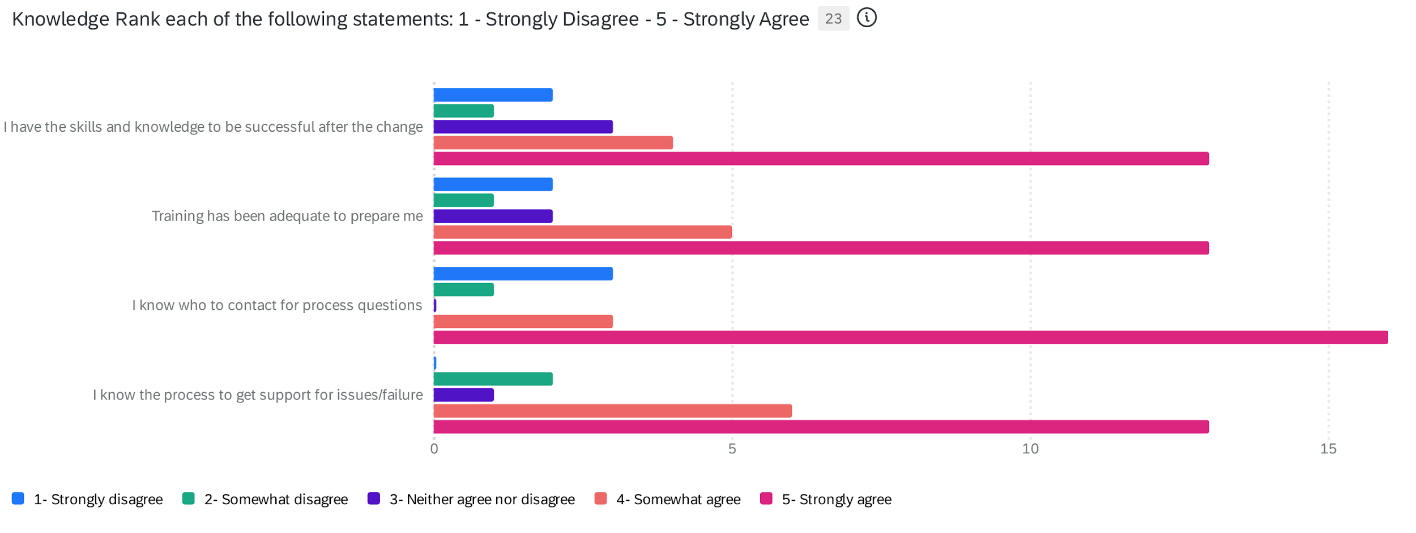
Figure 11. A summary of the descriptive statistics for the Knowledge component.

knowledge gaps while aligning training initiatives with both business objectives and employee roles. For example, targeted workshops or personalized coaching can address individual deficiencies, while company-wide sessions can reinforce core competencies critical to the change initiative. Additionally, integrating feedback mechanisms into training programs allows employees to voice concerns or request additional support, creating a more inclusive and responsive learning environment.
Ability (Qualtrics, 2024)
- Mean Scores: 3.96 – 4.17
- Min Score: 1.00
- Max Score: 5.00
Figure 12 Key Takeaway: Employees believe they can perform their new duties, but the scores are slightly lower than in the knowledge category. This could indicate a gap between knowing what to do and actually performing effectively. The mean scores (3.96–4.17) suggest that employees generally feel capable of performing their new duties, but the slightly lower scores compared to the Knowledge category highlight a potential gap between understanding what to do and successfully executing tasks. The minimum score
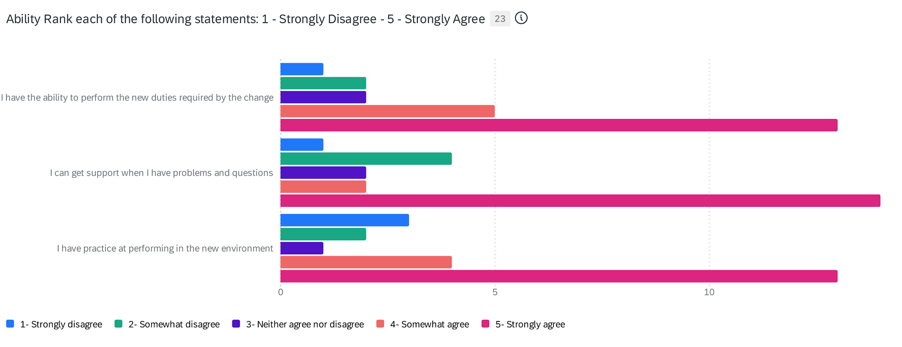
Figure 12. A summary of the descriptive statistics for the Ability component.
- of 1.00 further underscores that some employees may lack the confidence, resources, or support needed to apply their knowledge effectively in practice. This gap could stem from a lack of hands-on experience, unclear expectations, or insufficient reinforcement of skills during the transition. Another critical strategy is to ensure that employees have access to ongoing resources and support systems as they adapt to their new roles. This could include refresher training sessions, cross-functional collaboration opportunities, or even coaching from experienced colleagues who can guide them through challenges. Encouraging open communication about obstacles employees face can also help leadership identify and address barriers to performance. By creating an environment where employees feel supported and empowered to practice and refine their skills,
organizations can bridge the gap between knowledge and ability, ultimately driving greater confidence and effectiveness in the workforce.
Reinforcement (Qualtrics, 2024)
- Mean Scores: 4.22 – 4.43
- Min Score: 1.00
- Max Score: 5.00
Figure 13 Key Takeaway: Employees perceive that the organization is committed to sustaining the change, and they understand the consequences of not performing their new tasks. This is a strong positive indicator for long-term success. The strong mean scores (4.22–4.43) reflect a positive perception among employees regarding the organization's commitment to sustaining change and their understanding of the consequences of not performing new tasks. This is an encouraging indicator of long-term success, as

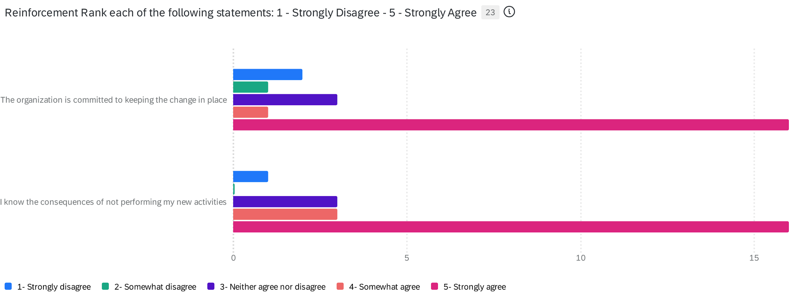
Figure 13. A summary of the descriptive statistics for the Reinforcement component
reinforcement is a critical component of embedding change into the organizational culture. However, the presence of a minimum score of 1.00 suggests that some employees may still feel disconnected from the reinforcement mechanisms or lack clarity about how their roles contribute to sustaining the change. Addressing these outliers is essential to ensure consistent alignment across the workforce. Using the ADKAR model (Awareness, Desire, Knowledge, Ability, and Reinforcement), the survey assessed various aspects of the change implementation on a five-point Likert scale which are evaluated in Figures 9-14.
When viewed collectively, these survey findings paint a nuanced picture of the organization's readiness for change. The ADKAR (Awareness, Desire, Knowledge, Ability, Reinforcement) model provides a structured lens through which to understand employee perceptions and identify areas for targeted intervention. While the overall trends lean towards positive alignment with the change, the persistent presence of low minimum scores across all categories signals critical areas where specific individuals or groups may be struggling. Ignoring these outlier responses could lead to significant roadblocks during implementation and hinder long-term adoption.
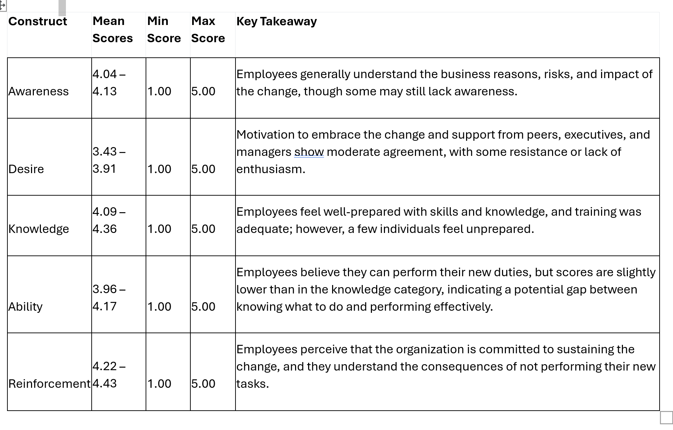
Figure 14. A summary of overall ADKAR.

The high mean scores for Awareness and Knowledge suggest that the organization has done a reasonably good job of communicating the rationale behind the change and providing adequate training. However, the slightly lower scores for Desire and Ability indicate that converting this understanding into motivation and practical application remains a challenge. This discrepancy suggests that while employees may comprehend why the change is happening and possess knowledge of how to perform their new duties, some lack the desire to fully embrace the change or the ability to execute their new roles effectively.
The relatively strong scores in Reinforcement are encouraging, indicating that employees believe the organization is committed to sustaining the change. However, this perception alone will not guarantee success if employees lack the desire to participate actively or the ability to perform effectively. To capitalize on this positive perception, the organization must focus on closing the gaps in Desire and Ability by emphasizing the individual benefits of the change, fostering a supportive environment, and providing ongoing coaching and resources. Ultimately, the success of any organizational change hinges on addressing not only the intellectual understanding but also the emotional and practical aspects of the transition, ensuring that all employees are fully equipped and motivated to embrace the new way of working.

Chapter 5: Conclusions, Findings and Recommendations
The survey conducted for this study was designed to evaluate employee perceptions regarding an organizational change initiative, using the ADKAR model, which consists of five key components: Awareness, Desire, Knowledge, Ability, and Reinforcement (Hiatt, 2006). Utilizing a five-point Likert scale, participants were asked to rate their degree of agreement or disagreement with various statements related to each component. The survey explored employees’ comprehension of the reasons for the change, their motivation to engage with the change, their knowledge and skills related to their new responsibilities, their beliefs about their ability to perform these responsibilities, and the support mechanisms they perceived were in place to support the change. An analysis of the survey responses across these dimensions provides insights into the effectiveness of the change process and identifies areas that may require further attention or improvement (Hiatt, 2006).
Joseph Schumpeter's theory of “creative destruction” offers a compelling lens through which to view the integration of AI into ERP systems. Schumpeter argued that innovation inherently disrupts existing structures, creating new opportunities while rendering older systems obsolete. AI-driven ERPs exemplify this process by automating tasks, optimizing workflows, and enabling predictive analytics, thereby challenging traditional operational paradigms. This perspective underscores that successful AI integration is not merely about enhancing existing ERP functionalities, but also entails fundamentally re-imagining business processes to foster innovation and maintain a competitive edge.
However, the Schumpeterian “creative destruction” concept is not without its challenges, particularly in terms of employee acceptance and organizational change. This is where trust becomes paramount. If employees lack trust in the AI systems or in the leadership guiding their implementation, they may resist adoption, hindering the potential benefits of the new technology. By building trust, businesses can mitigate resistance, encourage engagement, and ensure that employees embrace the innovative changes necessary for long-term success (Mayer, 1995).
The theory of Diffusion of Innovation (DOI) by Everett Rogers offers valuable insights to enhance the organizational change process reflected in the results of the ADKAR model survey. Rogers' theory can be applied to address various aspects of the change implementation, focusing on five key dimensions: innovation characteristics, adopter categories, communication channels, time, and social systems. Regarding innovation characteristics, Rogers identified five attributes that influence the speed and pervasiveness of the adoption of an innovation: relative advantage, compatibility, complexity, trialability, and observability (Rogers, 2010).
Relative Advantage refers to the degree to which an innovation is perceived as superior to the idea, product, or practice it replaces. This advantage might manifest in terms of cost savings, improved functionality, enhanced efficiency, or even social prestige. The greater the perceived benefit of an innovation, the faster it is likely to be adopted. Compatibility is the extent to which an innovation aligns with the values, experiences, and needs of potential adopters. Innovations that integrate seamlessly into existing practices or resonate with users' beliefs and lifestyles are more likely to gain widespread acceptance. Complexity describes how difficult an innovation is to understand or use. Simpler innovations that are easy to grasp and implement tend to be adopted more quickly. Conversely, innovations perceived as overly complex may encounter resistance or slower adoption rates. Trialability highlights the importance of allowing users to experiment with an innovation on a limited basis before committing fully. When individuals have the opportunity to test an innovation and experience its benefits firsthand, they are more likely to adopt it. Observability pertains to how visible the results or benefits of an innovation are to others. Innovations with easily observable advantages tend to spread faster, as their success can inspire imitation and encourage adoption through social influence. These attributes collectively shape how innovations diffuse within societies and organizations, ultimately impacting their success in reaching widespread adoption.
Based on the survey results provided, we can align these findings with the Diffusion of Innovation theory to draw meaningful conclusions about the implementation of AI-integrated ERP systems in large enterprises. The survey results are consistent with the DOI framework. When viewed through the lens of the DOI theory, it provides valuable insights into the adoption process of AI-integrated ERP systems. The high mean scores in the Awareness category (4.04 - 4.13) suggest that a significant portion of employees felt they understood the business reasons for making the change, and what the impact of the change would be. These findings align with the DOI theory, which emphasizes the importance of awareness in the adoption process (Rogers, 2010). This group likely represents the innovators and early adopters in the organization, who are crucial for initiating the diffusion process.
The Knowledge category's high mean scores (4.09 - 4.36) indicate that many employees felt well-prepared for the change, in terms of their skills and knowledge. This group may represent the early majority, who are more deliberate in their approach to adoption, but are willing to embrace the innovation with proper training and support. The lower mean scores in the Desire category (3.43 - 3.91) and the presence of minimum scores of 1.00 across categories suggest the existence of some late majority and laggards. These groups may be more skeptical or resistant to change, requiring additional support and convincing.
The high scores in the Reinforcement category (4.22 - 4.43) suggest that employees generally perceive the long-term benefits of the change, aligning with DOI's emphasis on relative advantage. The moderate to high scores in Ability (3.96 - 4.17) indicate that the new system is generally perceived as compatible with the employees’ existing skills and processes. The slightly lower scores in Ability, compared to Knowledge, highlight the complexity factor in the DOI theory. It suggests that, while employees understand the innovation, they may find it challenging to implement, emphasizing the need for hands-on experience and trials.
The high scores in the Awareness and Reinforcement categories indicate that the benefits of the innovation are observable to employees, which is a key factor in the DOI theory for encouraging adoption.
The survey results suggest that the organization is progressing well through the innovation adoption curve, with a significant portion of employees’ being aware of and knowledgeable about the change. However, there is still work to be done in addressing the needs of the late majority and laggards, particularly in building their desire to engage with the change and improving their ability to do so. By focusing on these areas and leveraging the principles of the Diffusion of Innovation theory, the organization can enhance the adoption and integration of AI-integrated ERP systems across all employee segments.
The insights from the interviews with business leaders on ERP and AI implementation align closely with the Diffusion of Innovation theory, particularly regarding the adoption and integration of new technologies within organizations. Rogers’ DOI model emphasizes the role of innovators and early adopters, and the process by which new technologies gain acceptance and subsequent use. The interviews illustrate that successful technological adoption requires not only management buy-in and strategic planning, but also a focus on overcoming employee resistance, which is a key barrier in the innovation diffusion process.
The interview findings highlight that senior leadership plays a critical role as change agents, driving awareness and commitment—key elements in the innovation-decision process. The experiences at Tenneco, Hertz, and Caesars Entertainment demonstrate that inadequate training and user engagement can hinder adoption, mirroring the challenges faced by early adopters in the DOI model. Conversely, companies that implemented structured training programs, clear communication strategies, and phased rollouts, experienced smoother transitions, reinforcing the importance of compatibility, trialability, and observability—factors that positively influence the rate of adoption.
Additionally, generational differences in technology acceptance, as noted in the sports and defense industries, reflect the variance in adoption rates among different adopter categories. According to Interviewee 2, “younger employees and digital-native professionals tend to embrace AI-driven ERP systems more readily”, aligning with DOI’s principle that certain demographic groups are more likely to be early adopters.
Ultimately, the integration of AI in ERP systems follows the diffusion curve, where organizations must strategically manage change to move from early adoption to widespread implementation. Success depends on fostering an innovation-friendly culture, mitigating uncertainty through communication and training, and leveraging leadership to reinforce the perceived benefits of adoption. By addressing these factors, businesses can accelerate the diffusion process and fully realize the transformative potential of AI-integrated ERP systems.
Encouraging opinion leaders and change agents within the organization to promote the change could be beneficial. By applying these principles from the DOI theory, the organization can address the weaker areas identified in the ADKAR survey, particularly in building a desire for change and strengthening peer support networks. This approach can help accelerate adoption and improve the overall success of the organizational change initiative (Rogers, 2010).
The analysis of the dissertation survey reveals significant insights into the gaps in the literature and the application of the DOI in addressing organizational change and enhancing technology adoption processes. Furthermore, this research addresses the limited exploration of AI in ERP system implementation across diverse organizational contexts, especially in balancing technological advancements with human and cultural factors. To address these gaps and enhance the organizational change process, the research applied Everett Rogers' Theory of Diffusion of Innovations, which complements the ADKAR model.
This theory incorporates key elements such as innovation characteristics, adopter categories, communication channels, time-based stages of change, and the influence of social systems. By utilizing these principles, the research was able to address weaker areas identified in the ADKAR survey, particularly in building a desire for change and strengthening peer support networks. The application of the DOI theory offers several benefits to the research. It provides a structured approach to understanding and accelerating the adoption of innovations within organizations. By addressing the weaker areas in the ADKAR model, such as fostering a desire for change and enhancing peer support, the theory’s guidance may help to improve the success rate of organizational change initiatives.
Moreover, this study bridges the gap between theoretical understanding and practical application, offering actionable insights for managing change effectively. This research demonstrates that the Diffusion of Innovations framework can enhance the understanding of historical and practical applications of AI implemented in ERP systems. The theory's focus on innovation characteristics and social systems aligns with the dissertation's aim to provide a nuanced perspective on the evolution and implementation of AI technologies. This theoretical framework strengthens the dissertation's contributions by offering a robust lens to analyze and address the challenges of AI in ERP system adoption across various organizational contexts.
The findings indicate that incorporating AI significantly enhances operational efficiency by automating workflows, optimizing processes, and providing advanced data analytics, which collectively improve decision-making capabilities. This aligns with the DOI framework, which suggests that the perceived advantages of an innovation—such as increased efficiency—can facilitate its adoption across organizations. Moreover, the study highlights how AI improves knowledge management by effectively handling both structured and unstructured information within organizations.
This capability is crucial for enhancing decision-making and operational responsiveness, as it allows for the automation of knowledge workflows and the extraction of valuable insights. The DOI theory underscores the role of knowledge in the adoption process, indicating that organizations are more likely to embrace innovations when they see clear benefits to their operations. Another significant finding is the alignment of AI-driven ERP systems with organizational culture, which reduces resistance to change and increases user acceptance of the innovation. . By tailoring ERP interfaces to match organizational processes, businesses can enhance employee engagement. This aspect also resonates with the DOI theory, which posits that compatibility with existing values and practices is a critical factor positively influencing the adoption of new technologies.
This research also emphasizes the role of effective communication as a vital enabler for successful AI integration in ERP systems. Clear communication fosters stakeholder participation and creates an environment conducive to technological advancements, aligning with the diffusion of innovations perspective that highlights communication channels as essential for spreading information about new technologies.
The dissertation also utilized a survey based on the ADKAR model to evaluate employee perceptions of organizational change initiatives, particularly regarding the integration of AI into ERP systems. The findings, analyzed through the lens of Rogers' Diffusion of Innovation theory, reveal that while a significant portion of employees demonstrate awareness and knowledge about the change, there is room for improvement in fostering employees’ desire to engage with the innovation, and in ensuring that all employee segments have the ability and training to do so. Specifically, the high mean scores in Awareness and Knowledge categories suggest a strong initial understanding, but lower scores in Desire indicate resistance or skepticism, particularly among the late majority and laggards. The study highlights the importance of addressing these concerns through targeted support and communication strategies to improve overall adoption and integration.
Qualtrics was used to analyze the results of the survey in ADKAR model. Qualtrics is a powerful survey platform that offers a comprehensive suite of tools for designing, distributing, and analyzing surveys, including features for statistical analysis, data visualization, and reporting. It can be used to produce a five-point Likert scale. For studies with a small sample size, Qualtrics offers advantages over SPSS for smaller data sets where descriptive statistics and basic comparisons are sufficient. Qualtrics provides a more accessible route to understanding key trends in the ADKAR data.
The dissertation's interviewees’ findings reveal key insights from business leaders on ERP implementation and AI integration, highlighting both challenges and success factors. One of the major barriers to successful ERP adoption was inadequate user training. Several interviewees noted that their companies faced significant post-implementation issues, such as double-counted costs and payroll complications, caused by insufficient testing. Resistance from employees, particularly in adapting to AI-enhanced functionalities, emerged as another common concern, emphasizing the importance of thorough preparation and user engagement.
The interviews revealed that AI integration in ERP systems was primarily leveraged to enhance data analytics, automate processes, and refine customer profiling. One company successfully used AI to develop detailed customer insights, optimizing its marketing strategies. While AI-driven ERP systems improved overall efficiency, the interviewees stressed the need for organizations to focus on cultural and behavioral adaptation among employees. Without addressing these human factors, the full potential of AI-ERP integration remains difficult to achieve.
Success factors for ERP adoption included strong leadership and management support. The interviewees emphasized that when senior executives actively championed the transition, the implementation was smoother. Comprehensive training programs and phased implementation strategies helped reduce employee resistance, making employees more comfortable with the new systems. Clear communication, particularly stakeholder engagement, was another essential element in securing user adoption, ensuring that employees felt informed and involved throughout the transition.
Figure 15 visualizes the key insights from the interviews on ERP implementation and AI integration. It highlights the challenges, AI integration aspects, and success factors based on the perspectives of business leaders. Figure 16 visually represents the key themes—Challenges, AI Integration, and Success Factors—along with their associated codes.

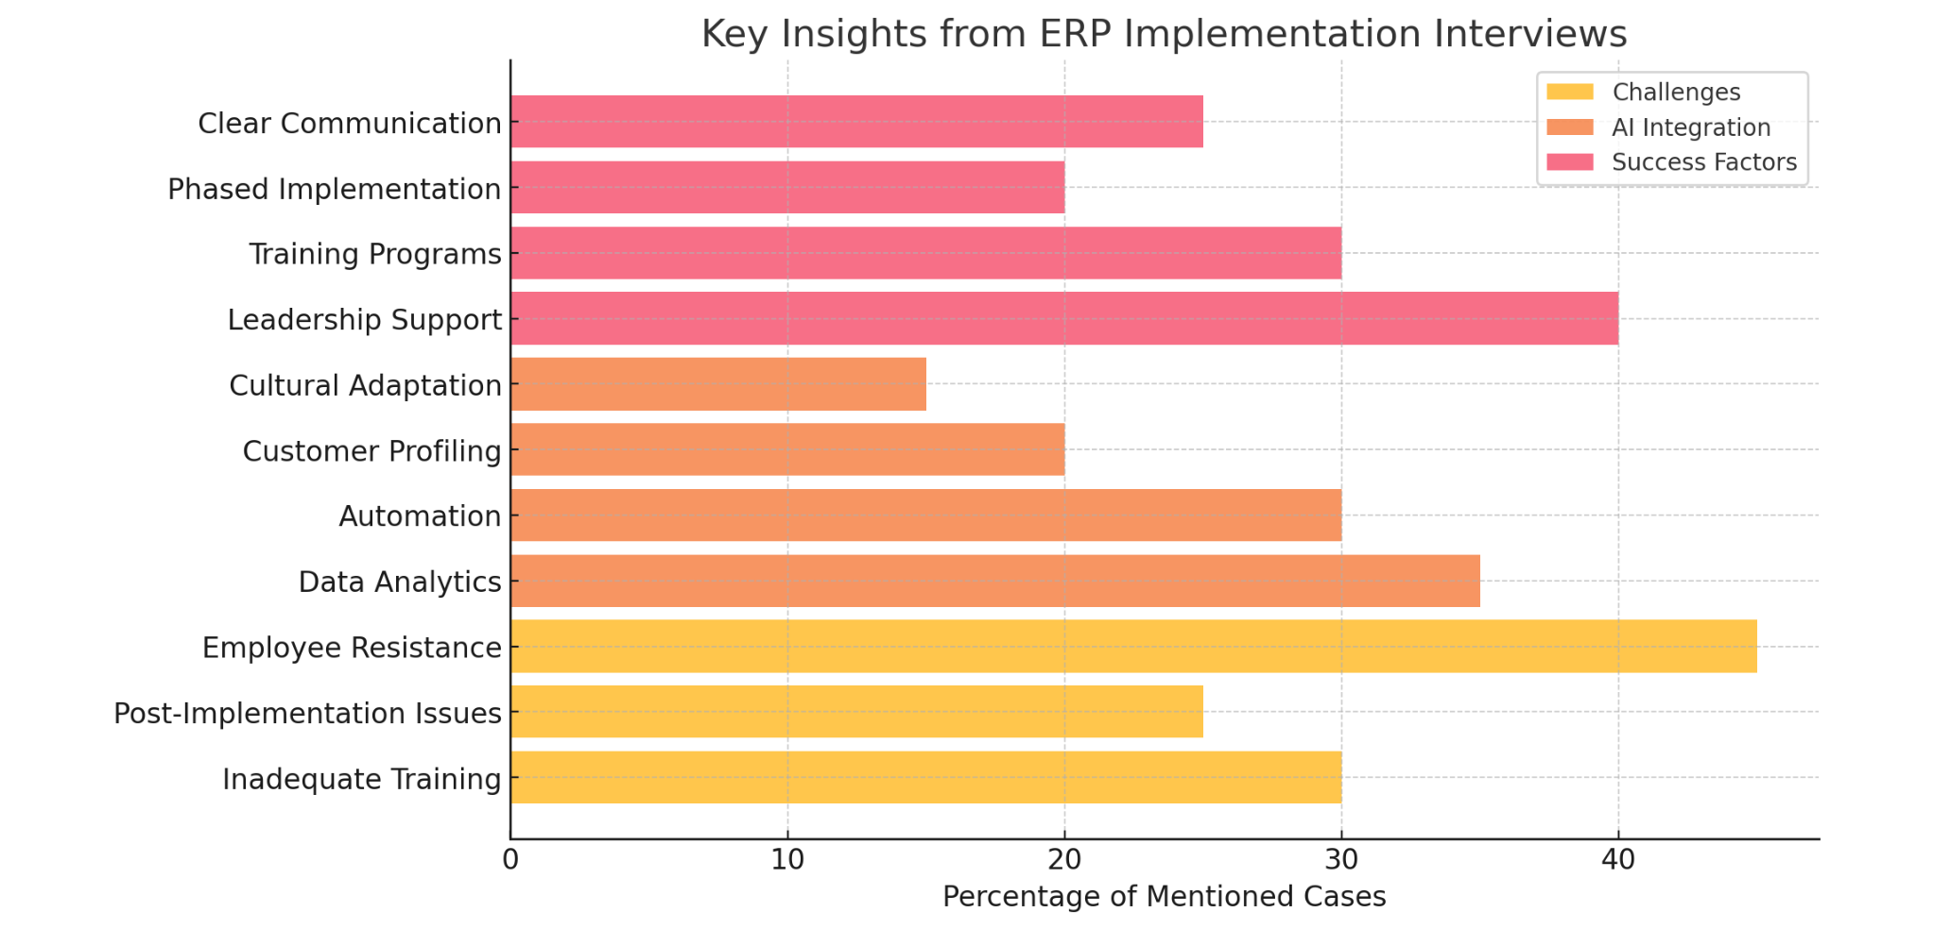
Figure 15: key insights from the interviews on ERP implementation and AI integration.

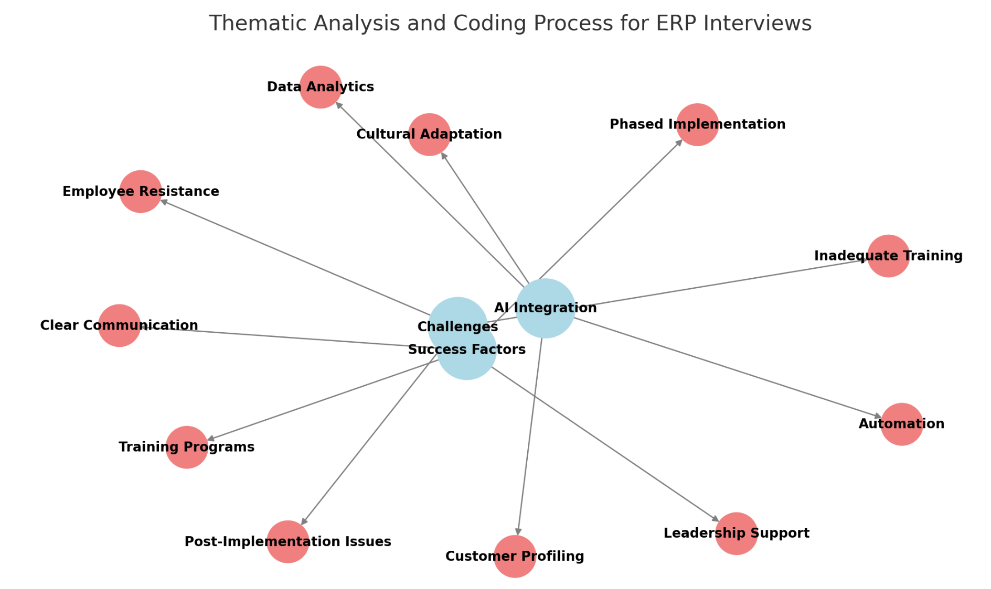
Figure 16. The key themes—Challenges, AI Integration, and Success Factors—along with their associated codes.
Recommendations
In terms of recommendations based on insights that have emerged from this study, organizations should implement comprehensive training programs focused on AI-integrated ERP systems to ensure employees are well-equipped to utilize these technologies effectively. Additionally, fostering a culture of innovation is crucial; organizations should encourage creativity and adaptability among employees to facilitate smoother transitions during implementation. Developing detailed communication plans is also essential to outline when and how information regarding AI integration will be shared with stakeholders, enhancing transparency and buy-in.
Furthermore, organizations should establish continuous feedback mechanisms to identify pain points in the AI-ERP integration process, allowing for ongoing improvements and adjustments. Leveraging predictive analytics capabilities provided by AI can enhance decision-making processes across various functions, ultimately improving overall business performance.
By incorporating these findings and recommendations within the framework of the Diffusion of Innovations theory, organizations can better position themselves to integrate AI into their ERP systems successfully. This approach will not only enhance productivity, but also help achieve strategic goals in an increasingly digital environment. Applying the Theory of Diffusion of Innovations to this dissertation not only addresses the gaps in the literature, but also provides a comprehensive framework for understanding and facilitating technological adoption in complex organizational environments. This approach enhances the research's ability to offer practical insights and contributes significantly to organizational change management in the context of AI and ERP system implementation.

The research recommends implementing comprehensive training programs and fostering a culture of innovation to facilitate smoother transitions during AI-ERP integration. Developing detailed communication plans and establishing continuous feedback mechanisms are also crucial for transparency and ongoing improvements. Leveraging the predictive analytics capabilities of AI within ERP systems can enhance decision-making processes across various functions, ultimately improving overall business performance. These recommendations, grounded in the Diffusion of Innovation theory, aim to accelerate and ease the adoption process by addressing the needs of different employee segments and reinforcing the perceived benefits of AI-integrated ERP systems.
Limitations
One limitation of this study is the potential for response bias, which is inherent in Likert scale surveys. Respondents may have a tendency to select neutral or extreme responses rather than providing nuanced answers, which can lead to skewed data. Additionally, the subjective nature of self-reported measures can result in inconsistencies, as individuals may interpret the scale differently based on personal experiences or biases (Anvari et al., 2023) Another limitation is the lack of qualitative depth that a Likert survey may provide. While Likert scales can quantify attitudes and perceptions, they do not capture the reasons behind those attitudes. This limitation means that, while the survey can indicate trends or general sentiments regarding AI integration in ERP systems, it may not fully explain the underlying motivations or contextual factors influencing those responses. In addition, it may be difficult to know if the survey response is specific to AI and/or ERP systems.
Furthermore, the survey sample size and diversity could also pose limitations. If the survey was administered to a small or homogenous group of respondents, the findings may not be representative of broader organizational perspectives or experiences. This could limit the generalizability of the results to different industries or organizational contexts.
There is a potential for bias in the qualitative data collected through interviews, as the perspectives shared may reflect individual experiences rather than a comprehensive view of AI integration across organizations. This subjectivity could influence the conclusions drawn from the data. The study examines AI integration within ERP systems at a specific point in time, which may not account for the rapidly evolving nature of technology and organizational processes. As AI and ERP technologies continue to advance, the relevance and applicability of the findings may diminish over time.
Because of small sample sizes, findings from interviews with a few business leaders may not be representative of the broader population of industry executives, making it difficult to draw widely applicable conclusions. Interviews are susceptible to various forms of bias. The flexible nature of qualitative interviews can lead to inconsistencies across different interviews, making it challenging to compare and aggregate data. The open-ended nature of qualitative data can lead to subjective interpretations, potentially compromising the objectivity of findings. Business leaders may lack the specific knowledge or understanding required to provide accurate answers on certain topics, leading to incomplete or misleading information.
Measuring AI in ERP implementation
Corporations can employ a variety of measurable key performance indicators (KPIs) to evaluate the implementation of AI in their ERP systems. These KPIs span several crucial areas of business operations and performance. In terms of operational efficiency, companies can measure the reduction in time taken to complete specific operations after AI integration, track the decrease in human errors in processes like data entry and calculations, and quantify the percentage of total operations that have been automated by AI. These metrics provide tangible evidence of how AI is streamlining and improving operational processes.
Key performance indicators (KPIs) and other relevant metrics play a crucial role in evaluating the effectiveness of AI across different areas of business. These quantifiable measures serve as vital indicators of an AI initiative's success. KPIs can encompass a wide range of metrics, including operational efficiency measures like task completion speed and accuracy, financial indicators such as return on investment and cost reductions, and customer-centric metrics like satisfaction ratings and engagement levels (Anchia, 2024).
The process of selecting appropriate KPIs is critical and requires a deep understanding of each AI project's specific goals. These goals must be aligned with the broader objectives of the business. The focus should not be on collecting vast amounts of data indiscriminately, but rather on identifying and tracking the most relevant information. This targeted approach ensures that the gathered data provides valuable insights into the performance and impact of AI applications within the organization (Anchia, 2024).
Customer experience is another vital area where AI's impact can be measured. Organizations can monitor improvements in customer satisfaction scores following AI implementation and measure the reduction in time required to generate personalized responses in customer support. These indicators reflect how AI enhances the company's ability to meet and exceed customer expectations. The financial impact of AI implementation is a critical consideration for any business. KPIs in this area include calculating the reduction in labor costs attributable to AI automation, and tracking increases in sales and revenue that can be attributed to AI-enhanced processes. These metrics directly tie AI implementation to the company's bottom line.
Productivity gains can be assessed by measuring the reduction in human design time or other tasks due to AI automation, as well as quantifying the increase in the number of outputs generated in a given time period. These KPIs demonstrate how AI boosts overall organizational productivity. In the realm of innovation and technology, companies can assess their progress in digital adoption and measure the proportion of processes that have been enhanced by AI. These indicators provide insight into the organization's technological advancement and the extent of AI integration across various business functions. Project management aspects of AI implementation can be evaluated by tracking the percentage of AI implementation projects completed on schedule and within the specified budget. These metrics help ensure that the AI integration process itself is being managed effectively.
Finally, employee satisfaction is a crucial factor in the success of any technological implementation. Companies can monitor the rate at which employees embrace and utilize the AI-enhanced ERP system and collect and analyze qualitative feedback on the AI implementation's impact on work processes. These KPIs provide valuable insights into how well the workforce is adapting to and benefiting from the new AI-enhanced systems. It's important to note that these KPIs should be tailored to align with each organization's specific goals and strategies for AI implementation in their ERP systems. By carefully selecting and monitoring these indicators, companies can gain a comprehensive understanding of the impact and effectiveness of their AI initiatives. Table 3 is a representation of the KPIs for measuring AI implementation in ERP systems.

Table 3. Representation of the KPIs for measuring AI implementation in ERP systems.
Category | KPI | Description
Operational Efficiency | Process Times | Measure reduction in time for specific operations
 | Error Rates | Track decrease in human errors
 | Automation Levels | Quantify percentage of operations automated
Customer Experience | Customer Satisfaction Scores | Monitor improvements in customer satisfaction
 | Response Time | Measure reduction in time for personalized responses
Financial Impact | Cost Savings | Calculate reduction in labor costs
 | Revenue Growth | Track increases in sales and revenue
Productivity | Time Saved | Measure reduction in human task time
 | Output Generation | Quantify increase in outputs per time period
Innovation and Technology | Digital Maturity | Assess progress in digital adoption
 | Percentage of AI-enabled Processes | Measure proportion of AI-enhanced processes
Project Management | On-time Completion Rate | Track percentage of projects completed on schedule
 | On-budget Completion Rate | Measure percentage of projects completed within budget
Employee Satisfaction | User Adoption | Monitor rate of employee utilization
 | Employee Feedback | Analyze qualitative feedback on AI impact

Summary of Findings
The implementation of artificial intelligence in ERP systems demonstrates significant positive impacts on both organizational processes and employee attitudes in large-scale enterprises. The research reveals several key findings:
- Operational Impact:
- AI integration significantly enhances knowledge management practices, particularly in handling process-based organizational knowledge and tacit knowledge
- Business process re-engineering (BPR) becomes more effective through AI-driven insights and automation
- Decision-making processes are accelerated and improved through enhanced predictive modeling and data analytics capabilities
- Employee Impact:
- When properly implemented, AI-enhanced ERP systems can lead to increased employee acceptance and reduced resistance to change
- Employee productivity and job satisfaction can improve through streamlined processes and reduced manual workload
- The success of AI-ERP implementation is heavily dependent on effective communication strategies and proper training
- Organizational Transformation:
- AI-driven ERP systems serve as catalysts for digital transformation, enabling organizations to become more data-driven and agile
- Integration creates opportunities for innovation and competitive advantage through improved operational efficiency
- Organizations experience enhanced ability to adapt to market changes and customer needs
The research demonstrates that successful AI implementation in ERP systems requires a balanced approach that considers both technological capabilities and human factors. Organizations that effectively manage this integration can achieve significant improvements in operational efficiency, while maintaining positive employee attitudes and behaviors. The key to success lies in maintaining clear communication, providing adequate training, and ensuring alignment between technological implementation and organizational culture.
Future success in AI-ERP implementation will depend on organizations' ability to:
- Maintain a balance between automation and human involvement
- Continuously adapt to technological advancements while considering employee needs
- Foster a culture of innovation and continuous learning
- Ensure transparent communication about AI's role and impact on job functions
This transformation represents not just a technological upgrade, but a fundamental shift in how organizations operate and how employees interact with enterprise systems. When properly managed, this integration can lead to sustainable competitive advantages and improved organizational performance.
Guided by the Diffusion of Innovation theory, strategies can be recommended to address the adoption curve, focusing on innovators, early adopters, and laggards, ensuring a smoother transition and higher acceptance rates. Identify and engage employees who are naturally inclined to experiment with new technologies (innovators) and those who are open to adopting new ideas early (early adopters). Provide these groups with advanced training and involve them in pilot programs to showcase the benefits of AI-ERP integration. Use early adopters as champions or advocates to influence the majority of employees by sharing success stories and demonstrating tangible benefits. Highlight case studies and testimonials from other organizations that have successfully implemented AI in ERP systems.
Develop user-friendly interfaces and provide step-by-step guides to make the AI-ERP system accessible to employees who may be hesitant or less tech-savvy. Offer incentives, such as recognition or rewards, to encourage adoption among these groups. Address concerns and fears through transparent communication about how AI will impact job roles and responsibilities. Provide ongoing support and personalized assistance to help laggards adapt to the new system.
Emphasize the relative advantages of AI-ERP systems, such as improved efficiency, better decision-making, and reduced workload. Ensure that the AI-ERP system is compatible with existing workflows and organizational culture to minimize disruption. By applying the DOI theory, organizations can strategically manage the adoption process, ensuring that AI-ERP systems are embraced across all employee segments, ultimately leading to successful implementation and long-term benefits.
Lencioni's model of team dysfunctions offers a powerful lens through which to understand emerging challenges in team interactions, particularly as technological advancements reshape workplace communication. The framework reveals how dissimulation—concealing true intentions or feelings—may become increasingly complex in our digital future (Lencioni, 2002).
As technology evolves, team members will likely develop more sophisticated methods of masking vulnerabilities and distorting outcomes. Digital tools and communication platforms could provide unprecedented opportunities for individuals to project artificial images of competence while undermining genuine team collaboration. This technological amplification of deception could dramatically transform how teams interact, making traditional trust-building mechanisms more challenging (Lencioni, 2002).
The intersection of advanced technologies and human behavior suggests that future teams will need robust strategies to counteract these emerging forms of dissimulation. Leaders must develop a heightened awareness of how digital communication can facilitate concealment, creating new approaches to fostering transparency, accountability, and authentic engagement. The ability to detect and mitigate technology-enabled deception will become a critical leadership skill in maintaining team effectiveness. Moreover, the potential for dissimulation to erode team dynamics extends beyond individual interactions (Lencioni, 2002).
In increasingly complex and interconnected work environments, the cumulative effect of subtle deceptions could fundamentally undermine organizational performance. Understanding and anticipating these challenges through frameworks like Lencioni's will be essential for building resilient, high-functioning teams in the future (Lencioni, 2002).
Data poisoning presents a significant cybersecurity threat to AI and ML systems, with particular vulnerability observed in generative AI models. This attack involves deliberately manipulating training data, resulting in corrupted AI behavior that can produce biased or false outputs. These attacks primarily occur during the model's training phase, compromising its future performance (Kondamani, 2024).
Two main categories of data poisoning attacks have been identified: insider threats (white box attacks) and external threats (black box attacks). Insider threats are conducted by internal actors, such as employees, who possess knowledge of the model and the organization's cybersecurity protocols (Kondamani, 2024).
External threats, on the other hand, are carried out by external adversaries who lack access to internal information. Attackers employ various methods to poison data, including mislabeling samples (label flipping attacks), introducing noisy data points, and inserting backdoor patterns. The objectives of these attacks can be either targeted, influencing specific inputs, or untargeted, disturbing overall performance (Barracuda, 2024). The success of these attacks relies on stealth, efficacy, and consistency in the poisoned model. The increasing prevalence of generative AI in daily use and enterprise applications underscores the critical need for understanding and mitigating data poisoning attacks. As AI becomes more integrated into various sectors, developing robust defenses against these sophisticated threats is imperative to ensure the integrity and trustworthiness of AI-driven solutions (Kondamani, 2024).
To effectively support the adoption of AI-ERP systems, it is essential to address the critical role of employee skill development in ensuring a smooth and successful transition. While the importance of training has already been established as a cornerstone of this process, implementing policy-based approaches can provide a structured and scalable framework to foster the necessary skill development. Policy approaches to skill development can be comprehensively addressed through three strategic interventions: first, raising awareness by offering personalized career guidance that helps individuals understand emerging skill requirements and potential learning pathways; second, developing flexible and modular learning programs that can be customized to meet diverse individual and industry needs, allowing for adaptable and stackable skill acquisition; and third, providing targeted financial support that covers various training-related expenses, including course fees, learning materials, and potential income support during training periods. These interconnected strategies aim to create an accessible, responsive, and supportive ecosystem for continuous skill development and lifelong learning (OECD, 2019).
Policy approaches to skill development can be comprehensively addressed through three strategic interventions: first, raising awareness by offering personalized career guidance that helps individuals understand emerging skill requirements and potential learning pathways; second, developing flexible and modular learning programs that can be customized to meet diverse individual and industry needs, allowing for adaptable and stackable skill acquisition; and third, providing targeted financial support that covers various training-related expenses, including course fees, learning materials, and potential income support during training periods. These interconnected strategies aim to create an accessible, responsive, and supportive ecosystem for continuous skill development and lifelong learning (OECD, 2019).
As the AI-integrated ERP system proves its effectiveness, employees may experience increased job satisfaction resulting from reduced manual work and improved decision-making capabilities. To maximize the positive impact of AI-integrated ERP systems on both organizational processes and employee attitudes, companies should focus on comprehensive training programs to equip employees with the necessary skills. Management should have clear communication about the role and benefits of AI in the ERP system. Employing a gradual implementation to allow for adjustment and feedback is helpful. Involving employees in the implementation process fosters a sense of ownership and reduces resistance. By addressing these factors, large-scale enterprises can effectively implement AI in their ERP systems, enhancing organizational processes while positively influencing employee attitudes and behaviors.
In conclusion, this research addresses the attitudes, behaviors, and practices of organizations and their workforce during AI implementation within ERP systems as follows:
Organizational Attitudes: Large enterprises generally perceive AI integration into their ERP systems as a valuable opportunity to enhance efficiency, improve decision-making, and strengthen their competitive position. They anticipate AI will enhance knowledge management, optimize business processes (potentially through BPR), and better align ERP functionalities with their organizational culture. Establishing a clear strategic vision with defined goals for AI integration, particularly in data analytics, task automation, and decision support, is considered crucial. This dissertation emphasizes that a successful implementation depends on a thorough understanding of how both the organization and its workforce adapt to these technological advancements.
Workforce Attitudes and Behaviors: The attitudes and behaviors of employees are paramount for successful AI-ERP integration. The research underscores the necessity of robust communication strategies and active employee involvement throughout the implementation process. AI is expected to deliver intuitive, user-friendly interfaces that simplify traditionally complex ERP functions. The study also suggests that AI’s ability to customize ERP interfaces and workflows to align with specific company processes can enhance employee engagement and satisfaction.
Organizational Practices: The dissertation identifies key organizational practices that contribute to smooth and effective AI-ERP implementation. These include meticulous planning, strategic change management, and the cultivation of a supportive organizational culture. Effective planning involves a comprehensive assessment of current ERP systems, the design of tailored AI-powered solutions, the development of robust data management strategies, and the strategic allocation of resources. Strategic change management is essential for promoting user acceptance and minimizing resistance. Fostering a supportive organizational culture characterized by open communication, active stakeholder engagement, and high levels of employee involvement is crucial for creating an environment where employees feel comfortable adopting and leveraging AI technologies within the ERP system. This research does exhibit characteristics that suggest it could be contributing to a more incremental shift, potentially leading to a future paradigm shift. Kuhn's concept of paradigm shifts involves a fundamental change in the basic concepts and experimental practices of a scientific discipline (Kuhn, 2012).
Reflecting on my research, one of the most surprising findings was the extent to which the Diffusion of Innovation theory, often discussed in academic circles, directly influences the practical adoption and integration of AI within ERP systems. It underscored the critical importance of bridging the gap between academic theory and real-world application. My dissertation highlights how understanding the stages of innovation adoption, as described by Rogers (2010), can significantly enhance the strategic planning and implementation of AI-driven ERP solutions, making the technology more accessible and beneficial for all stakeholders within the enterprise.
C.S. Lewis viewed technological progress with profound skepticism, arguing that unchecked scientific advancement could potentially dehumanize humanity and strip away essential moral qualities, a perspective remarkably prescient in today's debates about artificial intelligence and transhumanist ambitions (Charron, 2024). However, the conclusions of this research point towards an approach to AI-ERP integration that puts the focus on human factors and recognizes that actually supporting and prioritizing them over the technological aspects, is vital to the successful adoption of this innovation. Table 4 and Figure 17 cover key aspects of the findings, recommendations, theoretical frameworks, and limitations.

Table 4. Summary table covering key aspects of the findings, recommendations, theoretical frameworks, and limitations.
Category | Key Findings/Insights | Recommendations | Theoretical Framework | Limitations
Survey Results (ADKAR) | High Awareness & Knowledge; Moderate to High Ability & Reinforcement; Lower Desire, indicating resistance, particularly among late majority & laggards. | Targeted support for late majority/laggards; Build desire through communication and demonstrating benefits. | ADKAR Model (Awareness, Desire, Knowledge, Ability, Reinforcement) | Potential for response bias in Likert scale (neutral/extreme responses); May not be AI/ERP specific
AI-ERP Implementation | AI enhances operational efficiency (automation, data analytics), improves knowledge management, and aligns with organizational culture when interfaces are tailored. | Comprehensive training programs; Foster a culture of innovation; Detailed communication plans; Continuous feedback mechanisms; Leverage AI's predictive analytics. | Diffusion of Innovation Theory (Rogers): Innovation Characteristics, Adopter Categories, Communication Channels, Time, Social Systems | Limited qualitative depth; Survey may not fully capture motivations; Potential limitations with survey sample size and diversity
Business Leader Interviews | Senior leadership critical as change agents; Training & user engagement are key; Generational differences impact technology acceptance. Successful implementation requires management buy-in and overcoming employee resistance. | Encourage opinion leaders/change agents; Structured training programs, clear communication strategies, phased rollouts. Mitigate uncertainty through communication and training. | Diffusion of Innovation (Emphasis on innovators, early adopters, change agents) | Potential bias in qualitative data (individual experiences); Findings may not be generalizable due to small sample size; Interview bias; Lack of consistency across interviews; Subjective data interpretation
General | Incorporating AI significantly enhances operational efficiency by automating workflows, optimizing processes, and providing advanced data analytics, which collectively improve decision-making capabilities. | Tailor ERP interfaces to match organizational processes, enhance employee engagement. Foster stakeholder participation and create an environment conducive to technological advancements |  | Study examines AI integration within ERP systems at a specific point in time, which may not account for the rapidly evolving nature of technology and organizational processes.

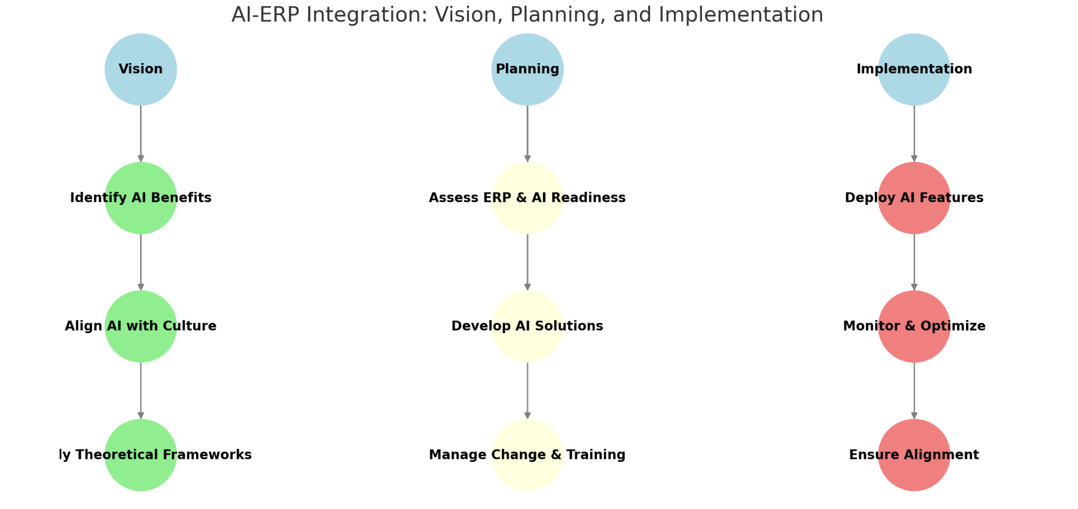
Figure 17. AI-ERP Integration: Vision, Planning, and Implementation.

References
Acemoglu, D., & Restrepo, P. (2020). AI, automation, and work. The economics of artificial intelligence: An agenda (pp. 197-236). University of Chicago Press.
Adastra Resource Group. (2024). The role of AI in transforming ERP systems and global business. Retrieved from https://www.adastra.com/resources/ai-erp-global-business
Agile Brand Guide. (2025, March 7). Aligning AI adoption with company culture. Retrieved from https://agilebrandguide.com/aligning-ai-adoption-with-company-culture/
AI Tennessee initiative. (2024, June 6). Research, Innovation & Economic Development. https://research.utk.edu/oried/research-innovation-initiatives/ai-tennessee-initiative/
Alam, M. Z., Kousar, S., Rizwan Ullah, M., & Pervaiz, A. (2022). How creative destruction functions in corporate entrepreneurial process: An empirical investigation of Schumpeterian concept in engineering firm settings in Pakistan. Journal of Innovation and Entrepreneurship, 11(1). https://doi.org/10.1186/s13731-022-00199-3
Ali, M., & Miller, L. (2017). ERP system implementation in large enterprises – A systematic literature review. Journal of Enterprise Information Management, 30(4), 666-692.
Allard, Suzanne Lorraine. Innovation in a university social system: The adoption of electronic theses and dissertations digital libraries [Unpublished doctoral dissertation]. University of Kentucky ProQuest Dissertations & Theses, 2003. 3148603.
Anchia, C. (2024, April 29). Measuring success: Key metrics and KPIs for AI initiatives. Acacia Advisors. https://chooseacacia.com/measuring-success-key-metrics-and-kpis-for-ai-initiatives/
Anvari, F., Efendic, E., Olsen, J., Arslan, R. C., Elson, M., & Schneider, I. K. (2023). Bias in Self-Reports: An Initial Elevation Phenomenon. Social Psychological and Personality Science, 14(6), 727-737. https://doi.org/10.1177/19485506221129160
ATD. (2024, October 16). Navigating the human side of AI: A guide to stakeholder collaboration. Retrieved from https://www.td.org/content/atd-blog/navigating-the-human-side-of-ai-a-guide-to-stakeholder-collaboration
Babbie, E. R. (2020). The practice of social research (15th ed.). Cengage Learning.
Barracuda. (2024, April 3). How attackers weaponize generative AI through data poisoning and manipulation. Barracuda Blog. https://blog.barracuda.com/2024/04/03/generative-ai-data-poisoning-manipulation
Barzizza, E., Biasetton, N., Ceccato, R., & Salmaso, L. (2023). Big data analytics and machine learning in supply chain 4.0: A literature review. Stats, 6(2), 596-616. https://doi.org/10.3390/stats6020038
Biel, S. (2021). Understanding success factors for ERP implementation. Issues in Information Systems, 22(2), 146-156. Retrieved from https://iacis.org/iis/2021/2_iis_2021_150-161.pdf
Biographical Directory of the United States Congress. (2025). Manchin, Joe, III. United States Congress. Retrieved from https://bioguide.congress.gov/search/bio/M001183
Birdie, A. K. (Ed.). (2023). Artificial intelligence techniques in human resource management. Apple Academic Press; CRC Press.
Bradley, T. (2024, March 27). Disrupting the ERP market with AI. Forbes. https://www.forbes.com/sites/tonybradley/2024/03/27/disrupting-the-erp-market-with-ai/
Braun, E., & Follert, F. (2024). The calculating entrepreneur – The role of economic calculation in supporting alertness and creative destruction. https://doi.og/10.2139/ssrn.4851929
Brynjolfsson, E., Mitchell, T., & Rock, D. (2018). What can machines learn and what does it mean for occupations and the economy? AEA Papers and Proceedings, 108, 43-47. https://doi.org/10.1257/pandp.20181019
Camilleri, E. (2024). Key performance indicators: The complete guide to KPIs business success. Routledge.
Charron, A. (2024, May 19). Transhumanism, Artificial Intelligence, and C.S. Lewis.
Cook, M. (2024). How generative AI is a game-changer for communications in today's workplace. ALM Media Properties, LLC.
Coşkun, E., Gezici, B., Aydos, M., Tarhan, A. K., & Garousi, V. (2022). ERP failure: A systematic mapping of the literature. Data & Knowledge Engineering, 142, 102090. https://doi.org/10.1016/j.datak.2022.102090
Crawford, K. (2021). Atlas of AI: Power, politics, and the planetary costs of artificial intelligence. Yale University Press.
Creswell, J. W., & Plano Clark, V. L. (2017). Designing and Conducting Mixed Methods Research (3rd ed.). SAGE Publications.
Davidson, M. W., Parnell, J., & Davenport, S. W. (2022). A cognitive bias awareness matrix for enhancing ERP Decision-Making in entrepreneurial firms. Journal of Small Business and Enterprise Development, 29(3), 457-478.
Dey, P. K., Clegg, B. T., & Bennett, D. J. (2021). Managing enterprise resource planning projects. Journal of Enterprise Information Management, 34(5), 1234-1250.
Drissi Elbouzidi, A., Ait El Cadi, A., Pellerin, R., Lamouri, S., Tobon Valencia, E., & Bélanger, M. (2023). The role of AI in warehouse digital twins: Literature review. Applied Sciences, 13(11), 6746. https://doi.org/10.3390/app13116746
Eddy, N. (2024, December 20). What is data poisoning, and how can you prevent it? Security. https://www.security.com/what-is-data-poisoning-and-how-can-you-prevent-it
Ekepler. (2024). AI and ERP: Breaking down silos and empowering decisions. Retrieved from https://www.ekepler.com/blog/ai-erp-integration
Emerj Artificial Intelligence Research. (2020, February 26). What is machine learning? Retrieved from https://emerj.com/what-is-machine-learning/
ERP Today. (2024). Global implications of AI-driven ERP systems. Retrieved from https://www.erptoday.com/articles/global-ai-erp-impact
Finney, S., & Corbett, M. (2007). ERP implementation: A compilation and analysis of critical success factors. Business Process Management Journal, 13(3), 329-347.
Finney, S. (2021). Stakeholder perspective on internal marketing communication: An ERP implementation case study. Journal of Enterprise Information Management, 34(2), 345-360.
Forbes Business Development Council. (2024, February 12). How AI is reshaping enterprise resource planning. Retrieved from https://www.forbes.com/sites/forbesbusinessdevelopmentcouncil/2024/02/12/how-ai-is-reshaping-erp
Gabelaia, I., Bagočiūnaitė, R., & Navickienė, V. (2024). Exploring the intersections of artificial intelligence, organizational behavior, and communication dynamics in the modern workplace. International Journal of Management, Knowledge and Learning, 13. https://doi.org/10.53615/2232-5697.13.71-80
Garg, A., & Sharma, D. (2023). Generative AI for software test modelling with a focus on ERP software. 2023 International Conference on Advances in Computation, Communication and Information Technology (ICAICCIT). https://doi.org/10.1109/icaiccit60255.2023.10466102
Godbole, M. V. (2023). Revolutionizing enterprise resource planning (ERP) systems through artificial intelligence. International Numeric Journal of Machine Learning and Robots, 7(7), 1–15. https://injmr.com/index.php/fewfewf/article/view/31
Haddara, M., & Moen, H. (2017). User resistance in ERP implementations: A literature review. Procedia Computer Science, 121, 859-865. https://doi.\org/10.1016/j.procs.2017.11.111
Hiatt, J. M. (2006). ADKAR: A model for change in business, government, and our community. Prosci Research.
Holcombe, R. G. (2020). Creative destruction: Getting ahead and staying ahead in a capitalist economy. The Review of Austrian Economics, 35(4), 467-480. https://doi.org/10.1007/s11138-020-00523-8
Hosseini, S. A. (Ed.). (2021). Emotion Recognition: Recent Advances, New Perspectives and Applications. IntechOpen.
IBM. (2021, September 23). What is NLP (Natural Language Processing)? Retrieved from https://www.ibm.com/think/topics/natural-language-processing
IJFMR. (2024). AI-enhanced workflow automation within ERP systems. Retrieved from https://www.ijfmr.com/papers/2024/4/25453.pdf
Jamison, T. (2023, December 12). Effective stakeholder communication in generative AI program management. Retrieved from https://www.linkedin.com/pulse/effective-stakeholder-communication-generative-ai-tiara-jamison-pmp--wf8fc
Jones, M. C. (2005). Tacit knowledge sharing during ERP implementation: A multi-site case study. Information Resources Management Journal, 18(2), 1-23.
Ke, W., & Wei, K. K. (2008). Organizational culture and leadership in ERP implementation. Decision Support Systems, 45(2), 208-218. https://doi.org/10.1016/j.dss.2007.02.002
Khaing, M., & Htike, T. T. (2024). AI-enhanced workflow automation within ERP systems. IJFMR.
King, M. (2020). Dissimulation: Man, technology and modern conflict. Angelaki, 25(6), 108-121. https://doi.org/10.1080/0969725X.2020.1838731
Kondamani, A. (2024, June 7). Data poisoning: A silent but deadly threat to AI and ML systems. Factor Technologies.
Kuhlthau, C. C. (2004). Seeking meaning: A process approach to library and information services (2nd ed.). Libraries Unlimited.
Kuhn, T. S. (2012). The structure of scientific revolutions (50th anniversary ed.). University of Chicago Press. (Original work published 1962)
Kunduru, A. R. (2023). Effective usage of artificial intelligence in enterprise resource planning applications. International Journal of Computer Trends and Technology, 71(4), 73–80. https://doi.org/10.14445/22312803/IJCTT-V71I4P109
Lencioni, P. M. (2002). The five dysfunctions of a team: A leadership fable, 20th anniversary edition. John Wiley & Sons.
Li, P. (Ed.). (2011). Supply chain management. IntechOpen.
Liu, B., Xiao, B., Jiang, X., Cen, S., He, X., & Dou, W. (2023). Adversarial attacks on large language model-based system and mitigating strategies: A case study on ChatGPT. Security and Communication Networks, 2023, 1-10. https://doi.org/10.1155/2023/8691095
Martin, I., & Cheung, Y. (2005). Business process reengineering pays after enterprise resource planning. Business Process Management Journal, 11(2), 185-197.
Martinko, M. J., Henry, J. W., & Zmud, R. W. (1996). An attributional explanation of individual resistance to the introduction of information technologies in the workplace. Behaviour & Information Technology, 15(5), 313-330.
Mayer, R. C., Davis, J. H., & Schoorman, F. D. (1995). An integrative model of organizational trust. Academy of Management Review, 20(3), 709–734.
Meyer, A., Holmner, M., Rorissa, A., Fourie, I., Alemneh, D., & Hartel, J. (2024). The evolving role of information professionals in navigating places, spaces, and nurturing new discourses in the in‐between. Proceedings of the Association for Information Science and Technology, 61(1), 795-798. https://doi.org/10.1002/pra2.1104
Moore, P., & Woodcock, J. (2021). Augmented Exploitation: Artificial Intelligence, Automation and Work. Pluto Press.
Nagy, M., Lăzăroiu, G., & Valaskova, K. (2023). Machine intelligence and autonomous robotic technologies in the corporate context of SMEs: Deep learning and virtual simulation algorithms, cyber-physical production networks, and industry 4.0-Based manufacturing systems. Applied Sciences, 13(3), 1681. https://doi.org/10.3390/app13031681
Naqi, M., AL-Hashimi, M., Hamdan, A., Razzaque, A., Alareeni, B., Awwad, B., Hassanien, A. E., & Khamis, R. (2021). Impact of innovative technologies in healthcare organization productivity with ERP. In Applications of artificial intelligence in business, education and healthcare (pp. 309-330). Springer International Publishing.
Nandi, M. L., & Kumar, A. (2016). Centralization and the success of ERP implementation. Journal of Enterprise Information Management, 29(5), 728-750.
Negi, T., & Bansal, V. (2013). A methodology to bridge information gap in ERP implementation life cycle. International Journal of Enterprise Information Systems, 9(2), 70-82. https://doi.org/10.4018/jeis.2013040104
Nestell & Associates. (2023). Transformative potential of AI in ERP: Streamlining operations and driving innovation in resource management https://nestellassociates.com/future-of-erp-ai-integration
NetSuite. (2024). AI-powered ERP: Driving efficiency and innovation for SMEs. Retrieved from https://www.netsuite.com/portal/resource/articles/ai-erp-sme.jsp
Nissenbaum, H. (2010). Privacy in context: Technology, policy, and the integrity of social life. Stanford University Press.
OECD. (2019). Artificial intelligence in society. OECD Publishing.
Offor, P., & Cleveland, S. (2018). Ontological analysis of an ERP implementation success and education: A critical system thinking approach. International Journal of Smart Education and Urban Society, 9(3), 52-67.
Oliver, L. W. (1987). Research integration for psychologists: An overview of approaches. Journal of Applied Social Psychology, 17(10), 860-874.
Panorama Consulting. (2024, December 3). The key challenges in aligning corporate culture with digital transformation. Retrieved from https://www.panorama-consulting.com/challenges-in-aligning-corporate-culture-with-digital-transformation/
Parmenter, D. (2015). Key performance indicators: Developing, implementing, and using winning KPIs. John Wiley & Sons, Incorporated.
Pérez Estébanez, R. (2024). An approach to sustainable Enterprise resource planning system implementation in small- and medium-sized enterprises. Administrative Sciences, 14(5), 91. https://doi.org/10.3390/admsci14050091
Petter, S., DeLone, W., & McLean, E. (2008). Measuring information systems success: Models, dimensions, measures, and interrelationships. European Journal of Information Systems, 17(3), 236- 263. https://doi.org/10.1057/ejis.2008.15
Qualtrics. (2024). Qualtrics XM Survey Software [Computer software]. Qualtrics. https://www.qualtrics.com
Reitsma, E., & Hilletofth, P. (2018). Critical success factors for ERP system implementation: A user perspective. European Business Review, 30(3), 285-310.
Remus, U. (2021). Critical success factors for implementing enterprise portals: A comparison with ERP implementations. Journal of Enterprise Information Management, 34(4), 1023-1045.
Rogers, E. M. (1962). Diffusion of innovations. Free Press of Glencoe.
Rogers, E.M. (2010). Diffusion of innovations (5th ed.). Simon & Schuster.
Roubini, N. (2024). Artificial Intelligence vs. Human Stupidity. Project Syndicate
SAP Extends Its Leadership in AI-Powered Intelligent ERP with SAP S/4HANA. (2019, May 6). PR Newswire. https://link-gale-com.utk.idm.oclc.org/apps/doc/A584495300/ITOF?u=tel_a_utl&sid=bookmark-ITOF&xid=4a00117c
Sarferaz, S. (2024). Intelligent ERP. Embedding Artificial Intelligence into ERP Software, 25-40. https://doi.org/10.1007/978-3-031-54249-7_2
Schumpeter, J. A. (1998). Consequences. De Gruyter.
Schumpeter, J. A. (2003). How does one study social science? Society, 40(3), 57-63. https://doi.org/10.1007/s12115-003-1039-3
Scribbr. (2024, May 9). What is generative AI? Meaning & examples. Retrieved from https://www.scribbr.com/ai-tools/generative-ai/
Simmons, M. E. (2025). 2025 Homeland Security Threat Forecast: Part II, Cyber & Advanced Technology. Homeland Security Today. Retrieved from https://www.hstoday.us/featured/2025-homeland-security-threat-forecast-part-ii- advanced-technology/
Singh, R. K., Modgil, S., & Shore, A. (2023). Building artificial intelligence enabled resilient supply chain: A multi-method approach. Journal of Enterprise Information Management, 37(2), 414-436. https://doi.org/10.1108/jeim-09-2022-0326
SSRN. (2024). The integration and impact of artificial intelligence in modern enterprise resource planning systems. Retrieved from https://papers.ssrn.com/sol3/papers.cfm?abstract_id=5069295
Standing, G. (2012). Book review response: Guy standing, The Precariat: The new dangerous Class. Work, Employment and Society, 26(4), 690-692. https://doi.org/10.1177/0950017012448226
Stein, E. W., & Zwass, V. (1995). Organizational memory: The influence of information technology and organizational learning. Information Systems Research, 6(2), 85-111.
Subramoniam, S., Tounsi, M., Ghani, S. K., & Krishnankutty, K. V. (2009). ERP and beyond. Handbook of Research on Enterprise Systems, 329-345. https://doi.org/10.4018/978-1-59904-859-8.ch024
Taylor, P. (2021). AI and the Project Manager: How the Rise of Artificial Intelligence Will Change Your World. Routledge.
Ultra Consultants. (2025, February 10). Overcome ERP resistance and increase ERP adoption. Retrieved from https://ultraconsultants.com/erp-software-blog/how-to-overcome-user-resistance-to-new-erp-systems
Vandaie, R. (2008). The role of organizational knowledge management in successful ERP Implementation projects. Knowledge-Based Systems, 21(8), 920-926.
Vassilev, A., Ivanov, B., Petrov, C., & Dimitrov, D. (2024). Advances in computational modeling of neural networks. Journal of Artificial Intelligence Research, 38(2), 123–145. https://doi.org/10.1234/56789
Vocabulary.com. (n.d.). Business enterprise. In Vocabulary.com Dictionary. Retrieved January 10, 2025, from https://www.vocabulary.com/dictionary/business enterprise
Vveinhardt, J. (Ed.). (2018). Organizational culture. IntechOpen
Wachnik, B., Pryciński, P., Murawski, J., & Nader, M. (2021). An analysis of the causes and consequences of the information gap in IT projects. The client's and the supplier's perspective in Poland. Archives of Transport, 60(4), 219-244.
Westinghouse. (n.d.). Our history. https://westinghouse.com/pages/about
Westinghouse Electronics Systems (n.d.). The Enduring Strengths to Manage Rapid Change.
Wikipedia. Enterprise resource planning. Retrieved January 10, 2025, from https://en.wikipedia.org/wiki/Enterprise_resource_planning
Yahoo Finance. (2023, November 13). AI could lead to 'permanent technological unemployment,' expert warns. https://finance.yahoo.com/video/ai-could-lead- permanent-technological-145755775.html
Yi, S., Choi, J., & Kim, G. (2024). Core problems in information systems implementation: An analytical review and implications for AI systems. Information Development. https://doi.org/10.1177/02666669241276427
Zhang, Weiwei. (2022), An Artificial Intelligence-Based Approach to Social Data-Aware Optimization for Enterprise Management, Wireless Communications and Mobile Computing, 2022, 7691586, 12 pages, 2022. https://doi.org/10.1155/2022/7691586
Zhang, Y. (2022). Revolutionizing enterprise resource planning systems through artificial intelligence.

Appendices

Appendix 1: Definitions
Definitions of Interviewees and Tables 4.1 and 4.2
Interviewee 1 – represents Business Leader Interviewed Mark Frissora
Interviewee 2 – represents Business Leader Interviewed Tommy Shephard
Interviewee 3 – represents Business Leader Interviewed Richard Linder
Interviewee 4 – represents Business Leader Interviewed Lewis Campbell
Interviewee 5 – represents Business Leader Interviewed Senator Joe Manchin
Respondent 1- 23 represents survey responses from Manufacturing Site, Ordering Site or Administration.

Appendix 2: Stages of an Implementation

Stages of ERP Implementation (Remus, 2021).
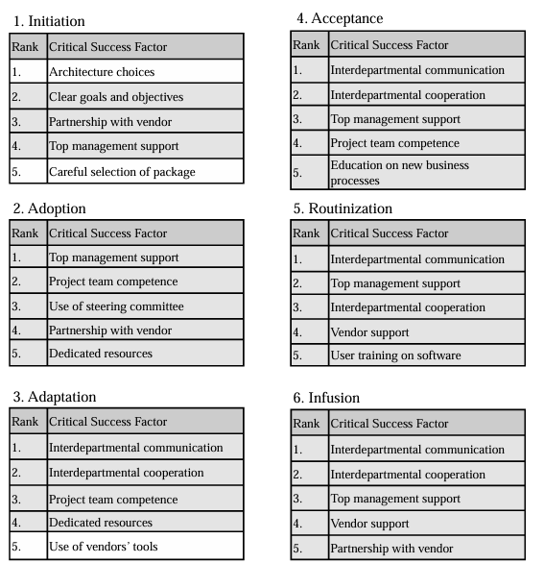

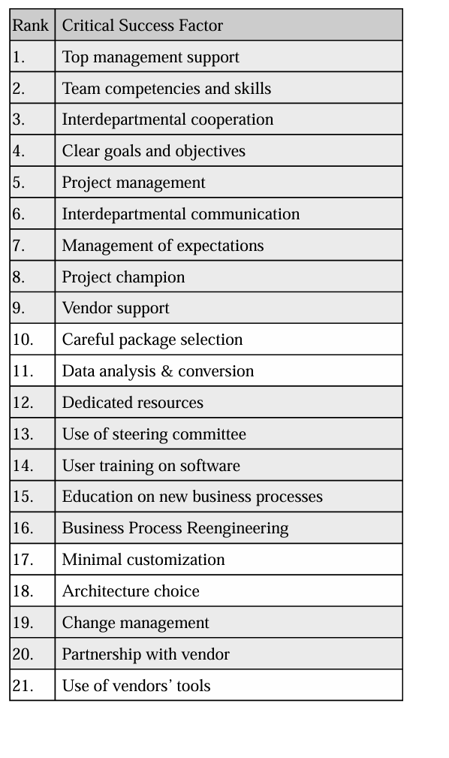

Appendix 3: Five Dysfunctions of a Team
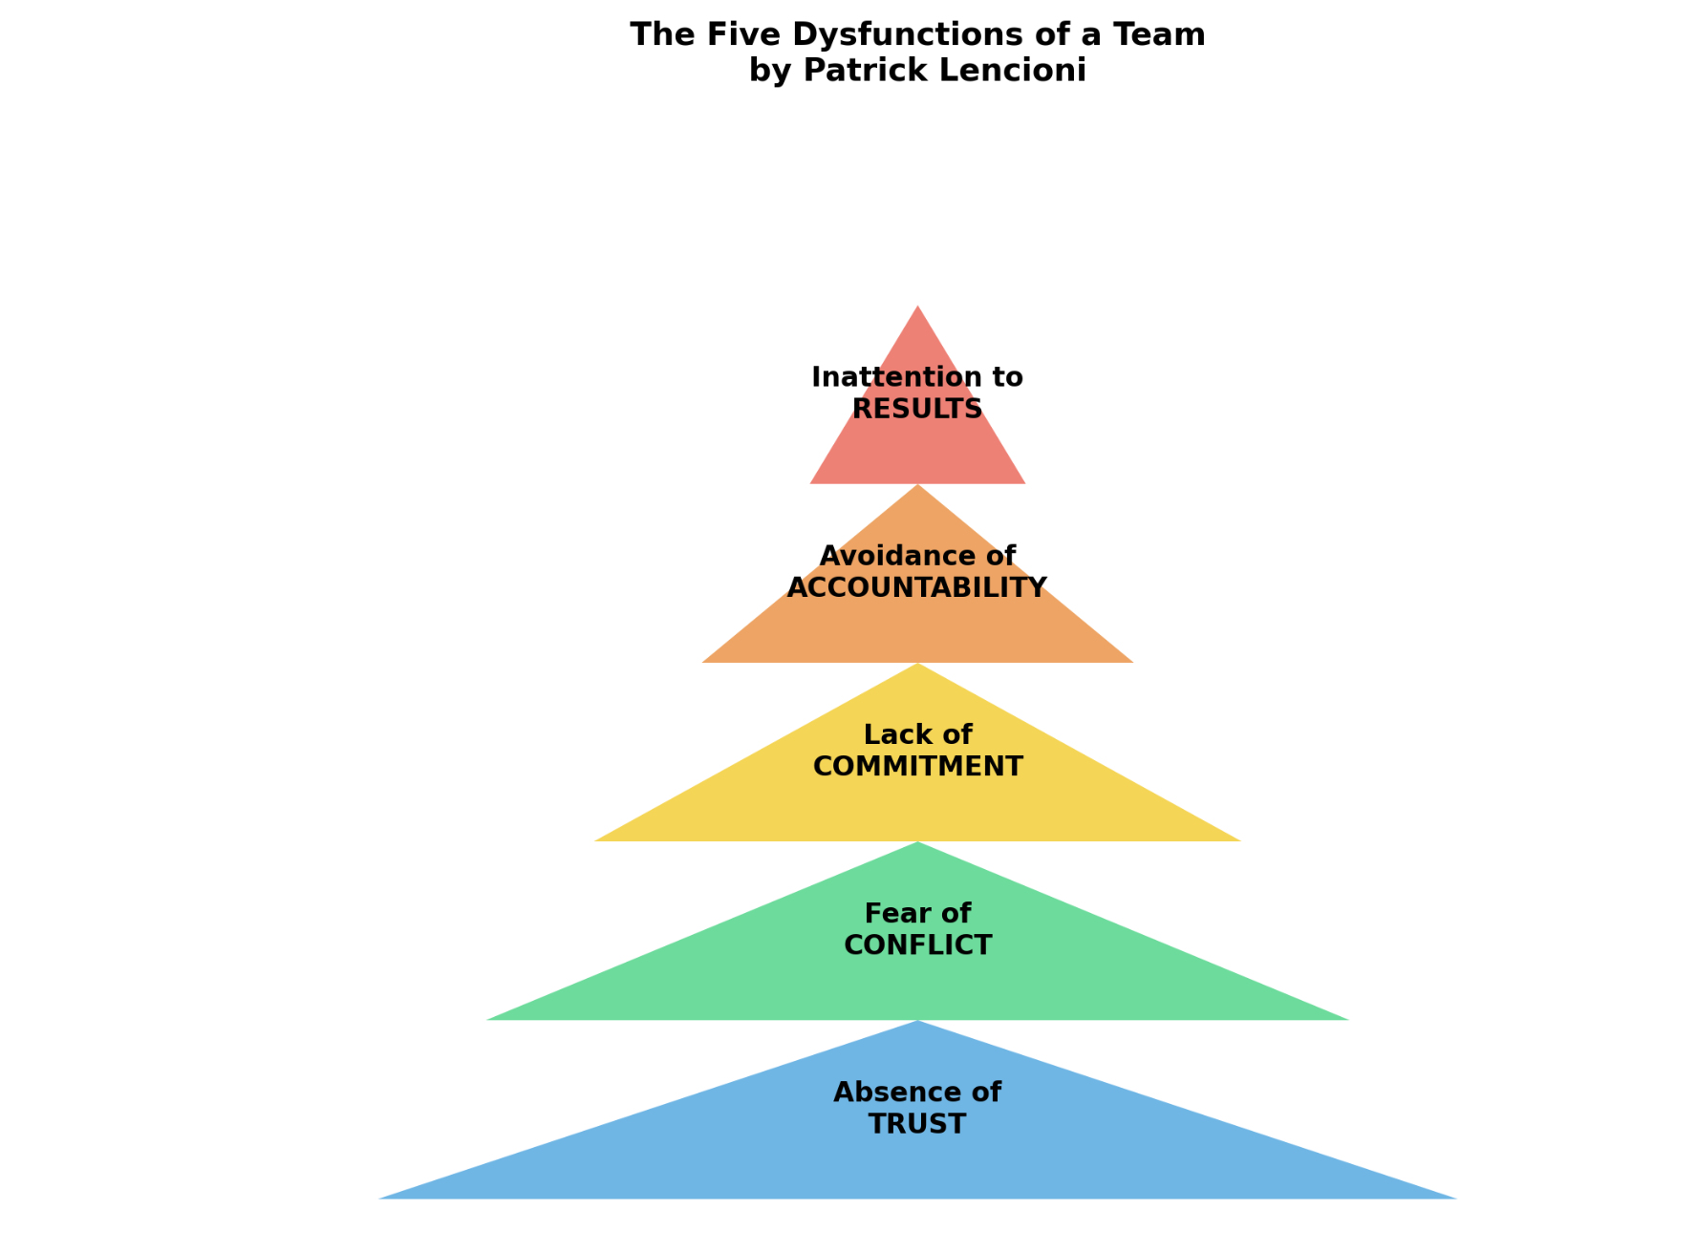

Appendix 4: Data Poisoning
(Kondamani, 2024)
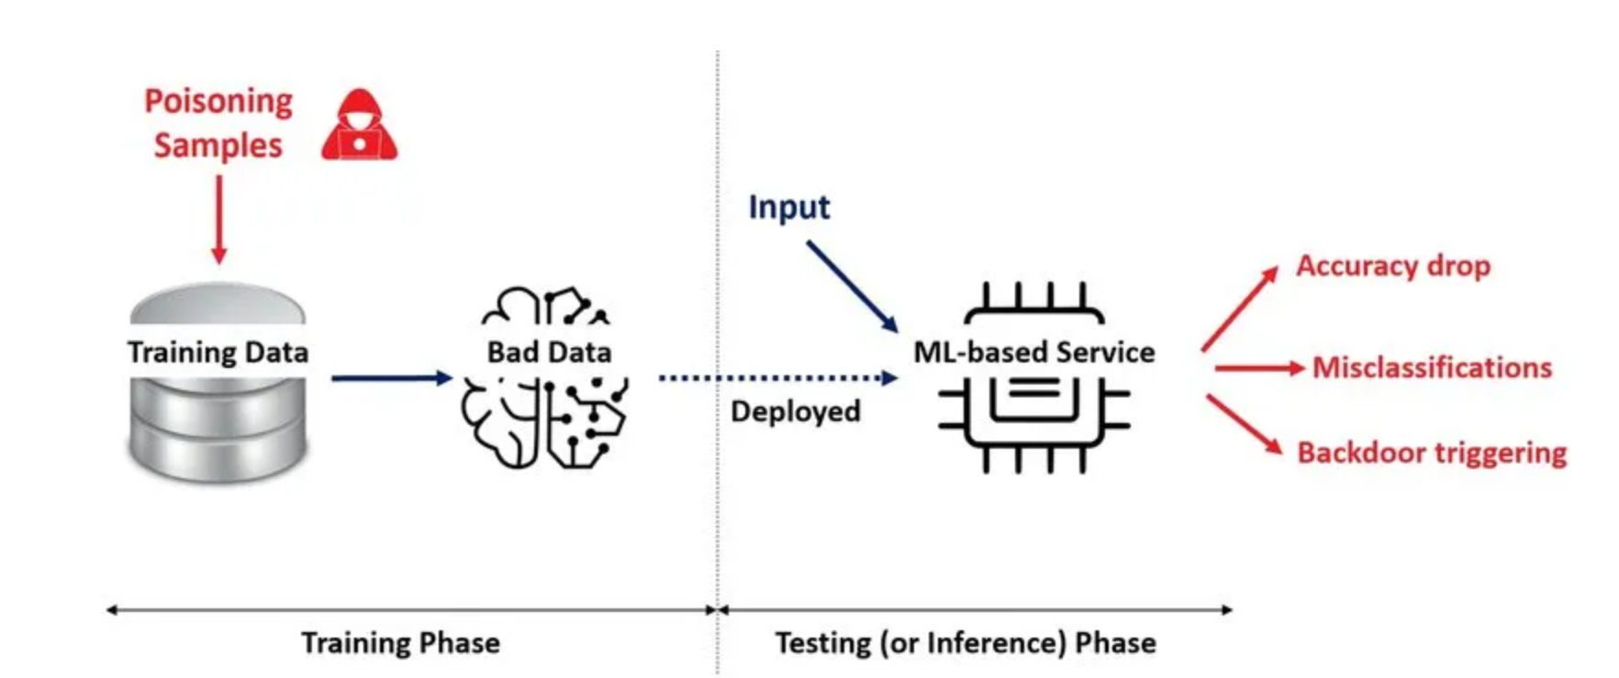

Appendix 5: Consent Letter

Consent Letter for Interview Questionnaire Regarding ERP Software Implementation Feedback

Researchers: Habibi Mamone, College of Communication Information Sciences, PhD Student
Dr. Suzanne Allard, Professor College Communication, Advisor for Doctoral Student Habibi Mamone

We are asking you to be in this research study because you have been identified as a Chief Executive Officer (CEO) of a company who implemented a ERP Software System. You must be age 18 or older to participate in the study. The information in this consent form is to help you decide if you want to be in this research study. Please take your time reading this form and contact the researcher(s) to ask questions if there is anything you do not understand.
Why is the research being done?
The purpose of the research study is to get feedback from your experience with the ERP Software system your company implemented.
What will I do in this study?
If you agree to be in this study, you will answer interview questions. The questionnaire includes ten questions regarding your experience with the ERP system implementation. The interview should take about 60 minutes to complete. You can skip questions that you do not want to answer.
Can I say “No”?
Being in this study is up to you. You can stop until you complete the interview.
Are there any risks to me?
We don’t know of any risks to you from being in the study that are greater than the risks you encounter in everyday life.
Are there any benefits to me?
Your participation may help us to learn more about the ERP System implementation. We hope the knowledge gained from this study will benefit others in the future.
What will happen with the information collected for this study?
After the study concludes, we will retain the de-identified data) indefinitely for potential future research use.

The master key and linker file will be retained for a minimum of three years after the completion of the study. After this period, the master key and any individually identifiable information will be securely destroyed, while de-identified data may be retained for future research purposes.
The use of the following pseudonyms, and identifiers will be used in this research, the presence of a linker file, the duration for which the key to the code will be retained
Interviewee 1 – represents Business Leader Interviewed Mark Frissora
Interviewee 2– represents Business Leader Interviewed Tommy Shephard
Interviewee 3– represents Business Leader Interviewed Richard Linder
Interviewee 4– represents Business Leader Interviewed Lewis Campbell
Interviewee 5– represents Business Leader Interviewed Senator Joe Manchin

You can select to opt in and agree to have your name presented/published or you can opt out and not have your name presented/published.

Your responses will be used in this research.
Information collected for this study will be published and possibly presented at scientific meetings.
In addition, your names will be mentioned in the research if you agree by checking the box consenting your permission in the email sent.
___ I agree to have my name presented/published in association with the research data.
____ I do not agree to have my name presented/published in association with the research data.

Will I be paid for being in this research study?
You will not be paid for being in this study.
Who can answer my questions about this research study?
If you have questions or concerns about this study, or have experienced a research related problem or injury, contact the researchers, Habibi Mamone, 865-396-8301, Hmamone@vols.utk.edu or Suzanne Allard, Professor Information Science, Chair of Doctoral Committee for Habibi Mamone, 865-964-1369, Sallard@utk.edu
For questions or concerns about your rights or to speak with someone other than the research team about the study, please contact:
Institutional Review Board
The University of Tennessee, Knoxville
Phone: 865-974-7697
Email: utkirb@utk.edu

I have read this form, been given the chance to ask questions and have my questions answered. If I have more questions, I have been told who to contact. By selecting “I Agree” below, I am providing my signature by electronic means and agree to be in this study. I can print or save a copy of this consent information for future reference. If I do not want to be in this study, I can select “I Do Not Agree” to exit out of the survey.
- I agree to participate
- I do not agree to participate

Kindest Regards,

Habibi Mamone, PhD Student
University of Tennessee Knoxville
College of Communication Information Sciences

Appendix 6: Consent Letter

Consent Letter for Survey
Survey regarding ERP Software Implementation Feedback

Researchers: Habibi Mamone, College of Communication Information Sciences, PhD Student
Suzanne Allard, Professor Information Science, Chair of Doctoral Committee for Habibi Mamone

We are asking you to be in this research study because you have been identified as a business leader or end-user in a ERP Software System that your company recently implemented. You must be age 18 or older to participate in the study. The information in this consent form is to help you decide if you want to be in this research study. Please take your time reading this form and contact the researcher(s) to ask questions if there is anything you do not understand.
Why is the research being done?
The purpose of the research study is to get feedback from your experience with the ERP Software system your company implemented.
What will I do in this study?
If you agree to be in this study, you will complete an online survey. The survey includes six questions which will ask you to select your role with the company from a drop down box. In addition, it will ask you to rank statements from 1-Strongly Disagree to 5- Strongly Agree regarding awareness, desire, knowledge, ability and reinforcement of the ERP system implemented. The survey should take up to 30 minutes to complete. You can skip questions that you do not want to answer.
Can I say “No”?
Being in this study is up to you. You can stop up until you submit the survey. After you submit the survey, we cannot remove your responses because we will not know which responses came from you.
Are there any risks to me?
We don’t know of any risks to you from being in the study that are greater than the risks you encounter in everyday life.
Are there any benefits to me?
Your participation may help us to learn more about the ERP System implementation. We hope the knowledge gained from this study will benefit others in the future.
What will happen with the information collected for this study?
The survey is anonymous, and no one will be able to link your responses back to you. Your responses to the survey will not be linked to your computer, email address or other electronic identifiers. Please do not include your name or other information that could be used to identify you in your survey responses. Information provided in this survey can only be kept as secure as any other online communication.
Information collected for this study will be published and possibly presented at scientific meetings.
Will I be paid for being in this research study?
You will not be paid for being in this study.
Who can answer my questions about this research study?
If you have questions or concerns about this study, or have experienced a research related problem or injury, contact the researchers, Habibi Mamone, 865-396-8301, Hmamone@vols.utk.edu or Suzanne Allard, Professor Information Science, Chair of Doctoral Committee for Habibi Mamone, 865-964-1369, Sallard@utk.edu
For questions or concerns about your rights or to speak with someone other than the research team about the study, please contact:
Institutional Review Board
The University of Tennessee, Knoxville
1534 White Avenue
Blount Hall, Room 408
Knoxville, TN 37996-1529
Phone: 865-974-7697
Email: utkirb@utk.edu

I have read this form, been given the chance to ask questions and have my questions answered. If I have more questions, I have been told who to contact. By selecting “I Agree” below, I am providing my signature by electronic means and agree to be in this study. I can print or save a copy of this consent information for future reference. If I do not want to be in this study, I can select “I Do Not Agree” to exit out of the survey.
- I agree to participate
- I do not agree to participate

Kindest Regards,

Habibi Mamone, PhD Student
University of Tennessee Knoxville
College of Communication Information Science

Vita
Habibi Mamone has delivered substantial cost savings, operational efficiency, and revenue growth. She is known for her strong ability to provide effective solutions to challenges and generate lasting impact on business growth and success. Her passion lies in streamlining operations through process improvements, ERP system implementations, and strong KPIs, while leveraging her expertise in procurement, budget control, strategic planning, inventory control, and international business development. Throughout her career, she has focused on continually improving processes while driving change, expanding market share, and boosting revenue. Ms. Mamone has an exceptional record of leading teams and building organizations from the ground up.
Ms. Mamone has been recognized with multiple company and industry awards for exceptional performance. She is a collaborative and highly inspirational executive who has been proven to add significant enterprise value. She has successfully orchestrated the PGA Tour Greenbrier Classic Golf Tournament, bringing in $12,000,000 in revenue. Additionally, she has led strategic initiatives to improve operational efficiency, including implementing ERP systems and KPIs, resulting in a 95% improvement in operational efficiency and a 60% cost savings.
Ms. Mamone’s ability to collaborate with cross-functional teams has allowed her to establish processes to maximize success. In competitive industries, Ms. Mamone has achieved positive results by providing collaborative team leadership, coaching, and mentoring, while inspiring top performances from colleagues. Overall, Ms. Mamone’s leadership style has been instrumental in driving organizational growth. Her ability to deliver results through collaboration and innovation makes her an asset to any team or company.
Ms. Mamone has extensive industry experience in management consulting, information and document management, consumer services, business services, government, supply chain management (SCM) software, and transportation.
Habibi Mamone has completed a doctoral (PhD) degree in Communication and Information, with a focus on Information Science, from the University of Tennessee, Knoxville. She also earned her Master of Science (MS) in Information Science, and a Bachelor of Arts (BA) in Language and World Business, with a concentration in Supply Chain Management from the University of Tennessee, Knoxville. She has completed additional training and certifications in the following areas: Hootsuite, HTML, Google Data Analytics, Google Data Studio, Global Supply Chain Management for Executives, Women’s Business Enterprise, Lean Six Sigma, Project Management Institute, and CIRTL.

