QUANTITATIVE AND FUNCTIONAL ANALYSIS PIPELINE FOR LABLE-FREE METAPROTEOMICS DATA AND ITS APPLICATIONS

A Dissertation Presented for the
Doctor of Philosophy
Degree
The University of Tennessee, Knoxville

Lang Ho Lee
July 2015

Copyright © 2015 by Lang Ho Lee
All rights reserved.

ACKNOWLEDGEMENTS

Thank you all for your help. However, this page is optional.
ABSTRACT

Metaproteomics is highly complicated proteomics data containing multiple proteomes from microbial communities and host organism. Since large-scale investigation of metaproteome has been reported in 2005, metaproteomics has been quantitatively and qualitatively advanced and applied to various environmental samples from acid mine-drainage biofilms to human microbiome. Even though importance of rapidly growing metaproteomics is rising in life science and environmental science field, its analysis pipeline is not available yet. Therefore, we developed quantitative and functional analysis pipeline for metaproteomics (QFAM) to analyze large and complicated metaproteomics data. QFAM enables multiprocessing with up to 48 cores of Newton cluster for rapid process and comparisons between metaproteomes quantitatively and functionally.
QFAM has four modules for swift and confident analysis. First, it has peptide-spectrum match (PSM) search module using MyriMatch and IDPicker. MyriMatch and IDPicker are multiprocessing and have accurate scoring system for confident protein identification. These two advantages of MyriMatch and IDPicker are required features for huge and complicated metaproteome identification. Next, QFAM has normalization module allowing widely used methodologies in label-free proteomics, such as total sum normalization and the normalized spectral abundance factor (NSAF).
With the normalized PSMs, quantitative analysis module (QAM) and functional analysis module (FAM) produce dependable signatures and insights for understanding characteristics of metaproteomes. QAM uses ’selfea’ R package, which provides various probability models as well as Cohen’s effect sizes. Our benchmark data test and Monte Carlo simulation results show that selfea can reduce false positives efficiently while losing few true positives.
FAM has two modules, Biosystem analysis and cluster of genes (COG) analysis. BioSystem module is for functional analysis based on reference database like NCBI BioSystems, while COG module is rooted from sequence comparisons. Biosystem module is appropriate to well-annotated model organisms, such as human, whereas COG module is useful for less-annotated sequences, such as microbial species and metagenome sequences. Both of two modules provide enrichment test using Fisher’s exact test and quantitative test using selfea. With two statistics, FAM generates abundantly and differentially enriched functional terms that are insightful for making biological stories laid behind metaproteome data.
Two application studies in chapter 4 and 5 show how QFAM can be employed for metaproteomics data analysis. QFAM is distinguished from other proteomics pipelines by multiprocessing PSM search and quantitative and functional analysis.

TABLE OF CONTENTS

CHAPTER I INTRODUCTION 1
Metaproteomics 1
Metaproteomics in proteomics 1
Shotgun metaproteomics 3
LC-MS/MS analysis 9
Bioinformatics for metaproteomics 19
Peptide-spectrum search 19
Post-process of PSM search results 29
Quantitative and Functional analysis pipeline for Metaproteomics 39
CHAPTER II QUANTITATIVE AND FUNCTIONAL ANALYSIS PIPELINE FOR METAPROTEOMICS DATA 44
General information about the pipeline 44
Quantitative and functional analysis for metaproteomics (QFAM) 44
Module for LC-MS/MS data analysis 47
Automated module for DB search and protein assembly 47
Making contrast file, comparing MS runs and normalization 50
Module for quantitative and functional analysis 53
Quantitative analysis module (QAM) 53
Functional analysis module (FAM) 56
BioSystems analysis of FAM 58
COG analysis of FAM 64
Other modules of QFAM 70
Conclusion 74
CHAPTER III Selfea: R package for reliable feature selection 77
Introduction 77
Methods 79
Label free LC-MS/MS Proteomics Data 79
Calculation of Cohen’s effect sizes and statistics 80
Benchmark data test and fecal proteome data test 82
Monte Carlo simulation 83
User guide for selfea package 84
Algorithm 84
Benchmark test 88
Tests using Gregori data 88
Tests using fecal proteome data 89
Monte Carlo simulation 94
Conclusion 94
CHAPTER IV APPLICATION CASE 1 – HUMAN FECAL PROTEOME STUDY 97
Introduction 97
Methods 99
Sample preparation and LC-MS/MS experiment 99
PSM search and protein identification 99
Statistical analyses 102
Results 104
Data generation from 11 fecal and 5 PBMC samples 104
Comparison of 29 fecal and 5 PBMC MS runs 106
Human proteins in 11 fecal proteomes 110
Quasi-Poisson model construction using QFAM 119
Functional analysis using QFAM 122
Conclusion 132
CHAPTER V APPLICATION CASE 2 – HUMAN DIET PROTEOME STUDY 134
Introduction 134
Methods 135
Generation of Metaproteome data 135
Sample preparation and LC-MS/MS experiment 137
Quantitation and normalization of metaproteome data 138
Quantitative analysis of metaproteome data 139
Functional analysis of metaproteome data 140
Identification of translated-metagenome sequences 142
Results 142
Generation of diet metaproteome data 142
Construction of generalized linear mixed model 145
Functional analysis using FAM 149
Conclusion 161
CHAPTER VI Conclusions 163
Significance of QFAM in metaproteomics analysis tools 163
Future direction of QFAM 163
LIST OF REFERENCES 164
APPENDIX 175
LIST OF TABLES

Table 1 Various proteases. This table is adapted from the website, http://www.proteinsandproteomics.org/content/free/tables_1/table11.pdf. 7
Table 2 Accuracy and quantitative coverage of various labeling method in proteomics. This table was adapted from Bantscheff et al [36]. 18
Table 3 MyriMatch search time. This table was adapted from Gross et al [87]. 48
Table 4 MyriMatch run time in Newton cluster. We tested MyriMatch for 500 megabytes protein DB, containing 176,620 proteins, to search 41,079 peaks. Increasing the number of CPU cores dramatically decreases running time. 48
Table 5 Run time of LC-MS/MS data analysis in the pipeline. 49
Table 6 Example result of the QAM. Cohens_W: Cohen’s w, Cohens_F: Cohen’s f, Max_FC: maximum fold change, QP_Pval_adjusted: adjusted p-value from quasi-Poisson model, NB_Pval_adjusted: adjusted p-value from negative binomial model and Normal_Pval_adjusted: adjusted p-value from Normal ANOVA model. 55
Table 7 An example contingency table for one pathways ID of the enrichment test of FAM. Numbers in every cell are the number of proteins. 62
Table 8 Example result of FAM. FAM provides three statistics, adjusted p-value of enrichment test and significance test and effect size. The table is filtered pathways from whole FAM analysis result (pathway = KEGG, p-value adjustment method = FDR, significance test method = quasi-Poisson and Cohen’s f, enrichment test p-value < 0.05, significance test p-value < 0.05 and 80% statistical power. # of proteins: the number of proteins 63
Table 9 Comparison of the number annotated proteins between KEGG pathway and COG. Total number of identified microbial proteins is 5,354. 64
Table 10 An example contingency table for one COG ID of the enrichment test of FAM. Numbers in every cell are the number proteins. 68
Table 11 Example result of COG analysis in FAM. Same threshold was applied to BioSystem analysis in table 8. Func. cat.: COG functional category 69
Table 12 Six methods used for comparing Cohen’s ES and FC. Three probability models, widely used in biological data analysis, were employed for comparison of Cohen’s ES with FC. Abbreviations denoting model and ES are summarized at the table with used thresholds. 88
Table 13 Comparison of MS runs of fecal sample and PBMC. The number of identified proteins was counted for fecal human, microbiome and PBMC human data. Unshared proteins are proteins uniquely identified in only one sample. 105
Table 14 Protein identification frequency in fecal and PBMC proteomes. 110
Table 15 Top 25 abundant human proteins in 11 fecal samples. * means immune response related proteins. Frequency is identification frequency in 11 fecal samples of healthy volunteers. Sum of SC is total count of SC from 29 MS runs. 112
Table 16 Top 25 abundant immune response proteins in 11 fecal samples. Frequency is identification frequency in 11 fecal samples of healthy volunteers. Sum of SC is total count of SC from 29 MS runs. 117
Table 17 Significantly varied GO terms in human fecal proteins. FDR: FDR-adjusted enrichment test and # of prot: the number of member proteins. 124
Table 18 Significant COG terms in microbial fecal proteins. FDR: FDR-adjusted enrichment test and # of prots: the number of member proteins. 126
Table 19 Significant COG functional terms in microbial fecal proteins. FDR: FDR-adjusted enrichment test and # of prots: the number of member proteins. 129
Table 20 The number of identified proteins in different species. SD is standard deviation of numbers in three different diets. 144
Table 21 166 significant COG terms in different diets. COG Func.: COG broad function single digit symbol. Related diets are categorized by expression level in three diets. 153

LIST OF FIGURES

Figure 1 Various applications of Proteomics. Proteomics is diversely applied to many life science fields including basic scientific researches, clinical protein marker discovery and drug discovery. This figure was adapted from a book, ‘Molecular Biologist's Guide to Proteomics’ [2]. 2
Figure 2 Overview of typical shotgun metaproteomics steps. Metaproteomics collects a sample containing microbial community. Then proteins are collected from the collected sample. Then, the collected proteins are cleaned up and digested by an enzyme, typically trypsin. The peptides are ionized and measured by LC-MS/MS. Finally, the measured MS/MS peaks are identified and analyzed by many bioinformatics tools. This illustration was adapted from Tanca et al [4] and http://www.planetorbitrap.com. 4
Figure 3 in silico digestions of human HeLa cell proteome with assorted proteases A) without mis-cleavage and B) with assuming two miss-cleavages. This figure is adapted from Wu et al [20]. 8
Figure 4 These panels display distribution of P-score, peptide identification score of MaxQuant. Blue color means peptide identifications from forward database search and red colors are from reverse database, intended false positive peptide database. L means peptide length. This illustration was adapted from Cox et al [23]. 10
Figure 5 The effect of increasing mass accuracy for unambiguous identification of compounds. PPM is a parts per million (((exact mass – accurate mass) / exact mass) x 10⁶). Lower ppm means small mass error. If mass accuracy is low (ppm is high), the number of candidate compounds is linearly increased. The slope is getting steeper, while molecular weight is getting larger. This illustration is adapted from Quenzer et al [24]. 12
Figure 6 Data dependent acquisition (DDA) and data independent acquisition (DIA). DDA targets MS/MS scans with narrow isolation windows centered on specific precursor ion in an survey MS1 scan. DIA acquired MS/MS scans with wide isolation windows acquiring any peptide precursors. Peptide precursor VLENTEIGDSIFDK++ is present in a single MS/MS spectrum in a DDA analysis, while it can be extracted from every retention times in DIA. This image was adapted from Egertson et al [31]. 14
Figure 7 Relative amount of proteins in original sample, in identification and quantification by metaproteome analysis. Proteins are lost during protein extraction, digestion and LC-MS/MS steps. Low-abundant proteins are majorly not identified due to limit of dynamic range. Specific type of proteins is missed by protein extraction method. Only a fraction of original proteins is reliably quantified. This illustration was adapted from Bantscheff et al [36]. 16
Figure 8 Common quantitative mass spectrometry workflows. Boxes in blue and yellow indicate experiments to be compared. Solid line means that labeled sample is mixed. Dashed line means that points at experimental variation that quantification error can be occurred. This illustration was adapted from Bantscheff et al [36]. 17
Figure 9 Example of de novo sequencing from MS/MS spectrum. This is tandem mass spectrum of the [M+2H]+2 ion m/z 955.03 in LC/ESI/MS analyses of tryptic peptides from a 70 kDa iPLA2 digest. This illustration was borrowed from http://msr.dom.wustl.edu/ms-peptide-mapping/. 21
Figure 10 Schematic diagram of DB search. This diagram is based on SEQUEST, but other engines have very similar structure. First, search engines generate all the possible peptides from protein DB given the number of allowed miss-cleavage and digestion enzyme. Then, candidate peptides are selected from peptide library using mass of precursor ion. Next step is calculation of scores, probability, correlation coefficient or similarity, between candidate peptides and MS/MS spectrum. The engines report top 10 or 20 peptides for given MS/MS. This illustration was adapted from McHugh et al [55]. 22
Figure 11 DB search of MS-GF+. MS GF+ is updated version of Spectral Dictionary [56]. Red line is traditional DB search comparing spectra against the peptide library generated from protein DB. Blue line is the de novo based DB search constructing all the possible de novo sequences from a MS/MS spectrum. This illustration was adapted from Kim et al [56]. 25
Figure 12 Target-decoy DB comparison. The number of trypsin-derived peptides over calculated monoisotopic mass of A) target DB and B) decoy DB from in silico trypsin digestion of IPI human protein DB. C) The number of trypsin-derived peptides is in target (blue line) and decoy (blue line) DB. Green line is intersection between those two, target and decoy. 28
Figure 13 Overview of bipartite graph model and analysis procedure of protein assembly in IDPicker. Pro: protein, pep: peptide. This figure was adapted from Zhang et al [68]. 32
Figure 14 Typical distribution of SC in label-free metaproteomics data. 38
Figure 15 Interface of GalaxyP. It has three-column interface consisting of available tools, main screen for analysis result and parameter input and status of analysis steps from left to right. This illustration is screen-captured from http://www.usegalaxyp.org. 40
Figure 16 Schematic diagram of workflow in MetaProteomeAnalyzer. Server side and client side are communicating and uploaded data is deposited in server SQL DB. The illustration is adapted from Muth et al [78]. 41
Figure 17 Schematic diagram of quantitative and functional analysis pipeline for metaproteomics (QFAM). QFAM consists of seven modules and is designed to process metaproteome data rapidly and give functional reports to users. 45
Figure 18 Boxplots showing the distribution of Pearson correlation coefficients among the different levels of replicates. This illustration was adapted from Piehowski et al [88]. 52
Figure 19 Protein scatter plot for quasi-Poisson model and Cohen’s f combination. Selfea provides protein scatter plot for explaining how significant proteins were distinguished. Horizontal black line is false discovery rate (FDR) = 0.05, user-defined p-value threshold, and vertical black line is Cohen’s f at 80% statistical power, typically recommended power for reliable feature selection. Red dots are insignificant proteins, while blue dots are significant. 57
Figure 20 Overview of existing pathway analysis methods using gene expression data as an example. 59
Figure 21 A diagram of biosystems part of FAM. FAM has two parts, a script updating reference file up-to-date and enrichment test part. QAM is incorporated into FAM for significance test. User receives results from enrichment test and significance test in terms of Biosystems. 61
Figure 22 COG analysis part of FAM. COG analysis starts running PSI-BLAST and COGSoftware to identify COG IDs of query proteins. With the identified COG IDs, enrichment test and significance test are conducted by the R and Python scripts of FAM. Orange color box: input files, blue oval shape: python and R scripts, Green box: COGSoftware and PSI-BLAST, purple box: distributed jobs and light purple box: output files 67
Figure 23 Examples of bar- and line-graph generated by QFAM. QFAM provides R library for drawing A) line graph and B) bar graph from analysis result of QFAM. 72
Figure 24 Example heat-map drew by QFAM’s R library. Heat-map, colored by steal blue and white, can display global trend of protein expression. Hierarchical clustering for proteins and for experimental groups are available in QFAM’s R library. In this example, only proteins are clustered to show how protein expressions are changed in different groups (color bars of upper side of heat-map). Heat-map’s cells are standardized spectral counts by mean and variance. 73
Figure 25 Median power of studies included in neuroscience meta-analyses. This figure shows a histogram of median statistical power of neuroscience papers published in 2011. If this figure was based on minimum power as we used, the power of papers should be far more below than 80%. This illustration was borrowed from Button et al [103]. N: the number of papers, Power(%): median statistical power 78
Figure 26 Testing result with Gregori data and fecal proteome data. A) Statistical power, B) the number of true positives (human proteins) and C) the number of false positives (yeast proteins) in significant protein list of Gregori data benchmark test for 6 method sets, QP_F, QP_FC, NB_W, NB_FC, NOR_F and NOR_FC described in table 12. FDR thresholds for QP, NB and NOR are 0.05 and Cohen’s ES (f and w) threshold is 90% statistical power. Scatter plot of 39 human (red) and 646 yeat (blue) proteins comparing D) Cohen’s w and FC, E) Cohen’s f and FC, F) QP model and Cohen’s f, G) NB model and Cohen’s w and H) NOR model and Cohen’s f. 86
Figure 27 Protein scatter plots comparing three models and FC. False positive yeast proteins (blue color cross) and true positive human proteins (red color dot) were distributed on the plain of A) FDR-adjusted p-value of QP model and FC, B) FDR-adjusted p-value of NB model and FC and C) FDR-adjusted p-value of Normal model and FC. Vertical line is 2-FC and horizontal line is 0.05 FDR. Red-colored left-bottom section, divided by vertical and horizontal lines, is filtered by 2-FC after probability filter (FDR < 0.05). Little or none of FPs (blue dots) is removed by 2-FC. 92
Figure 28 Boxplots of 1,000 times Monte Carlo simulation of Gregori data. A) Statistical power, B) the number of false positives (yeast proteins), C) the number of true positives (human proteins) and D) FP Rate, FP/(FP+TN), of 1,000 times Monte Carlo simulation, based on Gregori data, for 6 method sets, QP_F, QP_FC, NB_W, NB_FC, NOR_F and NOR_FC described in supplementary table 1. FDR thresholds for QP, NB and NOR are 0.05 and Cohen’s ES (f and w) threshold is 90% statistical power. TN: True Negative (The number of total yeast proteins in Gregori data – FP). 95
Figure 29 Experiment workflow of fecal metaproteome data generation. This illustration was adapted from Xiong et al [122]. 100
Figure 30 Hierarchical clustering of 29 MS runs of 11 fecal samples. Technical replicates are closely clustered together, which means small variance within technical replicates. 107
Figure 31 Correlation coefficients between fecal and PBMC MS runs. Pearson correlation coefficients between A) technological replicates of fecal samples, B) biological replicates of PBMC samples and C) biological replicates of fecal samples. 108
Figure 32 Expression location of top 25 abundant human fecal proteins. Origin of fecal proteins were estimated by two databases, A) Proteomics DB and B) Human Proteome Map. 114
Figure 33 Protein scatter plot of human fecal proteome comparison. Blue dots are significantly categorized proteins, while red dots are proteins that could not passed two thresholds, FDR < 0.05 and Cohen’s f > 1.3769. 121
Figure 34 Expression profile of 15 COG functions. Spectrum counts of member proteins were transferred to COG broad functional terms. COG function name for corresponding symbol is in table 19. This plot was drown by line plot module of QFAM. 131
Figure 35 Experiment design of diet proteome study. Low RS has 2g amylose and High RS has 38g amylose. Every diet is treated for two weeks. Total 8 patients had different diets, as is schedule in cross over design. 136
Figure 36 Protein scatter plot of diet proteome comparison. Green dots mean insignificant microbial proteins, and red dots are insignificant human proteins. Significant proteins are colored as purple (significant microbial) and blue (significant human). Since we used rigorous thresholds to make the expected number of false positive below 1, almost all the visible spots were excluded by two lines (FDR threshold (= 0.0001) horizontal line and Cohen’s w (= 1.0258) vertical line). 148
Figure 37 Stacked bar graphs of accumulated spectral counts of 20 significant KEGG pathways. Y-axis is KEGG pathway and X-axis is percentage of accumulated spectral counts of 2A (baseline), HRS and LRS samples. Blue-colored bar is sum of spectral counts in baseline diet. Red-colored bar means expression level (sum of spectral counts) in HRS. Green bars are from sum of expression level in LRS. 150
Figure 38 Heat-map of significant 166 COG terms. We standardized sum of transferred SC of each of COG terms. Deeper steel-blue color means higher expression level in diet metaproteome. COG terms are clustered by their expression pattern and broad functional term. 160

CHAPTER I
INTRODUCTION

Metaproteomics

Metaproteomics in proteomics
Proteomics is an all-inclusive collection of proteins in a cell, a multicellular organism, an extracellular environment and a community of multiple organisms. This comprehensive analysis is accomplished through protein extraction, identification and comparative analysis steps using liquid chromatography mass spectrometry (LC-MS), two-dimensional gel electrophoresis-mass spectrometry (2DE-MS), affinity purifications-mass spectrometry (AP-MS) and protein- or antibody-based microarray [1]. The goals of proteomics research are various and extensive, such as protein quantification on a large scale, finding drug targets, exploring clinical protein markers, structural characterization of protein complexes, imaging protein traffic in multicellular system and discovery of significant proteins for a specific perturbation like a disease [1,2] (Fig. 1).
Metaproteomics, also known as community proteomics, is an extension of proteomics. Wilmes primarily used and defined metaproteomics term as “the large-scale characterization of the entire protein complement of environmental microbiota at a given point in time” [3,4]. As Wilmes defined, this recently arising field studies microbial communities that consist of multiple spices from two to the sheer number of species.

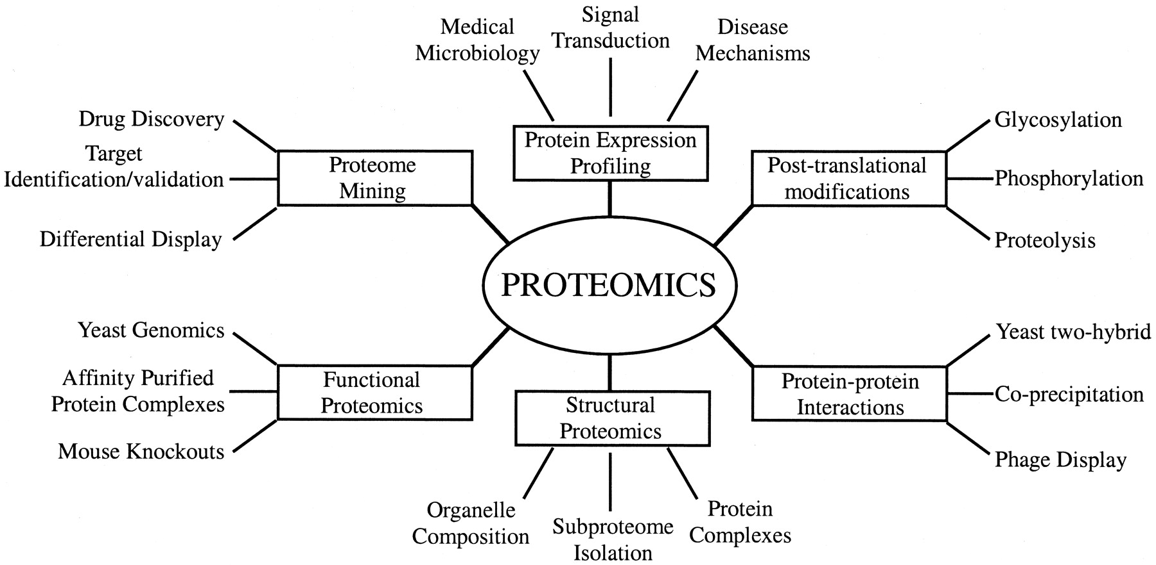
Figure 1 Various applications of Proteomics. Proteomics is diversely applied to many life science fields including basic scientific researches, clinical protein marker discovery and drug discovery. This figure was adapted from a book, ‘Molecular Biologist's Guide to Proteomics’ [2].

Its target communities are diverse including acid mine drainage biofilms[5], wastewaters[6], ocean[7], soil[8], permafrost[9] and human microbiome[10]. Since the first large-scale metaproteome data was generated in 2005 [5], metaproteomics has rapidly advanced in terms of scale and quality. For example, the number of identified human and microbial protein identifications from human feces were 234 proteins by Lichtman et al[11], but it is now 7,553 proteins from human and 34 microbial species in this paper.

Shotgun metaproteomics
Metaproteomics studies are generally based on bottom up approach, also known as shotgun proteomics [4]. Bottom up method identifies small peptides digested from proteins before LC-tandem mass (MS/MS) analysis, while top down directly investigates intact proteins [12,13]. Shotgun proteomics have advantages on large-scale data acquisition, high-complexity samples, high sensitivity and good front-end separation [12]. These advantages are all required features to profile highly complicated metaproteomes. Therefore, bottom up proteomics is majority in metaproteomics studies [13].
The typical shotgun metaproteomics consists of four steps: protein extraction, protein digestion, LC-MS/MS analysis and bioinformatics analysis (Fig. 2). Protein extraction step is collection of entire proteins from a number of microbial organisms in a efficient, unbiased and reproducible way [4].
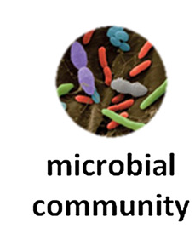
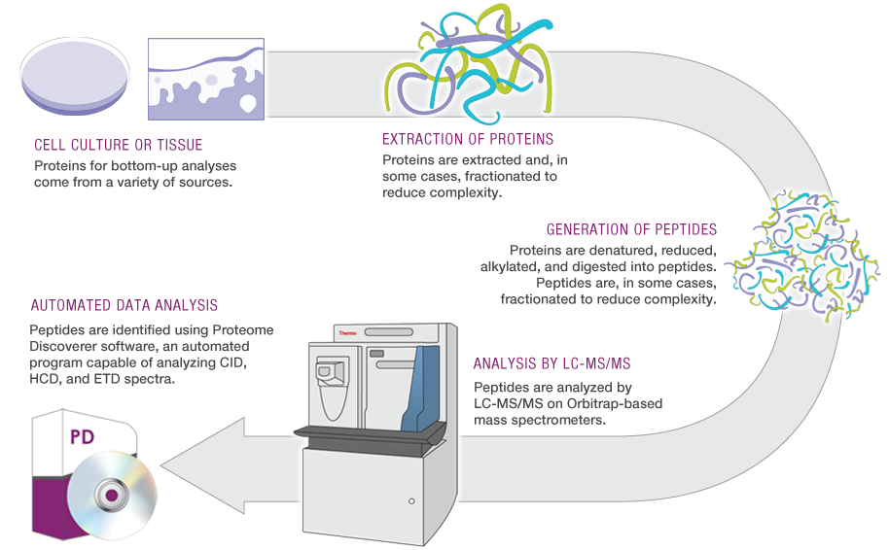

Figure 2 Overview of typical shotgun metaproteomics steps. Metaproteomics collects a sample containing microbial community. Then proteins are collected from the collected sample. Then, the collected proteins are cleaned up and digested by an enzyme, typically trypsin. The peptides are ionized and measured by LC-MS/MS. Finally, the measured MS/MS peaks are identified and analyzed by many bioinformatics tools. This illustration was adapted from Tanca et al [4] and http://www.planetorbitrap.com.

There are various methods of protein prep by combining various detergent (sodium dodecyl sulfate (SDS), CHAPS or Triton X-100), organic/inorganic compounds (phenol, NaOH), chaotropic agents (urea or guanidine hydrochloride), reducing agents (dithiothreitol (DTT), tributylphosphine) and thermal treatments (boiling). Detergents like SDS are used for cell lysis and chaotropic agents can denature protein three-dimensional structures. Reducing agents is employed to hold denatured protein structure during protein digestion. Rapid and controlled thermal treatment can inactivate native enzymatic activity and prevent proteome degradation [14]. Phenol can help protein separation by its less-polar characteristics as well as protein denaturation. Since there is no gold standard for the extraction, it is important to consider characteristics of community and target proteins to maximize extraction yield. Since environmentally derived samples are often not enough to get required biomass of microbial community due to difficulties and cost of sample acquisition, protein extraction is more challenging than proteomics study of laboratory-grown microbes [15].
After proteins are extracted from a sample, next step is protein digestion. Before proteins are digested, chemical compounds, added for protein extraction, should be removed not to disturb following enzymatic digestion. This cleaning step is traditionally fulfilled by protein precipitation using Trichloroacetic acid (TCA), chilled acetone or ammonium acetate/methanol to the protein extract solution [4]. However, these classical methods may have significant loss of certain type of proteins. Filter-aided sample preparation (FASP), recently developed in 2009 by Mann et al [16], is recently applied successfully in many metaproteome studies and it can do sample cleanup and protein digestion together on a centrifuge filter that filter out by weights. This FASP showed out-performance over several competing methods specifically for low abundant proteins [17]. To facilitate effective protein digestion, proteins are denatured and reduced using chemicals, such as Guanidine/DTT or Urea/DTT [18].
Protein digestion is an important step in shotgun metaproteomics because all the proteins in bottom up approach are assembled from the digested peptides. Trypsin is widely used for proteolysis in metaproteomics because it is highly specific and generates positively charged N-terminus. Since MS-based metaproteomics usually run positive ion mode in MS, positively charged N-terminus is ideal for MS. It targets carboxyl side of arginine and lysine of proteins at weakly basic environment (Table 1). Nevertheless, trypsin hardly breaks tightly folded proteins that may not be denatured by denaturing reagents and inadequate distribution of trypsin cleavage sites cause too short peptides [19]. Especially, membrane proteins have resistance to trypsin and little number of lysine and arginine [19]. According to Wu et al, trypsin generates predominantly small peptides (< 2 kDa) that is shorter than 20 amino acid length (Fig. 3) [20]. This small size of peptides (averagely 7~20 residues [19]) can facilitate MS detection, but at the same time it causes number of redundant peptides that are derived by more than two proteins.
Table 1 Various proteases. This table is adapted from the website, http://www.proteinsandproteomics.org/content/free/tables_1/table11.pdf.
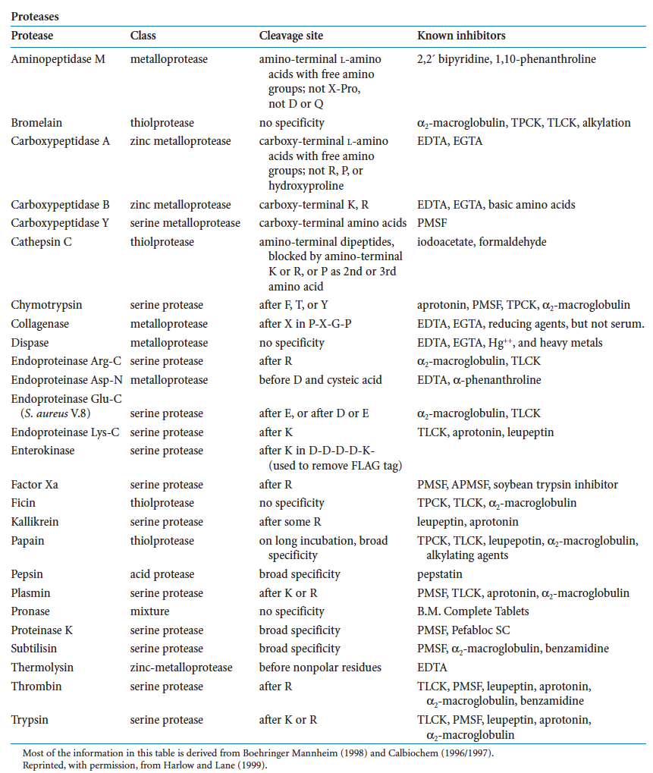
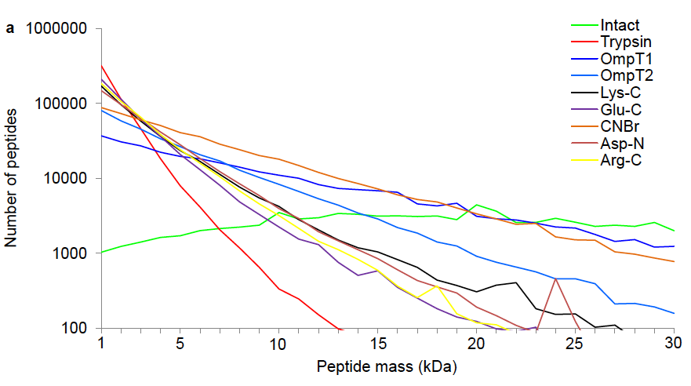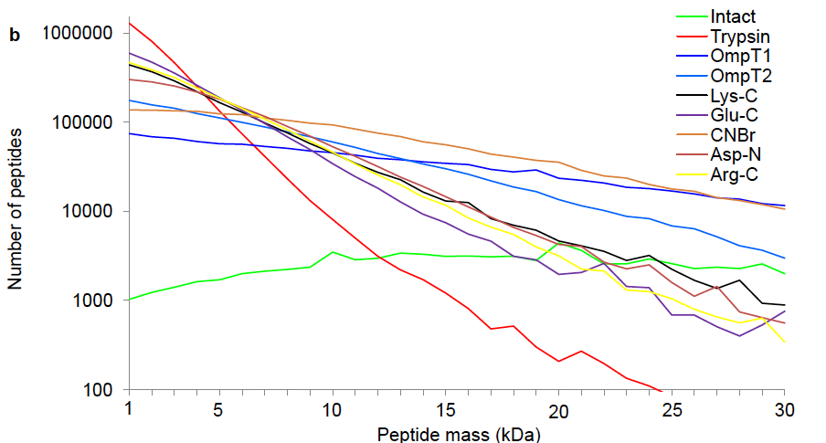
Figure 3 in silico digestions of human HeLa cell proteome with assorted proteases A) without mis-cleavage and B) with assuming two miss-cleavages. This figure is adapted from Wu et al [20].

Redundant peptides, generated much more by trypsin digestion, are the biggest huddle to gather appropriate proteins from the peptides identified by LC-MS/MS. Since redundant peptides can be congregated in more than two proteins, we can’t be sure where those come from. In other words, we cannot know which proteins those redundant peptides should be assigned to. To reduce the number of the problematic peptides, middle down proteomics is newly arising by intending more of miss-cleavages or using another protease producing long peptides [20-22]. Wu et al introduced OmpT enzyme as replacement of trypsin to produce lengthy peptides longer than 3 kDa (Fig. 3) [20]. The longer a peptide is, the less redundant a peptide is.
In addition to decrease of redundant peptides, longer peptides have less probability of false positive identification (Fig. 4) [23]. Figure 4 shows that P-score, Bayesian probability model based score of peptide identification in MaxQuant [23], are different by peptide length. P-score distribution of false positive identifications (red color) is getting smaller and narrower than true positive distribution (blue color) while peptide length (L) is getting longer. Metaproteomics study using middle down approach is not published yet, but I believe that it should be very effective to accurately investigate metaproteomes that have high number of microbial orthologous proteins.

LC-MS/MS analysis
The digested peptides are ionized and separated by their chemical and physical characteristics through LC and measured by MS.
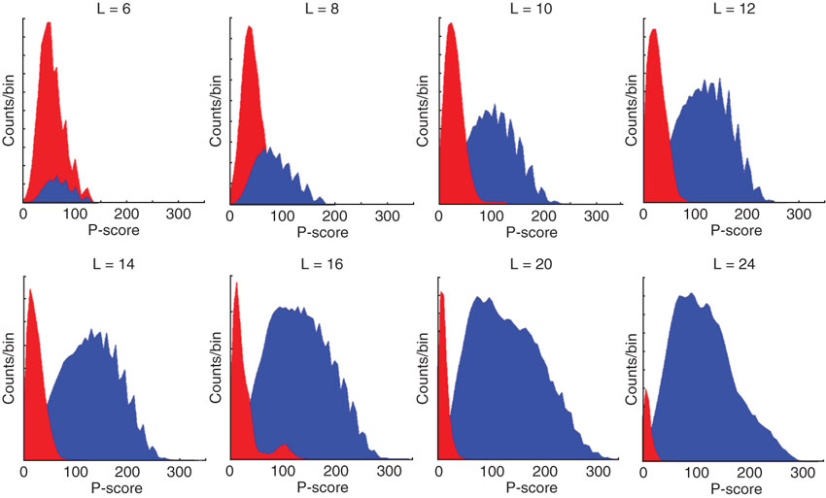
Figure 4 These panels display distribution of P-score, peptide identification score of MaxQuant. Blue color means peptide identifications from forward database search and red colors are from reverse database, intended false positive peptide database. L means peptide length. This illustration was adapted from Cox et al [23].

Since metaproteome usually has more proteins than normal single species proteome, ion separation is important. If massive number of ions is sprayed together into MS, some of ions may not be appropriately measured or missing due to MS scans speed. Peptide separation should be designed by considering ability of MS instrument. Besides the scan speed, good ion separation is able to reduce density of ions. In other words, similar m/z (molecular mass per charge) ions can be apart by elution time. Close m/z ions within the isolation window are often segregated together during MS/MS. This co-isolation makes peptide identification difficult. To get better coverage, the number of peptide identifications, the running time is generally extended. In this paper, human fecal proteome study in chapter 4 and diet study in chapter 5 had run MS instrument for 24 hour to obtain maximum coverage.
High resolving power is an important virtue of MS instrument for unambiguous protein identification in metaproteomics. The better mass accuracy is, the more exact peptide identification is. Low-resolution MS (LRMS) is less expensive and relatively easy to maintain, but it cannot provide exact mass, while high-resolution MS (HRMS) can determine several decimal places. This high precision of HRMS can narrow down candidate peptides to only a few possibilities (Fig. 5). HRMS can give more exact parts per million (PPM) than LRMS. PPM is (((exact mass – accurate mass) / exact mass) x 10⁶). Lower PPM means small mass error. Smaller ppm (mass difference between observed and expected mass) can reduce false matches by removing similar weighted false peptide candidates.

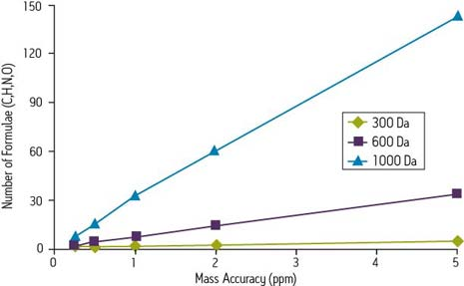
Figure 5 The effect of increasing mass accuracy for unambiguous identification of compounds. PPM is a parts per million (((exact mass – accurate mass) / exact mass) x 10⁶). Lower ppm means small mass error. If mass accuracy is low (ppm is high), the number of candidate compounds is linearly increased. The slope is getting steeper, while molecular weight is getting larger. This illustration is adapted from Quenzer et al [24].

Since metaproteome is much more complicated than single species proteome, it requires to discern narrow down candidate peptides for the measured m/z. Some of amino acid residues have very similar molecular weights. Glutamate and lysine are differed by only 0.036 Da. Phenylalanine and oxidized methionine are only 0.033 Da difference. This little difference is another reason of employing HRMS for metaproteomics.
Even though high mass accuracy can provide better resolution for peptide identification, it is not enough to identify peptides. MS/MS is required process for exact peptide identification and sequencing. In MS/MS step, target mass peak in a survey full-scan mass spectrum (MS1) is selected first. This MS1 peak selection can be different by acquisition approaches, data dependent acquisition (DDA) and Data independent acquisition (DIA) (Fig. 6).
In DDA approach, a fixed number of peaks in MS1 are selected and subjected to MS/MS analysis (Fig. 6). This DDA is powerful and versatile, but it limits the number of peptides sampled for fragmentation regardless of dynamic range and peak capacity of MS [25]. In a complex protein mixture, up to 84% of peptides are not sampled for MS/MS, while at most 30% of peptides are analyzed by MS/MS [26]. DIA is an alternative way of DDA. DIA collects all the peaks systematically and independently of status of precursor ions (Fig. 6), such as collecting MS/MS data without precursor ion selection[27], using ion mobility–collision-induced dissociation–time-of-flight mass spectrometry [28], using wide isolation windows [29], using narrow isolation windows combined with many injections [30] and using multiplexing strategy [25].
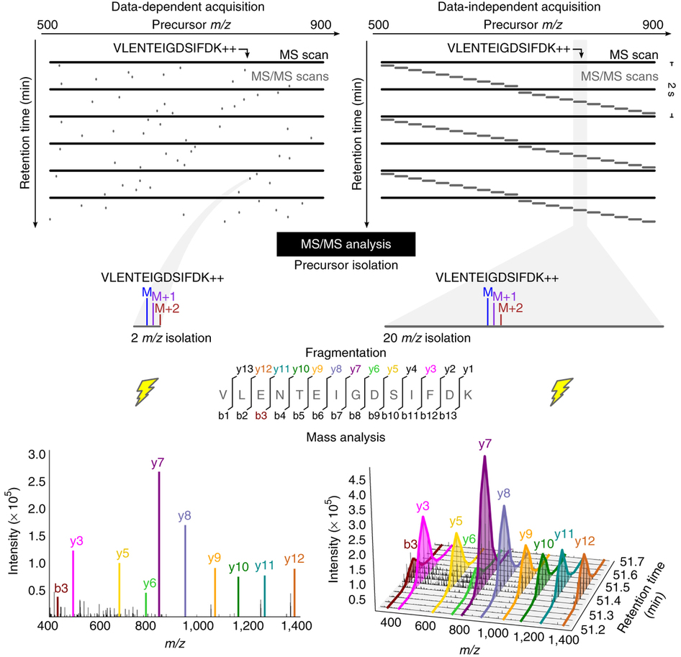
Figure 6 Data dependent acquisition (DDA) and data independent acquisition (DIA). DDA targets MS/MS scans with narrow isolation windows centered on specific precursor ion in an survey MS1 scan. DIA acquired MS/MS scans with wide isolation windows acquiring any peptide precursors. Peptide precursor VLENTEIGDSIFDK++ is present in a single MS/MS spectrum in a DDA analysis, while it can be extracted from every retention times in DIA. This image was adapted from Egertson et al [31].
Even though DIA resolve limit of DDA, its data complexity is much higher than DDA because MS/MS spectrum of DIA has peaks from more than two peptides. Traditional protein reference database search, widely used for DDA data, is not effective for DIA data due to presence of multi-peptides in MS/MS data. There are several tools for DIA data analysis, such as Skyline [32], OpenSWATH [33] and UDMS^{E} [34], but DIA still has a long way to go in spite of its rapid development speed [35]. There is no metaproteomics publication using DIA because DIA makes intricate metaproteomics data even more complicated. However, DIA is worth to enhance depth of metaproteome if following bioinformatics can afford to analyze the higly complex data.
Quantification of proteins, the goal of metaproteomics, is directed at various labeling methods and limited by dynamic range and sensitivity of MS instrument [36]. The number of proteins is getting smaller and smaller while following metaproteomics experiment steps (Fig. 7). Labeling method can be categorized into metabolic labeling (SILAC[37] and isotopes), chemical labeling (ICAT [38,39], iTRAQ [39] and TMT[40]), spiked proteins and counting spectra identified to a peptide (Label-free) (Fig. 8). Since little quantification error is in metabolic labeling (Fig. 7), it has good accuracy and medium coverage (Table 2). Chemical labeling method targets specific residues (ICAT) or terminus (iTRAQ and TMT) and has medium accuracy and medium quantitative coverage (Table 2). Spiked protein method is to compare the fixed amount of spiked proteins and has low coverage and medium accuracy (Table 2). Label-free quantification is good coverage, but low accuracy (Table 2).
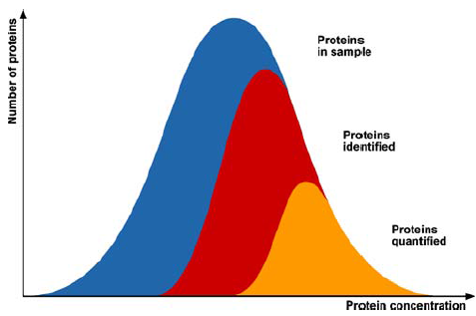
Figure 7 Relative amount of proteins in original sample, in identification and quantification by metaproteome analysis. Proteins are lost during protein extraction, digestion and LC-MS/MS steps. Low-abundant proteins are majorly not identified due to limit of dynamic range. Specific type of proteins is missed by protein extraction method. Only a fraction of original proteins is reliably quantified. This illustration was adapted from Bantscheff et al [36].

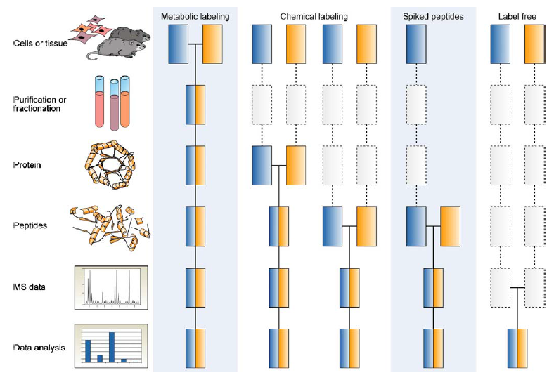
Figure 8 Common quantitative mass spectrometry workflows. Boxes in blue and yellow indicate experiments to be compared. Solid line means that labeled sample is mixed. Dashed line means that points at experimental variation that quantification error can be occurred. This illustration was adapted from Bantscheff et al [36].

Table 2 Accuracy and quantitative coverage of various labeling method in proteomics. This table was adapted from Bantscheff et al [36].
 | Accuracy  (process) | Quantitative  proteome  coverage | Linear  dynamic  range
Metabolic protein labeling | +++ | ++ | 1-2 logs
Chemical protein labeling (MS) | +++ | ++ | 1-2 logs
Chemical peptide labeling (MS) | ++ | ++ | 2 logs
Chemical peptide labeling (MS/MS) | ++ | ++ | 2 logs
Enzymatic labeling (MS) | ++ | ++ | 1-2 logs
Spiked peptides | ++ | + | 2 logs
Label free (ion intensity) | + | +++ | 2-3 logs
Label free (spectrum counting) | + | +++ | 2-3 logs

Label-free quantification is majorly used in metaproteomics and extensive isotopic labeling of an environmental sample is recently demonstrated [41-44].

Bioinformatics for metaproteomics

Peptide-spectrum search
Bioinformatics analysis is conducted to identify peptides from MS/MS spectra and reconstruct and quantify proteins. Bioinformatics analysis is the most challenging in all the steps of metaproteomics. This difficulty of computational analysis is caused by particularly intricate data structure of metaproteome and lack of prior information about microbial communities.
Species cohabiting in a community is not known, which means that we can’t construct protein database collected from reference databases (DB), such as RefSeq[45], UniProt[46] and IMG[47]. Even though Metagenome sequencing can replace reference DB, we don’t know what it is. Since identification of MS/MS spectrum is based on reference protein sequences, deficiency of reference DB limits exact protein identification. If appropriate reference protein DB is unavailable, de novo sequencing can be alternative way for identification of MS/MS. However, de novo sequencing based MS/MS search is difficult.
De novo sequencing does not require any prior information. MS/MS spectrum is collection of ions derived by fragmentation of a precursor peak (sometimes, more than two peaks). Fragmented ions are varied by fragmentation methods. Collision induced dissociation (CID) and higher-energy collision dissociation (HCD) produce b and y ions, while electron-transfer dissociation (ETD) generates c and z ions. For example, when it comes to MS/MS fragmented by CID and HCD, de novo peptide sequencing starts from finding b and y ions that are differed by molecular mass of amino acid residues. By comparing ion mass, sequence order is determined (Fig. 9). However, de novo sequencing from MS/MS spectrum is generally not successful for the following reasons: 1. Low ion intensity causes incomplete detection of sequence ions, 2. Many peptide sequences cannot have sufficient set of sequence ions and 3. Unusual amino acid and uncommon covalent modifications can prevent sequencing [48]. De novo sequencing is the ideal way to identify MS/MS, but is dependent on charge state of precursor ions and fragmentation efficiency. De novo sequencing is often used to support and improve DB-based MS/MS search (DB search).
DB search is majorly employed for MS/MS identification in proteomics studies. Most widely used MS/MS search engines, such as SEQUEST[49], MASCOT[50], X!Tandem[51], OMSSA[52], MyriMatch[53] and MS-GF+[54], use protein DB for peptide identification. These are all comparing MS/MS with peptides generated from protein DB, but use different scoring system (Fig. 10). First, search engines generate all the possible peptides from protein DB given the number of allowed miss-cleavage and digestion enzyme. Then, candidate peptides are selected from peptide library using mass of precursor ion. Next step is calculation of scores, probability, correlation coefficient or similarity, between candidate peptides and MS/MS spectrum.
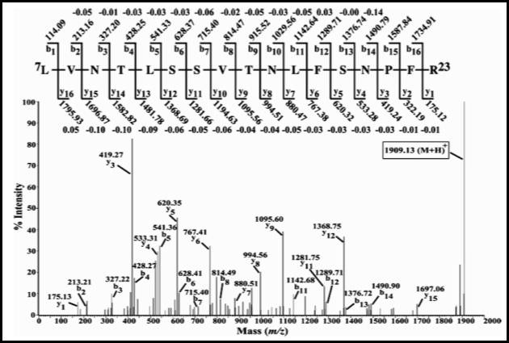
Figure 9 Example of de novo sequencing from MS/MS spectrum. This is tandem mass spectrum of the [M+2H]+2 ion m/z 955.03 in LC/ESI/MS analyses of tryptic peptides from a 70 kDa iPLA2 digest. This illustration was borrowed from http://msr.dom.wustl.edu/ms-peptide-mapping/.

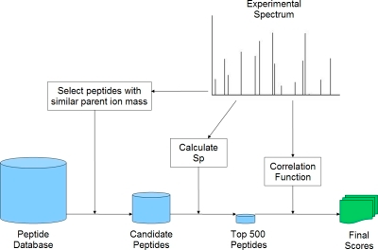
Figure 10 Schematic diagram of DB search. This diagram is based on SEQUEST, but other engines have very similar structure. First, search engines generate all the possible peptides from protein DB given the number of allowed miss-cleavage and digestion enzyme. Then, candidate peptides are selected from peptide library using mass of precursor ion. Next step is calculation of scores, probability, correlation coefficient or similarity, between candidate peptides and MS/MS spectrum. The engines report top 10 or 20 peptides for given MS/MS. This illustration was adapted from McHugh et al [55].

The engines report top 10 or 20 peptides for given MS/MS.
Since SEQUEST is developed in 1994, many algorithms for MS/MS identification were developed, such as MASCOT in 1999, X!Tandem in 2004, OMSSA in 2004, MyriMatch in 2007 and MS-GF+ in 2014. SEQUEST is the frontier of DB search engine and commercialized now. It calculates cross-correlation coefficient (XCorr), similarity score between theoretically generated peaks and query MS/MS spectrum, and deltaCn, difference of XCorr from next candidate following initial screening using Sp score. MASCOT is based on MOWSE algorithm, first probaibility-based score for mass finger printing, and provides probability of observed match between query MS/MS and peptide library by change. Even though MASCOT and SEQUEST were released more than 15 years ago, those two are still major DB search engine in proteomics because those were upgraded to follow technological advances. However, basic design of scoring system in SEQUEST and MASCOT is for traditional CID and low-resolution MS [54].
Since SEQUEST and MASCOT are old and commercialized, there were a number of attempts to develop engines more accurate, faster and open source, such as X!Tandem, OMSSA, MyriMatch and MS-GF+. OMSSA has a probability-based scoring system like MASCOT. OMSSA employed Poisson distribution because the number of spectrum matches is distributed like Poisson distribution. OMSSA is faster and much cheaper due to open source tool than MASCOT. X!Tandem is another engine that has probability-based score (hyperscore), combination of hypergeometric distribution and dot product. X!Tandem collects common MS/MS peaks between theoretical peaks and actual query peaks filtered by the expected intensities, then do dot product. This dot product result is modified by multiplying by N factorial for the assigned b and y ions. The factorial modification is based on hypergeometric distribution. X!Tandem calculates E-value, by extrapolating the linear regression line of the log histogram (the number of results), to measure how different the top hit is from the following hit. This E-value plays same role to DeltaCn of SEQUEST. MyriMatch hired multivariate hypergeometric distribution (MVH) to calculate probability of matches between query and DB by chance.
MS-GF+ has different approach from other DB search engines (Fig. 11). General DB search engines compares one spectrum to all the candidate peptides filtered from the library by preliminary score, such as Sp of SEQUEST and noise filter of X!Tandem. However, MS-GF+ generates peptide dictionary that is all the possible de novo sequences from a MS/MS spectrum and search their presence in the peptide library [56]. MS-GF+ compares log likelihood ratio of vectors of peptides and spectra and calculate E-value to find the best hit. While traditional DB searches should compare every spectrum against every peptide in the library (running time is linearly increased by size of the library), MS-GF+ execution time is not dependent on DB size. This is very important advantage to metaproteomics because metaproteomics has much larger protein DB than single species proteomics. In addition to being independent on DB size, since MS-GF+ is based on de novo sequencing, it can provide more sequences that are not found in the reference DB.
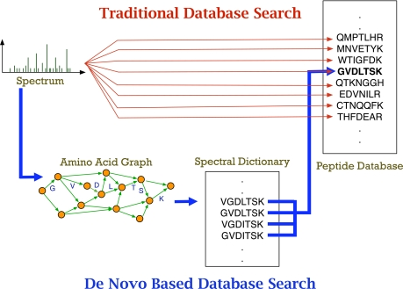
Figure 11 DB search of MS-GF+. MS GF+ is updated version of Spectral Dictionary [56]. Red line is traditional DB search comparing spectra against the peptide library generated from protein DB. Blue line is the de novo based DB search constructing all the possible de novo sequences from a MS/MS spectrum. This illustration was adapted from Kim et al [56].

This de novo sequencing based approach can benefit metaproteomics studies because unknown species in a microbial community is not in protein DB.
In addition to different scoring metrics, every DB search engines has pre-processing step prior to compute scoring matrix. This filtering step is to remove noise peaks and collect valid b and y ions, but this step can introduce problems. If the filtering threshold is too low, noisy matches will hinder true matches; if it is too high, peaks observed fragment ion may be lost. These different preprocessing approaches in different DB search engines can result in different peptide identification output.
Speed of MS/MS search is a critical issue besides accuracy of peptide identification because metaproteome data has complicated structure. MS-GF+ has advantage on this issue because its search speed is not lowered by protein DB size. However, since MS/MS search is embarrassingly parallel, which means easily dividable into small pieces, other MS search engines can process MS/MS search by being run simultaneously at cluster server or supercomputer. Briefly, one LC-MS/MS run (MS run) consists of many of MS/MS spectra, so if we have 1,000,000 CPUs in a supercomputer, we can search a million MS/MS spectra at the same time, which means that a million spectra can be processed within time for one spectrum search theoretically. For this purpose, there are several ways to parallelize MS/MS peak search engines, such as X!!Tandem[57], wrapper for MS[58] and Myrimatch[53]. In contrast to others, MyriMatch does not require additional install to work in parallel environment. It can utilize available cores by simple option when it is executed. MASCOT also has a platform for multi-core environment and it is same to SEQUEST. For this reason, parallel environment is recommended for bioinformatics analysis in metaproteomics.
Target-decoy search strategy revolutionized peptide and protein identification of proteomics area. Elias et al suggested generating decoy database, have same characteristics to protein DB, but never be found in a sample, and competing target DB and decoy DB during MS/MS search [59]. Decoy DB is generally engineered by reversing protein sequences of target DB (original protein DB). By reversing sequences, decoy proteins have same characteristics to target DB in terms of digested peptides and mono-isotopic mass (Fig. 12). Since decoy sequences are not in a sample, if it is included in the peptide identifications, it is considered as false positive. Counting the false positives from decoy hits, false discovery rate (FDR) is calculated as described below if MS/MS search is done against concatenated target and decoy DB.
$$FDR=\frac{2×Decoy hits (FP)}{Decoy hits (FP)+Target this (TP)}$$

Generally, 5% FDR is threshold of publishable MS/MS search. FDR formula is different by different tools. PeptideProphet, MASCOT and Percolator have their modified own FDR formulas. After decoy search approach is employed, FDR calculation is necessary for proteomics studies. However, artificially decoy can’t cover all the possible false positives, so there are worries about using FDR as gold standard method for MS/MS search assessment [60].

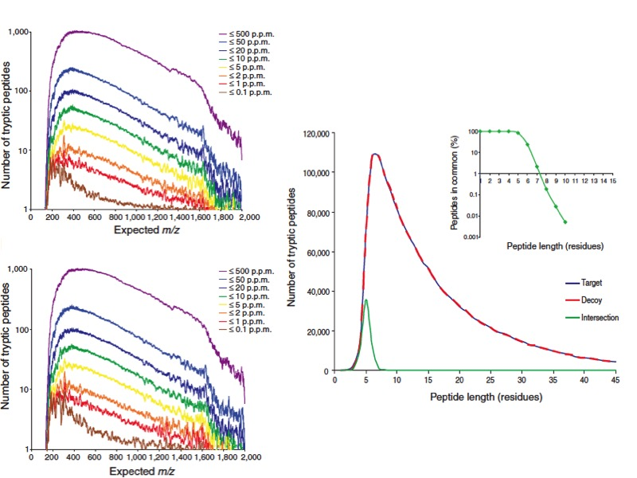
C) )
A)
B) )
Figure 12 Target-decoy DB comparison. The number of trypsin-derived peptides over calculated monoisotopic mass of A) target DB and B) decoy DB from in silico trypsin digestion of IPI human protein DB. C) The number of trypsin-derived peptides is in target (blue line) and decoy (blue line) DB. Green line is intersection between those two, target and decoy.

As peptide-spectrum matches (PSM) are accumulated by number of laboratories, spectral library is constructed by nature in order to reduce DB search time and not to repeat searching same post-translational modifications (PTM) and same peptides. The National Institute for Standards and Technology (NIST) and the Global Proteome Machine (GPM) provides spectral libraries for proteomics studies. PSM search against spectral libraries is mediated by X!Hunter[61], Spec2Spec[62] and Pepitome[63] that don’t need to generate theoretical MS/MS spectrum. However, spectral library search is not appropriate method to metaproteomics because spectral library is used for what we already know, while metaproteomics studies what we never know.

Post-process of PSM search results
After PSM search, post-processing is required to have valid PSMs and assemble appropriate proteins from PSMs. Assessing of MS/MS identification is always an important issue of PSM search. What threshold of scoring metrics can give reliable peptide identification is ambiguous. Since MS/MS search engine is developed first in 1994, evaluation of peptide identification has been hot. DTASelect [64], developed in 2002 and widely used for protein assemble of SEQUEST result, suggested good guideline for SEQUEST search; > 1.8 XCorr for +1 charged ion, > 2.5 XCorr for +2 charged ion, > 3.5 XCorr for +3 charged ion and > 0.08 DeltCN for every charged ions. By providing above filters and simple protein assembly, report all the possible protein existence, DTASelect had been widely used for SEQUEST search. Protein Prophet [65], developed in 2002 and incorporated to trans plant pipeline (TPP), calculates probability, based on mixture model EM method using Bayesian approach, of MS/MS identification. Protein Prophet gives statistical guideline for assessing correct and incorrect peptide assignment and estimation of likelihood for the presence of proteins corresponding to those peptides in a sample. To maximize peptide identification, Scaffold [66] employs various search engines and integrates results from them using Protein Prophet. Scaffold obtains MS/MS search results from SEQUEST, MASCOT, OMSSA, X!Tandem and etc. Then, it evaluates peptide identifications of each engines using Protein Prophet. These results are aggregated and re-evaluated by Protein Prophet. By aggregation and multiple evaluations, Scaffold provides platform-independent result and maximized peptide identifications.
Protein assembly is challenging step following peptide identification of MS/MS. Generally, assembly is more difficult than disassemble because some parts dissociated from different two can have confusing shape. Those components are actually same in peptide world, which means same amino acid sequence. Redundant peptide, found in more than two proteins, makes protein reconstruction and quantification difficult. The probability of the shared peptides is much higher than one looks due to existence of orthologous, similar sequences in different sequences, and paralogous, duplicated in the same species, proteins.
Meyer-Arendt et al demonstrated using human proteins that 89,486 entries in international protein index (IPI) DB v3.75 could have almost 2 million shared peptides over 4 million of trypsin-derived peptides (length > 7 amino acids allowing up to 2 miss-cleavages) [67]. Moreover, metaproteome has a number of microbial species, which means being likely to have higher chance of overlapping peptides than Meyer-Arendt’s human only example. Therefore, metaproteome has many shared peptides making ambiguous protein identifications.
Handling ambiguous protein identifications directly affects on final protein identification. If peptide A is identified and can be generated from protein 1, 2 and 3 in protein DB, in actual sample peptide A may be derived only from 1, from 1 and 3 together or from 1, 2, and 3 at the same time. Source of peptide A is not uncertain due to lack of information, different final protein identifications are possible by how to handle ambiguous protein identifications. DTASelect, developed in 2002 and widely used for protein assemble of SEQUEST result, includes all the possible proteins, such as protein 1, 2 and 3 of above example. However, IDPicker[68], developed in 2007 and basically linked to MyriMatch, reports minimal protein list. Protein assembly of IDPicker is based on bipartite graph and greedy algorithm (Fig. 13). First, IDPicker connects peptides and proteins in a bipartite graph (Fig. 13A). Next, indistinguishable peptides and proteins are collapsed (Fig. 13B). The collapsed bipartite graph is decomposed to separate protein clusters with connected peptides (Fig. 13C). Proteins that have uniquely matched peptides or supported by more than two different peptide groups are identified and added to the minimal protein list (Fig. 13D). IsoformResolver [67] access to the shared peptides differently, peptide-centric approach. This peptide-centric approach is similar to algorithm of MS-GF+ generating all the possible de novo sequences.
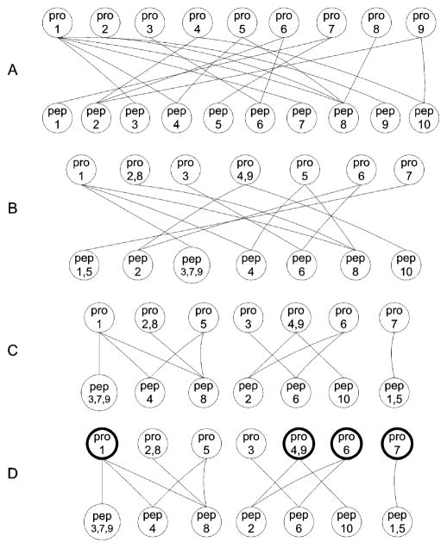
Figure 13 Overview of bipartite graph model and analysis procedure of protein assembly in IDPicker. Pro: protein, pep: peptide. This figure was adapted from Zhang et al [68].
IsoformResolver constructs unique peptide library from protein DB and assign proteins to corresponding peptides. IsoformResolver is able to keep shared peptides as unique entries, however it can’t provide any insight about how to interpret the problematic peptides. Percolator [69] emplyed semi-supervised machine learning to discriminate correct from incorrect PSMs, and calculates accurate FDR and posterior error probabilities.
Protein quantification is also varied by handling of ambiguous protein identifications. Since shotgun metaproteomics explores peptides, not proteins, so quantitative measurement of peptides, generally spectrum counts (SC) in label-free and ratios in labeling, should be transferred to corresponding proteins. Processing of unique peptides, solely matched to one protein, is straightforward, assigning to the matched protein. However, assigning shared peptides to candidate proteins is ambiguous due to uncertainty of source of origin. DTASelect redundantly assigns SC of overlapping peptides to every candidate proteins, so DTASelect amplifies expression level more if there is more number of ambiguous peptides in DB search result. IDPicker employed greedy algorithm following winner takes all. After protein and peptide groups are separated, IDPicker prioritize proteins by whether unique peptide is linked or not and the number of SC from linked unique peptides. Greedy algorithm iteratively chooses proteins by order of priority and gives all the shared peptides first. IDPicker generate parsimonious protein identification and amplify their expression level by casting all the available votes. Protein Prophet and Percolator transfer peptide’s quantification to corresponding protein.
In label-free shotgun proteomics, SC of redundant peptides is sometimes distributed into corresponding proteins (spectral balancing) [70,71]. Spectral balancing considers only proteins that have more than one unique peptide (Unique proteins). SC of a redundant peptide is divided into unique proteins by SC of unique peptide. Divided SC of a shared peptide for a unique protein is calculated as described below:
$$Divided SC=\frac{uSC}{\sum_{i=1}^{n}{{uSC}_{i}}}×sSC$$
Where uSC is SC of unique peptide, sSC is SC of the shared peptide and n is the number of unique proteins linked to the shared peptide. This spectral balancing is connected to the normalized spectral abundance factor (NSAF) [71,72].
If we have more than two MS runs, we need to normalize them to compare. There are systematic errors including instrumental error and human error even though MS runs were carried out by same experimenter using same instrument for same sample. Normalization is to adjust these errors. Labeled MS runs don’t require normalization theoretically due to being run simultaneously, but normalization between different labeled MS runs may be needed. Generally, normalization methods are designed for label-free experiment. NSAF is most widely used normalization method. It considers spectral balancing as well as protein length due to probability of peptide assignment. Long protein may have more chance to have peptides than short protein. Distributed NSAF (dNSAF) for i-th protein is calculated as described below:
$${dNSAF}_{i}= \frac{{dSAF}_{i}}{\sum_{i=1}^{N}{{dSAF}_{i}}} where, {dSAF}_{i}= \frac{{uSC}_{i}+\frac{{uSC}_{i}}{\sum_{m=1}^{M}{{uSC}_{m}}}×{sSC}_{i}}{{Length}_{i}}$$
Where, N = the number of total identified proteins, uSC is SC of unique peptide, sSC is SC of shared peptide, Length is protein length and M is the number of unique proteins. Sum of dNSAF within a MS run is 1, so dNSAF number is too small. This small number of dNSAF is often logged to make it easy to analyze.
In addition to NSAF, there are a few normalization methods including total PSM normalization, exponentially modified protein abundance index (emPAI)
and quantile normalization. Normalization by total sum of PSM is also widely used in metaproteomics studies [73] and is calculated as described below:
$$Normalized {SC}_{i}= \frac{\frac{\sum_{j=1}^{M}{\sum_{k=1}^{N}{{SC}_{k}}}}{M}}{\sum_{k=1}^{N}{{SC}_{k}}}×{SC}_{i}$$
Where, N = the number proteins and M = the number MS runs. The total sum normalization assumes that all the MS runs should have same amount of PSMs theoretically, so it makes MS runs to have same sum of total PSM. However, the total sum normalization tends to amplify small sum of PSM runs too much. Small sum of PSM runs generally have small number of proteins, so the total sum normalization method can make false positives by making data distortion. To complement this disadvantage of total sum normalization, average normalization can be used as described below:
$$Normalized {SC}_{i}= \frac{\frac{\sum_{j=1}^{M}{\frac{\sum_{k=1}^{N}{{SC}_{k}}}{N}}}{M}}{\frac{\sum_{k=1}^{N}{{SC}_{k}}}{N}}×{SC}_{i}$$
Where, N = the number proteins and M = the number MS runs.
Normalization using emPAI method is used in MASCOT searches [74]. emPAI is also designed for label-free proteomics and considers the number of experimentally observed peptide and observable peptides calculated as described below:
$$emPAI={10}^{\frac{N_{observed}}{N_{observable}}}-1$$
Where, N_{observed} = the number of experimentally observed peptides and N_{observable} = the number of theoretically observable peptides. N_{observable} is calculated by in silico protein digestion considering digestion enzyme, allowed miss-cleavages and mass range of the instrument. Even though emPAI normalize SC considering potential number of peptides, it does not correct systemic error between different MS runs.
Quantile normalization is a technique for making two distributions identical in statistics. Quantile normalization considers rank of SC within a MS run and make same rank to have same SC across MS runs. Since quantile normalization make MS runs to have same SC on same rank, it can distort data too much similar to total sum normalization.
Statistical analysis in proteomics is not quite different from other biology data analysis. Student’s t test, ANOVA and quasi-Poisson modeling are used for statistical comparisons between different experiment groups. Students’ test and ANOVA requires Normal distribution assumption, but typical SC distribution in MS runs does not follow Normal distribution (Fig. 14). In figure 14, red empirical estimated line is not similar blue Normal fitted line. Left wing of blue Normal line is missing because negative values are not in SC. Other distribution except Normal is required for proteomics data analysis, however various distributions are not tested in proteomics data analysis. Recently quasi likelihood Poisson modeling (quasi-Poisson) is tested by Li et al [75]. Li et al compared quasi-Poisson model to many methods including Fisher’s exact test, Wilcoxon rank test and Student’s t test over LC-MS/MS data and successfully showed quasi-Poisson can be applied for proteomics data analysis.
Since Student’s T-test is not appropriate for multiple comparisons, required for all the large biology data analysis, ANOVA is more recommended. Whenever T-test is conducted, there is a chance of Type I error, typically 5%. If we run T-test three times, potential Type I error will be accumulated up to 15% [76]. If we tested T-test over 1,000 proteins collected from LC-MS/MS runs, the accumulated Type I error may be converged to 100%, which means unreliable analysis result containing too many false positives. However, ANOVA can keep certain level of Type I error even though it is repeatedly tested. This difference between ANOVA and T-test is what is compared. T-test compares mean of each samples, while ANOVA does variance within groups and between groups. Therefore, T-test is not appropriate statistical method for proteomics as well as other large biology data analysis.
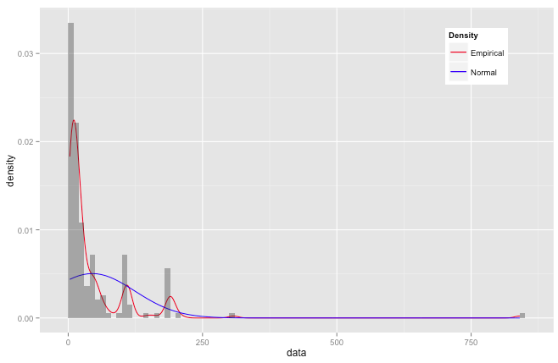
Figure 14 Typical distribution of SC in label-free metaproteomics data.

Quantitative and Functional analysis pipeline for Metaproteomics
Even though there is a growing sense that metaproteomics studies are important, a few analysis pipelines are publicly available. GalaxyP (https://usegalaxyp.org/) is proteomics application of Galaxy platform[77]. Galaxy platform is a scientific workflow and data analysis pipeline of computational biology for wet-lab biologists who don’t know programming. Galaxy is written in Python and Javascript and provides simple three-column interface (Fig. 15). Galaxy is easy to install and free, so any user can have own Galaxy if appropriate server computer is available. Adding bioinformatics tools to Galaxy is possible, however many Galaxy servers already service many of publicly available tools (https://wiki.galaxyproject.org/PublicGalaxyServers). GalaxyP provides X!Tandem and Protein Prophet as well as data management. However, GalaxyP may not be appropriate for metaproteomics because X!Tandem is not run in parallel environment and Protein Prophet is not the best tool for handling redundant peptides.
MetaProteomeAnalyzer (MPA) is recently published and is designed for metaproteomics (Fig. 16) [78]. While GalaxyP has web-interface and server-oriented pipeline, MPA is client-server communicating system. Client-side uploads MS/MS experiment data and server-side deposits and analyzes the uploaded data. MPA focuses on data interpretation rather than parallelized MS/MS search. MPA employed four DB search engines; X!Tandem, OMSSA, Crux [79] and InsPecT [80] and aggregates four DB search results to increase PMSs.

Figure 15 Interface of GalaxyP. It has three-column interface consisting of available tools, main screen for analysis result and parameter input and status of analysis steps from left to right. This illustration is screen-captured from http://www.usegalaxyp.org.

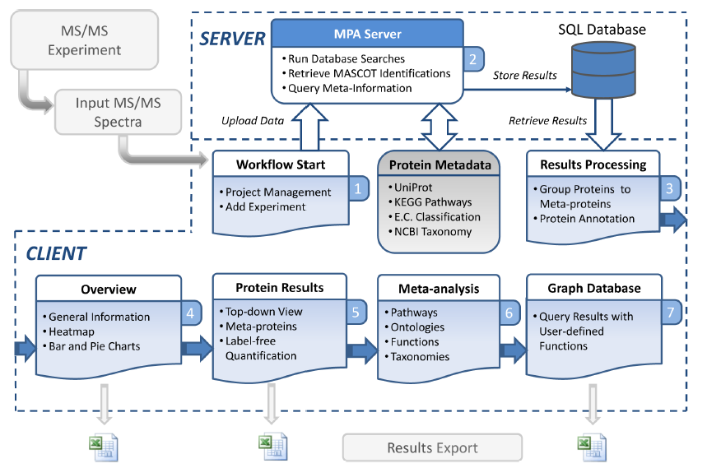
Figure 16 Schematic diagram of workflow in MetaProteomeAnalyzer. Server side and client side are communicating and uploaded data is deposited in server SQL DB. The illustration is adapted from Muth et al [78].

MPA groups proteins into meta-proteins due to redundant peptides. Based on meta-proteins, MPA provides functional analysis using Kyoto encyclopedia of genes and genomes (KEGG) pathways [81], enzyme commission (E.C.) [82] and National Center for Biotechnology Information (NCBI) Taxonomy [83]. MPA generates visualized reports drawing figures and producing analysis reports. MPA is the first analysis pipeline, equipped with visual interface, but it does not provide parallel running of DB search engine for enhancing speed and COG analysis. MPA’s functional analysis is all based on reference DB. However, metagenome sequences, generally used for metaproteome DB construction, can’t be annotated and many of microbes are not well annotated by reference DB. Therefore, MPA’s functional analysis is very limited to be designed for metaproteomics.
Analysis pipeline for Metaproteomics should have two important requirements. First, simultaneously running MS/MS search engine is necessary. Since metaproteomics needs highly complicated protein sequence DB, DB search speed is very slower than single species proteomics. Search speed of every DB search engine is dependent on DB size. MyriMatch is designed to do multithreading, so it can use multiple CPUs for DB search. Also, functional analysis of metaproteomics should be based on sequences, not on reference DB. Human, mouse, Escherichia coli and yeast have manually curated and widely covered annotation. However, almost all the microbes living in an environmental sample, target of metaproteomics, is unknown and does not have annotation. Functional analysis based on reference DB, used in MPA, is not much valuable in metaproteomics. Therefore, next metaproteomics pipeline should have these required features.

CHAPTER II
QUANTITATIVE AND FUNCTIONAL ANALYSIS PIPELINE FOR METAPROTEOMICS DATA

General information about the pipeline

Quantitative and functional analysis for metaproteomics (QFAM)
Our analysis pipeline for metaproteomics, named as quantitative and functional analysis for metaproteomics (QFAM), is installed in Newton cluster of the University of Tennessee. Newton cluster has 4,200 processor cores (400 nodes). All nodes are connected via 1Gb Ethernet and Infiniband interconnected (up to 40Gb/sec). Operating system is Scientific Linux 6.5 (Redhat Enterprise compatible) and sun grid engine (SGE), also known as N1 grid engine, controls batch-queue system. Newton is serviced for scientific high performance computing purpose and freely available to students and steps of University of Tennessee. Generally Newton allows only 24 hour run for single job, but QFAM is allowed to use 48 cores for unlimited time because PSM search of metaproteomics analysis sometimes takes more than two weeks despite of using 48 CPUs, which is maximum number of, allowed.
QFAM is designed for label-free shotgun metaproteomics data that is from microbial communities of environmental samples. The pipeline consists of five modules; PSM search module, module for making contrast file, normalization module, statistical analysis module and functional analysis module (Fig. 17).
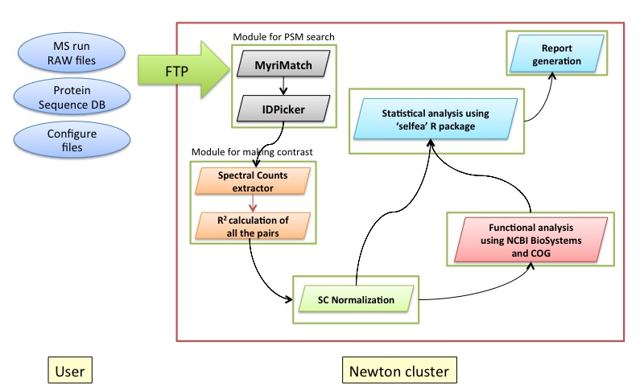
Figure 17 Schematic diagram of quantitative and functional analysis pipeline for metaproteomics (QFAM). QFAM consists of seven modules and is designed to process metaproteome data rapidly and give functional reports to users.

PSM search module employed MyriMatch and IDPicker for fast and exact peptide and protein identifications. PSM search module produces tab-delimited files containing protein ID, spectrum counts and decoy-target information. If multiple MS runs are accumulated, spectrum counts of multiple MS runs are summarized into one contrast file that have protein IDs in rows and spectrum counts of MS runs in columns. Module for contrast also compares each of MS runs by calculating Pearson coefficient correlation (PCC) to find similar technical runs. If experiment datasets have many technical replicates and needs to pick good and similar technical runs, MS runs that have high PCC for each other are preferentially selected. Next module is for normalization. The module provides three options; total sum normalization and same average normalization. Statistical analysis module is programmed by R statistics script to apply three methodologies; quasi-Poisson model with Cohen’s f, negative binomial model with Cohen’s w and Normal ANOVA with Cohen’s f. Functional analysis module is based on NCBI Biosystems DB[84] and cluster of genes (COG) terms [85]. Last module is for drawing charts for publication. This module draws bar and line graphs and use ‘ggplot2’ R package[86]. All the modules are programmed in Python 2.7.6 and R 3.1.3.
QFAM is distinguished from other proteomics pipelines, such as MPA and GalaxyP, by its PSM search speed and quantitative analysis module (QAM) and functional analysis module (FAM). QFAM has automatically controlled PSM search module using MyriMatch and IDPicker, which are able to do multithreading. PSM search time with multiple cores is a far reduced than using single core. QAM of QFAM uses ‘selfea’ R package for discerning false positives efficiently. Selfea is applied for significance test of FAM using NCBI BioSystems and COG. FAM provides COG enrichment test and significance test, which are not incorporated in other pipelines.

Module for LC-MS/MS data analysis

Automated module for DB search and protein assembly
PSM search speed is dependent on protein DB size because each of PSM comparison process checks protein DB and this process is repeated as many as MS/MS spectra exist in a MS run. Since metaproteomics has large protein DB (about 1 gigabytes), PSM search speed is much slower than single species proteomics. Slow search speed increases total time for PSM search. This time-consuming process is the bottleneck of analysis pipeline for metaproteomics. To make the speed faster, multithreading technique is required. Multithreading is execution of multiple threads within the context of a single process, which means running multiple processes simultaneously using multiple CPU resources. PSM search is independent process, so it is embarrassingly parallel, which means being possible to run each of PSM searches individually on multiple CPUs. Multithreading is applied on MyriMatch that is employed for QFAM.
MyriMatch and IDPicker v3.0 are incorporated to QFAM for DB search, post-processing and protein assembly. MyriMatch was tested by Gross et al [87] whether its multithreading can reduce running time or not (Table 3).
Table 3 MyriMatch search time. This table was adapted from Gross et al [87].
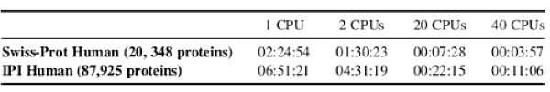
We also tested MyriMatch in Newton cluster, where QFAM is installed, and could confirm that MyriMatch can reduce PSM search time by using more number of CPUs (Table 4). Since PSM search part is the bottleneck of LC-MS/MS data analysis, saving much time in the search is good advantage for metaproteomics studies.
Table 4 MyriMatch run time in Newton cluster. We tested MyriMatch for 500 megabytes protein DB, containing 176,620 proteins, to search 41,079 peaks. Increasing the number of CPU cores dramatically decreases running time.
 | 1 CPU | 2 CPUs | 12 CPUs | 48 CPUs
Run time for single RAW file | 49:03:45 | 40:53:07 | 08:27:34 | 02:51:06

IDPicker has three sub-modules, IDPQonvert, IDPAssemble and IDPQuery. IDPQonvert creates idpDB from pepXML or mzIdentML files produced by MyriMath as PSM search results. IDPAssemble analyzes peptide-protein matches by using bipartite graphs and calculates spectrum counts following greedy algorithm. IDQuery is a data-retrieving tool from the idpDB processed by IDPAssemble. QFAM executes these three modules automatically after MyriMatch is done. Total execution time to do single MS run, consists of five RAW data, is almost 10 and half hours when we tested 500 megabytes protein DB (Table 5). DTASelect generally takes more than a week to assemble peptides and calculate spectrum counts, while IDPicker only took two minutes to do the same job (Table 5). This enhanced speed is required for processing big and highly complicated metaproteome data.
Table 5 Run time of LC-MS/MS data analysis in the pipeline.
 | MyriMatch | IDPQonvert | IDPAssemble | IDPQuery | Total
Run time | 10:24:55 | 0:01:07 | 0:00:31 | 0:00:15 | 10:26:48

IDPicker’s MaxFDR is 0.05 as default. QFAM reports peptides and proteins at 0.05 FDR level.
This module for MyriMatch and IDPicker is automated. Only one job submission to Newton is enough. This job controller is programmed in Python 2.7.6 and requires one configure file named as “BMI_pipeline.cfg”. This configure file contains information of data file path, program (MyriMatch and IDPicker) path, the number of CPU for the pipeline execution and job list file location. The PSM search module finally produces tab-delimited file that have protein ID, spectrum counts from unique peptides, the number of unique peptides, DB source (target or decoy), protein length, percentage of protein sequence coverage and spectrum counts.

Making contrast file, comparing MS runs and normalization
Any experiments don’t have only one MS run unless it is a test run. Multiple MS runs are basically included in the experiment design for comparison of test and control groups. Multiple MS runs, making technical replicates or biological replicates for reliable research findings, are generally produced for one experiment. Multiple MS runs are summarized into one data file (contrast file), usually tab- or comma-delimited file, containing MS run names in columns and protein IDs in rows. QFAM provides a module for making a contrast file from multiple PSM search results. Also, QFAM reports protein FDR, the number of decoy protein identifications divided by the total number of proteins, as well as removes decoy protein identifications.
In addition to making the contrast file, QFAM calculates Pearson correlation coefficient (PCC) of every possible pairs in one contrast file. By comparing PCC within replicates and between different groups, users can choose more similar replicates and more different MS runs from other experiment groups. This module is importantly used for comparison of technical replicates and biological replicates in Chapter 4. PCC comparison module is programmed in R. Also this PCC comparison can group MS runs that are considered as very similar (PCC >= 0.90). Generally technical replicates have much better PCC than biological replicates and other experimental groups. Picking MS runs for further analysis is not automated.
Next module is normalization following making contrast file and picking MS runs. Normalization is necessary step for label-free proteomics data to standardize different MS runs for comparison. Piehowski et al examined source of proteomics data generation [88]. They considered four variance sources, protein extraction, digestion, instrumental stability and instrumental variance (Fig. 18). Different protein extraction replicates were made by dissecting different part from single sample. Protein digestion, instrumental stability and instrumental variance were measured by repeating experiments at different stages. Interestingly, MS instrument related variances were negligible when compared to protein extraction and digestion (average PCC is 0.99 for Instrumental variance and 0.97 for instrumental stability). Despite of same patient’s sample, protein extraction variability was much higher than others (average PCC is 0.86). Normalization is mainly for sample variation rather than instrumental variability. Our module for normalization provides total sum normalization and average normalization. Since QFAM employed IDPicker that has greedy algorithm for assignment of redundant peptide matches, spectral balancing is not included in the pipeline.
Even though normalization is employed to correct potential systemic errors, sometimes normalization can make more serious changes in a dataset. This means that normalization can make unwanted difference between experimental groups. When we standardize our data, we should be aware of this risk of data distortion. Interestingly, normalization affects very much on data analysis, but not many papers were published about normalization of proteomics data.

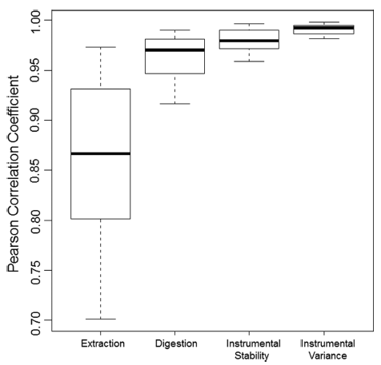
Figure 18 Boxplots showing the distribution of Pearson correlation coefficients among the different levels of replicates. This illustration was adapted from Piehowski et al [88].

Module for quantitative and functional analysis

Quantitative analysis module (QAM)
QFAM’s quantitative analysis module (QAM) is a big advantage compared to other proteomics analysis pipelines. QFAM uses ‘selfea’ R package as the core statistics calculator. Selfea will be explained in Chapter 3 with more details. The analysis module has several R and Python scripts to execute ‘selfea’ simultaneously using multiple cores. Running time for statistics computation takes relatively long time because metaproteome data basically has more number of proteins, such as more than 55k proteins in human diet proteome of chapter 5. It took more than 12 hours to calculate statistics of 55k proteins with single core, however 1 hour was enough to the parallel-running module.
The QAM has four steps. First, the normalized expression profile is divided into small pieces. Users can decide size of data pieces. Python script for the fragmentation produces job files for parallel execution as well as many reduced data chunks. Job files have information for module loading, change directory and R script execution. R script is prepared for statistics calculation using ‘selfea’ package. Next, job files are submitted to SGE of Newton cluster. Every submitted job runs in computing core that is dedicated only for computation, not for system administration or control. After all the jobs are completed, Python script for gathering the result of executed jobs is carried out. All the separately calculated statistics results are collected and compiled. P-values, calculated from three models, quasi-Poisson model, negative binomial model and Normal ANOVA model, are adjusted by user-selected method including Benjamini and Hochberg correction (FDR) [89]. At the same time, filtering out insignificant proteins are conducted as well as drawing a protein scatter plot.
QFAM provides six statistics for every protein, Cohen’s w, Cohen’s f, maximum fold change and adjusted p-values from quasi-Poisson model, negative binomial model and Normal ANOVA model (Table 6). Cohen’s w and f are effect sizes (ES) measuring how much differently detected in different experiment groups. Those two are important ES to keep certain level of statistical power in result signature. Maximum fold change is the biggest fold change among all the possible pairs of experiment groups. Selfea provides three probability models as well as various ES. Quasi-Poisson model is confirmed method for label-free proteomics data analysis. Negative binomial model is similar model to quasi-Poisson and used for analysis of count-type data, such as spectrum counts of label-free proteomics and the number of reads in RNA sequencing (RNA-Seq).
Selfea calculates ES threshold by desired statistical power, default is 80% ~ 0.84. By combining selected methods, such as quasi-Poisson and Cohen’s f, significant proteins are selected at the designated statistical power. Statistical power is a probability correctly rejecting null hypothesis when it is false. Hence, it is directly related with reliable protein selection. Selfea enhances statistical power by removing out underpowered hypotheses tests using Cohen’s ES. The higher Cohen’s ES is, the better statistical power is. High statistical power can reduce the number of false positives in the analysis result.
Table 6 Example result of the QAM. Cohens_W: Cohen’s w, Cohens_F: Cohen’s f, Max_FC: maximum fold change, QP_Pval_adjusted: adjusted p-value from quasi-Poisson model, NB_Pval_adjusted: adjusted p-value from negative binomial model and Normal_Pval_adjusted: adjusted p-value from Normal ANOVA model.
Protein | Cohens_W | Cohens_F | Max_FC | QP_Pval_adjusted | NB_Pval_adjusted | Normal_Pval_adjusted
SERPINA1 | 0.4988 | 1.7646 | 3.1710 | 3.9790E-04 | 4.9878E-05 | 3.0741E-04
UBC | 0.8655 | 0.7157 | 7.4570 | 1.3285E-01 | 5.2853E-02 | 4.3099E-01
IGLL5 | 1.2780 | 1.0265 | 96.4830 | 2.4177E-03 | 5.1797E-07 | 7.6510E-02
FCGBP | 0.9688 | 4.9266 | 266.0565 | 2.9330E-11 | 0.0000E+00 | 1.8945E-10
CELA3A | 0.4067 | 1.5158 | 6.8717 | 4.7076E-04 | 1.7161E-05 | 1.8453E-03
ACTB | 0.6098 | 1.5480 | 5.0740 | 3.2750E-04 | 2.6138E-06 | 1.4676E-03
ACTG1 | 0.6098 | 1.5480 | 5.0740 | 3.2750E-04 | 2.6138E-06 | 1.4676E-03
UBB | 0.8595 | 0.7446 | 7.4849 | 1.1914E-01 | 4.8966E-02 | 3.6476E-01
DMBT1 | 1.5035 | 3.7198 | 296.4068 | 3.4727E-09 | 1.9259E-12 | 1.2735E-08
IGJ | 1.0418 | 1.3838 | Inf | 4.1234E-05 | 2.7157E-11 | 4.9763E-03

However, many of biology experiments are agonized by short of statistical power due to limited budge and time. Selfea can complement low statistical power experiment by increasing ES. For example, when significance is determined for one effect, in previous approaches only p-value, calculated from Student’s t-test, is considered. P-value can paly its role as statistical evidence of significance at high statistical power. With low statistical power, its evidence is highly fickle to be solid supporting clue. Therefore, Cohen’s ES is required to complement p-value’s weakened power. By considering Cohen’s d, for Student’s t-test, at higher than 80% statistical power in concert with p-value significance test can be fulfilled more reliably. Selfea provides probability-based thresholds and ES thresholds at the same time for reliable feature selection.
Also, the QAM supplies a protein scatter plot showing how significant proteins were selected from total proteins (Fig. 19). Red dots are insignificant proteins, while blue dots are significant in figure 19. Horizontal line shows p-value threshold, while vertical line means ES threshold.

Functional analysis module (FAM)
Since metaproteome has lots of undistinguishable proteins, functional analysis can explain better metaproteome’s characteristics than focusing on individual proteins. In this sense, QFAM provides FAM module, in which consists of two modules, biosystems and COG analysis. Both of two provides two statistics, enrichment test and significance test. Enrichment test measures how abundantly specific functional terms are enriched from total proteins.
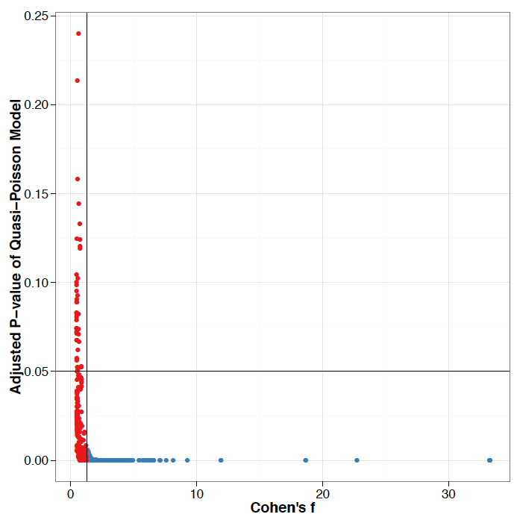
Figure 19 Protein scatter plot for quasi-Poisson model and Cohen’s f combination. Selfea provides protein scatter plot for explaining how significant proteins were distinguished. Horizontal black line is false discovery rate (FDR) = 0.05, user-defined p-value threshold, and vertical black line is Cohen’s f at 80% statistical power, typically recommended power for reliable feature selection. Red dots are insignificant proteins, while blue dots are significant.
Significance test examines how differently terms are detected between independent experiment groups. These two statistical methods can report differentially and abundantly discovered functions from microbial comminutes.
Of many functional analysis tools, FAM may be categorized to second-generation functional class scoring approaches (FCS). Khatri et al [90] grouped pathway analysis tools into three categories, over-representation analysis (ORA), FCS and pathway topology (PT) (Fig. 20). FCS tools utilize expression profiles for finding of significant functions, similar to FAM’s significance test using selfea, while ORA, first generation, is relied on pre-selected features, such as differentially expressed genes or proteins. FAM’s enrichment test is close to ORA group. Therefore, FAM approaches to functions by using two kinds of analytical methodologies, ORA and FCS. These two methodologies, the enrichment test and significance test, are mutually related to generate importantly and differentially detected functions. FAM does not consider network topology or different weights that are important issues in TP.

BioSystems analysis of FAM
Biosystems part of FAM investigates KEGG, BioCyc [91], Reactome[92], National cancer institute (NCI) pathway interaction database (PID) [93] and GO [94]. All these are functional annotations of biosystems, such as biological pathways and disease, which can involve components (genes, proteins, metabolites and drugs). KEGG and GO are most widely used functional terms.

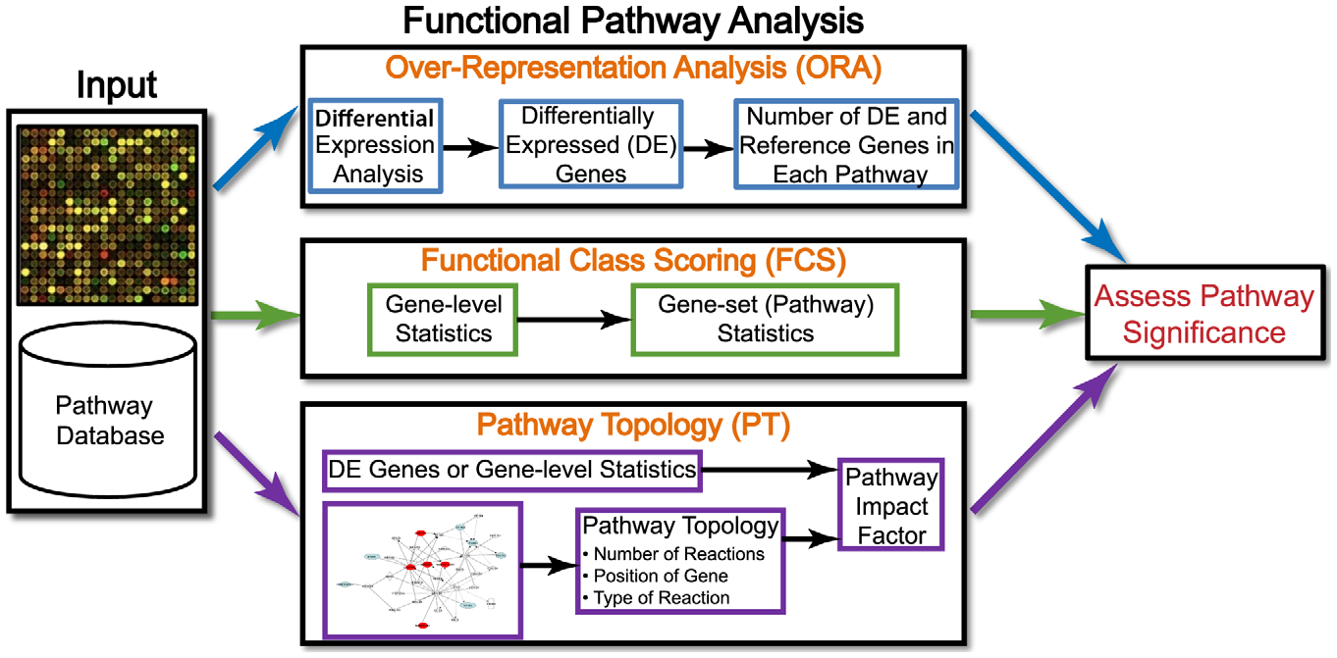
Figure 20 Overview of existing pathway analysis methods using gene expression data as an example.

BioCyc, Reactome and NCI PID have their own insights, such as pathway integration in BioCyc, reaction-focused in Reactome and PID for pathway interaction.
FAM consists of two parts, enrichment test part and annotation pipeline downloading source files, parsing and updating reference files for FAM analysis in order to maintain up-to-date information (Fig. 21). FAM annotation pipeline downloads and parses NCBI Entrez Gene[95], RefSeq[96] and BioSystems through file transfer protocol (FTP). Then, FAM starts parsing the downloaded files and updating flat-files for NCBI BioSystems analysis. This process is automated and can be run regularly to keep up-to-date status.
Next, FAM executes enrichment test over pathways. Proteins in user’s expression profile should have NCBI RefSeq ID, Entrez Gene or UniProt ID because FAM’s annotation reference files are based on NCBI GenBank and UniProt’s SwissProt and TrEBML IDs. All of these IDs are transformed to Entrez Gene ID that is directly connected to pathways. After transformation, the script finds pathways that are matched from Gene IDs in the expression profile. Counting the number of proteins for every pathways perceived at the antecedent step. The enrichment test is rooted on contingency table operated by the number of observed proteins, the total number of proteins in the expression profile and the total number of proteins in the BioSystems DB (Table. 7). With the constructed contingency table, Fisher’s exact test is computed by using NumPy [97] and SciPy [98] packages. The acquired p-values for every spotted pathways ID are adjusted by FDR.
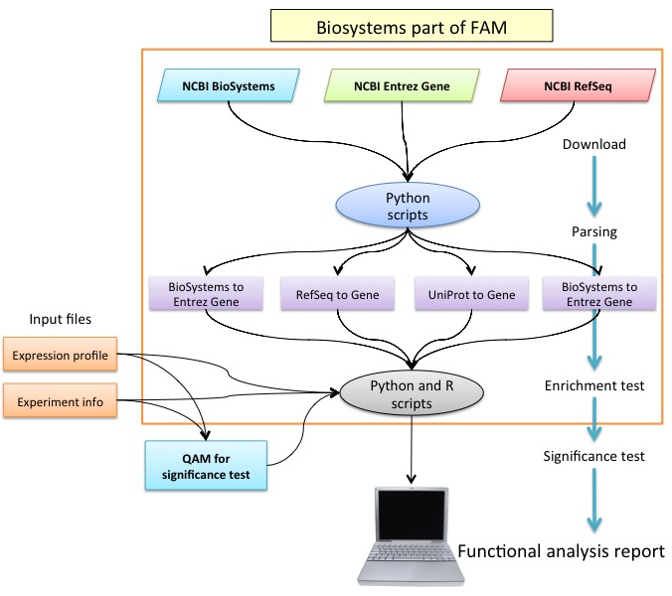
Figure 21 A diagram of biosystems part of FAM. FAM has two parts, a script updating reference file up-to-date and enrichment test part. QAM is incorporated into FAM for significance test. User receives results from enrichment test and significance test in terms of Biosystems.

Table 7 An example contingency table for one pathways ID of the enrichment test of FAM. Numbers in every cell are the number of proteins.
 | Expression profile data | BioSystems DB
Matched | 19 | 37
Unmatched | 52,934 | 978,925
Total | 52,953 | 978,962

This FDR is Benjamini-Hochberg method for controlling of false positives caused by repeated hypotheses tests, that is different method from what was used in PSM identification.
Significance test is conducted by calling QAM subsequent to the enrichment test. FAM produces an expression profile for pathways during orchestrating the enrichment test. Pathway expression profile is constructed by transferring spectrum counting of member proteins to pathways. QAM is executed in concert with FAM to compute p-values and Cohen’s ES for the pathway expression profile. The significance test is for how differently pathways are detected, while the enrichment test is about how many member proteins are discovered. Hence, those two tests are mutually combined to report pathways that should be seriously considered when thinking of biological meanings. Basically, significant pathways have p-values less than 0.05 for both of the tests and Cohen’s ES larger than 80% statistical power. There are options for significance test methods, selfea provides, such as quasi-Poisson model and Cohen’s f and negative binomial model and Cohen’s w.
Table 8 Example result of FAM. FAM provides three statistics, adjusted p-value of enrichment test and significance test and effect size. The table is filtered pathways from whole FAM analysis result (pathway = KEGG, p-value adjustment method = FDR, significance test method = quasi-Poisson and Cohen’s f, enrichment test p-value < 0.05, significance test p-value < 0.05 and 80% statistical power. # of proteins: the number of proteins
BS ID | Description | Enrichment FDR | Source ID | # of proteins | Cohen’s F | Quasi-Poisson FDR
287 | Glycolysis / Gluconeogenesis | 2.49E-12 | ko00010 | 38 | 2.5236 | 4.24E-07
296 | Fatty acid degradation | 1.65E-06 | ko00071 | 22 | 2.6618 | 4.81E-10
817567 | Carbon metabolism | 8.94E-11 | ko01200 | 44 | 2.6143 | 2.41E-07
795174 | Biosynthesis of amino acids | 3.57E-09 | ko01230 | 34 | 2.5554 | 6.84E-07
478 | Focal adhesion | 3.03E-06 | ko04510 | 52 | 2.5316 | 1.81E-07
498 | Olfactory transduction | 2.39E-06 | ko04740 | 11 | 1.6099 | 1.25E-04
169295 | Pancreatic secretion | 3.01E-10 | ko04972 | 41 | 4.2238 | 9.48E-10
171868 | Protein digestion and absorption | 1.61E-09 | ko04974 | 38 | 2.9432 | 2.82E-07
516 | Pathogenic Escherichia coli infection | 8.45E-08 | ko05130 | 27 | 1.6479 | 1.07E-04
167191 | Amoebiasis | 4.87E-08 | ko05146 | 39 | 2.2770 | 1.16E-06
662842 | Viral carcinogenesis | 6.77E-09 | ko05203 | 59 | 1.5133 | 2.16E-04
468194 | Glycolysis (Embden-Meyerhof pathway), glucose => pyruvate | 4.87E-07 | M00001 | 18 | 2.4862 | 6.24E-07
468195 | Glycolysis, core module involving three-carbon compounds | 9.19E-06 | M00002 | 12 | 2.3486 | 1.03E-06
468196 | Gluconeogenesis, oxaloacetate => fructose-6P | 1.13E-06 | M00003 | 15 | 2.4402 | 7.27E-07

COG analysis of FAM
COG analysis is better approach to explain characteristics of microbial community than pathway analysis. COG is not dependent on database annotation, so it has better coverage than pathway annotations. Model organisms, such as human, mouse, budding yeast and Escherichia coli, have very good annotation because those were examined for a long time. However, since almost all the microbes are not cultivable in laboratories, many of microbes are not studied well. Hence, available annotations of microorganisms are very limited in reference database, such as NCBI Gene and BioSystems, in contrast to model organisms. Many annotations of microbial proteins are inferred by sequence alignment, but still not enough. For example, we counted the number of pathway-annotated and COG-assigned microbial proteins in human fecal proteome study of chapter 4 (Table 9).
Table 9 Comparison of the number annotated proteins between KEGG pathway and COG. Total number of identified microbial proteins is 5,354.
 | KEGG Pathway | COG
The number of proteins annotated | 2,254 (42.1%) | 4,905 (91.6%)

There are two reasons explaining why COG has better coverage than pathways. First, sequence comparison is not efficient way to annotate pathway information, while COG is originally rooted on sequence comparisons. Although there are common pathways, many microbes have different pathways adapted for survival in new environment. Therefore, sequence comparison for pathway annotation is restricted to universally shared pathways. However, protein functions can cover various things that are not covered by pathways. Another reason is that pathway is limited information. Pathways are manually generated by reading papers and organizing accumulated research findings. Theoretically, all the proteins should be involved in at least one pathway, but many evidences are necessary to uncover a pathway. However, most microbes are not studied well as is described above. Therefore, pathway annotation is not applicable to many microbial proteins.
COG assignment is built on protein sequences that are always available in metaproteomics. COG term is generated by sequence comparisons of all to all and all to COG DB. Each COG has protein paralogs from at least three lineages, so species and sequence similarity are required to decide COG assignment. COG is widely used to find orthologous proteins, but its update was stopped after 2005 by NCBI. From 2010 NCBI released the updated COG database by expanding species and introducing new COG assignment algorithm, COG software [99]. Until new COGnitor, a tool for COG allocation, was come out, finding similar COG ID through running RPS-BLAST [100] or PSI-BLAST [101] at certain level of E-value, such as 0.00000001, have been used. However, this old approach is different from the original COG construction in terms of requirements for being COG. COG requires at least three proteins from different lineages and needs to shows enough level of similarity to members of COGs, not only one. However, the simple method using RPS-BLAST and PSI-BLAST were widely accepted because those are easy to conduct and original COG assignment algorithm, SymBet, is hard to follow. SymBet is complicated and too slow to run in local desktop.
Newly released COGSoftware employed EdgeSearch algorithm that is faster and less complex than SymBet so that new COGnitor enables us to assign COG ID to proteins in our dataset avoiding violation of COG construction rules. COG analysis of FAM employs COGSoftware for COG allocation. COGSoftware go through two steps to assign COG to new proteins. Prior to COG assignment, COGSoftware requires PSI-BLAST results compared query protein sequences against COG DB and query against itself. With these multiple sequence alignment, COGSoftware finds best COG terms to query proteins.
FAM controls COGSoftware and distributes PSI-BLAST job to 48 CPUs for speed up (Fig. 22). Sequence comparisons using PSI-BLAST takes most of time of COG analysis. PSI-BLAST execution time depends on BLAST DB size and query protein size. Size of the BLAST DB and the query protein FASTA file are large because FAM requires whole protein sequence database, used for PSM search of LC-MS/MS data. In metaproteomics, this DB is several hundreds megabytes. FAM divides the large protein DB into small chunks and runs PSI-BLAST simultaneously. FAM also waits until all the PSI-BLAST jobs are done, and then it executes COGSoftware to process PSI-BLAST results. This process is automated and controlled by python script.
Next step of COG analysis is the enrichment test (Fig. 22). This enrichment test is similar to what was done in BioSystems analysis.
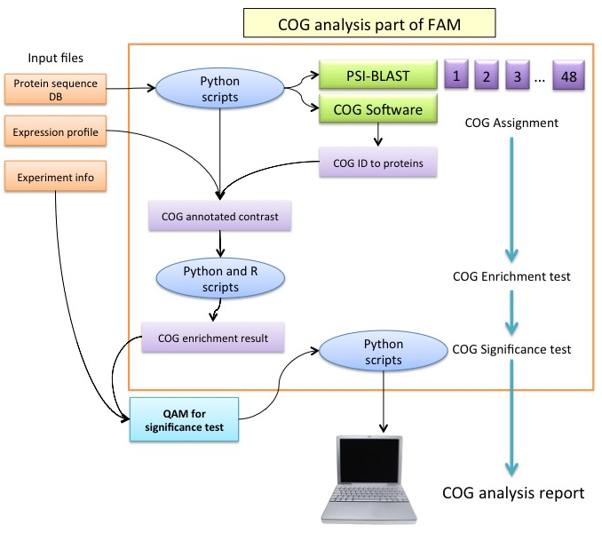
Figure 22 COG analysis part of FAM. COG analysis starts running PSI-BLAST and COGSoftware to identify COG IDs of query proteins. With the identified COG IDs, enrichment test and significance test are conducted by the R and Python scripts of FAM. Orange color box: input files, blue oval shape: python and R scripts, Green box: COGSoftware and PSI-BLAST, purple box: distributed jobs and light purple box: output files

However, COG identification of the whole protein DB is limited or not provided from publicly available databases, while BioSystems get this information from NCBI BioSystems. Hence, FAM identifies all the possible COGs in the whole metaproteomics protein DB at the precedent step despite of long PSI-BLAST running time (Fig. 22). To annotate protein DB used for fecal proteome study in chapter 4, almost 12 hours was required even though we distributed sequences to 48 CPUs. Since the enrichment test measures how significantly the expression profile is enriched from the total DB, FAM needs COG identification of whole protein pool. FAM makes the contingency table for every COG (Table 10) and calculate p-value using Fisher’s exact test.
Table 10 An example contingency table for one COG ID of the enrichment test of FAM. Numbers in every cell are the number proteins.
 | Expression profile data | Entire proteins in metaproteomics DB
Matched | 34 | 77
Unmatched | 48,934 | 263,921
Total | 48,968 | 263,998

P-values are adjusted by user-selected method, such as FDR, following the enrichment test. The enrichment test script produces expression profile of every identified COG. This expression profile gets through significance test of QAM. Results of significance test and enrichment test are integrated and finally significant COGs are reported (Table 11).
Table 11 Example result of COG analysis in FAM. Same threshold was applied to BioSystem analysis in table 8. Func. cat.: COG functional category
COG ID | Description | Enrichment FDR | Func. cat. | # of proteins | Cohen’s F | Quasi-Poisson FDR
COG00542 | ATPases with chaperone activity; ATP-binding subunit | 2.33E-13 | O | 36 | 3.1885 | 4.27E-07
COG00050 | GTPases - translation elongation factors | 5.32E-12 | J | 26 | 1.5264 | 8.32E-05
COG00480 | Translation elongation factors (GTPases) | 5.32E-12 | J | 32 | 2.5506 | 9.50E-07
COG00055 | F0F1-type ATP synthase; beta subunit | 1.42E-11 | C | 24 | 2.7013 | 1.14E-06
COG00465 | ATP-dependent Zn proteases | 8.86E-11 | O | 27 | 3.3691 | 5.58E-08
COG00653 | Preprotein translocase subunit SecA (ATPase; RNA helicase) | 1.99E-10 | U | 23 | 1.4936 | 2.55E-04
COG00086 | DNA-directed RNA polymerase; beta' subunit/160 kD subunit | 1.99E-10 | K | 22 | 1.5654 | 1.30E-04
COG00048 | Ribosomal protein S12 | 1.99E-10 | J | 21 | 1.6682 | 1.27E-04
COG00100 | Ribosomal protein S11 | 1.99E-10 | J | 21 | 2.0664 | 4.58E-06
COG00085 | DNA-directed RNA polymerase; beta subunit/140 kD subunit | 2.75E-10 | K | 22 | 1.9143 | 4.63E-06
COG00459 | Chaperonin GroEL (HSP60 family) | 2.75E-10 | O | 22 | 2.9585 | 7.46E-08
COG00052 | Ribosomal protein S2 | 7.43E-10 | J | 20 | 1.5196 | 7.50E-05
COG00185 | Ribosomal protein S19 | 7.43E-10 | J | 20 | 1.6309 | 6.39E-04
COG00057 | Glyceraldehyde-3-phosphate dehydrogenase/erythrose-4-phosphate dehydrogenase | 7.43E-10 | G | 23 | 1.9770 | 1.11E-05
COG01629 | Outer membrane receptor proteins; mostly Fe transport | 7.43E-10 | P | 45 | 2.0563 | 2.90E-05

COG analysis of FAM enables us to get differentially and abundantly expressed COG terms. Same analysis is repeated to COG functional categories, broad functional terms of individual COG terms, in order to provide wider view of functional features of the microbial community. Since none of COG analysis tools provide enrichment test and significance test at the same time, FAM is very unique tool among many of functional analysis software.

Other modules of QFAM
QFAM has other modules besides PSM search, QAM and FAM. First, it has a module for metagenome proteins, translated from metagenome sequences. Metagenome has vast, various and unannotated sequences, so metagenome sequences are not characterized even though those are differentially detected. Metagenome is functionally analyzed by COG identification in QFAM, however annotation is required for analysis using reference database, such as pathway analysis and protein location. Therefore, QFAM has a module for protein annotation of metagenome. This module uses BLAST for sequence comparison with UniProt, which has extensive protein sequence pool collected for a long time. Of top BLAST hits, the most similar UniProt ID is given to a metagenome protein if their alignment does not have gap-open and shows more than 95% sequence similarity. Sequence similarity is calculated as described below:
$$Similarity=\frac{Aligned length}{Protein length}×Percent identity$$
Where aligned length and percent identify are of BLAST result and protein length is the number of amino acid residues. Since generally metaproteme DB has a lots of metagenome proteins, BLAST running process is divided into multi-cores and merged after all the jobs are completed. With this annotation, we can apply reference DB-based analysis to metagenome proteins.

QFAM provides R library for drawing graphs including bar- and line-graph and heat-map using ‘ggplot2’ package. Since biologically meaningful images are manually drawn, QFAM does not provide automated module for making figures. However, if manually curated information is provided, QFAM can produce publication-class figures. Bar- and line-graphs are for showing expression profile of remarkably changed proteins across different experiment groups (Fig. 23). Line graph can show expression profiles of multiple proteins over different samples. Proteins are colored differently. QFAM’s bar graph is for showing multiple proteins, pathways or COGs in different experiment groups. Significance is able to be marked by red asterisks and error bars are also added to show data variation.
Drawing heat-map is serviced by QFAM’s R library (Fig. 24). Heat-map is widely used to display expression profile of many proteins or genes. Although heat-map can show global trends in whole dataset, it is not able to exhibit detail information. Heat-map is often combined to hierarchical clustering to group similarly expressed proteins. QFAM provides protein and experiment group clustering.
B)
A)
Figure 23 Examples of bar- and line-graph generated by QFAM. QFAM provides R library for drawing A) line graph and B) bar graph from analysis result of QFAM.
Figure 24 Example heat-map drew by QFAM’s R library. Heat-map, colored by steal blue and white, can display global trend of protein expression. Hierarchical clustering for proteins and for experimental groups are available in QFAM’s R library. In this example, only proteins are clustered to show how protein expressions are changed in different groups (color bars of upper side of heat-map). Heat-map’s cells are standardized spectral counts by mean and variance.

Coloring of expression is standardized spectral counts calculated by (spectral counts – mean) / standard deviation. Colored bars located at upper side of heat-map can display experimental groups. Color-key is also provided by QFAM.

Conclusion

We developed QFAM for quantitative and functional analysis of metaproteome data. Since metaproteome data is highly complicated and less annotated, analysis pipeline should be able to run its processes in parallel environment and functionally interpret metaprotome proteins. In terms of these requirements, QFAM is useful and decent pipeline for metaproteome data analysis. QFAM can run MyriMatch and IDPicker with 48 CPUs and automatically control all the processes of PSM search. MPA is another pipeline for metaproteome, but it doesn’t provide multithreading and multiprocessing execution of PSM search steps. Therefore, QFAM has an important advantage to MPA in terms of PSM search speed.
In addition to fast search speed, QFAM has QAM module for reliable feature selection. QAM employs selfea R package for finding of differentially expressed proteins. Selfea provides three widely used probability models, quasi-Poisson, negative binomial and normal distribution, with Cohen’s effect-sizes, such as Cohen’s f and w. Combination of p-values and effect-sizes is able to produce reproducible research findings. Detail explanation of selfea is in chapter 3.
QFAM services functional analysis module, FAM, for metaproteome data interpretation. FAM has two parts, BioSystems and COG analysis. BioSystems is based on reference databases of NCB, while COG is derived from sequence comparisons. BioSystems analysis is favored to well-annotated organisms, such as human, mouse and yeast, while COG is the best analysis approach to metagenome proteins that takes biggest portion of metaproteome data. Through COG analysis and BioSystems analysis, FAM can cover from well-known species to undiscovered species. Since metaproteome has mixed proteome with deeply-studied organisms and never-found microbes, FAM is appropriate analysis pipeline for metaproteomics.
Moreover, FAM provides two statistical tests, enrichment test and significance test, for every functional term including pathways and COGs. Enrichment test measures how many proteins are enriched from total proteins, while significance test is for getting differentially detected terms over different experiment groups. Both of two tests can be mutually analyzed to provide differentially and meaningfully enriched characteristics of microbial communities. This FAM’s approach is unique in many of published functional analysis tools because FAM integrates enrichment test and significance test together.
Even though QFAM provides useful and practical analytical methodologies, it has several disadvantages. First, it is opened only to people of University of Tennessee because it is installed in Newton cluster. Also, it does not have graphical interface that is greatly provided by another metaproteomics pipeline, MPA. Since job controller is designed for sun grid engine of Newton cluster, it can’t be transferred to another MPI engines. QFAM’s ability, such as execution speed, is dependent Newton cluster. For example, QFAM can’t use more than 48 CPUs. In spite of these drawbacks, it is for sure that QFAM has unique algorithms and practical analysis methodologies for metaproteomics.

CHAPTER III
Selfea: R package for reliable feature selection

Introduction
In data analysis from biological studies it’s often a struggle to obtain reproducible confident results. Most scientific discoveries, in the biological sciences, are statistically supported by p-value that is not always reliable evidence unless statistical power is high enough (≥90%) [102]. However, many of biology experiments are not conducted with parameters that have enough statistical power due to limited budget and time. Button et al showed that 42 of 49 neurological studies, published in 2011, have less than 90% power that is typically recommended level for reliable hypothesis tests [102,103] (Fig. 25). Since p-value is fickle at insufficient power, it is often accompanied by effect size (ES), such as fold change (FC), in biological studies, to increase result confidence[104,105]. ES can show the magnitude of difference between experiment groups, while p-value assesses if an effect exists[104]. Combination of ES and significance filter can improve reproducibility[105]. FC is, however, not sufficient to supplement p-value.
FC is easy to calculate and a ratio for relative comparison, familiar to biological research, but it has obvious limits. First, FC threshold is rooted on empirical evidence of biologists. FC is traditionally accepted because it means observable changes that are clear to the naked eye.

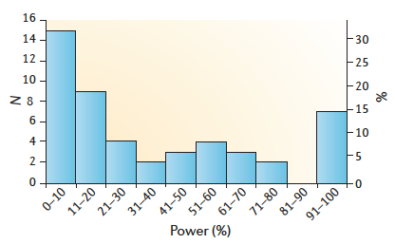
Figure 25 Median power of studies included in neuroscience meta-analyses. This figure shows a histogram of median statistical power of neuroscience papers published in 2011. If this figure was based on minimum power as we used, the power of papers should be far more below than 80%. This illustration was borrowed from Button et al [103]. N: the number of papers, Power(%): median statistical power

However, this visible difference doesn’t always mean significant effect, considering signal intensity and variation within replicates. The same FC threshold is generally applied to various data regardless of dataset’s characteristics, such as variance and sample size. Furthermore, since FC is a relative ratio, it cannot distinguish absolute quantitative difference, which is main purpose of ES[104]. For instance, in label-free proteomics experiment, if expression level of proteinA has an observed 1 spectrum count (SC) in control and 2 SC in test group, FC of proteinA is 2. It is still same 2-FC, however, to another proteinB whose expression level is 1,000 SC in control and 2,000 SC in test group. Difference in the two groups for proteinA is 1 SC while for proteinB is 1,000 SC. We may not be sure whether the 1 SC difference of proteinA is true or from systematic-error because protein detection and quantitation are limited by the sensitivity of the instrumentation making the measurement (low spectral count proteins in label free proteomics is always suspect). As was confirmed in microarray[106], FC is no-good at handling low expression level features (genes or proteins) that are prevalent in biological data.

Methods

Label free LC-MS/MS Proteomics Data
Gregori data were obtained from ‘msmsTests’ R package[105,107]. Fecal proteome data were generated in a study of chapter 4, human fecal proteome study, via label free shotgun proteomics. The detail information of data generation is in method part of chapter 4.

Calculation of Cohen’s effect sizes and statistics
All the statistical analysis, used in this study, was done with R 3.1.3. Cohen’s effect sizes, fold change and p-values were obtained by ‘selfea’ R package we developed. Selfea is available at http://cran.r-project.org/web/packages/selfea/. Selfea calculates Cohen’s f as described below:
$$f= \sqrt{\frac{\sum_{i=1}^{k}{p_{i}{\left(μ_{i}-μ\right)}^{2}}}{MSE}}$$
Where p_{i} = N/n_{i}, k = the number of groups, n_{i} = the number of observation in group i, N = total number of observations, μ_{i} = mean of group i, μ = grand mean over all the observations, and MSE = mean square error[108,109]. Cohen’s w is calculated in selfea as described below:
$$w= \sqrt{\sum_{i=1}^{m}{\frac{{({p0}_{i}-{p1}_{i})}^{2}}{{p0}_{i}}}}$$
Where m = the number of cells, p0_{i} = cell probability in i-th cell under null hypothesis, and p1_{i} = cell probability in i-th cell under alternative hypothesis. We used ‘ES.w1’ function of ‘pwr’ package[110] for Cohen’s w calculation because we compare goodness of fit of two NB models[108,109,111]. Selfea calculates minimum Cohen’s f using ‘pwr.anova.test’ function of pwr pacage with parameters (k = the number of groups, n = the common sample size in each group, sig.level = p-value threshold defined by an user (0.05 by default) and power = statistical power defined by an user (0.90 by default)). Cohen’s w is calculated in selfea through ‘pwr.chisq.test’ function of pwr package with parameters (N = the total sample size, df = the degree of freedom, sig.level = p-value threshold defined by an user (0.05 by default) and power = statistical power defined by an user (0.90 by default)). Selfea calculates p-values from quasi-Poisson, negative binomial and Normal distribution. Since generalized linear model of basic R does not provide negative binomial distribution, ‘glm.nb’ function of MASS package[112] was used for making a negative binomial linear model. Generated linear models for quasi-Poisson, negative binomial and Normal distribution were compared against null linear model using ‘anova’ function. One-way ANOVA F-test is used to compare linear models based on quasi-Poisson and Normal distribution, while chi square likelihood ratio test is used for a negative binomial linear model. Since one-way ANOVA F-test is used for quasi-Poisson and Normal distribution linear models, Cohen’s f is coupled. Negative binomial linear model is paired to Cohen’s w due to chi-square likelihood ratio test. All the p-values were adjusted by FDR[89]. Fold change between experiment groups was calculated by selfea. Selfea returns maximum fold change among all the possible pairs as representative fold change. Minimum statistical power is reported as representative statistical power in selfea package.

Benchmark data test and fecal proteome data test
We employed the benchmark data generated by Gregori et al[105] and fecal proteome data in order to test Cohen’s effect sizes. The dataset, termed here as fecal proteomes, have 29 2D-LC-MS/MS runs from 11 fecal samples from healthy adult volunteers (unpublished). Selfea was used to find differently expressed proteins in 11 fecal samples. Gregori data consist of 19 label-free liquid chromatography-tandem mass spectrometry runs and have 4 groups that have a fixed loading amount of standard yeast lysates (500 ng) with different amounts of 48 human proteins (100, 200, 400 and 600 fmol). Differentially expressed proteins over 4 groups were found by using selfea. As is assumed by Gregori et al[107], we considered human proteins as true positives and yeast proteins as false positives. Using selfea, we got differentially expressed proteins of Gregori data and fecal proteome data through six methods; quasi-Poisson (FDR < 0.05) and Cohen’s f (Power > 0.90), quasi-Poisson (FDR < 0.05) and 2 fold change, negative binomial (FDR < 0.05) and Cohen’s w (Power > 0.90), negative binomial (FDR < 0.05) and 2 fold change, Normal ANOVA (FDR < 0.05) and Cohen’s f (Power > 0.90), and Normal ANOVA (FDR < 0.05) and 2 fold change. With the significant proteins, we counted human proteins as true positives and yeast proteins as false positives. Percentage of false positives in a signature is the number of false positives divided by the total number of proteins in a signature. In addition to NB, QP and NOR model, we calculated p-values using QProt to check if Cohen’s ES can be successfully combined with other type method. QProt was downloaded from http://sourceforge.net/projects/qprot and installed on the Newton computational cluster at the University of Tennessee. Since QProt provides only two-sample test, we tested all the possible pairs of experiments of Gregori data. After collection of all the FDR-adjusted p-values from six two-sample tests, we picked minimum FDR as representative FDR. Input parameter of QProt was nburnin=2,000, niter=10,000, and normalized=1. Bar plots were drawn by Microsoft Excel. Scatter plots were drawn by ‘ggplots2’ package[86].

Monte Carlo simulation
We used ‘rpois’ function of R to generate random data based on Poisson distribution with mean expression level of each groups in Gregori data. Since Gregori data has four groups, we separately generated random data for each of four groups (λ = mean spectral counts within groups). From the randomly generated data, p-values, fold change and Cohen’s effect sizes were computed by selfea. Six methods, used for the benchmark data test, were examined. We calculated minimum statistical power and counted human proteins as true positives and yeast proteins as false positives in significant proteins. FP rate is the number of false positives divided by the total number of yeast proteins in a random data. This simulation was repeated 1,000 times. Box-plots were drawn by ‘ggplot2’ package[86].

User guide for selfea package
R document of selfea is available at CRAN, R package repository, and its web addressed is http://cran.r-project.org/web/packages/selfea/selfea.pdf. This R document provides detail information about every function and data as well as examples.

Algorithm
To overcome limitations of FC, we developed an alternative approach based on Cohen’s ES. Cohen’s ES are designed to measure difference between groups and there are specific types for different hypothesis test methods, such as Cohen’s d for Student’s t-test[113]. Cohen’s ES is, moreover, a parameter for statistical power calculation of a hypothesis test[113,114]. The higher Cohen’s ES is, the better statistical power is. Statistical power is the probability of correctly rejecting the null-hypothesis when it is false. Therefore, higher statistical power can improve reliability of quantitative biological studies. We can obtain higher statistical power by increasing threshold of Cohen’s ES filter.
First, our approach calculates Cohen’s f and w for each comparison between experiment groups for every individual feature[108,114]. Cohen’s f is for one-way ANOVA F-test using quasi-Poisson (QP) or Normal distribution (Normal). Cohen’s w is linked to the Chi-square likelihood-ratio test (LR-test) for comparing goodness of fit of two generalized linear models based on negative binomial distribution (NB). Those three, QP, Normal and NB, are widely used distributions for treatment comparisons in biological data.
Next, the minimum Cohen’s f and Cohen’s w are calculated for desired statistical power, typically 90%, and alpha, typically 0.05, by using power analysis function[108,110]. Features having Cohen’s f or w below the obtained minimum are filtered out. This gives a statistical basis to determine ES threshold by considering sample size, significance and statistical power. In addition to the statistical benefits, our approach can maintain the level of statistical power by filtering out low-powered hypotheses tests.
We incorporated these concepts in an R package named ‘selfea’, freely available on CRAN. To test if its performance was significantly better than traditional FC approach, we employed benchmark data, generated by Gregori et al[105], because it has clear true positive (TP) and false positive (FP) identifications. Gregori data consist of 19 label-free liquid chromatography-tandem mass spectrometry (LC-MS/MS) runs and have 4 groups that have a fixed loading amount of standard yeast lysates (500 ng) with different amounts of 39 purified standard human proteins (100, 200, 400 and 600 fmol). Theoretically, the human proteins should show significant quantitative differences over the 4 groups while yeast proteins should not. As is assumed by Gregori et al[107], we counted human proteins as TP and yeast proteins as FP in signatures of Gregori data. At FDR[89]-adjusted p-value (FDR) < 0.05, we compared Cohen’s ES (> 0.90 power ) to 2-FC (> 2-fold change) (Fig. 26). We chose 90% power for ES threshold because it is the level p-value requires for being reliable evidence[102].
B)
D)
F)
H)
G)
E)
C)
A)
Figure 26 Testing result with Gregori data and fecal proteome data. A) Statistical power, B) the number of true positives (human proteins) and C) the number of false positives (yeast proteins) in significant protein list of Gregori data benchmark test for 6 method sets, QP_F, QP_FC, NB_W, NB_FC, NOR_F and NOR_FC described in table 12. FDR thresholds for QP, NB and NOR are 0.05 and Cohen’s ES (f and w) threshold is 90% statistical power. Scatter plot of 39 human (red) and 646 yeat (blue) proteins comparing D) Cohen’s w and FC, E) Cohen’s f and FC, F) QP model and Cohen’s f, G) NB model and Cohen’s w and H) NOR model and Cohen’s f.

We picked maximum FC as representative FC and minimum statistical power as representative statistical power.

Benchmark test

Tests using Gregori data
We compared 2-FC and Cohen’s ES for three models (QP, NB and NOR) using the benchmark data (Table 12). The benchmark data test showed that our approach has significantly better statistical power than 2-FC, 0.90 for Cohen’s ES vs. 0.08~0.59 for 2-FC (Fig. 26A). Cohen’s ES has similar number of true positives (TP) (Fig. 26B), while it has a lower number of false positives (FP) (Fig. 26C). This means that Cohen’s ES lost fewer of TP while filtering out many more FP than 2-FC.
Table 12 Six methods used for comparing Cohen’s ES and FC. Three probability models, widely used in biological data analysis, were employed for comparison of Cohen’s ES with FC. Abbreviations denoting model and ES are summarized at the table with used thresholds.
 | Quasi-Poisson model (QP)  (< 0.05 FDR) | Negative binomial model (NB)  (< 0.05 FDR) | Normal ANOVA model (NOR)  (< 0.05 FDR)
FC2  (> 2-fold change) | QP_FC2 | NB_FC2 | NOR_FC2
Cohen’s f  (> 90% power) | QP_F | - | NOR_F
Cohen’s w  (>90% power) | - | NB_W | -
Protein scatter plots show that Cohen’s ES filters out FP efficiently. Cohen’s w (Fig. 26D) and Cohen’s f (Fig. 26E) could remove more FP (blue dots) while excluding less number of TP (red dots). Especially, Cohen’s f has superior selection power than Cohen’s w and 2-FC (Fig. 26E). Also, Cohen’s f showed that it could complement p-value by efficiently removing FP (Fig. 26F and 26H), while 2-FC removed a smaller number of FP (Fig. 27A-C). Relatively low performance of Cohen’s w and NB (Fig. 26G) is speculated that these are not fit to the benchmark data. Nevertheless, Cohen’s w showed better selection power than 2-FC (Fig. 26A-C).

Tests using fecal proteome data
We also compared the statistical methods with a more complex and real human dataset that is noisier than the well-organized benchmark data. The dataset, termed here as fecal proteomes, have 29 2D-LC-MS/MS runs from 11 fecal samples from healthy adult volunteers (chapter 4). The fecal proteome is extremely complex having proteins coming from both human and bacterial origin, over a wide dynamic range, and high variability between individuals. Since we can’t know TP and FP of fecal proteomes, we compared statistical power between Cohen’s ES and 2-FC (Fig. 27). Similar to Gregori data, Cohen’s ES had higher statistical power than 2-FC (0.90 for Cohen’s ES vs. 0.16 ~ 0.70 for 2-FC).

A)

B)

C)
Figure 27 Protein scatter plots comparing three models and FC. False positive yeast proteins (blue color cross) and true positive human proteins (red color dot) were distributed on the plain of A) FDR-adjusted p-value of QP model and FC, B) FDR-adjusted p-value of NB model and FC and C) FDR-adjusted p-value of Normal model and FC. Vertical line is 2-FC and horizontal line is 0.05 FDR. Red-colored left-bottom section, divided by vertical and horizontal lines, is filtered by 2-FC after probability filter (FDR < 0.05). Little or none of FPs (blue dots) is removed by 2-FC.

Monte Carlo simulation
After the verifications of our method using the benchmark and actual experiment data, we explored our method via the Monte Carlo simulation (MC). We generated random data based on Poisson distribution with mean expression level of each groups in Gregori data. Then, we calculated statistics and counted TP and FP. These simulations were repeated 1,000 times in order to investigate how much our approach is effective. The simulation results are summarized and illustrated in Fig. 2. We could confirm that Cohen’s ES have better power (0.90 for Cohen’s ES vs. 0.06~0.55 for 2-FC) (Fig. 28A), reduced FP greatly (29~32 for Cohen’s ES vs. 70~114 for 2-FC) (Fig. 28B) and lost fewer TP (20 for Cohen’s ES vs. 27~32 for 2-FC) (Fig. 28C) when compared with 2-FC. FP rate is the probability of falsely rejecting the null hypothesis and is calculated by FP divided by total number of yeast proteins in Gregori data. Cohen’s ES has a smaller FP rate than 2-FC (< 5% of Cohen’s ES vs. > 11% of 2-FC), which means that our method is better at discerning FP than 2-FC (Fig. 28D).

Conclusion
P-values should not be the only piece of information used to discern reproducible findings in biological studies. Although effect size filters can complement p-value information, fold-change, widely used effect size in biological data analysis, is not sufficient. We suggest using Cohen’s effect sizes at a desired statistical power.
D)
B)
A)
C)
Figure 28 Boxplots of 1,000 times Monte Carlo simulation of Gregori data. A) Statistical power, B) the number of false positives (yeast proteins), C) the number of true positives (human proteins) and D) FP Rate, FP/(FP+TN), of 1,000 times Monte Carlo simulation, based on Gregori data, for 6 method sets, QP_F, QP_FC, NB_W, NB_FC, NOR_F and NOR_FC described in supplementary table 1. FDR thresholds for QP, NB and NOR are 0.05 and Cohen’s ES (f and w) threshold is 90% statistical power. TN: True Negative (The number of total yeast proteins in Gregori data – FP).

The benchmark test and MC simulation show that our method can reduce a number of FP while losing relatively small number of TP. This drop of FP is meaningful because many published research findings are concerned by potential false positives due to misused statistical approaches including low statistical power[103,115]. In addition to QP, NB and NOR, Cohen’s ES can be associated with another type of probability-based method, such as QProt[116], and showed good selection power when compared to 2-FC (Supplementary figure 3). We believe that Cohen’s ES can help biologists to report reproducible discoveries. Even though selfea was tested only for label-free proteomics data, we believe that it can be applied to other type of biological data, such as RNA sequencing.

CHAPTER IV
APPLICATION CASE 1 – HUMAN FECAL PROTEOME STUDY

Introduction
Microbes inhabit on every part of human body including the skin, in the gut, mouth and the nose. Sometimes they cause illness, but most of the time, microorganisms commensally live with their human host organs. The number of microbes in symbiosis with human is estimated to 100 trillion, while we have 10 trillion cells. It is outnumbering human cells by 10 to 1. Interestingly, number of microbes is not just living in human body, but they are interacting and playing a vital role in human health and diet [117]. In recent years the human gut microbiome, all the microbes living in human gastrointestinal tracts, has become an area of interesting and rapid research developments. Many of research groups applied a wide range of analytical technologies for understanding microbiome’s role in human health and how they interact with human host cells [118,119]. Also, gut microbiota is known to have relationship with disease, such as inflammatory bowl disease [119] and type-2 diabetes [120].
Since microbiome has unique microbial communities interacting with host cells, microbiome is an important target of metaproteomics [121]. Metaproteome of gut microbiota are examined by fecal samples because feces have large amount of microbial proteins, convenience of sample collection and results of immune response between human intestinal cells and microbiome [122]. Also, feces have abundant human proteins, so it enables us to find biomarkers of disease and study interactions between microbes and human cells. Fecal metaproteomics has a great potential for disease diagnostics, studying host-microbes interaction and microbial community cohabiting in gastrointestinal tracts. However, fecal metaproteomics has several unresolved problems to go further analysis. First, we don’t know how much different kind of microbes is living there. In other words, species composition of microbiome is not uncovered. This is important issue to PSM search. However, many studies have resolved this uncertainty by employing metagenome sequences [121-123]. Another challenge is variation of individual microbiomes. Naturally, people have different microbiome by diets, origin, drugs and genetic backgrounds. Probably, personal microbime is the most varying organ in entire human body if gut microbiome is assumed as another human organ. We may not be sure if there is normal microbiome shared by all the people. This variation of microbiome makes scientists difficult to compare fecal proteomes.
High variation in fecal proteomes is fatal attack to statistical analysis of fecal proteomes. Indeed, sample size is very limited to biology studies due to finite budget and time; so low statistical power is ineluctable destiny of fecal metaproteomics studies as is usual to other biology researches. At low-powered studies, high variance within group, caused by dissimilar microbiome corresponding to different environmental factors, impedes getting reproducible results via comparison between different effects. Chance of false positive findings is relatively high in fecal metaproteomics. This application study shows if there is large variation within fecal proteomes from healthy volunteers and how QFAM analyze fecal metaproteomes can be employed to analyze a dataset.

Methods

Sample preparation and LC-MS/MS experiment
Proteins of all fecal samples were extracted by direct cell lysis method (Fig. 29). Direct cell lysis method is preferred to collect host proteins, while indirect method is for microbiome proteins. Proteins of all the samples were digested by trypsin and analyzed via two-dimensional (2D) nano-LC MS/MS system with a split-phase column (SCX-RP) Velos Orbitrap Pro (Thermo Fisher Scientific) for feces and LTQ-Velos (Thermo-Fisher) for PBMC with 22 hour runs per sample as shown in Figure 29. The Orbitrap settings were as follows: 30K resolution on full scans in Orbitrap, data-dependent MS/MS in LTQ (Top 10 peaks were chosen), two micro-scans for both full and MS/MS scans, centroid data for all scans.

PSM search and protein identification
All MS/MS spectra were searched against our customized sequence database. Our database consists of human protein sequences, microbial proteins isolated from human gut and common contaminants (i.e., trypsin and keratin; 36 protein sequences).
Figure 29 Experiment workflow of fecal metaproteome data generation. This illustration was adapted from Xiong et al [122].

We collected ~36,000 human protein sequences from NCBI RefSeq DB and microbial proteins from JGI IMG human microbiome project (http://img.jgi.doe.gov/) as is described in our previous paper [73]. For PBMC samples, we used human protein sequences only during MS/MS search while microbiome proteins were included in the DB used for MS/MS search of fecal samples. All MS/MS individual runs were searched with the SEQUEST (v.27) algorithm [49] against our customized FASTA sequence database. Search parameters were followed to our prior study [73] (<4 miscleavages, 3 Da mass tolerance window around the precursor ion mass and 0.5 Da for fragment ion masses). All SEQUEST output files were gathered and filtered using DTASelect (1.9) [64] at ≥ 2 peptides per protein and the following widely accepted parameters for all the MS runs: XCorr of at least 1.8, 2.5, 3.5 for +1, +2, and +3 charge states, respectively and a minimum deltCN for 0.08. All the peptide spectrum matches (PSM) that could not satisfy a post-database search filter, -10≤ ppm ≤10, were excluded out to remove false positives as described in previous study [73]. In this study, only human proteins were analyzed, but we included microbial proteins in the FASTA database to remove false positives. We calculated spectral counts of human proteins via DTASelect. We removed redundant protein sequences in the result proteome using NCBI Entrez Gene [95] so that one gene symbol have one sequence. Spectral counts (SC) were normalized by scaling factor α_{i} for i-th protein described as below:
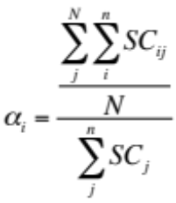
Where N = the number MS runs, n = the number of proteins, SC is spectral counts of i-th protein in j-th MS run.

Statistical analyses
All the statistical analysis including hierarchical clustering was done by R version 3.1.0 and Python 2.7.3 in-house scripts. We used vegan, cluster, psych and gclus library of R to calculate distances between MS runs and draw dendrogram. To maximize clustering efficiency we calculated Cophenetic correlation coefficient and Gower similarity coefficient of several distance methods, such as single linkage, complete linkage, Unweighted pair-group method using arithmetic averages (UPGMA) and Ward’s minimum variance matrixes. UPGMA matrix shows highest Cophenetic correlation coefficient (93.3%), so we used UPGMA for hierarchical clustering. Pearson correlation coefficients (PCC) between 29 MS runs were calculated by in-house R scripts. Shapiro-Wilk normality test was used to test our dataset if it is following Normality using shapiro.test function of R.
The proteomics results were also analyzed by using ‘selfea’ R packae (unpublished) providing Quasi-Poisson Generalized Linear Modeling (QP) and Cohen’s f [124]. [Selfea paper is submitted; we can add its reference after it is published.] We applied QP model to find significantly varied proteins in 11 fecal proteomes. Poisson distribution is usually assumed to analyze frequency-based data like spectral counts [75]. However, Poisson distribution assumes that its parameter λ = E(X) = Var(X). Because of the assumption, Poisson distribution cannot bear over-dispersion. Quasi maximum likelihood approach can alleviate Poisson test’s less flexibility by employing variance function based on given data [75]. Our QP model is Spectral count ~ Fecal sample. P-value was calculated by QP model and adjusted by Benjamini-Hochberg method (FDR) [89]. Cohen’s f was used as effect size filter. Cohen’s f is ES linked with ANOVA F-test, which was used for QP model comparison. Important advantage of using Cohen’s f is that we can filter out underpowered hypotheses tests. P-value cannot play its statistical evidence role at low statistical power (< 90%)[102,103]. Selfea provides minimum Cohen’s f at 90% statistical power and reliable results using ES filter and FDR filter. Cohen’s f is calculated as described below:
$$f= \sqrt{\frac{\sum_{i=1}^{k}{p_{i}{\left(μ_{i}-μ\right)}^{2}}}{MSE}}$$
Where, p_{i} = N/n_{i}, k = the number of groups, n_{i} = the number of observation in group i, N = total number of observations, μ_{i} = mean of group i, μ = grand mean over all the observations, and MSE = mean square error. The minimum Cohen’s f at 90% statistical power was 1.3769 given sample size and p-value 0.05 threshold. We accepted proteins that have bigger Cohen’s f than 1.3769 and less than 0.05 FDR for further analysis.
Functional analysis of fecal proteome was done by enrichment test and significance test. These analyses were done by in-house Python and R script. We annotated the dataset with GO terms [94] for human proteins and Cluster of ortholog groups (COG) terms [125] for microbial proteins. GO terms were downloaded from NCBI BioSystems database [84] via FTP. COG terms were assigned to fecal microbial proteins by using COGSoftware [99]. We followed steps recommended by COGSoftware to identify COG terms. With COG and GO terms, we conducted enrichment test using Fisher’s exact test and significance test using selfea. Same filtering threshold, FDR < 0.05 and Cohen’s f > 1.3769, were applied to find significant GO and COG terms.

Results

Data generation from 11 fecal and 5 PBMC samples
From the 11 fecal samples metaproteomic datasets were generated by nano 2D-LC-MS/MS on an OrbiVelos Pro (Thermo-Fisher). Of these 11 samples four were duplicated and others were triplicated and totally 29 MS runs were obtained. The datasets were searched against human NCBI RefSeq [45] and 21 microbes isolated from human gut downloaded from JGI IMG (http://img.jgi.doe.gov/) by using SEQUEST/DTASelect. From these 29 runs, we were able to identify 7,455 proteins, 2,102 human proteins and 5,353 microbiome proteins, after excluding out of redundant sequences using NCBI Entrez Gene DB (Table 13). These redundant protein sequences have same spectral counts (SC) due to almost same sequence that cannot be distinguished by trypsin-digested peptides. SC of 7,455 proteins were normalized by scaled factor (α_{i}) that is average number of total SC per run (N) divided by sum of SC of run i (n_{i}) as is used in our previous study of Crohn disease [73]. This normalization makes 29 MS runs to have same total number of PSMs.

Table 13 Comparison of MS runs of fecal sample and PBMC. The number of identified proteins was counted for fecal human, microbiome and PBMC human data. Unshared proteins are proteins uniquely identified in only one sample.
 | Feces |  | PBMC
 | Human | Microbiome | Human
Total number of proteins | 2,102 | 5,353 | 2,556
The number of MS Runs | 29 | 29 | 5
Average number of proteins detected/MS run | 501 | 1,688 | 1,278
Average number of unshared proteins | 115 | 213 | 158
% of unshared proteins | 22.88% | 12.61% | 12.37%

We also collected five Peripheral blood mononuclear cell (PBMC) samples. PBMC is any blood cell that has a round nucleus, such as lymphocyte, a monocyte or a macrophage. We applied same pre-processing steps to five PBMC runs such as, normalization by total spectral counts and reduction of redundant protein sequences by NCBI Gene ID. Finally, 2,556 human proteins are identified from five PBMC replicates (Table 13). In terms of the number of identified human proteins, PBMC has two times more proteins per MS run than feces, 501 in feces vs. 1,278 in PBMC, (Table 13). Unshared proteins are proteins uniquely identified in only one sample. Percentage of unshared human proteins in fecal is almost two times of fecal microbiome and PBMC human proteins (Table 13). More than 20% of human fecal proteins are uniquely identified from 11 healthy volunteers, which means that averagely one fifth of human fecal proteins are not shared.

Comparison of 29 fecal and 5 PBMC MS runs
All the fecal samples were collected from healthy volunteers who do not have any of gastrointestinal disorders. To understand how their fecal proteomes are different, first we compared 29 MS runs in a broad sense using hierarchical clustering method (Fig. 30). Unweighted pair-group method using arithmetic averages (UPGMA) was used to calculate distance between MS runs because its Gower similarity coefficient is lower than other metrics, such as complete, average and single linkage metrics. The dendrogram of figure 30 shows that technical replicates of 11 fecal samples are clustered together (Fig. 30), which means technical replicates are not biased nor varied neither. Pearson correlation coefficients (PCC) between technical replicates confirm their similarity ranged from 0.75 to 0.98, which means closely correlated data (Fig. 31A).
In contrast to technical replicates’ high similarity, all the biological replicates of fecal proteomes are dissimilar each other. In addition to hierarchical clustering result, we could confirm this dissimilarity from comparing PCC between biological replicate MS runs. PCC between biological replicates of feces are ranged from 0.15 to 0.81 (Fig. 31C).
Figure 30 Hierarchical clustering of 29 MS runs of 11 fecal samples. Technical replicates are closely clustered together, which means small variance within technical replicates.

C)
A)
B)
Figure 31 Correlation coefficients between fecal and PBMC MS runs. Pearson correlation coefficients between A) technological replicates of fecal samples, B) biological replicates of PBMC samples and C) biological replicates of fecal samples.

A difference between maximum and minimum PCC is 0.23 in technical replicates, but 0.66 in biological replicates, which means dissimilarity of fecal proteome is seriously high. Moreover, minimums of PCCs in technical and of biological replicates are much different, 0.77 for technical replicates and 0.10 for biological replicates. Also, average PCC of biological replicates is 0.50 that is much lower than one of technical replicates (0.91). Low mean and wide range of PCC in the biological replicates show the diversity between individual fecal proteomes.
Comparing PCC of biological replicates between fecal and PBMC proteome confirms that the heterogeneity of fecal proteome is especially high. PCCs between PBMC biological replicates are ranged from 0.62 to 0.95 (Fig. 31B). This range is much narrower and relatively higher than the fecal proteome (PCC: 0.15~0.81). The difference between minimum and maximum of PCC in PBMC is 0.33 that is half of the fecal proteome, 0.66. Also, minimum PCC of the fecal proteome, 0.15, is one fourth to one of PBMC, 0.62. All in all, we could see high variability in individual human fecal proteomes when compared to PBMC.
In addition to PCC comparisons, frequency of protein identifications within 11 fecal samples shows non-uniformity in protein identifications (Table 14). We counted how many times proteins were identified in 11 fecal samples. Surprisingly, of overall 7,455 proteins, the number of proteins with frequency 1 is 3,603, which means that almost half of total proteins are not redundantly detected in 11 healthy volunteers (Table 14). This percentage of unshared proteins is increased up to 60% in human proteins (1,261 proteins over total 2,102 proteins). This 60% is much higher than one of PBMC, 37%. As protein frequency is increased, the number of proteins is drastically decreased in fecal samples, 60% to around 1%, when compared to PBMC samples, 37% to about 12% (Table 14). It is significant that almost 74% of human fecal proteins were discovered just once or twice in 11 fecal samples (Table 14). PCC comparison and identification frequency of fecal proteins shows its seriously high dissimilarity.
Table 14 Protein identification frequency in fecal and PBMC proteomes.
Protein  Frequency | Fecal Human |  | PBMC Human |  | Fecal Microbiome
Protein  Frequency | # of proteins | % of frequency | # of proteins | % of frequency | # of proteins | % of frequency
1 | 1,261 | 59.99% | 947 | 37.05% | 2,342 | 43.75%
2 | 287 | 13.65% | 540 | 21.13% | 738 | 13.79%
3 | 116 | 5.52% | 342 | 13.38% | 479 | 8.95%
4 | 86 | 4.09% | 299 | 11.70% | 315 | 5.88%
5 | 64 | 3.04% | 428 | 16.74% | 233 | 4.35%
6 | 32 | 1.52% | - | - | 226 | 4.22%
7 | 30 | 1.43% | - | - | 175 | 3.27%
8 | 32 | 1.52% | - | - | 158 | 2.95%
9 | 37 | 1.76% | - | - | 140 | 2.62%
10 | 54 | 2.57% | - | - | 236 | 4.41%
11 | 103 | 4.90% | - | - | 311 | 5.81%
Total | 2,102 | 100.00% | 2556 | 100.00% | 5,353 | 100.00%

Human proteins in 11 fecal proteomes
Even though many of human fecal proteins are low abundant and unshared, about one hundred proteins were repeatedly and abundantly identified in 11 healthy volunteers (Table 14). Many of these high-spectral-count proteins are related to digestion, such as chymotrypsin like elastases (CELA3A and CELA3B), alpha-amylases (AMY1A, 1B, 1C and 2A), trypsins (PRSS1 and PRSS2) and chymotrypsinogen B (CTRB1 and CTRB2) (Table 15). Also, immune response related proteins are frequently spotted such as, IgG Fc binding protein, DBMT1 that is related to innate immunity [126,127], SERPINA3 that is related to inflammation [128] and PIGR that is polymeric immunoglobulin receptor precursor (Table 15). Polyubiquitin-C (UBC) is also in top-25 list and is related to innate immunity according to Gene Ontology DB (GO) [94]. Polyubiquitin B that is isoform of UBC is also discovered in all the fecal samples. Various myosin isotypes were found in fecal proteomes, such as myosin type 1, 2, 4, 6 and 8 (Table 15). Interestingly, transthyretin precursor (TTR) is copiously identified in 11 fecal samples. TTR is thyroid hormone-binding protein and is considered that it transports thyroxine from the bloodstream to the brain. TTR is found in various tissues including colon muscle according to Proteomics DB [17].
We searched top 25 abundant proteins of table 15 using Human Proteome Map (Fig. 32A) [129] and Proteomics DB (Fig. 32B) [17] to know where these came from. Human Proteome Map is a database that has proteins profiled from 17 adult tissues, 6 primary hematopoietic cells and 7 fetal tissues. Proteomics DB is developed by Technische Universität München (TUM) and dedicated to deposit and share proteomics data to the scientific community. We compared our top-25 list to Proteomics DB through its provided analysis tool.

Table 15 Top 25 abundant human proteins in 11 fecal samples. * means immune response related proteins. Frequency is identification frequency in 11 fecal samples of healthy volunteers. Sum of SC is total count of SC from 29 MS runs.
Rank | Gene Symbol | Description | Frequency | Sum of SC
1 | CELA3A | Chymotrypsin-like elastase family member 3A preproprotein | 11 | 7,562.19
2 | *FCGBP | IgGFc-binding protein precursor | 11 | 5,582.98
3 | *DMBT1 | Deleted in malignant brain tumors 1 protein isoform c precursor | 11 | 4,793.61
4 | SERPINA1 | Alpha-1-antitrypsin precursor | 11 | 4,089.48
5 | AMY2A | Pancreatic alpha-amylase precursor | 9 | 3,367.48
6 | AMY1A | Alpha-amylase 1 precursor | 9 | 3,225.87
7 | AMY1B | Alpha-amylase 1 precursor | 9 | 3,225.87
8 | AMY1C | Alpha-amylase 1 precursor | 9 | 3,225.87
9 | CELA3B | Chymotrypsin-like elastase family member 3B preproprotein | 11 | 3,176.00
10 | AMY2B | Alpha-amylase 2B precursor | 9 | 3,015.61
11 | MYH2 | Myosin-2 | 11 | 2,067.20
12 | MYH1 | Myosin-1 | 11 | 1,984.50
13 | TTR | Transthyretin precursor | 10 | 1,860.49
14 | PRSS1 | Trypsin-1 preproprotein | 11 | 1,654.03
15 | MYH4 | Myosin-4 | 11 | 1,577.53
16 | MYH8 | Myosin-8 | 11 | 1,572.74
17 | UBC | Polyubiquitin-C | 11 | 1,568.63
18 | PRSS2 | Trypsin-2 preproprotein | 11 | 1,178.51
19 | MYH6 | Myosin-6 | 11 | 1,134.14
20 | MYH7 | Myosin-7 | 11 | 1,126.16
21 | CTRB2 | Chymotrypsinogen B2 precursor | 10 | 1,041.42
22 | CTRB1 | Chymotrypsinogen B precursor | 10 | 997.56
23 | *PIGR | Polymeric immunoglobulin receptor precursor | 10 | 950.77
24 | *IGLL5 | Immunoglobulin lambda-like polypeptide 5 | 11 | 938.32
25 | *SERPINA3 | Alpha-1-antichymotrypsin precursor [Homo sapiens] | 11 | 935.14

A)
B)
Figure 32 Expression location of top 25 abundant human fecal proteins. Origin of fecal proteins were estimated by two databases, A) Proteomics DB and B) Human Proteome Map.

The most frequently matched tissue in Proteomics DB is colon (22 proteins) and pancreas (19 proteins) (Fig. 32A), whereas is adult pancreas (16 proteins) and adult gallbladder (14 proteins) in Human Proteome Map (Fig. 32B). All those tissues, frequently matched in both of Proteomics DB and Human Proteome Map are related with digestion. MYH1, MYH7 and MYH8 are not detected in colon tissue of Proteomics DB, but these are previously identified in esophagus among digestion related tissues. Therefore, we guess that MYH1, MYH7 and MYH8 come from esophagus unlike other isotypes of myosins. Many tissues involved in the digestion are found in the search result of Proteomics DB, such as colon muscle, saliva, salivary gland, rectum, pancreatic juice, pancreas, oral epithelium, esophagus and colon (Fig. 32B). Besides tissues on the digestion tract, immune response related cells are spotted in the result of Proteomics DB and Human Proteome Map (Fig. 32). Some of proteins in the top-25 list are reported that these are expressed in Natural killer cell, monocyte, helper T-cell, cytotoxic T-cell and B-lymphocyte according to previous studies of Proteomics DB (Fig. 32B). Human Proteome Map also shows similar result including B cells, CD4+ T cells, CD8+ T cells, NK cells and Monocytes (Fig. 32A).
On top of proteins related with digestion, proteins associated with immune response were also repeatedly identified in the 11 fecal samples. We expected that feces have abundant immune proteins because of innate and adaptive immune responses against microflora, pathogens or vaccines. Immune proteins were recognized by combining several annotation resources that are WikiGO [6], Immunome [130,131], Innate DB [132], 19 immune response GO terms [133] and immune response keyword search against protein description, such as immunoglobulin and IgA that were missed by other methods. Of 2,102 total human fecal proteins, 214 immune response proteins were discovered. We listed frequently and abundantly identified 25 immune response proteins in Table 16. IgGFc-binding protein precursor (FCGBP) is the most abundant protein in Table 16. FCGBP is not directly related to immune response, but it is interacting with FC portion of IgG and indirectly involved in the mucosal immunity by making gel-like mucosa [134]. FCGBP also interacts with Mucin-2 (MUC2) [135] and is expressed at colon, colon epithelium, colon muscle and gut according to Proteomics DB (Fig. 32B). Some of inflammatory proteins, such as S100-A8, S100-A9, lactotransferrin (LTF) and Keratin type II cytoskeletal 1 (KRT1) were copiously detected in the fecal proteomes. LTF is antimicrobial protein by removing essential substrate required for bacterial growth and stimulateTLR4 signaling pathway [136,137]. KTR1 is also reported that it is involved in the inflammatory network in a skin by interacting with interleukin-18 [138]. S100A8 binds to S100A9 in order to be heterodimer named as Calprotectin that is secreted by Neutrophils and acts as important pre-inflammatory mediator in acute and chronic inflammation [139]. IGLL5 and IGJ are immunoglobulin subtypes, detected in the fecal proteome. IGLL5’s function is not clarified while IGJ is known to interact with IGA and IGM to form polymers. Even though IGA and IGM were not found in 11 fecal proteomes, we can speculate that there are IGA or IGM from IGJ identification. CEACAM5, CEACAM1 and CEACAM6 are another immunoglobulin superfamily called as CEA family.
Table 16 Top 25 abundant immune response proteins in 11 fecal samples. Frequency is identification frequency in 11 fecal samples of healthy volunteers. Sum of SC is total count of SC from 29 MS runs.
Gene Symbol | Description | Freq. | Sum of SC | Sources
FCGBP | IgGFc-binding protein precursor | 11 | 5,582.98 | Keyword
DMBT1 | deleted in malignant brain tumors 1 protein isoform c precursor | 11 | 4,793.61 | WikiGO, GO term, Innate DB
IGLL5 | immunoglobulin lambda-like polypeptide 5 | 11 | 950.77 | Keyword
SERPINA3 | alpha-1-antichymotrypsin precursor | 11 | 938.32 | WikiGO
PIGR | polymeric immunoglobulin receptor precursor | 10 | 935.14 | WikiGO, Keyword
IGJ | immunoglobulin J chain | 10 | 729.67 | WikiGO, GO term, Immunome, Keyword
S100A9 | protein S100-A9 | 11 | 636.55 | WikiGO, GO term, Innate DB
CEACAM5 | carcinoembryonic antigen-related cell adhesion molecule 5 preproprotein | 11 | 414.82 | WikiGO, Immunome
GP2 | pancreatic secretory granule membrane major glycoprotein GP2 isoform 4 | 10 | 414.06 | GO term, Innate DB
CEACAM1 | carcinoembryonic antigen-related cell adhesion molecule 1 isoform 2 precursor | 11 | 395.66 | WikiGO, Innate DB, Immunome
LGALS3BP | galectin-3-binding protein | 11 | 369.90 | WikiGO
DEFA1 | neutrophil defensin 1 preproprotein | 11 | 293.57 | WikiGO, GO term, Innate DB, Immunome
DEFA3 | neutrophil defensin 3 preproprotein | 11 | 273.66 | WikiGO, GO term, Innate DB, Immunome
LTF | lactotransferrin isoform 1 precursor | 7 | 227.05 | WikiGO, GO term, Immunome
MPO | myeloperoxidase | 10 | 224.96 | WikiGO, GO term, Immunome
LYZ | lysozyme C precursor | 9 | 214.56 | WikiGO, Immunome
KRT1 | keratin, type II cytoskeletal 1 | 8 | 196.43 | WikiGO, GO term
ALB | serum albumin preproprotein | 8 | 187.45 | WikiGO
S100A8 | protein S100-A8 | 8 | 172.26 | WikiGO, GO term, Innate DB, Immunome
CEACAM6 | carcinoembryonic antigen-related cell adhesion molecule 6 precursor | 10 | 167.92 | WikiGO, Immunome
DPP4 | dipeptidyl peptidase 4 | 6 | 150.79 | WikiGO, GO term, Immunome
ANXA2 | annexin A2 isoform 1 | 9 | 142.79 | Innate DB
ANPEP | aminopeptidase N precursor | 10 | 137.01 | WikiGO, Immunome
DEFA5 | defensin-5 preproprotein | 5 | 108.09 | WikiGO, GO term, Innate DB, Immunome
CTSG | cathepsin G preproprotein | 8 | 101.60 | WikiGO, GO term, Innate DB, Immunome

They are glycoprotein and their function is not clearly known, but CEACAM5 is reported that it is located on the cell surface and stimulates intracellular signaling by binding to adhesins of Escherichia coli [140].

Quasi-Poisson model construction using QFAM
After we confirmed variation of the fecal proteome by PCC and protein frequency, we constructed a linear regression model of the fecal proteins in order to find proteins significantly varied in 11 fecal proteomes. Since protein spectral counts of our proteome dataset deviate from Normality (Shapiro-Wilks normality test p-value = 2.2E-16) and are frequency-based data, we employed Poisson distribution via Generlized Linear Model (GLM) for hypothesis tests. Poisson distribution is usually assumed to analyze frequency-based data like spectral counts and shows better or equal performance for label-free proteomics data than other methods, such as Fisher’s exact test, G-test, student t-test [75,116,141]. However, Poisson distribution has less-flexibility to over-dispersion in terms of empirical fitting because of its assumption that its parameter λ = E(X) = Var(X). GLM can handle non-normal response variables and Quasi maximum likelihood (QP) approach can alleviate Poisson test’s less flexibility by employing variance function based on given data [75]. We used F-test to calculate p-values that were adjusted by False Discovery Rate (FDR) method to correct multiple hypothesis testing [89].
In addition to QP model, we also calculated fold changes (FC) from all the possible pairs of 11 fecal samples and picked maximum-FC as representative FC of a protein because hypotheses test and fold change filtering can give us better selection power [105]. Interestingly, maximum-FC of all the 7,455 fecal proteins is over 2-fold change. Since many of fecal proteins are sparsely identified, many of proteins have infinite FC even though these are identified in only one fecal sample at low level of SC. Thus, we utilized another type of effect size, Cohen’s f [124], to figure out how much different is reliable when considering sample size, significance threshold (FDR < 0.05) and desired statistical power (power > 90%). Statistical power is a probability rejecting correctly null hypothesis when it is false. The certain level of power (90%) is required to correctly find significant proteins [102]. Cohen’s f is designed for ANOVA’s F-test and was used to keep our model to have enough statistical power, 90%, given samples size and significance level. Minimum Cohen’s f for effect size filter was obtained by power analysis. The minimum Cohen’s f for effect size filter is 1.3769 for 29 samples of 11 healthy volunteers for 90% power and 0.05 significance level. By combining QP and effect size filter, of total 7,455 fecal proteins, 1,610 proteins were categorized as differentially identified fecal proteins from 11 fecal proteomes (Fig. 33). Of significant 1,610 proteins, 355 proteins are from human and 1,255 proteins are from microbiome.
More than 20% of total fecal proteins are significantly varied at 5% false positive level and 90% statistical power. This is not comparison between control and treatment group, but examining changes within biological replicates of healthy normal volunteers. Studies using fecal samples should consider high within-group variance.
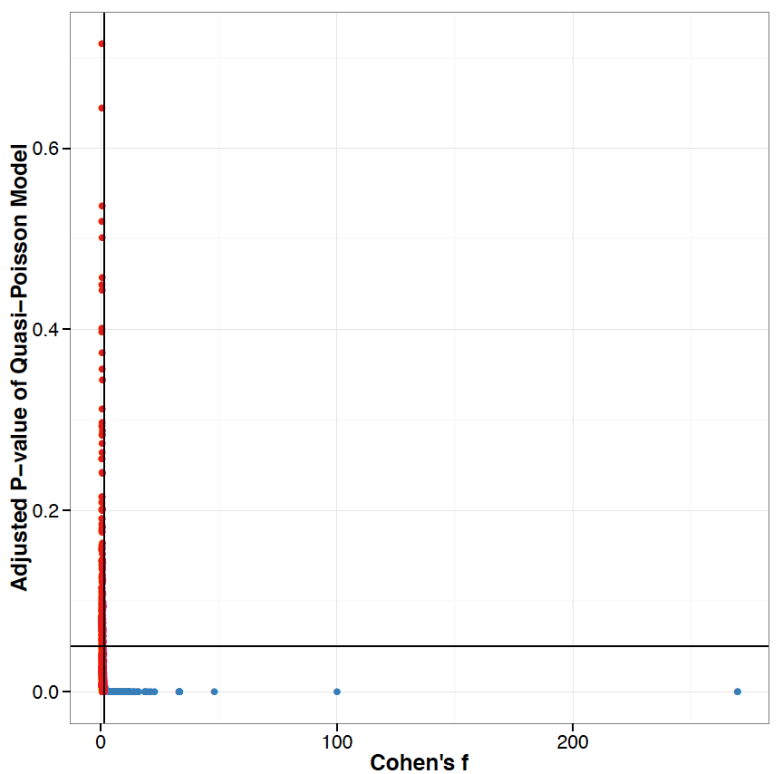
Figure 33 Protein scatter plot of human fecal proteome comparison. Blue dots are significantly categorized proteins, while red dots are proteins that could not passed two thresholds, FDR < 0.05 and Cohen’s f > 1.3769.

High variance within replicates affects on comparison between different experiment groups. To analyze highly varied data like fecal proteomes, many biological and technical replicates are required. Otherwise, strict threshold should be applied and reliable statistical methodology is employed.

Functional analysis using QFAM
We analyzed fecal proteins in terms of functional terms, such as gene ontology (GO) [94] enrichment test for human proteins and cluster of ortholog groups (COG) [125] analysis for microbiome proteins, so that we understand metabolic functions of identified human fecal proteins. GO and COG terms are widely used to get to know functional features of proteomics data [142,143].
COG and GO terms were enriched over all the human fecal proteins by using Fisher’s exact test. P-values of the enriched COG and GO terms were adjusted by FDR. Also, significance test was conducted by employing QP model and transferring SC of member proteins to COG and GO terms. Significantly enriched and varied COG and GO terms have less than 0.05 p-value (Fisher’s exact test FDR < 0.05 and QP FDR < 0.05) and more than 1.3769 Cohen’s f (statistical power > 90%).
The result of GO term analysis includes interesting GO terms. Extracellular location related GO cellular component terms, extracellular vesicular exosome (GO:0070062), extracellular vesicle (GO:1903561), extracellular membrane-bounded organelle (GO:0065010), vesicle (GO:0031982), extracellular organelle (GO:0043230), extracellular region (GO:0005576) and extracellular region part (GO:0044421), were understandably enriched (Enrichment FDR <1.07E-55) from the significant human proteins (Table 17). This shows that many of the significant human fecal proteins are secreted into extracellular regions and excreted into feces.
Besides of extracellular location GO terms, digestion (GO:0007586) and mucosal immune response (GO:0002385) were enriched (Table 17). Mucosal immune response GO term was enriched from RYR1, TPM4, VCL, FLII, myosin proteins and actin proteins (FDR = 7.08E-05). In addition to mucosal immunity, immune defense-related GO terms are enriched (FDR < 0.05), such as defense response to fungus (GO:0050832), response to fungus (GO:0009620), defense response to bacterium (GO:0042742) and cell killing (GO:0001906) (Table 17). Digestion related proteins, such as AMY2B, CTRB1, CTRB2 and CELA2A, are abundantly identified in the fecal proteomes (Table 16) and also included in the 355 significant protein list. Digestion proteins are required to obtain nutrition and energy for everybody, but abundance of those proteins is very dissimilar. For example, average spectral counts of digestion related proteins, assigned to digestion (GO:0007586), is 24.2904 in 174c while it is 289.1341 in 196N. The fold change between 174c and 196N is more than 10. Since cytoskeleton proteins including keratins, tubulins, actins and myosins are significantly and differentially detected in the fecal proteomes, cytoskeleton (GO:0005856), protein complex subunit organization (GO:0071822) and muscle contraction (GO:0006936) are enriched with remarkable FDR (FDR < 1.91E-12) (Table 17).
Table 17 Significantly varied GO terms in human fecal proteins. FDR: FDR-adjusted enrichment test and # of prot: the number of member proteins.
BS ID | Description | Enrich. FDR | GO ID | # of prot | Cohen’s f | QP  FDR
515001 | Extracellular exosome | 3.91E-98 | 0070062 | 691 | 4.4624 | 3.29E-10
514941 | Extracellular membrane-bounded organelle | 3.91E-98 | 0065010 | 691 | 4.4624 | 3.29E-10
1129387 | Extracellular vesicle | 1.17E-97 | 1903561 | 691 | 4.4624 | 3.29E-10
506297 | Extracellular organelle | 1.17E-97 | 0043230 | 691 | 4.4624 | 3.29E-10
501226 | Membrane-bounded vesicle | 2.12E-87 | 0031988 | 765 | 4.7401 | 1.66E-10
501220 | Vesicle | 7.12E-84 | 0031982 | 770 | 4.7451 | 1.61E-10
507370 | Extracellular region part | 2.02E-76 | 0044421 | 771 | 5.0905 | 3.40E-11
489955 | Extracellular region | 3.67E-55 | 0005576 | 804 | 5.2393 | 1.67E-11
492328 | Digestion | 7.80E-07 | 0007586 | 39 | 3.8928 | 3.28E-11
488258 | Mucosal immune response | 7.08E-05 | 0002385 | 17 | 2.0228 | 1.94E-05
489316 | Defense response to fungus | 1.18E-03 | 0050832 | 13 | 4.1696 | 1.17E-08
493740 | Response to fungus | 8.80E-03 | 0009620 | 14 | 4.1802 | 1.03E-08
489314 | Defense response to bacterium | 3.15E-02 | 0042742 | 38 | 3.4573 | 4.33E-09
487798 | Cell killing | 3.39E-02 | 0001906 | 15 | 4.5767 | 2.52E-11
490871 | Cytoskeleton | 2.14E-40 | 0005856 | 418 | 4.2486 | 1.08E-09
516744 | Protein complex subunit organization | 8.08E-42 | 0071822 | 356 | 1.6116 | 1.44E-04
489296 | Muscle contraction | 1.91E-12 | 0006936 | 70 | 3.4826 | 2.61E-08
489491 | alcohol dehydrogenase (NAD) activity | 4.42E-02 | 0004022 | 5 | 2.4551 | 1.16E-11
We guess that these cytoskeletal proteins are excreted from the dead intestinal cells and immune response cells, and their amount is different from person to person. Interestingly, alcohol dehydrogenase (GO: 0004022) is also differentially detected over healthy volunteers (Table 17). Its QP model FDR (1.16E-11) and Cohen’s f (2.4551) shows how it is variously expressed from person to person.
Functional features of microbial proteins were analyzed by employing COG terms. We tested COG terms by enrichment test using Fisher’s exact test and quantitative QP model with conferred SC from member protein to COG terms. Lots of ribosome related COG terms were frequently found in the COG analysis result, such as ribosomal protein L1 (COG00081), S2 (COG00052), S10 (COG0051), S11 (COG00100), L11 (COG0080), S12 (COG00048) and S19 (COG00185) at enrichment FDR < 2.95E-09 and QP FDR < 0.0007 (Table 18). Since ribosome is the most abundant protein in microorganism cells, many ribosome-related COGs were detected in the COG analysis. Energy-required (ATP or GTP) enzyme activity COG terms were also frequently enriched besides ribosomes (Table 18). ATPases with chaperone activity; ATP-binding subunit (COG00542), F0F1-type ATP synthase; beta subunit (COG00055), ATP-dependent Zn proteases (COG00465), Preprotein translocase subunit SecA (ATPase; RNA helicase) (COG00653), GTPases - translation elongation factors (COG00050) and Translation elongation factors (GTPases) (COG00480) were enriched at enrichment FDR < 1.99E-10 and QP FDR < 0.0003.

Table 18 Significant COG terms in microbial fecal proteins. FDR: FDR-adjusted enrichment test and # of prots: the number of member proteins.
COG ID | Description | Enrich. FDR | # of prots | Cohen’s f | QP FDR
COG00542 | ATPases with chaperone activity; ATP-binding subunit | 2.33E-13 | 36 | 3.1885 | 4.27E-07
COG00480 | Translation elongation factors (GTPases) | 5.32E-12 | 32 | 2.5506 | 9.50E-07
COG00050 | GTPases - translation elongation factors | 5.32E-12 | 26 | 1.5264 | 8.32E-05
COG00055 | F0F1-type ATP synthase; beta subunit | 1.42E-11 | 24 | 2.7013 | 1.14E-06
COG00465 | ATP-dependent Zn proteases | 8.86E-11 | 27 | 3.3691 | 5.58E-08
COG00100 | Ribosomal protein S11 | 1.99E-10 | 21 | 2.0664 | 4.58E-06
COG00048 | Ribosomal protein S12 | 1.99E-10 | 21 | 1.6682 | 0.000127452
COG00086 | DNA-directed RNA polymerase; beta' subunit/160 kD subunit | 1.99E-10 | 22 | 1.5654 | 0.000129515
COG00653 | Preprotein translocase subunit SecA (ATPase; RNA helicase) | 1.99E-10 | 23 | 1.4936 | 0.000254607
COG00459 | Chaperonin GroEL (HSP60 family) | 2.75E-10 | 22 | 2.9585 | 7.46E-08
COG00085 | DNA-directed RNA polymerase; beta subunit/140 kD subunit | 2.75E-10 | 22 | 1.9143 | 4.63E-06
COG01592 | Rubrerythrin | 7.43E-10 | 21 | 2.2773 | 1.10E-06
COG00057 | Glyceraldehyde-3-phosphate dehydrogenase/erythrose-4-phosphate dehydrogenase | 7.43E-10 | 23 | 1.9770 | 1.11E-05
COG01629 | Outer membrane receptor proteins; mostly Fe transport | 7.43E-10 | 45 | 2.0563 | 2.90E-05
COG00052 | Ribosomal protein S2 | 7.43E-10 | 20 | 1.5196 | 7.50E-05
COG00185 | Ribosomal protein S19 | 7.43E-10 | 20 | 1.6309 | 0.000638967
COG00443 | Molecular chaperone | 8.88E-10 | 25 | 2.6864 | 7.01E-07
COG00080 | Ribosomal protein L11 | 1.12E-09 | 20 | 2.0750 | 3.51E-06
COG00051 | Ribosomal protein S10 | 1.12E-09 | 20 | 1.7237 | 4.86E-05
COG01454 | Alcohol dehydrogenase; class IV | 9.98E-06 | 21 | 1.9329 | 7.50E-05

Interestingly, alcohol dehydrogenate COG term (COG01454) was significantly enriched like GO analysis of human proteins at enrichment FDR = 9.98E-06 and QP FDR = 7.50E-05.
COG’s broad functional terms were analyzed likewise to GO and COG terms (Table 19). We applied same thresholds (enrichment FDR < 0.05, QP, FDR < 0.05 and Cohen’s f < 1.3769). As is confirmed by COG term analysis, translation, ribosomal structure and biogenesis (J) were significantly and differentially enriched (enrichment FDR: 7.00E-258 and QP FDR = 1.48E-10) (Fig. 34) (Table 19). Also, energy production and conversion (C), carbohydrate transport and metabolism (G), inorganic ion transport and metabolism (P), and amino acid transport and metabolism (E) were detected (Fig. 34) (Table 19). These are partially related to digestion and energy generation. These COG functions may be varied in different microbiome. Interestingly, cell motility and defense mechanisms (V) were found in the COG broad functional analysis result (enrichment FDR = 1.19E-07 and QP FDR = 2.95E-05) (Fig. 34) (Table 19). Microbiome is speculated that they may move to find nutrients and defend themselves from host immune system. These functions also were dissimilar in different people, which mean that microbiome may be facing in different environment (human gut).

Table 19 Significant COG functional terms in microbial fecal proteins. FDR: FDR-adjusted enrichment test and # of prots: the number of member proteins.
COG ID | Description | Enrich. FDR | # of prots | Cohen’s f | QP FDR
J | Translation; ribosomal structure and biogenesis | 7.00E-258 | 1,060 | 4.1810 | 1.48E-10
S | Function unknown | 1.44E-39 | 159 | 2.3167 | 3.51E-06
X | Not predicted | 2.42E-37 | 205 | 2.3234 | 7.05E-07
C | Energy production and conversion | 1.47E-34 | 476 | 2.2074 | 1.46E-06
G | Carbohydrate transport and metabolism | 1.39E-31 | 626 | 3.1924 | 3.15E-09
O | Posttranslational modification; protein turnover; chaperones | 1.88E-27 | 319 | 4.5972 | 1.48E-10
R | General function prediction only | 1.10E-19 | 313 | 1.7545 | 3.43E-05
K | Transcription | 6.68E-17 | 214 | 2.1878 | 2.77E-07
L | Replication; recombination and repair | 2.51E-16 | 229 | 1.8058 | 2.76E-06
T | Signal transduction mechanisms | 1.39E-09 | 94 | 1.5192 | 3.12E-04
V | Defense mechanisms | 1.19E-07 | 70 | 2.1949 | 2.95E-05
M | Cell wall/membrane/envelope biogenesis | 1.26E-05 | 226 | 3.7150 | 8.49E-09
E | Amino acid transport and metabolism | 1.60E-05 | 471 | 2.2311 | 7.57E-07
N | Cell motility | 5.57E-04 | 37 | 1.5247 | 9.60E-05
P | Inorganic ion transport and metabolism | 3.44E-03 | 162 | 2.1932 | 1.45E-06

Figure 34 Expression profile of 15 COG functions. Spectrum counts of member proteins were transferred to COG broad functional terms. COG function name for corresponding symbol is in table 19. This plot was drown by line plot module of QFAM.

Conclusion

We could identify 2,102 fecal human proteins and 5,453 microbial proteins from feces of 11 healthy volunteers and confirmed their heterogeneity. This number of human fecal proteins is highly bigger than previous studies, 234 proteins from three samples in Lichtman et al [11] and 446 proteins from two samples in our previous study [127]. We identified averagely 501 proteins per a MS run that is bigger number than total number of proteins from two or three samples in the previous studies. We confirmed that host proteins in feces are diverse in human as is shown in mice feces by Lichtman et al [11]. Host fecal protein’s variance was disclosed by PCC (Fig. 31) and identification frequency (Table 14) comparisons with technical replicates and five PBMC proteomes. Figure 31 shows that fecal proteins are not uniformly identified in individual fecal samples. The QP model also reveals that expression levels of fecal proteomes are various. We could find 1,610 proteins that are differentially and significantly detected in 11 fecal proteomes via QP model and effect size filter. We utilized Cohen’s f to enhance statistical power of our QP model. Functional enrichment analyses over the 1,610 significant proteins show that human significant proteins are generally located extracellular regions and are related with digestion, cytoskeleton and protein metabolisms, and microbial significant proteins are related with translation, energy generation and protein metabolisms.
Many immune response proteins are also identified in our fecal proteome. Identification of immune response proteins in fecal proteomes is a natural outcome because the GI tract is a direct interface of interaction between host immune system and microbiome including commensal flora and enteric pathogens. We dug 214 immune proteins out of 11 fecal proteomes. Almost 40 immune proteins are detected in more than half of fecal samples (> 5 samples), while others are less-frequently identified. Toll-like receptor family protein (TLR) plays a key role in the innate immunity, so we expected TLR proteins in many of fecal samples, but only TLR6 was weekly identified in one fecal sample. TLR6 has a fundamental role in pathogen recognition and induction of innate immune response. We also expected to see immunoglobulins for innate immunity, such as IGA, IGD, IGE, IGG and IGM, but none of these are in our fecal proteomes. In place of above five immunoglobulins, IGJ are strongly and frequently identified. IGJ is involved in polymer form of IGA and IGM, so IGJ can be an indirect clue of existence of IGA and IGM. IGJ is also identified in previous studies, but TLR6 is found only in our study.
Human fecal proteins that were identified by previous studies are confirmed in our study. We could confirm that 196 proteins of 234 in Lichtman et al and 243 proteins of 446 in our previous study were identified in our study. The number of fecal proteins that are commonly identified in three studies including our fecal proteome is 101. Of the commonly identified 101 proteins, 24 proteins are immune response proteins including IGJ and DMBT1. Digestion related proteins, such as, AMY2A and PRSS1, are also commonly found. Many of the simultaneously found proteins are detected with high SC in our study. Top 25 abundant fecal proteins in table 15 are found in at least one of previous studies.

CHAPTER V
APPLICATION CASE 2 – HUMAN DIET PROTEOME STUDY

Introduction
What we are eating have undoubtedly affected on the relative abundance and the types of our microbiome living in gastrointestinal tract [144]. For example, western diets, low in carbohydrates and high in simple sugar and fat, are associated with the decrease of Bacteriodetes in North Americans [145,146]. This change in microbiome is generally detected in feces [147]. For instance, certain type of bacteria is increased by short-term dietary changes, such as resistant starch (RS) contents, in the collected fecal samples. The pattern changed by different RS amount in diets is likely associated with how long the changed diet is taken and its specific nutritional contents, such as more refined RS [148-150]. Also, antibiotics, effective against autochthonous species members, such as Helicobacter pylori and Lactobacillus Reuteri, made significant decrease detected in feces [147].
RS is one of starch or derivatives of starch and is not fully digested by human small intestine, while sugars and most starches are rapidly digested and absorbed as glucose. This undigested RS, dietary fiber, is diet-derived energy-source of microbiome living in large intestine. Several scientific reports showed that high RS diet could result in abundance of specific bacteria in microbiome, such as Ruminococcus bromii, Eubacterium rectale, and Bifidobacterium adolescentis [144,150-152]. These changes in microbiome are probably caused by substrate-specific preference of different microbes that can uptake and degrade RS efficiently. Generally people inhabiting in different places have dissimilar microbiome, but children in European Union and Burkina Faso showed similar response to high fiber diets, which Bacteroidetes and Firmicutes ratio are changed by different amount of dietary RS [153]. Potential increase of short chain fatty acid and butyrate-producing microbes and decrease of disease-causing bacteria enables us to associate RS diet with human health.
While the influence of resistant starch on both the gut microbial community and human metabolism has been demonstrated, the precise relationship between the gut microbiome and human metabolic factors remains unclear. This study is proteomics part of the integrative “omics” study including metagenomics, metabolomics and metaproteomics. Two different diets containing high and low amounts of RS were treated to 8 patients in crossover time course design. Feces after having specific diets were sampled and analyzed by 2D LC-MS/MS and QFAM.

Methods

Generation of Metaproteome data
The diet study design is summarized in Figure 35. Briefly, 8 patients who were insulin resistant (HOMA-IR > 50th percentile for sex), overweight or obese (BMI between 27 and 35 kg/m2), and met other eligibility criteria were enrolled in the study.
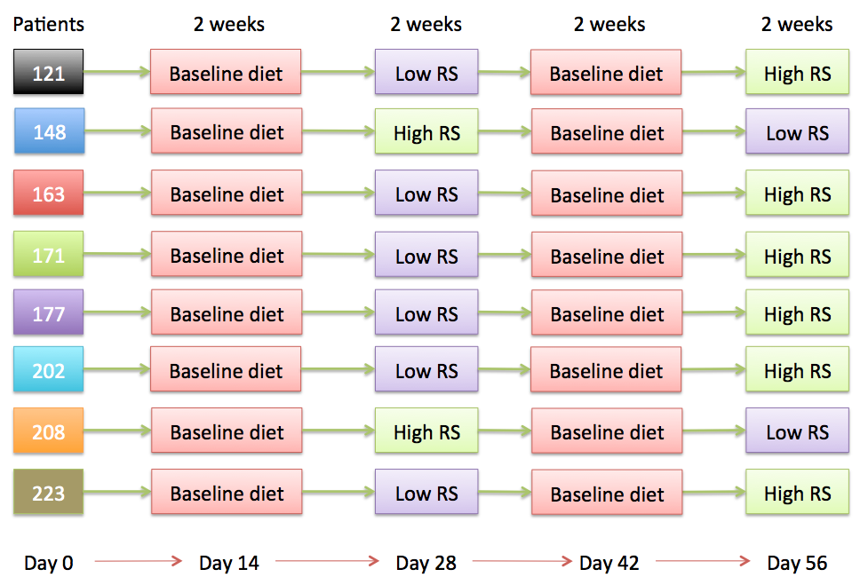
Figure 35 Experiment design of diet proteome study. Low RS has 2g amylose and High RS has 38g amylose. Every diet is treated for two weeks. Total 8 patients had different diets, as is schedule in cross over design.

All subjects were otherwise healthy and not taking any antibiotics, lipid-reducing or blood-thinning medications, or hormones. The study protocols were approved by the Human Subjects Committee of both Children’s Hospital Oakland Research Institute and Lawrence Berkeley National Laboratory. Written informed consent was obtained from each subject. Study participants were randomly assigned to a sequence of the two experimental diets: a low resistant starch (LRS) diet containing 2 grams of resistant starch and a high resistant starch (HRS) diet containing 38 grams of resistant starch. Each diet period was 2 weeks with 2 weeks baseline washout diet between diet periods (Fig. 35). In both diets, type 2 RS, a granular form of high amylose cornstarch, was used. Melojel of Ingredion Inc. was used for LRS diets, while Hi-maize 260 RS was used for the HRS diets. Following the initial baseline diet and each diet period, fecal samples were collected.

Sample preparation and LC-MS/MS experiment
Proteins of all fecal samples were extracted by indirect cell lysis method (Fig. 29) because indirect method is preferred for collection of more amount of microbiome proteins. Proteins of all the samples were digested by trypsin and analyzed via two-dimensional (2D) nano-LC MS/MS system with a split-phase column (SCX-RP) Velos Orbitrap Pro (Thermo Fisher Scientific) for feces as shown in Figure 29. The Orbitrap settings were as follows: 30K resolution on full scans in Orbitrap, data-dependent MS/MS in LTQ (Top 10 peaks were chosen), two micro-scans for both full and MS/MS scans, centroid data for all scans.

Quantitation and normalization of metaproteome data
All MS/MS spectra were searched against our customized sequence database. The database consists of human protein sequences, translated meta-genome sequences, proteins of 34 human-gut-isolated microbial species, and common contaminants (i.e., trypsin and keratin; 36 protein sequences). We collected human proteins sequences from NCBI RefSeq and microbial proteins from JGI human microbiome project (IMG-HMP) as is described in our previous paper [73]. All MS/MS individual runs were searched with the SEQUEST (v.27) algorithm against our customized FASTA sequence database. Search parameters were followed to our prior study [73] (<4 miss-cleavages, 3 Da mass tolerance window around the precursor ion mass and 0.5 Da for fragment ion masses). All SEQUEST output files were gathered and filtered using DTASelect (1.9) at ≥ 2 peptides per protein and the following widely accepted parameters for all the MS runs: XCorr of at least 1.8, 2.5, 3.5 for +1, +2, and +3 charge states, respectively and a minimum deltCN for 0.08. All the peptide spectrum matches (PSM) that could not satisfy a post-database search filter, -10 ≤ ppm ≤ 10, were excluded out to remove false positives as described in our previous study [73]. Finally 57,397 proteins were quantitatively identified (human: 1,103 and microbes: 56,294). Spectrum counts (SC) of protein is normalized as described below [73]:
$$Normalized {SC}_{i}= \frac{\frac{\sum_{j=1}^{M}{\sum_{k=1}^{N}{{SC}_{k}}}}{M}}{\sum_{k=1}^{N}{{SC}_{k}}}×{SC}_{i}$$
Where, N = the number proteins and M = the number MS runs.

Quantitative analysis of metaproteome data
All the statistical analyses were fulfilled by using R 3.1.3 and Python 2.7.6. Since people have different gut microbiome and different genetic background, fecal proteomes are heterogeneous from person to person. Our previous study showed that human fecal proteome is highly varied (unpublished). Hence, we considered that personal variation is important to interpret our proteomics data in terms of diet type. Generalized Linear Mixed Model (GLMM) is the extended one of generalized linear model (GLM) and able to include random effects in addition to the usual fixed effects. We set personal variation as random effect to explain different people’s different fecal proteomes. Our model for the proteome analysis is SC ~ μ + Diet type + (1|Person). Negative binomial distribution (NB) was employed as null distribution in GLMM instead of Normal distribution because spectral count is frequency-based data and NB distribution is generally used for count-type data analysis, such as read numbers of RNA sequencing. The constructed GLMM NB model was compared to null model through chi-square likelihood ratio test (LR test). All the P-values were adjusted by FDR in order to reduce multiple comparison effect. Cut-off FDR is 0.0001. We used ‘lmerTest’ package to construct GLMM NB model [154].
On top of GLMM NB model, effect size (ES) filter was applied to enhance reproducibility. Combining p-value and ES filter can enhance reproducibility of proteomics data analysis [107]. As is showed in chapter 3, fold change is widely used ES, but Cohen’s ES is better ES in terms of statistical power and selection power filtering false positives. We used ‘selfea’ R package, described in chapter 3, to calculate Cohen’s w that is designed for chi-square test that was used for GLMM NB model comparison. Since a number of microbial proteins were significantly detected, we used very strict statistical filters (FDR-adjusted p-value (FDR) < 0.0001) to make the expected number of false positives is smaller than 1. When p-value threshold is 0.0001, minimum Cohen’s w for our data was 1.0258 corresponding to 80% statistical power that is recommended level for reliable hypothesis test. Statistical power is a probability correctly rejecting null hypothesis when it is false, so it is directly related statistics with reproducible result. The expected number of false positives is 0.7 at 0.0001 FDR and 80% power. The number of significantly detected human proteins is 94, while one of microbial proteins is 7,018.

Functional analysis of metaproteome data
Metaproteome data was functionally analyzed by using COG for microbial proteins and KEGG pathway terms. Using COG-analysis pipeline of FAM examined COG and COG functional terms. To assign COG ID to microbial proteins, we used COG-software by following steps suggested by Kristensen et al. For proteins, COG-software could not assign, PSI-BLAST search against COG sequences was used with cut off E-value 0.00000001. We could assign COG ID to 54,290 microbial proteins. To quantitatively analyze COG IDs, we transferred SC of member proteins, assigned to at least one COG ID, to COG ID. Same assignment was done to 25 broad COG functional terms. We applied GLMM NB model and Cohen’s w to get significant COG terms and their broad functional terms. For COG analysis, 0.0001 FDR thresholds and 1.0258 Cohen’s w were applied. We could examine significantly changed 400 COG terms and 4 COG functional terms across different diet types. Since many of significant COG terms were supported by only 1 or 2 member proteins, we filtered out COGs by the number of member proteins (member > 2). This rule was applied to COG functional terms. After filtering by minimum member proteins, remaining COGs were 166 terms and 2 functional terms. For COG functions, we applied 0.001 FDR of GLMM-NB model and 0.9051 Cohen’s w (the number of expected false positive is 0.02).
FAM was used to analyze KEGG pathway for human proteins in diet metaproteome. SC transfer to KEGG pathways was done like COG analysis. Enrichment test was carried out by QAM module. FDR threshold for the enrichment test was 0.05. To quantitatively analyze KEGG pathways, we applied GLMM NB model and Cohen’s w, 0.05 FDR thresholds and 0.6336 Cohen’s w, so that the number of expected false positives is 1. We could identify 20 significant KEGG pathways.

Identification of translated-metagenome sequences
Undefined translated-metagenome sequences (metagenome proteins) were defined by BLAST search pipeline of QFAM against whole UniProt DB downloaded in Dec. 2014. BLAST search, using BLAST 2.2.24, was fulfilled in Newton cluster of the University of Tennessee (https://newton.utk.edu/). We divided 48,284 metagenome proteins into 48 groups and had run 48 BLAST jobs simultaneously onto 48 cores of Newton cluster. Sequence similarity was calculated for every alignment as described below:
$$Similarity=\frac{Aligned length}{Protein length}×Percent identity$$
Where aligned length is value of ‘alignment length’ of BLAST result, protein length is the number of amino acid of a protein and percent identity is ‘% identity’ of BLAST result. We assigned single UniProt ID to a metagenome protein by 95% sequence similarity without gap opens. At 95% similarity level, 38,543 metagenome proteins were successfully determined.

Results

Generation of diet metaproteome data
From 24 MS runs (8 patients * 3 diets), 57,398 proteins were determined. Of 57,398 proteins, 56,295 were from microbiome and 1,103 were host human proteins. This identification bias is caused by indirect protein extraction method (Fig. 29). Since we collected microbial pellets and removed supernatant, human proteins, floating in supernatant, were efficiently removed. Filtering out of host proteins are required to get more microbial proteins from fecal samples. This diet proteome study targets understanding of changes in microbiome communities, so half number of human proteins was identified when compared to human fecal proteome study of chapter 4.
Much more number of microbial proteins was detected in this study than human fecal proteome study (56k of diet proteome vs. 5k of human fecal proteome). This abundant microbial protein examination is due to two reasons. First, it is employing indirect protein collection method as is described in chapter 4. Another factor is the metagenome sequencing. As is explained in chapter 4, species composition of human feces is not known and is various from person to person. In this study, metagenome sequencing was employed and added to PSM search, while it wasn’t in human fecal proteome study. Since metagenome is not annotated, metagenome characterization is required. However, microbial protein identification is dramatically increased by metagenome sequences and indirect method. The number of metagenome proteins, translated metagenome coding genes, is 48,376 of 56,295 total microbial proteins. This is 86% of total microbial protein identifications, which means showing huge contribution of metagenome proteins to increase of microbial proteins.
Some species had significant changes in the number of identified proteins (Table 20). The number of metagenome proteins was increased by RS amount (26,075 in LRS and 28,776 in HRS). As is reported previously [153], Bacteriodes showed changes by RS amount (Table 20).
Table 20 The number of identified proteins in different species. SD is standard deviation of numbers in three different diets.
Species | Baseline | LRS | HRS | SD
Aeromonas hydrophila hydrophila ATCC 7966 | 4 | 4 | 5 | 0.58
Desulfovibrio sp. 3_1_syn3 | 13 | 13 | 11 | 1.15
Escherichia coli CFT073 | 12 | 10 | 8 | 2.00
Lactobacillus reuteri CF48-3A | 6 | 2 | 4 | 2.00
Enterococcus faecalis PC4.1 | 11 | 10 | 7 | 2.08
Shigella flexneri 2a 2457T | 11 | 10 | 7 | 2.08
Methanobrevibacter smithii F1, DSM 2374 | 1 | 1 | 6 | 2.89
Salmonella enterica enterica sv Typhi Ty2 | 13 | 8 | 8 | 2.89
Blautia hydrogenotrophicus S5a33, DSM 10507 | 72 | 66 | 66 | 3.46
Klebsiella sp. 1_1_55 | 20 | 9 | 15 | 5.51
Streptococcus sp. 2_1_36FAA | 21 | 14 | 8 | 6.51
Coprococcus sp. HPP0048 | 75 | 61 | 74 | 7.81
Anaerostipes sp. 3_2_56FAA | 58 | 67 | 74 | 8.02
Ruminococcus lactaris ATCC 29176 | 87 | 103 | 89 | 8.72
Prevotella melaninogenica D18 | 64 | 82 | 71 | 9.07
Clostridium sp. 7_2_43FAA | 45 | 31 | 50 | 9.85
Dorea formicigenerans ATCC 27755 | 93 | 104 | 84 | 10.02
Coprococcus comes | 77 | 81 | 98 | 11.15
Lachnospiraceae bacterium 6_1_63FAA | 90 | 89 | 115 | 14.73
Alistipes putredinis DSM 17216 | 130 | 157 | 161 | 16.86
Dialister invisus DSM 15470 | 23 | 47 | 57 | 17.47
Roseburia intestinalis L1-82 | 104 | 145 | 111 | 21.93
Akkermansia muciniphila ATCC BAA-835 | 14 | 11 | 58 | 26.31
Eubacterium rectale ATCC 33656 | 263 | 311 | 325 | 32.52
Bifidobacterium adolescentis ATCC 15703 | 41 | 38 | 102 | 36.12
Ruminococcaceae bacterium D16 | 75 | 147 | 126 | 37.03
Bacteroides uniformis CL03T00C23 | 393 | 314 | 367 | 40.26
Bifidobacterium adolescentis L2-32 | 44 | 38 | 111 | 40.53
Bacteroides uniformis CL03T12C37 | 392 | 312 | 366 | 40.81
Prevotella copri CB7, DSM 18205 | 529 | 633 | 523 | 61.85
Homo sapiens | 893 | 723 | 760 | 89.40
Faecalibacterium prausnitzii A2-165 | 226 | 361 | 454 | 114.64
Bacteroides vulgatus ATCC 8482 | 777 | 571 | 785 | 121.31
Bacteroides sp. 1_1_6 | 774 | 389 | 320 | 244.64
Bacteroides sp. D2 | 885 | 379 | 409 | 283.88
Metagenome | 23,359 | 26,075 | 28,766 | 2,703.51
Bacteriodes vulgatus ATCC 8482 had 571 proteins in low RS, however its number of proteins is increased in high RS up to 785 (Table 20). Interestingly, all the Bacteriodes species, Bacteriodes sp. D2, Bacteriodes sp. 1_1_6 and Bacteriodes vulgatus ATCC 8482, were remarkably decreased in low RS when compared to baseline diet (Table 20). These changes are relatively large, considering changes in other species. The number of human proteins is not quite changed by different diets (Table 20). Abundance of many species in fecal samples was not much changed except Bacteroides and Metagenome (Table 20).

Construction of generalized linear mixed model
Generalized linear mixed model (GLMM) was constructed for comparing proteomes between different diets. We showed that fecal proteomes are highly varied even in healthy volunteers at chapter 4. Therefore, GLMM was constructed based on Negative Binomial distribution. GLMM is an extended linear model of Generalized Linear Model (GLM) that can cover random effects and fixed effects as well as regression variables. Our model is described below.
$$SC \sim μ+diet type+(1|patients)$$
Where SC is spectral counts and $μ$ is intercept. This model considers that SC can be varied by diet type in different patients. We assumed that eight patients can have different fecal proteome profiles, even though they are basically same biological replicates who have same disease and healthy background. Also, different diets are crossed over through patients, so it makes sense that GLMM has patients as random effect and diet type as fixed effect.
Negative binomial distribution (NB) was employed as null distribution in GLMM instead of Normal distribution because spectral count is frequency-based data and NB distribution is generally used for count-type data analysis, such as read numbers of RNA sequencing. NB is widely used distribution in RNA sequencing data comparison [155,156], while has not been used in proteomics data analysis. NB is robust to over-dispersion when compared to Poisson that is also basically designed distribution for count type data. Also, NB is uniquely determined by two parameters, mean and variance. However, the number of replicates in biological studies is often not enough to estimate mean and variance reliably. Therefore, tools based on NB for RNA sequencing data comparison, such as DESeq[156] and edgeR[155], have their variance functions adjusted for RNA sequencing data. Even though the diet proteome dataset has small number of replicates, tools using NB for GLMM models are not available. Therefore, we used general NB variance function provided by lmerTest R package designed for GLMM model. The constructed GLMM-NB model was compared to null model (null hypothesis) through chi-square likelihood ratio test (LR test). All the P-values were adjusted by FDR in order to reduce multiple comparison effect.
On top of GLMM-NB model, ES filter was applied to enhance reproducibility of our data analysis. In label-free proteomics data analysis like diet proteome dataset, combining p-value and ES filter can bring better results (Gregori et al 2013). Moreover, as is explained in chapter 3, we can filter out low-powered hypothesis tests by using Cohen’s ES. One important advantage of employing Cohen’s ES is that we can enhance statistical power up to the level required for making p-value as reliable evidence. According to Halsey et al [102], high statistical power is generally needed to p-value. Through removing out of underpowered hypothesis tests, we can keep only hypothesis tests that have enough statistical power, which means that p-values in our comparisons can play its pivotal role appropriately.
For this study we used Cohen’s w as effect size filter because it is designed for Chi-Square test used for the GLMM-NB model comparison. Cohen’s w is one of variables for the calculation of statistical power, so it can be increased or decreased by sample size and significance level to keep certain level of the power (typically 80%). The higher statistical power means better selection power in hypothesis tests. Using GLMM-NB and Cohen’s w we found 7,113 significant proteins, 94 from human and 7,018 from microbiome and metagenome, that are differently detected in different diet types. These significant proteins were picked by 0.0001 FDR and 1.0258 Cohen’s w threshold (Fig. 36). We increased p-value threshold to reduce the number of expected false positives. The expected false positive in our results is less than 1. Protein scatter plot in figure 36 shows how many proteins we filtered out from total proteins. Since fecal proteomes are highly varied by patients as is shown in chapter 4, we applied rigorous thresholds to exclude out potential false positives. Cohen’s w was calculated by selfea R package used in chapter 3 and 4.

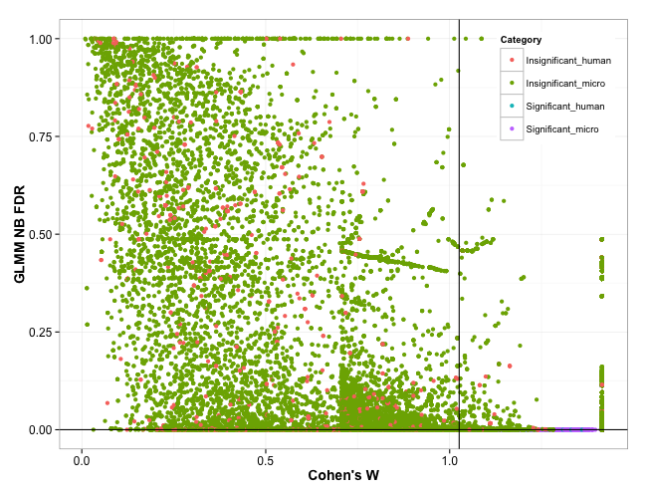
Figure 36 Protein scatter plot of diet proteome comparison. Green dots mean insignificant microbial proteins, and red dots are insignificant human proteins. Significant proteins are colored as purple (significant microbial) and blue (significant human). Since we used rigorous thresholds to make the expected number of false positive below 1, almost all the visible spots were excluded by two lines (FDR threshold (= 0.0001) horizontal line and Cohen’s w (= 1.0258) vertical line).

Functional analysis using FAM
Functional analysis of diet proteomes was conducted by using FAM. For this study, we used KEGG pathway analysis for human proteins and COG terms for microbial proteins. Even though relatively small number of human proteins was identified in the diet proteome, we analyzed their functional characteristics. Since we are interested in microbial changes caused by different RS amount, COG terms were exciting results.
First, we analyzed human proteins in the diet proteome using KEGG pathways. FAM was employed to get reliable results using enrichment test and significance test. Enrichment test was carried out via Fisher’s exact test. For quantitative comparison GLMM NB model and Cohen’s w were applied. Also, SC transferring from member proteins to KEGG pathways was done for human proteins of diet metaproteome. We downloaded up-to-date NCBI BioSystems DB. All the p-values from two tests were adjusted by FDR. FDR thresholds of two tests were 0.05 and minimum Cohen’s w was 0.6336 for 80% statistical power that is generally recommended level.
With these probability and ES filters, we could get 20 significant KEGG pathways (Fig. 37). HIF-1 signaling pathway, biosynthesis of amino acids, galactose metabolism, central carbon metabolism in cancer, proteasome and immunoproteasome were enriched almost only in LRS. In other diets, HRS and baseline, these were not expressed. Since proteasome and immunoproteasome are related to defense from microbial proteins, we speculate that innate immune system was turned on against increased species in LRS diets.

Figure 37 Stacked bar graphs of accumulated spectral counts of 20 significant KEGG pathways. Y-axis is KEGG pathway and X-axis is percentage of accumulated spectral counts of 2A (baseline), HRS and LRS samples. Blue-colored bar is sum of spectral counts in baseline diet. Red-colored bar means expression level (sum of spectral counts) in HRS. Green bars are from sum of expression level in LRS.

Interestingly, digestion-related pathways were enriched in both of LRS and HRS, such as glycolysis, fructose and mannose metabolism, carbon metabolism, pentose phosphate pathway and glucogenesis. This may be human body response to changed diets from baseline. Insulin signaling pathway and starch and sucrose metabolism were enriched in HRS. These means that uptake of glucose was not efficient in HRS because high amount of RS in HRS cannot be digested and absorbed by small intestine. Therefore, these were expressed higher than other diet types.
COG analysis was achieved by employing FAM. For this study we employed FAM’s quantitative test only because of time. Since diet metaproteomics used metagenome, more than several million sequences in protein DB. To conduct the enrichment test, we have to run PSI-BLAST of more than million sequences, which means that it takes too much long time about 50 days in Newton. This is critical disadvantage of QFAM. QFAM analyzes highly complicated and very large metaproteomics data, so it requires high level of computing power. Unfortunately, Newton could not afford to run this type of big data in a reasonable time. Therefore, we used arbitrary threshold instead of the enrichment test.
We transferred SC of member proteins to COG terms and constructed GLMM NB model for COG terms. Also, Cohen’s w for COG terms was computed for quantitative analysis using QAM. P-values were adjusted by FDR. FDR threshold of GLMM NB model was 0.001 and minimum Cohen’s w for 80% statistical power was 0.9051. On top of GLMM NB model, we applied arbitrary threshold for COG terms by the number of member proteins (> 2). With these thresholds, we could have 166 significant COG terms (Table 21). Also, heat-map of significant 166 COGs was drawn by using QFAM’s R graphic library (Fig. 38). Energy generation and digestion related COG terms were enriched in baseline diet, such as COG03808, COG01775 and COG01748 (Table 21 and Fig. 38). Also, ribosomal COGs were significantly enriched, such as COG00261 and COG00238 (Table 21). We speculate hat microbiome is growing with baseline diet, considering significantly enriched translation and DNA replication COG terms (Table 21).
COG terms analysis in LRS and HRS diets give us insight speculating changes caused by RS. In LRS diet, microbes in human gastrointestinal track are not quite different from baseline. Energy generation (COG00716, COG01013, COG01951, COG00554 and COG01805) is activated and digesting nutrients, such as amino acids, carbohydrates, lipid metabolism, are turned on similar to baseline (Table 21 and Fig. 38). However, microbes seem to try to changed nutrients by expressing appropriate proteins and post-translational modifications (COG00060, COG00254, COG00124, COG00621, COG00525 and COG01438 for transcription and translation and COG00760, COG00484, COG00691, COG01066 and COG00740 for post-translational modifications). Interestingly, cell motility COG terms are started being expressed from LRS diets (COG01360 and COG01749), which mean that microbes may be moving into changed environment (Table 21). Also, cell wall biogenesis is turned on from LRS (Table 21 and Fig. 38).
Table 21 166 significant COG terms in different diets. COG Func.: COG broad function single digit symbol. Related diets are categorized by expression level in three diets.
COG ID | # of Proteins | Description | COG Func. | Related diets
COG03808 | 158 | Inorganic pyrophosphatase | C | Baseline
COG01748 | 13 | Saccharopine dehydrogenase and related proteins | E | Baseline
COG01775 | 12 | Benzoyl-CoA reductase/2-hydroxyglutaryl-CoA dehydratase subunit; BcrC/BadD/HgdB | E | Baseline
COG00040 | 7 | ATP phosphoribosyltransferase | E | Baseline
COG00006 | 4 | Xaa-Pro aminopeptidase | E | Baseline
COG01027 | 3 | Aspartate ammonia-lyase | E | Baseline
COG00176 | 9 | Transaldolase | G | Baseline
COG02160 | 8 | L-arabinose isomerase | G | Baseline
COG03693 | 5 | Beta-1;4-xylanase | G | Baseline
COG01830 | 4 | DhnA-type fructose-1;6-bisphosphate aldolase and related enzymes | G | Baseline
COG02893 | 4 | Phosphotransferase system; mannose/fructose-specific component IIA | G | Baseline
COG01482 | 3 | Phosphomannose isomerase | G | Baseline
COG03345 | 3 | Alpha-galactosidase | G | Baseline
COG02022 | 3 | Uncharacterized enzyme of thiazole biosynthesis | H | Baseline
COG00447 | 3 | Dihydroxynaphthoic acid synthase | H | Baseline
COG01260 | 4 | Myo-inositol-1-phosphate synthase | I | Baseline
COG01022 | 3 | Long-chain acyl-CoA synthetases (AMP-forming) | I | Baseline
COG02030 | 3 | Acyl dehydratase | I | Baseline
COG00261 | 35 | Ribosomal protein L21 | J | Baseline
COG00238 | 25 | Ribosomal protein S18 | J | Baseline
COG00188 | 21 | Type IIA topoisomerase (DNA gyrase/topo II; topoisomerase IV); A subunit | L | Baseline
COG01918 | 21 | Fe2+ transport system protein A | P | Baseline
COG00523 | 21 | Putative GTPases (G3E family) | R | Baseline
COG02406 | 10 | Protein distantly related to bacterial ferritins | R | Baseline
COG03937 | 5 | Uncharacterized conserved protein | S | Baseline
COG01217 | 25 | Predicted membrane GTPase involved in stress response | T | Baseline
COG01702 | 6 | Phosphate starvation-inducible protein PhoH; predicted ATPase | T | Baseline
COG03706 | 5 | Response regulator containing a CheY-like receiver domain and a GGDEF domain | T | Baseline
COG00317 | 9 | Guanosine polyphosphate pyrophosphohydrolases/synthetases | TK | Baseline
COG00342 | 28 | Preprotein translocase subunit SecD | U | LRS
COG00716 | 51 | Flavodoxins | C | LRS
COG01013 | 20 | Pyruvate:ferredoxin oxidoreductase and related 2-oxoacid:ferredoxin oxidoreductases; beta subunit | C | LRS
COG01951 | 5 | Tartrate dehydratase alpha subunit/Fumarate hydratase class I; N-terminal domain | C | LRS
COG00554 | 3 | Glycerol kinase | C | LRS
COG01805 | 3 | Na+-transporting NADH:ubiquinone oxidoreductase; subunit NqrB | C | LRS
COG00347 | 31 | Nitrogen regulatory protein PII | E | LRS
COG00436 | 10 | Aspartate/tyrosine/aromatic aminotransferase | E | LRS
COG00076 | 3 | Glutamate decarboxylase and related PLP-dependent proteins | E | LRS
COG00175 | 4 | 3'-phosphoadenosine 5'-phosphosulfate sulfotransferase (PAPS reductase)/FAD synthetase and related enzymes | EH | LRS
COG00444 | 4 | ABC-type dipeptide/oligopeptide/nickel transport system; ATPase component | EP | LRS
COG01102 | 3 | Cytidylate kinase | F | LRS
COG00395 | 10 | ABC-type sugar transport system; permease component | G | LRS
COG03534 | 5 | Alpha-L-arabinofuranosidase | G | LRS
COG02376 | 4 | Dihydroxyacetone kinase | G | LRS
COG01440 | 4 | Phosphotransferase system cellobiose-specific component IIB | G | LRS
COG03669 | 4 | Alpha-L-fucosidase | G | LRS
COG01904 | 4 | Glucuronate isomerase | G | LRS
COG03717 | 3 | 5-keto 4-deoxyuronate isomerase | G | LRS
COG00413 | 12 | Ketopantoate hydroxymethyltransferase | H | LRS
COG01429 | 7 | Cobalamin biosynthesis protein CobN and related Mg-chelatases | H | LRS
COG00452 | 4 | Phosphopantothenoylcysteine synthetase/decarboxylase | H | LRS
COG00161 | 4 | Adenosylmethionine-8-amino-7-oxononanoate aminotransferase | H | LRS
COG00007 | 3 | Uroporphyrinogen-III methylase | H | LRS
COG00214 | 3 | Pyridoxine biosynthesis enzyme | H | LRS
COG01024 | 15 | Enoyl-CoA hydratase/carnithine racemase | I | LRS
COG02185 | 13 | Methylmalonyl-CoA mutase; C-terminal domain/subunit (cobalamin-binding) | I | LRS
COG01788 | 6 | Acyl CoA:acetate/3-ketoacid CoA transferase; alpha subunit | I | LRS
COG00332 | 3 | 3-oxoacyl-[acyl-carrier-protein] synthase III | I | LRS
COG00060 | 15 | Isoleucyl-tRNA synthetase | J | LRS
COG00254 | 7 | Ribosomal protein L31 | J | LRS
COG00124 | 5 | Histidyl-tRNA synthetase | J | LRS
COG00621 | 4 | 2-methylthioadenine synthetase | J | LRS
COG00525 | 3 | Valyl-tRNA synthetase | J | LRS
COG01438 | 3 | Arginine repressor | K | LRS
COG02885 | 25 | Outer membrane protein and related peptidoglycan-associated (lipo)proteins | M | LRS
COG00860 | 3 | N-acetylmuramoyl-L-alanine amidase | M | LRS
COG00773 | 3 | UDP-N-acetylmuramate-alanine ligase | M | LRS
COG02089 | 3 | Sialic acid synthase | M | LRS
COG01360 | 12 | Flagellar motor protein | N | LRS
COG01749 | 9 | Flagellar hook protein FlgE | N | LRS
COG00760 | 5 | Parvulin-like peptidyl-prolyl isomerase | O | LRS
COG00484 | 4 | DnaJ-class molecular chaperone with C-terminal Zn finger domain | O | LRS
COG00691 | 3 | tmRNA-binding protein | O | LRS
COG01066 | 3 | Predicted ATP-dependent serine protease | O | LRS
COG00740 | 7 | Protease subunit of ATP-dependent Clp proteases | OU | LRS
COG01116 | 5 | ABC-type nitrate/sulfonate/bicarbonate transport system; ATPase component | P | LRS
COG01160 | 6 | Predicted GTPases | R | LRS
COG00312 | 6 | Predicted Zn-dependent proteases and their inactivated homologs | R | LRS
COG02872 | 3 | Predicted metal-dependent hydrolases related to alanyl-tRNA synthetase HxxxH domain | R | LRS
COG04716 | 26 | Myosin-crossreactive antigen | S | LRS
COG04198 | 19 | Uncharacterized conserved protein | S | LRS
COG04260 | 8 | Putative virion core protein (lumpy skin disease virus) | S | LRS
COG00393 | 6 | Uncharacterized conserved protein | S | LRS
COG04475 | 5 | Uncharacterized protein conserved in bacteria | S | LRS
COG02013 | 3 | Uncharacterized conserved protein | S | LRS
COG02197 | 3 | Response regulator containing a CheY-like receiver domain and an HTH DNA-binding domain | TK | HRS
COG00039 | 26 | Malate/lactate dehydrogenases | C | HRS
COG01456 | 8 | CO dehydrogenase/acetyl-CoA synthase gamma subunit (corrinoid Fe-S protein) | C | HRS
COG03426 | 7 | Butyrate kinase | C | HRS
COG00778 | 6 | Nitroreductase | C | HRS
COG03288 | 6 | NAD/NADP transhydrogenase alpha subunit | C | HRS
COG00479 | 6 | Succinate dehydrogenase/fumarate reductase; Fe-S protein subunit | C | HRS
COG00711 | 4 | F0F1-type ATP synthase; subunit b | C | HRS
COG00371 | 3 | Glycerol dehydrogenase and related enzymes | C | HRS
COG00031 | 20 | Cysteine synthase | E | HRS
COG03643 | 13 | Glutamate formiminotransferase | E | HRS
COG02873 | 13 | O-acetylhomoserine sulfhydrylase | E | HRS
COG00527 | 9 | Aspartokinases | E | HRS
COG00747 | 7 | ABC-type dipeptide transport system; periplasmic component | E | HRS
COG00140 | 6 | Phosphoribosyl-ATP pyrophosphohydrolase | E | HRS
COG01362 | 5 | Aspartyl aminopeptidase | E | HRS
COG00410 | 4 | ABC-type branched-chain amino acid transport systems; ATPase component | E | HRS
COG00160 | 3 | 4-aminobutyrate aminotransferase and related aminotransferases | E | HRS
COG00106 | 3 | Phosphoribosylformimino-5-aminoimidazole carboxamide ribonucleotide (ProFAR) isomerase | E | HRS
COG00252 | 3 | L-asparaginase/archaeal Glu-tRNAGln amidotransferase subunit D | EJ | HRS
COG00145 | 3 | N-methylhydantoinase A/acetone carboxylase; beta subunit | EQ | HRS
COG03185 | 10 | 4-hydroxyphenylpyruvate dioxygenase and related hemolysins | ER | HRS
COG00274 | 8 | Deoxyribose-phosphate aldolase | F | HRS
COG00504 | 8 | CTP synthase (UTP-ammonia lyase) | F | HRS
COG00035 | 7 | Uracil phosphoribosyltransferase | F | HRS
COG00027 | 6 | Formate-dependent phosphoribosylglycinamide formyltransferase (GAR transformylase) | F | HRS
COG03363 | 6 | Archaeal IMP cyclohydrolase | F | HRS
COG00150 | 5 | Phosphoribosylaminoimidazole (AIR) synthetase | F | HRS
COG00152 | 4 | Phosphoribosylaminoimidazolesuccinocarboxamide (SAICAR) synthase | F | HRS
COG00167 | 4 | Dihydroorotate dehydrogenase | F | HRS
COG00284 | 3 | Orotidine-5'-phosphate decarboxylase | F | HRS
COG01109 | 14 | Phosphomannomutase | G | HRS
COG01080 | 12 | Phosphoenolpyruvate-protein kinase (PTS system EI component in bacteria) | G | HRS
COG02190 | 6 | Phosphotransferase system IIA components | G | HRS
COG03957 | 6 | Phosphoketolase | G | HRS
COG01820 | 5 | N-acetylglucosamine-6-phosphate deacetylase | G | HRS
COG01523 | 4 | Type II secretory pathway; pullulanase PulA and related glycosidases | G | HRS
COG00698 | 4 | Ribose 5-phosphate isomerase RpiB | G | HRS
COG01638 | 4 | TRAP-type C4-dicarboxylate transport system; periplasmic component | G | HRS
COG00054 | 6 | Riboflavin synthase beta-chain | H | HRS
COG00511 | 5 | Biotin carboxyl carrier protein | I | HRS
COG00245 | 3 | 2C-methyl-D-erythritol 2;4-cyclodiphosphate synthase | I | HRS
COG00304 | 4 | 3-oxoacyl-(acyl-carrier-protein) synthase | IQ | HRS
COG00233 | 17 | Ribosome recycling factor | J | HRS
COG01534 | 5 | Predicted RNA-binding protein containing KH domain; possibly ribosomal protein | J | HRS
COG00255 | 4 | Ribosomal protein L29 | J | HRS
COG01190 | 3 | Lysyl-tRNA synthetase (class II) | J | HRS
COG00568 | 28 | DNA-directed RNA polymerase; sigma subunit (sigma70/sigma32) | K | HRS
COG01158 | 18 | Transcription termination factor | K | HRS
COG00781 | 3 | Transcription termination factor | K | HRS
COG04775 | 7 | Outer membrane protein/protective antigen OMA87 | M | HRS
COG04932 | 5 | Predicted outer membrane protein | M | HRS
COG00438 | 5 | Glycosyltransferase | M | HRS
COG01209 | 4 | dTDP-glucose pyrophosphorylase | M | HRS
COG00793 | 3 | Periplasmic protease | M | HRS
COG00643 | 19 | Chemotaxis protein histidine kinase and related kinases | NT | HRS
COG00840 | 9 | Methyl-accepting chemotaxis protein | NT | HRS
COG01450 | 4 | Type II secretory pathway; component PulD | NU | HRS
COG00576 | 5 | Molecular chaperone GrpE (heat shock protein) | O | HRS
COG02077 | 5 | Peroxiredoxin | O | HRS
COG00735 | 6 | Fe2+/Zn2+ uptake regulation proteins | P | HRS
COG01117 | 6 | ABC-type phosphate transport system; ATPase component | P | HRS
COG00004 | 4 | Ammonia permease | P | HRS
COG00226 | 4 | ABC-type phosphate transport system; periplasmic component | P | HRS
COG00704 | 3 | Phosphate uptake regulator | P | HRS
COG02368 | 3 | Aromatic ring hydroxylase | Q | HRS
COG00714 | 17 | MoxR-like ATPases | R | HRS
COG01837 | 8 | Predicted RNA-binding protein (contains KH domain) | R | HRS
COG01461 | 8 | Predicted kinase related to dihydroxyacetone kinase | R | HRS
COG01878 | 4 | Predicted metal-dependent hydrolase | R | HRS
COG01159 | 3 | GTPase | R | HRS
COG04864 | 16 | Uncharacterized protein conserved in bacteria | S | HRS
COG02268 | 13 | Uncharacterized protein conserved in bacteria | S | HRS
COG00217 | 11 | Uncharacterized conserved protein | S | HRS
COG01624 | 6 | Uncharacterized conserved protein | S | HRS
COG01917 | 5 | Uncharacterized conserved protein; contains double-stranded beta-helix domain | S | HRS
COG01302 | 4 | Uncharacterized protein conserved in bacteria | S | HRS
COG02859 | 4 | Uncharacterized protein conserved in bacteria | S | HRS
COG04702 | 4 | Uncharacterized conserved protein | S | HRS
COG03976 | 3 | Uncharacterized protein conserved in bacteria | S | HRS
COG01875 | 6 | Predicted ATPase related to phosphate starvation-inducible protein PhoH | T | HRS

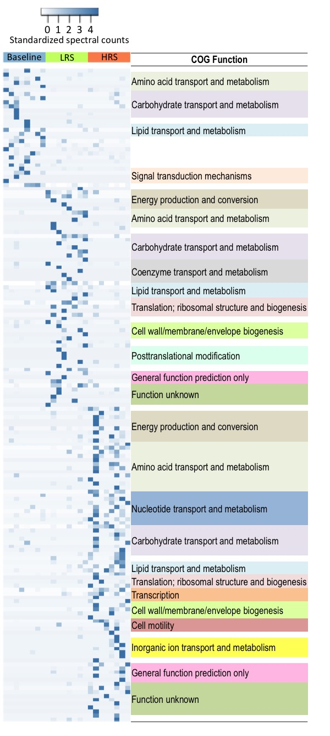
Figure 38 Heat-map of significant 166 COG terms. We standardized sum of transferred SC of each of COG terms. Deeper steel-blue color means higher expression level in diet metaproteome. COG terms are clustered by their expression pattern and broad functional term.
In HRS, energy production and uptake of changed nutrients are similarly expressed to LRS and baseline. However, cell wall and envelope biogenesis is turned on so that microbes may need to defense themselves from increase of competing or host immune system (COG04775, COG04932, COG00438, COG01209 and COG00793). Likewise to LRS, microbes are trying to express and modify appropriate proteins in order to adapt to the changed environment, high amount of RS (COG00233, COG01534, COG00255 and COG01190 for translation, COG00568, COG01158 and COG00781 for transcription and COG00576 and COG02077 for post-translational modification). Interestingly, HRS also has significantly enriched cell motility COG terms like LRS. This may mean that microbes were moving toward new energy source or seeking reduced pre-existing nutrients (COG00643, COG00840 and COG01450).

Conclusion

We could identify 57,398 proteins from 24 MS runs (8 patients * 3 diets). Of 57,398 proteins, 56,295 were from microbiome and 1,103 were host human proteins. This seriously unequal protein identification is caused by employing indirect methods and metagenome. Those two could dramatically increase the number of identified microbial proteins that are main targets of this study.
With this successful protein identification, we constructed GLMM-NB model to compare diet metaproteomes. Since the experiment design is based on cross over and fecal proteome is highly varied even within same group, we selected GLMM model by setting patients as random effect and diet types as fixed effect. NB is employed as null distribution of GLMM model because NB is effective to analyze count type data, such as spectrum counting of the diet metaproteome. On top of GLMM NB model, Cohen’s w was combined to enhance statistical power of hypothesis tests. This GLMM NB model and Cohen’s w could provide reliable statistical comparisons and were used for finding significantly changed proteins and functional analysis of the diet metaproteome. We could find 7,113 significantly changed proteins (94 from human and 7,018 from microbiome and metagenome). These significant proteins were picked by 0.0001 FDR and 1.0258 Cohen’s w
Functional analysis of the diet metaproteoe provided understanding of changes in human and microbial community. KEGG pathway analysis showed that functional changes of host are immune response and glucose uptake. COG analysis told that microbial community also had changes in energy generation, gene and protein expression and cell motility. As RS is increased, new species is growing rapidly, so existing microbes in the community prepared cell wall and envelop against changed environment.
Diet metaproteome is highly complicated and very huge data. However, QFAM could appropriately analyze the generated metaproteome and could give exciting insights about functional changes in human host and microbes. In spite of high variance within fecal replicates, GLMM NB and Cohen’s w could rigorously compared and gave interesting and reliable analysis results.

CHAPTER VI
Conclusions

Significance of QFAM in metaproteomics analysis tools

Asdfasdfasdfasdf

Future direction of QFAM

Asdfasdfasdfsadf

LIST OF REFERENCES

1. Pieper R, Huang S-T, Suh M-J (2014) Proteomics and Metaproteomics. Encyclopedia of Metagenomics: Springer. pp. 1-11.
2. Aerni SJ, Sirota M (2014) A Bioinformatics Guide for Molecular Biologists: Cold Spring Harbor Laboratory Press.
3. Wilmes P, Bond PL (2004) The application of two‐dimensional polyacrylamide gel electrophoresis and downstream analyses to a mixed community of prokaryotic microorganisms. Environmental Microbiology 6: 911-920.
4. Tanca A, Palomba A, Pisanu S, Deligios M, Fraumene C, et al. (2014) A straightforward and efficient analytical pipeline for metaproteome characterization. Microbiome 2: 1-16.
5. Ram RJ, VerBerkmoes NC, Thelen MP, Tyson GW, Baker BJ, et al. (2005) Community proteomics of a natural microbial biofilm. Science 308: 1915-1920.
6. Lacerda CM, Choe LH, Reardon KF (2007) Metaproteomic analysis of a bacterial community response to cadmium exposure. Journal of proteome research 6: 1145-1152.
7. Powell MJ, Sutton JN, Del Castillo CE, Timperman AT (2005) Marine proteomics: generation of sequence tags for dissolved proteins in seawater using tandem mass spectrometry. Marine chemistry 95: 183-198.
8. Schulze WX, Gleixner G, Kaiser K, Guggenberger G, Mann M, et al. (2005) A proteomic fingerprint of dissolved organic carbon and of soil particles. Oecologia 142: 335-343.
9. Hultman J, Waldrop MP, Mackelprang R, David MM, McFarland J, et al. (2015) Multi-omics of permafrost, active layer and thermokarst bog soil microbiomes. Nature.
10. Xiong W, Abraham P, Li Z, Pan C, Hettich RL (2015) Microbial metaproteomics for characterizing the range of metabolic functions and activities of human gut microbiota. Proteomics.
11. Lichtman JS, Marcobal A, Sonnenburg JL, Elias JE (2013) Host-centric proteomics of stool: a novel strategy focused on intestinal responses to the gut microbiota. Molecular & Cellular Proteomics 12: 3310-3318.
12. Yates JR, Ruse CI, Nakorchevsky A (2009) Proteomics by mass spectrometry: approaches, advances, and applications. Annual review of biomedical engineering 11: 49-79.
13. VerBerkmoes NC, Denef VJ, Hettich RL, Banfield JF (2009) Systems biology: functional analysis of natural microbial consortia using community proteomics. Nature Reviews Microbiology 7: 196-205.
14. Goodwin RJ, Lang AM, Allingham H, Borén M, Pitt AR (2010) Stopping the clock on proteomic degradation by heat treatment at the point of tissue excision. Proteomics 10: 1751-1761.
15. Hettich RL, Pan C, Chourey K, Giannone RJ (2013) Metaproteomics: harnessing the power of high performance mass spectrometry to identify the suite of proteins that control metabolic activities in microbial communities. Analytical chemistry 85: 4203-4214.
16. Wiśniewski JR, Zougman A, Nagaraj N, Mann M (2009) Universal sample preparation method for proteome analysis. Nature methods 6: 359-362.
17. Sharma R, Dill BD, Chourey K, Shah M, VerBerkmoes NC, et al. (2012) Coupling a detergent lysis/cleanup methodology with intact protein fractionation for enhanced proteome characterization. Journal of proteome research 11: 6008-6018.
18. Monera OD, Kay CM, Hodges RS (1994) Protein denaturation with guanidine hydrochloride or urea provides a different estimate of stability depending on the contributions of electrostatic interactions. Protein Science 3: 1984-1991.
19. Saveliev S, Engel L, Strauss E, Jones R, Rosenblatt M (2007) The Advantages to Using Arg-C, Elastase, Thermolysin and Pepsin for Protein Analysis. pp. Available from: http://www.promega.com/resources/pubhub/the-advantages-to-using-arg-c-elastase-thermolysin-and-pepsin-for-protein-analysis/.
20. Wu C, Tran JC, Zamdborg L, Durbin KR, Li M, et al. (2012) A protease for'middle-down'proteomics. Nature methods 9: 822-824.
21. Cannon J, Lohnes K, Wynne C, Wang Y, Edwards N, et al. (2010) High-throughput middle-down analysis using an orbitrap. Journal of proteome research 9: 3886-3890.
22. Zhou H, Ning Z, E. Starr A, Abu-Farha M, Figeys D (2011) Advancements in top-down proteomics. Analytical chemistry 84: 720-734.
23. Cox J, Mann M (2008) MaxQuant enables high peptide identification rates, individualized ppb-range mass accuracies and proteome-wide protein quantification. Nature biotechnology 26: 1367-1372.
24. Quenzer T, Robinson J, Bolanios B, Milgram E, Greig M. Automated accurate mass analysis using FTICR mass spectrometry; 2002.
25. Egertson JD, Kuehn A, Merrihew GE, Bateman NW, MacLean BX, et al. (2013) Multiplexed MS/MS for improved data-independent acquisition. Nature methods 10: 744-746.
26. Michalski A, Cox J, Mann M (2011) More than 100,000 detectable peptide species elute in single shotgun proteomics runs but the majority is inaccessible to data-dependent LC− MS/MS. Journal of proteome research 10: 1785-1793.
27. Purvine S, Yi EC, Goodlett DR (2003) Shotgun collision‐induced dissociation of peptides using a time of flight mass analyzer. Proteomics 3: 847-850.
28. Myung S, Lee YJ, Moon MH, Taraszka J, Sowell R, et al. (2003) Development of high-sensitivity ion trap ion mobility spectrometry time-of-flight techniques: a high-throughput nano-LC-IMS-TOF separation of peptides arising from a Drosophila protein extract. Analytical chemistry 75: 5137-5145.
29. Venable JD, Dong M-Q, Wohlschlegel J, Dillin A, Yates JR (2004) Automated approach for quantitative analysis of complex peptide mixtures from tandem mass spectra. Nature methods 1: 39-45.
30. Panchaud A, Scherl A, Shaffer SA, von Haller PD, Kulasekara HD, et al. (2009) Precursor acquisition independent from ion count: how to dive deeper into the proteomics ocean. Analytical chemistry 81: 6481-6488.
31. Egertson JD, MacLean B, Johnson R, Xuan Y, MacCoss MJ (2015) Multiplexed peptide analysis using data-independent acquisition and Skyline. Nature protocols 10: 887-903.
32. MacLean B, Tomazela DM, Shulman N, Chambers M, Finney GL, et al. (2010) Skyline: an open source document editor for creating and analyzing targeted proteomics experiments. Bioinformatics 26: 966-968.
33. Röst HL, Rosenberger G, Navarro P, Gillet L, Miladinović SM, et al. (2014) OpenSWATH enables automated, targeted analysis of data-independent acquisition MS data. Nature biotechnology 32: 219-223.
34. Distler U, Kuharev J, Navarro P, Levin Y, Schild H, et al. (2014) Drift time-specific collision energies enable deep-coverage data-independent acquisition proteomics. Nature methods 11: 167-170.
35. Doerr A (2015) DIA mass spectrometry. Nature Methods 12: 35-35.
36. Bantscheff M, Schirle M, Sweetman G, Rick J, Kuster B (2007) Quantitative mass spectrometry in proteomics: a critical review. Analytical and bioanalytical chemistry 389: 1017-1031.
37. Ong S-E, Blagoev B, Kratchmarova I, Kristensen DB, Steen H, et al. (2002) Stable isotope labeling by amino acids in cell culture, SILAC, as a simple and accurate approach to expression proteomics. Molecular & cellular proteomics 1: 376-386.
38. Gygi SP, Rist B, Gerber SA, Turecek F, Gelb MH, et al. (1999) Quantitative analysis of complex protein mixtures using isotope-coded affinity tags. Nature biotechnology 17: 994-999.
39. Ross PL, Huang YN, Marchese JN, Williamson B, Parker K, et al. (2004) Multiplexed protein quantitation in Saccharomyces cerevisiae using amine-reactive isobaric tagging reagents. Molecular & cellular proteomics 3: 1154-1169.
40. Thompson A, Schäfer J, Kuhn K, Kienle S, Schwarz J, et al. (2003) Tandem mass tags: a novel quantification strategy for comparative analysis of complex protein mixtures by MS/MS. Analytical chemistry 75: 1895-1904.
41. Belnap CP, Pan C, Denef VJ, Samatova NF, Hettich RL, et al. (2011) Quantitative proteomic analyses of the response of acidophilic microbial communities to different pH conditions. The ISME journal 5: 1152-1161.
42. Belnap CP, Pan C, VerBerkmoes NC, Power ME, Samatova NF, et al. (2010) Cultivation and quantitative proteomic analyses of acidophilic microbial communities. The ISME journal 4: 520-530.
43. Pan C, Fischer CR, Hyatt D, Bowen BP, Hettich RL, et al. (2011) Quantitative tracking of isotope flows in proteomes of microbial communities. Molecular & Cellular Proteomics 10: M110. 006049.
44. Taubert M, Jehmlich N, Vogt C, Richnow HH, Schmidt F, et al. (2011) Time resolved protein‐based stable isotope probing (Protein‐SIP) analysis allows quantification of induced proteins in substrate shift experiments. Proteomics 11: 2265-2274.
45. Pruitt KD, Tatusova T, Maglott DR (2007) NCBI reference sequences (RefSeq): a curated non-redundant sequence database of genomes, transcripts and proteins. Nucleic acids research 35: D61-D65.
46. Consortium U (2008) The universal protein resource (UniProt). Nucleic acids research 36: D190-D195.
47. Markowitz VM, Chen I-MA, Palaniappan K, Chu K, Szeto E, et al. (2012) IMG: the integrated microbial genomes database and comparative analysis system. Nucleic acids research 40: D115-D122.
48. Seidler J, Zinn N, Boehm ME, Lehmann WD (2010) De novo sequencing of peptides by MS/MS. Proteomics 10: 634-649.
49. Eng JK, McCormack AL, Yates JR (1994) An approach to correlate tandem mass spectral data of peptides with amino acid sequences in a protein database. Journal of the American Society for Mass Spectrometry 5: 976-989.
50. Cottrell JS, London U (1999) Probability-based protein identification by searching sequence databases using mass spectrometry data. electrophoresis 20: 3551-3567.
51. Craig R, Beavis RC (2004) TANDEM: matching proteins with tandem mass spectra. Bioinformatics 20: 1466-1467.
52. Geer LY, Markey SP, Kowalak JA, Wagner L, Xu M, et al. (2004) Open mass spectrometry search algorithm. Journal of proteome research 3: 958-964.
53. Tabb DL, Fernando CG, Chambers MC (2007) MyriMatch: highly accurate tandem mass spectral peptide identification by multivariate hypergeometric analysis. Journal of proteome research 6: 654-661.
54. Kim S, Pevzner PA (2014) MS-GF+ makes progress towards a universal database search tool for proteomics. Nature communications 5.
55. McHugh L, Arthur JW (2008) Computational methods for protein identification from mass spectrometry data. PLoS computational biology 4: e12.
56. Kim S, Gupta N, Bandeira N, Pevzner PA (2009) Spectral dictionaries integrating de novo peptide sequencing with database search of tandem mass spectra. Molecular & Cellular Proteomics 8: 53-69.
57. Bjornson RD, Carriero NJ, Colangelo C, Shifman M, Cheung K-H, et al. (2007) X!! Tandem, an improved method for running X! tandem in parallel on collections of commodity computers. The Journal of Proteome Research 7: 293-299.
58. Mohammed Y, Mostovenko E, Henneman AA, Marissen RJ, Deelder AM, et al. (2012) Cloud parallel processing of tandem mass spectrometry based proteomics data. Journal of proteome research 11: 5101-5108.
59. Elias JE, Gygi SP (2007) Target-decoy search strategy for increased confidence in large-scale protein identifications by mass spectrometry. Nature methods 4: 207-214.
60. Gupta N, Bandeira N, Keich U, Pevzner PA (2011) Target-decoy approach and false discovery rate: when things may go wrong. Journal of the American Society for Mass Spectrometry 22: 1111-1120.
61. Craig R, Cortens J, Fenyo D, Beavis RC (2006) Using annotated peptide mass spectrum libraries for protein identification. Journal of proteome research 5: 1843-1849.
62. Yen C-Y, Houel S, Ahn NG, Old WM (2011) Spectrum-to-spectrum searching using a proteome-wide spectral library. Molecular & Cellular Proteomics 10: M111. 007666.
63. Dasari S, Chambers MC, Martinez MA, Carpenter KL, Ham A-JL, et al. (2012) Pepitome: evaluating improved spectral library search for identification complementarity and quality assessment. Journal of proteome research 11: 1686-1695.
64. Tabb DL, McDonald WH, Yates JR (2002) DTASelect and Contrast: tools for assembling and comparing protein identifications from shotgun proteomics. Journal of proteome research 1: 21-26.
65. Keller A, Nesvizhskii AI, Kolker E, Aebersold R (2002) Empirical statistical model to estimate the accuracy of peptide identifications made by MS/MS and database search. Analytical chemistry 74: 5383-5392.
66. Searle BC (2010) Scaffold: a bioinformatic tool for validating MS/MS‐based proteomic studies. Proteomics 10: 1265-1269.
67. Meyer-Arendt K, Old WM, Houel S, Renganathan K, Eichelberger B, et al. (2011) IsoformResolver: A peptide-centric algorithm for protein inference. Journal of proteome research 10: 3060-3075.
68. Zhang B, Chambers MC, Tabb DL (2007) Proteomic parsimony through bipartite graph analysis improves accuracy and transparency. Journal of proteome research 6: 3549-3557.
69. Käll L, Canterbury JD, Weston J, Noble WS, MacCoss MJ (2007) Semi-supervised learning for peptide identification from shotgun proteomics datasets. Nature methods 4: 923-925.
70. Mondav R, Woodcroft BJ, Kim E-H, McCalley CK, Hodgkins SB, et al. (2014) Discovery of a novel methanogen prevalent in thawing permafrost. Nature communications 5.
71. Zhang Y, Wen Z, Washburn MP, Florens L (2010) Refinements to label free proteome quantitation: how to deal with peptides shared by multiple proteins. Analytical chemistry 82: 2272-2281.
72. Zybailov B, Mosley AL, Sardiu ME, Coleman MK, Florens L, et al. (2006) Statistical Analysis of Membrane Proteome Expression Changes in Saccharomyces c erevisiae. Journal of proteome research 5: 2339-2347.
73. Erickson AR, Cantarel BL, Lamendella R, Darzi Y, Mongodin EF, et al. (2012) Integrated metagenomics/metaproteomics reveals human host-microbiota signatures of Crohn's disease. PloS one 7: e49138.
74. Ishihama Y, Oda Y, Tabata T, Sato T, Nagasu T, et al. (2005) Exponentially modified protein abundance index (emPAI) for estimation of absolute protein amount in proteomics by the number of sequenced peptides per protein. Molecular & Cellular Proteomics 4: 1265-1272.
75. Li M, Gray W, Zhang H, Chung CH, Billheimer D, et al. (2010) Comparative shotgun proteomics using spectral count data and quasi-likelihood modeling. Journal of proteome research 9: 4295-4305.
76. Ltd Lr (2013) 1-way ANOVA lecture note. pp. https://statistics.laerd.com/statistical-guides/one-way-anova-statistical-guide-2.php.
77. Goecks J, Nekrutenko A, Taylor J (2010) Galaxy: a comprehensive approach for supporting accessible, reproducible, and transparent computational research in the life sciences. Genome Biol 11: R86.
78. Muth T, Behne A, Heyer R, Kohrs F, Benndorf D, et al. (2015) The MetaProteomeAnalyzer: a powerful open-source software suite for metaproteomics data analysis and interpretation. Journal of proteome research 14: 1557-1565.
79. Park CY, Klammer AA, Käll L, MacCoss MJ, Noble WS (2008) Rapid and accurate peptide identification from tandem mass spectra. Journal of proteome research 7: 3022-3027.
80. Tanner S, Shu H, Frank A, Wang L-C, Zandi E, et al. (2005) InsPecT: identification of posttranslationally modified peptides from tandem mass spectra. Analytical chemistry 77: 4626-4639.
81. Kanehisa M, Goto S (2000) KEGG: kyoto encyclopedia of genes and genomes. Nucleic acids research 28: 27-30.
82. Webb EC (1992) Enzyme nomenclature 1992. Recommendations of the Nomenclature Committee of the International Union of Biochemistry and Molecular Biology on the Nomenclature and Classification of Enzymes: Academic Press.
83. Federhen S (2012) The NCBI taxonomy database. Nucleic acids research 40: D136-D143.
84. Geer LY, Marchler-Bauer A, Geer RC, Han L, He J, et al. (2009) The NCBI biosystems database. Nucleic acids research: gkp858.
85. Tatusov RL, Koonin EV, Lipman DJ (1997) A genomic perspective on protein families. Science 278: 631-637.
86. Wickham H (2009) ggplot2: elegant graphics for data analysis: Springer Science & Business Media.
87. Gross ML, Chen G, Pramanik B (2011) Protein and peptide mass spectrometry in drug discovery: John Wiley & Sons.
88. Piehowski PD, Petyuk VA, Orton DJ, Xie F, Moore RJ, et al. (2013) Sources of technical variability in quantitative LC–MS proteomics: human brain tissue sample analysis. Journal of proteome research 12: 2128-2137.
89. Benjamini Y, Hochberg Y (1995) Controlling the false discovery rate: a practical and powerful approach to multiple testing. Journal of the Royal Statistical Society Series B (Methodological): 289-300.
90. Khatri P, Sirota M, Butte AJ (2012) Ten years of pathway analysis: current approaches and outstanding challenges. PLoS Comput Biol 8: e1002375.
91. Caspi R, Altman T, Billington R, Dreher K, Foerster H, et al. (2014) The MetaCyc database of metabolic pathways and enzymes and the BioCyc collection of Pathway/Genome Databases. Nucleic acids research 42: D459-D471.
92. Croft D, Mundo AF, Haw R, Milacic M, Weiser J, et al. (2014) The Reactome pathway knowledgebase. Nucleic acids research 42: D472-D477.
93. Schaefer CF, Anthony K, Krupa S, Buchoff J, Day M, et al. (2009) PID: the pathway interaction database. Nucleic acids research 37: D674-D679.
94. Ashburner M, Ball CA, Blake JA, Botstein D, Butler H, et al. (2000) Gene Ontology: tool for the unification of biology. Nature genetics 25: 25-29.
95. Maglott D, Ostell J, Pruitt KD, Tatusova T (2005) Entrez Gene: gene-centered information at NCBI. Nucleic acids research 33: D54-D58.
96. Pruitt KD, Maglott DR (2001) RefSeq and LocusLink: NCBI gene-centered resources. Nucleic acids research 29: 137-140.
97. Van Der Walt S, Colbert SC, Varoquaux G (2011) The NumPy array: a structure for efficient numerical computation. Computing in Science & Engineering 13: 22-30.
98. Jones E, Oliphant T, Peterson P (2014) {SciPy}: Open source scientific tools for {Python}.
99. Kristensen DM, Kannan L, Coleman MK, Wolf YI, Sorokin A, et al. (2010) A low-polynomial algorithm for assembling clusters of orthologous groups from intergenomic symmetric best matches. Bioinformatics 26: 1481-1487.
100. Marchler-Bauer A, Panchenko AR, Shoemaker BA, Thiessen PA, Geer LY, et al. (2002) CDD: a database of conserved domain alignments with links to domain three-dimensional structure. Nucleic acids research 30: 281-283.
101. Altschul SF, Madden TL, Schäffer AA, Zhang J, Zhang Z, et al. (1997) Gapped BLAST and PSI-BLAST: a new generation of protein database search programs. Nucleic acids research 25: 3389-3402.
102. Halsey LG, Curran-Everett D, Vowler SL, Drummond GB (2015) The fickle P value generates irreproducible results. Nature methods 12: 179-185.
103. Button KS, Ioannidis JP, Mokrysz C, Nosek BA, Flint J, et al. (2013) Power failure: why small sample size undermines the reliability of neuroscience. Nature Reviews Neuroscience 14: 365-376.
104. Sullivan GM, Feinn R (2012) Using effect size-or why the P value is not enough. Journal of graduate medical education 4: 279-282.
105. Gregori J, Villarreal L, Sánchez A, Baselga J, Villanueva J (2013) An effect size filter improves the reproducibility in spectral counting-based comparative proteomics. Journal of Proteomics 95: 55-65.
106. Tusher VG, Tibshirani R, Chu G (2001) Significance analysis of microarrays applied to the ionizing radiation response. Proceedings of the National Academy of Sciences 98: 5116-5121.
107. Gregori J, Sanchez A, Villanueva J (2013) msmsTests. Bioconductor. pp. msmsTests, http://www.bioconductor.org/packages/release/bioc/html/msmsTests.html.
108. Kabacoff RI (2014) Power Analysis. Quick-R. pp. Power Analysis, http://www.statmethods.net/stats/power.html.
109. Cohen J (2013) Statistical power analysis for the behavioral sciences: Academic press.
110. Stephane Champely CE, Peter Dalgaard, Jeffrey Gill, Helios De Rosario (2015) R package 'pwr'. CRAN. pp. R package 'pwr' ver. 1.1-2, power analysis functions along the lines of Jacob Cohen.
111. Wikipedia (2014) Effect size. Wikipedia. pp. http://en.wikipedia.org/wiki/Effect_size.
112. Venables WN, Ripley BD (2002) Modern applied statistics with S: Springer Science & Business Media.
113. Cohen J (1990) Things I have learned (so far). American psychologist 45: 1304.
114. Cohen J (1992) A power primer. Psychological bulletin 112: 155.
115. Ioannidis JP (2005) Why most published research findings are false. PLoS medicine 2: e124.
116. Choi H, Fermin D, Nesvizhskii AI (2008) Significance analysis of spectral count data in label-free shotgun proteomics. Molecular & cellular proteomics 7: 2373-2385.
117. Claesson MJ, Jeffery IB, Conde S, Power SE, O’Connor EM, et al. (2012) Gut microbiota composition correlates with diet and health in the elderly. Nature 488: 178-184.
118. Pacheco AR, Curtis MM, Ritchie JM, Munera D, Waldor MK, et al. (2012) Fucose sensing regulates bacterial intestinal colonization. Nature 492: 113-117.
119. Jostins L, Ripke S, Weersma RK, Duerr RH, McGovern DP, et al. (2012) Host-microbe interactions have shaped the genetic architecture of inflammatory bowel disease. Nature 491: 119-124.
120. Qin J, Li Y, Cai Z, Li S, Zhu J, et al. (2012) A metagenome-wide association study of gut microbiota in type 2 diabetes. Nature 490: 55-60.
121. Verberkmoes NC, Russell AL, Shah M, Godzik A, Rosenquist M, et al. (2009) Shotgun metaproteomics of the human distal gut microbiota. The ISME journal 3: 179-189.
122. Xiong W, Abraham PE, Li Z, Pan C, Hettich RL (2015) Microbial metaproteomics for characterizing the range of metabolic functions and activities of human gut microbiota. Proteomics.
123. Fouts DE, Pieper R, Szpakowski S, Pohl H, Knoblach S, et al. (2012) Integrated next-generation sequencing of 16S rDNA and metaproteomics differentiate the healthy urine microbiome from asymptomatic bacteriuria in neuropathic bladder associated with spinal cord injury. J Transl Med 10: 174.
124. Cohen J (1992) Statistical power analysis. Current directions in psychological science: 98-101.
125. Tatusov RL, Natale DA, Garkavtsev IV, Tatusova TA, Shankavaram UT, et al. (2001) The COG database: new developments in phylogenetic classification of proteins from complete genomes. Nucleic acids research 29: 22-28.
126. Madsen J, Mollenhauer J, Holmskov U (2010) Review: Gp-340/DMBT1 in mucosal innate immunity. Innate immunity 16: 160-167.
127. Verberkmoes NC, Russell AL, Shah M, Godzik A, Rosenquist M, et al. (2008) Shotgun metaproteomics of the human distal gut microbiota. The ISME journal 3: 179-189.
128. Sun Y, Wright H, Janciauskiene S (2002) Glioma cell activation by Alzheimer's peptide Aβ 1–42, α 1-antichymotrypsin, and their mixture. Cellular and Molecular Life Sciences CMLS 59: 1734-1743.
129. Kim M-S, Pinto SM, Getnet D, Nirujogi RS, Manda SS, et al. (2014) A draft map of the human proteome. Nature 509: 575-581.
130. Ortutay C, Vihinen M (2006) Immunome: a reference set of genes and proteins for systems biology of the human immune system. Cellular immunology 244: 87-89.
131. Ortutay C, Siermala M, Vihinen M (2007) Molecular characterization of the immune system: emergence of proteins, processes, and domains. Immunogenetics 59: 333-348.
132. Lynn DJ, Winsor GL, Chan C, Richard N, Laird MR, et al. (2008) InnateDB: facilitating systems‐level analyses of the mammalian innate immune response. Molecular systems biology 4.
133. Diehl AD, Lee JA, Scheuermann RH, Blake JA (2007) Ontology development for biological systems: immunology. Bioinformatics 23: 913-915.
134. Harada N, Iijima S, Kobayashi K, Yoshida T, Brown WR, et al. (1997) Human IgGFc binding protein (FcγBP) in colonic epithelial cells exhibits mucin-like structure. Journal of Biological Chemistry 272: 15232-15241.
135. Johansson ME, Thomsson KA, Hansson GC (2009) Proteomic analyses of the two mucus layers of the colon barrier reveal that their main component, the Muc2 mucin, is strongly bound to the Fcgbp protein. Journal of proteome research 8: 3549-3557.
136. Velliyagounder K, Kaplan JB, Furgang D, Legarda D, Diamond G, et al. (2003) One of two human lactoferrin variants exhibits increased antibacterial and transcriptional activation activities and is associated with localized juvenile periodontitis. Infection and immunity 71: 6141-6147.
137. Ando K, Hasegawa K, Shindo Ki, Furusawa T, Fujino T, et al. (2010) Human lactoferrin activates NF‐κB through the Toll‐like receptor 4 pathway while it interferes with the lipopolysaccharide‐stimulated TLR4 signaling. FEBS journal 277: 2051-2066.
138. Roth W, Kumar V, Beer H-D, Richter M, Wohlenberg C, et al. (2012) Keratin 1 maintains skin integrity and participates in an inflammatory network in skin through interleukin-18. Journal of cell science 125: 5269-5279.
139. Gebhardt C, Németh J, Angel P, Hess J (2006) S100A8 and S100A9 in inflammation and cancer. Biochemical pharmacology 72: 1622-1631.
140. Taheri M, Saragovi U, Fuks A, Makkerh J, Mort J, et al. (2000) Self recognition in the Ig superfamily Identification of precise subdomains in carcinoembryonic antigen required for intercellular adhesion. Journal of Biological Chemistry 275: 26935-26943.
141. Zhang B, VerBerkmoes NC, Langston MA, Uberbacher E, Hettich RL, et al. (2006) Detecting differential and correlated protein expression in label-free shotgun proteomics. Journal of proteome research 5: 2909-2918.
142. Yin Y, Yu G, Chen Y, Jiang S, Wang M, et al. (2012) Genome-wide transcriptome and proteome analysis on different developmental stages of Cordyceps militaris. PloS one 7: e51853.
143. Zeng J, Liu Y, Liu W, Liu X, Liu F, et al. (2013) Integration of transcriptome, proteome and metabolism data reveals the alkaloids biosynthesis in Macleaya cordata and Macleaya microcarpa. PloS one 8: e53409.
144. Walker AW, Ince J, Duncan SH, Webster LM, Holtrop G, et al. (2011) Dominant and diet-responsive groups of bacteria within the human colonic microbiota. The ISME journal 5: 220-230.
145. Ley RE, Turnbaugh PJ, Klein S, Gordon JI (2006) Microbial ecology: human gut microbes associated with obesity. Nature 444: 1022-1023.
146. Turnbaugh PJ, Bäckhed F, Fulton L, Gordon JI (2008) Diet-induced obesity is linked to marked but reversible alterations in the mouse distal gut microbiome. Cell host & microbe 3: 213-223.
147. Walter J, Ley R (2011) The human gut microbiome: ecology and recent evolutionary changes. Annual review of microbiology 65: 411-429.
148. Englyst HN, Kingman S, Cummings J (1992) Classification and measurement of nutritionally important starch fractions. European journal of clinical nutrition 46: S33-50.
149. Duncan SH, Belenguer A, Holtrop G, Johnstone AM, Flint HJ, et al. (2007) Reduced dietary intake of carbohydrates by obese subjects results in decreased concentrations of butyrate and butyrate-producing bacteria in feces. Applied and environmental microbiology 73: 1073-1078.
150. Martínez I, Kim J, Duffy PR, Schlegel VL, Walter J (2010) Resistant starches types 2 and 4 have differential effects on the composition of the fecal microbiota in human subjects. PloS one 5: e15046-e15046.
151. Abell GC, Cooke CM, Bennett CN, Conlon MA, McOrist AL (2008) Phylotypes related to Ruminococcus bromii are abundant in the large bowel of humans and increase in response to a diet high in resistant starch. FEMS microbiology ecology 66: 505-515.
152. Leitch E, Walker AW, Duncan SH, Holtrop G, Flint HJ (2007) Selective colonization of insoluble substrates by human faecal bacteria. Environmental microbiology 9: 667-679.
153. De Filippo C, Cavalieri D, Di Paola M, Ramazzotti M, Poullet JB, et al. (2010) Impact of diet in shaping gut microbiota revealed by a comparative study in children from Europe and rural Africa. Proceedings of the National Academy of Sciences 107: 14691-14696.
154. Kuznetsova A, Brockhoff PB, Christensen RHB (2013) lmerTest: Tests for random and fixed effects for linear mixed effect models (lmer objects of lme4 package). R package version 2.
155. Robinson MD, McCarthy DJ, Smyth GK (2010) edgeR: a Bioconductor package for differential expression analysis of digital gene expression data. Bioinformatics 26: 139-140.
156. Anders S, Huber W (2010) Differential expression analysis for sequence count data. Genome biol 11: R106.

APPENDIX
[Remove this note, but DO NOT REMOVE THIS PAGE, AND/OR DO NOT PUT APPENDIX MATERIAL ON THIS PAGE – you can change “Appendix” to “Appendices” if you would like, but this is the ONLY text that should be on this page. The actual appendix material should start at the top of the NEXT page.]
You’ll put appendix material here. This section is optional. You can place tables and figures in the appendix if you like. If you choose this option, you should indicate that tables and figures are in the appendix after the first mention in the text. You can place some tables/figures in the text and others in the appendix.
Vita

Jane X. Doe was born. She wrote a thesis. She graduated. She followed instructions and wrote her vita in third person and paragraph form (as opposed to a resume or CV), which made her thesis consultant very happy. This page is required.

