Addressing inertia and grid strength
of operating high renewable grids

A Dissertation Presented for the Doctor of Philosophy Degree
The University of Tennessee, Knoxville

Chang Chen June 2024

© by Chang Chen, 2024 All Rights Reserved.

dedication...

Acknowledgements

I would like to thank...

Some quotation...

Abstract

The power grid architecture is undergoing substantial transformation as efforts are made to phase out generators that produce greenhouse gases and replace them with renewable energy sources. While inverter-based renewable (IBRs) energy resources supply clean energy to electricity customers, they also pose challenges to grid strength and system inertia. The grid strength is weakened with IBRs connected, potentially leading to voltage stability and reliability issues, especially during large events such as Fault-Induced Delayed Voltage Response (FIDVR). Therefore, studies focus on FIDVR events, using IBRs to mitigate FIDVR, and assessing grid strength with IBRs.
Another challenge introduced by IBRs is decreasing system inertia. Low inertia reduces the system's ability to suppress frequency variations when there are power changes. To help operators avoid low inertia situations and maintain system stability, an online power system inertia monitoring system based on the Bath County Pumped Storage Hydropower (PSH) plant turn-off operations has been developed. This approach utilizes PSH turn-off event signatures for detection and employs improved inertia estimation for more accurate results. Additionally, the second-largest PSH plant is studied, providing supplementary estimates for EI inertia estimation. To provide continuous inertia estimates, the feasibility of using ambient data for system inertia estimation is explored.
The complexity of an IBR-connected grid necessitates high-resolution data, which challenges network communication and data storage. To address this, novel data compression methods are proposed to compress high-resolution synchrophasor and point-on-wave data.
The studies in the thesis evaluates the grid strength and inertia with the IBRs penetrations with the PSS/e simulations and the field PMU measurements, making efforts on a stable system operation for the large interconnection power system such as the EI.

Contents

Contents
List of Figures 11
Chapter 1 Introduction 12
1.1 Background and Motivation 12
1.2 Dissertation Outline 14
Chapter 2 Allocation of battery energy storage systems (BESS) to mitigate Fault-Induced Delayed Voltage Recovery (FIDVR) in the Eastern Interconnection Power System 15
2.1 Introduction 15
2.2 BESS control options and parameters 17
2.3 The Con Edison of New York PSS/e model with different fault locations 18
2.4 BESS capacity impact 20
2.5 The effect of the BESS distribution 24
2.5.1. Deploy one BESS 24
2.5.2. Deploy multiple BESS at different locations 24
2.5.3. Deploy Large BESS at large load bus1 26
2.6 Short Circuit Ratio Analysis with BESS integrated. 26
2.6.1. BESS integrated in 23-bus system 26
2.6.2. BESS integrated in the EI system with over 3000buses 28
2.7 Results and Conclusions2 31
Chapter 3 Online Power System Inertia Estimation based on the Pump Storage Hydropower Turn-off Signatures 33
3.1 Introduction 33
3.2 Support Methodology and Background 35
3.2.1. Potential of utilizing PSH switching-off event for inertia estimation 35
3.2.2. FNET/GridEye Inertia Monitoring System 37
3.3 PSH Turn-off Event Detection 39
3.3.1. Trigger step 1: PSH Turn-off Event Signatures 39
3.3.2. Trigger step 2: fine rules for false alarm filtering 40
3.3.3. Real-Time PSH Turn-off Event Detection Trigger Overview 41
3.4 PSH Turn-off Event-Based Inertia Estimation 42
3.4.1. PSH Turn-off Event Start Time 42
3.4.2. Improvement on Inertia Calculation 43
3.4.3. .RoCoF Calculation methods 44
3.4.4. Validation on the improved RoCoF 45
3.5 Field Tests Result 48
3.5.1. Event Detection 48
3.5.2. Inertia Estimation 49
3.6 <TBC>Generation trip test 49
3.7 Conclusion 52
Chapter 4 <TBC>EI inertia estimation based on ambient data 53
4.1 Introduction 53
4.2 Inertia estimation based on ambient data. 53
4.3 Performance Evaluation 53
4.4 Conclusion 53
Chapter 5 High Density Synchrophasor Lossless Data Compression for Efficient Data Storage 54
5.1 Introduction 54
5.2 Improved-TSSC Frequency Compression Method 56
5.2.1. UHD Frequency Data Characteristics 57
5.2.2. ITSSC Method for UHD Frequency Data 58
5.2.3. Compression Performance 60
5.2.4. Compression Example 60
5.3 Phase Angle Compression Method 61
5.3.1. UHD Phase Angle Data Characteristics 61
5.3.2. Preprocessing algorithms 62
5.3.3. Encoding techniques 63
5.3.4. Huffman-TSSC Phase Angle Compression Algorithm 63
5.4 Point on Wave Data Compression 65
5.4.1. UHD Point on Wave Data Characteristics 65
5.4.2. CHDM-VB Compression Method 67
5.5 Data Compression Tests 69
5.5.1. UHD Frequency Compression Tests 71
5.5.2. UHD Phase Angle Compression Tests 72
5.5.3. UHD Synchrophasor Data Online Compression Tests 73
5.5.4. UHD POW Data Compression Tests 75
5.6 Conclusion 78
Vita 90

List of Tables

List of Figures

Chapter 1 Introduction

Background and Motivation

The power grid architecture is undergoing a substantial transformation with the current efforts to phase out the generators that produce greenhouse gases and replace them with renewable energy [1]. While the inverter-based renewable energy resources (IB-RERs) supply clean energy to electricity customers, they pose many challenges in grid planning and operation.
The IB-RERs provide expected real and reactive power based on the electronic controls, which separate the power source from the grid. An associated challenge with high instantaneous penetrations of grid-following IB-RERs is the reduction of synchronous generation results in a weak grid. Under weak grid conditions, the grid voltage is sensitive to active and reactive power disturbances, which may result in potential voltage stability and grid reliability issues. Such weak grid issues are becoming prominent due to the variability and uncertainty of renewable generation. In such a case, the system may lack the capability to return to normal operation after a big event, such as the Fault-Induced Delayed Voltage Recovery (FIDVR). FIDVR is a phenomenon when the power system voltage remains at a substantially reduced level several seconds after a transmission fault is cleared . FIDVR is caused by the widespread installing of residential single-phase induction motors. During a FIDVR event, it may take up to 30 seconds for the system voltage to return to normal. The long duration of the low-voltage scenarios during the FIDVR posts challenges the power system, especially to the weak system with high IBRs penetrated.
As renewable penetration increases, another key challenge is the lack of system inertia. Inertia in power systems refers to the ability of the system to suppress frequency variations in the presence of power imbalance. With the increasing deployment of renewable energy sources, the system inertia is gradually decreased, which deteriorates the system stability. An accurate online system inertia monitor is valuable to ensure the system will respond adequately to sudden changes in frequency, which plays a crucial role in the power system operation and planning. Many studies have been conducted to estimate the power system inertia in real time. These inertia estimation approaches can be roughly classified into 4 categories, the dispatch-based, event-based, ambient-based and probing-based methods [4]. Among all these algorithms, the event-based method provides the highest accuracy of inertia estimates. Therefore, an event-based online inertia monitoring system should be considered for the EI system. The main drawback of the event-based algorithms is that it does not provide continuous estimated inertia. To overcome this, an ambient-based inertia monitoring system should also be developed as a supplementary.
To monitor and analyze the power system dynamics, ensure the stability of the power system, it is essential for the Phasor Measurement Unit (PMU) to provide Ultra-High-Density (UHD) data. Recently, the advanced PMUs developed by FNET/GridEye are reported to provide synchrophasor and Point on Wave (POW) data at an extremely high reporting rate, e.g. 6000 Hz, which is much faster than other devices that have been recorded [1]-[3]. However, the UHD data will significantly challenge the underlying communication network and the server storage due to its massive data size [4]. Therefore, intelligent online compression methods are essential for UHD data to maintain the efficiency of communication and storage.
In this dessertaion, the two key challenges of operating the high-renewable penetration power system, i.e. the grid strength and the system inertia, are discussed based on the combination analysis of the field measurements and power system simulations via the PSS/e in several ways:
    - FIDVR events are studied based on the PSS/e simulations. The potential of mitigating the FIDVR with the Battery Energy Storage System (BESS) for the Eastern Interconnection (EI) is studied, and the system strength is evaluated.
    - The online inertia monitoring systems are designed with the field measurements for the EI system. An event-based inertia monitoring system is developed to provide accurate inertia estimates, and an ambient inertia monitoring system is developed to give continuous inertia monitoring.
    - To build a reliable communication system for the high-resolution data, lossy data compression methods are developed. The methods aims at compressing the UHD synchrophasor data and the POW data effectively and losslessly.

Dissertation Outline

This section presents an outline of the rest of the chapters in this dissertation.
    - Chapter 2 studies the potential of mitigating the FIDVR with the BESS in the EI power system with the PSS/e simulation. The short-circuit ratio of the system is assessed to evaluate the strength of the power system.
    - Chapter 3 proposed a novel online inertia monitoring system based on the pump storage hydro switching-off event signatures. An improved RoCoF calculation method is proposed for accurate inertia estimation.
    - Chapter 4 studies the inertia based on the ambient power system frequency data and the system generation data.
    - Chapter 5 proposed algorithms to compress the UHD synchrophasor data and the POW data to provide effective and lossless data compression for the modern high-resolution PMUs.

Chapter 2 Allocation of battery energy storage systems (BESS) to mitigate Fault-Induced Delayed Voltage Recovery (FIDVR) in the Eastern Interconnection Power System

Introduction

Fault-Induced Delayed Voltage Recovery (FIDVR) is a phenomenon when the power system voltage remains at a substantially reduced level several seconds after a transmission fault is cleared [1]. FIDVR is caused by the widespread installing of residential single-phase induction motors, such as AC conditioners [2]. In the system with large load proportion and constant torque characteristics of single-phase induction motor, when the system voltage drops to a lower value under fault conditions, the motor stalls [3][4]. These types of low inertia motors absorb a large amount of reactive power from the grid under low voltage conditions. The current consumed by these motors under such stall or locked rotor conditions is 5-6 times of their steady-state current. Therefore, the system voltage remains in the reduced state for a long time until the thermal protection trips the single-phase motor load. Once the motor is removed from the system, the system voltage will gradually recover. During a FIDVR event, it may take up to 30 seconds for the system voltage to return to normal. The consequences of FIDVR events may be voltage collapse and multiple cascading events on the power system[5].
With the increasing integration of inverter-based renewables, e.g., battery energy storage systems, winds and solar PVs, it is feasible to use these inverters’ fast reactive power modulation capability to provide voltage support during FIDVR events. Battery energy storage systems (BESS) is one of the energy storage technologies that has been widely adopted in the current power industry in the U.S. A BESS equipped with a suitably inverter can perform both active power control and reactive power control. This allows a BESS to provide reactive power to support the system voltage during FIDVR events.
There are multiple literatures studied on mitigating FIDVR with inverter-based devices. For example, ref. [6]-[8] presented control strategies for STATCOM, energy storage systems to alleviate FIDVR. However, these studies carried out simulations with small systems, such as the IEEE 13 or 57 example bus system. In practice, the system is relatively much larger, which may affect the FIDVR mitigation result.
ConEdison of New York operates one of the world’s largest energy delivery systems. Recently, they experienced a few FIDVR events and expected several BESS to be installed in its system. In this paper, simulations are carried out with the ConEdison of New York PSS/e model, which consists of almost 90,000 buses. Different battery energy storage systems (BESS) control strategy, size, locations are tested to understand the allocation of BESS to mitigate FIDVR in the ConEdison Transmission Systems.
This paper is organized as follows: In Section II, different 3-phase short circuit fault locations are simulated to find a more obvious FIDVR event for the following simulation. In Section III, Based on this event, different reactive power control options are all tested to design a control strategy for the BESS to mitigate FIDVR. Sensitivity studies are carried out to find the optimal parameters under each control options. In Section IV, simulations with different BESS sizes are also carried out. Since Con Edison is more interested in the voltage at 5 second after fault is cleared (tfault+5s), this study calculated the voltage improvement with the help of BESS being installed at tfault.. Section V tests the effect of BESS distribution for different bus voltage levels and BESS sizes. Section VI summaries the finding in this study.

BESS control options and parameters
BESS models that are introduced by the WECC Renewable Energy Modeling Task Force have a variety of control options for real power control and reactive power control [3]. To support system voltage, the 8 reactive power control options are tested in Con Edison’s model. Through simulations, we found the optimal parameter combinations for 3 control options that performs better than the default parameters. The optimal parameters for these 3 options are shown in Table 1, where parameters that are not shown in this table are still the default values.

Table 1 optimal parameters for control options that have good voltage support during FIDVR
Control option number |  | (1) | (2) | (3)
Tuned parameters | Iqh1 (Upper limit on reactive current injection) | 1 | 1 | 1
Tuned parameters | Vref0 (User defined reference) | 1.3 | 1.3 | 1.3
Tuned parameters | Vup(voltage above which reactive current injection logic is activated) | 1 | --- | ---
Tuned parameters | Trv (voltage filter time constant) | 0.8 | --- | ---
Tuned parameters | Kqv (reactive current injection gain during over and undervoltage conditions) | 30 | --- | ---
Tuned parameters | Kqi (Reactive power regulator integral gain) | 0 | --- | ---
Tuned parameters | Kvi (Voltage regulator integral gain) | 10 | --- | ---
Tuned parameters | Vdip (low voltage threshold to activate reactive current injection logic) | 1 | --- | ---
* "---" indicates that the parameter is the default value
Figure 2 shows the bus voltage response and the BESS reactive power output. Since the control option (3) generates more reactive power among all the options, the rest of the simulations in this paper adopts the control option (3).
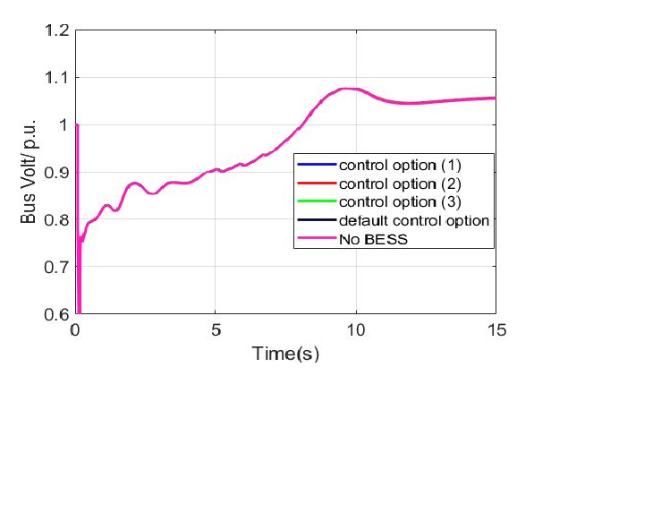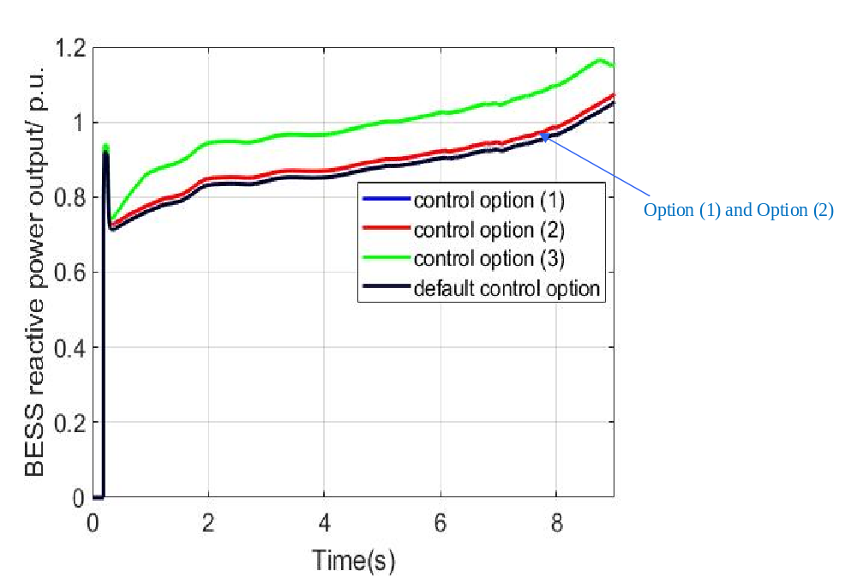
Figure 2 Voltage (left) and BESS reactive power output (right) at bus Bus_66[345kV] when BESS is located at the bus Bus_84[345kV]

The Con Edison of New York PSS/e model with different fault locations

Fault location affects the FIDVR voltage response. In this subsection, the 3-phase short-circuit fault is applied to different buses. According to the Con Edison of New York PSS/e model, buses that are associated with the top 2 largest loads for each voltage level are selected as the fault location candidatess as the below:
- Bus_77[345kV] ​ for station transmission Station_F
- Bus_04[345kV] for station transmission Station_W
- Bus_34[138kV] for station transmission Station_G
- Bus_84[138kV] ​ for station transmission station E
Con Edison recorded a real event that has an obvious FIDVR, which in the simulation system operated as: a 3-phase short-circuit fault happened at 0.1s at a 345kV bus Bus_66[345kV]. At 0.19s, fault is cleared and Bus_52[22kV]is disconnected.
Note that, in this case, a bus is disconnected at the time the fault is cleared in the real event. To make it comparable, a simulation that applies fault to Bus_66[345kV] is also carried out, while there is no bus being disconnected.
Fig.1 shows the bus voltage at bus Bus_18[138kV] when fault happens at different locations. It can be seen that more obvious FIDVR occurs when fault happens at 345kV buses. They are the worst among all the cases and is similar to each other. Therefore, the real event that was introduced above is selected as the simulation event for the following study.
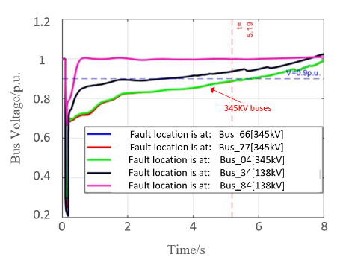
Figure 1 Bus voltage at Bus_18[138kV]

BESS capacity impact
Capacity is a factor that affects how BESS performs during FIDVR events. In this section, BESS with different capacities (ranges from 100MVA to 500MVA) are added to the 10 potential locations that are recommended by Con Edison’s engineers listed in Appendix A. For example, Figure 3 shows the bus voltage at Bus_84[138kV] when different capacity BESS located at Bus_84[138kV]. some conclusions can be summarized for this case as the below:
- The voltage at tfault+5s (i.e. 5.19s) increases with the BESS capacity.
- When BESS capacity increased to above 300MVA, the voltage at Bus_84[138kV] meet Con Edison’s voltage response criteria, i.e. the voltage reaches 0.9p.u. at the 5s after the fault is cleared(tfault+5s).
- With each time the BESS capacity increases 100MVA, the voltage at tfault+5s increases by 0.01p.u.
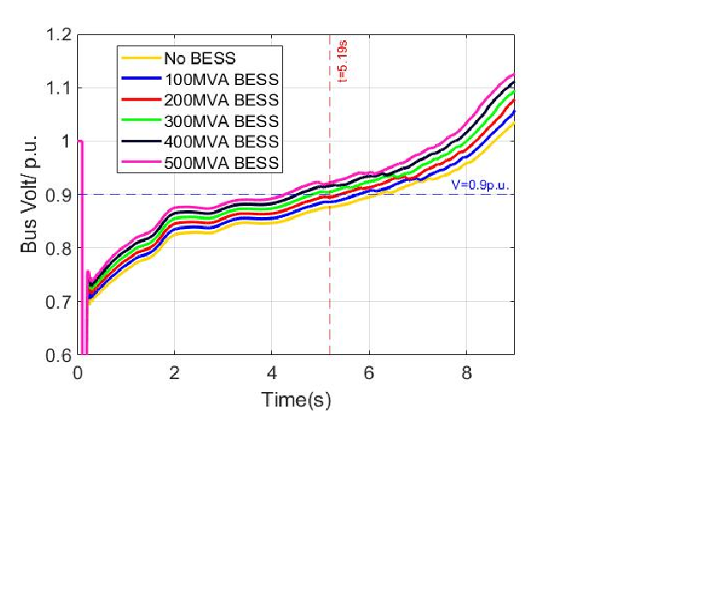
Figure 3 Voltage at Bus_84[138kV] when a 100MVA BESS at Bus_84[138kV]
As indicated in the conclusion c above, with the increase of the BESS capacity by every 100MVA, the voltage at the tfault+5s tends to increase by a certain value. In other words, there is a possibility that the increased voltage at the tfault+5s to be linear to the increase of the BESS capacity.
Figure 4 shows the relationship between the delta voltage(ΔV) and the BESS capacity when BESS is at location 1) in in Appendix A. The observation buses are the high voltage-level buses (345kV or 138kV) that Con Edison are interested in. The ΔV in this report is the voltage difference at tfault+5s between the case when there is a BESS and there is no BESS. It can be seen that the curves in Figure 4 are almost straight lines, which means that the voltage increase is almost linear to the BESS capacity.
As an exception, the voltage responses at buses with generators connected are not always increases with the BESS capacity, as shown in Figure 5. With generators connected to the nearby buses, the bus voltage responses can be supported and multiplied.
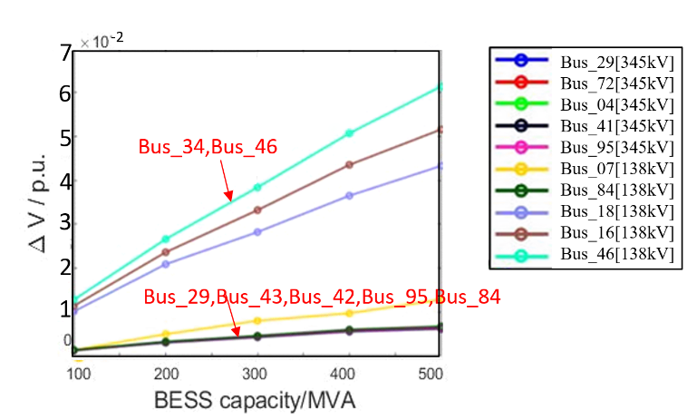
Figure 4 Relationship between ΔV and the BESS capacity when BESS is at location 1)
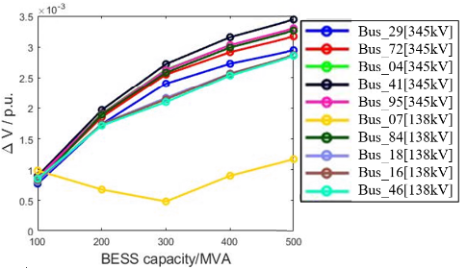
Figure 5 Relationship between ΔV and the BESS capacity when BESS is at location 7)
As can be seen from Figure 2, there are bus voltage overshoots after the fault clearance. The overshoots may be the result of the synchronous generation in the system but not be attributed to the inverters and batteries. However, the inverters can help with minimizing the overshooting, for example, by providing a much more controlled response, etc.
In practice, it is possible to implement a large-size BESS by deploying multiple small-size BESS. Therefore, a potential and easy way to mitigate the voltage overshoot is to gradually shut off BESS.
In this example case, assume that there multiple BESS being deployed at Bus_84[138kV] and the total BESS capacity is 3000MVA. The blue curve in Figure 6 shows the voltage at bus Bus_66[345kV].It can be seen that the voltage reaches 1.2p.u. in the steady state after the fault clearance. To mitigate the voltage overshoot, adjust the total BESS capacity by following Figure 7. This means that the total BESS capacity is reduced by shutting off 300MVA BESS every 0.25s starting from 5s.
The bus voltage after shutting off all the BESS is shown in the yellow curve of Figure 6. It can be seen that the steady-state voltage after fault clearance is mitigated to around 1.02 p.u..
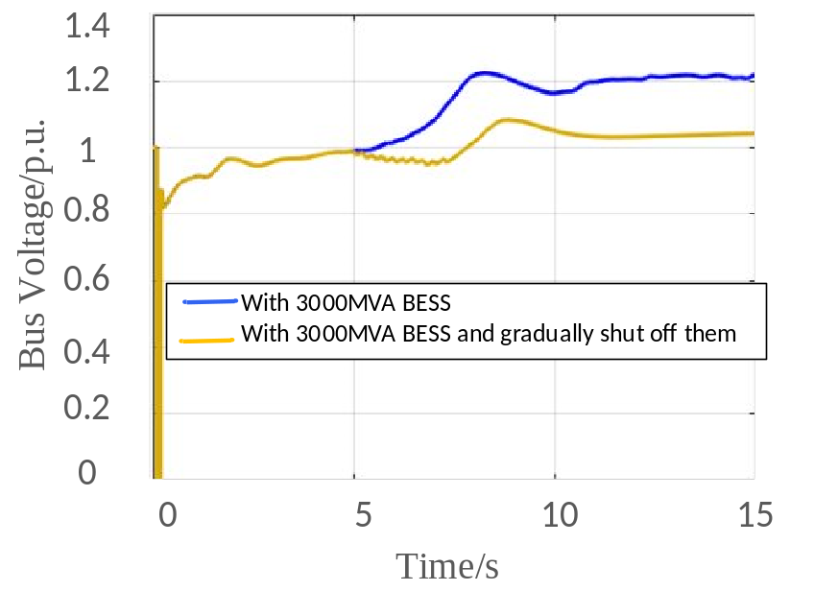
Figure 6 Bus voltage before/after gradually reduce the total BESS capacity
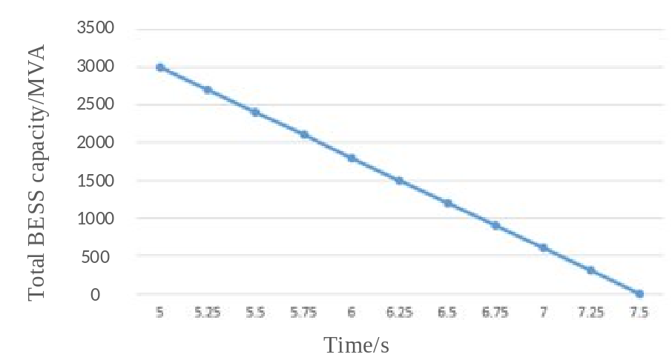
Figure 7 Total BESS capacity.

The effect of the BESS distribution

Deploy one BESS
In this section, a 100MVA BESS is deployed to one of the potential locations in Appendix A, and the voltage responses of the following 10 buses are monitored : Bus_29[345kV], Bus_72[345kV], Bus_04[345kV], Bus_41[345kV], Bus_95[345kV], Bus_07[138kV], Bus_84[138kV], Bus_18[138kV], Bus_16[138kV], Bus_46[138kV].
Among all the tested cases, the voltage responses at different monitored buses do not have a significant difference, such as Figure 8 shows. It can be seen that the voltage difference between the two scenarios is marginal, which is within the PSSE modeling error.
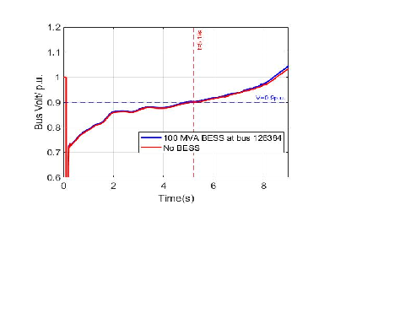
Figure 8 Voltage at bus Bus_72[345kV] when a 100MVA BESS at Bus_84[138kV]

Deploy multiple BESS at different locations
As discussed in Section III, the ΔV tends to be linear to the BESS capacity when there is a BESS in the system. In this Section, multiple BESS are added to the system to calculate the voltage increase ΔV at t_{fault+5s}.
In Figure 9, the curve ΔV_{L1+L2} shows the ΔV at t_{fault+5s} when 100 MVA BESS are added to both the locations L1 and L2; ΔVL1 is the ΔV when a 100 MVA BESS is added to location L1, ΔVL2 is the ΔV when a 100MVA BESS is added to location L2. The tested locations are the BESS potential locations 1)~5) in Appendix A.
It can be seen from Figure 9 that ΔVL1+L2 ≈ΔVL1+ΔVL2 for the tested cases. Take Case 1 as an example, Figure 10 shows the reactive power output of the BESS at Bus_34[345kV]. It can be seen from Figure 10 that, the BESS output similar reactive power when there is another BESS deployed in the system.
Similar results can be found from Figure 11 when 100MVA BESS are added to three different locations. It shows that there is ΔVL1+L2+L3 ≈ΔVL1+ΔVL2 +ΔVL2 . Based on these two figures, it can be found that, distributing 100MVA BESS to different locations or one location will not make a significant difference on the voltage support.
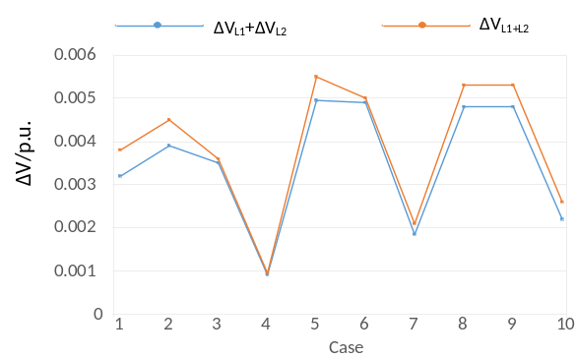
Figure 9 ΔV when 100MVA are added to two different locations
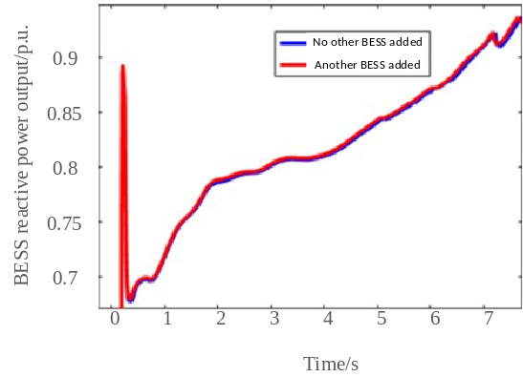
Figure 10 the BESS at location Bus_34[345kV] outputs reactive power when there is/is not another BESS added to the system
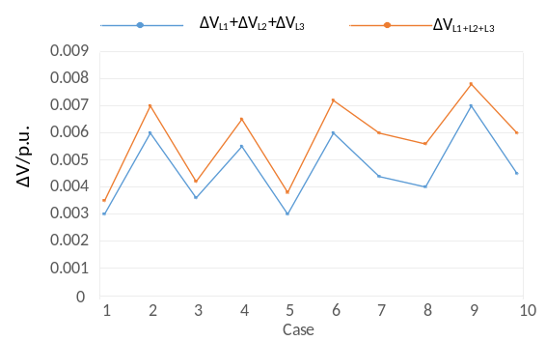
Figure 11 ΔV when 100MVA BESS are added to three different locations

Deploy Large BESS at large load bus1
In this sub-section, BESS with large size is deployed at some load buses. According to Con Edison’s system model, three locations are selected as the BESS location because they are associated with the transmission station that has the largest or the second-largest load:Bus_07[138kV], Bus_46[138kV], and Bus_95[345kV].
Based on the testing results, some conclusions are:
- For the 138kV buses, the voltage at the tfault+5s with BESS added decreases with its associated transmission station load. However, the buses Bus_18[138kV] and Bus_16[138kV] are special and probably because they are connected to some generator.
- There are 4 buses meet the voltage criteria even without a BESS being installed: Bus_29[345kV], Bus_45[138kV], Bus_85[138kV], Bus_47[138kV]
- There are 3 buses meet the voltage criteria with the help of installing BESS: Bus_04[345kV] ,Bus_41[345kV], Bus_95[345kV]
- Bus Bus_46[138kV] is associated with a large load, which prevents it from reaching the voltage response criteria for all the tested cases.

Short Circuit Ratio Analysis with BESS integrated.

BESS integrated in 23-bus system
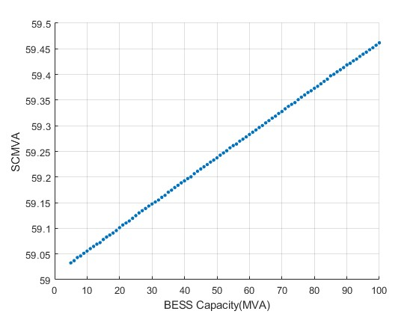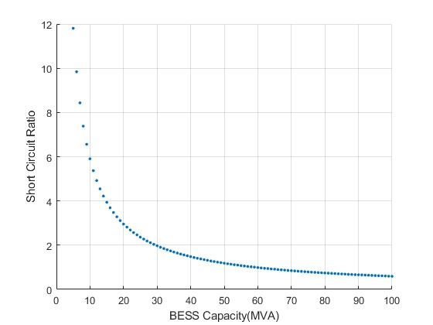

BESS integrated in the EI system with over 3000buses

Only area 10 and 9 has obvious SCMVA change during the IEC test.
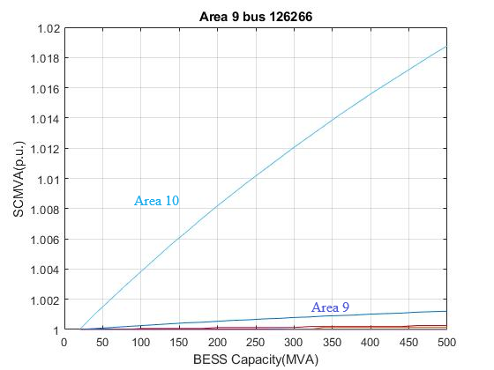
Area 9, BESS capacity =110MVA SCR=3
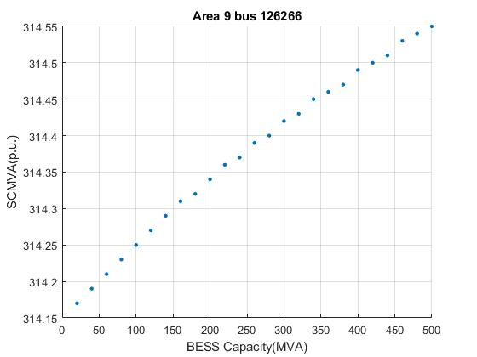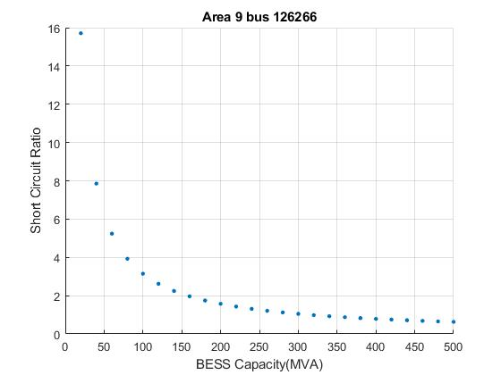
Area 10 BESS capacity =90MVA SCR=3
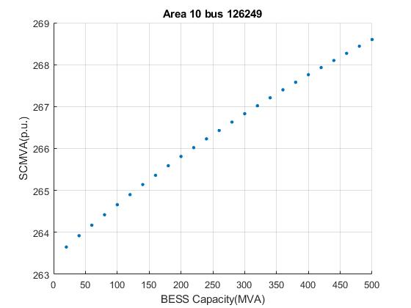
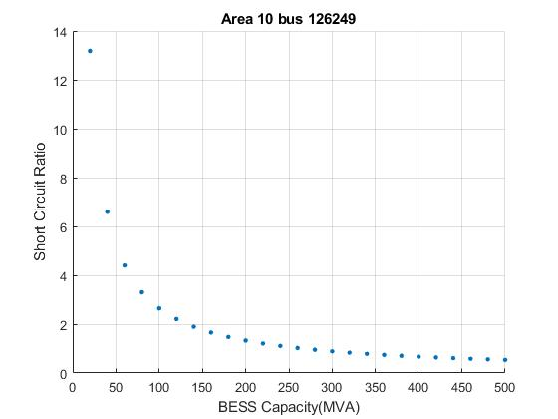

Results and Conclusions2
The analysis in this study designs a basic FIDVR controller and compares the control effects under different BESS locations for the Con Edison of New York PSS/e model.
FIDVR events were firstly replicated by applying a 3-phase short-circuit fault to several different buses, it is found that the fault at the 345kV buses leads to more obvious FIDVR. The BESS control effect was then tested under the most obvious FIDVR event suggested by Con Edison.
There are eight reactive power control options for BESS to support system voltage in the positive sequence models used in PSS/E. To find the optimal values, model parameters were adjusted in simulations. The results of that tuning are provided as well as descriptions of each parameter. Among these options, BESS outputs the most reactive power with the local V control. The tuned parameters are Iqh1=1 and Vref0=1.3.
The BESS location and size affects the bus voltage responses. Several results are concluded in this report as below:
First, the deployment of BESS in the system could lead to bus voltage overshoot. This report discussed a potential way to minimize this overshoot, which is to gradually shut off the BESS. Other sophisticated ways to achieve this could be studied in the future.
Additionally, it is observed that the voltage change is linear to the BESS size for small BESS. Meanwhile, generators affect the voltage response for nearby buses. That is, the voltage response at buses can be supported and multiplied by the nearby generators.
Moreover, given the local configuration of the Con Edison system, the placement at 345 kV stations appears to provide more leverage for BESS responses than 138 kV stations.
The reactive power generated by a BESS does not have a significant difference regardless of whether there is another BESS in the system or not. That is, it does not matter if the BESS is distributed or aggregated in the system.
Finally, it is found that the larger the transmission station load is, the greater the voltage drop during a FIDVR event. That is, Local generation and lighter load help to alleviate the drop.
In conclusion, this study designs a control strategy for BESS to provide voltage support during FIDVR in Con Edison of New York. There are three interesting topics that remained and could be further studied in the future. The first topic would be how to design a control method that actively looks to dampen the response to mitigate the voltage overshoot response. Second, this report studied a large grid, future work could investigate using BESS for voltage support on microgrids. The last topic of interest is to predict the impact of future heat pump (building loads) and EV loads on FIDVR responses.

Chapter 3 Online Power System Inertia Estimation based on the Pump Storage Hydropower Turn-off Signatures

Introduction
Inertia in power systems refers to the ability of the system to suppress frequency variations in the presence of power imbalance [1]. With the increasing deployment of renewable energy sources, the system inertia is gradually decreased, which deteriorates the system stability [2] [3]. An accurate online system inertia monitor is valuable to ensure the system will respond adequately to sudden changes in frequency, which plays a crucial role on the power system operation and planning.
Many studies have been conducted to estimate the power system inertia in real time. These inertia estimation approaches can be roughly classified into 4 categories, the dispatch-based, event-based, ambient-based and probing-based methods [4]. The dispatch-based algorithm involves directly summing the online inertia of each generator by taking into account their online status and known inertia. This algorithm is simple which can be implemented based on SCADA or EMS data. However, this method does not consider the contribution from Inverter Based Resources (IBRs) or load. The event-based approaches use classical swing equation to estimate inertia as the ratio between power variation and rate of change of frequency (RoCoF), after large disturbance, when the frequency response is predominantly dictated by the system’s inertia [5]. It uses the frequency measurement collected by Phasor Measurement Unit (PMU) to estimate the system inertia. Studies usually [6] [7] [8] [9]utilize the measurement data during the electromechanical oscillation trajectory to estimate the inertia. This method is the most accurate algorithm among all the methods. However, the calculation times is dependent on the event occurrence time. This may limit the estimated value, constraining its practical application. The ambient-based algorithm regards the random load variations of the system as the main source of fluctuation for the inertia estimation, which also uses the PMU collected data. Compared to the event-based approaches, the main advantage is that it can provide continuous estimated inertia. However, since this method relies on random frequency variations, accuracy concerns arise due to the noise uncertainty [10]. Meanwhile, the inertia estimation for large power systems requires a massive PMU deployment on all the traditional generators as well as renewable energy resources [11] [12] [13], and the algorithm needs calibration with known values to get a satisfied estimation performance. The probing-based method inject active power into the system and identify the linear model between the probing signal and measured system frequency response and extract the system inertia based on the identified model [14]. This method can also cause system inertia continuously. However, it requires extra installment of specific equipment or the modification of pre-existing controllers [12].
The outlined drawbacks of the existing system inertia estimation methods constrain their application on large interconnection power systems such as the Eastern Interconnection (EI) system. To estimate the system-level inertia and get a relatively accurate estimation result, this paper proposes an online Pump storage turn-off event-based inertia estimation method. This method utilized the Pump storage turn-off event signatures for the event detection, and the feature of constant power change during the event for the inertia estimation. It has advantages compared to existing methods. The pump storage turn-off event provides ample samples for inertia estimation compared to the other event-based methods, such as those oscillation event-based methods. Meanwhile, a novel RoCoF calculation method is proposed to mitigate the effects of the prior-event frequency random change to post-event RoCof, improving the inertia estimation performance. The proposed online inertia monitoring system is deployed to the FNET/GridEye platform, which allows the inertia online monitoring system to be developed with no additional cost.

Support Methodology and Background

Potential of utilizing PSH switching-off event for inertia estimation
(1) PSH plants in EI
To reduce the noise effect on the inertia estimation, PSH plants with larger capacity are preferable in the inertia estimation. This is because a large capacity unit can produce a larger magnitude during the PSH switching-off event, leading to a higher Signal-to-Noise Ratio (SNR). The U.S. has developed sufficient PSH plants for the EI system. Table I shows the PSH plants with unit capacity that is larger than 300MW in the EI grid. In this paper, Bath County is used as the base show case for the EI inertia estimation.
(2) Bath County PSH switching off event occurrence times
The occurrence of an event is important for the event-based method to get an adequate number of the estimated values. Fig. 1 shows the Bath County PSH switching-off operation times confirmed with the PMU measurements in 2023. At the end of the year 2023, the occurrence bars are sparse due to data loss.
It shows in Fig. 1 that the PSH event happens on an average of about 4 times each day at the Bath County PSH plant, with the maximum of 9 times a day. It should also be noted that there are plenty of PSH plants in EI, they will contribute more estimated inertia values to give a denser inertia picture with the proposed method eventually.

TABLE I
EI Pumped Storage Hydropower Plants with Unit
Capacities Larger Than 300MW.
Pump storage plants | Unit capacity (MW) | Number of units
Bath County | 477 | 6
Raccoon Mountain | 428.4 | 4
Ludington | 329.8 | 6
Bad Creek | 324 | 4
Bear Swamp | 300 | 2

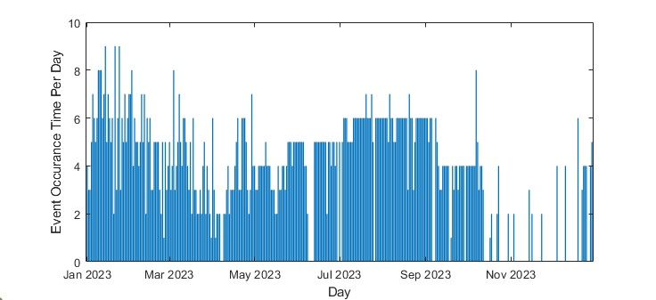
Fig. 1. Bath County PSH switching-off occurrence time per day.
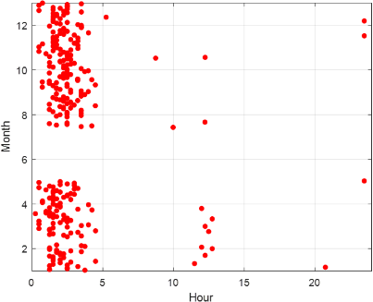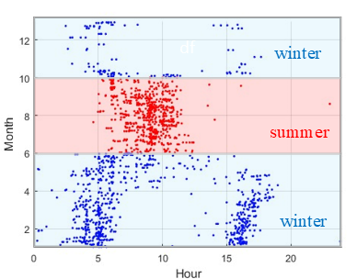
(a) (b)
Fig. 2. Time distribution comparison between (a) lowest inertia within a day and (b) the Bath County PSH event operation time (local time).

(3) Inertia time Distribution at Bath County
The estimated inertia is more beneficial for the operators if the calculated inertia reflects the lowest values. Fig. 2(a) shows the inertia time distribution during a day. As illustrated, the inertia usually reaches its lowest value at around 1AM-5 Am, which is typically during the load ramping up time at around 3am -6 am. Fig.2 (b) shows the PSH switching-off operation time distribution at the Bath County. Upon comparing Fig.2(a) and (b), it is discovered that the Bath County PSH operates a switching-off when it’s close to lowest inertia time during the day. This validates the effectiveness of the PSH switching-off events as the base events for the inertia estimation.
(4) MW Change
Fig.3 shows the power change collected by PMUs during PSH turn-off events for Bath County. Once receiving a switching-off signal, the hydro gate closes gradually, leading to a slow voltage ramp down at the beginning. When the Power reaches a threshold, the pump breaker is switched off, resulting in a sudden voltage stepwise change.
Based on the year 2023 historical voltage step MW distribution depicted on Fig.5, the MW step change has a constant pattern with small deviations. This provides particular advantage on inertia estimation since the real-time power change of a PSH event is not required. Instead, the historical median MW step change, which is 360MW and mainly varies within ±8%, can be used as the constant power change value for the inertia estimation.

FNET/GridEye Inertia Monitoring System
The FNET/GridEye is a low-cost, quickly deployable GPS-synchronized wide-area frequency measurement network. High-resolution power system measurement devices, the Frequency Disturbance Recorders (FDRs), are deployed worldwide to collect the frequency, phase angle, and voltage of the power system at ordinary 120 V outlets. As Fig.5 shows, the high-density distribution of the FDRs in the EI system makes it possible to monitor system dynamics, contributing to the system inertia online monitor.
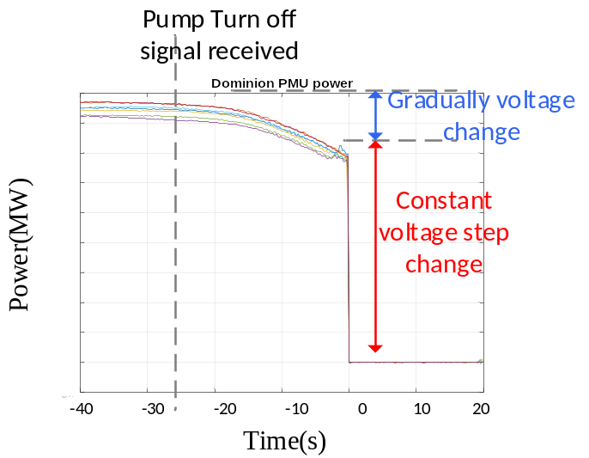
Fig. 3. Power change during events.

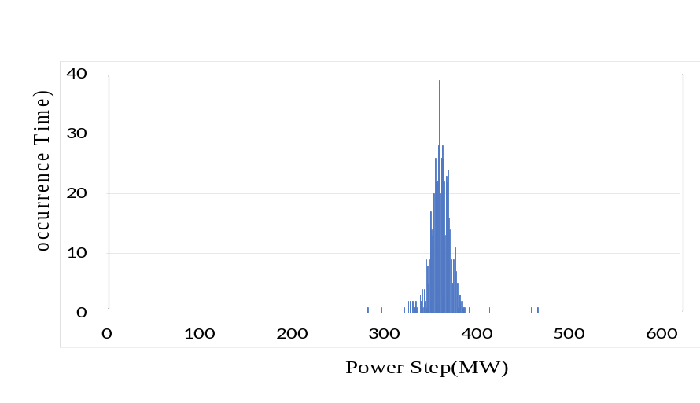
Fig. 4. Bath County Power Step MW distribution
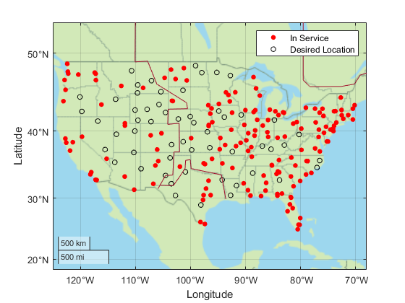
Fig. 5. FNET/GridEye Frequency Disturbance Recorder Deployment locations.

Fig.6 shows the concept of using the PSH switching-off events for inertia estimation. Pump storage switching off events can be detected by the FDRs deployed nearby the plants, utilizing the event signatures. Once an event has been detected, the system-level inertia is estimated by the system frequency, taking advantage of the constant voltage step change. The estimated inertia value and the trend will be displayed on the FNET/GridEye public website for all the industrial and educational purposes. The entire process is cost-effective as it does not require additional massive measurement devices to be deployed.
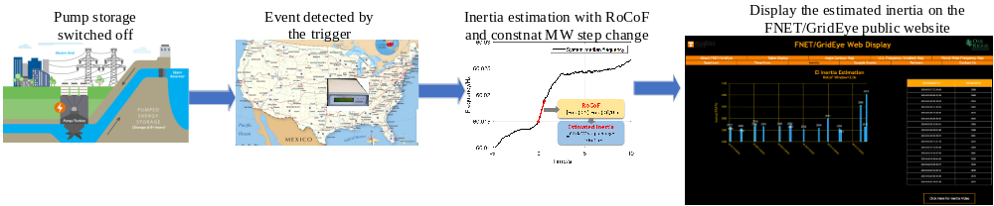 Fig. 6 Concept of Inertia estimation process using the PSH switching off events

PSH Turn-off Event Detection
In this paper, a two-step PSH turn-off event trigger is proposed, where the first step utilizes the event signatures to simply and quickly detect events, and the second step is to set fine rules to filter out the false alarms.

Trigger step 1: PSH Turn-off Event Signatures
Appropriate event signatures and proper threshold settings for the PSH switching-off events are important for the event fast detection. By observing the confirmed PSH switching-off events in Bath County, it is noticed that the events have local features on the frequency, phase angle, and voltage. This ensures the potential of PSH switching-off event detection for the FNET/GridEye system.
Fig.7 shows a typical example of a local device data collected by the FDRs during a PSH event, where the event start time is when there is a step MW change. As shown in Fig.7(a), there is a frequency spike when a PSH switching off event happens. This feature also serves as one of the indicators of the event’s start time. It should be noted that the frequency spike can only be detected by the local device that is close to the pump storage plant, but not distant devices. This ensures that the detected events can be attributed to a certain pump storage plant. The point A-C frequency deviation is another frequency-related feature. Point A here is the start time and point C is when frequency reaches its peak.
The voltage change is another important feature of the PSH switching-off event. Since the voltage change is usually stepwise as Fig. 7(b) shows, it is named as “voltage step” in this paper. The voltage step is calculated by the 1s voltage difference between the median voltage after the event and that before the event. To avoid the noise impact, a 5-point median filter should first be applied to pre-prepare the voltage data for the voltage step calculation.
Similar to the voltage step, there is also a relative angle change during the PSH switching-off event. The difference is that the relative angle changes slower than the voltage when there is an event. Therefore, as Fig.7(c) shows, the relative angle step calculation uses different time windows.
Tests have been carried out to verify the effectiveness of the signatures based PSH turn-off event trigger as shown in Table II. The test is based on 3 months of data, starting from Aug.1 2023 to Nov.30 2023. It should be noted that the actual PSH turn-off events happen during the three months are more than 286. The measurement data missing from both the Dominion Energy side and the FNET/GridEye side reduced the cases that can be confirmed. Based on the test result, it can be concluded that the event signatures can help to detect the majority of the PSH event, with only 2.8% of the event missing.
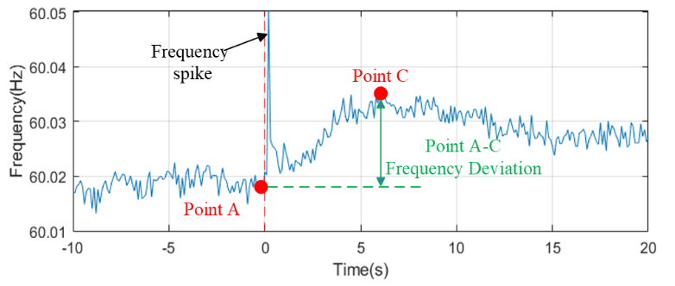

(a)Frequency
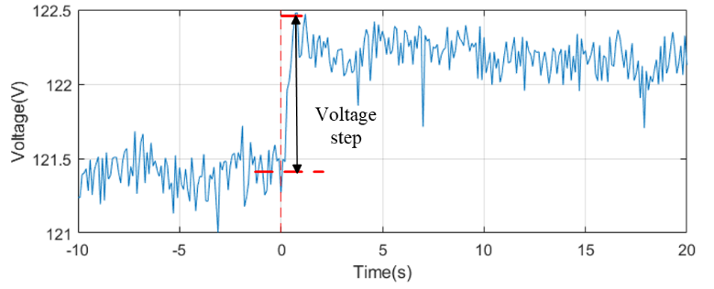
(b)Voltage
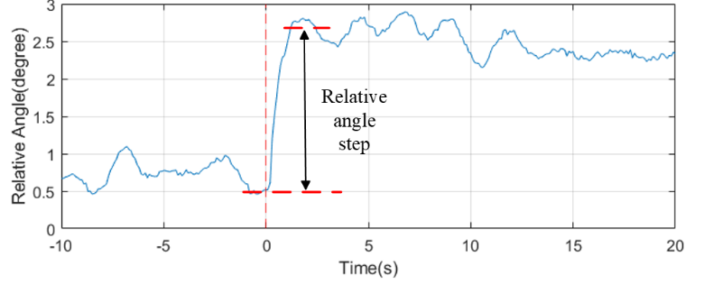
(c) Relative angle
Fig. 7. PSH true event local device data

TABLE II
Signatures-based PSH Turn-Off Event Trigger Test Result
 | Step 1 | Step1 and Step 2
Confirmed events | 286(100%) | 286(100%)
Detected true events | 278(97.2%) | 277(96.8%)
Missed true events | 8(2.8%) | 9(3.2%)
Detected false alarms | 16(5.5%) | 1(0.3%)

Trigger step 2: fine rules for false alarm filtering
The PSH Turn-off event signatures can identify the true events effectively. However, some of the false alarms may remain inevitably. As Table II shows, there are 5.5% false alarms after the step 1 trigger applied solely. Therefore, the step 2 trigger needs to be designed for less false alarms.
Based on the observation of the false alarms, a typical feature is that the system median frequency 2s-RoCoF changes little during the event. For example, as Fig.8 shows, the 2s-RoCoF before and after the event changes 0.0002Hz/s, while for the confirmed events, the 2s-RoCoF difference is larger than 0.002Hz/s. So, calculating the 2s-RoCoF difference and filters out cases with the calculation result that is smaller than 0.002Hz/s is applied to step 2 of the trigger.
The two-step PSH switching-off event trigger shows an advantage of detecting true events while remains a small number of false alarms. As Table II shows, even though step 2 of the trigger filters out 0.4% of the true events, the majority of the true events are still successfully detected. Meanwhile, most of the false alarms are filtered out, with only 0.3% remaining.

Real-Time PSH Turn-off Event Detection Trigger Overview
Fig.9 shows the workflow of the two-step PSH turn-off event trigger. The raw data is preprocessed with linear interpolation to address missing data points. The preprocessed data then is sent to trigger step 1 to calculate the four signature values. It should be noted that despite the 0.1s RoCoF spike signature, the other signatures should be calculated on the device 5-point median data to diminish the system noise effect. If all the signature values are over the threshold settings, then the system median frequency 2s-RoCoF difference is calculated to identify if it is a false alarm or not. To avoid multiple detection on a single event, the trigger will freeze for 10s once an event is detected.

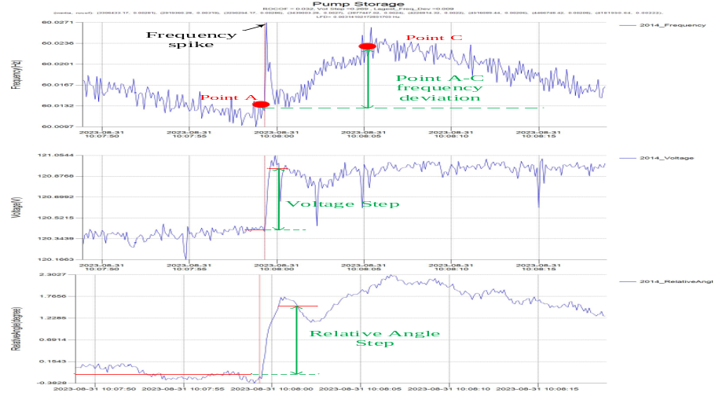
(a)Frequency

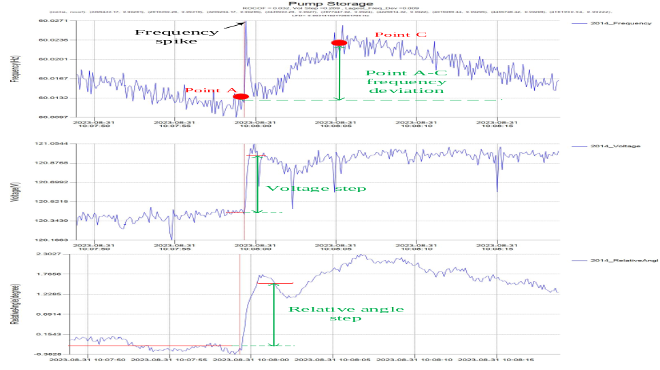
(b)Voltage
(c) Relative angle
Fig. 7. PSH true event local device data

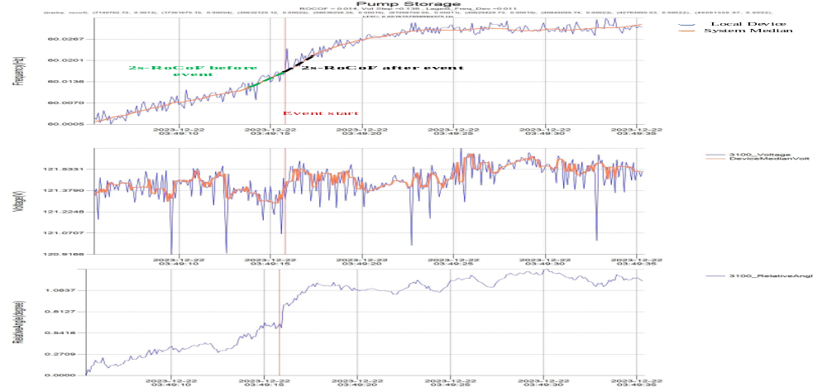
Fig. 8. False alarm frequency example
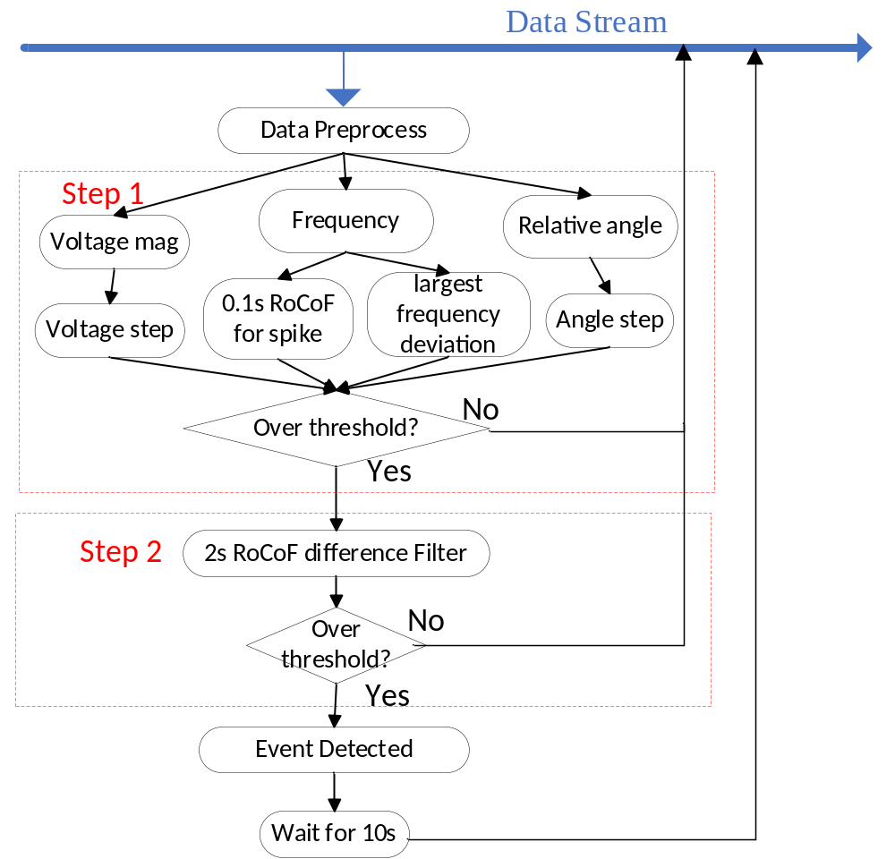
Fig. 9. two-step PSH turn-off event trigger design

PSH Turn-off Event-Based Inertia Estimation

PSH Turn-off Event Start Time
Event-based methods utilizes the event Rate of Chang of Frequency (RoCoF) and the change of the power to estimate the system inertia. The relationship among them can be expressed as:
$H=\frac{f_{0}ΔP}{2 RoCoF}$ (1)
where $ΔP$ is the power change during the event, and H is the system inertia. Eq.(1) shows that the H is inversely proportional to RoCoF. So, an accurate RoCoF calculation is important to the inertia estimation. Experiments also show that the inertia is sensitive to the RoCoF making the event time crucial to the inertia estimation.
As discussed in Chapter III Section A, the frequency spike can serve as an indicator for the event start time. However, the frequency spike can be undistinguishable in some cases caused by the noise, making the frequency spike not sufficient for the event start time determination. Considering that the voltages surge change caused by the event, the voltage step change serves as another indicator to determine the event’s start time.
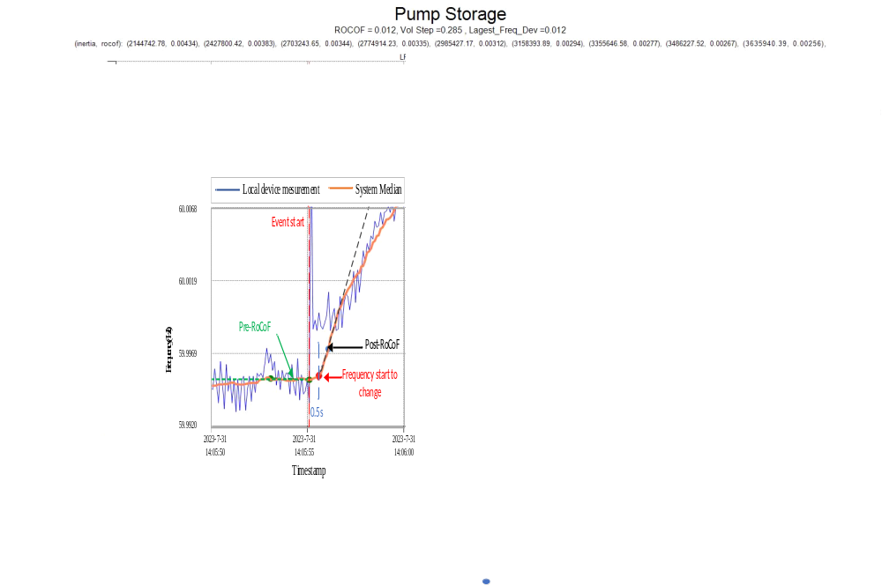
Fig. 10. RoCoF Calculation example

Improvement on Inertia Calculation
RoCoF is the time derivative of the power system frequency. Traditional field measurement based RoCoF calculation approaches for inertia estimation only consider the frequency change after the event. However, in practice, there is usually random frequency change before the event happens. The post-event RoCoF is not only introduced by the PSH switching event. The pre-event frequency random change can affect the post-event RoCoF. Therefore, simply using the post-event RoCoF can lead to an inaccurate estimation.
Considering the fact that the low-cost FDRs do not collect the power information from the grid, the only prior knowledge about the power change is the pump step change $ΔP_{pump}$, which is 360MW for the Bath County. Therefore, the corresponding RoCoF for inertia estimation should be solely related to the PSH switching-off events. Due to the limitation of the existing RoCoF calculation method mentioned above, an approach to calculate RoCoF that is specially related to the PSH switching-off events is necessary.
Assuming that at time t_{pre}, the random frequency change has a RoCoF of ${RoCoF}_{pre}$. At time t₀, the PSH is switched off, contributing to additional frequency change ${RoCoF}_{pump}$. Then, the measured system RoCoF that calculated after PSH event is expressed as:
$${RoCoF}_{post}={RoCoF}_{pump}+{RoCoF}_{pre}$$ | (2)
Therefore, the system inertia can be estimated by
$$H_{est}=\frac{f_{0}ΔP_{pump}}{2 {RoCoF}_{pump}}=\frac{f_{0}ΔP_{pump}}{2 {(RoCoF}_{post-}{RoCoF}_{pre}})$$ | (3)
Fig. 10 depicts an example of the RoCoF calculation. System noise introduces fluctuations to the local device measurement, challenging the RoCoF calculation. Considering the system median frequency more resistant to the system noise, it is used to calculate the inertia in this paper.

.RoCoF Calculation methods
(1) Post-event RoCoF calculation
As shown in Fig.5, the system median frequency does not respond to the PSH switching-off event immediately. The response delay typically ranges from 0 to 1s, which is not fixed. Disregarding the response time delay tends to decrease the post-event RoCoF, thus increasing the estimated inertia values. To obtain the start time of post-event RoCoF calculation, the 1s-frequency-deviations (FDs) are calculated with:
$${FD}_{i}=f_{t+1,i}-f_{t,i}$$ | (4)
where t=t₀, t₀+0.1,…t₀+2.0, t₀ is the event start time, $f_{t+1,i}$ ;is the system median frequency at time t+1 for the ith case. The t₀ of the case with the largest FD is the start time(t_{s}) of the post-event RoCoF calculation.
The most commonly used approach to calculate RoCoF is to use the two points of the frequency data within a time window:
$$RoCoF=\frac{f_{ts+T}-f_{ts}}{T}$$ | (5)

where T is the calculation time window. $f_{ts}$ and $f_{ts+T}$ are the frequency at time t_{s} and t_{s}+T. Since the SNR is relatively high for the post-event RoCoF, the two-point RoCof calculation method can have a satisfactory RoCoF calculation result.
(2 )Pre-event RoCoF Calculation
The pre-event RoCoF should capture the RoCoF trend before the event happens. However, the pre-event magnitude is not as high as the post-event magnitude, the SNR of the pre-event RoCoF is not as high as the post-event RoCoF. So, noise still has a moderate effect on the system median frequency trend before the PSH switching off event starts. In this case, the two-point RoCoF calculation approach will introduce a high calculation error, so other methods are necessary.
The curve fitting has been utilized for the RoCoF calculation since 2015 [15, 16, 17] . Since the curve-fitting aims at identifying the data trend by the general polynomial regression model, the 1st curve fitting is ideal for the pre-event RoCoF calculation. Traditional RoCoF calculation usually uses small time windows that is within 0.5s, For the pre-event RoCoF calculation, to better capture the data trend, 2s long time window is used in this paper.
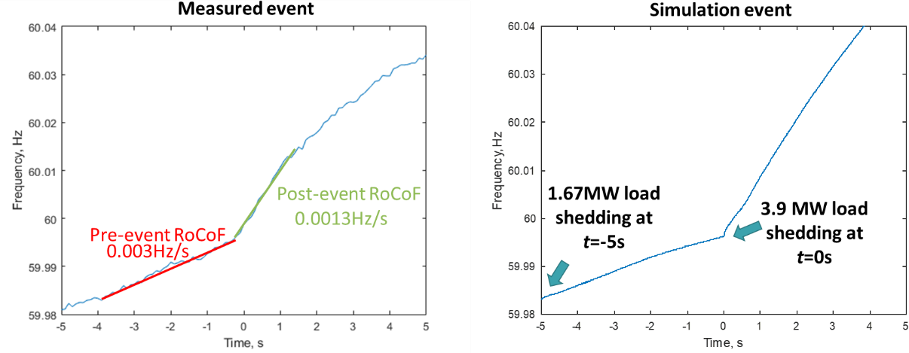
Fig. 11. Simulation generating similar events with both pre-event RoCoF and post-event RoCoF.

Validation on the improved RoCoF
To validate effectiveness of the improved RoCoF calculation method, simulations were carried out on both a 23-bus system and the EI MMWG model. These simulations are designed to duplicate the true measured event. Fig.11 shows an example of the simulation case. The true event has a pre-event RoCoF of 0.003Hz/s, which can be simulated with a 1.67 MW load shedding in the 23-bus system.
The pre-event RoCoF could be either negative or non-negative. In the simulation test, both scenarios were tested. By comparing the estimated inertia values calculated with the proposed Inertia algorithm and the background truth of the simulation inertia values, the absolute calculation errors are illustrated in Fig. 12. As shown in Fig.12(a) and (b), 440 cases are tested with the 23-bus small system. The mean absolute error rate was reduced from 30% to 4.5%. As shown in Fig.12(c) and (d), 66 cases are tested with the EI MMWG model that has over 30000 buses. The mean absolute error rate was reduced from 40% to 3%. The proposed algorithm can give a much more accurate estimated inertia, with an absolute calculation error below 5%, validating the effectiveness of the algorithm.

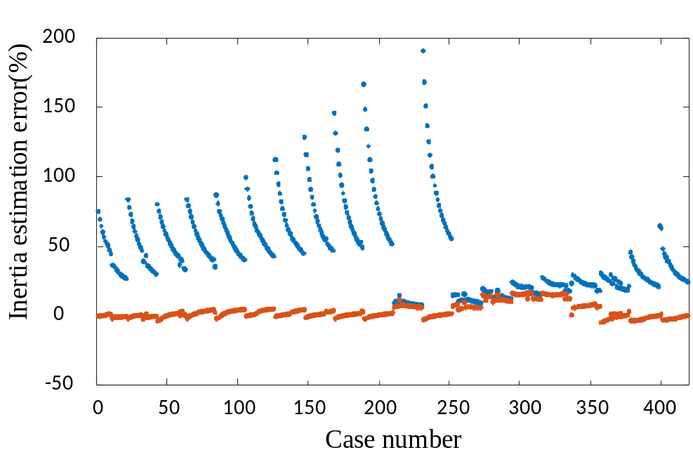
(a) Negative pre-event RoCoF from 23-bus system
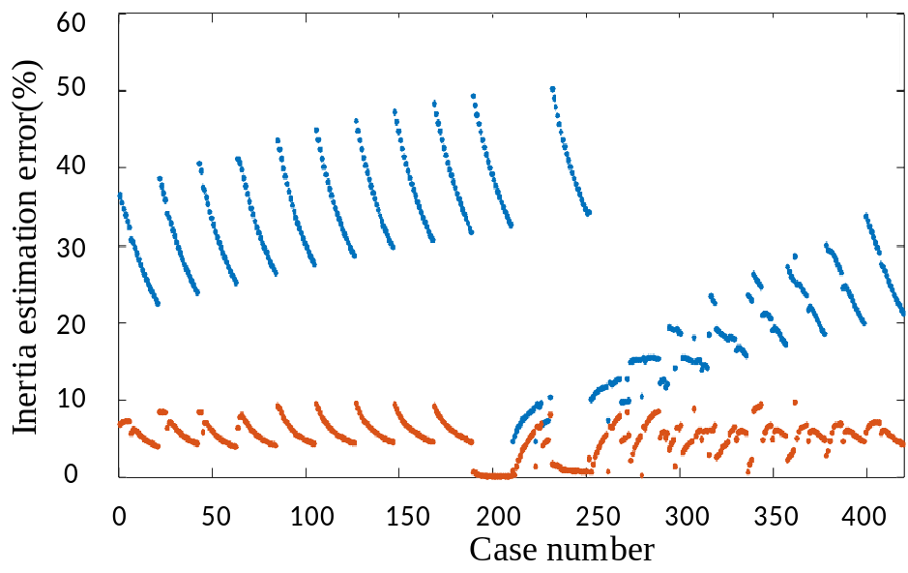
(b) Non-negative pre-event RoCoF from 23-bus system

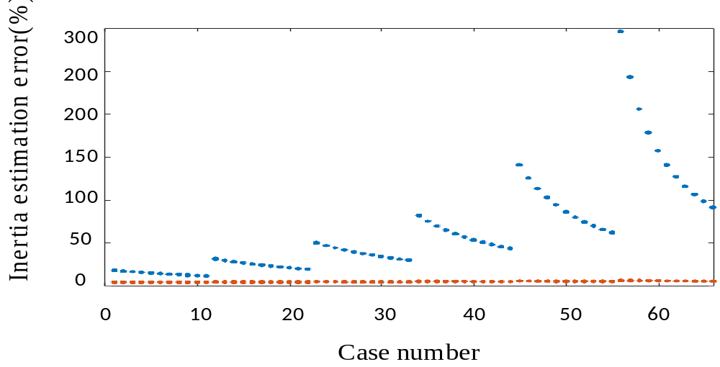
Case number
(c)Negative pre-event RoCoF from EI MMWG model 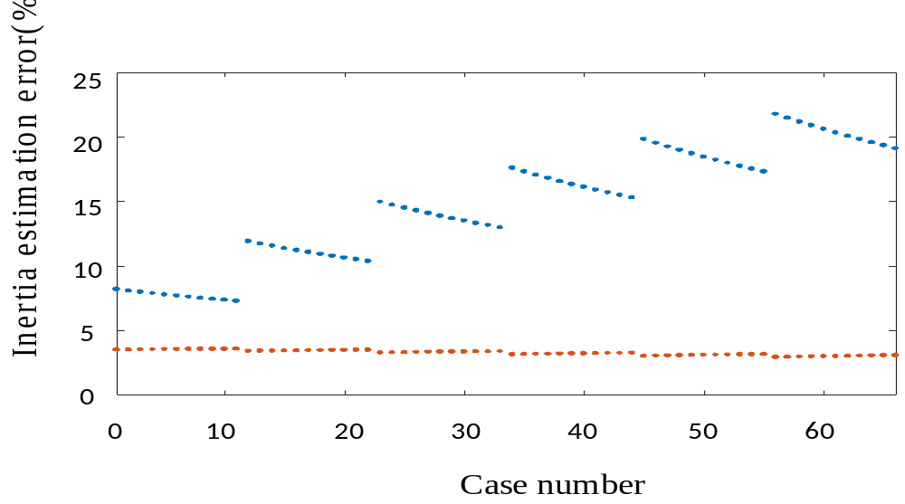
Case number
(d) Non-negative pre-event RoCoF from EI MMWG model
Fig. 12. Inertia estimation error comparison for difference simulation cases.

Field Tests Result

Event Detection
Field experiments were carried out on the real-time Bath County PSH switching-off event detection started from Dec.1 2023 and ended on Apr.30 2024. Fig. 13(a) shows the FDR deployment map from the FNET/GridEye system in the Bath County PSH plant area. The two devices are located at the Roanoke,VA, and Blacksburg, VA, respectively,
Fig. 13 (b) and (c) shows the frequency and voltage plot of the Roanoke and the Blacksburg devices. The Roanoke device measures the PSH switching-off events signatures better since it is electrically closer to the Bath County PSH plant station than the Blacksburg device.
Table II shows the experiment result. The online trigger detects 95% true events, with only 2% of them are false alarms. This validates the effectiveness of the trigger to detect PSH switching-off events in practice.
TABLE II
Signatures-based PSH Turn-Off Event Trigger Test Result
 | Dec.2023 | Jan.2024 | Feb.2024 | Mar.2024 | Apr.2024 | Total
Confirmed events | 69 | 157 | 126 | 60 | 84 | 496
Detected true events | 67 | 152 | 112 | 59 | 78 | 468(95%)
Missed true events | 2 | 5 | 14 | 1 | 6 | 28(5%)
Detected false alarms | 3 | 0 | 3 | 4 | 0 | 10 (2%)

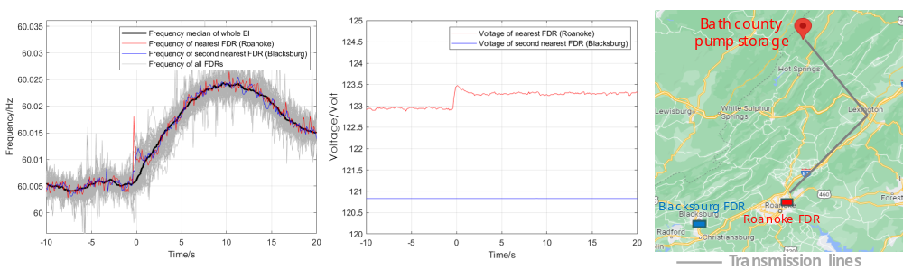
(a) FDR deployment location illustration (b) PSH switching-off event frequency example (c) PSH switching-off event voltage example

Fig. 13. FDR deployment location and measurement example.

Inertia Estimation
In this section, the inertia is calculated with online field experiments as well as with historical data starting from 2022. Fig. 14 shows the estimated inertia values…

<TBC>Generation trip test

Convert x% of the generator to renewables(inertia amount), give a 5G gen trip, see when the frequency drops to 59.5Hz.

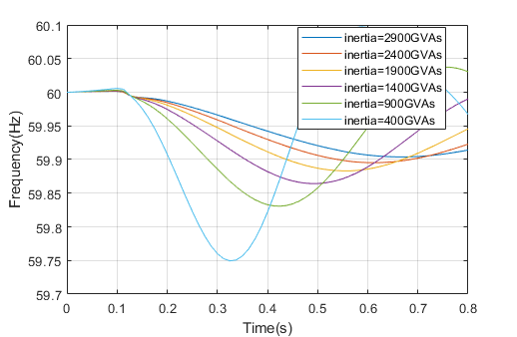
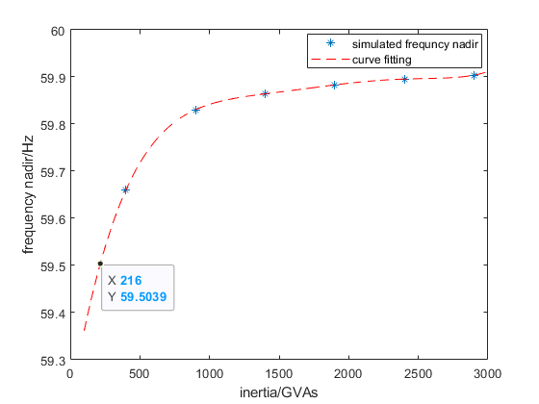
Convert x% of the generator to renewables(inertia amount), give a 4.5G gen trip, see when the frequency drops to 59.5Hz.

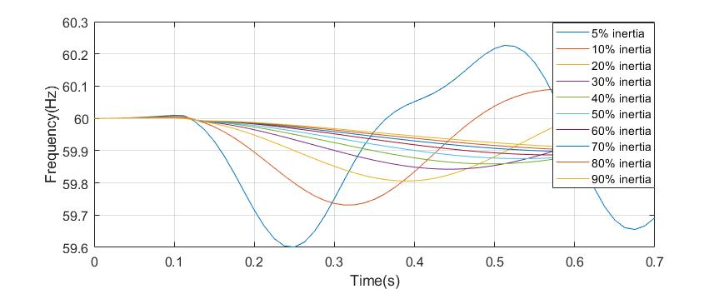
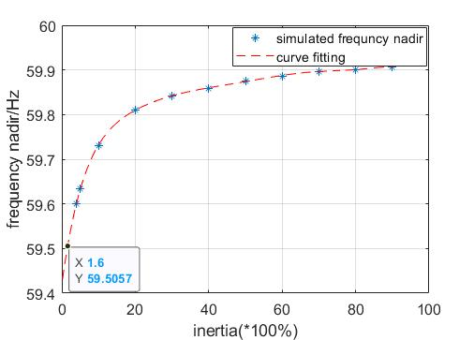
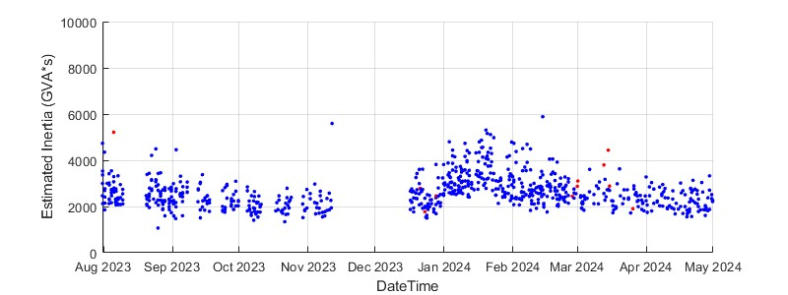
Fig. 14. Estimated inertia value plot.

Conclusion
Real-time knowledge of the system-level inertia for large interconnection is essential to ensure system stability with a large amount of IBRs gradually connected. In this paper, an online inertia monitoring system is designed based on the PSH switching-off events, which takes advantage of the fact that MW change is stepwise and nearly constant during the events.
The PSH switching-off events have signatures on the synchrophasor data collected by the PSH plant. Based on these signatures, a two-step online trigger is designed and test result shows that it can detect 95% of the true events with 2% of false alarms.
To avoid the prior-event frequency change affecting the post-event RoCoF, this paper proposes a novel method for inertia estimation. Simulation results show that this method achieves satisfactory accuracy with a 5% error rate.
The online inertia monitoring system has been implemented into the FNET/GridEye system,

Chapter 4 EI grid inertia estimation based on multiple PSH turn-off events

Introduction

Support Methodology and Background
Timestamp | Power step 2
2022-08-01 07:30:00 | 261.3
2022-08-01 08:28:00 | 268.4
2022-08-02 08:23:00 | 262.6
2022-08-02 08:41:00 | 264
2022-08-03 09:08:00 | 262.4
2022-08-04 09:22:00 | 267.1
2022-08-06 08:43:00 | 245.7
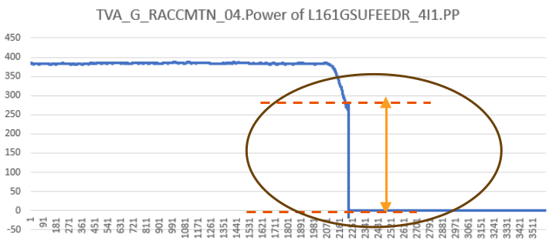
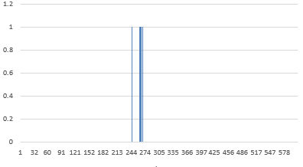

PSH Turn-off Event Detection

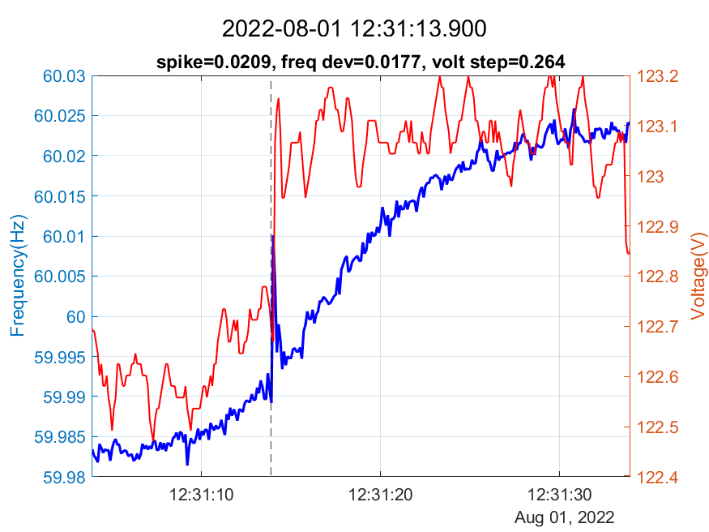

PSH Turn-off Event-Based Inertia Estimation

Performance Evaluation

Conclusion

Chapter 5 <TBC>Feasibility of regional inertia estimation based on the ambient data

Introduction

Inertia estimation based on ambient data.

Performance Evaluation

Conclusion

Chapter 6 High Density Synchrophasor Lossless Data Compression for Efficient Data Storage

Introduction

With the increasing demand to analyze the complex power system dynamics, the Phasor Measurement Unit (PMU) is required to provide Ultra-High-Density (UHD) data. Recently, the advanced PMUs developed by FNET/GridEye are reported to provide synchrophasor and Point on Wave (POW) data at an extremely high reporting rate, e.g. 6000 Hz, which is much faster than other devices that have been recorded [1]-[3]. However, the UHD data will significantly challenge the underlying communication network and the server storage due to its massive data size [4]. Therefore, intelligent online compression methods are essential for UHD data to maintain the efficiency of communication and storage.
The compression techniques generally are classified into two fields: lossy compression and lossless compression. Lossy compression approaches can have a better compression performance though sacrificing the accuracy of the data [5]. However, online compression of UHD data needs to maintain data accuracy for future analyses. Therefore, the lossless compression algorithms that can exactly reconstruct the raw data are preferred for the online compression of UHD data. Lossless compression can be categorized into dictionary-based and prediction-based algorithms. The dictionary-based method compresses the repetitive patterns into a shorter codeword. The computational time of some dictionary-based methods, such as LZ77 and LZW, is a great concern, though they can achieve a high compression ratio (CR) for archived data. On the other hand, the prediction-based methods need prior knowledge of the data characteristics, which allows the algorithm to transfer the raw data into some residuals. Then, some methods can be adopted to compress the residuals.
Some methods have been proposed to compress synchrophasor data in a lossless manner [6]-[14]. However, these methods are optimal only for archived data, and the online compression is mostly implemented by lossy compression methods [15], [16]. The Time-Series Special Compression (TSSC) method is a dedicated algorithm developed for the Streaming Telemetry Transport Protocol. It is a potential tool for the UHD frequency data compression which changes slightly due to the high sampling rate. However, this method does not consider the effect of the number of the Immediate Predecessors (IPres), N, and the size of the moving window where the Valid Bits (VBs) are recorded, M, on the Compression Ratio (CR), making it not the optimal solution for the UHD frequency data. The approaches to achieve high CR for the phase angle data generally consist of two stages, preprocessing and encoding [6]. By preprocessing, the raw data is transferred to the intermediate form with low entropy, so that it can be encoded by an entropy compression algorithm in the second stage. The Huffman method is one of the most widely used entropy method, which minimizes the average code length in bits by constructing a Huffman table for the data. However, regarding the real-time UHD phase angle compression, the Huffman table information should be reconstructed for every next frame, which introduces more information to each frame, restricting the CR.
For the UHD Point on Wave (POW) data, traditional algorithms use tools such as the Fast Fourier Transform (FFT) to obtain the signal frequency, constructing an estimated POW signal [17], [18]. Lossless compression can be achieved by combining these tools with lossless encoding algorithms such as Huffman encoding. However, the running time of the FFT is the concern for the real-time PMU compression. [19] proposes a High-order Delta Modulation (HDM) algorithm to preprocess the POW data to some residuals, and it employs the Huffman encoding method afterward. However, the HDM signal does not repeat frequently in one frame, making Huffman method hard to compress well.
This paper proposes some methods to efficiently compress the UHD synchrophasor and POW data in real time. First, an Improved-TSSC (ITSSC) method is proposed to quickly compress the UHD frequency data. This method set the N and the M as variables. In this way, the optimal algorithm for the UHD frequency data compression can be obtained at runtime. For the UHD phase angle data, the Huffman-TSSC method is proposed, where the Huffman table information is compressed in stage 3 by the TSSC method to increase the compression performance. Finally, The Cyclical High-order Delta Modulation (CHDM) method is proposed for the UHD POW data due to its cyclicality. Considering that the CHDM signal does not occur frequently but has fewer VBs in one frame, it is compressed by assigning code words based on the length of the VBs. According to field testing, the proposed methods show satisfying compression performances.
In Section II, the ITSSC method is proposed to compress UHD frequency data based on its characteristics. In Section III, the Huffman compression method is combined with the TSSC algorithm to compress the UHD phase angle data. In Section IV, the cyclical characteristics of the UHD POW data are discussed, and the CHDM-VB method is proposed. Section V tests the proposed methods with both the collected data and a PMU variation, high-speed Universal Grid Analyzer (UGA). Finally, a summary of the proposed methods is presented in Section VI.

Improved-TSSC Frequency Compression Method

UHD Frequency Data Characteristics
A PMU data frame contains a batch of GPS-synchronized measurement data. It benefits the PMU communication efficiency by including synchrophasors in a single frame to reduce the data streaming rate. Fig. 1 shows one sample frame of the UHD frequency data, where the reporting rate is 1440 Hz. In this case, the PMU streams 10 frames per second, where each frame has n=144 frequency measurements.
As is seen from Fig.1, although the trend of the UHD frequency data is like a random walking, the high reporting rate reduces the difference between any two consecutive measurements. Traditional compression methods, such as entropy encoding, generally require the raw data to be repetitive, which is not suitable for the UHD frequency data. The TSSC method is applicable to compress the erratic but small-variation values. However, it is not the optimal solution to compress the real-time UHD frequency data. First, this method sets N=3, while a larger N makes the processes RV more likely to match one of the IPres, thus a higher Compression Ratio (CR) could reach as no BD is calculated. Second, the TSSC method sets M=4 bits, which could lead to extraneous zero prefix, thus it decreases CR. For example, assume that the BDs is 00011101 in binary, where only the last five bits, 11101, are valid. However, the recorded BDs will be 00011101, when M=4, because it records the 3 prefix zeros to make up 4 digits. As opposed to it, when M=2, the BDs will be 011101, which reduces 2 bits. However, it is not optimal to naively use the largest N and the smallest M. This is because these parameters will increase the bit length of the CW, thus decreasing the CR as well.
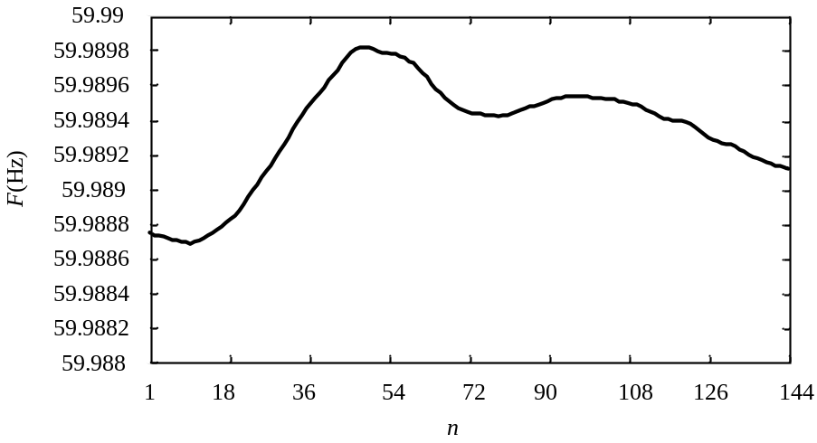
Fig.1 UHD frequency data
To efficiently compress the UHD frequency data in real time, this paper proposes an Improve-TSSC (ITTS) method. The ITSSC sets N and M as variables, so that the optimal parameters for the UHD frequency compression can be obtained at runtime.

ITSSC Method for UHD Frequency Data
Fig. 2 shows the flow chart of the ITSSC method. As illustrated, this method transforms each value into a fixed-length CW and the BDs. Note that the ITSSC method compresses Raw Values (RVs) one after another due to the dependency of the current value and its predecessors. The specific steps to compress the i-th RV, RVi, are as follows:
- Step 1: Compare with immediate predecessors.
There is a vector of N IPres (IPres=[IPres₀, IPres₁, …, IPres_{N-1}] ) in the allocated buffer, where IPres₀ is the most recent immediate predecessor. These values are kept so that they can be compared with the current RV. If the RV equals any value in the IPres, a CW will be generated to directly represent RV_{i}. In this way, RV_{i} is transformed into a fixed-length CW with fewer bits
- Step 2: Calculate BDs.
If no value in the IPres matches RV_{i}, an XOR algorithm is used to calculate the BD of the RV_{i} (BD_{i}) by
BD_{i}=RV_{i} ^IPres₀
where ^ is the XOR operator.
As demonstrated, the ITSSC method is an XOR bitwise compression approach and operates only in binary rather than in floating values, making the operation faster than arithmetic-based methods.
Step 3: Valid bits (VBs) of BDs determination, and VB-based CW assignment.
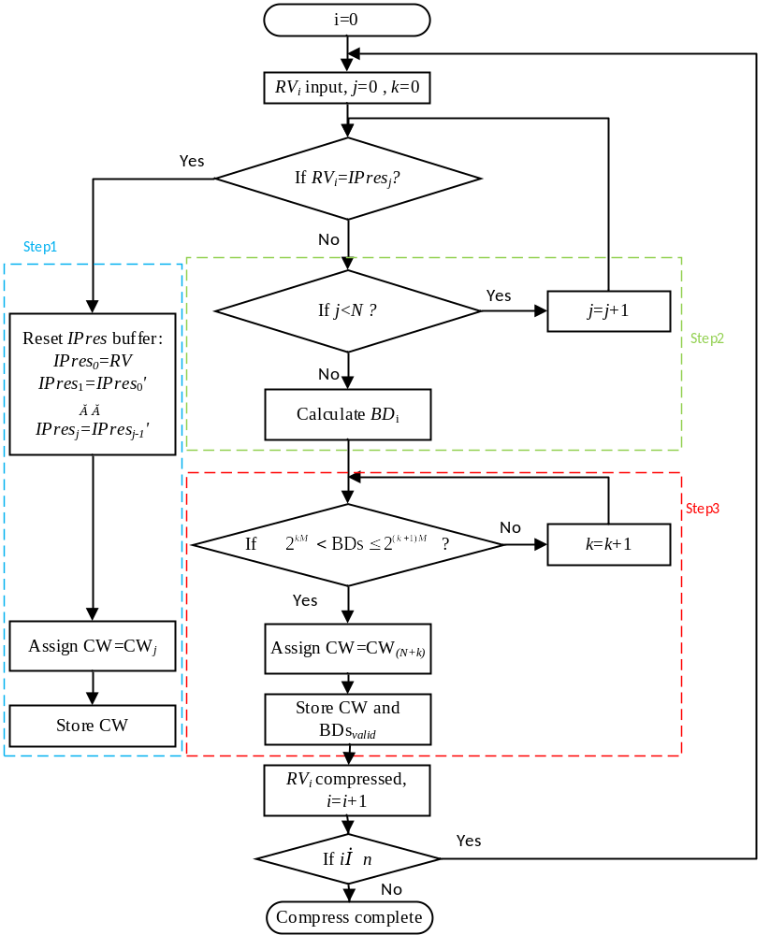
Fig. 2 ITSSC compression algorithm diagram
Per its definition, the BD indicates the variation between RVi and IPres0. For the UHD frequency data, the BDs are supposed to be small. However, BDs are, by default, 32-bit integers, which means only some lower bits can represent the difference. Discarding the meaningless prefix zeros to get the VBs of the BDs (BDvalid) is the next step for ITSSC to reduce redundancy.
However, discarding all the prefix zeros can create more scenarios than only discarding a fixed number of prefix zeros, which requires more CWs. Therefore, instead of discarding all the prefix zeros, BDvalid is determined by the criterion as follows.
2^{kM}<BD_{i}$≤$2^{(k+1)M}
where k=0,1,2…, $L$(BDvalid)/M-1，$L$(•) is the bit length calculation function. Once the criterion (2) is satisfied, the last (k+1)M bits of the BDs are Bdvalid, and the corresponding CW will be stored accompany by the Bdvalid.

Compression Performance
The CR is defined as the ratio between the original and the compressed sizes of a data frame, which can be expressed as follows for the ITSSC method
$\text{CR}=\frac{n×L\left(RV\right)+L\left(FrameHeader\right)}{n×L\left(CW\right)+L\left(FrameHeader\right)+\sum_{i=0}^{n-1}{L\left({BD}_{i}\right)}}$
Theoretically, the limit of the CR for the proposed ITSSC method can be estimated by
$\underset{n→∞,BD=0}{Lim}\left[\frac{n×L\left(RV\right)+L\left(FrameHeader\right)}{n×L\left(CW\right)+L\left(FrameHeader\right)+\sum_{i=0}^{n-1}{L\left({BD}_{i}\right)}}\right]=\frac{L\left(RV\right)}{L\left(CW\right)}$
As mentioned, the compression performance of the ITSSC method is affected by the N and the M. As is seen from (4), to pursue a higher CR, a minimized $L$(CW) should be determined by
$L\left(CW\right)=\left\lceil \log_{2}{(N+\frac{L\left(RV\right)}{M})}\right\rceil$
where ⎡•⎤ is the operator that rounds a number up to the next largest integer.

Compression Example
Fig. 3 shows an example for the ITSSC method to compress a batch of RVs (RVi, i=0,1,2,3,4), where N=9, IPres0=60.000000, IPres1=59.999962, IPresj=0 (j=2,3,…,8); M=8; $L(RV)$ =32 bits, and $L(CW)$=4 bits. In this example, RV0~RV2 equals one of the IPres, so they are only assigned with CWs in order, but no BDs information is required. For RV3, since it does not match any of the IPres, the BDs are calculated. Although only the last 5 bits contain the valid information of the BDs, the last 8 bits are recorded as BDsvalid according to the criterion (2). Then, RV3 is added to the PVs buffer as the new IPres0. RV4 has a similar compression process as RV3, which has a longer BDsvalid. The CR of this example is 3.63, which means that 72.5% of the space was saved after the compression.
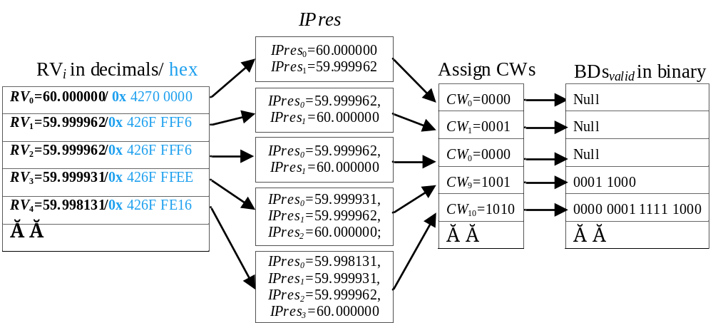
Fig. 3 ITSSC frequency compression process example(M=8, N=9)
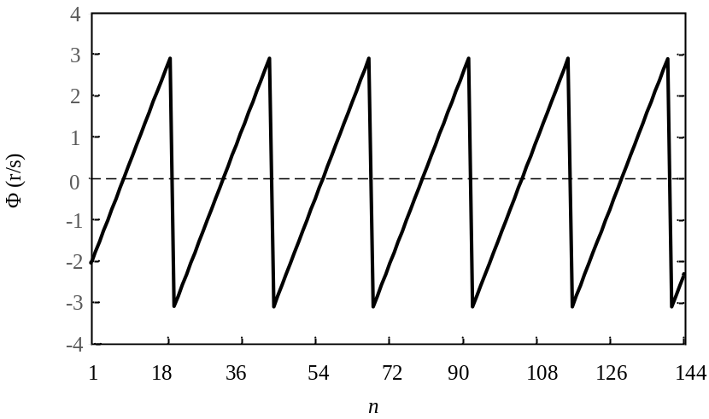
Fig. 4 UHD phase angle data sample frame

Phase Angle Compression Method

UHD Phase Angle Data Characteristics
Fig. 4 shows one sample frame of UHD phase angle data. The reporting rate of this example is 1440 Hz, where 10 frames are sent per second and each has n=144 measurement points. As can be seen from Fig. 4, the phase angle data has a relatively fixed slope rate in each cycle.
Fig. 5 shows a slope distribution of UHD phase angle data, which is the difference value between two consecutive values Δϕ(n)
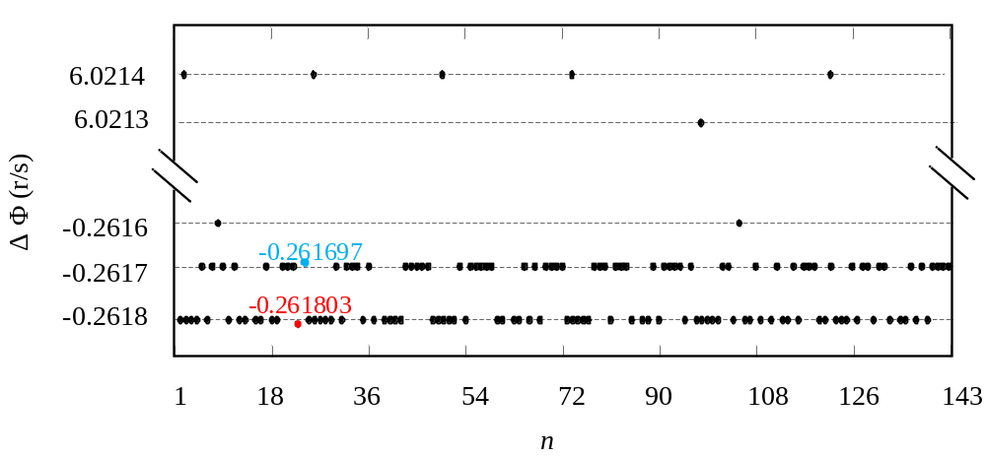
Fig. 5 Δϕ(n) of UHD phase angle data

Δϕ(n)=ϕ(n) -ϕ(n-1)
As is seen from Fig. 5, UHD Δϕ(n) data is highly repetitive. However, the repetition is intermittent.
It is mentioned in the Introduction section that the Huffman table information should be reconstructed for every next frame if the Huffman encoding method is exploited to compress the UHD phase angle data. This is because each frame has a unique Huffman table, and the loss of a single frame will lead to the decompression failure for the subsequent frames if their Huffman tables are dependent. However, including the Huffman table information introduces more information to each frame, restricting the CR. Considering that the different values in the Huffman table variate slightly due to the high sampling rate, this paper exploits the TSSC method as stage 3 to compress the Huffman table information, forming the Huffman-TSSC compression method.

Preprocessing algorithms
There are several methods proposed for the preprocessing, including the slack reference encoding (SRE), the swinging door (SD), the piecewise linear online trending (PLOT), and the difference encoding [8]-[12]. The SRE uses one node as a reference to predict the others, which is only applicable for a multi-nodes system but not for independent PMU data online compression. SD and PLOP are lossy methods that replace raw data with a set of parameters under given error limits; these methods cannot maintain data accuracy. Besides, [6] proposes the DEFC method to predict phase angle values by compensating a frequency-related element. As UHD Δϕ(n) has lower entropy than raw data, Delta Encoding (DE) that transforms raw data into the differences between sequential data via (6) shows the potential of compressing UHD phase angle data[11].

Encoding techniques
Various algorithms have been proposed to encode the preprocessed data. These algorithms include run-length encoding (RLE), the Huffman compression method, etc.
The RLE simplifies the consecutive repeated values into a single value and the number of its repetition. This method is efficient when the same data value occurs consecutively [13]. However, it is unable to have a good performance for UHD phase angle data as the preprocessed data occurs intermittently.
The Huffman compression method is one of the most widely used techniques. It first builds the Huffman table, which consists of the different values and their occurrence frequency. Then a Huffman tree is constructed, which assigns the CWs with fewer bits to the values that occur more frequently [11]. Unlike the RLE, Huffman encoding does not require the data to be consecutively repeated. It compresses the data efficiently if it has some frequently observed values. Additionally, it is easy to implement and faster than dictionary encoding methods.
Technically, the limit of the CR for the Huffman-based method is
$\lim_{n→∞}(CR){=\frac{n×L\left(RV\right)+L\left(FrameHeader\right)}{\sum_{i=0}^{n-1}{L\left({CW}_{i_Huff}\right)}+L\left(FrameHeader\right)}}=L\left(RV\right)$
where ${CW}_{i_Huff}$ is the Huffman CW.

Huffman-TSSC Phase Angle Compression Algorithm
Since the Huffman table introduces more information to each frame, restricting the CR, the TSSC method is exploited to compress the different values in the Huffman table. Fig. 6. shows the stages of the Huffman-TSSC method for phase angle compression. Stage 1 is to preprocess the raw data to the intermediate form Δϕ(n) by DE, and then the Huffman table is built for Δϕ(n). Then, in stage 2, a Huffman tree is built, which assigns shorter CWs to Δϕ(n) that occurs more frequently, so that Δϕ(n) can be compressed to some CWs with less bits. In stage 3, the TSSC method is used to compress the Huffman table, where N=1, M=4, and XOR are operated between any two consecutive different values of the Huffman table.
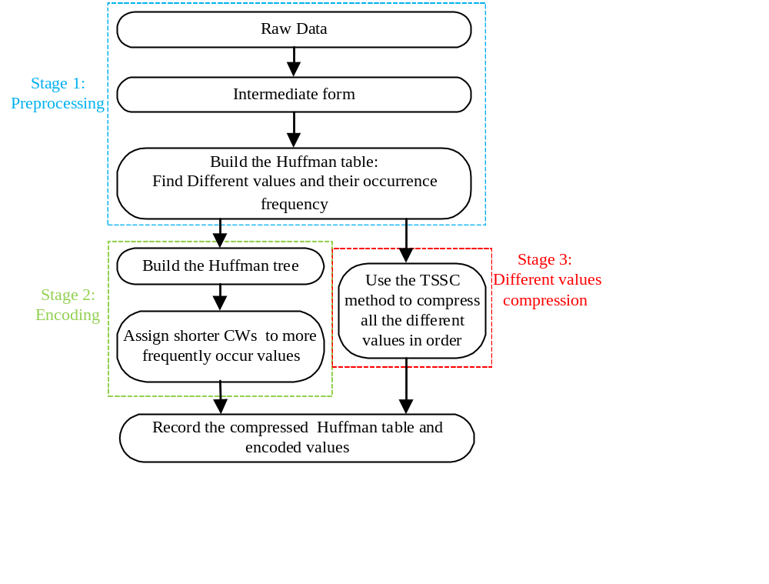
Fig. 6 Flow chart of the DE-Huffman-TSSC compression method.

Fig.7 shows an example of the proposed Huffman-TSSC method. As is seen, the data is first preprocessed to Δϕ(n) that could repeat. Then, a Huffman table is built for Δϕ(n). After that, the Δϕ(n) that occurs the most frequently are compressed to the shortest CWs based on the Huffman tree. Finally, the Huffman table is compressed to CWs and BDsvalid via the TSSC method, so that the Huffman table can take up fewer bits. In this example, the CR is increased by 20%.
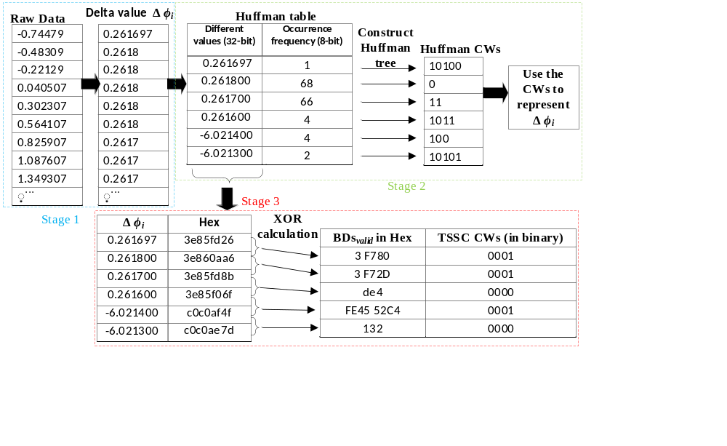
Fig. 7 The Huffman-TSSC compression example.

Point on Wave Data Compression

UHD Point on Wave Data Characteristics
Fig. 8 shows a UHD Point on Wave (POW) example, where the values are expressed in 16-bit integers. As is seen, the POW signal is almost a sinusoidal wave, which can be expressed as
x(k)=Asin(ωTsk+φ)
where A, ω, and φ are the amplitude, angular frequency, and the phase angle of the POW. The A, ω, and φ can change between every two points in practical. However, since the sampling rate is quite high, the changes of A and ω can be very small.
Fig 9 shows a sample frame of the HDM signal, which contains 600 points. As mentioned in Section III, the Huffman table needs to be reconstructed for every frame if Huffman method is used. However, it can be seen from Fig.9 that the residuals do not tend to repeat frequently in one frame, making Huffman algorithm unable to compress it well.
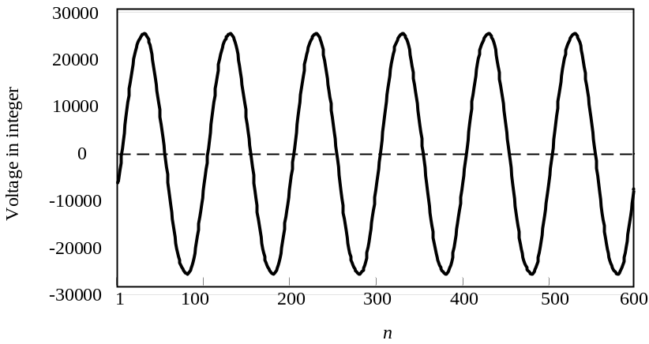
Fig. 8 UHD POW (voltage) data sample.
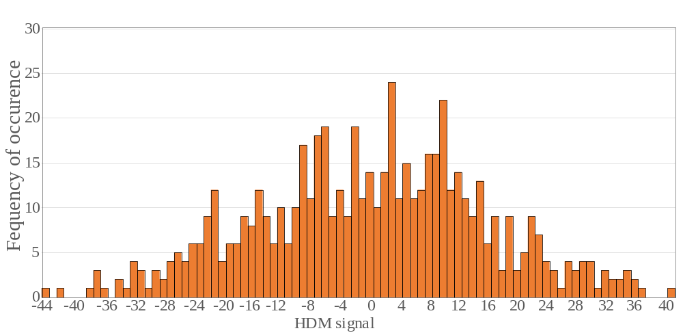
Fig.9. An example of frequency occurrence of HDM signal.

To compress the UHD POW data in real time, this paper proposes a CHDM-VB method. The Cyclical High-order Delta Modulation (CHDM) model that takes A, ω, and φ as inconstant parameters is deducted. Based on the model, a criterion to determine the optimal differential order is established, thus the optimal high-order delta modulation signal is obtained. Differential operation is then carried out cyclically for the obtained data to further reduce the VBs. Since the data processed by the aforementioned approaches have fewer VBs, it can be better compressed via the VB-based CW assignment method. Since this algorithm simply employs arithmetic operations, its running speed is higher than the FFT-based methods.
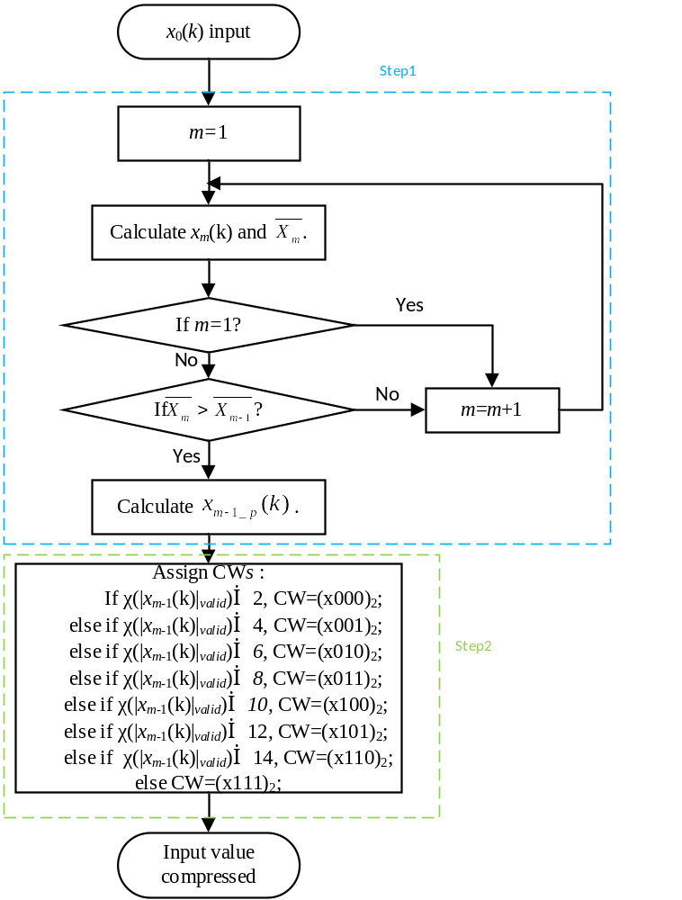
Fig. 10 CHDM-FLA algorithm flow chart

CHDM-VB Compression Method
Fig.10 shows a flow chart of the algorithm, where the compression steps are as follows:
Step 1: CHDM
Assuming x0(k-1)=A0(k-1)sin[ω0(k-1)(k-1)+φ0(k-1)] is the POW value at time tk-1 and x0(k)=A0(k)sin[ω0(k)k+φ0(k)] is the next point of value, the difference value between these two values, x1(k)=x0(k)-x0(k-1), can be derived as
x1(k)$≈$A1(k)cos[ω1(k)k+φ1(k)]
where $A_{1(k)}=2sin[(φ_{0\left(k\right)}-φ_{0\left(k-1\right)})/2]×A_{0(k)}$, ω1(k)=ω0(k) and $φ_{1\left(k\right)}=(φ_{0\left(k\right)}+φ_{0\left(k-1\right)})/2$.
As is seen from (9), by calculating the difference value between any two adjacent points, the POW data is transferred to a new set of data, where the amplitude $A_{1(k)}$ is much smaller than $A_{0(k)}$. The data set x1(k) is termed as the 1st DM.
Similarly, the 2nd DM data set can be calculated by
x2(k)=x1(k)-x1(k-1)
x2(k) can also be expressed as a sinusoidal wave x2(k)$≈$A2(k)sin[ω2(k)k+φ2(k)], where $φ_{2\left(k\right)}=\text{(}φ_{1\left(k\right)}+φ_{1\left(k-1\right)}\text{)}/2$，$A_{2(k)}=-2sin[(φ_{0\left(k\right)}-φ_{0\left(k-2\right)})/4]×A_{1(k)}$, and ω2(k)=ω0(k).
Such differential operations can be repeated many times. However, it can be seen that A2(k) is not necessarily smaller than A0(k). When the differential order increases to a certain number, the amplitude could increase. In this case, the compressed data has more VBs, which requires more CWs and decreases the CR.
A criterion is set to determine the optimal differential order when the data set has fewer VBs, which is expressed as
$\overline{X_{m}}=\frac{\sum_{k=0}^{n-m}{L({{|x}_{m}\left(k\right)|}_{valid})}}{n-m}$
where $L$(|xm(k)|valid) is the VBs of the absolute value of xm(k). The smaller the |xm(k)|, the smaller the $\overline{X_{m}}$, the higher the CR. Therefore, if $\overline{X_{m}}>\overline{X_{m-1}}$, xm-1(k) is considered as the optimal differential data set that has fewer VBs.
xm-1(k) is a sinusoidal wave that has the same cycle as x0(k), so the values tend to be cyclical. Therefore, the high-order difference data set xm-1(k) can be processed by a periodically differential operation as follows:
$x_{m-1_{_p}}\left(k\right)=x_{m-1}(k+\frac{1}{T_{s}f_{nom}})$-$x_{m-1}(k)$
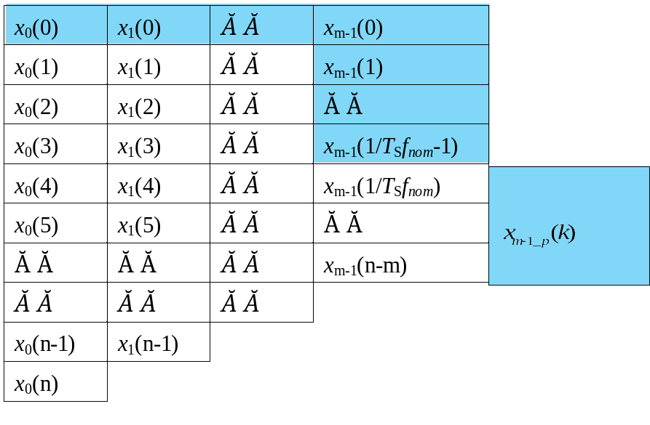
Fig. 11 The CHDM table

Fig.11 shows the CHDM table that indicates the CHDM compression process. As is seen, the high-order DM data sets (x1, …, xm-1, xm) are calculated. Based on the criterion in (11), the optimal high-order differential data set xm-1 is determined. Then, the differential operation is processed periodically for the xm-1. The original data is therefore transferred to the intermediate form that is colored in the blue background.
Step 2: VB-based CW assignment
The CHDM-preprocessed values are not highly repeated, which makes it difficult to be compressed by the entropy methods. However, they have fewer VBs compared with raw values. Therefore, they can be efficiently compressed by discarding the prefixed meaningless zeros and assigning fix-length CWs, which is similar to Step 3 of the ITSSC method. Note that the CWs for POW data consists of two parts, i.e. a sign bit that indicates if xm-1(k) is positive or negative and several bits that represent the VBs of |xm-1(k)|.

Data Compression Tests
In this paper, experiments are carried out in offline and online modes, using the field-collected UHD data of the wide-area monitoring system (WAMS), FNET/GridEye and Oak Ridge National Laboratory (ORNL) [20]-[22]. In the offline tests, the frame header is not considered, i.e. $L$(FrameHeader)=0. In the online tests, the algorithms are implemented in IEEE C37.118.2 PMU communication protocol and L(FrameHeader)=32 bytes. Since the data frame complies with the standard protocol, there is no need to change the original circuit of the measurement device.
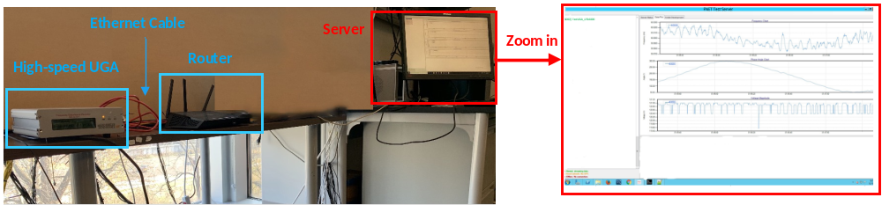
Fig. 12 Online experiment system setup
Note that each of the frame header has only one timestamp. This timestamp is related to the first measurement point of the data set. Since the data in each frame is consecutive in time series, the rest timestamps of the data can be easily obtained when the sampling rate is known. For example, assuming that the sampling rate is 1000Hz and the reporting rate is 10Hz, each of a data frame consists of 100 measurement values. If the timestamps of the 100 values are “2020-01-01 00:00:00.000”, “2020-01-01 00:00:00.001”, “2020-01-01 00:00:00.002”, …, “2020-01-01 00:00:00.099”, respectively, then the timestamp of the frame will be “2020-01-01 00:00:00.000”.
Fig. 12 shows the experiment system setup, where the compression methods are implemented into a PMU variation, Universal Grid Analyzer (UGA). The UGA is connected to a router via an ethernet cable, and the router is connected to the remote router that the server is connected. The remote testing server decompresses the compressed data frames and shows the data plot in real time.
The frequency and phase angle data are 32-bit values and their reporting rates are 1440Hz, where 10 frames are sent per second and each has n=144 measurement points.

UHD Frequency Compression Tests
TABLE I
UHD Frequency Compression Ratio of Collected Data
N  M | 2 | 4 | 8 | 12 | 14 | 16 | 24 | 28 | 30 | 32
1 | 3.17 | 3.31 | 3.35 | 3.38 | 3.39 | 3.40 | 3.43 | 3.45 | 3.45 | 3.46
2 | 3.65 | 3.72 | 3.76 | 3.82 | 3.84 | 3.85 | 3.40 | 3.40 | 3.41 | 3.41
4 | 3.82 | 3.90 | 4.00 | 3.60 | 3.61 | 3.63 | 3.69 | 3.31 | 3.33 | 3.34
8 | 3.38 | 3.50 | 3.24 | 3.31 | 3.02 | 3.04 | 3.10 | 3.12 | 2.62 | 2.62
16 | 2.25 | 2.18 | 2.12 | 2.18 | 2.20 | 2.07 | 2.13 | 2.15 | 2.16 | 2.03
*The shading represents the $L$(CW)
2 bits | 3 bits | 4 bits | 5 bits | 6 bits

a)The effect of different algorithm settings
To find the optimal parameters (N and M) for the ITSSC method, tests are conducted with the data collected by the high-speed UGAs. The results are shown in Tab. I, where different shading indicates different $L$(CW).
As is seen from Tab. I, when M is fixed, the CR increases with N if $L$(CW) does not change as more values are in the IPres. However, if $L$(CW) becomes larger with N, the CR becomes smaller. This is because the CW, in this case, takes up more bits, which offsets the positive effects of the increase of N on the compression performance. For the M, when $L$(CW) is fixed, the CR decreases with it as more meaningless prefix zeroes are recorded. When the increase of M decreases $L$(CW), the CW takes up less space while more prefix values are recorded. Therefore, the CR could become either larger or smaller.
The CR is 4.0 when M=4, N=8, which is the highest among all the test results. Therefore, they are the optimal parameters of the ITSSC method.
b) Online compression experiments
The proposed ITSSC method with optimal parameters is tested by implementing the code into the UGA. As a reference, the traditional Huffman compression method combined with the DE preprocessing is also tested, where the results are shown in Tab. II. As is seen, the Average CR (ACR) of the ITSSC method is 3.51, exceeding that of the Huffman-based method, 3.34. Notice that the CR of the ITSSC method shown in Tab. I is greater than that shown in Tab. II. This is mostly because the frame size is 0.
TABLE II
Real-time CR of Different Algorithms For UHD Frequency Data
Method | Day 1 | Day 2 | Day 3 | Day 4 | Day 5 | Day 6 | Day 7 | Day 8 | Day 9 | Day 10 | ACR
ITSSC | 3.23 | 3.51 | 3.11 | 3.51 | 3.92 | 3.16 | 4.28 | 3.47 | 3.62 | 3.57 | 3.51
Huffman-based | 3.05 | 3.20 | 3.15 | 3.45 | 3.68 | 3.05 | 4.31 | 3.47 | 3.56 | 3.07 | 3.34
TABLE III
Real-Time ACR of Different Algorithms For UHD Phase Angle Data
Stage 1  Stage 2& Stage 3 | DE | 1st LP | DEFC
TSSC | 3.78 | 3.83 | 3.56
Huffman | 8.10 | 5.32 | 2.13
Huffman-TSSC | 8.90 | 5.71 | 2.23

Note that the experiments are carried out under day-to-day operations, where events (generation trip, load disconnection, oscillation) and noises (mainly spikes) are constantly observed. Based on the performance evaluation, we believe the proposed methods can achieve a good CR under these scenarios.

UHD Phase Angle Compression Tests
- Different algorithms comparison
Tab. III shows the compression performance of the Huffman-TSSC method compression performance. As references, the TSSC-based and the Huffman-based methods are also tested. Additionally, different preprocessing algorithms are combined. As is seen from Tab. III, DE, 1st LP, and DEFC perform similarly with the TSSC-based method for UHD phase angle data, where 1st LP has the highest CR 3.83 among them. For the Huffman-based encoding algorithms, the DE combined method has the highest CR 8.1 among all the tests. This method is 2 times of the TSSC-based method. However, when combined with DEFC, the Huffman-based method has the lowest CR 2.13, which means that the DEFC is not suitable to preprocess UHD phase angle data. When using the TSSC method to compress the Huffman table information, the ACR can be increased by 10%, where the DE-processed algorithm has the highest ACR, which is 8.9. Therefore, the proposed Huffman-TSSC method that is preprocessed by DE is optimal for UHD phase angle data compression.
TABLE IV
Real-time CR of The Huffman-TSSC Method For UHD Phase Angle Data
Day 1 | Day 2 | Day 3 | Day 4 | Day 5
6.68 | 7.02 | 7.28 | 7.36 | 7.15
Day 6 | Day 7 | Day 8 | Day 9 | Day 10
8.10 | 6.25 | 7.81 | 6.41 | 7.67

- Online compression experiments for phase angle data
The proposed Huffman-TSSC method is tested for several days in PMUs. The results are shown in Tab. IV. As is seen from Tab. IV, the proposed method compresses the UHD phase angle data efficiently. The ACR of experiments is 7.2, which is less than the offline CR due to the frame header.

UHD Synchrophasor Data Online Compression Tests
- Compression ratio
Since the frequency and the phase angle data are usually monitored simultaneously, they will be sent out at the same time as well. Therefore, it is more efficient for communication to compress them into one frame. To confirm the ACR for the UHD UGAs, experiments are also carried out to compress both the frequency and phase angle data.
The ITSSC method is used for the UHD frequency compression, where the parameters are M=4 and N=8. For UHD phase angle data, the proposed Huffman-TSSC method is used. Although the literature on the lossless compression of streaming data for power system monitoring is limited [23], it is reported that the ACR of the lossless compression methods that has been reported is 3 [24]. In the experiments of this paper, the ACR of the UHD sychrophasor data is 4.90, which exceeds the previously reported state-of-the-art by the time the paper was written.
- PMU reporting latency
The high-speed UGA is designed for both measuring and protecting power systems. As shown in Fig.13, the frequency error of the high-speed UGA is less than 0.004Hz, which satisfies the IEEE C37.118.1-2014 standard for both P-class (protection) and M-class (measurement) PMUs. It is also stated in the standard that the PMU real-time output reporting latency shall below 2/Fs and 7/Fs for P-class and M-class PMUs, respectively, where Fs is the reporting rate and Fs=10Hz in this paper
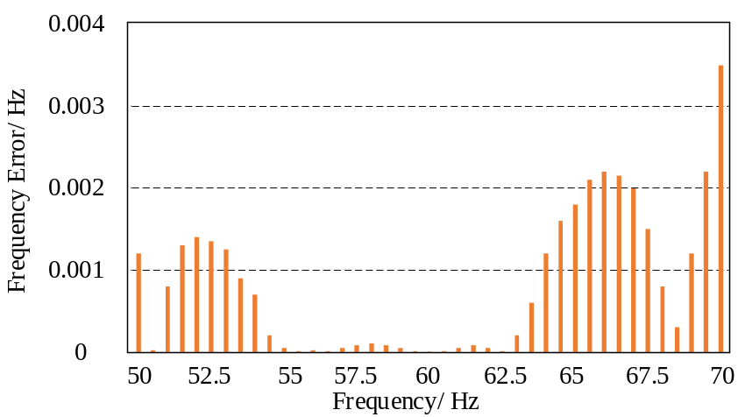
Fig. 13 Frequency error o6f the high-speed UGAs.
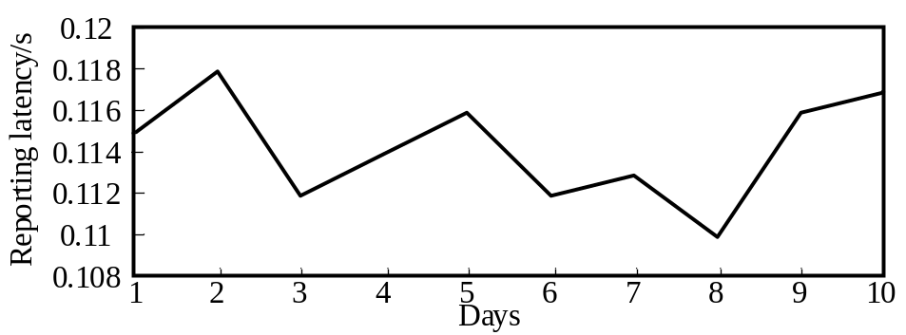
Fig. 14 Reporting latency for high-speed UGA with sychronphasor data compression methods implemented

This paper measures the reporting latency of the high-speed UGAs with the proposed compression method implemented. The reporting latency during different days is shown in Fig. 14. As is seen, the maximum reporting latency is 0.118s, which is lower than the IEEE standard limits 0.2s and 0.7s for the P-class and M-class PMUs, respectively.

UHD POW Data Compression Tests
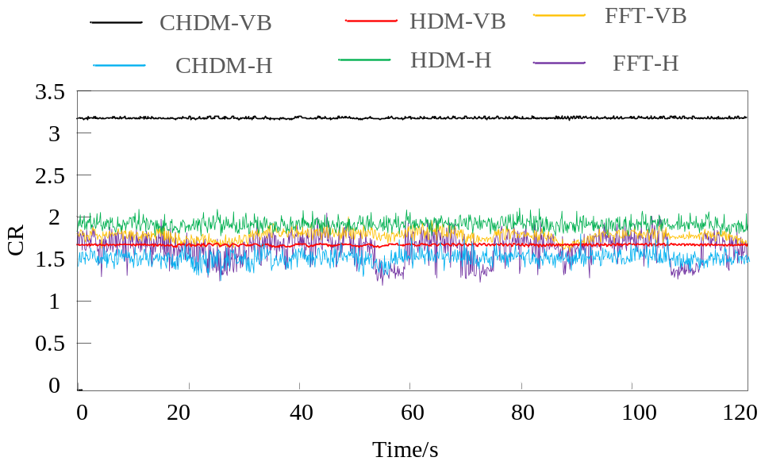
Fig. 15 CR of different algorithms for UHD POW data
TABLE V
ACR of Different Method For FNET UHD POW Data in Real Time
CHDM-VB | CHDM-H | HDM-VB | HDM-H | FFT-VB | FFT-H
3.19 | 1.53 | 1.91 | 1.62 | 1.80 | 1.61

- FNET/GridEye data tests
The POW data is 16-bit and sampled at 6000Hz. Fig.15 shows the compression performance of the proposed CHDM-VB method, and several combined methods are also tested as references. As is seen from Fig.15, the CHDM-VB method can always compress POW data more aggressively than the others. The compression ratio of the CHDM-VB method is about 3.2, while that of the other methods are 1.2~2.
Tab. V lists the ACRs of the proposed and reference methods, where the Huffman method is abbreviated as “H”. As can be seen, the proposed cyclical difference calculation can dramatically increase the ACR from 1.8 (FFT-VB) to 3.19 (CHDM-VB). Additionally, the Huffman coding does not perform well for online UHD POW data compression compared with the VB method due to the non-repeatability of the preprocessed POW data. It is also noticed that the ACR of the proposed CHDM-VB method is higher than the ACR that has been reported, which is 3, thus further confirming the compression performance of the CHDM-VB method.
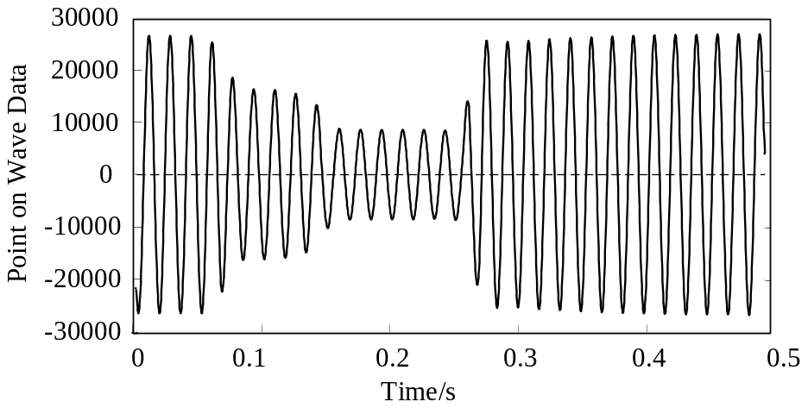
Fig. 16 ORNL POW data
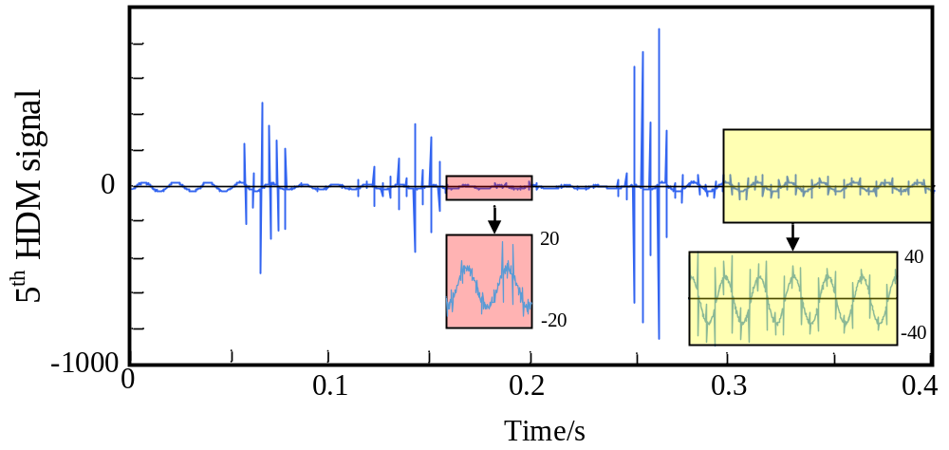
Fig. 17 HDM signals
TABLE VI
ACR of Different Method For ORNL UHD POW Data
CHDM-FL | CHDM-H | HDM-FL | HDM-H | FFT-FL | FFT-H
3.33 | 1.60 | 1.58 | 1.40 | 1.20 | 0.90

The reporting latency of the high-speed UGA with the CHDM-VB implemented is tested for the UHD POW data. The maximum reporting latency during the ten-day experiment is 0.125s, which is lower than the IEEE standards limits 0.2 s and 0.7s for the P-class and M-class PMUs.
- ORNL data tests
Fig.16 shows a sample of the UHD POW data collected by ORNL at a sampling rate of 3840 Hz, where an event occurs at 0.06s and disappears at around 0.28s. Use CHDM-VB method to compress the POW data, and compare it with other reference methods. The compression performance is listed in Tab. VI. As is seen from Tab. VI, the CHDM-VB method also has a good compression performance for the 3840 Hz POW data, whose ACR is 3.33, while the ACRs of other methods are less than 1.6.
Fig. 17 shows the optimal HDM differential signals for the ORNL collected POW data shown in Fig. 16, which contains an event and has an ACR of 3.12. As is seen, the high-order DM signal has some spikes due to the magnitude change of the raw POW dada, which may affect the compression performance of the method. However, most of the points still have less VBs, making it possible to be compressed well.

Conclusion

This paper proposes several methods to compress the UHD synchrophasor and POW data in a lossless and real-time manner. The methods are designed for advanced PMUs to compress data packets efficiently and quickly before its transmission to the server. The proposed methods address the communication efficiency and memory space issues on the server side.
The proposed methods are tested with the field-collected data, and the algorithms are implemented in a high-speed PMU to compress data in real time. The results show that the proposed methods have extraordinary compression efficiency, where the average compression ratio of the synchrophasor data is 4.9, and that of the POW data is 3.3.

Chapter 7 Conclusions

Bibliography

- Hannah Ritchie, Max Roser, and Pablo Rosado. Energy. Our World in Data, 2022. https://ourworldindata.org/energy. 1
- AG Olabi and Mohammad Ali Abdelkareem. Renewable energy and climate change. Renewable and Sustainable Energy Reviews, 158:112111, 2022. 1
- Govinda R Timilsina. Are renewable energy technologies cost competitive for electricity generation? Renewable Energy, 180:658–672, 2021. 1
- KA Folly. Wind energy integration into the south african grid: Prospects and challenges. Wind Energy-developments, Potential and Challenges, pages 93–120, 2016. 1, 5
- Arne van Stiphout, Kristof De Vos, and Geert Deconinck. The impact of operating reserves on investment planning of renewable power systems. IEEE Transactions on Power Systems, 32(1):378–388, 2016. 1, 5
- Hongyu Li, Ping Ju, Chun Gan, Shutang You, Feng Wu, and Yilu Liu. Analytic analysis for dynamic system frequency in power systems under uncertain variability. IEEE Transactions on Power Systems, 34(2):982–993, 2018. 1, 5
- MD Hadley, JB McBride, TW Edgar, LR O’Neil, and JD Johnson. Securing wide area measurement systems. US Department of Energy, 2007. 1

- Shengyuan Liu, Shutang You, He Yin, Zhenzhi Lin, Yilu Liu, Wenxuan Yao, and Lakshmi Sundaresh. Model-free data authentication for cyber security in power systems. IEEE Transactions on Smart Grid, 11(5):4565–4568, 2020. 2
- Alexandra Von Meier, Emma Stewart, Alex McEachern, Michael Andersen, and Laura Mehrmanesh. Precision micro-synchrophasors for distribution systems: A summary of applications. IEEE Transactions on Smart Grid, 8(6):2926–2936, 2017. 2
- Yanzhu Ye. Wide-area Situational Awareness Application Developments. PhD thesis, University of Tennessee, 2011. 3, 40
- Shengyuan Liu, Kaiqi Sun, Chujie Zeng, Shutang You, Hongyu Li, Wenpeng Yu, Xianda Deng, Zhenzhi Lin, and Yilu Liu. Practical event location estimation algorithm for power transmission system based on triangulation and oscillation intensity. IEEE Transactions on Power Delivery, 37(6):5190–5202, 2022. 3, 40
- Power IT Lab. Fnet/grideye frequency display. https://fnetpublic.utk.edu/ tabledisplay.html. 3
- Power IT Lab. Fnet/grideye event visualization. https://fnetpublic.utk. edu/frequencymap.html. 3
- Power IT Lab. Fnet/grideye event visualization. https://www.youtube.com/ @fnet/videos. 3, 40, 42
- Hyang-Won Lee, Jianan Zhang, and Eytan Modiano. Data-driven localization and estimation of disturbance in the interconnected power system. In 2018 IEEE International Conference on Communications, Control, and Computing Technologies for Smart Grids (SmartGridComm), pages 1–6. IEEE, 2018. 5, 25
- Brendan J Kirby, Jim Dyer, Carlos Martinez, Rahmat A Shoureshi, Ross Guttromson, Jeff Dagle, et al. Frequency control concerns in the North American electric power system. United States. Department of Energy, 2003. 5, 25

- Mark Z Jacobson and Mark A Delucchi. Providing all global energy with wind, water, and solar power, part i: Technologies, energy resources, quantities and areas of infrastructure, and materials. Energy policy, 39(3):1154–1169, 2011. 5
- Yong Liu, Shutang You, Wenxuan Yao, Yi Cui, Ling Wu, Dao Zhou, Jiecheng Zhao, Hesen Liu, and Yilu Liu. A distribution level wide area monitoring system for the electric power grid–fnet/grideye. IEEE Access, 5:2329–2338, 2017. 6
- Weikang Wang, Kaiqi Sun, Chang Chen, Yin He, Shutang You, Wenxuan Yao, Jiaojiao Dong, Chujie Zeng, Xianda Deng, Yilu Liu, et al. Advanced synchrophasor-based application for potential distributed energy resources management: key technology, challenge and vision. In 2020 IEEE/IAS Industrial and Commercial Power System Asia (I&CPS Asia), pages 1120–1124. IEEE, 2020. 6
- Kaiqi Sun, Wei Qiu, Wenxuan Yao, Shutang You, He Yin, and Yilu Liu. Frequency injection based hvdc attack-defense control via squeeze-excitation double cnn. IEEE Transactions on Power Systems, 36(6):5305–5316, 2021. 6, 27
- Can Huang, Charanraj Thimmisetty, Xiao Chen, Emma Stewart, Philip Top, Mert Korkali, Vaibhav Donde, Charles Tong, and Liang Min. Power distribution system synchrophasor measurements with non-gaussian noises: Real-world data testing and analysis. IEEE Open Access Journal of Power and Energy, 8:223– 228, 2021. 6
- M Anvari, G Lohmann, M Reza Rahimi Tabar, M Wa¨chter, P Milan, D Heinemann, Joachim Peinke, and E Lorenz. Suppressing the non- gaussian statistics of renewable power from wind and solar. arXiv preprint arXiv:1505.01638, 2015. 6, 9

- Katrin Schmietendorf, Joachim Peinke, and Oliver Kamps. The impact of turbulent renewable energy production on power grid stability and quality. The European Physical Journal B, 90:1–6, 2017. 6, 9
- Hauke Haehne, Katrin Schmietendorf, Samyak Tamrakar, Joachim Peinke, and Stefan Kettemann. Propagation of wind-power-induced fluctuations in power grids. Physical Review E, 99(5):050301, 2019. 6, 9
- Benjamin Schafer, Marc Timme, and Dirk Witthaut. Isolating the impact of trading on grid frequency fluctuations. In 2018 IEEE PES Innovative Smart Grid Technologies Conference Europe (ISGT-Europe), pages 1–5. IEEE, 2018. 6, 9
- Benjamin Sch¨afer, Christian Beck, Kazuyuki Aihara, Dirk Witthaut, and Marc Timme. Non-gaussian power grid frequency fluctuations characterized by l´evy- stable laws and superstatistics. Nature Energy, 3(2):119–126, 2018. 6, 9, 15
- Chujie Zeng, Wei Qiu, Weikang Wang, Kaiqi Sun, Chang Chen, and Yilu Liu. Non-gaussianity in frequency distribution: Fnet/grideye’s observation of worldwide grids. In 2022 International Conference on Smart Grid Synchronized Measurements and Analytics (SGSMA), pages 1–6. IEEE, 2022. 6
- Bin Qiu, Ling Chen, Virgilio Centeno, Xuzhu Dong, and Yilu Liu. Internet based frequency monitoring network (fnet). In 2001 IEEE Power Engineering Society Winter Meeting. Conference Proceedings (Cat. No. 01CH37194), volume 3, pages 1166–1171. IEEE, 2001. 7
- Zhian Zhong, Chunchun Xu, Bruce J Billian, Li Zhang, S-JS Tsai, Richard W Conners, Virgilio A Centeno, Arun G Phadke, and Yilu Liu. Power system frequency monitoring network (fnet) implementation. IEEE Transactions on Power Systems, 20(4):1914–1921, 2005. 7

- Xianda Deng, Hongyu Li, Wenpeng Yu, Wang Weikang, and Yilu Liu. Frequency observations and statistic analysis of worldwide main power grids using fnet/grideye. In 2019 IEEE Power & Energy Society General Meeting (PESGM), pages 1–5. IEEE, 2019. 7, 27
- Shengyuan Liu, Shutang You, Chujie Zeng, He Yin, Zhenzhi Lin, Yuqing Dong, Wei Qiu, Wenxuan Yao, and Yilu Liu. Data source authentication of synchrophasor measurement devices based on 1d-cnn and gru. Electric Power Systems Research, 196:107207, 2021. 25
- Philip M Anderson and Mahmood Mirheydar. An adaptive method for setting underfrequency load shedding relays. IEEE Transactions on Power Systems, 7(2):647–655, 1992. 26, 27
- Vladimir V Terzija. Adaptive underfrequency load shedding based on the magnitude of the disturbance estimation. IEEE Transactions on power Systems, 21(3):1260–1266, 2006. 26, 27
- Scott Manson, Greg Zweigle, and Vinod Yedidi. Case study: An adaptive underfrequency load-shedding system. IEEE Transactions on Industry Applications, 50(3):1659–1667, 2013. 26
- Y Zhang, X Deng, S You, J Dong, W Yu, and Y Liu. Measurement-driven disturbance magnitude estimations for bulk power systems. In Proceedings of 2019 IEEE PES GTD Grand International Conference and Exposition Asia, volume 104, 2019. 26, 27
- Chujie Zeng, Wei Qiu, Weikang Wang, Kaiqi Sun, Chang Chen, Lakshmi Sundaresh, and Yilu Liu. Disturbance magnitude estimation: Mlp-based fusion approach for bulk power systems. In 2022 IEEE/IAS 58th Industrial and Commercial Power Systems Technical Conference (I&CPS), pages 1–6. IEEE, 2022. 27

- NERC. Frequency response standard, background document, November 2012. https://www.nerc.com/pa/Stand/Project200712FrequencyResponseDL/ Bal-003-1-Background_Document-Clean-2013_FILING.pdf. 27
- NERC. M-4 interconnection frequency response, November 2021. https://www. nerc.com/pa/RAPA/ri/Pages/InterconnectionFrequencyResponse.aspx. 28
- Claude Elwood Shannon. Communication in the presence of noise. Proceedings of the IRE, 37(1):10–21, 1949. 31
- Stephen Butterworth et al. On the theory of filter amplifiers. Wireless Engineer, 7(6):536–541, 1930. 31
- Kurt Hornik. Approximation capabilities of multilayer feedforward networks.
Neural networks, 4(2):251–257, 1991. 35

- Zhou Lu, Hongming Pu, Feicheng Wang, Zhiqiang Hu, and Liwei Wang. The expressive power of neural networks: A view from the width. In Proceedings of the 31st International Conference on Neural Information Processing Systems, pages 6232–6240, 2017. 35
- Abien Fred Agarap. Deep learning using rectified linear units (relu). arXiv preprint arXiv:1803.08375, 2018. 35
- Quynh Nguyen and Matthias Hein. The loss surface of deep and wide neural networks. In International conference on machine learning, pages 2603–2612.
PMLR, 2017. 35

- Diederik P Kingma and Jimmy Ba. Adam: A method for stochastic optimization.
arXiv preprint arXiv:1412.6980, 2014. 36

- Ian Goodfellow, Yoshua Bengio, and Aaron Courville. Deep Learning. MIT Press, 2016. http://www.deeplearningbook.org. 36

- Ilya Loshchilov and Frank Hutter. Decoupled weight decay regularization. arXiv preprint arXiv:1711.05101, 2017. 36
- James S Thorp, Charles E Seyler, and Arun G Phadke. Electromechanical wave propagation in large electric power systems. IEEE Transactions on Circuits and Systems I: Fundamental Theory and Applications, 45(6):614–622, 1998. 40
- Sahand Negahban, Sewoong Oh, and Devavrat Shah. Iterative ranking from pair-wise comparisons. Advances in neural information processing systems, 25, 2012. 43

Vita

Vita goes here...

