It Takes a Village: A Secondary Qualitative Analysis Study

A Thesis Presented for the
Master of Arts
Degree
The University of Tennessee, Knoxville

Desirée S. Woodle
May 2025

Copyright © 2025 by Desirée S. Woodle.
All rights reserved.

ACKNOWLEDGEMENTS

I want to express my gratitude to everyone who supported and encouraged me during this journey. A heartfelt thank you goes to the mothers who shared their stories. Your voices and experiences are influencing the quality of care for mothers.

ABSTRACT

Half of all women experience health-related issues during the fourth trimester, which is typically characterized by physical, psychological, biological, and social changes (Verbiest et al., 2018). Additionally, with a growing body of research on the fourth trimester, there is evidence indicating an increase in maternal mortality rates in the United States since the pandemic (Brik et al., 2022). This concern highlights the need for improved resources and interventions to better support mothers during this transitional period. The current study explores mothers’ experiences during the fourth trimester to gain insights regarding available resources, specific needs during the period, and the importance of navigating the fourth trimester period from a holistic perspective. Furthermore, the current study seeks perspectives from providers who provide services and care to mothers during the fourth trimester period. This approach allows for an investigation of the similarities and differences regarding available and needed resources for mothers during the period. The secondary analysis involved a sample of 17 mothers and eight providers, all of whom participated in individual or focus group interviews for program evaluation for a Federally Qualified Healthcare Center (FQHC). Participants were recruited using snowball sampling from the community. Given the nature of this secondary analysis, thematic analysis was employed to interpret the data. Results from the current study showcased the mothers’ adaptive experiences during the fourth trimester, particularly concerning physical adaption, emotional responses, relational adjustments, and the paradigm shifts that can occur. Additionally, another theme that emerged pertained to the impacts on mothers’ mental health during the fourth trimester. The interviews also revealed gaps in resources related to mothers’ fourth trimester support. Lastly, the results discussed the differences and similarities in interview responses from mothers and providers about fourth trimester support. Overall, our findings indicate that continued research on mothers’ support systems and relationships during the fourth trimester is essential. Recommendations for continuously addressing gaps in fourth trimester support are discussed.

Table Of Contents

Introduction and General Information 1
Literature Review 3
Holistic Wellness 3
Intersectionality 4
Impact of the Pandemic on the Fourth Trimester 5
Mother’s Voices 6
Purpose And Significance of The Present Study 8
Materials and Methods 10
Methodology 10
Social Constructionism 10
Thematic Analysis 11
Background of Study 11
Methods 13
Recruitment 13
Positionality 13
Participants 14
Data Collection 15
Data Analysis 16
Results and Discussion 19
Research Questions One & Two: Navigation during the Fourth Trimester: Adaptation, Mental Well-being, and Systemic Support 19
Adaptation 19
Mental Well-being 26
Systemic Support Network 31
Research Question Three: The Provider Perspective 41
Discussion 43
Addressing Gaps in Fourth Trimester Support 43
Limitations of the Study 46
Conclusions and Recommendations 47
List of References 52
Appendix 58

LIST OF TABLES
Table 4.1. Adaptation Themes 19
    - Table 4.2. Mental Well-being Themes 26
    - Table 4.3. Systemic Support Network Themes and Subthemes 30

Introduction and General Information
Each year, about 4 million women give birth (Tully et al., 2017). This is a cause for concern due to half of the 4 million women experiencing health-related issues during their postpartum period, which is known as the fourth trimester. The fourth trimester is defined as roughly 12 weeks post-delivery (Verbiest et al., 2018)., and this period is marked by significant physical, psychological, biological, and social changes that have often been overlooked in women’s health despite the number of women who decide to give birth (Verbiest et al., 2018). Some notable changes can include breastfeeding, bladder control changes, changes in physical appearance, and general postpartum healing on top of potential depressive symptoms (Verbiest et al., 2018). Continual neglect of a mother’s well-being during this period will result in severe consequences for their personal health and the health of their newborn. Mothers need the necessary time to recover and adjust to their new role and these changes, both for their own health and well-being but also for their newborns. It is vital for clinicians to understand that the fourth trimester period is important not just for newborn care but also for the mother’s physical and psychological health (Tani & Castagna, 2016).
In recent years, there has been an increase in concerns about this postpartum period due to the alarming rise in maternal mortality rates documented in the United States since the start of the pandemic (Brik et al., 2022). According to Hoyert (2023), the maternal mortality rate in 2021 was 32.9 deaths per 100,000 live births, which was an increase from 23.38 in 2020 and 20.21 in 2019. Among the previously stated statistics from 2021 regarding maternal mortality rates, Black women experienced 69.99 deaths per 100,000 live births that year (Hoyert, 2023). Most maternal deaths do not occur during pregnancy or delivery; instead, the majority occur in the postpartum period. Tikkanen (2020) noted that 21% of maternal deaths occur between one and six weeks postpartum. These unnerving statistics highlight the important need for researchers and healthcare professionals to extend their focus to the fourth trimester and start including mothers’ health and well-being in the prioritization of this critical period, especially for mothers of color who are disproportionately affected by maternal mortality (Altman et al., 2020).
The creation of a supportive environment that can address the unique needs of mothers and provide them with quality care and resources to thrive during this transitional period is essential. By prioritizing the health and well-being of mothers, there can be improvements in outcomes for both mothers and babies, in addition to a reduction in maternal mortality rates in the United States. To effectively enhance maternal healthcare, we should prioritize understanding mothers’ experiences, as their personal feedback and insights are invaluable in the formation of policies and practices that will accurately cater to their health and needs (Verbiest et al., 2018). The present study sought to gain a better understanding of mothers’ experiences during their fourth trimester period by empowering their voices through group and individual interviews. By conducting these interviews, mothers were able to share what went well and where they experienced difficulties during the fourth trimester period.

Literature Review
A review of the existing literature suggests the importance of exploring mothers’ experiences from a holistic perspective, which includes not only the physical recovery from childbirth but also emotional, social and psychological aspects. Additionally, the research further acknowledges that a mother’s overall wellness can be affected by various intersecting factors, including the mothers’ identity which in return can influence her experiences and needs. Furthermore, since 2020 and the start of the pandemic, the needs and challenges mothers face during the fourth trimester have highlighted the disparities in access to care and support for mothers from diverse backgrounds. Finally, the literature review indicates the importance of mothers’ voices, acknowledging their valuable insights and lived experiences as they navigate the fourth trimester.

Holistic Wellness
Commonly, during the fourth trimester, providers shift their focus to the education, assessment, and support of the newborn’s needs rather than the needs and concerns of the mothers (Fahey & Shenassa, 2013). Although there is some understanding that mothers will inevitably go through a physical recovery after birth, mothers are also navigating complex issues related to their self-image, intimate relationships, and bonding with their newborns, in addition to attempting to remain consistent with other demands such as caring for themselves, their newborns, and their families (Verbiest et al., 2016). Additionally, postpartum depression is a concern for mothers, impacting the quality of life and functionality of hundreds of thousands of American women each year (Howell et al., 2012). Physical symptoms, daily demands, and inadequate social support were identified as various factors that can contribute to depressive symptoms (Howell et al., 2012). Moreover, a Pakistani study found that breastfeeding difficulties are significantly associated with anxiety and depression (Mortazavi et al., 2014; Ali et al., 2009). Verbiest et al. (2018) also found that early support is important for an exclusive breastfeeding relationship between a mother and her newborn. Likewise, Guerra-Reyes et al. (2017) reported that it is essential for expecting and new mothers to have access to health information during pregnancy and after giving birth to support a healthy transition into motherhood.
Thus, a holistic perspective on the fourth trimester period and overall wellness for mothers emphasizes how there needs to be a shift to providing proper care for both the mother and their newborn. In sum, the recent literature has highlighted the need for this shift in mindset related to how we view mother’s health during the post-partum months. Rather than a narrow point of view, a holistic perspective that includes acknowledgment of the mother’s physical, mental, and social well-being should be emphasized (Mortazavi et al., 2014), along with the well-being of the newborn.

Intersectionality
Additionally, the way maternal health is experienced, especially in the months after giving birth, is affected by various aspects like a woman's race, income level, and education, which is better known as intersectionality. Intersectionality highlights that certain aspects of a person’s identity can create unique advantages and disadvantages. Hannon et al. (2022) discussed how these elements shape women's experiences during pregnancy and after childbirth, influencing how they interact with healthcare providers and how safe and respected they feel in the healthcare system.
Tierney et al. (2023) identified potential obstacles to receiving care after childbirth, like having different priorities for appointments, not enough time, focusing on children's needs, and lacking resources such as health insurance. They observed that white women and those with a higher SES are more likely to go to postpartum checkups (Tierney et al., 2023). Additionally, a mother’s return to work after birth can also be challenging due to issues like finding affordable childcare and having flexible work arrangements, which can be particularly difficult for women from marginalized groups (Hannon et al., 2022). Additionally, Harrell et al. (2022) highlighted the complex relationship between maternal health and various forms of discrimination like racism, classism, and sexism. These overlapping discriminations affect health outcomes for mothers and their access to necessary resources. By recognizing and tackling these issues, we can work towards a more inclusive healthcare system for mothers.

Impact of the Pandemic on the Fourth Trimester
As mentioned above, the COVID-19 pandemic significantly impacted new mothers, especially regarding mental health. Research by Chen et al. (2022) showed a sharp increase in postpartum depression (PPD) rates, rising to 34% from pre-pandemic levels of 10% in developed countries and 21-26% in developing ones. Factors such as stress, anxiety, fear of infection, age, and employment status played a role. Support from healthcare providers and families was crucial in helping mothers cope. Brik et al. (2021) also found increased anxiety and depression among new moms, particularly those with little social support or a history of mental health issues. They stressed the need for mental health screenings to prevent PPD, as social support can be vital.
Furthermore, the pandemic has only worsened maternal mortality and associated healthcare inequities, with maternal mortality increasing by 33% and late maternal deaths by 41%, with a higher percentage among mothers who identify as Black and Hispanic (Njoku et al., 2023). These discrepancies further highlight the need to consider intersectionality when addressing this issue. As pointed out by Njoku et al. (2023), the maternal mortality rate for Black women is 2.9 times higher than that of White women in the United States.
On a brighter note, Kuipers et al. (2022) noted that some mothers reported better emotional well-being and stronger bonds with their babies thanks to more support and less stress. However, many still struggle with depression and anxiety due to isolation and the challenges of motherhood, especially those with existing health conditions. These studies underscore the importance of talking to mothers about their experiences during the pandemic. Understanding what they have been through can help develop better support systems and mental health resources, ensuring they get the care they need during such challenging times.

Mother’s Voices
As mentioned above, women's health needs have often been overlooked by medical professionals, and there is inadequate funding for women's health in general. Thus, there is a strong need to center women’s voices, which is particularly true for women of color. Furthermore, as stated by Verbiest et al. (2018), a comprehensive and intersectional approach is required to understand how different aspects of this period affect each other. Unfortunately, much of the literature on this topic is quantitative (Delicate et al., 2018), which can overlook the mothers’ nuanced experiences and perspectives and contribute to their voices being overlooked.
One exception to this trend is The Fourth Trimester Project. Tully et al. (2017) wanted to improve the services and support provided to new mothers during the fourth trimester by initiating The Fourth Trimester Project, which sought to bring together mothers, healthcare providers, and other stakeholders to discuss the needs and challenges faced by mothers up to 12 weeks postpartum. A key component of the project was the Fourth Trimester Perspective event, which was designed to address the lack of care and support provided to mothers during this distinct period, as well as the poor attendance at follow-up appointments. Qualitative information yielded from this project captured six interrelated health themes that affect mothers’ lives during the fourth trimester. Those themes were identified as Mood & Emotional Well-being, Infant Care & Feeding, Sexuality, Contraception & birth Spacing, Sleep & Fatigue, Physical Recovery from Childbirth, and Medications and substances and exposures. The unique approach taken during this study allowed mothers to guide the conversation and drive the necessary changes in postpartum healthcare, education, and research (Verbiest et al., 2018).
It is worth noting that not all mothers will face difficulties and challenges in every domain previously mentioned. However, navigating this transitional period can be increasingly challenging without proper support (Verbiest et al., 2017). Studies have already underscored the significance of a woman-centered support system during the fourth trimester, emphasizing the importance of bolstering maternal health, role adjustment, and family well-being and functioning (Verbiest et al., 2016). Additionally, Hannon et al. (2022) found that when women feel heard, listened to, and supported, they are more likely to feel confident as they navigate the transition to motherhood.
By heeding the experiences of mothers themselves during this crucial period, the maternal health community can continue to make strides in addressing the gaps in care and support for new mothers. An in-depth, qualitative approach enables the field to gain a deeper understanding of how mothers perceive available support during this time. As a result, we can devise more effective and tailored interventions to enhance fourth-trimester wellness for mothers.

Purpose And Significance of The Present Study
The basis of this study was a secondary analysis of interviews conducted during program development and evaluation by a community engagement initiative. This research study aimed to explore the impact of a mother’s adaptation during the fourth trimester. There is a growing awareness of the unmet needs of mothers during this critical period of transition; thus, the purpose of the present study was to expand on the knowledge and themes generated by The Fourth Trimester Project (Tully et al., 2017). The current study was designed to provide a distinct viewpoint from a diverse group of women, who were primarily women of color, which was crucial for studying such a vital topic with varied perspectives. Thus, the study gathered insights from mothers by listening to their experiences regarding the fourth trimester and identifying their met and unmet needs during that time. This study specifically reviewed insights from mothers who received services at a federally qualified healthcare center (FQHC), mothers who did not receive health services at the FQHC, and local medical and community providers who provided services to these mothers.
The primary focus of this study was to explore how mothers perceived their transition during the fourth trimester through both focus groups and individual interviews. The mothers also explored their experiences with medical providers and community providers during this distinct period. Additionally, the mothers were interviewed about their access to resources for their fourth-trimester wellness. The research questions guiding the proposed study were as follows:
RQ1: What were mothers’ experiences during the postpartum period, referred to here as the Fourth Trimester?
RQ2: During this time, how were mothers evaluating the services and resources they received compared to the ones they needed?
RQ3: What were the similarities and differences between the perspectives of providers and mothers regarding resources tailored to the Fourth Trimester?

Materials and Methods

Methodology

Social Constructionism
The data analysis team adopted a social constructionist approach as their theoretical perspective. This decision was made based on the theoretical position that reality is not a single objective entity but rather a collection of multiple equally valid realities (Schwandt, 1994). Therefore, it was unrealistic to expect study participants to conform to a single, objective reality. This core concept lies at the heart of constructionism (Ponterotto, 2005).
The primary goal of this study was to illuminate the unique experiences of a diverse group of women who received services at a federally qualified healthcare center (FQHC) alongside mothers who, despite not receiving services, were residing in the same area during their fourth trimester. Previous research, such as The Fourth Trimester Project, recognized the significance of this transitional period. It also was essential to acknowledge and appreciate each mother's distinct experience, as they were all equally valuable.
The power of personal experience is undeniable, as it shapes our perception of reality in distinct ways. According to Devault and Gross (2012), interview researchers needed to acknowledge the mutual influence between the person being interviewed and the interviewer. Expanding on constructionist theory, they proposed that during an interview, the participants’ accounts of their experiences were not static but rather shaped by their own storytelling and the interviewer's attentive listening, interpretation, and feedback. This highlights the fluidity of personal narratives and reinforces the social construction’s perspective that reality is co-created through dialogue and shared understanding. By embracing a social constructionist lens it can allow for a richer exploration of an individual’s experience.

Thematic Analysis
Through qualitative research, the research team effectively identified, analyzed, and reported themes within the data, which proved invaluable for exploring the nuanced experiences of mothers during the fourth trimester. By conducting both individual and group interviews, the research team gained insight into mothers’ perspectives, capturing the complex emotional, physical, and social elements of the fourth trimester period.
Clarke and Braun's thematic analysis provided a structured and adaptable framework for examining mothers’ experiences during the fourth trimester. This method involves coding and theme development, which allowed the research team to highlight the intricate emotional and social complexities that can manifest for mothers during this period. This insight is essential for fostering a deeper understanding of maternal well-being and for informing the development of support services tailored to mothers’ needs (Clarke & Braun, 2013; 2019). A more detailed overview of Clarke and Braun’s thematic analysis is further discussed in the data analysis section.

Background of Study
This study is based on a secondary analysis of program development and evaluation interviews collected by a community engagement initiative pertaining to mothers during their fourth trimester who could have received services with a federally qualified healthcare center (FQHC). The goal of the original interviews was to gather information about local mothers’ needs in order to inform the development of services at a federally qualified healthcare center (FQHC). The FQHC provides comprehensive health services to a Southern Appalachian region's children, adults, and seniors. Additionally, they provide services for individuals who have insurance, coverage through state programs, and individuals who have no insurance coverage. Partnerships for the community engagement initiative consisted of the University of Tennessee, Knoxville, the local community, and FQHC.
To evaluate current services and also develop new programs, interviews were conducted through in-person group interviews with mothers who all identified as Black/African American and did not receive any services from FQHC but were part of a local support group for mothers. Interviews were also conducted individually and virtually with mothers who received services at one of the FQHC locations, as well as individual virtual interviews with providers employed within the FQHC and who worked in the community and offered services to mothers during their fourth trimester.
The focus group interviews were held in two community centers located in the community. These centers were conveniently located and offered enough space for mothers to meet privately as a group. Childcare services, refreshments, and transportation were also provided as needed. Due to challenges in conducting in-person focus groups for the mothers not established at the local FQHC, all other interviews were conducted virtually over Zoom. A $50 gift card was given to each participant, except for providers, for their time, and they had the opportunity to receive up to $150 in gift cards for participating in each scheduled interview. Providers were not allowed to receive compensation and thus took part voluntarily. The community engagement team conducted a total of 18 individual interviews between providers and the mothers with established care at the local FQHC as of July 2023 and two focus group interviews that took place in 2022. The interviews covered topics such as support (community-based and familial-based), relational health impacts, and the resources received and needed during the fourth trimester (Appendix C).

Methods

Recruitment
The secondary qualitative analysis was approved by the institutional review board at the University of Tennessee, Knoxville. Mother participants (n=17) were previously recruited for the program evaluation through snowball sampling from the community. Additionally, medical and community providers (n=8), who were invited through email and professional networks within the local area. The community engagement team also partnered with a local organization that runs a program for mothers. Additionally, a descriptive flyer was distributed at various locations in the Knoxville area, including the federally qualified healthcare center (FQHC) locations. Furthermore, the community engagement team tabled and provided translated flyers at various locations in the community.

Positionality
It is essential to acknowledge the diverse positionalities of the team members that were involved in the coding of the research study. The Moradi et al. (2023) article emphasized the importance of careful consideration of the relationship between the researchers and the research being conducted. By keeping this in mind, it was important to make sure the research team had a variety of backgrounds to contribute a comprehensive understanding of the interviews. This aided in consideration of biases and nuances, especially with consideration of the research being conducted with a unique time period and a primarily marginalized population of mothers. The lead graduate student researcher, who also conducted some interviews as part of the program evaluation and development team, identifies as Black, cisgender female, heterosexual, and having no children. The lead graduate researcher provided a valuable perspective, having facilitated interviews with some interviewees. The faculty investigator, who also conducted some interviews, identifies as a White, cisgender female, heterosexual, mother, and a university professor. Along with the lead researcher, the faculty investigator has a unique perspective of having the opportunity to facilitate interviews with interviewees, while also having her own lived experience of motherhood. The data analysis team included an early career academic postdoctoral researcher who identifies as a White, cisgender female, heterosexual, and has no children. A graduate student researcher who identifies as a White, cisgender male, gay, and has no children. Additionally, there were three undergraduate student researchers whose identities ranged from a White, cisgender female, bisexual, to a White, cisgender male, heterosexual, both without children. One undergraduate’s positionality remains unknown. Overall, these identities shaped our research and analysis approach, especially considering that qualitative research often emphasizes contextual factors (Moradi et al., 2023).

Participants
A total of 17 mothers were interviewed via individual and focus group interviews during the program evaluation, and eight providers were interviewed via individual interviews. No participants were re-interviewed for the current study. The mother participant interviewees’ demographics are listed below in Appendix C. The participants had to meet the following inclusion criteria: they needed to have given birth within the last three years and be at least 18. Depending on the interviews being conducted at a particular time, they also needed to have previously received care at the local FQHC or not yet received any services at the local FQHC. Medical and community providers must have provided care to mothers during their pregnancy or fourth trimester in the Knoxville area.

Data Collection
As previously mentioned, the participants for the program evaluation were selected through an existing group, as well as through recruitment flyers and the snowball sampling technique. Additionally, medical and community providers were invited through email and professional networks within the local area. The community engagement team also partnered with a local organization that runs a program for mothers. The program evaluation was conducted with the full consent of all participants and was designed specifically for the federally qualified healthcare center (FQHC) evaluation of current programs and the desire to develop new ones as part of an emerging partnership with the University of Tennessee, Knoxville.
Data collection took place between June 2022 and November 2023. Before the interviews, mother participants were asked to complete a pre-survey presented via hard copy and Qualtrics, which provided additional information about their demographics and other important details. During the in-person group interviews, only members of the community engagement team were present with the participants. One-on-one virtual interviews were conducted between a community engagement team member and each participant. These interviews lasted between 45 minutes to one hour and were recorded and transcribed using a transcribing software platform or Zoom's transcription option. Lastly, the Research Assistants (RAs) took measures to guarantee that all interviews underwent a de-identification process during the review of transcript accuracy.

Data Analysis
A secondary qualitative data analysis was useful for this study because it allowed the use of pre-collected data to explore additional questions (Chatfield, 2020). Secondary Analysis was defined as the reuse of existing data to investigate a different research question (Tate & Happ, 2018). Secondary data analysis was used to interpret and evaluate what mothers and medical and community providers indicated the fourth-trimester experience for mothers. Furthermore, taking into account the number of participants involved, conducting a secondary qualitative analysis was advantageous. This was due to the detailed data gathered from the program evaluation, as well as the recognition of the participants' time and the challenges faced by the community engagement team in recruiting them (Chatfield, 2020). As noted by Tate and Happ (2018), qualitative secondary analysis could be a useful and cost-effective alternative to designing a new study.
Additionally, as previously discussed, thematic analysis was selected as the appropriate analytical approach for this qualitative secondary analysis. A thematic analysis was best suited for this study because it identified, analyzed, and reported themes within data (Braun & Clarke, 2006). Distinguishing themes within and between the three groups could aid in answering the research question. Furthermore, thematic analysis allowed for flexibility in terms of the sample size, data collection method, and generation of meaning (Clarke & Braun, 2016). Lastly, thematic analysis is widely used in many disciplines that are interested in health and well-being research (Braun & Clarke, 2014). For this study, to ensure a deliberately sound thematic analysis, the six-phase guide and 15-point checklist for good thematic analysis were followed (Braun & Clarke, 2006, 2022) as outlined in Appendix A. As part of the project's initial phase, the dedicated research assistants (RAs) undertook a comprehensive review of audio interviews gathered from non-established mothers integrated healthcare system established mothers, and healthcare and community providers. The collected data were meticulously transcribed and examined by skilled research assistants to ensure accuracy. For interviews that were recorded via Zoom, there were audio and video options; if the video was used during the interview, the RAs took note of significant non-verbal cues such as facial expressions and changes in interviewees' tone of voice that might be relevant to the research.
To familiarize ourselves with the content of the transcripts, the research team each read through one transcript from each group individually. This enabled them to gain a deeper understanding of the content and start generating initial ideas. Once the coding process was fully understood, the remaining interviews were divided among the team. They were led by alternating primary code leaders who generated their initial ideas for their assigned interviews. The team then collaboratively reviewed and added any additional ideas as needed to ensure a thorough and comprehensive analysis.
After the team completed all assigned data readings for each group, they moved into phase two, which consisted of generating initial codes based on the initial ideas agreed upon for all interviews. The research team then met to start forming initial codes from the initial list of ideas for all groups. For phase three, the team searched for themes in each group, which involved sorting the codes into identified overarching themes and sub-themes. Once identified, the auditor reviewed and suggested changes to the current themes and subthemes identified by the research team. Once agreed upon, the research team used the qualitative analysis software program NVivo (QSR International, Version [14]) for another round of coding of the interviews with the utilization of the originally generated themes to differentiate any need for refinement.
Phase four involved reviewing the themes for refinement. This included two levels of reviewing. The first level required the team to review all the codes for each theme and determining if they formed a coherent pattern. Braun & Clarke (2006) stipulated that this was done by reviewing all items that fell under each theme. Then, the team moved to the second level, which involved looking at the entire set; they considered validity and accurate representation in relation to the original data. This included reading the data to ensure no additional codes were missed in previous phases, and that the themes were meaningful in relation to the data.
Phase five involved defining and naming the themes. During this phase, the team identified the meaning of each theme and the themes overall. This also included looking at the codes from each theme to support coherent and internally consistent themes with accompanied narratives. For each theme, there were specific quotes from the interviews that aligned with the themes. Phase six, the final phase, concluded with a written report of the final analysis of the themes presented below that described the experiences and the importance of fourth trimester relational health and wellness.

Results and Discussion

Research Questions One & Two: Navigation during the Fourth Trimester: Adaptation, Mental Well-being, and Systemic Support

Adaptation
    - Table 4.1. Adaptation Themes
    - 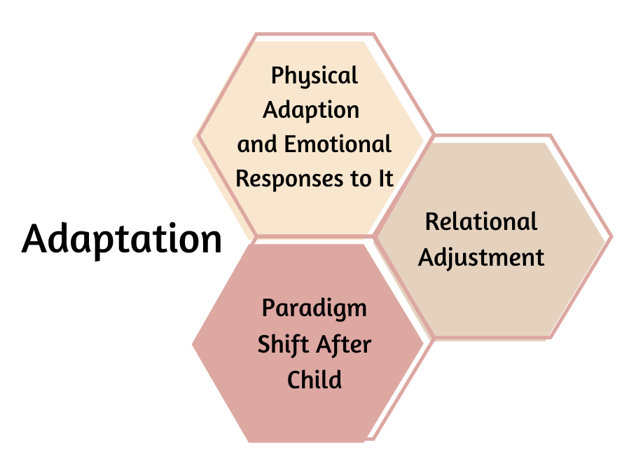
The fourth trimester, a crucial time after childbirth, presents mothers with various adaptions and challenges, as previously discussed in the literature review. This section goes into detail about key topics from the interviews, highlighting the various aspects of the transition. Additionally, it provides an overview of the adaptive process that characterizes the fourth trimester experience.
Physical Adaption and Emotional Responses to it
One prominent topic that emerged from the interviews was mothers’ physical adjustment to their new roles and identities. When discussing physical adaptation, mothers named various challenges that can show up during the fourth trimester, noting how these physical adaptions intertwine with their emotional responses. Mothers openly shared about diverse experiences related to their birth recovery, which included general recovery, recovery from a c-section, the emotional recovery from a traumatic birth, or an unexpected birthing experience. One provider spoke about the physical and emotional connection that at times can show up for mothers: “I think one thing for the patients that I work with that is not always talked about enough is that many of them have gone through some pretty traumatic birth experiences. A lot of the moms that I see, they felt maybe invalidated or powerless during their birth, or maybe it didn't go quite the way that they wanted to, and they're struggling with the aftereffects of that, while also trying to juggle like taking care of other things too. So, a lot of my time has been trying to empower them to feel kind of in control of their health care again.”
While mothers discussed the processing of their bodies during that of their pregnancies, the mothers also reflected on the additional adjustments related to changes in appearance. These adjustments often included fluctuations in their weight and learning to adjust to new bodies, another example where the emotional and physical aspects are intertwined. This interaction could lead to insecurities and self-doubt if mothers struggled to understand and accept the naturally occurring changes. Mothers also expressed concerns about their physical limitations during the recovery period. Mothers commented on the needed support for day-to-day tasks they used to be able to manage independently which caused a mixture of feelings and emotions. The mothers noted awareness of the importance of resting and allowing adequate time to recover, which, for some, was not always an option. In addition, mothers openly discussed their emotional experiences during their fourth trimester related to their recovery. The mothers discussed how fluctuations in hormones can lead to physical changes, which in turn contribute to potential mood swings, and anxieties surrounding motherhood as they adjust to their new normal. While attempting to manage emotions, mothers shared about their journey and struggles with sleep changes due to the addition of a newborn to the family. Sleep deprivation can be a commonality during the fourth trimester, and the recommendation to “sleep while the baby is sleeping” is not always practical.
Relational Adjustment
As suggested in the previous code, transitioning into the fourth trimester can present significant challenges and adjustments for mothers and their families. The interviews revealed the multifaceted nature of relational adjustment that can occur during this period, such as complexities of bonding with the newborn, changes in sex life, shifts in friendships, and adaptations in family dynamics and home life. There was a central theme related to relational adjustment as families adjusted to the new reality of having a new member being a part of their family. One provider noted: “just transitioning from having not had that baby to having that baby. And it doesn't matter if it's the first or the twelfth- having that additional person that's now depending on you, and it's leaving you sleep deprived, and all the things that come with that.” This highlighted the universal challenges of integrating a newborn into a family regardless of prior parenting experience.
Bonding with a newborn is a critical part of this adjustment. While mothers often experience a significant emotional connection with their infants, this bond can also be accompanied by feelings of exhaustion and stress. The added demands of caring for a newborn can lead to sleep deprivation, which can start to affect other areas of life, such as the parent’s relationship and sex life. During this period, many couples find that intimacy can take a backseat as they navigate the immediate needs of the child or children.
Additionally, there can be shifts in friendships and social interactions, mothers at times can find their social circles changing as they seek support from those who may understand their new reality. Moral support is an important factor during this period as mothers desire reliance on others to share experiences and advice. One mother wanting a support group for mothers noted “I believe that after giving birth, women need support from other women who are going through the same experience.” Mothers desire to know they are not experiencing this transitional period alone.
In relation to family dynamic changes, one mother expressed the pressure of maintaining household responsibilities and relationships while caring for a newborn: “the time comes when you feel overwhelmed because you are used to having everything prepared, and now you have less time because you have to care for the baby. And the activities and schooling of the other children continue, and your husband gets home. You have to have everything ready, but they don't understand that sometimes the baby wants to be held all day or something happens, and he cries a lot, and it is hard to console him.” This specific quote stresses the emotional and logistical challenges that can lead to tension within the family dynamic.
Paradigm Shift After Child
During the fourth trimester, mothers and providers revealed that in addition to mothers adapting to their new roles as caregivers, there can also be periods of redefining personal identities and priorities. From the focus group interview, a mother shared her journey of empowerment, stating: “And I started watching women empowerment videos on how to become better. Start doing little steps at a time, just being able to grow so that my kids know, "Mama got us. We are going to always be okay. I'm not going to let nothing happen to y'all." This quote emphasizes the determination many mothers can feel to become a stronger and more resilient version of themselves for their children. Additionally, another aspect of this paradigm shift is the change in perspective following challenging life experiences, such as abusive relationships. One mother noted:
“Oh, gosh. It was this post on Facebook. And it was like, "When you have a daughter, you supposed to do stuff differently." And it was like, once I had her, I was like, I don't want her to see me going through that.” This quote illustrates how motherhood can sometimes serve as a catalyst for breaking negative cycles and emphasizes the importance of fostering a healthier environment for the next generation.
Furthermore, mothers and providers hinted at the lack of consistency in their support systems regarding the mothers’ individual needs during this period. One interviewer pointed out: “you know during pregnancy, you get so much of that feedback like you have to take care of yourself, because you are literally housing this child, you know. But after delivery we don't get as much of that.” At times, mothers felt there was a gap in postnatal care and support due to the focus shifting awareness from the mother’s well-being, despite mothers; continued need for support. During this period, mothers experienced moments of self-discovery, empowerment, and redefinition of their own goals and values, which highlights a continual need for adequate support to aid in successful navigation of this change.

Perceptions of Support
As previously stated, the fourth trimester can be a period marked by significant adaptation and change. Mothers during this period expressed the crucial role their support system can play in their adjustment and overall well-being. During the interview process, some mothers reflected on how support is a multifaceted experience that can be influenced by cultural, familial, and community factors. One subtheme from the interviews was the impact of cultural and community resources. A provider noted: “I think the social and community of resources kind of go hand in hand for me. And I think that that's really huge, just like we were talking about how relationships impact adjustment.” This showcased the importance of having access to a network of resources in a practical and emotional way.
Moreover, the role of neighbors and parents did not go unnoticed. It was noted that having a supportive partner and neighbors can alleviate the pressures of early motherhood. Emotional support can be provided by partners by sharing the responsibilities of childcare and in relation to neighbors through the offering of a sense of community and practical help. Mothers also shared about the invaluable support provided by some providers. One mother shared: “I have had a wonderful experience. I am still receiving services because my son is just two, and he will receive services until he is five. The person in charge has been very kind and has taught me many things about my son's development. It has been wonderful, truthfully!” Mothers who felt they had support during the fourth trimester aligned it with their positive transition into motherhood.

Unique Factors Impacting Adaptation
The fourth trimester, for these mothers specifically, was marked by unique challenges and experiences. Interviews with mothers and providers shed light on various factors influencing this period, particularly in the context of the COVID-19 pandemic, cultural adjustments, and immigration-related limitations. COVID-19 altered the traditional experiences of pregnancy and delivery. One interviewer noted: “COVID-19 created an extremely different experience of pregnancy and delivery. It was very isolating at times for our family.” The isolation that accompanied the pandemic in ways added to the stress of new motherhood and highlighted the need for support systems.
There was discussion during the interviews related to differences between pregnancies. One mother shared: “Honestly, this pregnancy affected me a lot and was different from my pregnancies with my sons. I didn't suffer or have any problems with them, but with this one, I had so many issues.” This underscores the variability in maternal experiences and the importance of personalized care. Additionally, new mothers and experienced mothers desired a need for continuous guidance and support. “It's not a matter if we already have one, two, or three. We always need support and instructions about new things.” Noting the evolving nature that comes with parenting and the mothers wish for ongoing education and support.
Furthermore, cultural adaptation poses additional challenges, particularly for immigrant mothers. One mother reflected: “It was more difficult during my pregnancy with [NAME] because I had just traveled here from [LOCATION] and had to adapt to being here in this new country. I was depressed. I had to accept being in this new place without understanding the culture or safety.” Similarly, other mothers had similar experiences, which were compounded by language barriers. Another mother mentioned: “Groups here, yes, they probably exist. But I didn't look for them. Obviously, they are in English, And when one is not fluent in English, it makes one timid, and you prefer to just not go.” Also, there could be limitations related to immigration and ESL that could hinder mothers’ access to resources. One mother shared: “Sometimes, they think moms don't need the information when she has one, two, or three babies. But it's my first baby in this country because my other sons were born in my country.” Comments like these indicate a critical need for accessible information and resources tailored to diverse cultural backgrounds.

Mental Well-being
    - Table 4.2. Mental Well-being Themes
    - 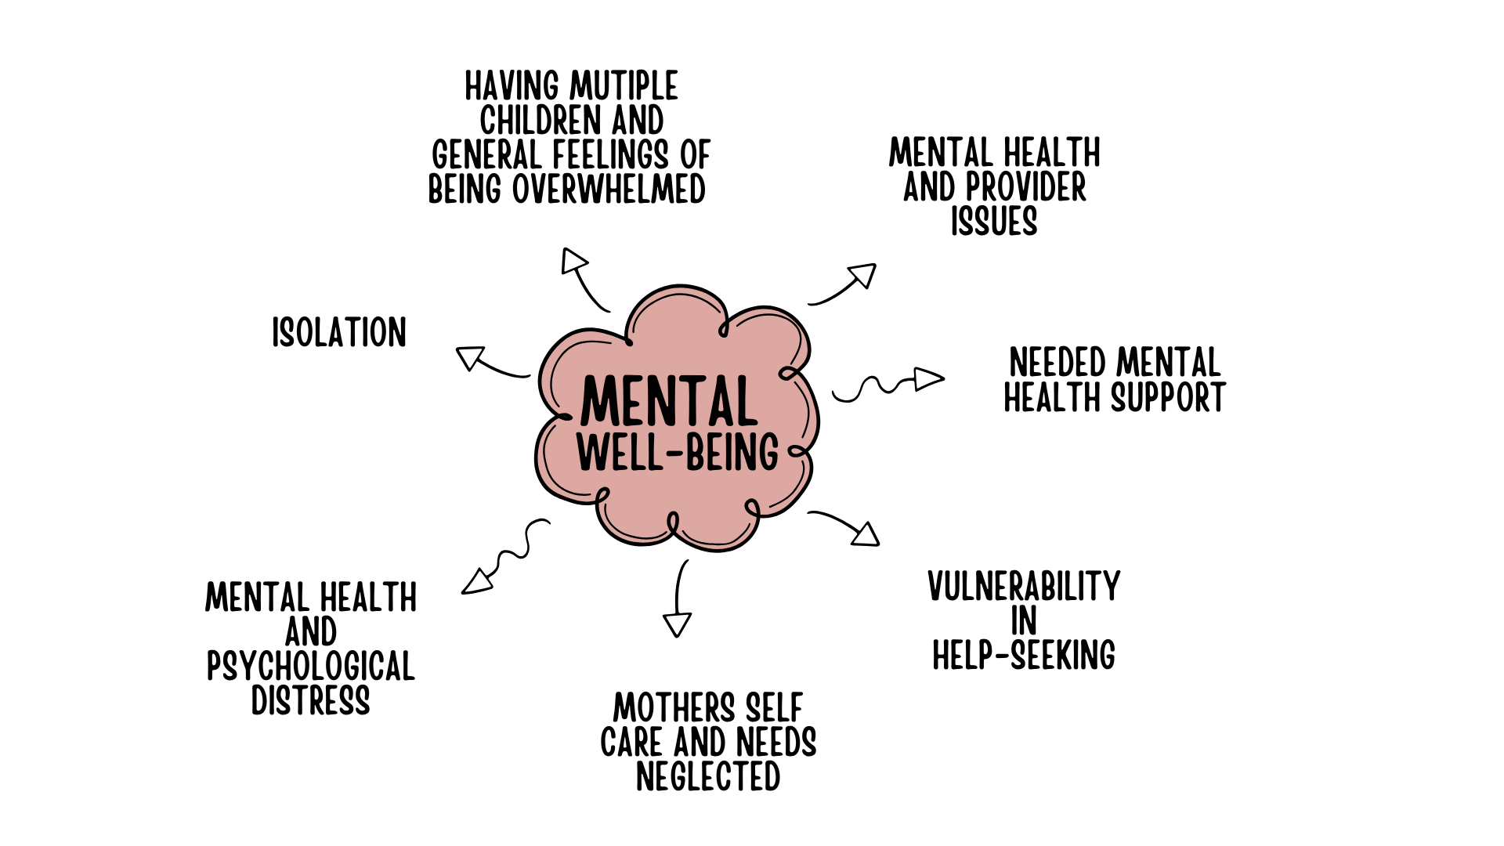
As described above, during the fourth trimester, mothers undergo significant physical, emotional, and psychological adaptations as they adjust to their new roles as mothers. Emotional well-being is paramount during this period, as it affects not only the mother’s health but also the development and well-being of their newborn. This section dives into the emotional challenges faced by mothers during the fourth trimester, based on interviews with mothers and providers, focusing on themes that emerged during the interviews related to being overwhelmed with multiple children, feeling isolated, experiencing mental health challenges and psychological distress, as well as general overwhelm, which is exacerbated by neglect of self-care, and issues related to mental health providers.
Having Multiple Children and General Feelings of Being Overwhelmed
Mothers at times can find themselves feeling overwhelmed when managing multiple children, especially during the fourth trimester. The demands of care for a newborn, coupled with the needs of other children, can feel daunting. One of the mothers expressed, “Sometimes, men say you've only been here in the house. How can you be tired? Physically, we get tired from waking up in the middle of the night or staying up with the baby. If the baby and another child are crying, that's stressful. All of this makes us tired.” Another mother shared “It hurt my heart, because I was just like, I don't want any more kids. I can't afford any more kids. Like that's just doing too much.” Attending appointments with multiple children also presents logistical challenges that can lead to feelings of being overwhelmed for mothers. One provider shared, “a fair amount of families don't just have one child, and so getting to an appointment with one child- potentially not having child care for the other, having to have you know, three children you’re bringing all at once with different needs.”
In addition to having multiple children, feelings of general overwhelmedness were a common theme among mothers during this time that was captured by mothers and providers. Exhaustion from the sleepless nights and the constant demands of a newborn can take a toll, with one mother describing the period as “very draining. Exhausting. It was really exhausting.” The mental load of adjusting to the new routine adds to this overwhelm, as noted by a provider: “And just like adjusting to that routine, and the mental load that takes and like the thoughtfulness and the planning that takes, especially in a period where you're like figuring so much out.”
Isolation
Despite having some forms of support, many mothers experience feelings of isolation during the fourth trimester. One mother noted that her partner “never missed an appointment and always drove me. But in other ways, I felt alone.” The sense of loneliness mothers feel during this period can exacerbate the emotional challenges faced during this period, highlighting the need for comprehensive support systems that address both practical and emotional needs.
Mental Health and Psychological Distress
Mental health issues, including postpartum anxiety (PPA) and postpartum depression (PPD), are prevalent during the fourth trimester. One of the mothers shared her experience with PPA: “I had a lot of anxiety. The doctors always said I was ok, but I had high blood pressure and couldn't breathe deeply. Each time I tried, I would feel panic and despair.” Not to mention, the stigma that is still associated with these disorders often can prevent mothers from seeking help. One mother reflected, “Many moms may go through postpartum depression, and they don’t understand what they are feeling is depression and that it is something real that exists.” When coupled with stigma seeking help and lack of understanding of mental health disorders and symptoms, there presents the concerns of suicidality, which one provider reflected on, noting “two suicides we've had were people that had very poor support.”
Mothers Self-care and Needs Neglected
Mothers often neglect their own needs during the fourth trimester, prioritizing the well-being of their newborns, which was briefly discussed earlier. One mother from the focus group emphasized, “Then it doesn't matter if you're sick, because, at the end of the day even if you are sick, that baby still needs you.” The connection between a mother’s well-being and her newborn’s health is crucial yet often overlooked. Additionally, mothers who were dealing with immigration factors noted how it can further complicate self-care due to having to navigate cultural and systemic barriers.
Vulnerability in Help-Seeking
The fourth trimester is a critical period where mothers often face vulnerability in seeking health support. Cultural awareness from partners and providers is essential to respect diverse expressions of motherhood. Additionally, many mothers expressed concerns about mandated reporting, fearing judgment and stigma. One provider shared perspective from a mother’s point of view, noting: ‘I can't really ask’, or ‘if I ask now, it looks like I can't manage this or ‘I’m not taking care of my baby in the way that I need to or that I’m overwhelmed.” There was an acknowledgment from the providers in relation to the difficulties that accompany asking for support during this period, one provider noted how they remind mothers by “one of the things that I tell them in all of our sessions is “it's okay to not be okay. It's okay to reach out for help.”
Needed Mental Health Support
Access to mental health resources is critical during the fourth trimester. However, many mothers are unaware of available services or face barriers to accessing them. One mother shared that she “didn't know where to go for them to examine or attend to me. I managed my illness myself by exercising and eating well.” From the interviews, providers stressed the importance of mental health: “I think, having that access to mental health support is so crucial during that time.” Education on postpartum mood disorders and immediate access to mental health professionals are essential for effective support.
Mental Health and Provider Issues
The lack of specialized mental health providers and inadequate training are significant issues. Providers and mothers expressed concerns about having providers in place that can provide quality care for mothers to meet their specific concerns and symptoms that can show up for mothers during this period related to their emotional health. One provider mentioned, “there's a recommendation that at post-partum visits, women or birthing people are completing an Edinburgh to assess their symptoms. But I think that there's not always really a good process in place for what do we do. If there's a positive screener, not all clinics really have a good solid plan in place, or you know they'll refer out to some sort of specialty for Mental health and women will be on a wait list for like weeks and weeks or months, and then, you know time is so crucial at that point. And so, I think, having immediate access to that type of mental health support is really important.” Furthermore, misinformation and distrust further hinder mothers from seeking help. Concerns about mandated reporting and cultural insensitivity also contribute to reluctance to access mental health services.

Systemic Support Network
    - Table 4.3. Systemic Support Network Themes and Subthemes Continued

    - 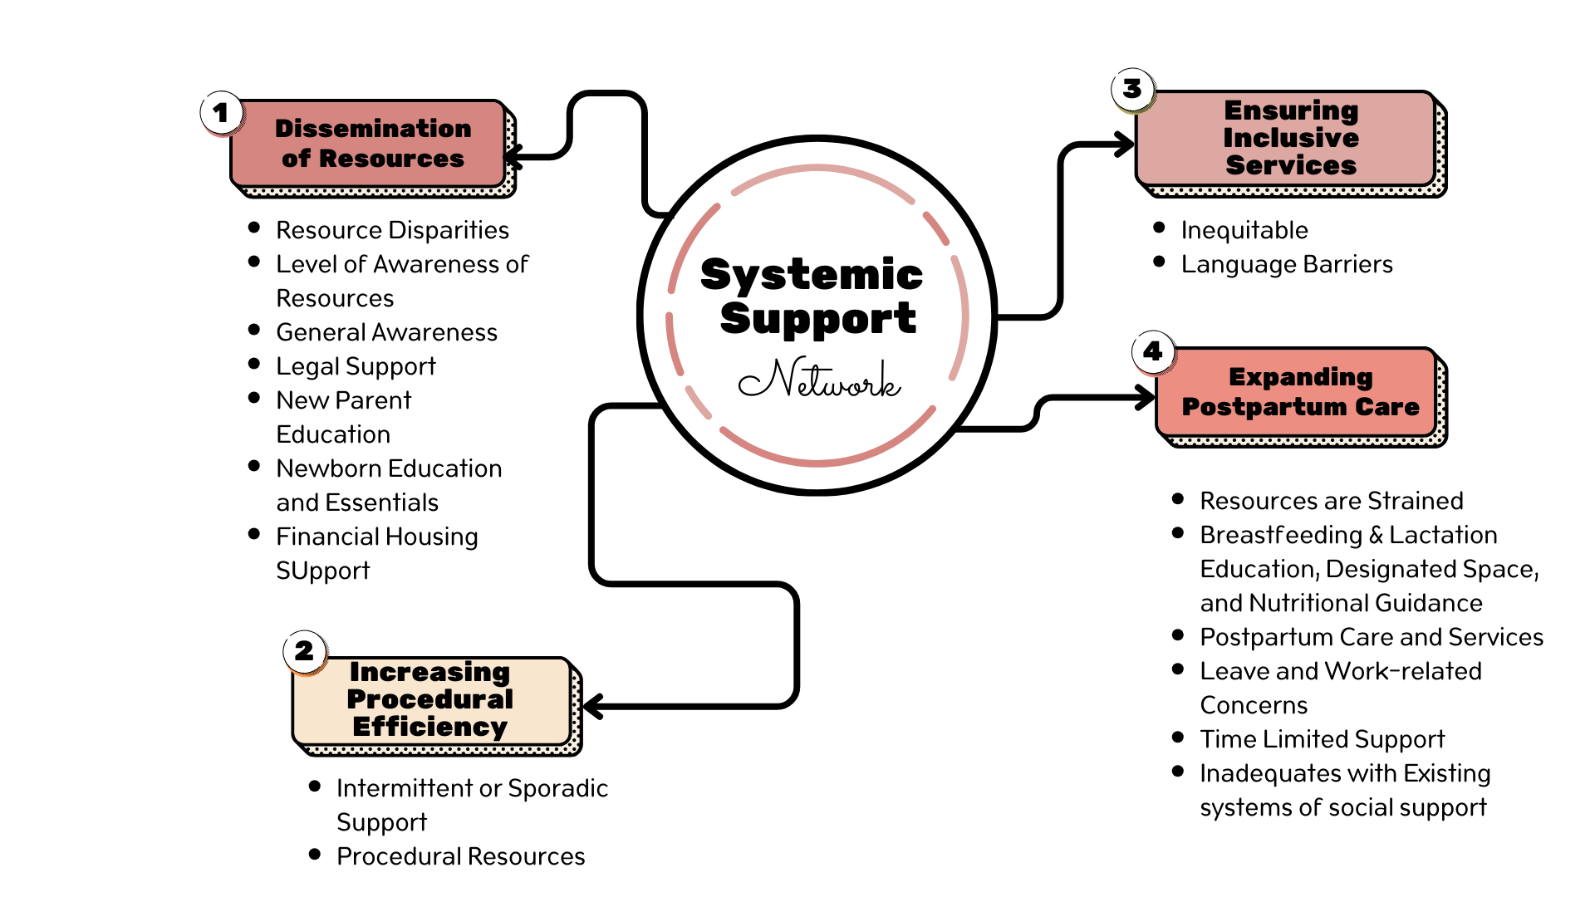
The fourth trimester is a crucial time for mothers, characterized by a strong demand for a strong support system. The interviews conducted with mothers and providers revealed that support is often time-limited and inequitable, with inconsistencies and disparities in resources available. The mothers discussed their concerns regarding the often insufficient awareness of resources intended for them, which exacerbates challenges and hinders necessary adjustments. The interviews provided an in-depth exploration of various topics and themes in this section, emphasizing the necessity for enhanced support.

Dissemination
Awareness of available resources is crucial for mothers, but still, mothers reported feeling uninformed about support systems outside their physician’s office. One provider highlighted the need for dissemination of information to pediatricians and family practitioners, emphasizing that "there are other resources outside of just the physician." This was also shared by another provider who noted the disparities in awareness levels, noting that some mothers have “no idea that these resources exist." Similarly, but from a different perspective, mothers stressed the importance of sharing information within communities, advocating for a culture where mothers openly share knowledge about available resources. Furthermore, financial counseling and literacy are highlighted as essential elements of general awareness. Many new mothers face financial difficulties during the fourth trimester and understanding financial resources could help alleviate the challenges they encounter in accessing other necessary services, such as counseling. A mother stated her need for financial stability to care for her child, while a provider noted that basic necessities like clothing and diapers are often hard to access. Situations similar to this can also be compounded by housing and insurance worries, which one mother expressed that it can make mothers “feel stressed, anxious, overwhelmed, and in despair. Because you ask yourself what am I going to do to get the income I need?”
The interviews with mothers and providers revealed a significant gap in awareness of the available resources, which is a major barrier to effectively supporting mothers during this period. One provider noted: “Lack of awareness is a really huge one. It's like people don't know what's out there, whether that's like, I don't know lack of advertising, or You're just so stressed and bogged down with dealing with other things that you don't have time to look up what's available to you. So, lack of awareness is a huge barrier.” This quote highlights the dual challenge of insufficient information dissemination and the overwhelming nature of postpartum responsibilities that prevent mothers from seeking out support.
Mothers also agreed with this concern, expressing a sense of isolation from potential resources. One mother shared: “They probably existed, but since I don't get out much, I don't know about them.” This highlights the disconnect between resource availability and accessibility, which can be exacerbated by the demands of caring for a newborn. Then, concerns can be further compounded by the perception of a resource gap. Another mother shared: “I do think it's like a resource gap. It's like they're out there. But how are we going to bridge the gap from the client to the actual resources? Because it's like when you're. you know, postpartum, all of your energy is going towards caring for a human, a new human,” emphasizing the need for a more proactive approach in connecting mothers with the support they need.
Moreover, societal attitudes toward seeking help contribute to the problem. A provider observation stated: “They're definitely lacking. We don't see it really widespread, advertised, advocated for, really even mentioned that much. It goes back to that whole thing of ‘pull yourself up by your bootstraps and get it together and take care of this baby.’ And so a lot of moms, number one, don't know the resources that are there, and then two, they're not really open to doing it because they don't realize it's not something that is a weakness. It's a level of strength that you have to have to say I need help.” This introduces a cultural barrier that discourages mothers from seeking assistance, framing it as a sign of weakness rather than strength. To address these issues, there needs to be better dissemination and advertising of resources, along with a cultural shift in how postpartum support is perceived and utilized.
During the focus group, a mother stated, “I was just saying how we could use legal resources.” Legal resources are often overlooked but are essential for mothers when they are navigating complex issues. One of the focus group mothers expressed the need for legal support, indicating that access to legal resources could significantly benefit mothers who are facing difficulties and need legal support and clarification during the fourth trimester. During the fourth trimester mothers can have concerns such as custody issues, family law disputes, and navigating healthcare rights. Mothers who have the appropriate legal support and resources will aid in the well-being and welfare of their families and peace of mind.
Education for parents is vital, specifically related to the fourth trimester. A provider emphasized the importance of postpartum appointments and education provided prior to delivery, which plays a crucial role in helping mothers to understand what to potentially expect during the particular period. The topics of self care and self grace were noted as important concepts that need to be emphasized during parent education. One provider stated, “we do a lot of education about self-care. You know this baby needs a ton from you, from dad, from a partner, from whomever. And we know that you're taking great care of the baby, but we want to make sure that you're taking care of yourself as well.” By providing such education there are opportunities to highlight the need for rest, seeking support from others, and mothers allowing themselves the grace to adapt to their new roles without undue stress. Through the integration of this topic into parenting education, it can create the fostering of a supportive environment that encourages parents to thrive emotionally and physically during challenging yet rewarding times of parenthood.
Moreover, reliable resources for newborn education are also essential for parents. A mother expressed the desire for “one reliable source” of information, while a provider shared concerns that even if resources are available, mothers might not have the knowledge of what to ask for or how, “I think part of it is knowing that you can ask, and not all women, not all new moms know what sort of what resources can I ask for, what's available, and what's out there.” In addition to education, access to newborn essentials, such as baby goods, clothing, and diapers, is just as critical. A mother described the relief of receiving a crib, which alleviated the financial stress and provided stability for the family.
While touching on dissemination with resources, the mothers and providers also discussed the disparities. One provider highlights the multifaceted nature of these barriers: “It's about reducing the barriers to access because you have to look at it from all parameters. If there's a food issue. Okay, now we solve the food issue. But then, how do we get to the food? You know, if there's an information issue. Okay, we got the information. But how do we get it to the community?” This quote notes the complexity of addressing resource disparities, noting the need for a holistic approach that considers all potential barriers. During the interview, the provider noted that solving one problem often leads to the emergence of another, showcasing the necessity for comprehensive strategies that cover various aspects of accessibility.
Similarly, another provider pointed out the disconnect between resource availability and accessibility: “So yeah, there are resources available, but they're not necessarily accessible to everyone. I think the availability is something we’ve done really well with, but accessibility is not something that we've done well.” This is a common issue with resources, in the fact that resources exist in theory but are not practically reachable for all individuals who need them. The provider interview observation suggests that systemic barriers, such as geographic location, socioeconomic status, and lack of awareness, can prevent equitable access to necessary support.
The interviews collectively highlighted the need for more integrated and inclusive support networks during the fourth trimester. The addressing of resource disparities requires not only the provision of resources but also the ensuring that the resources are accessible to all mothers regardless of their circumstances. This would involve the reduction of logistical barriers, enhancing communication channels, and fostering community engagement to confirm that support systems are available and reachable. Through this shift in focus and reduction of barriers, healthcare providers and policymakers can work towards a more equitable distribution of resources, which in return improves outcomes for mothers and their families.
Increased Procedural Efficiency
The interviews showcased concerns related to challenges identifying the process for accessing needing resources or feeling it was not an easy process to navigate. An example shared was related to the Women, Infants, and Children (WIC) program, which provides mothers with nutritional support. One provider described the WIC process as “cumbersome,” with “long wait times and inefficient service delivery.” Such inefficiency at times can discourage mothers from accessing the support they need, which goes back to the need for improved streamlined service delivery processes that allow for mothers to gain access to the resources they need.
Furthermore, many mothers and providers highlighted the inconsistency in the availability of resources. Forms of support systems, ranging from healthcare visits, community programs, and informational material, were often identified as sporadic. This inconsistency left mothers feeling unsupported during a time when continuous care was crucial for both maternal and newborn health. A mother shared of her difficulties with transportation resources, even when accessing it through insurance, “it was very difficult because of the language barrier. I would ask my son to call, and whenever I arrived, I would have to call and let them know, and they would leave me on hold for a long time. They would say, yes, we can pick you up, and then they would say, something happened, and we can't come anymore.”
By increasing procedural efficiency in accessing resources, it will improve the reliability in support networks. When mothers felt they could not rely on support networks, it sometimes made them feel isolated and more stressed, which could hinder the recovery and adjustment process.
Ensuring Inclusive Services
A recurring theme from the interviews conducted was the inconsistency in the availability and accessibility of resources. Mothers and Providers named several contributing factors, including intermittent support from relevant authorities or organizations, limited supply of resources required for effective operations, and language barriers that hindered communication and understanding among participants. These inconsistencies impacted the quality of experiences and the overall effectiveness of navigating the fourth trimester period.
While discussing the difficulties with obtaining resources, mothers shared about their challenges accessing resources successfully due to language barriers. Many non-English speaking mothers expressed concerns with the lack of materials and support in their native language and noted how it could then become another obstacle for them to overcome. As mentioned by one mother: “They should have some papers in Spanish. In my case, it wasn't necessary, but with others, it is.“ Additionally, mothers and providers expressed similar concerns related to resources such as dental care, noting the importance of bi-lingual support. One interview stated “having access to interpretation services" could have positive improvements for families whom English is not the primary language utilized. Mothers identified that even when aware of resources they at times encounter barriers such as transportation. The gap with communication can potentially lead to misunderstandings, reduced quality of care, and increased anxiety for mothers who are already experiencing challenges navigating the fourth trimester period. More focus on inclusive services will ensure that all mothers have access to dental care they may require.
Expanding Postpartum Care
The extension of postpartum care beyond the traditional six-week period is a pressing concern. A provider mentioned that postpartum care often stops at six weeks despite the ongoing needs of mothers beyond that period. Inadequate resources and follow-up can exacerbate these challenges, as highlighted by a provider, “I don't think the resources are or adequately presented enough to say, “Here are all the resources we have, and they're at your disposal.” I don't think they're really represented well enough for people to even know they're there, because, as it stands right now, people are still even trying to figure out what doulas are. So, you know it's just a lot of information that not a lot of people are privy to, especially people that are already in underserved populations. They don't even know that the information is there, or the resources are there, so getting that message out to those people is going to be important. And it's got to be intentional, because otherwise they're never going to know. And they're going to continue to go through these cycles in the fourth trimester, because they don't know the resources are there to even ask for the help.”
The extension of maternity and paternity leave is another pressing issue for parents. Providers and mothers emphasized the inadequacy of the current six-week leave policy, which does not allow sufficient time for recovery and bonding with a newborn. Additionally, there is the balancing act of trying to work and attend healthcare appointments; one provider reflected on the experience of mothers’ difficulties attempting to utilize resources for themselves, let alone multiple children, “ If I'm already taking off a couple of hours from work, and then I have to sit in the doctor's office, because they overbook themselves for three, four hours. Or I have to cancel it because they're taking too long, and I gotta get back to work. Then I have to reschedule and take more time off work, because the resource that you are trying to use is not using their resources necessarily the best and causing you to have to miss out on more than what you intended on missing out on.”
Feelings of unpreparedness were common among the interviewees, particularly related to breastfeeding. One mother expressed the need for more support and focus on breastfeeding education because many mothers “do not know how to do it.” Additionally, partner integration is important and was noted by another mother, who described the frustration and guilt experienced by partners who want to help but feel unable to. This continues to emphasize the importance of comprehensive parent education and expansion of resources during the fourth trimester to support breastfeeding education that includes partners so that they can foster a supportive environment for breastfeeding mothers.
Along the same lines expansion of lactation support is essential, considering each newborn could present unique challenges. Mothers called for tailored support during their breastfeeding journeys, as a provider emphasized that “what works for one baby may not work for the next,” due to the variety of feeding habits and preferences. These services help alleviate daily struggles and promote successful breastfeeding experiences, benefiting both the mother’s confidence and the child’s nutritional needs. Moreover, mothers expressed a desire for more designated spaces, such as breastfeeding locations. One mother discussed the stigmas surrounding breastfeeding in public. Mothers emphasized the continual need for societal understanding that “it is natural and the baby also wants to eat.”
Interviews with providers frequently noted that resources are stretched thin, which impacts the quality and accessibility of care. One provider mentioned: “I’ve really seen a range of a lot of experiences, but I would say most often, I see that they seem to be pretty stretched thin, but they're juggling, you know, so many responsibilities with often limited access to resources, but at the same time, I've also observed a lot of really incredible resiliency.” Perspectives like this hint at the evidence of the limited availability of healthcare professionals, insufficient funding for postpartum programs, and the overburdening of existing services.
From a different perspective of expansion on postpartum care, interviewers touched on feelings that support on a familial level was time-limited and inconsistent. Noting initial excitement and a noticeable decline during the fourth trimester period, which at times left some mothers feeling isolated and overwhelmed. This fluctuation in support highlights the importance of sustained familial involvement during vulnerable periods such as the fourth trimester. The lack of support can lead to mothers feeling like they have to navigate the fourth trimester on their own.
To tackle these challenges and enhance awareness of available resources and support, a comprehensive approach is needed. This includes improving resource dissemination, increasing procedural efficiency, ensuring inclusive services, and expanding postpartum care. By developing a systematic support network, mothers will feel more supported during their fourth trimester.

Research Question Three: The Provider Perspective
A unique approach to this study was the opportunity to interview mothers and providers who provide services and care for mothers in their fourth trimester. With this opportunity, the coding team was able to gain an understanding of similarities and differences between responses to the needs and experiences of mothers during the fourth trimester. As observed from the previous sections, there are countless challenges that are perceived differently by mothers and providers. Both groups acknowledged the adjustments required, yet their perspectives varied.
From the providers’ standpoint, the emphasis was on empowering mothers post birth and ensuring healthcare control. The providers were more likely to recognize the systemic challenges, such as resource disparities and the need for better access to support systems. The providers often highlighted the importance of addressing mental health issues and postpartum mood disorders and advocating for accessible mental health resources. The providers also focused on cultural competency and patient empowerment, striving to respect cultural differences and fill need gaps in social support.
Conversely, mothers experienced the fourth trimester through a more personal lens, often highlighting the physical and emotional exhaustion they face. The mothers were seeking support for daily tasks and expressed feelings of being overwhelmed and isolated. The immediate demands of newborn care, coupled with household responsibilities, contribute to the stress. Mothers frequently emphasized the need for emotional and practical support, such as language assistance and financial aid, and they often relied on community networks and peer support groups for help.
Both groups recognized the importance of support systems, yet mothers described a more personal, familial impact. They recounted specific instances of support from family members, while also expressing frustration over unsupportive advice. Relationship challenges, such as neglect and lack of paternal engagement, further compounded their struggles, highlighting the need for understanding and support. Additionally, both mothers and providers touched on their perspectives with appointments. The mothers focused on various aspects of appointments, from difficulties obtaining them, being unsure when to make an appt, and not feeling the appointments were long enough, whereas providers focused primarily on the need for more providers and awareness of specialized care providers such as doulas, lactation specialists, and other fourth trimester providers that are not widely shared with mothers to support them during their adjustment.
Unique factors like COVID-19 and cultural adjustments were acknowledged by both providers and mothers. However, mothers emphasize their personal experiences and language barriers, underscoring the critical need for comprehensive postpartum care that addresses both systemic and individual challenges. Additionally, more providers discussed how isolating the experience may have been for mothers during that time, mainly due to the restrictions on who could attend appointments or the difficulties of navigating a lockdown with a newborn.
Overall, providers focused on addressing systemic issues and the need for improved healthcare structures. In contrast, mothers highlighted insight into their personal experiences while navigating the fourth trimester. Mothers emphasized their interactions with healthcare providers, and expressed the immediate need for resources tailored to the fourth trimester, which could play a vital role in their adaptation and emotional well-being. Both perspectives were aligned in highlighting the critical importance of developing robust support networks that can serve as empowerment for mothers and their families as they navigate the fourth trimester period, which would ensure a smoother transition through the challenges and adjustments mothers experience.

Discussion
By conducting the interviews with mothers and providers there was opportunity for a greater understanding of the complex narrative surrounding the experiences of women during the fourth trimester. This particular period, which is often overlooked in maternal health, is critical for mothers in terms of adaptation, emotional well-being and systemic support.

Addressing Gaps in Fourth Trimester Support
Based on the results, the interviews highlighted a need for more comprehensive support systems in place for mothers during their fourth trimester. Some mothers reported feeling overwhelmed and at times isolated due to a reduction in support following their childbirth. When mothers experience dips in support or even a shift of focus to newborns rather than both mother and newborn, it creates a gap in care that can make motherhood feel lonely and stressful. Not only did mothers express such concerns, but providers also agreed that we need a more seamless transition for mothers in relation to sustained support as they proceed through the fourth trimester. This perceived deficit highlights the failure of systemic support systems to adapt to the needs of mothers, which in return has an impact on their overall wellness. The results emphasized the importance of a shift to a holistic approach, which would allow for the integration of physical health, social support, coping skills, and transitional support for mothers, echoing earlier research (e.g., Fahey & Shenassa, 2013). By developing more consistent and comprehensive support, the hope is that this shift will aid mothers in navigating challenges presented during early motherhood (Mortazavi et al., 2014).
Additionally, providers indicated concerns about the inadequacies of follow-up care, while mothers also expressed a desire to be seen more frequently in relation to postpartum care to address various health and mental health concerns. This highlighted the existing gap in communication between providers and mothers, which showed how impactful The Fourth Trimester Project was, as it allowed a space for mothers and providers to come together to engage in discussion about care during the fourth trimester (Verbiest et al., 2018). The practice of a single follow-up appointment at six weeks is problematic because it could potentially delay necessary care and support. Furthermore, both mothers and providers emphasized the need for greater diversity among providers and specialized fourth trimester care support. Maternal mortality rates have risen across all racial and ethnic groups from 2020 to 2021 (Hoyert, 2023). By increasing the diversity of healthcare providers and accessibility of tailored resources, we can enhance comprehensive support tailored to the evolving needs of mothers while effectively addressing the factors that contribute to maternal mortality.
Throughout the interviews, there was a common theme of frustration that emerged regarding the accessibility of resources. Financial constraints, employment challenges, and childcare issues were recurrent themes that highlighted the systemic barriers mothers encounter. Many women felt overwhelmed by the lack of support systems that could play a role in alleviating certain pressures. For example, mothers mentioned the difficulties in finding affordable childcare, which hindered their ability to attend necessary appointments. This highlighted the need for a more improved support network that can address practical concerns. Similarly, the Mortazavi et al. (2014) article emphasized the critical importance of addressing practical and logistical concerns and needs due to the impact it can have on a mother’s overall wellness and access to healthcare.
Additionally, there was discussion related to intersectional factors and broader structural systems that can impact a mothers’ ability to meet their needs during the fourth trimester. Varying complexities such as SES, race, and cultural backgrounds as previously discussed in the literature review can interact to create unique barriers for different groups of mothers (Hannon et al., 2022, Harrell et al., 2022, Tierney et al., 2023). As mentioned in the results, concerns pertaining to language barriers and general lack of awareness about available resources featured prominently in the narratives, especially within marginalized communities. When mothers experience these various barriers, the barriers can not only disrupt access to care but also play a role in feelings of potential inadequacy and isolation. From the interviews, mother were able to state their understanding of the problems they faced, but at times felt that healthcare providers were unable to address the initial causes of these concerns which could be related to systemic inequities. These feelings of disconnect could suggest a critical need for improvement with communication and collaboration between mothers and providers, which was also noted to an extent in The Fourth Trimester Project (Tully et al., 2017). Additionally, the research shows that women of color or of a lower SES are more likely to not attend their postpartum visits, due to various intersectional factors that diminish their access to care (Tierney et al., 2023). By acknowledging and addressing these intersectional challenges, fourth trimester care can be made more responsive to the unique situations marginalized mothers may face during this transitional period. This shift in perspective would ensure that all mothers are receiving the support that they need regardless of their backgrounds or circumstances.

Limitations of the Study
Although this study provided valuable information into mothers’ experiences during the fourth trimester, it is essential to acknowledge the limitations and areas of improvement for the study. The interviews touched on various aspects of the 4th trimester experience, but they were constrained by limited time related to the duration of interviews which were 45 mins to an hour, which may have inadvertently reduced the richness of information gathered on each mother’s unique experience during their fourth trimester. Like The Fourth Trimester Project, our study offered insight into mothers needs and experiences during this period, along with the overlapping aspects that impact a mother’s fourth trimester experience (Tully et al., 2017). Furthermore, due to the study’s focus being limited to a geographical location and predominantly consisting of participants from a single FQHC, there are still concerns with the generalizability of the findings. While the experiences shared are extremely important, they do not encompass the diverse realities of all mothers during the fourth trimester. This issue relates back to the importance of giving more mothers the opportunity to use their voices to authentically share their experiences. Additionally, by continuing the replication of studies similar to The Fourth Trimester Project in different locations and providing space for open dialogue with mothers across the United States, we can continue to progress in shaping a more comprehensive approach to care and intervention (Verbiest et al., 2018).
When considering the earlier limitations, it’s worth noting that the current study is a secondary qualitative analysis, which is a study based on recollected data. The original study was primarily focused on program evaluation, which partially explains the range of topics discussed. Cheong et al. (2023) mentioned the difficulties that can occur at times with secondary analysis, particularly in attempting to perfectly align it with specific research questions. Therefore, this was a limitation of the current study, as the interview questions could not be tailored to more specifically address the study’s current research questions. These challenges could lead to the limitations previously mentioned concerning interpretation and the focus, specifically the lack of depth in insights across numerous topics. Additionally, some members of the research team participated in the conducting of the program evaluation interviews, while other team members were not involved. These discrepancies may have introduced biases and affected the overall findings of the secondary analysis. For example, the lead coder and auditor participated in conducting interviews for the original program evaluation. This limitation may have affected the findings due to the coder and auditor potentially having preconceived biases due to their interactions with some participants. This could potentially allow for a reduction in objectivity when analyzing themes or an influence on interpretations due to their interactions with some interviewers, unlike other coders who had no contact with the participants.

Conclusions and Recommendations
Becoming a parent brings a deep and profound change in identity and priorities for mothers. The transition into motherhood often will reshape a mother’s perspective on self-care, relationships, and the support required to facilitate their journey. The interviews within this study revealed an understanding of the multifaceted experiences mothers face during the period following childbirth. A recurring theme throughout the interviews is the importance of strong support systems. Mothers reported feelings of isolation and the overwhelming nature of postpartum recovery, that at times is exacerbated by limited access to resources. The insights gathered highlight that while some resources are available, there is a significant gap in the quality and accessibility of these resources.
There are multiple key areas for future research and action that have been identified by the research team. The first recommendation is to consider the cultural impact of support during the fourth trimester; it is encouraged that future studies explore how cultural backgrounds can influence the types of support mothers receive and seek during the fourth trimester. The sources of support that mothers receive can vary based on cultural backgrounds. For instance, some mothers prioritize the desire for familial support, while some mothers emphasize professional support from licensed providers who specialize in quality care for mothers during their fourth trimester. The hope is that tailored support services can be more culturally sensitive and effective. By investigating various aspects such as community, values, and available resources, we can gain understanding of ways to improve support networks that cater to the diverse needs of mothers.
The second recommendation is related to an in-depth look at social support and relational health during the fourth trimester. Previous research findings indicated that emotional support can have an effect on the postpartum psychological health of a mother and potentially reduce symptoms such as anxiety and depression (Kuipers et al., 2022). In the interviews with providers and mothers, several key aspects of relational health emerged, which highlighted how important relationships are and how they can influence the maternal well-being post-birth. Future research should include examining the role of partners. Research showed that during the pandemic, some mothers reported receiving more support from their partners, which in return had a positive impact on their emotional wellbeing (Kuipers et al., 2022). Additionally, more research needs to be conducted on the dynamics involving extended family and friends, and the use of community resources tailored to relational health in aiding mothers during this period. The literature stated that it is important to consider the intersecting elements of mothers’ broader social and environmental factors and how they can impact maternal health (Fahey& Shenassa, 2013). Understanding how these social networks interconnect is important for the mother’s recovery and overall experience. Similarly, the research team noted that many of the relational health questions from the current study deserved further in-depth exploration and investigation. Through this exploration, there can be a deeper understanding of specific ways social support can affect mothers during this period. By prioritizing this area of study, researchers are able to highlight how a strong social network can improve maternal health, empower resilience, and promote overall wellness during a challenging period. Thirdly, there needs to be a research focus that includes fathers’ and partners’ perspectives in relation to the fourth trimester period. It is important to include the voices of fathers and partners with the hopes that their experiences and insights can provide a more holistic view of the support system and highlight the shared responsibilities during the fourth trimester experience. This could allow the creation or improvements of parent education groups focused on awareness and the accessibility of available services that can empower overall wellness for mothers and their family during this transitional period.
Moreover, there needs to be improvements with community engagement, with more focus on community initiatives that foster to create a supportive environment for mothers. This could include the organization of local support groups, workshops, and educational programs that encourage community involvement in maternal care. Based on the interviews, several adjustments can be made to improve support systems for mothers during the fourth trimester period. Establishing dedicated support groups for mothers and their partners can provide a safe space for sharing of experiences and resources.
Lastly, the final recommendation is related to enhancing resource quality and accessibility. There is an urgent need to assess and enhance the existing resources available to mothers. This includes evaluating the effectiveness of existing programs and identifying barriers to access. Key stakeholders such as community members and medical providers should collaborate to develop comprehensive support networks that are easily accessible and of high quality for mothers and their families. By potentially incorporating case management services specializing in pregnancy and the fourth trimester, mothers can receive guidance in navigating the complexities of available resources, so that mothers can receive the support necessary for their well-being. The ultimate goal is for mothers to have access to comprehensive and easy to understand resources that can aid in the reduction of stress in this period (Guerra-Reyes et al., 2017).
In conclusion, this study's take-home message is very straightforward: mothers need support. The existing resources for mothers during the fourth trimester have to be improved not only in terms of quality but also in relation to accessibility. By taking on a community-oriented approach to maternal care, we can ensure that mothers receive the comprehensive support they require during this critical period. Ultimately, it takes a village to nurture and sustain the health of mothers and their families, and it is our collective responsibility to strengthen these vital support networks.

List of References
Ali, N. S., Ali, B. S., & Azam, I.S. (2009). Postpartum anxiety and depression in peri-urban communities of Karachi, Pakistan: A quasi-experimental study. BMC public health. Retrieved December 3, 2022, from https://pubmed.ncbi.nlm.nih.gov/19821971/
Altman, M. R., McLemore, M. R., Oseguera, T., Lyndon, A., & Franck, L. S. (2020). Listening to women: Recommendations from women of color to improve experiences in pregnancy and birth care. Journal of Midwifery and Women's Health, 65(4), 466-473. doi:10.1111/jmwh.13102
Braun, V., & Clarke, V. (2006). Using thematic analysis in psychology. Qualitative Research in Psychology, 3(2), 77–101. https://doi.org/10.1191/1478088706qp063oa
Braun, V., & Clarke, V. (2013). Successful qualitative research: A practical guide for beginners. London: Sage.
Braun, V., & Clarke, V. (2014). What can “thematic analysis” offer health and wellbeing researchers? International Journal of Qualitative Studies on Health and Well-Being, 9(1), 26152. https://doi.org/10.3402/qhw.v9.26152
Braun, V., & Clarke, V. (2019). Reflecting on reflexive thematic analysis. Qualitative Research in Sport, Exercise & Health, 11(4), 589–597. doi:10.1080/2159676X.2019.1628806
Braun, V., & Clarke, V. (2022). Conceptual and design thinking for thematic analysis. Qualitative Psychology, 9(1), 3–26. https://doi.org/10.1037/qup0000196
Brik, M., Sandonis, M.A., Fernández, S., Suy, A., Parramon-Puig, G., Maiz, N., Dip, M.E., Ramos-Quiroga, J.A., & Carreras, E. (2021). ​ Psychological impact and social support in pregnant women during lockdown due to SARS-CoV2 pandemic: A cohort study. ​ Acta Obstetricia et Gynecologica Scandinavica, 100(6), 1026-1033. https://doi.org/10.1111/aogs.14073
Brik, M., Sandonis, M., Horrillo Murillo, E. R., Monfort Ortiz, R., Arteaga Fernandez, A., de Arriba, M., Fernández, S., Iglesias Román, N., Parramon-Puig, G., Suy, A., Dip, M. E., Perales Marin, A., Maiz, N., Ramos-Quiroga, J. A., & Carreras, E. (2022). Social support and mental health in the postpartum period in times of SARS-CoV-2 pandemic: Spanish multicentre cohort study. *International Journal of Environmental Research and Public Health, 19*(15445). https://doi.org/10.3390/ijerph192315445.
Clarke, V., & Braun, V. (2016). Thematic analysis. The Journal of Positive Psychology, 12(3), 297–298. https://doi.org/10.1080/17439760.2016.1262613
Chatfield, S. (2020). Recommendations for secondary analysis of qualitative data. The Qualitative Report. https://doi.org/10.46743/2160-3715/2020.4092
Chen, Q., Li, W., Xiong, J., & Zheng, X. (2022). Prevalence and Risk Factors Associated with Postpartum Depression during the COVID-19 Pandemic: A Literature Review and Meta-Analysis. International Journal of Environmental Research and Public Health, 19(4), 2219-. https://doi.org/10.3390/ijerph19042219
Cheong, H., Lyons, A., Houghton, R., & Majumdar, A. (2023). Secondary Qualitative Research Methodology Using Online Data within the Context of Social Sciences. International Journal of Qualitative Methods, 22. https://doi.org/10.1177/16094069231180160
Delicate, A., Ayers, S., & McMullen, S. (2018). A systematic review and meta-synthesis of the impact of becoming parents on the couple relationship. Midwifery, 61, 88–96. https://doi.org/10.1016/j.midw.2018.02.022
DeVault, M. & Gross, G. (2012). Feminist qualitative interviewing: Experience, talk, and knowledge. In S. N. Hesse-Biber, Handbook of feminist research: Theory and praxis (pp. 206-236). Thousand Oaks, CA: SAGE Publications, Inc.
Fahey, J. O., & Shenassa, E. (2013). Understanding and Meeting the Needs of Women in the Postpartum Period: The Perinatal Maternal Health Promotion Model. Journal of Midwifery & Women’s Health, 58(6), 613–621. https://doi.org/10.1111/jmwh.12139
Guerra-Reyes, L., Christie, V. M., Prabhakar, A., & Siek, K. A. (2017). Mind the gap: Assessing the disconnect between postpartum health information desired and health information received. Women’s Health Issues, 27, 167–173. https://doi.org/10.1016/j.whi.2016.11.004
Hannon S, Newnham E, Hannon K, Wuytack F, Johnson L, McEvoy E, Daly D. Positive postpartum well-being: What works for women. Health Expect. 2022 Dec;25(6):2971-2981. doi: 10.1111/hex.13605. Epub 2022 Nov 2. PMID: 36321376; PMCID: PMC9700135.
Harrell, T., Howell, E. A., Balbierz, A., Guel, L., Pena, J., Janevic, T., & Gorbenko, K. (2022). Improving postpartum care: Identifying opportunities to reduce postpartum emergency room visits among publicly-insured women of color. Maternal and Child Health Journal, doi:https://doi.org/10.1007/s10995-021-03282-5
Howell, E. A., Balbierz, A., Wang, J., Parides, M., Zlotnick, C., & Leventhal, H. (2012). Reducing postpartum depressive symptoms among Black and Latina mothers: A randomized controlled trial. Obstetrics and Gynecology, 119, 942–949. https://doi.org/10.1097/AOG.0b013e318250ba48
Hoyert, D. (2023). Maternal Mortality Rates in the United States, 2021. https://doi.org/10.15620/cdc:124678
Kuipers, Y. J., Bleijenbergh, R., Van Den Branden, L., Van Gils, Y., Rimaux, S., Brosens, C., Claerbout, A., & Mestdagh, E. (2022). Psychological health of pregnant and postpartum women before and during the COVID-19 Pandemic. PloS One, 17(4), e0267042-. https://doi.org/10.1371/journal.pone.0267042
Moradi, B., Brewster, M. E., Grzanka, P. R., & Miller, M. J. (2023). The hidden curriculum of academic writing: Toward demystifying manuscript preparation in counseling psychology. Journal of Counseling Psychology, 70(2), 119-132. https://doi.org/10.1037/cou0000650
Mortazavi, F., Mousavi, S.A., Chaman, R., Khosravi, A., 2014. Maternal quality of life during the transition to motherhood. Iran. Red Crescent Med. J. 16 (5), e8443 https://doi.org/10.5812/ircmj.8443.
Njoku, A., Evans, M., Nimo-Sefah, L., & Bailey, J. (2023). Listen to the whispers before they become screams: Addressing black maternal morbidity and mortality in the United States. Healthcare, 11(3), 438. https://doi.org/10.3390/healthcare11030438
Ponterotto, J. G. (2005). Qualitative research in counseling psychology: A primer on research paradigms and philosophy of science. Journal of Counseling Psychology, 52(2), 126-136.
QSR International Pty Ltd. (2024). NVivo (Version [14]) [Computer software]. Available from https://www.qsrinternational.com/nvivo-qualitative-data-analysis-software/home
Schwandt, T. A. (1994). Constructivist, interpretivist approaches to human inquiry. In N. K. Denzin, & Y. S. Lincoln (Eds.), Handbook of qualitative research, 1, 118-137. Thousand Oaks, CA: SAGE Publications, Inc.
Tani, F., & Castagna, V. (2016). Maternal social support, quality of birth experience, and post-partum depression in primiparous women. The Journal of Maternal-Fetal &amp; Neonatal Medicine, 30(6), 689–692. https://doi.org/10.1080/14767058.2016.1182980
Tate, J. A., & Happ, M. B. (2018). Qualitative Secondary Analysis: A case exemplar. Journal of Pediatric Health Care, 32(3), 308–312. https://doi.org/10.1016/j.pedhc.2017.09.007
Tierney, K. I., Pearce, N., Miller, E., Steiner, A., Tighe, K., Presberry, J., & Kothari, C. (2023). Barriers to postpartum care: A mixed methods study of midwestern postpartum women. Maternal and Child Health Journal, doi:https://doi.org/10.1007/s10995-023-03800-7
Tikkanen, R., Gunja, M. Z., FitzGerald, M., &amp; Zephyrin, L. (2020, November 18). Maternal mortality and maternity care in the United States compared to 10 other developed countries. Maternal Mortality Maternity Care US Compared 10 Other Countries | Commonwealth Fund. Retrieved December 3, 2022, from https://www.commonwealthfund.org/publications/issue-briefs/2020/nov/maternal-mortality-maternity-care-us-compared-10-countries
Tully, K. P., Stuebe, A. M., & Verbiest, S. B. (2017). The fourth trimester: A critical transition period with unmet maternal health needs. American Journal of Obstetrics and Gynecology, 217(1), 37–41. https://doi.org/10.1016/j.ajog.2017.03.032
Verbiest, S., Bonzon, E., & Handler, A. (2016). Postpartum health and wellness: A call for Quality Woman-Centered Care. Maternal and Child Health Journal, 20(S1), 1–7. https://doi.org/10.1007/s10995-016-2188-5
Verbiest, S. B., Tully, K. P., & Stuebe, A. M. (2017). Promoting Maternal and Infant Health in the fourth Trimester. ZERO TO THREE, 34–44.
Verbiest, S., Tully, K., Simpson, M., &amp; Stuebe, A. (2018). Elevating mothers’ voices: Recommendations for improved patient-centered postpartum. Journal of Behavioral Medicine, 41(5), 577–590. https://doi.org/10.1007/s10865-018-9961-4

Appendix
Appendix A - Methods
Phases of Thematic Analysis
# | Phase | Description of the process
1 | Familiarizing yourself with your data: | Transcribing data (if necessary), reading and re-reading the data, noting down initial ideas.
2 | Generating initial codes: | Coding interesting features of the data in a systematic fashion across the entire data set, collating data relevant to each code.
3 | Searching for themes: | Collating codes into potential themes, gathering all data relevant to each potential theme.
4 | Reviewing themes: | Checking if the themes work in relation to the coded extracts (Level 1) and the entire data set (Level 2), generating a thematic ‘map’ of the analysis.
5 | Defining and naming themes: | Ongoing analysis to refine the specifics of each theme, and the overall story the analysis tells, generating clear definitions and names for each theme.
6 | Producing the report: | The final opportunity for analysis. Selection of vivid, compelling extract examples, final analysis of selected extracts, relating back of the analysis to the research question and literature, producing a scholarly report of the analysis.

15 Point Checklist Criteria for Thematic Analysis

Process | # | Criteria
Transcription | 1 | The data have been transcribed to an appropriate level of detail, and the transcripts have been checked against the tapes for ‘accuracy.’
Coding | 2 | Each data item has been given equal attention in the coding process.
 | 3 | Themes have not been generated from a few vivid examples (an anecdotal approach), but instead, the coding process has been thorough, inclusive and comprehensive.
 | 4 | All relevant extracts for all each theme have been collated.
 | 5 | Themes have been checked against each other and back to the original data set.
 | 6 | Themes are internally coherent, consistent, and distinctive.
Analysis | 7 | Data have been analysed/interpreted, made sense of / rather than just paraphrased or described.
 | 8 | Analysis and data match each other / the extracts illustrate the analytic claims.
 | 9 | Analysis tells a convincing and well-organized story about the data and topic.
 | 10 | A good balance between analytic narrative and illustrative extracts is provided.
Overall | 11 | Enough time has been allocated to complete all phases of the analysis adequately, without rushing a phase or giving it a once-over-lightly.
Written Report | 12 | The assumptions about, and specific approach to, thematic analysis are clearly explicated.
 | 13 | There is a good fit between what you claim you do, and what you show you have done / ie, described method and reported analysis are consistent.
 | 14 | The language and concepts used in the report are consistent with the epistemological position of the analysis.
 | 15 | The researcher is positioned as active in the research process; themes do not just ‘emerge.’

Appendix B - Surveys
Pre-Survey Questionnaire - Qualtrics - Community Health Center Mothers (Translated in Spanish)
Criteria Questions
- Did you give birth in Knoxville, TN?
  - Yes
  - No
- What is the date of birth of your most recent childbirth? (mm/dd/yyyy)

Age
- How old are you?

Race/Ethnicity
- Are you Hispanic or Latino?
  - Yes
  - No
- What best describes you:
  - Asian or Pacific Islander
  - Black or African American
  - Native American or Alaskan Native
  - White or Caucasian
  - Multiracial or Biracial
  - I prefer not to answer
Location
- What is the zip code of your current residence? (required)

- What is your current address? (Optional)

Education Level
- What is your highest level of education?
  - No degree or Diploma
  - HS Diploma/GED
  - Voc/Tech Certificate
  - Associate Degree
  - Bachelor’s Degree
  - Graduate Degree

Employment Status
- What is your current employment status?
  - Disabled
  - Special Needs
  - Part-time
  - Unemployed
  - Full-time

Healthcare
- Are you currently enrolled in a state or federally sponsored healthcare insurance?
  - Yes
  - No

Household Income
- What is your household annual gross income? Please round to the nearest $1,000.
  - Less than $10,000
  - $10,000 - $19,000
  - $20,000 - $29,000
  - $30,000 - $39,000
  - $40,000 - $49,000
  - $50,000 - $59,000
  - $60,000 - $69,000
  - More than $70,000

Relationship Status
- Which of the following best describes your current relationship status?
  - Married
  - Widowed
  - Divorced
  - Separated
  - In a domestic partnership or civil union
  - Single but in a relationship with a significant other
  - Single, never married

Children
- How many children do you have?
- How many children do you have living in the home?
- What is your relation to the children living in your household? Check All that apply
  - Biological
  - Stepchildren
  - Foster
  - Adoptive
  - Extended Family

Pregnancy Questions
- Did you have any pregnancy complications?
- Yes
- No
- Did you have any complications during delivery?
- Yes
- No
- Did you see your doctor after your childbirth for your follow-up appointment?
- Yes
- No
- If not, why not (i.e., were there any barriers)

- A typical follow-up appointment after delivery is scheduled 6 to 8 weeks out. Do you feel this is a suitable time period before seeing your doctor?
- Yes
- No
- If not, what would be a better timeframe?

- How did/has COVID-19 impacted your fourth trimester?
  - Please explain below:

- Are you a patient within the Cherokee Health Systems?
  - Yes
  - No
- What Cherokee Health Systems Clinic are you established at?
- If you received post-natal services at any point outside of Cherokee, how did your experience compare to you experience at Cherokee? (open-response)
  - N/A if they didn’t
- What type of feeding method did you choose for your infant (bottle, breast, formula, etc)?
  - (drop down, other and text box?)
  - Did you feel supported?
    - Yes or No
  - What was your experience? (open - response)

- How often did you receive OB/GYN care post-delivery?
  - How many visits?

- Would you be interested in receiving OB/GYN services for yourself post-delivery at the same time as you receive services for your baby? (yes or no)

Resources
- Did you use any community resources during your fourth trimester?
- Yes
- No
- If yes, please name the organizations or programs

Pre-Survey Questionnaire - Hard Copy - Non-Community Center Mothers
Criteria Questions
- Did you give birth in Knoxville, TN?
  - Yes
  - No
- What is the date of birth of your most recent childbirth? (mm/dd/yyyy)

Age
- How old are you?

Race/Ethnicity
- Are you Hispanic or Latino?
  - Yes
  - No
- What best describes you:
  - Asian or Pacific Islander
  - Black or African American
  - Native American or Alaskan Native
  - White or Caucasian
  - Multiracial or Biracial
  - I prefer not to answer
Location
- What is the zip code of your current residence? (required)

- What is your current address? (Optional)

Education Level
- What is your highest level of education?
  - No degree or Diploma
  - HS Diploma/GED
  - Voc/Tech Certificate
  - Associate Degree
  - Bachelor’s Degree
  - Graduate Degree

Employment Status
- What is your current employment status?
  - Disabled
  - Special Needs
  - Part-time
  - Unemployed
  - Full-time

Healthcare
- Are you currently enrolled in a state or federally sponsored healthcare insurance?
  - Yes
  - No

Household Income
- What is your household annual gross income? Please round to the nearest $1,000.
  - Less than $10,000
  - $10,000 - $19,000
  - $20,000 - $29,000
  - $30,000 - $39,000
  - $40,000 - $49,000
  - $50,000 - $59,000
  - $60,000 - $69,000
  - More than $70,000

Relationship Status
- Which of the following best describes your current relationship status?
  - Married
  - Widowed
  - Divorced
  - Separated
  - In a domestic partnership or civil union
  - Single but in a relationship with a significant other
  - Single, never married

Children
- How many children do you have?
- How many children do you have living in the home?
- What is your relation to the children living in your household? Check All that apply
  - Biological
  - Stepchildren
  - Foster
  - Adoptive
  - Extended Family

Pregnancy Questions
- Did you have any pregnancy complications?
- Yes
- No
- Did you have any complications during delivery?
- Yes
- No
- Did you see your doctor after your childbirth for your follow-up appointment?
- Yes
- No
- If not, why not (i.e., were there any barriers)

- A typical follow-up appointment after delivery is scheduled 6 to 8 weeks out. Do you feel this is a suitable time period before seeing your doctor?
- Yes
- No
- If not, what would be a better timeframe?

- How did/has COVID-19 impacted your fourth trimester?
  - Please explain below:

- Are you a patient within the Cherokee Health Systems?
- Yes
- No
*put N/A for question(s) below that do not apply to you
- If Yes, what Cherokee Health Systems Clinic are you established at?

- If No, where do you receive healthcare services?

- If No, were you aware of services provided at Cherokee Health Systems?
  - Yes
  - No
Resources
- Did you use any community resources during your fourth trimester?
- Yes
- No
- If yes, please name the organizations or programs

Appendix C - Mother Participant Demographics

 | Interview  Style | Age | Primary Language | Race | Relationship Status | # of Children in Household | Household Annual Gross Income
1 | Individual Interview | 31 | English | White or Caucasian | Single, Never Married | 1 | $10,00 - $19,000
2 | Individual Interview | 20 | English | Black or African American | Single, Never Married | 1 | Less than $10,000
3 | Individual Interview | 31 | English | White or Caucasian | Married | 1 | $40,000 - $49,000
4 | Individual Interview | 28 | English | White or Caucasian | In a relationship | 4 | $20,000 - $29,000
5 | Focus Group | 23 | English | Black or African American | In a domestic partnership or civil union | 2 | Less than $10,000
6 | Focus Group | 24 | English | Black or African American | In a relationship | 2 | Less than $10,000
7 | Focus Group | 25 | English | Black or African American | Single, Never Married | 2 | $30,000 - $39,000
8 | Focus Group | 25 | English | Black or African American | In a relationship | 1 | $10,000 - $19,000
9 | Focus Group | 23 | English | Black or African American | Single, never married | 4 | $10,000 – $19,000
10 | Focus Group | 23 | English | Black or African American | Separated | 3 | $10,000 - $19,000
11 | Focus Group | 18 | English | Black or African American | Single, never married | 1 | Less than $10,000
12 | Individual Interview | 40 | Spanish | White or Caucasian | Married | 2 | $10,000 - $19,000
13 | Individual Interview | 34 | Spanish | White or Caucasian | Married | 3 | Less than $10,000
14 | Individual Interview | 23 | Spanish | White or Caucasian | Married | 2 | $60,000 - $69,000
15 | Individual Interview | 38 | Spanish | Prefer Not to Answer | Married | 3 | $20,000 - $29,000
16 | Individual Interview | 38 | Spanish | Prefer Not to Answer | In a relationship | 5 | Less than $10,000
17 | Individual Interview | 36 | Spanish | Prefer Not to Answer | Married | 2 | $30,000 - $39,000

Appendix D - Interview Questions

Questions for Federally Qualified Healthcare Center (FQHC) Interview - Translated in Spanish
- As a mother how would you define your Wellness, or how you were doing overall (physically, mentally, emotionally, with your family etc) the time after you had your baby (during the fourth trimester)?
  - The fourth trimester is defined as the 12 weeks (roughly three months) after giving birth. Considering that period, how would you describe your fourth-trimester experience?
- What kinds of support do you think new moms need during the first three months after giving birth?
- Think about a time your relationship with your intimate partner was impacted by your experiences during your fourth-trimester, what did you need during that time?
- Think about a time during your fourth-trimester that impacted your relationships with your immediate and extended family, what did you need during that time?
- Do you feel these resources already exist in your community?
- What would make it easier for you to access resources around the fourth-trimester?
- How would you describe your experience with services at Cherokee Health Systems when receiving fourth-trimester resources?
- What resources were you provided during your medical visits at Cherokee Health Systems?
- Think of a time when you had a good experience with a health resource that provided support for moms during the fourth-trimester.
  - What made you feel good about this experience?
  - How do you think it impacted your health and well-being?
- Think of a time when you had a good experience with a community organization resource that provided support for moms during the fourth-trimester.
  - What made you feel good about this experience?
  - How do you think it impacted your health and well-being?
- How would you describe community support for new mothers?
- What additional information do you consider important regarding the fourth-trimester experience that wasn’t mentioned today?

Focus Group Questions - Jun 11, 2022 at 3:00 pm (Bolded = Questions Asked)
- As a mother how would you define your Wellness, or how you were doing overall (physically, mentally, emotionally, with your family etc) the time after you had your baby (during the fourth trimester)?
- The fourth trimester is defined as the 12 weeks (roughly three months) after giving birth. Considering that period, how would you describe your fourth-trimester experience?
- What kinds of support do you think new moms need during the first three months after giving birth?
- Tell me a story about a time your relationship with your intimate partner was impacted by your experiences during your fourth-trimester.
- Tell me a story about a time during your fourth-trimester that impacted your relationships with your immediate family.
- Tell me a story about a time during your fourth-trimester that impacted your relationships with your extended family.
- How would you describe the availability of things identified earlier as the kinds of support new moms needs during their fourth-trimester experience?
- Do you feel these resources already exist in your community?
- What would make it easier for you to access resources around the fourth-trimester?
- What do you feel prevents you from receiving the necessary resources to improve your experience in the fourth-trimester?
- Tell me a story about a time you needed support related to your fourth-trimester experience and found it challenging to get help.
- If you knew about Cherokee Health Systems and were not receiving health-related care from a Cherokee Health Systems site, what kept you from seeking or receiving care from them?
- Think of a time when you had a good experience with a health resource that provided support for moms during the fourth-trimester.
  - What made you feel good about this experience?
  - How do you think it impacted your health and well-being?
- Think of a time when you had a good experience with a social resource that provided support for moms during the fourth-trimester.
  - What made you feel good about this experience?
  - How do you think it impacted your health and well-being?
- Think of a time when you had a good experience with a community organization resource that provided support for moms during the fourth-trimester.
  - What made you feel good about this experience?
  - How do you think it impacted your health and well-being?
- What resources were you provided leading up to your fourth trimester?
- How would you describe community support for new mothers?
- What additional information do you consider important regarding the fourth-trimester experience that wasn’t mentioned today?

Provider Interview Questions
- The fourth trimester is defined as the 12 weeks after giving birth. How would you describe the fourth-trimester experience for the mothers that you have worked with?
- How do you think the fourth trimester experience is impacted by the mothers’ relationships (e.g., intimate partners, family, friends, etc)?
- What kinds of resources or support do you think new moms need during the fourth trimester?
  - Health
  - Social
  - Community
- How would you describe the availability of resources to support new moms during the fourth-trimester?
- Where do these resources already exist in the community?
- What do you think are the barriers for new moms accessing resources during the fourth-trimester?
- What would make it easier for new moms to access these resources during the fourth-trimester?
- What additional information do you think is important for us to know regarding the fourth-trimester experience that we haven’t already talked about?

Appendix D - Recruitment

Recruitment Flyer - Federally Qualified Healthcare Center (FQHC) - Translated into Spanish
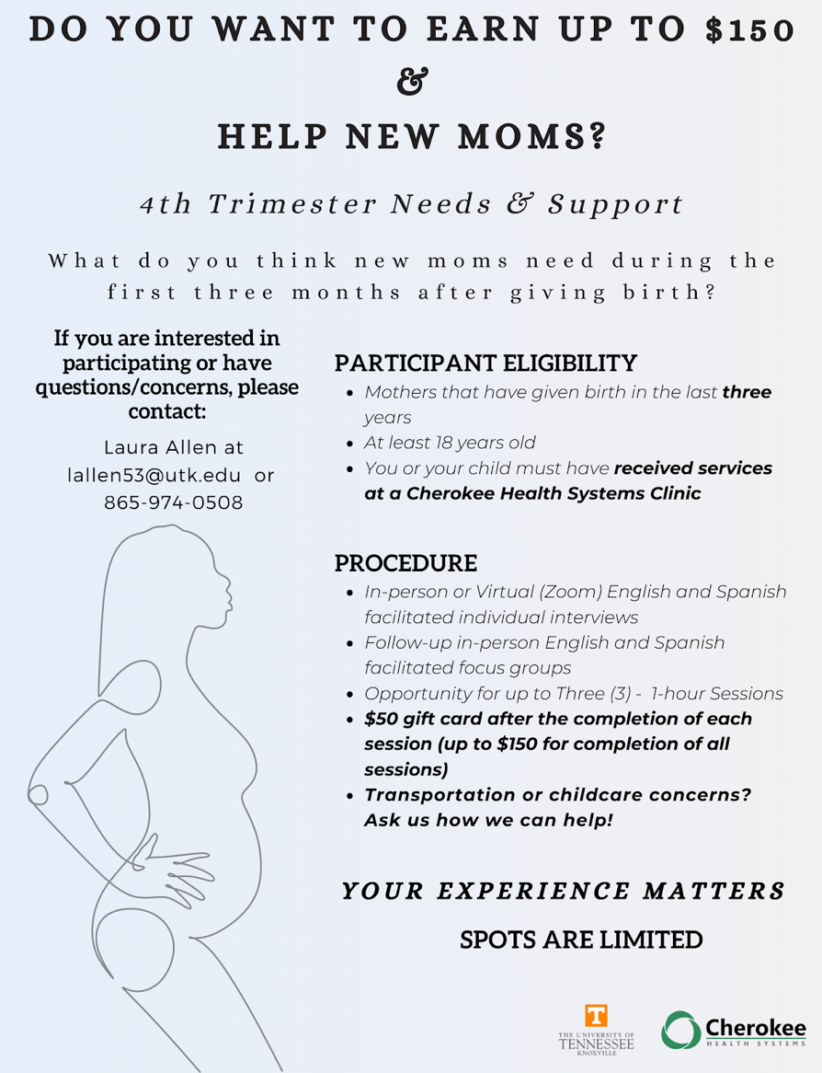
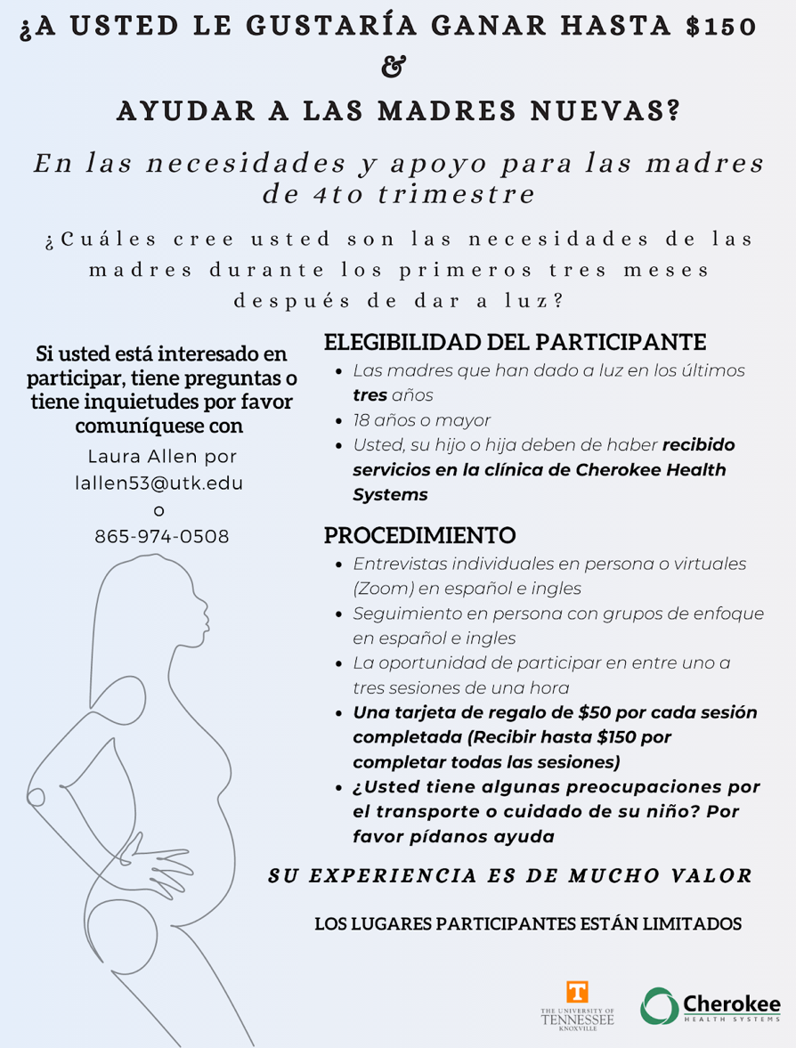

Vita
Desirée S. Woodle was born in Asheboro, North Carolina to parents Mr. Timothy Woodle and Mrs. DeShandra Woodle. She attended Asheboro High School, followed by a year at Clemson University, and completed her undergraduate studies as a transfer student at the University of North Carolina at Charlotte. In 2018, she earned her Bachelor of Science in Psychology with a minor in Communication. Desirée received her Master of Educational Leadership from the University of North Carolina at Charlotte in May 2020. In the fall of 2021, she began the Clinical Psychology doctoral program at The University of Tennessee, Knoxville, under the supervision of Dr. Kristina Coop Gordon.

