The Walking Threat: Traits of Pathogen Avoidance, Pathogen Threat Proximity and Functional Flexibility

A Dissertation Presented for the
Doctor of Philosophy
Degree
The University of Tennessee, Knoxville

Lahai Alexander Massaquoi Wicks
May 2024

Copyright © 2024 By Lahai Alexander Massaquoi Wicks
All Rights Reserved.

ACKNOWLEDGMENTS
As proud as I am of this accomplishment, there are so many individuals I must recognize for their great support, influence, and love. They are the reason I have had the privilege to achieve something of this magnitude. I am forever grateful.
Before all else, I must give thanks to my family, and my tribes. You all have given me the values and heart to spark my ambitions, pursue them, and see them out to completion. I love nothing in this world more than my you all, and my ultimate goal has always been for my work to one day put me in a position where I can be of greater service to you. My parents, Wokie and Stephen, deserve so much appreciation. You’ve always emphasized my education, inspired me to find my passion, and provided support when I was in need. There are far too many things you’ve done for me that I could thank you for, but that’s just evidence of your great love and generosity. Many of your dreams are also mine, and I look forward to using my work to eventually make some of them come true.
I also must give thanks to my wife Haley and son Camden. You both have also been unbelievably patient and supportive of me throughout my education. It’s been a long journey for us, but I can’t think of how many times you two have motivated me to be tenacious and brave. I love you both and can’t thank you enough for all of the times you two have validated me throughout this process. Haley, the fact that you’ve believed in me even when we’ve fallen on hard times has allowed me to have some much-needed faith in myself, and I could never thank you enough for that. Camden, for the record, all of the cool art you’ve made for my desk over the years has made me feel like a super scientist at work. Your creations have really helped me to remember what my purpose is, so keep developing that talent of yours. Seeing you work tirelessly sharpen your skills for basketball has reminded me that I have to always give my work a similar effort.
My grandparents and ancestors require a special passage in these acknowledgements, as their influence upon my education was of central importance. My late grandparents, Pete and Nancy Wicks, deeply inspired my academic interests from an early age. My grandfather, Pete, was a scientist and made sure that each of his grandchildren understood the importance of the sciences. He is the reason I love science. In particular, I recall two experiences as being most influential on my development as a scientist. When I was a child Pete was the head of the Department of Biochemistry & Molecular Biology here at the University of Tennessee, and he allowed me to come and see his laboratory. It was so amazing to see all his work for the first time, and the experience changed me forever. My grandfather also gave me my first lesson in auditory perception, which I believe was the initial seed that eventually grew into my passion for behavioral science. My grandmother, Nancy, was an avid reader and taught me how to enjoy reading large volumes of material—a skill that has served me very well throughout my doctoral experience. I still remember the days that we wandered the halls of the Columbus Library and the bookstore with great fondness. Another ancestral figure to recognize within this passage is my late granduncle, Fritz Massaquoi. Uncle Fritz got to witness the entirety of my education, save for the end of this doctoral program. However, he was an always so supportive of my desire to learn, and through his education in educational psychology, he was able to give me support that others simply could not. His sister, my “Oma” Fasia Massquoi, also deserves an acknowledgment. You helped to raise me, and always highlighted the importance of keeping faith and being diligent in my daily activities. Knowing that you’ve prayed for me every day has given me strength, and I look forward to bringing honor to you through this achievement. I would like to give a final acknowldgement to my great-grandfather, Momolu Massaquoi. He was the first African diplomat in modern history, king of the Vai tribe, and one of the last people to bring honor to the family name from his own efforts. From the moment I heard his story, I became inspired to achieve something of importance for the purpose of bringing honor to the family name. He dedicated his life and used his success to serve not only his Vai and Mende kin, but all Liberians. While I cannot achieve what he set out to do, I only pray that this achievement of mine can grow into a boon that allows me to serve my people similarly.
I would also like to recognize the people that have specifically helped me throughout my academic journey. I have always loved science, but I didn’t have a sense of what my field really was. Mr. Rich McKinney, my AP Psychology teacher in high school, was the first person to make me realize that the study of behavior was my passion. Additionally, I want to give a special thanks to Dr. Todd Freeberg for encouraging me to be tenacious in my turbulent attempts at reaching graduate school. You were one of the only people in the field that I felt respected my ambitions. Similarly, I must give much credit to Dr. John Dougherty and Dr. Monica Crane. Because you both believed in me, I was able to establish a professional foundation through an internship at the Cole Neuroscience Center, which allowed me to later gain admission to graduate school at Fisk University. I thank the entirety of the Fisk University Psychology Department faculty, as the training you all gave me prepared me for the challenge of a doctoral program. I must give a very special thanks to the late Dr. Terry Wertz of Vanderbilt University. He was a consistent mentor for me over the years, and I fondly recall our conversations about the strange nuances of psychophysiology. He was the person that inspired me to first read the literature on disgust, which ultimately led me to the production of this dissertation. I also hope to honor his memory through my work.
I want to thank my advisor, Dr. Debora Baldwin, for taking me under her wing in the doctoral program. It is because of your expertise, patience, and diligence that I can now confidently feel like a psychoneuroimmunologist. I also appreciate your willingness to allow me to explore new research topics and methods, as being creative has always fueled my motivation. You have been instrumental to my success, and I will forever be thankful for your support throughout this challenging time in the doctoral program. I could never have made it this far without you. Additionally, I want to individually thank each member of my dissertation committee: Dr. Jeffry King, Dr. Matthew Cooper, and Dr. Jake Levy. Your guidance has been extremely helpful for me as I developed my dissertation project. It is easy to be confident in your work when a group of experts such as these are guiding you along the way. I’d like to give an extra bit of appreciation to Dr. Jeffry King for being on my committee, as your special expertise in infectious diseases was instrumental in my growth as a scholar of mucosal immunity and SARS-CoV-2. Despite my relatively recent venture into the realm of immunology, you have always been positive and encouraging.
I want to give appreciation for my teaching supervisor, Dr. Bob DuBois. While you were not on my dissertation committee, you were always cheering me on and checking on me when the journey became daunting. I will always be grateful for your moral support and the ways you demonstrated that I could use my teaching of research methods to enhance my research.
I must individually thank my research assistants: Dasha Ogle, Jaedyn Wyer, Savannah Sexton, Adi Gujar, Alycia Kang, Livia Thomas, and Ethan Woodland. Without the hard work of these exceptional individuals, this dissertation simply could not have been possible. I know that each of you will excel on your various paths in life.

ABSTRACT
The threat of infection to humans is unwavering, and it is increased through social interaction, which human life is based around. This has been demonstrated through the recent SARS-CoV-2 pandemic, where social distancing was recommended to prevent the spread of the virus. Therefore, it is important to understand both the behavioral and physiological defenses that we possess against illness. However, the characteristics of the relationship between the behavioral immune system (BIS) and the physiological immune system (PIS) are still murky. This dissertation sought to better understand how the BIS considers the costs of mounting an immune response via functional flexibility with the PIS through three aims. Aim 1 was to identify predictive traits of BIS responses. This was done by correlating data from various relevant surveys and performing regressions to detect predictors across two studies. Aim 2 was to discern if social pathogen threats could elicit behavioral immune responses. Aim 3 was to determine if proximity is a moderator of functionally flexible BIS responses. These aims were met by conducting a factorial experiment utilizing confederates as pathogen threats while measuring physiological responses. Data analyses revealed that both proximity and health status contribute to a crossover interaction that produced differences in antibody secretion over time. Data analyses showed that the manipulation of health status could produce differences in observed avoidant behaviors, with groups exposed to a sickly and distant confederate expressing more behaviors. Data analyses also revealed that neuroticism and illness perception are strong correlates of the BIS. It was also found that these correlates were able to predict SARS-CoV-2 exposure. These findings allow for not only a greater understanding of functional flexibility, but also inspire better public health strategies for the management of infectious disease spread.

TABLE OF CONTENTS

CHAPTER I INTRODUCTION 1
Statement of the Problem 5
Statement of the Purpose 7
Significance of the Study 8

CHAPTER II REVIEW OF THE LITERATURE 10

A Brief Overview of the Historical Utility of Behavioral Immunity 11

Aspects of Behavioral Immunity 14

Disgust as an Affective State 14
Disgust Sensitivity 16
Disgust and Detection within the Behavioral Immune System 17
Attribution and Behavioral Immunity 22
Implicit Biases and Behavioral Immunity 24
Potential Variables of Behavioral Immunity 28

Illness Perception 28
Big Five Factor Model (OCEAN) 32

Secretory Immunoglobulin A 35
Interleukin-6 38

Heart Rate Variability 40

CHAPTER III STUDY ONE 44

Introduction 45

Methods 50

Results 55

Discussion 59

CHAPTER IV STUDY TWO 67

Introduction 68

Methods 76

Results 85

Discussion 89

CHAPTER V GENERAL DISCUSSION 99

Characterizing Functional Flexibility 100

Predicting BIS Responses 101

Social Pathogen Threats and Immunity 103

Proximity and Functional Flexibility 104

Overall Limitations and Conclusions 106
REFERENCES 111
APPENDIX 136
VITA 173

LIST OF TABLES

Table 1: Means and Standard Deviations for all Quantitative Dependent Variable Measures in Study 1 138

Table 2: Pearson Correlation Analyses between the Quantitative Dependent Variable Measures in Study 1 139

Table 3: Means and Standard Deviations for Factors of Confederate Proximity and Health Status across Self-Report Dependent Variables (DVs) in Study 2 142

Table 4: Means and Standard Deviations for Factors of Confederate Proximity and Health Status across Physiological Dependent Variables (DVs) in Study 2 144

Table 5: Means and Standard Deviations for Factors of Confederate Proximity and Health Status for Total Observed Avoidant Behaviors in Study 2 146

Table 6: Pearson Correlation Analyses between Autonomic Measures and other Dependent Variable Measures in Study 2 147

Table 7: Pearson Correlation Analyses between Salivary SIgA Measures and Other Dependent Variable Measures in Study 2 150

Table 8: Pearson Correlation Analyses between Salivary IL-6 Measures and Other Dependent Variable Measures in Study 2 152

LIST OF FIGURES

Figure 1. Correlation between Neuroticism (BFI-10) and Disgust Sensitivity (DS-R) in Study 1. 155

Figure 2. Correlation between Neuroticism (BFI-10) and Total Illness Perception (Brief IPQ) in Study 1. 156

Figure 3. Crossover interaction between independent variables of Confederate Health Status and Confederate Proximity upon ΔSIgA Secretion Rates in Study 2. 157

Figure 4. Disgust Ratings by Factorial Group Assignment in Study 2. 158

Figure 5. Disease Ratings by Factorial Group Assignment in Study 2. 159

Figure 6. Total Observed Avoidant Behaviors by Factorial Group Assignment in Study 2. 160

Figure 7. Correlation between Observed Avoidant Behaviors and ΔHR in Study 2. 161

Figure 8. Correlation between Observed Avoidant Behaviors and ΔHF HRV in Study 2. 162

Figure 9. Correlation between Observed Avoidant Behaviors and ΔSIgA Secretion Rates in Study 2. 163

Figure 10. Correlation between Openness to Experience (BFI-10) and ΔHF HRV in Study 2.

164

Figure 11. Confederate Ratings by Factorial Group Assignment in Study 2. 165

CHAPTER 1
INTRODUCTION

For as long as modern humans (homo sapiens sapiens) have existed, we have constantly had to strike a balance between procuring resources and avoiding danger (Murray & Schaller, 2016). The pursuit of sustenance in particular poses risks, namely on the microbial level. For example, to take in the proper number of nutritious calories and hydrate our bodies, humans have had to determine whether or not they were at risk for infection from any number of microscopic pathogens (Murray & Schaller, 2016). Thankfully, modern humans already had a working immune system, but there had to be actions taken to avoid pathogens prior to their introduction into the body. Behavioral responses such as avoiding a contaminated body of water, spitting up a spoiled meal, and recoiling from rancid sources of food (i.e., carrion) have allowed us to survive and adapt to the presence of environmental pathogens for hundreds of thousands of years (Murray & Schaller, 2016).
The basic idea of the ongoing “arms race” between humans and pathogens is outlined in a perspective called the “parasite stress theory” (Murray & Schaller, 2016). The theory implies that as humans develop better defenses against parasites and other pathogens, those same infectious agents develop counterstrategies to infect us more easily, resulting in humans needing to modify their defenses. Obviously, understanding the core principles of behavioral and physiological responses against pathogens is important for evaluating the parasite stress theory. However, more emphasis has been placed on how the two systems responsible for these defenses (i.e., the behavioral immune system and the physiological immune system) interact under the functional flexibility hypothesis. The functional flexibility hypothesis states that the behavioral immune system considers the costs and benefits of pathogen avoidance strategies (Ackerman, Hill, & Murray, 2018). This is important, as physiological immune responses carry a significant metabolic cost, yet there are circumstances where pathogen avoidance strategies might be less effective or efficient (Ackerman et al., 2018; Dantzer & Kelley, 2007; Murray & Schaller, 2016; van Leeuwen & Petersen, 2018).
The behavioral immune system (BIS) is a wide collection of evolved pathogen avoidance behaviors (Fleischman, 2016). Its function largely depends on the affective state of disgust and hypersensitivity to environmental pathogen cues, which is outlined in the smoke detector principle (Ackerman et al., 2018; Haselton & Nettle, 2005; Murray & Schaller, 2016; Nesse, 2005; Rozin & Fallon, 1987; Schaller & Park, 2011). The smoke detector principle describes how the affective state of disgust as a reaction to the presence of a pathogenic cue can activate the BIS like the smallest amount of smoke from a fire can activate a smoke alarm. The BIS would rather falsely deem a stimulus as being pathogenic than to assume that it is non-threatening to the body (Ackerman et al., 2018; Haselton & Nettle, 2005; Nesse, 2005; Schaller, Murray, & Bangerter, 2015; Schaller & Park, 2011; Shook, Oosterhoff, Terrizzi, Jr., & Clay, 2017). Early in human history, such false positive appraisal of environmental cues would have allowed humans to remain cautious and avoid needless risk (Haselton & Nettle, 200; Nesse, 2005; Schaller et al., 2015; Schaller & Park, 2011; Shook et al., 2017). This hypersensitivity requires that the human body has a variety of sharp sensory abilities to detect a pathogen threat, but it also can result in horribly prejudiced behavior due to implicit biases. Examples of this include participants deeming obesity, homosexuality, foreign origin, and other traits as disgusting across many studies (Faulkner, Schaller, Park, & Duncan, 2004; Inbar, Pizarro, Knobe, & Bloom, 2009; Park, Faulkner, & Schaller, 2003; Park, Schaller, & Crandall, 2007).
Even after these incredibly ancient examples of pathogen avoidance, humanity has faced an innumerable amount of pathogen threats and countless outbreaks of disease (Stenseth et al., 2008). With the sheer variety of infectious microorganisms that inhabit the planet, humanity has been pressed to not only adapt physiological immune defenses against introduced pathogens, but also new behavioral defenses to prevent infection altogether. While behavioral measures are often overlooked, they serve as an optimal way of securing positive health outcomes without expending the metabolic resources necessary for a robust physiological immune response. Take for example the SARS-CoV-2 pandemic, which ravaged the world from late 2019 until 2023 (Centers for Disease Control, 2024). The SARS-CoV-2 virus is known for having extremely contagious variants with debilitating and often unpredictable COVID -19 pathologies. Although we are fortunate to have developed effective vaccines to deal with the SARS-CoV-2 virus, the most prominent public health organizations in the world have continually stressed the importance of behavioral measures to prevent the infection and spread of the virus (Centers for Disease Control, 2024; World Health Organization, 2024). These measures consist of social distancing, handwashing, and mask-wearing. Each one has varying levels of efficacy in certain contexts, but research has shown that these methods significantly decreased risk of infection (Chu, Akl, Duda, Solo, Yaacoub, & Schünemann, 2020).
As the importance of both behavioral and physiological methods of dealing with pathogens have been highlighted, it is essential that researchers continue to investigate how these evolutionary methods function in tandem. By understanding the human body’s natural defenses, better public health strategies and personal decision-making can be promoted while providing clinicians with a better idea of the limits of these defenses.

Statement of the Problem
Frequently, humans encounter sources of infection and to maintain health, must be able to mitigate the chances of being infected by others (Hagger, Koch, Chatzisarantis, & Orbell, 2017; Schaller, 2011). This can be difficult, as humans typically thrive within sophisticated social environments with other humans (Schaller, 2016). However, humans have developed an effective way of dealing with the constant threat of pathogenic infection by not only having a physiological immune system that fights infection introduced to the body, but also a suite of behaviors meant to prevent infection altogether, known as the behavioral immune system (Fleischman, 2016; Schaller, 2014). A major component of the BIS’ function is the proactive regulation of social behaviors; however, the relationship between the BIS and the PIS is not fully understood (Ackerman et al., 2018; Fleischman, 2016; Schaller, 2011).
The BIS and the PIS are seemingly cooperative systems, and the field of psychoneuroimmunology has been focused on delineating their relationship (Ackerman et al., 2018; Fleischman, 2016). An important concept to address in researching the relationship between the BIS and PIS is the perception that the BIS has functional flexibility. The principle of functional flexibility is the popular concept that the BIS considers the rewards and costs of pathogen avoidance and attempts to adjust its activation accordingly (Ackerman et al., 2018; Schaller & Park, 2011). The significance of this principle is that it gives support to the idea that the BIS and the PIS could have a compensatory or complementary relationship. A compensatory relationship is notable in some behavioral reactions to pathogen threats, such as salivary flushing in response to a disgusting sensation, which is thought to lower concentrations of antibodies such as salivary secretory immunoglobulin A (SIgA; Stevenson, Hodgson, Oaten, Moussavi, Langberg, Case, & Barouei, 2012). This salivary flushing is an evolutionary behavioral reaction that occurs in the mouth to quickly remove toxins and protect tooth enamel if vomiting is necessary to expel a pathogen threat (Ackerman et al., 2018; Fleischman, 2016; Stevenson et al., 2012; Stevenson, Hodgson, Oaten, Sominsky, Mahmut, & Case, 2015). An example of this is attempting to ingest rancid food that is recognized by the body as being disgusting and not fit for consumption. Such a reaction is critical and logically supports functional flexibility because being able to eject a source of contamination rather than allow it to introduce infection into the body is a more efficient reaction, and an example of functional flexibility.
There are also accounts of the BIS and PIS activating simultaneously to a threat--and thereby having a complementary relationship (Ackerman et al., 2018; Schaller, Miller, Gervais, Yager, & Chen, 2010; Stevenson et al., 2011). For example, a complementary relationship between the immune systems would also result in an adequate defense against incoming threats to the body but defies the prediction that a normally functioning PIS only activates when truly threatened, as a physiological immune response comes with considerable consequence to the body (Kandrick, Hahn, Fisher, Wincenciak, DeBruine, & Jones, 2017; Schaller, 2014; Schaller, 2016; Schaller & Park, 2011). This uncertainty regarding whether functional flexibility insinuates a particular relationship between these defensive systems indicates that at least one essential variable has been excluded from the field’s understanding of functional flexibility. Considering that the distance between a person and a pathogen threat seems to elicit different types of BIS responses (proactive versus reactive), then once a person has come into direct contact with a pathogen threat, proximity may play an integral role in functional flexibility (Schaller, 2014; Stevenson, Case, Oaten, Stafford, & Saluja, 2019).
Although the underpinnings of pathogen avoidance are vast and span the across multiple fields of study, the interdisciplinary nuances of this matter are largely neglected. The two prominent perspectives regarding the development of the BIS that consider its relationship with the PIS are the parasite-stress theory and the functional flexibility hypothesis (Murray & Schaller, 2016).
It is ironically the interdisciplinary nature of the topic of functional flexibility that currently limits our understanding of immunomodulation, or how changes in the body’s immune system are elicited (National Cancer Institute, 2024). Functional flexibility suggests that the BIS and PIS cooperate to ensure optimal health outcomes at the lowest possible metabolic cost (Ackerman et al., 2018; Murray & Schaller, 2016). However, while many studies posit that the two systems have a compensatory relationship, there is yet to be any conclusive evidence of this (Ackerman et al., 2018). In fact, it seems as though the relationship between the BIS and PIS changes wildly depending on an intimidating number of biopsychosocial factors. When specializing in one area of science, such as psychology, it can be difficult to understand enough of the factors of physiological immunity to properly theorize about functional flexibility. Inversely, the immunologist who has never been educated in behavioral science struggles to understand the long-term behavioral effects of functional flexibility. However, by engaging in more intensive interdisciplinary research, I believe that there are commonalities between the BIS and PIS that, if explored, could tell us more about the relationship occurring between these systems for a substantial public health benefit.
Statement of the Purpose
The purpose of this dissertation is to further identify the underlying predictors of behavioral immune function (e.g., personality) and better characterize the functionally flexible relationship between the behavioral and physiological immune systems through the primary manipulation of pathogen threat proximity. Therefore, this research pursued the following aims regarding functional flexibility: Aim 1: To identify predictors of greater behavioral immune responses, such as personality traits, disgust sensitivity, and illness perception. Aim 2: To determine if a social pathogen threat creates an immune response in healthy individuals. Aim 3: To determine if the proximity of a social pathogen threat will moderate an elicited immune response. To reach our aims, a correlational design will be implemented in the first study to identify correlates of behavioral immunity. The second study will focus on whether proximity is a moderator of the relationship between the BIS and PIS.
Significance of the Study
The potential findings yielded from the current studies could fill gaps of understanding within the fields of psychoneuroimmunology and public health. By identifying correlates of behavioral immunity and understanding how general proximity to a simulated and realistic pathogen threat changes the functionally flexible response of our two immune systems, we can better comprehend the utility of social distancing policies as a valuable way to stay uninfected. If people are unable to appropriately avoid pathogen threats in their environment, they will have a higher risk of reinfection. This is of great concern, due to the risk of variant emergence via genetic recombination (Flint, Racaniello, Rall, Hatziioannou, & Skalka, 2020). This danger was evident during the SARS-CoV-2 pandemic, as the politicization of public health strategies was related to a lack of adherence despite the efficacy of these measures (Chu et al., 2020; Farias & Pilati, 2023). This likely contributed to the emergence of new SARS-CoV-2 variants that challenged public health agencies worldwide (Loo & Letchumanan, 2022). Therefore, having an operational BIS is in our best interest as a species. In summary, this study will be of importance to the field of psychoneuroimmunology and evolutionary psychology due to collecting data that demonstrates the social foundation of the BIS and uses that foundation to illuminate the nature of the relationship between the BIS and the PIS.

CHAPTER 2
LITERATURE REVIEW

A BRIEF OVERVIEW OF THE HISTORICAL UTILITY OF BEHAVIORAL IMMUNITY
The full benefit of the BIS as a defense mechanism can be seen rather obviously in the fact that modern humans (Homo sapiens sapiens) have survived many horrid outbreaks of illness (Chen, Toorop, de Boer, Rosendaal & Lijfering., 2020; Hackl & Dubernet, 2019; Pearson, Brown, Rendtorff, Ridenour, & Francis, Jr., 1945; Stenseth et al., 2008; Tybur, Merriman, Hooper, McDonald, & Navarette, 2010; Vazquez-Prokopec, Kitron, Montgomery, Horne, & Ritchie, 2010). This is especially significant considering that much of our modern methods of safely treating illness (e.g., antibiotics and antivirals) are only a couple of centuries old at most (Bauer, 1985; Clardy, Fischbach, & Currie, 2009). Therefore, it is likely that the BIS has kept humans and their groups relatively safe since the Pleistocene era through the careful employment and appraisal of behavioral immune responses and illness information (Murray & Schaller, 2016; Tooby & Cosmides, 1990).
A great benefit that the BIS likely performed for ancient humans is preventing the physiological immune system from having to engage a pathogen threat, which is taxing to the body (Ackerman et al., 2018; Murray & Schaller, 2016; Schaller et al., 2015; Tooby & Cosmides, 1990). This is an even greater detriment in light of the perpetual need for nutrients and calories, which will be wasted if one gets a parasitic infection due to a poor appraisal of a pathogen threat (e.g., gaining a toxoplasmosis infection from eating spoiled meat; Centers for Disease Control, 2024; Murray & Schaller, 2016). Therefore, the goal of the BIS is to make a judgment about potential pathogen threats with as little information as possible, as more information about a pathogen threat usually requires more risky exposure to the stimulus in-question (Haselton & Nettle, 2005; Murray & Schaller, 2016; Nesse, 2005; Schaller et al., 2015; Schaller & Park, 2011; Shook et al., 2017; Tooby & Cosmides, 1990).
However, this is troublesome considering that humans are social beings that often thrive in environments that allow for interaction with other human beings as well as many sources of contamination (Murray & Schaller, 2016; Schaller, 2011). Because socially gregarious behaviors and extraversion can be beneficial for the individual, these behaviors tend to be compromised within individuals that need defense against a perceived source of illness (Mortensen, Becker, Ackerman, Neuberg, & Kenrick, 2010). Furthermore, a lack of social distancing has been historically associated with horrible events of widespread illness. These include but are not limited to dengue fever, plague, and polio (Chen et al., 2020; Hackl & Dubernet, 2019; Pearson et al., 1945; Stenseth et al., 2008; Vazquez-Prokopec et al., 2010).
In recent times, the consequences of poor behavioral immune strategies were felt during the COVID-19 pandemic. The SARS-CoV-2 virus undoubtedly ravaged the world for years and still poses a health concern, albeit less than it used to (Center for Disease Control, 2024). Despite the use of immensely helpful preventative vaccines from pharmaceutical companies, the behavioral measures put in place by public health officials during the COVID-19 pandemic were at the core of the Centers for Disease Control (CDC) and World Health Organization’s (WHO) plans for handling the viral pandemic (Center for Disease Control, 2024; World Health Organization, 2024). The recommended behavioral measures for reducing one’s risk of infection primarily consisted of social distancing, donning a mask and frequent handwashing (Centers for Disease Control, 2024; World Health Organization, 2024). The efficacy of these behaviors cannot be understated. For example, researchers found that social distancing decreased risk of infection by 90% and appropriate mask-wearing decreased risk of infection by 65% (Chu et al., 2020).
Behavioral immunity is so essential for survival that even non-human animals boast behavioral immune strategies (Hart, 1990; Wisenden, Goater, & James, 2009). Bullfrog tadpoles have been known to swim away from other infected tadpoles (Kiesecker, Skelly, Beard, & Preisser, 1999), chimpanzees have been shown displaying aversive and occasionally violent behavior towards chimpanzees with polio (Goodall, 1986), wood ants use tree resin as a defense against both bacterial and fungal infections (Chapuisat, Opplinger, Magliano, & Christe, 2007), and female mice find the odors of male mice that carry nematode parasites aversive (Kavaliers & Colwell, 1995). Even for scavenging animals that are resistant to many of the pathogens that infect humans, the ability to appraise carrion is beneficial. This can be observed in the case of various carrion bird species, who despite having a digestive system that is adapted for consuming carcasses, can still fall victim to infection via scavenging (Vicente & Vercauteren, 2019). In order to deal with this risk, these birds have been known to avoid certain decaying tissues when scavenging, and the avoided tissues are usually the most dangerous to consume. For example, carrion birds will eat ovine central nervous tissues, but avoid bovine central nervous tissues, which can carry prions (Vicente & Vercauteren, 2019). When comparing these displays of behavioral defense towards pathogen threats, aversion seems to be the common factor between how these animals react to the pathogen threats in their environment. For humans, aversion to pathogen threats typically comes in the form of disgust (Schaller & Park, 2011; Chan, Holland, van Loon, Arts, & van Knippenberg, 2016).

ASPECTS OF BEHAVIORAL IMMUNITY
Disgust as an Affective State
Disgust functions as an emotional stimulus that activates the BIS in a way that has been compared to a “smoke detector” (Schaller & Park, 2011). This function is formally described as the “Smoke Detector Principle”. This principle states that the BIS has evolved to prevent the likelihood of false-negative errors (e.g., assuming a food item is safe to consume despite having been spoiled from a lack of refrigeration) and is therefore extremely sensitive to any stimulus that might resemble a pathogen threat (Ackerman et al., 2018; Schaller et al., 2015; Haselton & Nettle, 2005; Nesse, 2005; Schaller & Park, 2011; Shook et al., 2017). Notably, when the “smoke detector” registers a potential source of infection, typically, the emotion of disgust acts as the alarm (Ackerman, et al., 2018; Murray & Schaller, 2016; Schaller & Park, 2011). An appreciation for the specificity of the BIS function can be found in the reality that false-negative errors in identifying pathogen threats can be fatal to both the individual and the individual’s associates (Ackerman et al., 2018; Haselton & Nettle, 2005; Nesse, 2005; Schaller et al., 2015; Schaller & Park, 2011; Shook et al., 2017).
It is important to note that the smoke detector principle is the lynchpin for understanding how the BIS can work alongside the PIS for reduced susceptibility to infections (Murray & Schaller, 2016). This is because previous research has suggested that disgusting stimuli lower the threshold of sensory systems such as vision and smell, making it easier to detect pathogen threats in the environment and promoting aversive behavior towards those threats (Chan et al., 2016; Schaller, 2011; Schienle, Übel, Rössler, Schwerdtfeger, & Lackner, 2016). Fleischman (2016) defines the BIS as “a suite of evolved strategies to minimize the risk or prevent the introduction of pathogens and parasites into the organism”. In other words, the primary function of the BIS is to prevent people from contacting environmental contaminants, stemming from a need to prevent parasitic infections that were frequent in early human life (Murray & Schaller, 2016). The BIS does so through both proactive and reactive strategies (Ackerman et al, 2018).
Reactive strategies are based in an affective state of disgust and involve impromptu behaviors that seek to create distance between an individual and a pathogen threat within the vicinity (Murray & Schaller, 2016). Reactive behavioral immune responses are characterized by disgusted behaviors to confirmed pathogen threats within the vicinity of the individual, such as gagging when spoiled food is ingested or not sitting next to an individual with a noticeable skin lesion on public transportation (Murray & Schaller, 2016). This can present as vomiting, gagging, coughing, fleeing, or recoiling behaviors.
One reactive behavioral immune response that serves the purpose of facilitating interpersonal communication and social learning regarding pathogen threats is a disgusted expression. Case in point, when a person becomes disgusted during the display of a reactive behavioral immune response, they will likely make a distinct “disgusted face”, characterized by heightened muscle tension in the corrugator and levator labii superioris muscles of the face (Oum, 2010). This facial expression is also characterized by constriction of the oral and nasal cavities, in order, to prevent the intake of pathogens (Ekman & Friesen, 2003; Oum, 2010; Vrana, 1993). This expression could be adaptive for human groups, as others in the vicinity of a disgusted individual will witness the disgusted expression as a signal of a potential pathogen threat and could modify their own proactive behavioral immune response to better prevent any exposure to the pathogen threat. Such a phenomenon could allow for groups and communities to reduce risk for infection, and it further underlines the importance of conformity in proactive behavioral immune responses. (Schaller, 2014).
Proactive behavioral immune responses are characterized by the avoidance of long-term pathogen threats that are not in the immediate vicinity of the individual or do not pose an immediate threat (Schaller, 2014). Therefore, they allow the individual to develop pathogen avoidance strategies prior to exposure based upon previously collected information on a pathogen threat. Also, proactive behavioral responses are typically devoid of any disgust affect because there is a lack of an imminent source of infection (Schaller, 2014). Examples of proactive behavioral responses are consistent handwashing or preemptively deciding to increase intake of vitamin C. Interestingly, many proactive responses are simply acts of conformity to cultural norms, which are said to have had direct health implications in pre-industrial societies (Fabrega, 1997; Murray & Schaller, 2012). Examples include an individual routinely washing their hands before preparing food, choosing to cook food for longer periods to ensure food safety, or even bringing hand sanitizer with them when they leave their home (Murray & Schaller, 2016; Schaller, 2014). While disgust arousal is not immediately relevant to a proactive behavioral immune response, it can be confidently stated that disgust likely plays a causal role in the production of future proactive behavioral immune responses (Schaller, 2014; Stevenson et al., 2019).

Disgust Sensitivity
Disgust sensitivity can be defined as an individual’s general proneness to disgusting stimuli, which often results in greater reactivity to disgusting stimuli. The Revised Disgust Scale (DS-R) is a measure used to determine the disgust sensitivity of individuals. Previous literature has suggested that higher disgust sensitivity leads to higher salivary secretory immunoglobulin A (sIgA) levels, but the literature also suggests that sIgA concentration tends to drop once a participant is disgusted due to salivary flushing (Fleischman, 2016; Stevenson, Hodgson, Oaten, Barouei, & Case, 2011; Stevenson et al., 2012). The reason that this salivary flushing occurs is to prepare the oral cavity to expel hazardous substances when extreme disgust is experienced, as the extra saliva protects tooth enamel from stomach acids presented during vomiting. Vomiting as a disgusted response is likely more effective at removing as much of a pathogen threat as possible compared to solely relying on mucosal immune function (Fleischman, 2016; Rubio-Godoy, Aunger, & Curtis, 2007; Stevenson et al., 2011; Stevenson et al., 2012). Therefore, disgust sensitivity in relation to sIgA needs more investigation, considering this antibody is the first line of defense for many pathogen threats (Benjamini & Leskowitz, 1988).

Disgust and Detection within the Behavioral Immune System
As mentioned before, the affective state of disgust serves as a vital component of the BIS, acting as an “alarm”, according to the smoke detector principle (Ackerman et al., 2018; Murray & Schaller, 2016; Schaller, 2011; Schaller, 2014). Considering that specific systems of motivation are associated with specific emotions, the importance of this emotion is not downplayed (Schaller, 2014). Research indicates that disgust is a reliable predictor of whether or not an individual will expose themselves to a potentially disgusting object (Park et al., 2003; Rozin, Millman, & Nemeroff, 1986; Ryan, Oaten, Stevenson, & Case, 2012). This is because disgust can trigger a state of sensitivity to sensory stimuli (Chan et al., 2016; Schaller, 2011; Schienle et al., 2016). Thus, if an individual can even marginally detect a pathogen threat and emotionally response with disgust, they will likely be even more sensitive to the threat and avoid it altogether.
When presenting information on the BIS, it is important to discuss how it detects environmental pathogen threats, especially in light of the smoke detector principle (Ackerman et al., 2018; Haselton & Nettle, 2005; Nesse, 2005; Schaller et al., 2015; Schaller & Park, 2011; Shook et al., 2017). From a behavioral immunity perspective, sensory systems provide the foundation for behavioral immunity. The breadth of information regarding sensory systems will be limited to the most relevant human senses for behavioral immunity: smell, taste, and vision. Keeping in mind the tendency for the BIS to be oversensitive in the detection of infection risks in the environment, it seems sensible that this system hones the senses, in order, to better prepare for the presentation of stimuli that signal a risk of infection (Kandrik et al., 2017; Schaller & Park, 2011).
Olfaction is of great importance to the BIS. Smell primarily functions to cue motivational affective states (e.g., disgust) via the intake of chemical signals in the environment (Stevenson, 2010). These chemical signals are received by a specialized area of tissue in the human nasal cavity known as the olfactory epithelium (Wysocki & Preti, 2004). Once received, the signals provide information on whether or not an individual should engage or avoid another person or object in the environment (Wysocki & Preti, 2004). This particular sensory system is of great importance due to the implicit connections between various infectious agent odors and the individual’s ability to detect foul odors (Stevenson, 2010; Stevenson & Repacholi, 2003). In fact, disgusting odors have been known to prime the behavioral immune system to detect pathogenic threats more easily via the human nose; thereby lowering the olfactory threshold (Chan, van Dooren, Holland, & van Knippenberg, 2020; Chan, Holland, van Loon, Arts, & van Knippenberg, 2016). For example, Chan et al (2020) performed a study where participants underwent emotional induction with either positive, negative, or disgusting images while being exposed to a pleasant and mildly unpleasant scent. They found that sensitivity to both pleasant and mildly unpleasant smells increased when participants viewed disgusting pictures. Therefore, confirming earlier findings on how disgust lowers the olfactory threshold and contributes to an individual’s enhanced sensitivity to foul odors.
While it could be argued that olfaction is one of the most important senses for the proactive management of pathogen threats, the gustatory sense or taste has an equivalent if-not greater significance within the evolutionary development of the BIS (Rottman, 2014; Schaller, 2016). Since the Pleistocene epoch, humans have had to intake enough calories and nutrients to survive (Cloninger, 2009; Tanaka, 2010). However, many substances in the natural world lack nutrition, are inedible, toxic, or contain pathogens. This is further evidenced by bitter flavors in food sometimes acting as a sign of toxicity (Nissim, Dagan-Wiener, & Niv, 2017). The sense of taste has evolved in humans to detect if certain substances are suitable as food, and when ingested material is unfit for consumption, our tastebuds help our BIS to produce a reactive response consisting of increased salivation, nausea, vomiting, and other symptoms (Rottman, 2014; Stevenson et al., 2011; Schaller, 2016). These symptoms are not necessarily a sign of actual infection, but more indicative of an appropriate removal of a potentially hazardous item from the body (Ackerman et al., 2018; Murray & Schaller, 2016). Because of how the body responds to foul tastes, many researchers have studied both disgust and the gustatory system, with a notable emphasis on conditioning paradigms and moral disgust.
Much of the literature on taste and disgust focuses on conditioned taste avoidance or the Garcia Effect (Parker, 2014; Parker, Rana, & Limebeer, 2008). Although this concept sounds like conditioned disgust, research demonstrates the differences between condition taste avoidance and conditioned disgust (Parker, 2014). More specifically, Parker and colleagues (2008) explained that conditioned taste avoidance does not require experienced nausea via taste, but conditioned disgust to a taste does require the prior onset of nausea (Parker, 2014). This would imply that someone can be conditioned to avoid a food item without the flavor causing a visceral experience of disgust, but a visceral experience of disgust is critical to the disgust conditioning of a participant. Parker seems to think that this is because food items in conditioned taste avoidance paradigms signal dangerous qualities without provoking conditioned nausea (Parker, 2014). Interestingly, the same body of research has indicated that conditioned taste avoidance is upregulated by serotonin and downregulated by endocannabinoids. Serotonin triggers nausea when it is released in the gastrointestinal system, and the endocannabinoid system is thought to suppress nausea (Parker, 2014; Parker et al., 2008; Tuerke, Limebeer, Fletcher, & Parker, 2012). Furthermore, work by Vicario (2013) indicated that taste response is directly tied to visceral changes to disgust sensitivity due to experience (Vicario, 2013).
Some researchers have attempted to link moral disgust to gustatory responses. While it has been shown that tasting an unpleasant substance can increase morally disgusting judgments and that immorality is rated similarly to stimuli representative of a pathogen threat, the evidence of a relationship between the two variables has been primarily based upon self-report data or slim physiological data (Chapman, Kim, Susskind, & Anderson, 2009; Elad-Strenger, Proch, & Kessler, 2020; Eskine, Kacinik, & Prinz, 2011; Skarlicki, Hoegg, Aquino, & Nadisic, 2013). Furthermore, it has been demonstrated that taste sensitivity is not reliably tied to moral disgust, but to visceral experiences of disgust only (Herz, 2011). In addition, disgust is thought to have emerged in large part due to experiences of distaste, and some of the literature on moral disgust even states that it does not have any clear ties to neural correlates of visceral disgust such as the anterior insula (Chapman & Anderson, 2012; Herz, 2011; Rottman, 2014; Schaller, 2016). Therefore, moral disgust is not strongly associated with visceral disgust, the sensory modality of taste, or other disgusting experiences of the viscera.
Due to the ease of creating and/or providing disgusting imagery, vision is often used to activate the BIS in research (Chan et al., 2016; Mortensen et al., 2010; Rohrmann, Hopp, Schienle, & Hodapp, 2009; Schaller, 2011; Schienle et al., 2016; Kandrik et al., 2017). An example is in the work of Rohrmann et al (2009), who investigated whether disgust sensitivity moderates the type of reaction to disgust-inducing film when given various coping instructions (e.g., suppression of reaction, stimulus reappraisal, and uninstructed viewing as a control). Results showed that participants with high disgust sensitivity had significant physiological and emotional responses to the film when compared to participants with low disgust sensitivity (Rohrmann et al., 2009).
Not only do disgusting images increase the contrast sensitivity of perceptual vigilance, but these visuals also boost activity in the visual cortex. Specifically, disgusting sights increase contrast sensitivity via activation in the primary and secondary visual cortices—which allow for the detection of nuances in the shading and patterns of stimuli, as well as the assistance of appropriate bottom-up processing of salient disgusting visual stimuli in concert with other brain areas such as the amygdala and insula (Alghwiri & Whitney, 2020; Schienle et al., 2016; Schienle, Übel, & Scharmüller, 2015). This change in visual performance upon the initial perception of a disgusting visual stimulus is greatly beneficial, as it allows for the eyes to sensitize to any potential pathogen threats. In turn, this prevents the BIS from committing a false-negative error. Interestingly, better increases in contrast sensitivity are seen in those individuals who are more sensitive to disgusting stimuli (Chan et al., 2016).

Attribution and Behavioral Immunity
Hypervigilance and sensitivity of the BIS are tied to an important yet somewhat underappreciated concept that assists us in our understanding of the BIS: attribution (Kelley & Michela, 1980). Attribution can be defined as causal determinant or reasons for one’s behavior or the behaviors of others. Attributions influence our behaviors and behavioral responses to illness is often affected by one’s attributions. Individuals tend to make dispositional attributions (i.e., personality traits) when they are viewing the behaviors of others. However, individuals tend to make situational attributions (i.e., contextual) when rationalizing their own behaviors (Kelley & Michela, 1980). Therefore, behavioral immunity may change based upon the rationale for the illness or infection. For example, someone that temporarily forgoes dental hygiene might be judged as inherently filthy, while a person might spare themselves from such judgment when they forget to maintain their own dental hygiene. Instead, they will not judge themselves as filthy and rather determine that their lapse in cleanliness was due to some temporary circumstantial factor (e.g., not having time to brush their teeth before work). An individual will see themselves as only temporarily risking infection while perceiving another person as a potential constant source of infection, leading to interesting moral and cultural implications.
Often the BIS will attribute traits in line with infection to various objects or people (Faulkner et al., 2004). However, traits assigned to others by an individual are not always seemingly relevant to disease but do assist in the humanization or dehumanization of a target (Buckels & Trapnell, 2013; Faulkner et al., 2004; Haidt, 2001). An example of this is in the work of Buckels & Trapnell (2013), who demonstrated that disgusted individuals are more likely than sad or neutral individuals to dehumanize outgroups as animalistic when presented with words and pictures of both outgroup members and animals (rather than blatant pathogen cues such as words and pictures of fecal matter). The researchers randomly assigned participants to groups that would either be induced with disgust, sadness, or neutral emotions. The induction of these emotional states included words such as person, civilian, mongrel, and feral. Participants were asked to rate these words based upon two 7-point scales (uniquely human to uniquely animal, and extremely negative to extremely positive). The pictures used for emotion induction involved counterbalanced photos of both ingroup and outgroup members, whom participants were asked to rate as either “us” or “them”. While some participants rated the words and pictures separately, others were able to rate them simultaneously. Buckels and Trapnell (2013) found that disgusted participants were far more likely to associate outgroup members with animals, which can be considered a form of unfair dispositional attribution upon said outgroup members. Such findings not only highlight the role that disgust can play in the judgment of others, but also the ways in which disgust can foster implicit biases towards others.
Some other examples of traits tied to pathogenic risk are the beliefs that deter the performance of proactive behavioral immune responses endorsed by the in-group majority. For example, the refusal to wear a mask due to a disbelief in its efficacy in preventing the spread of SARS-CoV-2, or beliefs that certain “taboo” foods are acceptable to consume (e.g., cultures that might consume food that is seen as unsafe by another culture). These pathogen threat-related attributions manifest most prominently in research regarding moral disgust. Moral disgust describes an aversion to the moral alignment and behaviors of others (Chapman et al., 2009; Elad-Strenger, Proch, & Kessler, 2020; Eskine, et al., 2011; Skarlicki, et al., 2013.) Because individuals that do not follow societal norms are more likely to disobey societal guidelines that promote health (e.g., hygiene), moral disgust assists in the avoidance of pathogen threats (Schaller, 2016) This is essential to attribution, as the dispositional judgment of others that fail to meet the behavioral expectations of the individual could protect the individual from the costs of associating with others that pose a pathogenic risk. This hypervigilance in attributing the behaviors of others to disposition is in line with the hypervigilance of the overall BIS. It is usually safer to assume that outside factors could expose you to infection (Schaller, 2016).

Implicit Biases and Behavioral Immunity
Implicit biases are formed against physical and behavioral features that differ from the prototypical self or the norms of one’s culture, relatively speaking (Murray & Schaller, 2016). While this can lead to effective preventative measures against pathogen threats, often times these implicit biases manifest as harmful phobias (e.g., homophobia, xenophobia, etc). This is due to the tendency for the BIS to register “false positives” or assuming a person is infectious and avoiding them despite the person posing no threat (Faulkner, Schaller, Park, & Duncan, 2004; Inbar et al., 2007). Case in point, one study showed that individuals sensitive to disgust typically described behavior acted out by an agent that resulted in public displays of affection between gay men as intentional, regardless of whether the result of the agent’s behavior was intentional (Inbar et al., 2009). In another study, participants were more disgusted and avoidant of images of obese individuals compared to images of individuals with facial bruising (negative controls) or healthy control images (Tapp, Oaten, Stevenson, Occhipinti, & Thandi, 2019). Also, participants in this study were nearly equally as disgusted and avoidant of images of obese individuals compared to images of influenza-infected people. These arguably hateful attitudes are likely influenced in part by the hypervigilance of the BIS. Occasionally, this system will falsely deem objects as infectious to ensure that there is no exposure to anything that could potentially be infectious (Ackerman et al., 2018; Haselton & Nettle, 2005; Nesse, 2005; Schaller et al., 2015; Schaller & Park, 2011; Shook et al., 2017). Case in point, while obesity is not known ot be infectious, it is associated with certain adenoviruses, causes a number of diseases, and is linked to various lifestyle choices that do not promote healthy outcomes (Hruby, Manson, Qi, Malik, Rimm, Sun, Willett, & Hu, 2016; Ponterio & Gnessi, 2015).
There is a wealth of research which demonstrate that disgust and disease avoidance emphasize differences specifically between ingroups and outgroups (Aarøe, Petersen, & Arceneaux, 2017; Ackerman et al., 2018; Berger & Anaki, 2021; Buckels & Trapnell, 2013; Faulkner et al., 2004; Inbar et al., 2009; Murray & Schaller, 2016; Shook et al., 2017; Terrizzi, Shook, & Daniel, 2013; Tybur et al., 2010). One such example is a series of studies carried out by Faulkner et al. (2004) that suggest the BIS employs disgust to identify potentially infectious outgroup members. The purpose is to avoid them and keep the body safe from pathogens. Faulkner et al. (2004) carried out four different studies to determine whether feelings of vulnerability to disease is correlated with negative reactions to foreign people. The researchers postulated that group discrimination such as xenophobic behavior is based on individual differences and the perception of vulnerability to disease and how humans have evolved to be able to understand their level of vulnerability to pathogens in the environment. Across the four studies, the participants were 313 British Columbian undergraduate students. These participants were either given stories (narratives) to read about fictional ethnic groups or they were presented with pictures of people from foreign ethnic groups in implicit association tasks. The participants were then asked if they would feel comfortable with these people immigrating to their nation of Canada. The participants were also asked if they would endorse them with money or if they felt as though those individuals would bring disease or accidents based on their appearance or characteristics as noted in the narrative. In addition, participants self-reported on their perceived vulnerability to disease. Regarding the results, there were higher levels of discomfort and disgust associated with the non-European ethnic groups. Specifically, there were higher ratings of disgusting discomfort amongst participants presented with an African stimulus. Also, there was a negative correlation between perceived vulnerability to disease and endorsement of individuals presented with African stimuli. Because of these findings, the authors concluded that xenophobic behavior and modern social cognition is significantly influenced by ancient evolutionary mechanisms for avoiding infection—the BIS (Faulkner et al., 2004).
The primary issue with such conclusions is that they somewhat imply that the BIS has evolved to specifically perform the identification of group affiliation via pathogen threat detection. However, the only reason that the BIS displays any xenophobic effects is due to the probability that there could be an immune risk in dealing with nonfamiliar individuals rather than nonfamiliar groups. A rebuttal to the aforementioned study demonstrated that the BIS actually guides decision-making in social situations by identifying differences between the ingroup and outgroup. Van Leeuwen and Petersen (2018) asserted that the behavioral immune system is designed to avoid infected individuals, not outgroups. They stated that the BIS is totally focused on avoiding pathogens and therefore might result in eventual avoidance of entire outgroups after experiences with those outgroups carrying disease (e.g., such as when Europeans brought smallpox Native Americans in large numbers). When certain outgroups have presented an apparent pathogen threat in the past, it could be beneficial to avoid those outgroup members. However, when studying the evolution of pathogen avoidance strategies in humans, it becomes rather apparent that the BIS was only designed to identify threats on the level of the individual.
Van Leeuwen and Petersen (2018) were able to support their ideas and refute Faulkner et al.’s (2004) assertions by conducting an experiment. Unlike Faulkner et al. (2004), van Leeuwen and Petersen (2018) sampled participants from two very different locations: The United States of America and India. In addition, these researchers greatly exceeded the sampling size of Faulkner et al. (2004) by having 1615 American and 1969 Indian participants. Their methods involved showing participants pictures of various individuals from either India or the United States of America (thus simultaneously showing both ingroup and outgroup members), and having the participants express through a survey how comfortable they would be with physical contact between them and each depicted individual. An important aspect of the pictures is that visual pathogen cues (e.g., mouth sores) were randomly present across the pictures of the individuals that were presented, regardless of nationality. As expected, the findings of their study showed that the self-reported levels of comfort and discomfort were very similar in both groups’ ratings of both ingroup and outgroup members that expressed visual pathogen cues. This implies that the BIS has evolved to be more focused on identifying threatening individuals regardless of group affiliation. Their findings also disrupt the idea that pathogen avoidance can explain xenophobia.
During the Pleistocene era, humans were traveling on foot and therefore not able to reach areas far from their communities. This means that early humans were also unlikely to wander far enough to encounter outgroup members very often—and even less likely to make contact with an entire foreign community (van Leeuwen & Petersen, 2018). However, there are certain benefits to interacting with outgroup communities. These involve the following: 1) trading of exotic goods and novel ideas which could greatly enhance the ingroup’s overall fitness, 2) exposure to an outgroup member could provide new pathogenic defenses, and 3) interbreeding with an outgroup could diversify the genetic traits of both groups, potentially boosting fitness (van Leeuwen & Petersen, 2018). While the risk of infection from members of an outgroup is present, van Leeuwen and Petersen (2018) point out that avoiding outgroup members would not likely reduce the cost of pathogenic infection due to the possibility of an ingroup member becoming ill (and thereby potentially contagious) without intergroup circumstances.

POTENTIAL VARIABLES OF BEHAVIORAL IMMUNITY
Illness Perception
The importance of proper decision-making for one’s health is obvious, especially in the context of the recent COVID-19 pandemic. People across the world are still reflecting upon their experiences with the SARS-CoV-2 virus, the information they received about it from others, and attempted to make the right decisions to preserve their health based upon these factors. Generally, it is thought that an individual’s personal understanding of an illness (i.e., illness perception) determines their health-related decision-making behavior (Chapman, Johannes, Poppenk, Moscovitch, & Anderson, 2013; Hagger, Koch, Chatzisarantis, & Orbell, 2017; Leventhal, Benyamini, Diefenbach, Leventhal, Patrick-Miller, & Robitaille, 1997; Leventhal, Safer & Panagis, 1983; Lowe & Norman, 2017). While the aspects of a person’s perception of an illness are complicated and schematic in nature, there are a few fundamental parts to be considered. These include the self-system, emotional representations of an illness, cognitive representations of an illness, and prior experience with particular approaches to dealing with an illness (Hagger, Koch, Chatzisarantis, & Orbell, 2017; Leventhal et al., 1983).
The self-system refers to one’s understanding of themselves, which includes information on the capacity to deal with illness (e.g., financial ability to pay for treatment, a sense of personal immune function, etc). Emotional representations to illness are predominantly associated with aversion, thereby emphasizing the role of fear and disgust in illness. This is because negative emotions such as disgust and fear are seemingly able to affect the formation of illness schemas (i.e., cognitive frameworks that store and organize information on illness and health information), including pathogen threats (Chapman, Johannes, Poppenk, Moscovitch, & Anderson, 2013; Hagger et al., 2017; Leventhal et al., 1997; Leventhal et al., 1983; Lowe & Norman, 2017). However, fear is typically the focus of research regarding the influence of emotions upon illness representation (Hagger et al., 2017; Leventhal et al., 1997; Leventhal et al., 1983; Lowe & Norman, 2017). For example, Leventhal and colleagues (1967) investigated how participants would handle quitting cigarette smoking by randomly assigning participants to one of four groups based on the level of fear (high- or low-fear) of a received health message stimulus and the type of specific action plan (plan or no plan) provided to each participant for dealing with the message’s content. In the case of smoking, high-fear health messages included film clips of lung surgery due to cancer developed from smoking, and low-fear health messages included asking the participant to quit smoking. It was found that high-fear health messages were the most effective in creating short-term changes to health behaviors and attitudes. Moreover, health messages on both fear levels were useful for influencing positive long-term changes when combined with specific action plans.
It is important to note that both emotional and cognitive representations of illness can influence the onset of both adaptive and maladaptive health-related decision-making. This is because fear or disgust of an illness can lead an individual to compulsively seek insufficient treatment or avoid treatment altogether (Hagger et al., 2017; Leventhal et al., 1997; Leventhal et al., 1983; Lowe & Norman, 2017). On the other hand, while cognitive representations can lead the individual to decide how to deal with the threat of illness based upon the characteristics of the illness threat, the effectiveness of the individual’s decision-making is largely dependent on the quality of the information received about the illness (Leventhal et al., 1983; Leventhal, Watts, & Pagano, 1967). Basically, emotional representations provide a bottom-up approach to dealing with health-related decision-making while cognitive representations provide a top-down approach.
Once the information about an illness threat is understood considering the self-system, decisions can be made about how to handle an illness threat. These decisions to handle illness threats are called coping behaviors or illness behaviors. However, they can also be understood as forms of proactive and reactive behavioral immune responses (Leventhal et al., 1997; Leventhal et al., 1983; Schaller, 2016; Schaller et al., 2015). The efficacy of these decisions produces a feedback effect that will either reinforce or diminish the salience of various illness information when presented will a pathogen threat in the future (Baumann & Leventhal, 1985; Hagger et al., 2017; Henderson, Hagger, & Orbell, 2007; Henderson, Orbell, & Hagger, 2009; Leventhal et al., 1997; Leventhal et al., 1983; Orbell & Henderson, 2016). While decision-making in the face of a pathogen threat does require the accommodation of self-related, emotional, and cognitive information, the specifics of how the BIS has influenced decision-making can be seen in both ancient and modern scenarios. In order to study illness perception and how it can influence decision-making in a modern context, there are a number of measures to consider in light of the current study.
The Revised Illness Perception Questionnaire for Healthy People (IPQ-RH) is a measure used to study the perceptions that participants have regarding their relationship to various illnesses and symptoms, including vulnerability (Henderson et al., 2009). Illness perception is made up of both cognitive and emotional representations of illness (Broadbent, Petrie, Main, & Weinman, 2006; Henderson et al., 2009; Moss-Morris, Weinman, Petrie, Horne, Cameron, & Buick, 2002). Cognitive representations are typically described through dimensions such as consequences of illness, personal control over illness, and risk factors of illness. Emotional representations are typically described through an entirely separate dimension (Broadbent et al., 2006). High illness perception scores can indicate a greater perceived vulnerability to illness depending on the dimension of illness perception being considered. The dimensions that are included are as follows: illness effect, illness timeline, illness control, illness treatment, illness symptoms, illness concern, illness comprehension, and emotional effect of illness. Henderson, Orbell, and Hagger (2009) reported that representations of illness can be behaviorally activated if the illness stimuli presented are associated with the specific illness in question, as both groups of participants in their study showed a response bias to the illness words that were related to illnesses that they were visually primed with. The Positive and Negative Affect Schedule (PANAS), which is sometimes paired with the IPQ-RH, is a reliable and valid measure of a participant’s emotional state. It has been found to heighten the discriminant validity of the IPQ-RH (Crawford & Henry, 2004).
Disgust is the only affective state of concern in this body of research. Therefore, the PANAS will be replaced by the Disgust Rate Survey (DRS), which will simply assess how disgusted a participant is after an experimental task (Stevenson et al., 2015). A brief version of the IPQ-RH (i.e., the Brief IPQ) has also been shown to reliably measure illness perception in a short amount of time (Broadbent et al., 2006; Broadbent, Wilkes, Koschwanez, Weinman, Norton, & Petrie, 2015). For the purposes of this dissertation, this version shall be implemented to reduce detrimental participant effects. Based upon this information from the literature, it is imperative to consider disgust sensitivity, emotional affect, and illness perception through survey data in light of the BIS and PIS with careful consideration.
Big Five Factor Personality Model (OCEAN)
Personality traits are of paramount importance to the study of human behavior. There are five relatively stable personality dimensions of interest that are commonly studied known as the “Big-Five”, and they consist of openness, conscientiousness, extraversion, agreeableness, and neuroticism (Cobb-Clark & Schurer, 2011). These dimensional personality traits are associated with many health outcomes which must be highlighted to ultimately assess the importance of personality for the avoidance of pathogen threats (Goodwin & Friedman, 2006).
Openness refers to a willingness to experience change and has been found to decrease with several debilitating physical diagnoses (e.g., stroke, hernia, tuberculosis, joint problems, etc; Goodwin & Friedman, 2006; Levy, Richardson, Lounsbury, Stewart, Gibson, & Drost, 2011). Additionally, low openness has been shown to be somewhat linked to lessened physical impairment in those with physical illnesses (Goodwin & Friedman, 2006). Conscientiousness is defined as dependability and a desire to adhere to social norms (Levy et al., 2011). Interestingly, this personality trait is associated with an overall reduced risk for many physical and mental illnesses (Goodwin & Friedman, 2006). Extraversion is described as social gregariousness and has also been associated with lessened physical impairment at low levels (Goodwin & Friedman, 2006; Levy et al., 2011). In patients with a number of conditions such as high blood pressure and tuberculosis, low extraversion is more common. Low extraversion has also been found in those with major depression, panic attacks, and generalized anxiety disorder (Goodwin & Friedman, 2006).
Agreeableness describes altruistic and prosocial behavior and has been shown to be lower in those with alcoholism and substance use disorders (Goodwin & Friedman, 2006; Levy et al., 2011). Strangely, agreeableness was found to be higher in those with diabetes and high blood pressure. Higher agreeableness was linked to less frequent challenges on bathing, dressing, and short-distance walking (Goodwin & Friedman, 2006). Neuroticism is marked by emotional instability and a propensity for maladjustment (Olatunji, Haidt, McKay, & David, 2008). Perhaps unsurprisingly, neuroticism is strongly associated with greatly increased risk for many physical and mental illnesses (Goodwin & Friedman, 2006).
The personality traits associated with heightened disgust sensitivity and pathogen avoidance tend to be openness, extraversion, and neuroticism (Shook et al., 2017). Typically, disease avoidant behavior is positively correlated with neuroticism and negatively correlated with extraversion and openness to experience (Mortensen et al., 2010; Schaller & Murray, 2008; Shook et al., 2017). For example, Olatunji and colleagues (2008) explored the relationships between disgust sensitivity and disgust (specifically core, contamination, and animal-reminder disgust) in light of physiological responses, behavioral avoidance, anxiety disorder symptoms and personality traits across four studies. The first study was the only one specifically focused on the connection between disgust and personality traits. In this study, 247 students completed the revised disgust sensitivity scale (DS-R), the NEO Five-Factor Inventory (NEO-FFI), the Behavioral Inhibition System and Behavioral Approach System Scales (BIS/BAS) and the Rosenberg Self-Esteem Scale (RSES). It was found that neuroticism was significantly positively correlated with disgust sensitivity, and all measured domains of disgust. Extraversion was negatively correlated with disgust sensitivity, animal-reminder disgust, and contamination disgust despite being positively correlated with core disgust. However, these correlations were weak and insignificant. Openness was weakly and insignificantly correlated with all variables (domains of measured disgust and disgust sensitivity), save for a significant negative correlation with core disgust. These findings signify that each type of disgust investigated by Olatunji et al (2008) could be a function of differing psychological mechanisms with varying relevance to the avoidance of illness. The researchers infer that some forms of disgust (e.g., animal reminder) have not emerged from core disgust to directly protect humans from pathogens, but instead to preserve the sovereignty of humans within the animal kingdom (Olatunji et al., 2008). While this idea is rather controversial due to the widely held belief that all disgust is somehow tied to pathogen avoidance, it is important because the personality traits associated with forms of disgust that function as pathogen avoidance mechanisms seem to be different than the personality traits associated with other “non-prototypical” forms of disgust (Olatunji et al., 2008; Stevenson et al., 2019).
While it is quite evident that the BIS is vital to human health, the malfunction of this system and the personality traits that it is usually characterized by must be described. For one, the tendency to identify false positives could potentially be tied to pathology seen in individuals with contamination-specific obsessive-compulsive disorder (OCD), specific phobias, eating disorders, and posttraumatic stress disorder, which decrease the quality of life and potentially even the health of the individual (Shook et al., 2017). This is further substantiated by the research that indicates that neuroticism is marked by anxiety, emotional reactivity, and negative affect (Shook et al., 2017).
Regarding disgust and pathogen avoidance, the “Big-Five” personality traits hold great significance. Pathogen avoidant behavior is negatively correlated with personality traits like extraversion and openness, as they promote exposure to others (Mortensen et al., 2010; Shook et al., 2017). The information on personality traits and behavioral immune responses suggests that while personality cannot entirely determine your health outcomes, they must be considered in the appraisal of behavioral immune function. However, considering that conscientiousness has notable importance for general health outcomes and is based within adherence to social norms, it is peculiar that there are no clear findings that tie this personality trait to disgust (Goodwin & Friedman, 2006; Olatunji et al., 2008). Considering the findings of prior research on personality and disgust, it seems as though openness to experience, extraversion, and neuroticism hold the most relevance to disgust out of the Big Five Factor Model (Goodwin & Friedman, 2006; Mortensen et al., 2010; Shook et al., 2017; Olatunji et al., 2008).

Secretory Immunoglobulin A
Immunoglobulin A (IgA) is an antibody produced by B cells that is the primary antibody found in bodily secretions (Benjamini & Leskowitz, 1988). It specializes in binding to antigen presented within mucosal membranes and neutralizing them. It is effectively one of the body’s first defenses against pathogens and is vital to the treatment of local infections. It is important to note that IgA is also found within intravascular spaces, the placenta, and breast milk (Cacho & Lawrence, 2017; Hasselquist & Nilsson, 2009).
There are two types of IgA known as IgA₁ and IgA₂, which differ based on both structure and function, with IgA₂ encouraging proinflammatory responses in other immune cells that IgA₁ does not (Steffen et al., 2020). Structurally, the IgA monomer consists of two γ or two κ L chains and two H α chains bound by disulfide bonds. In the mucous membranes where plasma cells create IgA monomers, plasma cells also make J chains, which link the monomers in pairs to create an IgA dimer (Benjamini & Leskowitz, 1988). Once this IgA dimer is created, it is released from the plasma cell and binds to nearby epithelial cells that secrete them into extracellular fluids. When this happens, an S piece is added to the IgA dimer via a strong noncovalent bond, resulting in the creation of secretory IgA (sIgA) (Benjamini & Leskowitz, 1988). It is because of this that IgA seems to exist only as monomers prior to secretion, and that its primary function within the immune system depends on the secretory dimer form. SIgA is even essential for the homeostasis of the gut microbiome (Steffen et al., 2020). However, recent research has shown that serum IgA has important signaling properties that can control monocytes, neutrophils, subsets of macrophages, and even some subsets of dendritic cells. By signaling to immune cells, serum IgA can control inflammation, induce phagocytosis, and activate antibody-dependent cytotoxicity better than IgG, among other functions (Steffen et al., 2020). Although IgA does not interact with the complement system and therefore cannot induce bacterial lysis, it is able to perform antibacterial functions against gram-negative bacteria in the presence of lysozyme. Also, IgA has remarkable antiviral properties because it prevents viruses from entering host cells through binding to the virions and agglutinating them (Benjamini & Leskowitz, 1988).
The utility of sIgA against viruses can be seen in the event of a SARS-CoV-2 infection. If behavioral strategies to avoid SARS-CoV-2 fail, the virus is able to reach intercellular spaces within the mucous membranes, requiring the PIS to respond. If the PIS can mount an adaptive response before the virus can infect host cells and replicate to an uncontrollable extent, the battle within the mucosae will largely depend on the antibodies (e.g., sIgA) produced by B cells (Wu, Zhang, Tu, Chen, & Chen, 2014). This will take the form of various effector T cells attacking cells infected by the SARS-CoV-2 virus. B cells will give rise to plasma cells in the lamina propria that secrete antigen-specific sIgA through the epithelium to neutralize SARS-CoV-2 virions before they can reach other intracellular spaces (Wu et al., 2014). As the virions and infected cells are destroyed, the detrimental inflammation will begin to cease (Khamis et al., 2021; Pavia & Wormser, 2021; Peng, Rhind, & Beckett, 2021; Perricone, Triggianese, Bursi, Cafaro, Bartoloni, Chimenti, Gerli & Perricone, 2021).
Salivary secretory Immunoglobulin A (sIgA) is often measured in various studies regarding disgust and immune activation, as sIgA is an established biomarker of immune activation for disease avoidance and can be collected non-invasively via participant saliva (Brown, Ikeuchi, & Lucas III, 2014). This is because IgA “attacks microbes prior to their entry into the body” and is found in bodily secretions more than any other antibody (Benjamini & Leskowitz, 1988; Brown et al., 2014). IgA becomes sIgA after being created by B cells and secreted through mucuous membranes, and sIgA functions by attacking any substances deemed foreign in the mucuous membranes (Benjamini & Leskowitz, 1988). Although IgA is typically in the same bodily secretions as sIgA, IgA in serum also has important signaling capabilities that allow for necessary immunomodulation when fighting off infection (Steffen et al., 2020). IgA is also important for gastrointestinal health through interaction with the gut microbiome and plays an important role in passing along immunity to babies (via breast milk and the placenta; Cacho & Lawrence, 2017; Hasselquist & Nilsson, 2009; Steffen et al., 2020). Stevenson et al (2012) suggested that sIgA concentration increases in response to disease cues and found that sIgA concentration can spike momentarily with exposure to food-related disgust stimuli. However, SIgA concentration has also been found to decrease in response to disgust-eliciting pictures that are not food-related (Fleischman, 2016; Stevenson et al., 2012). This decrease in sIgA concentration was thought to be due to the mouth producing saliva to flush itself of harmful contaminants and to protect tooth enamel from stomach acid (Fleischman, 2016; Stevenson et al., 2011; Stevenson et al., 2012). The instance of sIgA concentration increasing in response to disgusting pictures could be due to the stimuli causing active coping, as passive coping is thought to show downregulation of sIgA (Stevenson et al., 2011).

Interleukin-6
Interleukin-6 (IL-6) is a cytokine made by T cells that serves to increase the antibody output of B cells, increase inflammation, and cause fever in the body (An et al., 2011; Blomqvist & Engblom, 2018; Eskilsson, Morrasekhian, Dufour, Schwaninger, Engblom, & Blomqvist, 2014; National Cancer Institute, 2024; Tanaka & Kishimoto, 2014). IL-6 is also partially responsible for other centrally mediated physiological functions such as hypothalamic-pituitary-adrenal (HPA) axis activation (Kenney & Ganta, 2014). Specifically, IL-6 and other proinflammatory cytokines serve as mediators of what is known as “sickness behavior”, or the changes in behavior that occur when an organism experiences disease. These changes include fatigue, decreased consumption of nutrients, altered cognition, and social withdrawal (Dantzer & Kelley, 2007; Dantzer, O’Connor, Freund, Johnson, & Kelley, 2008). This behavior is considered part of a motivational system to prioritize the allocation of metabolic resources to the PIS in order to fight the infection, but it could also be inferred that this type of behavior could have been selected for the prevention of infectious transmission through social groups (Dantzer & Kelley, 2007; van Leeuwen & Petersen, 2018).
Furthermore, sickness behavior can be seen as a result of IL-6’s role in communicating with the hypothalamus to mount an immune response against a pathogen. IL-6, among other cytokines, can signal that the body has become ill through the activation of afferent nerves (e.g., vagal nerves), access to the brain via the blood-brain barrier using cytokine transporters, and volume diffusion leakage through the blood-brain barrier from circumventricular organs into the brain (Dantzer et al., 2008; McCusker & Kelley, 2013). An important effect of the cytokine-based communication between the PIS and brain is the inducement of pyrexia (i.e., fever; Scrase & Tranter, 2011). This occurs when prostaglandins are made by the brain after being exposed to the cytokines of an innate immune response, which then alter the “internal thermometer” set by the hypothalamus (Dantzer et al., 2008; Scrase & Tranter, 2011). In the event of infection, raising the body temperature to a state of pyrexia is typically beneficial because the increased temperature increases the speed of leukocyte delivery to sites of infection, antibody production, T cell production, cellular repair, and causes bacterial destruction (Scrase & Tranter, 2011). While the hypothalamus obviously plays an important role in the brain’s contribution to fighting off pathogens such as SARS-CoV-2, it should be noted that the brain circuitry that determines the sickness behavior based upon cytokine signaling is complex and still unclear (Dantzer et al., 2008).
Although the nuances of the relationship between IL-6 and the nervous system are still not fully understood, prior research has given extra support to the idea that the cytokine production is closely related to stress disorders. Maes et al (1999) demonstrated through a correlational investigation on posttraumatic stress disorder (PTSD) that participants with PTSD had higher serum concentrations of IL-6 and IL-6 receptors compared to those who did not have PTSD, further highlighting the role of IL-6 within the autonomic nervous system. Because IL-6 induces fever, activates the HPA axis, and indirectly influences the release of SIgA, it is an important measure for the study of functional flexibility (Blomqvist & Engblom, 2018; Kenney & Ganta, 2014).

Heart Rate Variability
Heart rate variability (HRV) is an important measure of sympathetic and parasympathetic nervous system activity and is defined as the variance in the amount heart rate fluctuates around the mean heart rate (van Ravenswaaij-Arts, Kollée, Hopman, Stoelinga, & van Geijn, 1993). Put simply, HRV is the beat-to-beat variation in heart rate (Billman, 2011). Resting HRV is a good measure of both psychological and physical health (Oliver, Baldwin, & Datta, 2019; Shaffer & Ginsberg, 2017). Psychological stress, which increases sympathetic nervous system activity, has been associated with low frequency heart rate variability (Taelman, Vandeput, Spaepen, & Huffell, 2009). Alternatively, parasympathetic activity has been correlated with high frequency heart rate variability (Oliver, et al., 2019; Shaffer & Ginsberg, 2017). Therefore, it is especially useful in studies related to cardiac health, stress, and arousal (Malik & Camm, 1990; O’Connor et al., 2021).
Despite this simple description of HRV, there are a number of complex metrics regarding the features of the heart’s inter-beat intervals (IBIs), which are typically described as time-domain measures, frequency-domain measures, or non-linear measures (Shaffer & Ginsburg, 2017). For the purposes of this dissertation, frequency-domain measures are of particular interest. Frequency-domain measures are used to estimate the distribution of absolute or relative power. These frequency distributions are split into four band types, with power referring to the signal energy found within frequency bands. There are ultra-low frequency (ULF) bands (<0.003 Hz), very-low frequency (VLF) bands (0.003-0.04 Hz), low frequency (LF) bands (0.04-0.15 Hz), and high frequency (HF) bands (0.15-0.4 Hz) (Shaffer & Ginsburg, 2017; Thayer, 2009).
ULF bands are frequency bands that are potentially driven by slow biological processes such as circadian rhythms, metabolism, and core body temperature. Due to the slow biological influence over ULF bands, 24-hour recordings of HRV are necessary for measurement (Shaffer & Ginsburg, 2017). Although the sympathetic (SNS) and parasympathetic nervous systems (PNS) cooperate in their contributions to HRV, it is undecided how these two autonomic branches contribute to ULF bands. ULF bands seem to be associated with psychiatric disorders that are tied to circadian rhythms (Shaffer & Ginsburg, 2017). VLF bands are frequency bands that can be measured for a minimum period of 5 minutes, despite a 24-hour measurement providing better measurement (Shaffer & Ginsburg, 2017). VLF bands seems to be a critical measurement of overall health, as it is strikingly well-associated with all-cause mortality (Shaffer & Ginsburg, 2017). Stimulation of afferent sensory neurons in the heart through factors such as physical activity, thermoregulatory processes, and endothelial influences seems to generate VLF bands (Shaffer & Ginsburg, 2017). Interestingly, despite some uncertainty, it seems as though the PNS has a dominant influence over VLF bands compared to the SNS. This type of frequency band is associated with posttraumatic stress disorder (PTSD), arrhythmic death, high inflammation, and low testosterone levels (Shaffer & Ginsburg, 2017). LF bands are a primary reflection of baroreceptor activity during rest and can be measured at a minimum of just 2 minutes. The PNS and baroreflex activity seem to be the primary contributors of LF band power, and slow respiration influences LF bands via vagal mediation (Shaffer & Ginsburg, 2017). HF bands, also known as respiratory bands, reflects PNS activity and has a seemingly nocturnal rhythm. They can be recorded in a minimum period of 1 minute (Shaffer & Ginsburg, 2017). HF bands correspond to variations in heart rate during respiration and demonstrate vagal control of the heart. Low HF band power is associated with stress, anxiety, and panic (Shaffer & Ginsburg, 2017).
Interestingly, it was also found that individuals with a lower resting HRV experienced slower physiological recovery from psychological stressors compared to individuals with higher resting HRV, demonstrating the importance of HRV in maintaining one’s health (Weber, Thayer, Rudat, Wirtz, Zimmermann-Viehoff, Thomas, Perschel, Arck, & Deter, 2010). Based upon other prior research, it seems that heart rate variability is negatively correlated with IL-6 (and other inflammatory markers), indicating that stress and inflammation promote worse cardiovascular health overall via autonomic modulation of the heart (Kenney & Ganta, 2014). In this dissertation, HRV will be measured using the HF band. This is because HF HRV can be accurately measured in short durations, which is most appropriate for the current experiment considering the equipment used for the measurement of this autonomic variable (Shaffer & Ginsburg, 2017).
Utilizing blood volume pulse (BVP) rather than more conventional methods to measure HRV (e.g., electrocardiography) has been shown to be valid, especially when considering that both BVP and HRV are susceptible to stressful emotional stimuli (Peper, Harvey, Lin, Tylova, & Moss, 2007). Furthermore, other research has demonstrated that important supporting measures of HF HRV such as respiration do not require measurement to obtain useful data from the HF band in order to provide useful autonomic insights (Bhattacharyya, Whitehead, Rakhit, & Steptoe, 2008). This is because of close relationship held between respiration and HF HRV (Allen, Jennings, Gianaros, Thayer, & Manuck, 2015; Hill, Siebenbrock, Sollers, & Thayer & Lane, 2009; Macatee, Albanese, Schmidt, & Cougle, 2017; Shaffer & Ginsberg, 2017)
It is important to note that HRV is built upon the measure of heart rate (HR), which is an elementary measure of stress (Paran, Amir, & Yaniv, 1996; Raemakers, Ector, Aubert, Rubens & Van de Werf, 1998; Robinson, Epstein, Beiser, & Braunwald, 1966; Thayer & Lane, 2009). Despite the simplicity of the measurement and analysis of HR compared to HRV, HR is valued as a stress correlate due to the wide array of studies that link HR to various autonomic activity (e.g., sympathetic; Grassi, Vailati, Bertineri, Seravalle, Stella, Dell’Oro, & Mancia, 1998; Robinson et al., 1966; Sacha, 2014). In particular, it has been found that disgust and other emotional stimuli can greatly affect HR (Chan et al., 2016; Schienle et al., 2015). Schienle and colleagues (2015) demonstrated that disgusting visual stimuli can elicit increases in HR in participants that were situated in an upright tilted position, especially those that were more prone to experiencing disgust. In this dissertation, HR, HRV, and BVP will be measured in conjunction with immune responses (sIgA and IL-6) because they serve as important autonomic markers of stress. By allowing us to measure stress directly from the autonomic nervous system, we can better understand the ties between behavioral responses and physiological responses to pathogen threats. Such an understanding will assist in the investigation of our aims. Specifically, these autonomic measures should change from baseline if we are able to elicit an immune response after presenting a pathogen threat to participants, as outlined in our second aim. Also, these variables should also experience significant changes from baseline as proximity to a pathogen threat changes, as outlined in our final aim.

CHAPTER 3
STUDY ONE

Introduction
It is important that we identify the psychological variables behind the behavioral immune system, as this comprehension could allow us to predict or possibly experimentally manipulate behavioral immune responses. Controlling the spread and effect of disease outbreaks can be made much more difficult when individuals have maladaptive behavioral immune responses, as shown throughout the COVID-19 pandemic (Hills & Eraso, 2021; van den Broek-Altenburg & Atherly, 2021). While previous research has studied several independent correlates of behavioral immunity and disgust, there has yet to be any studies done to build a complete profile of behavioral immune function by considering these variables simultaneously (Chan et al., 2020; Hagger et al., 2017; Leventhal et al., 1997; Leventhal et al., 1983; Olatunji et al., 2008; Rohrmann et al., 2009; Vicario 2013). Therefore, this study’s premise has vital implications for public health, because honing the behavioral immune responses of others for better adaptability would allow public health organizations to more seamlessly implement interventions to keep the public safe from pathogenic threats (Adjodah, Dinakar, Chinazzi, Fraiberger, Pentland, Bates, Staller, Vespignani, & Bhatt, 2021; Hills & Eraso, 2021).
Disgust sensitivity is an important measure for behavioral immunity that determines how sensitive a person is to a disgusting stimulus (Deacon & Olatunji, 2007; Stevenson, Case & Oaten, 2009; Stevenson et al., 2015; Vicario, 2013). Deacon & Olatunji (2007) researched the specificity of disgust sensitivity’s ability to predict both behavioral avoidance and contamination-related anxiety. Participants were separated into groups based upon a measure of contamination fear (Padua inventory contamination fear subscale) and were asked to complete a combination of three random behavioral avoidance tasks after filling out several self-report measures. One of these self-report measures was the Disgust Scale (Haidt, McCauley & Rozin, 1994). The tasks randomly given to participants consisted of being presented with a bedpan filled with toilet water, a cookie on the floor, or a used comb. Deacon & Olatunji (2007) found that disgust sensitivity was associated with anxious and avoidant responding to contamination-related tasks after controlling for gender, age, anxiety, depression, and contamination fear group membership. Not only that, but disgust sensitivity was also found to fully mediate a significant relationship between contamination cognitions and responses on behavioral avoidance tasks. These results demonstrated the important role that disgust sensitivity has in the avoidance of contaminants, a central aspect of behavioral immunity (Schaller, 2016). Other prior research on disgust sensitivity surveyed 616 participants on their frequency of infectious illness, recency of infectious illness, contamination sensitivity, disgust sensitivity and other factors (Stevenson et al., 2009). Contamination sensitivity was not associated with recency of infectious illness but was positively associated with frequency of infectious illness. However, if participants scored highly in both contamination and disgust sensitivity, they tended to experience far fewer bouts of infectious illness (Stevenson et al., 2009). These findings further substantiate the defensive role that disgust sensitivity takes as part of the behavioral immune system.
Illness perception refers to the perceived susceptibility one has to illness and their ability to adapt to it (Leventhal et al., 1997). Leventhal and colleagues (1980) presented evidence through their Common-Sense Model of Illness that a person’s ability to handle a health threat (e.g., infectious illness) is through assessing personal risk by way of emotional and cognitive representations of that specific illness. By understanding how afraid or disgusted a potential illness makes you feel and receiving supporting information about the illness (e.g., treatment options, comorbidities, prognoses, etc), could motivate a person to become an active agent against said health threat through their perception of that threat and subsequent coping (Diefenbach & Leventhal, 1996; Henderson et al., 2009). To substantiate this, Henderson and colleagues (2009) carried out two between-subjects factorial experiments where they would determine if coping information for an illness is inherently a part of the overall representations of that illness. Participants were either past users of common cold coping strategies (e.g., using lozenges while experiencing a common cold) or not a user of said coping strategies. These same participants were either primed with a word associated with the common cold, or not primed at all. The researchers measured reaction time to certain treatment words in a grammatical decision task as the outcome variable. It was shown across both experiments that participants who were given the common cold prime and had also reported a lot of prior use of coping strategies for the common cold displayed significantly lower response times to the treatment words. Such findings further indicate the importance of illness perception in a functioning behavioral immune system (Henderson et al., 2009).
Personality traits described by the Big Five Inventory of personality are extraversion, openness to experience, agreeableness, conscientiousness, and neuroticism. These traits are widely accepted as being appropriate broad domains of personality, and research has shown that several personality traits are connected to disgust (Druschel & Sherman, 1999; Mortensen et al., 2010; Olatunji et al., 2008). In the current study we emphasized neuroticism, openness to experience, and extraversion because prior research has specifically highlighted the connection between disgust and these personality traits. For example, Druschel & Sherman (1999) surveyed 132 undergraduate students on their Big Five personality factors as well as their disgust sensitivity. While they found that disgust sensitivity had a positive relationship with agreeableness and conscientiousness, they detected a far larger positive effect between disgust sensitivity and neuroticism. A significant relationship was also found between disgust sensitivity and openness to experience, although it was negative (Druschel & Sherman, 1999). Other researchers later performed a more thorough investigation on the correlates of three types of disgust (core, animal reminder, and contamination; Olatunji et al., 2008). Their first of four studies had 247 students fill out the Disgust Scale-Revised, which measures the three aforementioned types of disgust, the NEO Five Factor Inventory, a relatively short personality survey, as well as other self-report measures. A significant positive correlation was found between all types of disgust and neuroticism. On the other hand, small negative associations were found between core disgust, contamination disgust, and openness to experience (Olatunji et al., 2008). In essence, the correlations found between various personality traits and disgust sensitivity provides evidence for the idea that disgust is not a one-dimensional construct, with the affective state being attributed to a different psychological construct depending on the type of disgust in question (Olatunji et al., 2008; Olatunji, Sawchuck, Lohr, & de Jong, 2004).
Another study found an interesting connection between disgust and extraversion, as Mortensen and colleagues (2010) showed that when giving participants a disease prime via video, extraversion was significantly lowered. These various findings were likely detected because both extraversion and openness can influence how much a person puts themselves at risk for disease exposure (Mortensen et al., 2010; Shook et al., 2017). Specifically, high extraversion can present as gregarious behavior that seeks out social interactions, even with individuals that show signs of infection (Mortensen et al., 2010; Shook et al., 2017). High openness could present itself as thrill-seeking behavior that others might suppress to avoid exposing themselves to pathogens (Mortensen et al., 2010; Shook et al., 2017). Neuroticism, on the other hand, seems inseparable from the study of disgust, as both disgust and neuroticism are deeply based in psychological distress (Olatunji et al., 2008).
Purpose and Hypotheses
The present study sought to characterize the relationship between the correlates of behavioral immunity such as disgust sensitivity, illness perception, and personality simultaneously to identify relevant variables associated with the BIS. Additionally, demographic information can often yield valuable insights and prior research identified the importance that gender plays in disgust sensitivity. Specifically, Tybur and colleagues (2011) found that compared to men, women display greater levels of disgust sensitivity across three domains of disgust (e.g., sexual, pathogen, and moral). It was of interest to us to collect data regarding exposure to the SARS-CoV-2 virus and the experience of COVID-19 fatigue in college students. This was an important choice, as prior experience with illness and pathogen threats can alter behavioral immune responses (Schaller, 2014). In addition, behavioral immune responses should be able to alter risk for these SARS-CoV-2 variables to a degree via adaptive avoidant strategies (Murray & Schaller, 2016; Schaller, 2014). Therefore, it was assessed via the demographic survey.
Study 1 addressed the first discussed aim of this dissertation: to identify predictors of greater behavioral immune responses. The main hypotheses were as follows:
Hypothesis 1: that disgust sensitivity and illness perception would have a negative relationship with openness and extraversion.
Hypothesis 2: both disgust sensitivity and illness perception would have a positive correlation with neuroticism.
Hypothesis 3: a significant correlation between disgust sensitivity and both exposure to SARS-CoV-2 and SARS-CoV-2 pandemic-related fatigue will emerge.
Hypothesis 4: a significant correlation between illness perception and both exposure to SARS-CoV-2 and SARS-CoV-2 pandemic-related fatigue will emerge.
Hypothesis 5: a significant predictor of exposure to SARS-CoV-2 will be identified out of the possible correlates.
Methods
Participants
Three-hundred and twenty undergraduate students were recruited from undergraduate psychology courses through the university’s SONA system. The majority of the sample consisted of participants who identify as women (82.2%), with smaller portions identifying as men (16.6%) or of an unspecified gender (1.3%). Additionally, most of the participants reported their race as Caucasian (81.3%), followed by Asian (6.4%), African American (4.4%), Multiracial (3.4%), Hispanic/Latinx (2.5%), an unspecified race (.9%) and Native American/Pacific Islander (.6%). The mean age of the participants was between 18 and 19 years of age (M = 18.61, SD = 1.55), and ages of the entire sample ranged from 18 to 32. Furthermore, most of the sample identified as freshman (75%) that lived on campus (74.7%). Less than half of the sample reported as having been knowingly exposed to the SARS-CoV-2 virus (33.4%). Participants were only allowed to participate in the study if they were 18 years or older, and participation was awarded with .5 SONA credits, which are valued as either class credit or extra credit within their psychology courses. Although this study was conducted entirely using online surveys, participants were asked if they were ever exposed to the SARS-CoV-2 virus or experienced SARS-CoV-2 pandemic-related fatigue. This study was approved by the university’s IRB. All data were collected between August and December of 2022.

Instrumentation
Disgust Sensitivity. The Revised Disgust Scale is a 27-item survey that measures a participant’s sensitivity to disgusting stimuli (Olatunji, Williams, Tolin, Sawchuck, Abramowitz, Lohr & Elwood, 2007). According to Stevenson et al (2015), the DS-R is shown to have a Cronbach’s alpha of .87. The survey is split into two halves, with the first half presenting 14 items and the second half presenting 13-items. The first half asks the participant how much they agree with a variety of statements, allowing them to respond with a 5-point Likert scale (0 – strongly disagree, 4 – strongly agree). An example item from this half is, “I might be willing to try eating monkey meat, under some circumstances.” The second half asks the participant how disgusting they feel a variety of scenarios are, allowing them to respond with a 5-point semantic differential scale (0 – not disgusting at all, 4 – extremely disgusting). An example item from this half is, “You see maggots on a piece of meat in an outdoor garbage pail.” To score the DS-R, items 12 and 16 are omitted prior to the reverse scoring of items 1, 6, and 10 by subtracting the participant response on item 4 from those items. Afterwards the sum of remaining item scores is calculated. The resulting score should range from 0 to 100, with lower scores indicating less sensitivity to disgusting stimuli, and higher scores indicating a higher sensitivity (Olatunji et al., 2007).
Illness Perception. The Brief Illness Perception Questionnaire (Brief IPQ) is a 9-item survey that measures a participants’ emotional and cognitive representations of illness (Broadbent et al., 2006). Participants are asked to respond to a variety of statements by indicating how much each statement corresponds with their views. Each statement corresponds to a dimension of illness perception: consequences, timeline, personal control, treatment control, identity, concern, understanding, and emotional response. Responses are made using an 11-point semantic differential format with a variety of semantic anchors (e.g., 0 – no affect at all, 10 – severely affects my life). An example of an item from the Brief IPQ is, “How much does your illness affect your life?” There is also a final open-ended item that asks the participant to list the top three causes of their illness, which allows for optional categorical analyses on the listed causes of illness. A study has shown that the Brief IPQ has good test-retest reliability and concurrent validity with relevant measures like the full IPQ-R (Broadbent et al., 2006; Broadbent et al., 2015). The Brief IPQ also showed discriminant validity through the distinguishing of various illnesses. Furthermore, the survey was able to accurately predict the ability of participants to recover from illnesses and return to normal functioning (Broadbent et al., 2006; Broadbent et al., 2015). The Brief IPQ can be scored by simply taking the numerical response from each question as a representation of a participant’s overall score on that dimension of illness perception. Higher scores are representative of a stronger illness perception, or a state where an individual is more deeply preoccupied with the effects of illness upon their health (Li, Ma, Zhu, Chen, Liang, Cai, & Zhao, 2023). The open-ended final question requires responses to be classified by categorical terms such as “stress”, “lifestyle”, and “hereditary” prior to the previously mentioned optional categorical analysis. Because healthy participants made up the current samples, participants were asked to recall a recent illness when completing the Brief IPQ (Broadbent et al., 2006; Broadbent et al., 2015).
Personality Traits. The Big Five Inventory 10 (BFI-10) is a 10-item survey that quickly measures the personality dimensions of openness (α = .79), conscientiousness (α = .82), extraversion (α = .89), agreeableness (α = .74), and neuroticism (α = .86) in participants in comparison to the Big Five Inventory 44 (BFI-44; Rammstedt & John, 2007). There are two statements for each personality trait, and participants are asked to respond based upon how much they agree that each statement describes their personality. Participants can respond using a 5-point Likert scale (Rammstedt & John, 2007). An example item from the BFI-10 is, “I see myself as someone who is reserved.” The BFI-10 was shown to have acceptable test-retest reliability, external validity, convergent validity, and discriminant validity when compared to more comprehensive personality measures (e.g., NEO-PI-R and BFI-44; Rammstedt & John, 2007; Rammstedt, Roemer, & Lechner, 2023). In particular, the validity and reliability seen in the bigger BFI-44 is largely maintained, especially for extraversion, neuroticism, and conscientiousness. To score the BFI-10, half of the items must be reverse scored, with all remaining items scored normally (Balgiu, 2018; Rammstedt & John, 2007; Rammstedt et al., 2023). Out of the ten items, two items are attributed to each personality trait. High scores in these pairs of questions present a greater indication of specific personality traits (Balgiu, 2018; Rammstedt & John, 2007; Rammstedt et al., 2023).
Demographic Survey. A custom 20-item demographic survey was used to collect data on a variety of topics such as age, sex, contraceptive use, recent illness, SARS-CoV-2 exposure, SARS-CoV-2 pandemic-related fatigue, neurological health, and immune health. This helped to provide information on several possible participant variables and future exclusionary criteria In Study #2 (e.g., SARS-CoV-2 exposure). When measuring perceived exposure to the SARS-CoV-2 virus, participants were asked, “Have you knowingly been exposed to the SARS-CoV-2 virus?” An additional note was included to remind participants that a COVID-19 vaccine does not qualify as exposure to the SARS-CoV-2 virus. Because this question was asked in a forced-choice format, we were not able to measure the frequency of exposure in each participant. When measuring SARS-CoV-2 pandemic-related fatigue, participants were asked, “Have you experienced SARS-CoV-2 pandemic-related fatigue?” Responses to these questions were presented in a forced-choice format of “yes” or “no”. For easier analytical interpretation, each of these items were reverse-scored, with the value “1” representing a lack of exposure or fatigue, and the value “2” representing the presence of self-reported exposure or fatigue. Therefore, higher values represent unfavorable outcomes in relation to the SARS-CoV-2 virus.
Procedure
This study only utilized self-report measures; therefore, it was posted on the SONA website for psychology students to participate in online at any time from any location for extra credit. SONA provided basic information about the study, including the study’s topic, restrictions, inclusion criteria and duration. Once participants indicated an initial interest in the study, they were able to then gain access through SONA to the secure Qualtrics (Qualtrics Experience Management, Provo, UT) website to a form that presented more information about the study in-detail, including what had been covered via SONA. The information form communicated that participation was voluntary and that participants could withdraw from the study at any time. If they declined to participate in the study at any time, they were compensated for their time and told to refrain from further participation. Participants were informed that completion of the study’s tasks would serve as consent. If they chose to continue their participation, the information form directed them to the Revised Disgust Sensitivity Scale (DS-R), the Revised Illness Perception Questionnaire for Healthy People (IPQ-RH), a brief version of the Big Five Personality Inventory (BFI-10), and a demographic survey. It is important to note that attention checks were placed amongst the presented self-report questions to protect construct validity beyond the reverse-scaled questions included in the surveys. Once participants completed all self-report measures, they were directed to a debriefing form for them to read that was available to them through SONA after their participation. In total, their participation took about 15 minutes and awarded them with 0.5 SONA credits.
Regarding the risks of participation, the only notable factor of interest was the confidentiality of each participant and the security of the sensitive information they provide us. To uphold an appropriate standard of confidentiality, identifying information was not requested in any of the self-report measures, ensuring that participant identity cannot be connected to the information they submitted during participation. Furthermore, only authorized researchers will have access to the data collected in this study. Because the surveys were administered through Qualtrics (Qualtrics Experience Management, Provo, UT), storage of data on paper forms was unnecessary. The data was only used for its intended purposes, stored on a password-protected computer within a secure laboratory, and will be destroyed four years after the study’s conclusion. Also, there was no contact whatsoever between participants and researchers, guaranteeing a greater level of privacy. This study was approved by the institutional review board of the university.
Data Analysis Techniques
All data were exported from Qualtrics (Qualtrics Experience Management, Provo, UT) into a data file, and were analyzed using SPSS 29 (SPSS, Chicago, USA). Specifically, Pearson’s correlations, point biserial correlations, and binary logistic regressions were used to analyze the data in light of the hypotheses. Alpha levels were set to 0.05 for every statistical test.
Results
Prior to analysis, all data were checked for normality and outliers with Kolmogorov-Smirnov tests, as our sample was greater than fifty participants. The variables of interest were normally distributed (p > .05). Any outliers with extreme values had their values replaced by the overall mean (5%). All means and standard deviations for non-categorical study variables can be found in Table 1 (see Appendix).
To test the hypothesis that disgust sensitivity and total illness perception have a negative relationship with openness and extraversion, 1-tailed Pearson’s correlations were conducted. Our first hypothesis was not supported. Openness was not significantly correlated with disgust sensitivity (r = .022, p = .346, r² = .000). However, openness to experience did demonstrate a significant correlation with total illness perception, although it was unexpectedly positive (r = .105, p = .030, n = 320, CI = [.013, 1], r² = .011). This finding demonstrates that when a person is more open to experiences, that might have a greater awareness of illness. Openness was also found to be correlated with illness perception subscales of illness effect (r = .100, p = .037, n = 320, CI = [.008, 1], r² = .010), illness control (r = -.119, p = .017, n = 320, CI = [-1, -.027], r² = .014), and the emotional effect of illness (r = .134, p = .008, n = 320, CI = [.043, 1], r² = .018). These findings indicate that individuals that are more open to experiences might believe that illness has a greater effect upon their life, that they have less control over their illness, and feel that illness has a greater emotional effect upon them. Extraversion was not found to be significantly correlated with disgust sensitivity (r = .033, p = .280, r² = .001) or total illness perception (r = .031, p = .292, r² = .001). Therefore, extraversion as a personality trait does not relate to how sensitive a person is to disgusting stimuli or how they perceive the role of illness in their life. See Table 2 in Appendix for all correlational findings.
Our prediction that both disgust sensitivity and illness perception have a positive correlation with neuroticism was also tested using a 1-tailed Pearson’s correlation. Neuroticism was found to be positively correlated with disgust sensitivity (r = .263, p = <.001, n = 320, CI = [.175, 1] r² = .069; see Figure 1 in Appendix), and total illness perception (r = .199, p = <.001, n = 320, CI = [.108, 1], r² = .040; see Figure 2 in Appendix). These findings demonstrate that as a person is more neurotic, they will tend to be more sensitive to disgusting stimuli have a heightened awareness of how illness affects them personally. Considering these results, our second hypothesis was largely supported, as neuroticism seems to be a key element of qualities associated with behavioral immunity (e.g., disgust sensitivity and illness perception).
A correlation was predicted between disgust sensitivity and both exposure to SARS-CoV-2 and SARS-CoV-2 pandemic-related fatigue. We refrained from using a t-test to look at differences in our dependent measures, as there were notable differences in sample sizes between the categories of our dichotomous SARS-CoV-2 variables. Therefore, we tested our third hypothesis using a point biserial correlation.
When we tested for our third hypothesis regarding a correlation between our SARS-CoV-2 variables and disgust sensitivity, we found that neither exposure to SARS-CoV-2 nor SARS-CoV-2 pandemic-related fatigue were related to disgust sensitivity (p > .05). Therefore, forcing us to accept the null hypothesis. It was also predicted that both exposure to SARS-CoV-2 and SARS-CoV-2 pandemic-related fatigue would be correlated with overall illness perception. The results of the point biserial correlation showed that total illness perception was positively related to SARS-CoV-2 pandemic-related fatigue (r = .215, p < .001, n = 320, CI = [.125, 1], r² = .046) and SARS-CoV-2 exposure (r = .191, p < .001, n = 320, CI = [.100, 1], r² = .036). These findings indicate that with a greater awareness of one’s relationship with illness, an individual is more likely to report that they have been exposed to the SARS-CoV-2 virus or experienced fatigue from the SARS-CoV-2 pandemic. When taking the findings into account, it is apparent that our fourth hypothesis was supported, indicating that the balance of emotional and cognitive information seen in illness perception might be more relevant to understanding behavioral responses to SARS-CoV-2 than a purely affective variable such as disgust sensitivity (Diefenbach & Leventhal, 1996; Leventhal et al., 1997; Leventhal et al., 1980; Sayampanathan, Heng, Pin, Pang, Leong, & Lee, 2021).
To build upon the findings of our previous hypotheses, we sought to determine if a correlate of self-reported SARS-CoV-2 exposure predicted behavioral immune responses via exposure to the SARS-CoV-2 virus. To achieve this, the data were subjected to a binary logistic regression analysis utilizing total illness perception, which we had found to be related to exposure to the SARS-CoV-2 virus. In our model to predict exposure to self-reported SARS-CoV-2, we did not include disgust sensitivity, as it was not found to be related to self-reported SARS-CoV-2. We did not include the personality traits emphasized in earlier hypotheses, as we made no predictions regarding their relationship to with exposure variable. Additionally, neuroticism was not included in this model due to collinearity with total illness perception. Our model was statistically significant (χ²(1) = 11.752, p < .001), and it was a good fit for predicting perceived exposure to SARS-CoV-2 according to a Hosmer and Lemeshow test (χ²(8) = 13.801, p = .087). Our model only explained 5.0% (Nagelkerke R²) of the variance in self-reported exposure to the SARS-CoV-2 virus, but correctly classified 68.1% of cases. The likelihood of perceived SARS-CoV-2 exposure was seemingly mildly increased by stronger illness perceptions (β = .039, p < .001, CI = [1.016, 1.064]).
Because total illness perception was significantly related to neuroticism and seemed to significantly predict exposure to the SARS-CoV-2 virus, we performed an additional binary logistic regression to determine neuroticism’s ability to predict our exposure variable. This second model was also statistically significant (χ²(1) = 7.648, p = .006), and a good fit for predicting perceived exposure to SARS-CoV-2 according to a Hosmer and Lemeshow test (χ²(5) = 4.818, p = .438). However, our model explained even less of the variance in self-reported exposure to the SARS-CoV-2 virus at 3.3% (Nagelkerke R²). The model correctly classified 66.6% of cases. Like the prior model, the likelihood of perceived SARS-CoV-2 exposure was seemingly mildly increased by greater levels of neuroticism (β = .165, p < .007, CI = [1.047, 1.329]).
Discussion
The current study sought to highlight the relationship between the correlates of behavioral immunity such as disgust sensitivity, illness perception, and personality to further identify potential variables associated with the BIS. Specifically, the study sought to identify predictors of greater behavioral immune responses in a college student sample. It was predicted that disgust sensitivity and illness perception would have a negative relationship with openness and extraversion. Additionally, it was hypothesized that both disgust sensitivity and illness perception would have a positive correlation with neuroticism. We also predicted that correlations between both illness perception and disgust sensitivity with both exposure to SARS-CoV-2 and SARS-CoV-2 pandemic-related fatigue would emerge. We found that extraversion was not significantly correlated with either disgust sensitivity or total illness perception. However, we did find that openness to experience was significantly positively correlated with total illness perception, albeit not in the hypothesized direction. Neuroticism was found to be significantly positively correlated with both disgust sensitivity and total illness perception. Furthermore, both SARS-CoV-2 variables (exposure and fatigue) were positively associated with total illness perception, although neither of them were linked to disgust sensitivity.
Overall, the findings regarding extraversion are somewhat peculiar considering previous research (Mortensen et al., 2010; Shook et al., 2017). Despite these surprising results, there could be some plausible explanations for them. The lack of direct association with either disgust sensitivity or illness perception could be due to how the social well-being of our sample, college students, had been recently affected by SARS-CoV-2 pandemic regulations (e.g., lockdowns, social distancing, etc; Lancaster & Arango, 2021; Nyunt, McMillen, Oplt, & Beckham, 2022).
Our results demonstrating a connection between openness and total illness perception were to be expected. However, it was not in the hypothesized direction, resulting in our acceptance of the null hypothesis. This is because we assumed openness to experience would be linked to more reckless health behaviors out of a tendency to act unconventionally and seek adventure. This was reasonable, as researchers have defined openness as a tolerance of change and new experiences (Shook et al., 2017). However, illness perception requires the assessment of risk attributed to an illness by the individual, which requires said individual to be open to information about a specific health threat (Diefenbach & Leventhal, 1996; Leventhal et al., 1997; Leventhal et al., 1980). Furthermore, patients that are open to experiences have been shown to adhere to general medical treatment more often, which could help an individual control their illness (Bagherian-Sararoudi, Ahmadzadeh, & Bahraminejad, 2020). This finding highlights the likely reason that openness to experience and total illness perception were positively correlated—internal attentiveness is also attributed to being open to experiences (McCrae, 1993; Williams, Rau, Cribbet, & Gunn, 2009). Because illness perception requires the individual to appraise their beliefs and feelings about illness, this conclusion is plausible (Diefenbach & Leventhal, 1996). While we did expect openness to covary in some fashion with total illness perception and illness control, it was also initially perplexing to see that openness positively correlated with the Brief IPQ’s emotional representation item, “How much did your illness affect you emotionally?” We expected openness to negatively correlate with this item because individuals that are very open to experiences have been shown to also be rather resilient (Williams et al., 2009). However, the positive correlation we detected could be due to highly open individuals having a desire to examine their own experiences (McCrae, 1993). Further research is warranted.
Our second hypothesis, which was based on neuroticism’s relationship to illness perception and disgust sensitivity, was mostly supported. We found that it was positively correlated with disgust sensitivity, total illness perception, and several aspects of illness perception. These included the domains of illness consequences, illness timeline, illness symptoms, illness concerns, and the emotional effect of illness. Neuroticism was also negatively correlated with a Brief IPQ item that measured illness control. These relationships were to be expected, as highly neurotic individuals are prone to having negative illness perceptions, and the trait of neuroticism is underlined by inherent emotional instability (Li et al., 2023; Shook et al., 2017). Although neuroticism was not correlated with Brief IPQ items for illness treatment or illness comprehension, this is explicable because neuroticism alone does not likely determine a person’s complete adherence to treatment or their ability to comprehend their illness. Generally, representations of illness, which integrate both cognitive and emotional content, determine how a person handles illness (Hagger & Orbell, 2022). Prior research has also shown that although neuroticism can sometimes be a predictor of non-adherence to medical treatment, other personality traits (e.g., agreeableness and conscientiousness) can mitigate its effects (Axelsson, 2013; Rychter, Minizewska, & Góra-Tybor, 2023).
In the current study, we were curious about the role that self-reported exposure to the SARS-CoV-2 virus and SARS-CoV-2 pandemic-related fatigue have in aspects of behavioral immunity. Our analyses concluded that SARS-CoV-2 pandemic-related fatigue is significantly negatively correlated with overall illness perception. Based on how we dichotomized SARS-CoV-2 pandemic-related fatigue, this means that those who said they did experience SARS-CoV-2 pandemic-related fatigue tended to have a greater overall illness perception score. Similarly, self-reported SARS-CoV-2 virus exposure was significantly positively correlated with overall illness perception. Our dichotomization of self-reported SARS-CoV-2 exposure signifies that participants who reported exposure to the SARS-CoV-2 virus tended to have a greater overall illness perception score. This is plausible, as prior exposure to an infamous virus could make an individual have a stronger illness perception, especially if you suffer physical consequences from the associated pandemic (Hüfner, Tymoszuk, Sahanic, Luger, Boehm, Pizzini, Schwabl, Koppelstätter, Kurz, Asshoff, Mosheimer-Feistritzer, Pfeifer, Rass, Schroll, Iglseder, Egger, Wöll, Weiss, Helbok, Widmann, Sonnweber, Tancevski, Sperner-Unterweger, & Löffler-Ragg, 2023; Li et al., 2023).
Interestingly, disgust sensitivity was not correlated with either self-reported exposure to the SARS-CoV-2 virus or SARS-CoV-2 pandemic-related fatigue. Because disgust is such an important part of behavioral immunity, we did expect there to be some level of significant association between disgust and our SARS-CoV-2 variables. However, the lack of association in this case is not entirely unfounded. It should be noted that disgust is predominantly tied to reactive behavioral immune strategies, which are typically founded upon the response to a stimulus of disgust (Schaller, 2014). Considering that the SARS-CoV-2 virus has been capable of asymptomatic spread, disgust sensitivity likely is less useful than something like illness perception, which takes cognitive content regarding the virus into account (Diefenbach & Leventhal, 1996; Leventhal et al., 1997; Leventhal et al., 1980; Sayampanathan et al., 2021).
A major goal of our correlational analyses into the variables of personality, illness perception, and disgust sensitivity was to identify possible predictors of behavioral immune responses. Behavioral immune responses can be considered as strategies taken by an individual to prevent infection when a pathogen threat has been posed (Fleischman, 2016; Murray & Schaller, 2016; Schaller & Park, 2011). For the purposes of the current study, self-reported exposure to the SARS-CoV-2 virus was considered as an outcome of behavioral strategies taken by our participants.
The assessment of possible predictors of exposure to the SARS-CoV-2 virus yielded some relatively important findings. Through two simple binary logistic regressions we were also able to show that both total illness perception and neuroticism significantly predicted self-reported exposure to the SARS-CoV-2 virus in separate models. We selected total illness perception as a possible predictor because it was significantly correlated with exposure to the virus based on our current findings. We also chose neuroticism as a possible predictor due to its significant associations with disgust sensitivity and illness perception. Specifically, it was shown that an increasingly strong illness perception predicted exposure to the SARS-CoV-2 virus. This result is seemingly counterintuitive because a strong illness perception, which is typically associated with fear, can influence an individual to avoid risky situations (Leventhal et al., 1997; Leventhal et al., 1983). However, it has been shown in the literature that having an overly high illness perception, which is typically associated with some level of stress, can give way plethora of maladaptive coping strategies that worsen health outcomes (Chapman et al., 2013; Leventhal et al., 1997; Leventhal et al., 1983; Lowe & Norman, 2017). This is made evident when accounting for the finding that neuroticism predicted SARS-CoV-2 exposure, with exposure increasing alongside neuroticism scores. Furthermore, due to the pandemic status of the SARS-CoV-2 outbreak, the virus was very difficult to avoid. This could result in the current findings, as a higher perception of illness might only allow for an individual to notice signs of exposure to this specific virus, since complete avoidance was difficult without strict lockdown procedures (Alfano & Ercolano, 2020; Bodas, Adini, Jaffe, Kaim & Peleg, 2022; Vincenti, Filippini, Rothman, Ferrari, Goffi, Maffeis, & Orsini, 2020). Also, an important note about the findings of our significant regression analyses is that they did not explain a lot of the variance in the viral exposure outcome variable. Therefore, these findings should be considered with caution.
A few limitations in the current study should be highlighted in order to fully understand its implications. Namely, our sample was predominantly composed of participants who identify as women (n = 264), with only a subset of participants who identify as men (n = 53), and a few participants that identify as “other” (n = 3). This imbalance in the sample prevented any meaningful comparisons between the groups based upon sex or gender. Prior literature has shown that both sex and gender are associated with disgust sensitivity (Fessler, Eng, & Navarette, 2005; Wicks, Baldwin & Richesin, 2022), which would have been interesting to investigate and should be addressed in future research. Furthermore, because our sample was primarily comprised of Caucasian freshmen women between the ages of 18 and 19 that lived on campus, the findings of this study might lack generalizability. This is especially evident when considering prior literature that has shown that personality traits can vary wildly between college students depending on where they go to school, limiting the generalizability of the present study (Corker, Donnellan, Kim, Schwartz, & Zomboanga, 2017). Had we sampled from the general population, we could have found different results for our variables, especially regarding Big Five Factor personality traits. Another limitation is that the study was based around self-report measures, which can suffer from a number of inaccuracies on the part of the participant (e.g., acquiescence, nay-saying, etc; Paulhus & Vazire, 2007). Moreover, participants were not asked specifically to self-report their experiences with COVID-19 during completion of the Brief IPQ. This may have influenced the findings. A final limitation is that we were unable to build anything beyond simple binary logistic regression models due to multicollinearity between many of the variables that could have been used as predictors. Additionally, it could be fascinating to perform a factorial comparison on measures of behavioral immunity dependent upon the participant variables of both SARS-CoV-2 exposure and SARS-CoV-2 pandemic-related fatigue in a 2x2 design.
In conclusion, the present study found that while personality traits might be correlated with aspects of behavioral immunity, neuroticism has by far the strongest connection. Additionally, illness perception, an arguably important aspect of behavioral immunity, was found to be tied to important SARS-CoV-2-related experiences such as reported exposure to the SARS-CoV-2 virus. The findings also highlighted the predictive power of illness perception and neuroticism on important outcomes of the SARS-CoV-2 pandemic. The lack of findings regarding disgust sensitivity was initially unexpected but can be rationalized with the reliability of disgusting stimuli for pathogen avoidance possibly being limited to situations where a pathogen threat gives off a detectable disgusting stimulus, which we know SARS-CoV-2 does not always provide (e.g., asymptomatic infections; Barboza, Chambergo-Michilot, Velasquez-Sotomayor, Silva-Rengifo, Diaz-Arocutipa, Caballero-Alvarado, Garcia-Solorzano, Alarcon-Ruiz, Albitres-Flores, Malaga, Schlagenhauf, & Rodriguez-Morales, 2021; Murray & Schaller, 2016). Furthermore, we know that proactive behavioral immune responses are not linked to a disgusted state and rely on cognitive information (Schaller, 2014). Therefore, disgust sensitivity is still likely critical for understanding behavioral immunity but cannot explain every feature of the BIS due to the dependence that disgust sensitivity has upon affective content, which is not always present in a behavioral response to a pathogen threat (e.g., proactive BIS responses; Schaller, 2014). This conclusion is further supported by Howard Leventhal’s Common-Sense Model of Illness, which highlights the importance of cognitive content (e.g., health beliefs) in the understanding of illness (Diefenbach & Leventhal, 1996; Hagger & Orbell, 2022). The significance of these findings supports the idea that behavioral immune strategies, whether adaptive or maladaptive, are dependent upon neurotic behaviors and an awareness of how one interacts with health threats.

CHAPTER 4
STUDY TWO

Introduction
Although there has been copious amounts of research on the physiological immune system, and an ample amount of research on behavioral immunity, there is still much uncertainty regarding how both immune systems interact to ensure optimal health outcomes (Ackerman et al., 2018; Cain & Cidlowski, 2017; Dantzer, Cohen, Russo, & Dinan, 2018; Dantzer et al., 2008; Fleischman et al., 2016; McCusker & Kelley, 2013). However, there is evidence suggesting that proximity to a pathogen threat could change how the body reacts (Schaller, 2014; Stevenson et al., 2019).
The second study sought to better describe how the behavioral and physiological immune systems interact by manipulating the proximity of a presented pathogen threat in a sample of college students ages 18 to 25. Additionally, the study attempted to determine if the difference in pathogen threat presentation promotes alters our behavioral and physiological responses. The current study sought to utilize behavioral observations to assist in the quantification of pathogen avoidance. The included physiological measures of the current study are sIgA, IL-6, HR and HRV.
Observed behaviors of pathogen avoidance are based in the affective state of disgust and include but are not limited to recoiling, gagging, and contraction of relevant facial muscles (e.g., levator labii; Oum, 2010). Schaller (2014) makes note of the importance of visibly disgusted facial expressions in order to communicate to others the presence of disease-related stimuli. Furthermore, he mentions that more exaggerated reactions might occur depending on the social context, especially when around members of one’s own community (Schaller, 2014). Other research has emphasized the importance of observed behaviors of disgust and pathogen avoidance. To validate the Disgust Scale, Rozin and colleagues (1999) had participants fill out the Disgust Scale and then undergo many behavioral tasks. Participants were under conspicuous video observation and given a preliminary task of being asked to eat a corn chip to demonstrate how easy the remainder of their participation would be. Afterwards, they began a series of twenty-eight behavioral tasks, with twenty-five of the tasks being specific procedures that participants had to complete, and three were simply videos that they were asked to watch. Amongst the twenty-eight tasks, three control tasks (e.g., cold pressor task) were implemented to gauge discriminant validity of the Disgust Scale, and the rest were disgusting in nature (e.g., touching a cockroach to your lips). The researchers took the percentage of agreement to perform each task and created the Disgust Behavior Scale, which they found was negatively correlated with the Disgust Scale. This finding indicates not only that disgusting behavior can be quickly measured, but also that a participant’s engagement with a disgusting stimulus can be indicative of being less disgust-prone (Rozin et al., 1999).
Salivary secretory immunoglobulin A (sIgA) is an essential antibody found within the mucous membranes, and it serves as a first line of defense against infectious threats (Benjamini & Leskowitz, 1988). A prior study collected sweat and saliva samples from young men that were either healthy, infected with gonorrhea, or recovered from gonorrhea (Moshkin, Litvinova, Litvinova, Bedareva, Lutsyuk, & Gerlinskaya, 2012). The biological samples were then randomly presented to young healthy women in an odor-smelling task. Afterwards, the women submitted their own saliva samples. It was found that sIgA negatively correlated with odor pleasantness. Stevenson and colleagues (2015) had 39 male participants view three sets of images over the span of a few weeks and collected saliva samples both before and after each viewing. The used image sets were either disease-related with little disgusting content, disgust-related with little disease-related content, or a negative control. They found that changes in sIgA were positively associated with pathogen disgust in participants, which was further supported by significant differences in sIgA changes between groups based upon disgust propensity (Stevenson et al., 2015). In a previous factorial experiment, we attempted to discern if there would be substantial differences in sIgA, heart rate, disgust sensitivity, and disgust ratings based upon gender and exposure to either visual or olfactory stimuli (Wicks, Baldwin, & Richesin, 2022). Sixty-four participants were assigned to either look at disgusting images, non-disgusting images, smell a disgusting odor, or smell no odor at all. We found baseline sIgA concentrations in men were significantly correlated with their disgust ratings, which represented a complementary functionally flexible response to possible pathogen threats (Wicks, Baldwin, & Richesin, 2022). More specifically, compared to women, men displayed lower disgust sensitivity but more robust baseline levels of sIgA. These findings underline the deep link between sIgA and affective responses to pathogen threats.
Interleukin-6 (IL-6) is an essential proinflammatory cytokine released when an immune challenge is presented in the peripheral immune system (Eskilsson et al., 2014). It plays a central role in not only the inducement of pyrexia, but also in the initiation of sickness behavior and the enhancement of antibody production (Dantzer & Kelley, 2007; Tanaka & Kishimoto, 2014). The necessity of this cytokine in research related to behavioral immunity and pathogen avoidance is evident based upon prior work. Ersche and colleagues (2014) had a variety of men, some of whom were cocaine addicts, view a variety of images to determine if IL-6 concentrations would increase after presentation of disgusting images. Participants had the opportunity to view food or non-food-related images that could be disgusting or not. The researchers found that IL-6 levels were far higher in men that viewed disgusting stimuli, regardless of cocaine addiction (Ersche et al., 2014).
IL-6 is also a compelling aspect of the current study due to its interesting relationship with the sympathetic nervous system. Past research has made mention of the ability of IL-6 to modulate HPA-axis activation (Kenney & Ganta, 2014). Also, researchers showed a link between IL-6 in bone cells and HPA axis activity such that increases in cortisol release resulted in a decrease in IL-6 expression in human osteoblast-like cells, which can harm bone formation (Swolin-Eide & Ohlsson, 1998). Additionally, Bluthé and colleagues (2000) found that sickness behavior could be induced in mice even in the absence of a pathogen threat by increasing the expression of IL-6 in serum. This was accomplished by injecting cytokine inducer lipopolysaccharide and interleukin-1 (IL-1) into each mouse, and animals that were not IL-6-deficient experienced the most severe sickness behavior. In summary, there is ample evidence for the connection between IL-6 and the behavioral immune system.
Heart rate variability (HRV) is defined as the beat-to-beat variation in heart rate and is used to study both sympathetic and parasympathetic function (Billman, 2011; van Ravenswaaij-Arts et al., 1993). The balance between the sympathetic and parasympathetic nervous systems are captured by measurements of HRV, allowing for an understanding of overall autonomic function (van Ravenswaaij-Arts et al., 1993). Generally speaking, as stress increases, HRV decreases, and vice-versa (Peper et al., 2007). HRV can be measured either through time-domain measurements or frequency domain measurements.
In the current study, we are interested in the high frequency (HF) domain of HRV, which is associated with parasympathetic activity, self-regulation, and respiration. Because HF HRV is indicative of parasympathetic action, it can represent a relaxed or self-regulated state when it is measured at high levels (Gillie, Vasey, & Thayer, 2015; Shaffer & Ginsburg, 2017). Although HF HRV is indicative of parasympathetic nervous system activity, it does not usually represent pure vagal tone. This is because respiration can greatly shift respiratory sinus arrythmia without always changing vagal tone. However, the HF band of HRV is associated with less aroused state (Shaffer & Ginsburg, 2017). When a person is panicked or stressed, lower HF HRV is seen due to vagal blockage, which also occurs during inhalation (Shaffer & Ginsberg, 2017). Past research has also demonstrated that depressed mood is linked to HF HRV. Hughes and colleagues (2000) had fifty-three healthy college students complete the Beck Depression Inventory (BDI) prior to a baseline resting period. Then, participants underwent both a challenging speech task and a forehead cold pressor task. It was found that participants with higher depression ratings had smaller increases in HF HRV during the cold pressor task and larger decreases in HF HRV during the speech task compared to their less depressed peers (Hughes & Stoney, 2000). In another study that did not find a consistent link between HRV and BDI scores, seventy-six patients that were suspected of having coronary artery disease underwent 24-hour electrocardiograms and completed the BDI as well as the Day Reconstruction Method (DRM) for affect over a prolonged period (Bhattacharyya et al., 2008). The results revealed that greater HF HRV was linked to positive affect when controlling for a number of other factors (e.g., age, body mass index, etc). The study also found that participants with confirmed coronary artery disease and depressed mood on the DRM had reduced HF HRV compared to other participants in the sample (Bhattacharyya et al., 2008).
Notably, there is also good evidence to support the use of blood volume pulse (BVP)—the volume of blood that passes over a photoplethysmographic sensor with each pulse, as a metric of HRV (Peper et al., 2007). For example, Peper and colleagues (2007) found that BVP decreases in amplitude in response to stressful stimuli (e.g., sudden clapping sound, being asked to recall a stressful event) and takes longer to return to baseline when someone is in a deeply emotional state related to trauma.
We are also interested in HR within the current study, as it is not only convenient to measure alongside HF HRV and BVP, but it is also a wonderful indicator of the effects of stressful stimuli (Grassi et al., 1998; Paran et al., 1996; Raemakers et al., 1998; Robinson, et al., 1966; Sacha, 2014; Schienle et al., 2016; Taelman et al., 2009; Thayer & Lane, 2009). Furthermore, HR and HF HRV are closely related as aspects of autonomic cardiovascular function (Kranjec, Beguš, Geršak, & Drnovšek, 2014; Sacha, 2014; Thayer & Lane, 2009). Not only that, but a HR measure has proved useful for showing how sympathetic nervous system activity following chronic stress can have deleterious effects on immune responses (Bardwell et al., 2009; Benham et al., 2009; Dantzer et al., 2018; Kenney & Ganta, 2014; Schubert, Lambertz, Nelesen, Bardwell, Choi, & Dimsdale, 2007).
In the current study, the independent variables were the confederate’s health behavior (e.g., disgusting behavior indicative of illness or non-disgusting behavior) and the proximity of the confederate to the participants (e.g., a random position near the participant, a random position far away from the participant). The dependent variables were a demographic survey, the Brief IPQ, the DS-R, the BFI-10, SIgA, IL-6, HF HRV, HR, disgust ratings, disease ratings, and observed aversive behavior in participants.
We chose confederate health status and proximity as our manipulations based upon support from prior literature. For one, the manipulation of health status is essentially the standard manipulation found in most disgust experiments, where participants are either exposed to a disgusting stimulus or a non-disgusting control (Chan et al., 2016; Mortensen et al., 2010; Schienle et al., 2016; Stevenson et al., 2011; Stevenson et al., 2015; Tybur et al., 2011). The incorporation of proximity as a manipulation in the investigation of behavioral immunity was inspired by a few prior experiments (Cacioppo, Priester, & Berston, 1993; Chen & Bargh, 1999; Duckworth, Bargh, Garcia, & Chaiken, 2002; Stevenson et al., 2019). However, it is apparent that more investigation into the effect of pathogen threat proximity was warranted. In part, this is due to interesting research done by Mortensen and colleagues (2010), who conducted two experiments, with one specifically testing whether automatic evaluations of others could be influenced by a disease prime. They found that individuals exposed to disease prime facial images displayed highly avoidant behavior compared to controls, using their arm extension movements that could repel the stimulus from them using a special keyboard. Such results support the view that the purpose of behavioral immune strategies is to create distance between the self and sources of illness. On a more fundamental level, this investigation was warranted because behavioral immunity is all about the detection of potential sources of contamination in order to avoid them (Chapuisat et al., 2007; Faulkner et al., 2004; Goodall, 1986; Hart, 1990; Kavaliers & Colwell, 1995; Kiesecker et al., 1999; Murray & Schaller, 2016; Schaller, 2011; Schaller & Park, 2011; van Leeuwen & Petersen, 2018; Wisenden et al., 2009). Therefore, it is reasonable to assume that distance from a perceived pathogen threat could affect the function of the behavioral immune system. Additionally, we chose to manipulate these variables through a social paradigm that utilized confederates due to the BIS’ role in regulating social behaviors (Ackerman, Hill, & Murray, 2018; Fleischman, 2016; Schaller, 2011; Schaller, Murray & Bangerter, 2015).

Purpose and Hypotheses
In summary, this experiment addressed aspects of functional flexibility by manipulating proximity of potential pathogen threat and measuring immune responses. The hypotheses were as follows:
Hypothesis 1: proximity will serve as a moderator of behavioral immune responses, producing significant differences in the dependent variables depending upon the levels of confederate health status. This relationship will remain even when controlling for individual differences in disgust sensitivity, total illness perception, personality, and confederate selection.
Hypothesis 2: physiological measures, observed behaviors, disgust ratings, and disease ratings will differ across our manipulations of confederate health behavior and proximity of the confederate to the participant. This relationship will remain when controlling for individual differences in disgust sensitivity, total illness perception, personality traits, and confederate selection.
Hypothesis 3: personality traits will predict behavioral immune responses following manipulation of proximity and confederate health behavior.
Hypothesis 4: positive correlations will be found between physiological measures and the variables of disgust sensitivity, illness perception, neuroticism, and number of observed avoidant behaviors.
Hypothesis 5: openness and extraversion will tend to have negative relationships with all physiological measures.
Hypothesis 6: exposure to SARS-CoV-2 or SARS-CoV-2 pandemic-related fatigue will be correlated with self-report, physiological, and behavioral measures.

Methods
Participants
Ninety-nine undergraduate students were recruited from undergraduate psychology courses through the university’s SONA system. The majority of the sample consisted of participants who identify as women (76.8%), with the minority identifying as men (23.2%). Additionally, most of the participants reported their race as Caucasian (77.8%), followed by Asian (7.1%), Multiracial (6.1%), African American (5.1%), and Hispanic/Latinx (4.0%). The mean age of the participants was between 19 and 20 years of age (M = 19.64, SD = 2.26), and ages of the entire sample ranged from 18 to 30. Slightly more than half of the sample identified as freshmen (52%), followed by sophomores (22.4%), juniors (14.3%), and seniors or greater (11.2%). Around half of the participants reported living on campus (50.5%). Most participants reported as not having been knowingly exposed to the SARS-CoV-2 virus (81.8%). Participants were only allowed to participate in the study if they were 18 years or older, and participation was awarded with .75 SONA credits, which are valued as either class credit or extra credit within their psychology courses. Participants were asked about if they’ve ever been exposed to the SARS-CoV-2 virus or experienced SARS-CoV-2 pandemic-related fatigue in the interest of determining if effects related to these variables from Study 1 would persist.
Regarding age, it seems as though behavioral immune function tends to decline with age, especially with the threat of neurodegenerative disorders (Verstaen, Eckart, Muhtadie, Otero, Sturm, Haase, Miller, & Levenson, 2016). It is for this reason that a sample of young adults (18 – 30) was appropriate for the purpose of the current study. Because certain neurodegenerative diseases like multiple sclerosis can also afflict younger populations, participants with any history of diagnosed neurodegenerative disease will be excluded (Ellwardt & Zipp, 2014; Freire, 2012; Verstaen et al., 2016). Individuals who have been knowingly sick 30 days prior to participation were excluded alongside those who have periodontal disease or compromised immune function to maintain the quality of submitted saliva samples and ensure the construct validity of the biomarkers of interest according to Salimetrics standards (Salimetrics, Inc., State College, PA).
The exclusion criteria regarding prior and present sickness were also to prevent actual pathogen threats experienced by a participant from affecting the data this study seeks to collect regarding the BIS and PIS. Participants with sensory impairments were also excluded to ensure that all confederate behaviors can be perceived. SONA credit was still offered to those who had originally intended on participating in the study but decided to not participate after showing up for their lab appointment. All data were collected between March and December of 2023.
The design of the current study was an independent-groups 2x2 factorial experiment. Participants were randomly assigned to one of four groups: the sick-and-close confederate group, the sick-and-distant confederate group, the healthy-and-close confederate group, and the healthy-and-distant group. Each group consisted of 24 participants.
Apparatus and Materials
A desktop Dell computer with a 22-inch color monitor was used to administer the surveys. In the event of technical difficulties with the computer in-question, paper surveys were administered. In an adjacent experiment room, an additional Dell desktop computer with two 22-inch color monitors was used to run the physiological software program used in the current study. Some of the physiological measures (HR, HRV, & BVP) were sampled via the multichannel Procomp InfinitiTM and Biograph software system (Thought Technology Ltd., Montreal, Canada). All sensor leads were connected to this 8-channel encoder, and the physiological data were exported into a data file. HR, HRV, and BVP were measured via a 1-lead electrode sensor placed on middle finger of the participant’s non-dominant hand. The raw inter-beat interval (IBI) data were analyzed in the high frequency domain (0.15 Hz - 0.40 Hz). Saliva samples were collected using plastic 5 mL specimen tubes and centrifuged at 1500 rpm for 10 minutes (Wicks, Baldwin, & Richesin, 2022). Once centrifuged, salilva samples were aliquot into 1.5 mL plastic specimen tubes, and stored in a secure laboratory freezer at -80°F. All video data was obtained using a conspicuous wall-mounted GoPro Hero 8 camera at 4K resolution.
Instrumentation
Salivary Measures (SIgA, IL-6). The saliva samples were used to assay markers of the physiological immune response, such as SIgA and IL-6 secretion rates (Benham, Nash, & Baldwin, 2008; Tanaka & Kishimoto, 2014). The saliva samples were collected using a passive pool drool method that required participants to quietly pool saliva in their mouths for 1 minute prior to drool out of the side of their mouths into a test tube. For a complete saliva sample, this process occurred three times, resulting in a 3-minute data collection (Salimetrics, Inc., 2022). Fasting from food, water, and other beverages was necessary to ensure quality control and prevent the inclusion of greater variability within a sample. If a participant had not fasted, they were asked to rinse their mouth out and wait 10 minutes prior to submitting a saliva sample (Salimetrics, Inc., 2022). All saliva samples were stored at -80ºF within a Thermo Scientific™ laboratory freezer and processed in a Thermo Scientific™ microcentrifuge. The samples were analyzed using a ThermoFisher™ accuSkan FC plate reader after the completion of corresponding enzyme-linked immunosorbent (ELISA) assays. All ELISA assays were sourced from Salimetrics, Inc (Salimetrics, Inc., 2024). Salivary sIgA was specifically analyzed using an indirect ELISA method with a sensitivity of 2.5 μg/mL. Salivary IL-6 was specifically analyzed using a sandwich ELISA method with a sensitivity of 2.08 pg/mL.
It must be noted that participants would all release different amounts of saliva over time (Stevenson et al., 2012). In other words, there would be individual variability regarding saliva secretion rate. This would affect the concentration of SIgA in the saliva of participants, and therefore be a potential confound. To alleviate this, the amount of saliva produced by each participant was averaged between baseline and post-test measurements. This was done to ensure that outlying participants’ saliva samples would be noticed in their affect upon the results. Outliers were corrected based upon statistical recommendations from Sailmetrics, Inc (Salimetrics, Inc., 2022). Furthermore, secretion rates and change scores were calculated to better interpret the salivary data. For sIgA ELISA assays, inter-plate reliability was calculated at 12.2%, and intra-plate reliability was calculated at 9.4%. For IL-6 ELISA assays, inter-plate reliability was calculated at 15.7%, and intra-plate reliability was calculated at 21.5%.
Heart Rate Variability and heart rate. Heart rate variability (HRV) served as a measure of autonomic activity and was measured using a Thought Technology™ multichannel Procomp Infinity analog-to-digital converter (Thought Technology™, Montreal, Canada). Specifically, an photoplethysmograph electrode sensor used to measure BVP was placed on the middle finger of the non-dominant hand of the participant to record the HRV and HR data. HF HRV was measured in the range of 0.15-0.40 Hz (Shaffer & Ginsberg, 2017; Thought Technology™, Montreal, Canada). HF HRV, BVP, and HR were measured using a Thought Technology™ multichannel Procomp Infinity analog-to-digital converter (Thought Technology™, Montreal, Canada). This was acceptable because various experts have suggested that HF HRV has the most well-understood ties to health, and HF HRV’s direct link to respiration prevented us from having to measure respiration discretely (Allen et al., 2015; Hill et al., 2009; Macatee et al., 2017; Shaffer & Ginsberg, 2017). Furthermore, BVP sensors have been found to be an acceptable method of recording HRV data, and BVP data can serve as a representative of HRV (Peper et al., 2007). HRV, HR, and BVP were recorded at baseline and post-test. HRV, HR, and BVP data were analyzed using Thought Technology™ Biograph Infinity software (van Ravenswaaij-Arts et al., 1993; Thought Technology™, Montreal, Canada).
Disgust and Disease Ratings. The Disgust Rate Survey is a 6-item survey that measured how disgusting a stimulus was to a participant or how much a stimulus reminded them of disease (Stevenson et al., 2015). It was used as a manipulation check to ensure that disgusting treatments in our experimental design elicited disgust and disease responses discreetly. One example of an item from the DRS is, “Overall, how disgusting did these [stimuli] make you feel?” Another is, “Overall, how much did these [stimuli] remind you of disease?” Responses to this self-report measure are obtained through a 7-point semantic differential scale of 1 (not at all) to 7 (very). This measure was scored by summing the numerical total of every item that asked a participant about disgust.
Confederate Ratings. We also separately administered a single 7-point Likert-Scale question as another manipulation check to ensure that confederate performance was maintained. This question asked, “How much would you agree that the confederate was convincing in their acting?”
Other Self-report Measures. All self-report measures from Study 1 are included within the current study. The demographic survey was again used to collect data on various demographic variables, including exposure to SARS-CoV-2 and SARS-CoV-2 pandemic-related fatigue. The Revised Disgust Scale (DS-R) was once again used to measure each participants’ sensitivity to disgusting stimuli. The Brief Illness Perception Questionnaire (Brief IPQ) was again used to measure how each participant considers their relationship with illness based upon information about said illness as well as how illness affects them emotionally. The Brief Version of the Five Factor Inventory (BFI-10) was used to determine how each participant presents across personality traits of openness to experience, conscientiousness, extraversion, agreeableness, and neuroticism. All self-report measures used in this study can be found in the Appendix.
Behavioral Observations. Video footage was obtained via a conspicuous wall-mounted GoPro Hero 8 camera (GoPro, San Mateo, USA) in 4K resolution during the 4-minute period that the confederate and the participant interacted in the absence of the researcher. Video footage was scored using an observational checklist that is based upon typical avoidant, disgusted, and sickness behaviors (Dantzer & Kelley, 2007; Oum et al., 2010). Examples of avoidance and disgust on the checklist include common behaviors such as coughing, gagging, leaning away, and covering one’s face. Each research assistant tasked with scoring video data was individually trained on how to use the checklist and were instructed to have no communication with others about the videos they scored. Specifically, scorers were trained to use the checklist through practice appointments that simulated the experimental procedure, and had their performance assessed afterwards. The checklist can be found in the Appendix. Video scorers were also blind to the design and the hypotheses of the current study. Interrater reliability was calculated between the scorers at 95%.
Procedure
The experiment was posted on the university’s SONA website with basic information for undergraduate psychology students to read. If a student had an interest in the experiment, they were put through the prescreen process. If they successfully got through the prescreen process, they were permitted to sign-up for a specific time slot for participation in the experiment. The Baldwin Wellness & Autonomic Nervous System Laboratory (Mossman 337) hosted the experiment. Upon reporting to our laboratory, participants were shown an electronic informed consent document via lab computer. They were asked to read and sign the document before participating in this study. Most importantly, participants were informed that participation in the study would be strictly voluntary. An important point to note about the consent form used in the current study is that it informed participants that they would be video recorded during the experiment. Participants were informed that they could withdraw from the study at any time, with compensation for their time and no penalty.
Participants then filled out the Brief Illness Perception Questionnaire (Brief IPQ), the Disgust Scale Revised (DS-R), the Disgust Rate Survey (DRS) a brief version of the Big Five Personality Inventory (BFI-10), and a demographic survey using the Qualtrics (Qualtrics Experience Management, Provo, UT) platform. Afterwards, participants were individually escorted to a nondescript room that served as the experimental area. Once they were there, they were randomly seated near a nondescript individual that acted normally. The participant was instructed to refrain from personal device use and that they must not leave their designated seat under any circumstances that were not an emergency for the duration of their participation. Three research assistants served as confederates, and one would be selected at a time to be placed in the room with the participant. Participants in the close confederate groups had the confederate seated in a specific location three feet from them, while those in the distant confederate groups had the confederate seated in a specific location nine feet from them. Confederates underwent multiple training sessions to ensure optimal performance (e.g., sickness behaviors).
Once the participant and confederate were in place, the participant was guided through a baseline reading of heart rate variability via the adherence of a sensor to the middle finger of their non-dominant hand. This was followed by the experimenter guiding the participant through the submission of a baseline saliva sample that utilized the passive pool drool technique. The standard passive pool drool method called for a participant to collect saliva in their mouth passively for one minute before drooling into a test tube, with the process occurring three times in total for a complete sample.
Once the baseline saliva sample was collected, the experimenter informed the participant that they would need to put the saliva sample into cold storage, but that they would return shortly. As soon as the experimenter left the room, the video recording began, and the confederate would begin their assigned behaviors around the participant. Specifically, those confederates in the sick condition began to act violently ill (e.g., intense coughing without covering mouth, wiping nose, sniffling, etc). Those confederates in the healthy condition did not act ill and maintained their normal behavior. The experimenter returned after four minutes, video recording ceased, and confederates began to slowly resolve any sickly behaviors they might have performed in order to ensure that their acts were convincing to participants.
During the time of exposure to the confederate, observational data was discreetly recorded via video regarding the behavior of both the participant and the confederate for the four minutes that the experimenter was not present. These video clips were scored by blinded undergraduate research assistants using a behavioral checklist. Afterwards, the experimenter returned to the experimental room to instruct the participant to submit another saliva sample and a post-test heart rate variability measurement prior to completing the Disgust Rate Survey (DR-S) as a manipulation check. Once participants had completed the requirements of their participation, debriefing occurred. They were thanked for their time, explained the purpose of the video recording, and asked if they had any questions or concerns. In total, the current study took approximately 25 minutes to complete and awarded students with .75 SONA credits.
Data Analysis Techniques
All digital data were exported from Qualtrics (Qualtrics Experience Management, Provo, UT) into a data file. All data recorded on paper were transcribed into the same data file prior to the storage of the hard copies within the secure laboratory space. Video footage was transferred to secure computers within the laboratory for in-house scoring. After scoring was completed on video, it was deleted from both the laboratory computer and the GoPro Hero 8 camera (GoPro, San Mateo, USA). Artifacts from the HRV and BVP data were removed with the auto-edit capabilities of the Biograph (Physiological Suite) software program (Thought Technology Ltd., Montreal, Canada). The frequency domains of the HRV indices were analyzed by fast Fourier transformation. Salivary data was cleaned according to Salimetrics (Salimetrics, Inc., State College, PA) standards. Video scorers’ ratings were also calculated to have significant interrater reliability at 95%, signifying high agreement between both observers. All data were analyzed using SPSS 29 (SPSS, Chicago, USA). Alpha levels were set to 0.05 for every statistical test.
Means and standard deviations for all study variables are presented in Table 3 (see appendix). Two-way ANCOVAs were used to discern if proximity was a moderator of the relationship between the BIS and PIS, as we expected proximity to create differences in the dependent variables based upon confederate health status. The same two-way ANCOVAs were also specifically employed to determine if physiological measures, observed behaviors, disgust ratings, and disease ratings differed across proximity to the confederate and confederate health behavior. For these tests, we controlled for factors such as disgust sensitivity, total illness perception and personality traits. We also included the various confederates as a covariate to control for inconsistencies in confederate performance. These ANCOVAs were also used to verify whether extraversion, openness, and neuroticism were predictors of our outcome variables under the circumstances of the current study. 1-tailed Pearson’s correlational analyses and point biserial correlations were used to investigate associations between all dependent variable measures.
Results
Our ANCOVA model determined that there was a meaningful crossover interaction between our manipulations regarding changes in sIgA secretion rate (F(1, 89)= 9.947, p = .002, η² = .101, R² = .160, Adjusted R² = .075). This interaction indicated a possible moderating effect for this important outcome variable (see Figure 3). Specifically, those in the sick-and-close group (M = -39.469, SD = 93.300) had a significant increase in sIgA secretion rate over the task compared to the sick-and-distant group (M = 38.823, SD = 144.903) and the healthy-and-close group (M = 29.705, SD = 60.048). However, their increase in this antibody was not significantly different than participants in the healthy-and-distant group (M = -25.288, SD = 68.570). Also, sick-and-distant group participants had a significant decrease in sIgA secretion rate over the task compared to the sick-and close group. However, their decrease in this antibody was not significantly different than participants in either healthy group. Observed avoidant behaviors (p = .129, η² = .026) nor any other physiological measures differed in a way that suggested an interaction, resulting in mixed support for our first hypothesis. This included changes in HR (p = .361, η² = .009), BVP (p = .460, η² = .006), HF HRV (p = .283, η² = .013), sIgA concentration (p = .307, η² = .012), IL-6 concentration (p = .394., η² = .008), or IL-6 secretion (p = .490, η² = .005).
When controlling for covariates of personality and confederate type in our model, neither proximity (p = .199, η² = .019) or health status (p = .430, η² = .007) created significant main effects in disgust ratings. The manipulations also did not interact to bring out differences in disgust ratings (p = .896, η² = .000); see Figure 4). Therefore, regardless of what group a participant was in, they felt a similar level of disgust to participants in other groups. Furthermore, only our manipulation of confederate health status brought about main effects in disease ratings within our sample (F(1, 89)= 4.461, p = .037, η² = .048, R² = .157, Adjusted R² = .072; see Figure 5). Specifically, participants in sick conditions rated them as more reminiscent of disease compared to participants in healthy conditions (p = .037, CI = [.035, 1.132]). Additionally, the manipulation of confederate health status also brought about significant differences in the expression of observed avoidant behaviors (F(1, 89)= 13.046, p < .001, η² = .128; see Figure 6). Participants in sick conditions performed significantly more avoidant behaviors than participants that were in healthy conditions. In particular, participants placed at a distance from a sick confederate expressed more avoidant behaviors than those placed close to a sick confederate according to post-hoc pairwise comparisons (p < .001, CI = [1.524, 5.250]. These findings lend mixed support to our first and second hypotheses but are compelling in consideration of proactive behavioral immunity (Schaller, 2014).
In light of our goal to determine whether extraversion, openness, or neuroticism were predictors of behavioral immune responses in the experiment, we found that neuroticism was the only personality trait covariate to predict significant differences in ratings following manipulation of confederate proximity and health behavior. Although it did not predict significant differences in our physiological (ΔHR (p = .628, η² = .003), ΔBVP (p = .215, η² = .017), ΔHF HRV (p = .477, η² = .006), ΔsIgA concentration (p = .617, η² = .003), ΔsIgA secretion (p = .381, η² = .009), ΔIL-6 concentration (p = .732, η² = .001), ΔIL-6 secretion (p = .458, η² = .006) or observational measures (p = .687, η² = .002), it did predict our manipulation check ratings for the experiment. Neuroticism specifically predicted both disease ratings (F(1, 91)= 5.149, p = .026, η² = .054) and disgust ratings (F(1, 91)= 7.019, p = .010, η² = .073). These findings provide limited support for the third hypothesis but indicate more neurotic participants tended to feel more disgusted or reminded of disease during the experiment.
1-tailed Pearson’s correlations were conducted to test our next hypothesis that positive correlations were likely to be found between physiological measures and variables of disgust sensitivity, illness perception, neuroticism, and number of observed avoidant behaviors. Neuroticism was positively correlated with baseline HR (r = .289, p = .002, n = 99, CI = [.129, 1], r² = .084) and post-test HR (r = .277, p = .003, n = 99, CI = [.116, 1], r² = .077). Neuroticism was also negatively correlated with baseline HF HRV (r = -.180, p = .037, n = 99, CI = [-1, -.014], r² = .032). These findings indicate that neurotic participants tended to be more stressed based upon our autonomic measures. Observed behaviors of pathogen avoidance (e.g., leaning away, gagging, etc) were correlated with changes in mean HR over the task (r = -.311, p < .001, n = 99, CI = [-1, -.151], r² = .097; see Figure 7), post-test HF HRV (r = -.245, p = .007, n = 99, CI = [-1, -.081], r² = .060), changes in HF HRV over the task (r = .294, p = .002, n = 99, CI = [.133, 1], r² = .086; see Figure 8), baseline sIgA secretion rate (r = .259, p = .005, n = 99, CI = [.096, 1], r² = .067), and changes in sIgA secretion rate over the task (r = .174, p = .043, n = 99, CI = [.007, 1], r² = .030; see Figure 9). The sum of these findings regarding our observational measure suggests that those who expressed more avoidant behaviors during the task were more stressed and experienced a decline in antibody secretion over time. Disgust sensitivity was not correlated significantly with any physiological measures. Specifically, disgust sensitivity was not related to any changes in HR (r = .143, p = .078, n = 99, CI = [-.024, 1], r² = .020), BVP (r = .016, p = .438, r² = .000), HF HRV (r = -.111, p = .137, r² = .012), sIgA concentration (r = -.073, p = .237, r² = .005), sIgA secretion rate (r = .040, p = .347, r² = .002), IL-6 concentration (r = -.086, p = .199, r² = .007), IL-6 secretion rate (r = -.144, p = .077, r² = .021). This indicates that regardless of how sensitive a person is to a disgusting stimulus, their sensitivity is unrelated to any physiological changes brought about during the experiment.
Further 1-tailed Pearson’s correlational analyses were conducted to determine if openness and extraversion would tend to have a negative relationship with physiological measures. Openness to experience was significantly correlated with baseline HR (r =.311 , p < .001, n = 99, CI = [.153, 1], r² = .097), post-test HR (r = .298, p = .001, n = 99, CI = [.139, 1], r² = .089), baseline HF HRV (r = -.234, p = .010, n = 99, CI = [-1, -.071], r² = .055), changes in HF HRV over the task (r = -.208, p = .019, n = 99, CI = [-1, -.043], r² = .043; see Figure 10), baseline BVP amplitude (r = -.193, p = .028, n = 99, CI = [-1, -.028], r² = .037), and post-test BVP amplitude (r = -.227, p = .012, n = 99, CI = [-1, -.063], r² =.052). These findings regarding openness suggest that the participants that were high in this personality trait were aroused at the beginning of the experiment, but they acclimated to stress of the novel experience over time. Extraversion was significantly negatively correlated with baseline HR (r = -312, p <.001, n = 99, CI = [-1, -.154], r² = .097) and post-test HR (r = -.295, p = .002, n = 99, CI = [-1, -.135], r² = .087). The results around extraversion suggest that being more extraverted was connected to less stress during our social experiment. As the valence of the Pearson’s correlations varied, the data provided mixed support for the fourth and fifth hypotheses. All quantitative correlational values can be found in Table 4 (see in appendix).
Point biserial correlations were used to discern if exposure to SARS-CoV-2 or SARS-CoV-2 pandemic-related fatigue correlated with self-report, physiological, and behavioral measures. Despite a lack of associative direction in the original hypothesis, the findings of the prior study implied the possibility of positive correlations with our dependent variables, justifying 1-tailed tests. No significant associations were found between SARS-CoV-2 variables and any of the other dependent variables. Specifically, SARS-CoV-2 exposure was also not related to changes in HR (r = -.021, p = .418, r² = .000), BVP (r = -.028, p = .393, r² = .001), HF HRV (r = .095, p = .174, r² = .009), sIgA concentration (r = -.005, p = .481, r² = .000), sIgA secretion (r = -.018, p = .431, r² = .000), IL-6 concentration (r = .165, p = .051, r² = .027), or IL-6 secretion (r = -.008, p = .469, r² = .000). SARS-CoV-2 pandemic-related fatigue was not related to changes in HR (r = .029, p = .389, r² = .001), BVP (r = .031, p = .381, r² = .001), HF HRV (r = .002, p = .493, r² = .000), sIgA concentration (r = -.070, p = .245, r² = .005), sIgA secretion (r = -.020, p = .422, r² = .000), IL-6 concentration (r = -.026, p = .400, r² = .001), or IL-6 secretion (r = -.034, p = .369, r² = .001). These results indicate that exposure to SARS-CoV-2 and SARS-CoV-2 pandemic-related fatigue are unrelated to any personality, observational, or physiological factors in the current study.
Discussion
The current study sought to address every aim of the overall project. Specifically, the current study attempted to identify predictors of greater behavioral immune responses, such as personality traits, disgust sensitivity, and illness perception. It also sought to determine if a social pathogen threat created an immune response in healthy individuals and if the proximity of a social pathogen threat would moderate the elicited immune response. To address these aims, we predicted that physiological measures, avoidant behaviors, disgust ratings, and disease ratings would differ across our manipulations of confederate health behavior and proximity of the confederate to the participant. It was also predicted that proximity would serve as a moderator of behavioral immune responses, producing significant differences in the dependent variables depending upon the levels of confederate health status. We anticipated that personality traits would predict behavioral immune responses with the manipulation of proximity and confederate health behavior. It was also expected that a positive correlation would be found between disgust sensitivity, illness perception, neuroticism, and number of observed avoidant behaviors with physiological measures, but that openness and extraversion would have a negative relationship with physiological measures. Additionally, we predicted that exposure to SARS-CoV-2 or SARS-CoV-2 pandemic-related fatigue would be correlated with self-report, physiological, and behavioral measures.
Proximity only served as a potential moderator of changes in sIgA secretion rates, however, because this effect was found in a crossover interaction, confederate health status is intertwined with proximity’s effect on sIgA. We found that there were no significant differences other than on disease ratings and observed avoidant behaviors, with sick groups reporting greater disease levels and performing more avoidant behaviors than healthy groups. Out of the personality traits emphasized in the current study, only neuroticism held predictive power, with it predicting differences in both disgust and disease ratings. Disgust sensitivity was not found to be significantly linked to any other dependent variable measures. However, neuroticism was positively correlated with baseline HR, post-test HR, and baseline HF HRV. Furthermore, avoidant behaviors were negatively correlated with changes in HR, changes in HF HRV, post-test HF HRV, baseline sIgA secretion rates, and changes in sIgA secretion rates. On the other hand, openness to experience was found to be positively associated with baseline and post-test HR, yet negatively associated with baseline BVP, HF HRV, and changes in HF HRV. Extraversion was negatively correlated with baseline and post-test HR. Finally, there were no significant associations found between either SARS-CoV-2 variable and our other dependent variables.
The first hypothesis, which controlled for individual differences (e.g., disgust sensitivity, illness perception, personality, confederate selection) via ANCOVA, stated that proximity would serve as a moderator of behavioral immune responses and had mixed support. The only evidence of moderation that was detected was a crossover interaction between our manipulations of proximity and confederate health status upon changes in sIgA secretion rates. Specifically, those in the sick and close group had significant increases in sIgA secretion rates and those in the sick and distant group had significant decreases in sIgA secretion rates. Regarding the sick and close group, this spike is expected, as participants in this group were closer to the pathogen threat of the confederate. These findings suggest that closeness to a potential pathogen threat could still be seen as stressful or unpleasant, leading to a possible reactive behavioral immune response with compensatory features (Ackerman et al., 2018; Kvietkauskaite, Vaicaitiene, & Mauricas, 2014; Schaller, 2014; Schaller et al., 2010; Stevenson et al., 2019; Stevenson et al., 2011).
The healthy and close condition also experienced expected changes in sIgA secretion rates, as their rates of secretion insignificantly decreased over the task. This finding corresponds with the lack of a presented pathogen threat in their condition (Fleischman, 2016, Stevenson et al., 2015). The most perplexing aspect of the detected interaction is how the “far” groups affect the interpretation. For the sick and distant condition, sIgA secretion rates significantly decreased over time. Although the participants in this group were exposed to a pathogen threat, the distance might have elicited a proactive behavioral immune response with compensatory features, as indicated by their possession of the highest observed avoidant behaviors and highest disease ratings (Schaller, 2014). The healthy and distant group provided the most bizarre information in relation to the crossover interaction, as this group experienced insignificant increases in sIgA secretion rates despite being part of the group that went unexposed to a pathogen threat and had a confederate placed at a distance from them. While this specific finding is insignificant, it could possibly be explained by the fact that this group was effectively alone for the duration of the task, which has been found to be associated with higher levels of sIgA (Engeland, Hugo, Hilgert, Nascimento, Junges, Lim, Marucha, & Bosch, 2016). Due to the nature of the interaction, both of our manipulations seem to have a moderating effect, although this should be further explored with various other forms of moderation detection.
The second hypothesis, which utilized the same ANCOVA model as the first hypothesis, was met with mixed support. Only disease ratings and observed avoidant behaviors significantly differed in our sample due to confederate health when controlling for individual differences in disgust sensitivity, total illness perception, personality traits, and confederate selection. Specifically, participants in sick groups reported that their experience was reminiscent of disease, and they performed more behaviors of pathogen avoidance (e.g., leaning away). These are both sensible findings, as we would assume that our sick groups would be reminded of disease when presented with a confederate that is acting afflicted by illness, and likely act more avoidant to that confederate. Interestingly, participants in the sick and distant group performed more avoidant behaviors than those in the sick and close group, which could be indicative of a proactive immune response, as these responses lack disgust and are anticipatory behavioral strategies of illness prevention (Fabrega, 1997; Murray & Schaller, 2012; Schaller, 2014).
We anticipated that personality traits would predict behavioral immune responses with the manipulation of proximity and confederate health behavior. Unfortunately, only neuroticism was able to predict significant differences in our dependent variable measures. Both disgust and disease ratings were predicted by neuroticism. This was anticipated, as neuroticism is not only marked by emotional instability and anxiety but has also been previously correlated with disgust (Druschel & Sherman, 1999; Olatunji et al., 2008). Neither extraversion nor openness to experience predicted significant differences in our dependent variables in the current study. Considering the lack of associations for extraversion in the prior study, its lack of predictive power is at least somewhat explicable by the fact that the current study took place after the SARS-CoV-2 pandemic, which affected the social well-being of our college student sample (Lancaster & Arango, 2021; Nyunt et al., 2022). Also, although the paradigm had a social component through the confederate, because the confederate was trained not to communicate with the participant, extraversion tendency may have been dampened. Openness to experience is more nuanced, as it was correlated with aspects of illness perception in the prior study, however, it seems to have limited relevance compared to neuroticism within the context of the current study. This is possibly because openness has only sporadic connections to illness perception, and none with disgust sensitivity, as we determined in the prior study. However, it could also be because openness to experience is attributed to internal attentiveness, which would only be somewhat useful in the understanding of an illness threat, which would also call for great external attentiveness (e.g., physical senses; Chan et al., 2016; McCrae, 1993; Williams et al., 2009).
It was also expected that positive correlations would likely be found between physiological measures and other factors such as disgust sensitivity, illness perception, neuroticism, and number of observed avoidant behaviors. Although correlations were found between these variables, the direction of association was not always as predicted, giving mixed support for the hypothesis. Neuroticism was positively correlated with both baseline and post-test HR, which is expected considering that higher HR is associated with stress, and neuroticism is also associated with stress (Olatunji et al., 2008; Schienle et al., 2016). Neuroticism also had a negative correlation with baseline HF HRV, which was anticipated because higher neuroticism should coincide with lower HF HRV. This is because lower HF HRV is associated with stressful states (Shaffer & Ginsburg, 2017). Avoidant behaviors were positively correlated with baseline sIgA secretion rates, changes in sIgA secretion rates, and changes in HF HRV. These positive associations indicate that as participants expressed more behaviors of avoidance, they experienced declines in sIgA secretion and showed more cardiovascular stress. Because those in the sick and distant group had the highest total observed avoidant behaviors, we are able to understand these correlations as a possible manifestation of proactive behavioral immune responses.
Avoidant behaviors were also negatively correlated with changes in HR as well as post-test HF HRV. This is also sensible, as the negative association with these variables would indicate a state of distress in the participants as they express more avoidant behaviors, which would be triggered by our manipulations of confederate proximity and health status. Essentially, as participants express more avoidant behaviors, increases in HR and decreases in HF HRV should coincide to reflect a state of distress on both a behavioral and autonomic level. Disgust sensitivity was not associated with any of the dependent variable measures, surprisingly. This warrants further investigation, but perhaps emotional traits are insufficient for explaining behavioral immunity when pathogen threats are not administered at an extremely close range, eliciting a reactive behavioral immune response (Schaller, 2014).
Our findings regarding possible negative relationships between openness and extraversion and our physiological measures provided mixed support for our corresponding hypothesis. Extraversion was found to be negatively correlated with both baseline and post-test HR, which is surprising, but could be due to highly extraverted participants being gregarious enough to withstand some of the effects of the manipulations due to their social context (Eaton & Funder, 2003; Olatunji et al., 2008). Openness to experience was positively correlated with both baseline and post-test HR. Inversely, it was negatively linked to baseline BVP, HF HRV, and changes in HF HRV. These findings were not expected but could possibly be explained as participants high in openness being excited upon entering the lab and initially anticipating the experience they were about to undergo before eventually adjusting to the experience. This is because openness can be related to sympathetic activity in resting conditions (Čukić & Bates, 2014). Even though post-test HR was still positively correlated with openness, indicating the possibility of a prolonged state of arousal, HRV is a more robust measure of autonomic activity because it measures HR and its variability (Sacha, 2014). Therefore, the negative association between openness to experiences and changes in HF HRV, which suggests relaxation over time, is more compelling.
Our final hypothesis that exposure to SARS-CoV-2 or SARS-CoV-2 pandemic-related fatigue would be correlated with self-report, physiological, and behavioral measures had no support, forcing us to accept the null hypothesis. This is not terribly surprising, as our methods of gauging SARS-CoV-2 exposure and pandemic-related fatigue could be far more sophisticated, rather than using two simple forced-choice format questions. Furthermore, the sample of the current study is far smaller than that of the prior study, which found significant correlations between the SARS-CoV-2 variables in question and some of the same dependent variables of the current study. Therefore, a larger sample might provide a better pool of data to address this specific hypothesis. A final consideration is that participants in the current study filled out their surveys in-person, which might feel less confidential to them than completing surveys online, as the prior study instructed. A perceived discrepancy in confidentiality could lead to participants reporting favorably upon encountering the questions that ask about SARS-CoV-2, a virus that carries a social stigma (Yuan et al., 2021).
Limitations
One limitation is the use of self-report measures, which could be unreliable due to a few participant effects (e.g., acquiescence). However, the self-report measures used in this study have been supported by the literature in recent studies and possess good construct validity (Chan et al., 2016; Hagger et al., 2017; Stevenson et al., 2012). Another limitation was that the confederates were not matched with the participants. This could have presented as an outgroup member to participants and elicit disgust in them due to implicit biases based upon phenotypic differences (e.g., skin color, body composition, etc). Additionally, the measure of HRV must be considered carefully, as a variety of individual differences can produce differences in HRV, which include but are not limited to various cardiovascular and mental conditions (Gilley et al., 2015; Shaffer & Ginsburg, 2017). Also, while the lack of findings regarding IL-6 can partially be explained by its naturally low levels in healthy populations, it could be argued that more rigorous assay procedures would have produced more informative results. This is because our calculated coefficients of inter-plate and intra-plate variability percentages did not meet the standards of the field (i.e., <15% for inter-plate variability and <10% for intra-plate variability), leading to unreliable IL-6 results (Salimetrics, 2024). It must be noted that many participants made remarks outside of the observation period about either how disgusting giving a saliva sample was, or how much the lab space reminded them of a medical facility. Although we maintained a simple and clean lab space to prevent any accidental confounds, the experience of participating in the experiment could have been disgusting and disease-reminiscent regardless of the participant’s assigned condition. In addition, recording cardiovascular measures in a pre-post format was necessary due to the equipment being unable to handle continuous recordings of HR, BVP, and HF HRV. However, future research should attempt to capture continuous recordings of these variables in order to document the effect of the manipulations in real-time.
Our participant sample was not the most optimal for the investigation of our first aim. Much like the first study, our sample was primarily comprised of Caucasian freshmen women between the ages of 19 and 20, and most of them did not report any exposure to the SARS-CoV-2 virus. These aspects of our sample likely influenced how personality traits (e.g., extraversion) and SAR-CoV-2 exposure appeared in our results, and could appear quite differently in a different sample. Also, we collected the data across the seasons of spring and fall of 2023. These seasons are marked by either seasonal allergies or flu outbreaks, which could have altered how participants in sick groups perceived the confederate (Paules, Sullivan, Subbarao, & Fauci, 2018; Schmidt, 2016). Finally, our manipulation of proximity was appropriate, but could be improved. Due to ethical concerns, we could not place a confederate closer than three feet away from a participant. On the other hand, we were unable to place confederates further than 9 feet away due to the size and layout of the lab facility. Therefore, the manipulation could be strengthened in future research by making the distance between the “close” and “far” groups greater.
Conclusion
The current study sought to identify predictors of behavioral immune responses, determine if a social pathogen threat could elicit an immune response, and discern if proximity to a pathogen threat served as a moderator for behavioral immune responses. We found that both proximity to a pathogen threat and confederate health status interact to influence changes in sIgA. We also found that confederate health status creates differences in both disease ratings and observable behaviors of pathogen avoidance. The current study determined that neuroticism was able to significantly predict differences in both disgust and disease ratings even with the manipulation of our independent variables of proximity and health status. Openness, extraversion, and neuroticism were also found to be significantly related to HR, BVP, and HF HRV. However, openness to experience and neuroticism had the most meaningful connections to the physiological dependent variables. Avoidant behaviors were tied to sIgA secretion rates, HR, and HF HRV. It seems as though we can conclude that the most important predictors of behavioral immunity overall are illness perception, neuroticism, and openness to experience. The role of disgust sensitivity, as stated in the prior study, is important but limited in contexts that are not guaranteed to elicit disgust (Barboza et al., 2021; Murray & Schaller, 2016). Furthermore, we can safely declare that a social pathogen threat is able to elicit an immune response, as we not only elicited changes in sIgA secretion, but our manipulation of confederate health status brought about a significant different in avoidant behaviors.
In total, there is ample evidence that we created proactive behavioral immune responses in the sick and distant group. Regarding the role of proximity as a moderator, it seems as though it moderates the relationship between confederate health status and changes in sIgA secretion rates, but that confederate health status also moderates the relationship between proximity and those same changes in sIgA. This indicates that both the information regarding the range and quality of a presented pathogen threat is vital for effective BIS responses. Such a conclusion follows what prior literature has informed us about the detection of pathogen threats, preventative strategies, and the hypervigilance of the BIS, and allows for more sophisticated manipulations to be developed for experiments on the BIS (Haselton & Nettle, 2005; Nesse, 2005; Schaller, 2014; Schaller et al., 2015; Shook et al., 2017).

CHAPTER 5
GENERAL DISCUSSION

Characterizing Functional Flexibility
In this dissertation project, we strove to better characterize the BIS and its functional flexibility with the PIS through the manipulation of pathogen threat proximity. To realize this overarching goal, we proposed three aims to be addressed over two studies. Our first aim was to identify predictors of greater behavioral immune responses, such as personality traits, disgust sensitivity, and illness perception. The first and second studies both addressed this aim. This aim was important because although there is ample understanding of the role that disgust and other variables such as perceived vulnerability play in behavioral immunity, we have yet to fully understand what variables can shift or predict an adaptive or maladaptive behavioral immune response (Murray & Schaller 2016; Olatunji et al., 2004; Olatunji et al., 2008; Schaller, 2014; Schaller, 2016; Stevenson et al., 2011; Stevenson et al., 2012; Stevenson et al., 2015). The findings from the first study also informed and improved our data analysis in the second study, thereby benefitting both subsequent aims. Our second aim was to determine if a social pathogen threat could produce an immune response in healthy individuals, and it was addressed by the second study. This aim was of great need because unless we could create a pathogen threat in a social context that was able to elicit a physiological immune response, it would be far more troublesome to address our final aim. The final aim of this project was to classify whether the proximity of the social pathogen threat would serve as a moderator of elicited immune responses. What made this aim the focus of the current project is that by declaring proximity a moderator of pathogen threat-elicited immune responses, we can begin to understand exactly the conditions under which certain types of functionally flexible responses occur (e.g., reactive/proactive, complementary/compensatory). Regarding the aims of the current dissertation, varying amounts of evidence were collected across both studies.
Predicting BIS Responses
In our efforts to understand what personality traits possibly correlate and predict behavioral immune responses, we selected a small group of variables based upon the findings of prior research. The Big Five Factor Model of personality consists of five personality traits: openness to experience, conscientiousness, extraversion, agreeableness, neuroticism. In past studies, neuroticism has easily been the most highlighted personality trait for its connection to disgust (Goodwin & Friedman, 2006; Mortensen et al., 2010; Olatunji et al., 2008; Schaller & Murray, 2008; Shook et al., 2017). Openness to experience, or the willingness to experience change, has also shown some interesting connections to disgust, albeit less clear than neuroticism (Goodwin & Friedman, 2006; Mortensen et al., 2010; Olatunji et al., 2008; Schaller & Murray, 2008; Shook et al., 2017). Extraversion, despite having less of an apparent connection to disgust and behavioral immunity on record, is arguably incredibly important to consider in this body of work (Mortensen et al., 2010; Olatunji et al., 2008; Schaller & Murray, 2008; Shook et al., 2017). This is because humans thrive in social settings, and studies have shown that illness within a group of people can hinder normal social activities (Dantzer et al., 2008; Faulkner et al., 2004; van Leeuwen & Petersen, 2018). Also, there has been extensive research on sickness behavior, which is the behavior one assumes when suffering from a symptomatic illness (Dantzer & Kelley, 2007; Dantzer et al., 2008; McCusker & Kelley, 2013). Sickness behavior is characterized by withdrawing into seclusion and being generally inactive, which reduces opportunities to otherwise express extraverted behavior (Dantzer & Kelley, 2007; McCusker & Kelley, 2013; van Leeuwen & Petersen, 2018). We did not include conscientiousness or agreeableness in our hypotheses or analyses, as there was hardly a theoretical or empirical basis to do so (Olatunji et al., 2008).
We also included disgust sensitivity and illness perception as possible predictors of behavioral immune responses, as prior studies either link them to behavioral immunity or coping strategies for illness (Fleischman, 2016; Stevenson et al., 2011; Stevenson et al., 2012). Disgust sensitivity is described as how easily someone can become disgusted (Chan et al., 2016). Illness perception describes how a person feels and thinks about illness and is normally associated with the Common-Sense Model of Illness, a health model that describes how an individual forms illness schemas and personalized self-regulation tactics specific to each perceived illness (Chapman et al., 2013; Hagger et al., 2017; Leventhal et al., 1997; Leventhal et al, 1983; Lowe & Norman, 2017).
The findings of both studies yielded a lot of correlational information regarding our possible predictors of behavioral immune responses. Overall, we found that disgust sensitivity was only correlated with neuroticism. While this was disappointing, it makes sense that these two variables would be interlinked, as highly neurotic person could be less resilient to gross stimuli due to their marked emotional instability (Li et al., 2023; Shook et al., 2017). Extraversion was only correlated with baseline and post-test HR in Study 2. Openness to experience, neuroticism and illness perception had the greatest associations with behavioral immunity compared to other possible predictors. Openness to experience was positively correlated with illness perception. Neuroticism was positively correlated with both disgust sensitivity and illness perception. Neuroticism was also found to predict SARS-CoV-2 exposure, disgust ratings, and disease ratings significantly. Illness perception was found to be correlated with neuroticism, openness to experience, SARS-CoV-2 exposure, and SARS-CoV-2 pandemic-related fatigue. Illness perception was also shown to predict SARS-CoV-2 exposure. However, the exposure predictions warrant further investigation due to the nature of the exposure data and the low percentage of variance explained by both predictive models. Therefore, while we can say that evidence was found to support neuroticism and illness perception as predictors of behavioral immune responses, we strongly encourage others to initiate a more thorough investigation into this particular aim.
Social Pathogen Threats and Immunity
Although this aim was easily the most straightforward of the three aims in this dissertation, it is arguably the most important one. This is because the majority of empirical research that has been conducted on disgust or behavioral immunity rely on the manipulation of a pathogen threat (Ackerman, et al., 2018; Fleischman, 2016). With that said, the establishment of a viable response-eliciting social pathogen threat was a prerequisite to addressing the third and most ambitious aim of this dissertation. This aim was solely addressed by the second study.
Even though we were not able to detect main effects and interactions for all of our outcome variables, we did find solid evidence to support the notion that we did in fact create a social pathogen threat that was capable of eliciting not only physiological immune responses, but also behavioral immune responses. Participants exposed to a sick confederate displayed more avoidant behaviors than those exposed to a healthy confederate. Specifically, those in the sick-and-distant group performed the highest amount of observed avoidant behaviors compared to our other factorial groups. Also, our manipulations of confederate health status and proximity interacted to create interesting changes in sIgA secretion rates between our factorial groups. Specifically, members of the sick-and-close group saw significant increases in sIgA secretion rates compared to participants in the sick-and-distant group and the healthy-and-close group. Participants in the sick-and-distant group saw decreases in sIgA secretion rates compared to participants in the sick-and-close group. Also, the manipulation of confederate health status influenced significant differences in disease ratings, even though that was not the case for disgust ratings. What makes the collection of these findings most interesting is that it indicates that we were able to induce proactive behavioral immune responses in the participants within the sick-and-distant group (Schaller, 2014). Our social pathogen threat could have been more potent under different circumstances covered in the limitations, however, the overall findings attributed to this aim attest to the feasibility of creating a pathogen threat in a laboratory environment.
Proximity and Functional Flexibility
Our primary goal within the dissertation was to determine if proximity to a pathogen threat moderated behavioral immune responses. This is because the various behavioral strategies that the BIS can utilize often focus on detecting how close a pathogen threat is, followed by creating distance between the threatened individual and the pathogen threat (Murray & Schaller, 2016; Schaller, 2014; Schaller et al., 2015; Stevenson et al., 2019). Therefore, proximity deserved to be thoroughly investigated in the current dissertation. The other important part of investigating proximity as a moderator is that by classifying the boundaries between reactive and proactive behavioral immune responses beyond the presence or lack of disgust (Schaller, 2014). Such classification allows future research to begin understanding how our two immune systems cooperate depending upon distance from a pathogen threat. In our Study 2, we found that our manipulations of proximity and confederate health status interacted with one another in a crossover formation. This indicates that proximity likely is a moderator of behavioral immune responses, even if confederate health status assists in that effect. When taking this finding into account alongside the increased disease ratings within the sick groups (and particularly the sick and distant group) and the relatively homogenous disgust ratings, it seems as though we began to illustrate a key difference in reactive and proactive responses. Participants in the sick-and-distant group had the highest disease ratings and avoidant behaviors, yet they showed marked decreases in sIgA secretion rates over the task. This is indicative of a proactive behavioral immune response to a pathogen threat that is noticed but not yet a true threat. Additionally, because the response was marked by a greater number of avoidant behaviors but a decrease in sIgA, the proactive response in this group seems to demonstrate a rather compensatory bond between the BIS and PIS. Participants in the sick-and-close group expressed less disease rating and avoidant behaviors, but they were significant nonetheless. However, the participants in these groups had a significant increase in sIgA secretion rates, which in total represents the characteristics of a more reactive behavioral immune response. Because this group did not express a significant number of avoidant behaviors, yet experienced a spike in sIgA secretion, their reactive response also seems to demonstrate a compensatory relationship between both immune systems for the duration of the experiment.
These ideas are reasonable based upon the basic descriptions of both reactive and proactive BIS responses. Reactive responses are classic responses to disgusting stimuli, and they depend on the affective state of disgust to activate the BIS, which allows for coping strategies to occur (Schaller, 2014). Because disgust is the lynchpin of reactive BIS responses, the stimulus must be close enough to be perceived and cause revulsion. Once this occurs, the body will primarily attempt to combat the stimulus via expulsion (e.g., vomiting) or PIS action (Murray & Schaller, 2016, Schaller, 2014; Stevenson et al., 2019; Stevenson et al., 2012). Even though salivary flushing that would normally occur during a reactive BIS response would dampen sIgA concentration, it does not have a similar effect on sIgA secretion rates (Stevenson et al., 2012; Salimetrics, 2024). In consideration of this, seeing a spike in sIgA as a reaction to a potential source of infection at close range is not unreasonable, especially because disgusting stimuli can elicit changes in sIgA (Fleischman et al., 2016; Stevenson et al., 2012).
On the other hand, proactive BIS responses are typically void of disgust and are seen in preparation to face a potential pathogen threat that is not yet posing the level of danger that a reactive BIS response would be elicited by. Because proactive BIS responses do not utilize disgust, they depend on information obtained about various pathogen threats over time (Schaller, 2014). For example, if someone has had experiences with ebola hemorrhagic fever and knows that someone standing away from them might have been exposed to the virus that causes the illness, they will reflect upon the information gained from their prior experience with ebola hemorraghic fever and assume behaviors to proactively avoid infection (e.g., organizing a way to leave the area without getting any closer to the infected person). Therefore, proactive BIS responses involve the employment of various behaviors to avoid any risk of potential infection, while reactive BIS responses can involve the employment of physiological mechanisms but are seemingly restricted to basic behaviors that are meant to expel or evade an imminent pathogen threat (Murray & Schaller, 2016; Schaller, 2014). While there were no other variables outside of observed avoidant behaviors and changes in sIgA secretion rate that support these assertions, the combination of these behavioral and physiological variables is compelling, as the primary goal of this overall project was to understand how behavioral and physiological defenses cooperate. In summary, the dissertation was able to address the final aim adequately, and the findings should inspire a wealth of future research.
Overall Limitations and Conclusions
Regarding the dissertation, there are some limitations that must be highlighted. Although we found compelling correlations between some of our variables, many of the variables that we anticipated as having a relationship simply did not. Also, the predictive findings of neuroticism and illness perception, while interesting, should be replicated in future work. An unfortunate limitation presented within this body of work is the imbalance within our samples based on gender and other factors. In both studies, most of the samples are comprised of people who identify as women (Study 1 = 82.2%, Study 2 = 76.8%). It would have been interesting to do some analyses based upon gender, but this limitation prevented that. Additionally, at least half of the sample in both studies did not report any perceived exposure to the SARS-CoV-2 virus (Study 1 = 66.6%, Study 2 = 81.8%). This likely thwarted some of our attempts at using SARS-CoV-2 exposure as an important outcome, as there was a lack of needed balance in the samples which likely affected the results.
With the use of self-report measures in both studies, there were some natural challenges that arose. Participants can answer surveys inaccurately, and things such has personality traits have considerable variability based upon school, limiting the generalizability of our findings based on personality (Corker et al., 2017; Paulhus & Vazire, 2007). Also, we did not specifically ask participants to self-report their experiences with COVID-19 during completion of the Brief IPQ in either study, which would have helped us to better use illness perception to predict our SARS-CoV-2 variables. Additionally, using a forced-choice format for investigating SARS-CoV-2 variables greatly limited the scope of the data we could collect on these variables. Finally, had we achieved lower intra-plate (21.5%) and inter-plate (15.7%) reliability for our IL-6 assays, we might have found some results tied to this normally influential biomarker in the second study (Salimetrics, 2024).
Despite some of the shortcomings of the current studies, there are many possibilities for expanding upon this work to further investigate functional flexibility. While our investigation in Study 1 was informative, another broad survey study of BIS correlates should be done with both clinical and non-clinical populations. For example, different results might be found in patients of chronic illnesses compared to individuals that do not suffer from chronic illness, as they are known to have differences in illness perception (Leventhal, Breland, Mora, & Leventhal, 2010). With that in mind, the second study could be replicated in two innovative ways. By utilizing a more comprehensive measure of illness perception, the factorial groups could also be divided based upon how perceptive each participant is of illness in their life (e.g., high perception vs. low perception). Alternatively, the factorial groups could be divided based on certain Big Five Factor personality traits. Because our experiment involved a social manipulation, the factorial groups in a future study investigating the role of proximity upon functional flexibility might divide their groups based upon levels of extraversion (Mortensen et al., 2010).
In the event of optimal funding and support for a future investigation of proximity and functional flexibility, the manipulation of proximity itself could be further explored. At bare minimum, it would be illuminating to compare the response to a pathogen threat that is presented at proximities far closer and more distant than we were able to in Study 2. Not only would this strengthen the manipulation, but it would allow us to truly test the limits of how the BIS engages pathogen threats at various ranges. This is important, as the ideal manipulation would be for us to administer a pathogen threat at a range that is close enough to interact with the mucous membranes (e.g., mouth, nasal cavity, etc). Based upon prior research regarding behavioral and physiological correlates of disgust, the mucous membranes play an essential role in the adjustment to presumed infectious sources through the release of antibodies, heightened secretion of fluids (e.g., saliva; Ackerman et al., 2018; Fleischman, 2016). Furthermore, prior literature has demonstrated that the human body’s physiological and behavioral response to an ongoing infection within the body is different than the response to a potential source of infection (Benjamini & Leskowitz, 1988; Dantzer & Kelley, 2007; Dantzer et al., 2008; Scrase & Tranter, 2011). If we can present a pathogen threat at a variety of ranges that are more extreme, then perhaps the role of the mucous membranes as important barriers to potential sources of infection can be even more understood. Another idea for future research that is interested in using SARS-CoV-2 exposure as a variable is that participants should be able to respond with how many times they believe they have been exposed to the virus. This could allow for the investigation of whether certain factors (e.g., disgust sensitivity) are related to the total number of exposures reported by each participant. Additionally, because the coronaviruses can be peculiar characteristics, future research might need to emphasize other illnesses altogether, such as influenza (da Costa, Moreli, & Saivish, 2020; Paules et al., 2018).
In summary, we gathered evidence that illness perception, neuroticism, and openness to experience are decent correlates if not predictors of behavioral immune responses. We also highlighted the idea that disgust sensitivity might be limited in its usefulness for understanding behavioral immunity, as the BIS arguably requires a balance of emotional and cognitive input, similarly to an illness schema (Diefenbach & Leventhal, 1996; Henderson et al., 2009; Schaller, 2011; Schaller, 2014). Additionally, this dissertation has introduced new possibilities for research focused on social aspects of behavioral immunity or sickness behavior, as our experiment is easy to replicate and allows for functional flexibility to be studied in a semi-realistic setting. Perhaps most importantly, our finding that proximity is a moderator of behavioral immune responses provides new opportunities in the field of public health.
Understanding the role of proximity as a moderator of functionally flexible BIS responses is of great importance because although we are aware that pathogen threats often must be within perceptual range to be addressed, prior literature has shown that coping strategies can be quite different when a source of illness is presented at different ranges. Despite the findings of prior literature, the overarching trends of behavioral immunity across these ranges are not yet thoroughly investigated. This dissertation assists in this investigation by demonstrating that different types of BIS responses can be elicited within the confines of an experimental space with relatively simple manipulations. Because the findings presented in this manuscript further inform the role of proximity in how the BIS is sensitive to the costs of activation within a social context, this body of work can assist public health officials to create improved adaptive strategies for predicting, avoiding, and preventing infection, as well as the transmission of illness. This could develop into better outbreak management protocols designed to suppress any future outbreaks of contagious illness. Specifically, future social distancing measures might be greatly improved through a combination of BIS principles and microbiological research on the pathogen of concern. This could allow for public health organization to also find alternatives to outright lockdowns when challenged with an outbreak, because an understanding of how people will cope with pathogen threats in common social contexts could allow for more flexible outbreak management. Such outcomes inspired by this dissertation are of great importance considering the recent SARS-CoV-2 pandemic and other plagues that humanity has faced throughout history.

References

Aarøe, L., Petersen, M. B., & Arceneaux, K. (2017). The behavioral immune system shapes political intuitions: Why and how individual differences in disgust sensitivity underlie opposition to immigration. American Political Science Review, 111(2), 277-294.
Ackerman, J. M., Hill, S. E., Murray, D. R. (2018). The behavioral immune system: Current concerns and future directions. Soc Personal Psychol Compass.
Adjodah, D., Dinakar, K., Chinazzi, M., Fraiberger, S. P., Pentland, A., Bates, S., ... & Bhatt, D. L. (2021). Association between COVID-19 outcomes and mask mandates, adherence, and attitudes. PloS one, 16(6), e0252315.
Alfano, V., & Ercolano, S. (2020). The efficacy of lockdown against COVID-19: a cross-country panel analysis. Applied health economics and health policy, 18, 509-517.
Alghwiri, A. A., & Whitney, S. L. (2020). Guccione’s Geriatric Physical Therapy, 4th Edition: Balance and Falls in Older Adults. Elsevier.
Allen, B., Jennings, R., Gianaros, P. J., Thayer, J. F., & Manuck, S. B. (2015). Resting high-frequency heart rate variability is related to resting brain perfusion. Psychophysiology, 52, 277-287.
An, Y., Chen, Q., & Quan, N. (2011). Interleukin-1 exerts distinct actions on different cells types of the brain in vitro. Journal of Inflammation Research, 4, 11-20.
Axelsson, M. (2013). Report on personality and adherence to antibiotic therapy: a population-based study. BMC psychology, 1, 1-6.
Bagherian-Sararoudi, R., Ahmadzadeh, G., & Bahraminejad, M. (2020). The relationship between illness perception, personality variables, and adherence among the patients with myocardial infarction. Journal of Isfahan Medical School, 37(560), 1454-1461.
Balgiu, B. A. (2018). The psychometric properties of the Big Five Inventory-10 (BFI 10) including correlations with subjective and psychological well-being. Global Journal of Psychology Research: New Trends and Issues, 8(2), 61-69.
Barboza, J. J., Chambergo-Michilot, D., Velasquez-Sotomayor, M., Silva-Rengifo, C., Diaz-Arocutipa, C., Caballero-Alvarado, J., Garcia-Solorzano, F. O., Alarcon-Ruiz, C. A., Albitres-Flores, L., Malaga, G., Schlagenhauf, P., & Rodriguez-Morales, A. J. (2021). Assessment and management of asymptomatic COVID-19 infection: A systematic review. Travel medicine and infectious disease, 41, 102058.
Bauer, D. J. (1985). A history of the discovery and clinical application of antiviral drugs. British medical bulletin, 41(4), 309-314.
Baumann, L. J., & Leventhal, H. (1985). I can tell when my blood pressure is up, can't I?. Health Psychology, 4(3), 203.
Benham G., Nash, M. R., & Baldwin, D. R. (2009). A comparison of changes in secretory immunoglobulin A following a stress-inducing and stress-reducing task. Stress and Health, 25, 81-90.
Benjamini, E., & Leskowitz, S. (1988). Immunology: a Short Course. Alan R. Liss, Inc.
Berger, U., & Anaki, D. (2014). Demographic influences on disgust: Evidence from a heterogeneous sample. Personality and Individual Differences, 64, 67-71.
Bhattacharyya, M. R., Whitehead, D. L., Rakhit, R., & Steptoe, A. (2008). Depressed mood, positive affect, and heart rate variability in patients with suspected coronary artery disease. Psychosomatic Medicine, 70(9), 1020-1027.
Billman, G. E. (2011). Heart rate variability - a historical perspective. Front Physiol, 2(86).
Blomqvist, A., & Engblom, D. (2018). Neural Mechanisms of Inflammation-Induced Fever. The Neuroscientist, 24(4), 381-399.
Bluthé, R. M., Michaud, B., Poli, V., & Dantzer, R. (2000). Role of IL-6 in cytokine-induced sickness behavior: a study with IL-6 deficient mice. Physiology & behavior, 70(3-4), 367-373.
Bodas, M., Adini, B., Jaffe, E., Kaim, A., & Peleg, K. (2022). Lockdown efficacy in controlling the spread of COVID-19 may be waning due to decline in public compliance, especially among unvaccinated individuals: A cross-sectional study in Israel. International Journal of Environmental Research and Public Health, 19(9), 4943.
Buckels, E. E., & Trapnell, P. D. (2013). Disgust facilitates outgroup dehumanization. Group Processes & Intergroup Relations, 16(6), 771-780.
Broadbent, E., Petrie, K. J., Main, J., & Weinman, J. (2006). The brief illness perception questionnaire. J Psychosom Res, 60(6), 631-637.
Broadbent, E., Wilkes, C., Koschwanez, H., Weinman, J., Norton, S., & Petrie, K. J. (2015). A systematic review and meta-analysis of the Brief Illness Perception Questionnaire. Psychology & health, 30(11), 1361-1385.
Brown, S. G., Ikeuchi, R. K. M., Lucas III, D. R. (2014). Collectivism/individualism and its relationship to behavioral and physiological immunity. Health Psychology and Behavioral Medicine: an Open Access Journal, 2(1), 653-664.
Cacho, N. T., & Lawrence, R. M. (2017). Innate Immunity and Breast Milk. Frontiers in Immunology, 8, 584.
Cacioppo, J. T., Priester, J. R., & Berntson, G. G. (1993). Rudimentary determinants of attitudes: II. Arm flexion and extension have differential effects on attitudes. Journal of personality and social psychology, 65(1), 5.
Cain, D. W., & Cidlowski, J. A. (2017). Immune regulation by glucocorticoids. Nature Review: Immunology, 17, 233-247.
Center for Disease Control (2023, Sept 12). End of the Federal COVID-19 Public Health Emergency (PHE) Declaration. Retrieved from: https://www.cdc.gov/coronavirus/2019-ncov/your-health/end-of-phe.html
Center for Disease Control (2024, March 16). Interim Infection Prevention and Control Recommendations for Healthcare Personnel During the Coronavirus Disease 2019 (COVID-19) Pandemic. Retrieved from: https://www.cdc.gov/coronavirus/2019-ncov/hcp/infection-control-recommendations.html
Center for Disease Control (2024, March 16). Respiratory Virus Guidance. Retrieved from: https://www.cdc.gov/respiratory-viruses/guidance/respiratory-virus-guidance.html
Center for Disease Control (2024, March 16). Toxoplasmosis: General FAQs. Retrieved from: https://www.cdc.gov/parasites/toxoplasmosis/gen_info/faqs.html
Chan, K. Q., Holland, R. W., van Loon, R., Arts, R., van Knippenberg, A. (2016). Disgust and Fear Lower Olfactory Threshold. Emotion, 16(5), 740-749.
Chan, K. Q., van Dooren, R., Holland, R. W., & van Knippenberg, A. (2020). Disgust lowers olfactory threshold: a test of the underlying mechanism. Cognition and Emotion, 34(3), 621-627.
Chapman, H. A., Johannes, K., Poppenk, J. L., Moscovitch, M., & Anderson, A. K. (2012). Evidence for the Differential Salience of Disgust and Fear in Episodic Memory. Journal of Experimental Psychology: General.
Chapman, H. A., Kim, D. A., Susskind, J. M., & Anderson, A. K. (2009). In Bad Taste: Evidence for the Oral Origins of Moral Disgust. Science, 323, 1222-1226.
Chapuisat, M., Opplinger, A., Magliano, P., Christe, P. (2007). Wood ants use resin to protect themselves against pathogens. Proc. R. Soc. B, 274, 2013-2017.
Chen, M., & Bargh, J. A. (1999). Consequences of automatic evaluation: Immediate behavioral predispositions to approach or avoid the stimulus. Personality and social psychology bulletin, 25(2), 215-224.
Chen Q., Toorop, M. M. A., de Boer, M. G. J., Rosendaal, F. R., & Lijfering, W. M. (2020). Why crowding matter in the time of COVID-19 pandemic? – a lesson from the carnival effect on the 2017/2018 influenza epidemic in the Netherlands. BMC Public Health, 20.
Chu, D. K., Akl, E. A., Duda, S., Solo, K., Yaacoub, S., & Schünemann, H. J. (2020). Physical distancing, face masks, and eye protectiong to prevent person-to-person transmission of SARS-CoV-2 and COVID-19: a systematic review and meta-analysis. The Lancet, 395(10242), 1973-1987.
Clardy, J., Fischbach, M. A., & Currie, C. R. (2009). The natural history of antibiotics. Current biology, 19(11).
Cloninger, R. C. (2009). Evolution of human brain functions: the functional structure of human consciousness. Australian and New Zealand Journal of Psychiatry, 43, 994-1006.
Cobb-Clark, D. A., & Schurer, S. (2011). The stability of big-five personality traits. Economics Letters, 115, 11-15.
Corker, K. S., Donnellan, M. B., Kim, S. Y., Schwartz, S. J., & Zamboanga, B. L. (2017). College student samples are not always equivalent: The magnitude of personality differences across colleges and universities. Journal of personality, 85(2), 123-135.
Crawford, J. R., & Henry, J. D. (2004). The positive and negative affect schedule (PANAS): construct validity, measurement properties and normative data in a large non-clinical sample. Br J Clin Psychol, 43(3), 245-265.
Čukić, I., & Bates, T. C. (2014). Openness to experience and aesthetic chills: Links to heart rate sympathetic activity. Personality and Individual Differences, 64, 152-156.
da Costa, V. G., Moreli, M. L., & Saivish, M. V. (2020). The emergence of SARS, MERS and novel SARS-2 coronaviruses in the 21st century. Archives of virology, 165(7), 1517-1526.
Dantzer, R., Cohen, S., Russo, S. J., & Dinan, T. G. (2018). Resilience and immunity. Brain, Behavior, and Immunity, 74, 28-42.
Dantzer, R., & Kelley, K. W. (2007). Twenty years of research on cytokine-induced sickness behavior. Brain, behavior, and immunity, 21(2), 153-160.
Dantzer, R., O’Connor, J. C., Freund, G. G., Johnson, R. W., & Kelley, K. W. (2008). From inflammation to sickness and depression: when the immune system subjugates the brain. Nat Rev Neurosci, 9(1), 46-56.
Deacon, B., & Olatunji, B. O. (2007). Specificity of disgust sensitivity in the prediction of behavioral avoidance in contamination fear. Behaviour research and therapy, 45(9), 2110-2120.
Diefenbach, M. A., & Leventhal, H. (1996). The common-sense model of illness representation: Theoretical and practical considerations. Journal of social distress and the homeless, 5(1), 11-38.
Druschel, B. A., & Sherman, M. F. (1999). Disgust sensitivity as a function of the Big Five and gender. Personality and Individual Differences, 26(4), 739-748.
Duckworth, K. L., Bargh, J. A., Garcia, M., & Chaiken, S. (2002). The automatic evaluation of novel stimuli. Psychological science, 13(6), 513-519.
Eaton, L. G., & Funder, D. C. (2003). The creation and consequences of the social world: An interactional analysis of extraversion. European Journal of Personality, 17(5), 375-395.
Ekman, P., & Friesen, W. V. (2003). Unmasking the face: A guide to recognizing emotions from facial cues. Malor Books.
Elad-Strenger, J., Proch, J., & Kessler, T. (2020). Is Disgust a “Conservative” Emotion? Personality and Social Psychology Bulletin, 46(6), 896-912.
Ellwardt, E., & Zipp, F. (2014). Molecular mechanisms linking neuroinflammation and neurodegeneration in MS. Experimental Neurology, 262(A), 8-17.
Engeland, C. G., Hugo, F. N., Hilgert, J. B., Nascimento, G. G., Junges, R., Lim, H. J., ... & Bosch, J. A. (2016). Psychological distress and salivary secretory immunity. Brain, behavior, and immunity, 52, 11-17.
Ersche, K. D., Hagan, C. C., Smith, D. G., Abbott, S., Jones, P. S., Apergis-Schoute, A. M., & Döffinger, R. (2014). Aberrant disgust responses and immune reactivity in cocaine-dependent men. Biological psychiatry, 75(2), 140-147.
Eskilsson, A., Mirrasekhian, E., Dufour, S., Schwaninger, M., Engblom, D., & Blomqvist, A. (2014). The Journal of Neuroscience, 34(48), 15957-15961.
Eskine, K. J., Kacinik, N. A., & Prinz, J. J. (2011). A Bad Taste in the Mouth: Gustatory Disgust Influences Moral Judgment. Psychological Science, 22(3), 295-299.
Fabrega, H. (1997). Earliest Phases in the Evolution of Sickness and Healing. Medical Anthropology Quarterly 11(1), 26-55.
Farias, J., & Pilati, R. (2023). COVID-19 as an undesirable political issue: Conspiracy beliefs and intolerance of uncertainty predict adhesion to prevention measures. Current Psychology, 42(1), 209-219.
Faulkner, J., Schaller, M., Park, J. H., & Duncan, L. A. (2004). Evolved Disease-Avoidance Mechanisms and Contemporary Xenophobic Attitudes. Group Processes & Intergroup Relations, 7(4).
Fessler, D. M., Eng, S. J., & Navarrete, C. D. (2005). Elevated disgust sensitivity in the first trimester of pregnancy: Evidence supporting the compensatory prophylaxis hypothesis. Evolution and Human Behavior, 26(4), 344-351.
Fleischman, D. (2016). Immune Response to Disgust and Disease Cues. Encyclopedia of Evolutionary Psychological Science.
Flint, S. J., Racaniello, V. R., Rall, G. F., Hatziioannou, T., & Skalka, A. M. (2020). Principles of Virology, Volume 2: Pathogenesis and Control. American Society for Microbiology.
Freire, M. A. M. (2012). Pathophysiology of Neurodegeneration Following Traumatic Brain Injury. West Indian Med J, 61(7), 751.
Gillie, B. L., Vasey, M. W., & Thayer, J. F. (2015). Individual differences in resting heart rate variability moderate thought suppression success. Psychophysiology, 52(9), 1149-1160.
Goodall, J. (1986). Social rejection, exclusion and shunning among the Gombe chimpanzees. Ethology of Sociobiology, 7, 227-239.
Goodwin, R. D., & Friedman, H. S. (2006). Health Status and the Five-factor Personality Traits in Nationally Representative Sample. Journal of Health Psychology, 11(5), 643-654.
Grassi, G., Vailati, S., Bertinieri, G., Seravalle, G., Stella, M. L., Dell'Oro, R., & Mancia, G. (1998). Heart rate as marker of sympathetic activity. Journal of hypertension, 16(11), 1635-1639.
Hackl, J., & Dubernet, T. (2019). Epidemic spreading in urban areas using agent-based transportation models. Future Internet, 11(4), 92.
Haidt, J. (2001). The emotional dog and its rational tail: a social intuitionist approach to moral judgment. Psychological review, 108(4), 814.
Haidt, J., McCauley, C., & Rozin, P. (1994). Individual differences in sensitivity to disgust: A scale sampling seven domains of disgust elicitors. Personality and Individual differences, 16(5), 701-713.
Hagger, M. S., Koch, S., Chatzisarantis, N. L. D., & Orbell, S. (2017). The Common Sense Model of Self-Regulation: Meta-Analysis and Test of a Process Model. Psychological Bulletin, 143(11), 1117-1154.
Hagger, M. S., & Orbell, S. (2022). The common sense model of illness self-regulation: A conceptual review and proposed extended model. Health psychology review, 16(3), 347-377.
Hart, B. L. (1990) Behavioral adaptations to pathogens and parasites: five strategies. Neurosci. Biobehav. Rev., 14, 273-294.
Haselton, M. G., & Nettle, D. (2006). The paranoid optimist: An integrative evolutionary model of cognitive biases. Personality and Social Psychology Review, 10, 47-66.
Hasselquist, D., & J. A. Nilsson. (2009). Maternal transfer of antibodies in vertebrates: Trans-generational effects on offspring immunity. Philosophical Transactions of The Royal Society B, 364, 51-60.
Henderson, C. J., Hagger, M. S., & Orbell, S. (2007). Does priming a specific illness schema result in an attentional information-processing bias for specific illnesses?. Health Psychology, 26(2), 165.
Henderson, C. J., Orbell, S., & Hagger, M. S. (2009). Illness schema activation and attentional bias to coping procedures. Health Psychology, 28(1), 101-107.
Herz, R. S. (2011). PROP Taste Sensitivity is Related to Visceral but Not Moral Disgust. Chem Percept, 4, 72-79.
Hill, L. K., Siebenbrock, A., Sollers, J. J., & Thayer, J. F. (2009). Are all measures created equal? Heart rate variability and respiration. Biomed. Sci. Instrum, 45, 71-76.
Hills, S., & Eraso, Y. (2021). Factors associated with non-adherence to social distancing rules during the COVID-19 pandemic: a logistic regression analysis. BMC Public Health, 21(1), 1-25.
Hruby, A., Manson, J. E., Qi, L., Malik, V. S., Rimm, E. B., Sun, Q., ... & Hu, F. B. (2016). Determinants and consequences of obesity. American journal of public health, 106(9), 1656-1662.
Hüfner, K., Tymoszuk, P., Sahanic, S., Luger, A., Boehm, A., Pizzini, A., ... & Löffler-Ragg, J. (2023). Persistent somatic symptoms are key to individual illness perception at one year after COVID-19 in a cross-sectional analysis of a prospective cohort study. Journal of psychosomatic research, 169, 111234.
Hughes, J. W., & Stoney, C. M. (2000). Depressed mood is related to high-frequency heart rate variability during stressors. Psychosomatic medicine, 62(6), 796-803.
Inbar, Y. Pizarro, D. A., Knobe, J., & Bloom, P. (2009). Disgust sensitivity predicts intuitive disapproval of gays. Emotion, 9(3), 435-439.
Kandrik, M., Hahn, A. M., Fisher, C. I., Wincenciak, J., DeBruine, L. M., Jones, B. C. (2017). Are physiological and behavioral immune responses negatively correlated? Evidence from hormone-linked differences in men’s face preferences. Hormones and Behavior, 87, 57-61.
Kavaliers, M., & Colwell, D. D. (1995). Odours of parasitized males induce aversive responses in female mice. Animal Behavior, 50, 1161-1169.
Kelley, H. H., & Michela, J. (1980). Attribution theory & research. Annual Review of Psychology, 31, 457-501.
Kenney, M. J., Ganta, C. K. (2014). Autonomic Nervous System and Immune System Interactions. Compr Physiol, 4(3), 1177-1200.
Khamis, F., Al Arimi, Z., Al Naamani, H., Al Bahrani, M., Pandak, N., Al Bolushi, Z., Deenadayalan, S. S., Al Lawati, A., Al Salmi, I., & Al-Zakwani, I. (2021). Convalescent Plasma Therapy In Critically Ill COVID-19 Patients: An Open Label Trial. Oman Med J, 36(5), e296-e303.
Kiesecker, J. M., Skelly, D. K., Beard, K. H., Preisser, E. (1999). Behavioral reduction of infection risk. Proc. Natl Acad, Sci. USA, 96, 9165-9168.
Kranjec, J., Beguš, S., Geršak, G., & Drnovšek, J. (2014). Non-contact heart rate and heart rate variability measurements: A review. Biomedical signal processing and control, 13, 102-112.
Kvietkauskaite, R., Vaicaitiene, R., & Mauricas, M. (2014). The change in the amount of immunoglobulins as a response to stress experienced by soldiers on a peacekeeping mission. International archives of occupational and environmental health, 87, 615-622.
Lancaster, M., & Arango, E. (2021). Health and emotional well-being of urban university students in the era of COVID-19. Traumatology, 27(1), 107.
Leventhal, H., Benyamini, Y., Brownlee, S., Diefenbach, M., Leventhal, E. A., Patrick-Miller, L., & Robitaille, C. (1997). Illness Representations: Theoretical Foundations. Perceptions of Health and Illness: Current Research and Applications.
Leventhal, H., Breland, J. Y., Mora, P. A., & Leventhal, E. A. (2010). Lay representations of illness and treatment: A framework for action. Handbook of behavioral medicine: Methods and applications, 137-154.
Leventhal, H., Meyer, D., & Nerenz, D. (1980). The common sense model of illness danger In: Rachman S.(Ed.), Medical psychology, Vol. 2 pp. 7–30.
Leventhal, H., Safer, M. A., Panagis, D. M. (1983). The Impact of Communications on the Self-Regulation of Health Beliefs, Decisions, and Behavior. Health Education Quarterly, 10(1), 3-29.
Leventhal, H., Watts, J. C., Pagano, F. (1967). Effects of fear and instruction on how to cope with danger. J Pers Soc Psychol (6), 313-321.
Levy, J. J., Richardson, J. D., Lounsbury, J. W., Stewart, D., Gibson, L. W., & Drost, A. W. (2011). Personality Traits and Career Satisfaction of Accounting Professionals. Individual Differences Research, 9(4), 238-249.
Li, Q. F., Ma, Q. W., Zhu, C. H., Chen, J. B., Liang, S. W., Cai, C. C., & Zhao, J. B. (2021). Neuroticism and patients’ depressive symptoms: a moderated mediation model of illness perception and patient-physician trust. Current Psychology, 1-9.
Loo, K. Y., & Letchumanan, V. (2022). COVID-19: understanding the new variants of concern. Progress In Microbes & Molecular Biology, 5(1).
Lowe, R., & Norman, P. (2017). Information processing in illness representation: Implications from an associative-learning framework. Health Psychology, 36(3), 280-293.
Macatee, R. J., Albanese, B. J., Schmidt, N. B., & Cougle, J. R. (2017). The moderating influence of heart rate variability on stressor-elicited change in pupillary and attentional indices of emotional processing: An eye-Tracking study. Biological psychology, 123, 83-93.
Maes, M., Lin, A., Delmeire, L., Gastel, A. V., Kenis, G., De Jongh, R. & Bosmans, E. (1999). Elevated serum interleukin-6 (IL-6) and IL-6 receptor concentrations in posttraumatic stress disorder following accidental man-made traumatic events. Biol Psychiatry, 45, 833-839.
Malik, M., & Camm, A. J. (1990). Electrophysiology, Pacing, and Arrhythmia. Clin Cardiol., 13, 570-576.
McCrae, R. R. (1993). Openness to experience as a basic dimension of personality. Imagination, Cognition and Personality, 13(1), 39-55.
McCusker, R. H., & Kelley, K. W. (2013). Immune-neural connections: how the immune system’s response to infectious agents influences behavior. J Exp Biol, 216(1), 84-98.
Mortensen, C. R., Becker, D. V., Ackerman, J. M., Neuberg, S. L., & Kenrick, D. T. (2010). Infection Breeds Reticence: The Effects of Disease Salience on Self-Perceptions of Personality and Behavioral Avoidance Tendencies. Psychological Science, 21, 440-447.
Moshkin, M., Litvinova, N., Litvinova, E., Bedareva, A., Lutsyuk, A., & Gerlinskaya, L. (2012). Scent Recognition of Infected Status in Humans. J Sex Med, 9, 3211-3218.
Moss-Morris, R., Weinman, J., Petrie, K. J., Horne, R., Cameron, L. D., & Buick, D. (2002). The Revised Illness Perception Questionnaire (IPQ-R). Psychology and Health, 17(1), 1-16.
Murray D. R. & Schaller, M. (2012). Threat(s) and conformity deconstructed: Perceived threat of infectious disease and its implications for conformist attitudes and behavior. European Journal of Social Psychology, 42(2), 180-188.
Murray, D. R., & Schaller, M. (2016). The Behavioral Immune System: Implications for Social Cognition, Social Interaction, and Social Influence. Advances in Experimental Social Psychology, 53.
National Cancer Institute. (2024). NCI Dictionary of Cancer Terms. Retrieved from: https://www.cancer.gov/publications/dictionaries/cancer-terms
Nesse, R. M. (2005). Natural selection and the regulation of defenses: A signal detection analysis of the smoke detector principle. Evolution and Human Behavior, 26(1), 88-105.
Nissim, I., Dagan‐Wiener, A., & Niv, M. Y. (2017). The taste of toxicity: A quantitative analysis of bitter and toxic molecules. IUBMB life, 69(12), 938-946.
Nyunt, G., McMillen, J., Oplt, K., & Beckham, V. (2021). Flourishing (or lack thereof) during COVID-19: College students’ social-psychological well-being during the Fall 2020 semester. Journal of American College Health, 1-11.
O'Connor, D. B., Thayer, J. F., & Vedhara, K. (2021). Stress and health: A review of psychobiological processes. Annual review of psychology, 72, 663-688.
Olatunji, B. O., Abramowitz, J. S., Williams, N. L., Connolly, K. M., & Lohr, J. M. (2007). Scrupulosity and obsessive-compulsive symptoms: Confirmatory factor analysis and validity of the Penn Inventory of Scrupulosity. Journal of Anxiety Disorders, 21(6), 771-787.
Olatunji, B. O., Haidt, J., McKay, D., & David, B. (2008). Core, animal reminder, and contamination disgust: Three kinds of disgust with distinct personality, behavioral, physiological, and clinical correlates. Journal of Research in Personality (42), 1243-1259.
Olatunji, B. O., Sawchuk, C. N., Lohr, J. M., & De Jong, P. J. (2004). Disgust domains in the prediction of contamination fear. Behaviour research and therapy, 42(1), 93-104.
Oliver, M. D., Baldwin, D. R., & Datta, S. (2019). The relationship between sleep and autonomic health. Journal of American College Health, 68(5), 550-556.
Orbell, S., & Henderson, C. J. (2016). Automatic effects of illness schema activation on behavioral manifestations of illness. Health Psychology, 35(10), 1144.
Oum, R. E. (2010). Psychophysiological Responses to Disgust: Cardiovascular and Facial Muscle Patterns Associated with Different Functional Domains. Open Access Dissertations, 502.
Paran, E., Amir, M., & Yaniv, N. (1996). Evaluating the response of mild hypertensives to biofeedback-assisted relaxation using a mental stress test. Journal of behavior therapy and experimental psychiatry, 27(2), 157-167.
Park, J. H., Faulkner J., & Schaller, M. (2003). Evolved disease-avoidance processes and contemporary anti-social behavior: Prejudicial attitudes and avoidance of people with physical disabilities. Journal of Nonverbal behavior, 27, 65-87.
Park, J. H., Schaller, M., Crandall, C. S. (2007). Pathogen-avoidance mechanisms and the stigmatization of obese people. Evolution and Human Behavior, 28, 410-414.
Parker, L. A. (2014). Conditioned Taste Aversion Learning: Relationship to Nausea and Conditioned Disgust. The Wiley Blackwell Handbook of Operant and Classical Conditioning, 1st Edition, 97-116. John Wiley & Sons, Ltd.
Parker, L. A., Rana, S. A., & Limebeer, C. L. (2008). Conditioned Nausea in Rats: Assessment by Conditioned Disgust Reactions, Rather Than Conditioned Taste Avoidance. Canadian Journal of Experimental Psychology, 62(3), 198-209.
Paules, C. I., Sullivan, S. G., Subbarao, K., & Fauci, A. S. (2018). Chasing seasonal influenza—the need for a universal influenza vaccine. New England Journal of Medicine, 378(1), 7-9.
Paulhus, D. L., & Vazire, S. (2007). The self-report method. Handbook of research methods in personality psychology, 1(2007), 224-239.
Pavia, C. S., & Wormser, G. P. (2021). Passive immunization and its rebirth in the era of the COVID-19 pandemic. Int J Antimicrob Agents, 57(3), 10675-10678.
Pearson, H. E., Brown, G. C., Rendtorff, R. C., Ridenour, G. M., & Francis, Jr., T. (1945). Studies of the Distribution of Poliomyelitis Virus: III. In An Urban Area During An Epidemic. American Journal of Epidemiology, 41(2), 188-210.
Peng, H. T., Rhind, S. G., & Beckett, A. (2021). Convalescent Plasma for the Prevention and Treatment of COVID-19: A Systematic Review and Quantitative Analysis. JMIR Public Health Surveill, 7(4), e25500.
Perricone, C., Triggianese, P., Bursi, R., Cafaro, G., Bartoloni, E., Chimenti, M. S., Gerli, R., & Perricone, R. (2021). Intravenous Immunoglobulins at the Crossroad of Autoimmunity and Viral Infections. Microorganisms, 9(1), 121-135.
Peper, E., Harvey, R., Lin, I. M., Tylova, H., & Moss, D. (2007). Is there more to blood volume pulse than heart rate variability, respiratory sinus arrhythmia, and cardiorespiratory synchrony? Biofeedback, 35(2).
Ponterio, E., & Gnessi, L. (2015). Adenovirus 36 and obesity: an overview. Viruses, 7(7), 3719-3740.
Ramaekers, D., Ector, H., Aubert, A. E., Rubens, A., & Van de Werf, F. (1998). Heart rate variability and heart rate in healthy volunteers. Is the female autonomic nervous system cardioprotective? European heart journal, 19(9), 1334-1341.
Rammstedt, B., & John, O. P. (2007). Measuring personality in one minute or less: A 10-item short version of the Big Five Inventory in English and German. Journal of research in Personality, 41(1), 203-212.
Rammstedt, B., Roemer, L., & Lechner, C. M. (2023). Consistency of the structural properties of the BFI-10 across 16 samples from eight large-scale surveys in Germany. European Journal of Psychological Assessment.
Robinson, B. F., Epstein, S. E., Beiser, G. D., & Braunwald, E. (1966). Control of heart rate by the autonomic nervous system: studies in man on the interrelation between baroreceptor mechanisms and exercise. Circulation Research, 19(2), 400-411.
Rohrmann, S., Hopp, H., Schienle, A., & Hodapp, V. (2009). Emotion regulation, disgust sensitivity, and psychophysiological responses to a disgust-inducing film. Anxiety, Stress, & Coping, 22(2), 215-236.
Rottman, J. (2014). Evolution, Development, and the Emergence of Disgust. Evolutionary Psychology, 12(2), 417-433.
Rozin, P. & Fallon, A. E. (1987). A perspective on disgust. Psychological review, 94(1), 23-41.
Rozin, P., Haidt, J., McCauley, C., Dunlop, L., & Ashmore, M. (1999). Individual differences in disgust sensitivity: Comparisons and evaluations of paper-and-pencil versus behavioral measures. Journal of Research in Personality, 33(3), 330-351.
Rozin, P., Millman, L., & Nemeroff, C. (1986). Operation of the laws of sympathetic magic in disgust and other domains. Journal of personality and social psychology, 50(4), 703.
Rubio-Godoy, M., Aunger, R., & Curtis, V. (2006). Serotonin – a link between disgust and immunity? Medical Hypotheses, 68, 61-66.
Ryan, S., Oaten, M., Stevenson, R. J., & Case, T. I. (2012). Facial disfigurement is treated like an infectious disease. Evolution and Human Behavior, 33(6), 639-646.
Rychter, A., Miniszewska, J., & Góra-Tybor, J. (2023). Personality traits favourable for non-adherence to treatment in patients with chronic myeloid leukaemia: role of type A and D personality. BioPsychoSocial Medicine, 17(1), 1-7.
Sacha, J. (2014). Interaction between heart rate and heart rate variability. Annals of Noninvasive Electrocardiology, 19(3), 207-216.
Salimetrics, Inc. (2024). Calculating Inter- and Intra-Assay Coefficients of Variability. Retrieved from: https://salimetrics.com/calculating-inter-and-intra-assay-coefficients-of-variability/
Salimetrics, Inc. (2022). Saliva Collection Handbook. Retrieved from: https://salimetrics.com/saliva-collection-handbook/
Salimetrics, Inc. (2024). Salivary SIgA: Salivary SIgA Quick Start Research Guide. Retrieved from: https://salimetrics.com/analyte/salivary-secretory-immunoglobulin-a/
Sayampanathan, A. A., Heng, C. S., Pin, P. H., Pang, J., Leong, T. Y., & Lee, V. J. (2021). Infectivity of asymptomatic versus symptomatic COVID-19. The Lancet, 397(10269), 93-94.
Schaller, M. (2011). The behavioural immune system and the psychology of human sociality. Philosophical Transactions: Biological Sciences, 366(1583), 3418-3426.
Schaller, M. (2014). When and how disgust is and is not implicated in the behavioral immune system. Evolutionary Behavioral Sciences, 8(4), 251.
Schaller, M., Miller, G. E., Gervais, W. M., Yager, S., & Chen, E. (2010). Mere visual perception of other people’s disease symptoms facilitates a more aggressive immune response. Psychological Science, 21(5), 649-652.
Schaller, M., Murray, D. R., & Bangerter, A. (2015). Implications of the behavioral immune system for social behaviour and human health in the modern world. Philosophical Transactions B, 370.
Schaller, M., Park, J. H. (2011). The Behavioral Immune System (and Why it Matters). Current Directions in Psychological Science, 20(2), 99-103.
Schaller, M. (2016). The Behavioral Immune System. The Handbook of Evolutionary Psychology, 2(1), 206-224.
Schienle, A., Übel, S., Gremsl, A., Schöngassner, F., Körner, C. (2016). Disgust Proneness and the Perception of Disgust-Evoking Pictures. Journal of Psychopathology, 30(3), 124-129.
Schienle, A., Übel, S., Rössler, A., Schwerdtfeger, A., Lackner, H. K. (2015). Body Position Influences Cardiovascular Disgust Reactivity. Journal of Psychophysiology, 29(2), 73-79.
Schmidt, C. W. (2016). Pollen overload: seasonal allergies in a changing climate.
Schubert, C., Lambertz, M., Nelesen, R. A., Bardwell, W., Choi, J. B., & Dimsdale, J. E. (2009). Effects of stress on heart rate complexity—a comparison between short-term and chronic stress. Biological psychology, 80(3), 325-332.
Scrase, W., & Tranter, S. (2011). Improving evidence-based care for patients with pyrexia. Nursing Standard, 25(29), 37-41.
Shaffer, F., & Ginsberg, J. P. (2017). An Overview of Heart Rate Variability Metrics and Norms. Front Public Health, 5(258).
Shook, N. J., Oosterhoff, B., Terrizzi, J. A., & Clay, R. (2017). Disease avoidance: An evolutionary perspective on personality and individual differences. The SAGE handbook of personality and individual differences: Applications of personality and individual differences, 133-158.
Skarlicki, D. P., Hoegg, J., Aquino, K., & Nadisic, T. (2013) Does injustice affect your sense of taste and smell? The mediating role of moral disgust. Journal of Experimental Social Psychology, 49, 852-859.
Steffen, U., Koeleman, C. A., Sokolova, M. V., Bang, H., Kleyer, A., Rech, J., Unterweger, H., Schict, M., Garreis, F., Hahn, J., Andes, F. T., Hartmann, F., Hahn, M., Mahajan, A., Paulsen, F., Hoffmann, M., Lochnit, G., Muñoz, L. E., Wuhrer, M., Falck, D., Herrmann, M., & Schett, G. (2020). IgA subclasses have different effector functions associated with distinct glycolysation profiles. Nature Communications, 11(120).
Stenseth, N., C., Atshabar, B., B., Begon, M., Belmain, S., R., Bertherat, E., Carniel, E., Gage, K., L., Leirs, H., & Rahalison, L. (2008). Plague: Past, Present, and Future. PLoS Med, 5(1), 9-13.
Stevenson, R. J. (2010). An Initial Evaluation of the Functions of Human Olfaction. Chem Senses, 35, 3-20.
Stevenson, R. J., Case, T. I., & Oaten, M. J. (2009). Frequency and recency of infection and their relationship with disgust and contamination sensitivity. Evolution and Human Behavior, 30(5), 363-368.
Stevenson, R. J., Case, T. I., Oaten, M. J., Stafford, L., & Saluja, S. (2019). A proximal perspective on disgust. Emotion Review, 11(3), 209-225.
Stevenson, R. J., Hodgson, D., Oaten, M. J., Barouei, J., Case, T. I. (2011). The effect of disgust on oral immune function. Psychophysiology, 48, 900-907.
Stevenson, R. J., Hodgson, D., Oaten, M. J., Moussavi, M., Langberg, R., Case, T. I., Barouei, J. (2012). Disgust elevates core body temperature and up-regulates certain oral immune markers. Brain, Behavior, and Immunity, 26, 1160-1168.
Stevenson, R. J., Hodgson, D., Oaten, M. J., Sominsky, L., Mahmut, M., Case, T. I. (2015). Oral Immune Activation by Disgust and Disease-Related Pictures. Journal of Psychophysiology, 29(3), 119-129.
Stevenson, R. J., & Repacholi, B. M. (2003). Age-related changes in children’s hedonic response to male body odor. Dev Psychol, 39, 670-679.
Swolin-Eide, D., & Ohlsson, C. (1998). Effects of cortisol on the expression of interleukin-6 and interleukin-1 beta in human osteoblast-like cells. j Endocrinol, 156(1), 107-114.
Taelman, J., Vandeput, S., Spaepen, A., & Van Huffel, S. (2009). Influence of mental stress on heart rate and heart rate variability. In 4th European Conference of the International Federation for Medical and Biological Engineering: ECIFMBE 2008 23–27 November 2008 Antwerp, Belgium (pp. 1366-1369). Springer Berlin Heidelberg.
Tanaka, J. (2010). What Is Copernican? A Few Common Barriers to Darwinian Thinking About the Mind. The Evolutionary Review, 1, 6-12.
Tanaka, T., & Kishimoto, T. (2014). The Biology and Medical Implications of Interleukin-6. Cancer Immunol Res, 2(4), 288-294.
Tapp, C., Oaten, M., Stevenson, R. J., Occhipinti, S., & Thandi, R. (2019). Is obesity treated like a contagious disease? J Appl Soc Psychol, 50, 205-212.
Terrizzi Jr., J. A., Shook, N. J., McDaniel, M. A. (2013). The behavioral immune system and social conservatism: a meta-analysis. Evolution and Human Behavior, 34, 99-108.
Thayer, J. F., & Lane, R. D. (2009). Claude Bernard and the heart–brain connection: Further elaboration of a model of neurovisceral integration. Neuroscience & Biobehavioral Reviews, 33(2), 81-88.
Tooby, J., & Cosmides, L. (1990). The past explains the present: Emotional adaptations and the structure of ancestral environments. Ethology and sociobiology, 11(4-5), 375-424.
Tuerke, K. J., Limebeer, C. L., Fletcher, P. J., & Parker, L. A. (2012). Double Dissociation between Regulation of Conditioned Disgust and Taste Avoidance by Serotonin Availability at the 5-HT₃ Receptor in the Posterior and Anterior Insular Cortex. The Journal of Neuroscience, 32(40), 13709-13717.
Tybur, J. M., Merriman, L. A., Hooper, A. E. C., McDonald, M. M., & Navarette, C. D. (2010). Extending the Behavioral Immune System to Political Psychology: Are Political Conservatism and Disgust Sensitivity Really Related? Evolutionary Psychology, 8(4), 599-616.
van den Broek-Altenburg, E., & Atherly, A. (2021). Adherence to COVID-19 policy measures: Behavioral insights from The Netherlands and Belgium. PloS one, 16(5), e0250302.
van Leeuwen, F., & Petersen, M. B. (2018). The behavioral immune system is designed to avoid infected individuals, not outgroups. Evolution and Human Behavior, 39(2), 226-234.
van Ravenswaaij-Arts, C. M., Kolée, L. A., Hopman, J. C., Stoelinga, G. B., & van Geijn, H. P. (1993). Heart rate variability. Annals of internal medicine, 118(6), 436-447.
Vazquez-Prokopec, G. M., Kitron, U., Montgomery, B., Horne, P., & Ritchie, S. A. (2010). Quantifying the Spatial Dimension of Dengue Virus Epidemic Spread within a Tropical Urban Environment. PLoS Neglected Tropical Diseases, 4(12).
Verstaen, A., Eckart, J. A., Muhtadie, L., Otero, M. C., Sturm, V. E., Haase, C. M., Miller, B. L., Levenson, R. W. (2016). Insular Atrophy and Diminished Disgust Reactivity. Emotion, 16(6), 903-912.
Vicario, C. M. (2013). Altered Insula Response to Sweet Taste Processing in Recovered Anorexia and Bulimia Nervosa: a Matter of Disgust Sensitivity? Am J Psychiatry, 170(12), 1497.
Vinceti, M., Filippini, T., Rothman, K. J., Ferrari, F., Goffi, A., Maffeis, G., & Orsini, N. (2020). Lockdown timing and efficacy in controlling COVID-19 using mobile phone tracking. EClinicalMedicine, 25.
Vicente, J., & Vercauteren, K. C. (2019). The Role of Scavenging in Disease Dynamics. USDA Wildlife Services – Staff Publications. 2287.
Vrana, S. R. (1993). The psychophysiology of disgust: Differentiating negative emotional contexts with facial EMG. Psychophysiology, 30(3), 279-286.
Weber, C. S., Thayer, J. F., Rudat, M., Wirtz, P. H., Zimmermann-Viehoff, F., Thomas, A., ... & Deter, H. C. (2010). Low vagal tone is associated with impaired post stress recovery of cardiovascular, endocrine, and immune markers. European journal of applied physiology, 109, 201-211.
Wicks, L. A., Baldwin, D. R., & Richesin, M. T. (2022). Disgust-Eliciting Pathogen Threats and Salivary Immune Responses. Journal of Psychophysiology.
Williams, P. G., Rau, H. K., Cribbet, M. R., & Gunn, H. E. (2009). Openness to experience and stress regulation. Journal of Research in Personality, 43(5), 777-784.
Wisenden, B. D., Goater, C. James, C. T. (2009). Behavioral defenses against parasites and pathogens. Fish defenses: pathogens, parasites and predators, 2, 151-168.
World Health Organization. (2024, Mar 16). Advice for the public: Coronavirus disease (COVID-19). Retrieved from: https://www.who.int/emergencies/diseases/novel-coronavirus-2019/advice-for-public
World Health Organization. (2024, Mar 16). Timeline: WHO’s COVID-19 response. Retrieved from: https://www.who.int/emergencies/diseases/novel-coronavirus-2019/interactive-timeline
Wu, R., Zhang, D., Tu, E., Chen, Q., & Chen, W. (2014). The mucosal immune system in the oral cavity—an orchestra of T cell diversity. International Journal of Oral Science, 6, 125-132.
Wysocki, C. J., Preti, G. (2004). Facts, Fallacies, Fears, and Frustrations With Human Pheromones. The Anatomical Record Part A, 281A, 1201-1211.
Yuan, K., Huang, X. L., Yan, W., Zhang, Y. X., Gong, Y. M., Su, S. Z., ... & Lu, L. (2022). A systematic review and meta-analysis on the prevalence of stigma in infectious diseases, including COVID-19: a call to action. Molecular psychiatry, 27(1), 19-33.

APPENDIX

TABLES

Table 1
Means and Standard Deviations for all Quantitative Dependent Variable Measures in Study 1

Variables M SD
Age 18.61 1.55
Openness (BFI-10) 7.07 1.80
Conscientiousness (BFI-10) 7.52 1.54
Extraversion (BFI-10) 6.35 2.15
Agreeableness (BFI-10) 6.99 1.82
Neuroticism (BFI-10) 6.92 2.04
Disgust Sensitivity (DS-R) 69.93 11.33
Total Illness Perception Score (Brief IPQ) 43.35 10.72
Illness Effect Subscale (Brief IPQ) 4.48 2.77
Illness Timeline Subscale (Brief IPQ) 4.13 2.70
Illness Control Subscale (Brief IPQ) 5.12 2.88
Illness Treatment Subscale (Brief IPQ) 6.38 3.03
Illness Symptoms Subscale (Brief IPQ) 5.70 2.51
Illness Concern Subscale (Brief IPQ) 4.61 2.71
Illness Comprehension Subscale (Brief IPQ) 6.15 2.84
Emotional Effect of Illness Subscale (Brief IPQ) 5.30 3.12

Table 2

Pearson Correlation Analyses between the Quantitative Dependent Variable Measures in Study 1

Variables 2 3 4 5 6 7 8 9 10 11 12 13 14 15
1 Pearson
Correlation .045 .012** -.032 .050 .022 .105* .100* .044 -.119* .073 .043 .085 -.060 .134*
Sig. (1-tailed) .212 .000 .286 .186 .346 .030 .037 .217 .017 .097 .219 .064 .144 .008
N 320 320 320 320 320 320 320 320 320 320 320 320 320 320
2 Pearson
Correlation 1 .205** .191** -.104* .037 .013 .046 -.041 -.014 .058 -.015 -.060 .043 -.030
Sig. (1-tailed) .000 .000 .032 .255 .408 .208 .231 .400 .152 .394 .141 .224 .296
N 320 320 320 320 320 320 320 320 320 320 320 320 320
3 Pearson
Correlation 1 .201** -.125* .033 .031 .023 -.002 .069 .041 .059 -.027 .048 -.019
Sig. (1-tailed) .000 .012 .280 .292 .344 .485 .110 .232 .146 .318 .194 .369
N 320 320 320 320 320 320 320 320 320 320 320 320
4 Pearson
Correlation 1 -.054 .020 -.054 -.088 -.157** .073 .153** -.109* -.112* .017 -.135**
Sig. (1-tailed) .168 .364 .168 .058 .002 .097 .003 .026 .022 .382 .008
N 320 320 320 320 320 320 320 320 320 320 320
5 Pearson
Correlation 1 .263** .199** .203** .228** -.132** -.023 .112* .249** -.009 .244**
Sig. (1-tailed) .000 .000 .000 .000 .009 .339 .023 .000 .433 .000
N 320 320 320 320 320 320 320 320 320 320
6 Pearson
Correlation 1 .079 .068 .043 -.017 .031 .082 .114* .064 .129*
Sig. (1-tailed) .081 .113 .219 .380 .289 .071 .021 .125 .010
N 320 320 320 320 320 320 320 320 320
7 Pearson
Correlation 1 .709** .618** .055 .316** .609** .677** .223** .659**
Sig. (1-tailed) .000 .000 .162 .000 .000 .000 .000 .000
N 320 320 320 320 320 320 320 320

Table 2 Continued

8 Pearson
Correlation 1 .665** -.131** .099* .663** .608** .078 .625**
Sig. (1-tailed) .000 .010 .038 .000 .000 .082 .000
N 320 320 320 320 320 320 320
9 Pearson
Correlation 1 -.165** .045 .567** .581** -.053 .574**
Sig. (1-tailed) .002 .212 .000 .000 .174 .000
N 320 320 320 320 320 320
10 Pearson
Correlation 1 .360** -.080 -.132** .395** -.177**
Sig. (1-tailed) .000 .078 .009 .000 .000
N 320 320 320 320 320
11 Pearson
Correlation 1 .149** .108* .346** .109*
Sig. (1-tailed) .004 .027 .000 .026
N 320 320 320 320
12 Pearson
Correlation 1 .610** .107* .572**
Sig. (1-tailed) .000 .028 .000
N 320 320 320
13 Pearson
Correlation 1 .037 .668**
Sig. (1-tailed) .257 .000
N 320 320
14 Pearson
Correlation 1 .024
Sig. (1-tailed) .334
N 320

Table 2 Continued

15 Pearson
Correlation 1
Sig. (1-tailed)
N

Note. 1 = Openness. 2 = Conscientiousness. 3 = Extraversion. 4 = Agreeableness. 5 = Neuroticism. 6 = Disgust Sensitivity. 7 = Total Illness Perception. 8 = Illness Effect Subscale. 9 = Illness Timeline Subscale. 10 = Illness Control Subscale. 12 = Illness Treatment Subscale. 12 = Illness Symptoms Subscale. 13 = Illness Concern Subscale. 14 = Illness Comprehension Subscale. 15 = Emotional Effect of Illness Subscale.
*. Correlation is significant at the 0.05 level (1-tailed). **. Correlation is significant at the 0.01 level (1-tailed)
Table 3
Means and Standard Deviations for Factors of Confederate Proximity and Health Status across Self-report Dependent Variables (DVs) in Study 2

Confederate Proximity
 | Close |  |  |  | Far
 | Sick (n=26) |  | Healthy (n=24) |  | Sick (n=25) |  | Healthy (n=24)
DVs | M | SD | M | SD | M | SD | M | SD
1 | 6.38 | 1.88 | 7.29 | 1.49 | 7.16 | 1.82 | 7.63 | 1.61
2 | 8.00 | 1.36 | 8.08 | 1.18 | 7.68 | 1.80 | 7.67 | 1.47
3 | 7.04 | 2.32 | 6.67 | 2.18 | 6.88 | 2.26 | 6.63 | 2.00
4 | 7.31 | 1.74 | 7.21 | 1.41 | 7.28 | 1.82 | 7.71 | 1.40
5 | 6.73 | 2.09 | 6.63 | 2.28 | 6.04 | 2.26 | 7.08 | 1.77
6 | 47.00 | 11.20 | 45.33 | 10.89 | 48.04 | 14.30 | 51.58 | 11.87
7 | 36.12 | 10.40 | 38.75 | 8.98 | 32.72 | 9.31 | 37.21 | 9.88
8 | 3.04 | 2.07 | 4.13 | 2.27 | 2.96 | 2.32 | 3.25 | 2.03
9 | 3.00 | 1.65 | 3.21 | 2.52 | 2.64 | 2.20 | 3.08 | 2.65
10 | 4.77 | 2.50 | 5.58 | 2.06 | 5.00 | 2.42 | 4.63 | 3.06
11 | 6.19 | 2.19 | 7.42 | 1.59 | 6.16 | 2.93 | 6.88 | 2.19
12 | 4.65 | 2.56 | 4.71 | 1.92 | 4.64 | 2.00 | 4.42 | 2.62
13 | 4.12 | 2.69 | 3.21 | 2.30 | 3.28 | 2.64 | 4.00 | 2.77
14 | 5.69 | 2.53 | 5.79 | 2.09 | 4.80 | 2.33 | 6.13 | 2.46
15 | 4.65 | 2.80 | 4.71 | 2.61 | 3.24 | 2.70 | 4.83 | 2.71
16 | 2.28 | 1.43 | 2.00 | 1.32 | 1.96 | 1.27 | 2.13 | 1.57

Table 3 Continued
17 | 2.72 | 1.24 | 1.92 | 1.14 | 2.13 | 1.57 | 1.92 | 1.21
18 | 5.76 | 1.48 | 5.83 | 1.66 | 5.83 | 1.09 | 6.42 | 1.06
Note. 1 = Openness. 2 = Conscientiousness. 3 = Extraversion. 4 = Agreeableness. 5 = Neuroticism. 6 = Disgust Sensitivity. 7 = Total Illness Perception. 8 = Illness Effect Subscale. 9 = Illness Timeline Subscale. 10 = Illness Control Subscale. 12 = Illness Treatment Subscale. 12 = Illness Symptoms Subscale. 13 = Illness Concern Subscale. 14 = Illness Comprehension Subscale. 15 = Emotional Effect of Illness Subscale. 16 = Disgust Ratings. 17 = Disease Ratings. 18 = Confederate Ratings.

Table 4
Means and Standard Deviations for Factors of Confederate Proximity and Health Status Across Physiological Dependent Variables (DVs) in Study 2

Confederate Proximity
 | Close |  |  |  | Far
 | Sick (n=26) |  | Healthy (n=24) |  | Sick (n=25) |  | Healthy (n=24)
DVs | M | SD | M | SD | M | SD | M | SD
1 | 76.10 | 12.94 | 76.80 | 10.16 | 74.01 | 12.13 | 76.81 | 12.80
2 | 77.51 | 13.51 | 76.35 | 10.56 | 75.06 | 14.44 | 76.89 | 11.25
3 | -1.42 | 4.76 | .45 | 4.16 | -1.05 | 4.20 | -.08 | 4.48
4 | 37.02 | 17.00 | 39.91 | 17.04 | 35.63 | 14.41 | 37.42 | 14.24
5 | 38.91 | 16.02 | 37.69 | 15.20 | 34.45 | 16.96 | 39.26 | 12.13
6 | -1.89 | 12.72 | 2.22 | 9.95 | 1.18 | 11.49 | -1.85 | 16.42
7 | 9.69 | 5.90 | 10.24 | 5.14 | 8.71 | 4.88 | 7.85 | 3.28
8 | 7.27 | 4.60 | 8.49 | 3.93 | 7.17 | 4.36 | 5.99 | 3.23
9 | 2.42 | 5.30 | 1.75 | 3.11 | 1.55 | 3.86 | 1.86 | 3.05
10 | 267.99 | 268.13 | 396.08 | 413.46 | 395.36 | 384.98 | 349.17 | 336.27
11 | 298.61 | 272.10 | 270.12 | 304.23 | 317.88 | 271.95 | 279.12 | 235.19
12 | -21.62 | 231.04 | 125.96 | 249.25 | 77.49 | 283.24 | 70.06 | 211.40
13 | 66.53 | 56.18 | 99.84 | 71.50 | 171.86 | 182.79 | 78.60 | 81.37
14 | 105.99 | 88.49 | 70.12 | 51.06 | 133.04 | 143.46 | 103.88 | 92.95
15 | -39.47 | 93.30 | 29.71 | 60.05 | 38.82 | 144.90 | -25.29 | 68.57

Table 4 Continued
16 | 8.73 | 11.31 | 17.85 | 49.12 | 5.93 | 12.31 | 7.78 | 10.31
17 | 9.18 | 13.29 | 9.10 | 17.41 | 5.31 | 9.11 | 7.11 | 9.62
18 | -.45 | 6.13 | 8.74 | 49.63 | .62 | 5.48 | .67 | 5.98
19 | 1.74 | 2.06 | 2.66 | 6.09 | 2.02 | 4.59 | 3.96 | 9.38
20 | 3.46 | 6.38 | 2.77 | 7.16 | 1.66 | 3.20 | 3.45 | 7.18
21 | -1.72 | 5.45 | -.108 | 7.89 | .36 | 4.74 | .51 | 3.49
22 | .32 | .19 | .41 | .40 | .51 | .53 | .35 | .37
23 | .48 | .34 | .43 | .34 | .50 | .52 | .49 | .48
Note. 1 = Baseline HR. 2 = Post-test HR. 3 = ΔHR over Task. 4 = Baseline HF HRV (0.15 Hz - 0.40 Hz). 5 = Post-test HF HRV (0.15 Hz - 0.40 Hz). 6 = ΔHF HRV over Task (0.15 Hz - 0.40 Hz). 7 = Baseline BVP Amplitude. 8 = Post-test BVP Amplitude. 9 = ΔBVP Amplitude over Task. 10 = Baseline SIgA Concentration. 11 = Post-test SIgA Concentration. 12 = ΔSIgA Concentration over Task. 13 = Baseline SIgA Secretion Rate (μg/min). 14 = Post-test SIgA Secretion Rate (μg/min). 15 = ΔSIgA Secretion Rate over Task (μg/min). 16 = Baseline IL-6 Concentration. 17 = Post-test IL-6 Concentration. 18 = ΔIL-6 Concentration over Task. 19 = Baseline IL-6 Secretion Rate (pg/min). 20 = Post-test IL-6 Secretion Rate (pg/min). 21 = ΔIL-6 Secretion Rate over Task (pg/min). 22 = Baseline Salivary Flow Rate (mL/min). 23 = Post-test Salivary Flow Rate (mL/min).

Table 5
Means and Standard Deviations for Factors of Confederate Proximity and Health Status for Total Observed Avoidant behaviors in Study 2

Confederate Proximity
 | Close |  |  |  | Far
 | Sick (n=26) |  | Healthy (n=24) |  | Sick (n=25) |  | Healthy (n=24)
DVs | M | SD | M | SD | M | SD | M | SD
1 | 8.27 | 3.89 | 6.15 | 4.13 | 11.76 | 4.96 | 6.79 | 4.60
Note. 1 = Total Observed Avoidant Behaviors.

Table 6
Pearson Correlation Analyses between Autonomic Measures and other Dependent Variable Measures in Study 2

Variables 2 3 4 5 6 7 8 9 10 11 12 13 14 15
1 Pearson
Correlation -.127 .199* .253** .145 .311** .298** .003 -.234** -.066 -.208* -.193* -.227* -.005 .008
Sig. (1-tailed) .199 .024 .006 .076 .000 .001 .487 .010 .259 .019 .028 .012 .480 .468
N 99 99 99 99 99 99 99 99 99 99 99 99 99 99
2 Pearson
Correlation 1 -.150 -.057 .125 -.312** -.295** -.014 .111 .076 .045 .100 .091 .031 -.028
Sig. (1-tailed) .069 .254 .109 .000 .002 .443 .138 .226 .331 .162 .186 .381 .392
N 99 99 99 99 99 99 99 99 99 99 99 99 99
3 Pearson
Correlation 1 .311** .117 .289** .277** .003 -.180* -.061 -.147 -.133 -.057 -.108 -.010
Sig. (1-tailed) .000 .124 .001 .003 .488 .037 .274 .073 .095 .289 .145 .459
N 99 99 99 99 99 99 99 99 99 99 99 99
4 Pearson
Correlation 1 .171* .149 .093 .143 .031 .126 -.111 -.026 -.046 .160 .069
Sig. (1-tailed) .045 .070 .180 .078 .379 .107 .137 .399 .324 .438 .250
N 99 99 99 99 99 99 99 99 99 99 99
5 Pearson
Correlation 1 .014 .015 -.004 -.070 .025 -.115 -.041 -.127 -.081 -240**
Sig. (1-tailed) .446 .443 .486 . 247 .402 .129 .342 .105 .212 .008
N 99 99 99 99 99 99 99 99 99 99
6 Pearson
Correlation 1 .935** .075 -.418** -.305** -.149 -.141 -.160 -.010 .058
Sig. (1-tailed) .000 .230 .000 .001 .071 .082 .057 .462 .284
N 99 99 99 99 99 99 99 99 99
7 Pearson
Correlation 1 -.283** -.348** -.324** -.042 -.137 -.108 -.059 .166*
Sig. (1-tailed) .002 .000 .000 .342 .088 .143 .281 .050
N 99 99 99 99 99 99 99 99
Table 6 Continued

8 Pearson
Correlation 1 -.152 .085 -.287** .004 -.128 .140 -.311**
Sig. (1-tailed) .066 .201 .002 .483 .103 .084 .000
N 99 99 99 99 99 99 99
9 Pearson
Correlation 1 .653** .447** -.037 .007 -.054 .003
Sig. (1-tailed) .000 .000 .358 .473 .299 .487
N 99 99 99 99 99 99
10 Pearson
Correlation 1 -.386** -.036 -.140 .101 -.245**
Sig. (1-tailed) .000 .361 .083 .159 .007
N 99 99 99 99 99
11 Pearson
Correlation 1 -.002 .174* -.185* .294**
Sig. (1-tailed) .491 .043 .033 .002
N 99 99 99 99
12 Pearson
Correlation 1 .636** .589** -.069
Sig. (1-tailed) .000 .000 .249
N 99 99 99
13 Pearson
Correlation 1 .249** -.057
Sig. (1-tailed) .006 .287
N 99 99
14 Pearson
Correlation 1 -.027
Sig. (1-tailed) .397
N 99

Table 6 Continued

15 Pearson 1
Correlation
Sig. (1-tailed)
N
_________
Note. 1 = Openness. 2 = Extraversion. 3 = Neuroticism. 4 = Disgust Sensitivity. 5 = Total Illness Perception. 6 = Baseline HR. 7 = Post-test HR. 8 = ΔHR over Task. 9 = Baseline HF HRV (0.15 Hz - 0.40 Hz). 10 = Post-test HF HRV (0.15 Hz - 0.40 Hz). 11 = ΔHF HRV over Task (0.15 Hz - 0.40 Hz). 12 = Baseline BVP Amplitude. 13 = Post-test BVP Amplitude. 14 = ΔBVP Amplitude over Task. 15 = Total Observed Avoidant Behaviors.
*. Correlation is significant at the 0.05 level (1-tailed). **. Correlation is significant at the 0.01 level (1-tailed)

Table 7
Pearson Correlation Analyses between Salivary SIgA Measures and Other Dependent Variable Measures in Study 2
Variables 2 3 4 5 6 7 8 9 10 11 12
1 Pearson
Correlation -.127 .199* .253** .145 -.105 -.110 -.030 -.100 -.058 -.056 .008
Sig. (1-tailed) .106 .024 .006 .076 .151 .139 .384 .161 .283 .290 .468
N 99 99 99 99 99 99 99 99 99 99 99
2 Pearson
Correlation 1 -.150 -.067 .125 -.027 .008 -.047 .051 -.030 .087 -.028
Sig. (1-tailed) .069 .254 .109 .397 .468 .323 .309 .383 .195 .392
N 99 99 99 99 99 99 99 99 99 99
3 Pearson
Correlation 1 .311** .117 -.030 -.044 .004 -.116 -.156 .022 -.010
Sig. (1-tailed) .000 .124 .383 .334 .484 .126 .062 .416 .459
N 99 99 99 99 99 99 99 99 99
4 Pearson
Correlation 1 .171* -.142 -.119 -.073 -.102 -.159 .040 .069
Sig. (1-tailed) .045 .081 .120 .237 .156 .059 .347 .250
N 99 99 99 99 99 99 99 99
5 Pearson
Correlation 1 -.103 -.015 -.130 -.138 -.045 -.111 -.240**
Sig. (1-tailed) .155 .440 .099 .087 .329 .136 .008
N 99 99 99 99 99 99 99
6 Pearson
Correlation 1 .713** .650** .480** .244** .303** -.010
Sig. (1-tailed) .000 .000 .000 .007 .001 .462
N 99 99 99 99 99 99

Table 7 Continued

7 Pearson
Correlation 1 -.069 .285** .527** -.196* -.111
Sig. (1-tailed) .249 .002 .000 .026 .137
N 99 99 99 99 99
8 Pearson
Correlation 1 .374** -.224* .644** .107
Sig. (1-tailed) .000 .013 .000 .147
N 99 99 99 99
9 Pearson
Correlation 1 .562** .579** .259**
Sig. (1-tailed) .000 .000 .000
N 99 99 99
10 Pearson
Correlation 1 .349** .122
Sig. (1-tailed) .000 .115
N 99 99
11 Pearson
Correlation 1 .174*
Sig. (1-tailed) .043
N 99
12 Pearson
Correlation 1
Sig. (1-tailed)
N
_________
Note. 1 = Openness. 2 = Extraversion. 3 = Neuroticism. 4 = Disgust Sensitivity. 5 = Total Illness Perception. 6 = Baseline SIgA Concentration. 7 = Post-test SIgA Concentration. 8 = ΔSIgA Concentration over Task. 9 = Baseline SIgA Secretion Rate (μg/min). 10 = Post-test SIgA Secretion Rate (μg/min). 11 = ΔSIgA Secretion Rate over Task (μg/min). 12 = Total Observed Avoidant Behaviors.
*. Correlation is significant at the 0.05 level (1-tailed). **. Correlation is significant at the 0.01 level (1-tailed)

Table 8
Pearson Correlation Analyses between Salivary IL-6 Measures and Other Dependent Variable Measures in Study 2
Variables 2 3 4 5 6 7 8 9 10 11 12
1 Pearson
Correlation -.127 .199* .253** .145 -.025 -.093 .021 .062 .005 .061 .008
Sig. (1-tailed) .106 .024 .006 .076 .403 .179 .417 .270 .479 .274 .468
N 99 99 99 99 99 99 99 99 99 99 99
2 Pearson
Correlation 1 -.150 -.067 .125 .158 .151 .088 .165 .107 .061 -.028
Sig. (1-tailed) .069 .254 .109 .060 .067 .192 .051 .147 .174 .392
N 99 99 99 99 99 99 99 99 99 99
3 Pearson
Correlation 1 .311** .117 -.031 -.078 .008 -.151 -.044 -.114 -.010
Sig. (1-tailed) .000 .124 .382 .223 .471 .068 .333 .130 .459
N 99 99 99 99 99 99 99 99 99
4 Pearson
Correlation 1 .171* -.049 .066 -.086 -.073 .061 -.144 .069
Sig. (1-tailed) .045 .314 .257 .199 .238 .275 .077 . .250
N 99 99 99 99 99 99 99 99
5 Pearson
Correlation 1 .022 -.146 .097 -.042 -.076 .038 -.240**
Sig. (1-tailed) .416 .075 .169 .340 .226 .353 .008
N 99 99 99 99 99 99 99
6 Pearson
Correlation 1 .341** .877** .628** .207* .449** -.099
Sig. (1-tailed) .000 .000 .000 .020 .000 .165
N 99 99 99 99 99 99

Table 8 Continued

7 Pearson
Correlation 1 -.152 .352** .768** -.462** -.043
Sig. (1-tailed) .006 .000 .000 .000 .338
N 99 99 99 99 99
8 Pearson
Correlation 1 .481** -.174 .708** -.082
Sig. (1-tailed) .000 .042 .000 .209
N 99 99 99 99
9 Pearson
Correlation 1 .575** .447** -.094
Sig. (1-tailed) .000 .000 .178
N 99 99 99
10 Pearson
Correlation 1 -.475** -.004
Sig. (1-tailed) .000 .484
N 99 99
11 Pearson
Correlation 1 -.097
Sig. (1-tailed) .171
N 99
12 Pearson
Correlation 1
Sig. (1-tailed)
N
_________
Note. 1 = Openness. 2 = Extraversion. 3 = Neuroticism. 4 = Disgust Sensitivity. 5 = Total Illness Perception. 6 = Baseline IL-6 Concentration. 7 = Post-test IL-6 Concentration. 8 = ΔIL-6 Concentration over Task. 9 = Baseline IL-6 Secretion Rate (pg/min). 10 = Post-test IL-6 Secretion Rate (pg/min). 11 = ΔIL-6 Secretion Rate over Task (pg/min). 12 = Total Observed Avoidant Behaviors.
*. Correlation is significant at the 0.05 level (1-tailed). **. Correlation is significant at the 0.01 level (1-tailed)
FIGURES

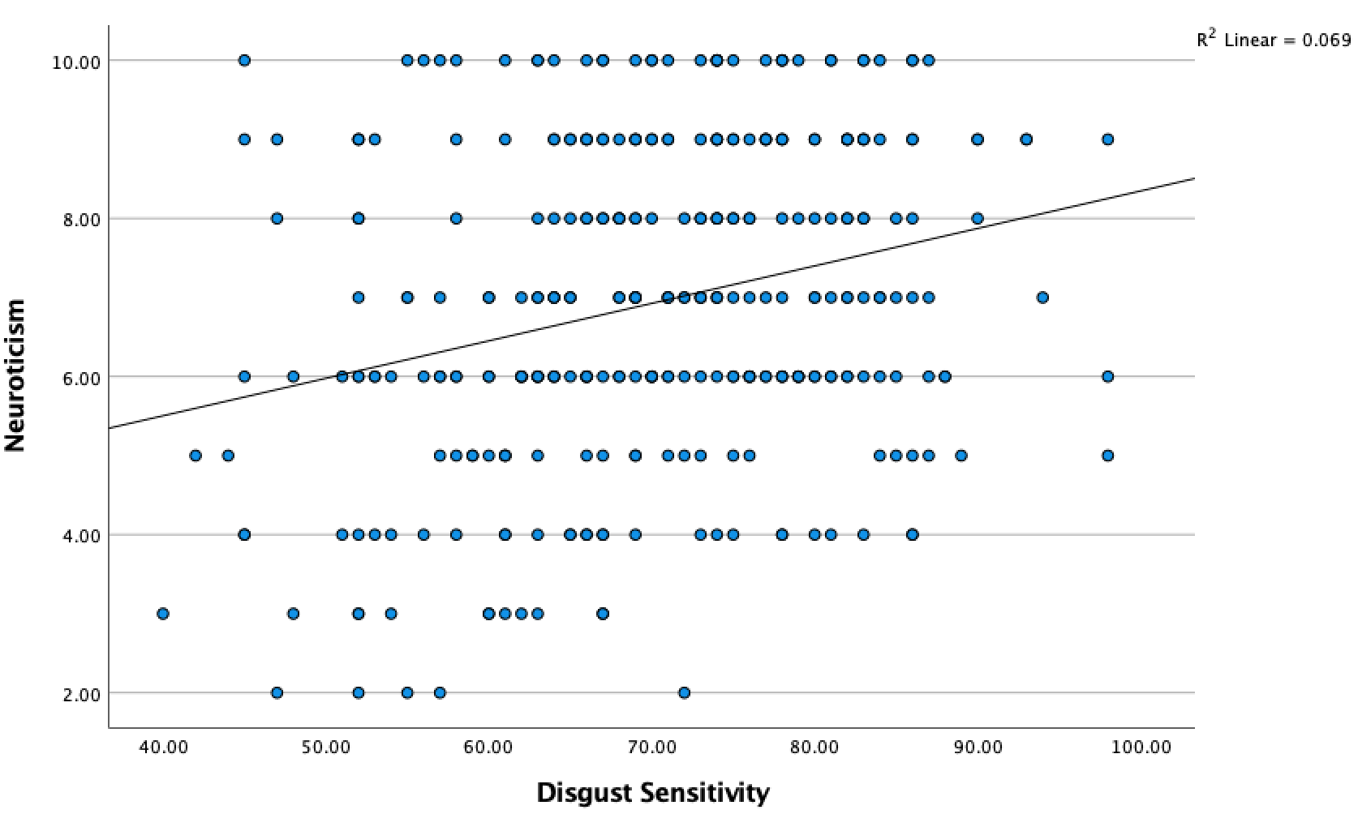
Figure 1. Correlation between Neuroticism (BFI-10) and Disgust Sensitivity (DS-R) in Study 1.

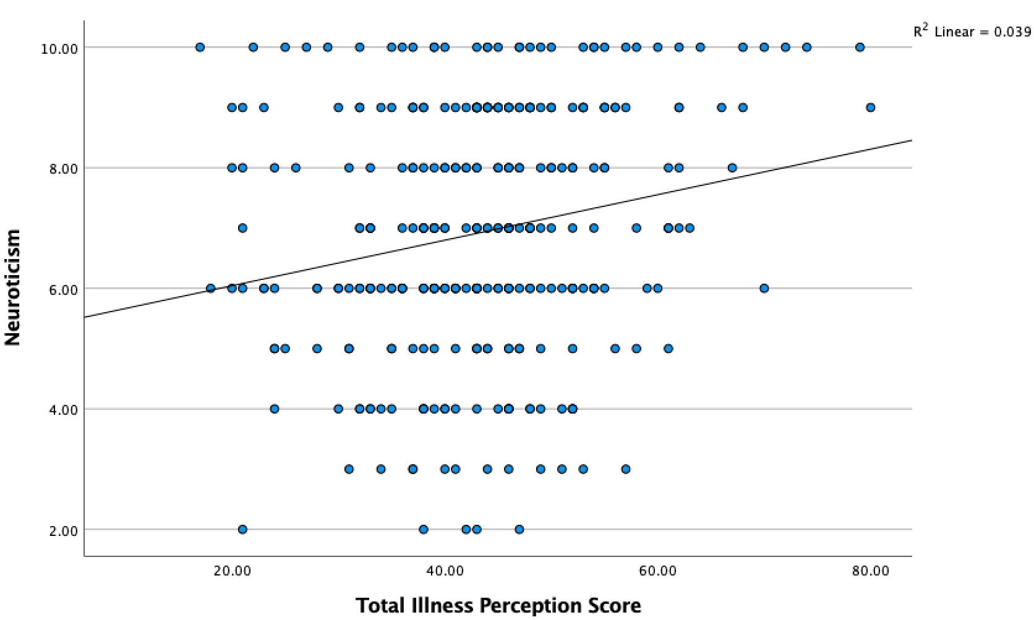

Figure 2. Correlation between Neuroticism (BFI-10) and Total Illness Perception (Brief IPQ) in Study 1.

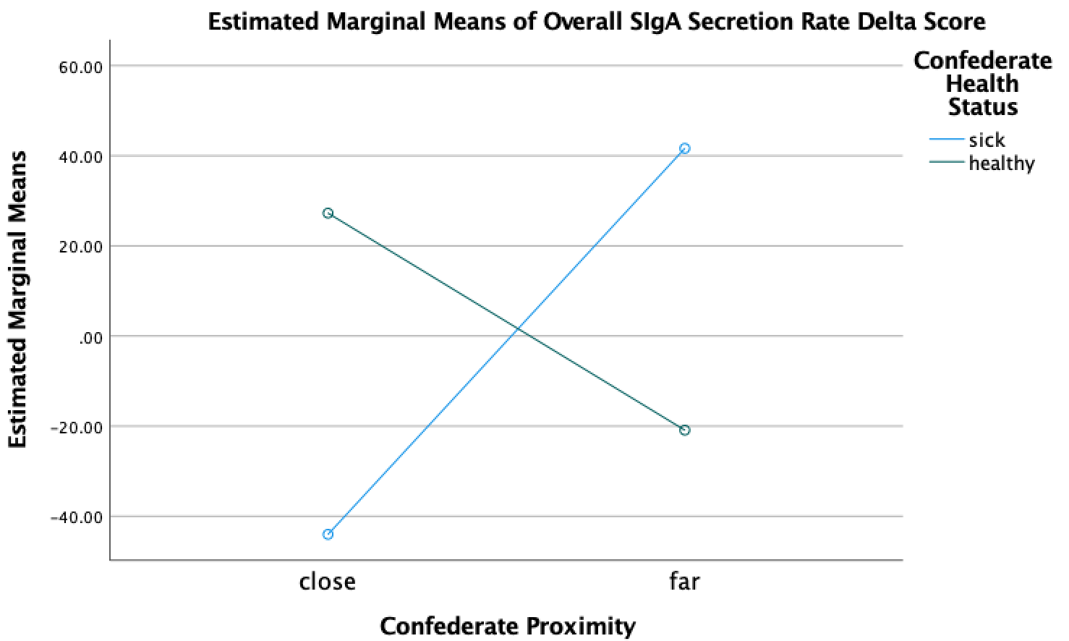
Figure 3. Crossover interaction between independent variables of Confederate Health Status and Confederate Proximity upon ΔSIgA Secretion Rates in Study 2.

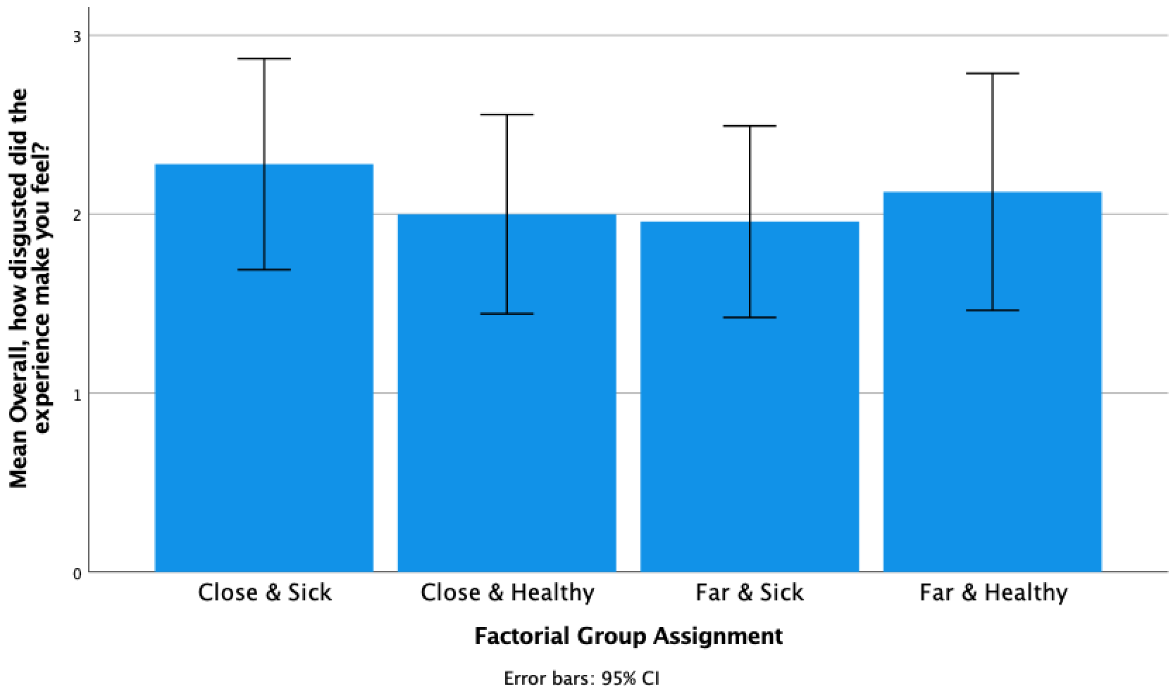
Figure 4. Disgust Ratings by Factorial Group Assignment in Study 2.

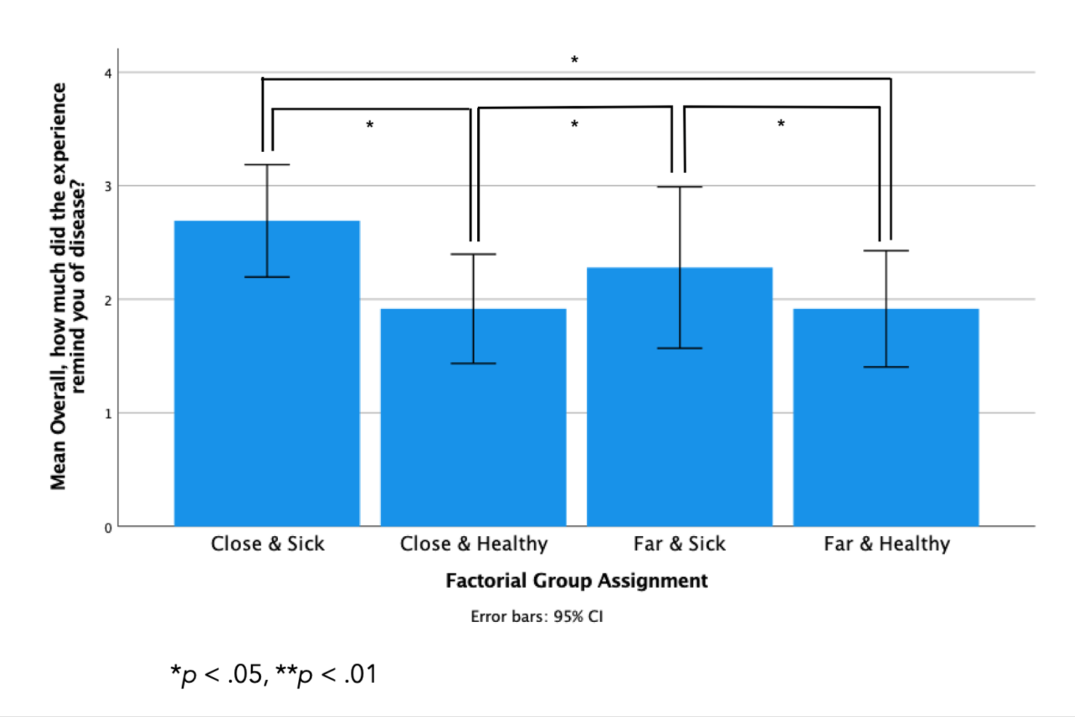

Figure 5. Disease Ratings by Factorial Group Assignment in Study 2.

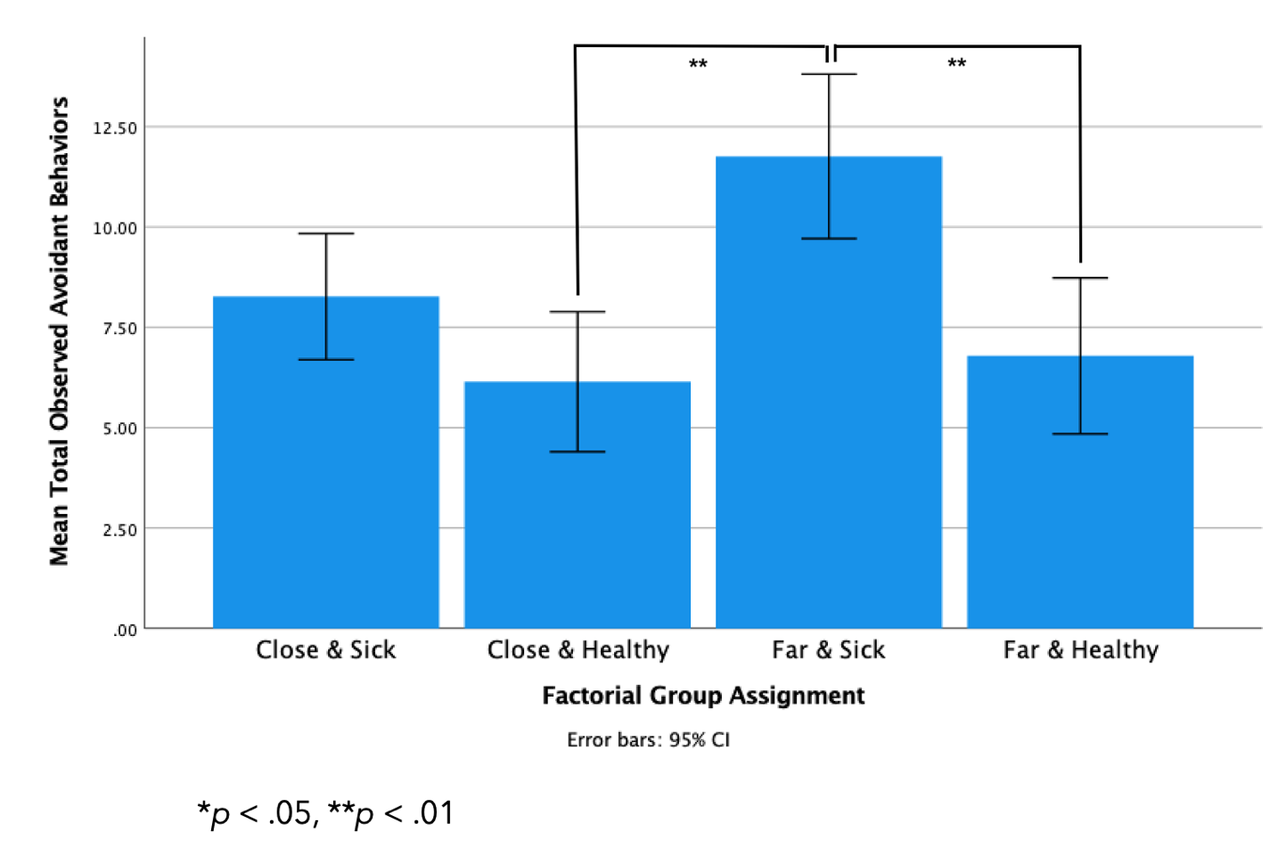
Figure 6. Total Observed Avoidant Behaviors by Factorial Group Assignment in Study 2.

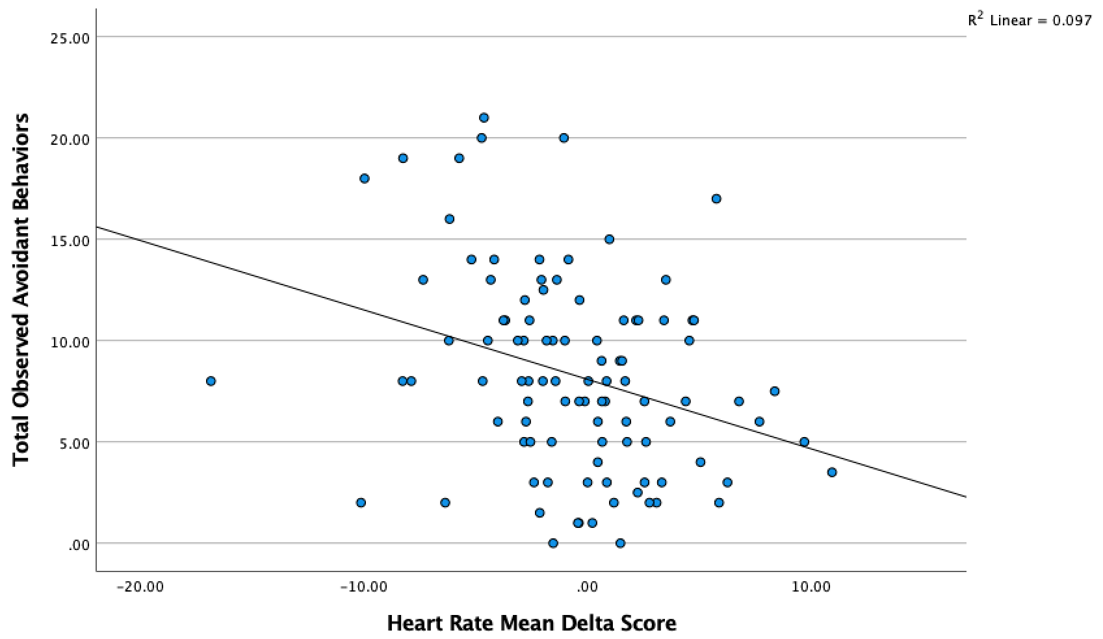
Figure 7. Correlation between Observed Avoidant Behaviors and ΔHR in Study 2.

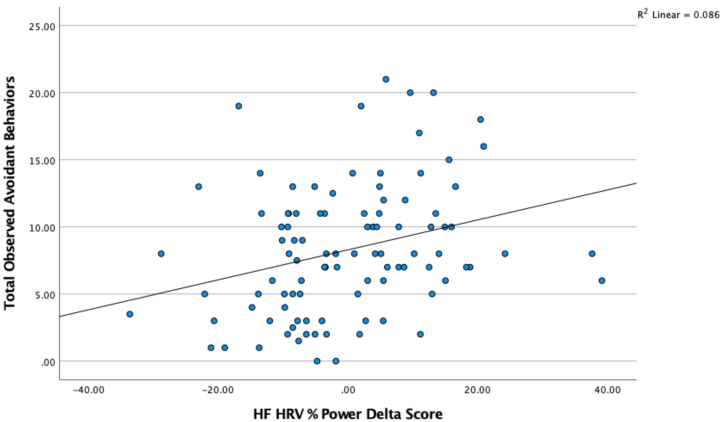
Figure 8. Correlation between Observed Avoidant Behaviors and ΔHF HRV in Study 2.

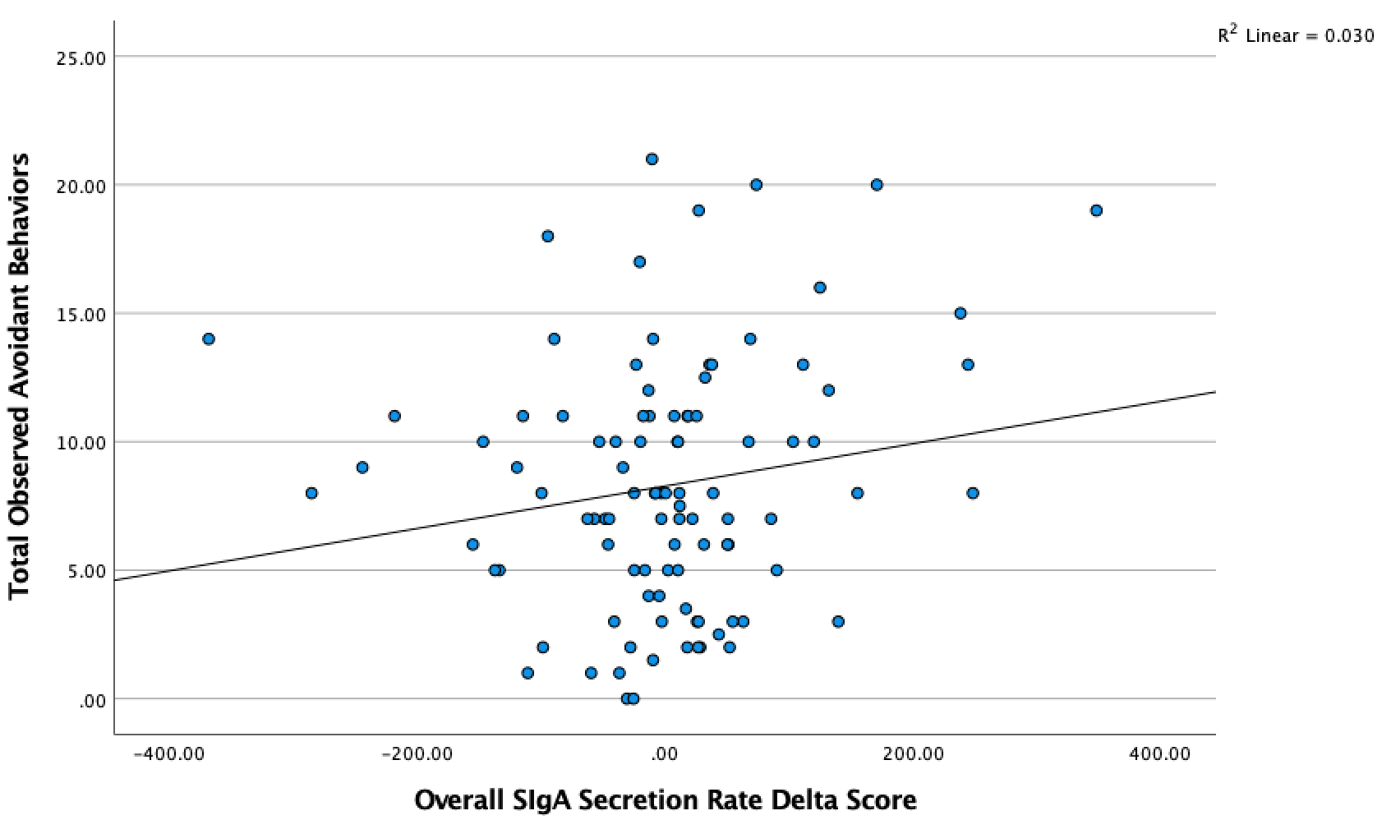
Figure 9. Correlation between Observed Avoidant Behaviors and ΔSIgA Secretion Rates in Study 2.

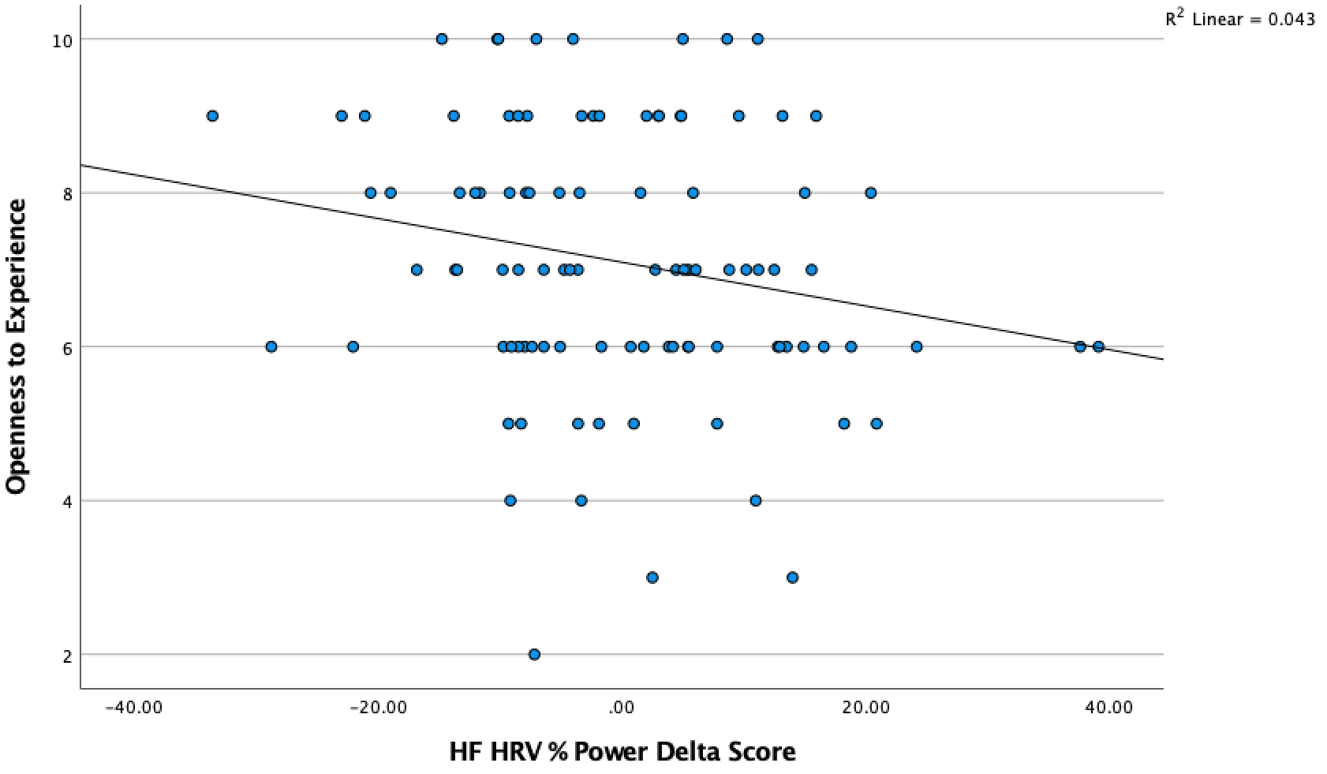
Figure 10. Correlation between Openness to Experience (BFI-10) and ΔHF HRV in Study 2.

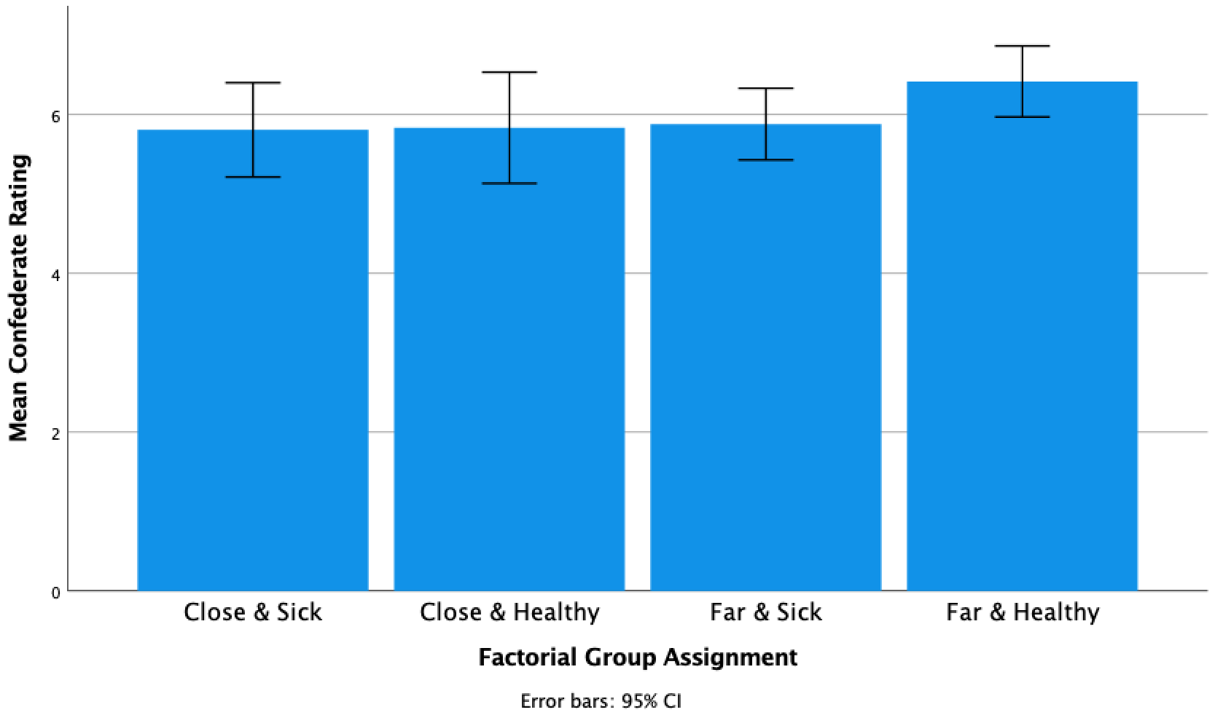

Figure 11. Confederate Ratings by Factorial Group Assignment in Study 2.

The Demographic Survey

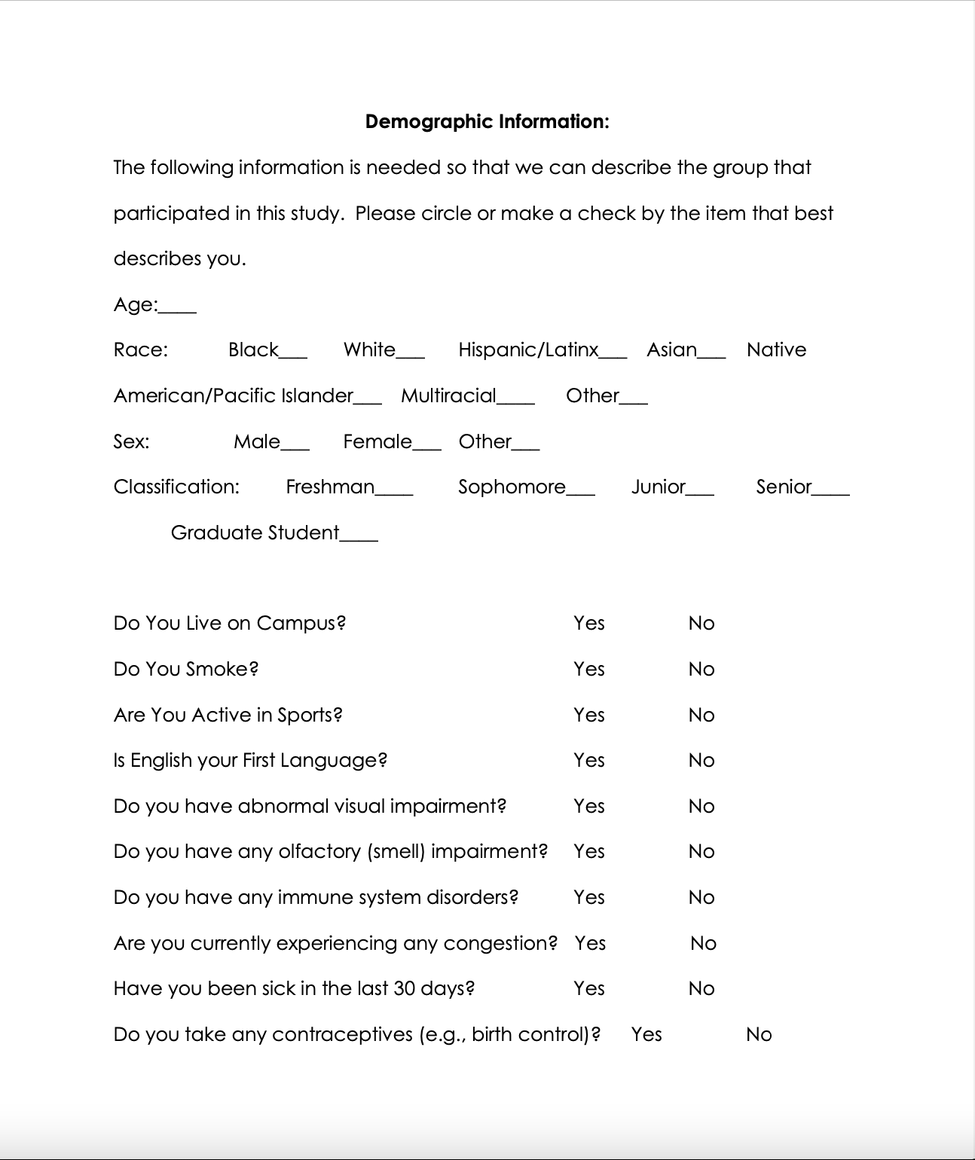

The Demographic Survey Continued
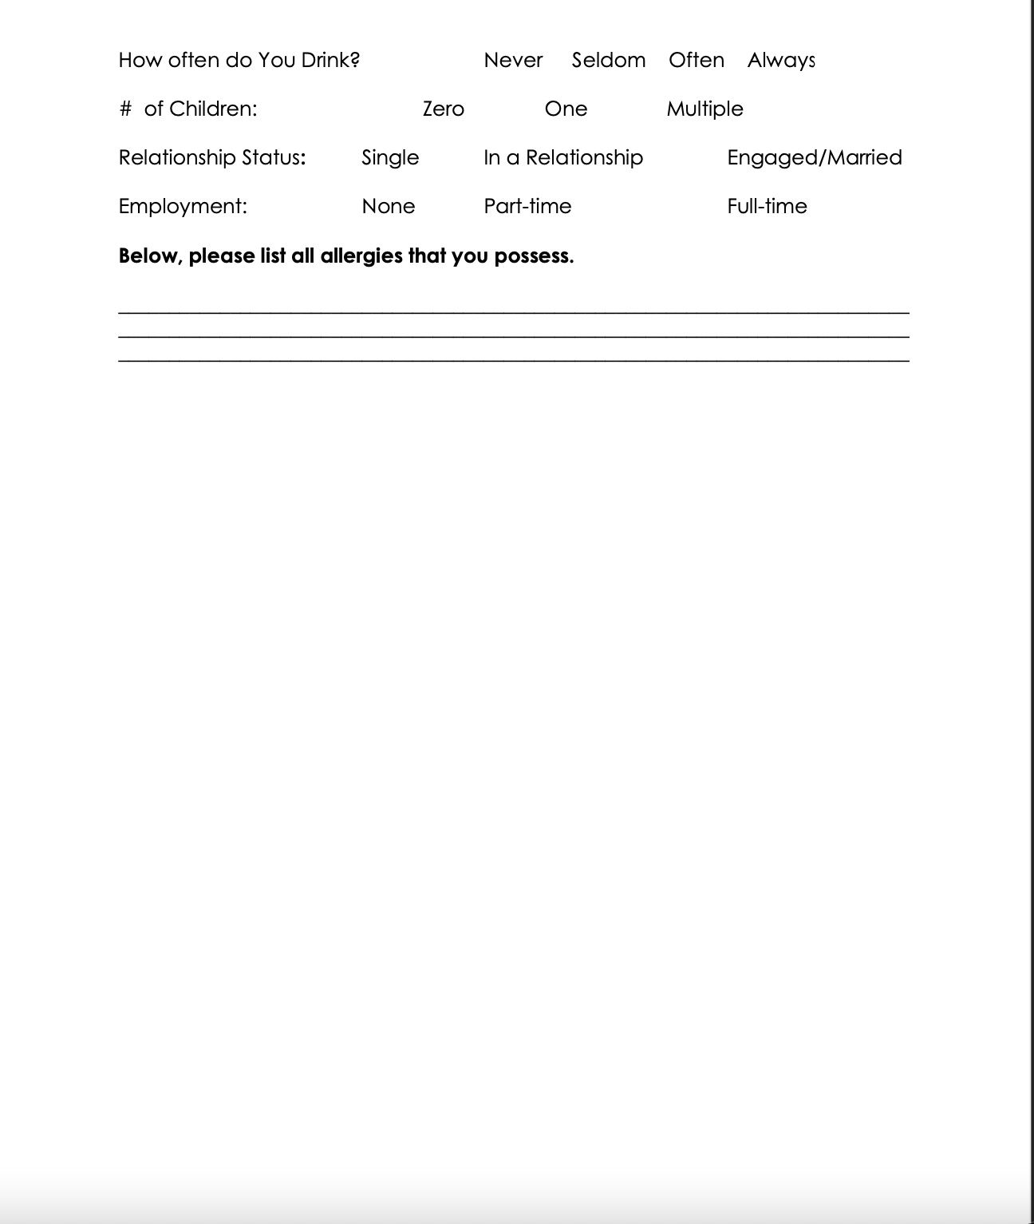

The Revised Disgust Sensitivity Scale (DS-R)
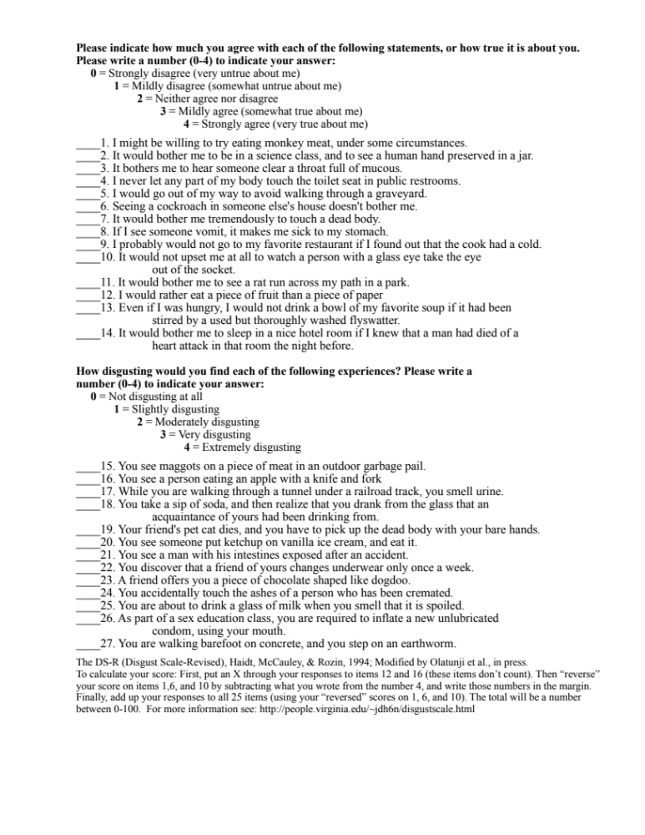

A Brief Version of the Big Five Personality Inventory (BFI-10)
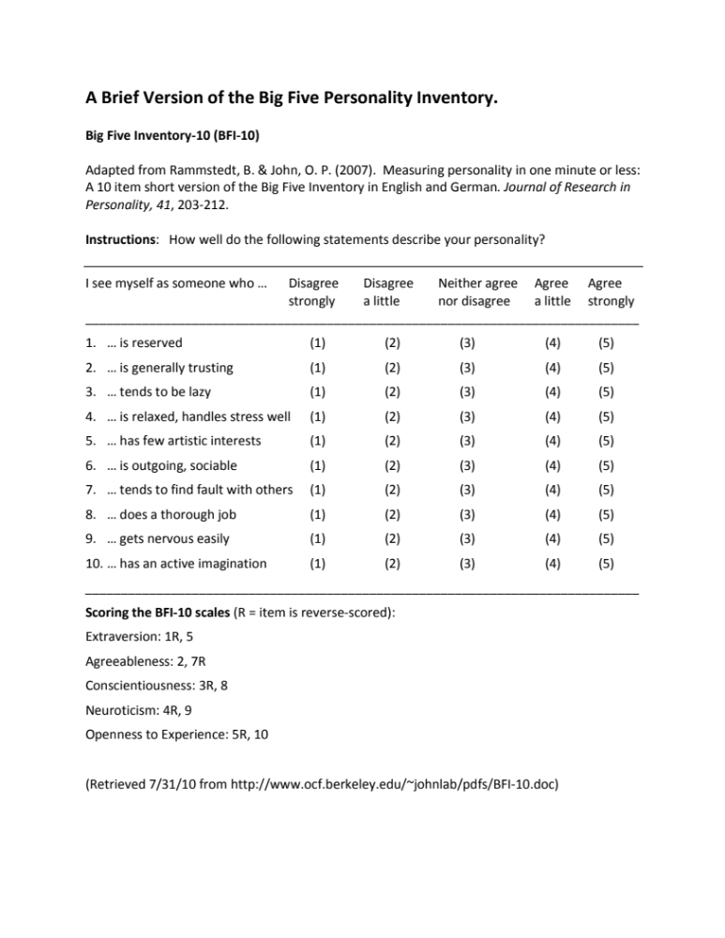

The Brief Illness Perception Questionnaire (Brief IPQ)
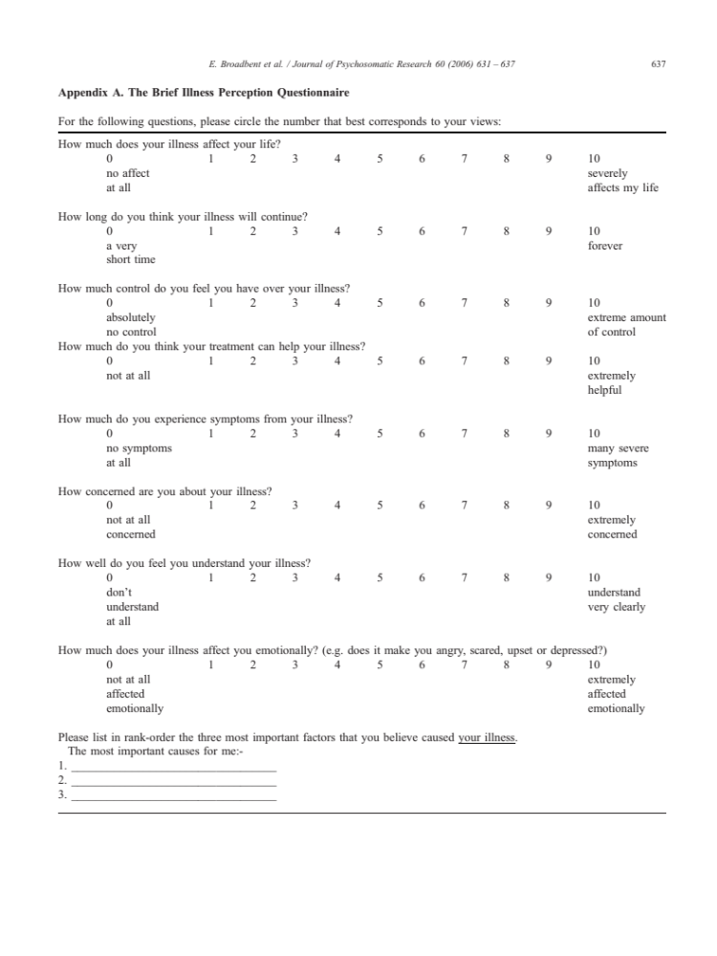
Disgust Rate Survey (DRS)
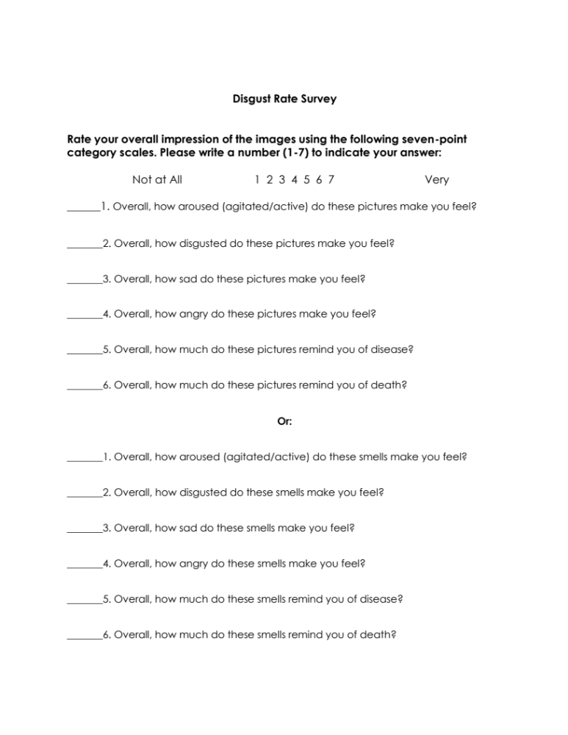

Confederate Rating Item
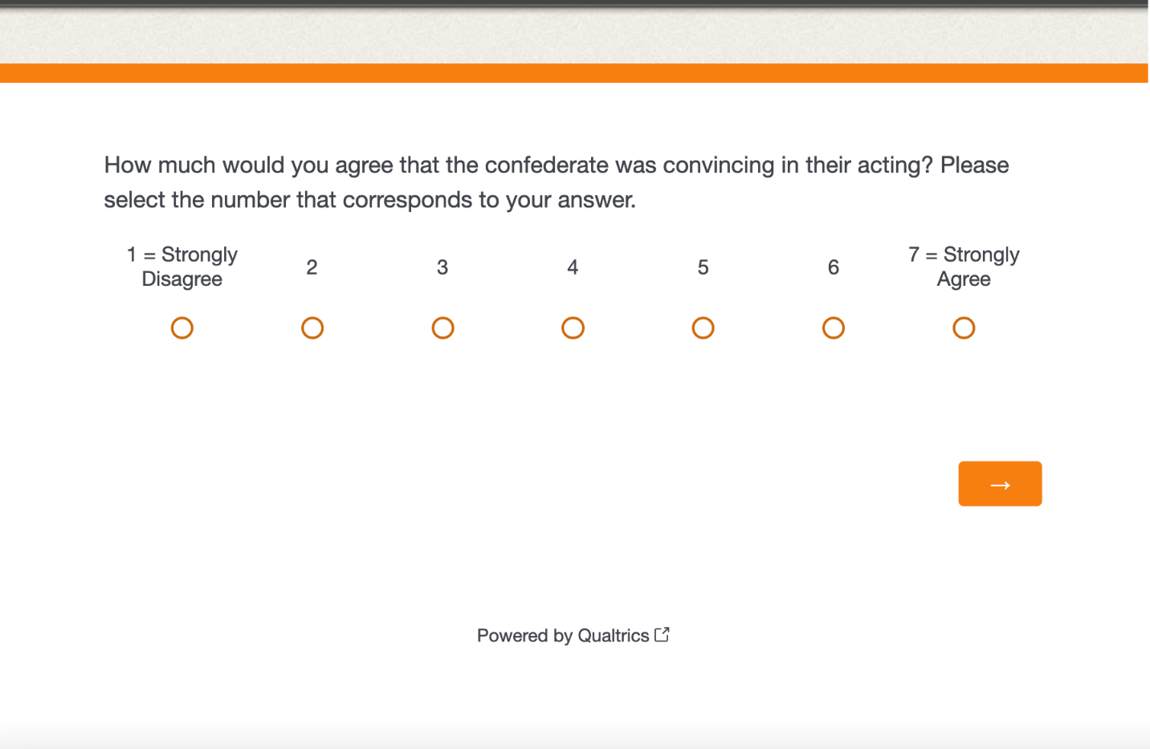

VITA
Lahai Wicks grew up in Knoxville, Tennessee with his Liberian immigrant family. After graduating from West High School, Lahai decided that he wanted to attend the University of Tennessee, which had been his parents’ alma mater. There he received an undergraduate degree in psychology and graduated in 2014. However, Lahai realilzed that in order to attain his goal of becoming a neuroscientist, he would need more experience. Lahai spent time training under neurologists at the Cole Neuroscience Center prior to being accepted into a Master’s Program for Psychology at Fisk University. It was there that he realized his interest in health psychology and the study of illness-related behavior. He graduated in 2018 with his Master’s Degree, and decided to pursue a Doctor of Philosophy Degree in Experimental Psychology with a concentration in Neuroscience & Behavior. His research interest includes the study of behavioral immunity, illness perception, coping behaviors, and mucosal immunity. After graduation, Lahai hopes to begin working as a quantitative researcher within industry.

