Shielding Design for a Combined Accelerator and Physical Security Facility

UT Department of Nuclear Engineering
NE472-Nuclear Systems Design II
Spring 2015

Performed by:

Isaac Mobley Jordan Parker Whitney Smith

Zach Weis Eric Welch

Mentored by:

Dr. Laurence Miller
Table of Contents
- Introduction
- Technical Approach
  - NCRP methods
  - MCNP approach
  - Comparison of methods
- Computational methods
  - Design Considerations
  - NCRP analytical calculation methods
    - NCRP assumptions
    - NCRP calculations
- Primary Barrier Calculations
- Secondary Scatter Calculations
- Secondary Leakage Calculations
- Tenth Value Layers
- Barrier Thicknesses
- Secondary Barrier Remarks
- Neutron Considerations
- Door and DT Generator Cover Calculations
- Wall Thicknesses
  - MCNP simulation of planned room design
    - MCNP geometry
    - MCNP dose conversion
- Methods of Obtaining a Cost Estimate
- Summary and Conclusion
- Future work
  - Neutron generator considerations
  - Faculty optimization
  - Auxiliary equipment and Considerations
- Ventilation
- Cabling
- Temperature and humidity
- Other factors to be considered
  - Shielding verification
  - Architectural modification
- Appendices
  - References
  - Large floor plan with dimensions
  - Acknowledgements

- Introduction
As part of the design of its future building, the University of Tennessee nuclear engineering department intends to incorporate a variety of nuclear engineering and nuclear science laboratories to advance the department’s research, as well as its educational capabilities. Included in these intended laboratories are a wet chemistry laboratory, materials characterization laboratory, linear accelerator facility, physical security laboratory, critical experiment facility, and more. For our group’s senior design project, we were tasked with designing a facility or group of facilities that could house the future linear accelerator, neutron generator, and irradiation area. Beyond this general description, our facility must be able to stand up to the usage needs for the department, provide adequate shielding to protect the users and general public, be cost effective, and provide the potential for future upgrades. Each one of these tasks provide their own design challenges. When combined, these tasks create a project environment that allows for a wide range of engineering skills to be tested (project management, drafting, dose calculations, computer simulations, etc.).
Outside
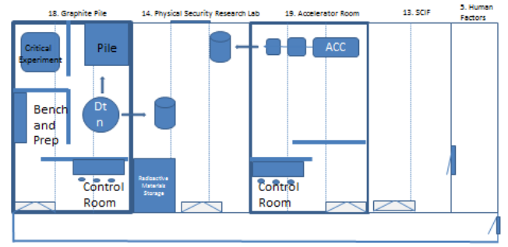
Hallway
Figure 1: Initial room layouts provided by the nuclear engineering faculty, showing possible facility placement and room geometries.

Hallway
Shown in Figure 1 are the critical facility/graphite pile, physical security research laboratory, and accelerator room (along with additional departmental facilities). The linear accelerator facility will include the 9MV Varian materials linear accelerator and accelerator control room. The physical security laboratory will include an irradiation area with high bay doors to allow for truck access. The critical experiment facility will include a NASA critical experiment, graphite pile, and DT neutron generator. These three laboratories are interconnected in their usage and will be physically connected with conduits through which radiation will be directed for imaging, materials characterization, amongst other usages.
From the geometrical layout (Figure 1) provided by the department, we had to adapt the facility design to further suit the needs of the individual faculty members and provide a shielding analysis for the design. This adaptation consisted of considering known design parameters and anticipating design parameters that could easily change. These design parameters included: the allotted size of facilities, the energy of linear accelerator, the possible addition of a DT neutron generator, the space needed for experiments, the type of experiments, and more. A majority of the design process was devoted to weighing these considerations and creating a layout to best suit facility needs. To provide a more robust facility, we decided to shield for a higher energy linear accelerator, a 22 MV linear accelerator that could be bought at a later time. By shielding for this higher energy linear accelerator, we will take into account the lower energy radiation of the 9 MV linear accelerator, while limiting the amount of retrofitting that would need to be done with the implementation of future upgrades.
The shielding analysis was done in as two part calculation method. The first being an analytical solution based on regulation guidelines set by the Nuclear Regulatory Commission (NRC) and the state of Tennessee and described in detail by the National Council on Radiation Protection and Measurements (NCRP) reports 144 ^{[2]} and 151 ^{[3]} (auxiliary support for the analytical NCRP methods was taken from McGinley’s Shielding Techniques for Radiation Oncology Facilities ^{[1]}). The second being an MCNP simulation of the floor plan (Figure 2, derived from the NCRP methods) and source. From the simulation, doses in occupied spaces were determined. These doses were then compared against governing regulations to verify that dose limits were not exceeded.
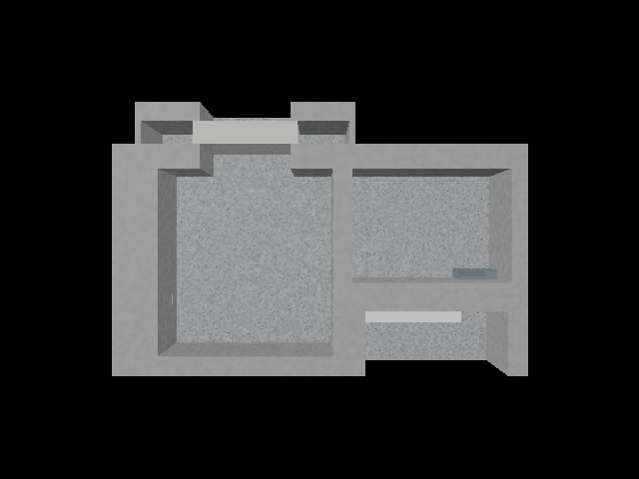
Figure 2: CAD drawing of intended room layout for the accelerator and physical security research facilities after initial calculations were done with the NCRP methods.

Due to the complexity of the project, certain aspects had to be given more attention. The way this was decided on was based on the likelihood of events and the time that each task required. For the project, we chose to focus primarily on designing the facilities to allow the use of the primary radiation source, the 22 MV linear accelerator, as well as accounting for the special requirements that our departmental faculty requested. These tasks were given precedence over shielding for the neutron generator because of the certainty that the linear accelerator facility will be part of the future nuclear engineering building, whereas the neutron generator is an intended addition that would require additional shielding to be taken into account in the graphite pile/critical experiment facility and physical security laboratory. Our floor plan takes into account the neutron generator’s utilization with respect to the physical security laboratory, but a set of dose calculations through the use of NCRP analytical calculations and MCNP simulations will not be done at this time. In the “Future Works” section, we will address the next steps needed to be taken including: simulation considerations, possible floor plan modifications, amongst others. Throughout the duration of the project, the floor plan has continually developed; creating a group of facilities that could be a valuable addition to the future departmental building of the University of Tennessee, Department of Nuclear Engineering.
In this report, we will provide an account of the methods that were used in the design of the combined physical security and linear accelerator facility, a comparison of the methods, design considerations, a description of the calculations undertaken, a summary of results, a conclusion of the project, along with future works that need to be taken into consideration. The report is intended to serve as a reference for faculty members as they undertake the design of the new nuclear engineering building.
- Technical Approach
  - NCRP methods
Reports 144 and 151 of the National Council on Radiation Protection and Measurements present recommendations and shielding calculation methods to aid in the shielding design of megavoltage (MV) x-ray and other radiation facilities. These reports offer recommendations that, if used correctly, should adequately meet the currently accepted standards of radiation protection. The purpose of these documents is to offer those performing a shielding analysis, a standard way to analytically calculate an effective amount of shielding. This shielding is split into several different categories: primary barriers, secondary barriers, mazes, and doors.
Primary barriers are the barriers on which the primary beam is incident on. It is these barriers that the most intense radiation is incident, thus they are almost exclusively the thickest barriers of a facility. Primary barrier width must be at least the size of the primary beam on the barrier plus an additional foot on each side¹. Medical linear accelerator facilities are generally smaller in their footprint, when comparing them to the facility that we are considering. This is due to the space needed in these facilities to accomplish their intended tasks. For medical linear accelerator facilities, this is to treat patients with radiation. For facilities such as ours, the tasks are varied and unpredictable. Thus there is a need for a larger source to surface distance, and consequently a wider primary barrier.
Secondary barriers are all other barriers that radiation is incident on, whether that be through scattering events, from accelerator head leakage, or from secondary radiation. Shielding doors are typically a continuation of secondary shielding that allows radiation workers to have access to the radiation areas. Shielding doors, depending on the materials chosen, can be large (both in size and weight). To reduce the size of shielding doors, mazes can be used. Mazes are secondary barriers placed between the beam and access doors. Mazes limit the pathways of radiation from reaching areas to be protected, specifically these access doors. However, due to the need of hallways and the additional shielding of the maze, this adds considerable square footage to a facility design. It is up to each facility to determine the layout which works best for them.
Shielding is typically calculated utilizing radiation’s intrinsic $\frac{1}{r^{2}}$dose fall off and negative exponential attenuation. Due to the dependence of attenuation on materials, this does not lend itself to a general shielding calculation. For a simplified, more general shielding calculation, a set of transmission factor equations was developed to establish the necessary tenth value layers and consequently barrier thicknesses. This set of transmission factor equations is described in detail in both NCRP 144 and 151. Each barrier type has its own transmission factor formula with appropriate variables including but not limited to: shielding design goal, distance to be protected, workload, use factor, and occupancy factor. These equations and variables, are based on experience and expected operation; taking into account the amount of radiation that will be incident on barriers and the length of time that individuals will be beyond the barrier in question. These calculations and parameters used within these calculations can be seen in section III.b.ii.
The methods described in the NCRP reports are the methods relied upon by health physicists, medical physicists, and radiation specialists. If the correct formulae are chosen and the correct variables are applied, the calculated thicknesses will be an overestimate for the required radiation shielding. However, the factors chosen in the transmission factor formulae dictate the quality of your shielding, if the variables chosen do not take into account the full extent of the radiation, the calculated thicknesses will potentially be inadequate.
  - MCNP approach
MCNP (Monte Carlo N-Particle code) is a Monte Carlo code, which uses the Monte Carlo method for solving transport problems for nuclear engineering and other nuclear science problems. MCNP was first released in 1977, and was derived from work done at Los Alamos ^{[4]}. The version used in this project was MCNP5, which is accompanied by MCNP6 and MCNPX and is an export controlled software distributed by Los Alamos National Lab (LANL) and the Radiation Safety Information Computational Center (RSICC).
The main function of MCNP is to solve transport problems. This is stated in the MCNP references (X-5, Volume I: Overview and Theory and Volume II: User’s Guide) ^{[4,5]}. One of the reasons that this code was developed is to help solve the complex transport equations used in the nuclear sciences. This code is used extensively in the nuclear engineering field to solve complex transport problems in nuclear reactors; however, its capabilities lend themselves to a variety of aspects in the nuclear sciences, including: health physics, medical physics, detection, and spallation activities.
This code offers a statistical representation of particle transport within materials, interactions of the incident particles, secondary particle generation, secondary particle interaction, and other transport information that would be difficult to observe and calculate without the computational power that this Monte Carlo code harnesses.
MCNP input is a three part text document consisting of cells, surfaces, and data. Each section works with the others to create a cohesive model of a source, geometry, and detector to allow for the simulation of particle transport. In the surface section, geometrical boundaries (planes, cylinders, spheres, etc.) are placed within the “MCNP workspace”. Alone, these boundaries serve no purpose, but used together these boundaries are what are used to define cells, the building blocks for a transport geometry. Cells are the physical spaces in which particles are transported. The particle transport is governed by information contained within the data of the input. Here, materials, sources, tallies, conversions, and other data cards can be implemented. These data cards, when acting on the cells, allow for representative transport of the particles of interest.
For shielding analysis, the geometry of interest, when tested through simulation, should show the required dose limits are met. For this to be done accurately; the geometry, source, and detectors must all be created to offer a representative reality for simulation.
  - Comparison of Methods
The NCRP analytical calculations and MCNP simulations were performed for different reasons. The methods described in the NCRP 144 and 151 reports offer a generalized way to calculate the necessary shielding based on a set of user specified coefficients and objectives. The NCRP analytical calculations are extremely useful if the extend of the radiation is known and consistent. Whereas, MCNP performs a complex particle simulation based on a specific geometry, utilizing tallies to find doses at a given location.
The NCRP analytical method provides transmission factors that can then be turned into the number of tenth value layers to achieve the specified dose limit. From the number of tenth value layers, a barrier thickness of a desired material can be calculated. The advantage of using the NCRP analytical methods is that it is allows the user to input those parameters that apply to their individual facility, including: how long the beam is on in a given week, how long people will be occupying adjacent facilities, how long the beam will be directed at a given wall, distance from beam to area to be protected, beam energy, amongst others. Given the appropriate parameters and the appropriate equations, the NCRP analytical methods give the user a simple, quick way to determine shielding thicknesses for radiation facilities. The disadvantage of using the NCRP analytical methods is that the method has an intrinsic overestimate of shielding. This overestimate of shielding is beneficial for ensuring the safe operation of a facility; however, more shielding translates into a higher construction cost.
The MCNP simulations are particle simulations based off of a representative geometry of the facility in question. Unlike the general NCRP analytical method, the MCNP is a highly specific simulation that tracks both primary and secondary radiation through the specified geometry. The advantage of an MCNP simulation is in the accuracy of the calculation. However, this accuracy is a double edged sword. For the simulation to yield relevant results, a geometry and source term must be supplied that is representative enough of the actual facility and linear accelerator. The facility geometries can be fairly easily recreated in MCNP. And using resources such as the Pacific Northwest National Laboratory’s Compendium of Material Composition Data for Radiation Transport Modeling ^{[6]}, the geometry can be created using the representative materials. It is the linear accelerator source term that can cause the error in dose results. If the source term is not modelled correctly, any dose results obtained from simulations will be subject to any differences between the simulated and actual accelerator. Thus it is paramount that any MCNP simulation run to verify that dose limits are not exceeded must be performed with the utmost care and by those with sufficient shielding and simulation experience.
- Computational Methods
  - Design Considerations
The goal of this project was to create a viable shielding option for a 22 MV linear accelerator and DT neutron generator. Due to time constraints, the shielding analysis was only verified for the linear accelerator; however, the design takes into account its implementation into the facility and offers margins in the floor plan for additional neutron shielding. Starting from the faculty suggested room layout seen in Figure 1, we had to decide which modifications to make to the design that would best utilize the approximate 2000 sqft area. We started by talking with the faculty members that would be primarily involved in the usage of the room. From talks with faculty, it became evident that the facility design would need to be heavily altered.
Due to the nuclear engineering department’s imaging and nonproliferation interests, the faculty has asked that the new physical security and linear accelerator facilities be designed such that large objects, such as shipping containers, can be brought into the facilities and imaged using an Eagle Portal imaging system. To allow for the large containers to be brought in, we decided to utilize a large direct access door measuring 16 ft high and 3.5 ft thick. The doorframe has a 15 ft clearance, that would allow for trucks to drive into the facility and be unloaded using a crane attached to the facility’s ceiling. To allow for the movement of the large cargo and the inclusion of a cargo crane, the ceiling of the facility also had to be of sufficient height. It was decided to use a 20 ft ceiling for both the linear accelerator and physical security facilities.
Other requests by the faculty included the utilization of a collimation wall between the accelerator and physical security facilities. This collimation wall is a 3 ft thick wall with a 2 ft x 2 ft square conduit centered laterally and located between 3 ft and 5 ft vertically. It was positioned laterally as to weigh lessen the leakage radiation on the outer wall (uncontrolled) and weight it more heavily toward the control room wall (controlled). It was placed between 3 ft and 5 ft vertically as to create a realistic and useable accelerator height. The point of the collimation wall is to provide a place to add additional beam shaping devices on either side of the wall, such as lead collimation plates. As for the thickness of the collimation wall, it was decided on so that if the accelerator is placed directly adjacent to the collimation wall, only the photons created outside of the 15 degree off-axis primary beam would be collimated.
From here, given the size limitations that were provided, we created areas to be protected. We attached occupancy factors, workloads, and relevant distances to each barrier. With these factors we calculated transmission factors and consequently barrier thicknesses. These calculations are in the following section (NCRP analytical calculation methods). After these calculations were performed, an MCNP simulation on the finalized geometry was performed to verify the shielding. A to-scale drawing of the facilities can be seen in appendix b.

  - NCRP analytical calculation methods
    - NCRP assumptions
The analytical methods described in NCRP reports 144 and 151 are intended for the use in shielding calculations for medical linear accelerators (NCRP 151) and various particle accelerators (NCRP 144). For the shielding calculations that were needed for this atypical project, certain assumptions had to be made including: the appropriate equation modifications, correct occupancy factors, necessary workload, limiting dose rates, and other factors.
First, the decisions on which equations to use for the calculations had to be made. The bulk of the reference shielding materials was about medical linear accelerator shielding. Each reference, although similar, handled their variables slightly differently and were based on various assumptions. For the final calculations, equations were drawn from both reports ^{[2,3]}, as well as from McGinley’s Shielding Techniques for Radiation Oncology Facilities ^{[1]}. The chosen equations can be found below under the NCRP calculations heading (Equations 1-3).
Next were the decisions about equation variables, namely: occupancy factors, workload, and limiting dose rates. Occupancy factors (fraction of time that an area will be occupied during a given week) were decided upon by the type of area that was to be protected and ranged from 1/20 for low traffic areas to 1 (full occupancy) for uncertain or possibly high traffic areas. With the occupancy factor decisions, caution was taken to over shield rather than under shield. Work load (amount of dose delivered to the isocenter during a given week) was decided to be 1000 Gy/week for our accelerator facility. This number is higher than the 500-600 Gy/week recommended for typical facilities ^{[2]} because of the uncertainty in the amount of usage that the facility would get during a typical or atypical week. Finally, dose limits were assigned to barriers based on the occupants that could pass by or reside in the area beyond that barrier. These dose limits were taken to be 0.1 mSv/week for controlled areas and 0.02 mSv/week for uncontrolled areas and are based on NCRP recommendations and governing regulations ^{[2,3,7]}.

    - NCRP calculations
      - Primary Barrier Calculations ^{[3]}
B_{pri} = $\frac{Pd_{pri}^{2}}{WUT}$ (1)
Equation 1: Primary barrier transmission taken from NCRP 151 pg. 22 ^{[3]}.
B_{pri} = Transmission factor for the primary barrier
P = Shielding design goal (expressed in dose equivalent) beyond the barrier and is usually given for weekly time frame (Sv/week)
d_{pri} = Distance from the X-ray target to the point protected (m)
W = Workload or photon absorbed dose delivered at 1 m from the x-ray target per week (Gy/week).
      - For medical accelerators, isocenter is assumed or calibrated to be 1 m. For the materials linear accelerator, the isocenter is not established. For the project, we assumed the irradiation material would be placed in the center of the room, approximately 15-16 ft away from the accelerator.
U = Use factor or fraction of the workload that the primary beam is directed at the barrier in question.
T = Occupancy factor for the protected location or fraction of the workweek that a person is present beyond the barrier. This location is usually assumed to be 0.3 m beyond the barrier in question.
Table 1: Primary barrier transmission factor calculations
T | 0.6
W | 1000 | Gy/week
dpri | 37 | Ft
dpri | 11.28 | M
U | 1
P | 0.0001 | Sv/week
Bpri | 0.0000212
n | 4.67
tbar | 214.82 | cm
tbar | 7.05 | ft
In the primary barrier calculations, we had to consider factors relating to the critical facility. We assumed a conservative occupancy factor of 60% of the work week. This would take into account students or faculty working for a majority of the week in the facility. We also assumed a conservative workload of 1000 Gy/week. This workload is twice the workload recommended by the NCRP reports 144 and 151. The critical facility is also a radiation environment, thus we assumed it would be a controlled area, assigning it a dose limit of 0.1 mSv/week. Finally we determined a distance for the area to be protected. Based on these parameters, a transmission factor was determined using equation 1. From the transmission factor, the number of tenth value layers and barrier thicknesses can be determined. For our primary barrier, we used a 7 ft thick concrete wall.
      - Secondary Scatter Calculations ^{[2]}
T(x) = $\frac{H_{m}{(d_{i}d_{s})}^{2}}{AWT}$ (2)
Equation 2: Scatter transmission factor taken from NCRP 144 pg. 193-5 ^{[2]}.
T(x) = Transmission factor for the shield barrier
H_{m} = Maximal permissible dose-equivalent rate for the type of area (Sv/week)
d_{i} = Distance to incident of scatter (m)
d_{s} = Distance from scatter to area to be protected (m)
α = Differential dose albedo (α)
- For our shielding analysis, we assumed a differential dose albedo of 5x10⁻³ ^{[2]}.
A = Beam area of the scattering surface (m²)
W = Workload or photon absorbed dose delivered at 1 m from the x-ray target per week (Gy/week).
T = Occupancy factor for the protected location or fraction of the workweek that a person is present beyond the barrier. This location is usually assumed to be 0.3 m beyond the barrier in question.

Table 2: Secondary scatter calculations for the hallway adjacent to the facilities |  |  |  | Table 3: Secondary scatter calculations for the large direct access door
T | 0.2 |  |  | T | 0.05
W | 1000 | Gy/week |  | W | 1000 | Gy/week
H | 0.0001 | Sv/week |  | H | 0.00002 | Sv/week
di | 17 | Ft |  | Di | 17 | Ft
di | 5.18 | M |  | Di | 5.1816 | M
A | 6.1 | m² |  | A | 6.1 | m²
ds | 22 | Ft |  | Ds | 17.3 | Ft
ds | 6.71 | M |  | Ds | 5.27304 | M
alpha | 0.005 |  |  | Alpha | 0.005
T(x) or Bs | 0.020 |  |  | T(x) or Bs | 0.009862
n | 1.700 |  |  | N | 2.006043
tbar | 81.02 | cm |  | Tbar | 94.77 | cm
tbar | 2.66 | ft |  | Tbar | 3.11 | ft

Table 4: Secondary scatter calculations for wall adjacent to direct access door |  |  |  | Table 5: Secondary scatter calculations for ceiling of physical security room
T | 0.05 |  |  | T | 1
W | 1000 | Gy/Week |  | W | 1000 | Gy/Week
H | 0.00002 | Sv/week |  | H | 0.00002 | Sv/week
di | 17 | ft |  | Di | 17 | Ft
di | 5.1816 | m |  | Di | 5.1816 | M
A | 6.1 | m² |  | A | 6.1 | m²
ds | 13.8 | ft |  | Ds | 20.25 | Ft
ds | 4.20624 | m |  | Ds | 6.1722 | M
alpha | 0.005 |  |  | Alpha | 0.005
T(x) or Bs | 0.006275 |  |  | T(x) or Bs | 0.000676
n | 2.202377 |  |  | N | 3.170315
tbar | 103.607 | cm |  | Tbar | 147.1642 | cm
tbar | 3.399178 | ft |  | Tbar | 4.828221 | ft

Secondary barriers are calculated using both secondary scatter and leakage radiation components. For the secondary scatter calculations, we focused on those walls that are beyond the collimation wall. This was done because the primary beam is directed through the radiation conduit. If radiation backscatters off a surface and back through the collimation wall, its impact on further shielding would be of a lower magnitude than leakage. Thus any major component of secondary scatter will be restricted to areas beyond this conduit. The four major barriers that were calculated using secondary scatter equations were the large direct access door adjacent to the outside, the wall accompanying the large direct access door adjacent to the outside, the wall adjacent to the hallway, and the ceiling.
For calculation purposes we assumed that the ceiling and outside were uncontrolled areas (0.02 mSv/week), while the hallway was a controlled area (0.1 mSv/week). The hallway was considered controlled due to the multiple radiation facilities on the leve; if someone is going to be around these facilities, they should be badged and monitored. Occupancy factors ranged from 5% to 100%. We assumed lower occupancies in transient areas and full occupancy in the area above, due to the uncertainty in what is going to be placed above. We assumed that scattering events would take place in the middle of the irradiation facility, along the central axis of the beam.
From these calculations, we obtained shielding thicknesses needed to protect against the secondary scatter radiation. These barrier thicknesses corresponded to concrete walls of: 2.7 ft for the hallway, 3.1 ft for the large direct access door, 3.4 ft for the outside wall, and 4.8 ft for the ceiling. However, these barrier thicknesses only take into account one secondary radiation component. Secondary leakage also needs to be considered in final barrier thicknesses.
      - Secondary Leakage Calculations ^{[3]}
B_{L} = $\frac{Pd_{L}^{2}}{{10}^{-3}WT}$ (3)
B_{L} = Transmission factor for the shield barrier
P = Shielding design goal (expressed in dose equivalent) beyond the barrier and is usually given for weekly time frame (Sv/week)
d_{L} = Distance travelled by leakage radiation
W = Workload or photon absorbed dose delivered at 1 m from the x-ray target per week (Gy/week).
T = Occupancy factor for the protected location or fraction of the workweek that a person is present beyond the barrier. This location is usually assumed to be 0.3 m beyond the barrier in question.

Table 6: Secondary leakage calculations for outside wall |  |  |  | Table 7: Secondary leakage calculations for control room
T | 0.05 |  |  | T | 0.666667
W | 1000 | Gy/week |  | W | 1000 | Gy/week
P | 0.00002 | Sv/week |  | P | 0.0001 | Sv/week
d_{L} | 13.8 | ft |  | d_{L} | 12 | ft
d_{L} | 4.20624 | m |  | d_{L} | 3.6576 | m
BL | 0.007077 |  |  | BL | 0.002007
n | 2.1501519 |  |  | n | 2.697516
t_{bar} | 101.25684 | cm |  | t_{bar} | 125.8882 | cm
t_{bar} | 3.3220747 | ft |  | t_{bar} | 4.130191 | ft

Table 8: Secondary leakage calculations for wall behind accelerator |  |  |  | Table 9: Secondary leakage calculations for ceiling in accelerator room
T | 0.13 |  |  | T | 1
W | 1000 | Gy/week |  | W | 1000 | Gy/week
P | 0.0001 | Sv/week |  | P | 0.00002 | Sv/week
d_{L} | 26.5 | ft |  | d_{L} | 20.25 | ft
d_{L} | 8.0772 | m |  | d_{L} | 6.1722 | m
BL | 0.052193 |  |  | BL | 0.000762
n | 1.282388 |  |  | n | 3.11809
t_{bar} | 62.20748 | cm |  | t_{bar} | 144.8141 | cm
t_{bar} | 2.040928 | ft |  | t_{bar} | 4.751117 | ft

Along with secondary scatter, secondary leakage radiation must also be considered when defining shielding thicknesses. For secondary leakage components, we focused on those walls behind the collimation wall, in the direction opposite the primary beam. Leakage radiation comes off of the accelerator head, we assumed that any forward directed leakage radiation would be absorbed or greatly reduced by the collimation wall. Limiting the major leakage radiation shielding components to the outside wall adjacent to the accelerator room, wall behind the accelerator, accelerator control room wall, and ceiling.
For calculation purposes, we assumed that the room behind the accelerator and control room were controlled areas (0.1 mSv/week) and that above the ceiling and outside were uncontrolled areas (0.02 mSv/week). We assumed occupancy of 13% for the room behind the accelerator, 67% for the accelerator control room, 5% for outside, and 100% for the area above the ceiling.
From these calculations, we obtained shielding thicknesses needed to protect against the secondary leakage radiation. These barrier thicknesses corresponded to concrete walls of: 2.1 ft for the room behind the accelerator, 4.1 ft for the control room, 3.3 ft for the outside wall, and 4.8 ft for the ceiling. However, these barrier thicknesses only take into account one secondary radiation component. Secondary scatter, calculated above, also needs to be considered in final barrier thicknesses.
      - Tenth Value Layers ^{[3]}
n = - log(B) (4)
Based on transmission factors obtained from Equations 1-3, the number of tenth value layers (TVL) required to reach the specified dose limits can be determined using Equation 4.
      - Barrier Thicknesses ^{[3]}
t_{bar} = TVL₁ + (n – 1)TVL_{eq} (5)
Once the necessary tenth value layers are found, barrier thickness can be determined based on tenth value layers of the target shielding material. For photon shielding, the main shielding material for primary and secondary barriers is concrete. Tenth value layers vary from reference to reference. For our shielding analysis we used regular concrete walls (ρ = 2.35 g/cm³) with tenth value layers of 49.5 cm and 45 cm, for first and equilibrium tenth value layers respectively.
      - Secondary Barrier Remarks
Secondary barriers are impacted by secondary scatter and leakage. If the thickness of the barrier is approximately the same for each secondary component (scatter and leakage), it is recommended that 1 half value layer (HVL) is added to the larger of the two barrier thicknesses. If the two thicknesses differ by a TVL or more, the larger thickness is used for the barrier. This is referred to as the two source rule ^{[3]}. For our accelerator facility, the two components are approximately the same, thus we used the larger and added 1 HVL to determine the shielding thickness. For regular concrete, we determined ^{[3]} a HVL to be 15cm.
      - Neutron Considerations
Since the accelerator used in our shielding design is a 22 MV accelerator (above the binding energy of nucleons), photon neutrons will be produced. Thus neutrons will also play a part in the shielding considerations. If the material used in the primary barrier is concrete, then the barrier will absorb both the produced photoneutrons and neutron capture gamma rays, without the need for additional barriers ^{[3]}. After considering this accepted guideline for primary barriers, we extended the rule to all secondary barriers including the primary door which is predominantly concrete. If a barrier is not concrete, further neutron considerations must be taken into account. For our shielding analysis, this included the considerations for the control room door and neutron generator cover.
      - Door and DT Generator Cover Calculations ^{[4]}
For areas that need to be shielded but require access like doors and conduits, concrete is not the best material to used, because of the thicknesses or more importantly volumes required. For these, a laminated barrier is typically used to allow for thinner shielding and to stop both the incoming photon and neutron radiation.
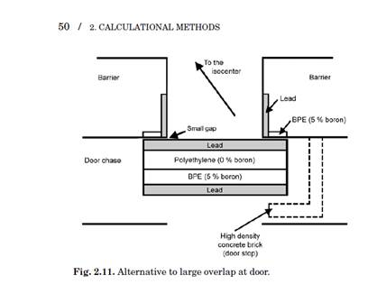
Figure 3: Example of a laminated shielding door composed of lead, polyethylene, and borated polyethylene (BPE). Shown in the figure is the laminated door and additional strips of BPE and lead on the threshold to shield against radiation that misses the laminated door ^{[2]}.

For our project, we took this recommendation of materials and did a slight adaptation. Instead of using lead, polyethylene, and borated polyethylene, we decided to use steel, lead, and borated polyethylene. The steel was used to add structure. The high-Z metals (steel and lead) were selected to create inelastic collisions with photoneutrons and provide photon attenuation. The borated polyethylene was used to slow and absorb the photoneutrons. The stacking of lead and steel on both sides of the BPE was to: on the front, offer the inelastic neutron collisions and incoming photon attenuation and on the back, offer additional photon attenuation from capture gamma rays. Below is a breakdown of the control room door and neutron hole cover calculations. Because of the similar TVL requirements, we elected to use the same material thicknesses on each.

Control Room Door
Table 10: Secondary leakage calculations for the control room door
T | 0.666667
W | 1000 | Gy/week
P | 0.0001 | Sv/week
d_{L} | 20 | Ft
d_{L} | 6.096 | M
BL | 0.005574
n | 2.253819

Steel TVL = 11cm
Lead TVL = 5.5cm
Borated Polyethylene 5% (BPE) TVL = 8.5cm
Used thicknesses
Steel = 1.27cm and 2.54cm
Lead = 15.2cm
BPE = 30.5cm
Construction from back to front
Steel = 0.635cm
Lead = 7.6cm
BPE = 30.5cm
Lead = 7.6cm
Steel = 0.635cm
Surround Material (Top, bottom, and sides)
Steel = 2.54cm
Threshold shielding strips
BPE = 5cm thick and 30cm wide (facing radiation area)
Lead = 5cm thick and 30cm wide (along inside of threshold)
Control Room Door Dimensions
8 feet tall x 6.5 feet wide x 1.54 feet thick
Or
2.44 m tall x 1.98 m wide x 0.47 m thick
Neutron Generator Cover
Table 11: Secondary scatter calculations for the neutron hole cover calculations
T | 0.666667
W | 1000 | Gy/Week
P | 0.0001 | Sv/week
Di | 17 | ft
Di | 5.1816 | m
A | 6.1 | m²
Ds | 20 | ft
Ds | 6.096 | m
Alpha | 0.005
Bs | 0.004943
N | 2.306044

Steel TVL = 11cm
Lead TVL = 5.5cm
Borated Polyethylene 5% (BPE) TVL = 8.5cm
Used thicknesses
Steel = 1.27cm and 2.54cm
Lead = 15.2cm
BPE = 30.5cm
Construction from back to front
Steel = 0.635cm
Lead = 7.6cm
BPE = 30.5cm
Lead = 7.6cm
Steel = 0.635cm
Surround Material (Top, bottom, and sides
Steel = 2.54cm
Threshold shielding strips
BPE = 5cm thick and 30cm wide (facing radiation area)
Lead = 5cm thick and 30cm wide (along inside of threshold)

Neutron Hole Cover Dimensions
3 feet tall x 3 feet wide x 1.54 feet thick (centered at 5 ft height)
Or
  - tall x 0.91 m wide x 0.47 m thick (centered at 5 ft height)

      - Wall Thicknesses
Wall thicknesses were determined based on the primary, scatter, and leakage calculations recommended by the NCRP reports 144 and 151. These reports offer varied forms of equations, constants, and tenth value layers. Thus there is some subjectivity to the actual calculations that are used in each analytical solution. For our calculations, we justified the most reasonable equations and constants (Equations 1-6) and tried to provide conservative estimates on factors such as occupancy factor, workload, distance to interaction, etc. From the results of these calculations and additional considerations such as the two source rule, we determined wall thicknesses that were deemed suitable for use in the facility. Below is a to-scale representation of the facility (Figure 4), labelled with relevant shielding areas, along with a compiled table of used wall thicknesses (Table 12). For a larger to-scale drawing with dimensions, see Appendix b.

C
D
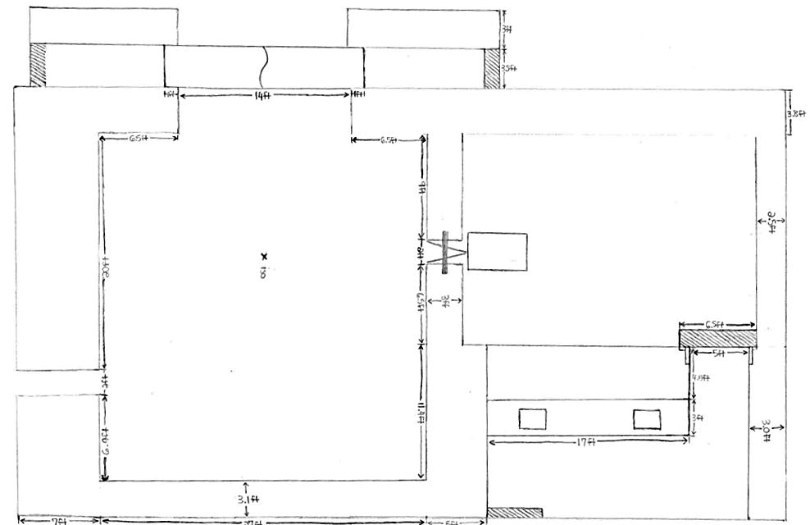
E
J
I
G
F
B
H
A
Figure 4: Drafted geometry based on NCRP calculations with labelled walls.

Table 12: Finalized barrier thicknesses used in facility design
Wall ID and Description | Concrete Thickness
- Primary Barrier | 7ft / 2.13m
- Hallway | 3.1ft / 0.95m
- Large Access Door | 3.5ft / 1.07m  (0.635 cm steel surround)
- Door Access Area | 3ft / 0.91m
- Outer Wall | 3.8ft / 1.16m
- Collimation Wall | 3ft / 0.91m
- Control Room  (Accelerator room) | 4.5ft / 1.37m
- Control Room  (Physical Security room) | 5ft / 1.52m
- Back Wall  (Accelerator room) | 2.5ft / 0.76m
- Back Wall (Control room) | 3ft / 0.91m
- Ceiling (not pictured) | 5ft / 1.52m

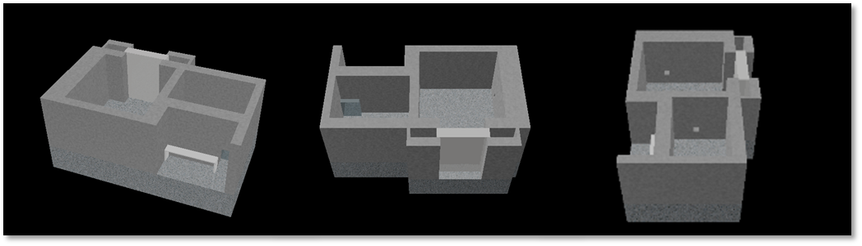
Figure 5: CAD renders of room geometry derived from NCRP analytical calculations that was used in MCNP simulations

  - MCNP simulation of planned room design
    - MCNP geometry
From the dimensions determined from the NCRP analytical methods, a full-scale MCNP geometry was created to perform particle simulations on. This allowed for a particle physics based simulation based on individual geometry and materials to investigate dose rates at select areas of the geometry based on the tallies and response functions that are chosen.

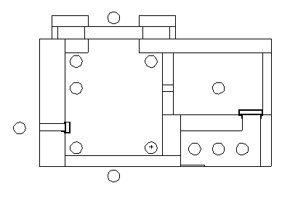
5
3
4
1
Figure 6.1: Top view of MCNP geometry taken at 5 ft from the floor of the facility, showing locations of tally cells
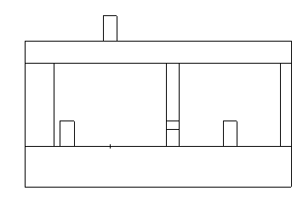
Figure 6.2: Side view of MCNP geometry taken parallel to the photon beam conduit, showing the height of the floor tally cells and the location of the ceiling tally cell.
8
6
7
2
    - MCNP source term
To accurately obtain dose results, a representative source was developed. Instead of both accelerator shielding group spending precious time developing the source term, the source term was developed by our partner group Accelerator Shielding 1 and verified by both groups. Two source terms were developed: one for photons produced by the 22 MeV electron beam from the tungsten target and one for neutrons produced from the tungsten target.
To start a 22 MeV electron beam was simulated on a 2 mm thick, 5 cm radius tungsten disk. This size of target was chosen based on personal experience from viewing a tungsten target, from contacting experts in the field about the size, and reading papers. This simple geometry was set between two “infinite” planes. The two planes were tallied for both photons and neutrons, creating energy and directional dependent distributions. These distributions were then used to create two equivalent point charge source terms that are dependent on energy and direction. Figures 7 and 8 show a visual representation of select energy groups for both source terms.
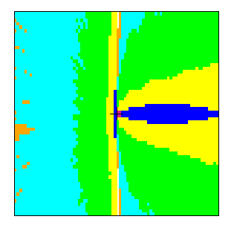
Figure 7: Source term representation for
21-22 MeV photons

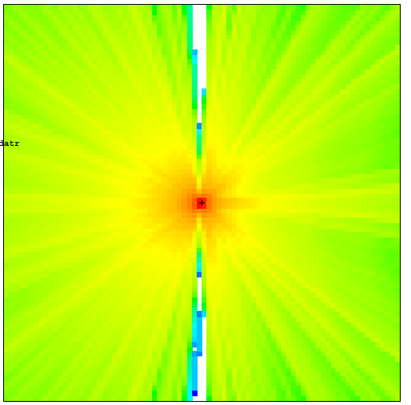
Figure 8: Source term representation of
13-14 MeV neutrons

Two source terms were needed due to the high energy beam’s capability to produce photoneutrons. For any beam energy above approximately 7 MeV (above the nuclear binding energy), there is a chance of “knocking out” a neutron. Having both of these sources of primary radiation and being able to track their journey along with any subsequent secondary radiation allows for a representative simulation of the linear accelerator and physical security facilities. Upon subsequent conversion, dose rates can be determined.
    - MCNP dose conversion
For this project we were tasked with producing a floor plan that would shield the users and public from radiation exceeding the limits set by governing regulatory bodies. In Tennessee, the state governs the regulation or radiation dose limits. Regulatory dose limits are almost exclusively given in dose equivalent rates (Sieverts/hour, Sieverts/week, Sieverts/year, etc.). To get usable dose rates from MCNP to compare against regulatory limits, some type of data manipulation must be made. This can be done in a number of different ways, utilizing dose maps, anthropomorphic phantoms, or response functions. For our MCNP simulations, we chose to set up tally cells and utilize response functions on the simulated volume averaged fluxes (F4).
Our tally cells were placed at high risk areas or the most probable points of failure. We selected thirteen areas to tally. These were placed inside the irradiation area, in the hallway adjacent to the irradiation area (verifying wall B in Figure 4), behind the primary wall in line with the neutron generator conduit (verifying wall A in Figure 4), beyond the large access door (verifying door C in Figure 4), in the control room (verifying walls G and H in Figure 4, as well as the control room door), and in the ceiling (verifying dose to occupants above are properly shielded). From the tally results generated by these cells, we applied response functions taken from ANS-6.1.1-1977 to get dose rates to compare against regulations ^{[4]}. To get accurate dose rates we had to multiply each dose rate by a factor corresponding to electron beam intensity. Based on simulations and judgement calls, we used two beam intensities corresponding to a low and high estimate beam intensity for a reasonable min and max dose rate. It is important to say at this point that these values are representative of a high powered beam. This beam will not be used continuously, but for select, short irradiations.
Table 13: Neutron Flux-to-Dose rate conversion factors for MCNP from ANSI/ANS 6.1.1-1977 ^{[4]}
Energy, E  (MeV) | DF(E)  (rem/hr)(p/cm²-s) | Quality Factor
2.5E–08 | 3.67E–06 | 2
1.0E–07 | 3.67E–06 | 2
1.0E–06 | 4.46E–06 | 2
1.0E–05 | 4.54E–06 | 2
1.0E–04 | 4.18E–06 | 2
1.0E–03 | 3.76E–06 | 2
1.0E–02 | 3.56E–06 | 2.5
1.0E–01 | 2.17E–05 | 7.5
5.0E–01 | 9.26E–05 | 11
1 | 1.32E–04 | 11
2 | 1.43E–04 | 9.3
2.5 | 1.25E–04 | 9
5 | 1.56E–04 | 8
7 | 1.47E–04 | 7
10 | 1.47E–04 | 6.5
14 | 2.08E–04 | 7.5
20 | 2.27E–04 | 8

Table 14: Photon Flux-to-Dose rate conversion factors for MCNP taken from ANSI/ANS 6.1.1-1977 ^{[4]}
Energy, E (MeV) | DF(E) (rem/hr)(p/cm²-s)
0.01 | 3.96E–06
0.03 | 5.82E–07
0.05 | 2.90E–07
0.07 | 2.58E–07
0.1 | 2.83E–07
0.15 | 3.79E–07
0.2 | 5.01E–07
0.25 | 6.31E–07
0.3 | 7.59E–07
0.35 | 8.78E–07
0.4 | 9.85E–07
0.45 | 1.08E–06
0.5 | 1.17E–06
0.55 | 1.27E–06
0.6 | 1.36E–06
0.65 | 1.44E–06
0.7 | 1.52E–06
0.8 | 1.68E–06
1 | 1.98E–06
1.4 | 2.51E–06
1.8 | 2.99E–06
2.2 | 3.42E–06
2.6 | 3.82E–06
2.8 | 4.01E–06
3.25 | 4.41E–06
3.75 | 4.83E–06
4.25 | 5.23E–06
4.75 | 5.60E–06
5 | 5.80E–06
5.25 | 6.01E–06
5.75 | 6.37E–06
6.25 | 6.74E–06
6.75 | 7.11E–06
7.5 | 7.66E–06
9 | 8.77E–06
11 | 1.03E–05
13 | 1.18E–05
15 | 1.33E–05

Table 15: MCNP hourly dose rates corrected for beam intensity. Area of interest numbers correspond to tally cell ID numbers identified in Figures 6.1 and 6.2.
Area of Interest | Low estimate for MCNP dose rates (mrem/hr) | High estimate for MCNP dose rates (mrem/hr)
1. Critical Facility | 9.48E-03 | 7.96E+00
2. Outside | 1.19E-02 | 1.00E+01
3. Hallway | 1.98E-02 | 1.66E+01
4. Mid Control Room | 9.34E-05 | 7.85E-02
5. Left Control Room | 7.09E-05 | 5.95E-02
6. Right Control Room | 1.14E-04 | 9.60E-02
7. Accelerator Room | 1.77E+01 | 1.48E+04
8. Ceiling | 2.41E-04 | 2.03E-01

Table 16: MCNP weekly dose rates corrected for weekly usage (40 hours/week) and area occupational factors.
Area of interest | Low estimate for  MCNP dose rates  (mSv/wk) | High estimate for  MCNP dose rates  (mSv/wk)
1. Critical Facility | 0.0023 | 1.9115
2. Outside | 0.0002 | 0.2
3. Hallway | 0.0016 | 1.3271
4. Mid Control Room | 0 | 0.0209
5. Left Control Room | 0 | 0.0159
6. Right Control Room | 0 | 0.0256
7. Accelerator Room | 4.7067 | 3952.7528
8. Classes Above | 0.0001 | 0.0811

- Methods for Obtaining a Cost Estimate
Cost estimates on facilities are hard to determine based on: the uniqueness of the project, cost of labor, materials, and possible changes proposed by experts and architects. However, certain estimates can be made, specifically estimates based on the cost per volume of concrete and costs of renting a crane, which would be required for construction. Radiation shielding experts were also contacted to provide estimates for ventilation, possible labor costs, surveying, and radiation monitors.

Materials
Concrete = $160/m³
Approximate concrete volume = 1500 m³
Estimated cost = $240,000

Crane (75 Ton) = $200/hour + $700 travel

Large Direct Access Door = $200,000

HEPA ventilation = $14,000

Labor = $750,000
Health physics work
Certified health physicist = $125 /hr
Health physics technician = $60 /hr
Radiation area monitors = $50,000
Total health physics estimate = $75,000

Total Project Estimate
$1,500,000-$2,000,000

These prices are estimated costs Cost estimates were estimated through contacting multiple resources, including: architects, shielding experts, medical physicists, and radiation engineers. These are conservative estimates based on expertise in the field. In reality, construction rates would be lumped into the cost of the entire engineering complex that would be sent out and bid on by various construction firms.
- Summary and Conclusion
In the coming years, the nuclear engineering department will be expanding. A part of this expansion is a proposed new building. This state-of-the-art building will incorporate multiple research laboratories. Three of these laboratories include a linear accelerator facility, physical security laboratory, and graphite pile/critical facility. The design of physical security laboratory and linear accelerator facility along with considerations regarding the affiliated critical facility is described in this project report. For this design project, we have:
- consulted faculty members about facility requirements
- contacted professionals in the field about design considerations and methods
- determined a viable facility layout
- performed analytical calculations for shielding thicknesses using methods laid out by the National Council on Radiation Protection and Measurements reports 144 and 151
- ran particle simulations of the source and geometry using MCNP
- determined facility factors such as materials costs and auxiliary equipment.
From talks with faculty members about the function of the facility, design parameters were determined. The design that was achieved allows for the utilization of two radiation sources, a 22 MV linear accelerator and DT neutron generator. This was done to allow lower energy radiation sources to be used such as the 9 MV accelerator planning to be used by the department, while allowing for higher energy and more diverse radiation sources to be utilized in the future. Also taken into consideration was the ability to bring in large objects in to the facility through the large direct access door. The combined facilities (linear accelerator and physical security) measures 35.8 ft x 64 ft including barriers and active floor space, not including the large direct access door. The facility is designed with 20 ft ceilings set between a 5 ft thick concrete ceiling and 10 ft thick concrete floor. The calculations for barrier thicknesses can be found in section III.b.ii. The barriers that were calculated ranged from 2.8 ft to 7ft thick. The method used to determine the shielding thicknesses takes into account various factors of the facility: what is beyond the barrier, intensity of the beam, energy of the beam, distance to the barrier, and the material of the barrier, to name a few ^{[2,3]}. From these calculations we established a floorplan to use in our design. A detailed floor plan with dimensions can be seen in appendix b. Visual representations of the facility can be seen throughout the report but namely in Figures 2 and 5.
From the established floorplan, an MCNP geometry was built including the correct dimensions and materials (Figure 6). To accompany this representative geometry, a representative source term was created to allow for an accurate particle simulation to be run (Figures 7 and 8). After creation, the simulations were run tracking photons, photoneutrons, and neutron capture gamma rays, specifically their fluxes incident on tally cells. From the fluxes recorded by the tally cells, conversions must be performed both during and after simulations. Response functions were applied during simulation to convert fluxes to dose rates in mrem/hour. After simulations, these dose rates were then weighted with source intensities to get representative dose rates (Table 15). The minimum dose rates reported in this table all fall within the regulatory hourly limit set by the State of Tennessee and the NRC ^{[7]} (2 mrem/hour for uncontrolled areas and 10 mrem/hour for controlled areas). The maximum dose rates fall inside the hourly dose rates for the most part, falling outside for the hallway and beyond the large direct access door.
After hourly dose rates were determined, we converted the hourly dose rates into weekly dose rates. This was done by first converting the mrem/hour into mSv/hour and then multiplying by the work hours in a week and occupation factors for the various areas to be protected to get weighted weekly dose rates (mSv/week). These dose rates can be seen in Table 16. According to the governing bodies, the weekly dose rates limits are 0.02mSv/week for uncontrolled areas and 0.1 mSv/week for controlled areas. If you look at the high estimate for MCNP dose rate, several areas are above regulatory limit. This estimate is based off a beam intensity that was higher than used in our analytical calculations. If you look at the low estimate for MCNP dose rate, all areas are below regulatory limit. In reality, the beam intensity would be between these two estimates, falling within regulatory limits.
This deviation from regulatory limits using a high beam intensity estimate is expected. If an accelerator ran at full power for a full business week, the necessary shielding would be outrageous. A linear accelerator typically runs for short intervals with breaks in between. When doing the first order analytical calculations, we were directed by the NCRP reports which give conservative parameters relevant to medical linear accelerator facilities ^{[2,3]}. These parameters were used because of a lack of parameters related directly to our facility. If the needs of the faculty require for extended and consistent irradiation times, then a revised set of NCRP calculations would need to be done given updated facility parameters. This increase in beam intensity will result in thicker barriers.
Our facility design was created to be as user friendly as possible. Due to the size of the facility, large scale as well as small scale experiments can be undertaken. Due to the shielding, a high powered 22 MV accelerator can be used. With this high energy shielding taken into consideration, any lower energy accelerator could be used, specifically the 9 MV linear accelerator that is intended to be included in the new nuclear engineering building. The facility that was designed throughout the course of this project should easily meet the standards set by the state of Tennessee and NRC given a moderate amount of use. It should also meet the needs of the nuclear engineering department, as described by those faculty directly involved in the daily usage of the facilities in question.
- Future work
  - Neutron generator considerations
Along with the linear accelerator, the nuclear engineering department would like to add a DT neutron generator. This neutron generator would allow for material’s damage to be investigated along with neutron imaging to be performed. This additional radiation source would increase the radiation fluence in and beyond the facility, thus more shielding would need to be investigated. Due to time constraints within the project, this shielding was not investigated. However, the placement of the radiation source was taken into account along with additional room for shielding to be modified.
Due to the primary neutron source, the shielding would need to be of substantial thickness to allow for the probability of interaction to increase. Additionally, the inclusion of a high Z material on the surfaces of walls, such as a lead sheet, could aid in inducing inelastic collisions. These inelastic collisions reduce the neutron’s energy, greatly reducing the amount of needed shielding. For the purposes of this facility, we recommend adding lead sheets to the inside of walls H and B in Figure 4 and adjusting wall thicknesses to shield the additional source of radiation. Shielding will also need to be verified for the graphite pile/critical facility.
  - Faculty optimization
The facility that we have designed in the course of this project was a best guess estimate based on the faculty design (Figure 1) and talks with faculty members about individual desires for the design of the facilities. These individual desires include the large direct access door, high ceilings, collimation wall, large imaging array, dual radiation sources, and the option to utilize a higher energy linear accelerator.
Throughout the course of the project, desires changed and new desires came to light. We did our best to accommodate all of these design parameters; however, it would be necessary for the faculty to identify all of the parameters that the facility must satisfy and adjust the design to fit these needs.
  - Auxiliary Equipment and Considerations
    - Ventilation
A high power linear accelerator can produce many toxic and radioactive gases (¹³N, ¹⁵O, ozone, nitric oxide, nitrogen dioxide, nitrogen trioxide, etc.) while running routinely in pure oxygen. The higher the power of the linear accelerator the more these gases will be produced. Thus, the ventilation system should be designed for a 22 MV accelerator. Ozone (O₃) has the greatest concern of hazard due to it being the most toxic and it reacts with nitric acid to form oxides of nitrogen which can corrode the equipment in the linear accelerator facility or the linear accelerator itself. Ozone has a production rate of 13 molecules per 100 eV ^{[8]}. Due to these effects, it is important to have a proper ventilation and monitoring system to discharge these gases. The ventilation system should use labyrinth ventilator pipelines, which provides continuous ventilation for the ozone being produced. Lastly, the concentration of these gases inside the facility should be monitored in the control room to guarantee a safe environment to the radiological workers entering the linear accelerator room ^{[8,9]}.
    - Cabling
Cabling is a necessity in any research facility to support the machines and measurement equipment. Due to the amount of cabling and the need for occupational safety, cables must be managed. This is usually done with either a cable ditch dug into the floor and covered, cable ducts, cable tray attached to the ceiling, or through temporary covers ^{[9]}.
    - Temperature and humidity
The linear accelerator and physical security rooms must be maintained between 5°C and 35°C and below a maximum 90% humidity (information corresponds to 15MV Varian Linatron K15) ^{[10]}. This is done so that the linear accelerator and affiliated equipment, such as the power supply, do not get overheated or too wet. For the purpose of these facilities and their direct access to the outside an air conditioner, heater, and dehumidifier are all going to be needed ^{[9]}.
    - Other factors to be considered
Beyond these more general concerns needed for the operation of any linear accelerator facility, specific factors must be addressed for each individual facility including: safety interlocks, power requirements, lighting system, crane, amongst others ^{[9]}. These factors are dependent on: the type of linear accelerator selected, the size of the finalized facility, the geometry of the finalized facility. Due to time constraints and the possibility that the room layout will change with further faculty optimization and shielding verification, we have elected to not go into detail in these systems but mention the necessity for considering them in any future design modification.
- Shielding verification
In the event that this design is considered for use or adapted for use in the plan of the proposed nuclear engineering building, a shielding professional would need to be commissioned to perform a shielding calculation to verify and correct shielding dimensions. These calculations and verifications could be undertaken by departmental faculty adept in shielding, adjunct medical physics faculty that have shielding experience, or shielding venders.
- Architectural modification
Where a normal building would need to take into account the expertise of one specialty, a radiation facility must take into account multiple to account for the design, functionality, and safety. At the time of design by the architect, there needs to be considerable cooperation between the shielding expert commissioned to undertake the shielding verification and the architect commissioned to design the building. Each of these professionals is concerned with different aspects of a building design. The shielding professional is concerned with the functionality of the building, namely the ease of use and the effectiveness of the shielding. Whereas the architect is concerned with the aesthetics and flow of the building. If changes are made to the room layout that does not directly follow the shielding verified by the expert, there will be a possibility that the shielding is insufficient. For instance, if a wall is pulled closer to the source without adjusting the shielding, the radiation transmission will be greater due to radiation’s $\frac{1}{r^{2}}$ dose fall off. To achieve an effective design, both must be consulted about any changes that each needs to make.
- Appendices
  - References
[1] McGinley, Patton H. Shielding Techniques for Radiation Oncology Facilities. Madison, WI: Medical Physics Pub., 2002. Print.
[2] Radiation Protection for Particle Accelerator Facilities: Recommendations of the National Council on Radiation Protection and Measurements. NCRP 144. Bethesda, MD: National Council on Radiation Protection & Measurements, 2003. Print.
[3] Structural Shielding Design and Evaluation for Megavoltage X- and Gamma-ray Radiotherapy Facilities: Recommendations of the National Council on Radiation Protection and Measurements. NCRP 151. Bethesda, MD: National Council on Radiation Protection and Measurements, 2005. Print.
[4] X-5 Monte Carlo Team. MCNP-- A General Monte Carlo N-Particle Transport Code, Version 5. Volume II: User's Guide. III vols. Los Alamos: Los Alamos National Laboratory, 2008.
[5] X-5 Monte Carlo Team. MCNP-- A General Monte Carlo N-Particle Transport Code, Version 5. Volume I: Overview and Theory. III vols. Los Alamos: Los Alamos National Laboratory, 2008.
[6] United States. Department of Homeland Security, U.S. Customs, and Border Protection, and Domestic Nuclear Detection Office. Pacific Northwest National Laboratory. Compendium of Material Composition Data for Radiation Transport Modeling. By R. J. McConn, Jr., C. J. Gesh, R. T. Pagh, R. A. Rucker, and R. G. Williams, III. Alexandria: National Technical Information Service, 2011. Web.
[7] "PART 20—STANDARDS FOR PROTECTION AGAINST RADIATION." NRC: 10 CFR Part 20—Standards for Protection Against Radiation. Nuclear Regulatory Commission, n.d. Web. 27 Apr. 2015.
[8] Swanson, William P. Toxic Gas Production at Electron Linear Accelerators. Publication no. 2470. Stanford: Stanford Linear Accelerator Center, 1980.
[9] Medical Electron Linear Accelerator: Guidelines for Accelerator Rooms Design. Publication no. 0402 208 0911 1. Shinva Medical Instrument co., Ltd.
[10] Varian Medical Systems. Linatron K15 Modular High-energy X-ray Source. Las Vegas: Varian Medical Systems.
  - Large Floor Plan with Dimensions
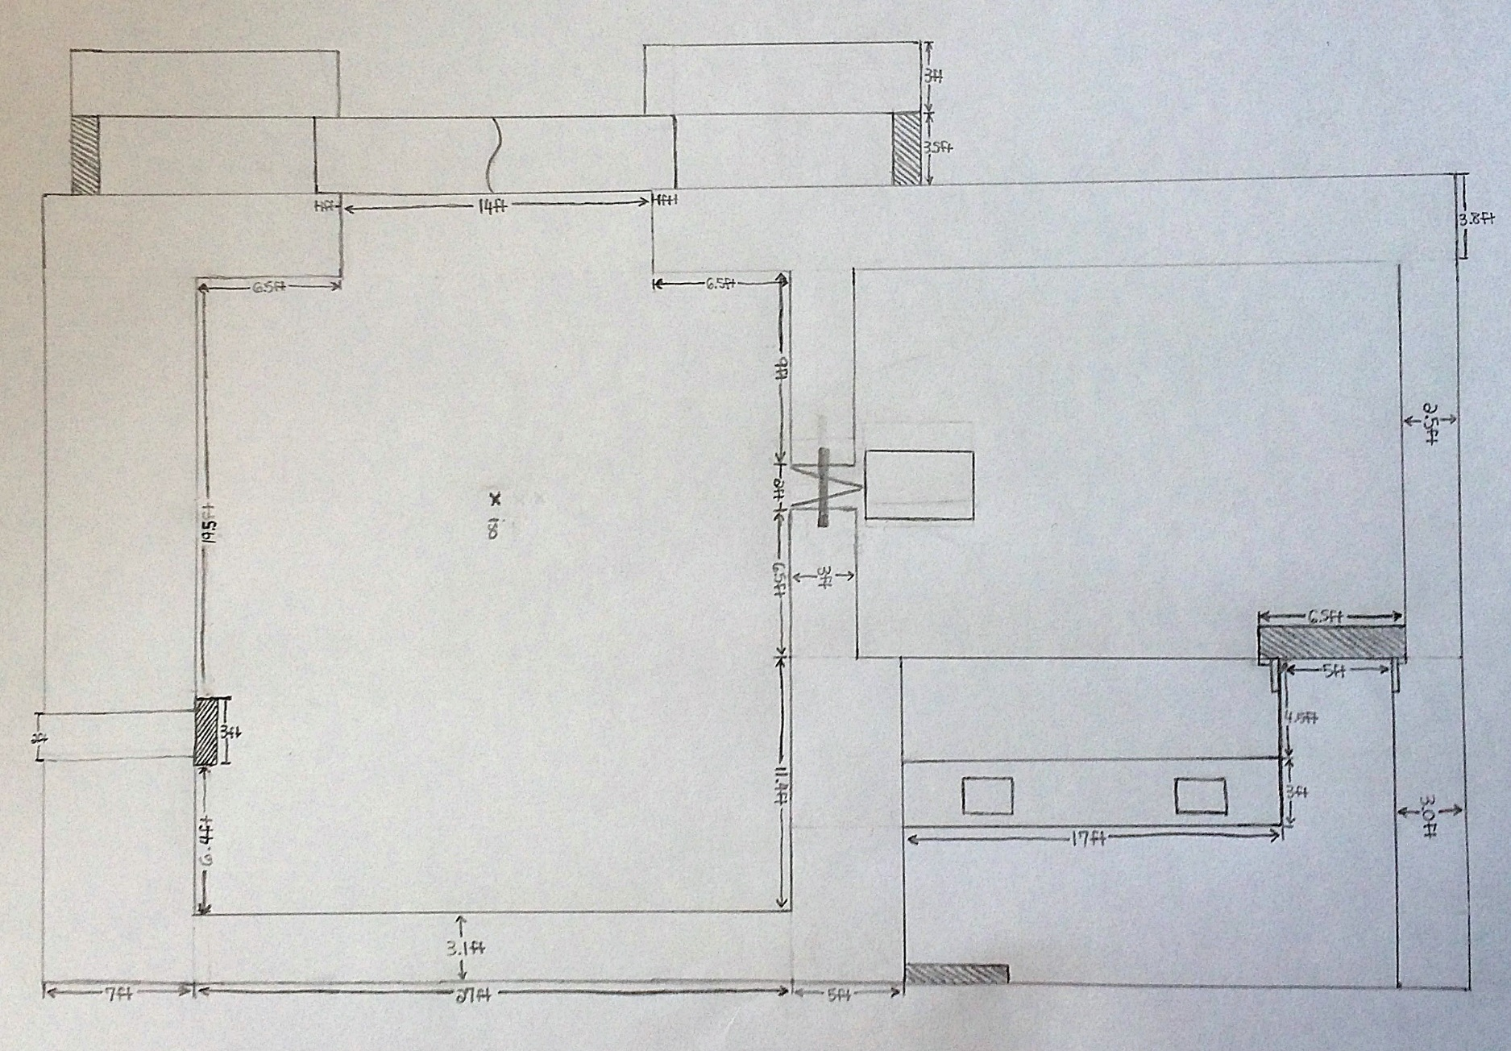
  - Acknowledgements
We would like to thank the following people for their help in this project:
- Our mentor, Dr. Laurence Miller
- The faculty of the University of Tennessee Nuclear Engineering Department
- Ben Robison, medical physicist from Provision Center for Proton Therapy
- Jackson Renegar, medical physicist from Provision Center for Proton Therapy
- Marc Blakey, medical physicist from Provision Center for Proton Therapy
- Niek Schreuder, medical physicist from Provision Center for Proton Therapy
- Mark Balzer, radiation engineer from Idaho Accelerator Center
Each of these people were of great help in the completion of the project from assisting in design considerations to offering assistance in calculations. We appreciate the help that each offered and are forever grateful.

