PROPELLING RESILIENCE: AIRSHIP INNOVATION AND THE TRANSFORMATION OF GRID LOGISTICS

A Thesis Presented for the
Master of Science
Degree
The University of Tennessee, Knoxville

Stephanie Marie Tomasik
August 2025
ABSTRACT
As extreme weather events and aging infrastructure continue to challenge the reliability of the electric grid, the ability to restore power as fast as possible has become a priority. At the center of this issue lies the substation, a critical and vulnerable node that houses equipment like power transformers that are large, expensive, and difficult to replace. When equipment damage occurs, especially in remote or inaccessible regions, restoration can be delayed not just by supply chain shortages[1] but also a logistics network that depends heavily on roads, rails, bridges, and ports that may not be intact or convenient.
This thesis explores the potential for hybrid airships to solve these logistical constraints and alter how utilities respond to grid emergencies. What was once regarded as obsolete technology, airships are being reinvented with updated materials, navigation systems, and efficient propulsion systems[2], [3]. Possessing the ability of vertical takeoff and landing, soft delivery, and carrying excessively heavy payloads, these bulbous aircrafts offer an ideal alternative to helicopters, trucks, cargo planes, trains, and even shipping barges.
Through comparative analysis to evaluate recent hurricanes and power system equipment transport needs, this paper argues that airships could close substantial logistical gaps in grid resilience. This thesis identifies regulatory and technical barriers to adoption while outlining a policy roadmap involving various government agencies to support integration and resilience planning.
Table of Contents
CHAPTER ONE INTRODUCTION 1
CHAPTER TWO LITERATURE REVIEW 4
EVOLUTION OF TECHNOLOGY 4
GRID VULNERABILITIES DURING RECOVERY 6
REGULATORY AND MARKET ENVIRONMENTS 7
CHAPTER THREE AIRSHIPS THEN AND NOW: OBSOLETE TO INNOVATIVE 8
A HISTORICAL BRIEFING 8
MODERNIZING INNOVATION 9
COMMON DESIGNS 9
RECENT PROJECTS 12
CHAPTER FOUR AIRSHIPS FOR POWER SYSTEM LOGISTICS 20
THE GRID’S WEAKEST LINK 20
THE WEIGHT, SIZE, AND SUPPLY PROBLEM 21
RECENT EVENTS: SUBSTATIONS UNDER SIEGE 24
HURRICANE DAMAGES 24
PHYSICAL ATTACKS 25
AIRSHIPS: UNREALIZED LOGISTICS SOLUTION 27
CHAPTER FIVE QUANTITATIVE ANALYSIS OF CARGO TRANSPORTATION METHODS 30
FREIGHT VOLUME AND PAYLOAD CAPACITY 30
CARBON EMISSIONS SUSTAINABILITY WITHIN CARGO TRANSPORTATION 31
CHAPTER SIX REGULATORY, TECHNICAL, AND INDUSTRY PATHWAYS FORWARD 33
CURRENT STANDING AND APPLICATIONS OF AIRSHIPS 33
LIMITATIONS AND CHALLENGES 34
ROADMAP TO FULL INTEGRATION 36
CHAPTER SEVEN CONCLUSION 39
REFERENCES 41
VITA 43

LIST OF TABLES
Table 3.1. Comparison of recent airship designs. 18

LIST OF FIGURES
Figure 3.1. LTA Research’s Pathfinder 1 over the San Francisco Bay. 13
Figure 3.2. LCA60T artistic rendering designed by Flying Whales. 14
Figure 3.3. Lockheed Martin’s LMH-1 demonstrates its ability to unload cargo at truck bed height. 15
Figure 3.4. Test flight of the Airlander 10. 16
Figure 3.5. Artistic rendering of the Airlander 50 delivering a shipping container. 17
Figure 4.1. Comparison of transformer capacity to reference weight. 22
Figure 4.2. Response comparison to recent hurricanes with and without airship assistance. 28
Figure 5.1. Shipment by mode distribution in 2023 in the United States. 31
Figure 6.1. Recommendations for stakeholders in the airship adoption process. 38

Introduction
The United States’ electric power grid is a complex and critical component of infrastructure in our society, and yet it remains extremely vulnerable to natural and man-made disruptions. As extreme weather events become more frequent and supply chains struggle to meet demand, the weaknesses in the ability for utility companies to restore power quickly has become evident[4], [5], [6]. A specific point of fragility comes from the logistics of replacing and repairing substation equipment – primarily large power transformers – after catastrophic failures or damage.
Substations are one of the most vital components of the electric grid. They step voltage up or down, connect transmission and distribution systems, and serve as the link between power generation and load. Their components, particularly transformers, are large, expensive, and not easily replaced when damaged. When a transformer fails, the restoration timeline is often dictated by the availability of parts and the logistics of moving that equipment where it needs to go. This challenge is exacerbated when natural disasters like hurricanes, wildfires, and flooding occur. Roads become inaccessible and traditional cargo transportation systems cannot fulfill the restoration needs.
Congruently, technology in transportation has begun moving to electrification for low-emission logistics. In this transition, the re-emergence of a historically overlooked technology – the airship – has quietly re-entered the conversation as a potentially game-changing logistics solution for heavy-lift cargo in infrastructure-lacking environments. Unlike helicopters or trucks, airships can carry tens of tons of cargo without requiring roads, railways, or runways. They possess the ability to hover, loiter, and land vertically which allows them to deliver directly to the location, even when conventional access is impossible[7], [8], [9].
This thesis proposes the potential of modern airships to solve the pressing logistical challenges associated with power system restoration including the transportation of heavy equipment like transformers as well as personnel deployment in emergency scenarios. Airships can offer a combination of payload capacity, sustainability, and infrastructure independence that can improve the speed and effectiveness of disaster recovery efforts within the electric power industry[10], [11], [12], [13].
This paper proposes airships within the broader context of utility logistics and disaster resilience. It begins by examining the technological evolution and renewed relevance of these aircrafts, followed by the evaluation of their performance relative to conventional cargo transport modes. The discussion then proceeds with the specific challenges of delivering large power transformers, before analyzing recent disasters and substation failures where airships could have meaningfully impacted restoration durations. The thesis concludes with considering the regulatory, technical, and institutional barriers that must be addressed to integrate airships into grid operations.

Literature Review
The resurgence of airship technology is occurring at the intersection of multiple disciplines including aviation engineering, disaster logistics, energy infrastructure, and regulatory policy. To understand how hybrid airships might reshape utility logistics and grid restoration, it is imperative to evaluate existing research across these domains. The literature provides a renewed technical interest in these aircrafts and a growing awareness of their potential in transportation. At the same time, literature exposes persistent barriers to adoption.
Given the wide range of fields involved in the airship evolution, this review organizes the literature by thematic relevance. The following sections explore the history behind airships, their modern capability, applications in cargo and disaster logistics, restoration challenges facing power systems equipment, and the regulatory environment shaping the future for airships. The structure allows for a synthesis of the role airships may play in the future of grid resilience strategies.

Evolution of Technology
The modern resurgence of airships draws upon a long and uneven development of technology, with recent literature focusing on their design transformation and renewed relevance. Early airship usage was dominated by military and passenger transport functions but fell out of favor due to high-profile disasters and emergence of faster fixed-wing aircrafts[14]. However, several articles revisited this narrative, highlighting how the foundational aerodynamic and buoyancy principles of airships have remained technically viable and are being reimagined through modern engineering solutions[15], [16]. These works emphasize that the decline of airships was due more to contextual limitations than technological obsolescence.
Within literature, the conversation has shifted toward airships as sustainable and adaptive logistics platforms. Sherer argues for their role in decarbonizing freight and reaching remote or underdeveloped regions with minimal infrastructure, which is an argument that ties directly into this thesis’ focus on disaster logistics within grid resilience[15]. Similarly, another author provided a comparative lens by evaluating the propulsion and structural advancements made in hybrid airships, particularly their ability to combine vertical take-off, heavy lifting, and long hover duration[2], all of which are factors central to their proposed use in the power system sector. Across these texts, there is a clear convergence around the notion that airships are not “relics” of the past, but rather underutilized assets for modern infrastructure challenges[17].

Grid Vulnerabilities During Recovery
A growing body of literature highlights how modern power systems are facing threats of aging infrastructure and escalating natural disasters[18]. The 2025 Utility Dive report discusses the extent to which the transformer supply chain has become an issue for grid recovery, noting that transformer lead times often exceed what is necessary to keep emergency stock of equipment[1], [18], [19]. These delays are magnified during post-disaster scenarios when extensive amounts of equipment may need to be replaced, outpacing existing inventories. Analysts further point out that while manufacturers have announced production expansions, substantial relief will not materialize for several years, leaving the current state of the system vulnerable.
Additionally, literature has suggested that recent storm response delays are not only a logistical inconvenience but also pose a systemic risk to the grid. Damage assessments and repairs often require bulky equipment that cannot be moved swiftly due to damaged or impassible roadways. According to one study’s findings, hurricanes not only cause direct equipment failure, but also create terrain that is inaccessible and hampers recovery times, especially in rural and mountainous areas. This interplay between supplies and transportation creates a feedback loop where outages can last longer and restoration becomes complex. These publications collectively suggest that without diversification in transport methods and prepositioned recovery solutions, power system recovery will remain risk-prone.

Regulatory and Market Environments
Despite growing technological feasibility, the regulatory environment surrounding airships remains outdated, especially for utility-oriented applications. The Federal Aviation Administration (FAA) governs airship certification through 14 CFR Part 21[20], which outlines the airworthiness certification procedures calling the category a “special class” aircraft[20], [21]. However, these guidelines are based on criteria developed as early as the 1980’s, drawing heavily from outdated military specifications and legacy systems designed for nonrigid blimps.
This aging regulatory infrastructure presents potential barriers to adoption for airships. The FAA design certification criteria, such as those found in FAA-P-8110-2[22], do include references to cargo transport and propulsion integration, but they are narrowly scoped to aircraft models that fit pre-existing criteria. For the modern hybrid airships intended to deliver multi-ton payloads to infrastructure-deficient regions, there are minimal specific provisions that address operational scenarios involving post-disaster grid recovery or power system logistics. While FAA’s Part 91 governs operating rules for civil aircrafts, including airships, there is no language that anticipates or enables rapid integration into emergency airspace usage or prioritization for grid-sensitive tasks.

Airships Then and Now: Obsolete to Innovative

A Historical Briefing
Airships once symbolized the story of early aviation innovation, allowing for long-range transport capabilities unlike early fixed-wing aircrafts. The German Zeppelin company led the development of rigid airships in the early 20th century, demonstrating the potential for luxury travel and military application. The Graf Zeppelin and Hindenburg, two of the most infamous early airships, could span intercontinental ranges and carry dozens of passengers or heavy cargo loads[14], [17]. However, the Hindenburg disaster in 1937, combined with rapid wartime evolution in fixed-wing aircrafts, diminished the interest in lighter-than-air vehicles[2], [7], [17]. Between the flammability of hydrogen used to provide the lift in airships, comparably slow speeds to other aircrafts, and susceptibility to weather, airships were relegated to niche applications or completely obsolete all together.
In the past two decades, however, these aircrafts have undergone a profound evolution. Motivated by material science propulsion systems, and navigation system advances, a new generation of airships has emerged. These are not simply reinventions of the past, but reengineered platforms aimed at solving modern problems. Through airships, heavy cargo transportation can be decarbonized, remote or infrastructure-absent areas can be reached, and disaster zones can receive aid responses where traditional emergency services currently fail.

Modernizing Innovation

Common Designs
Today’s airships are designed with helium-based lift systems, eliminating the safety concerns associated with hydrogen from the Hindenburg catastrophe[17]. They utilize hybrid propulsion, which is the combination of electric motors with fuel-burning engines to provide both range, lower emissions, and highly capable maneuverability. Their structures are made from advanced materials such as carbon fiber and high-strength fabrics that combine light weight and durability characteristics, which contrast from their predecessors. Flight systems also include GPS navigation, collision-avoidance radar, and autonomous flight control in some designs[2], [14], [17]. These features are vital in modern airship design because it significantly enhances operational safety, precision in cargo delivery, and the ability to navigate challenging environments without the need for extensive ground support or constant pilot intervention.
Modern airships vary widely in form and functionality, but they all rely on the same fundamental principle of using lighter-than-air gases, typically helium, to achieve their lift. However, the design approaches to shape, structural support, and propulsion can widely differ. There are three primary categories of airships: blimps, rigid airships, and hybrid airships[2], [14]. Understanding these distinctions is important to decide which design is best considering they have different capabilities and limitations.
Blimps are the simplest form of an airship, defined by their non-rigid structure[2]. The shape is maintained through internal pressure of the helium gas within a flexible envelop of a fabric type material. Commonly used for advertising or short-duration surveillance, blimps lack the structural framework required to carry heavy cargo or operate in less-than-ideal environments[14]. Their utility is largely confined to small payloads, luxury travel, and short-range trips.
Conversely, rigid airships have a full internal framework which is typically composed of supportive trusses. This framework provides the shape of the airship regardless of internal gas pressure[2]. Commonly known, the Zeppelins of the early 20th century were rigid airships, able to carry significant cargo and passengers over long distances. Modern versions of the rigid airship have revived the rigid design to enable precise structural control and increased payload capacity, making them attractive to industrial and logistics applications.
The third category of airships is a combination of the previous two called a semi-rigid or hybrid airship. Hybrid airships are a newer innovation which combines the traditional helium lift with an aerodynamic lift generated by the shape and thrust from onboard propulsion systems[2], [14], [17]. This allows the hybrid airship to carry even heavier payloads with less gas volumes all while offering improved maneuverability and control[2]. This design allows for a reduced size and less fuel consumption relative to a fully buoyant blimp. The new generation of airships have a set of technical capabilities that distinguish them from conventional aircrafts and ground-based logistics such as trucks and trains.
One of the most valuable features of modern airships is their ability to operate without traditional infrastructure. Equipped with Vertical Takeoff and Landing (VTOL) capabilities, they can access remote or disaster-impacted regions where runways, roads, or ports are damaged or nonexistent[8], [23], [24]. Unlike helicopters which consume large amounts of fuel while hovering and are limited in payload, airships can loiter for extended periods with high fuel efficiency. This enables precision placement of cargo–including oversized or sensitive equipment–directly to a site without the need for cranes, aircraft taxiing, or complex ground handling. Their low-speed, stable hover also minimized the risk of mechanical shock during delivery.
This ability to hover and deliver cargo precisely in damaged or constrained environments is only part of what sets airships apart. Equally important is their heavy payload capacity, which rivals or exceeds that of many helicopters and matches certain fixed-wing cargo aircrafts. Modern airships are developed to lift between 10 and 60+ metric tons, depending on the design characteristics. These capacities make them well-suited for transporting bulking, awkwardly shaped, or otherwise immobile components–such as substation transformers, prefabricated grid modules, or renewable energy infrastructure–which are too heavy for helicopters and too logistically complex for ground transport during emergency scenarios.
All these capabilities establish airships as the logistic solution to the challenges of delivering power system equipment to infrastructure-poor, remote, or damaged regions. As the need for grid resilience, low-emissions transport, and rapid emergency response grows, airships offer the optimal alternative to the existing systems.

Recent Projects
Lighter-Than-Air (LTA) Research’s Pathfinder 1, which is currently the largest aircraft at over 120 meters in length shown in Figure 3.1., is a prime example of the modernization of airship technology within the United States. Constructed with carbon-fiber-reinforced components and powered by electric motors and lidar sensors[14], [16], it is built to carry humanitarian supplies and infrastructure materials to regions without airports or roads. Pathfinder 1 possessed a modular gondola, and its payload bay was designed to accommodate heavy machinery or containers that would otherwise require several various modes of transportation[16]. This design emphasizes the adaptability for extreme conditions, making it ideal for post-disaster delivery operations, including personnel for medical aid or infrastructure repair.
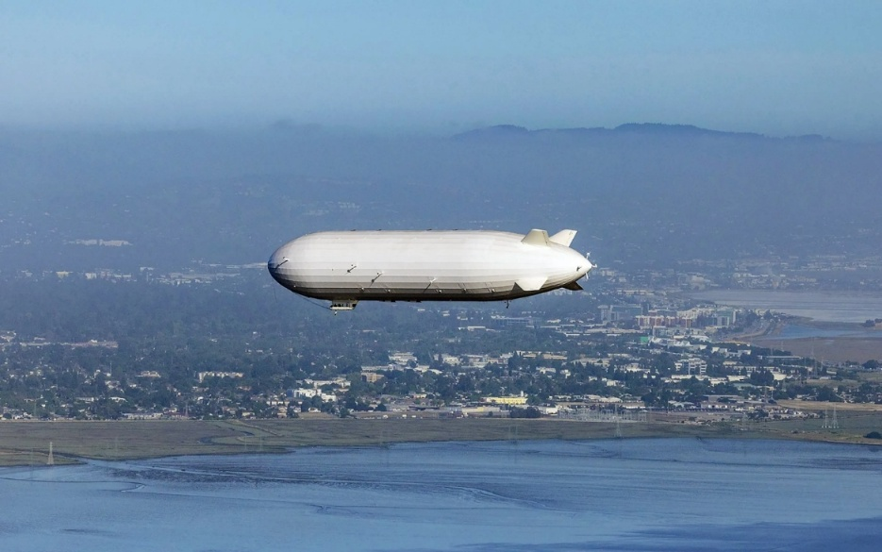
Figure 3.1. LTA Research’s Pathfinder 1 over the San Francisco Bay. [25]

The Flying Whales, a French startup, is currently developing what they call the LCA60T, which is a rigid airship specifically build to carry up to 60 metric tons of cargo seen in Figure 3.2.[26]. The design includes in-flight loading and unloading capabilities, meaning it can hover over a site and deliver its contents without landing[26]. The LCA60T targets industrial, logging, humanitarian, and energy sector logistics[26]. This includes transporting wind turbine blades, prefabricated buildings, transformers, and medical aid to isolated areas. The airship features distributed propulsion and advanced stability control to maintain position while hovering with a wide weight range of loads.
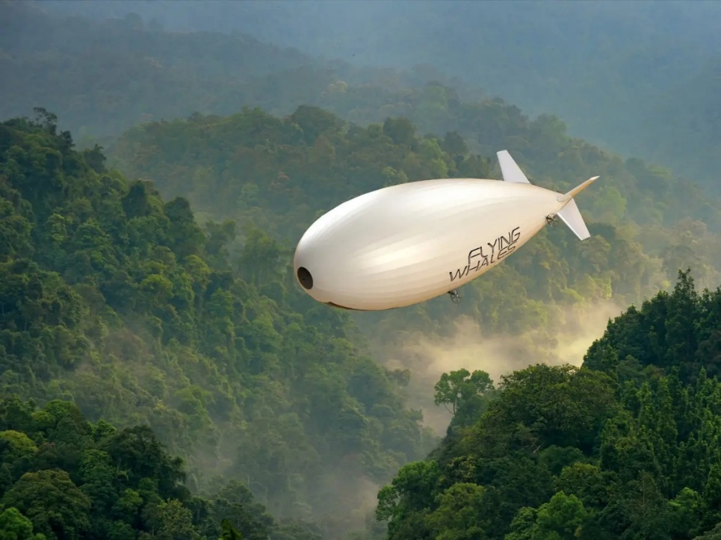
Figure 3.2. LCA60T artistic rendering designed by Flying Whales. [27]

Another US-based company, Lockheed Martin, has developed the LMH-1 seen in Figure 3.3., another hybrid airship with a carrying capacity of 20 tons over 1,400 nautical miles. The LMH-1 has a tri-lobe shape which provides an aerodynamic lift and buoyancy, reducing fuel consumption and improving flight control[2]. It is equipped with hover-cushion landing gear, allowing it to land on less-than-ideal surfaces like snow, sand, and even water. This design was explicitly intended for logistics missions in regions lacking runways or roads such as oil fields, mines, and disaster-struck areas.
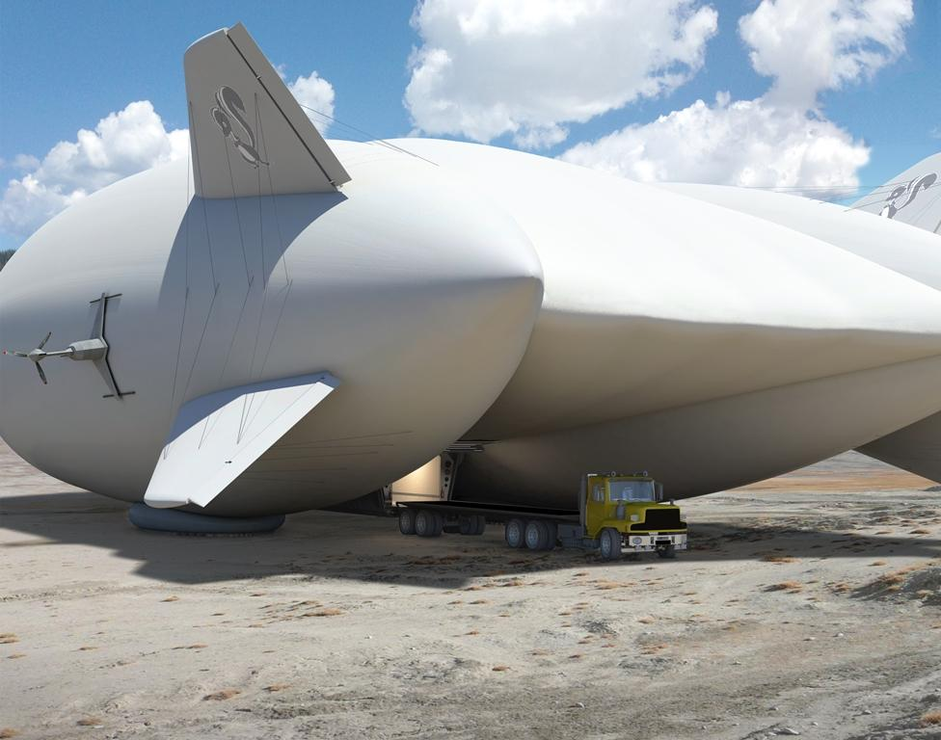
Figure 3.3. Lockheed Martin’s LMH-1 demonstrates its ability to unload cargo at truck bed height. [28]

Based in the United Kingdom, Hybrid Air Vehicles (HAV) developed the Airlander 10 which was a hybrid airship with a focus on surveillance, research, and modern cargo transportation[17]. While smaller than the previously mentioned airships, it is notable for its ultra-low emissions and ability to stay airborne for up to five days[29]. Even though the Airlander 10 project, as seen in Figure 3.4., has since been abandoned, HAV is coping with the growing demand for sustainable freight transportation through the design of the Airlander 50, a larger cargo variant capable of carrying significantly heavier loads than the Airlander 10. This design, in Figure 3.5., is motivated by the need to decarbonize regional supply chains while still reaching areas underserved by transport networks. HAV sees this as a necessary step toward replacing short-haul air freight with a cleaner and quieter alternative[17].
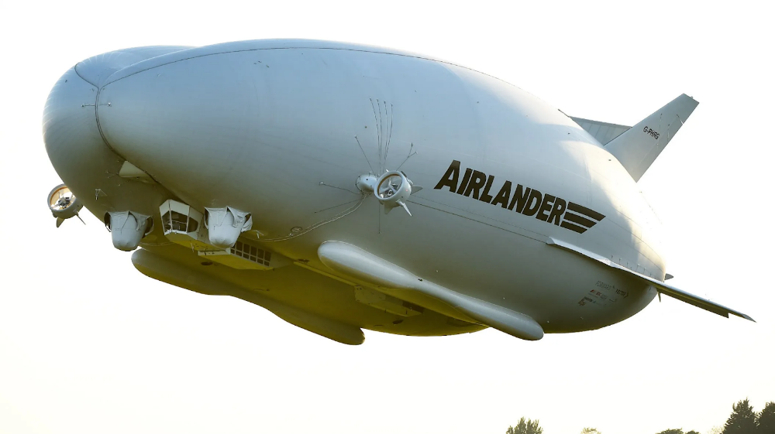
Figure 3.4. Test flight of the Airlander 10. [29]

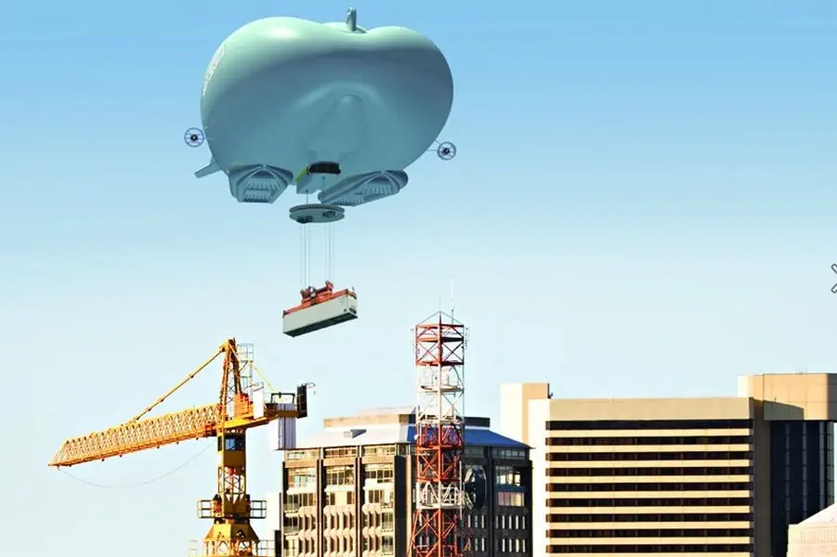
Figure 3.5. Artistic rendering of the Airlander 50 delivering a shipping container.[30]
Across these designs and companies, several consistent characteristics are evident including lift capacities from 10 to 60+ tons, hover and VTOL for infrastructure-free operations, flight durations exceeding most helicopters and many fixed-wing aircrafts, low environmental impact in terms of emissions, terrain disruption, and modular payload capabilities to carry everything from containers to oversized equipment to people[2], [3], [31].
These features position airships not just as an alternative to current technologies, but as an efficient solution for specific logistical challenges – primarily where existing infrastructure is lacking or even damaged. Their capacity to operate independent of roads, airports, or ports makes them well-suited for use in rural areas with energy projects, large equipment delivery like transformers, or emergency manpower for power system restoration. Comparing these mentioned designs in Table 3.1. shows the advancements made in the evolution of airships and the untapped potential for a variety of industries.

Table 3.1. Comparison of recent airship designs.
Design | Developer | Lift Capacity | Range | Features | Primary Application
Pathfinder 1 | LTA Research (US) | ~20 Tons | Not disclosed | Carbon-fiber frame, modular gondola | Humanitarian aid, disaster response, infrastructure logistics
LCA60T | Flying Whales (France) | 60 Tons | +1,000 km | Rigid structure, inflight load/unload capabilities | Heavy cargo delivery, humanitarian aid, energy sector equipment delivery
LMH-1 | Lockheed Martin (US) | 20 Tons | ~2,600 km | Tri-lobe hybrid lift, hover-cushion landing gear, semi-rigid frame | Remote logistics, disaster-zone access
Airlander 10 | HAV (UK) | 10 Tons | Up to 5 days | Hybrid lift design, low emissions, soft-field landing ability | Surveillance, research, low environmental impact logistics

Airships for Power System Logistics

The Grid’s Weakest Link
Substations are one of the most vital and vulnerable aspects to the electrical grid infrastructure. These locations have expensive and incredibly important equipment such as the power transformer, which performs voltage regulation between transmission and distribution systems. Unlike circuit breakers and other components commonly found in substations, transformers are particularly difficult to replace due to their size and sensitivity to movement as well as the extended time it takes to produce them. When a transformer fails, it can instigate cascading failures across the grid, especially in areas where the system is substantially interconnected and redundancy is constrained[18], [32]. A single point of failure at a substation can result in a wide-area outage, long restoration times, and many people and businesses without power.
This vulnerability is compounded by the growing threat of severe weather, which is becoming both more intense and more frequent. Substations are often exposed and unprotected from flooding, high winds, and lightning strikes, all of which can damage or destroy critical components[33]. Many substations were not originally designed to withstand the frequency and severity of today’s weather patterns which leaves them at risk primarily during hurricanes, polar storms, and extreme heatwaves. These high impact events can incapacitate core components of the grid which is problematic if backup equipment is limited or logistically hard to deliver. As a result, maintaining substation operability and securing rapid deployment logistics are becoming central priorities for resilience planning.

The Weight, Size, and Supply Problem
Power transformers are among the most operationally burdensome components of the grid. Their size, weight, and sensitivity to mechanical stress makes them exceptionally difficult to transport. Even mid-sized units can weigh several tons as shown in Figure 4.1. For example, a 2,500 kVA transformer typically weighs 5 tons, or 4,750 kg[34]. Larger substation transformers generally weigh tens of tons like a 10,000 kVA transformer reaching 15,800 kg, or 17.5 tons[34]. Moving these units often require specialized trailers, permits, and highly coordinated transport across road, rail, and barge–all of which depends heavily on intact and accessible infrastructure.
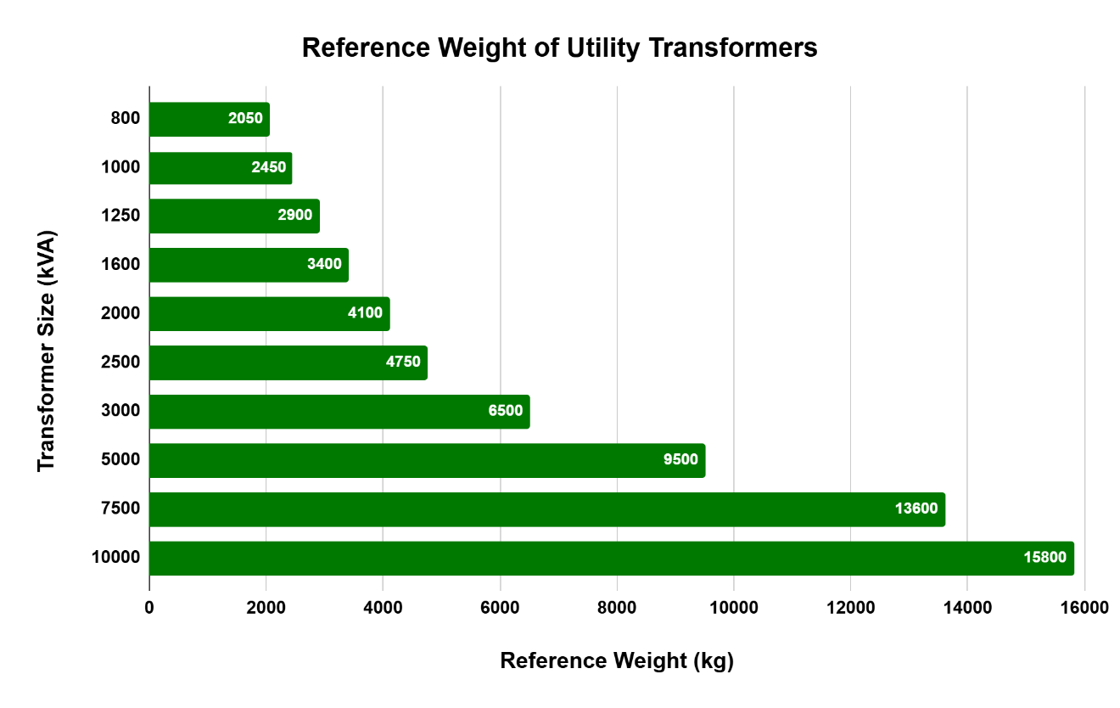
Figure 4.1. Comparison of transformer capacity to reference weight.[34]

This challenge is exacerbated by an ongoing supply shortage[19], [35]. What used to be a lead time of 4-6 weeks for many common transformer types has now extended to 18-36 months, with specialized units taking as long as six years to deliver in some cases[19]. These delays are due to increased demand driven by load growth, electrification, and extreme weather events and by constriction in manufacturing where raw material shortages and limited qualified producers plague the industry[19].
The U.S. transformer fleet is actively aging, and distribution-level transformers are being rapidly installed with grid expansions, EV charging developments, and wildfire/hurricane infrastructure rebuilds. Manufacturers have responded with hundreds of millions in investments to expand capability, however, these efforts are unlikely to resolve the problem before the late 2020’s[19]. Meanwhile, utilities continue to face the dual threat of increased transformer failure risk and inability to source timely replacements, which slows the recovery time from outages and minimizes resilience. In this context, the capability to rapidly deploy replacement transformers–particularly in hard-to-reach sites–becomes a logistical question and a strategic priority for grid resiliency.
While transformer weight presents a clear barrier to efficiency in logistics, size and shape also poses a different and limiting set of challenges. Components like wind turbine blades are exceptionally long, stiff, and difficult to maneuver, especially in rural or mountainous terrain where wind resources are most abundant[36].
Wind turbine blades for smaller units can range from 120 feet to 215 feet, while larger utility-scale blades can exceed 280 feet in length[37]. Transporting these therefore requires specialized trucks and trailers with a minimum of ten axles according to a logistics company. This also includes extensive route planning to navigate narrow roads, sharp turns, overpasses, and height restrictions[38]. In some cases, utility companies and turbine developers are required to modify roadways, remove utility poles, or construct new pathways all together just to deliver this equipment[38].
This added burden significantly increases lead time, environmental disturbance of ecosystems, and overall project costs. Transporting these blades short distances can cost between $30,000 to $40,000 while longer distances can surpass $100,000[38], [39]. Even with more advanced group transportation innovations used to maneuver the blades only marginally solve the delivery time as these technologies reduce transport speeds, are sensitive to external conditions, and still require expertly skilled personnel[39].

Recent Events: Substations Under Siege
Recent severe hurricanes have exposed how fragile the substation infrastructure is and how convoluted the logistics of traditional recovery methods are. During Hurricane Irma (2017) over 6 million customers across several southeastern states and Puerto Rico lost power as a result of the strong winds, flash flooding, and tornadoes that damaged vast amounts of infrastructure[40], [41], [42]. Substations were flooded and transformers were damaged, leading to cascading outages and extended recovery timelines[41], [42]. The storm caused road damages which further complicated the restoration process by delaying the movement of repair teams and delivery of replacement equipment[41]. Evacuation orders and impassable routes caused additional friction in the repair process, showing how dependent the grid is on functional ground infrastructure and the challenges associated with the damage when that method of transport is compromised[41].
Further, Hurricane Helene in 2024 provided another perspective of complications during such extreme weather events. Topography and rural geography played a significant role in constraining the recovery process from Hurricane Helene. The storm had extreme rainfall and flooding to western North Carolina and eastern Tennessee, washing out Interstate 40, a major east-west route connecting the two states, disconnecting transport lines between regions. Substations located in mountainous and low-lying coastal zones were severely impacted, with crews unable to reach affected areas due to landslides, road collapses, and broken dams[35]. Emergency response teams reported delays of over 48 hours in reaching critical sites with over 4 million outages[18], [43], causing grid outages to persist for longer than anticipated[35]. In scenarios like Hurricane Helene needed a way to bypass the damaged infrastructure or navigate through the mountainous terrain quickly to deliver personnel and equipment directly to the disaster zones to cut response ties and mitigate the extent of the blackouts.

Airships: Unrealized Logistics Solution
As illustrated in recent disasters, one of the most significant limitations in power system recovery is the inability to deliver equipment rapidly and reliably to compromised locations. Whether due to washed-out roadways from hurricanes or constricted access following security incidents, traditional logistics pathways have repeatedly proven inadequate in emergencies. In this context, hybrid airships present an underutilized and effective tool to transform how utilities respond to grid failures and damages.
Airships cannot resolve the manufacturing delays affecting the transformer supply chain, but they can bridge the delivery gap once equipment is available. With the ability to lift heavy loads and hover directly over a delivery site, airships eliminate the dependency on roads, bridges, shipping ports, or rail infrastructure, all of which are prone to damage or congestion in crisis situations[8], [9]. This means that equipment like large power transformers, mobile substations, or emergency repair crews could be deployed with the speed and precision needed to bypass restoration delays[44].
Airships also reduce the physical stress on sensitive components by minimizing loading and unloading events which lowers the risk of in-transit damage. Unlike conventional multimodal transport systems, involving multiple transfers between trucks, ships, or trains[45], airships provide direct source to destination movement. This ensures cargo arrives both intact and on schedule. In an industry where every hour of delay can affect thousands of lives, this level of reliability is imperative[4], [5], [6].
Further, airships can be strategically pre-stages as mobile disaster response depots near high-risk zones when extreme weather is anticipated. Equipping them with spare transformers, switchgears, or other commonly damaged equipment along with modular repair tools, airship platforms could allow utilities to launch restoration activities immediately when safe to do so following a disaster. Figure 4.2. provides a direct comparison between the current disaster response conditions and how responses could be improved through the implementation of hybrid airships in disaster response. The adoption of airships in emergency response is a proactive model that has the potential to redefine grid resilience, shorten outage duration, and reinforce the grid system’s ability to recover under extreme conditions.
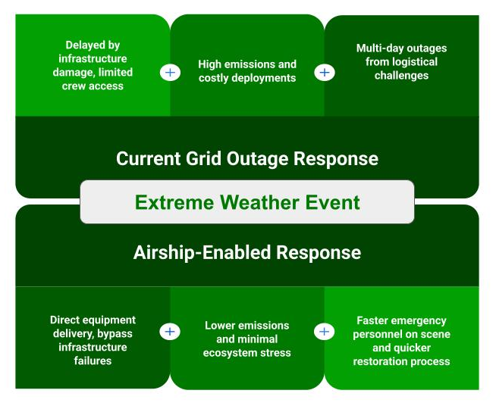
Figure 4.2. Response comparison to recent hurricanes with and without airship assistance.

Quantitative Analysis of Cargo Transportation Methods

Freight Volume and Payload Capacity
In 2023, the United States freight transport was dominated by maritime and surface modes, with shipping barges moving upwards of 101,486 billion ton-kilometers while air freight accounted for just 303 billion ton-kilometers[46]. Figure 5.1. displays the imbalance of the role aviation has in bulk cargo logistics–a consequence of its limited capacity, high operational costs, and large environmental impact. When it comes to moving large utility equipment, each mode faces its own set of limitations beyond raw volume[23], [46].
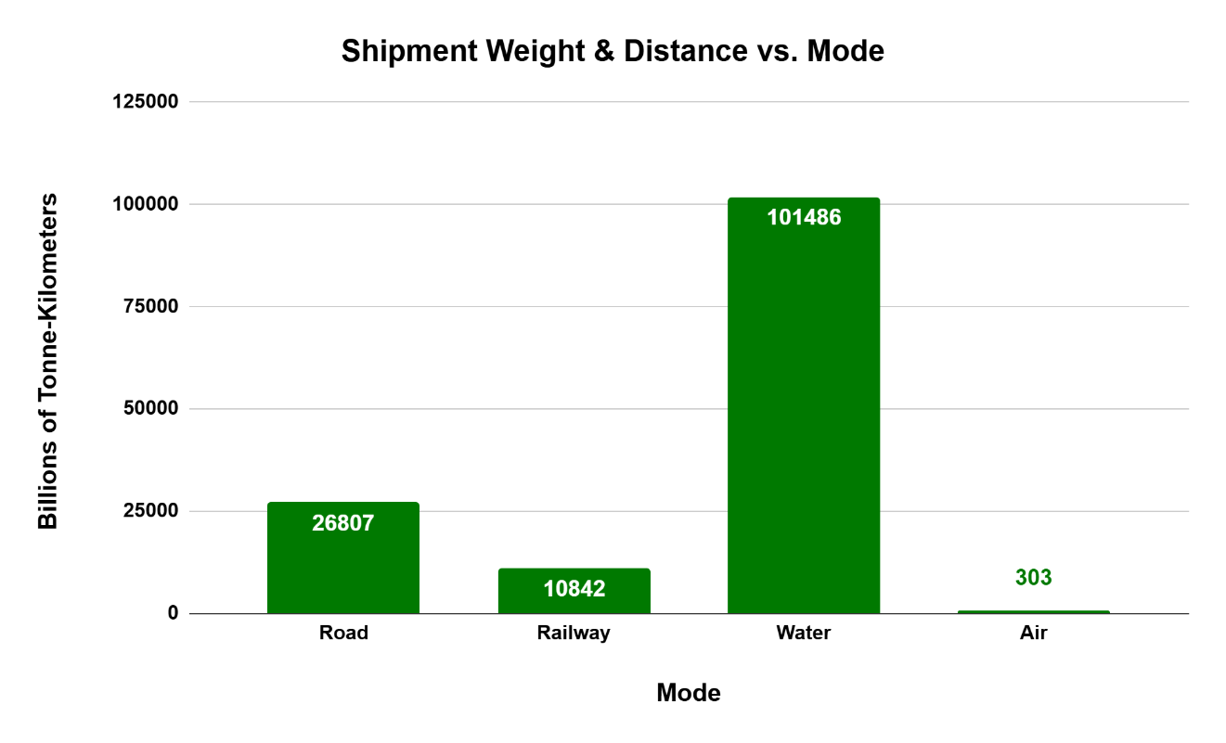
Figure 5.1. Shipment by mode distribution in 2023 in the United States.

Shipping barges boast unmatched capacity, hauling over 1,500 tons at a time, but they are vastly restricted to navigable waterways and lack route flexibilities, especially when equipment must be delivered inland. Semi-trucks carry up to 40 tons but depend on intact roads, bridges, and highways–all of which may be compromised in extreme events. Helicopters, while extremely agile, typically only lift 0.6 to 2 tons, making them unsuitable for large equipment. In contrast to these modes, hybrid airships are constantly emerging with higher and higher payload capacities currently touting over 60 tons in carrying capacity, combining the accessibility advantages of helicopters with the load-bearing power of ground and maritime transport. Airships fill the middle ground being capable of reaching difficult terrain, carrying substation transformer-weight cargo.

Carbon Emissions Sustainability within Cargo Transportation
Air freight is not only minor in scale, but also disproportionately harmful in terms of carbon emissions. Air freight emits approximately 10 times the grams of CO2 per ton-kilometer than that of the trucking industry and almost 20 times more than shipping barges. The current technology utilized for cargo transport in aviation does not align with the overall sustainability goals of the country.
By contrast, hybrid airships have been shown to produce up to 50 times fewer CO2 emissions than helicopters, dependent upon the load and flight conditions. This positions them as a drastically more sustainable air freight solution that can access virtually all regions without incurring the environmental cost typical of aviation logistics. Moreover, unlike trucks, trains, and barges, airships do not require smooth, flat land, or vast waterways[46], [47] meaning that there’s no need to disrupt ecosystems with the development of roads, railways, or ports.

Regulatory, Technical, and Industry Pathways Forward

Current Standing and Applications of Airships
Airships were once regarded as a memory of early human flight history but are gradually reentering the logistics conversation as a legitimate, scalable solution to some of the most complex challenge facing modern industries[17]. While full-scale deployment remains limited, the technological evolution in materials, propulsion, and navigation has reignited interest across both the public and private sectors. Several companies are demonstrating prototype successes and securing regulatory approvals, partner investments, and early customers focused on remote locations, emergency response, and environmentally friendly deliveries.
Current applications remain largely in demonstrative and pilot stages of development, but several tests and niche deployments show progress to the airship revival. In northern Canada and Alaska, airships are being examined for use in moving food and medical supplies to indigenous and rural communities inaccessible by roads for much of the year due to the extreme weather conditions of the winter seasons[31], [48], [49]. Similarly, agriculture and resource extraction industries possess interest in using hybrid airships for delivering fuel, equipment, and labor to difficult terrains without the environmental damage of additional road construction[8]. These use cases are applicable where traditional transport options are cost prohibitive or physically infeasible.
At a policy level, the regulatory framework surrounding airship operations is still evolving to compensate for recent developments. FAA Part 43 provides the maintenance and airworthiness requirements applicable to U.S. registered aircrafts, including experimental and hybrid models[20], [21], [50], but it lacks tailored guidance specific to hybrid airship configurations and capabilities. Despite this gap in regulation, agencies and operators are actively exploring how to adapt these preexisting boundaries to accommodate modern designs. In anticipation of continued developments, public and private initiatives are beginning to appear which encourages coordination between government organizations and manufacturers to build airship-compatible protocols.

Limitations and Challenges
Even with compelling evidence of the potential modern airships possess, they still face several barriers to entry that limit widespread adoption. One of the most significant challenges associated with airship readoption is the heavy reliance on helium which is a scarce and non-renewable resource that is heavily demanded in other industries as well[17]. While helium can be recycled within the airship industry, the cost associated with this, and additional supply concerns persist[17]. Alternatives to helium, like hydrogen, exist but regulatory restrictions and public fear from the historical accidents associated with hydrogen airships remain a barrier for this solution[7].
In addition to the lighter than air gas sources, operational challenges include a vulnerability to strong winds that affect maintaining control of the aircraft when on the ground as well as a technically complex buoyancy control system[7], [14]. Scalability is also a concern as airships benefit from increased size, but larger size comes with a larger upfront cost[7]. When trying to test these larger airships, smaller models need to be built. It’s hard to build and test smaller airships because the scale influences the overall aircraft performance which makes it tough to construct for startups to prove valuable and attract investment[7]. Developing a commercially viable cargo airship often demands an investment level out of reach of what historically has been financially feasible.
Within the power system sector, these issues are compounded by additional constraints. Airships intended to carry heavy infrastructure like transformers must prove ultra-reliable and resilient operations under emergency conditions. These expectations are high especially for innovations that are still trying to prove their worthiness[15]. Severe weather and rough terrain, often the scenarios where airships could be most impactful, are also the most punishing for experimental technologies.
With no clear rules yet about where and how large hybrid airships can fly, regulatory ambiguity makes it difficult to plan safe and legal routes to start testing this new technology in emergency response. Industry hesitation to adopt unproven systems means utility companies will remain reluctant without government backing and corresponding regulations[15]. Until airships can demonstrate a consistent, scalable performance under real-time grid logistics crises, they will remain a promising but peripheral solution.

Roadmap to Full Integration
For hybrid airships to fulfill their potential as critical logistics solutions in the power sector, the surrounding regulatory framework must be modernized to match the changing climate. Currently, these aircrafts fall under the 14 CFR Part 21 from FAA, which discusses the certification of aircraft products and parts[20]. While this offers a baseline, it was constructed primarily for conventional fixed-wing aircrafts, not for the hybrid airships seen emerging today.
Airships occupy a regulatory grey zone for their overall function in the sky. FAA Advisory Circular 21.17-1 provides provisional guidance under Section 21.17(b) for special class aircraft[20], but this guidance leans heavily on legacy models such as blimps or military surveillance[14]. It lacks the specificity required to certify large-payload hybrid cargo airships intended for post-disaster deployment. Existing documentation, such as FAA-P-8110-2[22], references cargo transport capabilities but offers no operational policies or criteria tailored to the airship’s role in grid resilience or emergency response scenarios. Operational rules similarly omit language enabling emergency priority use cases or infrastructure-critical logistics.
In parallel, NERC and federal energy agencies should begin incorporating airship logistics into resilience planning. As threats to substation infrastructure from weather escalate, policy must reflect the need for rapid independent-response logistics. This includes pre-positioned hybrid airships equipped for emergency delivery, aerial deployment of personnel, and high-risk route access mapping during blackouts. Currently, there are no governmental incentives to encourage utilities to explore these methods. By funding pilot programs, creating reliability standards that recognize the aerial logistics capabilities, and developing interoperability protocols, agencies like NERC can build the policy infrastructure needed to unlock the airships industry.
To build trust in this technology and truly establish the value proposed, real-world testing is required. Deployments should be actively evaluated during emergency response scenarios, whether as part of scheduled disaster drills or in the aftermath of catastrophic events. These tests should compare traditional truck- and rail-based response systems against the airship methods in terms of response speed, operational flexibility, access to damaged areas, and power restoration time. Performing this comparison will provide the empirical data necessary to inform future investments, guide regulation, and propel industry confidence. Without deliberate testing and documentation of airship performance during crises, their potential will remain theoretical than practical.
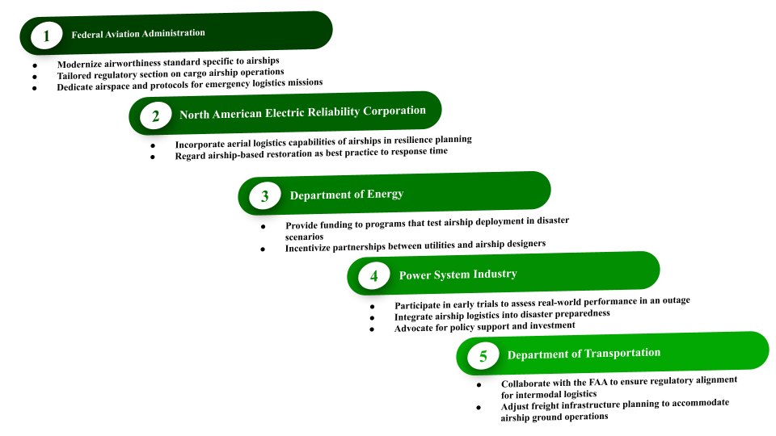
Figure 6.1. Recommendations for stakeholders in the airship adoption process.

Conclusion
This resurfaced focus on airships is not speculative, it is grounded in real challenges with current logistics, environmental limits, and disaster response readiness. Airships bring a convergence of capabilities with VTOL, minimal ground infrastructure, and significantly lower emissions. These features make hybrid airships optimal for operation in environments where traditional freight systems are ineffective or entirely inoperable.
As extreme weather events grow in frequency and magnitude and the infrastructure continues to age and be heavily loaded, limitations of conventional emergency response logistics become harder to cope with. The power grid, and particularly substations, cannot afford delays in restoration when a lack of power deeply impacts lives. Hybrid airships offer a scalable, sustainable solution that fills logistical gaps during crises and supports long-term decarbonization goals.
Integrating these aircrafts into utility logistic planning will not be a simple task. It will require regulatory adoption, industry acceptance, and performance validation. However, the foundation to this process is already in place as technologies are always advancing, companies are developing airships for research, and policy conversations are being held. This thesis contends that the path forward to resiliency within the energy sector is through airships.

REFERENCES
[1] H. Trabish, “Transformer Supply Bottleneck Threatens Power System Stability As Load Grows,” Utility Dive.
[2] M. Manikandan and R. S. Pant, “Research And Advancements In Hybrid Airships—A Review,” Nov. 01, 2021, Elsevier Ltd. doi: 10.1016/j.paerosci.2021.100741.
[3] B. E. Prentice, A. Phillips, R. P. Beilock, and J. Thomson, “Industry Issue Paper: The Rebirth of Airships Transportation Research Forum,” 2005.
[4] O. J. Chukwuka, J. Ren, J. Wang, and D. Paraskevadakis, “Managing Risk In Emergency Supply Chains–An Empirical Study,” International Journal of Logistics Research and Applications, 2024, doi: 10.1080/13675567.2024.2359645.
[5] “Emergency Preparedness and the Importance of Equipment Repositioning.” [Online]. Available: https://www.nema.org/storm-disaster-recovery/replacing-and-relocating-equipment/emergency-preparedness-and-the-importance-of-equipment-re
[6] J.-P. Rodrigue, “9.4-Transportation, Disruptions and Resilience”, doi: 10.4324/9781003343.
[7] “Airships- Challenges to Overcome,” ISOPolar. Accessed: Jun. 21, 2025. [Online]. Available: https://isopolar.com/public-policy-airships/
[8] C. Neal and T. T. R. Koo, “Demand For Cargo Airships: An Analysis Of Mode Choice Decision Making In The Freight Transport Industry,” J Air Transp Manag, vol. 83, Mar. 2020, doi: 10.1016/j.jairtraman.2019.101741.
[9] T. Williams, “An Assessment Of The Potential Use Of Modern Airships In Humanitarian Logistics,” 2022.
[10] A. Mitra et al., “Enhancing Cargo Transportation by Reducing Airship Operating Costs,” 2024. [Online]. Available: http://www.sti.nasa.gov
[11] C. Stockbridge, A. Ceruti, and P. Marzocca, “Airship Research And Development In The Areas Of Design, Structures, Dynamics And Energy Systems,” 2012. doi: 10.5139/IJASS.2012.13.2.170.
[12] M. Murugaiah, D. F. Theng, T. Khan, T. A. Sebaey, and B. Singh, “Hybrid Electric Powered Multi-Lobed Airship for Sustainable Aviation,” Aerospace, vol. 9, no. 12, Dec. 2022, doi: 10.3390/aerospace9120769.
[13] B. E. Prentice and R. Knotts, “Give to AgEcon Search,” Toronto, May 2016. [Online]. Available: http://ageconsearch.umn.edu
[14] M. Piesing, “Are We in an Airship Renaissance?,” National Air and Space Museum. Accessed: Jun. 21, 2025. [Online]. Available: https://airandspace.si.edu/air-and-space-quarterly/issue-9/airships
[15] A. Sherer, “It’s Time for the Age of the Airship to Return,” Jan. 2025. [Online]. Available: https://bpr.studentorg.berkeley.edu/2021/12/26/its-time-for-the-age-of-the-airship-to-return/#:~:text=Based
[16] M. Harris, “The World’s Largest Aircraft Breaks Cover In Silicon Valley Sergey Brin-Backed Airship Startup LTA Research Begins Flight Testing Today,” Tech Crunch. [Online]. Available: https://techcrunch.com/2023/11/08/the-worlds-largest-aircraft-breaks-cover-in-silicon-valley/
[17] “Airships Are Back To Clean Up Aviation. Will They Take Off?” [Online]. Available: https://www.positive.news/environment/airships-are-back-promising-to-clean-up-aviation/
[18] R. Chaturvedi, “Why Better Monitoring Of US Transformers Is A National Security Imperative,” 2025. [Online]. Available: https://www.utilitydive.com/news/monitoring-transformer-shortage-national-security/749349/
[19] “The Electrical Equipment Shortage Looms Over Helene Recovery.” [Online]. Available: https://www.latitudemedia.com/news/the-electrical-equipment-shortage-looms-over-helene-recovery/
[20] “Advisory US. Deportment of Transportation.”
[21] “Public Policy and Airships,” ISOPolar. Accessed: Jun. 21, 2025. [Online]. Available: https://isopolar.com/airships-challenges-to-overcome/
[22] “Airship Design Criteria,” Jun. 1995.
[23] P. Tatham, C. Neal, and Y. Wu, “Hybrid Cargo Airships: A Humanitarian Logistic Game Changer?,” Journal of Humanitarian Logistics and Supply Chain Management, vol. 7, no. 2, pp. 102–125, 2017, doi: 10.1108/JHLSCM-09-2016-0036.
[24] C. Mebius, Should Airships Make A Comeback?, (Aug. 31, 2023). Accessed: Jan. 05, 2025. [Online Video]. Available: https://www.youtube.com/watch?v=ZjBgEkbnX2I&ab_channel=Veritasium
[25] M. Harris, “LTA Research Airship Flies Over San Francisco Bay,” IEEE Spectrum.
[26] K. Pickering, “Flying Whales Eyes Cargo Revolution With A Familiar Solution,” Airport Technology, Sep. 2023.
[27] B. Chang, “French Company Flying Whales Is Creating An Airship That Can Pickup And Drop Cargo Without Landing — See How,” Business Insider.
[28] G. Norris, “Up Close: Lockheed Martin’s LMH-1 Hybrid Airship,” Aviation Week Network.
[29] N. Kobie, “The Sky-High Future Of The Airlander’s Remarkable Flying Bum,” Wired.
[30] “Hybrid Air Vehicles,” AeroEXPO Connect.
[31] B. E. Prentice, Y. Y. Lau, and A. K. Y. Ng, “Transport Airships For Scheduled Supply And Emergency Response In The Arctic,” Sustainability (Switzerland), vol. 13, no. 9, May 2021, doi: 10.3390/su13095301.
[32] “Airship Technology for Air Connectivity and Humanitarian Aid in the Caribbean and the Pacific: Transport and trade connectivity in the age of pandemics UN solutions for contactless, seamless and collaborative transport and trade,” Jan. 2022.
[33] “What Really Happened with the Substation Attack in North Carolina?,” Practical Engineering.
[34] “What Is A Substation Transformer?,” Daelim Transformers. Accessed: Jun. 21, 2025. [Online]. Available: https://www.daelimtransformer.com/a-substation-transformer.html
[35] G. Mehta, “Hurricane Helene Could Force Local Utilities To Rethink Grid Resilience As Recovery Efforts Continue, Utilities In Appalachia Need To Consider Their Approach To Providing Electricity In The Face Of Climate Change,” 2024. [Online]. Available: https://www.canarymedia.com/articles/utilities/hurricane-helene-could-force-local-utilities-to-rethink-grid-resilience
[36] “Wind Turbines Blades.” [Online]. Available: https://www.iberdrola.com/sustainability/wind-turbines-blades#:~:text=The
[37] “Eight Interesting Facts About Wind Turbine Blades,” Iberdrola. Accessed: Jun. 21, 2025. [Online]. Available: https://www.iberdrola.com/sustainability/wind-turbines-blades
[38] “Blade Lifter: Wind blade transportation,” Iberdrola. Accessed: Jun. 21, 2025. [Online]. Available: https://www.iberdrola.com/about-us/our-innovation-model/blade-lifter-wind-turbine-blades-transportation
[39] “Wind Turbine Blade Sizes And Transport: A Guide.” [Online]. Available: https://www.utilitydive.com/spons/wind-turbine-blade-sizes-and-transport-a-guide/623444/
[40] J. McNamara, “Why Did Hurricane Irma Leave So Many People in the Dark?,” The Equation, Sep. 14, 2017.
[41] “NERC | Report Title | Report Date I Hurricane Irma Event Analysis Report,” 2018.
[42] D. Mitsova, A.-M. Esnard, A. Sapat, and B. S. Lai, “Socioeconomic Vulnerability And Electric Power Restoration Timelines In Florida: The Case Of Hurricane Irma,” Natural Hazards, vol. 94, no. 2, pp. 689–709, Nov. 2018, doi: 10.1007/s11069-018-3413-x.
[43] “Hurricane Helene: Rebuild Efforts Continue,” Edison Electric Institute. Accessed: Jun. 21, 2025. [Online]. Available: https://www.eei.org/en/mutual-assistance/helene
[44] S. Tomasik and P. Fuhr, “Airships as Transformative Tools for Power Systems Logistics: Addressing Infrastructure Challenges and Enhancing Disaster Resilience,” International Research Journal of Engineering and Technology, vol. 12, no. 01, Jan. 2025, doi: 10.4324/9781003343.
[45] “What is Multimodal Transportation?,” Quality Carriers. Accessed: Jun. 21, 2025. [Online]. Available: https://qualitycarriers.com/intermodal/what-is-multimodal-transportation/
[46] S. Greene, “Freight Transportation,” Feb. 2023. [Online]. Available: https://climate.mit.edu/explainers/freight-transportation
[47] S. R. Lynch, A. Esmail, K. Mccoy, D. Rembert, and C. Hilliman, “Consensus On The Effective Employment Of Hybrid Airships In Future Disaster Logistics,” 2018.
[48] B. E. Prentice and M. Adaman, “Economics Of Cargo Airships For Food Transport To Remote Northern Communities,” Research in Transportation Business and Management, vol. 25, pp. 87–98, Dec. 2017, doi: 10.1016/j.rtbm.2017.06.001.
[49] B. E. Prentice, “Intermodal Competition: Cargo Airships versus Long-Haul Trucking for Perishable Commodities,” J Transp Technol, vol. 14, no. 02, pp. 195–211, 2024, doi: 10.4236/jtts.2024.142012.
[50] “Special Federal Aviation Regulation No. 88 Fuel Tank System Fault Tolerance Evaluation Requirements Title 14-Aeronautics and Space Chapter I-Federal Aviation Administration, Department of Transportation Subchapter C-Aircraft Part 21 Certification Procedures for Products and Articles.”

Vita
Stephanie Marie Tomasik was born and raised in Mukwonago, Wisconsin. She earned her Bachelor of Science degree in Electrical Engineering from The University of Tennessee, Knoxville in December 2023. Continuing her academic journey at the same institution, she pursued a Master of Science in Electrical Engineering, with an expected graduation date of August 2025.
Stephanie’s research interests center on advancing energy justice through microgrid development and enhancing power system resiliency. Her work explores emerging technologies such as exoskeletons to support utility linemen and hybrid airships for critical cargo and personnel transport. These innovative approaches reflect her broader commitment to sustainable and accessible infrastructure solutions.
Upon completing her master’s degree, Stephanie plans to pursue a Ph.D. in Electrical Engineering. Her long-term goal is to contribute to the evolution of the power and energy sector while helping guide and inspire the next generation of engineers.

