Augmented Reality on Mobile Devices to Improve the Academic Achievement and Independence of Students with Disabilities

A Dissertation Presented for the
Doctor of Philosophy
Degree
The University of Tennessee, Knoxville

Donald Douglas McMahon
May 2014

Copyright © 2014 by Donald Douglas McMahon
All rights reserved.

Dedication

To my wife
Amanda McMahon, the love of my life

my daughter
Sydney Reese, who teaches me about joy everyday

and my parents
Don and Billie McMahon, the best teachers I have ever had

Thank you all for your love, inspiration, and support!

Acknowledgements
I would like to thank my committee members, Dr. David Cihak, Dr. Sherry Bell, Dr. Mari Beth Coleman, and Dr. Gary Skolits for their guidance, feedback, and support. A doctoral program is a long journey. Your guidance helped make this journey a success. In particular, I would like to thank Dr. David Cihak for supporting, encouraging, and directing my progress. Your support made my doctoral program the amazing experience it has been through all the research, classes, projects, grants, applications, good ideas and bad ideas.
I would like to thank my parents for all of their support from birth until now. This work would not have been possible without your time, support, and love. You are the best people I know and I love you very much.
Thank you to my friend Dr. Zachary Walker for his friendship and collaborations during my doctoral program. Thank you to my friend Rachel Wright for her help, advice, and redirection when I needed it.
Additionally, I would sincerely like to acknowledge the participants in this research. Thank you for your hard work and your time. You are an amazing group of people that I am fortunate to know.
Finally, thank you to all my professors, teachers, students, family, and friends for the opportunity to learn from you.

And now the end is near
And so I face the final curtain
My friend I'll say it clear
I'll state my case of which I'm certain
Regrets I've had a few
But then again too few to mention
I did what I had to do
And saw it through without exemption
I planned each charted course
Each careful step along the byway
And more, much more than this
I did it my way
Frank Sinatra, My Way.

Abstract
Augmented reality (AR) is a technology that overlays digital information on a live view of the physical world to create a blended experience. AR can provide unique experiences and opportunities to learn and interact with information in the physical world (Craig, 2013). The purpose of this dissertation was to investigate uses of AR on mobile devices to improve the academic and functional skills of students with disabilities.
The first chapter is a literature review providing a clear understanding of AR and its connections with existing learning theories and evidence-based practices that are relevant for meeting the needs of individuals with disabilities. This chapter explores the available research on mobile devices, AR educational applications, and AR research involving students with disabilities.
The purpose of Study 1 was to examine the effects of an augmented reality vocabulary instruction for science terms on college-aged students with ID. A multiple probe across skills design was used to determine if there was a functional relation between the AR vocabulary instruction and the acquisition of correctly defined and labeled science terms. The results indicated that all participants learned new science vocabulary terms using the augmented reality vocabulary instruction.
Study 2 examined the effects of using an AR navigation, Google Maps, and a paper map as navigation aids for four college-aged students with ID enrolled in a PSE program. Using an adapted alternating treatments design, students used the three navigation aids to travel independently to unknown businesses in a large downtown city to seek employment opportunities. During the intervention phase, students used a mobile device with Google maps and the AR application to navigate to unfamiliar businesses. Results from Study 2 indicated all students improved navigation decision making when using AR.
In the final chapter, both studies are discussed in relation to the AR research literature and as potential interventions. Findings from the studies include the capabilities of ARon mobile devices, academic and functional applications of this technology for students with disabilities, implications for mobile learning, and limitations of this technology. Recommendations for future research are presented to further examine using AR for students with disabilities.

TabLE of Contents
Chapter 1: Understanding Augmented Reality as an Instructional Tool for Students with Disabilities 1
Organization of This Dissertation 2
Research Questions 3
Key Terms 4
Theoretical Foundations of Augmented Reality 6
Augmented Reality 6
Mixed Reality. 7
Types of AR 8
AR in relation to UDL, AT, and IT 10
Universal Design for Learning 10
Assistive Technology 16
Review of Research 19
Mobile learning for students with ID and ASD 21
Evidence-Based Practices on mobile devices 22
Research on Augmented Reality 24
Marker-Based AR 26
Markerless AR 28
Mixed Reality and Students with Disabilities 30
Virtual Reality and Students with Disabilities 31
AR and Students with Disabilities 32
Research Plan 34
Why AR matters for students with disabilities 34
Purpose of this Research 35
Research Questions 36
Chapter 2: Augmented Reality as an Instructional Tool for Teaching Vocabulary to Postsecondary Education Students with Intellectual Disabilities and Autism 37
Methods 42
Participants 42
Setting 46
Materials 46
Variables and Data Collection 50
Procedures 50
Design 54
Data Analysis Procedures 54
Interobserver and Procedural Reliability 55
Social Validity 56
Results 57
Effect Size. 69
Social Validity Results. 72
Discussion 74
Limitations 75
Future Studies 76
Summary 77
Chapter 3: Augmented Reality as a Navigation Tool to Employment of Activities for Postsecondary Education Students with Intellectual Disabilities 78
Barriers to Employment 78
Mobile Devices for Students with Disabilities. 79
Augmented Reality for Location Based Learning and Navigation 81
Purpose: Navigating to Employment Opportunities 82
Methods 84
Participants 84
Settings 87
Research Design 87
Treatment Conditions and Materials 88
Variables and data collection 91
General Procedures 94
Data Analysis Procedures 97
Interobserver Agreement and Treatment Integrity 97
Social Validity 99
Results 99
Social Validity Results. 108
Discussion 110
Limitations 112
Future Studies 112
Conclusion 113
Chapter 4: Implications for the Future of Augmented Reality and Individuals with Disabilities 114
Mobile Learning 114
AR in Education 118
UDL and AR 119
Limitations 120
Future Research 121
Lines of Research from Study 1 122
Lines of Research from Study 2 125
Preparing for the Augmented Future 127
Conclusion 130
References 131
Appendices 154
Appendix A. Study 1: Vocabulary Words 155
Appendix B. Study 1: Sample Data Collection Form AR Vocabulary List 1 156
Appendix C. Study 1: Treatment Integrity Checklist Vocabulary 160
Appendix D. Study 1: Social Validity Questionnaire 161
Appendix E. Data Collection Form: Study 2 Navigation 162
Appendix F. Study 2: Procedural Integrity Data Sheet 164
Appendix E. Sample Data Collection Form: Navigation 165
Vita 166

LIST OF TABLES
Table 1. Study 1: Participants Characteristics 44
Table 2. Study 1: Effect sizes by student. 71
Table 3. Study 1: Student responses to social validity questions 73
Table 4. Study 2: Participant Characteristics. 85
Table 5. Study 2: Student responses to social validity questions. 109

LIST OF FIGURES

Figure 1. Milgram and Kishino’s Mixed Reality Continuum 7
Figure 2. Marker based augmented reality used to teach sight words. 8
Figure 3. A screenshot of markerless AR 9
Figure 4. UDL, AT, and IT. 11
Figure 6. The Gartner Hype Cycle of New Technology. 20
Figure 7. Study1: Screenshot from mobile device displaying the AR content. 49
Figure 8. Study 1: Student using the AR vocabulary intervention. 53
Figure 9. Study 1: Miguel’s results 59
Figure 10. Study 1: Catherine’s AR Vocabulary results. 62
Figure 11. Study 1: Billie’s AR Vocabulary results. 65
Figure 12. Study 1: Brenda’s AR Vocabulary results. 68
Figure 13. Study 1: Graph of PND by Student 70
Figure 14. Study 2: Augmented Reality view of location based jobs information 90
Figure 15. Study 2: Participants using the mobile devices 92
Figure 16. Study 2: Jamie’s navigation results graph. 101
Figure 17. Study 2: Catelyn’s results graph. 103
Figure 18. Study 2: Jon’s results graph. 105
Figure 19. Study 2: Ayra’s results graph 107
Figure 20. Examples of marker-based AR for functional skills. 124
Figure 21. Examples of markerless AR for academic learning 126

Chapter 1
Understanding Augmented Reality as an Instructional Tool for Students with Disabilities: Problem Statement
Educators have more educational technological tools at their disposal than at any time in history due to the proliferation of new technologies, mobile devices, applications, and other innovations available for the delivery and creation of instructional content. Many of these new tools have “provided special educators with new and creative strategies for implementing interventions for students with disabilities” (Carnahan, Basham, Christman, & Hollingshead, 2012, p. 50). This research explores the potential of augmented reality (AR) which is an interactive technology based medium that engages people with digital content in the physical world (Craig, 2013). AR uniquely bridges the digital world and physical world to create a blended environment that has the benefits of both by allowing users to experience digital information in the physical world. At this time, the problem with AR instructional tools for students with disabilities is that there is limited research evidence for their use. If this new medium is to be effectively applied to meet the needs of individuals with disabilities, AR interventions need to be designed to connect with existing learning theories and evidence-based practices. After being examined empirically, these practices can become another technological-based intervention option to increase the academic achievement and functional independence of students with disabilities.
This dissertation includes an examination of the features, capabilities, and available research in order to provide an adequate understanding of AR as a strategy for students and teachers. It also examines connections between the principles of Universal Design for Learning (UDL) and AR in education. Learning is becoming increasingly mobile as people use new devices to access information whenever and wherever they need it (Elias, 2011). AR on mobile devices provides a new means of viewing digital information in the physical world. The combination of real world and digital information will only continue to grow as a field (Wu, Lee, Chang, & Liang, 2013). In summary, AR is a relatively young technology based medium that is beginning to be examined in education, but needs additional research to establish it as a means to address the needs of teachers and students. AR research in education tends to involve students without disabilities related to science, language arts, and math activities. Research is needed involving students and people with disabilities. The purpose of this dissertation is to examine empirically the use of AR technologies on mobile devices for college students with intellectual disabilities (ID) and autism spectrum disorders (ASD).
Organization of This Dissertation
This four chapter dissertation examines the use of augmented reality as an instructional and functional living tool for students with disabilities. Chapter 1 defines augmented reality, its relationship to related mediated reality concepts, the importance of mobile devices for learning in terms of augmented reality for students with disabilities, what research has been conducted on AR in education, a discussion of the current problems of AR in education for students with disabilities, and the research questions to be examined in this dissertation. Chapter 2 is the first study of this two-study dissertation and it is designed to stand alone as a single subject design study. It examines an AR based intervention to teach academic vocabulary to postsecondary education students with intellectual disabilities. Chapter 3 is the second study of this two-study dissertation and designed to stand alone as a single subject design study. It examines an AR based intervention to support functional navigation skills relating to an employment task to postsecondary education students with intellectual disabilities. Chapter 4 is a discussion of the findings from both studies and previous research, implications from these studies, a discussion of AR technology trends, the importance of AR specifically for students with disabilities, and what needs exist in future AR research for people with disabilities.
Research Questions
Study 1
The purpose of this study is to examine the effects of a marker-based AR technology to teach college students with ID and ASD science related vocabulary words. Specific research questions include:
- What are the effects of marker-based augmented reality vocabulary instruction on the acquisition of science vocabulary words of college students with ID and ASD?
- Do college students with ID and ASD find augmented reality vocabulary instruction to learn new science vocabulary words socially acceptable?
Study 2
The purpose of this study is to examine the effects of a markerless AR technology to teach college students with ID and ASD to navigate a city independently to local businesses. Specific research questions include:
- What are the differential effects of using a printed map, Google Maps, and a markerless augmented reality navigation map on navigating a city independently to businesses for college students with ID and ASD?
- Which navigation strategy does college students with ID and ASD report as being most helpful and socially acceptable?

Key Terms
Augmented Reality: A field of technology and/or a medium using technology that combines a live view of the physical world, overlaid with digital information, which can include text, pictures, audio, and video. At times AR will be referred to both as medium and a technology.
iOS Devices: The operating system used by iPhones, iPads, and iPod Touch devices, that includes access to over 1 million mobile apps available on Apple’s App Store.
Internet of Everything: A developing concept in information technology that describes an interconnected world that includes a wide variety of Internet connected devices including household appliances, medical devices, mobile devices, traditional computers, and public infrastructure.
Marker: In the field of augmented reality a “marker” is an object that when viewed by the AR application will trigger preselected digital content. Examples include pictures, audio, and video that display for the user when the user views the printed trigger. Markers are sometimes referred to as triggers or trigger images. This form of AR generally does not require an internet connection and/or GPS.
Markerless or Markerless AR: Also referred to as location based AR. This is a type of augmented reality that displays digital information based on a user's specific location. This type information generally requires access to the internet and/or Global Position System (GPS) to provide accurate display information.
Mediated Reality: See Mixed Reality.
Mixed Reality: A continuum in the field of technology that describes the intersection of the physical world and digital information. This continuum includes both augmented reality and virtual reality.
Mobile Device(s): Portable computers with a variety of applications, which can be customized to meet the needs of the individual user. These devices can include smartphones, iPads, Android devices, and other handheld devices.
Physical World: The material world that people inhabit comprised of corporeal matter.
Universal Design for Learning: Universal Design for Learning is an instructional framework connected to neuroscience, learning sciences, and cognitive psychology (CAST, 2011). The three broad principles of UDL are:
- Provide Multiple Means of Representation
- Provide Multiple Means of Action and Expression
- Provide Multiple Means of Engagement
In the Higher Education Opportunity Act 2008 UDL is defined as “a scientifically valid framework for guiding educational practices that:
(A) provide flexibility in the ways information is presented, in the ways students respond or demonstrate knowledge and skills, and in the ways students are engaged; and
(B) reduce barriers in instruction, provide appropriate accommodations, supports, and challenges, and maintain high achievement expectations for all students, including students with disabilities and students who have limited English proficiency.
(HEOA, 2008, p. 110)
This policy definition supports the definition of UDL established by Rose and Meyer (2002) and updated by CAST (2011).
Virtual Reality: A fully artificial digital environment in which a user navigates an avatar in order to complete tasks or gain experiences.
Theoretical Foundations of Augmented Reality
Augmented reality (AR) is a relatively new medium of technology combining digital information and in the physical world (Craig, 2013). Although the AR research literature is limited involving students and people with disabilities, existing educational frameworks, learning theories and principles in education do support the use of AR as a promising instructional strategy for students and people with disabilities. What follows is a review of the literature defining AR and depiction of educational theories and principles that support the applications of AR for students with disabilities.
Augmented Reality
Augmented reality (AR) is a technology that takes a physical environment and overlays virtual information on top of the physical world to create an interactive space where users can explore, discover, interact, and learn (Craig, 2013). Milgram and Kishino (1994) described AR as any instance where the “display of an otherwise real environment is augmented by means of virtual (computer graphic) objects” (p. 2). The combination of computer graphic displays and views of the real world appeared as early as 1968 with the use of large stationary computers and helmet-mounted video screens (Sutherland, 1968). The term “augmented reality” was introduced in 1992 to describe a manufacturing advancement by Boeing engineers, which allowed workers to see digital prompts over real-time imagery to assist in the completion of assembly tasks (Caudell & Mizell, 1992). Early implementations of AR systems were limited by large, immobile, and expensive technology of the time. However, AR technologies have evolved from large and impractical applications such as the prototype 15 pound AR backpack (Kalkusch, Lidy, Knapp, Reitmayr, Kaufmann, & Schmalstieg, 2002) to more practical and commercially available handheld mobile devices. Smartphones and other mobile devices have the required battery power, processing power, Internet connectivity, multimedia capabilities, and location-based services to make AR practical for educational use (Pence, 2010).
Mixed Reality. Augmented reality exists along a continuum of mixed reality environments. Milgram and Kishino (1992) described mixed reality as a convergence of a virtual world and the physical world along a continuum of digital information. This continuum is displayed in Figure 1. The concept of mixed reality includes augmented reality and the related but separate virtual reality technology. Virtual Reality generally refers to a fully artificial digital environment in which a user navigates an avatar in order to complete tasks or gain experiences. These immersive virtual reality environments are commonly used for applications including training, education, and video games. The nature of the learning environment is what separates augmented reality and virtual reality. AR integrates virtual or digital information into a live view of the real physical world, whereas virtual reality is a completely artificial digital environment. By combining the physical world and digital information, AR creates new experiences for users to interact and receive information (Fisher & Baird, 2007). Narzt et al. (2005) described the potential of AR as a paradigm that allows new and innovative interaction among the user, their environment and digital information.

Mixed Reality (MR)

Real Augmented Augmented Virtual
Environment Reality (AR) Virtuality (AV) Environment

Figure 1. Milgram and Kishino’s Mixed Reality Continuum.

Types of AR. The digital content displayed in AR is registered in the physical world and designed to provide the user with this mixed view of reality. The AR applications are generally designed to perform this function in one of two ways.
Marker-Based AR. The first method uses a physical object as a trigger. When the device detects the trigger, it displays corresponding and preprogrammed digital information. This method will be referred to as marker-based AR. In these applications, a user will view the marker and an overlay of digital information appears for the user. This digital information can include pictures, three dimensional animations, text, audio, and video. An example of this is shown in Figure 2 which depicts a student with a disability using an AR application to view sight words that are used as “markers” in order to trigger the digital content, in this figure the flashcard for the word “Ball” triggers an image a of a ball.

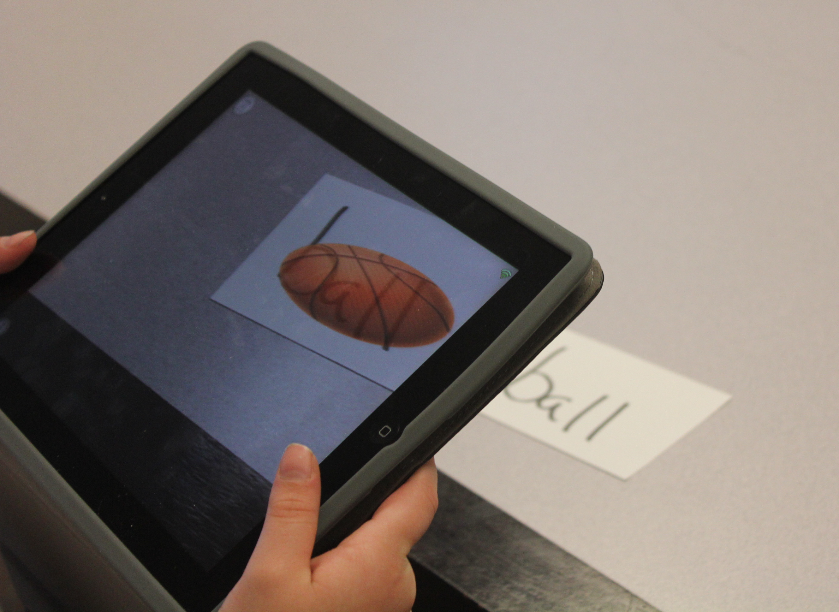
Figure 2. Marker based augmented reality used to teach sight words. Photo by Don McMahon.
Markerless AR. Not all AR applications require a printed marker to trigger the display of digital information. Markerless AR sometimes called location-based AR uses a Global Positioning System (GPS), compass, internet, and/or other tools to recognize the user’s location and to display the digital content corresponding to the user’s location. As the user moves the device, changes orientation, or moves themselves, the device continues to update the AR view based on the new situation. An example of this, shown in Figure 3, illustrates an AR navigation tool by providing a context relevant line of sight direction marker to a specific destination. This information includes both an indicator of where the location is as well as the distance to that location.

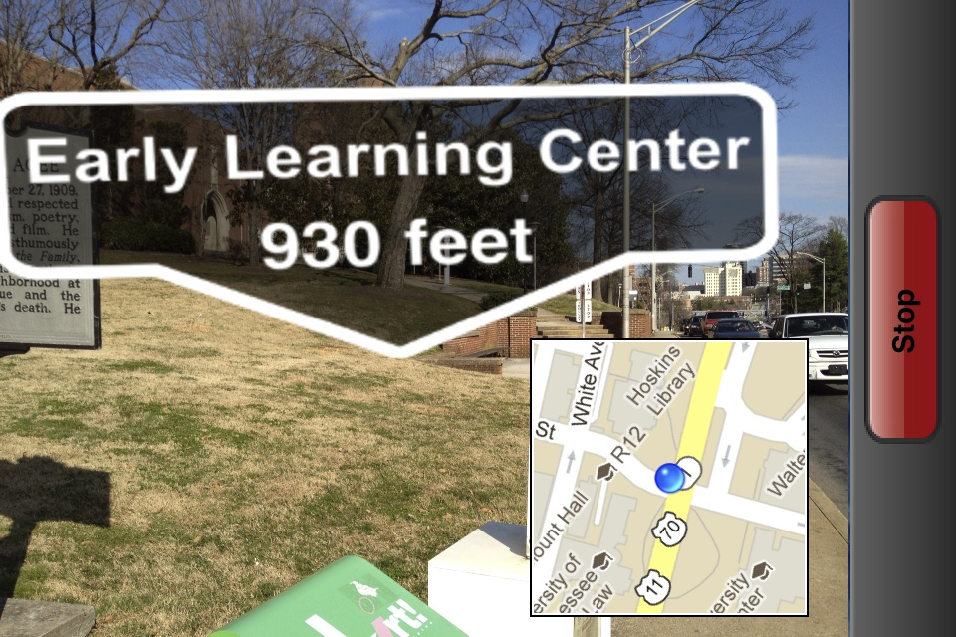
Figure 3. A screenshot of markerless AR based mobile app Heads Up Navigator being used to support independent navigation. Photo by Don McMahon.

AR in relation to UDL, AT, and IT
The principles of Universal Design for Learning (UDL) support instructional and assistive technologies. AR as a tool for students with disabilities is a concept with connections to the established principles of UDL, assistive technology (AT), and instructional technology (IT). Depending on how it is used, AR can function as instructional technology and/or assistive technology. AR also frequently embodies many of the principles of Universal Design for Learning. In order to understand the technology of AR as a resource for students with disabilities, understanding its relationship to IT, AT, UDL is critical.
The interrelated nature of UDL and AT was graphically displayed by Rose, Hasselbring, Stahl, and Zabala (2003), in a Venn diagram with two overlapping circles representing UDL and AT. Figure 4 was inspired by that representation and illustrates how instructional technology, assistive technology, and universal design for learning all relate to each other with a few relevant examples related to the future research in this dissertation. In the previous section the term instructional technology (IT) as it will be used in this dissertation was defined. In the following sections UDL and AT will be briefly defined in terms of how they will be used in this dissertation and how they relate to augmented reality.
Universal Design for Learning. Universal Design for Learning is a theoretical framework connected to neuroscience, learning sciences, and cognitive psychology (CAST, 2011) UDL identifies affective, recognition, and strategic networks, which correspond to the three broad principles of UDL:
- Provide Multiple Means of Representation
- Provide Multiple Means of Action and Expression
- Provide Multiple Means of Engagement

Figure 4. UDL, AT, and IT. Relationships between Universal Design for Learning, Assistive Technology, and Instructional Technology with examples.

Rose and Meyer (2002) connected these three networks to the three prerequisites for learning identified by Vygotsky. These three networks describe different structures and functional areas in the human brain. According to Rose and Meyer (2006) the nine guidelines in the UDL framework, three for each major principle, can be used to scaffold instructional practices in ways that are similar to the scaffolding of learning described by Vygotsky. Turnbull, Wehmeyer, and Turnbull (2007) described how the UDL framework also applies as a cognitive taxonomy that provides lists of cognitive skills or activities similar to the Cognitive Taxonomy developed by Bloom (1956). By building on the work of researchers in cognitive theory, UDL provides a scientific framework for designing curricula that articulates a method of teaching for learning based on planning to include learners with diverse strengths. Using this strategy, several researchers have used the UDL framework to inform their decision making and evaluation process about technology interventions for students (Almond et al., 2010; Dolan, Hall, Banerjee, Chun, & Strangman, 2005; Strangman, Hall, & Meyer, 2003). As future research explores the potential of AR in education, researchers can use the UDL framework in the research design process, which assists to establish how the AR field functions as a support for the learning networks described by Rose and Meyer (2002). This approach to educational research has the added benefit of building a body of research analyzing effects of UDL in educational practice.
To utilize the principles of UDL as instructional guidelines for promoting academic and independent living, it is useful to be familiar with UDL’s three broad principles as well as its specific guidelines and organization. UDL, according to Edyburn, (2010) is a frequently used term in education, but unfortunately, the meaning is not understood very well by many educators. The instructional framework of UDL is organized into the three broad principles – each with three guidelines to serve as strategies for a total of nine UDL guidelines. These nine guidelines are further supported and defined by approximately three checkpoints for each guideline. The UDL Principle > Guideline > Checkpoint organizational relationship is shown in Figure 5; a graphic organizer available at the National Center for Universal Design for Learning website (CAST, 2011). The three broad principles of UDL frequently are identified in the research literature (Almond et al., 2010; Basham & Marino, 2011; Dolan, Hall, Banerjee, Chun, & Strangman, 2005), but the more specific guidelines of each principle rarely are systematically considered in the literature (McMahon & Smith, 2012). In the interest of using instructional framework of UDL to improve educational practice, researchers apply particular concepts from the guidelines or the more detailed checkpoints of each guideline. See Figure 5 on the following page for a graphic organizer of the UDL Guidelines (CAST, 2011) reprinted with permission from the National Center on UDL.

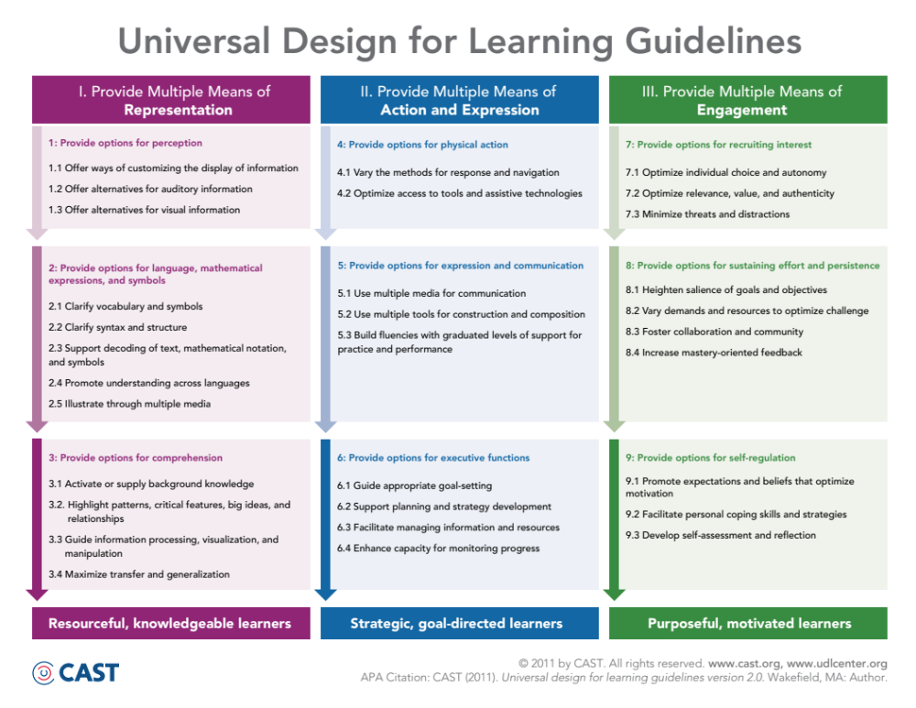
Figure 5. The Universal Design for Learning Guidelines and their checkpoints organized by UDL principle.

Researchers have identified several limitations and challenges of using technology to address the needs of individuals with disabilities. Phillips and Zhao (1993) identified several factors that lead to technology abandonment by individuals with disabilities including ease of use, how effectively it enhanced a user’s performance, and the inflexibility to change with the user’s needs. Woodward and Rieth (1997) examined the history of technology use in special education research and indicated that there was a great deal of variability of quality and results from the effects of technology. One of the limitations noted by the Woodward and Rieth was the majority of studies focused on academic interventions and the majority of interventions were prototypes. As a result, while the reported results were favorable, the technologies described were not available to other educators, nor could other researchers replicate the studies. A meta- analysis conducted in 2008 which examined technology use by people with intellectual disabilities determined that the most significant barriers to effectively using technology were cost, need for training, and lack of information about how the technology can benefit the person in their daily life (Wehmeyer, Palmer, Smith, Davies, & Stock, 2008). In light of how some technologies can have increased barriers for use or fail to meet the changing needs of users with disabilities, researchers and educators need to examine how some technologies may embody UDL principles more effectively than other technologies, which may allow them to meet the changing needs of the users.
While UDL is closely associated with technology, it is not an instructional framework about using technology. UDL is an instructional framework about providing flexibility and increased accessibility about the curriculum. No place in the three principles of UDL, or nine specific guidelines, or in the even more specific checkpoints is any electronic technology mentioned (CAST, 2011). However, McMahon and Walker (2014) suggested that mobile devices like iOS devices (i.e. iPads, iPhones) embody many UDL principles and guidelines. For example, they describe how mobile apps for augmented reality are examples of multiple means of action and expression.
AR has the potential to incorporate many of the UDL principles and guidelines. Labeling objects or locations with video, text, and audio are clear examples of multiple means of representation and its associated guidelines. The mobile nature of this technology and the potential for individuals to interact with digital information physically is one of many reasons why AR is a prime example of the second UDL principle of multiple means of action and expression. The third principle of UDL is providing multiple means of engagement, for which AR is a uniquely positioned field of technology because it provides connections between highly engaging digital content and the physical world. This review of UDL principles and concepts support the promise of AR as a viable instructional strategy.
Assistive Technology. In terms of AR as a tool for students and people with disabilities, it is important to consider how AR functions as an assistive technology (AT). The broadly accepted definition of an assistive technology device is “Any item, piece of equipment, or product system, whether acquired commercially or off the shelf, modified, or customized, that is used to increase, maintain, or improve functional capabilities of individuals with disabilities” (Public Law 100-147, 2004). One characteristic of a successful AT is the ability to be transparent, which is how evident the meaning of a symbol or support is to the user (King, 2002). This term was developed to discuss the effectiveness of Augmented and Alternative Communication (AAC) devices and has implications far beyond AAC devices and AT. This concept of transparency of meaning extends into commercially available devices, software, signs, and technology for all people. Apple’s (2013) guidelines for accessibility for technology developers emphasize features being readily apparent to the broadest range of users. Transparent meaning of a symbol or feature is related to UDL principles. Assistive technologies that are transparent often provide multiple means of representation in order to support the user’s individual learning or functional strengths.
Some researchers in the field of technology for people with disabilities support a strong relationship between instructional technology (IT) and assistive technology (AT) for students with disabilities. Edyburn (2000) suggested that the two fields are closely related and that depending on use, an instructional technology may become an assistive technology simply by how it is used to support a person with a disability. Edyburn (2005) defined instructional technology (IT) as any technology designed to enhance teaching and learning. Woodward and Rieth (1997) in their instructional technologies review, found that new technologies frequently appear first as commercial tools for businesses, then become instructional tools for learning focused on students without disabilities, and lastly applied as assistive technologies for students with disabilities.
AR and Assistive Technology. Augmented reality applications are natural extensions of the user interface with transparent supports to support all users to achieve a particular task. In the previously shown Figure 3, this combination of AR as a literally and figuratively transparent and self-evident interactive technology for reaching a location is apparent. For some learners and some AR applications as assistive technology, the relationship may not be as self-evident as this navigation example. In these cases, AR as an assistive technology may be described more accurately as being translucent because of its ability to be “guessable” with some training or background knowledge (King, 2002). In the example of a marker-based AR application, the user views an augmented reality marker for a static picture of a solar system and an augmented reality video simulation of the solar system appears above the printed solar system marker. This association may require practice and training to acquire, but may quickly become a generalized skill to students once they have the requisite knowledge. Once mastered, the combination of the solar system AR app and the printed marker create an assistive technology for learning about the solar system that could be considered translucent for many learners with disabilities.
The combination of an AR app and the mobile device functions as an integrated system in terms of assistive technology. Olson and DeReyter (2002) described an integrated control system as any AT system that uses one device to control one or more other assistive technologies. Mobile devices fit this definition when combined with other resources such as mobile apps. For example, Proloquo2go, a popular AAC app, is delivered on the iPad and other mobile devices. Consequently, the mobile device hardware functions as the control system for the AR software on the device.
In their review of assistive technology and literacy for students with developmental disabilities Pierce and Porter (1996) stated, “Early literacy abilities can emerge in persons who are immersed in an environment where reading and writing is used to accomplish real tasks” (p. 143). AR may become what Pierce and Porter described. AR is an immersive technology combining live views of the world and selected digital information. Since AR is also an example of ubiquitous computing, it has the capability of acting as a literacy building assistive technology by providing a comprehensive environment of text labeled real world objects and communication tools. Many AR applications on mobile devices are designed to support people without disabilities in accomplishing real world tasks. As previously shown in Figures 2 and 3, both marker-based and markerless AR can provide text supports and visual prompts. AR has the potential to enhance literacy and increase functional skills for students with disabilities through instructional practices that empower students to use this technology.
It can be challenging to attempt to delineate clearly whether a device is functioning as either an instructional technology or an assistive technology when applied for people with disabilities. Regardless, AR is a technology that embodies UDL principles with potential applications both as instructional and assistive technology. The technology of augmented reality has strong connections to the existing constructs in educational research of instructional technology, universal design for learning, and assistive technology. By using these concepts to inform future research on AR in education, researchers will be able to build upon an established body of knowledge as they explore the capabilities of this new technology.
Review of Research
Because AR is an emerging technology, researchers in disability fields need to be actively engaged in bringing these new technologies into the mainstream. Technology trends usually grow along predictable lines of public interest and development. Gartner (2013) described this process as the Hype Cycle shown in Figure 6. Lloyd, Moni, and Jobling (2006) demonstrated how this cycle is represented in educational technology in their review of effective computer use for students with intellectual disabilities. In brief, this cycle includes the introduction of a new technology, the technology explodes in popularity and interest, dramatically loses public interest, then slowly increases in use as the technology is systematically perfected for education use and eventually, based on effective use and research, plateaus at a consistent level of productivity and usage.
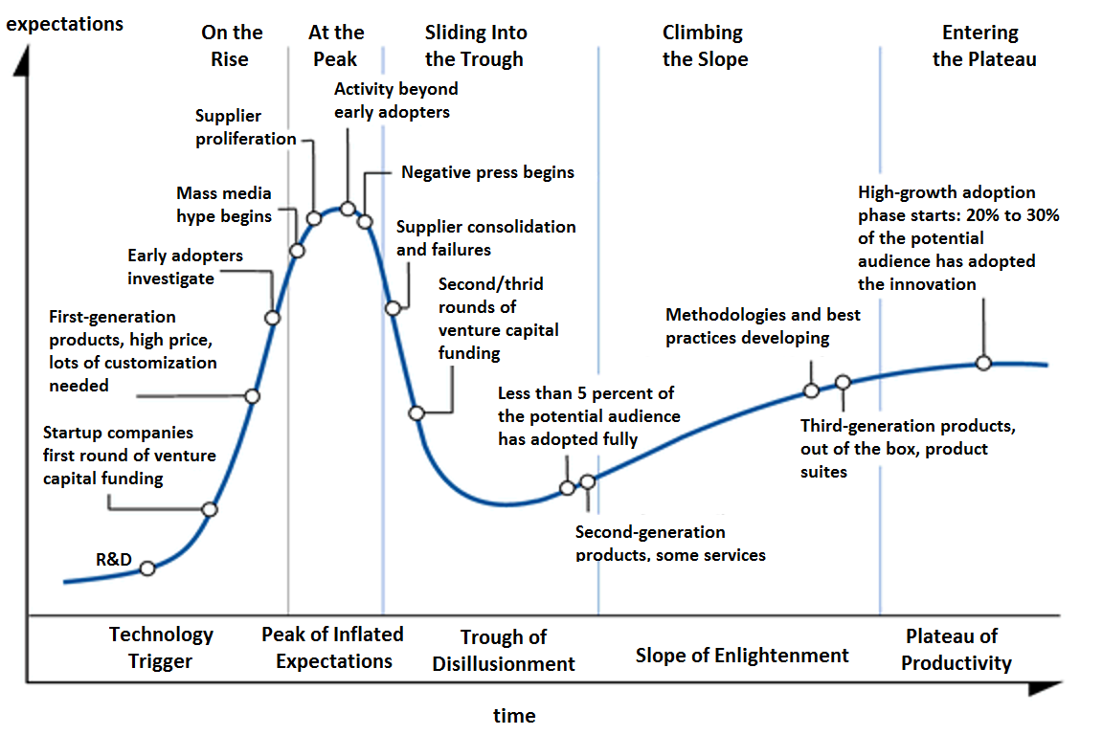
Figure 6. The Gartner Hype Cycle of New Technology. Image credit (Tarkovskiy, 2013)

In order to advance AR beyond the initial stages of the hype cycle effectively and eventually establish it as a strategy for students with disabilities, it is necessary to make connections to established supporting research. Unfortunately, there is a limited amount of research on AR as an instructional strategy to facilitate academic learning and functional independence for students with intellectual disabilities (ID) and autism spectrum disorders (ASD). However, there is an established body of research for using mobile devices with students with ID and ASD and a separate body of research on using augmented reality in education. This review of the literature first examines mobile learning for students with ID and ASD. Then, a review of research applying AR as an education strategy is discussed. Lastly, a literature review on mixed reality, which includes both virtual reality and AR for students with disabilities is presented.
Mobile learning for students with ID and ASD
Mobile devices are now equipped with all the capabilities to support the use of AR. Moreover, mobile devices have been established as an effective medium to improve educational outcomes for students with disabilities. These implementations of mobiles devices for students with disabilities are strong examples of mobile learning, which according to Crompton is “learning across multiple contexts, through social and content interactions, using personal electronic devices.” (2013, p. 4). Various mobile devices like the iPad have the benefits of being portable, the availability of software to meet individual needs, and possess social validity for individuals using a dedicated device (McMahon, Cihak, Gibbons, Fussell, & Mathison, 2013; Van der Meer, Sigafoos, O’Reilly, & Lancioni, 2011). In these applications, the mobile devices or other technologies support the needs of a person with an educational disability by serving as a “cognitive prosthesis.” The idea of a “cognitive prosthesis” is a decades old idea of using technology devices to support the needs of people with cognitive disabilities (Cole, 1999). Mobile devices provide tremendous flexibility to adapt a device to the unique and changing needs of an individual with a disability.
Mobile apps are part of the evolving concept of literacy that emphasizes both reading and the application of those reading skills in a variety of methods including using technology. Twenty-first century literacy is evolving as society’s expectations for individuals continue to grow to incorporate new technologies and skills. According to the National Council of Teachers of English, being literate now has the implication of both being able to comprehend information from a text and use technology to achieve goals effectively (NCTE, 2008). Israel, Maynard, and Williamson (2013) strongly supported the use of mobile devices in their review of strategies for promoting authentic STEM instruction students with disabilities. They noted that mobile devices like tablet computers and smart phones provide flexibility to educators to address the needs of their students through these large app libraries by allowing identical pieces of hardware to provide tens of thousands of different educational resources. These devices can provide new resources for students with disabilities to learn and express knowledge of content in science, technology, engineering and math.
Evidence-Based Practices on mobile devices. Mobile devices are being used as new platform for established evidence based practices for students with disabilities. One example of this is video modeling which is greatly simplified in the production and delivery by utilizing mobile devices (Cihak, Smith, McMahon, & Ramsey, in press). Video modeling (VM) is an instructional strategy for teaching discrete and complex skills including academic and functional skills in which the learner watches the activity being completed on a video, either in first person or third person point of view (Hine & Wolery, 2006). Afterwards, the learner has the opportunity to practice the skill. While previous video modeling studies used televisions to display the VM clip, researchers recently have implemented this evidence-based practice using mobile devices (Cihak, Fahrenkrog, Ayres, & Smith, 2010; Kagohara et al., 2011).
The impact of mobile devices for students with complex communication needs is another example from the research literature demonstrating the positive impact of mobile devices for established evidence-based practices. Kagohara et al. (2012) used iOS devices with an AAC app (iPod Touch and iPads) to teach culturally relevant vocabulary words and curriculum related vocabulary terms to students with ASD and complex communication needs. The results from these studies demonstrated an increase in vocabulary skills on the measured items. In their discussion, the authors made a strong case that AAC devices are critical tools for providing increased access to inclusive settings and the general curriculum. In a related study, van der Meer et al. (2012) compared the effectiveness of manual signing to the use of iOS devices (iPads and iPod Touch) with the mobile app Proloquo2Go™ for elementary students with ASD with complex communication needs. All students were able to increase their communication skills using the mobile app and the majority of students preferred using the mobile app. Kagohara et al. (2013) conducted a systematic review of studies that involved iOS devices (i.e. iPads & iPhones) in teaching programs for individuals with developmental disabilities. Their review concluded that these mobile devices are viable technological aids for individuals with developmental disabilities not only in the area of communication but also in the domains of academics, employment, and leisure.
Mobile learning for students with disabilities can combine the benefits of evidence-based practices with the capabilities of mobile devices. Fernández-López, Rodríguez-Fórtiz, Rodríguez-Almendros, and Martínez-Segura (2013) demonstrated this in their examination of a mobile app to support 39 elementary students with a variety of disabilities including ASD and ID in Spain through the learning process of planning, instruction, and practice measured across several content areas. Using a mobile app called Picaa, instructional material was presented through a variety of activities that included multiple representations and multiple means of action and expression including using the devices accelerometer to allow students to complete tasks by moving the devices. The app also included a built in AAC component to support communication for some of the students who had complex communication needs. The mobile app produced significantly higher language, math, environmental, autonomy, and social skills (p < 0.05) from pretest to posttest measures. Using the mobile app platform, students increased achievement and social interactions. Additionally, many of the students with disabilities in the study were able to engage in learning activities that they were unable to complete otherwise.
When mobile devices are used to support the needs of individuals with ID and ASD, they function as assistive technology that can increase their access to the curriculum and increase, maintain, or improve functional capabilities. The flexibility of mobile devices to provide ubiquitous computing, information, and communication technologies has established benefits for students with intellectual disabilities and autism. Many of these same features are why mobile devices are powering the growth of augmented reality.
Research on Augmented Reality
In an early survey of AR in 1997, Azuma detailed both applications of the technology and existing methods of delivery. Azuma found that applications fell into one of six categories: (1) Medical, (2) Manufacturing and Repair, (3) Annotation and Visualization, (4) Robot Path Planning (where and how to move), (5) Entertainment, and (6) Military Aircraft. These applications were limited to the technology of the time that required head-mounted displays to achieve the practical benefits of augmentation. Wearing a large head-mounted display/helmet attached to a computer worn on the back had limited practical application for the average person. Additionally, none of the AR examples provided by Azuma was available to the average person. For example, one of the demonstrations of AR in medical applications was a project that combined an ultrasound machine and helmet mounted display that allowed doctors to view into the womb to see the movement and position of a baby. When addressing the future developments of AR as a technology, moving towards portability was noted as an area that needed to be developed. This need identified by Azuma is now a common capability for people because of the growth of the mobile device market. Only 15 years later, hundreds of applications using augmented reality are available on many different device platforms. The majority of them are completely free and with dozens of real world practical uses. Many of these devices could be used to meet the academic and functional needs of students with disabilities to give them the skills to live more independently.
Not only did the growth of mobile devices help to support the growth of augmented reality, but there is also evidence that augmented reality on mobile devices is preferred over head-mounted display systems for some tasks. Asai, Kobayashi, and Kondo (2005) conducted an experiment comparing students’ preferences using both a mobile device and a head-mounted display to complete a science activity that included instructions featuring augmented reality. After the participants had completed the same AR activity using both systems, the results showed that students liked using both, but preferred the handheld device to view the augmented reality instructions. One of the reasons identified was the long-term fatigue of wearing the head-mounted AR system. Klopfer (2008) argued that head-mounted displays could be more immersive than a mobile device for displaying AR content since the student would not need to use a device like a mobile phone but will see the AR content through their head-mounted display. However, if the educational goal of AR implementation is to provide scaffolded supports for students with disabilities the “Heavily Augmented” head mounted tools described by Klopfer may prove too distracting or lack the social validity for students with disabilities to use them practically to support their functional needs. This may become an important consideration when designing AR interventions for individuals with disabilities.
Several promising implementations of AR were described in journals of computer science and engineering, but were not apparently implemented in research studies and most likely served primarily as a proof of concept and explorations of this technology. For example, using a marker based AR solution Feiner, Macintryre, and Seligmann (1993) created an application for improving instructions on how to perform maintenance on a laser printer. This tool provided a 3D overlay on how to assemble and disassemble parts when shown the corresponding steps. Instructional tools like this one, if implemented with individuals with disabilities, could provide new functional skills that would provide access and open up new job opportunities for them. In a more mobile AR demonstration of technology, Feiner, Terauchi, Rashid, and Hallaway (1999) created an AR wearable system that allowed students to navigate indoors and outdoors while receiving augmented information on the buildings and structures around the person. These examples demonstrate both the promise and provide some background on how emerging technologies like AR are developed.
After refinement to become more functional, augmented reality began to appear as an educational strategy to provide curriculum support for students without disabilities. AR research projects in education tend to be related primarily to science, language arts, and math activities. Both marker-based and markerless AR instructional activities were present in the research. The following studies are an overview of the available literature on AR as an educational tool. These studies provide a foundation and can inform the design of future research applying this technology to improve the academic and functional skills of students with disabilities.
Marker-Based AR. Liu (2009) used augmented reality on hand held smart phones to teach foreign language vocabulary to high school students using marker based augmented reality. Objects were labeled with a marker, which was scanned by the students, and then relevant content was displayed on the students’ mobile device to help them learn the new vocabulary words in context. The experiment included 64 seventh grade students learning English. Students were divided into a control group of traditional instruction and an experimental group that received the AR instructional activities. After several weeks of instruction, the AR group had significantly higher (p < .05) achievement levels on the English vocabulary assessment than the control group. Liu concluded that the context relevant nature of the instructional supports provided by the AR system and the ability to create an ever-present learning environment that extended beyond the classroom was very beneficial.
Some of the initial studies of augmented reality in education specifically looked at its impact on student motivation and overall reaction to the technology. Researchers in Taiwan implemented AR in science classes to encourage both physical exercise and learning by applying the Ecosystems AR learning system (Hsiao, Chen, & Huang, 2013). The researchers implemented the study with 1,211 middle and high school students. The results showed that students using the AR intervention were highly motivated and engaged while still learning the material as effectively as students using traditional instructional methods. Similarly, Di Serio, Ibáñez, and Kloos (2012) implemented a study with 69 middle school students in Spain and compared student motivation in a visual art history course using AR versus a traditional lecture activity. Paired sample t-tests were used compare the results after all students participated in both an AR teaching and traditional lecture. The results from their study showed that students were significantly more motivated (t (54) < 4.19, p = 0.000) to engage in the learning activities when AR was included. The students required little training to use the devices and were able to use AR independently to complete the assigned tasks. Student interviews expressed a high level of interest in using this technology in other courses. The authors of both studies concluded that AR is a very promising technology for keeping students engaged and learning which they conclude should lead to higher achievement.
Vilkoniene (2009) did empirically measure the effect of AR technology on student achievement. This study used AR to provide students with a digital manipulative of the human digestive system. In the study, 114 seventh grade students were divided into an experiential group using the AR manipulatives, and a control group that used traditional physical models and books. The AR intervention allowed students to move and manipulate organs as well as provide information about the names and functions of the organs. Results of the study demonstrated that students in the AR group were significantly more likely to identify the name and function of the parts of the human digestive system. The author found that using AR as an instructional support in combination with traditional instruction, printed materials, and learning aids positively affects the learning of the human digestive system and resulted in significantly (p < 0.05) higher achievement on digestive organ identification.
Markerless AR. Narzt and colleagues (2005) piloted a variety of AR navigation technologies, one of which included a mobile device based pedestrian AR Navigation tool. In order to create a portable navigation system, the researchers created a specially designed system using a personal digital assistant and attached several additional technologies including a Global Positioning System receiver (GPS), a camera to create the live view, orientation tracker, and a wireless internet network card. Mobile devices now have the necessary technologies embedded in the device that Narzt and collegues had to assemble together to create effective AR navigation tools for pedestrians.
Dunleavy, Dede, and Mitchell (2009) examined how students and teachers interact using a collaborative AR science activity. The activity required that students move around the campus based on information displayed via the AR app. This qualitative study examined student engagement and teachers’ attitudes toward using the AR intervention and the affordances and limitations of the technology. They conducted their study across three schools (two 7th grade classrooms and one 10th grade classroom). In their findings, the researchers reported that student and teacher interviews indicated very high levels of student engagement and collaboration. One of the biggest limitations of this study reported by the teachers and students was GPS errors on the device displaying inaccurate information. These GPS errors may have been related to technology limitations of the time since the Windows mobile hand devices used in the study required a separate handheld Bluetooth receiver to communicate with a GPS receiver.
Using another markerless location based information system, Squire and Jan (2007) created a science game based curriculum activity to support science education called Mad City Mystery. Participants navigated around a college campus looking for clues using a handheld mobile device. The study used a case study methodology that included students from an elementary school, a middle school and a high school. The activity was effective according to researchers’ observations of the students and showed the promise of AR as an instructional strategy. Replicating and expanding previous research, Squire and Klopfer (2013) conducted four case studies with 75 students overall, using an AR simulation for a secondary science activity called Environmental Detectives with both high school and university students. Using location based AR information on hand held mobile devices, the students interacted in teams on a project based game based environment to learn clues about the science lesson as they navigated, investigated, and analysis location specific information to solve problems. The authors noted that elements of AR experience provided instructional scaffolds which increased the ability of the students to use the available data and plan their activities. Both university and high school students quickly adapted to using the blended reality components of the augmented reality activity. In their analysis of student interviews, teacher interviews, and researcher observations the authors identified several implications for future pedagogical practice. In their discussion, they present a strong case for the potential of AR in education by stating that, “The ease with which students synthesized information from the physical and virtual environments suggests that a pedagogical benefit of augmented realities may be in how they encourage learners to draw upon existing knowledge and apply new information to understanding the world around them” (2008, p. 403).
One of the next steps for AR technology is additional research and implementation. New research to establish augmented reality as a research based instructional strategy for students is needed, especially students with disabilities. The reviewed studies suggest the potential benefits of augmented reality. The benefits of location-referenced information, portability, engagement, context relevant prompts, and creating a pervasive learning environment, were demonstrated repeatedly in these studies. In summary, AR research studies in education show promise for teaching skills in a variety of areas and across a wide range of students.
Mixed Reality and Students with Disabilities
There is a need for increased overlap between the state of the art instructional technology and assistive technology both in application for students with disabilities and applied educational research. One example of this is that the amount of available research on augmented reality as an educational strategy primarily focused at this time on students without disabilities, such as studies of students in high school geometry education (Kaufman& Schmalstieg, 2002), university students in organic chemistry (Chen, 2006), middle school in science students (Hsiao, Chen, & Huang, 2013), and secondary level biology students (O’Shea, Dede, & Cherian, 2011). These studies included findings supporting the effectiveness of AR for the selected students and targeted skill. While there is a limited amount of research on AR and students with disabilities, there is a body of research on the broader field of mixed reality, specifically the technology of virtual reality and people with disabilities. Reviewing the available research for both the limited AR and more established virtual reality research for this population demonstrates the benefits of mixed reality interventions to address their needs.
Virtual Reality and Students with Disabilities. Virtual reality training and instructional activities for students with intellectual disabilities can transfer to new locations which can allow students to practice functional activities like navigating a grocery store or making a purchase in a low stress, failure free environment (Cobb & Sharkey, 2007). The intuitive nature of the closely related technology of virtual reality also was recognized in a study that implemented a virtual reality kitchen safety-training program for people with intellectual disabilities (Brooks, Rose, Attree, & Elliot-Square, 2002). The mediated reality training was found to be as effective as traditional on-site kitchen training.
Lotan, Yalon-Chamovitz, and Weiss (2010) used virtual reality games with students with disabilities to increase their physical fitness in several categories. The students using the VR system increased functional movement in a series of activities after repeated sessions with the VR system. The ability of this technology to engage students and keep them motivated resulted in improved outcomes. A decade ago, Strangman, Hall, and Meyer (2003) examined how virtual reality provided students with disabilities with relevant feedback, choice of instructional tools, variable levels of challenge, and multiple methods of practice because of the ability to create artificial interactive content. The ability of virtual reality to provide specific consistent feedback and a safe artificial environment for errorless practice for people with disabilities was identified as a key factor in the long-term potential of using virtual reality as an assistive technology tool to increase functional skills.
AR and Students with Disabilities. Very few studies were identified that involved augmented reality and students with disabilities. Richard, Billaudeau, Richard, and Gaudin (2007) used AR to teach matching skills using an intuitive interface for elementary students with intellectual disabilities. In the AR interface, students were able to manipulate 2-dimensional two dimensional and 3-dimensional objects such as fruits and match them. The students with disabilities had no difficulty learning to operate the tangible markers to move the digital content in order to complete the matching tasks correctly. Not only were the students successful, but they also demonstrated a very high level of engagement and required little training to achieve mastery. Researchers in Taiwan were able to similarly apply AR in a preliminary case study with four elementary students (Kindergarten and 1st) with ID to teach students to match sounds to the appropriate objects, which were triggered using a marker based AR system that allowed the students use the cards as digital manipulatives. The researchers reported several positive qualitative results including high student mastery of sound matching skill, high student engagement, and the ease of learning to use this type of user interface.
McMahon and colleagues (2013) used a mobile app with augmented reality features to teach six post-secondary students with intellectual disabilities to identify foods with particular food allergens. The results of their single subject ABAB design study demonstrated that the AR interface allowed the students to determine quickly and accurately if a food was safe for an individual who had a particular food allergy. The mobile app used in this instance was designed as a barcode scanning tool to provide additional information to consumers. When applied to meeting the cognitive needs of students with intellectual disabilities who are attempting to determine whether or not food was safe to eat, this instructional/information tool can be considered an assistive technology because it supports or increases a functional skill for these students with disabilities through its intuitive augmented reality interface.
McMahon, Smith, Cihak, and Gibbons, (under review) used a markerless AR application to improve navigation ability of six college students with ID and ASD to unknown locations on a college campus. Using an alternating treatments design, the researchers compared a paper map, Google maps on a mobile device, and the AR navigation tool. Students were taught to access the AR application using a mobile device (iPhone). As students looked through the camera view, digital information was displayed including a text label, arrow showing the direction, and text distance remaining to reach the destination. The results showed that students increased successfully independent navigating and preferred using the AR navigation tool. Smith (2013) successfully replicated their work using an ABAB design but increased the difficulty by having students select the unknown location from a list of choices from within the application on the mobile device. Using the AR navigation app all of the students successfully independently navigated to the unknown locations.
The blending of real world and digital supports is a promising area of technology that when applied to meeting the needs of individuals with disabilities can be a powerful assistive technology. If effectively used AR may increase the academics and functional abilities of people with disabilities. The research plan in the next section will build on the existing body of knowledge from previous research. This dissertation builds on the identified gaps in the established research to develop a line of research that will positively affect lives of people with disabilities by exploring the capabilities of augmented reality.
Research Plan
Why AR matters for students with disabilities.
Augmented reality systems have the capability to recognize and present information to the user that the user may be unable to remain aware of independently. In applications of AR for people with disabilities, AR can function as a “cognitive prosthesis.” Individuals with disabilities often have difficulty recognizing vocabulary, building new associations, or attending to multiple items at a time. For example, in a navigation related task, they have difficulty keeping track of the relative location of two nearby potential destinations. AR navigation tools can “attend” to both the destination location and the users’ location to provide the necessary prompts to support their independent navigation. Results from research showed that using computers as assisted instruction for functional tasks produced fewer errors and better overall performance than traditional instructions (Kirsch, Levine, Lajiness-O'Neill, & Schnyder, 1992). AR applications using live views of the world from a camera on a mobile device and information from digital sources such as maps or databases of relevant information can expand on AR’s potential as a cognitive prosthesis. This technology has the potential to provide intuitively context relevant information that can improve the functional and academic skills of individuals with disabilities.
Applied research is needed to address the development of AR to empower individuals with disabilities in the areas of inclusion, social integration, employment, and independent living. New technology trends like augmented reality may not be designed specifically for people with disabilities in mind, but with adaption and some training, they hold the potential to make society more inclusive and to increase the self-determination skills of individuals with disabilities. Participation in the areas of education, training for employment and employment for students with disabilities is significantly lower than for students without disabilities (Newman et al., 2011). Augmented reality on mobile devices functions as a new form of information and communication technology (ICT). This trend in technology has practical applications that can address the needs of people with disabilities. A scientific development process is necessary to determine effective implementations and necessary adaptations of this innovative technology on mobile devices when used to meet the needs of individuals with disabilities. Targeted research in teaching AR tools on mobile devices to students and people with disabilities is necessary to determine what challenges may occur, what factors influence successful implementations, and to guide future research questions. The research studies in this dissertation aim to advance the use of AR technology to support people with disabilities.
Purpose of this Research
As shown earlier in the Gartner Hype Cycle graphic, one of the hallmarks of the “Slope of enlightenment” stage is the establishment of methodologies and best practices to effective use of the technology. Because AR is a new technology, researchers in disability related fields need to be actively engaged and empirically examining the effects of AR for students and people with disabilities to improve educational and functional outcomes. Research involving students and people with disabilities is needed. The purpose of these companion studies is to examine empirically the use of portable AR technologies for college students with intellectual disabilities (ID) and autism spectrum disorders (ASD). The two research studies in this paper are initial examinations of this field of augmented reality on mobile devices as a tool for students with disabilities.
Research Questions
Both studies used single-subject design methods in order to demonstrate a functional relation between the use of portable AR technologies and acquiring science vocabulary words (Study 1) and navigating a city independently (Study 2) for college students with ID and ASD.
Study 1. The purpose of this study is to examine the effects of a marker-based AR technology to teach college-students with ID and ASD science related vocabulary words. Specific research questions include:
- What are the effects of marker-based augmented reality vocabulary instruction on the acquisition of science vocabulary words of college students with ID and ASD?
- Do college students with ID and ASD find augmented reality vocabulary instruction to learn new science vocabulary words social acceptable?
Study 2. The purpose of this study is to examine the effects of a markerless AR technology to teach college-students with ID and ASD to navigate a city independently to local employment opportunities. Specific research questions include:
- What are the differential effects of using a printed map, Google Maps, and a markerless augmented reality navigation tool on navigating a city independently to businesses for college students with ID and ASD?
- Which navigation strategies do college students with ID and ASD report as being most helpful and social acceptable?

Chapter 2:
Augmented Reality as an Instructional Tool for Teaching Vocabulary to Postsecondary Education Students with Intellectual Disabilities and Autism.
Mobile applications devices such as tablet computers and smart phones promote literacy in science, technology, engineering and math (STEM) for students with disabilities. Mobile applications provide “a broad range of learning experiences” and instructional supports include pictures, text-to-speech, video, vocabulary supports, literacy connections, and games (Israel, Maynard, & Williamson, 2013, p. 23). Unfortunately, young adults with intellectual disabilities (ID) and autism spectrum disorders (ASD) are less likely to find employment opportunities in STEM related fields compared to students with other disabilities and students without disabilities. According to the National Longitudinal Transition Study 2, no students with ID reported working in computers, engineering, or science related jobs whereas 3.8% students with other disabilities found employment in these fields (Newman, et al., 2011). In order to increase employment opportunities for students with ID and ASD, additional opportunities to learn STEM content is needed.
A fundamental aspect of developing literacy skills is acquiring vocabulary. Bell and McCallum (2008) established a strong connection between vocabulary proficiency and increased reading comprehension, writing skills, and overall academic achievement of students with disabilities. Research in reading instruction for students with ID lacks the comprehensiveness advocated for by the National Reading Panel (NRP; Browder, Wakeman, Spooner, et al., 2006; Erickson, Hanser, Hatch, & Sanders, 2009; NRP, 2000) and the Reading Next report (Biancarosa & Snow, 2006). Comprehensive approaches to reading instruction provide a more authentic exposure to the general curriculum (Erickson et al., 2009). Comprehensive approaches also incorporate instruction of all five elements of reading as recommended by the NRP (i.e., phonemic awareness, phonics, fluency, vocabulary, and comprehension), writing instruction, and opportunities for interaction with a wide variety of texts (Erickson et al., 2009).
For students with ID, traditional literacy instruction has focused primarily on teaching sight word recognition and often isolated from meaningful context (Clendon & Erickson, 2008). Shifting perspectives of special educators and improvements in legislature (IDEA 2004; NCLB, 2002) indicate a more expansive and potentially liberating view of literacy and learning for students ID. As a result of these changes, educators and proponents of students with disabilities have advocated for access to instructional programs that would promote participation and progress in the general curriculum, including literacy instruction (Jackson, 2005). Although sight words are an essential component of literacy instruction, comprehension and communication also are key skills for students with ID (Browder, Wakeman, Spooner, Ahlgrim-Delzell, & Algozzine, 2006). A growing body of research has indicated that students with ID can demonstrate new literacy skill acquisition, including comprehension skills, with systematic prompting and feedback (Browder, Ahlgrim-Delzell, Spooner, & Baker, 2009; Browder, Lee, & Mims, 2011).
Despite what is known about the components of high quality reading instruction, reading instruction for students with ID and ASD has traditionally overemphasized functional reading skills such as sight words necessary for daily living, safety, and independence rather than academic reading skills and content (Browder, Wakeman, Spooner, Ahlgrim-Delzell, & Algozzine, 2006; Kliewer, 1998). Camahan, Williamson, Hollingshead, and Israel (2012) advocated using technology to provide more balanced literacy supports to meet the needs of students with disabilities like ID and ASD when they are learning academic content. However, limited research is available on teaching academic content vocabulary to students with ID and autism. Browder, Spooner, Wakeman, Trela, and Baker (2006) were able to identify only 10 studies that examined the learning of science vocabulary content for students with ID.
For students with ID and ASD, postsecondary education (PSE) provides opportunities to gain skills and content knowledge needed to gain employment (Grigal, Hart, & Migliore, 2011). According to Zafft, Hart, and Zimbrich’s, (2004) review of PSE program options, they recommended the use technology to teach new skills and as a means to accommodate learners. People with ID reported that they like using technology and electronic tools (Carey, Friedman, Bryen, & Taylor, 2005). Carey et al. also indicated technology improves work, school, community, and leisure activities for people with ID. However, the field of technology is ever growing and evolving. New technologies are developed every day. Researchers need to examine emerging technologies as instructional practices for students with disabilities in order determine their effectiveness and utility.
Wehmeyer (2006) recommended that teachers can improve outcomes for individuals with ID by implementing Universal Design for Learning (UDL) principles “using both technology and pedagogical strategies, to make progress in ensuring access to the general curriculum.” (p. 324). According to the Center for Applied Special Technology (CAST), UDL refers to three principles for planning effective instruction by providing multiple means of representation, action and expression, and engagement (CAST, 2011). The UDL guidelines provide a research-based instructional framework for examining how technology can be used to teach vocabulary and reading skills for students with disabilities. Rose and Meyer (2002) indicated once curriculum materials are in a digital media format, then multiple options for displaying content to meet individual student needs are readily available. Digital media allows information to be transformable into other mediums, such as video, audio, and pictures. Text can be easily adjusted by size, color, and can be translated into other languages with digital.
Computer assisted instruction (CAI) has been successfully used to provide multiple means of representing content information to facilitate vocabulary acquisition, maintenance and generalization (Strangman, & Dalton, 2005). As early as 1985, Reinking and Schreiner demonstrated the effectiveness of CAI by having multiple literacy supports for struggling readers. These supports included additional illustrations, examples, definitions, and passage summaries. Similarly, Lange, McPhillips, Mulhern, and Wylie (2006) examined vocabulary acquisition and a software application for struggling readers called Read & Write Gold. Following CAI, students improved vocabulary word meaning and reading comprehension.
As technology evolved, CAI became more sophisticated. Bosseler and Massaro (2003) implemented a computer animated tutor to teach elementary students with ASD vocabulary. The results indicated that all students acquired the new vocabulary words and maintained 85% of the words 30 days following CAI. Moreno, Mayer, Spires, and Lester (2001) successfully used an interactive animated instructor to improve science vocabulary words for students with ID. Wade, Boon, and Spencer (2010) used a computer-based story map with pictures to increase vocabulary acquisition. Travers et al. (2011) compared CAI and teacher led instruction regarding word recognition and vocabulary acquisition with a group of students with ASD. The results demonstrated that students with ASD were highly engaged and motivated to use the CAI intervention and that it was as effective as teacher led instruction on the selected literacy related tasks. In Hall, Hughes, and Filbert’s (2000) meta-analysis of CAI, they noted that effective CAI was followed by initial teacher instruction, allowing students to engage in their own structured practice independently, reinforcement, systematic feedback, and self-assessments to monitor progress.
CAI for vocabulary instruction can now be delivered on mobile devices. Smith, Spooner, and Wood (2013) implemented an iPad based intervention to teach high school students with ASD science vocabulary. The iPad based intervention provided several effective CAI features including reinforcement and progress self-monitoring. The results indicated that the students acquired the science vocabulary words. Jameson et al. (2012) indicated similar results and noted that using the mobile device to learn vocabulary words was highly motivating for students with ID. According to McMahon and Smith (2012) UDL influenced strategies can effectively support students with ID and ASD in postsecondary education, especially through the use of mobile devices.
A promising new technology is augmented reality on mobile devices. Augmented reality (AR) combines a live view of the physical world and digital content including pictures text, images, audio, and video (Craig, 2013). This technology has the potential to provide a variety of instructional supports for students with ID and ASD to learn new academic skills, such as vocabulary words. There is limited research on using AR in education (Wu, Lee, Chang, & Liang, 2013). Most studies only involve students without disabilities and generally involve STEM related studies. An example of this is Yoon, Elinich, Wang, Steinmeier, and Tucker’s mixed methods study using AR as a knowledge building scaffold in in science museum which found that “digital augmentations [AR] can help in conceptual development of science knowledge.” (2012, p. 539). While most AR research at this time does not involve students with disabilities, a few studies were identified. Richard, Billaudeau, Richard, and Gaudin (2007) used AR to teach matching skills to elementary students with ID. The students successfully manipulated three-dimensional objects to increase matching skills. The students also demonstrated a very high level of engagement and required little training to learn how to use AR. In addition, McMahon, Cihak, Gibbons, Fussell, and Mathison (2013) used a mobile app with AR features to teach college-students with disabilities to identify food allergies. The researchers found that the students quickly learned how to use the AR application to scan food items and correctly identify potential food allergens included. While there is limited research on AR for students with disabilities, AR has the potential to provide similar positive effects as CAI and mobile devices to teach students with ID and ASD vocabulary skills.
The purpose of this study is to examine the effects of a marker-based AR technology to teach college students with ID and ASD science related vocabulary words. Specific research questions include:
- What are the effects of marker-based augmented reality vocabulary instruction on the acquisition of science vocabulary words of college students with ID and ASD?
- Do college students with ID and ASD find augmented reality vocabulary instruction to learn new science vocabulary words socially acceptable?

Methods
Participants
Four individuals with intellectual disabilities and autism attending a postsecondary education (PSE) program at a southeastern university participated in this multiple probe across skills study (Gast, 2010). The participants were one male and three females. Pseudo names (Miguel, Catherine, Brenda, and Billie), were used to maintain confidentiality. Participants ranged in age from 19 to 25 years old. All participants were selected based on the following (a) diagnosis of an intellectual disability, (b) participation in a postsecondary education program, (c) no physical disability that impeded the performance of the activity, and (d) consent to participate in the study. Participants’ full-scale IQ standard scores ranged from 45 to 85. All students were at least 1 standard deviation below the mean. All students received special education services under the ID or Autism category during their K-12 schooling. In addition, all students met eligibility guidelines for admission to the postsecondary education program (e.g. diagnosed with an intellectual disability or autism, had an IEP in K-12 education settings, and not able to enroll and/or not likely to be successful in a “regular” college or university program with accommodations). All students were familiar using mobile devices for academic tasks and attended a course called Digital Literacy designed for students in the PSE program. Two months before the start of this study all of the participants were administered selected tests from the Woodcock-Johnson III Normative Update Tests of Cognitive Abilities and Tests of Achievement (Woodcock, Schrank, McGrew, &, Mather 2007). Additionally as part of their PSE program they were administered selected tests from the Brigance Transition Skills Inventory (2010). Participants’ characteristics are overviewed in Table 1 below.

Table 1. Participant descriptions Study 1.

Participant | Age | IQ | Woodcock Johnson III  (Standard Scores/Proficiency) |  |  |  | Brigance Transition Inventory  (Grade Equivalents)
Participant | Age | IQ | Processing Speed | Basic  Reading | Reading Comp. |  | Decoding | Vocab  Comp.
Miguel | 25 | 85^{A} | 81 / Limited | 100 / Average | 82 /  v.limited |  | 8th | 4th
Catherine | 25 | 48^{B} | 50 / v.limited | 41 / negligible | 55/ negligible |  | 4th | 2nd
Billie | 19 | 67^{C} | 68 / limited | 73 / v.limited | 71/ v.limited |  | 6th | 2nd
Brenda | 20 | 61^{D} | 52 / v.limited | 59/ v.limited | 70/ v.limited |  | 5th | 3rd
A= Wechsler Adult Intelligence Scale III (WAIS III), B= Wechsler Intelligence Scale for Children (WISC III), C= Reynolds Intellectual Assessment Scales (RAIS), D= Kaufman Brief Intelligence Test 2 (KBIT2).

Miguel. Miguel was a 25 year-old student diagnosed with Autism. Miguel had a FSIQ of 85 on the Wechsler Adult Intelligence Scale III. Miguel’s results from the WJ-III indicate compared to peers of his age limited processing speed (SS=81), average basic reading skills (SS=100), and very limited reading comprehension (SS=82). Miguel’s reading decoding skills were assessed to be at the 8th grade level equivalent and his reading vocabulary comprehension skills were at the 4th grade level equivalent using the Brigance Transition Skills Inventory.
Catherine. Catherine was a 25 year-old student diagnosed with an intellectual disability.
She had a FSIQ of 48 on the Wechsler Intelligence Scale for Children (WISC). Results from the WJ-III indicate compared to peers of her age indicate very limited processing speed (SS=50), negligible basic reading skills (SS=41), and negligible reading comprehension proficiency (SS=55). Catherine’s reading decoding skills were assessed to be at the 4th grade level equivalent and her reading vocabulary comprehension skills were at the 2nd grade level equivalent using the Brigance Transition Skills Inventory.
Billie. Billie was a 19 year-old student diagnosed with an intellectual disability. She had a FSIQ of 67 on the Stanford Binet Fifth Edition. Results from the WJ-III indicate compared to peers of her age, Billie had limited processing speed (SS=68), very limited basic reading skills (SS=73), and very limited reading comprehension proficiency (SS=71). Billie’s reading decoding skills were assessed to be at the 6th grade level equivalent and her reading vocabulary comprehension skills were at the 2nd grade level equivalent using the Brigance Transition Skills Inventory.
Brenda. Brenda was a 20 year-old student diagnosed with an intellectual disability. She had IQ of 61 based on results from Kaufman Brief Intelligence Test 2 (KBIT2). Results from the WJ-III indicate compared to peers of her age, Brenda had very limited processing speed (SS=52), very limited basic reading skills (SS=59), and very limited reading comprehension proficiency (SS=70). Brenda’s reading decoding skills were assessed to be at the 5th grade level equivalent and her reading vocabulary comprehension skills were at the 3rd grade level equivalent using the Brigance Transition Skills Inventory.
Setting
Participants attended a postsecondary education program (PSE) for individuals with intellectual disabilities located at a public research university according to the Carnegie Foundation for the Advancement of Teaching (Carnegie Foundation, 2014). Each participant was enrolled in traditional university courses for audit credit, recreational classes, student work internship, and program specific/core courses that included life skills, career development, and digital literacy. The core courses were designed specifically for college students with intellectual disabilities enrolled in the PSE program. Each participant was included in traditional university courses and activities for a minimum of 80% of the week. All phases of this study occurred in a computer lab located on campus.
Materials
Assessment Materials. Vocabulary tests were developed to assess the three science-related word lists: (a) human bones, (b) human organs, and (c) cell biology. Ten target vocabulary words were identified for each word list by the investigator based off low pretest knowledge by the participants. Each vocabulary test was a 20-item assessment that included two questions for each of the 10 vocabulary words on the list. One question was designed to measure the ability of the student to correctly match a description/definition of the vocabulary term and was referred to as the definition question. Definitions were adapted to simplify language from their original dictionary and/or text book definitions. For example in the definition of Femur the word proximal was removed and replaced with description of where the bone is located. The readability of these assessments ranged from 3.6 to 5.8 grade level on the Flesch-Kincaid readability assessments (Kincaid, Fishburne, Rogers, & Chissom, 1975). This question was presented in a multiple-choice format in which the definition was provided and the student identified the correct vocabulary word from a field of four choices (one correct and three incorrect responses). The three distractor questions were all from the word list being assessed (i.e. during the bones word list phase all of the distractors were bones). The second question type required the student to use the vocabulary word to label either a diagram or figure with the correct vocabulary term. A word bank of targeted vocabulary words was included on the labeling section of the assessment. Pictures used were royalty free images selected by the investigator and modified if necessary (i.e. arrows pointing to a specific structure). Three assessment versions of each skill were created that varied the order of questions, possible answers, and labeling activities. Appendix B displays one of the assessments. This assessment was intended to measure understanding of the vocabulary terms by measuring both the ability to define and correctly label the selected science terms.
Intervention Materials. The intervention examined in this study is an example of an augmented reality tool according to the mixed reality continuum as described by Milgram and Kishino (1994). The mobile app used was Aurasma (Aurasma, 2014), which provides thousands of different augmented reality content viewing experiences. This app also allows user to create their own AR experiences by matching trigger images/objects with user created digital content that can include images and video.
Aurasma Mobile App. The Aurasma app uses live video from the mobile device’s camera to identify an object, in this case a printed marker. When an individual views the printed marker using the Aurasma app, the marker is detected by the app. This then triggers the display of the programmed digital content in an augmented reality view. AR content generally displayed after a two to three second time delay. Aurasma is available on a variety of mobile device platforms and was implemented using iPads in this study.
AR Triggers. The investigator created one trigger image for each of the 30 science vocabulary terms in the study. Each trigger included a large print (72 point font) of the vocabulary term and a unique design comprised of different shapes in order to provide enough detail for the app to distinguish one trigger from another. The triggers were produced using Microsoft’s PowerPoint and then printed as handouts. Then, the investigator stapled them to create a 10- page book of “AR vocabulary cards” for each word list.
AR Content. The AR content displayed was a short 30 to 35 second video created by the investigator for each vocabulary term. The elements of each video included 1.) Title slide of the vocabulary term 2.) Video with audio of the definition text being read aloud electronically 3.) the same free to use image used in labeling activity for the vocabulary term with the correct vocabulary term labeled 4.) video of a 3D simulation showing the location the of the vocabulary term, during which the audio from the definition being read aloud was repeated 5.) repeat of the image of the vocabulary term as shown in the labeling part of the assessment with the audio of the definition being played a third time. Videos either were taken by the investigator (definitions, bones, and human organs) or were used with permission (i.e., parts of the plant cell).
These elements were edited in the video editing program iMovie. This movie was programmed within the Aurasma app to play when the corresponding AR vocabulary card was detected (full instructions available from Aurasma, 2014). During the intervention phase, an iPad (third generation) equipped with the Aurasma app and this content was provided to each participant. When the user moved the mobile device so the marker was visible, using the devices camera, this app detected the printed vocabulary card and displayed the appropriate AR vocabulary content. This augmented reality experience provided the user a view of the vocabulary word card and overlaid digital information in the form of audio, pictures, and video designed to teach the meaning and location of the term. Figure 7 is an example of the physical AR content being overlaid with vocabulary card AR as displayed on the mobile device.
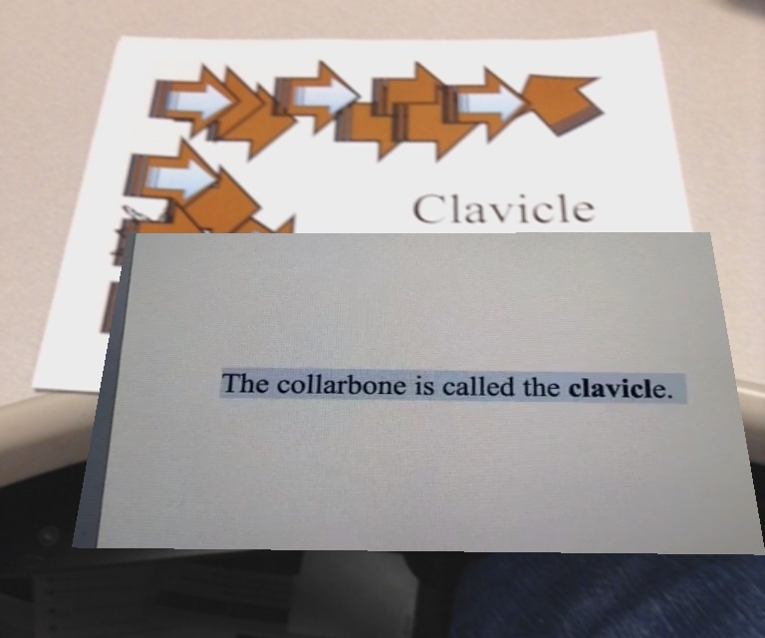
Figure 7. Screenshot from the mobile device displaying the AR content.
Variables and Data Collection
In this multiple probe across behaviors/skills design, the independent variable was the use of the augmented reality app to learn new vocabulary words. The dependent variable was defined as the number of correct responses on the vocabulary assessment, described in detail in the materials section. This number was calculated separately according the two types of questions (definition or labeling). The dependent variable was designed to separately measure the definition and labeling scores in order to examine possible differences in the rate of learning the definition versus the rate of learning to label science vocabulary when learning with AR. Permanent product data collection procedures were used to record the number of questions correct. Each session was made up of an assessment that included 20 items assessing the ability to define and label the 10 vocabulary terms on that list. These questions were ordered randomly on three different assessment versions of the same vocabulary words to reduce practice effects. If the participant correctly answered the question, then it was recorded as a correct response. If the participant did not answer the question correctly or did not respond, then it was recorded as an incorrect.
Procedures
Baseline. During baseline, each participant completed a minimum of three assessment probes (human anatomy bones, human anatomy organs, and parts of a plant cell) of the 20-item science vocabulary test targeting 10 vocabulary words. Although the test was read aloud, no additional feedback or prompts were provided. Participants were instructed to answer the vocabulary questions on the assessment and were told they could skip questions they did not know. This process occurred for a minimum three sessions until three sets of 10 unknown science terms were identified or until the data were considered stable. Stability was determined using the “80%-20%” criteria of stability envelope (Gast, 2010). If 80% of the data points fell on or within 20% of the mean of baseline, the data would be considered stable.
AR Training. Participants were trained how to use the Aurasma application to scan vocabulary cards to trigger the AR content to display (picture, video narration of defined term). Students were informed that the designs on the cards were just to help the mobile app recognize what video to play but they should learn the printed word. Students in small groups (two-four students) were shown objects (various denominations of U.S. currency) that triggered AR animations to appear. The investigator implemented the Model-Lead-Test procedures (Adams & Englemann, 1996) to train the students. The investigator modeled how to use the app to scan the trigger and view the content in the display. Then, the investigator led the students as they practiced using the device to scan the markers and to display the AR content. When a participant was observed operating the device incorrectly to view the AR content (e.g. too close, hand over the camera), the investigator implemented a system of least prompts to teach them the correct way to view the AR content. A four second delay occurred between each prompt level. The least-to-most prompt hierarchy consisted of the following levels (a) verbal prompt (e.g., ‘‘[Name] do you see the marker?’’, (b) gesture plus verbal explanation (e.g., pointing to the barcode and saying ‘‘[Name] scan the marker’’), and (c) physical assistance plus verbal explanation (e.g., investigator and participant holding the iPad or iPhone together, guiding the device to scan the marker, and saying ‘‘[Name] scan the marker’’). Lastly, the investigator tested each student until each was able to independently scan the vocabulary word and trigger the AR definition display for three consecutive trials.
AR Vocabulary Intervention. At the start of each intervention session, students completed the vocabulary assessment. Afterwards, they used the AR vocabulary intervention to practice learning the science vocabulary words. Students completed 4 to 5 sessions a week. The AR intervention was first introduced to target the 10 vocabulary words on bones in the human anatomy. Students were given the vocabulary words, mobile device, and instructed to “try and beat the definition”. That is, students would try to verbally define the word before the two to three second lag time for the AR content providing the definition was displayed. The purpose of this was to prime the student’s attention for the AR content. After the students practiced the first vocabulary word, they proceeded to the second vocabulary word and so forth until all 10 words were practiced. Students then practiced all 10 words two additional times for a total of three practice opportunities. The students continued to practice defining the anatomy vocabulary words until they performed 80% on three consecutive quizzes for both the definition and labeling items. After reaching criteria, students then were provided human organs vocabulary words and the AR intervention to “try and beat the definition”. After reaching criteria, students were introduced to parts of the plant cell vocabulary words and AR intervention. An example of the AR vocabulary experience is shown in Figure 8 in which a student is using the mobile device to interact with the trigger for the word phalanges from the bones word list and viewing the AR 35 second video providing the definition, images and 3-dimensional video simulations.

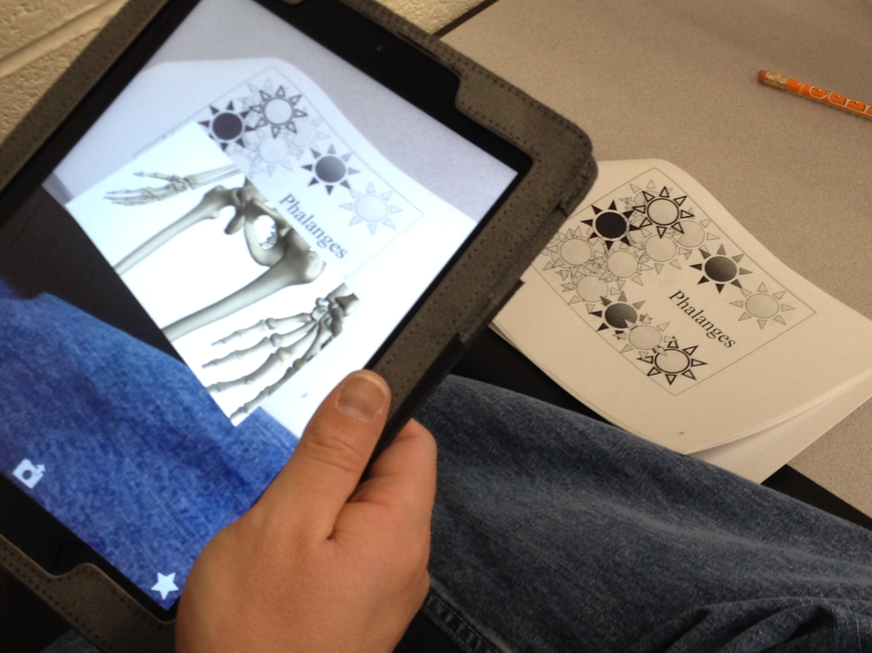
Figure 8. Student using the AR vocabulary intervention. Students interact with the AR experience by viewing the “trigger” or “marker” for the vocabulary term, in this example the Human anatomy bones word list term PHALANGES,with the Aurasma app on a mobile device.

Design
A multiple probe across behaviors/skills design (Gast, 2010) was used to examine the relation between the AR based vocabulary intervention and each participant’s performance to correctly identify and label the meaning of the science vocabulary word. The AR intervention was introduced systematically across three science vocabulary word sets. First, AR was introduced to target words related to human anatomy bones. Then, AR was introduced to target human anatomy organs words and finally AR was introduced to teach plant cell biology words.
Data Analysis Procedures
Visual analysis procedures were used to evaluate the results of the multiple probe across behaviors/skills intervention using augmented reality to teach science vocabulary. Intervention effects were assessed using six indicators to examine within-and between-phase data patterns: (a) level, (b) trend, (c) variability, (d) immediacy of the effect, (e) overlap, and (f) consistency of data patterns across similar phases (Kratochwill, et al., 2010). Also within-phase comparisons were evaluated to assess predictable patterns of data, data from adjacent phases were used to assess whether manipulation of the independent variable was associated with change in the dependent variable, and data across all phases were used to document a functional relationship (Gast, 2012). Horner et al. (2005) stated that a functional relationship was demonstrated after at least three occurrences of an effect after a minimum of three different points in time were observed.
In addition to visual analysis, two separate effect size measures were calculated. Providing effect size measures increases the ability of investigators to compare these findings with other research but there is significant debate about the best methods for calculating effect size for single subject research (Parker, Vannest, & Davis, 2011). The first effect size method applied is the most common measure used in single-subject research percentage of non-overlapping data (PND) (Scruggs & Mastropieri, 2001). For each participant the percentage of non-overlapping data (PND) was calculated between the baseline and intervention phases (Scruggs, Mastropieri & Casto, 1987). Scruggs and Mastropieri (2001) suggested interpretational guidelines of PND were used to evaluate the effectiveness of the intervention. Based off their guidelines, this study evaluated PND greater than 90% as a highly effective intervention, PND greater than 70% and less than 90% as an effective intervention, PND greater than 50% and less than 70% as questionable effective, and PND less that 50% was considered unreliable effectiveness for interventions. The second effect size measure calculated was a variation of Cohen’s d (1988) as calculated by Busk and Serlin (1992, p. 197). Cohen’s original effect size interpretational benchmarks were greater than .8 was a large effect size, greater than .5 and less than .8 was medium effect size, and greater than .2 and less than .5 was a small effect size. Robey et al., (1999) revised these benchmarks for single single-subject research and suggested 2.6 to 3.9 for small effect size, 3.9 to 5.8 for medium effect size, and greater than 5.8 as a large effect size.
Interobserver and Procedural Reliability
The lead investigator, a doctoral student in special education, and a trained research assistant simultaneously collected interobserver reliability (IOR) and procedural reliability data. Interobserver reliability data were collected during a minimum of 60% of baseline and intervention sessions for each participant. Observers independently scored the number of vocabulary items defined and labeled correctly on the permanent product vocabulary tests. Interobserver agreement was calculated by dividing the number of agreements of participant responses by the number of agreements plus disagreements and multiplying by 100. Reliability was defined as 90% or greater, if the IOR had researched lower than 90%, then the two observers would have met and reviewed all test items and responses. The percentage IOA was 100% (M = 100%).
Procedural reliability data also were collected during a minimum of 60% baseline and intervention sessions for each participant. The investigator was required to provide participants with the necessary materials (i.e., iPad with the AR intervention, vocabulary word markers), read aloud vocabulary test, and provide a system of least prompts contingent on observing participants operating the device incorrectly. The observer was provided a task analysis (See Appendix C) of the procedures to mark procedures completed as intended. The procedural agreement level was calculated by dividing the number of observed investigator’s behaviors by the number of planned investigator’s behaviors and multiplying by 100. Procedural reliability was defined as 90% or greater, if the procedural reliability was lower than 90%, then the investigator and observer met and clarified all intervention procedures and practiced procedures. The overall mean treatment integrity was 96 % (range = 92%-100%). Miguel’s treatment integrity ranged from 92% to 100% (M = 94 %), Billie’s ranged from 92% to 100% (M = 96 %), Catherine’s ranged from 93% to 100% (M = 98 %), and Brenda’s ranged from 92% to 100% (M = 96%).
Social Validity
The social validity of an intervention for the participants is an important factor to measure for new interventions (Wolf, 1978). Following the conclusion of the intervention phase, each participant was asked to complete a Likert-type survey (See Appendix D) created by the investigator to assess their opinions and acceptability of using the AR intervention to learn new vocabulary. The question items were read aloud individually to the participants. Each survey item used Likert-type scale ranged from 1 (strongly disagree) to 5 (strongly agree) with the addition of “Sad Faces” (1 Strongly Disagree) to “Smiling Faces” as indicators on the scale to support comprehension of the question. The social validity survey also included two open ended social validity questions in which the answers were scribed by the investigator.
Results
Baseline scores on the vocabulary assessments for the students indicated that the students had very low initial knowledge about the science vocabulary terms on the three word lists. Correct responses during baseline generally appeared to be random chance since they were not consistently matched with a corresponding correct definition and labeling. Visual analysis procedures for all of the participants revealed that the AR intervention was an effective strategy for improving science vocabulary acquisition of the students. Effect size averages for definition and labeling scores are reported individually by each student below and are provided for each testing condition in effect size section after the results by student.
Miguel. Miguel learned the three sets of science vocabulary terms using the AR vocabulary instruction. Miguel’s baseline average correct responses for the first word list human bones were 30% for the definition questions and 12.5% for the labeling questions. After using the AR vocabulary intervention his results immediately improved the next session. During the AR intervention, on the first word list (bones), Miguel reached criteria of 80% correct definition and labeling responses for three consecutive sessions after his fourth session on the bones word list. Miguel’s baseline average correct responses for the second word list (human organs) were 15% for the definition questions and 17.5% for the labeling questions. On the second word list organs, he reached criteria of 80% correct definition and labeling response for three consecutive sessions after his fifth session using the AR vocabulary instruction. Miguel’s baseline average correct responses for the third word list (parts of the plant cell) was 20% for the definition questions and 18% for the labeling questions. On the final word list, using the AR vocabulary experience he reached criteria of 80% correct definition and labeling responses for three consecutive sessions after his fifth session using the AR vocabulary instruction. Visual analysis shows that his definition score and labeling score improved at approximately the same rate. Across all conditions, Miguel immediately improved his science using the AR vocabulary as measured by the ability to find the correct definition and the ability to correctly label the term. Miguel’s results are presented in Figure 9 below.
Both effect size measures calculated signify this was an effective intervention for Miguel and results for each word list are presented in Table 2 in the effect size section. Miguel’s percentage for non-overlapping data (Scruggs, Mastropieri, & Casto, 1987) average for definition questions on the three word lists was 85%, which indicates an effective intervention (Scruggs & Mastropieri, 2001). The Modified Cohen’s d statistic (d₁) (Beeson & Robey, 2008) indicated a large effect size (Robey, et al., 1999) for definition questions across the three word lists, d₁ = 8.17. For labeling questions, the percentage for non-overlapping data average across the three word lists was 100%, which indicates a highly effective intervention (Scruggs & Mastropieri, 2001). The Modified Cohen’s d statistic (d₁) (Beeson & Robey) indicated large effect size (Robey, et al.) for labeling questions across the three word lists, d₁ = 7.87.
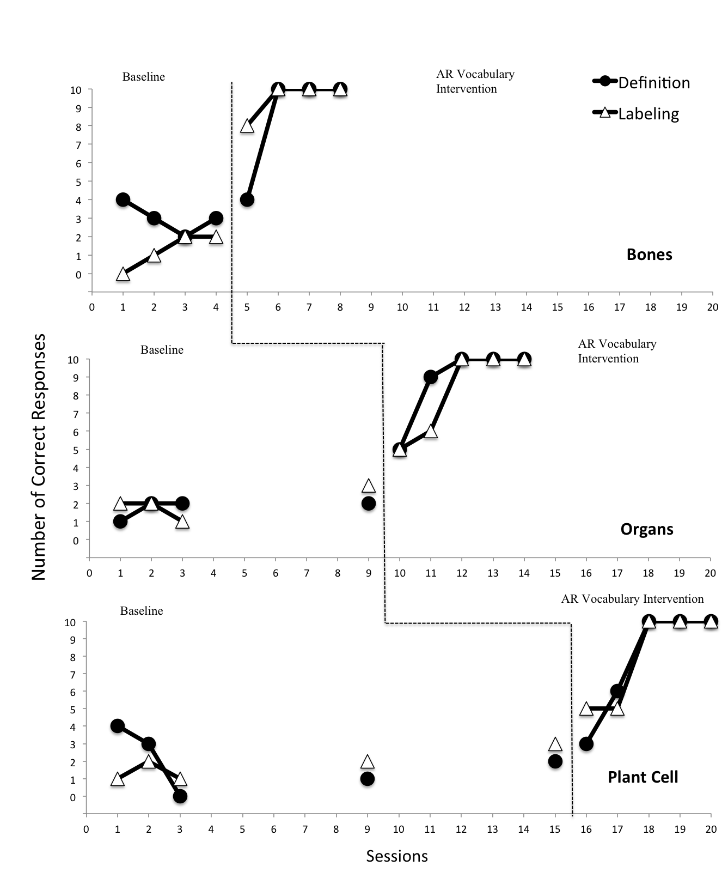
Figure 9. Miguel’s results. Data show the amount of sessions required for Miguel to master each of the three science related vocabulary word lists at 80% accuracy for three consecutive probes on both the definition and labeling assessments.
Catherine. Catherine learned the three sets of science vocabulary terms using the AR vocabulary instruction. Catherine’s baseline average correct responses for the first word list human bones were 26.7% for the definition questions and 6.7% for the labeling questions. During the AR intervention, on the first word list (bones), Catherine reached criteria of 80% correct definition and labeling responses for three consecutive sessions after her eighth session on the bones word list. Catherine’s baseline average correct responses for the second word list (human organs) were 7.5% for the definition questions and 20% for the labeling questions. On the second word list organs, she reached criteria of 80% correct definition and labeling responses for three consecutive sessions after her eleventh session using the AR vocabulary instruction. Catherine’s baseline average correct responses for the third word list (parts of the plant cell) was 10% for the definition questions and 18% for the labeling questions. On the final word list, using the AR vocabulary experience she reached criteria of 80% correct definition and labeling responses for three consecutive sessions after her eleventh session using the AR vocabulary instruction. Visual analysis shows that her definition score and labeling score improved at approximately the same rate for the bones word list but her ability to correctly label improved faster than her ability to correctly find the definition on the organs and parts of the plant cell. Across all conditions, Catherine immediately improved her science using the AR vocabulary as measured by the ability to find the correct definition and the ability to label correctly the term. Catherine’s results are presented in Figure 10 below.
Both effect size measures calculated signify this was an effective intervention for Catherine and results for each word list are presented in Table 2 in the effect size section. Catherine’s percentage of non-overlapping data (Scruggs, Mastropieri, & Casto, 1987) average for definition questions on the three word lists was 89.8%, which indicates an effective intervention (Scruggs & Mastropieri, 2001). Catherine’s modified Cohen’s d statistic (d₁) (Beeson & Robey, 2008) for definition questions on the three word lists was d₁ = 8.77, which indicates a large effect size (Robey, et al., 1999). Her percentage of non-overlapping data average for labeling questions on the three word lists was 89.77% which indicates a highly effective intervention (Scruggs & Mastropieri, 2001). Catherine’s modified Cohen’s d statistic (d₁) (Beeson & Robey, 2008) for labeling questions on the three word lists was d₁ = 6.17, which indicates a large effect size (Robey, et al., 1999).
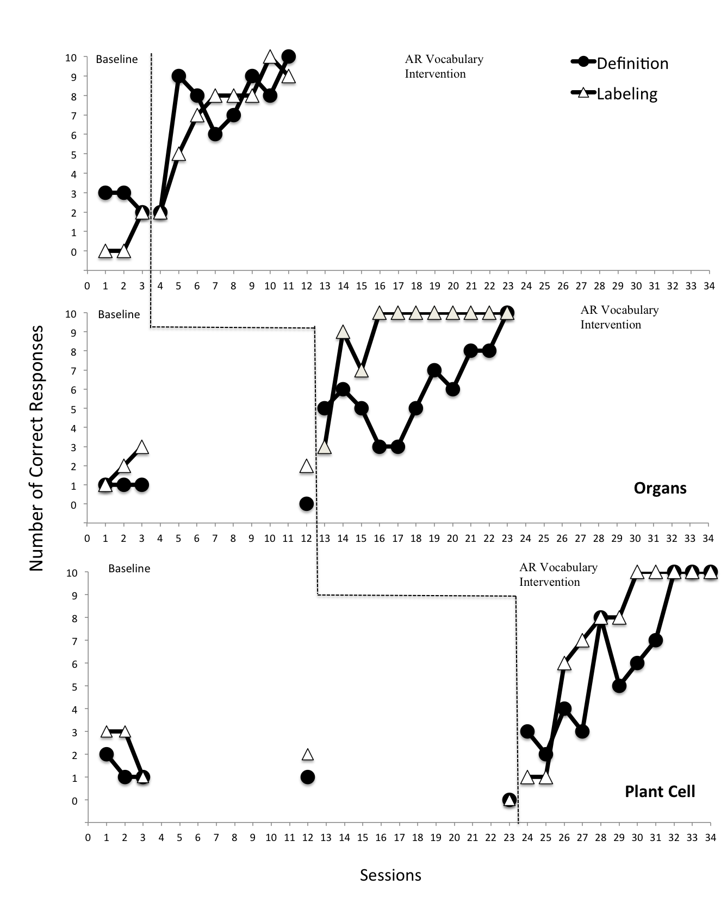
Figure 10. Catherine’s AR Vocabulary results.. Data show the amount of sessions required to master each of the three science related vocabulary word lists at 80% accuracy for three consecutive probes on both the definition and labeling score.
Billie. Billie learned the three sets of science vocabulary terms using the AR vocabulary instruction. Billie’s baseline average correct responses for the first word list human bones were 30% for the definition questions and 7.5% for the labeling questions. During the AR intervention, on the first word list (bones), Billie reached criteria of 80% correct definition and labeling responses for three consecutive sessions after her seventh session on the bones word list. Billie’s baseline average correct responses for the second word list (human organs) were 20% for the definition questions and 22.5% for the labeling questions. On the second word list organs, she reached criteria of 80% correct definition and labeling responses for three consecutive sessions after her eleventh session using the AR vocabulary instruction. Billie’s baseline average correct responses for the third word list (parts of the plant cell) was 16% for the definition questions and 14% for the labeling questions. On the final word list, using the AR vocabulary experience she reached criteria of 80% correct definition and labeling responses for three consecutive sessions after her seventh session using the AR vocabulary instruction. Visual analysis shows that her definition score and labeling score improved at approximately the same rate for all three sets of vocabulary. Across all conditions, Billie immediately improved her science using the AR vocabulary as measured by the ability to find the correct definition and the ability to correctly label the term. Billie’s results are presented in Figure 11 below.
Both effect size measures calculated signify this was an effective intervention for Billie and results for each word list are presented in Table 2 in the effect size section. Billie’s percentage of non-overlapping data (Scruggs, Mastropieri, & Casto, 1987) average for definition questions on the three word lists was 94.43%, which indicates a highly effective intervention (Scruggs & Mastropieri, 2001). Billie’s modified Cohen’s d statistic (d₁) (Beeson & Robey, 2008) for definition questions on the three word lists was d₁ = 5.08, which indicates a large effect size (Robey, et al., 1999). Her percentage of non-overlapping data average for labeling questions on the three word lists was 79.77%, which indicates a highly effective intervention (Scruggs & Mastropieri, 2001). Billie modified Cohen’s d statistic (d₁) (Beeson & Robey, 2008) for labeling questions on the three word lists was d₁ = 5.02, which indicates a large effect size (Robey, et al., 1999).
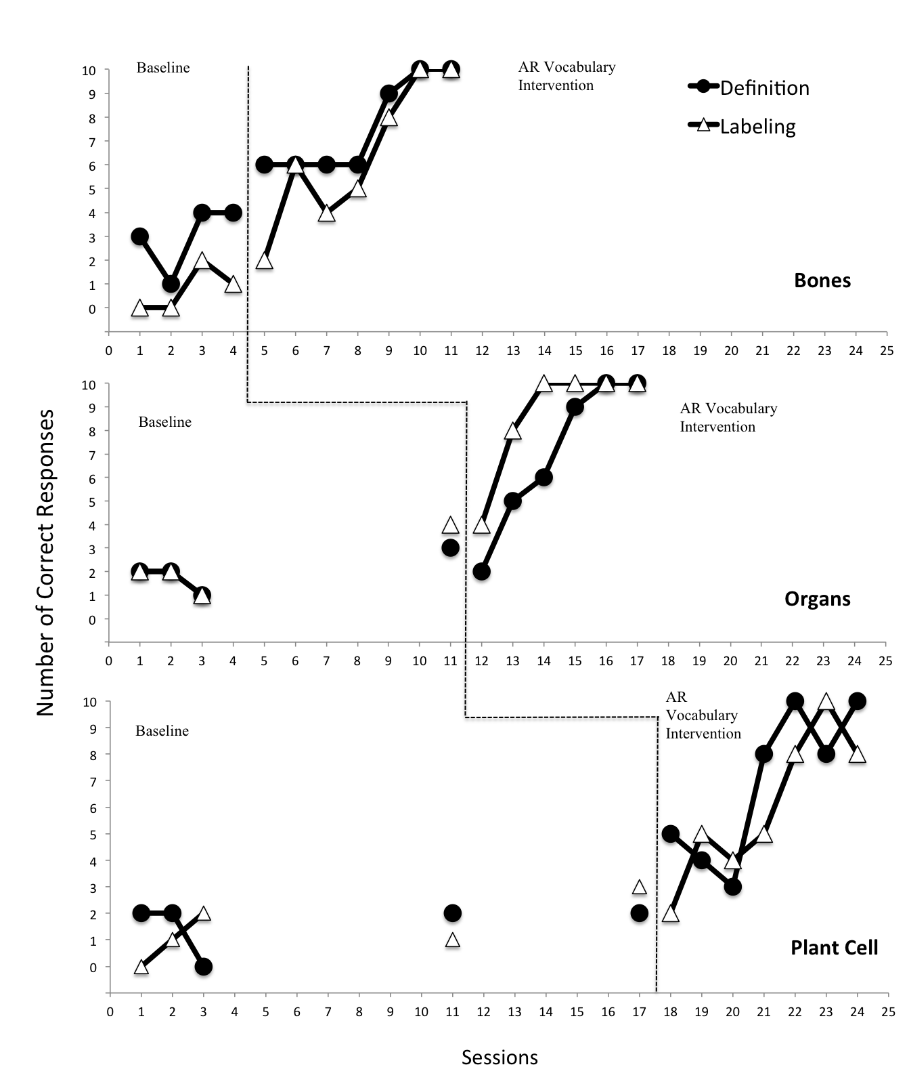
Figure 11. Billie’s AR Vocabulary results. Data show the amount of sessions required to master each of the three science related vocabulary word lists at 80% accuracy for three consecutive probes on both the definition and labeling score.
Brenda. Brenda learned the three sets of science vocabulary terms using the AR vocabulary instruction. Brenda’s baseline average correct responses for the first word list human bones were 2.5 for the definition questions and 1.0 for the labeling questions. During the AR intervention, on the first word list (bones), Brenda reached criteria of 80% correct definition and labeling responses for three consecutive sessions after her seventh session on the bones word list. Brenda’s baseline average correct responses for the second word list (human organs) were 2.75 for the definition questions and 2.25 for the labeling questions. On the second word list organs, she reached criteria of 80% correct definition and labeling responses for three consecutive sessions after her eleventh session using the AR vocabulary instruction. Brenda’s baseline average correct responses for the third word list (parts of the plant cell) was 1.8 for the definition questions and 1.4 for the labeling questions. On the final word list, using the AR vocabulary experience she reached criteria of 80% correct definition and labeling responses for three consecutive sessions after her seventh session using the AR vocabulary instruction. Visual analysis shows that her definition score and labeling score improved at approximately the same rate for the all three sets of vocabulary terms. Across all conditions, Brenda immediately improved her science using the AR vocabulary as measured by the ability to find the correct definition and the ability to correctly label the term. Brenda’s results are presented in Figure 12 below.
Both effect size measures calculated signify this was an effective intervention for Brenda and results for each word list are presented in Table 2 in the effect size section. Brenda’s percentage of non-overlapping data (Scruggs, Mastropieri, & Casto, 1987) average for definition questions on the three word lists was 100% which indicates an highly effective intervention (Scruggs & Mastropieri, 2001). Brenda’s modified Cohen’s d statistic (d₁) (Beeson & Robey, 2008) for definition questions on the three word lists was d₁ = 8.77, which indicates a large effect size (Robey, et al., 1999). Her percentage of non-overlapping data average for labeling questions on the three word lists was 91.9%, which indicates a highly effective intervention (Scruggs & Mastropieri, 2001). Brenda’s modified Cohen’s d statistic (d₁) (Beeson & Robey, 2008) for labeling questions on the three word lists was d₁ = 6.17, which indicates a large effect size (Robey, et al., 1999).
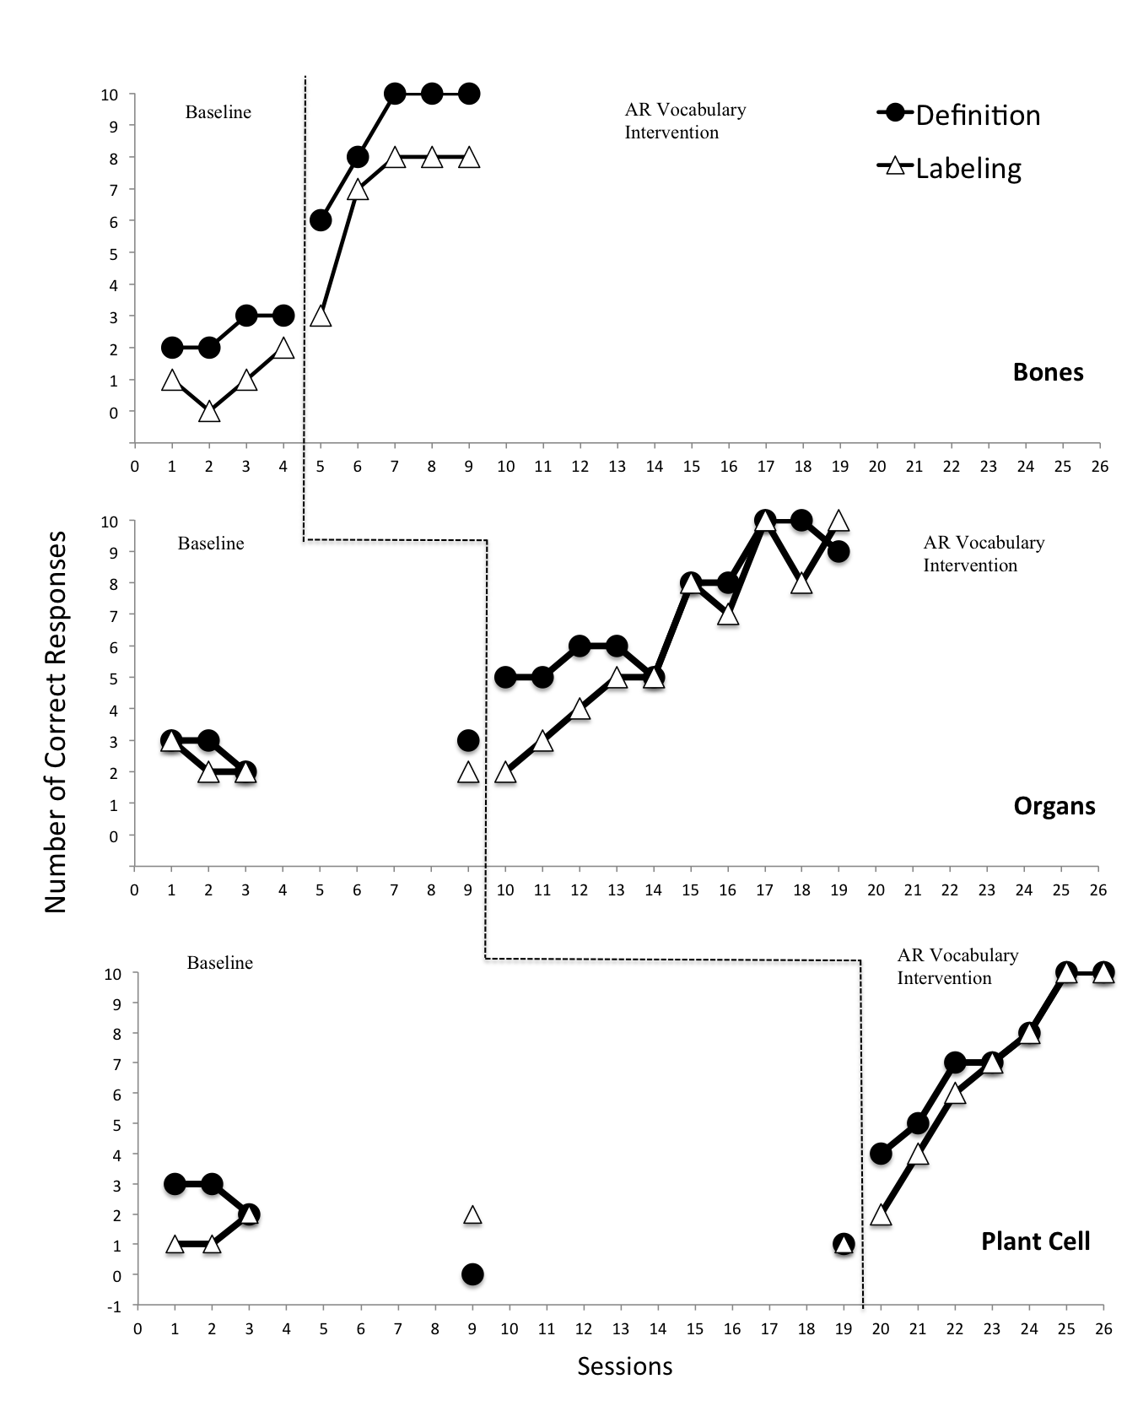
Figure 12. Brenda’s AR Vocabulary results. Data show the amount of sessions required to master each of the three science related vocabulary word lists at 80% accuracy for three consecutive probes on both the definition and labeling score.
Effect Size. Both measure of effect size indicate that the AR experience intervention was an effective instructional tool for science vocabulary. The magnitude of the effect size was calculated using both PND and a modified Cohen’s d (d₁) for each of the three word lists for both of the targeted skills of defining the vocabulary term and labeling the term. Figure 14 is a graph of the PND results by student on each of the six measures. Table 2 provides both effect size measures for each student on the two skills assessed on each word list. Interpretation guidelines for both effect size measures allow investigators to compare the magnitude of the effect of the intervention for example highly effective (PND) or large effect size (Cohen’s d₁). The magnitude of the effect size interpretations varies according to individual results but overall both effect size measures produced similar indicators magnitude of effect size. The average PND for all students was slightly higher for the definition score (M=92.30) than for the labeling score (M=90.35). The average effect size using the modified Cohen’s d (d₁) for all students was also slightly higher for the definition score (d₁ = 7.47) than for the labeling score (d₁ = 6.76).

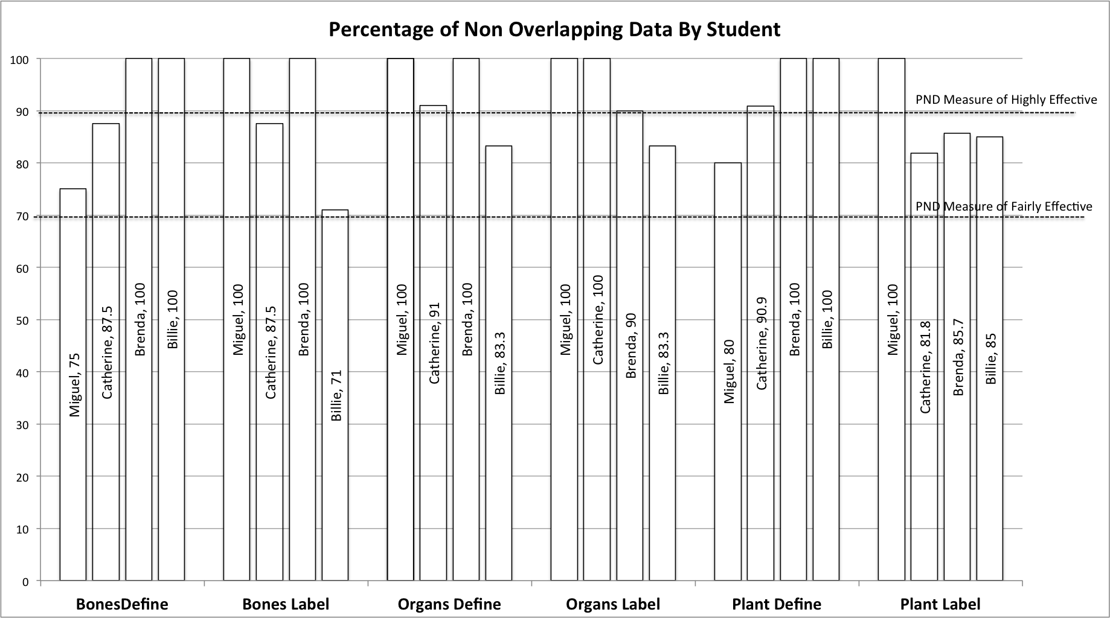
Figure 13. Graph of Percentage of Non-Overlapping Data in each treatment phase by student.
Table 2. Study 1: Effect sizes by student. Two separate effect size measures were calculated using percentage of non-overlapping data and modified Cohen’s d_{1.}
Student |  | Bones |  | Organs |  | Plant Cell |  | Total
 | Effect Size | Define | Label | Define | Label | Define | Label | Define | Label
Miguel | PND | 75* | 100** | 100** | 100** | 80* | 100** | 85* | 100**
 | Cohen’s d₁ | 6.74 ^{Ŧ} | 8.62 ^{Ŧ} | 14.10 ^{Ŧ} | 7.59 ^{Ŧ} | 3.67 | 7.41^{Ŧ} | 8.17 ^{Ŧ} | 7.87 ^{Ŧ}
Catherine | PND | 87.5* | 87.5* | 91** | 100** | 90.9** | 81.8* | 89.8* | 89.77*
 | Cohen’s d₁ | 8.16 ^{Ŧ} | 5.59 | 10.5 ^{Ŧ} | 8.57 ^{Ŧ} | 7.33 ^{Ŧ} | 4.27 | 8.77 ^{Ŧ} | 6.17 ^{Ŧ}
Brenda | PND | 100** | 100** | 100** | 90.8** | 100** | 85.7* | 100** | 91.9**
 | Cohen’s d₁ | 10.91 ^{Ŧ} | 7.10 ^{Ŧ} | 8.50 ^{Ŧ} | 7.06 ^{Ŧ} | 5.88 ^{Ŧ} | 4.03 | 5.08 ^{Ŧ} | 5.02
Billie | PND | 100** | 71* | 83.3* | 83.3* | 100** | 85* | 94.4** | 79.7*
 | Cohen’s d₁ | 3.23 | 5.93 ^{Ŧ} | 6.12 ^{Ŧ} | 5.10 | 5.88 ^{Ŧ} | 4.03 | 5.08 | 5.02
Note. Scruggs and Mastropieri (2001) interpretational guidelines of PND
**PND greater than 90% = highly effective intervention
*PND greater than 70% and less than 90% = an effective intervention
PND greater than 50% and less than 70% = questionable effective
PND less that 50% = unreliable effectiveness for interventions
Robey et al., (1999) revised (d₁) benchmarks for single-subject research
^{Ŧ} 5.8 or greater = large effect size
3.9 to 5.8 = medium effect size
2.6 to 3.9 = small effect size

Social Validity Results.
After the conclusion of the study, students completed a social validity questionnaire regarding the use of AR to learn new vocabulary words. All students reported that using AR to learn vocabulary words was socially acceptable. Results also indicate all four students agreed or strongly agreed that they (a) liked seeing the vocabulary word and information about it at the same time using AR, (b) the AR tools helped to improve their science vocabulary, (c) AR vocabulary instruction was easy to use on my own, (d) hearing the definitions was easier than reading them, and (e) they would like to use augmented reality more to learn new things. The open ended questions from the social validity survey also indicated that the participants enjoyed using the AR experience to learn new science vocabulary. Some specific responses are shown in Table 3 below.
Table 3. Student responses to social validity questions.
Social Validity Likert Questions |  |  | Likert Average
I liked using AR view the vocabulary words. |  |  | 4.25
I liked seeing the vocabulary word and information about it at the same time using AR. |  |  | 5
Learning how to use these tools helped me to improve my science vocabulary. |  |  | 4.5
The AR vocabulary instruction was easy to use on my own. |  |  | 5
I was able see both the word and definition videos in the augmented reality app. |  |  | 4.5
I learned the definitions faster than the labeling. |  |  | 3.5
I learned the labeling faster than the definitions. |  |  | 3.5
Hearing the definitions was easier than reading them. |  |  | 5
I learned the vocabulary words faster on my own using the AR vocabulary instruction than I would normally from a teacher. |  |  | 4.5
I would like to use augmented reality more to learn new things. |  |  | 5
Social Validity Open Ended Questions

Student | What was it like to use the augmented reality vocabulary instruction? | What did you like or not like about the augmented reality vocabulary instruction?
Catherine | “You point the camera at the paper and it explains it” | “This really is helping me learn my science”
Brenda | “The app made the words come to life and showed what they did” | “Seeing the video and the word together helped me to learn where they go [to be labeled]”
Miguel | “The definition just popped up from nowhere with pictures telling about the word.” | “How it just popped up out of nowhere. How did it do that?”- Miguel
Billie | “It helps you learn the science [vocabulary words]” | “I liked how the pictures float above the science word when you look at the science word. So you can learn about it.”

Discussion
The purpose of this study was to examine the effects of a marker-based AR technology to teach college-students with ID and ASD science related vocabulary words. All participants demonstrated improvement in their ability to define and label science terms each time the AR vocabulary instruction was applied systematically to a new set of vocabulary terms. These findings support previous research that computer assisted instruction is an effective tool for teaching vocabulary to students with ID and ASD (Bosseler & Massaro, 2003; Wade, Boon, and Spencer, 2010, Browder, Lee, & Mims, 2011). Additionally, this study supports previous research that the use of mobile devices is an effective tool for teaching vocabulary to students with ID and ASD (Smith, Spooner, & Wood, 2013; Jameson, et al. 2012).
This study extended the reading literature for students with ID and ASD in several ways. First, it demonstrated the use of pairing science vocabulary words with meaningful digital content information by means of augmented reality. Camahan et al. (2012) suggested that technology integrated vocabulary instruction is a promising strategy for students with ID and ASD to gain contextual and meaningful vocabulary understanding. Second, this study extended the literature by teaching science vocabulary to students with ID and ASD. Educators have had few strategies for teaching science content that links to state standards Second, this study extends the literature by teaching science vocabulary to students with ID and ASD. Educators have had few strategies for teaching science content that links to state standards for students with ID and ASD (Browder, Trela, Courtade, Jimenez, Knight, & Flowers, 2012). Courtade, Spooner, and Browder (2007) found a limited number of studies with science content. A search of the literature using key terms from the National Science Education Standards (NSES) (National Research Council [NRC], 1996) revealed 11 studies in which science content was taught to students with ID and ASD. Third, this study applied the principles of UDL. Wehmeyer (2006) advocated the incorporation of UDL principles to improve academic achievement and access to the curriculum for students with ID and ASD. Fourth, this study examined the social acceptability of AR for students with ID and ASD. A more developed extension of the reading literature for students with ID and ASD is discussed in chapter 4.
In addition, student specific outcomes emerged. One student (i.e., Catherine) acquired labeling faster than defining the science terms, especially for the organs word list. Although additional research is needed, students might have been distracted when terms included multiple similar organs. For example, several organs were involved in digestion functions including pancreas, gallbladder, small and large intestine. In an effort to differentiate clearly among the organs, definitions tended to be five to eight words longer than the bones or plant cell word lists. The word length of specific definitions presents an area of potential future research. Catherine had the lowest reading ability of the participants which also could have contributed to her longer mastery time.
Limitations
One of the limitations of this study, like all single subject research is the small sample size of this study (n = 4) limits external validity and generalizability. In addition, all of the participating students attended a PSE program. Students were highly motivated adults with disabilities. Also, they had similar characteristics including disability diagnosis, cultural background, and socioeconomic status. All students also participated in a digital literacy course. Students had relatively strong basic computer skills. All students were familiar with the types of mobile devices used in this study. Although AR was new to the students, they often used computers and mobile devices for learning. The novelty of AR might have influenced the students learning. Students who use AR on a more regular basis might have performed differently.
The assessment of the science vocabulary terms included the students identifying the correct term from a list of four choices and labeling the term on a diagram. The assessment also read aloud. The assessment of the science terms did not include reading comprehension or application of the science terms. Additional and varied vocabulary assessments are needed to more fully assess the student’s actual understanding of science.
Another limitation of this study was the lack of maintenances probes. Although students acquired the science vocabulary words relatively quickly, longer term effects of AR vocabulary instruction are needed. Time constraints prevented the collection of maintenance probes in this study. This limitation also should be addressed in future research.
Future Studies
Future research is needed to replicate this study’s methods and procedures. Future research should replicate this study across other disability populations and age groups. Similarly, AR instruction requires investigation to other subjects areas such as reading, math, and social studies as well as functional life skill domains. In addition, the instructional AR component requires further examination. It is important to explore what AR features lead to the positive outcomes without distracting the learner. AR instructional components include the length of AR content, using video and/or static pictures, the word length of definitions, and use of audio information. These instructional AR components could be examined through a series of comparative intervention studies. Lastly, AR used to teach vocabulary should be compared to more established vocabulary instructional procedures, such as time delay, read alouds, and picture-to-text matching.
Summary
The AR vocabulary intervention produced a positive impact on student mastery of the science vocabulary terms through its combination of real world and digital content. Using the AR vocabulary intervention was a positive experience for all the participants according to the social validity data. The findings of the study support further examination of AR as medium for science and vocabulary instruction for students with disabilities.

Chapter 3:
Augmented Reality as a Navigation Tool to Employment Opportunities for Postsecondary Education Students with Intellectual Disabilities and Autism.
Unemployment levels of people with disabilities are much higher than the rate of unemployment in the general population. According to the National Longitudinal Transition Study (NLTS), the rate of employment for students with intellectual disabilities up to eight years post high school is 38.8% which is much lower than the similarly general population average of 66% (2011). Including additional postsecondary education programs and job training, 45.8% of students with intellectual disabilities engaged employment or employment related activities. The primary transition goal of secondary students with disabilities is to be employed (Cameto, Levine, & Wagner, 2004). Unfortunately, students with disabilities are significantly less likely to be employed than their peers without disabilities of the same age (Burge, Ouellette-Kuntz, & Lysaght, 2007; Newman, et al., 2011). Employment is one of several factors that increase the quality of life for individuals with intellectual disabilities (ID) (Schalock, et al., 2002) and autism (Garcıa-Villamisar, Wehman, & Navarro, 2002) so it is critical for educators to find ways of helping these students minimize the barriers to their employment.
Barriers to Employment
There are several identified barriers to employment for students with intellectual disabilities and autism including societal factors (Swain, 2004), limited transition options and training (Migliore, Mank, Grossi, & Rogan, 2007), limited availability of post-secondary education opportunities (Gringal, Hart, Migliore, & Alberto, 2011), lack of knowledge (Folk, Yamamoto, & Stodden, 2012), and navigation/travel concerns (Rose, Saunders, Hensel, & Kroese, 2005). New technologies and innovative solutions using existing commercial technologies may provide individuals with ID and ASD increased employment and navigation skills.
Mobile Devices for Students with Disabilities
A wide variety of technologies have been used successfully to assist people with ID and ASD to navigate more independently including using mobile devices. Instructional technologies can be applied as assistive technologies to promote greater independence by enabling people with disabilities to perform tasks that they were formerly unable to accomplish. The proliferation of mobile devices in society led to the growing field of using these devices to learn new things commonly called mobile learning. Mobile learning emphasizes a movable learning environment rather than a static location (Ogata & Yano, 2004). Mobile Learning tools have several advantages over stationary, traditional computer-based tools for navigation related tasks. In addition to portability, mobile devices frequently offer a variety of accessibility options for students with ID and ASD (McMahon & Smith, 2012). Wehmeyer, Palmer, Smith, Davies, and Stock (2008) conducted a meta-analysis of research on technologies used by people with disabilities, which identified several studies that support the effectiveness of mobile devices for teaching people with ID skills across many different academic and functional skills. Mobile devices have the potential to empower people with disabilities by providing full range of supports readily available for the user in a socially acceptable platform.
Navigation for Students with Disabilities
Lancioni et al. (2010) conducted two multiple baseline studies using navigational technologies that provide both auditory and physical prompts (vibrating) to assist individuals with multiple disabilities and low vision or blindness in finding indoor routes. In the first study, the participants were wheelchair users while the second study’s participants were ambulatory. The system prompted the participants when they were approaching doorways and corridors. Both the participants who used wheelchair and the participants who were able to walk successfully oriented themselves indoors using the mobile device prompting tools.
Mechling and Seid (2011) used a commercially available handheld personal digital assistant (PDA) to provide picture, auditory and video prompts for three young adults with ID to support independent navigation skills. The students could choose what prompts and how often they needed them based on their individual needs. Using the mobile device, the young adults with ID were able to increase their ability to find landmarks along a route and to reach independently their destination. However, since the intervention relied on video modeling, all materials for the students were created and downloaded in advance in order to navigate to a new location. Students were unable to travel to a location in which the video clips were not developed ahead of time.
Davies, Holloway, and Wehmeyer (2010) used commercially available mobile devices with a global positioning system (GPS) to support independent bus travel for adults with ID. This study measured the independence of two groups of adults with ID. The intervention group (n=12) used a GPS system to navigate independently to a new location while the control group (n=11) used a traditional paper map. The investigators collected data at specific decisions points. Decision points were defined as navigation points which required a decision regarding which way to turn (e.g., left, right, continue forward) and/or to access specific public transportation (e.g., bus). Using the handheld GPS, 73% of students with ID were able to navigate independently to a new location using public transportation; in the control group less than 10% of the students were able to get to the correct destination independently.
Augmented Reality for Location Based Learning and Navigation
As described by Craig (2013), the defining characteristic of augmented reality (AR) is the addition of digital information within the physical world. In AR applications that use global positioning systems, (GPS) or other location tools (compass, accelerometer, etc.) information, individuals view digital media based on their location. This digital media can provide a variety of educational and independent living supports. Ten years ago, a portable AR navigation system required a 15-pound computer backpack that and used a helmet-mounted display system (Kalkusch, et al., 2002). Today using mobile devices as platforms, there are hundreds of AR applications addressing a wide range of needs including navigation.
Beckett and Shaffer (2005) used an augmented reality geographic information system (GIS) to teach urban planning skills for high school students in authentic professional practices. The authors concluded that the AR system represents a new technology that can teach students ecological concepts in a practical context, which can help to bridge the gap between indoor and outdoor learning environments. Etxeberria, Asensio, Vicent, and Cuenca (2012) reviewed the use of mobile devices to support location-based learning. The authors found that a variety of technologies on mobile devices were implemented to support location based context relevant learning, navigation, and prompting at cultural tourism sites in Europe including virtual reality, augmented reality, and geographic information system reference information that appears when an individual is near a particular set of GPS coordinates. Throughout Europe at cultural locations, these technologies are used to create formal scripted instructional experience, informal learning options, and optional supplementary information based on the needs and interests of the user.
While there is limited research on AR as a navigation tool for students with disabilities, there is research on the related technology of virtual reality that is relevant to this work. Virtual reality training and instructional activities for students with ID can transfer to new locations which allows students to practice functional activities like navigating a grocery store or making a purchase in a low stress, failure free environment (Cobb & Sharkey, 2007). Hutcherson, Langone, Ayres, and Clees (2004) applied virtual simulations that provided prompts to assist students with ID to navigate large 3-dimensional simulations of shopping experiences from a first person point of view. Their results indicated that all of the students were able to generalize the lessons learned on the computer to the physical store.
Smith (2013) used a markerless AR application to improve college students with ID and ASD navigation skills to unknown locations on a college campus. Participants in this ABAB design selected the target destination from a list of choices from within the application on the mobile device and then used the AR application to navigate independently to unknown locations. As students looked through the AR view, digital information was displayed including an arrow showing the correct direction and text that indicated the amount of distance remaining to reach the destination. McMahon, Smith, Cihak, and Gibbons, (under review) conducted a comparative study using paper map, Google maps on a mobile device, and an AR navigation tool for a similar group of students in a PSE program. The results indicated that students using the AR navigation app navigated more independently and the students preferred using the AR app.
Purpose: Navigating to Employment Opportunities
Augmented reality is a technology that may empower students with new skills for independent navigation to unknown locations. One example that demonstrates the flexibility of using AR on mobile devices is the app Layar, which can function as an Internet browser for location based information, like nearby job openings. When used, the AR app displays nearby businesses with open job opportunities based on the user’s settings and location. A user choosing to display open jobs within a five-mile radius is likely to have more search results compared to a user who only displayed job results located within a 1-mile radius of their location. Adjusting the app search criteria allows the user to adjust the number of points of interest that are displayed in their mobile device, which is then used in addition to live video that was augmented by search apps for locating jobs.
The purpose of this study was to examine the effects of a markerless AR technology to teach college students with ID and ASD to navigate a city independently to local employment opportunities. This study used an augmented reality app called Layar (2013) to view location based navigation data on employment opportunities within walking distance of the individual with an intellectual disability. Due to the complex nature of navigation, appropriate technology should be selected to assist individuals with disabilities when navigating independently to new locations for employment opportunities in large cities, suburbs, and urban areas. By teaching young adults with ID to access the needed technology, apply the knowledge needed to use the tool or application, make a decision based on information obtained, and utilize embedded digital supports, AR navigation tools may help increase their ability of independent decision-making skills when navigating to unknown locations. The current study evaluated the use of three different navigation aids for people with ID. This study examined the following research questions.
- What are the differential effects for college students with ID and ASD when using a printed map, Google Maps, and a markerless augmented reality navigation tool to navigate independently a city to unknown businesses locations?
- Which navigation strategy do college students with ID and ASD report as being most helpful and socially acceptable?

Methods
Participants
Four college-age students participated in this study. All students attended a postsecondary education program (PSE) for college-students with intellectual disabilities (ID) and ASD. This program was located at a large public university in the southeastern United States. Students participated in university audit courses, PSE courses, a work-based internship, and campus activities. Students participated in a course on digital literacy and regularly used mobile devices for educational and recreational activities. As part of their PSE program students regularly independently traveled to classes along familiar routes. Participants included 1 male and 3 female students. Pseudo names (Jamie, Catelyn, Jon, and Arya) were used to maintain confidentiality. None of these students participated in study 1. All students received special education services under the ID category during their previous K-12 schooling. In addition, all students met ID eligibility guidelines for admission to the postsecondary education program. Two months before the start of this study all of the participants were administered selected tests from the Woodcock-Johnson III Normative Update Tests of Cognitive Abilities and Tests of Achievement (Woodcock, Schrank, Mather, & McGrew, 2007). Diagnostic and educational information including IQ, processing speed, and reading proficiency levels for each participant is included below and displayed in Table 4.
Table 4. Study 2. Participant Characteristics.

Participant | Age | IQ | Adaptive  IQ | Processing Speed | Broad Reading
Jamie | 21 | 63 (WISC-III) | 67 | 34 | 74
Catelyn | 23 | 45 (SB-IV) | 65 | 54 | 55
Jon | 24 | 56 (RAIS) | 73 | 49 | 71
Arya | 20 | 64 (WISC-III) | 72 | 50 | 77
A= Wechsler Intelligence Scale for Children (WISC III), B= Stanford Binet Fourth Edition (SB-IV), C= Reynolds Intellectual Assessment Scales (RAIS).

Jamie. Jamie was a 21 year-old student diagnosed with autism. Jamie had IQ of 63 based on results from WISC-III. Results from the Woodcock Johnson III indicate compared to peers of his age, Jamie had very limited processing speed (SS=34) and limited broad Reading skills (SS=74). Results from the Vineland Adaptive Behavior Scales (VABS) indicate mildly deficient adaptive functioning (SS=67). Jamie had moderate navigation skills and could independently travel to known locations but required assistance to travel new locations.
Catelyn. Catelyn was a 23 year-old student diagnosed with an intellectual disability. She had an IQ of 45 on the Stanford Binet Fourth Edition. Results from the WJ-III indicate compared to peers of her age, Catelyn had very limited processing speed (SS=54), negligible broad reading skills (SS=54). Results from the Vineland Adaptive Behavior Scales (VABS) indicate mildly deficient adaptive functioning (SS=65). Catelyn had limited navigations skills and required a mentor to travel to some known locations on campus depending on distance in her PSE program.
Jon. Jon was a 24 year-old student diagnosed with ID. He had IQ of 56 as measured on the Reynolds Intellectual Assessment Scales RAIS. Results from the WJ-III indicate compared to peers of his age, Jon had very limited processing speed (SS=49), very limited broad reading skills (SS=50). Results from the Vineland Adaptive Behavior Scales (VABS) indicate borderline adaptive functioning (SS=74). Jon had moderate navigations skills and frequently traveled independently to known locations on campus.
Arya. Arya was a 20 year-old student diagnosed with multiple disabilities, including ID. She had IQ of 64 based on results from WISC-III. Results from the Woodcock Johnson III indicate compared to peers of her age, Arya had very limited processing speed (SS=50) and limited Broad Reading skills (SS=77). Results from the Vineland Adaptive Behavior Scales (VABS) indicate borderline adaptive functioning (SS=72). Ayra required a motorized scooter in order travel between locations in her daily life. Ayra had moderate navigations skills and frequently traveled independently to known locations on campus.
Settings
All phases of this study occurred in a community setting, specifically in a city downtown area of 180,000 people approximately. Participants navigated city streets to locate businesses that offered potential employment opportunities. Starting and ending locales were within a 12 to 20 minute walking distance from one another. Starting and ending points were continuously in order for students to always attempt a new navigation experience.
Research Design
An adapted alternating treatments design (Gast, 2010) was used to determine the efficacy of college students with ID and ASD to use a paper map, Google Maps, and the AR application to navigate correctly to an unknown business location. Sindelar, Rosenburg, and Wison (1985) suggested that in adapted alternating treatment designs researchers can demonstrate functional control of the dependent variable by extending the baseline condition during intervention as a third condition. The baseline condition, the paper map, was continued as a third condition of the adapted alternating treatment in order to allow for the demonstration of a functional relations between the independent and dependent variables. The adapted alternating treatments design allowed the lead investigator to evaluate the relation between each navigation treatment condition and correct navigational checks. Navigation treatment conditions were presented randomly to reduce potential carryover effects. The more effective navigation aid treatment was defined as bifurcation of the data paths or if the student reported a preference using one application over another via the social validity questionnaire. Afterwards, only the preferred navigation application continued to be assessed.
Treatment Conditions and Materials
Three treatment conditions were implemented to examine the effectiveness of each student’s independent navigation skills including (a) paper map, (b) Google Map, and (c) augmented reality (AR). During the paper map treatment condition, a paper map of the city’s downtown area was produced using Google maps. The paper map was 8.5 in x 11 in and printed in color. The map included major street names and the student’s current location. Destinations were marked clearly on the paper map for the students.
The Google Maps treatment condition used the Google Maps software application (Google, 2014). Students accessed the application from a mobile device. The Google Maps application displayed the student’s current location as a blue dot and displayed a pin for the targeted business location. The lead investigator selected the target location. Google Maps also highlighted a route to the targeted business. The mobile devices used in this study were iPhones.
The AR treatment condition used the Layar mobile app (Layar, 2013). The Layar application is available on multiple platforms including iOS and Android mobile devices. The specific devices used in this study were all iPhone 4s’. Layar uses a markerless or location-based augmented reality display to show selected content. There are thousands of potential channels of content called “geolayars.” Users select content to view by subscribing to a particular topic’s geolayer. This allows the app to function as a search engine for location-based information from the selected geolayer topics (e.g. employment opportunities) displayed according to the relative location of the user. This study used Layar to view employment postings from variety of geolayars for example, “Tweet my jobs.” Layar’s embedded visual prompts appeared as an icon of the employment location when viewed through the camera feature. The icon helps to inform the student’s decision-making by “hovering” above the specific business destination. The prompts also include the distance to the location in miles. Like the Google Maps treatment, Layar uses a wireless Internet connection and other built in tools on the mobile device to determine the users’ location and orientation. In addition, the lead investigator selected the target location from the available nearby unknown business locations with employment opportunities. Figure 14 illustrates a participant’s view when using AR to navigate.

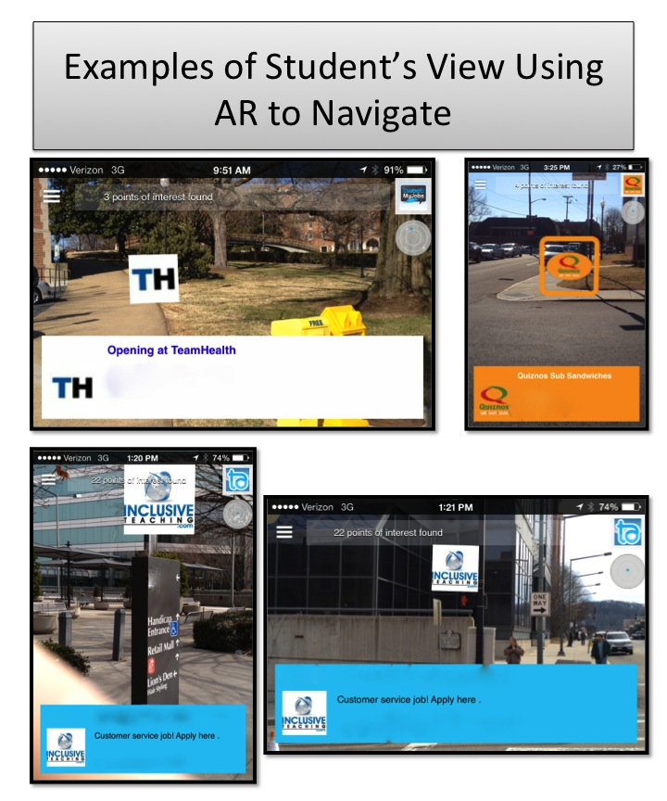
Figure 14. Augmented Reality view of location based jobs information displayed for jobs within set distance of the user.

Variables and data collection
The independent variable was the specific navigational condition. Each student participated in three navigational treatment conditions to assess the number of correct navigational checks to an unknown business location. The treatment conditions were (a) paper map, (b) Google Map, and (c) augmented reality (AR). Implementation of each treatment condition is described below in the procedures section.
The dependent variable was the percentage of correct independent navigation decisions during “navigation checks” while walking to a targeted unknown business location. Responses were marked as either yes = independent correct responses, no = for incorrect responses, or assisted = for correct responses after assistance. Event recording procedures were used to record the number of correct navigation checks from the starting location to the business location. In terms of calculating the dependent variable, the number of correct independent responses was divided by the total number of navigation checks in order to produce a percentage of independent correct navigation decisions. Acquisition criterion was defined as 100% independent navigation checks for three consecutive sessions.
Navigation Checks. Navigation checks occurred at common decision points (e.g. intersections, crosswalks), or after more than two minutes of walking without a navigation check. The investigator asked, “which direction do we go from this point?” during the navigation check. The investigator recorded the student’s response as correct, incorrect, or assisted. Starting locations for the sessions were sufficiently far enough away that a minimum of seven navigation checks would occur, though more were allowable. Students were allowed 30 seconds in order to use the selected independent variable condition (paper map, Google Map, AR app) to make their navigation decision. Figure 15 shows participants using the mobile devices to navigate.
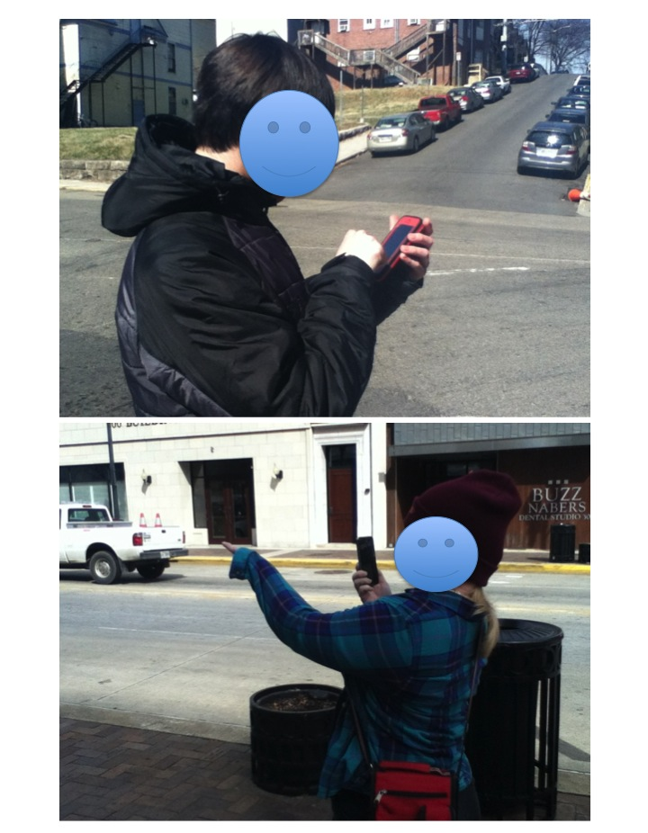
Figure 15. Participants using the mobile devices during navigation checks.

Correct Responses. A correct response was considered any response that could directly and safely get the participant to the employment location. This included any verbal or gestural response indicating the accurate path to get direction (i.e. forward, left, or right) to get to the final destination without person-support assistances. If the response was questionable, the investigator used a general “rule of thumb” of a 45-degree arc the “best” path. An example of a 45-degree arc was included in the data collection form, see Appendix E. If the student indicated a path that fell within the correct 45-degree area of the 365 degrees possible then the response was marked as correct. If the student correctly responded either verbally and/or gestural, within 30 seconds, the investigator said, “ok” and they continued to travel to the business destination.
Incorrect and Assisted Responses. Incorrect responses were defined as responses that would not directly or safely get to the business location. However, if students did not respond after 30 seconds, the investigator provided both verbal and gestural assistances and they continued walking to the business destination. Participants were allowed to get three incorrect responses before receiving assistance in order for each participant to have the opportunity to realize the navigation errors. This also prevented artificially inflated correct independent navigation checks. Theoretically, it is easier to determine correctly where to go next as students got closer to the business destination since students could narrow down the correct direction through a process of elimination. Contingent on the third incorrect navigation check, the investigator then provided verbal and gestural assistance and recorded the navigation check as “assisted”.
In addition, jaywalking or taking a shortcut through buildings or alleys was not accepted as a correct response. If an obstacle or barrier (e.g. construction, sidewalk closure) was encountered, the investigator asked “what is the safest way to get there?” or “what is the best way to get there?” If the student self-corrected and indicated the correct direction without assistance within four seconds, the investigator recorded the response as “correct”. However, if the student’s response was incorrect or unsafe, the investigator provided verbal and gestural assistance and recorded the student’s responses as “assisted”. The number of correct independent navigation checks was divided by the total number of navigational checks in order to calculate a percentage of correct navigational checks, which was graphed for visual analysis.
General Procedures
During each navigation session, each student was randomly assigned using a spinner to one of the three treatment conditions 1.) A, B, C 2.) B, C, A 3.) C. A, B. The conditions for those treatment cycles were (a) paper map, (b) Google Map, or (c) AR. Each of the treatment conditions had the target destination selected (Google Maps and AR app) or marked (paper map) for the user. The investigator started the session by asking the students to verbalize the name of the target destination and to show the investigator on the map or mobile device. Then, the investigator asked, “Have you ever been there before?” This ensured that the students looked at the map or device and that the destination was unknown. Starting locations and destinations were sufficiently far away enough to in order to require between 12 and 20 minutes of travel time walking or using a motorized scooter in the case of Arya. Starting positions and destinations were varied every session so students always experienced novel navigation activities.
Baseline. During baseline, students were given an unknown business location to travel to navigating independently using a paper map. The location of the business destination was marked on the map as well as the student’s current location. The investigator asked, “Have you ever been there before?” If the student responded “yes” then a different business was selected until the student indicated that they have not been to a specific business. The investigator asked the students to verbalize the name of a business and to show the investigator the business location on the map. This ensured that the students looked at the map. Afterwards, the investigator and student traveled to the business location. At seven different intersections, the investigator asked the student “which direction do we go from this point?” The investigator recoded the student’s responses and provided contingent assistance as noted above.
Pretraining phase. Pretraining was provided to each participate to ensure that they could independently access and use the use the two mobile applications (Google Map and Layar). Model-Lead-Test procedures (Adams & Engelmann, 1996) were used to instruct each participant. First, the investigator modeled each step of the task analysis regarding how to access and use the mobile application. As stated previously all students regularly used and were familiar with bases operations of the mobile devices. During pretraining, all students demonstrated the ability to open both apps and view the selected destinations.
Paper City Map. During the paper map navigation condition, students continued to use the same paper map implemented during the baseline phase. This treatment was a continuation of the baseline. Similar to baseline, the job location was marked on the paper map and the student was asked to navigate to the location. Using the navigation check procedures, the student and investigator then traveled according to the decisions of the participant as they attempted to navigate to the business location. The investigator conducted periodic navigation checks (i.e., intersections, crosswalks, or after two minutes of walking without a navigation check) and provided verbal and gestural assistance contingently.
Google Maps. The Google map was displayed on a mobile device using the iOS operating system (iPhone 4s). The app used location information obtained by the wireless data connection on the device, which allowed the student to see their current location and the target destination. The investigator selected the unknown business location and provided the mobile device to the student. Using the navigation check procedures the student and investigator then traveled according to the decisions of the participant as they attempted to navigate to the business location. The investigator conducted periodic navigation checks (i.e., intersections, crosswalks, or after two minutes of walking without a navigation check) and provided verbal and gestural assistance contingently.
AR Navigation. The AR application Layar was displayed on a mobile device using the iOS operating system (iPhone 4s). This app also used location information provided from the wireless data connection and used that information to provide the AR experience described in the materials section. Similar to the Google Map treatment, the investigator selected the unknown business location and provided the mobile device to the student. Using the navigation check procedures the student and investigator then traveled according to the decisions of the participants as they attempted to navigate to the business location. The investigator conducted periodic navigation checks (i.e., intersections, crosswalks, or after two minutes of walking without a navigation check) and provided verbal and gestural assistance contingently.
Preference phase. The more effective navigation treatment condition was replicated during a preference phase. The more effective condition was defined as bifurcation of the data paths. In visual analysis, bifurcation is the separation in the data path of at least three consecutive points (Gast, 2010). If all conditions were determined to be equally effective, then the student’s reported navigation preference via the social validity questionnaire would be replicated. Students navigated to three additional unknown businesses using the same procedures defined aforementioned.
Data Analysis Procedures
Visual analysis procedures were used to evaluate the results of the three navigation conditions. To assess intervention effects, six indicators were used to examine within-phase and between-phase data patterns: (a) level, (b) trend, (c) variability, (d) immediacy of the effect, (e) overlap, and (f) consistency of data patterns across similar phases (Kratochwill, et al., 2010). Also, within-phase comparisons were evaluated to assess predictable patterns of data, data from adjacent phases were used to assess whether manipulation of the independent variable was associated with change in the dependent variable, and data across all phases were used to document a functional relation (Gast, 2012). Horner et al. (2005) recommended that a functional relationship or causal relationship is demonstrated after at least three occurrences of an effect at a minimum of three different points in time are observed. For each participant the percentage of non-overlapping data (PND) was calculated between the baseline and intervention phases (Scruggs, Mastropieri & Casto, 1987). Scruggs and Mastropieri (2001) suggested interpretational guidelines of PND were used to evaluate the effectiveness of the intervention. Based off their guidelines, this study evaluated PND greater than 90% as a highly effective intervention, PND greater than 70% and less than 90% as an effective intervention, PND greater than 50% and less than 70% as questionable effective, and PND less that 50% was considered unreliable effectiveness for interventions.
Interobserver Agreement and Treatment Integrity
The lead investigator and a trained research assistant trained to study procedures independently and simultaneously collected interobserver agreement (IOA) and procedural reliability data. The research assistant was trained in the study procedures, independent and dependent variables, and in data collection procedures. This training involved the investigator teaching and demonstrating procedures, as well as role modeling possible navigation behaviors and teaching the research assistant how those were to be scored as well as. Interobserver agreement data were collected during a minimum of 25% of baseline and intervention conditions. Observers independently and simultaneously recorded the number of correct navigation checks. Interobserver agreement was calculated by dividing the number of agreements of the participant responses by the number of agreements plus disagreements and multiplying by 100. Acceptable IOA was 90% or greater for each student across all phases and treatments. If IOA had fallen below 90%, then the investigator and second observer would have clarified IOA and data collection procedures. See Appendix F for a sample of the treatment integrity measurement form. The overall IOA was 97% (range = 91%-100%). Jamie’s treatment integrity ranged from 92% to 100% (M = 98 %), Catelyn’s ranged from 91% to 100% (M = 96 %), Jon’s’ ranged from 94% to 100% (M = 98 %), and Arya’s ranged from 94% to 100% (M = 96%).
Procedural reliability data also were collected during a minimum of 25% of all sessions for each treatment condition and for each participant. The investigator was required to provide participants with the necessary materials (i.e., paper map, mobile device, app, location preloaded), ask “which direction do we go from this point?”, and provide verbal and gestural assistances, contingent upon an incorrect response or no response following four seconds. A trained graduate assistant and doctoral student who was knowledgeable of the study, independent and dependent variables, and treatment condition instructional procedures observe the investigator implementation of treatment condition procedures. The observer was provided with a task analysis of instructional procedures for the treatment conditions (see Appendix F) and recorded if specific instructional procedures were observed. The procedural agreement level was calculated by dividing the number of observed investigator’s behaviors by the number of planned investigator’s behaviors and multiplying by 100. Acceptable procedural reliability was defined as 90% or greater for each student across all treatments conditions. If procedural reliability had fallen below 90%, then the investigator and second observer would have clarified IOA and data collection procedures. The overall mean treatment integrity was 100 %.
Social Validity
Following the conclusion of the reimplementation phase, each participant was asked to complete a Likert survey (See Appendix G) created by the investigator to assess their opinions and acceptability of using the navigation tools. The question items were read aloud to the students. Each survey item used Likert scale ranged from 1 (strongly disagree) to 5 (strongly agree) with the addition of “thumbs up” (1 Strongly Disagree) to “thumbs down” as indicators on the scale to support comprehension of the question. The social validity survey also included two open-ended social validity questions whose answers were scribed by the investigators.
Results
Baseline results for all of the participants indicated that they were not able to navigate independently to the unknown business locations. Visual analysis procedures for all of the participants revealed that the AR treatment was the more effective treatment for improving the navigation skills of the students. A bifurcation was observed favoring AR. The continuation of the baseline condition, the paper map, as a condition of the alternating treatments demonstrated a functional relation between improved navigation independence and the two conditions using mobile devices. Between these two conditions, the AR condition was superior in terms of reaching the criteria of three successful 100% independent navigation attempts to potential employment opportunities.
Jamie. Jamie required assistance during all baseline sessions using the paper map to navigate to nearby possible job opportunities. His baseline average was 12.1% correct independent navigation checks. During the intervention phase, the three treatments produced noticeable differences navigating independently. Jamie’s first session using the AR app was 75% independent navigation checks. In his second session using AR, his independent navigation increased to 100% independence and he achieved criteria after two more AR app sessions. Jamie’s average navigation independence was 49.1% with Google Maps. His scores on the AR app remained at 100% while his scores remained approximately the same for the paper map and Google Map both of which had an overall average of 50% or less. Of the three conditions, the paper map was the least successful with a mean of 13.8% correct navigation checks, which was effectively no improvement from baseline. During the preference phase, Jamie’s navigation checks remained at 100% using the AR navigation treatment. Jamie’s percentage of non-overlapping data average using the more successful treatment (AR navigation) was 100%, which indicated a highly effective intervention (Scruggs & Mastropieri, 2001). Jamie’s results are displayed below in Figure 16.
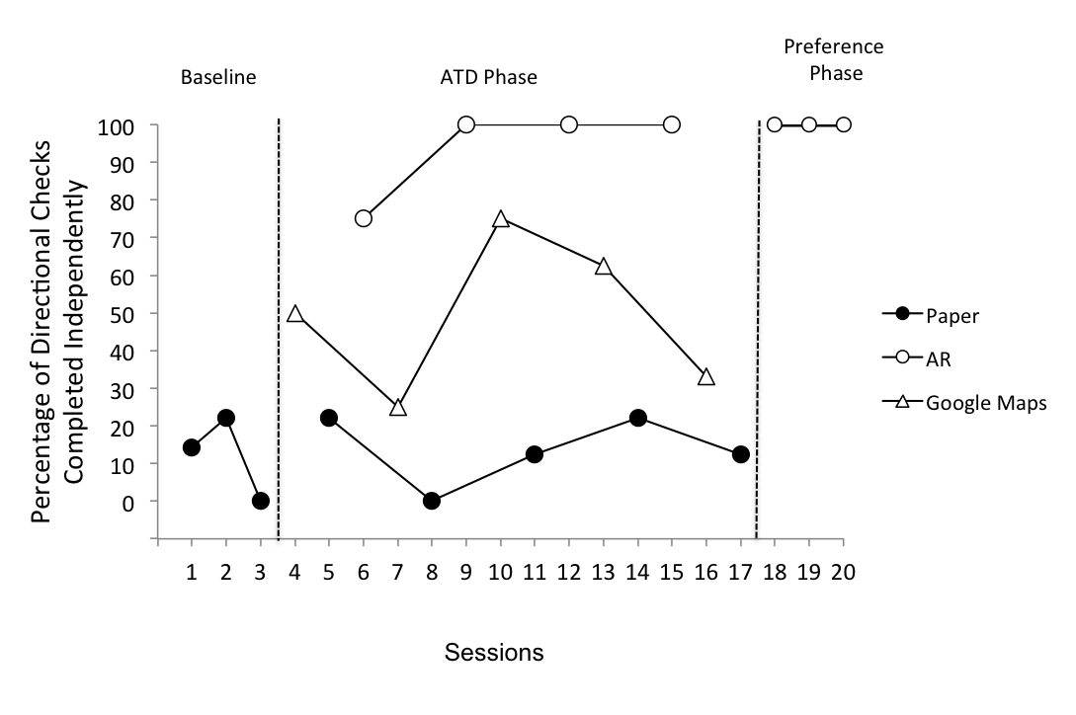

Figure 16. Jamie’s navigation results graph. Results for Jamie from the alternating treatment design comparing independent navigation across the conditions of a paper map, augmented reality navigation, and Google Maps.

Catelyn. Catelyn was unable to navigate to any location independently during baseline. Her baseline average was 11.5% correct independent navigation decisions. The AR app was immediately more successful than the other treatments with 75% navigation independence. Catelyn achieved criteria of three consecutive sessions at 100% on her fifth session using the AR app. Visual analysis showed that the other two conditions remained fairly low and did not trend toward improvement. Google Maps was second most successful with a total of 45.75% independent navigation checks. The paper map was the least successful with an average of independent direction checks of 20.14% which was a marginal improvement from baseline. During the preference phase her scores remained at 100% using the AR navigation treatment. Catelyn’s percentage of non-overlapping data average using the more successful treatment (AR navigation) was 100% which indicated this was a highly effective intervention (Scruggs & Mastropieri, 2001). Catelyn’s results are displayed below in Figure 17.
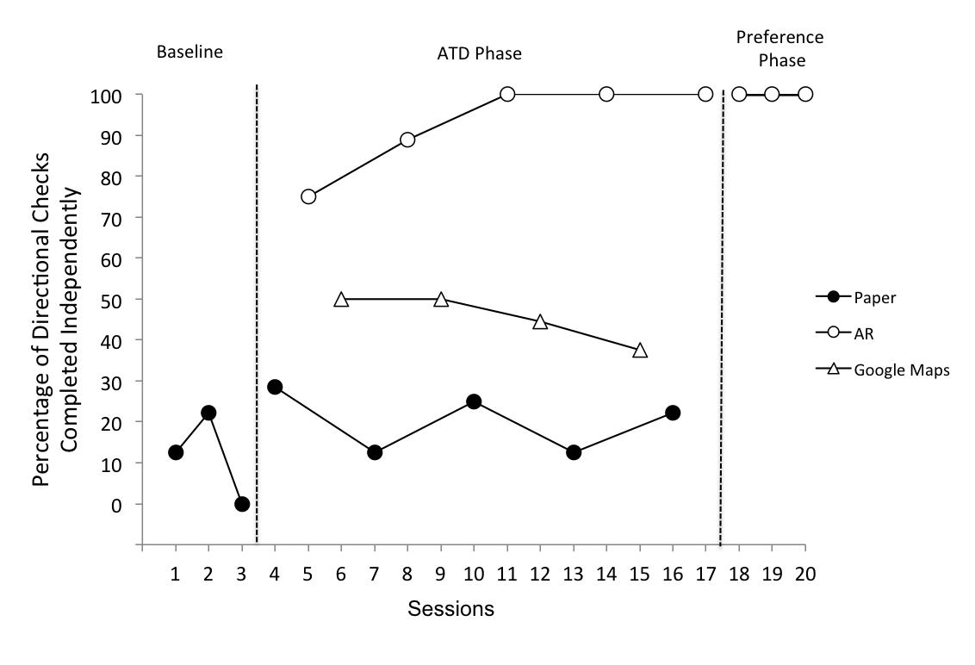
Figure 17. Catelyn’s results graph. Results for Catelyn from the alternating treatment design comparing independent navigation across the conditions of a paper map, augmented reality navigation, and Google Maps.
Jon. Jon did not navigate independently to any location during baseline. His baseline average was 16.13% correct independent navigation decisions. The AR app was immediately more successful than the other treatments with 75% navigation independence. Jon acquired 100% independence for three consecutive sessions on the fourth navigation session indicating the preferred navigation aid for him was AR. Jon’s mean level of independent navigation for Google Maps was 40.95%. The paper map was the least successful with an average of independent direction checks of 20.47%, which was effectively unchanged from baseline. During the preference phase, his independence remained at 100% using the AR navigation treatment. Jon’s percentage of non-overlapping data average using the more successful treatment (AR navigation) was 100%, which indicates a highly effective intervention (Scruggs & Mastropieri, 2001). Jon’s results are displayed below in Figure 18.

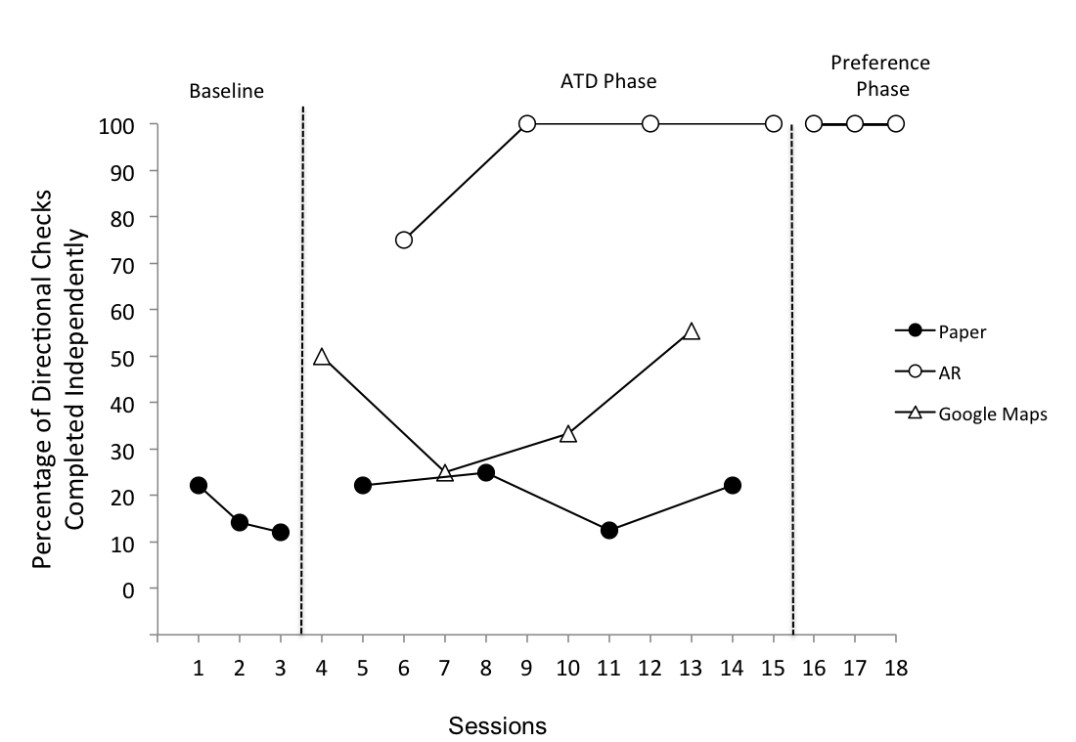
Figure 18. Jon’s results graph. Results for Jon from the alternating treatment design comparing independent navigation across the conditions of a paper map, augmented reality navigation, and Google Maps.

Arya. Arya was unable to travel independently to any unknown location during baseline using the paper map. Her baseline average was 13.6% correct independent navigation decisions. The AR app was immediately more successful than the other treatments with 85.7% navigation decisions. On her second session using the AR app, her independent navigation increased to 100% independence and she achieved criteria after two more AR navigator sessions. Using Google Maps, her mean was 31.4% independent correct navigation decision. During treatment, her scores remained approximately the same for the paper map and Google Map conditions, which had an overall average of less than 50% correct. The paper map was the least successful with an average of independent direction checks of 19%, which was effectively unchanged from baseline. During the preference phase, her independence remained at 100% using the AR app treatment. Arya’s percentage of non-overlapping data average using the more successful treatment (AR navigation) was 100%, which indicated this was a highly effective intervention (Scruggs & Mastropieri, 2001). Arya’s results are displayed below in Figure 19.

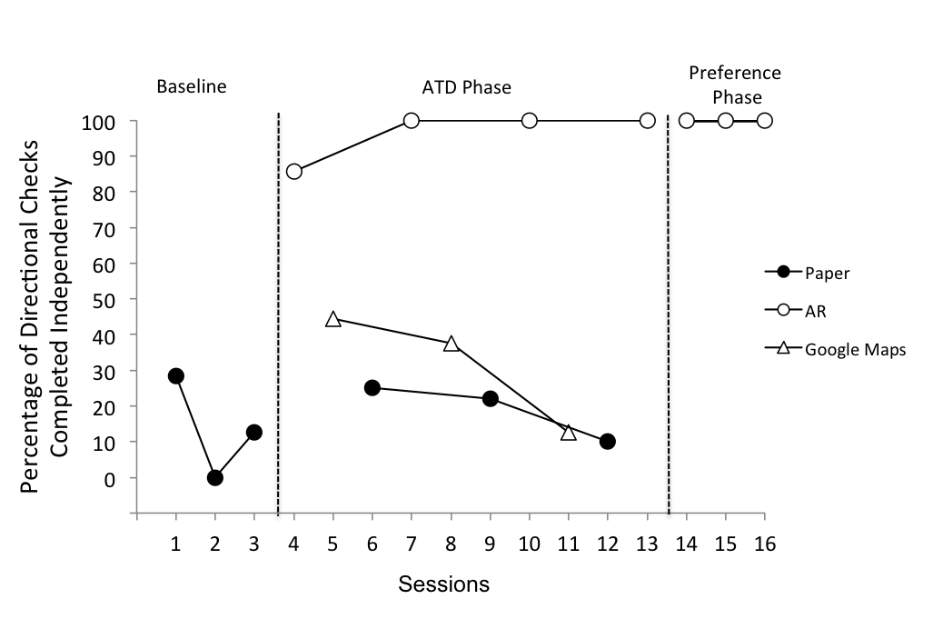

Figure 19. Arya’s results graph. Results for Arya from the alternating treatment design comparing independent navigation across the conditions of a paper map, augmented reality navigation, and Google Maps.
Social Validity Results. The social validity measure completed by the students after they completed the adapted alternating treatment design phase of the study indicated that all participants preferred to use the AR condition to navigate. The open-ended questions from the social validity survey also indicated that the participants enjoyed using the AR navigation tool over the Google Map and paper map navigation tools. Social validity results indicated all four students agreed or strongly agreed that they (a) think practicing the different apps helped to improve their navigation skills, (b) liked using the both of mobile device (iPhone) apps better than the paper map, (c) liked the AR app best, (d) always found the place I was looking for using the AR app, and, (e) recommend using their favorite navigation tool [AR] to a friend. Additionally, the open-ended questions from the social validity survey suggested that the participants enjoyed using the AR experience to learn new science vocabulary. Some specific responses to are shown below in Table 5.
Table 5. Student responses to social validity questions.
Social Validity Likert Questions |  |  | Likert Average
Practicing the different apps helped me to improve my navigation skills. |  |  | 5
I liked using the mobile device (iPhone) better than the paper map. |  |  | 5
I liked the Google Map best. |  |  | 1
I like the AR app best. |  |  | 5
I liked the Paper Map best. |  |  | 1
I would use my favorite tool __________ again to help me navigate to new locations. |  |  | 4.5
I would recommend using my favorite tool_________ to a friend. |  |  | 4.5
I always found the place I was looking for using the Google map |  |  | 2.5
I always found the place I was looking for using the AR app. |  |  | 5
Student | Questions
 | Which did you like best the paper map, Google Map or the augmented reality app and why? | What would make your favorite tool better?
Arya | The camera one [the AR condition] is more meaningful to me” | “May be if it talked and showed you the camera [live view] with the location”
Jon | “The AR one was best because all you had to do was look around you and see the thingy showing you the business [Location] and then you walked that way.” | “I don’t know how it could be better.”
Jamie | “The AR one. It helped me to navigate to the places. It was easy.” | “Having more places be in AR would make it better.”
Catelyn | “AR. You look and check and then go that way.” | -

Discussion
The purpose of this research was to compare the effectiveness of three navigation tools (printed map, Google Maps on a mobile device, and AR navigation app on a mobile device) for college students with ID and ASD to navigate to unknown business locations. The three navigation conditions produced noticeable differences. All students made more independent navigation decisions using the AR navigation tool. Students also reached unknown designations without requiring person-supported assistance during AR. During printed maps and Google Maps, students required person-supported assistance in all sessions. In addition, all students reported preferring AR to printed maps and Google Maps when navigating the city. The investigator chose to continue the baseline condition (paper map) as a condition to determine if using the other treatments produced any effect on this skill and to allow it to function as an extended baseline for this alternating treatment design. Also, this extended baseline could indicate a functional relation between the mobile device and improved independent decision making depending on results (Sindelar, et al., 1985). The results showed that the paper map did not improve the student navigation skills and demonstrated that a functional relation was established between the AR app and improved independent navigation decision-making.
This study supported previous research on mobile devices to navigate independently to unknown locations for students with ID and ASD (McMahon et al. under review; Mechling & Seid, 2011; Smith, 2013). By providing context relevant prompts, students were more likely to determine their current location and make decisions independently regarding what direction to continue to travel to ultimately reach the final destination. The mobile devices acted as a mobile prompting strategy that was accessible at anytime and anywhere the students needed a prompt. Second, this study supported the use of previous AR navigation studies (McMahon et al., under review; Smith, 2013). Students were more likely to make the correct navigation decisions compared to a printed map or Google Maps. All students reached criteria only during the AR navigation condition. The AR’s ability to deliver digital information while viewing the physical world assisted the students more effectively in reaching their destination. Both Google Maps and paper maps required the students to interpret their positions on a 2-dimensional map of the physical world and then extrapolate how to best proceed in the physical three-dimensional world. The AR experience allowed students to view context relevant prompts in the physical world that effectively supported their decision making needs in order to make correct navigation decisions.
This study also extended the navigation research literature in several ways. First, previous navigation AR research was conducted on a college campus (McMahon et al., under review; Smith, 2013). This study demonstrated the use of AR in a large city. Students traveled on city sidewalks and had to adjust to city traffic and other pedestrians. While university campuses tend to be pedestrian friendly, the city streets presented additional challenges including larger intersections, more traffic, and less familiarity. Second, the AR app used (i.e., Layer) identified business with job position openings. A major barrier of employment for people with ID and ASD is navigation and travel concerns (Rose et al., 2005). This study demonstrated a potential means to overcome this barrier. Third, the students indicated that using AR to navigate a city was highly socially acceptable. The improved independence and strong preference for the AR navigation tool suggest that students will be more likely to travel with confidence to business with employment opportunities available.

Limitations
Single subject methodologies are effective for exploring new interventions in a controlled setting to demonstrate a functional relation but they do have some inherent limitations. This study like all single subject research examined a small population (n=4). Additional studies will improve the ability to generalize these results by applying this intervention to different populations, additional settings, or replicating the study with a larger population. The AR experiences provided by the mobile app Layar are possible because of the app’s ability to access databases of jobs opportunities that provide location information to this system. If the mobile device was not able to access the Internet then this would not be possible. Additionally this study was conducted in an urban area with several nearby job postings viewable in AR using the employment “geolayars” in Layar such as Tweet My Jobs. In a more rural area or an area without any job postings listed in these databases, business locations would be unavailable. Lastly, the investigator was always present with the participating students; therefore the students were never alone. This was designed purposefully to maximize safety. The results might have been different if the student was actually traveling alone.
Future Studies
These results support the use of AR on mobile devices as an effective strategy to support the independent navigation of students with ID and ASD. Additional research can further explore the advantages and disadvantages of using markerless or location-based AR navigation tools for students with disabilities. Future studies applying this intervention to other navigation related tasks and across different student groups will determine if these results can be replicated and generalized to other populations. Some possible examples for future research include applying the AR medium to other employment related navigation tasks such as delivering packages, environmental monitoring in different locations, or conducting promotions across a city. Studies could examine using this technology for location based learning opportunities to assist learners by providing instructional supports outside of the classroom. Another study could include “confederate” pedestrians who would observe the student for safety concerns while assessing their navigation skills.
Conclusion
Navigating to employment opportunities is only one of many factors involved in improving employment outcomes for students with ID and ASD. Using the AR medium as a tool, as described in this study, individuals with disabilities can systematically explore what job opportunities are available within their ability to navigate independently. The intuitive nature digital content registered in the physical world allowed these participating students to demonstrate increased independent navigation.
Chapter 4:
Implications for the Future of Augmented Reality and Individuals with Disabilities
In a review of the critical issues regarding special education technology, Edyburn (2013) described the challenges educators face when developing a strong evidence-based foundation of technology innovations. Edyburn suggested that revolutionary technologies can create disruptive changes if researchers do not adapt to new developments and trends in technology. Developing a sound evidence-base for new technologies is a challenge. It requires a complex approach of theory, research, practice, policy and innovation (Edyburn). The goal of this dissertation was to apply this complex approach and to establish an empirical foundation of augmented reality as an instructional medium for students with disabilities.
Specifically, the purpose of this dissertation was to conduct two single-subject design studies to examine the effects of marker-based AR on the acquisition of science vocabulary words and to examine the effects markerless AR has on the acquisition of navigation skills for college-students with ID and ASD. All participating student outcomes improved following the systematic implementation of AR instruction establishing a functional relation. Additionally, the results of the social validity questionnaire from both studies indicated that using the AR based interventions produced high levels of engagement and enjoyment from the students. The findings from this dissertation support and extend educational research in variety of domains.
Mobile Learning
These two studies support previous research demonstrating the improved outcomes for students with ID and ASD when using mobile devices for learning academic vocabulary and functional tasks. Previous research has demonstrated positive outcomes using mobile devices as a new platform to teach and support students with ID and ASD (e.g., Cihak et al., 2010; Kagohara et al., 2011). Mobile devices have been used successfully to teach students with ID and ASD functional tasks like using a washing machine, managing a budget, performing morning routines, cooking simple meals, completing novel tasks, transitioning, and social-communicative behaviors (Davidson, 2010; Davidson, Smith, & Naffi, 2011; Fernández-López, Rodríguez-Fórtiz, Rodríguez-Almendros, & Martínez-Segura, 2013; Mechling, Gast, & Seid, 2009; Gentry, Wallace, Kvarfordt, & Lynch, 2010). These findings demonstrated how mobile devices can create mobile learning environment that moves with the learner (Ogato & Yano, 2004).
These companion studies extended the use of mobile learning technologies for students with ID and ASD by incorporating AR technologies. By blending the physical world with digital information (Craig, 2013), students readily obtained available supplemental information in the context of their physical environment. Alberto, Fredrick, Hughes, Mclntosh, and Cihak (2007) proposed a broader definition of literacy for students with moderate and severe intellectual disabilities that expand beyond the traditional concepts of functional literacy. This broader recommended definition of literacy includes “obtaining information from the environment with which to make decisions and choices, alter the environment, and gain pleasure" (2007, p. 234). Both studies used AR to enhance student’s literacy skills by gaining meaningful understanding of science vocabulary words and to navigate a city.
Vocabulary. Using marker-based AR, students immediately learned new science vocabulary terms. By pairing science vocabulary words with meaningful digital content information, students gained contextual and meaningful vocabulary understanding. Students successfully identified the vocabulary words meaning and were able to apply the words to a figure or diagram. Clendon and Erickson (2008) noted that traditional literacy instruction focused primarily on teaching sight word recognition and often isolated from meaningful context. The use of marker-based AR facilitated greater understanding of targeted sight words used in study 1. Students were able to view the vocabulary words within the academic discipline context. When students were learning about the bones of the body, the AR intervention provided audio and video representation of the term and definition, the function, and specific location in the body. According to Browder et al. (2012), teachers have limited strategies for teaching science content for students with ID and ASD. Only 11 studies in which science content was taught to students with ID were located in the empirical literature (Courtade et al., 2007). The marker-based AR intervention used in this dissertation extends the science literature for students with ID and demonstrates a potential technical use to add science content in a meaningful and contextualized manner for students with ID and ASD.
Navigation. This dissertation supported previous research that used mobile devices to support navigating to unknown locations for students with ID and ASD (Davies, Holloway, & Wehmeyer (2010): Mechling & Seid, 2011; Smith, 2013). Rose et al. (2005) identified that deficits in navigational skills limited the employment opportunities available to people with ID and ASD. This study addressed employment and navigation simultaneously by navigating to nearby businesses with employment opportunities. All of the students were able to navigate to unknown locations independently using AR, whereas they still required person-supported assistance when traveling using either a paper map or Google Maps. The AR navigation app was determined to be more effective than either the printed paper map or Google Map. This supported the findings of a previous comparative study by McMahon et al. (under review) that also demonstrated AR to be more effective than a printed map or Google Map. Moreover, this study supported Smith’s (2013) findings that AR navigation supports were an effective intervention for students with ID and ASD. Location based augmented reality on mobile devices provides a potential solution for assisting people with ID and ASD to locate employment opportunities and improve navigational skills.
While previous AR navigation research focused on navigating to unknown locations on a college campus (McMahon, et al., under review; Smith, 2013), study 2 improved student navigation skills within a city environment. In a city environment, students were required to be more mindful of safety issues related to street crossing and traffic when traveling to unknown business locations. This study also extended the literature by exploring the effects of different AR app for navigation than the one used in McMahon et al. (under review) and Smith (2013).
Additionally, both AR-based interventions implemented appeared to be highly intuitive and thus required little training to master. This was shown in the results of the experiments, which repeatedly demonstrated that the students were able to quickly learn to use the technology. The National Council on Disability (2011) reported that individuals with disabilities adopt new technologies at a slower pace, which reduces their access to current technologies and opportunities when compared to their peers without disabilities. Proactive technology instruction with current and emerging technologies on means of reducing this digital divide. The social validity results supported that the AR interventions were very intuitive for the users. For example, in the first study, Catherine’s statement, “you point the camera at the paper and it explains it”, speaks to how easy this technology was to use. In the second study, Jon’s statement, “the AR one was best because all you had to do was look around you and see the thingy showing you the business [location] and then you walked that way”, described his experience with the Layar app. In order to bridge this digital divide, targeted research is needed to apply these and other technologies to the needs of people with disabilities. Additionally the AR based interventions implemented appeared to be highly intuitive and thus required little training to master. These studies supported previous findings indicating mobile devices are an effective tool for teaching vocabulary and navigation skills to students with ID and ASD (Jameson et al. 2012; Smith, Spooner, & Wood, 2013).
AR in Education
Both studies supported previous research demonstrating that the AR medium is an interactive experience between the user (learner), environment, and the content (Milgram & Kishino, 1992; Asai, Kobayashi, & Kondo, 2005; Squire & Jan, 2007: Craig, 2013). In the first study, the instructional experience required the user to interact with the trigger image in order to view the instructional content. In the second study, the AR intervention condition allowed students to interactively view relevant information 3-dimensionally placed in the physical world based on their location at that moment.
AR interventions, if effectively applied to meet the needs of individuals with disabilities, may provide diverse learners new strategies for learning and facilitating independence.. Results of study 1 support previous research in AR in several ways. First, the improved vocabulary findings of study 1 were similar to those found in Liu’s (2009) study of a marker-based vocabulary activity to teach high school students foreign language vocabulary. Second, they support Vilkoniene’s (2009) findings that AR instructional activities can improve student knowledge in biology. Vilkoniene used AR to provide digital manipulatives of the organs in AR similar to the objects displayed in the science AR vocabulary terms. Study 2 supports findings from previous educational research that markerless AR were an effective instructional tool for learning in a natural environment (Squire & Klopfer, 2013). These findings support McMahon et al.'s (2012) study that AR assisted students with ID in finding and using information to make independent decisions. Finally, both studies examined the social validity of AR in education and found high levels of motivation and enjoyment when using AR for educational activities. These social validity results support findings from other researchers in AR in education who found high levels of student engagement (Di Serio, Ibáñez, and Kloos, 2012; Hsiao, Chen, & Huang, 2013).
These findings extended research by Richard et al. (2007) that demonstrated the instructional benefits of using AR to teach matching skills to elementary students with ID by including college students with ID and ASD, as well as the complexity of the AR instructional tasks. Second, this study extended the AR literature by targeting academic vocabulary words to students with ID and ASD. This research contributes to the established AR literature by extending it through its application in the field of special education technology with a population of students with ID and ASD.
UDL and AR
This dissertation supports and extends the research-based instructional framework of UDL. Wehmeyer (2006) advocated for the incorporation of UDL principles to improve academic achievement and curriculum access for students with ID and ASD. Similarly, the National Education Technology Plan (2010) also supports the use of UDL- to enable all learners with access to engaging and empowering learning experiences both in and out of school settings. The AR interventions implemented in these studies provide clear examples of each of the three broad UDL principles discussed in Chapter 1 (CAST, 2011).
The first UDL principle, provide multiple means of representation, was demonstrated through the use of AR on a mobile device in both studies. Study 1 involved AR content displayed as both audio and video representations of vocabulary meaning when viewing the vocabulary word. As described by one student, “the definitions just pop up with videos right beside the word.” In Study 2, AR provided a new means of representing the location and relative distance of a destination. The second UDL principle, provide multiple means of action and expression, was demonstrated in both studies through the students’ physical interaction with the device and the environment to learn or find the information. The third UDL principle, provide multiple means of engagement, was demonstrated in both studies. In Study 1, this was exhibited in the AR intervention’s ability to optimize relevance and authenticity by making the unknown vocabulary word trigger a display of its meaning. In Study 2, AR optimized the autonomy of students in their navigation decision-making and maximize the relevance of information by registering it in the physical world. These findings support the conclusions of McMahon and Walker (2014) in their review of UDL features made available through the combination of built-in device capabilities (e.g. GPS, camera, internet access) and large app libraries to provide educators with the flexibility to address each of the nine UDL guidelines.
Limitations
Several limitations of the present studies warrant caution in interpreting these findings and emphasize the need for replication. Both studies employed single-subject research design methodologies. As with most single-subject research design studies, these studies included a small sample size, which limits external validity and generalizability. Additionally, all participating students attended a postsecondary education program for college students with ID and ASD. They had comparatively similar characteristics including disability diagnosis, cultural background, and socioeconomic status. All students had relatively sufficient literacy, functional, and computer skills using mobile devices.
The novelty of AR might have influenced the students learning. Students who use AR on a more regular basis might have performed differently. In addition, both AR applications required access to the Internet. Neither study could have happened in a location without reliable Internet access. The content delivered through AR instructional mediums is likely to continue to require Internet access in order to retrieve and display information that is registered in the real world.
Another limitation of both studies was the lack of maintenances probes. Although students acquired the science vocabulary words and navigated independently to unknown business, longer-term effects of AR instruction are needed.
In study 1, the assessment of the science vocabulary terms included a multiple-choice exam and labeling diagram. Moreover, the assessment was read aloud. The vocabulary assessment may not have truly captured the students understanding of the science term. Likewise, the investigator was always present with the students when navigating the city during study 2. Finding an unknown business location by oneself would have truly assessed independence. Students always could have asked for assistance from the investigator.
Despite these limitations, the results of these studies supported the use of AR instruction on mobile devices to improve the academic and functional needs of people with ID and ASD. Researchers can expand on these findings through examinations of additional AR interventions designed to meet the academic and functional needs of people with disabilities.
Future Research
AR could become a particularly powerful tool for individuals with disabilities because the capability of displaying context relevant digital information to supporting the needs of the individual at that moment. AR can provide new learning opportunities for students to learn new vocabulary words in context by labeling physical objects with text labels, reading aloud difficult words, displaying additional information on an academic topic, providing video instructions on what to do next when attempting a multistep activity, or prompts on supporting independent living.
Future research in augmented reality is limited only by the imagination of educators to apply augmented reality’s potentially revolutionary capabilities in order to empower students with disabilities. This dissertation explored this potential using augmented reality on mobile devices as tools for students with disabilities. As stated in the limitations, future research is needed to replicate and systematically replicate these studies methods and procedures. Future research is needed to study the effects of AR instruction across students and people of various abilities, age groups, skills, and adaptive behaviors. Specifically, prerequisite computer or mobile device skills requires investigation. These studies could establish several lines of research to be examined in several future studies. The reviews of study 1 and study 2 below present several options to expand this research.
Lines of Research from Study 1
The first study in this dissertation applied a marker-based AR experience to the task of teaching academic vocabulary in science with a group of students in a post-secondary education program for students with intellectual disabilities and autism. It is important to explore what marker-based AR features were responsible for the positive outcomes without distracting the learner, such as the length of AR content, using video and/or static pictures, the word length of definitions, and use of audio information. In addition, the use of marker-based AR instruction to teach vocabulary should be compared to more established vocabulary instructional procedures, such as time delay, read aloud, and picture-to-text matching. AR experiences also could be applied to students with a variety of educational disabilities in elementary and secondary levels. This may serve as a foundation for future studies with marker-based AR experiences to teach academic subjects like social studies, math, and language arts. While this dissertation applied marker-based AR academic skills, it could be used easily to teach a variety of functional skills. An example of this could be using AR instructions for how to cook, make coffee, and apply first aid.. Some possible examples are shown in Figure 20.
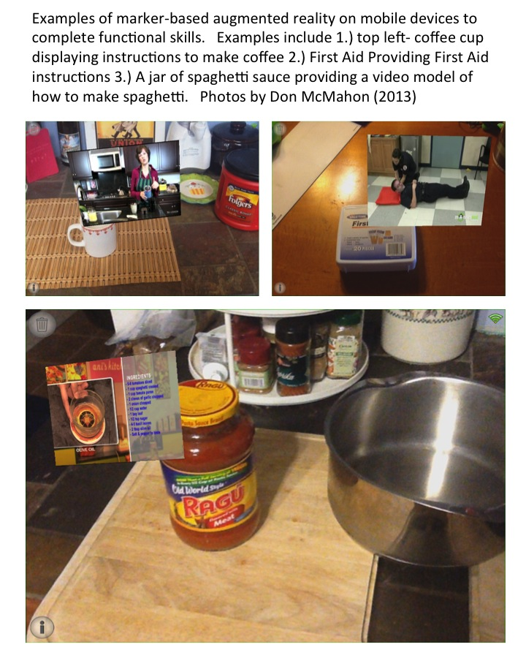
Figure 20. Examples of marker-based AR for functional skills.
Lines of Research from Study 2
The second study of this dissertation used a markerless or location-based AR experience to improve the ability to navigate to employment opportunities for students in a post-secondary education program for students with intellectual disabilities and autism. This study may be used as a foundation for future studies with markerless or location-based AR experiences to teach other functional skills like navigating to delivery locations for a job. Future students can examine what elements of the AR experience are responsible for the positive outcomes of this research. It also may influence the design of future studies using location-based AR learning experiences for students with disabilities, for example, historical monuments that provide additional detail about themselves. These location-based learning experiences could address multiple academic and functional skills. Additionally, markerless AR learning experiences could apply to the educational needs of students with a variety of educational disabilities across elementary, secondary, and postsecondary ages. Examples of location-based AR providing academic supports are shown below in Figure 21. These examples are from the Pearl Harbor National Monument using the mobile app Layar, the same app used in the second study of this dissertation but viewing a different one of the thousands of possible “layars” of content.

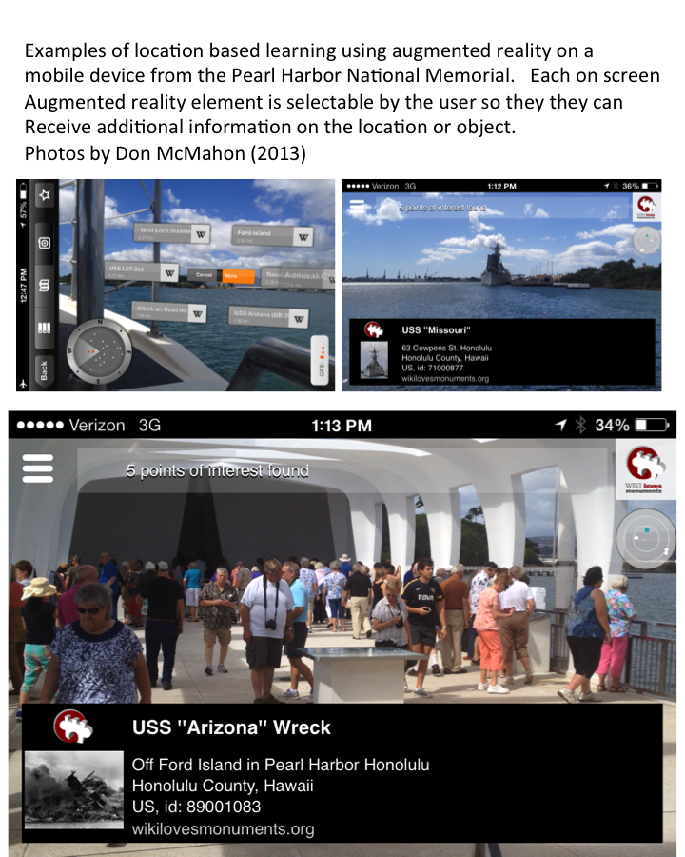
Figure 21. Examples of markerless or location-based AR for academic learning.
There is a broad potential audience for research on AR as a medium for individuals with disabilities for several reasons. First, it is not focused specifically on one particular type of student disability. While these studies were successful for students with ID and ASD, there is no reason to think that the benefits of AR are limited to this particular population. Second, it is not limited to one academic area, or even academic tasks. The two studies in this dissertation included activities both academic and functional skill domains; additional research opportunities are possible to apply this technology to many different skills in both academic and functional tasks domains. In these future studies particular effort should be directed at examining methods of designing systematic supports for individuals with disabilities using more complex combinations of the physical world and digital information displayed using AR on a variety of different types devices. In time, future studies could build the knowledge base about this medium, best practices, limitations, and effects to develop a - framework for augmented reality technology. Although, we might have to work on the acronym for this framework.
Preparing for the Augmented Future
“The future is already here — it’s just not very evenly distributed” is a famous quote by the author William Gibson who coined the term “cyberspace” in 1982, before most people owned computers (Gibson, 1999). AR instruction could accurately be described as part of the future that is also already here but not evenly distributed. The medium of augmented reality will become more common as more technologies incorporate it. Although current education AR applications are in its initial stages, the rapid growth of AR is likely to mature quickly. Briefly looking beyond the scope of this dissertation, there are three current technology trends that are likely to increase the frequency and availability of applications using the medium of AR. These trends are increasing use of mobile devices, “The Internet of things” and wearable computers.
Mobile devices. Mobile device use is expanding world wide, even doubling year over year in some developing countries (Evans, 2014). The software distribution systems on mobile devices are relatively easy for people to use as evidenced by the rapid growth of the mobile application market. Mobile devices have the necessary battery power, processing power, Internet connectivity, multimedia capabilities, and location-based services to make AR practical for educational use (Pence, 2010). These AR apps may become as socially common as using a mobile device in public to complete a brief tasks like checking directions, reading text, or viewing a picture. These concerns about social validity and acceptance are important to consider when using AR as an intervention to support the needs of students with disabilities. Since mobile devices are common tools for adults, children, and youths, the use of these devices for AR tasks would not attract negative attention. Additionally, schools are increasingly adopting mobile devices as a centerpiece of their instructional landscape for all learners. As these devices become more common, more AR applications will bridge the digital and physical worlds.
Internet of Things. The ‘Internet of Things’ refers to the concept of a plethora of networked devices that can share information and be controlled over the Internet. Augmented reality is emerging as a new means of accessing information using this “internet of things”. This concept is the realization that a wide variety of technologies from traditional computers, game systems, phones, household appliances, and even light bulbs are becoming an interconnected system creating unprecedented tools for people (Domingo, 2012). With training and planning, these tools can become empowerment resources for people with disabilities, allowing them the ability to access, use, create, and share information in ways that can improve and enhance their participation in the world.
Wearable Computers. Wearable computers allow people to use technology in new ways to meet a variety of needs. Some current examples of this include smart watches like the Samsung Galaxy Gear (Samsung, 2014), biometric monitors like the Fitbit, virtual reality head-mounted displays like Sony’s Playstation 4 glasses (Langley, 2014), and personal augmented reality vision systems like Google Glass. Professional AR applications also exist such as the Evena Medical’s augmented reality glasses, which allow medical personnel to find a person’s veins (Evenamed, 2014). Beyond these existing examples, new wearable computers will continue to connect a person to technology and digital information. For example, Japanese researchers have created “Earclip-type Wearable PC” that can determine what a person is viewing and provide supplementary information (Suzuki, 2014). This trend of wearable computing will have positive and negative implications for people with disabilities. A positive implication of these technologies is the plethora of new opportunities for people with disabilities to access, apply and use technology to support their needs.
However, these technologies will present challenges for people with disabilities. Just as access to the Internet has become a factor to full inclusion in society, access and proficiency with these wearable technologies may become a social expectation in modern society. The recent controversy over the debut of Google Glass (Stern, 2013) is just one example of how wearable computers will create additional social challenges. Many locations and even legislatures are considering policies on when and where wearable AR technologies, such as Google Glass, can be used. These and other new technologies from this emerging augmented future will create additional social challenges, questions and debate. Acknowledging and addressing these challenges will become part of the domain of special education technology in the near future as AR experiences become as common a learning tool as video, interactive simulations, computers, the Internet, and mobile devices.
Conclusion
AR instruction has the potential to become a particularly powerful medium for students and people with disabilities because the capability of displaying context relevant digital information to support the needs of the individual at that moment. However, the field of special education technology research is not focused on what is going to happen in technology in the next 5, 10, or 15 years. There are many practical concerns such as solving existing problems, limited funds and resources, limited time of educators for training, and the necessity to immediately meet the needs of students. Additionally there is uncertainty about which technologies will take hold and flourish, which technologies will fade away. Despite these challenges, researchers need to examine these innovations so that the broader audience of individuals with disabilities, teachers, therapists, educational researchers, parents, and other stakeholders for people with disabilities, will be able to find and apply new technologies to expand opportunities.
“As educators, we can passively wait until the future becomes the present, or we can work to actively influence the future” was the challenge Edyburn (2013, p. 18) presented to educators and researchers in his review of critical issues in the evidence base of special education technology. It should be a rallying cry to educators across all disciplines. This dissertation was an active decision not to wait and to influence the future of augmented reality in the field of special education technology. Hopefully, this work will be a first step toward establishing augmented reality’s promise as medium for innovative technology interventions that will influence a brighter future that is inclusive of everyone.
References

Adams, G. L., & Engelmann, S. (1996). Research on Direct Instruction: 25 Years beyond DISTAR. Educational Achievement Systems, 319 Nickerson Street, Suite 112, Seattle, WA 98109.
Alberto, P. A., Fredrick, L., Hughes, M., McIntosh, L., & Cihak, D. (2007). Components of visual literacy: Teaching logos. Focus on Autism and Other Developmental Disabilities, 22(4), 234-243.
Almond, P., Winter, P., Cameto, R., Russell, M., Sato, E., Clarke-Midura, J., …Russell, E. M. (2010). Technology-enabled and universally designed assessment: considering access in measuring the achievement of students with disabilities — A Foundation for Research. The Journal of Technology, Learning, and Assessment, 10(5).
Asai, K., Kobayashi, H., & Kondo, T. (2005). Augmented instructions - a fusion of augmented reality and printed learning materials. Proceedings of the Fifth IEEE International Conference on Advanced Learning Technologies (ICALT’05), 213–215. doi:10.1109/ICALT.2005.71
Azuma, R. T. (1997). A survey of augmented reality. Presence: Teleoperators and Virtual Environments, 4(August), 355–385.)
Aurasma, Inc (2014). Auramsa. (Version 2.7.0). [iPad and iPhone software].
Basham, J. D., & Marino, M. T. (2011). Understanding STEM Education and Supporting Students Through Universal Design for Learning. TEACHING Exceptional Children, Mar/Apr, 8–15.
Beckett, K. L., & Shaffer, D. W. (2005). Augmented By Reality: the Pedagogical Praxis of Urban Planning As a Pathway To Ecological Thinking. Journal of Educational Computing Research, 33(1), 31–52. doi:10.2190/D5YQ-MMW6-V0FR-RNJQ
Beeson, P. M., & Robey, R. R. (2006). Evaluating single-subject treatment research: Lessons learned from the aphasia literature. Neuropsychology review, 16(4), 161-169.
Bell, S. M., & McCallum, R. S. (2008). Handbook of reading assessment. Boston: Pearson Allyn and Bacon.
Biancarosa, G., & Snow, C. E. (2006). Reading next—A vision for action and research in middle and high school literacy: A report from Carnegie Corporation of New York (2nd ed.). Washington, DC: Alliance for Excellent Education.
Bloom, B. S. (1956). Taxonomy of educational objectives: The classification of educational goals. New York: Longmans, Green.
Bosseler, A., & Massaro, D. W. (2003). Development and evaluation of a computer-animated tutor for vocabulary and language learning in children with autism. Journal of autism and developmental disorders, 33(6), 653–672. Retrieved from http://www.ncbi.nlm.nih.gov/pubmed/14714934
Brigance, A. H, (2010). Brigance Transition Skills Inventory. North Billerica, MA, Curriculum Associates.
Brooks, B. M., Rose, F. D., Attree, E. A., & Elliot-Square, A. (2002). An evaluation of the efficacy of training people with learning disabilities in a virtual environment. Disability & Rehabilitation, 24(11-12), 622-626.
Browder, D. M., Spooner, F., Wakeman, S., Trela, K., & Baker, J. N. (2006). Aligning instruction with academic content standards: Finding the link. Research and Practice for Persons with Severe Disabilities, 31(4), 309-321.
Browder, D. M., Wakeman, S. Y., Spooner, F., Ahlgrim-Delzell, L., & Algozzine, B. (2006). Research on reading instruction for individuals with significant cognitive disabilities. Exceptional Children, 72, 392–408.
Browder, D. M., Wakeman, S., Spooner, E, Ahlgrim-Delzell, L., & Algozzine, B. (2006). Research on reading instruction for individuals with significant cognitive disabilities. Exceptional Children, 72, 392-408.
Browder, D., Ahlgrim-Delzell, L., Spooner, F., & Baker, J. (2009). Using time delay to teach literacy to students with severe developmental disabilities. Exceptional Children, 75, 343–364.
Browder, D., Lee, A., & Mims, P. (2011). Literacy for students with multiple disabilities: Using systematic instruction, individualized responses, and assistive technology. Education and Training in Autism and Developmental Disabilities, 46, 339-351.
Browder, D.M., Trela, K., Courtade, G.R., Jimenez, B.A., Knight, V., & Flowers, C. (2012). Teaching mathematics and science standards to students with moderate and severe developmental disabilities. The Journal of Special Education, 46(1), 26-35.
Burge, P., Ouellette-Kuntz, H., & Lysaght, R. (2007). Public views on employment of people with intellectual disabilities. Journal of Vocational Rehabilitation, 26(1), 29-37.
Busk, P., & Serlin, R. (1992). Meta-analysis for single participant research. In T. R. Kratochwill & J. R. Levin (Eds.), Single-case research design and analysis: New Directions Jbr psychology and education (pp. 187-212). Mahwah, NJ: Eribaum.
Carnahan, C. R., Williamson, P. S., Hollingshead, A., & Israel, M. (2012). Using technology to support balanced literacy for students with significant disabilities. TEACHING Exceptional Children, 45(1), 20-29.
Carnegie Foundation. (2014, March 01). Institution lookup. Retrieved from http://www.carnegiefoundation.org/
Cameto, R., Levine, P., & Wagner, M. (2004). Transition Planning for Students with Disabilities. A Special Topic Report from the National Longitudinal Transition Study-2 (NLTS2). Menlo Park, CA: SRI International
Carey, A. C., Friedman, M. G., & Bryen, D. N. (2005). Use of electronic technologies by people with intellectual disabilities. Journal Information, 43(5).
Carnahan, C. R., Basham, J. D., Christman, J., & Hollingshead, A. (2012). Overcoming Challenges: Going Mobile with Your Own Video Models. Teaching Exceptional Children, 45(2), 50-59.
CAST (2011). Universal design for learning guidelines version 2.0. Wakefield, MA: Author.
Caudell, T. P., & Mizell, D. W. (1992, January). Augmented reality: An application of heads-up display technology to manual manufacturing processes. In System Sciences, 1992. Proceedings of the Twenty-Fifth Hawaii International Conference on (Vol. 2, pp. 659-669). IEEE.
Chen, Y. C. (2006, June). A study of comparing the use of augmented reality and physical models in chemistry education. In Proceedings of the 2006 ACM international conference on Virtual reality continuum and its applications (pp. 369-372). ACM.
Cihak, D., Fahrenkrog, C., Ayres, K. M., & Smith, C. (2010). The Use of Video Modeling via a Video iPod and a System of Least Prompts to Improve Transitional Behaviors for Students with Autism Spectrum Disorders in the General Education Classroom. Journal of Positive Behavior Interventions, 12(2), 103–115. Retrieved from http://dx.doi.org/10.1177/1098300709332346
Cihak, D. F., Kessler, K., & Alberto, P. A. (2008). Use of a handheld prompting system to transition independently through vocational tasks for students with moderate and severe intellectual disabilities. Education and Training in Developmental Disabilities, 43(1), 102.
Cihak, D.F., Smith, C.C., McMahon, D.D., & Ramsey, J. (In press). Using video modeling in conducting research with young children. In O.N. Saracho (Ed.), Handbook of Research Methods in Early Childhood Education. Charlotte, NC: Information Age Publishing Inc. Accepted August 29, 2013
Clendon, S. A. & Erickson, K. A. (2008). The vocabulary of beginning writers: Implications for children with complex communication needs. Augmentative and Alternative Communication, 24(4), 281-293
Cobb, S., & Sharkey, P. (2007). A decade of research and development in disability, virtual reality and associated technologies: review of ICDVRAT 1996-2006. The International Journal of Virtual Reality, 6(2), 51–68. Retrieved from http://citeseerx.ist.psu.edu/viewdoc/download?doi=10.1.1.119.6052&rep=rep1&type=pdf
Cole, E. (1999). Cognitive prosthetics: an overview to a method of treatment. NeuroRehabilitation, 12(1), 39-51.
Courtade, G. R., Spooner, F., & Browder, D. M. (2007). Review of studies with students with significant cognitive disabilities which link to science standards. Research and Practice for Persons with Severe Disabilities, 32(1), 43-49.
Craig, A. B. (2013). Understanding augmented reality: Concepts and applications. Amsterdam: Morgan Kaufmann.
Crompton, H. (2013). A historical overview of mobile learning: Toward learner-centered education. In Z. L. Berge & L. Y. Muilenburg (Eds.), Handbook of mobile learning (pp. 3-14). Florence, KY: Routledge.
Davidson, A.-L. (2010). Vid-Ability: A portable computing project using instructional video to improve the condition of people living with an intellectual disability. In T. Bastiaens & M. Ebner (Eds.), Proceedings of World Conference on Educational Multimedia, Hypermedia and Telecommunications 2011(pp. 3576–3581). Chesapeake, VA: AACE.
Davidson, A.-L., Smith, J., & Naffi, N. (2011). Producing instructional videos through collaborative-action research for people living with an intellectual disability. In T. Bastiaens & M. Ebner (Eds.), Proceedings of World Conference on Educational Multimedia, Hypermedia and Telecommunications 2011 (pp. 1504–1509), Chesapeake, VA: AACE.
Davies, E., Holloway, S., & Wehmeyer, M. L. (2010). Evaluating a GPS-Based Transportation Device to Support Independent Bus Travel by People with Intellectual Disability. Intellectual and Developmental Disabilities, 48(6), 454–463.
Dieker, L., Hynes, M., Hughes, C., & Smith, E. (2008). Implications of Mixed Reality and Simulation Technologies on Special Education and Teacher Preparation. Focus on Exceptional Children, 40(6),
Di Serio, Á., Ibáñez, M. B., & Kloos, C. D. (2012). Impact of an augmented reality system on students' motivation for a visual art course. Computers & Education.
Dolan, R. P., Hall, T. E., Banerjee, M., Chun, E., & Strangman, N. (2005). Applying Principles of universal design to test delivery: The effect of computer-based read-aloud on test performance of high school students with learning disabilities. Journal of Technology, Learning, and Assessment, 3(7), 5–32.
Domingo, M. C. (2012). An overview of the Internet of Things for people with disabilities. Journal of Network and Computer Applications, 35(2), 584-596.
Dunleavy, M., Dede, C., & Mitchell, R. (2009). Affordances and limitations of immersive participatory augmented reality simulations for teaching and learning. Journal of Science Education and Technology, 18(1), 7-22.
Edyburn, D.L. (2000). Assistive technology and students with mild disabilities. Focus on Exceptional Children, 32(9), 1-24
Edyburn, D.L. (2005). Assistive technology and students with mild disabilities: From consideration to outcome measurement. In D. Edyburn, K. Higgins, & R. Boone (Eds.). Handbook of special education technology research and practice (pp. 239-269). Whiteﬁsh Bay, WI: Knowledge by Design, Inc.
Edyburn, D. L. (2010). Would you recognize universal design for learning if you saw it ? Ten propositions for new directions for the second decade of UDL. Learning Disability Quarterly, 33(Winter), 33–41.
Edyburn, D. L. (2013). Critical issues in advancing the special education technology evidence base. Exceptional Children, 80(1), 7-24.
Elias, T. (2011). Universal Instructional Design Principles for Mobile Learning. International Review of Research in Open and Distance Learning, 12(2), 143–156.
Erickson, K. A., Hanser, G., Hatch, P., & Sanders, E. (2009). Research-based practices for creating access to the general curriculum in reading and literacy for students with significant intellectual disabilities. Retrieved from http://idahotc.com/Portals/15/Docs/IAA/10-11%20Docs/Research_Based_Practices_Reading_2009.pdf
Evans, J. (2014, February 24). In 3.5 years most africans will have smartphones. Techcrunch.com, Retrieved from http://techcrunch.com/2014/02/08/in-3-5-years-most-africans-will-have-smartphones/
Etxeberria, A. I., Asensio, M., Vicent, N., & Cuenca, J. M. (2012). Mobile devices: A tool for tourism and learning at archaeological sites. International Journal of Web Based Communities, 8(1), 57–72.
Feiner, S., Macintyre, B., & Seligmann, D. (1993). Knowledge-based augmented reality. Communications of the ACM, 36(7), 53-62.
Feiner, S., Terauchi, T., Rashid, G., & Hallaway, D. (1999). Exploring MARS : developing indoor and outdoor user interfaces to a mobile augmented reality system Tobias Ho. Computers & Graphics, 23, 779–785.
Fernández-López, Á., Rodríguez-Fórtiz, M. J., Rodríguez-Almendros, M. L., & Martínez-Segura, M. J. (2013). Mobile learning technology based on iOS devices to support students with special education needs. Computers & Education, 61, 77–90. doi:10.1016/j.compedu.2012.09.014
Fisher, M., & Baird, D. E. (2007). Making mLearning Work: Utilizing Mobile Technology for Active Exploration, Collaboration, Assessment, and Reflection in Higher Education. Educational Technology, 35(1), 3-30.
Folk, E. D., Yamamoto, K. K., & Stodden, R. A. (2012). Implementing Inclusion and Collaborative Teaming in a Model Program of Postsecondary Education for Young Adults With Intellectual Disabilities. Journal of Policy and Practice in Intellectual Disabilities, 9(4), 257-269.
Garcıa-Villamisar, D., Wehman, P., & Navarro, M. D. (2002).Changes in the quality of autistic people’s life that work in supported and sheltered employment, a 5-year follow-up study.Journal of Vocational Rehabilitation, 17(4), 309–312.
Gartner, Inc. (2013). The Hype Cycle. Http://www.gartner.com/technology/ research/methodologies/hype-cycle.jsp . [Accessed: 2013, Dec 20.]
Gast, D. L. (2010). Single subject research methodology in behavioral sciences. New York: Routledge.
Gentry, T., Wallace, J., Kvarfordt, C., & Lynch, C.B., (2010). Personal digital assistants as cognitive aids for high school students with autism: results of a community-based trial. Journal of Vocational Rehabilitation, 32, 101–107.
Gast, D. L. (2012). Single Subject Research Methodology in Behavioral Sciences. Taylor & Francis.
Gibson, W., (1999, November 30). Talk of the Nation. [Radio Broadcast]. Washington, DC: National Pubic Radio. Retrieved from http://www.npr.org/templates/story/story.php?storyId=1067220
Google, Inc. (2014). Google Maps (Version. 2.7.0). [iPad and iPhone software].
Grigal, M., Hart, D., & Migliore, A. (2011). Career Development for Exceptional Individuals. Career Development for Exceptional Individuals, 34(4), 4–17. doi:10.1177/0885728811399091
Hall, T. E., Hughes, C. A., & Filbert, M. (2000). Computer assisted instruction in reading for students with learning disabilities: A research synthesis. Learning Disability Quarterly, 23, 173–193. doi:10.1111/j.1540-5826.2012.00352.x
The Higher Education Opportunity Act (Public Law 110-315).
Hine, J. F., & Wolery, M. (2006). Using point-of-view video modeling to teach play to preschoolers with autism. Topics in Early Childhood Special Education, 26(2), 83-93.
Horner, R. H., Carr, E. G., Halle, J., Mcgee, G., Odom, S., & Wolery, M. (2005). The use of single-subject research to identify evidence-based practice in special education. Exceptional Children, 71(2), 165-179.
Hsiao, K.-F., Chen, N.-S., & Huang, S.-Y. (2013). Learning While Exercising for Science Education in Augmented Reality among Adolescents. Interactive Learning Environments, 20(4), 331–349. Retrieved from http://proxy.lib.utk.edu:90/login?url=http://search.ebscohost.com/login.aspx?direct=true&db=eric&AN=EJ972922&scope=site
Hutcherson, K., Langone, J., Ayres, K., & Clees, T. (2004). Computer Assisted Instruction to Teach Item Selection in Grocery Stores: An Assessment of Acquisition and Generalization. Journal of Special Education Technology, 19(4), 33–42. Retrieved from http://proxy.lib.utk.edu:90/login?url=http://search.ebscohost.com/login.aspx?direct=true&db=eric&AN=EJ729609&scope=site
Individuals With Disabilities Education Act, 20 U.S.C. § 1400 (2004).
Israel, M., Maynard, K., & Williamson, P. (2013). Promoting Literacy- Emhedded , Authentic STEM Instruction for Students With Disahilities and Other Struggling Learners. TEACHING Exceptional Children, (Mar/Apr), 18–25.
Jackson, R. M. (2005). Curriculum access for students with low incidence disabilities: The promise of universal design for learning. Wakefield, MA: Center for Applied Special Technology.
Jameson, J. M., Thompson, V., Manuele, G., Smith, D., Egan, H., & Moore, T. (2012). Using an iTouch to Teach Core Curriculum Words and Definitions: Efficacy and Social Validity. Journal of Special Education Technology, 27(3), 41–54. Retrieved from http://proxy.lib.utk.edu:90/login?url=http://search.ebscohost.com/login.aspx?direct=true&db=eric&AN=EJ1001431&scope=site
Kagohara (2012), D. M., van der Meer, L., Achmadi, D., Green, V. A., O’Reilly, M. F., Lancioni, G. E., … Sigafoos, J. (2012). Teaching picture naming to two adolescents with autism spectrum disorders using systematic instruction and speech-generating devices. Research in Autism Spectrum Disorders, 6(3), 1224–1233. doi:10.1016/j.rasd.2012.04.001
Kagohara, D. M., Sigafoos, J., Achmadi, D., van Der Meer, L., O’Reilly, M. F., Lancioni, G. E., … Green, V. A. (2011). Teaching students with developmental disabilities to operate an iPod Touch(®) to listen to music. Research in developmental disabilities, 32(1), 2987–92. doi:10.1016/j.ridd.2011.04.010
Kagohara, D. M., van der Meer, L., Ramdoss, S., O’Reilly, M. F., Lancioni, G. E., Davis, T. N., … O’Reilly, M. F. (2013). Using iPods[R] and iPads[R] in Teaching Programs for Individuals with Developmental Disabilities: A Systematic Review. Research in Developmental Disabilities: A Multidisciplinary Journal, 34(1), 147–156. doi:10.1016/j.ridd.2012.07.027
Kalkusch, M., Lidy, T., Knapp, N., Reitmayr, G., Kaufmann, H., & Schmalstieg, D. (2002). Structured visual markers for indoor pathfinding. In Augmented Reality Toolkit, The First IEEE International Workshop (p. 8-16). IEEE
Kaufman, A.S., & Kaufman, N.L. (2004). Kaufman Assessment Battery for Children Second Edition. Circle Pines, MN: American Guidance Service
Kaufmann, H., & Schmalstieg, D. (2003). Mathematics and geometry education with collaborative augmented reality. Computers & Graphics, 27(3), 339–345. http://dx.doi.org/ 10.1016/s0097-8493(03)00028-1
Kincaid, J.P., Fishburne, R.P., Rogers, R.L., & Chissom, B.S. (1975). Derivation of New Readability Formulas (Automated Readability Index, Fog Count, and Flesch Reading Ease formula) for Navy Enlisted Personnel. Research Branch Report 8-75. Chief of Naval Technical Training: Naval Air Station Memphis
King, T. W. (2002). Assistive technology: Essential human factors. Boston: Allyn & Bacon.
Kirsch, N. L., Levine, S. P., Lajiness-O'Neill, R., & Schnyder, M. (1992). Computer-assisted interactive task guidance: Facilitating the performance of a simulated vocational task. The Journal of Head Trauma Rehabilitation, 7(3), 13-25.
Kliewer, C. (1998). Citizenship in the literate community: An ethnography of children with Down Syndrome and the written word. Exceptional Children, 64, 167–180.
Kling, A., Campbell, P. H., & Wilcox, J. (2010). Young children with physical disabilities: Caregiver perspectives about assistive technology. Infants & Young Children, 23(3), 169-183.
Klopfer, E. (2008). Augmented learning: Research and design of mobile educational games. The MIT Press.
Klopfer, E., & Squire, K. (2008). Environmental Detectives—the development of an augmented reality platform for environmental simulations. Educational Technology Research and Development, 56(2), 203-228.
Kratochwill, T. R., Hitchcock, J., Horner, R. H., Levin, J. R., Odom, S. L., Rindskopf, D. M., & Shadish, W. R. (2010). What works clearinghouse. Retrieved Sep, 25, 2011.
Kurubacak, G. (2007). Identifying research priorities and needs in mobile learning technologies for distance education: A delphi study. International Journal of Teaching and Learning in Higher Education, 19(3), 216–227.
Lancioni, G. E., Singh, N. N., O’Reilly, M. F., Sigafoos, J., Alberti, G., Scigliuzzo, F., .Signorino, M., Oliva, D., Smaldone, A., & La Martire, M. L. (2010). Persons with multiple disabilities use orientation technology to find room entrances during indoor traveling. Research in developmental disabilities, 31(6), 1577-1584.
Lange, A. A., McPhillips, M., Mulhern, G., & Wylie, J. (2006). Assistive software tools for secondary-level students with literacy difficulties. Journal of Special Education Technology,21(3), 13-22.
Langley, H. (2014). “Sony set to reveal PS4 virtual reality headset at GDC 2014” Magazine article. Retreived on February 22, 2014 http://www.techradar.com/news/gaming/sony-set-to-reveal-ps4-virtual-reality-headset-at-gdc-2014-1226620.
Layar, (2013). Layar (8.1) [iPad and iPhone software].
Liu, T.-Y. (2009). A context-aware ubiquitous learning environment for language listening and speaking. Journal of Computer Assisted Learning, 25(6), 515–527. doi:10.1111/j.1365-2729.2009.00329.x
Lloyd, J., Moni, K., & Jobling, A. (2006). Breaking the hype cycle: Using the computer effectively with learners with intellectual disabilities. Down Syndrome Research and Practice, 9(3), 68-74.
Lotan, M., Yalon-Chamovitz, S., & Weiss, P. L. T. (2010). Virtual reality as means to improve physical fitness of individuals at a severe level of intellectual and developmental disability. Research in developmental disabilities, 31(4), 869–74. doi:10.1016/j.ridd.2010.01.010
Martín-Gutiérrez, J., Luís Saorín, J., Contero, M., Alcañiz, M., Pérez-López, D. C., & Ortega, M. (2010). Design and validation of an augmented book for spatial abilities development in engineering students. Computers & Graphics, 34(1), 77-91.
McMahon, D. D., Cihak, D. F., Gibbons, M. M., Fussell, L., & Mathison, S. (2013). Using a Mobile App to Teach Individuals with Intellectual Disabilities to Identify Potential Food Allergens. Journal of Special Education Technology, 28(3), 21–32.
McMahon, D. & Smith, C. (2012). Universal design for learning: Implications and applications in UT Knoxville FUTURE program. A Think College Brief on Policy, Research, & Practice, 14, 1-4.
McMahon, D., Smith, C.C., Cihak, D. F., Gibbons, M., (under review). Effects of digital navigation aids on adults with intellectual disabilities: Comparison of printed map, Google maps, and augmented reality via the iPad and iPhone Journal of Special Education Technology. Submitted September 30, 2013.
McMahon, D. & Walker, Z. (2014). Universal design for learning features and tools on iPads and iPhones. Journal of Special Education Technology. 29 (2)
Mechling, L.C., Gast,D.L., & Seid, N.H (2009). Using a personal digital assistant to increase independent task completion by students with autism spectrum disorder. Journal of Autism and Developmental Disorders, 39 (10), 1420–1434
Mechling, L. C., & Seid, N. H. (2011). Use of a Hand-Held Personal Digital Assistant (PDA) to Self-Prompt Pedestrian Travel by Young Adults with Moderate Intellectual Disabilities. Education and Training in Autism and Developmental Disabilities, 46(2), 220-237.
Migliore, A., Mank, D., Grossi, T., & Rogan, P. (2007). Integrated employment or sheltered workshops: Preferences of adults with intellectual disabilities, their families, and staff. Journal of Vocational Rehabilitation, 26(1), 5-19.
Milgram, P., & Kishino, F. (1994). A taxonomy of mixed reality visual displays. IEICE TRANSACTIONS on Information and Systems, 77(12), 1321-1329.
Moreno, R., Mayer, R. E., Spires, H. A., & Lester, J. C. (2001). The case for social agency in computer-based teaching: Do students learn more deeply when they interact with animated pedagogical agents?. Cognition and Instruction, 19(2), 177-213.
Narzt, W., Pomberger, G., Ferscha, A., Kolb, D., Muller, R., Wieghardt, J., … Lindiger, C. (2005). Augmented reality navigation systems. Universal Access in the Information Society, 4(3), 177–187.
National Council on Disability (2011). The power of digital inclusion: Technology’s impact on employment and opportunities for people with disabilities. Washington, DC.
National Education Techology Plan, (2010). Transforming American Education: Learning Powered by Technology, Washington, D.C., U.S. Department of Education, Office of Educational Technology.
National Reading Panel. (2000). Teaching children to read: An evidence-based assessment of the scientific research literature on reading and its implications for reading instruction (NIH Pub. No. 00–4754). Washington, DC: U.S. Department of Health and Human Services.
Newman, L., Wagner, M., Knokey, A.-M., Marder, C., Nagle, K., Shaver, D., Wei, X., with Cameto, R., Contreras, E., Ferguson, K., Greene, S., and Schwarting, M. (2011). The Post-High School Outcomes of Young Adults With Disabilities up to 8 Years After High School. A Report From the National Longitudinal Transition Study-2 (NLTS2) (NCSER 2011-3005). Menlo Park, CA: SRI International.
No Child Left Behind (NCLB) Act of 2001, Pub. L. No. 107-110, § 115, Stat. 1425 (2002).
Novak, D., Wang, M., & Callaghan, V. (2012). Looking In, Looking Out: A Discussion of the Educational Affordances of Current Mobile Augmented Reality Technologies. Educational Stages and Interactive Learning: From Kindergarten to Workplace Training, 92-106.
Odom, S. L., Brantlinger, E., Gersten, R., Horner, R. H., Thompson, B., & Harris, K. R. (2005). Research in special education: Scientific methods and evidence-based practices. Exceptional Children, 71(2), 137-148.
Ogata, H., & Yano, Y. (2004). Context-aware support for computer supported ubiquitous learning. Proceedings of IEEE International Workshop on Wireless and Mobile Technologies in Education (WMTE) 2004 (pp. 27–34). IEEE Computer Society Press.
Olson, D. A., & DeRuyter, F. (2002). Clinician's guide to assistive technology. St. Louis: Mosby.
O’Shea, P. M., Dede, C., & Cherian, M. (2011). The Results of Formatively Evaluating an Augmented Reality Curriculum Based on Modified Design Principles. International Journal of Gaming and Computer-Mediated Simulations, 3(2), 57–66. doi:10.4018/jgcms.201104010
Parker, R. I., Vannest, K. J., & Davis, J. L. (2011). Effect size in single-case research: a review of nine nonoverlap techniques. Behavior Modification, 35(4), 303–22. doi:10.1177/0145445511399147
Pence, H. E. (2010). Smartphones, smart objects, and augmented reality. The Reference Librarian, 52(1-2), 136-145.
Phillips, B., & Zhao, H. (1993). Predictors of assistive technology abandonment. Assistive Technology, 5(1), 36-45.
Pierce, P. L., & Porter, P. B. (1996). Helping Persons with Disabilities to Become Literate Using Assistive Technology Practice and Policy Suggestions. Focus on Autism and Other Developmental Disabilities, 11(3), 142-146.
Reinking, D., & Schreiner, R. (1985). The effects of computer mediated text on measures of reading comprehension and reading behavior. Reading Research Quarterly, 20(5), 536-552.
Richard, E., Billaudeau, V., Richard, P., & Gaudin, G. (2007). Augmented Reality for Rehabilitation of Cognitive Disabled Children: A Preliminary Study. 2007 Virtual Rehabilitation, 102–108. doi:10.1109/ICVR.2007.4362148
Robey, R. R., Schultz, M. C., Crawford, A. B., & Sinner, C. A. (1999). Review: Single-subject clinical-outcome research: designs, data, effect sizes, and analyses. Aphasiology, 13(6), 445-473.
Rose, D. H., & Meyer, A. (2002). Teaching every student in the Digital Age : universal design for learning. Alexandria, Va.: Association for Supervision and Curriculum Development.
Rose, D. H., & Meyer, A. (2006). A practical reader in universal design for learning. Cambridge, MA: Harvard Education Press.
Rose, D. H., Hasselbring, T. S., Stahl, S., & Zabala, J. (2003). Assistive Technology and Universal Design for Learning : Two Sides of the Same Coin. In Handbook of Special Education Technology Research and Practice (pp. 507–518).
Rose, J., Saunders, K., Hensel, E., & Kroese, B. S. (2005). Factors affecting the likelihood that people with intellectual disabilities will gain employment. Journal of Intellectual Disabilities, 9(1), 9-23.
Schalock, R. L., Brown, I., Brown, R., Cummins, R. A., Felce, D., Matikka, L., ... & Parmenter, T. (2002). Conceptualization, measurement, and application of quality of life for persons with intellectual disabilities: Report of an international panel of experts. Journal Information, 40(6).
Scruggs, T. E., & Mastropieri, M. A. (2001). How to summarize single-participant research: Ideas and applications. Exceptionality, 9(4), 227-244.
Scruggs, T. E., Mastropieri, M. A., & Casto, G. (1987). The Quantitative Synthesis of Single-Subject Research Methodology and Validation. Remedial and Special Education, 8(2), 24-33.
Sindelar, P. T., Rosenburg, M. S., & Wilson, R. J. (1985). An Adapted Alternating Treatments Design for Instructional Research.pdf. Education & Treatment of Children, 8(1), 67–76.
Smith, C., (2013) Using Mobile Technology to Improve Autonomy in Students with Intellectual Disabilities in Postsecondary Education Programs. [Dissertation]. The University of Tennessee, Knoxville. Knoxville, TN.
Smith, B. R., Spooner, F., & Wood, C. L. (2013). Using embedded computer-assisted explicit instruction to teach science to students with autism spectrum disorder. Research in Autism Spectrum Disorders, 7(3), 433-443.
Squire, K. D., & Jan, M. (2007). Mad City Mystery: Developing Scientific Argumentation Skills with a Place-based Augmented Reality Game on Handheld Computers. Journal of Science Education and Technology, 16(1), 5–29. doi:10.1007/s10956-006-9037-z
Squire, K., & Klopfer, E. (2013). Augmented Reality Simulations on Handheld Computers. Journal of the Learning Sciences, 16 (May 2013), 371–413.
Stern, J. (2013, May 02). Google glass: What you can and can't do with Google's wearable computer. Retrieved from http://abcnews.go.com/Technology/google-glass-review-return-googles-connected-glasses/story?id=19344303
Strangman, N., & Dalton, B. (2005). Using technology to support struggling readers: A review of the research. In D. Edyburn, K. Higgins & R. Boone (Eds.), The handbook of special education technology research and practice (pp. 545-569). Whitefish Bay, WI: Knowledge by Design.
Strangman N., Hall, B. T., & Meyer, A. (2003). Differentiated instruction and implications for UDL implementation. Access, 9, 2004.
Strangman, N., Hall, T., & Meyer, A. (2003). Virtual reality and computer simulations and the implications for UDL implementation: Curriculum Enhancements Report. National Center on Accessing the General Curriculum.
Sutherland, I. E. (1968, December). A head-mounted three dimensional display. In Proceedings of the December 9-11, 1968, fall joint computer conference, part I (pp. 757-764). ACM.
Swain, J. (2004). Disabling barriers--enabling environments. London: SAGE Publications
Tang, A., Owen, C., Brocca, F., Mou, W. (2003) Comparative effectiveness of augmented reality in object assembly. In: SIGCHI conference on human factors in computer systems. New York, USA
Tanis, E. S., Palmer, S., Wehmeyer, M., Davies, D. K., Stock, S. E., Lobb, K., & Bishop, B. (2012). Self-report computer-based survey of technology use by people with intellectual and developmental disabilities. Intellectual and developmental disabilities, 50(1), 53–68. doi:10.1352/1934-9556-50.1.53
Tarkovskiy, O., (2013) General Gartner Research's Hype Cycle diagram. [Image] Creative Commons Attribution-Share Alike 3.0 Unported license. Available at http://commons.wikimedia.org/wiki/File:Hype-Cycle-General.png
Travers, J. C., Higgins, K., Pierce, T., Boone, R., Miller, S., & Tandy, R. (2011). Emergent Literacy Skills of Preschool Students with Autism : A Comparison of Teacher-led and Computer-Assisted Instruction. Education & Training in Autism & Developmental Disabilities, 46(September), 326–338.
Turnbull. R.., Wehmeyer, M.L., & Turnbull, A. (2007). Exceptional lives: Special education in today ‘s schools (5th ed.). Columbus, OH: Merrill/Prentice Hall.)
Van der Meer, L., Sigafoos, J., O’Reilly, M. F., & Lancioni, G. E. (2011). Assessing preferences for AAC options in communication interventions for individuals with developmental disabilities: A review of the literature. Research in Developmental Disabilities: A Multidisciplinary Journal, 32(5), 1422–1431. Retrieved from http://proxy.lib.utk.edu:90/login?url=http://search.ebscohost.com/login.aspx?direct=true&db=eric&AN=EJ928719&scope=site
Van der Meer, L., Kagohara, D., Achmadi, D., O’Reilly, M. F., Lancioni, G. E., Sutherland, D., & Sigafoos, J. (2012). Speech-Generating Devices versus Manual Signing for Children with Developmental Disabilities. Research in Developmental Disabilities: A Multidisciplinary Journal, 33(5), 1658–1669. Retrieved from http://proxy.lib.utk.edu:90/login?url=http://search.ebscohost.com/login.aspx?direct=true&db=eric&AN=EJ971895&scope=site
Vilkonienė, M. (2009). Influence of augmented reality technology upon pupils’ knowledge about human digestive system : The results of the experiment. US-China Education Review, 6(1), 36–43.
Vygotsky, L. S. (1978). Mind in society: The development of higher psychological processes. Cambridge, MA: Harvard University Press
Wade, E., Boon, R. T., & Spencer, V. G. (2010). Use of Kidspiration [C] Software to Enhance the Reading Comprehension of Story Grammar Components for Elementary-Age Students with Specific Learning Disabilities. Learning Disabilities: A Contemporary Journal, 8(2), 31-41.
Wagner, E. (2008). Realizing the promises of mobile learning. Journal of Computing in Higher Education, 20(4), 4–14.
Wang, M., Shen, S., Novak, D., & Pan, X. (2008). The impact of mobile learning on students’ learning behaviours and performance: Report from a large blended classroom. British Journal of Educational Technology, 40(4), 673–695.
Wehmeyer, M. L. (2006). Beyond Access: Ensuring Progress in the General Education Curriculum. Research & Practice for Persons with Severe Disabilities, 31(4), 322-326.
Wehmeyer, M. L., Palmer, S. B., Smith, S. J., Davies, D. K., & Stock, S. (2008). The Efficacy of Technology Use by People with Intellectual Disability: A Single-Subject Design Meta-Analysis. Part of a special issue entitled Video technology as an effective instructional tool, 23(3), 21–30. Retrieved from http://proxy.lib.utk.edu:90/login?url=http://search.ebscohost.com/login.aspx?direct=true&db=eric&AN=EJ861032&scope=site
Woodcock, R. W., Schrank, F. A., McGrew, K. S., & Mather, N. (2007). Woodcock-Johnson III Normative Update. Rolling Meadows, IL: Riverside Publishing.
Woodward, J., & Rieth, H. (1997). A Historical Review of Technology Research in Special Education. Review of Educational Research, 67(4), 503–536. doi:10.3102/00346543067004503
Wu, H.-K., Lee, S. W.-Y., Chang, H.-Y., & Liang, J.-C. (2013). Current status, opportunities and challenges of augmented reality in education. Computers & Education, 62, 41–49. doi:10.1016/j.compedu.2012.10.024
Yoon, S. A., Elinich, K., Wang, J., Steinmeier, C., & Tucker, S. (2012). Using augmented reality and knowledge-building scaffolds to improve learning in a science museum. International Journal of Computer-Supported Collaborative Learning, 7 (4), 519-541.
Zafft, C., Hart, D., & Zimbrich, K. (2004). College career connection: A study of youth with intellectual disabilities and the impact of postsecondary education. Education and Training in Developmental Disabilities, 39(1), 45-53.

Appendices

Appendix A. Vocabulary Words
STUDY 1

# | Word List 1 - Anatomy | Word List 2-  Astronomy | Word List 3-  Plant Cell
1 | femur | aorta | chloroplast
2 | sternum | liver | mitochondria
3 | vertebrae | small intestine | cell wall
4 | cranium | esophagus | golgi vesicles
5 | tibia | large intestine | cytoplasm
6 | phalanges | thyroid | nucleus
7 | patella | kidneys | endoplasmic reticulum
8 | mandible | pancreas | vacuole
9 | clavicle | spleen | plasma membrane
10 | humerus | gallbladder | ribosomes

Appendix B. Sample Data Collection Form: Science Vocabulary

Vocabulary Multiple Choice World List 1 BONES FORM 1C

Definition SCORE | Labeling  SCORE
STUDENT_________________
Date__________________________

- ____________is a large bone in the human thigh and the largest bone in the human body
  - Humerus
  - Patella
  - Clavicle
  - Femur

- ________________ is a thin, flat bone running down the center of the chest and connecting the ribs
  - Sternum
  - Tibia
  - Cranium
  - Vertebrae

- The ____________ is the bone in the lower jaw.
  - clavicle
  - mandible
  - tibia
  - humerus

- The ______________is the skull, especially the part protecting the brain.
  - phalanges
  - femur
  - cranium
  - vertebrae

- The _____________is one of two long bones in the lower leg between the knee and the ankle.
  - femur
  - patella
  - vertebrae
  - tibia

- In the human body ____________________ are the most distant part of arm or leg from the human body such as fingers and toes
  - clavicle
  - phalanges
  - humerus
  - vertebrae

- The ___________________ is the kneecap.
  - patella
  - mandible
  - humerus
  - tibia

- The ____________________ is the bone in the upper arm that connects the shoulder and elbow.
  - humerus
  - sternum
  - tibia
  - vertebrae

- The collarbone is called the ________________.
  - patella
  - sternum
  - clavicle
  - vertebrae

- ________________ are small bones that make up the backbone.
  - Cranium
  - Phalanges
  - Vertebrae
  - Femur

In the diagram below label the following body parts. There are more options than you will need.
1.) Femur
2.) Cranium
3.) Sternum
4.) Phalanges
5.) Tibia

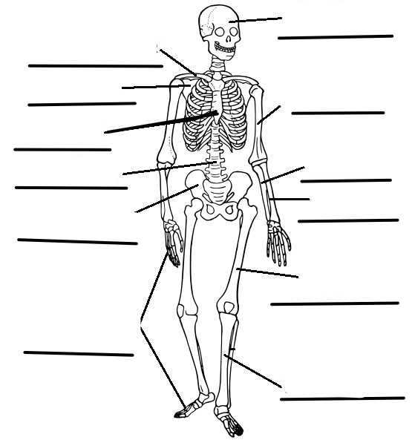

Match these parts of the human body to correct picture below.

- Mandible | - Patella | - Humerus | - Clavicle | - Vertebrae
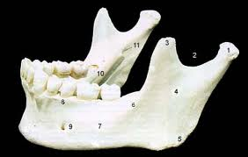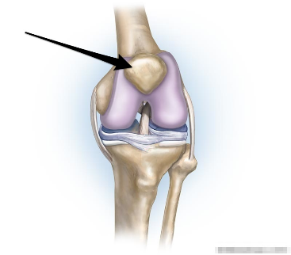

______________________________ ___________________________

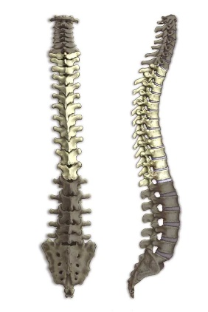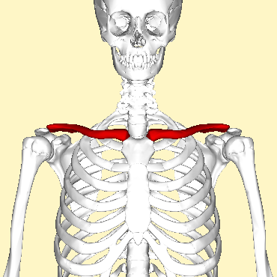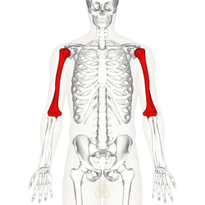

______________________ _______________________ ________________

Appendix C. Treatment Integrity Checklist: Study 1 Science Vocabulary
Study 1: Augmented Reality Vocabulary Instruction

Data Collector: _____________________ Date: _____________________________
Coder Name: _______________________

 | Observed
- Ask the student complete the data collection form. | YES NO
- Read each question aloud to the student on the form and wait for the students to respond. | YES NO
- Observed completion by student of the data collection sheet questions? | YES NO
- Provided mobile device to student to practice the vocabulary? | YES NO
- Instruct the students to view the AR vocabulary markers for the word list? | YES NO
- Watched the student wait for the AR app to recognize the marker? | YES NO
- Observed the student view the AR definition view the marker? | YES NO
- Provided visual aid as first prompt if needed? | YES NO or N/A
- Observed 10 second wait time before providing second prompt? | YES NO or N/A
- Provided verbal prompt as second prompt if needed? | YES NO or N/A
- Observed 10 second wait time before providing third prompt? | YES NO or N/A
- Provided physical prompt as third prompt if needed? | YES NO or N/A
- Observe students practice all the vocabulary words. | YES NO
- Remind the students to view each AR video three times. | YES NO
- Collected the mobile devices (if loaned), data sheet, and trigger at end of session? | YES NO

Appendix D. Social Validity Questionnaire: Study 1 Science Vocabulary
Study 1. Social Validity Questionnaire Augmented Reality Vocabulary Instruction

Student: _________________________ Date: ___________
“I have some questions to ask you about the augmented reality vocabulary study. I am interested in your opinion, so there are no right or wrong answers. Do you have any questions before we begin?”

Questions |  | Responses  
1. | I liked using AR view the vocabulary words. | Strongly Disagree | Disagree | Neutral | Agree | Strongly Agree
2. | I liked seeing the vocabulary word and information about it at the same time using AR. | Strongly Disagree | Disagree | Neutral | Agree | Strongly Agree
3. | Learning how to use these tools helped me to improve my science vocabulary. | Strongly Disagree | Disagree | Neutral | Agree | Strongly Agree
4. | The AR vocabulary instruction was easy to use on my own. | Strongly Disagree | Disagree | Neutral | Agree | Strongly Agree
5. | I was able see both the word and definition videos in the augmented reality app. | Strongly Disagree | Disagree | Neutral | Agree | Strongly Agree
6. | I learned the definitions faster than the labeling. | Strongly Disagree | Disagree | Neutral | Agree | Strongly Agree
7. | I learned the labeling faster than the definitions. | Strongly Disagree | Disagree | Neutral | Agree | Strongly Agree
8. | Hearing the definitions was easier than reading them. | Strongly Disagree | Disagree | Neutral | Agree | Strongly Agree
9. | I learned the vocabulary words faster on my own using the AR vocabulary instruction than I would normally from a teacher. | Strongly Disagree | Disagree | Neutral | Agree | Strongly Agree
10. | I would like to use augmented reality more to learn new things. | Strongly Disagree | Disagree | Neutral | Agree | Strongly Agree
11. | What was it like to use the augmented reality vocabulary instruction?
12. | What did you like or not like about the augmented reality vocabulary instruction?
Appendix E. Data Collection Form: Study 2 Navigation
STUDY 2 Navigation Alternating Treatments Design.

Student _____________________ Date _____________________
Researcher _____________________ IOR Person_________________________

Navigating to Job Opportunities Intervention
Students will find their way to a new location using the Layar Application on the iPhone or iPad. The researcher should offer no assistance at each Navigation Check. At each Navigation Check, record a Yes if the student made the correct choice, or No if he/she did not. For the first three incorrect responses do not correct the student. After three incorrect responses use the system of Least Prompts if the student indicates he/she does not know the way.
Navigation checks should occur at common decision points like before intersections, crosswalks, or after more that 2 minutes of walking without a direction check. Trials need to sufficiently far enough away that a minimum of 7 navigation checks will occur, more than 7 is fine.

Location: _______________________________________________
Tell the student: “We are going to navigate to a nearby by job opportunity at {state business name}. Have you been there before? Do you know how to get there?”

(If student knows how to get there, tell Don McMahon before you leave and get a new location).
Step | Navigation Checks | Student Response*
1 |  | YES NO Assisted
2 |  | YES NO Assisted
3 |  | YES NO Assisted
4 |  | YES NO Assisted
5 |  | YES NO Assisted
6 |  | YES NO Assisted
7 |  | YES NO Assisted
8 |  | YES NO Assisted
9 |  | YES NO Assisted
10 |  | YES NO Assisted
11 |  | YES NO Assisted
12 |  | YES NO Assisted
 | TOTAL | CORRECT | TOTAL NUMBER
 | Percentage Independent | ______ / ____________

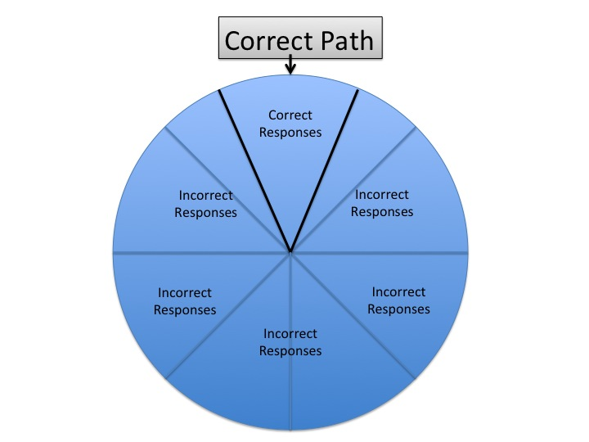

Error Procedures

Student action | Incorrect Direction | “I Do not know”
Data Collector action | First occurrence= Do Not correct | Ask them if they are sure. Mark as incorrect. Then assist. Repeat for all “I don’t know responses.
Data Collector action | Second occurrence= Do Not correct
Data Collector action | Third occurrence= Do Not correct
Data Collector action | Fourth occurrence – Assist for this and all future occurrences of this trial

Appendix F. Procedural Integrity Data Sheet: Study 2 Navigation
STUDY 2. Alternating Treatment Navigation

Data Collector: _____________________ Date: _____________________________
Coder Name: _______________________

 | Observed
- Checked mobile device battery charge prior to session? | YES NO
- Assisted student in locating front of building prior to session? | YES NO
- Provided mobile device to student? | YES NO
- Asked them if they know how to get to the specified location? | YES NO
- Asked them to use the appropriate tool to find location? | YES NO
- Observed the student open the application? | YES NO
- Observed the student select the specified location from menu? | YES NO
- Allowed 10 seconds of wait time throughout session? | YES NO or N/A
- Provided prompt using system of least prompts if student indicated an incorrect response | YES NO or N/A
- Provided praise for correct response? | YES NO
- Observed safety precautions when traveling on foot with student? | YES NO
- Recorded student responses throughout session on data collection sheet? | YES NO
- Collected mobile device at the end of the session? | YES NO
- Tallied the correct responses at the end of the session? | YES NO
- Escorted student back to building at end of session? | YES NO

TOTAL: _________/__________ = __________

Appendix G. Social Validity Questionnaire: Study 2 Navigation
STUDY 2. Social Validity Questionnaire: Alternating Treatment Navigation

Student: _________________________ Date: ___________
“I have some questions to ask you about the navigation study. I am interested in your opinion, so there are no right or wrong answers. Do you have any questions before we begin?”

Questions |  | Responses
1. | Practicing the different apps helped me to improve my navigation skills. | Strongly Disagree | Disagree | Neutral | Agree | Strongly Agree
2. | I liked using the mobile device (iPhone) better than the paper map. | Strongly Disagree | Disagree | Neutral | Agree | Strongly Agree
3. | I liked the Google Map best. | Strongly Disagree | Disagree | Neutral | Agree | Strongly Agree
4. | I like the AR app best. | Strongly Disagree | Disagree | Neutral | Agree | Strongly Agree
5. | I liked the Paper Map best. | Strongly Disagree | Disagree | Neutral | Agree | Strongly Agree
6. | I would use my favorite tool __________ again to help me navigate to new locations. | Strongly Disagree | Disagree | Neutral | Agree | Strongly Agree
7. | I would recommend using my favorite tool_________ to a friend. | Strongly Disagree | Disagree | Neutral | Agree | Strongly Agree
8. | I always found the place I was looking for using the Google map | Strongly Disagree | Disagree | Neutral | Agree | Strongly Agree
9. | I always found the place I was looking for using the AR app. | Strongly Disagree | Disagree | Neutral | Agree | Strongly Agree
10. | Which did you like best the paper map, Google Map or the augmented reality app and why?
11. | What would make your favorite tool better?
12. | Describe how your favorite navigation tool helped you and what is like to use it?

Vita
Don McMahon was born in Columbia, South Carolina and graduated from Irmo High School. Don left Columbia after high school to attend the University of Tennessee, Knoxville where he graduated Cum Laude with an Honors Degree in College Scholars in History, English and Film Production. After working in television production for a year he went to work as a full time summer camp director working with children in outdoor education in Hendersonville, NC. Finally, realizing that his mom was right all along he moved back to Knoxville to become a teacher. Don worked as an elementary special education teacher at a special day (alternative) school for Knox County Schools for six and half years. During that time he earned his masters in special education. Don was then promoted to work as instructional coach for general education and special education teachers working together in co-taught classrooms. Don was selected to attend the Harvard Graduate School of Education’s summer institute on Universal Design for Learning in 2010. Soon after that experience he decided to pursue his PhD in special education with a focus on technology fulltime at the University of Tennessee. At the University of Tennessee he worked as a graduate assistant as an instructor for the FUTURE post secondary education program for students with intellectual disabilities. Don graduated with a PhD in Special Education in May 2014. In the fall of 2014, Don McMahon will begin his new position as an Assistant Professor of Special Education/Technology at Washington State University in Pullman, Washington.

