Physical Adsorption of Linear Hydrocarbon Quadrupoles on Graphite and MgO (100): Effects of the Compatibility of Surface and Molecular Symmetries

A Dissertation Presented for the
Doctor of Philosophy
Degree
The University of Tennessee, Knoxville

Andrew Jesse Pedersen
September 2020

Copyright © 2020 by Andrew J. Pedersen
All rights reserved

ACKNOWLEDGEMENTS

ABSTRACT
The process of physical adsorption find a practical role in wide ranging fields from catalysis, to lubrication, and to optoelectronics. It provides a mechanism to probe the fundamental understanding of intermolecular forces and how symmetries can play a role in the behavior of a system. Linear quadrupoles preferentially adopt square-T configurations in 2-dimensions that lead to a 4-fold symmetry in the molecule-molecule arrangements. Two archetypal surfaces often studied in physisorption studies are MgO (100) which has a 4-fold symmetry of alternating charges, and the basal plane of graphite, which has a 6-fold symmetry to its non-polar surface These differing symmetries provide two test cases for comparison. In the case of MgO (100), the molecule-molecule and the molecule-surface interactions are both driving the system towards a 4-fold configuration. Whereas for graphite, the 6-fold symmetry of the molecule-surface interactions, and the 4-fold symmetry of the molecule-molecule interactions instead create the opportunity for structurally frustrated systems to arise. Acetylene and Allene are both simple, linear, rigid hydrocarbons with large, and similar strength quadrupole moments, that vary most importantly in size and rotational symmetry along the molecular axis. These molecules, just like the surface provide two simple but contrasting symmetry effects, as acetylene is completely linear, and can lie flat on a surface. However for allene, the two pairs of hydrogens located at opposing ends of the molecule are not only angled out from the molecular axis, but are rotated 90 degrees to one another, resulting in no orientation in which allene can lay perfectly flat on a surface. This investigation aims to study the behavioral properties of these films through thermodynamic, structural, and phase behavior of both acetylene and allene adsorbed on both graphite and MgO. To this end a combination of volumetric adsorption isotherms, neutron diffraction data, and molecular dynamics simulations was employed.

Table of Contents
Chapter 1: Introduction and Background 1
1.1 - Overview 2
1.2 - Adsorption and Wetting Behavior 3
1.2.1 - Types of Adsorption 3
1.2.2 -Surface Wetting 3
1.2.3 - Wetting in Two-Dimensions 4
1.3 - Surface Structure 6
1.3.1 - Crystal Lattices 6
1.3.2 - Miller Indices 6
1.3.3 - Binding sites 6
1.3.4 - Commensurability 6
1.4 - Forces and Interactions in Physical Adsorption 6
1.4.1 - Intermolecular Forces 6
1.4.2 - Molecule-Molecule Interactions 6
1.4.3 - Surface-Molecule Interactions 6
1.5 - Systems of Study 7
1.5.1 - Adsorbate Molecules 7
1.5.2 - Adsorbate Surfaces 7
1.5.3 - Intermolecular Interactions of Linear Molecular Quadrupoles 7
1.5.4 - Surface Interactions with Linear Molecular Quadrupoles 7
1.6 - Volumetric Adsorption Isotherms 7
1.6.1 - The Measurement Process 7
1.6.2 -Determination of Surface Area 7
1.6.3 - Thermodynamic Analysis 7
1.6.2 – Phase Changes and Diagrams 7
1.7 - Neutron Diffraction 7
1.7.1 - Bragg’s Law 7
1.7.2 - Reciprocal Space 7
1.7.3 - Powder Diffraction 7
1.7.4 - Diffraction in Two Dimensions 7
1.8 - Molecular Dynamics 8
1.8.1 - Theory and the Equations of Motions 8
1.8.2 - Force-Fields and Potentials 8
1.8.3 - Energy Minimizations 8
1.8.4 - Analysis of Simulations 8
Chapter 2: Materials and Methods 9
2.1– Purification of Adsorbate Gases 10
2.1.1 – Purification of Acetylene Gas 10
2.1.2 – Freeze-Pump-Thaw 10
2.2 – Preparation of Surface Substrates 10
2.2.1 – Synthesis of MgO (100) 10
2.2.2 – Vacuum Heat Treatment 10
2.2.3 – Sample Loading 10
2.3 – Volumetric Isotherms 10
2.3.1 – Instrumentation 10
2.3.2 – Determination of System Volume 10
2.3.3 – Measurement Process 10
2.4 – Molecular Dynamics Simulations 10
2.4.1 – Preparation of Simulated System 10
2.4.2 – Energy Minimizations Analysis 10
2.4.3 – Dynamics Analysis 10
2.5 – Neutron Diffraction 11
Chapter 3: Adsorption of Acetylene on Graphite’s Basal Plane: A Thermodynamic, Neutron Diffraction, and Modeling Study on the Physisorption of a Strong Quadrupolar Molecule 12
3.1 – Abstract 13
3.2 – Introduction 13
3.2 – Experimental 16
3.2.1 – Acetylene Purification 16
3.2.2 – Volumetric Isotherms 16
3.2.3 Computer Modeling 17
3.2.4 – Neutron Diffraction 18
3.3 – Results and Discussion 19
3.3.1 – Thermodynamics 19
3.3.2 – Molecular Dynamics Simulations 31
3.3.3 – Neutron Diffraction 39
3.4 – Conclusions 42
Chapter 4: Adsorption of Acetylene on MgO (100) 43
Chapter 5: Adsorption of Allene on Graphite 43
Chapter 6: Adsorption of Allene on MgO 43
Chapter 7: Conclusions 43
References 45
Appendices: 48
A) Program for the generation of 2-dimensional radial distribution functions 48

LIST OF TABLES
No table of figures entries found.

List of Figures
Figure 1: The three regimes of surface wetting 5

List of Abbreviations

Chapter 1: Introduction and Background

1.1 - Overview

The phenomena of the physical adsorption of volatile molecules on solid surfaces has been something that has been researched for centuries. As far back as 1450, there are records of devices created to study the process. Leonardo da Vinci was even known to have observed the phenomena using balances loaded with textile fibers. The first modern and quantitative research on the process began in 1773, when the adsorption of air on charcoal was studied. However, the true growth of this field into a large area of research interest didn’t occur until the 20th century as the ability to make pristine, high surface area materials and the standardization of measurement techniques became a reality¹.
The study of physical adsorption has been useful in providing great fundamental incites and understanding on the nature of intermolecular interactions. Beyond this, it also has practical applications in fields of catalysis, gas storage, separation science, and optoelectronics. Furthermore, volumetric adsorption isotherms (often simply referred to as isotherms) are a standard technique used to assess the specific surface area and porosity of materials. A more recent area where these studies find potential usefulness is the study of 2D materials. Since the isolation of graphene less than two decades ago, the search for other 2D systems has proved difficult. The two-dimensional nature of adsorbed monolayer films provides an alternative method for fabrication and study of such systems. While these films lack the stability and permanence of materials like graphene, the scale of the possible systems that can be fabricated from the interactions between surfaces of many varying symmetry types with a massively large possible number of adsorbate molecules with different sizes and intermolecular interactions provides to ability to fabricate a 2D system with fine-tuned structure and properties for study.
The study herein involves the investigation of the interaction of surface and adsorbate symmetries on the behavior of thin films comprised of simple quadrupolar hydrocarbons; namely acetylene and allene. The two surfaces of focus are MgO (100) and the basal plane of graphite, which are archetypal examples for surfaces with 4-fold and 6-fold symmetries, respectively. The main methods employed were a combination of volumetric adsorption isotherms, neutron diffraction experiments and computational simulations. The data gathered from these experiments help establish an understanding of the thermodynamics, structural, and dynamic behaviors for these systems. As will be shown, the nature of how the two symmetry systems of the surface and the molecules of the adsorbed film interact can lead to very complex thermodynamic and phase behavior, even in systems that seem to otherwise be simple.

1.2 - Adsorption and Wetting Behavior

1.2.1 - Types of Adsorption

Adsorption processes are divided into two major classifications, physical adsorption (physisorption) and chemical adsorption (chemisorption). The distinction between them is due to the nature of the interactions between the adsorbate and the surface. In chemisorption, the binding of molecules to the surface involves the exchanging of electrons, thus forming a chemical bond. Good example of this process is the formation of passive oxidation layers on the surfaces of metals, such as aluminum, when they interact with atmospheric oxygen or the adsorption of thiol-based molecules onto a metallic surface. Whereas physisorption arises from the interaction of the intermolecular forces, primarily van der Waal’s electrostatic interactions.
These two processes represent opposing ends on the spectrum of adsorption energies. Since chemisorption involves the formation of chemical bonds, it represents the higher end of this spectrum, usually in a range of 1 eV to 4 eV, but depends on the nature and strength of the chemical bond formed. At the lower end of the adsorption energy range is physisorption, with typical values from 0.05 to 0.4 eV. For the systems presented in this study, physical adsorption will be the only process observed.

1.2.2 -Surface Wetting

The most easily and commonly observable form of physical adsorption is the bulk condensation of gas phase molecules onto a surface. An everyday example of this is the condensation of water vapor onto the surface of a drinking cup. One might also note in this context that the nature of the droplets formed might vary depending on whether the cup is made of plastic, metal, or glass for example. When a vapor condenses onto a surface, the behavior of the condensed phase depends on the relative strength of the intermolecular forces between the condensed molecules and the interaction forces between the molecules and the surface. In the liquid condensate, these forces manifest in the form of the surface tensions from the resulting interfaces between the surface (s), liquid (l), and vapor phases(v). The minimization of the surface energy from these competing interactions leads to the formation of droplets whose contact angle with the surface is given by:
 | $$\cos{θ}= \frac{σ_{s,v}-σ_{s,l}}{σ_{l,v}}$$ | (1.1)
where θ is the contact angle, and σ_{n,m} is the surface tension at the interface at the interface of the respective two phases (e.g. s,l being the surface-liquid interface)².
Based on the behavior of the contact angle, surface wetting can be broadly categorized into three regimes: non-wetting, incomplete wetting, and complete wetting (figure 1). The origin of the relative surface tension magnitude relates directly to the relative strengths of the intermolecular interactions of the system. When the surface-molecule interactions are significantly weaker than the molecule-molecule interactions, we see the non-wetting regime, where the liquid forms a spherical droplet with a 180° contact angle. At the other extremely, where the surface-molecule interactions are dominant, the liquid forms a uniform film across the surface (0° contact angle) that is the signature of complete wetting. The intermediate case between these two extremes lies incomplete wetting, where there is competition between the strength of the molecule-molecule and molecule-surface interactions, characterized truncated drops with contact angles between 0° and 180°.

1.2.3 - Wetting in Two-Dimensions

These same principles that govern the bulk wetting properties of liquids on surfaces can be extended to analogous cases down to the nano-scale, for films of one or several molecules thickness.
Figure 1: The three regimes of surface wetting
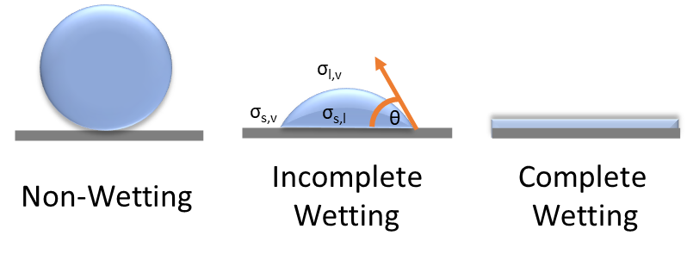

1.3 - Surface Structure

1.3.1 - Crystal Lattices

1.3.2 - Miller Indices

1.3.3 - Binding sites

1.3.4 - Commensurability

1.4 - Forces and Interactions in Physical Adsorption

1.4.1 - Intermolecular Forces

1.4.2 - Molecule-Molecule Interactions

1.4.3 - Surface-Molecule Interactions

1.5 - Systems of Study

- Adsorbate Molecules

1.5.1.1 - Acetylene

1.5.2.2 - Allene

1.5.2 - Adsorbate Surfaces

- The Basal Plane of Graphite

1.5.2.2 - MgO (100)

1.5.3 - Intermolecular Interactions of Linear Molecular Quadrupoles

1.5.4 - Surface Interactions with Linear Molecular Quadrupoles

1.5.4.2– Adsorption on Graphite

1.5.4.2– Adsorption on MgO (100)

1.6 - Volumetric Adsorption Isotherms

1.6.1 - The Measurement Process

1.6.2 -Determination of Surface Area

1.6.3 - Thermodynamic Analysis

1.6.2 – Phase Changes and Diagrams

1.7 - Neutron Diffraction

1.7.1 - Bragg’s Law

1.7.2 - Reciprocal Space

1.7.3 - Powder Diffraction

1.7.4 - Diffraction in Two Dimensions

1.8 - Molecular Dynamics

1.8.1 - Theory and the Equations of Motions

1.8.2 - Force-Fields and Potentials

1.8.3 - Energy Minimizations

1.8.4 - Analysis of Simulations

Chapter 2: Materials and Methods

2.1– Purification of Adsorbate Gases

2.1.1 – Purification of Acetylene Gas

2.1.2 – Freeze-Pump-Thaw

2.2 – Preparation of Surface Substrates

2.2.1 – Synthesis of MgO (100)

2.2.2 – Vacuum Heat Treatment

2.2.3 – Sample Loading

2.3 – Volumetric Isotherms

2.3.1 – Instrumentation

2.3.2 – Determination of System Volume

2.3.3 – Measurement Process

2.4 – Molecular Dynamics Simulations

2.4.1 – Preparation of Simulated System

2.4.1.1 – Surface Construction

2.4.1.2 – Preparation of Molecules

2.4.1.3 – Special Considerations for Allene

2.4.2 – Energy Minimizations Analysis

2.4.3 – Dynamics Analysis

2.4.3.1 – Simulation Process

2.4.3.2 – Analysis of Simulation Trajectories

2.5 – Neutron Diffraction

Chapter 3: Adsorption of Acetylene on Graphite’s Basal Plane: A Thermodynamic, Neutron Diffraction, and Modeling Study on the Physisorption of a Strong Quadrupolar Molecule

Authors: Andrew Pedersen, J.Z. Larese
(pre-print)

3.1 – Abstract

A detailed investigation of the phase behavior acetylene monolayers adsorbed on graphite’s basal plane between 119 K and 141 K was conducted. Volumetric adsorption isotherms in this region show four distinct features within the first monolayer at lower temperatures, as well as a fifth that is hidden within the first monolayer step. A sharp change in isotherm behavior occurs between 132.5 K and 134.5 K, where the system begins to undergo a 2D melting transition. Following this, a new isotherm profile is established consisting of three main monolayer features, for which a second melting transitions is observed at 140.5 K. Neutron diffraction data at sub-monolayer coverage has been used to analysis the structure of one of the previously observed solid phases. The intensity of the neutron diffraction data as a function of temperature shows an order-disorder transition at 133 K indicative of the 2D melting seen in the isotherm data. Molecular dynamics computations were made on the system at a range of coverages. At low coverages, the competition between molecular quadrupole-quadrupole interactions and molecule-surface interactions lead to structures with a high degree of disorder. As the film density was increased in these simulations, the film structures became more ordered, and began to adopt a hexagonal structure, more compatible with the symmetry of the molecule-surface interactions.

3.2 – Introduction

Understanding the behavior of molecules adsorbed on a solid surface plays an important role in current basic scientific and technological issues. Examples where these investigations are most relevant include catalysis², gas separation², gas storage³, and optoelectronics⁴. By expanding the fundamental knowledge base on how molecules interact (and perhaps modify) a material’s surface provides an ideal platform to probe and test theories on intermolecular interactions and in principle subsequently lead to technological advancements. One interesting area involves examination of the interplay of study the molecule-molecule and molecule-surface symmetries, especially in cases where the two symmetries are incompatible. Archetypal surface substrates such as MgO (100) and graphite basal plane have recently been undertaken to probe how the relative size of these two interactions influence the properties of the adsorbed molecular film. Graphite is one of the most widely studied surfaces; due to its chemical stability, the availability of uniform, single facet high surface area materials (i.e. predominantly basal plane exposure) and relative ease to prepare and maintain clean surfaces).
For this study, the focus was an examination of the adsorption of acetylene films on the surface of graphite. As such, it is one component of an ongoing series of investigations which exam the behavioral trends of homologous series of molecules adsorbed on surfaces of varying symmetry⁵⁻⁸. This study represents the first step in an examination on the adsorption properties of linear, quadrupolar hydrocarbons. Acetylene may be considered as the prototypical hydrocarbon in this regard. It is a small, highly symmetric molecule similar to other molecules that have previously been studied, such as as N₂^{9, 10}, C₂N₂¹¹, and CO₂^{11, 12}. Linear molecules of these types all belong to the same point group (D_{∞h}), the common symmetry which prevents the formation of any type of static dipole moment. These small molecules can however, have charge distributions with higher order electrostatic moments, e.g. a quadrupole moment and in cases where this electrostatic property is substantial, a notable influence on their intermolecular interactions and resulting condensed state properties. Acetylene distinguishes itself from these other molecules as a result of its small size and large quadrupole moment, which is approximately 5 times greater than that of nitrogen¹³⁻¹⁸. This means that the quadrupolar interaction between molecules should be a key factor in the resulting surface structure and behavior of adsorbed acetylene films. Notably acetylene is considerably smaller and lighter than CO₂ which also has a sizable quadrupole moment. It is nearly small enough to adopt a √3 x √3 R30° commensurate lattice on graphite while lying flat¹⁹, suggesting that the six-fold symmetry of the surface will influence the physical properties of the film as well.
The minimum energy configuration for two interacting linear quadrupoles is such that they adopt a T-shaped arrangement. Extending this effect in two dimensions would result in the formation of stable, ordered square lattice containing two molecules per unit cell in the T-shaped configuration, with four-fold symmetry²⁰. It is well known that graphite forms a hexagonal or “honeycomb” lattice, with a weakly corrugated, nonpolar surface plane. Thus the 6-fold surface symmetry would naturally “steer” molecules towards structures which would favor a similar arrangement. The juxtaposition of these two different structurally favorable symmetries underscores one of the underlying purposes for investigating acetylene film adsorption on the graphite basal plane (i.e. 4-fold versus 6-fold symmetry respectively). Depending on the relative size of the molecule-molecule and molecule-surface interactions and the surface density a “tug of war” between the preferred molecular orientations can result, producing a solid film that is structurally frustrated²¹. For example, nitrogen, which has a weaker quadrupole moment compared to other molecules of similar size, readily forms a monolayer solid that is commensurate with the graphite (hexagonal) surface²¹. In the current study, acetylene, with its larger quadruple moment has a phase diagram with fascinating structural and physical properties.
Earlier less comprehensive thermodynamic and microscopic studies suggested that this is a system that is poorly understood and complex^{19, 22-28}. The thermodynamic investigations revealed several adsorption features that may be related to phase transitions within the monolayer phase. Preliminary neutron data identified two solid phases (referred to as S₁ and S₂) as well as one liquid phase²². A more recent neutron study broadened this picture, by introducing phase transitions and mixed solid phases²³. Although these studies, have revealed the complexity of this system, they have not presented a detailed enough combined thermodynamic, microscopic and modeling study to provide a more complete picture of the structural, thermodynamic, and phase behavior for this system.
The present investigation presents da comprehensive examination of the adsorption of acetylene films on graphite using thermodynamic, neutron scattering, and molecular dynamic modeling techniques aimed at the monolayer and beyond behavior of the acetylene on graphite system. Thermodynamic measurements were made using high resolution volumetric isotherms in a temperature range of 119 K to 141 K. From these data, potential phase transitions, surface densities, and differential enthalpies and entropies were obtained. Molecular dynamics simulations were performed over a range of coverages above and below monolayer completion to illuminate the structure and dynamics of the film behavior. Single molecule geometry optimizations on graphite were performed to identify preferred binding sites and energies. Lastly, neutron diffraction data at low coverages were obtained to provide structural information and additional information concerning 2D melting.
.

3.2 – Experimental

3.2.1 – Acetylene Purification

Most commercially available acetylene gas (pressurized over 2 atm) is dissolved in acetone to stabilize it and allow for safe storage at higher pressures. For this study, atomic absorption grade (99.7 % purity, Airgas), was used. Before use, the gas was purified following a procedure described by Hyman at al.²⁹ shown to effectively remove the contaminating acetone vapor as well as several other contaminants common to acetylene production. The resulting gas was then subjected to several freeze-pump-thaw cycles to remove any remaining volatile gases.

3.2.2 – Volumetric Isotherms

The graphite sample used was an exfoliated foam provided by Union Carbide with a surface area around 20 m² g⁻¹. The graphite sample was heat treated in vacuo inside a quartz tube at 750 °C for 24 hours. The sample was then transferred into an argon filled glove box where it was loaded into a OFHC copper sample cell, subsequently sealed with an indium gasket. The sample cell was then mounted on a cold finger inside an ARS™ 4K based closed-cycle helium cryostat. A Neocera™ LTC-21 controller was used to regulate temperature to a stability of less than ± 5 mK using a silicon diode thermometer mounted at the top of the cold finger. The sample temperature was monitored with a second silicon diode attached to the top of the sample cell.
As in the past, adsorption experiments were performed using an automated, high-resolution isotherm apparatus controlled by a custom LabVIEW program the regulate and record gas dosing, pressures, and temperature³⁰. Pressure readings were made using either a 1 or 100 torr MKS baratron capacitance monometer. This system has been shown to produce highly stable and precise measurements, across a wide range of temperatures and pressures. A methane isotherm at 77K was initially performed to characterize the quality and surface area of the heat-treated sample after mounting the sample in the cryostat. In order to monitor if surface degradation took place the methane isotherm was performed periodically. More than twenty isotherms were recorded within the temperature range of 119 K >T(K) > 141 K. Sample temperatures were established using saturated vapor pressures (SVP) for each isotherm using parameters determined for acetylene by Menaucourt et al¹⁹.

3.2.3 Computer Modeling

Molecular modeling studies were performed using the Forcite Module in Accelrys’ Materials Studio 6.0 software. As in the past the COMPASS forcefield, was used to define the intermolecular and molecule surface interactions in the simulations known to realistically describe the interactions of many hydrocarbons and small molecules³¹. Two types of computations were performed in this study. Geometry optimization of a single molecule on a graphite surface were used to identify favorable surface binding sites and energies. Molecular dynamics (MD) simulations were conducted at various temperatures and for several fixed numbers of molecules to gain insight regarding possible film structure and attendant molecular dynamic behavior.
For both types of simulations, the initial preparation of the graphite surfaces and acetylene molecules was the same. An optimized graphite unit cell (2.46 x 2.46 x 6.80 Å) consistent with crystallographic data was used to create a larger supercell of the graphite substrate, the atomic positions of the C atoms were subsequently constrained to remain fixed in their optimized positions. A vacuum slab was created above the surface with periodic boundary conditions to create and infinite xy-plane of the graphite surfaces, and the z direction connects the vacuum space of the top and bottom surfaces of the simulation box. Likewise, individual acetylene molecules were constructed and optimized and then transferred onto the graphite surface within the simulation box.
For the geometry optimization calculations, acetylene molecules were placed onto a graphite surface of an 9.84 x 9.84 x 17.00 Å graphite supercell with a 20 Å vacuum slab with the molecular center of mass positioned over high symmetry points of the graphite surface; the center hollow of the hexagonal unit, the mid-point of a carbon-carbon bond, and directly on top of a carbon atom. Calculations were run for at various initial molecular orientations over these fixed points using the Forcite module’s Smart algorithm.
MD simulations were performed using a 36.90 x 36.90 x 17.00 Å supercell with a 100 Å vacuum slab. To investigate the density dependence of a single layer of adsorbed molecules with the graphite surface, five different groups of acetylene molecules (over an approximate range of 0.3 to 1.2 monolayers) were placed randomly within the simulation box. Simulations were performed using the NVT (canonical) ensemble with a Nose-Hoover-Langevin (NHL) thermostat for temperature regulation. Simulation times ranges from 50 to 250 ps depending on equilibration times with a 1 fs time step. Equilibrium was determined to be reached when the non-bonded and potential energy terms remain constant with time. In order to eliminate any unintended bias of the starting position of any molecule within the ensemble each MD simulation was initially performed at 400 K. The system was incrementally cooled by using the final velocities and positions from the end of the simulation as the start point of the next simulation at lower temperature. This process ensures that the simulations were conducted from a suitably random arrangement of molecules that then incrementally approach equilibrium with the surface as the temperature is lowered.

3.2.4 – Neutron Diffraction
Elastic neutron diffraction data was collected using the powder diffractometers TAMPA located at the High Flux Beam Reactor and WAND² at the High Flux Isotope Reactor were operated at a fixed wavelength of 1.63 Å and 1.5Å at Brookhaven and Oak Ridge National Laboratories respectively. The sample cells were loaded in a glove box and mounted on a custom cryostat insert (reference Kohler and JZL RSI). The adsorbed films were prepared in situ as in the past using a custom-built gas handling system²⁴. All quantities of C₂D₂ gas are quoted in fractional coverages where one monolayer refers to the quantity of gas needed to form a √3 x √3 R30° commensurate lattice (as determined using a N₂ isotherm at 77.4K). Films were annealed for ~ 2 hours at (XYZ K) and then slowly cooled at 1K/min to the data collection temperature. Diffraction profiles were recorded within a temperature range between 160 K to 4 K. As in the past the diffraction data is evaluated by subtracting off the signal from the sample cell containing the bare graphite.

3.3 – Results and Discussion

3.3.1 – Thermodynamics

As noted above, twenty-seven volumetric isotherms were recorded between 119.69 K < T(K)< 141.62 K. Once the raw data was corrected for molecules that occupied the dead space, these data were reduced as in the past³² using the interpolation routine described in our earlier work to obtain smooth curves that accurately represent the experimental data. Figure 1 use at four different isotherms to illustrate how the interpolated curves match the behavior of the experimental data (solid circles). Figure 2 shows that at temperatures <132.63 K, four prominent features (labeled A through D) are recorded. Between 132.63 K and 134.52 K, these features exhibit noticeable changes; feature B broadens and disappears while feature C splits into two sub-steps (C₁ and C₂). Furthermore, above 134.52 K, feature C undergoes another change in behavior as a function of coverage for the lower step (labelled C₁’). Lastly, the substep denoted as C₂ disappears between 140.61 K and 141. 62 K.

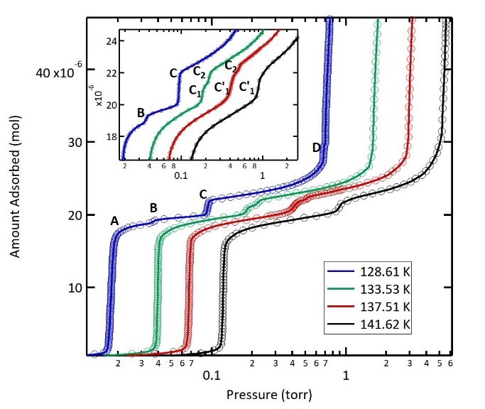
Figure 2: Interpolated fits (lines) with matching raw data points (circles) at four selected temperatures within the analyzed range. Transition features of the first monolayer are labeled here as A through D.

When the isotherm temperature is >132.63 K the slope of initial step A appears to be less vertical and becomes progressively less steep as the temperature is decreased. This behavior can be associated with a with a decrease in film density as well (see e.g. figure 3). Previous investigations have led to uncertainty in the critical temperature, T_{c1} associated with the first layer transition. It appears that concensus^{14,20} indicates that T_{c1} is at 155 K. Interestingly the study by Peters et al.²⁶ who reported T_{c1} to be at 120 K based their conclusion on an apparent splitting and reduction in slope of the initial riser (labelled feature A here at ~120 K). In the high-resolution measurements report here a similar (albeit subtle) feature associated with step A appears in all traces < 132.5 K. It is important to note that this feature is barely visible in the raw data, however, by taking the numerical derivative of the interpolated fits this feature is readily observable (see e.g. the bottom trace of figure 2). The heat capacity study by Alkhafaji and Migone²⁷ provides valuable information for understanding this finding especially in terms of whether it relates to the first order versus continuous melting behavior. The latter has been observed in study of sub-monolayer ethylene on graphite³³⁻³⁵.
Surface coverages corresponding to the various monolayer substep features were identified using the point B method. The area per molecule (APM) was determined by comparing the substep locations to the initial 77K methane calibration isotherm where the √3 x √3 R30° commensurate structure and 15.72 Å² APM is well established. All coverages are reported as a fraction, where 1.00 monolayer is the coverage where the √3 x √3 commensurate phase is completed, consistent with earlier published measurements^{19, 25, 27}. These values are summarized in table 1. Notably, the coverage/APM value for phase A has a lower surface density in the low temperature regime than in the higher temperature region. The C and C₂ phases have similar densities i.e. ~ 5 % lower than the √3 x √3 R30° phase and where C₂ is slightly more dense. The density associated with feature D is significantly higher than the other monolayer films and may signal that the molecules are tilted away from the graphite surface or that feature D corresponds to the start of the formation of a second layer.

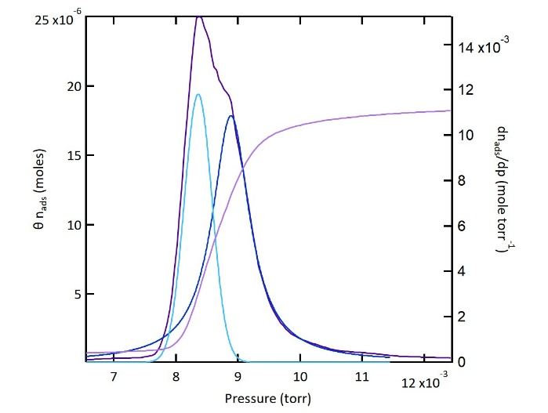
Figure 3: (top) plot of isotherms over the full temperature range examined plotted as a function of chemical potential. (bottom) First monolayer step of isotherm at 124.64 K with numerical derivative. Peak fitting results showing two distinct peaks are in blue showing two distinct sub-features. FWHMs for two peak fit solution: 5.2274E-4 and 7.4087E-4. FWHM for one peak fit solution: 1.0176E-3

phase | Coverage  (relative to CH₄) | APM | A^{(n)} | B^{(n)} | ΔH  kJ mol⁻¹ | ΔS  J mol⁻¹ K⁻¹ | Q_{ads} | temperature range observable
A | 0.790 ± 0.007 | 19.92 ± 0.15 | 2673 | 17.532 | 1.247 | 35.484 | 22.223 | ≥ 133.53
A₁ | ≈0.57† | ≈28† | 2810 | 17.795 | 0.108 | 33.298 | 23.362 | ≤ 132.14
A₂ | 0.762 ± 0.007 | 20.66 ± 0.22 | 2723.8 | 17.17 | 0.825 | 38.494 | 22.646 | ≤ 132.14
B | 0.824 ± 0.004 | 19.1 ± 0.10 | 2384.8 | 15.199 | 3.643 | 54.881 | 19.827 | ≤ 132.14
B’ | ‡ | ‡ | 5219 | 36.67 | -19.920 | -123.63 | 43.3908 | 132.63 – 133.70
C | 0.950 ± 0.002 | 16.56 ± 0.04 | 2496.8 | 17.035 | 2.712 | 39.616 | 20.758 | ≤ 132.14
C₁ | 0.896 ± 0.005 | 17.57 ± 0.11 | 1444.5 | 9.100 | 11.461 | 105.588 | 12.010 | 132.52 – 133.77
C’₁ | 0.923 ± 0.006 | 17.06 ± 0.12 | 3788.1 | 26.644 | -8.024 | -40.273 | 31.4943 | ≥ 136.54
C₂ | 0.959 ± 0.008 | 16.42 ± 0.15 |  |  | -10.21 | -58.09 | 33.68 | ≥ 136.54
D | 1.202 ± 0.019 | 13.10 ± 0.25 | 2821.7 | 21.550 | 0.0108 | 2.079 | 23.460 | ≤ 133.01
layer 2 | - | - | 2804.0 | 21.453 | 0.158 | 2.885 | 23.313 | Full range
layer 3 | - | - | 2827.1 | 21.742 | -0.034 | 0.482 | 23.505 | Full range
layer 4 | - | - | 2859.5 | 22.015 | -0.304 | -1.788 | 23.774 | Full range
Bulk | - | - | 2823.0 | 21.800 | - | - | 23.470 | -
Table 1: Coverage and thermodynamic data for observed phases. Coverages for multilayers are excluded do to overlap with capillary condensation within the vermicular graphite structure. († estimate based on best fitting isotherms data, ‡ feature is visible in only two isotherms weakly, coverage and thermodynamic values are should be regarded as estimations).

While earlier adsorption studies^{23, 36} reported substeps in the monolayer regime , the results presented here follow the evolution of these feature in the monolayer region up to and beyond first layer completion. this includes evidence that these features are present at the onset and within the second acetylene layer. The present study is focused on developing a detailed understanding of the monolayer regime and a discussion of these bilayer features will be left to a future publication.
The data plotted in Fig. 4 correspond to the location of the peak in the numerical derivatives associated with each of the adsorption features (A-D) discussed above. These data are analyzed following the formalism introduced by Larher³⁷ which employs a Clausius-Clapeyron analysis, i.e. linear fits of the natural logarithm of the pressures values plotted vs the inverse isotherm temperature (found in figure 4) namely:
$\ln\left(p_{f}^{\left(n\right)}\right)=B^{(n)}-\frac{A^{(n)}}{T}$ (3.1)
The thermodynamic values summarized in Table 1 include both the differential enthalpy, $∆H^{(n)}$and entropy $∆S^{(n)}$ and the heat of adsorption $Q_{ads}^{(n)}$, where the slope, A^{(n)}, and y-intercept, B^{(n)}, represent fits determined for each of the nth adsorbed layers (n) the differential enthalpy ($∆H^{(n)})$ and entropy ($∆S^{(n)}$) are calculated relative to the bulk acetylene (n = ∞) values. These relationships are given in equations (3.2)-(3.4) below:
$∆H^{(n)}=-R(A^{\left(n\right)}-A^{\left(∞\right)})$ (3.2)
$∆S^{(n)}=-R(B^{\left(n\right)}-B^{\left(∞\right)})$ (3.3)
$Q_{ads}^{(n)}=RA^{\left(n\right)}$ (3.4)
The values summarized in Table 1 illustrate that film thermodynamics primarily are characterized by positive values of the differential enthalpy and entropy, indicating the processes are entropically driven and likely partially disordered. Some notable exceptions to this trend are associated with the B’, C’₁, and C₂ features. It appears that these transformations evolve from high energy and disordered structures at lower temperature, to a lower energy more ordered phase at higher temperature. Interestingly bulk acetylene undergoes a solid-solid phase transition at 133 K from a low energy, disordered orthorhombic phase at low temperatures, to a high energy, disordered cubic phase at higher temperature³⁸⁻⁴¹. Interaction of the film with the substrate is known to modify the bulk behavior and is likely the explanation of this behavior here
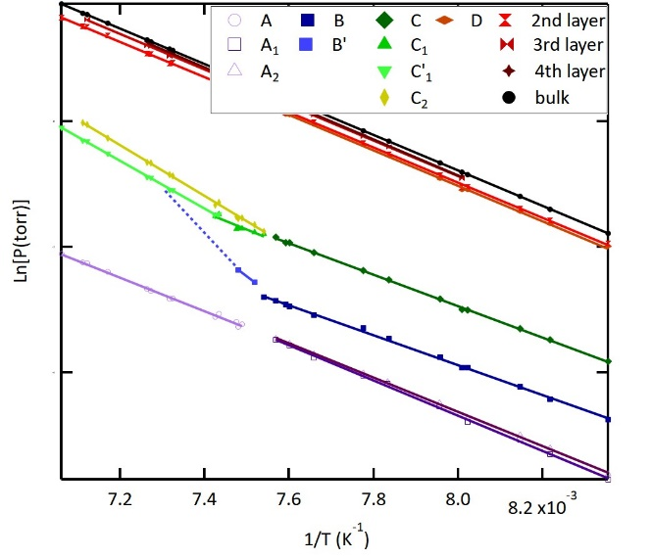
Figure 4: Clausius-Clapeyron plot of different phases whose positions were obtained from the maxima present in the numerical derivative. Results are in table 1. (note: the phase noted B’ only was fully resolvable at two temperatures. Dashed line is a projection based on other empirical data)

especially when one considers that the solid-solid transition in the bulk occurs at approximately the same temperature as those transitions observed in the isotherms presented here. Here the relative strength of the quadrupole interactions relative to surface potential and the thermal energy is most likely explanation of this behavior.
Isosteric heats of adsorption are defined as the amount of energy associated with the addition of a molecule from originally in the gas phase to the surface film at constant coverage:
$Q_{st}=R\overline{T^{2}}{\left(\frac{∂ln⁡(p_{f})}{∂T}\right)}_{θ}≅R\overline{T^{2}}{\left(\frac{∆ln⁡(p_{f})}{∆T}\right)}_{θ}$ (3.5)
The numerical derivative vs temperature between two isotherms closely spaced in T can be used to determine the value for Q_{st}(T_{avg}), where T_{avg} is the average of the two isotherms temperatures used to calculate Q_{st}. Figure 5 displays the isosteric heats for several temperatures between 122K and 142K. The NIST Webbook⁴² lists both 22.1 and 23.5 kJ/mole for bulk molar heat of acetylene at 130 K. As expected, the isosteres shown in Fig 5 converge towards the bulk values at higher coverage. Peaks in the isosteric heats indicate that adsorption is energetically favorable at those points. One prominent feature in the isosteric heat traces is the large, broad peak located near  ~1 at temperatures < 132.5 K. This is the region where the isotherm plateaus between steps C and D at a coverage which corresponding to a surface coverage where a commensurate √3 x √3 R30° phase would form. The behavior of isotherm feature C suggests that the film may undergo a continuous transition to a commensurate hexagonal structure if the molecular axes are no longer parallel to the graphite basal plane.
In the low coverage, Henry’s law regime the molecule interaction with the surface plays a dominant role. The binding energy of an isolated molecule to the graphite surface is Q⁰ , i.e. the heat of adsorption in the zero coverage limit. The Henry’s law constant K(T) is given by:
$K\left(T\right)=K^{*}exp⁡(\frac{Q^{0}}{RT})$ (3.6)
where K* is a constant of integration, R is the gas constant, T the isotherm temperature and as noted above Q⁰ the heat of adsorption in the zero coverage limit. See supplementary information for results.

Figure 5: Isosteric heats of adsorption over the monolayer range. The plots are offset vertically by 10 units for clarity Vertical lines mark upper and lower bounds of each adsorption step.

The 2D isotherm compressibility (K_{2D}) given in eqn. (7) can be used to better understand the nature of the phase behavior and transitions of the adsorbed film:
$K_{2D}=\frac{A∙p_{f}}{N_{A∙}k_{B}∙T∙n_{ads}^{2}}∙\frac{∆n_{ads}}{∆p_{f}}$ (3.7)
where A is the surface area of the substrate, p_{f} is the vapor pressure, N_{A} is Avogadro’s number, k_{B} is Boltzmann’s constant, T is the temperature in kelvin, n_{ads} is the moles adsorbed, and Δn_{ads}/Δp_{f} is the numerical derivative of the isotherm. Figure 6 shows a plot of the K_{2D} for each of the observed monolayer features (steps and substeps) as a function of temperature. Remarkably the K_{2D} associated step A exhibits a sharp increase in intensity at 132.63 K. Such behavior would be consistent for being at or near a first order transition phase transition where compressibility should be theoretically infinite.
Further analysis of K_{2D} was performed by examining the functional form and changes in the width of the compressibility peaks as a function of temperature. The entire results are summarized in the supplementary data, however, Figure 7 shows the behavior of the width of K_{2D} as a function of temperature for step A. In the step A case a Gaussian fits the data quite well.
The details of the K_{2D} behavior, i.e. temperature dependence of the peak widths have been used in the past to identify where possible phase transitions occur. For the A step for example, both A₁ and A₂ exhibit abrupt changes in slope at 133 K. Additionally, A₁ shows a second change at 126 K. The supplementary data displays the temperature dependence of features B, C and D. Step B exhibits both a discontinuity at 126 K and a change of slope at 132 K. The C step and its corresponding sub steps show a much greater deal of complexity. With increasing temperature, the first change occurs at 132.5 K where C₂ shows a discontinuity at 132 .5 K with an increase in the FWHM, where C₁ continues along the same line as before. Then at 134.5 K, both C₁ and C₂ go through another discontinuity point, with the values for C₁ increases and simultaneously C₂ decreases. From there, the C₁ FWHM decreases with temperature while C₂ stays relatively constant. Then at 140.7, the FWHM of C₂ sharply increases joining with the C₁ line into a single peak. For step D, the peaks were the most challenging to fit, and have the largest degree of error, but a seems to exist there as well, with to notable changes happening at 126 K and 130 K. To attach meaning to these observations and put them into a greater context, a proposed phase diagram will be discussed later in this report.
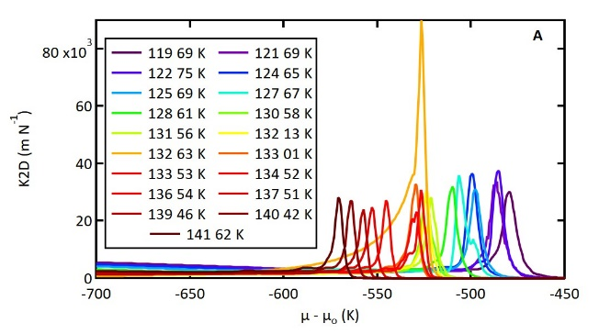
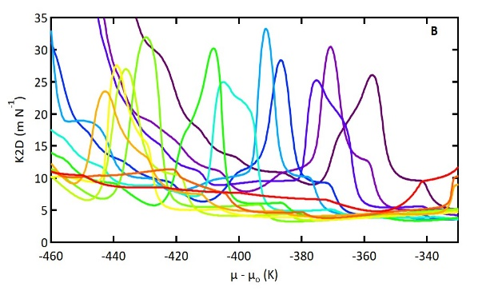
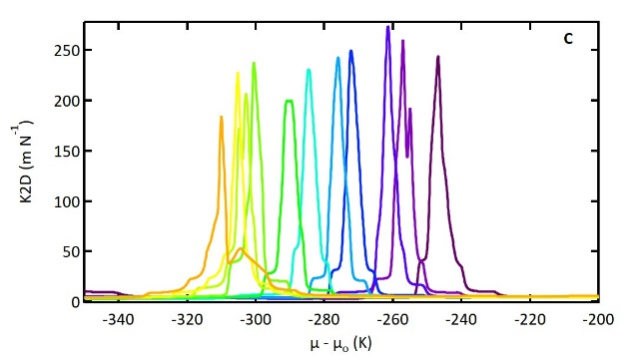
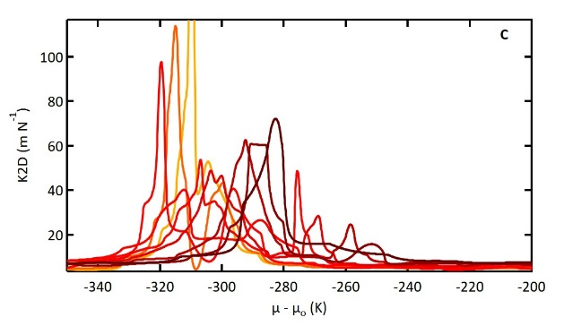
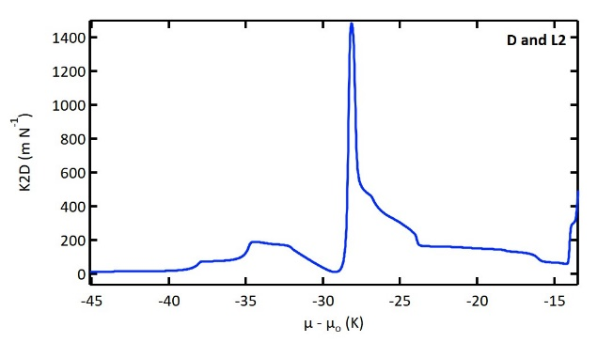
Figure 6: The K_{2D} peaks corresponding to steps A through D with C sub-step and the second layer peak (L2). D and L2 are shown at 124.65 K only due to overlap of different temperatures

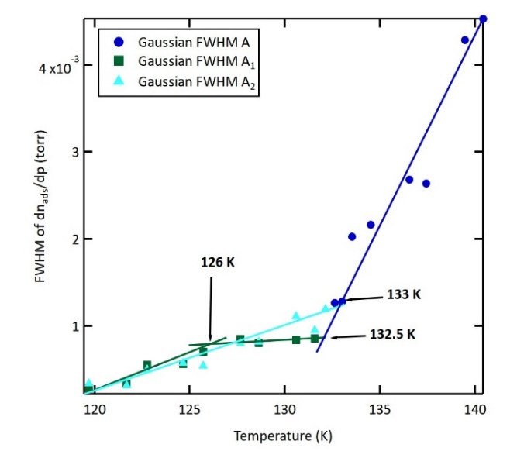
Figure 7: Plots of FWHM values for the first monolayer step (A) with secondary features. Temperatures of possible phase changes are labeled

3.3.2 – Molecular Dynamics Simulations

Energy Minimizations. To examine how the graphite surface influences the behavior of adsorbed acetylene molecules, a geometry optimization was performed using Accelrys Materials Studio 6.0. Acetylene is a challenge to simulate accurately, in large part due to limitations in computational models that accurately reflect its large quadrupole moment ^{16, 26, 43, 44}. This is mainly due to the difficulty of accurately describing the quadrupole interaction of a small molecule using only 4-point charges located at the centers of the atomic nuclei. The addition of a fifth point charge located at the center of massof the molecule improves these models, but the functionality of the version of Forcite used here. In these simulations, the value of the point charges assigned by the COMPASS forcefield were ± 0.223 e⁻ with the positive poles placed on the hydrogen atoms. These point charge values are considerably lower than the more accurate point charge models in the literature, with charges around ± 0.3 e⁻.
A complication that arose in the data obtained from these calculations was in the calculation of the electrostatic interaction energies. The software utilized does not allow for the exclusion of intramolecular 1-4 atom-atom interactions. As such, the positive charges on the hydrogen atoms lead to a large, positive electrostatic energy term Though this did not affect the on the minimized positions relative to the surface, the effect on the energy values had to be subtracted for meaningful interpretation of the binding energies. This was solved but removing the surface from the simulated space after optimization and performing an energy calculation on the molecule that remained in the absence of the surface binding interactions. The binding energies could then be calculated:
$E_{binding}=E_{non-bond}- E_{molecule non-bond}$ (3.8)
Where E_{n} is the energy of the corresponding interaction term.
These results (figure 8) show a remarkably good agreement with the Henry’s law analysis value of 21 kJ mol⁻¹. Furthermore, the difference between the lowest and highest binding energies from these calculations was a difference of 0.213 kJ mol⁻¹. This also fits with the expectation of the strength of the intermolecular interactions and the molecule-surface interactions would be of similar magnitude.
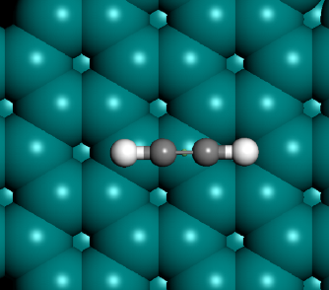
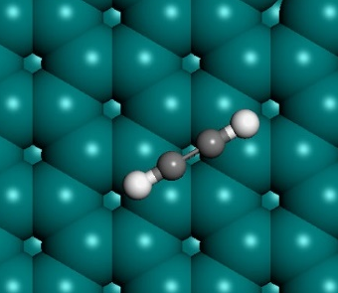
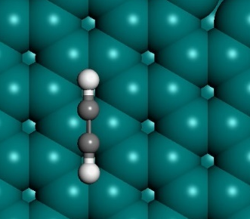
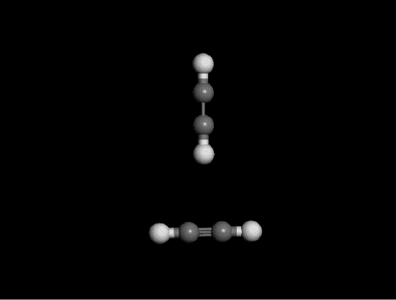
Figure 8: The most optimized energy configuration angle and binding energies for each high symmetry site A) on carbon atom, B) on hollow, and C) on C=C bond. and also D) The optimized angle for two interacting acetylene molecules and their interaction energy. (original, unsubtracted binding energies are in parenthesis for comparison)
C -20.995 kJ/mol
(-0.26550 kJ/mol)
A -20.849 kJ/mol
(-0.15481 kJ/mol)

B -20.995 kJ/mol
(-0.25589 kJ/mol)

D - 0.912 kJ/mol
(+ 9.008 kJ/mol)

Molecular Dynamics. Using the Accelrys Materials Studio Forcite package molecular dynamics (MD) was used to simulate the microscopic dynamics of the acetylene films on graphite at a number of surface densities within the monolayer range. In terms of fractional surface coverage, θ, between 0.25 ≤ θ < 1.25 where θ=1.0 corresponds to a commensurate √3x√3R30° monolayer. These simulations provide a microscopic picture of the structure and behavior of the film behavior as a function of density and temperature. Quantitatively precise description of the energetics and thermodynamic quantities from these MD simulations requires additional microscopic data to validate the findings. The MD simulations presented here as in previous works are intended to serve as a guide for understanding the trends in the adsorption properties as well as a guide for interpreting the neutron scattering investigations of the microscopic structure and dynamics of the films.
In addition to providing a snapshot of the adsorbed film structure and Newtonian dynamics further analysis of the simulations enables one to calculate the: film radial distribution function, concentration profiles orthogonal to the surface, rotational time correlation functions, root mean squared displacements and special orientation correlation functions of the system as a function of coverages and temperature.
For the work described here, visual inspection of the molecular trajectories and evaluation of the two-dimensional radial distribution functions (2D RDF) of the molecular centers of mass (CoM) are found to be extremely useful. The 2D RDFs functions in contrast to their 3-dimensional counterparts are normalized over a circular surface element (as opposed to a spherical volume element), such that:
$g{(r)}_{2D}= \frac{1}{{2πrρ}_{2D}}×\frac{dn_{r}}{dr}$ (3.9)
Where ρ_{2D} is the areal number density of the molecules, and dn_{r} is the number of molecules in a circular shell between radii of r and r + dr. As in earlier studies, molecular concentration profiles normal to the surface plane, C(z), can be used to examine monolayer films of various densities, films close to monolayer completion and thicker in order to quantify the orientation and vertical distribution of molecules within the film. This is particularly important for understanding how increases in surface density might drive a change in the molecular orientation (in the monolayer case) or the vertical displacement of molecules (i.e. layer promotion or film roughening). Needless to say, these analyses are useful in identifying solid and liquid structural features and the location of phase changes such as melting, commensurate and incommensurate and order-disorder transitions, etc.
A basic expectation in the structure can be drawn here about the family of structures the molecules are likely to adopt. That since the quadrupole-quadrupole minimization would lead to a face centered square-T lattice. The surface interactions would be trying to pull the system into a hexagonal herringbone arrangement, such as in the case of nitrogen on graphite, which is a face centered rectangle. It can be assumed that even in a competitive regime between these two structural driving forces, the face centered rectangular (FCR) lattice structure is will be likely preserved in some manner. Figure 9 shows the face centered unit-cell with calculated RDFs for face centered rectangular lattices with theta values between 90° (square lattice) and 120° (hexagonal). This simple model allows for a method for more rigorous way of using RDFs to analyze the structure from numerous simulation trajectories quickly. RDFs have an advantage in analyzing the structure and order over visual analysis in that it provides the time averaged of all the molecules in the simulation over the entire time window. To further improve the quality of the analysis, the structures can be analyzed at 5K to limit thermal disorder contributions.
Using the standard parameters assigned by the COMPASS forcefield, only a herringbone ordered phase was observed regardless of coverage amounts. To enhance the accuracy of these simulations, point charges corresponding to stronger quadrupole moments were examined. Shown here is the set with point charges of ± 0.298 e⁻, which best match observed experimental behavior. A comparison of the forcefield assigned charges vs the modified charges is located in the supplementary information
Six coverages were examined within the range corresponding to steps A and B (Θ = 0.26, 0.33, 0.67, 0.76, 0.84, 0.85); the range of the S₁ phase in previous neutron experiments^{22, 23, 28}. Visual inspection of simulations and RDF structural analysis (figure 10) show a propensity for the expected square-T configurations. However, at the lowest two coverages (Θ = 0.26, 0.33), lower coordination values resulting from so few molecules results in a favoritism for 3 molecule pinwheel structures over the square-T. The next two higher coverages shown (Θ = 0.67, 0.76) fall just below and above the top for the first monolayer step, A. In these simulations, the square-T
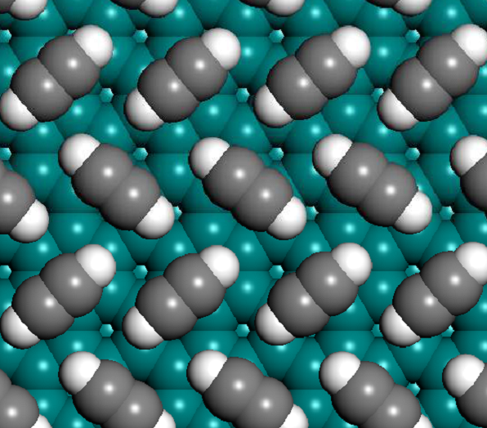
θ
$$\vec{a}$$
$$\vec{b}$$

d
Figure 9: (Top) generic square lattice template assumed as a starting point model for structural analysis. (Bottom) Calculated radial distribution functions for the centers of mass for different possible lattices based on this model, and the nearest neighbor peak position based on simulation result

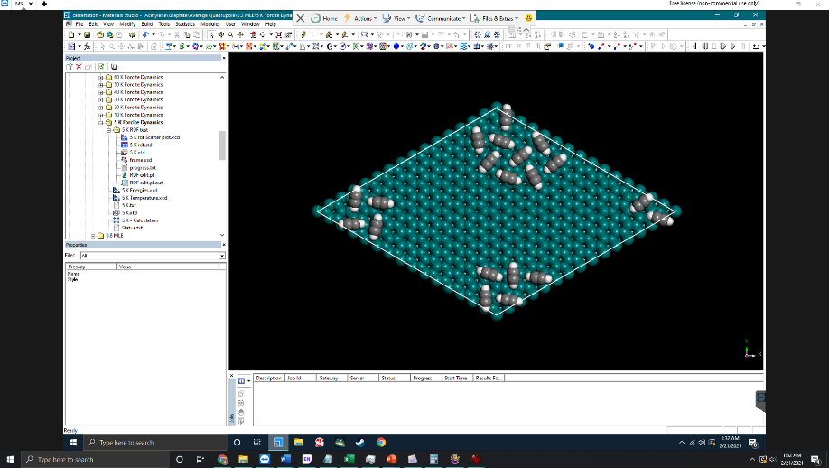
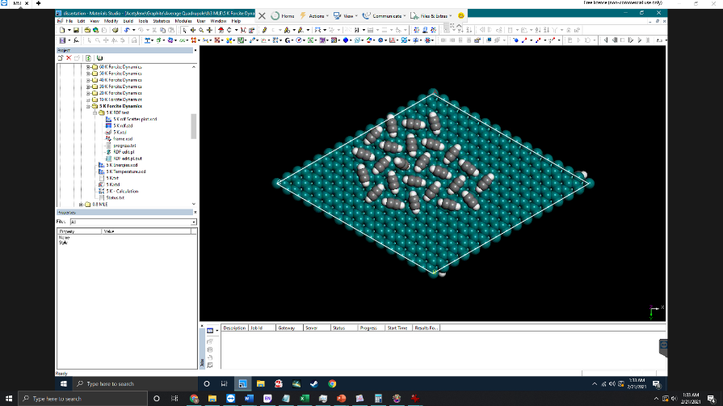
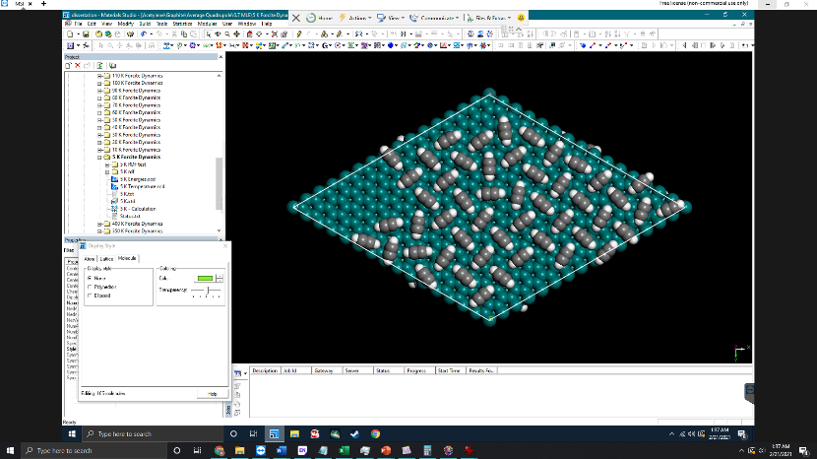
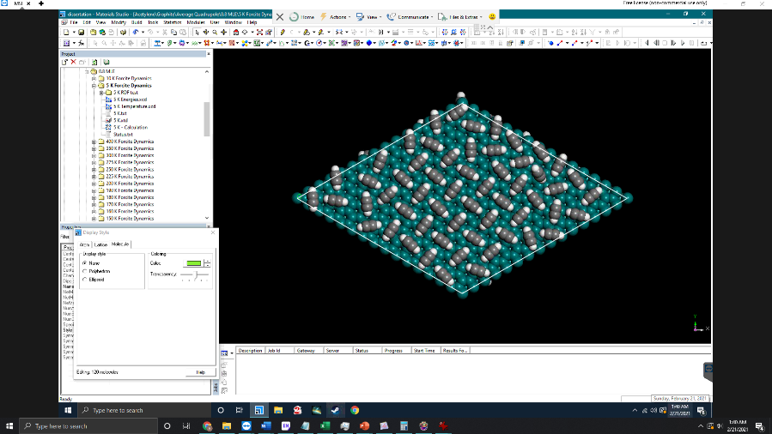
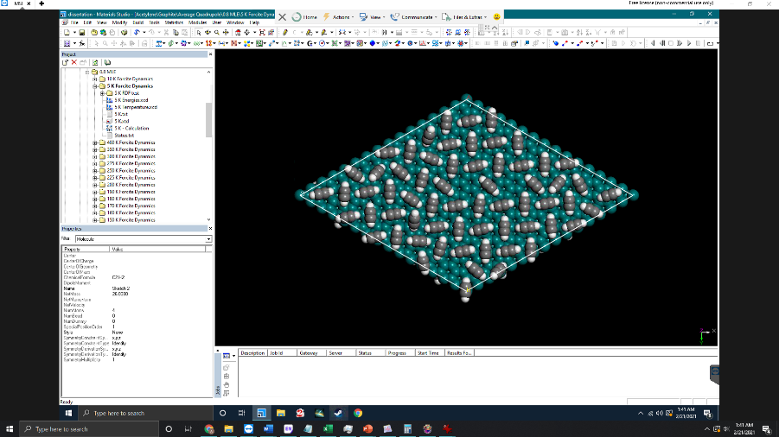
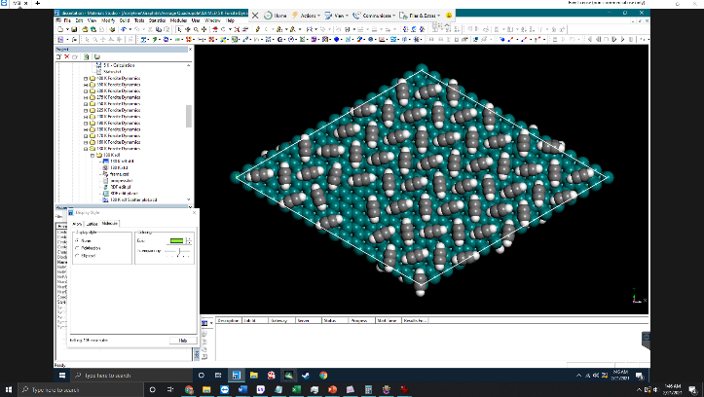
Figure 10: (left) COM 2D RDF for simulated coverage ranges of the S₁ phase at 5 K, spaced. (right) Simulation snapshots of the corresponding coverages.
+5

lattice is dominant, with some disorder in the form of 5 molecule pinwheel structures. This change in behavior from lower to higher coverage within the first monolayer provides a possible explanation for the observed sub-features within the first isotherm step. The last two coverages within this regime (Θ = 0.84, 0.85) fall above the B substep in the isotherms, with the latter being at the very start of isotherm step C. At Θ = 0.84, the square lattice is still present, however, the molecules have adopted a twisted-T shape, several degrees off from the ideal right angle. Following this, at Θ = 0.85, though marginally different in coverage, the square symmetry of the lattice is broken. The film has switched to a face-centered rectangular lattice, with a herringbone molecular configuration, with the molecules laying flat
For the higher coverage regime covering the C and D substeps, for more coverages are shown in figure 11, for further simulation results, see supplementary information. This regime shows the formation of a face centered rectangular (FCR) lattice with a herringbone structure. At Θ = 0.95, the FCR lattice uniaxially commensurate is 1.5% larger than the √3 x √3 R30° at 5 K, at higher temperatures, the lattice remains uniaxially commensurate as it expands. For Θ = 1.01, the trend is similar, however the expansion of the lattice is more severe, and maintains a lower density than at less coverage. Higher disorder seen in the simulation outputs is a probable explanation for this peculiar behavior. Θ = 1.05 marks a deviation from the FCR rectangle, seen by the splitting of the primary coordination peak in the RDF output. The splitting is caused by a symmetry break of the FCR lattice, which takes on an oblique lattice with an angle of approximately 88°. A more thorough investigation shows this behavior to be dynamic, even at 5K, where the lattice oscillates between the rectangular and oblique forms. At higher temperatures, the system melts into a disordered FCR structure. Such a mixed system would explain previous observed diffraction patterns for the so called S₁₂ state, previously believed to be a mixture of the other two observed solid phases S₁ and S₂. These results suggest a possibility of mixed phase of normal and obliquely distorted S₂ phases. Moving up to Θ = 1.38, the formation of a second layer acts to stabilize the film structure and a re-entrant behavior of the FCR lattice is observed.
While these simulations do elicit behaviors that would explain other observed experimental behaviors, they do fall short in a few key points. Firstly, the diffraction pattern for

Figure 11: RDF outputs for simulations in the higher coverage regime

a twisted-T shaped lattice seen at Θ = 0.84 is not currently seen in the diffraction experiments around this coverage. It might be in this case however, that if the angle of the twist is small enough, it would be difficult to distinguish from the square-T case²³. Secondly, the commensurate structures seen at higher coverages are not fully in agreement with diffraction experiments either^{22, 23}. Though, this also could be due to the limited scope of previous experiments not covering those temperature ranges. Increasing the quadrupole strength more did elicit very similar behavior, with three notable distinctions. The films were all much more disordered, the oblique phase occurs at 5% less coverage and the system adopted fully commensurate lattices more readily. It is also likely that a simple point charge system for describing acetylene’s quadrupole distribution is insufficient for accurate simulations.

3.3.3 – Neutron Diffraction

Neutron data was obtained for acetylene at a coverage of 0.67 monolayers (Figure 7). Diffraction data match closely with data previously reported (S₁)(source). For this low coverage data, the diffraction pattern would fit with a square lattice with two molecules per unit cell in a T-shaped configuration, the angle between the two molecules slightly skewed away from a perfect 90° (a = 6.21 Å, nearest neighbor 4.3485 Å). This would fit with the expected orientation for the minimum energy configuration for two interacting linear quadrupoles. The slight skewing in the angle could be the result of surface interactions. The APM obtained from this structure is 19.27 Å². This is more dense than the value obtained from the isotherms in this region of 20.23 ± 0.52 Å². The high entropy of this phase could mean that the lower density observed in the isotherm is the result of disorder. Diffraction intensity as a function of temperature shows a sudden increase occurring at 133 K (Figure 13).

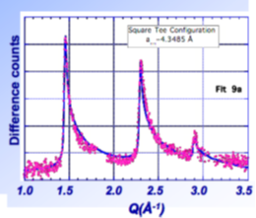
Figure 12: Neutron Diffraction pattern for Acetylene on graphite at 0.67 monolayer coverage

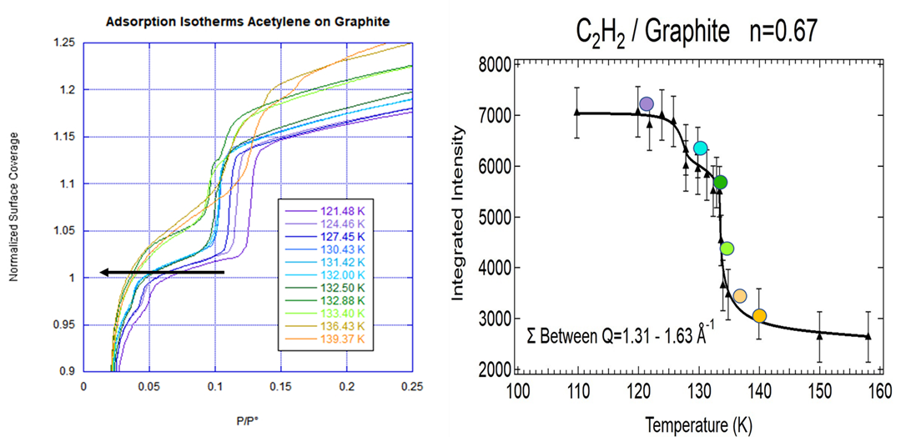
Figure 13: Plot of neutron diffraction intensity showing melting transition at 133 K

3.4 – Conclusions

This work combines and expands on previous work done on this system. Adsorption behavior of acetylene adsorbed on graphite (0001) was examined between 119 K to 141 K using volumetric isotherms. Thermodynamic values and possible positions of phase transitions were obtained by a detailed analysis. The isotherms show multiple sub-steps within the first monolayer that evolve with temperature, with a major melting transition happening at 132.5 K. The third monolayer step in these isotherms displays extremely complex behavior reminiscent of monolayer melting observed in the adsorption of krypton, xenon or methane on graphite. Further complexities in this feature unique to acetylene could arise from the mixed phase nature of the third isotherm step, where one of the solid phases melts while the other does not.
The cause for this complex behavior is most likely the result of competition between the 6-fold symmetry of the surface with the 4-fold symmetry of the strong quadrupole moment of acetylene, and the size of acetylene, which is too large for molecules to adopt the surface influenced commensurate phase observed in other smaller linear molecules with weaker quadrupole moments.
Binding energy calculations and molecular dynamics simulations were performed with Accelrys Materials Studio using the COMPASS force field. This force field is known to be highly accurate in simulating the behavior of hydrocarbon molecules. However, the simulated results for acetylene show significant difference from the experimental data. It is likely the point charge model used by these simulations is not sufficient to adequately represent the influence of acetylenes strong quadrupole moment.

Chapter 4: Adsorption of Acetylene on MgO (100)

Chapter 5: Adsorption of Allene on Graphite

Chapter 6: Adsorption of Allene on MgO

Chapter 7: Conclusions

a²⁴

References

1. Robens, E., Some intriguing items in the history of adsorption. In Studies in Surface Science and Catalysis, Rouquerol, J.; Rodríguez-Reinoso, F.; Sing, K. S. W.; Unger, K. K., Eds. Elsevier: 1994; Vol. 87, pp 109-118.
2. Osipow, L. I., Surface Chemistry: Theory and Industrial Applications. R. E. Krieger Publishing Company: 1972.
3. Züttel, A., Materials for hydrogen storage. Materials Today 2003, 6 (9), 24-33.
4. Dash, J. G., Films on Solid Surfaces: The Physics and Chemistry of Physical Adsorption. Elsevier Science: 2012.
5. Wahida, F.; Larese, J. Z., Adsorption of Cyclopentane on MgO(100), Hexagonal Boron Nitride, and Graphite Basal Planes: A Thermodynamic and Modeling Study. The Journal of Physical Chemistry C 2018, 122 (44), 25301-25313.
6. Strange, N.; Larese, J. Z., High-Resolution Volumetric Adsorption and Molecular Dynamics of the n-Alkanes on the Surface of Hexagonal Boron Nitride. The Journal of Physical Chemistry C 2018, 122 (37), 21308-21321.
7. Strange, N.; Fernández-Cañoto, D.; Larese, J. Z., Thermodynamic and Modeling Study of n-Octane, n-Nonane, and n-Decane Films on MgO(100). The Journal of Physical Chemistry C 2016, 120 (33), 18631-18641.
8. Fernández-Cañoto, D.; Larese, J. Z., Thermodynamic and Modeling Study of Thin n-Heptane Films Adsorbed on Magnesium Oxide (100) Surfaces. The Journal of Physical Chemistry C 2014, 118 (7), 3451-3458.
9. Chan, M. H. W.; Migone, A. D.; Miner, K. D.; Li, Z. R., Thermodynamic study of phase transitions of monolayer N 2 on graphite. 1984, 30 (5), 2681-2694.
10. Diehl, R. D.; Fain, S. C., Adsorption of nitrogen molecules on graphite for 31<T<52 K: The fluid‐to‐commensurate‐solid transition, multilayer condensation, and the pressure–temperature phase diagram. The Journal of Chemical Physics 1982, 77 (10), 5065-5072.
11. Terlain, A.; Larher, Y., Phase diagrams of films of linear molecules with large quadrupole moments (CO2, N2O, C2N2) adsorbed on graphite. Surface Science 1983, 125 (1), 304-311.
12. Xu, H.; Zeng, Y.; Do, D. D.; Nicholson, D., On the Nonwetting/Wetting Behavior of Carbon Dioxide on Graphite. The Journal of Physical Chemistry C 2019, 123 (14), 9112-9120.
13. Mataz, A.; Gregory, B. M., Effects of confinement on material behaviour at the nanometre size scale. Journal of Physics: Condensed Matter 2005, 17 (15), R461.
14. D.ferry; J.suzanne; M.hoang, P.; C.girardet, Acetylene C2H2 Adsorbed onto MgO(001): Structure and Thermodynamics. Surface Review and Letters 2012, 05.
15. Ferry, D.; Suzanne, J., Structure and thermodynamics of acetylene C2H2 on MgO(100). Surface Science 1996, 345 (1), L19-L22.
16. Ferry, D.; Suzanne, J.; Hoang, P. N. M.; Girardet, C., Interaction of acetylene molecules with the MgO(100) surface: LEED experiments and potential-energy calculations. Surface Science 1997, 375 (2), 315-330.
17. Amos, R. D.; Williams, J. H., Accurate SCF calculations of the multipole moments and polarizabilities of acetylene, ethylene and ethane. Chemical Physics Letters 1979, 66 (3), 471-474.
18. Filippini, G.; Gramaccioli, C. M.; Simonetta, M., Application of semiempirical atom–atom potentials to crystals of acetylene. The Journal of Chemical Physics 1980, 73 (3), 1376-1380.
19. Menaucourt, J.; Thomy, A.; Duval, X., Propriétés thermodynamiques du film d'acétylène adsorbé sur graphite : un nouvel exemple intéressant de transitions de phase en physisorption. Journal de Chimie Physique 1980, 77, 959-965.
20. Nöldeke, C.; Press, W.; Hüller, A., A magnetic model for the demonstration of phase transitions and excitations in molecular crystals. American Journal of Physics 1991, 59 (3), 260-269.
21. Bruch, L. W., Ground state energy and structure of physisorbed monolayers of linear molecules. The Journal of Chemical Physics 1983, 79 (6), 3148-3156.
22. P. Thorel, C. M., G. Bomchil, J. M. Alloneau, Two solid phases of a monolayer of C2D2 adsorbed on graphite. Suppl. Le Vide, les Couches Minces 1980, (201), 119-121.
23. Khémiri, F.; Trabelsi, M.; Saidi, S.; Coulomb, J.-P.; Larher, Y., Thermodynamic study of C2H2 thin films adsorbed on graphite (0001). 2015; Vol. 53, p 612-616.
24. Missaoui, S.; Khémiri, F.; Etteyeb, H.; Trabelsi, M.; Coulomb, J.-P.; Larher, Y., Structural Study of Acetylene Thin Films Absorbed on Exfoliated Graphite (0001). International Journal of Science and Research (IJSR) 2020, 9, 1320.
25. Trabelsi, M.; Larher, Y., Critical temperature of the first layering transition of acetylene adsorbed on graphite (0001). Surface Science 1992, 275 (1), L631-L635.
26. Peters, C.; Morrison, J. A.; Klein, M. L., The adsorption of acetylene on a graphite surface. Surface Science 1986, 165 (2), 355-374.
27. Alkhafaji, M. T.; Migone, A. D., Heat-capacity study of acetylene on graphite. Physical Review B 1992, 45 (10), 5729-5732.
28. Elmiger, M.; Zhang, Q. M.; Larese, J. Z., Melting of Acetylene Monolayers Adsorbed on Graphite. Bull. Am. Phys. Soc. 1990, 35.
29. Hyman, M. R.; Arp, D. J., Quantification and removal of some contaminating gases from acetylene used to study gas-utilizing enzymes and microorganisms. Appl Environ Microbiol 1987, 53 (2), 298-303.
30. Mursic, Z.; Lee, M. Y. M.; Johnson, D. E.; Larese, J. Z., A computer‐controlled apparatus for performing high‐resolution adsorption isotherms. Review of Scientific Instruments 1996, 67 (5), 1886-1890.
31. Sun, H., COMPASS: An ab Initio Force-Field Optimized for Condensed-Phase ApplicationsOverview with Details on Alkane and Benzene Compounds. The Journal of Physical Chemistry B 1998, 102 (38), 7338-7364.
32. Freitag, A.; Larese, J. Z., Layer growth of methane on MgO: An adsorption isotherm study. Physical Review B 2000, 62 (12), 8360-8365.
33. Kim, H. K.; Feng, Y. P.; Zhang, Q. M.; Chan, M. H. W., Phase transitions of ethylene on graphite. Physical Review B 1988, 37 (7), 3511-3523.
34. Larese, J. Z.; Passell, L.; Heidemann, A. D.; Richter, D.; Wicksted, J. P., Melting in Two Dimensions: The Ethylene-on-Graphite System. 1988, 61 (4), 432-435.
35. Larese, J. Z.; Passell, L.; Ravel, B., Orientational ordering of ethylene on graphite. Canadian Journal of Chemistry 1988, 66 (4), 633-636.
36. Beinfait, M., Two Dimensional Phase Transitions in Classical van de Waals Films Adsorbed on Graphite. In Phase Transitions in Surface Films, Dash, J. R., J., Ed. Springer US: 1980; pp 29-62.
37. Larher, Y., Chaleurs Isosteriques Et Entropies D’Adsorption Pour Des Systemes Presentant Des Changements De Phase Bidimensionnels (2D). Journées De Calorimétrie Et D’Analyse Thermique 1976, 1-11.
38. Koski, H. K., The structure of solid acetylene-d2, C2D2, at 4.2 K. A further refinement. Acta Crystallographica Section B 1975, 31 (3), 933-935.
39. Koski, H. K., Neutron powder diffraction study of the low-temperature phase of solid acetylene-d2. A correction. Acta Crystallographica Section B 1975, 31 (11), 2747-2747.
40. Koski, H. K.; Sándor, E., Neutron powder diffraction study of the low‐temperature phase of solid acetylene‐d 2. Acta Crystallographica Section B 1975, 31 (2), 350-353.
41. Scheie, C. E.; Peterson, E. M.; O'Reilly, D. E., Molecular reorientation in the plastic phase of solid acetylene. The Journal of Chemical Physics 1973, 59 (5), 2758-2759.
42. Chickos, J. S., NIST Chemistry WebBook, NIST Standard Reference Database Number 69. In NIST Chemistry WebBook, NIST Standard Reference Database Number 69, Mallard, P. J. L. a. W. G., Ed. National Institute of Standards and Technology, : Gaithersburg, M.D.
43. Cai, S.; Neyman, K. M.; Knözinger, H.; Rösch, N., Density functional model cluster study of adsorption of acetylene on magnesium oxide. Surface Science 2001, 479 (1), 169-182.
44. Cox, S. R.; Williams, D. E., Representation of the molecular electrostatic potential by a net atomic charge model. Journal of Computational Chemistry 1981, 2 (3), 304-323.

Appendices:

A) Program for the generation of 2-dimensional radial distribution functions

