Improving antimicrobial activity of lauric arginate by combination with essential oils for novel applications

A Dissertation Presented for the
Doctor of Philosophy Degree
The University of Tennessee, Knoxville

Qiumin Ma
August 2015
Copyright © 2015 by Qiumin Ma
All rights reserved.

ACKNOWLEDGEMENTS

First of all, I’d like to thank my major advisor Dr. Qixin Zhong. Thanks for all the efforts he made to help, encourage and inspire me during these four years. I am so lucky to have him as my major advisor; he is so patient, considerate, responsible and hardworking, which sets up an example for me if I take a faculty position in the future. Thanks for the time and efforts that he devoted to revise my manuscripts and posters, and help me to solve every problem I met in my research and daily life. The encouragement and kind reminders from him facilitated my progress during my PhD study.
I’d also like to thank my dear committee members, Dr. P. Michael Davidson, Dr. Faith Critzer and Dr. Douglas Hayes. Thanks for all the help you provided during my study. Dr. Davidson is so nice and patient. He helped me to revise my manuscript and was always there to answer my questions about microbiology. He also encouraged me, and served a reference for my job-hunting, in spite of how busy he was. Dr. Critzer gave me a lot of help to design the microbiological experiments and Dr. Hayes always tried his best to help me, gave me papers that he thought was useful to my research. I am so lucky to have these great professors as my committee members! Thank you all!
Besides, I’d like to thank my lab mates and my friends: those who are here, Yue Zhang, Huaiqiong Chen, Jia Xue, Kang Pan, Yun Zhang, Yongguang Guan, Dan Su, Kangkang Li; and those who have graduated and left, Linhan Zhang, Wan Wang, Cong Cao, Yangchao Luo. Many of us came to the US together, and because of you, I didn’t feel lonely in this foreign country. We shared a lot of moments together; we are a great team and I am so proud of being a member in “Dr. Zhong’s army”. Also I’d like to thank Maneesha Mohan, Manpreet Cheema, Virginia Artegoitia, Emefa Monu, Chayapa Techathuvanan, Stella Chen and Malcond Valladares, who gave me help for my research and enriched my experience.
At last, I’d like to thank my dear parents for their supporting me to pursue a doctoral degree in the US. Thanks are due to my dear boyfriend, Zidong Wang, for always being there to encourage me and be supportive.

ABSTRACT
Lauric arginate (LAE) and essential oils (EOs) are highly efficacious in broth media but are required at much higher concentrations in food products to inhibit foodborne pathogens. Because high levels of LAE and EOs affect organoleptic properties of food products, this dissertation was studied for the potential of lowering their usage concentrations by using them in combination. Antimicrobial activities of LAE and EO used alone or in combination were characterized in Chapter 2. Synergistic and antagonistic effects of LAE-EO combinations and cinnamon leaf oil/eugnol/thymol were observed for inhibiting Gram-positive Listeria monocytogenes and Gram-negative Salmonella Enteritidis and Escherichia coli O157:H7, respectively. To overcome the antagonistic effect, the antimicrobial activities of LAE-cinnamon oil (CO) combination with and without ethylenediaminetetraacetic acid (EDTA) were investigated in Chapter 3. EDTA significantly enhanced antimicrobial activities against both Gram-positive L. monocytogenes and Gram-negative S. Enteritidis and E. coli O157:H7 that showed the increased permeability of outer membrane. Because microscopy studies showed the severe damage of bacteria cell membranes by CO and the induced assembly of DNA by LAE, it was hypothesized that the increased membrane permeability by EDTA facilitated the penetration of LAE and CO targeting intracellular and extracellular matters, respectively, to enhanc the activity against Gram-negative bacteria. The LAE-CO-EDTA combination was then studied as coatings to improve the safety and quality of whole cantaloupes. To predict properties of coatings, chitosan-based films containing LAE, CO, and EDTA were characterized for physical and antimicrobial properties in Chapter 4. The chosen formulation, with 0.1% LAE, 0.1% EDTA and 1% CO, was studied on whole cantaloupes in Chapter 5. These chitosan-based coatings significantly inhibited the growth of foodborne pathogens inoculated on whole cantaloupes and natural molds and yeasts and delayed the ripening of whole cantaloupes during 14-day storage at room temperature (21°C). The last study in Chapter 6 was focused on emulsifying EOs with LAE for use in aqueous systems. Cosurfactant lecithin facilitated the formation of stable nanoemulsions but reduced the antimicrobial activity at the studied conditions. Overall, the combination of LAE and EO after supplementing EDTA can provide novel applications in various consumer products.

Keywords: lauric arginate, essential oils, EDTA, synergistic antimicrobial effect, chitosan, coating, cantaloupes.

TABLE OF CONTENTS
Chapter 1. Introduction and literature review 1
1.1. Properties of lauric arginate 2
1.1.1. History, structure and chemistry 2
1.1.2. Antimicrobial activity of LAE in microbial growth media 2
1.1.3. Antimicrobial activity of LAE in food matrices 3
1.1.3.1. Meat and poultry products 3
1.1.3.2. Dairy products 5
1.1.3.3. Other products 6
1.1.4. Interaction of LAE with food components 6
1.1.5. Combinations of LAE and other antimicrobials to inhibit foodborne pathogens 7
1.1.6. Antimicrobial mechanism of LAE 8
1.1.7. Antimicrobial coatings or films containing LAE 9
1.1.8. Emulsions prepared with LAE 10
1.1.9. Stability of LAE 11
1.1.10. Sensory impact of LAE 11
1.2. An overview of essential oils 12
1.2.1. Antimicrobial activities of EOs 12
1.2.2. Antimicrobial mechanisms of EOs 14
1.2.3. Sensory impact of EOs on food products 14
1.2.4. Nanoemulsions as delivery systems for EOs 15
1.3. An overview of antimicrobial coatings or films 16
1.3.1. Materials for preparing coatings and films 17
1.3.2. Effects of antimicrobial coatings and films on quality and safety of food products 18
1.4. Hypothesis and scope of dissertation research 19
References 21
Appendix 37
Chapter 2. Antimicrobial properties of lauric arginate alone or in combination with essential oils in tryptic soy broth and 2% reduced fat milk 40
2.1. Abstract 42
2.2. Introduction 43
2.3. Materials and Methods 45
2.3.1. Chemicals 45
2.3.2. Bacterial culture 45
2.3.3. Determination of minimum inhibitory (MIC) and minimum bactericidal (MBC) concentrations in TSB 46
2.3.4. Checkerboard method to study antimicrobial combinations 46
2.3.5. The interaction between LAE and food compounds 47
2.3.6. Microbial survivability end-point analysis in 2% reduced fat milk 47
2.3.7. Microbial growth kinetics in 2% reduced fat milk 48
2.3.8. GC-MS analysis 48
2.3.9. Data and statistical analyses 49
2.4. Results and discussion 49
2.4.1. MIC and MBC of LAE and essential oils when used alone 49
2.4.2. Interaction of antimicrobials 50
2.4.3. Impacts of beef extract and soluble starch on antimicrobial properties of LAE 51
2.4.4. Antilisterial activities in 2% reduced fat milk 53
2.4.5. Growth curves of bacteria treated with individual and combinational antimicrobials 54
2.5. Conclusions 55
References 56
Appendix 62
Chapter 3. Antimicrobial activities of lauric arginate and cinnamon oil combination against foodborne pathogens: improvement by ethylenediamine- tetraacete and possible mechanisms 79
3.1. Abstract 80
3.2. Introduction 82
3.3. Materials and Methods 84
3.3.1. Materials 84
3.3.2. Bacterial culture 84
3.3.3. Microbial growth kinetics in tryptic soy broth 84
3.3.4. Microbial survivability end-point analysis in tryptic soy broth 85
3.3.5. Crystal violet assay 85
3.3.6. Nucleic acid released from bacteria cells 86
3.3.7. Extracellular adenosine triphosphate (ATP) level 87
3.3.8. Cell morphology studied with scanning electron microscopy (SEM) 87
3.3.9. Interaction of antimicrobials with bacteria DNA 88
3.3.10. Statistical analysis 89
3.4. Results 89
3.4.1. Microbial growth kinetics in tryptic soy broth 89
3.4.2. Microbial survivability end-point analysis in tryptic soy broth 90
3.4.3. Membrane permeability 90
3.4.4. Cell morphology after antimicrobial treatments 91
3.4.5. Interaction between DNA and antimicrobials 92
3.5. Discussions 93
3.5.1. Effects of antimicrobials on bacteria membrane structures 93
3.5.2. Binding between DNA and antimicrobials 96
3.6. Conclusions 97
References 99
Appendix 104
Chapter 4. Physical and antimicrobial properties of chitosan films incorporated with lauric arginate, cinnamon oil, and ethylenediaminetetraacetate 123
4.1. Abstract 124
4.2. Introduction 125
4.3. Materials and Methods 127
4.3.1. Materials 127
4.3.2. Film preparation 127
4.3.3. Physical and mechanical properties of films 128
4.3.3.1. Thickness 128
4.3.3.3. Moisture content and water solubility 128
4.3.3.4. Water vapor permeability (WVP) 129
4.3.3.5. Tensile strength and elongation 129
4.3.3.6. Scanning electron microscopy (SEM) 130
4.3.6. Antimicrobial properties of films 131
4.3.7. Statistical analysis 131
4.4. Results and Discussions 132
4.4.1. Thickness and color of films 132
4.4.2. Water barrier properties of films 132
4.4.3. Mechanical properties of films 134
4.4.4. Surface morphology of films 134
4.4.5. Residual content of cinnamon oil in the films 135
4.4.6. Antimicrobial properties of films 135
4.5. Conclusions 137
References 139
Appendix 143
Chapter 5. Quality attributes and microbial growth on whole cantaloupes with antimicrobial coatings containing chitosan, lauric arginate, cinnamon oil and ethylenediaminetetraacetic acid 151
5.1. Abstract 152
5.2. Introduction 153
5.3. Materials and Methods 155
5.3.1. Materials 155
5.3.2. Bacteria culture 155
5.3.3. Preparation of coating solutions 156
5.3.4. Inoculation and treatment of whole cantaloupes 156
5.3.5. Enumeration of foodborne pathogens 157
5.3.6. Effects of chitosan-based coatings on the quality characteristics of whole cantaloupes 158
5.3.6.1. Weight and color measurement 158
5.3.6.2. Firmness and total soluble solids (TSS) measurement 158
5.3.7. Enumeration of total molds and yeast 159
5.3.8. Statistical analysis 159
5.4. Results and Discussions 159
5.4.1. Coating effect on microbial growth on cantaloupes 159
5.4.2. Quality properties of cantaloupes 161
5.5. Discussions 162
5.6. Conclusions 164
References 165
Appendix 170
Chapter 6. Nanoemulsions of thymol and eugenol co-emulsified by lauric arginate and lecithin 184
6.1. Abstract 185
6.2. Introduction 186
6.3. Materials and methods 188
6.3.1. Materials 188
6.3.2. Bacterial culture 188
6.3.3. Preparation of nanoemulsions 188
6.3.4. Dimension and stability of emulsion droplets 189
6.3.5. Atomic force microscopy (AFM) 189
6.3.6. Zeta-potential measurement 189
6.3.7. Release kinetics of LAE 190
6.3.8. Determination of minimum inhibitory concentration (MIC) and minimum bactericidal concentrations (MBC) in tryptic soy broth 191
6.3.9. Microbial growth kinetics in 2% reduced fat milk 191
6.3.10. Statistical analysis 192
6.4. Results 192
6.4.1. Conditions of preparing emulsions 192
6.4.2. Droplet dimension and zeta-potential of nanoemulsions 192
6.4.3. Morphology of emulsion droplets 193
6.4.4. Release kinetics of LAE 193
6.4.5. MICs and MBCs in tryptic soybean broth 193
6.4.6. Microbial growth kinetics in 2% reduced fat milk 194
6.5. Discussions 195
6.6. Conclusions 197
References 199
Appendix 204
Chapter 7. Conclusions and future work 211
VITA 214

LIST OF TABLES
Table 1.1. Studies related to the application of LAE on meat and poultry products. 37
Table 1.1. continued 38
Table 1.2. Major components of essential oilsª 39
Table 2.1. Minimum inhibitory concentrations (MICs) and minimum bactericidal concentrations (MBCs) of various antimicrobials against Listeria monocytogenes (LM), Escherichia coli O157:H7 (EC) and Salmonella Enteritidis (SE) in Tryptic Soy Broth at 32°C (LM) or 37°C (EC and SE) ª. 62
Table 2.2. Fractional inhibitory concentrations indices (FIC_{I}, mean±standard deviation, n≥ 3) of lauric arginate (LAE) used in combination with essential oils against Listeria monocytogenes, Escherichia coli O157:H7 and Salmonella Enteritidisª. 63
Table 2.3. Minimum inhibitory concentration (MIC) and minimum bactericidal concentration (MBC) of lauric arginate (LAE) against Listeria monocytogenes in microbiological media with added beef extract or soluble starch at 32°Cª. 64
Table 2.4. Log reduction of Listeria monocytogenes Scott A (initial count of 7.31 log CFU/mL) in 2% reduced fat milk at 32°C after 24 h. Numbers are mean ± standard deviation (n=4). 65
Table 3.1. Log reduction of Escherichia coli O157:H7 ATCC 43895 (initial count of 6.17 log CFU/mL) and Salmonella Enteritidis (initial count of 6.23 log CFU/mL) at 37°C and Listeria monocytogenes Scott A (initial count of 6.41 log CFU/mL) at 32°C after treatment by 5 ppm lauric arginate (LAE), 200 ppm cinnamon oil (CO), and 500 ppm EDTA alone or their combination in tryptic soy broth for 2 h. 104
Table 3.2. Log reduction of Salmonella Enteritidis (initial count of 10.06 log CFU/mL) at 37°C and Listeria monocytogenes Scott A (initial count of 9.79 log CFU/mL) at 32°C after treatment by 40 ppm lauric arginate (LAE), 600 ppm cinnamon oil (CO), and 1,000 ppm EDTA alone or their combination in PBS (10 mM, pH 7.4) for 2 h. 105
Table 4.1. Thickness and color of films prepared from mixtures containing 1% w/w chitosan, 0.25% w/w EDTA, and various concentrations of lauric arginate (LAE) and cinnamon oil (CO). * 143
Table 4.2. Moisture content, water solubility and water vapor permeability (WVP) of films prepared from mixtures containing 1% w/w chitosan, 0.25% w/w EDTA, and various concentrations of lauric arginate (LAE) and cinnamon oil (CO). * 144
Table 4.3. Residual content of cinnamon oil (CO) in films prepared from mixtures containing 1% w/w chitosan, 0.25% w/w EDTA, and various concentrations of lauric arginate (LAE) and CO. * 145
Table 4.4. Tensile strength and elongation at break of films prepared from mixtures containing 1% w/w chitosan, 0.25% w/w EDTA, and various concentrations of lauric arginate (LAE) and cinnamon oil (CO). * 146
Table 4.5. Inhibition zone diameters of film discs prepared from mixtures containing 1% w/w chitosan, various concentrations of lauric arginate (LAE), EDTA and cinnamon oil (CO). 147
Table 4.5. continued 148
Table 4.6. Viable cells of film squares prepared from mixtures containing 1% w/w chitosan, 0.2% w/w lauric arginate (LAE), and various concentrations of EDTA and cinnamon oil (CO) *. 149
Table 6.1. Minimum inhibitory concentration (MICs, in LAE concentration, ppm) and minimum bactericidal concentrations (MBCs, in LAE concentration, ppm) of antimicrobials against Listeria monocytogenes (LM) at 32 °C and Escherichia coli O157:H7 (EC) and Salmonella Enteritidis (SE) at 37 °C in tryptic soy broth. 204

LIST OF FIGURES
Figure 1.1 Structure of lauric arginate. 39
Figure 2.1. Gas chromatograms of (A) cinnamon leaf oil and (B) eugenol with a purity of >98% from Sigma-Aldrich Corp. (St. Louis, MO, USA). 66
Figure 2.2. Effects of lauric arginate (LAE) alone or in combination with essential oils (EO) on the growth of Listeria monocytogenes in 2% reduced fat milk at room temperature (21°C): (A) cinnamon leaf oil, (B) eugenol, and (C) thymol. Diamonds: control without antimicrobials; squares: EO only; triangles: LAE only; circles: LAE and EO. The concentrations of EO and LAE were 6000 and 750 ppm, respectively, when used individually or 3000 and 375 ppm, respectively, when used in combination. Error bars are standard deviations from 2 replicates. 67
Figure 2.2. continued 69
Figure 2.2. continued 70
Figure 2.3. Effects of lauric arginate (LAE) alone or in combination with essential oils (EO) on the growth of Escherichia coli O157:H7 ATCC 43895 in 2% reduced fat milk at room temperature (21°C): (A) cinnamon leaf oil, (B) eugenol, and (C) thymol. Diamonds: control without antimicrobials; squares: EO only; triangles: LAE only; circles: LAE and EO. The concentrations of cinnamon leaf oil, eugenol, thymol and LAE were 5000, 5000, 4000 and 750 ppm, respectively, when used individually or 2500, 2500, 2000 and 375 ppm, respectively, when used in combination. Error bars are standard deviations from 2 replicates. 71
Figure 2.3. continued 73
Figure 2.3. continued 74
Figure 2.4. Effects of lauric arginate (LAE) alone or in combination with essential oils (EO) on the growth of Salmonella Enteritidis in 2% reduced fat milk at room temperature (21°C): (A) cinnamon leaf oil, (B) eugenol, and (C) thymol. Diamonds: control without antimicrobials; squares: EO only; triangles: LAE only; circles: LAE and EO. The concentrations of cinnamon leaf oil, eugenol, thymol and LAE were 5000, 5000, 4000 and 750 ppm, respectively, when used individually or 2500, 2500, 2000 and 375 ppm, respectively, when used in combination. Error bars are standard deviations from 2 replicates. 75
Figure 2.4. continued 77
Figure 2.4. continued 78
Figure 3.1. Growth curves of (A) Escherichia coli O157:H7 ATCC 43895, and (B) Salmonella Enteritidis at 37°C and (C) Listeria monocytogenes Scott A at 35°C in tryptic soy broth. Treatments for E.coli O157:H7 and S. Enteritidis contained 5 ppm lauric arginate (LAE), 500 ppm EDTA, and 200 ppm cinnamon oil (CO) alone or in combinations. Treatments for L. monocytogenes contained 2.5 ppm lauric arginate (LAE), 100 ppm EDTA, and 100 ppm CO alone or in combination. 106
Figure 3.1. continued 108
Figure 3.1. continued 109
Figure 3.2. Uptake% of crystal violet by (A) Escherichia coli O157:H7 ATCC 43895, (B) Salmonella Enteritidis, and (C) Listeria monocytogenes Scott A in 0.1 M PBS (pH 7.4) at 37°C (for E.coli O157:H7 and S. Enteritidis) or 32°C (for L. monocytogenes) after 2 h treatment with 5ppm lauric arginate (LAE), 500 ppm EDTA, and 200 ppm cinnamon oil (CO) alone or in combinations. Errors are standard deviations (n =3). Different letters above bars indicate significant difference of treatments in the same plot. 110
Figure 3.2. continued 112
Figure 3.2. continued 113
Fig. 3.3. Absorbance at 260 nm (A₂₆₀) of extracellular contents after treating (A) Escherichia coli O157:H7 ATCC 43895 and (B) Salmonella Enteritidis at 37°C, and (C) Listeria monocytogenes Scott A at 32°C in 10 mM Tris-HCl (pH 7.2) for 2 h with 10 ppm lauric arginate (LAE), 1000 ppm EDTA, and 400 ppm cinnamon oil (CO) alone or in combinations. Errors are standard deviations (n =3). Different letters above bars indicate significant difference of treatments in the same plot. 114
Figure 3.3. continued 116
Figure 3.3. continued 117
Figure 3.4. SEM images of Salmonella Enteritidis after treatment by (A) 40 ppm lauric arginate (LAE), (B) 1,000 ppm EDTA, (C) 600 ppm cinnamon oil (CO), (D) 40 ppm LAE+600 ppm CO, or (E) 40 ppm LAE+600 ppm CO+1,000 ppm EDTA at 37°C for 2 h, with comparison to the untreated sample (F). Bar = 1 μm. 118
Figure 3.5. SEM images of Listeria monocytogenes Scott A after treatment by (A) 40ppm lauric arginate (LAE), (B) 1,000 ppm EDTA, (C) 600 ppm cinnamon oil (CO), (D) 40 ppm LAE+600 ppm CO, and (E) 40 ppm LAE+600 ppm CO+1,000 ppm EDTA, at 32°C for 2, h, with comparison to the untreated sample (F). Arrows indicated disrupted cells. Bar = 1 μm. 119
Figure 3.6. Luminescence showing extracellular ATP content of (A) Listeria monocytogenes Scott A at 37°C and (B) Salmonella Enteritidis at 32°C after 30 min incubation in tryptic soy broth with 5 ppm lauric arginate (LAE), 500 ppm EDTA, and 200 ppm cinnamon oil (CO) alone or in combinations. 120
Figure 3.7. AFM images of Listeria monocytogenes Scott A (A-C, G) and Salmonella Enteritidis DNA (D-F, H) before (A and D) and after treatment by 10 ppm (B and E), 50 ppm (C and F) LAE or 100 ppm cinnamon oil (G and H). Image dimensions are 10 μm ×10 μm. 121
Figure 3.8. Absorbance spectra of Salmonella Enteritidis DNA with the addition of (A) 50 ppm lauric arginate (LAE) or (B) 100 ppm cinnamon oil (CO). 122
Figure 4.1. SEM images of films prepared from mixtures containing (A) 1% w/w chitosan and additional (B) 0.1%w/w lauric arginate (LAE) and 0.25% w/w ethylenediaminetetraacetate (EDTA); (C) 0.1%w/w LAE, 0.25%w/w EDTA, and 0.5%w/w cinnamon oil (CO); (D) 0.1%w/w LAE, 0.25%w/w EDTA, and 1%w/w CO; (E) 0.2%w/w LAE and 0.25%w/w EDTA; (F) 0.2%w/w LAE, 0.25%w/w EDTA, and 0.5%w/w CO; or (G) 0.2%w/w LAE, 0.25%w/w EDTA, and 1%w/w CO. Bar = 20 μm. 150
Figure 5.1. Growth kinetics of E. coli O157:H7 (A), S. enterica (B), and L. monocytogenes (C) on cantaloupes during storage at room temperature (21°C) up to 14 days. The inoculated cantaloupes were coated with 1% chitosan only or with additional 0.1% w/w LAE, 0.1% w/w EDTA, and 0, 0.5 or 1% w/w CO. The detection limit was 1.60 log CFU/cm². Error bars are standard deviations from two squares obtained from each of two cantaloupes (n = 4). 170
Figure 5.1. continued 172
Figure 5.1. continued 173
Fig. 5.2. Populations of total molds and yeasts on cantaloupe surfaces after coating (day 2) with chitosan only or with additional 0.1% w/w LAE, 0.1% w/w EDTA, and 0, 0.5 or 1% w/w CO. The detection limit was 1.22 log CFU/cm². Error bars are standard deviations from four rind discs obtained from each of three cantaloupes (n = 3). 174
Fig. 5.3. Percentages of cantaloupes with visible molds during storage at room temperature (21°C). Cantaloupes were coated with chitosan only or with additional 0.1% w/w LAE, 0.1% w/w EDTA, and 0, 0.5 or 1% w/w CO. Each treatment had 3 groups of cantaloupes with 8 cantaloupes in each group. Error bars are standard deviations from 3 groups of cantaloupes (n = 3). 175
Figure 5.4. Changes of cantaloupe colors during storage at room temperature (21°C). Cantaloupes were coated with chitosan only or with additional 0.1% w/w LAE, 0.1% w/w EDTA, and 0, 0.5 or 1% w/w CO. Error bars are standard deviations from three measures on each of four cantaloupes (n =12). 176
Figure 5.4. continued 178
Figure 5.4. continued 179
Figure 5.5. Photos of coated and uncoated cantaloupes on day 2 and day 14 at room temperature (21°C) storage. Cantaloupes were coated with chitosan only or with additional 0.1% w/w LAE, 0.1% w/w EDTA, and 0, 0.5 or 1% w/w CO. 180
Figure 5.6. Changes of cantaloupe firmness during storage at room temperature (21°C). Cantaloupes were coated with chitosan only or with additional 0.1% w/w LAE, 0.1% w/w EDTA, and 0, 0.5 or 1% w/w CO. Error bars are standard deviations from four flesh discs obtained from each of three cantaloupes (n = 12). 181
Figure 5.7. Changes of total soluble solids contents of cantaloupe flesh during storage at room temperature (21°C). Cantaloupes were coated with chitosan only or with additional 0.1% w/w LAE, 0.1% w/w EDTA, and 0, 0.5 or 1% w/w CO. Error bars are standard deviations from four flesh discs obtained from each of three cantaloupes (n = 12). 182
Figure 5.8. Changes of weight loss (%) of cantaloupes during storage at room temperature (21°C). Cantaloupes were coated with chitosan only or with additional 0.1% w/w LAE, 0.1% w/w EDTA, and 0, 0.5 or 1% w/w CO. Error bars are standard deviations from four cantaloupes (n = 4). 183
Figure 6.1. Emulsions with 1% w/w eugenol emulsified by (A) 0.47-1.09% w/w lauric arginate (LAE) (B) 0.47-1.09% w/w LAE with 1% w/w lecithin (C) 1% w/w lecithin along; and absorbance of eugenol nanoemulsions at 600 nm (OD_{600 nm}) prepared by LAE with and without lecithin (D). 205
Figure 6.2. Hydrodynamic diameter of thymol and eugenol nanoemulsions during storage at 21 °C (A) and particle size distribution of the nanoemulsions after 30 days (B). Error bars are standard deviations (n = 6). 206
Figure 6.3. Zeta-potential of LAE, lecithin, LAE-lecithin mixture, and a nanoemulsion with 1% eugenol emulsified by 0.93% LAE and 1% lecithin at pH 4.0-7.0 and 25°C. Error bars are standard deviations (n = 9). 207
Figure 6.4. AFM topography images of nanoemulsions prepared with eugenol (A) and thymol (B). Image dimensions are 1 μm 1 μm. 208
Figure 6.5. Release kinetics of LAE at 21°C. Error bars are standard deviations (n = 3). 209
Figure 6.6. Growth curves of L. monocytogenes Scott A (A) and E. coli O157:H7 ATCC 43895 (B) in 2% reduced fat milk at 21°C after treatment by antimicrobials containing 750 ppm lauric arginate (LAE). The LAE+lecithin mixture had same LAE and lecithin concentrations as in nanoemulsions. Error bars are standard deviations (n = 3). 210

Chapter 1. Introduction and literature review

1.1. Properties of lauric arginate

1.1.1. History, structure and chemistry

Lauric arginate (LAE) was approved in 2005 by the Food and Drug Administration of the United States as a novel generally recognized as safe (GRAS) antimicrobial and was approved as a safe food additive in 2007 by the European Food Safety Authority (Authority, 2007; USDA, 2005). Its chemical name is ethyl-N^{α}-lauroyl-L-arginate hydrochloride (C₂₀H₄₁N₄O₃Cl, CAS number 60372-77-2). LAE has a molecular weight of 421.0 Da and its structure is shown in Fig. 1. LAE was first synthesized from lauric acid, L-arginine and ethanol (Ruckman et al., 2004) in Barcelona in 1984 by the Higher Council of Scientific Research (Infante et al., 1984) and was then patented and commercialized by the Vedeqsa Lamirsa Group in Spain. A&B ingredients Inc. (Fairfield, NJ) is the distributor in the United States (Gil Bakal, 2005). The rapidly metabolism of LAE in vivo to naturally occurring dietary components lauric acid and arginine suggests its low toxic to human (Authority, 2007; Hawkins et al., 2009).

1.1.2. Antimicrobial activity of LAE in microbial growth media
LAE has a high efficacy in inhibiting a broad spectrum of microorganisms. The minimum inhibitory concentrations (MICs) were 0.004% -0.008% for Listeria monocytogenes and Listeria innocua strains and 0.02% for Salmonella Typhimurium and S. Heidelberg at 37°C (Lingbeck et al., 2014). the MICs was increased when the temperature was lower to 10 and 4°C (Lingbeck et al., 2014). In another study, MICs and minimum bactericidal concentrations (MBCs) of LAE against Escherichia coli, L. innocue, Salmonella enterica, Staphylococcus aureus and Pseudomonas aeruginosa in broth medium at 37°C were tested (Becerril et al., 2013). The MIC was the lowest for S. aureus (12.5 mg/L), and MBC was 50 mg/L. MIC and MBC was the highest against P. aeruginosa (100 mg/L). MICs and MBCs for other strains were all 25 mg/L. The high antimicrobial efficacy of LAE in broth medium was also reported in other studies (Adams, 2012; Kang et al., 2014; Soni et al., 2010).

1.1.3. Antimicrobial activity of LAE in food matrices

1.1.3.1. Meat and poultry products
LAE is mainly allowed to use in meat and poultry products in the United States (USDA, 2005). Therefore, many studies have been done to explore the applications of LAE in these products, as compiled in Table 1. The dosage limit of LAE is 200 ppm in the United States (USDA, 2005). However, 200 ppm LAE was not sufficient to inhibit the growth of foodborne pathogens in meat products such as ground chicken (Sharma, Ates, Joseph, Soni, et al., 2013) or cold-smoked salmon (Kang et al., 2014). No inhibitory effect of 200 ppm LAE on the growth of S. enterica was observed when applying 1 mL of a 200 ppm LAE solution on 25 g ground chicken (Sharma, Ates, Joseph, Soni, et al., 2013). Similarly, 300 μL of a 200 ppm LAE solution did not show any inhibitory effect on the growth of L. monocytogenes inoculated at about 6 log CFU/g on the surface of 10 g cold-smoked salmon at 7 °C (Kang et al., 2014). 200 ppm LAE was not sufficient to inhibit the non-pathogenic microorganisms during storage either (Nair et al., 2014). Treatment with 200 or 400 mg/kg LAE on chicken breast fillets significantly reduced the total population of psychrotrophs by 1.3 and 2.3 log CFU/g, respectively. However, the recovery of psychrotrophs was observed after 3-day storage at 4°C, resulting no difference among treated and untreated chicken breast fillets. Additionally, 200 or 400 mg/kg LAE showed no inhibition of total aerobic bacteria on chicken breast fillets.
Antimicrobial activity of LAE has also been studied at an amount much higher than 200 ppm in meat and poultry products. Treating ham (ca. 3 pound) surface pre-inoculated with ca. 7 log CFU/ ham L. monocytogenes with 4, 6, 8 mL 5% LAE dramatically reduced the total amount of bacteria by 5.1, 5.4 and 5.5 log CFU/ ham within 24 h at 4°C, respectively; but the bacteria recovered by 2 to 5 log CFU/ham after 60 days storage (Luchansky et al., 2005). When the inoculation level was reduced to ca. 3 log CFU/ ham, the recovery of the bacteria was still observed after treatment with 4 and 6 mL 5% LAE (Luchansky et al., 2005). Treatment of 2.5% v/v Protect-M (containing 10% LAE) reduced the population of L. monocytogenes by 2.38 log CFU/g on ready-to-eat ham after 1-day storage at 4±1°C, but the population of L. monocytogenes increased rapidly during storage and showed no differences from the control group by day 28 (Lavieri, Sebranek, Brehm-Stecher, Cordray, Dickson, Horsch, Jung, Larson, Manu and Mendonça, 2014).
Therefore, combining LAE with other antimicrobials or postlethality inactivation treatment has been investigated (Benli et al., 2011; Christopher, 2012; Martin et al., 2009; Porto-Fett et al., 2010; Stopforth et al., 2010). For the combination of 22 or 44 ppm LAE with potassium lactate and sodium diacetate, the population of L. monocytogenes on frankfurters was reduced by 2.0 log/ package within 2h and no recovery of L. monocytogenes was detected during the 120-day storage at 4°C, which contrasted with a recovery of the bacteria in treatments with 22 or 44 ppm LAE alone (Porto-Fett et al., 2010). Similarly, combinations of flash pasteurization (1.5s, 120°C steam) and LAE (3.33 mL 5% v/v / pack of four frankfurters) effectively inhibited the growth of L. innocua on frankfurters during the 12-week storage at 10°C (Taormina and Dorsa, 2009a). Meat processors are required to use one of the three alternatives to maintain the sanitary conditions of ready-to-eat meat products: 1) post-lethality treatment and antimicrobial agent/process to inhibit the growth of pathogens; 2) post-lethality treatment or antimicrobial agent/process to inhibit the growth of pathogens and sanitation program; 3) sanitation program that include intensity testing and sanitation measures (Food Safety and Inspection Service, 2003; Stopforth et al., 2010). In this case, LAE may be more suitable for a short-term efficient post-lethality treatment.

1.1.3.2. Dairy products
Compared to meat and poultry products, fewer studies have been done to evaluate the antimicrobial effectiveness of LAE in dairy products, because LAE is not currently allowed in dairy products (USDA, 2015) except cheese (USDA, 2005). 200 ppm of LAE reduced the population of L. monocytogenes inoculated at 4 log CFU/mL in skim milk by approximately 1 log CFU/mL after 24 h at 4°C, but the recovery of bacteria was detected during the 15-day storage (Soni et al., 2010). Using a much higher concentration (800 ppm) of LAE, L. monocytogenes in skim milk was reduced to the undetectable level after 24h and was completely inhibited during the subsequent storage at 4°C (Soni et al., 2010). The antimicrobial activity of LAE in Queso Fresco cheese has also been evaluated, but neither 200 ppm nor 800 ppm of LAE was able to totally inhibit the growth of L. monocytogenes during the 28-day storage at 4°C (Soni et al., 2010). Soni et. al (2012) also studied the effect of 200 ppm LAE in inhibiting the growth of L. monocytogenes in Queso Fresco cheese and similar results were found—initial reduction of L. monocytogenes was achieved by the addition of 200 ppm LAE followed by growth of the bacteria during the 28-day storage at 4°C (Soni et al., 2012). In contrast, combination of 200 ppm LAE and potassium lactate–sodium diacetate mixture completely inhibited the recovery of L. monocytogenes on the surface of Queso Fresco cheese during storage (Soni et al., 2012). Although low concentrations of LAE were not effective to inhibit the growth of foodborne pathogens during storage, the addition of ≤ 200 ppm LAE significantly reduced the total bacterial counts in unflavored pasteurized milk and maintained the total bacterial counts below 20,000 /mL (Woodcock et al., 2009), which was the Pasteurized Milk Ordinance limit for grade A pasteurized milk (Food and Drug Administration, 2007). These studies showed the potential application of LAE as an effective preservative in pasteurized milk.

1.1.3.3. Other products
Aerobic plate count and E.coli /coliform count of California walnuts were evaluated after spaying with 0.2% LAE and up to 200 ppm peracetic acid; no significant differences were observed from the water control (Frelka and Harris, 2015). In another study, 100 ppm LAE on polished stainless coupons reduced the initial amount of ca. 4 log CFU/mL L. monocytogenes by 1.38 and 2.57 log CFU/ coupon after 5 and 15 min exposure, respectively (Saini et al., 2013).

1.1.4. Interaction of LAE with food components
The much reduced antimicrobial activity of LAE in food matrixes, as described above, is mainly due to the interaction of LAE with food components. LAE is an active cationic surfactant and therefore can interact with many anionic food compounds, such as pectin (Asker et al., 2008). The activity of 200 ppm LAE was observed to be lower in chocolate flavor milk than in unflavored milk (Woodcock et al., 2009). Similarly, 200 or 800 ppm LAE was lower efficient in inhibiting the growth of L. monocytogenes in whole milk than in skim milk (Soni et al., 2010). Asker et, al. (2008) studied the interaction of LAE with negatively-charged pectin using isothermal titration calorimertry (ITC), microelectrophoresis, and turbidity results and concluded the binding was attributed to the electrostatic attraction. Strong interactions between LAE and other anionic biopolymers, such as alginate, carrageenan, and xanthan were also identified in ITC, while no complex formation was detected between LAE and cationic chitosan or nonionic dextran (Bonnaud et al., 2010). Electrostatic interactions between LAE and anionic polysaccharides--xanthan and λ-carrageenan-- were shown to decrease the antimicrobial efficacy of LAE against spoilage yeasts including Saccharomyces cerevisiae, Candida albicans and Zygosaccharomyces bailii, showing increased MICs and MBCs at a higher concentration of polysaccharides (Loeffler et al., 2014).

1.1.5. Combinations of LAE and other antimicrobials to inhibit foodborne pathogens
Many studies have been conducted to investigate the possible synergistic effect by combining LAE and other antimicrobials, in order to lower the concentration of LAE used, increase antimicrobial efficacy and lower the cost of antimicrobials. A triplet combination of LAE, cinnamic acid and sodium benzoate was found to be synergistic against spoilage yeast Brettanomyces naardenensis (Dai et al., 2010). Synergistic antimicrobial effect was also shown in the combination of LAE and carvacrol in inhibiting Salmonella in TSB and on ground turkey containing 7% fat (Oladunjoye et al., 2013). The combination of LAE and a cyclical antimicrobial peptide—subtilosin synergistically inhibited the growth of human pathogen Gardnerella vaginalis associated with bacterial vaginosis (Noll et al., 2012). Besides, combinations of LAE with organic acid salts including sodium diacetate, sodium citrate and sodium lactate were synergistic against L. monocytogenes and Salmonella Rissen (Suksathit and Tangwatcharin, 2013). In another study, the enhanced antilisterial activity in emulsion-type sausages was detected when combining LAE with sodium lactate and/or methylparaben (Terjung, Loeffler, Gibis, Hinrichs, et al., 2014). Additive/indifferent effect, which means the antimicrobial activity of the combination equals the sum of individual antimicrobials, of LAE and nisin was detected in inhibiting the growth of L. monocytogenes (Brandt et al., 2010). Similarly, additive effect against E. coli, S. Enteritidis, Enterobacter aerognes, Bacillus cereus and L. monocytogenes was found in combinations of white mustard EO, citrus flavonoid and acid blend, and LAE, while these combinations were synergistic against Staphylococcus aureus (Techathuvanan et al., 2014). Moreover, combination of LAE and bacteriophage P100 had no significant difference from treatments with antimicrobials alone when inhibiting L. monocytogenes on cold-smoked salmon (Soni et al., 2014).

1.1.6. Antimicrobial mechanism of LAE
Although antimicrobial activity of LAE was well characterized in broth and in food matrices, alone or in combination with other antimicrobials, the mechanism of the antimicrobial action has not been fully understood. Rodríguez et. al (2004) studied the effect of LAE on the cell envelope of Gram-negative bacteria S. Typhimurium and Gram-positive bacteria S. aureus using transmission electron microscopy (TEM), fluorescence microscopy, flow cytometry and ion-flux across the cellular membrane. The authors found that LAE altered the cell integrity or disrupted the outer membrane of S. Typhimurium but no change in cytoplasm was observed. For Gram-positive S. aureus, treatment with LAE led to the formation of mesosome-like structures and abnormal septation in the cytoplasm. However, all the treated cells were kept intact. Pattanayaiying et, al. (2014) studied the antimicrobial mechanism of LAE and nisin combination. They found that LAE caused the morphology change of bacteria cells, such as distorted and dimpled E. coli O157: H7 cells based on scanning electron microscopy. Formation of irregular cross-wall and abnormal septation was also observed in the cytoplasmic membrane of L. monocytogenes using TEM, which was similar to observation of Rodriguez et al. (2004). Cell lysis was not observed either. The authors hypothesized that LAE affected the outer membrane of Gram-negative bacteria E. coli O157:H7 through the electrostatic interaction between the positively charged arginine and negatively charged outer membrane. Overall, these studies show that LAE mainly act towards the cell envelop of bacteria to cause the instability of cell membrane without causing cell lysis to inhibit bacteria growth (Gil Bakal, 2005). Other mechanisms are to be further investigated.

1.1.7. Antimicrobial coatings or films containing LAE
To explore the application of LAE, several studies have been done to prepare antimicrobial coatings or films incorporated with LAE alone or with other antimicrobials (Aznar et al., 2013; Guo et al., 2014; Higueras et al., 2013; Muriel-Galet et al., 2012; Muriel-Galet et al., 2014). Antimicrobial coatings and films consisting of 1.94 mg/cm² chitosan and 0.388 mg/cm² LAE reduced the population of L. innocua by ca. 4.5 log CFU/cm² on ready-to-eat deli turkey meat, and the addition of 486 IU/cm² nisin did not additionally improve the antimicrobial efficacy of the coatings and films (Guo et al., 2014). LAE in films of ethylene-vinyl alcohol copolymers (EVOH) with different mol % ethylene contents (EVOH-29 and EVOH-44) was fully released (Muriel-Galet et al., 2014). Besides, EVOH-29 film containing 10% LAE (with respect to EVOH weight) reduced the population of L. monocytogenes and S. enterica by ca. 4 log in infant formula after 6-day storage at 4°C (Muriel-Galet et al., 2012). Therefore, LAE can be used to prepare high antimicrobial efficacy films and coatings to improve the safety of food products.

1.1.8. Emulsions prepared with LAE
Being a cationic surfactant, LAE can be used to prepare emulsions. LAE can improve the stability and antimicrobial activity of the system (Chang et al., 2015), also antimicrobial activity of LAE can be impacted by emulsification (Terjung, Loeffler, Gibis, Salminen, et al., 2014; Terjung, Monville, et al., 2014). LAE has a water/oil partitioning coefficient of >10, which means it prefers to be in the aqueous phase of products (Gil Bakal, 2005). The emulsification ability of LAE was not good when used alone (Ziani et al., 2011); but it can be used to help preparation of emulsions. Emulsions of thyme oil (>0.4%) and corn oil (<0.6%) were highly unstable and phase separation occurred when only 1.0% Tween 80 was used as an emulsifier (Chang et al., 2015); with 0.9 % Tween 80 and 0.1% LAE, stable nanoemulsions of thyme oil were obtained and the concentration of thymol oil can be added up to 0.7% in the system; and antimicrobial efficacy of the system was also significantly improved. Terjung et al. (2014) studied the impact of different application forms of LAE on antimicrobial activity in “Lyoner style” sausages. They found that antimicrobial activity of LAE increased in the order of powder < aqueous and solid lipid particles (SLP) with a particle size of 15 μm < emulsion with a droplet size of 15 μm < SLP with a particle size of 5 μm < emulsion with a droplet size of 5 μm < emulsion with a droplet size of 0.2 μm. The results suggested that increasing surface area of the application systems increased antimicrobial activity of LAE. However, opposite results were obtained when applying these systems on the surface of “Lyoner style” sausage slices, because the reduced antimicrobial activity of LAE was detected when applied as emulsions or SLPs, which was explained as the reduced mobility of LAE when incorporated into emulsions or SLPs compared to in aqueous solution (Terjung, Monville, et al., 2014).

1.1.9. Stability of LAE
LAE commercial products are usually dissolved in a food grade solvent, such as propylene glycol and glycerol, because LAE powder is not convenient for low-dose applications (European Food Safety Authority, 2007). At pH 4, the half-life of LAE was longer than 1 year at 25°C, but it decreased to 57 days at pH 7, and 34 hours at pH 9 (European Food Safety Authority, 2007). Additionally, LAE precipitates in solutions at pH>4.5 and a high ionic strength (Asker et al., 2011). Very few studies are available to improve the stability of LAE, except in one study by forming complexes with Tween 20 and negatively charged pectin (Asker et al., 2011).

1.1.10. Sensory impact of LAE
Due to the cationic nature, LAE has a bitter taste at high concentrations, which may affect the acceptability of food products, but threshold of LAE in food products has not been reported. A few studies have evaluated the impact of LAE on the sensory attributes of food products. Sommers et. al (2012) found the insignificant impact of combined LAE and flash pasterization on the color and texture of frankfurters (Christopher, 2012). Soni et. al (2010) studied the consumer acceptability of Quesco Fresco cheese after being treated with 200 ppm and found no significant differences in the acceptability of the appearance, aroma, flavor and texture between the control and treatments (Soni et al., 2010).

1.2. An overview of essential oils
Essential oils (EOs) are aromatic oily liquids obtained from plants. EOs are secondary metabolites in plant and play roles in mediating plant-environment interactions such as plant-plant communication, defense and plant pollination (Burt, 2004; Croteau et al., 2000; Lewinsohn et al., 1991). They are complex mixtures containing 20-60 components with variable concentrations; and usually are characterized by their major components (Bakkali et al., 2008). The major components of some commonly used EOs are listed in Table 1.

1.2.1. Antimicrobial activities of EOs
Many EOs exhibit great antimicrobial activities against a broad spectrum of microoranisms, such as foodborne pathogens, fungi, and viruses (Burt, 2004). Many of them have been approved as GRAS additives in the United States (U.S. Food and Drug Adminstration, 2014). Antibacterial activities of EOs have been well characterized (Burt, 2004; Fu et al., 2007; Kim et al., 1995). MBCs of carvacrol against S. Typhimurium and Vibrio vulnificus in a liquid medium were 250 μg/mL, and were 500 μg/mL against E. coli O157:H7 and L. monocytogenes (Kim et al., 1995). 0.250% v/v of clove oil was able to inhibit the growth of Staphylococcus epidermidis, S. aureus, Bacillus subtilis, E.coli and Proteus vulgaris in broth medium (Fu et al., 2007). EOs have antifungal activities as well (Omidbeygi et al., 2007; Oxenham et al., 2005; Tian et al., 2011). 5 μL/mL EO extracted from the fruits of Cicuta virosa L. var. latisecta Celak was able to totally inhibit the growth of Aspergillus flavus, Aspergillus oryzae, Aspergillus niger, and Alternaria alternata in potato dextrose agar. EO can also inhibit the spore production (Tian et al., 2011). 500 ppm thyme oil reduced the total population of A. flavus by 87.5% compared to the initial count of 10⁵ CFU/mL in culture medium (Omidbeygi et al., 2007). Besides, antiviral activities of EOs were investigated (Garozzo et al., 2009; Loizzo et al., 2008; Reichling et al., 2009). The concentration of Laurus nobilis oil required to inhibit 50% of (IC₅₀) of severe acute respiratory syndrome-coronavirus (SARS-CoV) was shown to be 120 μg/mL and that against Herpes simplex virus type 1 (HSV-1) was 60 μg/mL (Loizzo et al., 2008); similarly, IC₅₀ of Thuja orientalis oil was 130 μg/mL in inhibiting SARS-CoV, but was greater than 1000 μg/mL for HSV-1 (Loizzo et al., 2008). In another study, tea tree oil effectively inhibited the growth of HSV-1 and HSV-2, and the IC₅₀ in inhibiting HSV-1 and HSV-2 was 0.025% v/v (Garozzo et al., 2009).
Because EOs are natural compounds from plants, many efforts are made to explore the applications of EOs in food products to meet the increasing demand of consumers about natural additives. However, a much higher concentration of EOs is needed in food matrices to inhibit target microorganisms. The application of 3 mmol/L carvacrol reduced L. monocytogenes by 0.6 log units at 1°C in N-[2-acetamido]-2-aminoethanesulphonic acid buffer, while no log reduction was detected when applying the same concentration in semi-skimmed milk (Karatzas et al., 2001). Similarly, 0.5% rosemary oil was able to completely inhibit the recovery of L. monocytogenes on brain heart infusion agar, but 1% rosemary oil showed no bactericidal effect of L. monocytogenes in pork liver sausage (Pandit and Shelef, 1994). In another study, to achieve the same effect as in broth, about 50-fold higher concentrations of carvacrol were needed in commercial soups to inhibit the toxin production by Bacillus cereus (Ultee and Smid, 2001). It is generally supposed that components such as protein and fat in food matrices protect the microorganisms from the action of EOs (Aureli et al., 1992; Burt, 2004). The interaction of EOs with the lipid phase of food matrices or less water content in food products may also prevent the antibacterial action of EOs (Mejlholm and Dalgaard, 2002; Smith-Palmer et al., 2001).

1.2.2. Antimicrobial mechanisms of EOs
EOs have different groups of chemical compounds, therefore, their antimicrobial actions may not be the same (Lambert et al., 2001). However, an important characteristic of EOs is their hydrophobicity, which makes the bacteria cell membranes the first target of their antimicrobial action (Sikkema et al., 1994). Treatment with carvacrol or thymol increased the permeability of cell membrane and leakage of inorganic ions (Lambert et al., 2001). The integrity of cell membrane was destroyed by oregano, basil, bergamot and perila EOs observed by scanning electron microscopy, and the release of cell constituents was also detected (Lv et al., 2011). In another study, sever damages of both Gram-positive bacteria L. monocytogenes and Gram-negative bacteria E. coli O157: H7 cell membranes were observed after treatment with oregano oil, cinnamon oil or savory oil, which also suggested the cytoplasmic membrane being one of the targets for EOs (Oussalah et al., 2006).

1.2.3. Sensory impact of EOs on food products
EOs are aromatic volatile compounds, and thus, high concentrations of EOs used in food products can affect the sensory attributes and acceptability of food products. Off-flavor was detected on hot-dog bread when 1.8~3.5 μg/mL of the active component of mustard oil, allyl isothiocyanate, was added in the modified atmosphere packaging (MAP) (Nielsen and Rios, 2000). In another study, a very strong taste was imparted to the fresh chicken breast meat when adding 1% of oregano oil into MAP, although microorganisms on the product were significantly inhibited (Chouliara et al., 2007). Alterations in the taste of sausage after addition of marjoram oil were also reported by Busatta et. al (Busatta et al., 2008). In milk, addition of 0.1 μL/L of EO mainly composed of terpenoid compounds did not affect its sensory properties, whereas the sensory properties were altered at 1.0 μL/L (Tornambé et al., 2008). The addition of 3.0 μL/L EO in milk imparted some unusual odors and aromas to the prepared small Cantal-type cheese products (Tornambé et al., 2008). However, some EOs are acceptable in specific products. In a study, addition of up to 0.8% of oregano oil in MAP yielded a distinct but pleasant flavor to the lightly salted cultured sea bream fillets under refrigeration, and the products with oregano oil was still acceptable after 33-day storage (Goulas and Kontominas, 2007). Addition of 300 ppm oregano and 1,000 ppm marjoram EO was also overall acceptable on lettuce (Gutierrez et al., 2008). Overall, sensory properties and acceptability of food products associated with spices, herbs or seasonings are the least affected by the addition of aromatic EOs (Burt, 2004). However, lowering the concentration of EOs is desirable, which would be an effective method to avoid the influence of EOs on the sensory properties of food products.

1.2.4. Nanoemulsions as delivery systems for EOs
A high concentration of EOs is needed in food products, but the low solubility of EOs in water can limit their applications in aqueous systems (Chen et al., 2014). Nanoemulsions, consisting of oil phase, water phase, surfactant and possibly a co-surfactant, are transparent or translucent colloidal dispersions that have a droplet size range of 50-200nm (Kong and Park, 2011). They are usually prepared by high-energy approaches, such as sonication, high pressure valve homogenization, and microfluidization (McClements, 2012). Many studies have been conducted to prepare nanoemulsions of EOs, in order to disperse EOs in the aqueous phase and improve their antimicrobial activity (Anwer et al., 2014; Donsì et al., 2011; Xue and Zhong, 2014). For example, water solubility of thymol is 0.48 g/liter at 21°C, while 2.5% thyme oil (major component being thymol) can be incorporated in the nanoemulsion system with 5% sodium caseinate and 1% lecithin (Xue and Zhong, 2014). In one study, similar or slightly better antimicrobial activity in bacteria media was observed in a nanoemulsion of thyme oil emulsified by soluble soybean polysaccharide than thyme pre-dissolved in ethanol (Wu et al., 2014). In another study, a nanoemulsion of peppermint oil emulsified by 12% w/w modified starch showed better antimicrobial activity in inhibiting L. monocytogenes and S. aureus than pure peppermint oil (Liang et al., 2012). Therefore, nanoemulsions are good delivery systems for the application of hydrophobic EOs in food products.

1.3. An overview of antimicrobial coatings or films
Quality, safety, and shelf life of semi-solid food products, such as ready-to-eat fruits and ready-to-eat meat products are mainly dominated by microorganisms present on the surface. Antimicrobial coatings or films exhibit great potential to improve the safety and quality, and extend the shelf life of food products, because antimicrobials are easy to attach on the surface of food products and slow release of antimicrobials during storage may be obtained (Muriel-Galet et al., 2012). Furthermore, antimicrobial coatings or films can be prepared to be selective for permeation of oxygen, carbon dioxide (Srinivasa et al., 2002), and water (Carrillo-Lopez et al., 2000), which can slow down the ripening process of fruits and vegetables and improve the quality of food products (Carrillo-Lopez et al., 2000; Park et al., 1994; Xu et al., 2001).

1.3.1. Materials for preparing coatings and films
Materials used in coatings and films can be divided into three groups: polysaccharides, proteins and lipids (Cagri et al., 2004). Polysaccharide-based coatings and films usually include chitosan, alginate, pectin and cellulose derives (Cagri et al., 2004). Chitosan consisting of β-1, 4-linked glucosamine and N-acetyl glucosamine is derived from chitin by deacetylation, which is one of the most abundant natural polymers (Coma et al., 2002). Chitosan-based films have good mechanical properties but have poor water resistant properties (Caner et al., 1998). Alginate, consisting of unbranched binary copolymers of 1, 4-linked β-D-mannuronic acid and α-L-guluronic acid (Gacesa, 1988), is a hydrophilic polysaccharide extracted from different species of brown seaweeds. Alginate shows unique thickening, film forming, gel producing and stabilizing properties (Rhim, 2004). Calcium ions are usually needed to prepare alginate-based films to improve their physical properties (Rhim, 2004). Pectin, the major structural component of cell walls, is composed of β-1,4-linked D-galacturonic acid residues, in which the uronic acid carboxyls are either partially (low methoxyl pectin) or fully (high methoxyl pectin) methyl esterfied (da Silva et al., 2009; Pavlath et al., 1999).
Protein-based coatings and films include those of casein, whey protein, gelatin, corn zein, and soy protein (Brandenburg et al., 1993; Cagri et al., 2004; Chambi and Grosso, 2006; Mastromatteo et al., 2009; Seydim and Sarikus, 2006). Lipids such as waxes, fatty acids and acylglycerols are usually used to form films (Cagri et al., 2004; Kamper and Fennema, 1984; Saucedo-Pompa et al., 2009).

1.3.2. Effects of antimicrobial coatings and films on quality and safety of food products
Many studies are conducted to evaluate the effect of antimicrobial coatings or films on quality and safety of food products. For meat and poultry products, cellulose films incorporated with 2500 IU/mL of nisin reduced the amount of L. monocytogenes on the surface of vacuum-packaged frankfurters by about 2 log CFU/g during the 14-day storage at 4°C, and the total aerobic bacterial count was reduced by about 3.3 log CFU/g when compared to control samples (Nguyen et al., 2008). Chitosan-based film incorporated with acetic acid and cinnamaldehyde significantly reduced the population of Serratia liquefaciens on the surface of cooked ham by ca. 2~4 log during the 21-day storage at 4°C (Ouattara et al., 2000). In another study, milk protein-based films containing 1.0 % w/v oregano or 1.0% w/v pimento oil were applied on beef muscle slices (Oussalah et al., 2004). The films containing oregano oil reduced the level of Pseudomonas spp. and E. coli O157: H7 by 0.95 log and 1.12 log, respectively, during 7-day storage at 4°C, and the prepared films inhibited lipid oxidation of beef muscle samples as well (Oussalah et al., 2004).
Antimicrobial films and coatings are also frequently studied to improve the quality and safety of fresh produce (Cagri et al., 2004; Devlieghere et al., 2004). Coatings consisting of 1% high molecular weight chitosan and 3% lemon oil on cold-stored strawberries slowed down the respiration rate and significantly reduced the decay level of strawberries (Perdones et al., 2012). Apple puree-alginate coatings containing lemongrass, oregano oil and vanillin significantly reduced the ethylene production in fresh-cut “Fuji” apples, and significantly inhibited the growth of yeast and molds, and psychrophilic aerobes (Rojas-Graü et al., 2007). Chitosan-based coating incorporated with 60 μL/mL allyl isothiocyanate reduced more than 5 log CFU/cm² of Salmonella on the surface of cantaloupes (Chen et al., 2012). Overall, antimicrobial films and coatings are a good strategy to improve the safety and quality of food products.

1.4. Hypothesis and scope of dissertation research
LAE has high efficacy in inhibiting microorganisms in broth medium. However, recovery of microorganisms is frequently detected during the storage of food products after treatment with LAE alone, even at high concentrations. High concentrations of LAE used in food products can cause the bitter taste, and therefore, strategies are needed to lower the concentration of LAE needed in food products. High concentrations of EOs are also needed in food matrixes, which may impact the sensory properties and acceptability of food products and impart undesirable flavors.
Combining antimicrobials may generate synergistic antimicrobial effect, which is an effective method to lower the concentration of each antimicrobial used. Combination of LAE and cavacrol showed synergistic effect in inhibiting Salmonella on ground chicken (Oladunjoye et al., 2013), but the effect of LAE and other EOs combination has not been characterized. Thus we hypothesize that LAE and EOs can synergistically act against foodborne pathogens. In this way, concentrations of LAE and EOs needed in food matrices can be reduced.
Therefore, in Chapter 2, antimicrobial activity of LAE and EOs alone and in combination against both Gram-positive and Gram-negative bacteria was evaluated in TSB and 2% reduced fat milk. Furthermore, ethylenediaminetetraacetic acid (EDTA) was known to increase the permeability of Gram-negative bacteria outer membrane (Vaara, 1992) and enhance the antimicrobial activity of antimicrobials, such as nisin and lysozyme (Branen and Davidson, 2004). Therefore, in Chapter 3, antimicrobial activity of LAE and cinnamon oil was studied with or without EDTA as well as the mechanisms of the antimicrobial activity of the triplet combination. Findings from Chapter 3 were used to study antimicrobial films in Chapter 4 after incorporating LAE, cinnamon oil and EDTA, in Chitosan. In Chapter 5, chitosan-based coatings containing LAE, cinnamon oil and EDTA were applied on the surface of whole cantaloupes. Effectiveness of the coatings in inhibiting foodborne pathogens on the surfaces of whole cantaloupes was evaluated. Quality parameters of cantaloupes including color, weigh loss, total soluble solids and firmness were measured during 14-day storage at room temperature. In Chapter 6, because EOs are hydrophobic and have low solubility in water, to utilize the synergistic antilisterial effect of LAE and EOs, nanoemulsions of EOs were prepared using LAE and lecithin as co-emulsifier. Physical and antimicrobial properties of the nanoemulsions were characterized.

References
Adams, C., 2012. Determination of the Minimal Inhibitory Concentration of Lauric Arginate against Three Strains of Salmonella enterica, 2012 Annual Meeting. Iafp.
U.S. Food and Drug Adminstration, 2014. Code of Federal Regulations Title 21.
Anwer, M.K., Jamil, S., Ibnouf, E.O., Shakeel, F., 2014. Enhanced antibacterial effects of clove essential oil by nanoemulsion. Journal of Oleo Science 63, 347-354.
Asker, D., Weiss, J., McClements, D., 2008. Analysis of the interactions of a cationic surfactant (lauric arginate) with an anionic biopolymer (pectin): isothermal titration calorimetry, light scattering, and microelectrophoresis. Langmuir 25, 116-122.
Asker, D., Weiss, J., McClements, D., 2011. Formation and stabilization of antimicrobial delivery systems based on electrostatic complexes of cationic− non-ionic mixed micelles and anionic polysaccharides. Journal of Agricultural and Food Chemistry 59, 1041-1049.
Aureli, P., Costantinf, A., Zolea, S., 1992. Antimicrobial activity of some plant essential oils against Listeria monocytogenes. Journal of Food Protection 55, 344-348.
European Food Safety Authority, 2007. Opinion of the scientific panel on food additives, flavourings, processing aids and materials in contact with food on a request from the Commission related to an application on the use of ethyl lauroyl arginate as a food additive. The European Food Safety Authority Journal 511, 1-27.
Aznar, M., Gómez-Estaca, J., Vélez, D., Devesa, V., Nerín, C., 2013. Migrants determination and bioaccessibility study of ethyl lauroyl arginate (LAE) from a LAE based antimicrobial food packaging material. Food and Chemical Toxicology 56, 363-370.
Bakkali, F., Averbeck, S., Averbeck, D., Idaomar, M., 2008. Biological effects of essential oils–a review. Food and Chemical Toxicology 46, 446-475.
Becerril, R., Manso, S., Nerin, C., Gómez-Lus, R., 2013. Antimicrobial activity of Lauroyl Arginate Ethyl (LAE), against selected food-borne bacteria. Food Control 32, 404-408.
Benli, H., Sanchez-Plata, M.X., Keeton, J.T., 2011. Efficacy of ε-polylysine, lauric arginate, or acidic calcium sulfate applied sequentially for Salmonella reduction on membrane filters and chicken carcasses. Journal of Food Protection 74, 743-750.
Bonnaud, M., Weiss, J., McClements, D.J., 2010. Interaction of a food-grade cationic surfactant (lauric arginate) with food-grade biopolymers (pectin, carrageenan, xanthan, alginate, dextran, and chitosan). Journal of Agricultural and Food Chemistry 58, 9770-9777.
Brandenburg, A., Weller, C., Testin, R., 1993. Edible films and coatings from soy protein. Journal of Food Science 58, 1086-1089.
Brandt, A.L., Castillo, A., Harris, K.B., Keeton, J.T., Hardin, M.D., Taylor, T.M., 2010. Inhibition of Listeria monocytogenes by food antimicrobials applied singly and in combination. Journal of Food Science 75, M557-M563.
Branen, J.K., Davidson, P.M., 2004. Enhancement of nisin, lysozyme, and monolaurin antimicrobial activities by ethylenediaminetetraacetic acid and lactoferrin. International Journal of Food Microbiology 90, 63-74.
Burt, S., 2004. Essential oils: their antibacterial properties and potential applications in foods—a review. International Journal of Food Microbiology 94, 223-253.
Busatta, C., Vidal, R., Popiolski, A., Mossi, A., Dariva, C., Rodrigues, M., Corazza, F., Corazza, M., Oliveira, J.V., Cansian, R., 2008. Application of Origanum majorana L. essential oil as an antimicrobial agent in sausage. Food Microbiology 25, 207-211.
Cagri, A., Ustunol, Z., Ryser, E.T., 2004. Antimicrobial edible films and coatings. Journal of Food Protection 67, 833-848.
Caner, C., Vergano, P., Wiles, J., 1998. Chitosan film mechanical and permeation properties as affected by acid, plasticizer, and storage. Journal of Food Science 63, 1049-1053.
Carrillo-Lopez, A., Ramirez-Bustamante, F., Valdez-Torres, B., Rojas-Villegas, R., Yahia, E., 2000. Ripening and quality changes in mango fruit as affected by coating with an edible film. Journal of Food Quality 23, 479-486.
Chambi, H., Grosso, C., 2006. Edible films produced with gelatin and casein cross-linked with transglutaminase. Food Research International 39, 458-466.
Chang, Y., McLandsborough, L., McClements, D.J., 2015. Fabrication, stability and efficacy of dual-component antimicrobial nanoemulsions: Essential oil (thyme oil) and cationic surfactant (lauric arginate). Food Chemistry 172, 298-304.
Chen, H., Davidson, P.M., Zhong, Q., 2014. Impacts of sample preparation methods on solubility and antilisterial characteristics of essential oil components in milk. Applied and Environmental Microbiology 80, 907-916.
Chen, W., Jin, T.Z., Gurtler, J.B., Geveke, D.J., Fan, X., 2012. Inactivation of Salmonella on whole cantaloupe by application of an antimicrobial coating containing chitosan and allyl isothiocyanate. International Journal of Food Microbiology 155, 165-170.
Chouliara, E., Karatapanis, A., Savvaidis, I., Kontominas, M., 2007. Combined effect of oregano essential oil and modified atmosphere packaging on shelf-life extension of fresh chicken breast meat, stored at 4 C. Food Microbiology 24, 607-617.
Christopher, S., 2012. Inactivation of Listeria innocua on frankfurters by flash pasteurization and lauric arginate ester. Journal of Food Processing & Technology.
Coma, V., Martial‐Gros, A., Garreau, S., Copinet, A., Salin, F., Deschamps, A., 2002. Edible antimicrobial films based on chitosan matrix. Journal of Food Science 67, 1162-1169.
Croteau, R., Kutchan, T.M., Lewis, N.G., 2000. Natural products (secondary metabolites). Biochemistry and Molecular Biology of Plants 24, 1250-1319.
da Silva, M.A., Bierhalz, A.C.K., Kieckbusch, T.G., 2009. Alginate and pectin composite films crosslinked with Ca ²⁺ ions: effect of the plasticizer concentration. Carbohydrate Polymers 77, 736-742.
Dai, Y., Normand, M.D., Weiss, J., Peleg, M., 2010. Modeling the efficacy of triplet antimicrobial combinations: yeast suppression by lauric arginate, cinnamic acid, and sodium benzoate or potassium sorbate as a case study. Journal of Food Protection 73, 515-523.
Devlieghere, F., Vermeulen, A., Debevere, J., 2004. Chitosan: antimicrobial activity, interactions with food components and applicability as a coating on fruit and vegetables. Food Microbiology 21, 703-714.
Dias-Morse, P., Pohlman, F., McDaniel, J., Guidry, R., Coffman, C., Devine, T., 2012. Novel decontamination approaches for beef trimmings using lauric arginate to reduce O157: H7 and non-O157: H7 shiga toxin producing E. coli and Salmonella in ground beef. Arkansas Animal Science Department Report, 92-94.
Donsì, F., Annunziata, M., Sessa, M., Ferrari, G., 2011. Nanoencapsulation of essential oils to enhance their antimicrobial activity in foods. LWT-Food Science and Technology 44, 1908-1914.
Food and Drug Administration, 2007. Grade “A” pasteurized milk ordinance. Public Health Services Publication.
Frelka, J.C., Harris, L.J., 2015. Evaluation of microbial loads and the effects of antimicrobial sprays in postharvest handling of California walnuts. Food Microbiology 48, 133-142.
Food Safety and Inspection Service, 2003. Control of Listeria monocytogenes in ready-to-eat meat and poultry products. Federal Register 68, 34207-34254.
Fu, Y., Zu, Y., Chen, L., Shi, X., Wang, Z., Sun, S., Efferth, T., 2007. Antimicrobial activity of clove and rosemary essential oils alone and in combination. Phytotherapy Research 21, 989-994.
Gacesa, P., 1988. Alginates. Carbohydrate polymers 8, 161-182.
Garozzo, A., Timpanaro, R., Bisignano, B., Furneri, P., Bisignano, G., Castro, A., 2009. In vitro antiviral activity of Melaleuca alternifolia essential oil. Letters in Applied Microbiology 49, 806-808.
Gil Bakal, A.D., 2005. The lowdown on lauric arginate: Food antimicrobial eats at plasma membrane, disrupting a pathogen's metabolic process. Food Quality and Safety.
Goulas, A.E., Kontominas, M.G., 2007. Combined effect of light salting, modified atmosphere packaging and oregano essential oil on the shelf-life of sea bream (Sparus aurata): Biochemical and sensory attributes. Food Chemistry 100, 287-296.
Guo, M., Jin, T.Z., Wang, L., Scullen, O.J., Sommers, C.H., 2014. Antimicrobial films and coatings for inactivation of Listeria innocua on ready-to-eat deli turkey meat. Food Control 40, 64-70.
Gutierrez, J., Rodriguez, G., Barry-Ryan, C., Bourke, P., 2008. Efficacy of plant essential oils against foodborne pathogens and spoilage bacteria associated with ready-to-eat vegetables: antimicrobial and sensory screening. Journal of Food Protection 71, 1846-1854.
Hawkins, D., Rocabayera, X., Ruckman, S., Segret, R., Shaw, D., 2009. Metabolism and pharmacokinetics of ethyl N^{α}-lauroyl-L-arginate hydrochloride in human volunteers. Food and Chemical Toxicology 47, 2711-2715.
Higueras, L., López-Carballo, G., Hernández-Muñoz, P., Gavara, R., Rollini, M., 2013. Development of a novel antimicrobial film based on chitosan with LAE (ethyl-N ^{α}-dodecanoyl-l-arginate) and its application to fresh chicken. International Journal of Food Microbiology 165, 339-345.
Infante, R., Dominguez, J.G., Erra, P., Julia, R., Prats, M., 1984. Surface active molecules: preparation and properties of long chain n^{α}-acyl-l-α-amino-ω-guanidine alkyl acid derivatives. International Journal of Cosmetic Science 6, 275-282.
Kamper, S., Fennema, O., 1984. Water vapor permeability of an edible, fatty acid, bilayer film. Journal of Food Science 49, 1482-1485.
Kang, J., Stasiewicz, M.J., Murray, D., Boor, K.J., Wiedmann, M., Bergholz, T.M., 2014. Optimization of combinations of bactericidal and bacteriostatic treatments to control Listeria monocytogenes on cold-smoked salmon. International Journal of Food microbiology 179, 1-9.
Karatzas, A., Kets, E., Smid, E., Bennik, M., 2001. The combined action of carvacrol and high hydrostatic pressure on Listeria monocytogenes Scott A. Journal of Applied Microbiology 90, 463-469.
Kim, J., Marshall, M.R., Wei, C.-i., 1995. Antibacterial activity of some essential oil components against five foodborne pathogens. Journal of Agricultural and Food Chemistry 43, 2839-2845.
Kong, M., Park, H.J., 2011. Stability investigation of hyaluronic acid based nanoemulsion and its potential as transdermal carrier. Carbohydrate Polymers 83, 1303-1310.
Lambert, R., Skandamis, P.N., Coote, P.J., Nychas, G.J., 2001. A study of the minimum inhibitory concentration and mode of action of oregano essential oil, thymol and carvacrol. Journal of Applied Microbiology 91, 453-462.
Lavieri, N.A., Sebranek, J.G., Brehm-Stecher, B.F., Cordray, J.C., Dickson, J.S., Horsch, A.M., Jung, S., Larson, E.M., Manu, D.K., Mendonca, A.F., 2014. Investigating the control of Listeria monocytogenes on alternatively-cured frankfurters using natural antimicrobial ingredients or post-lethality interventions. Meat Science 97, 568-574.
Lavieri, N.A., Sebranek, J.G., Brehm-Stecher, B.F., Cordray, J.C., Dickson, J.S., Horsch, A.M., Jung, S., Larson, E.M., Manu, D.K., Mendonça, A.F., 2014. Investigating the control of Listeria monocytogenes on a ready-to-eat ham product using natural antimicrobial ingredients and postlethality interventions. Foodborne Pathogens and Disease 11, 462-467.
Lewinsohn, E., Gijzen, M., Savage, T.J., Croteau, R., 1991. Defense mechanisms of conifers relationship of monoterpene cyclase activity to anatomical specialization and oleoresin monoterpene content. Plant Physiology 96, 38-43.
Liang, R., Xu, S., Shoemaker, C.F., Li, Y., Zhong, F., Huang, Q., 2012. Physical and antimicrobial properties of peppermint oil nanoemulsions. Journal of Agricultural and Food Chemistry 60, 7548-7555.
Lingbeck, J.M., Cordero, P., O'Bryan, C.A., Johnson, M.G., Ricke, S.C., Crandall, P.G., 2014. Temperature effects on the antimicrobial efficacy of condensed smoke and lauric arginate against Listeria and Salmonella. Journal of Food Protection 77, 934-940.
Loeffler, M., McClements, D., McLandsborough, L., Terjung, N., Chang, Y., Weiss, J., 2014. Electrostatic interactions of cationic lauric arginate with anionic polysaccharides affect antimicrobial activity against spoilage yeasts. Journal of Applied Microbiology 117, 28-39.
Loizzo, M.R., Saab, A.M., Tundis, R., Statti, G.A., Menichini, F., Lampronti, I., Gambari, R., Cinatl, J., Doerr, H.W., 2008. Phytochemical analysis and in vitro antiviral activities of the essential oils of seven Lebanon species. Chemistry & Biodiversity 5, 461-470.
Luchansky, J., Call, J., Hristova, B., Rumery, L., Yoder, L., Oser, A., 2005. Viability of Listeria monocytogenes on commercially-prepared hams surface treated with acidic calcium sulfate and lauric arginate and stored at 4 C. Meat Science 71, 92-99.
Lv, F., Liang, H., Yuan, Q., Li, C., 2011. In vitro antimicrobial effects and mechanism of action of selected plant essential oil combinations against four food-related microorganisms. Food Research International 44, 3057-3064.
Martin, E., Griffis, C., Vaughn, K., O'Bryan, C., Friedly, E., Marcy, J., Ricke, S., Crandall, P., Lary Jr, R., 2009. Control of Listeria monocytogenes by lauric arginate on frankfurters formulated with or without lactate/diacetate. Journal of Food Science 74, M237-M241.
Mastromatteo, M., Barbuzzi, G., Conte, A., Del Nobile, M., 2009. Controlled release of thymol from zein based film. Innovative Food Science & Emerging Technologies 10, 222-227.
McClements, D.J., 2012. Nanoemulsions versus microemulsions: terminology, differences, and similarities. Soft Matter 8, 1719-1729.
Mejlholm, O., Dalgaard, P., 2002. Antimicrobial effect of essential oils on the seafood spoilage microorganism Photobacterium phosphoreum in liquid media and fish products. Letters in Applied Microbiology 34, 27-31.
Ming, X., Rothenburger, S.J., 2013. Antimicrobial composition. US8604073 B2， Google Patents.
Muriel-Galet, V., López-Carballo, G., Gavara, R., Hernández-Muñoz, P., 2012. Antimicrobial food packaging film based on the release of LAE from EVOH. International Journal of Food Microbiology 157, 239-244.
Muriel-Galet, V., López-Carballo, G., Hernández-Muñoz, P., Gavara, R., 2014. Characterization of ethylene-vinyl alcohol copolymer containing lauril arginate (LAE) as material for active antimicrobial food packaging. Food Packaging and Shelf Life 1, 10-18.
Nair, D.V., Nannapaneni, R., Kiess, A., Mahmoud, B., Sharma, C.S., 2014. Antimicrobial efficacy of lauric arginate against Campylobacter jejuni and spoilage organisms on chicken breast fillets. Poultry Science 93, 2636-2640.
Nguyen, V., Gidley, M., Dykes, G., 2008. Potential of a nisin-containing bacterial cellulose film to inhibit Listeria monocytogenes on processed meats. Food Microbiology 25, 471-478.
Nielsen, P.V., Rios, R., 2000. Inhibition of fungal growth on bread by volatile components from spices and herbs, and the possible application in active packaging, with special emphasis on mustard essential oil. International Journal of Food Microbiology 60, 219-229.
Noll, K.S., Prichard, M.N., Khaykin, A., Sinko, P.J., Chikindas, M.L., 2012. The natural antimicrobial peptide subtilosin acts synergistically with glycerol monolaurate, lauric arginate, and ε-poly-L-lysine against bacterial vaginosis-associated pathogens but not human lactobacilli. Antimicrobial Agents and Chemotherapy 56, 1756-1761.
Oladunjoye, A., Soni, K.A., Nannapaneni, R., Schilling, M.W., Silva, J.L., Mikel, B., Bailey, R.H., Mahmoud, B.S., Sharma, C.S., 2013. Synergistic activity between lauric arginate and carvacrol in reducing Salmonella in ground turkey. Poultry Science 92, 1357-1365.
Omidbeygi, M., Barzegar, M., Hamidi, Z., Naghdibadi, H., 2007. Antifungal activity of thyme, summer savory and clove essential oils against Aspergillus flavus in liquid medium and tomato paste. Food Control 18, 1518-1523.
Ouattara, B., Simard, R.E., Piette, G., Bégin, A., Holley, R.A., 2000. Inhibition of surface spoilage bacteria in processed meats by application of antimicrobial films prepared with chitosan. International Journal of Food Microbiology 62, 139-148.
Oussalah, M., Caillet, S., Lacroix, M., 2006. Mechanism of action of Spanish oregano, Chinese cinnamon, and savory essential oils against cell membranes and walls of Escherichia coli O157: H7 and Listeria monocytogenes. Journal of Food Protection 69, 1046-1055.
Oussalah, M., Caillet, S., Salmiéri, S., Saucier, L., Lacroix, M., 2004. Antimicrobial and antioxidant effects of milk protein-based film containing essential oils for the preservation of whole beef muscle. Journal of Agricultural and Food Chemistry 52, 5598-5605.
Oxenham, S., Svoboda, K., Walters, D., 2005. Antifungal activity of the essential oil of basil (Ocimum basilicum). Journal of Phytopathology 153, 174-180.
Pandit, V., Shelef, L., 1994. Sensitivity of Listeria monocytogenes to rosemary (Rosmarinus officinalis L.). Food Microbiology 11, 57-63.
Park, H.J., Chinnan, M.S., Shewfelt, R.L., 1994. Edible coating effects on storage life and quality of tomatoes. Journal of Food Science 59, 568-570.
Pavlath, A.E., Voisin, A., Robertson, G.H., 1999. Pectin-based biodegradable water insoluble films, Macromolecular Symposia. Wiley Online Library, pp. 107-113.
Perdones, A., Sánchez-González, L., Chiralt, A., Vargas, M., 2012. Effect of chitosan–lemon essential oil coatings on storage-keeping quality of strawberry. Postharvest Biology and Technology 70, 32-41.
Porto-Fett, A., Campano, S., Smith, J., Oser, A., Shoyer, B., Call, J., Luchansky, J., 2010. Control of Listeria monocytogenes on commercially-produced frankfurters prepared with and without potassium lactate and sodium diacetate and surface treated with lauric arginate using the Sprayed Lethality in Container (SLIC®) delivery method. Meat Science 85, 312-318.
Reichling, J., Schnitzler, P., Suschke, U., Saller, R., 2009. Essential oils of aromatic plants with antibacterial, antifungal, antiviral, and cytotoxic properties-an overview. Forschende Komplementrmedizin (2006.) 16, 79.
Rhim, J.-W., 2004. Physical and mechanical properties of water resistant sodium alginate films. LWT-Food Science and Technology 37, 323-330.
Rodriguez, E., Seguer, J., Rocabayera, X., Manresa, A., 2004. Cellular effects of monohydrochloride of l-arginine, N^{α}-lauroyl ethylester (LAE) on exposure to Salmonella typhimurium and Staphylococcus aureus. Journal of Applied Microbiology 96, 903-912.
Rojas-Graü, M.A., Raybaudi-Massilia, R.M., Soliva-Fortuny, R.C., Avena-Bustillos, R.J., McHugh, T.H., Martín-Belloso, O., 2007. Apple puree-alginate edible coating as carrier of antimicrobial agents to prolong shelf-life of fresh-cut apples. Postharvest Biology and Technology 45, 254-264.
Ruckman, S.A., Rocabayera, X., Borzelleca, J.F., Sandusky, C.B., 2004. Toxicological and metabolic investigations of the safety of N-α-Lauroyl-l-arginine ethyl ester monohydrochloride (LAE). Food and Chemical Toxicology 42, 245-259.
Saini, J.K., Barrios, M.A., Marsden, J.L., Getty, K.J., Fung, D.Y., 2013. Efficacy of antimicrobial lauric arginate against Listeria monocytogenes on stainless steel coupons. Advances in Microbiology 3, 65-68.
Saucedo-Pompa, S., Rojas-Molina, R., Aguilera-Carbó, A.F., Saenz-Galindo, A., de La Garza, H., Jasso-Cantú, D., Aguilar, C.N., 2009. Edible film based on candelilla wax to improve the shelf life and quality of avocado. Food Research International 42, 511-515.
Seydim, A., Sarikus, G., 2006. Antimicrobial activity of whey protein based edible films incorporated with oregano, rosemary and garlic essential oils. Food Research International 39, 639-644.
Sharma, C., Ates, A., Joseph, P., Nannapaneni, R., Kiess, A., 2013. Reduction of Salmonella in skinless chicken breast fillets by lauric arginate surface application. Poultry Science 92, 1419-1424.
Sharma, C.S., Ates, A., Joseph, P., Soni, K.A., Schilling, M., Kiess, A., 2013. Evaluation of antimicrobial effects of lauric arginate on reduction of Salmonella spp. in ground chicken. International Journal of Food Science & Technology 48, 1410-1415.
Sikkema, J., De Bont, J., Poolman, B., 1994. Interactions of cyclic hydrocarbons with biological membranes. Journal of Biological Chemistry 269, 8022-8028.
Smith-Palmer, A., Stewart, J., Fyfe, L., 2001. The potential application of plant essential oils as natural food preservatives in soft cheese. Food Microbiology 18, 463-470.
Soni, K., Nannapaneni, R., Schilling, M., Jackson, V., 2010. Bactericidal activity of lauric arginate in milk and Queso Fresco cheese against Listeria monocytogenes cold growth. Journal of Dairy Science 93, 4518-4525.
Soni, K.A., Desai, M., Oladunjoye, A., Skrobot, F., Nannapaneni, R., 2012. Reduction of Listeria monocytogenes in Queso Fresco cheese by a combination of listericidal and listeriostatic GRAS antimicrobials. International Journal of Food Microbiology 155, 82-88.
Soni, K.A., Shen, Q., Nannapaneni, R., 2014. Reduction of Listeria monocytogenes in cold-smoked salmon by bacteriophage P100, nisin and lauric arginate, singly or in combinations. International Journal of Food Science & Technology 49, 1918-1924.
Srinivasa, P., Baskaran, R., Ramesh, M., Prashanth, K.H., Tharanathan, R., 2002. Storage studies of mango packed using biodegradable chitosan film. European Food Research and Technology 215, 504-508.
Stopforth, J., Visser, D., Zumbrink, R., Van Dijk, L., Bontenbal, E., 2010. Control of Listeria monocytogenes on cooked cured ham by formulation with a lactate-diacetate blend and surface treatment with lauric arginate. Journal of Food Protection 73, 552-555.
Suksathit, S., Tangwatcharin, P., 2013. Activity of organic acid salts in combination with lauric arginate against Listeria monocytogenes and Salmonella Rissen. Science Asia 39, 346-355.
Taormina, P., Dorsa, W., 2009a. Inactivation of Listeria monocytogenes on hams shortly after vacuum packaging by spray application of lauric arginate. Journal of Food Protection 72, 2517-2523.
Taormina, P., Dorsa, W., 2009b. Short-term bactericidal efficacy of lauric arginate against Listeria monocytogenes present on the surface of frankfurters. Journal of Food Protection 72, 1216-1224.
Techathuvanan, C., Reyes, F., David, J.R., Davidson, P.M., 2014. Efficacy of commercial natural antimicrobials alone and in combinations against pathogenic and spoilage microorganisms. Journal of Food Protection 77, 269-275.
Terjung, N., Loeffler, M., Gibis, M., Hinrichs, J., Weiss, J., 2014. Control of listeria in meat emulsions by combinations of antimicrobials of different solubilities. Food Research International 66, 289-296.
Terjung, N., Loeffler, M., Gibis, M., Salminen, H., Hinrichs, J., Weiss, J., 2014. Impact of lauric arginate application form on its antimicrobial activity in meat emulsions. Food Biophysics 9, 88-98.
Terjung, N., Monville, C., Loeffler, M., Gibis, M., Hinrichs, J., Weiss, J., 2014. Impact of lauric arginate application form on its antimicrobial activity on the surface of a model meat product. Journal of Food Science 79, M2056-M2065.
Tian, J., Ban, X., Zeng, H., He, J., Huang, B., Wang, Y., 2011. Chemical composition and antifungal activity of essential oil from Cicuta virosa L. var. latisecta Celak. International Journal of Food Microbiology 145, 464-470.
Tornambé, G., Cornu, A., Verdier-Metz, I., Pradel, P., Kondjoyan, N., Figueredo, G., Hulin, S., Martin, B., 2008. Addition of pasture plant essential oil in milk: Influence on chemical and sensory properties of milk and cheese. Journal of Dairy Science 91, 58-69.
Ultee, A., Smid, E., 2001. Influence of carvacrol on growth and toxin production by Bacillus cereus. International Journal of Food Microbiology 64, 373-378.
USDA, 2005. Agency response letter GRAS Notice No. GRN 000164.
USDA, 2015. Safe and suitable ingredients used in the production of meat, poultry, and egg products.
Vaara, M., 1992. Agents that increase the permeability of the outer membrane. Microbiological Reviews 56, 395-411.
Woodcock, N., Hammond, B., Ralyea, R., Boor, K., 2009. Short communication: N^{α}-Lauroyl-l-arginine ethylester monohydrochloride reduces bacterial growth in pasteurized milk. Journal of Dairy Science 92, 4207-4210.
Wu, J.-E., Lin, J., Zhong, Q., 2014. Physical and antimicrobial characteristics of thyme oil emulsified with soluble soybean polysaccharide. Food Hydrocolloids 39, 144-150.
Xu, S., Chen, X., Sun, D.-W., 2001. Preservation of kiwifruit coated with an edible film at ambient temperature. Journal of Food Engineering 50, 211-216.
Xue, J., Zhong, Q., 2014. Thyme oil nanoemulsions coemulsified by sodium caseinate and lecithin. Journal of Agricultural and Food Chemistry 62, 9900-9907.
Ziani, K., Barish, J.A., McClements, D.J., Goddard, J.M., 2011. Manipulating interactions between functional colloidal particles and polyethylene surfaces using interfacial engineering. Journal of Colloid and Interface Science 360, 31-38

Appendix
Table 1.1. Studies related to the application of LAE on meat and poultry products.
Products | Antimicrobial | Tested microorganism (s) | Reference
Frankfurters | 22 or 44ppm LAE with or without potassium lactate and sodium diacetate | L. monocytogenes | (Porto-Fett et al., 2010)
Frankfurters | 22ppm LAE with or without potassium lactate and sodium diacetate | L. monocytogenes | (Martin et al., 2009)
Frankfurters | 5% LAE with or without flash pasteurization | L. innocua | (Christopher, 2012)
Frankfurters | Varies volumes of 5,000 or 8,000ppm LAE or together with liquid smoke extract | L. monocytogenes | (Taormina and Dorsa, 2009b)
Frankfurters | 2.5% protect M (containing 10% LAE) | L. monocytogenes | (Lavieri, Sebranek, Brehm-Stecher, Cordray, Dickson, Horsch, Jung, Larson, Manu and Mendonca, 2014)
Ham | 0.07% LAE with or without potassium lactate and sodium diacetate | L. monocytogenes | (Stopforth et al., 2010)
Ham | Varies volumes of 5% LAE | L.monocytogenes | (Luchansky et al., 2005)
Ham | 5,000 or 9,090 ppm LAE | L. monocytogenes | (Taormina and Dorsa, 2009a)
Ham | 2.5% protect M (containing 10% LAE) | L. monocytogenes | (Lavieri, Sebranek, Brehm-Stecher, Cordray, Dickson, Horsch, Jung, Larson, Manu and Mendonça, 2014)

Table 1.1. continued
Chicken carcasses | 200 mg/L LAE with acidic calcium sulfate | S. Enteritidis and S. Typhimurium | (Benli et al., 2011)
Chicken breast fillets | 200 or 400 ppm LAE | S. enterica | (Sharma, Ates, Joseph, Nannapaneni, et al., 2013)
Chicken breast fillets | 200 or 400 ppm LAE | Campylobacter jejuni | (Nair et al., 2014)
Ground chicken | 200 or 400 ppm LAE | S. enterica | (Sharma, Ates, Joseph, Soni, et al., 2013)
Ground beef | 0.1 mg/g 5% LAE with or without cetylpirinidium chloride, sodium metasilicate, peracetic acid, trisodium phosphate | E.coli O157: H7 or non-O157: H7, S. enterica | (Dias-Morse et al., 2012)
Salmon | 200 ppm LAE | L. monocytogenes | (Kang et al., 2014)

Table 1.2. Major components of essential oilsª
Essential oils | Major components | Approximate % composition
Cilantro | Linalool | 26%
 | E-2-decanal | 20%
Cinnamon | Trans-cinnamaldehyde | 65%
Clove (bud) | Eugenol | 75-85%
 | Eugenol acetate | 8-15%
Oregano | Carvacrol | Trace to 80%
 | Thymol | Trace to 64%
Thyme | Thymol | 10-64%
 | Carvacrol | 2-11%
ªTable is adapted from Burt (2004) with modification.

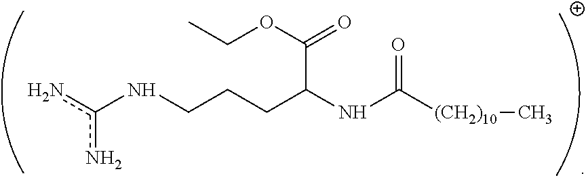
Figure 1.1 Structure of lauric arginate.

Adapted from Ming and Rothenburger (2013)

Chapter 2. Antimicrobial properties of lauric arginate alone or in combination with essential oils in tryptic soy broth and 2% reduced fat milk

A version of this chapter was originally published by Qiumin Ma, P. Michael Davidson, Qixin Zhong . 2013. Antimicrobial properties of lauric arginate alone or in combination with essential oils in tryptic soy broth and 2% reduced fat milk. International Journal of Food Microbiology. 166: 77–84.

2.1. Abstract
The objective of this study was to evaluate the antimicrobial activity of lauric arginate (LAE) when used alone or in combination with the essential oil (EO) from cinnamon leaf and EO components, thymol and eugenol. Minimum inhibitory concentrations (MICs) and minimum bactericidal concentrations (MBCs) for Listeria monocytogenes, Escherichia coli O157:H7 and Salmonella Enteritidis were determined by the microbroth dilution method in tryptic soy broth (TSB) at their optimal growth temperatures. The MIC for LAE was 11.8 ppm against L. monocytogenes and E. coli O157:H7 and 23.5 ppm against S. Enteritidis. Synergistic antimicrobial activity was demonstrated against L. monocytogenes with combinations of LAE and cinnamon leaf oil or eugenol, while the LAE and thymol combination showed additive antimicrobial activity. Conversely, antagonistic effects were shown for all combinations against E. coli O157:H7 and S. Enteritidis. Beef extract, at 2 or 5% w/v in TSB, showed no effects on the MIC and MBC of LAE against L. monocytogenes, while soluble starch from potato, at 2–10% w/v in TSB, increased the MIC and MBC. When tested in 2% reduced fat milk, significantly higher levels of antimicrobials were required to achieve similar inhibitions as in TSB. The growth curves of bacteria at 21 °C followed similar trends as in TSB, showing synergism against the Gram-positive L. monocytogenes and antagonism against the two Gram-negative bacteria. Findings suggest that application of LAE could enhance microbial food safety, especially when used in combination with EO to inhibit the growth of Gram-positive bacteria.
Keywords: lauric arginate, essential oils, combination, antimicrobial ability, interaction

2.2. Introduction
Lauric arginate (LAE; ethyl-N^{α}-lauroyl-L-arginine ethyl ester monohydrochloride) is a cationic surfactant derived from lauric acid, L-arginine, and ethanol (Ruckman et al., 2004). It has been approved by the United States FDA as a generally regarded as safe (GRAS) food preservative to inhibit microbial growth in selected applications (USDA, 2005), e.g., at up to 200 ppm in milk and Queso Fresco cheese (Soni et al., 2010). LAE inhibits a broad spectrum of foodborne pathogens. For example, Porto-Fett et al. (2010) treated frankfurters with 22 or 44 ppm LAE and observed the reduction of Listeria monocytogenes by ca. 2.0 log CFU/package within 2 h. The researchers also observed that a combination of LAE with lactate and diacetate was required to maintain inhibition during 120-day refrigerated storage. Woodcock et al. (2009) treated chocolate and unflavored milk with 125, 170, and 200 mg/L of LAE. The aerobic plate count in unflavored milk was inhibited by 200 mg/L LAE to below 4.3 log CFU/mL which is the Pasteurized Milk Ordinance limit for grade A pasteurized milk during a 21-day storage at 6°C. Inhibition was less in chocolate than in unflavored milk, with 200 mg/L showing 0.9 and 5.77 log CFU/mL, respectively, lower than that of the untreated controls without LAE at day 21.
Antimicrobial activities of combinations of LAE with other antimicrobials have been studied. Additive antilisterial activity was observed for a combination of LAE and nisin in tryptose phosphate broth at 35°C (Brandt et al., 2010). Synergistic antimicrobial activity was reported for a combination of LAE with subtilosin, a natural antimicrobial peptide produced by Bacillus amyloliquefaciens, against Gardnerella vaginalis ATCC 14018 (Noll et al., 2012). A combination of LAE and lactate-diacetate blend used to surface-treat cured ham (Stopforth et al., 2010) and frankfurters (Martin et al., 2009) showed significantly better inhibition of L. monocytogenes during storage than treatments with LAE or lactate-diacetate alone.
Several studies characterized antimicrobial activities involving combinations of surfactants and essential oils (EO), usually in the manner of emulsifying the EOs to form nanoemulsions or microemulsions Generally, surfactants could enhance the antimicrobial activities of EOs by increasing the solubility of EOs in the aqueous phase (Donsì et al., 2012; Liang et al., 2012). Since LAE is a cationic surfactant, similarly, combinations LAE with essential oils may show synergistic effects in inhibition of bacteria. However, reduction of antimicrobial activity of LAE and Tween 80 surfactant mixture was reported when loading with thymol oil (Ziani et al., 2011), Thus, it may be interesting to study the combination effect of LAE and EOs in inhibiting of foodborne pathogens, since no detailed information of combinations of LAE and EOs was available. Besides, bitter taste of LAE was unfavorable for consumers, EOs may be helpful in masking the bad taste of LAE.
When used in foods, the cationic nature of LAE may reduce the antimicrobial effectiveness because of the potential for binding with anionic and hydrophobic food components (Bonnaud et al., 2010). The reduced antimicrobial activity of LAE added to chocolate milk compared to unflavored milk was speculated to have been caused by stabilizers such as anionic carrageenan in the chocolate powder (Woodcock et al., 2009). Strong electrostatic binding between LAE and anionic biopolymers (pectin, alginate, carrageenan, and xanthan) was verified by isothermal titration calorimetry (Asker et al., 2008; Bonnaud et al., 2010). Thus, the influence of food components on the antimicrobial ability of LAE must be studied for realistic application of LAE in foods.
The objectives of this research were (1) to characterize antimicrobial properties of LAE alone or in combination with thymol, eugenol or cinnamon leaf oil against L. monocytogenes, Escherichia coli O157:H7 and Salmonella Enteritidis in microbial growth media and (2) to determine the influence of model food compounds, beef extract and soluble starch, and a model food matrix (2% reduced fat milk) on the antimicrobial properties of LAE and antimicrobial combinations.

2.3. Materials and Methods

2.3.1. Chemicals
LAE was kindly provided by Vedeqsa Inc. (New York, NY) with a commercial product name of Mirenat-TT that contained 15±0.5% w/w LAE. Eugenol (> 98% purity) and beef extract were purchased from Sigma-Aldrich Corp. (St. Louis, MO). Cinnamon leaf oil was purchased from Plant Therapy Essential Oils (Twin Falls, ID). Tryptic soy broth (TSB) was from Thermo-Fisher Scientific Inc. (Pittsburgh, PA). The ultra-pasteurized 2% reduced fat milk was from Kroger Co. (Cincinnati, OH). Thymol (99% purity) and soluble potato starch were purchased from Acros Organics (Morris Plains, NJ).

2.3.2. Bacterial culture
E. coli O157:H7 ATCC 43895, L. monocytogenes Scott A and S. Enteritidis were obtained from the culture collection of the Department of Food Science and Technology at the University of Tennessee in Knoxville. All strains were maintained at -20°C in 20% glycerol. Each strain was transferred at least 2 times in TSB with an interval of 24 h before use.

2.3.3. Determination of minimum inhibitory (MIC) and minimum bactericidal (MBC) concentrations in TSB
The MIC was determined by the microbroth dilution method (Branen and Davidson, 2004). The bacterial culture was diluted to about 10⁶ CFU/mL in TSB, and 120 μL of the diluted culture was added into wells of a 96-well microtiter plate. Antimicrobial stock solutions were prepared at 6% w/w in 70% ethanol. The working antimicrobial solution was prepared by diluting the stock solution in TSB to 6000 ppm that was further diluted in series from 11.7 to 6000 ppm, with each dilution made to an equal volume with TSB. An aliquot of 120 μL of the antimicrobial solution was mixed with the bacterial culture in each well and the plates were incubated at 32°C (for L. monocytogenes) or 37°C (for E. coli O157:H7 and S. Enteritidis) for 24 h. The MIC was defined as the lowest antimicrobial concentration corresponding to an optical density change at 630 nm (ΔOD_{630 nm}) of < 0.05. The MBC was determined by spreading 100 μL aliquots from negative wells (i.e., ΔOD_{630 nm} < 0.05) on tryptic soy agar (TSA), followed by incubation for 48 h at 32°C or 37°C. MBC was defined as the antimicrobial concentration corresponding to at least a 3 log reduction of viable cells (Branen and Davidson, 2004).

2.3.4. Checkerboard method to study antimicrobial combinations
A “checkerboard” method (Brandt et al., 2010) was used to test the antimicrobial effectiveness for the combinations of LAE with EO. To the individual wells of a 96-well microtiter plate were added 60 μL of an LAE solution, 60 μL of an EO solution and 120 μL of bacterial culture (ca. 10⁶ CFU/mL) in TSB. The concentrations of LAE used were 0 to 23.5 ppm, cinnamon oil and eugenol, 0 to 750 ppm, and thymol, 0 to 187.5 ppm. The MIC of antimicrobial combinations was determined as above and was used to calculate fractional inhibitory concentration index (FIC_{I}) as Equation 1. The synergistic, additive, and antagonistic interactions of antimicrobials A and B correspond to FIC_{I} values of < 1, 1 and > 1, respectively (Davidson and Branen, 1993).
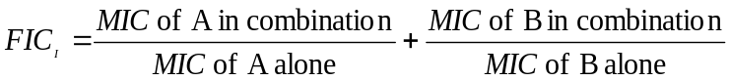 (1)

2.3.5. The interaction between LAE and food compounds
To study the interaction of LAE with food compounds, 2, 5, and 10% w/v of beef extract or 2 and 5% w/v of soluble starch were dissolved in TSB and sterilized. Listeria monocytogenes culture and LAE solution were added for determination of MIC and MBC using the above methods. The protein content of beef extract was quantified using the Coomassie blue reagent from Pierce Biotechnology (Rockford, IL), with bovine serum albumin as a reference protein. Protein assay was tested in triplicate.

2.3.6. Microbial survivability end-point analysis in 2% reduced fat milk
To test the microbial survivability of bacteria in 2% reduced fat milk, 3000, 4000, 5000, or 6000 ppm of EO (stock solution 10% w/w EO in 70% ethanol) and 375 or 750 ppm of LAE (stock solution 6% w/w LAE in 70% ethanol) were added alone or in combination into 2% reduced fat milk. One mL culture with ca. 10⁷ CFU/mL L. monocytogenes was added to 9 mL 2% reduced fat milk containing the above antimicrobials to achieve a bacterial population of ca. 10⁶ CFU/mL. After incubating the mixtures at 32°C for 24 h, the pour plate method, which had a limit of detection of 1 log CFU/mL, was used to enumerate viable bacteria.

2.3.7. Microbial growth kinetics in 2% reduced fat milk
To study the growth of L. monocytogenes in the presence of antimicrobials in 2% fat milk, 1 mL of culture (ca. 10⁷ CFU/mL) was added to 9 mL of 2% reduced fat milk to obtain a final bacterial population of about 10⁶ CFU/mL. EO and LAE at 6000 ppm and 750 ppm, respectively, were added to evaluate the compounds alone and 3000 ppm of EO and 375 ppm of LAE were used for combination studies. The final mixtures were incubated at room temperature (21°C) and the viable bacteria enumerated at 0, 4, 8, 24 and 48 h using the pour plate method. When E. coli O157:H7 and S. Enteritidis were studied, concentrations of cinnamon leaf oil, eugenol, thymol and LAE were 5000, 5000, 4000 and 750 ppm, respectively, when antimicrobials were used alone, while these antimicrobial concentrations were reduced by one-half to study the effectiveness of combinations.

2.3.8. GC-MS analysis
To characterize the major component in cinnamon leaf oil, GC-MS was performed on a Shimadzu GC-2010 gas chromatography instrument (Shimadzu Scientific Instruments, Columbia, MD) coupled to a Shimadzu QP2010 mass spectrometer (Shimadzu Scientific Instruments, Columbia, MD). Compounds were separated on a fused silica capillary Rtx-5 ms (5% phenyl methyl siloxane) column (30 m×0.25 mm inner diameter, 0.25 mm film thickness). The injection volume was 1 µL. The oven temperature program was set as follows: initiated at 80°C, held for 2 min, then increased at the rate of 10 °C/min to 200 °C and held for 2 min. The spectrometer was operated in the electron-impact (EI) mode, with the scan range of 40–500 amu and the ionization energy of 70 eV. Helium was used as a carrier gas at a flow rate of 1.0 mL/min. Eugenol from Sigma-Aldrich Corp. (St. Louis, MO) was analyzed separately as an external standard to quantify eugenol content in cinnamon leaf oil based on peak areas. The mean value was calculated from duplicate assays.

2.3.9. Data and statistical analyses
To determine the MICs, at least twice in triplicate experiments were conducted. For microbial survivability end-point analysis and microbial growth kinetics experiments, experiments were conducted at least twice in duplicate; mean and standard deviation of replicates were reported. Data were analyzed with one way ANOVA Tukey’s test using SPSS 20 (IBM, Armonk, NY).

2.4. Results and discussion

2.4.1. MIC and MBC of LAE and essential oils when used alone

MICs of individual antimicrobials are listed in Table 2.1. LAE showed the highest effectiveness on a concentration basis for inhibiting all bacteria. The MIC of LAE against L. monocytogenes and E. coli O157:H7 was 11.8 ppm which was similar to the 12.50 ppm reported by Brandt et al. (2010). S. Enteritidis was more resistant with LAE, with MIC of 23.5 ppm. As for EO and EO components, thymol was more effective in inhibiting the bacteria than eugenol and cinnamon oil, which is also consistent with the literature (Gutierrez, Rodriguez, et al., 2008; Olasupo et al., 2003). The MIC of thymol against L. monocytogenes was 187.5 ppm. Similar reports found that 200 (Gutierrez, Barry-Ryan, et al., 2008) or 250 ppm thymol (Falcone et al., 2007) inhibited L. monocytogenes IL323 or L. monocytogenes isolated from poultry, respectively. The small variations can be due to differences in test strains and dilution schemes. The MIC of thymol was 93.8 and 187.5 ppm against E. coli O157:H7 and S. Enteritidis, respectively. The MIC was identical (750 ppm) for eugenol and cinnamon leaf oil against all three bacteria. This concentration was higher than the MIC of 400 ppm for cinnamon leaf oil (with 77% eugenol) reported by Cava et al. (2007) for L. monocytogenes Scott A in TSB. The MBC of the antimicrobials was similar to the MIC against E. coli O157:H7 and S. Enteritidis but was twice of the MIC for L. monocytogenes (Table 2.1).
Some studies have suggested that complete EOs may have a greater antimicrobial effect than a mixture of major components (Gill et al., 2002; Mourey and Canillac, 2002), because the minor components of the EOs may play a key role in the antimicrobial activity and possibly enable synergism (Burt, 2004). In the present study, cinnamon leaf oil had 80.1% eugenol according to GC-MS (Fig. 2.1) but the MIC and MBC of eugenol and cinnamon leaf oil were identical in inhibiting the growth of L. monocytogenes and the two Gram-negative bacteria. Thus, our data confirm that eugenol is a major antimicrobial component in cinnamon leaf oil and other minor components contributed less than eugenol to the antimicrobial activity of cinnamon leaf oil under the studied conditions.

2.4.2. Interaction of antimicrobials
The FIC_{I}s were calculated based on the checkerboard method results and are presented in Table 2.2. The combination of LAE and cinnamon oil or eugenol showed synergistic activity in inhibiting L. monocytogenes, with FIC_{I}s being 0.87 and 0.94, respectively. However, LAE combined with thymol showed only an additive effect, with an FIC_{I} of 1.01. Conversely, all combinations showed antagonistic effects for inhibition of the Gram-negative E. coli O157:H7 and S. Enteritidis, with FIC_{I}s > 1. This result probably could explain what Dr. Gaysinsky had reported--incorporated with 1mM mixtures of LAE and nonionic surfactant T-Maz® 80K (TM) at ratio 1:5, only 3mM eugenol was needed to inhibit the growth of L.monocytogenes, while 7mM eugenol was needed to inhibit the growth of gram-negative bacteria E. coli O157:H7 ; when used alone, reversely, more eugenol was needed for inhibition of L. monocytogenes (20mM) than E. coli O157:H7 (15mM) (Gaysinsky, 2007). Thus, LAE and eugenol here may show synergistic effect in inhibiting L. monocytogenes as well.
Some studies have proposed mechanisms for the interaction of antimicrobials against microorganisms. For example, the synergistic combination of thymol and nisin Z against L. monocytogenes and Bacillus subtilis was attributed to an altered permeability and structure of the cytoplasmic membrane and thus a dissipation of intracellular metabolites (Ettayebi et al., 2006). The cationic LAE may bind the negatively charged cell membrane and cause structural changes and even disruption (Rodríguez et al., 2004). For Gram-positive bacteria, the initial action of LAE may facilitate other antimicrobial mechanisms of EOs, which enables synergistic effects. Conversely, antagonistic effects may be due to LAE binding on the lipopolysaccharide-rich outer membrane, which increases the thickness and robustness of the cell wall of Gram-negative bacteria and thus restricts the diffusion of hydrophobic EOs (Ratledge and Wilkinson, 1988; Vaara, 1992).

2.4.3. Impacts of beef extract and soluble starch on antimicrobial properties of LAE
Beef extract and soluble potato starch were used to represent the effect of hydrolyzed protein (Becton, Dickinson and Co.,, 2013) and polysaccharides (Gutierrez, Barry-Ryan, et al., 2008) on antimicrobial activity. MIC and MBC of LAE were not significantly affected by addition of 2-10% w/v beef extract in TSB, while MIC and MBC in the presence of soluble potato starch increased significantly (Table 2.3).
Starch has been reported to interact with small molecular weight preservatives such as sorbic, benzoic and p-benzoic acids (Ofman et al., 2004) and can diminish the antimicrobial activity of fatty acids (Ababouch et al., 1994; Ababouch et al., 1992). A similar negative effect of starch on the antimicrobial activity of EOs has been reported by Gutierrez et al. (2008). Devlieghere et al. (2004) reported that 30% w/v soluble starch reduced the antimicrobial activity of positively charged chitosan which was explained as either a protective effect by the starch or a potential electrostatic interaction with charge-modified starch. In the present study, since the starch was not charged, reduced antimicrobial activity of LAE could have resulted from the increased viscosity which limited access of LAE to L. monocytogenes.
The addition of beef extract showed no significant effect on the MIC of LAE. This was in contrast to the findings of Gutierrez et al. (2008) who showed enhanced efficacy of oregano and thyme against L. monocytogenes in the presence of beef extract. This may be due to the difference in physical properties of LAE and EO. Peptone, the major component of beef extract can facilitate the dissolution of hydrophobic EO in the medium (Gutierrez, Barry-Ryan, et al., 2008) but not the hydrophilic LAE. At pH 7, most proteins are negatively charged, which may significantly affect the antimicrobial activity of cationic LAE. However, the total protein content of beef extract was 0.48% w/w which may be too low to cause significant influence on LAE activity. The MBC of LAE increased only one fold at all concentrations of beef extract suggesting limited effects of the beef extract on lethality of LAE.

2.4.4. Antilisterial activities in 2% reduced fat milk
It has been repeatedly observed that higher concentrations of antimicrobials are required in food systems to inhibit microorganisms than in growth media (Burt, 2004; Karatzas et al., 2002; Shelef et al., 2006; Soni et al., 2010). Log reductions of L. monocytogenes in 2% reduced fat milk by different levels of individual antimicrobials are presented in Table 4. Around 6000 ppm of EO or 750 ppm LAE was needed to reduce L. monocytogenes to undetectable levels which was several times higher than the corresponding MBC in TSB (Table 2.1). At 3000 ppm of the EOs (2 or 4 times of MBC in TSB), no significant antilisterial effect was observed. Differences in EO levels required to inhibit bacteria in growth media and foods have been attributed to the reduced availability of antimicrobials due to binding EO with hydrophobic food components (Bonnaud et al., 2010; Glass and Johnson, 2004) and the faster reparation of injured bacteria cells in foods rich in nutrients (Gill et al., 2002). For LAE, the interaction with milk fat may have occurred, as observed for other antimicrobials with hydrophilic and hydrophobic moieties (Branen and Davidson, 2004; Wang and Johnson, 1992). Besides, no significant differences between the antilisterial effects of thymol and eugnol were found at all the levels tested (3000-6000 ppm, P > 0.05) in 2% reduced fat milk. Eugenol was slightly more effective than cinnamon leaf oil at 3000-5000 ppm (P < 0.05). The differences may be due to the lower eugenol concentration in cinnamon leaf oil than pure eugenol when both were used at same mass concentrations, which further confirmed that eugenol was the major active compound in cinnamon leaf oil.

2.4.5. Growth curves of bacteria treated with individual and combinational antimicrobials
Growth curves of L. monocytogenes, E. coli O157:H7 and S. Enteritidis in 2% reduced fat milk with LAE and EOs alone and in combination were studied during 48 h incubation at 21°C. Results are shown in Figure 2.2, 2.3, and 2.4 for L. monocytogenes, E. coli O157:H7 and S. Enteritidis, respectively. At the studied conditions, synergistic antilisterial activity was observed when combining EO with LAE, with the combination of thymol and LAE being the most efficient (Fig. 2.2C). For E. coli O157:H7 (Fig. 2.3), combinations were less effective than antimicrobials used alone, and LAE was not as effective as EO. The most effective EO was eugenol followed by cinnamon oil and thymol. Results of S. Enteritidis (Fig. 2.4) were similar to those of E. coli O157:H7, except that thymol was more effective than cinnamon oil. The potential difference of LAE activity when used in combination with EO against bacteria was discussed previously, the differences of outer cell membrane structure between Gram-positive and Gram-negative bacteria may play a key role. The antimicrobial effects of combinations of LAE and EO in 2% reduced fat milk generally agree with FIC_{I} results (Table 2.2) with the exception of the antilisterial effect of LAE combined with thymol that appeared to show synergism in milk but additive activity in TSB.
When comparing Table 2.4 with Fig. 2.2, the log reductions of L. monocytogenes caused by 750 ppm LAE or 6000 ppm EO in microbial kinetics assay were much lower after 24 h (Fig.2.2) than the results from microbial survivability end-point analysis (Table 2.4). Given that different incubation temperatures were used in these two experiments (21 vs. 32°C), the lower antilisterial activities at the lower temperature may be due to the lower diffusion rate or binding rate of antimicrobials (Diver et al., 1990). The lower growth rate of bacteria at lower temperatures can also make them less susceptible to antimicrobials, if antimicrobials are targeting some enzymes (Martinsen et al., 1992). Higher activities of antimicrobials at higher temperatures were reported previously (Mackowiak et al., 1982; Martinsen et al., 1992; Sorrells et al., 1989).

2.5. Conclusions
In conclusion, LAE was the most effective among the antimicrobials in inhibiting the three bacteria tested in vitro in this study. Combinations of LAE with cinnamon leaf oil and its major component eugenol were found to be synergetic in inhibiting the Gram-positive bacteria L. monocytogenes. This permits the applications of low amounts of antimicrobials to reduce negative flavors or quality of the food products, e.g., the bitter taste of LAE (Bonnaud et al., 2010). However, combinations reported in this study, showing antagonistic antimicrobial activities against Gram-negative bacteria such as E. coli O157:H7 and S. Enteritidis, should not be used. Food components differ in their interference on antimicrobial activities, but significantly higher levels of antimicrobials are required to obtain similar inhibition in foods than in growth media. Thus, sensory evaluation of LAE may need to be further studied in food system, since relatively higher amount of LAE was needed. EOs used in the study may be able to mask the taste. To ensure microbiological safety, the antimicrobials, used individually or in combination, must still be analyzed to determine the influence of factors such as refrigeration, abuse temperatures, pH, ionic strength, and food matrices of the intended applications.

References
Ababouch, L., Bouqartacha, F., Busta, F., 1994. Inhibition of Bacillus cereus spores and vegetative cells by fatty acids and glyceryl monododecanoate. Food Microbiology 11, 327-336.
Ababouch, L., Chaibi, A., Busta, F., 1992. Inhibition of bacterial spore growth by fatty acids and their sodium salts. Journal of Food Protection 55, 980-984.
Asker, D., Weiss, J., McClements, D., 2008. Analysis of the interactions of a cationic surfactant (lauric arginate) with an anionic biopolymer (pectin): isothermal titration calorimetry, light scattering, and microelectrophoresis. Langmuir 25, 116-122.
Becton, Dickinson and Co., 2013. BBL™ Beef Extract Powder, Bacto™ Beef Extract Desiccated. Available at http://www.bdbiosciences.com/documents/Beef_Extract.pdf. Last accessed on March 20, 2013.
Bonnaud, M., Weiss, J., McClements, D.J., 2010. Interaction of a food-grade cationic surfactant (lauric arginate) with food-grade biopolymers (pectin, carrageenan, xanthan, alginate, dextran, and chitosan). Journal of Agricultural and Food Chemistry 58, 9770-9777.
Brandt, A.L., Castillo, A., Harris, K.B., Keeton, J.T., Hardin, M.D., Taylor, T.M., 2010. Inhibition of Listeria monocytogenes by food antimicrobials applied singly and in combination. Journal of Food Science 75, M557-M563.
Branen, J.K., Davidson, P.M., 2004. Enhancement of nisin, lysozyme, and monolaurin antimicrobial activities by ethylenediaminetetraacetic acid and lactoferrin. International Journal of Food Microbiology 90, 63-74.
Burt, S., 2004. Essential oils: their antibacterial properties and potential applications in foods—a review. International Journal of Food Microbiology 94, 223-253.
Cava, R., Nowak, E., Taboada, A., Marin-Iniesta, F., 2007. Antimicrobial activity of clove and cinnamon essential oils against Listeria monocytogenes in pasteurized milk. Journal of Food Protection 70, 2757-2763.
Davidson, P., Branen, A., 1993. Methods for evaluation., Antimicrobials in foods. Marcel Dekker, New York, pp. 597-615.
Devlieghere, F., Vermeulen, A., Debevere, J., 2004. Chitosan: antimicrobial activity, interactions with food components and applicability as a coating on fruit and vegetables. Food Microbiology 21, 703-714.
Ettayebi, K., El Yamani, J., Rossi‐Hassani, B.D., 2006. Synergistic effects of nisin and thymol on antimicrobial activities in Listeria monocytogenes and Bacillus subtilis. FEMS Microbiology Letters 183, 191-195.
Diver, J., Piddock, L., Wise, R., 1990. The accumulation of five quinolone antibacterial agents by Escherichia coli. Journal of Antimicrobial Chemotherapy 25, 319-333.
Donsì, F., Annunziata, M., Vincensi, M., Ferrari, G., 2012. Design of nanoemulsion-based delivery systems of natural antimicrobials: Effect of the emulsifier. Journal of biotechnology 159, 342-350.
Falcone, P.M., Mastromatteo, M., Del Nobile, M.A., Corbo, M.R., Sinigaglia, M., 2007. Evaluating in vitro antimicrobial activity of thymol toward hygiene-indicating and pathogenic bacteria. Journal of Food Protection 70, 425-431.
Gaysinsky, S., 2007. Emulsions and microemulsions as antimicrobial delivery systems, Food Science. University of Massachusetts Amherst.Gill, A.O., Delaquis, P., Russo, P., Holley, R.A., 2002. Evaluation of antilisterial action of cilantro oil on vacuum packed ham. International Journal of Food Microbiology 73, 83-92.
Glass, K.A., Johnson, E.A., 2004. Antagonistic effect of fat on the antibotulinal activity of food preservatives and fatty acids. Food Microbiology 21, 675-682.
Gutierrez, J., Barry-Ryan, C., Bourke, P., 2008. The antimicrobial efficacy of plant essential oil combinations and interactions with food ingredients. International Journal of Food Microbiology 124, 91-97.
Gutierrez, J., Rodriguez, G., Barry-Ryan, C., Bourke, P., 2008. Efficacy of plant essential oils against foodborne pathogens and spoilage bacteria associated with ready-to-eat vegetables: antimicrobial and sensory screening. Journal of Food Protection 71, 1846-1854.
Karatzas, A., Kets, E., Smid, E., Bennik, M., 2002. The combined action of carvacrol and high hydrostatic pressure on Listeria monocytogenes Scott A. Journal of Applied Microbiology 90, 463-469.
Liang, R., Xu, S., Shoemaker, C.F., Li, Y., Zhong, F., Huang, Q., 2012. Physical and antimicrobial properties of peppermint oil nanoemulsions. Journal of Agricultural and Food Chemistry 60, 7548-7555.
Mackowiak, P.A., Marling-Cason, M., Cohen, R.L., 1982. Effects of temperature on antimicrobial susceptibility of bacteria. Journal of Infectious Diseases 145, 550-553.
Martin, E., Griffis, C., Vaughn, K., O'Bryan, C., Friedly, E., Marcy, J., Ricke, S., Crandall, P., Lary Jr, R., 2009. Control of Listeria monocytogenes by lauric arginate on frankfurters formulated with or without lactate/diacetate. Journal of Food Science 74, M237-M241.
Martinsen, B., Oppegaard, H., Wichstrøm, R., Myhr, E., 1992. Temperature-dependent in vitro antimicrobial activity of four 4-quinolones and oxytetracycline against bacteria pathogenic to fish. Antimicrobial Agents and Chemotherapy 36, 1738-1743.
Mourey, A., Canillac, N., 2002. Anti-Listeria monocytogenes activity of essential oils components of conifers. Food Control 13, 289-292.
Noll, K.S., Prichard, M.N., Khaykin, A., Sinko, P.J., Chikindas, M.L., 2012. The natural antimicrobial peptide subtilosin acts synergistically with glycerol monolaurate, lauric arginate and ε-poly-L-lysine against bacterial vaginosis-associated pathogens but not human lactobacilli. Antimicrobial Agents and Chemotherapy 56, 1756-1761.
Ofman, M.H., Campos, C.A., Gerschenson, L.N., 2004. Effect of preservatives on the functional properties of tapioca starch: analysis of interactions. LWT-Food Science and Technology 37, 355-361.
Olasupo, N., Fitzgerald, D., Gasson, M., Narbad, A., 2003. Activity of natural antimicrobial compounds against Escherichia coli and Salmonella enterica serovar Typhimurium. Letters in Applied Microbiology 37, 448-451.
Porto-Fett, A., Campano, S., Smith, J., Oser, A., Shoyer, B., Call, J., Luchansky, J., 2010. Control of Listeria monocytogenes on commercially-produced frankfurters prepared with and without potassium lactate and sodium diacetate and surface treated with lauric arginate using the Sprayed Lethality in Container (SLICо) delivery method. Meat Science 85, 312-318.
Ratledge, C., Wilkinson, S.G., 1988. Microbial lipids. Academic Press, London, UK.
Rodríguez, E., Seguer, J., Rocabayera, X., Manresa, A., 2004. Cellular effects of monohydrochloride of l-arginine, Nα-lauroyl ethylester (LAE) on exposure to Salmonella typhimurium and Staphylococcus aureus. Journal of Applied Microbiology 96, 903-912.
Ruckman, S.A., Rocabayera, X., Borzelleca, J.F., Sandusky, C.B., 2004. Toxicological and metabolic investigations of the safety of N-[alpha]-Lauroyl--arginine ethyl ester monohydrochloride (LAE). Food and Chemical Toxicology 42, 245-259.
Shelef, L., Jyothi, E., Bulgarellii, M., 2006. Growth of Enteropathogenic and Spoilage Bacteria in Sage‐Containing Broth and Foods. Journal of Food Science 49, 737-740.
Soni, K., Nannapaneni, R., Schilling, M., Jackson, V., 2010. Bactericidal activity of lauric arginate in milk and Queso Fresco cheese against Listeria monocytogenes cold growth. Journal of Dairy Science 93, 4518-4525.
Sorrells, K., Enigl, D., Hatfield, J., 1989. Effect of pH, acidulant, time, and temperature on the growth and survival of Listeria monocytogenes. Journal of Food Protection 52, 571-573.
Stopforth, J., Visser, D., Zumbrink, R., Van Dijk, L., Bontenbal, E., 2010. Control of Listeria monocytogenes on cooked cured ham by formulation with a lactate-diacetate blend and surface treatment with lauric arginate. Journal of Food Protection 73, 552-555.
USDA, 2005. Agency Response Letter GRAS Notice No. GRN 000164. Available at http://www.accessdata.fda.gov/scripts/fcn/gras_notices/grn000164.pdf. Last accessed on March 20, 2013.
Vaara, M., 1992. Agents that increase the permeability of the outer membrane. Microbiological Reviews 56, 395-411.
Wang, L.-L., Johnson, E.A., 1992. Inhibition of Listeria monocytogenes by fatty acids and monoglycerides. Applied and Environmental Microbiology 58, 624-629.
Woodcock, N., Hammond, B., Ralyea, R., Boor, K., 2009. Short communication: N [alpha]-Lauroyl-l-arginine ethylester monohydrochloride reduces bacterial growth in pasteurized milk. Journal of Dairy Science 92, 4207-4210.

Appendix
Table 2.1. Minimum inhibitory concentrations (MICs) and minimum bactericidal concentrations (MBCs) of various antimicrobials against Listeria monocytogenes (LM), Escherichia coli O157:H7 (EC) and Salmonella Enteritidis (SE) in Tryptic Soy Broth at 32°C (LM) or 37°C (EC and SE) ª.
Bacteria | MIC (ppm) |  |  |  |  |  |  | MBC (ppm)
Bacteria | Thymol | Eugenol | Lauric arginate | Cinnamon oil |  |  | Thymol |  |  | Eugenol |  | Lauric arginate |  | Cinnamon oil
LM | 187.5 | 750 | 11.8 |  | 750 | 375 |  |  | 1500 |  | 23.5 |  | 1500
EC | 93.8 | 750 | 11.8 |  | 750 | 93.8 |  |  | 750 |  | 11.8 |  | 750
SE | 187.5 | 750 | 23.5 |  | 750 | 187.5 |  |  | 750 |  | 23.5 |  | 750
ª MICs were the lowest antimicrobial concentrations corresponding to an optical density change at 630 nm (∆OD_{630nm}) of <0.05 after 24 h incubation at 32°C (LM) or 37°C (EC and SE). MBCs were the lowest antimicrobial concentrations corresponding to at least a 3 log reduction of viable cells.

Table 2.2. Fractional inhibitory concentrations indices (FIC_{I}, mean±standard deviation, n≥ 3) of lauric arginate (LAE) used in combination with essential oils against Listeria monocytogenes, Escherichia coli O157:H7 and Salmonella Enteritidisª.
Strains | Temperature (°C) | LAE + cinnamon oil | LAE + eugenol | LAE + thymol
L. monocytogenes | 32 | 0.87±0.04 (S)^{b} | 0.94±0.05 (S) | 1.01±0.05 (A)
E. coli O157:H7 | 37 | 1.15±0.09 (AN) | 1.24±0.15 (AN) | 1.23±0.09 (AN)
S. Enteritidis | 37 | 1.22±0.05 (AN) | 1.22±0.05 (AN) | 1.17±0.12 (AN)
ª FIC value was calculated by dividing MIC of an antimicrobial when used in combination by MIC of the antimicrobial when used alone. FIC_{I} was the sum of FIC values from antimicrobials A and B.
^{b} The antimicrobial effect of combinations was synergistic (S, FIC_{I}<1), additive (A, FIC_{I}=1), or antagonistic (AN, FIC_{I}>1).
Table 2.3. Minimum inhibitory concentration (MIC) and minimum bactericidal concentration (MBC) of lauric arginate (LAE) against Listeria monocytogenes in microbiological media with added beef extract or soluble starch at 32°Cª.
Media | MIC (ppm) | MBC (ppm)
TSB | 11.8 | 11.8
TSB + 2% beef extract | 11.8 | 23.5
TSB + 5% beef extract | 11.8 | 23.5
TSB + 10% beef extract | 11.8 | 23.5
TSB + 2% soluble starch | 93.8 | 187.5
TSB + 5% soluble starch | 187.5 | 375
ª MICs were the lowest antimicrobial concentrations corresponding to an optical density change at 630 nm (∆OD_{630nm}) of <0.05 after 24 h incubation at 32°C (LM). MBCs were the lowest antimicrobial concentrations corresponding to at least a 3 log reduction of viable cells.
Table 2.4. Log reduction of Listeria monocytogenes Scott A (initial count of 7.31 log CFU/mL) in 2% reduced fat milk at 32°C after 24 h. Numbers are mean ± standard deviation (n=4).
Antimicrobial | Concentration (ppm) | Log reduction
Cinnamon oil | 3000 | -0.14 ± 0.15 ^{a*}
 | 4000 | 1.93 ± 0.19 ^{b}
 | 5000 | 3.56 ± 0.51 ^{c}
 | 6000 | 6.20 ± 0.10 ^{d}
Eugenol | 3000 | 0.69 ± 0.09 ^{e}
 | 4000 | 2.77 ± 0.57 ^{f}
 | 5000 | 4.75 ± 0.38 ^{g}
 | 6000 | 6.20 ± 0.10 ^{d}
Thymol | 3000 | 0.79 ± 0.24 ^{e}
 | 4000 | 2.61 ± 0.06 ^{f}
 | 5000 | 4.76 ± 0.34 ^{g}
 | 6000 | 6.20 ± 0.10 ^{d}
Lauric arginate | 375 | 1.02 ± 0.06 e
 | 750 | 6.20 ± 0.10 ^{d}
* Different letters showed statistical differences (P<0.05).
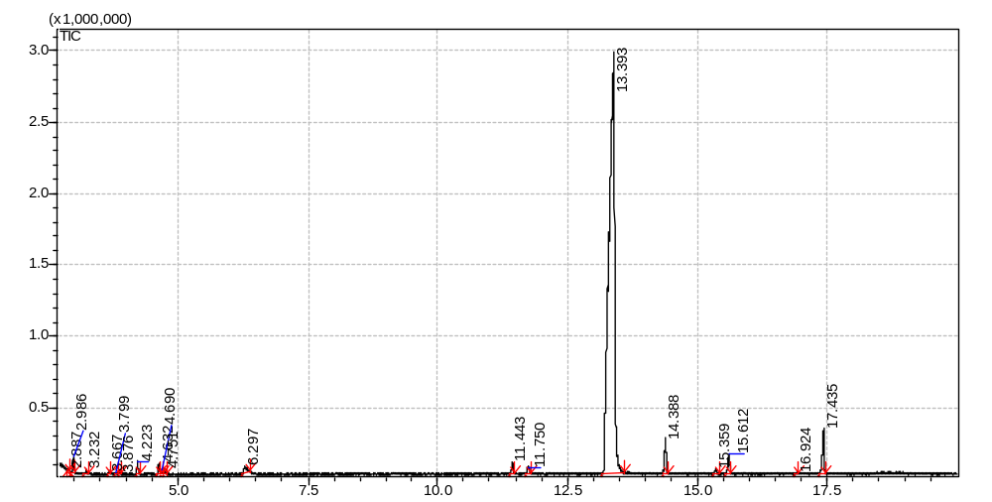
Time (min)
Recorder response
(A)

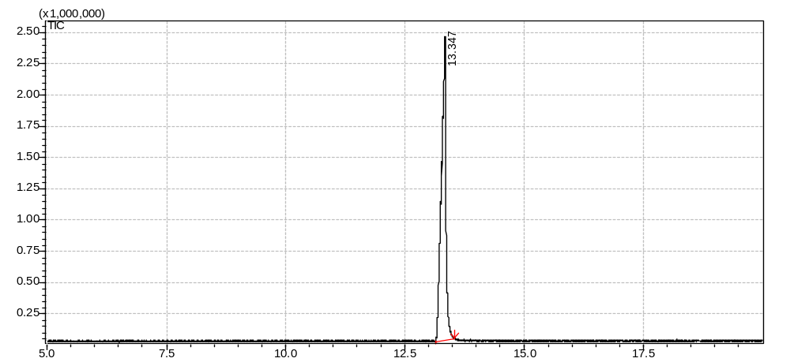
(B)
Recorder response
Time (min)

Figure 2.1. Gas chromatograms of (A) cinnamon leaf oil and (B) eugenol with a purity of >98% from Sigma-Aldrich Corp. (St. Louis, MO, USA).

Figure 2.2. Effects of lauric arginate (LAE) alone or in combination with essential oils (EO) on the growth of Listeria monocytogenes in 2% reduced fat milk at room temperature (21°C): (A) cinnamon leaf oil, (B) eugenol, and (C) thymol. Diamonds: control without antimicrobials; squares: EO only; triangles: LAE only; circles: LAE and EO. The concentrations of EO and LAE were 6000 and 750 ppm, respectively, when used individually or 3000 and 375 ppm, respectively, when used in combination. Error bars are standard deviations from 2 replicates.

Figure 2.2. continued

Figure 2.2. continued

Figure 2.3. Effects of lauric arginate (LAE) alone or in combination with essential oils (EO) on the growth of Escherichia coli O157:H7 ATCC 43895 in 2% reduced fat milk at room temperature (21°C): (A) cinnamon leaf oil, (B) eugenol, and (C) thymol. Diamonds: control without antimicrobials; squares: EO only; triangles: LAE only; circles: LAE and EO. The concentrations of cinnamon leaf oil, eugenol, thymol and LAE were 5000, 5000, 4000 and 750 ppm, respectively, when used individually or 2500, 2500, 2000 and 375 ppm, respectively, when used in combination. Error bars are standard deviations from 2 replicates.

Figure 2.3. continued

Figure 2.3. continued

Figure 2.4. Effects of lauric arginate (LAE) alone or in combination with essential oils (EO) on the growth of Salmonella Enteritidis in 2% reduced fat milk at room temperature (21°C): (A) cinnamon leaf oil, (B) eugenol, and (C) thymol. Diamonds: control without antimicrobials; squares: EO only; triangles: LAE only; circles: LAE and EO. The concentrations of cinnamon leaf oil, eugenol, thymol and LAE were 5000, 5000, 4000 and 750 ppm, respectively, when used individually or 2500, 2500, 2000 and 375 ppm, respectively, when used in combination. Error bars are standard deviations from 2 replicates.

Figure 2.4. continued

Figure 2.4. continued

Chapter 3. Antimicrobial activities of lauric arginate and cinnamon oil combination against foodborne pathogens: improvement by ethylenediamine- tetraacete and possible mechanisms

3.1. Abstract
The combination of lauric arginate (LAE) and essential oil has a synergistic and antagonistic antimicrobial activity against Gram-positive and Gram-negative bacteria, respectively. The objective of this work was to study if ethylenediaminetetraacetate (EDTA) could overcome the antagonistic antimicrobial activity of the combination of LAE and cinnamon oil (CO) against two Gram-negative bacteria and improve the antimicrobial activity against a Gram-positive bacteria, and the possible mechanisms. In the presence of 500 ppm of EDTA, 5 ppm of LAE and 200 ppm of CO showed an increased log reductions of Escherichia coli O157: H7, Salmonella Enteritidis, and Listeria monocytogenes of ca. 4, 5 and 1 logs, respectively. 500 ppm of EDTA significantly increased the permeability of outer membrane of E. coli O157: H7 based on a crystal violet assay. Scanning electron microscopy showed that 600 ppm CO damaged the cell membrane of S. Enteritidis, while 40 ppm LAE did not. Atomic force microscopy demonstrated that LAE caused the aggregation of DNA molecules, while 100 ppm CO had no impact. It was hypothesized that EDTA increased the permeability of the outer membrane of Gram-negative bacteria to facilitate the penetration of LAE and CO enabling enhanced antimicrobial activity. Compared to treatment with LAE or CO alone, severe damage of L. monocytogenes membrane occurred with LAE and CO in combination based on scanning electron microscopy (SEM), loss of intracellular material (increase in absorbance at 260 nm), and increase of extracellular ATP level. This suggested LAE and CO acted synergistically on L. monocytogenes cell membranes, which may be the major mechanism for lethality of L. monocytogenes.
Keywords: lauric arginate, cinnamon oil, EDTA, synergistic antimicrobial activity, mechanism.

3.2. Introduction
Lauric arginate (ethyl-N^{α}-lauroyl-L-arginine ethylester monohydrochloride; LAE) is approved by the United States Food and Drug Administration as a generally recognized as safe preservative (USDA, 2005). It is a cationic surfactant derived from lauric acid, L-arginine and ethanol (Ruckman, Rocabayera, Borzelleca, & Sandusky, 2004). LAE has been shown to be non-toxic to human because it is metabolized rapidly in vivo to lauric acid and arginine, which are naturally occurring dietary components (Hawkins, Rocabayera, Ruckman, Segret, & Shaw, 2009). LAE has a broad antimicrobial spectrum and a minimum inhibitory concentration (MIC) of LAE against 6 log CFU/mL Listeria monocytogenes Scott A is as low as 11.8 ppm in tryptic soy broth (TSB) at 32°C (Ma, Davidson, & Zhong, 2013). However, a much higher amount of LAE is needed in complex food matrices due to its interaction with negatively charged food components (Bonnaud, Weiss, & McClements, 2010; Ma et al., 2013). Because a high concentration of LAE can lead to a bitter taste, strategies are needed to lower the LAE level used in food products.
Combinations of natural antimicrobials with synergistic antimicrobial effects are a possible way to lower the concentration of each antimicrobial needed in the food matrix (Ma et al., 2013; Noll, Prichard, Khaykin, Sinko, & Chikindas, 2012; Techathuvanan, Reyes, David, & Davidson, 2014). Essential oils (EOs) have gained a lot of attention for possible use as natural antimicrobial preservatives in recent years (Chen, Zhang, & Zhong, 2015; Elgayyar, Draughon, Golden, & Mount, 2001; Pan, Chen, Davidson, & Zhong, 2014). EOs have a broad spectrum of antimicrobial activity but, due to binding with hydrophobic components, are needed at high concentrations in complex food products to enable sufficient inhibition of foodborne pathogens. Lowering the amount of EOs used in the food products is also desired since high concentrations of EOs affect sensory quality of food products. Previously, a synergistic effect against the Gram-positive bacteria L. monocytogenes was found when combining LAE and cinnamon leaf oil or eugenol, while the combination was antagonistic against Gram-negative Escherichia coli O157:H7 and Salmonella Enteritidis (Ma et al., 2013).
The major difference between Gram-negative and Gram-positive bacteria is that the lipopolysaccharide (LPS) outer membrane of Gram-negative bacteria can protect against the penetration of antimicrobial compounds, especially hydrophobic compounds, while Gram-positive bacteria do not have an outer membrane (Bladen & Mergenhagen, 1964). Ethylenediaminetetraacetic acid (EDTA) can chelate divalent cations that are critical to the ordered structure of LPS outer membrane of Gram-negative bacteria (Nikaido, 2003; Ruiz, Kahne, & Silhavy, 2009), which increases the permeability of the outer membrane (Vaara, 1992). Studies have been shown that EDTA can enhance activities of nisin, lysozyme, and monolaurin (Branen & Davidson, 2004). Therefore, we hypothesize that EDTA could overcome the antagonistic effect of LAE-EO combination against Gram-negative bacteria.
The objective of the present study was to test antimicrobial activities of the combinations of LAE, cinnamon oil (CO), and EDTA against both Gram-positive and Gram-negative bacteria. Possible mechanisms for the enhancement of activity by EDTA and/or interactions among antimicrobials investigated included disruption of the cell membrane using the crystal violet assay (Devi, Nisha, Sakthivel, & Pandian, 2010), loss of intracellular nucleic acids using absorption at 260 nm (Diao, Hu, Zhang, & Xu, 2014) , and loss of ATP as well as observation of cell morphology using scanning electron microscopy (SEM). Interaction of antimicrobials and bacterial DNA was also investigated using UV-vis spectroscopy and atomic force microscopy (AFM).

3.3. Materials and Methods

3.3.1. Materials
LAE with a brand name of Mirenat-TT was provided by Vedeqsa Inc. (New York, NY). The commercial product contained 15.5% w/w LAE. CO and EDTA were purchased from Sigma-Aldrich Corp. (St. Louis, MO).

3.3.2. Bacterial culture
L. monocytogenes Scott A, E. coli O157:H7 ATCC43895, and S. Enteritidis were used in the present study. All strains were from Department of Food Science and Technology at University of Tennessee in Knoxville. Strains were stored in sterile 20% glycerol at -20°C and transferred at least 2 times in TSB for E. coli O157:H7 and S. Enteritidis or in TSB supplemented with yeast extract (TSBYE) for L. monocytogenes before testing. Unless stated otherwise, L. monocytogenes Scott A was incubated at 32°C, while E. coli O157:H7 ATCC43895 and S. Enteritidis were incubated at 37°C.

3.3.3. Microbial growth kinetics in tryptic soy broth
Growth curves of bacteria were determined in 96-well microtiter plates using a spectrophotometric plate reader (Synergy HT MultiMode Microplate Reader, BioTek, Winooski, VT). 120 µL of culture with ca. 10⁷ CFU/mL bacteria and 120 µL of an antimicrobial solution were added into each well. The optical density (OD) at 600 nm was automatically recorded at an interval of 30 min during incubation at 37°C (for S. Enteritis and E. coli O157:H7) or 35°C (for L. monocytogenes Scott A) for up to 12 h. Stock solutions with 500 ppm LAE or 4% w/v EDTA were prepared in water and adjusted to pH 6.8 using 1.0 M NaOH or HCl. The stock solution of CO was prepared by dissolving 5% w/v CO in 90% aqueous ethanol. The same ethanol concentration as in CO sample was used as an ethanol control, while wells without antimicrobial were treated as positive controls. Concentrations of antimicrobials used in inhibiting S. Enteritidis and E. coli O157:H7 were 5 ppm LAE, 500 ppm EDTA, and 200 ppm CO, while those used against L. monocytogenes Scott A were 2.5 ppm LAE, 100 ppm EDTA, and 100 ppm CO. Experiments were performed in triplicate.

3.3.4. Microbial survivability end-point analysis in tryptic soy broth
To confirm the antimicrobial effect of the antimicrobials alone or in combination, viable bacterial cells were enumerated after treatments. 5 ppm of LAE, 200 ppm CO, and 500 ppm EDTA were added alone or in combination in TSB. One mL culture with ca. 10⁷ CFU/mL L. monocytogenes Scott A, S. Enteritidis or E. coli O157:H7 was added to 9 mL TSB containing antimicrobials at the above concentrations to obtain a bacterial population of ca. 10⁶ CFU/mL. After incubating the mixtures at 32 °C (for L. monocytogenes) or 37 °C (for S. Enteritidis and E. coli O157:H7) for 2 h, viable bacteria were enumerated using surface plating on tryptic soy agar (TSA) for S. Enteritidis and E.coli O157:H7 or TSA supplemented with yeast extract (TSAYE) for L. monocytogenes. The detection limit was 1 log CFU/mL. The experiments were done in triplicate

3.3.5. Crystal violet assay
Alteration in outer membrane permeability was detected by the crystal violet assay (Devi et al., 2010). Suspensions of bacteria in TSB were harvested by centrifugation at 6,700 ×g for 5 min at 21°C (Sorvall Legend 23R, Thermal Scientific, Waltham, MA). The pellets were washed twice with and resuspended in 10 mM phosphate-buffered saline (PBS, pH 7.4). Antimicrobials were added into the suspension and incubated at 37°C (for S. Enteritidis and E. coli O157:H7) or 32°C (for L. monocytogenes) for 2 h. Cells without treatment were used as control. After treatment, the cells were harvested at 6,700 ×g for 5 min and resuspended in PBS (10 mM, pH 7.4) containing 10 µg/mL of crystal violet. After incubating for another 15 min, the suspensions were centrifuged at 13,000 ×g for 15 min and the absorbance of the cell free supernatant was measured at 590 nm (Synergy HT MultiMode Microplate Reader). The uptake% of crystal violet was calculated using Eq. (1):
$Uptake\left(\%\right)=(1-\frac{Abs value of supernant}{Abs value of the crystal violet solution})×100\%$ (1)

3.3.6. Nucleic acid released from bacteria cells
The release of cellular nucleic acids was detected by measuring the absorbance at 260 nm (Diao, Hu, Zhang, & Xu, 2014) of cells treated with antimicrobials. Bacteria were incubated overnight at 37°C (for S. Enteritidis and E. coli O157:H7) or 32°C (for L. monocytogenes) and washed twice in Tris-HCl buffer (10 mM, pH 7.2). After centrifugation at 10,000 ×g for 5 min at 20°C, 1 mL cell suspension with ca. 10¹⁰ CFU/mL bacteria cells was incubated with 10 ppm LAE, 1,000 ppm EDTA, and 400 ppm CO alone or in combination at 37°C (for S. Enteritidis and E. coli O157:H7) or 32°C (for L. monocytogenes) for 3 h. Cells were then centrifuged at 13,000 ×g for 15 min, and the absorbance of the supernatant was measured at 260 nm using a UV-Vis spectrophotometer (model Evolution 201, Thermo Scientific, Waltham, MA). The net increase of absorbance due to antimicrobial treatments was obtained after subtracting the absorbance of supernatants collected from suspensions with same concentrations of bacteria and antimicrobials without incubation. Measurement was done in triplicate.

3.3.7. Extracellular adenosine triphosphate (ATP) level
Bacteria were concentrated by centrifugation at 7,500 ×g for 3 min at 25°C, washed twice with and then resuspended in PBS (10 mM, pH 7.4) and 1 mL (ca. ~ 10⁹ CFU/mL) treated with 5 ppm LAE, 500 ppm EDTA and 200 ppm CO alone or in combination and incubated at 37°C (for E.coli O157:H7 and S. Enteritidis) or 32°C (for L. monocytogenes) for 30 min. Then, bacteria were centrifuged at 7,500 ×g for 4 min and the supernatants were collected and immediately placed to an ice bath to prevent ATP loss. The Enliten™ ATP assay system with bioluminescence detection kit (Promega Corp., Madison, WI) was used for ATP assay. The rL/L reagent was rehydrated in the reconstitution buffer and incubated at room temperature (21°C) for 1 h before use. 10 L of a sample and 100 L of a reagent solution were added into wells of a 96-well microtiter plate, and the luminescence values were determined with a luminescence plate reader (BioTek). A standard curve was made to quantify the ATP concentration in bacterial suspensions. Each treatment was measured in duplicate.

3.3.8. Cell morphology studied with scanning electron microscopy (SEM)
SEM was used to study the morphology of bacterial cells after treatment with antimicrobials. Bacterial cells were collected at 7,500 ×g for 4 min after 24 h incubation at 37°C (for S. Enteritidis and E. coli O157:H7) or 32°C (for L. monocytogenes). After washing twice with and resuspension in PBS (10 mM, pH 7.4), 40 ppm LAE, 1,000 ppm EDTA, and 600 ppm CO alone or in combinations were added to a 1 mL suspension with 10¹⁰ CFU/mL of cells and incubated at 37°C (for S. Enteritidis and E. coli O157:H7) or 32°C (for L. monocytogenes) for 2 h. Cells were re-washed, and pre- and post-fixed using 3% glutaraldehyde and 2% osmium tetroxide, respectively, for 1 h at room temperature (21°C). Subsequently, cells were gradually dehydrated using first 25%, then 50%, 75%, 95% and 100% ethanol for 20 min at each concentration. The dehydrated cells were placed on a silicon wafer, coated with gold, and imaged using a LEO 1525 surface SEM (LEO Electron Microscopy, Oberkochen, Germany). Viable bacteria cells after treatment with the antimicrobials for 2 h before fixation were also enumerated using the same method described in microbial survivability end-point analysis.

3.3.9. Interaction of antimicrobials with bacteria DNA
Extraction of DNA. The DNA of bacteria cells was extracted using a genomic DNA purification kit from Thermo Scientific (Waltham, WA). The purity of the extracted DNA was evaluated based on the ratio of absorbance at 260 and 280 nm, which was measured using a NanoDrop ND-1000 spectrophotometer (Thermo Scientific, Waltham, MA) at room temperature (21°C). In our study, the absorbance ratio was about 1.82.
Interaction between DNA and LAE studied using atomic force microscopy (AFM). LAE was added in to Tris-HCl (10mM, pH 7.2) buffer containing about 30 μg/mL DNA to reach a final LAE concentration of 10 or 50 ppm. The DNA-LAE mixture was incubated at room temperature (21°C) for 15 min and diluted 10 times with 10mM Tris-HCl buffer (pH 7.2). 10 μL of the diluted mixture was spread onto a freshly cleaved mica sheet mounted on a sample holder. After drying at room temperature for about 6 h, samples were imaged using a Multimode VIII nanoscope AFM (Bruker Corp., Santa Barbara, CA) operating in the tapping mode. All images were captured at a scanning speed of 1.78 Hz.
Absorption spectra of antimicrobial-DNA mixture To specify the possible interactions of the antimicrobials with bacterial DNA, the extracted DNA was diluted using 10 mM Tris–HCl buffer (pH 7.2) to about 10 μg/mL and the 1% w/v LAE or 4% w/v CO stock solution was titrated into DNA solution gradually to reach LAE concentration of 0, 25, 50 and 100 ppm and CO concentration of 0, 50, 100 ppm. The absorption spectra of the mixtures were determined in a 1 cm quartz cuvette from 200 to 400nm using a UV-Vis spectrophotometer (Evolution 201, Thermo Scientific, Waltham, MA).

3.3.10. Statistical analysis
Experiment data were analyzed using ANOVA Turkey’s test (SPSS 22, IBM, Armonk, NY) with a significant level of 5%.

3.4. Results

3.4.1. Microbial growth kinetics in tryptic soy broth
Growth curves of bacteria measured at an OD of 600 nm are shown in Fig. 3.1. For E. coli O157:H7 ATCC 43895 (Fig. 3.1A), the treatment with a combination of LAE, EDTA and CO showed no growth over 12 h and had a significantly lower OD than other treatments except the one with a combination of LAE and EDTA (open circle hidden by the solid black circle, Fig.3.1A). For S. Enteritidis (Fig. 3.1B), the combination of LAE, EDTA and CO also prevented growth followed by the combinations of LAE and EDTA, and CO and EDTA. Similarly, the triple antimicrobial combination showed the highest efficiency inhibiting the growth of L. monocytogenes Scott A (Fig. 3.1C) although the bacterium did demonstrate growth with this treatment after 7-8 h. Overall, antimicrobial activities of the combination of LAE, EDTA and CO were significantly better than treatments with double or single antimicrobials, which indicated potential of synergistic effect among LAE, EDTA and CO.

3.4.2. Microbial survivability end-point analysis in tryptic soy broth
To further evaluate the potential for enhanced antimicrobial activity by the triple combination, a test was done to determine the lethality of the treatments in TSB after 2 h exposure (Table 3.1). Log-reductions of Gram-negative bacteria in treatments with the combination of 5 ppm LAE, 500 ppm EDTA and 200 ppm CO were significantly greater than treatments with one or two compounds. After 2 h at 37°C, the triple combination resulted in a reductions of 4.70 and 5.01 log CFU/mL for E.coli O157: H7 and S. Enteritidis, respectively, which contrasted with no more than 0.91 log CFU/mL reduction for other treatments. For the Gram-positive L. monocytogenes, a reduction of about 1.7 log CFU/mL was observed for the triple combination after 32°C for 2 h, which was also significantly greater than other treatments with a reductions of no more than 0.76 log CFU/mL. Also, a much higher reduction of L. monocytogenes was observed in the treatment of LAE and CO combination (0.76 log CFU/mL) compared to treatments of LAE (-0.31 log CFU/mL) or CO (-0.42 log CFU/mL) alone, which agreed with our previous report about the potential synergistic effect of LAE and EOs against L. monocytogenes (Ma et al., 2013).

3.4.3. Membrane permeability
To determine the potential mechanisms of the antimicrobials against the test bacterium, their influence of membrane permeability was determine using the crystal violet assay, loss of nucleic acids and loss of ATP. For the crystal violet assay, a higher uptake (% uptake) indicates greater membrane permeability (REFERENCE). Fig. 3.2A shows the uptake% of crystal violet by E. coli O157:H7 after different treatments. The highest uptake% was observed in the treatment with EDTA (>70%) . A significantly higher uptake% for LAE+CO+EDTA (>70%) than other treatments with LAE+CO, CO and LAE showing significantly lower uptake%. There were no consistent differences detected among treatments for S. Enteritidis (Fig. 3.2B) and for L. monocytogenes, no significant differences of crystal violet uptake% were detected (Fig. 3.2C).
To further detect the integrity of cell membranes after antimicrobial treatments, UV absorbing substances at 260 nm (A₂₆₀) (nucleic acids) released from bacterial cells were measured in the supernatant after centrifugation of treated cell suspensions. As shown in Fig. 3.3, the treatment of LAE+CO and LAE+CO+EDTA (A₂₆₀ > 0.500) demonstrated significantly higher release of cellular constituents from E. coli O157:H7, S. Enteritidis and L. monocytogenes than other treatments.
As shown in Fig. 3.4A and similar to the results with UV-absorbing material leakage, extracellular ATP from L. monocytogenes in treatments LAE+CO and LAE+CO+EDTA was significantly higher than that in other treatments, while the addition of EDTA had no significant impact on the extracellular ATP level (p > 0.05). For S. Enteritidis (Fig. 3.4B), extracellular ATP was the highest in the treatment of LAE+CO (p < 0.05). Similarly, addition of EDTA did not increase the extracellular ATP (p > 0.05).

3.4.4. Cell morphology after antimicrobial treatments
Fig. 3.5 shows SEM images of S. Enteritidis cells after various treatments. Compared to the treatment with LAE or EDTA (Fig. 3.5A and B), a greater extent of disruption of bacteria cell membranes was observed for the treatment with 600 ppm CO (Fig. 3.5C). Based on inspection of about 50 cells on SEM images, ca. 10-20% cells were disrupted in the control group or treatments with LAE or EDTA alone, while more than 40% cells were disrupted in treatments with CO alone, the combination of LAE and CO, and the combination of LAE, CO and EDTA.
For L. monocytogenes, < 10% of cells were damaged in untreated cells (Fig. 3.6F) or in treatment with LAE, EDTA or CO alone (Fig. 3.6 A,B and C), while about 20-30% of cells was damaged in treatments with combinations of LAE and CO or LAE, EDTA and CO (Fig. 3.6 D,E). Compared to log reduction results (Table 3.2), treatment with LAE, CO or EDTA alone did not cause large reduction of viable bacteria cells; only 0.10, 0.01 and 0.08 log CFU/mL reduction of S. Enteritidis were detected in the treatments with 40 ppm LAE, 1,000 ppm EDTA and 600 ppm CO, respectively. Treatment by combinations of LAE and CO or LAE, CO and EDTA resulted in significantly higher log reductions for S. Enteritidis of 1.43 or 1.71 log CFU/mL, respectively. Similarly, much higher log reductions (>6 log) of L. monocytogenes were observed in treatments with combinations of LAE and CO or LAE, CO and EDTA, while only an 0.84 log CFU/mL reduction was found with 40 ppm LAE, and no log reduction was observed in the treatments with the other two antimicrobials alone.

3.4.5. Interaction between DNA and antimicrobials
To test whether there was any binding between the antimicrobials and bacterial DNA, which may lead to the morphology change of DNA molecules, bacterial DNA morphology was observed using AFM before and after antimicrobial treatments. As shown in Fig. 3.7, DNA of L. monocytogenes and S. Enteritidis was regularly distributed. However, with the addition of 10 or 50 ppm LAE, DNA assembled to aggregated structures (Fig. 3.7 B, C, E and F). Conversely, no significant differences were observed when same amounts of DNA were mixed with or 100 ppm CO (Fig. 3.7 G and H).
To further confirm the interaction between antimicrobials and DNA, the absorption spectra of solutions with about 10 μg/mL of S. Enteritidis DNA were measured before and after the addition of antimicrobials. As shown in Fig. 8A, the absorbance of DNA centered on 260 nm increased as the addition of 50 ppm LAE; but negligible absorbance of LAE was detected at 260 nm. The absorbance peak of 100 ppm CO was at 280 nm and the absorbance at 280 nm was decreased after mixing CO with the DNA solution.

3.5. Discussions

3.5.1. Effects of antimicrobials on bacteria membrane structures
The bacterial cell envelope is the first barrier for antimicrobial action and differs significantly between Gram-positive and Gram-negative bacteria. The envelope of Gram-positive bacteria consists of an outer peptidoglycan cell wall and a cytoplasmic membrane, while that of Gram-negative bacteria is comprised of an outer LPS-containing membrane, a thin peptidoglycan layer, and the inner cytoplasmic membrane (Bladen & Mergenhagen, 1964; Kong, Chen, Xing, & Park, 2010). Gram-positive bacteria possess relatively porous hydrophilic cell wall consisting of peptidoglycan linked with anionic compounds such as teichuronic acids, teichoic acids, and lipoteichoic acids (Navarre & Schneewind, 1999). This open network allows most antimicrobials such as phenols, alcohols, aldehydes to freely cross the cell wall (Lambert, 2002). Thus, Gram-positive bacteria are generally more sensitive to small molecular weight antimicrobials. For Gram-negative bacteria, the existence of an extra LPS-containing outer membrane slows or prevents diffusion of antimicrobials. The LPS is localized in the outer layer of the outer membrane and, together with the phospholipid inner layer contributes to the structure of the asymmetric outer membrane (Kamio & Nikaido, 1976; Mühlradt & Golecki, 1975). Hydrophobic interactions between LPS molecules together with hydrogen bonds and ionic bridging by multivalent cations (Ca²⁺ and Mg²⁺) enable the low fluidity and impermeability of the outer membrane to large hydrophilic and small hydrophobic antimicrobials (Nikaido, 2003; Ruiz et al., 2009).
EDTA is known to improve the permeability of LPS outer membrane because it chelates divalent Ca²⁺ and Mg²⁺ ions that are essential to the membrane stability (Hancock, 1984; Nikaido, 2003; Vaara, 1992). In the present study, increased membrane permeability, as measured by uptake% of crystal violet, was observed for E. coli O157:H7 cells to be the highest for EDTA alone followed by the LAE+CO treatment with EDTA (Fig. 3.2A). However, no significant difference was observed for same treatments with S. Enteritidis (Fig. 3.2B). The EDTA concentration (500 ppm) may not be sufficient to affect the membrane structure of S. Enteritidis compared to E. coli O157:H7 under the conditions studied (Table 3.1 and Fig. 3.1). Results in other study also showed that S. Enteritidis was more resistant to EDTA than E. coli O157:H7 (Branen & Davidson, 2004). As for L. monocytogenes, because of missing LPS outer membrane, EDTA with or without antimicrobials did not significantly impact crystal violet uptake% (Fig. 3.2C).
The A₂₆₀ was also measured as the amount of material released from bacteria as an indicator of the integrity of bacteria cytoplasmic membranes (Fig. 3.3). The A₂₆₀ of E. coli O157:H7 after the 10 ppm LAE treatment was similar to the control without treatment, which indicated that 10 ppm LAE may not cause cell leakage. This could be due to the LAE concentration being lower than the 11.5 ppm minimum inhibitory concentration (MIC) and minimum bactericidal concentration (MBC) of E. coli O157:H7 (Ma et al., 2013). This may also result if the antimicrobial mechanism of LAE does not involving cell membrane disruption and leakage which was evident in the SEM images of S. Enteritidis or L. monocytogenes treated with 40 ppm LAE but not E. coli O157:H7. 40 ppm LAE did have lethal effect on S. Enteritidis and L. monocytogenes cells (Table 3.2). The results in the present study agreed with some previous studies. Disruption of cell membranes but no cell lysis of the Gram-negative S. Typhimurium and Gram-positive Staphylococcus aureus after LAE treatment was observed based on transmission electron microscopy (TEM) images (Rodriguez, Seguer, Rocabayera, & Manresa, 2004). Similarly, no cell lysis of E. coli O157:H7 or L. monocytogenes by LAE was detected based on SEM and TEM images (Pattanayaiying, Aran, & Cutter, 2014).
Extracellular ATP of S. Enteritidis was the highest in the treatment of LAE+CO. Interestingly, lower extracellular ATP was detected in the treatment of LAE+CO+EDTA (Fig. 4B). One possible explanation for this may be found in a study by Gill & Holley (2014). They showed that EOs inhibit ATP generation in bacteria cells. Addition of EDTA may increase permeability of the outer membrane of S. Enteritidis thus facilitating penetration of LAE+CO. With greater penetration of LAE and CO, the generation of cellular ATP may be inhibited which would lead to lower extracellular ATP detected.

When treated by 600 ppm CO, severe damage of S. Enteritidis cells was observed (Fig. 3.5), although only 0.08 log CFU/mL reduction of S. Enteritidis could be detected (Table 3.2), which indicates the main target of CO is the cell membrane. Similar results have been reported for the bactericidal action of EOs against Gram-negative and Gram-positive bacteria analyzed using the crystal violet assay, SEM, and AFM (Bajpai, Sharma, & Baek, 2013; Devi et al., 2010; Lv, Liang, Yuan, & Li, 2011; Oussalah, Caillet, & Lacroix, 2006; Rhayour, Bouchikhi, Tantaoui-Elaraki, Sendide, & Remmal, 2003). However, at this level of CO, no severe damage of cell morphology was observed for L. monocytogenes (Fig. 3.5). This may have resulted from the greater resistance of L. monocytogenes to CO as reported previously (Ma et al., 2013).
Compared to E. coli O157:H7 or S. Enteritidis treated with LAE or CO alone, A₂₆₀ of the treatment of LAE+CO was significantly higher and was nearly equivalent to the sum of treatments with LAE and CO alone. Since the total antimicrobial concentration was higher in the combination of LAE+CO, A₂₆₀ values suggest the additive effects of the two antimicrobials in releasing intra-cellular materials from E. coli O157:H7 and S. Enteritidis. For L. monocytogenes, A₂₆₀ of the LAE+CO treatment was significantly higher than the sum of LAE and CO alone treatments, which agreed with the potential synergistic antilisterial effect of LAE and CO as reported in a previous study (Ma et al., 2013). This also suggests that the disruption of cytoplasmic membrane by the combination of LAE and CO may be the major mechanism for lethality of L. monocytogenes, which was further confirmed by SEM (Fig. 7) and extracellular ATP results (Fig. 3.4).

3.5.2. Binding between DNA and antimicrobials
DNA has a negatively charged phosphate backbone and cationic surfactant is known to interact with DNA molecules through electrostatic attraction and hydrophobic interaction, causing precipitation of DNA (Bathaie, Moosavi-Movahedi, & Saboury, 1999; Bhattacharya & Mandal, 1997; Ishaq, Wolf, & Ritter, 1990). Strong interaction of positively charged LAE and bacteria DNA was also shown in our study (Fig. 3.7 and 3.8); assembled DNA could be observed in the presence of 10 ppm LAE (Fig.3.8), which suggested that DNA was an intracellular target for LAE bactericidal action. Increased absorption of DNA at 260 nm after addition of 50 ppm LAE suggested the distortion of stacking interactions between nucleic acid base pairs and a significant change of DNA secondary structure after binding with LAE (Morrissey, Kudryashov, Dawson, & Buckin, 1999). Decreased absorbance of CO at 280 nm indicated CO can intercalate into the double helix of DNA and change the native structure of DNA. One study showed that lipids can bind with DNA molecules through hydrophobic interaction (Matulis, Rouzina, & Bloomfield, 2002); CO is small hydrophobic molecule and thus, may be able to bind with DNA through hydrophobic interaction and influence the conformation of DNA molecules (Fig.3.8).

3.6. Conclusions
In the present study, enhanced antimicrobial activity of LAE and CO against Gram-negative bacteria was observed in the presence of EDTA which was in contrast a normally antagonistic interaction for the pair. EDTA is suggested to improve the permeability of the LPS outer membrane and enable greater penetration by LAE and CO to the cytoplasmic membrane. The main target of CO is thought to be the bacterial cell membrane with hydrophobic binding of DNA being another possible mechanism. LAE did not cause lysis of cells but affected DNA structures by causing them to aggregate through ionic bridging. Thus, it is hypothesized that EDTA improved the permeability of outer membrane of Gram-negative bacteria to facilitate the penetration of LAE and CO which targeted the cytoplasmic membrane and intracellular structures to enable the enhanced antimicrobial activity. For the gram-positive bacteria L. monocytogenes, LAE and CO had synergistically antimicrobial activity and caused severe damage of the cytoplasmic membrane, which may be a major mechanism for lethality of the bacterium.

References
Bajpai, V.K., Sharma, A., Baek, K.-H., 2013. Antibacterial mode of action of Cudrania tricuspidata fruit essential oil, affecting membrane permeability and surface characteristics of food-borne pathogens. Food Control 32, 582-590.
Bathaie, S., Moosavi-Movahedi, A., Saboury, A., 1999. Energetic and binding properties of DNA upon interaction with dodecyl trimethylammonium bromide. Nucleic Acids Research 27, 1001-1005.
Bhattacharya, S., Mandal, S.S., 1997. Interaction of surfactants with DNA. Role of hydrophobicity and surface charge on intercalation and DNA melting. Biochimica et Biophysica Acta (BBA)-Biomembranes 1323, 29-44.
Bladen, H.A., Mergenhagen, S.E., 1964. Ultrastructure of Veillonella and morphological correlation of an outer membrane with particles associated with endotoxic activity. Journal of Bacteriology 88, 1482-1492.
Bonnaud, M., Weiss, J., McClements, D.J., 2010. Interaction of a food-grade cationic surfactant (lauric arginate) with food-grade biopolymers (pectin, carrageenan, xanthan, alginate, dextran, and chitosan). Journal of Agricultural and Food Chemistry 58, 9770-9777.
Branen, J.K., Davidson, P.M., 2004. Enhancement of nisin, lysozyme, and monolaurin antimicrobial activities by ethylenediaminetetraacetic acid and lactoferrin. International Journal of Food Microbiology 90, 63-74.
Chen, H., Zhang, Y., Zhong, Q., 2015. Physical and antimicrobial properties of spray-dried zein–casein nanocapsules with co-encapsulated eugenol and thymol. Journal of Food Engineering 144, 93-102.
Devi, K.P., Nisha, S.A., Sakthivel, R., Pandian, S.K., 2010. Eugenol (an essential oil of clove) acts as an antibacterial agent against Salmonella typhi by disrupting the cellular membrane. Journal of Ethnopharmacology 130, 107-115.
Diao, W.-R., Hu, Q.-P., Zhang, H., Xu, J.-G., 2014. Chemical composition, antibacterial activity and mechanism of action of essential oil from seeds of fennel (Foeniculum vulgare Mill.). Food Control 35, 109-116.
Elgayyar, M., Draughon, F., Golden, D., Mount, J., 2001. Antimicrobial activity of essential oils from plants against selected pathogenic and saprophytic microorganisms. Journal of Food Protection 64, 1019-1024.
Gill, A.O., Holley, R.A., 2004. Mechanisms of bactericidal action of cinnamaldehyde against Listeria monocytogenes and of eugenol against L. monocytogenes and Lactobacillus sakei. Applied and environmental microbiology 70, 5750-5755.
Hancock, R.E., 1984. Alterations in outer membrane permeability. Annual Reviews in Microbiology 38, 237-264.
Hawkins, D., Rocabayera, X., Ruckman, S., Segret, R., Shaw, D., 2009. Metabolism and pharmacokinetics of ethyl N^{α}-lauroyl-L-arginate hydrochloride in human volunteers. Food and Chemical Toxicology 47, 2711-2715.
Ishaq, M., Wolf, B., Ritter, C., 1990. Large-scale isolation of plasmid DNA using cetyltrimethylammonium bromide. BioTechniques 9, 19-20, 22, 24.
Kamio, Y., Nikaido, H., 1976. Outer membrane of Salmonella typhimurium: accessibility of phospholipid head groups to phospholipase c and cyanogen bromide activated dextran in the external medium. Biochemistry 15, 2561-2570.
Kong, M., Chen, X.G., Xing, K., Park, H.J., 2010. Antimicrobial properties of chitosan and mode of action: a state of the art review. International Journal of Food Microbiology 144, 51-63.
Lambert, P., 2002. Cellular impermeability and uptake of biocides and antibiotics in Gram-positive bacteria and mycobacteria. Journal of Applied Microbiology 92, 46S-54S.
Lv, F., Liang, H., Yuan, Q., Li, C., 2011. In vitro antimicrobial effects and mechanism of action of selected plant essential oil combinations against four food-related microorganisms. Food Research International 44, 3057-3064.
Ma, Q., Davidson, P.M., Zhong, Q., 2013. Antimicrobial properties of lauric arginate alone or in combination with essential oils in tryptic soy broth and 2% reduced fat milk. International Journal of Food Microbiology 166, 77-84.
Matulis, D., Rouzina, I., Bloomfield, V.A., 2002. Thermodynamics of cationic lipid binding to DNA and DNA condensation: roles of electrostatics and hydrophobicity. Journal of the American Chemical Society 124, 7331-7342.
Morrissey, S., Kudryashov, E., Dawson, K., Buckin, V., 1999. Surfactant-DNA complexes in low ionic strength dilute solutions, Trends in Colloid and Interface Science XIII. Springer, pp. 71-75.
Mühlradt, P.F., Golecki, J.R., 1975. Asymmetrical distribution and artifactual reorientation of lipopolysaccharide in the outer membrane bilayer of Salmonella typhimurium. European Journal of Biochemistry 51, 343-352.
Navarre, W.W., Schneewind, O., 1999. Surface proteins of gram-positive bacteria and mechanisms of their targeting to the cell wall envelope. Microbiology and Molecular Biology Reviews 63, 174-229.
Nikaido, H., 2003. Molecular basis of bacterial outer membrane permeability revisited. Microbiology and Molecular Biology Reviews 67, 593-656.
Noll, K.S., Prichard, M.N., Khaykin, A., Sinko, P.J., Chikindas, M.L., 2012. The natural antimicrobial peptide subtilosin acts synergistically with glycerol monolaurate, lauric arginate, and ε-poly-l-lysine against bacterial vaginosis-associated pathogens but not human lactobacilli. Antimicrobial Agents and Chemotherapy 56, 1756-1761.
Oussalah, M., Caillet, S., Lacroix, M., 2006. Mechanism of action of Spanish oregano, Chinese cinnamon, and savory essential oils against cell membranes and walls of Escherichia coli O157: H7 and Listeria monocytogenes. Journal of Food Protection 69, 1046-1055.
Pan, K., Chen, H., Davidson, P.M., Zhong, Q., 2014. Thymol nanoencapsulated by sodium caseinate: physical and antilisterial properties. Journal of Agricultural and Food Chemistry 62, 1649-1657.
Pattanayaiying, R., Aran, H., Cutter, C.N., 2014. Effect of lauric arginate, nisin Z, and a combination against several food-related bacteria. International Journal of Food Microbiology 188, 135-146.
Rhayour, K., Bouchikhi, T., Tantaoui-Elaraki, A., Sendide, K., Remmal, A., 2003. The mechanism of bactericidal action of oregano and clove essential oils and of their phenolic major components on Escherichia coli and Bacillus subtilis. Journal of Essential Oil Research 15, 286-292.
Rodriguez, E., Seguer, J., Rocabayera, X., Manresa, A., 2004. Cellular effects of monohydrochloride of l-arginine, N^{α}-lauroyl ethylester (LAE) on exposure to Salmonella typhimurium and Staphylococcus aureus. Journal of Applied Microbiology 96, 903-912.
Ruckman, S.A., Rocabayera, X., Borzelleca, J.F., Sandusky, C.B., 2004. Toxicological and metabolic investigations of the safety of N-α-Lauroyl-l-arginine ethyl ester monohydrochloride (LAE). Food and Chemical Toxicology 42, 245-259.
Ruiz, N., Kahne, D., Silhavy, T.J., 2009. Transport of lipopolysaccharide across the cell envelope: the long road of discovery. Nature Reviews Microbiology 7, 677-683.
Techathuvanan, C., Reyes, F., David, J.R., Davidson, P.M., 2014. Efficacy of commercial natural antimicrobials alone and in combinations against pathogenic and spoilage microorganisms. Journal of Food Protection 77, 269-275.
USDA, 2005. Agency Response Letter GRAS Notice No. GRN 000164.
Vaara, M., 1992. Agents that increase the permeability of the outer membrane. Microbiological Reviews 56, 395-411.

Appendix
Table 3.1. Log reduction of Escherichia coli O157:H7 ATCC 43895 (initial count of 6.17 log CFU/mL) and Salmonella Enteritidis (initial count of 6.23 log CFU/mL) at 37°C and Listeria monocytogenes Scott A (initial count of 6.41 log CFU/mL) at 32°C after treatment by 5 ppm lauric arginate (LAE), 200 ppm cinnamon oil (CO), and 500 ppm EDTA alone or their combination in tryptic soy broth for 2 h.
Treatment (Conc. in ppm) | Log reduction*
Treatment (Conc. in ppm) | E. coli O157:H7 | S. Enteritidis | L. monocytogenes
LAE (5) | -0.16±0.05^{c} | -0.60±0.18^{d} | -0.31±0.16^{c}
EDTA (500) | -0.18±0.08^{c} | -0.51±0.15^{d} | -0.07±0.44^{bc}
CO (200) | 0.03±0.05^{c} | -0.49±0.10^{d} | -0.42±0.51^{c}
LAE (5) + EDTA (500) | 0.91±0.27^{b} | 0.34±0.18^{b} | 0.10±0.30^{bc}
CO (200) + EDTA (500) | 0.44±0.11^{bc} | 0.07±0.17^{bc} | -0.06±0.16^{bc}
LAE (5) + CO (200) | 0.42±0.12^{bc} | -0.24±0.16^{cd} | 0.76±0.20^{b}
LAE (5) + CO (200) + EDTA (500) | 4.70±0.53ª | 5.01±0.26ª | 1.71±0.08ª

*Numbers are mean ± standard deviation (n=3). Different superscript letters in each column indicate significant differences (p < 0.05)

Table 3.2. Log reduction of Salmonella Enteritidis (initial count of 10.06 log CFU/mL) at 37°C and Listeria monocytogenes Scott A (initial count of 9.79 log CFU/mL) at 32°C after treatment by 40 ppm lauric arginate (LAE), 600 ppm cinnamon oil (CO), and 1,000 ppm EDTA alone or their combination in PBS (10 mM, pH 7.4) for 2 h.
Treatment | Log reduction*
Treatment | S. Enteritidis | L. monocytogenes
LAE | 0.10 ± 0.04^{b} | 0.84 ± 0.65^{b}
EDTA | 0.01 ± 0.04^{b} | -0.01 ± 0.19^{b}
CO | 0.08 ± 0.08^{b} | -0.03 ± 0.11^{b}
LAE+CO | 1.43 ± 0.44ª | 6.19 ± 1.41ª
LAE+CO+EDTA | 1.71 ± 0.33ª | 6.37 ± 1.19ª
*Numbers are mean ± standard deviation (n=6). Different superscript letters in each column indicate significant differences (p < 0.05)

Figure 3.1. Growth curves of (A) Escherichia coli O157:H7 ATCC 43895, and (B) Salmonella Enteritidis at 37°C and (C) Listeria monocytogenes Scott A at 35°C in tryptic soy broth. Treatments for E.coli O157:H7 and S. Enteritidis contained 5 ppm lauric arginate (LAE), 500 ppm EDTA, and 200 ppm cinnamon oil (CO) alone or in combinations. Treatments for L. monocytogenes contained 2.5 ppm lauric arginate (LAE), 100 ppm EDTA, and 100 ppm CO alone or in combination.

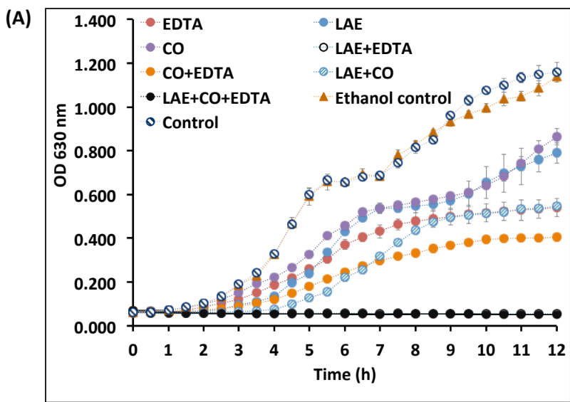

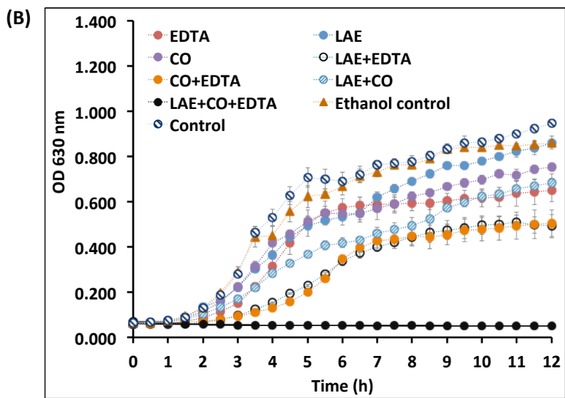
Figure 3.1. continued

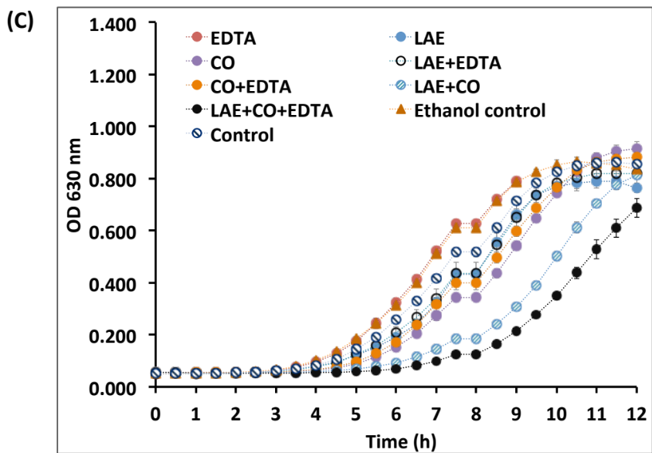
Figure 3.1. continued

Figure 3.2. Uptake% of crystal violet by (A) Escherichia coli O157:H7 ATCC 43895, (B) Salmonella Enteritidis, and (C) Listeria monocytogenes Scott A in 0.1 M PBS (pH 7.4) at 37°C (for E.coli O157:H7 and S. Enteritidis) or 32°C (for L. monocytogenes) after 2 h treatment with 5ppm lauric arginate (LAE), 500 ppm EDTA, and 200 ppm cinnamon oil (CO) alone or in combinations. Errors are standard deviations (n =3). Different letters above bars indicate significant difference of treatments in the same plot.
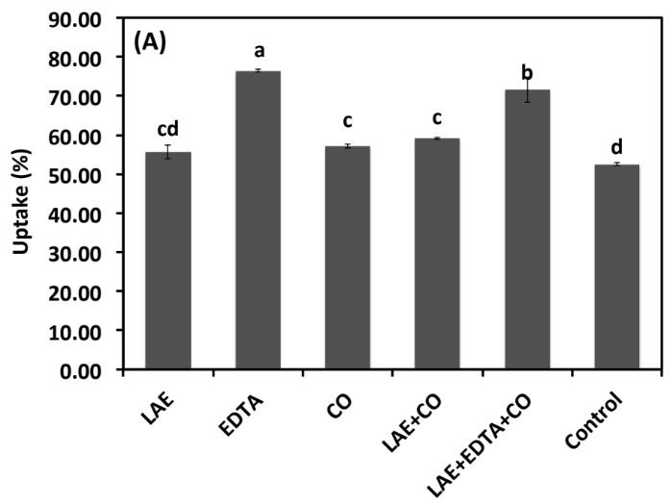

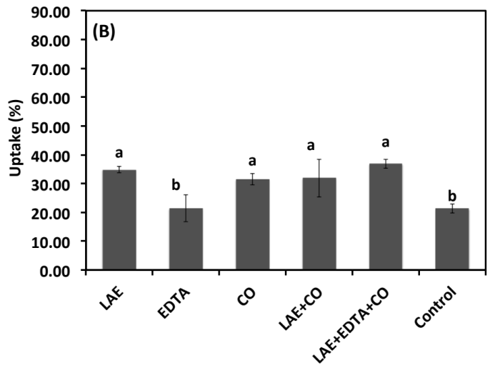
Figure 3.2. continued

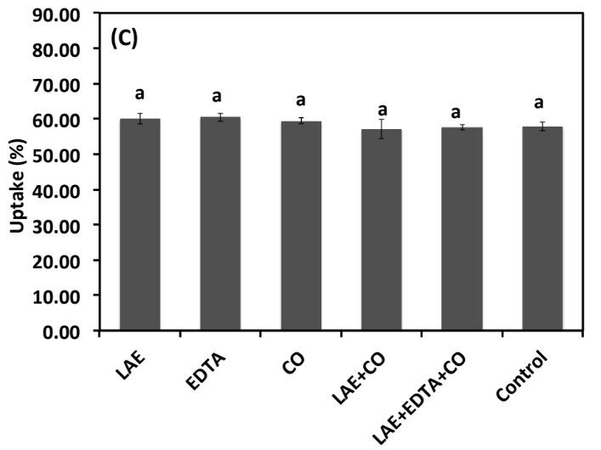
Figure 3.2. continued

Fig. 3.3. Absorbance at 260 nm (A₂₆₀) of extracellular contents after treating (A) Escherichia coli O157:H7 ATCC 43895 and (B) Salmonella Enteritidis at 37°C, and (C) Listeria monocytogenes Scott A at 32°C in 10 mM Tris-HCl (pH 7.2) for 2 h with 10 ppm lauric arginate (LAE), 1000 ppm EDTA, and 400 ppm cinnamon oil (CO) alone or in combinations. Errors are standard deviations (n =3). Different letters above bars indicate significant difference of treatments in the same plot.

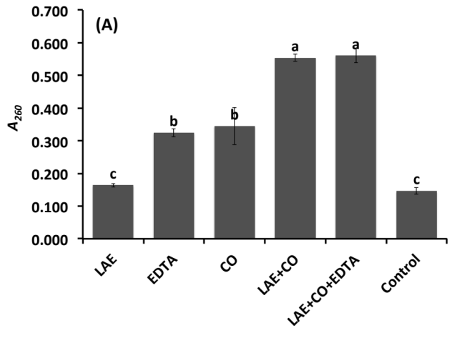

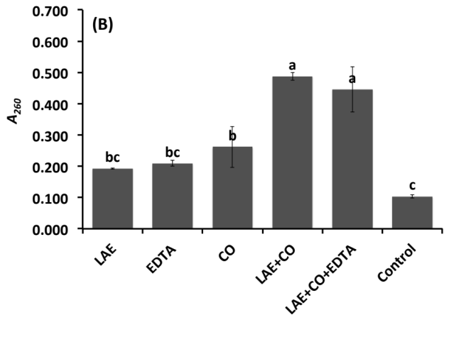
Figure 3.3. continued

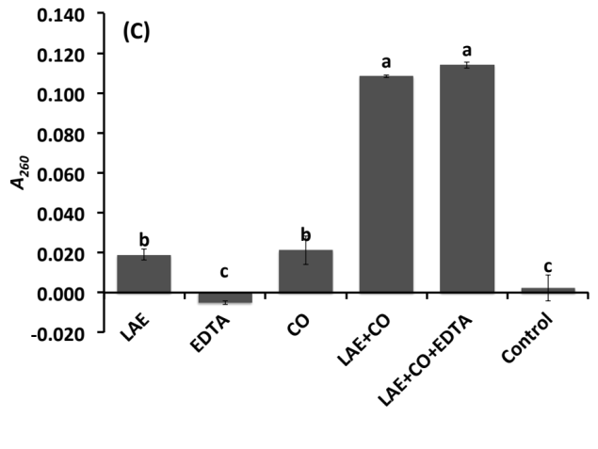
Figure 3.3. continued

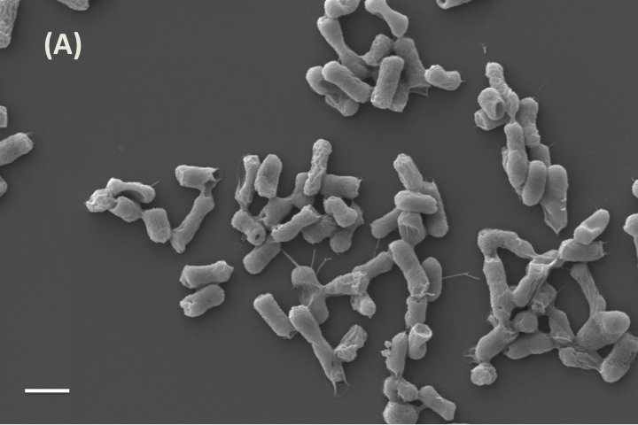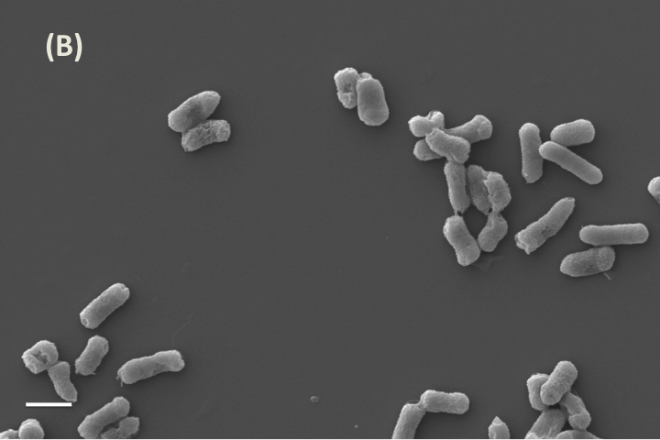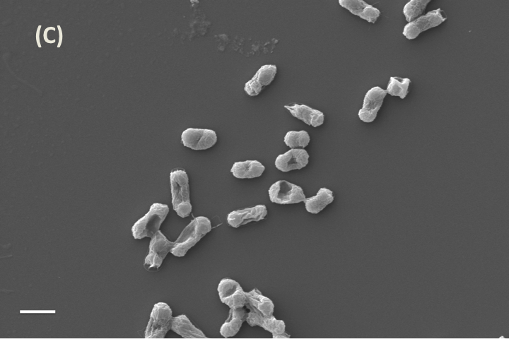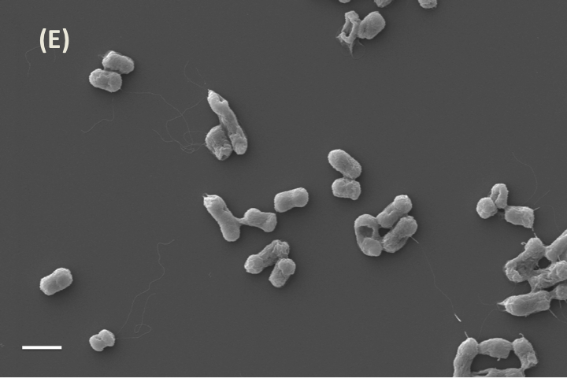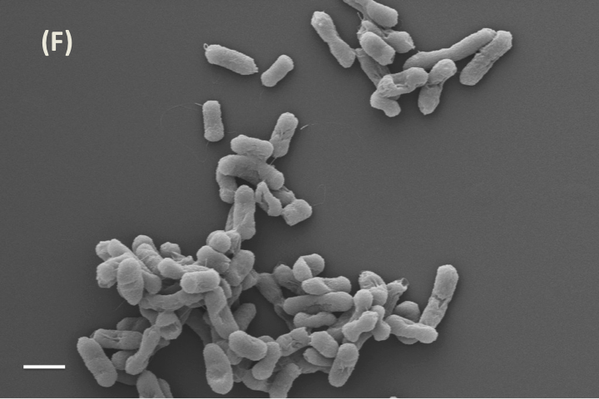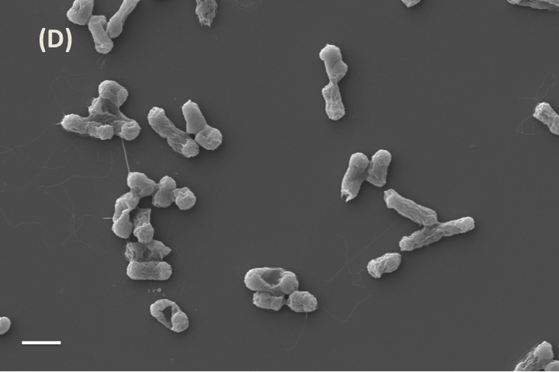
Figure 3.4. SEM images of Salmonella Enteritidis after treatment by (A) 40 ppm lauric arginate (LAE), (B) 1,000 ppm EDTA, (C) 600 ppm cinnamon oil (CO), (D) 40 ppm LAE+600 ppm CO, or (E) 40 ppm LAE+600 ppm CO+1,000 ppm EDTA at 37°C for 2 h, with comparison to the untreated sample (F). Bar = 1 μm.

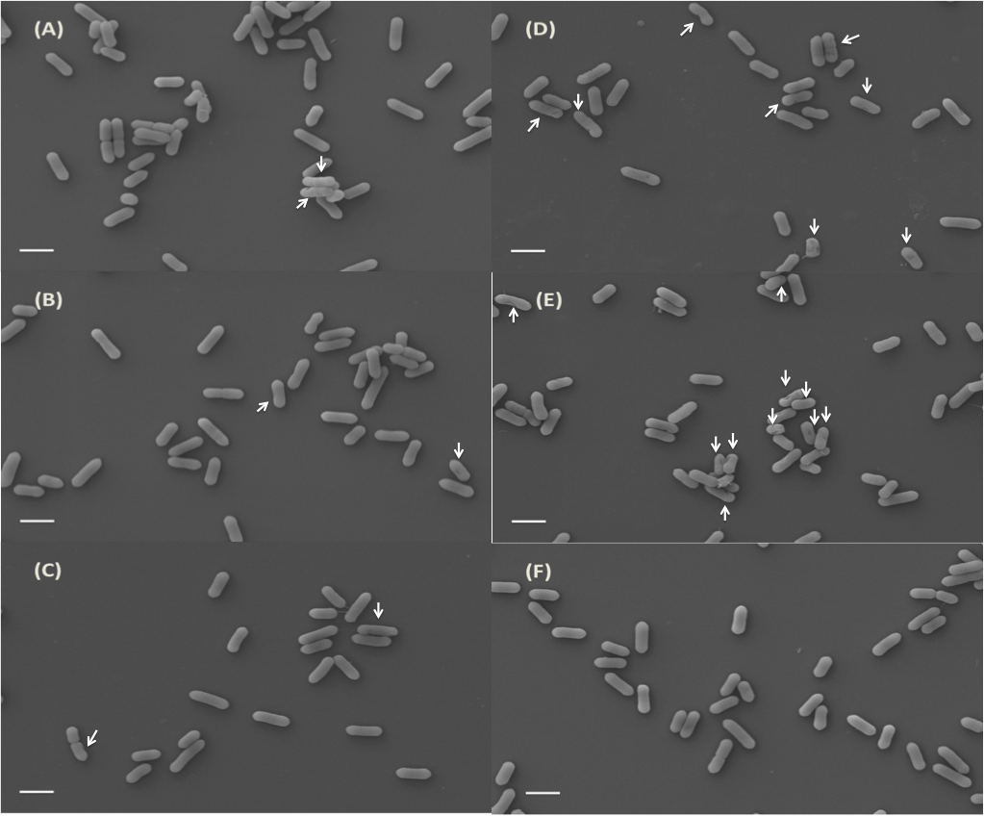
Figure 3.5. SEM images of Listeria monocytogenes Scott A after treatment by (A) 40ppm lauric arginate (LAE), (B) 1,000 ppm EDTA, (C) 600 ppm cinnamon oil (CO), (D) 40 ppm LAE+600 ppm CO, and (E) 40 ppm LAE+600 ppm CO+1,000 ppm EDTA, at 32°C for 2, h, with comparison to the untreated sample (F). Arrows indicated disrupted cells. Bar = 1 μm.

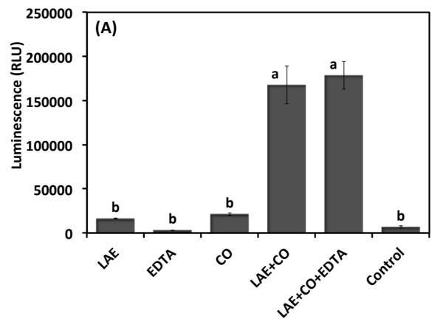
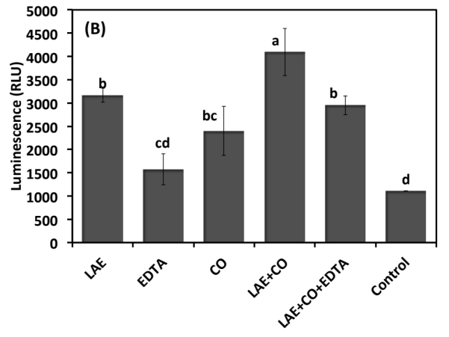
Figure 3.6. Luminescence showing extracellular ATP content of (A) Listeria monocytogenes Scott A at 37°C and (B) Salmonella Enteritidis at 32°C after 30 min incubation in tryptic soy broth with 5 ppm lauric arginate (LAE), 500 ppm EDTA, and 200 ppm cinnamon oil (CO) alone or in combinations.

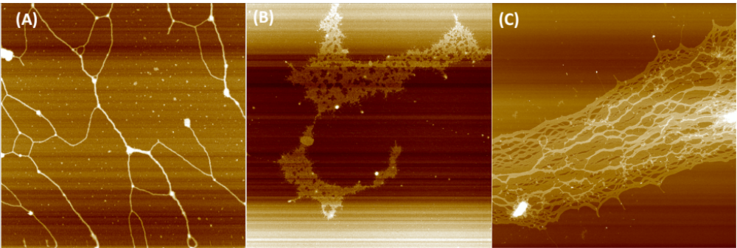
Figure 3.7. AFM images of Listeria monocytogenes Scott A (A-C, G) and Salmonella Enteritidis DNA (D-F, H) before (A and D) and after treatment by 10 ppm (B and E), 50 ppm (C and F) LAE or 100 ppm cinnamon oil (G and H). Image dimensions are 10 μm ×10 μm.

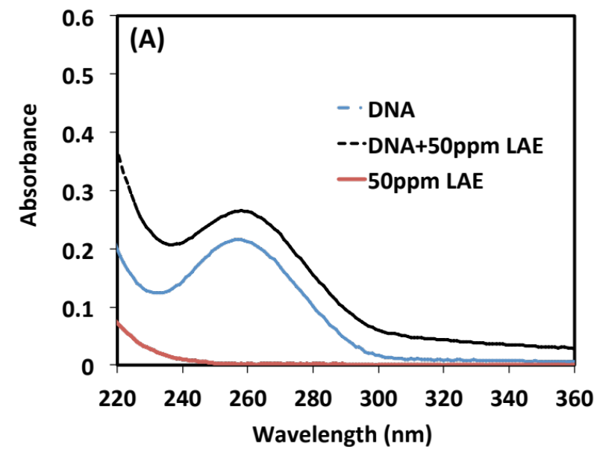
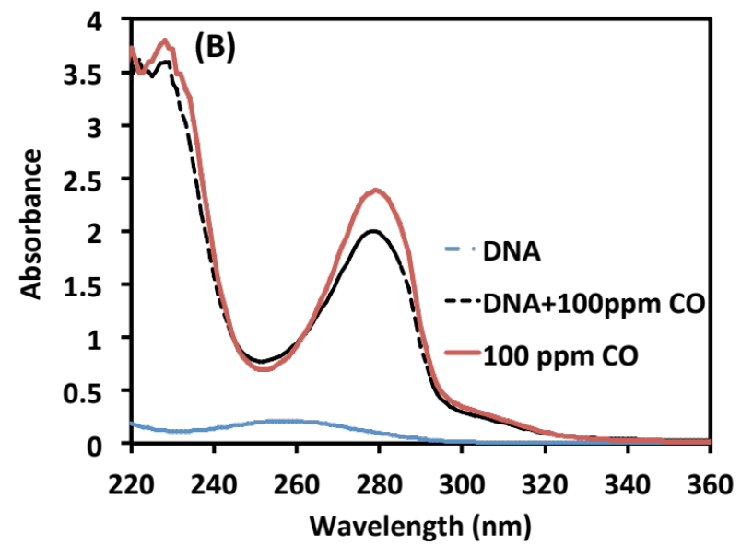

Figure 3.8. Absorbance spectra of Salmonella Enteritidis DNA with the addition of (A) 50 ppm lauric arginate (LAE) or (B) 100 ppm cinnamon oil (CO).

Chapter 4. Physical and antimicrobial properties of chitosan films incorporated with lauric arginate, cinnamon oil, and ethylenediaminetetraacetate

4.1. Abstract
Lauric arginate (LAE) and cinnamon oil (CO) are efficacious antimicroibials, and their combination results in synergistic and antagonistic effects against Gram-positive and Gram-negative bacteria, respectively. We recently observed that the antagonistic effect can be overcome by ethylenediaminetetraacetate (EDTA). The objective of this work was to study physical and antimicrobial properties of chitosan films with LAE, CO, and EDTA. A significant increase in the thickness was detected after incorporating antimicrobials in chitosan films. The yellowness of films increased, while water solubility decreased as the concentration of CO increased. Water vapor permeability of films was similar with or without antimicrobials. Incorporation of antimicrobials in chitosan films lowered the tensile strength but did not affect elongation%. Much larger inhibition zones of film discs with antimicrobials against foodborne pathogens were detected compared to that of chitosan film only. Overall, these novel antimicrobial films with LAE, CO, and EDTA showed great potential to improve the safety of food products.
Keywords: Chitosan films; lauric arginate; cinnamon oil; EDTA; physical and antimicrobial properties

4.2. Introduction
Antimicrobial films/coatings are potential intervention strategies to control foodborne pathogens contaminating food products (Chen et al., 2012; Higueras et al., 2013). Natural antimicrobials have received particular interest because they are perceived by consumers to be safe and healthy. Examples of natural antimicrobials include essential oils (EOs) which showed great antimicrobial activities, such as eugenol, cinnamon oil (CO) and thyme oil (Chen et al., 2015; Ma et al., 2013; Pan et al., 2014; Xue and Zhong, 2014). Therefore, antimicrobial films/coatings incorporated with natural EOs have been investigated by many researchers (Hosseini et al., 2009; Wang et al., 2011; Zivanovic et al., 2005). A coating solution consisting of 2% w/v chitosan and 1.5% v/v CO maintained the total viable aerobic bacterial counts on rainbow trout fillets below 6 log₁₀ CFU/g over 16-day storage at 4 ± 1 °C (Ojagh et al., 2010b). Coatings with 1% w/w chitosan and 3% w/w lemon oil significantly reduced the fungal decay percentage of strawberries stored at 5°C after 3 days, when compared to that of uncoated strawberries (Perdones et al., 2012).
Lauric arginate (ethyl-N^{α}-lauroyl-L-arginine ethyl ester monohydrochloride; LAE) is another effective antimicrobial that has been approved by the United States Food and Drug Administration as a generally-recognized-as-safe food additive (USDA, 2005). LAE is a cationic surfactant derived from lauric acid, L-arginine and ethanol, has a low toxicity (Ruckman et al., 2004), and is highly efficacious in inhibiting foodborne pathogens (Ma et al., 2013). The minimum inhibitory concentration (MIC) of LAE against ca. 6 log CFU/mL Listeria monocytogenes in tryptic soy broth (TSB) at 32°C was determined to be 11.8 ppm (Ma et al., 2013). Applying a solution with 22 ppm LAE on the surface of frankfurters resulted in more than 1 log₁₀ CFU/cm² reduction of L. monocytogenes within 12 h at 4°C (Martin et al., 2009).
Because LAE has a bitter taste and EOs have strong aroma, combination of these antimicrobials may lower the concentrations of individual antimicrobials if they have synergistic activities. We recently showed that the combination of LAE and EOs had the synergistic activity inhibiting Gram-negative L. monocytogenes but had the antagonistic effect against Gram-negative Escherichia coli O157:H7 and Salmonella Enteritidis (Ma et al., 2013). In our preliminary studies, addition of 500 ppm ethylediaminetetraacetate (EDTA) in the mixture of 200 ppm cinnamon oil (CO) and 5ppm LAE resulted in much enhanced activity against both L. monocytogenes Scott A, E. coli O157:H7 and S. Enteritidis. EDTA is a safe and economical additive that chelates divalent cations (Ca²⁺ and Mg²⁺) that are important to the structures of outer membranes of Gram-negative bacteria (Vaara, 1992), which enhances the activity of several antimicrobials (Branen and Davidson, 2004) and may have overcome the antagonistic activity of LAE-EO combination. This novel combination may be used in various applications to improve food safety.
The object of the present study was to study physical and antimicrobial properties of cast chitosan films incorporated with LAE, CO, and EDTA. Chitosan was studied as film-forming biopolymer because chitosan is an excellent film-forming material and chitosan films have good mechanical properties (Elsabee and Abdou, 2013). Additionally, chitosan itself has antibacterial and antifungal activity (Kim et al., 2003; Tsai et al., 2002).

4.3. Materials and Methods

4.3.1. Materials
Chitosan (low molecular weight, 75-85% deacetylated), CO, and EDTA were purchased from Sigma-Aldrich Corp. (St. Louis, MO). The commercial LAE with a name of CytoGuard LA was kindly provided by A&B Ingredients (Fairfield, NJ). The product contained 10% w/w LAE and 90% propylene glycol. Acetic acid and TSB were procured from Thermo Fisher Scientific, Inc. (Waltham, MA).

4.3.2. Film preparation
The chitosan stock solution was prepared by dissolving 2% w/w chitosan powder in 1% w/w acetic acid solution and stirring overnight on a magnetic stir plate at a low speed. The impurities were removed by filtering the solution through a microcloth (Calbiochem-Novabiochem Corp., San Diego, CA). LAE, EDTA, and CO were then directly added into the chitosan stock solution by mixing on a magnetic stir plate at room temperature (21°C) until visually homogeneous. The final film-forming mixtures after supplementing deionized water contained 1% w/w chitosan, 0.5% w/w acetic acid, 0, 0.1 or 0.2% w/w LAE, 0 or 0.25% w/w EDTA, and 0, 0.5, or 1% w/w CO. Films were prepared by casting 30 g film-forming mixtures on 17.8 cm × 17.8 cm glass plates and drying at ambient conditions (21°C) for 24 h. After peeling, films were conditioned at 57% relative humidity (RH) controlled by a saturated sodium bromide solution in a desiccator for 48 h at 21°C before characterizations. Films prepared with 1 % w/w chitosan, 0.5% w/w acetic acid were treated as the control.

4.3.3. Physical and mechanical properties of films

4.3.3.1. Thickness
A digital microcaliper (Mitutoyo Corp., Kawasaki, Japan) was used to measure the thickness of chitosan films. The microcaliper had a precision of 0.001 mm. Twelve locations on various regimes of films were measured for each film and means and standard deviations were reported.
4.3.3.2. Color
Lightness (L) and chromaticity parameters a (red-green) and b (yellow-blue) in the Hunter Lab scale were measured in triplicate using a MiniScan XE Plus Hunter colorimeter (Hunter Associates Laboratory, Inc., Reston, VA) for each film. Color differences (ΔE) based on the standard white plate were calculated using Eq. (1) (Hosseini et al., 2009).
$ΔE=\sqrt{{(a^{*}-a)}^{2}+{(b^{*}-b)}^{2}+{(L^{*}-L)}^{2}}$ (1)
where a, b, and L are the color parameter values of the film, and a* (-1.11), b* (0.57) and L* (93.82) are the color parameter values of the standard white plate.

4.3.3.3. Moisture content and water solubility
To determine the moisture content and water solubility of films, 2×2 cm film squares were prepared and weighed (w₀). Film squares were then put in an oven and dried at 60°C for 24 h to constant mass (Jiménez et al., 2012). After cooling to room temperature in a desiccator filled with anhydrous calcium chloride, film squares were weighed again (w₁). Moisture content was then calculated based on Eq. (2). Water solubility of films was measured by immersing the film squares into deionized water for 2 h at room temperature. After removing free water, film discs were put into an oven and dried at 60°C for 24 h. Total solids mass of film discs was recorded after cooling to room temperature in a desiccator (w₃). Water solubility was calculated based on Eq. (3) (Rotta et al., 2009). Three film replicates prepared from each formulation were tested.
$Moisture\left(\%\right)=\frac{w_{0}-w_{1}}{w_{1}}× 100\%$ (2)
$Water solubility \left(\%\right)=(1-\frac{w_{3}}{w_{0}×\left(100\%-moisture\%\right)})×100\%$ (3)

4.3.3.4. Water vapor permeability (WVP)
The WVP of films was measured using Fisher/Payne permeability cups with an opening area of 9.61 cm² (Fisher Scientific, Pittsburgh, PA). Films were sealed on cups which were pre-filled with 5.0 g deionized water (Zivanovic et al., 2005) and then cups were placed in a desiccator with 57% RH at room temperature (21°C). The cup mass was measured every hour up to 8 h with a precision of 0.0001 g. Water vapor permeation ratio (WVPR) was calculated based on the mass changes (M) over time (T) and effective film area (A) according to Eq. (4), while WVP was calculated using Eq. (5) (Pelissari et al., 2009). Measurements were performed in triplicate.
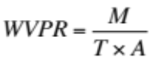 (4)
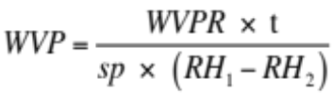 (5)
where t is the thickness of films, RH₁ and RH₂ are the RH inside (100%) and outside (57%) the cup, and sp is the water vapor saturation pressure at the test temperature (Pa).

4.3.3.5. Tensile strength and elongation
A TA.XTplus Texture Analyzer (Texture Technologies Corp., Scarsdale, NY) was used to determine the tensile strength and elongation at break of films. 10 cm×1 cm film strips were prepared and tested with an initial gap of 8 cm, and the test speed was 1 mm/s. Elongation at break was calculated as the percentage of extension at break with respect to the original strip length, and tensile strength (Pa) was determined by dividing the maximum force by the cross-section area of each film strip (Pranoto et al., 2005).

4.3.3.6. Scanning electron microscopy (SEM)
Surface morphology of films was observed using a LEO 1525 surface scanning electron microscope (LEO Electron Microscopy, Oberkochen, Germany). A small piece of film was mounted on the specimen holder and imaged without gold coating at a voltage of 1000 V.

4.3.4. Residual content of cinnamon oil in the films
To measure the residual content of CO in the films after drying, 2×2 cm film squares were prepared and placed into 20 mL glass vials containing 20 mL hexane, and extracted overnight by stirring on a magnetic stir plate (Chi et al., 2006). After centrifugation at 11,337×g for 5 min, the absorbance of the supernatant at 280 nm (A₂₈₀) was measured using a UV-Vis spectrophotometer (model Evolution 201, Thermo Scientific, Waltham, MA). A standard curve was constructed from A₂₈₀ of CO standard solutions in hexane to determine CO content in films (Pan et al., 2014). Six squares from two films were measured for each film formulation.

4.3.5. Bacteria culture
Three bacteria cocktails consisting of equal populations of 5 test strains/serovars were used in the microbiological tests. The composition of each cocktail was listed as following: (1) E. coli O157: H7 cocktail: H1730, F4546, K3995, 658 and 932; (2) S. enterica cocktail: S. Agona, S. Montevideo, S. Gaminara, S. Michigan and S. Saint Paul; (3) L. monocytogenes cocktail: LM1, LM2, 310, Scott A and V7. TSB was used for S. enterica and E. coli O157:H7, and TSB supplemented with yeast extract (TSBYE) was used for the growth of L. monocytogenes. Before mixing, each strain was transferred in broth for at least 2 times at 32°C (L. monocytogenes) or 37°C (S. enterica and E. coli O157:H7) with an interval of 24 h. Then cocktails were generated by mixing 2 mL culture from each strain and diluted in TSB or TSBYE to ca.10⁶ CFU/mL before tests.

4.3.6. Antimicrobial properties of films
Disk diffusion method was used to evaluate antimicrobial properties of films (Zivanovic et al., 2005). Tryptic soy agar (TSA) or TSA supplemented with yeast extract (TSAYE, for L. monocytogenes) plates was spread with 200 μL culture with 10⁶ CFU/mL of bacteria cocktail. Films were cut into 10 mm circular discs and two discs of each film were placed on each plate. After incubation for 24 and 48 h at 32°C (L. monocytogenes) or 37°C (E. coli O157: H7 and S. enterica), the diameter (mm) of inhibition zones was then measured using a ruler. Mean values of inhibition zone diameters from two films with two discs each (n = 4) were reported.
Antimicrobial activity of the films in liquid medium was also tested. 1×1 cm² film squares were prepared, and one piece of each film squares was added into 10 mL TSB containing ca. 10⁶ CFU/mL S. enterica or 10 mL TSBYE containing ca.10⁶ CFU/mL L. monocytogenes, viable cells were enumerated after 24-h incubation at 32°C (for L. monocytogenes) or 37°C (for S. enterica). Experiments were performed in triplicate.

4.3.7. Statistical analysis
Variance analysis of experiment data was performed using Tukey's test in SPSS 20 (IBM, Armonk, NY) at a 5% significance level.

4.4. Results and Discussions

4.4.1. Thickness and color of films
The thickness and color of films are shown in Table 4.1. Control chitosan films were significantly thinner (0.010 mm) than films incorporated with antimicrobials (p < 0.05), which was in agreement with other studies when incorporating antimicrobials in a film matrix (Hosseini et al., 2009; Ojagh et al., 2010a). The thickness of films with antimicrobials varied from 0.017 mm to 0.020 mm, but no significant differences were detected among films prepared with various amounts of antimicrobials. No difference of thickness among chitosan films incorporated with 0.8-2% CO was also reported in a previous study (Ojagh et al., 2010a).
No difference was detected in lightness (L) and greenness (a) of films, as shown in Table 1. Compared to control chitosan film, increasing the concentration of CO in the film significantly increased the yellowness (b) of films, from 1.27 for the control film to about 7 for the film prepared with 1% CO. The increased yellowness may be due to yellow pigments in CO. Correspondingly, the color difference (ΔE) was significantly higher in films with 1% CO than that of other films. The results agreed with a previous study that reported the significantly increased yellowness after incorporating 1% CO in chitosan films (Peng and Li, 2014).

4.4.2. Water barrier properties of films
Moisture content, water solubility, and WVP of films are summarized in Table 4.2. The control chitosan film had the lowest moisture content (13.65%). With the addition of 0.2% LAE and 0.25% EDTA, the moisture content of films significantly increased (19.89%). This may resulted from the amphipathic nature of LAE, as indicated by the oil-water partition coefficient of LAE being greater than 10 which means LAE has high affinity with water molecules (Gil Bakal, 2005). For films prepared with a higher concentration of CO, the measured moisture content was higher and the difference became significant between the film prepared with 1% CO and the control film. Because CO is volatile and can be evaporated during drying at 60°C, the moisture content was overestimated.
The control chitosan film was totally dissolved after immersion in deionized water for 2 h at room temperature (Table 4.2). With the addition of antimicrobials, the water resistance of films increased significantly. The increased content of CO in films prepared with 0.2% LAE and 0.25% EDTA significantly reduced the water solubility of chitosan films. Similar results about the decreased water solubility of chitosan films after incorporating a greater amount of EO have been reported by other researchers (Hosseini et al., 2009). No significant differences of water solubility were observed for films prepared with 0.1% LAE and 0.5% or 1% CO, while a significantly lower water solubility was observed in the film prepared with 0.2% LAE and 1% CO than that prepared with 0.2% LAE and 0.5% CO. This may due to the better retention of CO in chitosan films when the concentration of LAE was higher (Table 4.3).
As shown in Table 4.2, WVP of films with antimicrobials (up to 9.3×10⁻¹¹ g/Pa m s) was significantly higher than the control chitosan film (6.7×10⁻¹¹ g/Pa m s). Chitosan films are formed by intra- and intermolecular hydrogen bonding between chitosan molecules (Gartner et al., 2011). Incorporation of antimicrobials in chitosan films may break hydrogen bonding and disrupt the long-range ordering of chitosan molecules, resulting in the increased WVP of films (Hosseini et al., 2009). Additionally, a higher thickness of films with other antimicrobials can increase WVP (Eq. 5), as reported in other studies (Bertuzzi et al., 2007; Longares et al., 2004).

4.4.3. Mechanical properties of films
The tensile strength and elongation% at break of films are shown in Table 4.4. The control chitosan film had a much higher tensile strength (ca. 486 MPa) than films incorporated with antimicrobials (< 321 MPa). This may result from the interruption of ordered structures in chitosan films by antimicrobials (Hosseini et al., 2009), as discussed above. The lowest tensile strength was observed in the film prepared with 0.2% LAE and 0.5% CO. Since LAE is a cationic surfactant, it is expected to emulsify CO as positively-charged oil droplets. The mass ratio of surfactant to oil was the highest in this film, and the smallest droplets may be distributed most uniformly to disrupt the matrix of positively-charged chitosan molecules to lower the tensile strength.
The elongation% at break was the highest for the film prepared with 0.2% LAE without CO, while there was no difference among other treatments (P > 0.05), which may due to the uniformly distributed positive charged LAE molecules in chitosan matrix. Films with 0.2% LAE also had a higher amount of propylene glycol (90% in the commercial LAE product) that is a known plasticizer with the ability to increase the elongation% of chitosan films (Suyatma et al., 2005).

4.4.4. Surface morphology of films
SEM images of films with or without antimicrobials are presented in Fig. 4.1. The surface of control chitosan film was very smooth and uniform (Fig. 4.1A). The ordered structure of chitosan film was interrupted by the addition of LAE and EDTA (Fig. 4.1B and E). Separated structures were shown on the surface of chitosan films with 0.1 or 0.2% LAE and 0.25% EDTA. Small oil droplets were observed in the film with 0.1% LAE and 0.5% CO (Fig. 4.1C), and large oil droplets were shown when CO concentration increased to 1% (Fig. 4.1D). In addition to the need of a sufficient amount of surfactant (LAE) to emulsify CO, coalescence of oil droplets can occur during drying to form films. Small, abundant, and non-uniform structures were seen in the film with 0.2% LAE and 0.5% CO (Fig. 4.1E), which had the highest surfactant:oil mass ratio and may form the most abundant and smallest droplets repelled by chitosan, as discussed previously. Compared to the 0.1% LAE treatment (Fig. 4.1D), a higher amount of LAE (0.2%) resulted in smaller oil droplets in the film prepared with 1% CO (Fig. 4.1F).

4.4.5. Residual content of cinnamon oil in the films
The residual amount of CO decreased in the order of film with 0.2% LAE and 1% CO > film with 0.1% LAE and 1% CO> film with 0.2% LAE and 0.5% CO > film with 0.1% LAE and 0.5% CO (Table 4.4). About 50% of CO remained in the film after drying the mixture with 0.2% LAE and 1% CO, which was significantly higher than 34% of the film prepared with 0.1% LAE and 1% CO. Similarly, for the films with 0.5% CO, a higher amount of LAE significantly improved the residual percentage of CO, which was 21% and 6.75% for 0.2% and 0.1% LAE treatments, respectively. Thus, increasing the concentration of surfactant (LAE) significantly increased the residual content of CO in the films.

4.4.6. Antimicrobial properties of films
The diameters of inhibition zones of film discs are presented in Table 4.5. No bacteria growth was observed under films discs prepared with chitosan only. Large inhibition zones around film discs with the antimicrobials were observed, and the differences were insignificant after 24 and 48 h (p > 0.05), which showed the constant inhibition effect of films incorporated with the tested antimicrobials. Overall, the antimicrobial film discs produced a higher inhibition effect against L. monocytogenes than S. enterica and E. coli O157:H7, which agreed with a study for chitosan-based films with 0.693%, 3.465% and 6.930% (dry weight basis) of LAE (Higueras et al., 2013).
The film discs with 0.1% LAE and 0.25% EDTA showed significantly larger inhibition zone in inhibiting all three bacteria than film discs with 0.1% LAE only after 24-h incubation. In our separate study to be published elsewhere, EDTA was observed to enhance the antimicrobial activity of LAE. Similarly, films discs with 0.2% LAE and 0.25% EDTA had significantly larger inhibition zones against L. monocytogenes than film discs with 0.2% LAE only either after 24 or 48-h incubation. However, no significant differences in inhibition zones were found when S. enterica or E. coli O157:H7 were treated by film discs containing 0.2% LAE with or without 0.25% EDTA. This may be due to the negligible improvement in activities by EDTA at a high LAE content (0.2%) or higher resistance to EDTA of Gram-negative bacteria (Branen and Davidson, 2004). Compared to film discs with LAE and EDTA without CO, film discs with CO did not show significantly larger inhibition zone in many treatments. This may have been caused by slower diffusion of hydrophilic LAE and EDTA into TSA matrix after incorporation of hydrophobic CO, as discussed previously for water solubility (Table 4.2). Nonetheless, large inhibition zones were observed around film discs with LAE, EDTA and CO, which indicated the promising effectiveness of the films in improving the safety of food products.
Similar results were shown in the antimicrobial test conducted in liquid medium, the viable cells were the least in treatment with film squares containing LAE and EDTA (Table 4.6). Viable cells of L. monocytogenes after treatments are following the increase order of treatment with film containing LAE and EDTA, and treatment with film containing LAE, EDTA and 0.5% CO < treatment with film containing LAE alone < treatment with film containing LAE, EDTA and 1% CO. For S. enterica, viable cells are the least in treatment with film containing LAE alone or in combination with EDTA; followed by the treatment with film containing LAE, EDTA and 0.5% CO and the treatment with film containing LAE, EDTA and 1% CO. Insignificant difference between treatment with film containing LAE alone or in combination with EDTA may be due to the higher resistance of S. enterica to EDTA (Branen and Davidson, 2004). The increased number of viable bacteria cells with increasing concentration of CO indicated the effect of CO on slowing the diffusion of hydrophilic antimicrobials. Besides, the highest residual amount of CO was 48 mg/ cm² (Table 4.3), which was not be enough to exert the bactericidal activity, since the minimum inhibitory concentration of CO against the foodborne pathogens was 750 ppm in TSB (Ma et al., 2013).

4.5. Conclusions
Physical and antimicrobial properties of chitosan films were affected to different extent after incorporation with different amounts of LAE, EDTA and CO. With the addition of CO, the water solubility of films significantly decreased, which suggested the increased water-resistance of films. No significant differences of WVP were detected between control chitosan film and those with additional antimicrobials. The tensile strength of films significantly decreased after addition of the antimicrobials, while no significant differences were observed in elongation% among most films. Strong antimicrobial activities of the films incorporated with antimicrobials were detected against both Gram-positive and Gram-negative bacteria after 24 and 48 h. The enhanced antimicrobial activity was observed when incorporating EDTA in films prepared with 0.1% LAE. However, addition of CO in the film-forming mixtures resulted in a slower release of the LAE. Therefore, in the perspective of high antimicrobial efficacy in short time, the film-forming mixtures may be more suitable to be applied as antimicrobial coatings to improve the safety of food products.

References
Bertuzzi, M., Castro Vidaurre, E., Armada, M., Gottifredi, J., 2007. Water vapor permeability of edible starch based films. Journal of Food Engineering 80, 972-978.
Branen, J.K., Davidson, P.M., 2004. Enhancement of nisin, lysozyme, and monolaurin antimicrobial activities by ethylenediaminetetraacetic acid and lactoferrin. International Journal of Food Microbiology 90, 63-74.
Chen, H., Zhang, Y., Zhong, Q., 2015. Physical and antimicrobial properties of spray-dried zein–casein nanocapsules with co-encapsulated eugenol and thymol. Journal of Food Engineering 144, 93-102.
Chen, W., Jin, T.Z., Gurtler, J.B., Geveke, D.J., Fan, X., 2012. Inactivation of Salmonella on whole cantaloupe by application of an antimicrobial coating containing chitosan and allyl isothiocyanate. International Journal of Food Microbiology 155, 165-170.
Chi, S., Zivanovic, S., Penfield, M., 2006. Application of chitosan films enriched with oregano essential oil on bologna–active compounds and sensory attributes. Food Science and Technology International 12, 111-117.
Elsabee, M.Z., Abdou, E.S., 2013. Chitosan based edible films and coatings: a review. Materials Science and Engineering: C 33, 1819-1841.
Gartner, C., López, B.L., Sierra, L., Graf, R., Spiess, H.W., Gaborieau, M., 2011. Interplay between structure and dynamics in chitosan films investigated with solid-state NMR, dynamic mechanical analysis, and X-ray diffraction. Biomacromolecules 12, 1380-1386.
Gil Bakal, A.D., 2005. The lowdown on lauric arginate: Food antimicrobial eats at plasma membrane, disrupting a pathogen's metabolic process. Food Quality and Safety.
Higueras, L., López-Carballo, G., Hernández-Muñoz, P., Gavara, R., Rollini, M., 2013. Development of a novel antimicrobial film based on chitosan with LAE (ethyl-N^{α}-dodecanoyl-l-arginate) and its application to fresh chicken. International Journal of Food Microbiology 165, 339-345.
Hosseini, M., Razavi, S., Mousavi, M., 2009. Antimicrobial, physical and mechanical properties of chitosan-based films incorporated with thyme, clove and cinnamon essential oils. Journal of Food Processing and Preservation 33, 727-743.
Jiménez, A., Fabra, M.J., Talens, P., Chiralt, A., 2012. Effect of re-crystallization on tensile, optical and water vapour barrier properties of corn starch films containing fatty acids. Food Hydrocolloids 26, 302-310.
Kim, K.W., Thomas, R., Lee, C., Park, H.J., 2003. Antimicrobial activity of native chitosan, degraded chitosan, and O-carboxymethylated chitosan. Journal of Food Protection® 66, 1495-1498.
Longares, A., Monahan, F., O’riordan, E., O’sullivan, M., 2004. Physical properties and sensory evaluation of WPI films of varying thickness. LWT-Food Science and Technology 37, 545-550.
Ma, Q., Davidson, P.M., Zhong, Q., 2013. Antimicrobial properties of lauric arginate alone or in combination with essential oils in tryptic soy broth and 2% reduced fat milk. International Journal of Food Microbiology 166, 77-84.
Martin, E., Griffis, C., Vaughn, K., O'Bryan, C., Friedly, E., Marcy, J., Ricke, S., Crandall, P., Lary Jr, R., 2009. Control of Listeria monocytogenes by lauric arginate on frankfurters formulated with or without lactate/diacetate. Journal of Food Science 74, M237-M241.
Ojagh, S.M., Rezaei, M., Razavi, S.H., Hosseini, S.M.H., 2010a. Development and evaluation of a novel biodegradable film made from chitosan and cinnamon essential oil with low affinity toward water. Food Chemistry 122, 161-166.
Ojagh, S.M., Rezaei, M., Razavi, S.H., Hosseini, S.M.H., 2010b. Effect of chitosan coatings enriched with cinnamon oil on the quality of refrigerated rainbow trout. Food Chemistry 120, 193-198.
Pan, K., Chen, H., Davidson, P.M., Zhong, Q., 2014. Thymol nanoencapsulated by sodium caseinate: physical and antilisterial properties. Journal of Agricultural and Food Chemistry 62, 1649-1657.
Pelissari, F.M., Grossmann, M.V., Yamashita, F., Pineda, E.A.G., 2009. Antimicrobial, mechanical, and barrier properties of cassava starch− chitosan films incorporated with oregano essential oil. Journal of Agricultural and Food Chemistry 57, 7499-7504.
Peng, Y., Li, Y., 2014. Combined effects of two kinds of essential oils on physical, mechanical and structural properties of chitosan films. Food Hydrocolloids 36, 287-293.
Perdones, A., Sánchez-González, L., Chiralt, A., Vargas, M., 2012. Effect of chitosan–lemon essential oil coatings on storage-keeping quality of strawberry. Postharvest Biology and Technology 70, 32-41.
Pranoto, Y., Salokhe, V.M., Rakshit, S.K., 2005. Physical and antibacte rial properties of alginate-based edible film incorporated with garlic oil. Food Research International 38, 267-272.
Rotta, J., Ozório, R.Á., Kehrwald, A.M., de Oliveira Barra, G.M., Amboni, R.D.d.M.C., Barreto, P.L.M., 2009. Parameters of color, transparency, water solubility, wettability and surface free energy of chitosan/hydroxypropylmethylcellulose (HPMC) films plasticized with sorbitol. Materials Science and Engineering: C 29, 619-623.
Ruckman, S.A., Rocabayera, X., Borzelleca, J.F., Sandusky, C.B., 2004. Toxicological and metabolic investigations of the safety of N-α-Lauroyl-l-arginine ethyl ester monohydrochloride (LAE). Food and Chemical Toxicology 42, 245-259.
Suyatma, N.E., Tighzert, L., Copinet, A., Coma, V., 2005. Effects of hydrophilic plasticizers on mechanical, thermal, and surface properties of chitosan films. Journal of Agricultural and Food Chemistry 53, 3950-3957.
Tsai, G.J., Su, W.H., Chen, H.C., Pan, C.L., 2002. Antimicrobial activity of shrimp chitin and chitosan from different treatments and applications of fish preservation. Fisheries Science 68, 170-177.
USDA, 2005. Agency Response Letter GRAS Notice No. GRN 000164.
Vaara, M., 1992. Agents that increase the permeability of the outer membrane. Microbiological Reviews 56, 395-411.
Wang, L., Liu, F., Jiang, Y., Chai, Z., Li, P., Cheng, Y., Jing, H., Leng, X., 2011. Synergistic antimicrobial activities of natural essential oils with chitosan films. Journal of Agricultural and Food Chemistry 59, 12411-12419.
Xue, J., Zhong, Q., 2014. Thyme oil nanoemulsions coemulsified by sodium caseinate and lecithin. Journal of Agricultural and Food Chemistry 62, 9900-9907.
Zivanovic, S., Chi, S., Draughon, A.F., 2005. Antimicrobial activity of chitosan films enriched with essential oils. Journal of Food Science 70, M45-M51.

Appendix

Table 4.1. Thickness and color of films prepared from mixtures containing 1% w/w chitosan, 0.25% w/w EDTA, and various concentrations of lauric arginate (LAE) and cinnamon oil (CO). *
LAE  (% w/w) | CO  (% w/w) | Thickness (mm) |  | L | a | b | ΔE
0 (Chitosan only) |  |  | 0.010 ± 0.002^{c} | 89.28 ± 0.41^{b} | -1.86 ± 0.03ª | 1.27 ± 0.19^{d} | 4.66 ± 0.38^{cd}
0.1 | 0 |  | 0.017 ± 0.001^{b} | 90.18 ± 1.40^{ab} | -2.06 ± 0.10ª | 1.98 ± 0.19^{cd} | 4.06 ± 1.21^{cd}
 | 0.5 |  | 0.019 ± 0.003^{ab} | 89.47 ± 0.21^{b} | -2.10 ± 0.22ª | 3.59 ± 0.34^{bc} | 5.39 ± 0.30^{cd}
 | 1 |  | 0.019 ± 0.003^{ab} | 89.19 ± 0.12^{b} | -2.36 ± 0.52ª | 6.97 ± 1.26ª | 8.03 ± 1.00^{ab}
0.2 | 0 |  | 0.019 ± 0.003^{ab} | 91.10 ± 0.17ª | -2.22 ± 0.09ª | 2.53 ± 0.14^{bcd} | 3.54 ± 0.05^{d}
 | 0.5 |  | 0.020 ± 0.002ª | 89.65 ± 0.25^{ab} | -0.44 ± 2.39ª | 4.49 ± 0.37^{b} | 6.09 ± 0.17^{bc}
 | 1 |  | 0.019 ± 0.003^{ab} | 89.55 ± 0.27^{ab} | -1.96 ± 0.59ª | 7.64 ± 1.38ª | 8.34 ± 1.24ª
* Numbers are mean ± standard deviation (n = 12 for thickness, 3 for color). Different superscript letters in the same column indicate mean values differ significantly (p < 0.05).
Table 4.2. Moisture content, water solubility and water vapor permeability (WVP) of films prepared from mixtures containing 1% w/w chitosan, 0.25% w/w EDTA, and various concentrations of lauric arginate (LAE) and cinnamon oil (CO). *
LAE (% w/w) | CO (% w/w) | Moisture content (%) | Water solubility (%) | WVP×10⁻¹¹ (g/Pa m s)
0 (Chitosan only) |  | 13.65 ± 1.10^{d} | 100.0 ± 0.0ª | 6.703 ± 0.051^{b}
0.1 | 0 | 16.78 ± 0.62^{cd} | 72.02 ± 1.49^{b} | 8.547 ± 0.159ª
 | 0.5 | 19.67 ± 1.57^{bc} | 59.72 ± 2.81^{c} | 9.325 ± 0.226ª
 | 1 | 23.56 ± 1.86^{ab} | 55.86 ± 3.62^{c} | 9.098 ± 0.103ª
0.2 | 0 | 19.89 ± 1.11^{bc} | 71.22 ± 1.35^{b} | 8.342 ± 0.515ª
 | 0.5 | 23.34 ± 2.55^{ab} | 60.76 ± 3.29^{c} | 9.313 ± 0.128ª
 | 1 | 26.83 ± 0.87ª | 46.84 ± 1.22^{d} | 8.662 ± 0.563ª
* Numbers are mean ± standard deviation (n=3). Different superscript letters in the same column indicate mean values differ significantly (p < 0.05).

Table 4.3. Residual content of cinnamon oil (CO) in films prepared from mixtures containing 1% w/w chitosan, 0.25% w/w EDTA, and various concentrations of lauric arginate (LAE) and CO. *
LAE (% w/w) | CO (% w/w) | Residual content of CO  (mg/cm² film) | Residual content of CO  (%)**
0.1 | 0.5 | 0.03 ± 0.01^{d} | 6.75 ± 2.65^{d}
 | 1 | 0.32 ± 0.05^{b} | 34.12 ± 5.04^{b}
0.2 | 0.5 | 0.11 ± 0.04^{c} | 21.42 ± 4.59^{c}
 | 1 | 0.48 ± 0.09ª | 50.63 ± 9.81ª
* Numbers are mean ± standard deviation (n=6). Different superscript letters in the same column indicate mean values differ significantly (p < 0.05).
** Percentages were calculated based on original mass of CO in the film-forming mixture.

Table 4.4. Tensile strength and elongation at break of films prepared from mixtures containing 1% w/w chitosan, 0.25% w/w EDTA, and various concentrations of lauric arginate (LAE) and cinnamon oil (CO). *
LAE (% w/w) | CO (% w/w) | Tensile strength (MPa) | Elongation (%)
0 (Chitosan only) |  | 486.7 ± 42.2ª | 3.5 ± 0.4^{b}
0.1 | 0 | 320.6 ± 26.8^{b} | 3.8 ± 0.3^{b}
 | 0.5 | 251.1 ± 21.0^{cd} | 4.5 ± 1.6^{b}
 | 1 | 279.9 ± 21.3^{bc} | 9.4 ± 5.5^{b}
0.2 | 0 | 288.8 ± 59.8^{bc} | 33.5 ± 11.0ª
 | 0.5 | 227.9 ± 23.6^{d} | 2.6 ± 0.7^{b}
 | 1 | 250.0 ± 16.2^{cd} | 7.9 ± 2.8^{b}
* Numbers are mean ± standard deviation (n ≥ 5). Different superscript letters in the same column indicate mean values differ significantly (p < 0.05).

Table 4.5. Inhibition zone diameters of film discs prepared from mixtures containing 1% w/w chitosan, various concentrations of lauric arginate (LAE), EDTA and cinnamon oil (CO).
LAE  (%w/w) | EDTA (%w/w) | CO  (% w/w) | Inhibition zone diameter (mm)*
LAE  (%w/w) | EDTA (%w/w) | CO  (% w/w) | SE** |  |  |  | EC |  |  |  | LM
LAE  (%w/w) | EDTA (%w/w) | CO  (% w/w) | 24 h |  | 48 h |  | 24 h |  | 48 h |  | 24 h |  | 48 h
0.1 | 0 | 0 |  | 15.0 ± 0.7^{j} |  | 14.9 ± 0.6^{kl} |  | 16.0 ± 0.0^{hij} |  | 16.3 ± 0.6^{hijk} |  | 20.4 ± 0.8^{cd} |  | 20.1 ± 0.9^{cd}
 | 0.25 | 0 |  | 16.6 ± 0.5^{ghi} |  | 16.1 ± 0.5^{ijkl} |  | 17.8 ± 1.0^{fg} |  | 18.0 ± 1.6^{efg} |  | 22.9 ± 1.3ª |  | 22.5 ± 1.4^{ab}
 | 0.25 | 0.5 |  | 14.8 ± 0.3^{j} |  | 14.6 ± 0.8^{l} |  | 18.3 ± 0.3^{ef} |  | 18.3 ± 0.5^{efg} |  | 21.4 ± 1.0^{bc} |  | 21.0 ± 0.8^{bc}
 | 0.25 | 1 |  | 17.4 ± 1.9^{fgh} |  | 17.4 ± 1.9^{ghi} |  | 19.8 ± 1.5^{d} |  | 19.4 ± 1.8de |  | 22.8 ± 0.9ª |  | 22.4 ± 0.8^{ab}
0.2 | 0 | 0 |  | 15.9 ± 0.8^{ij} |  | 15.6 ± 0.5^{jkl} |  | 16.5 ± 0.4^{ghi} |  | 16.8 ± 0.3^{ghij} |  | 20.6± 0.5^{cd} |  | 20.3± 0.5^{cd}
 | 0.25 | 0 |  | 16.5 ± 0.7^{ghi} |  | 16.1 ± 1.3^{ijkl} |  | 17.7 ± 1.5^{fg} |  | 18.0 ± 0.7^{efg} |  | 23.3 ± 0.5ª |  | 22.8 ± 0.3ª
 | 0.25 | 0.5 |  | 16.0 ± 0.4^{hij} |  | 16.0 ± 0.6^{ijkl} |  | 17.4 ± 0.8^{fgh} |  | 17.8 ± 1.2^{fgh} |  | 22.6 ± 0.5^{ab} |  | 23.0 ± 0.0ª

Table 4.5. continued
0.2 | 0.25 | 1 | 16.5 ± 1.5^{ghi} |  | 16.3 ± 1.8^{hijk} |  | 19.3 ± 0.6de | 19.0 ± 1.0^{def} | 22.0 ± 0.8^{ab} | 22.5 ± 1.2^{ab}
0.2 | 0 (Chitosan only) |  |  | 10 ± 0.0^{k} | 10 ± 0.0^{m} | 10 ± 0.0^{k} |  | 10 ± 0.0^{m} | 10 ± 0.0^{k} |  | 10 ± 0.0^{m}

*The diameters include the film discs with a diameter of 10 mm. Numbers are mean ± standard deviation (n = 4). Different superscript letters indicate mean values at the same incubation time (24 or 48h) differ significantly (p < 0.05).
** SE: Salmonella enterica; EC: Escherichia coli O157:H7; LM: Listeria monocytogenes.

Table 4.6. Viable cells of film squares prepared from mixtures containing 1% w/w chitosan, 0.2% w/w lauric arginate (LAE), and various concentrations of EDTA and cinnamon oil (CO) *.
LAE (% w/w) | EDTA (% w/w) | CO (% w/w) | Log reduction**
LAE (% w/w) | EDTA (% w/w) | CO (% w/w) | L. monocytogenes | S.enterica
0.2 | 0 | 0 | 6.77 ± 0.73^{b} | 5.70 ± 0.42ª
 | 0.25 | 0 | 5.85 ± 0.64ª | 5.83 ± 0.50ª
 | 0.25 | 0.5 | 6.05 ± 0.28ª | 7.64 ± 0.94^{b}
 | 0.25 | 1 | 8.65 ± 0.06^{c} | 8.37 ± 0.25^{c}

* Initial concentrations of L. monocytogenes and S. enterica were 6.31 log CFU/mL and 5.95 log CFU/mL, respectively.
** Numbers are mean ± standard deviation (n = 3). Different superscript letters indicate mean values at same column differ significantly (p < 0.05).

Figure 4.1. SEM images of films prepared from mixtures containing (A) 1% w/w chitosan and additional (B) 0.1%w/w lauric arginate (LAE) and 0.25% w/w ethylenediaminetetraacetate (EDTA); (C) 0.1%w/w LAE, 0.25%w/w EDTA, and 0.5%w/w cinnamon oil (CO); (D) 0.1%w/w LAE, 0.25%w/w EDTA, and 1%w/w CO; (E) 0.2%w/w LAE and 0.25%w/w EDTA; (F) 0.2%w/w LAE, 0.25%w/w EDTA, and 0.5%w/w CO; or (G) 0.2%w/w LAE, 0.25%w/w EDTA, and 1%w/w CO. Bar = 20 μm.

Chapter 5. Quality attributes and microbial growth on whole cantaloupes with antimicrobial coatings containing chitosan, lauric arginate, cinnamon oil and ethylenediaminetetraacetic acid

5.1. Abstract
Cantaloupes are susceptible to microbiological contamination in pre- or postharvest environment. Intervention strategies such as novel antimicrobial coatings are needed to improve the safety of cantaloupes. The objective of this study was to prepare whole cantaloupes coated with mixtures containing chitosan, lauric arginate (LAE), cinnamon oil (CO), and ethylenediaminetetraacetic acid (EDTA) and determine quality attributes and growth characteristics of inoculated foodborne pathogens during storage. Chitosan coating with 0.1% LAE, 0.1% EDTA, and 1% CO was the most effective for inhibiting foodborne pathogens inoculated on cantaloupes, resulted in > 3 log CFU/cm² reduction of Escherichia coli O157: H7 and Listeria monocytogenes immediately after coating, and reduced Salmonella enterica to below the detection limit during the 14-day storage. Total molds and yeasts also were reduced to the detection limit by the coating. The redness and yellowness of uncoated cantaloupes were significantly higher than coated ones from day 6. The firmness of uncoated cantaloupes and those coated with chitosan only was significantly lower than other treatments from day 10. No significant differences were found in total soluble solids content or weight loss between coated and uncoated cantaloupes. Our study showed the potential application of the coating mixtures to improve the quality and safety of cantaloupes.
Keywords: Cantaloupe, chitosan, lauric arginate, cinnamon oil, EDTA, coating.

5.2. Introduction
Cantaloupes are perishable and susceptible to microbiological contamination in pre- or postharvest environment. Pre-harvest safety concerns originate from the fact that cantaloupes are grown on ground and can be contaminated with foodborne pathogens from irrigation water, manure fertilizers, and wild or domestic animals (Bowen et al., 2006). Post-harvest threats include poor hygiene and unsanitary procedures by workers that can lead to the cross-contamination of cantaloupes (Bowen et al., 2006). Cross-contamination can also occur during cutting cantaloupes (Ukuku and Sapers, 2001). An important feature of cantaloupes is their rough surface which can favor the attachment of bacteria (Bowen et al., 2006), as demonstrated for the positive linear correlation between the adhesion rate of Escherichia coli O157: H7 and the surface roughness of fruits (Wang et al., 2009). Surface roughness was also negatively linearly correlated to the inactivation efficacy of E. coli O157: H7 by acidic electrolyzed water and peroxyacetic acid, with cantaloupe being more resistant to the wash treatments than other fruits (apple, avocado and orange) with smoother surfaces (Wang et al., 2009). These pre- and post-harvest safety factors have resulted in more than 25 outbreaks of foodborne illnesses associated with the consumption of cantaloupes between 1973 and 2003 in the United States and Canada (Bowen et al., 2006). A most recent large scale outbreak of listeriosis in 2011 was linked to whole cantaloupes from Jensen Farms in Colorado, USA and resulted in 147 infections, 33 deaths, and 1 miscarriage (Center for Disease Control and Prevention, 2012). Therefore, strategies are needed to improve the safety of cantaloupes.
Antimicrobial coatings have been widely investigated to improve the safety of food products (Alvarez et al., 2013; Chen et al., 2012; Li et al., 2013). Chitosan, derived from chitin by deacetylation (Hajji et al., 2014), is an excellent film forming material (Domard and Domard, 2001). Chitosan-based coatings incorporated with antimicrobials or bioactive compounds have been extensively studied to improve the safety and quality of food products (Elsabee and Abdou, 2013). A coating solution with 1% chitosan and 2% acetic acid resulted in a 5.38 log CFU/g reduction of Listeria monocytogenes on ready-to-eat shrimps after 16-day storage at 4°C (Li et al., 2013). Spraying a coating solution with 1% w/v modified chitosan and 0.05% w/v carvacrol nanoemulsion on green beans resulted in a 1.7-log CFU/g reduction of E. coli O157:H7 after 7-day storage at 4°C (Severino et al., 2015). Thus, chitosan-based antimicrobial coatings have potential to improve the safety of whole cantaloupes during storage.
Lauric arginate (LAE) is a generally-recognized-as-safe (GRAS) antimicrobial (USDA, 2005) and effectively inhibits a board spectrum of foodborne pathogens (Ma et al., 2013). Essential oils (EOs) are another group of effective GRAS antimicrobials (Pan et al., 2014; Shah et al., 2013). In our recent study, synergistic antilisterial activity was observed when combining LAE and EOs, while this combination was antagonistic against Gram-negative E. coli O157:H7 and Salmonella (Ma et al., 2013). Ethylenediaminetetraacetic acid (EDTA) chelates divalent calcium ions that are important to bacteria structures (Vaara, 1992) and enhances the activities of various antimicrobials such as lysozyme that is effective against Gram-positive but not Gram-negative bacteria (Branen and Davidson, 2004; Proctor et al., 1988) . In our preliminary studies to be published elsewhere, EDTA significantly enhanced the LAE- cinnamon oil (CO) combination against L. monocytogenes, Salmonella enterica and E.coli O157: H7. The elimination of antagonistic effects of LAE-EO combinations against Gram-negative bacteria by EDTA enables expanded application of these GRAS antimicrobials.
The objective of the present study was to evaluate effects of chitosan-based coatings incorporated with LAE, CO and EDTA on the antimicrobial and quality attributes of whole cantaloupes. Inhibition of L. monocytogenes, S. enterica and E. coli O157: H7 inoculated on whole cantaloupes was studied because these foodborne pathogens are frequently linked to outbreaks of foodborne illnesses associated with fresh produce. Coatings were also studied for inhibition of native molds and yeasts on whole cantaloupes. Color, weight loss, firmness and total soluble solids content of cantaloupes during storage were studied as quality parameters.

5.3. Materials and Methods

5.3.1. Materials
Chitosan (low molecular weight, 75-85% deacetylated), EDTA and CO were purchased from Sigma-Aldrich Corp. (St. Louis, MO). Commercial LAE product (CytoGuardTM LA 20) containing 10% LAE and 90% propylene glycol was kindly provided by A&B Ingredients (Fairfield, NJ) . Non-selective media tryptic soy broth (TSB) was purchased from Thermo Fisher Scientific, Inc. (Waltham, MA).
Cantaloupes were bought from a local supermarket on the day of arrival and were immediately washed for microbiological tests or stored overnight at room temperature (21°C) for quality tests.

5.3.2. Bacteria culture
Cocktails with equal populations of 5 strains/serovars were used for each bacterium in the microbial study. E. coli O157:H7 cocktail consisted of H1730, F4546, K3995, 658 and 932 strains. S. enterica cocktail contained Agona, Montevideo, Gaminara, Michigan and Saint Paul serovars. L. monocytogenes cocktail comprised of LM1, LM2, 310, Scott A and V7 strains. Each strain of the cocktails was cultured in TSB or TSB supplemented with yeast extract (TSBYE, for L. monocytogenes) and transferred for at least 2 times with an interval of 24h. The incubation temperature was 32°C for L. monocytogenes and 37°C for S. enterica and E. coli O157:H7. The cocktails were generated before tests by mixing 2 mL culture of each strain.

5.3.3. Preparation of coating solutions
Chitosan stock solution was prepared by dissolving 2% w/w chitosan powder in 1% w/w acetic acid aqueous solution and stirred overnight at room temperature (21°C). Undissolved debris was removed by filtering the solution through a microcloth (Calbiochem-Novabiochem Corp., San Diego, CA). Coating solutions were prepared by adding LAE, EDTA, CO, and deionized water into the 2% w/w chitosan stock solution. The final coating solutions contained 1% w/w chitosan, 0.5% w/w acetic acid, 0.1% w/w LAE, 0.1% w/w EDTA, and 0, 0.5 or 1% w/w CO. Unless statement otherwise, all the percentages are weight percentages, hereafter.

5.3.4. Inoculation and treatment of whole cantaloupes
Treatment of cantaloupes was done according to the method of Chen et al. (Chen et al., 2012). Cantaloupes were washed using deionized water containing 0.5% w/v Tween 80 and rinsed with tap water. The washed cantaloupes were placed on bench and dried overnight at room temperature (21°C). 100 μL culture with about 10⁸ CFU/mL bacteria was inoculated on the premarked squares on cantaloupes with an area of 6.25 cm². Two squares on each of 2 cantaloupes were inoculated for each bacterium and each coating treatment. After inoculation, cantaloupes were dried for another 6 h at room temperature (21°C) to allow the bacteria completely attach to the surface of cantaloupes before treatment.
For coating treatment, 400 μL of each following coating solution: A) 1% chitosan with 0.1% LAE and 0.1% of EDTA; B) 1% chitosan with 0.1% LAE, 0.1% EDTA and 0.5% CO; C) 1% chitosan with 0.1% LAE, 0.1% EDTA and 1% CO; and D) 1% chitosan solution only was spread on the inoculated squares with a small paintbrush. Cantaloupes without coating were taken as a control. Cantaloupes were then stored at room temperature (21°C) for up to 14 days.

5.3.5. Enumeration of foodborne pathogens
Selective media were used to eliminate the influence of background microorganisms. Cefixime-tellurite sorbital MacConkey (CT-SMAC), modified oxford agar (MOX), and xylose lysine tergitol 4 agar (XLT4) were used for E. coli O157:H7, L. monocytogenes, and S. enterica, respectively. Treated areas were excised using a sterile knife on day 1, 3, 7, 10 and 14. The squares were placed into sterile blender bags (Thermo Fisher Scientific, Inc., Waltham, MA) containing 25 mL sterile 10 mM phosphate buffered saline (PBS, pH 7.4) and 0.2% Tween 80 and hand-massaged for 1 min. The homogenate was then serially diluted in 0.1% w/v peptone water and surface plated on CT-SMAC plates for E.coli O157:H7, XLT4 plates for S. enterica or MOX plates for L. monocytogenes. Counting of colonies was carried out after 24-h incubation at 37°C for E.coli O157:H7 and S. enterica, or 48-h incubation at 32°C for L. monocytogenes.

5.3.6. Effects of chitosan-based coatings on the quality characteristics of whole cantaloupes
Cantaloupes with similar size, color and degree of visual ripeness were immersed into the 2 L above coating solutions for 30 s. After draining excess solutions, cantaloupes were incubated at room temperature (21°C) for up to 14 days. Weight, color, firmness, and total soluble solids (TSS) content of cantaloupes were measured using the methods below on day 2, 6, 10 and 14. The total populations of molds and yeasts were enumerated on day 2. Uncoated cantaloupes were taken as a control.

5.3.6.1. Weight and color measurement
Four cantaloupes with similar ripeness were assigned to each treatment, and color and weight of cantaloupes were measured during storage for up to 14 days. For color measurements, same three spots on different locations of each cantaloupe were measured during storage. The instrument was a MiniScan XE Plus Hunter colorimeter (Hunter Associates Laboratory, Inc., Reston, VA). Lightness (L*) and chromaticity parameters a* (green to red) and b* (blue to yellow) in the CIELab scale were reported.

5.3.6.2. Firmness and total soluble solids (TSS) measurement
Three cantaloupes in each treatment were used to measure firmness and TSS content. Each cantaloupe was longitudinally cut into four parts and each part was punctured with a sterile cylindrical borer (diameter = 22 mm) in the center. Then discs with a thickness of 10 mm were generated by vertically cut the cylindrical flesh right under the rind of cantaloupes. Firmness was measured using a TA.XTplus Texture Analyzer in the compression mode (Texture Technologies Corp., Scarsdale, N.Y.). A flat head stainless steel cylindrical probe with a diameter of 7 mm was used to puncture the flesh discs at a speed of 50 mm/min. Firmness was defined as the force (N) required to puncture the flesh disc (Mahmoud, 2012). TSS of each flesh disc was measured after squeezing one drop of juice from the flesh disc onto the digital refractometer mirror (Thermo Fisher Scientific, Inc., Waltham, MA).

5.3.7. Enumeration of total molds and yeast
The rind discs (diameter = 22 mm) generated in section 2.6.2 were used to enumerate the total molds and yeast on cantaloupes after 5-day incubation at room temperature (21°C). Four rind discs of each cantaloupes were put into sterile blender bags containing 25 mL sterile 10 mM PBS (pH 7.4) and 0.2% Tween 80 and hand-massaged for 1 min as described in section 2.5. The total populations of molds and yeasts of uncoated and coated cantaloupes were enumerated on dichloran rose bengal chloramphenicol agar (DRBC). In addition, 24 cantaloupes (divided into 3 groups) in each treatment were recorded for visible molds during ambient storage for up to 14 days, and the percentages of cantaloupes with visible molds were reported for different coating treatments.

5.3.8. Statistical analysis
Experiment data was analyzed using Tukey’s test in SPSS 20 (IBM, Armonk, NY) at a 5% significance level.

5.4. Results and Discussions

5.4.1. Coating effect on microbial growth on cantaloupes
As shown in Fig. 5.1A, coating treatments significantly reduced the viable cell counts of E. coli O157:H7. However, only the coating treatment with 0.1% LAE, 0.1% EDTA and 1% CO effectively inhibited the recovery of E. coli O157:H7 after day 3 and more than 3 log CFU/cm² reduction of E. coli O157:H7 after 14 days. For S. enterica (Fig. 5.1B), coating treatments with LAE and EDTA, with and without CO, reduced the viable cell counts to the detection limit after day 1, and no recovery was observed during storage. Conversely, some recovery of S. enterica was observed in the treatment of chitosan only on day 7 and day 14. For L. monocytogenes (Fig. 5.1C), viable cell counts were significantly reduced after coating treatments (day 1), with about 3 to 4-log CFU/cm² reduction. The treatment with 0.1% LAE, 0.1% EDTA and 1% CO showed the best inhibition of L. monocytogenes during storage, followed by treatment with 0.1% LAE, 0.1% EDTA and 0.5% CO. Overall, the chitosan coating with 0.1% LAE, 0.1% EDTA and 1% CO was the most effective in inhibiting the growth of all three tested pathogens on cantaloupes.
Total populations of mold and yeast are shown in Fig. 5.2. Coating treatments reduced the molds and yeasts to below the detection limit on day 2. In contrast, about 3.80 log CFU/cm² of the total molds and yeasts was observed on the uncoated cantaloupes. Molds were visible on uncoated cantaloupes from day 2 and appeared on day 4 and day 5 for treatments with chitosan only and those containing 0.1% LAE, 0.1% EDTA and 1% CO (Fig. 5.3); while on day 5, uncoated cantaloupes and cantaloupes coated with chitosan only had much higher percentage of cantaloupes with visible mold (56.3% and 50%, respectively) than cantaloupes in other treatments (25%). The chitosan coating containing 0.1% LAE, 0.1% EDTA and 1% CO significantly reduced the growth of native molds and yeasts on cantaloupes during 14-day storage (Fig. 5.3).

5.4.2. Quality properties of cantaloupes
To study the effect of coating treatments on quality properties of cantaloupes, color, weight loss, firmness, and TSS content of cantaloupes were measured during storage. As shown in Fig. 5.4A, redness of uncoated cantaloupes was significantly higher than that of coated cantaloupes after day 6, and no significant differences in redness were found among coating treatments. Similarly, after day 6, yellowness of uncoated cantaloupes was much higher than that of cantaloupes coated with chitosan containing antimicrobials, but no difference was found for uncoated cantaloupes and those coated with chitosan only (Fig. 5.4B). Lightness of uncoated cantaloupes was much higher than that of coated ones after day 2 (Fig. 5.4C). Photos of coated and uncoated cantaloupes were taken on day 2 and day 14 (Fig. 5.5). Coatings were barely visible on cantaloupes. No significant differences in appearance were observed between coated and uncoated cantaloupes on day 2. On day 14, uncoated cantaloupe was apparently more yellowish and red than coated cantaloupes. Color changes results indicated the coating treatments, especially coatings containing tested antimicrobials slowed the ripening process of whole cantaloupes.
Correspondingly, firmness of uncoated cantaloupes was lower than that of coated cantaloupes on day 6 and the differences became significant on day 10 (p < 0.05) (Fig. 5.6). Cantaloupes coated with chitosan only were siginicantly softer than those with additional LAE, EDTA, and/or CO from day 10. However, no significant difference was found in weight loss (Fig. 5.7) and total solids content (Fig. 5.8) of cantaloupes among all treatments during storage.

5.5. Discussions
Chitosan-based coatings incorporated with 0.1% LAE, 0.1% EDTA and 1% CO effectively inhibited the growth of tested foodborne pathogens (Fig. 5.1), especially S. enterica, on cantaloupes during 14-day storage at room temperature (21°C). Cocktails of E. coli O157: H7 and L. monocytogenes were more resistant to coating treatments than that of S. enterica. In a study (Trinetta et al., 2013), S. enterica cocktail on Roma tomatoes, cantaloupes and strawberries was the more sensitive bacteria to the treatment of chlorine dioxide gas than E. coli O157: H7 and L. monocytogenes cocktails. As explained by the authors, microbial attachment, colonization and survival on the surface of fresh produce can be the factors causing different inactivation rates (Trinetta et al., 2013). E. coli O157: H7 and L. monocytogenes were reported to be more capable of attaching on the surface of lettuce leaves than S. Typhimurium (Takeuchi et al., 2000). In another study, S. Typhimurium was found to produce fewer microcolonies and had poorer survivability on peach and plum than E. coli O157: H7 and L. monocytogenes (Collignon and Korsten, 2010). In our study, higher populations of E. coli O157: H7 and L. monocytogenes than S. enterica were detected on the surface of untreated cantaloupes during storage (Fig. 5.1), which indicates differences of these bacteria to attach and survive on cantaloupes. Besides, Gorski et al. (Gorski et al., 2003) reported that the attachment of L. monocytogenes 10403 on radish tissue was better at 20°C than at 37°C; thus, the tested temperature (21°C) in our study may favor the attachment of L. monocytogenes as well. In addition to attachment, declined bacteria cells were observed on uncoated cantaloupes during storage; the limit nutrient and competitive growth of native microflora on the surface of cantaloupes may have contributed to the declining bacterial populations on uncoated cantaloupes during storage (Fig. 5.1). Similar phenomenon was also observed in other study (Ukuku et al., 2001)
The coating treatments significantly reduced total molds and yeasts on the surface of cantaloupes (Fig. 5.2) and delayed the appearance of visible molds (Fig. 5.3), which indicates the potential of coating treatments to delay the microbial spoilage and extend the shelf life of cantaloupes. However, coatings did not completely inhibit molds and yeasts after 4-day storage (Fig. 5.3). Recovery of total molds and yeast was also observed after treatment of cantaloupes using chlorine gas (Trinetta et al., 2013) and X-ray (Mahmoud, 2012). Incomplete inhibition of yeasts was also observed after treating cantaloupes with 0.7 and 1.5 kGy electron beam (Palekar et al., 2015). This calls for other strategies to effectively inhibit molds and yeasts on cantaloupes throughout shelf-storage.
Ripening of cantaloupes, in terms of color and firmness changes during storage, was significantly delayed by the coating treatments, especially that with 0.1% LAE, 0.1% EDTA and 1% CO (Figures 5.4-5.6). Similar results have been reported by others. Coating comprised of 10% gum arabic and 0.4% CO maintained the firmness of banana and papaya during storage at 13 ± 1°C and 12 ± 1°C for 28 days (Maqbool et al., 2011). Coatings with 1% w/v hydroxypropylmethylcellulose or chitosan with and without 2% bergamot EO maintained the firmness of grapes stored at 1-2°C for 22 days (Sánchez-González et al., 2011). Ethylene plays a critical role in the regulation of the ripening process including degreening of cantaloupe rind and softening of the pulp (Flores et al., 2008; Pech et al., 2008). Addition of EOs in the coating treatment with alginate-apple puree was observed to inhibit ethylene production from fresh-cut Fuji apple, which indicates inhibitory effect of EOs on the production of ethylene (Rojas-Graü et al., 2007). Besides, the reduction of spoilage microorganisms can also reduce ethylene production, as observed for table grapes when eugenol, methol or thymol was included in modified atmosphere packaging (Valverde et al., 2005). In our study, inhibition of total molds and yeasts was observed in all coating treatments with antimicrobials (Fig. 5.2), which may contribute to the delayed ripening of cantaloupes. However, the specific role of each antimicrobial is to be studied. Lastly, no significant differences of weight loss and total soluble solids content among coated and uncoated cantaloupes may resulted from to the thin coating layer that was not able to cause significant impacts on these parameters.

5.6. Conclusions
Chitosan-based coatings with LAE, EDTA, and CO significantly inhibited the growth of E. coli O157: H7, L. monocytogenes and S. enterica cocktails on whole cantaloupes during 14-day storage at room temperature (21°C). Coatings also significantly reduced total molds and yeasts on whole cantaloupes. Chitosan-based coating with 0.1% LAE, 0.1% EDTA, and 1% CO was observed to be the most effective in inhibiting pathogenic and spoilage microorganisms during the 14-day storage. The antimicrobial coatings also delayed the changes of color and firmness of cantaloupes during storage. These observations suggest the great potential of these novel coating formulations to improve the safety and quality of whole cantaloupes.

References
Alvarez, M.V., Ponce, A.G., Moreira, M.d.R., 2013. Antimicrobial efficiency of chitosan coating enriched with bioactive compounds to improve the safety of fresh cut broccoli. LWT-Food Science and Technology 50, 78-87.
Bowen, A., Fry, A., Richards, G., Beauchat, L., 2006. Infections associated with cantaloupe consumption: a public health concern. Epidemiology and Infection 134, 675-685.
Branen, J.K., Davidson, P.M., 2004. Enhancement of nisin, lysozyme, and monolaurin antimicrobial activities by ethylenediaminetetraacetic acid and lactoferrin. International Journal of Food Microbiology 90, 63-74.
Center for Disease Control and Prevention, 2012. Multistate outbreak of listeriosis linked to whole cantaloupes from Jensen Farms, Colorado.
Chen, W., Jin, T.Z., Gurtler, J.B., Geveke, D.J., Fan, X., 2012. Inactivation of Salmonella on whole cantaloupe by application of an antimicrobial coating containing chitosan and allyl isothiocyanate. International Journal of Food Microbiology 155, 165-170.
Collignon, S., Korsten, L., 2010. Attachment and colonization by Escherichia coli O157: H7, Listeria monocytogenes, Salmonella enterica subsp. enterica serovar Typhimurium, and Staphylococcus aureus on stone fruit surfaces and survival through a simulated commercial export chain. Journal of Food Protection 73, 1247-1256.
Domard, A., Domard, M., 2001. Chitosan: structure-properties relationship and biomedical applications. Polymeric Biomaterials 2, 187-212.
Elsabee, M.Z., Abdou, E.S., 2013. Chitosan based edible films and coatings: a review. Materials Science and Engineering: C 33, 1819-1841.
Flores, F., Martínez-Madrid, M.C., Romojaro, F., 2008. Influence of fruit development stage on the physiological response to ethylene in cantaloupe charentais melon. Food Science and Technology International 14, 87-94.
Gorski, L., Palumbo, J.D., Mandrell, R.E., 2003. Attachment of Listeria monocytogenes to radish tissue is dependent upon temperature and flagellar motility. Applied and Environmental Microbiology 69, 258-266.
Hajji, S., Younes, I., Ghorbel-Bellaaj, O., Hajji, R., Rinaudo, M., Nasri, M., Jellouli, K., 2014. Structural differences between chitin and chitosan extracted from three different marine sources. International Journal of Biological Macromolecules 65, 298-306.
Li, M., Wang, W., Fang, W., Li, Y., 2013. Inhibitory effects of chitosan coating combined with organic acids on Listeria monocytogenes in refrigerated ready-to-eat shrimps. Journal of Food Protection 76, 1377-1383.
Ma, Q., Davidson, P.M., Zhong, Q., 2013. Antimicrobial properties of lauric arginate alone or in combination with essential oils in tryptic soy broth and 2% reduced fat milk. International Journal of Food Microbiology 166, 77-84.
Mahmoud, B.S., 2012. Effects of X-ray treatments on pathogenic bacteria, inherent microflora, color, and firmness on whole cantaloupe. International Journal of Food Microbiology 156, 296-300.
Maqbool, M., Ali, A., Alderson, P.G., Mohamed, M.T.M., Siddiqui, Y., Zahid, N., 2011. Postharvest application of gum arabic and essential oils for controlling anthracnose and quality of banana and papaya during cold storage. Postharvest Biology and Technology 62, 71-76.
Palekar, M.P., Taylor, T.M., Maxim, J.E., Castillo, A., 2015. Reduction of Salmonella enterica serotype Poona and background microbiota on fresh-cut cantaloupe by electron beam irradiation. International Journal of Food Microbiology.
Pan, K., Chen, H., Davidson, P.M., Zhong, Q., 2014. Thymol nanoencapsulated by sodium caseinate: physical and antilisterial properties. Journal of Agricultural and Food Chemistry 62, 1649-1657.
Pech, J.-C., Bouzayen, M., Latché, A., 2008. Climacteric fruit ripening: ethylene-dependent and independent regulation of ripening pathways in melon fruit. Plant Science 175, 114-120.
Proctor, V.A., Cunningham, F., Fung, D.Y., 1988. The chemistry of lysozyme and its use as a food preservative and a pharmaceutical. Critical Reviews in Food Science & Nutrition 26, 359-395.
Rojas-Graü, M.A., Raybaudi-Massilia, R.M., Soliva-Fortuny, R.C., Avena-Bustillos, R.J., McHugh, T.H., Martín-Belloso, O., 2007. Apple puree-alginate edible coating as carrier of antimicrobial agents to prolong shelf-life of fresh-cut apples. Postharvest Biology and Technology 45, 254-264.
Sánchez-González, L., Pastor, C., Vargas, M., Chiralt, A., González-Martínez, C., Cháfer, M., 2011. Effect of hydroxypropylmethylcellulose and chitosan coatings with and without bergamot essential oil on quality and safety of cold-stored grapes. Postharvest Biology and Technology 60, 57-63.
Severino, R., Ferrari, G., Vu, K.D., Donsì, F., Salmieri, S., Lacroix, M., 2015. Antimicrobial effects of modified chitosan based coating containing nanoemulsion of essential oils, modified atmosphere packaging and gamma irradiation against Escherichia coli O157: H7 and Salmonella Typhimurium on green beans. Food Control 50, 215-222.
Shah, B., Davidson, P.M., Zhong, Q., 2013. Nanodispersed eugenol has improved antimicrobial activity against Escherichia coli O157: H7 and Listeria monocytogenes in bovine milk. International journal of food microbiology 161, 53-59.
Takeuchi, K., Matute, C.M., Hassan, A.N., Frank, J.F., 2000. Comparison of the attachment of Escherichia coli O157: H7, Listeria monocytogenes, Salmonella typhimurium, and Pseudomonas fluorescens to lettuce leaves. Journal of Food Protection 63, 1433-1437.
Trinetta, V., Linton, R., Morgan, M., 2013. The application of high-concentration short-time chlorine dioxide treatment for selected specialty crops including Roma tomatoes (Lycopersicon esculentum), cantaloupes (Cucumis melo ssp. melo var. cantaloupensis) and strawberries (Fragaria× ananassa). Food Microbiology 34, 296-302.
Ukuku, D.O., Pilizota, V., Sapers, G.M., 2001. Influence of washing treatment on native microflora and Escherichia coli population of inoculated cantaloupes. Journal of Food Safety 21, 31-47.
Ukuku, D.O., Sapers, G.M., 2001. Effect of sanitizer treatments on Salmonella Stanley attached to the surface of cantaloupe and cell transfer to fresh-cut tissues during cutting practices. Journal of Food Protection 64, 1286-1291.
USDA, 2005. Agency Response Letter GRAS Notice No. GRN 000164.
Vaara, M., 1992. Agents that increase the permeability of the outer membrane. Microbiological Reviews 56, 395-411.
Valverde, J.M., Guillén, F., Martínez-Romero, D., Castillo, S., Serrano, M., Valero, D., 2005. Improvement of table grapes quality and safety by the combination of modified atmosphere packaging (MAP) and eugenol, menthol, or thymol. Journal of Agricultural and Food Chemistry 53, 7458-7464.
Wang, H., Feng, H., Liang, W., Luo, Y., Malyarchuk, V., 2009. Effect of surface roughness on retention and removal of Escherichia coli O157: H7 on surfaces of selected fruits. Journal of Food Science 74, E8-E15.

Appendix
Figure 5.1. Growth kinetics of E. coli O157:H7 (A), S. enterica (B), and L. monocytogenes (C) on cantaloupes during storage at room temperature (21°C) up to 14 days. The inoculated cantaloupes were coated with 1% chitosan only or with additional 0.1% w/w LAE, 0.1% w/w EDTA, and 0, 0.5 or 1% w/w CO. The detection limit was 1.60 log CFU/cm². Error bars are standard deviations from two squares obtained from each of two cantaloupes (n = 4).

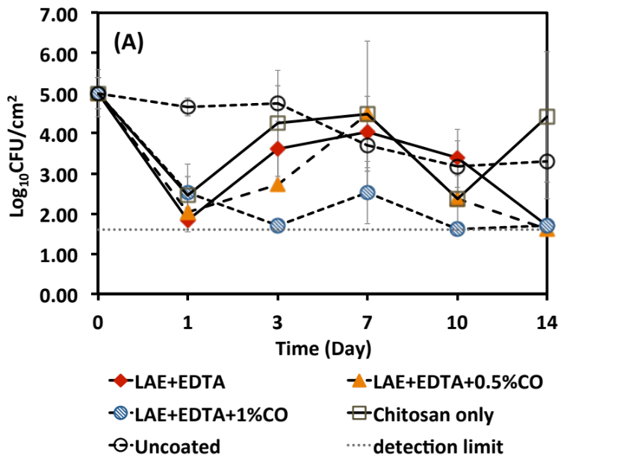

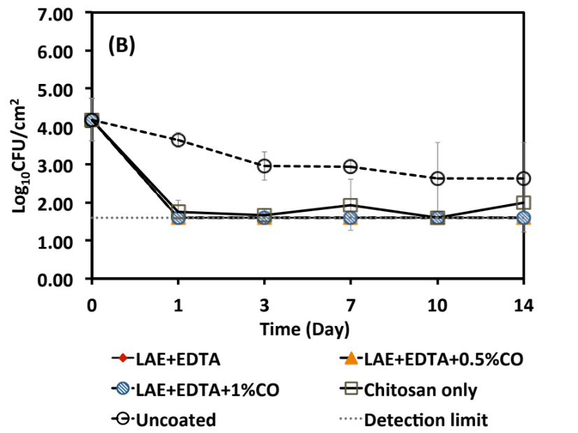
Figure 5.1. continued

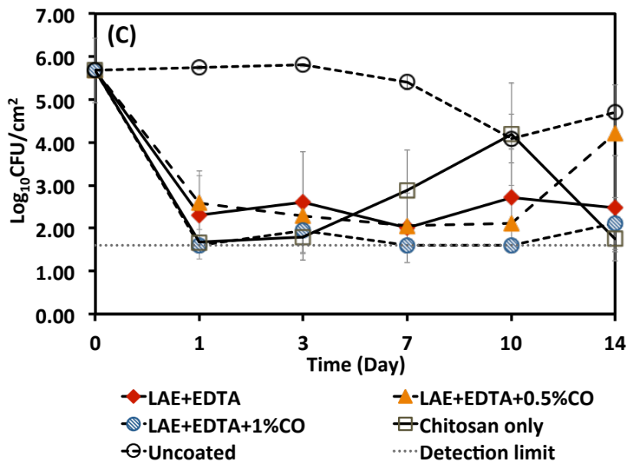
Figure 5.1. continued

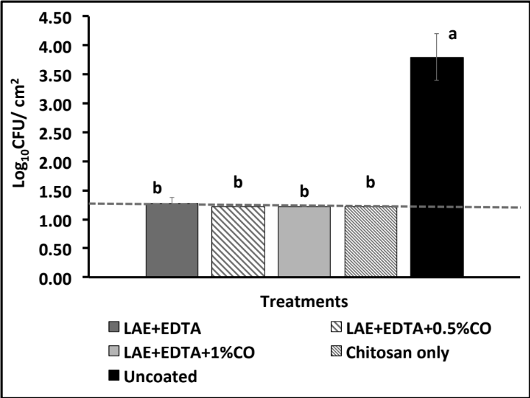
Fig. 5.2. Populations of total molds and yeasts on cantaloupe surfaces after coating (day 2) with chitosan only or with additional 0.1% w/w LAE, 0.1% w/w EDTA, and 0, 0.5 or 1% w/w CO. The detection limit was 1.22 log CFU/cm². Error bars are standard deviations from four rind discs obtained from each of three cantaloupes (n = 3).

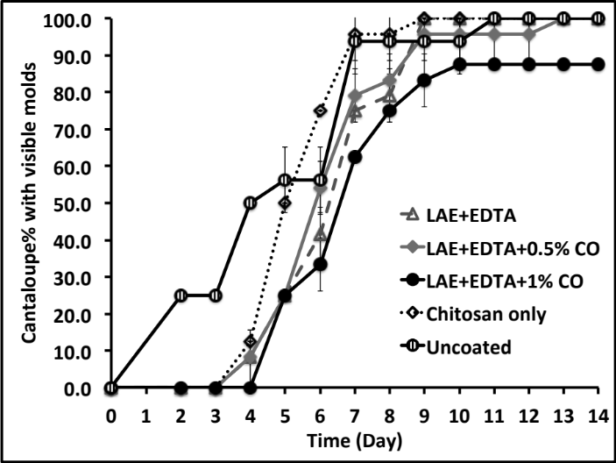
Fig. 5.3. Percentages of cantaloupes with visible molds during storage at room temperature (21°C). Cantaloupes were coated with chitosan only or with additional 0.1% w/w LAE, 0.1% w/w EDTA, and 0, 0.5 or 1% w/w CO. Each treatment had 3 groups of cantaloupes with 8 cantaloupes in each group. Error bars are standard deviations from 3 groups of cantaloupes (n = 3).

Figure 5.4. Changes of cantaloupe colors during storage at room temperature (21°C). Cantaloupes were coated with chitosan only or with additional 0.1% w/w LAE, 0.1% w/w EDTA, and 0, 0.5 or 1% w/w CO. Error bars are standard deviations from three measures on each of four cantaloupes (n =12).

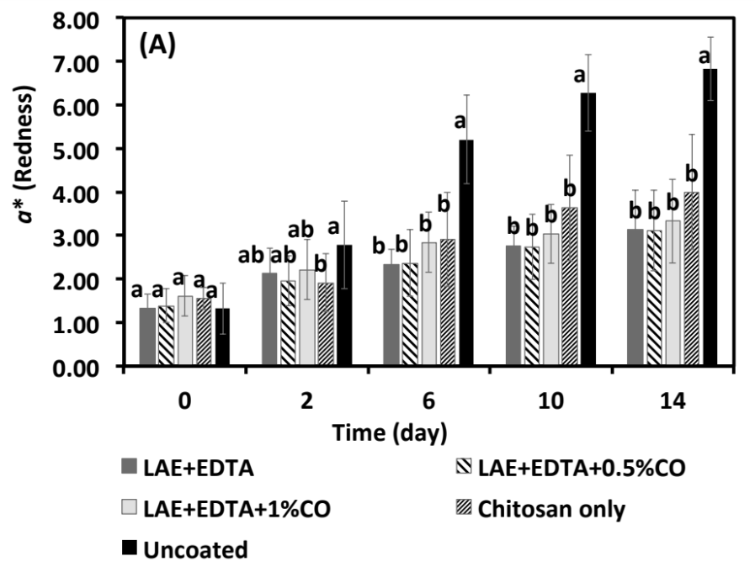

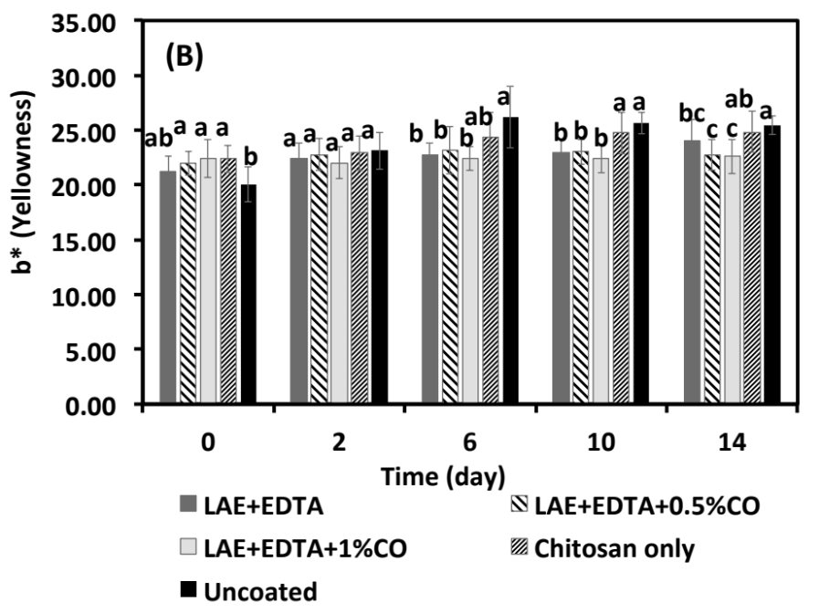
Figure 5.4. continued

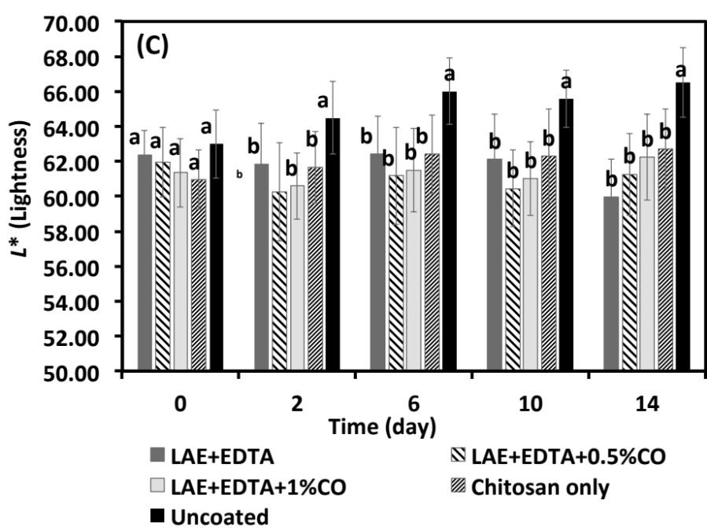
Figure 5.4. continued

Figure 5.5. Photos of coated and uncoated cantaloupes on day 2 and day 14 at room temperature (21°C) storage. Cantaloupes were coated with chitosan only or with additional 0.1% w/w LAE, 0.1% w/w EDTA, and 0, 0.5 or 1% w/w CO.
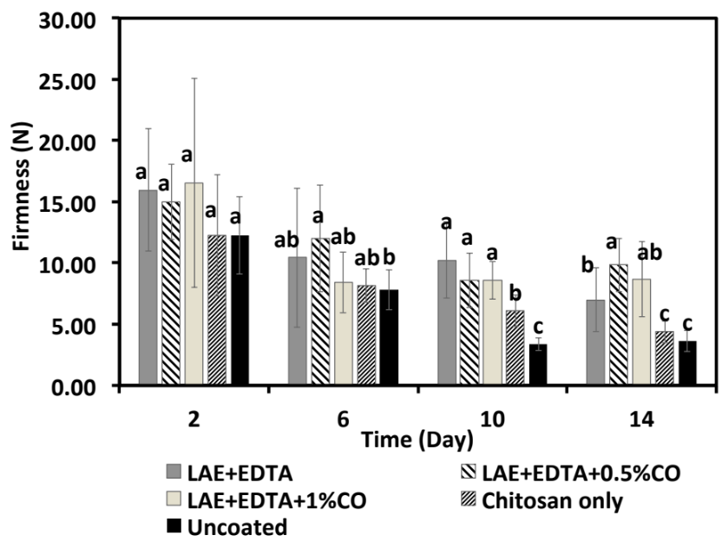
Figure 5.6. Changes of cantaloupe firmness during storage at room temperature (21°C). Cantaloupes were coated with chitosan only or with additional 0.1% w/w LAE, 0.1% w/w EDTA, and 0, 0.5 or 1% w/w CO. Error bars are standard deviations from four flesh discs obtained from each of three cantaloupes (n = 12).

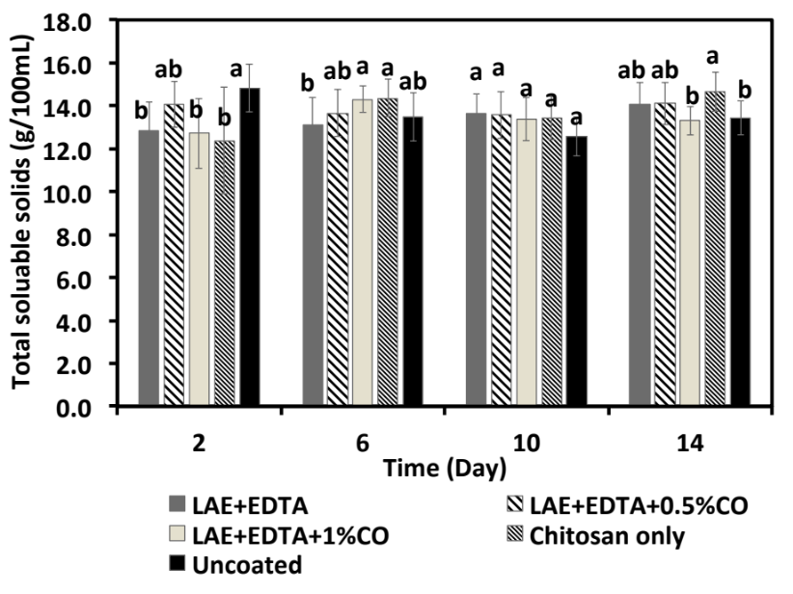
Figure 5.7. Changes of total soluble solids contents of cantaloupe flesh during storage at room temperature (21°C). Cantaloupes were coated with chitosan only or with additional 0.1% w/w LAE, 0.1% w/w EDTA, and 0, 0.5 or 1% w/w CO. Error bars are standard deviations from four flesh discs obtained from each of three cantaloupes (n = 12).

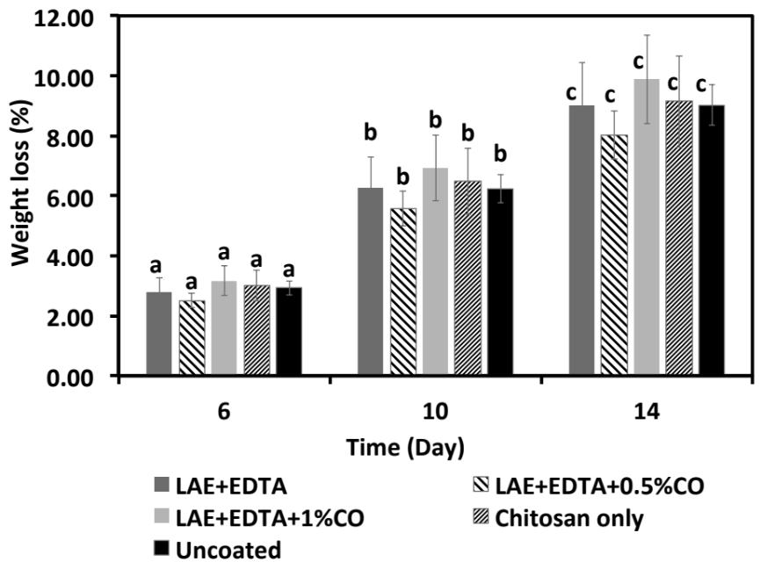
Figure 5.8. Changes of weight loss (%) of cantaloupes during storage at room temperature (21°C). Cantaloupes were coated with chitosan only or with additional 0.1% w/w LAE, 0.1% w/w EDTA, and 0, 0.5 or 1% w/w CO. Error bars are standard deviations from four cantaloupes (n = 4).

Chapter 6. Nanoemulsions of thymol and eugenol co-emulsified by lauric arginate and lecithin

6.1. Abstract
Lauric arginate (LAE) and essential oils (EOs) have synergistic antimicrobial activity against Listeria monocytogenes but they are antagonistic against Gram-negative bacteria. In an attempt to overcome that antagonistic activity, and to incorporate EOs in aqueous systems, properties of EO nanoemulsions prepared with an LAE and lecithin mixture were studied. The mixture resulted in translucent nanoemulsions of thymol and eugenol with spherical droplets smaller than 100 nm, contrasting with the turbid emulsions prepared with individual emulsifiers. LAE and lecithin were observed to form complexes that stabilized emulsion droplets during storage. Complex formation and nanoemulsification had negligible effects on the antimicrobial activity of LAE in tryptic soy broth. In 2% reduced fat milk, complex of LAE and lecithin showed reduced antimicrobial activity in inhibiting Gram-positive L. monocytogenes and Gram-negative Escherichia coli O157:H7 than LAE alone. Nanoemulsions showed similar antilisterial activities with LAE ; however, antagonistic activity of LAE and EOs against E. coli O157:H7 still existed, resulting the lowest activity of nanoemulsions. The greater availability of LAE assessed in release kinetics agreed with the greater inhibition of pathogens by nanoemulsions in the first 8 h, while a slower release at a later stage resulted in recovery of E. coli O157:H7 or slower reductions of L. monocytogenes. Our study showed improved emulsification capacity for EOs using complex of LAE and lecithin than either one alone; while lecithin showed negative effect on the antimicrobial activities of nanoemulsion systems.
Keywords: Lauric arginate, lecithin, nanoemulsion, essential oil, antimicrobial properties.

6.2. Introduction
Lauric arginate (LAE; ethyl-N^{α}-lauroyl-L-arginine ethyl ester monohydrochloride) is a cationic antimicrobial derived from lauric acid, arginine and ethanol (Ruckman et al., 2004). LAE has been approved as a generally recognized as safe (GRAS) preservative by the United States Food and Drug Administration (USDA, 2005). LAE has very low toxicity because it is rapidly metabolized in vivo to lauric acid and arginine, both of which are naturally occurring dietary components (Hawkins et al., 2009). These features make LAE a promising antimicrobial preservative to control foodborne pathogens in food systems. It inhibits a broad spectrum of foodborne pathogens (Ma et al., 2013; Noll et al., 2012; Porto-Fett et al., 2010) and, to date, LAE has been reported in many studies to be a highly efficient antimicrobial agent (Higueras et al., 2013a; Nair, 2013; Saini et al., 2013). In recent study in our laboratories, the minimum inhibitory concentration (MIC) of LAE for inhibiting Listeria monocytogenes Scott A was found to be 11.8 ppm in tryptic soy broth (TSB), while the MIC for Escherichia coli O157:H7 ATCC 43895 or Salmonella Enteritidis was 23.5 ppm (Ma et al., 2013).
One problem with LAE is that, as a cationic antimicrobial, its antimicrobial activity is reduced considerably when applied in complex food matrices (Ma et al., 2013) due to binding with food components, such as anionic biopolymers (Asker et al., 2008; Bonnaud et al., 2010). For example, even at 750 ppm, LAE did not completely inhibit 6 log CFU/mL of E. coli O157:H7 ATCC 43895 or S. Enteritidis in 2% fat milk after incubation at 21°C for 48 h (Ma et al., 2013). Additionally at high concentrations, the cationic nature of LAE causes a bitter taste, which affects the acceptability of food products. Thus, strategies are needed to improve the functionality of LAE.
Some spice essential oils (EOs) have strong antimicrobial activity (Burt, 2004; Ma et al., 2013) and are promising natural antimicrobial preservatives. Like LAE, binding by proteins and lipids requires high concentrations of EOs to obtain sufficient inhibition of foodborne pathogens in complex food matrices such as milk (Chen et al., 2014; Ma et al., 2013). EOs can also affect the sensory aspects and acceptability of food products. Therefore, approaches for lowering the usage level of EOs in foods are needed.
Preservation using antimicrobial combinations is an effective way to lower the concentration of each antimicrobial if synergistic antimicrobial effectiveness can be obtained. In our recent study, combining LAE and EOs (eugenol, thymol, and cinnamon leaf oil) pre-dissolved in ethanol showed a synergistic antimicrobial effect against L. monocytogenes Scott A (Ma et al., 2013). Since EOs are hydrophobic and have limited solubility in water (Chen et al., 2014), colloidal systems, such as oil-in-water nanoemulsions, are needed to incorporate EOs in aqueous systems (Chang et al., 2015; Pan et al., 2014; Xue and Zhong, 2014c). Because LAE is also an emulsifier, it can be used to prepare EO nanoemulsions (Ziani et al., 2011). To reduce the level of LAE as an emulsifier, another GRAS emulsifier may be used to co-emulsify EOs. In recent studies, we have observed synergistic surface activity when hydrophobic lecithin was used in combination with water-soluble sodium caseinate, gelatin, or Tween 20 to prepare nanoemulsions or microemulsions of EOs (Chen et al., 2015; Xue and Zhong, 2014a, c). Therefore, the objective of the present study was to prepare and characterize emulsions of eugenol or thymol using a combination of LAE and lecithin. Physical properties were studied for dimension, storage stability, zeta-potential, and morphology of emulsion droplets, as well as release kinetics of LAE. Antimicrobial activities of emulsions were characterized in TSB and 2% reduced fat milk using a Gram-positive bacterium, L. monocytogenes Scott A, and two Gram-negative bacteria, E. coli O157:H7 ATCC43895 and S. Enteritidis.

6.3. Materials and methods

6.3.1. Materials
LAE was provided by Vedeqsa Inc. (New York, NY). The commercial product Mirenat-TT contained 15.5% w/w LAE. Eugenol (98% purity) was purchased from Sigma-Aldrich Corp. (St. Louis, MO). Soy lecithin (major component being phosphatidylcholine) was from Thermo Fisher Scientiﬁc Inc. (Waltham, MA). Simple Truth® 2% ultra-pasteurized reduced fat milk was bought from Kroger Co. (Cincinnati, OH).

6.3.2. Bacterial culture
L. monocytogenes Scott A, E. coli O157:H7 ATCC43895, and S. Enteritidis were from the culture collection of Department of Food Science and Technology at the University of Tennessee in Knoxville. All strains were stored in sterile 20% glycerol at -20°C and transferred at least 2 times in TSB with an interval of 24 h before use. L. monocytogenes was incubated at 32°C, while E. coli O157:H7 and S. Enteritidis were incubated at 37°C.

6.3.3. Preparation of nanoemulsions
Lecithin was mixed at 1% w/w in deionized (DI) water, followed by adding 3-7% w/w Mirenat-TT (corresponding to 0.47-1.09% w/w LAE) and 1% w/w eugenol. The mixture was then homogenized at 15,000 rpm for 6 min using a T25 digital UlTRA TURRAX® homogenizer (IKA® Works, Inc., Wilmington, NC). Absorbance at 600 nm was measured using a UV-Vis spectrophotometer (Evolution 201, Thermo Scientific, Waltham, MA). The optimized conditions identified for eugenol were then used to prepare the nanoemulsion of thymol.

6.3.4. Dimension and stability of emulsion droplets
The hydrodynamic diameter of nanoemulsions was measured by dynamic light scattering during 30-day storage at room temperature (21°C). The Delsa Nano analyzer (Beckman Coulter, Atlanta, GA) had at a scattering angle of 165°. Samples were diluted in DI water before measurement. Three nanoemulsion replicates were studied.

6.3.5. Atomic force microscopy (AFM)
The morphology of nanoemulsion droplets was studied using AFM. Nanoemulsions were diluted 1,000 times in DI water. Ten microliter of the diluted sample was spread on a freshly cleaved mica sheet and mounted on a sample holder (Bruker Corp., Santa Barbara, CA). After about 2-h drying, samples were scanned in the tapping mode with a Multimode VIII microscope (Bruker AXS, Billerica, MA, USA). Topography images scanned at a dimension of 1.0×1.0 µm were collected.

6.3.6. Zeta-potential measurement
The zeta-potential of LAE, lecithin, LAE and lecithin mixture, and eugenol nanoemulsions prepared with LAE and lecithin were measured at 25°C (model Nano-ZS Zetasizer, Malvern Instruments Ltd, Worcestershire, UK). Nanoemulsions were diluted in DI water and adjusted to pH 4.0-7.0 using 1.0 M HCl or NaOH before measurement. Three measurements with 3 runs each were done for each sample.

6.3.7. Release kinetics of LAE
Release kinetics of LAE from nanoemulsions was studied by dialysis against DI water at room temperature (21°C). Regenerated cellulose dialysis tubing with a molecular weight cut-off of 3,500 Da (Thermo Fisher Scientific Inc., Waltham, MA) was loaded with 5 mL nanoemulsions or a 6000 ppm LAE solution that was identical to the LAE concentration of the nanoemulsion. The sealed tubes were placed in beakers containing 200 mL DI water that was mixed on a stir plate at 300 rpm. 20 mL of solution outside the dialysis tubing was withdrawn after 0, 1, 2, 4, 8, 24, 48, 72, 96 h, and 20 mL of fresh DI water was added to the beakers to maintain the volume at each sampling. LAE concentration in the sample withdrawn was quantified with HPLC (Higueras et al., 2013b). Briefly, the reversed-phase HPLC system (1200 series; Agilent Technologies, Waldbronn, Germany) was equipped with a UV detector (204.16 nm). A Zorbax Eclipse Plus C18 HPLC column (4.6 × 150 mm, 5 µm; Agilent, Palo Alto, CA) protected by a Zorbax Eclipse Plus C18 guard column (4.6 × 12.5 mm, 5µm) was used. The sample injection volume was 10 µL and the mobile phase with equal volumes of acetonitrile and water acidiﬁed with 0.1% trifluoroacetic acid was run at 1.0 mL/min. The cumulatively released LAE was calculated using the following equation (Xiao and Zhong, 2011):
$$R_{t_{i}}(\%)=\frac{\sum_{n=1}^{i-1}{a_{n}}×20+a_{i}×200}{A×5}×100\%$$
where R_{ti} is the cumulatively released LAE at time t_{i}, a_{i} is the concentration of LAE outside the dialysis tube at time t_{i}, and A is the original concentration of LAE in the dialysis tube. All experiments were repeated in triplicate.

6.3.8. Determination of minimum inhibitory concentration (MIC) and minimum bactericidal concentrations (MBC) in tryptic soy broth
MICs and MBCs of antimicrobials were determined by a microbroth dilution method (Ma et al., 2013). In addition to nanoemulsions, samples with LAE only, lecithin only, or both at concentrations identical to nanoemulsions were tested as controls.The culture was diluted to ca. 10⁶ CFU/mL bacteria using TSB. Then 120 µL of a bacteria culture and 120 µL of an antimicrobial working solution were added into wells of sterile microtiter plates. After 24 h incubation at 32°C for L. monocytogenes or 37°C for E. coli O157:H7 and S. Enteritidis, plates were observed for growth of bacteria by visual inspection. MICs were defined as the lowest antimicrobial concentration inhibiting bacteria growth (Ma et al., 2013). MBCs were defined as the lowest antimicrobial concentration corresponding to at least 3 log reduction of viable cells by spreading the negative cells in MICs tests on tryptic soy agar (TSA) plates and incubating for 48 h at 32°C (for L. monocytogenes) or 37°C (for E. coli O157:H7 and S. Enteritidis) (Branen and Davidson, 2004). Experiments were repeated once with 3 replications each time.

6.3.9. Microbial growth kinetics in 2% reduced fat milk
Free LAE, a mixture of LAE and lecithin, or nanoemulsions were added at an LAE overall concentration of 750 ppm in the 2% fat milk. One milliliter of cultures containing 10⁷ CFU/mL L. monocytogenes Scott A or E. coli O157:H7 ATCC 43895 were added to 9 mL of milk to achieve a final population of ca. 10⁶ CFU/mL. The mixtures were incubated at room temperature (21°C) for up to 120 h. Viable cells were enumerated after incubation for 0, 4, 8, 24, 48, 72 and 120 h by surface plating on TSA plates and incubating at the appropriate optimum temperature for each bacterium for 24 h. Experiments were done in triplicate.

6.3.10. Statistical analysis
Data were analyzed with ANOVA Tukey's test using SPSS 20 (IBM, Armonk, NY) at a significance level of 5%.

6.4. Results

6.4.1. Conditions of preparing emulsions
The appearance and absorbance at 600 nm of emulsions with 1% w/w eugenol emulsified by 0.47-1.09% w/w LAE with and without 1% w/w lecithin are shown in Fig. 6.1. Emulsions prepared with combinations of LAE and lecithin had much lower absorbance values than those emulsified by LAE alone. The emulsion prepared by 1% w/w lecithin alone was the most turbid. Translucent emulsions were obtained using 1% w/w lecithin and 0.78-1.09% w/w LAE, and the absorbance was similar for the emulsions with 0.93% w/w and 1.09 % w/w LAE alone. Thus, the combination of 0.93% w/w LAE and 1% w/w lecithin was chosen to prepare emulsions for further study.

6.4.2. Droplet dimension and zeta-potential of nanoemulsions
The hydrodynamic diameters of nanoemulsions during 30-day storage are shown in Fig. 6.2A. The hydrodynamic diameter was around 55 and 75 nm for eugenol and thymol nanoemulsions, respectively, and remained stable for 30 days at room temperature (21°C). Particle size distribution (Fig. 6.2B) of the nanoemulsions on day 30 showed only one sharp peak, which suggested the nanoemulsions were stable after one month.
The zeta-potentials of LAE, lecithin, LAE-lecithin mixture, and eugenol nanoemulsion emulsified with LAE-lecithin at pH 4.0-7.0 are shown in Fig. 6.3. Lecithin had a highly negative zeta-potential at pH 4.0-7.0, and the decrease from pH 4.0 to 7.0 was significant (p < 0.05). No significant difference (p > 0.05) in positive zeta potential of LAE, the mixture of LAE and lecithin, and eugenol nanoemulsion was found at pH 4.0-7.0.

6.4.3. Morphology of emulsion droplets
The AFM morphology of nanoemulsion droplets is shown in Fig. 6.4. Both eugenol and thymol nanoemulsions had mostly spherical particles. The average diameter estimated over 50 particles of eugenol and thymol nanoemulsions was about 90 and 100 nm, respectively, which was about 30 nm larger than the hydrodynamic diameter (Fig. 6.2). This can result from the drying process during sample preparation that caused flattening of the particles.

6.4.4. Release kinetics of LAE
Release kinetics of LAE from nanoemulsions is shown in Fig. 6.5. A rapid release of LAE from the dialysis tube to bulk water was observed in the first 8 h for nanoemulsions and free LAE. The cumulative release of LAE at 8 h reached 72%, 58%, and 55% for free LAE, eugenol nanoemulsion, and thymol nanoemulsion, respectively. After 8 h, the release of LAE was slower in all samples. Overall, the free LAE solution passed through the dialysis tube more rapidly and to a greater extent under the conditions studied.

6.4.5. MICs and MBCs in tryptic soybean broth
No inhibition by lecithin of the test bacteria was observed with MICs greater than 1,500 ppm (Table 6.1). The mixture of LAE and lecithin, LAE alone, and nanoemulsions had the same MICs of 11.8 ppm LAE against L. monocytogenes Scott A and E. coli O157:H7 ATCC43895 and 23.5 ppm against S. Enteritidis. When LAE was used alone, the MBC was 11.8 ppm for L. monocytogenes and E. coli O157:H7 and was 23.5 ppm for S. Enteritidis. The MBCs of LAE alone against E. coli O157:H7 and S. Enteritidis were the same (in LAE concentration) after mixing LAE with lecithin or being used to prepare nanoemulsions. However, the MBCs of the mixture and nanoemulsions increased to 23.5 ppm (one dilution higher) when tested against L. monocytogenes.

6.4.6. Microbial growth kinetics in 2% reduced fat milk
Growth curves of Gram-positive L. monocytogenes Scott A and Gram-negative E. coli O157:H7 ATCC43895 in 2% reduced fat milk at 21°C treated by antimicrobials at an overall LAE concentration of 750 ppm are shown in Fig. 6.6. For L. monocytogenes, a continuous reduction of viable cells was observed for nanoemulsion and LAE only treatments, reaching below the detection limit (1.0 log CFU/mL) after 24 h. The reduction of L. monocytognenes by the LAE-lecithin mixture was the slowest, and viable cells were still detected after 72 h. Except for the untreated control, a decrease of E. coli O157: H7 population was observed for all treatments in the first 8 h, with the eugenol nanoemulsion treatment demonstrating the least effectiveness. After 8 h, recovery of E. coli O157: H7 was observed for all treatments except LAE alone. The relative effectiveness in increasing order was eugenol nanoemulsion<thymol nanoemulsion<LAE-lecithin mixture<LAE alone. This group of studies demonstrated the negative effect of lecithin on the antimicrobial activity of LAE.

6.5. Discussions
Findings from this work (Fig. 6.1) showed the improved emulsification capacity for EOs when LAE and lecithin were used in combination than either one used alone. The partition coefficient of LAE between oil and water phases is high (>10), which means LAE is present mostly in the water phase of an emulsion (Gil Bakal, 2005). Lecithin is a natural anionic surfactant consisting of various phospholipids (Fernandez et al., 1998), which results in a hydrophile-lipophile-balance (HLB) value of about 9.2-9.5 (Kunieda and Ohyama, 1990) and an overall lipophilic property. As reported in many studies, surfactants with a proper HLB value are required to form stable emulsions (Peng et al., 2010; Sagitani, 1981). Thus, the mixture of LAE with a high HLB value and lecithin with a low HLB value may favor the formation of nanoemulsions of EOs. Based on zeta-potential data (Fig. 6.3), the mixture of overall anionic lecithin and cationic LAE has a similar zeta-potential as LAE, which indicates the two surfactants form complexes with the surface being predominantly hydrophilic LAE. The complex can be formed through electrostatic attraction between opposite charges of LAE and lecithin or hydrophobic attraction. Similar zeta potentials of LAE and LAE-lecithin mixture suggest hydrophobic attraction is the major mechanism. Complexes were also previously found to favor the preparation of EO nanoemulsions when lecithin and gelatin (Xue and Zhong, 2014b) and other surfactants (Gullapalli and Sheth, 1999; Porras et al., 2008) were used in combination.
No creaming or precipitation was observed during 30-day storage. The stable hydrodynamic diameters and particle size distribution of nanoemulsions (Fig. 6.2) showed the absence of Ostwald ripening and coalescence. The high magnitude of positive zeta-potential (Fig. 6.3) provides strong electrostatic repulsion to prevent the aggregation and thus coalescence of emulsion droplets. As discussed previously, LAE and lecithin form complexes that have similar zeta-potential at pH 4.0- 7.0 as the eugenol nanoemulsion, which suggests that the adsorption of complexes on droplets and the lipophilic lecithin is in contact with the oil phase (Jain et al., 2012). The complexes on droplet surfaces may be effective in preventing droplet dimension changes due to Ostwald ripening.
The formation of LAE-lecithin complexes likely reduced the inhibition by LAE of E. coli O157: H7 and L. monocytogenes in milk (Fig. 6.6). Milk was used because the binding between proteins and/or fats and antimicrobials is significant and can indicate the influence of food components on antimicrobial activity of compounds. LAE is an arginine-based cationic antimicrobial that inhibits microorganisms by first binding with negatively charged bacteria surfaces (Castillo et al., 2004; Pattanayaiying et al., 2014). Binding with lecithin reduced the amount of free LAE thus reducing interaction with the bacteria which resulted in less penetration of LAE into the bacteria cell membranes. Thus, there was a lowered antimicrobial activity of LAE in milk (Fig. 6.6). In contrast, no significant difference was found for inhibition of L. monocytogenes with the same concentrations of free LAE and nanoemulsion LAE in milk (Fig. 6.6B). Because, as discussed previously, while complexing of LAE with lecithin reduced antimicrobial activity, similar activity of free and nanoemulsion LAE likely resulted from the complementary effect of the synergistic activity of LAE and eugenol or thymol inhibiting L. monocytogenes. Conversely, the antagonistic effects of LAE-EO combinations against E. coli O157:H7 (Ma et al., 2013) were more pronounced than the effect of the lecithin-LAE complex, resulting in the most rapid recovery by the Gram-negative bacteria in the nanoemulsion treated in milk (Fig. 6.6).
No differences were detected in the MICs of free LAE, LAE-lecithin mixture, and nanoemulsions for the three tested bacteria (Table 6.1). There was also no difference in the MBCs of the above antimicrobials when tested for Gram-negative bacteria (Table 6.1). The contradiction between MICs/MBCs and growth in 2% reduced fat milk can be the result of several factors. The end-point assay to determine MIC and MBC is done at a single time, 24 h. No kinetics are determined in the end-point test so the level of growth or inactivation is unknown. Thus, MICs/MBCs can only give a limited picture of the antimicrobial efficacy and are therefore must be used together with dynamic assay such as growth curves to comprehensively analyze antimicrobial properties.
The release kinetics of LAE from nanoemulsions (Fig. 6.5) was in good agreement with the growth kinetics of E.coli O157: H7 or L. monocytogenes in milk (Fig. 6.6). In the first 8 h, the release rate of LAE corresponded to the rapid reduction of E. coli O157: H7 and L. monocytogenes in the first 8 h. The lesser increases of LAE release during longer time points agreed with less reduction of L. monocytogenes or recovery of E. coli O157: H7 treated by nanoemulsions. For free LAE, it was not bound by lecithin and hydrophobic EOs and therefore had the greatest activity against E.coli O157: H7. However, even 750 ppm LAE was insufficient to completely inhibit E.coli O157:H7 which gradually recovered over 120 h.

6.6. Conclusions
In the present study, nanoemulsions of EOs were successfully prepared with positively-charged LAE and negatively-charged lecithin. LAE and lecithin formed complexes that improved the ability to emulsify EOs and stabilize emulsion droplets during storage. Complex formation reduced the availability of LAE and the antimicrobial activity in milk. Similar antilisterial activities of nanoemulsions and free LAE were observed in milk. Conversely, compared to free LAE, much reduced inhibition of Gram-negative E. coli O157:H7 in milk by nanoemulsions was detected. Overall, the combination of LAE and lecithin provided an effective approach to nano-emulsify EOs for incorporation in food products, especially those requiring optical transparency. However, it did not improve the activity of LAE and EOs to effectively inhibit Gram-negative pathogens like E. coli O157:H7.

References
Asker, D., Weiss, J., McClements, D., 2008. Analysis of the interactions of a cationic surfactant (lauric arginate) with an anionic biopolymer (pectin): isothermal titration calorimetry, light scattering, and microelectrophoresis. Langmuir 25, 116-122.
Bonnaud, M., Weiss, J., McClements, D.J., 2010. Interaction of a food-grade cationic surfactant (lauric arginate) with food-grade biopolymers (pectin, carrageenan, xanthan, alginate, dextran, and chitosan). Journal of agricultural and food chemistry 58, 9770-9777.
Branen, J.K., Davidson, P.M., 2004. Enhancement of nisin, lysozyme, and monolaurin antimicrobial activities by ethylenediaminetetraacetic acid and lactoferrin. International journal of food microbiology 90, 63-74.
Burt, S., 2004. Essential oils: their antibacterial properties and potential applications in foods—a review. International journal of food microbiology 94, 223-253.
Castillo, J.A., Pinazo, A., Carilla, J., Infante, M.R., Alsina, M.A., Haro, I., Clapés, P., 2004. Interaction of antimicrobial arginine-based cationic surfactants with liposomes and lipid monolayers. Langmuir 20, 3379-3387.
Chang, Y., McLandsborough, L., McClements, D.J., 2015. Fabrication, stability and efficacy of dual-component antimicrobial nanoemulsions: Essential oil (thyme oil) and cationic surfactant (lauric arginate). Food Chemistry 172, 298-304.
Chen, H., Davidson, P.M., Zhong, Q., 2014. Impacts of sample preparation methods on solubility and antilisterial characteristics of essential oil components in milk. Applied and environmental microbiology 80, 907-916.
Chen, H., Guan, Y., Zhong, Q., 2015. Microemulsions based on sunflower lecithin-Tween 20 blend have high capacity of dissolving peppermint oil and stabilizing Coenzyme Q10. Journal of agricultural and food chemistry.
Fernandez, M.J.A., Salve, P.C., Lopez, C.R., Jato, J.L.V., 1998. Stabilization of colloidal systems through the formation of lipid-polyssacharide complexes. Google Patents.
Gil Bakal, A.D., 2005. The lowdown on lauric arginate: Food antimicrobial eats at plasma membrane, disrupting a pathogen's metabolic process. Food Quality and Safety.
Gullapalli, R.P., Sheth, B.B., 1999. Influence of an optimized non-ionic emulsifier blend on properties of oil-in-water emulsions. European journal of pharmaceutics and biopharmaceutics 48, 233-238.
Hawkins, D., Rocabayera, X., Ruckman, S., Segret, R., Shaw, D., 2009. Metabolism and pharmacokinetics of ethyl N^{α}-lauroyl-L-arginate hydrochloride in human volunteers. Food and Chemical Toxicology 47, 2711-2715.
Higueras, L., López-Carballo, G., Hernández-Muñoz, P., Gavara, R., Rollini, M., 2013a. Development of a novel antimicrobial film based on chitosan with LAE (ethyl-N ^{α}-dodecanoyl-l-arginate) and its application to fresh chicken. International journal of food microbiology 165, 339-345.
Higueras, L., López-Carballo, G., Hernández-Muñoz, P., Gavara, R., Rollini, M., 2013b. Development of a novel antimicrobial film based on chitosan with LAE (ethyl-N^{α}-dodecanoyl- L-arginate) and its application to fresh chicken. International journal of food microbiology 165, 339-345.
Jain, S., Valvi, P.U., Swarnakar, N.K., Thanki, K., 2012. Gelatin coated hybrid lipid nanoparticles for oral delivery of amphotericin B. Molecular pharmaceutics 9, 2542-2553.
Kunieda, H., Ohyama, K.-i., 1990. Three-phase behavior and HLB numbers of bile salts and lecithin in a water-oil system. Journal of colloid and interface science 136, 432-439.
Ma, Q., Davidson, P.M., Zhong, Q., 2013. Antimicrobial properties of lauric arginate alone or in combination with essential oils in tryptic soy broth and 2% reduced fat milk. International journal of food microbiology 166, 77-84.
Nair, D., 2013. Antimicrobial effects of lauric arginate against Campylobacter jejuni and spoilage organisms on chicken breast fillets, 2013 Annual Meeting (July 28-31, 2013). International Association for Food Protection.
Noll, K.S., Prichard, M.N., Khaykin, A., Sinko, P.J., Chikindas, M.L., 2012. The natural antimicrobial peptide subtilosin acts synergistically with glycerol monolaurate, lauric arginate, and ε-poly-l-lysine against bacterial vaginosis-associated pathogens but not human lactobacilli. Antimicrobial agents and chemotherapy 56, 1756-1761.
Pan, K., Chen, H., Davidson, P.M., Zhong, Q., 2014. Thymol nanoencapsulated by sodium caseinate: physical and antilisterial properties. Journal of agricultural and food chemistry 62, 1649-1657.
Pattanayaiying, R., Aran, H., Cutter, C.N., 2014. Effect of lauric arginate, nisin Z, and a combination against several food-related bacteria. International journal of food microbiology 188, 135-146.
Peng, L.-C., Liu, C.-H., Kwan, C.-C., Huang, K.-F., 2010. Optimization of water-in-oil nanoemulsions by mixed surfactants. Colloids and Surfaces A: Physicochemical and Engineering Aspects 370, 136-142.
Porras, M., Solans, C., Gonzalez, C., Gutierrez, J., 2008. Properties of water-in-oil (W/O) nano-emulsions prepared by a low-energy emulsification method. Colloids and Surfaces A: Physicochemical and Engineering Aspects 324, 181-188.
Porto-Fett, A., Campano, S., Smith, J., Oser, A., Shoyer, B., Call, J., Luchansky, J., 2010. Control of Listeria monocytogenes on commercially-produced frankfurters prepared with and without potassium lactate and sodium diacetate and surface treated with lauric arginate using the Sprayed Lethality in Container (SLIC (R)) delivery method. Meat science 85, 312-318.
Ruckman, S.A., Rocabayera, X., Borzelleca, J.F., Sandusky, C.B., 2004. Toxicological and metabolic investigations of the safety of N-α-Lauroyl-l-arginine ethyl ester monohydrochloride (LAE). Food and Chemical Toxicology 42, 245-259.
Sagitani, H., 1981. Making homogeneous and fine droplet O/W emulsions using nonionic surfactants. Journal of the American Oil Chemists’ Society 58, 738-743.
Saini, J.K., Barrios, M.A., Marsden, J.L., Getty, K.J., Fung, D.Y., 2013. Efficacy of antimicrobial lauric arginate against Listeria monocytogenes on stainless steel coupons. Advances in Microbiology 3, 65.
USDA, 2005. Agency Response Letter GRAS Notice No. GRN 000164.
Xiao, D., Zhong, Q., 2011. In vitro release kinetics of nisin as affected by Tween 20 and glycerol co-encapsulated in spray-dried zein capsules. Journal of Food Engineering 106, 65-73.
Xue, J., Zhong, Q., 2014a. Blending Lecithin and Gelatin Improves the Formation of Thymol Nanodispersions. Journal of agricultural and food chemistry 62, 2956-2962.
Xue, J., Zhong, Q., 2014b. Blending lecithin and gelatin improves the formation of thymol nanodispersions. Journal of agricultural and food chemistry 62, 2956–2962.
Xue, J., Zhong, Q., 2014c. Thyme Oil Nanoemulsions Coemulsified by Sodium Caseinate and Lecithin. Journal of agricultural and food chemistry 62, 9900-9907.
Ziani, K., Chang, Y., McLandsborough, L., McClements, D.J., 2011. Influence of surfactant charge on antimicrobial efficacy of surfactant-stabilized thyme oil nanoemulsions. Journal of agricultural and food chemistry 59, 6247-6255.

Appendix
Table 6.1. Minimum inhibitory concentration (MICs, in LAE concentration, ppm) and minimum bactericidal concentrations (MBCs, in LAE concentration, ppm) of antimicrobials against Listeria monocytogenes (LM) at 32 °C and Escherichia coli O157:H7 (EC) and Salmonella Enteritidis (SE) at 37 °C in tryptic soy broth.
 | Bacteria | Lecithin | LAE | LAE+lecithin | Nanoemulsion of eugenol* |  | Nanoemulsion of thymol*
MICs | LM | >1500 | 11.8 | 11.8 |  | 11.8 |  | 11.8
MICs | EC | >1500 | 11.8 | 11.8 |  | 11.8 |  | 11.8
MICs | SE | >1500 | 23.5 | 23.5 |  | 23.5 |  | 23.5
MBCs | LM | >1500 | 11.8 | 23.5 |  | 23.5 |  | 23.5
MBCs | EC | >1500 | 11.8 | 11.8 |  | 11.8 |  | 11.8
MBCs | SE | >1500 | 23.5 | 23.5 |  | 23.5 |  | 23.5
*Nanoemulsions were prepared with 1%w/w eugenol or thymol and 0.93% w/w LAE and 1% w/w lecithin.

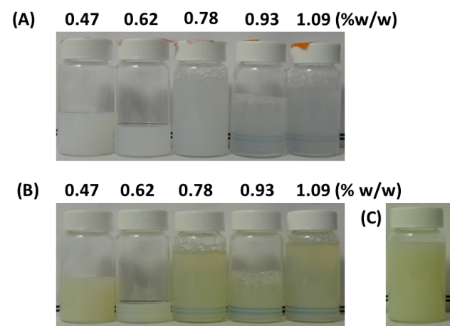
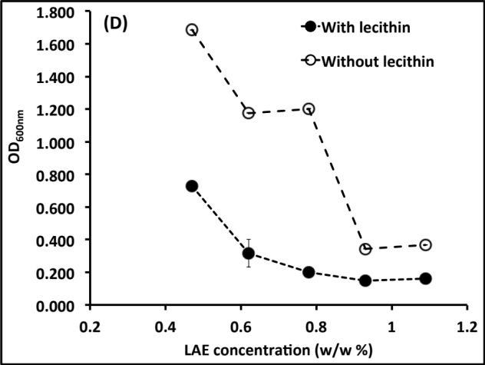
Figure 6.1. Emulsions with 1% w/w eugenol emulsified by (A) 0.47-1.09% w/w lauric arginate (LAE) (B) 0.47-1.09% w/w LAE with 1% w/w lecithin (C) 1% w/w lecithin along; and absorbance of eugenol nanoemulsions at 600 nm (OD_{600 nm}) prepared by LAE with and without lecithin (D).

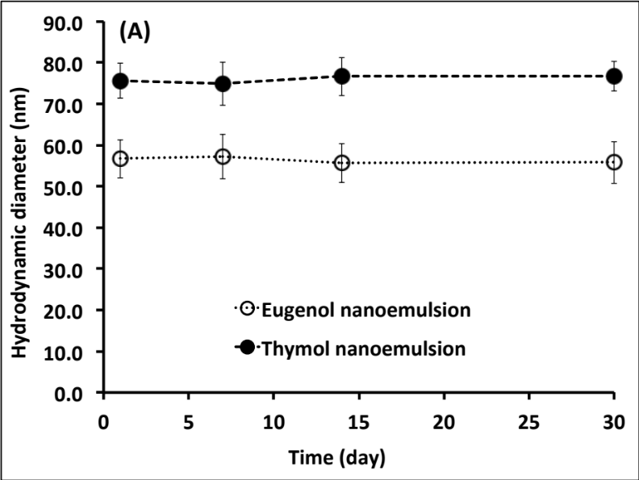
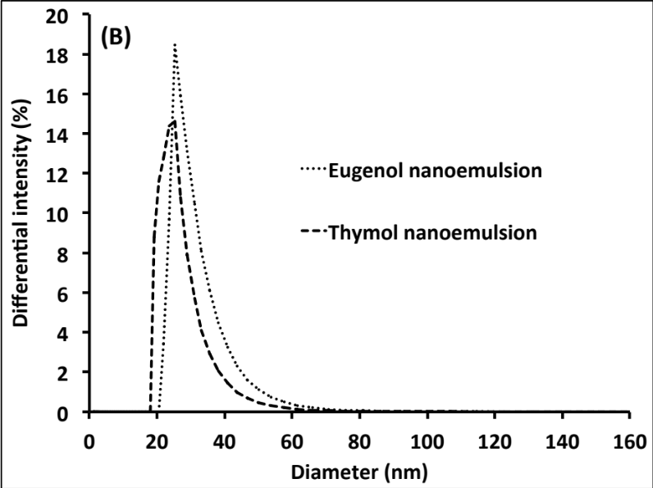
Figure 6.2. Hydrodynamic diameter of thymol and eugenol nanoemulsions during storage at 21 °C (A) and particle size distribution of the nanoemulsions after 30 days (B). Error bars are standard deviations (n = 6).

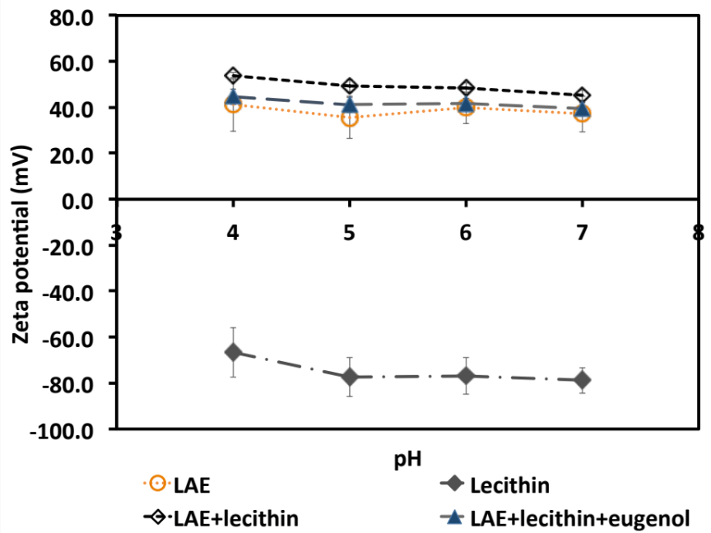
Figure 6.3. Zeta-potential of LAE, lecithin, LAE-lecithin mixture, and a nanoemulsion with 1% eugenol emulsified by 0.93% LAE and 1% lecithin at pH 4.0-7.0 and 25°C. Error bars are standard deviations (n = 9).

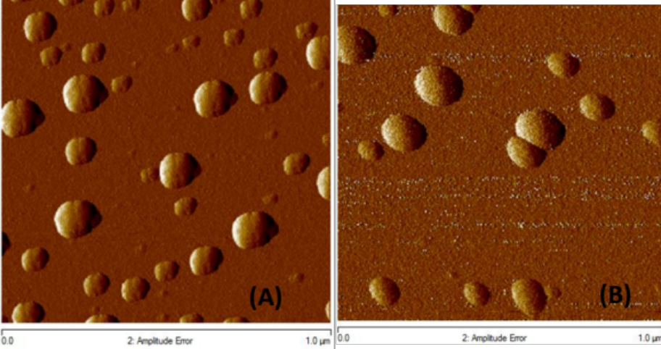

Figure 6.4. AFM topography images of nanoemulsions prepared with eugenol (A) and thymol (B). Image dimensions are 1 μm 1 μm.

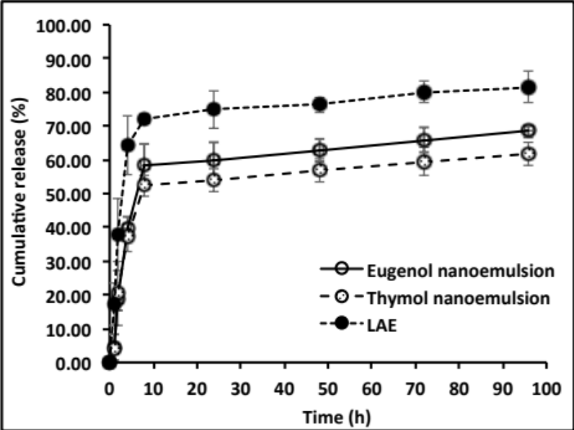
Figure 6.5. Release kinetics of LAE at 21°C. Error bars are standard deviations (n = 3).

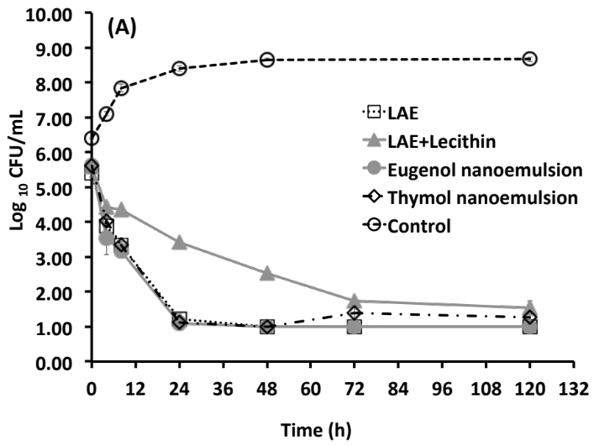
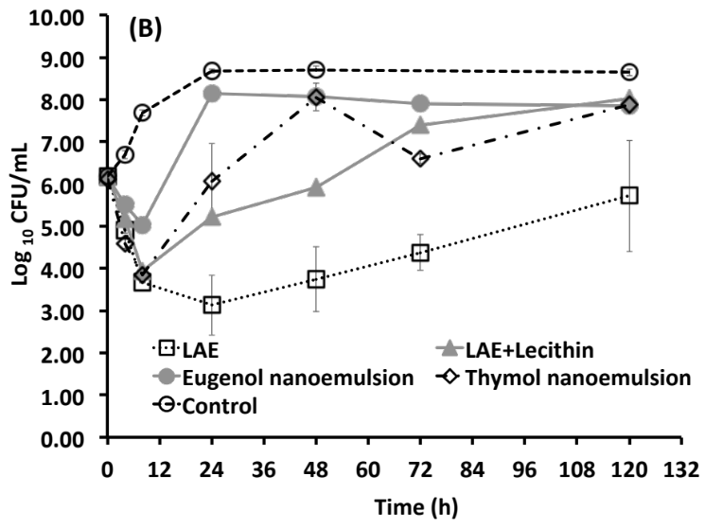
Figure 6.6. Growth curves of L. monocytogenes Scott A (A) and E. coli O157:H7 ATCC 43895 (B) in 2% reduced fat milk at 21°C after treatment by antimicrobials containing 750 ppm lauric arginate (LAE). The LAE+lecithin mixture had same LAE and lecithin concentrations as in nanoemulsions. Error bars are standard deviations (n = 3).

Chapter 7. Conclusions and future work

This dissertation demonstrated the antimicrobial activity of combinations of LAE, EOs and/ or EDTA, the mechanism of the antimicrobial action, and effects of chitosan-based coatings incorporated with these antimicrobials on safety and quality of whole cantaloupes.
Synergistic effect of LAE and EOs in inhibiting the Gram-positive bacteria L. monocytogenes and antagonistic effect against Gram-negative bacteria S. Enteritidis and E. coli O157: H7 were detected. With the addition of EDTA, antimicrobial activities against both Gram-positive and Gram-negative bacteria were dramatically enhanced. Results on the mechanism of the antimicrobial action showed that EDTA can improve the permeability of Gram-negative bacteria outer membrane and facility the penetration of LAE and CO; CO can cause the severe damage of bacteria cell membranes, while LAE can cause the assembly of bacteria DNA molecules. Chitosan-based coatings can effectively inhibit the growth of foodborne pathogens inoculated on the surface of whole cantaloupes during 14-day storage at room temperature. Delayed ripening of whole cantaloupes with chitosan-based coatings containing the antimicrobials was also observed.
To broaden the applications of hydrophobic EOs and utilize the synergistic effect of LAE and EOs in inhibiting Gram-positive bacteria, nanoemulsions of EOs co-emulsified by LAE and lecithin were prepared. However, negative-charged lecithin caused a decreased antimicrobial efficacy of the nanoemulsion systems.

Therefore, future work is needed to further explore the effect of the prepared chitosan-based coating systems on safety and quality of other food products, such as meat and poultry products. Nanoemulsions of EOs emulsified with LAE and other emulsifiers, which have no negative effects on the antimicrobial activity of the systems, need to be further investigated. Besides, sensory properties of the whole cantaloupes with or without coating are to be evaluated.

VITA
Qiumin Ma was born on Aug. 14th, 1986. She took her undergraduate study in China Agricultural University in Beijing, China, majoring in Bio-engineering from 2005 to 2009. After finishing Bachelor’s degree, she went directly to the graduate school of China Agricultural University, and obtained the Master degree in Food Science in Jul. 2011. Then she applied University of Tennessee in Knoxville, TN to pursue Doctorate degree in Food Science and Technology from 2011 to 2015.

