DESIGNING A SERIOUS GAME TO SIMULATE ECOLOGICAL PROCESSES ON A POST-ERUPTION MOUNT ST. HELENS LANDSCAPE

A Thesis Presented for the
Master of Science
Degree
The University of Tennessee, Knoxville

Parker Maynard
May 2024

ACKNOWLEDGEMENTS
I would like to thank Virginia Dale for creating this opportunity and providing guidance and encouragement throughout the completion of my thesis. Thank you to Cary Staples for providing expertise in design and having the necessary resources and aid to help me design and develop the game. Thank you to Elisabeth Schussler for guiding the development of the assessment used to analyze this research. Thank you to Elsie Denton, Allison Gonzales, and Lex Matthews for contributing to the content of the game. Thank you to Orou Gaoue, Karen King, Cary Staples, and the University of Tennessee Knoxville department of Ecology and Evolutionary Biology for allowing their students to contribute to our research by completing surveys and playing the game. Finally, thank you to the National Science Foundation grant DEB 2043870 for providing funding for this project.

ABSTRACT
Developing strategies to successfully manage landscapes to meet ecological, economic, and social goals is an increasing concern in a world experiencing anthropogenic global changes. The 1980 eruption of Mount St. Helens in Washington state provided a major learning opportunity in managing resource effectively after a major disturbance. This information is explored through Resilience: After The Eruption: a serious game developed as part of this thesis that synthesizes research about ecological recovery and resource management following the eruption of Mount St. Helens. The digital game allows players to take on the role of four different stakeholders performing landscape-based operations while posing a minimal threat to a simulated environment and each other’s values. Through gameplay, players learn about the natural and human phenomena that affect post-disturbance ecological recovery processes and experience the complexities of multiple-stakeholder cooperation. Through pre- and post-gameplay surveys, we assessed how players consider post-disturbance ecosystems and cooperation among stakeholders. Players showed an overall increase in knowledge that corresponded to the desired learning objectives. These results confirm that Resilience: After the Eruption and serious games in general can be useful learning tools in the fields of resource management and ecology.

TABLE OF CONTENTS
SECTION 1 INTRODUCTION 1
SECTION 2 BACKGROUND ON THE 1980 ERUPTION OF MOUNT ST. HELENS 4
SECTION 3 DEVELOPMENT OF RESILIENCE: AFTER THE ERUPTION 6
Game Overview 6
Game Elements 9
Ecological Succession Model 9
Stakeholders 9
Capital 10
Strategies 13
SECTION 4 METHODS 14
Participants 14
Study Design 14
Study Procedure 15
Analysis 15
SECTION 5 RESULTS 19
SECTION 6 DISCUSSION 31
Implications 31
Future Directions 31
SECTION 7 CONCLUSION 34
REFERENCES 35
APPENDIX 40
VITA 44

LIST OF TABLES
Table 3.1. Capital Effects Per Stakeholder. 12
Table 4.1. Codebook for Opinion-Based Short Answer Responses. 16

LIST OF FIGURES
Figure 3.1. Stakeholder Concerns. 7
Figure 3.2. Resilience User Interface Screenshot. 8
Figure 5.1. Comparison of Total Pre- and Post-Test Scores. 19
Figure 5.2. Comparison of Objective 1 Pre- and Post-Test Scores. 20
Figure 5.3. Comparison of Objective 2 Pre- and Post-Test Scores. 21
Figure 5.4. Participant Opinions on Entertainment Value. 22
Figure 5.5. Participant Opinions on Engagement While Playing. 23
Figure 5.6. Participant Opinions on Ease of Learning How to Play the Game. 24
Figure 5.7. Participant Self-Perception of Learning About Ecological Systems. 25
Figure 5.8. Positive Codes Appearing in Short Answer Responses. 26
Figure 5.9. Negative Codes Appearing in Short Answer Responses. 27
Figure 5.10. Participant Demographics. 29

LIST OF ATTACHMENTS
Pre-Gameplay Survey. Resilience_Pre-test.docx
Post-Gameplay Survey. Resilience_Post-test.docx

Section 1
Introduction

Developing strategies to successfully manage landscapes to meet ecological, economic, and social goals is an increasing concern in a world experiencing anthropogenic global change [1]. Responsible decision-making often involves forecasting how ecosystems respond to Irregular disturbance events like landslides, windstorms, and wildfires [2]. Additionally, when multiple stakeholders with conflicting goals are operating on the same landscape, lack of communication among them can constrain efficient use of resources and thus limit the availability of valued ecosystem services [3]. Communicating ideas about how to maximize ecosystem services to encourage current and future generations of problem solvers to efficiently manage disturbed landscapes is a challenge unto itself. Complex relationships between stakeholders and ecosystem processes are difficult to accurately depict in conventional forms of education media such as text and infographics [4]. A promising approach for increasing understanding of human-ecosystem relationships is the use of active learning facilitated by multimedia educational tools like serious games [5][6].

Serious games are games that serve a primary objective other than entertainment, with those objectives often being to further a player’s knowledge of a concept, teach them a skill, or have them experience a simulated situation [7]. Serious games have the benefit of featuring real world content in ways that facilitate learning of complex concepts and systems in comparison to more conventional educational tools [8][9]. The interactive and experimental approach to learning permitted by serious games allows for greater understanding, particularly in fields like ecology and spatial planning, where it is important to understand the relationships between concepts and the greater whole (i.e., systems thinking) [10]. Serious games may therefore be useful for interpreting the effects of human activity on ecosystems. Serious games can also act as a way for players to learn by simulating actions through role playing. A player may be able to empathize with a real-world actor through playing as their simulated counterpart and therefore understand the challenges faced in that role and be given an opportunity to test solutions to those challenges in a low-stakes environment.

We demonstrate the utility of serious games for simulating and educating about human-ecosystem relationships through Resilience: After The Eruption (hereafter referred to as ‘Resilience’), which simulates resource management and the multiple stakeholder decision making process in an environment undergoing rapid change. Resilience synthesizes some of the major concepts learned after the eruption of Mount St. Helens (Washington, USA), including insights gained from research on recovery after a large-scale disturbance and the careful planning of resource management activities around recovery processes. Players take on the role of a suite of stakeholders performing landscape-based operations, posing a minimal threat to a simulated environment and each other’s values. Resilience serves two main purposes: 1. Simulation of resource management activities and 2. Simulation of collaboration between stakeholders with different values and goals. In correspondence to these purposes, Resilience delivers two main learning objectives: 1. Players learn about natural and human phenomena that affect post-disturbance ecological recovery processes and 2. Players experience the complexities of multiple-stakeholder cooperation.

Environmental role-playing simulation games like Resilience are becoming increasingly common tools for learning and producing solutions to real-world issues [11][12][13]. For example, Climate Action Simulation is a model-based role-playing game for environmental stakeholders that allows for interpretation of how collective player actions can impact variables like sea level rise and global temperature [14]. The novel addition of a digital data-driven model to a traditional role-play allows for players to receive instantaneous feedback on their decisions. Though applicable on larger scales, Climate Action Simulation lacks the ability to interpret how management decisions directly affect natural processes at community, ecosystem, and regional scales. Resilience utilizes a framework that combines role-playing game mechanics with a digital simulated landscape that allows players to interpret how their capacity to reconcile conflicting stakeholder goals directly impacts ecosystem processes like recovery after a disturbance.

Resilience is based on ideas about ecological succession, focusing on processes that a disturbed ecosystem goes through with the return of plant and animal life and re-establishment of soil and nutrient cycles. Resilience draws on the theory of alternative stable states, which proposes that ecosystems exist in an equilibrium state that generally resets after small disturbances but may be shifted to a new equilibrium state after a sufficiently large disturbance [13][16][17]. This approach departs from many existing interactive teaching tools that explore succession depicted as ecosystems progressing towards a single final equilibrium state, an older and outdated view of succession [18][19][20]. For example, in the Ecological Succession kit, a board game-like activity for classrooms, players move along the board in a line starting from bare rock towards a “climax community” [21]. The climax community idea misrepresents the potential for nonlinear ecosystem change reflective of the theory of alternative stable states, under which multiple “climax” communities may exist. By emphasizing alternative stable states through its simulated landscape, Resilience exposes players to ideas about the successional process consistent with current scientific understanding.

Here we outline the scientific underpinnings of Resilience, as well as the context in which the game takes place. We then describe key aspects of the development process, including design principles and elements that are important for delivering learning opportunities. We include an analysis of feedback focused on assessing how players respond to a survey based on the following questions: 1. Do players understand concepts about ecological succession at Mount St. Helens? 2. Do players understand the benefits of collaborative engagement? 3. Do players find the game fun and engaging? Finally, we discuss applications of Resilience and what has been learned thus far about the merits of the game through the analysis of player feedback. We show that Resilience demonstrates the potential for serious games to engage individuals in thinking about environmental issues in multi-use landscape-scale ecosystem management in a realistic manner. Finally, we discuss some potential next steps for development and deployment of Resilience.

Section 2
Background on the 1980 Eruption of Mount St. Helens

The eruption and ongoing ecosystem recovery of Mount St. Helens (Washington, USA) is an extensively studied volcanic system [22][23][24][25]. Before 1980, Mount St. Helens provided a variety of ecosystem services. The area supported conifer forests, lakes, and streams. The mountain was enjoyed for the beauty of its seemingly perfectly shaped cone, as a recreational area, and for timber harvesting which occurred in parcels owned by private companies, the US Forest Service, and the State of Washington. On May 18, 1980, a massive eruption of the volcano was triggered by a 5.1 magnitude earthquake that caused the north side of the mountain to collapse. The area that was inundated by the collapse of Mount St. Helens, known as the debris avalanche deposit, spans 23 square miles (60 km²) with the 0.67 cubic miles (2.8 km³) of the mountain that tumbled down into the valley [20]. The resulting area was hummocky and interspersed by flat gravelly plains with virtually no surviving vegetation and nutrient-poor soils.

The eruption caused more than just environmental damage, 250 homes were destroyed, employment was lost, and 57 casualties resulted. The eruption triggered several different types of disturbances. In addition to the debris avalanche, pyroclastic flows inundated cottages and scout camps, mudflows destroyed bridges and infrastructure related to forestry operations, and a blast flattened 230 square miles (596 km²) of forest. Over 4 billion board feet (9.4 million m³) of timber was damaged or destroyed, of which 25% was subsequently salvaged [26][27]. The total cost of the eruption exceeded $3.4 billion. Heavy ash was deposited over eastern Washington, Idaho, Montana, and other states east of the summit.

Although the immediate effects were devastating, the eruption led to an initiative to protect the affected area and its resources. In 1982, the Mount St. Helens National Volcanic Monument was established under management of the US Forest Service to preserve the diverse areas affected by the eruption that are most valued for recreation, conservation, and scientific investigation (as well as some areas not impacted). Mount St. Helens subsequently became one of the most studied volcanoes in the world [23][28]. Major findings from post-eruption research include the legacy of surviving plants and animals in determining the future plant community composition of a given area and the fact that previously categorized “late-successional” plant species were able to establish alongside typically earlier establishing ones [29]. The occurrence of several different types of secondary disturbances over time led to discoveries about the multiple pathways of ecosystem recovery [29]. These observations emphasized the importance of scale in studying succession, as most prior research on succession was not conducted over such a large landscape. Research on the impacts of human activity on ecological processes like succession also occurred. As may be expected, areas where human needs like forestry or tourism were prioritized experienced a different rate and pattern of recovery than areas that were able to progress largely undisturbed by human actions [29][29]. This finding emphasized the importance of considering the ecological consequences of various types of human activity.

Since the eruption, different stakeholders have had different goals which often conflicted with one another. Aspects of the Mount St. Helens system were valued differently by scientists and managers. Ecologists wanted to understand the process and patterns of ecosystem reestablishment. Foresters managing this land for timber production focused on growth and sustainable harvesting of trees, while considering forestry’s impact on the ecological recovery process of the area. Recreation managers sought to provide safe, interesting, and fun opportunities for the public to learn about the eruption and ensuing developments as well as enjoying outdoor experiences. Resource managers working under the guidance of the US Forest Service fostered the ecological benefits provided to the region such as clean water and abundant habitats, while maintaining the safety of people in and around the Monument [29]. An important task of resource managers was reducing risks of disturbances like wildfires, insect outbreaks, and landslides which threatened the natural and human resources of the area. Overall, a philosophy emerged over this time that highlighted how improved understanding of how the various objectives of the system interact fosters better management. This philosophy persists today as these stakeholders continue to pursue diverse objectives.

Section 3
Development of Resilience: After the Eruption

Game Overview

Resilience is a computer-based simulation management and strategy game for 1-4 players. The game begins in 1980 on the debris avalanche deposit at Mount St. Helens: the gray, rocky landscape that was created when the top of the mountain collapsed in the 1980 eruption. The area is initially devoid of plant and animal life and lacking in soil nutrients. As the game progresses, life slowly returns to the landscape. While this process occurs, players perform actions in an attempt to meet their goals. Players take on the role of four different stakeholders: Ecologist, Resource Manager, Recreation Manager, and Forester. Each stakeholder varies in the actions they can take and the values that they are most concerned with. Some values are shared between multiple stakeholders, including several values that all stakeholders find important (Figure 3.1).

Each stakeholder’s actions have the potential to affect the natural features of the landscape, available funds and assets, and human resources. The compounding effects of these actions and their impacts are measured through three types of capital: Natural, Economic, and Social. The win condition of Resilience is achieved when all four stakeholders hold Natural, Economic, and Social Capital above a minimum threshold at the same time. Achieving sufficient capital in this way represents a successful equilibrium state where all stakeholders can simultaneously meet their monetary goals while serving the public, without compromising the recovery process of the landscape. Thoughtful consideration of which actions to take to meet the win condition is intended to deliver the second learning objective of Resilience: Players learn about the complexities of multiple-stakeholder cooperation. Figure 3.2 illustrates what a player sees while making decisions as the Forester, including which actions are available to take and the current level of Natural, Economic, and Social capital represented as the three colored gauges at the top of the screen.

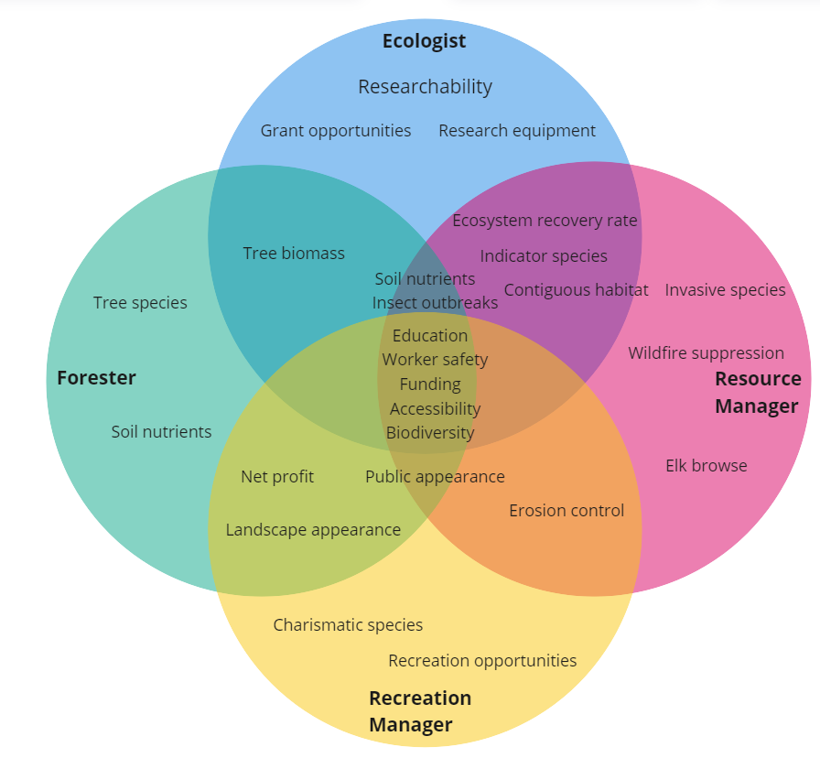

Figure 3.1. Stakeholder Concerns.

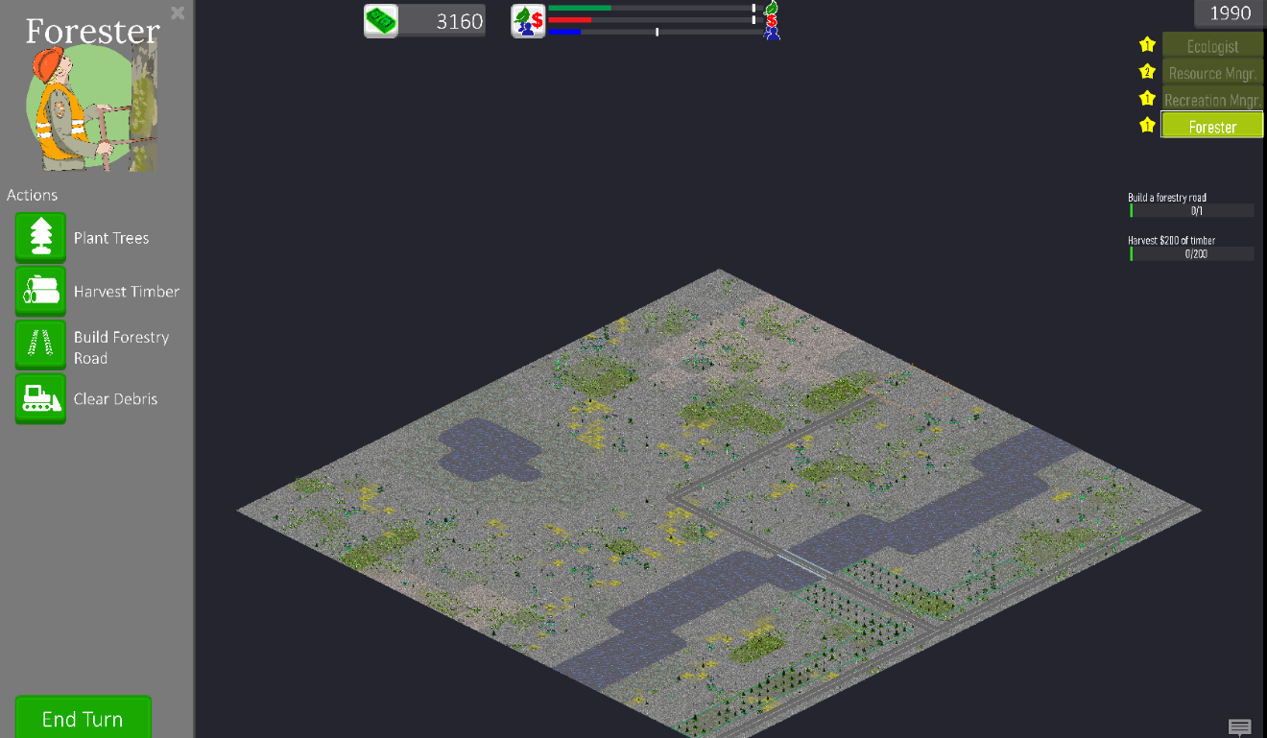

Figure 3.2. Resilience User Interface Screenshot.

Game Elements

Ecological Succession Model

In Resilience, players can choose to advance time by any number of years after making management decisions. During this progression through time, plants establish, reproduce, and spread where conditions are suitable for survival of the species. Over the years, animals move in and populate the area and nutrients return to the soil. Resilience employs a simulation of plant and animal colonization informed by the findings of research on ecological succession that was conducted on the real-world debris avalanche deposit at Mount St. Helens, but on a simplified scale [30]. This successional model was developed using information traits of the depicted species, such as lifespan, habitat requirements, and tolerance to environmental stressors.

In addition to the simulation aspects that contribute to the recovery process of the ecosystem, other events occur that may inhibit this recovery process. Major natural disturbances like droughts, landslides, wildfires, and insect infestations take place randomly every few years throughout the game. Other directly human-caused disturbances like invasive species introductions and erosion also occur. Disturbances largely work against the players by setting back their progress towards reaching their goals. Players are encouraged to learn about the causes and effects of disturbances to mitigate the disruption they cause.

Players perceive the process of ecological succession through investigating changes in the environment over time. The simulation model aspect of the game, in combination with the actions that players take, is intended to help deliver the first learning objective of Resilience: “Players learn about the natural and human phenomena that affect post-disturbance ecological recovery processes.”

Stakeholders

The Ecologist is the stakeholder primarily interested in studying the landscape and communicating findings to the other stakeholders to increase the chance that their actions are as environmentally responsible as possible. To investigate the debris avalanche deposit, the Ecologist conducts research by sampling features of the landscape, such as soil conditions and plants and animals present. After collecting enough data, the Ecologist can publish their research which helps to provide information about the ecosystem so that players can make more ecologically responsible decisions as the other stakeholders. To receive funding to conduct research, the Ecologist must apply for grants which have a chance to be awarded depending on how much data they have collected to date.

The Resource Manager is involved in monitoring and carrying out actions that protect the recovery process of the ecosystem and fosters safety of the public. Responsibilities of the Resource Manager include mitigating potential disturbances to natural and human resources like wildfires and landslides. Resource protection is achieved through removing invasive species, creating fire watchtowers, or removing debris after a landslide.

The Recreation Manager’s objective is to create opportunities for the public to engage with the landscape, such as building trails, visitors centers, and infrastructure like public roads that allow access to these resources. Recreation Managers may also benefit other stakeholders by creating roads to improve their access to the landscape and creating educational opportunities that increase public opinion of these stakeholders.

The Forester interacts with the landscape by planting trees and managing areas to create healthy forest systems. The Forester has the goal of maintaining a steady and profitable timber harvest in an ecologically sustainable way. Sustainable timber management involves protecting onsite and offsite soil, water, and air quality of managed forests, while protecting the living plants and animals. The Forester must also consider how their actions affect their public perception and ensure safety for their workers.

Capital

Natural capital acts as a quantifiable metric of the ecosystem services that players are attempting to balance and maximize. Natural capital is shared among all stakeholders and reflects the condition, arrangement, and quantity of the natural components of the landscape. Examples of in-game variables that affect natural capital are the diversity of species present, total biomass of native plants, and habitat continuity.

Economic capital is measured in the amount of money each stakeholder has access to at a given time plus the amount held in assets. Examples of assets include built infrastructure like roads and trails. The amount of money held by each player increases based on how much funding a stakeholder receives and decreases based on how much a player spends to conduct actions.

Social capital reflects how the actions taken by a stakeholder serve humans. Actions like building trails, publishing research, or preserving habitat increase social capital for the stakeholder that carried out the action. Social capital can be lost by performing actions that the public deems uncommendable.
Table 3.1 shows how each stakeholder may increase and decrease natural, economic, and social capital within Resilience. A “(+)” symbol indicates actions that increase a specific type of capital, while a “(-)” symbol indicates actions that decrease that type of capital.

Strategies

An important aspect affecting player success in Resilience involves the degree to which stakeholders work together in the game. Through experimenting with different types and amounts of stakeholder contribution, players can devise which actions synergize more readily and which do not. For example, players will find that building new roads is one way that the Recreation Manager can help the Forester reach new areas for timber harvesting but decrease the amount of natural area for the Ecologist to obtain reliable field data from. Understanding how each stakeholder’s actions will affect each other stakeholder is a critical step for players to win the game.

It is important for players of Resilience to carefully consider their actions to succeed. Through observing some of the initial playtesting sessions of the game, we found that the actions taken early in the play session often created effects that impacted success later in the session. We call these effects “priority effects” as they bear similarities to the ecological concept of the same name that describes how the order and timing of species establishment in an area affect the long-term community structure in that area [31]. One example of this effect that we witnessed was when a player chose not to conduct much research early in the game as the Ecologist. Because of this choice, the player had limited access to information when choosing actions and therefore found it difficult to make ecologically responsible decisions. Winning the game may involve playing Resilience multiple times to experiment with different management decisions and learn from mistakes, a key strategy of adaptive management that can be applied in the low-stakes environment of the game [32].

Table 3.1. Capital Effects Per Stakeholder.
Ecologist
Natural Capital | Social Capital | Economic Capital
(+) Providing research data that informs conservation actions  (-) Creating soil erosion through accessing plots | (+) Increasing public knowledge through publishing research  (-) Failing to communicate scientific information to the public | (+) Receiving grants  (-) Spending money on research equipment
Resource Manager
Natural Capital | Social Capital | Economic Capital
(+) Removing invasive plants  (-) Failing to remove debris after a landslide | (+) Protecting human resources from disturbances  (-) Failing to protect human resources from disturbances | (+) Receiving disaster relief funds  (-) Spending money on removing debris
Recreation Manager
Natural Capital | Social Capital | Economic Capital
(+) Increasing interest in conservation through public education  (-) Increasing soil erosion from allowing too many hikers | (+) Increasing access through building roads and trails  (-) Poorly maintaining trails | (+) Creating recreation infrastructure like trails and visitor centers  (-) Spending money to maintain infrastructure
Forester
Natural Capital | Social Capital | Economic Capital
(+) Planting trees  (-) Creating fertilizer runoff | (+) Improving landscape aesthetics through planting trees  (-) Harvesting many trees in one area (clear cutting) | (+) Selling timber from harvested trees  (-) Losing planted trees to a wildfire

Section 4
Methods

We administered anonymous pre- and post-tests to assess the effectiveness of Resilience in delivering the learning objectives. Both tests included the same questions to gauge comprehension of concepts before and after playing the game. The post-test included an opinion and demographic-based questionnaire to gauge participant perceptions and background and to see if there were any relationships between these variables and test scores. This questionnaire also allowed us to understand the degree to which students were enjoying their experience playing Resilience.

Participants

We recruited participants from classes at the University of Tennessee, Knoxville, with the only requirement being that participants were students at the university and at least 18 years of age. Two classes in the Ecology and Evolutionary Biology Department and two classes in the Geography and Sustainability Department had participating students. Classes participated based on the instructor’s willingness to have their students play the game as part of the course’s curriculum. As such, these classes involved content related to ecology, resource management, or game-based learning. Some instructors assigned playing Resilience as part of the class, and some offered it as an extra credit activity. The students’ decision to opt out of answering the surveys did not result in a penalty to the students’ grade in the class. 58 students agreed to participate in the research in total.

Study Design

We designed the pre- and post-test to help assess the participants’ grasp of the learning objectives before and after playing Resilience respectively. Both tests featured the same 8 short answer questions, with the first five questions assessing the first learning objective (Players learn about the natural and human phenomena that affect post-disturbance ecological recovery processes) and the next 3 questions assessing the second learning objective (Players experience the complexities of multiple-stakeholder cooperation). We wrote questions at an 8th grade reading level. To match each pre-test with the appropriate post-test while keeping the participants' identities confidential, the tests ask the participants to create a unique encrypted identification code.

In addition to re-answering the comprehension questions on the post-test, we also asked participants to answer a questionnaire which included 4 opinion-based and 14 demographic and background questions. Answers to the opinion-based questions were in the form of a Likert scale rating followed by a short answer component to allow for elaboration. The demographic questions were either in the form of multiple choice, yes/no, Likert scale, or short answer. The survey also asked for participants’ education level, age range, and experience with science classes and serious games.

Study Procedure

We provided all potential participants with a short description of the research and what participation in the study involved followed by a link to the informed consent form and an invitation link to begin the pre-test in the online survey platform Qualtrics®. Since we retrieved data anonymously, signatures of consent could not be provided. Instead, the completion of the tests by the individual participants designated their willingness to participate in the study. We provided 15 minutes for the completion of the pre-test.

Participants proceeded to download and play Resilience individually. Individual play times ranged from 1-3 hours and occurred within and outside of class periods. The research team was available for questions about technical difficulties but otherwise did not observe or interact with the participants.

We provided participants with access to the post-test either before or during the beginning of the class period following the participants’ completion of their play session. Participants were given around 20 minutes to complete this post-test.

Analysis

To assess how learning objectives were met, we developed a rubric that assigned point values to the 8 short answer questions based on the number of criteria that a response included (Appendix 1). We scored responses to the 8 short answer questions on both pre- and post-tests and summed each participant’s scored responses individually. The highest possible score overall was 25 points, with 18 points for the five questions measuring learning objective 1 and 7 points for the 3 questions measuring learning objective 2. We used a paired sample t-test to assess the statistical differences between pre- and post-test scores overall and among individual learning objectives.

We used an inductive coding process to group opinion-based short answer responses. Participants answered 4 different opinion-based questions on a Likert scale and provided short written responses to elaborate on their answers to each. The coding process consisted of developing codes that represented commonly appearing themes and attitudes present throughout the short answer responses (Table 4.1). We developed 6 codes associated with positive feedback and 7 codes associated with negative feedback. After developing codes, we re-read and coded each response.

We conducted regression analyses to determine if there were any correlations between score variables, demographics, and opinion-based responses. We compared overall score improvements, total pre-test scores, and total post-test scores to each demographic and opinion-based response.

Table 4.1. Codebook For Opinion-Based Short Answer Responses.
Feedback Type | Code Name | Code Description | Example
Positive | Fun (general) | Response indicates enjoyment without specifying why | “I enjoyed playing the game”
Positive | Engaging (general) | Response indicates engagement without specifying why | “I got caught up playing the game for a long time”
Positive | Simulation | Response mentions enjoying simulation aspects of the game | “It was exciting to see how disturbances changed the landscape”
Positive | Stakeholders | Response mentions enjoying playing the game from the different stakeholder perspectives | “I loved seeing how different managers had different goals for the same landscape”
Positive | Learning | Response mentions the participant had learned from playing the game | “I learned a lot about how ecosystems recover after disturbances”
Positive | Clear instructions | Response mentions the game’s instructions are clear and easy to follow | “It was simple to follow along with the help that the game provides”
Negative | Hardware | Response mentions issue(s) running the game on the participant’s hardware | “The game ran slowly on my laptop”
Negative | Gameplay | Response mentions a gameplay-related feature detracting from their experience | “My game encountered an error and randomly crashed”
Negative | Genre | Response mentions not enjoying the game due to the game’s genre | “I don’t typically play strategy games, so I didn’t enjoy this game very much”

Table 4.1 Continued.
Feedback Type | Code Name | Code Description | Example
Negative | Confused | Response indicates confusion by some aspect of the game | “I did not understand how to achieve the overall goal of the game”
Negative | Long | Response indicates that the participant found the game took too long | “Completing the game took too long”
Negative | Repetitive | Response mentions finding the game too repetitive | “After about 45 minutes of playing, the game began to feel stale”
Negative | No learning | Response indicates the participant did not learn by playing the game | “I feel like I already knew about most of the topics in the game”

Section 5
Results
After exploring our data, we displayed the major results of our analyses graphically. We observed an increase of 21% (p<0.001) when comparing the sum of all pre-test (M=13, SD=2.82) and post-test scores (M=16, SD=2.83) (Figure 5.1). After partitioning scores into the learning objectives being assessed, we found an increase of 28% (p<0.001) when comparing the sum of pre-test (M=8, SD=2.03) and post-test scores (M=10, SD=2.42) associated with learning objective 1 (Figure 5.2) and an increase of 12% (p=0.004) when comparing the sum of pre-test (M=6, SD=1.14) and post-test scores (M=6.5, SD=0.91) associated with learning objective 2 (Figure 5.3).

We visualized responses to opinion-based questions measured on a Likert scale using bar graphs. The first question, “Playing the game Resilience was a fun and entertaining experience,” assessed players’ ability to have fun during gameplay (Figure 5.4). The second question, “I feel that I could play Resilience for an hour without getting bored,” assessed players’ ability to engage with the game for the minimum recommended amount of playtime (1 hour) (Figure 5.5). The third question, “Resilience was easy to learn how to play,” provided feedback on how the game’s tutorial and general presentation facilitated player’s understanding of how to engage with and succeed at the game (Figure 5.6). Finally, the fourth question, “I feel that I learned about ecological systems while playing Resilience,” allowed us to assess if information about ecological systems was being successfully delivered and the level to which participants felt that they were understanding these concepts (Figure 5.7).

For each code in the developed codebook, we plotted the number of participants who had a response that fell into that code (Figure 5.8 and Figure 5.9). When the same code was present more than once across a participant’s responses, we only counted the first time it appeared. Among positively coded responses, “Fun (general)” appeared most frequently with 25 participants including a response that mentioned having fun playing the game without further elaboration. Other common positively coded responses included “Learning,” which appeared 24 times and indicated a participant who mentioned learning from the game, and “Clear instructions,” which appeared 20 times and indicated a participant who found the game’s instructions to be clear. Among negatively coded responses, “Gameplay” appeared most frequently, with 17 participants mentioning some sort of dissatisfaction with gameplay-related elements.

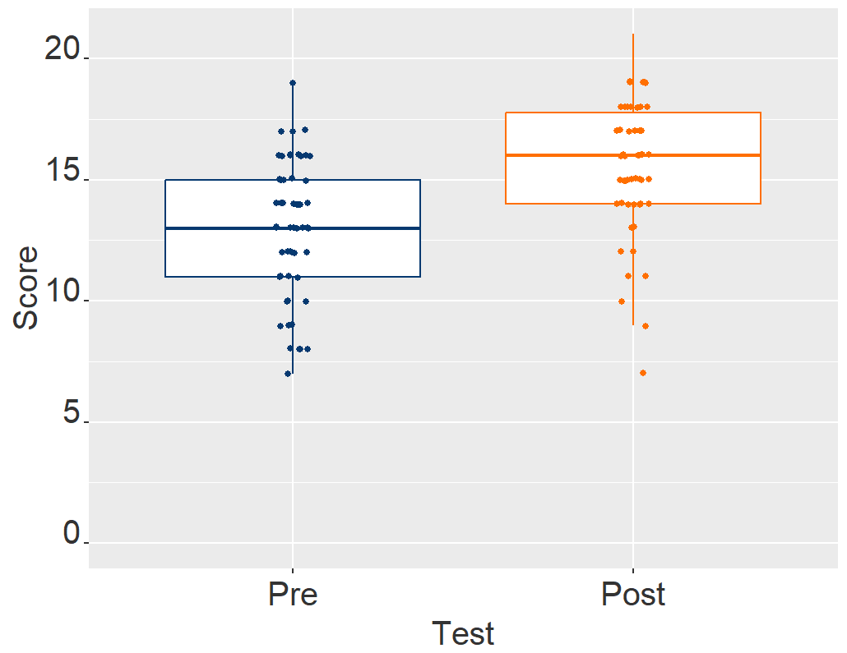

Figure 5.1. Comparison of Total Pre- and Post-Test Scores. (Out of 25 possible points, n=58, p<0.001).

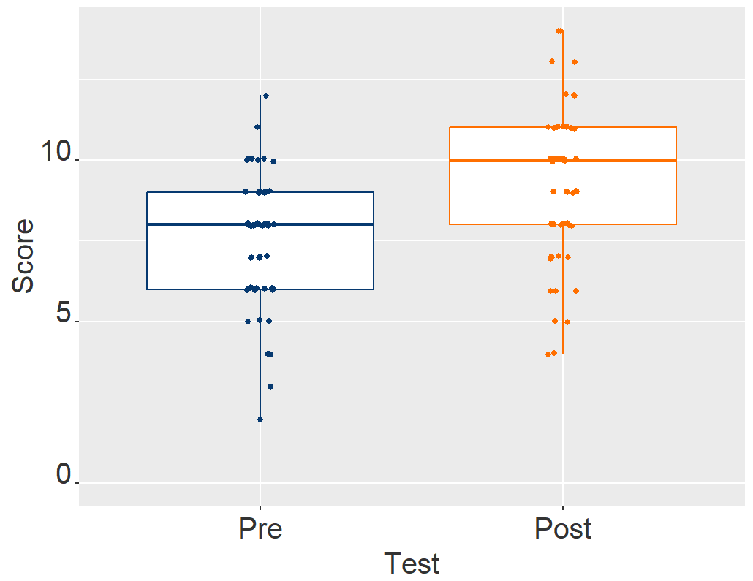

Figure 5.2. Comparison of Objective 1 Pre- and Post-Test Scores. (Out of 18 possible points, n=58, p<0.001).

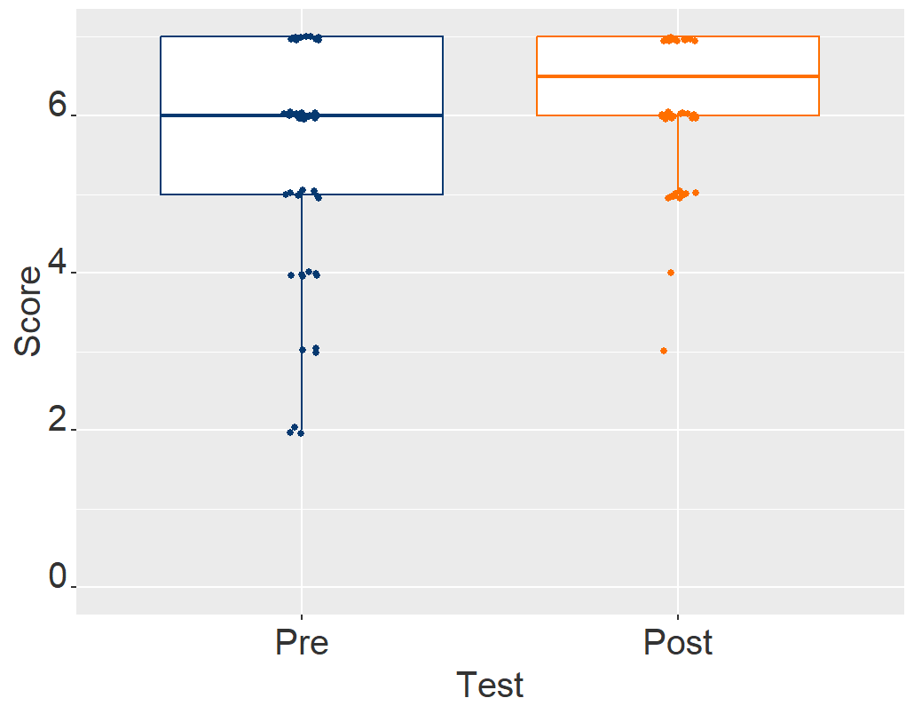

Figure 5.3. Comparison of Objective 2 Pre- and Post-Test Scores. (Out of 7 possible points, n=58, p=0.004).

Figure 5.4. Participant Opinions on Entertainment Value.

Figure 5.5. Participant Opinions on Engagement While Playing.

Figure 5.6. Participant Opinions on Ease of Learning How to Play the Game.

Figure 5.7. Participant Self-Perception of Learning About Ecological Systems.

Figure 5.8. Positive Codes Appearing in Short Answer Responses.

Figure 5.9. Negative Codes Appearing in Short Answer Responses.

We visualized information about our sample by plotting results to several demographic questions (Figure 5.10). Out of 58 participants, 33 had completed a high school education or gotten a GED, and 25 had received a bachelor’s degree. 54 participants fell between the ages of 18-25, with 3 participants between 26-40 years old and a single participant older than 40. 48 participants (83%) reported having taken a class that discussed ecological succession, and 36 participants (62%) reported having played a serious game before. Results of regression analyses failed to yield any statistically significant relationships between these demographics, opinion-based responses, and score variables.

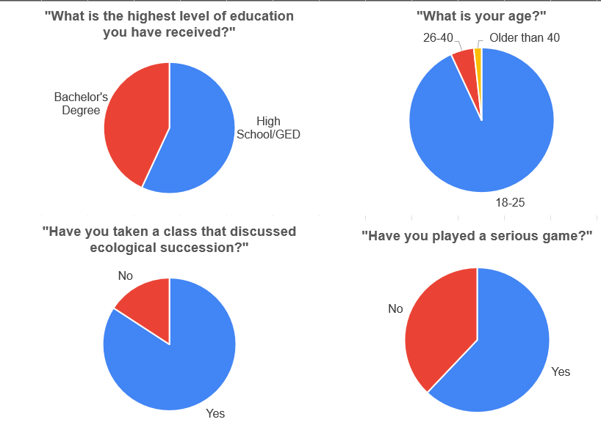

Figure 5.10. Participant Demographics.

Section 6
Discussion

Implications

The increase between pre- and post-test scores implies that Resilience can be used as an effective tool to learn about ecosystem recovery and stakeholder cooperation. There was a significant increase in comprehension of concepts related to ecosystem recovery (a.k.a. learning objective 1). Understanding of stakeholder cooperation (a.k.a. learning objective 2) only increased by about half of the amount of learning objective 1 after playing the game. While still significant, this lower increase in scores suggests that we need to improve the degree to which players of Resilience can learn about this concept or that we may need to change our survey and/or scoring methods. The high pre-test scores in comparison to post-test scores associated with learning objective 2 suggest that the latter strategy may be an appropriate first step.

Our analysis of opinion and background information retrieved from the questionnaire led to some interesting insight on how different people perceived the game and the game-playing experience. Participants generally agreed with the statement that Resilience was fun and entertaining, but there were mixed opinions on whether the game could be played for an hour without the participant getting bored. These results could be an indication that some players are not finding the game to be engaging but could also imply that the question itself is not accurately capturing the true level of engagement that the participant is experiencing.

We found no significant trends when comparing scores between different demographics or among individuals with certain opinions or perceptions. This lack of significant relationships could potentially be due to most of our sample being comprised of similar demographics. For example, all but 4 participants fell into the 18-25 age range.

Future Directions

Due to the nature of our ability to gain a significant portion of our participants from college classes with focuses related to the content of the game, most of the sample demographics consisted of college students in STEM concentrations. Further analysis of participants from different demographics is required to better assess the effects of playing Resilience. Individuals with background knowledge not as closely related to the game’s content and individuals outside of our sample group of University of Tennessee, Knoxville, students may find certain concepts to be harder to understand as well as showing a different level of engagement and enjoyment.

We plan to release Resilience to deliver relevant knowledge and experience to the game’s intended audience: students in grades 8 and above and professionals in the fields of ecology and resource management. By using Resilience in classrooms, students can learn about and explore concepts related to ecological recovery, disturbances, and responsible resource management in relevant classes. In addition, we view Resilience as a potential tool to raise awareness of careers associated with the stakeholders within the game and increase overall recruitment to fields that involve the management of natural and human resources. Resilience is also intended to be used as a training tool by professionals who may be likely to experience scenarios like those that appear in the game. This use could range from specific jobs that include management of resources in a recovering ecosystem, or a more general use like training individuals on the importance of stakeholder cooperation. Finally, we aim to release Resilience to the general public who seek to learn about its concepts or just to experience and enjoy the game.

Going forward, we will use the information gained from this study to inform the development of Resilience before its eventual public release. Results from opinion surveys reveal that Engagement is a critical component of learning and correlates with student success [35]. One major benefit of serious games is their potential to be more engaging than traditional education media, so fostering engagement is a crucial step when creating a serious game. Feedback from opinion-based responses of our surveys elucidates some of the things perceived most negatively about the game. This includes gameplay-related issues, confusion, and finding the game too repetitive and long, all of which could be altered to increase engagement. Other potential ways to increase engagement in digital serious games include implementing score systems, clearer player feedback, and allowing players to represent themselves through customizable avatars [36][37]. Changing the game’s difficulty level throughout the game could also increase engagement levels by keeping the player from becoming bored by the lack of challenge or frustrated by too much challenge, thus creating a “pleasantly challenging” experience [38].

A major feature to be implemented before the final release of Resilience is the inclusion of a multiplayer version with different players taking on different stakeholder roles in addition to the single player version of the game that players tested. When multiple individuals are engaged in a play session that facilitates communication, players can feel more engaged [37]. Conversation-enabled gameplay allows for a mix of unique perspectives and provides a forum for players to be more open to considering both complimentary and opposing viewpoints of gameplay decisions, which increases knowledge gained compared to individuals playing the game alone [39][40][41]. Conversational gameplay may also allow players to see how asymmetrical imbalances in access to abilities or resources can be used synergistically. On the other hand, playing as a single role may inhibit the players’ abilities to see how their actions fit into the larger context of the game, and limit the amount of content they would otherwise experience if they were embodying all stakeholder roles themselves.

Section 7
Conclusion

Our findings serve as evidence that serious games can be used to help individuals learn about and explore concepts in ecology and resource management. Through its realistic and dynamic simulation of ecological processes, Resilience allows players to learn about the natural and human phenomena that affect these processes. Players concurrently experience the complexities of multiple-stakeholder cooperation through inhabiting multiple stakeholder roles with varying values and goals. To deliver learning objectives more effectively to future players of Resilience, we plan to focus on making the game more engaging and polishing existing features. We also plan to analyze how the content is received by a wider audience. Using Resilience for education and training could potentially help produce more cooperative and ecologically informed resource managers and thus help improve the protection and restoration of ecosystem services and human resources after disturbances.

References

- E. M. Bennett, G. D. Peterson, and L. J. Gordon, “Understanding relationships among multiple ecosystem services,” Ecology Letters, vol. 12, no. 12, pp. 1394–1404, 2009, doi: 10.1111/j.1461-0248.2009.01387.x.
- V. H. Dale, A. E. Lugo, J. A. MacMahon, and S. T. A. Pickett, “Ecosystem Management in the Context of Large, Infrequent Disturbances,” Ecosystems, vol. 1, no. 6, pp. 546–557, Nov. 1998, doi: 10.1007/s100219900050.
- R. Berardo, T. Heikkila, and A. K. Gerlak, “Interorganizational Engagement in Collaborative Environmental Management: Evidence from the South Florida Ecosystem Restoration Task Force,” Journal of Public Administration Research and Theory, vol. 24, no. 3, pp. 697–719, Jul. 2014, doi: 10.1093/jopart/muu003.
- K. F. E. Hogan et al., “New multimedia resources for ecological resilience education in modern university classrooms,” Ecosphere, vol. 13, no. 10, p. e4245, 2022, doi: 10.1002/ecs2.4245.
- Y. Rogers and M. Scaife, “How can interactive multimedia facilitate learning,” 1998. Accessed: May 23, 2023. [Online]. Available: https://www.semanticscholar.org/paper/How-can-interactive-multimedia-facilitate-learning-Rogers-Scaife/6a378d072625b02f2d96e6063c1a0d1a6800ecd7
- V. Rossano, T. Roselli, and G. Calvano, “Multimedia Technologies to Foster Ecological Skills,” in 2017 IEEE 17th International Conference on Advanced Learning Technologies (ICALT), Jul. 2017, pp. 128–130. doi: 10.1109/ICALT.2017.76.
- F. Laamarti, M. Eid, and A. El Saddik, “An Overview of Serious Games,” International Journal of Computer Games Technology, vol. 2014, pp. 1–15, 2014, doi: 10.1155/2014/358152.
- P. Sajjadi et al., “Promoting systems thinking and pro-environmental policy support through serious games,” Frontiers in Environmental Science, vol. 10, 2022, Accessed: May 23, 2023. [Online]. Available: https://www.frontiersin.org/articles/10.3389/fenvs.2022.957204
- M. Riopel et al., “Impact of serious games on science learning achievement compared with more conventional instruction: an overview and a meta-analysis,” Studies in Science Education, vol. 55, no. 2, pp. 169–214, Jul. 2019, doi: 10.1080/03057267.2019.1722420.
- D. Cabrera, L. Colosi, and C. Lobdell, “Systems thinking,” Evaluation and Program Planning, vol. 31, no. 3, pp. 299–310, Aug. 2008, doi: 10.1016/j.evalprogplan.2007.12.001.
- F. Dahdouh-Guebas et al., “The Mangal Play: A serious game to experience multi-stakeholder decision-making in complex mangrove social-ecological systems,” Front. Mar. Sci., vol. 9, Aug. 2022, doi: 10.3389/fmars.2022.909793.
- C. C. M. Deaton and M. Cook, “Using Role-Play and Case Study to Promote Student Research on Environmental Science,” Science Activities, vol. 49, no. 3, pp. 71–76, Jun. 2012, doi: 10.1080/00368121.2011.632449.
- K. Madani, T. W. Pierce, and A. Mirchi, “Serious games on environmental management,” Sustainable Cities and Society, vol. 29, pp. 1–11, Feb. 2017, doi: 10.1016/j.scs.2016.11.007.
- J. Rooney-Varga, F. Kapmeier, J. Sterman, A. Jones, M. Putko, and K. Rath, “The Climate Action Simulation,” Simulation & Gaming, vol. 51, p. 104687811989064, Dec. 2019, doi: 10.1177/1046878119890643.
- R. C. Lewontin, “The meaning of stability,” Brookhaven Symp Biol, vol. 22, pp. 13–24, 1969.
- R. M. May, “Thresholds and breakpoints in ecosystems with a multiplicity of stable states,” Nature, vol. 269, no. 5628, Art. no. 5628, Oct. 1977, doi: 10.1038/269471a0.
- B. Beisner, D. Haydon, and K. Cuddington, “Alternative stable states in ecology,” Frontiers in Ecology and the Environment, vol. 1, no. 7, pp. 376–382, 2003, doi: 10.1890/1540-9295(2003)001[0376:ASSIE]2.0.CO;2.
- “Ecological Succession.” Texas Gateway. https://www.texasgateway.org/resource/ecological-succession (accessed May 23, 2023).
- D. J. Gibson, “Textbook Misconceptions: The Climax Concept of Succession,” The American Biology Teacher, vol. 58, no. 3, pp. 135–140, Mar. 1996, doi: 10.2307/4450101.
- V. H. Dale et al., “Plant Succession on the Mount St. Helens Debris-Avalanche Deposit,” in Ecological Responses to the 1980 Eruption of Mount St. Helens, V. H. Dale, F. J. Swanson, and C. M. Crisafulli, Eds., New York, NY: Springer, 2005, pp. 59–73. doi: 10.1007/0-387-28150-9_5.
- Lab-Aids Inc., “Ecological Succession Kit.“ Available: https://store.lab-aids.com/kits-and-modules/ecological-succession.
- D.E. Bilderback, Mount St. Helens 1980: Botanical Consequences of the Explosive Eruptions, Los Angeles, CA, USA: University of California Press, 1987.
- V. H. Dale and C. Crisafulli, “Ecological Responses to the 1980 Eruption of Mount St. Helens: Key Lessons and Remaining Questions,” in Ecological Responses at Mount St. Helens: Revisited 35 years after the 1980 Eruption, 2018, pp. 1–18. doi: 10.1007/978-1-4939-7451-1_1.
- S.A.C Keller, Mount St. Helens: one year later, Cheney, WA, USA: Eastern Washington University Press, 1982.
- P.W. Lipman and D.R. Mullineaux, The 1980 Eruptions of Mount St. Helens, Washington, Washington, District of Columbia, USA: US Geological Survey, 1981.
- “MSH Impact and aftermath [USGS].” Accessed: Feb. 14, 2024. [Online]. Available: https://pubs.usgs.gov/gip/msh/impact.html
- S.D. Burket, E.P. Furlow, P.R. Golding, L.C. Grant, W.A. Lipovsky and T.G Lopp, “The Economic Effects of The Eruptions of Mount St. Helens,” United States International Trade Commission, Washington, D.C., 1980.
- F. J. Swanson and C. M. Crisafulli, “Volcano Ecology: State of the Field and Contributions of Mount St. Helens Research,” in Ecological Responses at Mount St. Helens: Revisited 35 years after the 1980 Eruption, C. M. Crisafulli and V. H. Dale, Eds., New York, NY: Springer, 2018, pp. 305–323. doi: 10.1007/978-1-4939-7451-1_16.
- V. H. Dale, F. J. Swanson, and C. M. Crisafulli, “Ecological Perspectives on Management of the Mount St. Helens Landscape,” in Ecological Responses to the 1980 Eruption of Mount St. Helens, V. H. Dale, F. J. Swanson, and C. M. Crisafulli, Eds., New York, NY: Springer, 2005, pp. 277–286. doi: 10.1007/0-387-28150-9_19.
- V. H. Dale and E. M. Denton, “Plant Succession on the Mount St. Helens Debris-Avalanche Deposit and the Role of Non-native Species,” in Ecological Responses at Mount St. Helens: Revisited 35 years after the 1980 Eruption, C. M. Crisafulli and V. H. Dale, Eds., New York, NY: Springer, 2018, pp. 149–164. doi: 10.1007/978-1-4939-7451-1_8.
- T. Fukami, “Historical Contingency in Community Assembly: Integrating Niches, Species Pools, and Priority Effects,” Annual Review of Ecology, Evolution and Systematics, vol. 46, no. Volume 46, 2015, pp. 1–23, Dec. 2015, doi: 10.1146/annurev-ecolsys-110411-160340.
- C. S. Holling, “Understanding the Complexity of Economic, Ecological, and Social Systems,” Ecosystems, vol. 4, no. 5, pp. 390–405, Aug. 2001, doi: 10.1007/s10021-001-0101-5.
- J. H. Lawton, “Daily, G. C. (Ed.). 1997. Nature’s services. Societal dependence on natural ecosystems. Island Press, Washington, DC. 392 pp. ISBN 1-55963-475-8 hbk), 1 55963 476 6 (soft cover).,” Animal Conservation forum, vol. 1, no. 1, pp. 75–76, Feb. 1998, doi: 10.1017/S1367943098221123.
- C. Folke et al., “Regime Shifts, Resilience, and Biodiversity in Ecosystem Management,” Annual Review of Ecology, Evolution, and Systematics, vol. 35, pp. 557–581, 2004.
- R. M. Carini, G. D. Kuh, and S. P. Klein, “Student Engagement and Student Learning: Testing the Linkages*,” Res High Educ, vol. 47, no. 1, pp. 1–32, Feb. 2006, doi: 10.1007/s11162-005-8150-9.
- M. V. Birk and R. L. Mandryk, “Combating Attrition in Digital Self-Improvement Programs using Avatar Customization,” in Proceedings of the 2018 CHI Conference on Human Factors in Computing Systems, in CHI ’18. New York, NY, USA: Association for Computing Machinery, Apr. 2018, pp. 1–15. doi: 10.1145/3173574.3174234.
- B. Reeves and J. L. Read, Total Engagement: How Games and Virtual Worlds Are Changing the Way People Work and Businesses Compete. Harvard Business Press, 2009, pp. 61–90.
- G. Chanel, C. Rebetez, M. Bétrancourt, and T. Pun, “Boredom, engagement and anxiety as indicators for adaptation to difficulty in games,” in Proceedings of the 12th international conference on Entertainment and media in the ubiquitous era, Tampere Finland: ACM, Oct. 2008, pp. 13–17. doi: 10.1145/1457199.1457203.
- M. Sousa, A. P. Antunes, N. Pinto, and N. Zagalo, “Serious Games in Spatial Planning: Strengths, Limitations and Support Frameworks,” International Journal of Serious Games, vol. 9, no. 2, Art. no. 2, Jun. 2022, doi: 10.17083/ijsg.v9i2.510.
- E. Gordon and J. Baldwin-Philippi, “Playful Civic Learning: Enabling Lateral Trust and Reflection in Game-based Public Participation,” International Journal of Communication, vol. 8, no. 0, Art. no. 0, Feb. 2014.
- C. González-González, P. Toledo-Delgado, C. Collazos-Ordoñez, and J. L. González-Sánchez, “Design and analysis of collaborative interactions in social educational videogames,” Computers in Human Behavior, vol. 31, pp. 602–611, Feb. 2014, doi: 10.1016/j.chb.2013.06.039.
- Matt Leacock, “Pandemic.” 2008.
- Jacob Fryxelius, “Terraforming Mars.” 2016.
- Joe Hopkins, “Endangered.” 2020.
- Christian Telesmar, “Disparity Trap.” 2022.
- Mr. Bistro, J. Arthur Ellis, and Isaac Vega. “Forgotten Waters.” 2020

Appendix
Appendix 1. Survey grading rubric.
Question  The question as it appears on the survey | Points  Each bullet point represents a feature of an answer that is necessary to receive a point | Example response  Responses that receive the maximum number of points
How would you explain "ecological succession" to someone? | 5 points  - Initiated by a disturbance  - A change in abiotic factors  - A change in composition  - A change in structure  - A change in function | “Ecological succession is a process whereby a disturbance causes a shift in an ecosystem’s components, including changes in soil nutrients, the types of plant and animal species present, habitat types available like forests or grasslands, and functions offered by the ecosystem.”
What does it mean when an ecosystem is "resilient”? | 3 points  - Capability to recover after a disturbance  - Maintaining a state  - Mention of ecosystem processes/patterns/services/functions | “An ecosystem can be described as resilient when its main functions are represented consistently over time, despite facing disturbances that set these functions off-balance. In other words, recovery from these disturbances relatively quickly.”
What do you think the term “natural capital” means? | 4 points  - Resources  - Benefits to people (ecosystem services)  - Benefits to the ecosystem  - Mention one or more examples of resources | “Natural capital represents the resources provided by an ecosystem that benefit both people and the ecosystem itself. An example is a tree which converts carbon dioxide into breathable air for humans and habitats for wild animals.”
Name three ways that humans can aid plant re-establishment after a disturbance. | 3 points  - Mention one correct way  - Mention a second correct way  - Mention a third correct way | “Humans can aid plant re-establishment after a disturbance by reducing the risk of future disturbances, removing competitive invasive species, and limiting public access to the area.”
Name three ways that humans can deter plant re-establishment after a disturbance. | 3 points  - Mention one correct way  - Mention a second correct way  - Mention a third correct way |  | “Humans can deter plant re-establishment after a disturbance by building roads through the area, trampling new growing plants, and creating soil pollution.”

Appendix 1 Continued.
Question  The question as it appears on the survey | Points  Each bullet point represents a feature of an answer that is necessary to receive a point | Example response  Responses that receive the maximum number of points
Name three groups of people who care about and/or use wild land areas. | 3 points  - Mention one correct group  - Mention a second correct group  - Mention a third correct group | “Foresters, ecologists, and hikers all care about or use wild land areas.”
What conflicts might arise when an area is being used to produce timber as well as being studied for its ecology? | 2 points  - Conflict is described in detail  - Conflict is realistic | “A forester could desire modifications of an area that could create conflict with an ecologist studying the plants in the area. The forester may want to remove understory plants to decrease the risk of intense wildfires, while the ecologist might lose the chance to observe and record information about these plants.”
If it is your responsibility to increase trail use in an area, how can you benefit from an increase in plants and animals in this area? | 2 points  - Benefit is described in detail  - Benefit is realistic | “An increase in plant and animal species in an area could encourage people who are interested in the local flora and fauna to visit trails in this area. Examples of interested people include hunters or birdwatchers.”

Vita
Parker Maynard was born and raised in southeast Michigan. He earned a Bachelor of Science in environmental science and society from Eastern Michigan University. After graduating, Parker went on to work in natural land stewardship. He participated in the 2022 field campaign at Mount St Helens during which 63 permanent plots were surveyed for plant diversity as part of monitoring on the debris avalanche deposit that has been ongoing since the 1980 eruption. Parker attended the University of Tennessee, Knoxville from 2022 to 2024 to earn his Master’s degree in ecology and evolutionary biology, where he combined his knowledge of ecology and resource management with his interest in game development.

We define stakeholders as all persons and groups that influence the activity or may be affected positively or negatively by changes in the provision of ecosystem services or socioeconomic conditions associated with the activity [19].
Ecosystem services refers to the benefits that people derive from nature such as clean water and clean air [28].

