Structural and Kinetic Studies of Structure I & II Gas Hydrates via Neutron Powder Diffraction and Low Temperature X-Ray Diffraction

A Dissertation Presented for the

Doctor of Philosophy

Degree

The University of Tennessee, Knoxville

Susan Michelle Everett

March 2013

Copyright © 2013 by Susan Michelle Everett
All rights reserved.

DEDICATION

I dedicate this work to my husband Chris (babers).
He kept saying, “You can do this! I’ll support you however I need!”
He has surprising patience when it comes to my crazy.
I love that man.

To my mom and dad, who raised me to be independent,
do things the right way and take pride in my work.
They’ve never stopped loving and nurturing me in all my 40 years.
Mom always knew that
I asked too many questions not to be a scientist,
and my dad, says he is still living just to see me walk across that stage.

And to my close friends, Toby and Christine, who kept asking questions
and cheering appropriately, even though their eyes glazed over
when the nerdy details came out. If they could have used their collective writing skills to save me, they would have.

Of course enough cannot be said about the influence Claudia had on this adventure. Without her constant search for worthy students to send running head first into science, this experience would not have been possible. Her zeal for understanding and quest for scientific discovery is unparalleled.
Not to mention her cheerleading skills, if not for those,
I most definitely would have lost this game.

ACKNOWLEDGEMENTS

This work is supported by National Science Foundation Grant No. DGE0801470, “Sustainable Technology through Advanced Interdisciplinary Research” (STAIR), awarded to the University of Tennessee, Knoxville. Also in small part by the Office of Fossil Energy through Field Work Proposal FEAB111 “Hydrate Formation and Dissociation in Simulated and Field Samples.”

Neutron powder diffraction data were collected at the Spallation Neutron Source and the High Flux Isotope Reactor. Low temperature x-ray powder diffraction data were collected at the Center for Nanophase Materials Sciences. All of these are sponsored at Oak Ridge National Laboratory by the Scientific User Facilities Division, Office of Basic Energy Sciences, U.S. Department of Energy.

There have been a number of people along the way that has made this journey come to a successful end. The scientific community that I was a part of at ORNL supported me, and gave me every tool they could to make me successful. Also, my fellow graduate students, without their commiseration I would have felt completely alone in the world.

ABSTRACT

Gas hydrates are materials of interest as sources for clean energy, carbon sequestration, greenhouse gas mitigation, and gas storage. This body of work presents three projects that each separately explore one aspect of the potential found in gas hydrates. Part 1 tackles the structural changes found to occur over the CO₂ [carbon dioxide] - CH₄ [methane] hydrate solid solution. The application here pertains to the sequestration of CO₂ in natural gas hydrates found in permafrost regions and ocean floors. As CO₂ is injected into the hydrate reservoir, CH₄ is released and recovered for energy use. Samples synthesized from liquid water were studied using high-resolution neutron diffraction. Static images of the nuclear scattering density of the free moving gas molecules were determined. Cage occupants and occupancies, the volume change of the unit cell and the individual cages based on composition were determined. Part 2 pertains to the decomposition of methane hydrate and a phenomenon termed anomalous preservation. Three samples were studied using in situ low temperature x-ray diffraction as they decomposed over a temperature range of 140 – 260 K and the kinetics were analyzed using the Avrami model. Activation energies were determined as well as nucleation schemes for two temperature ranges within the overall range. Part 3 studies gas hydrate as a storage medium for H₂ [hydrogen]. Samples of mixed Ar/D₂ [argon/deuterium] and N₂/D₂ [nitrogen] were studied via neutron diffraction. Cage occupants were determined through the modeling of mixed gas ratios.

TABLE OF CONTENTS

INTRODUCTION 1
Gas Hydrates 1
Energy Source 3
Global Climate Change 5
Gas Storage 7
Purpose 9
EXPERIMENTAL METHODS 9
Sample Synthesis 9
X-Ray Diffraction 11
Neutron Diffraction 14
Rietveld Refinements 16
CHAPTER I Molecular Visualization of CH₄ – CO₂ Solid Solution in Gas Hydrates via High-resolution Neutron Powder Diffraction 22
Abstract 23
Background 23
Experimental 25
Results and Discussion 27
Conclusion 31
CHAPTER II Kinetic Studies OF Methane Hydrate Decomposition via Low Temperature X-ray Powder Diffraction 33
Abstract 34
Background 34
Experimental 38
Results and Discussion 40
Conclusion 44
CHAPTER III Hydrogen Storage in Mixed Gas Hydrates via Wide Angle Neutron Diffraction 45
Abstract 46
Background 46
Experimental 46
Results and Discussion 46
Conclusion 46
CONCLUSION 47
LIST OF REFERENCES 49
APPENDIX 58
Figures 59
Tables 70
VITA 75

LIST OF TABLES

Table A - 1. Experimental results 70
Table A - 2. Rietveld results 71
Table A - 3. Cage occupancies and occupants 72
Table A - 4. Avrami constants 73

LIST OF FIGURES

Figure A - 1. Diffraction of x-rays by atomic planes 59
Figure A - 2. Large and small cage of sI placed in the unit cell 60
Figure A - 3. Powder pattern for 50% CH₄ nominal sample 61
Figure A - 4. Fourier density difference maps 62
Figure A - 5. Lattice parameters, ADPs, cell volumes, and density 63
Figure A - 6. Temperature dependent decomposition 64
Figure A - 7. Waterfall at 250K 65
Figure A - 8. Avrami plot for Region 2 66
Figure A - 9. Avrami plot for Region 3 67
Figure A - 10. Arrhenius plot for region 2 68
Figure A - 11. Arrhenius plot for region 3 69

INTRODUCTION

Gas Hydrates

Gas hydrates, also referred to as clathrate hydrates, are nonstoichiometric crystalline water inclusion compounds wherein the water host lattice is a hydrogen-bonded network that traps small gas molecules, approximately 9 Å or less (Koh and Sloan 2007) inside cages. High pressure (2 − 1,000 MPa) and/or low temperature (<323 K) are required for hydrate formation and stability (Sloan 2003). There are three primary hydrate structures; the structure formed is dependant on the type of gas molecule stored inside and the pressure conditions under which it was formed. They readily occur in nature; found in permafrost regions and in sediments of the continental margins.
Evidence of the discovery of hydrates may date back to 1778 when Priestly observed a material from freezing H₂O and SO₂ (Sloan and Koh 2008). However, there is not enough documentation to substantiate the claim. The first well-documented discovery is attributed to Sir Humphry Davy in 1810. He observed the production of a solid material from liquid H₂O and Cl gas (oxymuriatic gas) above the freezing point for water (Davy 1811). Hydrates went without consideration until Hammerschmidt from Canada in 1934 discovered that hydrates were the reason gas lines were blocked in high-pressure low temperature conditions offshore and onshore. Since then, flow assurance has been a top priority for the oil/gas industry (Koh, Sloan et al. 2011). It was not until 1964 in Russia that the first permafrost natural gas hydrate (NGH) was discovered and later marine hydrates were found in the 1970’s (Demirbas 2010). NGH is formed from either biogenic or thermogenic methane sources. The current state of hydrates is no longer in the discovery stage, but rather in the exploitation stage.
The three primary structures are known as structure I (sI), structure II (sII), and structure H (sH). They are denoted by the shape and number of the faces that make up the cage; A^{x}B^{y} where A and B are the number of sides of each face, and x and y are the numbers of faces that make up each cage. sI has two small cages (5¹²) and six large cages (5¹²6²) made from 46 H₂O molecules per unit cell. sII has sixteen small cages (5¹²) and eight large cages (5¹²6⁴) made from 136 H₂O molecules per unit cell. Both sI and sII crystallize in the cubic crystal system with lattice parameters of approximately 12 and 17 Å, respectively. sH has three (5¹²), two (4³5⁶6³) and one (5¹²6⁸) from 34 H₂O molecules. Although the structures are different in cage size and number, they are all 85 mol% water and 15 mol% guest (Sloan 2003).
The most influential factor in structure type is the guest molecule size. Most naturally occurring hydrates are sI comprised of small guests in the range of 4 − 5.5 Å (Sloan 2003). Larger molecules of 6 − 7 Å and very small molecules <4 Å usually crystalize as sII and are generally found in synthetic hydrates, however they have been found in nature as well. sH can be found in either natural or unnatural samples with a mix of small and large molecules, but are rare. Since the hydrates in this work did not crystalize as sH, there will be no further discussion of this structure type. Two gases that form sI separately may form sII when mixed, if the small molecule is so small that it is on the edge of sI formation and the large molecule is so large that it is on the other end of sI formation (Ripmeester 2000; Hester and Sloan 2005). For example, gas hydrates in oil pipelines are mainly sII due to the fact that the methane rich gas found with oil also contains propane and isobutene (Koh, Sum et al. 2010). Most clathrate hydrates found in ocean sediments and under permafrost are sI because the methane has very little large hydrocarbons in accompaniment.
It is not required for 100% of the cages in a structure to be full. In fact they are known has nonstoichiometric because they are not always fully occupied (Koh, Sloan et al. 2011). However, the structure in not stable unless a critical number is filled. For the most part there is only one gas molecule per cage. The exception comes from high-pressure hydrates such as hydrogen, where two molecules can be found in the small cage and up to four in the large cage.
Nucleation, crystallization, growth, and agglomeration are all important parts of hydrate formation (Demirbas 2010). Nucleation propagates from the gas-water interface after gas has dissolved into the water, indicating gas rich conditions are required. PVT effects govern the rate of formation as well as both mass and heat transfer. Mass transfer dominates in the gas supply regime. Gas has to dissolve in the liquid and then be moved close into the crystal for a constant supply of gas rich solution. Hydrate formation is an exothermic process requiring heat to be moved way from the growing crystals. Therefore hydrate formation is dependent on reaction, transport and PVT effects.

Energy Source

The amount of hydrocarbons (mostly methane) stored in NGH at the very minimum is approximated to be twice the amount of all other fossil fuel reserves combined (Koh, Sloan et al. 2011). The US uses about 23 trillion ft³ (tcf) per year. Modest calculations estimate there is 700,000 tcf of gas stored in NGH, although the estimates in amount have changed drastically over the years. Milkov, Archer et al., and Klauda et al. report values ranging from 500 to 74,400 Gt (Milkov 2004; Klauda and Sandler 2005; Archer, Buffett et al. 2009). While Collett et al. reports thermogenic hydrate reserves in the Gulf of Mexico alone could range fro 5 to 500 Gt (Collett and Kuuskraa 1998). However, the vast majority of hydrated gas is in ocean sediments and is the result of biogenic sources. Over 230 NGH reservoirs have been identified world wide in 79 countries (Sun, Li et al. 2011).
Like other natural resources, there are varying types of deposits with varying degrees of accessibility. Higher concentrations of gas were thought to be recoverable from permafrost regions rather than marine sources due to the terrestrial matrix. The most easily recoverable resources are within sand deposits, as found in the Arctic (Moridis and Sloan 2007). The concentration in these sand deposits is very high, 60 − 90% of the pore space, compared to unconsolidated or undeformed muds at 10% pore filling (Boswell 2009), which are found in the ocean. However, in 1999 Japanese explorers discovered a large marine hydrate deposit in sand off the southeastern shore of Japan. In 2009 a drilling expedition in the Gulf of Mexico confirmed 2 of 3 hydrate reservoirs to be contained in sand. It is now estimated that the in-place resources (tcf) are made up of 100’s in Arctic sand reserves, 1000’s in marine sands and 100,000’s in muds (Boswell and Collett 2006). Arthur Johnson, a retired geologist of the oil industry now in energy consultation in Louisiana, stated at a workshop on methane hydrates in Vienna that he predicts NGH will become 10 − 15% of the natural gas feedstock within the next two decades (Bohannon 2008).
In 2002 the first attempts to recover gas from NGH were launched in the Arctic of Canada known as the Mallik project (Kerr 2004). It was a collaboration of six countries led by Japan and Canada. The scale was very small, but proved that gas could be produced from hydrates. In Nankai, Japan in 2004 large scale drilling projects began (Demirbas 2010). Due to a lack of resources in Japan the country is forced to import 99% of the gas and oil it consumes (Kerr 2004). Recovery from gas hydrates offers Japan a domestic source of natural gas, resulting in the goal of gas production from hydrates by 2015 (Bohannon 2008). India began offshore drilling in several sites in 2006.
Four things are needed for hydrate formation: gas, water, high pressure and low temperature. Recovering methane from natural deposits requires changing one of these things. Lowering the pressure, disrupting the hydrogen bonds by adding energy, or adding hydrogen-bonding chemicals in order to disturb the hydrate structure are all approaches implored to recover methane from NGH. With the exception of the hydrate formations often distributed within sediments there are not many technical roadblocks to extracting natural gas from hydrate deposits. However, the environmental impact of that process needs serious consideration (Koh, Sloan et al. 2011).

Global Climate Change

Gas concentrations in the atmosphere are the driving force behind our climate (Kroeger, di Primio et al. 2011). Gases termed greenhouse gases act as a blanket to hold in radiative energy from the earth. The most noted is CO₂, specifically from anthropogenic sources. CH₄ is also a greenhouse gas and said to be 20 times more effective in irradiative heat generation than CO₂ (Rasmussen and Khalil 1981), and it makes up 15% of the present warming trend (Hatzikiriakos and Englezos 1993). There is evidence that CH₄ levels have doubled between 1960 and 2000 representing a six-fold increase than any previous 40 year period in the last two millennia (Kroeger, di Primio et al. 2011). The increase in methane over the last few decades is anthropogenic due to food and fertilizer production, and overall there has been a carbon increase in the industrial age due to fossil fuel fed power plants. The recent increase of anthropogenic carbon in the atmosphere is closely related to an excursion 55 million years ago, which began the Paleocene Eocene Thermal Maximum. This event has been linked to a methane release of catastrophic proportions from NGH (Kennett and Stott 1991; Dickens, Oneil et al. 1995; Thomas, Zachos et al. 2002).
As the climate changes, NGH reservoirs are in danger of disruption. As mentioned earlier, a change in temperature or pressure will disrupt the hydrate stability zone. This can be accomplished by overall temperature increase, ice sheets retreating or sea level decrease. In deep water hydrates the decomposition would be from bottom up, and in shallow water hydrates, from top down (Kroeger, di Primio et al. 2011). The Arctic Ocean will be the most affected, as the models show the biggest increase in temperature will be there. The Arctic permafrost regions have already begun to decompose (Kvenvolden 1988; Kvenvolden 1988), however the amount released has not shown a substantial effect. The 1 °C increase in ocean temperature over the last 30 years has caused an estimated 20 Tg/year release of CH₄ in the Svalbard Archipelago (Westbrook, Thatcher et al. 2009). Davy et al. reported some 10,000 gas releases east of New Zealand where some released as much as several Tg (Davy, Pecher et al. 2010). If temperatures continue to rise, hydrate dissociation could result in a “run-away” greenhouse effect (Hatzikiriakos and Englezos 1993). Current rising temperature trends point to temperatures in hydrate zones beginning to rise in ~100 yrs. There is evidence that hydrate dissociation from an increase in water temperature has resulted in catastrophic landslides at continental margins (Paull, Ussler et al. 1991; Nisbet 2002; Davy, Pecher et al. 2010). In turn this causes the release of large amounts of methane from both the hydrate structure and free gas trapped below the hydrate reservoirs. This brings up the question as to whether that methane makes it to the atmosphere.
The argument arises from the fact that methane can be turned into CO₂ through oxidation before entering the atmosphere, dissolved into the seawater (Kroeger, di Primio et al. 2011), or sequestered in carbonates (Boetius and Suess 2004). However, if the seawater depth were shallow, there would not be enough time for oxidation, and if the concentration of CH₄ in the water is already high, no additional CH₄ could be dissolved. The solubility of CH₄ in seawater is dependent on water specifics (e.g. chemical composition, temperature, etc.). In the Santa Barbara Channel, California, at a depth of 20 − 70 m, 50% of the released CH₄ breeches the surface (Kvenvolden and Harbaugh 1983). In stratified oceans such as the Black Sea, as little as 1.5% is released from the water (Schmale, Greinert et al. 2005). In total, Kvenvolden et al. reported that about 2/5 of CH₄ seepage enters the atmosphere (Kvenvolden, Lorenson et al. 2001). Part of that is caused from masses of hydrate deposits that are freed and float into the upper 100 m of the ocean.
Both CO₂ and CH₄ hydrate form as sI; however, CO₂ hydrate is more thermodynamically stable than CH₄ hydrate. These facts make it a promising venture to replace the CH₄ in NGH with CO₂. It mitigates the spontaneous release of CH₄, recovers it for energy use, and sequesters CO₂ all at once. As found in natural formations, hydrate structures are separated from the mineral matrix by a liquid buffer (Kvamme, Graue et al. 2007), which allows for the injection of CO₂ and the escape of CH₄.
Mining methods explored thus far for methane extraction include the addition of hydrate inhibitors (Gayet, Dicharry et al. 2005), depressurization of methane deposits (Ji, Ahmadi et al. 2001), and thermal stimulation (Tsimpanogiannis and Lichtner 2007). All or any of these techniques individually could destabilize the seafloor. However, the use of CO₂ could help to mitigate the destabilization by replacing the CH₄ with CO₂. In this scenario the structure may be less likely to collapse and cause catastrophic geological disasters such as earthquakes and submarine landslides (Zhao, Xu et al. 2012). It could also serve to solve some of the problems associated with current mining strategies such as in the inhibitor method, which has the potential for high cost and damage to the surroundings.

Gas Storage

The clathrate hydrate structures offer a way to compress gas into a small volume. The cages within the hydrate structures are very close together, and therefore the gas molecules are close together, much closer than in their gaseous phase. At STP methane hydrate contains 180 volumes of gas to 1 volume of water, because of this it makes for an attractive gas storage medium (Strobel, Koh et al. 2007). In situations where there is not enough natural gas to support a liquefaction plant, the gas could be stored in hydrate pellets (Koh, Sloan et al. 2011). This process is near to commercialization for wide spread storage and transportation. The obvious benefit is a high volume percent of storage in a reversible process that only requires water.
Hydrates have also been studied as a means to store hydrogen. In the early history of gas hydrates research it was assumed that hydrogen was too small to stabilize a hydrate structure. Unlike the moderate pressures of natural hydrates, hydrogen hydrates require high pressures, more than 200 MPa at ambient temperatures (Koh, Sloan et al. 2011). They were first investigated by Dyadin et al. (Dyadin, Larionov et al. 1999) and Mao et al. (Mao, Mao et al. 2002). Mao et al. used neutron powder diffraction to characterize the hydrates and found that hydrogen occupies both the small and large cages of sII. Lokshin et al. also used neutron powder diffraction and found one molecule in the small cages and anywhere from two to four in the large cages (Lokshin, Zhao et al. 2004). The difference in cage filling was attributed to differences in temperature and pressure conditions. In the latter study it was found that the cages containing four molecules were tetrahedrally coordinated with a D₂-D₂ bond distance of 2.93 Å. This is in contrast to the 3.78 Å bond distance observed in solid hydrogen at 4 K and atmospheric pressure. Indicating that hydrates are indeed a good hydrogen storage medium with the promise of high concentration.
There are some obvious benefits to using hydrates for hydrogen storage. Both the dissociation and formation can be very fast. Hydrogen hydrate formation from bulk ice can occur in a matter of hours while formation from powdered ice can occur in a matter of minutes (Lokshin and Zhao 2006). The hydrogen is stored molecularly meaning the binding energy is so low that the generation of extra heat is not a concern (Strobel, Koh et al. 2007). The matrix is water, which is non reactive with fuel cells, recyclable, inexpensive, and readily available.
The challenge in hydrogen storage with hydrates is the high pressure needed to stabilize hydrogen hydrate structures (200 MPa at 273 K (Dyadin, Larionov et al. 1999)). Research has shown that using helper molecules, such as THF, reduced the pressure and/or raised the temperature needed for stability. Lee et al. discovered hydrogen hydrate was stable with THF at 270 K and 15 MPa (Lee, Lee et al. 2005). This strategy results in a compromise, the addition of helper molecules helps reduce the pressure needed for formation and stability, however, these helper molecules also result in the decrease of overall hydrogen storage capacity.

Purpose

The work presented here addressed these topics in different ways. Part I pertains to the exchange of CO₂ for CH₄ by using neutron powder diffraction to study the solid solution between pure CO₂ and pure CH₄. Molecular visualization of nuclear scattering densities from the guest molecules was used to confirm cage accupants. Basic kinetic studies of hydrate dissociation are explored in Part II. The information from these studies can be applied to gas storage, transportation, or methane release. Anomalous preservation of CH₄ hydrate was observed in two different temperature regions, and the kinetics between the regions were compared. Part III studied hydrates as a hydrogen storage material. In the search for a higher temperature lower pressure hydrates D₂/Ar and D₂/N₂ mixtures were considered and probed for a better understanding for cage preference and occupancy.

EXPERIMENTAL METHODS

Sample Synthesis

Two different types of synthesis were used for these studies. The first synthesis started with hexagonal ice, I_{h}. Water was frozen into thin ice cubes, crushed, and sieved to a particle size of <500 μm. All preparations were performed in a liquid N₂ glove bag and/or a cold room. Once the ice was prepared, it was loaded into a 450 mL pressure vessel with stainless steel milling media, the atmosphere was evacuated, and the vessel was pressurized with the desired gas (more specifics to follow). Gas was sent through ice-cooled coils in order to not blast the ice with room temperature gas, therefore altering the particle size or melting the ice. This process was time consuming, and there were a number of steps that were meticulously followed for hydrate formation. The vessel containing the ice and gas was stored in a -20 °C freezer on a tumbler and rotated to promote diffusion. The pressure was monitored until the characteristic pressure drop associated with hydrate formation was observed to stop, at that point hydrate formation was assumed complete. This pressure drop is due to the free moving gas from the headspace being encapsulated into the closely packed cages of crystalline water. The vessel was then depressurized, quenched in liquid N₂, and the resulting powders were collected into pre-cooled vials for subsequent storage in liquid N₂. Hydrate samples are stable at 77 K for some time without the help of pressure, but will not remain so indefinitely.
X-ray powder diffraction results revealed that this synthesis technique did not result in more than a 60% conversion of the ice into hydrate. I_{h} is well known for exhibiting preferred orientation in crystal growth. With 50% of the sample being I_{h} and exhibiting preferred orientation, there was an additional level of complexity to the analysis of the diffraction patterns. This synthesis method was used in Part II of this study.
In a separate hydrates-related project, it was required for hydrate to be formed reliably on a time scale. In preparing for this project a new synthesis route was developed and used for Part I. The synthesis was based on studies by Priest et al. (Priest, Rees et al. 2009). To perfect this synthesis method a pressure cell with sapphire windows containing gas, water, and sand was used. This pressure cell was equipped with a syringe injector for adding water. The temperature was controlled using a cooling bath where the cooing medium was allowed to flow through tubing surrounding the cell shroud and an independent thermocouple and a pressure transducer were used to monitor the P and T conditions. This method better mimicked how gas hydrates are formed in nature at the water/gas interface. Lessons learned from using the above method were used to modify synthesis using liquid water and pressuring with cooled gas in a 450 ml Paar vessel. Distilled water was mixed with a small amount of nucleating protein (~10 ppm) (McCallum, Riestenberg et al. 2007). Prior to pressurization with the desired gas the vessel was evacuated. After the gas was introduced the vessel was then placed in a cold room and rotated (more specifics are given in the Experimental section of Part I). The interface between the water and gas is assumed to be where hydrate formation occurs (Sloan 2003). Therefore mixing allows for the liquid and gas to remain in contact. After the pressure drop ceases the formation is assumed to be complete and cell and contents were allowed to warm to room temperature for 15 minutes. Subsequently the cell it was placed in a freezer at -20 °C for 24 h or more. If the stainless milling media inside did not move freely when the vessel was shaken this suggested the hydrate had not formed and that the media was frozen in by ice (I_{h}). If the media moved freely, it suggested hydrate formation had occured. Subsequent X-ray and neutron powder characterization of samples synthesized using this route revealed samples with >90% hydrate.

X-Ray Diffraction

After Röntgen discovered x-rays in 1895, Max von Laue discovered x-ray diffraction in 1912, and in the same year W.L. Bragg discovered the mathematical relationship between diffraction angle and inter-atomic spacing (Stout and Jensen 1989). He discovered that x-rays could be focused into a material and the fine structure of that material could be probed with resolution on the order of nanometers. The position of the diffracted beam allows for the determination of the size and shape of the unit cell, while the relative intensities of the planar reflections provide information on the positions and the specific atoms found in the unit cell (De Graef and McHenry 2007). X-ray diffraction has been a staple of science since, serving to reveal the atomic composition of a crystalline material, as well as the atomic placements.
X-rays have wavelengths on the order of atomic spacing (0.5 − 2.5 Å (Cullity and Stock 2001)), making diffraction a desirable choice for characterizing atomic structures. It works through constructive interference and Bragg’s Law. When a planar wave has a scattering event, there are two extreme possibilities for the diffracted beam (Callister 2007). The waves can leave the scattering event and still be exactly in phase with each other. When this happens, the amplitudes of the waves are additive and are said to constructively interfere with each other. On the other hand, the waves could be completely out of phase (half a wavelength off), and the amplitudes cancel each other, known as destructive interference (De Graef and McHenry 2007). When any electromagnetic wave is incident on a material, it sets in motion oscillation of the atoms. This oscillation creates spherical, concentric waves about the atoms, which will in turn begin to interact with each other. The interaction is a complex pattern of interference, where constructive interference will only occur from a specific relationship between the planar spacing and radiation wavelength (De Graef and McHenry 2007). This is known as Bragg diffraction and the resulting constructive interference is known as a Bragg peak. The fundamentals of diffraction are the same for x-ray, neutron, and electron radiation.
Error! Reference source not found. shows parallel planes of atoms. They are separated by a distance d_{hkl} and have the same Miller indices h, k, and l. The incoming wave represents a beam at some angle θ that is coherent, monochromatic, and parallel with wavelength λ. Atoms A and B are scattering the two rays of the beam shown. There is constructive interference if the diffracted beam is at the same angle θ and the path length difference between the top wave and the bottom wave is an integer n wavelengths apart. This sets up Bragg’s Law. In order to satisfy the Bragg condition for constructive interference the following holds,

Eq. 1

which can also be written,

Eq. 2

Eq. 3

Eq. 3 is Bragg’s Law, a simple, fundamental relation to correlate inter-planar spacing and x-ray wavelength to a scattered beam’s angle (Callister 2007). Destructive interference will not satisfy the Bragg condition, and therefore the detected intensity will be very low compared to angles that do satisfy it.
The order of the diffracted beam is denoted by the integer n. The Bragg equation can be rewritten as

Eq. 4

Then d_{hkl}/n represents inter-planar spacing for the planes (nk nh nl), since d_{hkl} = 1/|g_{hkl}| and ng_{hkl} = nha* + nkb* + nlc* = g_{nh nk nl}. Now n can be dropped and only first-order diffraction is considered. Even though the (100) and (200) planes may be equivalent by symmetry, they are not equivalent as d₁₀₀ = 2d₂₀₀. Further a generalized formula expresses d_{hkl} in terms of the unit cell dimensions a, b, and c and Miller indices h, k, and l through metric tensor formalism and the Bragg equation. The equation for a cubic system, as is the case for sI and sII hydrate, is as follows:

Eq. 5

The whole story becomes a bit more complicated. Error! Reference source not found. shows the most basic simple cubic arrangement where atoms are only sitting on the corners of a cubic unit cell. In reality the majority of materials have much more complicated structures and other things must be considered.

Neutron Diffraction

Neutron powder diffraction (NPD) is less commonly used as a characterization method than XRD due to limited availability and access. The diffraction fundamentals are the same, and both XRD and NPD are useful individually and in complement. Specific information needed from the data can often determine which technique should be used. Neutrons are beneficial for hydrate characterization due to sample size and environment, resolvability, and sensitivity to low Z or light elements. Neutrons are charge neutral, which allows them to penetrate deep into a sample (De Graef and McHenry 2007). In comparison, XRD is often thought of as a surface technique and only requires small amounts of sample. This allows for some ease in sample environment. Liquid N₂ temperatures (77 K) are required for working with hydrates at ambient pressure to avoid decomposition. The small sample wells used in XRD are tedious to pack in liquid N₂ conditions, making it challenging to pack a sample holder with a smooth surface, which is desirable for XRD studies. NPD samples are typically in V cans with diameters as large as 10 mm, which is helpful for sample filling. Hydrates have an irregular particle size; think of the sample as looking like snow. Debye-Scherrer geometry is common for neutron scattering, thus the cylindrical sample holders. This geometry and volume are more favorable, and issues such as sample surface displacement are minimized. In addition more sample can be used and probed using NPD.
Neutrons have the advantage of being scattering angle independent (De Graef and McHenry 2007) and do not scatter from electron clouds due to their neutral charge. Rather they are scattered from the nucleus. The volume of a nucleus can be written as:

Eq. 6

where r_{N} is the radius of the nucleus, r_{n} ~ 1.5 × 10⁻¹⁵ m, and A is the atomic weight. A will always be <250 so r_{n} will always be <10⁻¹⁴ m or 0.001 Å. Therefore the nucleus can be treated like a point source, or δ-function. That is the big difference between neutron diffraction and either x-ray or electron diffraction. The intensity is uniform, not a function of scattering angle and therefore does not fall off due to form factor. The wave functions are shown as the following for neutron (Eq. 7), x-ray (Eq. 8), and electron (Eq. 9), respectively, and show the lack of angle dependence for neutrons; k′ is the wave vector for the scattered wave, r_{p} is wavefront position, b is neutron scattering length, and θ the scattering angle.

Eq. 7

Eq. 8

Eq. 9

The fact that neutrons are angle independent allows for better discrimination of the atomic displacement parameters. This is helpful in the hydrate system where there is always movement from the occluded gas molecules.
Charge neutrality will help with the elements found in these proposed samples. The mixed hydrates proposed contain D, O, C, and H, all low Z elements. X-rays interact directly with the electron cloud, and therefore the scattering potential scales with Z, the higher Z, the better the scattering. This reduces the ability of x-rays to provide detailed diffraction data for low Z materials. Neutron scattering length, b, is directly proportional to the cross section, σ, of the nucleus as shown by:

Eq. 10

Since it is not a function of scattering angle, this relationship suggests that (De Graef and McHenry 2007). This makes b ≈ r_{N}. Further:

barns^{1/2} Eq. 11

There are differences between elements and even between the same isotopes of elements, so b varies from element to element with positive and negative numbers based on resonance absorption in compound nucleus formation. This makes NPD an attractive technique for materials with such low Z elements as gas hydrates.

Rietveld Refinements

Rietveld refinements of both the x-ray and neutron data were performed to ascertain information needed for discussion. General Structure Analysis System (GSAS) software package with EXPGUI was used for all refinements (Larson and Von Dreele 1994; Toby 2001). Rietveld refinement is an essential tool for quantitative analysis of powder diffraction data. There are a number of things that can affect the accuracy of data collected from a diffraction experiment. Hugo Rietveld developed an algorithm to help alleviate these issues, and close in on results that offer a more accurate interpretation of the experimental data. Rietveld refinement is a least squares treatment of the observed (collected) data that attempts to mathematically represent the data to create calculated patterns. The least squares parameters associated with the calculated pattern represent actual quantitative values for specific attributes of the material (Rietveld).
The Rietveld method utilizes a pattern fitting algorithm that takes the entire pattern into consideration. Calculated intensities rather than integrated intensities are used (Rietveld 1969). Therefore it is not necessary to break the pattern into individual Bragg peaks. This helps to reduce the problems caused from the gross overlapping of patterns with multiphase components (Young 1995). In order to control some issues like preferred orientation, nonlinear detection systems, and primary extinction, all reflections are used. A phase missed in the original analysis of the sample will be clearly obvious in the comparison of the calculated pattern to the observed one. Preferred orientation is probably the most serious problem to Rietveld refinement (Esteve, Ochando et al. 2000), for which I_{h}, a common phase found with hydrates, is well known.
In order for the Rietveld Method to be successful, it’s helpful to control the sample and collection conditions as best as possible. X-ray experiments in this study were performed in Bragg Brentanno geometry using a flat plate. For flat plate specimens preferred orientation is hard to avoid, and unfortunately this leads to misread intensities. As mentioned earlier this is a benefit to the neutron geometry. The reflections of the preferred orientation will skew the relative intensities of the other reflections. March-Dollase Model was used for the kinetic studies. This allows refinement of the preferred orientation with respect to a specific crystallographic direction (McCusker, Von Dreele et al. 1999). Compensating for preferred orientation is not preferred, avoidance by careful sample prep or experimental set-up if possible is important. A finely ground with a well-packed sample holder sample is best, which is difficult with hydrate samples.
A model of the structure is used to begin refinements. The hydrate H₂O structure is well known and was obtained from ICSD, Inorganic Crystal Structure Database. For the mixed gas hydrates the gas molecules were modeled individually. A sphere of sorts was assumed, to model the movement of the gas and the subsequent scattering of nuclear density based on that. Symmetry was used to maximize the multiplicity to model this smearing effect of the movement. Rigid bodies were then created for the molecules (more on this to follow). This information is needed for refinement of the structure and determination of the amounts of phases present. Without a fairly accurate model and good identification of the phases present, Rietveld is not as accurate. Without the proper atomic positions, the Rietveld algorithm will try to correlate all the electron densities to an incorrect model, and result in a false minimum (McCusker, Von Dreele et al. 1999).
For both the x-ray and neutron data a multi-term Simpson’s rule integration of the pseudo – Voigt function was used for peak fitting (Larson and Von Dreele 1994). Since the key to the Rietveld method is using the peaks separately, the peak fitting process is most important for a successful refinement. The goodness of fit for the final results is only as good as the polynomial fit to the pattern. Peak fitting is nontrivial (McCusker, Von Dreele et al. 1999).
Once the phase model is well defined and the peaks are fitted, this information is used with the observed diffraction pattern to refine structural parameters and determine lattice parameters, occupancies, and phase fractions of the sample, among other variables that represent physical qualities of the sample. A least squares analysis is used to bring the calculated intensities close to the observed intensities. The M function shown below represents groups of overlapping reflections and is minimized in the process of executing a least squares refinement:
Eq. 12

where W_{i} is a halfwidth parameter, y_{i} is the atomic coordinate of the ith atom, and c is the overall scale factor such that (Rietveld 1969).
Refining continues till there is convergence, which means the maximum shift and estimated standard deviation (esd) of the last cycle should be <1 (McCusker, Von Dreele et al. 1999). Some combinations are helpful for convergence. Refining structure and profile parameters at the same time will help to correct esds. Other factors to consider refining together are scale, occupancy, and thermal factors since they are highly correlated. These are also more sensitive to background than are the positional parameters (McCusker, Von Dreele et al. 1999). However, refining too many parameters at once will cause the function to diverge.
Intensity is related to the phase abundance in a multiphase sample (Esteve, Ochando et al. 2000). Fitting the curve properly and calculating the intensity properly helps to determine the amounts of phases. Due to the presence of I_{h} in hydrate samples, quantitative phase analysis was used on all diffraction analyses. Phase fractions amounts were used in the kinetic studies of Chapter 2. Phase fractions are calculated based on the weight fraction, w_{i}, of the ith crystalline component from the corresponding refined scale parameter, S_{i} through,

Eq. 13

where M_{i} is mass of the unit cell, and V_{i} is volume. is the normalization condition on which the algorithm is modeled (Gualtieri 2001). This normalization assumes any amorphous component as part of the background, and therefore doesn’t include it.
A measure of how well the refinement has worked is determined by various residuals. The weighted-profile R value is:

Eq. 14

where y_{i} (obs) is the observed intensity at step i, y_{i} (calc) the calculated intensity, and w_{i} the weight (McCusker, Von Dreele et al. 1999). During the refinement process the numerator is minimized. Background treatment plays a significant role in the R_{wp} value. Comparing these values between different types of powder experiments is cautioned. If the background has been subtracted, then y_{i} (obs) represents the net intensity. On the other hand if the background has been refined, y_{i} (obs) will most likely include contribution from the background leading to a low R_{wp} if the background is high. Laboratory x-rays have values on the order of 10%, while neutron time of flight data is on the order of just a few %. The refinements reported here did not refine the background functions.
R_{exp} is the R value that is expected based on the counting statistics or data quality:

Eq. 15

where N is observed data points and P is the number parameters. When N is large due to high collection times, R_{exp} will be very small, which will in turn gives large values (Eq. 16).

Eq. 16

This is known as the goodness of fit; this value should approach 1 (McCusker, Von Dreele et al. 1999). The effect of over counting can be seen in the small reported R_{exp} values for the neutron data collected on POWGEN.
R_{Bragg} (Eq. 17) reported here as R_{p} is a way to monitor the structural model but does not play an active role in the refinement process.

Eq. 17

The refinement can be tweaked and continued until the R values are acceptable. Although the R values are good for guidance, more important are the calculated to observed fit and whether or not the chemistry of the structural model is logical (McCusker, Von Dreele et al. 1999).

CHAPTER I
Molecular Visualization of CH₄ – CO₂ Solid Solution in Gas Hydrates via High-resolution Neutron Powder Diffraction
A version of this chapter was originally submitted by S. Michelle Everett, Claudia J Rawn, Bryan C. Chakoumokas, David J. Kefer, Ashfia Huq, and Tommy J Phelps to Chemistry of Materials 2/4/13.
John X. Doe, Juanita Q. Vera. “Towards A Theory of Page Rage.” Journal of Infomatic Bloat 221 (2009): 102-105.

This manuscript is presented as published. The primary author performed all of the experimental work, data analysis and original manuscript; co-authors added value by guiding experiments, examining analysis results and offering editorial suggestions for publication.

Abstract

The exchange of CO₂ for CH₄ in natural gas hydrates is an attractive approach to produce energy while simultaneously sequestering CO₂. In addition to the energy and environmental implications, the solid solution of clathrate hydrate 1-x(CH₄)x(CO₂) • 5.75H₂O provides a model system to study how the distinct bonding and shapes of CH₄ and CO₂ influence the structure and properties of the compound. High-resolution neutron diffraction was used to examine mixed CO₂/CH₄ gas hydrates. CO₂-rich hydrates had smaller lattice parameters, which were attributed to the higher affinity of the CO₂ molecule interacting with H₂O, and resulted in a reduction in the unit cell volume. Images of experimental nuclear scattering densities illustrate how the cage occupants and energy landscape change with composition. These results provide important insights on the impact and mechanisms for exchanging CH₄ and CO₂.

Background

The search for energy sources to ease environmental and political issues of conventional sources has encouraged scientists to look to the sun, the plants, and the ocean for answers. Found at moderate pressure, low temperature conditions such as the ocean floor and subsurface permafrost regions, natural gas hydrates constitute a valuable potential source of methane (Makogon 1987; Koh and Sloan 2007). The amount of carbon stored in natural gas hydrates is estimated to be twice that of all other carbon sources combined (Suess, Bohrmann et al. 1999). Over the past 15 years the idea of harvesting methane from natural hydrate deposits while simultaneously sequestering industrially produced CO₂ has been tantalizing (Ripmeester and Ratcliffe 1998; Brewer, Friederich et al. 1999; Lee, Seo et al. 2003; Qi, Ota et al. 2011). As envisioned, CO₂ is pumped deep into the sediment layers where natural hydrates are found. The CO₂ replaces CH₄ in the hydrate structure, and CH₄ is released. This conceptually simple process involves great engineering challenges, and a detailed understanding of the mechanisms and crystallographic response to the exchange of CO₂ molecules for CH₄ molecules is key to understanding the implications of a large-scale adoption of this strategy.
Methane hydrate most commonly adopts cubic structure type I (sI) (Schicks and Ripmeester 2004), as does CO₂. Two small cages (SC) and six large cages (LC) of hydrogen-bonded water molecules make up the sI clathrate hydrate unit cell. Figure A - 2 (all Tables and Figures are in the Appendix) shows how one of each of those cages is placed crystallographically inside the unit cell. CO₂ hydrate is more thermodynamically stable at temperatures below 10 °C (Ohgaki, Takano et al. 1996; Kang, Chun et al. 1998; Anderson, Llamedo et al. 2003) than CH₄ hydrate, and the stability of CO₂ hydrate requires considerably less partial pressure at a given temperature than CH₄ (~2 MPa at 4 °C vs. ~4 MPa for methane hydrate (Adisasmito, Frank et al. 1991; Adisasmito and Sloan 1992)). Molecular dynamics simulation found the Gibbs free energy for CO₂ gas exchange in CH₄ hydrate is negative (Yezdimer, Cummings et al. 2002), indicating it is thermodynamically favorable to replace CH₄ with CO₂ in gas hydrate (Geng, Wen et al. 2009). Yuan et al. (Yuan, Sun et al. 2012) proposed that CO₂ exchange takes place by a reconstructive transformation, whereby the CH₄ hydrate first dissociates, and then the water reforms hydrate choosing from the dissolved mixture of CO₂/CH₄ gas. The placement and cage occupancy of the gas molecules during this process dictates the change in structure, which is critical for seafloor stability.
In this study, we examined the structural changes of gas exchange on sI hydrate via high-resolution neutron diffraction over a CH₄/CO₂ hydrate solid solution series. Samples were synthesized from liquid water and CO₂/CH₄ gas, closely representing the natural process where the water crystallizes around the gas molecules as they bubble up and dissolve in the seawater. Using this synthesis route, the preference of the two cage types for one gas or the other could be established in the hydrate formation process. We made pure samples of each end-member as well as 3:1, 1:1, and 1:3 CH₄/CO₂ target ratios to establish a sample series across most of the compositional range.

Experimental

Sample Synthesis. 10 mL of liquid D₂O was mixed with 1 mg of Snomax® (an ice nucleating protein made from Pseudomonas syringae 31a). This solution was then placed in a 450 mL Parr vessel with steel bars used for milling media. The vessel was sealed and evacuated. Each sample was pressurized with gas to 600 psi. The amount of each type of gas was sample dependent. There were 5 samples, 100% CH₄, 75% CH₄/25% CO₂, 50% CH₄/50% CO₂, 25% CH₄/75% CO₂, and 100% CO₂. In the mixed samples CO₂ was introduced first. The pressure vessel was stored in a cold room at 2 °C on a tumbler and was tumbled constantly for 5 days at 30 RPM. The dropping pressure that is associated with hydrate formation was monitored. Hydrate formation was assumed to be complete when the pressure stopped dropping. Usually 3 to 4 days into the synthesis the vessel was brought out to room temperature for about 15 − 20 minutes, then back in the cold room on the tumbler. Before collecting the samples, they were placed in a deep freezer at -20 °C for a number of hours. If the milling media were still moving inside the vessel, the water was assumed converted into hydrate. The samples were depressurized, quenched in liquid N₂, collected, and stored in liquid N₂. The samples were synthesized using deuterated water, and isotopically natural CH₄. This choice creates a natural contrast in the measurements; H atomic scattering density has an opposite sign from O, which creates strong contrast between CH₄ from CO₂ as guest occupants.
Neutron Data Collection. Samples were loaded into vanadium cans (OD=10 mm). Neutron powder diffraction data was collected at the Spallation Neutron Source at Oak Ridge National Lab on the POWGEN time of flight diffractometer. Data was collected using center wavelengths 1.333 Å and 2.665 Å providing a range from 0.42 − 6.18 Å in d-spacing at 10 K. In order to avoid solid N₂ at this temperature, the V cans were evacuated and backfilled with chilled He, 3 to 4 times. It was successful for 4 of the 5 samples. In the one sample where N₂ was found, it was <7% of the total sample.
POWGEN was chosen for its high-resolution capabilities along with the availability of high Q data. High Q data are imperative for resolving low d-spacing peaks, which are needed to model nearly freely rotating gas molecules with no primary chemical bonding to the crystalline lattice, and to determine details including occupant types, abundance of occupants, and atomic displacement parameters (ADPs). Figure A - 3 shows the 50% CH₄ sample after refinement. A low d-spacing section is shown to demonstrate high-resolution. Inelastic neutron scattering has previously shown that the methane molecules in methane hydrate are almost freely rotating (Tse, Ratcliffe et al. 1997; Gutt, Asmussen et al. 1999; Kamiyama, Seki et al. 2008), and neutron powder diffraction has shown that CO₂ molecules in CO₂ hydrate have a restricted but unresolved libration and large displacements (Ikeda, Yamamuro et al. 1999). This study shows real-space, static depictions of distributions of the molecular scattering densities of each cage size by way of Fourier transforms of the diffraction data, and the extended Q-range data from POWGEN ensures high fidelity. Experimental specifics can be found in Table A - 1.
Rietveld Refinement. GSAS (Larson and Von Dreele 1994) along with EXPGUI (Toby 2001) were used for Rietveld refinement of the data. In the refinements, a rigid body treatment of the gas molecules was employed. A rigid body fixes the atoms of a molecule to be bound together at certain bond lengths and bond angles and allows the body to be treated as a discrete unit (Lake and Toby 2011). The benefit of this is to reduce the number of refineable parameters, to make the refinements less influenced by statistical uncertainty. The movement of the molecule was then handled by TLS tenors (translation, libration, and screw) instead of individual vectors for each atom of the molecule. The high symmetry of sI hydrate’s space group, , further reduced the number of TLS elements. Once the rigid bodies were defined in the phase of the refinement, the occupancies of the rigid bodies were refined. At first the occupancies were constrained to hold the cages as fully occupied and in a 3:1 ratio LC:SC. That restraint was then relaxed and the residuals decreased. This indicates that the technique of neutron diffraction for structural investigation is statistically sensitive to cage occupancy, and therefore a good characterization method. Specifics on the refinements can be found in Table A - 2.

Results and Discussion

Data resulting from Fourier difference analysis were exported for use in VESTA (Momma and Izumi 2011) to provide graphical visualizations of the gas molecules inside their crystal structures. For the visualizations, the host lattice was accounted for in the refinement model while the gas molecules were removed from the model, so that the Fourier difference map revealed the nuclear scattering density distributions within the cages (Figure A - 4a,b). These maps represent a time average nuclear density of the molecules inside the clathrate structure over the collection time, which is a real space approach (Takeya, Udachin et al. 2010) to hydrate analysis through gas visualization. C and O both have positive bound coherent scattering lengths, while H is negative (6.646, 5.803, -3.739 fm, respectively). The density maps, with positive scattering density in yellow and negative in blue, clearly indicate the occupants in the LCs and the SCs, and verify that for the pure samples only CO₂ or CH₄ exist in the cages. The nuclear density maps for the pure samples provide reference points of comparison for the three mixed-gas samples. A blending of the mixed gases and their decreasing CH₄ content is evident in the morphing of the nuclear density maps from one end-member to the other. Gas molecules are superimposed on the nuclear density maps to give a spatial sense of the map relationship to the molecules themselves. The LCs appear to confine CO₂ molecules to (010) planes of motion due to cage size and surface potential restrictions, but the more symmetrical SC allowed CO₂ molecules to move equally in all directions. Methane appears to be free to oscillate isotropically in either size cage, which is expected given its smaller molecular van der Waals radius and tetrahedral shape (Sloan and Koh 2007).
The density maps show little evidence of CH₄ in the large cage of the nominal 25% CH₄ sample. In fact, the large cages of all mixed samples show reduced CH₄, while the small cages show less CO₂. Table A - 3 contains the refinement results of the full structure including gas molecules, revealing the various site occupancies, and further supporting the visually identified gas mixtures and cage occupants. When CO₂ is present as 50% or greater of the feed gas, the structure accommodates the larger molecule in the smaller cage contrary to the speculation that CH₄ would be the only gas accepted in the small cage (Ota, Morohashi et al. 2005), showing evidence of the higher susceptibility for CO₂ hydrate formation (Adisasmito, Frank et al. 1991). Yet, overall there is a greater percentage of CH₄ in the small cages and CO₂ in the large ones. These results also confirm that not all cages are completely filled throughout the structure. Vacancies in both sized cages, and evidence of CO₂ in the smaller cage, shows potential for structural change in the hydrate reservoir during gas exchange. Additionally, these results have important implications for computational studies of gas hydrates since the amount and location of the gas molecules are important starting parameters.
Figure A - 5a shows the variations of lattice parameters with the experimentally refined CH₄ composition. The lattice parameter decreases with a Vegard’s Law type behavior as the CH₄ content decreases, resulting in a 0.25% reduction in unit cell volume from pure CH₄ hydrate to pure CO₂ hydrate, contrary to the expectation that the lattice parameters would increase as the amount of the larger CO₂ molecule increased, when considering the van der Waals radii of these two gases (Sloan and Koh 2007). One plausible explanation for this anomalous behavior could be attributed to greater ADPs for the smaller, lighter molecule. Due to a smaller molecular mass and tetrahedral shape, the CH₄ molecule should be able to move more freely (Kuhs 1992) and to push on the structure causing it to expand. Again an anomalous behavior was observed, and larger ADPs were refined for the pure CO₂ hydrate (Figure A - 5b). The refined ADPs for the CO₂ molecules occluded in the LCs are significantly larger than the ADPs refined for the CH₄ molecules contained in either the LC or SC. At the same time, the refined ADPs for the CO₂ molecules in the SCs are only slightly larger than those refined for the CH₄ molecules contained in either the LCs or SCs.
ADPs are highly correlated with site occupancy and absorption. One cause of disorder in this system is occupancy of the cages. The more fully occupied the hydrate is, the more disorder due to the movement of the gas. A fuller structure means more moving molecules. By comparing the ADP trend of the large and small cages and the percentage of cages full, the large and small cages’ ADPs trend down from pure CO₂ to 75% CO₂, as does the overall cage occupancy, from 100(6)%-70(3)%. Both the ADP and cage occupancy then trend back up for 100% CH₄, indicating the strong relation between ADPs and molecular movement in the structure.
The argument that there is a positive correlation between lattice parameters and ADPs is based on entropic arguments in which the energy landscape within the cage is relatively constant, allowing the occluded species to explore the entirety of the cage volume. This assumption is valid for CH₄, which is a non-polar molecule, resulting in weak energetic interactions with the framework water molecules. Consequently, the shape of the adsorption site for pure CH₄ (Figure A - 4c) is approximately spherical, mimicking the shape of the cage. The same assumption is not valid for CO₂, which has a permanent quadrupole, resulting in a non-negligible energetic interaction with the framework. Moreover, previous work has shown that a significant portion of the large displacement of the CO₂ molecule is due to its positional disorder in the large cage (Circone, Stern et al. 2003).
When energetics are important, the ADPs are not only guided by molecular weight or cage size, but are dominated by adsorption site size, defined by the energy landscape within the cage. This behavior can be seen in the nuclear density data (Figure A - 4c). The CO₂ nuclear density volumes in the LCs are anisotropic and do not mimic the shape of the cage. As the isosurface level is increased to the point that only the energy maxima sites are shown, one observes that for CO₂ the ADP is averaging localization in 4 distinct sites. The anisotropy of the CO₂ molecule is evident in the multiple views, where it exhibits a disc type motion. On the other hand, the CH₄ is much more spherical and shows no preferred sites, thus explaining the larger ADP of the CO₂. The electrostatic attraction between CO₂ and H₂O may also serve to reduce the lattice constant for the CO₂ hydrate, pulling in the water matrix as it bounces between the 4 maxima. The energy landscape in the small cage is not as influential, because both CO₂ and CH₄ are isotropic in that site.
Another interesting anomaly is that the volumes of LCs and SCs did not increase uniformly with increasing lattice size. LC volume increased with increasing CH₄ content, while SC volume decreased (Figure A - 5c,d). SCs had the largest volume in the pure CO₂ sample, again pointing to the tight fit of CO₂, and LCs had the largest volume when they contained the smaller CH₄ molecule. Klapproth et al. reported an overall larger cage volume ratio V_{SC}/V_{LC} for CO₂, explained by the larger SC without much change in the LC, where we found them to be approximately the same, 0.69 for CH₄ and 0.70 for CO₂, due to the LC compensation. LCs dominate the structure by a 3:1 ratio, so their increase in volume dictates the overall increase of the lattice parameters as the CH₄ content increases.
The occupants of the cages play a role in the density of the structure (Figure A - 5e). The hydrate becomes denser than seawater at ~34% when calculated based on the experimental results. Those include the formula weight determined from the refined site occupancies and unit cell volumes. Using a Vegard’s law extrapolation of the lattice parameters to estimate volume of a completely filled H₂O structure, the transition occurs at a much higher percentage of CH₄, ~81%. This outcome indicates that the vacancies of the cages and the preference for CO₂ in the structure are significant structural factors when estimating the resulting physical behavior during exchange. These structural changes must be anticipated and considered when dealing with changing properties of large amounts of hydrate in the seafloor.

Conclusion

In this synthesis where hydrates were formed with liquid water and CO₂/CH₄ in gas phase, the water was free to select gas molecules from the headspace during hydrate formation, indicating a strong preference of occupants based on the phases present at the time of formation. As shown here, these occupants set the tone for the overall structure. CO₂ molecules were evident in small cages in contradiction to most speculation, and the permanent quadrupole aspect of the CO₂ molecule had an affect on the lattice parameters. This study and future studies like it will facilitate better exchange models for predicting outcomes when recovering CH₄ from natural gas hydrates. This method of synthesis and neutron diffraction characterization provide a powerful combination to vary composition and temperature of mixed gas hydrates for solid solution determinations and structural, volumetric physical property changes, thus paving the way for successful exchange that allows utilization of natural gas hydrates for CO₂ sequestration and clean energy production.

CHAPTER II
Kinetic Studies OF Methane Hydrate Decomposition via Low Temperature X-ray Powder Diffraction
A version of this chapter was submitted by S. Michelle Everett, Claudia J. Rawn, Derek L. Mull, E. Andrew Payzant, and Tommy J. Phelps to Journal of Physical Chemistry A.
John X. Doe, Juanita Q. Vera. “Towards A Theory of Page Rage.” Journal of Infomatic Bloat 221 (2009): 102-105.

The primary author performed all of the experimental work, data analysis and original manuscript; co-authors added value by guiding experiments, examining analysis results and offering editorial suggestions for publication.

Abstract

Gas hydrates are known to have a slowed decomposition rate at ambient pressure and temperatures below the melting point of ice termed “self-preservation” or “anomalous preservation.” As hydrate exothermically decomposes, gas is released and water of the clathrate cages transforms into hexagonal ice (I_{h}). Two regions of slowed decomposition for methane hydrate, 180 – 200 K and 240 – 270 K, were observed, and the kinetics were studied by in situ low temperature x-ray powder diffraction. The kinetic constants for hexagonal ice formation from methane hydrate were determined by the Avrami model within each region and activation energies, E_{a}, were determined by the Arrhenius plot. E_{a} determined from the data for 180 – 200 K was 42 kJ/mol and for 240 – 260 K was 22 kJ/mol. Hexagonal ice particle growth in the temperature range of 180 − 200 K was found to be one dimensional, growing in one direction or linear, whereas from 240 − 260 K, ice growth was found to be instantaneous.

Background

Gas hydrates are ice-like inclusion compounds belonging to the clathrate family, in which gas molecules are trapped inside cages formed of hydrogen-bonded water molecules (Davidson 1973; Sloan and Koh 2008). Under moderate to high pressure conditions and low temperatures, water molecules crystallize around gas molecules forming cages (Van der Waals and Platteeuw 1959). These guest gas molecules do not have primary bonding to the host lattice, but instead interact through van der Waals forces. The two most common types of gas hydrate structures found in nature are structure I (sI) and structure II (sII) (Stackelberg and Muller 1954). Structure formation is based on the size of the occluded molecule (Sloan 2003). Guests ranging from 4 – 5.5 Å form sI; guests <4 Å or >6 Å form sII. Mixed gas can form either sI or sII. The water lattice is not stable without a minimum amount of gas-filled cages(Koh, Sloan et al. 2011). Methane hydrate forms sI hydrate, and if all the cages are filled with methane molecules a ratio of 46 water molecules to 8 methane molecules results. There are 2 pentagonal dodecahedral (5¹²) cages and 6 tetrakaidecahedral (5¹²6²) cages that form the sI methane clathrate unit cell (Gupta, Dec et al. 2007).
It is well known that there are immense naturally occurring methane hydrate reservoirs in the ocean floor and permafrost regions (Suess, Bohrmann et al. 1999; Boswell 2009; Boswell and Collett 2011; Koh, Sloan et al. 2011). Estimates put the amount of carbon stored in hydrates at about twice that of all other known sources combined, including natural gas, crude oil and coal (Koh, Sloan et al. 2011). Over 230 reservoirs in 79 countries have been identified (Sun, Li et al. 2011). Hydrate reservoirs are dependent on temperature and pressure for stability, and any change in the stability field will cause the gas to be released. As climate change potential increases, reservoirs are in danger of disruption from an overall temperature increase (Kroeger, di Primio et al. 2011). Models predict the Arctic Ocean will be most affected by a temperature increase. In fact, the Arctic permafrost regions have already begun to decompose (Kvenvolden 1988; Kvenvolden 1988). The immediate concern arises from the accidental discharge of methane due to oil/gas drilling for new deposits. Deposits in Russia contain self-preserved hydrates (Yakushev and Istomin 1992). Disruption of any kind would easily prompt these highly unstable formations into immediate decomposition.
Methane hydrate has a well-defined stability zone of temperature and pressure, within which it is stable as a solid mass (Sloan and Koh 2008). When removed from the thermodynamically stable zone, hydrates decompose, releasing methane. In the case of ambient pressure, below 273 K, thermodynamically stable hexagonal ice I_{h} and gas result from hydrate decomposition (Stern, Circone et al. 2001; Takeya, Shimada et al. 2001; Circone, Stern et al. 2003; Kuhs, Genov et al. 2004; Takeya, Uchida et al. 2005; Ogienko, Kurnosov et al. 2006). There is some recent evidence that under certain conditions, in some gas hydrates, supercooled liquid water is present after dissociation (Takeya, Nango et al. 2005; Melnikov, Nesterov et al. 2009; Melnikov, Nesterov et al. 2012). Under temperature and pressure conditions outside of the stability zone, a number of gas hydrates (N₂, Ar, Kr, CF₄, CO, CO₂, and CH₄) (Takeya and Ripmeester 2008) exhibit periods of slowed decomposition when held isothermally, referred to as self-preservation or anomalous preservation.
The self-preservation of methane hydrates has been well documented in both synthetic and recovered naturally occurring samples (Davidson, Garg et al. 1986; Handa and Stupin 1992; Dallimore and Collett 1995). In the early 2000s, a number of publications provided an understanding of the self-preservation phenomena (Kuhs, Klapproth et al. 2000; Stern, Circone et al. 2001; Takeya, Shimada et al. 2001; Takeya, Ebinuma et al. 2002; Stern, Circone et al. 2003; Kuhs, Genov et al. 2004; Takeya, Uchida et al. 2005). A generally accepted temperature-dependent decomposition model was proposed by Stern et al. (Stern, Circone et al. 2001) that highlighted an increasing, monotonic decomposition regime from 193 K, with significantly decreased decomposition kinetics beginning around 240 K and ceasing just under 273 K. Decomposition rates were observed to exhibit two minima at 250 and 268 K. Other publications from Takeya et al. (Takeya, Uchida et al. 2005) suggested an ice shield and Kuhs et al. (Kuhs, Genov et al. 2004) suggested a defect-controlled mechanism, in order to explain anomalous preservation.
Kinetic studies of methane hydrate decomposition are typically either treated as an intrinsic kinetic process or a moving boundary heat transfer problem (Clarke and Bishnoi 2001). Ullerich et al. (Ullerich, Selim et al. 1987) assumed that water was carried away from the bulk hydrate as methane was released, using the moving heat transfer problem model, whereas Kim et al. (Kim, Bishnoi et al. 1987) presented an intrinsic kinetics approach. By combining these methods, Jamaluddin et al. (Jamaluddin, Kalogerakis et al. 1989) showed that the pressure determines whether the process is strictly based on heat transfer or both heat transfer and intrinsic kinetics.
Kim et al. (Kim, Bishnoi et al. 1987) investigated the activation energy of methane hydrate decomposition by using a semi-batch reactor where methane was vented from the system. The pressure was held just below the triple point phase equilibrium pressure for the corresponding temperature, giving a pressure range of 0.17 – 6.97 MPa for temperatures of 274 – 283 K. Hydrate dissociation was estimated by recording moles of methane released, resulting in E_{a} = 78.3 kJ/mol. Clarke et al. (Clarke and Bishnoi 2001) developed a model, which built on the work of Kim et al. including the added information of particle size, relating it to the diffusion of methane away from the bulk. This system also measured moles of methane released, but in a closed system. The conditions were: 3.1 – 6.1 MPa and 274.65 – 281.15 K, resulting in E_{a} = 81 kJ/mol. Takeya et al. (Takeya, Shimada et al. 2001) determined diffusion coefficients based on a scaled radius model resulting from integrated intensities of energy-dispersive x-ray data. At ambient pressure and a temperature range of 168 – 198 K an E_{a} = 20.1 kJ/mol was calculated.
The Avrami model is commonly used to determine kinetic information such as activation energy and heterogeneous types of crystal growth. Avrami behavior can be described by:

Eq. 18

or

Eq. 19

where α is the fraction transformed (in this case the percent ice formed), k_{a} is the reaction constant, and n is the Avrami constant (Ayturk, Payzant et al. 2008). The derivation of the Avrami model is based on a set of limiting cases. The Avrami constant is an indicator of the type of crystal growth occurring. An Avrami constant in the range of 3 ≤ n ≤ 4 corresponds to polyhedral or three-dimensional growth, 2 ≤ n ≤ 3 corresponds to plate-like or two-dimensional growth, 1 ≤ n ≤ 2 corresponds to linear or one-dimensional growth, and n ≤ 1 corresponds to instantaneous growth (Avrami 1939). The reaction constant, k_{a}, is dependent on the growth and nucleation and in turn is very susceptible to temperature. By plotting the ln[−ln(1 − α)] vs. ln t the slope yields n and the y intercept yields k_{a}. By plotting the ln k_{a} versus 1/T, the result is an Arrhenius plot. The slope of the resulting Arrhenius plot yields E_{a}/R, from which the activation energy can be determined.

Experimental

The objective of this study was to investigate the differences in the types of crystal growth and activation energies in temperature ranges known to show anomalous preservation in methane hydrate. This was accomplished by isothermally decomposing synthesized methane hydrate, while collecting in situ low temperature x-ray diffraction data for analysis using Avrami’s nucleation and growth model (Putnis 1992). Three regions of slowed decomposition were observed and the mechanism-dependent kinetic constant, or the Avrami exponent, n, and the activation energies (E_{a}) of two of those regions based on Avrami models and Arrhenius plots (Kim, Kim et al. 2005; Ayturk, Payzant et al. 2008; Kim, Payzant et al. 2008) were determined. The assumption made in the Avrami model was that the new phase was independent from the original phase growing randomly and uniformly, until one single crystal collided with growth from another (Ayturk, Payzant et al. 2008). Phase transition from cubic sI hydrate to ice I_{h} can be thought of as a solid-solid phase transition, even though gas is liberated, and studied as such. Throughout most heterogeneous mineral reactions the original phase is separated from the new phase by some sort of interface that is caused by the nucleation and growth of that new phase (Putnis 1992). We specifically examined the nucleation of ice I_{h} from methane hydrate. There were two processes occurring during the solid-solid phase transition. Atoms from the original phase were diffusing to the new growth, and then they were combined with the newly established surface structure. The experimentally observed E_{a} was a function of both the diffusive and combinatory processes (Putnis 1992).
Hydrate Sample Preparation. Water was frozen in thin layers, crushed with a mortar and pestle in liquid nitrogen, and sieved to a 500 μm or less particle size. The crushed ice was placed in a 450 mL Parr vessel that had been chilled to 77 K. The pressure vessel was then packed in ice and the atmosphere evacuated. The vessel was pressurized with cold CH₄ to 300 psi and placed in a freezer at 253 K. The pressure was recorded daily for 10 days, and the vessel was shaken to promote even diffusion of the gas into the ice. The formation of hydrate was deemed complete when the pressure ceased to drop. The vessel was rapidly depressurized, and immediately quenched in liquid N₂ to preserve the hydrate. Three samples were synthesized at different times.
Low Temperature X-ray Diffraction (LTXRD). Liquid N₂ quenched samples were cold loaded onto an Anton-Paar TTK450 low temperature reaction chamber. LTXRD data were collected using a PANalytical X’Pert Pro MPD diffractometer, equipped with an X’celerator detector that enabled fast data collection using Cu K_{α} radiation at 45 kV and 40 mA. Data were collected between 10° − 70° (2θ) with a count time of 0.2 seconds per step so that each scan took approximately 10 minutes. Each of the three samples was decomposed from a temperature range of 140 − 260 K. Various samples were then decomposed over time isothermally at various temperatures within the 140 – 260 K range. Phase fractions of hydrate and ice I_{h} were refined by Rietveld analysis of the data using the General Structural Analysis System (GSAS) (Larson and Von Dreele 1994) and EXPGUI (Toby 2001).

Results and Discussion

LTXRD data were collected on three different samples. Each sample was first decomposed as a function of temperature while data were collected. As can be seen in Figure A - 6, all three samples exhibited a similar overall decomposition scheme even though the initial ratio of hydrate to ice varied. There are three regions of slowed decomposition and two regions of more rapid decomposition. Region 1 of slowed decomposition was estimated to be from 140 − 160 K, region 2 was from 180 − 200 K, and region 3 was from 230 − 260 K. Once these three regions were identified, in situ data were collected while the samples decomposed isothermally as a function of time at various temperatures within each region of slowed decomposition. The decomposition of sample 1 at 250 K (Figure A - 7) was chosen to demonstrate the phase change from hydrate to ice I_{h}; I_{h} peaks are growing as hydrate peaks are disappearing. The phase fractions of both the methane hydrate and the ice I_{h} were refined from the LTXRD data.
Avrami and Arrhenius plots were calculated for regions 2 (180 − 200 K) (Figure A - 8) and 3 (230 − 260 K) (Figure A - 9). The coldest region (140 – 160 K) was difficult to assess due to the long reaction times, requiring extended data collection times, during which additional ice (frost from the moisture in the atmosphere) formed on the sample, complicating the analysis. In Figure A - 8, an Avrami plot was constructed from data collected on sample 3 at three temperatures in region 2 (180 – 200 K). The three linear relationships exhibited similar slopes, resulting in Avrami exponents in the narrow range of 1.33 ≤ n ≤ 1.36 (Table A - 4). Based on the Avrami model, this exponent corresponds to one-dimensional crystal growth in this temperature range. The fact that all three scans provided similar Avrami exponents despite the fact that they were taken at different temperatures (190, 195, and 200 K) supports the premise that within a given region isokinetic behavior was observed, in contrast to anisokinetic behavior between the regions.
In Figure A - 9, an Avrami plot is shown for three samples evaluated at four temperatures in region 3 (230 – 260 K). The six linear relationships revealed similar slopes, resulting in Avrami exponents in the range of 0.59 ≤ n ≤ 0.75 (Table A - 4). In order to establish that similar behavior in the hydrate decomposition was observed for different samples, prepared at different times and with different starting amounts of hydrate, all three samples were examined at 240 K. These three experiments showed quantitatively similar behavior, emphasizing the reproducibility of results. Based on the Avrami model, this exponent corresponded to instantaneous crystal growth within this temperature range. Again, the small range of Avrami exponents in this region despite the fact that they are taken at different temperatures (from 230 − 260 K) supported the premise of isokinetic behavior within a given temperature region.
In Figure A - 10, an Arrhenius plot is shown for region 2 (180 – 200 K). Each point on the plot corresponds to a value of k_{a} obtained from the corresponding Avrami plot in Figure A - 8. The activation energy obtained in region 2 was 42 kJ/mol. In Figure A - 11, an Arrhenius plot is shown for Region 3 (230 – 260 K). Each point on the plot corresponds to a value of k_{a} obtained from the corresponding Avrami plot in Figure A - 9. The activation energy obtained in region 3 was 22 kJ/mol.
Results herein differ from other E_{a} numbers reported by, Kim et al.(Kim, Bishnoi et al. 1987) (78.3 kJ/mol) and Clarke et al.(Clarke and Bishnoi 2001) (81 kJ/mol), likely due to differences in experimental conditions. Decomposition rates are known to be heavily affected by temperature-pressure-time conditions.(Jamaluddin, Kalogerakis et al. 1989; Stern, Circone et al. 2001) The previous studies initiated hydrate decomposition via pressure change, as opposed to temperature change used in the current study. Activation energy is not a thermodynamic state variable so it is path dependent. Therefore it is reasonable that different paths to dissociation yield different values of E_{a}, and direct comparison is not instructive. We need to provide an explanation for the change we see within the same conditions of our study.
In this study, as the temperature increased, the activation energy decreased, potentially because the microstructure of the ice in the higher temperature range is more conducive to the rapid dissipation of heat and occluded gas than that of the colder temperature range. It has been well documented that cubic ice I_{c}, is formed upon heating from high pressure ices that have been quenched and recovered at ambient pressure.(Lisgarten and Blackman 1956; Shallcross and Carpenter 1957; Dowell and Rinfret 1960; Shimaoka 1960; Beaumont, Chihara et al. 1961; Sugisaki, Suga et al. 1968) The temperature range for ice I_{c} formation has been reported anywhere between 140 and 160 K,(Beaumont, Chihara et al. 1961; Sugisaki, Suga et al. 1968) indicating the presence of ice I_{c} in region 2 (180 – 200 K). The transformation temperature from ice I_{c} to I_{h} has been reported in the range of 190 – 200 K,(Beaumont, Chihara et al. 1961; Sugisaki, Suga et al. 1968) at which point the transforming ice would contain many defects from the change. Takeya et al.(Takeya, Ebinuma et al. 2002) stated that the diffusion of methane from the core through the ice was grain boundary controlled. Therefore larger grains would slow diffusion from the hydrate core and defects would increase it. Sugisaki et al.(Sugisaki, Suga et al. 1968) also saw an increase in exothermic activity during the I_{c} to I_{h} phase change between 190 and 210 K, explaining the rapid increase in hydrate dissociation between region 2 and region 3; the amount of defects were increased and therefore the gas could more easily escape.(Kuhs, Genov et al. 2004) According to Kuhs et al.(Kuhs, Genov et al. 2004) ice I_{h} has transformed and annealed by ~240 K, which is the onset of anomalous preservation. We saw this begin in region 3 at 230 K. The E_{a} from colder region 2 to warmer region 3, must then be driven by the different microstructures found in the different temperature ranges, perhaps in our case, making the path out from the core in region 3 a bit easier than in region 2 and explaining the lower activation energy found in region 3. Ice I_{c} was not seen in the diffraction data here because it is known to only broaden I_{h} peaks and create shoulders on others.(Arnold 1968; Kuhs, Genov et al. 2004) This x-ray data could not support further I_{c} investigation.
Jamaluddin et al.(Jamaluddin, Kalogerakis et al. 1989) proposed that decomposition rate was due to heat transfer or a combination of heat transfer and intrinsic kinetics, and could be determined by the E_{a}. E_{a} < 63 kJ/mol meant the rate was high and controlled by heat transfer. E_{a} > 63 kJ/mol suggested the rate depended on both. Here where both activation energies were <42 kJ/mol, it indicated the intrinsic rate of decomposition was not a limiting step for either temperature range, and that heat transfer alone appeared to be controlling the decomposition rate. The E_{a} of previous studies(Kim, Bishnoi et al. 1987; Clarke and Bishnoi 2001) indicated control by both heat transfer and intrinsic kinetics. The discrepancy between Takeya et al. (20.1 kJ/mol, 168 – 198 K) and this work (42 kJ/mol, 180 – 200 K) is unclear. Both studies held samples at ambient pressure. The only obvious difference appears to be that a constant stream of temperature controlled N₂ was passed over the sample, possibly this contributed to the lower E_{a} values of Takeya et al. by promoting the transport of CH₄ away from the sample. Another source that could have contributed to different results is that the calculated numbers used for the Arrhenius plot in Takeya et al.(Takeya, Shimada et al. 2001) covered both fast and slow decomposition rates, where this study excluded the fast regions.
Our samples appeared to remain preserved above 230 K once the hydrate content drops below 30% by weight. Most of the temperatures in previous studies were well above 200 K, so little comparison into decomposition behavior between region 1 (140 − 160 K) or region 2 (180 – 200 K) can be remarked upon (Stern, Circone et al. 2001; Stern, Circone et al. 2003; Kuhs, Genov et al. 2004). Kinetic studies of the R1 temperature range will require a modified sample chamber with more control over the atmosphere, particularly the humidity.

Conclusion

Methane hydrate decomposition was studied via in-situ LTXRD, from which three temperature ranges of anomalous preservation were identified. Two of the ranges found to exhibit anomalous preservation were kinetically analyzed, 180 – 200 K and 230 – 260 K and found to have activation energies of, E_{a} = 42 kJ/mol and E_{a} = 22 kJ/mol respectively. The differences between the E_{a} determined here and previous studies can be attributed to differing experimental temperature/pressure regimes. The higher E_{a} in the colder temperature was associated with different microstructures of the differing temperature ranges. This is further supported by the crystal growth results. Region 2 (180 – 200 K) had an Avrami constant of ~1.3 indicating one dimensional growth, where region 3 (230 – 260 K) was instantaneous crystal growth with n ~ 0.65.

CHAPTER III
Hydrogen Storage in Mixed Gas Hydrates via Wide Angle Neutron Diffraction

A version of this chapter was originally published by John X. Doe and Juanita Q. Vera:
John X. Doe, Juanita Q. Vera. “Towards A Theory of Page Rage.” Journal of Infomatic Bloat 221 (2009): 102-105.

Samples were synthesized by collaborators at Osaka University, Japan. The primary author collected the neutron data, completed the analysis, and authored the original manuscripts; co-authors added value by guiding experiments, examining analysis results and offering editorial suggestions for publication.

Abstract

You need an abstract for each “part” of a multi-part ETD. You don’t need them for the introduction and conclusion. Unlike the main abstract, these chapter or part abstracts can be longer than 350 words and can contain special characters that can exist on their own, without plain-type translations in square brackets as required in the main abstract.

Background

Experimental

Results and Discussion

Conclusion

CONCLUSION

Three aspects of gas hydrates were investigated. High-resolution neutron diffraction was used to investigate mixed CO₂/CH₄ hydrates. A new sample synthesis that took experimentation and care to perfect was used, and found to be very effective in eliminating a large percentage of ice phase in the hydrate samples. Fourier difference maps were used to render 3D models of gas molecules in order to visualize them in large and small cages. Rigid bodies were developed from crystallographic models, and TLS methods were used to determine the gas occupancy and cage preference. Lattice parameters, cage volumes, and ADPs were determined through Rietveld analysis and were compared as a function of CH₄ content. Energy maxima was investigated from nuclear scattering density and applied to the finding of ADPs and lattice parameters. Density of experimental hydrates with various gas amounts was discussed and compared to theoretical calculations.
Low temperature x-ray diffraction was used to study the kinetics of CH₄ hydrate decomposition. Kinetics of solid-solid phase transition were studied through the Avrami model determining the nucleation growth. The Arrehnius model was then used to determine activation energy. Three regions of slowed decomposition were observed from temperature dependent x-ray data collection. Within the regions, hundreds of scans were collected for isothermal decomposition as a function of time. Two of the regions were found to have isokinetic behavior (similar Avrami numbers) within their own temperature regions, and anisokinetic behavior between the two regions. Different crystal growth and different activation energies were observed between the regions, but similar within. It was observed in the third region that lengthy reaction time at low temperatures allowed frost to grow on the sample in the unsealed sample chamber. The effect of sample surface displacement and sample preparation was evident as some samples had to be decomposed multiple times for the data to support quality refinement. Preferred orientation was observed as ice percentages grew over the decomposition times.
Mixed gas hydrates of D₂/Ar and D₂/N₂ were studied via neutron diffraction.

LIST OF REFERENCES

Adisasmito, S., R. J. Frank, et al. (1991). "Hydrates of Carbon Dioxide and Methane Mixtures." Journal of Chemical and Engineering Data 36(1): 68-71.
Adisasmito, S. and E. D. Sloan (1992). "Hydrates of Hydrocarbon Gases Containing Carbon Dioxide." Journal of Chemical and Engineering Data 37(3): 343-349.
Anderson, R., M. Llamedo, et al. (2003). "Experimental measurement of methane and carbon dioxide clathrate hydrate equilibria in mesoporous silica." Journal of Physical Chemistry B 107(15): 3507-3514.
Archer, D., B. Buffett, et al. (2009). "Ocean methane hydrates as a slow tipping point in the global carbon cycle." Proceedings of the National Academy of Sciences of the United States of America 106(49): 20596-20601.
Arnold, G. P. (1968). "Neutron-Diffraction Study of Ice Polymorphs. III. Ice Ic." The Journal of Chemical Physics 49(10): 4365.
Avrami, M. (1939). "Kinetics of phase change I - General theory." Journal of Chemical Physics 7(12): 1103-1112.
Ayturk, M. E., E. A. Payzant, et al. (2008). "Isothermal nucleation and growth kinetics of Pd/Ag alloy phase via in situ time-resolved high-temperature X-ray diffraction (HTXRD) analysis." Journal of Membrane Science 316(1-2): 97-111.
Beaumont, R. H., H. Chihara, et al. (1961). "Transitions between Different Forms of Ice." The Journal of Chemical Physics 34(4): 1456.
Boetius, A. and E. Suess (2004). "Hydrate Ridge: a natural laboratory for the study of microbial life fueled by methane from near-surface gas hydrates." Chemical Geology 205(3-4): 291-310.
Bohannon, J. (2008). "Energy - Weighing the climate risks of an untapped fossil fuel." Science 319(5871): 1753-1753.
Boswell, R. (2009). "Is Gas Hydrate Energy Within Reach?" Science 325(5943): 957-958.
Boswell, R. and T. S. Collett (2006) Fire in the Ice: Methane HydrateNewsletter, 5.
Boswell, R. and T. S. Collett (2011). "Current perspectives on gas hydrate resources." Energy & Environmental Science 4(4): 1206-1215.
Brewer, P. G., C. Friederich, et al. (1999). "Direct experiments on the ocean disposal of fossil fuel CO2." Science 284(5416): 943-945.
Callister, W. D. (2007). Materials Science And Engineering: An Introduction, John Wiley & Sons.
Circone, S., L. A. Stern, et al. (2003). "CO(2) hydrate: Synthesis, composition, structure, dissociation behavior, and a comparison to structure I CH(4) hydrate." Journal of Physical Chemistry B 107(23): 5529-5539.
Clarke, M. and P. R. Bishnoi (2001). "Determination of the activation energy and intrinsic rate constant of methane gas hydrate decomposition." Canadian Journal of Chemical Engineering 79(1): 143-147.
Collett, T. S. and V. A. Kuuskraa (1998). "Hydrates contain vast store of world gas resources." Oil & Gas Journal 96(19): 90-95.
Cullity, B. D. and S. R. Stock (2001). Elements of x-ray diffraction, Prentice Hall.
Dallimore, S. R. and T. S. Collett (1995). "Intrapermafrost Gas Hydrates from a Deep Core-Hole in the Mackenzie Delta, Northwest-Territories, Canada." Geology 23(6): 527-530.
Davidson, D. W. (1973). Clathrate Hydrates. Water: A comprehensive treatise. F. Franks. New York, Plenum. 2: 115 - 234.
Davidson, D. W., S. K. Garg, et al. (1986). "Laboratory analysis of a naturally occurring gas hydrate from sediment of the Gulf of Mexico." Geochimica Et Cosmochimica Acta 50(4): 619-623.
Davy, B., I. Pecher, et al. (2010). "Gas escape features off New Zealand: Evidence of massive release of methane from hydrates." Geophysical Research Letters 37.
Davy, H. (1811). "On some of the combinations of oxymuriatic gas and oxygene, and on the chemical relations of these principles to inflammable bodies." Philos. Trans. R. Soc. 101: 1-35.
De Graef, M. and M. E. McHenry (2007). Structure of Materials: An introduction to crystallography, diffraction and symmetry. Cambridge, Cambridge University Press.
Demirbas, A. (2010). "Methane hydrates as potential energy resource: Part 1-Importance, resource and recovery facilities." Energy Conversion and Management 51(7): 1547-1561.
Dickens, G. R., J. R. Oneil, et al. (1995). "DISSOCIATION OF OCEANIC METHANE HYDRATE AS A CAUSE OF THE CARBON-ISOTOPE EXCURSION AT THE END OF THE PALEOCENE." Paleoceanography 10(6): 965-971.
Dowell, L. G. and A. P. Rinfret (1960). "Low-Temperature Forms of Ice as Studied by X-Ray Diffraction." Nature 188(4757): 1144-1148.
Dyadin, Y. A., E. G. Larionov, et al. (1999). "Clathrate hydrates of hydrogen and neon." Mendeleev Communications(5): 209-210.
Esteve, V., L. E. Ochando, et al. (2000). "Quantitative phase analysis of mixtures of three components using Rietveld and Rius standardless methods. Comparative results." Crystal Research and Technology 35(10): 1183-1192.
Gayet, P., C. Dicharry, et al. (2005). "Experimental determination of methane hydrate dissociation curve up to 55 MPa by using a small amount of surfactant as hydrate promoter." Chemical Engineering Science 60(21): 5751-5758.
Geng, C. Y., H. Wen, et al. (2009). "Molecular Simulation of the Potential of Methane Reoccupation during the Replacement of Methane Hydrate by CO(2)." Journal of Physical Chemistry A 113(18): 5463-5469.
Gualtieri, A. F. (2001). "A guided training exercise of quantitative phase analysis using EXPGUI." Retrieved January 24, 2013, from http://www.ccp14.ac.uk/solution/gsas/files/expgui_quant_gualtieri.pdf.
Gupta, A., S. F. Dec, et al. (2007). "NMR investigation of methane hydrate dissociation." Journal of Physical Chemistry C 111(5): 2341-2346.
Gutt, C., B. Asmussen, et al. (1999). "Quantum rotations in natural methane-clathrates from the Pacific seafloor." Europhysics Letters 48(3): 269-275.
Handa, Y. P. and D. Stupin (1992). "Thermodynamic Properties and Dissociation Characteristics of Methane and Propane Hydrates in 70-A-Radius Silica Gel Pores." Journal of Physical Chemistry 96(21): 8599-8603.
Hatzikiriakos, S. G. and P. Englezos (1993). "The relationship between global warming and methane gas hydrates in the earth." Chemical Engineering Science 48(23): 3963-3969.
Hester, K. C. and E. D. Sloan (2005). "sII structural transitions from binary mixtures of simple sI formers." International Journal of Thermophysics 26(1): 95-106.
Ikeda, T., O. Yamamuro, et al. (1999). "Neutron diffraction study of carbon dioxide clathrate hydrate." Journal of Physics and Chemistry of Solids 60(8-9): 1527-1529.
Jamaluddin, A. K. M., N. Kalogerakis, et al. (1989). "Modelling of Decomposition of a Synthetic Core of Methane Gas Hydrate by Coupling Intrinsic Kinetics with Heat Transfer Rates." Canadian Journal of Chemical Engineering 67(6): 948-954.
Ji, C., G. Ahmadi, et al. (2001). "Natural gas production from hydrate decomposition by depressurization." Chemical Engineering Science 56(20): 5801-5814.
Kamiyama, T., N. Seki, et al. (2008). Inelastic Neutron Scattering Study of Host and Guest Molecular Motions in Methane Hydrate. Proceedings of the 6th International Conference on Gas Hydrates (ICGH 2008), Vancouver, British Columbia, Canada.
Kang, S. P., M. K. Chun, et al. (1998). "Phase equilibria of methane and carbon dioxide hydrates in the aqueous MgCl2 solutions." Fluid Phase Equilibria 147(1-2): 229-238.
Kennett, J. P. and L. D. Stott (1991). "Abrupt deep-sea warming, palaeoceanographic changes and benthic extinctions at the end of the Palaeocene." Nature 353(6341): 225-229.
Kerr, R. A. (2004). "Energy - Gas hydrate resource: Smaller but sooner." Science 303(5660): 946-947.
Kim, H. C., P. R. Bishnoi, et al. (1987). "Kinetics of Methane Hydrate Decomposition." Chemical Engineering Science 42(7): 1645-1653.
Kim, W. K., S. Kim, et al. (2005). "Reaction kinetics of alpha-CuInSe2 formation from an In2Se3/CuSe bilayer precursor film." Journal of Physics and Chemistry of Solids 66(11): 1915-1919.
Kim, W. K., E. A. Payzant, et al. (2008). "Reaction kinetics of CuGaSe2 formation from a GaSe/CuSe bilayer precursor film." Journal of Crystal Growth 310(12): 2987-2994.
Klauda, J. B. and S. I. Sandler (2005). "Global distribution of methane hydrate in ocean sediment." Energy & Fuels 19(2): 459-470.
Koh, C. A. and E. D. Sloan (2007). "Natural gas hydrates: Recent advances and challenges in energy and environmental applications." Aiche Journal 53(7): 1636-1643.
Koh, C. A., E. D. Sloan, et al. (2011). Fundamentals and Applications of Gas Hydrates. Annual Review of Chemical and Biomolecular Engineering, Vol 2. J. M. Prausnitz. 2: 237-257.
Koh, C. A., A. Sum, et al. (2010). Natural Gas Hydrates in Flow Assurance, Elsevier Science.
Kroeger, K. F., R. di Primio, et al. (2011). "Atmospheric methane from organic carbon mobilization in sedimentary basins - The sleeping giant?" Earth-Science Reviews 107(3-4): 423-442.
Kuhs, W. F. (1992). "Generalized Atomic Displacements in Crystallographic Structure-Analysis." Acta Crystallographica Section A 48: 80-98.
Kuhs, W. F., G. Genov, et al. (2004). "Ice perfection and onset of anomalous preservation of gas hydrates." Physical Chemistry Chemical Physics 6(21): 4917-4920.
Kuhs, W. F., A. Klapproth, et al. (2000). "The formation of meso- and macroporous gas hydrates." Geophysical Research Letters 27(18): 2929-2932.
Kvamme, B., A. Graue, et al. (2007). "Storage of CO2 in natural gas hydrate reservoirs and the effect of hydrate as an extra sealing in cold aquifers." International Journal of Greenhouse Gas Control 1(2): 236-246.
Kvenvolden, K. A. (1988). "Methane hydrate — A major reservoir of carbon in the shallow geosphere?" Chemical Geology 71(1-3): 41-51.
Kvenvolden, K. A. (1988). "Methane hydrates and global climate." Global Biogeochemical Cycles 2: 221-229.
Kvenvolden, K. A. and J. W. Harbaugh (1983). "Reassessment of the Rates at which Oil from Natural Sources Enters the marine environment." Marine Environmental Research 10(4): 223-243.
Kvenvolden, K. A., T. D. Lorenson, et al. (2001). "Attention turns to naturally occuring methane seepage." EOS Transactions(82): 457.
Lake, C. H. and B. H. Toby (2011). "Rigid body refinements in GSAS/EXPGUI." Powder Diffraction 26: S13-S21.
Larson, A. C. and R. B. Von Dreele (1994). "General Structure Analysis System (GSAS)." Los Alamos National Laboratory Report LAUR 86-748.
Lee, H., J. W. Lee, et al. (2005). "Tuning clathrate hydrates for hydrogen storage." Nature 434(7034): 743-746.
Lee, H., Y. Seo, et al. (2003). "Recovering methane from solid methane hydrate with carbon dioxide." Angewandte Chemie-International Edition 42(41): 5048-5051.
Lisgarten, N. D. and M. Blackman (1956). "The Cubic Form of Ice." Nature 178(4523): 39-40.
Lokshin, K. A. and Y. S. Zhao (2006). "Fast synthesis method and phase diagram of hydrogen clathrate hydrate." Applied Physics Letters 88(13).
Lokshin, K. A., Y. S. Zhao, et al. (2004). "Structure and dynamics of hydrogen molecules in the novel clathrate hydrate by high pressure neutron diffraction." Physical Review Letters 93(12).
Makogon, Y. (1987). "Gaseous Hydrates - The Frozen Energy." Recherche 18(192): 1192-1200.
Mao, W. L., H. K. Mao, et al. (2002). "Hydrogen clusters in clathrate hydrate." Science 297(5590): 2247-2249.
McCallum, S. D., D. E. Riestenberg, et al. (2007). "Effect of pressure vessel size on the formation of gas hydrates." Journal of Petroleum Science and Engineering 56(1-3): 54-64.
McCusker, L. B., R. B. Von Dreele, et al. (1999). "Rietveld refinement guidelines." Journal of Applied Crystallography 32: 36-50.
Melnikov, V. P., A. N. Nesterov, et al. (2012). "NMR evidence of supercooled water formation during gas hydrate dissociation below the melting point of ice." Chemical Engineering Science 71: 573-577.
Melnikov, V. P., A. N. Nesterov, et al. (2009). "Evidence of liquid water formation during methane hydrates dissociation below the ice point." Chemical Engineering Science 64(6): 1160-1166.
Milkov, A. V. (2004). "Global estimates of hydrate-bound gas in marine sediments: how much is really out there?" Earth-Science Reviews 66(3-4): 183-197.
Momma, K. and F. Izumi (2011). "VESTA 3 for three-dimensional visualization of crystal, volumetric and morphology data." Journal of Applied Crystallography 44: 1272-1276.
Moridis, G. J. and E. D. Sloan (2007). "Gas production potential of disperse low-saturation hydrate accumulations in oceanic sediments." Energy Conversion and Management 48(6): 1834-1849.
Nisbet, E. G. (2002). "Have sudden large releases of methane from geological reservoirs occurred since the Last Glacial Maximum, and could such releases occur again?" Philosophical Transactions of the Royal Society of London Series a-Mathematical Physical and Engineering Sciences 360(1793): 581-607.
Ogienko, A. G., A. V. Kurnosov, et al. (2006). "Gas hydrates of argon and methane synthesized at high pressures: Composition, thermal expansion, and self-preservation." Journal of Physical Chemistry B 110(6): 2840-2846.
Ohgaki, K., K. Takano, et al. (1996). "Methane exploitation by carbon dioxide from gas hydrates - Phase equilibria for CO2-CH4 mixed hydrate system." Journal of Chemical Engineering of Japan 29(3): 478-483.
Ota, M., K. Morohashi, et al. (2005). "Replacement of CH4 in the hydrate by use of liquid CO2." Energy Conversion and Management 46(11-12): 1680-1691.
Paull, C. K., W. Ussler, et al. (1991). "Is the extent of glaciation limited by marine gas-hydrates?" Geophysical Research Letters 18(3): 432.
Priest, J. A., E. V. L. Rees, et al. (2009). "Influence of gas hydrate morphology on the seismic velocities of sands." Journal of Geophysical Research - Solid Earth 114.
Putnis, A. (1992). An Introduction to Mineral Sciences, Cambridge University Press.
Qi, Y. X., M. Ota, et al. (2011). "Molecular dynamics simulation of replacement of CH(4) in hydrate with CO(2)." Energy Conversion and Management 52(7): 2682-2687.
Rasmussen, R. A. and M. A. K. Khalil (1981). "Increase in the concentration of atmospheric methane." Atmospheric Environment (1967) 15(5): 883-886.
Rietveld, H. M. (1969). "A Profile Refinement Method for Nuclear and magnetic structures." Journal of Applied Crystallography 2: 65-&.
Ripmeester, J. A. (2000). Hydrate research - From correlations to a knowledge-based discipline - The importance of structure. Gas Hydrates: Challenges for the Future. G. D. Holder and P. R. Bishnoi. 912: 1-16.
Ripmeester, J. A. and C. I. Ratcliffe (1998). "The diverse nature of dodecahedral cages in clathrate hydrates as revealed by Xe-129 and C-13 NMR spectroscopy: CO2 as a small-cage guest." Energy & Fuels 12(2): 197-200.
Schicks, J. M. and J. A. Ripmeester (2004). "The coexistence of two different methane hydrate phases under moderate pressure and temperature conditions: Kinetic versus thermodynamic products." Angewandte Chemie-International Edition 43(25): 3310-3313.
Schmale, O., J. Greinert, et al. (2005). "Methane emission from high-intensity marine gas seeps in the Black Sea into the atmosphere." Geophysical Research Letters 32(7).
Shallcross, F. V. and G. B. Carpenter (1957). "X-Ray Diffraction Study of the Cubic Phase of Ice." The Journal of Chemical Physics 26(4): 782.
Shimaoka, K. (1960). "Electron Diffraction Study of Ice." Journal of the Physical Society of Japan 15(1): 106-119.
Sloan, E. D. (2003). "Fundamental principles and applications of natural gas hydrates." Nature 426(6964): 353-359.
Sloan, E. D. and C. A. Koh (2007). Clathrate Hydrates of Natural Gases, Taylor & Francis CRC Press.
Sloan, E. D. and C. A. Koh (2008). Clathrate Hydrates of Natural Gases, Taylor & Francis CRC Press.
Stackelberg, M. v. and H. R. Muller (1954). "Feste gas hydrate II: Struktur und Raumchemie." Zeitschrift Fur Elektrochemie 58(1): 25-39.
Stern, L. A., S. Circone, et al. (2001). "Anomalous preservation of pure methane hydrate at 1 atm." Journal of Physical Chemistry B 105(9): 1756-1762.
Stern, L. A., S. Circone, et al. (2003). "Temperature, pressure, and compositional effects on anomalous or "self" preservation of gas hydrates." Canadian Journal of Physics 81(1-2): 271-283.
Stout, G. H. and L. H. Jensen (1989). X-ray structure determination: a practical guide, Wiley.
Strobel, T. A., C. A. Koh, et al. (2007). "Hydrogen storage properties of clathrate hydrate materials." Fluid Phase Equilibria 261(1-2): 382-389.
Suess, E., G. Bohrmann, et al. (1999). "Flammable ice." Scientific American 281(5): 76-83.
Sugisaki, M., H. Suga, et al. (1968). "Calorimetric Study of the Glassy State. IV. Heat Capacities of Glassy Water and Cubic Ice." Bulletin of the Chemical Society of Japan 41(11): 2591-2599.
Sun, C. Y., W. Z. Li, et al. (2011). "Progress in Research of Gas Hydrate." Chinese Journal of Chemical Engineering 19(1): 151-162.
Takeya, K., K. Nango, et al. (2005). "Activation energy of methyl radical decay in methane hydrate." Journal of Physical Chemistry B 109(44): 21086-21088.
Takeya, S., T. Ebinuma, et al. (2002). "Self-preservation effect and dissociation rates of CH4 hydrate." Journal of Crystal Growth 237: 379-382.
Takeya, S. and J. A. Ripmeester (2008). "Dissociation behavior of clathrate hydrates to ice and dependence on guest molecules." Angewandte Chemie-International Edition 47(7): 1276-1279.
Takeya, S., W. Shimada, et al. (2001). "In situ X-ray diffraction measurements of the self-preservation effect of CH4 hydrate." Journal of Physical Chemistry A 105(42): 9756-9759.
Takeya, S., T. Uchida, et al. (2005). "Particle size effect of CH4 hydrate for self-preservation." Chemical Engineering Science 60(5): 1383-1387.
Takeya, S., K. A. Udachin, et al. (2010). "Direct Space Methods for Powder X-ray Diffraction for Guest-Host Materials: Applications to Cage Occupancies and Guest Distributions in Clathrate Hydrates." Journal of the American Chemical Society 132(2): 524-531.
Thomas, D. J., J. C. Zachos, et al. (2002). "Warming the fuel for the fire: Evidence for the thermal dissociation of methane hydrate during the Paleocene-Eocene thermal maximum." Geology 30(12): 1067-1070.
Toby, B. H. (2001). "EXPGUI, a graphical user interface for GSAS." Journal of Applied Crystallography 34: 210-213.
Tse, J. S., C. I. Ratcliffe, et al. (1997). "Rotational and translational motions of trapped methane. Incoherent inelastic neutron scattering of methane hydrate." Journal of Physical Chemistry A 101(25): 4491-4495.
Tsimpanogiannis, I. N. and P. C. Lichtner (2007). "Parametric study of methane hydrate dissociation in oceanic sediments driven by thermal stimulation." Journal of Petroleum Science and Engineering 56(1-3): 165-175.
Ullerich, J. W., M. S. Selim, et al. (1987). "Theory and Measurement of Hydrate Dissociation." Aiche Journal 33(5): 747-752.
Van der Waals, J. H. and J. C. Platteeuw (1959). "Clathrate Solutions." Advances in Chemical Physics 2: 1-57.
Westbrook, G. K., K. E. Thatcher, et al. (2009). "Escape of methane gas from the seabed along the West Spitsbergen continental margin." Geophysical Research Letters 36.
Yakushev, V. S. and V. A. Istomin (1992). Gas-Hydrate, Self-Preservation Effect. Physics and Chemistry of Ice. Japan, Hokkaido University Press.
Yezdimer, E. M., P. T. Cummings, et al. (2002). "Determination of the Gibbs free energy of gas replacement in SI clathrate hydrates by molecular simulation." Journal of Physical Chemistry A 106(34): 7982-7987.
Young, R. A. (1995). The Rietveld Method, Oxford University Press.
Yuan, Q., C. Y. Sun, et al. (2012). "Recovery of methane from hydrate reservoir with gaseous carbon dioxide using a three-dimensional middle-size reactor." Energy 40(1): 47-58.
Zhao, J. F., K. Xu, et al. (2012). "A Review on Research on Replacement of CH4 in Natural Gas Hydrates by Use of CO2." Energies 5(2): 399-419.

APPENDIX

Figures

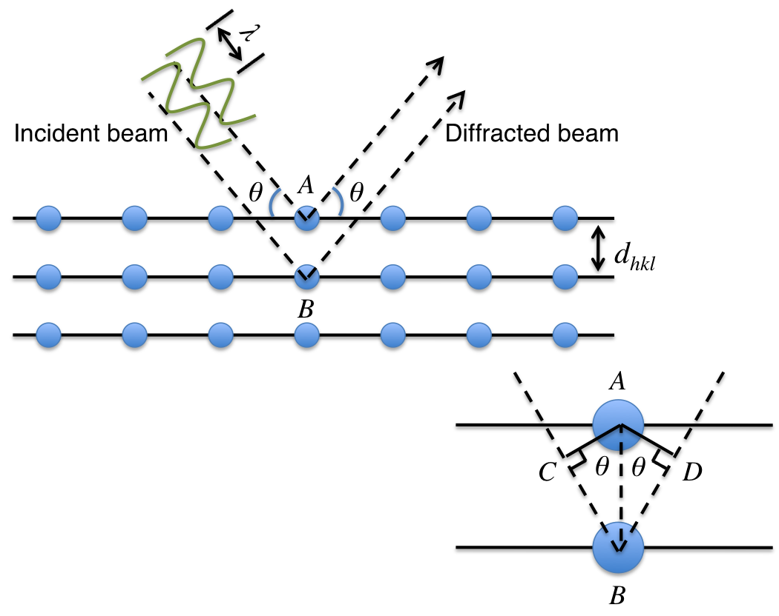
Figure A - 1. Diffraction of x-rays by atomic planes
Incoming radiation diffracts from planes of atoms demonstrating the basis of Bragg’s law, , which relates the wavelength of the radiation to the inter-planar spacing and angle of diffraction.
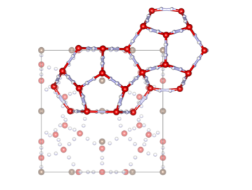
Figure A - 2. Large and small cage of sI placed in the unit cell
Two polyhedral cages (large cage on left, small cage on right) defined by the hydrogen bonded water network in sI hydrate as compared to their location in the unit cell. The vertices are the locations of the oxygen atoms (red), the edges are hydrogen sites (white) randomly half occupied, and the centers of the cages contain one single carbon atom (brown) to indicate the gas placement.
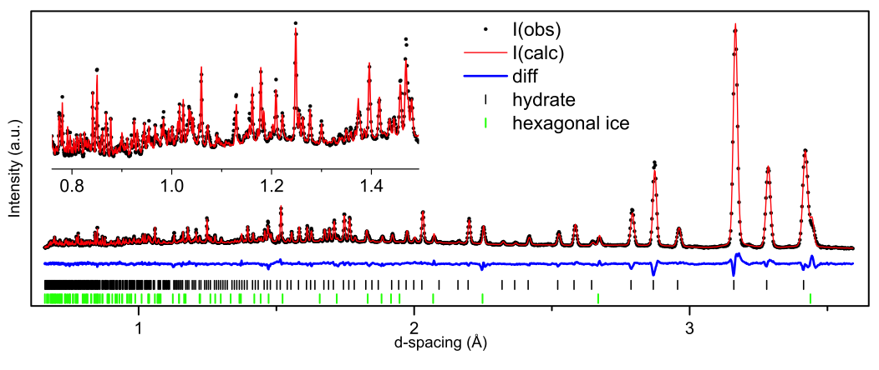
Figure A - 3. Powder pattern for 50% CH₄ nominal sample
Neutron observed, calculated, and difference powder diffraction patterns for 50% CO₂/50% CH₄ feed gas sample. 0.7 – 1.5 Å has been enlarged to show the resolvability of the low d range.
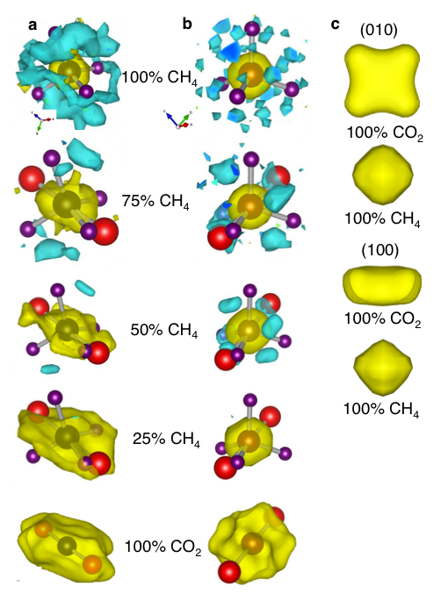

Figure A - 4. Fourier density difference maps
Graphic displays of nuclear densities of guest gas molecules as determined by Fourier difference analysis of CO₂/CH₄ gas hydrate. Large cages depicted on the left (a) and small cages on the right (b). The isosurface level is 1.5 fm/Å³ for last four samples (nominal compositions of 75% CH₄, 50% CH₄, 25% CH₄, and 100% CO₂), and 2.2 fm/Å³ for the nominal composition of 100% CH₄ (to eliminate extra noise created by high incoherent scattering of H₂). Positive nuclear scattering (oxygen and carbon) is shown in yellow, negative (hydrogen) in blue. A single CO₂ and/or CH₄ molecule has been superimposed to give a spatial sense of the molecule compared to the observed nuclear density. Energy maxima determined from the nuclear density for the large cage (c) with isosurface level 3 fm/Å³; CO₂ top, CH₄ bottom, shown along both the (010) and (100) projection vectors in the large cage to demonstrate the extent of the anisotropy of CO₂ on this site.
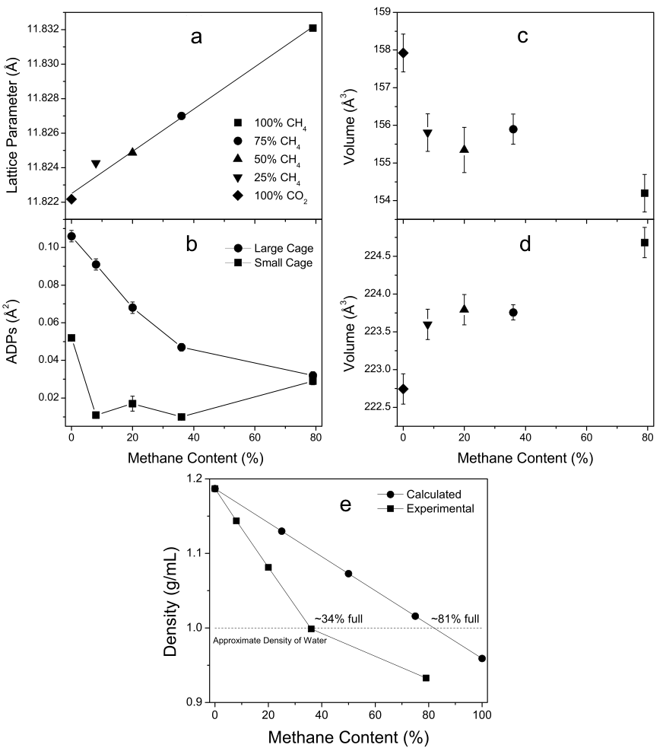
Figure A - 5. Lattice parameters, ADPs, cell volumes, and density
Refined lattice parameters (a) and refined atomic displacement parameters (b). Volumes of the small cages (c) and large cages (d) calculated from the refined atomic coordinates. The top legend denotes the sample names as they correspond to the nominal feed gas composition. Experimental densities determined from the refined occupancies and calculated densities for the nominal compositions (e) comparing how the density changes based on the guest molecule.
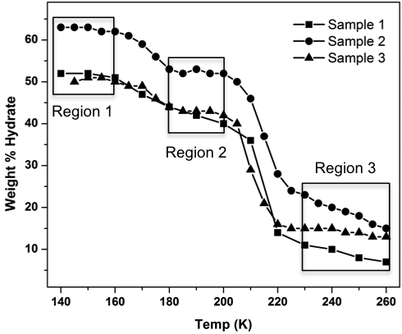

Figure A - 6. Temperature dependent decomposition
Hydrate decomposition curves of three samples decomposed from 140 − 270 K. Three regions of slower decomposition were identified.
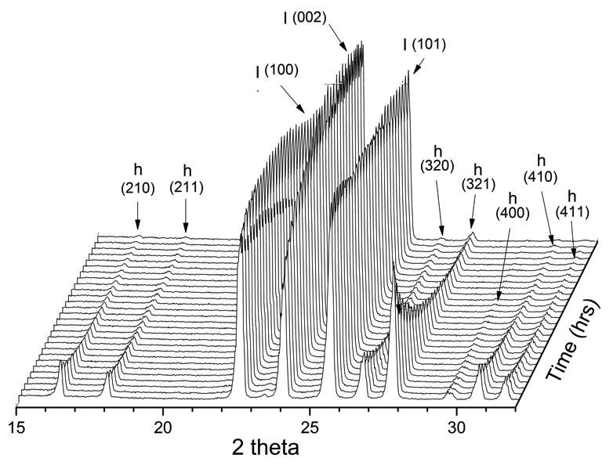
Figure A - 7. Waterfall at 250K
LTXRD data collected isothermally every 10 minutes over ~7 hrs at 250 K on Sample 2. Hydrate peaks were diminishing (h) as ice I_{h} peaks (I) were intensifying.
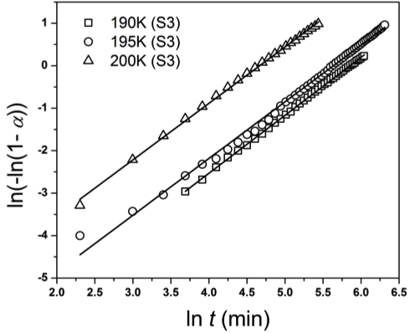
Figure A - 8. Avrami plot for Region 2
Avrami model plots ln(-ln(1-α)) vs. ln t, where α is the weight percent of the converted phase and t is time in minutes, for isothermal scans at 190, 195, 200 K, for sample 3, the resulting slopes, n, are in the range 1.33 ≤ n ≤ 1.36.

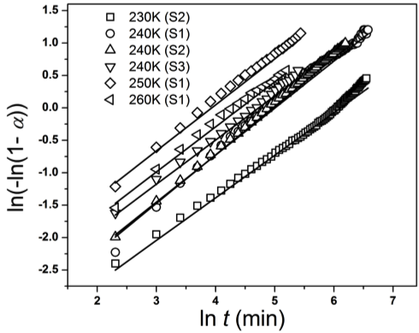
Figure A - 9. Avrami plot for Region 3
Avrami model plots for isothermal scans at 230 K (from data collected on sample 2), 240 K (from data collected samples 1, 2, and 3), 250 K (from data collected on sample 1) and 260 K (from data collected on sample 1). The resulting slopes, n, are in the range 0.59 ≤ n ≤ 0.75.
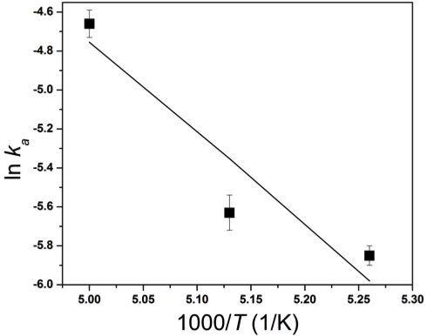
Figure A - 10. Arrhenius plot for region 2
Arrhenius plot (each point is a k determined by each sample from the Avrami plot) for the 180 – 200 K temperature region, slope = −E_{a}/R therefore with slope = −5, E_{a} = 42 kJ/mol.
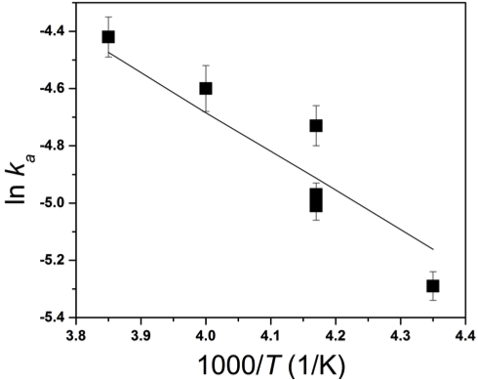
Figure A - 11. Arrhenius plot for region 3
Arrhenius plot (each point is a k determined by each sample from the Avrami plot) for the >240 K temperature region, slope = −E_{a}/R therefore with slope = −2.6, E_{a} = 22 kJ/mol.

Tables

Table A - 1. Experimental results
Experimental information for neutron powder data collected on five hydrate samples with nominal gas amounts of 100%CH₄, 75%CH₄/25%CO₂, 50%CH₄/50%CO₂, 25%CH₄/75%CO₂, and 100%CO₂.

 | 0.79(CH₄) 5.75H₂O | 0.36(CH₄)0.34(CO₂) 5.75H₂O | 0.2(CH₄)0.63(CO₂) 5.75H₂O | 0.08(CH₄)0.85(CO₂) 5.75H₂O | (CO₂) 5.75H₂O
Crystal system | cubic | cubic | cubic | cubic | cubic
Space group
a (Å) | 11.83210(8) | 11.82699(4) | 11.82487(6) | 11.82427(7) | 11.82216(9)
Volume (Å³) | 1656.48 | 1654.34 | 1653.44 | 1653.19 | 1652.31
ρ_{calc} (g/cm³) | 0.93 | 1.00 | 1.08 | 1.14 | 1.19
Temp(K) | 10 | 10 | 10 | 10 | 10
Phases | hyd, ice I | hyd, ice I | hyd, ice I | hyd, ice I, N₂ | hyd, ice I
Geometry | Debye Scherrer | Debye Scherrer | Debye Scherrer | Debye Scherrer | Debye Scherrer
Variables | 36 | 47 | 47 | 36 | 47
Refinement | GSAS | GSAS | GSAS | GSAS | GSAS

Table A - 2. Rietveld results
Crystallographic goodness of fit information for neutron powder data collected on five hydrate samples with nominal gas amounts of 100%CH₄, 75%CH₄/25%CO₂, 50%CH₄/50%CO₂, 25%CH₄/75%CO₂, and 100%CO₂.

 | 0.79(CH₄) 5.75H₂O |  | 0.36(CH₄)0.34(CO₂) 5.75H₂O
Center wavelength | 1.333 | 2.665 | 1.333 | 2.665
d-spacing range | 0.57-3.59 | 1.23-6.16 | 0.66-3.59 | 1.15-6.16
R_{p} | 0.009 | 0.011 | 0.022 | 0.032
R_{wp} | 0.010 | 0.012 | 0.022 | 0.032
R_{exp} | 0.002 | 0.003 | 0.003 | 0.004
Goodness of fit, χ² | 5.72 | 3.81 | 7.10 | 7.69
Combined R_{p} | 0.010 |  | 0.028
Combined R_{wp} | 0.011 |  | 0.026
 | 0.2(CH₄)0.63(CO₂) 5.75H₂O |  | 0.05(CH₄)0.85(CO₂) 5.75H₂O
Center wavelength | 1.333 | 2.665 | 1.333 | 2.665
d-spacing range | 0.66-3.59 | 1.15-6.16 | 0.57-3.59 | 1.23-6.16
R_{p} | 0.025 | 0.034 | 0.009 | 0.011
R_{wp} | 0.024 | 0.035 | 0.010 | 0.012
R_{exp} | 0.003 | 0.004 | 0.002 | 0.003
Goodness of fit, χ² | 9.38 | 8.16 | 5.72 | 3.81
Combined R_{p} | 0.030 |  | 0.010
Combined R_{wp} | 0.028 |  | 0.011
 | (CO₂) 5.75H₂O
Center wavelength | 1.333 | 2.665
d-spacing range | 0.66-3.59 | 1.15-6.16
R_{p} | 0.022 | 0.032
R_{wp} | 0.022 | 0.032
R_{exp} | 0.003 | 0.004
Goodness of fit, χ² | 7.10 | 7.69
Combined R_{p} | 0.028
Combined R_{wp} | 0.026

Table A - 3. Cage occupancies and occupants
Refined cage occupancies are shown for each molecule and each cage. Those numbers are applied to the 2 SCs and 6 LCs to give the percent of each gas found. The final column shows the percentage of all cages filled.

Target | Large Cage Occ. |  | Small Cage Occ. |  | Content % |  | % Cages
Composition | CH₄ | CO₂ | CH₄ | CO₂ | CH₄ | CO₂ | Full
100% CH₄ | 0.73(3) | - | 0.93(5) | - | 79(4) | - | 79(4)
75% CH₄ | 0.28(2) | 0.42(1) | 0.59(3) | 0.09(2) | 36(2) | 34(1) | 70(3)
50% CH₄ | 0.08(3) | 0.77(1) | 0.54(4) | 0.21(2) | 20(3) | 63(1) | 83(5)
25% CH₄ | 0.00(2) | 0.98(2) | 0.33(4) | 0.47(3) | 8(3) | 85(2) | 94(5)
0% CH₄ | - | 1.00(6) | - | 1.00(4) | - | 100(6) | 100(6)

Table A - 4. Avrami constants
Avrami constants for each temperature and sample within R2 (180 – 200 K) and R3 (240 – 260 K). The similar n values within the regions show the same nucleation process is occurring, just as the different n values between the regions show different nucleation processes.

Region | Sample | Temp (K) | N | Crystal Growth
2 | 3 | 190 | 1.36 | 1D
2 | 3 | 195 | 1.33 | 1D
2 | 3 | 200 | 1.33 | 1D
3 | 1 | 230 | 0.59 | instantaneous
3 | 1 | 240 | 0.72 | instantaneous
3 | 2 | 240 | 0.75 | instantaneous
3 | 3 | 240 | 0.68 | instantaneous
3 | 1 | 250 | 0.71 | instantaneous
3 | 1 | 260 | 0.69 | instantaneous

VITA

Susan Michelle Everett was born in Morristown, TN to parents Lloyd and Barbara Turner. She is the younger sibling of Mark Turner. She spent the greater part of her schooling in Kingston, TN. She attended Kingston Elementary, Cherokee Middle, and graduated from Roane County High School in the top ten of her class. On scholarship, she continued her education with an Associate of Science degree in Mathematics from Roane State Community College, Harriman, TN, May 1992, and a Bachelor of Science degree in Mathematics and Latin from The University of Tennessee, Knoxville, May 1995. After 11 years in the workplace, she decided to return to UTK in order to pursue an engineering degree. After starting in Aerospace Engineering, Michelle moved into the graduate program in Materials Science and Engineering through a National Science Foundation program, STAIR, Sustainable Technology through Advanced Interdisciplinary Research, as an IGERT Trainee (Integrative Graduate Education and Research Traineeship). She completed her Master of Science degree in Materials Science and Engineering in December 2009, and her Doctor of Philosophy in Materials Science and Engineering May 2013.

