Multiscale Investigation of Freeze Cast Process and Ion Transport for Graphene Aerogel Electrodes

A Dissertation Presented for the

Doctor of Philosophy

Degree

The University of Tennessee, Knoxville

Yu-Kai Weng
December 2022

ACKNOWLEDGEMENTS

ABSTRACT

TABLE OF CONTENTS
Chapter 1 Introduction 1
1.1 Background: Organic Redox Flow Battery and Graphene Electrodes 1
1.2 Motivations and Objectives 3
1.3 Thesis Organization 4
1.4 Figures and Tables 5
Chapter 2 Investigation of Microscopic Mechanisms for Water-Ice Phase Change Propagation Control 6
2.1 Abstract 6
2.2 Disclosure 7
2.3 Introduction 7
2.4 Methodology 9
2.5 Results and Discussion 17
2.5.1 Ice propagation in pure water 17
2.5.2 Effects of water-graphene interaction 20
2.6 Conclusions 22
2.7 Figure and Tables 23
Chapter 3 Rayleigh-Bénard Convection and Freezing Propagation during Water-Ice Phase Change 30
3.1 Abstract 30
3.2 Disclosure 31
3.3 Introduction 31
3.4 Methodology 33
3.5 Results and Discussion 38
3.6 Conclusions 43
3.7 Figures and Tables 44
Chapter 4 Surface Interaction Effect on Ion Transport with Convective Flow in Graphene Nanochannel 53
4.1 Abstract 53
4.2 Disclosure 54
4.3 Introduction 55
4.4 Methodology 57
4.5 Result and Discussion 59
4.6 Conclusions 60
4.7 Figures and Tables 61
Chapter 5 Summary and Conclusions 62
List of References 63
Vita 79

LIST OF TABLES
Table 2.1 Angles between the graphene flakes and the basal plane of ice crystal (θ_{f,1} and θ_{f,2}) at t₁ = 30 ns for two different distances between the graphene flake and water-ice interface (d_{gi} = 3 and 14 Å). 23
Table 3.1 Density inversion parameters (Θ_{m}) and Rayleigh numbers (Ra) with different prescribed boundary temperatures 44
Table 3.2 Dimensions of the simulated water container and the aspect ratio (Г) 44
Table 3.3 Comparison of Nu from this study with prior research 44

LIST OF FIGURES
Figure 2.1 Initial atomic configurations of molecular dynamics simulations for (a) pure water freezing, (b) water freezing with movable graphene flakes, and (c) water freezing with a movable rigid ice cluster and a graphene plate at bottom. (Blue and yellow spheres: oxygen and hydrogen atoms from water or ice molecules, orange spheres: carbon atoms from graphene, and red spheres: oxygen and hydrogen atoms from the rigid ice cluster). 23
Figure 2.2 (a) Hexagonal ice crystal structure and basis vectors, and atomic configurations of three surface orientations (basal, primary prism, and secondary prism). (b) Initial atomic structures (oxygen: blue, hydrogen: yellow, and carbon: orange) of water-ice system with two inclined graphene flakes with two distances (d_{gi}) between the flakes and a water-ice interface, and (c) water with ice seed (red) on graphene surface (first row: front view and second row: bottom view). Three different surfaces of the ice crystals are facing down to graphene. 24
Figure 2.3 The freezing process of water-ice system at 250 K: (a) the water-ice interfaces propagate from ice region toward water region, and (b) the structure order parameter plot at two different time steps, (t₀ = 0; t₁= 30 ns after freezing process). More molecules have structure order parameters $q6$ larger than the water-ice criterion of 0.385 at t = t₁, demonstrating the formation of hexagonal ice structure. 25
Figure 2.4 (a) The water-ice interface propagation speed (u_{wi}) averaged over three crystal orientations with respect to the supercooling temperature (ΔT_{sc}). The red open circles and blue open triangles represent the results of ice propagation speed from other MD studies [20, 49], and the green cross rectangles do those from a previous experimental study [50]. (b) The distributions of the structure order parameters ($q4$ and $q6$) of water molecules in the water-side region at three supercooling temperatures, ΔT_{sc} = 65 (blue squares; T_{sys} = 200 K), 13 (black circles; 252 K), and 5 K (red triangles; 260 K) after 30 ns of freezing propagation. (c) Self-diffusivity (D) and (d) free energy of supercooled water and ice (G_{water} and G_{ice}) with respect to the temperature. The results are compared with experimental self-diffusivities [51] and free energy from MD with the TIP4P water model [52], MD with the SPC/E model [53], and experiments [54]. 26
Figure 2.5. (a) Temperature dependency of propagation speed from different crystal orientations at interface. (b) Speed of water-ice interface propagation (u_{wi}; gray bars) and interfacial energy (γ_{wi}; blue crossed circles) for the three different orientations at 15 K of ΔT_{sc}. 27
Figure 2.6 (a) Schematic illustration of the angle between graphene and basal plane normal vector. (Cyan surfaces and arrows: basal plane and its normal vector, orange arrows: normal vector of graphene flake surfaces) (b) Change of the alignment of two graphene flakes during the freezing process between t₀ = 0 and t₁ = 30 ns. The crystal surface of the interface is secondary prism plane (P2). 28
Figure 2.7 (a) Atomic configurations from the bottom view of water freezing simulations with graphene surface (orange) and three different initial orientations of ice cluster (red) at t₀ = 0, and t₁ = 100 ns. First and third row: front view, second and fourth row: bottom view. (b) Schematic illustration describes the viewing direction of the front and bottom view. (c) Regional potential energy (U_{R.avg}) of three cases of different ice cluster orientations. 29
Figure 3.1 Schematic diagram of simulation domain for Rayleigh-Bénard convection. 45
Figure 3.2 The propagation of water-ice interface through the freezing times. The color contour in the streamline represents the water temperature, the blue surface near the bottom represents the water-ice interface (the surface of ice propagates from the bottom ), and the arrows in the figures represent the velocity vectors. 46
Figure 3.3 The instantaneous snapshot of temperature and velocity profile in the vertical cross-section of the container under different inversion parameters at 1200 seconds freezing times, Θ_{m} = 0.57, 0.71, 1.00, 1.28, and 1.45. The water temperature is represented by color following the scale in the left, and the arrows show the velocity vectors. 47
Figure 3.4 Nusselt number (Nu, black filled squares) for the heat transfer between the top and bottom boundaries and the freezing propagation speed (u_{f}, red empty circles) with respect to the density inversion parameter (Θ_{m}). 48
Figure 3.5 (a) The distribution of the water-ice interface height from the top view and (b) the standard deviation of interface height (σ_{z}) with respect to the density inversion parameter (Θ_{m}). 49
Figure 3.6 Temperature and velocity profile in the vertical cross-section of the container under different aspect ratios, i.e., Г = 2.0, 1.0, 0.67, and 0.5. The water temperature is represented by color following the scale below, and the arrows show the velocity vectors. 50
Figure 3.7 (a) Nusselt number (Nu) for the heat transfer between the top and bottom boundaries and (b) the freezing propagation speed (u_{f},) with respect to the aspect ratio (Г = D/H) at three different density inversion parameters (Θ_{m} = 0.75, 1.0, and 1.25). 51
Figure 3.8 (a) The distribution of the water-ice interface height from the top view and (b) the standard deviation of interface height (σ_{z}) with respect to the aspect ratio (Г = D/H). 52

Introduction

Background: Organic Redox Flow Battery and Graphene Electrodes
Reducing the environmental impact of conventional energy conversion, which is primarily generated by burning fossil fuels, has undoubtedly become one of the most challenging global issues in the 21st century. For this reason, the power generation from renewable energy sources, defined as the energy harvested from the natural sources that can be restored within the human timescale [], has significantly increased in recent decades, and its continuous growth is expected []. However, compared with conventional energy sources, renewable energy, such as wind power, solar power, and hydropower, has a fluctuating and intermittent nature. Such fluctuating and intermittent nature of renewable sources would cause unnecessary loading or damage to the electric grid systems, hindering their broader application []. To mitigate this unsteady power production problem and thus to accommodate the increasing demand for renewable energy, a reliable high-energy storage system should be developed.
Among various energy storage technologies, redox flow battery (RFB) has been recognized as a promising device for storing a large capacity of electronic power generated by renewable energy. The RFB utilizes the chemical oxidation and reduction reactions to convert and store the electric energy in the liquid electrolytes solutions that flow through the battery cells. RFBs using vanadium ion solution as the electrolytes (VRFB) is the most popular [], however their relatively high toxicity is still problematic. To ease the environmental and sociopolitical impact of the metal-based VRFB, organic redox flow battery (ORFB) employing redox-active organic materials has been suggested. The ORFB offers several advantages for electric energy storage (EES) systems. First, raw materials of ORFB can be acquired with a lower cost than the metallic precursor, which makes the ORFB have higher potential to meet the cost target for large scale ESS from ($100/kWh) from the United State DoE [1], and through the structure modifications and functionalization of the materials, the thermochemical properties of the electrolyte can be tuned []. Also, nonflammable organic electrolytes provide safety benefits for the EES system. However, various disadvantages and drawbacks still need to be addressed for ORFB. One of the most reported challenges for ORFB is a relatively limited life cycle due to the electrochemical instability of organic electrolyte materials [2]. In addition, the low charge/discharge current density also remains the primary challenge for the ORFBs [3]. To further improve the performance of the RFB, comprehensive studies and summaries have been reported by various research groups [4-7]. As a major component where the redox chemical reactions occurred, the physical properties of the electrode materials undoubtedly have a significant contribution to the kinetics of interfacial charge transfer. Traditionally, graphitic carbon materials can serve as electrodes to collect electrons and catalyze the redox reactions [8, 9]

Motivations and Objectives

Thesis Organization

Figures and Tables

Investigation of Microscopic Mechanisms for Water-Ice Phase Change Propagation Control

Abstract
The influence of thermodynamic and structural conditions on water-ice phase change process was investigated with consideration of graphene-water surface interactions for fundamental understanding and effective control of freezing propagation. The phase change propagation as well as structural and energetic properties during the phase change were examined by analyzing atomic data from molecular dynamics simulations. The freezing propagation speed is affected by the competition between atomic mobility and thermodynamic driving force for phase change, which causes an optimal temperature for fast ice growth to appear at 252 K. In addition, the water-ice interfacial energy, which depends on the orientation of the water-contacting ice surface, changes interfacial structural stability and thus freezing propagation, i.e., a higher interfacial energy leads to a faster ice propagation. Therefore, we suggest that the water-ice phase change propagation can be controlled by adjusting the orientation of ice crystal. The surface interactions, or graphene-water interactions in this research, affect the energetics near the water-surface interface. The energetic change rearranges the ice crystal or surface structures to reach the most stable ice-surface configuration or minimum energy state, in which the basal plane of the ice crystal is parallel with the graphene surface. As ice propagation is the slowest perpendicular to the basal plane, ice can grow faster parallel to graphene surface. The findings from this study provides insights to ice propagation control mechanisms for versatile freeze casting and its broader applications.

Disclosure
Chapter 2 is a modification of the published work: Yu-Kai Weng, Seungha Shin*, Kenneth D. Kihm, Mohammad Bahzard, and Douglas S. Aaron, "Investigation of Microscopic Mechanisms for Water-Ice Phase Change Propagation Control", International Journal of Heat and Mass Transfer, 184, 122357 (2022). This publication is reprinted with permission from Elsevier. The dissertation author listed in this publication directed and supervised the research which forms the basis for this publication.

Introduction
Water freezing is one of the most familiar phase-change phenomena in nature and an essential process for diverse science and engineering fields, such as microbiology [10], physics [11], and materials science [12]. One of the representative applications, which take advantage of the water-ice phase change process, is freeze casting or ice templating, where materials dispersed in liquid can be aligned by the anisotropic solidification of the liquid [13]. Freeze casting is employed to produce aligned porous structure from various building blocks [14], such as ceramics [15], graphene [16], and carbon nanotubes [17]. We studied the freezing process with an interest in the synthesis of graphene aerogels with aligned pores, which can be used as a component of electrochemical storage systems, specifically as an electrode material in organic redox flow batteries [18]. Since the working principle of freeze casting is to construct the material by phase change of water, water-ice interface propagation behaviors affect the resulting structure. For example, the average pore size and wall thickness of porous structures manufactured by freeze casting can be controlled by the solidification velocity [19]. Therefore, investigation of effective control of ice front propagation is essential for the control of freeze-cast material structures and ultimately their application performance.
Previous studies reported that the thermodynamic driving force for phase change and the self-diffusivity of water molecules have an opposite dependency on the temperature in the supercooling region [20, 21]. Thus, temperature can be one of the parameters controlling ice growth rate [22]. Surface interaction can be another possible parameter to control ice propagation, as it was reported to change the ice crystal structure in the proximity of surface/water interface [23], which can also alter the ice propagation and freeze-cast structures. For example, if a droplet of water was frozen between two layers of graphene, a two-dimensional (2D) square-like crystal ice structure formed [24]. Since the interaction between water and graphene enhances the reordering of the water molecules [25], the freezing behavior and water-ice interface propagation near the graphene appear differently such as crystal structure [26]. Moreover, the average density profile and diffusion of water molecules near the interface can be changed by the crystal orientation of ice surface [27] in contact with water. Therefore, we can expect the control of water-ice interface propagation to be achieved by the surface interaction and ice crystal surface orientation at the interface as well as temperature.
Although water freezing behaviors have been studied for both pure water [20] and water-surface systems [28], the detailed mechanism of ice propagation and freeze casting process has not been identified clearly to the best of our knowledge. To find an effective control of ice propagation based on fundamental understanding of freezing process, we investigated the water-ice phase change under various conditions, changing temperature, ice crystal orientation, and surface interaction. In this research, molecular dynamics (MD) simulations were employed to address the atomic-scale interactions and structures for the fundamental understanding. For the study of surface interaction, graphene was used as a surface material due to our interest in freeze casting of graphene aerogel for the development of electrode material with effective ion transport and its 2D nature that reduces computational cost and facilitates the analysis.

Methodology
Pure water structures were simulated via MD to examine the effects of temperature and ice crystalline structure (Fig. 2.1a), while the simulated systems for the study of surface interaction included graphene flakes or surface (Figs. 2.1b and 2.1c). Since the spontaneous ice nucleation from pure water requires a prohibitively large amount of simulation time in MD [29], a block of ice was introduced as a nucleation seed into initial simulation cells to accelerate the water-ice interface propagation. Here, initial structures of pure water and water with graphene flakes contain 50% of water molecules as ice, and a small ice seed is added near the graphene surface for water-graphene surface simulations. The periodic boundary conditions were used in all three dimensions. Therefore, in the simulation domain for a half-ice/half-water system, two water-ice interfaces (I₁ and I₂) exist, and they propagate in the opposite directions as in Fig. 2.1a. Simulations with graphene flakes (Fig. 2.1b) and those with ice cluster and a graphene plate (Fig. 1c) were conducted to investigate the effects of the surface-water interaction on the structural changes, i.e., re-alignment of ice or graphene structures, during the ice propagation ultimately for enhanced understanding of freeze casting.
The TIP4P/ICE model [30] was employed to calculate positions and momentums of water molecules because it accurately reproduces thermodynamic properties, especially ice-water phase change properties. TIP4P/ICE is a rigid water model that fixes bond length (O-H) of 9.572 Å and bond angle (H-O-H) of 104.52˚ as constant, and the charges of O and H atoms are -1.179e_{c} and 0.589e_{c}, respectively, where e_{c} is the elementary charge. The massless charge site M was introduced 0.1577 Å away from the O atom. The SHAKE algorithm [31] was also used to enforce the rigidity of water molecules. The particle-particle particle-mesh (PPPM) algorithm [32] is applied to compute the long-range Coulombic interactions among the water molecules. In addition to the Coulombic interaction, dispersive intramolecular interactions (ϕ) between oxygen atoms of water molecules with a distance less than the cut-off distance (r_{c}) are calculated using the 12-6 Lennard-Jones (LJ) model [33]:
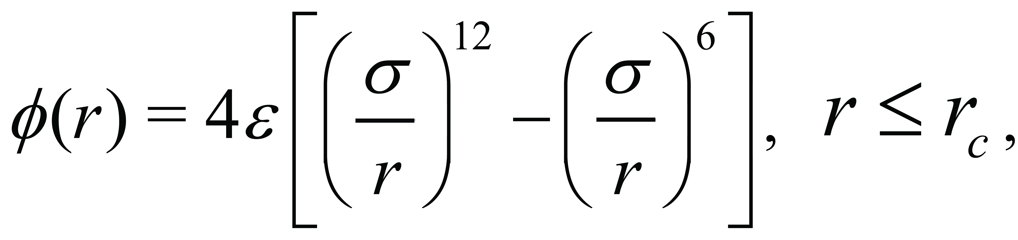 (1)
where ɛ is the LJ interaction energy strength, σ is the distance at which the potential is zero, and r is the interatomic distance. In the simulations, the parameters for oxygen-oxygen interaction (O-O) were set as ɛ_{o-o} = 9.142 meV, σ_{o-o} = 3.16 Å, and r_{c,o-o}=8.5 Å. In the simulations including graphene, the carbon-oxygen (C-O) interaction for the graphene-water interaction was also calculated using a LJ model with parameters of ɛ_{c-o} = 8.19 meV, σ_{c-o} = 3.19 Å, and r_{c,c-o}=8.0 Å [34]. The carbon-carbon (C-C) interaction within a graphene plate was modeled with the Tersoff potential [35].
To integrate Newton’s equations of motion, the velocity-Verlet algorithm [36] was used, and the temperatures were controlled via Nose-Hoover thermostats in all MD simulations in this research. Pure water simulations used a time step of 1.0 fs, while simulations with graphene employed a shorter time step (0.5 fs) to treat carbon atoms with high vibrational frequencies. Two different sizes of water freezing simulations containing 864 and 9216 water molecules were conducted to verify the size effect on the simulation results. Moreover, since the triggering of the freezing process varies with surface-to-volume ratio [37], these two systems were adjusted to have the same ratio between the area of water-ice interface and the volume of ice. The result shows that the increment of propagation speed is relatively small (< 14%) with more than 10 times larger system size. This result is in a good agreement with a previous study [38].

In MD simulations, temperature, ice crystal orientation, and water-surface interaction were control parameters, and their effects on water-ice interface propagation were investigated. First, to examine the temperature dependence, a 52 Å × 21 Å × 27 Å water-ice system was initially equilibrated at 250 K with an NPT ensemble (i.e., fixed number of molecules, pressure, and temperature) for 3.5 ns. After initial relaxation, the ensemble was switched to NVT (constant number of molecules, volume, and temperature) at a desired temperature (T) ranging from 200 K to 270 K for 30 ns. The effect of ice crystal orientation was studied by simulating three cases of ice-water system with a different interface structure. Within a simulation box of 52 Å × 21 Å × 27 Å, the ice surface in contact with water has a crystal structure of either basal plane, primary prism plane (denote as P1), or secondary prism plane (denote as P2) as depicted in Fig. 2.2a. For the analysis of ice propagation, we processed 20 ns of atomic data produced by MD simulations with NVT at 250 K, after the relaxation of the initial structures with different ice surface orientations for 1.0 ns (NPT, at 250 K).
For the study of the surface interaction, specifically graphene-water interaction, two types of MD simulations were performed. First, water-ice structures that included graphene flakes were used as initial structures to examine the structuring during the freezing process. Two graphene flakes were added to the half-water, half-ice system with a dimension of 52 Å × 21 Å × 27 Å. The distance between the centers of the graphene flakes was 13.3 Å and they have ±45˚ of inclination angles. Two different distances between the flakes and water-ice interface (d_{gi} = 3 and 14 Å) are set as Fig. 2.2b shows. The atomic data for analysis were recorded for 30 ns of a simulation with NVT at 220 K, and we examined the relative orientation between the graphene flakes and the basal plane of the ice crystal. The second case of freezing simulations with graphene-water interaction employed initial atomic structures of 17 Å × 17 Å × 22 Å water with a 17 Å × 17 Å graphene surface. A prebuilt ice seed of 4.5 Å × 5.2 Å × 4.6 Å was included, and the center of the ice seed was located 9.7 Å above the graphene surface. Three different crystal orientations of the ice seed surface (i.e., primary prism, secondary prism, and basal) facing the graphene were tested in MD as in Fig. 2.2c. The atomic trajectory data from the MD simulations (with NVT at 220 K) for 100 ns were used for the analysis of ice propagation and atomic behaviors during freezing. For the study of energetics during freezing, the regional energies of the three configurations (U_{R.avg}) were calculated from the potential energy of water molecules in the sampling region, which was defined between the ice cluster and graphene flakes (yellow dash line in Fig. 2.2c).
Since we studied effective control of ice propagation, the propagation speed was a major property that we measured by processing the resulting MD data. The speed was calculated using the location change of the water-ice interface with respect to time. To identify the phase (water or ice) and ultimately the location of the water-ice interface, we employed the Steinhardt-Nelson order parameter (q) [39]. This method quantitatively recognizes specific crystal orders based on spherical harmonic functions Y_{lm} [40], which are the solutions of the Laplace’s equation in the spherical domains and widely used to describe spherical or near-spherical symmetry systems. Each Y_{lm}, where l and m stand for the orders of the functions, represents a specific shape of the solution. The Steinhardt-Nelson order parameter of order l of molecule i is given as,
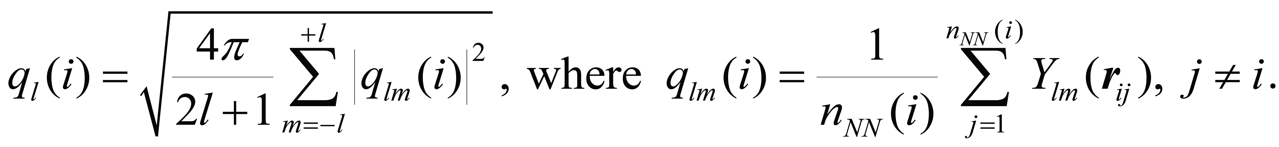 (2)
Here, r_{ij} represents a position vector from molecule i to j (represented by O atom), and n_{NN}(i) is the total number of the nearest neighboring molecules of i. Using the structure order parameters of molecule i and its nearest neighboring molecules, the average structure order parameter ${\overline{q}}_{l}\left(i\right)$ is calculated as [41]
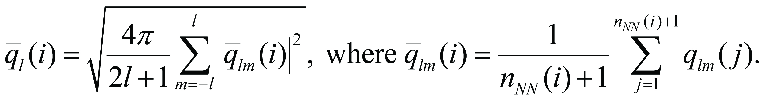 (3)
Water molecules with the average Steinhardt-Nelson parameter of order 6 larger than 0.385 (${\overline{q}}_{6}$ > 0.385) are recognized as ice-like phase, while those with ${\overline{q}}_{6}$ < 0.385 are as water-like phase [41]. For ice-like structures (${\overline{q}}_{6}$ > 0.385), ${\overline{q}}_{4}$ is used to identify a more detailed structure order; i.e., when ${\overline{q}}_{4}$ < 0.42, the ice structure is regarded as hexagonal (ice-I_{h}), while it is cubic for ${\overline{q}}_{4}$ > 0.42 (ice-I_{c}). Thus, the ${\overline{q}}_{6}$-${\overline{q}}_{4}$ scatter plot was used to analyze the freezing progress and the detailed ice crystal structure. For the calculation of the water-ice interface propagation speed u_{wi}, the entire simulation domain of the water-ice system was subdivided into n slabs (S_{k}, k = 1, 2, 3, …, n) with a uniform thickness of 4.2 Å along the x-axis (ice propagation direction). Local structure order parameter (${\overline{q}}_{6,k}$) at x = x_{k} (the center location of slab k) was evaluated by taking an ensemble average of ${\overline{q}}_{6}$ of water molecules in slab k. Using the spatial distribution of local structure order parameter ${\overline{q}}_{6,k}$ and the ice-water criterion for ${\overline{q}}_{6}$, the location of the water-ice interface was identified. Since the freezing propagation accelerates as the liquid volume shrinks, the calculation of u_{wi} excluded the freezing of the last two slabs before the freezing completion of the whole simulation domain.
To understand detailed mechanisms of ice propagation control, we examined the thermodynamic driving force of water-ice phase change, the mobility of water molecules to join the phase transition, and the interfacial energetics. These are characterized by calculating i) the difference of free energy between water and ice phases, ΔG (eV), ii) self-diffusivity of water molecules, D (m²/s), and iii) water-ice interfacial energy γ_{wi} (mJ/m²) [42], respectively. Using the free-energy perturbation (FEP) method [43], the free-energy difference (ΔG) between state A and state B was calculated as
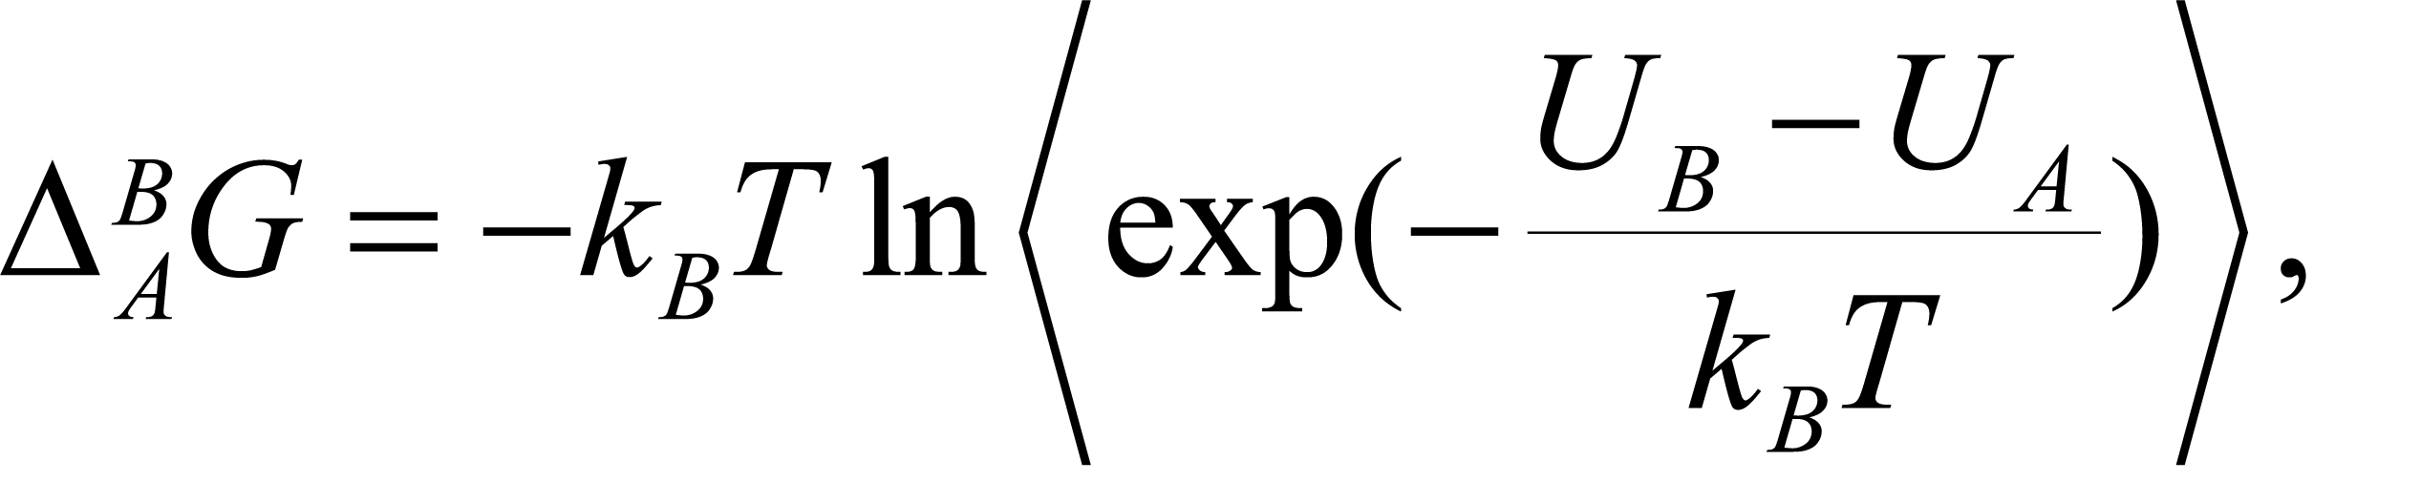 (4)
where k_{B} is Boltzmann’s constant (8.617×10⁻⁵ eV/K), and U_{A} and U_{B} are the potential energies of the system at state A and state B, respectively, and the angle brackets represent an ensemble average. In MD, the free-energy perturbation is applied by coupling a perturbation parameter λ into the interaction force calculation, varying λ from 0 to 1 with an increment of dλ = 0.001. The perturbation parameter λ was introduced into the atomic point charges of oxygen and hydrogen atoms (λ = 0 for no charge, while λ = 1 for full charge). Therefore, the free energy (G) in this study was determined as overall free-energy difference $∆_{λ=0}^{λ=1}G$, which was obtained from the ensemble average (over 10,000 cases for each λ) of the free-energy difference from timestep i to i+1:
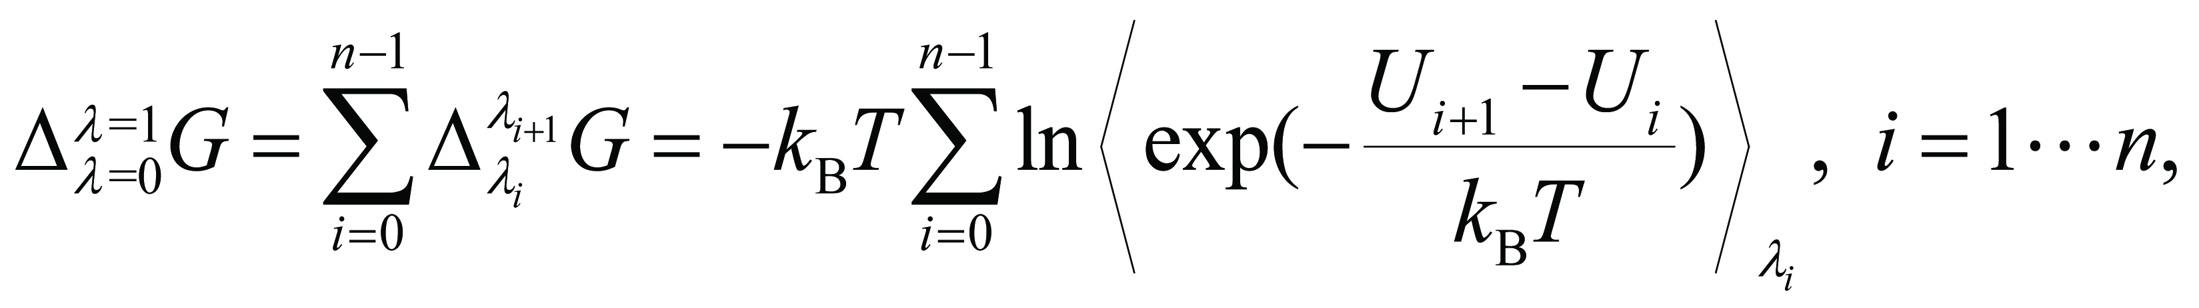 (5)
where n is the total number of the timesteps during the simulation.
The self-diffusivity can be calculated by taking the mean square displacement (MSD) of the simulated molecules [44, 45]:
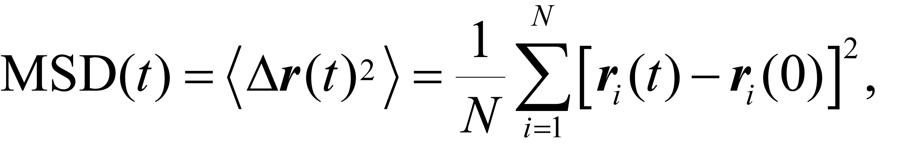 (6)
where r_{i}(t) is the position vector of oxygen atom i at time t. Using the time dependence of MSD(t), the self-diffusivity (D) is given as,
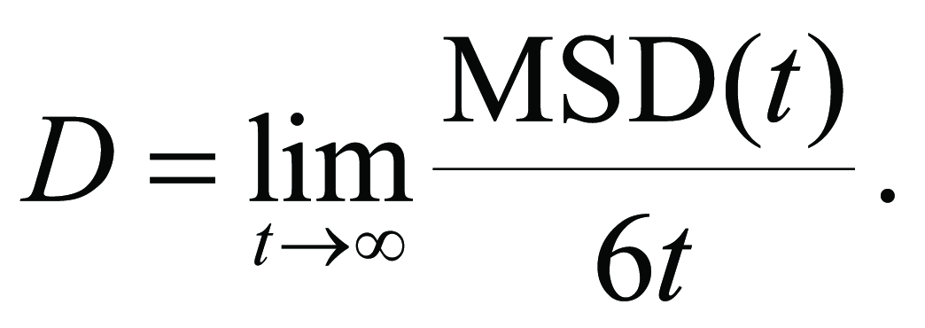 (7)
With the calculated D, the diffusion activation energy of supercooled water can be obtained by fitting D with respect to temperature to the Arrhenius expression [46]:
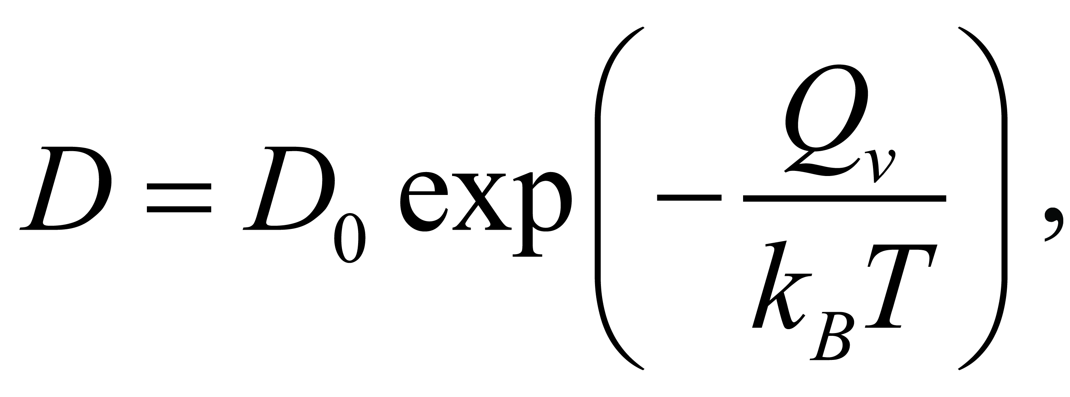 (8)
where D₀ is pre-exponential factor, and Q_{v} is the activation energy (eV). To estimate the dependence of the diffusivity on temperature, a series of MD simulations of supercooled pure water systems (with 432 water molecules) were conducted at T = 200 – 270 K.
Unlike the free-energy difference and the diffusivity, the water/ice interfacial energy (γ_{wi}) is independent of temperature [47]. The calculation of γ_{wi} employed the ensemble switch method [48], where the energy difference between two different ensemble stages is calculated. In the first stage, two separate ice and water systems are simulated under the periodic boundary conditions in all directions. The total energies of ice-only and water-only simulation structures were measured under equilibrium and denoted as E_{w} and E_{i}, respectively. Then, combining the water and ice systems, the total energy E_{w+i} of the combined systems was calculated and compared with that from the separate systems. Therefore, the interfacial energy γ_{wi} is given by
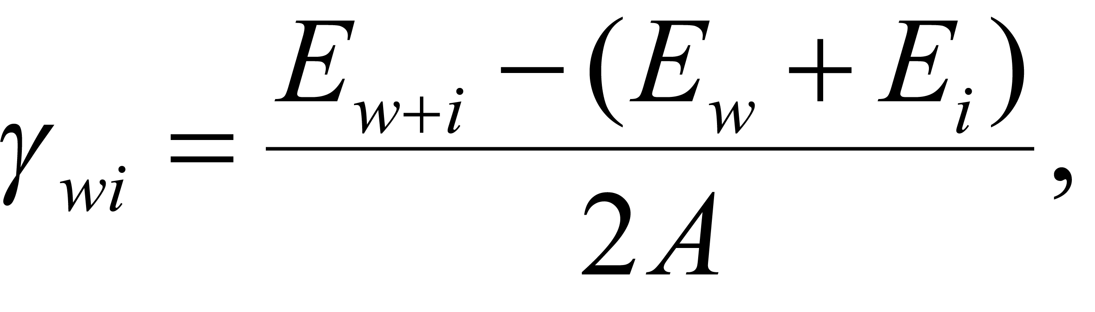 (9)
where A is the area of water-ice interface.

Results and Discussion

Ice propagation in pure water
During freezing, new layers of crystal ice are formed near the water-ice interface until the entire system is frozen. As depicted in Fig. 2.3a, the water-ice interfaces (I₁ and I₂) were propagated, expanding the crystal ice region between 0 and 30 ns after relaxation. The scatter plot of structure order parameters of water molecules in the entire simulation domain quantitatively confirms the expansion of ice crystal (Fig. 2.3b), i.e., more data points or more molecules of local order parameter ${\overline{q}}_{6}$ > 0.385 at t = 30 ns.
To examine the water-ice propagation speed under different temperature below the freezing point of the system, the supercooling temperature is defined as ΔT_{sc} = T_{m} – T_{sys}, where T_{m} is the water-ice phase change temperature in MD simulations (265 K in this study) and T_{sys} is the simulated system temperature. In pure water-ice systems, the water-ice interface propagation speed (u_{wi}), which was estimated by averaging the propagation speed from three crystal surfaces (P1, P2, and basal), reached the maximum (0.20 m/s) at 13 K of ΔT_{sc} (denoted as ΔT_{sc},_{max}), as shown in Fig. 2.4a. When the supercooling temperature is lower than ΔT_{sc},_{max}, u_{wi} decreased with decreasing ΔT_{sc}, while for ΔT_{sc} > ΔT_{sc},_{max}, u_{wi} increased with decreasing ΔT_{sc}. In the simulations, significant water-ice interface propagation (0.02 m/s to 0.20 m/s) was observed in the range of 3 – 25 K of ΔT_{sc}. The supercooling and the maximum propagation from our simulations (u_{wi} = 0.20 m/s at 13 K of ΔT_{sc}) are in good agreements with other MD works [20, 49] and experimental works [50], as presented in Fig. 2.4a. Even though the maximum propagation speed appears at larger ΔT_{sc} in the experimental work [50, 55], the overall dependence and speed are similar to our study.
The number of water molecules in an ice-like structure (${\overline{q}}_{6}>0.385$) at 30 ns after the beginning of ice propagation was the largest at ΔT_{sc,max} (= 13 K), while at 65 K of ΔT_{sc}, transition to ice structure in the initial water region was not observed (Fig. 2.4b). Large fraction of newly formed ice structures, when the highest propagation speed appears (i.e., at ΔT_{sc,max} = 13 K), are cubic-like, while the hexagonal ice structures are created partially in case of ΔT_{sc} = 5 K with a lower propagation speed. This is attributed to a rapid phase transformation at ΔT_{sc,max} which causes the metastable phase of ice (ice-I_{c}). On the other hand, the lower propagation speed provides water molecules with sufficient time for transition to more stable phase, i.e., hexagonal ice structure (ice-I_{h}) [56].
To explain the dependency of u_{wi} on the temperature (T_{sys}), the mobility of water molecules and thermodynamic driving force of water-ice phase change were examined by calculating the self-diffusivity D and the free-energy difference between water and ice (ΔG) at several temperatures. The self-diffusivity D describes the random translational movement of water molecules driven by the internal kinetic energy [57]. Figure 2.4c shows the self-diffusivity D of supercooled water calculated using MD data in a temperature range of 200 – 280 K, and the results are compared with experiments [51]. Although the self-diffusivities from MD are around five times smaller than the experiments, the MD activation energy (-35.82 kJ/mol) that was calculated from the temperature-dependence of the self-diffusivity between 200 K and 270 K is close to the value determined by the experiment (-30.16 kJ/mol) from 240 K to 270 K. The discrepancy from the experiments can originate from the size effect in molecular simulations or the usage of rigid water model, where atomic movements are constrained [58]. The appearance of the maximum u_{wi} at higher temperatures (smaller supercooling) in MD than experiments can be attributed to the lower of self-diffusivity in MD, as Fig. 2.4a presents. Since temperature represents the average kinetic energy of water molecules, lower temperatures lead to lower mobilities or smaller self-diffusivity. The lower mobilities of water molecules slow the ice propagation as the transition to ice requires the migration of water molecules to a lattice point of the ice crystal.
While the mobility of water molecules increases with temperature, the thermodynamic driving force of the phase change, which we characterized using the free-energy difference between supercooled water and ice, decreases with increasing temperature, as Fig. 2.4d shows. Linear fitting and extrapolation of the free-energy values from MD simulations indicate that the free energy of crystal ice is less than that of water when T_{sys} < 280 K, which confirms that ice is more energetically stable. The opposite temperature dependences of the thermodynamic driving force and self-diffusivity of water molecules explain the existence of optimum freezing temperature (T_{wi,max}) for the maximum water-ice propagation speed (252 K in this report).
The water-ice interface propagation speed (u_{wi}) also depends on the orientation of ice crystal surface that contacts water as shown in Figs. 2.5a and 2.5b. When the secondary plane (P2) of ice crystal is in contact with liquid water, the water-ice interface propagation is the fastest in all ranges of ΔT_{sc} (Fig. 2.5a), while the basal plane-water interface have the slowest propagation speed. The energy analysis (Fig. 2.5b) also shows that a larger water-ice interfacial energy (γ_{wi}) was measured in case of faster propagation speed; P2-water interface has the largest γ_{wi}, and the basal plane-water interface has the lowest. Since a lower interfacial energy represents a more stable configuration, which leads to a lower atomic mobility and slower ice propagation [59], the dependence of freezing propagation speed on the water-ice interface orientation can be attributed to the interfacial energy.

Effects of water-graphene interaction
The effects of surface-water interactions on water phase change process, in addition to pure water properties discussed in Sec. 3.1, were examined for the understanding of freeze casting. In the freezing simulations of water with graphene flakes for the study of surface interaction effects, all the surfaces of graphene flakes were initially perpendicular to the basal plane of the ice crystal, i.e., angle between graphene and basal plane normal vector, θ_{f} is 90˚, as in Fig. 2.6a However, due to the water-graphene interactions, as ice propagates near graphene surface, all the graphene flakes rotated about the long axis of the flakes, reducing the angles with the basal plane (θ_{f,1} and θ_{f,2} , where 1 and 2 are index of the flake) as in Fig. 2.6b The change of the angle between graphene flakes and the ice crystal basal plane are summarized in the Table 2.1 Two cases of the simulations with different distances between flakes and the water-ice interface (d_{gi} = 3 and 14 Å) show that the larger distance case resulted in the re-arrangement of two graphene flakes with more similar degrees of the flake-basal plane angle.
The preferred parallel angle between graphene surface and ice crystal basal plane was also observed in the simulations with a large graphene surface. Even with a different initial orientation of ice seed as described in Fig. 2.2c, the ice cluster ended up with the basal plane parallel to the graphene surface as shown in Figs. 2.7a and 2.7b. Thus, for the first two cases of initial ice cluster orientations, where a primary or secondary prism plane (P1 and P2) of ice cluster is parallel to the graphene surface, the ice cluster rotated to have the basal plane facing down.
As Fig. 2.7c shows, the initial potential energy (U_{R.avg}) of the ice cluster-graphene interfacial region is -1.84 eV when the basal plane faces the graphene surface, and it is lower than the other two cases (U_{R.avg} = -0.31 eV for the primary prism plane and -0.51 eV for the secondary prism plane). During the freezing process, the U_{R.avg} from the first two cases (P1 and P2 plane facing the graphene surface) gradually decreased as the ice cluster rotated to have the basal plane parallel to the surface. Consequently, the U_{R.avg} from three different orientation cases converged to a similar value (~ -2.0 eV at t₁ = 100 ns). As the lower U_{R.avg} represents the more stable configuration, the configuration where the basal plane and graphene are parallel is the most stable. This explains the alignment of graphene flakes in Fig. 2.6 and the ice cluster rotation of the P1 and P2 cases in Fig. 2.7. Moreover, after the alignment of the ice cluster for the basal plane parallel to graphene, the hexagonal structure of water molecules started forming around the ice cluster, showing ice growth. As discussed above in Fig. 2.5, the ice crystal mainly grows in a direction normal to the P2 or P1 plane, i.e., parallel to the basal plane. Therefore, with graphene-water surface interactions, ice mainly grows in a direction parallel to graphene surface.

Conclusions
In this research, the fundamental controlling mechanisms of water-ice interface propagation were investigated through molecular dynamics. The maximum propagation speed of the water-ice interface appeared at 252 K. The competition between self-diffusivity and thermodynamic driving force results in an optimal temperature for maximum ice growth speed. Water-ice interfacial energy depends on the orientation of water-contacting ice surface, and a higher interfacial energy leads to a faster ice propagation speed. Thus, the ice propagation speed depends on water-ice surface orientation. Graphene-water surface interactions align ice clusters or graphene flakes to have a minimum energy state, in which the basal plane of the ice crystal is parallel with the graphene surface. As a result, the orientation of ice crystals and the ice growth speed and direction can be changed by controlling surface interactions. This study provides insights to ice propagation control mechanisms for effective freeze cast structuring and its broader applications.

Figure and Tables
Table 2.1 Angles between the graphene flakes and the basal plane of ice crystal (θ_{f,1} and θ_{f,2}) at t₁ = 30 ns for two different distances between the graphene flake and water-ice interface (d_{gi} = 3 and 14 Å).
d_{gi} (Å) | θ_{f,1} | θ_{f,2}
3 | 2.56 ˚ | 43.11˚
14 | 20.77˚ | 28.60˚
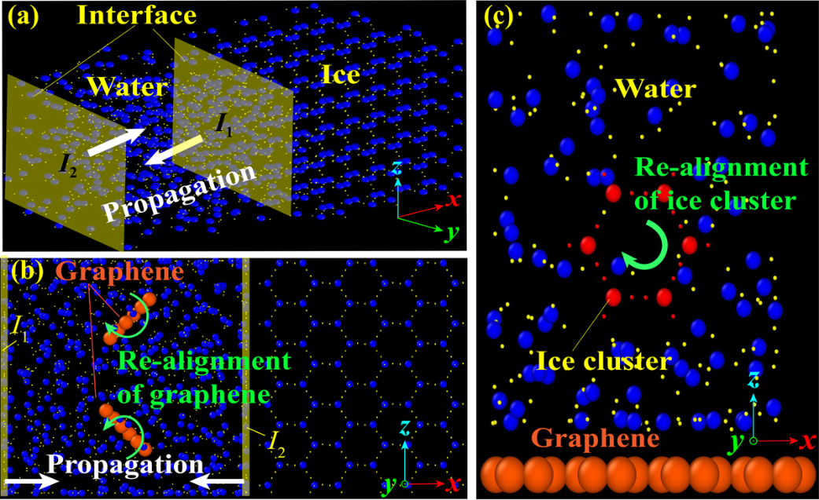
Figure 2.1 Initial atomic configurations of molecular dynamics simulations for (a) pure water freezing, (b) water freezing with movable graphene flakes, and (c) water freezing with a movable rigid ice cluster and a graphene plate at bottom. (Blue and yellow spheres: oxygen and hydrogen atoms from water or ice molecules, orange spheres: carbon atoms from graphene, and red spheres: oxygen and hydrogen atoms from the rigid ice cluster).
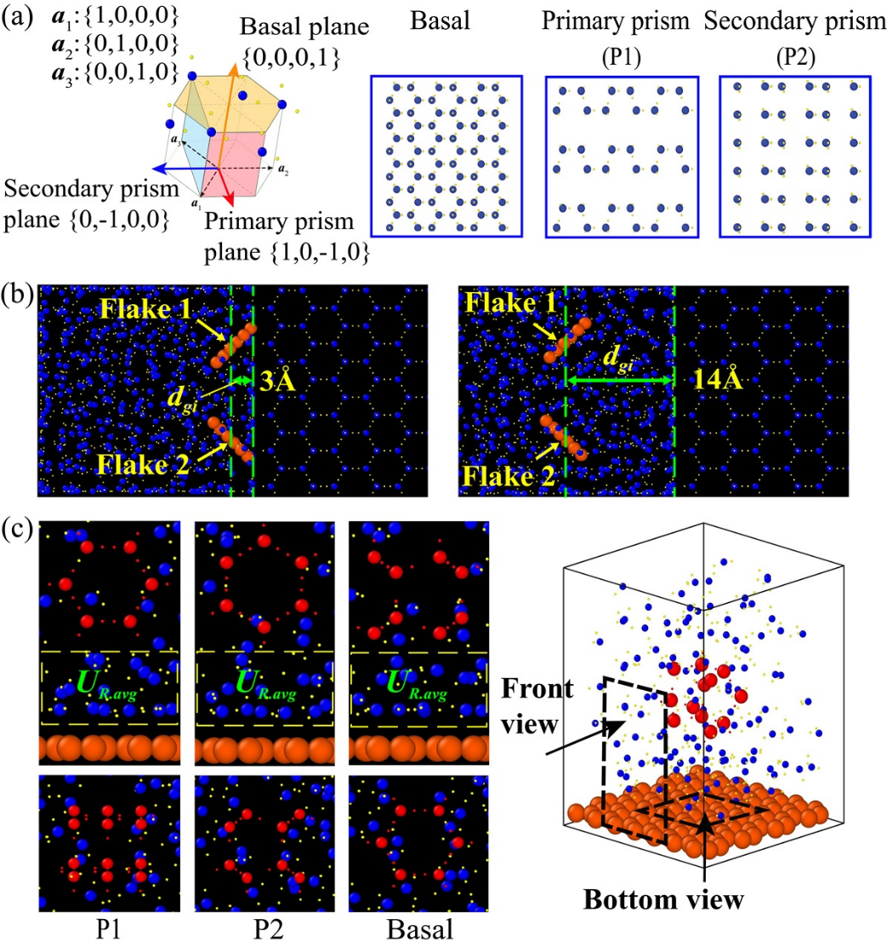
Figure 2.2 (a) Hexagonal ice crystal structure and basis vectors, and atomic configurations of three surface orientations (basal, primary prism, and secondary prism). (b) Initial atomic structures (oxygen: blue, hydrogen: yellow, and carbon: orange) of water-ice system with two inclined graphene flakes with two distances (d_{gi}) between the flakes and a water-ice interface, and (c) water with ice seed (red) on graphene surface (first row: front view and second row: bottom view). Three different surfaces of the ice crystals are facing down to graphene.

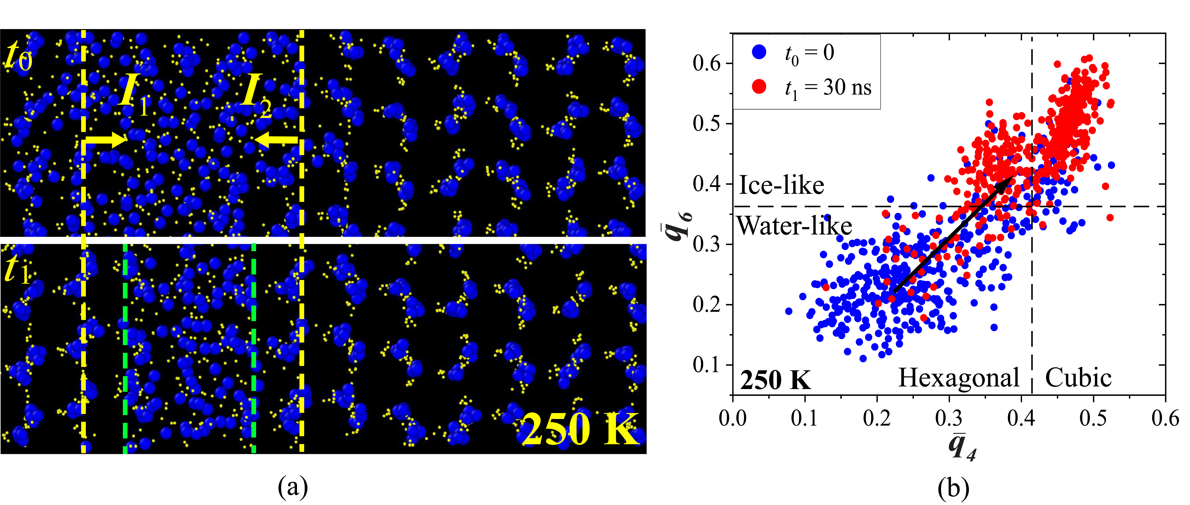
Figure 2.3 The freezing process of water-ice system at 250 K: (a) the water-ice interfaces propagate from ice region toward water region, and (b) the structure order parameter plot at two different time steps, (t₀ = 0; t₁= 30 ns after freezing process). More molecules have structure order parameters ${\overline{q}}_{6}$ larger than the water-ice criterion of 0.385 at t = t₁, demonstrating the formation of hexagonal ice structure.

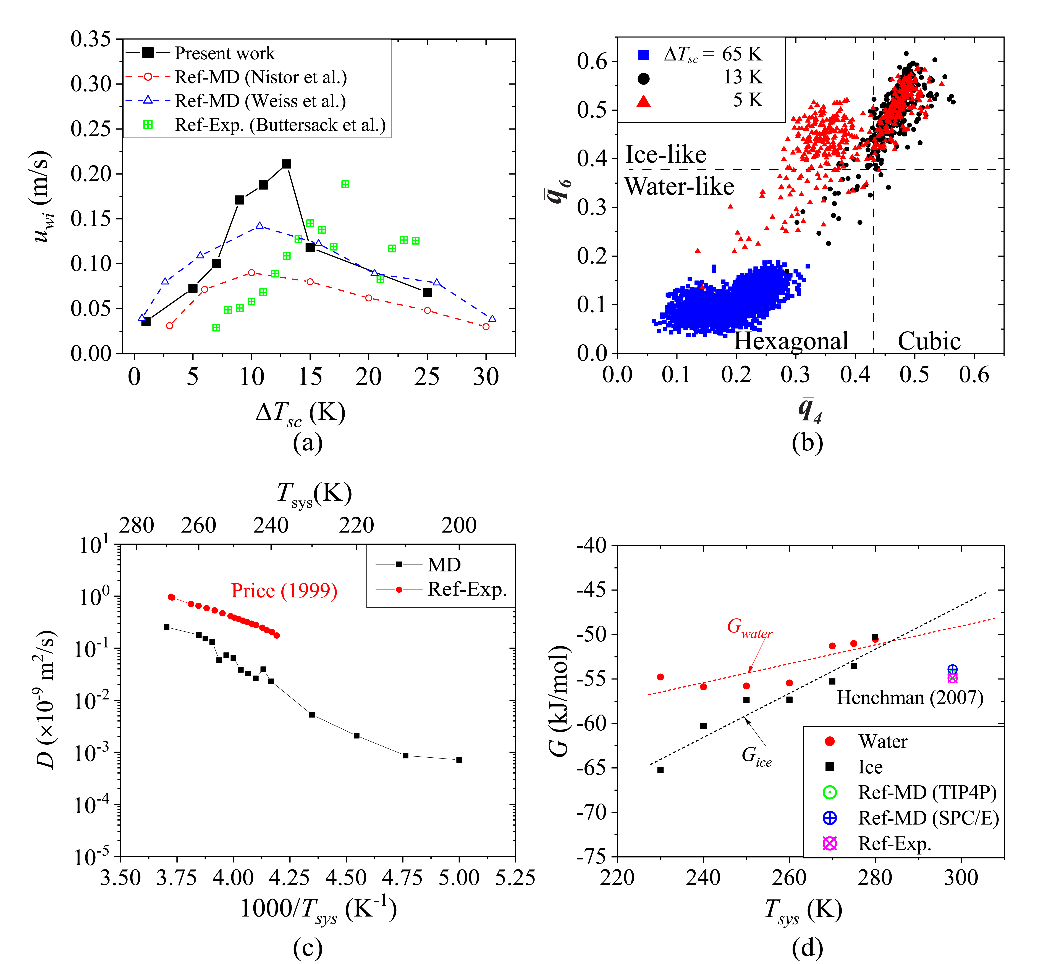
Figure 2.4 (a) The water-ice interface propagation speed (u_{wi}) averaged over three crystal orientations with respect to the supercooling temperature (ΔT_{sc}). The red open circles and blue open triangles represent the results of ice propagation speed from other MD studies [20, 49], and the green cross rectangles do those from a previous experimental study [50]. (b) The distributions of the structure order parameters (${\overline{q}}_{4}$ and ${\overline{q}}_{6}$) of water molecules in the water-side region at three supercooling temperatures, ΔT_{sc} = 65 (blue squares; T_{sys} = 200 K), 13 (black circles; 252 K), and 5 K (red triangles; 260 K) after 30 ns of freezing propagation. (c) Self-diffusivity (D) and (d) free energy of supercooled water and ice (G_{water} and G_{ice}) with respect to the temperature. The results are compared with experimental self-diffusivities [51] and free energy from MD with the TIP4P water model [52], MD with the SPC/E model [53], and experiments [54].

Figure 2.5. (a) Temperature dependency of propagation speed from different crystal orientations at interface. (b) Speed of water-ice interface propagation (u_{wi}; gray bars) and interfacial energy (γ_{wi}; blue crossed circles) for the three different orientations at 15 K of ΔT_{sc}.

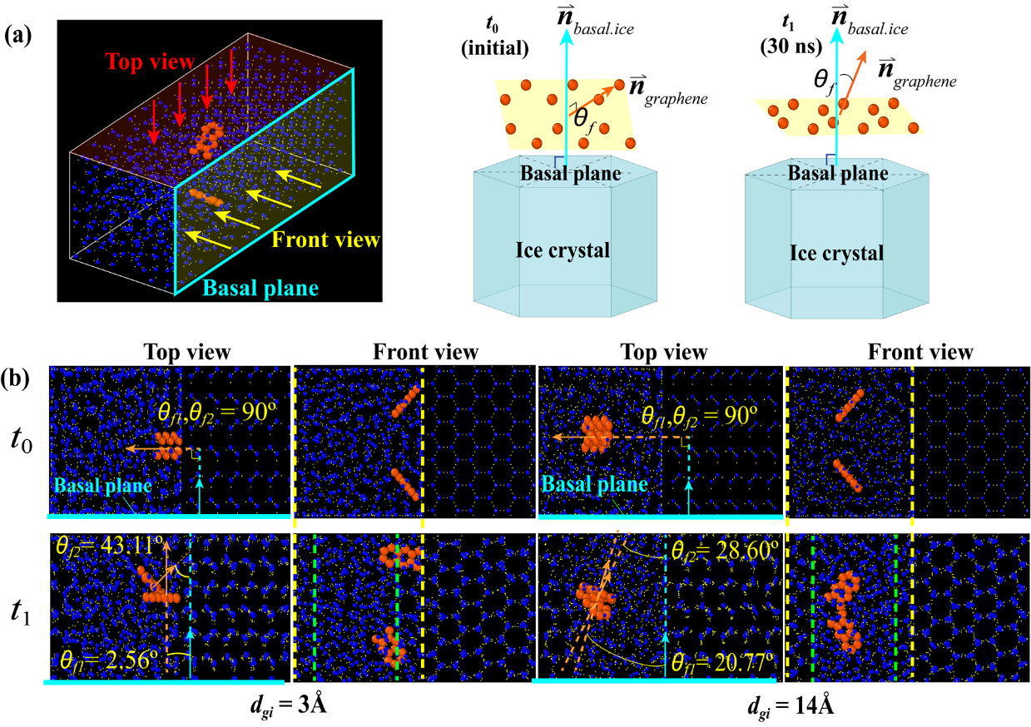
Figure 2.6 (a) Schematic illustration of the angle between graphene and basal plane normal vector. (Cyan surfaces and arrows: basal plane and its normal vector, orange arrows: normal vector of graphene flake surfaces) (b) Change of the alignment of two graphene flakes during the freezing process between t₀ = 0 and t₁ = 30 ns. The crystal surface of the interface is secondary prism plane (P2).

Figure 2.7 (a) Atomic configurations from the bottom view of water freezing simulations with graphene surface (orange) and three different initial orientations of ice cluster (red) at t₀ = 0, and t₁ = 100 ns. First and third row: front view, second and fourth row: bottom view. (b) Schematic illustration describes the viewing direction of the front and bottom view. (c) Regional potential energy (U_{R.avg}) of three cases of different ice cluster orientations.

Rayleigh-Bénard Convection and Freezing Propagation during Water-Ice Phase Change

Abstract
The water-ice phase change and convection behaviors with a bottom surface cooling were investigated for the fundamental understanding and control of the ice front propagation. The convection flow profiles, and the geometry and propagation of water-ice interface were examined using the computational fluid dynamics simulations with different temperature and geometrical conditions. This study revealed that the water-ice interface has the largest spatial variation in height when the temperature of maximum density (277K) is applied to the top boundary or the density inversion parameter is the unity, due to the effect of Rayleigh-Bénard convection and propagation of the water-ice interface. The geometrical confinement by the water container, characterized by the aspect ratio, also influences the convection profiles. The Rayleigh-Bénard convection becomes more prominent as the aspect ratio Г (the height-to-diameter ratio) increases, which enhances the convection heat transfer or the Nusselt number but lowers the ice propagation speed. Since the water-ice interface propagates more unevenly with a faster propagation speed and more developed convection, the largest interface height variation appears at Г = 0.67, as a result of the competition the Rayleigh-Bénard convection and the interface propagation on the aspect ratio. As this research identifies the control of the Rayleigh-Bénard convection, ice front propagation and interface shape, the findings will benefit the applications of water-ice phase change, such as freeze casting.

Disclosure
Chapter 3 is a modification of the developing manuscript: Yu-Kai Weng, Seungha Shin*, Mian Umar Saeed, Mohammad Bahzad, Kenneth D. Kihm, and Douglas S. Aaron, " Rayleigh-Bénard Convection and Freezing Propagation during Water-Ice Phase Change" The dissertation author listed in this publication directed and supervised the research which forms the basis for this manuscript.

Introduction
Natural convection, which is generated by thermal buoyancy originating from the temperature dependence of density, plays an important role in various heat transfer applications, such as heat exchangers, solar water heaters [60-62], and passive cooling systems in electronic devices [63], where active cooling with external power source is unavailable or inefficient. In addition, natural convection has been extensively investigated to understand natural phenomena, like atmospheric motion [64, 65] and ocean circulation [66]. Since the convection heat transfer coefficient is determined by temperature (T) profile, understanding of flow patterns that affect the T profile is critical to evaluate the heat transfer efficiency in natural convection [67, 68].
Rayleigh-Bénard (RB) convection is one of representative natural convection patterns, which can be observed in a fluid layer heated by the horizontal boundary at the bottom while cooled at the top boundary [69, 70]. Due to the convenience of experimental setup and clearly-identified physical mechanism [71], RB convection has been used to study various issues, such as the stability [72, 73] and spatial-temporal chaotic behaviors [74], in natural convection. Water is a widely used working fluid in heat transfer systems due to their large heat capacity, availability, etc.; thus, the RB convection of water has been widely studied [75-77].
Water has a unique temperature-density relation in that the density increases with increasing temperature up to the temperature of maximum density, T_{ρ.max} (277 K, or 4℃) and then decreases [78]. This enables a flow circulation with an inverse temperature gradient, where the bottom surface is colder, and the top surface is warmer, can be recognized as Rayleigh-Bénard (RB) convection. In the past three decades, RB convection has been extensively reported by experiments [79, 80] and numerical simulations [81, 82]; however, research on RB convection of water during freezing, with an inverse temperature gradient is rare.
Inverse temperature setting of water is employed in freeze casting, used to fabricate porous materials like polymer [83] and ceramic biomaterials [84]. When a fluid with suspended particles is solidified, the suspended particles are rejected by solidifying fluid and that templates porous structures [13]. Thus, the freeze cast structure has a strong sensitivity on the directionality of the solidification [85], and the understanding and control of ice propagation behaviors [86] is important in the freeze casting using water. As interference of the solidification [87] and melting [88] process by convection has been reported, RB convection by the inverse density profile is also expected to perturb the water-ice interface during freezing. With our interest in the synthesis of directional graphene aerogel using freeze casting, we studied the convection behaviors and ice propagation during water-ice phase change process with inverse temperature gradient. Computational fluid dynamics (CFD) was employed as a primary tool in this work for effective analysis of the fluid flow behaviors and phase changes [89, 90].
The Rayleigh-Bénard convection of water during freezing was investigated under different geometrical and physical conditions in CFD simulations. Specifically, the boundary temperatures which determine the density profile and the container aspect ratio to impose geometrical constraint were varied as main control parameters. In this paper, these control parameters and the simulation details are introduced, followed by the discussion on their effects on the flow profile, water-ice interface shape, freezing propagation, and overall heat transfer performance.

Methodology
To investigate the Rayleigh-Bénard convection under an inverse temperature gradient and its effect on water-ice phase change, water in a cylindrical container, as depicted in Fig. 3.1, was simulated near the freezing temperature (273 K) using ANSYS-Fluent computational fluid dynamics (CFD) package [91]. The height H and diameter D of the water are 40 mm and 20 mm, respectively, under the benchmark condition. The temperatures of the top and bottom horizontal surfaces were fixed at T_{h} and T_{c} during our simulations, and the benchmark simulations employed T_{h} = 277 K and T_{c} = 270 K. The sidewalls of cylindrical water were assumed to be adiabatic. The density, viscosity, and thermal expansion coefficient of the water were considered as a function of temperature, while the other thermophysical properties were assumed to be constant. All the properties and their temperature dependence were obtained from the referenced database [92].
In natural convection, the ratio of diffusion and convection, i.e., Rayleigh number Ra, is used as a main control parameter in general [93], which is defined as
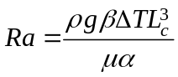, (1)
where ρ is the density, β is the thermal expansion coefficient, ΔT is the temperature difference, L_{c} is the characteristic length (height, H in this work), g is the gravitational acceleration, μ is the dynamic viscosity, and α is the thermal diffusivity. In conventional RB convections, where a higher temperature is applied to the bottom surface, Ra has been reported to have a strong influence on the structure of convection rolls [94]; into addition to physical properties such as viscosity, Ra effects on the RB convection have been extensively investigated [95]. Since the buoyancy caused by temperature gradient is a driving force of RB convection with an inverse temperature gradient, boundary temperatures were varied in this study, which also changed Ra due to the variation of the density, viscosity, and thermal expansion coefficient. For effective analysis, fixing the maximum T difference (ΔT = T_{h} – T_{c} = 7 K), temperatures of two boundaries, i.e., T_{h} and T_{c}, were changed in the simulations. The temperature setup, which can induce a density inversion (the density increases with temperature), was characterized by the density inversion parameter (Θ_{m}) that is defined as Θ_{m} = (T_{ρ.max} – T_{c})/(T_{h} – T_{c}). Our simulations employed T_{c} ranging from 267 K to 273 K and T_{h} ranging from 274 K to 280 K as Table 3.1 shows, and thus, Θ_{m} and Ra ranged from 0.59 to 1.45 and from 1.61×10⁵ to 1.83×10⁶, respectively for the fixed T_{h} - T_{c} of 7 K. For Θ_{m} < 1 (T_{c} > 270 K), the temperature of the maximum density T_{ρ.max} (277 K) is located between the top and bottom boundaries, and the density does not change monotonically; as the distance from the bottom surface increases, the density first increases and then decreases after the maximum density. On the other hand, Θ_{m} > 1 (T_{c} < 270 K) leads to an inverse water density gradient over the whole simulation region.
In addition to the boundary temperatures, the influence of geometrical constraint on the RB convection has been reported to be significant in several studies. Experimental [96] and numerical studies [97] show that the aspect ratio of the container alters the convection patterns, including the number of RB convection rolls [93]. The RB convection under an inverse temperature setup is also expected to be affected by the geometry, which is characterized by the aspect ratio (Г), i.e., the ratio of the horizontal to vertical dimensions of the system domain (Г = D/H). To adjust the aspect ratio (Г), the diameter, D was varied from 20 to 80 mm (0.5 ≤ Г ≤ 2), while H was maintained at 40 mm, as in Table 3.2. As H was used as a characteristic length, Ra does not change with the variation of Г only.
In the reference to the coordinate system shown in Fig. 3.1, the governing equations based on the continuity, momentum and energy conservations are described as:
$\frac{∂ρ}{∂t}+\frac{∂}{∂x_{i}}(ρu_{i})=0$, (2)
$\frac{∂{ρu}_{i}}{∂t}+\frac{∂}{∂x_{j}}\left(ρu_{i}u_{j}\right)=-\frac{∂p}{∂x_{i}}+\frac{∂τ_{ij}}{∂x_{j}}$, and (3)
$\frac{∂ρe}{∂t}+\frac{∂}{∂x_{j}}\left[μ_{i}ρ(e+\frac{\sum{u_{i}^{2}}}{2})\right]=\frac{∂}{∂x_{j}}\left[pu_{j}+τ_{ik}u_{k}\right]$, (4)
where ρ is the density, e represents the specific internal energy, p is the pressure, and μ is the dynamic viscosity. The subscript i, j, and k are the indices for direction in the Cartesian coordinate system in Fig. 3.1. The viscous stress τ_{ij} is given by:
$τ_{ij}=(μ+μ_{t})\left[\left(\frac{∂u_{i}}{∂x_{j}}+\frac{∂u_{j}}{∂x_{i}}\right)-\frac{2}{3}δ_{ij}\frac{∂u_{k}}{∂x_{k}}\right]$, (5)
where δ_{ij} is the Kronecker delta function, μ is the dynamic viscosity, and μ_{t} is the dynamic eddy viscosity, which is estimated by the k-ɛ turbulent model [98].
The SIMPLE [99] pressure-velocity coupling algorithm was introduced to solve the governing equations. The standard scheme is used to discretize pressure, while the second-order upwind methods are used to discretize the momentum and energy transport. The turbulent kinetic energy and turbulent dissipation rate were discretized by the first-order upwind method, and the first-order implicit scheme was also applied to discretize the time. The time step of the simulations was set in the range from 10⁻¹ to 10⁻³ s, and the total simulation time was 1200 s. The convergence of the solution was assumed when the maximum relative error achieves 10⁻⁴.
During the RB convection, the circulating flow creates the inhomogeneous velocity and temperature profile, which locally enhance or suppress the water-ice interface propagation. Consequently, the shape and location of the water-ice interface changes. To characterize the effect of the RB convection during the freezing process, the freezing propagation speed (u_{f}) was calculated using the average distance of water-ice interface from the bottom of the container (z_{w/i,avg}) with respect to time (t). Also, the spatial variation of the water-ice interface that represents the interface shape was characterized by the standard deviation of the interface height (σ_{z}), as:
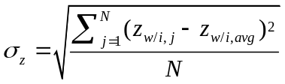, (6)
where z_{w/i,j} is the interface height from the bottom at the j-th data point, and N is the total number of the data point at the water-ice interface.
To characterize the convection heat transfer, Nusselt number Nu, which is defined as the ratio of the convective and conductive heat transfer, is calculated using [100]:
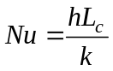, (7)
where h is the convection heat transfer coefficient, L_{c} is characteristic length (H in this research), and k is the fluid thermal conductivity. In this work, the heat transfer coefficient is obtained by calculating the ratio of the heat flux through the container to the temperature difference (h = qʺ/ΔT), and the heat flux qʺ is extracted from the simulation data.

Results and Discussion
The interaction between the Rayleigh-Bénard convection and the freezing makes the water-ice interface nonuniformly propagates from the bottom, while the convection flow carries the energy and momentum toward the interface. This non-uniform interface due to the Rayleigh-Bénard convection in the density inversion temperature ranges agrees with the prior experimental observations [101, 102]. Eventually, the interface developed into a concave shape, where the interface near the sidewall has a higher propagation distance than that at the center, as shown in Fig. 3.2 After 1200 sec, temperature and velocity profiles do not change much, and thus, the RB convection and water-ice interface properties at 1200 sec were analyzed under various freezing conditions.
The velocity and temperature distributions of water undergoing the RB convections were first examined with different density inversion parameters (Θ_{m}). Figures 3.3(a)-3.3(e) demonstrate the temperature distribution (in color) and velocity vectors (with arrows) in the vertical cross-section of water for Θ_{m} = 0.57, 0.71, 1.00, 1.28, and 1.45. When Θ_{m} is less than unity (i.e., T_{c} < T_{ρ.max} < T_{h}), the convection flow develops a primary circulation roll at the bottom corner, and several secondary rolls co-exist at the other corners. In contrast, for Θ_{m} > 1, a single dominant circulation that occupies the entire container was observed. This phenomenon is attributed to the monotonic density change as T_{h} is lower than T_{ρ.max}.
The different RB convection behaviors by different Θ_{m} affect heat transfer efficiency between the top and bottom surfaces and the freezing process. To examine the effect of Θ_{m} on the heat transfer and water-ice phase change, we calculated the Nusselt number (Nu) and the water-ice interface propagation speed (u_{f}). As Fig. 3.4 shows, Nu decreases with increasing Θ_{m} while the freezing propagation speed increases. The relationship between Nu and Θ_{m} matches with the numerical estimation from other researchers [103]. The reduced heat transfer at greater Θ_{m}’s even with a constant temperature difference (ΔT = 7 K) is attributed to slower convection with a simple structure due to greater water viscosity at lower temperature and monotonic density profiles at larger Θ_{m}’s. In contrast, a lower Nu in the liquid water region at greater Θ_{m}’s demonstrates lower heat flux to the water-ice interface region, which promotes the water-ice phase change. Moreover, a lower T_{c} at larger Θ_{m} increases the thermodynamic driving force for the water freezing [86] and enhances the water-ice interface propagation u_{f}.
Consequently, the competition between the interface propagation and the convection effect leads to the variation of the interface height in different Θ_{m} cases, as shown in Fig. 3.5a. The standard deviation of the interface height (σ_{z}), characterizing the height variation, was calculated by analyzing the spatial distribution of the water-ice interface as Fig. 3.5b. The largest variation (σ_{z}) of the interface height appears in the case of Θ_{m} equal to unity; that is, the shape of the water-ice interface at Θ_{m} = 1 has a more curved (bowl-like) shape while a more flattened water-ice interface appears a Θ_{m} deviated from unity. More significant convection flow or faster ice formation contributes to flattening the water-ice interface, and the opposite trends of the convection and ice propagation with Θ_{m} lead to the maximum variation at Θ_{m} = 1.
In addition to the density inversion parameter (Θ_{m}), the aspect ratio of the container (Г = D/H) affects RB convection because the geometry confinement restricts the development of convection circulation rolls. Figure 3.6 presents the temperature and velocity distributions of the RB convection under different aspect ratios. In the container with Г = 2, two convection rolls, which symmetrically occupy the fluid domain, were observed in the cross-section, while a single dominant circulation roll appears when Г is equal to or lower than unity. These observations agree that the size of the fully-developed Bénard convection cell λ is close to twice the characteristic length (i.e., height λ = 2H) in the rigid top and bottom boundary conditions without a geometrical constraint on the side [104]. When the longest horizontal length of the container (D) is less than the unconstraint Bénard cell size λ but larger than H (H ≤ D < 2H or λ), two convection rolls appear; however, one of them occupies a majority part of the container, which creates an asymmetric flow field. The transition from a symmetric to asymmetric state can be recognized as spontaneous symmetry-breaking [105]. When the horizontal length is further reduced to less than the height of the container (D < H), the development of a single convection roll is also restricted as the diameter of a single convection roll (d_{c}) ranges from 1 to 1.4 times the container height (d_{c} = λ/2 ~ H) in RB convection [106]. Consequently, RB convection is suppressed by reducing the aspect ratio (Г).
The effects of the aspect ratio (Г) on the heat transfer (Nu) and the water-ice interface propagation (u_{f}) were examined with the different inversion parameters (Θ_{m} = 0.75, 1.0, and 1.25), as shown in Figs. 3.7a and 3.7b. Nu increases with increasing Г (increasing D) for all three Θ_{m}’s due to a less restricted RB convection with larger Г or D, enhancing the heat transfer. Above Г of one, as convection circulation rolls can be fully developed without geometrical constraints, Nu does not change significantly, which agrees with a previous computational study [97]. The sensitivity of Nu to Г also decreases with increasing Θ_{m} as the heat supply is reduced at larger Θ_{m}. The propagation speed of the water-ice interfaces (u_{f}) also shows the opposite dependence on Г, i.e., u_{f} decreases with increasing Г because the freezing process slows down by increasing convective heat transfer. With a given Θ_{m}, temperature boundary conditions are identical, and thus, the reduction in u_{f} at larger Г’s can be attributed solely to the enhanced convection heat transfer to the water-ice interface, which suppresses the freezing process. Here, Nu obtained from the simulation in this study is in a good agreement with the results from experiments [107] and CFD [93] simulations in prior RB convection studies, which were conducted under similar conditions (Ra ~ 10⁶) but via heating (not inverse temperature gradient), as in Table. 3.3. This agreement suggests that the dependence of heat transfer efficiency in RB convection on Ra is similar in both heating and cooling conditions and validates our simulation results.
RB convection alters the circulation flow patterns and interface propagation during freezing. As a result, the shape of the water-ice interface changes with Г as presented in Fig. 3.8a. The figure shows that the lower surface region (blue and cyan) of the interface deviates from the center, and the higher surface region (red) is only distributed on the single side of the interface in the two low aspect ratio cases (Г = 0.5 and 0.67). These asymmetric interface patterns indicate that the entire interfaces are affected by a single direction of a convection flow, as shown in Fig. 3.6. On the contrary, interface propagation for the largest aspect ratio case (Г = 2.0) shows a more consistent and symmetric propagation, which matches the temperature and velocity profile shown in Fig. 3.6. The analysis of these figures shows that geometrical confinement restricts the development of RB convection, which affects the convection flow path inside the container and the resulting overall heat transfer and water-ice interface propagation and shape.
Figure 3.8b shows that the interface shape has stronger sensitivity on the aspect ratio (Г) when the density inversion parameter is unity (Θ_{m} = 1), which has the largest variation of interface height in every aspect ratio. As the geometrical confinement is reduced with an increasing aspect ratio (Г), the convection circulation rolls can develop more completely, which makes the convection effect increases with Г when Г < 1 and start to converge when Г > 1. Both more significant RB convection and faster interface propagation contribute to the height variation of the water-ice interface, but they have the opposite trends with respect to Г. Thus, the variation σ_{z} is maximized at 0.67 in Г in all three Θ_{m} cases.

Conclusions
The water-ice interface propagation and the Rayleigh-Bénard convection during freezing were investigated using computational fluid dynamics with inverse temperature and density profiles. Our simulations show that the convection structure becomes simpler and slower as the density inversion parameter increases because the stronger phase changing tendency at lower temperatures interrupts the convection heat transfer. Hence, the heat transfer efficiency decreases with an increasing density inversion parameter; conversely, the speed of water-ice interface propagation has the opposite dependency on inversion parameter because the increasing convective heat transfer suppresses the freezing process. Consequently, the competition between the effects of Rayleigh-Bénard convection and the water-ice interface propagation makes the maximum variation of the interface appear at the inversion parameter equal to the unity. The geometrical confinement of the container, which is characterized by aspect ratio Г, restricts the development of RB convection rolls, which decreases the heat transfer or Nu. Nu increases with increasing aspect ratio below the unity (Г < 1), but the increase above one is insignificant. In contrast, the interface propagation speed is reduced with an increasing aspect ratio due to enhanced heat transfer. Finally, the opposite trends between the RB convection and the water-ice interface propagation speed with aspect ratio led to the largest variance of the water-ice interface at Г, equal to 0.67. Our findings demonstrate that ice propagation speed and water-ice interface shape can be effectively controlled by the temperature setup and geometrical confinement. Therefore, this report will benefit the applications of water-ice phase change, such as freeze casting.

Figures and Tables
Table 3.1 Density inversion parameters (Θ_{m}) and Rayleigh numbers (Ra) with different prescribed boundary temperatures
T_{h} (K) | T_{c} (K) | Θ_{m} | Ra (×10⁵)
280 | 273 | 0.59 | 1.61
279 | 272 | 0.74 | 4.73
277 | 270 | 1.00 | 10.6
275 | 268 | 1.31 | 15.9
274 | 267 | 1.45 | 18.3
Table 3.2 Dimensions of the simulated water container and the aspect ratio (Г)
D (mm) | H (mm) | Г
20.0 | 40 | 0.50
26.6 | 40 | 0.66
40.0 | 40 | 1.00
80.0 | 40 | 2.00
Table 3.3 Comparison of Nu from this study with prior research
Source | Method | Container | Г | Ra (×10⁶) | Nu
Ref. [107] | Exp. | Cubical | 1.0 | 1.0 | 7.883
Ref. [93] | CFD | Cylindrical | 0.5 | 1.0 | 8.02
Current work (Θ_{m} = 1) | CFD | Cylindrical | 0.5 | 1.06 | 8.81

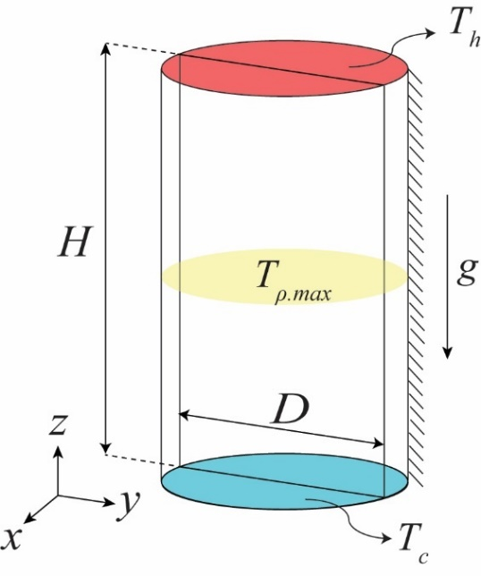
Figure 3.1 Schematic diagram of simulation domain for Rayleigh-Bénard convection.

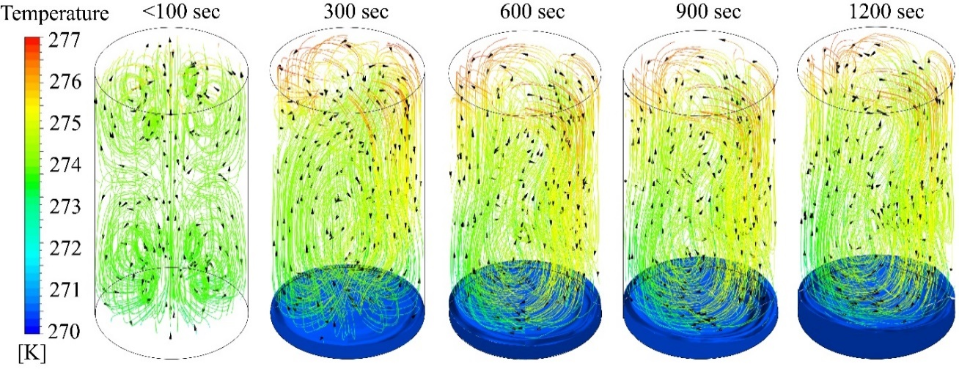
Figure 3.2 The propagation of water-ice interface through the freezing times. The color contour in the streamline represents the water temperature, the blue surface near the bottom represents the water-ice interface (the surface of ice propagates from the bottom ), and the arrows in the figures represent the velocity vectors.

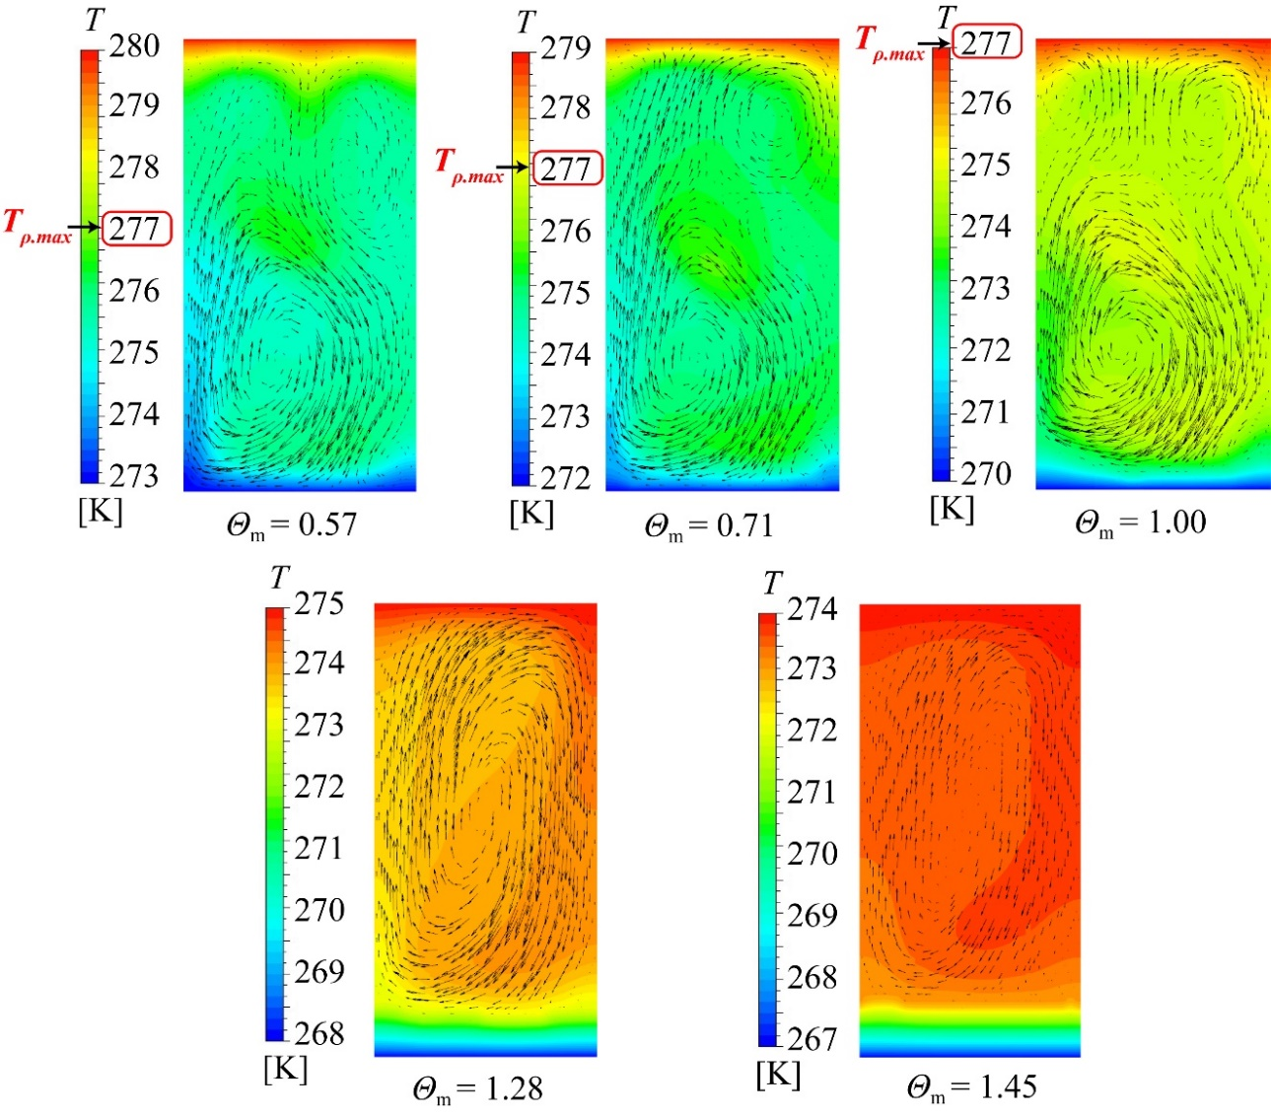
Figure 3.3 The instantaneous snapshot of temperature and velocity profile in the vertical cross-section of the container under different inversion parameters at 1200 seconds freezing times, Θ_{m} = 0.57, 0.71, 1.00, 1.28, and 1.45. The water temperature is represented by color following the scale in the left, and the arrows show the velocity vectors.

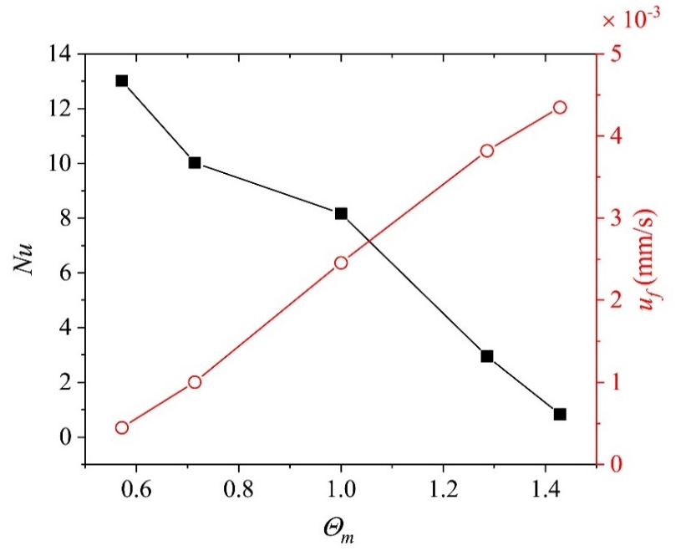
Figure 3.4 Nusselt number (Nu, black filled squares) for the heat transfer between the top and bottom boundaries and the freezing propagation speed (u_{f}, red empty circles) with respect to the density inversion parameter (Θ_{m}).

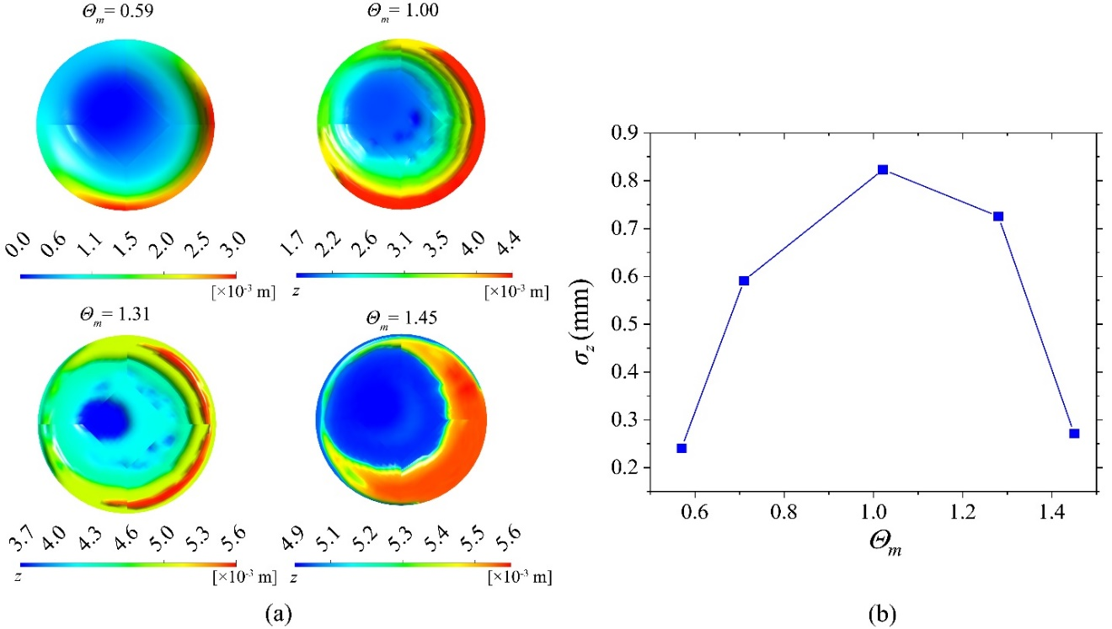
Figure 3.5 (a) The distribution of the water-ice interface height from the top view and (b) the standard deviation of interface height (σ_{z}) with respect to the density inversion parameter (Θ_{m}).

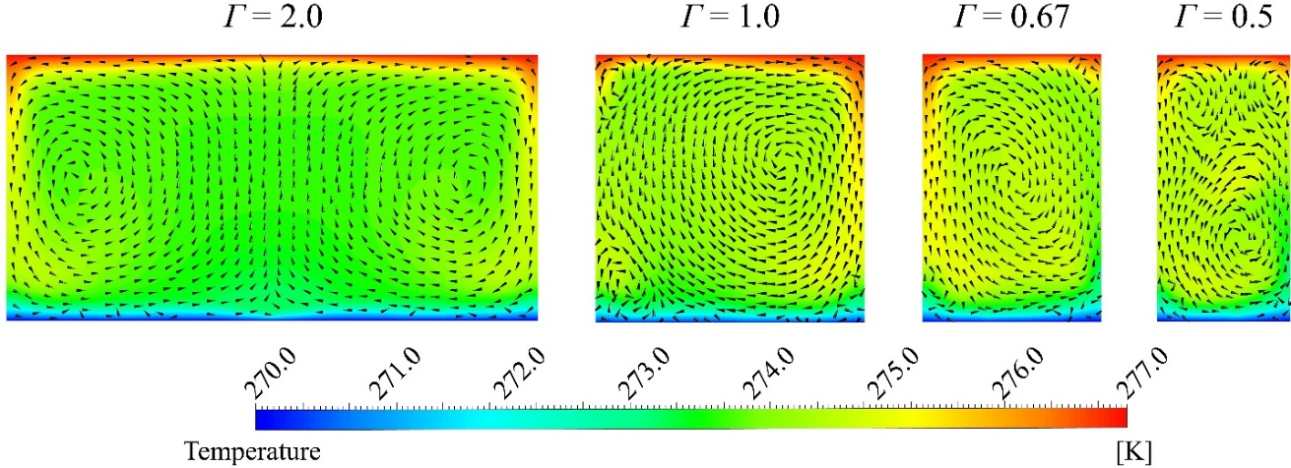
Figure 3.6 Temperature and velocity profile in the vertical cross-section of the container under different aspect ratios, i.e., Г = 2.0, 1.0, 0.67, and 0.5. The water temperature is represented by color following the scale below, and the arrows show the velocity vectors.

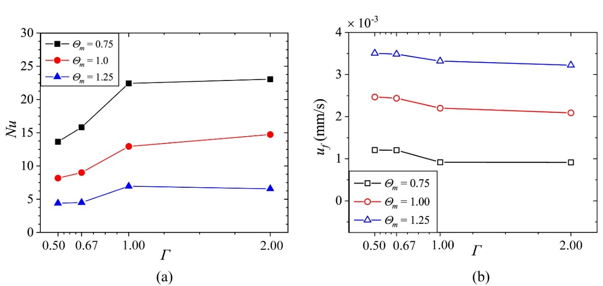
Figure 3.7 (a) Nusselt number (Nu) for the heat transfer between the top and bottom boundaries and (b) the freezing propagation speed (u_{f},) with respect to the aspect ratio (Г = D/H) at three different density inversion parameters (Θ_{m} = 0.75, 1.0, and 1.25).

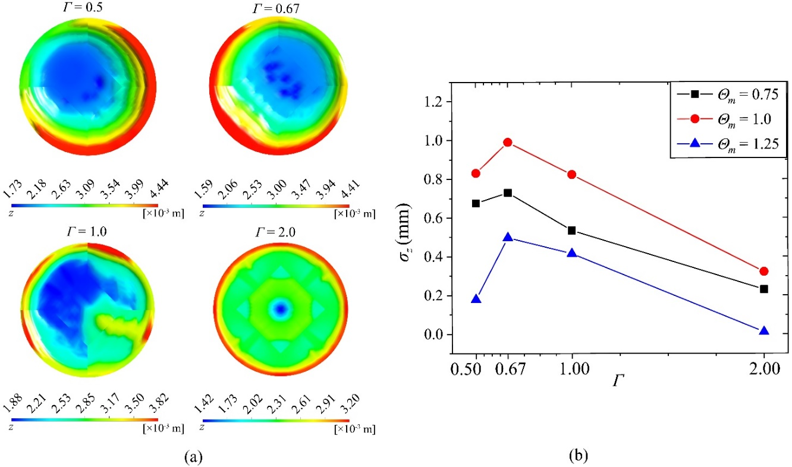
Figure 3.8 (a) The distribution of the water-ice interface height from the top view and (b) the standard deviation of interface height (σ_{z}) with respect to the aspect ratio (Г = D/H).

Surface Interaction Effect on Ion Transport with Convective Flow in Graphene Nanochannel

Abstract

Disclosure

Introduction
Ion transport in Nanofluidic devices have becomes a popular research study topic because of their excessive potential applications [108], such as energy storage [109, 110], ion separation [111, 112], and water desalination [113, 114]. There are several driven sources of the ion transport, such as pressure gradient [115], electrical field [116], and concentration gradient [117]. Among these applications, the large electric energy storage system received considerable attention due to the rising demands of the electric power generated by renewable energy. The redox flow battery (RFB) is one of the examples that charged or discharged the electronic power by pumping the electrolyte flow through an electrode for the electrochemical reactions. Therefore, the efficiency of the convective ion transport under the surface interaction from the electrode materials plays an important role in the performance of the RFB. Graphene, as a popular nanomaterial, has been used to develop nanofluidic devices [118] in various structures, namely carbon nanotube [119], graphene oxide laminates [120], and graphene nanochannel and nanopores [121, 122]. Graphene nanochannels have a promising potential as electrode material in organic redox flow batteries, effectively responding to the rising demands of the large-scale energy storage systems.
Since the source of the ion transport in RFB is the convective flow motion driven by the pressure gradient [123], the flow rate optimization of the electrolyte is essential [124]. In addition to the piping arrangement between the tank and reactor of the battery, the convective flow inside the electrode affects the transportability [125]. Thus, the convective ion transport through the nanostructure becomes a critical task that needs a detailed investigation. Since the graphene-based electrode has a large surface area, the surface interaction effect from the channel wall to the ion and molecular water is essential that need to be addressed [126-128]. The surface treatment of the graphene, such as doping and functionalization, has been reported that able to modify the thermal conductivity [129], wettability [130], and electrical conductivity [131]. Moreover, the surface interaction between carbon and water molecular changes the crystal surface of the ice during the freezing process [86].
During the ion transport through the graphene nanochannel, the chance that the ion drifted into the effective range of surface interaction from graphene will affect the drifting of the ion. Thus, the sizes of the graphene nanochannel should contribute to the movement behavior of the ion. In addition to the channel size effect, the temperature represents the kinetic distribution of the atoms in the system. Thus, different system temperatures change the mobility of ions and waters. Moreover, the intermolecular interaction energy is a function of the system temperatures. Therefore, the temperature effect contributes to the efficiency of ion transport [132]. To improve the performance of the redox flow battery, the ion transport through the graphene nanochannel has been studied by several researchers in the experiment [133] or numerical simulation [134, 135]. Although ion transport through the carbon nanostructures has been reported in various conditions, such as types of the structure [136, 137] and solute concentration [138], the detailed knowledge of the intermolecular interaction effect on the ion transport still needs to be identified. To achieve the objective that increase the electrical conductivity of graphene electrodes, the ion transport properties under various channel sizes, temperatures, and surface interaction strengths are studied.
In this chapter, the efficiency of ion transport through the graphene nanochannel is investigated by molecular dynamics (MD) simulation to have comprehensive knowledge of the surface interaction effect on the drifting velocity of ions. Three different magnitudes of the interaction strengths are applied to the simulation. The ion transport through the graphene nanochannel by convective flow under different channel sizes and system temperatures is also examined. The content of this chapter is organized as follows: the system configuration, simulation detail, and control parameters are described. In the result section, the relationship between the drift velocity and electrical field or pressure gradient under various channel sizes, system temperatures with different interaction strengths are presented in the discussion.

Methodology
The surface interaction effect on ion transport through graphene nanochannel was examined via MD simulation. The simulation was performed on the LAMMPS open-source package [139]. The benchmark system configuration is shown in Fig. 4.1. The nanochannel is built by two parallel graphene sheets where the width (W) and length (L) are 20 Å and 160 Å, respectively. The distance between two graphene sheets (d) is subject to be changed as a control parameter. The channel is filled with water molecules with one potassium ion. The initial location of the ion is 10 Å inside the left boundary and in the center (d/2) of the channel.
Simulation setup
In this ion transport MD simulation, the TIP4P/ICE water model [30] is used to obtain the position and force of the water molecules. This rigid water model fixes bond length (O-H) of 9.572 Å with 104.52˚ fixed bond angle (H-O-H), and the charges of O and H atoms are -1.179 and 0.589 elementary charges (e_{c}), respectively. The massless charge site M is set 0.1577 Å away from the O atom. The rigidity of the water molecules are secured by using the SHAKE algorithm [31]. The long-range Coulombic interactions among the water molecules are calculated by applying the particle-particle particle-mesh (PPPM) algorithm [32]. In addition, the intramolecular interaction between the oxygen, carbon, and potassium ion with a distance less than the cut-off distance (r_{c}) was calculated by using 12-6 Lennard-Jones (LJ) model [33]. The carbon-carbon (C-C) interaction inside the graphene was estimated by Tersoff potential [35]. Newton’s equations of motion were integrated by the velocity-Verlet algorithm [36]. All the temperatures in this simulation were controlled by Nose-Hoover thermostats. In the channel size dependency study, two different sizes of the graphene channel (d = 14 Å and 40 Å) are introduced to create the water and graphene channel system, where the system temperature (T_{sys}) was set at 300 K. The system initially equilibrated at T_{sys} with an NPT ensemble (i.e., fixed number of molecules, pressure, and temperature) for 0.01 nanosecond. After the relaxation, the system was switched to NVT (constant number of molecules, volume, and temperature) at T_{sys} for at least 1.0 nanosecond. At this stage, the pressure drop (ΔP) and electric field (E_{e}) are applied to the system. The trajectory of the Potassium ion is recorded for further analysis of the distance between the ion and graphene wall during the drifting. For the temperature dependency study, two different T_{sys} were set at 300 and 320 K, and the channel size was fixed at 14 Å. Thereafter, the MD simulation procedure of the temperature dependency cases is the same as the size dependency cases.
Equation and analysis

$$μ_{e}=\frac{u_{d}}{E_{e}}$$
p(z*): z*=z/d

Result and Discussion

Conclusions

Figures and Tables
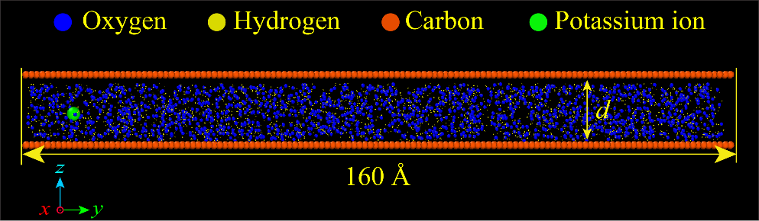
Figure 4.1 System configuration of the graphene channel

Summary and Conclusions

List of References
[1] A.Z. Weber, M.M. Mench, J.P. Meyers, P.N. Ross, J.T. Gostick, and Q. Liu, Redox flow batteries: a review, Journal of Applied Electrochemistry 41 (10) (2011) 1137.
[2] B. Hu, C. DeBruler, Z. Rhodes, and T.L. Liu, Long-Cycling Aqueous Organic Redox Flow Battery (AORFB) toward Sustainable and Safe Energy Storage, Journal of the American Chemical Society 139 (3) (2017) 1207-1214.
[3] X. Xing, Y. Huo, X. Wang, Y. Zhao, and Y. Li, A benzophenone-based anolyte for high energy density all-organic redox flow battery, International Journal of Hydrogen Energy 42 (27) (2017) 17488-17494.
[4] T.B. Schon, B.T. McAllister, P.-F. Li, and D.S. Seferos, The rise of organic electrode materials for energy storage, Chemical Society Reviews 45 (22) (2016) 6345-6404.
[5] J.A. Kowalski, L. Su, J.D. Milshtein, and F.R. Brushett, Recent advances in molecular engineering of redox active organic molecules for nonaqueous flow batteries, Current Opinion in Chemical Engineering 13 (2016) 45-52.
[6] J. Winsberg, T. Hagemann, T. Janoschka, M.D. Hager, and U.S. Schubert, Redox-Flow Batteries: From Metals to Organic Redox-Active Materials, Angewandte Chemie International Edition 56 (3) (2017) 686-711.
[7] M. Park, J. Ryu, W. Wang, and J. Cho, Material design and engineering of next-generation flow-battery technologies, Nature Reviews Materials 2 (1) (2016) 16080.
[8] G.J.W. Radford, J. Cox, R.G.A. Wills, and F.C. Walsh, Electrochemical characterisation of activated carbon particles used in redox flow battery electrodes, Journal of Power Sources 185 (2) (2008) 1499-1504.
[9] J. Jin, X. Fu, Q. Liu, Y. Liu, Z. Wei, K. Niu, and J. Zhang, Identifying the Active Site in Nitrogen-Doped Graphene for the VO2+/VO2+ Redox Reaction, ACS Nano 7 (6) (2013) 4764-4773.
[10] S. Hirano and C. Upper, Bacteria in the leaf ecosystem with emphasis on pseudomonas syringae-a pathogen, ice nucleus, and epiphyte, Microbiology and Molecular Biology Reviews 64 (2000) 624-653.
[11] T. Koop and B.J. Murray, A physically constrained classical description of the homogeneous nucleation of ice in water, The Journal of Chemical Physics 145 (21) (2016) 211915.
[12] A. Michaelides and K. Morgenstern, Ice nanoclusters at hydrophobic metal surfaces, Nature Materials 6 (8) (2007) 597-601.
[13] K.L. Scotti and D.C. Dunand, Freeze casting – A review of processing, microstructure and properties via the open data repository, FreezeCasting.net, Progress in Materials Science 94 (2018) 243-305.
[14] G. Shao, D.A.H. Hanaor, X. Shen, and A. Gurlo, Freeze casting: From low-dimensional building blocks to aligned porous structures—a review of novel materials, methods, and applications, Advanced Materials 32 (17) (2020) 1907176.
[15] H. Bai, Y. Chen, B. Delattre, A.P. Tomsia, and R.O. Ritchie, Bioinspired large-scale aligned porous materials assembled with dual temperature gradients, Science Advances 1 (11) (2015) e1500849.
[16] H.-L. Gao, Y.-B. Zhu, L.-B. Mao, F.-C. Wang, X.-S. Luo, Y.-Y. Liu, Y. Lu, Z. Pan, J. Ge, W. Shen, Y.-R. Zheng, L. Xu, L.-J. Wang, W.-H. Xu, H.-A. Wu, and S.-H. Yu, Super-elastic and fatigue resistant carbon material with lamellar multi-arch microstructure, Nature Communications 7 (1) (2016) 12920.
[17] M.C. Gutiérrez, Z.Y. García-Carvajal, M.J. Hortigüela, L. Yuste, F. Rojo, M.L. Ferrer, and F. del Monte, Biocompatible MWCNT scaffolds for immobilization and proliferation of E. coli, Journal of Materials Chemistry 17 (29) (2007) 2992-2995.
[18] T. Zhai, X. Lu, H. Wang, G. Wang, T. Mathis, T. Liu, C. Li, Y. Tong, and Y. Li, An Electrochemical capacitor with applicable energy density of 7.4 Wh/kg at average power density of 3000 W/kg, Nano Letters 15 (5) (2015) 3189-3194.
[19] A.Z. Lichtner, D. Jauffrès, C.L. Martin, and R.K. Bordia, Processing of hierarchical and anisotropic porosity LSM-YSZ composites, Journal of the American Ceramic Society 96 (9) (2013) 2745-2753.
[20] V.C. Weiss, M. Rullich, C. Köhler, and T. Frauenheim, Kinetic aspects of the thermostatted growth of ice from supercooled water in simulations, The Journal of Chemical Physics 135 (3) (2011) 034701.
[21] P. Montero de Hijes, J.R. Espinosa, C. Vega, and E. Sanz, Ice growth rate: Temperature dependence and effect of heat dissipation, The Journal of Chemical Physics 151 (4) (2019) 044509.
[22] D. Rozmanov and P. Kusalik, Temperature dependence of crystal growth of hexagonal ice (I-h), Physical Chemistry Chemical Physics : PCCP 13 (2011) 15501-15511.
[23] J. Liu, C. Zhu, K. Liu, Y. Jiang, Y. Song, J. Francisco, Z. Cheng, and J. Wang, Distinct ice patterns on solid surfaces with various wettabilities, Proceedings of the National Academy of Sciences 114 (43) (2017) 11285-11290.
[24] G. Algara-Siller, O. Lehtinen, F.C. Wang, R.R. Nair, U. Kaiser, H.A. Wu, A.K. Geim, and I.V. Grigorieva, Square ice in graphene nanocapillaries, Nature 519 (7544) (2015) 443-445.
[25] A. Akaishi, T. Yonemaru, and J. Nakamura, Formation of water layers on graphene surfaces, ACS Omega 2 (5) (2017) 2184-2190.
[26] S. Chen, A.P. Draude, A.X.C. Nie, H.P. Fang, N.R. Walet, S. Gao, and J.C. Li, Effect of layered water structures on the anomalous transport through nanoscale graphene channels, Journal of Physics Communications 2 (8) (2018) 085015.
[27] J. Hayward and A. Haymet, The ice/water interface: Molecular dynamics simulations of the basal, prism, {202̄1}, and {21̄1̄0} interfaces of ice Ih, The Journal of Chemical Physics 114 (2001) 3713-3726.
[28] Z. Gao, N. Giovambattista, and O. Sahin, Phase diagram of water confined by graphene, Scientific Reports 8 (1) (2018) 6228.
[29] M. Matsumoto, S. Saito, and I. Ohmine, Molecular dynamics simulation of the ice nucleation and growth process leading to water freezing, Nature 416 (6879) (2002) 409-413.
[30] J.L.F. Abascal, E. Sanz, R.G. Fernández, and C. Vega, A potential model for the study of ices and amorphous water: TIP4P/Ice, The Journal of Chemical Physics 122 (23) (2005) 234511.
[31] J.-P. Ryckaert, G. Ciccotti, and H.J.C. Berendsen, Numerical integration of the cartesian equations of motion of a system with constraints: molecular dynamics of n-alkanes, Journal of Computational Physics 23 (3) (1977) 327-341.
[32] R.W. Hockney and J.W. Eastwood, Computer Simulation Using Particles, 1st ed, CRC Press, 1988, pp. 367-304.
[33] L.S. Tee, S. Gotoh, and W.E. Stewart, Molecular parameters for normal fluids. Lennard-Jones 12-6 potential, Industrial & Engineering Chemistry Fundamentals 5 (3) (1966) 356-363.
[34] D.C. Marable, S. Shin, and A. Yousefzadi Nobakht, Investigation into the microscopic mechanisms influencing convective heat transfer of water flow in graphene nanochannels, International Journal of Heat and Mass Transfer 109 (2017) 28-39.
[35] A. Kınacı, J.B. Haskins, C. Sevik, and T. Çağın, Thermal conductivity of BN-C nanostructures, Physical Review B 86 (11) (2012) 115410.
[36] L. Verlet, Computer "Experiments" on classical fluids. I. Thermodynamical properties of Lennard-Jones molecules, Physical Review 159 (1) (1967) 98-103.
[37] A. Tabazadeh, Y.S. Djikaev, and H. Reiss, Surface crystallization of supercooled water in clouds, Proceedings of the National Academy of Sciences of the United States of America 99 (25) (2002) 15873-15878.
[38] Y. Lü, X. Zhang, and M. Chen, Size effect on nucleation rate for homogeneous crystallization of nanoscale water film, The Journal of Physical Chemistry. B 117 (35) (2013) 10241–10249.
[39] P. Steinhardt, D. Nelson, and M. Ronchetti, Bond-orientational order in liquids and glasses, Physical Review B 28 (2) (1983) 784-805.
[40] S. Auer and D. Frenkel, Advanced computer simulation: Approaches for soft matter sciences i, Springer Berlin Heidelberg, Berlin, Heidelberg, 2005, pp. 149-208.
[41] W. Lechner and C. Dellago, Accurate determination of crystal structures based on averaged local bond order parameters, The Journal of Chemical Physics 129 (11) (2008) 114707.
[42] S. Javan Nikkhah, M.R. Moghbeli, and S.M. Hashemianzadeh, A molecular simulation study on the adhesion behavior of a functionalized polyethylene-functionalized graphene interface, Physical Chemistry Chemical Physics 17 (41) (2015) 27414-27427.
[43] R.W. Zwanzig, High‐temperature equation of state by a perturbation method. I. Nonpolar Gases, The Journal of Chemical Physics 22 (8) (1954) 1420-1426.
[44] J. Wang, S. Shin, and A. Hu, Geometrical effects on sintering dynamics of Cu–Ag core–shell nanoparticles, The Journal of Physical Chemistry C 120 (31) (2016) 17791-17800.
[45] M.A.A. Hasan, J. Wang, Y.C. Lim, A. Hu, and S. Shin, Concentration dependence of hydrogen diffusion in α-iron from atomistic perspectives, International Journal of Hydrogen Energy 44 (51) (2019) 27876-27884.
[46] J. Key and D.W. Ball, Introductory Chemistry, 1st Canadian ed, BCcampus, 2014.
[47] Y. Zhang, E. Anim-Danso, S. Bekele, and A. Dhinojwala, Effect of surface energy on freezing temperature of water, ACS Applied Materials & Interfaces 8 (27) (2016) 17583-17590.
[48] P. Virnau, F. Schmitz, and K. Binder, The ensemble switch method and related approaches to obtain interfacial free energies between coexisting phases from simulations: a brief review, Molecular Simulation 42 (6-7) (2016) 549-562.
[49] R.A. Nistor, T.E. Markland, and B.J. Berne, Interface-limited growth of heterogeneously nucleated ice in supercooled water, The Journal of Physical Chemistry B 118 (3) (2014) 752-760.
[50] T. Buttersack and S. Bauerecker, Critical radius of supercooled water droplets: On the transition toward dendritic freezing, The Journal of Physical Chemistry B 120 (3) (2016) 504-512.
[51] W.S. Price, H. Ide, and Y. Arata, Self-diffusion of supercooled water to 238 K using PGSE NMR diffusion measurements, The Journal of Physical Chemistry A 103 (4) (1999) 448-450.
[52] R.H. Henchman, Free energy of liquid water from a computer simulation via cell theory, The Journal of Chemical Physics 126 (6) (2007) 064504.
[53] H.J.C. Berendsen, J.R. Grigera, and T.P. Straatsma, The missing term in effective pair potentials, The Journal of Physical Chemistry 91 (24) (1987) 6269-6271.
[54] W. Wagner and A. Pruß, The IAPWS Formulation 1995 for the thermodynamic properties of ordinary water substance for general and scientific use, Journal of Physical and Chemical Reference Data 31 (2) (2002) 387-535.
[55] T. Wang, Y. Lü, L. Ai, Y. Zhou, and M. Chen, Dendritic growth model involving interface kinetics for supercooled water, Langmuir 35 (15) (2019) 5162-5167.
[56] S.-H. Guan, C. Shang, S.-D. Huang, and Z.-P. Liu, Two-stage solid-phase transition of cubic ice to hexagonal ice: Structural origin and kinetics, The Journal of Physical Chemistry C 122 (50) (2018) 29009-29016.
[57] S. Mori and J. Zhang, Encyclopedia of Neuroscience, Academic Press, Oxford, 2009, pp. 531-538.
[58] I.-C. Yeh and G. Hummer, System-size dependence of diffusion coefficients and viscosities from molecular dynamics simulations with periodic boundary conditions, The Journal of Physical Chemistry B 108 (40) (2004) 15873-15879.
[59] M. Fitzner, G.C. Sosso, S.J. Cox, and A. Michaelides, The many faces of heterogeneous ice nucleation: Interplay between surface morphology and hydrophobicity, Journal of the American Chemical Society 137 (42) (2015) 13658-13669.
[60] C.-C. Cho, C.-L. Chen, and C.o.-K. Chen, Natural convection heat transfer performance in complex-wavy-wall enclosed cavity filled with nanofluid, International Journal of Thermal Sciences 60 (2012) 255-263.
[61] F.J. Arias and G.T. Parks, On the use of stimulated thermocapillary currents and virtual walls as computational tools for natural convection simulation in enclosed spaces, International Journal of Thermal Sciences 95 (2015) 47-52.
[62] O. kok seng, K. Osmond, and W. Tong, Reverse flow in natural convection heat pipe solar water heater, International Journal of Low-Carbon Technologies 10 (2014).
[63] F.P. Incropera, Liquid cooling ofelectronic devices by sngle-phase convection, Wiley, 1999.
[64] J.C. Wyngaard, Atmospheric turbulence, Annual Review of Fluid Mechanics 24 (1) (1992) 205-234.
[65] B. Stevens, Atmospheric moist convection, Annual Review of Earth and Planetary Sciences 33 (1) (2005) 605-643.
[66] S.A. Thorpe, Recent developments in the study of ocean turbulence, Annual Review of Earth and Planetary Sciences 32 (1) (2004) 91-109.
[67] G.-J. Huang, S.-C. Wong, and C.-P. Lin, Enhancement of natural convection heat transfer from horizontal rectangular fin arrays with perforations in fin base, International Journal of Thermal Sciences 84 (2014) 164-174.
[68] S.G. Taji, G.V. Parishwad, and N.K. Sane, Experimental investigation of heat transfer and flow pattern from heated horizontal rectangular fin array under natural convection, Heat and Mass Transfer 50 (7) (2014) 1005-1015.
[69] F. Chillà and J. Schumacher, New perspectives in turbulent Rayleigh-Bénard convection, The European Physical Journal E 35 (7) (2012) 58.
[70] S. Liu, L. Jiang, K.L. Chong, X. Zhu, Z.-H. Wan, R. Verzicco, R.J.A.M. Stevens, D. Lohse, and C. Sun, From Rayleigh–Bénard convection to porous-media convection: how porosity affects heat transfer and flow structure, Journal of Fluid Mechanics 895 (2020) A18.
[71] E. Bodenschatz, W. Pesch, and G. Ahlers, Recent developments in Rayleigh-Bénard convection, Annual review of fluid mechanics 32 (1) (2000) 709-778.
[72] S. Chandrasekhar, Hydrodynamic and hydromagnetic stability, Clarendon Press, Oxford,1961.
[73] P.G. Drazin and W.H. Reid, Hydrodynamic stability, 2nd ed. ed, Cambridge University Press, Cambridge,2004.
[74] C. Kanchana, Y. Su, and Y. Zhao, Regular and chaotic Rayleigh-Bénard convective motions in methanol and water, Communications in Nonlinear Science and Numerical Simulation 83 (2020) 105129.
[75] Y.-H. Yang, X. Zhu, B.-F. Wang, Y.-L. Liu, and Q. Zhou, Experimental investigation of turbulent Rayleigh-Bénard convection of water in a cylindrical cell: The Prandtl number effects for Pr > 1, Physics of Fluids 32 (1) (2020) 015101.
[76] L. Valencia, J. Pallares, I. Cuesta, and F.X. Grau, Turbulent Rayleigh–Bénard convection of water in cubical cavities: A numerical and experimental study, International Journal of Heat and Mass Transfer 50 (15) (2007) 3203-3215.
[77] G. Paolillo, C.S. Greco, T. Astarita, and G. Cardone, Experimental determination of the 3-D characteristic modes of turbulent Rayleigh–Bénard convection in a cylinder, Journal of fluid mechanics 922 (2021).
[78] G.S. Kell, Density, thermal expansivity, and compressibility of liquid water from 0.deg. to 150.deg.. Correlations and tables for atmospheric pressure and saturation reviewed and expressed on 1968 temperature scale, Journal of Chemical & Engineering Data 20 (1) (1975) 97-105.
[79] G. Ahlers, S. Grossmann, and D. Lohse, Heat transfer and large scale dynamics in turbulent Rayleigh-B'enard convection, Reviews of Modern Physics 81 (2) (2009) 503-537.
[80] D. Lohse and K.-Q. Xia, Small-scale properties of turbulent Rayleigh-Bénard convection, Annual Review of Fluid Mechanics 42 (2009) 335-364.
[81] A. Xu, B.-R. Xu, L.-S. Jiang, and H.-D. Xi, Production and transport of vorticity in two-dimensional Rayleigh–Bénard convection cell, Physics of Fluids 34 (1) (2022) 013609.
[82] J.-Y. Moon and B.-J. Chung, Time-dependent Rayleigh–Benard convection: Cell formation and Nusselt number, Nuclear Engineering and Design 274 (2014) 146-153.
[83] N.L. Francis, P.M. Hunger, A.E. Donius, U.G.K. Wegst, and M.A. Wheatley, Strategies for neurotrophin-3 and chondroitinase ABC release from freeze-cast chitosan–alginate nerve-guidance scaffolds, Journal of Tissue Engineering and Regenerative Medicine 11 (1) (2017) 285-294.
[84] S. Deville, Freeze-casting of porous biomaterials: structure, properties and opportunities, Materials 3 (3) (2010) 1913-1927.
[85] S. Deville, Freeze-casting of porous ceramics: A review of current achievements and issues, Advanced Engineering Materials 10 (3) (2008) 155-169.
[86] Y.-K. Weng, S. Shin, K.D. Kihm, M. Bahzad, and D.S. Aaron, Investigation of microscopic mechanisms for water-ice phase change propagation control, International Journal of Heat and Mass Transfer 184 (2022) 122357.
[87] P. Kumar, K. Srinivasan, and P. Dutta, Visualization of convection loops due to Rayleigh–Benard convection during solidification, Mechanics Research Communications 33 (5) (2006) 593-600.
[88] O. Satbhai, S. Roy, S. Ghosh, S. Chakraborty, and R. Lakkaraju, Comparison of the quasi-steady-state heat transport in phase-change and classical Rayleigh-Bénard convection for a wide range of Stefan number and Rayleigh number, Physics of fluids (1994) 31 (9) (2019) 96605.
[89] H. Jayakody, R. Al-Dadah, and S. Mahmoud, Computational fluid dynamics investigation on indirect contact freeze desalination, Desalination 420 (2017) 21-33.
[90] A.C. Bourdillon, P.G. Verdin, and C.P. Thompson, Numerical simulations of water freezing processes in cavities and cylindrical enclosures, Applied Thermal Engineering 75 (2015) 839-855.
[91] ANSYS® FLUENT. 2021, ANSYS, Inc.: Canonsburg, Pennsylvania.
[92] R.C.A. Weast, M. J., CRC Handbook of Chemistry and Physics. 1982, CRC Press, Boca Raton, Florida.
[93] G. Silano, K. Sreenivasan, and R. Verzicco, Numerical simulations of Rayleigh–Bénard convection for Prandtl numbers between 10¹ and 10⁴ and Rayleigh numbers between 10⁵ and 10⁹, Journal of Fluid Mechanics 662 (2010) 409-446.
[94] T. Hartlep, A. Tilgner, and F.H. Busse, Large scale structures in Rayleigh-B'enard convection at high Rayleigh numbers, Physical Review Letters 91 (6) (2003) 064501.
[95] K.R. Rajagopal, G. Saccomandi, and L. Vergori, Stability analysis of the Rayleigh–Bénard convection for a fluid with temperature and pressure dependent viscosity, Zeitschrift für angewandte Mathematik und Physik 60 (4) (2009) 739-755.
[96] H.R. Upadhye and S.G. Kandlikar. Optimization of microchannel geometry for direct chip cooling using single phase heat transfer. in ASME 2004 2nd International Conference on Microchannels and Minichannels. 2004.
[97] S. Wagner and O. Shishkina, Aspect-ratio dependency of Rayleigh-Bénard convection in box-shaped containers, Physics of Fluids 25 (8) (2013) 085110.
[98] W.P. Jones and B.E. Launder, The prediction of laminarization with a two-equation model of turbulence, International Journal of Heat and Mass Transfer 15 (2) (1972) 301-314.
[99] S.V. Patankar, Numerical heat transfer and fluid flow, Taylor & Francis., 1980.
[100] U. Roy and P.K. Roy, Advanced Analytic and Control Techniques for Thermal Systems with Heat Exchangers, Academic Press, 2020, pp. 197-207.
[101] V. Kumar, M. Kumawat, A. Srivastava, and S. Karagadde, Mechanism of flow reversal during solidification of an anomalous liquid, Physics of Fluids 29 (12) (2017) 123603.
[102] R.S. Tankin and R. Farhadieh, Effects of thermal convection currents on formation of ice, International Journal of Heat and Mass Transfer 14 (7) (1971) 953-961.
[103] X.-J. Huang, Y.-R. Li, L. Zhang, and C.-M. Wu, Turbulent Rayleigh-Bénard convection of cold water near its maximum density in a vertical cylindrical container, International Journal of Heat and Mass Transfer 116 (2018) 185-193.
[104] E. Koschmieder and C.D. Andereck, Bénard cells and Taylor vortices, Cambridge University Press, 1993.
[105] M.J. Richardson and R.W. Kallen, Contextuality from Quantum Physics to Psychology, pp. 229-286.
[106] P. Manneville, Dynamics of Spatio-Temporal Cellular Structures: Henri Bénard Centenary Review, Springer New York, New York, NY, 2006, pp. 41-65.
[107] W.H. Leong, K.G.T. Hollands, and A.p. Brunger, Experimental Nusselt numbers for a cubical-cavity benchmark problem in natural convection, International Journal of Heat and Mass Transfer 42 (11) (1999) 1979-1989.
[108] P. Abgrall and N.T. Nguyen, Nanofluidic Devices and Their Applications, Analytical chemistry (Washington) 80 (7) (2008) 2326-2341.
[109] T. Li, X. Zhang, S.D. Lacey, R. Mi, X. Zhao, F. Jiang, J. Song, Z. Liu, G. Chen, J. Dai, Y. Yao, S. Das, R. Yang, R.M. Briber, and L. Hu, Cellulose ionic conductors with high differential thermal voltage for low-grade heat harvesting, Nature Materials 18 (6) (2019) 608-613.
[110] D. Gillespie, High Energy Conversion Efficiency in Nanofluidic Channels, Nano Letters 12 (3) (2012) 1410-1416.
[111] S. Faucher, N. Aluru, M.Z. Bazant, D. Blankschtein, A.H. Brozena, J. Cumings, J. Pedro de Souza, M. Elimelech, R. Epsztein, J.T. Fourkas, A.G. Rajan, H.J. Kulik, A. Levy, A. Majumdar, C. Martin, M. McEldrew, R.P. Misra, A. Noy, T.A. Pham, M. Reed, E. Schwegler, Z. Siwy, Y. Wang, and M. Strano, Critical Knowledge Gaps in Mass Transport through Single-Digit Nanopores: A Review and Perspective, The Journal of Physical Chemistry C 123 (35) (2019) 21309-21326.
[112] K. Raidongia and J. Huang, Nanofluidic Ion Transport through Reconstructed Layered Materials, Journal of the American Chemical Society 134 (40) (2012) 16528-16531.
[113] Y. Wu, C.-F. Fu, Q. Huang, P. Zhang, P. Cui, J. Ran, J. Yang, and T. Xu, 2D Heterostructured Nanofluidic Channels for Enhanced Desalination Performance of Graphene Oxide Membranes, ACS Nano 15 (4) (2021) 7586-7595.
[114] W. Ouyang and W. Wang, Nanofluidic water desalination by Nafion-induced ion concentration polarization,2013.
[115] S. Marbach and L. Bocquet, Osmosis, from molecular insights to large-scale applications, Chemical Society Reviews 48 (11) (2019) 3102-3144.
[116] X. Gao, T. Zhao, and Z. Li, Fluid breakup in carbon nanotubes: An explanation of ultrafast ion transport, Physics of Fluids 29 (9) (2017) 092003.
[117] C. Lee, C. Cottin-Bizonne, R. Fulcrand, L. Joly, and C. Ybert, Nanoscale Dynamics versus Surface Interactions: What Dictates Osmotic Transport?, The Journal of Physical Chemistry Letters 8 (2) (2017) 478-483.
[118] U. Mirsaidov, V.R.S.S. Mokkapati, D. Bhattacharya, H. Andersen, M. Bosman, B. Özyilmaz, and P. Matsudaira, Scrolling graphene into nanofluidic channels, Lab on a Chip 13 (15) (2013) 2874-2878.
[119] E. Secchi, A. Niguès, L. Jubin, A. Siria, and L. Bocquet, Scaling Behavior for Ionic Transport and its Fluctuations in Individual Carbon Nanotubes, Physical Review Letters 116 (15) (2016) 154501.
[120] J. Abraham, K.S. Vasu, C.D. Williams, K. Gopinadhan, Y. Su, C.T. Cherian, J. Dix, E. Prestat, S.J. Haigh, I.V. Grigorieva, P. Carbone, A.K. Geim, and R.R. Nair, Tunable sieving of ions using graphene oxide membranes, Nature Nanotechnology 12 (6) (2017) 546-550.
[121] S. Sahu, M. Di Ventra, and M. Zwolak, Dehydration as a Universal Mechanism for Ion Selectivity in Graphene and Other Atomically Thin Pores, Nano Letters 17 (8) (2017) 4719-4724.
[122] Selective Ion Passage through Functionalized Graphene Nanopores, Journal of the American Chemical Society 131 (27) (2009) 9600-9600.
[123] T. Shigematsu, Redox flow battery for energy storage, SEI technical review 73 (7) (2011) 13.
[124] A. Tang, J. Bao, and M. Skyllas-Kazacos, Studies on pressure losses and flow rate optimization in vanadium redox flow battery, Journal of Power Sources 248 (2014) 154-162.
[125] M. Miansari, J.R. Friend, and L.Y. Yeo, Enhanced Ion Current Rectification in 2D Graphene-Based Nanofluidic Devices, Advanced Science 2 (6) (2015) 1500062.
[126] K.S. Novoselov, Nobel Lecture: Graphene: Materials in the Flatland, Reviews of Modern Physics 83 (3) (2011) 837-849.
[127] K. Nomura and A.H. MacDonald, Quantum Hall Ferromagnetism in Graphene, Physical Review Letters 96 (25) (2006) 256602.
[128] A.A. Balandin, Thermal properties of graphene and nanostructured carbon materials, Nature Materials 10 (8) (2011) 569-581.
[129] Y.-K. Weng, A. Yousefzadi Nobakht, S. Shin, K.D. Kihm, and D.S. Aaron, Effects of mass and interaction mismatches on in-plane and cross-plane thermal transport of Si-doped graphene, International Journal of Heat and Mass Transfer 169 (2021) 120979.
[130] A. Ashraf, Y. Wu, M.C. Wang, K. Yong, T. Sun, Y. Jing, R.T. Haasch, N.R. Aluru, and S. Nam, Doping-Induced Tunable Wettability and Adhesion of Graphene, Nano Letters 16 (7) (2016) 4708-4712.
[131] T. Van Khai, H.G. Na, D.S. Kwak, Y.J. Kwon, H. Ham, K.B. Shim, and H.W. Kim, Significant enhancement of blue emission and electrical conductivity of N-doped graphene, Journal of Materials Chemistry 22 (34) (2012) 17992-18003.
[132] J. Kong, Z. Bo, H. Yang, J. Yang, X. Shuai, J. Yan, and K. Cen, Temperature dependence of ion diffusion coefficients in NaCl electrolyte confined within graphene nanochannels, Physical Chemistry Chemical Physics 19 (11) (2017) 7678-7688.
[133] K. Guan, Y. Jia, Y. Lin, S. Wang, and H. Matsuyama, Chemically Converted Graphene Nanosheets for the Construction of Ion-Exclusion Nanochannel Membranes, Nano Letters 21 (8) (2021) 3495-3502.
[134] Q. Xie, M.A. Alibakhshi, S. Jiao, Z. Xu, M. Hempel, J. Kong, H.G. Park, and C. Duan, Fast water transport in graphene nanofluidic channels, Nature Nanotechnology 13 (3) (2018) 238-245.
[135] F. Sofos, T.E. Karakasidis, and D. Spetsiotis, Molecular dynamics simulations of ion separation in nano-channel water flows using an electric field, Molecular Simulation 45 (17) (2019) 1395-1402.
[136] N. Modi, M. Winterhalter, and U. Kleinekathöfer, Computational modeling of ion transport through nanopores, Nanoscale 4 (20) (2012) 6166-6180.
[137] A.-E. Ailenei and T.A. Beu, Ion transport through gated carbon nanotubes: Molecular dynamics simulations using polarizable water, Journal of Molecular Structure 1245 (2021) 131022.
[138] T.A. Beu, Molecular dynamics simulations of ion transport through carbon nanotubes. III. Influence of the nanotube radius, solute concentration, and applied electric fields on the transport properties, The Journal of Chemical Physics 135 (4) (2011) 044516.
[139] S. Plimpton, Fast Parallel Algorithms for Short-Range Molecular Dynamics, Journal of Computational Physics 117 (1) (1995) 1-19.

Vita

