THREE ESSAYS ON THE ECONOMICS OF HEALTH AND HIGHER EDUCATION IN THE UNITED STATES

A Dissertation Presented for the

Doctor of Philosophy

Degree

The University of Tennessee, Knoxville

Hieu Minh Nguyen

June 2021

Copyright © 2021 by Hieu Nguyen. “Three essays on the economics of health and higher education in the United States”

All rights reserved.
Dissertation Summary
This dissertation broadly explores
Chapter 1. Chapter 2. Chapter 3.

Acknowledgements
I wish to thank…

Table of Contents

Chapter 1. 7
1.1 Introduction 8
1.2 Related literature 11
1.3 Data and methods 16
1.4 Results 23
References 29
Appendix 43
Chapter 2. 51
2.1 Introduction 53
2.1 Background on college diversity 57
2.1 The free-college idea and its implications for diversity 60
2.1 Data and methods 63
2.2 Power analysis and minimum detectable effect considerations 71
2.3 Main results 71
2.2 Concluding remarks 74
References 77
Chapter 3 99
Abstract 100
3.1 Introduction 101
3.2 Data and Methods 103
3.3 Results 109
3.3.1 Summary statistics 110
3.3.2 Regression results 110

3.4 Concluding remarks………………………………………………………………………115

List of Tables
Table 1.1…………………………………………………………………………………….33
Table 1.2…………………………………………………………………………………….34
Table 1.3…………………………………………………………………………………….35
Table 1.4…………………………………………………………………………………….36
Table A1.1…………………………………………………………………………………..43
Table A 1.2.…………………………………………………………………………………44
Table A 1.3………………………………………………………………………………….45
Table 2.1…………………………………………………………………………………….84
Table 2.2…………………………………………………………………………………….85
Table 2.3…………………………………………………………………………………….86
Table 2.4…………………………………………………………………………………….87
Table 2.5……………………………………………………………….……………………88
Table 2.6…………………………………………………………………………………….89
Table 2.7…………………………………………………………………………………….90

List of Figures

Figure 1.1…………………………………………………………………………………….37
Figure 1.2…………………………………………………………………………………….38
Figure 1.3…………………………………………………………………………………….39
Figure 1.4…………………………………………………………………………………….40
Figure 1.5 ……………………………………………………………………………………41
Figure 1.6…………………………………………………………………………………….42
Figure A 1.1.…………………………………………………………………………………46
Figure A 1.2.…………………………………………………………………………………47
Figure A 1.3………………………………………………………………………………….48
Figure A 1.4.…………………………………………………………………………………49
Figure A 1.5.…………………………………………………………………………………50
Figure 2.1…………………………………………………………………………………….91
Figure 2.2…………………………………………………………………………………….92
Figure 2.3…………………………………………………………………………………….93
Figure 2.4…………………………………………………………………………………….94
Figure 2.5……………………………………………………………….……………………95
Figure 2.6…………………………………………………………………………………….96
Figure 2.7…………………………………………………………………………………….98
Figure 2.8 …………………………………………………………………………………….99

This page is intentionally left blank.

Chapter 1. Free College? Assessing Enrollment Responses to the Tennessee Promise Program

Abstract

In this paper, we study a novel, broad-based tuition assistance program within the two-year college sector and contribute new results to both the expansive higher education funding literature and the modest yet fast-growing college promise literature. Starting with the class of 2015, the state of Tennessee has been covering full tuition and fees for any high school graduate who wishes to attend a state-funded two-year college under its unique Tennessee Promise initiative. Exploiting the timing of this policy shock, we employ quasi-experimental methods to document that Tennessee Promise increased full-time first-time undergraduate enrollment at the state’s community colleges by at least 40 percent. We also find a positive response in attendance among black and Hispanic students. An auxiliary analysis shows a short-run reduction of about 2 percent in enrollment at the state’s public four-year institutions, suggesting some degree of substitutability between the unsubsidized and subsidized college sectors. We discuss the implications of our findings for the design of future statewide free-college programs. List of abbreviations: ATT: Average treatment effect on the treated; DID: Difference-in-differences; FTF: Full-time first-time (freshman) undergraduate enrollment; GSC: Generalized synthetic control; SF ratio: Student–faculty ratio

1.1 Introduction
It is well known that price is an important determinant of an individual’s demand for higher education. Due to the ever-increasing costs of acquiring a traditional bachelor’s degree, attending a state community college either to complete a terminal postsecondary degree or to later transfer to a four-year institution remains an attractive and popular route for many high school graduates in the United States. For most, however, community college education is not free. At present, most students, except those in the lowest income percentiles, are expected to incur some out-of-pocket college expenses.
The escalation of tuition and fees in recent decades has encouraged Tennessee, Oregon, and Minnesota to initiate plans to reverse this trend and provide free community college education across the board. Statewide tuition assistance policies have been designed to mitigate the cost pressures, increase college-going rates, and, ultimately, foster future regional economic activity.
Tennessee, in particular, instituted the “Drive to 55” campaign in 2013 under Governor Haslam with an ambitious mission of bringing the share of Tennesseans possessing a college degree or certificate up to 55 percent by 2025. One prominent piece of “Drive to 55” is the Tennessee Promise program, which entails the coverage of tuition and fees for high school graduates attending the state’s two-year colleges. Conditional on several eligibility criteria, none of which is related to need or merit, high school students beginning with the graduating class of 2015 can now attend the state’s two-year colleges at no cost via the "last-dollar" scholarship formula, whereby the parts of tuition fees not met by other federal and state aid programs are covered.
In this study, we examine the enrollment impacts of Tennessee’s novel program. Following Cornwell et al. (2006), we shift the focus away from individual student outcomes and instead look at enrollment changes at the institution level. This analysis warrants attention, since statewide free-college programs like Tennessee Promise are large, and given that they target the entire population of high school students in the state as opposed to the marginal, highest-performing, or lowest-performing students, the intended effects of these programs are expected to be more general than what local estimates would indicate. In addition to appealing to state committees, our study is of interest to both researchers and college-level policymakers.
While our main focus is on two-year institutions, we also conduct an auxiliary analysis on enrollment substitutability. The motivation is that if publicly funded programs like Tennessee Promise provide a truly credible signal, then we might expect a change in college preferences among high school seniors, which in turn might alter enrollment patterns at the state’s four-year institutions, at least in the short run. This conjecture is at least descriptively corroborated by a notable fall in enrollment at branch campuses of the University of Tennessee, including the University of Tennessee at Chattanooga and the University of Tennessee at Martin, which was observed immediately following the inception of the Tennessee Promise program.
Exploiting the timing of Tennessee’s policy action, we employ quasi-experimental designs with the classic difference-in-differences (DID henceforth) estimator and the new generalized synthetic control (GSC henceforth) estimator to quantify the treatment effects, with the latter approach being robust to a potential violation of the common-trends assumption. Our results indicate that the Tennessee Promise program has had a notable enrollment impact on the state’s two-year institutions since its enactment. The analysis also reveals a significant increase in attendance among black and Hispanic students and some degree of enrollment substitutability across colleges in the short run.
Our study contributes to both academic and policy discourse in meaningful ways. Whereas community colleges play a significant role in the US postsecondary education system, previous research has largely focused on the impact of financial support on college outcomes among four-year institutions. By investigating a recent universal tuition-free policy within the two-year sector, we add new results to the expansive higher education funding literature and the modest yet fast-growing literature on college promise programs.
Given the ongoing discussions on the concept of “free college” at the national level, our results for a statewide program like Tennessee Promise are timely and policy-relevant. As of March 2018, 16 states had at least one statewide free-college variant. Among these 16, 10 states had executed both enactment and funding, with eight enacting the program in 2017 alone.It is predicted that Tennessee’s action will provide lessons for other states to follow in the future. To this end, we highlight the most important similarities and differences between Tennessee Promise and other aid programs, including smaller-scale, residency-based projects as well as HOPE-style initiatives, to shed light on the future design of statewide free-college policies.

1.2. Related literature
    - Research on the financial aid-college outcome nexus: Toward a new conceptual model
The relationship between financial aid and college outcomes has been extensively discussed in the previous literature. Researchers typically turn to Becker’s (1964) human capital model to motivate discussions related to the impacts of financial aid on the individual demand for higher education. The most powerful prediction of Becker’s framework is that, all else equal, an exogenous reduction in tuition costs will induce marginally motivated students (those who are weighing the decision to matriculate at a particular college) to enroll (Becker, 1964; Welch, 2014; Castleman and Long, 2016).
This simple economic intuition appears consistent with the bulk of empirical evidence, which has documented the positive impacts of aid programs on a wide range of college outcomes, including enrollment, access, and completion (Deming and Dynarski, 2009; Kane, 2003, 2004; Dynarski, 2000, 2003; Castleman and Long, 2016). However, in assessing the performance of financial aid and merit-based policy instruments, including HOPE scholarships, researchers have also pointed out the ineffectiveness of certain programs in encouraging enrollment and completion, relying on data from Georgia (Cornwell et al., 2006; Sjoquist and Winters, 2015a) and Tennessee (Carruthers and Ozek, 2016), among other states., Another relevant modern perspective is exposed in the work of Havranek et al. (2018), who extract 443 estimates from 43 related studies on the tuition–enrollment relationship to show an estimated mean elasticity of almost zero once publication bias and model uncertainty are accounted for.
Among other things, this mixed evidence might be attributable to the varying degrees to which different programs acknowledge the role of market imperfections, a direct violation of the perfect-markets notion on which Becker’s original model is based. Page and Scott-Clayton (2016) take a critical look at the college financial aid literature and identify two primary sources of market failures, namely, credit constraints and lack of good information, which lay the foundations for policy interventions and corrective measures. These factors are vital to our understanding of the intended effects of different aid programs on college access and enrollment yet are not well understood.
Of the five common financial-aid vehicles discussed in Page and Scott-Clayton (2016), broad-based programs provide the most promising conceptual model for modern aid interventions, most notably because of their simplicity compared to the more conventional approaches. An ideal prototype for policymaking would be one that emphasizes not only simple formulas in eligibility determination but also provision of good and reliable information to individual decision-makers. This realization then raises a natural policy question of whether and how design and implementation factor into the relative performance of different aid programs.
    - Research on community college funding
While the link between financial aid and collegiate outcomes has been extensively explored at both college and student levels, little attention has been paid to the community college sector until recently. Most of the aforementioned research focuses on four-year institutions. Using National Center for Education Statistics data, Welch (2014) estimates that approximately 40 percent of college enrollees attend two-year institutions as opposed to four-year institutions. Given their role in the postsecondary education sector in general, and their share in total public expenditures in particular, community colleges have taken center stage in policy debates in recent years.
Cornwell et al. (2006) study enrollment patterns at two-year and less-than-two-year colleges within the context of Georgia’s HOPE program. Echoing studies on the four-year sector, Cornwell et al. find that the grant component of HOPE, distinct from the scholarship component, delivers mixed and likely null effects on attendance. Beyond immediate outcomes like enrollment, recent work has also studied longer-term outcomes, including persistence, graduation, and post-graduation earnings (Welch, 2014; Castleman and Long, 2016). Welch (2014), for instance, utilizes Tennessee’s data on community colleges to show that tuition reduction has no impact on persistence, academic performance, degree completion, expected earnings, or post-college short-term earnings for students bordering on the eligibility threshold.
These puzzling and somewhat disappointing results are partially attributable to the lack of a large shock to identify causal effects. A universal-eligibility tuition-free program like Tennessee Promise gives us an ideal natural policy experiment to fill this gap.
    - Institutional context: “Promise”-labeled programs and the Tennessee Promise
“Promise” initiatives, tuition-assistance policies designed to partially resolve the student debt challenge, have gained increasing popularity over the past few decades. Earlier forms of these programs are typically place-based and privately funded. The most prominent examples include the Kalamazoo Promise and El Dorado Promise, which feature a departure from traditional merit-based scholarships in merely requiring recipients to graduate from a public high school within a particular school district. Another category is “state-based” aid programs, which bring locally focused programs to a higher level and target a substantially broader audience, as the name suggests. While local programs have received increasing scholarly attention, relatively much less research is done on broad-based programs.
Existing state-funded promise programs share two common characteristics. First, they typically have less rigorous academic requirements (i.e., lower GPA/ACT/SAT scores) than do conventional merit-based scholarships. Second, the paperwork burden is substantially lower. From our initial discussion of a potential conceptual model, these programs are highly promising in boosting college access not only among the most financially needy students but also among those from middle-class families and others. The concept of “free college” would clear up any disconnect about tuition and net price.
Tennessee Promise represents one of the premier examples of a promise initiative that fits squarely into this framework. The particular design features of Tennessee Promise give us sufficient grounds to predict that the program can address credit constraints and information-related challenges, and generate a desired enrollment response.
First, as mentioned earlier, Tennessee Promise has a “last-dollar” nature, which entails the state’s coverage of residual tuition and fees once funding support from other sources, such as the Pell Grant, HOPE scholarship, or Tennessee Student Assistance Award, is exhausted. Although not as generous as its “first-dollar” cousins, Tennessee Promise is distinct from many other last-dollar promise programs in that it involves neither an “enrollment cap” (a maximum number of aid recipients) nor any additional eligibility criteria beyond state residency. As Bell (2018) phrases it, Tennessee Promise represents a “deviation from the norm” in that it provides comprehensive coverage of tuition and fees with relatively few means-tested requirements.
Second, the information component is embedded within the design of Tennessee Promise in a natural and novel way. Having “Knox Achieves” as its most prominent predecessor, Tennessee Promise improves upon the county-level Knox Achieves program in meaningful and important ways. In particular, recipients of Tennessee Promise dollars must not only maintain full-time status and a GPA of 2.0 but are also expected to provide eight hours of community service before each enrolled semester. Financially supported students are also expected to meet regularly (for a total of 10–15 hours in the senior year of high school) with an assigned community mentor, who is trained to give them information on the college application process and provide them with necessary resources to succeed academically (Carruthers and Fox, 2016; Billings, 2018).
The last point to be kept in mind in predicting the performance of the Tennessee Promise program relative to the likes of Georgia’s HOPE grant concerns timing differences. Whereas Georgia’s HOPE grant, at least in its primitive form, does not impose any restriction on when the student graduated from high school, delaying enrollment is not an option for Tennessee’s high school graduates. This difference is likely to matter for many college-bound seniors, especially cost-sensitive students, in weighing whether to take advantage of the state’s generous free-college movement or to attend a four-year university upon high school graduation.

1.3. Data and methods
Given our description of the institutional context, we primarily focus on the direct impacts of Tennessee Promise on full-time first-time undergraduate enrollment at two-year public institutions in Tennessee. Similar to Bruce and Carruthers (2014), however, we also extend the analysis of enrollment to the four-year sector in Tennessee as a complementary exercise. Bruce and Carruthers document little substitutability among different college sectors in the context of lottery scholarships. Statewide promise programs feature a larger scope, and therefore, enrollment substitutability patterns are expected to be more visible.

The data for all of the empirical analyses that follow are extracted from the Integrated Postsecondary Education Data System, maintained by the National Center for Education Statistics. Our main variable of interest is full-time first-time degree/certificate-seeking undergraduate enrollment (FTF henceforth) at degree-granting public two-year colleges during the fall semesters of 2009–2017. Following Saboe and Terrizzi (2019), we incorporate into the data-generating process for enrollment the institutions’ time-varying controls, including published in-state tuition, student–faculty ratio, and the percentage of full-time first-time undergraduate students awarded any financial aid in the previous academic year.

It is also worth noting that Tennessee was the first state to implement a free community college initiative on a large scale. Several other states also enacted their own statewide programs one or two years later following Tennessee’s example. Including colleges within these states would not significantly increase statistical power but instead may confound our estimations. Therefore, for the main analysis, we exclude 4 states, namely Oregon, Minnesota, Kentucky, and Rhode Island, which, as of December 2016, had enacted some variant of a large-scale college promise program. For a robustness check, we follow Dynarski (2000) and select control units from states that border Tennessee.

A few methodological remarks are worth discussing in the context of estimating treatment effects. In an ideal world, we would compare actual enrollment outcomes at Tennessee’s colleges to what they would have achieved in the absence of the program. The latter, however, is not observed and thus impossible to calculate.

As a first approximation, one could take a simple difference between pre-treatment and post-treatment outcomes for Tennessee’s institutions. However, failing to account for macro-level enrollment trends would likely lead to biases. One could also simply compare enrollment outcomes between Tennessee’s institutions and institutions from other states after 2015, when the Tennessee Promise program started. However, this approach also potentially suffers from biases, as the “true” treatment effect is likely to be confounded by systematic differences between Tennessee’s and other states’ colleges that existed even before Tennessee’s initiative took place.

As a starting point, we employ a variant of the DID estimator, following Card and Krueger (1994), to help address these estimation challenges. Our control group is composed of two-year public colleges in other states. Considering our focus on aggregate enrollment patterns, institution-level data are also employed in the subsequent generalized synthetic control (GSC henceforth) estimations. Our chosen estimators possess an external-validity advantage over local estimators, and are justifiable in answering the current research questions.

    - DID estimation
Our main specification is as follows:
$Y_{ist}=π_{i}+Year_{t}+γTN_{is}+λD{15}_{t}+δ\left(TN_{is}*D{15}_{t}\right)+x_{ist}^{'}β+ϵ_{ist},$ (1)
where $Y_{ist}$is either the level or natural logarithm of enrollment for college i in state s in year t. $TN_{is}$ is a binary indicator that takes on the value of 1 if the particular college is located in Tennessee and 0 otherwise. $D{15}_{t}$ is a binary indicator for the year of 2015, which marks the start of Tennessee Promise, or later.$π_{i}$ and $Year_{t}$ denote the college and time fixed effects, accounting for time-invariant institution-specific unobservables and macro-level time trends that might influence the outcome. $x_{ist}$is the vector of observed time-varying covariates. Of most interest is the interaction coefficient $δ$, which captures the average enrollment effect of the Tennessee Promise program on public colleges in the state.
    - The common-trends assumption
A critical identifying assumption in the DID framework is the common-trends assumption, which requires that the outcome variable follow similar trends for treated and untreated units if it were not for the treatment. We note that this assumption is nottestable, since the potential outcome for treated units in the absence of the treatment is not observed. Nonetheless, it is still possible to get some insight into the model’s validity by seeing whether different paths already exist even prior to the treatment. To be specific, we expect full-time enrollment for both Tennessee and non-Tennessee states to follow a common trend before Tennessee Promise was enacted. In addition to presenting descriptive historical-average statistics, we also perform a formal analysis using an event-study specification:
$$Y_{ist}=π_{i}+\sum_{t}{β_{t}Year_{t}+\sum_{t}{γ_{t}\left(TN_{is}*Year_{t}\right)}+}$$
$$+\sum_{t}{\sum_{x∈x}{μ_{xt}\left(x_{i,t-1}*Year_{t}\right)+ \sum_{x∈x}{η_{x}x_{i,t-1}+ϵ_{ist}}}}$$
$∀t∈\left\{2009-2017\right\}\backslash \{2014\},$ (2)
where $π_{i}$ denotes the institution fixed effects; $Year_{t}$ is a series of binary indicators for each year in our sample, except for the year of 2014; $TN_{is}$ denotes a binary indicator that takes on value of 1 if the college is located in Tennessee and 0 otherwise; and $x_{i,t-1}$ is a set of lagged institution-level time-varying controls. The standard errors are clustered at the college level to allow for the possibility that the model errors are serially correlated and heteroskedastic.

Of most interest is the set of coefficients $γ_{t}$ on the interaction terms $TN_{is}*Year_{t}$, which captures the average differences in the outcome variable between treated and control groups for each time period. In the Results section, we will provide both unconditional-mean and event-study graphics to assess the common-trends assumption in relation to DID estimates.
    - Generalized synthetic control estimation
Finally, we consider a more flexible identification strategy and employ the recently proposed generalized synthetic control estimator (Xu, 2017). This new estimator, a refinement of Abadie and Gardeazabal’s (2003) and Abadie et al.’s (2010) original synthetic control framework, possesses a distinct advantage in relaxing the parallel-paths assumption (having “common trends” as a special case), which DID critically hinges upon. Xu’s (2017) new estimator is especially useful for our application, where enrollment is aggregated at the college level and some enrollment time series exhibit unpredictable dynamics even before the intervention.

Following Xu, we construct the counterfactuals based on a linear interactive model of the form:
$Y_{it}=α_{it}D_{it}+λ_{i}^{'}f_{t}+x_{it}^{'}β+ϵ_{it},$ (3)
where $D_{it}$ is the treatment indicator; $f_{t}$ and $λ_{i}$ denote the vector of unobserved common factors and unknown factor loadings of dimension r, respectively; $x_{it}$ is the same set of time-varying controls used in the DID specification; and $ϵ_{it}$ is the idiosyncratic error term with ${E(ϵ}_{it})=0$. Let $Y_{it}(1)$ and $Y_{it}(0)$ denote the potential outcomes. The dynamic average treatment effect on the treated (ATT) is then given by:
$ATT=\frac{\sum_{i}{(Y_{it}\left(1\right)-Y_{it}\left(0\right))}}{number of treated units}$ (4)
for all units that belong to the set of institutions exposed to the program.
Xu’s framework relies on the important assumption of strict exogeneity, which requires that the error term in any time period be independent of the treatment assignment, observed covariates, and unobserved heterogeneities of all units in all periods. Xu argues that this assumption is weaker than the standard strict exogeneity assumption in fixed effects models in certain cases (such as when the unobserved time-varying confounders are decomposable into a multiplicative form). We note, however, that this assumption does not rule out the potential correlation between the treatment indicator and the covariates and factor components, signifying a significant advantage of the GSC over the standard DID.

Since $Y_{it}\left(0\right)$ in equation (4) is unobservable, Xu (2017) proposes estimating it with a three-step procedure that, for identification, requires the normalization and orthogonality of the factors. The conceptual estimation framework is summarized in our appendix, and further implementational details are explained in the online appendix of Xu (2017). Since the optimal number of included factors is typically unknown a priori, cross-validations are implemented prior to calculating the causal effect to avoid the need for specification searches.

As mentioned in Xu’s (2017) paper, one limitation of the GSC estimation framework is the “incidental parameters” problem resulting from having either too few control units or too few pre-treatment periods (or both). The former possibility appears less worrisome than the latter in our case, since while there are several hundred units that are never treated, we have only six pre-treatment periods. As such, we emphasize that the GSC results presented should still be interpreted with caution. Another limitation of our estimation framework concerns excessive extrapolation, which can cause the estimated factors and factor loadings to be imprecise. Despite offering limited evidence because of the lack of pre-treatment periods, Figure A4 does show an upward trend in the estimated factor and some overlap in the factor loadings for treated and control units, suggesting that our estimation of the counterfactual path for the outcome variable is still meaningful to some extent.

Results
    - Descriptive statistics
Detailed summary statistics are displayed in Table 1.1. To make these numeric measures more informative, Figure 1.1 compares (unconditional) mean two-year enrollment between Tennessee and other states over the sample period of 2009-2017. The vertical dashed lines identify 2014 as the last pre-treatment period before the Tennessee Promise program commences.

Overall, the descriptive graphics indicate that prior to the intervention, the two time series for enrollment in Tennessee and non-TN states seem to follow similar trends, providing partial support for the satisfaction of the common-trends assumption. It also appears that overall enrollment experiences an immediate jump after the policy intervention. Hispanic enrollment follows a similar pattern. Black enrollment series, on the other hand, exhibit widely unpredictable trends even before the program takes place.

Figure 1.2 complements this descriptive evidence by showing the evolution of the estimated interaction coefficients $γ_{t}$ in the event-study specification (2).

Overall, it can be seen that the pre-trends for Hispanic enrollment are fairly stable, while those for total and black enrollment exhibit some variability, suggesting that the subsequent DID analyses warrant caution. The proposed synthetic control estimator could be a viable recourse in this case. As discussed earlier, since the GSC estimator allows for the possibility that the outcome paths may feature different pre-treatment dynamics, it provides more general and robust estimates than does the standard DID estimator.
    - DID estimation results
Tables 1.2 and 1.3 summarize the results for our main DID analyses both without and with time-varying controls.

It can be seen that the overall treatment effect from the standard DID framework, represented by the estimated coefficient on the interaction term, is fairly consistently positive, signifying that the Tennessee Promise program has brought about an increase in average enrollment among the state’s public two-year institutions. Subgroup analyses also indicate an increase in enrollment among both blacks and Hispanics following the enactment of the program.

Given the distribution of enrollment and taking into account the regression results for both enrollment and its natural logarithm, we estimate that the Tennessee Promise program has brought about at least a 40 percent increase in enrollment at Tennessee’s public two-year colleges. This result shows a remarkable treatment effect of a financial aid program relative to what previous studies have shown in similar contexts. Most relevantly, Carruthers and Fox (2016) document an increase in enrollment at community colleges in Knox County following the Knox Achieves program on the order of 25 to 30 percent. Likewise, Dynarski (2000) finds a “surprisingly large” impact of Georgia’s HOPE program on college attendance among middle- and high-income youths. By comparison, Cornwell et al. (2006) show that the same program had no statistically significant impact on attendance at Georgia’s two-year colleges. To reconcile this discrepancy, it is worth keeping in mind is that Dynarski does not disentangle the influence of the grant component (which is intended only for non-degree programs at community and technical colleges) from that of the merit-based scholarship component (which has certain academic requirements attached to it) when studying the HOPE program.
    - GSC estimation results
Our GSC estimations are conducted upon a strongly balanced panel, with TN institutions serving as treated units. The “donor” pool is composed of institutions from the remaining states. The key idea behind synthetic control estimation in general is to construct a convex combination of control institutions that resembles treated units in pre-intervention periods. To facilitate GSC estimation, we exclude from our analysis any college whose data on full-time first-time, black, or Hispanic enrollment are missing. We bootstrap the standard errors with 1,000 replications in each estimation. Also, for each model, an optimal number of unobserved factors (r*) is selected in a Mean Squared Prediction Error sense. Our main GSC results are summarized in Figure 1.5.

The panels show how the average outcomes for both treated units and their synthetic controls evolve over time. Across the respective columns for total, black and Hispanic enrollment, it can be noted that the synthetic controls model the pre-treatment dynamics for treated units fairly well. Immediately after the treatment, however, the outcome paths diverge. The average treatment effects can also be visualized with the accompanying estimated gap plots, which together indicate a positive enrollment impact of the Tennessee Promise program. It can be seen from Figure 1.5 that the enrollment gap appears to be in the neighborhood of 500, which is similar to the DID estimates in Table 1.2.
    - Robustness checks
In this section, we follow Dynarski (2000) and Cornwell et al. (2006), among others, and replicate all of the previous analyses using as control units all public two-year colleges in Tennessee’s neighboring states. The donor states are Alabama, Arkansas, Georgia, Kentucky, Missouri, Mississippi, North Carolina, and Virginia. Numerical and graphical results are attached in the Appendix. The evidence shows that changes relative to the original DID and GSC results are qualitatively and quantitatively negligible under an alternative sample restriction.

In sum, the Tennessee Promise program has been shown to create a statistically and economically significant impact on the state’s two-year enrollment. Garnering all of the evidence so far, taking into account the distribution of enrollment, accounting for time trends, and using different control groups, we conservatively estimate that the Tennessee Promise program has improved attendance among public two-year institutions in Tennessee by 40 percent, or approximately 500 students per college.
    - Additional results: Enrollment substitutability
This section is devoted to examining how enrollment at the state’s four-year public universities is affected by the enactment of the Tennessee Promise program. The results are attached in Table 1.4 and Figures 1.2, 1.4, and 1.6.

We summarize two notable findings from this analysis. First, the program creates a statistically significant decrease in four-year enrollment immediately after its first treatment round, providing strong support for the enrollment substitutability hypothesis. Second, enrollment bounces back in the second round and thereafter, suggesting that the Tennessee Promise program has generated a positive medium-run impact of boosting attendance at the state’s public four-year institutions. Accumulating the evidence and averaging across periods, we conservatively estimate a 2-percent reduction in four-year enrollment, or approximately 100 students per college, following the enactment of the program.
  - Concluding remarks
Community colleges play a crucial role in America’s higher education. Since the graduating class of 2015, Tennessee has been providing full tuition and fee support for all high school seniors in the state who wish to attend a public two-year college under the so-called “Tennessee Promise” initiative. The state has since garnered a reputation as a pioneer in its attempt to make two-year colleges free on a broad scale.

In this study, we sought to measure the enrollment effects of such a novel policy. Our estimates indicated that, overall, the enrollment responses have been remarkable. To help better understand the program’s direct and indirect impacts, we showed that the program has generated a significant increase in attendance among black and Hispanic students and a short-run decrease in the state’s public four-year enrollment.

These results make sense, at least conceptually, on several grounds. First, relative to Becker’s theoretical framework, Tennessee’s program is likely to increase the probability of attendance among marginally motivated students, especially those for whom cost and academic preparedness are decisive factors. Second, considering that Tennessee Promise adopts a fairly broad-based funding formula, we speculate that there has been significant program participation from middle-income or high-income students who are typically ineligible for education subsidies that target only a certain group of students. Because of its last-dollar nature, Tennessee Promise is unlikely to affect attendance among the lowest-income students, whose funding needs are already covered via the federal Pell grant, HOPE grant, and other sources of financial support. Moving forward, it is informative to examine behavioral responses at the student level to unpack the mechanism behind the aggregate patterns that have been observed in this paper.

It is still premature to declare the program a success, although we are optimistic that at least in terms of enrollment, Tennessee Promise has achieved some initial intended effects. To emphasize, in contrast to prominent income-based programs such as New York Excelsior, any high school graduate in Tennessee qualifies for the state’s promise dollars, so long as he or she meets a few mild requirements. We speculate that much of the positive enrollment response is attributable to the program’s focus on simplicity and to its unique component of mentoring, the combination of which is likely to address both credit-constraint and information elements missing from traditional frameworks. Disentangling the contribution of each component to the overall program participation is beyond the current scope yet represents a meaningful next step.

References
Abadie A., & J. Gardeazabal (2003). The economic costs of conflict: A case study of the Basque Country. American Economic Review, 93(1), pp. 113-132.
Abadie A., A. Diamond, & J. Hainmueller (2010). Synthetic Control Methods for Comparative Case Studies: Estimating the Effect of California's Tobacco Control Program. Journal of The American Statistical Association, 105(490).
Becker, G. (1964). S. Human Capital: A Theoretical and Empirical Analysis, with Special Reference to Education. University of Chicago Press.
Bell, E. (2018). “Estimating the Impact of Tennessee Promise Eligibility on Tuition, Fees, and Enrollment.” Working paper. Retrieved from Association for Education Finance and Policy website: https://aefpweb.org/sites/default/files/webform/Manuscript_Submit.pdf
Billings, Meredith (2018). “Free College For All: The Impact Of Promise Programs On College Access And Success.” Unpublished doctoral dissertation (University of Michigan, United States). Retrieved from https://deepblue.lib.umich.edu/handle/2027.42/144101
Bruce, D. J., & Carruthers, C. K. (2014). Jackpot? The impact of lottery scholarships on enrollment in Tennessee. Journal of Urban Economics, 81, 30-44. doi:10.1016/j.jue.2014.01.006
Card, D. and A. B. Krueger (1994). "Minimum Wages and Employment: A Case Study of the Fast-Food Industry in New Jersey and Pennsylvania." The American Economic Review84(4): 772-793.
Carruthers, C. K., & Fox, W. F. (2016). Aid for all: College coaching, financial aid, and post-secondary persistence in Tennessee. Economics of Education Review, 51, 97-112. doi:10.1016/j.econedurev.2015.06.001
Carruthers, C. K. and U. Özek (2016). "Losing HOPE: Financial aid and the line between college and work." Economics of Education Review53 (Supplement C): 1-15.
Castleman, B. L. and B. T. Long (2016). "Looking beyond Enrollment: the Causal Effect of Need-based Grants on College Access, Persistence, and Graduation." Journal of Labor Economics34(4): 1023-1073.
Cornwell, C., Mustard, D., & Sridhar, D. (2006). The Enrollment Effects of Merit‐Based Financial Aid: Evidence from Georgia’s HOPE Program. Journal of Labor Economics, 24(4), 761-786. doi:10.1086/506485
Deming, David and Susan Dynarski (2009). Into college, out of poverty? Policies to increase the postsecondary attainment of the poor. Working Paper 15387, National Bureau of Economic Research, Cambridge, MA.
Denning, J. T., Marx, B. M., & Turner, L. J. (2018). Welfare Effects of Changes in College Pricing. Unpublished working paper. Retrievable from: http://econweb.umd.edu/~turner/DMT_Pricing_Welfare.pdf
Doyle, W. R. (2009). "The Effect of Community College Enrollment on Bachelor's Degree Completion." Economics of Education Review28(2): 199-206.
Dynarski, S. (2000). "Hope for Whom? Financial Aid for the Middle Class and Its Impact on College Attendance." National Tax Journal53(3): 629-662.
Dynarski, Susan. 2003. Does aid matter? Measuring the effect of student aid on college attendance and completion. American Economic Review 93, no. 1: 279-288.
Havranek, T., Irsova, Z., & Zeynalova, O. (2018). Tuition Fees and University Enrolment: A Meta-Regression Analysis. Oxford Bulletin of Economics and Statistics, 80(6), 1145-1184. doi:10.1111/obes.12240
Kane, Thomas J. 2003. A quasi-experimental estimate of the impact of financial aid on college-going. Working Paper 9703, National Bureau of Economic Research, Cambridge, MA.
Kane, T. (2007). Evaluating the Impact of the D.C. Tuition Assistance Grant Program. The Journal of Human Resources,42(3), 555-582. Retrieved from http://www.jstor.org/stable/40057318
Miller-Adams, M. (2015). W.E. Upjohn Institute.
Page, L. C., & Scott-Clayton, J. (2016). Improving college access in the United States: Barriers and policy responses. Economics of Education Review, 51, 4-22. doi:10.1016/j.econedurev.2016.02.009
Perna, L. W., & Leigh, E. W. (2017). Understanding the Promise: A Typology of State and Local College Promise Programs. Educational Researcher, 47(3), 155-180. doi:10.3102/0013189x17742653
Saboe, M., &Terrizzi, S. (2019). SAT optional policies: Do they influence graduate quality, selectivity or diversity? Economics Letters, 174, 13-17. doi:10.1016/j.econlet.2018.10.017
Sjoquist, D. L. and J. V. Winters (2015a). "State Merit‐based Financial Aid Programs and College Attainment." Journal of Regional Science55(3): 364-390.
Sjoquist, D. L., & Winters, J. V. (2015b). The effect of Georgia’s HOPE scholarship on college major: a focus on STEM. IZA Journal of Labor Economics, 4(1). https://doi.org/10.1186/s40172-015-0032-6
Welch, J. G. (2014). "HOPE for Community College Students: The Impact of Merit Aid on Persistence, Graduation, and Earnings." Economics of Education Review43(Supplement C): 1-20.
Xu, Y. (2017). Generalized Synthetic Control Method: Causal Inference with Interactive Fixed Effects Models. Political Analysis,25(1), 57-76. doi:10.1017/pan.2016.2

Table 1.1. Descriptive statistics for full-time first-time two-year enrollment and other institutional characteristics

 |  | Total |  | Black |  | Hispanic |  | Tuition |  | SF ratio |  | Percent aided
Year | Stats | TN=0 | TN=1 | TN=0 | TN=1 | TN=0 | TN=1 | TN=0 | TN=1 | TN=0 | TN=1 | TN=0 | TN=1
2009 | Mean | 823.32 | 1,222.69 | 125.32 | 250.75 | 126.91 | 29.00 | 2,558.16 | 2,668.00 | 21.17 | 22.62 | 69.71 | 78.77
 | N | 784 | 13 | 369 | 12 | 369 | 12 | 776 | 13 | 785 | 13 | 782 | 13
2010 | Mean | 799.16 | 1,173.69 | 127.80 | 216.38 | 136.40 | 26.54 | 2,693.27 | 2,853.08 | 21.35 | 22.31 | 73.76 | 82.92
 | N | 786 | 13 | 786 | 13 | 786 | 13 | 780 | 13 | 787 | 13 | 784 | 13
2011 | Mean | 761.64 | 1,113.31 | 126.94 | 231.85 | 139.70 | 31.46 | 2,876.00 | 3,097.23 | 20.54 | 21.62 | 76.91 | 87.08
 | N | 787 | 13 | 787 | 13 | 787 | 13 | 782 | 13 | 788 | 13 | 787 | 13
2012 | Mean | 744.01 | 962.15 | 119.85 | 156.31 | 143.69 | 32.08 | 2,997.16 | 3,240.00 | 20.07 | 20.54 | 79.29 | 90.77
 | N | 788 | 13 | 788 | 13 | 788 | 13 | 782 | 13 | 789 | 13 | 787 | 13
2013 | Mean | 745.79 | 970.54 | 118.31 | 160.62 | 156.29 | 34.46 | 3,121.96 | 3,357.23 | 19.45 | 19.85 | 79.13 | 92.38
 | n | 791 | 13 | 791 | 13 | 791 | 13 | 785 | 13 | 792 | 13 | 791 | 13
2014 | Mean | 715.26 | 1,003.69 | 107.92 | 159.77 | 159.87 | 43.38 | 3,234.84 | 3,528.00 | 18.96 | 19.62 | 79.67 | 92.62
 | n | 793 | 13 | 793 | 13 | 793 | 13 | 788 | 13 | 794 | 13 | 792 | 13
2015 | Mean | 687.99 | 1,506.62 | 97.07 | 253.08 | 159.89 | 71.54 | 3,365.06 | 3,644.54 | 18.63 | 19.92 | 80.09 | 93.38
 | n | 795 | 13 | 795 | 13 | 795 | 13 | 790 | 13 | 796 | 13 | 795 | 13
2016 | Mean | 688.95 | 1,406.77 | 96.56 | 230.62 | 170.40 | 73.08 | 3,435.51 | 3,758.31 | 18.37 | 20.31 | 78.22 | 94.69
 | n | 797 | 13 | 797 | 13 | 797 | 13 | 792 | 13 | 798 | 13 | 797 | 13
2017 | Mean | 679.01 | 1,454.31 | 94.95 | 250.46 | 177.02 | 84.38 | 3,533.71 | 3,847.38 | 18.29 | 20.54 | 77.98 | 95.46
 | n | 796 | 13 | 796 | 13 | 796 | 13 | 792 | 13 | 798 | 13 | 796 | 13

Note: TN=1 refers to the state of Tennessee; TN=0 refers to non-Tennessee states, excluding Kentucky, Minnesota, Rhode Island, and Oregon. Tuition, SF, and Aided stand for published in-state tuition (measured in US dollars), student–faculty ratio, and the percentage of full-time first-time undergraduate students awarded any financial aid in the previous academic year, respectively.

Table 1.2. DID results for total full-time first-time two-year enrollment

 | (1) | (2) | (3) | (4) | (5) | (6) | (7) | (8) | (9) | (10)
VARIABLES | FTF | FTF | FTF | FTF | FTF | Log (FTF) | Log (FTF) | Log (FTF) | Log (FTF) | Log (FTF)
TN*D15 | 458.91*** | 458.91*** | 453.49*** | 453.49*** | 453.49*** | 0.43*** | 0.43*** | 0.41*** | 0.41*** | 0.41***
 | (22.37) | (74.47) | (22.06) | (73.32) | (69.48) | (0.03) | (0.05) | (0.04) | (0.05) | (0.04)
Tuition |  |  | -0.02 | -0.02 | -0.02
 |  |  | (0.02) | (0.01) | (0.01)
SF ratio |  |  | 5.56** | 5.56** | 5.56*
 |  |  | (2.74) | (2.74) | (3.13)
Percent aided |  |  | 0.68 | 0.68 | 0.68 |  |  | -0.00 | -0.00 | -0.00
 |  |  | (0.65) | (0.53) | (0.46) |  |  | (0.00) | (0.00) | (0.00)
Log (tuition) |  |  |  |  |  |  |  | 0.09 | 0.09** | 0.09*
 |  |  |  |  |  |  |  | (0.06) | (0.04) | (0.05)
Log (SF ratio) |  |  |  |  |  |  |  | 0.30*** | 0.30*** | 0.30***
 |  |  |  |  |  |  |  | (0.06) | (0.04) | (0.04)
Constant | 827.29*** | 827.29*** | 706.11*** | 706.11*** | 706.11*** | 6.32*** | 6.32*** | 4.76*** | 4.76*** | 4.76***
 | (12.94) | (8.57) | (53.41) | (57.37) | (69.23) | (0.02) | (0.01) | (0.49) | (0.34) | (0.42)
Observations | 7,234 | 7,234 | 7,177 | 7,177 | 7,177 | 7,234 | 7,234 | 7,105 | 7,105 | 7,105
R-squared | 0.07 | 0.07 | 0.08 | 0.08 | 0.08 | 0.14 | 0.14 | 0.18 | 0.18 | 0.18
Institutions | 810 | 810 | 806 | 806 | 806 | 810 | 810 | 798 | 798 | 798
Std. errors | S-clust | C-clust | S-clust | C-clust | Boot | S-clust | C-clust | S-clust | C-clust | Boot

Note: FTF denotes the level of full-time first-time enrollment. Institution fixed effects and year fixed effects are included in all of the specifications. The standard errors are shown in parentheses. S-clust, C-clust, and Boot stand for “clustered at the state level,” “clustered at the college level,” and “bootstrapped,” respectively (*** p<0.01,** p<0.05, * p<0.1). All computations are executed in STATA version 14.1.

Table 1.3. DID results for enrollment by demographic group
 | (1) | (2) | (3) | (4) | (5) | (6) | (7) | (8) | (9) | (10)
Enrollment | Black | Black | Black | Black | Black | Hisp | Hisp | Hisp | Hisp | Hisp
TN*D15 | 75.91*** | 75.91*** | 72.73*** | 72.73*** | 72.73*** | 15.88 | 15.88* | 12.87 | 12.87 | 12.87
 | (4.30) | (22.52) | (3.88) | (22.02) | (20.95) | (13.95) | (8.81) | (14.30) | (8.79) | (8.78)
Tuition |  |  | -0.01*** | -0.01** | -0.01** |  |  | -0.01 | -0.01 | -0.01
 |  |  | (0.00) | (0.00) | (0.00) |  |  | (0.01) | (0.01) | (0.01)
SF ratio |  |  | 3.08*** | 3.08*** | 3.08*** |  |  | -0.05 | -0.05 | -0.05
 |  |  | (0.83) | (0.51) | (0.51) |  |  | (0.41) | (0.65) | (0.69)
Percent aided |  |  | 0.22 | 0.22* | 0.22* |  |  | 0.84 | 0.84*** | 0.84***
 |  |  | (0.15) | (0.12) | (0.13) |  |  | (0.51) | (0.19) | (0.19)
Constant | 127.54*** | 127.54*** | 67.15*** | 67.15*** | 67.15*** | 111.11*** | 111.11*** | 69.94** | 69.94*** | 69.94***
 | (6.14) | (3.56) | (18.16) | (15.21) | (17.68) | (17.18) | (5.45) | (30.74) | (26.04) | (23.93)
Observations | 6,818 | 6,818 | 6,766 | 6,766 | 6,766 | 6,818 | 6,818 | 6,766 | 6,766 | 6,766
R-squared | 0.07 | 0.07 | 0.10 | 0.10 | 0.10 | 0.07 | 0.07 | 0.07 | 0.07 | 0.07
Institutions | 810 | 810 | 806 | 806 | 806 | 810 | 810 | 806 | 806 | 806
Std. errors | S-clust | C-clust | S-clust | C-clust | Boot | S-clust | C-clust | S-clust | C-clust | Boot

Note: Institution fixed effects and year fixed effects are included in all of the specifications. The standard errors are shown in parentheses. S-clust, C-clust, and Boot stand for “clustered at the state level,” “clustered at the college level,” and “bootstrapped,” respectively (*** p<0.01,** p<0.05, * p<0.1). All computations are executed in STATA version 14.1.

Table 4. Enrollment substitutability analysis
(effects of the Tennessee Promise program on the state’s public four-year enrollment)
 | (1) | (2) | (3) | (4) | (5) | (6) | (7) | (8) | (9) | (10)
VARIABLES | FTF | FTF | FTF | FTF | FTF | Log (FTF) | Log (FTF) | Log (FTF) | Log (FTF) | Log (FTF)
TN*D15 | -93.79*** | -93.79 | -113.43*** | -113.43 | -113.43 | -0.03 | -0.03 | -0.02 | -0.02 | -0.02
 | (29.62) | (106.64) | (32.55) | (95.94) | (128.85) | (0.02) | (0.05) | (0.02) | (0.04) | (0.04)
Tuition |  |  | 0.05** | 0.05*** | 0.05***
 |  |  | (0.02) | (0.01) | (0.01)
SF ratio |  |  | 29.28*** | 29.28*** | 29.28***
 |  |  | (5.29) | (3.31) | (2.96)
Percent aided |  |  | -1.07 | -1.07 | -1.07 |  |  | 0.00 | 0.00 | 0.00
 |  |  | (0.76) | (0.85) | (0.86) |  |  | (0.00) | (0.00) | (0.00)
Log (tuition) |  |  |  |  |  |  |  | 0.02 | 0.02 | 0.02
 |  |  |  |  |  |  |  | (0.03) | (0.03) | (0.02)
Log (SF ratio) |  |  |  |  |  |  |  | 0.47*** | 0.47*** | 0.47***
 |  |  |  |  |  |  |  | (0.08) | (0.07) | (0.06)
Constant | 1,545.94*** | 1,545.94*** | 871.16*** | 871.16*** | 871.16*** | 6.91*** | 6.91*** | 5.26*** | 5.26*** | 5.26***
 | (24.19) | (11.33) | (121.62) | (96.82) | (116.14) | (0.01) | (0.01) | (0.32) | (0.29) | (0.26)
Observations | 6,021 | 6,021 | 5,979 | 5,979 | 5,979 | 6,021 | 6,021 | 5,902 | 5,902 | 5,902
R-squared | 0.04 | 0.04 | 0.11 | 0.11 | 0.11 | 0.01 | 0.01 | 0.08 | 0.08 | 0.08
Institutions | 682 | 682 | 680 | 680 | 680 | 682 | 682 | 675 | 675 | 675
Std. errors | S-clust | C-clust | S-clust | C-clust | Boot | S-clust | C-clust | S-clust | C-clust | Boot

Note: FTF denotes the level of full-time first-time enrollment. Institution fixed effects and year fixed effects are included in all of the specifications. The standard errors are shown in parentheses. S-clust, C-clust, and Boot stand for “clustered at the state level,” “clustered at the college level,” and “bootstrapped,” respectively (*** p<0.01,** p<0.05, * p<0.1). All computations are executed in STATA version 14.1.
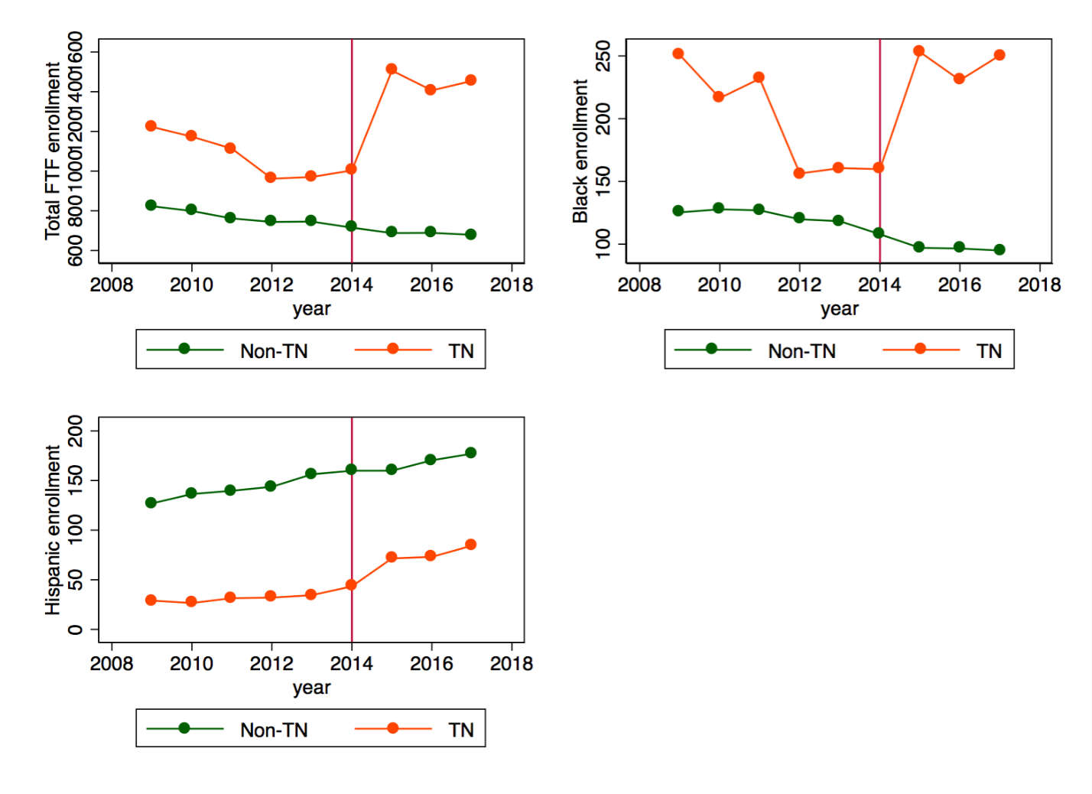
Figure 1.1. Mean full-time first-time public two-year enrollment for Tennessee and other states, 2009–2017.
Note: The red vertical line denotes the last pre-treatment year before the Tennessee Promise program took place.

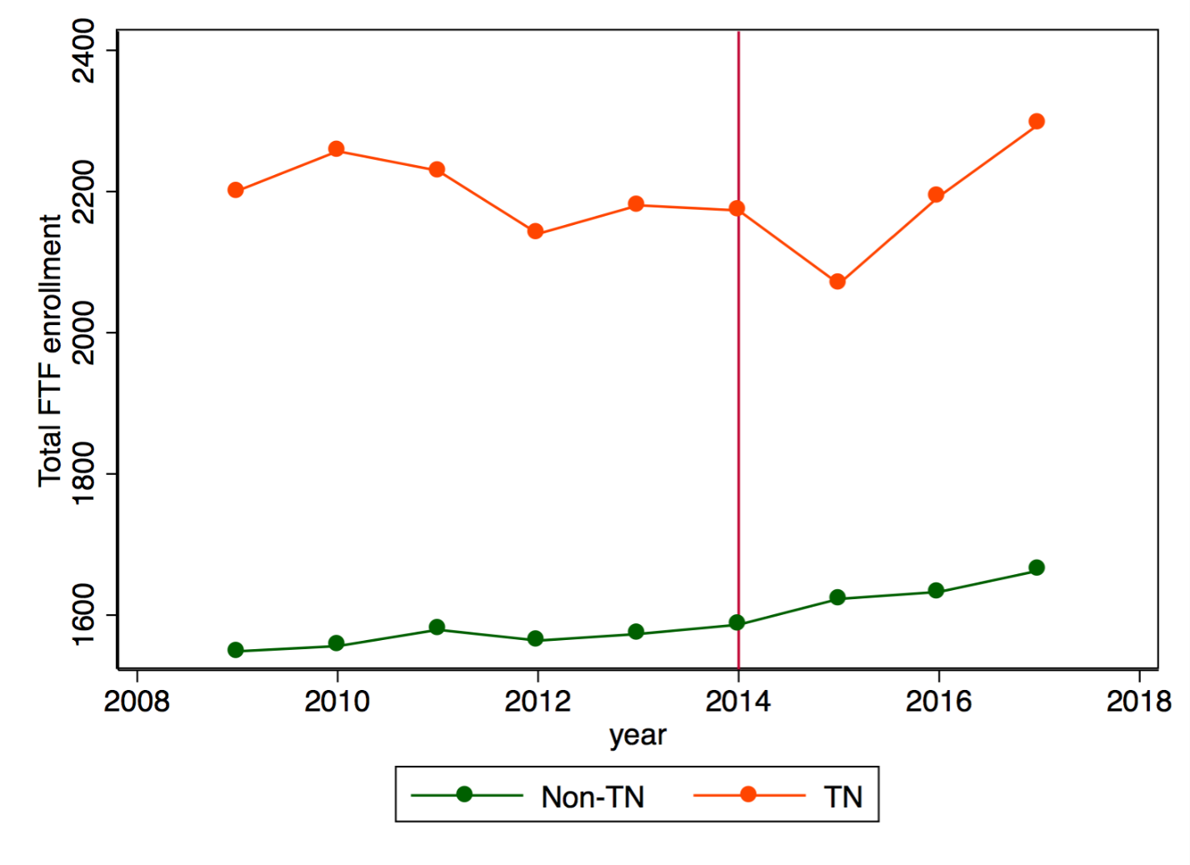
Figure 1.2. Mean full-time first-time public four-year enrollment for Tennessee and other states, 2009–2017.
Note: The red vertical line denotes the last pre-treatment year before the Tennessee Promise program took place.

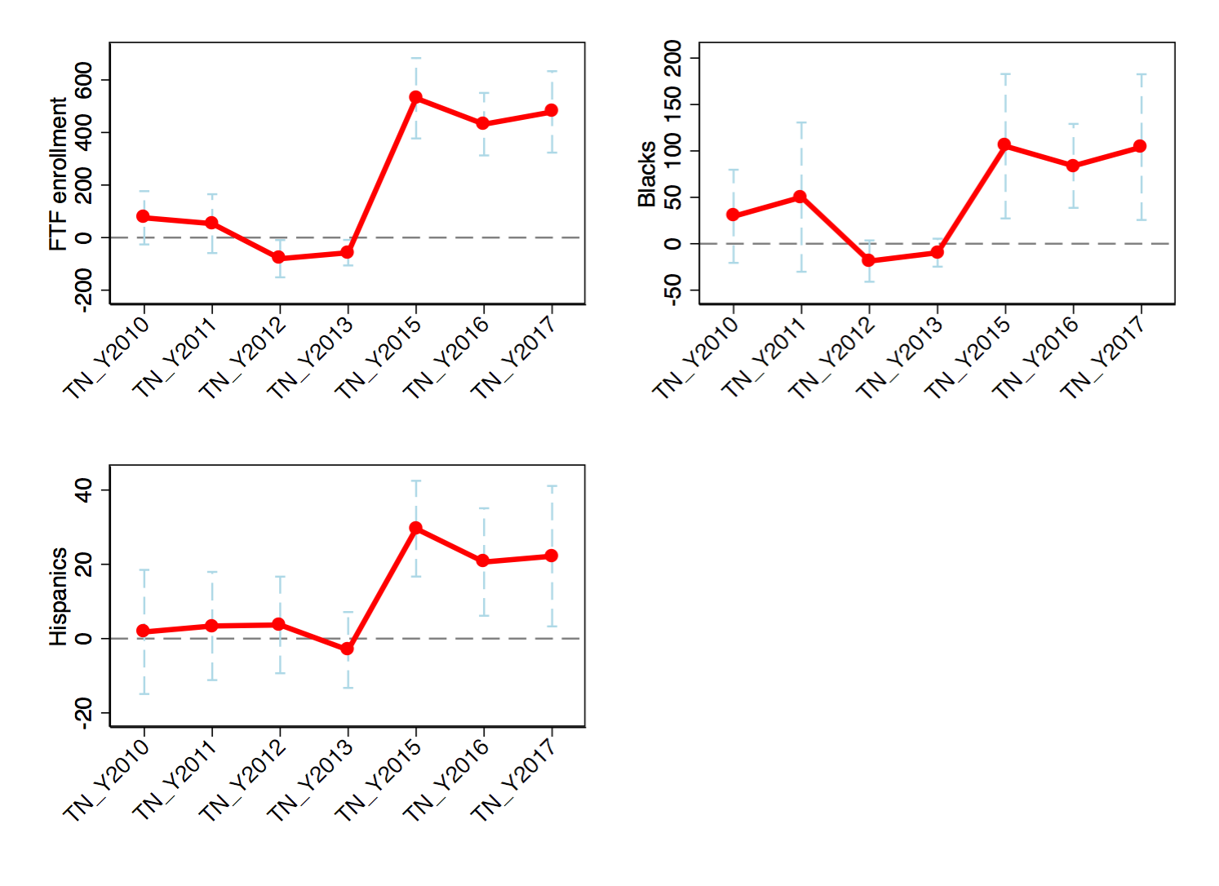
Figure 1.3. Event-study graphics
Note: Each panel graphs point estimates of the interaction coefficients $γ_{t}$ from the event-study specification in equation (2) with the associated 95 percent confidence intervals. The standard errors are clustered at the college level.

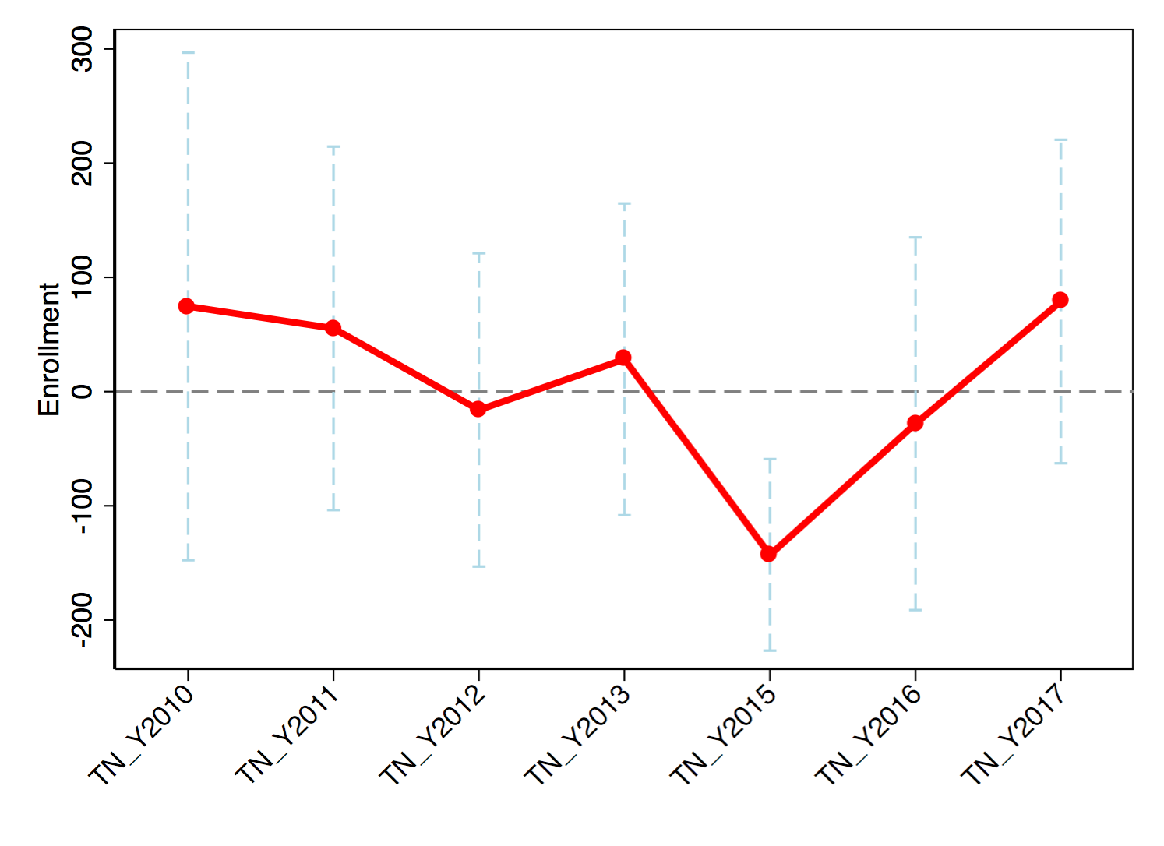
Figure 1.4. Event-study graphics for public four-year enrollment
Note: Each panel graphs point estimates of the interaction coefficients $γ_{t}$ from the event-study specification in equation (2) with the associated 95 percent confidence intervals. The standard errors are clustered at the college level.

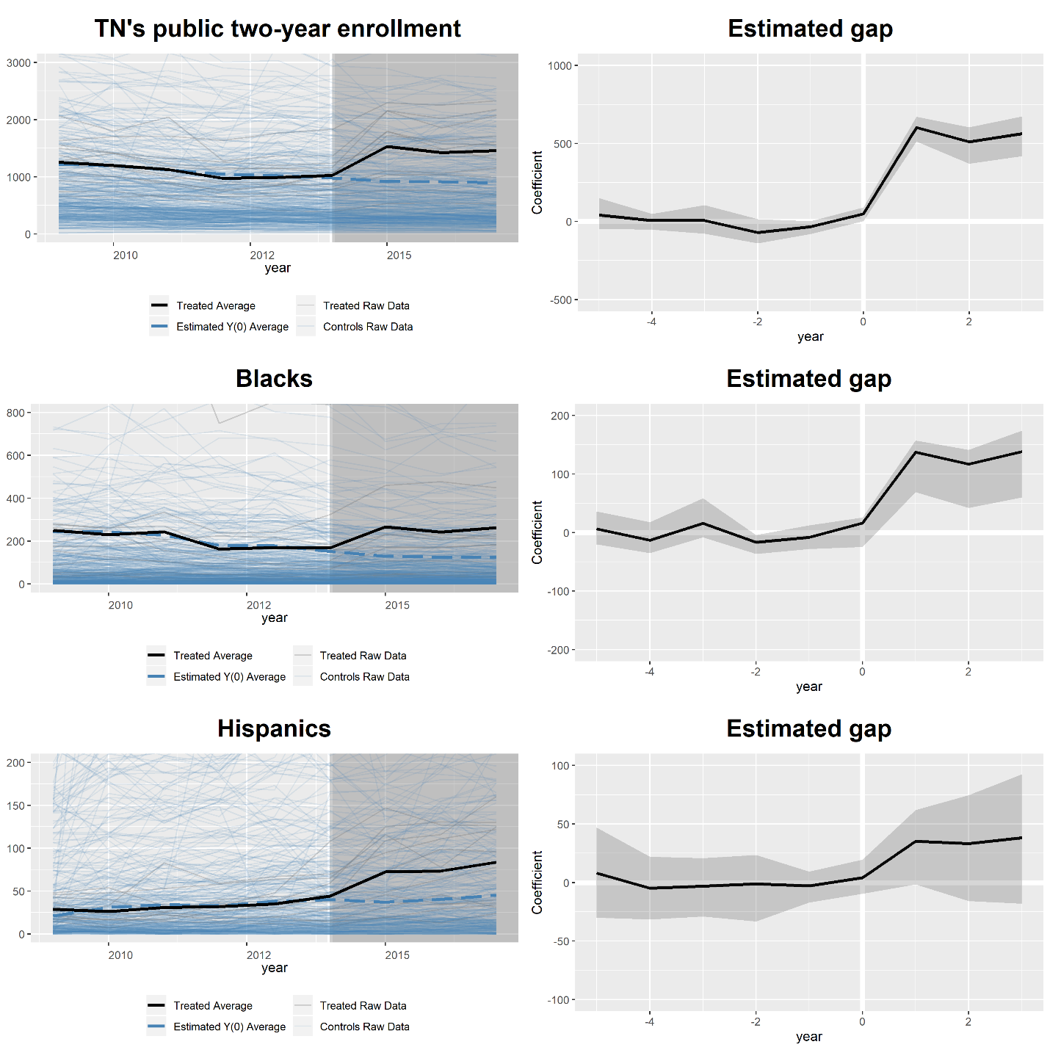
Figure 1.5. Treated and counterfactual averages for the GSC two-way additive fixed-effects models
Note: This table shows the graphics for the main GSC results with the same set of controls as in the DID estimations. The left column shows the treated averages and counterfactual paths, and the right column shows the associated gap series in terms of years relative to the intervention. In each estimation, cross-validations are employed for objectivity in model selection. An optimal number of unobserved factors (r *) is selected in the Mean Squared Prediction Error sense, and the standard errors are bootstrapped with 1,000 replications. Parallel computing is used to improve efficiency. Other technical details are discussed in the text and in Xu’s (2017) online appendix. All computations are implemented in R version 3.6.1.

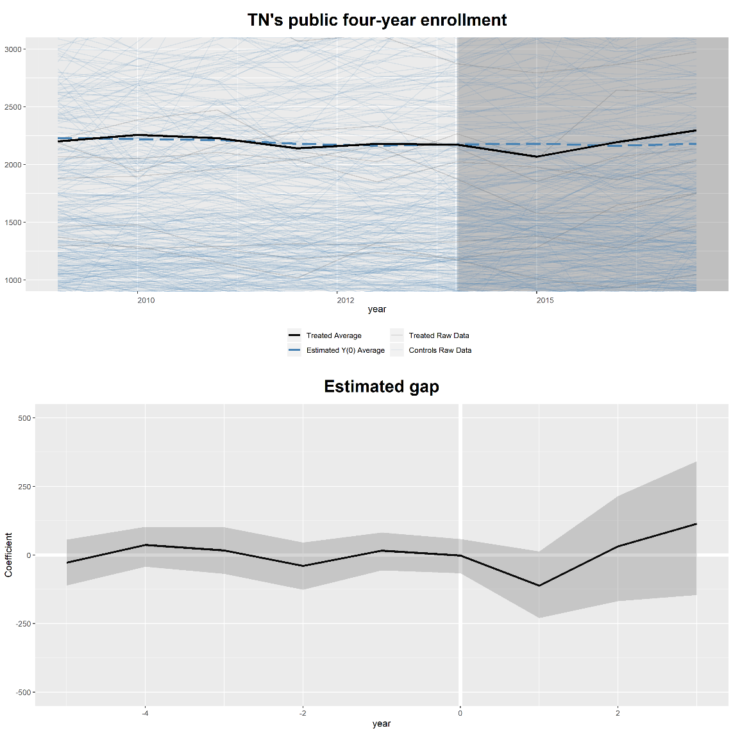
Figure 1.6. Treated and counterfactual averages for the GSC two-way additive fixed-effects models (public four-year institutions)

Note: This table shows the graphics for the main GSC results with the same set of controls as in the DID estimations. The left column shows the treated averages and counterfactual paths, and the right column shows the associated gap series in terms of years relative to the intervention. In each estimation, cross-validations are employed for objectivity in model selection. An optimal number of unobserved factors (r *) is selected in the Mean Squared Prediction Error sense, and the standard errors are bootstrapped with 1,000 replications. Parallel computing is used to improve efficiency. Other technical details are discussed in the text and in Xu’s (2017) online appendix. All computations are implemented in R version 3.6.1.

APPENDIX
Table A1.1. A three-step procedure to estimate the average potential outcomes for treated units via Xu (2017)’s GSC estimator
- Step 1: Estimate an interactive fixed effects model using only control units to obtain:
$$\left(\hat{β }\hat{F}{\hat{Λ}}_{control}\right)=\underset{\left(\tilde{β}\tilde{F }{\tilde{Λ}}_{control}\right)}{argmin}{\sum_{i ∈ control set}{{\left(Y_{i}-\tilde{F}{\tilde{λ}}_{i}-x_{i}^{'}\tilde{β}\right)}^{'}}}\left(Y_{i}-\tilde{F}{\tilde{λ}}_{i}-x_{i}^{'}\tilde{β}\right) (5)$$
subject to $\tilde{F'}\tilde{F }/T=I_{r}$ and ${\tilde{Λ}'}_{control}{\tilde{Λ}}_{control}=Diagonal$. In this notation, $F={\left[f_{1}f_{2}…f_{T}\right]}^{'}$ is a T x r matrix, where T is the number of observed time periods; $λ_{control}={\left[λ_{1}λ_{2}…λ_{N_{control}}\right]}^{'}$ ($N_{control}$ denotes the total number of control units) is a matrix of dimension $N_{control}$x r.
- Step 2: Estimate the factor loadings for each treated unit by minimizing the pre-treatment mean squared prediction error (MSPE):
$${\hat{λ}}_{i}=\underset{{\tilde{λ}}_{i}}{argmin}{(Y_{i}^{0}-{\hat{F}}^{0}}{\tilde{λ}}_{i}-x_{i}^{0'}\hat{β})'(Y_{i}^{0}-{\hat{F}}^{0}{\tilde{λ}}_{i}-x_{i}^{0'}\hat{β}) (6)$$
where $\hat{β}$ and ${\hat{F}}^{0}$ are obtained from the first step, and the superscript “0” denotes pre-treatment periods.
- Step 3:$Y_{it}\left(0\right)$ is estimated by computing:
$${\hat{Y}}_{it}\left(0\right)=x_{i}^{'}\hat{β}+{\hat{λ}}_{i}^{'} \hat{f_{t}} (7)$$
for all treated units in post-treatment periods.

Table A1.2. DID results for full-time first-time two-year enrollment following Dynarski’s (2000) sample restriction

 | (1) | (2) | (3) | (4) | (5) | (6) | (7) | (8) | (9) | (10)
VARIABLES | FTF | FTF | FTF | FTF | FTF | Log (FTF) | Log (FTF) | Log (FTF) | Log (FTF) | Log (FTF)
TN*D15 | 474.24*** | 474.24*** | 467.79*** | 467.79*** | 467.79*** | 0.49*** | 0.49*** | 0.49*** | 0.49*** | 0.49***
 | (13.12) | (75.29) | (12.81) | (74.06) | (72.79) | (0.03) | (0.05) | (0.03) | (0.05) | (0.05)
Tuition |  |  | 0.01 | 0.01 | 0.01
 |  |  | (0.02) | (0.03) | (0.03)
SF ratio |  |  | 11.12*** | 11.12*** | 11.12***
 |  |  | (1.79) | (2.96) | (3.26)
Percent aided |  |  | 0.03 | 0.03 | 0.03 |  |  | -0.00 | -0.00 | -0.00
 |  |  | (0.49) | (0.87) | (0.64) |  |  | (0.00) | (0.00) | (0.00)
Log (tuition) |  |  |  |  |  |  |  | 0.07 | 0.07 | 0.07
 |  |  |  |  |  |  |  | (0.10) | (0.09) | (0.09)
Log (SF ratio) |  |  |  |  |  |  |  | 0.27** | 0.27*** | 0.27***
 |  |  |  |  |  |  |  | (0.10) | (0.06) | (0.06)
Constant | 702.51*** | 702.51*** | 458.43*** | 458.43*** | 458.43*** | 6.24*** | 6.24*** | 5.09*** | 5.09*** | 5.09***
 | (23.61) | (14.64) | (76.46) | (101.05) | (75.23) | (0.03) | (0.02) | (0.91) | (0.66) | (0.62)
Observations | 1,893 | 1,893 | 1,888 | 1,888 | 1,888 | 1,893 | 1,893 | 1,888 | 1,888 | 1,888
R-squared | 0.18 | 0.18 | 0.21 | 0.21 | 0.21 | 0.28 | 0.28 | 0.31 | 0.31 | 0.31
Institutions | 212 | 212 | 212 | 212 | 212 | 212 | 212 | 212 | 212 | 212
Std. errors | S-clust | C-clust | S-clust | C-clust | Boot | S-clust | C-clust | S-clust | C-clust | Boot

Note: This table replicates the main result using two-year public institutions in TN’s neighboring states as control units. FTF denotes the level of full-time first-time enrollment. Institution fixed effects and year fixed effects are included in all of the specifications. The standard errors are shown in parentheses. S-clust, C-clust, and Boot stand for “clustered at the state level,” “clustered at the college level,” and “bootstrapped,” respectively (*** p<0.01,** p<0.05, * p<0.1). All computations are executed in STATA version 14.1.

Table A1.3. DID results by demographic group following Dynarski’s (2000) sample restriction
 | (1) | (2) | (3) | (4) | (5) | (6) | (7) | (8) | (9) | (10)
FTF | Black | Black | Black | Black | Black | Hisp | Hisp | Hisp | Hisp | Hisp
TN*D15 | 88.00*** | 88.00*** | 85.58*** | 85.58*** | 85.58*** | 32.71*** | 32.71*** | 29.43*** | 29.43*** | 29.43***
 | (5.22) | (23.01) | (4.22) | (22.53) | (24.49) | (2.50) | (8.47) | (3.20) | (9.27) | (10.69)
Tuition |  |  | -0.00 | -0.00 | -0.00 |  |  | 0.01 | 0.01 | 0.01
 |  |  | (0.01) | (0.01) | (0.01) |  |  | (0.01) | (0.01) | (0.01)
SF ratio |  |  | 5.25*** | 5.25*** | 5.25*** |  |  | 0.18 | 0.18 | 0.18
 |  |  | (0.90) | (1.11) | (1.19) |  |  | (0.36) | (0.32) | (0.30)
Percent aided |  |  | 0.06 | 0.06 | 0.06 |  |  | 0.31 | 0.31* | 0.31*
 |  |  | (0.13) | (0.27) | (0.25) |  |  | (0.28) | (0.17) | (0.18)
Constant | 185.07*** | 185.07*** | 80.13** | 80.13** | 80.13** | 20.92*** | 20.92*** | -28.07 | -28.07 | -28.07
 | (13.70) | (8.50) | (29.37) | (34.07) | (33.24) | (4.80) | (4.13) | (31.74) | (36.27) | (28.41)
Observations | 1,805 | 1,805 | 1,800 | 1,800 | 1,800 | 1,805 | 1,805 | 1,800 | 1,800 | 1,800
R-squared | 0.11 | 0.11 | 0.15 | 0.15 | 0.15 | 0.12 | 0.12 | 0.14 | 0.14 | 0.14
Institutions | 212 | 212 | 212 | 212 | 212 | 212 | 212 | 212 | 212 | 212
Std. errors | S-clust | C-clust | S-clust | C-clust | Boot | S-clust | C-clust | S-clust | C-clust | Boot

Note: Institution fixed effects and year fixed effects are included in all of the specifications. The standard errors are shown in parentheses. S-clust, C-clust, and Boot stand for “clustered at the state level,” “clustered at the college level,” and “bootstrapped,” respectively (*** p<0.01,** p<0.05, * p<0.1). All computations are executed in STATA version 14.1.
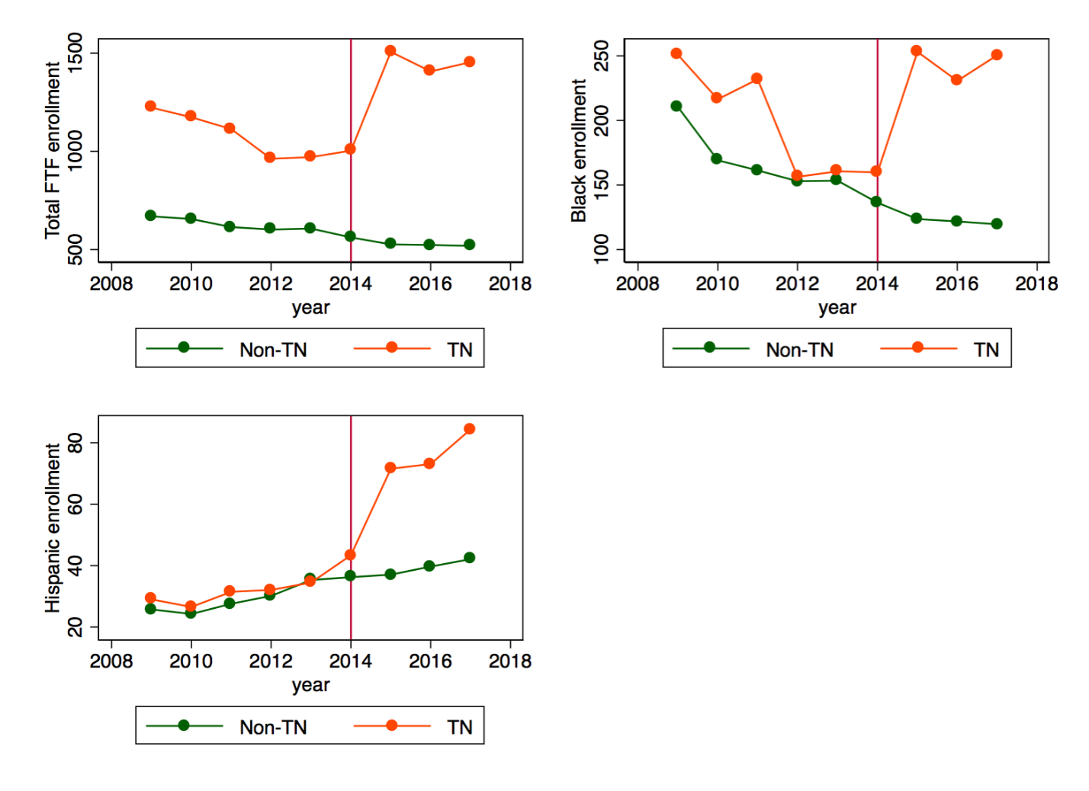
Figure A1.1. Mean full-time first-time undergraduate enrollment at public two-year institutions in Tennessee and neighboring states (2009-2017)
Note: The red vertical line denotes the last pre-treatment year before the Tennessee Promise program took place.

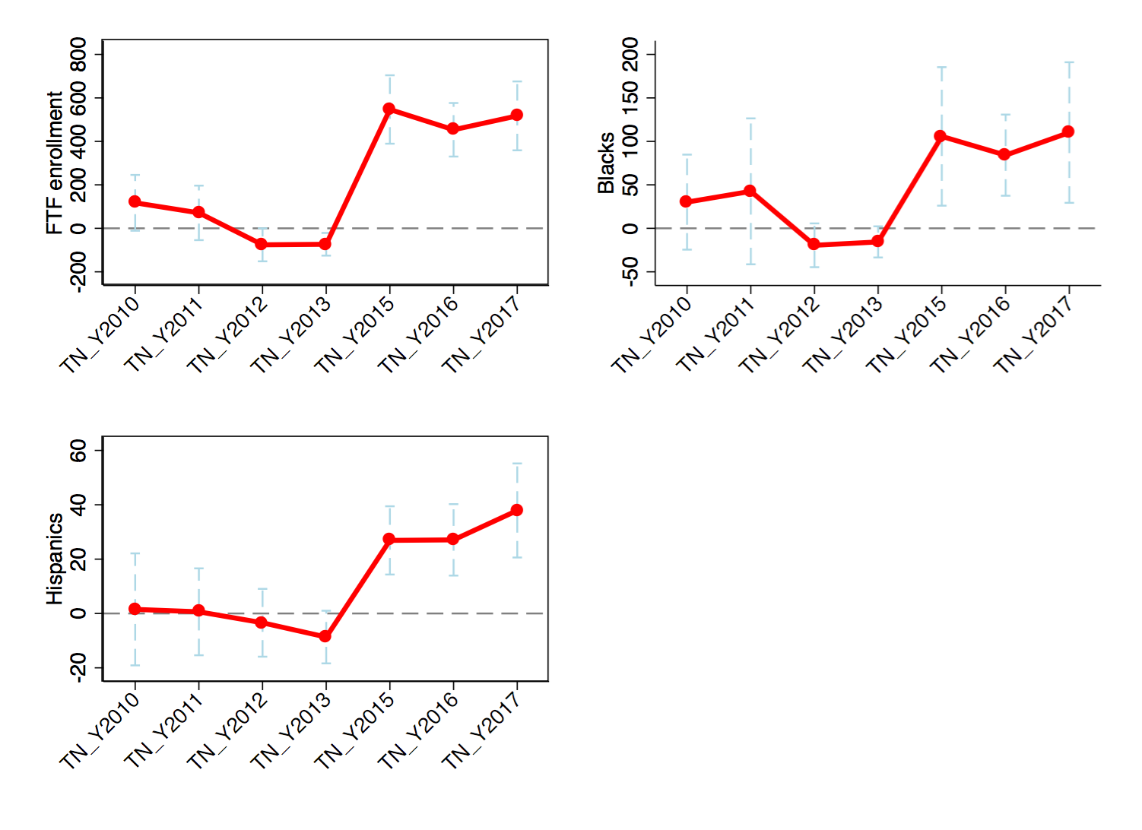
Figure A1.2. Event-study graphics following Dynarski’s (2000) sample restriction
Note: Each panel graphs point estimates of the interaction coefficients $γ_{t}$ from the event-study specification in equation (2) with the associated 95 percent confidence intervals.

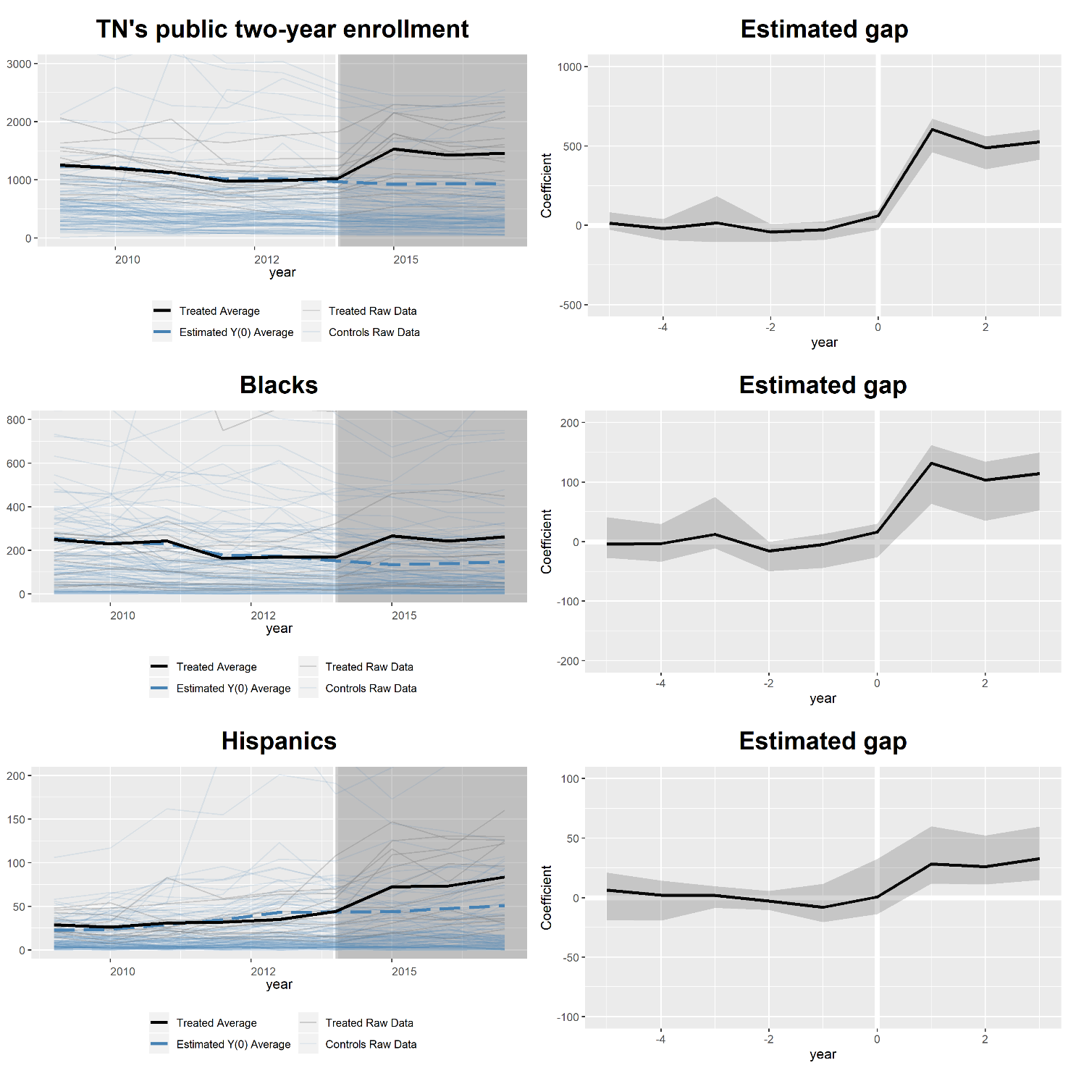
Figure A1.3. Estimated treated and counterfactual averages for the GSC two-way additive fixed effects models following Dynarski’s (2000) sample restriction
Note: This table shows graphics for the robustness GSC results using neighboring states’ two-year institutions as control units. In each estimation, cross-validations are employed for objectivity in model selection. An optimal number of unobserved factors (r *) is selected in the Mean Squared Prediction Error sense, and the standard errors are bootstrapped with 1,000 replications. Parallel computing is used for efficiency. Other technical details are discussed in the text and in Xu (2017)’s online appendix. All computations are implemented in R version 3.6.1.

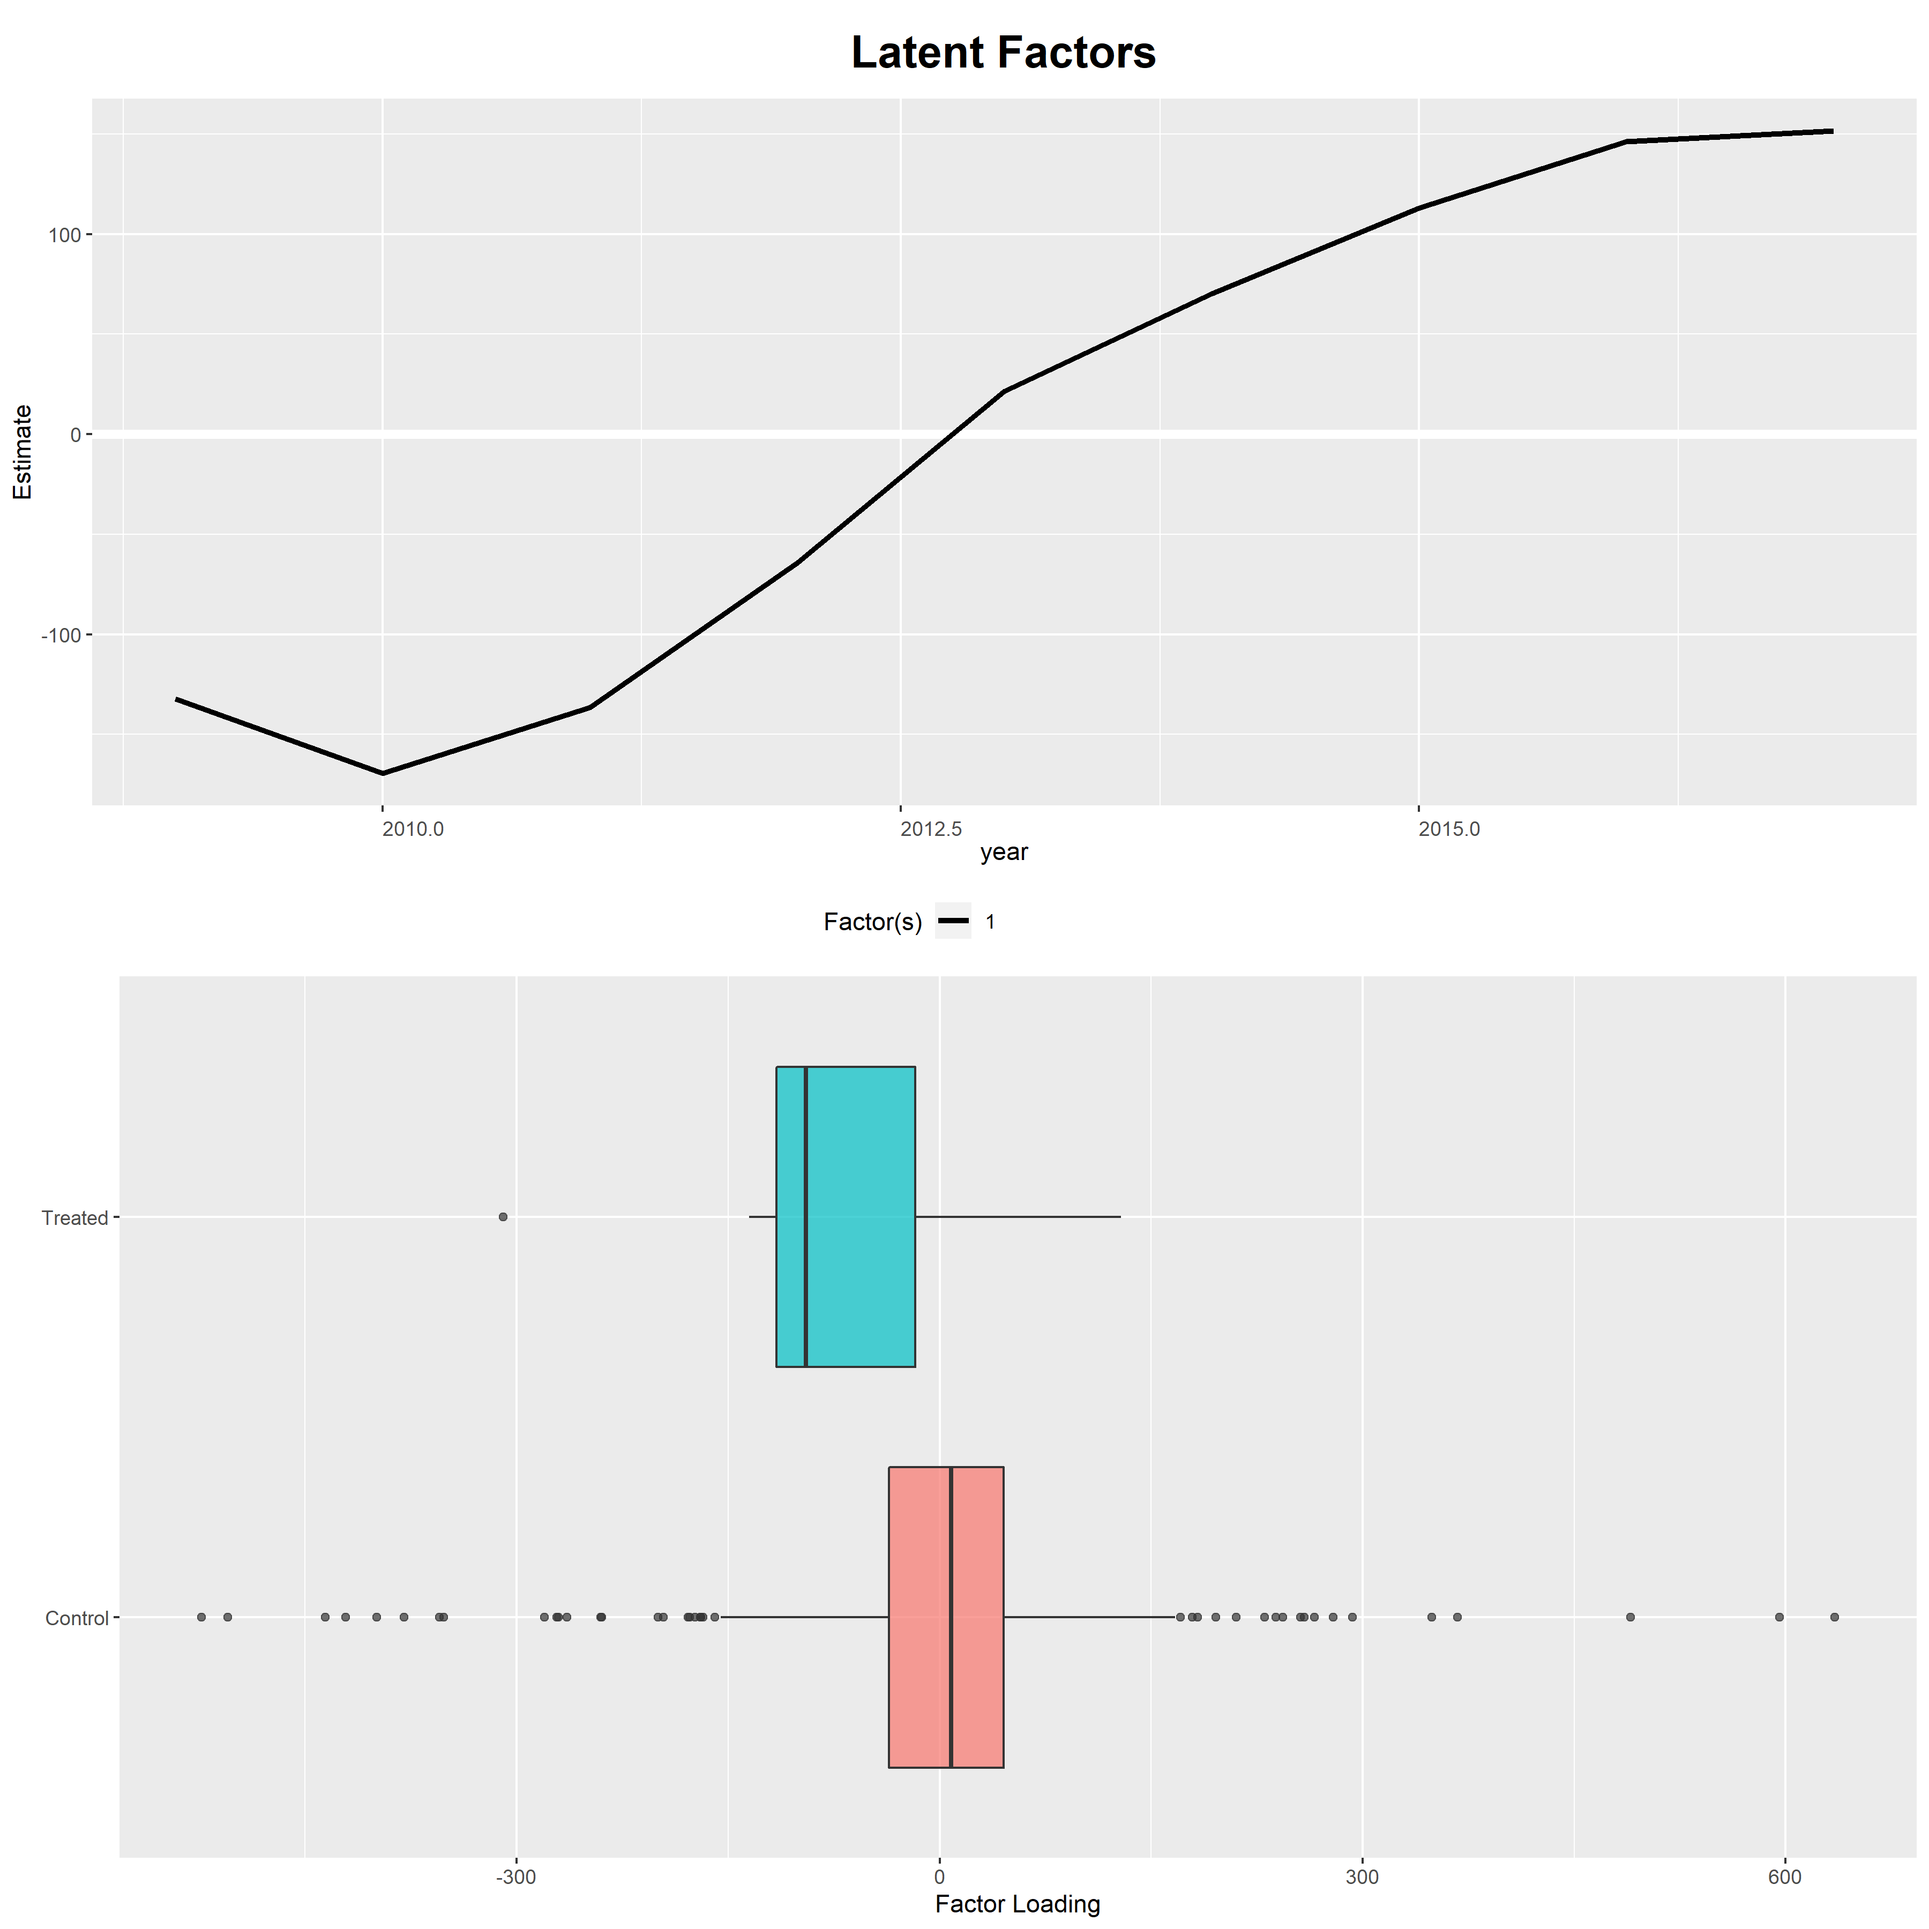
Figure A1.4. Factors and factor loadings associated with the main GSC estimation

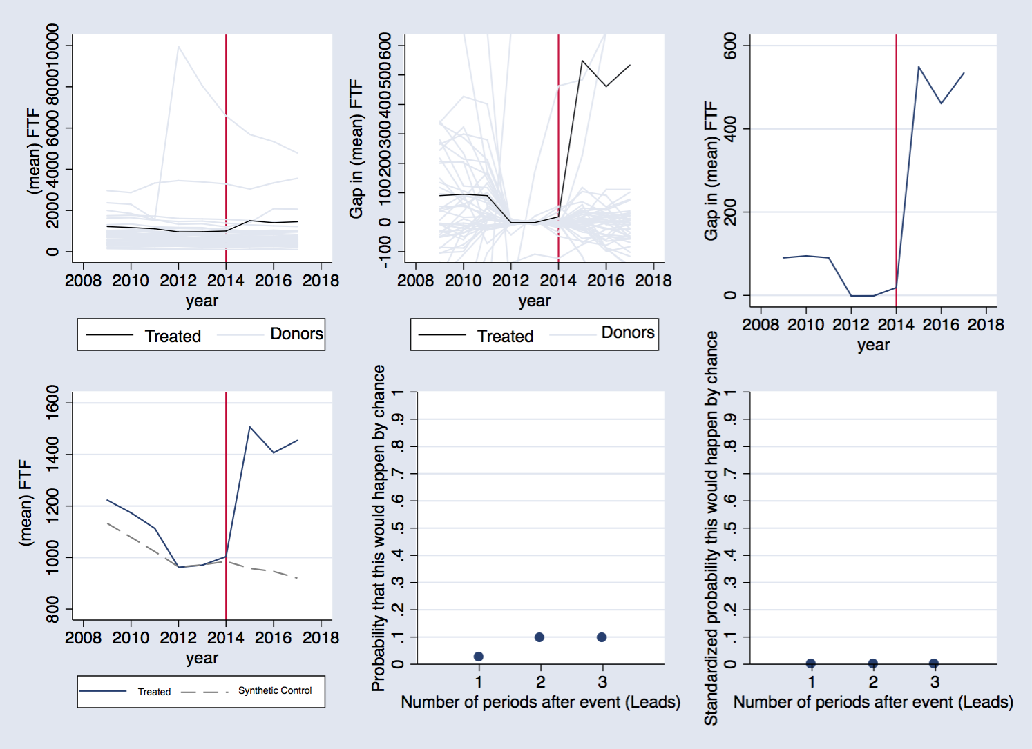
Figure A1.5. Synthetic control results in the spirit of Abadie et al. (2010)
Note: This figure shows a summary of synthetic control results following Abadie et al.’s (2010) method. The top panel indicates raw averages, treatment-effect estimates, and the estimated gap, respectively. The bottom panel shows the outcome paths for Tennessee and synthetic Tennessee, p-values comparing the main effect to the placebo-effect distribution, and the standardized p-values, respectively. The predictors of enrollment include Tuition, SF ratio, Percent aided, and the enrollment levels for 2012, 2013, and 2014. The red vertical line identifies 2014 as the last pre-treatment period. Other technical details are available in Abadie et al. (2010).

Chapter 2. Public provision of higher education and its implications for college diversity

Abstract

While diversity has been shown to matter in collegiate settings, not much is known about the diversity effects of higher education policy. Studying a large policy change in the US postsecondary education system, this paper sheds light on whether and how public provision of higher education makes colleges more demographically diverse. I first use institution-level data to construct three metrics of diversity, namely the share of underrepresented minorities in the student body, Simpson’s index, and Shannon’s index. These measures each reflect a disparate dimension of diversity yet altogether yield a unified framework to understand the construct. I then leverage the staggered timing of statewide free-college programs across states to document these programs’ impacts on college diversity. Employing different quasi-experimental methods, I show that free-college programs have not catalyzed an economically significant effect on demographic diversity in the student bodies of public two-year colleges. A power analysis for various difference-in-differences specifications suggests that this null effect is statistically meaningful. The paper’s findings offer a fresh outlook on recent work, which has suggested that promise programs encourage more high school graduates to attend community college.

Keywords: diversity; free college; IPEDS; higher education
List of abbreviations. ATT: average treatment effect on the treated; DID: difference-in-differences; GSC: generalized synthetic control; IPEDS: Integrated Postsecondary Education Data System; URM: underrepresented minority groups.

Inequitable distribution of educational resources throughout the educational pipeline prompts cumulative deficits in wealth and cultural means for social mobility. Unintended consequences of US financial aid policy illustrate how such inequities historically have led to disparities in life outcomes for various groups.
(Davis, Green-Derry and Jones, 2013)

2.1. Introduction
Equity, inclusion, and diversity are long-standing issues in America’s higher education. To ensure equal and equitable access to educational resources and promote a college-going culture, concerted efforts in increasing college affordability have been made at multiple levels. Over the past few decades, many financial aid programs have been designed and implemented. These initiatives constitute a sizable portion of taxpayer dollars spent on higher education every year. Among the criticisms of conventional financial aid vehicles, which encompass need-based grants and merit-based HOPE scholarships, are their various and often elaborate eligibility requirements. Such requirements may turn away many students who wish to demand further education yet are discouraged by the complex application hurdle. Recent theory and evidence have highlighted a shift away from the traditional model toward a simpler framework in aid determination. The idea of “free college” emerged (or more precisely, resurfaced) against this backdrop. While manifesting themselves in multiple forms, statewide free-college programs typically provide, at a minimum, full tuition support, and involve few requirements for eligibility and renewal beyond state residency.
The current study seeks to shed light on whether and how statewide free-college programs affect diversity in the student bodies of public institutions. The standard economic justifications for increased diversity in higher education are based upon the premise that diversity generates both private and social returns. There are, however, other reasons to desire and promote diversity beyond economic benefits. For one, diversity may be important in aligning state citizens’ demands for higher education with the mission of public institutions to serve every group. State policymakers may also care about diversity if they perceive higher education as a critical part of social mobility. Viewed this way, a statewide free-college movement represents a state’s commitment to socioeconomic equity for all.

In this study, I focus on the two-year college sector, which enrolls a large number of minority, first-generation, and low-income students. Students attending two-year institutions also face a substantially different set of challenges relative to their four-year counterparts. Except for New York’s Excelsior program (which supports both two- and four-year students), all free-college programs implemented between 2015 and 2018 focus on the two-year sector. The best evidence to date indicates that despite some variation in effectiveness, statewide free-community-college programs are highly promising in encouraging college attendance and completion (Perna& Smith, 2020). However, little is known about the overall effects of these programs on the sociodemographic diversity of the states’ colleges. Filling this literature gap, my research enriches the modest yet rapidly expanding academic evidence on free-college programs. In doing so, the study also contributes to the broader public policy discourse regarding affordability, inclusion, and diversity.

To date, research on college financial aid has contributed to much of what we know about the educational trajectories of low-income, non-traditional, and underrepresented students. However, due in part to the variance in findings and differences in focus across studies, this work has failed to deliver a conclusive and systematic framework to think about diversity (Dynarski & Scott-Clayton, 2013; Boatman & Long, 2016; Anderson et al., 2019). Another important factor that limits the progress of this literature is the questionability of the diversity measures employed, if any (Tienda, 2013). Most studies have only looked at narrow sets of financial aid beneficiaries separately without any explicit treatment of diversity. To this end, the current study joins the efforts of Hinrichs (2011, 2012), Gándara& Li (2020), and others, in reshaping the way diversity is typically understood in higher education settings.

I re-examine this very construct and argue that there is more to diversity than an emphasis on a select group. I look beyond the “share of underrepresented minorities” (“URM” henceforth), and employ several other metrics borrowed from ecologists, to better understand diversity. In essence, these new measures take into account the uncertainty associated with finding two members of the population with a common ethnic background and hence reflect the “exposure to other races” aspect of belonging to a diverse group. Putting together disparate dimensions of diversity within the same analysis, the research provides a comprehensive treatment of the concept and adds more context and nuances to the ongoing public policy discussions.

To provide additional insights, I supplement the main analysis with separate case studies of individual promise programs. In fall 2015, the state of Tennessee began providing free tuition and fees to its community college students, becoming the first state in the nation to implement a statewide free-college program. Several other states have followed in Tennessee’s footsteps and implemented their own variants of free college. Irrespective of the findings, an examination of whether and how the Tennessee Promise and other programs that model on it have changed the postsecondary landscape in terms of student diversity is expected to provide important lessons for policymakers, and this study is among the first to undertake such an initiative.

I employ a combination of program-evaluation methods to provide a holistic and objective assessment of the “treatment effect” of the free-college movement. While modeling assumptions and control groups vary from specification to specification, these methods all leverage the timing of these programs to construct the counterfactuals. The sufficiently long post-intervention window provides an opportunity to study medium-run impacts of free college beyond immediate outcomes such as first-time enrollment. Altogether, the results show that the diversity effects of free-college programs are mild.

To put the research in perspective, recent statistics have shown that America’s undergraduate population is becoming more diverse than ever. Despite this encouraging trend, racial disparities in college access and success remain a major policy issue. For instance, looking at over 200 indicators, the American Council on Education sees “stagnant and low” levels of college participation and educational attainment for many communities of color. Echoing this concern, the National Center for Education Statistics also reports that certain groups such as American Indians/Alaska Natives continue to be underrepresented in overall enrollment and that the relative ranking across demographic groups has remained almost unchanged over the past decade. To my knowledge, diversity is not emphasized in most existing statewide free-college programs, suggesting that there is room for a fundamental change in policy design.

2.1 Background on college diversity
At present, many public institutions and organizations are taking active steps to promote diversity. At the national level, for instance, the American Association of Community Colleges, which represents almost 1,200 two-year, associate degree-granting institutions, explicitly designates diversity as one of its core values, and sets specific milestones for meeting the diverse needs of its 12 million students. As another example, the Tennessee Board of Regents, which supervises all public two-year colleges in the College System of Tennessee, also makes it formal under the authority of T.C.A. § 49-8-203 that diversity and equity are to be observed throughout the system.

In its broadest sense, “diversity” refers to any differences across individuals who belong to a common group. In the current context, this construct can be operationalized in terms of the differences in race, ethnicity, gender, beliefs, and other dimensions, which are exhibited by students attending the same college. Having various demographic groups represented in the student body signals that a college is promoting a collaborative and inclusive culture. This might in turn have important implications for outreach, endowment, and public relations, in addition to the pure educational benefits. From the students’ perspectives, diversity in the classroom facilitates civil academic exchange. Having diverse classmates also helps eradicate harmful stereotypes and prepares students for an increasingly globalized and diversified workforce (Bowman, 2010). This point is particularly salient for community colleges, which enroll many non-traditional and minority students.

Previous researchers have expressed concerns that the absence of diversity may undermine policy interventions and exacerbate the “White privilege” in the college classroom. For instance, using mixed methods to study a community service learning program, Seider et al. (2013) find that white participants are more likely to engage in race discussions with their classmates than are students of color. The authors also suggest that the lack of representation may hinder the learning of all students. Much as diversity matters to the learning process, it has also been recently linked to post-graduation outcomes beyond the lecture hall. For instance, Arcidiacono &Vigdor (2010) estimate the economic returns to attending a racially diverse college in terms of educational attainment and post-graduation earnings. Rooted in Becker’s (1964) human capital model, Lazear's (1995) model of cultural assimilation, and Borjas’ (1992, 1995) model of productivity spillovers, Arcidiacono &Vigdor formalize Justice Lewis Powell’s hypothesis that diversity promotes an “atmosphere of 'speculation, experiment, and creation' so essential to the quality of higher education.” “Diversity capital,” as coined by Arcidiacono &Vigdor, essentially refers to the idea that individuals in a diverse group not only enjoy the within-group productivity spillovers, but also create extra surplus that benefits the group as a whole as well. Diversity is therefore viewed by many as an asset to the workplace.

However, for completeness it should be noted that while the conceptual arguments for increased diversity in educational settings are sound, empirical evidence for them is mixed. In reviewing the evidence on the returns to diversity, Arcidiacono &Vigdor (2010) document that despite some evidence on the positive effects of classroom racial composition and educational quality at primary and secondary levels (Hanushek et al. 2003; Hoxby 2000), the link between racial diversity and education is weak. The impact of diversity in higher education, according to Arcidiacono &Vigdor (2010), is primarily “correlational.” Boisjoly et al. (2006) and Carrell et al. (2019) provide notable exceptions. In a randomized roommate-assignment field experiment, Boisjoly et al. find that exposing first-year college students to roommates from different races causes individual students to be more empathetic and racially aware. Likewise, Carrell et al.’s (2019) random assignment in the U.S. Air Force Academy reveals that exposing white freshmen to black peers raises the probability of choosing a black roommate in the sophomore year and largely fosters future intergroup contact. By contrast, many other studies document null and even negative effects (Alesina& La Ferrara, 2000; Gugerty & Miguel, 2005; Vigdor, 2004). These contrary findings highlight the need to comprehensively assess both the determinants and implications of diversity.

2.2 The free-college idea and its implications for diversity
One of the primary arguments in support of free-college programs is the clear message that they convey: any state resident can acquire a higher education degree if one so chooses. Proponents of statewide free-college programs also argue that since the benefits of higher education extend far beyond individual betterment and contribute greatly to our civilization, higher education should be viewed as a public good and should be provided free of charge (Goldrick‐Rab& Steinbaum, 2020). Just as free-college programs are regularly featured in political and media discussions, these programs are also extoled as a “higher education funding revolution” in academic forums (Davidson et al., 2020).
Economically speaking, a tuition subsidy is expected to affect an individual’s ability to pay for college and subsequent enrollment decision. Allen & Wolniak (2019) analyze IPEDS data for both four-year and two-year public institutions within a fixed-effects multivariate framework to document that the relationship between tuition increases and US institution’s racial/ethnic composition is consistently and significantly negative, although with heterogeneous effects among different subsamples. Looking beyond the US context, Bietenbeck et al. (2020) also document a negative effect of tuition fees on university enrollment through a natural experiment in Germany. However, in a recent meta-analysis, Havranek et al. (2018) find that the overall enrollment effect of tuition is close to zero once publication biases are controlled for. One potential explanation for this mixed evidence is the possibility that even though tuition dynamics does not substantially alter behavior among many student groups, it might have far-reaching consequences on others. In particular, since underrepresented minority groups have relatively low incomes, providing them with a full-tuition subsidy will likely remove this source of heterogeneity and equalize access to educational opportunity.
Opponents of free-college programs cast doubt on the fairness implications of these programs, positing that free college serves “no real egalitarian purpose” (Bruenig, 2015). This criticism stems from the mere fact that by design, almost all statewide programs in existence are of a “last-dollar” nature, which entails the states’ coverage of the residual amount of tuition after all other sources of aid have been exhausted (Perna& Leigh, 2017). A potential issue with this model is that it might result in higher student debt from room and board borrowing. Judging by the way they are rolled out across states, existing programs might also be favoring well-off students over disadvantaged ones, considering that the latter group is already supported via other means of aid, and that other college-related expenses usually account for a larger proportion of a student’s budget than does tuition. Therefore, while last-dollar free-college programs are expected to change the enrollment pattern of middle-class students, who are otherwise ineligible for low-income education subsidies, the effects among both the poorest and most affluent students might be negligible. Similar to the argument that Hinrichs (2012) makes in the affirmative-action context, it is likely that a universal, race-blind free college program might not achieve its diversity goals, even if it fares well in other aspects, such as enrollment and persistence.
Another way in which a free college program might not be all that desirable lies in the way it is rolled out. To date, out of almost 20 statewide promise programs and almost 400 free-college programs in total, only a few programs, including the Tennessee Promise, explicitly feature “coaching” or “mentoring” as an integral design component. This might be problematic, since offering tuition support to students without any form of guidance or support would be analogous to giving them only a means to survive without helping them thrive. Given that many community college graduates will transfer to a four-year institution to complete a bachelor’s degree, the transitional burden might become a hindrance to the academic progress and full social integration of scholarship recipients, defying the very notion of “free college.”

Combining these arguments, it follows that while free-college programs do remove certain barriers, its real implications for diversity are ambiguous. In line with the heterogeneity in enrollment, high school graduation, earnings, and other outcomes, which has been attributed to a variation in policy design by researchers studying different free-college programs (Bell, 2020; Gándara& Li, 2020), the diversity effects of these programs are context-dependent. It is thus recommended that states contemplate comprehensive evidence prior to implementing free-college policies on a large scale.

The last point to be kept in mind in predicting the diversity performance of free-college programs concerns students’ access to financial aid information, which deserves a separate consideration from the access to aid itself. In a large-scale field experiment, Dynarski et al. (2018) target Michigan’s low-income high-school students and study the effect of a tuition guarantee on the probabilities of admission and enrollment at a highly selective public institution. Students in the treatment group were promised four years of tuition and fees if admitted to the state’s flagship University of Michigan without any requirement to complete financial aid forms. Importantly, the researchers do not vary the amount of grant aid, but instead, the information about what opportunities are already available for eligible students. The information intervention is found to raise application and enrollment rates substantially, suggesting that even a simple (yet credible) tuition promise can go a long way in motivating poor students. This experiment fits squarely into Page & Scott-Clayton’s (2016) theoretical framework, which emphasizes the need to simplify existing financial aid programs. Related to my earlier point, not only will free college narrow the income gap but, if properly executed, it will also have the potential to remove other barriers in higher education and ultimately, improve student diversity.

Data and methods
2.3.1. Data
The data for this study are extracted from the Integrated Postsecondary Education System (IPEDS). The main outcome of interest is fall undergraduate enrollment counts by race/ethnicity for all public two-year institutions in the United States (excluding US territories) for the academic years 2010-2011 through 2018-2019. This time window is chosen for consistency of variables’ definitions. I exclude institutions whose enrollment counts for any demographic group (as per the National Center for Education Statistics’ categorization) are missing, since these counts are critical to my construction of the diversity metrics. To facilitate the empirical implementations that follow, I also exclude a very small fraction of institutions whose important time-varying characteristics are missing for any year in the sample. The final analytic sample is a strongly balanced panel of 830 colleges for a total of 7,470 observations.
    - Diversity metrics
I consider a number of metrics that reflect different dimensions of diversity. Due to the normalizations, it should be kept in mind throughout that a larger index corresponds to a higher degree of diversity.
      - Coarse measure
I first consider a basic measure of diversity following Hinrichs (2012):
$$URM Share_{i}=100(b_{i}+h_{i}+n_{i}) \left(1\right),$$
where $URM Share$ stands for “share of underrepresented minority populations in the student body” at college i. b, h, and n represent the respective fractions of blacks, Hispanics, and Native Americans represented at a particular institution. This measure, an analog of the concentration ratios in industrial economics, connotes the potential effects of interacting with URM students.
While it is easy to interpret, this measure is disadvantageous in that it fails to reflect the “exposure to variety” dimension of diversity (Hinrichs, 2011). For instance, many students from underrepresented demographic groups select themselves into enrollment at minority-serving institutions, composing a large proportion of the student body at these institutions. Therefore, a large value of $URM Share$ might obscure the fact that only a few races are present in the total population and misleadingly suggest that the associated institution is racially diverse.
      - More refined measures
To complement the previous measure, this section introduces two more elaborate measures of diversity borrowed from biology and other fields. An ecosystem is considered “highly diverse” if the typical species is at least somewhat rare; that is, “no small number of species being much more abundant than the rest” (Schilling, 2002). Simpson’s diversity index is constructed as follows:
$$Simpson_{i}=\sum_{j=1}^{k}{p_{j}\left(1-p_{j}\right)} (2)$$
where p represents the proportion of each racial group and k indexes the number of groups represented in the population total. This measure captures the extent to which different races are represented in the student body (Hinrichs, 2011). Intuitively, if one is to randomly pick two students in the student body of college i, then this index shows the likelihood that these two students come from different demographic groups. It is noteworthy that this measure bears resemblance to (the opposite of) the familiar Herfindahl-Hirschman Index of industry concentration typically used in producer theory. As an alternative, I consider Shannon’s diversity index:
$$Shannon_{i}=-\sum_{j=1}^{k}{p_{j}lnp_{j}} (3)$$
where $p_{j}lnp_{j}=0$ if $p_{j}=0$. This index is known as Shannon’s entropy in physics and information theory.
Simpson’s and Shannon’s diversity indices are more informative than the coarse measure of URM share in that they emphasize rareness, an important aspect of diversity. Further, these measures also possess desirable theoretical properties that substantially facilitate interpretation. In particular, for a fixed number of groups, the two indices are both minimized (i.e., there is absolutely zero diversity) when there is only one group that makes up the whole population. By contrast, maximum diversity is achieved when all groups are represented in the population with equal probability.
    - Empirical models
      - DID specifications
I start the analysis with a basic DID specification of the form:
$$Y_{ist}=μ_{i}+λ_{t}+δ D_{st}+x_{ist}^{'}β+ϵ_{ist}\left(4\right)$$
where $Y$ is one of the aforementioned measures of diversity in year t for college i located in state s. $μ$ and $λ$ represent the college and year fixed effects, controlling for time-invariant determinants and macro-level time trends that might influence college diversity, respectively. $D$ is the treatment indicator (Treated), a binary variable that indicates whether a state implements a free-college program in a given year.$x$ is the vector of time-varying controls. All other, non-systematic determinants of college diversity are subsumed into the error term. The parameter of interest is $δ$, which, under the assumption of common trends, identifies the effect of the free-college initiatives on student diversity at the state’s public two-year colleges.
      - The common-trends assumption
In the potential-outcomes framework, to interpret the parameter $δ$ in the above equations as the average treatment effect of the free-college movement, we must assume that the evolutions of the potential outcome variable for treated and control units are parallel if it were not for the intervention. This assumption is not testable or verifiable, since it is conceptually impossible to observe the potential outcome for actually treated units in a hypothetical world without the program. However, researchers usually have more confidence in the accompanying regression results if prior to the intervention, the outcome paths for treated and control groups are similar. To assess the common-trends assumption, I present unconditional-average graphics, in addition to a formal regression-based event study of the form:
$$Y_{ist}=μ_{i}+λ_{t}+\sum_{j=\underline{j}}^{j=\overline{j}}{δ_{j}b_{st}^{j}}+x_{ist}^{'}β+ ϵ_{ist} (5)$$
where $b_{st}^{j}=\left\{\begin{aligned}I\left(t<{Free College}_{s}+j\right) if j=\underline{j} \\ I\left(t={Free College}_{s}+j\right) if j∈\left(\underline{j};\overline{j}\right) \\ I\left(t>{Free College}_{s}+j\right) if j=\overline{j}\end{aligned}\right.$
In this notation, $I(.)$ is the indicator function and ${Free College}_{s}$ denotes the time period in which the free-college policy is implemented in state $s$. The interaction coefficients represent the average differences in the level of the outcome between treated and control groups for each year. In this regression, the standard errors are clustered at the college level to allow for potential serial correlation and heteroscedasticity of the model errors (Bertrand et al., 2004).
      - (Model-based) generalized synthetic control estimation
This section considers a relaxation of the common-trends assumption in the DID framework. Following Xu (2017), I specify a linear interactive model of the form:
$$Y_{it}=δ_{it}D_{it}+x_{it}^{'}β+λ_{i}^{'}f_{t}+ϵ_{it}\left(6\right),$$
where the subscripts i and t index the colleges and years in the sample, respectively. D is a binary indicator which turns on for free-college states in post-treatment periods and equals zero otherwise. $x$ denotes the vector of predictors whose length corresponds to the number of unknown parameters in $β={\left[β_{1},…,β_{k}\right]}^{'}.λ=[λ_{1},…,λ_{r}]$ is an $[r×1]$ vector of unknown factor loadings (that is, the unit-specific intercepts) and $f$ represents the vector of unobserved common factors with length $r$. The most important term in the above equation is the factor component $λ_{i}^{'}f_{t}$, whose generality can accommodate a wide range of unobserved heterogeneities, with the conventional unit and time fixed effects as a special case. Intuitively, the factor component absorbs all unobserved confounders that are decomposable into a unit-year multiplicative form, i.e., $U_{it}=a_{i}×b_{t}$, including, for instance, college-specific gender norms, culture, and political partisanship, but is not able to capture unobserved confounders that are independent across units. The idiosyncratic disturbances capture the remaining (random) unobserved time-varying determinants of college diversity.
Suppose $T_{0}$ denotes the last pre-treatment time period. As in other Rubin-type causal-inference frameworks, let $Y_{it}(1)$ and $Y_{it}(0)$ be the potential outcomes of treated units. The average treatment effect on the treated (ATT) is given in the usual fashion by:
$$ATT_{t,t>T_{0}}=\frac{1}{N_{tr}}\sum_{t∈Treated}{\left(Y_{it}(1\right)-\left(Y_{it}(0\right))}=\frac{1}{N_{tr}}\sum_{t∈Treated}{δ_{it}} (7)$$
The quantity of interest is $δ_{it}$. To identify this parameter and interpret it as the causal effect of the free-college initiative, the model critically assumes strict exogeneity. “Strict” here dictates that the idiosyncratic error term of any unit at any time is orthogonal to the treatment assignment, time-varying characteristics, and unobserved cross-sectional and intertemporal heterogeneities of both the unit itself and all units in all time periods. While this assumption may appear restrictive, it is indeed weaker than other strict-exogeneity versions typically required by fixed effects models in the presence of decomposable time-varying confounders, and if satisfied, it automatically satisfies the familiar conditional mean independence assumption. It can also be noted that in the GSC framework, the treatment indicator is allowed to be correlated with the time-varying characteristics and unobserved factor component for all units at any time period, thereby relaxing one of the common assumptions in regression-based DID frameworks and signifying a significant advantage of Xu’s generalized synthetic control approach.
To estimate $δ_{it}$, Xu proposes a three-step procedure, which is summarized in the appendix. In essence, GSC estimation imputes the treated counterfactuals from a linear interactive fixed-effects model. The number of factors, factor loadings, and latent factors are selected via cross-validation, relying on information from both treated and control groups in pre-treatment periods. The standard errors are bootstrapped, with 1,000 replications in each estimation. In this manner, Xu’s procedure makes efficient use of the data and requires minimal subjectivity.

      - Canonical synthetic control estimation
Finally, I consider another data-driven estimation approach to analyze individual free-college states separately. In this analysis, college-level outcomes are averaged to the state level. This exercise bears very close resemblance to the case study exemplified in Abadie &Gardeazabal’s (2003) seminal paper. Therefore, for brevity I exclude the theoretical exposition and refer readers to the appendix of that paper.
Intuitively, the synthetic control in the spirit of Abadie &Gardeazabal’s (2003) and Abadie et al. (2010) works in the following way. Imagine in a pool of states, only one state receives the treatment (this state is called the “treated” state) at one point in time and remains to be treated thereafter. The remaining states do not receive the treatment (these units are considered “control” units and constitute the so-called “donor pool”). In all case studies, I exclude any other states that receive the treatment at any time during the sampled period.
The quantity of interest is the average treatment effect, or the difference between the actual outcome and the counterfactual outcome for the (same) treated state. Since the latter term is unobserved, the synthetic control method essentially estimates it by creating a “synthetic control,” or the best convex combination of control units that matches the observed characteristics of the actually treated unit (“best” in the sense of minimizing a loss function). Inference is conducted by hypothetically exposing each donor state to the intervention in an iterative fashion and calculating the probability of obtaining a treatment effect that is as large as that for the treated state.

Power analysis and minimum detectable effect considerations
Emerging evidence suggests that most reported treatment effects in economic research are under-powered and suffer from exaggeration bias (Ioannidis et al., 2017). To place the results from the empirical analysis in perspective, I undertake an ex ante power analysis based on pre-treatment data for all colleges in the sample. In particular, this data is used to obtain an estimate of the overall unexplained variation in the dependent variable(s), which is conditional on the basic specification (i.e., inclusion of fixed effects and/or control variables), as well as an estimate of the intraclass correlation (i.e., the fraction of the variance due to within-college variation). These variance measures are, in turn, used to calculate minimum detectable effect sizes based on 80% power, a 5% significance level, and a difference-in-differences identification strategy.
The power-analysis results are presented in Table 4. For the URM Share, the minimum detectable effect size of approximately 1 suggests that the quasi-experimental design is predicted to detect a treatment effect as small as 1 percentage point with at least 80% power. The obtained minimum detectable effect sizes for the other diversity measures are also fairly reasonable, relative to their distributions. Additional details on the power analysis are provided in the appendix.

Main results
    - Descriptive statistics
The summary statistics for the analytic sample are presented in Table 2.1. Figures 2.1-2.3 are provided as visual complements to make these numeric measures more informative. The figures display the evolution of diversity in public two-year colleges in treated free-college states and those in never-treated states. It can be seen from the raw data that overall, demographic diversity in the two-year sector has not changed significantly.
    - Event-study estimates
The results for OLS estimation of the event-study specification are provided in Table 2.3, and the accompanying graphics are shown in Figure 2.4. Despite some pre-treatment variability, it can be seen that the post-treatment changes in the outcomes are negligible.
    - DID results
The main DID results are provided in Table 2.5. Irrespective of statistical significance, one can observe that the coefficient on the treatment indicator is largely not economically significant, relative to the distribution of the outcome measures.
    - DID results accounting for urban status and county-level demographics
Given the state-based rolling out of free-college programs, one would naturally expect some treatment heterogeneity. In the United States, the majority of public community college students attend institutions in proximity to where they live. A large statewide financial aid policy would have two main effects. A priori, the policy’s diversity impacts are expected to be more pronounced in community college districts or counties whose pre-existing demographics are relatively diverse, even if the student bodies of the local colleges are not. A more subtle channel is that under a statewide program, as opposed to an in-district or college-level one, scholarship recipients are given substantially more flexibility in their locational choices. As such, the former effect might be amplified by many rural students choosing to enroll at urban colleges for better job prospects, enhanced social capital, and other opportunities, while pursuing their community college education.
For robustness and to examine the possibility that the diversity effects of free college may have geographic variation, in addition to the treatment indicator I include an interaction term in the estimating equation. I consider first the interaction between the treatment variable and college-level urban-centric indicator using the US Census’ definitions. I then match the current dataset to county-level 5-year estimates of the Black and Hispanic populations from Table DP05 of the American Community Survey Demographic and Housing (US Census Bureau, 2020).
Disregarding statistical significance, the results from Table 2.6 suggest that the policy has had some locational effects, although the direction is slightly counterintuitive. One possible explanation is that the predicted geographical impact might have been qualified by an income effect, whereby rural community colleges may enroll a higher share of low-income students than do urban colleges in the first place. If this channel prevails, then it is possible that rural institutions experience a larger diversity effect of a statewide tuition subsidy. The difference, however, is not economically meaningful. Overall, the signs and magnitudes of the coefficients on the treatment indicator as shown in both Table 2.6 and Table 2.7 are fairly consistent with those from the main results.
    - Generalized synthetic control estimation results
Generalized synthetic control estimation results are visualized through Figure 5. Across all three panels, it can be seen that the actual average series overlaps the counterfactual path almost completely both prior and subsequent to the free-college intervention. This suggests that the free-college movement has not substantially improved diversity at the affected institutions, and confirms the main insights from DID estimates.
    - Case studies of statewide free-college programs
Figures 6-8 display results for the case studies of individual free-college programs using the original synthetic control estimation procedure. The figures indicate that with the exception of Tennessee Promise, which has generated a weak increase in the share of underrepresented minorities at the state’s two-year colleges, all three measures of diversity have not experienced dramatic changes in post-intervention periods. The implications of the empirical findings will be discussed in the following section.

Concluding remarks
This study assessed the extent to which statewide free-college programs, a large recent financial aid innovation, have changed diversity outcomes in the US postsecondary landscape. Conceptually, subsidizing high school students with full tuition might remove income heterogeneity and encourage students from marginalized backgrounds to demand higher education. However, the presence of other frictions might limit the success of such a noble goal. Using a combination of program-evaluation methods, I provided new evidence showing that the “free-college” initiative has not substantially increased demographic diversity among public two-year colleges.

In interpreting this result, several caveats should be kept in mind. First, what has been presented in the paper pertains to a short- and medium-run equilibrium, while students’ college-going decisions and college choices are often part of long-term planning. Clearly, it is possible that while the positive effects of free-college policies are absent in the short run, these programs have potential for long-run success. Methodologically speaking, while reasonable attempts have been made to provide a holistic assessment of the treatment effect, concerns regarding statistical power of the proposed estimation strategies remain. In particular, the null results in the generalized synthetic control and case studies might have been an artefact of underpowered research designs.

Given these limitations, the study makes several contributions to the literature. First, it poses and takes initial steps to address a novel and timely question. In doing so, the paper provides a potential framework to think about diversity – an integral component of higher education – in general terms. These preliminary endeavors will lay the foundations for both theoretical and methodological extensions in future research.

The paper also offers several implications for practice. In particular, the United States has long been known for its large racial disparity in educational attainment and lack of socioeconomic mobility. Just as certain ethnic groups, including African Americans and Native Americans, are overrepresented in occupations that require low formal education, these groups have been historically underrepresented in America’s postsecondary institutions. The current findings suggest that financial support is not the sole path to increased access and diversity in higher education. Despite the promising initial outcomes reported by recent researchers such as Gándara & Li (2020) and Nguyen (2020), non-financial barriers remain. To emphasize a previous point, among the various explanations for the persistence of the opportunity gaps in higher education attainment is the perception that the current financial aid system is designed to serve only certain groups, including traditional students (Chen &Hossler, 2016). Similar to Hinrichs’ (2011) argument in the affirmative action context, it is unlikely that this perception will change in the absence of a bold attempt to improve diversity and representation. However, what we can change in the foreseeable future, according to Dynarski et al. (2018), Page & Scott-Clayton (2016), and others, is mitigate the information barriers and simplify the processes of determining, disbursing, and administering financial aid to encourage more students from underrepresented backgrounds to attend college.

The study’s findings also highlight the need for policymakers to be explicit about diversity goals in designing free-college programs, and modern financial-aid interventions in general. As discussed in the conceptual framework, a diversity-focused program might emphasize demographic representation, or it can focus on the academic aspect of diversity. It is important to note that these two goals are neither necessarily mutually exclusive, nor in conflict with each other. In regard to an “optimal” level of diversity for a particular institution, a structural model that incorporates both students’ and colleges’ preferences for diversity, as well as how diversity is related to learning, human capital accumulation, and labor market outcomes, will have many interesting insights to offer. This is a major undertaking yet represents a fruitful direction for future work.

References
Abadie, A., A. Diamond, and J. Hainmueller (2010), “Synthetic Control Methods for Comparative Case Studies: Estimating the Effect of California’s Tobacco Control Program,” Journal of the American Statistical Association 105:490, 493-505.
Abadie, A. and J. Gardeazabal (2003), “The Economic Cost of Conflict: A Case Study of the Basque Country,” The American Economic Review 93:1, 113-132.
Alesina, A., and E. La Ferrara (2000). “Participation in Heterogeneous Communities.” Quarterly Journal of Economics, 115, 847–904.
Allen, D., &Wolniak, G. C. (2019). Exploring the effects of tuition increases on racial/ethnic diversity at public colleges and universities. Research in Higher Education, 60(1), 18-43.
Anderson, D. M., Broton, K. M., Goldrick‐Rab, S., &Kelchen, R. (2019). Experimental evidence on the impacts of need‐based financial aid: Longitudinal assessment of the Wisconsin Scholars grant. Journal of Policy Analysis and Management, 39(3), 720-739.
Arcidiacono, P., &Vigdor, J. L. (2010). Does the river spillover? Estimating the economic returns to attending a racially diverse college. Economic Inquiry, 48(3), 537-5.
Asplund, R., Adbelkarim, O. B., &Skalli, A. (2008). An equity perspective on access to, enrollment in and finance of tertiary education. Education Economics, 16(3), 261–274.
Baum, S. (2006). Fixing the formula: A new approach to determining independent students’ ability to pay for college. Indianapolis, IN: Lumina Foundation.
Becker, G. (1964). S. Human Capital: A Theoretical and Empirical Analysis, with Special Reference to Education. University of Chicago Press.
Bell, E. (2020). The Politics of Designing Tuition-Free College: How Socially Constructed Target Populations Influence Policy Support, The Journal of Higher Education, 91:6, 888-926.
Bertrand, M., Duflo, E., & Mullainathan, S. (2004). How much should we trust differences-indifferences estimates? Quarterly Journal of Economics, 119, 249-275.
Bietenbeck, J., J. Markus, and F. Weinhardt (2020). Tuition Fees and Educational Attainment. Working paper.
Boisjoly, J., Duncan, G. J., Kremer, M., Levy, D. M., & Eccles, J. (2006). Empathy or antipathy? The impact of diversity. American Economic Review, 96(5), 1890-1905.
Borjas, G. J. (1992). Ethnic capital and intergenerational mobility. The Quarterly Journal of Economics, 107(1), 123-150.
Borjas, G. (1995). Ethnicity, Neighborhoods, and Human-Capital Externalities. The American Economic Review, 85(3), 365-390.
Boatman, A., & Long, B. T. (2016). Does financial aid impact college student engagement?.Research in Higher Education, 57(6), 653-681.
Bowman, N. (2010). College Diversity Experiences and Cognitive Development: A Meta-Analysis. Review of Educational Research, 80(1), 4-33.
Bruenig, M. (2015). The Case Against Free College. Dissent, 62(4), 112-114.
Carrell, S. E., Hoekstra, M., & West, J. E. (2019). The impact of college diversity on behavior toward minorities. American Economic Journal: Economic Policy, 11(4), 159-182.
Castellano, M., & Overman, L. T. (2009). Community college access and affordability for occupational and non-traditional students. Louisville, KY: National Research Center for Career and Technical Education, University of Louisville.
Chapman, B. (2005). Income-contingent loans for higher education: International reform. CEPR Working Paper No. 491. Center for Economic Policy Research, Australian National University, Canberra, Australia.
Chen, R. (2008). Financial aid and student dropout in higher education: A heterogeneous research approach. In J. C. Smart (Ed.), Higher education: Handbook of theory and research (Vol. 23, pp. 209–239). Dordrecht, The Netherlands: Springer.
Chen, J., &Hossler, D. (2017). The effects of financial aid on college success of two-year beginning nontraditional students. Research in Higher Education, 58(1), 40-76.
Choitz, V., &Widom, R. (2003). Money matters: How financial aid affects nontraditional students in community colleges. New York: MDRC.
Clarke, D. & Schythe, K. (2020) "EVENTDD: Stata module to panel event study models and generate event study plots," Statistical Software Components S458737, Boston College Department of Economics, revised 08 Jul 2020.
Correia, Sergio (2017). reghdfe: Stata module for linear and instrumental-variable/gmm regression absorbing multiple levels of fixed effects. Statistical Software Components S457874, Boston College Department of Economics.
Davidson, C. T., Ashby-King, D. T., & Sciulli, L. J. (2020). The higher education funding revolution: An exploration of statewide community college “free tuition” programs. Community College Journal of Research and Practice, 44(2), 117-132.
Davis, D. J., Green-Derry, L. C., & Jones, B. (2013). The impact of federal financial aid policy upon higher education access. Journal of Educational Administration and History, 45(1), 49-57.
Deming, D., & Dynarski, S. (2009). Into college, out of poverty? Policies to increase the postsecondary attainment of the poor. NBER Working Paper, 15387.
Dynarski, S., & Scott-Clayton, J. (2013). Financial aid policy: Lessons from research. The Future of Children, 23(1), 67-91.
Dynarski, S. M., Libassi, C., Michelmore, K., & Owen, S. (2018). Closing the gap: The effect of a targeted, tuition‐free promise on college choices of high‐achieving, low‐income students. NBER Working Paper No. 25349. Cambridge, MA.
Gándara, D., & Li, A. (2020). Promise for whom? “free-college” programs and enrollments by race and gender classifications at public, 2-Year colleges. Educational Evaluation and Policy Analysis. https://doi.org/10.3102/0162373720962472
Goldrick‐Rab, S., & Steinbaum, M. (2020). What Is The Problem With Student Debt?. Journal of Policy Analysis and Management, 39(2), 534-540.
Gugerty, M., and E. Miguel. (2005). “Ethnic Diversity, Social Sanctions, and Public Goods in Kenya.” Journal of Public Economics, 89, 2325–68.
Hanushek, E., J. Kain, J. Markman, and S. Rivkin (2003). “Does Peer Ability Affect Student Achievement.” Journal of Applied Econometrics, 18, 527–44.
Havranek, T., Irsova, Z., & Zeynalova, O. (2018). Tuition fees and university enrolment: a meta‐regression analysis. Oxford Bulletin of Economics and Statistics, 80(6), 1145-1184.
Hinrichs, P. (2011). The effects of attending a diverse college. Economics of Education Review, 30(2), 332-341.
Hinrichs, P. (2012). The effects of affirmative action bans on college enrollment, educational attainment, and the demographic composition of universities. Review of Economics and Statistics, 94(3), 712-722.
Hoxby, C. (2000) “Peer Effects in the Classroom: Learning from Gender and Race Variation.” NBER Working Paper No. 7867.
Ioannidis, J. P., Stanley, T. D., &Doucouliagos, H. (2017). The power of bias in economics research. The Economic Journal, 127(605), F236-F265.
Joshi, A., Liao, H., & Roh, H. (2011). Bridging domains in workplace demography research: A review and conceptualization. Journal of Management, 37: 521-552.
Laanan, F. S. (2003). Older adults in community colleges: Choices, attitudes, and goals. Educational Gerontology, 29(9), 757–776.
Lapovsky, L. (2008). Rethinking student aid: Nontraditional students. In S. Baum, M. McPherson, & P. Steele (Eds.), The effectiveness of student aid policies: What the research tells us (pp. 141–158). New York, NY: The College Board.
Lazear, E. (1995). “Culture and Language.” Journal of Political Economy, 107, S95–126.
Layzell, D. T. (2007). State higher education funding models: An assessment of current and emerging approaches. Journal of Education Finance, 1-19.
Long, B. T. (2007). The contributions of economics to the study of college access and success. Teachers College Record, 109(10), 2367–2443.
Long, B. T. (2009). Financial aid and older workers: Supporting the nontraditional student. In M. Toussaint-Comeau & B. D. Meyer (Eds.), Strategies for improving economic mobility of workers: Bridging research and practice (pp. 109–126). Kalamazoon, MI: W.E. Upjohn Institute for Employment Research.
Martin, R. E. (2005). Cost control, college access, and competition in higher education. Cheltenham: Edward Elgar.
McMahon, A. M. (2010). Does workplace diversity matter? A survey of empirical studies on diversity and firm performance, 2000-09. Journal of Diversity Management, 5: 37-48.
Menz, M. (2012). Functional top management team members: A review, synthesis, and research agenda. Journal of Management, 38: 45-80.
Nielsen, S. 2010. Top management team diversity: A review of theories and methodologies. International Journal of Management Reviews, 12: 301-316.
Nguyen, H. (2020). Free college? Assessing enrollment responses to the Tennessee promise program. Labour Economics, 66, 101882.
Page, L. C., & Scott-Clayton, J. (2016). Improving college access in the United States: Barriers and policy responses. Economics of Education Review, 51, 4-22.
Perna, L. W., & Leigh, E. W. (2017). Understanding the promise: A typology of state and local college promise programs. Educational Researcher, 47, 155–180.
Perna, L. W., & Smith, E. J. (2020). Improving research-based knowledge of college promise programs. American Educational Research Association.
Roberson, Q., Holmes IV, O., & Perry, J. L. (2017). Transforming research on diversity and firm performance: A dynamic capabilities perspective. Academy of Management Annals, 11(1), 189-216.
Schilling, M. (2002). Measuring diversity in the United States. Math Horizons, 9(4), 29-30.
Seider, S., Huguley, J. P., & Novick, S. (2013). College students, diversity, and community service learning. Teachers College Record, 115(3), 1–44.
Smith, D. G. (2020). Diversity's promise for higher education: Making it work. JHU Press.
St. John, E. P., & Tuttle, T. J. (2004). Financial aid and postsecondary opportunity for nontraditional age, pre-college students: The role of information and the education delivery systems. Indianapolis: The Education Research Institute and The Lumina Foundation.
Stevenson, Betsey and Justin Wolfers. 2006. "Bargaining in the Shadow of the Law: Divorce Laws and Family Distress". The Quarterly Journal of Economics 121(1):267-288.
Tienda, M. (2013). Diversity ≠ inclusion: Promoting integration in higher education. Educational Researcher, 42(9), 467-475.
U.S. Census Bureau, Population Estimate, Total, Hispanic or Latino, Black or African American Alone (5-year estimate), retrieved from FRED, Federal Reserve Bank of St. Louis; https://geofred.stlouisfed.org/embed/?m=orc&esize=medium&h=481&w=1366, November 22, 2020.
Vigdor, J. L. (2004). Community composition and collective action: Analyzing initial mail response to the 2000 census. Review of Economics and Statistics, 86(1), 303-312.
Xu, Y., 2017. Generalized synthetic control method: causal inference with interactive fixed effects models. Political Analysis. 25 (1), 57–76.

Table 2.1. Summary statistics for the analytic sample
 | Whole sample (n = 830) |  | Never treated  (n = 689) |  | Eventually treated (n = 141)
 | (1) | (2) | (3) | (4) | (5) | (6)
 | Mean | SD | Mean | SD | Mean | SD
Diversity Metrics
URM Share | 31.12 | 22.49 | 33.295 | 22.753 | 20.508 | 17.695
Simpson | 4,869 | 1,759 | 4,971.861 | 1,743.265 | 4,365.326 | 1,750.489
Shannon | 101.7 | 34.06 | 103.268 | 33.991 | 94.096 | 33.385
Demographic Composition
AIAN | 0.0276 | 0.117 | 0.030 | 0.124 | 0.015 | 0.075
Asian | 0.0341 | 0.0570 | 0.033 | 0.054 | 0.037 | 0.071
Black | 0.138 | 0.159 | 0.144 | 0.164 | 0.106 | 0.122
Hisp | 0.146 | 0.174 | 0.158 | 0.182 | 0.084 | 0.101
NHPI | 0.00269 | 0.00848 | 0.002 | 0.004 | 0.005 | 0.018
White | 0.577 | 0.243 | 0.558 | 0.242 | 0.668 | 0.226
More-than-2-races | 0.0247 | 0.0321 | 0.022 | 0.020 | 0.038 | 0.062
Unknown | 0.0413 | 0.0549 | 0.042 | 0.055 | 0.038 | 0.054
Nonresident | 0.00912 | 0.0168 | 0.009 | 0.017 | 0.009 | 0.015
Other Characteristics
Pell Last Year | 39.51 | 14.14 | 38.927 | 14.549 | 42.363 | 11.534
Graduation Rate | 13.60 | 11.52 | 13.454 | 11.830 | 14.304 | 9.837
Tuition Fees | 3,827 | 1,968 | 3,751.105 | 2,104.755 | 4,196.653 | 994.721
Retention | 58.53 | 9.217 | 58.971 | 9.490 | 56.397 | 7.385
SF Ratio | 19.36 | 5.918 | 19.390 | 6.229 | 19.228 | 4.069
Urban | 0.75 | 0.43 | 0.745 | 0.436 | 0.780 | 0.414

Note: This table presents descriptive statistics for the analytic sample consisting of 830 public two-year colleges observed between 2010 and 2018, inclusive of both endpoints. Data are extracted from the Integrated Postsecondary Education Data System at the National Center for Education Statistics. URM Share, Simpson, and Shannon are the different diversity indices described in the text. AIAN (American Indians and Alaska Natives), Asian, Black, Hisp, NHPI (Native Hawaiians and Pacific Islanders), White, More-than-2-races, Unknown, and Nonresident represent the respective proportions of each demographic group in the student body. Pell Last Year is the percentage of students receiving Pell grant support in the previous academic year. Graduation Rate is the percentage of students graduating within 100% of the normal timeframe. Tuition Fees is the total published in-state tuition and fees. SF Ratio is the student-faculty ratio. Urban is a binary indicator of being located inside either an urban area or an urban cluster, as per US Census Bureau’s definitions and NCES’ newly adopted classification. Specifically, the US Census Bureau defines “urban areas” as core areas with populations of 50,000 or more and “urban clusters” as those with populations between 2,500 and 50,000. “Rural areas” are those that do not lie within either an urban area or urban cluster. More details are available at https://nces.ed.gov/surveys/ruraled/definitions.asp and https://www.census.gov/programs-surveys/geography/guidance/geo-areas/urban-rural.html.

Table 2.2. List of states with free-college implementation dates
State | First treated cohort
Tennessee | Fall 2015
Minnesota | Fall 2016
Oregon | Fall 2016
Hawaii | Fall 2017
Arkansas | Fall 2017
Kentucky | Fall 2017
Nevada | Fall 2017
New York | Fall 2017
Rhode Island | Fall 2017

Table 2.3. Event-study regression estimates
 | (1) | (2) | (3) | (4) | (5) | (6)
 | URM Share | URM Share | Simpson | Simpson | Shannon | Shannon
t ≤ -5 | -1.76 | -2.06 | -419.59 | -396.19 | -6.46 | -6.06
 | (1.91) | (1.90) | (314.31) | (309.60) | (5.65) | (5.60)
t = -4 | -1.18 | -1.48 | -380.05 | -347.79 | -6.14 | -5.66
 | (1.71) | (1.72) | (278.02) | (275.15) | (5.01) | (4.99)
t = -3 | -0.81 | -1.19 | -297.28 | -261.91 | -4.85 | -4.32
 | (1.38) | (1.39) | (231.83) | (230.91) | (4.18) | (4.18)
t = -2 | -0.58 | -0.89 | -256.37 | -228.66 | -4.23 | -3.81
 | (1.00) | (1.01) | (172.04) | (171.34) | (3.06) | (3.05)
t = -1 | -0.27 | -0.37 | -133.80 | -104.20 | -1.82 | -1.33
 | (0.53) | (0.54) | (92.03) | (92.31) | (1.63) | (1.63)
t = 1 | 0.58 | 0.72 | 54.83 | 29.13 | 0.55 | 0.08
 | (0.61) | (0.61) | (99.41) | (99.19) | (1.76) | (1.75)
t = 2 | 1.70 | 2.14* | 212.15 | 159.32 | 2.58 | 1.70
 | (1.24) | (1.25) | (187.72) | (190.44) | (3.33) | (3.35)
t = 3 | 1.10 | 1.76 | 48.60 | 12.54 | -0.55 | -1.43
 | (1.66) | (1.65) | (261.76) | (263.57) | (4.66) | (4.68)
Observations | 1,269 | 1,269 | 1,269 | 1,269 | 1,269 | 1,269
R-squared | 0.99 | 0.99 | 0.96 | 0.96 | 0.96 | 0.97
Std. errors | College | College | College | College | College | College
With controls | NO | YES | NO | YES | NO | YES

Note: This table shows event-study least-squares regression models estimated using Stata version 16.1 with the command reghdfe (Correia, 2017). The omitted reference category is the first “treated” period. Time lags past the 5th period are subsumed into a single category. The clustered standard errors are in parentheses, *** p<0.01, ** p<0.05, * p<0.1.

Table 2.4. Minimum detectable effects for difference-in-differences models
 | (1) | (2)
 | DID without controls | DID with controls
URM Share | 1.0851 | 1.0721
Simpson | 151.2261 | 151.0328
Shannon | 2.8600 | 2.8553

Note: This table shows minimum detectable effects for the power analyses of the proposed difference-in-difference models with an assumed power of 0.8, statistical significance level of 0.05, and equal standard deviations for both the treatment and control groups in the treatment period. The standard deviation is derived from a random-effects estimation using pre-intervention (i.e., 2010-2014) data only, and is approximated as $\sqrt{s^{2}+s^{2}-2s^{2}ρ}$, where $s$ is the overall standard deviation (i.e., the square root of the sum of the within- and between-variances), and $ρ$ is the intraclass correlation. The sample sizes used for all power computations are the average numbers of colleges in the control (n₁ = 741) and treatment (n₂ = 89) groups, respectively. To facilitate interpretation, the pre-intervention mean values of URM Share, Simpson Diversity, and Shannon Diversity for eventually treated states are 19.50, 4,167.62, and 89.97, respectively. The pre-intervention mean values of URM Share, Simpson Diversity, and Shannon Diversity for never-treated states are 32.28, 4878.43, and 100.77, respectively.

Table 2.5. Difference-in-differences results
 | (1) | (2) | (3) | (4) | (5) | (6)
 | URM Share | URM Share | Simpson | Simpson | Shannon | Shannon
Treated | -0.02 | -0.13 | 206.44*** | 207.77*** | 3.10*** | 3.16***
 | (0.27) | (0.27) | (39.54) | (39.50) | (0.73) | (0.73)
Observations | 7,470 | 7,470 | 7,470 | 7,470 | 7,470 | 7,470
R-squared | 0.22 | 0.26 | 0.14 | 0.14 | 0.21 | 0.21
Number of colleges | 830 | 830 | 830 | 830 | 830 | 830
Std. errors | College | College | College | College | College | College
W/ controls | NO | YES | NO | YES | NO | YES

Note: Each column represents a fixed-effect estimation with the year indicators included in all specifications. The clustered standard errors are shown in parentheses (*** p < 0.01, ** p < 0.05, * p < 0.1). All computations are executed in STATA version 16.1 using the command xtreg.
Table 2.6. Difference-in-differences results: heterogenous effects by urban status
 | (1) | (2) | (3) | (4) | (5) | (6)
 | URM Share | URM Share | Simpson | Simpson | Shannon | Shannon
Treated | 0.16 | -0.04 | 246.20*** | 246.74*** | 3.47** | 3.56**
 | (0.57) | (0.59) | (73.64) | (74.04) | (1.37) | (1.39)
Treated$×$Urban | -0.23 | -0.12 | -50.59 | -49.62 | -0.47 | -0.51
 | (0.62) | (0.64) | (82.35) | (83.09) | (1.52) | (1.54)
Observations | 7,470 | 7,470 | 7,470 | 7,470 | 7,470 | 7,470
R-squared | 0.22 | 0.26 | 0.14 | 0.14 | 0.21 | 0.21
Number of colleges | 830 | 830 | 830 | 830 | 830 | 830
Std. errors | College | College | College | College | College | College
W/ controls | NO | YES | NO | YES | NO | YES

Note: Each column represents a fixed-effect estimation with the year indicators included in all specifications. The clustered standard errors are shown in parentheses (*** p < 0.01, ** p < 0.05, * p < 0.1). All computations are executed in STATA version 16.1 using the command xtreg.

Table 2.7. Difference-in-differences results: accounting for county-level demographics
 | (1) | (2) | (3) | (4) | (5) | (6)
 | URM Share | URM Share | Simpson | Simpson | Shannon | Shannon
Treated | -0.02 | -0.15 | 275.01*** | 280.31*** | 3.90*** | 4.08***
 | (0.45) | (0.46) | (72.92) | (72.76) | (1.31) | (1.31)
Treated$×$Urban | -0.00 | 0.00 | -1.29 | -1.33 | -0.02 | -0.02
 | (0.01) | (0.01) | (1.73) | (1.73) | (0.03) | (0.03)
Observations | 7,260 | 7,260 | 7,260 | 7,260 | 7,260 | 7,260
R-squared | 0.21 | 0.25 | 0.13 | 0.13 | 0.20 | 0.21
Number of colleges | 824 | 824 | 824 | 824 | 824 | 824
Std. errors | College | College | College | College | College | College
W/ controls | NO | YES | NO | YES | NO | YES

Note: Each column represents a fixed-effect estimation with the year indicators included in all specifications. The clustered standard errors are shown in parentheses (*** p < 0.01, ** p < 0.05, * p < 0.1). All computations are executed in STATA version 16.1 using the command xtreg.

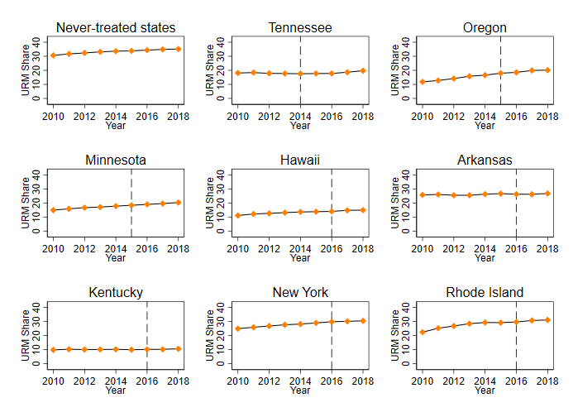
Figure 2.1. URM Shares for eventually treated and never-treated groups

Note: This figure compares the average URM Share between public two-year colleges in free-college states and those in never-treated states. The dashed vertical line denotes the last year prior to the statewide implementation of free college in the respective state.

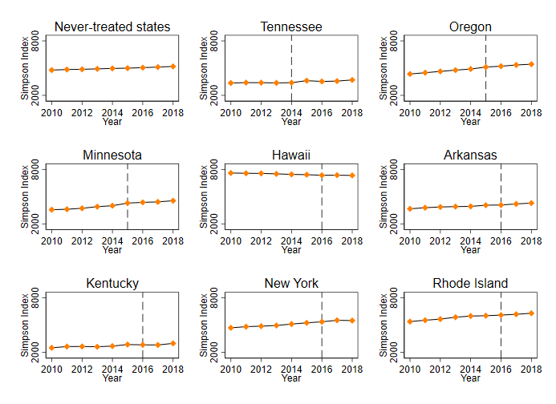
Figure 2.2. Simpson diversity for eventually treated and never-treated groups

Note: This figure compares the average Simpson index between public two-year colleges in free-college states and those in never-treated states. The dashed vertical line denotes the last year prior to the statewide implementation of free college in the respective state.

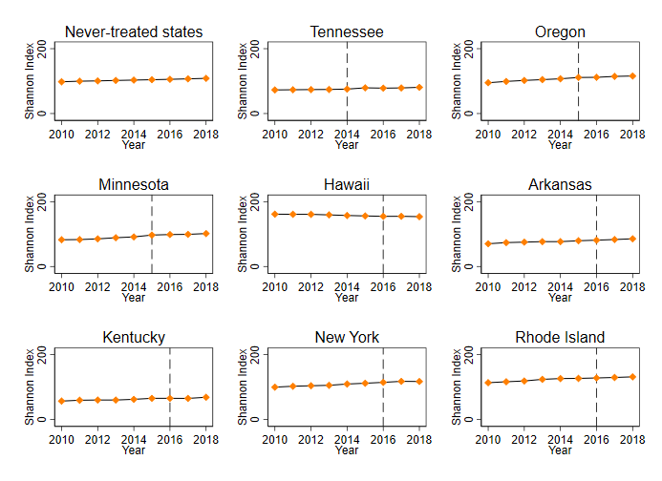
Figure 2.3. Shannon diversity for eventually treated and never-treated groups

Note: This figure compares the average Shannon index between public two-year colleges in free-college states and those in never-treated states. The dashed vertical line denotes the last year prior to the statewide implementation of free college in the respective state.
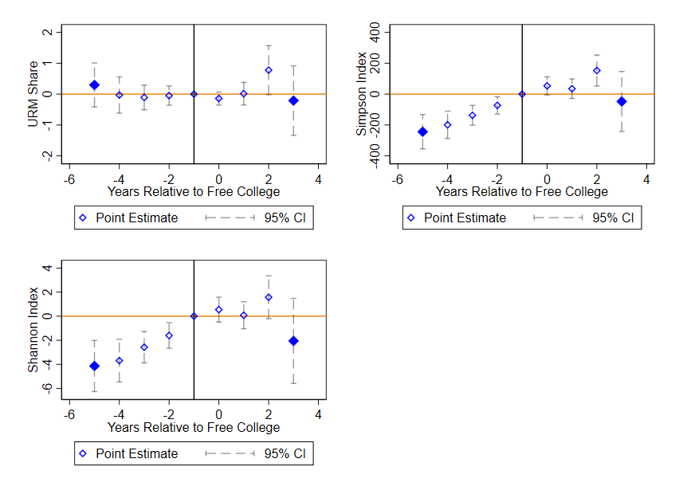
Figure 2.4. Event-study graphics

Note: This figure presents event-study coefficients for the event indicator, with time periods past the 5th lag collapsed into a single coefficient. The figure is generated in Stata version 16.1 following Stevenson &Wolfers‘(2006) and Clarke &Schythe’s (2020) method.

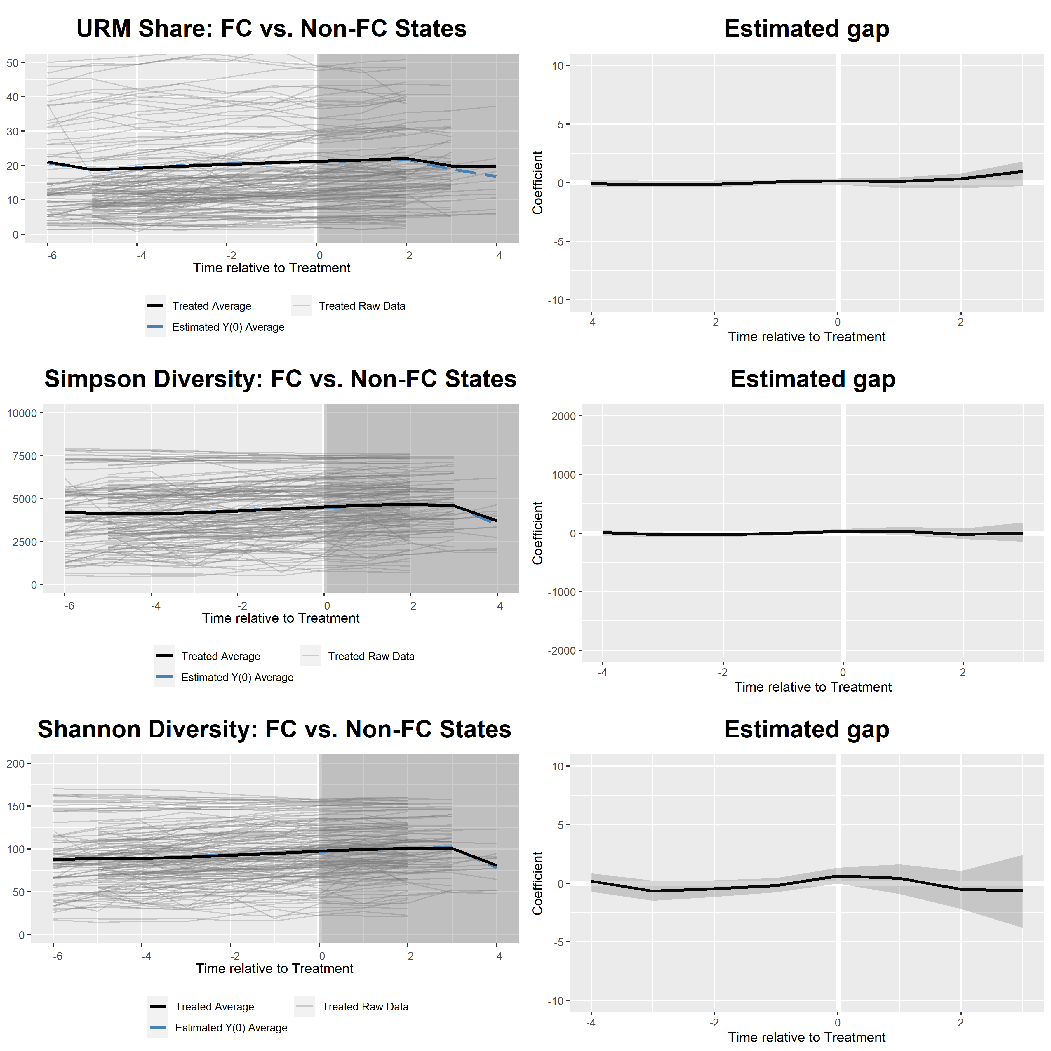
Figure 2.5. Generalized synthetic control estimation results

Note: This table summarizes the main GSC results. “FC” stands for “free college.” The left column shows treated averages and their counterfactual counterparts, and the right column shows the associated gaps. Cross-validations are employed in model selection throughout, and the standard errors bootstrapped with 1,000 replications in each estimation. Other technical details are discussed in the text and in Xu’s (2017) online appendix. All computations are implemented in R version 3.6.1.

Tennessee | Minnesota | Oregon | Hawaii
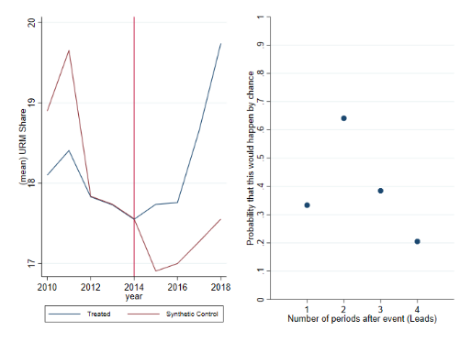 | 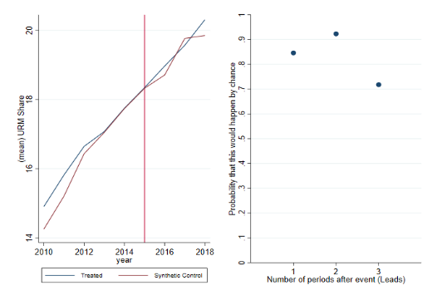 | 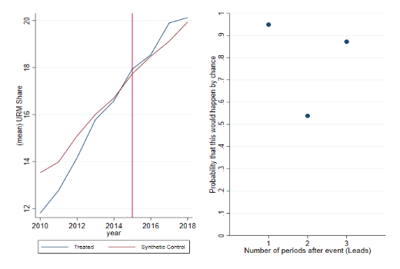 | 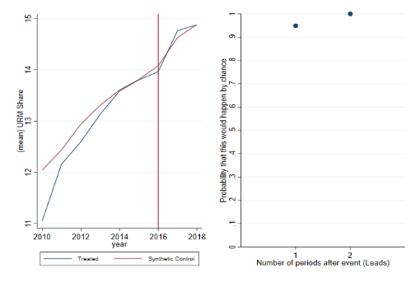
Arkansas | Kentucky | New York | Rhode Island
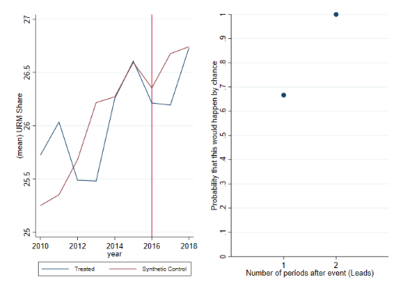 | 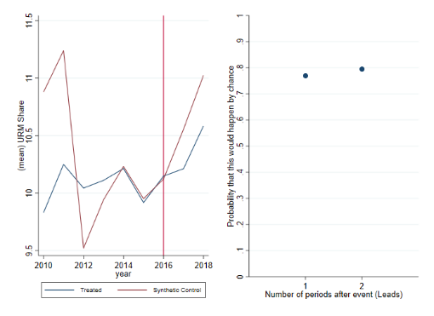 | 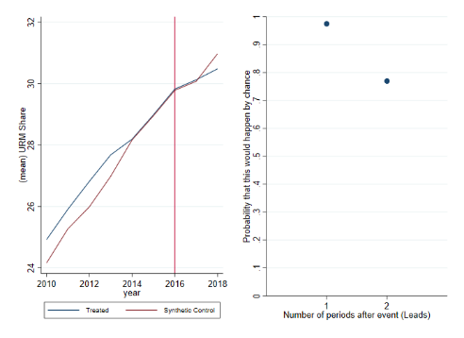 | 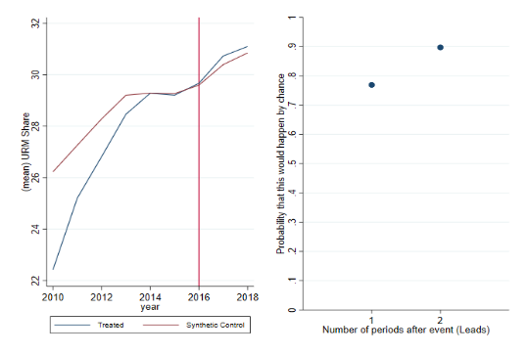

Figure 2.6. Synthetic control results in ADH’s (2010) framework: URM Share

Note: This figure summarizes synthetic control results following Abadie et al.’s (2010) method. The left panel in each subplot indicates raw averages for the state of study and its synthetic control. The right panel shows p-values comparing the main effect to the placebo-effect distribution. In addition to the time-varying covariates used in the previous estimations, the set of predictors also includes URM shares for three years prior to the statewide free-college intervention. The red vertical line identifies the last pre-treatment period. Other technical details are available in Abadie et al. (2010).
Tennessee | Minnesota | Oregon | Hawaii
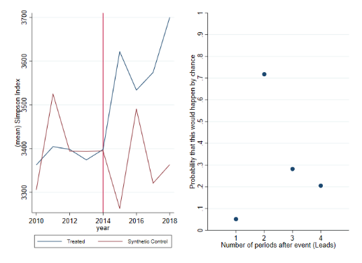 | 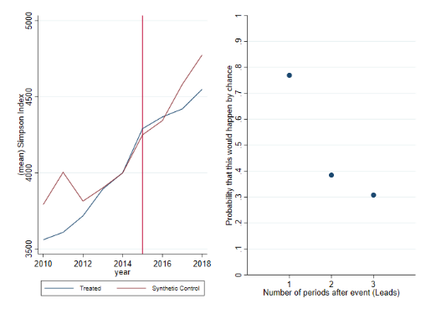 | 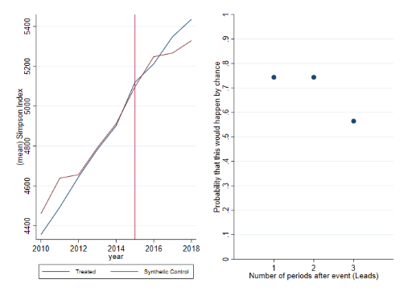 | 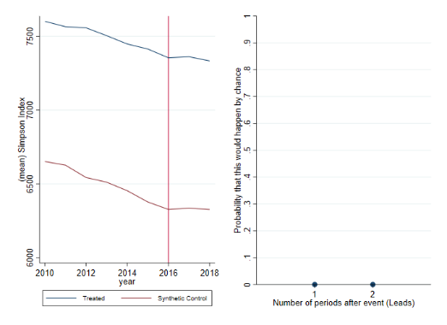
Arkansas | Kentucky | New York | Rhode Island
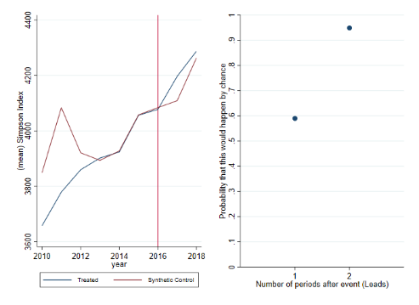 | 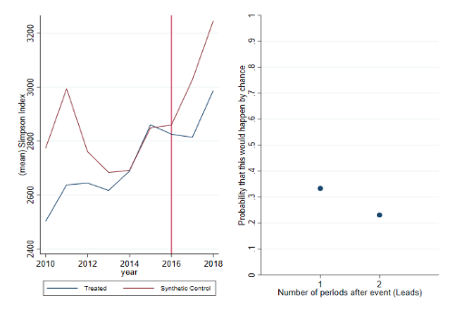 | 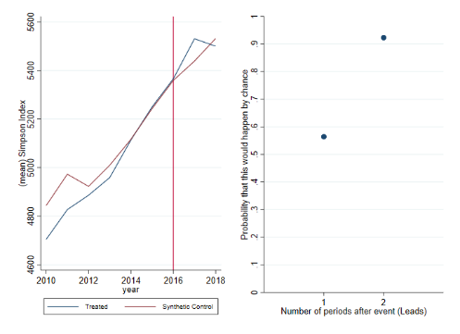 | 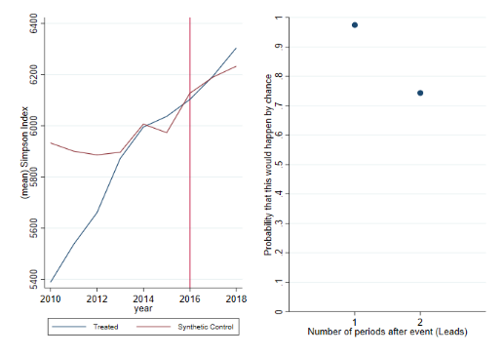

Figure 2.7. Synthetic control results in ADH’s (2010) framework: Simpson Diversity

Note: This figure summarizes synthetic control results following Abadie et al.’s (2010) method. The left panel in each subplot indicates raw averages for the state of study and its synthetic control. The right panel shows p-values comparing the main effect to the placebo-effect distribution. In addition to the time-varying covariates used in the previous estimations, the set of predictors also includes Simpson diversity measures for three years prior to the statewide free-college intervention. The red vertical line identifies the last pre-treatment period. Other technical details are available in Abadie et al. (2010).

Tennessee | Minnesota | Oregon | Hawaii
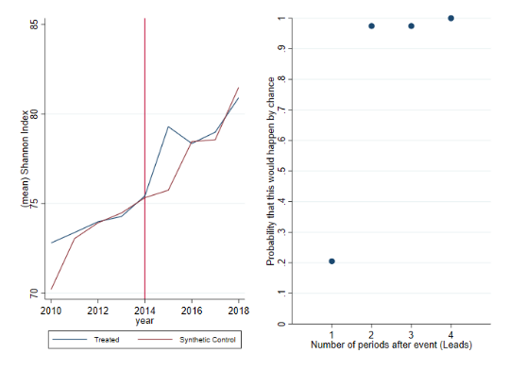 | 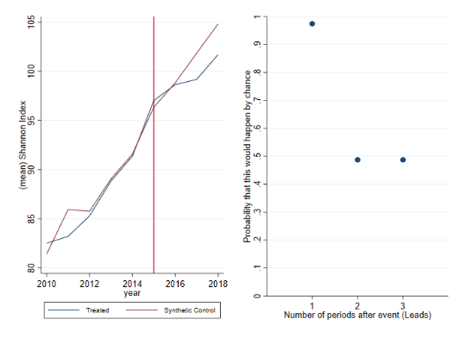 | 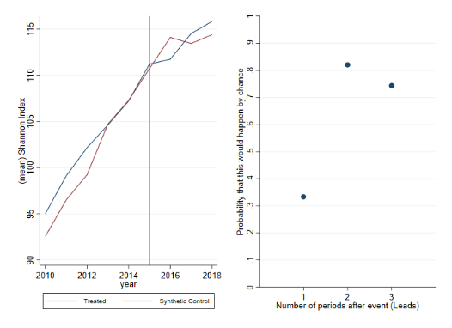 | 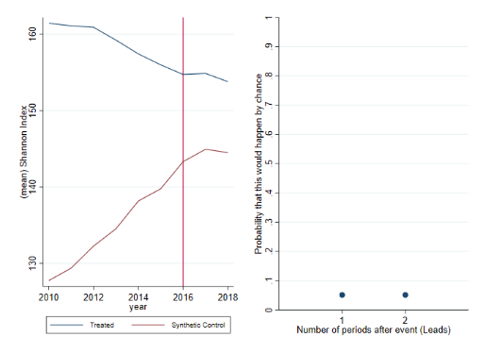
Arkansas | Kentucky | New York | Rhode Island
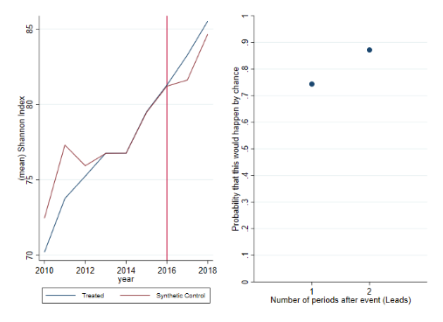 | 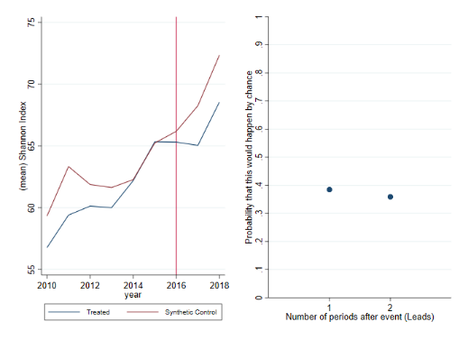 | 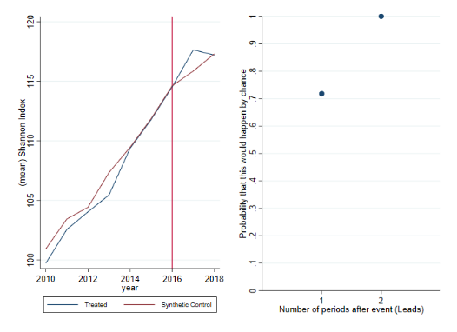 | 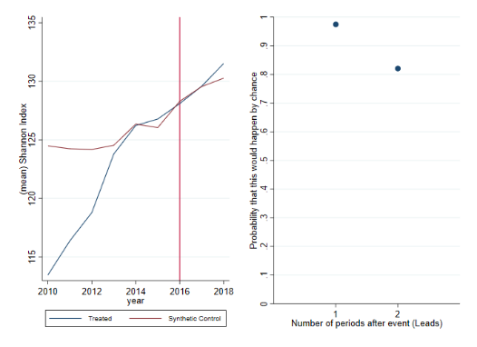

Figure 2.8. Synthetic control results in ADH’s (2010) framework: Shannon Diversity

Note: This figure summarizes synthetic control results following Abadie et al.’s (2010) method. The left panel in each subplot indicates raw averages for the state of study and its synthetic control. The right panel shows p-values comparing the main effect to the placebo-effect distribution. In addition to the time-varying covariates used in the previous estimations, the set of predictors also includes Shannon diversity measures for three years prior to the statewide free-college intervention. The red vertical line identifies the last pre-treatment period. Other technical details are available in Abadie et al. (2010)

Chapter 3. When in America, do as the Americans do? The evolution of health behaviors and outcomes across immigrant cohorts

This paper is joint work with Paolo Barbieri.

Abstract

This study seeks to understand US immigrants' health-related behaviors and outcomes across arrival cohorts. We simultaneously examine risky consumption choices (smoking and drinking) and physical health conditions (asthma, diabetes, vision problems, and coronary heart diseases) using data from the National Health Interview Surveys (1989-2014). We incorporate cohort fixed-effects and the interactions between cohort effects and years since immigration into our empirical framework to capture the dynamics of immigrant health over time. We find that cohort effects are present in all health indicators. Despite some heterogeneity in the dynamics of unhealthy behaviors, this heterogeneity seems to dissipate as we explore longer-term health outcomes. Overall, our findings provide an interesting outlook on how the integration into the host society affects American immigrants' health. We contribute new results to the immigrant health assimilation literature, which has primarily focused on obesity and wages.

3.1. Introduction
Evidence suggests that first-generation immigrants have made a remarkable contribution to the US productivity and economic prosperity (Becerra et al., 2012, Sequeira et al., 2018). However, the health disparity between US-born and foreign-born citizens perpetuates and remains an important public health challenge (Bustamante et al., 2019), Dickman et al., 2017, Fernandez and Rodriguez, 2017). Immigrants in the US are frequently blamed by the media for putting negative cost pressures on native taxpayers and health service users. However, the academic literature has shown that immigrants, upon arriving in the country, are younger and healthier than their American counterparts and less likely to utilize health care (Goldman et al., 2006). This paradox is conventionally known as the “healthy immigrant effect.” Interestingly, despite the initial health advantage over natives in both home and host countries, immigrants' health deteriorates with time spent in the host country (Akbulut-Yuksel and Kugler, 2016, Antecol and Bedard, 2006, Giuntella and Mazzona, 2015). This pattern might be explained by self-selection and socio-cultural protection, which lead initially healthy immigrants to converge to lower health standards as they assimilate with the new living conditions and customs (Antecol and Bedard, 2006, Jasso et al., 2004, McDonald and Kennedy, 2004, Riosmena et al., 2003).

The assimilation in health outcomes can also be reconciled with the slower convergence in earnings and increased exposure to unhealthy behaviors that later arrival cohorts exhibit due to their lower socioeconomic status (Borjas, 2015, Pampel et al., 2010). Similar trends are observed for several countries and across numerous health indicators (Antecol and Bedard, 2006, Leung, 2014). Of interest to both scholars and policymakers, therefore, are not only immigrants' health assimilation in general but also its possible heterogeneity across different arrival cohorts.
One of the few papers that examine both of these aspects is Giuntella and Stella (2016). Focusing on the spread of obesity among US immigrants, Giuntella and Stella show that more recent immigrant cohorts arrive with higher obesity rates and experience a faster weight gain. This finding is consistent with America's reputation as a highly obese country and partially confirms the notion that healthier immigrants converge toward worse health.

Drawing upon Giuntella and Stella’s empirical framework, we contribute to both academic and policy discourse on immigrant health in several ways. First, we extend Giuntella and Stella’s analysis to explore not only time differences in unhealthy behaviors across arrival cohorts but also heterogeneity over a broad spectrum of health outcomes. This analysis provides a more in-depth outlook on the health trajectories that pertain to each immigrant cohort and places what previous research has found on obesity into a more holistic perspective. In particular, we look at cohort effects and assimilation patterns in asthma, diabetes, vision problems, and coronary heart diseases. These health conditions are perceived to be driven by both genetic and environmental interactions, as opposed to congenital factors alone.
Second, in addition to these long-run health outcomes, we also analyze short-run behavioral dynamics among US immigrants by studying their drinking and smoking habits over time. Drinking and smoking are two interesting and important indicators to investigate since they are two “direct” consumption choices, rather than represent an upshot of the complex interaction among different individual decisions. Studying these behaviors brings us one step closer to unpacking the mechanism of how physical well-being among different immigrant cohorts adjusts over time.
Finally, previous evidence on American immigrants has documented a differential impact of smoking and alcohol consumption across different subpopulations, which stems from familial, social, and institutional factors (Bui, 2013, Eitle et al., 2009, Leung, 2014, Warner et al., 2010). Unfortunately, very little is known about the process of assimilation and its potential heterogeneity across different arrival cohorts and/or health behaviors. Even much less is known about the potential differing patterns across health indicators. Shedding light on these aspects is crucial for evaluating the costs and benefits of immigration, and, in particular, its impact on the healthcare system. In this regard, our paper contributes to a better understanding of immigration policy in the United States.
3.2. Data and methods
For the empirical analyses that follow, we employ nationally representative repeated cross-section individual-level data from the National Health Interview Surveys (NHIS)--formerly Integrated Health Interview Surveys--conducted by the U.S. Centers for Disease Control and maintained for public use at the Integrated Public Use Microdata Series (IPUMS) by the University of Minnesota. Rather than a compilation of separate statistics, the NHIS microdata system records multiple health and educational characteristics within a harmonized system. NHIS sampling procedures consist of two main steps: first, about 40,000 households are selected at random; then, one adult and one child are sampled from the participating households for health-related questions. More information is available in Thompson (2014) and a full description of the sampling procedures is available on IPUMS website.

One distinctive feature of the data which is most pertinent to our current research design is that information on the number of years spent in the US is available for a sufficient period of time (1989-2014). With 25 years of annual data, we are able to make cross-cohort comparisons and get a comprehensive outlook on how immigrant health evolves over time. Following similar works in the literature (Antecol and Bedard, 2006, Borjas, 2015, Giuntella and Stella, 2016) and to ensure the representativeness of the sample, we restrict the observations to individuals aged 25-65 years that migrated to the US after the age of 18 years. We also exclude from the sample any individual with missing data for age, years since migration, and year of arrival. Finally, we retain only observations with a flag variable of “sample adult,” following Thompson (2014).

3.2.1. Dependent variables
For analytical purposes, we examine several dependent variables, which can be placed into two broad categories--health behaviors and health outcomes. As for the former group, we consider two indicator variables that equal one if the individual is a smoker/binge drinker and two continuous variables measuring the average number of cigarettes/alcoholic beverages consumed on a daily basis. As for health outcomes, all of the indicators of asthma, diabetes, vision problem, and coronary heart disease statuses are codified as one if the individual currently has or has ever had the said condition.

3.2.2. Empirical specification
In order to investigate cohort differences in immigrant health upon arrival in the US and in the rate of growth of immigrant assimilation, we employ an ordinary least-squares specification (also called “linear probability model” whenever the dependent variable is a binary indicator) similar to Borjas (2015) and Giuntella and Stella (2016). Such a model allows for the presence of cohort differences in the rate of health assimilation. Specifically:

$$y_{ij}=α+δa_{i}+γ_{j}c_{j}+θ_{j}\left(a_{i}.c_{j}\right)+X_{i}^{'}Γ+ϵ_{ij} (1)$$

where the unit of observation is individual i aged 25-64 years at the time of the NHIS interview. $y_{ij}$ is a measure of the health behavior or outcome of interest; $a_{i}$ is the number of years the immigrant has lived in the US (equal to 0 for natives); $c_{j}$ indicates one of the cohorts (i.e. cohort fixed effects). Following the novelty introduced by Giuntella and Stella (2016), we include in (1) the factor $a_{i}.c_{j}$, which represents the interaction between the linear term of the years-since-migration and each of the cohorts fixed effects. Such a term allows each arrival cohort to have its own growth path regarding $y_{ij}$ and enables us to examine the differential assimilation pattern that the different immigrant arrival cohorts might exhibit. Finally, $X_{i}$ is a vector of control variables including years of schooling, an indicator for being married, an indicator for being employed, and age (introduced as a third-order polynomial) interacted with a variable indicating whether the person is foreign-born or native. The inclusion of such controls might better represent the different economic contexts in which immigrants live. Years of education, for instance, has a protective effect of reducing the rates of alcohol-cigarette consumption and incidence of negative health conditions. The standard errors are clustered at the cohort level to allow for the potential correlation of taste-related unobservables across individuals who belong to the same cohort.

In equation (1), the $γ_{j}$ coefficient indicates whether, upon their arrival in the US, immigrants are more or less likely to engage in unhealthy behaviors with respect to the otherwise similar natives. As in Borjas (2015), we also report the relative growth rates of unhealthy behaviors/negative healthy conditions in the first 10 years after immigration. Such an analysis is intended to highlight the trends in the rate of unhealthy assimilation and illustrate the extent to which the health gap between natives and immigrants narrows over the first decade in the US.

3.3. Results
3.3.1. Summary statistics
In Tables 1 and 2, we report the descriptive statistics on both health behaviors and conditions for our final sample separated by gender and stratified by ethnicity and citizenship. Overall, native men and women acquire about 1.5 more years of schooling than do immigrants. This pattern prevails for all ethnic groups with the exception of blacks, whereby educational attainment is equalized between natives and immigrants among both males and females. Native Americans are also less likely to be married and less likely to be employed than are their immigrant counterparts. Most strikingly, natives tend to smoke more than immigrants and, on average, experience a higher probability of suffering from ill health. This pattern is fairly consistent across different ethnic groups and across different indicators of chronic health outcomes. One exception is recorded for diabetes, where for both men and women, the incidence of diabetes among natives is generally lower than that among immigrants. The black subgroup again features an anomaly, as black natives are more likely to suffer from diabetes than their immigrant counterparts.
3.3.2. Regression results
We estimate equation (1) using ordinary least-squares (OLS) (linear probability model for binary responses), using the pooled data from the whole sample. Tables 3 to 10 present the results for the various health variables considered. The upper panel in each table presents coefficient estimates of the immigrant arrival cohort fixed effects, identifying cohorts' differences in health behaviors and statuses between immigrants, at the time of their entry, and comparable American natives. The lower part, instead, reports results on the interactions between cohort fixed effects and the number of years since migration. Gender-specific and subgroup-specific results are also provided.

3.3.2.1. Health behaviors: smoking and drinking
Table 3 presents the results for smoking status. It can be noticed that later immigrant cohorts are less likely to smoke, particularly after the turn of the century. The Hispanic subgroup experiences the most drastic change, whereby the difference in the initial entry level of smoking rate between immigrants and natives stabilizes at about 5% prior to the year of 2000 and climbs to as much as 11% for the 2005-2014 cohorts. The interaction results reveal some form of de-assimilation, with immigrants diverging from natives' smoking rates. However, in absolute terms, such divergence slows over time. Table 4 presents the results for the number of cigarettes consumed daily. On average, immigrants who arrived after 2000 consumed 2 fewer cigarettes than American natives. Overall, the results for smoking intensity are similar to what we found for smoking status, with sharp changes in the de-assimilation rates after 2000.
Table 5 presents the results for binge-drinking status. The cohort effects are uniform, significantly negative and smaller, in absolute terms, for recent arrival cohorts. These results support the healthy immigrant hypothesis, with recent cohorts experiencing a higher probability of being a binge drinker than the earlier ones. In general, similar patterns are found by gender and ethnicity, with the only exception of the black subgroup. The rates of assimilation, as indicated by the estimated coefficients on the interaction terms, are found to be consistently positive and significant. The coefficients increase with more recent arrival cohorts, with the exception of the 2005-2014 cohort. Table 6 shows the results for the number of alcoholic drinks consumed daily. We find that, on average, immigrants who arrived after 2005 consumed approximately half a drink per day fewer than American natives, whereas those who arrived between 1980 and 1995 consumed approximately a full drink fewer than their native counterparts. Our findings on drinking intensity are largely comparable to the binge-drinking results, although the assimilation rates decrease for later cohorts. Overall, our results suggest that relative to natives, later immigrant cohorts consume less alcohol (on average) than earlier cohorts. This pattern is readily rationalizable by the slower economic assimilation that later cohorts exhibit (Borjas, 2015), which limits their possibility to purchase higher doses of alcoholic beverages.

One potential explanation for the reverse pattern for smoking could be that later immigrant cohorts tend to be faced with more stress or other mental health issues while trying to navigate the new life, and that having a slower economic convergence to the natives’ standards of living augments this stress. While alcohol and tobacco products might not be perfect substitutes, the relatively lower price of tobacco in the United States might induce certain behavioral substitutions away from alcohol. Our results are in line with previous findings by Nierkens et al. (2006), who document that immigrants with lower formal education tend to be more exposed to smoking prevalence than are those with higher formal education. While our study does not focus on comparing male and female immigrants as in Nierkens et al. (2006), it is likely that gender differences in the adaptation of risky health behaviors might also drive the divergent patterns for drinking and smoking.

3.3.2.2. Health conditions: asthma, diabetes, vision problems and coronary heart diseases

Tables 7 through 10 display the trajectories of immigrant health conditions across arrival cohorts. Overall, it can be seen that the estimated cohort effects are consistently negative, statistically significant, and stable, for all of the health conditions under consideration, except for diabetes. To be specific, immigrants from different arrival cohorts experience similar propensities to suffer from asthma, vision problems and coronary heart conditions, relative to their native counterparts. However, for diabetes, we find that later arrival cohorts are less likely to suffer from this condition.

Our analysis of assimilation rates delivers mixed evidence. The estimated coefficients on the interaction terms are consistently positive and statistically significant across health conditions, although no clear path is recorded to confirm either convergence or divergence. One interesting pattern, however, is noted for asthma, where we find that within the Hispanic group, the assimilation rates broadly decrease with more recent arrival cohorts. Compared to other chronic health conditions, asthma development is presumably more strongly influenced by environmental factors and social interactions. Referring back to our unconditional-average summary statistics, we note that Hispanic native men (women) are almost three (four) times, or 6 (11) percentage points, as likely to suffer from asthma as their immigrant counterparts. Given the comparable sample sizes between the two groups and the distributions of asthma prevalence, we speculate that the assimilation result might be driven by the aforementioned selection mechanism, whereby recent Hispanic immigrants are healthier and converge more slowly to the ill-health equilibrium in the host country than those from earlier arrival cohorts. This result is also partly attributable to possible heterogeneities within the Hispanic group. For example, many studies suggest that the Hispanic health paradox is driven by Mexicans (e.g., Giuntella, 2017). Unfortunately, IPUMS data do not allow us to go further than the ''Hispanic/non-Hispanic'' classification. We are therefore not able to examine in depth the potential differences in asthma-related behaviors among Mexicans, Cubans, and Puerto Ricans, among other Hispanic subgroups. This data limitation leaves a promising venue for future work to address.

3.4. Concluding remarks
This study examined trends in health behaviors (drinking and smoking) and health outcomes (asthma, diabetes, vision problems, and coronary heart diseases) among immigrants relative to American natives. Using NHIS data (1989-2014), we found not only cohort differences but also assimilation heterogeneity for several immigrant health indicators. Overall, our results documented some degree of heterogeneity in immigrants’ adoption of unhealthy behaviors from natives, although this heterogeneity is no longer present as far as longer-term health outcomes are concerned. Our findings complemented those of Giuntella and Stella (2016), who highlighted a more rapid assimilation in obesity rates that recent arrival cohorts exhibit.

Smoking and drinking are two important public health challenges, which have attracted much attention from both scholars and policymakers for decades. Grounded within the health assimilation framework, we found interesting, albeit slightly differing, patterns of how these health behaviors evolved among US immigrants. These evidences provided a more nuanced view of how immigrants adapt to the health standards in the host country and, to some extent, were suggestive of the socioeconomic forces that different immigrant cohorts experience in the backdrop.

For drinking, in particular, immigrants' convergence towards native rates appears to start in the home countries and persists as these individuals stay in the US. For smoking, results from Table 3 suggest that immigrants seem overall to gain (in terms of reduced smoking habits) with time spent in the host country. Specifically, immigrants' relative health advantage over their native counterparts does not erode with time spent in the US, with the only exception of the most recently arrived cohort (2005-2014) of Hispanic immigrants. This difference in assimilation patterns is more or less in line with public health reports on the overall trends in risk factors in America. An international comparison, for instance, shows the risk associated with cigarette consumption to be very low, whereas alcohol-related risk is fairly high (OECD, 2015). On a relevant note, smoking in the US declined from 20.9% in 2005 to about 15% in 2015 (Jamal et al., 2016) while almost 20% of American adults engage in regular binge drinking (Safer, 2012). Previous research findings and official statistics have attributed the declining smoking rates to statewide and nationwide surveillance program, behavioral nudges, and enhanced regulation on the supply side of the tobacco market (Acquavita, 2020, CDC, 2019, Lathen et al., 2020). Another possible explanation for the lower odds of being a daily smoker among immigrants might be related to differences in the stage of the tobacco epidemic between immigrants’ countries of origin and the US and anti-smoking socialization in immigrant families (Acevedo-Garcia et al., 2005, Reiss et al., 2015). The fact that Americans are drinking more, on the other hand, has to do with increased media exposure, alcohol availability (e.g., Anderson et al., 2009, Braillon, 2019, Bryden et al., 2012, Hahn et al., 2012, Kerr et al., 2018, Sherk et al., 2018), and even terrorism-induced stress (Averett and Wang, 2012). Altogether, our results complement these findings and reflect some interesting aspects of assimilation with the American culture, policy context, and social norms that immigrants are exposed to (Ali and Dwyer, 2009, Gaviria and Raphael, 2001, Powell et al., 2005).

To account for assimilation patterns in wages and obesity, previous researchers often rely on two widely accepted mechanisms, namely self-selection and socio-cultural protection (Antecol and Bedard, 2006, Giuntella, 2017, Kennedy et al., 2015, Riosmena et al., 2013). Our study examined long-term trends in health outcomes among different immigrant cohorts and documented similar dynamics for asthma, diabetes, coronary heart conditions, and vision problems. We speculate that the proposed explanations still matter to a certain degree, considering, for instance, the potential role of education and cultural norms in alleviating at least some of these health problems. The results might also be explained by selection at migration, which varies across cohorts in part because of the host country's differential approaches to immigration policy over time. Unfortunately, the lack of information on immigrants' country of migration, area of migration, and reference peers prevents us from disentangling these channels.

Other mechanisms could be at work, too. First, the heterogeneity in health outcomes might indirectly reflect the long-standing discrimination in the labor market, which varies across immigrant cohorts. Despite some initial health advantage, certain groups of immigrants and refugees, such as Hispanics, Blacks, and Asians, might face social stigmas from natives even prior to their physical entry into the host country and actual participation in the domestic labor market (Boswell, 1986, Evans and Kelley, 1991, Wilson and Portes, 1980, Zschirnt and Ruedin, 2016). For instance, entrepreneurship scholars regularly document that many immigrants become entrepreneurs as a way to overcome discrimination in the host country (Evansluong et al., 2019, Griffin-EL and Olabisi, 2018, Portes and Sensenbrenner, 1993). Other immigrants strive for higher education and high-skilled corporate positions to fend off the negative associations with “ethnic enclaves” (Wilson and Portes, 1980). Irrespective of their sources, unfounded prejudices might obscure objectivity in hiring decisions, prevent immigrants from enjoying similar labor market opportunities to those of native citizens, and hence restrain them from investing in education and health at a socially efficient level. Should this hypothesis be true, then a more open immigration policy that emphasizes an accommodating attitude might be a promising tool for policymakers to enable future immigrant cohorts to experience a faster convergence in earnings and a slower erosion of the “healthy advantage.”

Aside from the economic-convergence story, it is important to discuss several non-economic aspects of immigration and how they might drive the observed health heterogeneity across different immigrant cohorts. For most people, relocating permanently to another country is a life-changing event, which induces various sources of mental stress. Many immigrants, for instance, start from scratch when they arrive in the host country, having to supply labor cheaply or illegally to make ends meet (Evansluong and Ramirez-Pasillas, 2019). For this group, the constant lack of familial support and the internal urge to take care of family back home (e.g., via remittances) may compound their distress levels and negatively their physical health.

Further, first-generation immigrants today might possess a greater skill premium and be endowed with more wealth inheritances than in earlier times. Another possibility is that the composition of the immigrant cohort entering the host country during an economic boom might differ from that of the cohort entering during a recession. These factors raise a valid concern that immigrants belonging to different cohorts are not directly comparable. In striving to overcome this empirical difficulty, we used NHIS longitudinal survey weights to partially address the compositional issue. Given the lack of information regarding country of origin, however, it remains a challenge to trace the specific sources of the documented heterogeneity in the assimilation dynamics. We acknowledge this as our most important limitation and leave it for future research.

Finally, given the mixed evidence across racial subgroups as documented in the results, we are cautious about making causal claims. To emphasize, our main message regarding heterogeneity is two-fold: (1) immigrant health varies by arrival cohort; and (2) immigrant health varies by outcome/behavior. We hope that these results, together with the set of results on obesity that Giuntella and Stella (2016) provided, will enrich the immigrant health assimilation literature and contribute to what we already know about immigrants’ wage growth and economic assimilation.

References
Acquavita, S. P. (2019). How social work can address the tobacco epidemic. Journal of Social Work Practice in the Addictions, 20(1), 82-87. https://doi.org/10.1080/1533256x.2020.1702348
Akbulut-Yuksel, M., & Kugler, A. D. (2016). Intergenerational persistence of health: Do immigrants get healthier as they remain in the U.S. for more generations? Economics & Human Biology, 23, 136-148. https://doi.org/10.1016/j.ehb.2016.08.004
Ali, M. M., & Dwyer, D. S. (2009). Estimating peer effects in adolescent smoking behavior: A longitudinal analysis. Journal of Adolescent Health, 45(4), 402-408. https://doi.org/10.1016/j.jadohealth.2009.02.004
Anderson, P., de Bruijn, A., Angus, K., Gordon, R., & Hastings, G. (2009). Impact of alcohol advertising and media exposure on adolescent alcohol use: A systematic review of longitudinal studies. Alcohol and Alcoholism, 44(3), 229-243. https://doi.org/10.1093/alcalc/agn115
Antecol, H., & Bedard, K. (2006). Unhealthy assimilation: Why do immigrants converge to American health status levels? Demography, 43(2), 337-360. https://doi.org/10.1353/dem.2006.0011
Argeseanu Cunningham, S., Ruben, J. D., & Venkat Narayan, K. (2008). Health of foreign-born people in the United States: A review. Health & Place, 14(4), 623-635. https://doi.org/10.1016/j.healthplace.2007.12.002
Averett, S. L., & Wang, Y. (2012). Identification of the effect of depression on risky sexual behavior: Exploiting a natural experiment. American Economic Review, 102(3), 570-574. https://doi.org/10.1257/aer.102.3.570
Becerra, D., Androff, D., Ayón, C., & Castillo, J. (2012). Fear vs. facts: Examining the economic impact of undocumented immigrants in the U.S. Journal of Sociology and Social Welfare, 39(4), 111-135. https://asu.pure.elsevier.com/en/publications/fear-vs-facts-examining-the-economic-impact-of-undocumented-immig
Borjas, G. J. (2015). The slowdown in the economic assimilation of immigrants: Aging and cohort effects revisited again. Journal of Human Capital, 9(4), 483-517. https://doi.org/10.1086/676461
Boswell, T. E. (1986). A split labor market analysis of discrimination against Chinese immigrants, 1850-1882. American Sociological Review, 51(3), 352. https://doi.org/10.2307/2095307
Braillon, A. (2019). Effects of a comprehensive pro-alcohol policy in Washington State. Alcohol and Alcoholism, 54(1), 119-121. https://doi.org/10.1093/alcalc/agy076
Bryden, A., Roberts, B., McKee, M., & Petticrew, M. (2012). A systematic review of the influence on alcohol use of community level availability and marketing of alcohol. Health & Place, 18(2), 349-357. https://doi.org/10.1016/j.healthplace.2011.11.003
Bui, H. N. (2012). Racial and ethnic differences in the immigrant paradox in substance use. Journal of Immigrant and Minority Health, 15(5), 866-881. https://doi.org/10.1007/s10903-012-9670-y
Bustamante, A. V., Chen, J., McKenna, R. M., & Ortega, A. N. (2019). Health care access and utilization among U.S. immigrants before and after the Affordable Care Act. Journal of Immigrant and Minority Health, 21(2), 211-218. https://doi.org/10.1007/s10903-018-0741-6
Cheung, N., & Wong, T. Y. (2007). Obesity and eye diseases. Survey of Ophthalmology, 52(2), 180-195. https://doi.org/10.1016/j.survophthal.2006.12.003
Dickman, S. L., Himmelstein, D. U., & Woolhandler, S. (2017). Inequality and the health-care system in the USA. The Lancet, 389(10077), 1431-1441. https://doi.org/10.1016/s0140-6736(17)30398-7
Eitle, T. M., Wahl, A. G., & Aranda, E. (2009). Immigrant generation, selective acculturation, and alcohol use among Latina/o adolescents. Social Science Research, 38(3), 732-742. https://doi.org/10.1016/j.ssresearch.2009.01.006
Evans, M. D., & Kelley, J. (1991). Prejudice, discrimination, and the labor market: Attainments of immigrants in Australia. American Journal of Sociology, 97(3), 721-759. https://doi.org/10.1086/229818
Evansluong, Q., Ramirez Pasillas, M., & Nguyen Bergström, H. (2019). From breaking-ice to breaking-out: Integration as an opportunity creation process. International Journal of Entrepreneurial Behavior & Research, 25(5), 880-899. https://doi.org/10.1108/ijebr-02-2018-0105
Fernández, A., & Rodriguez, R. A. (2017). Undocumented immigrants and access to health care. JAMA Internal Medicine, 177(4), 536. https://doi.org/10.1001/jamainternmed.2016.9209
Gaviria, A., & Raphael, S. (2001). School-based peer effects and juvenile behavior. Review of Economics and Statistics, 83(2), 257-268. https://doi.org/10.1162/00346530151143798
Giuntella, O. (2017). Why does the health of Mexican immigrants deteriorate? New evidence from linked birth records. Journal of Health Economics, 54, 1-16. https://doi.org/10.1016/j.jhealeco.2017.03.002
Giuntella, O., Kone, Z., Ruiz, I., & Vargas-Silva, C. (2018). Reason for immigration and immigrants' health. Public Health, 158, 102-109. https://doi.org/10.1016/j.puhe.2018.01.037
Giuntella, O., & Mazzonna, F. (2015). Do immigrants improve the health of natives? Journal of Health Economics, 43, 140-153. https://doi.org/10.1016/j.jhealeco.2015.06.006
Giuntella, O., & Stella, L. (2016). The acceleration of immigrant unhealthy assimilation. Health Economics, 26(4), 511-518. https://doi.org/10.1002/hec.3331
Goldman, D. P., Smith, J. P., & Sood, N. (2006). Immigrants and the cost of medical care. Health Affairs, 25(6), 1700-1711. https://doi.org/10.1377/hlthaff.25.6.1700
Griffin-EL, E. W., & Olabisi, J. (2018). Breaking boundaries: Exploring the process of Intersective market activity of immigrant entrepreneurship in the context of high economic inequality. Journal of Management Studies, 55(3), 457-485. https://doi.org/10.1111/joms.12327
Hahn, R. A., Middleton, J. C., Elder, R., Brewer, R., Fielding, J., Naimi, T. S., Toomey, T. L., Chattopadhyay, S., Lawrence, B., & Campbell, C. A. (2012). Effects of alcohol retail privatization on excessive alcohol consumption and related harms. American Journal of Preventive Medicine, 42(4), 418-427. https://doi.org/10.1016/j.amepre.2012.01.002
Holian, M. J. (2021). Searching for higher ground: Migration and quality of life. Data and the American Dream, 57-75. https://doi.org/10.1007/978-3-030-64262-4_3
Kennedy, S., Kidd, M. P., McDonald, J. T., & Biddle, N. (2014). The healthy immigrant effect: Patterns and evidence from four countries. Journal of International Migration and Integration, 16(2), 317-332. https://doi.org/10.1007/s12134-014-0340-x
Kerr, W. C., Williams, E., Ye, Y., Subbaraman, M. S., & Greenfield, T. K. (2018). Survey estimates of changes in alcohol use patterns following the 2012 privatization of the Washington liquor monopoly. Alcohol and Alcoholism, 53(4), 470-476. https://doi.org/10.1093/alcalc/agy004
Lathen, L. S., Plears, M. L., Shartle, E. L., Conner, K. L., Fiore, M. C., & Christiansen, B. A. (2020). The HUD smoke-free rule: Perceptions of residents post-implementation. Preventive Medicine Reports, 19, 101159. https://doi.org/10.1016/j.pmedr.2020.101159
Leung, L. A. (2014). Healthy and unhealthy assimilation: Country of origin and smoking behavior among immigrants. Health Economics, 23(12), 1411-1429. https://doi.org/10.1002/hec.2992
McDonald, J. T., & Kennedy, S. (2004). Insights into the ‘healthy immigrant effect’: Health status and health service use of immigrants to Canada. Social Science & Medicine, 59(8), 1613-1627. https://doi.org/10.1016/j.socscimed.2004.02.004
Nierkens, V. (2006). Smoking in immigrants: Do socioeconomic gradients follow the pattern expected from the tobacco epidemic? Tobacco Control, 15(5), 385-391. https://doi.org/10.1136/tc.2006.014902
Orrenius, P. M., & Zavodny, M. (2015). The impact of temporary protected status on immigrants' labor market outcomes. American Economic Review, 105(5), 576-580. https://doi.org/10.1257/aer.p20151109
Pampel, F. C., Krueger, P. M., & Denney, J. T. (2010). Socioeconomic disparities in health behaviors. Annual Review of Sociology, 36(1), 349-370. https://doi.org/10.1146/annurev.soc.012809.102529
Portes, A., & Sensenbrenner, J. (1993). Embeddedness and immigration: Notes on the social determinants of economic action. American Journal of Sociology, 98(6), 1320-1350. https://doi.org/10.1086/230191
Powell, L. M., Tauras, J. A., & Ross, H. (2005). The importance of peer effects, cigarette prices and tobacco control policies for youth smoking behavior. Journal of Health Economics, 24(5), 950-968. https://doi.org/10.1016/j.jhealeco.2005.02.002
Ramirez Pasillas, M., & EvansLuong, Q. (2019). The role of family social capital in immigrants entrepreneurial opportunity creation processes. International Journal of Entrepreneurship and Small Business, 36(1/2), 1. https://doi.org/10.1504/ijesb.2019.10010786
Riosmena, F., Wong, R., & Palloni, A. (2012). Migration selection, protection, and acculturation in health: A Binational perspective on older adults. Demography, 50(3), 1039-1064. https://doi.org/10.1007/s13524-012-0178-9
Sequeira, S., Nunn, N., & Qian, N. (2019). Immigrants and the making of America. The Review of Economic Studies, 87(1), 382-419. https://doi.org/10.1093/restud/rdz003
Sherk, A., Stockwell, T., Chikritzhs, T., Andréasson, S., Angus, C., Gripenberg, J., Holder, H., Holmes, J., Mäkelä, P., Mills, M., Norström, T., Ramstedt, M., & Woods, J. (2018). Alcohol consumption and the physical availability of take-away alcohol: Systematic reviews and meta-analyses of the days and hours of sale and outlet density. Journal of Studies on Alcohol and Drugs, 79(1), 58-67. https://doi.org/10.15288/jsad.2017.79.58
Thompson, O. (2014). Genetic mechanisms in the intergenerational transmission of health. Journal of Health Economics, 35, 132-146. https://doi.org/10.1016/j.jhealeco.2014.02.003
Warner, T. D., Fishbein, D. H., & Krebs, C. P. (2010). The risk of assimilating? Alcohol use among immigrant and U.S.-born Mexican youth. Social Science Research, 39(1), 176-186. https://doi.org/10.1016/j.ssresearch.2009.07.001
Wilson, K. L., & Portes, A. (1980). Immigrant enclaves: An analysis of the labor market experiences of Cubans in Miami. American Journal of Sociology, 86(2), 295-319. https://doi.org/10.1086/227240
Zschirnt, E., & Ruedin, D. (2016). Ethnic discrimination in hiring decisions: A meta-analysis of correspondence tests 1990–2015. Journal of Ethnic and Migration Studies, 42(7), 1115-1134. https://doi.org/10.1080/1369183x.2015.1133279

Vita

Hieu Nguyen is originally from Hai Duong Province, Viet Nam. He graduated Summa Cum Laude from the American University in Bulgaria in 2015 with a Bachelor of Arts degree double-majoring in Economics and Mathematics. Hieu then studied Economics at the University of Pittsburgh, and earned his Master of Arts degree in Economics in 2016. He is expected to earn his Ph.D. in Economics from the University of Tennessee, Knoxville, and to join Illinois Wesleyan University as a tenure-track faculty member starting August 2021. Hieu Nguyen’s research interests span labor, health, and behavioral economics. As an avid learner, Hieu enjoys reading papers from other fields and is especially passionate about interdisciplinary collaborations.

The College Board (2016) reports that for 2011–2012 full-time dependent students, the average total grant aid ranged from $1,100 to $5,690, depending on their relative positions in the income quartiles. However, this aid was only sufficient to pay for tuition and fees for those in the lower half of the income distribution. Detailed statistics and trend analyses are accessible via the April 2016 College Board Research Brief titled “Trends in Community Colleges”: https://trends.collegeboard.org/sites/default/files/trends-in-community-colleges-research-brief.pdf
The Future of Statewide College Promise Programs. (2018, May 16). Retrieved from https://tcf.org/content/report/future-statewide-college-promise-programs/?session=1
HOPE stands for “Helping Outstanding Pupils Educationally.” It is a popular financial aid program adopted by states to support their in-state students’ pursuit of postsecondary education. The funding for these scholarships typically comes from the net proceeds of state lotteries. Introduced in the early 1990s, HOPE programs have experienced substantial growth, with Georgia’s HOPE Scholarship program being one of the largest (Sjoquist and Winters, 2015b). In most cases, to be eligible for a HOPE scholarship, an applicant must meet certain academic requirements based, for example, on high school GPA or standardized test scores.On the other hand, eligibility for free-college (known as “promise”) programs is typically based on state residency only. With the exception of New York’s Excelsior Scholarship, most promise programs require no family income thresholds. Most relevant to our context, a concise yet useful comparison between Tennessee’s HOPE scholarship and its version of free college is available at https://www.wcschools.com/Page/3024.
Importantly, Carruthers and Ozek study the consequences of losing financial support from the HOPE scholarship among Tennessee’s public college students. They find that failure to meet the scholarship renewal threshold causes mild detachment from college and increases earnings by about 14 cents per dollar of lost aid. They document no local impact on timely degree completion.
Deming and Dynarski (2009) provide an excellent summary of what we know so far about programs that target the poorest students.
The presence of education externalities, which cause the social benefits of college-going to exceed its private returns, constitutes another source of market failure. This aspect, however, is beyond the scope of the present study.
To our knowledge, El Dorado Promise is the only promise program that financially supports attendance at any institution (public or private) in the US. In 2013, the residency requirement was dropped (Miller-Adams, 2015), rendering El Dorado Promise even more generous.
For a systematic comparison of the different variants of promise programs known to date, we refer readers to Page and Scott-Clayton (2016), Perna and Leigh (2017), and Billings (2018).
First-dollar programs do not take into account the students’ eligibility for other funding sources, e.g., the federal Pell Grant. As such, under the first-dollar model, students are given greater flexibility in allocating the additional dollars net of tuition to pay for housing, childcare, books, and other expenses. More details are available in Perna and Leigh (2017).
Initiated within Knox County (Tennessee) with the class of 2009, the “Knox Achieves” program does not have any eligibility requirements based on either need or merit. Knox Achieves is special in that it features community involvement and mentoring as an integral part of its missions. As shown in Carruthers and Fox (2016), participation in the program strongly increases the prospects of high school graduation and direct college enrollment.
We emphasize here that any high school student in Tennessee qualifies for the program; the 2.0 GPA threshold is only for aid renewal. We also note that this threshold is universal, meaning that continued funding support is contingent upon the student earning a 2.0 regardless of which institution he or she is attending. By comparison, other programs like Georgia’s HOPE grant (to distinguish it from HOPE’s merit-based scholarship component) and New York’s Excelsior free-college program have institution-specific academic requirements for funding renewal.
We were informed by a faculty researcher at the University of Tennessee (Department of Economics) who was directly involved in the Tennessee Promise project that the application window for community colleges was substantially later than the date of announcement of Tennessee Promise, and, more importantly, the programrequired immediate enrollment upon high school graduation. Therefore, by the time Tennessee Promise was enacted in the entire state in Fall 2015, the program would likely have picked up most of the enrollment responses.
We note that a possibly non-negligible proportion of community college graduates may go on to attend the state’s four-year college for a terminal bachelor’s degree, rendering it tricky to unpack the true contribution of Tennessee Promise from the historical contribution of the two-year sector. Therefore, for future research to deliver a clean causal claim, we recommend against employing too long a post-treatment window in studying enrollment substitutability.
This time window is chosen following Saboe and Terrizzi (2019), since changes were made to the variables in 2008. Starting the analysis from 2009 allows us to use systematically collected and consistently defined institutional characteristics.
The lagged value is chosen both to reflect a convenient choice on our part (given that IPEDS data on this variable is only available up until 2016) and to partially address the endogeneity concern. We note that the results are qualitatively and quantitatively robust to various sets of control variables, in either current-time or lagged forms.
See Perna and Leigh (2017) for a detailed discussion.
Whenever the dependent variable is the natural logarithm of enrollment, a consistent estimate of the treatment effect is calculated as $100×(e^{δ}-1)$ percent. This quantity is approximately$δ×100$ percent, although we note that this can be a bad approximation if $δ$ is not small.
For a complete presentation, we also conduct a synthetic control analysis. In doing this, we first average both the outcome and predictor variables by state and year and estimate the model. Following Abadie et al. (2010), we employ as predictors the enrollment levels for 2012, 2013, and 2014, in addition to the same set of controls as used in our main DID and GSC estimations. We then perform a series of permutation tests to quantify the uncertainty associated with the estimated effects. These permutation tests entail running a variety of placebo tests to compare the estimated treatment effects for Tennessee and the “placebo” effects for other states. It is important to note that Abadie et al.’s synthetic control method is non-parametric, which is essentially different from the generalized synthetic control method, which is based on the assumption of latent factors. For inferential reasons, we believe that the generalized synthetic control method is a reasonable alternative to Abadie et al.’s method. The graphical results for the original synthetic control method are attached as an appendix. Across six plots within Figure A5, it can be seen that the estimated gap for Tennessee is unusually larger than the placebo gaps when the same model is applied iteratively to the donor states. If one were to select a state at random, the probability of estimating a gap of the magnitude that we have observed for Tennessee is very small. Altogether, these results indicate a positive enrollment effect of the Tennessee Promise program, in line with our DID and GSC findings.
A holistic evaluation needs to account for the welfare effects of the program and its behavioral externalities, e.g., how the program affects consumption-smoothing motives among recipients, how the state’s productivity really benefits from a more educated workforce, and how other prices are affected by such a large shock in the price of education. For future research to explore this aspect, we recommend a structural approach, with Denning et al.’s (2018) conceptual model serving as a great starting point.
According to Layzell (2007), higher education usually accounts for the largest share in states’ discretionary spending (“discretionary” in the sense that this portion is legally mandatory) regardless of economic conditions. Within this category, state governments have been a major funder of public institutions’ operational funds and postsecondary programs such as student financial aid. The National Association of State Budget Officers reports that state financial aid now occupies almost 10% of all state appropriations (2019 Expenditure Report, retrieved from: https://higherlogicdownload.s3.amazonaws.com/NASBO/9d2d2db1-c943-4f1b-b750-0fca152d64c2/UploadedImages/SER%20Archive/2019_State_Expenditure_Report-S.pdf).
Detailed statistics are available in College Board’s (2016) report entitled “Trends in Community Colleges: Enrollment, Prices, Student Debt, and Completion,” which was retrieved from https://research.collegeboard.org/pdf/trends-community-colleges-research-brief.pdf.
The prologue of Perna& Smith’s (2020) book provides a quick summary of recent advances in this literature.
Given that financial factors play a key role in dropout decisions among college students, the provision of financial aid is expected to be effective in reducing dropout risks among students from marginalized groups (Chen, 2008, Asplund et al., 2008; Chapman, 2005; Martin, 2005; Long, 2007). However, this sentiment is not shared by critics of the existing financial aid system, which is itself believed to serve traditional students only by design (Long, 2009; Castellano & Overman, 2009; Choitz &Widom, 2003; Baum, 2006; Lapovsky, 2008; St. John & Tuttle, 2004). In Chen &Hossler’s (2016) argument, although financial aid may encourage non-traditional students to stay in school, it is unlikely to ensure timely completion of a college degree among this population. In reconciling this debate, Deming & Dynarski (2009) provide a comprehensive review of causal evidence from an economic perspective. Recent research has continued illuminating the role of financial aid in improving college persistence (Allen &Wolniak, 2019; Smith, 2020). The focus of the discussion has also been shifted to age diversity and the educational experiences of older adults (Laanan, 2003; Long, 2009).
According to a report by the National Center for Education Statistics, between 2000 and 2016, the share of whites in the undergraduate population has fallen from 70 to 56 percent, whereas the share of Hispanic students has increased by 9 percentage points to 19 percent (https://nces.ed.gov/blogs/nces/post/new-report-shows-increased-diversity-in-u-s-schools-disparities-in-outcomes). At roughly the same time, from 2000 to 2017, the percentage of the college-age population (18-24 years old, as per NCES’ definition) which was White decreased from 62 to 54 percent, while the percentages of other races/ethnicities increased (https://nces.ed.gov/programs/raceindicators/indicator_RAA.asp).
The report, entitled “Race and ethnicity in higher education: a status report executive summary”, was retrieved from: https://1xfsu31b52d33idlp13twtos-wpengine.netdna-ssl.com/wp-content/uploads/2019/02/REHE-Exec-Summary-FINAL.pdf.
According to the report, “[t]he college enrollment rate in 2018 was also higher than in 2000 for those who were White (42 vs. 39 percent)…In every year between 2000 and 2018, the college enrollment rate for those who were Asian was higher than the rates for those who were White, Black, and Hispanic, and the rate for those who were White was higher than the rate for those who were Black. The college enrollment rate for those who were White was also higher than the rate for those who were Hispanic in every year between 2000 and 2018, except 2016, when the rates were not measurably different (retrieved from https://nces.ed.gov/programs/coe/pdf/coe_cpb.pdf).
There is extensive evidence from well-identified management studies that links diversity to better workplace outcomes. See McMahon (2010), Nielsen (2010), Joshi et al. (2011), Menz (2012), and most recently, Roberson et al. (2017), for systematic reviews on the diversity-firm performance relationship.
For instance, half of Tennessee Promise recipients receive $0 in aid, according to the “Tennessee Promise students at community colleges: The Fall 2015 cohort after five semesters.” report, retrievable from https://www.tbr.edu/sites/tbr.edu/files/media/2018/05/TBR_TNPromise_2015_2.pdf. A recent report states that “non-tuition expenses make up more than half the cost of college and they increase year over year,” suggesting that college tuition and fees, even if transparently published, often obscure the large indirect costs of attendance. For full closure, this report was prepared by uAspire, an organization that strives to make colleges more affordable. We do not necessarily share the organization’s views on the current topic.
What further obfuscates the picture lies in the substantial heterogeneity in the way “free college” is comprehended and executed across states. Whereas many statewide programs apply a fairly broad funding formula, others have restricted their targets to only certain fields of study. For instance, Arkansas’s ArFuture Grant and South Dakota’s Build Dakota program require recipients to be enrolled in a high-demand field (such as STEM) for eligibility. Kentucky’s Work Ready Kentucky Scholarship Program even specifies five areas that the program can support, namely health care, advanced manufacturing, transportation/logistics, business services/IT, and construction.While their future effects are uncertain, these programs do reflect the incumbent states’ clear focus on building a skilled workforce and a technologically advanced economy. The message embedded within these types of programs should be evident to all, including minority students who opt for STEM education for a “brighter” future, whatever this connotes.
Note that for the case of $r=2$, with $λ_{i}^{'}=(1;α_{i})$ and $f_{t}^{'}=(λ_{t};1)$, the factor component reduces to just $α_{i}+λ_{t}$, which is precisely the combination of unit and time fixed effects.
https://nhis.ipums.org/nhis/surveys.shtml
As a robustness check in the online appendix we added all NHIS waves from 2015 to 2018 and the results remained qualitatively the same.
In this study, we define a native citizen as a US-born person living in the US and an immigrant as a foreign-born person living in the US. Unfortunately, we are not able to distinguish documented from undocumented immigrants.
The original NHIS variable CIGSDAY reports the average number of cigarettes smoked per day for “current smokers” (i.e., all “every day” smokers and “some day” smokers who smoked 1+ days or an unknown number of days in the past 30 days). Therefore, we identify a “smoker” as one who smokes at least one cigarette per day, conditional on having smoked in the past 30 days.
Following the guidelines from the National Institute of Alcohol Abuse and Alcoholism (NIAAA), binge drinking is defined as “… a pattern of drinking that brings blood alcohol concentration (BAC) levels to 0.08 g/dL; this typically occurs after 4 drinks for women and 5 drinks for men.” Therefore, a binge drinker is a man consuming more than 5 drinks a day, or a woman consuming more than 4 drinks.
Alcoholic beverages include liquor, beer, wine, wine coolers, and any other type of alcoholic beverage.
Since the NHIS codebook exercises caution in interpreting very high values for drinking habits, we exclude individuals that report an average of more than 20 drinks on days drank as these respondents may have misunderstood the question (e.g., they may have given a response related to the number of days drank or related to a different reference period, such as the number of drinks per year).
“vision problem” is defined as having trouble seeing, even with glasses or contact lenses. We consider vision problems since medical evidence (see, for example, Cheung and Wong, 2007, Zhang et al., 2010) shows that unhealthy behavior, excessive weight, and especially diabetes are determinants of many vision problems (e.g., macular degeneration, diabetes retinopathy, cataracts, glaucoma).
Two individuals of the same age might migrate to the United States in different years, and vice versa, two immigrants spending the same number of years in the US might belong to different age brackets. This allows us to identify the effects of age and years since immigration separately.
This is the same set of controls used by Giuntella and Stella (2016) and Borjas (2015). For the “age” variables in particular, the focus in not on identifying all coefficients per se. Instead, our introduction of a third-degree polynomial in age serves two main purposes: (1) to account for possible non-linearities in the effects of age on health; and (2) to reduce the overall bias in the estimation of the main coefficients of interest (please see Holian (2021), Orrenius and Zavodny (2010, 2015), for other methodological explanations).
The immigrant's year of arrival is defined as the difference between the survey year and the years since migration to the US. However, given that “years since migration” in the NHIS dataset is reported as a categorical variable with five intervals (i.e. 0-1, 1-4, 5-9, 10-14 and 15+), we take the midpoint of each interval to construct a continuous variable for the year of arrival. The interval 15+ is coded as 29 years.
The 10-year growth in the relative incidence of unhealthy behaviors/negative health outcomes of immigrants is calculated by computing immigrant and native incidence rates both at the time of entry, assuming it occurred at 25 years old and 10 years later.
To construct these interactions, we follow Borjas (2015).
In Tables 1 and 2 of the online appendix we report mean values for the health outcomes of interest and socio-economic variables of immigrants and compare them, using a t-test, with the one from Natives. We find that immigrants report different and better health status than the native born, similar to Cunningham et al. (2008) and Giuntella et al. (2018).
Probit/logit estimations, which deliver qualitatively similar results, are provided upon request.
We tried also to stratify the results by age, dividing the sample in two age brackets (25-40 and 41-65), brackets, although result did not prove to be interesting given also underrepresented of the upper age bracket.
To be clear, NHIS data do contain have a variable for “region of origin,” although information is not available for all sampled years and all health conditions. This limited-sample issue renders it challenging to make fair comparisons across behaviors and outcomes.

