Chapter 1. Introduction and Background

Introduction
This thesis is an effort to provide the US Forest Service with a tool to effectively and efficiently protect and manage the cultural resource heritage of the Kisatchie National Forest. The development and subsequent evaluation of modeling efforts are vital to the archaeology of the region. There are two goals of this modeling project: to evaluate the active US Forest Service Predictive Model and secondly, if warranted, which it was, to improve upon previous models in the region. To do so 23 environmental variables were analyzed, many of which are inter-related, to develop a new set of probability zones while considering temporal and geographic variability in the Forest.
The Kisatchie National Forest is located across seven central and northern Louisiana parishes: Vernon, Rapides, Grant, Natchitoches, Webster, Claiborne, and Winn. As a response to the region’s declining timber industry during the Great Depression, the United States Department of Agriculture in 1930 designated over 604,000 acres or 244,000 hectares as public lands, creating Kisatchie National Forest. Combining the public land with privately owned property within the Forest boundaries there is a total coverage of 1,061,905 acres. The Forest today is segmented into five discontiguous ranger districts: Calcasieu, Caney, Catahoula, Kisatchie, and Winn (Figure 1.1 and 1.2). The Calcasieu District is further

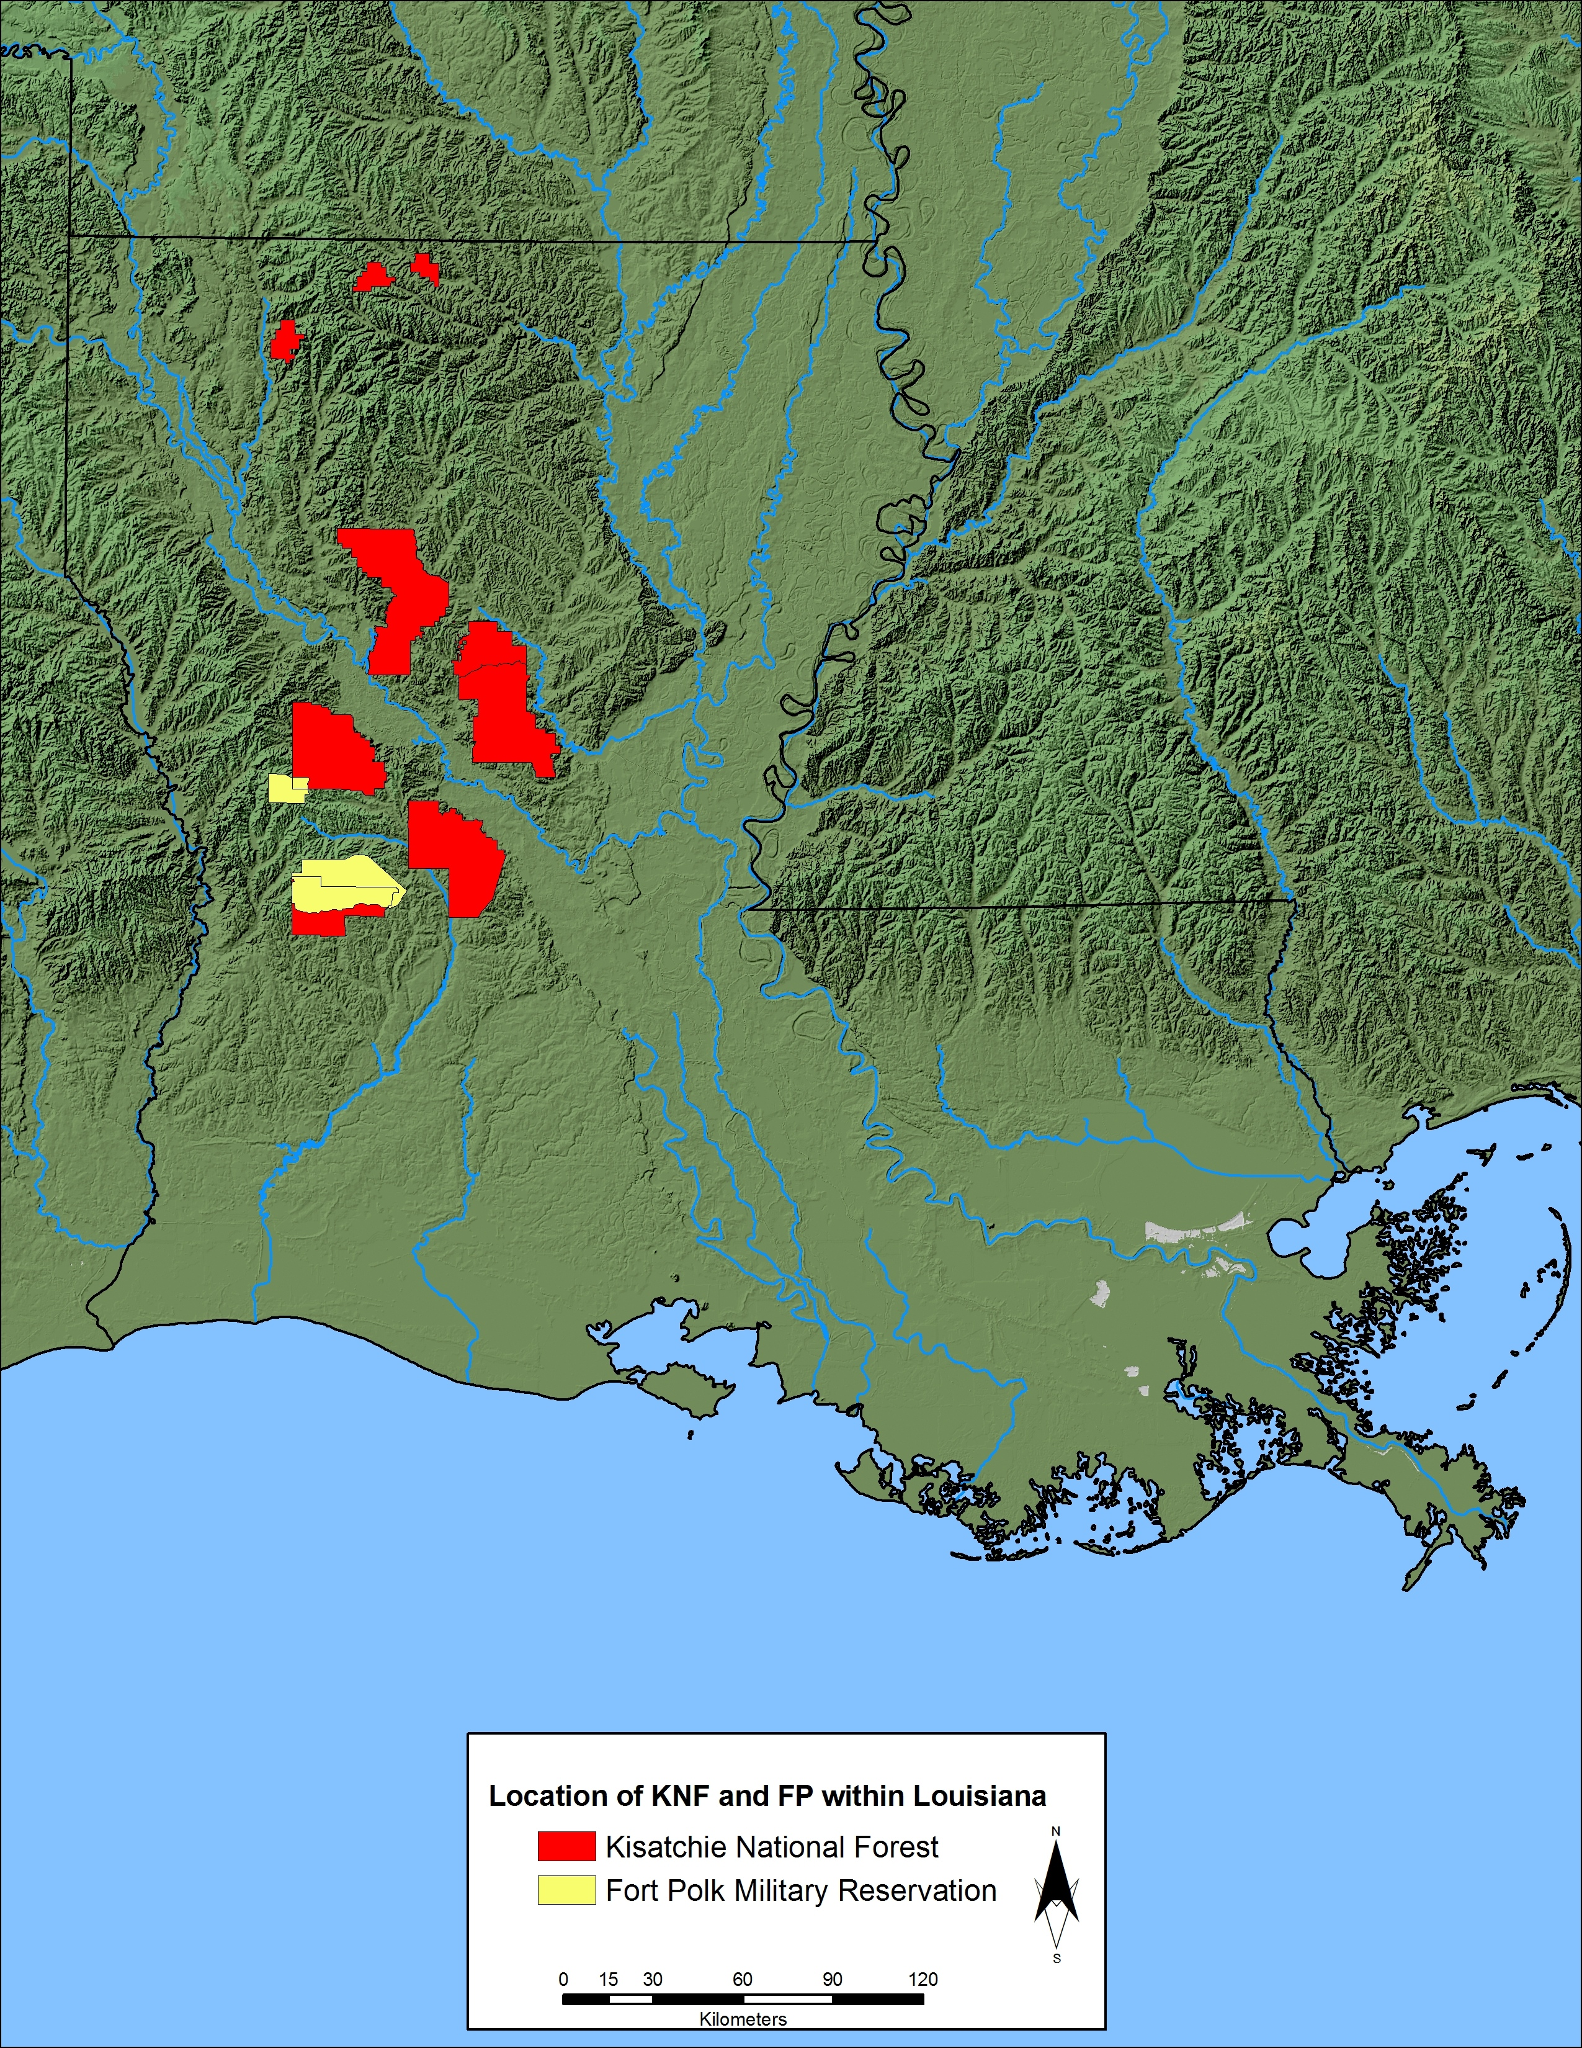
Figure 1.1. Location of the Kisatchie National Forest and the Fort Polk Military Reservation in Louisiana (See Figure 1.2 for KNF and Fort Polk by ranger district).

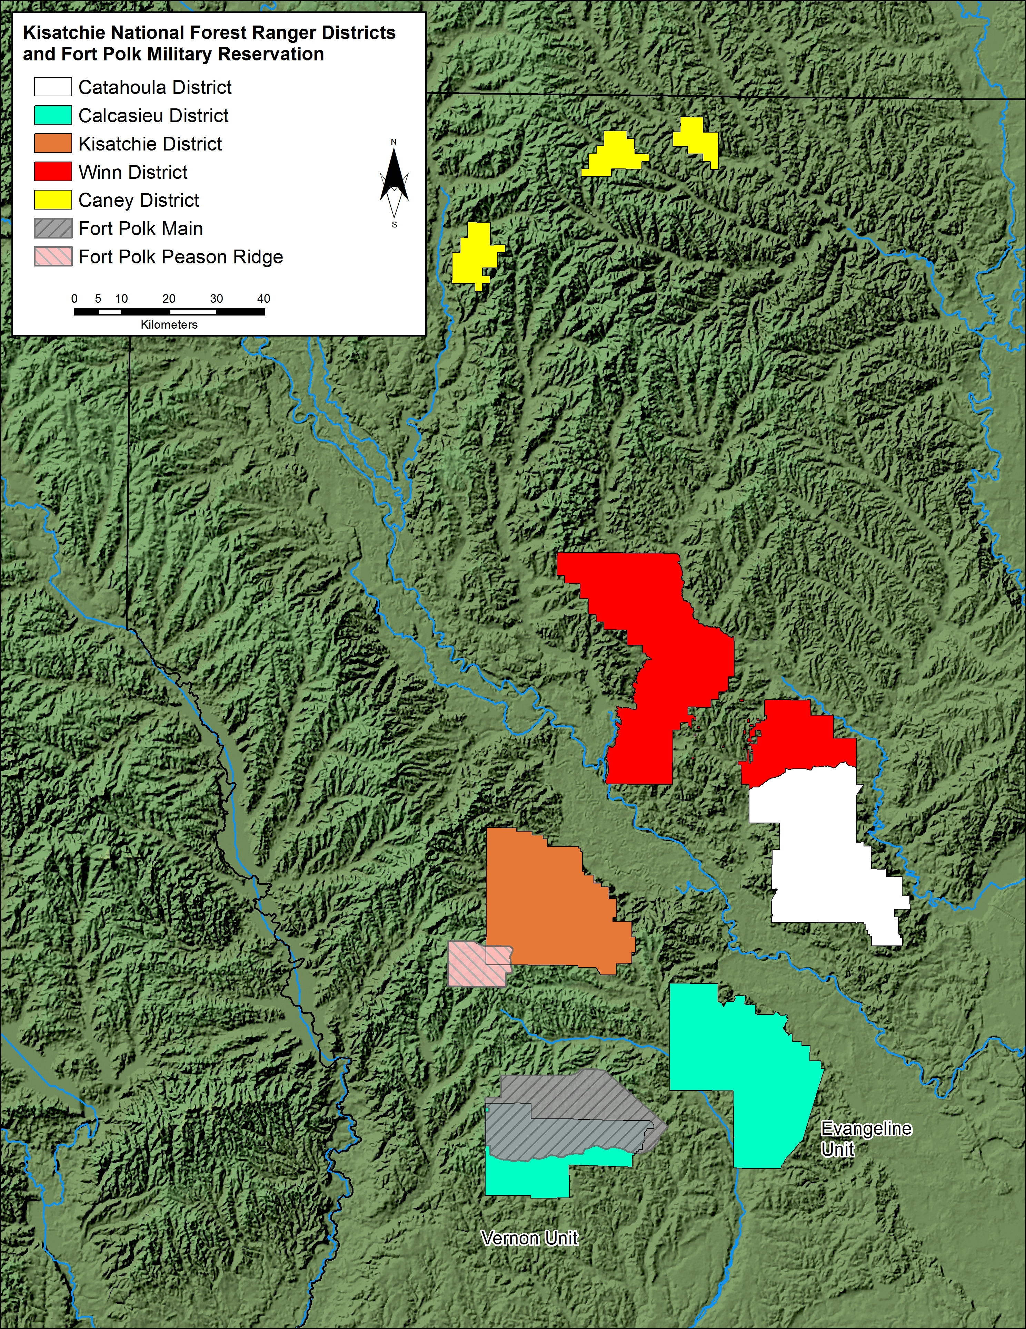
Figure 1.2. Location of the Kisatchie National Forest and the Fort Polk Military Reservation by ranger district.

subdivided into the Evangeline and Vernon Units—both of which are discontiguous from other districts as well as one another.
The Kisatchie National Forest (KNF) is headquartered in Pineville, Louisiana and managed by the U.S. Forest Service—an agency of the U.S. Department of Agriculture (USDA). The Kisatchie National Forest Heritage program is overseen by Velicia Bergstrom, the Forest heritage program manager. The program is responsible for the protection and curation of archaeological sites and structural features located on the Forest. As a federal agency, the Forest is required to conduct compliance-based archaeological work by the National Historic Preservation Act. Preservation efforts facilitated through the U.S. Forest Service have seen extensive archaeological survey across all ranger districts with 34.5 percent of USDA-owned lands surveyed as of 2011. An extremely large number of archaeological sites (n=4,175) , both prehistoric and historic, have been recorded within the total area of the Kisatchie National Forest including both USDA operated and privately held lands.
Guiding the cultural resource management efforts are settlement models and more recently predictive models, which serve to assign probabilities for containing archaeological sites to land areas based on an array of environmental variables. Such modeling efforts direct land-use planning and cultural resource assessments for Forest Service and Heritage personnel. The most common predictive models developed in and near the KNF are characterized by three probability zones (i.e. high, medium, low) containing corresponding densities of archaeological sites. Each probability zone reflects the selection and avoidance of areas for settlement by past populations. Prior to the development of formal empirical predictive models, archaeological fieldwork paralleled this process through clustering of surveys around logical features attractive to past human populations.
The predictive model currently employed by the Forest Service for the KNF was produced for the adjacent Fort Polk Military Reservation in 1995 (see Anderson et al. 1999; Anderson and Smith 2003). The Fort Polk Military Reservation overlays northern portions of the Vernon Unit of the Calcasieu ranger district as well as the southwestern corner of the Kisatchie ranger district (see Figure 1.2 above, also Appendix Figure A.1). The model recommends archaeological survey of tiered intensity based on probability zone. Variable survey intervals for shovel testing survey areas are not an uncommon recommendation as it serves to better allocate limited resources in the form of field technician hours. Implementing greater survey intensity in areas believed to contain more sites while limiting intensity in low probability zones does have the potential to become a self-fulfilling model, however, as by chance more sites should be encountered in zones receiving greater effort.
While the US Forest Service predictive model currently employed has been an important planning and management tool, it must be periodically evaluated for effectiveness, especially since the one currently in use was not produced for the Kisatchie National Forest. The current model, described in detail in Chapter 2 along with other models employed in the region, will be applied to evaluate geographic variation between the ranger districts and to parse out any temporal and cultural variation in site distribution. A new Fort Polk predictive model developed concurrently with this study is also summarized within Chapter 2. The methodology employed in the evaluation of the existing model and the development of a new model is described in Chapter 3. The purpose of the analyses conducted here, described in Chapters 3 through 5, was to determine the effectiveness of the current predictive model and recommend its continued use or its replacement/revision. Selected environmental variables as described within Chapter 3 were evaluated to determine the correlation between each variable and the location of archaeological sites while considering the background environment. The evaluation of environmental associations of archaeological sites was completed by district with results presented within Chapter 5 as well as within Appendix B. The Appendices also contains additional figures of archaeological site locations across the Kisatchie National Forest as separated by temporal components (Appendix A) as well as the 2011 KNF Predictive Model probability zone results by district (Appendix C), both of which supplement the tables and figures embedded within the text of this study.
Although the existing model has appreciable utility, it does not work well in all districts, particularly in the Caney District. For this reason, an improved predictive model for the Kisatchie National Forest is presented in Chapter 6 with effectiveness by district illustrated statistically. The recommendation of this study is to adopt the predictive model developed here for use across all ranger districts in order to more accurately predict the location of both prehistoric and historic archaeological sites.

Environmental Setting
Predictive modeling within an archaeological context heavily incorporates the environment of the study area as well as the archaeological record. In this chapter, the environmental setting is given an in-depth overview while the archaeological record is also examined both regionally and locally.

Physiography
The Kisatchie National Forest lies in west-central Louisiana, which falls within the Coastal Plain physiographic province. Within Louisiana, the Coastal Plain physiographic province is subdivided into five major natural regions: the uplands of the northwest, coastal terraces, Mississippi and Red River alluvial plains, Mississippi delta, and Chenier Plain (Rees 2010; Yodis et al. 2003). This region encompassing the Forest is frequently referred to as the “Kisatchie Wold” (Welch 1942) and is marked by dissected Pleistocene-age deltaic plains and terraces.

Geology
A variety of lithic raw materials have been reported at archaeological sites within the Kisatchie National Forest and on the nearby Fort Polk Military Reservation. Previous archaeological work around the Forest has emphasized the importance of proximity to exploitable lithic sources (e.g. Franks and Yakubik 1990). Indeed, lithic raw materials prove a necessary resource in any setting due to the importance of stone tool usage for prehistoric populations. While the distribution of lithic sources should provide insight toward subsistence and settlement patterns as well as trade relations in the region, the proximity to lithic material sources was not included within the analysis of environmental associations within Chapter 4 as the locations of the outcrops proved too approximate. This section instead serves as background insight as to why people settled the landscape around the Kisatchie National Forest.
Several in-depth reviews have been published of the geological formations as well as the lithic source locations within western Louisiana. Notably, Banks (1990) compiled a regional review of lithic sources for the Trans-Mississippi Coastal Plain with a detailed consideration of the Catahoula and overlying Fleming Formations that pass through the Kisatchie National Forest (Figure 1.3). The relative disparity in occurrence of lithic sources that naturally occur west of the Mississippi in western Louisiana highlights the importance of knappable raw material to the prehistoric human populations. Knowledge of and proximity to lithic outcrops, many researchers have argued, profoundly influenced settlement patterns in this lithic sparse region of the Trans-Mississippi Coastal Plain. It is therefore expected that higher densities of archaeological sites should be located near lithic sources; whether these sites express signatures of habitation or simply procurement requires detailed review of each site’s archaeological assemblage. Future prehistoric modeling efforts would benefit from accurate lithic source locations of both high and low quality raw materials.

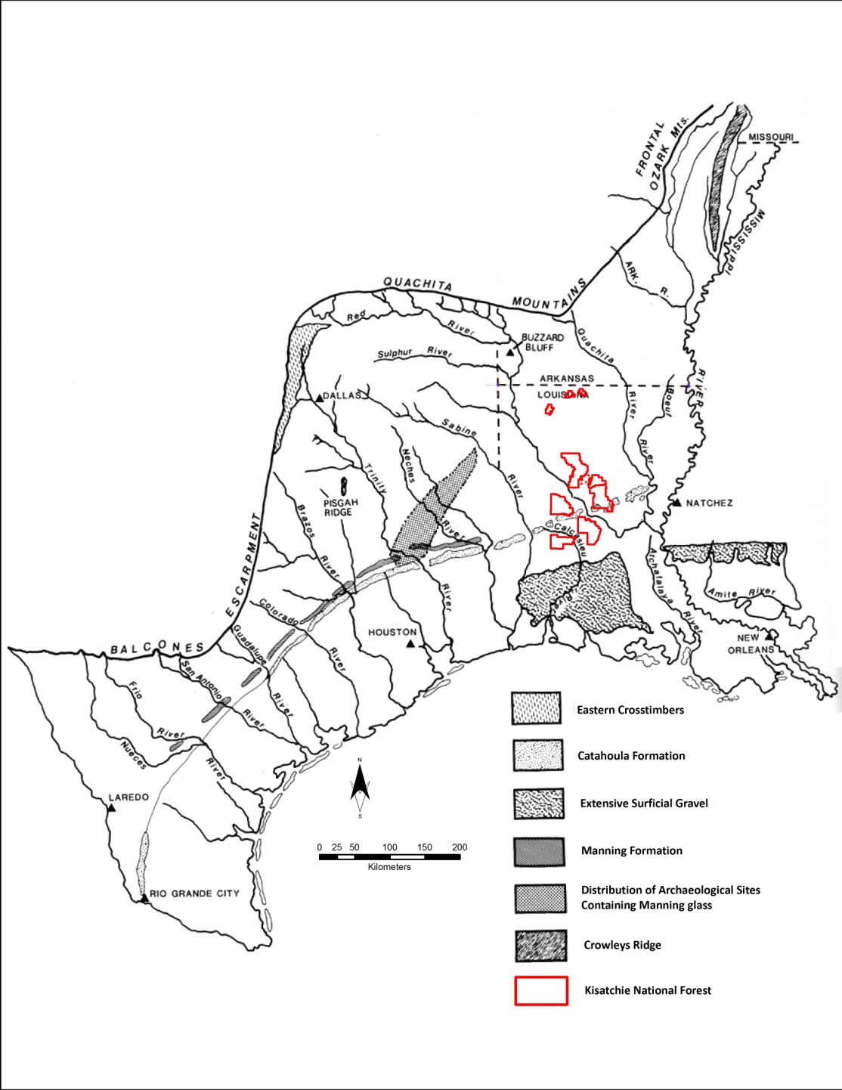
Figure 1.3. Chert sources in the Trans-Mississippi Gulf Coastal Plain in proximity to the Kisatchie National Forest (adapted from Banks 1990, Figure 2.1).

Within the outcropping strata of western Louisiana, six knappable lithic material types have been reported: silicified wood, Eagle Hill Chert, Gravel Chert, Fleming Gravel Chert, Fleming Opal, and Catahoula Sedimentary Quartzite (Banks 1990; Heinrich 1983, 1984; Jolly 1982; McGimsey 1996). Strata containing silicified wood tend to outcrop in broad bands across western Louisiana. Highly variable as a lithic resource, the process of opal and chert replacing the original organic wood produces stone of differing knapping quality based on the proportion of silica content. The variation can produce a black to dark grey material high in organic matter that fractures along the original wood grains in a flat or curved fashion or it can produce a highly permineralized hard material producing predictable conchoidal fractures when manipulated (Heinrich 1984:168).
Outcropping Miocene strata, namely the Catahoula and Fleming Formations, are identified as the primary source of silicified wood in the region and are concentrated within the upper Vernon Parish, lower Sabine Parish, and middle Rapides Parish (see figure 1.4 below) (Anderson 1960; Fisk 1940; Heinrich 1984; Matson 1916; Welch 1942). Additional, if less widespread sources, include the outcrops of the Sandel, Cockfield, and Summit Hall Formations of Central Sabine Parish (Anderson 1960:63, 92, 103), the Logansport Formation of the central De Soto Parish (Murray 1948:115), the Wilcox Group of southeastern Webster Parish (Martin et al. 1954:124), and the Pleistocene sands and gravels surrounding Vernon Parish. At the reported lithic sources, the lithic raw material—containing mostly palm wood—erodes out in pebble-size fragments to large log-size packages over a meter in diameter (Heinrich 1984:170). Dissection of Miocene strata through slope and stream

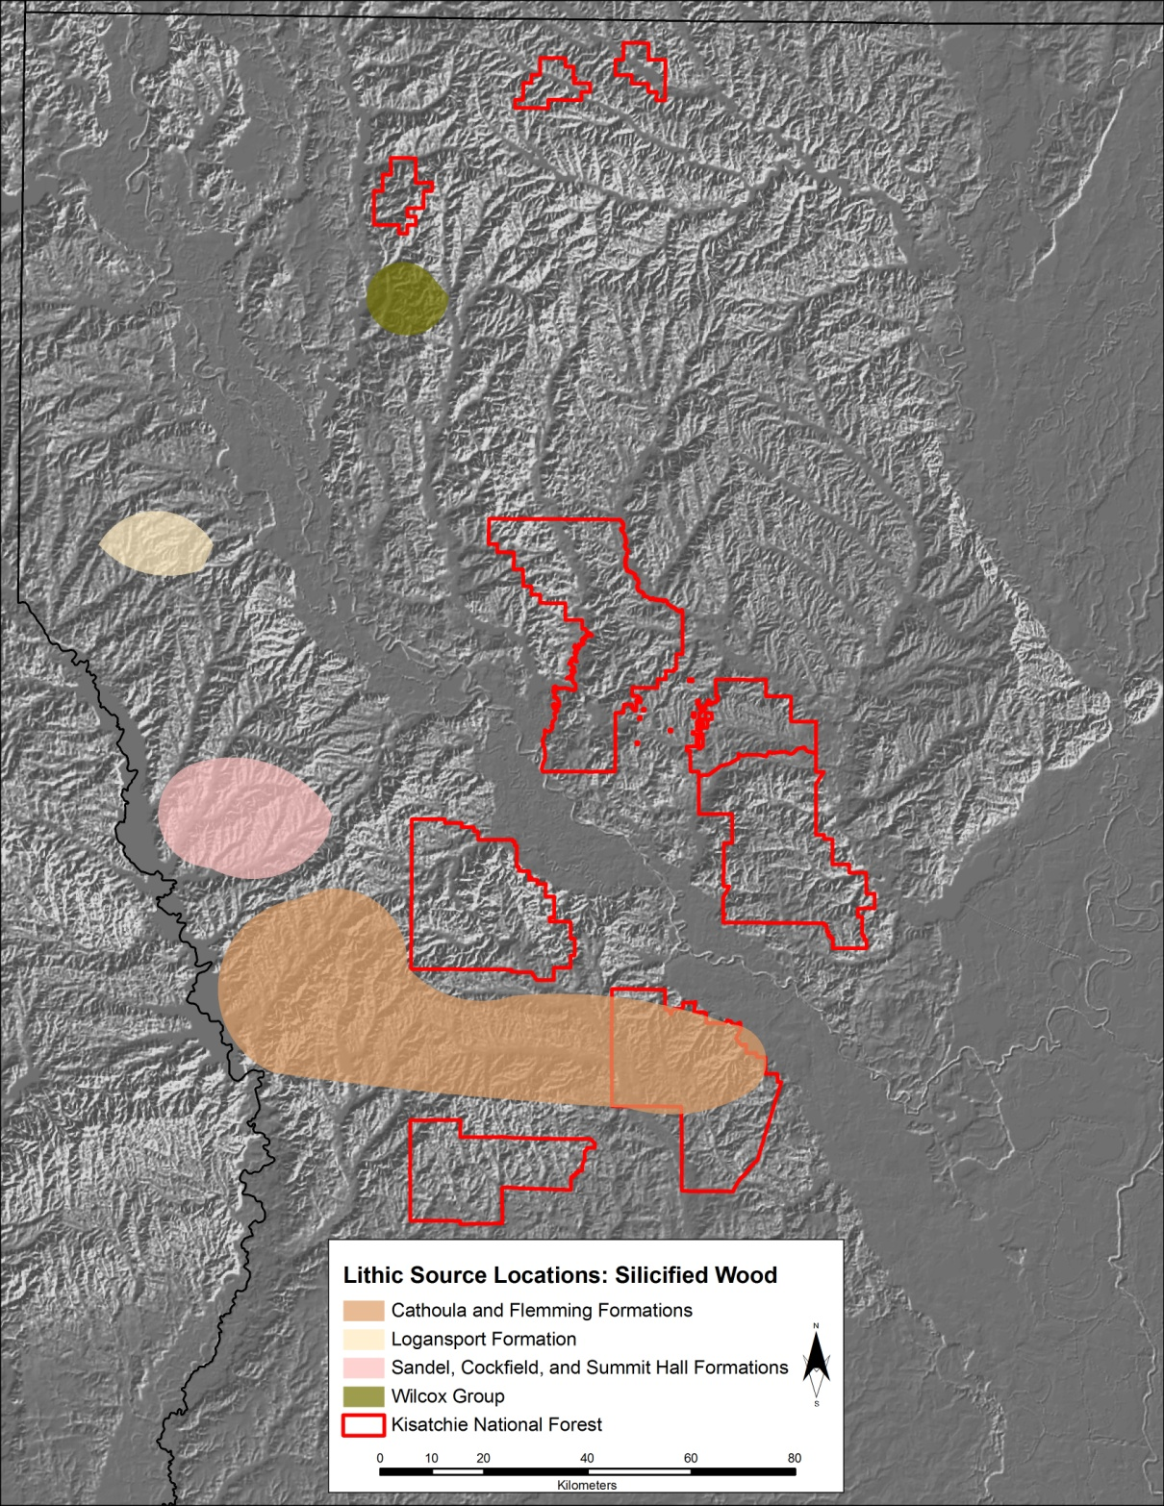
Figure 1.4. Lithic raw material source locations for silicified wood in western Louisiana (locations described by Heinrich 1984).

erosion provides the typical setting for the occurrence of large and small silicified wood packages (Brassieur 1983:251).
Eagle Hill Chert is a geographically restricted and highly silicified wood that lacks most semblances of its original wood structure. While Eagle Hill Chert is a silicified wood, it is discussed separately due to its relative absence of impurities, the uniform grain size of the microcrystalline quartz, and its restriction to the Eagle Hill area in Peason’s Ridge at the southwest extent of the Kisatchie District (Figure 1.5) (Heinrich 1984:1973). Visually variable by color and opaqueness, Eagle Hill Chert turns a black to mottled black following thermal alteration (Heinrich 1984:172).
Archaeological and petrographic data suggests large quarries of silicified wood outcropping within the Eagle Hill area as a result of: (1) the mineralogy and relict texture of Eagle Hill Chert matching other local silicified woods, (2) archaeological sites in this proximity exhibiting large quantities of primary and secondary reduction debris of Eagle Hill Chert, (3) these same archaeological sites reporting above 90 percent of the lithic raw material to be Eagle Hill Chert, and (4) unmodified nodules of Eagle Hill Chert appearing southwest of Eagle Hill (Heinrich 1984:173-174). As visible within the archaeological record, Eagle Hill Chert appears limited to the Eagle Hill area in high concentrations though it is likely that smaller outcrops do occur throughout the Fleming Formation. There remains a possibility for other highly concentrated localized outcrops which would likely produce exotic appearing but local cherts (Heinrich 1984:175).

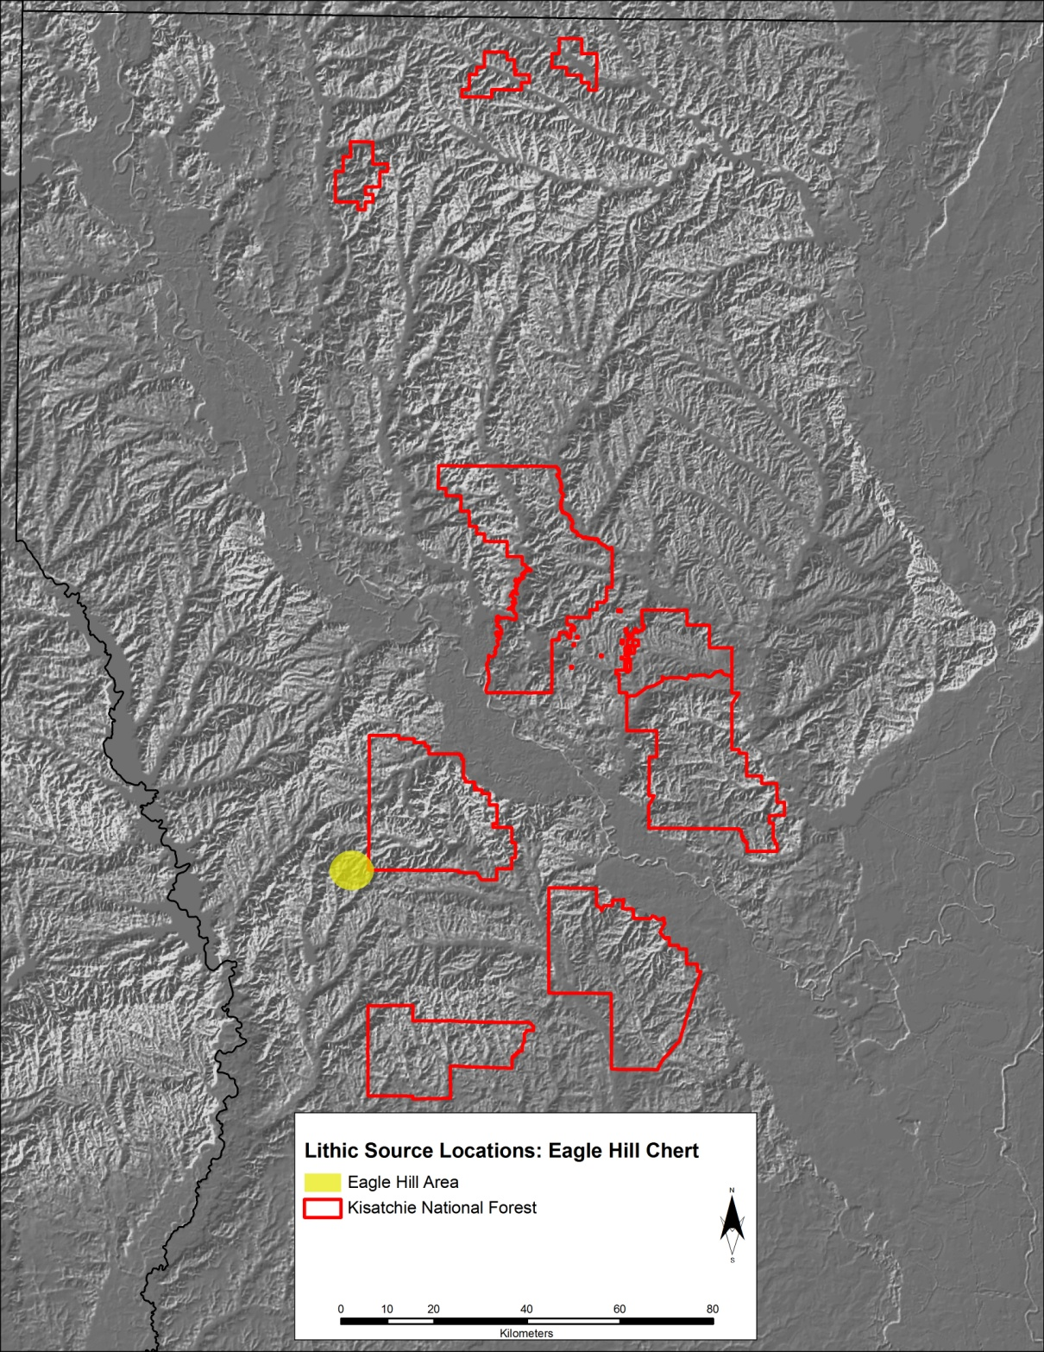
Figure 1.5. Lithic raw material source locations for Eagle Hill Chert in western Louisiana (locations described by Heinrich 1984).
Gravel Chert comprises the most utilized lithic resource by the prehistoric populations of western Louisiana (Figure 1.6). Gravel Cherts are found within Pleistocene strata and Holocene fluvial sediments and are the weathered and river-worn remains of highly transported cherts from outcrops of Paleozoic strata (Heinrich 1984:175). Consisting of hard, microcrystalline silica, the inconsistent quality and often limited size of the gravel restricted the form of crafted artifacts (Brassieur 1983:253). Heinrich (1984:176) notes that Gravel Chert colors range from red to brown, typically within the 10YR Munsell hue. Inclusions of relict textures including dolomite, casts of evaporates, fossils, and sponge spicules, among others, are common additions to the granular microcrystalline quartz composition (Heinrich 1984:176). The majority of Gravel Cherts occur within Pleistocene aged deposits outcropping along a west-east belt across southern Vernon Parish, northern Beaureguard Parish, northern Allen Parish, and central Rapides Parish (Heinrich 1984:178; Woodward and Geno 1941).

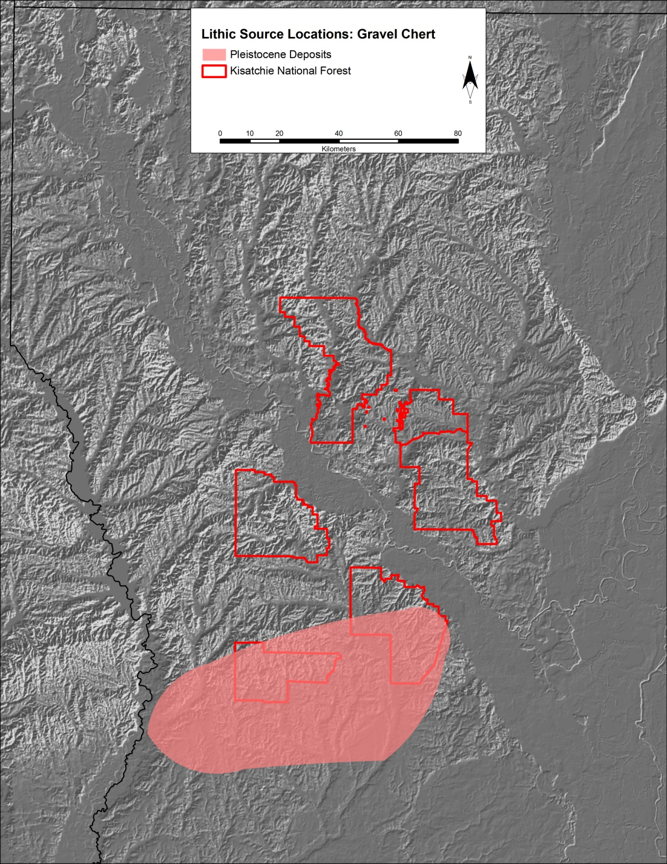
Figure 1.6. Lithic raw material source locations for Gravel Chert in western Louisiana. (locations described by Heinrich 1984).

Fleming Gravel Chert, named for the Fleming Formation where it occurs, shares most of its physical characteristics with the aforementioned Gravel Chert (Figure 1.7). Package sizes cluster around 2.5 cm in diameter, with the chert displaying a fine-grain black texture (Heinrich 1984:179). Isolated in its occurrence, Fleming Gravel Chert is reported by Heinrich (1984:179) to source to a ravine tributary of the Sabine River within Vernon Parish.
Occurring exclusively within the Fleming Formation (Figure 1.7), Fleming Opal represents a less dense material than chert that results in a blocky conchoidal fracture when manipulated (Heinrich 1984:180). A white to off-white cortex masks a highly variable opal color with specimens ranging from 10YR greys to 2.5YR browns (Heinrich 1984:180). The opal nodule package size ranges from 0.6 to 30 cm in diameter and has been identified by Heinrich (1984:181) and Welch (1942:42,49) to source to the Fleming Formation of Rapides and Vernon Parishes as well as within the Eagle Hill area.

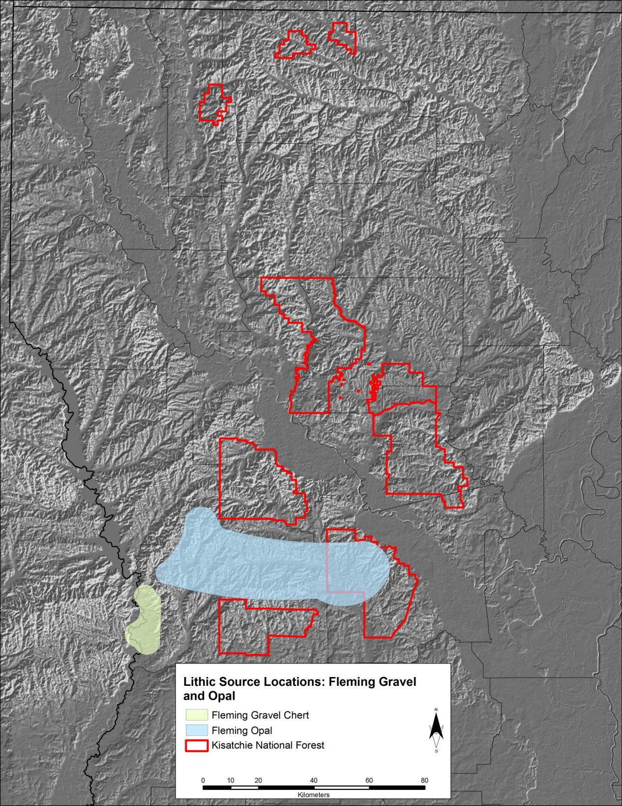
Figure 1.7. Lithic raw material source locations for Fleming Gravel and Fleming Opal in western Louisiana (locations described by Heinrich 1984).

Catahoula Sedimentary Quartzite is a relatively minor lithic material in western Louisiana likely due to the rough fracture characteristics of the material (Andrefsky 2005:24). Revealed through fracture, the quartzite typically is a rough vitreous material with floating grains of sands visible throughout the translucent dark grey material (Heinrich 1984:182). Scattered Pleistocene gravel exposures throughout the Catahoula Formation contain cobbles and pebbles of the quartzite along a west-east outcropping belt that is 8 to 16 km wide and 240 km long passing through southern Sabine Parish and central Nachitoches Parish (Heinrich 1984:184; Woodward and Geno 1941).
The typing of lithic artifacts from a sample of archaeological site assemblages across the Kisatchie National Forest by ranger district emphasizes the use intensity of gravel cherts in the region (Table 1.1). The remaining lithic sources together account for under 20 percent of the total analyzed artifacts. It can be inferred that prehistoric populations were utilizing more readily available lithic raw materials (e.g. Gravel Cherts). More data in the form of lithic outcrop locations will eventually provide an extremely relevant variable to incorporate into predictive modeling efforts in this region.
Table 1.1. Lithic Raw Materials, by Type, on a Sample of Sites from the Kisatchie National Forest (adapted from Anderson and Smith 2003:151, Table 3.3; Phillips and Haikey 1992).
 | Ranger District
Material | Catahoula | Evangeline | Kisatchie | Vernon | Totals
Gravel Chert | 1,309 | 1,749 | 901 | 2,569 | 6,528
(% of Total) | (72.8) | (82.54) | (82.54) | (82.54) | (82.54)
Silicified Wood | 64 | 6 | 328 | 14 | 412
(% of Total) | (3.56) | (0.28) | (5.02) | (0.47) | (6.31)
Catahoula Sedimentary Quartzite | 145 | 3 | 146 | 3 | 297
(% of Total) | (8.06) | (0.14) | (9.28) | (0.10) | (3.51)
Red Jasper | 125 | 181 | 140 | 323 | 769
(% of Total) | (6.95) | (8.54) | (8.89) | (10.91) | (9.10)
Fleming Opal | 0 | 0 | 2 | 4 | 6
(% of Total) | (0.00) | (0.00) | (0.13) | (0.14) | (0.07)
Fleming Chert | 4 | 10 | 3 | 3 | 20
(% of Total) | (0.22) | (0.47) | (0.19) | (0.10) | (0.24)
Banded Chert | 69 | 100 | 25 | 39 | 233
(% of Total) | (3.84) | (4.72) | (1.59) | (1.32) | (2.76)
Quartz | 11 | 11 | 4 | 1 | 27
(% of Total) | (0.61) | (0.52) | (0.25) | (0.03) | (0.32)
Other | 71 | 59 | 25 | 4 | 159
(% of Total) | (3.95) | (2.78) | (1.59) | (0.14) | (1.88)
Totals | 1798 | 2119 | 1574 | 2960 | 8451
(% of Total) | (100.00) | (100.00) | (100.00) | (100.00) | (100.00)

Soils
The soils in the region surrounding Kisatchie National Forest are classified by the USDA Natural Resources Conservation Service (NRCS) Soil Survey Geographic (SSURGO) Database as highly weathered Ultisols with low organic preservation. Soil profiles in the uplands are shallow with cultural activity often detected within the upper thirty centimeters, often proving advantageous for archaeological survey as noted in cultural resource management (CRM) reports (e.g. Heide 1999:7). Due to floodplain dynamics, cultural material within the floodplain is frequently deposited significantly deeper than the cultural material in the uplands. Sixty-five distinct soil types are classified within the Forest’s Geographic Information System (GIS) database—a result of a comprehensive USDA soil mapping project available through the Natural Resources Conservation Service (NRCS; http://soils.usda.gov/survey/geography/ssurgo/). These soils, along with the proportion of total forest acreage coverage by soil and drainage class are detailed in Table 1.2. The incorporated soil data for the modeling analysis are detailed in Chapter 3 as soil characteristics play a large role in both the active U.S. Forest Service Model and the newly developed predictive model outlined in Chapter 6.
Historically, the poor soil quality for growing crops directed early European settlement to areas along major river ways (Mann 2010). Unable to support substantial agriculture, the soils of western Louisiana, both those in the uplands and the flood-prone lowlands, appear to have been unfavorable for agriculture, and prevented large communities from forming in the historic era. This changed with the establishment of the timber industry and the introduction of the railroad in the late 19th century, which resulted in access to imported agricultural products. The soil differences between the uplands and lowlands would have thus limited past settlement, both historically and prehistorically. This assertion is evaluated within the following chapters of this study.

Table 1.2. Soil Types in the Kisatchie National Forest and Their Percent Coverage of Total Area within the KNF Boundaries (NRCS; http://soils.usda.gov/survey/geography/ssurgo).
Soil Name | Phase | Coverage (%) | Drainage
ACADIA | SILT LOAM | 0.18 | Somewhat Poorly
ALAGA | LOAMY FINE SAND | 0.01 | Well
ANACOCCO | LOAM | 1.37 | Somewhat Poorly
ANGIE | VERY FINE SANDY LOAM | 0.11 | Somewhat Poorly
BEAUREGARD | VERY FINE SANDY LOAM | 2.29 | Somewhat Poorly
BEAUREGARD-MALBIS | COMPLEX | 0.83 | Somewhat Poorly
BELLWOOD | LOAM | 5.19 | Somewhat Poorly
BETIS | LOAMY FINE SAND | 2.52 | Well
BETIS-BOYKIN | COMPLEX | 0.98 | Well
BIENVILLE | LOAMY FINE SAND | 0.36 | Well
BOWIE | FINE SANDY LOAM | 0.04 | Somewhat Poorly
BOYKIN | LOAMY FINE SAND | 0.93 | Moderately Well
BRILEY | LOAMY FINE SAND | 2.80 | Moderately Well
BRIMSTONE | VERY FINE SANDY LOAM | 0.04 | Poorly
CADDO | VERY FINE SANDY LOAM | 1.30 | Poorly
CADEVILLE | VERY FINE SANDY LOAM | 2.51 | Somewhat Poorly
CAHABA | FINE SANDY LOAM | 1.13 | Moderately Well
DARDEN | LOAMY FINE SAND | 0.07 | Excessively
DARLEY | GRAVELLY | 0.54 | Moderately Well
DARLEY-SACUL | COMPLEX | 0.13 | Moderately Well
EASTWOOD | VERY FINE SANDY LOAM | 1.23 | Somewhat Poorly
FLO | LOAMY FINE SAND | 0.10 | Well
FORBING | SILT LOAM | 0.03 | Somewhat Poorly
FRIZZELL-GUYTON | COMPLEX | 3.40 | Somewhat Poorly
GALLION | SILT LOAM RARE FLOOD | 0.05 | Moderately Well
GLENMORA | VERY FINE SANDY LOAM | 2.37 | Somewhat Poorly
GORE | VERY FINE SANDY LOAM | 2.98 | Somewhat Poorly
GUYTON | COMPLEX | 14.35 | Poorly
GUYTON-LOTUS | ASSN. FREQ. FLOODED | 1.09 | Poorly
HARLESTON | FINE SANDY LOAM | 0.04 | Somewhat Poorly
HOLLYWOOD | SILTY CLAY LOAM | 0.13 | Somewhat Poorly
IUKA-DELTA | COMPLEX FREQ. FLOOD | 0.42 | Somewhat Poorly
KEITHVILLE | LOAM | 0.45 | Somewhat Poorly
KIEFFER | LOAM | 0.02 | Somewhat Poorly
KISATCHIE | CLAY SEVERE ERODED | 0.72 | Moderately Well
KISATCHIE - ANACOCO | COMPLEX | 0.42 | Moderately Well
KISATCHIE-OULA | COMPLEX | 3.29 | Moderately Well
KISATCHIE-RAYBURN | COMPLEX | 0.00 | Moderately Well
KOLIN | SILT LOAM | 0.97 | Somewhat Poorly
LARUE | LOAMY FINE SAND | 0.01 | Moderately Well
MAHAN | FINE SANDY LOAM | 0.21 | Moderately Well
MALBIS | FINE SANDY LOAM | 8.69 | Somewhat Poorly
MAYHEW | SILTY CLAY LOAM | 0.19 | Poorly
MCLAURIN | LOAMY FINE SAND | 0.05 | Moderately Well
METCALF | VERY FINE SANDY LOAM | 1.50 | Somewhat Poorly
MORELAND | CLAY FREQ. FLOODED | 0.71 | Somewhat Poorly
MORSE | SILTY CLAY | 0.04 | Moderately Well
NATCHITOCHES | SANDY CLAY LOAM | 0.33 | Moderately Well
OCHLOCHONEE | SANDY LOAM | 0.91 | Moderately Well
OKTIBBEHA | SILT LOAM | 0.25 | Somewhat Poorly
OSIER | LOAMY FINE SAND | 0.23 | Poorly
PERRY | CLAY OCCAS. FLOODED | 0.13 | Poorly
RIGOLETTE-KISATCHIE | ASSOCIATION | 0.11 | Somewhat Poorly
ROXANNA | FREQUENTLY FLOODED | 0.04 | Moderately Well
RUSTON | FINE SANDY LOAM | 7.77 | Moderately Well
SACUL | FINE SANDY LOAM | 7.08 | Somewhat Poorly
SAVANAH | FINE SANDY LOAM | 2.26 | Somewhat Poorly
SAWYER | LOAM | 0.04 | Somewhat Poorly
SHATTA | VERY FINE SANDY LOAM | 0.08 | Moderately Well
SMITHDALE | FINE SANDY LOAM | 11.62 | Moderately Well
SMITHDALE-GORE | COMPLEX | 0.11 | Moderately Well
VAIDEN | SILTY CLAY | 0.65 | Somewhat Poorly
WOLFPEN | LOAMY SAND | 0.59 | Moderately Well
WRIGHTSVILLE | SILT LOAM | 0.05 | Poorly
YORKTOWN | CLAY FREQ. FLOODED | 0.92 | Very Poorly

Hydrology
Two primary drainages dissect Louisiana and influence the physiographic divisions of the state. The first, the Mississippi River, provides fertile floodplains for the eastern portion of the state, but it is not discussed at length due to its seventy kilometer distance from the nearest Forest District—the Catahoula district. The Red River and its tributaries drain portions of the Kisatchie National Forest before emptying into the Mississippi River. Two other large drainages in the region, the Calcasieu and the Sabine rivers, also drain the southern districts southward into the Gulf of Mexico. The streams and the associated tributaries of these three river systems dissect the uplands and transport eroded soils. The activity of these systems results in the exposure of lithic sources, which prehistoric peoples frequently mined for materials to manufacture tools. The archaeological populations also favored these river systems for settlement and movement for a variety of reasons, primarily subsistence related.
Caney District in the north of Louisiana is within moderate proximity to the Red River as well as both the Bayou Dorcheat and Bayou D’Arbonne. Saucier (1994:50) notes that bayous and slow moving river systems are a relatively new feature to the landscape, only forming after sea levels and river channels stabilized between 5,000 and 2,000 years ago. While the glaciers of the Last Glacial Maximum indirectly impacted the landscape in Louisiana, the Lower Mississippi Valley underwent the most dramatic changes as a result of fluctuating water levels (Rees 2010b:34). Past settlement would have been affected by the differing environmental conditions; however, the general environment of the Forest area within the modeling context is assumed to be relatively similar to that of modern conditions with the exception being the hydrology of western Louisiana past 5,000 years ago.

Ecoregions
Ecoregions delineate geographical areas within which a homogeneous ecosystem exists while also denoting the category, quality, and magnitude of available environmental resources (Daigle 2006). For anthropological purposes, the inclusion of both biotic and abiotic environmental categories such as flora, fauna, climate, soils, and hydrology in addition to the historically utilized categories of physiography and geology aid in parsing out variability within the environment at a finer scale (Omernik 1987, 1995; Wiken 1986). The diversity of factors contributing to ecoregions is relevant when situating prehistoric and historic settlement patterns and landscape use within the modern ecosystem. Ecoregions spatially portray environmental changes and similarities based on ecosystem capacities and potentials (Bryce et al. 1999).
The U.S. Environmental Protection Agency developed and employs a hierarchical ecoregion schema for the research assessment of ecosystems between multiple monitoring agencies and organizations (McMahon et al. 2001; Omernik 1987). The schema involves a refining and subdividing structure ranging from Level I, which divides North America into 15 ecological regions, to Level IV, an extremely detailed partitioning of local ecosystems. As relevant to Kisatchie National Forest, only the Level III and Level IV ecoregions for Louisiana are detailed in the following dialogue as drawn from published descriptions presented by Diagle et al. (2006). The ecoregion figures and the discussion of ecoregions serve as background context for the analysis in subsequent chapters.
Louisiana contains six Level III ecoregions with the majority of the state classified as either the Mississippi Alluvial Plain region on the east or the South Central Plains region to the northwest (Figure 1.8). The boundary of the Kisatchie National Forest lies completely within the South Central Plains ecoregion, which extends eastward to the bottomlands of the Ouachita River and Red River and southward to the Gulf Coastal Plain. The South Central Plains region spans portions of Arkansas, Oklahoma, and east Texas in addition to Louisiana. Unlike the flatter and intact terrain of the adjacent Mississippi Alluvial Plain and Western Gulf Coastal Plain regions, the South Central Plains region exhibits undulating plains interrupted by flat fluvial terraces, bottomlands, sandy low hills, and low cuestas. This region

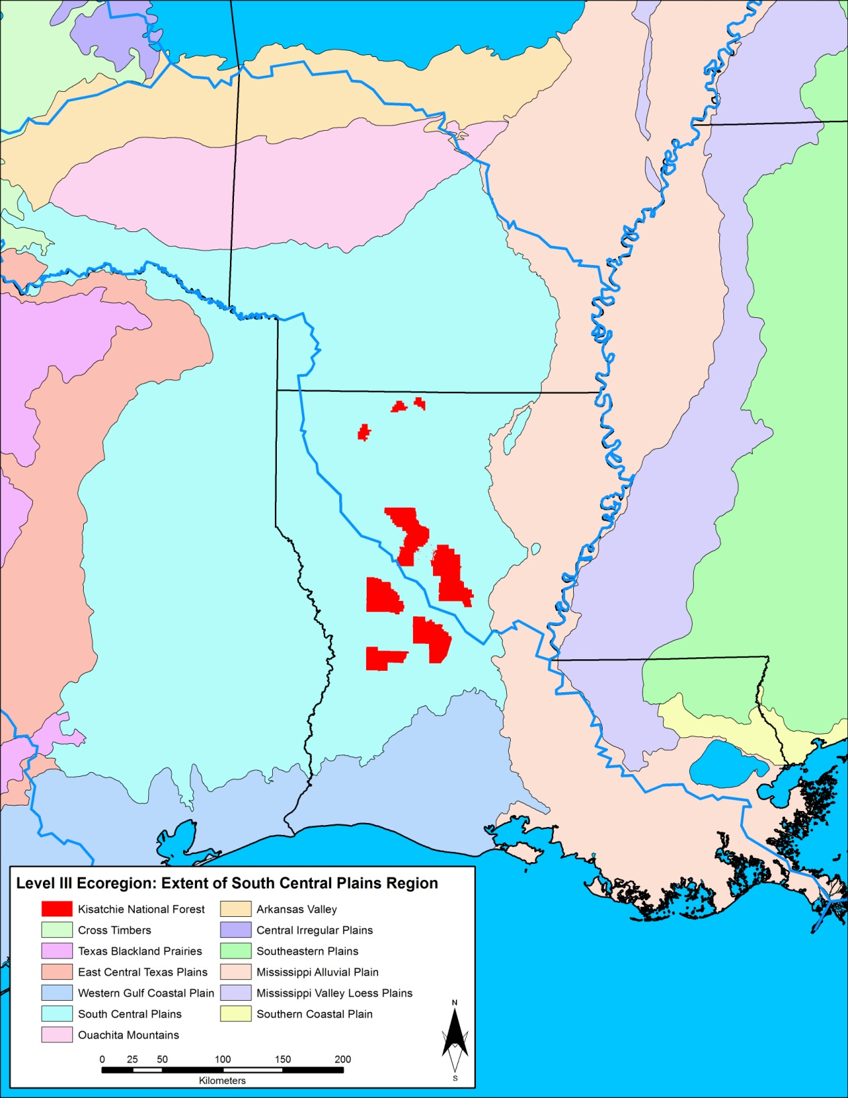
Figure 1.8. Extent of South Central Plains Level III Ecoregion (Daigle et al. 2006; US Environmental Protection Agency; GIS data available at http://www.epa.gov/wed/pages/ecoregions.htm).

displays more dissection with greater topographic relief as compared with its neighboring ecoregions within Louisiana. A lithologic mosaic, the South Central Plains’ uplands are underlain with Tertiary Coastal Plain while its bottomlands and terraces are underlain with Quaternary alluvium, terrace deposits, or loess. The soil composition is mostly acidic sandy loams, silt loams, sands, and sandy clay loams.
At a more local level, four Level IV ecoregions are contained within the Forest’s five ranger districts: the Red River Bottom Lands, the Pleistocene Fluvial Terraces, the Tertiary Uplands, and the Southern Tertiary Uplands (Figures 1.9 to 1.13). With the exception of the Caney District in the north of the state, the Southern Tertiary Uplands ecoregion accounts for the majority of the Kisatchie land area whereas the Caney District is entirely encompassed by the Tertiary Uplands ecoregion. The geographic extent of the Kisatchie National Forest, due to the discontiguous nature of the districts, makes it a diverse Forest system to model. The diversity between the different Level IV ecoregions is expressed in general diverging trends relating to geology, botany, and soils (Omernik 1987, 1995; Wiken 1986).

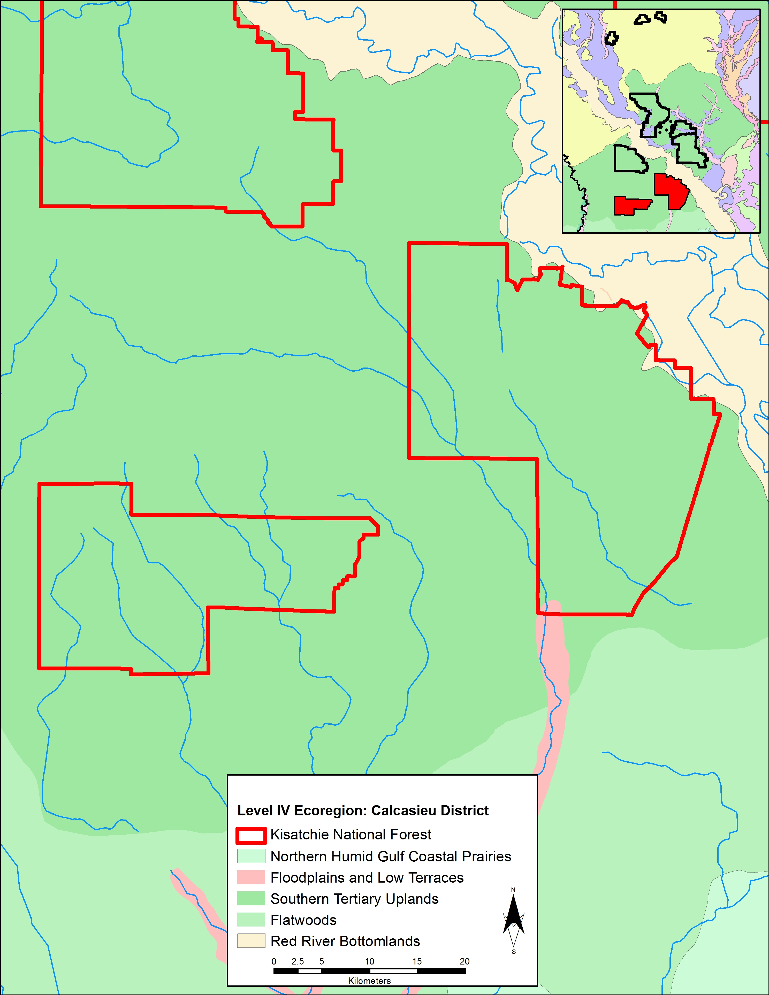
Figure 1.9. Level IV Ecoregion coverage for Calcasieu District—Vernon Unit (west) and Evangeline (east) (Daigle et al. 2006; US Environmental Protection Agency; GIS data available at http://www.epa.gov/wed/pages/ecoregions.htm).

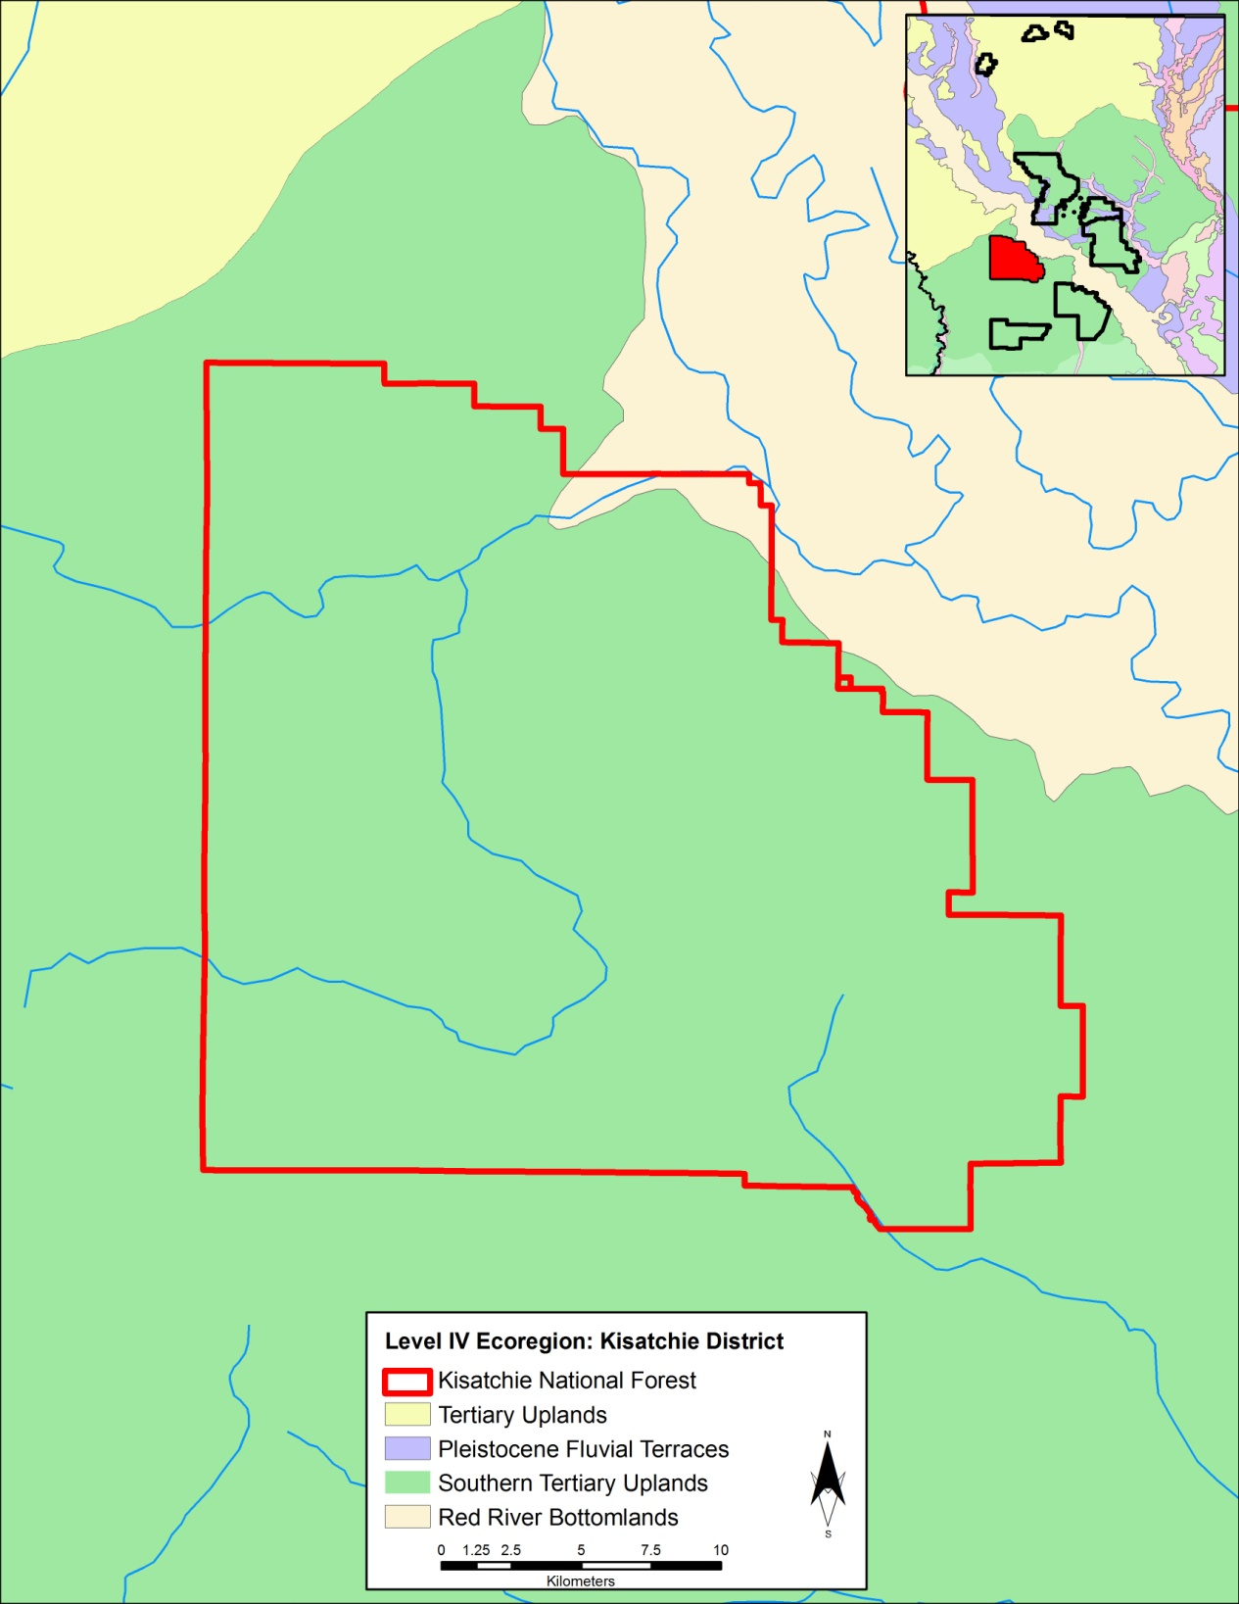
Figure 1.10. Level IV Ecoregion coverage for Kisatchie District (Daigle et al. 2006 US Environmental Protection Agency; GIS data available at http://www.epa.gov/wed/pages/ecoregions.htm).

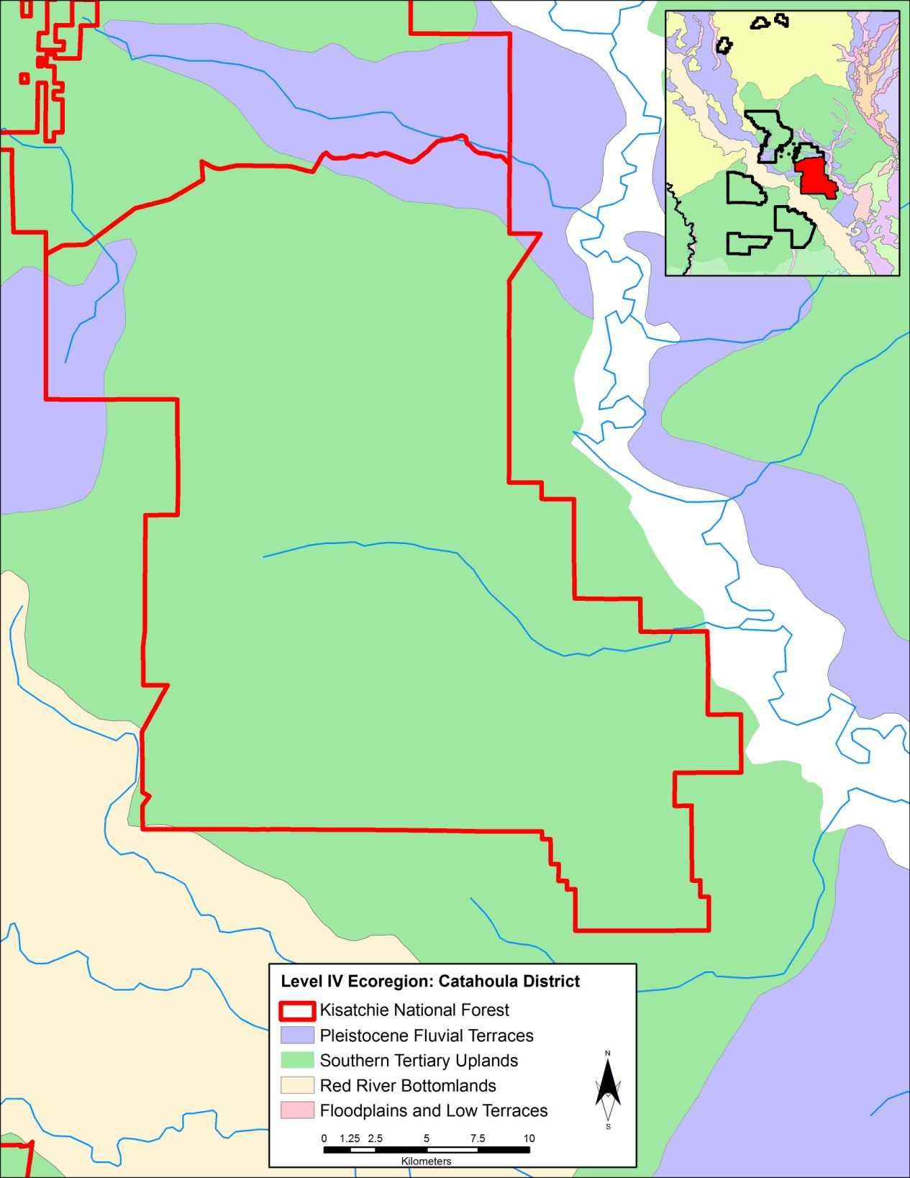
Figure 1.11. Level IV Ecoregion coverage for Catahoula District (Daigle et al. 2006; US Environmental Protection Agency; GIS data available at http://www.epa.gov/wed/pages/ecoregions.htm).

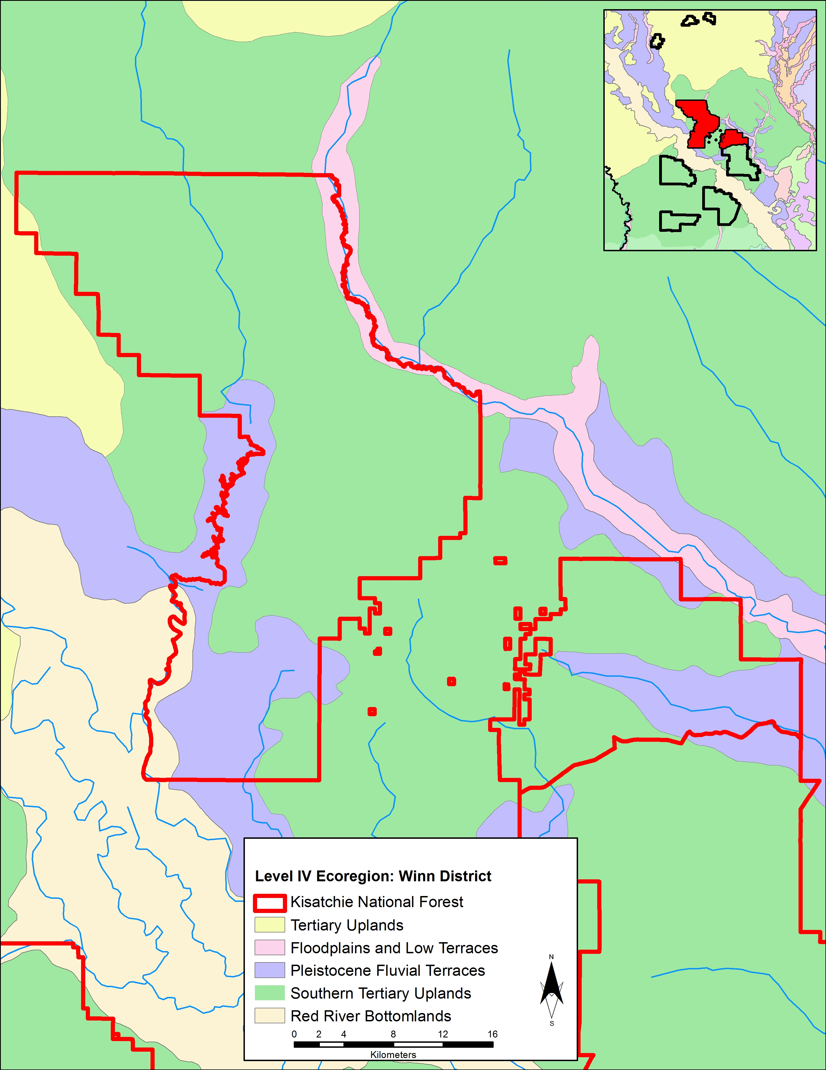
Figure 1.12. Level IV Ecoregion coverage for Winn District (Daigle et al. 2006; US Environmental Protection Agency; GIS data available at http://www.epa.gov/wed/pages/ecoregions.htm).

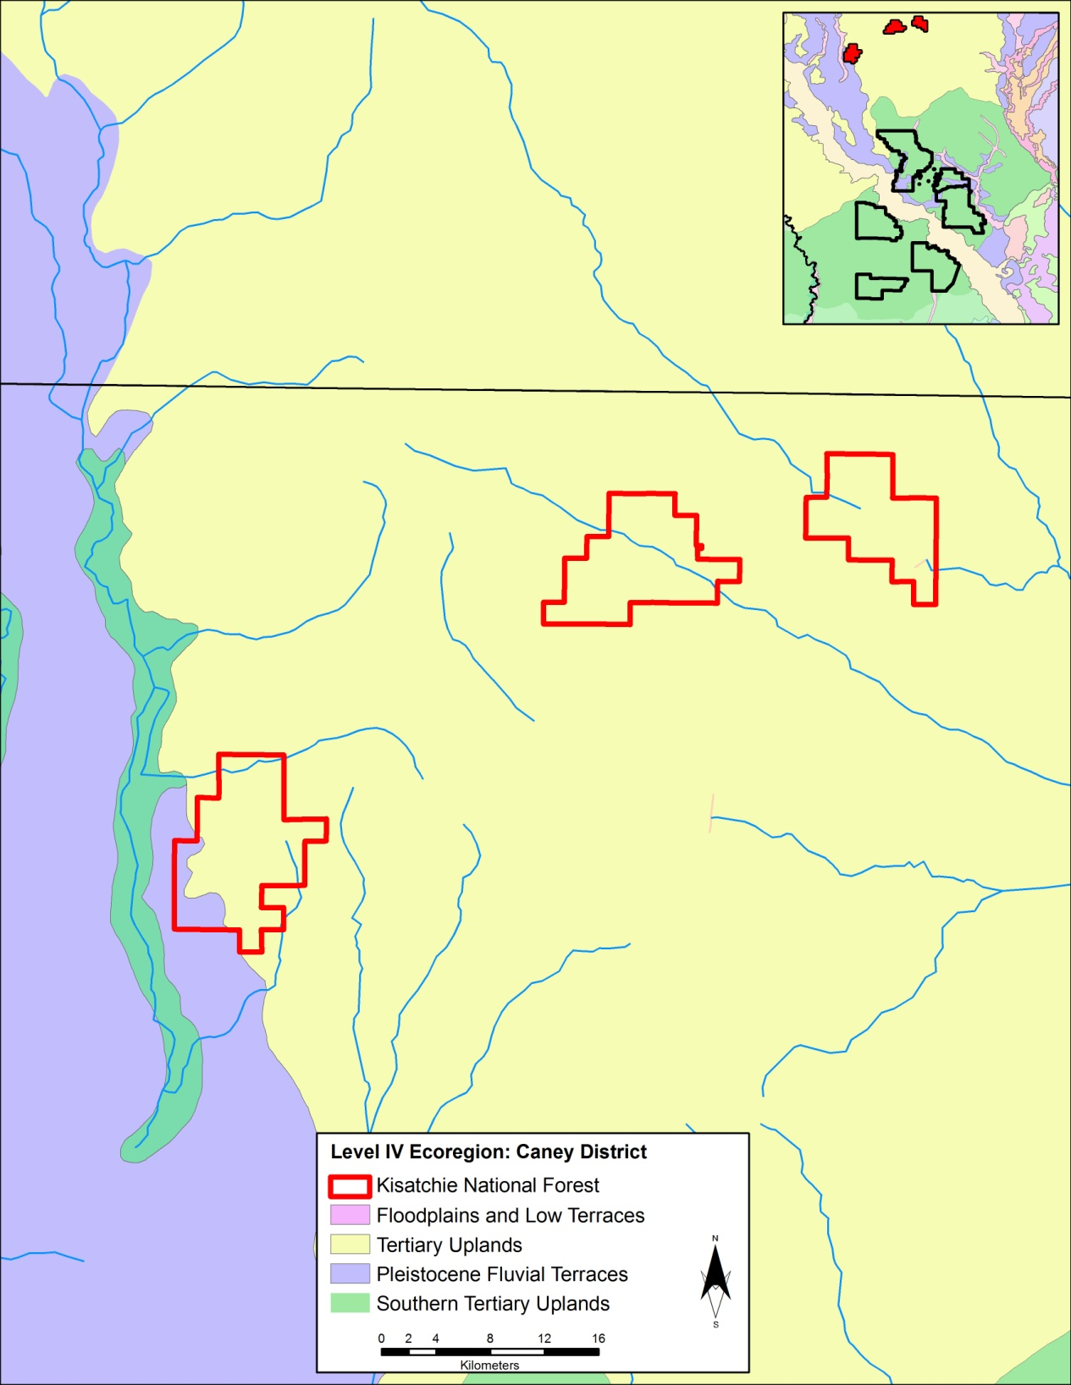
Figure 1.13. Level IV Ecoregion coverage for Caney District (Daigle et al. 2006; US Environmental Protection Agency; GIS data available at http://www.epa.gov/wed/pages/ecoregions.htm).

The Southern Tertiary Uplands (Omernik 1987) represents a hilly and well-drained region as a result of its Tertiary geology. The Ultisols and Alfisols soils that characterize the uplands are formed in humid climates and are mineral heavy with silt loam to loamy sand textures (Steila and Pond 1989: Chapter 10). The high basic saturation level of Alfisols suggests high soil fertility whereas the absence of a supply of bases results in the infertile nature of Ultisols suggesting varying soil quality across the ecoregion based on drainage (Steila and Pond 1989). Longleaf pine-bluestem woodlands comprise the majority of the historical vegetation of the Southern Tertiary Uplands region, and helped create the timber industry that has operated in the region since the late nineteenth century. Other contemporary vegetation includes shortleaf pine-hardwood forests, calcareous forests, mixed hardwood-loblolly pine forests, and hardwood-dominated forests near streams. Occurring in association with rare soil and geological outcrops, several rare vegetation communities exist. Isolated prairies with rare plants species occur in areas of calcareous clay soils while American beech or magnolia-beech-loblolly pine forests occur among the more common mesic localities within the Southern Tertiary Uplands. Acid bog species including southern sweetbay, gallberry, wax-myrtles, fetterbush, insectivorous plants, orchids, and wild azalea appear along seeps in sand hills.
Similar to the Southern Tertiary Uplands region in its geological and soil composition, the Tertiary Uplands (Omernik 1987) contain a variety of habitats and species including many of the state’s rare plant and animal species. Native species of shortleaf pine-hardwood have largely been replaced by commercial pine plantations. Other native tree species include loblolly pine, southern red oak, post oak, black oak, white oak, hickories, and sweetgum with understory species consisting of American beautyberry, sumac, greenbriar, and hawthorn. Areas containing sandier soils possess more bluejack oak, post oak, and stunted pines. Numerous small waterways dissect the Tertiary Uplands with stream flow decreasing in summer and fall. Climatically, the region tends to produce less annual precipitation, marking it as one of the driest regions in Louisiana.
The Pleistocene Fluvial Terraces region (Omernik 1987) contrasts the gentle rolling landscape of the Southern Tertiary Uplands and Tertiary Uplands regions due to its flat topography and poorly-drained soils—Alfisols and Ultisols with loamy and sandy textures. Variation in the terracing occurs with the lowest terrace being extremely flat with greater clay concentration and extensive hardwood wetlands accustomed to the hydroxeric regime. Higher terraces, exhibiting greater geological antiquity as compared with the lower terraces, are more dissected with less wetlands. The higher terraces contain either pine flatwoods or mixed pine and oak forests. The midlevel terrace is a hybrid of the lower and upper with significant loess deposits.
The Red River Bottomlands region (Omernik 1987) follows the Red River and its broad bottomlands, including the floodplain and low terraces. Accompanying the Red River channel are numerous backswamps, oxbow lakes, meander scars, and ridges. Clayey and loamy, reddish-brown, neutral to calcareous surfaces form the well to poorly drained Holocene alluvium. Major native trees of the bottomlands include water oak, sweetgum, willow oak, overcup oak, Nuttal oak, honey locust, water locust, river birch, red maple, green ash, and American elm. Cropland now dominates this region though poorly drained areas remain native woodland refuges. Prior to its damming, the waters of the Red River transported large loads of silt, producing an extremely turbid waterway.
The Floodplains and Low Terraces region (Omernik 1987) is remarkably similar to the Red River Bottomlands region both in terrain and inhabiting species. In addition, bald cypress and water tupelo are found in semi-permanently flooded areas, which provide an important habitat for a diverse variety of fish and wildlife. Soils are somewhat poorly drained to very poorly drained and comprised of Alfisols, Inceptisols, and Entisols.

Archaeological Context
The prehistoric record of the Kisatchie National Forest follows a temporal framework extending from the Paleoindian period to Protohistoric times. Recent summaries of the local cultural sequence (e.g., Anderson and Smith 2003:349-399; Avery 2010; Gibson 2010; Girard 2010; Hayes and Weinstein 2010; Lee 2010; Mann 2010; McGimsey 2010; Morehead et al. 2002:18-19; Rees 2010b, 2010c; Roe and Schilling 2010; Saunders 2010; Thomas et al. 1997:13-14) have covered this ground in great detail; hence, the local cultural sequence is only briefly summarized here. The formation of a local archaeological sequence was first proposed by Campbell and Weed (1986) from evidence collected at Fort Polk Military Base. The local culture history sequence (Table 1.3) was later revised by Campbell et al. (1987), and again
Table 1.3. Western Louisiana Cultural Sequence in Calendrical and Radiocarbon Time (Anderson and Smith 2003:332 Table 6.1; calibrations from Struvier et al. 1998).
through the production of the Fort Polk Preservation Plan (HPP) (Anderson et al. 1988; Anderson and Smith 1999, 2003), which thoroughly synthesized the existing literature for the region of western Louisiana. Other more limited local sequencing efforts include Survello and colleagues (e.g., Servello 1983:161-168), Gunn and Kerr (1984), and Cantley (1984:256-262). These efforts, beginning in the mid-1980s and continuing through the present, alleviated a growing need for archaeologists to move beyond discussing a regional cultural framework and instead report at a local and detailed level.

Paleoindian
The Paleoindian period (>11,450 cal B.P.) in Louisiana and the surrounding greater region follows a tripartite division of Early, Middle, and Late, a sequence that has been previously synthesized (e.g. Anderson 1990, 2001; Anderson and Sassaman 1996; Rees 2010b; Story 1990). Western Louisiana contains an abbreviated Paleoindian record relative to other temporal periods. There are no Early Paleoindian (pre-Clovis) assemblages located in this region and only limited assemblages for Middle and Late Paleoindian. Following the Last Glacial Maximum (LGM) at 22,000 year ago, lower sea levels at 125 meters below modern sea level exposed greater expanses of land with the Pleistocene shoreline approximately 200 km south of modern Louisiana shoreline (Saucier 1994). Early settlers may have exploited this now submerged landscape. Although the Paleoindian period receives less attention in Louisiana relative to later periods, several individuals have conducted considerable Paleoindian research within the state as a product of both state- and federally-funded research as well as academic synthesis (i.e. Campbell and Weed 1986; Hillman 1990; Moorehead et al. 2002; Rees 2010b; Saucier 1994).
The Middle Paleoindian period is recognized most notably by the occurrence of lanceolate Clovis fluted projectile points, which represent the earliest well- documented human settlement in Louisiana. The distribution of Clovis technology is consistently found across the continent during and just after the Inter-Allerød Cold Period at ca. 13,400-13,100 cal B.P. before being replaced by various subregional traditions soon after the start of the Younger Dryas at ca. 12,900 cal B.P. (Anderson and Smith 2003:350; Waters and Stafford 2007).
Settlement patterns of Clovis peoples have been inferred from projectile point distribution on the continental level by scholars namely through the use of the Paleoindian Database of the Americas (PIDBA) (Anderson et al. 2010). The density of the data suggests that staging areas along the major rivers of the Midsouth and Midwest—rich in biotic resources—facilitated the expansion of Clovis peoples (Anderson 1990:187-189, 1996:34-39; Dincauze 1993:51-56). The Clovis population is characterized as highly mobile, egalitarian hunter-gatherers operating in bands that ranged over large distances and targeted a variety of biota, including megafauna. Louisiana lacks direct evidence of mastodon and Bison antiquus human kill sites found in surrounding states, yet megafauna remains are found across the state (Rees 2010b; Rice 1981). Gagliano’s (1967) work at Salt Mine Valley on Avery Island in south central Louisiana has exposed deeply stratified Paleoindian sites along with fossilized remains of megafauna.
The Clovis tool kit contains some of the most sophisticated stone tools ever produced in prehistoric North America with fluted lanceolate projectile points as well as uniface tools (Goodyear 1979). While a systematic state-wide point database is absent for Louisiana, and therefore the Paleoindian record within the state as a whole is ambiguous, there is evidence of Clovis activity within Louisiana. Many of the earliest sites within Louisiana may remain in deeply buried or submerged contexts (Rees 2010b).
The Late Paleoindian period represents regional and subregional cultural traditions as opposed to the ubiquitous Clovis tradition. Coinciding with the start of the Younger Dryas cooling period from ca. 12,900 to 11,650 cal B.P., the diverse Late Paleoindian toolkit suggests a technological shift to focus on a wider breadth of available resources and a reliance on foraging in response to a rapid climatic reversal and a growing familiarity with local environments (Anderson and Smith 2003; Cable 1982, 1996; Jennings 2008; Meltzer 1984, 1988; Morse 1997). Examining the distribution of projectile points by lithic raw material within the PIDBA dataset, a range contraction appears to occur between Clovis and post-Clovis variants in the Southeast (Anderson et al. 2010; Johanson et al. 2010). This pattern indirectly suggests a greater isolation of existing populations, allowing for a cultural shift towards unique subregional traditions, such as that expressed by the Dalton and San Patrice cultural phases and their variations across the Southeast (Table 1.3; Anderson and Smith 2003:348; Coe 1964; Driskell 1996; Jennings 2008).

Archaic
The Archaic period, spanning from ca. 11,450 to 3,200 cal B.P. in the Southeast, has been generalized as a transitional stage of peoples adapting from a mobile, egalitarian lifeway to a more organizationally complex and possibly hierarchical society situated within a warming Holocene environment (Anderson and Sassaman 1996, 2004; Anderson et al. 2007; Kidder and Sassaman 2008; Sassaman and Anderson 1995, 1996, 2004; Saunders 2010; Smith 1986; Steponaitis 1986). Similarly divided as the Paleoindian and following periods, the Archaic Period has Early (11,450 to 8,900 cal B.P.), Middle (8,900 to 5,700 cal B.P.), and Late (5,700 to 3,200 cal B.P.) sub-periods. The change from a mobile, generalized exploitation strategy utilized during the Early Archaic, to a more sedentary and selective exploitation strategy of the Middle Archaic is visible archaeologically within sites in Louisiana and across the region.
The Early Archaic period (11,450 to 8,900 cal B.P.) is recognized archaeologically by the Early Side-Notched points classified locally as Big Sandy and San Patrice var. Dixon—continuing from the Late Paleoindian period—as well as by the Corner-Notched points such as San Patrice vars. Keithville and Leaf River, Palmer, and Kirk, which replace the side-notched tradition after approximately 10,700 cal B.P. (Anderson and Smith 2003:366). The quality of the lithic raw material used in tool manufacture decreases during the Early Archaic as small bands exploited reduced ranges while utilizing more diverse resources on the landscape (Anderson 1996:160-16; Rees 2010b)
In eastern North America, the Middle Archaic period represents a major cultural shift in organizational structure and social interaction. It is during this period that ceremonial shell and earthen mound works were first constructed, long distance regional exchange networks formed, new tool forms were adopted, and evidence appears for increased violence (Anderson and Smith 2003:369; Russo 1994; Sassaman and Anderson 1996; Saunders 2010; Smith 1986). While there is a general trend for increased social organization during the Middle Archaic, smaller organized foraging bands still persisted primarily within a geographically marginal context. Paleoenvironmnetal change (i.e. Hypsithermal, Altithermal) and its effects on the landscape dynamics of inhabiting populations is often given credence as a major factor in the origins of complexity, despite hunter-gatherers being less susceptible to that change than later agriculturalists (Gamble 2005:93).
The archaeological record of the area surrounding the Kisatchie National Forest suggests it was peripheral to the areas of primary settlement and regular use by prehistoric populations during this time (Anderson and Smith 2003:369). An alternative explanation for the local record favors undetected deeply stratified Middle Archaic deposits as a result of the circumscription of Middle Archaic peoples to a more favorable riverine setting. The emphasis on lowlands is a response to the environmental expression of the Hypsithermal during which the uplands are assumed to have become less favorable for human settlement due to heightened temperatures and changes in rainfall (Brown 1985; Sassaman 1995:182). Evidence for increased settlement permanence in the form of larger sites, midden deposits, storage pits, prepared surfaces, and formalized burials and cemeteries occurs at greater frequency in the eastern portion of the state, where Watson Brake, among other large Middle Archaic sites, has been recorded (Russo 1994, 1996; Sassaman and Anderson 2004; Saunders 2010; Saunders et al. 2005). Recent models have suggested that the layout of these mound sites may have made use of a common architectural grammar and measurement system, given the similarities that have been observed (e.g. Clark 2004; Sassaman and Heckenberger 2004). With the examination of the mound groups in eastern Louisiana, archaeologists began to recognize more sites in western Louisiana of similar antiquity containing Middle Archaic Sinner and Evans points (Russo 1996; Saunders and Allen 1997).
Technologically, stemmed hafted bifaces in the form of Sinner and Evans points replace the corner notched points of the late Early Archaic. Sinner points, speculated to be an initial Middle Archaic type, date widely from ca. 9500 to 7800 cal B.P. (Thomas et al. 1997:25). Distinguished by a short broad stem with the presence of two or more pairs of notches above the shoulders that could also be considered deep serrations, Sinner points resemble Kirk Stemmed and Kirk Serrated points, which are not local to this area (Morehead et al. 2002). Temporally proceeding Sinner points, Evans points display a similar morphology with the presence of deep single notches on either side of the blade as a defining characteristic (Morehead et al. 2002). Restricted to Louisiana and southern Arkansas, Evans points provide an important link to the Middle Archaic mound sites in northeastern Louisiana and date from ca. 6000 and 5000 cal B.P. (Anderson and Smith 2003:372; Saunders and Allen 1997).
The Late Archaic period (5700 to 3200 cal B.P.) represents the stabilization of climatic and environmental parameters that carry over to present time. Modern values of temperature, precipitation rates, sea and lake levels, and vegetation communities are approached during the onset of the Late Archaic. The distinctive characteristics of the Middle Archaic proceed at a larger scale including greater mound building, long-distance exchange, and expanded warfare. Such traits are exemplified within the great mound sites of eastern Louisiana including Poverty Point, Stallings Island, Indian Knoll, and Old Copper, while other sites are discovered in all parts of the landscape suggesting an intensification of human population (Anderson 1996; Gibson 2010; Griffin 1967; Smith 1986).
Two Late Archaic phases have been identified in west-central Louisiana including a range of dart point types, baked clay objects, and bannerstones (Anderson and Smith 2003:377; Morehead et al. 2002). The Birds Creek phase follows the Evans culture of the Middle Archaic with the Dooley Branch point cluster appearing at the end. Unifaces, ground stone tools, and baked clay objects complete the known assemblages in the area. The Leander phase exhibit several point types including Motley, Epps, Delhi, Gary, Kent, and Calcasieu, with bifaces commonly representing formal tools though ground stone is present (Morehead et al. 2002). Sandstone manos and metates have been discovered at sites in the region suggesting plant processing, but this activity appears to be occurring at a limited level due to the paucity of these artifacts and the lack of evidence for Eastern Agricultural Complex domesticates (Morehead et al. 1995). The proximity of the Kisatchie National Forest to the Poverty Point complex in northeast Louisiana and the possible relationship between these peoples has not fully been explored, though it has been proposed that the Kisatchie National Forest area served as a procurement ground for lithic materials and other resources (Anderson and Smith 2003:382).

Woodland
The Woodland period (3200 to 1000 cal B.P.) across the Eastern Woodlands sees the widespread adoption of domesticated plants, pottery, and burial mounds, along with a continuance of many Late Archaic practices (Anderson and Mainfort 2002; Russo 1994; Saunders et al. 2005; Smith 1986; Steponaitis 1986). The sub-periods of Early, Middle, and Late Woodland are defined largely by ceramic types, which locally in western Louisiana remain to be fully distinguished (Hays and Weinstein 2010).
The Early Woodland period (3200 to 2200 cal B.P.) in Louisiana follows the collapse of the Poverty Point complex, which may be related to the effects of the Sub-Boreal climatic episode in Eastern North America. This climatic episode represents two short-term cold events in relatively quick succession to one another, some two to three centuries apart (Anderson 2001; Fiedel 2001). While the Sub-Boreal episode likely stressed the environment, its effect alone was likely insufficient enough to cause the collapse of such a complex society.
Locally, the Tchefuncte culture corresponds to the Early Woodland period and is characterized by plain and incised ceramics with a temperless, laminated paste along with notched rims (Anderson and Smith 2003:383; Hays and Weinstein 2010). Birds Creek and Dooley Branch cluster points, along with Godley and Gary points, are often associated with Tchefuncte ceramics (Morehead et al. 2002). Tchefuncte culture surrounding the Kisatchie National Forest area needs to be compared and related to the more visible Tchefuncte culture along the Gulf Coast. The connection between these two areas is still not clear and needs to be explored further.
The Middle Woodland period (2200 to 1600 cal B.P.) is a period of climatic stability, which, as suggested by Griffin (1960, 1961), may have facilitated the beginnings of Hopewellian iconography and exchange due to food surpluses as a direct result of the moderate conditions. Marksville Stamped and Incised ceramics denote the early Middle Woodland while the Baytown and Troyville cultures and their Baytown Plain and Mulberry Creek Cord Marked grog-tempered pottery denote the later Middle Woodland and into the Late Woodland (Kidder 2002; McGimsey 2010).
The small number of Marksville ceramics found in the vicinity of the Kisatchie National Forest and Fort Polk Military Reservation suggests some level of interaction for the area with respect to the Hopewellian Interaction Sphere (Anderson and Smith 2003:386; Caldwell 1964). The small number of Marksville and Mulberry Creek Cord Marked ceramics suggests that the area staged limited foraging or resource procurement activities as opposed to permanent or frequent settlements during the Middle Woodland.
The Late Woodland period (1600 to 1000 cal B.P.) represents a time where the global temperature decreased slightly preceding the agriculturally advantageous Medieval Warm Period (Anderson 2001). Intensive maize agriculture occurs elsewhere in the Eastern Woodlands, but limited evidence for this activity occurs in the Kisatchie National Forest, likely due to the poor soil characteristics of the region. The archaeological expression of this period in western Louisiana is represented by the continuation of the Troyville culture from the later Middle Woodland period and eventually after 1300 cal B.P., by the emergence of the Coles Creek and early Caddoan cultures (Anderson and Smith 2003:389; Kidder 2002; Lee 2010).
The Late Woodland is recognizable by grog-tempered or grog-and-sand tempered ceramics. The assemblages in western Louisiana contain Chevalier Stamped, Coles Creek Incised, Evansville Punctated, French Fork Incised, Mazique Incised, and Pontchartrain Check Stamped ceramics with Caddoan equivalents reported as Dunkin Incised/Mazique Incised, Davis and Kiam Incised/Coles Creek Incised, or Wilkinson Punctated/Evansville Punctated (Anderson and Smith 2003:390; Roe and Schilling 2010). During this sub-period, the advent of the bow and arrow occurs with several arrow point types associated with both the Late Woodland and Caddoan/Mississippian periods such as the Alba, Catahoula, Hayes, Friley, Scallorn, and Colbert types. The Iatt Lake Bluff Site, a Late Woodland site that has been nominated to the National Register of Historic Places, provides evidence of long term habitation, food gathering, processing, and storage in the Catahoula ranger district (Mayer 1996).

Mississippian/Caddoan/Protohistoric
The Mississippian/Caddoan period (1000 to 200 cal B.P.) in the Southeast corresponds with the advent of full-scale maize agriculture and sedentary village life. Mississippian/Caddoan cultures are characterized as emerging in river valleys and rapidly expanding and forming complex social networks. The Caddoan culture, likely emerging from Coles Creek (Smith 1990), follows this trend from its origins in the Red River Valley of northwestern Louisiana and subsequent expansion throughout the state of Louisiana. The Mississippian culture emerged and expanded from the central Mississippi Valley and reached the Lower Valley as a local variant classified as Plaquemine, which is minimally expressed in western Louisiana (Rees 2010c; Rees and Livingood 2007). This period of complexity and expansion likely corresponded to a population increase prior to the onset of the Little Ice Age around ca. A.D. 1300, which would have caused unfavorable agricultural conditions leading to increased warfare and settlement nucleation (Griffin 1961; Milner 1999).
Caddoan assemblages are distinguished on the basis of the presence of Harrison Bayou Incised, L’Eau Noire Incised, Mazique Incised var. Manchac, and Coles Creek Incised var. Hardy along with Alba, Bassett, and Bayougoula Fishtailed points (Morehead et al. 2002). Several local sequences have been established, beginning with the Caddoan Alto focus, which principally includes Alba projectile points and Crockett Curvilinear Incised, Davis Incised, Dunkin Incised, Hickory Fine Engraved, Kiam Incised, and Pennington Punctated-Incised ceramics (Morehead et al. 2002:18, 56). Following the Alto focus and dating between ca. A.D. 1300 and 1500 (Story 1990), the Caddoan Bossier focus assemblages are identified by Bossier Brushed, Pease Brushed-Incised, and Karnack Brushed-Incised ceramics along with Bassett, Alba, Bonham, Fresno, Hayes, and Perdiz points (Morehead et al 2002). From ca. A.D. 1500 to 1700 (Story 1990), the Caddoan Belcher focus appears archaeologically and is recognized by Belcher Ridged pottery and Bassett points, which become more dominant following the Bossier focus (Anderson and Smith 2003:394).
Whether Caddoan people lived a sedentary village life year round is uncertain, though it has been suggested that populations may have seasonally relocated on the landscape for agricultural or winter hunting activities (Jackson 1984). Another interpretation of the archaeological record of the area around the Kisatchie National Forest was that the area was largely abandoned at this time, and served as a buffer between Caddoan and Mississippian populations (Campbell et al. 1987).
European contact with the prehistoric peoples of Louisiana occurred in 1542 when members of the De Soto expedition encountered Caddoan peoples in the northwestern portion of the state (Anderson and Smith 2003:394). Numerous Caddoan groups resided in the western portion of the state in ca. 1700, including the Caddoan Adai, Doustini, Natchitoches, Ouachita, and Yatasi (Kniffen et al. 1987). These populations were greatly reduced due to disease, warfare, and relocation, though later other Native American groups migrated to this area (Kniffen et al. 1987). Historical observations suggest that quarrying activities in the Kisatchie area were still of primary importance to historic native populations (Swanton 1946).

Historic context
During the nineteenth and early twentieth century, Kisatchie National Forest lands and surrounding areas were heavily logged at the expense of the archaeological record. Indeed, the act of harvesting timber along with the transportation of the timber out of the Forest produced adverse conditions for archaeological deposits occupying the upper soil horizons (Anderson and Smith 2003:23). A small portion (n = 328) of the 4,175 sites in the Kisatchie National Forest’s GIS database are typed as historic only with another 31 sites typed as containing both historic and prehistoric content (datasets detailed in Chapters 3 and 4). The majority of historic artifacts on Forest land relate to the timber industry and often to the transportation of harvested timber out of the region. The opening of the Southern Pacific Railroad in 1881 following a lull in transportation as a result of the Civil War boosted the development of the lumber industry (Humphreys 1964). The Weeks Act of 1911 allowed for greater land expansion for the forested land and incorporated long-term planning efforts, which enabled the utilization of the Civilian Conservations Corps (CCC) and a forest conservation program (Humphreys 1964:355).
The historical record of the Forest includes the preservation of the Stuart Seed Orchard and facilities, constructed to aid in the reforestation of harvested swaths of the National Forest. The Stuart Seed Orchard was constructed by the CCC following the designation of the National Forest in 1930. More CCC related structures and camps are curated on the Forest along with historic homesteads of early European settlers in the New World (Humphreys 1964).
In addition to the timber industry or National Forest-related construction projects, plantations and early European outposts appeared along the major waterways of the region. The Spanish arrived in the northwest of the state in the early 1700s and quickly adopted the indigenous dietary staple of maize (Avery 2010). The spread of European goods and technology followed. The exchange of cultural attributes between contacting groups is expected along with a continual increase in mixed heritage (Avery 2010:225; Jaffrey 2004:29).
Natchitoches, west of the Winn Ranger District and north of the Kisatchie Ranger District, played an important role in colonial politics between the Spanish, French, and indigenous Native Americans (Avery 2010; Mann 2010). Earlier French and Spanish settlements and outposts in Louisiana clustered in the east and south of the state along the Mississippi river.
Louisiana’s early history is one of indigenous Native Americans, French and Spanish colonizers, and enslaved and displace Africans. Plantations provided the means for large scale agricultural crop production yet the record of African American slavery in the state is mostly concentrated to the southeast of the state where extensive archaeological research exists (Wilkie et al. 2010). The excavation of slave quarters in addition to prominent plantation structures reveals a deeper dynamic of early history in Louisiana.

Discussion
Several analyses of the region around Fort Polk (e.g. Ezell and Ensor 1999) suggest that longer-term occupations likely occurred during Late Paleoindian San Patrice and Middle Woodland times. In contrast, Middle and Late Archaic and Caddoan components appear directed to shorter-term hunting and/or lithic-procurement activities (Ezell and Ensor 1999:391). It does appear that the Kisatchie National Forest area throughout much of prehistory was lightly settled or visited, and served primarily as a continued lithic procurement area for the greater region. There should be an expectation for more extralocal raw material if this is the case, as prehistoric peoples entering the area for materials would likely discard exhausted tools, some of which should be extralocal. While this study did not make use of lithic source location data or artifact assemblage data by lithic material, future models will benefit from the inclusion of this data. Historical data emphasizes the importance of the major waterways in the Kisatchie National Forest region as transportation arteries and areas of settlement, suggesting a shared importance of distance to water with the prehistoric populations.

The Louisiana Division of Archaeology defines the criteria for a site as a 20-meter x 20-meter area with the presence of five or more artifacts and a cultural feature with historic artifacts possessing an antiquity of at least 50 years.

