Understanding Traffic Flows and Activities by Evaluating Effectiveness, Interpretability and Robustness of Machine Learning Algorithms Under Realistic Conditions

A Dissertation Presented for the

Doctor of Philosophy

Degree

The University of Tennessee, Knoxville

Diyi Liu

June 2024

Copyright © 2024 by Diyi Liu
All rights reserved.

DEDICATION

This dissertation is dedicated to my parents, Yuanyuan Zhou and Shouyuan Liu, and my friend Yuening Li for their long-time love and support

ACKNOWLEDGEMENTS
I would like to express my gratitude to all people that have helped me during my student career.

I would like Dr. Lee D Han for his support during my PhD program. His gives me the freedom to explore whatever I want to explore. Being a student under his guidance is one of the best things I can image for my research career, although I doubt whether I have fully taken advantage of that. His thinking approach about science and research, similar to the approaches of Leonardo Da Vinci or Richard Feynman, helps me to further solidate my thinking approach from a lot of perspectives.

I would also thank Dr. Hyeonsup Lim at Oak Ridge National Laboratory for his long support. Overall, I am a lazy person who tries to avoid tedious research ideas. There are many times he described some idea that looks either tedious or not likely to work immediately, but in the end the method becomes useful and reasonable after I implement and experiment them. Without him discussing those ideas, I would not be willing to try those ideas from the beginning. Besides Hyeonsup, I would like to thank Dr. Asad Khattak and Dr. Hairong Qi for their spending their precious time for my committee. I would like to thank all my team members for working together with me, including Yangsong Gu, Hairuilong Zhang, Ruqing Huang, Lanmin Liu, Yuandong Liu, and Mohammad Khojastehpour.

I would note my gratitude for all people helped me during my career. There are lots of scholars that I have met with, and many of them are very nice people. They taught me knowledges and shared their ideas, but it is very likely that a student like me may never have time to directly feedback their support. There are many people I really feel I own them a lot. I would like to thank Dr. Joan Walker, Dr. Alexander Skabardonis, Dr. Raja Sengupta. These professors have hugely supported me during my stay at UC Berkeley. I would also like to thank Dr. Mark Hansen and Dr. Michael Cassidy for their knowledges shared with me about transportation and economics. I would like to thank Dr. Ronald Neath from Columbia University for sharing his knowledge and supporting me. I would like to thank Dr. Randall Guensler for his support during my stay at Georgia Institute of Technology. Finally, I would like to thank Dr. Santanu Dey and several other professors who take me to the journey of Linear Programming and Combinatorics. Overall, I am a greedy person trying to absorb ideas from all over the places, and these great professors all have shaped my view of the world and research more of less during my student career.

Finally, I would like to thank those people I get helped from. These include all the contributors from the internet (e.g., GitHub, StackOverflow, Youtube), many book authors, hardware and software builders, and all other people supported my study and research in this world. The only way I can give back is to pass down my knowledge and my insights to more people. Another way to give back is just to help other people in your life. Indeed, seeking knowledge is not the only purpose of life.
ABSTRACT
Understanding and identifying spatiotemporal information about truck and freight has been one of the key objectives in traffic research. There are many different data sources to monitor the traffic flow. In this study, four different data sets collected from different methods are used to extract traffic information. For each dataset, an innovative approach is devised and implemented to get useful insights. The first chapter proposed a new Linear Programming method to tackle the truck identification problem based on radar detector data. The method is a second-generation version from a previous approach. The second method used deep learning method to extract traffic information from CCTV camera. The challenge is that CCTV video’s resolution can be extremely low, many tricks are applied to enhance the performance of vehicle identification algorithms. A framework is proposed by combining separate machine learning models for vehicle detection, classification, and tracking. The third chapter tries to impute traffic flow by vehicle types over the network from a nationwide dataset. The dataset is an internal dataset named as Traffic Monitoring Analysis System (TMAS). The method tries to interactively impute the information over the network to generate traffic volume data by vehicle class under the prior assumption of Annual Average Daily Traffic (AADT) for each traffic link. The fourth chapter used survey data to understand traffic flow. The survey data, named as Commodity Flow Survey (CFS), collects real records of freight choice of shippers and the properties of the product. Besides applying machine learning methods to predict the freight mode choice, multiple features are collected to reach a better prediction performance. Finally, SHAP values are applied to interpret the machine learning model. Four chapters grasped four different datasets that can potentially understand truck and freight traffic in transportation. RDS and CCTV cameras are probably the two most equipped devices in the United States for traffic management. TMAS and CFS are nationwide dataset to understand problem from a nationwide scale. Understanding traffic from a nationwide scale is important for policymaking, logistics modeling, infrastructure planning, etc.

Keywords: Freight Transportation, Truck identification, Radar Detector System, Machine Learning, Linear Programming.

TABLE OF CONTENTS

INTRODUCTION 13
Motivation 14
Data 15
Single Loop Detector/ Radar Detector 15
CCTV cameras 15
TMAS dataset 15
Commodity Flow Survey 15
Miscellaneous datasets 15
Dissertation Structure 16
CHAPTER I 16
CHAPTER II 16
CHAPTER III 16
CHAPTER IV 16
CHAPTER I. Extracting Spatiotemporal Speed and Truck Flow Information Based on Radar Detectors: A Linear Programming approach 18
Abstract 19
Background & Introduction 19
Literature Review 20
Methdology 22
Empirical knowledges to exploit in the problem 22
The Linear Programming Approach 26
Generate spatiotemporal view of traffic corridors 29
Experiment 31
Estimating LV fleet along I-40 corridor in Knoxville, Tennessee 38
Estimating LV pattern changes for the bridge closure case in Memphis, Tennessee 41
Conclusion 41
Reference 42
Chapter II. A Flexible Framework Combining YOLO and self-supervised Model for Vehicle Detection and Classification on Low-resolution Video Data 44
Abstract 45
Introduction 46
Literature Review 46
Methods 49
Overall Framework 49
Training YOLO model over low-resolution data given samples generated by the pretrained YOLO (teacher-student model) 50
Learning vehicle image representations using self-supervised model 50
Training prediction classifiers as prediction heads 51
From Raw observation to transportation insights 52
Experiments 53
Experiment 1. Comparing self-supervised learning with finetuned model for classification tasks 53
Experiment 2. A qualitative study between proposed framework and pretrained YOLO 56
Experiment 3. Comparing extracted traffic information with radar detectors and NPMRDS data set 57
Conclusion 61
Chapter III. An Iterative Algorithm to Impute Traffic Information over Nationwide Traffic Networks 65
Abstract 66
Introduction 66
Literature Review 68
Methodology 69
An overview of the data analysis framework 69
Estimating AADT values by matching HPMS links to FAF links 72
Imputing values over the network with prior weights 74
Cross validation and evaluation metrics 76
Results 78
Data preparation: data selection and data quality check 78
Impute traffic volume by each traffic class for each TMAS station 79
Breakdown traffic class distribution by different states 80
Model evaluation by visualizing imputation results 1
Analysis of truck travel pattern along highway: a preliminary case study of Savannah, Georgia 2
A further visualization of specific stations: analyzing outliers 3
Conclusion 4
References 6
Chapter IV: Improving the Accuracy of Freight Mode Choice Models: A Case Study Using the 2017 CFS PUF Data Set and Ensemble Learning Techniques 10
Abstract 11
Introduction 12
Literature Review 13
Explorative Data Analysis 2
Mode Classification and Variable Definitions 2
Analyzing Freight Mode Choice Patterns 3
Methodology 6
An Overview of the Proposed Methodology 7
Developing Useful Features (Data Augmentation) 8
Building Base-learner (Level-1 Model) 10
Dynamically Building Ensemble Models (Level-2 model) 10
Experiment Results 13
Model Implementation 13
Experiment Design and Model Evaluation 13
Model Results 16
Conclusions 8
Statements and Acknowledgements 10
References 11
CONCLUSION 15
VITA 16

LIST OF TABLES

Table 1. A summary of all parameters involved in the Linear Programming problem 26
Table 2. Evaluation of the prediction error by comparing between WIM measured results and the proposed method 31
Table 3. Evaluation of the moving average speed prediction error between dual loop detector measured results and the proposed method 33
Table 4. Evaluation results for estimating speed and LVs using the proposed LP algorithm for morning peak traffic in I-24, Nashville 36
Table 5. Comparison of running speed (fps) of different algorithms. 56
Table 6. The overall structure of the network 70
Table 7. Aggregation options involved in the study and provided by the analysis pipeline 71
Table 8. A comparison of different experiments segmented by time of the day (for weekdays) 81
Table 9. A summary of cross validation experiment results of the vehicle class shares of each state 82
Table 10 Summary of recent comparative study comparing between machine learning algorithms and traditional methods in the application of transportation mode choice. 1
Table 11. Five aggregated freight mode classifications and more specific CFS PUF data set mode classifications 2
Table 12. Description of all considered information from the CFS PUF data set 3
Table 13. All explanatory input variables and features employed in the model 9
Table 14. Experiment design aspects to measure the effectiveness of three countermeasures 14
Table 15. Performance of unified models, SCTG models, NAICS models, and the overall voting model on the testing data set (boldface numbers are the best of each row) 17

LIST OF FIGURES

Figure 1. A histogram of vehicular axle-to-axle distance with respect to different vehicle types 22
Figure 2. A spatiotemporal diagram demonstrating the relationship between speed and density within each aggregation time bin $B$. 23
Figure 3. An empirical relationship between traffic densities and flow rate. 24
Figure 4. The artificial control curve between traveling pace and occupancy (left figure). The same relationship is converted to the right figure between traveling speed and occupancy. 25
Figure 5. Results of the number of LVs for any combination of observed vehicles and occupancy. 27
Figure 6. The speed field generating speed information at different time and locations 28
Figure 7. Comparing LP results from Loop detector against WIM ground truth data. 31
Figure 8. A comparison between dual loop detector measured speed and observed speed. The transparent corresponds to raw inputs, whereas the untransparent lines are 10 minutes moving average. 32
Figure 9. Trajectory examples and lateral distributions of I-24 Motion vehicle trajectories. 33
Figure 10. Data processing steps to compare against results with ground truth 34
Figure 11. A comparison between RDS estimated results and I-24 Motion vehicle trajectories. 36
Figure 12. The RDS station involved in this case study (in Knoxville, Tennessee). 37
Figure 13. Averaged speed along the I-40 corridor in Knoxville, Tennessee. 38
Figure 14. Adaptive smoothing spatiotemporal speed field and the virtual vehicle trajectories over spatiotemporal domain on I-40 corridor in Knoxville, Tennessee. 39
Figure 15. Estimation of travel time over the I-40 corridor in Knoxville, Tennessee 39
Figure 16. The RDS station involved in this case study (in Memphis, Tennessee) 40
Figure 17. A framework to fusion YOLO and self-supervised model for information detection. 48
Figure 18. Training YOLOv8s (small student) model with custom dataset generated by pretrained YOLOv8x (large teacher) model. 49
Figure 19. A review of the core SimCLR process to generate pairs of visual representations. 50
Figure 20. Steps of converting raw trajectories to projected trajectory. 51
Figure 21. Six pairs of augmented images for self-supervised training under SimCLR model. 52
Figure 22. New classification of small vehicle (“sv”), small trucks “st”, and large truck “lt”. 53
Figure 23. A Visualization of Embeddings Learned by SimCLR model for three types of vehicles. 54
Figure 24. Extract transportation information given trajectory outputs. 54
Figure 25. A qualitative comparison between YOLOv8x algorithm (above row) and the proposed framework (below row). 55
Figure 26. Six consecutive snapshots of a traffic fleet and identification results at the same site observing vehicle types of the traffic fleet. 56
Figure 27. The study site at mile marker 380.0 at I-40 highway near Knoxville, Tennessee. 57
Figure 28. Speed comparison between proposed method, RDS detector, and NPMRDS records for eastbound and westbound at the studied site. 58
Figure 29. Comparison of Identified vehicles for east bound and west bound directions at the studied site. 59
Figure 30. A quality check for the vertical length of identified trajectories within the detection zone. 60
Figure 31. Locations of TMAS detectors for both (a) volume observation and (b) vehicle class observation. 66
Figure 32. A simple example of imputing missing traffic volume in a grid network traveling from bottom left to top right. 67
Figure 33. The proposed analysis framework for estimating vehicle volume and class distributions along traffic networks based on AADT values and TMAS datasets. 69
Figure 34. A comparison of two networks: HPMS and FAF. FAF networks are more comprehensive and tailored for freight traffic analysis. 70
Figure 35. A typical local representation of an interstate segment with an overpass arterial using FAF and TMAS networks. 72
Figure 36. The procedure of estimating AADT values from HPMS networks. 72
Figure 37. A typical local representation of a highway segment with an overpass arterial network. A TMAS station (the blue circle) is located along the interstate highway. 73
Figure 38. Graph representing a local road segment to demonstrate the neighboring links (in solid red) of a link of interest (in solid black). 74
Figure 39. The pseudocode of the graph algorithm running the imputation process. 75
Figure 40. Two special kinds of traffic links with special rules for imputation. 75
Figure 41. A visualization of algorithm evaluation using cross validation. 76
Figure 42. Quality check of detector availability, average truck volume (normalized between 0 and 1), and truck activity level for each month for each state. 77
Figure 43. A visualization of directional AADT of trucks for (a) Texas and (b) Georgia. The AADT values are matched to FAF links from HPMS links. 78
Figure 44. Analysis of the R² of detectors of traffic volume from Vehicle Classes 5–13. 79
Figure 45. Breakdown analysis for the performance of truck volume prediction for different states. 80
Figure 46. A bubble plot comparing the Pearson R² performance for traffic volume with the density of TMAS stations by state. 1
Figure 47. A comparison between imputed truck value per hour and HPMS AADT truck volume (normalized to hourly volume) for Georgia. 2
Figure 48. A visualization of the ratio of Classes 5 and 9 for different times of the day for weekdays and weekends in Savannah, Georgia. 3
Figure 49. An interactive map of TMAS stations visualizing truck volume and vehicle class distributions near (left) Savannah, Georgia, and (right) near Tampa, Florida. 4
Figure 50. Share of different modes with respect to the number of shipments, total weight, total value, and total ton-miles traveled 4
Figure 51. Percentage value share (in US dollars) of different freight modes by origin state 4
Figure 52. Percentage value share (in US dollars) of different freight modes by destination state 5
Figure 53. Distribution of different freight mode choices by different SCTG (commodity) codes and NAICS (industry) codes (measured in the number of shipments) 6
Figure 54. Proposed data processing pipelines and analysis framework 7
Figure 55. Collected derived distance and spatial information for each mode between each origin–destination pair of CFS areas 9
Figure 56. One possible pseudocode of steps applying a voting mechanism to obtain ensembled predictions of base learners for each record. 11
Figure 57. The basic structure of stacking different types of tree-based methods using a two-level hierarchy to obtain final ensembled predictions 12
Figure 58. Data flow of the analysis framework: data preparation and cross-validation for the two-level stacking method 13
Figure 59. Accuracy of the final model for each freight mode by SCTG code (the left column) and by NAICS code (the right column) 15
Figure 60. Evaluating performance by receiver operating characteristic’s AUC for various models 16
Figure 61. Variable importance for the (left) global RF model and (right) XGBoost stacking model 2
Figure 62. A force diagram of SHAP values of one DT model over one testing data sample 3
Figure 63. (a) Summary plot of absolute SHAP values and (b–f) swarm plots of each mode choice using the SHAP game theory approach to explain feature influences on the overall RF model 5
Figure 64. SHAP dependence plot of the single weight (“sw”) feature and some interaction features for each freight mode 6
Figure 65. (a) Summary plot and (b–f) swarm plots of the level-2 stacking model 7

INTRODUCTION

Motivation
Recently, truck and freight traffic has become a more and more heated topic in transportation studies. There are multiple reasons. First, many trucks are going to transition to electric vehicles. Problems like planning traffic charging station, evaluating pollutant decrease and economic benefits are not possible without a better understanding of truck flow. Another issue is that the logistics chain and freights are becoming fragile, especially for key infrastructures like bridges. There are often cases of some bridges are closed because their needs to be repaired immediately. In other cases, bridges are even collapsed by fire, ship collision, etc. The impacts of those incidents cannot be understood well without a better understanding of traffic flow using a data-oriented approach. At a nationwide level, understanding traffic has become more and more important to evaluate the impacts of policies related to logistics chain. Thus, there is a need to design better methods to evaluate truck activities from different perspectives.

This study has four chapters providing four different angles to tackle the problem. The first two chapters are using the two most equipped detectors for monitoring traffic at a metropolitan level. The objective is not only to provide some methods identifying truck vehicles and flows, but also to provide a reasonable application that is useful to bring results to support traffic management. The remaining two chapters are trying to explain things on a national level. The problem becomes challenging because the total information known is sparse compared with the large range of the study. Moreover, most traffic studies are focusing on the metropolitan level, and much less researchers have the interest to generate the whole picture to understand the traffic behavior. Given the high data quality of TMAS and CFS datasets, it becomes time to design algorithms to handle those datasets for a better performance.

Besides doing some exploratory experiments, the objective of this dissertation is to provide relatively matured versions of products that can be directly deployed to support downstream analysis. For example, Chapter I looked at results of a chain of detectors separated every 0.5 miles apart to impute an overview of speed field with virtual traffic trajectory generated. The identified truck flow is used to discuss the impact of the Memphis bridge closure incidents. Chapter II limits the resolution to at $320×240$ dimensions at 15 frames per second, a very low resolution. This is to make sure that any video stream, even the poorest one can convert to this level of low resolution. Thus, it is possible to comfortably run process many 5-10 videos on just one graphic card in real time. Chapter III provides results over highways, making it possible to use them directly for emission modeling. Chapter IV also provides model for all scenarios for any possible input, any people investigating the freight topic can use the model to predict the transportation mode for products or regions of their interest.

Data
The data involved in this dissertation is briefly discussed as follows:

Single Loop Detector/ Radar Detector
Single loop detect or radar detector is the major topic of chapter 1. An algorithm is designed to evaluate the truck flow. For transportation agencies, single loop detectors are the most important type of detector. More recently, radar detectors have become popular as a substitutes of the single detectors. Both detectors are similar by generating traffic volume and traffic occupancy for each traffic lane every 30 seconds. These types of detectors are the most frequently equipped detector in the United States for traffic agencies to monitor traffic. In this dissertation, two kinds of datasets are used. The first dataset is the California DOT’s PeMS system. The second dataset is the Tennessee DOT’s Radar Detector System (RDS).

CCTV cameras
Video data is the major topic of chapter 2. For transportation agencies, CCTV cameras are also widely equipped. Those CCTV cameras should cover most of the road segment along major highways. Indeed, using streaming CCTV camera data is the only way for traffic operators to understand what happens when there is a traffic incident. In this study, a framework is designed to integrated different algorithms to generate transportation results. The framework can improve the outputs of vehicle identification, detection, and classification performance under low resolution camera data.

TMAS dataset
TMAS dataset is the main topic of chapter 3. TMAS dataset contains thousands of detectors collecting vehicle volume, class, and weights of vehicles. In this study, we focus on the vehicle class dataset. Each detector is located at a fixed location. The objective of this chapter is to impute traffic volume of each vehicle class over the traffic network. This is also a nationwide dataset, so imputing truck and freight values are important for understanding logistics, economy, emission modeling, etc.

Commodity Flow Survey
Commodity Flow Survey is the main topic of chapter 4. Commodity Flow Survey is an open-source dataset recording choice of shippers at a disaggregate shipment level. It contains detailed information of product’s property including single product’s weight, value, origin, destination, NAICS industry code and SCTG commodity code, etc. Moreover, there are more miscellaneous information including if the product is exported, temperature controlled, hazardous, etc.

Miscellaneous datasets
Many other datasets are used in the dissertation to compare between results generated from different data source using data values. For example, NPMRDS provides a reasonable estimate of average travel speed for each short traffic segment along highways aggregated by 10 or 15 minutes. Besides NPMRDS, some double loop detector can measure travel speed at some fixed locations. This can be viewed as a good reference of speed because the data is generated from GPS trajectories of traveling vehicles. Weigh-in Motion is the ground truth generating accurate outputs of vehicle class because it can measure vehicle axles spacing and weight. Thus, the vehicle class estimated is accurate enough to be considered as the ground truth.

Dissertation Structure

The dissertation contains four chapters. In the following section, each chapter will be briefly discussed.

CHAPTER I
Chapter I aims to find a reasonable yet simple method to estimate trucks using single loop detector or its equivalent radar detector. Radar detector or single loop detector is one of the most widely equipped detectors in the United States for traffic agencies to monitor traffic. The problem of identifying trucks has been discussed for decades with many algorithms proposed. However, the previous methods are usually not accurate enough. The assumptions of previous methods cannot stand for all scenarios. In this study, we proposed a Linear Programming approach to better estimate truck flow given radar detector outputs. Instead of solving statistics fitting or optimization problem in real time, the results for all combinations are precomputed. Thus, a big look up table is generated for fast query the number of trucks. A series of experiment is designed to evaluate the performance gain of this method. The algorithm is also tested for traffic corridors to show the consistency of the truck evaluations.

CHAPTER II
Chapter II targeted at designing a better framework to identify vehicles from low resolution CCTV cameras. This problem is very challenging because the low resolution means many vehicles are very vague with only several pixels wide and tall. To tackle this problem, we divide the problem to four subtasks: vehicle identification, vehicle classification, vehicle tracking, and trajectory aggregation. For the first three tasks, separate deep learning models are designed to tackle only one purpose. A YOLO model is retrained for vehicle identification without classification. Contrastive learning is applied to learn vehicle representations for classification. The ByteTrack is used to track identified vehicles between different frames. Finally, after all vehicle trajectories are identified, given perspective view of the camera, the trajectory is converted into aerial view to estimate volume, speed, etc. Experiment shows that the speed estimate is accurate, and the volume estimates are also reasonable on the near side of the camera.

CHAPTER III
Chapter III targeted at a nationwide imputation of traffic flow information by vehicle class. Compared with the first two chapters, the problem is less discussed by others before. This problem is also very challenging because the information is limited. In this study, we use AADT volume as a prior assumption for truck traffic. A limited number of TMAS stations are generating hourly results of traffic volume the whole year. In this study, we propose a method to iteratively update the traffic scenarios by taking the averages across neighboring links in the traffic network. Results show that the performance is higher than expected for many states. This elegant method can give a reasonable estimates of traffic volume, making it possible to break down the black box of freight movements in a better way.

CHAPTER IV
Chapter IV targeted at understanding the freight mode choice using the Commodity Flow Survey (CFS) dataset. Previous researcher has tested different machine learning models including random forests, XGBoost, k-NN to test the performance. The performance of those algorithms is not very high compared with other methods. In this study, we further investigate the possibilities of improving the outcomes. Three major tricks can significantly improve the model’s performance: (1) build different models for different commodity types or industry types; (2) use stacking method to ensemble different models to generate one outputs; (3) regression routed distance for each available traveling mode as an input feature. By applying those 3 countermeasures, the prediction accuracy reaches over 92%. Furthermore, SHAP package is applied to explain the model’s behavior with respect to different options.

CHAPTER I.
Extracting Spatiotemporal Speed and Truck Flow Information Based on Radar Detectors: A Linear Programming approach

Abstract

The traditional singly loop detector or its equivalent (e.g., Radar Detector System) plays a key role in understanding the overall traffic effectively. Although speed and occupancy readings are directly measured, the traffic speed outputs are speculated with the assumption of Mean Effective Vehicle Length (MEVL). This assumption leads to inaccurate speed outputs. In this study, assuming the traffic fleet is composed of two classes (i.e., Short Vehicles and Long Vehicles), we propose a new Linear Programming algorithm that can solve the combination of Short Vehicles and Long Vehicles. Besides a more accurate measure of traveling speed, the method also provides a good estimate of the number of long vehicles. By overview, the method can be useful in identifying truck hotspots and truck flows, generate more accurate travel time information, etc.

Background & Introduction

For decades, single loop detector (SLD) was the most used detector in the United States. More recently, radar detector become another substitute for the SLD. Unlike SLD embed the sensor within the road pavement, the radar detector is located on side of the road, making it easier to repair or substitute device without interfering the traffic. Other than sensor technology, they can be referred to as the same kind of detector because they all measure the total traffic volume and total traffic occupancy for each 20 or 30 seconds by each traffic lane. In this study, without further clarification, both radar detector and single loop detector are referred to as SLD.

For SLD, they are all measuring total traffic volume and total traffic occupancy every 20 or 30 seconds for each traffic lane. Traffic occupancy denotes the percentage of time during which vehicles are occupied by the detectors. The number can either be represented between 0 and 1 or between 0 and 100. In this study, we use the number ranging from 0 to 100 to denote the percentage number. Furthermore, all computations in this paper are using 30-second aggregation time length by default.

As mentioned, the difference between loop detectors and radar detectors are mainly based on sensor technologies. A diagram is drawn to demonstrate the difference between two sensor technologies. Compared to traditional singly loop detector, radar detectors become popular as they are unintrusive to the pavement, making it possible the fix without closing traffic lanes. In this study, both SLD and radar detectors are simply referred to as SLD.

Although the detector cannot measure travel speed, SLD is the most vastly equipped detector for many transportation agencies in United States. For example, the Tennessee DOT’s Radar Detector System (TN-RDS) contains hundreds of SLD detectors near its major metropolitan regions (i.e., Memphis, Nashville, Chattanooga, and Knoxville). Moreover, for many agencies those detectors collect one of the most important data to evaluate and operate traffic because they cover most of the highway systems near big metropolitan regions. This means that for all major corridors, there is a detector every 0.5 mile or 1 mile apart. It is possible to identify and construct truck flow by jointly looking at different SLD readings at different time and locations. If better algorithms exist to estimate truck flow and speed, then it becomes possible to bring more insights using established SLD detectors.

In the previous study, a new Linear Programming (LP) approach is formulated to solve the best combination of short vehicles (SVs) and Long Vehicle (LVs). This idea is inspired by the observation that most vehicles traveling on highways are either small (e.g., passenger cars, small SUVs) or long vehicles (e.g., trailer trucks). The previous study shows that the method is very capable of identifying LVs. It also has the benefits of improving the estimations of traveling speed. On top of the former proposed method, this study tries to further develop the idea with the following objectives:
- Improve the formulation of the LP problem by integrating even more physical constraints and empirical knowledges.
- Evaluate the performance of the LP results by comparing against ground truth measurements from other technologies.
- Build a scalable approach to propagate the LP results over traffic corridor to identify traffic flow, lane level journey time, etc.
- Explore the potentials of monitoring traffic network by identifying potential LV flow.

Literature Review
As mentioned, the SLD detectors are the most quipped detector in the United States. Moreover, those detectors cannot directly measure traveling speed. Thus, assumptions are necessary to estimate the traveling speed. Traditional approach assumes that all vehicle has a Mean Effective Vehicle Length (EMVL), giving the distribution of vehicle length a fixed number. In practice, this is far from truth as the small sample size within the 30-second aggregation time bin to make it hard to estimate traffic length. Thus, many researchers followed the path of the MEVL assumption to improve the accuracy of MEVL. (Wang and Nihan, 2000) proposed the concept of the g-factor to treat the inverse of EMVL as a function of traffic volume and occupancy. The study fits a log-linear regression model for mean vehicle length estimation. (Wang and Nihan, 2004) further provides another method of updating EMVL information using a 5-minute moving window based on the assumption that there are only two types of vehicles: LVs and SVs. Moreover, it is assumed that every 5-minute period contains at least 2 intervals without LVs.

The problem of identifying trucks given SLD outputs have been an important research topic for many years. Besides methods based on the EMVL concepts different people make different assumptions to estimate LVs given SLD outputs. For example, (Kwon et al., 2003) proposed a method to estimate LVs given single loop detector results based on lane-to-lane speed correlation. The algorithm is based on the assumptions that a freeway has a truck-free lane, and the speeds are highly correlated across different lanes at the same site. (Coifman and Neelisetty, 2014) proposed a method to improve the highway speed under traffic condition with heavy truck traffic. (Coifman and Kim, 2009) proposes a method to estimate vehicle length based on moving median vehicle length method and the sequence method. The moving median method is taken from the neighboring 33 vehicles. The sequence method acknowledged the fact that most vehicles are of two classes: a passenger vehicle class centered about 20 feet and a trailer truck centered at 70 feet. Unless the traffic is congested, the sequence method is used. Otherwise, the moving median method is used. The method is not based on standard aggregated outputs of SLD. Instead, the detector’s “on time” for every vehicle can be measured in the study. In practice, most detector vendors and transportation agencies cannot record or provide recordings at this unaggregated precision.

Finally, (Gu et al., 2022) proposed a Linear Programming method to estimate LVs given radar data. The method is evaluated against three different ground truth: SUMO simulation, PeMS Weigh-in motion detector, and video samples. Similar to (Kwon et al., 2003) , the core idea is that vehicle length distributions are bivariant centered around 16 feet for passenger vehicles and 70 feet for trailer trucks. The results for LVs are close to WIM data, although the performance was a bit off during very congested highway roads during peak hours. However, there is still a large room for improvements.

Most previous research only focuses on less than four core assumptions, and the solution is then solved using statistical method. By contrast, the proposed LP method (Gu et al., 2022) provides a chance to integrate constraints based on traffic characteristics before problem solving. A later study finds that (Gu, 2023) the method outperforms the other 3 methods in almost all scenarios.

In this study, we are trying to further improve the performance of the LP method. One of the advantages of using LP method is that it can integrate as many physical or empirical constraints to filter out rare cases. There are many useful empirical relationships to consider. For SLD, one of the most important relationships is the speed-occupancy relationship. (Kim and Hall, 2004) discussed the relationships between occupancy and density considering average vehicle lengths. Since the occupancy and density are related concepts and they are correlated, it is possible to integrate speed-density or flow-density relationships into the problem. (Wang et al., 2013) summarizes the speed-density models and compare their effectiveness of fitting curves for real observations. They found that most established parametric models are hard to model the speed density relationships accurately. Instead, multi-regime relationship can fit the curve in a better way. The occurrence of LVs can have a big impact on the traffic flow. Another notable traffic characteristic are the adverse impact of LVs over traffic flow and density. (Coifman, 2015) examined the impact of vehicle spacing on vehicle length. Vehicles with large spacings (i.e. LVs) can drastically decrease the available traffic densities and capacities. For example, the maximum capacities for vehicle fleet of spacing 68-78 feet can only have a capacity of 900 vehicles/hour. By contrast, passenger vehicles between 18-20 feet can have a capacity over 2000 vehicles/hour. The density for LVs between 68-78 feet should be less than 50 vehicles/mile at the maximum, whereas vehicles between 18-20 has a density over 200 vehicles/mile.

Previous studies only test their algorithm performance on a single site by comparing against dual loop detector or Weigh-in Motion data. Weigh-in Motion data stations can generate estimates close to the ground truth by measuring axle weights and spacings (Hernandez et al., 2016). As technology advances, it becomes the possible to compare estimations of LVs with many other new data sources. For example, the Tennessee’s I-24 Motion can also generate high quality truth vehicle trajectory data set given the input of high-resolution video data and deep learning algorithms (Gloudemans et al., 2023). Data gathered from probe vehicles can be helpful for the evaluation of speed or travel time along traffic corridors. For example, the National Performance Management Research Data Set (NPMRDS) can measure the corridor travel time as ground truth data (Kaushik et al., 2015). It is also possible to self-evaluate the results by comparing against estimations of different SLDs at different locations. This modern study should compare against as many different resources as possible.

In summary, a comparative study shows that previous methods of identifying LVs based on SLD records are not as good as the proposed LP method in most cases (Gu, 2023). Moreover, many those methods usually make assumptions only suitable under a restricted set of conditions. Some methods are not easy for others to use because they require to get statistics by looking at different lanes, consecutive recordings, or raw unaggregated detector signals. Thus, the target for this study is to further develop the former LP method with the following objectives:
- Design a LP formulation to solve the combination of LVs and SVs considering multiple empirical knowledges.
- The algorithm should be simple but accurate under almost all traffic conditions and road geometries.
- Solve all LP problems to generate a lookup table instead of solving LP problems on request.
- Run more experiment are necessary to evaluate the performance of the method.
- Design special study cases to demonstrate the ability of identifying LVs’ traffic flow along traffic corridors and networks solely based on SLDs.

Methdology
In this section, the methods applied in this study is introduced by four parts. The first part talks about the five empirical assumptions and knowledges to be integrated into the system. The second part formulates the problem with all constraints and the objective function. The third part builds up an efficient pipeline of estimating the approach by precompute all scenarios. The fourth part introduces the virtual vehicle trajectory approach to generate traffic information.

Empirical knowledges to exploit in the problem
- Vehicle classes and lengths
Figure 1 shows real observations collected from Weigh-in Motion (WIM) detector for the relationship between vehicle types and axle-to-axle distance. By observations, the histogram shows a clear bimodal distribution. The first mode corresponds to cars or SUVs. The second mode is almost solely composed by trucks. Thus, SVs or LVs corresponds to the number of vehicles near two modes. SV refers to passenger car, SUV, pickup cars, minivan, etc. LVs mainly refer to trucks, although there is a chance for other vehicle like couches to fall into this group.

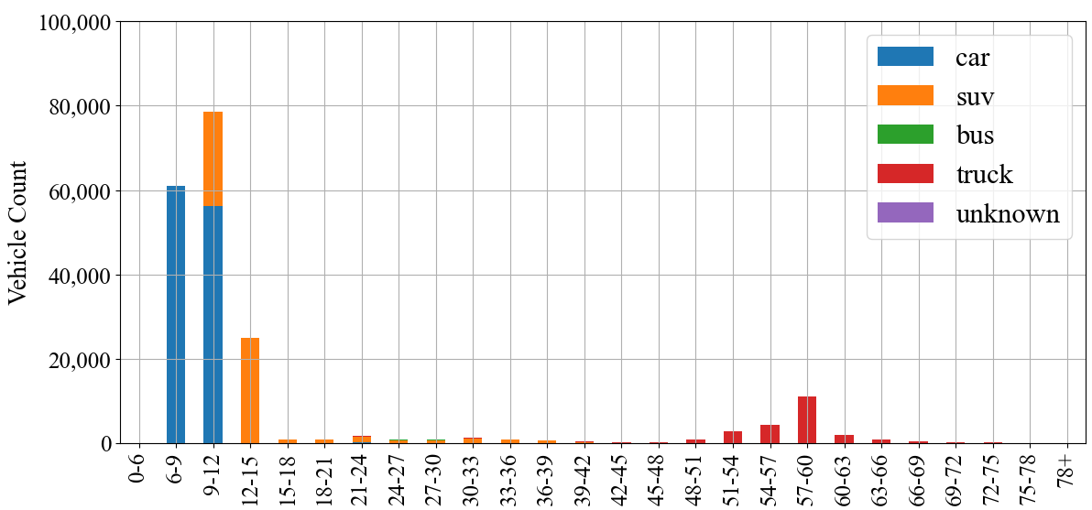
Figure 1. A histogram of vehicular axle-to-axle distance with respect to different vehicle types

Results show that most of vehicles are either LV or SV. Although there are other genres of vehicles (e.g., motorcycle, school bus.), the frequency of those vehicles is lower. Thus, we assume that the vehicles are either SVs or LVs in this study. Thus, we define the following constraints:

$$13≤l_{SV}≤19$$
$$70≤l_{LV}≤80$$

where $l_{SV}$ and $l_{LV}$ corresponds to the length of SVs and LVs, respectively. The length of SVs ($l_{SV}$) is between 13 and 19 feet. The length of LVs is between 70 and 80 feet. The ranges of vehicle length are higher than that of Figure 1 above because the WIM is measuring spacings between the first axle and the last axle, whereas in our case the SLDs are measuring the distance of the entire vehicle. As an averaged value of the vehicle length, the constraining ranges are also wide to compensate the occasional occurrence of other sized vehicles (e.g., motorcycle, school bus.) at times.

- Bounds of vehicular headings
Headings are defined as the seconds between two consecutive vehicles assuming a stationary traveling speed. In real world, for daily traffic, drivers are suggested to keep 3 seconds headings to the vehicle in front. It is hard for a long fleet to follow the front driver with only 1.5-second headways for a long time. Thus, a constraint is formulated as below:
$$L_{tot}P+2.5(N-1)≤B$$
where $L_{tot}$ denotes the total length of the fleet. $P$ is the pace of the fleet. $L_{tot}P$ just gives the total time the fleet occupying the detector within an aggregation time length of $B$. This constraint assumes that each vehicle should have at least 2.5 seconds of cleared headings in front, and the total time occupied plus the headings for all vehicles should below $B$, the observation time length. Without considering the headings, the constraint becomes:
$$L_{tot}P≤B$$
which means that all fleet’s time occupying the detector is below the total observation time length of $B$. Although this is a redundant constraint, it is worth to mention in the paper because the constraint above without considering headings are too loose to alleviate many unreasonable cases where all drivers are driving close to each other at high speed. Finally, the following constraint is formulated to bridge the connection between total length and vehicle combination:
$$L_{tot}=\left(m⋅l_{SV}+n⋅l_{LV}\right)$$
where $m$ and $n$ are the number of SVs and LVs during the observed time. They should follow the following constraints also:
$$N=m+n$$
where $N$ denotes the total number of vehicles in the fleet. Since $m$ and $n$ denotes the number of vehicles, they must be integers between $0$ and $N$ as shown below:
$$m∈\{0, 1, 2, …, N\}$$
$$n∈\{0, 1, 2, …, N\}$$

- Density-capacity constraints
Besides visualizing the headings over time, it is also possible to utilize the density relationship. For each aggregation time bin $B$ (e.g., 30 seconds), assuming all vehicles are traveling at the same speed within each lane, it is possible to speculate the travel density of vehicles as depicted in Figure 2:

Figure 2. A spatiotemporal diagram demonstrating the relationship between speed and density within each aggregation time bin $B$.

where x-axis and y-axis corresponds to the time of the day, and the coordinates along the road’s travel direction, respectively. Assuming the travel speed of the fleet within time bin $B$ is the same, the amount of distance the first vehicle can travel with the aggregation time is simply $Bv_{i}$, where $i$ denotes the time index of the recording bin. In this paper, all metrics are simplified without showing the index $i$. Thus, the road density becomes:

$$K=\frac{Bv}{N}=\frac{B}{NP}$$

where K denotes the traffic densities. Given traffic densities as inputs, an empirical distribution between density and traffic volume is visualized as follows:

Figure 3. An empirical relationship between traffic densities and flow rate.

The dashed line denotes the actual pattern between capacity and density, the solid line is used to cap the maximum throughput with respect to density and formulated as below:

$$q^{ub}≤2000$$
$$q^{ub}≤2000-\left(K-50\right)×20$$

where $q^{ub}$ denotes the upper bound of traffic flow, a number below the solid line. This upper bound $q^{ub}$ also regulates the total number of vehicles as follows:

$$\left(m+3n\right)×\frac{3600}{B}≤q^{ub}$$

As a reminder, $m$ and $n$ denotes the number of SVs and LVs, respectively. The hourly throughput should be lower than the previous upper bound $q^{ub}$. Note that in the occurrence of LVs can significantly drops the throughput. Thus, one LVs is set to equals to the impact of 3 SVs. Based on some literatures, LVs may have an even larger impact than that. In practice, although this constraint is loose, it can effectively alleviate some infeasible combination of vehicles. In summary, the logic is for these constraints is clear: If the traffic density becomes too high, then the traveling speed or throughput should be lower, making a contradiction to the prior assumption of the previous traveling speed.

- Prior assumption of speed
The occupancy can be treated as the percentage of time a detector is occupied. In general, a traffic lane with higher occupancy means a higher chance of congestion. Moreover, the concept of traveling speed, traveling pace, and occupancy per SV are convertible each other. In this section, we start to regulate the speed using the concept of occupancy per standard vehicle. The relationships and units for the following three metrics are visualized below.

In this study, an empirical artificial curve is applied to control the pattern of occupancy per SV vs. total occupancy.
$$o_{sv}=o_{ffsv}+1.5 o_{ffsv} {\left(\frac{O}{o_{crit}}\right)}^{p}$$
where $o_{sv}$ is the occupancy per small vehicle as a function of observed fleet occupancy denoted as $O$, and $o_{ffsv}$ is the free flow occupancy. Assuming a traveling speed of 70 mph, the vehicle’s pace is estimated as follows:
$P_{ffsv}=\frac{1}{70\frac{mile}{hour}×5280\frac{feet}{mile}×\frac{1}{3600}\frac{hour}{second}}=\frac{1}{100.98}\frac{second}{feet}$.

Thus, assuming the vehicle length is 17 feet, the time it takes for a vehicle to traverse the total distance becomes:
$$o_{ffsv}=16×\frac{P_{ffsv}}{B}×100=16×\frac{1}{100.98}×\frac{1}{30}×100≈0.53$$

In the previous control function, $o_{crit}$ and $p$ denotes two control parameters controlling the shape of the line. $o_{crit}$ is the “critical” point controls the curves offset, and $p$ can control the curvature of the curve. In this study, we choose $o_{crit}=20$ and $p=3$ to generate a prior knowledge of the traveling speed with respect to the detector occupancy. The following relationship between total occupancy and per vehicle occupancy are visualized in Figure below:
Figure 4. The artificial control curve between traveling pace and occupancy (left figure). The same relationship is converted to the right figure between traveling speed and occupancy.

The occupancy per SV can be converted to speed, which is represented in the second figure. In practice, occupancy over 25 becomes rare, and the speed prior believe is artificially chosen to be a low level as we tend to regulate the case because high occupancies are more likely to cause by congestion instead of high frequency of LVs.

The Linear Programming Approach
In this last section, all constraints and assumptions to formulate the problem is introduced. In this section, the Linear Programming problem is formulated to solve the best vehicle combination and lengths with the objective function and all constraints shown below:

$$\min{|L_{tot}⋅P-T|}$$
Subject to:
$$L_{tot}=\left(m⋅l_{SV}+n⋅l_{LV}\right)$$
$$L_{tot}P+2.5(N-1)≤B$$
$L_{tot}P≤B$i
$$K=B/NP$$
$$q^{ub}≤2000$$
$$q^{ub}≤2000-\left(K-50\right)×100$$
$$\left(m+3n\right)×\frac{3600}{B}≤q^{ub}$$
$$13≤l_{SV}≤19$$
$$70≤l_{LV}≤80$$
$$N=m+n$$
$$m∈\{1, 2, …, N\}$$
$$n∈\left\{1, 2, …, N\right\}$$
$$0≤q^{ub}, 0≤K, B=30$$
$$o_{sv}=0.53+1.5 ×0.53 {\left(\frac{O}{20}\right)}^{3}$$
$$P=\frac{o_{sv}×B}{100×17}$$
$$T=O×30/100$$

The meanings of all constraints are explained in the previous function. As a summary, the meaning of all parameters involved is summarized below:

Table 1. A summary of all parameters involved in the Linear Programming problem
Parameter | Description | Unit
$$L_{tot}$$ | Total vehicle length of the fleet
$$P$$ | Travel pace of the fleet | second/feet
$$T$$ | Number of seconds the fleet occupying the detector
$$N$$ | Total number of vehicles
$$m$$ | Number of SVs
$$n$$ | Number of LVs
$$l_{SV}$$ | Average vehicle length for SV | feet
$$l_{LV}$$ | Average vehicle length for LV | feet
$$N$$ | Number of observed vehicles
$$O$$ | Total occupancy of the fleet
$$o_{sv}$$ | Occupancy time takes for a vehicle to travel length of one SV
$$K$$ | Density of the fleet | vehicle/mile
$$q^{ub}$$ | Upper bound of effective traffic flow rate | vehicle/hour
$$B$$ | Time length of the aggregation time bin | second

With the problem defined, it comes the time to solve the problem.

  - Solving the LP Problem at scale
Although the searching scope of the problem is small for modern computer, it is still time consuming to compute the results one by one in real time considering there are hundreds of such detecting stations generating results for each traffic lane each 30 seconds. Instead of solving each problem, all possible combinations are precomputed in advance to generate a query table. For such efforts, all combinations of volume $N$ and occupancies $O$ are emuerated to solve the problem. A typical range of $N$ is all integers between 0 and 30. For occupancies $O$, all integers between 0 and 50 with are used to precompute results. In such cases, there are $30×50=1,500$ different LP problems to solve. Although occupancy can be decimal values, occupancy is rounded to whole number for simplification.

Strictly speaking, the LP problem in this study is a Mixed Integer Linear Programming (MILP) problem where some decision variables are continuous values and others are integers only. In practice, instead of generating one optimal solution solving the MILP directly, we just plug in each vehicle combination (i.e., the integer decision variables) and the problem becomes a standard LP problem. After getting the solutions for all combinations, we rank them the optimal solution for each vehicle combination. If two solutions reached same costs in the objective function (e.g., cost of zero), then solutions with higher number of SVs are preferred. All infeasible solutions are dropped. If no solution is found (i.e., all problems are infeasible), we assume all vehicles are SV with length of 16 feet. Thus, the solution ranked top is used as the solution of that scenario. Following this routine, the solutions of number of LVs with respect to the number of vehicles and occupancy can be visualized as follows:
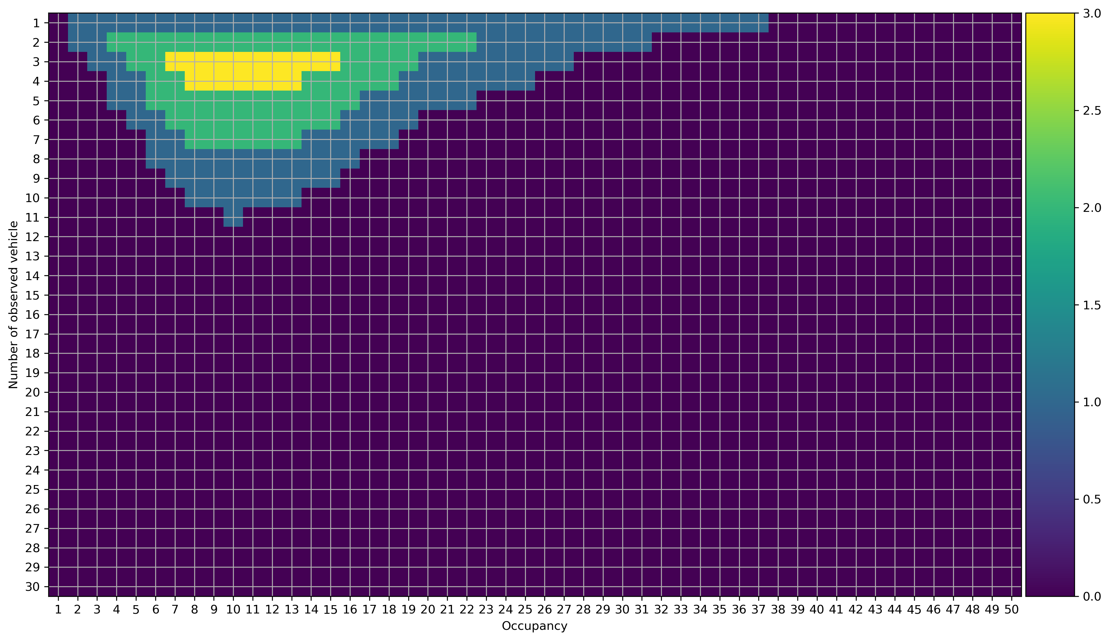
Figure 5. Results of the number of LVs for any combination of observed vehicles and occupancy.

The x-axis shows all the possible combination of occupancy, and the y-axis shows all the combinations of the observed vehicle. The time aggregation length $B$ is 30 seconds, the most frequently used aggregation bins for detectors. When the number of vehicles is fixed as 4, the number of LVs increase as the occupancy increased from 1 to 10. However, the number starts to decrease as the occupancy further increases. This is mainly because there is not enough time for all LVs to pass traveling at a lower speed, especially considering that on average there needs at least 2.5 seconds headings between consecutive vehicles in the fleet. Another way of interpreting the diagram is to keep the occupancy fixed. If occupancy is fixed to 10, the number of LVs also increase as the number of vehicles increase. Later, when there are more vehicles, the number of LVs dropped. This is because if the number of LVs remain the same, the total length of vehicles gets higher to make the traveling speed higher. In such cases, the density of vehicles gets higher than a feasible case. Thus, a contradiction is reached assuming there the number of LVs stays the same or get increased.

Generate spatiotemporal view of traffic corridors
After precomputing all the input scenarios, the number LVs/SVs can be checked directly from the matrices of saved results for different occupancy and volume. The algorithm has two potential benefits: 1) it has a better estimate of the number of LVs; 2) it has a better estimate of the fleet’s traveling speed for each lane within each 30-second aggregation bin. With that information, it is possible to analyze the travel time changes over time using a spatiotemporal diagram.

After estimating speed for different detectors and for different time, a large array of data is estimated as depicted below. In Figure, given time $t_{i}$ and location $x_{j}$, the detector generates a speed output $v(x_{i},t_{j})$. Thus, one can impute the speed over space and time over the spatiotemporal space by averaging neighboring data outputs using a smoothing average approach. As an established approach, two kernels, $ϕ^{cong}$ and $ϕ^{free}$, are defined to impute the speed of normal condition and congested condition. Only detector results within two kernels can be used for speed imputation.

Figure 6. The speed field generating speed information at different time and locations

The definition of kernel is demonstrated as follows:
$$ϕ_{0}\left(x-x_{i}, t-t_{i}\right)=Exp\left[-\left(\frac{\left|x-x_{i}\right|}{σ}+\frac{\left|t-t_{i}\right|}{τ}\right)\right]$$

The speed at spatiotemporal coordinate $\left(x_{0}, t_{0}\right)$ is represented a weighted average of neighboring records:

$$v\left(x_{0}, t_{0}\right)=\frac{1}{Φ\left(x,t\right)}\sum_{i}{ϕ_{0}\left(x-x_{i}, t-t_{i}\right)}v_{i}$$

where $Φ$ is the total number of observations within the scope.

$$Φ\left(x, t\right)=\sum_{i}{ϕ_{0}\left(x-x_{i}, t-t_{i}\right)}$$

For the kernels of $ϕ^{cong}$ and $ϕ^{free}$, another transfer is used as another set of affine transforms defined below:
$$ϕ^{cong}\left(x, t\right)=ϕ_{0}\left(x^{'}, t_{cong}^{'}\right)=ϕ_{0}(x, t-\frac{x}{c_{cong}})$$

$$ϕ^{free}\left(x, t\right)=ϕ_{0}\left(x^{'}, t_{free}^{'}\right)=ϕ_{0}(x, t-\frac{x}{c_{free}})$$
where $c_{free}$ and $c_{cong}$ refers to free speed and queue spillback speed. After getting the two speed estimates using $ϕ^{cong}$ and $ϕ^{free}$, the final speed is decided by the lower of the two value as shown below:
$$\hat{v}(x_{0}, t_{0})=\min{\{{\hat{v}}^{cong}\left(x_{0}, t_{0}\right), {\hat{v}}^{free}(x_{0}, t_{0})\}}$$

A dense grid is created to impute all the space along the traffic corridor between traffic stations. With all the spatiotemporal speed field imputed, virtual traffic trajectories can be traveled given the speed field using Euler method.
$$t_{i+1}=t_{i}+Δt$$
$$x_{i+1}=x_{i}+v(x_{i}, t_{i})Δt$$

Virtual vehicle trajectories can be applied to measure traffic state. Moreover, between two virtual vehicle trajectories, the number of vehicles should be same if no other ramps are present. Even if some ramps are along the road, the composition of vehicles should remain similar. Thus, it is possible to extract LVs fleet along the corridor.

  - Evaluation Metrics
In this study, two sets of results are of interest, the first is the LV estimation, the second is speed or travel time along corridor. For the LV estimation, the following two metrics, Mean Absolute Error (MAE) and Root Mean Squared Error (RMSE) are applied as follows:

$$MAE=\frac{\sum_{i=0}^{Λ}{\left|{\hat{m}}_{i}-m_{i}\right|}}{Λ}$$

where $Λ$ denotes the number of records to be evaluated. $m_{i}$ and ${\hat{m}}_{i}$ denotes the measured LV and observed LV, respectively. Similarly, the RMSE is defined as follows:
$$RMSE=\frac{1}{Λ}\sqrt{\sum_{i=0}^{Λ}{{\left(m_{i}-{\hat{m}}_{i}\right)}^{2}}}$$

For evaluation of traffic speed, the evaluation metrics are the same except the notations of $m_{i}$ and ${\hat{m}}_{i}$ are substituted to $s_{i}$ and ${\hat{s}}_{i}$ with $s$ denotes the travel speed. For travel speed estimation, Mean Absolute Percentage Error (MAPE) is also included for evaluation:
$$MAPE=\frac{1}{Λ}\sum_{i=0}^{Λ}{\left|\frac{s_{i}-{\hat{s}}_{i}}{s_{i}}\right|}$$

Experiment
Since different regions and roads have different road geometries, traffic, and vehicle distributions, it is important to do more experiments to solve the problem. A total of five different experiments are designed. The first three experiments try to compare against different detectors including VIM detector, dual loop detector, and vehicle trajectory data. The fourth and fifth experiment is study cases to utilize the problem at a long corridor level.

  - Evaluate the LVs estimation by comparing against WIM observations
One of the detectors that can generate accurate vehicle classification data is the WIM detector. The detector can measure the spacings and weight for all axles of each vehicle. Thus, WIM can be used as the ground truth data to compare against estimated LVs for SLD detector. In this study, such a pair of SLD and WIM detectors are found using the California’s PeMS dataset. In PeMS, the identification code for WIM is “34630” and the identification code for SLD/VDS is “3412041”. The first week in April 2024 is observed for each hour by each traffic lane. Note that hourly aggregated counts by lane are the finest aggregation level for WIM data outputs in PeMS. Results show that the count data for all vehicles are almost the same. For WIM, 13 different vehicular types are identified. In this study, truck types from type 6 to13 combined are considered as LVs.

The comparison results are visualized in Figure 7. Three subplots are made for the time series observations at each traffic lane. The dashed cyan lane and dashed black line corresponds to the total vehicles observed by WIM and LDS, respectively. Similarly, the grey solid line and cyan line corresponds to the WIM ground truth and the estimated results from the proposed algorithm, respectively. By observation, lane 1 (the innermost lane) is a truck free lane, whereas the other 2 lanes have more LVs. By comparison, the proposed algorithm just slightly overestimates the number LVs.

Besides visualization, Table 2 measures the MAE and RMSE results. The error for lane 1 is very small as a LV free lane. The error for lane 2 and lane 3 becomes larger. By observation, these metrics are aligned with the visualization in Figure 7.

Figure 7. Comparing LP results from Loop detector against WIM ground truth data.

Table 2. Evaluation of the prediction error by comparing between WIM measured results and the proposed method
 | Lane 1 | Lane2 | Lane 3
MAE | 1.02 | 11.38 | 23.46
RMSE | 2.41 | 15.09 | 27.83

  - Evaluate the LP algorithm by comparing against dual loop detector
Although WIM detectors generate a precise estimates of vehicle type and vehicle length, they are often established in suburban or rural regions. It only provides summarization of vehicle class and axle distributions aggregated by hour. For more detailed information, dual loop detector can be used because they can measure speed information. Thus, we can compare the speed information estimated by LP algorithm and by measurements from dual loop detector. For the study, a detector near the intersection of Eastbound I-580 and North Flynn Road is selected. The VDS detector id is “1031110” in the PeMS system. Data during the first week of April 2024 (April 1st - 7th) is observed. Figure 8 compares the measured speed and estimated speed. The dark green curve represents the 10-minute moving average measured speed, whereas the red dark curve represents the 10-minute moving average speed estimated by the algorithm. The light red and green corresponds to the raw readings speed at 30 second intervals. Results show that the speed between two series are similar most of the time. Overall, the speed for the proposed LP algorithm makes a conservative assumption for the speed prior. This is because the design philosophy of the algorithm is that the increased occupancy is attributed to the speed decrease whenever possible. Only in case where a speed drop cannot explain the increase in occupancy, those increased amount of occupancy should then be attributed to the present LVs. The LP algorithm tries to be conservative when identifying LVs. Table 3 further evaluates difference using MAE and RSME metrics. Lane 2 has the largest error for speed estimation with the largest RMSE. Lane 5 also has a relatively large error. The speed observation varies a lot for lane 5 because this lane is very close to an upstream exit ramp and a downstream enter ramp. Overall, the predicted speed is good enough to generate travel time information.

Figure 8. A comparison between dual loop detector measured speed and observed speed. The transparent corresponds to raw inputs, whereas the untransparent lines are 10 minutes moving average.

Table 3. Evaluation of the moving average speed prediction error between dual loop detector measured results and the proposed method
 | Lane 1 | Lane2 | Lane 3 | Lane 4 | Lane 5
MAE | 6.43 | 7.86 | 4.05 | 5.34 | 7.87
RMSE | 7.07 | 9.24 | 5.36 | 7.01 | 8.99
MAPE | 0.11 | 0.14 | 0.07 | 0.13 | 0.18

  - Evaluate the LP algorithm with I-24 Motion data in Nashville, Tennessee
I-24 Motion is a new project to identify vehicle trajectories over a 4-mile highway segment at the I-40 corridor by using 294 ultra-high resolution cameras (Gloudemans et al., 2023). Based on those high-resolution video, deep learning algorithms are developed to identify and track vehicles with very detailed information generated. The output data includes but not limited to vehicle’s trajectory, speed, size (i.e., length, width, and height), type, etc. Up till now, raw trajectory data of the morning peak data for 10 different days are publicly available. These 10 days include 8 workdays and 2 Thanksgiving holidays. Except for one holiday day, all other days are recording the inbound traffic (i.e., westbound) between 6-10 AM. In this study, those trajectory data can be used as the ground truth data.

Overall, Figure 9 below shows the spatiotemporal distributions of identified traffic trajectories. The top-left subplot shows the trajectory of a single vehicle identified and traced for 4 seconds. The down-left subplot shows the 10,000 trajectories identified within 14 minutes at the 4-mile corridor. Two plots at the right show the lateral distribution of the trajectories. Since the algorithms are predicting 3-dimensional boxes to identify vehicle sizes, the lateral results are precise enough to identify the traffic lane of vehicles. Given the detailed description, it is possible to emulate SDL outputs based on this.

Figure 9. Trajectory examples and lateral distributions of I-24 Motion vehicle trajectories.

Two methods are designed. The first method is to compare estimated results from Tennessee DOT’s RDS detectors with the I-24 ground truth at the same mile marker. The second approach tries to emulate the SDL outputs by aggregating trajectories passing a site at a 30-second interval. To emulate the SDL results, Figure 10 below shows the procedures to emulate RDS outputs given a specific mile marker. At the mile marker, a fictional line is drawn. The line is break into small line segments every 30 second. Each line corresponds to the spatiotemporal observation scopes. Given the identified vehicle length and scope, the occupancy is estimated by the equation on the right of Figure 10. For ground truth data, vehicles are classified into three types: (1) less than 25 feet (SVs); (2) between 25 and 45 feet (i.e. MVs); (3) beyond 45 feet (LVs). MV corresponds to middle-length vehicles between SVs and LVs.

Figure 10. Data processing steps to compare against results with ground truth

The comparison results are visualized in Figure 11. Along the 4-mile segment, five mile markers (i.e., 59.5, 59.9, 60.3, 60.7 and 62.6) corresponding to 5 RDS detectors are identified. To mitigate synchronization errors between I-24 Motion and RDS, results are compared by aggregated by 10 minutes across all traffic lanes. The green lines correspond to I-24 Motion counts for all vehicles passing the mile marker, whereas the dashed green line corresponds to the number of vehicles observed by RDS. The readings are similar except mile marker 59.9. The red solid line and dashed line corresponds to the I-24 Motion observation and the RDS estimates. Overall, the difference between two lines is small. The cyan solid line corresponds to the estimated results by rebuilding RDS information from I-24 ground truth. These estimates tend to overestimate the number of LVs. The reason for the bias needs to be further investigated. Overall, the activity of rebuilding RDS records from trajectory data can help people to understand the detector in more depth.

More detailed results are summarized in Table 1. Overall, the number of LVs are overestimated at the mile marker 60.3 and 60.7. Overall, this is an extreme test case where the traffic is busy and congested with almost all vehicles being SVs. It is very challenging to identify LVs while the average traveling speed is only around 15 mph. Researchers are going to investigate it in detail to explain the bias in the algorithm.

Figure 11. A comparison between RDS estimated results and I-24 Motion vehicle trajectories.

Table 4. Evaluation results for estimating speed and LVs using the proposed LP algorithm for morning peak traffic in I-24, Nashville
 | MM 59.5 |  | MM 59.9 |  | MM 60.3 |  | MM 60.7
 | I24-Motion | RDS | I24-Motion | RDS | I24-Motion | RDS | I24-Motion | RDS
MAE (LVs) | 23.67 | 28.38 | 4.05 | 5.34 | 41.42 | 38.21 | 58.58 | 18.67
RMSE (LVs) | 29.01 | 31.67 | 5.36 | 7.01 | 45.49 | 43.81 | 62.33 | 21.26
MAE (speed) | 9.24 | 6.05 | 5.46 | 12.39 | 7.59 | 7.13 | 6.31 | 2.47
RMSE(speed) | 10.07 | 6.72 | 7.77 | 13.57 | 8.60 | 7.94 | 9.24 | 3.06
MAPE(speed) | 0.29 | 0.19 | 0.14 | 0.57 | 0.23 | 0.22 | 0.13 | 0.08

Estimating LV fleet along I-40 corridor in Knoxville, Tennessee
Besides evaluating the performance at same site, the algorithm can be easily applied among all detectors along a long corridor. Given observations in section 4.3, the percentage of LVs are low at the morning peak hours. Thus, there is a need to test the algorithm along another long corridor. In this section, a consequent series along the corridor of I40 is examined to identify truck flow.

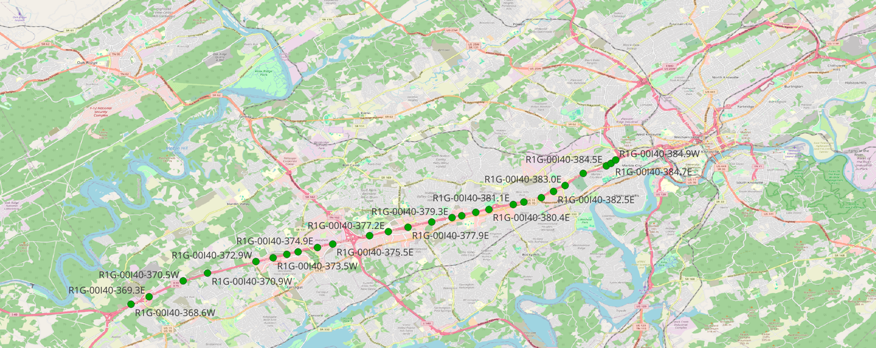
Figure 12. The RDS station involved in this case study (in Knoxville, Tennessee).

Unlike the I-24 corridor near Nashville, the I-40 corridor tends to have more percentage of LVs besides high commute demands during peak hours also. Thus, it is more relevant to analyze the LV flow as well as travel time over the corridor. By smoothing the speed outputs, a speed field is generated. Then, VVTs are generated to split the spatiotemporal region into small wedges. The number of SVs and LVs between VVTs at different locations are visualized. Assuming there are no major connector roads and ramps, the number of SVs between two VVTs should be a similar number.

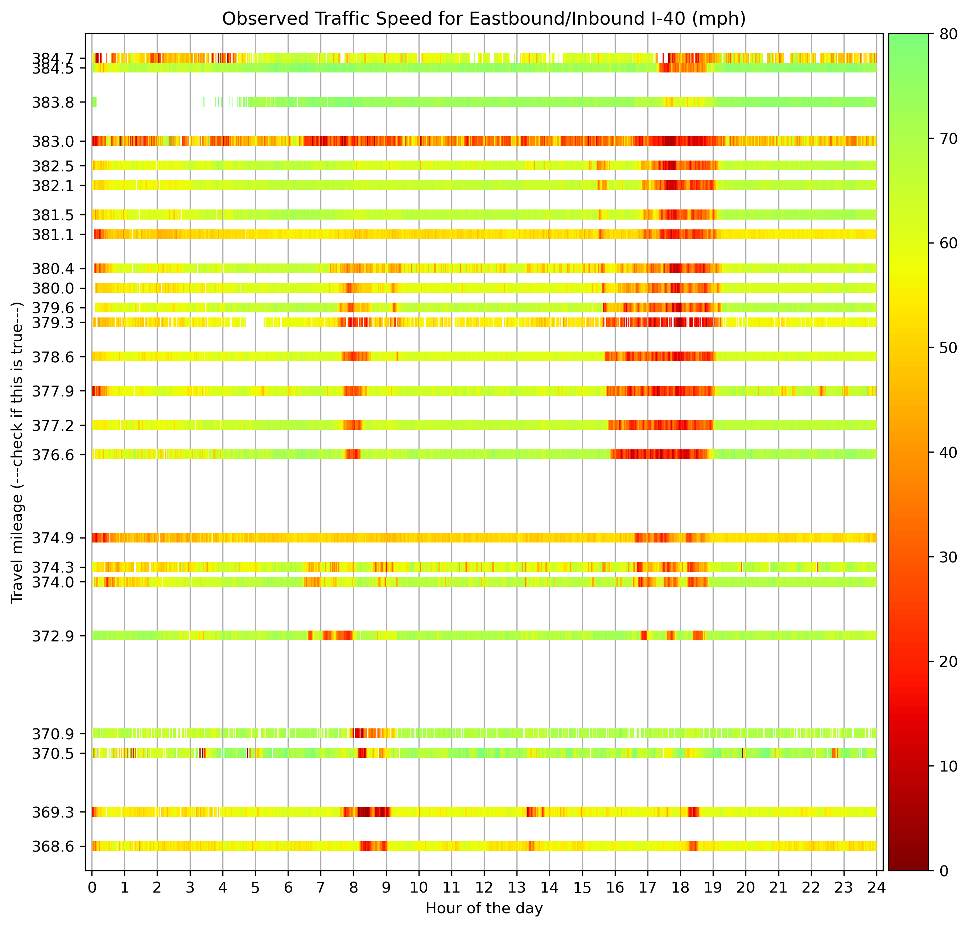
Figure 13. Averaged speed along the I-40 corridor in Knoxville, Tennessee.

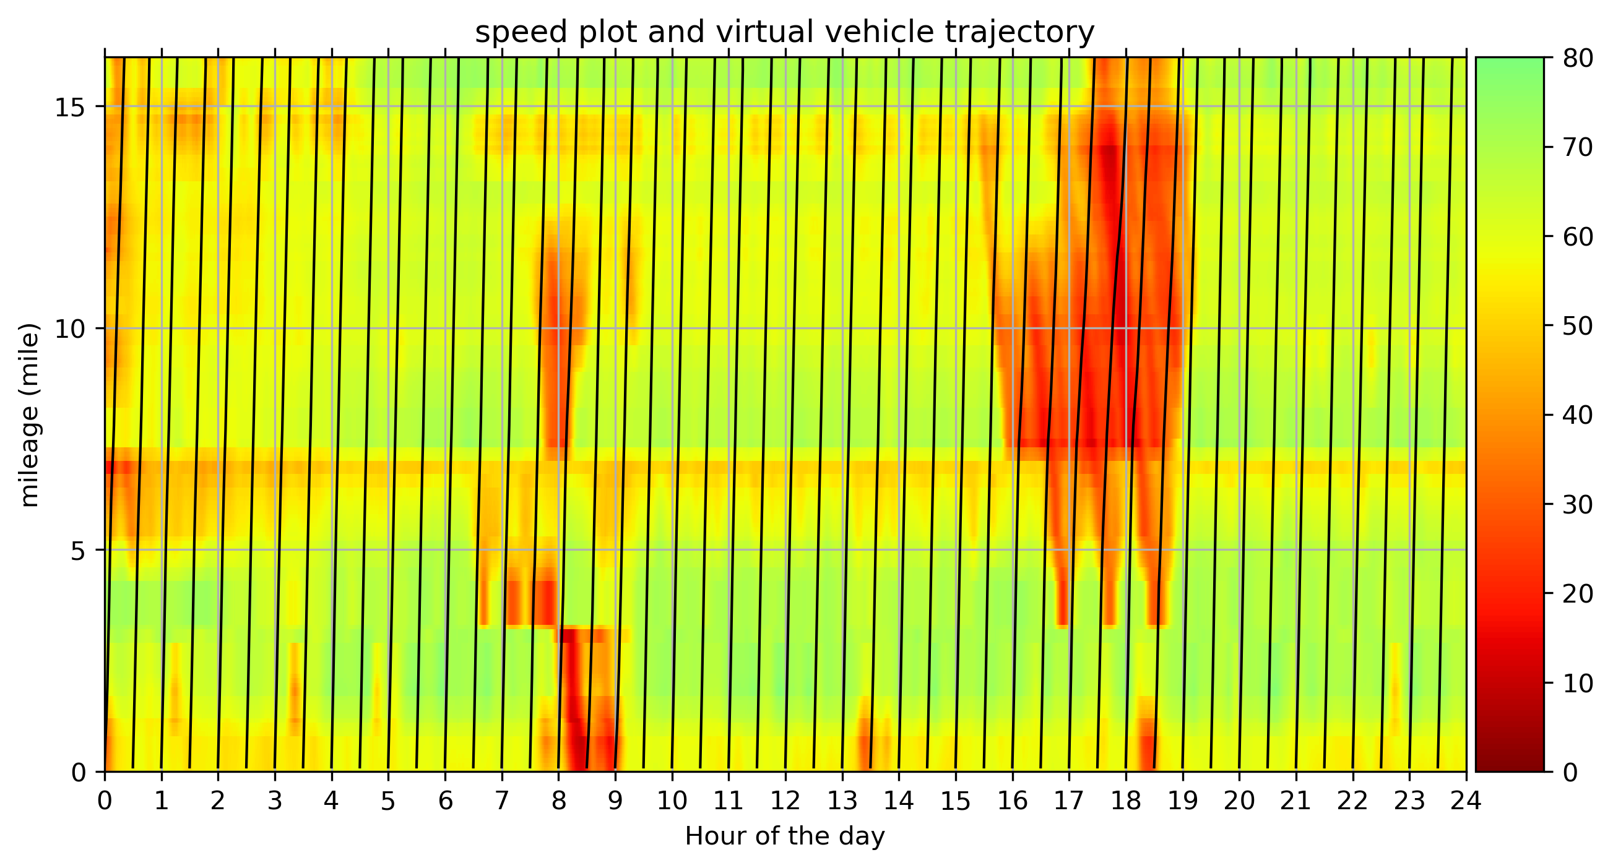
Figure 14. Adaptive smoothing spatiotemporal speed field and the virtual vehicle trajectories over spatiotemporal domain on I-40 corridor in Knoxville, Tennessee.

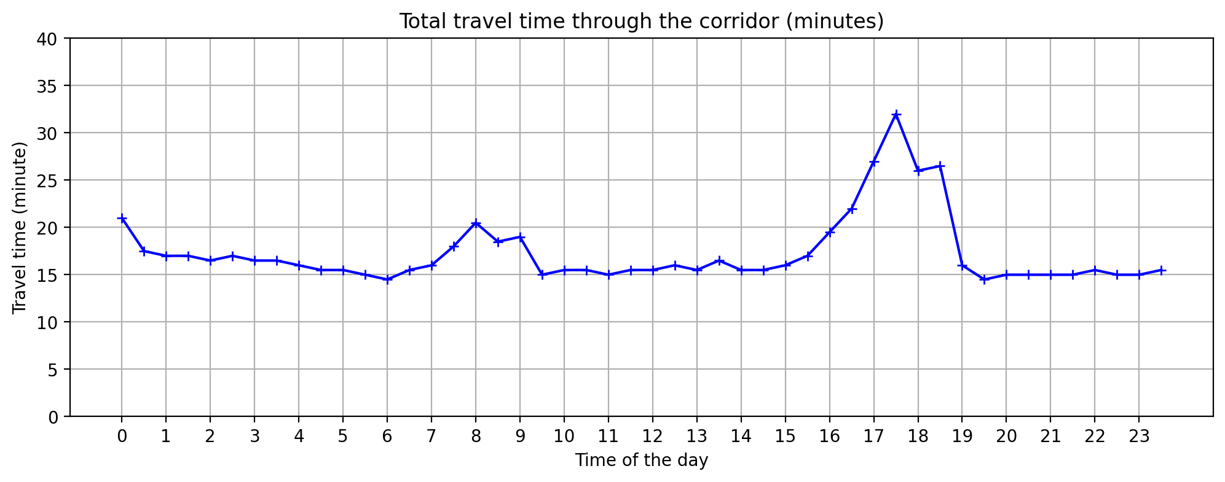
Figure 15. Estimation of travel time over the I-40 corridor in Knoxville, Tennessee

In summary, it is feasible to monitor the LV traffic using the proposed approach. The LV traffic can be approximately viewed as the truck or freight traffic. By generating LV flow at different detector locations, it is possible to learn the LVs travel pattern over places.

Estimating LV pattern changes for the bridge closure case in Memphis, Tennessee
Besides applying the algorithm along a corridor, it is also possible to apply the algorithm of a traffic network. The traffic network can just be decomposed to multiple small segments of corridors.

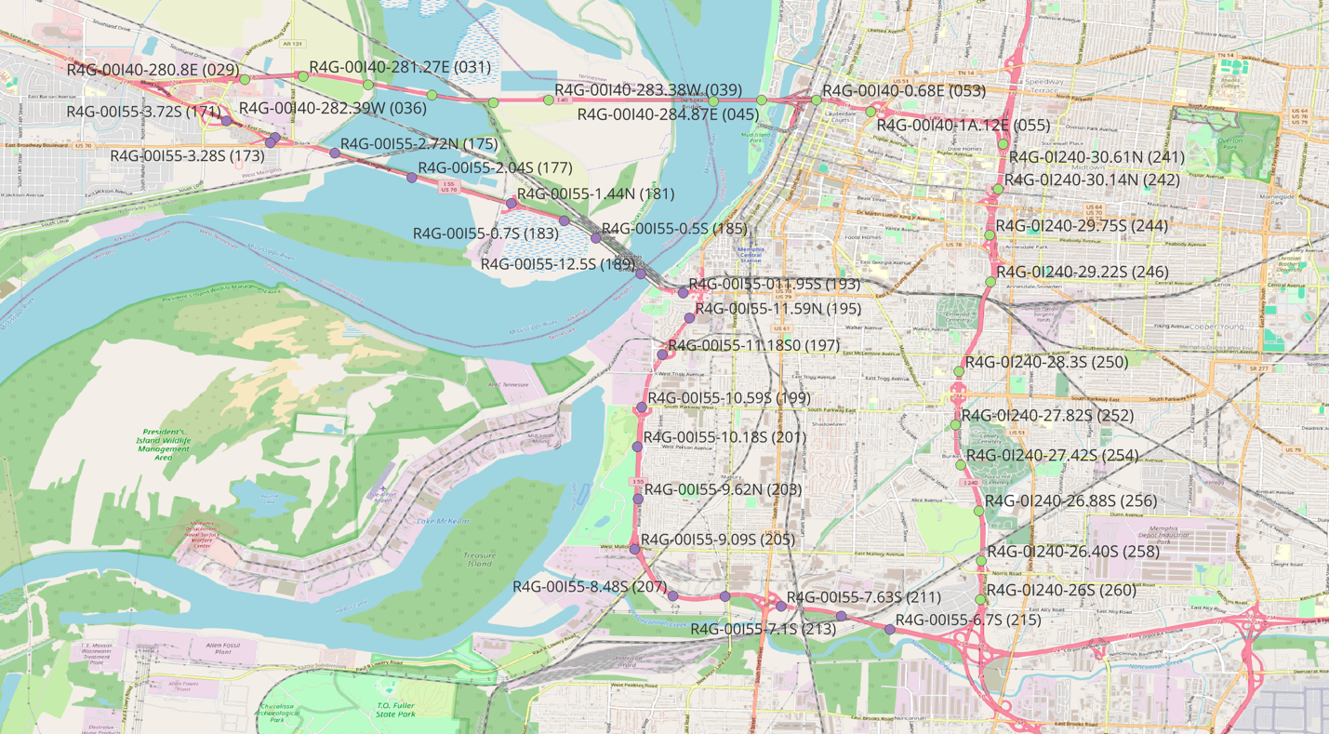
Figure 16. The RDS station involved in this case study (in Memphis, Tennessee)

Conclusion
Loop detector or its equivalents (e.g., radar detector system) are the most widely equipped traffic detectors along the highway systems. However, the detector is not perfect in estimating speed and truck flows. In this study, we proposed a Linear Programming method to estimate LVs and traffic speed. The method can be easily applied on all detectors to generate a spatiotemporal view of traffic status. Compared with other previous truck estimation methods, the method’s assumptions are very straightforward. The method is evaluated and tested in six different experiments. Results show that the method can significantly improve the speed estimation, truck flow estimation, etc. It has many potential applications in transportation management including a better estimate of traveling time. With the assumption that most LVs are trailer trucks, monitoring truck activities in metropolitan region become possible using the proposed approach.

During the practice, the authors gained the believe that using Linear Programming or other optimization formulations to integrate all physical constraints and assumption at one place becomes a good practice in this problem. By considering the problem from different angles, lots of constraints can be generated to exclude many unreasonable solutions. For example, one challenge of the method was that when the congestion is severe, the algorithm tends to overestimate the number of LVs. By overestimating LVs, the fleet’s travel speed also increases as the total fleet’s length get increased. Up until now, this scenario is not likely to happened in real world to form a long and fast-moving fleet “train” composed by LVs. Thus, considering headings between vehicles become an important constraint to filter out such cases.

There are still shortcomings for the methodology. First, for the same observed data of occupancy and volume, the algorithm generates same results. However, this might not be true because there might be more than one combination of vehicle type and size to reach optimal value for the objective function. Second, besides estimating speed for single data output, it is possible to measure the speed estimation for a consecutive stream of outputs over time to better estimate the traveling speed. This could be formulated by integrating the problem with some stochastic process. It is also possible to consider Medium sized vehicle with length between 25 and 45 feet. In such cases, another reasonable empirical assumption is that there can be at most one medium sized vehicle during 30 seconds per lane. Although those mentioned aspects are all potential future research directions, the current approach has the benefits of being simple in formulation and still works in practice.

Other limitations of the method come from the data itself. For radar detector system, data quality is a concern. There are often detectors generating inconsistent readings compared with neighboring detectors. Some radar detectors the occupancy data is only rounded to whole number, losing some useful information when the traffic flow and occupancy is low.

Reference
Coifman, B., 2015. Empirical flow-density and speed-spacing relationships: Evidence of vehicle length dependency. Transp. Res. Part B Methodol. 78, 54–65. https://doi.org/10.1016/j.trb.2015.04.006
Coifman, B., Kim, S., 2009. Speed estimation and length based vehicle classification from freeway single-loop detectors. Transp. Res. Part C Emerg. Technol. 17, 349–364. https://doi.org/10.1016/j.trc.2009.01.004
Coifman, B., Neelisetty, S., 2014. Improved Speed Estimation From Single-Loop Detectors With High Truck Flow. J. Intell. Transp. Syst. 18, 138–148. https://doi.org/10.1080/15472450.2013.801708
Gloudemans, D., Wang, Y., Ji, J., Zachár, G., Barbour, W., Hall, E., Cebelak, M., Smith, L., Work, D.B., 2023. I-24 MOTION: An instrument for freeway traffic science. Transp. Res. Part C Emerg. Technol. 155, 104311. https://doi.org/10.1016/j.trc.2023.104311
Gu, Y., 2023. Mining Crowdsourced Data for Pavement Maintenance, Incident Management, and Traffic Monitoring.
Gu, Y., Liu, D., Stanford, J., Han, L.D., 2022. Innovative Method for Estimating Large Truck Volume Using Aggregate Volume and Occupancy Data Incorporating Empirical Knowledge Into Linear Programming. Transp. Res. Rec. J. Transp. Res. Board 2676, 648–663. https://doi.org/10.1177/03611981221094569
Hernandez, S.V., Tok, A., Ritchie, S.G., 2016. Integration of Weigh-in-Motion (WIM) and inductive signature data for truck body classification. Transp. Res. Part C Emerg. Technol. 68, 1–21. https://doi.org/10.1016/j.trc.2016.03.003
Kaushik, K., Sharifi, E., Young, S.E., 2015. Computing Performance Measures with National Performance Management Research Data Set. Transp. Res. Rec. J. Transp. Res. Board 2529, 10–26. https://doi.org/10.3141/2529-02
Kim, Y., Hall, F.L., 2004. Relationships Between Occupancy and Density Reflecting Average Vehicle Lengths. Transp. Res. Rec. J. Transp. Res. Board 1883, 85–93. https://doi.org/10.3141/1883-10
Kwon, J., Varaiya, P., Skabardonis, A., 2003. Estimation of Truck Traffic Volume from Single Loop Detectors with Lane-to-Lane Speed Correlation. Transp. Res. Rec. J. Transp. Res. Board 1856, 106–117. https://doi.org/10.3141/1856-11
Wang, H., Ni, D., Chen, Q., Li, J., 2013. Stochastic modeling of the equilibrium speed–density relationship. J. Adv. Transp. 47, 126–150. https://doi.org/10.1002/atr.172
Wang, Y., Nihan, N.L., 2004. Dynamic Estimation of Freeway Large-Truck Volumes Based on Single-Loop Measurements. J. Intell. Transp. Syst. 8, 133–141. https://doi.org/10.1080/15472450490492815
Wang, Y., Nihan, N.L., 2000. Freeway Traffic Speed Estimation with Single-Loop Outputs. Transp. Res. Rec. J. Transp. Res. Board 1727, 120–126. https://doi.org/10.3141/1727-15

Chapter II. A Flexible Framework Combining YOLO and self-supervised Model for Vehicle Detection and Classification on Low-resolution Video Data

Abstract
Recently, Convolutional Neural Networks (CNN) algorithm like YOLO have been massively employed for transportation applications. However, the pretrained YOLO model cannot perform well when it comes to low resolution CCTV cameras. In this study, we propose a framework to combine several different deep learning models to extract traffic information. Basically, the major task is decomposed to four sub-tasks or modules: vehicle identification, vehicle classification, vehicle tracking, and trajectory transformation. Each task has their own specialized model. For vehicle identification, a supervised model (e.g., YOLO) is used solely for identifying vehicles. The model is retrained not to care about vehicle classification but just identify vehicles effectively. Another self-supervised model (e.g., SimCLR) is used solely for learning vehicle representation and vehicle classification. Next, an object tracking algorithm (e.g., ByteTrack) is employed to track vehicles and generate a time series of coordinates as travel trajectories. Finally, trajectories are converted to aerial view to generate traffic information given the knowledge of perspective view. Results show that the framework can identify almost all vehicles on the near side of the camera pole on low-resolution camera in $320×240$ dimensions at 15 frames per second. The framework is also good at identifying traveling speed at both directions. Consider the very large amount of established CCTV video stream data for traffic monitoring purpose, the proposed framework is very helpful with many potential downstream applications including automatic incident alert, detecting disabled vehicles, ramp metering, etc.

Key words: contrastive learning; self-supervised learning; YOLO; computer vision; vehicle identification; vehicle classification.

Introduction
For decades, CCTV cameras have become one of the most important data sources for traffic management. For many transportation agencies, there are hundreds of thousands of cameras located at different places in a large metropolitan area. Indeed, the most effective way for one to know what exactly happens at a site is by manually check the site through established CCTV cameras. Thus, for many traffic agencies there are hundreds of thousands of cameras along the roads. With the advancement in technology, it is now possible to process those camera streaming data to get knowledge about traffic by running algorithms.

Although there seems to be no limitations for identifying and tracking vehicles using deep learning algorithms, there are many challenges in practice. First, the running speed of deep learning algorithms are relatively slow even for the well-known YOLO algorithm. With hundreds of cameras, it become hard to extract traffic information for all sites at once. Another concern is that the data bandwidth of processing hundreds of cameras is extremely high. It is also hard for agencies to preserve these video data because usually there is not enough storage available.

To deal with these challenges, one approach is to use low resolution video data. There are many benefits for doing that. First, by using lower resolution data, most of the aforementioned drawbacks are mitigated. For example, by decreasing the resolution from SXGA ($1280×960$) to QVGA ($320×240$), the computing resource for processing one camera’s data can now process 16 cameras. Moreover, the lower density data can publicly stream to the public by DOTs. For example, traffic agencies like California DOT, Tennessee DOT have hundreds of sites streaming on the website for the benefits of the public. There is basically no privacy concern because the resolution is too low to identify unique information (e.g., license plate) to identify a vehicle. On the other hand, in practice, these low-resolution CCTV cameras are good enough for traffic experts to know the overall traffic status. If it is enough for human, we believe it is also enough for computers to generate good quality traffic information based on advanced deep learning algorithms.

In short, given the huge benefits of low-resolution video in traffic management, it comes the time for researchers to design a framework to integrate advanced deep learning method to extract traffic information from low-resolution camera data. The proposed framework, by taking the good part of different deep learning model, can be extremely powerful in extracting accurate traffic information. By deploying and running such algorithms in field, it is very likely that the respond time for traffic agencies can be decreased with help of automated algorithms integrated by the framework.

Literature Review
To identify vehicles, algorithms should be able to detect multiple objects for each image. The problem has become an important research topics for a long time (Cheng and Chen, 2006). Since the introduction of AlexNet (Krizhevsky et al., 2017) and VGG Net (Simonyan and Zisserman, 2015), the image classification problem dominated by Convolutional Neural Network (CNN). Lots of improvements are made since then to detect multiple objects at once. (He et al., 2015) proposed the Spatial Pyramid Pooling net (SPPnet) for various image sizes. (Girshick, 2015) developed the Fast Region-based Convolutional Network method (Fast R-CNN). The model, based on VGG16 network, trains 10 times faster and become more accurate than SPPnet. (He et al., 2018) proposed the Mask R-CNN to generate mask based on Fast R-CNN. (Redmon et al., 2016) proposed YOLO model. The model has a faster running time and less likely to predict false positives on background.
The YOLO model becomes popular for practical applications since its high performance and fast running speed. In other words, the trained YOLO model can provide a good object detecting algorithms out of box to solve lots of practical problems. Since the introduction of YOLO, the corresponding research team has been updating the model consistently. YOLOv2 adds multiscale training method can run at varying sizes (Redmon and Farhadi, 2016). YOLOv3 introduces more design changes using a model with 53 convolutional layers and predict boxes at 3 different scales (Redmon and Farhadi, 2018). YOLOv4 further improve the YOLO to reach a balance between speed and accuracy. Several innovative features are used to improve the YOLO performance. Data augmentation is also used during the training process. Since YOLOv5, different sizes of the model from small to large including nano (YOLO5n), small (YOLO5s), medium (YOLO5m), large (YOLO5L), extra (YOLO5x). Larger sized model has more accuracy but less running speed. YOLOv6 further improves the network architecture with innovations like Bidirectional Concatenation Module (BiC). YOLOv7 claimed to surpass other models in both speed and accuracy. YOLOv8, and YOLOv9 are also released in recent years. Overall, YOLO series of model has evolved to be decently useful for many daily applications. For more information, (Terven et al., 2023) reviews the history of YOLO series in details.
Since the introduction of YOLO, a lot of algorithms are designed to finetune the algorithms for some special cases related to vehicle detection. For example, for foggy weathers, by applying another set of image processing modules to augment object edges, the performance of YOLOv3 got significantly improved (Liu et al., 2022). Using image degradation operations (e.g., blur, rotation, flip, crop, etc.), the YOLO model shows a better capacity and robustness identifying traffic signs (Liu et al., 2018). (Mahmood et al., 2020) trained the YOLO model for infrared image and compare the results with K-means++ clustering algorithm, another method for multitarget detection based on convolutional neural network. Another model named YOLO-DS is proposed by modifying based on YOLOv5s. The model YOLO-DS announces a speed gain compared with YOLOv5s to make is feasible to run a 640$×$640 image data on the mobile phone within 35ms. (Al-qaness et al., 2021) demonstrated the possibility to extract traffic information based on YOLO-based traffic monitoring system. (Laroca et al., 2018) designed a robust model to identify license plate based on YOLO model. (Liang et al., 2022) discussed the possibility of applying YOLO for edge computing besides cloud computing. (Padilla Carrasco et al., 2023) improves YOLO for tiny vehicle detection over parking lots using cenital-plane camera monitoring the entire parking lots. (Lin et al., 2021) implemented a real-time traffic monitoring system counting vehicles with speed and class estimation over the virtual detection zone. (Bin Zuraimi and Kamaru Zaman, 2021) combines YOLO for identification and DeepSORT for object tracker.
Recently, self-supervised learning has become popular because it is not reliant on manually labeled data, making it easy to directly self-trained on the massive unlabeled images resources. (Chen et al., 2020) propose a simple framework, SimCLR, for contrastive learning for visual representation tasks. The model learns the features by pulling data of the same image together, whereas pushing data from different images away. The experiment found that data augmentations are the critical operation to predict tasks. A separate projection head is introduced to map the model output representations to a vector space. Another finding is that using a larger batch size can increase the contrastive learning algorithm results. For classification task, a linear classifier can be used to substitute the model. Results show that the model gets the best performance among semi-supervised or self-supervised model. After SimCLR, many other self-supervised models are proposed for an even better performance. For example, the self-distillation with no-labels model (DINO) tries to integrate Vision Transformer (ViT) architecture for self-supervised task (Caron et al., 2021). Features learnt by DINO can be excellent for k-NN classifiers.
Based on objects identified at each frame of the video, more information can be extracted by tracking objects/vehicles across frames. There are many methods capable of tracking objects after identifying objects for each frame. One algorithm is the Simple Online and Realtime Tracking (SORT). (Wojke et al., 2017) proposed the DeepSORT algorithm that further improves the SORT algorithm by providing a deep learning approach to generate association metric. Several studies used DeepSORT algorithms to track vehicles on highways (Bin Zuraimi and Kamaru Zaman, 2021; Kapania et al., 2020). Recently, a new tracking algorithm, ByteTrack, is proposed with a better performance compared with DeepSORT (Zhang et al., 2022). (Abouelyazid, 2023) compares the performance of three classical algorithms (i.e., SORT, DeepSORT, Byte) over the problem of tracking vehicles. The results show that ByteTrack consistently outcompete SORT and DeepSORT for the task of object tracking.
In conclusion, although there have been breakthroughs for vehicle identification and tracking, there are some limitations with the previous studies in extracting transportation information from videos. There lacks a study focuses purely on efficiently identifying traffic information using low-resolution CCTV data. The objective of the paper is to design a flexible framework to combine the benefits of established models from deep learning society. To be specific, the objectives of the proposed framework are sketched below:
- Finetune YOLO models for low-resolution. Instead of identifying and classify the object at once, YOLO model only focuses on identifying one class for all vehicles.
- After identifying bounding box for a vehicle, a representation vector is learnt for each vehicle using contrastive learning model.
- A classification model is built on top of the embedding vector given a limited number of labeled samples (e.g., 10-500 labeled images for each vehicle class).
- A pretrained object tracking model (e.g., ByteTrack) is plugged in to track vehicles and generate traffic trajectories along the road.
- Three modules mentioned above together form the one model pipeline to identify, classify, and tracking vehicles using three different models.
- A supplemental step is designed to convert identified trajectories to useful information for traffic management, especially considering the linear perspective property of CCTV cameras.
- Evaluate the results generated by the framework. The identified information like traffic volume and speed can be compared against traditional detectors results to evaluate the performance of the algorithms. The quality of tracked trajectories are also evaluated.

Methods

Overall Framework
To tackle the hard task of identifying, tracing, and classifying vehicles, a framework is established to solve the problem with four separate modules. The first module is to identify vehicles regardless of vehicle classes. Model like YOLO model is effectively used for this purpose. The second module is to learn a vector representation of each identified vehicle from module 1. After learning vehicle representation, a 3-layer Multilayer Perceptron (MLP) model given a small set of manually labeled samples. Finally, the fourth module uses an object tracker (e.g., ByteTrack) is plugged-in the trace vehicles in the video to generate trajectories of the vehicle. Based on trajectory results over time, useful traffic information is gathered, including traffic volume, traffic speed, etc.
Figure 17. A framework to fusion YOLO and self-supervised model for information detection.

Training YOLO model over low-resolution data given samples generated by the pretrained YOLO (teacher-student model)
In this study, YOLOv8 is used for vehicle detection for low resolution data. Although YOLOv8 models trained by corresponding research teams can be quite useful for many applications, there is a need to retrain YOLO model under low-resolution video data. A qualitative study shows that only a fraction of vehicles can be detected under low resolution CCTV video. Many vehicles are not detected during the whole lifetime traveling within the camera’s scope. Moreover, many output classes are not useful for the usage of transportation applications. By default, the YOLO trained on COCO dataset contains the following types related to highway traffic, including car, motorcycle, bus, and trucks. This kind of classification might not be of interest to traffic managers. Thus, there is a need to retrain the YOLO model.
In this study, a teacher-student approach is employed to distill the knowledge from a large model (e.g., YOLOv8x) to a smaller network (e.g., YOLOv8s). The process is summarized in Figure 18. A pretrained YOLOv8x model is used as the “teacher” to identify vehicles on available low-resolution videos. All identified objects for the 4 vehicle classes (i.e., motorcycle, car, bus, and truck) are treated as vehicles. To control quality, only identified objects with an over 90% confidence are passed forward to the dataset for training the smaller student model. Furthermore, an empirical filter is applied to filter out unreasonable identifications. For example, boxes that is over half of the width and height cannot be good samples of a single vehicle. objects too far apart near the end of the perspective at the top of the camera is not considered as good samples also since they are too small. Furthermore, all region in the images with annotated text information should be carved out because they can be mistakenly identified as vehicle some time. A manual check is encouraged to filter out unreasonable identification also. After applying the rules to control the sample’s quality, the identified vehicles are saved to the new custom dataset. All records in the dataset are treated as the “vehicle” type regardless of their original type. A YOLOv8s model is used to train on the new custom dataset to predict the only target class of “vehicle”. Thus, a smaller network is built to identify vehicles. Compared to the default YOLOv8x, the new trained YOLOv8s is much small and much faster to run. Moreover, quantitative study shows that the new model can performance better in identifying vehicles for low-resolution image.
Figure 18. Training YOLOv8s (small student) model with custom dataset generated by pretrained YOLOv8x (large teacher) model.

Learning vehicle image representations using self-supervised model
Traditionally, thousands labeled results are needed to train a deep learning model. This makes it very time and cost consuming to train a model. Moreover, for many small classes like motorcycle or ambulance, it is hard to find enough image samples for the training purpose. Thus, a self-supervised approach is more preferred to learn vector representation of the vehicle without labeled result. In this study, the standard SimCLR model is applied to demonstrate the abilities of learning vehicle representations, although other self-supervised models are also possible. The idea is to demonstrate that the framework works well even with the basic self-supervised model. Figure 19 below reviews the core idea of the SimCLR framework. Each image $x$ corresponds to the cropped image representing one vehicle. a series of image transformations are randomly applied on the image. Those transformations include pixel jitter, color to greyscale, flip, crop, resize, etc. Thus, ${\tilde{x}}_{i}$ and ${\tilde{x}}_{j}$ corresponds to two augmented or “polluted” images after applying transformations. For both augmented images, a CNN $f(∙)$ is applied to learn an output $h_{i}$ for the representations of the image. Another 2-layer MLP transformation $g(∙)$ is applied as the projection head to learn final embeddings ${\tilde{z}}_{i}$ and ${\tilde{z}}_{j}$ for images ${\tilde{x}}_{i}$ and ${\tilde{x}}_{j}$, respectively. Two embeddings, ${\tilde{z}}_{i}$ and ${\tilde{z}}_{j}$, should be as close as possible. For embeddings getting from other images, ${\tilde{z}}_{k}$, the distance between ${\tilde{z}}_{i}$ and ${\tilde{z}}_{k}$ or ${\tilde{z}}_{j}$ and ${\tilde{z}}_{k}$ should be as far as possible as they represent different objects.
Figure 19. A review of the core SimCLR process to generate pairs of visual representations.

Given the main idea of contrastive learning, a core metric is designed for modeling training named as the contrastive loss function:
$$l_{i,j}=-\log{\frac{\exp\left(sim\left(z_{i}, z_{j}\right)/τ\right)}{\sum_{k=1}^{2N}{1_{[k≠i]}exp⁡(sim\left(z_{i}, z_{k}\right)/τ)}}}$$
where $i$ and $j$ corresponds to the index of two images. $sim(∙)$ corresponds to the cosine similarity between two vectors embedding vectors $u$ and $v$ as $sim\left(u, v\right)=u^{T}v/\left\|u\right\|\left\|v\right\|$. $1_{\left[k≠i\right]}(∙)$ equals to one if $k≠i$, and $τ$ represents the temperature parameter. Each time, a large batch of $N$ images are used (e.g., 1,000 images). Among $2N-1$ representations to compared against, only the one with index $j$ is from the same image. The other vector embeddings are all from other vehicles. Note that in practice for vehicle identification, a heuristic is employed to generate training sample every 4 seconds apart to make sure that one vehicle is not captured twice from the YOLO model.

Training prediction classifiers as prediction heads
After learning the vehicle representations, different vehicles have different representations. On the contrary, same vehicle model at different angles should still have very similar vector representations. Therefore, with only limited number of data, it becomes possible to build a classification predicted on top of the embedding result. A small custom dataset is gathered with three classes: 1) small vehicle; 2) small truck; and 3) large truck. 200 records are prepared for each class. Small vehicles are mainly composed of passenger cars and pickup cars. Small truck and large truck correspond to delivery car and trailer trucks, respectively. Another 300 records are prepared as the testing set. Results show that with only 10 images per sample, the performance for the testing set gets a performance of 85%. Using 50 images, the performance for testing increases to 94%. This efficiency makes it possible for stakeholders to train different classifiers for different applications with ease. Furthermore, to compare the model with the other model, the same MLP is trained to pretrained VGG model.

From Raw observation to transportation insights
Finally, given the vehicle trajectories and classes collected overtime, one can extract useful transportation information. A cordon line can be drawn near the bottom of the image. By observation, trajectories are clustered for each lane, making it possible to cluster vehicles by their one lane.
Given that the CCTV camera is stationery videos with linear perspectives, it becomes possible to transform data to aerial view using the spatial transformation. Figure 20 shows the step of converting trajectories from perspective view to aerial view using a perspective transformation matrix. The matrix can be computed using the “cv2.getPerspectiveTransform(src, dst)” for OpenCV package where “src” and “dst” denotes the source and destination point. The $3×3$ transformation matrix $M$ is used to represent the matrix transition:
$$\left[\begin{matrix}t_{i}x_{i}^{'} \\ t_{i}y_{i}^{'} \\ t_{i}\end{matrix}\right]=M⋅\left[\begin{matrix}x_{i} \\ y_{i} \\ 1\end{matrix}\right]$$
where $(x_{i}, y_{i})$ corresponds to the coordinates in the origin image with perspective. $(x_{i}^{'}, y_{i}^{'})$ corresponds to the target coordinate of the origin coordinate $\left(x_{i}, y_{i}\right)$. By defining four corners of the detection zone, the detection zone can be transferred to the transfer matrix $M$.
Figure 20. Steps of converting raw trajectories to projected trajectory.

In this study, the detection zone is transferred into a matrix with size $100×100$ (see left bottom image). By identifying the distance of the detection zone, one can estimate the length of each pixel. Thus, with a reference distance, the speed of vehicles can be also estimated. In the United States, the interstate highway usually has a lane separation line of 10 feet separated by 30 feet between the separation white lines. Note that low quality identifications are filtered out if a vehicle is only identified for less than 4 frames, given a video is 15 frames per second. Practitioners can manually measure the length of detection zone using interactive map applications like Google Maps, etc.

Experiments
Although the Methods section introduces the steps and some results each module, there is a need to further study the performance and validity of the proposed method. Three experiments are designed. The first experiment compares the effectiveness of contrastive learning method in model classification over traditional methods. The second experiment compares the performance of the retrained YOLOv8s model with the pretrained YOLOv8x model. The third experiment compares the detected the speed and volume information identified by the algorithm with radar detectors.

Experiment 1. Comparing self-supervised learning with finetuned model for classification tasks
In this study, a self-supervised method is proposed to classify vehicles. In this study, identified vehicles from 20 hours of videos are used by using a pretrained YOLOv8x model. Only vehicles identified with 90% confidence can be used for training the data. Figure 21 shows the augmented results of six different vehicles. By contrasting between samples, the model gradually learns how to distinguish two kinds of models.
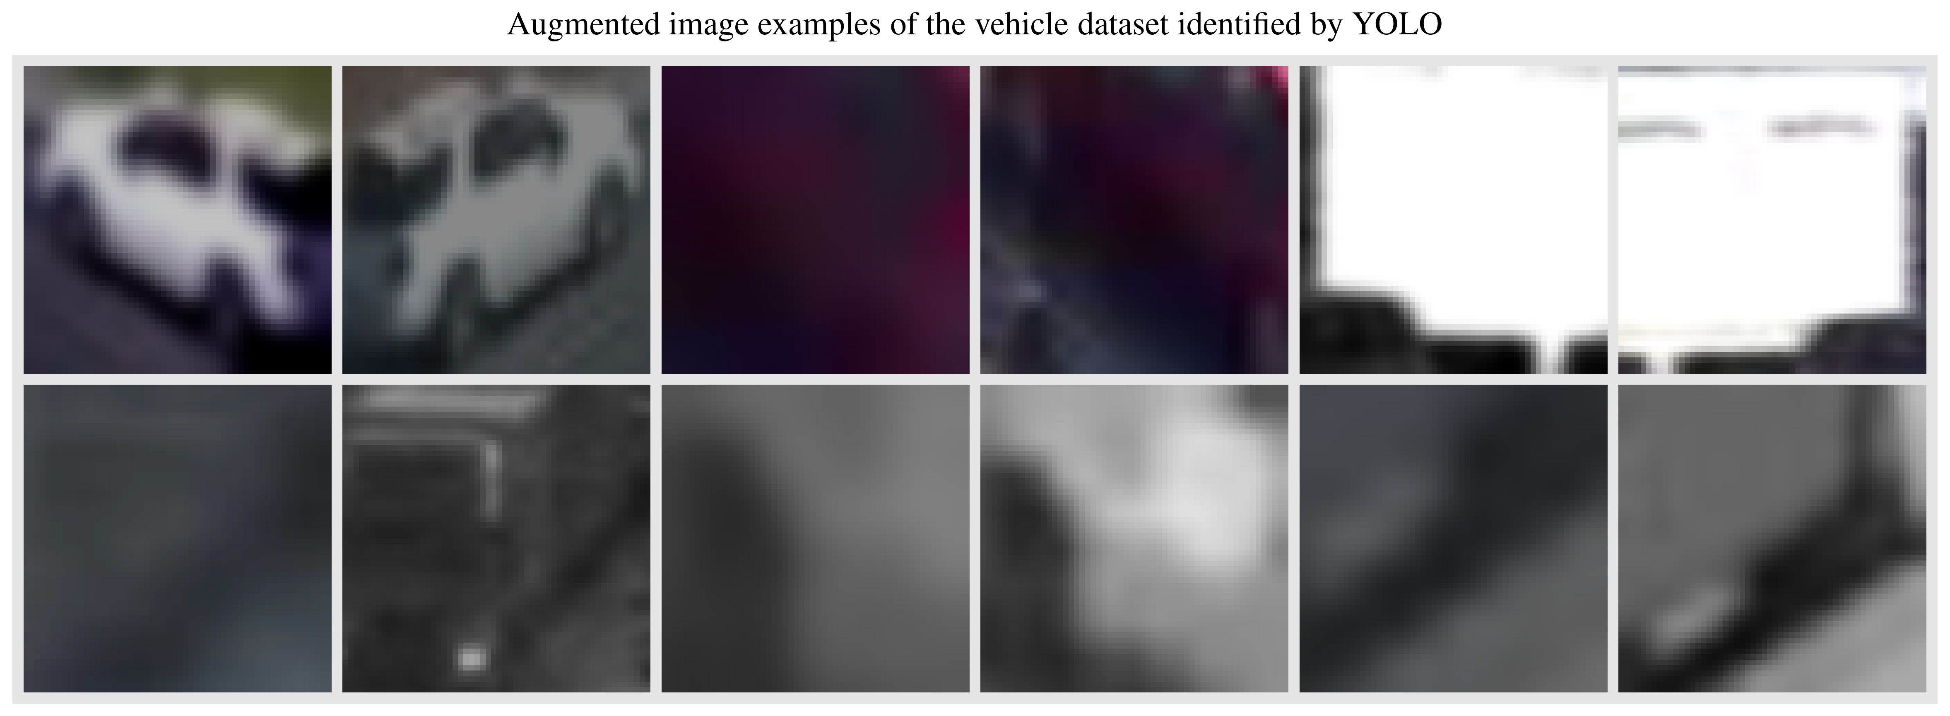
Figure 21. Six pairs of augmented images for self-supervised training under SimCLR model.

After using the SimCLR framework to learn the model, Figure 23 visualizes the representation in two dimensions. Another classifier is trained to visualize three types of vehicles: small vehicle, small truck, and large truck. The small vehicles are passenger sedan, and small SUVs. The large truck refers to all trailer trucks with at least a removable trailing part. Between the size of small vehicle and large truck, the small truck in the middle refers to trucks without a trailer part. For example, the delivery truck, sand carrying truck, concrete truck, etc. Special vehicles like small SUVs with a trailer part, ambulance, engineering vehicles are all considered as small truck in this classification. In this study, only 200 training samples are selected for each class of vehicles, and 100 vehicles are selected as the testing sample for each class.
Figure 22. New classification of small vehicle (“sv”), small trucks “st”, and large truck “lt”.

After getting the vehicle representation and training data, a classifier is trained on top of the SimCLR output representations by adding a 3-layer MLP model with the output of predictions of the three different classes. Figure 23 shows the representations denoted in 2 dimensions using the t-distributed Stochastic Neighbor Embedding (t-SNE) algorithm. The left and right subplot corresponds to the representations for the training set and testing set, respectively. The visual representations show that the passenger vehicles are easy to distinguish as they have unique representations. The large truck and small truck representations are mixed since they have more similarities. However, in many cases they are some small clusters for large truck and small truck. This means that each class are composed of several small trucks. Note that since the input data is different, the results of t-SNE algorithm is different. The first plot’s vehicle representations are transferred.
Figure 23. A Visualization of Embeddings Learned by SimCLR model for three types of vehicles.

A good property for self-learning is that the model has learned a lot of useful features to distinguish between different vehicles by applying the self-training (i.e., contrastive learning) approach. Thus, the model only needs a handful number of records to get good results. In this example, by using 10 labeled data as input, the performance in testing set is around 85%. With 20 and 50 training data, the performance in testing set is over 92%. By contrast, by using all 200 images as training data to finetune the VGG model, the performance is only 63.9% among testing datasets, although the accuracy for training set is over 98%. Thus, the contrastive learning method can effectively learn vehicle representation and improve classification results.
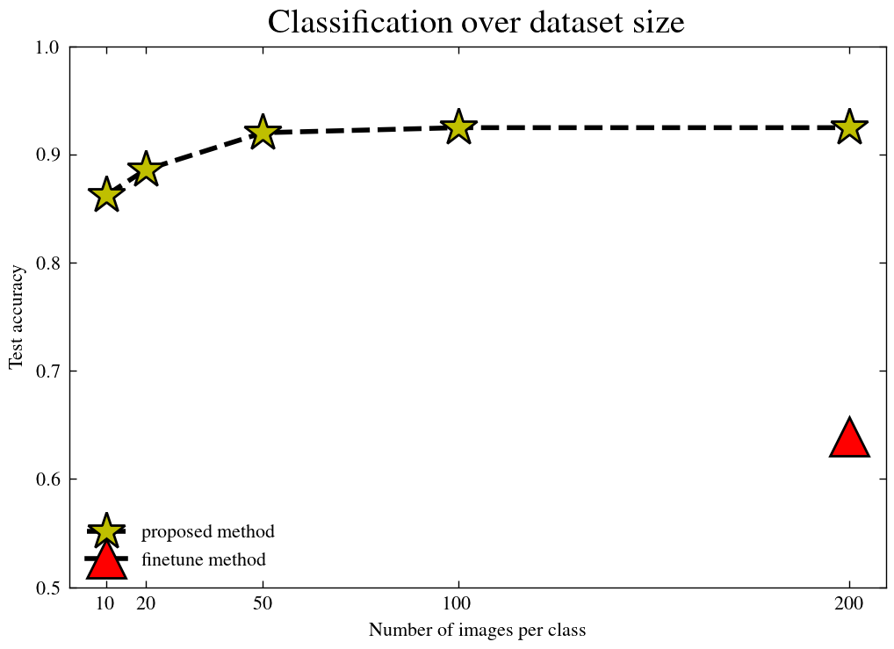
Figure 24. Extract transportation information given trajectory outputs.

Experiment 2. A qualitative study between proposed framework and pretrained YOLO
As mentioned before, the pretrained YOLOv8x, as the largest, most capable version of YOLOv8 series, cannot handle low-resolution images well. Figure 25 provides a qualitative comparison between the pretrained YOLOv8x model and the proposed framework. The upper row represents the annotated results of the pretrained YOLOv8x model, whereas the lower row represents result of the proposed method. Each column corresponds to the exact same video frame. By comparison, the proposed method has a better capability of identifying vehicles.
Figure 25. A qualitative comparison between YOLOv8x algorithm (above row) and the proposed framework (below row).

For the proposed method, the classification module based on self-supervised learning provides a reasonable estimate of vehicle classes. The proposed classification method doesn’t work well in some corner cases, though. Figure 25 (d) wrongly classifies a small black passenger vehicle as large truck because the vehicle is truncated in the image. Similarly, image Figure 25 (b) wrongly annotates two small vehicles as small trucks. This is probably because they are close to the boarder of the image, and their shape is similar to vans or utility vehicles. This classification error can always be mitigated by providing more examples. Figure 26 shows 6 consecutive snapshots at the same site ordered from (a) to (f). Each snapshot is separated apart about 0.33 seconds apart. All vehicles in the snapshots are of the type of small vehicles. However, two vehicles are identified as small trucks when they travel to the bottom of the image as their shape is distorted. In short, one should classify vehicle classification from multiple snapshots instead of one snapshot. The next experiment will discuss about vehicle tracking, trajectory extracting to get more detailed traffic information.
Figure 26. Six consecutive snapshots of a traffic fleet and identification results at the same site observing vehicle types of the traffic fleet.

Table 5 compares the running speed within the same framework using a Nvidia GeForce 3090 graphic card. The YOLOv8s method corresponds to the retrained method. The running time is composed of three parts. The first part is running the YOLO algorithm to detect vehicles. The second part is by running the classification model for each vehicle based on SimCLR. The third part corresponds to tracking vehicles across different frames of the video. There is a tiny extra cost of recording the trajectories, etc. The running speed in this experiment is around 140 frames per second. This means that if videos are 15 frames per second, the same graphic card can process videos from over 8-9 cameras at the same time. The pretrained algorithm using YOLOv8x, a larger model, can only process video around 60 frames per second. The proposed method can run 2.3 times faster than the default method.

Table 5. Comparison of running speed (fps) of different algorithms.
Running speed  (fps) | Proposed framework+YOLOv8s  (proposed method) | Proposed framework+YOLOv8x  (pretrained method)
Video 1 | 142 | 62
Video 2 | 138 | 60
Video 3 | 146 | 61

Experiment 3. Comparing extracted traffic information with radar detectors and NPMRDS data set
Besides visually compare results with the default YOLO algorithm, it is convincing to compare results with other data sources. Figure 27 shows the study site with both CCTV camera and radar detector system available. The site is located at the mile marker 380 along I-40 highway in Knoxville, Tennessee. The study period is a Thursday afternoon from 17:30 to 18:30 on July 12th, 2021. During the one-hour peak hour, the traffic is very busy. For eastbound, the traveling speed is very low at the begin and the end periods of the video. The westbound traffic is traveling at a high speed, although the flow rate is also high. Overall, it is a challenging site since there are several different traffic statuses involved within one hour. The information of this test site is never used during the training process. Besides comparing results with radar detectors, the lower left plot shows the corresponding NPMRDS link generating traveling speed. “121+04131” and “121-04131” corresponds to the Eastbound and Westbound traveling direction overlay with the CCTV’s observing region.
Figure 27. The study site at mile marker 380.0 at I-40 highway near Knoxville, Tennessee.

Figure 28 compares the traveling speed estimated or measured by different approaches. The upper plot and bottom plot show the speed distribution of the eastbound (near side) and westbound (far side), respectively. The x-axis and y-axis correspond to the time of the day and traveling speed in miles per hour, respectively. For each plot, the black solid line represents the observed speed aggregated every 30 seconds. The dashed red line corresponds the moving average values of traveling speed with a window size of 10 minutes. The cyan line with cross dots corresponds to the speed output of the NPMRDS data set from this travel segment. The traveling speed is aggregated by every 10 minutes. Results show that the speed estimated by the proposed method is close to the NPMRDS. Since the NPMRDS dataset is processed from GPS recordings of traveling vehicles, the speed measured by NPMRDS can be viewed as a reasonable speed measurement. Finally, the blue dotted line corresponds to the RDS readings. In this case, the readings are overestimated by this RDS detector. This is because the RDS speed is very coarsely estimated by assuming mean vehicle length. Overall, the proposed video recognition algorithm is surprisingly good at measuring speed. Note that there is a shift in speed pattern across different approaches. This is because the different system has their own clock, and for these systems on field it is just normal that there is a time shift of several minutes.
Figure 28. Speed comparison between proposed method, RDS detector, and NPMRDS records for eastbound and westbound at the studied site.

Figure 29 shows the time series of traffic volume using different methods for both eastbound (near side) and westbound (far side). The blue dotted line corresponds to the RDS volume for each 30 seconds. Although the RDS cannot directly measure the traveling speed, it is good at measuring the number of vehicles passing a site at each traffic lane. Thus, the RDS readings in doted blue line can be approximately viewed as the ground truth. The red dashed line and black solid line corresponds to the proposed method with retrained YOLO and the pretrained YOLOv8x model. For this test case, the proposed YOLOv8s performs slightly better in identifying vehicles compared with the pretrained YOLOv8x model, although the proposed model is the smaller in size. For this challenging case with a very limited video resolution of $320×240$, it is hard to identify all vehicles correctly using computer vision algorithm. On the near side (eastbound), the proposed algorithm did recognize most of the vehicles. On the far side (westbound), the proposed algorithm failed to identify many vehicles, although the algorithm is slightly better than the pretrained YOLO model. Overall, the criterion of identifying a vehicle is conservative in this study because only trajectories crossing the middle lane of the detection zone are identified as a vehicle. A qualitative check shows that most vehicles are identified at least once even on the farther side, it is just that they are not identified at the center of the detection zone.
Figure 29. Comparison of Identified vehicles for east bound and west bound directions at the studied site.

Besides comparing the quantity of identified vehicles, it is also possible to check the quality of identified vehicle trajectories by their length within the detection zone. Overall, the longer the trajectory, the better the observations. Figure 30 plots the survival curve for proposed method and for the pretrained YOLO method. The x-axis denotes the length of detection in the number of pixels. Since the detection zone is transferred to 100 pixels along travel directions, 100 denotes that the trajectory is observed from beginning to the end within the detection zone. The first row shows the number of records remaining at a given pixel length, the second row shows the percentage of records. By comparison, the proposed method finds can more vehicles. The survival curve shows that over 80 percent of vehicles can be tracked for 50% of the detection zone on eastbound.

Figure 30. A quality check for the vertical length of identified trajectories within the detection zone.

Conclusion
In conclusion, a new framework is proposed to tackle the challenging practical problem of identifying vehicles given low-resolution videos from CCTV cameras. The problem itself is important since the low-resolution traffic video is one of the most publicly shared data. Compared with videos higher resolution, low resolution video has advantages for data storage, data transfer, streaming, etc. One core philosophy for designing a framework is that: unlike algorithms for autonomous driving, the composition approach of combining the good parts of multiple established models within an organized framework should be sufficient for extracting useful information for understanding the traffic situations. Under resolution of $320×240$ at 15 frames per second, the model can track most vehicles at the near side and the speed output is also very accurate.
There are many innovations to train a system under the proposed framework. First, a YOLOv8s algorithm is retrained solely to identifying vehicle objects. Using YOLOv8x pretrained model as a teacher, training samples are generated for vehicles to train the YOLOv8s. The sole role of YOLOv8s is to identify vehicles without the burden of identifying specific vehicle type. Second, for identified vehicle, another contrastive learning model is trained solely to learn the representations of each vehicle. With representations learnt, new features are used to predict vehicle classes using a small prediction model. Finally, another advanced model, ByteTrack, is used to track the moving vehicles traveling along the road. Combining the good part of each model, the proposed model gets a consistent performance to identify, classify and track vehicles along the road. Finally, all identified vehicle trajectories are transferred to an aerial image based on perspective knowledge of the camera to extract basic traffic information including speed, volume, and vehicle class. Compared the version of solely using pretrained YOLO, the fusion code has the benefits of running faster because the YOLOv8s model is a much smaller than YOLOv8x without sacrificing performance. The contrastive learning model is also fast by running on the YOLO identified images, which is only sent to contrastive learning model with shape of $40×40$ in width and height.
The potential applications of the proposed algorithms are immense. Theoretically, most of the cameras for traffic monitoring are low resolution because the camera usually needs to monitor traffic across many lanes at both directions. Thus, the number of pixels for each vehicle is usually small. With trajectories being identified, lots of other applications are now feasible. For example, vehicle trajectories can bring more information compared with traditional loop or radar detectors. On highway, for control strategies like various speed limits or ramp metering, it is vital to directly measure the number of queued vehicles or measure the density of fleet. A better automatic traffic monitoring algorithm is also helpful for safety studies. For example, it can monitor the case of intruding animals, identifying stopped vehicle or fired vehicle, and generate reports to the traffic control centers. The potential benefits of alerting incidents seconds or minutes earlier are immense.
There are still some limitations for the current approach. Although the framework is good for transportation CCTV camera, there is a potential for improvements for each specific module. One limitation is that the standard self-supervised learning SimCLR prefers color-to-grey image transformation to make sure the model doesn’t rely on colors when identifying objects. In other words, it is color invariant. However, sometimes it is beneficial to consider color in our model as the number of pixels are so limited. For examples, most school buses are either yellow or white. Another big issue is about the bounding boxes. One idea is that using the centroid of the bounding box is not enough to identify vehicle trajectories because the vehicle is a 3d object in 2d perspective image. Just like the I-24 Motion project, a better identifying bounding boxes in 3 dimensions need to be implemented and tested in the future. To extract traffic information, human decisions are necessary to divide vehicles by their travel lane for now. It is possible to further combine information from other models to learn the background, the road lane positions, and image perspectives automatically using deep learning algorithms.

Reference
Abouelyazid, M., n.d. Comparative Evaluation of SORT, DeepSORT, and ByteTrack for Multiple Object Tracking in Highway Videos.
Al-qaness, M.A.A., Abbasi, A.A., Fan, H., Ibrahim, R.A., Alsamhi, S.H., Hawbani, A., 2021. An improved YOLO-based road traffic monitoring system. Computing 103, 211–230. https://doi.org/10.1007/s00607-020-00869-8
Bin Zuraimi, M.A., Kamaru Zaman, F.H., 2021. Vehicle Detection and Tracking using YOLO and DeepSORT, in: 2021 IEEE 11th IEEE Symposium on Computer Applications & Industrial Electronics (ISCAIE). Presented at the 2021 IEEE 11th IEEE Symposium on Computer Applications & Industrial Electronics (ISCAIE), IEEE, Penang, Malaysia, pp. 23–29. https://doi.org/10.1109/ISCAIE51753.2021.9431784
Caron, M., Touvron, H., Misra, I., Jégou, H., Mairal, J., Bojanowski, P., Joulin, A., 2021. Emerging Properties in Self-Supervised Vision Transformers.
Chen, T., Kornblith, S., Norouzi, M., Hinton, G., 2020. A Simple Framework for Contrastive Learning of Visual Representations.
Cheng, F.-H., Chen, Y.-L., 2006. Real time multiple objects tracking and identification based on discrete wavelet transform. Pattern Recognit. 39, 1126–1139. https://doi.org/10.1016/j.patcog.2005.12.010
Girshick, R., 2015. Fast R-CNN.
He, K., Gkioxari, G., Dollár, P., Girshick, R., 2018. Mask R-CNN.
He, K., Zhang, X., Ren, S., Sun, J., 2015. Spatial Pyramid Pooling in Deep Convolutional Networks for Visual Recognition. IEEE Trans. Pattern Anal. Mach. Intell. 37, 1904–1916. https://doi.org/10.1109/TPAMI.2015.2389824
Kapania, S., Saini, D., Goyal, S., Thakur, N., Jain, R., Nagrath, P., 2020. Multi Object Tracking with UAVs using Deep SORT and YOLOv3 RetinaNet Detection Framework, in: Proceedings of the 1st ACM Workshop on Autonomous and Intelligent Mobile Systems. Presented at the AIMS ’20: The 1st ACM Workshop on Autonomous and Intelligent Mobile Systems, ACM, Bangalore India, pp. 1–6. https://doi.org/10.1145/3377283.3377284
Krizhevsky, A., Sutskever, I., Hinton, G.E., 2017. ImageNet classification with deep convolutional neural networks. Commun. ACM 60, 84–90. https://doi.org/10.1145/3065386
Laroca, R., Severo, E., Zanlorensi, L.A., Oliveira, L.S., Goncalves, G.R., Schwartz, W.R., Menotti, D., 2018. A Robust Real-Time Automatic License Plate Recognition Based on the YOLO Detector, in: 2018 International Joint Conference on Neural Networks (IJCNN). Presented at the 2018 International Joint Conference on Neural Networks (IJCNN), IEEE, Rio de Janeiro, Brazil, pp. 1–10. https://doi.org/10.1109/IJCNN.2018.8489629
Liang, S., Wu, H., Zhen, L., Hua, Q., Garg, S., Kaddoum, G., Hassan, M.M., Yu, K., 2022. Edge YOLO: Real-Time Intelligent Object Detection System Based on Edge-Cloud Cooperation in Autonomous Vehicles. IEEE Trans. Intell. Transp. Syst. 23, 25345–25360. https://doi.org/10.1109/TITS.2022.3158253
Lin, C.-J., Jeng, S.-Y., Lioa, H.-W., 2021. A Real-Time Vehicle Counting, Speed Estimation, and Classification System Based on Virtual Detection Zone and YOLO. Math. Probl. Eng. 2021, 1–10. https://doi.org/10.1155/2021/1577614
Liu, C., Tao, Y., Liang, J., Li, K., Chen, Y., 2018. Object Detection Based on YOLO Network.
Liu, W., Ren, G., Yu, R., Guo, S., Zhu, J., Zhang, L., 2022. Image-Adaptive YOLO for Object Detection in Adverse Weather Conditions. Proc. AAAI Conf. Artif. Intell. 36, 1792–1800. https://doi.org/10.1609/aaai.v36i2.20072
Mahmood, M.T., Ahmed, S.R.A., Ahmed, M.R.A., 2020. Detection of vehicle with Infrared images in Road Traffic using YOLO computational mechanism. IOP Conf. Ser. Mater. Sci. Eng. 928, 022027. https://doi.org/10.1088/1757-899X/928/2/022027
Padilla Carrasco, D., Rashwan, H.A., García, M.Á., Puig, D., 2023. T-YOLO: Tiny Vehicle Detection Based on YOLO and Multi-Scale Convolutional Neural Networks. IEEE Access 11, 22430–22440. https://doi.org/10.1109/ACCESS.2021.3137638
Redmon, J., Divvala, S., Girshick, R., Farhadi, A., 2016. You Only Look Once: Unified, Real-Time Object Detection, in: 2016 IEEE Conference on Computer Vision and Pattern Recognition (CVPR). Presented at the 2016 IEEE Conference on Computer Vision and Pattern Recognition (CVPR), IEEE, Las Vegas, NV, USA, pp. 779–788. https://doi.org/10.1109/CVPR.2016.91
Redmon, J., Farhadi, A., 2018. YOLOv3: An Incremental Improvement.
Redmon, J., Farhadi, A., 2016. YOLO9000: Better, Faster, Stronger.
Simonyan, K., Zisserman, A., 2015. Very Deep Convolutional Networks for Large-Scale Image Recognition.
Terven, J., Córdova-Esparza, D.-M., Romero-González, J.-A., 2023. A Comprehensive Review of YOLO Architectures in Computer Vision: From YOLOv1 to YOLOv8 and YOLO-NAS. Mach. Learn. Knowl. Extr. 5, 1680–1716. https://doi.org/10.3390/make5040083
Wojke, N., Bewley, A., Paulus, D., 2017. Simple Online and Realtime Tracking with a Deep Association Metric.
Zhang, Y., Sun, P., Jiang, Y., Yu, D., Weng, F., Yuan, Z., Luo, P., Liu, W., Wang, X., 2022. ByteTrack: Multi-Object Tracking by Associating Every Detection Box.

Chapter III. An Iterative Algorithm to Impute Traffic Information over Nationwide Traffic Networks

Abstract
Understanding the dynamics of truck volumes and activities across the skeleton traffic network is pivotal for effective traffic planning, traffic management, sustainability analysis, and policy making. Yet, relying solely on average annual daily traffic volume for trucks cannot capture the temporal changes over time. Recently, the Traffic Monitoring Analysis System dataset has emerged as a valuable resource to model the system by providing information on an hourly basis for thousands of detectors across the United States. Combining the average annual daily traffic volume from the Highway Performance Monitoring System and the Traffic Monitoring Analysis System dataset, this study proposes an elegant method of imputing information across the traffic network to generate both truck volumes and vehicle class distributions. Specifically, the proposed method uses average annual daily traffic values as an initial assumption, iteratively refining Traffic Monitoring Analysis System information across neighboring traffic links to predict traffic information over the network. A series of experiments evaluated the model’s performance on various spatial and temporal scales. Results showed that the performance of the model achieved an R² of more than 0.56 for truck volume, outperforming benchmark methods such as the Kriging method. In summary, the proposed method underscores the importance of using network topologies and integrating diverse data sources to enhance our understanding and modeling of traffic activities.

Keywords: AADT, TMAS, vehicle class estimation, traffic flow estimation, data imputation, missing data

Introduction
Understanding the dynamics of freight flows is vital not only for effective transportation planning and management but also for assessing their implications on energy consumption and environmental sustainability. Recent advancements in the field have yielded a suite of tools tailored for the analysis of freight emissions analysis (Shiledar et al., 2024). Additionally, the emergence of electric vehicles has been touted for their potential economic and environmental advantages, particularly in energy conservation (Weiss et al., 2020). Consequently, there exists a pressing demand to systematically evaluate the efficacy of various policies and investments within the trucking and freight industries. However, a considerable portion of existing research relies on synthetic, simulated, or proprietary trucking data, underscoring the necessity to develop a data-centric approach to comprehensively model truck flows and activities over the traffic network.

To analyze traffic patterns in the United States, researchers often use the Highway Performance Monitoring System (HPMS) dataset, a widely recognized source of information. Alongside fundamental roadway characteristics, the US Department of Transportation mandates the reporting of annual average daily traffic (AADT) figures annually. Ideally, a comprehensive assessment would involve daily traffic counts at each location throughout the year to derive accurate average traffic volumes. However, practical constraints often limit this approach, particularly for smaller roads where AADT values are typically approximated through a 3 day observation period within a given year. Usually, a limited number of detectors are rotated across smaller road segments over the course of the year. Subsequently, the observed values undergo correction processes to determine AADT, accounting for various factors such as seasonal variations and weekday fluctuations. AADT values serve as crucial metrics for federal, state, and metropolitan planning agencies (Krile et al., 2016). Nonetheless, it is still necessary to enhance the precision of daily, weekly, and monthly traffic fluctuation modeling through more refined observational and analytical techniques.

To address the imperative for a more detailed nationwide traffic flow database, the Traffic Monitoring Analysis System (TMAS) dataset has been established to systematically monitor traffic patterns across the United States (“2022 Traffic Monitoring Guide,” 2022; Krile, 2016). Predominantly derived from sensors strategically positioned along major highways or arterials, the TMAS dataset comprises three primary subsets: (1) the volume dataset, detailing the count of vehicles traversing a designated point along a roadway in a consistent direction; (2) the class dataset, elucidating the distribution of vehicle classes; and (3) the weight dataset, delineating the distribution of vehicle weights.

Figure 31 illustrates the geographical distribution of traffic observation stations according to the TMAS dataset compiled in 2021. The dataset comprises approximately 4,558 stations for measured traffic volume and 3,573 stations for vehicle class assessments. Each yellow dot depicted in Figure 31(a) represents a site for volume observation, whereas each green dot in Figure 31(b) indicates a site for vehicle class observation. The geographic locations of weight stations are not shown because they are out of the scope of this study. For this study, only the class datasets were used for analysis, providing insights into traffic volume across the Federal Highway Administration’s 13 vehicle classes on an hourly basis (Pagan-Ortiz, 2014). Note that some states did not report class datasets to TMAS for 2021, but all states uploaded their volume information.

Figure 31. Locations of TMAS detectors for both (a) volume observation and (b) vehicle class observation.

Although TMAS data offer extensive coverage of geographical areas, their recordings are confined to predetermined locations or points at the traffic networks. In this investigation, our aim was to estimate traffic volume across the entire traffic network by leveraging TMAS recordings from fixed points. Specifically, the research team conducted imputation on the Freight Analysis Framework (FAF) networks as delineated in previous studies (Hwang et al., 2021, 2016; Department of Transportation et al., 2017). Additionally, we integrated AADT truck volume reported from the HPMS into the FAF network as weighting factors to propagate information over the network.

Figure 32 illustrates a simplified example to demonstrate the process of imputation on a grid network with directed edges, originating from the lower left corner and extending to the upper right corner. Truck percentages are set at 10% and 100% at the starting and ending edges, respectively. Initially, all nodes within the grid network, except for the starting and ending edges, lack information. Using an iterative algorithm, missing data within the grid network can be gradually imputed by iteratively running the algorithm multiple times. As depicted in the center of Figure 32, which represents 100 iterations, the proportion of trucks steadily transitions from 10% to 100%. Subsequently, the results converged after about 200 iterations, as shown on the right of Figure 32. Through the implementation of the algorithm, inferring the distribution of vehicle classes becomes feasible.

Figure 32. A simple example of imputing missing traffic volume in a grid network traveling from bottom left to top right.

The remainder of this work is structured as follows: Section 2 provides a comprehensive review of prior methodologies and approaches in traffic volume estimation. Section 3 presents the formulation of the proposed algorithm along with associated data processing steps necessary to facilitate its implementation. Section 4 presents the background and outcomes of a series of experiments conducted to assess efficacy of the algorithm from diverse analytical viewpoints. Finally, Section 5 concludes this study by delving into its contributions, potential implications, inherent limitations, and avenues for future research.

Literature Review
Traffic detectors are conventionally positioned at various intervals along roadways, necessitating the estimation or interpolation of traffic data across the entire network. Prior studies have predominantly used statistical methodologies to forecast the AADT values of roads, drawing upon factors such as roadway characteristics, socioeconomic indicators, and proximity to highways (Anderson et al., n.d.; Caceres et al., 2018; Chang and Cheon, 2019; Mohamad et al., 1998; Wang and Kockelman, 2009; Zhao and Chung, 2001). These regression techniques, termed aspatial methods, neglect the topology of the traffic network, thereby presenting certain limitations. Moreover, to improve performance, these methodologies need special socioeconomic data collection for each localized analysis zone within a metropolitan area or city. They rely solely on statistical modeling by using input features and do not integrate roadway geometries or network topologies.

In addition to the aspatial methods, various approaches exist for estimating roadway information by leveraging data from neighboring roadways. One prominent technique is geographically weighted regression (GWR), which entails computing a weighted average that considers geographical proximity. GWR has widespread application across diverse domains, including traffic safety analysis and traffic management (Gu et al., 2023; Hezaveh et al., 2019; Xu et al., 2020), and has been adapted for estimating AADT values (Liu et al., 2019; Zhao and Park, 2004). The limitation of using the GWR for estimating AADT is that its performance might not be as effective in urban areas as opposed to rural areas.

Besides the GWR method, Kriging methods are also employed for traffic flow imputation. Originally devised for spatial interpolation of mining resources based on sampled points (Gotway et al., 1996), Kriging has been adapted for transportation applications to interpolate values along traffic corridors and networks (Lowry, 2014). An extended Kriging method is used in transportation studies to impute values in spatiotemporal dimensions across traffic networks (Bae et al., 2018; Yang et al., 2018).

More recently, graph neural networks have gained traction for modeling traffic based on network structures in various applications, including traffic prediction (Bui et al., 2022; Jiang and Luo, 2022; Li and Zhu, 2021), data imputation (Kong et al., 2023; Liang et al., 2022; Shen et al., 2023), event identification (Zhang et al., 2020), and so forth. Despite claims of state-of-the-art performance, graph neural networks exhibit limitations, notably a focus on metropolitan areas rather than statewide or nationwide analyses, in which detector densities may be insufficient to adequately capture the roadway geometry. Moreover, training such models at state or national levels may become very computationally intensive.

Considering the constraints elucidated in previous studies, the reminder of this work will introduce the proposed methodology and analytical framework with the following objectives: (1) to devise an efficient method for imputing traffic data throughout a traffic network, (2) to construct a versatile analytical framework capable of data imputation at varying temporal aggregation levels as desired, and (3) to thoroughly analyze the advantages and limitations of the model across different scenarios and potential usages.

Methodology

An overview of the data analysis framework
To systematically address the issue, we proposed an analytical framework comprising four primary stages, as shown in Figure 33. The first step was the generation of AADT values and their alignment with the FAF traffic network. The second step was the delimitation of the temporal scope of interest and aggregation of TMAS class datasets to acquire freight volume and class distribution insights at TMAS locations. Additionally, the second step included the correlation of these data with the nearest directional link within the FAF traffic network. The third step included comprehensive integration of all gathered information to impute TMAS data across the entire network for both volume and class distribution. Finally, the fourth step included implementation of cross validation techniques involving the masking of selected TMAS stations as validation sets, followed by a comparison of predicted values against observed ones within these validation sets. Furthermore, the study’s outcomes could extend beyond the discussed parameters, offering potential benefits for various ancillary analyses such as emission modeling and activity pattern analysis through the provision of these more informed, data-driven estimations.

Figure 33. The proposed analysis framework for estimating vehicle volume and class distributions along traffic networks based on AADT values and TMAS datasets.

Integration of AADT values and TMAS information into a cohesive network representation is imperative for effective imputation. We employed the FAF network to amalgamate these datasets to form one graph representing all information. Although the HPMS network is another available option, the FAF network offers a more realistic geometric framework characterized by intricate geometries alongside a streamlined set of traffic links.

Figure 34 presents a visual representation of the differences between the two networks. The upper left histogram delineates the distribution of link lengths within the HPMS network across the United States, whereas the lower left histogram illustrates the distribution of link lengths within the FAF network across the same geographical scope. Note, in this study, most links of the HPMS network were under 1 mile, whereas a significant proportion of links within the FAF network was more than 1 mile. The map displayed on the right of Figure 34 exemplifies a typical instance of the divergence between the two networks. The green dots symbolize the end nodes of the TMAS network’s links, whereas the blue dots signify those of the FAF network. Note, the HPMS network (green dots and links) was deliberately partitioned into smaller units. Consequently, a solitary FAF link may correspond to multiple HPMS links in practical application. In summary, the FAF network exhibited greater comprehensiveness with a diminished quantity of links but featured geometries that align more closely with real-world scenarios.

Figure 34. A comparison of two networks: HPMS and FAF. FAF networks are more comprehensive and tailored for freight traffic analysis.

Table 6 further compares the disparities between the FAF network and the HPMS network regarding the quantities of links and nodes, the distribution of link lengths, and other parameters. Note, the median distance among FAF links measured 0.376 miles, whereas the median distance for HPMS links was markedly lower at 0.121 miles. Consistent with the observations, as shown in Figure 34, the FAF network was more comprehensive compared with its HPMS counterpart. Section 0 provides further discussion on the procedural intricacies involved in aligning the HPMS network with the FAF network.

Table 6. The overall structure of the network
Network | Number of links | Total length (miles) | 25% link length | 50% link length | 75% link length
HPMS (National Highway System) | 3,017,746 | 377,673 | 0.078 | 0.121 | 0.132
FAF | 487,394 | 766,646 | 0.161 | 0.376 | 0.997

The second phase of the analysis was dedicated to obtaining aggregated TMAS data. Given that the TMAS dataset encompasses records for every hour throughout the year, researchers can specify their time window of interest before conducting aggregation. Table 7 describes several typical temporal intervals of interest. For instance, analysts may opt to scrutinize monthly traffic patterns by aggregating data monthly. Similarly, aggregation based on different times of the day or days of the week is feasible. Moreover, AADT values for trucks can be approximated by aggregating data spanning a full year. In essence, analysts can configure temporal intervals for aggregation in accordance with their research objectives.

Table 7. Aggregation options involved in the study and provided by the analysis pipeline
Aggregation level | Description
Vehicle class | Aggregate probability by each vehicle class
All time | Aggregation observations over the whole year
Time of the day | Aggregate observations in different periods of the day; specifically, in this study:  - T0: Observations between 22:00 and 4:00  - T1: Observations between 4:00 and 10:00  - T2: Observations between 10:00 and 16:00  - T3: Observations between 16:00 and 22:00
Weekday/weekend | Aggregate observations by weekdays and weekends
By month | Aggregate observations by different months

Furthermore, the TMAS dataset encompasses traffic volume records categorized by vehicle class, enabling granular analysis at the level of individual vehicle classes. Within this study, the proportional representation of each vehicle class was carefully documented. Subsequently, employing spatial proximity and directional alignment, each TMAS station was precisely matched with the nearest link within the FAF network, a process elaborated on in Section 0.

In the third phase, the aggregated traffic volumes were converted into probabilities before the imputation process across the FAF network. Within the FAF network, the truck’s AADT volume served as foundational data guiding the imputation and distribution of values throughout the network. Section 0 explains the proposed algorithm in detail.

After running the imputation, Phase 4 involves a wide range of quantitative and qualitative tools to thoroughly analyze the advantages and limitations of the tool. Most of the experiments and evaluations were based on cross validation methods, as described in Section 0.

Estimating AADT values by matching HPMS links to FAF links
As outlined in Section 0, the imputation algorithm was exclusively executed within the framework of the FAF network because of its superior geometric properties and enhanced comprehensiveness. However, the AADT values derived from the HPMS dataset were contained within their own HPMS network. To transfer the AADT volume information from the HPMS network to the FAF network, the development of a matching algorithm was needed to align the respective outcomes.

Before the introduction of the matching algorithm, it was essential to assess the AADT value for each FAF link using AADT values derived from HPMS links. We observed the value against two networks (e.g., the right map of Figure 34), and Figure 35 illustrates a representative case comparing two networks. As observed earlier, the FAF network delineates network geometries, whereas the HPMS network comprises numerous smaller segments with reduced geometric intricacies. Additionally, each HPMS link represents two directions unless the road is one way. Conversely, within the FAF network, each link of interstate highways solely represents traffic flow in a single direction.

Figure 35. A typical local representation of an interstate segment with an overpass arterial using FAF and TMAS networks.

Figure 36 shows the six main steps for aligning HPMS links with FAF links. First, both networks were converted into directed graphs, wherein each edge represented a single travel direction. Given that AADT quantifies traffic volume bidirectionally, the metric was halved to reflect unidirectional traffic volume. Subsequently, a composite series of geographical operations was performed to ensure the fidelity of AADT matching outcomes.

Figure 36. The procedure of estimating AADT values from HPMS networks.

The second stage allowed for creation of a buffer zone around the HPMS link, and all intersecting HPMS edges were systematically collated for each FAF link buffer. Subsequently, during Stage 4, only those HPMS edges demonstrating approximate alignment with the prevailing traveling direction (±15°) were retained. In Stage 5, the median HPMS value served as the reference HPMS value. Finally, in cases of FAF links without corresponding HPMS links, volume information was effectively imputed using the proposed algorithm.

Upon generating precise estimates of AADT for each FAF edge, data generated from TMAS stations were matched to the most reasonable FAF edge, considering spatial proximity and travel direction. Figure 37 illustrates the process of aligning a TMAS station with FAF network links. It was imperative to discern between the two opposing travel directions, even though they shared identical TMAS station identifiers, and align them with their respective directional links. After the procedures of AADT estimation and the spatial alignment of TMAS stations with the nearest links, the FAF network comprehensively incorporated all pertinent information, encompassing AADT values, TMAS data recordings, and other relevant metrics. Because the algorithm was running at a nationwide scale and the density of detectors was low, an edge could be used to store information for TMAS stations at a fixed point.

Figure 37. A typical local representation of a highway segment with an overpass arterial network. A TMAS station (the blue circle) is located along the interstate highway.

Imputing values over the network with prior weights
As described earlier, the FAF network was converted into a directional graph; each link corresponded to a specific travel direction, and each node established connections with two or more links to constitute a traffic network. Following the construction of such a network, values were interactively imputed across the network, as illustrated in Figure 38. The link was designated as the target for estimating imputed values. Initially, all incoming links to node $C$ (i.e., $\overset{⃑}{AC}$ and $\overset{⃑}{BC}$) and outgoing links from node $D$ (i.e., $\overset{⃑}{DE}$ and $\overset{⃑}{DF}$) were identified as neighboring links of $\overset{⃑}{CD}$ (depicted in red in Figure 8). Subsequently, the values of $\overset{⃑}{CD}$ were determined as the weighted average of the neighboring links, following the formula

${\hat{y}}_{i} = \frac{\sum_{j}{w_{j}{\hat{y}}_{j}}}{\sum_{j}{w_{j}}}, ∀ y_{j}∈\left\{y_{j}: L_{i} and L_{j} are neighboring links\right\}$, (1)

where $L_{i}$ represents the target link for imputation (e.g., $\overset{⃑}{CD}$); $L_{j}$ denotes the neighboring links of $L_{i}$; and ${\hat{y}}_{i}$ and ${\hat{y}}_{j}$ signify the information to be imputed or estimated within this context, respectively. In practical application, ${\hat{y}}_{i}$ could signify the probability associated with a specific vehicle class, such as the probability of Vehicle Class 5, or represent traffic volume. Furthermore, $w_{j}$ refers to the weight attributed to each neighboring link. In the framework of this investigation, $w_{j}$ represents the truck AADT value of a link, derived through the methodology outlined in Figure 36.

Figure 38. Graph representing a local road segment to demonstrate the neighboring links (in solid red) of a link of interest (in solid black).

Consequently, when imputing a probability distribution across the network, the target link’s value is updated as a function of the weighted average of neighboring links, with weights determined by truck AADT volume. For the final step outlined in Figure 36, in instances where AADT values were either missing or deemed unrealistic, a similar imputation approach was employed, using the truck volume of the FAF network as link weights to estimate their AADT volumes, given existing neighboring links.

In addition to Equation (1), which serves as the foundational framework for imputing traffic values, the algorithm operated by systematically enumerating each link within the network, incrementally assigning values to links in a stepwise manner. Through repetition of this process, the algorithm converged toward a state in which link volumes approach equilibrium. Drawing inspiration from the renowned shortest path searching methodology elucidated in the Bellman–Ford algorithm (Dasgupta and Papadimitriou, 2006), a novel approach for traffic imputation was introduced, accompanied by the corresponding pseudocode presented in Figure 39.

Algorithm 1: Iteratively imputing traffic information over the network
Input: Graph $G$, which contains AADT values for each edge $e$, observed link values for the corresponding edges; $K$ is the number of epochs to impute data
Output: imputed values for all links in $G$
1: For $i$ in {1, …, $K$}:
2: For each edge $e$ in $G$:
3: if $e.y$ is observed value:
4: continue
5: $ns$ = get_neighboring_edges($e$, $G$)
6: if valid_to_impute($e$, $ns$, $G$):
7: $e.y$ = impute_edge($e$, $ns$, $G$)
Figure 39. The pseudocode of the graph algorithm running the imputation process.

The algorithm abstained from imputing a value if it was already an observed value corresponding to a TMAS station, according to the condition “if $e.y$ is observed value.” The parameter $K$ regulated the number of iterations the algorithm undergoes. The “valid_to_impute” function in Line 6 of the pseudocode described two exceptional scenarios in which imputation could not proceed until all links had been assigned values either upstream or downstream. One such scenario involved a merging link with multiple inbound links but only one outbound link.

The other scenario entailed multiple outbound links but only one inbound link. These instances represent specialized cases in which imputation is deferred until either all inbound (upstream) links or outbound (downstream) links are resolved. Note, all algorithms employed in this study are implemented using Python, whereas the graph of the FAF network leverages the NetworkX package (Hagberg et al., 2008).

Figure 40. Two special kinds of traffic links with special rules for imputation.

Cross validation and evaluation metrics
Quantitative methodologies are essential for assessing the efficacy of the proposed algorithm. Specifically, a tenfold cross validation technique was employed for model evaluation. Figure 41 describes the steps involved in the cross-validation process to assess the algorithm’s performance. All TMAS stations were randomly partitioned into 10 subsets. Within each iteration of imputation, one data subset comprising 10% of TMAS stations was masked (depicted by blue rectangles in the figure). The remaining 90% of detectors were used to propagate values across the network. Performance was gauged by comparing the observed and predicted values for the masked validation set. To evaluate the model performance, four primary metrics were used: mean absolute error (MAE), root mean squared error (RMSE), Pearson’s R² values, and cross entropy loss (CEL). Additionally, further visual investigation tools, such as scatterplots and probability distribution maps, were employed to comprehend the model performance and the algorithm’s behavior.

Figure 41. A visualization of algorithm evaluation using cross validation.

Three metrics were applied to evaluate the performance of traffic volume, including MAE, RMSE, and Pearson R² values. These three metrics are defined as

$MAE = \frac{\sum_{i = 1}^{N}{\left|y_{i} -{\hat{ y}}_{i}\right|}}{N}$, (2)

$RMSE = \sqrt{\frac{\sum_{i = 1}^{N}{{\left(y_{i }- {\hat{y}}_{i}\right)}^{2}}}{N}}$, and (3)

$R^{2} = ρ_{y_{i},\hat{y_{i}}}^{2} = {\left(\frac{cov\left(y_{i}, \hat{y_{i}}\right)}{σ_{y_{i}}σ_{\hat{y_{i}}}}\right)}^{2}$, (4)

where $N$ is the number of records and $y_{i}$ and ${\hat{y}}_{i}$ are the observed and predicted values, respectively. Meanwhile, $cov\left(y_{i}, \hat{y_{i}}\right)$ is the covariance between two series of data, and $σ_{y_{i}}$ and $σ_{\hat{y_{i}}}$ correspond to the standard deviation of observed (i.e., true) values and predicted values, respectively.

In addition to the three metrics in Equations (2)–(4), a fourth metric, CEL, was used to quantify the disparities between the predicted and actual observed distribution of vehicle classes. In this study, CEL was used to measure the distance between two distributions:

$CEL\left(f, g\right) = -\sum_{i = 5}^{13}{f\left(i = c\right)\log\left(g(x = i)\right)}$ (5)

where $f(i)$ and $g(i)$ are the observed and expected probability distributions for different vehicle type $i$s, respectively.

Results

Data preparation: data selection and data quality check
To investigate the proposed method, our analyses relied on the 2021 TMAS dataset. For simplicity, only the class dataset was considered in this study, whereas the weight and volume datasets were excluded from our current framework. Consequently, all findings presented here are predicated solely on the class dataset.

A quality assessment was conducted to evaluate the availability and variability of the TMAS class dataset throughout the year, as depicted in Figure 42. The red dashed line delineates the average percentage of hours each state reported data per month. Most states exhibited a relatively high and consistent percentage (above 75%) of records generated, with the exception of South Dakota.

Figure 42. Quality check of detector availability, average truck volume (normalized between 0 and 1), and truck activity level for each month for each state.

Concurrently, the blue line in Figure 42 illustrates the average truck volume normalized by the number of TMAS stations, with a scale ranging from 0 to 100 vehicles per hour. Illinois exhibited the highest observed traffic volume throughout the year, followed by Louisiana, Texas, Alabama, and California, indicating the operational intensity of each station on average. The volume was standardized from 0% to 100% to facilitate comparison of variations across different months, denoted by the green line. The busiest month was designated as 100%. Although many northern states displayed a seasonal trend with significantly reduced traffic volume during winter months, the overall trend remained relatively stable throughout 2021.

TMAS data quality should be checked, and the volume inputs for the FAF network’s edge weights should be reasonable. Figure 43 shows the AADT truck volume over the maps for Texas and Georgia. The color bar represents the truck AADT volume ranges from 0 to 10,000. A visual check over different places showed that the truck AADT flow trend was reasonable.

Figure 43. A visualization of directional AADT of trucks for (a) Texas and (b) Georgia. The AADT values are matched to FAF links from HPMS links.

Impute traffic volume by each traffic class for each TMAS station
As previously discussed, a tenfold cross validation procedure was conducted to evaluate the model. In each iteration, 10% of TMAS stations were masked as validation sets. Subsequently, the imputed values corresponding to these validation sets were compared with the observed values for model assessment.

Figure 44 depicts the scatterplot analysis of the TMAS detectors. For each plot, the x-axis represents the observed values, whereas the y-axis denotes the predicted values. A reference line at a 45° angle illustrates the ideal scenario where predicted values align perfectly with observed values. The right subplot presents the aggregate volume data for all vehicles, and all subplots are visualized using a logarithmic scale. The logarithmic scale manifested an ellipsoidal pattern around the 45° line, suggesting the method’s viability. The nine smaller subplots on the left depict scatterplots for individual vehicle classes ranging from 5 to 13. Notably, most large vehicles were either Class 5 or Class 9. Class 5 corresponded to two-axle trucks, such as single-unit trucks, whereas Class 9 comprised five-axle trucks, such as single-trailer trucks.

Figure 44. Analysis of the R² of detectors of traffic volume from Vehicle Classes 5–13.

Breakdown traffic class distribution by different states
To comprehensively assess outcomes across various vehicle classes, it is advantageous to disaggregate the findings based on geographic locations, given that each state contributes its distinct dataset to the TMAS database. Figure 45 illustrates this disaggregation, presenting results segmented by individual states through a geo-facet plot. Each subplot corresponds to a specific state, identified by its abbreviation at the top. Within each subplot, three horizontal bars are depicted vertically in blue, green, and red, representing the R² values for all vehicle classes, the MAE for Class 5, and the MAE loss for Class 9, respectively. States shown without data did not submit information to the TMAS dataset. Additionally, several states—including New Mexico, Kansas, Alabama, and the District of Columbia—demonstrated comparatively poorer performance than others.

Figure 45. Breakdown analysis for the performance of truck volume prediction for different states.

In addition to the regional analysis, we investigated the performance variation across different times of the day. Table 8 presents a breakdown of performance metrics for truck volume classes across distinct time intervals. Each day was segmented into four periods: T1 (22:00–4:00), T2 (4:00–10:00), T3 (10:00–16:00), and T4 (16:00–22:00). Three metrics were reported: Pearson R², MAE, and RMSE. Two other basic benchmark methods, GWR and Kriging, were compared with the proposed method. The results showed that the Kriging method has a poor performance with R² ranges from 0.10 to 0.20. GWR and the proposed method had a similar output. For GWR, the performance was good because AADT was well correlated to the imputed traffic volume.

Table 8. A comparison of different experiments segmented by time of the day (for weekdays)
Average hourly traffic volume (Classes 5–13)
Aggregation level | GWR |  |  | Kriging |  |  | Proposed method
Aggregation level | R² | MAE | RMSE | R² | MAE | RMSE | R² | MAE | RMSE
All time | 0.59 | 28.48 | 65.59 | 0.16 | 58.73 | 96.30 | 0.57 | 15.67 | 42.26
T1: (22:00–4:00) | 0.49 | 15.65 | 42.70 | 0.13 | 31.41 | 57.35 | 0.52 | 14.85 | 39.58
T2: (4:00–10:00) | 0.61 | 31.27 | 68.80 | 0.20 | 61.81 | 99.85 | 0.58 | 32.05 | 70.93
T3: (10:00–16:00) | 0.62 | 42.10 | 89.40 | 0.19 | 84.93 | 132.98 | 0.65 | 47.35 | 103.12
T4: (16:00–22:00) | 0.59 | 29.53 | 65.61 | 0.19 | 35.59 | 58.36 | 0.52 | 30.22 | 71.78
January 2021 | 0.66 | 23.62 | 51.60 | 0.16 | 53.53 | 86.50 | 0.57 | 26.18 | 57.78
February 2021 | 0.48 | 27.60 | 79.23 | 0.15 | 57.15 | 93.78 | 0.52 | 28.84 | 66.17
March 2021 | 0.54 | 27.95 | 73.75 | 0.17 | 59.04 | 98.90 | 0.55 | 28.57 | 67.43
April 2021 | 0.56 | 28.71 | 68.89 | 0.16 | 59.95 | 97.58 | 0.54 | 29.63 | 67.60
May 2021 | 0.47 | 29.26 | 78.41 | 0.17 | 56.73 | 94.34 | 0.52 | 28.69 | 67.62
June 2021 | 0.48 | 30.66 | 81.17 | 0.18 | 60.64 | 97.61 | 0.51 | 31.38 | 70.96
July 2021 | 0.59 | 28.65 | 63.55 | 0.16 | 60.92 | 96.28 | 0.53 | 29.36 | 67.18
August 2021 | 0.57 | 29.03 | 68.83 | 0.16 | 61.34 | 99.51 | 0.52 | 30.51 | 69.96
September 2021 | 0.71 | 27.00 | 52.46 | 0.18 | 59.69 | 93.06 | 0.58 | 30.03 | 62.33
October 2021 | 0.70 | 26.57 | 53.66 | 0.15 | 60.92 | 96.12 | 0.61 | 28.58 | 60.40
November 2021 | 0.71 | 26.25 | 52.20 | 0.18 | 59.27 | 93.98 | 0.63 | 28.67 | 59.12
December 2021 | 0.67 | 26.03 | 54.42 | 0.20 | 56.48 | 89.92 | 0.63 | 27.31 | 57.04

Despite initial concerns that temporal segmentation might adversely affect performance, the Pearson R² outcomes exhibited only marginal degradation for the proposed method. Instead of using a statistical regression method, the proposed method gets a similar result solely based on a physical informed algorithm.

Table 9 disaggregates the performance by each state. Five temporal aggregation levels were reported: all time, T1, T2, T3, and T4. The RMSEs for Classes 5 and 9 were examined. Among the distribution of Classes 5–13, the CEL was reported to measure the discrepancies between observed and predicted class distributions.

Table 9. A summary of cross validation experiment results of the vehicle class shares of each state
State name | Vehicle class probability (proposed method)
State name | Class 5 (RMSE) |  |  |  |  | Class 9 (RMSE) |  |  |  |  | All classes (CEL)
State name | All | T1 | T2 | T3 | T4 | All | T1 | T2 | T3 | T4 | All | T1 | T2 | T3 | T4
All states | .039 | .042 | .037 | .036 | .047 | .040 | .042 | .038 | .039 | .048 | 1.442 | 1.446 | 1.471 | 1.444 | 1.370
Alabama | .119 | .026 | .020 | .017 | .024 | .137 | .032 | .020 | .020 | .026 | 1.517 | 1.44 | 1.470 | 1.469 | 1.430
Alaska | .165 | .066 | .061 | .039 | .042 | .084 | .034 | .020 | .010 | .009 | 1.320 | 1.575 | 1.398 | 1.311 | 1.212
Arizona | .255 | .186 | .117 | .108 | .106 | .185 | .117 | .063 | .058 | .068 | 1.323 | 1.653 | 1.395 | 1.370 | 1.221
Arkansas | .155 | .026 | .030 | .026 | .041 | .174 | .043 | .029 | .038 | .055 | 1.364 | 1.433 | 1.358 | 1.390 | 1.355
California | .152 | .044 | .036 | .036 | .054 | .148 | .039 | .037 | .038 | .049 | 1.201 | 1.306 | 1.271 | 1.205 | 1.137
Colorado | .123 | .022 | .027 | .020 | .030 | .137 | .029 | .029 | .029 | .032 | 1.560 | 1.475 | 1.572 | 1.524 | 1.525
Connecticut | .275 | .066 | .105 | .095 | .135 | .196 | .096 | .070 | .069 | .066 | 1.816 | 1.924 | 1.848 | 1.799 | 1.792
Delaware | .180 | .034 | .028 | .058 | .054 | .092 | .032 | .017 | .013 | .022 | 1.474 | 1.879 | 1.471 | 1.486 | 1.337
District | .215 | .003 | .059 | .091 | .002 | .054 | .018 | .006 | .003 | .002 | 1.694 | 1.963 | 2.979 | 1.844 | 0.872
Florida | .121 | .028 | .022 | .024 | .034 | .137 | .03 | .031 | .032 | .040 | 1.377 | 1.342 | 1.44 | 1.395 | 1.266
Georgia | .104 | .020 | .024 | .025 | .032 | .143 | .028 | .039 | .041 | .045 | 1.366 | 1.32 | 1.367 | 1.343 | 1.335
Hawaii | .066 | .011 | .008 | .008 | .006 | .040 | .005 | .003 | .002 | .001 | 0.834 | 0.877 | 1.077 | 0.869 | 0.505
Idaho | .233 | .072 | .074 | .058 | .088 | .218 | .058 | .046 | .049 | .070 | 1.843 | 1.958 | 1.878 | 1.823 | 1.797
Illinois | .118 | .017 | .020 | .020 | .033 | .159 | .032 | .033 | .036 | .050 | 1.308 | 1.251 | 1.316 | 1.302 | 1.294
Indiana | .126 | .025 | .026 | .024 | .045 | .154 | .043 | .039 | .045 | .068 | 1.286 | 1.217 | 1.327 | 1.304 | 1.253
Iowa | .101 | .008 | .018 | .013 | .026 | .118 | .008 | .023 | .022 | .031 | 1.239 | 1.058 | 1.274 | 1.241 | 1.196
Kansas | .104 | .009 | .018 | .017 | .026 | .110 | .010 | .021 | .019 | .024 | 1.213 | 1.197 | 1.259 | 1.219 | 1.198
Kentucky | .207 | .111 | .055 | .055 | .098 | .215 | .076 | .070 | .063 | .097 | 1.469 | 1.56 | 1.504 | 1.502 | 1.406
Louisiana | .150 | .065 | .041 | .047 | .042 | .109 | .067 | .045 | .062 | .039 | 1.259 | 2.126 | 1.264 | 1.331 | 1.238
Maine | .050 | .003 | .006 | .007 | .007 | .159 | .060 | .028 | .034 | .043 | 1.613 | 1.45 | 1.634 | 1.659 | 1.544
Maryland | .120 | .041 | .024 | .027 | .054 | .153 | .042 | .032 | .039 | .055 | 1.424 | 1.365 | 1.48 | 1.485 | 1.302
Massachusetts | .078 | .010 | .012 | .018 | .019 | .085 | .013 | .014 | .018 | .023 | 1.540 | 1.483 | 1.527 | 1.522 | 1.531
Michigan | .097 | .012 | .013 | .010 | .023 | .133 | .020 | .022 | .024 | .036 | 1.478 | 1.404 | 1.543 | 1.452 | 1.387
Minnesota | .146 | .034 | .032 | .035 | .050 | .143 | .043 | .024 | .036 | .038 | 1.589 | 1.621 | 1.529 | 1.565 | 1.557
Mississippi | .140 | .031 | .036 | .032 | .049 | .178 | .052 | .062 | .058 | .066 | 1.810 | 1.599 | 1.595 | 1.555 | 1.581
Missouri | .070 | .017 | .015 | .008 | .021 | .094 | .022 | .021 | .015 | .025 | 1.215 | 1.203 | 1.262 | 1.237 | 1.166
Montana | .161 | .039 | .038 | .036 | .058 | .150 | .030 | .033 | .030 | .042 | 1.658 | 1.654 | 1.711 | 1.666 | 1.645
Nebraska | Data not available
Nevada | .131 | .004 | .078 | .046 | .037 | .128 | .018 | .042 | .030 | .026 | 1.422 | 1.263 | 1.655 | 1.450 | 1.306
New Hampshire | Data not available
New Jersey | .151 | .030 | .033 | .036 | .053 | .153 | .038 | .036 | .041 | .048 | 1.376 | 1.413 | 1.413 | 1.377 | 1.228
New Mexico | .321 | .145 | .155 | .136 | .166 | .265 | .121 | .121 | .106 | .142 | 1.856 | 1.989 | 1.872 | 1.771 | 1.814
New York | .156 | .046 | .045 | .047 | .066 | .184 | .054 | .051 | .065 | .080 | 1.640 | 1.668 | 1.701 | 1.686 | 1.599
North Carolina | Data not available
North Dakota | .120 | .026 | .023 | .019 | .030 | .110 | .031 | .019 | .021 | .028 | 1.646 | 1.759 | 1.635 | 1.663 | 1.631
Ohio | .120 | .018 | .028 | .025 | .042 | .160 | .039 | .045 | .046 | .065 | 1.425 | 1.396 | 1.461 | 1.402 | 1.402
Oklahoma | .157 | .056 | .035 | .031 | .049 | .154 | .054 | .039 | .036 | .047 | 1.304 | 1.352 | 1.327 | 1.351 | 1.234
Oregon | Data not available
Pennsylvania | .148 | .040 | .032 | .036 | .062 | .184 | .048 | .049 | .056 | .082 | 1.465 | 1.467 | 1.485 | 1.491 | 1.374
Rhode Island | .169 | .039 | .025 | .036 | .037 | .148 | .018 | .024 | .032 | .023 | 1.246 | 1.412 | 1.266 | 1.251 | 1.181
South Carolina | .130 | .034 | .029 | .030 | .035 | .130 | .031 | .032 | .032 | .033 | 1.259 | 1.238 | 1.276 | 1.264 | 1.157
South Dakota | .108 | .008 | .021 | .019 | .022 | .143 | .010 | .029 | .023 | .026 | 1.472 | 1.396 | 1.531 | 1.496 | 1.421
Tennessee | Data not available
Texas | .146 | .044 | .042 | .040 | .049 | .158 | .049 | .046 | .042 | .055 | 1.325 | 1.174 | 1.365 | 1.330 | 1.327
Utah | Data not available
Vermont | .300 | .137 | .143 | .114 | .137 | .238 | .083 | .056 | .056 | .082 | 1.763 | 1.783 | 1.761 | 1.672 | 1.633
Virginia | .118 | .021 | .024 | .029 | .036 | .170 | .035 | .042 | .048 | .051 | 1.368 | 1.279 | 1.382 | 1.387 | 1.293
Washington | .148 | .056 | .049 | .049 | .060 | .110 | .031 | .018 | .023 | .029 | 1.758 | 1.823 | 1.827 | 1.789 | 1.609
West Virginia | .184 | .084 | .049 | .070 | .079 | .190 | .077 | .057 | .070 | .066 | 1.437 | 1.416 | 1.52 | 1.504 | 1.315
Wisconsin | .122 | .025 | .023 | .021 | .042 | .181 | .046 | .050 | .046 | .057 | 1.490 | 1.383 | 1.513 | 1.474 | 1.404
Wyoming | .115 | .023 | .021 | .023 | .029 | .144 | .028 | .030 | .031 | .041 | 1.613 | 1.681 | 1.669 | 1.635 | 1.586

Model evaluation by visualizing imputation results
Figure 46 illustrates the performance breakdown of traffic volume prediction across individual states, employing cross validation methodology for analysis. The x-axis denotes the density of TMAS stations, whereas the y-axis represents the Pearson R² coefficient. Each data point corresponds to a state’s prediction performance, with the size of the marker indicating the number of TMAS stations within the state. Some states are excluded from the graph because they do not have TMAS stations. Additionally, the District of Columbia and Hawaii were excluded from the analysis because they exhibited outlier characteristics owing to unique geometries or a scarcity of detectors. States with higher density seem to have more stable performances.

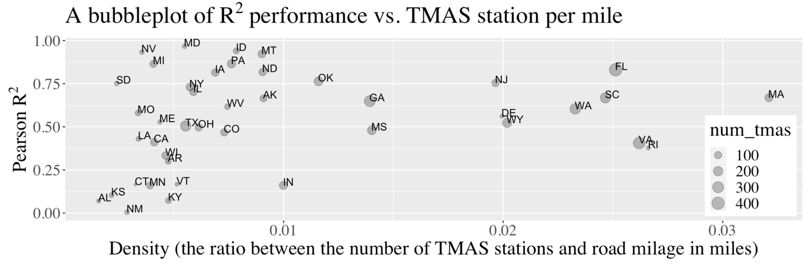
Figure 46. A bubble plot comparing the Pearson R² performance for traffic volume with the density of TMAS stations by state.

Figure 47 illustrates a comparative analysis between imputed truck volume and HPMS truck volume. The left subplot displays the forecasted values generated by the proposed algorithm, whereas the right subplot exhibits the HPMS’s truck AADT volume. Each blue point on the left subplot corresponds to a TMAS station. As anticipated, the imputation outcomes were similar to those of the historical AADT plot, despite AADT values being solely used as weights for network links within the algorithm. This underscores the efficacy of the algorithm in accurately imputing traffic volume across the network using the TMAS dataset.

Figure 47. A comparison between imputed truck value per hour and HPMS AADT truck volume (normalized to hourly volume) for Georgia.

Analysis of truck travel pattern along highway: a preliminary case study of Savannah, Georgia
A significant advantage of the proposed method lies in its capacity to extrapolate values across the network, transcending the confines of fixed TMAS stations. Furthermore, in addition to its capability to analyze traffic patterns at national or state levels, the proposed method proves highly valuable for scrutinizing local activities through the strategic placement of detectors along traffic links. This spatial analysis is automatically facilitated by the imputation algorithm, which operates seamlessly within the traffic network. To illustrate the efficacy of the tool, a case study was conducted, focusing on Savannah, Georgia. By 2023, the port of Savannah had become the fourth largest port in the United States (Lauriat, 2024), underscoring the importance of assessing truck performance along the major highways in proximity to Savannah.

Figure 48 illustrates the distribution of vehicle classes across varying times of the day and on weekdays versus weekends. Analysis revealed that within the subset of Vehicle Classes 9–13, Class 9 vehicles (i.e., trailer trucks) are the most common vehicles traveling on the eastbound and westbound Interstate 16 highways. In contrast, the use of Interstate 95 by Class 9 vehicles was comparatively lower, with Class 5 (two-axle vehicles, such as delivery trucks) being more prevalent. The figure also depicts the volume of Class 9 vehicles. Integration of this data with speed profiles and emission models facilitated the estimation of emission effects on major roadway segments.
Figure 48. A visualization of the ratio of Classes 5 and 9 for different times of the day for weekdays and weekends in Savannah, Georgia.

A further visualization of specific stations: analyzing outliers
Assessing performance at the level of individual detectors for comprehensive analysis was imperative. Figure 49 illustrates an interactive map using the Folium Python package, wherein each circle denotes a TMAS station. The size of each circle corresponds to the hourly truck traffic volume at the station, and the angle of each pie chart corresponds to a TMAS station. The angular sectors of the green and red pies represent the shares of Classes 5 and 9, respectively. Smaller angles signify smaller share. Note that a TMAS station could have one or two directions. The figure therefore provides a comprehensive visualization of truck volume and class distributions. The figure also reveals that many TMAS stations were located at connector roads instead of along busy highways.

The map’s interactivity enables users to click on circles to access the vehicle class distribution for each station. For example, the bottom row of Figure 49 shows the class distributions of three corresponding TMAS stations. The blue line signifies the observed percentage for each class, whereas the orange line depicts the percentage predicted or imputed by the proposed algorithm. Researchers can use the chart to check the distribution of trucks over places to understand truck traffic patterns over the highway system.

Figure 49. An interactive map of TMAS stations visualizing truck volume and vehicle class distributions near (left) Savannah, Georgia, and (right) near Tampa, Florida.

Conclusion
In this study, we introduced a novel iterative method for imputing traffic information across a traffic network. Beginning with a foundational HPMS dataset of AADT values, our approach enabled efficient imputation of observations at fixed locations throughout the traffic network. Unlike conventional interpolation techniques that primarily estimate AADT values, our method extends its capabilities to estimate aggregated traffic information across both temporal and spatial dimensions, accounting for diverse vehicle classes. The method’s versatility and underlying analytical framework render it highly applicable in various domains, including traffic analysis, emission modeling, and truck behavior analysis. Notably, our study offers several new perspectives on a national scale, leveraging insights derived from the TMAS dataset, thus advancing the state-of-the-art traffic data analysis based on the TMAS dataset.

As a novel approach, the proposed method may have some inherent limitations. Despite enhancements to the quality of the TMAS dataset over the preceding 5 years, significant room for refinement persists. First, the integrity of certain state-contributed data remains suspect, with concerns arising with the potential use of synthesized data for estimating absent observations. Second, the heterogeneity of detector types and data formats across different states presents an obstacle to the conversion of records into the standardized TMAS format. Within the TMAS data schema, ambiguous descriptions remain. Notably, in the context of detector alignment, the dataset exclusively accommodates eight cardinal travel directions (i.e., east, west, north, south, northeast, northwest, southeast, and southwest), complicating station-to-direction alignment procedures. It is plausible, for instance, for a directional designation such as northbound to correspond to eastbound in practice, owing to overarching highway nomenclature, such as I-40 E. Furthermore, certain states have not submitted vehicle classification data, although it is likely that many of these states possess the relevant data. The complexity inherent in the TMAS dataset’s 13-class “F-scheme” may prove prohibitive, necessitating advocacy for states to furnish a simplified classification system when F-scheme is not possible. Such a simplification could entail the adoption of a truncated F-scheme featuring two to three most dominant vehicle classes, such as Class 5 for delivery trucks, Class 9 for single-trailer trucks, and Class 13 for double-trailer trucks.

Despite data quality considerations, the proposed methodology has several inherent limitations. Each computational step potentially can introduce errors. The estimation of AADT values for individual segments within the FAF network based on the HPMS network may incur inaccuracies because of the intricate geometries of the network. Additionally, in the process of imputation, the determination of the termination criterion necessitates manual intervention to regulate the parameter $K$, the number of epochs through the graph’s edges. Furthermore, the imputation technique relies on the assumption of AADT truck volume, which commonly deviates from reality if investigated for some special time range.

Overall, our study demonstrates the feasibility of estimating freight traffic through the integration of AADT and TMAS observations, employing imputation techniques across the network. The sparse distribution of TMAS stations presents a significant challenge that has not been thoroughly investigated. This concept holds promise for further development and adaptation into alternative methodologies. For instance, there is potential to leverage deep learning techniques such as graph neural networks to facilitate information propagation across the network based on TMAS. Additionally, merging the three TMAS datasets—volume, class, and weight—offers the prospect of establishing a cohesive digital twin for analyzing freight traffic dynamics.

References
2022 Traffic Monitoring Guide, 2022.
Krile, R., Feng, J., Schroeder, J. AADT/ADT | Federal Highway Administration [WWW Document], 2016. URL https://www.fhwa.dot.gov/policyinformation/travel_monitoring/pubs/aadt/ (accessed 3.4.24).
Anderson, M.D., Sharfi, K., Gholston, S.E., n.d. Direct Demand Forecasting Model for Small Urban Communities Using Multiple Linear Regression.
Bae, B., Kim, H., Lim, H., Liu, Y., Han, L.D., Freeze, P.B., 2018. Missing data imputation for traffic flow speed using spatio-temporal cokriging. Transp. Res. Part C Emerg. Technol. 88, 124–139. https://doi.org/10.1016/j.trc.2018.01.015
Bui, K.-H.N., Cho, J., Yi, H., 2022. Spatial-temporal graph neural network for traffic forecasting: An overview and open research issues. Appl. Intell. 52, 2763–2774. https://doi.org/10.1007/s10489-021-02587-w
Caceres, N., Romero, L.M., Morales, F.J., Reyes, A., Benitez, F.G., 2018. Estimating traffic volumes on intercity road locations using roadway attributes, socioeconomic features and other work-related activity characteristics. Transportation 45, 1449–1473. https://doi.org/10.1007/s11116-017-9771-5
Chang, H., Cheon, S., 2019. The potential use of big vehicle GPS data for estimations of annual average daily traffic for unmeasured road segments. Transportation 46, 1011–1032. https://doi.org/10.1007/s11116-018-9903-6
Pagan-Ortiz, Chapter 2. Introduction to Vehicle Classification - Verification, Refinement, and Applicability of Long-Term Pavement Performance Vehicle Classification Rules, November 2014 - FHWA-HRT-13-091 [WWW Document], 2014, URL https://www.fhwa.dot.gov/publications/research/infrastructure/pavements/ltpp/13091/002.cfm (accessed 5.14.24).
Dasgupta, S., Papadimitriou, C.H., 2006. Algorithms.
Gotway, C.A., Ferguson, R.B., Hergert, G.W., Peterson, T.A., 1996. Comparison of Kriging and Inverse‐Distance Methods for Mapping Soil Parameters. Soil Sci. Soc. Am. J. 60, 1237–1247. https://doi.org/10.2136/sssaj1996.03615995006000040040x
Gu, Y., Liu, D., Arvin, R., Khattak, A.J., Han, L.D., 2023. Predicting intersection crash frequency using connected vehicle data: A framework for geographical random forest. Accid. Anal. Prev. 179, 106880. https://doi.org/10.1016/j.aap.2022.106880
Hagberg, A., Swart, P.J., Schult, D.A., 2008. Exploring network structure, dynamics, and function using NetworkX (No. LA-UR-08-05495; LA-UR-08-5495). Los Alamos National Laboratory (LANL), Los Alamos, NM (United States).
Hezaveh, A.M., Arvin, R., Cherry, C.R., 2019. A geographically weighted regression to estimate the comprehensive cost of traffic crashes at a zonal level. Accid. Anal. Prev. 131, 15–24. https://doi.org/10.1016/j.aap.2019.05.028
Hwang, H.-L., Hargrove, S., Chin, S.-M., Wilson, D.W., Lim, H., Chen, J., Taylor, R., Peterson, B., Davidson, D., 2016. The Freight Analysis Framework Verson 4 (FAF4) - Building the FAF4 Regional Database: Data Sources and Estimation Methodologies (No. ORNL/TM-2016/489, 1325489). https://doi.org/10.2172/1325489
Hwang, H.-L., Lim, H., Chin, S.-M., Uddin, M., Biehl, A., Xie, F., Hargrove, S., Liu, Y., Wang, R., 2021. Freight Analysis Framework Version 5 (FAF5) Base Year 2017 Data Development Technical Report (No. ORNL/TM-2021/2154, 1844893). https://doi.org/10.2172/1844893
Jiang, W., Luo, J., 2022. Graph neural network for traffic forecasting: A survey. Expert Syst. Appl. 207, 117921. https://doi.org/10.1016/j.eswa.2022.117921
Kong, X., Zhou, W., Shen, G., Zhang, W., Liu, N., Yang, Y., 2023. Dynamic graph convolutional recurrent imputation network for spatiotemporal traffic missing data. Knowl.-Based Syst. 261, 110188. https://doi.org/10.1016/j.knosys.2022.110188
Krile, R.S., Jeremy; Jessberger, Steven, 2016. Assessing Roadway Traffic Count Duration and Frequency Impacts on Annual Average Daily Traffic Estimation: Assessing Accuracy Issues Related to Short-Term Count Durations (No. FHWA-PL-16-016).
Li, M., Zhu, Z., 2021. Spatial-Temporal Fusion Graph Neural Networks for Traffic Flow Forecasting. Proc. AAAI Conf. Artif. Intell. 35, 4189–4196. https://doi.org/10.1609/aaai.v35i5.16542
Liang, Y., Zhao, Z., Sun, L., 2022. Dynamic Spatiotemporal Graph Convolutional Neural Networks for Traffic Data Imputation with Complex Missing Patterns. Transp. Res. Part C Emerg. Technol. 143, 103826. https://doi.org/10.1016/j.trc.2022.103826
Liu, H., Lee, M., Khattak, A.J., 2019. Updating Annual Average Daily Traffic Estimates at Highway-Rail Grade Crossings with Geographically Weighted Poisson Regression. Transp. Res. Rec. J. Transp. Res. Board 2673, 105–117. https://doi.org/10.1177/0361198119844976
Lowry, M., 2014. Spatial interpolation of traffic counts based on origin–destination centrality. J. Transp. Geogr. 36, 98–105. https://doi.org/10.1016/j.jtrangeo.2014.03.007
Mohamad, D., Sinha, K.C., Kuczek, T., Scholer, C.F., 1998. Annual Average Daily Traffic Prediction Model for County Roads. Transp. Res. Rec. J. Transp. Res. Board 1617, 69–77. https://doi.org/10.3141/1617-10
Shen, G., Zhou, W., Zhang, W., Liu, N., Liu, Z., Kong, X., 2023. Bidirectional spatial–temporal traffic data imputation via graph attention recurrent neural network. Neurocomputing 531, 151–162. https://doi.org/10.1016/j.neucom.2023.02.017
Shiledar, A., Sujan, V., Siekmann, A., Yuan, J., 2024. Enhanced Safety of Heavy-Duty Vehicles on Highways through Automatic Speed Enforcement–A Simulation Study. SAE Technical Paper.
Top 20 North American ports [WWW Document], n.d. URL https://www.ajot.com/premium/{path= (accessed 5.15.24).
United States. Department of Transportation. Office of the Secretary of Transportation, United States. Department of Transportation. Bureau of Transportation Statistics. Office of Statistical and Economic Analysis, 2017. Freight Analysis Framework (FAF) FAF5: HiLoForecasts [supporting datasets]. Freight Analysis Framework (FAF). https://doi.org/10.21949/1529116
Wang, X., Kockelman, K.M., 2009. Forecasting Network Data: Spatial Interpolation of Traffic Counts from Texas Data. Transp. Res. Rec. J. Transp. Res. Board 2105, 100–108. https://doi.org/10.3141/2105-13
Weiss, M., Cloos, K.C., Helmers, E., 2020. Energy efficiency trade-offs in small to large electric vehicles. Environ. Sci. Eur. 32, 46. https://doi.org/10.1186/s12302-020-00307-8
Xu, C., Wang, Y., Ding, W., Liu, P., 2020. Modeling the Spatial Effects of Land-Use Patterns on Traffic Safety Using Geographically Weighted Poisson Regression. Netw. Spat. Econ. 20, 1015–1028. https://doi.org/10.1007/s11067-020-09509-2
Yang, H., Yang, J., Han, L.D., Liu, X., Pu, L., Chin, S., Hwang, H., 2018. A Kriging based spatiotemporal approach for traffic volume data imputation. PLOS ONE 13, e0195957. https://doi.org/10.1371/journal.pone.0195957
Zhang, Y., Dong, X., Shang, L., Zhang, D., Wang, D., 2020. A Multi-modal Graph Neural Network Approach to Traffic Risk Forecasting in Smart Urban Sensing, in: 2020 17th Annual IEEE International Conference on Sensing, Communication, and Networking (SECON). Presented at the 2020 17th Annual IEEE International Conference on Sensing, Communication, and Networking (SECON), IEEE, Como, Italy, pp. 1–9. https://doi.org/10.1109/SECON48991.2020.9158447
Zhao, F., Chung, S., 2001. Contributing Factors of Annual Average Daily Traffic in a Florida County: Exploration with Geographic Information System and Regression Models. Transp. Res. Rec. J. Transp. Res. Board 1769, 113–122. https://doi.org/10.3141/1769-14
Zhao, F., Park, N., 2004. Using Geographically Weighted Regression Models to Estimate Annual Average Daily Traffic. Transp. Res. Rec. J. Transp. Res. Board 1879, 99–107. https://doi.org/10.3141/1879-12

A version of this chapter was originally published by Diyi Liu, Hyeonsup Lim, Majah Uddin, Yuandong Liu, Lee D. Han, Ho-long Hwang, and Shih-Miao Chin:
Liu, D., Lim, H., Uddin, M., Liu, Y., Han, L. D., Hwang, H. L., & Chin, S. M. (2024). Improving the accuracy of freight mode choice models: A case study using the 2017 CFS PUF data set and ensemble learning techniques. Expert Systems with Applications, 240, 122478.

Most of the original paper’s content is kept in this paper. Besides, the discussion of interpreting the model is modified.

Chapter IV: Improving the Accuracy of Freight Mode Choice Models: A Case Study Using the 2017 CFS PUF Data Set and Ensemble Learning Techniques

Abstract
The US Census Bureau has collected two rounds of experimental data from the Commodity Flow Survey, providing shipment-level characteristics of nationwide commodity movements, published in 2012 (i.e., Public Use Microdata) and in 2017 (i.e., Public Use File). With this information, data-driven methods have become increasingly valuable for understanding detailed patterns in freight logistics. In this study, we used the 2017 Commodity Flow Survey Public Use File data set to explore building a high-performance freight mode choice model, considering three main improvements: (1) constructing local models for each separate commodity/industry category; (2) extracting useful geographical features, particularly the derived distance of each freight mode between origin/destination zones; and (3) applying additional ensemble learning methods such as stacking or voting to combine results from local and unified models for improved performance. The proposed method achieved over 92% accuracy without incorporating external information, an over 19% increase compared to directly fitting Random Forests models over 10,000 samples. Furthermore, SHAP (Shapely Additive Explanations) values were computed to explain the outputs and major patterns obtained from the proposed model. The model framework could enhance the performance and interpretability of existing freight mode choice models.
Keywords: Commodity Flow Survey, freight mode choice, machine learning, stacking method, interpretable machine learning, behavior analysis

Introduction
Understanding national-level freight mode choice is a vital research area regarding sustainability, planning, policymaking, and economic analysis. The share of freight modes fluctuates over time because of the ever-changing operational characteristics and environment. Therefore, a comprehensive grasp of the underlying determinants that influence mode choice is crucial for optimizing freight transportation systems.
Recently, the landscape of freight logistics has experienced rapid changes under the influence of multiple factors, including technological advancements, infrastructure deterioration, labor shortages, and the fast growth of electronic commerce. For instance, the adoption of autonomous and electric vehicles holds great potential in reducing truck operating expenses (Monios & Bergqvist, 2019), leading to a possible shift from rail to road transport for certain cargo types. The surge in online shopping has placed immense strain on parcel delivery services worldwide (Zenezini et al., 2018), particularly when freight capacity is constrained by factors such as a shortage of truck drivers (Burks & Monaco, 2019; Hobbs, 2020). Furthermore, new operational practices in rail systems such as shift scheduling have been linked to fatigue, which could result in accidents (Rudin-Brown et al., 2019; Zhang et al., 2021). Mitigating these challenges requires a thorough understanding of the flow of goods across various transportation modes.
The Commodity Flow Survey (CFS), a collaborative effort of the US Census Bureau and the Bureau of Transportation Statistics, provides valuable insights into the characteristics of freight shipments in the United States. This shipper-based survey has been conducted every 5 years since the early 1990s and covers a broad spectrum of industries, encompassing approximately 100,000 establishments. The CFS data have been widely used by various federal, state, and local and regional agencies to understand freight commodity flows, evaluate transportation demand and infrastructures, and facilitate informed decision-making processes.
The CFS provides valuable data for analyzing freight transportation mode choices. Furthermore, experimental data products—Public Use Microdata in 2012 and Public Use File (PUF) in 2017—have allowed for more detailed analyses at the shipment level (Arencibia et al., 2015; Larranaga et al., 2017; Samimi et al., 2011). These surveys present a unique opportunity to employ a data-oriented, disaggregate-level approach to better understand freight mode selection.
This study focuses solely on the 2017 CFS PUF data and proposes a framework to enhance model performance by considering three key improvements: (1) constructing local models for each individual commodity/industry category; (2) extracting useful geographical features, particularly the derived distance of each freight mode between origin and destination zones; and (3) implementing additional ensemble learning methods, such as stacking or voting, to combine results from local and unified models for superior performance.
This article is organized as follows. In Section 2, prior practices of fitting machine learning models for both general classification tasks and transportation/freight mode choice tasks are discussed. Section 3 provides a definition of the mode classification used in this study, along with a summary of the CFS PUF data set. Section 4 describes the data processing steps, the model selection procedures, and the machine learning algorithms adopted. Section 5 presents model results through both performance metrics and a receiver operating characteristic curve. The model is also explained using different model interpretation methods including variable importance, SHAP values, etc. Finally, Section 6 concludes with an overview of lessons learned from this study, limitations, and future research directions.

Literature Review
The complexity of the freight system, with its multiple modes of transportation, operators, and routes, makes it difficult to obtain all operational data directly from the field. Consequently, surveys are one of the most viable methods for understanding freight choices for most applications. Two types of surveys are commonly used: stated preference (SP) and revealed preference (RP). SP surveys allow responders to indicate their preferred choice given specific scenarios and choices, whereas RP surveys generate reports that reflect actual choices made for their existing operations. SP surveys are often designed to gain insights into adopting new technologies, infrastructures, and policies. For example, Larranaga et al. (2017) designed an SP survey for six scenarios targeting policies that can encourage intramodality in Rio Grande do Sul, Brazil. RP surveys have become increasingly popular in recent years because of the lowered cost in collecting large data sets. Rich et al. (2009) in Denmark used an RP survey, the FEMEX/COMVIC RP data set, to build a multinomial logistic regression (MNL) model considering the effects of free flow time, congestion time, and waiting time for each traffic mode.
In the United States, numerous SP surveys have been established to understand freight choices within specific regions, industries, and commodities. For example, Samimi et al. (2011) built a behavior model of freight choice based on a survey conducted for 316 firms. Conducting such surveys incurs high labor and monetary costs. The recent establishment of the CFS PUF data set, as an RP data set, has presented an opportunity for researchers to access millions of freight shipment records. This public data set provides a nationwide scope for understanding freight choice in the United States using millions of records revealing freight shipments. Two shipment-level microdata sets were released for 2012 and 2017. The CFS PUF data set contains a wide range of industry and commodity types, as described in Section 3. For the 2017 survey, approximately 60,000 establishments were involved, and 5,987,535 shipments were recorded (2017 Commodity Flow Survey (CFS) Public Use File (PUF) Data Users Guide, 2020). With such scope and complexity, data-oriented methods such as machine learning may be preferred over traditional methods to attain high prediction performance in accuracies.
In the field of behavior modeling, two primary approaches are used: regression-based methods and machine learning methods. The regression-based methods, such as MNL, have proven useful in identifying statistical significance surveying transportation mode choice (Arencibia et al., 2015; Holguín-Veras et al., 2021; Keya et al., 2018; Uddin et al., 2021). For models with only two classes, MNL reduces to binary logit regression (LR). Hierarchical classification structures, such as those found in freight modes where intermodal modes like water-truck mode and rail-truck mode fall under intermodal mode, can be modeled with nested logistic regression (NL), which nests multiple MNLs together. These three models (i.e., MNL, LR, and NL) are known as random utility models because they assume an individual’s preference can be described by a utility function. This approach is commonly employed in traditional freight choice modeling (Arencibia et al., 2015; Holguín-Veras et al., 2021; Larranaga et al., 2017; Moschovou & Giannopoulos, 2012; Norojono & Young, 2003; Rich et al., 2009; Samimi et al., 2011; Shen & Wang, 2012; Uddin et al., 2021; Wang et al., 2013). These models are augmented by various explanatory variables that influence the utilities or attractiveness of each choice. Sensitivity analysis can be used to evaluate the effect of different influencing factors (Arencibia et al., 2015; Larranaga et al., 2017; Samimi et al., 2011). Another method, random regret minimization, employs a similar structure but uses different formulations that focus on the compromise effect of alternatives for modeling freight mode choice using the CFS PUF data set (Keya et al., 2018, 2019). Although these parametric models are valuable for analyses such as sensitivity analysis and econometric analysis, the lack of flexibilities of traditional models often limit their overall performance when applied on millions of data records.
For the classification of CFS PUF, which has thousands of subcategories and millions of records, machine learning methods may be preferred over traditional methods for their superior performance. To evaluate the effectiveness of various machine learning approaches, such as Naïve Bayes (NB), support vector machine (SVM), artificial neural network, k-nearest neighbors (KNN), decision tree (DT), random forest (RF), boosting DT, and bagging DT, Uddin et al. (2021) conducted a series of experiments with different numbers of training samples. Although the performance of DT and RF methods reached around 75.4% accuracy, which is significantly higher than utility-based MNL performance of 42.0% accuracy, further improvements can be made using ensemble techniques. Moreover, Uddin et al. (2021) and Keya et al. (2019) augmented the CFS Public Use Microdata data set by adding several secondary information such as local weather, logistics information, and origin and destination facility densities, which could limit the applicability of these models to public users. Models with accuracies below 80% may still not fully exploit the provided shipment information in terms of predicting freight mode. To further enhance model performance, other machine learning practices must be adopted that utilize big data from other disciplines.
The topic of transportation mode choice has been the focus of recent studies recently. A comprehensive synthesis of these studies during the last decade is presented in Table 10. Notably, with the exception of Uddin et al. (2021), all other studies have primarily focused on individual trip mode rather than freight mode choice, and they are arranged in ascending chronological order of publication. The observations from these studies are as follows: 1) Conventional methods such as MNL/LR do not perform well; 2) Machine learning methods such as NB, SVM, DT, MLP show better performance; 3) Tree-based models like RF and boosting decision trees (BOOST) are likely to achieve higher accuracies, probably due to the tabular nature of mode choice data, as indicated by these comparison studies. However, a limitation inherent in these methodologies is their tendency to prioritize the identification of fundamental input variables, often neglecting the derived explanatory features. Additionally, machine learning offers other advanced techniques to further enhance model’s performance.

Table 10. Summary of recent comparative study comparing between machine learning algorithms and traditional methods in the application of transportation mode choice.
Paper | Data sources & sizes | Study scope | Mode | Method tested | Training and testing sets | Best performed model reported
Uddin et al. (2021) | 2012 CFS data; 4,547,661 shipments from approximately 60,000 responding establishments; | United States | For-hire truck, private truck, parcel service, air, other mode | MNL; NB; SVM; ANN; CART; RF; BOOST; KNN | Performance tested under different sample sizes (136,073-2,267,842); tested training set (10%-60%). | Among all investigated classifiers, the highest model, a RF model, reached about 82% accuracy.
Omrani (2015) | Luxemburg PSELL survey; 9,500 individuals | Luxemburg | Car, PT, walk/bike | MNL; ANN-MLP; ANN-BLF; SVM | 60% training set;  40% testing set | Accuracy reported: MNL (0.65); SVM (0.68); ANN-RBF (0.80); ANN-MLP (0.82)
Nam et al. (2017) | Switzerland mode choice survey for long-distance travel; 6,768 individual observations | Switzerland | Car, rail, Metro | NL; CNL; ANN; ANN-MLP; DNN | Best outcomes correspond to 70% training set; 30% testing set | Accuracy reported: NL (0.64); CNL (0.64); ANN-MLP (0.63); DNN (0.67)
Hagenauer & Helbich (2017) | Dutch National Travel Survey (NTS); 230,608 trips reported from 69,918 individuals | Netherlands | car, walk, bike, PT | MNL; NB; SVM; ANN; RF; BOOST; BAG | 69,918 individuals with 230,608 trips reported | MNL (0.561), ANN (0.606), NB (0.602), BOOST (0.801), SVM (0.825), BAG (0.906), RF (0.914)
Cheng et al. (2019) | Household survey; | Nanjing, China | Walk, bike, EM, PT, car | MNL; RF; SVM; BOOST | 80% training set;  20% testing set | RF and SVM provides the best performance
Zhao et al. (2020) | State Preference Survey at University of Michigan, Ann Arbor campus; 8,141 observations from 1,163 individuals | Ann Arbor, Michigan, United States | car, walk, bike, PT | MNL; NB; NN; CART; SVM; RF; BOOST; BAG | 10-fold cross validation for tunning. | MNL(0.647); mixed logit (0.631); RF (0.856)
Kim (2021) | 2016 NHTS. 172,889 trips | Seoul, Korea | Car, bike, PT, walk | ANN, RF, XGBoost | 75% for training  25% for testing | ANN (0.882); RF (0.909); XGBoost (0.923)
Tamim Kashifi et al. (2022) | Dutch national travel survey (NTS); 230,608 trips reported from 69,918 individuals | Netherlands | car, walk, bike, PT | LR; MLP; DT; RF; LightGBDT | 10% testing set & 90% training set; Ten-fold cross validation for tunning; | Reported accuracies: LR (0.58), MLP (0.62), DT (0.80), RF (0.87), LightGBDT (0.89)
Notes for abbreviation and acronyms: LR: Logic Regression; MNL: Multinominal Logistic Regression; NL: Nested Logit Model; CNL: Cross Nested Logit Model; NB: Naïve Bayes; SVM: Support Vector Machine; CART: Classification and Regression Tree; RF: Random Forest; BOOST: Gradient Boosting Decision Tree; BAG: Bagging Decision Tree; NN: Neural Networks; ANN: Artificial Neural Networks; MLP: Multi-layer Perceptron; PT: public transits; EM: e-motorcycle.
Over the past two decades, the field of machine learning has seen significant advancements, leading to the emergence of several new techniques that enhance model performance. One noteworthy development in the data science and machine learning community was the Netflix Prize, held from 2006 to 2009 to predict Netflix user ratings on various movies (Bennett & Lanning, 2007). The winning team and other top-performing teams gained valuable insights into developing high-performance machine learning models. According to descriptions provided by the two top teams (Koren, 2009; Töscher et al., 2009), these breakthroughs were mainly attributed to three significant aspects: discovering new features underlying the data; employing different types of base learners; and blending predictions from different algorithms through ensemble methods such as gradient-boosted DT. Following the Netflix Prize, numerous competitions have been conducted over the past decade on platforms such as Kaggle (Bojer & Meldgaard, 2021) for various data sets and tasks. One popular category of ensemble methods is to blend different algorithms together, known as the stacking method (Hastie et al., 2009a), which is frequently employed in diverse classification tasks such as detecting phishing websites (Li et al., 2019), identifying defective products on production lines (Mangal & Kumar, 2016), and predicting antigenic variants of H1N1 influenza (Yin et al., 2018).
Given the constraints of prior freight choice models and the recent advances in developing high-performance models, this study aims to construct a high-performance model using solely the CFS PUF data set without any external data sources. The objective is to build a model framework that achieves superior performance by incorporating the three aspects gleaned from the Netflix Prize teams and other recent machine learning modeling practices into the development process.
In this study, we considered two distinct ensemble learning techniques: the weighted voting method and the stacking method. For feature extraction, we identified routed distances (estimated given the combination of origin, destination, and mode) as a crucial factor. Additionally, other features such as value-to-weight ratio and origin and destination metropolitan type (i.e., combined statistical areas, metropolitan statistical areas, and other regions) were also found useful. To construct base learners of the stacking and voting methods, we developed local models for various Standard Classification of Transported Goods types (SCTG code) and North American Industry Classification System types (NAICS code). Finally, stacking and voting methods were applied to ensemble the base learners from different commodity and industry genres and data scopes. Given these countermeasures, our findings indicate that all three countermeasures were effective in improving model performance. To the best of the authors knowledge, this is the first machine learning model that achieved accuracies above 90% using the CFS Public Use Microdata data set on freight mode choice predictions. This powerful model not only generates the most probable mode of transport but also estimates the probability of selecting each mode. In summary, this predictive model driven by machine learning can assist various stakeholders such as courier agencies, shippers, and transportation agencies in analyzing freight-related issues across different geographic scales (e.g., state-level, national-level) and product types (e.g., commodity type, industry type).

Explorative Data Analysis

Mode Classification and Variable Definitions
To compare the model performance of this study to the results of the previous work, this study used the five categories of freight modes that were adopted by two previous studies (Keya et al., 2021; Uddin et al., 2021). Table 11 describes the five modes used in this study, along with the original 13 types of major freight modes defined by the CFS. In this classification, rail, water, and pipeline modes are combined into a single mode referred to as other modes. Thus, the 13 modes from CFS are compressed to 5 freight modes: for-hire truck, privately owned truck, parcel service, air, and other modes. Privately owned trucks include company-owned trucks used for logistics activities, and for-hire trucks include self-employed drivers transporting goods over long distances. In total, 18,539 (0.31%) out of 5,978,523 records are provided at a more aggregated level (e.g., single mode) and are not matched to a specific mode in Table 11. Therefore, this study excluded such records and analyzed 5,959,984 (99.69%) records of the 2017 CFS PUF data.
Table 11. Five aggregated freight mode classifications and more specific CFS PUF data set mode classifications
Mode classification | Code defined by the CFS PUF data set
For-hire truck (Mode 1)
For-hire truck | 04
Privately owned truck (Mode 2)
Privately owned truck | 05
Parcel service (Mode 3)
Parcel service (parcel, USPS, or courier) | 14
Air (Mode 4)
Air (including truck and air) | 11
Other modes (Mode 5)
Rail | 06
Water | 07
Inland water (water) | 08
Great lakes (water) | 09
Deep sea (water) | 10
Multiple waterways (water) | 101
Pipeline | 12
Truck and rail (multiple modes) | 15
Truck and water (multiple modes) | 16
Rail and water (multiple modes) | 17

Table 12 presents all information considered from the CPS PUF data set. There are three categories of information: basic shipment information, spatial information, and supplementary information. The basic shipment information includes weight (in US pounds), value (in US dollars), commodity type (SCTG), and industry type (NAICS). The spatial information is based on origin, destination, great circle distance, and the routed distance for each specific freight mode. The 2017 CFS PUF data set reports the routed distance estimated for only the chosen mode. Because of this dependency on the chosen mode, directly incorporating the routed distance as model inputs results in a loss of information, which may cause modeling bias and overfitting. To address this, this study utilized derived routed distance estimates by origin and destination for each of the five modes, including both chosen and unchosen modes (as detailed in Section 4). This approach allowed for constructing a geographical profile of various freight modes between states or metropolitan regions. The group of variables of all derived distances for all available modes were employed as model inputs. Supplemental information pertains to detailed data regarding shipments of specialized commodities that require specific handling conditions because of their hazardous nature (e.g., chemical compounds) or temperature sensitivity (e.g., fresh meat). Such information proves valuable in forecasting the appropriate shipping mode for such commodities. Notably, our machine learning model does not rely on external data sets, thereby easing the efforts of data collection for researchers in their analyses. For each piece of information, there exists one or multiple variables to describe it. In the context of machine learning, these input variables are referred to as input features.
Table 12. Description of all considered information from the CFS PUF data set
Column name |  | Description
Basic shipment information
 | Mode (target variable) | Shipment mode (for-hire truck, privately owned truck, parcel, air, other modes)
 | Weight | Weight of the shipment (in US pounds)
 | Value | Value of the shipment (in US dollars)
 | SCTG | Two-digit SCTG commodity code of the shipment (43 categories)
 | NAICS | Industry classification of the shipper (45 categories)
Spatial information
 | Origin | Origin code (state code and metropolitan area code)
 | Destination | Destination code (state code and metropolitan area code)
 | Distance | Great circle distance between origin and destination (in miles)
 | Routed distance | For the chosen mode, the actual routed traveling distance of the shipment (in miles)
Supplemental information
 | HAZMAT | Hazardous material (Class 3.0 hazard, other hazard, or not hazard)
 | Temperature controlled | Temperature-controlled shipment

Analyzing Freight Mode Choice Patterns
Figure 50 shows the distribution of the five freight modes across multiple metrics for the 2012 and 2017 CFS data sets. The four plots, from left to right, correspond to metrics based on shipment count, total weight (in US tons), total value (in US dollars), and total ton-miles traveled (in US ton-mile). Across metrics, the share of different modes varies significantly. For instance, although most shipments correspond to the parcel service parcel in terms of shipment numbers, parcel service only represents a very small share in terms of the total weight. Besides, a side-by-side comparison between the 2012 and 2017 data sets provides insight into trends observed over 5 years. Between these two years, the shares of other modes remained relatively stable except for an increase in parcel service and a decrease in privately owned trucks. For analysis in this study, only the 2017 data set was used.
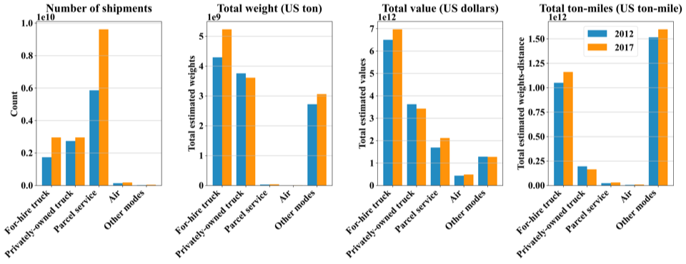
Figure 50. Share of different modes with respect to the number of shipments, total weight, total value, and total ton-miles traveled
Through the use of total values in US dollars as a metric, Figure 51 and Figure 52 illustrate the percentage distribution (in terms of value) of various modes of shipment origins and destinations in different US states. The results demonstrate that different states exhibit varying mode distributions. For instance, privately owned trucks are more prevalent in the Northeast, whereas for-hire trucks dominate many Midwest states. Furthermore, this study also used spatial information inferred from the derived distance between modes with respect to origin and destination states and metropolitan regions (Section 4).
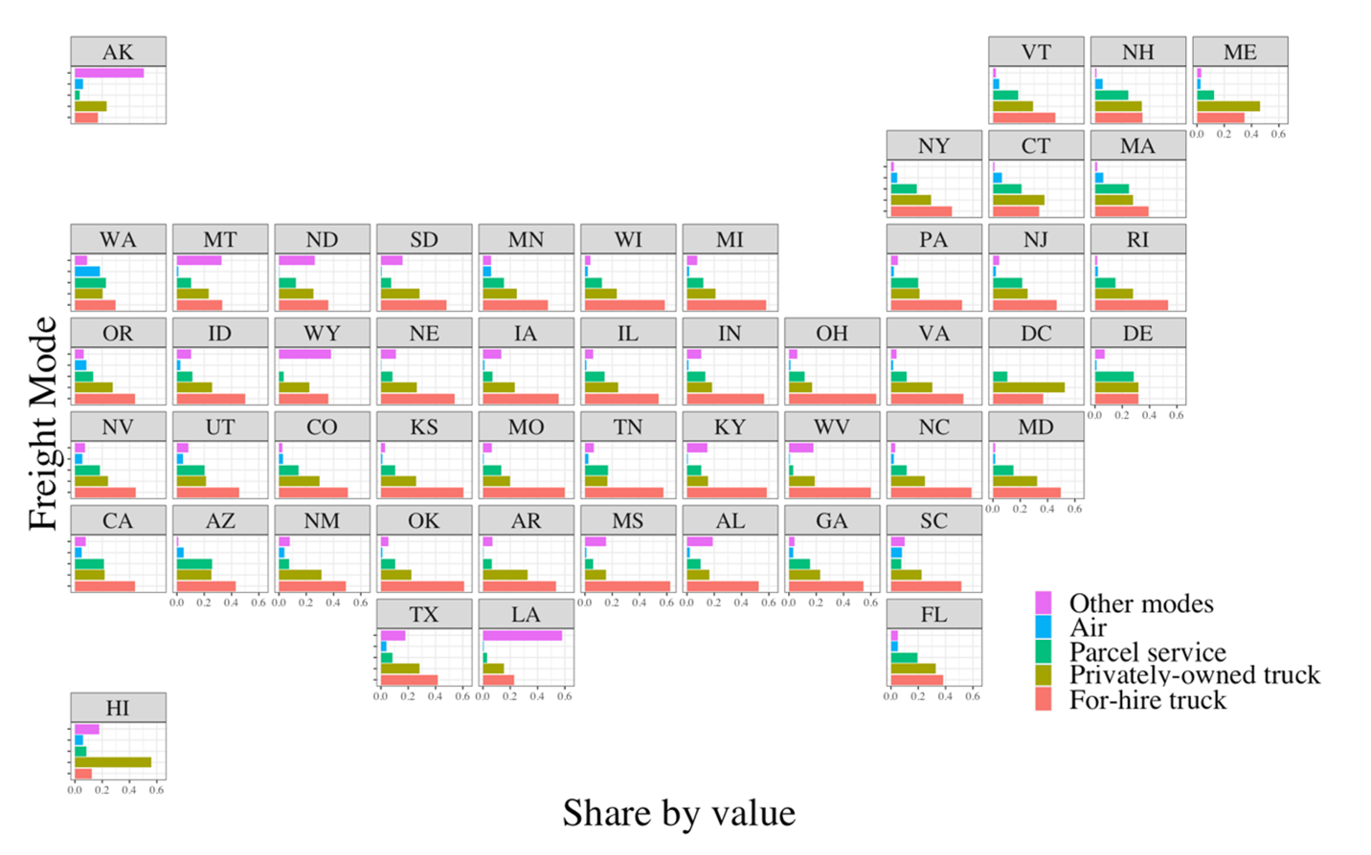
Figure 51. Percentage value share (in US dollars) of different freight modes by origin state
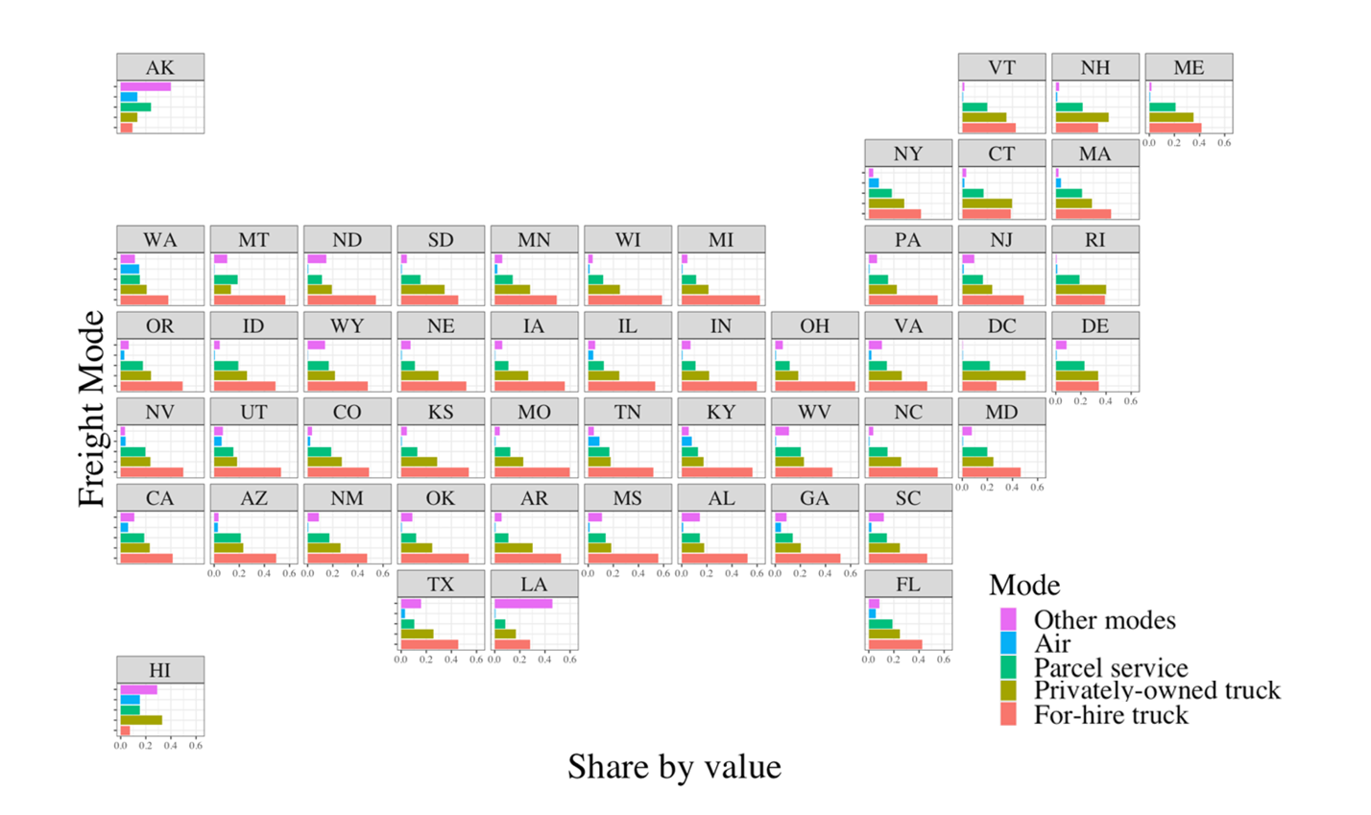
Figure 52. Percentage value share (in US dollars) of different freight modes by destination state
In addition to the spatial distribution of freight modes, the modal share of different product types must also be understood. To this end, we present the results of our distribution analysis in Figure 53, which displays the modal split by each commodity type according to the SCTG code and by each industry type according to the NAICS code. It is found that certain commodities present distinct mode preferences. For instance, alcoholic beverages (SCTG #08) are predominantly transported by privately owned trucks because of their requirement for special permits (Alcohol Transport Permit Requirements by State | Brew Movers, 2022). Meanwhile, parcel services are commonly used for transporting electronic devices (SCTG #35) or precision instruments (SCTG #38), likely because of their small size/weight and urgent delivery requirements.
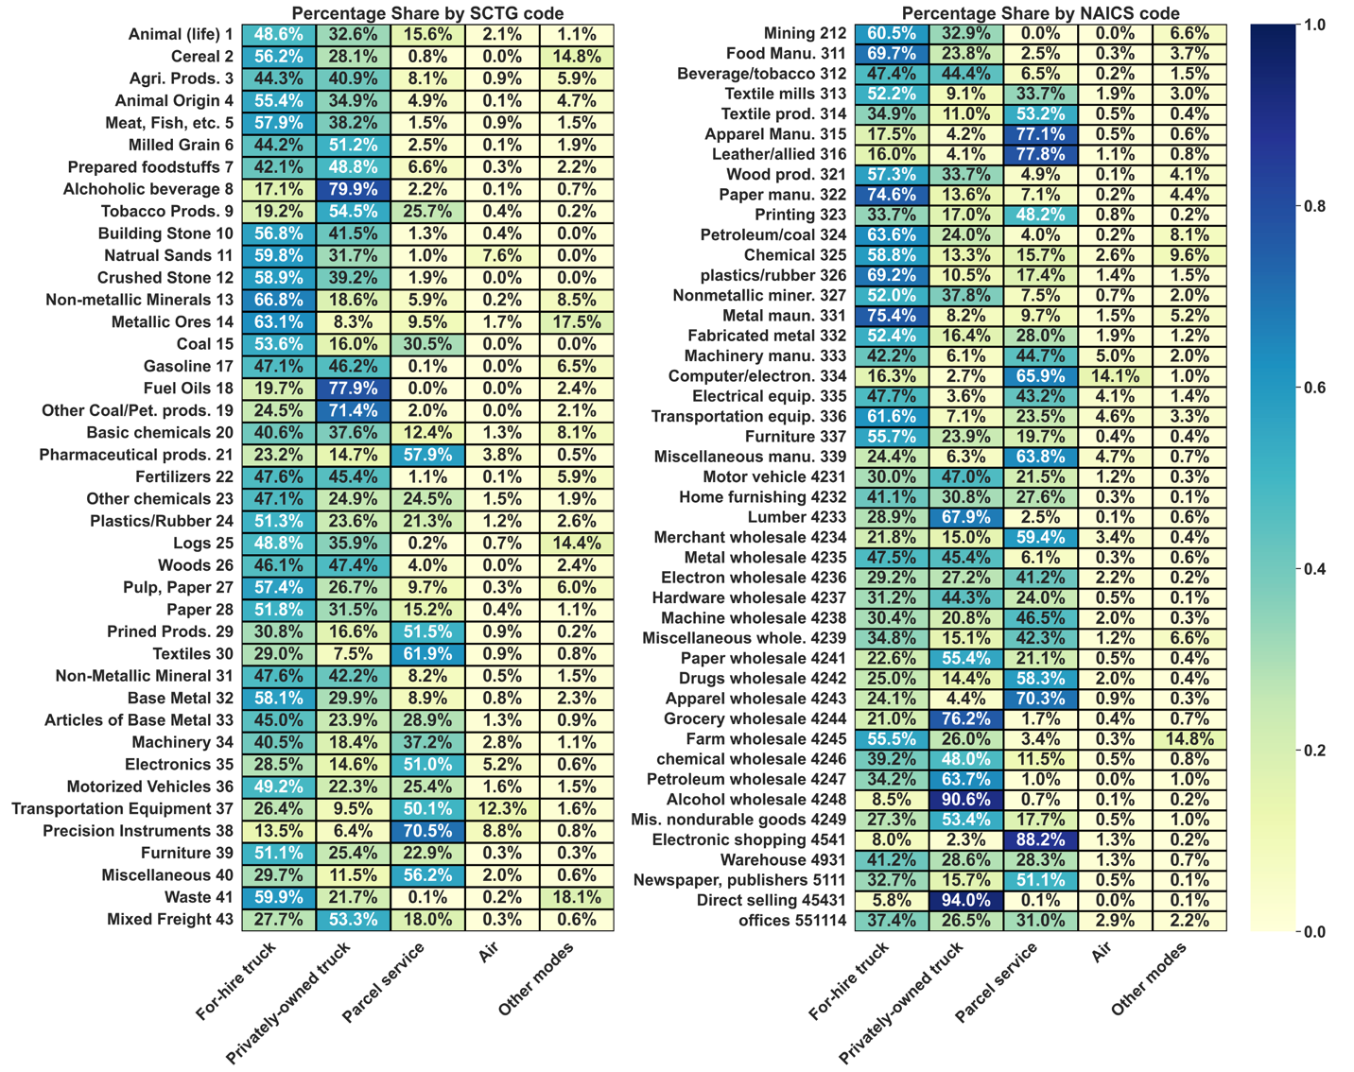
Figure 53. Distribution of different freight mode choices by different SCTG (commodity) codes and NAICS (industry) codes (measured in the number of shipments)
In summary, this section presents the results of an exploratory data analysis aimed at identifying key factors and trends to guide the modeling step in freight mode selection. First, the analysis reveals that different locations exhibit varying proportions of shipments. Therefore, incorporating both geographical traits and travel distances between origin and destination is crucial in narrowing the feasible freight modes. Second, the SCTG and NAICS codes characterizing commodity types play a significant role in selecting the preferred freight mode. Given the existence of more than 40 categories for SCTG and NAICS types, careful consideration must be given to exploit such categorical heterogeneity across different cases. Finally, the distribution of different freight modes varies significantly under different metrics. Consistent with previous studies (Keya et al., 2018; Rich et al., 2009; Uddin et al., 2021), we employed the number of shipments (i.e., records) for model evaluation.

Methodology
The structure of the methodology subsections is delineated as follows: (1) Section 4.1 outlines the general data processing pipeline employed for constructing the model; (2) Section 4.2 develops the augmented data features used for machine learning models; (3) Section 4.3 shows different types of level-1 model as well as the benefits of developing local/separate models to exploit the heterogeneous nature of different commodities/industries types of goods; (4) Section 4.4 shows the level-2 model blending different genres of level-1 model via model stacking/voting techniques; Furthermore, more detailed steps for training level-2 stacking methods are provided in this section.

An Overview of the Proposed Methodology
To develop a high-performance predictive model, it is essential to construct an efficient data pipeline through an analysis framework. This study focuses on building pipelines to prevent overfitting, data leakage issue, and to compare against different machine learning models and layouts. Figure 54 illustrates the data processing pipeline and analysis framework employed in this study. Step 1 in the pipeline is to split the data into a training set and a testing set. The testing set comprises 20% of the data, using stratified random sampling, grouped by SCTG code and NAICS code. In Step 2, useful geographical features are extracted, including great circle distance reported from the 2017 CFS PUF data and the derived distances between each origin and destination CFS metropolitan area (i.e., CFA area) for each of the five modes of transportation. At this point, the training and testing data sets are cleaned and formed. In Step 3, multiple machine learning models are trained and tested using different input features. Global base learners are trained using randomly drawn samples from all training data sets while separate models (base learners) for each commodity and industry type are trained and concatenated as one predicting model (i.e., base learner). In Step 4, different types of base learners are combined using either voting averages or stacking methods to create a final estimator (i.e., level-2 model or meta-learner). Each step of the data pipeline is discussed in further detail in the following sections.
Figure 54. Proposed data processing pipelines and analysis framework

Developing Useful Features (Data Augmentation)
Routed distance is the actual distance traveled by a specific freight mode. To obtain useful geographical and distance information (i.e., step 2 of the framework), regional definitions must be well understood. The CFS PUF data set classifies the United States into more than 123 regions, including combined statistical areas, metropolitan statistical areas, and the remainder of each state (2017 Commodity Flow Survey (CFS) Public Use File (PUF) Data Users Guide, 2020). These regions divide the United States into distinct parts (i.e., CFS areas). Since the CFS records provide the estimated routed distances only for the selected mode, directly using the derived distance information in the model may lead to a loss of information. However, since the data set has millions of records, between a specific pair of origins and destinations, it is plausible to assume that there would be many records for each freight mode. Thus, all five modes’ routed distances can be used jointly as input features in the model. For example, as input features, given a specific pair of origin and destination, these derived distances by each mode can be computed as a statistic (e.g., median) of observed routed distances.
In Figure 55, the map displayed on the left illustrates the identified CFS regions and their corresponding codes. Each yellow region represents a CFS area, and the remaining regions of each state are depicted in white and have a different code. The routed distance for various freight modes can vary significantly between an origin–destination pair. For instance, Figure 55 shows that the routed distance by air between Los Angeles, California, and New York, New York, is shorter than that of for-hire trucks, which is still shorter than that of other modes (e.g., water, rail, pipes). Comparing the routed distances of various freight modes (top right of Figure 55) provides valuable information regarding mode choice. Notably, using routed/derived distance entails a potential risk of overfitting due to data leakage. In this case, the data leakages refer to the misbehavior of disclosing the predicting mode by providing the routed distance for the selected freight mode. Consequently, all routed distances must be generated as input features from the training data set. Moreover, in this study, only the median distances for each mode between origin–destination pairs are employed to describe a general derived distance given the candidate mode, origin, and destination. Also, it is likely that some modes are not available between some origins and destinations. For example, although privately owned trucks mode is theoretically possible between Los Angeles and New York, no such records are found in the dataset because the trip distance is too long (the privately owned trucks rarely ship beyond 500 miles). For such cases, we impute that derived distances of the missing modes by fitting a regression model to estimate the routed distance given the great circle distance.
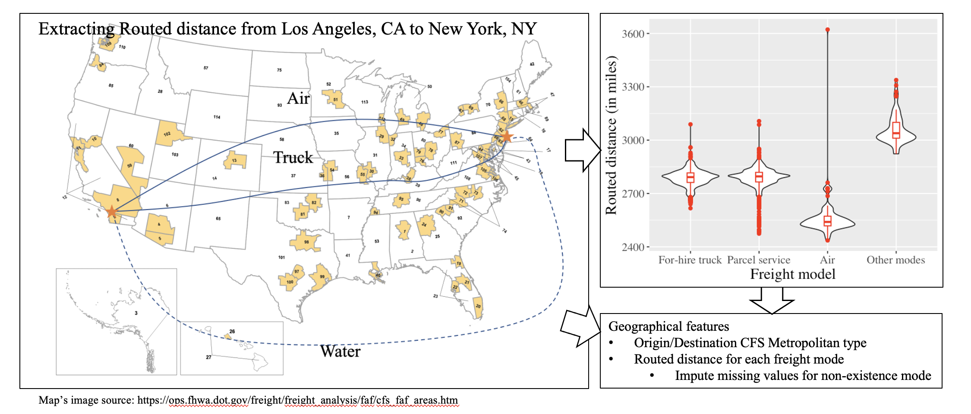
Figure 55. Collected derived distance and spatial information for each mode between each origin–destination pair of CFS areas
All explanatory input variables adopted in the model are described in Table 13, which were further derived from the data set inputs presented in Table 12. Compared with Table 12, the derived variables (marked by the asterisks in Table 13) are explained as follows. The value to weight variable, by measuring the products value given weights, is a useful derived feature. Origin and destination types are referred to by CFS area classes. Three classes are available: combined statistical area, metropolitan statistical area, and remaining part of each state. Although listed in Table 12, origin and destination CFS area is not directly fed into any predicting model. The origins and destinations are applied in an indirect way by aggregating derived distances between origin–destination pairs. Specifically, “M1”–“M5” correspond to the routed distance from each of the five modes. Missing values in routed distance for a specific mode (e.g., “M5”) between an origin–destination pair can arise from limited coverage of the data records, and it is imperative to impute these values for model execution. To this end, a linear regression model was constructed between the great circle distance and derived distance to impute those missing derived distances. Since imputation of missing values may affect model performance, we also propose a set of features to describe whether each derived distance has been imputed or not using Boolean values (true or false), denoted as “I1”–“I5” for five specific modes.
Table 13. All explanatory input variables and features employed in the model
Variable |  | Feature | Description
Basic shipment information
 | Single weight | “sw” | Weight of the shipment (in US pounds)
 | Single Value | “sv” | Value of the shipment (in US dollars)
 | SCTG | “sctg” | Two-digit SCTG commodity code of the shipment (43 categories)
 | “sctg_n” | “sctg_n” | Nine types of aggregated SCTG commodity codes
 | NAICS | “naics” | Industry classification of the shipper (45 categories)
 | *Value to weight ratio | “v2w” | Value to weight ratio for the shipment (US dollars per pound)
Spatial information
 | Origin | “orig” | Origin CFS area code
 | *Origin area type | “orig_type” | Three classes of CFS areas (C: combined statistical area; M: metropolitan statistical area; R: remaining part of each state)
 | Destination | “dest” | Destination CFS area code
 | *Destination area type | “dest_type” | Three classes of CFS areas (C: combined statistical area; M: metropolitan statistical area; R: remaining part of each state)
 | Great Circle Distance | “dc_dist” | Great circle distance between origin and destination (in miles)
 | *Routed Distance | “M1,” “M2,” “M3,” “M4,” “M5” | For each freight mode, the median routed traveling distance between origin and destination (in miles)
 | *Imputed Distance | “I1,” “I2,” “I3,” “I4,” “I5” | For each freight mode, whether the routed traveling distance was imputed since no records are recorded between origin and destination (in miles)
Supplemental information
 | HAZMAT | “haz” | Hazardous material (Class 3.0 hazard, other hazard, not hazard)
 | Temperature controlled | “temp_cntl” | Temperature-controlled shipment
*Derived information

Building Base-learner (Level-1 Model)
In addition to expanding the dataset by deriving more features from existing information, performance enhancement can also be achieved by constructing distinct sub-models tailored to specific data categories. Observed from Figure 53, different commodity or industry types exhibit different preferences and patterns in freight modes. Moreover, dedicated models are frequently fitted to model a specific type of commodity (e.g., hazardous commodity) in some previous studies (Nowlan et al., 2021; Xie et al., 2012). Those practical instances imply that pursuing a single for all product categories may not lead to an optimal performance. Given the limited number of 43 SCTG types and 45 NAICS types, it is entirely feasible to build a dedicated model by each SCTG and each NAICS category. Even for the category with fewest records, there are still enough number of records (e.g., over 2,000) to fit base learners.

In conclusion, three distinct modeling approaches can be considered: (1) a unified base learner applied on all record types; (2) a dedicated model for each SCTG type; (3) a dedicated model for each NAICS type. Fitting dedicated models for different types are not equivalent to the act of adding NAICS/SCTG features (e.g., one-hot encoding variables for SCTG type or NAICS type) for a unified model. Our base learners are trained utilizing a diverse set of machine learning algorithms, encompassing LR, DT, SVM, MLP, KNN, NB, RF, Gradient Boosted Decision Tree (GB), AdaBoost (ADA), and Extra Trees (Extra). Importantly, for any machine learning models, all three types of models can be built as base learners. For any trip to predict, one can dynamically get results from three types of models given its SCTG/NAICS type. Although any available machine learning models can be used as base-learners, only those best performed models are suitable as candidates for level-2 model, as elaborated in the following section.

Dynamically Building Ensemble Models (Level-2 model)
Voting mechanisms are commonly employed ensemble techniques for generating a final prediction by aggregating the outputs of multiple models (Hastie et al., 2009b). Moreover, a diverse range of local models must be considered that specialize in modeling different commodities and industry types. To consider such models, we propose a dynamic voting scheme, as illustrated in Figure 56. Specifically, all relevant base learners/models are selected for each record based on their commodity and industry types. These local models, together with a global base learner, constitute a pool of models. Each model generates five probabilities for selecting five freight modes. A voting classifier then computes the average probability of selecting each mode across all models. The predicted freight mode with the highest probability is considered the final outcome.
Algorithm 1. Dynamically combining different base learners using a voting mechanism
1: | procedure Collect_Models_For_One_Record(record, model_types)
2: | $S_{M1}$ = Get_Base_Learners_By_SCTG(record.sctg_id, model_types);
3: | $S_{M2}$ = Get_Base_Learners_By_NAICS(record.naics_id, model_types);
4: | $S_{M3}$ = Get_Global_Learners(model_types);
5: | $S_{pool}=\{s:s∈S_{M1}∪S_{M2}∪S_{M3}\}$;
6: | $V_{pool}$ = Compute_Predict_Vectors_For_Each_Learner($S_{pool}$);
7: | $V_{final}$= Get_Average_Voting_By_Probabilities($V_{pool}$);
Figure 56. One possible pseudocode of steps applying a voting mechanism to obtain ensembled predictions of base learners for each record.
Figure 57 illustrates the stacking methodology employed in this study. Analogous to the voting approach, high-performing tree-based models are employed as level-1 base learners. To obtain predictions for the level-2 model, an XGBoost model is trained on the probability predictions and a subset of input features from the level-1 models (Chen & Guestrin, 2016). Compared to other models like RF, XGBoost model has the benefits of fitting on large scale data more efficiently. In contrast, XGBoost model is not used for level-1 model in this study because the model takes too much memory space compared to other machine learning models. The purpose of the level-2 model is to determine optimal weights for the different combinations of NAICS and SCTG types, utilizing a DT model to achieve this objective. Finally, five probabilities are generated as predictions corresponds to each of the five different freight modes. Although the final mode prediction is determined by selecting the prediction with the highest probability, these five probabilities can also provide useful information since products are often distributed using more than one freight modes.
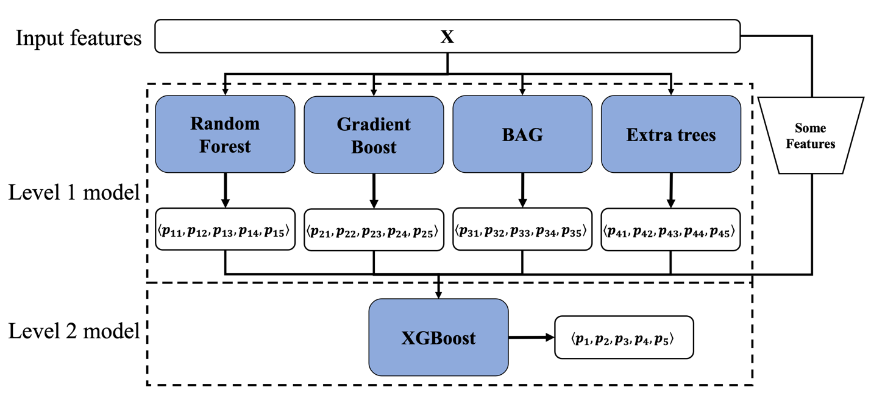
Figure 57. The basic structure of stacking different types of tree-based methods using a two-level hierarchy to obtain final ensembled predictions
The precise steps to generate the training and testing data sets considering 2-level stacking methods are summarized in Figure 58. As previously mentioned, the first data preparation step is to do a stratified sampling approach to reserve 20% of the data as the testing data set. To prevent data leakage of derived features, the derived features for the testing set were only derived from the training set instead of testing set (Figure 58 (bottom left)). Furthermore, to avoid data leakage during the data preparation step before training, a one out-of-bag method was used to generate derived features (Figure 58 (bottom right)). This method ensures that no data records used routed distances from their own group to obtain derived distance.
Notably, derived features only needed to be computed once during the entire data pipeline. When using the stacking method, a level-2 meta-learner is required (Figure 58 (top right)). The inputs for the meta-learner were generated from the validation set of each k-fold model to prevent overfitting (orange blocks in Figure 58). During level-1 model training, a five-fold cross-validation approach was applied to determine the best-performing base learners with respect to their meta-parameters. For level-2 models, all training data sets were used to train a meta-learner and were then tested using the reserved testing data set. This means that final model delivered was tested on the testing data set.
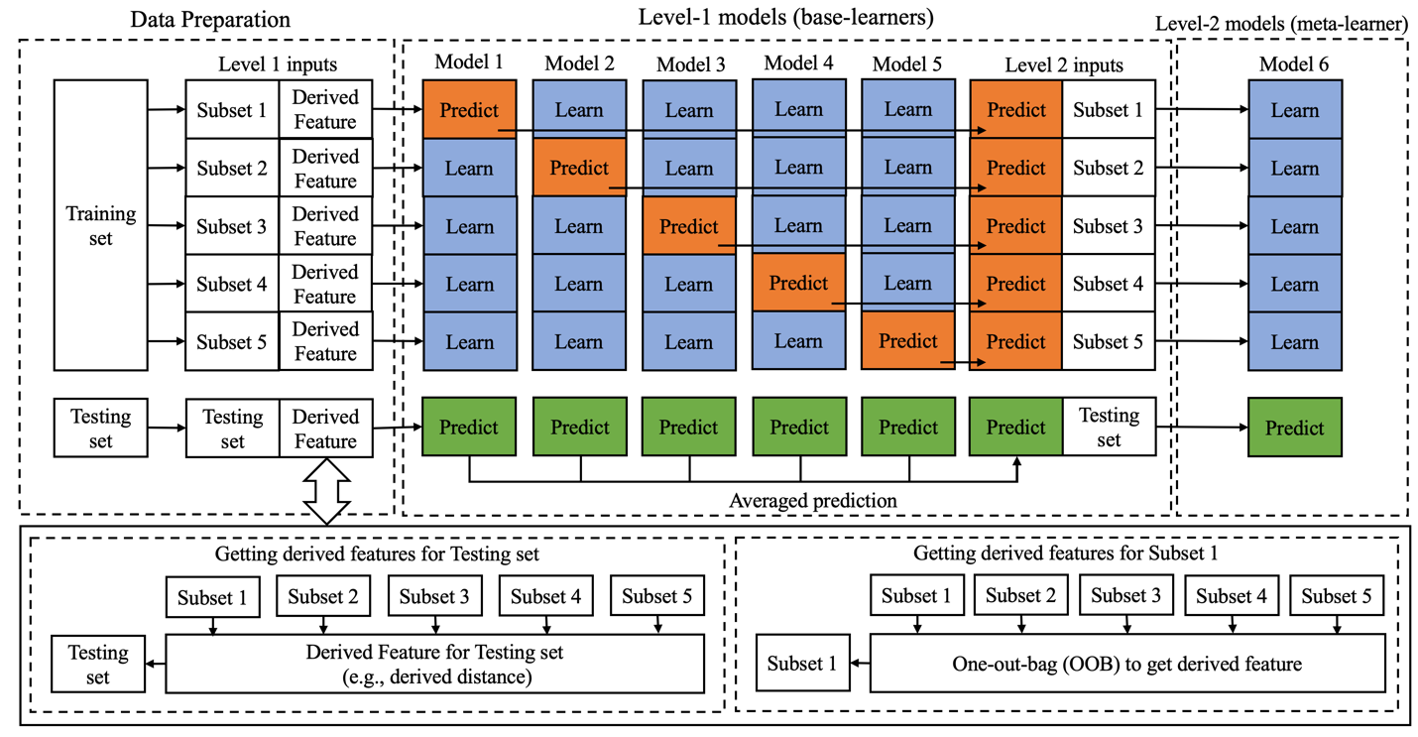
Figure 58. Data flow of the analysis framework: data preparation and cross-validation for the two-level stacking method

Experiment Results

Model Implementation
To assess the efficacy of various methodologies, an extensive range of machine learning models were employed in this study. Similar to some of the previous studies in Table 10, the models used encompassed Logistics Regression (LR), DT, SVM, MLP, KNN, NB, RF, GB, ADA, and extra trees (Extra). In most cases, the Scikit-learn package in Python was used to execute the models (Pedregosa et al., 2011). For the stacking model, the XGBoost package in Python was preferred for analysis because of its greater computational efficiency compared with the Scikit-learn package (Chen & Guestrin, 2016).

Experiment Design and Model Evaluation
In addition to the model performance, the input features and data fitting scope of the model were also evaluated. To enhance the model efficacy, this study proposes three countermeasures: (1) use derived distance as input features; (2) build dedicated models for each SCTG/NAICS type; (3) use ensemble methods to combine different models. The experimental controls for each proposed countermeasure are detailed in Table 14. More specifically, to compare the effectiveness of each of the three countermeasures, seven scenarios were developed and are presented in Table 15. The training set for all data sets comprises 80% of the total samples, and the remaining 20% of samples are reserved as testing set. Testing samples were selected randomly within each NAICS and SCTG category.
Table 14. Experiment design aspects to measure the effectiveness of three countermeasures
Input features | Description
“without derived distance” | “M1”–“M5” and “I1”–“I5” are not considered in the model
“with derived distance” | “M1”–“M5” and “I1”–“I5” are considered in the model
Modeling scope
“unified model” | Only one model is built across the entire data set
“local (concatenated) model” | One separate model is built for each NAICS and SCTG category
Stacking method
“voting model” | The average of output probabilities of other models is used as the final prediction
“stacking model” | An ensemble structure is applied (Figure 57) based on other models

To effectively compare different models, various evaluation metrics were computed. These metrics include accuracy, balanced accuracy (BA), precision, recall, and F1 score. Simply measuring accuracy alone may not accurately represent the distribution of data between the air and other modes because they constitute only a small portion of the overall data set (as illustrated in Figure 59). To address this issue, the BA considered the accuracy by averaging them across all five modes to mitigate the impacts of data imbalance issue. All metrics were measured based on the number of records without any further weighting (e.g., by values) to ensure comparability with previous studies.
Based on the analysis, the stacking model was selected as the final model. To further examine the stacking model performance, Figure 59 displays the results by SCTG code (left) and NAICS code (right). Overall, the final model proved effective across most SCTG and NAICS types, except for the air mode for some SCTG and NAICS types because of a severe data imbalance.
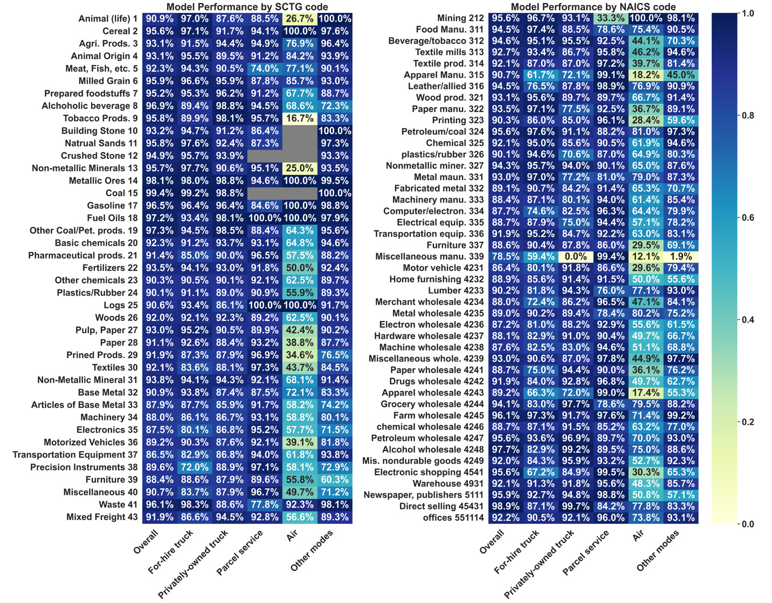
Figure 59. Accuracy of the final model for each freight mode by SCTG code (the left column) and by NAICS code (the right column)
Furthermore, by adjusting the probability threshold for each mode in decision-making, a receiver operating characteristic curve was generated with the corresponding Area Under the Curve (AUC) score reported in Figure 60. For the AUC score, the closer to 1, the better the model performed. By comparison, ensemble methods like stacking or voting model (the third row of subplots) can improve the AUC score by combining results from different base learners (the first two rows of subplots). Figure 60 will be discussed in more detailed way in the following section.
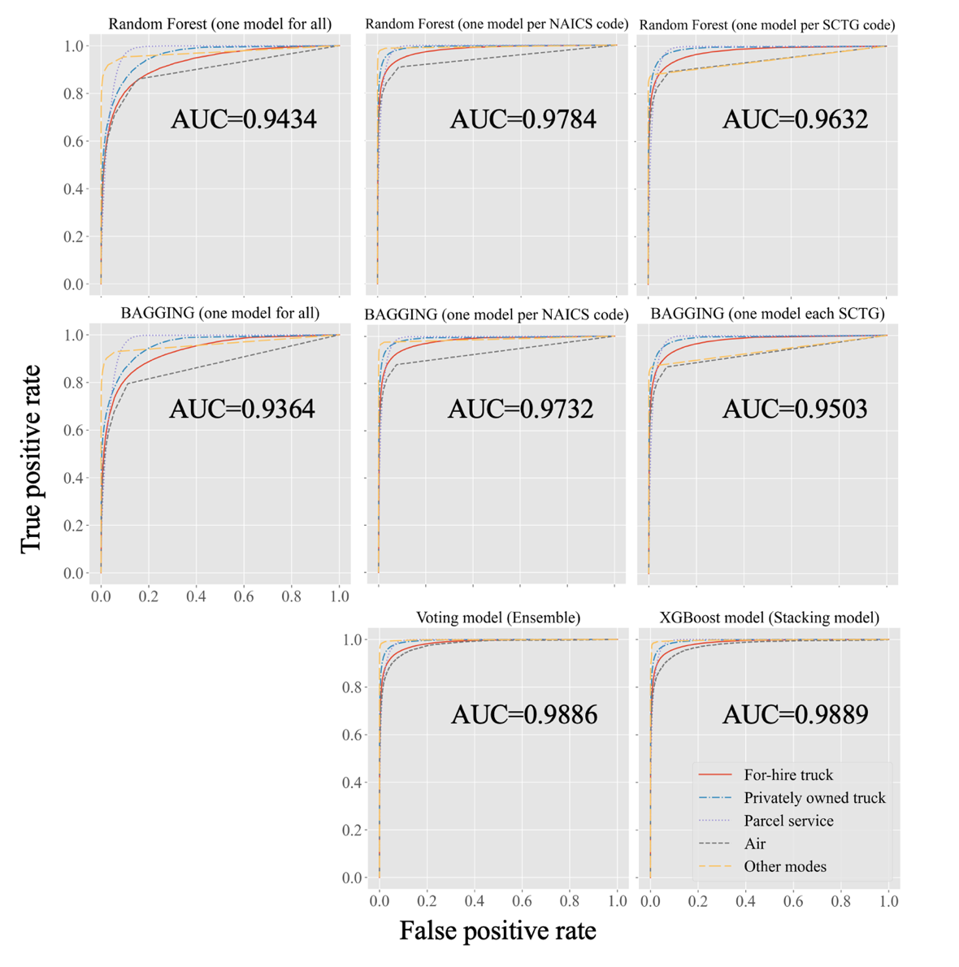
Figure 60. Evaluating performance by receiver operating characteristic’s AUC for various models

Model Results
Table 15 presents the results of evaluating various models under different specifications. Our findings demonstrate that the performance of these models can be significantly enhanced by implementing three key improvements: incorporating the distance between origin and destination for each freight mode; developing local models for each category; and adopting a voting/ensemble approach to combine different types of local and unified models.
Table 15. Performance of unified models, SCTG models, NAICS models, and the overall voting model on the testing data set (boldface numbers are the best of each row)
(a) Unified models (without derived distance, trained on 10,000 training records)
 | LR | DT | SVM | MLP | KNN | NB | RF | GB | BAG | ADA | Extra | XGBoost | Vote | Stack
Accuracy | 0.559 | 0.653 | 0.168 | 0.709 | 0.630 | 0.439 | 0.729 | 0.670 | 0.710 | 0.610 | 0.668 | 0.713 | 0.731 | 0.726
BA | 0.395 | 0.579 | 0.283 | 0.583 | 0.490 | 0.238 | 0.623 | 0.591 | 0.612 | 0.508 | 0.444 | 0.600 | 0.617 | 0.627
Precision | 0.553 | 0.653 | 0.437 | 0.717 | 0.628 | 0.468 | 0.731 | 0.676 | 0.708 | 0.622 | 0.686 | 0.713 | 0.733 | 0.726
Recall | 0.559 | 0.653 | 0.168 | 0.709 | 0.630 | 0.439 | 0.729 | 0.670 | 0.710 | 0.610 | 0.668 | 0.713 | 0.731 | 0.726
F1 | 0.541 | 0.653 | 0.181 | 0.701 | 0.627 | 0.356 | 0.725 | 0.664 | 0.708 | 0.598 | 0.659 | 0.709 | 0.728 | 0.720
$\hat{σ}$(Accuracy) | 0.000 | 0.070 | 0.046 | 0.052 | 0.047 | 0.060 | 0.000 | 0.004 | 0.009 | 0.027 | 0.026 | 0.001 | 0.000 | 0.000
(b) Unified models (with derived distance, trained on 10,000 training records)
 | LR | DT | SVM | MLP | KNN | NB | RF | GB | BAG | ADA | Extra | XGBoost | Vote | Stack
Accuracy | 0.563 | 0.779 | 0.374 | 0.787 | 0.681 | 0.511 | 0.819 | 0.716 | 0.824 | 0.595 | 0.796 | 0.821 | 0.837 | 0.841
BA | 0.469 | 0.696 | 0.210 | 0.709 | 0.555 | 0.333 | 0.699 | 0.561 | 0.709 | 0.491 | 0.671 | 0.724 | 0.715 | 0.752
Precision | 0.560 | 0.779 | 0.366 | 0.789 | 0.682 | 0.510 | 0.818 | 0.724 | 0.822 | 0.615 | 0.797 | 0.821 | 0.837 | 0.841
Recall | 0.563 | 0.779 | 0.374 | 0.787 | 0.681 | 0.511 | 0.819 | 0.716 | 0.824 | 0.595 | 0.796 | 0.822 | 0.837 | 0.840
F1 | 0.547 | 0.779 | 0.303 | 0.784 | 0.680 | 0.499 | 0.817 | 0.708 | 0.821 | 0.580 | 0.794 | 0.820 | 0.834 | 0.839
$\hat{σ}$(Accuracy) | 0.000 | 0.095 | 0.074 | 0.089 | 0.078 | 0.074 | 0.000 | 0.058 | 0.055 | 0.103 | 0.095 | 0.000 | 0.000 | 0.000
(c) Concatenate local models for each NAICS code (without derived distance, trained on all training data)
 | LR | DT | SVM | MLP | KNN | NB | RF | GB | BAG | ADA | Extra | XGBoost | Vote | Stack
Accuracy | 0.676 | 0.752 | 0.351 | 0.759 | 0.774 | 0.602 | 0.797 | 0.759 | 0.797 | 0.715 | 0.756 | 0.786 | 0.806 | 0.785
BA | 0.499 | 0.715 | 0.345 | 0.649 | 0.716 | 0.398 | 0.723 | 0.650 | 0.739 | 0.529 | 0.624 | 0.681 | 0.735 | 0.722
Precision | 0.671 | 0.752 | 0.507 | 0.759 | 0.773 | 0.611 | 0.796 | 0.758 | 0.796 | 0.711 | 0.756 | 0.787 | 0.806 | 0.786
Recall | 0.676 | 0.752 | 0.351 | 0.759 | 0.774 | 0.602 | 0.797 | 0.759 | 0.797 | 0.715 | 0.756 | 0.786 | 0.806 | 0.785
F1 | 0.670 | 0.752 | 0.387 | 0.755 | 0.773 | 0.594 | 0.796 | 0.756 | 0.796 | 0.709 | 0.753 | 0.783 | 0.805 | 0.783
$\hat{σ}$(Accuracy) | 0.001 | 0.070 | 0.164 | 0.001 | 0.008 | 0.077 | 0.000 | 0.019 | 0.018 | 0.034 | 0.030 | 0.000 | 0.000 | 0.000
(d) Concatenate local models for each NAICS code (with derived distance, trained on all training data)
 | LR | DT | SVM | MLP | KNN | NB | RF | GB | BAG | ADA | Extra | XGBoost | Vote | Stack
Accuracy | 0.681 | 0.884 | 0.441 | 0.843 | 0.873 | 0.636 | 0.916 | 0.812 | 0.913 | 0.712 | 0.902 | 0.868 | 0.922 | 0.919
BA | 0.552 | 0.834 | 0.325 | 0.752 | 0.818 | 0.482 | 0.849 | 0.696 | 0.848 | 0.530 | 0.837 | 0.775 | 0.859 | 0.859
Precision | 0.679 | 0.884 | 0.476 | 0.842 | 0.873 | 0.634 | 0.916 | 0.812 | 0.913 | 0.710 | 0.903 | 0.870 | 0.923 | 0.920
Recall | 0.681 | 0.884 | 0.441 | 0.843 | 0.873 | 0.636 | 0.916 | 0.812 | 0.913 | 0.712 | 0.902 | 0.868 | 0.922 | 0.919
F1 | 0.678 | 0.884 | 0.447 | 0.841 | 0.873 | 0.632 | 0.915 | 0.809 | 0.913 | 0.706 | 0.902 | 0.866 | 0.922 | 0.918
$\hat{σ}$(Accuracy) | 0.000 | 0.101 | 0.073 | 0.000 | 0.015 | 0.105 | 0.000 | 0.052 | 0.048 | 0.084 | 0.080 | 0.001 | 0.000 | 0.000
(e) Concatenate local models for each SCTG code (without derived distance, trained on all training data)
 | LR | DT | SVM | MLP | KNN | NB | RF | GB | BAG | ADA | Extra | XGBoost | Vote | Stack
Accuracy | 0.661 | 0.724 | 0.280 | 0.742 | 0.755 | 0.554 | 0.773 | 0.750 | 0.769 | 0.706 | 0.724 | 0.766 | 0.759 | 0.751
BA | 0.505 | 0.689 | 0.294 | 0.639 | 0.685 | 0.363 | 0.700 | 0.641 | 0.713 | 0.545 | 0.582 | 0.659 | 0.488 | 0.486
Precision | 0.658 | 0.724 | 0.415 | 0.742 | 0.755 | 0.572 | 0.773 | 0.750 | 0.768 | 0.704 | 0.729 | 0.768 | 0.751 | 0.746
Recall | 0.661 | 0.724 | 0.280 | 0.742 | 0.755 | 0.554 | 0.773 | 0.750 | 0.769 | 0.706 | 0.724 | 0.766 | 0.759 | 0.751
F1 | 0.655 | 0.724 | 0.306 | 0.739 | 0.754 | 0.545 | 0.771 | 0.746 | 0.768 | 0.701 | 0.72 | 0.762 | 0.754 | 0.744
$\hat{σ}$(Accuracy) | 0.000 | 0.081 | 0.190 | 0.000 | 0.006 | 0.092 | 0.000 | 0.012 | 0.010 | 0.027 | 0.026 | 0.001 | 0.000 | 0.000
(f) Concatenate local models for each SCTG code (with derived distance, trained on all training data)
 | LR | DT | SVM | MLP | KNN | NB | RF | GB | BAG | ADA | Extra | XGBoost | Vote | Stack
Accuracy | 0.662 | 0.869 | 0.423 | 0.867 | 0.867 | 0.586 | 0.902 | 0.806 | 0.901 | 0.706 | 0.887 | 0.853 | 0.908 | 0.908
BA | 0.563 | 0.820 | 0.340 | 0.814 | 0.814 | 0.430 | 0.836 | 0.691 | 0.838 | 0.546 | 0.819 | 0.759 | 0.834 | 0.833
Precision | 0.662 | 0.869 | 0.467 | 0.866 | 0.866 | 0.585 | 0.902 | 0.807 | 0.901 | 0.707 | 0.888 | 0.855 | 0.908 | 0.910
Recall | 0.662 | 0.869 | 0.423 | 0.867 | 0.867 | 0.586 | 0.902 | 0.806 | 0.901 | 0.706 | 0.887 | 0.853 | 0.908 | 0.909
F1 | 0.659 | 0.869 | 0.423 | 0.866 | 0.866 | 0.581 | 0.901 | 0.803 | 0.900 | 0.701 | 0.886 | 0.851 | 0.907 | 0.908
$\hat{σ}$(Accuracy) | 0.001 | 0.119 | 0.126 | 0.001 | 0.010 | 0.128 | 0.000 | 0.048 | 0.045 | 0.081 | 0.076 | 0.001 | 0.000 | 0.000
(g) Ensemble model combining (b)–(d) (with and without derived distance, trained on all training data)
 |  |  | Vote |  |  |  |  |  | Stack
 |  |  | Without derived distance |  |  | With derived distance |  |  | Without derived distance |  |  | With derived distance
Accuracy |  |  | 0.851 |  |  | 0.923 |  |  | 0.862 |  |  | 0.928
BA |  |  | 0.755 |  |  | 0.851 |  |  | 0.798 |  |  | 0.871
Precision |  |  | 0.854 |  |  | 0.924 |  |  | 0.861 |  |  | 0.928
Recall |  |  | 0.851 |  |  | 0.923 |  |  | 0.862 |  |  | 0.928
F1 |  |  | 0.849 |  |  | 0.922 |  |  | 0.861 |  |  | 0.927
$\hat{σ}$(Accuracy) |  |  | 0.000 |  |  | 0.000 |  |  | 0.000 |  |  | 0.000

All three suggested improvements are helpful in enhancing the performance. Through the use of derived distance, the accuracy of our model on the testing data set improved significantly, from 73% accuracy (best of part (a)) to 84% accuracy (best of part (b)). Furthermore, when dedicated models were constructed by different SCTG and NAICS categories, the performance increased even further from 84.1% (best of part (a)-(b)) to 90.8% (best of part (c)-(d)) and 92.2% (best of part (e)-(f)) for NAICS and SCTG, respectively. Finally, by using stacking method to combine all models, we achieved an accuracy of 92.8% and a BA of 87.1%. Moreover, the standard errors of accuracies are also estimated by bootstrapping over the testing dataset, as displayed in the final row of each section in Table 15. Ensembled model (e.g., stacking or voting method) also shown the advantage of stabilizing performance over testing sets. Most ensembled models exhibited a standard deviation of accuracies that was below 0.005%. Consequently, these values were rounded down to 0.000 in Table 15. Note that all results in Table 15 are run on over 1 million testing cases, and the standard deviation will be larger as the number testing samples gets lower. These results demonstrate that the model framework is reliable and suitable for use in various applications, including freight modal split analysis, traffic assignment studies, and sustainability assessments.
Other metrics to compare different predicting models were also applied. As mentioned, tree-based models provide the probabilities of selecting each mode. Thus, a threshold probability was used as a decision boundary to select a specific mode for each freight mode. By varying the decision boundary from 0 to 1 for each mode, a receiver operating characteristic curve was plotted, as depicted in Figure 60. The x-axis represents the false positive rate, and the y-axis represents the true positive rate. The first and second rows correspond to RF and BAG models, respectively. The third row shows the results of two ensemble methods. Each plot displays five lines that represent the receiver operating characteristic curve for each of the five modes indicated by the lower right legends. The AUC was used to evaluate model performance, where a value closer to 1 indicates better performance. The average AUC for all five plots is displayed in each plot. Using the RF or bagging method, the models built by NAICS and SCTG codes outperformed the unified (“one model for all”) models. Notably, the voting and stacking models (the third row) yielded significantly better performance than applying the base learners alone (the first and second row).
The behavior of the high-performance models was examined. The left and right subplots in Figure 61 correspond to the variable importance of the RF model and the level-2 stacking model (i.e., the meta-learner), respectively. One RF model was applied to the overall data set for Figure 61 (left). The routed distances of different modes (“M1”–“M5” and “I1”–“I5”) accounted for a significant portion of variations in the model. Conversely, a different pattern is discernible in Figure 61 (right), where five out of top six most “expressive” variables are probabilities of choosing different modes derived from base learners/models. This demonstrates that the meta-learner, an XGBoost model, begins to make predictions with the results of base learners before further polishing predictions using other variables (e.g., “v2w,” “sw”). Also, the effects of those variables were already considered by the base learners (level-1 model), as shown by Figure 61 (left).
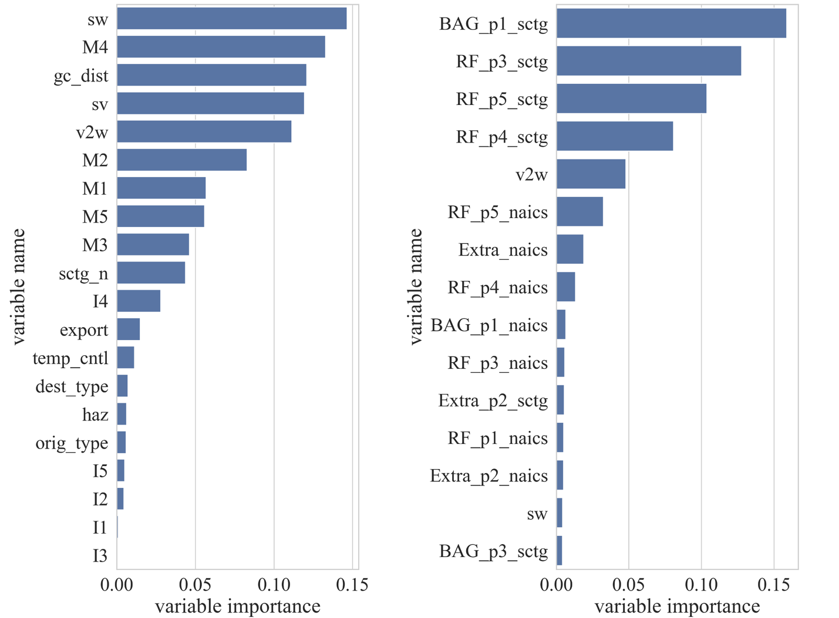
Figure 61. Variable importance for the (left) global RF model and (right) XGBoost stacking model
Recently, many methods have been developed for interpreting machine learning models. Among these, the LIME (Local Interpretable Model-Agnostic Explanations) approach is widely used in agnostic-model interpretation by fitting local linear additive models to approximate the model to be explained for individual inputs (Ribeiro et al., 2016). Furthermore, the SHAP (Shapely Additive Explanations) method (Lundberg et al., 2019; Uddin et al., 2023), which is based on game theory and focuses on global interpretation, was developed to evaluate the effects of different model features and has some theoretical and practical benefits. Recently, specialized algorithms are available for generating and efficiently analyzing SHAP values (Lundberg et al., 2019). Although the computational details of SHAP values can be tedious, the SHAP value only describes the “marginal impacts” of a specific feature on the final outputs. For this purpose, Figure 62 shows a force plot for one randomly chosen sample, where the probability of selecting each mode is interpreted by the contribution of each feature. In Figure 62 (a), value to weight (“v2w”), single weight (“sw”), and great circle distance (“gc_dist”) are the top three reasons to predict the for-hire truck mode, whereas the same variables on other modes have different magnitudes of influence.
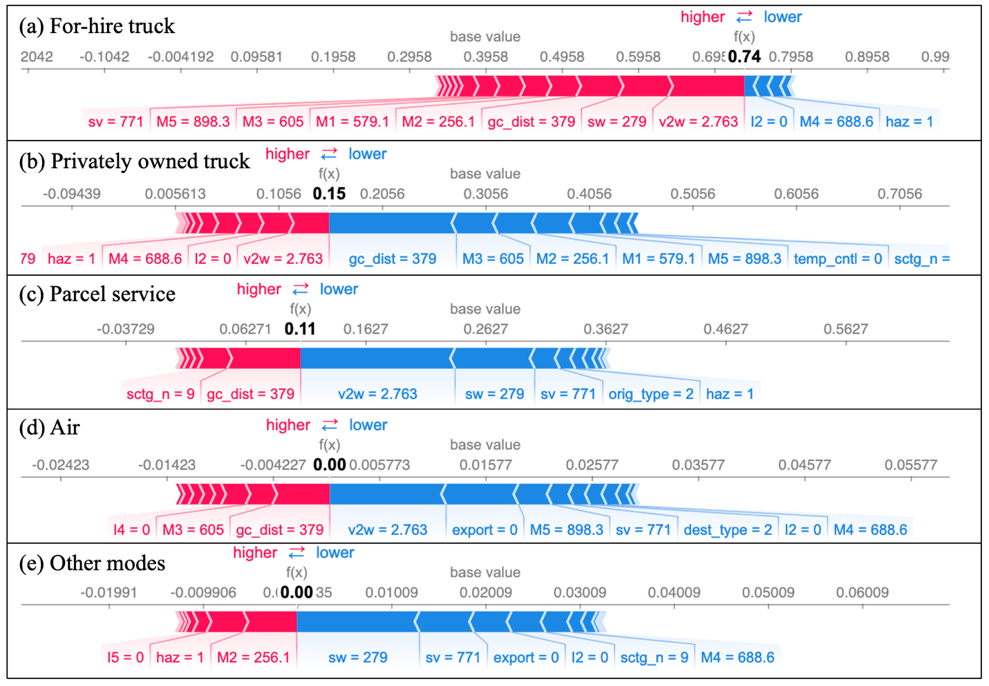
Figure 62. A force diagram of SHAP values of one DT model over one testing data sample
The SHAP method can also be applied to RF models, as shown in Figure 63. Figure 63 (a) displays the ratio of SHAP values across all the five modes by measuring the mean absolute SHAP values for each feature over 500 randomly selected samples. The remaining five plots (Figure 63 (b)–(f)) describe the SHAP values correspond to each of the five modes’ output probabilities. The x-axis shows the SHAP values. The feature value of each dot is denoted from high to low using a red to blue scale. The features are listed by their total SHAP impacts from top to bottom. A dot with a negative effect falls at the left side of the x-axis, and one with a positive effect falls at the right side of the x-axis. As shown, different freight modes have different influential features. A single weight (“sw”) had the highest SHAP value for for-hire trucks and parcel service, whereas the great circle distance (“gc_dist”) had the highest SHAP value for privately owned trucks.
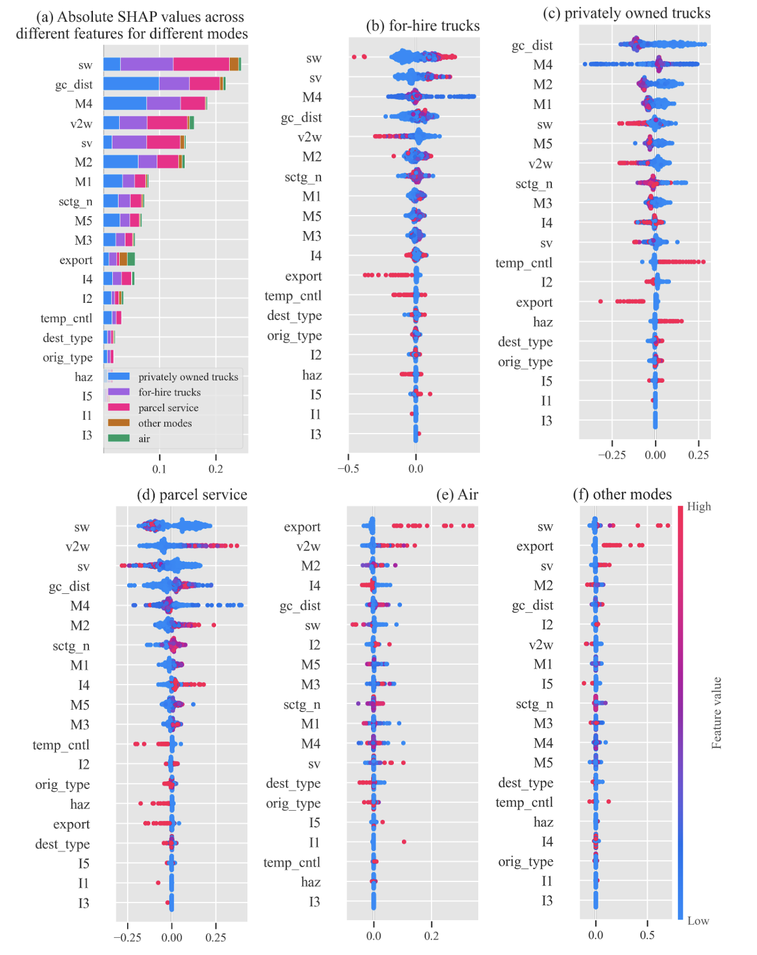
Figure 63. (a) Summary plot of absolute SHAP values and (b–f) swarm plots of each mode choice using the SHAP game theory approach to explain feature influences on the overall RF model
Figure 63 reveals several nontrivial patterns that offer significant insights. For instance, exported products are more likely to be transported via air or other modes. Furthermore, the great circle distance (“gc_dist”) has a strong influence on privately owned trucks’ mode choice. Also, privately owned trucks rarely travel for distances greater than 500 miles in great circle distance. Notably, several features with high SHAP values for privately owned trucks include routed distances for different modes (e.g., “M4”). In contrast, single weight (“sw”), single value (“sv”), and value-to-weight (“v2w”) ratios are the most influential features for for-hire trucks. This could be due to shippers operating for-hire trucks within an open market and competing with other long-distance freight modes who occasionally prefer transporting products with high single weight and single value but low value to weight. Notably, low value to weight is a relative term compared to commodities shipped via parcel service.
In addition to interpreting SHAP values on a feature-by-feature basis, we assessed the interaction values between two variables using the SHAP dependency plot, as illustrated in Figure 64. Each plot displays single weight (“sw”) and the corresponding SHAP value. The dots denote another selected feature that has a significant interaction effect for the given freight mode. The red to blue legend indicates the feature values from highest to lowest. The results show that there is an interactive relationship between single weight (“sw”) and distance metrics (e.g., “gc_dist”). For-hire truck and parcel service are sensitive to traveling distance given a fixed single weight, and privately owned trucks have reduced SHAP values for single weights when traveling long distances. Moreover, for air and other modes, the variable for indicating export shipment (0-domestic and 1-export) may have minor interaction effects on fixed single weight, as indicated by the SHAP values.
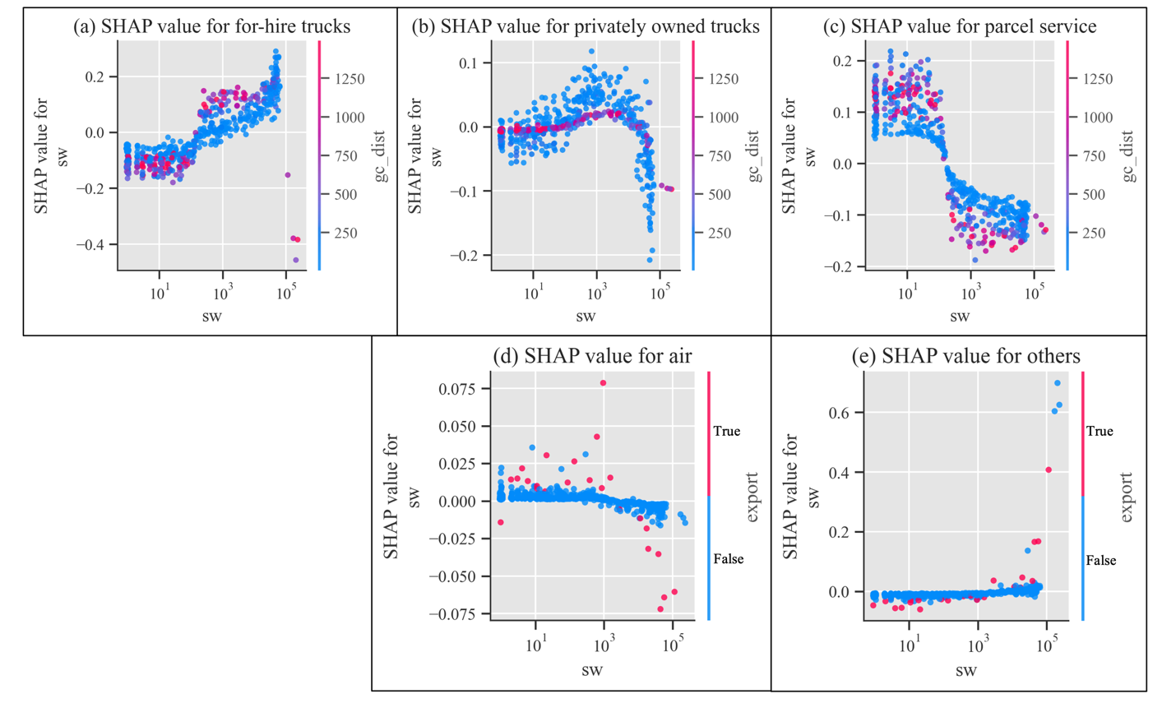
Figure 64. SHAP dependence plot of the single weight (“sw”) feature and some interaction features for each freight mode
The previous SHAP plots illustrate the patterns of level-1 models, such as a global RF model. Analyzing the SHAP effects on level-2 of the stacking model or on concatenated models split by different commodity or industrial types can offer further insights into interpreting models. Figure 65 presents the results of such analyses, revealing that the level-2 meta-learner simply averaged the probabilities of each model class outputted by the level-1 models. Many features are probability outputs from level-1 models, including “BAG_p1_sctg,” which denotes the probabilities of selecting for-hire trucks for the “sctg” segmented bagging tree model. Furthermore, information such as single weight (“sw”) and value to weight (“v2w”) still contribute to model interpretation based on their SHAP values. Although binary dummy variables are used for constructing level-1 models based on SCTG and NAICS types and their effects are summed, their SHAP values do not rank among the top 10 features for all freight modes.
In summary, the proposed modeling framework and methodologies can significantly improve the performance of mode choice modeling. Besides using basic performance metrics, receiver operating characteristic can also be helpful in visualizing the model’s performance. The machine learning model results were also interpreted, generating useful insights about feature importance with the help of the SHAP method.
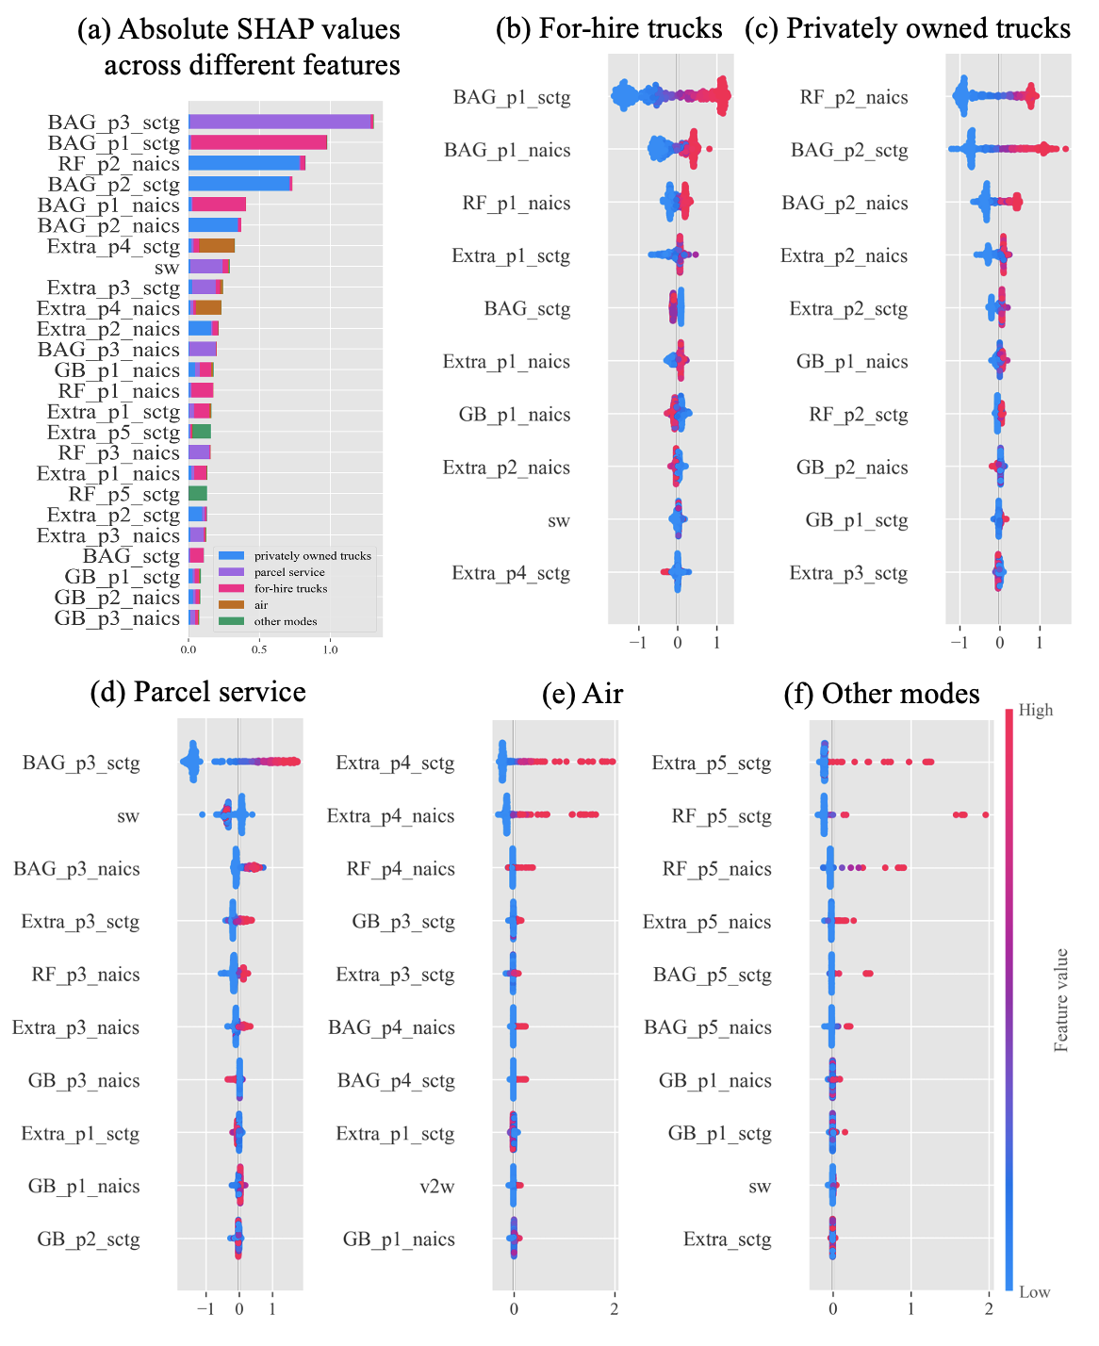
Figure 65. (a) Summary plot and (b–f) swarm plots of the level-2 stacking model

Conclusions
In this study, we developed a high-performance freight modal choice prediction model using the 2017 CFS PUF data set. The potential applications of such a model are wide-ranging and significant. Using some basic shipment and geographical information such as value, weight, commodity type, origin, and destination, our model predicted the probabilities of choosing available freight modes. Moreover, using ensemble techniques (e.g., stacking) for machine learning models by combining models built upon different sets of data records from different aspects, we significantly improved the model performance for freight mode prediction (or more generally, transportation mode prediction).
During the course of model development, numerous lessons were learned. First, although ensemble methods are advantageous for enhancing the overall model performance, they may not be effective when solely applied to a specific type of model (e.g., local models by SCTG). Furthermore, the performance of non-tree–based models was comparatively lower than that of tree-based models. Consequently, their inclusion in the ensemble did not lead to any significant improvement. Second, we attempted to identify different base learners from various categories dynamically to generate a dynamic model that combines different kinds of machine learning models. We hypothesized that certain commodities or industries may possess unique decision-making logic and so, a simple model could outperform tree-based models for some commodities. However, in practice, tree-based methods like RF and BAG demonstrated superior performance across all categories, including those with few data records. Finally, the use of neural networks as meta-learners in stacking methods was attempted without success.
Some limitations of this study stem from the CFS PUF data set. First, because it is a survey sampling among shippers, the data set does not provide uniform coverage of all freight movements (Comparison of Commodity Flow Survey (CFS) and Freight Analysis Framework (FAF) for 2017 Domestic Freight Flows, 2022). Another constraint of this research is the lack of consideration given to shipping time and its variability. Although logistics travel time could be estimated by reconstructing travel networks for various modes of transportation, this task is not straightforward because much of the logistics time is spent waiting at fixed locations such as warehouses, in addition to the travel time between locations. Furthermore, pricing or cost bids across different freight modes are essential factors when providing freight service to customers but are not incorporated in the data set. The only reported value is the value of a single product.
In this study, freight modes were classified into five categories to facilitate comparison with previous research. Water-related modes, train-related modes, and pipelines were all grouped under other modes because of their relatively low percentage of shipments. A nested model can be developed to further differentiate those modes. Also, one can apply oversampling methods to enhance the results for the air mode, which composed of less than 2% of trips in most commodity categories. The most challenging aspect of the study was predicting air mode shipments because of a data imbalance resulting from their small proportion in the data set. To address this issue in future work, we will focus on improving predictions for infrequent modes (e.g., air, other modes) through the use of different mode weights.

Statements and Acknowledgements
Statement: During the preparation of this work, the authors used gpt-3.5-turbo in order to improve the fluency and clarity of the writing. After using this tool, the authors reviewed and edited the content as needed and take full responsibility for the content of the publication.
Acknowledgement: The authors appreciate the funding and research opportunities provided by the Graduate Advancement Training and Education for collaborate research between the University of Tennessee, Knoxville, and the US Department of Energy’s Oak Ridge National Laboratory.

References
2017 Commodity Flow Survey (CFS) Public Use File (PUF) Data Users Guide. (n.d.). www.census.gov/programs-surveys/cfs.html.
Alcohol Transport Permit Requirements by State | Brew Movers. (n.d.). Retrieved May 3, 2023, from https://brewmovers.com/articles/guide-to-alcohol-transportation-permits-by-state/
Arencibia, A. I., Feo-Valero, M., García-Menéndez, L., & Román, C. (2015). Modelling mode choice for freight transport using advanced choice experiments. Transportation Research Part A: Policy and Practice, 75, 252–267. https://doi.org/10.1016/j.tra.2015.03.027
Bennett, J., & Lanning, S. (2007). The Netflix Prize.
Bojer, C. S., & Meldgaard, J. P. (2021). Kaggle forecasting competitions: An overlooked learning opportunity. International Journal of Forecasting, 37(2), 587–603. https://doi.org/10.1016/j.ijforecast.2020.07.007
Burks, S. v, & Monaco, K. (2019). Monthly La bor BLS Review BLS Is the U.S. labor market for truck drivers broken?
Chen, T., & Guestrin, C. (2016). Xgboost: A scalable tree boosting system. Proceedings of the 22nd Acm Sigkdd International Conference on Knowledge Discovery and Data Mining, 785–794.
Cheng, L., Chen, X., De Vos, J., Lai, X., & Witlox, F. (2019). Applying a random forest method approach to model travel mode choice behavior. Travel Behaviour and Society, 14, 1–10. https://doi.org/10.1016/j.tbs.2018.09.002
Comparison of Commodity Flow Survey (CFS) and Freight Analysis Framework (FAF) for 2017 Domestic Freight Flows. (n.d.). https://doi.org/10.21949/1526410
Hagenauer, J., & Helbich, M. (2017). A comparative study of machine learning classifiers for modeling travel mode choice. Expert Systems with Applications, 78, 273–282. https://doi.org/10.1016/j.eswa.2017.01.057
Hastie, T., Tibshirani, R., Friedman, J. H., & Friedman, J. H. (2009a). The elements of statistical learning: data mining, inference, and prediction (Vol. 2). Springer.
Hastie, T., Tibshirani, R., Friedman, J. H., & Friedman, J. H. (2009b). The elements of statistical learning: data mining, inference, and prediction (Vol. 2). Springer.
Hobbs, J. E. (2020). Food supply chains during the COVID-19 pandemic. Canadian Journal of Agricultural Economics, 68(2), 171–176. https://doi.org/10.1111/cjag.12237
Holguín-Veras, J., Kalahasthi, L., Campbell, S., González-Calderón, C. A., & (Cara) Wang, X. (2021). Freight mode choice: Results from a nationwide qualitative and quantitative research effort. Transportation Research Part A: Policy and Practice, 143, 78–120. https://doi.org/10.1016/j.tra.2020.11.016
Keya, N., Anowar, S., Bhowmik, T., & Eluru, N. (2021). A joint framework for modeling freight mode and destination choice: Application to the US commodity flow survey data. Transportation Research Part E: Logistics and Transportation Review, 146. https://doi.org/10.1016/j.tre.2020.102208
Keya, N., Anowar, S., & Eluru, N. (2018). Freight Mode Choice: A Regret Minimization and Utility Maximization Based Hybrid Model. Transportation Research Record, 2672(9), 107–119. https://doi.org/10.1177/0361198118782256
Keya, N., Anowar, S., & Eluru, N. (2019). Joint model of freight mode choice and shipment size: A copula-based random regret minimization framework. Transportation Research Part E: Logistics and Transportation Review, 125, 97–115. https://doi.org/10.1016/j.tre.2019.03.007
Kim, E. J. (2021). Analysis of Travel Mode Choice in Seoul Using an Interpretable Machine Learning Approach. Journal of Advanced Transportation, 2021. https://doi.org/10.1155/2021/6685004
Koren, Y. (2009). The BellKor Solution to the Netflix Grand Prize. www.netflixprize.com/leaderboard
Larranaga, A. M., Arellana, J., & Senna, L. A. (2017). Encouraging intermodality: A stated preference analysis of freight mode choice in Rio Grande do Sul. Transportation Research Part A: Policy and Practice, 102, 202–211. https://doi.org/10.1016/j.tra.2016.10.028
Li, Y., Yang, Z., Chen, X., Yuan, H., & Liu, W. (2019). A stacking model using URL and HTML features for phishing webpage detection. Future Generation Computer Systems, 94, 27–39. https://doi.org/10.1016/j.future.2018.11.004
Lundberg, S. M., Allen, P. G., & Lee, S.-I. (n.d.). A Unified Approach to Interpreting Model Predictions. https://github.com/slundberg/shap
Lundberg, S. M., Erion, G., Chen, H., DeGrave, A., Prutkin, J. M., Nair, B., Katz, R., Himmelfarb, J., Bansal, N., & Lee, S.-I. (2019). Explainable AI for Trees: From Local Explanations to Global Understanding. http://arxiv.org/abs/1905.04610
Mangal, A., & Kumar, N. (2016). Using big data to enhance the bosch production line performance: A Kaggle challenge. Proceedings - 2016 IEEE International Conference on Big Data, Big Data 2016, 2029–2035. https://doi.org/10.1109/BigData.2016.7840826
Monios, J., & Bergqvist, R. (2019). The transport geography of electric and autonomous vehicles in road freight networks. Journal of Transport Geography, 80. https://doi.org/10.1016/j.jtrangeo.2019.102500
Moschovou, T. P., & Giannopoulos, G. A. (2012). Modeling Freight Mode Choice in Greece. Procedia - Social and Behavioral Sciences, 48, 597–611. https://doi.org/10.1016/j.sbspro.2012.06.1038
Norojono, O., & Young, W. (2003). A stated preference freight mode choice model. Transportation Planning and Technology, 26(2), 1. https://doi.org/10.1080/715020600
Nowlan, A., Fine, J., O’connor, T., & Burget, S. (2021). Pollution accounting for corporate actions: Quantifying the air emissions and impacts of transportation system choices case study: Food freight and the grocery industry in los angeles. Sustainability (Switzerland), 13(18). https://doi.org/10.3390/su131810194
Omrani, H. (2015). Predicting travel mode of individuals by machine learning. Transportation Research Procedia, 10, 840–849. https://doi.org/10.1016/j.trpro.2015.09.037
Pedregosa, F., Varoquaux, G., Gramfort, A., Michel V. and Thirion, B., Grisel, O., Blondel, M., Prettenhofer P. and Weiss, R., Dubourg, V., Vanderplas, J., Passos, A., Cournapeau, D., Brucher, M., Perrot, M., & Duchesnay, E. (2011). Scikit-learn: Machine Learning in Python. Journal of Machine Learning Research, 12, 2825–2830.
Ribeiro, M. T., Singh, S., & Guestrin, C. (2016). Model-Agnostic Interpretability of Machine Learning. http://arxiv.org/abs/1606.05386
Rich, J., Holmblad, P. M., & Hansen, C. O. (2009). A weighted logit freight mode-choice model. Transportation Research Part E: Logistics and Transportation Review, 45(6), 1006–1019. https://doi.org/10.1016/j.tre.2009.02.001
Rudin-Brown, C. M., Harris, S., & Rosberg, A. (2019). How shift scheduling practices contribute to fatigue amongst freight rail operating employees: Findings from Canadian accident investigation. Accident Analysis and Prevention, 126, 64–69. https://doi.org/10.1016/j.aap.2018.01.027
Samimi, A., Kawamura, K., & Mohammadian, A. (2011). A behavioral analysis of freight mode choice decisions. Transportation Planning and Technology, 34(8), 857–869. https://doi.org/10.1080/03081060.2011.600092
Shen, G., & Wang, J. (2012). A Freight Mode Choice Analysis Using a Binary Logit Model and GIS: The Case of Cereal Grains Transportation in the United States. Journal of Transportation Technologies, 02(02), 175–188. https://doi.org/10.4236/jtts.2012.22019
Tamim Kashifi, M., Jamal, A., Samim Kashefi, M., Almoshaogeh, M., & Masiur Rahman, S. (2022). Predicting the travel mode choice with interpretable machine learning techniques: A comparative study. Travel Behaviour and Society, 29, 279–296. https://doi.org/10.1016/j.tbs.2022.07.003
Töscher, A., Jahrer, M., & Bell, R. M. (2009). The BigChaos Solution to the Netflix Grand Prize.
Uddin, M., Anowar, S., & Eluru, N. (2021). Modeling freight mode choice using machine learning classifiers: a comparative study using Commodity Flow Survey (CFS) data. Transportation Planning and Technology, 44(5), 543–559. https://doi.org/10.1080/03081060.2021.1927306
Uddin, M., Hwang, H. L., & Hasnine, M. S. (2023). An interpretable machine learning framework to understand bikeshare demand before and during the COVID-19 pandemic in New York City. Transportation Planning and Technology. https://doi.org/10.1080/03081060.2023.2201280
Wang, Y., Ding, C., Liu, C., & Xie, B. (2013). An Analysis of Interstate Freight Mode Choice between Truck and Rail: A Case Study of Maryland, United States. Procedia - Social and Behavioral Sciences, 96, 1239–1249. https://doi.org/10.1016/j.sbspro.2013.08.141
Xie, Y., Lu, W., Wang, W., & Quadrifoglio, L. (2012). A multimodal location and routing model for hazardous materials transportation. Journal of Hazardous Materials, 227–228, 135–141. https://doi.org/10.1016/j.jhazmat.2012.05.028
Yin, R., Tran, V. H., Zhou, X., Zheng, J., & Kwoh, C. K. (2018). Predicting antigenic variants of H1N1 influenza virus based on epidemics and pandemics using a stacking model. PLoS ONE, 13(12). https://doi.org/10.1371/journal.pone.0207777
Zenezini, G., Lagorio, A., Pinto, R., Marco, A. de, & Golini, R. (2018). The Collection-And-Delivery Points Implementation Process from the Courier, Express and Parcel Operator’s Perspective. 51(11), 594–599. https://doi.org/10.1016/j.ifacol.2018.08.383
Zhang, Z., Turla, T., & Liu, X. (2021). Analysis of human-factor-caused freight train accidents in the United States. Journal of Transportation Safety and Security, 13(10), 1157–1186. https://doi.org/10.1080/19439962.2019.1697774
Zhao, X., Yan, X., Yu, A., & Van Hentenryck, P. (2020). Prediction and behavioral analysis of travel mode choice: A comparison of machine learning and logit models. Travel Behaviour and Society, 20, 22–35. https://doi.org/10.1016/j.tbs.2020.02.003

CONCLUSION

In conclusion, traffic flow and freight behaviors are estimated using different datasets from different perspectives.

VITA
Diyi Liu was born in Beijing, China. He received his bachelor’s degree from Southeast University in Nanjing, China in 2016. From 2016-2020, he has received some other master’s degree at UC Berkeley, Columbia University, and Georgia Institute of Technology. He joined University of Tennessee, Knoxville in Spring 2021. In October 2023, he becomes a Ph.D. candidate at University of Tennessee, Knoxville (UTK). During his stay at UT, Knoxville, he is taking an internship at the Oak Ridge National Laboratory (ORNL) under the GATE fellowship program, a joint program between UTK and ORNL. His research is focusing on tackling transportation problem using machine learning algorithms.

