Spin Dynamics in Halide Perovskite and Organic Long Persistent Light Emission Materials

A Dissertation Presented for the
Doctor of Philosophy
Degree
The University of Tennessee, Knoxville

Yixuan Dou
December 2021
Copyright © 2021 by Yixuan Dou
All rights reserved.

DEDICATION

I dedicate my work to my parents.

ACKNOWLEDGEMENTS

I would like to express my sincere gratitude to my Ph.D. dissertation advisor Dr. Bin
Hu. I could not complete my dissertation in the absence of his help. Dr. Hu pointed out a clear direction for me when I started my research and helped me to explore my way to conduct research more effectively. Also, I appreciate the opportunities he provided for me to use frontier instruments and present my work at conferences.
I would like to express my great appreciation to my collaborators who contribute a lot to my research. I appreciate Prof. André-Jean Attias and Catherine Demangeat, who provided excellent materials to study. I want to thank Dr. Liam Collins, Dr. Olga S. Ovchinnikova, Dr. Jong Keum, and Dr. Mingxing Li who helped characterize samples. Also, I want to thank Dr. Frank E. Löffler Dr. Gao Chen, and Yanchen Sun who helped conduct the HPLC test.
I would like to thank all our group members. Dr. Ting Wu helped me a lot when I was new to our lab. Dr. Hengxing Xu and Dr. Miaosheng Wang introduced the basic characterizations in our lab to me. Dr. Jia Zhang brings me to the world of solar cell device fabrication. I also want to thank Bogdan Dryzhakov, Dr. Yongtao Liu, Dr. Jeremy Tisdale, Dr. Shengbo Ma, Dr. Ping Chen, Dr. Jiajun Qin, Dr. Xixiang Zhu, and Sreya Paladugu for their great support and friendship.
I would also like to show my gratitude to Dr. David Keffer, Dr. Mahshid Ahmadi, and Dr. Ilia N. Ivanov for serving as my committee members and for their valuable advice to my dissertation.
Finally, I want to show my thanks to my parents, my younger sister, and all other family members for their unconditional support and encouragement. Also, I want to thank my friends and roommates for their support and friendship.

ABSTRACT
The functional materials are of critical importance to the development of semiconductor devices, medical imaging, energy storage, etc. In this dissertation, two functional materials, halide perovskites (HPVs) and organic long persistent luminescence (OLPL) material, are studied. Chapter 1 of this dissertation presents an introduction to HPV and OLPL materials.
The first functional material, halide perovskite (HPV), has been heralded as one of the most promising emerging technologies owing to its remarkable photovoltaic performance and low-cost solution processability. The three-dimensional (3D) HPV solar cells have achieved an efficiency comparable to the commercialized solar cells. The bulk polarization and spin states are critical for promoting solar cell efficiency, however, the significant photo-induced bulk polarization process in 3D HPVs is still controversial and the interaction between polarization and spin-orbit coupling is still unclear. Chapter 2 identifies the photoinduced bulk polarization and the interaction between dipolar polarization and spin-orbit coupling in 3D HPVs. Furthermore, the highly tunable crystal structure of HPVs enables their various dimensionalities from 3D structure to 0D structure, and the 0D HPV typically exhibits larger bandgaps due to the spatial confinement effect. Nevertheless, recent reports insufficiently decipher the origin of the abnormal far below bandgap low-energy emission and explore their non-linear optical properties. In Chapter 3, we revealed the origin of the far below bandgap green emission in 0D HPV, also showed its polarized emission in both down-conversion and up-conversion emission regimes.
The other functional material, OLPL material, has achieved remarkable breakthroughs in recent years that enable long-lived light emission in metal-free purely organic materials at room temperature. However, the experimental evidence to identify spin characteristics of the critical long lifetime excited states in room temperature OLPL is still lacking. In addition, the non-linear optical properties in OLPL materials have not been well studied. Here, Chapter 4 deciphers the spin characteristics of the special intermolecular light-emitting states, also exhibits a slow phonon effect which is critical to the generation of OLPL. Chapter 5 exhibits the multiphoton up-conversion afterglow phenomenon and identifies the long-lived excited states within the ferroelectric lattice in OLPL material.
Table of Contents
Chapter 1: Introduction 1
1.1 Introduction of halide perovskite materials 2
1.1.1 Structure and basic properties of halide perovskites 2
1.1.2 Polarization in halide perovskites 2
1.1.3 Spin-orbit coupling in halide perovskites 6
1.2 Introduction of purely organic long persistent luminescence materials 6
1.2.1 Development of purely organic long persistent luminescence materials 6
1.2.2 Principles to enable long persistent light emission in purely organic materials 10
1.3 Characterization of spin dynamics 12
1.3.1 Magneto-photoluminescence 12
1.3.2 Magneto-photocurrent 14
1.3.3 Magneto-capacitance 14
1.3.4 Polarization-dependent photocurrent 16
1.3.5 Multi-photon up-conversion 16
Chapter 2: Photoinduced Bulk polarization in Mixed Cation Halide Perovskites 19
2.1 Abstract 20
2.2 Introduction 21
2.3 Material processing and Methods 23
2.3.1 Materials 23
2.3.2 Device fabrication 23
2.3.3 Characterizations 25
2.4 Results and discussion 25
2.4.1 Photovoltaic performance 25
2.4.2 Photoinduced capacitance-voltage 28
2.4.3 High-frequency magneto-capacitance 31
2.4.4 Orbit-orbit interaction 33
2.5 Conclusion 37
Chapter 3: Polarized Light Emission in Down-conversion and Up-conversion Excitation Regimes of 0D Cs₄PbBr₆ Perovskite Single Crystal 38
3.1 Abstract 39
3.2 Introduction 40
3.3 Experimental Methods 41
3.4 Results and discussions 42
3.4.1 Photo-physics of Cs₄PbBr₆ single crystals 42
3.4.2 Limited non-radiative recombination in Cs₄PbBr₆ single crystals 44
3.4.3 Polarized emission in the down-conversion regime of Cs₄PbBr₆ single crystals 46
3.4.4 Polarized emission in the up-conversion regime of Cs₄PbBr₆ single crystals 48
3.5 Conclusion 50
Chapter 4: Spin-orbit Coupling and Slow Phonon Effects Enabled Persistent Photoluminescence in Organic Crystal 53
4.1 Abstract 54
4.2 Introduction 69
4.3 Methods 71
4.3.1 Organic material synthesis 71
4.3.2 Photoluminescence measurement 72
4.3.3 Photoexcitation-assisted Raman measurement 72
4.3.4 Magneto-PL measurement 72
4.3.5 Nuclear magnetic resonance (¹H and ¹³C) spectrum 73
4.3.6 High-performance liquid chromatography measurement 73
4.3.7 Magneto-capacitance measurement 73
4.4 Results and discussions 73
4.4.1 CD49 persistent material characterizations 73
4.4.2 Crystalline intermolecular charge-transfer excitons 76
4.4.3 Spin characteristics of ultralong-lived light-emitting states 81
4.4.4 Slow phonon effects 88
4.4.5 Ferroelectric polarization 95
4.5 Conclusion 97
Chapter 5: Afterglow Multiphoton Up-conversion Photoluminescence in Organic Crystal 100
5.1 Abstract 101
5.2 Introduction 102
5.3 Methods 103
5.3.1 Synthesis of CD49 compound: 103
5.3.2 Photoluminescence measurement 103
5.3.3 Photoexcitation-assisted Raman measurement 104
5.3.4 Magneto-PL measurement 104
5.3.5 Nuclear magnetic resonance (¹H and ¹³C) spectra 104
5.3.6 High-performance liquid chromatography measurement 104
5.3.7 Magneto-capacitance measurement 104
5.4 Results and discussions 104
5.4.1 Up-conversion of CD49 persistent material 104
5.4.2 Isomer induced n-type doping 105
5.4.3 Spin characteristics of up-conversion ultralong-lived light-emitting states 109
5.5 Conclusion 115
Appendix 118
Publication list 119
Chapter 6: Conclusion 120
References 123
VITA 132

LIST OF TABLES

Table 1. Photovoltaic Parameters of the MA_{x}FA_{(1-x)}PbI₃ solar cells. 29
Table 2. Polarization of Cs₄PbBr₆ crystal with different vacuum annealing time 49

LIST OF FIGURES

Figure 1.1. Schematic diagram to show the structure of (a) 3D ABX₃ perovskite; (b) 0D A₄PbX₆ hybrid perovskites. 3
Figure 1.2. Illustration of the frequency-dependent dielectric spectrum typical of halide perovskites. 5
Figure 1.3. Multiple states in HPVs. 7
Figure 1.4.Proposed mechanism for ultralong organic phosphorescence by constructing lower-lying energy states to stabilize the lowest triplet excited state (T1). 11
Figure 1.5. Principles to enhance SOC in organic long-lived emission materials.. 11
Figure 1.6. Magnetic field effects for light-emitting exciplex systems in solid and liquid states.13
Figure 1.7. Magneto-photocurrent measurement. 15
Figure 1.8. Magnetodielectric effects in perovskite. 15
Figure 1.9. Orbital magnetic dipoles between excited states generated by circularly and linearly polarized photoexcitations. 18
Figure 1.10. Jablonski diagrams of (a) Two photon up-conversion (dual energy level model) and (b) TTA up-conversion. …………………………………………………………………………18
Figure 2.1. (a) schematic diagram of perovskite solar cell; (b) Energy level diagram of perovskite solar cell. 24
Figure 2.2. Device structure and performance of MA_{x}FA_{(1-x)}PbI₃ solar cells. 26
Figure 2.3. PL characterization of MA_{x}FA_{(1-x)}PbI₃ film. 27
Figure 2.4. Photovoltaic parameters of the MA_{x}FA_{(1-x)}PbI₃ solar cells with different MA:FA ratios. 29
Figure 2.5. Photoinduced C-V characteristics measured under simulated sunlight with variable intensities in perovskite solar cells with different MA:FA ratios. 30
Figure 2.6. C-V characteristics measured under different heating temperatures in MA_{x}FA_{(1-x)}PbI₃ solar cells with various MA:FA ratios in dark condition. 32
Figure 2.7. Magneto-capacitance measurement mechanism.. 32
Figure 2.8. Magneto-capacitance signals measured from perovskite devices with different MA:FA ratios under dark and light conditions. 34
Figure 2.9. Orbital magnetic dipoles between excited states generated by circularly and linearly polarized photoexcitations. 36
Figure 2.10. ΔJ_{SC} measured by switching linearly and circularly polarized photoexcitations in perovskite solar cells with different MA:FA ratios. 36
Figure 3.1. PL characteristics of nongreen emissive and green emissive Cs₄PbBr₆ single crystals 43
Figure 3.2. PL characteristics of Cs₄PbBr₆ single crystals under different vacuum annealing times 45
Figure 3.3. XRD spectra of Cs₄PbBr₆ single crystal under vacuum annealing time of 0 h, 0.5 h, and 7 h. 45
Figure 3.4. PL decay dynamics of Cs₄PbBr₆ single crystals under different vacuum annealing times 47
Figure 3.5. PL characteristics of green emissive Cs₄PbBr₆ single crystals under different temperatures 47
Figure 3.6. Polarized emission from Cs₄PbBr₆ single crystals. 49
Figure 3.7. Up-conversion characteristics of Cs₄PbBr₆ single crystals at room temperature 51
Figure 3-8. Up-conversion characteristics of Cs₄PbBr₆ single crystals at different temperatures 52
Figure 4.1. PL characteristics of CD49 molecular crystal, drop-cast film, and spin-cast film 60
Figure 4.2. The photograph with and after UV excitation of CD49 molecular crystal. 60
Figure 4.3. (a) XRD pattern for CD49 molecular crystal; (b) Optical microscopy of CD49 molecules from molecular crystal, drop-cast film, and spin-cast film. 61
Figure 4.4. Characterization on isomer molecules in CD49 MeCN/H₂O solution. 63
Figure 4.5. PL characteristics in isomer-free CD49 crystal at room temperature (298 K) and low temperature (5 K).. 64
Figure 4.6. Schematic diagram to show the formation of electron-hole pairs in crystalline lattice.. 66
Figure 4.7. Isomer doping effects. 68
Figure 4.8.Characteristics of crystalline intermolecular charge-transfer excitons (CTE) in organic molecular crystal. 69
Figure 4.9.PL spectra and magnetic field effects for light-emitting exciplex systems in solid and liquid states. 71
Figure 4.10. PL characteristics at different temperatures and time windows in CD49 molecular crystal synthesized with isomer molecules. 73
Figure 4.11. Spectral characteristics for CD49 THF solution (2.5 mg/mL). 76
Figure 4.12. Polarized emission from CD49 crystals with different crystallinity. 76
Figure 4.13. Photoexcitation-assisted Raman characterizations upon applying/removing 375 nm excitation (785 nm laser beam for Raman). 77
Figure 4.14. Photoexcitation-assisted Raman spectroscopy for Silicon characterized with 785 nm laser beam after applying 375 nm laser excitation. Raman signal remains unchanged upon applying/removing photoexcitation. 79
Figure 4.15. Photoexcitation-assisted Raman spectroscopy for isomer-free CD49 crystal. Raman spectroscopy was activated by using built-in 785 nm beam. Photoexcitation was applied by an external 375 nm beam. 79
Figure 4.16. Ferroelectric polarization of CD49. 82
Figure 4.17. Diagram of slow-phonon effects of CD49. 84
Figure 5.1. Afterglow multiphoton up-conversion PL and SHG in isomer-containing CD49. 92
Figure 5.2. Isomer-free CD49 crystal: PL characteristics at room and low temperatures. 94
Figure 5.3. Magnetic field effects of PL of CD49. 96
Figure 5.4. Down-conversion PL characteristics under 343 nm excitation in isomer-containing CD49 crystal. 98
Figure 5.5. Photoexcitation-assisted Raman spectroscopy characterized with 785 nm laser beam upon applying and removing 1025 nm photoexcitation in isomer-containing CD49 crystal. 98
Figure 5.6. Ferroelectric polarization under 1025 nm excitation in isomer-doped CD49. 100
Figure 5.7. Afterglow multiphoton up-conversion PL occurs in ferroelectric light-emitting lattice with both ferroelectric polarization and crystalline intermolecular charge-transfer excitons. 102

Chapter 1: Introduction

Introduction of halide perovskite materials

Structure and basic properties of halide perovskites
Halide perovskites (HPVs) have attracted numerous attentions as an emerging material for application in renewable solar energy owing to their remarkable photovoltaic performance and low-cost solution processability. [,,] HPV solar cells with outstanding photovoltaic properties are typically composed of ABX₃ structure as shown in Figure 1.1. The ABX₃ structure is composed of monovalent cations at A site and inorganic cages [BX₆]⁴⁻ (B = Pb²⁺, Sn²⁺; X = I⁻, Br⁻, Cl⁻). The methylammonium (CH₃NH₃⁺ or MA) and formamidinium (CH(NH₂)₂⁺ or FA) are the most common A-site organic cations for hybrid organic-inorganic perovskites with outstanding photovoltaic performance. [,] And Cesium (Cs) is the most common inorganic A-site cation for fabricating full inorganic perovskite devices. Theoretical investigations on the electronic structure of HOIPs demonstrated that the bandgap of HOIPs is dominated by BX₆ inorganic cages. For example, the conduction band minimum (CBM) and the valence band maximum (VBM) of CH₃NH₃PbI₃ are determined by Pb 6p orbital and I 5p/Pb 6s orbitals, respectively. ^{[4,5]}
In recent years, the low dimensional HPVs including 0D, 1D, and 2D HPVs have also been heavily studied due to their better stability, high photoluminescence quantum yield, strong anisotropy, etc.[,,,] The 2D HPVs showed a chemical formula of A’A_{n-1}B_{n}X_{3n+1}, where A’ is the interlayer organic cation, the n value represents the number of inorganic layers in one period within each organic spacer cations. The 0D HPVs have a unique A₄PbX₆ structure, the isolated lead halide octahedra [PbX₆]⁴⁻ is surrounded by Cs⁺ cations. [] The individual octahedron makes 0D HPVs exhibit special intrinsic properties and large bandgap. []
The unique structures of HPVs lead to outstanding properties such as remarkable long-range ambipolar charge transport characteristics [], high dielectric constants [], low exciton binding energies [], intrinsic ferroelectric polarizations [,], and spin-dependent responses. [] These intrinsic photophysics properties and spin-physics properties make HPV a promising candidate for solar cells, LED, and other applications.

Polarization in halide perovskites
As a promising material for next-generation solar cells, HPVs exhibit several significant physical properties which should be responsible for the outstanding photovoltaic properties, including high
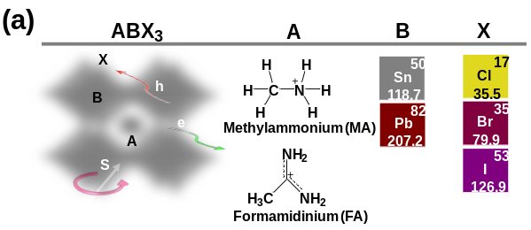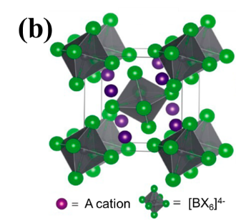
Figure 1.1. Schematic diagram to show the structure of (a) 3D ABX₃ HPVs; (b) 0D A₄PbX₆ HPVs.[]

defect tolerance,[] low exciton binding energy,^{[14]} spin-orbit coupling (SOC),[] large polaron,[] and ferroelectric.^{[16]} The electrical polarization plays an important role in suppressing the charge recombination, facilitating charge transport, and even polarizing excited states, which are critically important to the development of photovoltaic, light-emitting, lasing, optically-tunable ferroelectric, and optically-tunable mechanical properties in HPVs.
In HPVs, which is similar to other common semiconductor materials, typically there are four kinds of dielectric polarization mechanisms: Firstly, the interface or space charge polarization, which involves limited movement of charges resulting in the alignment of charge dipoles under applied field; Secondly, the dipolar or orientation polarization, which is due to the slower realignment of any dipolar species; Thirdly, the ionic contribution, which is due to the response of lattice vibrations (phonon modes) and proportional to the polarity of the chemical bonds and the softness of the vibrations; Fourthly, electronic or atomic polarization, involves the separation of the center of the electron cloud around an atom with respect to the center of its nucleus. The four kinds of polarizations have different response times depend on the ability of dipoles to orient themselves to the direction of the field. As a result, electronic polarization is the fastest and typically polarization which persists at frequencies between ~10¹³-10¹⁵ Hz. In contrast, ionic polarization is sluggish and occurs at frequencies between ~10⁹-10¹³ Hz. While dipolar polarization involving the movement of molecules happens below 10⁹ Hz. And the interface or space charge polarization occurs at frequencies below 10⁵ Hz (Figure 1.2).
Under photoexcitation, an incident electromagnetic wave generates an electronic polarization occurring at the frequency of 10¹⁴ Hz with a much lower amplitude as compared to the dipolar polarization regime.^{[27,]} Bulk polarization is governed by dipolar polarization within the MHz frequency range.[] Thus, there has been a fundamental question on whether a photoexcitation can induce a dipolar polarization change, and this topic is still controversial because of the difficulty of detecting photo-induced bulk polarization. Impedance spectroscopy measurement has been used to explore the photoinduced polarization in HPVs, the early studies attributed the largely enhanced capacitance under photoexcitation in the low-frequency regime to the enhanced
dielectric constant.[] However, further studies suggested this phenomenon comes from surface polarization induced by the accumulation of photoactivated ions.[] Later on, a new method was used to investigate photo-induced bulk polarization by ruling out the contribution from ions. [] In this method, the ions were continuously driven by gradually scanning the DC bias from -0.1 V to

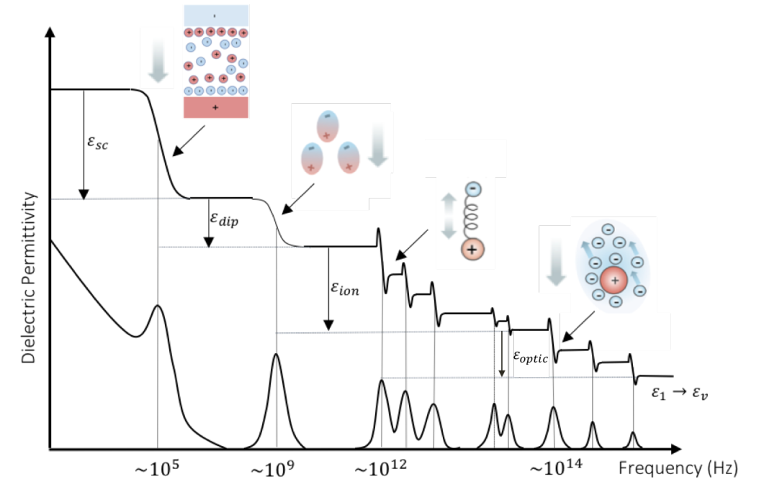
Figure 1.2. Illustration of the frequency-dependent dielectric spectrum typical of HPVs. The x-axis is scaled to provide an indication of the frequency at which the physical resonances are observed. The smooth (top) and piecewise (bottom) curves represent the real (ε₁) and imaginary (ε₂) components, respectively. The inset images schematically demonstrate the physical mechanisms which induce the various components of the static dielectric response (ε_{r}) ε_{v} refers to the vacuum permittivity. []

+1.5 V in capacitance-voltage (C-V) measurements. In this situation, a low AC bias (50 mV), required to detect capacitance signals, does not cause any response from continuously driven ions under gradually scanning DC bias, offering a method to detect photo-induced bulk polarization by monitoring the C-V signals under photoexcitation. However, this method was still questioned by considering the possibilities that capacitance signals may arise from the photoactivated ions accumulated in bulk and interface, which can be modulated by photoexcitation. ^{[23]} Therefore, the existence of photo-induced bulk polarization needs to be further studied by new methods.

Spin-orbit coupling in halide perovskites
In HPVs, the presence of relatively heavy elements (Pb²⁺ and I⁻) leads to significant SOC that generates two significant phenomena in HPVs: Rashba effects [] and multiple states (dark and bright excitons), []. In particular, Rashba effects generate both direct and indirect characters in bandgap with allowed and forbidden transitions, forming an important principle to control photovoltaic and light-emitting properties. [, , ] Dark and bright states have distinct contributions to recombination and dissociation, directly influencing exciton dynamics. The bright triplet exciton and dark singlet exciton have been identified in HPVs (Figure 1.3), which pointed out a direction to develop perovskite light-emitting devices and photovoltaic devices.^{[29,]} Therefore, understanding SOC effects is a fundamentally important issue towards controlling the optoelectronic performance such as photovoltaics and light emission in HPV devices.

Introduction of purely organic long persistent luminescence materials
The recent experimental studies have shown an emerging phenomenon where a long persistent light emission can be observed with the photoluminescence (PL) lasting from seconds to minutes and hours after ceasing photoexcitation, leading to the afterglow in purely organic molecules at room temperature.[,,,,,,,,] Technically, the persistent PL provides the opportunities to use for light-emitting optical recording[], medical imaging[], sensing[,], and display applications[,] with solution-processing thin-film formation capabilities.

Development of purely organic long persistent luminescence materials
Long-lived light emission, also known as long-persistent luminescence (LPL) and afterglow, is a phenomenon that materials can still emit light after the end of external light stimulation. [] This phenomenon was recorded on ancient Chinese paintings about one thousand years ago. Until the

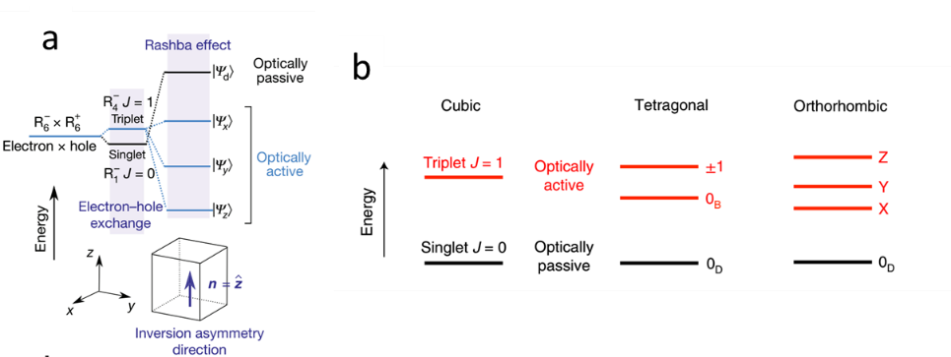
Figure 1.3. Multiple states in HPVs. (a) The expected fine structure of the band-edge exciton for CsPbBr₃ perovskite;^{[29]} (b) Diagrams of energy levels of the band-edge exciton fine structure of FAPbBr₃ perovskites for three different crystal anisotropies (lattice or shape). The lowest state is a dark state while the others are optically active.^{[33]}

end of the 20th century, zinc sulfide doped with copper/cobalt is the dominant LPL material. [] Then, revolutionary lanthanide-activated inorganic materials were developed in 1990th and have been heavily studied till now. [] However, the inorganic LPL material requires high-temperature and complicated fabrication processes, so the OLPL materials with more economical and flexible synthetic processes have been developed to address this concern.
The typical organic long-lived light emission is phosphorescence, which is from the deactivation between the states with different multiplicities. Two spin-forbidden intersystem crossing processes (ISC) are required to generate phosphorescence. One is the transformation from excited singlet state (S₁) to excited triplet state (T₁), and the other one is from excited triplet state (T₁) to ground singlet state (S₀). Obviously, SOC effects are critical to generating phosphorescence by enhancing the ISC process.
Another significant long-lived emission in organic materials is persistent luminescence. Although the detailed mission mechanism for persistent luminescence is still controversial, it is no doubt three key steps are required to generate persistent luminescence: ionization, transportation, and liberation.^{[49]} The ionization step is a charge carrier separation process, where electrons and holes are separated under photoexcitation. Then, intermediate states will be involved in the charge-carrier transportation process, following by the slow charge-carrier recombination process to generate persistent luminescence. However, the charge-carrier separated states are difficult to be formed in organic molecules, the conventional two-photon ionization process usually required low temperature and high excitation intensities, leading to the difficulty to develop room-temperature persistent luminescence in organic materials. Recently, Kabe and Adachi successfully developed a room temperature purely OLPL material formed by two simple organic molecules, which can be excited at low excitation intensity and last more than one hour.[] This work is revolutionary and brings new opportunities to develop purely OLPL materials and flexible and large-area devices. The following works showed that the energy gap between the lowest singlet excited state and lowest triplet excited state is critical to this donor-acceptor OLPL system, indicating the ISC process is significant for this OLPL emission process. []
Besides phosphorescence and persistent luminescence, the two most common long-lived emission mechanisms, long-lived emission in organic materials can also be induced by other mechanisms such as TADF and twisted intramolecular charge transfer (TICT) fluorescence. The lifetime of TADF is short while the TICT fluorescence can be longer than 1 s. The TICT was first reported in 1970th that the p-(9-anthryl)-n, n-dimethylaniline derivatives showed a photoinduced molecular structural twisting, leading to a long-loved emission from singlet excited states.
The organic long-lived light emission materials have achieved remarkable growth in recent years, and have been applied in various fields such as optical recording,[] medical imaging,[] sensing,[] and display applications.^{[48]} However, there are still challenges ahead for OLPL materials. A deeper understanding of mechanisms in long-lived light emission needs to be further explored, which can point out a clearer direction for promoting the performance of long-lived light emission materials and devices. Particularly, SOC is one of the most significant mechanisms which needs to be explored.
Fundamentally, the persistent PL implies that light-emitting states can undergo an abnormal dynamic process to become long-lived states towards developing a persistent light emission in organic materials at room temperature. In general, organic materials are formed with both singlet and triplet states to generate fluorescence and phosphorescence with the lifetimes in the order of nanoseconds[,] and microseconds[,], respectively. We should note that a photoexcitation is only allowed to generate singlet states due to the spin selection rule, normally leading to fluorescence from singlet transitions (S_{n} to S₀), where S_{n} and S₀ are singlet excited and ground states.[] When spin-orbital coupling (SOC) is occurred to flip spins, the singlet states can be converted into triplet states, giving rise to an intersystem (S_{n} → T_{n}) crossing.[,] In this situation, the triplet states (T) can become allowed transitions (T → S₀) through spin flipping to generate a phosphorescence with the lifetime in the order of microseconds typically in the presence of heavy elements.[,] It should be noted that simply using singlet and triplet transitions is difficult to generate a long persistent PL with an ultralong lifetime in the order of seconds up to minutes in organic molecules at room temperature. This is because un-restricted singlet and triplet transitions normally occur within the time scale less than microseconds in both intra- and inter-molecular states. Clearly, the recently observed ultralong lifetimes imply there exist new fundamental mechanisms to convert the short-lived light-emitting states into ultralong-lived states to generate a persistent light emission in organic molecules at room temperature. Such persistent PL was initially reported in the 1970’s by considering the singlet excitons formed with slow molecular twist induced by photoexcitation. [,,] Recently, the triplets have been widely considered to be responsible for long persistent PL through de-trapping dynamics, supported by theoretical calculations.^{[53,]} Essentially, this consideration relies on the possibility that aromatic aldehyde, heavy halogen, and deuterated carbon structures can generate a spin-orbital coupling (SOC) to convert optically generated singlet excitons into triplet excitons. [,,,,,,]

Principles to enable long persistent light emission in purely organic materials
Purely organic long persistent light emission materials without metal s are still rare. Based on fundamental molecular design principles, crystallization-induced long persistent light emission has been reported as an effective approach to achieve purely organic long persistent light emission. The crystallization has been reported that help construct rigidity of the system to suppress non-radiative transitions, isolating oxygen molecules that could easily quench the triplet state, and improving inter-system crossing by decreasing the energy gap between singlet and triplet at al. For example, Kim et al.^{[75]} developed a bright mixed crystal material with high RTP quantum yield through directed heavy-atom effect directed by halogen bonding. Huang et al. [] designed a series of purely organic molecules with ultralong room temperature phosphorescence lifetimes ranging from 0.21 to 1.35 s through H-aggregation in single crystals. (Figure 1.4) However, the exact role of molecular packing in crystal to the long persistent light emission is still unclear. Strong SOC aims to harvest triplet via efficient ISC is significant to achieve phosphorescence in organic materials. As shown in Figure 1.5, there are three most commonly considered approaches to enhance SOC: 1) Heavy atom effect. SOC is heavily affected by heavy atom effects, atoms with high atomic numbers will lead to stronger SOC. Therefore, heavy-atom complexes were the most widely used material when the organic phosphorescence study was at an early stage.^{[42]} 2) Heteroatoms with lone pair electrons such as N, O, P, S. By introducing heteroatoms with abundant lone pairs, S₁ with (n,π*) configuration will be introduced, which enable a large SOC constant by the large configuration difference between S₁ and T_{n} states according to the El­Sayed rule.^{[13]} Therefore, aromatic carbonyl, carbazole, and other organic groups with heteroatoms have been widely used for room temperature long-lived emission materials.^{[43]} 3) Halogen bonding. Organic crystals contain both halogen atoms and aromatic aldehyde can exhibit strong halogen bonding, which is a non-covalent interaction between neighboring molecules. Directed heavy atom effects can be induced by halogen bonding, which will largely enhance SOC. This halogen bonding which

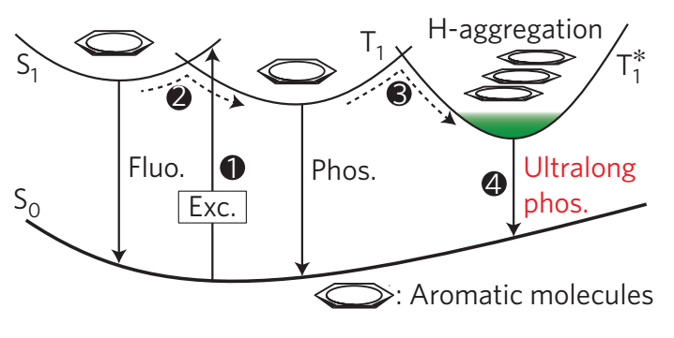
Figure 1.4. Proposed mechanism for ultralong organic phosphorescence by constructing lower-lying energy states to stabilize the lowest triplet excited state (T1). ^{[77]}

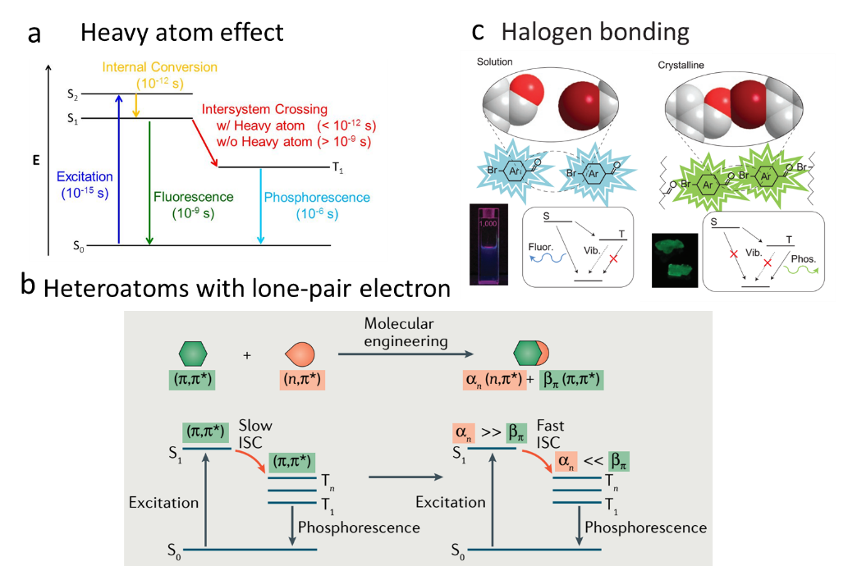
Figure 1.5. Principles to enhance SOC in organic long-lived emission materials. (a) heavy atom effect; (b) heteroatoms with lone-pair electron; c, halogen bonding.

leads to directed heavy atom effects is one of the most commonly used methods for generating phosphorescence in heavy-metal free organic materials.

Characterization of spin dynamics

Magneto-photoluminescence
Magneto-photoluminescence refers to the phenomenon that photoluminescence intensity is changed by applying a magnetic field. Generally, photoluminescence can be generated from both intermolecular and intramolecular excited states under photoexcitation. When a magnetic field changes the singlet and triplet population ratio in intermolecular and intramolecular excited states, magneto-photoluminescence can be observed due to the different recombination rates of singlet and triplet excited states. []
In general, magnetic field effects can provide three basic indications on (i) whether light-emitting states are intramolecular or intermolecular types, (ii) whether the intersystem crossing favors the singlets or triplets, and (iii) whether the intersystem crossing is governed by SOC or hyperfine interaction. First, the intermolecular and intramolecular excitons possess low and high exchange energies ($J∝e^{R_{eh}}$, R_{eh}: the distance between electron and hole in an exciton) due to their spatially extended and localized wavefunctions with allowed and forbidden intersystem crossing, leading to appreciable and negligible magnetic field effects ^{[78,]} as shown by intermolecular and intramolecular excitons in both solid and liquid states (Figure 1.6). Second, the intersystem crossing can increase or decrease light-emitting states. It has been experimentally shown that positive magnetic field effects of PL can be observed if the intersystem crossing increases the singlet light-emitting states, exampled in intermolecular charge-transfer states and polaron pairs in fluorescent molecules.^{[78]} Third, magnetic field effects of PL can be observed at low and high field (< 10 mT and > 10 mT) when hyperfine interaction and SOC govern the intersystem crossing, respectively.[] Magneto-photoluminescence can be used as an effective experimental tool to investigate the spin-dependent excited states formation, charge dissociation, and recombination process of organic semiconductors. Furthermore, exploring the fundamental mechanism of the magneto-optical phenomenon can lead to the development potential application of light and magnetic field sensing based on organic light-emitting materials.
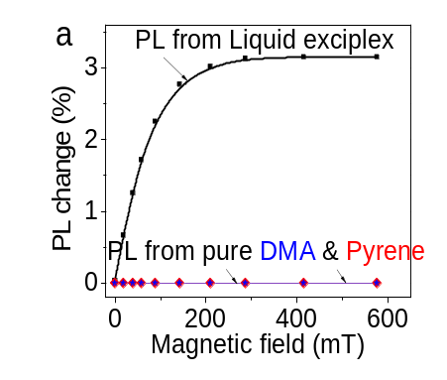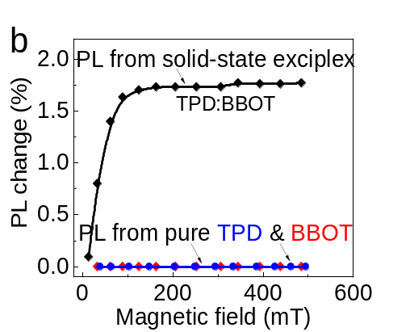
Figure 1.6. Magnetic field effects for light-emitting exciplex systems in solid and liquid states. (a) Magnetic field effects of PL measured for light-emitting exciplex in liquid (pyrene:DMA in DMF), pure DMA : DMF, and pure pyrene : DMF liquid solution at 375 nm excitation; (b) Magnetic field effects of PL measured for light-emitting exciplex in solid state (BBOT:TPD in PMMA). (DMA: N,N-dimethylaniline; BBOT: 2,5-bis(5-tert-butyl-2-benzoxazolyl)-thiophene; TPD: N,N'-diphenyl-N,N'-bis(3-methylphenyl)-[,11'-biphenyl]-4,4'-diamine)

Magneto-photocurrent
Magneto-photocurrent refers to the phenomenon that photocurrent is changed by applying a magnetic field. Under illumination, photoexcitation quickly generates free carriers within 1 ps, free carriers have the opportunity to recombine to bright and dark states.^{[29]} Spin mixing induced by SOC can lead to the conversion from dark to bright state, while the spin conserving process induced by exchange interaction tends to prevent the conversion between bright and dark states. The populations on the two states reach equilibrium via the competition between the spin mixing process and spin conserving process. After applying a magnetic field, the magnetic field would introduce coherent spin procession to the excited states, leading to the change of the ratio between bright and dark states, then resulted in a magnetic field-dependent photocurrent.^{[78]} With a stronger SOC, it is more difficult for an external magnetic field to change the populations between dark and bright states, leading to a broader line shape in magneto-Jsc characteristics. With a weaker SOC, it is easier for an external magnetic field to change the populations between dark and bright states, giving a narrower line shape in magneto-Jsc characteristics. Therefore, the line shape of magneto-Jsc can indicate whether the internal SOC is increased or decreased upon materials processing. Specifically, broader/narrow line shape of magneto-Jsc represents a stronger/weaker SOC. According to this, Zhang et al. compare the SOC difference in Pb-based and Sn-based solar cells based on the magneto-Jsc measurement (Figure 1.7); Dou et al. also study the change of SOC upon organic cation change by this measurement. [,]

Magneto-capacitance
Magneto-photocurrent refers to the capacitance change by an applied magnetic field. Since four kinds of dielectric polarization mechanisms are dominated under different frequencies, the mechanism of magneto-capacitance under different frequencies would be different. Thus, magneto-capacitance at different frequency ranges can be used to explore various physical processes in semiconductor materials. Magneto-capacitance at a low frequency around 5 KHz has been used to explore the spin-orbit coupling between perovskite and ferromagnetic surface (Figure 1.8 a) [] Magneto-capacitance at high frequency could be used to study the bulk dipolar polarization in perovskites since the magnetic field cannot change mobile ions at room temperature as shown in Figure 1.8b, the dipolar polarization becomes the only possibility to interact with the applied magnetic field. []

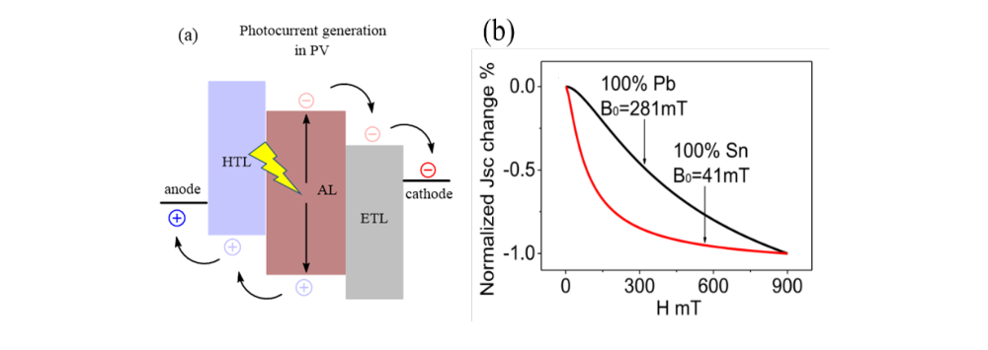
Figure 1.7. Magneto-photocurrent measurement. (a) Schematic of photocurrent generation in photovoltaic devices; (b) Normalized magneto-Jsc curves to show internal magnetic parameter B₀ derived from Lorentizan function.^{[81]}

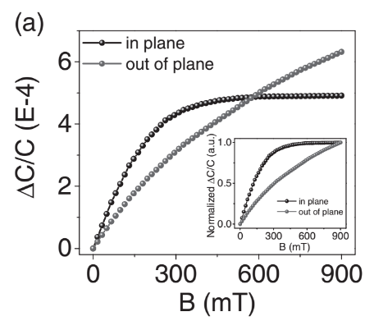
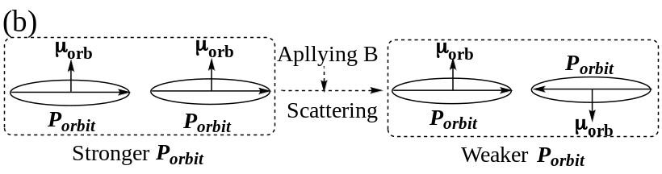
Figure 1.8. Magnetodielectric effects in HPVs. (a) Magnetodielectric effects were measured for both the in-plane and out-of-plane directions. The inset shows the normalized in-plane and out-plane magnetodielectric signals. (b)Principle to generate magneto-capacitance signal at 1MHz: magnetic field B scatters orbital magnetic dipoles, leading to out-phase orbital polarizations and decreasing bulk dipolar polarization. ^{[83]}

Polarization-dependent photocurrent
Linear/circular photoexcitation-modulated photocurrent change (ΔJsc) refers to the measurement where the photocurrent Jsc is monitored while switching the photoexcitation between linear and circular polarizations. ^{[81,]} Here, ∆Jsc is defined by $∆Jsc=\frac{I_{Circular}-I_{Linear}}{I_{Linear}}×100\%$, where I_{Linear} and I_{Circular} are the Jsc values under linear and circular photoexcitations, respectively. Essentially, a circularly polarized photoexcitation (σ⁺) generates the same-directional orbital magnetic dipoles between excitons, while a linearly polarized photoexcitation (the combination of σ⁺ and σ⁻) gives rise to opposite-directional orbital magnetic dipoles between excitons, as shown in Figure 1.9. When considering the interaction between orbital magnetic dipoles within orbit-orbit interaction between excitons, circularly and linearly polarized photoexcitations induce stronger and weaker total orbital magnetic dipoles, leading to higher and lower total SOC, respectively. [] Because the SOC provides an underlying mechanism to convert optically generate bright states to dark states, changing the SOC can consequently modify the Jsc value since the bright and dark states have different recombination rates. Therefore, switching the photoexcitation between linear and circular polarizations at the same intensity causes a change on Jsc, leading to a ΔJsc phenomenon in perovskite solar cells.^{[81,]} We should note that the optically operated orbit-orbit interaction detected by switching the photoexcitation between linear and circular polarizations competes with intrinsic orbit-orbit interaction. Specifically, larger/smaller ΔJsc corresponds to weaker/stronger intrinsic orbit-orbit interaction in HPVs. Here, using ΔJsc value upon switching the photoexcitation between linear and circular polarizations provides a unique method to evaluate the intrinsic orbit-orbit interaction between excitons.

Multi-photon up-conversion
The up-conversion process is a unique process that the high-energy emission can be excited by a low-energy excitation beam. In general, the up-conversion process can be generated through two mechanisms include multi-photon absorption or triplet-triplet annihilation (TTA) as shown in Figure 1.10.[] For multi-photon up-conversion, multi coherent photons can be absorbed simultaneously from ground state to excited state which enables the higher energy emission. The multi-photon up-conversion usually required an intense pulsed laser enabled high excitation density. For the TTA induced up-conversion, a bimolecular system including sensitizer and acceptor is required. The low-energy light is absorbed by the sensitizer singlet states and transfer to triplet states by the intersystem crossing process. Subsequently, an energy transfer process from sensitizer triplet states to acceptor triplet states will occur. Then, the TTA process will be enabled by a large number of long-lived triplet states. Since the triplet states are required for the TTA process, materials with heavy-atom are more commonly applied for TTA-based up-conversion.

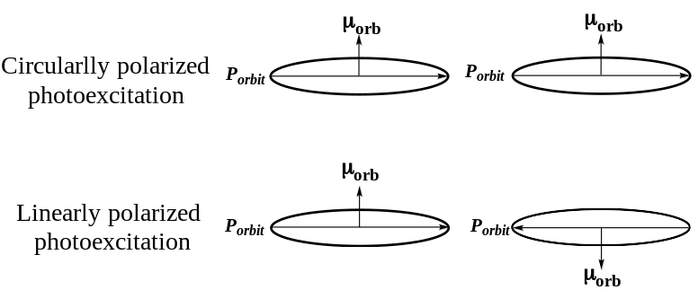
Figure 1.9. Orbital magnetic dipoles between excited states generated by circularly and linearly polarized photoexcitations.

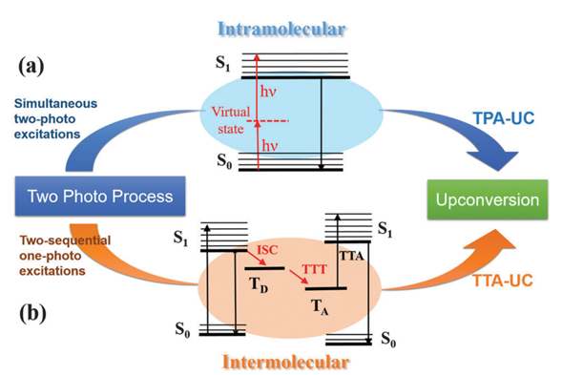
Figure 1.10. Jablonski diagrams of (a) Two photon up-conversion (dual energy level model) and (b) TTA up-conversion.[]

Chapter 2: Photoinduced Bulk polarization in Mixed Cation Halide Perovskites

Two papers based on this chapter were originally published by Yixuan Dou etc., Yixuan Dou designed and performed the experiments, analyzed the data, and wrote the manuscript.
- Dou, Y., Wang, M., Zhang, J., Xu, H. & Hu, B. Identifying Photoinduced Dipolar Polarization and Orbit–Orbit Interaction between Excitons in Organic–Inorganic Hybrid Perovskites. Advanced Functional Materials 30, 2003476 (2020).
- Dou, Y., Xu, H., Liu, Y., Wang, M., Zhang, J., Ovchinnikova, O.S. and Hu, B., Tuning spin-orbit coupling towards enhancing photocurrent in hybrid organic-inorganic perovskites by using mixed organic cations. Organic Electronics 81, (2020).

Abstract
Photoinduced polarization and orbit-orbit interaction are important issues in hybrid perovskites towards developing optoelectronic functionalities. This chapter identifies that photoinduced polarization occurs in hybrid perovskites (MA_{x}FA_{(1-x)}PbI₃) by measuring bulk polarization at 1 MHz in the magnetic field. Interestingly, when the internal dipole moment is increased upon increasing the MA:FA ratio, the photoinduced dipolar polarization can be substantially enhanced, clarifying the controversial issue of whether photoexcitation can induce a dielectric polarization within dipolar polarization regime in hybrid perovskites. Furthermore, upon increasing photoinduced dipolar polarization, it was found that the intrinsic orbit-orbit interaction between excitons can be increased, revealed by monitoring photocurrent change (ΔJsc) upon switching the photoexcitation between linear and circular polarizations. This presents those organic cations are directly involved in the orbit-orbit interaction within band structures. Clearly, our studies provide an insightful understanding on the dipole moment effects on photoinduced dipolar polarization and orbit-orbit interaction between excitons in hybrid perovskites towards controlling the optoelectronic properties.

Introduction
Organic-inorganic hybrid perovskites have been heavily studied owing to their remarkable photovoltaic performance and low-cost solution processability.^{[1,,,,]} Perovskites with ABX₃ structure are typically composed of organic cations at A site and inorganic cages BX₆ (B = Pb²⁺, Sn²⁺; X = I⁻, Br⁻, Cl⁻).[,] Owing to the small rotational energy and non-spherical nature, the organic cations with intrinsic dipole moment induce a dipolar polarization.^{[27,]} And the presence of the heavy elements (Pb²⁺ and I⁻) in APbI₃ leads to significant spin-orbit coupling (SOC), thus excitons in hybrid perovskites possess both orbital (L) and spin (S) momentums with the total momentum J = L + S.^{[29,]} In general, the electrical polarization plays an important role in suppressing the charge recombination, facilitating charge transport, and even polarizing excited states, which are critically important to the development of photovoltaic, light-emitting, lasing, optically-tunable ferroelectric, and optically-tunable mechanical properties in organic-inorganic hybrid perovskites.[,,,,] Under photoexcitation, an incident electromagnetic wave generates an electronic polarization occurring at the frequency of 10¹⁴ Hz with a much lower amplitude as compared to the dipolar polarization regime.^{[22]} Bulk polarization is governed by dipolar polarization within the MHz frequency range.^{[23]} Thus, there has been a fundamental question on whether a photoexcitation can induce a dipolar polarization change, which can provide an underlying mechanism to control the dynamic behaviors of excited states towards developing optoelectronic functionalities.
Using impedance spectroscopy, the early study attributed the largely enhanced capacitance under photoexcitation in a low-frequency regime to the enhanced dielectric constant.^{[24]} However, further studies suggested this phenomenon comes from surface polarization induced by the accumulation of photoactivated ions.^{[25]} Later on, a new photo-induced capacitance-voltage method was used to investigate photoinduced bulk polarization by ruling out the contribution from ions. ^{[26]} In this capacitance-voltage (C-V) measurements, the ions were continuously driven by the DC bias gradually scanning from -0.1 V to +1.5 V. In this situation, the AC bias for detecting capacitance signals is only 50 mV, which cannot cause any response from continuously driven ions under gradually scanning DC bias. Thus, this C-V measurement provides a method to detect photoinduced bulk polarization by monitoring the C-V signals under photoexcitation. However, this method was still questioned by considering the possibilities that the low-frequency capacitance signal change may induced by the photoactivated ions accumulated in bulk and interface, which can be modulated by photoexcitation. ^{[101]}
In this work, we intend to identify the photoinduced bulk polarization by using magnetic field effects of dielectric polarization, and to explore the orbit-orbit interaction between excitons via monitoring the circularly polarized photoexcitation-modulated photocurrent. The mixed cation MA_{x}FA_{(1-x)}PbI₃ perovskites whose electrical dipole moment can be changed upon using different MA/FA ratios were used to apply the In our early studies, we have established the materials processing procedure to change the spin-orbital coupling (SOC) by adjusting the MA/FA ratio in the MA_{x}FA_{(1-x)}PbI₃.^{[82]} We observed that the SOC can be changed upon using different MA/FA ratios in perovskite solar cells. This indicates that changing MA/FA ratio can lead to high-quality property-tunable hybrid perovskites. Especially, this observation provides the necessary perovskite samples to explore the photoinduced bulk polarization and the orbit-orbit interaction between excitons in hybrid perovskites. Here, to clarify whether photoinduced polarization can occur in the dipolar polarization regime, we detect the photoinduced bulk polarization signal via magneto-capacitance measurement. An applied magnetic field was used to directly probe the dipolar polarization at 1 MHz and keep ions intact during capacitance measurements under photoexcitation. Because a magnetic field cannot change mobile ions at room temperature, the dipolar polarization becomes the only possibility to interact with the applied magnetic field. Here, we observed that applying a magnetic field can change the dipolar polarization, leading to a magneto-capacitance signal at 1 MHz in MA_{x}FA_{(1-x)}PbI₃ hybrid perovskites in dark condition at room temperature. In addition, it was found that photoexcitation can largely increase the magneto-capacitance signal, clarifying the existence of photoinduced dipolar polarization in hybrid perovskites. Furthermore, we use circular/linear photoexcitation modulated photocurrent measurements to explore the interaction between orbit-orbit interaction between excitons upon photoinduced dipolar polarization. A smaller photocurrent difference (∆Jsc) was observed as dipole moment decreases by tuning MA:FA ratio in perovskites, indicating organic cations are directly involved in the orbit-orbit interaction within band structures.

Material processing and Methods

Materials
Lead (II) iodide (PbI₂, ultra-dry, 99.999 %, metals basis), Nickel(II) formate dehydrate, and Ethylene glycol (99 %) were purchased from Alfa Aesar. Methylammonium iodide (MAI) was purchased from Xi’an p-OLED Inc. Formamidinium iodide (FAI) was purchased from Greatcell Solar Limited. Phenyl-C61-butyric acid methyl ester (PC₆₁BM) was purchased from 1-Material. Dimethyl sulfoxide (DMSO), γ-butyrolactone (GBL), toluene, chlorobenzene, polyethylenimine (PEI, Mw~2000, 50 wt. % in water), and isopropanol were purchased from Sigma-Aldrich. All materials were used as received.

Device fabrication
The MAPbI₃ (or FAPbI₃) precursor solutions were prepared by dissolving MAI (or FAI) and PbI₂ with the concentration of 1.2 and 1.26 M in a mixed solvent of γ-butyrolactone (GBL) and dimethyl sulfoxide (DMSO) (7:3 v/v). Then the two precursor solutions (MAPbI₃ and FAPbI₃) were mixed with volume ratios of 1:0, 1:1, 1:3 to get MAPbI₃, MA_{0.5}FA_{0.5}PbI₃ and MA_{0.25}FA_{0.75}PbI₃ solutions. All solar cells studied in this work were fabricated with a planar structure of ITO/NiO_{x}/perovskite/PC₆₁BM/PEI/Ag (Figure 2.1). The precursor solution of NiO_{x} layer was prepared by adding 0.5 M Nickel(II) formate dehydrate, 1M equivalents of ethylenediamine in ethylene glycol. Then the NiO_{x} layer was spin-casted on top of the precleaned indium tin oxide (ITO) substrate at 4000 rpm for 90 s and followed by the thermal annealing at 300 °C for 1 h in ambient conditions.[] The MA_{x}FA_{(1-x)}PbI₃ perovskite thin films were spin-casted on top of NiO_{x} layer with a two-step spin-coating process (1000 rpm for 10 s and 4000 rpm for 60 s), in which 400 μL toluene was dropped as the antisolvent at the 22nd second during the second step. Then the MAPbI₃ and MA_{x}FA_{(1-x)}PbI₃ films were annealed at 100 °C and 110°C for 10 min, respectively. After cooling down, the 20 mg/mL PC₆₁BM Chlorobenzene solution was spin-coated on top of the perovskite layer at 2000 rpm for 60 s. After 30 min, 0.5 mg/mL PEI solution (Mw~2000, 50 wt. % in water) in isopropanol was then spin-casted on top of PC₆₁BM layer at 5000 rpm for 60 s. Finally, 90 nm silver electrode was thermally deposited. The devices were encapsulated in glovebox and used for measurements in ambient condition.

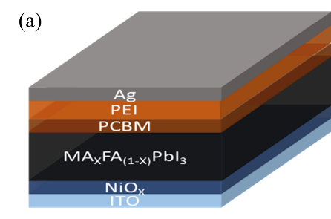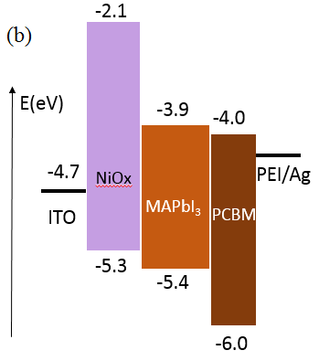
Figure 2.1. (a) schematic diagram of perovskite solar cell; (b) Energy level diagram of perovskite solar cell.

Characterizations
Current density-voltage (JV) characteristics were measured by Keithley 2612 source meter in glovebox with nitrogen atomsphere under the illumination of 100 mW/cm² from a solar simulator (Thermal Oriel 96000 300 W, Newport). Absorption spectra were taken by a UV/VIS spectrometer (Lambda 35, PerkinElmer). The magneto-capacitance measurements were performed under an external magnetic field (B) parallel to the device plane scanning from 0 to 900 mT. The capacitance was measured by using Agilent E4980A LCR meter under an alternating bias of 50 mV with a frequency at 1 MHz. The detection limit of the magneto-capacitance measurements is about 0.001 %. The capacitance-voltage measurements were conducted on the same instrument with an alternating bias of 50 mV under 5 kHz. For the circular/linear photoexcitation-modulated photocurrent measurements, the photocurrents from the perovskite solar cells were monitored by Keithley 2400 source meter under short-circuit condition upon switching the photoexcitation between linear and circular polarizations at same intensity. The linearly and circularly polarized photoexcitations were generated by using continuous-wave 488 nm laser in combination with a linear polarizer and a quarter wave plate.

Results and discussion

Photovoltaic performance
MA and FA are the two most used organic cations in hybrid perovskites for highly efficient perovskite solar cells. FA cation has a much smaller dipole moment (μ = 0.2 D) and larger orientation-potential barrier (E_{rot} = 13.9 kJ/mol) than MA cation (μ = 2.3 D, E_{rot} = 1.3 kJ/mol), [] as shown in Figure 2.2. Here, we explored the organic cations’ dipole moment effects on photoinduced bulk polarization based on the MA_{x}FA_{(1-x)}PbI₃ perovskites with different MA:FA ratios. MA_{x}FA_{(1-x)}PbI₃ perovskites solar cells were fabricated with an inverted (p-i-n) architecture of ITO/NiO_{x}/MA_{x}FA_{(1-x)}PbI₃/PC₆₁BM/PEI/Ag (Figure 2.2b). As shown in Figure 2.3, the PL spectra of perovskites with three different MA/FA ratios both showed good Gaussian distribution, indicating no phase segregation behavior inside mixed-cation perovskites. In addition, the peak shift has good linear dependence upon MA:FA ratio change, which further verifiedthe uniform distribution of FA and MA in perovskite films. Figure 2.2c presents the current-voltage (J-V)
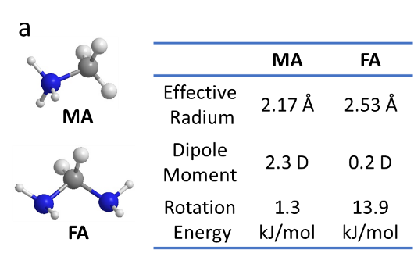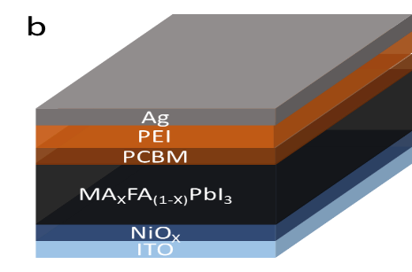
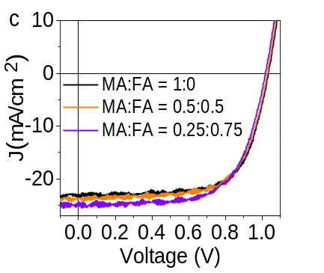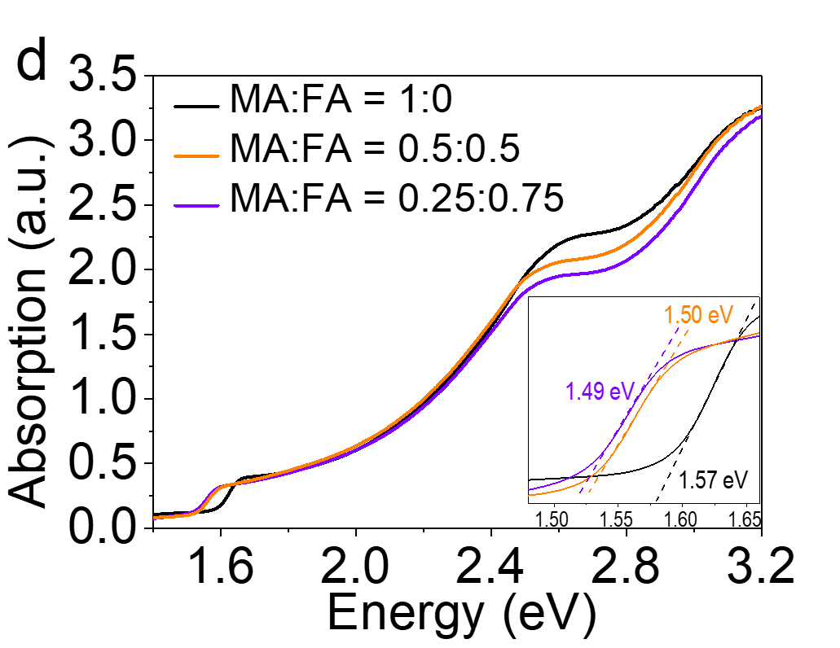
Figure 2.2. Device structure and performance of MA_{x}FA_{(1-x)}PbI₃ solar cells. (a) Schematic diagram of MA and FA cations. (b) Schematic diagram to show the device structure of perovskite solar cells. (c) J−V characteristics of MA_{x}FA_{(1-x)}PbI₃ solar cells; (d) Absorption spectra of MA_{x}FA_{(1-x)}PbI₃ thin films. The inset shows the enlarged area around the band edge to indicate the calculated bandgaps.

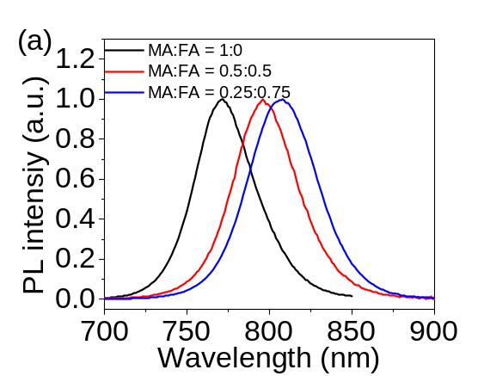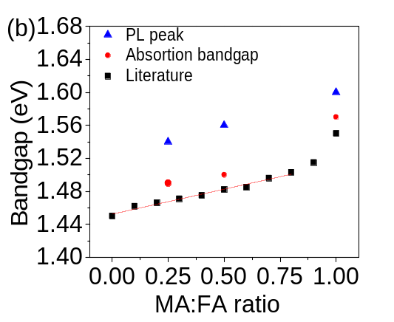

Figure 2.3. PL characterization of MA_{x}FA_{(1-x)}PbI₃ film. (a) PL spectra of MA_{x}FA_{(1-x)}PbI₃ perovskites with MA:FA ratio of 1:0, 0.5:0.5, and 0.25:0.75; (b) Comparison between literature and this work of the variation of bandgap with MA:FA ratio change. The literature data is extracted from reference [].

characteristics of MA_{x}FA_{(1-x)}PbI₃ solar cells with different MA:FA ratios (MAPbI₃, MA_{0.5}FA_{0.5}PbI₃, and MA_{0.25}FA_{0.75}PbI₃). Table 1 summarizes the photovoltaic parameters including short-circuit current (Jsc), open-circuit voltage (Voc), fill factor (FF), and power conversion efficiency (PCE). The MA_{x}FA_{(1-x)}PbI₃ solar cells show decent PCEs ranging between 16.43 % and 16.81 %, indicating great perovskite film quality. The statistics on the photovoltaic parameters for each type of perovskite solar cells are shown in Figure 2.3. It should be noted that additional perovskite film preparation techniques, such as chlorine doping [], polymer modification [], and composition engineering [,], have been used to further improve the device performance. In order to study the intrinsic bulk polarization change in a simple system, we use the standard MA_{x}FA_{(1-x)}PbI₃ perovskite preparation method without additional modifications. Figure 2.2d shows the absorption spectra of the MA_{x}FA_{(1-x)}PbI₃ perovskite thin films, from which the bandgaps are calculated to be 1.57 eV, 1.50 eV, and 1.49 eV for MAPbI₃, MA_{0.5}FA_{0.5}PbI₃, and MA_{0.25}FA_{0.75}PbI₃, respectively (Inset of Figure 2.2d). The bandgaps of the MA_{x}FA_{(1-x)}PbI₃ perovskites with different MA:FA ratios follow the same trend as compared with the well-established relationship between bandgap and MA:FA ratio.[] Meanwhile, the PL peaks of the corresponding MA_{x}FA_{(1-x)}PbI₃ perovskite thin films also follow the same trend with the bandgaps (Figure 2.4). This indicates the MA and FA cations are uniformly distributed in the MA_{x}FA_{(1-x)}PbI₃ perovskite thin films.

Photoinduced capacitance-voltage
Firstly, we used the C-V measurements under photoexcitation condition to provide preliminary information on the photoinduced dipolar polarization. In the C-V measurements, gradually increasing the DC bias from -0.1 V to 1.5 V can continuously drift the mobile ions within hybrid perovskite films. In this situation, the continuously drifted mobile ions have little opportunities to respond to the low AC bias of 50 mV during the detection of impedance signals. This provides a possibility to separate mobile ions from the detection of photoinduced dipolar polarization in hybrid perovskites. As shown in Figure 2.5a, broad C-V capacitance signal enhancement can be observed in MAPbI₃ perovskite solar cell at the depletion region from -0.1 to +1.5 V when increasing the excitation intensity from 0.1 sun to 1 sun condition. This broad capacitance signal enhancement (∆C) in the depletion zone under photoexcitation is an indication of the photoinduced dipolar polarization in perovskites. In addition, we excluded the contribution from the photoinduced thermal effects to the C-V measurements through the controlled temperature

Table 1. Photovoltaic Parameters of the MA_{x}FA_{(1-x)}PbI₃ solar cells.
Sample name | Jsc (mA/cm²) | Voc (V) | FF | PCE (%)
MAPbI₃ | 23.44 | 1.03 | 0.68 | 16.58
MA_{0.5}FA_{0.5}PbI₃ | 23.70 | 1.03 | 0.67 | 16.43
MA_{0.25}FA_{0.75}PbI₃ | 24.47 | 1.02 | 0.67 | 16.81

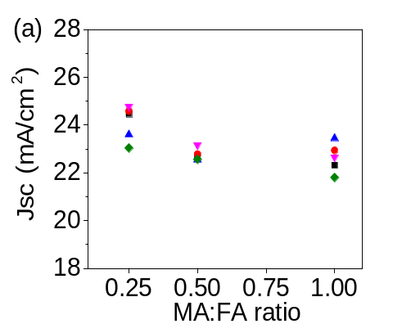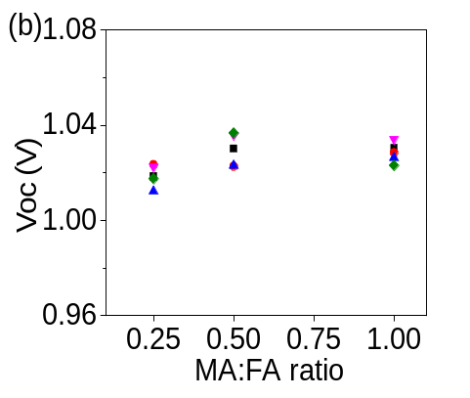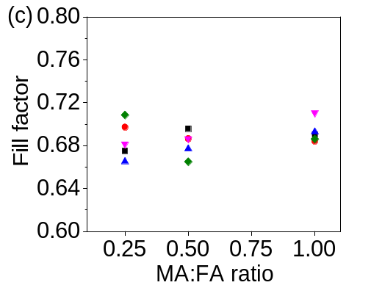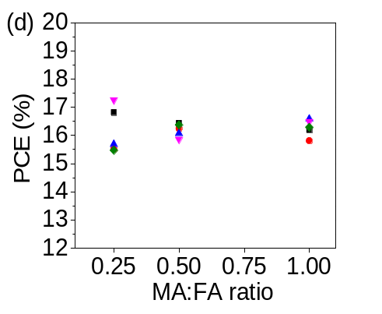
Figure 2.4. Photovoltaic parameters of the MA_{x}FA_{(1-x)}PbI₃ solar cells with different MA:FA ratios. (a) Jsc, (b) Voc, (c) Fill factor, and (d) PCE.
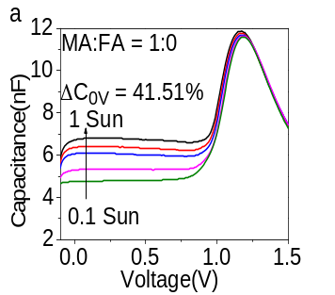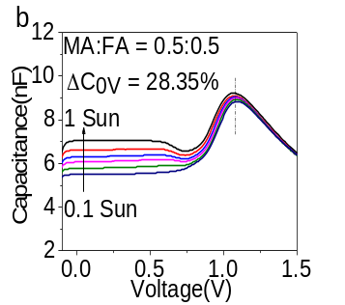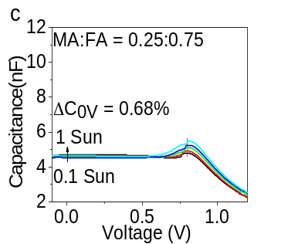
Figure 2.5. Photoinduced C-V characteristics measured under simulated sunlight with variable intensities in perovskite solar cells with different MA:FA ratios. (a) MAPbI₃. (b)MA_{0.5}FA_{0.5}PbI₃. (c) MA_{0.25}FA_{0.75}PbI₃.

measurements, as shown in Figure 2.6. Furthermore, the magnitude of ∆C drops from 41.51 % to 0.68 % with decreasing the MA:FA ratio (Figure 2.5 b and c), indicating the reduced dipolar polarization with less MA cation. It should be noted that FA cation has a much smaller dipole moment and larger orientation-potential barrier than MA cation. Therefore, the reduction of ∆C with decreasing the MA:FA ratio indicates that photoinduced dipolar polarization is largely influenced by the organic cation dipole moment.

High-frequency magneto-capacitance
To further confirm the dipolar bulk polarization, the magneto-capacitance measurement was taken on MA_{x}FA_{(1-x)}PbI₃ perovskites within the dipolar polarization regime at 1 MHz. The magneto-capacitance measurement was carried out by detecting the change of capacitance signal upon the applied magnetic field. Figure 2.7a shows a negative magneto-capacitance signal observed from the MAPbI₃ perovskite with the device architecture of ITO/PMMA/MAPbI₃/PMMA/Ag under the dark condition in dipolar polarization regime at 1 MHz. Besides, the negligible magneto-capacitance signal can be observed in a low-frequency regime at 1 kHz. It should be noted that capacitances measured in 1 kHz and 1 MHz mainly come from the surface and the bulk of the perovskite films, respectively, as shown in Figure 2-7b. The mechanism of the negative magneto-capacitance signal in the dipolar polarization regime at 1 MHz is shown in Figure 2.7c. The magnetic field scatters orbital magnetic dipoles, leading to out-phase orbital polarizations and decreasing bulk dipolar polarization. Since an external magnetic field has no effect on mobile ions, this magneto-capacitance measurement provides a unique experimental method to study bulk polarization when mobile ions become an issue.
Besides, the low-frequency surface polarization result from the accumulation of mobile ions cannot respond to the high frequency of about 1 MHz. [] Notably, the magneto-capacitance signal becomes disappeared at the frequency beyond dipolar polarization regime, exampled as the non-detectable magneto-capacitance signal at 1 kHz. This further verifies that magneto-capacitance measurement is valid for detecting bulk polarization in dipolar polarization regime in hybrid perovskites. Furthermore, the magneto-capacitance signal measured at 1 MHz under dark condition decreases its amplitude as the internal electrical dipole moment is decreased by increasing the FA ratio (Figure 2.8a-c). This indicates that magneto-capacitance amplitude can indeed reflect the bulk polarization in dipolar polarization regime.

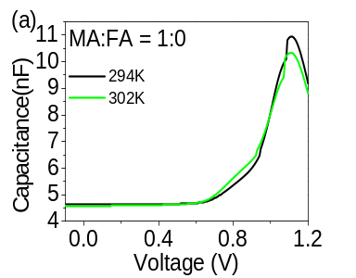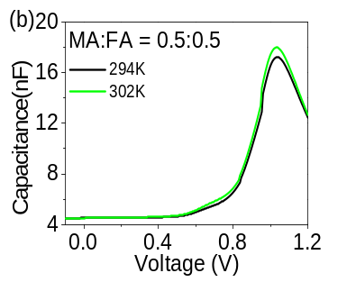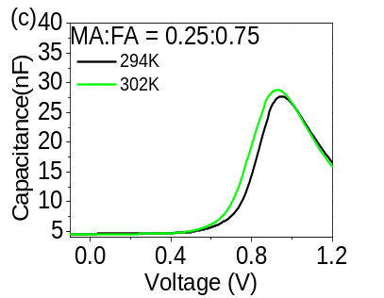
Figure 2.6. C-V characteristics measured under different heating temperatures in MA_{x}FA_{(1-x)}PbI₃ solar cells with various MA:FA ratios under dark condition. (a) MAPbI₃. (b)MA_{0.5}FA_{0.5}PbI₃. (c) MA_{0.25}FA_{0.75}PbI₃. Under the simulated sunlight illumination (one-sun condition), the device temperature is increased from 294 K to 302 K. With increasing device temperature through heating, the capacitance shows a negligible change in depletion zone (-0.1 V to 0.5 V) in C-V characteristics.

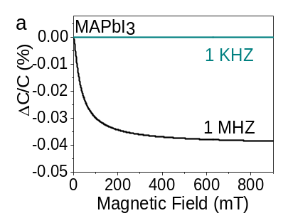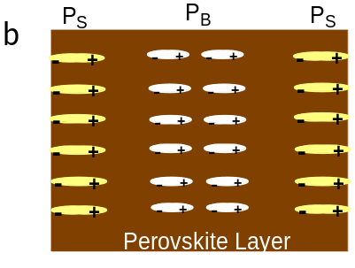
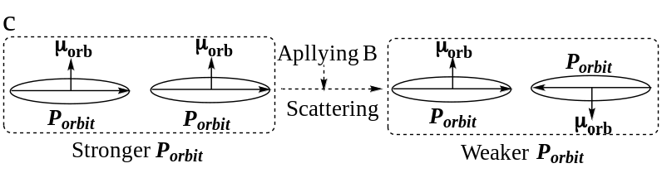
Figure 2.7. Magneto-capacitance measurement mechanism. (a) Magneto-capacitance signal detected in dipolar polarization regime at 1 MHz in ITO/PMMA/MAPbI₃/PMMA/Ag. (b) Schematic diagram to show surface and bulk dipolar polarization. (c) Principle to generate magneto-capacitance signal: magnetic field B scatters orbital magnetic dipoles, leading to out-phase orbital polarizations and decreasing bulk dipolar polarization.

Now we discuss the photoinduced bulk polarization by using magneto-capacitance measurement under photoexcitation. As shown in Figure 2.8a, applying photoexcitation can largely increase the magnitude of magneto-capacitance signals from 0.037 % to 0.07 % at 1 MHz in the MAPbI₃ perovskite. Because mobile ions have no response to an external magnetic field, this observation provides direct experimental evidence to clarify that a photoexcitation can indeed increase the bulk polarization in dipolar polarization regime. Moreover, the photoinduced magneto-capacitance amplitude decreases from 0.07 % to 0.014 % and 0.012 % when the MA:FA ratio is changed from 1:0 to 0.5:0.5 and 0.25:0.75. This presents clear information that decreasing internal electrical dipole moment can cause a reduction on photoinduced bulk polarization in hybrid perovskites. Therefore, our magneto-capacitance measurements provide un-ambiguous evidence to indicate that photoexcitation generates dipolar polarization in organic-inorganic hybrid perovskites. We should note that the observed magneto-capacitance signals experimentally indicate that an external magnetic field can change the dipolar polarization. This implies that an external magnetic field can interact with orbital magnetic dipoles, causing spin randomness between orbital magnetic dipoles and leading to out-phase orbital polarizations to show a change in dipolar polarization. Consequently, this generates a magneto-capacitance signal excluding any involvement from mobile ions. Nonetheless, magneto-capacitance provides a unique experimental method to study photoinduced bulk polarization in hybrid perovskites.

Orbit-orbit interaction
Now, we use circular/linear photoexcitation-modulated photocurrent measurements to explore the orbit-orbit interaction upon changing dipole moment through MA:FA ratio. In our early study we observed that changing MA/FA ratio can lead to different SOC values and consequently changes the photocurrent in perovskite solar cells based on hybrid perovskites (MA_{x}FA_{(1-x)}PbI₃). This observation indicates a convenient approach to change the SOC in hybrid perovskites. Here, we explore a new phenomenon where the exciton-exciton interaction can occur through orbital magnetic dipoles or orbital polarizations, leading to orbit-orbit interaction between excitons. Since the exciton-exciton interaction exists in photovoltaic, light-emitting, and lasing actions, this exploration can provide a deeper and insightful understanding of controlling the optoelectronic properties in hybrid perovskites. The excitons in hybrid perovskites possess both orbital and spin momentums, giving rise to total exciton angular momentum J (J = L + S).^{[97]} Therefore, the exciton-exciton interaction can occur through orbital dipoles or through spin dipoles, leading to
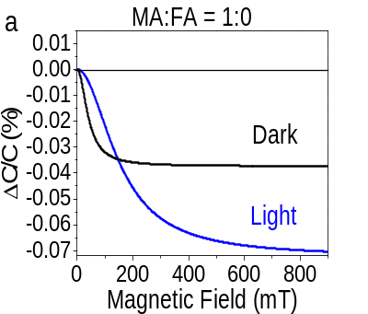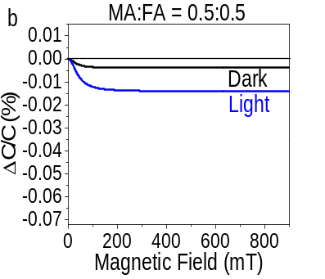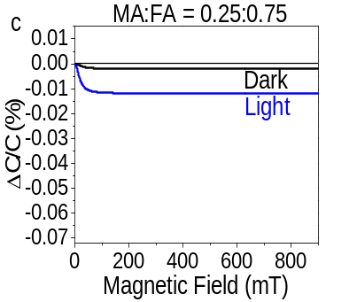
Figure 2.8. Magneto-capacitance signals measured from perovskite devices [ITO/PMMA/MAPbI₃/PMMA/Ag] with different MA:FA ratios under dark and light conditions. (a) MAPbI₃. (b)MA_{0.5}FA_{0.5}PbI₃. (c) MA_{0.25}FA_{0.75}PbI₃.

electric-type and magnetic-type orbit-orbit interactions between excitons. Especially, we have developed a unique method to identify these two types of orbit-orbit interactions by using the positive and negative ΔJsc or ΔPL while switching photoexcitation from linear to circular polarizations.[,,] Here, we found that the exciton-exciton interaction occurs through orbital magnetic dipoles (i.e. spin dipoles), leading to magnetic-type orbit-orbit interaction between excitons in the MA_{x}FA_{(1-x)}PbI₃ perovskite devices. Specifically, a circularly polarized photoexcitation (σ⁺) generates the same-directional orbital magnetic dipoles between excitons, while a linearly polarized photoexcitation (the combination of σ⁺ and σ⁻) gives rise to opposite-directional orbital magnetic dipoles between excitons, as shown in Figure 2.9. When considering the interaction between orbital magnetic dipoles within orbit-orbit interaction between excitons, circularly and linearly polarized photoexcitations induce stronger and weaker total orbital magnetic dipoles, leading to higher and lower total SOC, respectively. ^{[112]} Because the SOC provides an underlying mechanism to convert optically generate bright states to dark states, changing the SOC can consequently modify the Jsc value since the bright and dark states have different recombination rates. Therefore, switching the photoexcitation between linear and circular polarizations at the same intensity causes a change on Jsc, leading to a ΔJsc phenomenon in perovskite solar cells.^{[113,]} We should note that the optically operated orbit-orbit interaction detected by switching the photoexcitation between linear and circular polarizations competes with intrinsic orbit-orbit interaction. Specifically, larger/smaller ΔJsc corresponds to weaker/stronger intrinsic orbit-orbit interaction in hybrid perovskites. Here, using ΔJsc value upon switching the photoexcitation between linear and circular polarizations provides a unique method to evaluate the intrinsic orbit-orbit interaction between excitons as the MA:FA ratio is varied. Interestingly, Figure 2.10 shows that the ∆Jsc increases from 0.08 % to 0.42 % with MA:FA ratio decrease from 1:0 to 0.25:0.75. Here, ∆Jsc is defined by $∆Jsc=\frac{I_{Circular}-I_{Linear}}{I_{Linear}}×100\%$, where I_{Linear} and I_{Circular} are the Jsc values under linear and circular photoexcitations, respectively. This observation provides evidence that decreasing the internal dipole moment by changing the MA:FA ratio can essentially decrease the orbit-orbit interaction through orbital magnetic dipoles between excitons. This provides a convenient mechanism to tune the intrinsic orbit-orbit interaction between excitons by changing the internal electrical dipole moment in hybrid perovskites.
Figure 2.9. Orbital magnetic dipoles between excited states generated by circularly and linearly polarized photoexcitations.

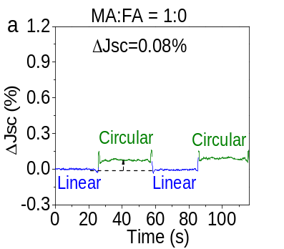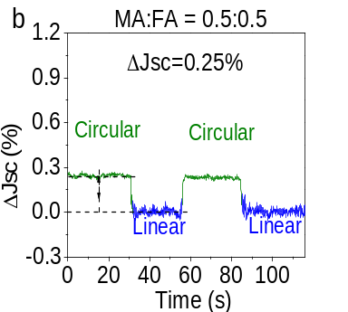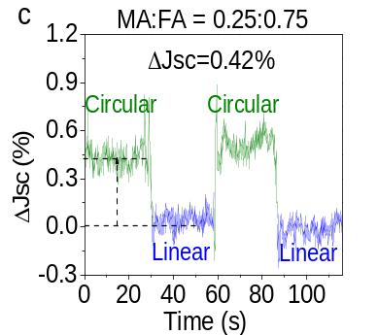
Figure 2.10. ΔJ_{SC} measured by switching linearly and circularly polarized photoexcitations in perovskite solar cells with different MA:FA ratios. (a) MAPbI₃. (b) MA_{0.5}FA_{0.5}PbI₃. (c) MA_{0.25}FA_{0.75}PbI_{3.}

Conclusion
In summary, the photoinduced dipolar polarization, suggested by C-V measurements under photoexcitation conditions, was identified by measuring bulk polarization in the magnetic field. Because mobile ions cannot respond to an external magnetic field, magneto-capacitance measurement provides a unique method to determine whether photoexcitation can induce a bulk dipolar polarization in hybrid perovskites. Specifically, we observed that a photoexcitation can clearly increase the magneto-capacitance signal generated by internal dipolar polarization, providing direct evidence that photoinduced bulk dipolar polarization indeed exists in the hybrid perovskites (MA_{x}FA_{(1-x)}PbI₃). Furthermore, we found that decreasing the internal dipole moment by introducing FA component leads to a reduction in photoinduced dipolar polarization, as reflected by the reduced magneto-capacitance signals under photoexcitation. This provides a new approach to control the optic, electric, ferroelectric, and mechanic properties in hybrid perovskites by adjusting internal electrical dipole moment. Moreover, by using linearly/circularly polarized photoexcitation-modulated photocurrents, we showed that changing the internal dipole moment by changing the MA:FA ratio can change the intrinsic orbit-orbit interaction through orbital magnetic dipoles between excitons. As the internal dipole moment is decreased by increasing the FA ratio, the intrinsic orbit-orbit interaction between excitons is decreased. This provides an insightful understanding of the orbit-orbit interaction between excitons towards controlling photovoltaic, light-emitting, and lasing properties in hybrid perovskites.

Chapter 3: Polarized Light Emission in Down-conversion and Up-conversion Excitation Regimes of 0D Cs₄PbBr₆ Perovskite Single Crystal

A manuscript organized based on this chapter by Yixuan Dou etc. is under submission, Yixuan Dou designed and performed the experiments, analyzed the data, and wrote the manuscript.
Dou Y., Wang M., J. Keum, Dryzhakov B., Hu B.*; Vacuum-annealing Induced Polarized Light Emission in Down-conversion and Up-conversion Excitation Regimes in Cs₄PbBr₆ Single Crystal Embedded with CsPbBr₃ Nanocrystals; To be submitted

Abstract
The zero-dimensional (0D) Cs₄PbBr₆ perovskite has attracted intense attention due to the unexcepted strong low-energy green emission around ~2.4 eV that is far from its calculated bandgap (3.2-3.99 eV). Here, a series of Cs₄PbBr₆ single crystals from non-green emissive to green emissive prepared by a vacuum annealing process were studied systematically to unveil the abnormal green emission. The new low-energy emission of the Cs₄PbBr₆ crystals exhibited nanocrystal size-dependent emission behaviors, and the X-ray diffraction results further verified the existence of CsPbBr₃ nanocrystal after vacuum annealing. Then, the lifetime and low-temperature results illustrated reduced defects stats and weak electron-phonon coupling in the new green emission recombination process, indicating the limited nonradiative recombination should be responsible for boosting green emission intensity. The new low-energy emission in the Cs₄PbBr₆ crystals was found to be linear polarized, and new green emission can also be excited under infrared excitation via a two-photon upconversion process. In addition, the infrared excited up-conversion green emission is also linear polarized. In summary, this work unveiled the origin of the strong green emission in Cs₄PbBr₆ crystal. Also, the observed polarized emission in both down-conversion and up-conversion excitation regimes indicates 0D perovskite is a promising candidate for multifunctional material.

Introduction
Over the last decades, lead halide perovskite materials have been heavily studied due to their remarkable performance in optoelectronics areas. [,,,] Typical three-dimensional (3D) perovskite showed a unique ABX₃ structure, where A represents monovalent cation, B represents divalent metal cation, and X represents halide anion.[,] In recent years, low dimensional perovskites including 0D, 1D, and 2D perovskites have been heavily studied due to their better stability, high photoluminescence quantum yield, strong anisotropy, etc.^{[6,,,]} Among the low dimensional perovskites, the 0D A₄BX₆ perovskite shows a much larger band-gap than its 3D analog due to the spatial confinement effect from the isolated [BX₆]⁴⁻ lead halide octahedra structure.[,] However, researchers have observed the strong green emission around 2.4 eV from the 0D Cs₄PbBr₆ perovskite, which is far below the calculated bandgap (3.2-3.99 eV) of this 0D perovskite.[,] Intensive efforts have been devoted to deciphering this abnormal phenomenon, and several mechanisms have been proposed to explain this phenomenon. The proposed mechanisms could be broadly divided into two theories.[,] One theory attributed the low energy green emission to defects/trap states, several defects/trap states have been proposed based on simulation results, including bromide vacancy, hydroxide induced defect states, etc.[,,,] The other theory is the embedded 3D CsPbBr₃ impurity in 0D Cs₄PbBr₆ perovskite matrix leading to the green emission. The embedded 3D CsPbBr₃ phase has been exhibited by various experimental evidence, such as high-pressure Raman, XRD, and transmission electron microscopy (TEM).[,,,,] However, how the embedded 3D CsPbBr₃ perovskite could induce such a strong robust green emission is still unclear.
In this work, the behaviors of a series of Cs₄PbBr₆ crystals from non-green emissive to green emissive were monitored to reveal the origin of the strong green emission. After processing with a vacuum annealing method, a new low-energy emission started to show up in the prepared non-green emissive 0D Cs₄PbBr₆ crystal. With the increase of vacuum annealing time, the new emission gradually red-shifted from blue to green with decreasing FWHM (full width at half maximum) and boosting PL intensity, which is similar to the size-dependent phenomenon of nanocrystals. Then, the XRD result further verified the existence of the 3D CsPbBr₃ phase in the Cs₄PbBr₆ perovskite crystal after vacuum annealing. Interestingly, the PL lifetime change of the new emission showed a positive correlation with the PL intensity change, implying the non-radiative recombination process should be critical to the PL intensity boosting of the new green emission. Then, the low-temperature behavior of the new green emission further verified the weak non-radiative recombination, particularly weak electron-phonon coupling, in the green emissive Cs₄PbBr₆ crystal. Moreover, the new emission from blue to green was found to be linear polarized, and polarization degree decreased from 2.73% to 1.45% when the emission redshifted from 494 nm to 512 nm. Finally, a two-photon up-conversion emission from blue to green under infrared excitation was observed from the Cs₄PbBr₆ crystal. More intriguingly, the up-conversion emission is also linearly polarized with a similar polarization degree to the corresponding down-conversion emission. Thus, this work deciphered the origin of the strong low-energy emission from the Cs₄PbBr₆ single crystal. Moreover, the observation of down-conversion and up-conversion linearly polarized emission indicate 0D perovskite can be a promising multifunctional material in the future.

Experimental Methods
3.3.1 Single crystal preparation
The Cs₄PbBr₆ single crystal preparation refers to the method reported by Zhang et al. [] The first step is to prepare the nearly-saturated CsBr solution, 5 g CsBr (Xi’an p-OLED Inc.) was added into 5 mL water, and keep the solution stir at 90°C for about 2 h. Then, the PbBr₂ solution was prepared by adding 0.049 g PbBr₂ (99.998%, Alfa aser) into 0.5 mL concentrated hydrobromic acid. Next, adding the PbBr₂ acid solution to the CsBr solution under 90°C drop by drop with vigorous stirring. Keep the mixed solution at 90°C under vigorous stirring for about 2 h. Next, taking out the magnetic stir bar, and slowly cooling down the solution with a rate of 2°C/h from 90°C to 25°C. After the cooling down process, the obtained Cs₄PbBr₆ single crystal would be transparent and non-green emissive.
3.3.2 Vacuum annealing method
The vacuum annealing method was putting the fresh transparent single crystal into a vacuum oven, and it under vacuum mode with a temperature of 100°C.
3.3.3 Characterizations of PL properties
The PL spectra of both time-resolved state and steady-state were measured by SPEX Fluorolog 3 spectrometer. The time-resolved photoexcitation source was generated by the harmonic generator (Ultrafast Systems LLC, third harmonic) with a Pharos laser (Light Conversion, 290 fs). The low-temperature condition was conducted by the cryostat with a water-cooled helium compressor (Advanced Research Systems, Inc.).
3.3.4 XRD measurement
XRD was measured on a PANalytical X’Pert Pro MPD equipped with an X’Celerator solid-state detector. For the XRD measurements, the X-ray beam was generated at 45 kV/40 mA, and the X-ray beam wavelength was λ=1.5406 Å (Cu Kα radiation). The step size (Δ2θ) was 0.016° and the exposure time at each step was 40 seconds.

Results and discussions

Photo-physics of Cs₄PbBr₆ single crystals
In this study, the non-green emissive Cs₄PbBr₆ single crystal was prepared by an aqueous solution inverse temperature growth method. As shown in the purple curve in Figure 3.1a, the obtained transparent crystal showed high energy PL emission peaked around 3.4 eV (362 nm). The deep-blue PL emission energy of the fresh Cs₄PbBr₆ crystal corresponds to the calculated wide bandgap of Cs₄PbBr₆ perovskite (3.2-3.99 eV). This indicated the high energy PL emission at 362 nm should be the intrinsic PL emission of Cs₄PbBr₆ crystal. Then, the fresh non-green emissive crystal was processed by a vacuum annealing method. As shown in Figure 3.1a, after vacuum annealing at 100 °C for about 7 h, the crystal turned to be strong green emissive with a new PL emission peak appeared at 510 nm. In the published works, the green emissive Cs₄PbBr₆ single-crystal usually showed the green emission only PL spectrum without the intrinsic short-wavelength blue emission peak. Here, under excitation wavelengths of 325 nm and 375 nm, the green emissive Cs₄PbBr₆ single crystal also showed green emission only spectra (Figure 3.1b). However, under an excitation wavelength of 290 nm, the dual emission spectrum can be observed (Figure 3.1b). From the excitation spectra (Figure 3.1c) monitored at intrinsic emission peaked at 362 nm and green emission peak peaked at 510 nm, it can be observed that the intrinsic emission at 362 nm is difficult to be excited by the excitation longer than 325 nm, while the green emission was easier to be excited by the excitation longer than 300 nm. Thus, to compare the change of intrinsic emission and green emission simultaneously, the excitation should be smaller than 300 nm. Then, the detailed PL changes of both intrinsic emission and new green emission under different vacuum

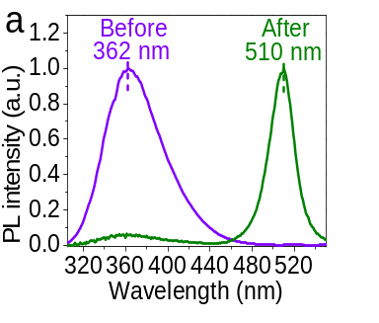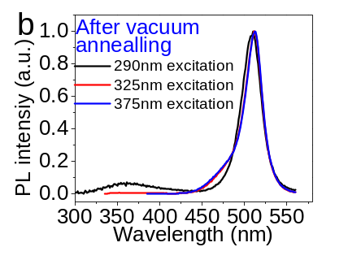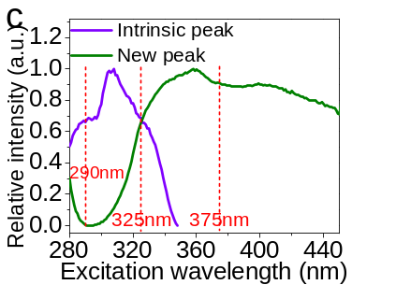
Figure 3.1. PL characteristics of nongreen emissive and green emissive Cs₄PbBr₆ single crystals (a) PL spectra of Cs₄PbBr₆ single crystals before and after vacuum annealing (100°C, 7 h); (b) PL spectra of Cs₄PbBr₆ single crystal after vacuum annealing under excitation wavelengths of 290 nm, 325 nm, and 375 nm; (c) Excitation spectra of Cs₄PbBr₆ single crystals before and after vacuum annealing.

annealing times were monitored to have a better understanding of the green emission in Cs₄PbBr₆ crystal (Figure 3.2a). From Figure 3.2b-c, it can be observed that the intrinsic emission peaked at 362 nm showed no peak shift and negligible intensity change after vacuum annealing. In other words, the high energy intrinsic emission at 362 nm is independent of vacuum annealing time, which further verified this high energy peak should result from wide bandgap Cs₄PbBr₆ perovskite crystal, and vacuum annealing has a negligible effect on the Cs₄PbBr₆ crystal structure. Besides the intrinsic peak, a new PL emission started to show up with a vacuum annealing time of 0.5 h. After increasing the vacuum annealing time from 0.5 h to about 9 h, the new peak showed a dramatic PL intensity increase (Figure 3.2d). And green PL emission intensity reached the highest value when the vacuum annealing time is about 7 h, which is about 12 times larger than the crystal with a vacuum annealing time of 0.5 h. Moreover, the FWHM (full width at half maximum) of the new emission peak decreased from 39 nm to 26 nm with increasing vacuum annealing time from 0.5 h to 9 h. This phenomenon is similar to the size-dependent properties of CsPbBr₃ nanocrystal, in which CsPbBr₃ nanocrystal can exhibit a redshift with the increase of grain size.[,] In addition, the decreased FWHM could be induced by the more uniform nanocrystal size distribution after long-time vacuum annealing. Therefore, the vacuum annealing new PL emission in Cs₄PbBr₆ crystal can be attributed to the appearance of CsPbBr₃ nanocrystals.
To further explore whether there was a new phase has been introduced after vacuum annealing, XRD measurement was conducted on both non-green emissive and green emissive crystals. As shown in Figure 3.3, new peaks which are identified to result from the CsPbBr₃ phase do show up in the green-emissive Cs₄PbBr₆ crystal after vacuum annealing. The XRD result provided direct and solid evidence of the existence of 3D CsPbBr₃ nanocrystal in green-emissive Cs₄PbBr₆ crystal, which should be responsible for the low energy strong green emission.

Limited non-radiative recombination in Cs₄PbBr₆ single crystals
Although the green emission from the green emissive crystal has been identified to be induced by the embedded CsPbBr₃ crystal, the mechanism of boosting green emission intensity after vacuum annealing is still unclear. To answer why this Cs₄PbBr₆ crystal with embedded CsPbBr₃ nanocrystal can lead to such a strong green emission, the lifetimes of Cs₄PbBr₆ single crystals were measured. Interestingly, as shown in Figure 3.4a the lifetime of new emission peaks of Cs₄PbBr₆ single crystals increased with the increase of vacuum annealing time. Also, it can be observed in

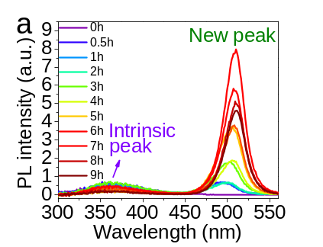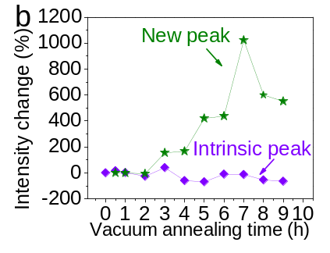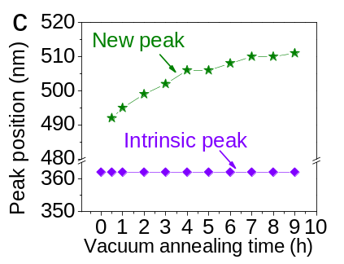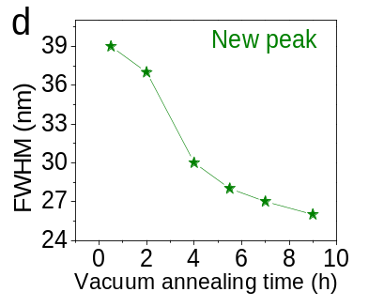
Figure 3.2. PL characteristics of Cs₄PbBr₆ single crystals under different vacuum annealing times (a) PL spectra of Cs₄PbBr₆ single crystal under different vacuum annealing time; (b) PL intensity change upon different vacuum annealing time of intrinsic peak and new peak; (c) PL peak position change upon different vacuum annealing time of intrinsic peak and new peak; (d) PL FWHM change upon different vacuum annealing time of the new peak.

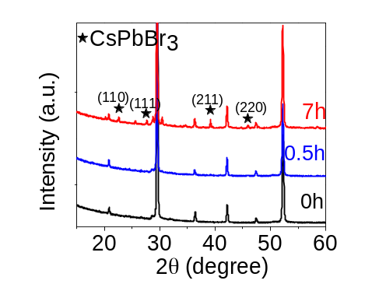
Figure 3.3. XRD spectra of Cs₄PbBr₆ single crystal under vacuum annealing time of 0 h, 0.5 h, and 7 h.

Figure 3.4b that the new emission peak reached the longest lifetime at vacuum annealing of 7 h, which is similar to PL intensity change tendency upon vacuum annealing. The same change tendency of PL intensity and PL lifetime indicating the suppressed nonradiative recombination process should be responsible for the boost green emission intensity. Then, since the electron-phonon coupling is one of the most important nonradiative recombination processes, the low-temperature behaviors of the green emissive Cs₄PbBr₆ single crystal were investigated. As shown in Figure 3.5a and 3.5b, the Cs₄PbBr₆ single-crystal PL peak position only showed a very small blue shift about 3 nm when the temperature decreased from 298 K to 80 K, the PL intensity also showed a very limited increase, and the bandwidth showed nearly no change. It should be noted that if the electron-phonon coupling is highly involved in the emission process, the emission would show a significant PL intensity decrease, large peak shift, and big bandwidth broadening.[,] Thus, the small PL peak shift, intensity change, and FMHW change with decreasing the temperature indicated weak electron-phonon coupling in the green emission process of the green emissive Cs₄PbBr₆ single crystal. Moreover, the lifetime of the green emission increased under higher temperatures (Figure 3.5c). It is well-known that electron-phonon coupling would lead to a shorter lifetime under higher temperatures.[] So this increased lifetime with increasing temperature further proved the weak electron-phonon coupling. The longer lifetime under high temperature could be induced by the weaker non-radiative recombination result from defect states change. Then, the emission-excitation intensity dependence under different temperatures of the green emissive Cs₄PbBr₆ crystal was explored, the PL peak intensity change versus different excitation power was plotted and fitted to the power-law $I∝P^{α}$ (I represents the PL intensity, P represents the excitation intensity) as shown in Figure 3.5. It should be noted that with an α value smaller than 1, a smaller α value indicates more nonradiative recombination may be induced by defects/trap states.[] It can be observed the green emissive Cs₄PbBr₆ crystal showed a larger α value which is closer to 1 with increased temperature, which should be resulted from suppressed non-radiative recombination process induced by fewer defects/trap states under high temperature.

Polarized emission in the down-conversion regime of Cs₄PbBr₆ single crystals
From our study, the embedded CsPbBr₃ nanocrystal has been verified to be responsible for the strong green emission from the Cs₄PbBr₆ single crystal. Since CsPbBr₃ perovskite nanocrystal has
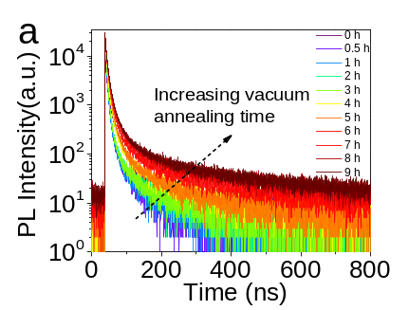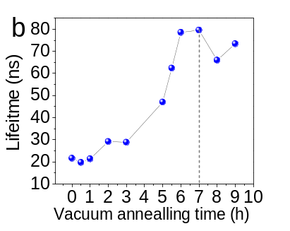
Figure 3.4. PL decay dynamics of Cs₄PbBr₆ single crystals under different vacuum annealing times (a) PL decay curves at the peak position of the new peaks of Cs₄PbBr₆ single crystal under different vacuum annealing time; (b) PL lifetime as the function of vacuum annealing time.

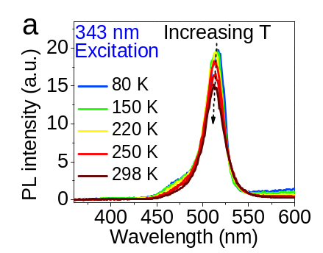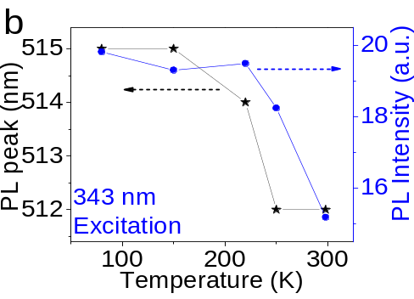
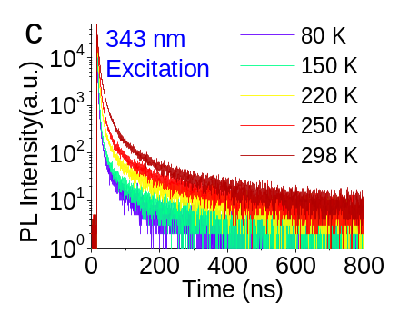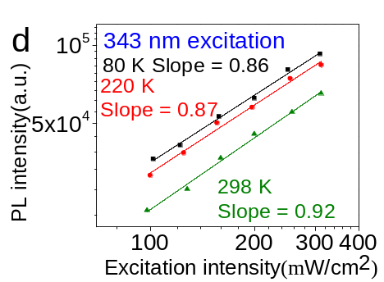
Figure 3.5. PL characteristics of green emissive Cs₄PbBr₆ single crystals under different temperatures (a) PL spectra from 80 K to 298 K of Cs₄PbBr₆ single crystal; (b) PL peak position and intensity change upon temperature; (c) Time-resolved PL spectra from 80 K to 298 K of Cs₄PbBr₆ single crystal; (d) Emission-excitation intensity dependence of Cs₄PbBr₆ single crystal under 343 nm excitation at different temperatures.

been reported to exhibit polarized emission,[,,] then we investigated whether polarized emission could be generated from the Cs₄PbBr₆ single crystals embedded with CsPbBr₃ nanocrystal. Interestingly, the Cs₄PbBr₆ single crystals with different vacuum annealing times exhibited polarized emission with different polarization degrees. As shown in Figure 3.6, with a vacuum annealing time about 0.5 h, where the new emission peak of the crystal is about 494 nm, the PL emission intensity change upon polarization angle change is about 2.73% ( $Polarization degree= \frac{I_{max}-I_{min}}{{I_{max}}_{ }+I_{min}}$, where I_{max}/I_{min} is the maximum/minimum PL intensity by changing the polarization degree of excitation beam). For perovskite bulk single crystal, it is hard to exhibit polarized emission because the small zero-field splitting (~ 1 meV) cannot be distinguished in the broad PL spectra of the bulk single crystal.[] While the nanocrystal with a size that comparable to the Bohr diameter exhibited narrower emission since the electronic density of states has been modified.[,,] So, the polarized emission from Cs₄PbBr₆ single-crystal further verified the existence of embedded CsPbBr₃ nanocrystal in green emissive Cs₄PbBr₆ crystal. Also, the previous study showed the CsPbBr₃ quantum dot only showed polarized emission in solution while the thin film exhibited no polarized emission because of the distortion of the cubic structure.^{[153]} So, the CsPbBr₃ nanocrystal should be highly dispersed in the Cs₄PbBr₆ bulk crystal. In addition, the polarized emission of Cs₄PbBr₆ single-crystal decreased from 2.73% to about 1.45% when the PL peak red-shifted from 494 nm to 513 nm (Table 1). Since the red-shifted emission should be induced by a larger nanocrystal size, the decreased polarized emission should also be induced by the increase of nanocrystal size with a longer vacuum annealing time. Therefore, the tunable polarized emission from Cs₄PbBr₆ crystal provides new evidence to support the embedded CsPbBr₃ nanocrystal-induced green emission theory. In addition, since the perovskite bulk crystal is difficult to generate polarized emission, the Cs₄PbBr₆/CsPbBr₃ binary system provides a new direction to develop polarized emission in perovskite bulk crystal as well as broaden the applications of Cs₄PbBr₆ single crystal.

Polarized emission in the up-conversion regime of Cs₄PbBr₆ single crystals
Interestingly, under a below bandgap 1025 nm excitation, the green emissive Cs₄PbBr₆ single crystal showed a strong up-conversion emission as shown in Figure 3.7 a. The up-conversion emission from the green emissive Cs₄PbBr₆ single crystal showed the same emission wavelength

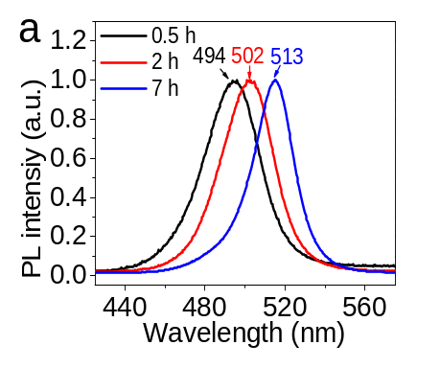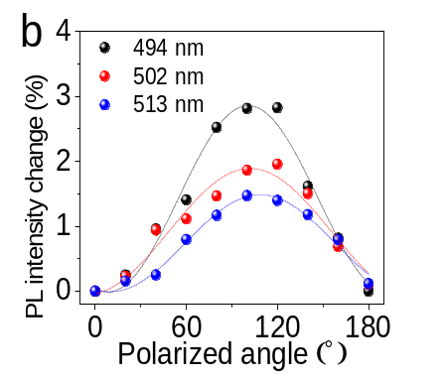
Figure 3.6. Polarized emission from Cs₄PbBr₆ single crystals. (a) PL spectra and (b) Polarization properties of Cs₄PbBr₆ crystal with vacuum annealing time of 0.5 h, 2 h, and 9 h under 343nm laser excitation( $PL intensity change= \frac{I_{ }-I_{min}}{I_{ }+I_{min}}$, where I is PL intensity.

Table 2.Polarization of Cs₄PbBr₆ crystal with different vacuum annealing time
Vacuum annealing time | PL emission peak | Polarization*
0.5 h | 494 nm | 2.73%
2 h | 502 nm | 1.95%
9 h | 513 nm | 1.45%
*Polarization was calculated by the equation: $P= \frac{I_{max }-I_{min}}{I_{max }+I_{min}}$, I represents PL intensity.

with down-conversion. The emission-excitation intensity dependence measurement demonstrated this up-conversion should be a two-photon process (Figure 3.7b). Since the bandgap of the 3D nanocrystal (2.4 eV) is two times the energy of the 1025 nm (1.2 eV) excitation, as shown in Figure 5c. This provided evidence that the green up-conversion emission should result from the embedded CsPbBr₃ nanocrystal (Figure 3.7c). Moreover, the up-conversion emission also showed polarized emission with a similar polarization degree to down-conversion emission (Figure 3.7d). The up-conversion polarized emission in 0D perovskite materials is observed for the first time, this observation indicated 0D perovskite is also a candidate for non-linear optics applications and multifunctional materials. Moreover, at low-temperature, the up-conversion PL change tendency is similar to the down-conversion green emission (Figure 3.8), which indicated the electron-phonon coupling process is also weak in the up-conversion process of the green emissive Cs₄PbBr₆ crystal.

Conclusion
In summary, by observing the PL emission change on a series Cs₄PbBr₆ crystal from non-green emissive to green emissive controlled by a vacuum annealing treatment, the green emission from Cs₄PbBr₆ crystal was proposed to result from a new CsPbBr₃ phase, which was further proved by XRD results. The lifetime and low-temperature results illustrated the suppressed non-radiative recombination should be responsible for boosting green emission intensity. Finally, the polarized emission from the Cs₄PbBr₆ crystal further verified new green emission should result from the embedded CsPbBr₃ nanocrystal. The polarized emission observed in both down-conversion and up-conversion regimes pointed out a new direction to develop perovskite bulk crystals with polarized emission and broaden the applications of 0D Cs₄PbBr₆ single crystal, indicating 0D perovskite is a promising multifunctional material.

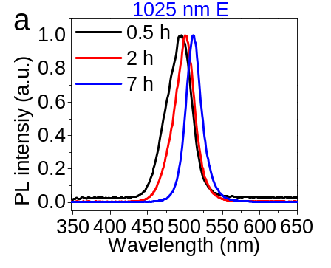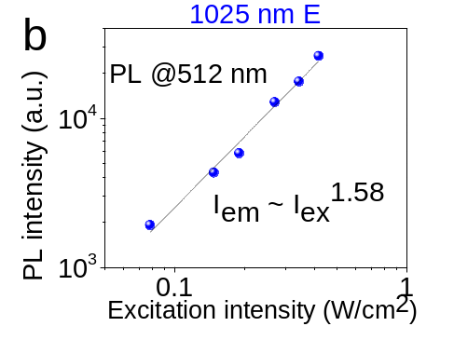
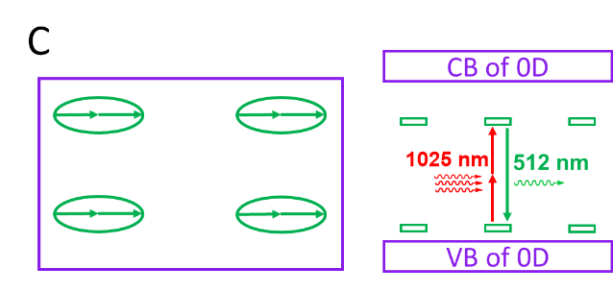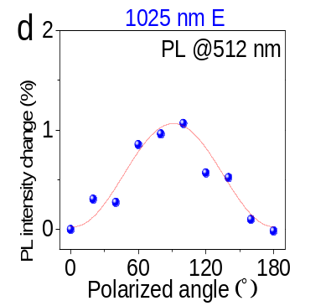
Figure 3.7. Up-conversion characteristics of Cs₄PbBr₆ single crystals at room temperature (a) Up-conversion PL spectrum of Cs4PbBr6 single crystal after vacuum annealing (100°C, 0.5 h, 2 h, and 7 h); (b) Emission-excitation intensity dependence under below bandgap 1025 nm excitation; (c) Diagram of the two-photon up-conversion process; (d) Polarization properties of Cs₄PbBr₆ crystal with vacuum annealing time of 7 h under 1025 nm laser excitation ( $PL intensity change= \frac{I_{ }-I_{min}}{I_{ }+I_{min}}$, where I is PL intensity)

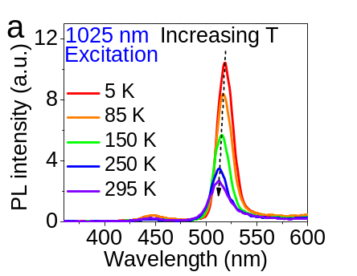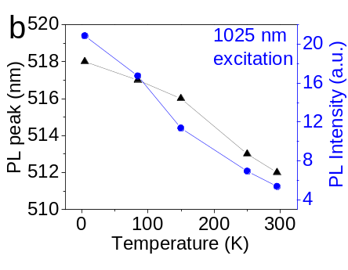
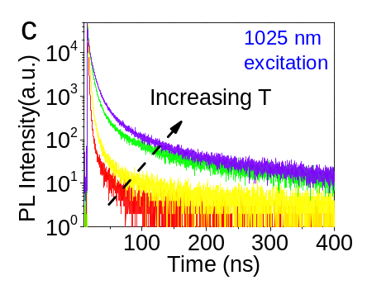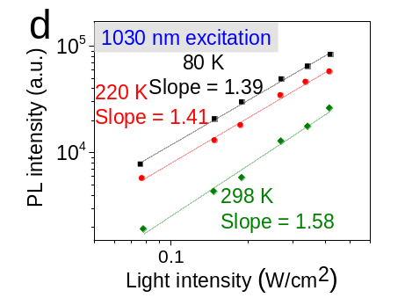
Figure 3.8. Up-conversion characteristics of Cs₄PbBr₆ single crystals at different temperatures (a) PL spectra from 5 K to 298 K of Cs₄PbBr₆ single crystal under 1025 nm excitation; (b) PL peak position and intensity change upon temperature under 1025 nm excitation; (c) Time-resolved PL spectra from 80 K to 298 K of Cs₄PbBr₆ single-crystal under1025 nm excitation; (d) Emission-excitation intensity dependence of Cs₄PbBr₆ single crystal under 343 nm excitation at different temperatures under 1025 nm excitation.

Chapter 4: Spin-orbit Coupling and Slow Phonon Effects Enabled Persistent Photoluminescence in Organic Crystal

A version of this chapter was originally published by Yixuan Dou etc., Yixuan Dou designed and performed the experiments, analyzed the data, and contributed to the writing of the manuscript.
Y. Dou, M. Wang, C. Demangeat, B. Dryzhakov, T.L. Bahers, E. Kim, K. Lee, A. Attias*, B. Hu*; Spin-orbital Coupling and Slow Phonon Effects enabled Persistent Photoluminescence in Organic Crystal under Isomer Doping; Nature Communications, 12(1), 1-10, 2021.

Abstract
Long-persistent luminescence (LPL) material has attracted intensive attention in recent years since the breakthrough of achieving the LPL at room temperature in purely organic materials with the absence of heavy-atom. However, the mechanism, particularly spin-characteristics to explain the LPL in metal-free organic molecules with weak spin-orbit coupling is still unclear. In this chapter, we studied the slow-phonon effects within the crystalline structure and the spin characteristics of our CD49 metal-free organic LPL material. The CD49 showed a dual emission spectrum including long-wavelength LPL emission with a lifetime of 0.43 s and short-wavelength prompt photoluminescence. The ratio between these two emissions is highly crystalline structure dependent. Interestingly, the long-wavelength LPL demonstrates magnetic field effects, showing as crystalline intermolecular charge-transfer excitons with singlet spin characteristics formed within ferroelectric-like lattice. Then, the singlet charge-transfer stats are found to be formed by using internal minority/majority carrier-balancing mechanism through isomer doping effects towards increasing electron-hole pairing probability. Our magneto-dielectric response shows that crystalline intermolecular charge-transfer excitons are interacted with ferroelectric-like lattice, leading to exciton-lattice coupling within periodically packed intramolecular donor-acceptor structures. Furthermore, our photoinduced Raman spectroscopy reveals unusual slow relaxation of photoexcited lattice vibrations, indicating slow phonon effects occurring in the ferroelectric-like lattice. Essentially, the slow phonon effects provide the fundamental possibility to evolve crystalline intermolecular charge-transfer excitons into ultralong-lived light-emitting states through exciton-lattice coupling towards realizing persistent PL at room temperature upon periodically packing intramolecular donor-acceptor structures.

Introduction
The recent experimental studies have shown an emerging phenomenon where a persistent light emission can be observed with the photoluminescence (PL) lasting from seconds to minutes and hours after ceasing photoexcitation, leading to an afterglow phenomenon in organic molecules at room temperature.[,,,,,,,] In general, the optically generated excitons in organic materials showed a lifetime normally less than microseconds, so there should be new fundamental mechanisms lead to the ultralong-lived light-emitting states from seconds to minutes and hours at room temperature. Notably, the triplets have been widely considered to be responsible for persistent light emission in organic molecules. In this scenario, it has been proposed that the triplets can directly recombine into phosphorescence or convert into singlets through the intersystem crossing, leading to persistent PL based on phosphorescence and delayed fluorescence. It should be noted that both phosphorescence and delayed fluorescence require a substantial spin-orbital coupling (SOC) to flip the spins of triplets towards either direct recombination or intersystem crossing. [, ] Therefore, establishing a SOC becomes a critical issue to generate phosphorescence and delayed fluorescence towards realizing a persistent PL. It has been considered that directed heavy atom effect, ^{[163,]} aromatic aldehyde, [] and deuterated carbon structures[,] can generate a SOC in organic molecules to flip the spins. Recently, by using magnetic field effects of PL, we have observed that the charge-transfer states formed between donor and acceptor components within light-emitting exciplex systems can directly establish a SOC by asymmetrically polarizing the orbital wavefunctions from optically generated dipoles.[,] However, the persistent PL is still lacking the direct evidence on SOC to experimentally verify the role of triplets through either phosphorescence or delayed fluorescence. Nonetheless, it demands much fundamental effort to understand the underlying mechanisms that evolve the light-emitting states into ultralong-lived states to generate a persistent PL. Interestingly, it has been reported that the isomer molecules function as donor to induce the charge-separated states with intrinsic molecules and consequently generates a persistent PL based on proposed phosphorescence from triplets in carbazole derivatives.[] This observation indicates that inducing charge transfer plays an important role in developing ultralong-lived light-emitting states in organic molecules. On the other hand, it was reported in the 1970s that the singlet excitons associated with a photoinduced molecular structural twist can give rise to a persistent PL with the lifetime in the order of seconds in p-(9-anthryl)-n, n-dimethylaniline derivatives at room temperature.[,,]
In this work, we utilized magnetic field effects and photoexcitation-assisted Raman spectroscopy to explore SOC and slow phonon effects to understand the underlying spin-physics and photophysics of evolving photoexcited excitons into ultralong-lived light-emitting states in developing persistent light emission based on our synthesized light-emitting CD49 molecules (9-(3-(5-bromopyridin-3-yl)prop-2-yn-1-yl)-9H-carbazole) with the PL lifetime in the order of seconds. The long-wavelength persistent PL peaked at 542 nm observed from the CD49 molecular crystal demonstrates magnetic field effects, showing as crystalline charge-transfer excitons with singlet spin characteristics through the formation of electron-hole pairs within Coulomb capture radius in periodically packed intramolecular donor-acceptor (D-A) structures. Essentially, the periodically packed intramolecular D-A structures act as ferroelectric-like dipolar lattice, shown by strong second harmonic generation (SHG) signal, to host crystalline intermolecular charge-transfer excitons towards establishing exciton-lattice coupling, providing a ready condition for realizing persistent PL in the CD49 molecular crystal. Furthermore, our photoinduced Raman spectroscopy revealed an unusual slow relaxation of photoexcited lattice vibrations in the order of seconds upon applying/removing photoexcitation in the CD49 molecular crystal. This unusual slow relaxation of photoexcited lattice vibrations provides a basic mechanism to evolve crystalline charge-transfer excitons into ultralong-lived light-emitting states through exciton-lattice interaction within periodically packed intramolecular D-A structures with ferroelectric-like dipolar polarization towards realizing persistent PL. On the other hand, the CD49 molecular crystal functions as a common p-type semiconductor where photoexcited electrons and holes have much shorter and longer lifetimes shown by distinctly low and high mobilities, serving as minority and majority carriers, respectively. This can largely decrease electron-hole pairing probability within Coulomb capture radius due to unbalanced electron/hole carriers, causing difficulty to establish crystalline intermolecular charge-transfer excitons for realizing a persistent PL at room temperature. Consequently, it requires n-type doping to balance minority/majority carriers to increase the electron-hole pairing probability within Coulomb capture radius towards forming crystalline intermolecular charge-transfer excitons within organic molecular crystals. Our magneto-dielectric studies show that crystalline intermolecular charge-transfer excitons are coupled with ferroelectric-like lattice, leading to exciton-lattice coupling in periodically packed intramolecular D-A structures. Based on this exciton-lattice coupling, the slow phonon effects provide a fundamental possibility to evolve crystalline intermolecular charge-transfer excitons into ultralong-lived light-emitting states towards developing persistent PL once the carrier-balancing mechanism is activated in organic molecular crystal.

Methods

Organic material synthesis
The CD49 compound was synthesized according to the following two-step procedure[]: (1) preparation of 9-H-propargyl-carbazole and (2) its subsequent Sonogashira cross-coupling with 3-bromo-5-iodopyridine.
9-H-propargyl-carbazole: Synthesis was adapted from the literature.[,] To a solution of carbazole (2.5 g, 15.0 mmol) in DMF (30 mL) was added solid KOH (1.26 g, 22.5 mmol) at 0 °C. After 20 min. stirring at this temperature, propargyl bromide (80 % solution in toluene – 2.52 mL, 22.5 mmol) was added. The reaction was allowed to stir for a further 6 h at room temperature before water (50 mL) was added. The mixture was extracted with AcOEt (3 x 30 mL) and the combined organic layer dried over CaCl_{2.} The solvent was removed under reduced pressure. The crude product was purified under column chromatography using EtOAc/n-hexane – 9/1 as eluent to obtain 9-propargylcarbazole as white crystals (2.4 g, 78%). ¹H NMR (300 MHz, CDCl₃) 8.08 (d, J = 7.8 Hz, 2H), 7.50-7.44 (m, 4H), 7.28-7.22 (m, 2H), 5.00 (s, 2H), 2.22 (t, J = 2.4 Hz, 1H).
9-(3-(5-bromopyridin-3-yl) prop-2-yn-1-yl)-9H-carbazole – CD49: Pd(PPh₃)₂Cl₂ (0.07 g, 0.1 mmol) CuI (0.04 g, 0.2 mmol), 3-bromo-5-iodopyridine (0.57 g, 2.0 mmol), 9-propargylcarbazole (0.41 g, 2.0 mmol) and triethylamine (10 mL) were added into a 100 mL two-necked flask under a nitrogen atmosphere. After stirring at room temperature for 12 h, water (15 mL) was added, and the mixture was extracted with AcOEt (3 x 15 mL). The combined organic layers were dried over CaCl₂, and the solvents were removed under reduced pressure. The crude product was purified under column chromatography using CHCl₃/n-hexane – 8/2 as eluent to afford the expected product as a colorless crystal (0.65 g, 90%), mp 144–145 °C. ¹H NMR (300 MHz, CDCl₃): 8.57 (d, J= 2.1 Hz,1H); 8.10 (d, J= 7.8 Hz, 2H); 7,69 (dd, J= 2.1, 8.1 Hz, 1H); 7.53-7.50 (m, 4H); 7.30-7.25 (m, 2H); 7.17 (d, J= 8.1 Hz, 1H); 5.28 (s, 2H).¹³C NMR (300 MHz, CDCl₃): 151.10, 140.77, 139.88, 138.86, 128.29, 126.03, 123.30, 120.51, 119.68, 108.80, 84.80, 82.28, 33.01.
The CD102 isomer was prepared using a similar procedure starting from pure 1H-benzo[f]indole.
All the products were characterized by NMR with satisfactory results.

Photoluminescence measurement
PL emissions in both steady and dynamic regimes were measured by the SPEX Fluorolog 3 spectrometer. The time-resolved photoexcitation source was from a pulsed laser beam (342 nm, 4 mW) generated through a harmonic generator (Ultrafast Systems LLC, third harmonic) with a Pharos laser (Light Conversion, 1 KHz, 1025 nm, 290 fs). The low temperature was generated by the cryostat with helium compressor (Advanced Research Systems, Inc.).

Photoexcitation-assisted Raman measurement
Photoexcitation-assisted Raman spectroscopy was characterized by using Horiba Xplora plus system confocal Raman microscope with built-in 785 nm laser beam in combination with an external photoexcitation of 375 nm laser beam.

Magneto-PL measurement
Magnetic field effects of PL (MFE-PL) were measured by monitoring PL intensity as a function of the magnetic field. The MFE amplitude is defined by the intensity change in percentage: MFE = $\frac{I_{B}-I_{0}}{I_{0}}$, where I_{B} and I₀ are PL peak intensities with and without magnetic field.

Nuclear magnetic resonance (¹H and ¹³C) spectrum
Nuclear magnetic resonance (¹H and ¹³C) spectra were obtained on a Bruker Ultra Shield 300 MHz spectrometer for CDCl₃. The chemical shift was relative to tetramethylsilane as the internal standard. Resonance patterns are reported with the notation s (singlet), d (doublet), t (triplet), and m (multiplet).

High-performance liquid chromatography measurement
The HPLC was conducted on Agilent 1200 coupled with a DAD (Diode-Array Detection) detector, the column is Agilent Eclipse XDB-C18 (5 um, 4.6x150 mm). The HPLC injection volume of CD49 solution was 20 µL The CD49 solution was added into the solvent of 70/30 acetonitrile-water (v/v) with a concentration 0.2 mg/mL, and keep the mixture under ultrasonic bath about 10 min to dissolve the CD49.

Magneto-capacitance measurement
The capacitance measurement was performed by using the Agilent E4980A LCR meter (alternating bias: 50 mV). The magneto-PL and magneto-capacitance were measured by monitoring signal intensity while applying a magnetic field. The amplitude for magnetic field effects is defined as MFE = $\frac{I_{B}-I_{0}}{I_{0}}$, where I₀ and I_{B} are signal intensities without and with the magnetic field, respectively.

Results and discussions

CD49 persistent material characterizations
The light-emitting CD49 molecular crystal shows short-wavelength and long-wavelength PL peaked at 363 nm and 542 nm with short and ultralong lifetimes at room temperature, known as prompt and persistent light emission (Figure 4.1a and 4.1b). The long-wavelength PL peaked at 542 nm leads to an afterglow phenomenon lasting up to 2 s after ceasing photoexcitation (Figure 4.2). The curve-fitting on the time-resolved PL decay spectrum shows a lifetime of 0.43 s, indicating ultralong-lived light-emitting states formed in the CD49 molecular crystal at room temperature. In contrast, the short-wavelength prompt PL peaked at 363 nm exhibits a lifetime of 0.45 ns, representing short-lived intramolecular excitons, known as Frenkel excitons. Interestingly, the persistent PL is highly dependent on crystallinity, as shown by the large decrease of persistent PL intensity from molecular crystal to drop-cast film, and disappeared in amorphous spin-cast film, as illustrated in Figure 4.1c. Simultaneously, the lifetime of long-wavelength persistent PL is decreased from 0.43 s to 0.12 s when lowering the crystallinity from molecular crystal to drop-cast film (Figure 4.1d). The different morphological structures in molecular crystal, drop-cast film, and spin-cast film are reflected by optical images shown in Figure 4.3. The crystallinity-dependent persistent PL indicates that the ultralong-lived light-emitting states are essentially crystalline intermolecular charge-transfer excitons formed within periodically packed intramolecular D-A structures in the CD49 crystal.

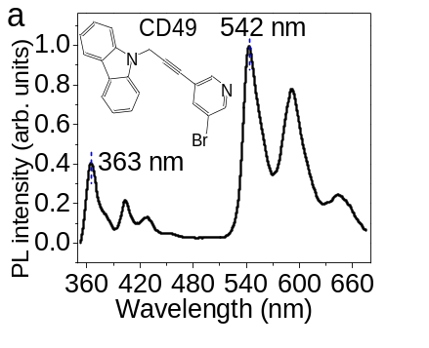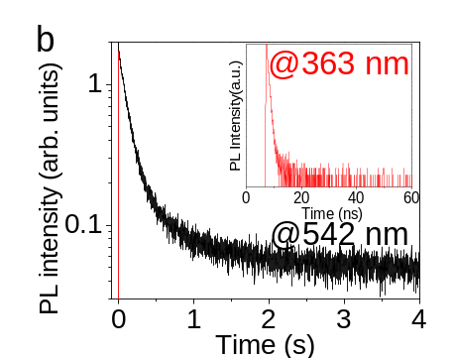
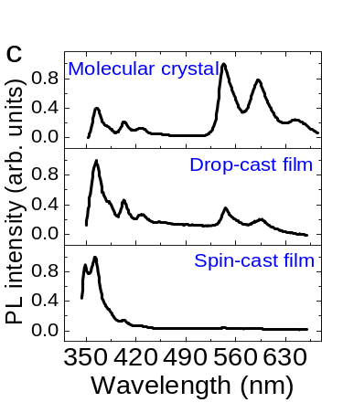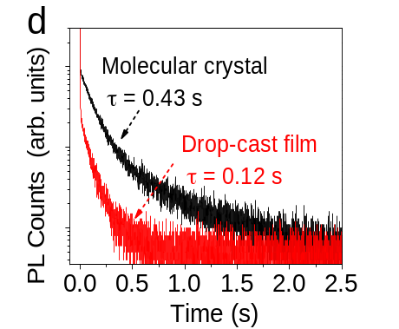
Figure 4.1. PL characteristics of CD49 molecular crystal, drop-cast film, and spin-cast film (a) PL spectra measured from CD49 molecular crystal under 325 nm laser excitation (Inset: chemical structure for CD49); (b) PL decay dynamics for short-wavelength PL peaked at 363 nm and long-wavelength PL peaked at 542 nm. PL lifetime was fitted with exponential decay equation, the average lifetime was calculated by the equation: $τ_{ave}=\frac{\sum_{i=1}^{n}{α_{n}*τ_{n}^{2}}}{\sum_{i=1}^{n}{α_{n}*τ_{n}}}$; (c) PL spectra for CD49 molecular crystal, drop-cast film, and spin-cast film; (d) PL decay dynamics for CD49 molecular crystal and drop-cast film.

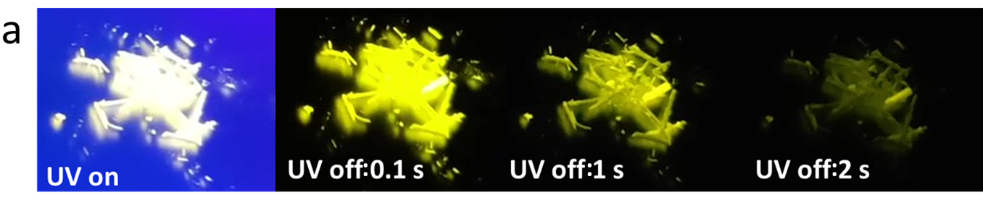
Figure 4.2. The photograph with and after UV excitation of CD49 molecular crystal.

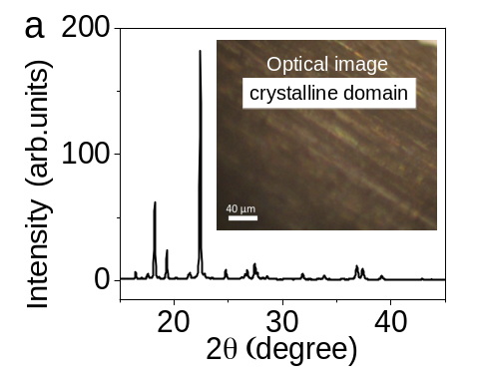
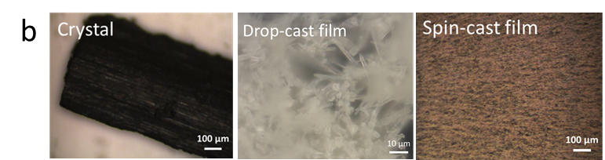
Figure 4.3. (a) XRD pattern for CD49 molecular crystal (Inset: optical image); (b) Optical microscopy of CD49 molecules from molecular crystal, drop-cast film, and spin-cast film.

Crystalline intermolecular charge-transfer excitons
It should be emphasized that organic materials especially carbazole derivatives are well-known as p-type semiconductors where photoexcited electrons and holes possess much unbalanced lifetimes due to distinctly low and high mobilities,[,] acting as minority and majority carriers. The distinctly unbalanced carrier lifetimes can largely lower the electron-hole pairing probability within the Coulomb capture radius and causes difficulty to generate crystalline intermolecular charge-transfer excitons in the organic molecular crystal at room temperature. It has been found that introducing isomer molecules in carbazole derivatives can induce persistent PL, and lacking the isomer leads to the disappearance of persistent PL.^{[170]} It was proposed that the isomer, namely Benzoindole (Bd), can form charge transfer with intrinsic carbazole derivatives towards developing the persistent PL. Here, we consider that the isomer molecules are essentially functioning as n-type dopants to donate electrons into the conduction band of CD49 molecular crystal to provide a carrier-balancing mechanism towards forming crystalline charge-transfer excitons through electron-hole pairing action within Coulomb capture radius in periodically packed intramolecular D-A structures. Indeed, our CD49 samples prepared with the commercial carbazole (Sigma) contain the isomer molecules (CD102) as demonstrated by the HPLC (high-performance liquid chromatography) data shown in Figure 4.4. When synthesizing the CD49 target from pure carbazole, the long-wavelength persistent PL becomes disappeared in the isomer-free CD49 crystal at room temperature (Figure 4.5a). Interestingly, the persistent PL can be recovered by lowering the temperature in the absence of isomer molecules (Figure 4.5b). At 5 K, the long-wavelength PL shows the ultralong lifetime of 0.17 s in the isomer-free CD49 crystal. This experimental observation provides the following three critical understandings. First, the crystalline intermolecular charge-transfer excitons are essentially formed between periodically packed intramolecular D-A structures, rather than between isomer and CD49 molecules, to develop a persistent PL. Second, the isomer molecules are functioning as n-type dopants to provide a carrier-balancing mechanism to increase electron-hole pairing probability towards forming crystalline intermolecular charge-transfer excitons within the Coulomb capture radius. Third, when the n-type doping molecule (CD102) is absent, lowering the temperature can increase the Coulomb capture radius, increasing the electron-hole pairing probability to form crystalline intermolecular charge-transfer excitons in organic crystal.
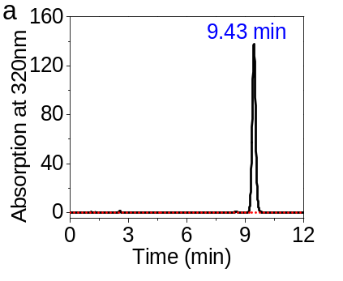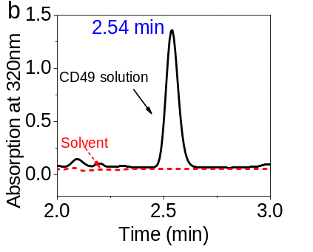
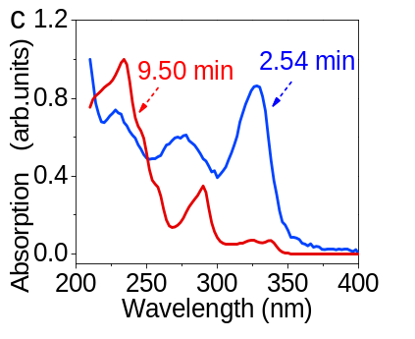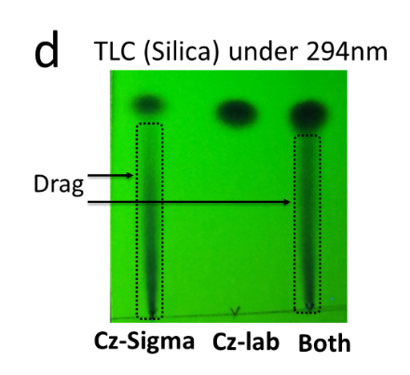
Figure 4.4. Characterization of isomer molecules in CD49 MeCN/H₂O solution. (a) HPLC spectrum monitored at onset absorption of 320 nm of CD49 MeCN/H₂O solution; (b) HPLC spectrum at 2.54 minutes monitored at onset absorption of 320 nm; (c) Absorption spectra at different times; (d) TLC results to indicate isomer impurities for CD49 samples prepared from Sigma-Cz and lab synthesized-Cz (Eluent is n-hexane/ EtOAc with the volume ratio of 9/1), and mixed Sigma-Cz and lab-synthesized Cz labeled as both. Lab-synthesized isomer-free CD49 (Cz-lab) does not show isomer impurities.

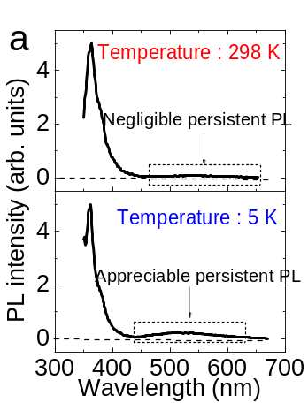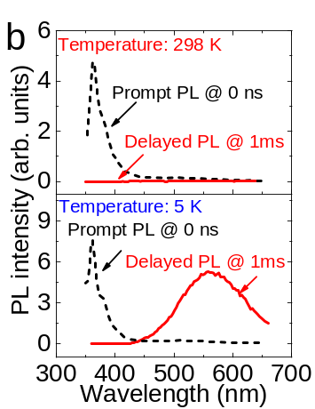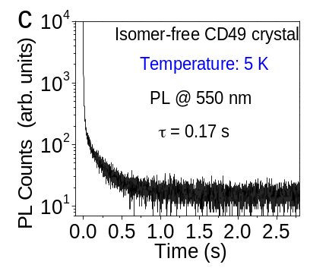
Figure 4.5. PL characteristics in isomer-free CD49 crystal at room temperature (298 K) and low temperature (5 K). (a) Steady-state PL spectra; (b) PL spectra at different delay times at 0 ns and 1 ms at 298 K and 5 K; (c) PL lifetime at 550 nm under 5 K.

It is also noted that isomer-free and isomer-containing CD49 crystals show slightly different long-wavelength persistent PL spectra but similar short-wavelength prompt PL. This indicates that the isomer molecules can somewhat change the crystalline packing in the CD49 molecular crystal.
Now we discuss the formation of crystalline intermolecular charge-transfer excitons within the periodically packed intramolecular D-A structures in the CD49 molecular crystal. When photoexcitation generates equal numbers of electrons and holes, the largely different carrier lifetimes can inevitably decrease electron-hole pairing probability within Coulomb capture radius, presenting a difficulty to form crystalline intermolecular charge-transfer excitons for realizing a persistent PL, shown by the absence of persistent PL in the isomer-free CD49 molecular crystal. However, this difficulty can be removed by introducing n-type dopants into p-type materials through a carrier-balancing mechanism. Figure 4.6 schematically illustrates that the isomer molecules (CD102) act as n-type dopants to activate the carrier-balancing mechanism towards increasing the electron-hole pairing probability for forming crystalline intermolecular charge-transfer excitons in the CD49 molecular crystal. Essentially, the n-type doping effects can be realized by satisfying two necessary conditions: (i) energy conservation while donating electrons from n-type dopants to the conduction band of intrinsic lattice and (ii) the electron wavefunction overlap between dopants and intrinsic lattice to allow electron donation through Dexter transfer. Clearly, isomer molecules can conveniently satisfy these two necessary conditions through lattice-substitutional occupation, enabling n-type doping effects towards forming crystalline intermolecular charge-transfer excitons to realize a persistent PL in p-type molecular crystals.
We should point out that, without n-type doping from isomer molecules, lowering temperature can offer an alternative approach to increase the probability for minority electrons to pair with majority holes by increasing the Coulomb capture radius towards forming the crystalline intermolecular charge-transfer excitons. The Coulomb capture radius can be given by $r_{c}=\frac{e^{2}}{4πεKT}$ , where ε is the dielectric constant, K is the Boltzmann constant, T is the temperature. Theoretically, lowering the temperature can largely increase the Coulomb capture radius, consequently increasing the probability of finding minority electrons to form electron-hole pairs towards forming crystalline intermolecular charge-transfer excitons. We can see in Figure 4.5 c that lowering the temperature to 5 K can clearly induce the long-wavelength persistent PL with a lifetime of 0.17 s in the isomer-free CD49 molecular crystal.

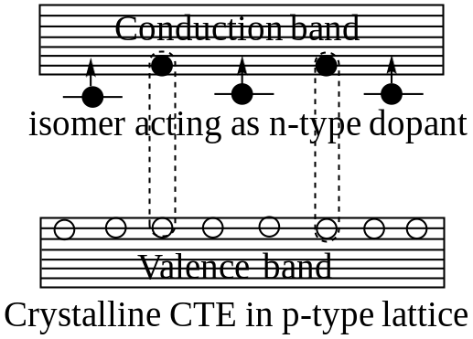
Figure 4.6. Schematic diagram to show the formation of electron-hole pairs in crystalline lattice through Coulomb capture between minority electrons and majority holes towards generating crystalline charge-transfer excitons (CTE) in p-type organic crystal under n-type doping. Isomer molecules are functioning as n-type dopants to donate electrons into p-type organic crystal.

This low temperature-induced persistent PL in the isomer-free CD49 crystal verifies that the ultralong-lived light-emitting states are the crystalline intermolecular charge-transfer excitons formed between periodically packed intramolecular D-A structures towards developing persistent PL. At room temperature when artificially adding the isomer molecules (CD102) into isomer-free CD49 solution, the prepared crystal shows the recovered long-wavelength persistent PL with a lifetime of 0.17 s at room temperature (Figure 4.7). This further indicates that the isomer molecules embedded into the crystalline structure can function as n-type dopants to provide the carrier-balancing mechanism necessary to increase electron-hole pairing probability within Coulomb capture radius towards forming crystalline charge-transfer excitons within periodically packed intramolecular D-A structures to realize a persistent PL at room temperature.

Spin characteristics of ultralong-lived light-emitting states
Now we discuss the spin characteristics of ultralong-lived light-emitting states by using magnetic field effects of PL. It is noted that both singlet and triplet states have been proposed to be responsible for persistent PL through the optically induced molecular twist and de-trapping dynamics.^{[171, 172, 173]} Recently, triplets have been widely considered to discuss persistent PL in organic molecules. ^{[154,155,159,]} It was further proposed that the triplet excitons, converted from optically generated singlet excitons through the intersystem crossing, can undergo a Dexter triplet-triplet transfer towards enhancing persistent PL based on carbazole-bromodibenzofuran molecules.[] However, the spin characteristics of ultralong-lived light-emitting states are still experimentally lacking to support the theoretically proposed triplet states in persistent PL. Here, we explore the spin characteristics of crystalline intermolecular-charge transfer excitons by using magnetic field effects of PL. In general, magnetic field effects of PL can provide direct evidence on whether the light-emitting states are singlets or triplets, identifying the spin characteristics of light-emitting states in organic materials. We have shown that magnetic field effects of PL can be conveniently observed from intermolecular charge-transfer excitons formed between donor and acceptor components in organic molecules.^{[168,,]} When photoexcited electrons and holes are randomly paired at donor and acceptor interfaces, both singlet and triplet intermolecular charge-transfer excitons are formed with the ratio of 1:3 through non-germinate recombination in organic materials, as shown in Figure 4.8a. Notably, the triplets are normally having higher energy than the singlets in intermolecular charge-transfer excitons governed by spin-exchange interaction,

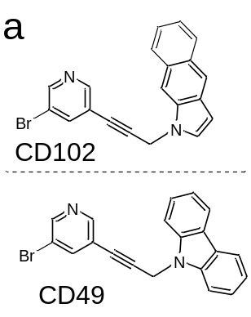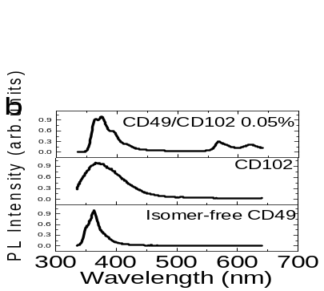
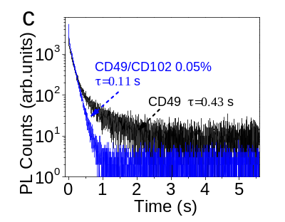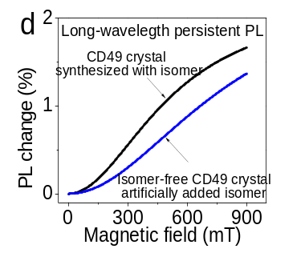PL
Figure 4.7. Isomer doping effects. (a) Chemical structures for CD49 and isomer (CD102) molecules; (b) PL spectra of CD49 without isomer, isomer (CD102), and CD49 doped with 0.05% CD102; (c) PL lifetimes for CD49 synthesized with isomer and isomer-free CD49 artificially added with 0.05% isomer (CD102); (d) Magnetic field effects of persistent PL for CD49 synthesized with isomer and isomer-free CD49 artificially doped with 0.05% CD102.

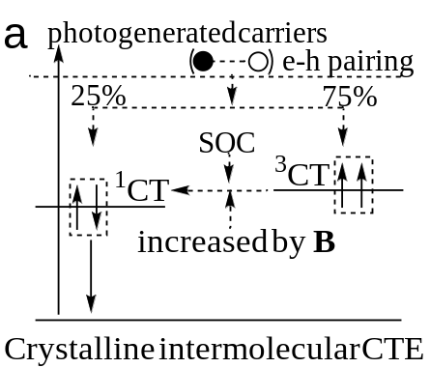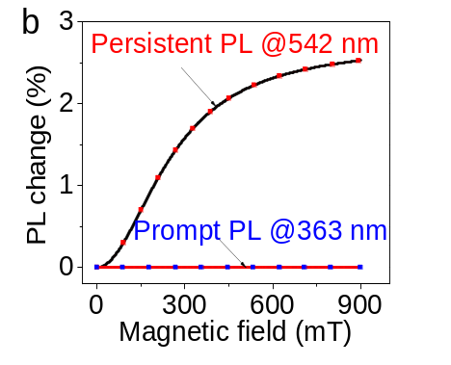
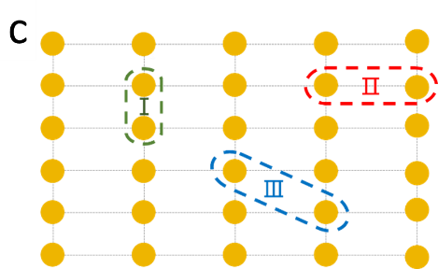

Figure 4.8. Characteristics of crystalline intermolecular charge-transfer excitons (CTE) in organic molecular crystal. (a) Diagram to show electron-hole pairing to form singlet and triplet crystalline intermolecular charge-transfer excitons (CTE) with 25 % and 75 %. SOC flips spins, enabling exothermic triplet-to-singlet intersystem crossing in crystalline intermolecular charge-transfer excitons. Magnetic field increases triplet-to-singlet intersystem crossing by introducing faster and slower spin precessions due to different g factors on electrons and holes; (b) Magnetic field effects measured for long-wavelength persistent PL (at 542 nm with ultralong lifetime of 0.43 s) and short-wavelength prompt PL (at 363 nm with short lifetime of 0.45 ns) (λ_{ex} = 325 nm); (c) The diagram to show crystalline intermolecular charge-transfer excitons through three different electron-hole captures labeled with I, II, and III within crystalline lattice from periodically packed intramolecular D-A structures. Each dot represents an intramolecular D-A structure.

opposite to intramolecular Frenkel excitons where the singlets are always having higher energy than triplets due to the kinetic energy difference governed by Pauli exclusion controlled wavefunction distributions in intramolecular states. ^{[80,,]} We should emphasize that intermolecular charge transfer can simultaneously induce electrical dipole (D⁺→A⁻) and spin dipoles (D⁺ and A⁻) due to unpaired electrons under photoexcitation. We have shown that an electric-magnetic coupling can be formed between photoinduced electric dipoles and spin dipoles within charge-transfer states, presenting an artificially-engineered SOC to flip the spins. ^{[181,182]} Essentially, this induces an intersystem crossing from high-energy triplets to low-energy singlets, an exothermic process occurring in intermolecular light-emitting states. Furthermore, we have observed that a magnetic field can increase the triplet-to-singlet intersystem crossing in intermolecular charge-transfer excitons, generating positive magnetic field effects where the PL intensity increases with magnetic field in the case that singlets serve as light-emitting states.^{[182,]} Therefore, magnetic field effects of PL have been commonly observed in fluorescence,^{[182,]} phosphorescence, [,] delayed fluorescence, ^{[162]} and lasing emission [] in organic molecules when intermolecular-type excited states such as charge-transfer states, exciplexes, excimers, and polaron pairs are involved in light emission, as verified by positive magnetic field effects of PL in organic mixtures where singlets serve as light-emitting states (Figure 4.9). As shown in Figure 4.8b, magnetic field effects are clearly occurring and lacking in long-wavelength persistent PL and short-wavelength prompt PL, respectively. Here, our positive magnetic field effects provide immediate evidence that the ultralong-lived light-emitting states possess singlet spin characteristics towards generating a persistent PL in our CD49 molecular crystal. It should be emphasized that the singlet spin characteristics of ultralong-lived light-emitting states are conserved when artificially adding the isomer molecules (CD102) functioning as n-type dopants into isomer-free CD49 solution to form a crystal, shown by positive magnetic field effects of persistent PL in isomer-containing CD49 crystal (Figure 4.7d). Essentially, the ultralong-lived light-emitting states are evolved from crystalline intermolecular charge-transfer excitons formed between different lattice units in periodically packed intramolecular D-A structures, as illustrated in Figure 4.8c.
In general, magnetic field effects can be observed at low and high fields (< 10 mT and > 10 mT) when hyperfine interaction and SOC govern the singlet-triplet intersystem crossing, respectively.^{[162,} ,] The early studies in the 1970s showed that the delayed fluorescence in

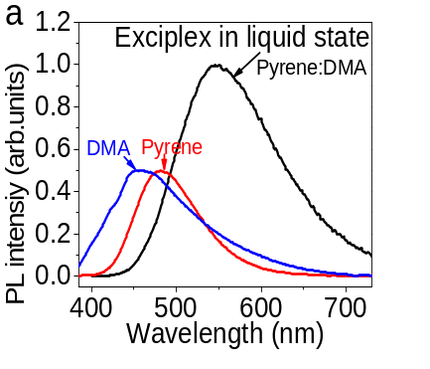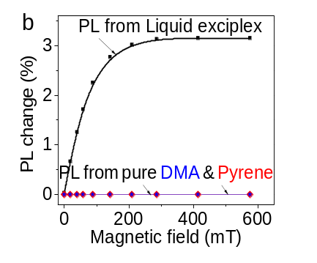
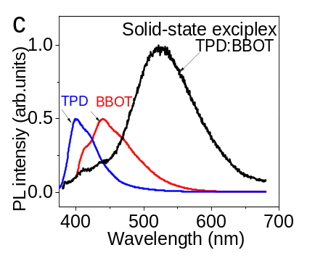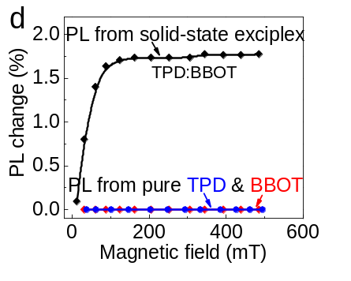
Figure 4.9. PL spectra and magnetic field effects for light-emitting exciplex systems in solid and liquid states. (a) PL spectra for pyrene:DMA and pure pyrene/DMA solutions (DMF solvent) at 375 nm excitation. (b) Magnetic field effects of PL; (c) PL spectra for BBOT:TPD and pure BBOT/ TPD in solid states at 375 nm excitation; (d) Magnetic field effects of PL.
Note: DMA, DMF, BBOT, TPF represent N,N-dimethylaniline, N,N-Dimethylmethanamide, 2,5-bis(5-tert-butyl-2-benzoxazolyl)-thiophene, and N,N'-diphenyl-N,N'-bis(3-methylphenyl)-[,11'-biphenyl]-4,4'-diamine.

aromatic structures can exhibit magnetic field effects at the lower field (< 10 mT). [,] This indicates that aromatic molecules are dominated by hyperfine interaction in developing intersystem crossing, giving rise to magnetic field effects at low field. For the persistent PL, magnetic field effects obviously occurred at the high field up to 900 mT. This provides direct evidence that the ultralong-lived light-emitting states are formed with a SOC within periodically packed intramolecular D-A structures. When SOC is established, there is a question on whether the persistent PL involves TADF (thermally activated delayed fluorescence). The TADF is an endothermic process to convert triplet excitons into singlet excitons, extending fluorescence lifetime from nanoseconds to microseconds to generate a delayed fluorescence.[,] In TADF, SOC provides a necessary spin-flipping mechanism to convert non-emissive triplet excitons into light-emitting singlet excitons at the condition that the singlet-triplet energy difference is matched by thermal energy. We should note that the singlet-triplet intersystem crossing can often occur in electron-hole pairs such as charge-transfer states and polaron pairs commonly observed in organic OLEDs.[,,] However, the singlet-triplet intersystem crossing occurring in electron-hole pairs does not appreciably extend the fluorescence lifetime, which is fundamentally different from TADF phenomenon. Nonetheless, whether the TADF is involved in the persistent PL is an important issue. We should note that the TADF lifetime can be appreciably decreased by increasing temperature because the thermal energy facilitates the triplet-to-singlet conversion.[,] However, the persistent PL lifetime exhibits a slight increase in the order of seconds from 0.35 s to 0.43 s when the temperature is increased from 5 K to 295 K (Figure 4.10), opposite to the TADF phenomenon. Therefore, the persistent PL is not governed by the TADF because of the absence of lifetime-temperature dependence.
It has been reported that crystalline packing can induce a long-wavelength PL with the ultralong lifetime of 5.4 ms in the organic crystal [2,5-Dihexyloxy-4-bromobenzaldehyde] at room temperature.^{[163]} This long-wavelength PL with an ultralong lifetime was proposed to be a phosphorescence. This leads to the hypothesis that SOC can be formed to activate the T→S₀ transition with phosphorescence outcome in crystalline molecular packing. However, direct experimental evidence on crystalline packing-induced SOC is still lacking. We have shown that SOC can be generated once the charge-transfer states are formed in organic D-A structures in the absence of heavy elements in organic molecules.^{[168,169]} Essentially, charge-transfer states
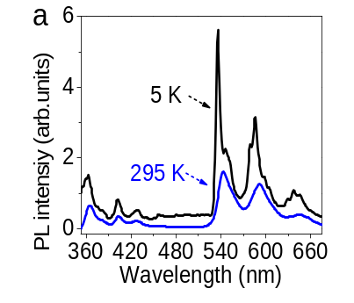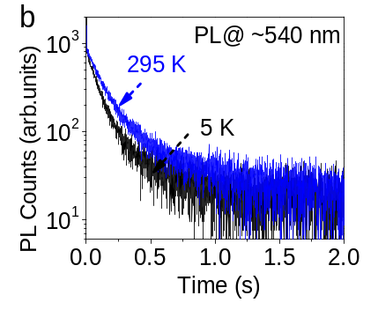
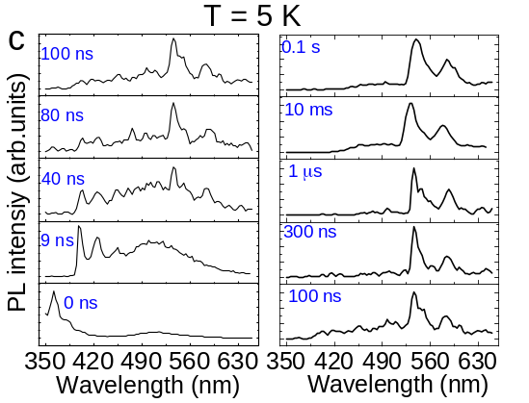
Figure 4.10. PL characteristics at different temperatures and time windows in CD49 molecular crystal synthesized with isomer molecules. (a) Steady-state PL spectra at different temperatures; (b) PL decay dynamics under 5 K and 295 K; (c) Time-resolved PL spectra under 5 K.

simultaneously possess electrical and spin polarizations with mutual interaction, leading to an electric-magnetic coupling shown as an artificially-engineered SOC. Normally, charge-transfer states are formed between different molecules with high and low electron negativities. However, charge-transfer states can still be formed between the same type of molecules, exampled as light-emitting excimers occurring between carbazole units in poly(N-vinyl carbazole).[,] In this case, the same type of molecules can exhibit different electron negativities caused by inhomogeneous structural morphologies, leading to partial charge transfer. Here, our magnetic field effects occur in persistent PL through crystalline intermolecular-charge transfer excitons. Essentially, crystalline intermolecular charge-transfer excitons are generated through the formation of electron-hole pairs within Coulomb capture radius in periodically packed intramolecular D-A structures when photogenerated carriers occurred in organic molecular crystals. When the photoexcited electrons and holes are randomly paired within crystalline lattice, both singlet and triplet crystalline intermolecular charge-transfer excitons are formed with the ratio of 1:3 based on spin statistics, as indicated in Figure 4.8a. When the spin-flipping mechanism is activated by SOC, the triplets can be spin-flipped into singlets through an exothermic process, leading to triplet-to-singlet intersystem crossing in intermolecular charge-transfer excitons. Particularly, an external magnetic field can enhance the spin-flipping mechanism by introducing different spin precessions on electron and hole within an intermolecular charge-transfer exciton through different g factors between electron and hole, increasing the exothermic triplet-to-singlet intersystem crossing and leading to an increase in PL intensity from singlets. This reflects as positive magnetic field effects of PL when singlets are responsible for light emission. It should be emphasized that fluorescence and phosphorescence are normally having lifetimes in the orders of nanoseconds and microseconds in organic materials, respectively. Therefore, there must be a new mechanism to evolve crystalline intermolecular charge-transfer excitons into ultralong-lived light-emitting states towards the realization of persistent PL in organic molecular crystals.

Slow phonon effects
Now we address the fundamental mechanism to slowly relax the crystalline intermolecular charge-transfer excitons into ultralong-lived light-emitting states towards developing a persistent PL in CD49 crystal. The crystallinity-dependent persistent PL indicates that the formation of ultralong-lived light-emitting states requires periodic packing of intramolecular D-A structures in the CD49 molecules. Amorphously packing intramolecular D-A structures does not form the ultralong-lived light-emitting states, as shown by the absence of persistent PL in spin-cast film at room temperature (Figure 4.1c). We should note that the CD49 molecules carry the AIE (aggregation-induced emission) properties operated by the suppressed molecular rotations with reduced nonradiative emission upon molecular packing, leading to an increase in PL intensity with increasing concentration, as illustrated in Figure 4.11c. However, the AIE properties do not lead to a persistent PL in the absence of periodic packing of intramolecular D-A structures, as shown by amorphous packing in the spin-cast film with disappeared persistent PL (Figure 4.1c). At cryogenic temperature (77 K), the frozen CD49 liquid does not show the long-wavelength persistent PL that was observed in the molecular crystal at room temperature (Figure 4.11b). Furthermore, when the higher and lower crystallinity are selected in CD49 crystals (shown as stronger and weaker polarizations of persistent PL), the persistent PL lifetime is consequently decreased from 0.39 s to 0.22 s (Figure 4.12). Clearly, the periodically packing intramolecular D-A structure presents a necessary condition to evolve the crystalline charge-transfer excitons into ultralong-lived light-emitting states.
Here, we utilized photoexcitation-assisted Raman spectroscopy to explore extremely slow relaxation of photoexcited lattice vibrations to understand the underlying mechanism of evolving crystalline intermolecular charge-transfer excitons into ultralong-lived light-emitting states. In our experimental method, the lattice vibrations were monitored by Raman spectroscopy while the photoexcitation was applied and removed in the CD49 crystal. Figure 4.13 shows the Raman spectra detected by using the 785 nm laser beam while simultaneously applying/removing the 375 nm laser photoexcitation. Intriguingly, the Raman signals between 50 cm⁻¹ and 200 cm⁻¹ from the lattice vibrations are slowly increasing at 0.3 s and 1.0 s after the 375 nm photoexcitation is applied (Figure 4.13a). After removing the 375 nm photoexcitation, the Raman signals are slowly decreasing at 0.5 s and 2.0 s (Figure 4.13b). As a reference, the silicon does not show any detectable slow modulation on Raman signals upon applying/removing an external photoexcitation (Figure 4.14). Essentially, our photoexcitation-assisted Raman studies indicate that applying/removing photoexcitation slowly increases/decreases the lattice vibrations to a new equilibrium within the time scale of seconds, leading to unusual slow relaxation of photoexcited lattice vibrations within periodically packed intramolecular D-A structures in the CD49 crystal, defined as slow phonon effects. Normally, photoexcited lattice vibrations can quickly evolve into
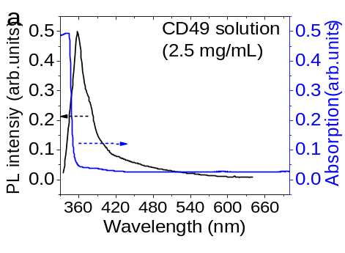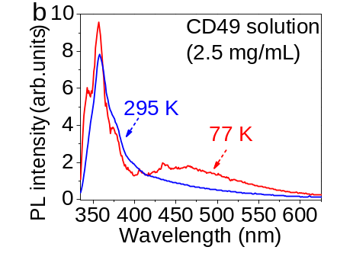

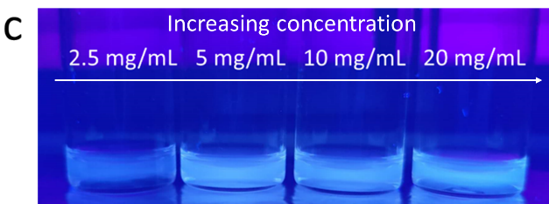
Figure 4.11. Spectral characteristics for CD49 THF solution (2.5 mg/mL). (a) Absorption and PL spectra. (b) PL spectra under 77 K and 295 K; (c) Photograph with different solution concentrations.

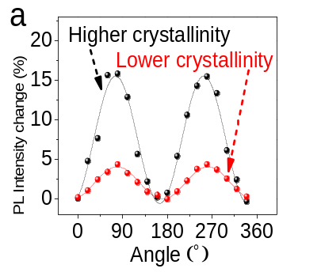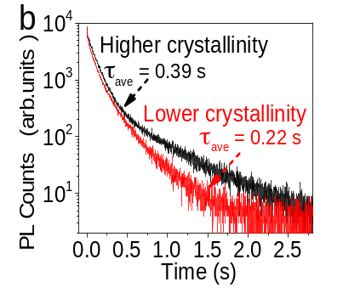
Figure 4.12. Polarized emission from CD49 crystals with different crystallinity. (a) Stronger and weaker polarized persistent PL at 542nm to show higher and lower crystallinities selected from CD49 crystals under 375 nm excitation; (b) PL decay dynamics for higher and lower crystallinities in CD49 crystals.

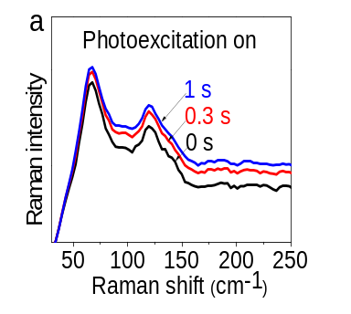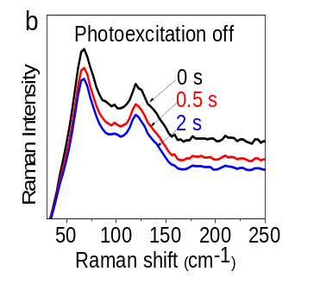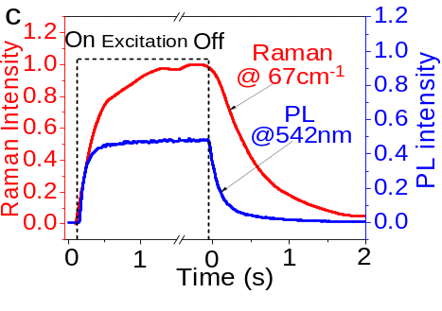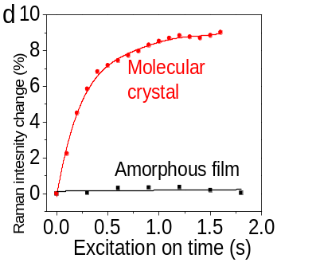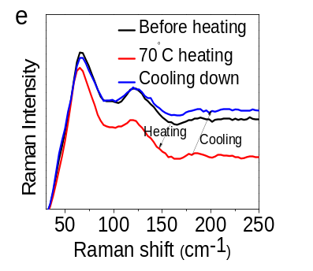

Figure 4.13. Photoexcitation-assisted Raman characterizations upon applying/removing 375 nm excitation (785 nm laser beam for Raman). (a) Raman spectra measured at different illumination times after applying 375nm laser excitation; (b) Raman spectra measured at different times after removing 375 nm laser excitation; (c) Raman signal intensity at 67 cm⁻¹ and PL intensity at 542 nm are plotted as a function of time upon applying/removing 375 nm laser excitation; (d) Raman signal intensity of molecular crystal at 67 cm⁻¹ and amorphous film at 59 cm⁻¹ plotted as a function of time upon applying/removing 375 nm laser excitation; e. Raman spectra measured with heating to 70 ⁰C and cooling-down to room temperature conditions.

a new equilibrium via the assistance from a large number of local vibrations/rotations, leading to an increased density of phonons within femtoseconds to picoseconds in semiconductors.[,] Here, we should emphasize that, within the persistent light-emitting CD49 molecules which carry AIE (aggregation-induced emission) properties, the molecular vibrations/rotations are significantly restricted by ordered intermolecular packing within crystalline lattice. Apparently, the un-usual slow lattice relaxation upon applying/removing photoexcitation is caused by the limited energy dissipation of photoexcited lattice vibrations to the suppressed intramolecular vibrations in periodically packed intramolecular D-A structures due to AIE properties. This leads to a hypothesis that there exists a strong coupling between optical and acoustic phonons within periodically packed intramolecular D-A structures. Consequently, suppressing the acoustic phonons through AIE properties can slow the relaxation of optical phonons towards slowly relaxing the crystalline intermolecular charge-transfer excitons. Notably, the photoexcitation-induced slow modulation of lattice vibrations is occurring within a similar time window as compared to persistent PL, as illustrated in Figure 4.13c. We should note that the Raman peak positions stay unchanged upon applying/removing photoexcitation, indicating that the lattice constants do not change in the CD49 molecules under photoexcitation. As a distinct comparison, Figure 4.13e shows that heating decreases the Raman signal intensity and also shifts Raman peaks to lower frequencies. This indicates that heating simultaneously expands the lattice constants and decreases the phonon density in the CD49 crystal. This confirms that slow photoexcitation-induced modulation of lattice vibrations is not a heating effect. Clearly, the photoexcitation-induced slow modulation of lattice vibrations presents a fundamental mechanism to slowly relax crystalline intermolecular charge-transfer excitons into ultralong-lived light-emitting states if the interaction between crystalline intermolecular charge-transfer excitons and lattice vibrations occurs within periodically packed intramolecular D-A structures in the CD49 molecular crystal. We should point out that the CD49 crystal without the isomer molecules still demonstrates similar un-usual slow lattice relaxation at room temperature upon applying/removing photoexcitation, shown as slowly increasing/decreasing Raman signal intensity of lattice vibrations when the photoexcitation is applied/removed (Figure 4.15). Clearly, in the isomer-free CD49 crystal, periodically packing intramolecular D-A structures still provides the un-usual slow relaxation of photoexcited lattice vibrations at room temperature, presenting a ready condition to develop ultralong-lived light-emitting states. However, when the isomer molecules are removed, the crystalline intermolecular

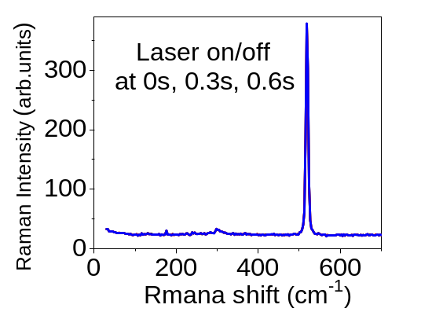
Figure 4.14. Photoexcitation-assisted Raman spectroscopy for Silicon characterized with 785 nm laser beam after applying 375 nm laser excitation. Raman signal remains unchanged upon applying/removing photoexcitation.

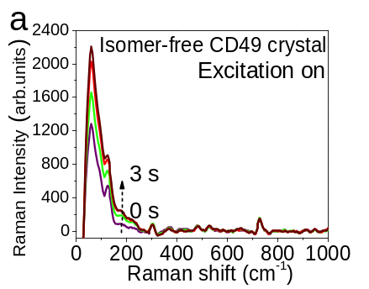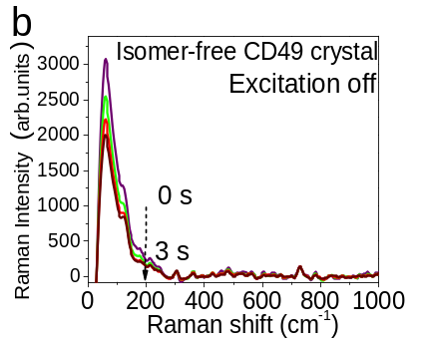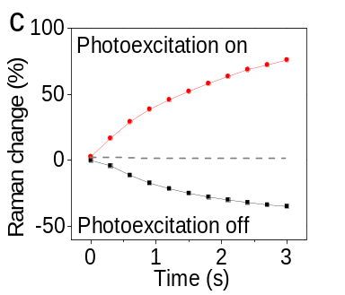
Figure 4.15. Photoexcitation-assisted Raman spectroscopy for isomer-free CD49 crystal. Raman spectroscopy was activated by using built-in 785 nm beam. Photoexcitation was applied by an external 375 nm beam. (a) Raman spectra measured at different times after applying photoexcitation; (b) Raman spectra measured at different times after removing photoexcitation; (c) Raman signal intensity at 65 cm⁻¹ was monitored as a function of time upon applying/removing photoexcitation.
charge-transfer excitons are difficult to form in the CD49 crystal at room temperature due to largely unbalanced lifetimes between photoexcited electrons and holes, shown as the absence of persistent PL. When the Coulomb capture radius is increased by lowering the temperature, the isomer-free CD49 crystal can recover the persistent PL at 5 K with a lifetime of 0.17 s based on the already-existed un-usual slow relaxation of photoexcited lattice vibrations, as indicated in Figure 4.5c.

Ferroelectric polarization
Here, we discuss the ferroelectric-like lattice in periodically packed intramolecular D-A structures in the CD49 molecular crystal based on SHG studies. The ferroelectric-like lattice can provide the necessary condition to establish crystalline exciton-lattice interaction when crystalline intermolecular charge-transfer excitons are formed within periodically packed intramolecular D-A structures. Figure 4-16a shows a strong SHG for both isomer-containing and isomer-free CD49 crystals under 1025 nm laser illumination at room temperature. The SHG signals show typical quadratic power dependence with excitation intensity (Figure 4.16b). The strong SHG signal confirms that the periodically packed intramolecular D-A structures are indeed formed with inverse symmetry breaking properties as ferroelectric-like lattice in both CD49 crystals prepared with and without isomer molecules. Furthermore, this SHG phenomenon implies that introducing the isomer molecules does not destroy the ferroelectric-like lattice with inverse symmetry breaking properties in the CD49 crystal. Clearly, the CD49 crystal presents as ferroelectric-like lattice by periodically packing the intramolecular D-A structures. Now, we identify whether the ferroelectric-like lattice is coupled with crystalline intermolecular charge-transfer excitons. Essentially, the coupling between the ferroelectric lattice and crystalline intermolecular charge-transfer states can establish an exciton-lattice interaction towards developing ultralong-lived light-emitting states once un-usual slow relaxation of photoexcited lattice vibrations is ready. We should note that the crystalline intermolecular charge-transfer states, equivalent to aligned intermolecular charge-transfer dipoles, carry a SOC. When photogenerated electrons and holes are captured into electron-hole pairs to form intermolecular charge-transfer states, SOC can demonstrate magnetic field effects of PL (Figure 4.8). Clearly, magnetic field effects represent the signature of intermolecular charge-transfer states. If the ferroelectric-like lattice is coupled with crystalline intermolecular charge-transfer states, magnetic field effects of polarization can be observed by
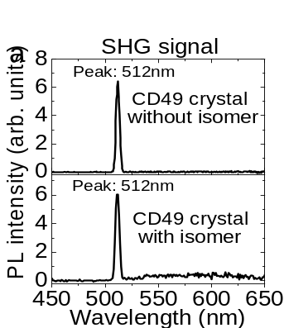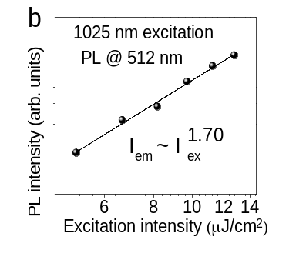
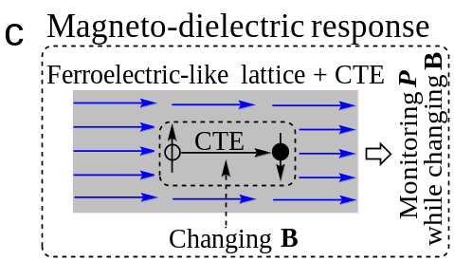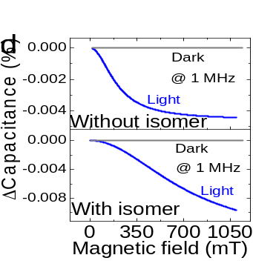
Figure 4.16. Ferroelectric polarization of CD49. (a) SHG signals for CD49 crystals prepared with and without isomer molecules under 1025 nm excitation; (b) Excitation-emission power dependence for SHG signals; (c) Principle for using magneto-dielectric response to identify coupling between ferroelectric-like lattice and crystalline intermolecular charge-transfer excitons (CTE). Electrical polarization P was measured at 1 MHz while gradually increasing magnetic field B. When ferroelectric-like lattice is coupled with CTE, disturbing CTE by magnetic field leads to a change on electrical polarization, presenting magneto-dielectric response; (d) Magneto-dielectric signals were measured at 1 MHz as a function of magnetic field under 343 nm excitation as compared to dark condition.

monitoring electrical polarization with a gradually increasing magnetic field, as illustrated in Figure 4.16c. Therefore, magnetic field effects of polarization present a unique method to identify the coupling between ferroelectric-like lattice and crystalline intermolecular charge-transfer states.
Here, magnetic field effects of polarization were performed by monitoring the polarization signal at 1 MHz while gradually scanning the magnetic field, at the condition that photoexcitation generates crystalline intermolecular charge-transfer dipoles. The frequency of 1 MHz was targeted at the intermolecular polarization occurring in crystalline lattice formed by periodically packing intramolecular D-A structures. Figure 4-16d shows magnetic field effects of polarization measured at 1 MHz for both CD49 crystals prepared with and without the isomer molecules. This observation confirms that the ferroelectric-like lattice is indeed coupled with crystalline intermolecular charge-transfer dipoles, leading to exciton-lattice coupling in periodically packing the intramolecular D-A structures. Essentially, this exciton-lattice coupling provides the ready condition to evolve crystalline intermolecular charge-transfer excitons into ultralong-lived light-emitting states through slow phonon effects within periodically packed intramolecular D-A structures. Therefore, persistent PL can be realized when crystalline intermolecular charge-transfer excitons and un-usual slow relaxation of lattice vibrations are simultaneously formed within ferroelectric-like lattice from periodically packed intramolecular D-A structures, as illustrated in Figure 4.17.

Conclusion
In summary, we found that the long-wavelength persistent PL is sensitive to the crystallinity in our CD49 crystal prepared with the isomer molecules. The lifetime of persistent PL is largely decreased from 0.43 s to 0.12 s by lowering the crystallinity from single crystal to drop-cast film, and consequently disappeared in spin-cast film at room temperature. This indicates that crystalline intermolecular charge-transfer excitons are responsible for persistent PL upon forming electron-hole pairs through Coulomb capture within periodically packed intramolecular D-A structures. Essentially, organic molecular crystals are typical p-type semiconductors with distinctly shorter and longer lifetimes between photoexcited electrons and holes with much lower and higher mobilities, acting as minority and majority carriers. The distinctly shorter and longer lifetimes between photoexcited electrons and holes can largely lower the electron-hole pairing probability
within Coulomb capture radius, causing a difficulty to form crystalline charge-transfer excitons in p-type organic crystals. Introducing isomer molecules can enable n-type doping effect to balance

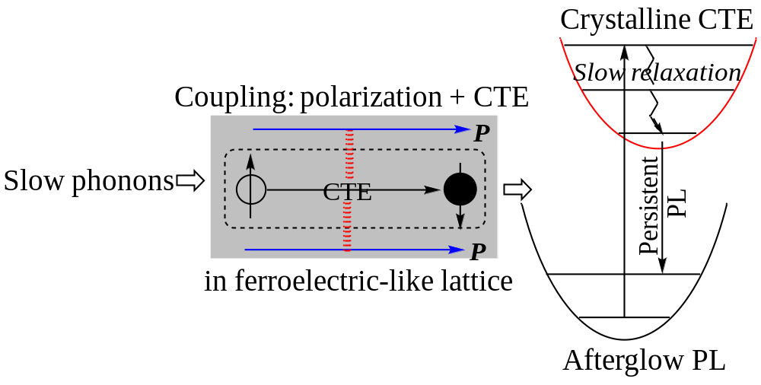
Figure 4.17. Diagram of slow-phonon effects of CD49. Persistent light emission is enabled by slow relaxation of photoexcited lattice vibrations when coupling between crystalline intermolecular charge-transfer excitons (CTE) and ferroelectric-like lattice is occurred. Through slow relaxation of lattice vibrations, crystalline charge-transfer excitons are slowly evolved into ultralong-lived light-emitting states, leading to a persistent PL in ferroelectric-like lattice upon periodically packing intramolecular D-A structures.

the minority and majority carriers, providing a carrier-balancing mechanism to increase electron-hole pairing probability within Coulomb capture radius towards forming crystalline intermolecular charge-transfer excitons for realizing a persistent PL. Consequently, the persistent PL can be observed at room temperature in our CD49 crystal when the isomer molecules are present, but becomes disappeared in the absence of isomer molecules due to unbalanced minority/majority carriers at room temperature. However, in the isomer-free CD49 crystal, the disappeared persistent PL can be recovered at low temperature when the isomer molecules are absent as n-type dopants. This confirms that crystalline intermolecular charge-transfer excitons, responsible for persistent PL, are essentially formed between periodically packed intramolecular D-A structures in our CD49 molecular crystal. Interestingly, the persistent PL demonstrates positive magnetic field effects, indicating that crystalline intermolecular-charge transfer excitons carry singlet spin characteristics with spatially extended wavefunctions. To understand the basic mechanism of evolving crystalline intermolecular-charge transfer excitons into ultralong-lived light-emitting states, the slow relaxation of lattice vibrations and the exciton-lattice coupling was investigated by using photoinduced Raman spectroscopy and polarization characterizations. Our photoexcitation-assisted Raman studies found a unique phenomenon where the Raman signals of photoexcited lattice vibrations are slowly increasing/decreasing when applying/removing an external photoexcitation, leading to un-usual slow phonon effects in the time window of seconds, providing the basic possibility to evolve intermolecular excitons into ultralong-lived light-emitting states when the exciton-lattice coupling is occurred in crystalline lattice. Furthermore, our SHG studies indicate that periodically packed intramolecular D-A structures are formed as ferroelectric-like lattice in the CD49 crystals. Especially, the magneto-dielectric response shows that crystalline intermolecular charge-transfer excitons are coupled with the ferroelectric lattice, presenting an exciton-lattice coupling in periodically packed intramolecular D-A structures. Based on the exciton-lattice coupling, the slow relaxation of lattice vibrations can evolve crystalline intermolecular charge-transfer excitons into ultralong-lived light-emitting states, leading to a persistent PL in organic molecular crystals. Therefore, our experimental studies provide an insightful fundamental understanding of the spin-physics and photophysics of ultralong-lived light-emitting states based on SOC and slow phonon effects towards developing persistent light emission in organic crystals.

Chapter 5: Afterglow Multiphoton Up-conversion Photoluminescence in Organic Crystal

A manuscript organized by Yixuan Dou etc. based on this chapter is under submission, Yixuan Dou designed and performed the experiments, analyzed the data, and contributed to the writing of the manuscript.
Dou Y., Wang M., Demangeat C., Dryzhakov B., Attias A., Hu B.*; Afterglow Multiphoton Up-conversion Photoluminescence Enabled by Ferroelectric Light-emitting Lattice Formed from Crystalline Donor-acceptor Structure; Under submission

Abstract

The organic CD49 molecule shows an afterglow up-conversion photoluminescence (PL) peaked at 542 nm lasting to 3 seconds after ceasing 1025 nm infrared excitation at room temperature, concurrently occurring with Second Harmonic Generation (SHG), in ferroelectric-light-emitting CD49 crystal designed with intramolecular donor-acceptor (carbazole-pyridine) structures. Essentially, the afterglow up-conversion PL results from crystalline charge-transfer excitons with singlet spin characteristics formed by electron-hole pairing, shown by magnetic field effects of PL. Because of distinctly different lifetimes between photoexcited electrons and holes, electron-hole pairing requires a carrier-balancing condition through isomer doping to form crystalline intermolecular charge-transfer excitons. Photoexcitation-assisted Raman spectroscopy indicates that photoexcited ferroelectric light-emitting lattice experiences an un-usual slow relaxation in the time window of seconds under multiphoton excitation. Our magneto-dielectric studies indicate that crystalline intermolecular charge-transfer excitons are coupled with ferroelectric light-emitting lattice, evolving crystalline intermolecular charge-transfer excitons into ultralong-lived light-emitting states towards developing afterglow multiphoton up-conversion PL in isomer doped CD49 crystal.

Introduction
Afterglow refers to the phenomenon that a PL can still be observed in the time window from seconds up to minutes and hours after ceasing an external photoexcitation, leading to the so-called persistent PL.[,,] Originally, the afterglow phenomenon was widely observed in inorganic phosphor crystals when the trapped photogenerated carriers were slowly released through thermal activation.[,,] Slowly releasing photoexcited carriers in energy traps has been functioning as a popular mechanism to generate an afterglow phenomenon at room temperature.[,,] Recently, afterglow PL has become an emerging phenomenon in organic crystals through ultralong-lived light-emitting states.[,,,,,] Normally, light-emitting states are formed as short-lived excitons in organic molecules to generate fluorescence and phosphorescence with lifetimes ranging from nanoseconds[,] to microseconds.[,,,] Clearly, the afterglow PL requires new fundamental mechanisms to evolve short-lived excitons into ultralong-lived light-emitting states through unusual excited states dynamics in organic molecular crystals.

In this work, we explore afterglow infrared-to-visible up-conversion PL through multiphoton excitation in carbazole-derivatives based crystal where intramolecular donor-acceptor structures are periodically packed to form the ferroelectric light-emitting lattice. We observe that an afterglow multiphoton up-conversion PL can be activated simultaneously with SHG in our CD49 crystal doped with isomer molecules (CD102). This shows that the isomer-containing CD49 crystal presents dual ferroelectric and light-emitting properties, leading to the ferroelectric light-emitting lattice. Magnetic field effects indicate that the afterglow multiphoton up-conversion PL results from crystalline intermolecular charge-transfer excitons with singlet spin characteristics formed through the electron-hole pairing within Coulomb capture radius in such ferroelectric light-emitting lattice under multiphoton excitation of an incident infrared laser beam. Essentially, electron-hole pairing requires the carrier-balancing condition to increase the electron-hole pairing probability within Coulomb capture radius towards forming crystalline intermolecular charge-transfer excitons. Here, we observe that the isomer molecules can function as n-type dopants and consequently activate the afterglow infrared-to-visible multiphoton up-conversion PL in the CD49 crystal. Therefore, providing carrier-balancing condition is a critical procedure to form crystalline intermolecular charge-transfer excitons in organic crystals towards developing an afterglow infrared-to-visible multiphoton PL in organic crystals which are naturally p-type semiconductors with much unbalanced electron/hole lifetimes. Our magneto-dielectric studies reveal that crystalline intermolecular charge-transfer excitons are coupled with ferroelectric polarization, leading to exciton-lattice coupling order in a ferroelectric light-emitting crystal formed by periodically packing the intramolecular donor-acceptor structures. This can dually increase multiphoton excitation probability and evolve crystalline intermolecular excitons into ultra-lived light-emitting states to generate an afterglow multiphoton up-conversion PL. Our photoexcitation-assisted Raman spectroscopy indicates that applying/removing multiphoton excitation leads to a very slow increase/decrease on Raman signal intensity of lattice vibrations in the time window of seconds, presenting an un-usual slow relaxation of photoexcited ferroelectric lattice vibrations in CD49 crystal. With the exciton-lattice coupling order, the slow relaxation of photoexcited ferroelectric lattice vibrations can evolve intermolecular charge-transfer excitons into ultralong-lived light-emitting states, giving rise to an afterglow up-conversion PL in organic crystals with dual ferroelectric polarizations and light-emitting properties. Technically, the afterglow in infrared-to-visible multiphoton up-conversion PL provides an opportunity to develop highly sensitive infrared imaging techniques by collecting optical signals after ceasing infrared stimulus to avoid background noise.

Methods

Synthesis of CD49 compound:
Same as the organic material synthesis in 4.3 Methods part.

Photoluminescence measurement
PL spectra in both steady and dynamic regimes were measured by the SPEX Fluorolog 3 spectrometer. The time-resolved photoexcitation source was from a pulsed laser beam (342nm, 4 mW) generated through a harmonic generator (Ultrafast Systems LLC, third harmonic) with a Pharos laser (Light Conversion, 1 KHz, 1025 nm, 290 fs). The SHG spectra and up-conversion emission were measured by the same excitation source as the time-resolved photoexcitation source under a frequency of 25 KHz laser. An 850 nm long-pass cutoff filter (Newport) was placed on the excitation beam path before the sample, an FSQ-KG5 short-pass filter (300-800 nm, Newport) was placed on the emission beam path after the sample. The low temperature was generated by the cryostat with a helium compressor (Advanced Research Systems, Inc.).

Photoexcitation-assisted Raman measurement
Photoexcitation-assisted Raman spectroscopy was characterized by using Horiba Xplora plus system confocal Raman microscope with built-in 785 nm laser beam in combination with an external photoexcitation of 1025 nm fs laser beam.

Magneto-PL measurement
Same as 4.3.4 part.

Nuclear magnetic resonance (¹H and ¹³C) spectra
Same as 4.3.5 part.

High-performance liquid chromatography measurement
Same as 4.3.6 part.

Magneto-capacitance measurement
The capacitance measurement was performed by using the Agilent E4980A LCR meter (alternating bias: 50 mV). The magneto-PL and magneto-capacitance were measured by monitoring signal intensity while applying a magnetic field. The amplitude for magnetic field effects is defined as MFE = $\frac{I_{B}-I_{0}}{I_{0}}$, where I₀ and I_{B} are signal intensities without and with a magnetic field, respectively. A 1025 nm fs laser was applied to conduct the magneto-capacitance measurement under photoexcitation.

Results and discussions

Up-conversion of CD49 persistent material
The light-emitting molecules [9-(3-(5-bromopyridin-3-yl)prop-2-yn-1-yl)-9H-carbazole] (CD49) were prepared by separately using commercial and home-synthesized carbazole molecules. It has been found that commercial carbazole contains isomer molecules while home-synthesized carbazole lacks isomer molecules.[] Therefore, our samples can be categorized as isomer-containing CD49 and isomer-free CD49 crystals, namely doped and undoped CD49 crystals in this work. Here we can see an afterglow phenomenon occurring in infrared-to-visible multiphoton up-conversion PL in the isomer-containing CD49 molecular crystal under 1025 nm excitation at room temperature. Figure 5.1a illustrates that the 1025 nm excitation generates the long-wavelength emission peaked at 542 nm and 590 nm in this doped CD49 crystal. Notably, the PL peaked at 542 nm and 590 nm can last until 3 seconds after ceasing 1025 nm excitation (Figure 5.1b,c), presenting an afterglow multiphoton up-conversion PL at room temperature. Simultaneously, a sharp peak at 512 nm is shown in the doped CD49 crystal under the 1025 nm excitation, giving rise to a strong SHG signal. Clearly, the doped CD49 crystal demonstrates dual ferroelectric polarization and ultralong-lived light-emitting properties, functioning as a ferroelectric light-emitting lattice. Interestingly, lowering the crystallinity largely decreases both the afterglow multiphoton up-conversion PL and the SHG signal from molecular crystal to drop-cast film, which eventually disappeared when the crystallinity is largely removed in the spin-cast film. This indicates that the light-emitting states are intermolecular charge-transfer excitons formed with a spatial order, leading to crystalline light-emitting excitons within ferroelectric lattice for developing the afterglow phenomenon multiphoton up-conversion PL. Here, crystalline intermolecular charge-transfer excitons exhibit structurally-resolved PL spectrum, as against structureless broad PL spectrum from amorphous intermolecular charge-transfer excitons. The curve fitting shows the lifetime of 0.43 s for the afterglow up-conversion PL peaked at 542 nm under 1025 nm excitation (Figure 5.1b). The power dependence between excitation and emission intensities shows the slope of 2.47 (Figure 5.1d), suggesting that this afterglow in infrared-to-visible up-conversion PL is essentially a three-photon excitation process occurring within ferroelectric lattice in the doped CD49 molecular crystal where the intramolecular donor-acceptor structures are periodically packed.

Isomer induced n-type doping
Essentially, crystalline intermolecular charge-transfer excitons can be formed when photogenerated carriers undergo the electron-hole pairing in Coulomb capture radius in organic crystals under multiphoton excitation.[] We should note that photoexcited electrons and holes in organic crystals are naturally having significant unbalanced lifetimes due to their largely different mobilities. Carbazole derivatives possess distinctly lower and higher mobilities between electrons
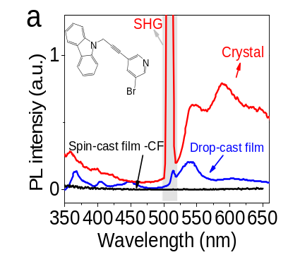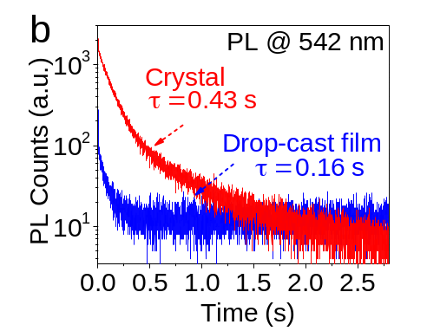
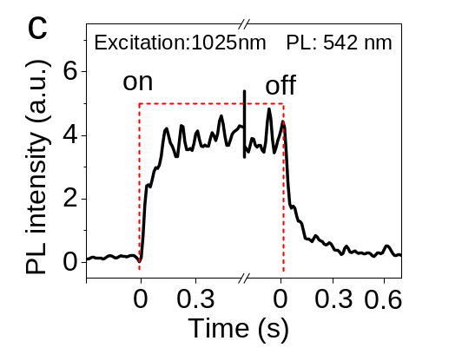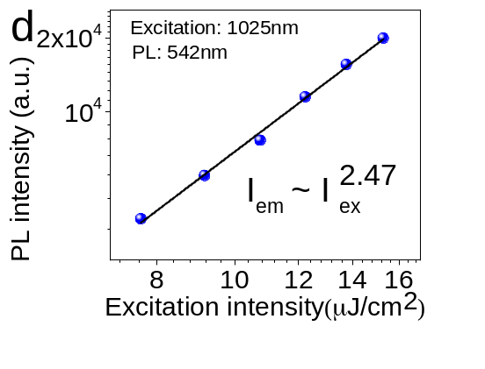
Figure 5.1. Afterglow multiphoton up-conversion PL and SHG in isomer-containing CD49. (a) PL spectra for crystal, drop-cast film, and spin-cast film under 1025 nm excitation. Inset: chemical structure; (b) PL lifetimes (peaked at 542 nm) for crystal and drop-cast film under 1025 nm excitation. PL lifetime was fitted with exponential decay equation, the average lifetime was calculated by the equation: $τ_{ave}=\frac{\sum_{i=1}^{n}{α_{n}*τ_{n}^{2}}}{\sum_{i=1}^{n}{α_{n}*τ_{n}}}$; (c) The rise and decay profiles are shown for PL at 542 nm with turning on/off 1025 nm laser excitation in CD49 crystal. (d) PL intensity at 542 nm is plotted against laser excitation intensity on a logarithmic under 1025 nm excitation for CD49 crystal.

and holes with significantly different lifetimes.[,] This can largely decrease the electron-hole pairing probability within Coulomb capture radius, presenting a difficulty to form crystalline intermolecular charge-transfer excitons towards realizing an afterglow infrared-to-visible up-conversion PL in organic crystals under multiphoton excitation. This difficulty can be conveniently
overcome by using n-type doping to increase the electron-hole pairing probability within the Coulomb capture radius to form crystalline intermolecular charge-transfer excitons. Due to the electron-donating capability, the isomer molecules can serve as n-type dopants through substitutional occupation in the crystal, forming isomer-containing doped CD49 crystal. Essentially, the isomer molecules provide a carrier-balancing condition to increase the electron-hole pairing probability within Coulomb capture radius towards forming crystalline intermolecular charge-transfer excitons. Figure 5.2a shows that the afterglow multiphoton up-conversion PL disappeared at room temperature in isomer-free CD49 crystal under 1025 nm excitation. Interestingly, in the isomer-free CD49 crystal, lowering the temperature can lead to the recovering of the afterglow multiphoton up-conversion PL as shown in Figure 5.2b. Figure 5.2c indicates that the multiphoton up-conversion PL can be observed at 0.17 ms after ceasing the 1025 nm excitation in the isomer-free CD49 crystal at 5 K, giving rise to an afterglow phenomenon up-conversion PL at cryonic temperature. The time-resolved PL dynamics in Figure 5.2d illustrate the lifetime of 0.2 s at 542 nm under 1025 nm excitation at 5 K in isomer-free CD49 crystal. This low-temperature-recovered afterglow phenomenon confirms that the crystalline intermolecular charge-transfer excitons are indeed formed between periodically packed intramolecular D-A structures in the isomer-free CD49 crystal. Furthermore, this experimental phenomenon indicates that lowering the temperature can still increase the electron-hole pairing probability in the isomer-free CD49 crystal where the electron and hole lifetimes are much unbalanced due to largely different mobilities. This is because lowering the temperature can expand the Coulomb capture radius given by $r_{c}=\frac{e^{2}}{4πεKT}$ , where ε is the dielectric constant, K is the Boltzmann constant, T is the temperature. Clearly, providing carrier-balancing conditions is an important procedure to form electron-hole pairs within the Coulomb capture radius towards generating crystalline intermolecular charge-transfer excitons for realizing afterglow up-conversion PL in organic crystals.

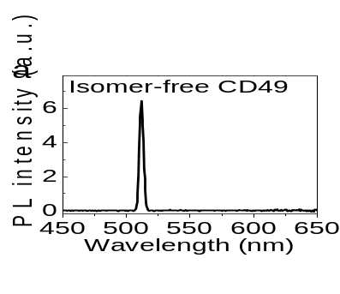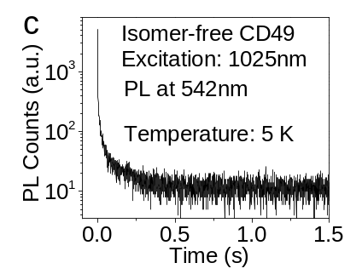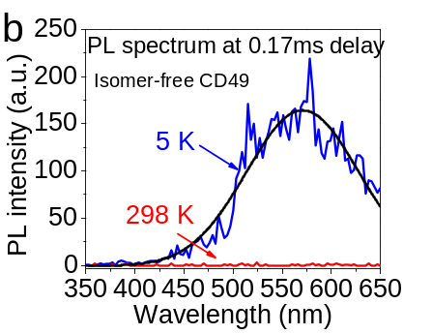
Figure 5.2. Isomer-free CD49 crystal: PL characteristics at room and low temperatures. (a) Lacking afterglow up-conversion PL at 298K in steady-state measurement; (b) Afterglow spectrum recovered at 5 K and 0.17 seconds after ceasing 1025 nm excitation; (c) Afterglow lifetime at 542 nm measured at 5 K.

Spin characteristics of up-conversion ultralong-lived light-emitting states
To understand the spin characteristics of ultralong-lived light-emitting states, the persistent PL peaked at 542 nm was monitored with and without a magnetic field at room temperature. Here, the persistent PL was generated by using down-conversion excitation of a 325 nm laser beam. Figure 5.3a shows that an external magnetic field can increase the persistent PL intensity in the CD49 crystal at room temperature, leading to positive magnetic field effects of persistent PL. We have shown that magnetic field effects of PL can be conveniently observed when an applied magnetic field disturbs the singlet-triplet intersystem crossing by flipping the spins at the precondition that the exchange energy in light-emitting states is comparable with the magnetic energy of the applied field.^{[79,,]}, as illustrated in Figure 5.3b. This precondition can be satisfied in intermolecular charge-transfer excitons where spatially extended wave functions largely decrease the exchange energy to allow magnetic field effects. ^{[78,80,]} If exchange energy is much larger than magnetic energy, magnetic field effects become negligible. Clearly, positive magnetic field effects provide evidence that the ultralong-lived light-emitting states possess singlet spin characteristics towards developing an afterglow up-conversion PL under multiphoton excitation. The singlet spin characteristics given by positive magnetic field effects are based on the following two experimental arguments. First, the triplets are normally having higher energy than singlets in intermolecular charge-transfer excitons, on the contrary to intramolecular excitons (known as Frenkel excitons) where singlets are shown to possess higher energy than triplets.^{[16,,]} Second, an applied magnetic field can increase the triplet-to-singlet intersystem crossing in intermolecular charge-transfer excitons by increasing spin flipping through magnetic scattering, leading to an increase in the PL intensity from singlets and consequently giving rise to positive magnetic field effects of PL.[,,,,] Therefore, the up-conversion ultralong-lived light-emitting states are essentially singlet crystalline intermolecular charge-transfer excitons formed by electron-hole pairing within Coulomb capture radius upon providing carrier-balancing condition in the isomer-containing CD49 crystal under multiphoton excitation.
The isomer-containing CD49 molecular crystal is known as persistent light-emitting materials in down-conversion PL under UV photoexcitation. Figure 5.4a shows that the PL spectrum consists of short-wavelength and long-wavelength components peaked at 363 nm and 542 nm in a down-conversion regime under 343 nm excitation in the isomer-containing CD49 molecular crystal. The short-wavelength PL is known as prompt light emission with a lifetime of 0.45 ns, also observed

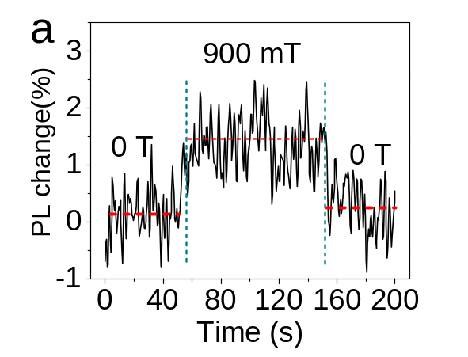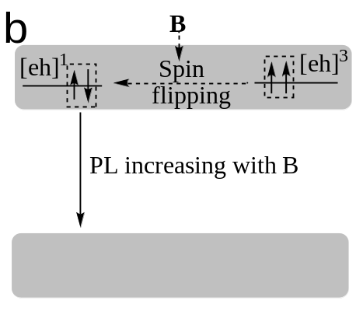
Figure 5.3. Magnetic field effects of PL of CD49. (a) PL intensity at 542 nm was measured without and with magnetic field (900 mT) for isomer-containing CD49 crystal under 325 nm excitation; (b) Diagram is shown for magnetic field effects of PL through field-dependent spin flipping between singlet and triplet states in crystalline intermolecular charge-transfer excitons.

in liquid solution. Interestingly, the long-wavelength PL peaked at 542 nm is shown with the ultralong lifetime of 0.43 s only in the crystalline state where the intramolecular donor-acceptor structures are periodically packed as shown in Figure 5.4b, leading to an afterglow phenomenon in down-conversion PL in ferroelectric light-emitting lattice formed in the isomer-doped CD49 crystal. It should be emphasized that the crystalline intermolecular charge-transfer excitons formed within periodically packed intramolecular donor-acceptor structures can respond to infrared 1025 nm excitation, giving rise to an afterglow up-conversion PL with the peak wavelength at 542 nm in the isomer-doped CD49 molecular crystal. This presents a fundamental question on why periodically packed intramolecular donor-acceptor structures can exhibit a multiphoton up-conversion PL with afterglow phenomenon in organic molecular crystals.
The CD49 molecular crystal possesses dual ferroelectric and light-emitting properties, presenting as a ferroelectric light-emitting lattice. Clearly, the ferroelectric light-emitting lattice simultaneously gives rise to both the non-central symmetric polarization with SHG through crystalline intermolecular polarization and the multiphoton up-conversion PL with afterglow phenomenon through crystalline intermolecular charge-transfer excitons at room temperature in the doped CD49 crystal where the intramolecular donor-acceptor structures are periodically packed. To understand the afterglow multiphoton up-conversion PL, we use the photoexcitation-assisted Raman spectroscopy through multiphoton excitation from the 1025 nm laser beam to explore the slow relaxation of photoexcited ferroelectric lattice vibrations in our CD49 crystal, serving as the basic mechanism to evolve crystalline intermolecular charge-transfer excitons into ultralong-lived light-emitting states. In photoexcitation-assisted Raman spectroscopy, the local ferroelectric lattice vibrations are monitored using the internal laser beam of 785 nm, serving as Raman scattering detection, in conjunction with an externally applied 1025 nm laser beam, serving as a multiphoton excitation. Figure 5.5 shows an interesting phenomenon: the Raman signal intensity below 200 cm⁻¹ is slowly increased/decreased in the time window up to 3 seconds upon applying/removing the 1025 nm excitation in the CD49 molecular crystal. This presents an unusual slow relaxation of photoexcited ferroelectric lattice vibrations. Essentially, this indicates that the photoexcited ferroelectric lattice vibrations are slowly releasing the energy to reach a new equilibrium in periodically packed intramolecular donor-acceptor structures after ceasing infrared 1025 nm photoexcitation, leading to an un-usual slow phonon effect in the ferroelectric light-emitting lattice.

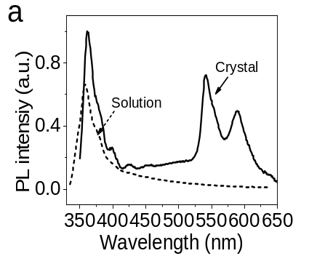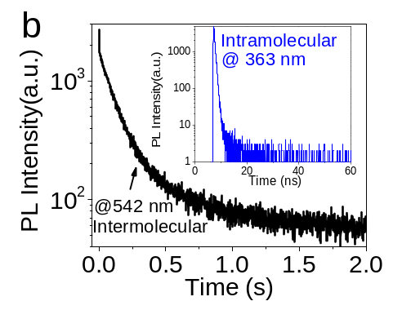
Figure 5.4. Down-conversion PL characteristics under 343 nm excitation in isomer-containing CD49 crystal. (a) PL spectrum under 343 nm excitation (dot-line for liquid sampel); (b) Time-resolved PL dynamics at 363 nm and 542 nm.

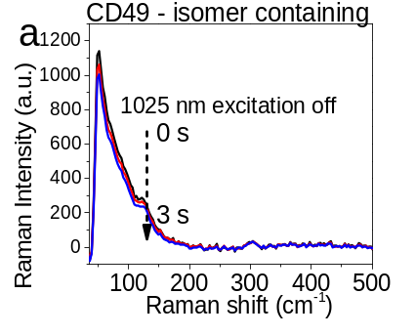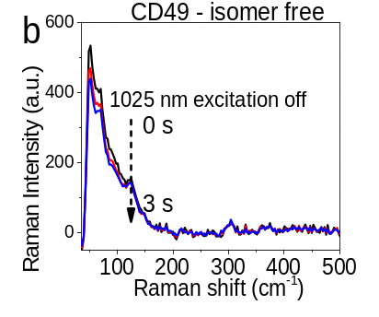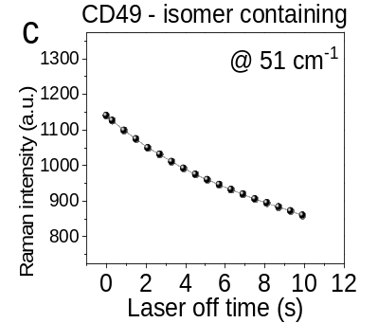
Figure 5.5. Photoexcitation-assisted Raman spectroscopy characterized with 785 nm laser beam upon applying and removing 1025 nm photoexcitation in isomer-containing CD49 crystal. (a) Raman spectra after removing 1025 nm laser excitation of isomer-containing CD49 crystal; (b) Raman spectra after removing 1025 nm laser excitation of isomer-free CD49 crystal; (c) Raman signal intensity at 51 cm⁻¹ as a function of time upon applying and removing 1025 nm laser excitation of isomer-containing CD49 crystal.

This slow phonon effect provides a basic mechanism to explain the evolution of crystalline intermolecular excitons into ultralong-lived light-emitting states through the lattice-exciton coupling in ferroelectric light-emitting lattice formed by periodically packing intramolecular donor-acceptor structures.
With the slow phonon effect, it requires the coupling between ferroelectric lattice and crystalline intermolecular charge-transfer excitons, leading to an exciton-lattice coupling order, to realize an afterglow up-conversion PL under multiphoton excitation. Here, we explore the possibilities that the exciton-lattice coupling order can simultaneously increase the multiphoton excitation probability and evolve crystalline intermolecular charge-transfer excitons into ultralong-lived light-emitting states in ferroelectric light-emitting crystals. First, with exciton-lattice coupling order, the ferroelectric polarization shown by the nonlinear optical response provided the possibilities to facilitate the multiphoton excitation of generating crystalline intermolecular charge-transfer excitons. Second, when the slow relaxation of photoexcited ferroelectric lattice vibrations occurs, the crystalline intermolecular charge-transfer excitons can be evolved into ultralong-lived light-emitting states under multiphoton excitation through the lattice-exciton coupling. Figure 5.6a indicates that the strong SHG signal from the ferroelectric lattice, shown as the narrow spectrum peaked at 512 nm, can be observed before the afterglow up-conversion PL becomes appreciable at the lower excitation intensity 8.17 µJ/cm² of 1025 nm laser beam in the isomer-containing CD49 crystal. The narrow spectrum peaked at 512 nm shows the power dependence slope of 1.99 (Figure 5.6b), confirming the SHG. Further increasing the 1025 nm excitation intensity leads to afterglow up-conversion PL peaked at 542 nm accompanied with SHG peaked at 512 nm. Here, we use magneto-dielectric measurement to reveal the coupling between ferroelectric polarization and crystalline intermolecular light-emitting excitons under infrared 1025 nm excitation. Magneto-dielectric measurement is performed by monitoring the dipolar polarization at 1 MHz under infrared 1025 nm excitation while gradually scanning the magnetic field. We should point out that crystalline intermolecular charge-transfer excitons are shown with magnetic field effects (Figure 5.3). If the coupling between ferroelectric polarization and crystalline intermolecular charge-transfer excitons has occurred, gradually scanning the magnetic field can lead to a change in ferroelectric polarization, giving rise to a magneto-dielectric response.

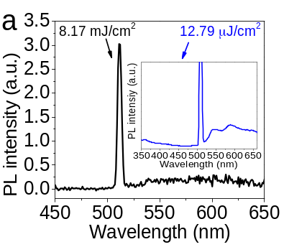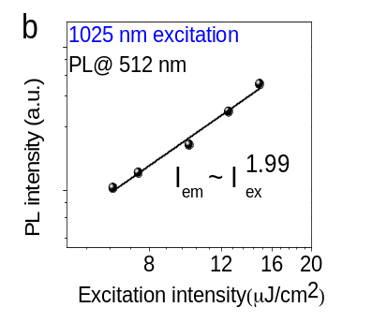
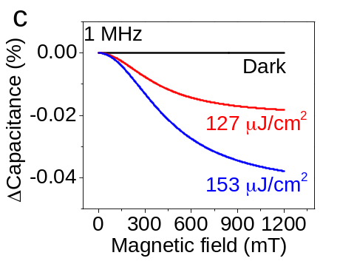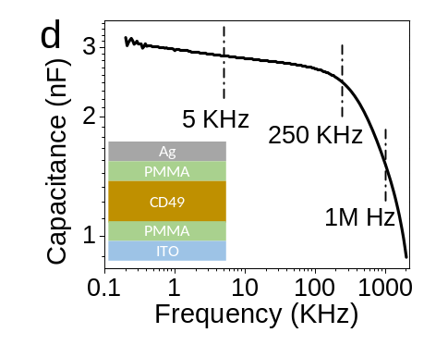
Figure 5.6. Ferroelectric polarization under 1025 nm excitation in isomer-doped CD49. (a) PL spectra under low/high excitation intensity (8.17/12.79 µJ/cm²). Low excitation: only SHG. High excitation: both SHG and afterglow up-conversion PL; (b) PL intensity excitation at 512 nm plotted against laser intensity on a logarithmic; (c) Magneto-capacitance signal from the device of ITO/PMMA/CD49-film/PMMA/Ag at different excitation intensities; (d) Capacitance-frequency characteristics.

In our early studies we have shown that, when a magnetic field disturbs the singlet/triplet ratio in intermolecular charge-transfer states, a magneto-dielectric signal can be observed in organic materials. ^{[227,} ,,] This is because singlets and triplets in intermolecular charge-transfer excitons are having stronger and weaker ionic properties due to their different spin-dependent asymmetric wavefunctions. When the ferroelectric polarizations are coupled with crystalline intermolecular charge-transfer excitons, a magnetic field can essentially change the ferroelectric polarizations by disturbing the singlet/triplet ratio in crystalline intermolecular charge-transfer excitons. Figure 5.6 shows the magneto-dielectric signal measured at 1 MHz under infrared 1025 nm excitation based on the device architecture of ITO/PMMA/CD49-film/PMMA/Ag. The local crystallinity was introduced in the isomer-containing CD49 film by using a high-boiling-point solvent of dimethyl sulfoxide (DMSO).
Under the infrared 1025 nm excitation, the electrical polarization monitored at 1 MHz is gradually changed with an increasing magnetic field, generating a magneto-dielectric signal within the dipolar polarization regime. Clearly, this magneto-dielectric signal measured at 1 MHz provides evidence that the ferroelectric polarization is coupled with crystalline intermolecular charge-transfer excitons under the infrared 1025 nm excitation within periodically packed intramolecular donor-acceptor structures. Importantly, this coupling provides the possibility to evolve crystalline intermolecular charge-transfer excitons into ultralong-lived light-emitting states under multiphoton excitation when the slow relaxation of photoexcited ferroelectric lattice vibrations occurs, as illustrated in Figure 5.7. Coupling order is occurred between ferroelectric lattice and crystalline intermolecular charge-transfer excitons, increasing multiphoton excitation probability. Slow relaxation of photoexcited ferroelectric lattice vibrations evolves crystalline intermolecular charge-transfer excitons into ultralong-lived light-emitting states under multiphoton excitation in ferroelectric light-emitting crystals.

Conclusion
In summary, an afterglow infrared-to-visible multiphoton up-conversion PL was observed together with SHG in our CD49 molecular crystal formed with periodically packed intramolecular donor-acceptor structures under the infrared 1025 nm excitation. The CD49 molecular crystal functions as a p-type semiconductor which requires a carrier-balancing condition by isomer doping to generate dual ferroelectric polarization and light-emitting properties. The afterglow multiphoton up-conversion PL exhibits a crystallinity dependence in isomer-containing CD49 molecular
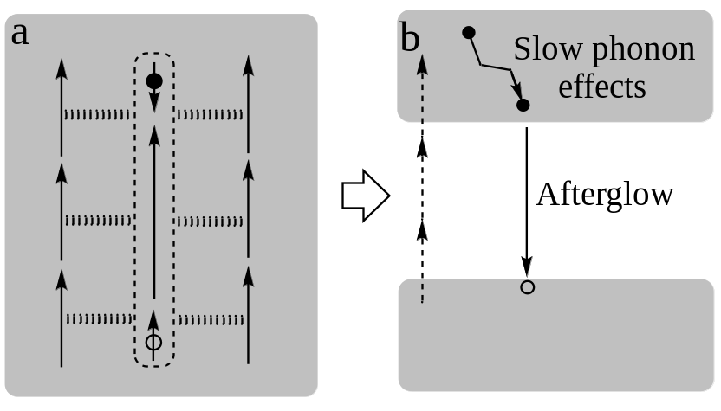
Figure 5.7. Afterglow multiphoton up-conversion PL occurs in ferroelectric light-emitting lattice with both ferroelectric polarization and crystalline intermolecular charge-transfer excitons. (a)

crystals. Lowering the crystallinity largely decreases the afterglow multiphoton up-conversion PL when changing from molecular crystal to drop-cast film, and becomes disappeared in spin-cast film. Magnetic field effects indicate that the afterglow up-conversion PL results from crystalline intermolecular charge-transfer excitons formed with singlet spin characteristics through the Coulomb capture between photoexcited electrons and holes in ferroelectric light-emitting lattice under multiphoton excitation. Essentially, forming crystalline intermolecular charge-transfer excitons requires a carrier-balancing condition to increase the electron-hole pairing probability within Coulomb capture radius in organic crystals naturally shown as p-type semiconductors where photoexcited electrons/holes have largely shorter/longer lifetimes due to distinctly different mobilities. In this sense, the isomer molecules (CD102) can function as n-type dopants to donate electrons into the ferroelectric light-emitting lattice, providing a carrier-balancing condition to increase the electron-hole pairing probability within Coulomb capture radius towards forming crystalline intermolecular charge-transfer excitons for developing afterglow multiphoton up-conversion PL. Furthermore, magneto-dielectric studies indicate that the crystalline intermolecular charge-transfer excitons are coupled with the ferroelectric light-emitting lattice in our CD49 crystal. This coupling provides dual functionalities: facilitating multiphoton excitation through nonlinear optical response and evolving crystalline intermolecular charge-transfer excitons into ultralong-lived light-emitting states through slow relaxation of photoexcited ferroelectric lattice vibrations under multiphoton excitation in periodically packed intramolecular donor-acceptor structures. Our photoexcitation-assisted Raman spectroscopy shows that the photoexcited ferroelectric lattice experiences an un-usual slow relaxation upon ceasing multiphoton excitation, presenting a slow phonon effect in our CD49 crystal. With the exciton-lattice coupling, the slow relaxation of photoexcited lattice vibrations provides the basic mechanism to evolve crystalline intermolecular charge-transfer excitons into ultralong-lived light-emitting states to demonstrate an afterglow multiphoton up-conversion PL upon forming electron-hole pairs in n-type doped organic crystals.

Appendix

Publication list
- Y. Dou, M. Wang, K. Wong, B. Hu*; Optically Uncover Hidden Delayed Fluorescence and Multiphoton Up-conversion Photoluminescence by Using Crystalline Donor-Acceptor Structures; In preparation
- Y. Dou, C. Demangeat, B. Dryzhakov, A. Attias, B. Hu*; Afterglow Scintillator in Metal-free Organic Crystal under Isomer Doping; In preparation
- M. Wang, Y. Dou, X. Zhu, B. Hu*, Spin-Orbital Coupling Effects of Excited States in Organic Light-Emitting, Lasing, and Photovoltaic Devices; To be submitted
- Y. Dou, M. Wang, B. Dryzhakov, J. Keum, B. Hu*; Vacuum-annealing Induced Polarized Light Emission in Down-conversion and Up-conversion Excitation Regimes in Cs₄PbBr₆ Single Crystal Embedded with CsPbBr₃ Nanocrystals; To be submitted
- Y. Dou, M. Wang, C. Demangeat, B. Dryzhakov, A. Attias, B. Hu*; Afterglow Multiphoton Up-conversion Photoluminescence Enabled by Ferroelectric Light-emitting Lattice Formed from Crystalline Donor-acceptor Structure; Under submission
- Y. Dou, M. Wang, C. Demangeat, B. Dryzhakov, T.L. Bahers, E. Kim, K. Lee, A. Attias*, B. Hu*; Spin-orbital Coupling and Slow Phonon Effects enabled Persistent Photoluminescence in Organic Crystal under Isomer Doping; Nature Communications, 12(1), 1-10, 2021.
- Y. Dou, M. Wang, J. Zhang, H. Xu, B. Hu*; Identifying Photoinduced Dipolar Polarization and Orbit-Orbit Interaction between Excitons in Organic-Inorganic Hybrid Perovskites; Advanced Functional Materials, 2003476, 2020.
- Y. Dou, H. Xu, Y. Liu, M. Wang, J. Zhang, O.S. Ovchinnikova, B. Hu *; Tuning Spin-Orbit Coupling towards Enhancing Photocurrent in Hybrid Organic-inorganic Perovskites by Using Mixed Organic Cations; Organic Electronics, 81: 105671, 2020.
- C. Demangeat, Y. Dou, B. Hu, Y. Bretonniere, C. Andraud, A. D'Aléo, J.W. Wu, E. Kim, T. Le Bahers, A.-J. Attias*; σ‐Conjugation and H‐Bond‐Directed Supramolecular Self‐Assembly: Key Features for Efficient Long‐Lived Room Temperature Phosphorescent Organic Molecular Crystals; Angewandte Chemie, 133(5), 2476-2484, 2020.

Chapter 6: Conclusion

Conclusions
This dissertation focuses on exploring the spin characteristics and photophysics of halide perovskites and organic long-persistent luminescence materials, also points out the direction to optimize the performance of functional materials and devices. The research works can be divided into two parts, one focus on halide perovskite materials, the other one focus on room temperature organic long persistent materials.
- Halide perovskite materials
MA_{x}FA_{(1-x)}PbI₃ mixed cation perovskites with different dipole moments were designed to explore the photo-induced bulk polarization, which is still a controversial topic because of the difficulty to eliminate the effect of surface polarization. The high-frequency magneto-capacitance measurement provided solid evidence of the existence of photo-induced bulk dipolar polarization. Moreover, we showed that changing the internal dipole moment by changing the MA:FA ratio can change the intrinsic orbit-orbit interaction through orbital magnetic dipoles between excitons. The intrinsic orbit-orbit interaction between excitons is decreased as the internal dipole moment is decreased. This observation provided an insightful understanding of the orbit-orbit interaction between excitons towards controlling photovoltaics, light-emitting, and lasing properties in hybrid perovskites.
Then, the low-dimensional 0D Cs₄PbBr₆ with boosting green emission was studied. The abnormal low energy emissions far below the bandgap from blue to green were activated by a vacuum annealing method. The unexpected low energy emissions were identified to be induced by embedded 3D CsPbBr₃ nanocrystals, and the suppressed non-radiative recombination leads to the boosting emission intensity. Moreover, a novel two-photon polarized up-conversion was observed in the green emissive Cs₄PbBr₆ crystal. In addition, linearly polarized emissions in both down-conversion and up-conversion regimes were observed from the Cs₄PbBr₆ crystal. This new phenomenon pointed out a new direction to develop perovskite bulk crystals with polarized emission and broaden the applications of 0D Cs₄PbBr₆ single crystal.
- Room temperature organic long persistent luminescence material
In this work, we observed that the long-wavelength persistent PL is sensitive to the crystallinity in our pure organic CD49 crystal with doped isomer molecules, and confirm that crystalline intermolecular charge-transfer excitons are responsible for persistent PL, which are essentially formed between periodically packed intramolecular D-A structures in crystal. This work provided an insightful fundamental understanding of the spin-physics and photophysics of ultralong-lived light-emitting states based on SOC and slow phonon effects towards developing persistent light emission in organic crystals.
Then, the infrared-to-visible three-photon up-conversion afterglow was observed together with SHG in CD49 purely organic molecular crystal under the infrared 1025 nm excitation. The long-lived excited states were identified to be formed with periodically packed intramolecular donor-acceptor structures. The CD49 molecular crystal functions as a p-type semiconductor which requires a carrier-balancing condition by CD102 isomer doping to generate dual ferroelectric polarization and light-emitting properties. The observation of up-conversion afterglow in organic crystal indicates the metal-free organic afterglow material is a promising candidate for multi-functional materials.

Outlooks
Our works explored the photo-physics and spin characteristics in two multi-functional materials: halide perovskite and organic long-persistent light emission materials. For perovskite materials, we found that decreasing the internal dipole moment by introducing FA component leads to a reduction on photoinduced dipolar polarization. The ferroelectric polarization is one of the promising methods to break the Shockley−Queisser (SQ) limit of perovskite solar cells. The internal dipole moment manipulated photo-induced bulk polarization provides a new approach to control the optic, electric, ferroelectric, and mechanic properties in hybrid perovskites by adjusting internal electrical dipole moment. Then, the linearly polarized emission is observed in both down-conversion and up-conversion regimes from 0D perovskite crystal embedded with 3D perovskite nanocrystals. The control of emission and polarization dynamics provide new enables future non-linear optic devices. For the organic long persistent light emission materials, our works point out a direction to optimize the long persistent light emission in organic materials by improving the crystallinity and introducing n-type dopants to balance the carrier lifetimes. The organic long persistent light emission materials with improved emission intensity and lifetime could lead to a breakthrough in organic bioimaging materials with better resolution and sensitivity.

References

VITA
Yixuan Dou was born in Jining city, Shandong province, China. She received her B.S. degree in Applied Chemistry in 2014 from Taiyuan University of Technology, and M.S. degree in Chemistry in 2017 from Nanjing University. In August 2017, she started her graduate study in the Department of Materials Science and Engineering at University of Tennessee-Knoxville for her Ph. D. degree. She has been working on the spin dynamics on perovskite materials and organic long persistent luminescence materials. Her works also include perovskite solar cell perovskite LED device fabrication, optical properties characterization of perovskite and afterglow materials.

[] Research Cell Efficiency Records http://www.nrel.gov/ncpv (National Renewable Energy Laboratory. (Accessed: September 18)
[] Jeon, N.J., Noh, J.H., Yang, W.S., Kim, Y.C., Ryu, S., Seo, J. and Seok, S.I. Compositional engineering of perovskite materials for high-performance solar cells. Nature 517, 476-480 (2015).
[] Correa-Baena, J.P., Saliba, M., Buonassisi, T., Grätzel, M., Abate, A., Tress, W. and Hagfeldt, A. Promises and challenges of perovskite solar cells. Science 358, 739-744 (2017).
[] Brivio, F., Butler, K. T., Walsh, A. & Van Schilfgaarde, M. Relativistic quasiparticle self-consistent electronic structure of hybrid halide perovskite photovoltaic absorbers. Physical Review B 89, 155204 (2014).
[] Yin, W. J., Shi, T. & Yan, Y. Unique properties of halide perovskites as possible origins of the superior solar cell performance. Advanced Materials 26, 4653-4658 (2014).
[] Ishihara, T., Takahashi, J. & Goto, T. Optical properties due to electronic transitions in two-dimensional semiconductors (CnH2n+1NH3)2PbI4. Physical review B 42, 11099 (1990).
[] Gong, X., Voznyy, O., Jain, A., Liu, W., Sabatini, R., Piontkowski, Z., Walters, G., Bappi, G., Nokhrin, S., Bushuyev, O. and Yuan, M. Electron–phonon interaction in efficient perovskite blue emitters. Nature materials 17, 550-556 (2018).
[] Blancon, J.-C., Even, J., Stoumpos, C. C., Kanatzidis, M. G. & Mohite, A. D. Semiconductor physics of organic–inorganic 2D halide perovskites. Nature nanotechnology 15, 969-985 (2020).
[] Wu, G. et al. A one-dimensional organic lead chloride hybrid with excitation-dependent broadband emissions. ACS Energy Letters 3, 1443-1449 (2018).
[] Saidaminov, M.I., Almutlaq, J., Sarmah, S., Dursun, I., Zhumekenov, A.A., Begum, R., Pan, J., Cho, N., Mohammed, O.F. and Bakr, O.M. Pure Cs4PbBr6: highly luminescent zero-dimensional perovskite solids. ACS Energy Letters 1, 840-845 (2016).
[] Yin, J., Maity, P., De Bastiani, M., Dursun, I., Bakr, O.M., Brédas, J.L. and Mohammed, O.F. Molecular behavior of zero-dimensional perovskites. Science advances 3, e1701793 (2017).
[] Heo, J.H., Im, S.H., Noh, J.H., Mandal, T.N., Lim, C.S., Chang, J.A., Lee, Y.H., Kim, H.J., Sarkar, A., Nazeeruddin, M.K. and Grätzel, M. Efficient inorganic–organic hybrid heterojunction solar cells containing perovskite compound and polymeric hole conductors. Nature photonics 7, 486-491 (2013).
[] Hu, M., Bi, C., Yuan, Y., Xiao, Z., Dong, Q., Shao, Y. and Huang, J. Distinct exciton dissociation behavior of organolead trihalide perovskite and excitonic semiconductors studied in the same system. small 11, 2164-2169 (2015).
[] Hirasawa, M., Ishihara, T., Goto, T., Uchida, K. & Miura, N. Magnetoabsorption of the lowest exciton in perovskite-type compound (CH3NH3) PbI3. Physica B: Condensed Matter 201, 427-430 (1994).
[] Frost, J.M., Butler, K.T., Brivio, F., Hendon, C.H., Van Schilfgaarde, M. and Walsh, A. Atomistic origins of high-performance in hybrid halide perovskite solar cells. Nano letters 14, 2584-2590 (2014).
[] Liu, Y., Collins, L., Proksch, R., Kim, S., Watson, B.R., Doughty, B., Calhoun, T.R., Ahmadi, M., Ievlev, A.V., Jesse, S. and Retterer, S.T. Chemical nature of ferroelastic twin domains in CH 3 NH 3 PbI 3 perovskite. Nature materials 17, 1013-1019 (2018).
[] Zhang, C., Sun, D., Sheng, C.X., Zhai, Y.X., Mielczarek, K., Zakhidov, A. and Vardeny, Z.V. Magnetic field effects in hybrid perovskite devices. Nature Physics 11, 427-434 (2015).
[] Wang, L., Liu, H., Zhang, Y. & Mohammed, O. F. Photoluminescence origin of zero-dimensional Cs4PbBr6 perovskite. ACS Energy Letters 5, 87-99 (2019).
[] Leveillee, J., Katan, C., Zhou, L., Mohite, A.D., Even, J., Tretiak, S., Schleife, A. and Neukirch, A.J. Influence of π-conjugated cations and halogen substitution on the optoelectronic and excitonic properties of layered hybrid perovskites. Physical Review Materials 2, 105406 (2018).
[] Hsiao, Y.C., Wu, T., Li, M., Liu, Q., Qin, W. and Hu, B. Fundamental physics behind high-efficiency organo-metal halide perovskite solar cells. Journal of Materials Chemistry A 3, 15372-15385 (2015).
[] Frost, J. M. Calculating polaron mobility in halide perovskites. Physical Review B 96, 195202 (2017).
[] Sychev, D.V., Ulanov, A.E., Tiunov, E.S., Pushkina, A.A., Kuzhamuratov, A., Novikov, V. and Lvovsky, A.I.. Entanglement and teleportation between polarization and wave-like encodings of an optical qubit. Nature communications 9, 1-7 (2018).
[] Almora, O., Aranda, C. & Garcia-Belmonte, G. Do capacitance measurements reveal light-induced bulk dielectric changes in photovoltaic perovskites? The Journal of Physical Chemistry C 122, 13450-13454 (2017).
[] Juarez-Perez, Emilio J., Rafael S. Sanchez, Laura Badia, Germá Garcia-Belmonte, Yong Soo Kang, Ivan Mora-Sero, and Juan Bisquert. Photoinduced giant dielectric constant in lead halide perovskite solar cells. The journal of physical chemistry letters 5, 2390-2394 (2014).
[] Liang, P.-W., Chen, C.-I., Chueh, C.-C. & Jen, A. K. Possible interfacial ion/charge accumulation in thin-film perovskite/fullerene surfactant planar heterojunction solar cells. Journal of Physics D: Applied Physics 51, 504001 (2018).
[] Wu, T., Collins, L., Zhang, J., Lin, P.Y., Ahmadi, M., Jesse, S. and Hu, B. Photoinduced bulk polarization and its effects on photovoltaic actions in perovskite solar cells. ACS nano 11, 11542-11549 (2017).
[] Wilson, J. N., Frost, J. M., Wallace, S. K. & Walsh, A. Dielectric and ferroic properties of metal halide perovskites. APL Materials 7, 010901 (2019).
[] Zheng, F., Tan, L. Z., Liu, S. & Rappe, A. M. Rashba spin–orbit coupling enhanced carrier lifetime in CH3NH3PbI3. Nano letters 15, 7794-7800 (2015).
[] Becker, M.A., Vaxenburg, R., Nedelcu, G., Sercel, P.C., Shabaev, A., Mehl, M.J., Michopoulos, J.G., Lambrakos, S.G., Bernstein, N., Lyons, J.L. and Stöferle, T. Bright triplet excitons in caesium lead halide perovskites. Nature 553, 189-193 (2018).
[] Yu, Z. Effective-mass model and magneto-optical properties in hybrid perovskites. Scientific reports 6, 1-14 (2016).
[]Hutter, E.M., Gélvez-Rueda, M.C., Osherov, A., Bulović, V., Grozema, F.C., Stranks, S.D. and Savenije, T.J.. Direct–indirect character of the bandgap in methylammonium lead iodide perovskite. Nature materials 16, 115-120 (2017).
[] Stranks, S. D. & Plochocka, P. The influence of the Rashba effect. Nature materials 17, 381-382 (2018).
[] Tamarat, P., Bodnarchuk, M.I., Trebbia, J.B., Erni, R., Kovalenko, M.V., Even, J. and Lounis, B. The ground exciton state of formamidinium lead bromide perovskite nanocrystals is a singlet dark state. Nature materials 18, 717-724 (2019).
[] Kabe, R. & Adachi, C. Organic long persistent luminescence. Nature 550, 384-387 (2017).
[] An, Z., Zheng, C., Tao, Y., Chen, R., Shi, H., Chen, T., Wang, Z., Li, H., Deng, R., Liu, X. and Huang, W. Stabilizing triplet excited states for ultralong organic phosphorescence. Nature Materials 14, 685-690 (2015).
[] Gu, L., Shi, H., Bian, L., Gu, M., Ling, K., Wang, X., Ma, H., Cai, S., Ning, W., Fu, L. and Wang, H. Colour-tunable ultra-long organic phosphorescence of a single-component molecular crystal. Nature Photonics 13, 406-411 (2019).
[] Kenry, Chen, C. & Liu, B. Enhancing the performance of pure organic room-temperature phosphorescent luminophores. Nature Communications 10, 2111, (2019).
[] Zhang, X., Du, L., Zhao, W., Zhao, Z., Xiong, Y., He, X., Gao, P.F., Alam, P., Wang, C., Li, Z. and Leng, J. Ultralong UV/mechano-excited room temperature phosphorescence from purely organic cluster excitons. Nature communications 10, 1-10 (2019).
[] Han, M., Tian, Y., Yuan, Z., Zhu, L. & Ma, B. A phosphorescent molecular “butterfly” that undergoes a photoinduced structural change allowing temperature sensing and white emission. Angewandte Chemie International Edition 53, 10908-10912 (2014).
[] Wang, T., Su, X., Zhang, X., Nie, X., Huang, L., Zhang, X., Sun, X., Luo, Y. and Zhang, G., Aggregation‐Induced Dual‐Phosphorescence from Organic Molecules for Nondoped Light‐Emitting Diodes. Advanced Materials 31, 1904273 (2019).
[] Huang, L., Chen, B., Zhang, X., Trindle, C.O., Liao, F., Wang, Y., Miao, H., Luo, Y. and Zhang, G. Proton‐activated “off–on” room‐temperature phosphorescence from purely organic thioethers. Angewandte Chemie International Edition 57, 16046-16050 (2018).
[] Feng, H.T., Zeng, J., Yin, P.A., Wang, X.D., Peng, Q., Zhao, Z., Lam, J.W. and Tang, B.Z. Tuning molecular emission of organic emitters from fluorescence to phosphorescence through push-pull electronic effects. Nature communications 11, 1-9 (2020).
[] Li, C. et al Li, C., Tang, X., Zhang, L., Li, C., Liu, Z., Bo, Z., Dong, Y.Q., Tian, Y.H., Dong, Y. and Tang, B.Z. Reversible luminescence switching of an organic solid: controllable on–off persistent room temperature phosphorescence and stimulated multiple fluorescence conversion. Advanced Optical Materials 3, 1184-1190 (2015).
[] Mathew, A. S., DeRosa, C. A., Demas, J. N. & Fraser, C. L. Difluoroboron β-diketonate materials with long-lived phosphorescence enable lifetime based oxygen imaging with a portable cost effective camera. Analytical Methods 8, 3109-3114 (2016).
[]Barrett, S. M., Wang, C. & Lin, W. Oxygen sensing via phosphorescence quenching of doped metal–organic frameworks. Journal of Materials Chemistry 22, 10329-10334 (2012).
[] Sung, Y.M., Gayam, S.R., Hsieh, P.Y., Hsu, H.Y., Diau, E.W.G. and Wu, S.P.. Quinone-modified Mn-doped ZnS quantum dots for room-temperature phosphorescence sensing of human cancer cells that overexpress NQO1. ACS applied materials & interfaces 7, 25961-25969 (2015).
[] Chen, Y.H., Chen, C.H., Chang, C.M., Fan, B.A., Chen, D.G., Lee, J.H., Chiu, T.L., Chou, P.T. and Leung, M.K. Control of π–π stacking in carbazole-benzimidazo< 1, 2-f> phenanthridines: the design of electron-transporting bipolar hosts for phosphorescent organic light-emitting diodes. Journal of Materials Chemistry C 8, 3571-3579 (2020).
[]Kabe, R., Notsuka, N., Yoshida, K. & Adachi, C. Afterglow organic light‐emitting diode. Advanced Materials 28, 655-660 (2016).
[] Wu, S., Pan, Z., Chen, R. & Liu, X. Long afterglow phosphorescent materials. (Springer, 2017).
[] Xu, J. & Tanabe, S. Persistent luminescence instead of phosphorescence: History, mechanism, and perspective. Journal of Luminescence 205, 581-620 (2019).
[] Matsuzawa, T., Aoki, Y., Takeuchi, N. & Murayama, Y. A new long phosphorescent phosphor with high brightness, SrAl2 O 4: Eu2+, Dy3+. Journal of the Electrochemical Society 143, 2670 (1996).
[] Kabe, R. & Adachi, C. Organic long persistent luminescence. Nature 550, 384-387, (2017).
[] Lin, Z., Kabe, R., Wang, K. & Adachi, C. Influence of energy gap between charge-transfer and locally excited states on organic long persistence luminescence. Nat Commun 11, 191, (2020).
[] Li, C., Tang, X., Zhang, L., Li, C., Liu, Z., Bo, Z., Dong, Y.Q., Tian, Y.H., Dong, Y. and Tang, B.Z.. Reversible luminescence switching of an organic solid: controllable on–off persistent room temperature phosphorescence and stimulated multiple fluorescence conversion. Advanced Optical Materials 3, 1184-1190 (2015).
[] Mathew, A. S., DeRosa, C. A., Demas, J. N. & Fraser, C. L. Difluoroboron β-diketonate materials with long-lived phosphorescence enable lifetime based oxygen imaging with a portable cost effective camera. Analytical Methods 8, 3109-3114 (2016).
[] Sung, Y.-M. et al. Quinone-modified Mn-doped ZnS quantum dots for room-temperature phosphorescence sensing of human cancer cells that overexpress NQO1. ACS applied materials & interfaces 7, 25961-25969 (2015).
[] Pu, L. Fluorescence of organic molecules in chiral recognition. Chemical Reviews 104, 1687-1716 (2004).
[] Reiser, A., Leyshon, L.J., Saunders, D., Mijovic, M.V., Bright, A. and Bogie, J. Fluorescence of aromatic benzoxazole derivatives. Journal of the American Chemical Society 94, 2414-2421 (1972).
[] Braunschweig, H., Dellermann, T., Dewhurst, R.D., Hupp, B., Kramer, T., Mattock, J.D., Mies, J., Phukan, A.K., Steffen, A. and Vargas, A. Strongly Phosphorescent Transition Metal π-Complexes of Boron–Boron Triple Bonds. Journal of the American Chemical Society 139, 4887-4893 (2017).
[] Yang, Y., Wang, K.-Z. & Yan, D. Ultralong persistent room temperature phosphorescence of metal coordination polymers exhibiting reversible pH-responsive emission. ACS applied materials & interfaces 8, 15489-15496 (2016).
[] Sauers, I., Grezzo, L. A., Staley, S. W. & Moore Jr, J. H. Low-energy singlet-triplet and singlet-singlet transitions in cycloalkenes. Journal of the American Chemical Society 98, 4218-4222 (1976).
[] Henry, B. R. & Siebrand, W. Spin–orbit coupling in aromatic hydrocarbons. Analysis of nonradiative transitions between singlet and triplet states in benzene and naphthalene. The Journal of Chemical Physics 54, 1072-1085 (1971).
[] Hong, T.-M. & Meng, H.-F. Spin-dependent recombination and electroluminescence quantum yield in conjugated polymers. Physical Review B 63, 075206 (2001).
[] El‐Sayed, M. Theoretical Considerations Concerning the Intramolecular Heavy‐Atom Effect on the Phosphorescence Process: C2v Symmetric Dihalonaphthalene. The Journal of Chemical Physics 43, 2864-2872 (1965).
[] Zhao, Q., Li, F. & Huang, C. Phosphorescent chemosensors based on heavy-metal complexes. Chemical Society Reviews 39, 3007-3030 (2010).
[] Siemiarczuk, A., Grabowski, Z. R., Krówczyński, A., Asher, M. & Ottolenghi, M. Two emitting states of excited p-(9-anthryl)-n, n-dimethylaniline derivatives in polar solvents. Chemical Physics Letters 51, 315-320 (1977).
[] Grabowski, Z. R., Rotkiewicz, K. & Rettig, W. Structural changes accompanying intramolecular electron transfer: focus on twisted intramolecular charge-transfer states and structures. Chemical reviews 103, 3899-4032 (2003).
[] Sasaki, S., Drummen, G. P. & Konishi, G.-i. Recent advances in twisted intramolecular charge transfer (TICT) fluorescence and related phenomena in materials chemistry. Journal of Materials Chemistry C 4, 2731-2743 (2016).
[] Randall, J. T. & Wilkins, M. H. F. Phosphorescence and electron traps II. The interpretation of long-period phosphorescence. Proceedings of the Royal Society of London. Series A. Mathematical and Physical Sciences 184, 390-407 (1945).
[] Turro, N. J. Modern molecular photochemistry. (University science books, 1991).
[] Pope, M. & Swenberg, C. Electronic Processes in Organic Crystals and Polymers. Oxford Univ Press. New York (1999).
[] McClure, D. S. Triplet‐singlet transitions in organic molecules. lifetime measurements of the triplet state. The Journal of Chemical Physics 17, 905-913 (1949).
[] Kearns, D. R. & Case, W. A. Investigation of singlet→ triplet transitions by the phosphorescence excitation method. III. Aromatic ketones and aldehydes. Journal of the American Chemical Society 88, 5087-5097 (1966).
[] Saigusa, H. & Azumi, T. Internal heavy atom effect on the triplet spin sublevels of the lowest triplet state of naphthalene. I. Radiative and nonradiative decays of the spin sublevels of 1‐halonaphthalenes. The Journal of Chemical Physics 71, 1408-1413 (1979).
[] Bolton, O., Lee, K., Kim, H.-J., Lin, K. Y. & Kim, J. Activating efficient phosphorescence from purely organic materials by crystal design. Nature chemistry 3, 205-210 (2011).
[] Kwon, M.S., Yu, Y., Coburn, C., Phillips, A.W., Chung, K., Shanker, A., Jung, J., Kim, G., Pipe, K., Forrest, S.R. and Youk, J.H. Suppressing molecular motions for enhanced room-temperature phosphorescence of metal-free organic materials. Nature communications 6, 1-9 (2015).
[]An, Z., Zheng, C., Tao, Y., Chen, R., Shi, H., Chen, T., Wang, Z., Li, H., Deng, R., Liu, X. and Huang, W. Stabilizing triplet excited states for ultralong organic phosphorescence. Nature Materials 14, 685-690 (2015).
[] Xu, H., Wang, M., Yu, Z.-G., Wang, K. & Hu, B. Magnetic field effects on excited states, charge transport, and electrical polarization in organic semiconductors in spin and orbital regimes. Advances in Physics 68, 49-121 (2019).
[] Hsiao, Y. C., Wu, T., Li, M. & Hu, B., Magneto-optical studies on spin-dependent charge recombination and dissociation in perovskite solar cells. Advanced Materials 27, 2899-2906, (2015).
[] Hu, B. & Wu, Y. Tuning magnetoresistance between positive and negative values in organic semiconductors. Nature Materials 6, 985, (2007).
[] Zhang, J., Wu, T., Duan, J., Ahmadi, M., Jiang, F., Zhou, Y. and Hu, B. Exploring spin-orbital coupling effects on photovoltaic actions in Sn and Pb based perovskite solar cells. Nano energy 38, 297-303 (2017).
[] Dou, Y., Xu, H., Liu, Y., Wang, M., Zhang, J., Ovchinnikova, O.S. and Hu, B., Tuning spin-orbit coupling towards enhancing photocurrent in hybrid organic-inorganic perovskites by using mixed organic cations. Organic Electronics 81, 105671 (2020).
[] Li, M., Li, L., Mukherjee, R., Wang, K., Liu, Q., Zou, Q., Xu, H., Tisdale, J., Gai, Z., Ivanov, I.N. and Mandrus, D. Magnetodielectric response from spin–orbital interaction occurring at interface of ferromagnetic Co and organometal halide perovskite layers via Rashba effect. Advanced Materials 29, 1603667 (2017).
[] Dou, Y., Wang, M., Zhang, J., Xu, H. & Hu, B. Identifying Photoinduced Dipolar Polarization and Orbit–Orbit Interaction between Excitons in Organic–Inorganic Hybrid Perovskites. Advanced Functional Materials 30, 2003476 (2020).
[] Qin, W., Xu, H. & Hu, B. Effects of Spin States on Photovoltaic Actions in Organo-Metal Halide Perovskite Solar Cells Based on Circularly Polarized Photoexcitation. ACS Photonics 4, 2821-2827 (2017).
[] Xu, H., Prabhakaran, P., Choi, S., Wang, M., Lee, K.S. and Hu, B. Exploring Orbit–Orbit Interaction in Relationship to Photoluminescence Quantum Efficiency in Perovskite Quantum Dots through Rashba Effect. The journal of physical chemistry letters 11, 1-6 (2019).
[]Qin, W., Xu, H. & Hu, B. Effects of Spin States on Photovoltaic Actions in Organo-Metal Halide Perovskite Solar Cells Based on Circularly Polarized Photoexcitation. ACS Photonics 4, 2821-2827 (2017).
[] Zhou, J., Liu, Q., Feng, W., Sun, Y. & Li, F. Upconversion luminescent materials: advances and applications. Chem. Rev. 115, 395-465, (2015).
[] Ye, C., Zhou, L., Wang, X. & Liang, Z. Photon upconversion: from two-photon absorption (TPA) to triplet-triplet annihilation (TTA). Phys. Chem. Chem. Phys. 18, 10818-10835, (2016).
[] Kim, D., Jung, H.J., Park, I.J., Larson, B.W., Dunfield, S.P., Xiao, C., Kim, J., Tong, J. Efficient, stable silicon tandem cells enabled by anion-engineered wide-bandgap perovskites. Science 368, 155-160 (2020).
[] Ye, Q., Zhao, Y., Mu, S., Ma, F., Gao, F., Chu, Z., Yin, Z., Gao, P., Zhang, X. and You, J. Cesium lead inorganic solar cell with efficiency beyond 18% via reduced charge recombination. Advanced materials 31, 1905143 (2019).
[]Liu, M., Chen, Y., Tan, C.S., Quintero-Bermudez, R., Proppe, A.H., Munir, R., Tan, H., Voznyy, O., Scheffel, B., Walters, G. and Kam, A.P.T. Lattice anchoring stabilizes solution-processed semiconductors. Nature 570, 96-101 (2019).
[] Meng, X., Cui, X., Rager, M., Zhang, S., Wang, Z., Yu, J., Harn, Y.W., Kang, Z., Wagner, B.K., Liu, Y. and Yu, C. Cascade charge transfer enabled by incorporating edge-enriched graphene nanoribbons for mesostructured perovskite solar cells with enhanced performance. Nano Energy 52, 123-133 (2018).
[] Keshavarz, M., Ottesen, M., Wiedmann, S., Wharmby, M., Küchler, R., Yuan, H., Debroye, E., Steele, J.A., Martens, J., Hussey, N.E. and Bremholm, M., Tracking Structural Phase Transitions in Lead‐Halide Perovskites by Means of Thermal Expansion. Advanced Materials 31, 1900521 (2019).
[] Fu, Y., Zhu, H., Chen, J., Hautzinger, M.P., Zhu, X.Y. and Jin, S. Metal halide perovskite nanostructures for optoelectronic applications and the study of physical properties. Nature Reviews Materials 4, 169-188 (2019).
[] Spaldin, N. A. A beginner's guide to the modern theory of polarization. Journal of Solid State Chemistry 195, 2-10 (2012).
[] Yu, Z. Effective-mass model and magneto-optical properties in hybrid perovskites. Scientific reports 6, 1-14 (2016).
[] Ma, S., Xu, H., Wang, M., Qin, J., Wu, T., Chen, P. and Hu, B. Polarization effects of transition dipoles on photoluminescence and photocurrent in organic-inorganic hybrid perovskites. Nano Energy 65, 104004 (2019).
[] Liu, Y., Ievlev, A.V., Collins, L., Borodinov, N., Belianinov, A., Keum, J.K., Wang, M., Ahmadi, M., Jesse, S., Xiao, K. and Sumpter, B.G., Light‐ferroic interaction in hybrid organic–inorganic perovskites. Advanced Optical Materials 7, 1901451 (2019).
[] Jurow, M.J., Morgenstern, T., Eisler, C., Kang, J., Penzo, E., Do, M., Manipulating the transition dipole moment of CsPbBr3 perovskite nanocrystals for superior optical properties. Nano letters 19, 2489-2496 (2019).
[] Bai, Y., Qin, J., Shi, L., Zhang, J., Wang, M., Zhan, Y., Zou, H., Haacke, S., Hou, X., Zi, J. and Hu, B. Amplified Spontaneous Emission Realized by Cogrowing Large/Small Grains with Self‐Passivating Defects and Aligning Transition Dipoles. Advanced Optical Materials 7, 1900345 (2019).
[] Coll, M. et al. Polarization switching and light-enhanced piezoelectricity in lead halide perovskites. The journal of physical chemistry letters 6, 1408-1413 (2015).
[] Lin, P.-Y. et al. Simultaneously enhancing dissociation and suppressing recombination in perovskite solar cells. Nano Energy 36, 95-101 (2017).
[] Frost, J.M., Butler, K.T., Brivio, F., Hendon, C.H., Van Schilfgaarde, M. and Walsh, A. Atomistic origins of high-performance in hybrid halide perovskite solar cells. Nano letters 14, 2584-2590 (2014).
[] O. Weber, B. Charles, M. Weller, J. Mater. Chem. A 2016, 4, 15375.
[] Colella, S., Mosconi, E., Fedeli, P., Listorti, A., Gazza, F., Orlandi, F., Ferro, P., Besagni, T., Rizzo, A., Calestani, G. and Gigli, G. MAPbI3-xCl x mixed halide perovskite for hybrid solar cells: the role of chloride as dopant on the transport and structural properties. Chemistry of Materials 25, 4613-4618 (2013).
[] Zuo, L., Guo, H., deQuilettes, D.W., Jariwala, S., De Marco, N., Dong, S., DeBlock, R., Ginger, D.S., Dunn, B., Wang, M. and Yang, Y. Polymer-modified halide perovskite films for efficient and stable planar heterojunction solar cells. Science advances 3, e1700106 (2017).
[] Son, D.Y., Lee, J.W., Choi, Y.J., Jang, I.H., Lee, S., Yoo, P.J., Shin, H., Ahn, N., Choi, M., Kim, D. and Park, N.G. Self-formed grain boundary healing layer for highly efficient CH3NH3PbI3 perovskite solar cells. Nature Energy 1, 1-8 (2016).
[] Park, B.W., Kedem, N., Kulbak, M., Yang, W.S., Jeon, N.J., Seo, J., Kim, G., Kim, K.J., Shin, T.J., Hodes, G. and Cahen, D. Understanding how excess lead iodide precursor improves halide perovskite solar cell performance. Nature communications 9, 1-8 (2018).
[] Weber, O., Charles, B. & Weller, M. Phase behaviour and composition in the formamidinium–methylammonium hybrid lead iodide perovskite solid solution. Journal of Materials Chemistry A 4, 15375-15382 (2016).
[] Kao, K. C. Dielectric phenomena in solids. (Elsevier, 2004).
[] Xu, H., Prabhakaran, P., Choi, S., Wang, M., Lee, K.S. and Hu, B. Exploring Orbit–Orbit Interaction in Relationship to Photoluminescence Quantum Efficiency in Perovskite Quantum Dots through Rashba Effect. The journal of physical chemistry letters 11, 1-6 (2019).
[] Yu, H., Wang, M., Han, C., Wang, K. & Hu, B. Mechanically tuning spin-orbit coupling effects in organic-inorganic hybrid perovskites. Nano Energy 67, 104285 (2020).
[]Wang, M., Zou, H., Zhang, J., Wu, T., Xu, H., Haacke, S. and Hu, B. Extremely Long Spin Lifetime of Light-Emitting States in Quasi-2D Perovskites through Orbit–Orbit Interaction. The journal of physical chemistry letters 11, 3647-3652 (2020).
[] Yu, H., Zhang, Q., Zhang, Y., Lu, K., Han, C., Yang, Y., Wang, K., Wang, X., Wang, M., Zhang, J. and Hu, B. Using Mechanical Stress to Investigate the Rashba Effect in Organic–Inorganic Hybrid Perovskites. The journal of physical chemistry letters 10, 5446-5450 (2019).
[] Yoo, J.J., Seo, G., Chua, M.R., Park, T.G., Lu, Y., Rotermund, F., Kim, Y.K., Moon, C.S., Jeon, N.J., Correa-Baena, J.P. and Bulović, V. Efficient perovskite solar cells via improved carrier management. Nature 590, 587-593 (2021).
[] Hassan, Y., Park, J.H., Crawford, M.L., Sadhanala, A., Lee, J., Sadighian, J.C., Mosconi, E., Shivanna, R., Radicchi, E., Jeong, M. and Yang, C. Ligand-engineered bandgap stability in mixed-halide perovskite LEDs. Nature 591, 72-77 (2021).
[] Qin, C., Sandanayaka, A.S., Zhao, C., Matsushima, T., Zhang, D., Fujihara, T. and Adachi, C. Stable room-temperature continuous-wave lasing in quasi-2D perovskite films. Nature 585, 53-57 (2020).
[] Sun, H., Tian, W., Cao, F., Xiong, J. & Li, L. Ultrahigh‐performance self‐powered flexible double‐twisted fibrous broadband perovskite photodetector. Advanced Materials 30, 1706986 (2018).
[] Ono, L. K., Juarez-Perez, E. J. & Qi, Y. Progress on perovskite materials and solar cells with mixed cations and halide anions. ACS applied materials & interfaces 9, 30197-30246 (2017).
[] Breternitz, J. & Schorr, S. What defines a perovskite? Advanced Energy Materials 8, 1802366 (2018).
[] Gong, X.; Voznyy, O.; Jain, A.; Liu, W.; Sabatini, R.; Piontkowski, Z.; Walters, G.; Bappi, G.; Nokhrin, S.; Bushuyev, O., Electron–phonon interaction in efficient perovskite blue emitters. Nature materials 2018, 17 (6), 550-556.
[] Blancon, J.-C.; Even, J.; Stoumpos, C. C.; Kanatzidis, M. G.; Mohite, A. D., Semiconductor physics of organic–inorganic 2D halide perovskites. Nature nanotechnology 2020, 15 (12), 969-985.
[] Wu, G.; Zhou, C.; Ming, W.; Han, D.; Chen, S.; Yang, D.; Besara, T.; Neu, J.; Siegrist, T.; Du, M.-H.; Ma, B.; Dong, A., A One-Dimensional Organic Lead Chloride Hybrid with Excitation-Dependent Broadband Emissions. ACS Energy Letters 2018, 3 (6), 1443-1449.
[] Toso, S., Baranov, D. & Manna, L. Hidden in Plain Sight: The Overlooked Influence of the Cs+ Substructure on Transformations in Cesium Lead Halide Nanocrystals. ACS Energy Letters 5, 3409-3414 (2020).
[] Cha, J.H., Han, J.H., Yin, W., Park, C., Park, Y., Ahn, T.K., Cho, J.H. and Jung, D.Y. Photoresponse of CsPbBr3 and Cs4PbBr6 perovskite single crystals. The journal of physical chemistry letters 8, 565-570 (2017).
[] Saidaminov, M. I. et al. Pure Cs4PbBr6: highly luminescent zero-dimensional perovskite solids. ACS Energy Letters 1, 840-845 (2016).
[] Yin, J., Maity, P., De Bastiani, M., Dursun, I., Bakr, O.M., Brédas, J.L. and Mohammed, O.F. Molecular behavior of zero-dimensional perovskites. Science advances 3, e1701793 (2017).
[] De Bastiani, M., Dursun, I., Zhang, Y., Alshankiti, B.A., Miao, X.H., Yin, J., Yengel, E., Alarousu, E., Turedi, B., Almutlaq, J.M. and Saidaminov, M.I. Inside perovskites: quantum luminescence from bulk Cs4PbBr6 single crystals. Chemistry of Materials 29, 7108-7113 (2017).
[] Wang, L., Liu, H., Zhang, Y. & Mohammed, O. F. Photoluminescence origin of zero-dimensional Cs4PbBr6 perovskite. ACS Energy Letters 5, 87-99 (2019).
[] Almutlaq, J., Yin, J., Mohammed, O. F. & Bakr, O. M. The benefit and challenges of zero-dimensional perovskites. The journal of physical chemistry letters 9, 4131-4138 (2018).
[] Hu, M., Ge, C., Yu, J. & Feng, J. Mechanical and optical properties of Cs4BX6 (B= Pb, Sn; X= Cl, Br, I) zero-dimension perovskites. The Journal of Physical Chemistry C 121, 27053-27058 (2017).
[] Cha, J.H., Lee, H.J., Kim, S.H., Ko, K.C., Suh, B.J., Han, O.H. and Jung, D.Y. Superparamagnetism of Green Emissive Cs4PbBr6 Zero-Dimensional Perovskite Crystals. ACS Energy Letters 5, 2208-2216 (2020).
[] Akkerman, Q. A., Abdelhady, A. L. & Manna, L. Zero-dimensional cesium lead halides: history, properties, and challenges. The journal of physical chemistry letters 9, 2326-2337 (2018).
[] Chen, X., Zhang, F., Ge, Y., Shi, L., Huang, S., Tang, J., Lv, Z., Zhang, L., Zou, B. and Zhong, H. Centimeter‐sized Cs4PbBr6 crystals with embedded CsPbBr3 nanocrystals showing superior photoluminescence: nonstoichiometry induced transformation and light‐emitting applications. Advanced Functional Materials 28, 1706567 (2018).
[] Bao, Z., Tseng, Y.J., You, W., Zheng, W., Chen, X., Mahlik, S., Lazarowska, A., Lesniewski, T., Grinberg, M., Ma, C. and Sun, W. Efficient Luminescence from CsPbBr3 nanoparticles embedded in Cs4PbBr6. The Journal of Physical Chemistry Letters 11, 7637-7642 (2020).
[] Xu, J., Huang, W., Li, P., Onken, D.R., Dun, C., Guo, Y., Ucer, K.B., Lu, C., Wang, H., Geyer, S.M. and Williams, R.T. Imbedded nanocrystals of CsPbBr3 in Cs4PbBr6: kinetics, enhanced oscillator strength, and application in light‐emitting diodes. Advanced Materials 29, 1703703 (2017).
[] Qin, Z., Dai, S., Hadjiev, V.G., Wang, C., Xie, L., Ni, Y., Wu, C., Yang, G., Chen, S., Deng, L. and Yu, Q. Revealing the origin of luminescence center in 0D Cs4PbBr6 perovskite. Chemistry of Materials 31, 9098-9104 (2019).
[] Shin, M., Nam, S.W., Sadhanala, A., Shivanna, R., Anaya, M., Jimenez-Solano, A., Yoon, H., Jeon, S., Stranks, S.D., Hoye, R.L. and Shin, B. Understanding the origin of ultrasharp sub-bandgap luminescence from zero-dimensional inorganic perovskite Cs4PbBr6. ACS Applied Energy Materials 3, 192-199 (2019).
[] Zhang, Z., Zhu, Y., Wang, W., Zheng, W., Lin, R., Li, X., Zhang, H., Zhong, D. and Huang, F. Aqueous solution growth of millimeter-sized nongreen-luminescent wide bandgap Cs4PbBr6 bulk crystal. Crystal Growth & Design 18, 6393-6398 (2018).
[] Ashner, M.N., Shulenberger, K.E., Krieg, F., Powers, E.R., Kovalenko, M.V., Bawendi, M.G. and Tisdale, W.A. Size-dependent biexciton spectrum in CsPbBr3 perovskite nanocrystals. ACS Energy Letters 4, 2639-2645 (2019).
[] Brennan, M.C., Herr, J.E., Nguyen-Beck, T.S., Zinna, J., Draguta, S., Rouvimov, S., Parkhill, J. and Kuno, M. Origin of the size-dependent stokes shift in CsPbBr3 perovskite nanocrystals. Journal of the American Chemical Society 139, 12201-12208 (2017).
[] Li, J., Yuan, X., Jing, P., Li, J., Wei, M., Hua, J., Zhao, J. and Tian, L. Temperature-dependent photoluminescence of inorganic perovskite nanocrystal films. RSC advances 6, 78311-78316 (2016).
[] Naghadeh, S. B. et al. Size and temperature dependence of photoluminescence of hybrid perovskite nanocrystals. The Journal of chemical physics 151, 154705 (2019).
[] Guo, Z., Wu, X., Zhu, T., Zhu, X. & Huang, L. Electron–phonon scattering in atomically thin 2D perovskites. ACS nano 10, 9992-9998 (2016).
[] Huntley, D. An explanation of the power-law decay of luminescence. Journal of Physics: Condensed Matter 18, 1359 (2006).
[] Wang, D., Wu, D., Dong, D., Chen, W., Hao, J., Qin, J., Xu, B., Wang, K. and Sun, X. Polarized emission from CsPbX 3 perovskite quantum dots. Nanoscale 8, 11565-11570 (2016).
[] Güner, T., Topçu, G., Savacı, U., Genç, A., Turan, S., Sari, E. and Demir, M.M. Polarized emission from CsPbBr3 nanowire embedded-electrospun PU fibers. Nanotechnology 29, 135202 (2018).
[] Wang, Y., Liu, X., He, Q., Chen, G., Xu, D., Chen, X., Zhao, W., Bao, J., Xu, X., Liu, J. and Wang, X. Reversible Transformation between CsPbBr3 Perovskite Nanowires and Nanorods with Polarized Optoelectronic Properties. Advanced Functional Materials, 2011251 (2021).
[] Yin, C., Chen, L., Song, N., Lv, Y., Hu, F., Sun, C., William, W.Y., Zhang, C., Wang, X., Zhang, Y. and Xiao, M. Bright-exciton fine-structure splittings in single perovskite nanocrystals. Physical review letters 119, 026401 (2017).
[] Wang, M., Yang, Z. & Zhang, C. Polarized Photoluminescence from Lead Halide Perovskites. Advanced Optical Materials, 2002236 (2021).
[] Ramade, J., Andriambariarijaona, L.M., Steinmetz, V., Goubet, N., Legrand, L., Barisien, T., Bernardot, F., Testelin, C., Lhuillier, E., Bramati, A. and Chamarro, M. Fine structure of excitons and electron–hole exchange energy in polymorphic CsPbBr3 single nanocrystals. Nanoscale 10, 6393-6401 (2018).
[] Shi, Z.F., Li, Y., Li, S., Ji, H.F., Lei, L.Z., Wu, D., Xu, T.T., Xu, J.M., Tian, Y.T. and Li, X.J. Polarized emission effect realized in CH 3 NH 3 PbI 3 perovskite nanocrystals. Journal of Materials Chemistry C 5, 8699-8706 (2017).
[] Kabe, R. & Adachi, C. Organic long persistent luminescence. Nature 550, 384-387, (2017).
[] An, Z. et al. Stabilizing triplet excited states for ultralong organic phosphorescence. Nature Materials 14, 685-690, (2015).
[] Gu, L. et al. Colour-tunable ultra-long organic phosphorescence of a single-component molecular crystal. Nature Photonics 13, 406-411 (2019).
[] Kenry, Chen, C. & Liu, B. Enhancing the performance of pure organic room-temperature phosphorescent luminophores. Nature Communications 10, 1-15, (2019).
[] Zhang, X. et al. Ultralong UV/mechano-excited room temperature phosphorescence from purely organic cluster excitons. Nature Communications 10, 1-10, (2019).
[] Lin, Z., Kabe, R., Wang, K. & Adachi, C. Influence of energy gap between charge-transfer and locally excited states on organic long persistence luminescence. Nature Communications 11, 1-7, (2020).
[] Wang, T., Su, X., Zhang, X., Nie, X., Huang, L., Zhang, X., Sun, X., Luo, Y. & Zhang, G. Aggregation-Induced Dual-Phosphorescence from Organic Molecules for Nondoped Light-Emitting Diodes. Advanced Materials 31, e1904273, (2019).
[] Feng, H.T., Zeng, J., Yin, P.A., Wang, X.D., Peng, Q., Zhao, Z., Lam, J.W. & Tang, B.Z. Tuning molecular emission of organic emitters from fluorescence to phosphorescence through push-pull electronic effects. Nature Communications 11, 1-9, (2020).
[] Wang, M., Chatterjee, T., Foster, C.J., Wu, T., Yi, C.L., Yu, H., Wong, K.T. & Hu, B. Exploring mechanisms for generating spin-orbital coupling through donor-acceptor design to realize spin flipping in thermally activated delayed fluorescence. Journal of Materials Chemistry C 8, 3395-3401, (2020).
[] Bolton, O., Lee, K., Kim, H.-J., Lin, K. Y. & Kim, J. Activating efficient phosphorescence from purely organic materials by crystal design. Nature chemistry 3, 205-210, (2011).
[] Maity, S. K., Bera, S., Paikar, A., Pramanik, A. & Haldar, D. Halogen bond induced phosphorescence of capped γ-amino acid in the solid state. Chemical Communications 49, 9051-9053, (2013).
[] Kearns, D. R. & Case, W. A. Investigation of singlet→triplet transitions by the phosphorescence excitation method. III. Aromatic ketones and aldehydes. Journal of the American Chemical Society 88, 5087-5097, (1966).
[] Katsurada, Y., Hirata, S., Totani, K., Watanabe, T. & Vacha, M. Photoreversible On-Off Recording of Persistent Room-Temperature Phosphorescence. Advanced Optical Materials 3, 1726-1737, (2015).
[] Tao, S., Lu, S., Geng, Y., Zhu, S., Redfern, S.A., Song, Y., Feng, T., Xu, W. & Yang, B. Design of Metal-Free Polymer Carbon Dots: A New Class of Room-Temperature Phosphorescent Materials. Angewandte Chemie 57, 2393-2398, (2018).
[] Wang, M., Huang, Y.H., Lin, K.S., Yeh, T.H., Duan, J., Ko, T.Y., Liu, S.W., Wong, K.T. & Hu, B. Revealing the Cooperative Relationship between Spin, Energy, and Polarization Parameters toward Developing High-Efficiency Exciplex Light-Emitting Diodes. Advanced Materials 31, e1904114, (2019).
[] Wang, M., Shin, H.S., Zhou, F., Xu, H., Prabhakaran, P., Dryzhakov, B., Su, H., Lee, K.S. & Hu, B. Identifying Different Spin Mixing Channels Occurring in Charge-Transfer States. The Journal of Physical Chemistry C 124, 14832-14837, (2020).
[] Chen, C., Chi, Z., Chong, K.C., Batsanov, A.S., Yang, Z., Mao, Z., Yang, Z. & Liu, B. Carbazole isomers induce ultralong organic phosphorescence. Nature Materials, 20, 175-180, (2021).
[] Siemiarczuk, A., Grabowski, Z. R., Krówczyński, A., Asher, M. & Ottolenghi, M. Two emitting states of excited p-(9-anthryl)-n, n-dimethylaniline derivatives in polar solvents. Chemical Physics Letters 51, 315-320, (1977).
[] Grabowski, Z. R., Rotkiewicz, K. & Rettig, W. Structural Changes Accompanying Intramolecular Electron Transfer : Focus on Twisted Intramolecular Charge-Transfer States and Structures. Chemical Reviews 103, 3899-4032, (2003).
[] Sasaki, S., Drummen, G. P. & Konishi, G.-i. Recent advances in twisted intramolecular charge transfer (TICT) fluorescence and related phenomena in materials chemistry. Journal of Materials Chemistry C 4, 2731-2743, (2016).
[] Demangeat, C., Dou, Y., Hu, B., Bretonniere, Y., Andraud, C., D'Aléo, A., Wu, J.W., Kim, E., Le Bahers, T. & Attias, A.J. σ‐Conjugation and H‐Bond‐Directed Supramolecular Self‐Assembly: Key Features for Efficient Long‐Lived Room Temperature Phosphorescent Organic Molecular Crystals. Angewandte Chemie 133, 2476-2484 (2021).
[] Zhao S, Kang J, Du Y, Kang J, Zhao X, Xu Y, Chen R, Wang Q, & Shi X. An Efficient Ultrasound‐Assisted Synthesis of N‐Alkyl Derivatives of Carbazole, Indole, and Phenothiazine. Journal of Heterocyclic Chemistry 51, 683-689 (2014).
[] Bassaco, M. M., Fortes, M. P., Back, D. F., Kaufman, T. S. & Silveira, C. C. An eco-friendly synthesis of novel 3, 5-disubstituted-1, 2-isoxazoles in PEG-400, employing the Et 3 N-promoted hydroamination of symmetric and unsymmetric 1, 3-diyne-indole derivatives. RSC advances 4, 60785-60797 (2014).
[] Penwell, R. C., Ganguly, B. N. & Smith, T. W. Poly(N-vinylcarbazole): A selective review of its polymerization, structure, properties, and electrical characteristics. Journal of Polymer Science: Macromolecular Reviews 13, 63-160, (1978).
[] Szymanski, A. & Labes, M. Carrier Mobility in Poly (N‐Vinylcarbazole). The Journal of Chemical Physics 50, 3568-3571, (1969).
[] Wu, S., Pan, Z., Chen, R. & Liu, X. Long afterglow phosphorescent materials. (Springer, 2017).
[] Zhao, W., Cheung, T.S., Jiang, N., Huang, W., Lam, J.W., Zhang, X., He, Z. & Tang, B.Z. Boosting the efficiency of organic persistent room-temperature phosphorescence by intramolecular triplet-triplet energy transfer. Nature communications 10, 1-8, (2019).
[] He, L., Li, M., Urbas, A. & Hu, B. Optically tunable magneto-capacitance phenomenon in organic semiconducting materials developed by electrical polarization of intermolecular charge-transfer states. Advanced Materials, 26, 3956-3961, (2014).
[] He, L., Li, M., Urbas, A. & Hu, B. Magnetophotoluminescence line-shape narrowing through interactions between excited states in organic semiconducting materials. Physical Review B 89, 155304, (2014).
[] Hu, B. & Wu, Y. Tuning magnetoresistance between positive and negative values in organic semiconductors. Nature Materials 6, 985, (2007).
[] Carrington, A. & McLachlan, A. D. Introduction to magnetic resonance: with applications to chemistry and chemical physics. (1967).
[] Hu, B., Yan, L. & Shao, M. Magnetic-Field Effects in Organic Semiconducting Materials and Devices. Advanced Materials 21, 1500-1516, (2009).
[] Tanimoto, Y., Okada, N., Itoh, M., Iwai, K., Sugioka, K., Takemura, F., Nakagaki, R. & Nagakura, S. Magnetic field effects on the fluorescence of intramolecular electron-donor-acceptor systems. Chemical physics letters 136, 42-46 (1987).
[] Mani, T., Tanabe, M., Yamauchi, S., Tkachenko, N. V. & Vinogradov, S. A. Modulation of Visible Room Temperature Phosphorescence by Weak Magnetic Fields. The Journal of Physical Chemistry Letters 3, 3115-3119, (2012).
[] Rausch, A. F. & Yersin, H. Magnetic field effects on the phosphorescence of Pt(4,6-dFppy)(acac)-Tunability of the vibrational satellite structure. Chemical Physics Letters 484, 261-265, (2010).
[] Wang, M., Lin, J., Hsiao, Y.-C., Liu, X. & Hu, B. Investigating underlying mechanism in spectral narrowing phenomenon induced by microcavity in organic light emitting diodes. Nature communications 10, 1-7, (2019).
[] Xu, H., Wang, M., Yu, Z.-G., Wang, K. & Hu, B. Magnetic field effects on excited states, charge transport, and electrical polarization in organic semiconductors in spin and orbital regimes. Advances in Physics 68, 49-121, (2019).
[] Kalinowski, J., Cocchi, M., Virgili, D., Fattori, V. & Di Marco, P. Magnetic field effects on organic electrophosphorescence. Physical Review B 70, 205303, (2004).
[] Groff, R., Merrifield, R., Suna, A. & Avakian, P. Magnetic hyperfine modulation of dye-sensitized delayed fluorescence in an organic crystal. Physical Review Letters 29, 429, (1972).
[] Groff, R., Suna, A., Avakian, P. & Merrifield, R. Magnetic hyperfine modulation of dye-sensitized delayed fluorescence in organic crystals. Physical Review B 9, 2655, (1974).
[] Lawetz, V., Orlandi, G. & Siebrand, W. Theory of Intersystem Crossing in Aromatic Hydrocarbons. The Journal of Chemical Physics 56, 4058-4072, (1972).
[] Liu, Y., Li, C., Ren, Z., Yan, S. & Bryce, M. R. All-organic thermally activated delayed fluorescence materials for organic light-emitting diodes. Nature Reviews Materials 3, 1-20, (2018).
[] Baldo, M.A., O'Brien, D.F., You, Y., Shoustikov, A., Sibley, S., Thompson, M.E. & Forrest, S.R. Highly efficient phosphorescent emission from organic electroluminescent devices. Nature 395, 151-154, (1998).
[] Baldo, M. A., O’Brien, D. F., Thompson, M. E. & Forrest, S. R. Excitonic singlet-triplet ratio in a semiconducting organic thin film. Physical Review B 60, 14422-14428, (1999).
[] Cleave, V., Yahioglu, G., Barny, P. L., Friend, R. H. & Tessler, N. Harvesting singlet and triplet energy in polymer LEDs. Advanced Materials 11, 285-288, (1999).
[] Wang, Y., Yang, J., Tian, Y., Fang, M., Liao, Q., Wang, L., Hu, W., Tang, B.Z. & Li, Z., Persistent organic room temperature phosphorescence: what is the role of molecular dimers? Chemical Science 11, 833-838, (2020).
[] Zhan, L., Chen, Z., Gong, S., Xiang, Y., Ni, F., Zeng, X., Xie, G. & Yang, C. A Simple Organic Molecule Realizing Simultaneous TADF, RTP, AIE, and Mechanoluminescence: Understanding the Mechanism Behind the Multifunctional Emitter. Angewandte Chemie International Edition 58, 17651-17655, (2019).
[] Klöpffer, W. Transfer of electronic excitation energy in polyvinyl carbazole. The Journal of Chemical Physics 50, 2337-2343, (1969).
[] Kal'Nitskii, A. Y., Faidysh, A. & Fedorova, L. Luminescence of the homopolymer and copolymers of vinylcarbazole. Journal of Applied Spectroscopy 38, 645-651, (1983).
[] Balkan, N. Hot electrons in semiconductors: physics and devices. (Oxford University Press on Demand, 1998).
[] Leheny, J. S. R. Hot carriers in semiconductors probed by picosecond techniques. Semiconductors probed by ultrafast laser spectroscopy 1, 45, (1984).
[] Harvey, E. N. A history of luminescence from the earliest times until 1900. Vol. 44 (American Philosophical Society, 1957).
[] Xu, J. & Tanabe, S., Persistent luminescence instead of phosphorescence: History, mechanism, and perspective. Journal of Luminescence 205, 581-620 (2019).
[] Wu, S., Pan, Z., Chen, R. & Liu, X., Long afterglow phosphorescent materials. (Springer, 2017).
[] Matsuzawa, T., Aoki, Y., Takeuchi, N. & Murayama, Y., A new long phosphorescent phosphor with high brightness, SrAl2O4:Eu2+,Dy3+. Journal of the Electrochemical Society 143, 2670 (1996).
[] Yamamoto, H. & Matsuzawa, T., Mechanism of long phosphorescence of SrAl2O4:Eu2+, Dy3+ and CaAl2O4:Eu2+, Nd3+. Journal of Luminescence 72-74, 287-289, (1997).
[] Van den Eeckhout, K., Smet, P. F. & Poelman, D., Persistent luminescence in Eu2+-doped compounds: a review. Materials 3, 2536-2566 (2010).
[] Brito, H.F., Hölsä, J., Laamanen, T., Lastusaari, M., Malkamäki, M. & Rodrigues, L.C., Persistent luminescence mechanisms: human imagination at work. Optical materials express 2, 371-381 (2012).
[] Zhuang, Y., Wang, L., Lv, Y., Zhou, T.-L. & Xie, R.-J., Optical Data Storage and Multicolor Emission Readout on Flexible Films Using Deep-Trap Persistent Luminescence Materials. Advanced Functional Materials 28, 1705769, (2018).
[] Li, W., Zhuang, Y., Zheng, P., Zhou, T.L., Xu, J., Ueda, J., Tanabe, S., Wang, L. & Xie, R.J., Tailoring Trap Depth and Emission Wavelength in Y3Al5–xGaxO12:Ce3+,V3+ Phosphor-in-Glass Films for Optical Information Storage. ACS Applied Materials & Interfaces 10, 27150-27159, (2018).
[] Kabe, R. & Adachi, C., Organic long persistent luminescence. Nature 550, 384-387, (2017).
[] Bolton, O., Lee, K., Kim, H. J., Lin, K. Y. & Kim, J., Activating efficient phosphorescence from purely organic materials by crystal design. Nature Chemistry 3, 205-210, (2011).
[] An, Z., Zheng, C., Tao, Y., Chen, R., Shi, H., Chen, T., Wang, Z., Li, H., Deng, R., Liu, X. & Huang, W., Stabilizing triplet excited states for ultralong organic phosphorescence. Nature Materials 14, 685-690, (2015).
[] Zhao, W., Cheung, T.S., Jiang, N., Huang, W., Lam, J.W., Zhang, X., He, Z. and Tang, B.Z., Boosting the efficiency of organic persistent room-temperature phosphorescence by intramolecular triplet-triplet energy transfer. Nature communications 10, 1595, (2019).
[] Wang, Y., Yang, J., Tian, Y., Fang, M., Liao, Q., Wang, L., Hu, W., Tang, B.Z. and Li, Z., Persistent organic room temperature phosphorescence: what is the role of molecular dimers? Chemical Science 11, 833-838, (2020).
[] Tao, Y., Tang, L., Wei, Q., Jin, J., Hu, W., Chen, R., Yang, Q., Li, H., Li, P., Xing, G. and Fan, Q., Near-Infrared-Excitable Organic Ultralong Phosphorescence through Multiphoton Absorption. Research (Wash D C) 2020, 2904928, (2020).
[] Reiser, A., Leyshon, L.J., Saunders, D., Mijovic, M.V., Bright, A. & Bogie, J., Fluorescence of aromatic benzoxazole derivatives. Journal of the American Chemical Society 94, 2414-2421 (1972).
[] Itoh, T., Fluorescence and phosphorescence from higher excited states of organi molecules. Chem Rev 112, 4541-4568, (2012).
[] Xu, J. & Tanabe, S., Persistent luminescence instead of phosphorescence: History, mechanism, and perspective. Journal of Luminescence 205, 581-620, (2019).
[] Zhou, Q., Yang, T., Zhong, Z., Kausar, F., Wang, Z., Zhang, Y. & Yuan, W.Z., A clustering-triggered emission strategy for tunable multicolor persistent phosphorescence. Chemical Science 11, 2926-2933, (2020).
[] Huang, C.H., Wu, P.J., Chung, K.Y., Chen, Y.A., Li, E.Y. & Chou, P.T., Room-temperature phosphorescence from small organic systems containing a thiocarbonyl moiety. Physical Chemistry Chemical Physics 19, 8896-8901 (2017).
[] You, Y., Kim, K. S., Ahn, T. K., Kim, D. & Park, S. Y. Direct spectroscopic observation of interligand energy transfer in cyclometalated heteroleptic iridium (III) complexes: A strategy for phosphorescence color tuning and white light generation. The Journal of Physical Chemistry C 111, 4052-4060 (2007).
[] Chen, C., Chi, Z., Chong, K.C., Batsanov, A.S., Yang, Z., Mao, Z., Yang, Z. & Liu, B., Carbazole isomers induce ultralong organic phosphorescence. Nature Materials 20, 175-180 (2021).
[] Zang, H., Xu, Z. & Hu, B., Magneto-optical investigations on the formation and dissociation of intermolecular charge-transfer complexes at donor−acceptor interfaces in bulk-heterojunction organic solar cells. The Journal of Physical Chemistry B 114, 5704-5709 (2010).
[] Borsenberger, P. M. & Ateya, A. I., Hole photogeneration in poly(N‐vinylcarbazole). Journal of Applied Physics 49, 4035-4040, (1978).
[] Gao, L., Schloemer, T.H., Zhang, F., Chen, X., Xiao, C., Zhu, K. & Sellinger, A., Carbazole-Based Hole-Transport Materials for High-Efficiency and Stable Perovskite Solar Cells. ACS Applied Energy Materials 3, 4492-4498, (2020).
[] He, L., Li, M., Urbas, A. & Hu, B., Magnetophotoluminescence line-shape narrowing through interactions between excited states in organic semiconducting materials. Physical Review B 89, (2014).
[] Hsiao, Y.C., Wu, T., Li, M., Liu, Q., Qin, W. & Hu, B., Fundamental physics behind high-efficiency organo-metal halide perovskite solar cells. Journal of Materials Chemistry A 3, 15372-15385, (2015).
[] Hu, B., Yan, L. & Shao, M., Magnetic-Field Effects in Organic Semiconducting Materials and Devices. Advanced Materials 21, 1500-1516, (2009).
[] Carrington, A. & McLachlan, A. D., Introduction to magnetic resonance: with applications to chemistry and chemical physics. (1967).
[] Doubleday, C. Jr, Turro, N. J. & Wang, J. F. Dynamics of flexible triplet biradicals. Accounts of Chemical Research 22, 199-205, (1989).
[] Tanimoto, Y., Okada, N., Itoh, M., Iwai, K., Sugioka, K., Takemura, F., Nakagaki, R. & Nagakura, S., Magnetic field effects on the fluorescence of intramolecular electron-donor-acceptor systems. Chemical physics letters 136, 42-46 (1987).
[] Rausch, A. F. & Yersin, H., Magnetic field effects on the phosphorescence of Pt(4,6-dFppy)(acac)-Tunability of the vibrational satellite structure. Chemical Physics Letters 484, 261-265, (2010).
[] Mani, T., Tanabe, M., Yamauchi, S., Tkachenko, N. V. & Vinogradov, S. A., Modulation of Visible Room Temperature Phosphorescence by Weak Magnetic Fields. The Journal of Physical Chemistry Letters 3, 3115-3119, (2012).
[] Wang, M., Lin, J., Hsiao, Y.-C., Liu, X. & Hu, B., Investigating underlying mechanism in spectral narrowing phenomenon induced by microcavity in organic light emitting diodes. Nature communications 10, 1-7, (2019).
[] Wang, M., Chatterjee, T., Foster, C.J., Wu, T., Yi, C.L., Yu, H., Wong, K.T. &Hu, B., Exploring mechanisms for generating spin-orbital coupling through donor-acceptor design to realize spin flipping in thermally activated delayed fluorescence. Journal of Materials Chemistry C 8, 3395-3401, (2020).
[] He, L., Li, M., Urbas, A. & Hu, B., Optically tunable magneto-capacitance phenomenon in organic semiconducting materials developed by electrical polarization of intermolecular charge-transfer states. Advanced Materials 26, 3956-3961, (2014).
[] Dou, Y., Wang, M., Zhang, J., Xu, H. & Hu, B., Identifying Photoinduced Dipolar Polarization and Orbit–Orbit Interaction between Excitons in Organic–Inorganic Hybrid Perovskites. Advanced Functional Materials 30, 2003476 (2020).
[] Li, M., Li, L., Mukherjee, R., Wang, K., Liu, Q., Zou, Q., Xu, H., Tisdale, J., Gai, Z., Ivanov, I.N. & Mandrus, D., & Hu, B., Magnetodielectric Response from Spin-Orbital Interaction Occurring at Interface of Ferromagnetic Co and Organometal Halide Perovskite Layers via Rashba Effect. Advanced Materials 29, (2017).

