University of Tennessee, Knoxville Trace: Tennessee Research and Creative Exchange

Master Theses Graduate School

15-2016
A Simulation Model of the “Bio-depot” Concept in the Context of Components of Variance and the “Taguchi Loss Function”

Maximilian Platzer

ACKNOWLEDGEMENTS

I wish to express my sincere gratitude to Dr. Timothy M. Young for support and encouragement throughout the master program. Furthermore, I’d like to thank him for providing me an opportunity to do my master degree, here at the University of Tennessee, Knoxville.
I would also like to thank Dr. Marius Barbu for supporting my work, and for his valuable guidance. Dr. Barbu motivated me throughout the program. I would like to thank Dr. Bogdan Bichescu who not only helped me with statistical questions, but also mentored me at every stage of the thesis. Special thanks to Dr. Terry Liles for believing in me and the magnificent invitation and tour through the OSB plant of HUBER, in Commerce, Georgia.
Funding for this project were provided by the U.S. Department of Energy research grant as administered by The University of Tennessee R11-3215-096 and the United States Department of Agriculture (USDA) Forest Service and McIntire-Stennis TENOOMS-107 administered by The University of Tennessee Agricultural Experiment Station.
Finally, I would like to thank my family and friends for their support. I would like to thank my mother and father for encouraging words, without which this thesis could not have been completed.
ABSTRACT
The research focuses on the simulation, statistical evaluation, costs, and continuous improvement of supply chains for bio-based materials. A significant challenge of using cellulosic feedstocks for biofuel or bioenergy production is the high per unit costs of final products, e.g, biofuels. The goal of the research is to provide practitioners with useful statistical methods and a simulation Excel template for evaluating the variance and costs associated with the supply chain of bio-based products. Statistical Process Control (SPC), components of variance, the Taguchi Loss Function, and reliability block diagrams are used in this thesis for the evaluation of the supply chain system of handling the feedstock components for biofuel production. These statistical methods are well accepted and suitable to assess and monitor the components of the supply chain for biofuel feedstocks, e.g., Switchgrass (Panicum virigatum L.), loblolly pine (Pinus taeda L.) chips, etc. Applying these statistical methods will allow for the quantification of the variance of the system and its components, e.g., feedstock particle size processing, drying, and ash content. Quantifying the variance of a system and its components is a requirement for improving any system.

Contents
ACKNOWLEDGEMENTS iii
Contents v
Chapter I. Introduction 1
Problem Identification and Explanation 1
Rationale for this Thesis 8
Objectives 9
Chapter II. Literature Review 11
Background Analysis 11
Historical Background of Supply Chain Evolution 11
Supply Chain Today 12
Biomass 15
Biomass Supply Chain/Logistics 15
Feedstocks of the Bio-Depot Addressed in this Thesis 19
Loblolly Pine (Pinus taeda) 19
Switchgrass (Panicum virigatum L.) 22
Statistical Process Control 26
Lean Principles 34
CHAPTER III. Materials and Methods 37
Bio-Depot Concept 37
Simulation 46
Simulation of Three Key Metrics of the Bio-depot 47
Ash Content 47
Particle Size 47
Moisture Content 48
Statistical Process Control 48
Taguchi Loss Function 51
Total Taguchi Loss Function 55
Reliability Block Diagram 55
Chapter IV. Results and Discussion 60
Simulation Concept 60
Simulation Template 60
Template Sheet 1 – Table of Content 60
Template Sheet 2 – Introduction 61
Template Sheet 3 – Flow Chart 62
Template Sheet 4 – Reliability Block Diagram 64
Template Sheet 5 – Key Metrics Data Output 68
Template Sheet 6 – Data input 76
Template Sheet 6 – Help Guide 77
Template Sheet 7 – Total Taguchi loss function 77
CHAPTER V. Conclusions and Recommendations for Improvement 78
List of References 79
Appendix 87
Vita 120

LIST OF TABLES

Table 1. Top Sources and amounts of U.S. Petroleum imports (EIA, 2016). 7
Table 2. Seven types of waste (Young, 2015), (García-Alcaraz, 2014). 35
Table 3. Virtual Basic Analysis_ code for “Reliability Block Diagram”. 99
Table 4. Virtual Basic Analysis – code for Taguchi Loss Function on Excel workbook (Young et al., 2014). 100

LIST OF FIGURES

Figure 1. Simulated biomass yields for woody and herbaceous energy crops averaged from 1966-2005 (Berninger, 2011). 3
Figure 2. Estimated contribution to RFS (Vilsack, 2010). 4
Figure 3. Cushing, Oklahoma (OK) West Texas intermediate (WTI) spot price FOB (Administration, 2016). 7
Figure 4. Dell’s Supply chain strategy (Shah, 2009, p. 7). 12
Figure 5. Influence of SCM on organizational performance and competitive advantage (Li, 2004). 13
Figure 6. Segments of a supply chain. 14
Figure 7. Feedstock supply system (Hettenhaus et al., 2004). 16
Figure 8. Example of possible primary woody biomass supply chain (Keefe et al., 2014). 17
Figure 9. Native spread of Loblolly Pine (Little, 1966). 20
Figure 10. Loblolly Pine (Pinus Taeda) processing steps for the bio-depot concept. 21
Figure 11. Native spread of switchgrass (Database, 2009). 22
Figure 12. Field handling and equipment specification of Switchgrass biomass. 24
Figure 13. Shewhart Cycle/ Deming Cycle (Deming, 2000). 29
Figure 14. Joseph M. Juran - Results of TQM (Joseph M. Juran et al., 1998). 32
Figure 15. Merchandizing system for consistent feedstock. 38
Figure 16. Conceptual model of bio-depot. 39
Figure 17. Softwood produce quantities from a sawmill (Dean Goble, 2013). 40
Figure 18. Loblolly pine chip size distribution after drum style shipping (S. Baker et al., 2011). 42
Figure 19 Knife-ring flaker (Hombak, 2013) 43
Figure 20. Display of pneumatic hammer mill (Brown, 2012). 45
Figure 21. Display of working process of a pellet mill die (Tumuluru et al., 2011). 46
Figure 22. Example Cause Effect- /Fishbone- / Ishikawa-Diagram (Montgomery, 2009).2 49
Figure 23. Two-sided Taguchi Loss Function, illustration from (Young, 2015) 52
Figure 24. One-sided Taguchi Loss Function – Smaller the Better (Liao, 2010). 53
Figure 25. One-Sided Taguchi Loss Function – Larger The Better (Liao, 2010). 54
Figure 26. Reliability Block Diagram Series System 56
Figure 27. Reliability block diagram for a parallel system. 58
Figure 28. Template Sheet 1 – table of contents. 61
Figure 29. Template sheet 2 – introduction. 62
Figure 30. Template sheet 3 – flow chart. 63
Figure 31. Template sheet 4 – reliability block diagram section 1. 64
Figure 32. Template sheet 4 – reliability block diagram section 2 65
Figure 33. Template sheet 4 – reliability block diagram section 3. 66
Figure 34. Template sheet 4 – reliability block diagram section 4. 67
Figure 35. Template sheet 5 – key metrics data output section 1.1 chip size. 68
Figure 36. Template sheet 5 – key metrics data output section 1.2 chip size. 69
Figure 37. Template sheet 5 – key metrics data output section 1.3 chip size. 70
Figure 38. Key metrics data output section 2.1 moisture content. 72
Figure 39. Template sheet 5 – key metrics data output section 2.2 moisture content. 73
Figure 40. Template Sheet 5 – Key metrics data output section 3.1 Ash Content 74
Figure 41. Template Sheet 5 – Key metrics data output section 3.2 Ash Content 75
Figure 42. Template Sheet 6 – key metrics data input. 77
Figure 43. Excel workbook: sheet 1, table of content for spread sheet. 88
Figure 44. Excel workbook: sheet 1, introduction to Bio-depot. 89
Figure 45. Excel workbook: sheet 3, flow chart for Bio-depot. 90
Figure 46. Excel workbook: sheet 4, Reliability Block Diagram. 91
Figure 47. Excel workbook: sheet 5.1, Taguchi Loss Function for chip size. 92
Figure. 48 Excel workbook: sheet 5.2, Taguchi Loss Function for moisture content. 93
Figure 49. Excel workbook: sheet 5.3, Taguchi Loss Function for ash content. 94
Figure 50. Excel workbook: sheet 6, dataset for key metrics. 95
Figure 51. Excel workbook: sheet 7, summary results. 96
Figure 52. Excel workbook: sheet 6-1, bio-depot model for Taguchi Loss Function. 97
Figure 53. Excel workbook: sheet 6-2, bio-depot model for Taguchi Loss Function. 98

Chapter I. Introduction

Problem Identification and Explanation
Inspired by various oil crises in the 20th century, the relationship between economic growth and energy consumption has become a highly investigated topic in energy economics in the past 35 years for both developed and current developing countries (Sanderson et al., 1996). The assumption of a correlation between economic growth and energy consumption arose from the oil crisis in the 1970s and economic recessions (Ouédraogo, 2010). Mohsen Mehrara (2007) by comparing energy consumption and the GDP of 11 selected oil exporting countries. Findings of the study suggest that gross domestic product (GDP) is a driver for energy consumption, not vice versa. In other words economic growth was slower than energy consumption (Mehrara, 2007). Ozturk, Aslan, & Kalyoncuc (2010) analyzed energy data from 51 countries from 1971 to 2005 focusing on energy consumption and economic growth. The 51 countries were divided into three groups, namely, low-, middle-, and upper- income group. The aim of the study was the investigation of a relationship between real GDP and energy consumption. The empirical outcome of the study states that it is not possible to conclude a direct relation between energy consumption and economic growth. Nevertheless, studies identified a relationship between energy dependent countries and energy policies due to the possible negative effect of a shortage in available energy on the national economy (Ozturk et al., 2010). United States politicians introduced the “Energy Independence and Security Act” (EISA) in 2007. This act is an energy policy law that focuses on provisions designed to increase energy efficiency as well as promoting the use of renewable energy in the U.S. Three key provisions enacted in the policy are the Corporate Average Fuel Consumption Standards (CAFE), the Renewable Fuel Standards (RFS), and the Appliance and Lightning Efficiency Standards (Sissine, 2007). RFS mandates that a certain percentage of transportation fuel used within U.S. borders must contain biofuel. The purpose of this standard is to diversify the energy portfolio of the U.S., promote energy independence, and strengthen rural economies. EISA acknowledges four types of renewable fuel divisions: conventional biofuel, cellulosic biofuel, advanced biofuel, and biomass-based diesel. Concerns arose among practitioners if the annual supply stated in EISA could be met by the biofuel industry (Bracmort, 2015). Biomass–derived transportation fuels and energy resources have been considered as an alternative to fossil fuels. Bioenergy development is widely supported by many governments throughout the world (Solecki et al., 2013). More than 60 countries have developed biofuels policies, these policies are intended to promote markets for biofuels with price support until such fuels become economically competitive (Figure 1) (Wilkinson 2013).
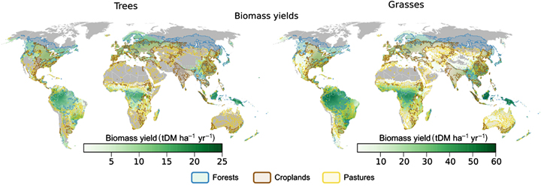
Figure 1. Simulated biomass yields for woody and herbaceous energy crops averaged from 1966-2005 (Berninger, 2011).

The idea of sustainability and renewability is important to the bioenergy/biofuel industry (Yue et al., 2014). Producing energy from biomass feedstocks presents difficulties due to low density for transport, feedstock quality variation, production performance, and variation of supply. These factors are critical in the context of the biomass energy supply chain (Mafakheri et al., 2014). A company’s business strategy involves leveraging competencies to achieve strategic goals. This competency directs the firm’s theoretical performance direction. For example, in the context of this thesis, a functional and optimized supply chain focuses on the reduction of operational costs and maximization of efficiency (Happek, 2005).
The geographical scope of this thesis is the Southeastern United States. The regional focus is the result of the “Biofuels Strategic Production Report” by the U.S. Department of Agriculture in 2010. USDA projected that in the U.S., in order to meet the RFS goals by 2022, a combination of dedicated energy crops (perennial grasses, biomass sorghum, and energy cane), oilseeds (soy, canola), crop residues (corn stover, straw), woody biomass and corn starch will be necessary. The USDA estimated the contribution from different regions in the United States for biofuel production (Figure 2). Five geographical regions of the U.S. were categorized based on percentages regarding their contribution to the Renewable Fuel Standard 2 (RFS2).
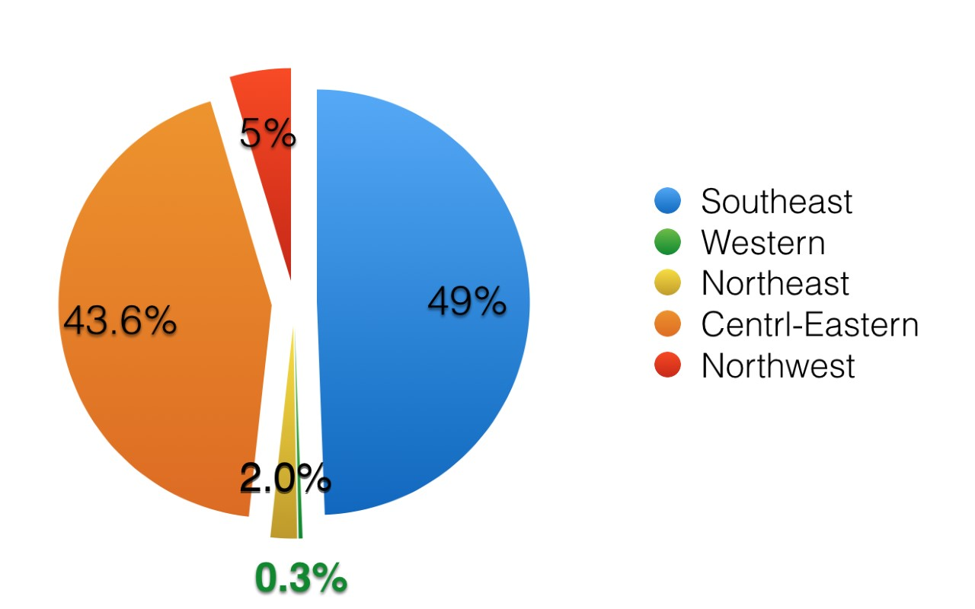
Figure 2. Estimated contribution to RFS (Vilsack, 2010).

The current wood supply for biomass energy consists of 81 power generating biomass-based projects of which 51 produce wood, and 17 produce liquid biofuel (Sooduck, 2010). European Union (EU) countries have developed independent national renewable action plans presenting schedules and engagements to meet the EU’s Renewable Energy Directive (RED), by 2020 (Commission, 2009). RED foresees that at least 20% of total European energy consumptions will come from renewable fuels. Energy from renewable fuels may come from wind, solar, geothermal, wave, tidal, hydropower, biomass, landfill gas, sewage treatment plant gas and biogases (Parliament, 2008). Due to the high demand for wood pellets in the EU, especially driven by the United Kingdom, Belgium, Denmark, and Netherlands; wood pellet exports from U.S. have risen from 1.6 million short tons in 2012 to 3.2 million short tons in in 2013. Ninety-eight percent of these exports were directly shipped to Europe (Wong et al., 2014). In 2014, 73% of the 4.4 million short tons, exported by the U.S., were delivered to the United Kingdom (Lowenthal-Savy, 2015). In 2010, the southern United States generated a supply of 65 million tons for biomass feedstock (Sooduck, 2010). Potential feedstocks feasible for supplying biofuel production facilities in the Southeastern U.S. consist of soybean oil, energy cane, biomass sorghum, perennial grasses, and woody biomass. USDA assumes, according to the EISA, that biomass is grown on well-defined agricultural cropland, meaning cropland where crops are produced, which does not include woody biomass.
Biomass utilization has become increasingly important for the timber industry. Biomass, in general, is considered as the total of organic matter in trees, crops, and living plant material. Woody biomass however, refers to the sum of materials collectable from a tree, including tops, limbs, needles/leaves, and woody fragments (OFRI, 2006). Timberland based feedstock, including wood residues, are feasible resources for biofuel production (Vilsack, 2010). Southern yellow (Pinus taeda) pine is a softwood species native to the Southern U.S. and is a resource for a variety of products. Due to its fast growth rate, lignin yield, and availability, southern yellow pine is an attractive biomass source (Owsley, 2011). Due to the emerging market and the rising demand of renewable fuels, the biomass industry has to focus on its operational effectiveness and increased efficiency to lower costs and maintain relevancy (Eisentraut, 2010). Current crude oil price development may suggest a decrease in investment on renewables (Figure 3). However, investments globally have risen by 17 percent, reaching $270 billion in 2014 (Nyquist, 2015). Dependence on imported energy, can also impact economy’s stability significantly (Aguiar-Conraria et al., 2006).
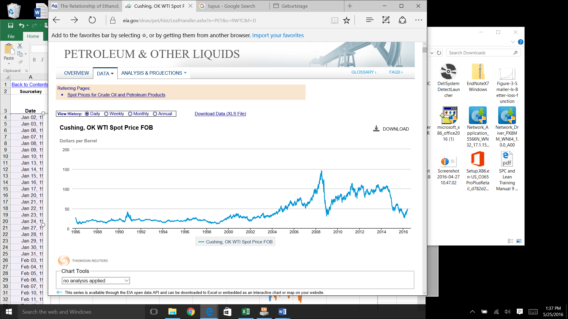
Figure 3. Cushing, Oklahoma (OK) West Texas intermediate (WTI) spot price FOB (Administration, 2016).

In 2012, 40% of the U.S. petroleum demand were covered by net imports (EIA, 2013), see Table 1.
Table 1. Top Sources and amounts of U.S. Petroleum imports (EIA, 2016).
Top sources and amounts of U.S. petroleum imports, exports, and net imports, 2015 (million barrels per day)
Import sources | Gross imports | Exports | Net imports
Total, all countries | 9.40 | 4.75 | 4.65
OPEC countries | 2.90 (31%) | 0. | 2.65
Persian Gulf counties | 1.51 (16%) | 0.01 | 1.50
Top five countries
Canada | 3.75 (40%) | 0.95 | 2.81
Saudi Arabia | 1.06 (11%) | 0.00 | 1.06
Venezuela | 0.83 (9%) | 0.08 | 0.75
Mexico | 0.76 (8%) | 0.08 | 0.07
Colombia | 0.39 (4%) | 0.17 | 0.22

In 2015, the United States imported about 9.4 million barrels per day (MMb/d). The top five net importing countries were Canada, Saudi Arabia, Venezuela, Mexico, and Colombia (EIA, 2016). Due to the high percentage and therefore, dependence on foreign crude oil supply, concerns about geopolitical, national security, and economic consequences have arisen. Due to the potential energy risks mentioned above, the U.S. congress advocated “energy independence” for United States, which resulted in the Energy Independence and Security Act (RAND, 2009).

Rationale for this Thesis
A key problem for biofuels is the large variance associated with feedstock quality and the ability of the manufacturing process to account for this variability, and the resulting influence this variability has on the variability of the quality of biofuel outputs. This ‘large variance’ problem directly influences the higher than necessary cost of final biofuel product, and inhibits biofuels to be price competitive in the market place. This thesis focuses on modeling the biomass supply chain of the ‘bioenergy depot’ (referred to in this thesis as the ‘bio-depot’) by estimating system and components variance which directly impact costs. The bio-depot is a concept focused on a centralized processing system, that receives woody biomass (e.g., loblolly pine residuals) and Switchgrass, through separate supply lines. The biomass sources are then blended and converted into feedstocks with more uniformity in particle size geometry, moisture content, and ash content which conform better to the specifications of the biorefineries. The thesis of this research is that quantifying the system variance of the bio-depot and the variance of its components will identify those components that have the greatest impact on cost in the bio-depot. Variance has a direct influence on cost of manufactured product (Taguchi et al., 2004). The logistics component of the biomass supply chain and associated bio-depot contains multiple-stages where variation accumulates and increases the costs of the system. Statistical Process Control (SPC) and industrial statistics methods will be used to quantify variation; the Taguchi Loss Function will estimate the cost of the quantified variance (Taguchi et al., 2004) (Deming, 2000).

Objectives
The objectives of the thesis are:
- Defining the upstream of the supply chain for loblolly pine,
  - Develop a logistics map from harvest site to plant-gate,
  - Develop a reliability block diagram with components of variance for the bio-depot within the plant gate,
  - Definine the key metrics in the supply network, based on 1a,
  - Quantify the variation for the key metrics;
- Create an Excel simulation spreadsheet for 1a and 1b, and 1c,
  - Simulate the process by assuming a Gaussian or normal distribution for variation;
- Apply the Taguchi Loss Function to estimate cost of variation for 1a, 1b and 1c;
- Conduct simulations to estimate costs and illustrate methods for reducing cost.

Chapter II. Literature Review

Background Analysis

Historical Background of Supply Chain Evolution
In the early 20th century, Henry Ford redesigned the supply chain of his company. Manufacturers and producers have dealt with logistics and supply chains ever since. A healthy and sustainable supply chain became a symbol for a competitive and beneficial enterprise (Rushton et al., 2014, p. 7). Ford saw the need for a variety of products, but he also recognized the complexity of a broad selection shown as an accumulation of waste in production resulting in unwanted costs (Goldsby et al., 2005). General Motors anticipated the customers’ needs and offered its products in a variety of specification options (Shah, 2009). A major issue of logistic systems in the 1950s was an uneven workload distribution and lack of information within the chain (Rushton et al., 2014). Between 1960 and 1970, Toyota initiated the Toyota Supply Chain. The Toyota Motor Company started to assemble and manufacture key components in their own production sites; other components were provided by third-party suppliers. Toyota built a supply network with partners with in short distance to the main plant. This strategy reduced the time needed to change a setup from hours down to several minutes (Shah, 2009). With the rise of technology and the fast exchange between enterprises, supply chains have become more complex and accurate. For example, the computer manufacturer Dell did not focus on long-term relations to suppliers but instead made short-term contracts only to highly flexible suppliers. Suppliers delivered on a just-in-time basis to ensure that Dell’s CPUs were assembled according to the demand of the consumer. The Dell monitors, however, went directly from the supplier to the customer in order to reduce storage cost (Figure 4) (Taylor, 2004).
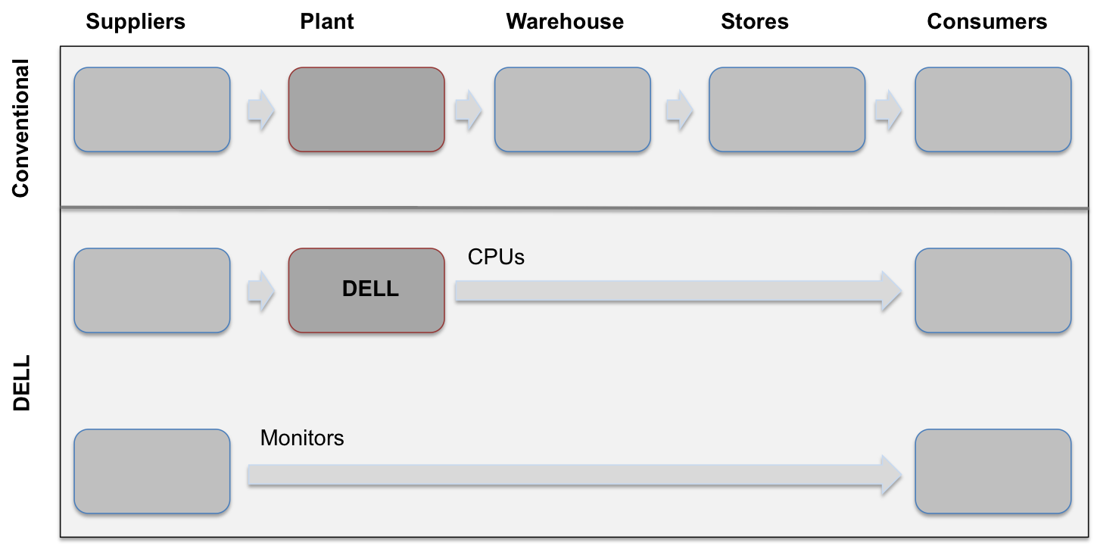
Figure 4. Dell’s Supply chain strategy (Shah, 2009, p. 7).

Supply Chain Today
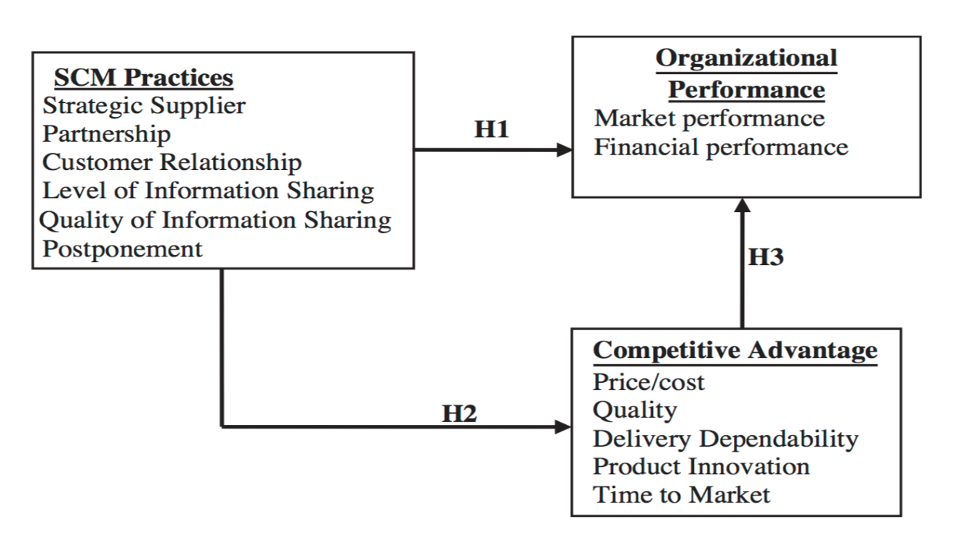
In today’s economy, companies are dealing with the “network competition age.” Sophisticated marketing plans and well-resourced showrooms are not a guarantee for success anymore, and the paradigm has shifted to supply chain competition. Markets are characterized by rapid changes and fluctuation in demand (Erturgut, 2012). Modern supply chain management (SCM) is operating under increased variability and constant reorganization due to changes in the market. Information Technology practices enable direct and fast communication between nodes integrating the supply network into the value system (Marinagi et al., 2014). SCM practices have a direct influence on both organizational performance and competitive advantage (Figure 5) (Li, 2004).
Figure 5. Influence of SCM on organizational performance and competitive advantage (Li, 2004).
SCM operations have to improve the throughput in combination with low storage and work in process. A significant driver of a firm’s success is linkage between Just in Time (JIT), Total Quality Management (TGM), and SCM practices. Effective integration of these practices into operations management improves performance and therefore, creates value and reduces overall costs (Kannan et al., 2005). Supply chains can be split into two categories, independent from enterprise size, namely upstream and downstream (Figure 6).
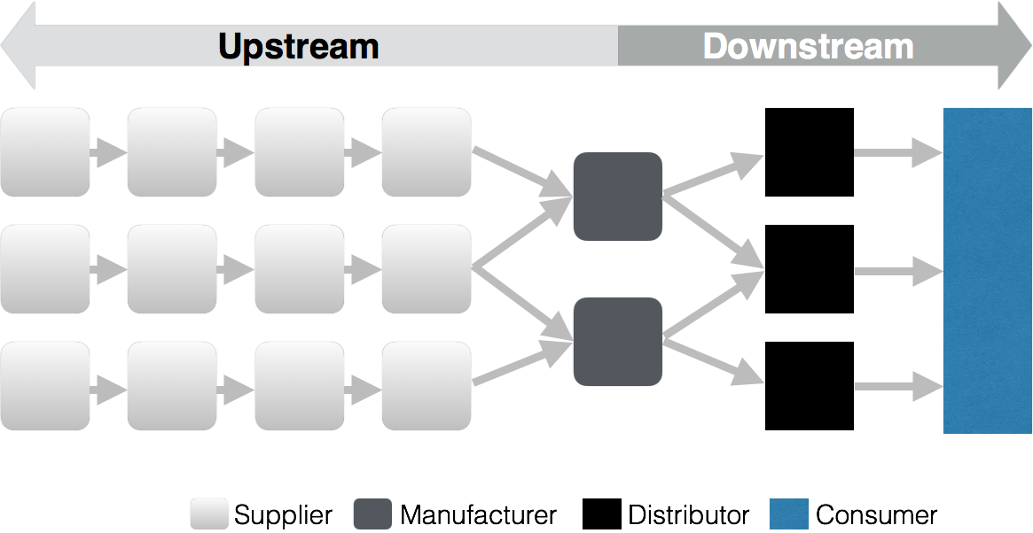
Figure 6. Segments of a supply chain.
Upstream refers to partners that provide the manufacturer with goods and services needed to satisfy demands. The supply side of the supply chain also includes other flows such as return product movements, payments for purchases and can be described as the opposite of a downstream. Downstream defines the flow of goods and services from the manufacturer to the consumer. This section is also known as the demand side of the supply chain, were usually third party companies support a manufacturer with the distribution goods (Visions, 2010).

Biomass

Biomass Supply Chain/Logistics
The literature reviewed for this chapter focuses on commonly used techniques to monitor and improve supply chains. This includes the identification of supply network issues and the application of models.
Biomass supply is built on a multicomponent supply network that faces availability challenges. This network can be described as a construct of five stages: feedstock production, feedstock logistics, biomass processing, biomass product distribution, and biomass end-product (Parish et al., 2012). The feedstock logistics stage includes all needed procedures to transport feedstock from harvest site to the production facility’s gate (Chung, 2010). A layout that emphasizes activities needed for transporting feedstock from the production point to a power station is described in six steps: Harvesting/collection, In-Field/Forest Handling, Storage, Loading/Unloading, Transportation, and Processing (Rentizelas et al., 2009). Figure 7 illustrates the process of a uniform format feedstock supply system. ‘Depots’ (i.e., intermediary processing station) are located strategically close to harvesting sites of the feedstocks. These depots include a preprocessing stage to ensure higher throughput quantities in transportation (Hettenhaus et al., 2004).
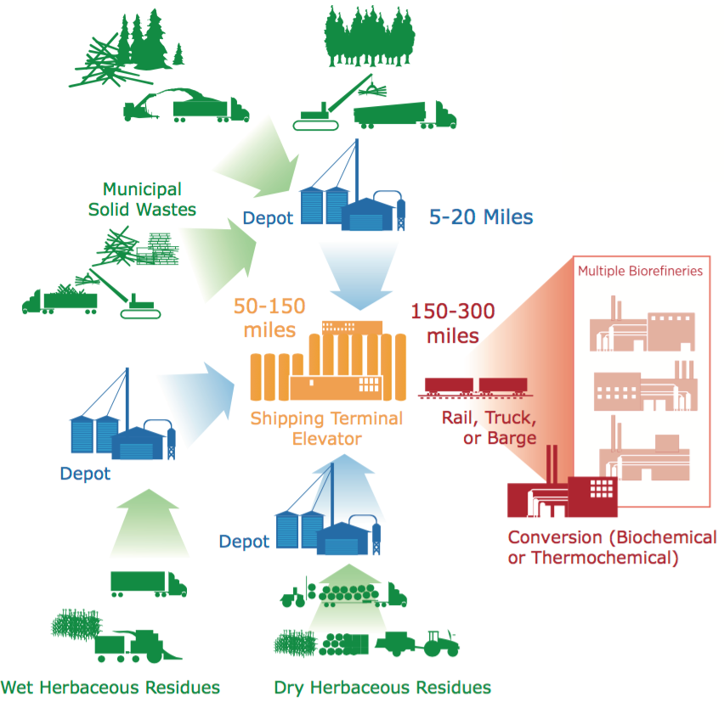
Figure 7. Feedstock supply system (Hettenhaus et al., 2004).

Preprocessing feedstocks have a major influence on transportation performance. The U.S. Department of Transportation declares the maximum weight limit for a truck to be 80,000 lbs. (approximately 40 tons), even though this varies by state regulations. Transportation parameters have to be taken into consideration when it comes to the preprocessing procedure. There are a number of established equipment options for harvest and on-site preprocessing. The level of preprocessing has a direct impact on entire efficiency of the supply chain.
Density is a limiting factor of the supply chain for bio-based feedstocks like Switchgrass (Panicum virgatum L.). For example, the density of chopped Switchgrass is around 70 kg/m³ while pelleted Switchgrass has a density of 700 kg/m³ (Sooduck, 2010). Switchgrass is harvested seasonally. Therefore, long term storage of feedstock has to be accounted for to ensure a stable annual supply. A challenge of the storage process is trying to minimize loss of feedstock due to decay. (Uslu et al., 2008). An example of a more detailed woody biomass logistics chain is shown in Figure 8. 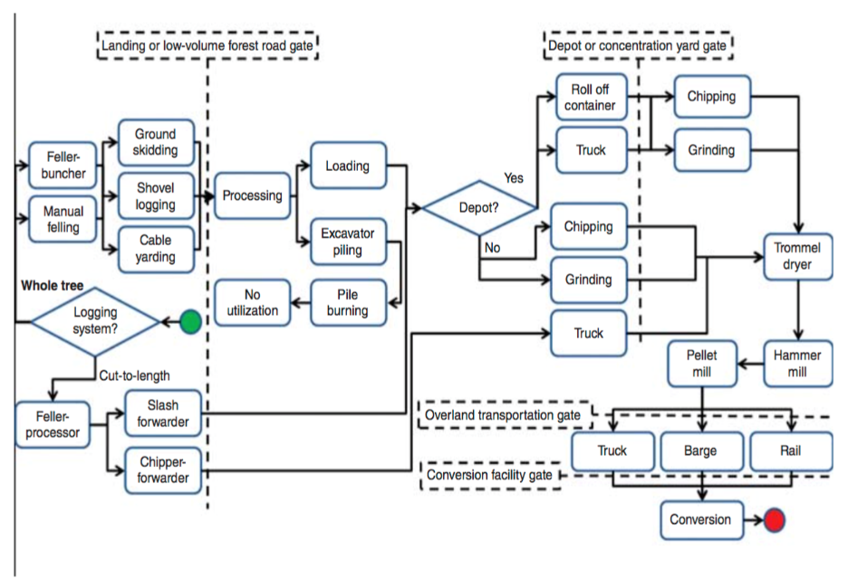
Figure 8. Example of possible primary woody biomass supply chain (Keefe et al., 2014).

Keefe et al. (2014) created a flow map for woody biomass, including different logging, preprocessing, and logistics-options. All these steps are potential causes for variation (Keefe et al., 2014). A bio-depot concept attempts to reduce variability of key feedstock characteristics, e.g., particle size, ash content and moisture content. The depot must be able to assess and quantify the variability of feedstock characteristics in order to meet the specifications and reduce the variability of the output feedstocks. Biomass feedstocks are typically blended to meet the target (Mafakheri et al., 2014). However, blending does not reduce the sum of the component variances, i.e., variance is additive as defined mathematically for any series or parallel system. The variance for a two component parallel system with independent components is defined as:
$Var \left(A+B\right)=Var \left(A\right)+Var \left(B\right).$ [1]
The variance for a two component series system with dependent components is defined as:
$Var \left(A+B\right)=Var \left(A\right)+Var \left(B\right)±2COV\left(A,B\right),$ [2]
assuming equal variance for each component,
or,
$Var(aX + bY) = a2VarX + b2VarY ± 2abCov(X,Y)$ [3]
assuming unequal variance for each component. The Bio-depot is similar to a series or dependent system.

Feedstocks of the Bio-Depot Addressed in this Thesis

Loblolly Pine (Pinus taeda)
Loblolly pine (Pinus taeda) is native to the Atlantic and Gulf coastal plains of the United States (Figure 9). The soil requirements of this coniferous tree shares similarities with Switchgrass; both plants grow on sandy and relatively infertile ground. This is one reason why loblolly pine is preferable for reforestation and erosion control (Owsley, 2011). The elevation requirement ranges from approximately sea level up to 1,970 feet (600m). Most of the loblolly pine forests are found at elevations below 660 feet (200m). The high quality timber of loblolly pine is well suited for sawlogs, poles, pulp, and plywood. At twenty years of age, the yield/ha is approximately 874 ft³ (61 m³) (Boyer, 1993). The range of loblolly pine is from southern New Jersey to eastern Texas, down to central and south Florida (Figure 9). Due to its adaptability, loblolly pine was introduced to other continents, such as Africa and Australia (J. B. Baker et al., 1990).
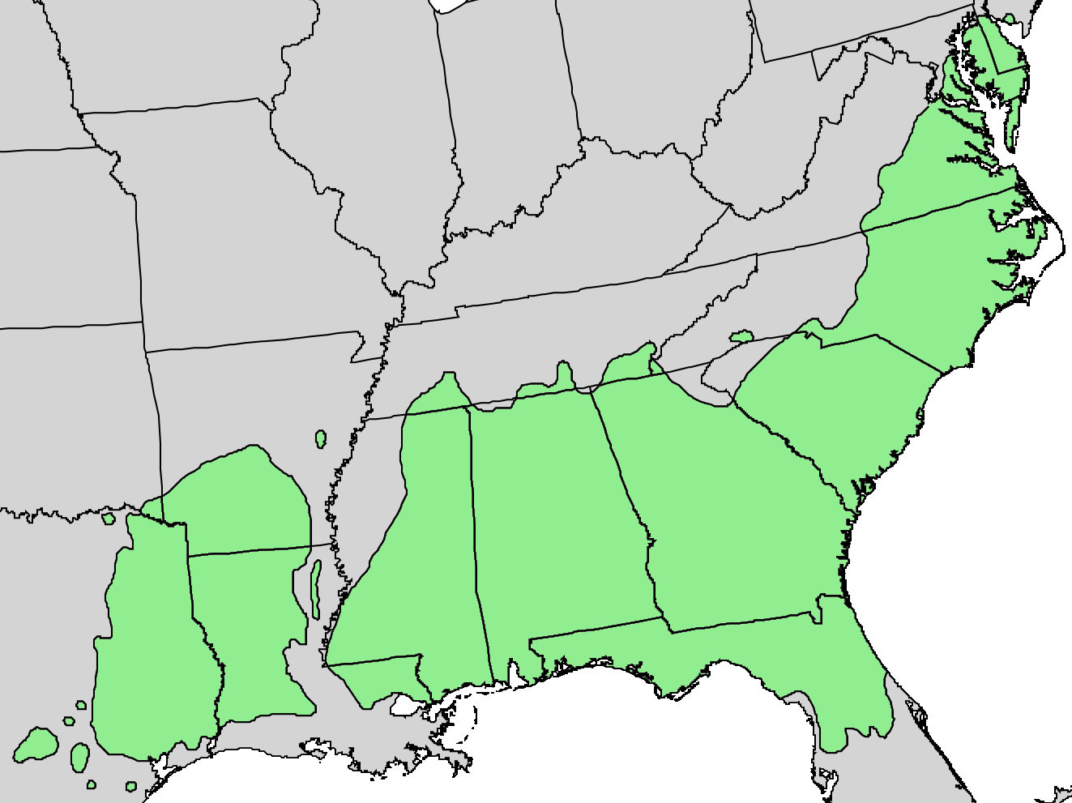
Figure 9. Native spread of Loblolly Pine (Little, 1966).

Figure 10 is an illustration of stages of biomass upstream process, starting with the harvest site. The stages all contribute to the feedstock’s total variance of feedstock quality attributes. Three feedstock characteristics are included in this thesis for simulating variance and estimating costs, e.g., particle size geometry of processed wood and Switchgrass, moisture content, and ash content.

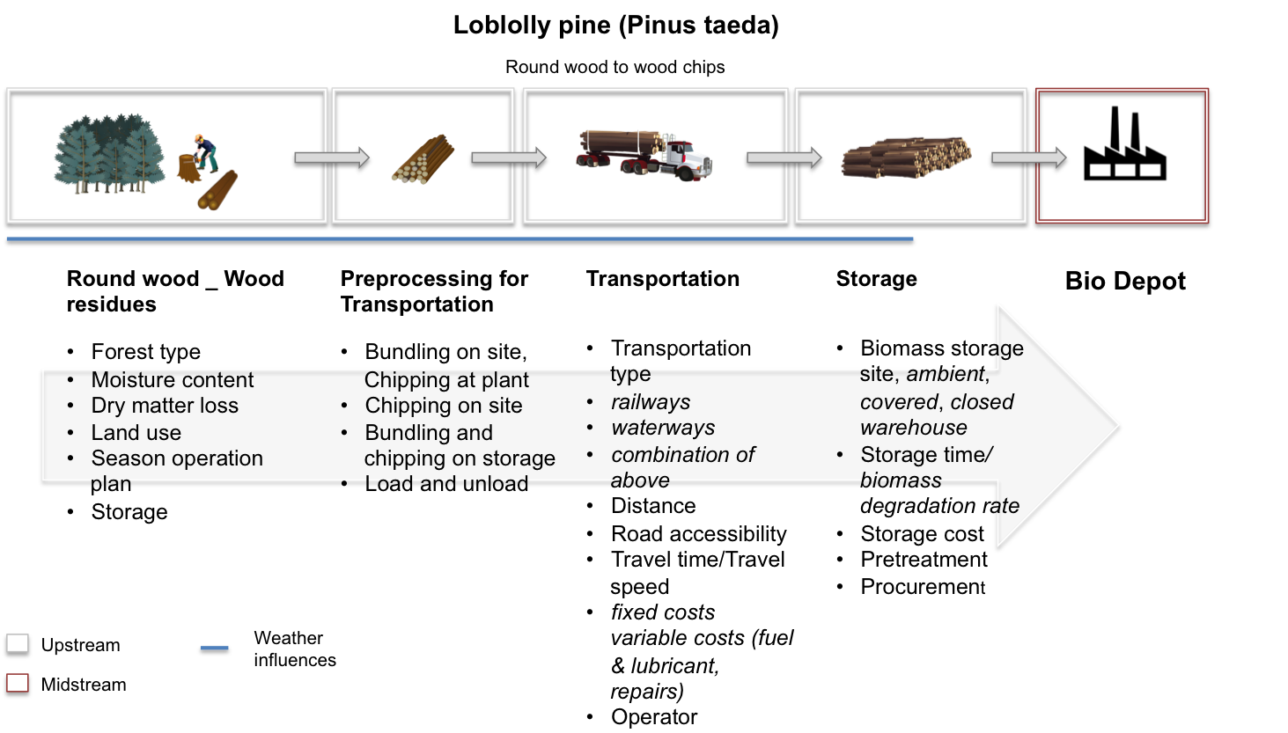
Figure 10. Loblolly Pine (Pinus Taeda) processing steps for the bio-depot concept.

Switchgrass (Panicum virigatum L.)
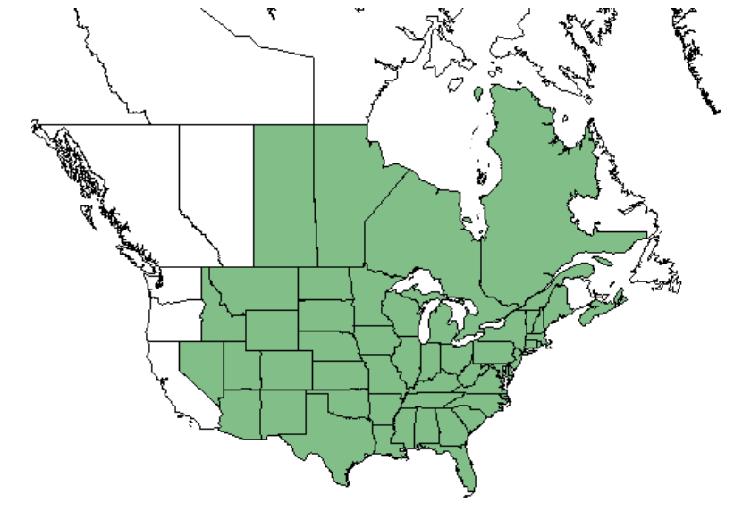
In 1978, the Department of Energy (DOE) mandated that Oak Ridge National Laboratory (ORNL) investigate the potential of fast growing trees as well as crop residues for renewable energy. ORNL assessed more than 30 herbaceous crops; Switchgrass was determined as the most beneficial high yielding perennial grass species. In 1991, Switchgrass (Panicum virigatum L.) was declared as a model energy crop (Mohammed et al., 2015). Switchgrass’s compatibility with common farming procedures led to the decision to use Switchgrass as resource for bioenergy (Sanderson et al., 1996). Switchgrass is a perennial bunch grass native to southeastern and central United States shown by the distribution map (Figure 11). The grass is climatically adapted throughout most of the United States. The distribution map emphasizes the minor soil requirements of Switchgrass.
Figure 11. Native spread of switchgrass (Database, 2009).

The best growing regions are those with a dry to poorly drained soil, as well as sandy or clay soils. Switchgrass doesn’t perform as well on dense soils, also known as heavy soils (Parrish et al., 2005). The grass grows from one to three meters in height, without extensive environmental or genetic influence, and its roots can penetrate the soil up to a depth of 3 meters (Luo et al., 2014). Switchgrass requires two to three years of establishment to be considered fully applicable for commercial use. This perennial grass is then harvestable for up to 15 years before replanting is necessary (Lu et al., 2015).
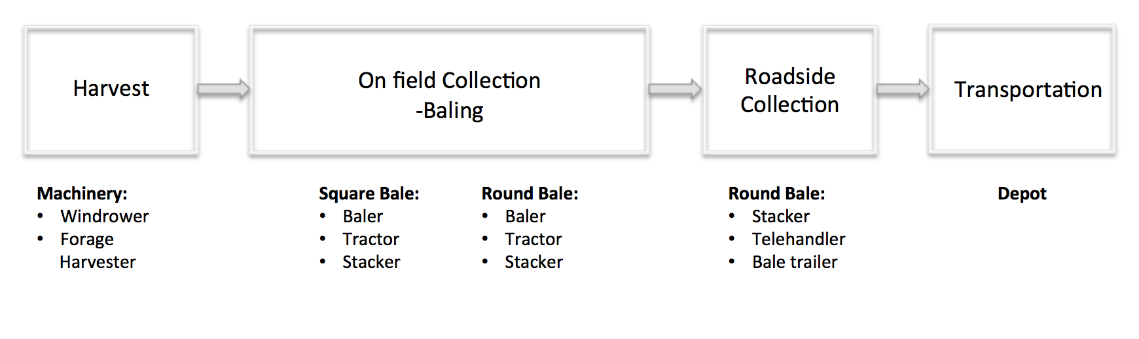
The limited time frame of Switchgrass harvesting season makes a continuous supply throughout the year difficult. Therefore, several suppliers/supply-lines have to be used by the bio-depot for a continuous supply to the manufacturing facility. Suppliers deliver different varieties of Switchgrass which creates variations in the feedstock quality (e.g., ash content, etc.). Blending of feedstocks is typically done to try to meet the required target requirement (e.g., ash content), but this does not reduce total variability (recall equations [1] and [2] that variance is additive). The total variance of the blend must meet the specifications of a bio-refinery. Switchgrass biomass production includes several processing steps (Figure 12).
Figure 12. Field handling and equipment specification of Switchgrass biomass.

There is a large body of literature regarding the modeling and optimization of supply chains for different feedstocks, products, processes, system properties, and from various modeling viewpoints (Yue et al., 2014). The increased interest in cellulosic biofuel production, generated from forest residues, agricultural wastes, and energy crops (Naik et al., 2010). Numerous studies have focused on the availability of cellulosic biofuel supply. Prior research stated that there is sufficient quantity of potential feedstocks to meet the requirements of EISA (Perlack et al., 2005).
Biomass has the advantages to be a versatile energy sources, generating not only electricity, but heat. Energy from biomass can be produced on demand, which makes it a promising fuel of the future (Rentizelas et al., 2009). The demand and consumption of bio based energy will rise significantly, which confronts the bio based energy sector with one of its major concerns, a secured and effective supply chain (De Meyer et al., 2015). A large fraction of cost of biomass energy production comes from transportation and handling (Hettenhaus et al., 2004).
There is an increased interest in increasing global production of biomass and bio based energy as a substitute for fossil fuels. This substitution contributes to the mitigation of greenhouse gas emissions. Despite the benefits of biomass usage, technical and economic challenges prevent the paradigm shift for bioenergy to develop at a fast pace (Cambero et al., 2014). Key issues with a competitive bioenergy price are related to the difficult supply chain management. An optimized and efficient supply chain management is required to adjust to detailed conditions of the corresponding feedstock, production system, logistics, and handling (Gold et al., 2011). The purpose of efficient biomass handling and transportation is to keep the cost factor competitive compared to fossil fuels. Sufficient supply of feedstock relies on consistent growing cycles, negatively influenced by unpredictable natural causes (Awudu et al., 2012). Biomass allocation and supply equilibrium (BASE) addresses major questions of cost factors concerning biomass use and biomass logistics. This analysis accounts for the costs and losses from the harvest site to the end user (Ruth et al., 2013).

Table 1. Commonly used methods for improving supply chains.
Quantative Modeling Method | Citation
Supply Chain Design | (Elia et al., 2012),
Ant Colony heuristic procedure | (Zamora-Cristales et al., 2015)
Area Restriction Model | (Gunnarsson et al. 2004)
Game Theory and Special Market Equilibrium | (Dutta, 1999), (Myerson, 1997), (Bai et al. 2012)
Goal Programming Method | (Yue et al., 2014)
Heuristics Algorithms and Metaheuristics | (Mula et al., 2010), (Chern et al., 2007),(Power, 2005), (Thomas et al., 1989)
Superstructure Optimization | (Lababidi, 2004; Roghanian et al., 2007)
Robust Optimization | (Sahinidis, 2004)
Unit Restriction model (URM) | (Mafakheri et al., 2014)
Simulation models | (Ferreira et al., 2011)
Greet Model | (Lu et al., 2015)

A review of the literature indicted that no citations exist as related to the objectives of this thesis.

Statistical Process Control
Walter Shewhart (1891-1967)
Walter Shewhart, an American physicist, engineer, and statistician invented control charts to monitor a process performance (Best et al., 2006). Control charts are an essential feature of SPC. With this statistical tool, expanded by W. Edwards Deming (Austenfeld, 2001), it is possible to improve processes via reduction of variation, which is necessary for an organization’s survival (Wheeler et al., 2010).
In 1924, when Shewhart invented the control chart, statistical methods were not widely used in manufacturing (Wilcox, 2003). Shewhart wanted to emphasize that variation is found in any process, product, or organization. Where manufacturing was focusing on meeting the specification, Shewhart tried to improve process consistency as long as the products met “spec,” results were good enough for manufacturing. Specification limits are only accurate if they meet customers’ needs. To meet demand, a process has to continuously adapt according to the change in demand (Wilcox, 2003). While working for Bell Telephone Laboratories, Shewhart refined his control charts and was able to apply these in manufacturing. Instead of a 100% inspection policy, Shewhart introduced inspections based on sampling. Statistical quality control was widely applied in Western Electric facilities by the mid 1930’s (Montgomery, 2009). In 1939, Shewhart published his book “Statistical Method from the Viewpoint of Quality Control,” (Best et al., 2006) which was a milestone for modern production systems and therefore, SPC, TQM, Six Sigma and Lean Manufacturing.
W. Edwards Deming (1900-1993)
While pursuing his PhD Deming spent the summer working for Western Electric, where Deming met Shewhart. Deming obtained his doctorate in mathematical physics at Yale in 1928 and became (Best et al., 2005) a mathematical physicist for the Department of Agriculture. Deming supported American troops during World War II as a statistical advisor concerning statistical quality control and sampling methods. His input had tremendous effect on production performance with a heavy reduction in rework (Neave, 1987).
In 1950, Deming lectured a vast number of engineers and managers in SPC. Despite the positive impact his methods had on the production of goods for WWII, American companies didn’t realize the potential of Deming’s ideas (Best et al., 2005). Deming’s basic teachings:
- The chain reaction: quality, productivity, lower costs, capture the market,
- Productivity viewed as a system,
- The Fourteen Points for transformation of management,
- The Seven Deadly Diseases,
- The Plan, Do, Study, Act (PDSA) Cycle,
- The Red Bead experiment,
- The Funnel experiment,
- The system of profound knowledge (Austenfeld, 2001).
His lectures to the Japanese Union of Scientists and Engineers (JUSE) however, influenced many Japanese companies and their approach on quality control. Due to his impact on Japanese firms and the resulting post war recovery, Deming was recognized with the Deming Prize founded by JUSE in 1951. This prize is the highest honor a Japanese company can receive for quality control.
Ichiro Ishikawa, a chairman of JUSE, gave Deming the chance to talk to 21 of Japan’s top managers. At the time, Deming evolved his idea of the “Shewhart Cycle” (i.e., the Plan-Do-Check-Act or PDCA cycle) and was able to gain the interest of Japanese business elites. Back then, manufacturers were focused on designing a product, production, and sales. The big mistake found by Deming was that there was no evidence that the consumer had any need for the product. Deming introduced the “Shewhart Cycle” to the managers: (Austenfeld, 2001):
- Design the product,
- Make it, test it in production/laboratory,
- Put it on the market,
- Test it in service, through market research, research the costumer,
- Re-design the product according to costumers’ needs,
- Loop those 5 steps (Austenfeld, 2001; Wheeler et al., 2010).
This process was condensed as the PDCA, Plan Do Act Check (Figure 13).

Figure 13. Shewhart Cycle/ Deming Cycle (Deming, 2000).

In 1986, Deming’s combined practices were published in the book “Out of the Crisis” (Deming, 2000). This work represents all quality improvement tools that he worked on throughout his life. In this book, Deming presented fourteen key principles, principles that management of any kind of company could use to achieve continuous improvement.
Deming’s 14 points were:
- "Create constancy of purpose towards improvement." Replace short-term reaction with long-term planning.
- "Adopt the new philosophy." The implication is that management should actually adopt his philosophy, rather than merely expect the workforce to do so.
- "Cease dependence on inspection." If variation is reduced, there is no need to inspect manufactured items for defects, because there won't be any.
- "Move towards a single supplier for any one item." Multiple suppliers mean variation.
- "Improve constantly and forever." Constantly strive to reduce variation.
- "Institute training on the job." If people are inadequately trained, they will not all work the same way, and this will introduce variation.
- "Institute leadership." Deming makes a distinction between leadership and mere supervision. The latter is quota- and target-based.
- "Drive out fear." Deming sees management by fear as counter- productive in the long term, because it prevents workers from acting in the organization’s best interests.
- "Break down barriers between departments." Another idea central to TQM is the concept of the 'internal customer', that each department serves not the management, but the other departments that use its outputs (Young, 2015).
- "Eliminate slogans." Another central TQM idea is that it's not people who make most mistakes - it's the process they are working within. Harassing the workforce without improving the processes they use is counter-productive. Deming’s Bead Box Experiment.
- "Eliminate management by objectives." Deming saw production targets as encouraging the delivery of poor-quality goods.
- "Remove barriers to pride of workmanship." Many of the other problems outlined reduce worker satisfaction.
- "Institute education and self-improvement."
- "The transformation is everyone's job."

Joseph M. Juran (1904-2008)
Juran, an American engineer and consultant, is considered to be the founding father of Total Quality Management (TQM). Juran was aware of the importance of human resources and related actions towards the goal of high quality products. Juran focused on empowered organizations, where employees align their goals and responsibilities with the firm’s duty to satisfy the customer needs. The concept of an empowered organization is described as: Empowerment = alignment x authority x capability x commitment (Joseph M. Juran et al., 1998). If TQM is applied correctly, it should result in lower costs, higher revenues, empowered employees, and delighted customers. The importance of these results is captured in Figure 14.
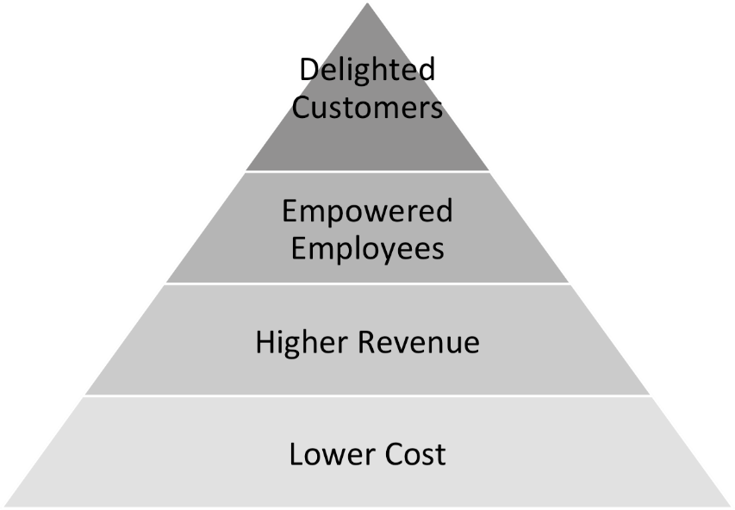
Figure 14. Joseph M. Juran - Results of TQM (Joseph M. Juran et al., 1998).

Joseph M. Juran developed the “Quality Trilogy” also known as the “Juran Trilogy”. This trilogy deals with the concept that quality oriented managing consists of three steps.
Quality Planning: Creating a technique/process that has the capability of meeting specifications under certain conditions that are established by operations.
- Identify the customers, both external and internal.
- Determine customer needs.
- Develop product features that respond to customer needs. (Products include both goods and services).
- Establish quality goals that meet the needs of customers and suppliers alike, and do so at a minimum combined cost.
- Develop a process that can produce the needed product features.
- Prove process capability—prove that the process can meet the quality goals under operating conditions.
Quality Control: Pursuing optimal effectiveness of any kind of process. Flaws/waste that are implemented in the process during the planning phase have to be addressed and eliminated. Quality control prevents waste/quality from getting under specifications/control limits.
- Choose control subjects — what to control.
- Choose units of measurement.
- Establish measurement.
- Establish standards of performance.
- Measure actual performance.
- Interpret the difference (actual versus standard).
- Take action on the difference.
Quality Improvement: A process step implemented by management in, addition to quality control, to ensure continuous improvement.
- Prove the need for improvement.
- Identify specific projects for improvement.
- Organize to guide the projects.
- Organize for diagnosis—for discovery of causes.
- Diagnose to find the causes.
- Provide remedies.
- Prove that the remedies are effective under operating conditions.
- Provide for control to hold the gains (J.M. Juran, 1986).
Joseph M. Juran inspired Apple founder and former CEO Steve Jobs (1955-2011) to question the reason for a process’s success. Jobs described Juran’s advice to him: “Look at everything as a repetitive process and instrument that process to find the reason why it is working. So that one is able to take it apart and reassemble it with improved effectiveness” (Jobs, 1990).

Lean Principles
Lean principles, an invention by the Toyota Motor Corporation, is also known as Toyota Production System. The oldest component of TPS, Jidoka, was invented by Sakichi Toyoda in 1902. Jidoka focuses on autonomation and therefore, more productivity within the system combined with less time, space, and effort while meeting customers’ needs (Dennis, 2002). The Japanese terminology where Lean originated is three specific kinds of waste: Muda, Mura, and Muri. Muda identifies waste of time and material, Mura addresses variation, and Muri emphasizes overburdening of workers or systems (Young, 2015). The reduction of inventories, waste, and improvement of the overall system performance are the main ideas behind this instrument. Toyota addressed seven kinds of waste in their production (Table 3). Due to the definition of the problem’s source, it is easier to improve the process. The seven waste factors are (Dennis, 2002):

Table 2. Seven types of waste (Young, 2015), (García-Alcaraz, 2014).
7 Types of Waste | Causes of Waste | Consequence
1. Correction | - Poor internal quality | - Extra handling  - Additional labor  - Risk of additional defects, delivering inferior products
2. Overproduction | - Machine breakdowns  - Wrong interpretation of efficiency  - Variation in loads | - Necessity for additional parts, storage, materials  - Increase in conveyance  - Growth of stock
3. Waiting | - Breakdowns  - Changeovers  - Delays  - Poor Layout | - Unnecessary cost  - Imbalanced workflow
4. Conveyance | - Inefficient facility design | - Materials and people move more than necessary
5. Processing | - Wrong use of machinery  - Insufficient machinery | - Production of products that are over or under customer specification
6. Inventory | - Unequal capabilities within process | - Work in process (WIP)  - Unbalanced work distribution  - Cost/space  - Additional handling/labor
7. Motion | - Unnecessary movement | - Time and energy

One essence of lean is to specify the value desired by the costumer (Young, 2015). Questioning each and every step within the production is beneficial for a continuous workflow. Value-added tasks should be maximized, where other steps of non-value or waste should be eliminated.

CHAPTER III.
Materials and Methods

Bio-Depot Concept
A challenge of supplying southern pine and Switchgrass is the high cost of transportation and handling (Lu et al., 2015). The research in this thesis will demonstrate the potential of a new type of biomass supply system (i.e., “The Bio-Depot”). The biomass supply system includes a centralized processing system within the supply chain which blends feedstocks in attempt to meet the target and specifications of biorefineries. The processing facility, also called “bio-depot’ (or ‘merchandising depot’), will convert stems of woody biomass (includes limbs and leafy materials) into the feedstocks for biofuels. This step is envisioned to reduce handling costs for bioenergy production (Figure 15).
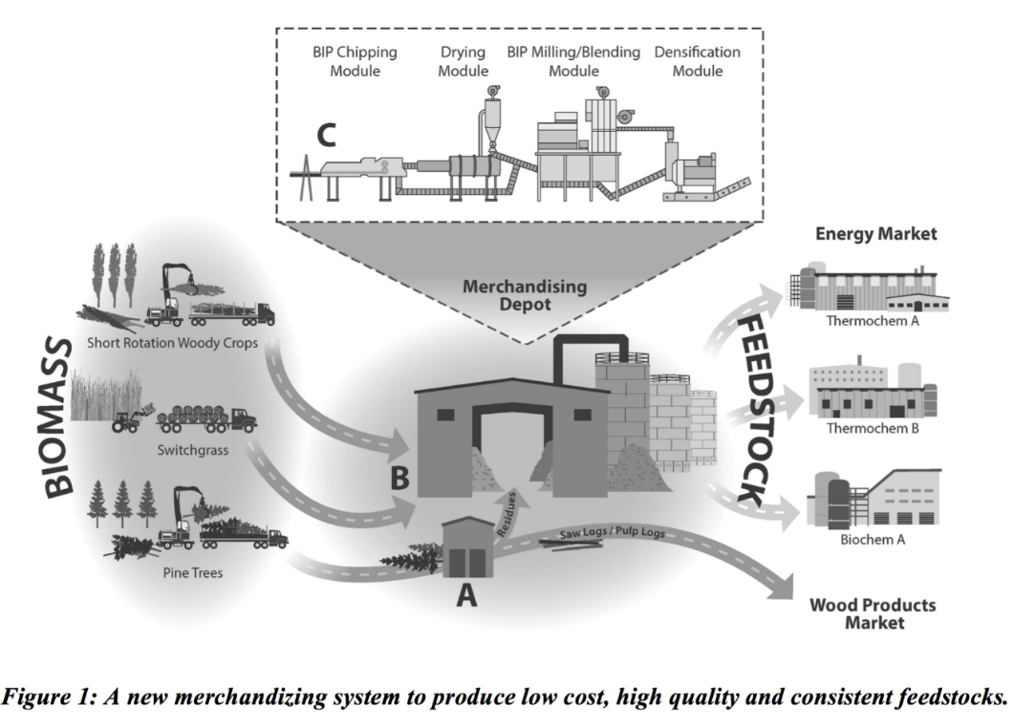
Figure 15. Merchandizing system for consistent feedstock.

The bio-depot will include several processing modules. Establishing this bio-depot within upstream supply chains of biomass is envisioned to increase throughput capacity while reducing variation and lowering costs. This thesis will simulate variation within the bio-depot. This thesis uses conceptual modeling which is an abstract view of the process. The process is described with a simplified model. Conceptual modeling is usually based on assumptions taken from real systems (Robinson, 2010), see Figure 16.
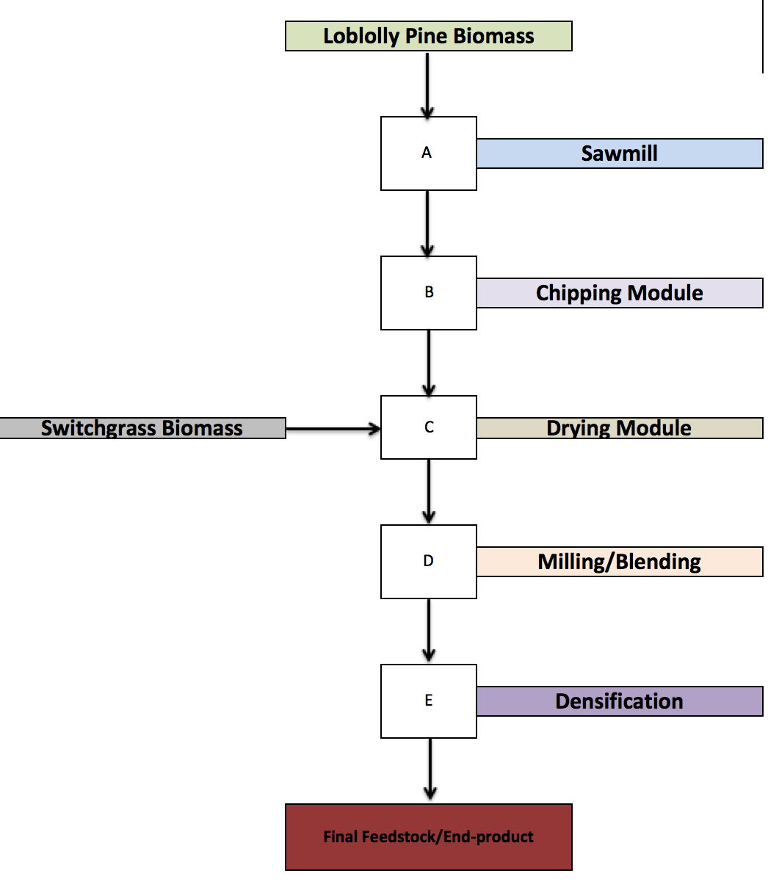
Figure 16. Conceptual model of bio-depot.

The different stages of the conceptual model are described below.

Component A - Sawlog or round wood supply
Full southern pine trees will be hauled to a sawmill for example; and will then be converted into high valuable wood products, as well as clean supply of woody residues. The sawmill will provide the merchandising depot with residues from the pine sawlogs (e.g., limbs, treetops, and needles). It is believed that the ash content will be reduced relative to producing this residue material from in-woods harvesting operations. Ash content or ash contamination is key problem with biomass feedstocks. Sawlogs typically yield many products and residues after being processed, as displayed in Figure 17.

Figure 17. Softwood produce quantities from a sawmill (Dean Goble, 2013).

These quantities vary by diameter of the log (Dean Goble, 2013). The quantity of residue produced by timber processing plants differs from properties of timber, timber species, tool condition, maintenance intervals, etc. However, averages proportion of residues produced from different wood processing industries is presented in Table 2.
Table 2. Proportion of wood residues generated by wood processing manufacturers excluding bark (Murray, 1990).
 | Sawmilling | Plywood Manufacturer | Particle Board Manufacturer | Integrated Operations
 | % | % | % | %
Finished Product (Range) | 45-55 | 40-50 | 85-90 | 65-70
Finished Product (Mean) | 50 | 47 | 90 | 68
Residues | 43 | 45 | 5 | 24
Losses | 7 | 8 | 5 | 8
Total | 100 | 100 | 100 | 100

Component B – Knife-ring Flaker
The bio-depot concept foresees to generate supply from preprocessed timber residues. Preprocessing is done by a sawmill. The Clean wood chips are produced from clean wood after debarking. Dirty chips are produced from entire trees, the chips include bark, needles, branch wood, and contaminations. Contaminations may consist of such things as soil and gravel (Mackes, 2010). According to the International Organization for Standardization (ISO), and therefore EN ISO 17225 series (Standard for Solid Biofuels), fuel specifications and classes for wood chips are:
EN ISO 17225-1: General Requirements
EN ISO 17225-4: Graded Wood Chips
The EN ISO 17225 also included standards and requirements for wood pellets briquettes, and firewood (ISO, 2014). However, no comparable standards
where found that apply for the United States.
The knife-ring of wood residues is required to produce uniform sized wood chips for the drying process (i.e., Component C - Drying Module which is discussed later). The handling of stems and limbs is performed by a drum style chipper. Processing loblolly stems with a drum-style chipper results in a chip size distribution from three mm to 63mm (Figure 19) (S. Baker et al., 2011).
Figure 18. Loblolly pine chip size distribution after drum style shipping (S. Baker et al., 2011).

After the intermediate step of knife-ring, previous studies prove that the moisture content of chips have an average 55% green-weight basis (Mackes, 2010).
The received wood chips are converted into smaller particles, by crushing the material using a knife-ring flaker. A knife-ring flakers (Figure 20) use the principle of converting cut woody material into strands, wafer or, flakes. The material is feed into a chamber that is encompassed by a blade ring, which rotates at high speed. Not only does the drum cut the material into smaller particles, furthermore, the material is moved slowly, which enables a continuous flaking process.
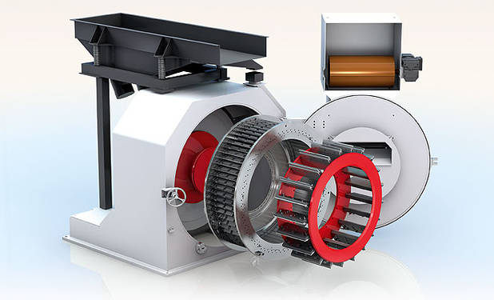
Figure 19 Knife-ring flaker (Hombak, 2013)

Component C - Drying Module
Available techniques for drying various types of biomass have a direct impact on dry matter loss and fuel quality (Jirjis, 1995). Rotary drum dryers are the most commonly used machinery to decrease the moisture content of wood flakes and particles. The dryer consists of a hollow, rotational cylinder, that holds the to be dried material. Hot air is introduced to the rotating chamber to ensure an evenly distributed heat distribution within. The cylinder is mounted in a slight angle so that the material moves along the length of the dryer (Figure 20).

Component D - Milling/Blending Module
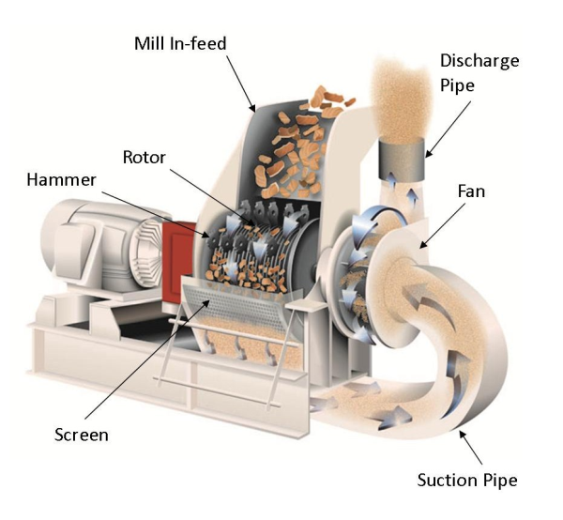
Uniform size reduction is important for pretreatment of biomass. This treatment step increases the particle size as well as the pore size of the feedstock (Drzymala, 1993). A commonly used method is to shred or crush material into smaller particles for the different application across industries. A hammermill (Figure 20) is common and operation depends on the feedstock’s properties such as moisture content, initial particle size, ash contamination, and operational throughput (Mani et al., 2004).
Figure 20. Display of pneumatic hammer mill (Brown, 2012).

In the bio-depot concept a multi-feedstock system is introduced that blends loblolly pine and Switchgrass.

Component E - Densification Module
Component E deals with the densification of the feedstock. Its purpose is to upturn the bulk and energy density, permitting an optimized transportation process, storage, and increases the energy output per bushel for refining purposes (Miao et al., 2013). Raw biomass varies in shape and energy content significantly. Biomass densifications processes have been adapted from highly productive and efficient industries, such as food and pharmacy. The application of pellet mills (Figure 21), briquette press, and screw extruder have been the most common machinery in use for bioenergy densification (Tumuluru et al., 2011).
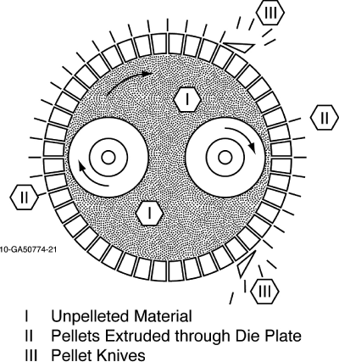
Figure 21. Display of working process of a pellet mill die (Tumuluru et al., 2011).

Densification of raw biomass increases the energy content of per unit weight. This gives the feedstock an advantage to compete against with oil, and other fuels. Converted biomass pellets are graded in British thermal unit per pound (BTU/lbs.) (Sjoding et al., 2013).

Simulation
A simulation of the components of the bio-depot for the knife-ring module, drying module, milling/blending module, and densification module was conducted given the absence of data from the larger research project which was delayed. A Microsoft Excel template with simulation of the variability was developed as part of this thesis and may be useful tool for the practitioner.

Simulation of Three Key Metrics of the Bio-depot

Ash Content
Biomass combustion and its quality depends on the chemical composition. The quality of biomass is also influenced by moisture content, ash contents, species, origin, harvesting method, on site handling, logistics, pretreatment, processing, and blending (Rector et al., 2013). Ash content of wood flakes stays in direct connection with bark content. Bark contains highest ash content of a tree. Ash is the inorganic matter that consists of a wide range of elements (James et al., 2012). The inorganic matter is of great importance, concerning the effect on the combustion process and the impact on the biofuel plant. Supply management and harvesting methods have direct influence on the quality of the biomass and therefore for example, ash content (Obernberger et al., 1997). Ash content in woody biomass, depending on the origin, ranges from 0.5 to three percent dry weight. However, ash content can rise up to ten percent, if limbs, branches, and bark are taken into account (Sjoding et al., 2013).

Particle Size
Switchgrass and loblolly pine in the bio-depot are processed to generate a target particle size. The target size will be set by the market, and requirements of biorefineries. The intermediate step of “milling” is required to accomplish this task, i.e., the biomass is milled to meet a target. Particle size of the raw material is a key metric due to its effect on overall feedstock quality.

Moisture Content
Feedstock moisture is a problematic and cost intensive factor, affecting feedstock supply and bio refinery performance excellence (Nigam et al., 2011). Excessive moisture content can lead to an increase of dry matter loss, increased transportation cost, and spontaneous combustion during storage. Process steps like milling are negatively affect due to increased moisture in the feedstock. The high water content causes wear and tear on machinery (Mani et al., 2004). Moisture content of roundwood after logging is estimated at 50% (Lu et al., 2015), whereas for Switchgrass moisture content ranges from 15%-30%, depending on the season (Robert B. Mitchel, 2012). Target value for the mixed feedstock will be ten percent in the bio-depot concept presented in this thesis

Statistical Process Control
Statistical process control (SPC) procedures are suitable for monitoring a process behavior. SPC is a tool that deals with variation in a process. Variation is unavoidable but controllable. Controlled variation is a consistent and stable pattern in process variation. On the other hand, uncontrolled variation is variation that changes due to special events or circumstances (Berger, 1986). Deming and Juran developed SPC into a tool for management to analyze variation and therefore, reduce defects. SPC is a tool to quantify variation and initiate the focus on root cause analysis (Grant et al., 1994). To monitor and avoid unwanted variance, SPC provides six tools:
- Control Charts:
Control Charts also known as Shewhart charts are used to evaluate data to control the stability of a process. Control charts indicate if a process changes significantly
- Cause-and-Effect Diagram:
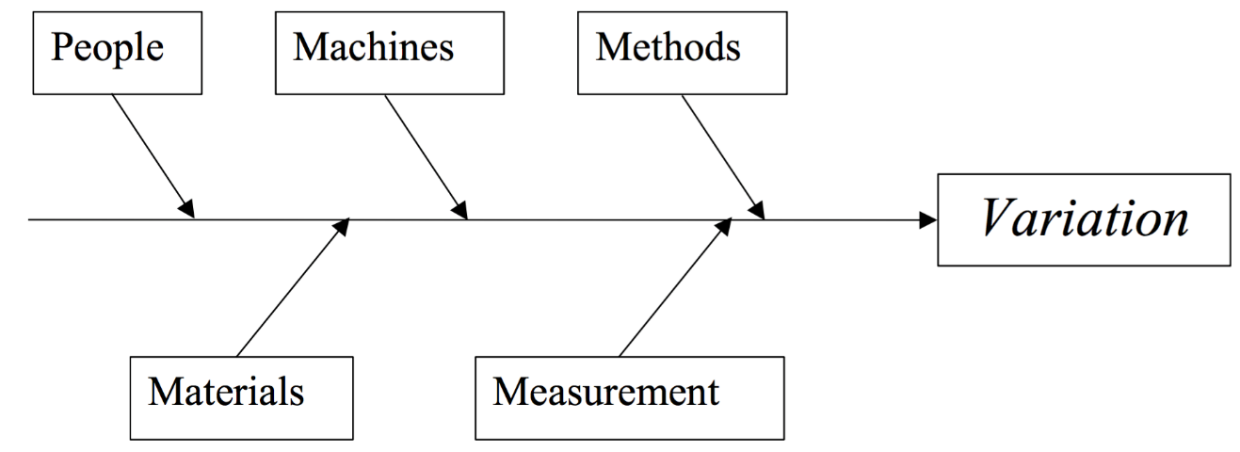
The Cause-and-Effect Diagram, also known as Ishikawa-, or Fishbone- Diagram, invented by Kaoru Ishikawa in the 1960s, is a visualization tool. Ishikawa’s diagram (Figure 22) maps a process and its possible causes of a problem (Young, 2015).
Figure 22. Example Cause Effect- /Fishbone- / Ishikawa-Diagram (Montgomery, 2009).2

Important for the application of the diagram is conformity within the group that is working on finding the reason of variation in a process. The issue has to be addressed and symbolized as the “head of the fish.” Every “crest” represents a major category/department. By adding subcategories, reasons for variance can be addressed more easily (Young, 2015).
- Pareto Charts:
The Pareto Chart, named after Italian economist Vilfredo Pareto, is another simple tool used to graph data. This chart type, however, has the same basic structure as the histogram but also includes a cumulative percent line graph. Based on the Pareto principle, Pareto Charts are used to find the problems with the greatest potential for improvement. The Pareto Principle states that 80% of the effects are due 20% of causes. By applying this chart, most influencing causes can be addressed and improved (Wheeler et al., 2010).
- Probability Plots.
These tools are essential for the improvement and understanding approach of a manufacturing process. SPC’s main goal is the identification of variability caused by assignable causes focusing on:
Making the process stable
Minimizing the process variability
Improving the process performance (Young, 2015).

Taguchi Loss Function
Increased competition in manufacturing caused producers to focus their effort of improvement towards high quality. The origin of Taguchi Methods comes from Japan. Taguchi methods are widely used in the modern quality philosophy known as “Six-Sigma Quality.”
Taguchi believed that companies view economic loss incorrectly. That is, he believed companies greatly underestimate economic loss when they view loss that only comes from a product being out of specification. Taguchi believed that loss occurs whenever a product varies from its target. Therefore loss is directly a function of the variability of the product, i.e., more variability from the target equates to more loss (Ross, 1996). Theoretically loss is zero if the target and measured value are the same (Figure 23) (Liao, 2010).
There are three types of loss functions according to Taguchi. A two-sided loss function is “nominal-is-best” when a lower and an upper specification exists. One-sided loss functions where “smaller-is-better” for a lower specification only, or “larger-is-better” for an upper specification only. Operational targets are directly related to the amount of product variation (Liao, 2010).
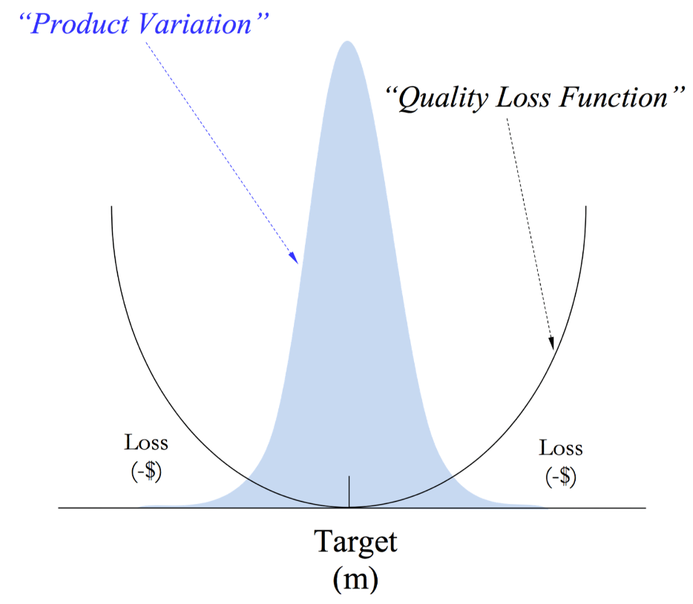
Figure 23. Two-sided Taguchi Loss Function, illustration from (Young, 2015)
Taguchi’s two-sided loss function is a valuable tool to address and measure the qualitative loss of one product. The two sided loss function is determined by the formula:
$L\left(y\right)=k*{\left(y-m\right)}^{2}$ [4]
where:
L = loss in dollars when the quality characteristic is equal to y,
y = the value of the quality characteristic (e.g., moisture, ash content, density, etc.),
m = target value of y,
k = constant depending on the organization’s loss definition.
In addition to nominal-is-best loss function, Taguchi also provided one-sided versions for either lower or upper specifications (Liao, 2010).
The smaller-the-function assumes an ideal target value as close to lower specification limit as possible (Figure 24). For example, weight in particleboard or oriented strand board.
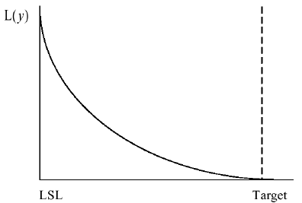
Figure 24. One-sided Taguchi Loss Function – Smaller the Better (Liao, 2010).

The smaller-the-better loss function does not include negative data (Taguchi et al., 2004). The smaller-the-better loss function is defined as:
$L\left(y\right)=k*y^{2}$ [5]
where:
$$k=\frac{A_{0}}{y_{0}^{2}}$$
L = loss in dollars when the quality characteristic is equal to y,
k = constant depending on the organization’s loss definition,
A₀ = consumer loss,
y_{o}= consumer tolerance,
y= the value of the quality characteristic (e.g., moisture, ash content, density, etc.).
The larger-the-better loss function is illustrated in Figure 25.
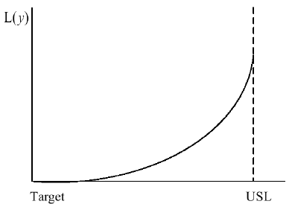
Figure 25. One-Sided Taguchi Loss Function – Larger The Better (Liao, 2010).

Characteristics of a larger-the-better loss function are when an upper specification is a limiting factor. An example of this is formaldehyde (HCHO) emissions from medium density fiberboard or particleboard. Theoretically if a manufacturer had no variability in HCHO emissions, they would emit at the upper specification limit. Manufacturers have to run the target emissions lower than upper specification given the degree of variability in emissions.

Total Taguchi Loss Function
The Taguchi loss method was applied to quantify the variance within the simulated process. The particle size analysis demands for a smaller the better loss function. Smaller particle size increases drying quality and pace. Moisture content is analyzed by using the nominal is best lost function, also known as two sided loss function. The demand for a consistent moisture content of the product is needed for the densification process and transportation. Therefore, a target value of 12% was assumed to represent a target value for biorefineries. Ash content deals with the one sided lower the better loss function. Due to the uncertain ash percentage in the feedstocks, an average value of five percent was assumed.

Reliability Block Diagram
Advances in technology, combined with the increased demand for quality and global competition, puts pressure on manufacturers. Reliability of products that have to meet customers and international standards press for quality improvement and insurance of reliability in manufacturing processes. Technical reliability is often considered as the probability that a system of equipment or devices will perform as intended, considering certain operating conditions and specified time period (Meeker et al., 1998).
Reliability block diagrams (RBD) were used in this study to illustrate how system reliability influences component and system variance in the bio-depot. That is, it is illustrated that as downtime of any component in a series system increases the variability of that component increases, i.e., inertia elements associated with startup operations of machinery typically have more variability than steady-state systems (example of Second Law of Thermodynamics).
RBD illustrates and estimates reliability of a process using block diagrams and probability. The components, defined as blocks, are organized as a flow from start to finish of the process. RBDs are organized into a flow chart of blocks of series and parallel systems; and combinations of the two (Modarres et al., 2009).
In this study a RBD was developed as simple series system (Figure 26). For a RBD series system, a serial connection of components is assumed. The amount of blocks is defined as n. A failure of any component has a direct impact on the process, resulting in system failure (Young, 2015). 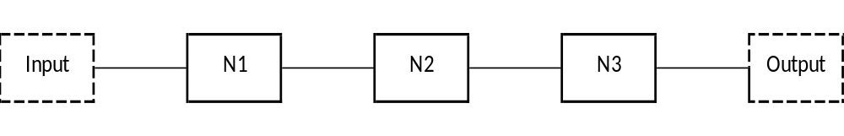
Figure 26. Reliability Block Diagram Series System
The reliability of a series systems is expressed as:
R_{S} = R_{A} * R_{B} ……… R_{Z.} _{[6]}
Reliability = 1 – (failure probability). Recall all probabilities sum to 1

For example if a series system has three components (N1, N2, N3), its system reliability is illustrated as (Water, 2010):
N1 = 0.95
N2 = 0.90
N3 = 0.91
R = Reliability of process
$$R=N1*N2*N3=0.95*0.90*0.91=0.778$$

A parallel system is illustrated in Figure 28. If two or more blocks are active in a parallel outline all components of the system must fail simultaneously for the system to fail.
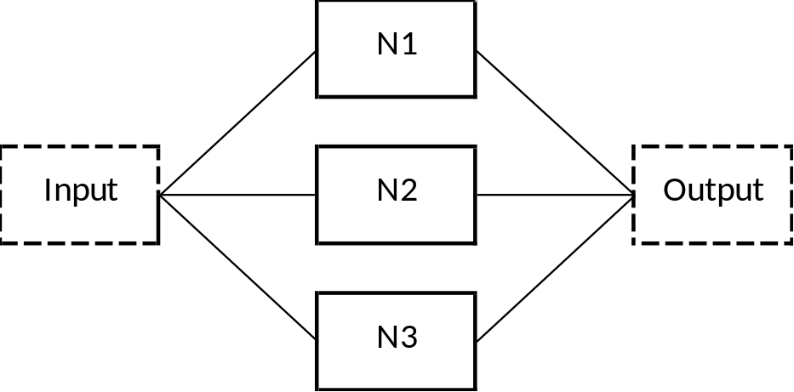
Figure 27. Reliability block diagram for a parallel system.

Failure of the entire system is defined as the principle of active redundancy.
The assumptions for a parallel model are:
- Components work independently, in view of reliability
- The system operates as long as at least one component is still operating.
For example, the reliability of a three component systems (N1, N2, N3) with full redundancy is ill-starred below Assume the components have the following reliability probabilities:
N1 = 0.95
N2 = 0.90
N3 = 0.91
R = Reliability of process
$$R=1-(\left(1-N1\right)*\left(1-N2\right)*\left(1-N3\right))$$
$$R=1-\left(\left(1-0.95\right)*\left(1-0.90\right)*\left(1-0.91\right)\right)=0.999$$
Assuming the component’s failure rates are 0.05, 0.10, 0.09 in a parallel system of three components, the overall reliability of the process equals to 99.9% (Modarres et al., 2009).

                - Chapter IV. Results and Discussion

Simulation Concept
The bio-depot is a concept for an intermediate step in the bio-based materials supply chain to reduce the variability of feedstock attributes which will lower costs and improve the economic competiveness of biofuels. This thesis highlights the criticality for the bioenergy industry to focus on the analytics of the supply chain as a business strategy for improved competitiveness. The idea of using analytics to improve processes and product quality is not unique, e.g., Delta airlines, FEDEX, Google, Amazon, etc. This chapter illustrates the components of an Excel Workbook that was developed as template to be used for analytical support for practitioners in the bioenergy industry.

Simulation Template

Template Sheet 1 – Table of Content
The worksheet titled “Table of Contents” gives detail about the seven Excel spreadsheets included in the overall workbook (Figure 28). All hyperlinks are highlighted in blue.
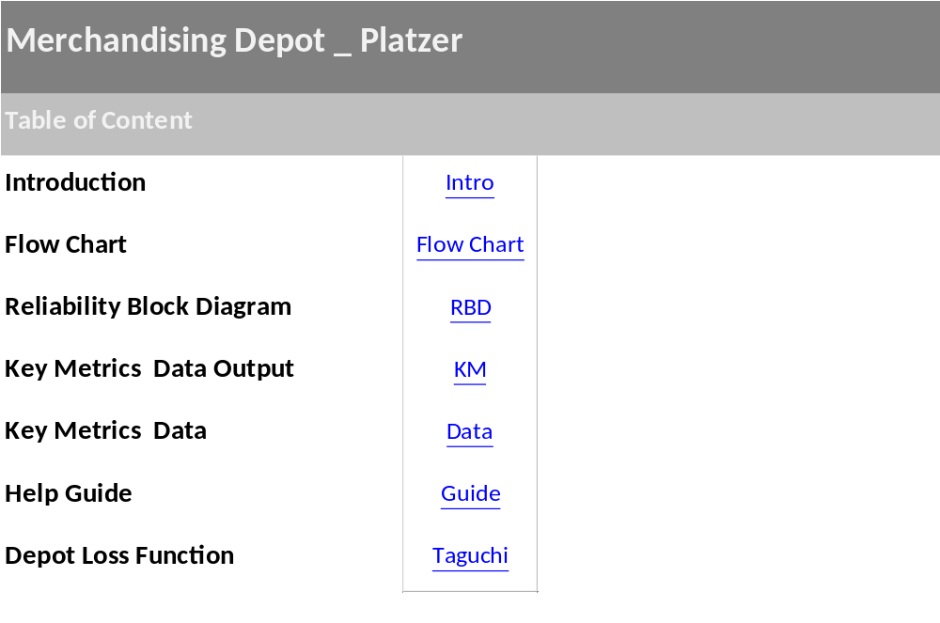
Figure 28. Template Sheet 1 – table of contents.

Template Sheet 2 – Introduction
The second spreadsheet (“Introduction”) of the workbook introduces the bio-depot concept (Figure 29). The yellow box on the top left corner of each sheet contains a hyperlink that directs the user to the Table of Contents, to enable fast navigation throughout the workbook. A detailed view of the sheet can be found in the Appendix.

Figure 29. Template sheet 2 – introduction.

Template Sheet 3 – Flow Chart
‘Template Sheet 3’ is a flow chart (Figure 30) of the bio-depot. Since the bio-depot does exist yet, a series system was assumed for the simulation. The design of the bio-depot starts with the sawmill and has materials as a continuous flow starting with the receiving department, which is defined as the green framed box. BMR stands for biomass residue. The process flow is continuous with the knife-ring module, the first step for the unification of feedstock particles. The knife-ring process is assumed to create a more consistent drying process which will have lower variability in final moisture content. After this step blending and milling will be performed simultaneously.
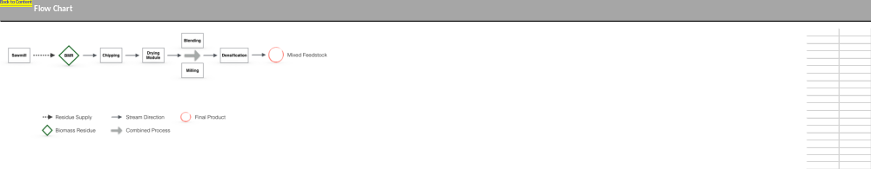
Figure 30. Template sheet 3 – flow chart.
Densification then forms densified bales which are considered a final feedstock or product.

Template Sheet 4 – Reliability Block Diagram
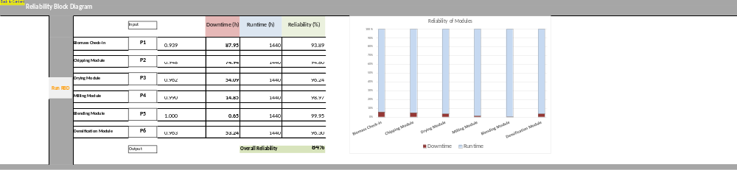
The first section of the RBD spreadsheet includes a navigation hyperlink on the top left corner and a “Run RBD” button (Figure 31). Since there is no available data of the reliability of the components, the failure rate had to be simulated. By pressing the button, the embedded VBA code calculates failure rates for each component, as well as the systems overall reliability. This worksheet enables the user to calculate system and component reliability.
Figure 31. Template sheet 4 – reliability block diagram section 1.
The second segment of the spreadsheet (Figure 32) highlights the process steps of the bio-depot. The different components, such as, biomass input, knife-ring module, drying module, milling module, blending module, and densification module, are displayed as P1, P2, P3, P4, P5 and P6 process steps. Given the assumption of a series system, the alignment of individual components emphasizes the systems layout. The column next to the components, indicates the reliability conditions, i.e., downtime for each component in minutes. The failure reliabilities are assumed to be the downtime minutes divided by total available minutes. The consistency of the process depends on the content of downtime column boxes.
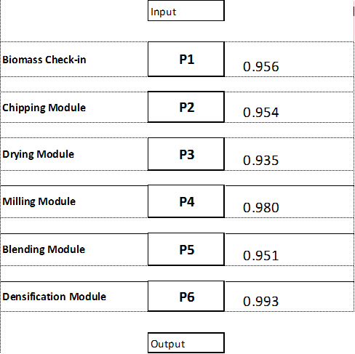

Figure 32. Template sheet 4 – reliability block diagram section 2

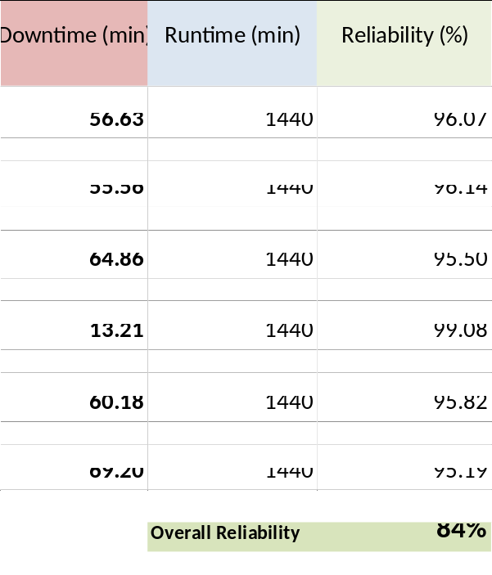
Section 3 of the RBD sheet lists the important reliability results for the reliability block diagram (Figure 33). Twenty-four hour available runtime (1440 minutes) was assumed for the runtime of this simulated process. The parameters for runtime and downtime of every stage are changeable, and recognized in the VBA code. The user can observe the overall reliability directly from the spreadsheet at the bottom of the reliability column. Reliability is presented as a percent for ease of interpretation.
Figure 33. Template sheet 4 – reliability block diagram section 3.
On the far right of the spreadsheet a graphical display is embedded to accentuate the reliability of the modules, using a column chart. Each process step is embodied by a column, the columns are split into a blue and a red section. The red section highlights the downtime. The graph automatically adapts to changes of the calculation input. This chart is especially helpful with real data input, as failure rates of the components can be identified more easily. The chart is envisioned to be a useful tool to compare reliability at a glance.
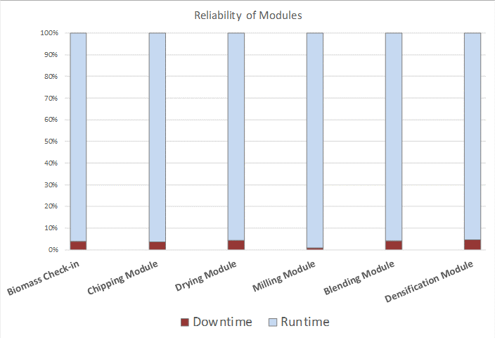

Figure 34. Template sheet 4 – reliability block diagram section 4.

Template Sheet 5 – Key Metrics Data Output
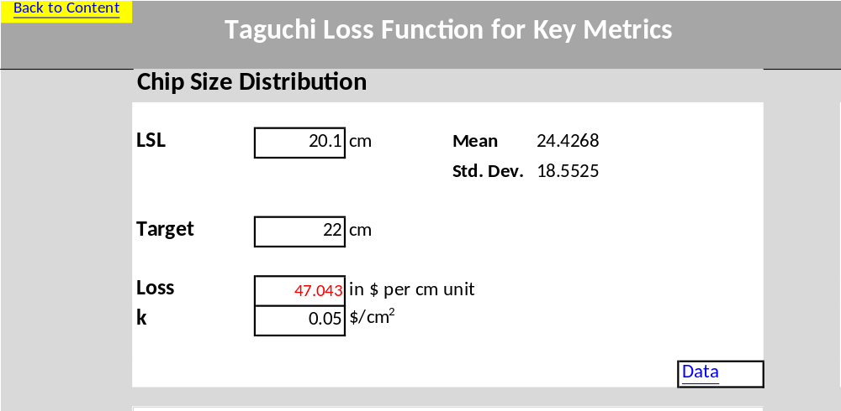
‘Template Sheet 5’ includes the data analysis output of the data implemented on ‘Template Sheet 6.’ The control box in white enables the user to see descriptive statistics of the variables, such as mean, standard deviation and the loss per unit. This section has key input parameters for the Taguchi loss function (Figure 36). Modifications are available by the user, such as ability to change of the lower specification limit, the target, or the k-value.
Figure 35. Template sheet 5 – key metrics data output section 1.1 chip size.
Modifications are automatically calculated in the loss function. The loss function is also illustrated graphically. A hyperlink is embedded at the lower right corner of the box that directs the user to ‘Template Sheet 6.’ The most important aspect of this section is the display of the loss per unit calculated assuming a smaller-the-better Taguchi loss function.
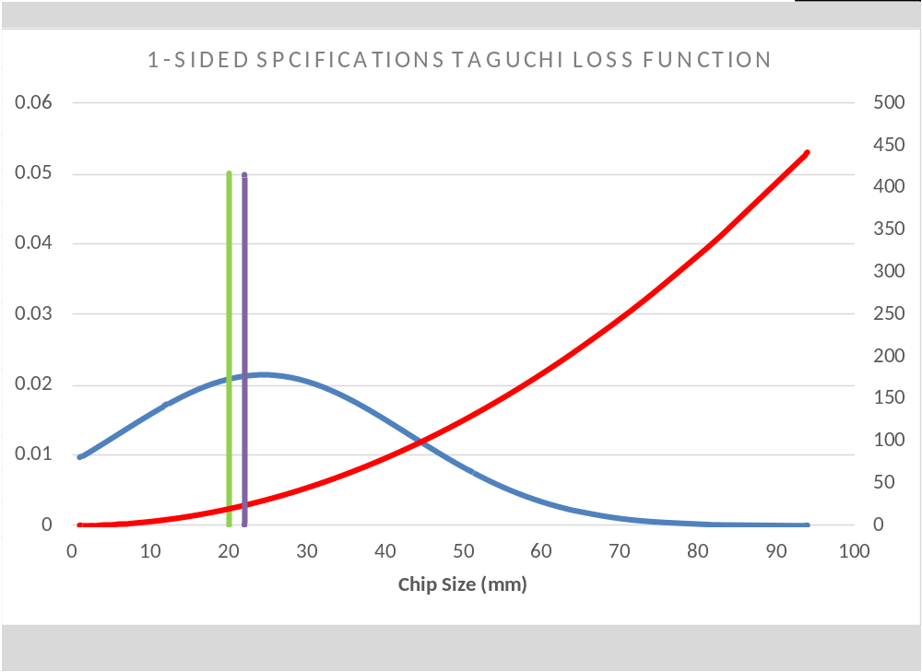
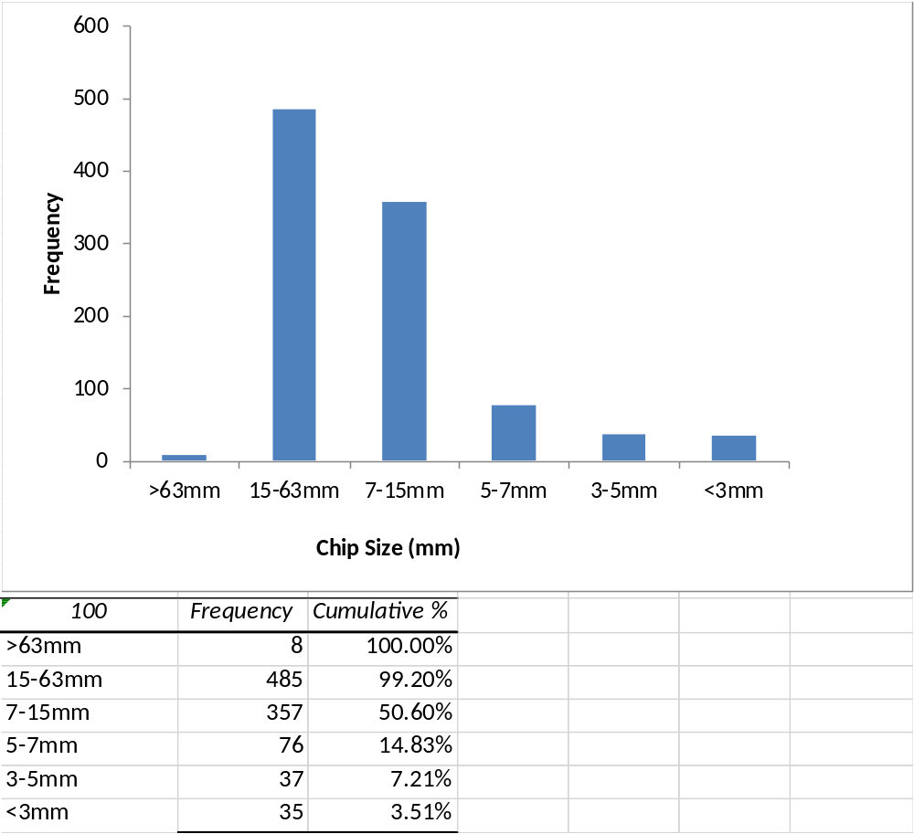
Below the control box a graphical display of the one-sided Taguchi loss function is displayed (Figure 36). Changing parameters in the control box or in the data will automatically be updated in this graph. The green bar emphasizes the lower specification limit; the purple bar highlights the mean of the of the data. The data distribution is displayed with the blue line, and the red line represents the change of loss when deviating from target. The third part of the chip size data analysis emphasizes the distribution and quantity of the size sections. This chart provides information about frequency and data input. The chart automatically updates, when data inputs are changed (Figure 37).
Figure 36. Template sheet 5 – key metrics data output section 1.2 chip size.
Figure 37. Template sheet 5 – key metrics data output section 1.3 chip size.
.
‘Template Sheet 5’ (Figure 38) includes the data analysis output of the data implemented in ‘Template Sheet 6.’ The control box in whites enable the user to see descriptive statistics (sample mean, sample standard deviation, and loss per unit. Modifications to this data are automatically updated in the Taguchi loss function on the output page. Modifications are capble to the upper specification limit, lower specification limit, target, or k-value. A hyperlink is embedded at the lower right corner of the box to navigate to “Template Sheet 6,’ namely data input for key metrics. The most important aspect of this section is the display of the loss per unit assuming the two-sided, nominal-the-best Taguchi loss function. A graphical display of the one-sided Taguchi loss function is also displayed (Figure 36). Changing parameters in the control box or in the data will automatically be presented in this graph. The green bar emphasizes the lower specification limit; dark green bar represents the upper specification limit; the purple bar highlights the mean of the data. The data distribution is displayed with the blue line, and the red line represents the change of loss when deviating from target.
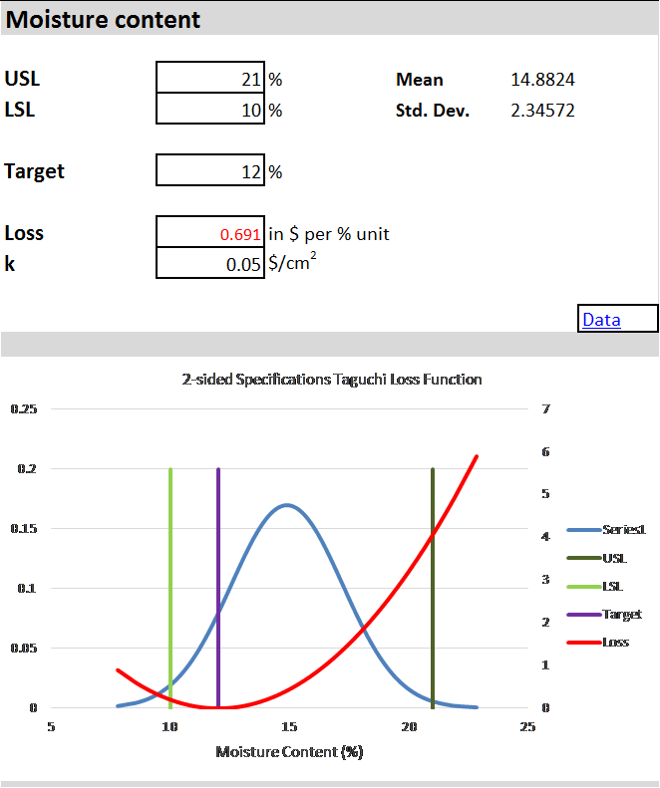
Figure 38. Key metrics data output section 2.1 moisture content.
The moisture content data analysis section emphasizes the distribution and quantity of the size sections (Figure 39). This chart provides information about frequency of data input, as well as a histogram to emphasize the distribution of moisture. The chart updates when changed by the user.
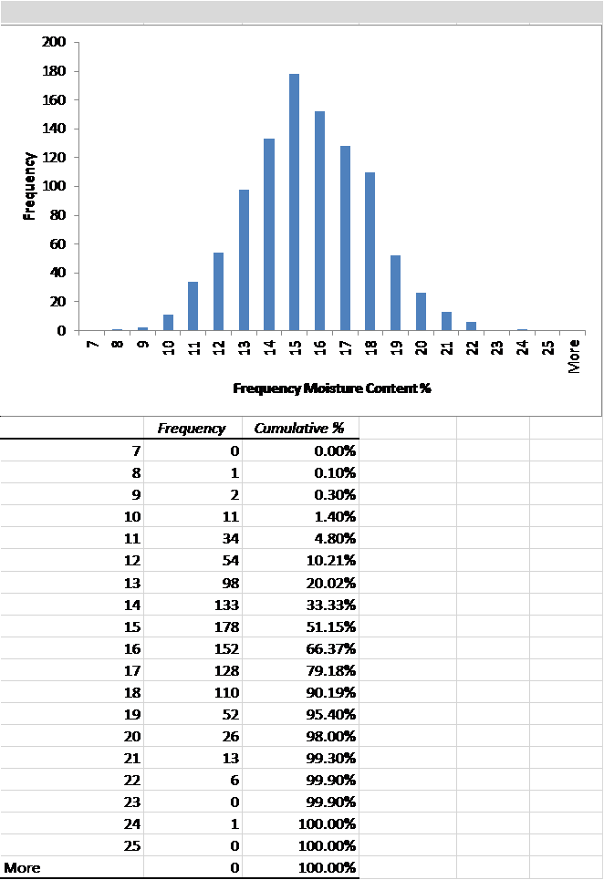
Figure 39. Template sheet 5 – key metrics data output section 2.2 moisture content.

The third section of the ’Template Sheet 5’ (Figure 40) focuses on ash content. A one-sided loss function was assumed to determine the loss induced by the process variability. The user has the option to change, LSL, target, and k value. The green bar emphasizes the lower specification limit; the purple bar highlights the mean of the data. The chart allows for data entry and the control boxes automatically update.
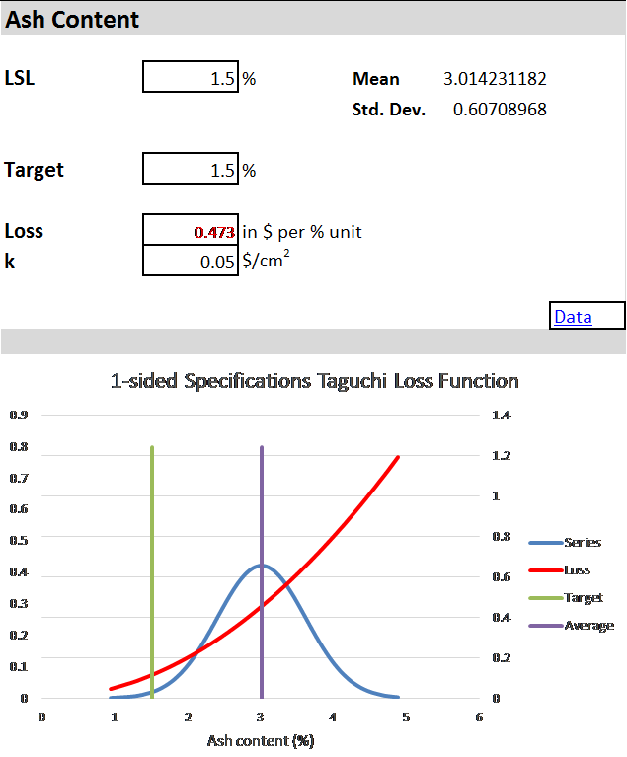
Figure 40. Template Sheet 5 – Key metrics data output section 3.1 Ash Content

The ash content data are illustrated as a histogram and frequency table (Figure 41). This chart provides information about frequency of the data input and is usful for the visualization of the distribution of ash content. Charts are updated automatically when data are changed.
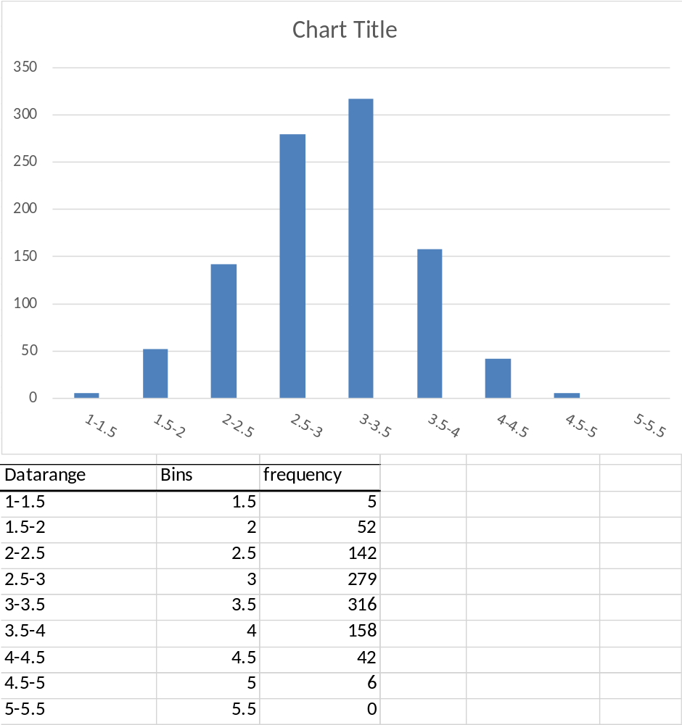
Figure 41. Template Sheet 5 – Key metrics data output section 3.2 Ash Content

Template Sheet 6 – Data input
’Template Sheet 6’ (Figure 42) provides sections for the calculation of the two types of Taguchi loss functions, smaller-the-better, and nominal-is-best. Sample averages, standard deviations, variances, mean square deviation, and loss are automatically calculated as data is imported. The mentioned parameters are linked to ’Template Sheet 5,’ and are the source for the graphical outputs. Every section of this sheet, such as particle size, moisture content, and ash content have a redirecting hyperlink embedded. The hyperlink directs the user to the output of the data analysis. The loss function is included by every section of the data input sheet. The column “L.F./Unit” calculates the loss of every data point individually. The equation of the loss function is embedded in the column and adapts automatically to changes in the data set. Mean square deviation (MSD) for the loss per unit calculation is programmed to adapt to changes in mean and standard deviation. Column “f(y)” is responsible for the distribution presentation. This column interacts with the y value mean and the standard deviation. 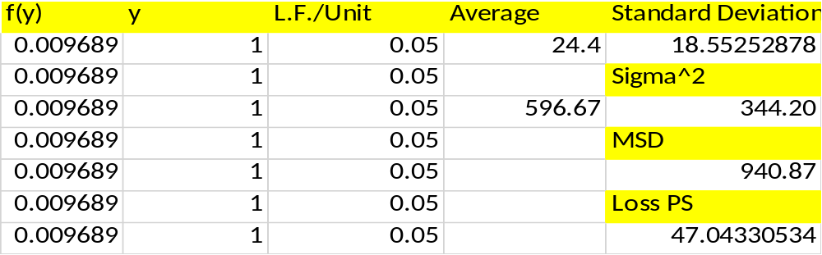
Figure 42. Template Sheet 6 – key metrics data input.

Template Sheet 7 – Help Guide
The help guide provides additional information to associated with ’Template Sheet 6’ concerning the Taguchi loss function.

Template Sheet 8 – Total Taguchi loss function
‘Total Taguchi Loss Function-sheet deals with the overall loss of the process and the display of the data. For that reason, a multiple1 linear regression model is applied. The user can import information to develop MLR model, estimate model coefficients, means and standard deviations for each significant variable, and estimate the correlation coefficients for each significant variable. The output is defined by a histogram and s-bar chart (Figure 52). The user can decide whether a normal or a lognormal distribution is a better fit for the imported data. The spreadsheet calculates both nominal is best and lower the better loss function.

CHAPTER V. Conclusions and Recommendations for Improvement
The simulation of the bio-depot and its key metrics is a beneficial tool for the continuous preparation and planning of the conceptual bio-depot idea. The Excel workbook can be used to emphasize the measurements collected for key data associated with the bio-depot process. Reliability, variance, and loss are quantified using this workbook. Statistical process control and its tools are suitable methods for monitoring the depots process steps. In combination with the Taguchi loss function, financial and process relevant factors can be evaluated and addressed. When the bio-depot starts its production and data are gathered, the spread sheets will help to improve the process quality at its genesis stage. Real-time data analyses will be needed at the bio-depot to ensure process control of variation and continuous improvement.
This research will need to be validated with actual data from the bio depot. Given real data, sensitivity analyses can be conducted. This will allow the practitioner to focus on components of the bio-depot that have the poorest reliability, largest variance, and highest economic loss. This will hopefully allow for improvements of the bio-depot based on analytics. Analytics are necessary to improve final product outputs (e.g., biofuels, etc.) at a competitive cost.

List of References

Administration, U. S. E. I. (2016). Cushing, OK WTI Spot Price FOB (Dollars per Barrel).
Aguiar-Conraria , L., & Wen, Y. (2006). A Note on Oil Dependence and Economic Instability
Austenfeld, R. B. (2001). W. Edwards Deming: The Story of a Truly Remarkable Person.
Awudu, I., & Zhang, J. (2012). Uncertainties and sustainability concepts in biofuel supply chain management: A review. Renewable & Sustainable Energy Reviews, 16(2), 1359-1368. doi:10.1016/j.rser.2011.10.016
Baker, J. B., & Langdon, O. G. (1990). Pinus taeda L., Loblolly Pine.
Baker, S., & Wilson, A. (2011). Chip properties from operational harvests of pine stands in the southern US.
Berger, R. W. (1986). Statistical process control: a guide for implementation. New York : Milwaukee: M. Dekker ; ASQC Quality Press.
Berninger, T. (2011). Bioenergy production potential of global biomass plantations under environmental and agricultural constraints.
Best, M., & Neuhauser, D. (2005). W Edwards Deming: father of quality management, patient and composer. Qual Saf Health Care, 14(4), 310-312. doi:10.1136/qshc.2005.015289
Best, M., & Neuhauser, D. (2006). Walter A Shewhart, 1924, and the Hawthorne factory. Qual Saf Health Care, 15(2), 142-143. doi:10.1136/qshc.2006.018093
Boyer, W. D. (1993). Pinus palustris Mill., Longleaf Pine. Retrieved from http://www.na.fs.fed.us/pubs/silvics_manual/Volume_1/pinus/palustris.htm
Bracmort, K. (2015). The Renewable Fuel Standard (RFS).
Brown, C. (2012). What are the Benefits of Pneumatic Discharge in Size Reduction?
Cambero, C., & Sowlati, T. (2014). Assessment and optimization of forest biomass supply chains from economic, social and environmental perspectives – A review of literature. Renewable and Sustainable Energy Reviews, 36, 62-73. doi:http://dx.doi.org/10.1016/j.rser.2014.04.041
Chern, C. C., & Hsieh, J. S. (2007). A heuristic algorithm for master planning that satisfies multiple objectives. Computers & Operations Research, 34(11), 3491-3513. doi:http://dx.doi.org/10.1016/j.cor.2006.02.022
Chung, S. (2010). Biofuel Supply Chain Challenges and Analysis.
Commission, E. (2009). DIRECTIVE 2009/28/EC OF THE EUROPEAN PARLIAMENT AND OF THE COUNCIL
Database, U.-N. P. (2009). Switchgrass distribution.
De Meyer, A., Cattrysse, D., & Van Orshoven, J. (2015). A generic mathematical model to optimise strategic and tactical decisions in biomass-based supply chains (OPTIMASS). EURO Excellence in Practice Award 2001, 245(1), 247-264. doi:10.1016/j.ejor.2015.02.045
Dean Goble, M. P. (2013). Opportunities for using Sawmill Residues in Australia. Forest & Wood Products Australia.
Deming, W. E. (2000). Out of the crisis (1st MIT Press ed.). Cambridge, Mass.: MIT Press.
Dennis, P. (2002). Lean production simplified : a plain language guide to the world's most powerful production system. New York: Productivity Press.
Drzymala, Z. (1993). Industrial briquetting—fundamentals and methods.
EIA. (2013). How dependent are we on foreign oil? , from U.S. Energy Information Administratio
EIA. (2016). Top sources and amounts of U.S. petroleum imports, exports, and net imports, 2015. from U.S. Energy Information Administration
Eisentraut, A. (2010). SuStainable Production of Second-Generation biofuelS. International Energy Agency.
Elia, J. A., Baliban, R. C., & Floudas, C. A. (2012). Nationwide energy supply chain analysis for hybrid feedstock processes with significant CO2 emissions reduction. Aiche Journal, 58(7), 2142-2154. doi:10.1002/aic.13842
Erturgut, R. (2012). The future of supply chain and logistics management in the strategic organizations: contractor companies and new generation suppliers. 4th World Conference on Educational Sciences (Wces-2012), 46, 4221-4225. doi:10.1016/j.sbspro.2012.06.230
Ferreira, L., & Borenstein, D. (2011). Normative agent-based simulation for supply chain planning. Journal of the Operational Research Society, 62(3), 501-514. doi:10.1057/jors.2010.144
García-Alcaraz, J. L. (2014). Lean Manufacturing in the Developing World: Methodology, Case Studies and Trends from Latin America (2014th Edition ed.).
Gold, S., & Seuring, S. (2011). Supply chain and logistics issues of bio-energy production. Sustainability and Supply Chain Management, 19(1), 32-42. doi:10.1016/j.jclepro.2010.08.009
Goldsby, T. J., & Martichenko, R. (2005). Lean Six Sigma logistics : strategic development to operational success. Boca Raton, Fl.: J. Ross Pub.
Grant, R. M., Shani, R., & Krishnan, R. (1994). TQM's Challenge to Managment Theory and Practice.
Happek, S. (2005). Supply chain strategy: the importance of aligning your strategies. UPS Supply Chain Solutions.
Hettenhaus, J., & Morris, D. (2004). Feedstock supply, logistics, processing, and composition. Appl Biochem Biotechnol, 113-116, 3-4.
Hombak (Producer). (2013). Drum chipper Type HMT, HOMBAK drum chipper technology for producing high-quality wood chips.
ISO. (2014). EN ISO 17225 Solid biofuels - Fuel specifications and classes
International Organization for Standardization.
James, A., Thring, R., Helle, S., & Ghuman, H. (2012). Ash Management Review—Applications of Biomass Bottom Ash
Jirjis, R. (1995). International Energy Agency Bioenergy Agreement Progress and Achievements 1992/94Storage and drying of wood fuel. Biomass and Bioenergy, 9(1), 181-190. doi:http://dx.doi.org/10.1016/0961-9534(95)00090-9
Jobs, S. (1990) An Immigrant’s Gift/Interviewer: I. WoodsEnd & G. H. Blackiston.
Juran, J. M. (1986). The Quality Trilogy, A Universal Approach to Managing for Quality. Retrieved from California:
Juran, J. M., & Godfrey, A. B. (1998). JURAN’S QUALITY HANDBOOK.
Kannan, V. R., & Tan, K. C. (2005). Just in time, total quality management, and supply chain management: understanding their linkages and impact on business performance. Omega-International Journal of Management Science, 33(2), 153-162. doi:10.1016/j.omega.2004.03.012
Keefe, R., Anderson, N., Hogland, J., & Muhlenfeld, K. (2014). Woody Biomass Logistics. Cellulosic Energy Cropping Systems, 251-279. doi:Book_Doi 10.1002/9781118676332
Lababidi, H. M. S. (2004). Optimizing the Supply Chain of a Petrochemical Company under Uncertain Operating and Economic Conditions.
Li, S. (2004). The impact of supply chain management practices on competitive advantage and organizational performance.
Liao, C. (2010). Supplier selection project using an integrated Delphi, AHP and Taguchi loss function.
Little, E. L. (1966). Geographic distribution of the pines of the world. U.S. Department of Agriculture Miscellaneous Publication.
Lowenthal-Savy, D. (2015). UK’s renewable energy targets drive increases in U.S. wood pellet exports. U.S. Energy Information Administration.
Lu, X., Withers, M. R., Seifkar, N., Field, R. P., Barrett, S. R., & Herzog, H. J. (2015). Biomass logistics analysis for large scale biofuel production: case study of loblolly pine and switchgrass. Bioresour Technol, 183, 1-9. doi:10.1016/j.biortech.2015.02.032
Luo, H., & Wu, Y. (2014). Compendium of bioenergy plants : switchgrass. Boca Raton, FL: CRC Press.
Mackes, K. (2010). Wood Chip Attributes. Retrieved from
Mafakheri, F., & Nasiri, F. (2014). Modeling of biomass-to-energy supply chain operations: Applications, challenges and research directions. Foresight Sustainable Energy Management and the Built Environment Project, 67, 116-126. doi:10.1016/j.enpol.2013.11.071
Mani, S., Tabil, L. G., & Sokhansanj, S. (2004). Grinding performance and physical properties of wheat and barley straws, corn stover and switchgrass. Biomass & Bioenergy, 27(4), 339-352. doi:10.1016/j.biombioe.2004.03.007
Marinagi, C., Trivellas, P., & Sakas, D. P. (2014). The impact of Information Technology on the development of Supply Chain Competitive Advantage. 3rd International Conference on Integrated Information (Ic-Ininfo), 147, 586-591. doi:10.1016/j.sbspro.2014.07.161
Meeker, Q., & Escobar, L. (1998). Statiscital Methods for Reliability Data.
Mehrara, M. (2007). Energy consumption and economic growth: The case of oil exporting countries. Foresight Sustainable Energy Management and the Built Environment Project, 35(5), 2939-2945. doi:http://dx.doi.org/10.1016/j.enpol.2006.10.018
Miao, Z., E. Grift, T., & Ting, K. C. (2013). Size Reduction and Densiﬁcation of Lignocellulosic Biomass Feedstock for Biopower, Bioproducts, and Liquid Biofuel Production. Retrieved from illinois:
Modarres, M., Kaminskiy, M., & Krivstov, V. (2009). Reliability Engineering and Risk Analysis: A Practical Guide, Second Edition.
Mohammed, Y. A., Raun, W., Kakani, G., Zhang, H. L., Taylor, R., Desta, K. G., . . . Reinert, M. (2015). Nutrient sources and harvesting frequency on quality biomass production of switchgrass (Panicum virgatum L.) for biofuel. Biomass & Bioenergy, 81, 242-248. doi:10.1016/j.biombioe.2015.06.027
Montgomery, D. C. (2009). Introduction to Statistical Quality Control.
Mula, J., Peidro, D., Díaz-Madroñero, M., & Vicens, E. (2010). Mathematical programming models for supply chain production and transport planning. EURO Excellence in Practice Award 2001, 204(3), 377-390. doi:http://dx.doi.org/10.1016/j.ejor.2009.09.008
Murray, C. H. (1990). Manual on sawmill operational maintenance FOOD AND AGRICULTURE ORGANIZATION OF THE UNITED NATIONS

Naik, S. N., Goud, V. V., Rout, P. K., & Dalai, A. K. (2010). Production of first and second generation biofuels: A comprehensive review. Renewable and Sustainable Energy Reviews, 14(2), 578-597. doi:10.1016/j.rser.2009.10.003
Neave, H. R. (1987). Deming's 14 points for management: framework for success.
Nigam, P. S., & Singh, A. (2011). Production of liquid biofuels from renewable resources. Progress in Energy and Combustion Science, 37(1), 52-68. doi:10.1016/j.pecs.2010.01.003
Nyquist, S. (2015). Lower oil prices but more renewables: What’s going on?
Obernberger, I., Biedermann, F., Widmann, W., & Riedl, R. (1997). Biomass Quality for Power ProductionConcentrations of inorganic elements in biomass fuels and recovery in the different ash fractions. Biomass and Bioenergy, 12(3), 211-224. doi:http://dx.doi.org/10.1016/S0961-9534(96)00051-7
OFRI. (2006). Biomass Energy and Biofuels from Oregon’s Forests.
Ouédraogo, I. M. (2010). Electricity consumption and economic growth in Burkina Faso: A cointegration analysis.
Owsley, M. (2011). LONGLEAF PINE Pinus palustris Mill. Plant fact sheet.
Ozturk, I., Aslan, A., & Kalyoncuc, H. (2010). Energy consumption and economic growth relationship: Evidence from panel data for low and middle income countries. Foresight Sustainable Energy Management and the Built Environment Project, 38(8), 4422-4428. doi:10.1016/j.enpol.2010.03.071
Parish, E. S., Hilliard, M. R., Baskaran, L. M., Dale, V. H., Griffiths, N. A., Mulholland, P. J., . . . Middleton, R. S. (2012). Multimetric spatial optimization of switchgrass plantings across a watershed. Biofuels Bioproducts & Biorefining-Biofpr, 6(1), 58-72. doi:10.1002/bbb.342
Parliament, E. (2008). DIRECTIVE OF THE EUROPEAN PARLIAMENT AND OF THE COUNCIL on the promotion of the use of energy from renewable sources
Parrish, D. J., & Fike, J. H. (2005). The biology and agronomy of switchgrass for biofuels. Critical Reviews in Plant Sciences, 24(5-6), 423-459. doi:10.1080/07352680500316433
Perlack, R. D., Wright, L. L., Turhollow, A. F., & Graham, R. L. (2005). Biomass as Feedstock for a Bioenergy and Bioproducts Industry: The
Technical Feasibility of a Billion Ton Annual Supply.
Power, D. (2005). Supply chain management integration and implementation: a literature review. Supply Chain Management-an International Journal, 10(3-4), 252-263. doi:10.1108/13598540510612721
RAND. (2009). Does Imported Oil Threaten U.S. National Security? Retrieved from
Rector, L., Allen, G., Hopke, P., & Chandrsekaran, S. (2013). Elemental Analysis of Wood Fuels. Retrieved from
Rentizelas, A. A., Tolis, A. J., & Tatsiopoulos, I. P. (2009). Logistics issues of biomass: The storage problem and the multi-biomass supply chain. Renewable & Sustainable Energy Reviews, 13(4), 887-894. doi:10.1016/j.rser.2008.01.003
Robert B. Mitchel, M. R. S. (2012). Switchgrass Harvest and Storage.
Robinson, S. (2010). Conceptual Modelling: Who Needs It? .
Roghanian, E., Sadjadi, S. J., & Aryanezhad, M. B. (2007). A probabilistic bi-level linear multi-objective programming problem to supply chain planning. Applied Mathematics and Computation, 188(1), 786-800. doi:http://dx.doi.org/10.1016/j.amc.2006.10.032
Ross, P. J. (1996). Taguchi techniques for quality engineering: loss function, orthogonal experiments, parameter and tolerance design (2nd ed ed.). New York: McGraw-Hill.
Rushton, A., Croucher, P., & Baker, P. (2014). The handbook of logistics & distribution management (5th edition. ed.). London ; Philadelphia: Kogan Page.
Ruth, M., Mai, T., Newes, E., Aden, A., Warner, E., Uriarte, C., . . . Argo, A. (2013). Projected Biomass Utilization for Fuels and Power in a Mature Market
Sanderson, M. A., Reed, R. L., McLaughlin, S. B., Wullschleger, S. D., Conger, B. V., Parrish, D. J., . . . Tischler, C. R. (1996). Switchgrass as a sustainable bioenergy crop. Bioresource Technology, 56(1), 83-93. doi:Doi 10.1016/0960-8524(95)00176-X
Shah, J. (2009). Supply chain management text and cases. Chennai [u.a.]: Pearson Education.
￼Energy Independence and Security Act of 2007, (2007).
Sjoding, D., Kanoa, E., & Jensen, P. (2013). Developing a Wood Pellet/Densified Biomass Industry in Washington State: Opportunities and Challenges.
Solecki, M., Scodel, A., & Epstein, B. (2013). Advanced Biofuel Market Report 2013 Retrieved from
Sooduck, C. (2010). Biofuel Supply Chain Challenges and Analysis.
Taguchi, G., Chowdhury, S., & Wu, Y. (2004). Taguchi's Quality Engineering.
Taylor, D. A. (2004). Supply chains a manager's guide. Boston, Mass. [u.a.]: Addison-Wesley.
Thomas, W. M., Yates, J., & Benjamin, R. (1989). The logic of electronic markets.
Tumuluru, J., Wright, C., Hess, J. R., & Kenney, K. L. (2011). A review of biomass densification systems to develop uniform feedstock commodities for bioenergy application.
Uslu, A., Faaij, A. P. C., & Bergman, P. C. A. (2008). Pre-treatment technologies, and their effect on international bioenergy supply chain logistics. Techno-economic evaluation of torrefaction, fast pyrolysis and pelletisation. Energy, 33(8), 1206-1223. doi:10.1016/j.energy.2008.03.007
Vilsack, T. (2010). A USDA Regional Roadmap to Meeting the Biofuels Goals of the Renewable Fuels Standard by 2022. Retrieved from
Visions, S. (2010). SUPPLYCHAIN and LOGISTICS TERMS andGLOSSARY
Water, S. (2010). Reliability Block Diagram (RBD) Retrieved from
Wheeler, D. J., & Chambers, D. S. (2010). Understanding Statistical Process Control.
Wilcox, M. (2003). THE PHILOSOPHY OF SHEWHART'S THEORY OF PREDICTION.
Wilkinson , J. (2013). Biofuels and food security.
Wong, P., & Bredehoeft, G. (2014). U.S. wood pellet exports double in 2013 in response to growing European demand.
Young, T. (2015). SPC. Continuous Improvement using Statistical Process Control and Lean Statistical Methods
, A Practical and Applied Course for Manufacturers.
Young, T., André, N., & Otjen, J. (2014). Quantifying the natural Variation of Formaldehyde Emissions for Wood Composite Panels.
Yue, D. J., You, F. Q., & Snyder, S. W. (2014). Biomass-to-bioenergy and biofuel supply chain optimization: Overview, key issues and challenges. Computers & Chemical Engineering, 66, 36-56. doi:10.1016/j.compchemeng.2013.11.016
Zamora-Cristales, R., Sessions, J., Boston, K., & Murphy, G. (2015). Economic Optimization of Forest Biomass Processing and Transport in the Pacific Northwest USA. Forest Science, 61(2), 220-234. doi:10.5849/forsci.13-158

                - Appendix

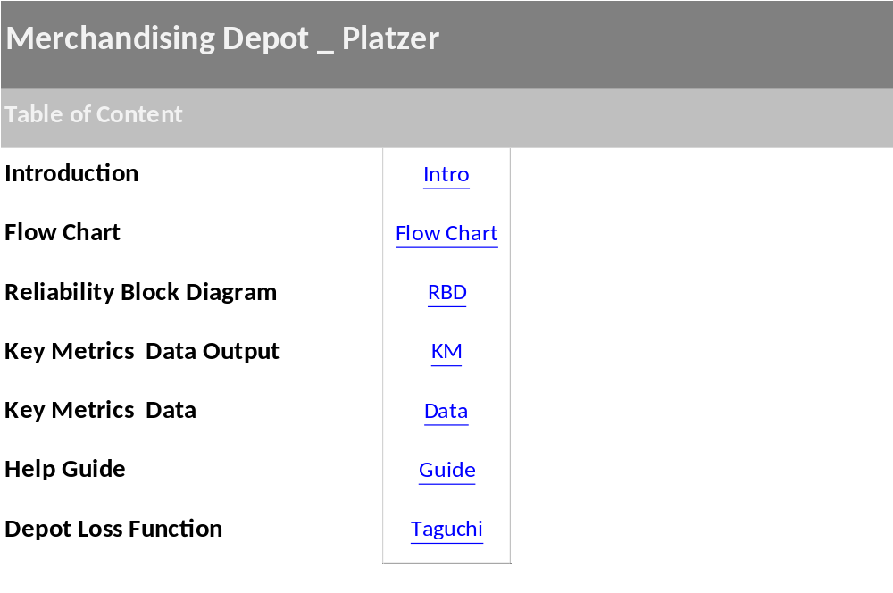
Figure 43. Excel workbook: sheet 1, table of content for spread sheet.

Figure 44. Excel workbook: sheet 1, introduction to Bio-depot.

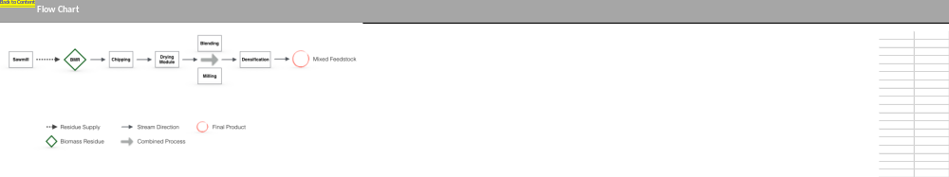
Figure 45. Excel workbook: sheet 3, flow chart for Bio-depot.
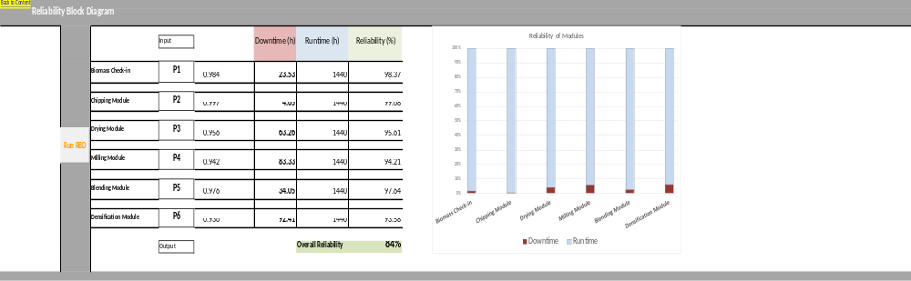
Figure 46. Excel workbook: sheet 4, Reliability Block Diagram.

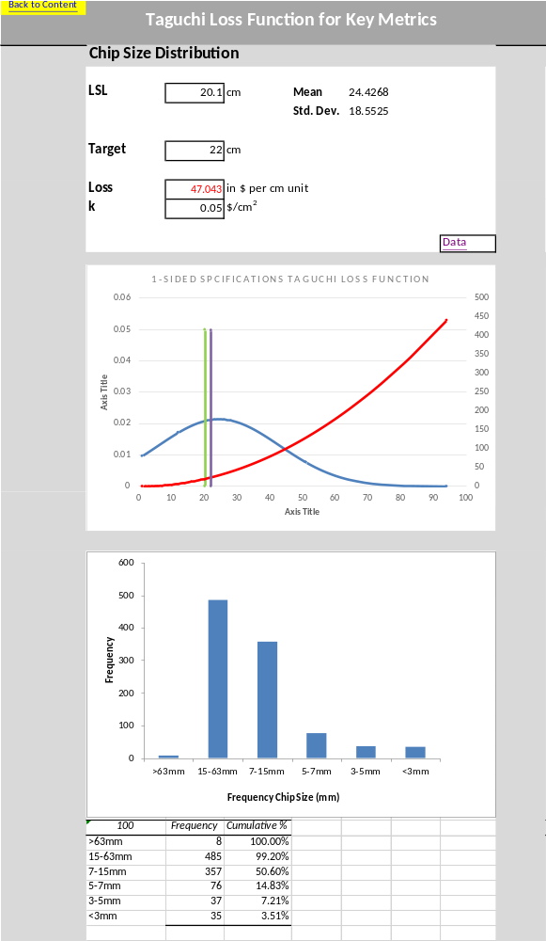
Figure 47. Excel workbook: sheet 5.1, Taguchi Loss Function for chip size.
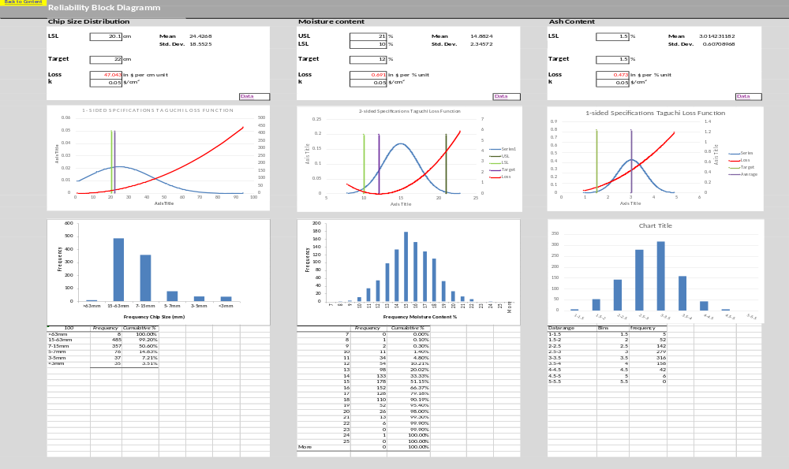
Figure. 48 Excel workbook: sheet 5.2, Taguchi Loss Function for moisture content.

Figure 49. Excel workbook: sheet 5.3, Taguchi Loss Function for ash content.

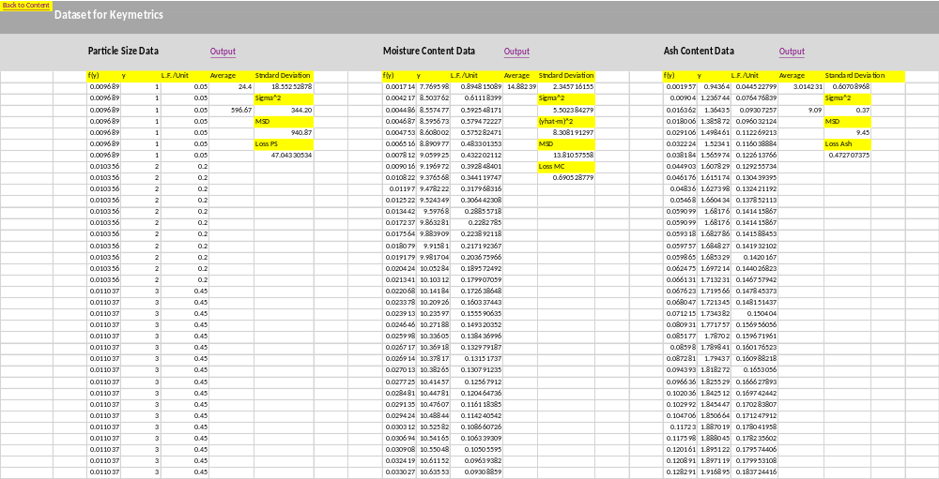
Figure 50. Excel workbook: sheet 6, dataset for key metrics.

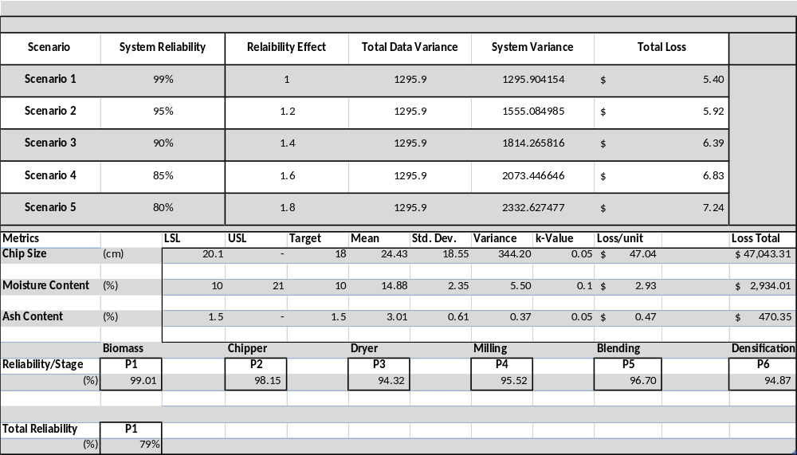
Figure 51. Excel workbook: sheet 7, summary results.

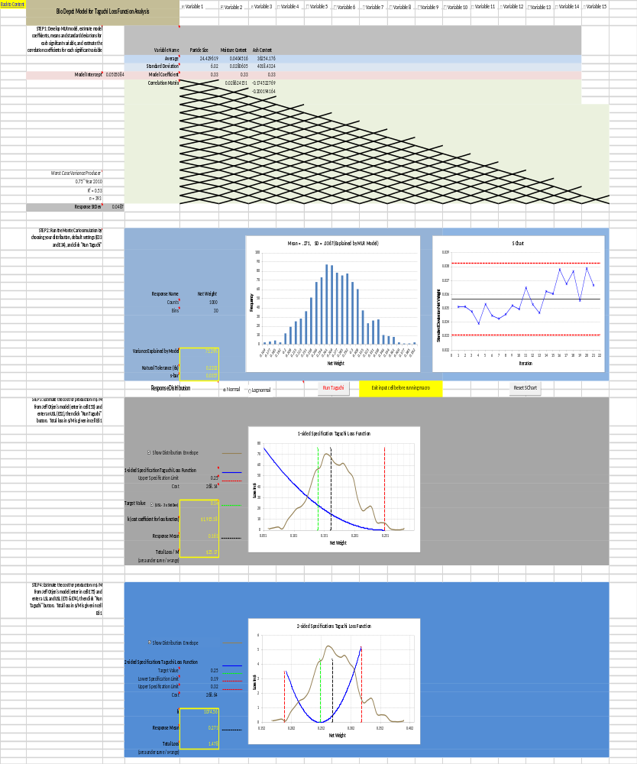
Figure 52. Excel workbook: sheet 6-1, bio-depot model for Taguchi Loss Function.
Figure 53. Excel workbook: sheet 6-2, bio-depot model for Taguchi Loss Function.

Table 3. Virtual Basic Analysis_ code for “Reliability Block Diagram”.
Virtual Basic Analysis_ Code for Reliability Block Diagram
Sub calc_formula()
Dim v1 As Double
Dim v2 As Double
Dim v3 As Double
Dim v4 As Double
Dim v5 As Double
Dim v6 As Double
Dim result1 As Double
Range("F8").Select
v1 = ActiveCell.Value
Range("F11").Select
v2 = ActiveCell.Value
Range("F14").Select
v3 = ActiveCell.Value
Range("F17").Select
v4 = ActiveCell.Value
Range("F20").Select
v5 = ActiveCell.Value
Range("F23").Select
v6 = ActiveCell.Value
Range("J25").Select
ActiveCell.Value = v1 * v2 * v3 * v4 * v5 * v6
End Sub

Table 4. Virtual Basic Analysis – code for Taguchi Loss Function on Excel workbook (Young et al., 2014).
Virtual Basic Analysis_ Code for Taguchi Loss Function
Dim CounterSbar As Integer
Dim Sbar() As Double
Dim x_Sbar() As Double
Dim IndivSDev As Double

Sub Taguchi()
'
' Taguchi Macro
Dim i As Integer
Dim j As Integer
'
'Response Calculations
Dim CleanInputs As Boolean
Dim VarExpl_y_val As Double
Dim VariableCount As Integer
Dim VarResp As Double
Dim MeanResp As Double
Dim RespRowCount As Integer
Dim RespBinCount As Integer
Dim y_val() As Double
Dim y_val_s() As Double
Dim RespBin() As Double
Dim RespBin_Label() As Double
Dim RespFreq()
RespRowCount = Worksheets("Taguchi").Range("$E$33").Value
RespBinCount = Worksheets("Taguchi").Range("$E$34").Value
ReDim RespBin(RespBinCount - 2)
ReDim RespBin_Label(RespBinCount - 1)
ReDim y_val(RespRowCount - 1)
ReDim y_val_s(RespRowCount - 1)
VariableCount = 0
Dim ChkBx As OLEObject
For i = 1 To 15
If Worksheets("Taguchi").OLEObjects("ChkBx_Var" & CStr(i)).Object.Value = True Then
VariableCount = VariableCount + 1
Else
Exit For
End If
Next i
''
'Read and Check Targets, LSL, and USL
CleanInputs = False
Dim TargetValue As Double
Dim TargetValue1 As Double
Dim LSL As Double
Dim USL As Double
Dim USL1 As Double
TargetValue = Worksheets("Taguchi").Range("$E$72").Value
LSL = Worksheets("Taguchi").Range("$E$73").Value
USL = Worksheets("Taguchi").Range("$E$74").Value
If TargetValue > LSL Then
CleanInputs = True
If TargetValue < USL Then
CleanInputs = True
Else
CleanInputs = False
MsgBox ("Please Enter an Upper Spec Limit Value Superior to Target Value")
End If
Else
CleanInputs = False
MsgBox ("Please Enter a Lower Spec Limit Value Inferior to Target Value")
End If
''
If CleanInputs = True Then
MeanResp = Worksheets("Taguchi").Range("$C$7").Value
For i = 1 To VariableCount
MeanResp = MeanResp + Worksheets("Taguchi").Cells(5, 4 + i).Value * Worksheets("Taguchi").Cells(7, 4 + i).Value
Next i
VarResp = 0
For i = 1 To VariableCount
VarResp = VarResp + Worksheets("Taguchi").Cells(6, 4 + i).Value ^ 2 * Worksheets("Taguchi").Cells(7, 4 + i).Value ^ 2
Next i
For i = 1 To VariableCount - 1
For j = i + 1 To VariableCount
VarResp = VarResp + 2 * Worksheets("Taguchi").Cells(7, 4 + i).Value * Worksheets("Taguchi").Cells(7, 4 + j).Value * Worksheets("Taguchi").Cells(7 + i, 4 + j).Value * Worksheets("Taguchi").Cells(6, 4 + i).Value * Worksheets("Taguchi").Cells(6, 4 + j).Value
'MsgBox (Str(Worksheets("Taguchi").Cells(7, 4 + i).Value) + "," + Str(Worksheets("Taguchi").Cells(7, 4 + j).Value) + "," + Str(Worksheets("Taguchi").Cells(7 + i, 4 + j).Value) + "," + Str(Worksheets("Taguchi").Cells(6, 4 + i).Value) + "," + Str(Worksheets("Taguchi").Cells(6, 4 + j).Value))
Next j
Next i
'
If RB_Normal.Value = True Then
For i = 0 To (RespRowCount - 1)
y_val(i) = Excel.Application.WorksheetFunction.NormInv(Math.Rnd, MeanResp, VarResp ^ 0.5)
y_val_s(i) = y_val(i)
Next i
Else
For i = 0 To (RespRowCount - 1)
y_val(i) = Log(Excel.Application.WorksheetFunction.LogInv(Math.Rnd, MeanResp, VarResp ^ 0.5))
y_val_s(i) = y_val(i)
Next i
End If
For i = 0 To (RespBinCount - 2)
RespBin(i) = ((Excel.Application.WorksheetFunction.Max(y_val) - Excel.Application.WorksheetFunction.Min(y_val)) / RespBinCount) * (i + 1) + Excel.Application.WorksheetFunction.Min(y_val)
RespBin_Label(i) = Math.Round(RespBin(i), 3)
Next i
RespBin_Label(i) = Math.Round(((Excel.Application.WorksheetFunction.Max(y_val) - Excel.Application.WorksheetFunction.Min(y_val)) / RespBinCount) * (i + 1) + Excel.Application.WorksheetFunction.Min(y_val), 3)
RespFreq = Excel.Application.WorksheetFunction.Frequency(y_val, RespBin)
''
''
'Taguchi Loss Function, 2-Sided
Dim LossFunction() As Double
Dim LossFunction_4chart() As Double
Dim y_val_4chart() As Double
Dim counter_y As Integer
Dim k As Double
counter_y = -1
k = Worksheets("Taguchi").Range("$E$75").Value / TargetValue
Worksheets("Taguchi").Range("$E$77").Value = Round(k, 3)
y_val_s = BubbleSrt(y_val_s, True)
ReDim LossFunction(RespRowCount - 1)
For i = 0 To RespRowCount - 1
LossFunction(i) = k * (y_val_s(i) - TargetValue) ^ 2
If y_val_s(i) > LSL Then
If y_val_s(i) < USL Then
counter_y = counter_y + 1
If counter_y = 0 Then
ReDim y_val_4chart(counter_y)
ReDim LossFunction_4chart(counter_y)
Else
ReDim Preserve y_val_4chart(counter_y)
ReDim Preserve LossFunction_4chart(counter_y)
End If
y_val_4chart(counter_y) = y_val_s(i)
LossFunction_4chart(counter_y) = LossFunction(i)
End If
End If
Next i
''
'Prep Data for Taguchi Loss Function 1 sided chart
Dim x_vlineMean(1) As Double
Dim y_vlineMean(1) As Double
Dim x_vlineMean1(1) As Double
Dim y_vlineLSL(1) As Double
Dim y_vlineUSL(1) As Double
Dim x_vlineLSL(1) As Double
Dim x_vlineUSL(1) As Double
Dim x_vlineTarget(1) As Double
Dim x_vlineTarget1(1) As Double
Dim y_vline1(1) As Double
Dim x_vlineUSL1(1) As Double
Dim y_val1() As Double
Dim LossFunction1() As Double
Dim k1 As Double
y_vlineLSL(0) = 0
y_vlineLSL(1) = LossFunction_4chart(0)
y_vlineUSL(0) = 0
y_vlineUSL(1) = LossFunction_4chart(UBound(LossFunction_4chart))
x_vlineLSL(0) = LSL
x_vlineLSL(1) = LSL
x_vlineUSL(0) = USL
x_vlineUSL(1) = USL
'Area under the curve calculation 2-sided TLF
Dim Area As Double
Area = 0
For i = 0 To UBound(LossFunction) - 1
If y_val_s(i) > LSL Then
If y_val_s(i + 1) < USL Then
Area = Area + ((LossFunction(i) + LossFunction(i + 1)) / 2) * (y_val_s(i + 1) - y_val_s(i))
Else
Exit For
End If
End If
Next i
Area = Area / (y_val_4chart(UBound(y_val_4chart)) - y_val_4chart(0))
Dim MeanResp1 As Double
MeanResp1 = Excel.Application.WorksheetFunction.Average(y_val)
Worksheets("Taguchi").Range("$E$79").Value = Str(Math.Round(MeanResp1, 3))
Worksheets("Taguchi").Range("$E$41").Value = Math.Round(Excel.Application.WorksheetFunction.StDev(y_val), 4) * 6
x_vlineMean(0) = Worksheets("Taguchi").Range("$E$79").Value
x_vlineMean(1) = x_vlineMean(0)
y_vlineMean(0) = 0
y_vlineMean(1) = (y_vlineLSL(1) + y_vlineUSL(1)) / 2
Worksheets("Taguchi").Range("$E$81").Value = Round(Area, 3)
x_vlineTarget(0) = Worksheets("Taguchi").Range("$E$72").Value
x_vlineTarget(1) = x_vlineTarget(0)
Worksheets("Taguchi").Range("$E$39").Value = Excel.Application.WorksheetFunction.StDev(y_val) / Worksheets("Taguchi").Range("$C$23").Value
IndivSDev = Excel.Application.WorksheetFunction.StDev(y_val)
CounterSbar = CounterSbar + 1
''
Dim objChrt_Resp As ChartObject
Dim chrt_Resp As Chart
Dim s_Resp As Series
Set objChrt_Resp = Worksheets("Taguchi").ChartObjects("Chart Resp")
Set chrt_Resp = objChrt_Resp.Chart
chrt_Resp.ChartType = xlColumnClustered
Set s_Resp = chrt_Resp.SeriesCollection(1)
s_Resp.XValues = RespBin_Label
s_Resp.Values = RespFreq
chrt_Resp.Axes(xlCategory, xlPrimary).HasTitle = True
chrt_Resp.Axes(xlCategory, xlPrimary).AxisTitle.Font.Size = 12
chrt_Resp.Axes(xlValue, xlPrimary).AxisTitle.Font.Size = 14
chrt_Resp.Axes(xlCategory, xlPrimary).AxisTitle.Characters.Text = Worksheets("Taguchi").Range("$E$32").Value
chrt_Resp.Axes(xlValue, xlPrimary).HasTitle = True
chrt_Resp.Axes(xlValue, xlPrimary).AxisTitle.Characters.Text = "Frequency"
chrt_Resp.HasTitle = True
chrt_Resp.ChartTitle.Text = "Mean = " + Str(Worksheets("Taguchi").Range("$E$79").Value) + ", SD = " + Str(Math.Round(IndivSDev, 4)) + " (Explained by MLR Model)"
chrt_Resp.ChartTitle.Font.Size = 14
''
Dim objChrt_Tag As ChartObject
Dim chrt_Tag As Chart
Dim s_Tag As Series
Set objChrt_Tag = Worksheets("Taguchi").ChartObjects("Taguchi 2")
Set chrt_Tag = objChrt_Tag.Chart
chrt_Tag.SeriesCollection(6).Delete
chrt_Tag.ChartType = xlXYScatterLinesNoMarkers
Set s_Tag = chrt_Tag.SeriesCollection(1)
s_Tag.XValues = y_val_4chart
s_Tag.Values = LossFunction_4chart
s_Tag.MarkerSize = 5
s_Tag.Border.Color = RGB(0, 0, 255)
s_Tag.Format.Line.DashStyle = msoLineSolid
s_Tag.AxisGroup = xlPrimary
chrt_Tag.Axes(xlCategory, xlPrimary).HasTitle = True
chrt_Tag.Axes(xlCategory, xlPrimary).AxisTitle.Characters.Text = Worksheets("Taguchi").Range("$E$32").Value
chrt_Tag.Axes(xlCategory, xlPrimary).AxisTitle.Font.Size = 12
chrt_Tag.Axes(xlValue, xlPrimary).HasTitle = True
chrt_Tag.Axes(xlValue, xlPrimary).AxisTitle.Characters.Text = "Loss in $"
chrt_Tag.Axes(xlValue, xlPrimary).AxisTitle.Font.Size = 14
chrt_Tag.Axes(xlCategory, xlPrimary).MinimumScale = Round(Excel.Application.WorksheetFunction.Min(RespBin_Label(0) - 0.1 * RespBin_Label(0), LSL - 0.1 * LSL, TargetValue - 0.1 * TargetValue), 3)
chrt_Tag.Axes(xlCategory, xlPrimary).MaximumScale = Round(Excel.Application.WorksheetFunction.Max(RespBin_Label(UBound(RespBin_Label)) + 0.1 * RespBin_Label(0), USL + 0.1 * RespBin_Label(0), TargetValue + 0.1 * RespBin_Label(0)), 3)
chrt_Tag.Axes(xlCategory, xlPrimary).MajorUnitIsAuto = True
chrt_Tag.HasTitle = True
chrt_Tag.ChartTitle.Text = Worksheets("Taguchi").Range("$D$71").Value
chrt_Tag.ChartTitle.Font.Size = 14
'
Dim s_TagLSL As Series
Set s_TagLSL = chrt_Tag.SeriesCollection(2)
s_TagLSL.XValues = x_vlineLSL
s_TagLSL.AxisGroup = xlPrimary
s_TagLSL.Values = y_vlineLSL
s_TagLSL.Border.Color = RGB(255, 0, 0)
s_TagLSL.Format.Line.DashStyle = msoLineSysDash
'
Dim s_TagUSL As Series
Set s_TagUSL = chrt_Tag.SeriesCollection(3)
s_TagUSL.XValues = x_vlineUSL
s_TagUSL.AxisGroup = xlPrimary
s_TagUSL.Values = y_vlineUSL
s_TagUSL.Border.Color = RGB(255, 0, 0)
s_TagUSL.Format.Line.DashStyle = msoLineSysDash
'
Dim s_TagMean As Series
Set s_TagMean = chrt_Tag.SeriesCollection(4)
s_TagMean.XValues = x_vlineMean
s_TagMean.AxisGroup = xlPrimary
s_TagMean.Values = y_vlineMean
s_TagMean.Border.Color = RGB(0, 0, 0)
s_TagMean.Format.Line.DashStyle = msoLineSysDash
'
Dim s_TagTarget As Series
Set s_TagTarget = chrt_Tag.SeriesCollection(5)
s_TagTarget.XValues = x_vlineTarget
s_TagTarget.AxisGroup = xlPrimary
s_TagTarget.Values = y_vlineMean
s_TagTarget.Border.Color = RGB(0, 255, 0)
s_TagTarget.Format.Line.DashStyle = msoLineSysDash
'
chrt_Tag.SeriesCollection.NewSeries
Dim s_Distri As Series
Set s_Distri = chrt_Tag.SeriesCollection(6)
s_Distri.AxisGroup = xlSecondary
s_Distri.XValues = RespBin_Label
s_Distri.Values = RespFreq
s_Distri.Border.Color = RGB(148, 128, 84)
s_Distri.ChartType = xlXYScatterSmoothNoMarkers
Call ChBx_ShowDistri_Click
chrt_Tag.Axes(xlValue, xlSecondary).MajorTickMark = xlNone
chrt_Tag.Axes(xlValue, xlSecondary).TickLabelPosition = xlNone
''
''
'One sided loss function calculation
Dim S3 As Double
S3 = Excel.Application.WorksheetFunction.StDev(y_val) * 3
USL1 = Worksheets("Taguchi").Range("$E$52").Value
If Worksheets("Taguchi").DrawingObjects("ChBx_3S").Value = 1 Then
TargetValue1 = USL1 - S3
Worksheets("Taguchi").Range("$E$55").Font.Color = RGB(255, 255, 0)
Else
TargetValue1 = Worksheets("Taguchi").Range("$E$55").Value
Worksheets("Taguchi").Range("$E$55").Font.Color = RGB(0, 0, 0)
End If
If TargetValue1 > 0 Then
If USL1 < y_val_s(UBound(y_val_s)) Then
Dim counterTLF1 As Integer
counterTLF1 = -1
k1 = Worksheets("Taguchi").Range("$E$53").Value / TargetValue1
Worksheets("Taguchi").Range("$E$57").Value = Round(k1, 3)
If Worksheets("Taguchi").DrawingObjects("ChBx_3S").Value = 1 Then
MeanResp1 = MeanResp1 - S3
Worksheets("Taguchi").Range("$E$55").Value = Round(TargetValue1, 3)
For i = 0 To UBound(y_val_s)
counterTLF1 = counterTLF1 + 1
If counterTLF1 = 0 Then
ReDim LossFunction1(counterTLF1)
ReDim y_val1(counterTLF1)
Else
ReDim Preserve LossFunction1(counterTLF1)
ReDim Preserve y_val1(counterTLF1)
End If
LossFunction1(counterTLF1) = k1 * ((y_val_s(i) - S3) - USL1) ^ 2
y_val1(counterTLF1) = y_val_s(i) - S3
If ((y_val_s(i) - S3) - USL1) > 0 Then
LossFunction1(counterTLF1) = 0
y_val1(counterTLF1) = USL1
Exit For
End If
Next i
Else
For i = 0 To UBound(y_val_s)
counterTLF1 = counterTLF1 + 1
If counterTLF1 = 0 Then
ReDim LossFunction1(counterTLF1)
ReDim y_val1(counterTLF1)
Else
ReDim Preserve LossFunction1(counterTLF1)
ReDim Preserve y_val1(counterTLF1)
End If
LossFunction1(counterTLF1) = k1 * (y_val_s(i) - USL1) ^ 2
y_val1(counterTLF1) = y_val_s(i)
If (y_val_s(i) - USL1) > 0 Then
LossFunction1(counterTLF1) = 0
y_val1(counterTLF1) = USL1
Exit For
End If
Next i
End If
''
'Area under the curve calculation one-sided TLF
Dim Area1 As Double
Area1 = 0
For i = 0 To UBound(LossFunction1) - 1
Area1 = Area1 + ((LossFunction1(i) + LossFunction1(i + 1)) / 2) * (y_val1(i + 1) - y_val1(i))
Next i
Area1 = Area1 / (y_val1(UBound(y_val1)) - y_val1(0))
Worksheets("Taguchi").Range("$E$59").Value = Str(Math.Round(MeanResp1, 3))
Worksheets("Taguchi").Range("$E$61").Value = Round(Area1, 3)
x_vlineMean1(0) = Worksheets("Taguchi").Range("$E$59").Value
x_vlineMean1(1) = x_vlineMean1(0)
x_vlineTarget1(0) = TargetValue1
x_vlineTarget1(1) = x_vlineTarget1(0)
x_vlineUSL1(0) = USL1
x_vlineUSL1(1) = x_vlineUSL1(0)
y_vline1(0) = 0
y_vline1(1) = LossFunction1(0)
Dim RespBin_Label_Shifted()
ReDim RespBin_Label_Shifted(UBound(RespBin_Label))
If Worksheets("Taguchi").DrawingObjects("ChBx_3S").Value = 1 Then
For i = 0 To UBound(RespBin_Label_Shifted)
RespBin_Label_Shifted(i) = RespBin_Label(i) - S3
Next i
End If
''
Dim objChrt_Tag1 As ChartObject
Dim chrt_Tag1 As Chart
Dim s_Tag1 As Series
Dim s_TagUSL1 As Series
Set objChrt_Tag1 = Worksheets("Taguchi").ChartObjects("Taguchi 1")
Set chrt_Tag1 = objChrt_Tag1.Chart
chrt_Tag1.SeriesCollection(5).Delete
chrt_Tag1.ChartType = xlXYScatterLinesNoMarkers
Set s_Tag1 = chrt_Tag1.SeriesCollection(1)
s_Tag1.AxisGroup = xlPrimary
s_Tag1.XValues = y_val1
s_Tag1.Values = LossFunction1
s_Tag1.Border.Color = RGB(0, 0, 255)
chrt_Tag1.Axes(xlCategory, xlPrimary).HasTitle = True
chrt_Tag1.Axes(xlCategory, xlPrimary).AxisTitle.Characters.Text = Worksheets("Taguchi").Range("$E$32").Value
chrt_Tag1.Axes(xlCategory, xlPrimary).AxisTitle.Font.Size = 12
chrt_Tag1.Axes(xlValue, xlPrimary).HasTitle = True
chrt_Tag1.Axes(xlValue, xlPrimary).AxisTitle.Characters.Text = "Loss in $"
chrt_Tag1.Axes(xlValue, xlPrimary).AxisTitle.Font.Size = 14
chrt_Tag1.Axes(xlCategory, xlPrimary).MinimumScale = Round(y_val1(0), 3)
chrt_Tag1.Axes(xlCategory, xlPrimary).MaximumScale = Round(Excel.Application.WorksheetFunction.Max(RespBin_Label_Shifted(UBound(RespBin_Label_Shifted)) + 0.1 * y_val_s(0), y_val1(UBound(y_val1)) + 0.1 * y_val_s(0), USL1 + 0.1 * y_val_s(0)), 3)
chrt_Tag1.Axes(xlCategory, xlPrimary).MajorUnitIsAuto = True
chrt_Tag1.HasTitle = True
chrt_Tag1.ChartTitle.Text = Worksheets("Taguchi").Range("$D$51").Value
chrt_Tag1.ChartTitle.Font.Size = 14
'
Set s_TagUSL1 = chrt_Tag1.SeriesCollection(2)
s_TagUSL1.XValues = x_vlineUSL1
s_TagUSL1.AxisGroup = xlPrimary
s_TagUSL1.Values = y_vline1
s_TagUSL1.Border.Color = RGB(255, 0, 0)
s_TagUSL1.Format.Line.DashStyle = msoLineSysDash
'
Dim s_TagMean1 As Series
Set s_TagMean1 = chrt_Tag1.SeriesCollection(3)
s_TagMean1.XValues = x_vlineMean1
s_TagMean1.AxisGroup = xlPrimary
s_TagMean1.Values = y_vline1
s_TagMean1.Border.Color = RGB(0, 0, 0)
s_TagMean1.Format.Line.DashStyle = msoLineSysDash
'
Dim s_TagTarget1 As Series
Set s_TagTarget1 = chrt_Tag1.SeriesCollection(4)
s_TagTarget1.XValues = x_vlineTarget1
s_TagTarget1.AxisGroup = xlPrimary
s_TagTarget1.Values = y_vline1
s_TagTarget1.Border.Color = RGB(0, 255, 0)
s_TagTarget1.Format.Line.DashStyle = msoLineSysDash
'
chrt_Tag1.SeriesCollection.NewSeries
Dim s_Distri2 As Series
Set s_Distri2 = chrt_Tag1.SeriesCollection(5)
If Worksheets("Taguchi").DrawingObjects("ChBx_3S").Value = 1 Then
s_Distri2.XValues = RespBin_Label_Shifted
Else
s_Distri2.XValues = RespBin_Label
End If
s_Distri2.AxisGroup = xlSecondary
s_Distri2.Values = RespFreq
s_Distri2.Border.Color = RGB(148, 128, 84)
s_Distri2.ChartType = xlXYScatterSmoothNoMarkers
chrt_Tag1.Axes(xlValue, xlSecondary).MajorTickMark = xlNone
chrt_Tag1.Axes(xlValue, xlSecondary).TickLabelPosition = xlNone
''
Call SBarChart
Else
MsgBox ("Target Value for one-sided Taguchi Loss Function is Too High," & vbCrLf & "Please Enter a Smaller Value")
End If
Else
MsgBox ("Upper Specification Limit is Too Small Compared to the Response Standard Deviation")
End If
End If
End Sub

Sub SBarChart()
Dim AvMovRange As Double
Dim AvSbar As Double
Dim i As Integer
Dim x_sLSL(1) As Double
Dim y_sLSL(1) As Double
Dim y_sUSL(1) As Double
Dim y_sCL(1) As Double
AvMovRange = 0
If CounterSbar = 1 Then
ReDim Sbar(0)
Sbar(0) = IndivSDev
ReDim x_Sbar(0)
x_Sbar(0) = CounterSbar
ElseIf CounterSbar > 1 Then
ReDim Preserve Sbar(CounterSbar - 1)
Sbar(CounterSbar - 1) = IndivSDev
ReDim Preserve x_Sbar(CounterSbar - 1)
x_Sbar(CounterSbar - 1) = CounterSbar
For i = 1 To UBound(Sbar)
AvMovRange = AvMovRange + Abs(Sbar(i) - Sbar(i - 1))
Next i
AvMovRange = AvMovRange / UBound(Sbar)
AvSbar = Excel.Application.WorksheetFunction.Average(Sbar)
''
x_sLSL(0) = 0
x_sLSL(1) = CounterSbar + 1
y_sLSL(0) = AvSbar - 2.66 * AvMovRange
y_sLSL(1) = y_sLSL(0)
y_sUSL(0) = AvSbar + 2.66 * AvMovRange
y_sUSL(1) = y_sUSL(0)
y_sCL(0) = AvSbar
y_sCL(1) = y_sCL(0)
'
Worksheets("Taguchi").Range("$E$42").Value = Round(AvSbar, 4)
''
'Populate Sbar Chart
Dim objChrt_Sbar As ChartObject
Dim chrt_Sbar As Chart
Set objChrt_Sbar = Worksheets("Taguchi").ChartObjects("Chart sbar")
Set chrt_Sbar = objChrt_Sbar.Chart
'chrt_Tag1.SeriesCollection(5).Delete
chrt_Sbar.ChartType = xlXYScatterLinesNoMarkers
chrt_Sbar.Axes(xlCategory, xlPrimary).HasTitle = True
chrt_Sbar.Axes(xlCategory, xlPrimary).AxisTitle.Characters.Text = "Iteration"
chrt_Sbar.Axes(xlCategory, xlPrimary).AxisTitle.Font.Size = 12
chrt_Sbar.Axes(xlValue, xlPrimary).HasTitle = True
chrt_Sbar.Axes(xlValue, xlPrimary).AxisTitle.Characters.Text = "Standard Deviation " + Worksheets("Taguchi").Range("$E$32").Value
chrt_Sbar.Axes(xlValue, xlPrimary).AxisTitle.Font.Size = 14
chrt_Sbar.Axes(xlCategory, xlPrimary).MinimumScale = 0
chrt_Sbar.Axes(xlCategory, xlPrimary).MaximumScale = CounterSbar + 1
chrt_Sbar.Axes(xlCategory, xlPrimary).MajorUnitIsAuto = False
chrt_Sbar.Axes(xlCategory, xlPrimary).MajorUnit = 1
chrt_Sbar.HasTitle = True
chrt_Sbar.ChartTitle.Text = "S Chart"
chrt_Sbar.ChartTitle.Font.Size = 14
'
Dim sLSL As Series
Set sLSL = chrt_Sbar.SeriesCollection(1)
sLSL.AxisGroup = xlPrimary
sLSL.XValues = x_sLSL
sLSL.Values = y_sLSL
sLSL.Border.Color = RGB(255, 0, 0)
sLSL.Format.Line.DashStyle = msoLineSysDash
'
Dim sUSL As Series
Set sUSL = chrt_Sbar.SeriesCollection(2)
sUSL.AxisGroup = xlPrimary
sUSL.XValues = x_sLSL
sUSL.Values = y_sUSL
sUSL.Border.Color = RGB(255, 0, 0)
sUSL.Format.Line.DashStyle = msoLineSysDash
'
Dim sCL As Series
Set sCL = chrt_Sbar.SeriesCollection(3)
sCL.AxisGroup = xlPrimary
sCL.XValues = x_sLSL
sCL.Values = y_sCL
sCL.Border.Color = RGB(0, 0, 0)
sCL.Format.Line.DashStyle = msoLineSolid
sCL.Format.Line.Weight = 1.25
'
Dim xy_sBar As Series
Set xy_sBar = chrt_Sbar.SeriesCollection(4)
xy_sBar.ChartType = xlXYScatterLines
xy_sBar.AxisGroup = xlPrimary
xy_sBar.XValues = x_Sbar
xy_sBar.Values = Sbar
xy_sBar.MarkerStyle = xlMarkerStyleX
xy_sBar.MarkerSize = 5
xy_sBar.MarkerForegroundColor = RGB(0, 0, 255)
xy_sBar.Border.Color = RGB(0, 0, 255)
xy_sBar.Format.Line.Weight = 1.25
xy_sBar.Format.Line.DashStyle = msoLineSolid
End If
End Sub

Sub ChBx_ShowDistri_Click()
Dim objChrt_Tag As ChartObject
Dim chrt_Tag As Chart
Set objChrt_Tag = Worksheets("Taguchi").ChartObjects("Taguchi 2")
Set chrt_Tag = objChrt_Tag.Chart
Dim s_Distri As Series
Set s_Distri = chrt_Tag.SeriesCollection(6)
If Worksheets("Taguchi").DrawingObjects("ChBx_ShowDistri").Value = 1 Then
s_Distri.Format.Line.Visible = msoTrue
s_Distri.Border.Color = RGB(148, 128, 84)
Else
s_Distri.Format.Line.Visible = msoFalse
End If
End Sub

Sub ChBx_ShowDistri2_Click()
Dim objChrt_Tag1 As ChartObject
Dim chrt_Tag1 As Chart
Set objChrt_Tag1 = Worksheets("Taguchi").ChartObjects("Taguchi 1")
Set chrt_Tag1 = objChrt_Tag1.Chart
Dim s_Distri2 As Series
Set s_Distri2 = chrt_Tag1.SeriesCollection(5)
If Worksheets("Taguchi").DrawingObjects("ChBx_ShowDistri2").Value = 1 Then
s_Distri2.Format.Line.Visible = msoTrue
s_Distri2.Border.Color = RGB(148, 128, 84)
Else
s_Distri2.Format.Line.Visible = msoFalse
End If
End Sub

Private Sub ChkBx_Var1_Click()
If ChkBx_Var1.Value = False Then
ChkBx_Var1.Value = True
End If
End Sub

Private Sub ChkBx_Var2_Click()
If ChkBx_Var2.Value = False Then
ChkBx_Var2.Value = True
End If
End Sub

Private Sub ChkBx_Var3_Click()
If ChkBx_Var2.Value = True Then
If ChkBx_Var4.Value = True Then
ChkBx_Var3.Value = True
End If
Else
ChkBx_Var3.Value = False
End If
End Sub

Private Sub ChkBx_Var4_Click()
If ChkBx_Var3.Value = True Then
If ChkBx_Var5.Value = True Then
ChkBx_Var4.Value = True
End If
Else
ChkBx_Var4.Value = False
End If
End Sub

Private Sub ChkBx_Var5_Click()
If ChkBx_Var4.Value = True Then
If ChkBx_Var6.Value = True Then
ChkBx_Var5.Value = True
End If
Else
ChkBx_Var5.Value = False
End If
End Sub

Private Sub ChkBx_Var6_Click()
If ChkBx_Var5.Value = True Then
If ChkBx_Var7.Value = True Then
ChkBx_Var6.Value = True
End If
Else
ChkBx_Var6.Value = False
End If
End Sub

Private Sub ChkBx_Var7_Click()
If ChkBx_Var6.Value = True Then
If ChkBx_Var8.Value = True Then
ChkBx_Var7.Value = True
End If
Else
ChkBx_Var7.Value = False
End If
End Sub

Private Sub ChkBx_Var8_Click()
If ChkBx_Var7.Value = True Then
If ChkBx_Var9.Value = True Then
ChkBx_Var8.Value = True
End If
Else
ChkBx_Var8.Value = False
End If
End Sub

Private Sub ChkBx_Var9_Click()
If ChkBx_Var8.Value = True Then
If ChkBx_Var10.Value = True Then
ChkBx_Var9.Value = True
End If
Else
ChkBx_Var9.Value = False
End If
End Sub

Private Sub ChkBx_Var10_Click()
If ChkBx_Var9.Value = True Then
If ChkBx_Var11.Value = True Then
ChkBx_Var10.Value = True
End If
Else
ChkBx_Var10.Value = False
End If
End Sub

Private Sub ChkBx_Var11_Click()
If ChkBx_Var10.Value = True Then
If ChkBx_Var12.Value = True Then
ChkBx_Var11.Value = True
End If
Else
ChkBx_Var11.Value = False
End If
End Sub

Private Sub ChkBx_Var12_Click()
If ChkBx_Var11.Value = True Then
If ChkBx_Var13.Value = True Then
ChkBx_Var12.Value = True
End If
Else
ChkBx_Var12.Value = False
End If
End Sub

Private Sub ChkBx_Var13_Click()
If ChkBx_Var12.Value = True Then
If ChkBx_Var14.Value = True Then
ChkBx_Var13.Value = True
End If
Else
ChkBx_Var13.Value = False
End If
End Sub

Private Sub ChkBx_Var14_Click()
If ChkBx_Var13.Value = True Then
If ChkBx_Var15.Value = True Then
ChkBx_Var14.Value = True
End If
Else
ChkBx_Var14.Value = False
End If
End Sub

Private Sub ChkBx_Var15_Click()
If ChkBx_Var14.Value = True Then
If ChkBx_Var15.Value = True Then
ChkBx_Var15.Value = True
Else
ChkBx_Var15.Value = False
End If
Else
ChkBx_Var15.Value = False
End If
End Sub

Private Sub Cmd_Reset_Sbar_Click()
CounterSbar = 0
ReDim Sbar(0)
ReDim x_Sbar(0)
End Sub

Private Sub Cmd_RunTaguchi_Click()
Call Taguchi
End Sub

Public Function BubbleSrt(ArrayIn, Ascending As Boolean)

Dim SrtTemp As Variant
Dim i As Long
Dim j As Long

If Ascending = True Then
For i = LBound(ArrayIn) To UBound(ArrayIn)
For j = i + 1 To UBound(ArrayIn)
If ArrayIn(i) > ArrayIn(j) Then
SrtTemp = ArrayIn(j)
ArrayIn(j) = ArrayIn(i)
ArrayIn(i) = SrtTemp
End If
Next j
Next i
Else
For i = LBound(ArrayIn) To UBound(ArrayIn)
For j = i + 1 To UBound(ArrayIn)
If ArrayIn(i) < ArrayIn(j) Then
SrtTemp = ArrayIn(j)
ArrayIn(j) = ArrayIn(i)
ArrayIn(i) = SrtTemp
End If
Next j
Next i
End If

BubbleSrt = ArrayIn

End Function

                - Vita

Maximilian Platzer is from Vienna, Austria, where he accomplished his A-levels and an apprenticeship to a joiner. He attended the University of Applied Sciences in Salzburg, Austria, where he earned a B.S. in forest product technology.
During his undergraduate program, Max dealt with the “Study of heat transfer and gluing quality of three-layer solid wood panels with MUF adhesive”. Prior to the graduate program at UT he worked for the Norwegian company Green Resources, Africa’s largest forestation company, the leader in East African wood manufacturing. Due to his effort in Tanzania he was able to establish a collaboration between Green Resources and the University of Applied Sciences, Salzburg. He is currently Studying under Dr. Timothy Young at the Center for Renewable Carbon and his M.S. research focuses on variation within a merchandising depot for biomass.
He plans to graduate from the University of Tennessee with a “Master of Science degree in Wood Science Technology and Biomaterials” in August 2016.

