Attention, Curiosity, and Pleasurable Solitude
Within Adventure Games: A Reading of
RealMyst: Masterpiece Edition and Paradise Killer

A Thesis Presented for the
Master of Arts
Degree
The University of Tennessee, Knoxville

Hannah J. Trammell
May 2024

Copyright © 2024 by Hannah J. Trammell
All rights reserved.

ACKNOWLEDGEMENTS

Thank you to Dr. Hilary Havens for being a kind, diligent, and incredibly insightful mentor and committee chair for both this project and the MA program. Thank you to Dr. Amy Elias and Dr. Gerard Cohen-Vrignaud for being readers on my committee and for amazing in-class experiences. Thank you to Leanne Hinkle for always reminding me of deadlines. Finally, thank you to all the friends with whom I have built a lovely community here at UTK and to my partner, Josh, for putting up with my chaotic work energy.
ABSTRACT

The project examines Paradise Killer and RealMyst: Masterpiece Edition as two games exemplary of the adventure game genre that evoke specific affects uniquely collocated within the genre itself. Previous research from authors like Aubrey Anable and Katherine Isbister has shown that video games make players feel and that what they make players feel is important to study. Like the novel and film before, video games are undergoing a legitimation process as objects worthy of study and cultural critique, and it is necessary to begin parsing how their multimedia existence relates to previous categories of genre and audience response. Using scholarship like Isbister’s and Anable’s, I examine two games that are exemplary of their genre to demonstrate their connections to longer literary and filmic traditions as well as their unique ability to evoke feelings of nostalgia, attention, curiosity, and pleasurable solitude in their aesthetic and mechanical forms as well as from their players. The players’ responses are gathered from Reddit and Youtube comments sections, both of which have been used in previous qualitative studies, and the tools used to analyze the comments and organize them are Communalytic and Netlytic. The project’s findings conclude that, while not every player experience is the same, there is evidence that the games do evoke these feelings from players and that they do so through remediations of older traditions and the visceral nature of the medium.

Table of Contents

LITERATURE REVIEW: VIDEO GAME STUDIES, ADVENTURE GAMES, AND AFFECT 1
Historical Context and Defining Adventure Games 8
Affect Theory, Intermediation, and Embodiment 13
Chapter Overview 20
CHAPTER ONE 23
RealMyst: Masterpiece Edition 27
Paradise Killer 43
CHAPTER TWO 56
RealMyst: Masterpiece Edition 63
Reddit Comments, Sentimentality Analysis, and Dictionary Results 65
YouTube Walkthrough Comments and Dictionary Results 69
Paradise Killer 73
Reddit Comments, Sentimentality Analysis, and Dictionary Results 75
YouTube Walkthrough Comments and Dictionary Results 81
CONCLUSIONS AND RECOMMENDATIONS 84
LIST OF REFERENCES 86
APPENDIX A: FULL SOCIAL MEDIA COMMENTS 91
RealMyst Reddit Full Comments 91
Paradise Killer Full Comments 94
APPENDIX B: WORDPRESS 98
VITA 99

LIST OF FIGURES

Figure 1.1: The Mechanical Age fortress, where players have to work to solve the rotation puzzle, while searching for the red and blue pages. 36
Figure 1.2: The hallway in which the floor turns into a staircase leading to a lower level or players can follow it down to the elevator. 36
Figure 1.3: The elevator that is part of the Mechanical Age rotation puzzle. 37
Figure 1.4: Here players glimpse some of Sirrus’s lavish decorations in his throne in the Mechanical Age. 37
Figure 1.5: Achenar’s room in the Stoneship Age–bare except for poison vials and dead things. 41
Figure 1.6: Sirrus’s bedroom in the Stoneship Age filled with expensive fabrics, patterns and vases. 41
Figure 1.7: A desk in Sirrus’s room after the fashion of Louis XV 19th century furniture. 42
Figure 1.8: For reference, this is a CreativeCommons licensed image of a Louis XV bureau with which to compare Sirrus’s desk. 42
Figure 1.9: The title screen of Paradise Killer that sets the tone for the game immediately. 45
Figure 1.10: One of several landmarks that reminds players of the long history of Paradise Islands and the Syndicate, which they can only grasp through these tenuous vignettes. 45
Figure 1.11: One of many Relics players can find hidden across the world of Paradise Island 24. 54
Figure 1.12: A glimpse at the crowded housing into which the Citizens of Paradise Island 24 are forced after having been kidnapped from the real world. 54
Figure 13: A screenshot of the listed r/Paradise Killer netiquette. 74

Literature Review: Video Game Studies, Adventure Games, and Affect

Ever since I can remember, I associated video games with feelings. I am an experienced escapist in that I have rarely been in a situation where I couldn’t–at least for a time–imagine my way out of it. Video games made that even more possible, and, in fact, have expanded my imaginative abilities. My first handheld console that I remember was a GameBoy Advance, and my first standing console, a PlayStation 1, was a hand-me-down from my brother. Before these consoles, I had to play games on my father’s computer in the rare moments he was not using it or on his hand-me-down laptop, including the original iteration of Myst (1994) and other point-and-click adventure games like Indiana Jones and the Fate of Atlantis (1992), Space Quest I (1986), and Don’t Go Alone (1989). The going was rough for the majority of my childhood, and I was often left to my own devices for significant portions of time, so there was something attractive about games that were intellectually stimulating and also primarily solitary. Other sorts of games would affect me in different ways–for instance, there were several Japanese Role-Playing Games (JRPGs) that would move me to tears or allow me to play as a male character in ways that assisted me in exploring my own desire for gender play. Those games are also important to my relationship with the medium; however, adventure games were the beginning of my journey with video games and hold special resonance for me.
The sense of curiosity and challenge inspired by these games consumed me whenever I played, especially since we did not have a regular or stable internet connection much of the time, which meant that play time and downloading new content for games was either a treat or involved secretly using up all of our internet hotspot’s limited data. The funny thing with adventure games is that some of the play moves beyond the bounds of the gameworld inside the console, in a way that not a lot of other games do. One example is note taking in order to keep track of information, which is especially necessary in older adventure games. This could be attributed to the lack of complexity in older games’ user interface (UI); however, several remakes and remasters later notetaking is still very useful when playing games from the Myst series. Another way that these games spill out into the real world is through internet forums, which may not immediately seem like a claim unique to adventure games, but I posit that the types of spaces created on the internet to discuss adventure games are unique when compared to more commercially popular series like Grand Theft Auto. Finally, adventure games are unique in the way that they make me and other players feel. When I solve a difficult puzzle or learned a new piece of knowledge from these games using my own wit or “domain knowledge,” I felt excited and attentive, my success only sharpening my focus on the game, which also results in a deeper investment in the game’s mechanics and systems. Paradise Killer (2020) and RealMyst: Masterpiece Edition (2014; Nintendo Switch 2020) both exemplify the unique aspects of adventure games and evoke that same excitement and attention using different mechanical and narrative techniques that overlap under the umbrella of adventure games, but those affects are inflected by differing aesthetics.
Critics, players, and theorists alike must be attuned to the context in which games are produced to recognize the ways that video games touch our lives. As Aubrey Anable writes in her book, Playing with Feelings, video games “engage and entangle us in a circuit of feeling between their computational systems and the broader systems with which they interface: ideology, narrative, aesthetics, and flesh” (xii). Anable highlights the multiple valences occupied by video games, evoking the language of networks and cybernetics to describe their position as objects of culture, history, literature, and material existence. Whether players admit it or not, in a first-person shooter style game, who you are able to shoot says something about the game’s overarching ideology. Who is able to play certain games based on controller design or cultural acceptability is indicative of ideology. The aesthetics that inform a game’s visual design and narrative inflections speak to a game’s creation within a complex cultural schema. Due to their highly physical medium, video games mediate between flesh and plastic and sensorial experience.
For instance, the way that my fingers hover and the way the gears turn in my brain, as I work on pushing buttons and trying new inputs, are actions that are attentive in hue; they require both my physical presence and mental presence. They are also lonely and solitary actions; many of these adventure games–even those that introduce players to Non-Playable Characters (NPCs)–leave players feeling alone and pensive for hours of gameplay. The color schemes, dialogue, musical choices, and visual design of a video game evoke place, time, and context; a game set in a Medieval castle necessarily evokes the Medieval even if it contains elements of modernity. These are the primary affects, the emotional and sensorial spaces evoked both materially and narratively, I identify in my personal experiences of these games, and I think they speak to the manifestation of affective spaces in these games. Adventure games are uniquely positioned to evoke affects like nostalgia, curiosity, pleasurable isolation, and the excitement of understanding, but there is a lot of existing literature to consider in making the case for this claim.
There is a substantive body of work available on video games, adventure games, and affect theory, and there are recent studies on all three in conjunction. With the proliferation of scholarship, it is important to test current theories by examining new game releases and re-releases. For my study, I selected two first-person adventure games that share some narrative and aesthetic commonalities even as they diverge ludologically: Paradise Killer and RealMyst: Masterpiece Edition. The latter of the two games is an updated version of RealMyst: Interactive 3D Edition (2000), which itself was a reimagining of the original 1994 Myst. In reading into the affective spaces created by these games, the intermediation of the body and the game interface, and the narratives constructed in these games, I hope to further explore why these particular types of games continue to appeal to what some scholars have called an “outsider” audience. Paradise Killer and RealMyst are readily available through the Nintendo Switch platform, and also represent some of the many permutations of the adventure game. They both create worlds in which players are isolated, compelled to solve puzzles and mysteries, and are not offered deterministic answers to narrative or ludological questions. Both games constitute spaces in which players engage with curiosity, pleasurable solitude, and the pleasure of discovery through engagement with mechanics, aesthetics, and narratives grounded in the history of the adventure game genre and literary genres. There is a continued interest in adventure games reflected in 50 years of experimentation with the form in games like Colossal Cave Adventure (1977), Space Quest I, Myst, Riven (1997), RealMyst, Outer Wilds (2019), Paradise Killer, Return to Monkey Island (2022), or Killer Frequency (2023), all of which connote the importance to culture of adventure game as a classification–even when there are clear ludological differences between all of these games that are associated with the category. Adventure games bring together seemingly disparate titles with some shared characteristics may also represent a desire to dismantle the violence-centric forms of play endemic to a hyper masculine gaming culture that focuses heavily on certain forms of video games.
The terms “large commercial audience” and “outsider” need to be unpacked, especially in the context of who plays video games. Anable uses Laine Nooney’s example of “spelunking” to clarify her approach to gaming audiences from a historical perspective. This approach foregrounds the importance of “fragments over any sense of a whole picture,” using Roberta Williams (cofounder of Online Systems/Sierra Online) as a prime example. Anable highlights Nooney’s observations about the fragments of Williams’ life and career that remain, and Nooney concludes that the male-centric history of video games is a product of complex historical processes rather than a base narrative to which other social groups may be added (3-5). Female, disabled, and queer audiences and creators, of course, were already there. The questions of who plays video games and who is allowed access to gaming are complex and have sometimes resulted in volatile conflicts over their answers. For instance, the GamerGate controversy led to several prominent women in the gaming industry and many from outside the industry being doxed and threatened with unspeakable violence simply for existing, playing video games, and for bringing up the need for feminist rhetoric in these spaces. The proponents of #GamerGate claimed that these women were in collusion with game journalists to produce unethical articles aimed at making video games “politically correct,” eliminating or pressuring the “true gamers” out of their spaces. According to #GamerGate proponents, the “true gamer” is a white, straight, and able man or rather this description of the “true gamer” emerges from the misogynistic and generally bigoted campaign. For my use of “outsider” I borrow from Aaron A. Reed et al., who use the term “outsider” to mean someone who is not given adequate representation by the mainstream gaming industry but also someone who is actively chased from gaming spaces. By “large commercial audience,” I am often referring to a cis-caucasian, non-disabled, heterosexual male audience, since that is the misperception many game developers seem to possess about who buys their games, despite research clearly indicating that women make up at least 40% of gamers, if not 50% by other estimations (Paaßen et al., 422; Chess, introduction).
Many larger companies, which refers to companies that produce “AAA” games and turn millions in profits, seem to believe that their primary target audience is male and, in many cases, white, straight, cis-gender, and able-bodied, especially in America’s gaming industry. Past studies have shown through analyses of large samples of video games across multiple playing platforms that the majority of games’ main characters are white males. In their famous article, “The Virtual Census,” Williams et al. found that there was a “ 85.23/14.77” split between the appearance of male and female characters respectively across their sample of “the top 150 games across all [9 selected] platforms, with a minimum of 15 titles per system.” They further found that “White characters account for 84.95 percent of all primary characters, black 9.67 percent, biracial 3.69 percent and Asian 1.69 percent. Hispanics and Native Americans did not appear as a primary character in any game, they existed solely as secondary characters” (822-825). Though their survey is from 2009, more recent surveys continue to back up their findings and highlight the fact that those findings have not changed, despite shifts in America’s national demographics. Game journalist Brittney Lin of DiamondLobby.com, which is a website dedicated to video game tutorials and video game journalism, conducted a study in which she and, presumably other employees of DiamondLobby.com, surveyed “over 100 games released…between 2017 to 2021.” The results were that “79.2% of main protagonists in games are male, 20.8% female [;] 54.2% of main characters in games are white (Caucasian)[;] Just 8.3% of main characters in games are females of non-white ethnicities” (“Diversity in Gaming Report”). The demographics of potential audiences shift, but representations in games shift at a much more glacial pace.
Again the “outsider” audience I refer to consists of anyone who does not quite fit this description and who also loves to play video games, including me. Reed et al. provide some specific descriptors for what is meant by “outsider” here, including: “the ‘non-gamer’ outsider customer…; the abandoned outsider, who…starts making some [adventure games] of their own; the rebel outsider, making queer or altgames…; the outsider auteur…and the disabled outsider, who is shut out of games…” (ch. 1). I tend to agree with their assessment that these descriptors cover a wide, intersectional, and complex audience that likely does not operate the same way within the gaming space as the “large commercial audience” described. This “outsider” audience by its nature makes up a significant portion of video game purchasers and players. Part of this project aims to identify why the affective spaces created by adventure games are potentially attractive to “outsider” audiences seeking escape from an industry obsessed with a hypermasculinized and normative idea of games and gamers.

Historical Context and Defining Adventure Games
In order to understand why adventure games may hold greater appeal to an “outsider” audience, it is necessary to examine the genre’s historical context within American culture. The tradition of adventure games produced in America goes well back into the 1970s; however, computer games were originally developed in the 1950s as tools for testing the capacity of computers to handle certain computations and to demonstrate that capacity to interested parties in the military-industrial complex (Anable, x-xi). Colossal Cave Adventure was initially created in 1976 by William Crowther for non-commercial purposes–specifically so that he could feel closer to his children after his divorce, which feels pertinent to my own personal love of adventure games and their sense of solitary and close intimacy. Adventure games have the potential to bring players into intimate contact with developers and game creators, especially when made by smaller studios or individual developers independent of a larger company. These games also inspire other creators to either continue the developers’ series or to make wholly new works of their own. For instance, Don Woods would later expand upon Colossal Cave Adventure, and his and Crowther’s work eventually became the progenitor of the entire emerging genre of game (Reed et al., ch. 2). While the original was purely text-based, it would inspire later iterations of its formula that included visual graphics, such as Adventure (1980) and Mystery House (1980)–and eventually, of course, the games of this study among many others. The ways in which visual graphics adjusted the player’s relationship with the game differentiates many adventure games from their text-based counterparts, evoking effects similar to those of cinema in the use of visuals to express metaphor and exposition in more discrete or indirect ways; however, I would not compare visual video games to film in a one-to-one way, as genre within video games runs along axes of both aesthetics and ludology, which complicates the project of categorization.
The genre of video games is heavily influenced by its ludological systems and how those systems can be read in context with a game’s aesthetics. One ludological function that is incredibly important to adventure games is environmental storytelling. When I play games like Thimbleweed Park (2017), Layers of Fear (2016), and, of course, Paradise Killer, I am excited to learn what sorts of puzzles I will find and to explore the environmental storytelling, which puts the onus of constructing narrative primarily on players and reminds me of what I felt when I was child first booting up Space Quest I. For reference, environmental storytelling refers to the lack of direct exposition through the mimetic world of the game: it reveals the game world through the placement of notes, the visuals of the environment, and other detritus of the world’s implied inhabitants (Shepard, “Interactive Storytelling”). Players are given the choice to understand the game world on their own terms, and the degree to which they want to engage with the world feels like a choice of intimacy. This environmental storytelling is not unique to adventure games, but it owes its historical development as a mechanic to adventure games. Reed, Murray, and Salter write about the nature of adventure games and our relationship to games more generally in their book, Adventure Games Playing the Outsider (2020). They make a compelling case for the genetic linkage between adventure games and modern games, which range from first-person shooters (FPS) to virtual reality (VR) based games. Along this line they posit that “on a higher level, it seems intuitive that these games operate in a shared (or at least overlapping) design context” (ch. 2). The genres under which we try to group games are often permeable containers that inevitably inform each other’s evolution over time. Given the significant leap that Colossal Cave Adventure represents from the early days of games, which were meant to demonstrate the processing power of machines for the military industrial complex, like Tennis for Two, it is easy to see how Colossal Cave Adventure influenced games to come; it signaled to the world that games could be more than functional but also recreational. The idea that adventure games have influenced the formation of the entire gaming industry is hardly new, but it is important to keep in mind when assigning games to categories. None of these categories will be perfect, and, in fact, some leaking and intermingling is highly encouraged and fostered.
An interesting example of intermingling occurs between Doom and Myst, both of which emerged in the early to mid-90s and have found resounding success over time, though this success happened for Myst sooner than Doom. The concurrence of their technological development is undeniable, though it diverges significantly. Both games used innovative 3D graphics to varying effect, which practically means that:
The worlds of both Myst and Doom are virtual, mathematical descriptions of the shapes and dimensions of spaces and objects, and their relative positions. A virtual “camera” defines a view of the world, and in both Myst and Doom, this is from a “first person” point of view, simulating that of a normal sized human standing up on the horizontal plane of the virtual world. (Hutchison)
They both pushed the limits of what was possible for the medium at the time, but with radically different generic concerns in mind. Doom is one of the most significant progenitors of the first-person shooter, while Myst deeply influenced the first-person walking-simulator. Both games have mysteries and puzzles as an integral part of their play, though to varying degrees. The similarities between Myst and Doom demonstrate the innate flexibility of the adventure game genre. I make this point to highlight the slipperiness of adventure games as a category. Between RealMyst and Paradise Killer there are significant mechanical differences, so that looking at them from a purely ludological perspective, they do not look like the same type of game. It is with a combination of mechanical, aesthetic, and affective similarities formed from the same historical roots that they find kinship.
The genetic bonds between RealMyst and Paradise Killer solidify their positions as adventure games, but nonetheless some concrete definition of what constitutes an adventure game is helpful to reading them. Reed, Murray, and Salter importantly refer to the work of Clara Fernández-Vara and Scot Osterweil, whose work with adventure games defines parameters for the genre. Fernández-Vara and Osterweil write in their essay, “The Key to Adventure Game Design: Insight and Sense-making,” that there are five common traits among adventure games in that “they are story-driven, the player controls a player character, puzzle-solving constitutes their basic core mechanic, the interaction with the world is mainly object manipulation, and the game motivates the player to explore the space of the game and the possible actions within it” (6-7). I will refer to this list of traits often throughout the course of this study, both to corroborate and trouble them, as I think there are ways in which the deterministic phrasing of puzzle-solving and narrative/story-driven in their work does not entirely align with the ethos of Paradise Killer and RealMyst. Alternatively, games of ostensibly opposite purposes and genres like Doom still overlap with some of the primary functions of adventure games, and the permeability of what an adventure game even is becomes increasingly evident. What remains consistent are the affects of attention and curiosity generally associated with adventure games, which correlate with who is more likely to play adventure games.

Affect Theory, Intermediation, and Embodiment
Many designers aspire for their games to be objects of interest, attention, and pleasure by their nature, and often video games are necessarily a physically involved medium, whether with our sense of touch, sight, and/or hearing. Marshall McLuhan’s Understanding Media: The Extensions of Man is a touchstone for discussing our bodies in relation to technology, especially our emotional interaction with computer or console games. His early formulations of “auto-amputation” point scholars towards the physical relationship between our embodied material selves and the technology we handle on a regular basis. In his short chapter on “The Gadget Lover: Narcissus as Narcosis,” McLuhan writes that “Any invention or technology is an extension or self-amputation of our physical bodies, and such extension also demands new ratios or new equilibriums among the other organs and extensions of the body” (49). His suggestion seems to be that new technology always calls for new understandings of intermediation. He goes on to say that America’s emerging relationship to television intensifies the synchronicity with which global events are experienced to the point that the television becomes an all-encompassing and excessive window to the world, evoking similar discussions that scholars like Umberto Eco would revisit in Travels in Hyperreality. Eco uses the example of Americans asking for “more” coffee and not another cup (or single unit) of coffee to describe the linguistic largesse of America as it correlates to our material overabundance (7-8). Indeed in our neoliberal, globalized world, many video games seem to subscribe to the notion of “more” video game, promising endless photorealistic virtual worlds and hundreds of hours of play. But not so for the adventure game, and certainly not for Paradise Killer and RealMyst.
The sort of interest evoked by the adventure game stands in contrast to some of the industry’s more handsomely funded projects. Despite attempts by certain internet communities to disparage games like Paradise Killer and RealMyst as not “real” games on the basis of their lack of physical challenge, they continue to thrive and speak to a desire for a game that does not rely solely on physical ability or aggression for enjoyment. These games also do not usually take over 200 hours to play, and generally champion stylized visuals over cutting edge graphics, as will be discussed in Chapter 1 of this thesis. This design may well speak to an anti-consumerist impulse within the industry and among players of these games. The physical dynamics in playing an adventure game are different from some other game genres. There is a difference between the affects engaged by these games and the affects engaged by games like Grand Theft Auto, and part of this difference is the complex relationship between human experience and code which is then mediated by the controller and everything that comes with the game: narrative, aesthetics, ludological actions. I cannot murder sex workers with impunity in RealMyst and Paradise Killer nor is my focus to tell a story of a criminal underground. Certainly crime is involved in Paradise Killer, but it is a singular crime, in multiple senses, not a pervasive and ever-present vector of game action. As someone who has enjoyed playing the Grand Theft Auto series in the past, my claim is not that RealMyst or Paradise Killer are necessarily morally superior games, making those who choose to play them superior. Instead, I am asserting that who you can kill in a game means something; if killing is a primary part of gameplay, then that means something. For instance, the Grand Theft Auto series is famous for players’ ability to kill anyone and everyone in an urban American setting. Often this leads to players laughing at the carnage they sow, as they wield military grade weaponry against civilians or beat sex workers to death after using their services in the game. The NPCs of Grand Theft Auto are generally nameless and consist of a few generic designs—essentially, they are designed to avoid the potential for guilt. In Paradise Killer players can kill NPCs via point-blank execution, but the game requires you to decide who to kill using collected evidence, and in order to gather information you have to interact with characters and get to know them as individuals.
While video games are not the same as electronic literature, there is work that has been done on electronic literature about how reading such literature constitutes a different interactive dynamic than classic literature. Both mediums involve intimate contact with a digital interface of some variety that affects how we relate to our bodies relating to the interface. N. Katherine Hayles defines the dynamics of human and computer well in her book, Electronic Literature: New Horizons for the Literary, compiling both older and newer research and deftly synthesizing all of it to discuss the human and machine dynamic, particularly as it relates to the contested sector of electronic literature and, by extension, computer games. As one of the most significant contributors to a cybernetic approach to human/machine mediation, Hayles highlights the dynamics between “author and program, player and computer,” writing that:
as human cognition is to the creation and consumption of the work, so computer cognition is to its execution and performance…[T]he experience of electronic literature can be understood in terms of intermediating dynamics linking human understanding with computer (sub)cognition through the cascading processes of interpretation that give meaning to information. (57)
Her suggestion is that the experience of electronic literature and computer games is one mediated by codes and programming that is synthesized into information by its reinterpretation of that code into visuals, sounds, possible inputs, and writing, which is not to make those aspects contingent upon code alone, but that they are mutually constitutive, as is the player’s sensorial encounter with them. This approach does fall into a sense of systematizing that may neglect certain liminal aspects of emotional experience, but it importantly imbricates our bodies and technology in inextricable ways. After all, what does a game unplayed signify?
Other approaches to the dynamics of embodiment focus on the liminal, such as Brian Massumi’s work on the “charge of indeterminacy carried by the body,” which also points toward the significance of physical imbrication with technology. He would take the issue further and say that when people are placed into a grid of intersecting existences or identities, they are fixed and the dynamism of their bodies lost (3-5). Though he tacitly does not engage with video games in Parables of the Virtual, his work is still applicable to the problem of bodies and video games. A video game is generally not a static experience: most of the time players use a physical controller, keyboard, mouse, or even joystick to input commands and explore a given video game’s world. Even the original Myst, which is composed of still images, is not entirely static, since “players still spent much of their time navigating complex environments, retracing their steps to return to earlier areas looking for clues, unsure where to go next” (Reed, Murray, Salter, ch. 5). There are hundreds of images that comprise the game and create a sense of the game space’s continuity, as players click through them. In addition to the volume of images with which players can interact, there is an iconic musical score that only adds to the game’s continuity. RealMyst updates this style of movement by fashioning the original game’s environments as a continuous 3D experience, but even this change in how players move alters how the game evokes affective spaces for players.
The orientation of players to games, as well as to the physical apparatuses with which video games are played–by which video games are made possible–inform and are informed by emotion. Who feels what about which games is a complex process of orientation and contact between surfaces of bodies, controllers, and the object that is the video game itself. Sara Ahmed’s foundational work in The Cultural Politics of Emotion is important to my work because she is specifically interested in which bodies are allowed to experience certain emotions and which are not. The affect of nostalgia is always contested. For example, who can claim nostalgia over what memories or phenomena depends on a multitude of factors, including age, gender, race, social class, and sexuality. Something that is nostalgic for one person may be a reminder of past discrimination or of past restrictions on experience for another person. As Ahmed writes, “emotionality as a claim about a subject or a collective is clearly dependent on relations of power, which endow ‘others’ with meaning and value” (4). Though she remains primarily interested in how bodies are ascribed emotionality, rather than the emotions experienced by the body of an individual or group, Ahmed’s formulation of how emotional inscription is integral to understanding political rhetoric is important to framing players’ orientation towards games. Video games not only tell us who they are made for through explicit stories in cutscenes, dialogue, and exposition, but also through the controller’s contours, through their advertisements, and through their possible ludological actions.
The delineation of how players are both ascribed emotionality by outside forces, but also inspired to emotionality through contact with video games is necessary to a study of both personal experience and the reported experiences of others. The reason for my bringing RealMyst and Paradise Killer together is based in theory and history, but not simply video game history. These games are important to my personal history as well, and it is here that Ahmed’s terms come into use again. She describes her own personal archives as, “not…the conversion of self into a textual gathering, but as a ‘contact zone’. An archive is an effect of multiple forms of contact, including institutional…as well as everyday forms” (14). The concept of “contact zones,” as she refers to it in this passage is not only applicable in the context of personal archives and institutional archives, but in an understanding of the ways that contact with video games inspires emotions, starting with the physical contact between players and the corresponding controller and console. On a grander scale then, collections of video games grouped under different genres and how those games are grouped begin to reveal contact zones among larger audiences.
The ways players orient their bodies physically to the controller, the game content, and the mechanics all reveal the “contact zones,” where attention, curiosity, nostalgia, and pleasurable solitude emerge; however, there is an important concept in video game studies that frames the recursive experience of play at the macro-level. Several writers turn to the concept of flow to explain players’ physical and mental entanglement with video games. Flow is “a pleasurable, optimal performance state” coined by psychologist, Mihaly Csikzentmihalyi, who argues, “When people are in flow— when musicians play at their best, when athletes are in ‘the zone,’ when programmers stay up all night creating brilliant code— time seems to melt away and personal problems disappear” (qtd. in Isbister, 4). Katherine Isbister identifies flow as an important category for describing emotions evoked by video games, including curiosity, in her book How Games Move Us: Emotion by Design. Flow does not encompass all of the affects I argue are endemic to adventure games generally, but it does describe aspects of immersion that are important in facilitating such affects. That said, Isbister is also primarily focused on the shared emotions in social spaces of gaming, which can describe emotional language shared within online gaming communities and will be significant to Chapter 2 of this thesis. Her work in charting the significance of emotional transmission is especially pertinent to my examination of Myst and Paradise Killer comment sections on YouTube and Reddit.
One of the most important parts of this project is examining actual players' expressions of experience to ground the theory applied to these games. The literature indicates that the process of intermediation in playing video games involves our bodies in mutually constitutive action and emotion. The gaming industry’s massive, consumptive body moves in complex and ungainly ways. Communities and identities form around this body, but they are based around a heavily commodified art form, so that examining games that resist heavy consumerism feels all the more important. Affect and video games are inextricably linked together, but Anable succinctly describes the connections between affect theory and video games historically, writing that many applications ignore their connections across time and reinforce binaries of “digital/analog, human/machine, and reason/emotion,” which by their nature cannot address the complexities involved. Instead Anable incorporates the notion of affect theory described by psychologist, Silvan Tompkins, writing that “Tomkins’s theory of the affects, in contrast,...[moves] across and through these impasses without ignoring their structural complexity–not collapsing the human into the machine but also not suggesting these things can be neatly separated or even realistically disentangled.” She combines this physiological approach with one that considers social identity and the ways representation interacts with and creates affect (4-5). My work with Paradise Killer and RealMyst expands upon Anable’s research, as I analyze the ways that playing these games creates a complex relationship between players’ embodied, physical feelings and symbolic systems of representation and identity. These interactions produce certain affects such as attention, curiosity, and pleasurable solitude.

Chapter Overview
The project is divided into two chapters, in which I will explore the affective concerns detailed in the introduction. Chapter 1 consists of a close reading of RealMyst: Masterpiece Edition and Paradise Killer, in which I detail the visual, auditory, narrative, and ludological aspects of both games and how they relate to each other to create affective spaces of curiosity, pleasurable solitude, and pleasurable discovery within the mimetic continuity of the game worlds and the gaming experience with which they are entangled. These close readings reveal the historical connections between the games, as well as their place within the modern gaming framework. Particularly, RealMyst is one of several remakes of Myst, and, as such, it presents an interesting overview of the ways in which game technology and interests have evolved since 1993, especially the adventure game genre. The relationship between the in-game aesthetics and ludological actions to nostalgia is further complicated by the game’s relationship to its previous versions. The ways in which attention, curiosity and pleasurable solitude are evoked differ between versions as well. The primary theoretical underpinnings that support these observations are hauntology, Ahmed’s and Anable’s approaches to affect theory, and a brief survey of previous scholarship on the Myst series. RealMyst is then connected to Paradise Killer by not only these theories but also discussions of music’s affective power in video games, which is especially pertinent given the iconic nature of Myst’s soundscape and Paradise Killer’s soundtrack, which is incidentally available as a vinyl double-LP. Then I examine Paradise Killer in the same manner, attending to its unique properties that differentiate it from RealMyst and discussing the significance of these aspects, including Paradise Killer’s use of platforming mechanics and item collections. This chapter covers my own close analyses that inform my play experience and build a theoretical framework with which to examine the comments of fans and players of these games in YouTube and Reddit comment sections in Chapter 2.
Chapter 2 details the findings of a digital humanities study conducted with the tools, Netlytic and Communalytic, in which several Reddit threads and YouTube comment sections that are focused on Paradise Killer and RealMyst are compiled into dictionaries and examined for emotional language in response to the games. I use Communalytic’s sentiment and toxicity analysis tools to analyze responses to the games, which reveal the general shape of player interactions in online forums. They also provide visualizations that reinforce my close analysis of specific comments. The results reveal that not only do the theories play out among fans and players, but they also reveal that even these solo games inspire shared experiences on the internet and attract an audience that is generally more interested in positive interactions.

Chapter One
The historical overview of the introduction sets up an understanding of the complex history between games and affect theory and reveals my current areas of focus within that web of scholars and ideas. One of the greatest hurdles to overcome in writing about video games is that there is such a rich history of scholarship, despite the fact that it was seldom mentioned at the universities where I studied. The survey in the introduction will suffice for my purposes of analyzing RealMyst: Masterpiece Edition's and Paradise Killer’s audiovisuals, mechanics, and stories for how they can evoke affects of nostalgia, pleasurable solitude, curiosity, and attention. More specifically, both games are first-person adventure games and involve exploration and puzzle-solving in a narrative-rich environment. They also share affective spaces with one another, especially insofar as much of the gameplay is similar. They both involve horizontal movement within a continuous 3D space, both use an interaction button for clicking on interactable objects in the environment, and both allow for a freedom of movement through that 3D space that does not corral players to complete tasks in a specific order. Both games also make gestures toward nostalgia in ways that both celebrate and critique it. In addition to nostalgia, these games use a combination of mechanics and aesthetics to maintain players’ attention and curiosity, while offering experiences of pleasurable solitude. The ways in which they vary, however, provide fertile ground for close-reading nuances within each game.
For instance, RealMyst relies heavily on aesthetics of antiquity and fantasy, whereas Paradise Killer is primarily grounded in retrofuturist modes inspired by the cultural memory of the western 1980s in America and Europe, which saw the rise of synthwave and cyber-aesthetics inspired by cultural trends towards a cybernetic future. Both games evoke affects that are embedded in cultural memory, but RealMyst relies on both the nostalgia of a pre-modern era through its visuals and on the nostalgia of an established player base. Meanwhile Paradise Killer relies on the aesthetic cues of categories like vaporwave and hauntology. Vaporwave is “an Internet-born electronic-music microgenre” that, “as a proper genre and scene[,] emerged only in the early 2010s” (Tanner, loc. 66), and hauntology is both an art movement and a theoretical term coined by Jacques Derrida that is concerned with the ways in which our analog past haunts the digital present, which is especially reflected in postmodern texts like Mark Danielewski’s House of Leaves or in digital literature. Given the complex interactions between audiovisuals, aesthetics, narrative, ludological aspects, and video games’ place in relation to film and literature, video games are a distinctly postmodern medium, and Paradise Killer especially reflects the complex, patchwork nature of the medium, while RealMyst reflects the ways in which remakes and adaptation within video games capitalize on nostalgia but also reflect how progress in technology affects players’ physical and emotional connections to games.
The issue of how nostalgia is capitalized upon in video games and around the sale of video games is one that is entrenched in history. After all, it is possible that without commercial success, video games would have fizzled out as an interesting but brief experiment with computer processing capabilities. In his book, Babbling Corpse: Vaporwave And The Commodification Of Ghosts Grafton Tanner observes:
Though [Frederic] Jameson does not explicitly state that postmodernism is politically subversive in the manner [Linda] Hutcheon outlines, he does note its place in history. With the realization of global capitalism, postmodern art pulls from various times and places to create a pastiche that reflects the commodification of culture without necessarily critiquing it openly. Rampant consumerism allows artists to willfully mix media to create a new form of artistic appropriation that erases time and space, a move that foreshadows the hauntology of the twenty-first century. (p. 32)
Tanner’s primary point is that consumerism collapses the time and space around cultural trends to resell them to audiences, but in doing so opens up new avenues for art to resist or at least ambivalently make observations about this practice. The practice of repackaging the trends of previous decades is hardly new, as we see waves of 80s fashion and 90s fashion resurging among younger generations; however, given the pervasiveness of technology in our lives, this repackaging of pastiche has reached a fever pitch. Given video games’ position as the art form of the 21st century, which is to say the art form that exemplifies concerns and modes of being in the 21st century, it makes sense that video games heavily rely upon the recapitulation of pastiche, as they are being produced primarily in an internet world, where information is constantly accessible, particularly in the developed world, but it is not always contextual or legible. Paradise Killer importantly follows on the heels of vaporwave, as previously mentioned, and necessarily includes the same echoes of the rise of synthwave and 1980s pastiche, while also mixing that Day Glo and distinct music with architecture reminiscent of Rococo’s excesses. RealMyst itself represents a desire to recapitulate the past, as it relies on both the nostalgia of players familiar with Myst and on the curiosity of new players, who have only heard of original Myst. These observations are not entirely a critique of developer choices. The ways in which both of these games compress styles together into continuous worlds immerses players in ways that capture their attention and lead them to engage in online community-building around the games, though the games and their studios are still bound up in commercial practices and concerns.
The intersections of aesthetics, narrative, and mechanics act as “contact zones,” from which points affect emerges. In a world that is dominated by these modes of capital and cultural dissemination, it is likely that these games are full of gestures that players recognize from history books, from advertisements, internet memes, and other ephemera, but the placement of these gestures are so far removed from their original contexts that they are revitalized and create a sense of eeriness or haunting that drive players’ continued engagement with the game worlds. RealMyst and Paradise Killer work within the generic mode of adventure games to recapitulate aesthetics from history and narrative and remix objects of nostalgia to create an ambient, haunting effect, which involves maintaining players’ attention, curiosity, and enjoyment of solitary activity. Both games do this through a complex interplay of ludological actions, music, visuals, and player bodies. RealMyst’s overall impressions on players are tied to childish nostalgia, use of synthetic music in contrast with settings that evoke fantasy, puzzles that require attention to solve, and overall a solitary experience that is reinforced by the suggestion of populations and civilizations lost to time. In contrast, Paradise Killer affects its players through the sampling of synthwave and vaporwave music and aesthetics (i.e., neon, Day Glo color schemes), mature themes that in combination with the music and aesthetics recall historical moments marked by excess and nostalgia, and also themes and structures that harken to genres like Detective Noir.

RealMyst: Masterpiece Edition
RealMyst is the latest remake of Myst following the monumental success of the original in the 90s. Since Myst’s release in 1993, there have been numerous remakes and ports including Myst: Masterpiece Edition (2000), RealMyst: Interactive 3D Edition (2000-2002), RealMyst: Masterpiece Edition (2014-2015), and Myst for VR (2020). There are numerous ports of these different versions of the game for successive generations of home game consoles, including the version of RealMyst on Nintendo Switch used for this study. Over time, the changes made to the original include updated graphics, a transition from the point-and-click mechanics to a traversable environment, updates to the sound quality, and new content. In tandem with Myst’s ongoing imprint on popular culture, many scholars have examined why Myst is so important to the history of video games and media. Its original release sparked several major articles, even as it remained the best-selling game for several years in a row. The significance of this fact is that, even before remakes of Myst were conceived, scholars recognized its importance to understanding both video games’ mass appeal but also critical potential.
Earlier video game and new media scholars looked at Myst and remarked at how it demonstrated the mutability of the adventure genre but also of mediums, which highlights the necessity to examine individual examples of games within any given generic category. Not long after Cyan released Myst, J. David Bolter and Richard Grusin gave Myst critical attention in their book, Remediation: Understanding New Media (1999), in which they describe how “Myst turns out to be an allegory about the remediation of the book in an age of digital graphics,” as part of their discussion of remediation between mediums more broadly (94). They identify the ways in which Myst pulls from books and films and adds an interactive dimension, making it an important steppingstone in the evolution of narrative games. Andrew Hutchison discusses the state of video game technology when Myst was created and how such limitations affected the game’s production. Particularly, he mentions the innovative ways in which sound was used to simulate visual immersion in order to overcome Myst’s limits. He also notes the increasing disparity between sales of games like Myst and sales of games like Doom (Game Studies). While his speculation on what games might become is outdated at this point (i.e., from 2007), Hutchinson’s point about game designers’ ingenuity, especially as concerns sound, remains a relevant topic, as not only do in-game sounds match more and more seamlessly with actions, such as footsteps, doors opening, characters speaking from far away or nearby, but game soundtracks have become as beloved as movie scores, if not more. The reasons for a shift in what sells the most is not something his article really addresses, as what is culturally valued and how the term “gamer” becomes constructed and historicized is not his main focus.
Hutchinson’s work builds on work done by Bolter and Grusin, but also by Mark J. P. Wolf, whom Hutchinson cites. Wolf is well-known for his influential work in the field and has his own book dedicated entirely to the world of Myst called Myst and Riven: The World of the D'ni (2011). His book is a thorough examination of the historical context around the production of Myst and its sequel Riven, and he analyzes the ways in which Myst continues to exert influence, especially due to the application of subcreation in its design, connecting Myst to a larger literary canon of genre fiction like J.R.R. Tolkien’s Lord of the Rings (79-83). The game continues to produce new discourse, and given the design changes made to RealMyst and how those design changes reflect Cyan’s awareness of video games’ evolution, it feels pertinent to compare RealMyst and Paradise Killer because they both participate in the same reflexive, nostalgic gestures and reflect the ways in which Myst and Doom cross-pollinated.
The abundance of writing already done on Myst reinforces its impact by reiterating its implications for modern audiences. The scholarship and continued interest in Myst is also reflected in the changes to mechanics and aesthetic experience of RealMyst. In RealMyst players explore multiple different worlds or “ages,” as they are referred to in the game, and each age is full of puzzles to be solved and environmental clues as to what has previously occurred in these worlds. The main way that players move between these worlds is through opening books that contain windows into these other ages and touching or clicking on these windows, which allow players to be pulled into the world pictured. Through exploration it is made apparent that these windows are created by Atrus, who is arguably the most centrally important non-player character. Players may activate the windows using the controller to hover over them and click them or, on the Nintendo Switch, they can transfer to touch mode and use their fingers to directly touch the windows on the screen. The physical motion imitates the pushing forward of falling.
On the Switch, the game’s primary mode of interaction is through movement controlled via the left analog stick on the controller and through shifting the camera focus via the right analog stick. Players can then interact with puzzles via the ZR button and, of course, their own mental processes in attempts to solve the puzzles. The game is played from the first-person perspective and takes place in a series of 3D environments. Games of this nature have been referred to as “walking simulators,” at first pejoratively and then later more affectionately. The shift from still images in the original Myst to RealMyst’s movement imitates realistic movement, with objects following the natural law of shifting perspective, making the player’s experience more continuous and fluid.
At the beginning of the game, players are dropped off on the central island of Myst without much pretext or exposition beyond a brief cutscene in which Atrus narrates his fears regarding the fate of the book that allows travel to his base of operations on Myst. From the moment the player is allowed to move, the first sight they are greeted with is a ship sunk beneath water as they stand on a wooden dock looking at a hill ahead of them. On that hill they see giant gears sitting in disarray, while the sound of waves lapping against wood continues in the background. There are no objective markers or immediate indications of where players should focus their attention. As Mark J.P. Wolf puts it, “Myst’s puzzles [were not] stand-alone and isolated, as they were in most games of the day; instead, they were set into the game’s geography and intermixed in such a way that it would not be clear at first which clues went with which puzzles (and one could encounter and solve them in any order), and the sorting and connecting of these clues added another layer of enigmas” (20). While he is discussing the original, RealMyst retains this aspect as well, and the freedom of movement afforded to players creates further mystification without the direction provided by a set number of directions players can click toward, as was the case with the original. The atmosphere of mystery presents the world of Myst as a playground with which players can begin experimenting. What does this lever versus that button do to the game world is a question that drives engagement with the whole of a given island.
RealMyst is something of a fever dream, evoking childish ideas of fantasy through its use of the familiar objects of childhood toys and play and narratively through the story of the two brothers, who are emotionally stunted and perverted towards evil ends, despite their father’s seemingly loving parenting. Though RealMyst is a significant update to the original Myst’s graphics and interactivity, it is still not hyperreal or photorealistic; it maintains a certain sense of stylized or intentional lo-fi quality. The game’s aesthetics are not concerned with verisimilitude between the game world and our world, enhancing the fantastical feel of the game. The fantasy texture of the game is evinced through the appearance of familiar objects like boats, rocket ships, and recognizable forms of historic architecture. The juxtaposition of these objects is one of the ways the game alienates these objects to make them unfamiliar or out of place. The fantasy feel is also reinforced through both diagetic and non-diagetic sounds and music. For instance, RealMyst's title screen has ominous music that hums in the background after striking a couple beats on a synthesizer, conveying a sense of trepidation and disjuncture between the premodern visuals and the modern soundscapes. The beats on the synthesizer are harsh compared to the other portion of the melody on the title screen, and as the last sound before the cycle of music repeats, they signal finality, but also dissonance. As Cale Plut and Philippe Pasquier explain, “dissonance is a chord, interval, or note that implies a future resolution to consonance” (“Music Matters”). The fact that the final note is disjunctive and does not reach a consonance, reinforces the call to action for players. If players start the game, then there is a chance for resolution at some later juncture. At the same time, much of the game is relatively quiet, with the exception of specific, geographic locations. In the Stoneship Age, players spend a good amount of time listening to the sounds of falling rain and distant thunder, which has a soothing but also isolating effect. It reinforces players’ sense of solitude because of the sense-memory rain evokes, and it also makes the moments where non-diegetic music interrupts all the more noticeable, such as when players are in Sirrus’s and Achenar’s rooms, where the spaces are accompanied by a thematized melody sonically representing the brothers as individuals.
The atmosphere of the game invokes a sense of isolation through its lack of non-player characters, and that sense of isolation is enforced through the detritus players observe in each of the ages, which are suggestive of inhabitants who are no longer there. Atrus’s books reveal that the ages did once have inhabitants, and given what the game tells us about Atrus’ sons, Sirrus and Achenar, it can be inferred that they have done something horrible to them. The isolation is also evoked in the eclectic aesthetics of the game’s architectural flourishes and era-specific objects. For instance, on Myst island, there are doric columns, wall-to-wall wood paneling, and a log cabin; their juxtaposition enhances the fantasy aspect of the game but also creates a sense of disjunction with time and space. The game is also fairly quiet, giving it a meditative quality. Music only cues up when players are standing or moving through certain areas of the game; otherwise, there are just environmental noises like running water, rain, thunder, and creaking wood. The quiet also allows players to take in the atmosphere and makes the moments with music more distinct, further reinforcing that sense of isolation. The reorientation of space and time and the ponderous atmosphere carries a sense of pleasure with it, enticing players to continue exploring.
The game’s use of environmental storytelling and puzzle-solving creates a space in which players are invited to make observations and piece together knowledge about the world of RealMyst through visual cues and the journals Atrus has left behind and their placement in the library and in various locations around the different ages. For example, in the Mechanical Age players find an abandoned military fortress, sitting between some small islands. The fortress itself contains a few rooms, two of which are throne rooms demarcated by red and blue color schemes, corresponding to the red and blue books in which Atrus has imprisoned his sons, Sirrus and Achenar. The throne rooms are vastly different in decor. In the red throne room, Sirrus has collected various expensive items and lavish decorations. In the blue throne room, Achenar has collected various torture devices and execution apparatuses. While there is some exposition in the books found in Myst’s central library, the actual history of Sirrus’ and Achenar’s descents into violence and plunder are rather revealed through these objects and their placements in the game.
As players continue to explore the abandoned fortress of the Mechanical Age looking for the red and blue pages, they may discover each brother’s secret rooms. Achenar’s contains a cage and various instruments for interrogation and torture, while Sirrus’ contains chests of money and riches. These secret rooms are also where the brothers’ pages are for this age. The puzzles in the game are not geared towards players’ search for the pages but are rather a search to discover the way back to Myst–just as the various puzzles on Myst are geared towards players finding the entrances to other ages. The main puzzle of the Mechanical Age involves a Fortress Rotation Simulator, which is a device players find in Achenar’s throne room. This device creates a hologram of the top-down view of the fortress and allows players to approximate how far to rotate the fortress in order to connect one of the exterior walkways with one of the islands nearby.
Players then must go to the hallway that is in the middle of the fortress, where there is a red button that when pressed lowers the hallway into a hidden staircase. After lifting a lever below, players must then raise the stairs again and follow the hallway down to an elevator. There are a couple finicky moments to make it work, but after a couple elevator rides players find the actual controls for rotating the fortress, which must be then manned somewhat blind. Players have to listen for certain sounds to make certain they have rotated the fortress to the right place. Sound plays a crucial role in many of RealMyst’s puzzles, returning in several other puzzles throughout the game. As players continue collecting pages and returning to Myst by solving these puzzles, they receive more and more information from the trapped brothers, who accuse the other of being the villain, insisting players bring them and not their brother the next page. As is revealed to players through the environment, both Sirrus and Achenar are perpetrators, though players can also discover this the hard way if they so choose or if they miss the wealth of evidence lying around the ages (see Figures 1.1-4).
The biggest narrative choice players have in the game is whether or not to bring Sirrus and/or Achenar their final pages or to read the green book that they both attempt to dissuade players from opening. In reading the green book, players discover their father, Atrus, trapped inside, and he insists that players find a different last page and that they do not free the brothers. Players can enter the book in which Atrus is trapped without retrieving the final page, at which point Atrus will curse them for fools and inform them that they are now trapped in the dungeon together for the rest of their lives. If players find the final page after solving the Marker Switches puzzle and they return it to Atrus, they are informed that they have done Atrus a great service before he reunites the page with the book, allowing him to escape his prison. As a reward he gives players his library on Myst and the ability to return and explore at their leisure.

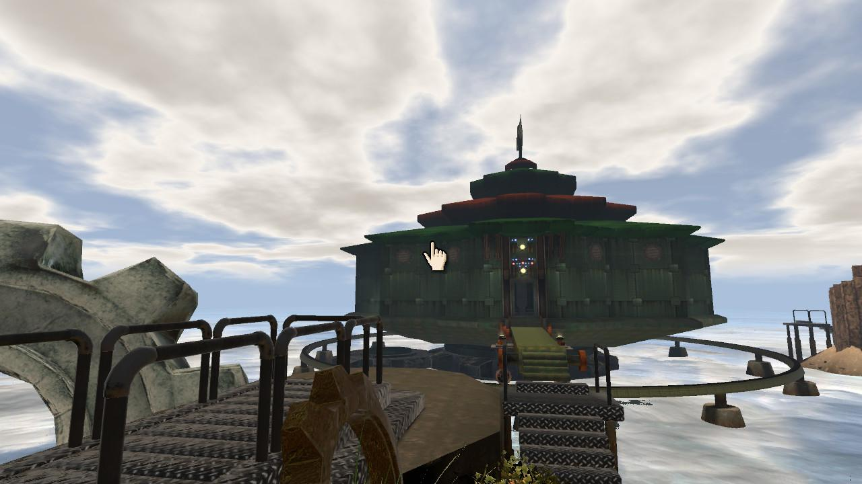
Figure 1.1: The Mechanical Age fortress, where players have to work to solve the rotation puzzle, while searching for the red and blue pages.
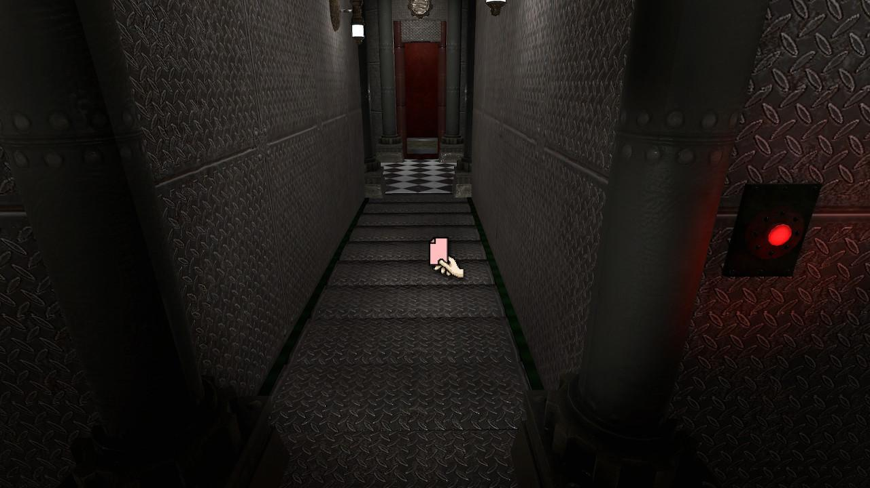
Figure 1.2: The hallway in which the floor turns into a staircase leading to a lower level or players can follow it down to the elevator.
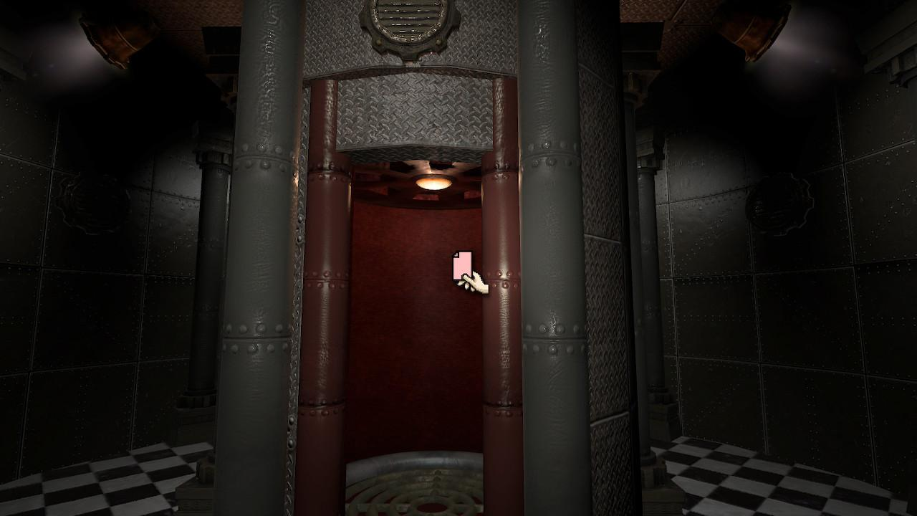
Figure 1.3: The elevator that is part of the Mechanical Age rotation puzzle.
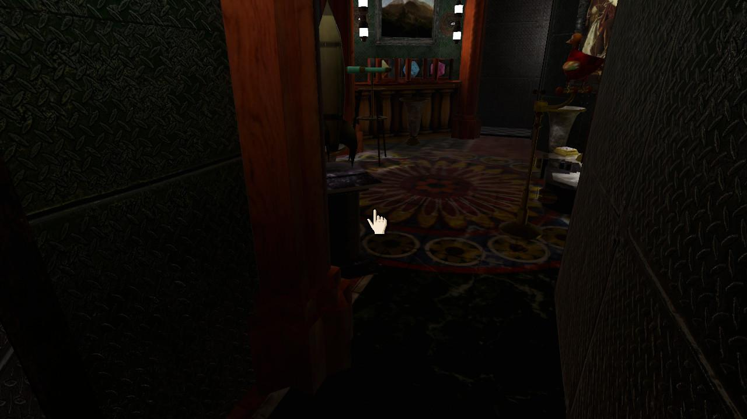
Figure 1.4: Here players glimpse some of Sirrus’s lavish decorations in his throne in the Mechanical Age.

The red and blue books are no longer on the shelves for players to access, so it does not initially appear that there is much left for players to do; however, if players take a turn around the library, they will notice one of the books has fallen onto the floor.
The book contains the solution to one of the last remaining puzzles. The puzzle opens up a pedestal containing a new travel book, which takes players to the age of Rime so often mentioned by Atrus in his journals. Rime is an addition to RealMyst and not in the original Myst but serves as an extra reward for returning the final page to Atrus instead of the brothers. In exploring Rime, players solve a couple more puzzles and learn a little more about Atrus’ experiments and his family dynamics. The game also does some clear telegraphing for the sequel, Riven. The ways in which the puzzles are constructed for players, presumably by Atrus and Catherine, suggests intentionality in that they seem to be obstacles to prevent someone from easily unleashing Sirrus and Achenar. That said, they also seem to make following Atrus’ works with the ages harder, which, given the relationship between Atrus and his father that is hinted at in notes within the game, make sense, since he seems concerned with finding a way to track and contain his father.
The game’s structure drives players to engage with narrativizing Atrus’ story, and, by extension, the stories of Catherine, Sirrus, Achenar, and the multitude of inhabitants that once populated the ages. The game also has a built-in hint section in the menu that encourages players to keep their attention with the game rather than breaking focus to search the internet for answers. The way the hints are written suggests that the creators want to act directly on players’ experience of play. The push to keep players engaged with the game evokes the way that “the continuous dream,” as it is called in the craft of fiction, is used. In video games it is sometimes referred to as the “magic circle,” a term which many video game communities and scholars alike have used to describe the space of connection between player and game or, in the case of fiction, the reader and the page and narration.
Nostalgia is deeply embedded in RealMyst, and it feels like a game made to evoke childhood for adult players, especially adults of the 90s, when the original Myst was published. In the case of RealMyst, players are encouraged by the very structure of the game and the evocation of nostalgia to engage with its world; however, the summoned nostalgia takes multiple forms for players, including a nostalgia for the original Myst, but also a nostalgia for childish whimsy that Myst’s visual choices evoke. The rocketship, the sailboat, and the great military fortress all feel like exaggerations of childish fantasies made manifest, and, through which, Sirrus and Achenar run amok. To some extent, Atrus’s complicity in creating Sirrus and Achenar as villains (through the negligence his journals suggest) needs to be addressed, but on another level, there is an argument that Sirrus and Achenar represent the inappropriateness of those childhood fantasies brought to bear in adult life. The nostalgia players may feel is made uncanny through its exaggerated forms.
The surrealness of the visuals is further enforced by explorations of Sirrus’ and Achenar’s rooms in each age. Sirrus indulges in decadent decorations that pull their styles from historical designs, including a clear connection to Louis XV desks. The eighteenth-century aesthetics of Sirrus’ decorations also evoke tales of colonial explorers like Robinson Crusoe and Lord Jim, though Sirrus is more conscious of his evils than the protagonists of these narratives. Meanwhile, Achenar’s chambers are often relatively bare. He often decorates his rooms with weapons, instruments of torture, and with morbid decorations, though his one chest of drawers in the Stone Age contains several detailed maps of different ages that echoes the connections between Sirrus’s taste and eighteenth-century colonial and bourgeoise excesses (see Figures 1.5-8 below). Nostalgia is certainly part of what keeps players attentive to the game’s mechanics and design, though that attention is driven by curiosity and a desire to reexamine the things that make us nostalgic through a fantastical narrative and series of creative puzzles. The pleasure of solitude here is like the pleasure of sitting alone with one’s fondest memories to some degree, but also in the loneliness of those recollections, discovering new ways to frame them, players are meant to be simultaneously placated and driven to reconsider their perspectives on the feeling of nostalgia. If RealMyst is interested in evoking nostalgia for childish wonder and fantasy, then Paradise Killer is interested in evoking nostalgia for historical moments of hedonistic excess. The ambivalence nostalgia produces in the context of these video games is only further intensified in Paradise Killer.

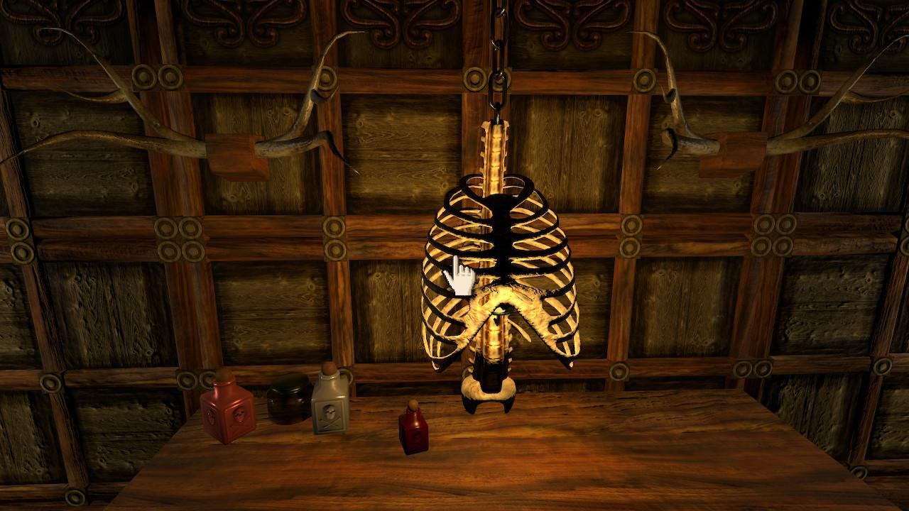
Figure 1.5: Achenar’s room in the Stoneship Age–bare except for poison vials and dead things.
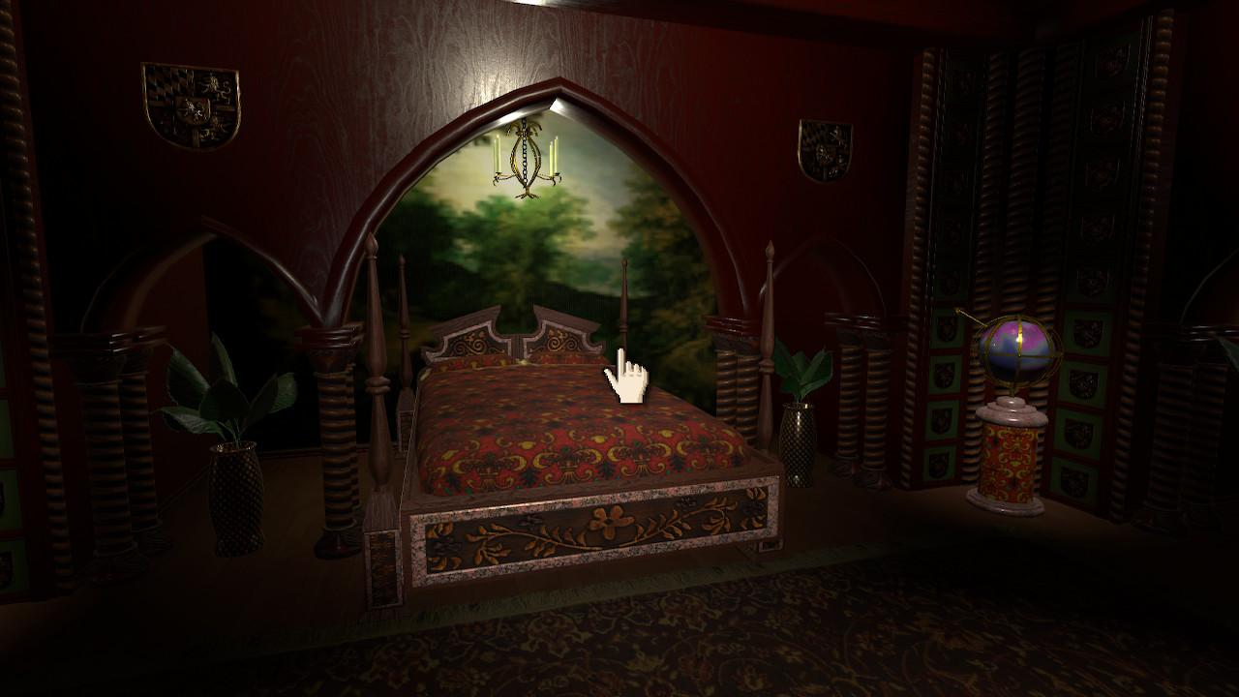
Figure 1.6: Sirrus’s bedroom in the Stoneship Age filled with expensive fabrics, patterns and vases.

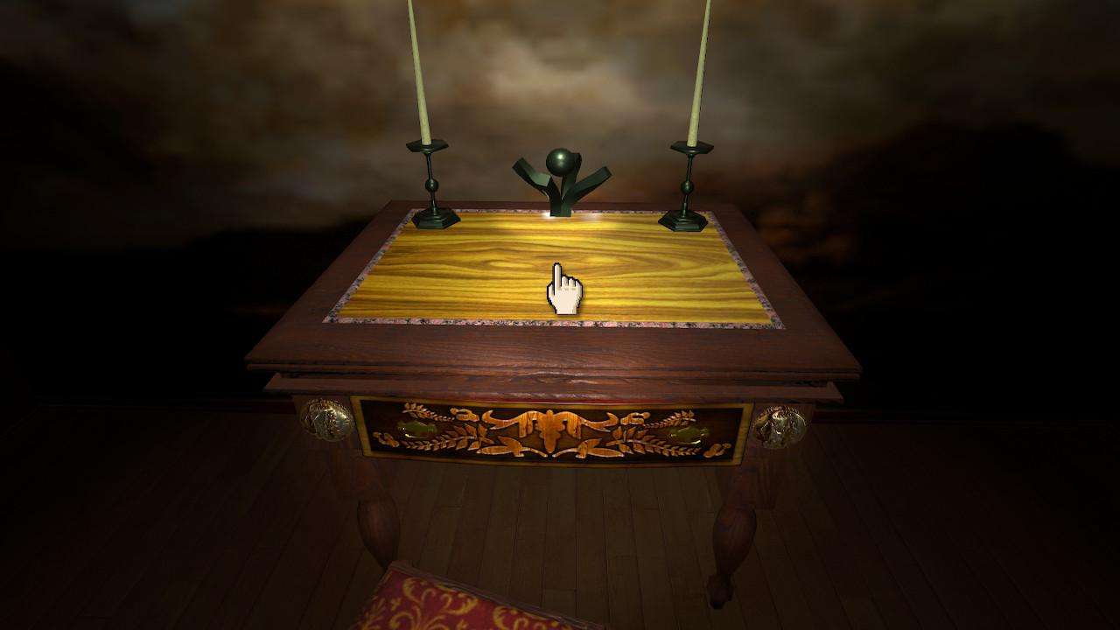
Figure 1.7: A desk in Sirrus’s room after the fashion of Louis XV 19th century furniture.


Figure 1.8: For reference, this is a CreativeCommons licensed image of a Louis XV bureau with which to compare Sirrus’s desk.

Paradise Killer
Paradise Killer is a Day-Glo, vaporwave dream full of neon colors and electronic, piano, and saxophone music. Like RealMyst, it runs on a newer engine, but it values stylization over photorealism in its graphics. Players are introduced to a title screen with ethereal white noise cut with some saxophone riffs playing in the background. Clicking on starting a New Investigation brings players to a screen that says “Welcome Investigator” in pink, all-capitalized letters. The next lines are “You will soon enter a Paradise where fact and truth are not the same. Explore Paradise in your own way and find your own truth” (Paradise Killer). From the start players are invited to make their own interpretations and promised the thrill or pleasure of discovery; the game immediately makes it clear that the players’ interactions and discoveries are charged with a degree of uncertainty.
The affect of isolation or pleasurable solitude is embedded in the game’s aesthetics, as Paradise Killer wields its 1980s neon with a combination of electronic and jazz music to evoke a sense of surrealism and nostalgia, the merging of which soothes even as its patchwork deployment defamiliarizes the nostalgia (see Figure 1.9). There can be a pleasure in estrangement too, as it sparks curiosity and a desire to explore the world of the game by making the familiar new once again. The neon in and of itself is pleasurable to look at; lush and excessive colors, especially pink, permeate the entire game world and the character models of Lady Love Dies (the main character) and the NPCs. In addition to neon, the buildings in the game are full of marble halls and solid gold trim and pathways, expressing not only the excess of 80s nostalgia and even Rococo design but also the excess of The Syndicate. These visuals may also be an attempt to make the space of the game feel fuller, despite the absence of the images and sounds of life (see Figure 1.10).
There is also the matter of narrative and aesthetic genre, as the game is rife with references to noir detective fiction and 80s pastiche. The main character’s name even feels like a noir reference. Lady Love Dies, despite its peculiarity, shares sonic qualities with the likes of Hercule Poirot, Sherlock Holmes, Norma Desmond, and Sam Spade. The other characters of the game mirror this distinct sonic attention paid to names–Witness to the End, Sam Day Break, Carmelina Silence, and Crimson Acid to name a few. These are names with texture that require attention to how they are said, and they also fit in with the game’s surreal, acid-like quality. The reconfiguration of such elements evokes Souvik Mukherjee when he writes “that in the encounter with any form of text, there is also an implicit playing with stories” (21). It does not seem coincidental that Paradise Killer intentionally fuses the neon colors, disco-techno music, and noir conventions into a game about Cthulhuian cultists in an extradimensional edenic island. The game forges a complex relationship between classic film and literary genres that recombines into a wholly unique experience.
One of the problems that occurs when considering the game’s genre is that it borrows from several popular forms, many of which are genre and pulp. It makes this close examination difficult, the complexity of the medium notwithstanding. Robyn Warhol makes an excellent point regarding genre and close reading in Having a Good Cry, while discussing the issues of canon.

Figure 1.9: The title screen of Paradise Killer that sets the tone for the game immediately.
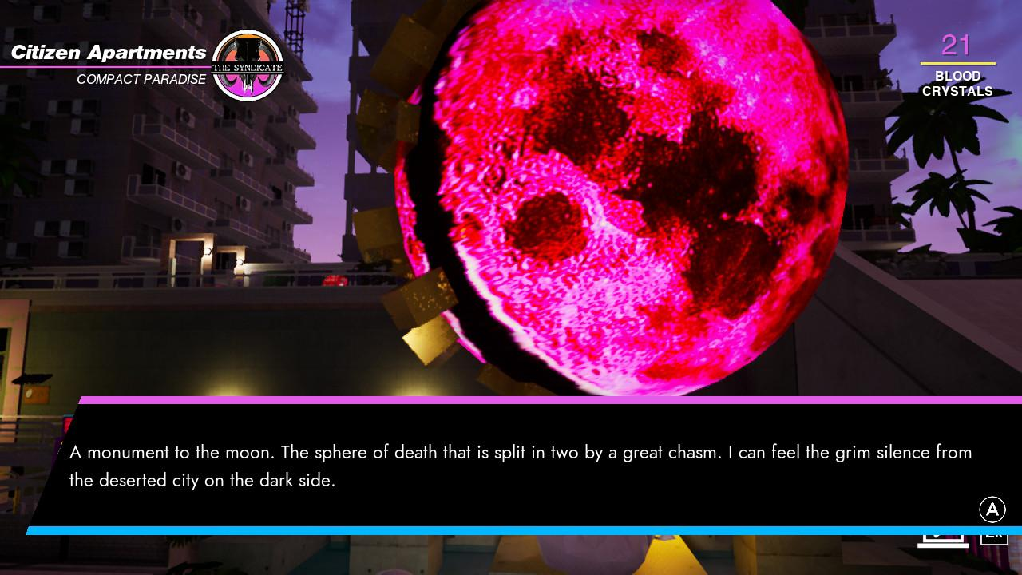
Figure 1.10: One of several landmarks that reminds players of the long history of Paradise Islands and the Syndicate, which they can only grasp through these tenuous vignettes.

Writing after Peter J. Rabinowitz, Warhol says “‘close reading’ was invented as a means of evaluating and interpreting canonical texts, and it favors texts that are written according to its premises. A ‘closely read’ popular text–one that operates conventionally, like a detective novel or television soap opera–can only end up looking bad. Based as it is on the canon, the method of course reinforces the canon” (26). Since video games are such a site of contention for literary scholars and often borrow from film and literature alike, they often tread territory that is considered less than literary. Paradise Killer not only retreads detective fiction and science fiction, it recombines in a way that forces players to pay attention and reevaluate their potential assumptions about these genres.
The game does contain quite a bit of environmental storytelling, but at the start of a new game, players are given some explicit exposition, as the opening sequence explains that the paradise in question is a Paradise Island, a construct of a dead alien god-worshiping cult known as The Syndicate. The Syndicate makes human sacrifices of Citizens in their attempts to resurrect their gods, but they inevitably summon demons in the process. “The islands always fail. The islands die and a new Paradise Island is born. The cycle repeats.” Players are informed that Lady Love Dies is a detective who caused a previous island sequence to fail: for “[endangering] Paradise[,] her sentence is eternal exile”(Paradise Killer). Players navigate the world of Paradise Killer as Lady Love Dies–an investigator and an outcast, who has been watching subsequent island sequences from afar for more than 3 million days or over 8 thousand years, according to the in-game counter. The player is charged to discover who murdered The Council–the appointed leaders of the Syndicate, who decide how islands will be managed and ensure that rituals are followed correctly in pursuit of resurrecting their gods. No matter what the player decides, another island will be made afterwards and a new cycle will begin. Before beginning the investigation, players are situated in the POV of Lady Love Dies as she awakens to a message summoning her out of exile. The game begins with Lady Love Dies in her exile home, which, while lonely, is incredibly opulent. Players can immediately start picking up relics, which are objects described as “Fleeting thoughts. Lost treasures. The remnants of lives lived. A vignette of another. A window in time” (Paradise Killer), including a photo of Love Dies as the head of the Paradise Psycho Unit before her exile. Players are given some vague context for this unit being a police force of some kind through speaking with NPCs and discovering relics, and it is made clear that Lady Love Dies was previously a part of the Syndicate’s elite. This is an important piece of information for inflecting players’ perception of Lady Love Dies even as they have relative control over her actions going forward. After getting some initial dialogue instructing them to jump down to Paradise from the incredibly tall tower, players stand before a precipice before taking the leap of faith and falling to Paradise as the opening credits roll.
The NPC named Justice is a former Syndicate member who has purged their identity and ego for impartiality, refers to the murder of the Council as “The Crime to End All Crimes,” tasking Lady Love Dies with “breathing life back into Paradise” through the execution of convicted suspects. Players are given freedom to explore the island, collect evidence, and decide for themselves how much information they need to determine the guilty party (or parties). From the beginning, the game isolates players socially, as most NPCs have mixed reactions to Lady Love Dies’s return to the island, so that deciding who is guilty is influenced by how players are received by other characters. Players are also surrounded by a fairly large space full of collectible items–some relevant to the plot and some that merely enhance the immersion into the game’s strange, ethereal world. All of these things are made possible through the mechanical operations of the game, as players have a neat array of controls with which they can build their case and learn more about the world.
Paradise Killer uses similar mechanics to RealMyst with some added interactions including a jump, flashlight, sprint, crouch, and even a specific button for changing which music track is playing. The added mechanics move Paradise Killer from pure “walking simulator” closer to platforming, especially as many of the game’s collectible items are scattered in strange, hard-to-reach locations all across the game map. The game also provides obtainable upgrades for the jump control and a meditate function, which players can access by using foot baths scattered across the map. The jump upgrades give players a “double” jump and an “air dash,” both of which help players to access new parts of the island. The meditate function highlights points of interest on the island by briefly marking them with a heart icon in the player’s visual field.
These points of interest may be relics, blood crystals, sacrifice altars, or puzzles. Relics often give a small piece of context or flavor to the game world, such as “Dead Man’s Ambition Whisky,” which is given the following description: “A floral taste with the aroma of vanilla. Find a comfortable chair. Not too comfortable. Comfort will make you nostalgic. You have nothing to be nostalgic about” (Paradise Killer), which feels like an ironic gesture given how laden with nostalgia the game can be at times. Blood crystals are the means by which players open points of fast travel around the island, so that players may journey to specific locations more easily; they also are how players pay to fast travel going forward and what players use at sacrificial altars to obtain relics hidden inside the altars. Fast travel is a common term in games that describes a system by which players can select from map (usually available in a game menu) previous locations and revisit them without consuming time to physically traverse that game space again. In Paradise Killer this system is integrated through what are essentially taxi cab stations where players can call a car to go to previously unlocked stations. The sacrificial altars are often microcosmic representations of the large pyramids that are visible in the distant vista from the island, though one such pyramid is available for player traversal. The altars primarily contain relics that pertain to the gods the Syndicate is desperate to resurrect, such as the “Dying From Sadness Carving,” which is described as “A carving about the god Dying From Sadness. ‘A sentient rock that drifted to earth in the wake of the other gods. A despair philosopher’” (Paradise Killer). Given the game’s definition of relics, these fragments act as windows into the game’s world and the past of its inhabitants, and it can be said that the nature of environmental storytelling is fragmentation and vignette.
Though many of the relics do not contain information that is necessary to the resolution of the main plot or the game itself, they enrich players’ experience of the game’s mechanics and aesthetics. Shepard writes more generally about found objects within game worlds, saying that, “Even in a moment that they could have no hand in, good or bad, [these objects help] to suck players into the world, telling stories through objects and places instead of dialogue” (“Interactive Storytelling”). As players glean more from the world by collecting relics, their search for the relics lead them to a vast number of interesting viewpoints and locations around the island in addition to the places they go in order to speak with NPCs. The views in Paradise Killer are beautiful and the music changes as players move across the map and collect more music tracks, and there is a day/night cycle to lend the game an illusion of timeliness. The beauty of the landscape contrasts with the knowledge players have of this world’s brutality. Oftentimes, players discover these views through their search for relics to collect, and the fact that relics are left in these places implies that the views were enjoyed by past inhabitants. One may imagine that whomever the “Dead Man’s Ambition Whiskey” belonged to was aware of the past island cycles or the history of the Syndicate, as its description points toward the foreclosure of futurity. The objects themselves are often beautifully rendered and feel like museum pieces. The gesture towards a past that is only available through fragments reflects our own engagement with history, evoking pensiveness and quiet attention to the implications of fragments from players.
In many other similar adventure games, puzzles tend to keep players’ attention and curiosity. However, puzzles are not overly difficult in Paradise Killer because they are not the primary purpose, though they are an important feature. Most of the puzzles involve simple visual arrangements, where players must hack into so-called Nightmare Computers by arranging puzzle pieces in the schema of a set of pixelated images shown on the screen. Putting together the correct shapes allows players to hack into computers that are often linked to doors or controls for tools around the island. While RealMyst challenges players to keep notes and move back and forth between clues to solve its puzzles, Paradise Killer’s are relatively easy and do not require as much searching or retracing. Their primary purpose is to evoke the sense of Lady Love Dies’ canny detectiveness, and to provide a brief respite from the more difficult aspects of the game, such as parsing testimony and figuring out where to jump and dash to obtain certain items. The complexity of Paradise Killer is in its murder-mystery narrative, as well as its environmental narrative.
The more players engage with the narrative, the more clues and notes their Starlight menu obtains, and the more they collect relics, the more they learn about how systems of power operate in what is a very dark and dystopian world. The Syndicate are mass murderers, and Lady Love Dies is one of them. She subscribes to their cult’s ideals to some extent, though players may moderate the degree of her zealotry through dialogue choices. In a conversation with Shinji (a rogue demon that pops up all over the island for brief conversations), I attempted to empathize with him when he says, “You ever think about how messed up this is?” to which I replied, “All the time.” The dialogue choice is given a “[PHILOSOPHICAL]” tag, affecting my understanding of the response. Shinji’s reply to this is “You don’t even know what I’m talking about. I haven’t even presented the theme of the conversation,” continuing with “You guys are the bad guys. The Syndicate worship dying gods that want to rule the world and drown it in a sea of war and blood.” Without prompting the player, Lady Love Dies replies, “I don’t see how that makes us the bad guys” (Paradise Killer). Players trying to determine relative guilt among the suspects must also contend with the fact that everyone with whom they interact is complicit in a system of abduction, murder, and slavery. This ambivalence is reinforced through the physical interactions within the game. Unless players tacitly refuse to find relics, talk to NPCs, or read the landscape of the game (in which case, why play?), the mechanics that provide the most physical interaction like moving the control sticks to walk/control the camera or using the shoulder buttons to jump and sprint are the ones that are most useful when players engage with the full array of ideas and narratives the game has to offer (see Figure 1.11 for an example of an artifact).
One of the other mechanics important to the game is interacting with NPCs through dialogue. An integral part of choosing to interact with the game is speaking to potential killers/witnesses, but in addition to asking them questions about the investigation, players can choose to “hang out” with the character, raising their relationship. Hanging out with other characters can lead to new information being shared or, in some cases, an opportunity to engage in one-night stands. Doctor Doomjazz and Crimson Acid are the two characters with whom players can initiate these encounters, though their relationships with Lady Love Dies are distinct in that Doomjazz is clearly a one-night experience and Crimson Acid’s conversation afterward hints that there may be a committed future between her and Love Dies. There are also certain characters who are more hostile than others towards Lady Love Dies, whether because of prejudice or a desire to not be caught is ambiguous. Regardless of their dispositions, the NPCs function to not only drive the main plot but inform players about the Syndicate and its customs.
The rest of the world is full of work facilities and apartment complexes, suggesting that the island was incredibly populous at one point before the Citizens were slaughtered for the ritual to begin the next Paradise Island. The council apartments are large and luxurious, while Citizens’ apartments are small, densely packed towers with little to no space for privacy (see Figure 1.12 ). Comparatively, the NPCs with whom you can interact are far and few between, though many of the collectible items you can find tell players a little bit about the Paradise Island before the murder of The Council, when Citizens were numerous. The implication of presence makes the absence of these people all the more stark.
As the sole investigators of a high-profile murder that none of the remaining non-playable characters actually care about solving, players must parse each character’s relative guilt and decide whether the evidence warrants the death penalty for a character. Some of the characters with whom players can speak are friendlier towards Lady Love Dies than others, which potentially affects their interpretations of NPCs’ testimonies and the other forms of evidence that point toward certain characters. While it may be a stretch to say that players may feel guilty weighing these decisions, there is a certain amount of unease that may occur, given that players become gradually aware of their player character’s complicity in the corrupt system within which they are adjudicating.
Whether players are convicting Syndicate members or returning red and blue pages to the brothers, they are bound to find contact zones that evoke nostalgia and history. Paradise Killer and RealMyst both make nostalgic gestures at different junctures of player experience. RealMyst not only echoes the history of its 90s origins, but also highlights popular and recognizable objects of childhood nostalgia within its landscape


Figure 1.11: One of many Relics players can find hidden across the world of Paradise Island 24.
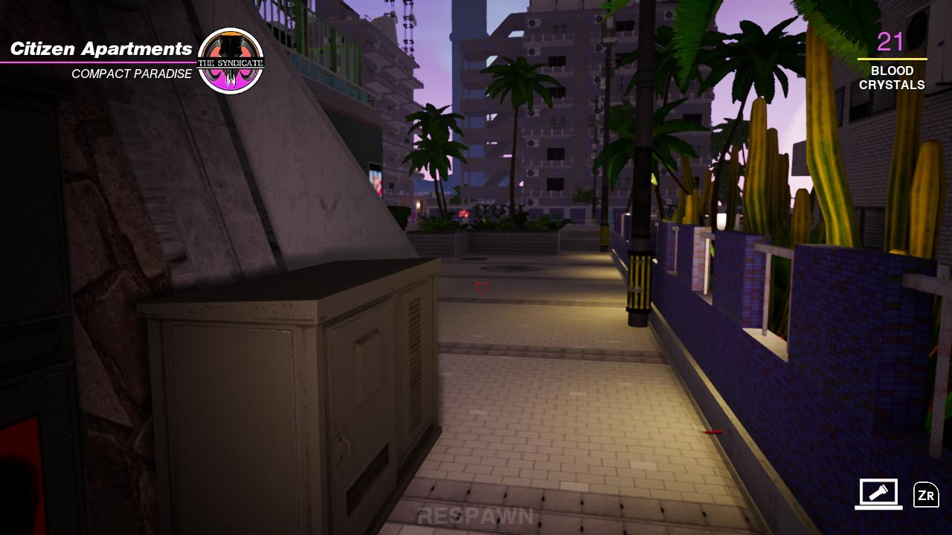
Figure 1.12: A glimpse at the crowded housing into which the Citizens of Paradise Island 24 are forced after having been kidnapped from the real world.

like the giant rocketship or the treehouse. Paradise Killer loudly proclaims its ties to both the 80s and the resurgence of 80s pastiche in the 2010s’ inception of vaporwave, but also evokes Rococo aesthetics as well. The music combines with the visuals to make the connections impossible to miss. Mechanically, RealMyst does contain updates, but it does not make the leap to include jumping, air dashing, or item collection as seen in Paradise Killer. Even with those additional mechanics Paradise Killer is not a “difficult” game in the sense that it does not require sustained physical action with the controller in order to accomplish the tasks given to players. If attention is not being held by a tense, reflexes-based task, then I argue it is held by a combination of more “outsider” friendly mechanics that are related to the puzzle-solving and narrative-decision-making aspects of the games. Part of the pleasure of these games is also their solitary nature. Not only are they single-player games, but even their in-game landscapes are not full to the brim with an overwhelming number of NPCs. Players can find a measure of peace in the lack of social expectations–real or simulated–and the most tense parts of the games then become predicated on simulated social interactions or intellectual challenges. In the following chapter, I observe across several comments from real-world players that not only do these affects seem to play out for players, but they also then lead players to spawn social communities around sharing experiences, tips, and insights, as well as extensions of the game universes through speculation and theorizing.

Chapter Two
“I finally decided to play this game during my spring break, and here's what I have to say about it:HOLY. SHIT.This honestly may just be my new favorite game. I absolutely love it! It's unlike anything I've ever played before…For me, what separates Myst from most other games is the way that it made me feel. Every single age in the game felt so surreal, yet oddly familiar at the same time. It's not too often that a game can genuinely make me smile, but Myst managed to do it effortlessly.” –explosiveramen, r/myst.

“I really fancied the setting, which I'd describe as ‘posthuman postapocalyptic vaporwavey simulated reality with a pinch of postlovecraft- ish cosmic horror’...it feels genuinely FRESH.it may not be entirely new, but at least to me is a new combination of familiar flavors, where alien cosmic gods aren't something old and unknowable, but routine, systematically ‘managed’ and reduced and subdued into the background existential dread that the vaporwave aesthetic invites. It would probably be a letdown (the more you know, the less you wonder), but i would read/watch/consume more media set in this universe or a similar setting.” –buddhastronaut, r/ParadiseKiller

The history of video games and affect and the theory of how to apply affect and some generic, formalist concepts to video games through specific examples is only a starting point for future studies. I argue that it is necessary to gain understanding of actual players’ responses to games. While there is value in observing the neurological responses of players while they are playing, the actual verbal and written responses are what give texture to that raw data, especially when coupled with a theoretical understanding of how the games elicited those responses in the first place. With that in mind, there are numerous places on the internet where players gather to discuss adventure games, but two of the most significant platforms are Reddit and Youtube. Reddit has grown to encompass a wide variety of subjects but in particular has Subreddits entirely dedicated to Myst, Paradise Killer, and adventure games more generally. Youtube is the most popular platform for longer, more heavily edited video series (e.g. video game walkthrough series, video essay series, comedy sketch series, etc.), and it also acts as an archive for many video creators who livestream playing video games on Twitch first before uploading videos to Youtube for fans to find after the fact. In order to get a sense of what affective responses players have to Paradise Killer and Myst, it is necessary to examine trends in comments from both Reddit and Youtube threads/channels because such analysis reveals a connection between my more traditional analysis of affects evoked theoretically by aesthetics, narrative, and mechanics in Chapter 1 and a correlation with actual players’ expressions of experience. This isn't to say all adventure games universally elicit the exact same affective responses, since there is a wide variety of these games, but rather that many of the ludic and aesthetic conventions associated with the genre are conducive to attention, curiosity, nostalgia and pleasurable solitude, especially in examples like RealMyst and Paradise Killer.
Both Youtube and Reddit offer spaces for players to connect with each other and express their own experiences with the games, but provide different structures for doing so. Youtube allows players to not only express themselves but to respond to content creators making walkthroughs of the games. They also comment on the creators’ skill in the game, which is to say how well the creator acclimates to the games’ mechanics and constraints. Of note, this is also a space for audience members to actively comment on the creator’s choices (e.g. will they choose to release one or both brothers in Myst, in what order will they complete the islands’ puzzles, or who will they prosecute to the fullest extent in Paradise Killer?), and this is a space to critique the entertainment value of the creator’s running commentary on the game itself. Meanwhile, Reddit provides a space for players to express their opinions, relate their experiences, and also ask questions about in-game solutions to puzzles and what in-game choices other players made and why. Though Youtube ostensibly can provide this space as well, its primary focus is on the playing ability or entertainment value of the content creator recording the walkthrough. The purpose and occasion of each platform is distinct enough to justify gathering data from both, and the subsections of this chapter demonstrate their research value.
Elly A. Konijn et al. have already demonstrated that Youtube is a useful platform for judging audience responses and for analyzing online communities. Youtube is a platform that hosts millions of users every day and a wide variety of content; Youtube’s public comments sections provide an excellent space for observing peer influence, especially in adolescents (695-696). While this project is not focused on age demographics as a specific metric, the ways that peer interaction influences the environment created in Youtube comment sections is significant to tracing affects in the video game walkthroughs. Reddit is similarly well suited to observing webs of interaction between commenters, and other scholars like Michelle R. Kaufmana et al. have noted its significance worldwide as a hub for online communities. They have also made note that Reddit tends to elicit more personal responses from users than other platforms like Twitter or Facebook. Specifically they write that, “Facebook data is not publicly available, and tweets tend to be short and not as conversational as posts on Reddit. Researchers compared the types of posts shared on Reddit and Twitter and found that Reddit users are more likely to share personal details of their story”(2). Given the focus on nostalgia throughout this project, it is important to note that several community members divulge not only their personal experiences playing the games but also memories of first encountering these games as children.
As the quotes heading this chapter suggest, players have significant emotional responses to RealMyst and Paradise Killer that reflect the affects that I argue are largely endemic to adventure games: nostalgia, curiosity, attention, and pleasurable solitude. The first item in my toolbox for analyzing these affects in Youtube and Reddit comments is Netlytic, which “is a community-supported text and social networks analyzer that can automatically summarize and visualize public online conversations on social media sites” (Netlytic.com, “About”). Using Netlytic, I trace these affects throughout the conversations and compile all the comments into Excel sheets, and I use Netlytic’s built-in dictionaries to highlight important trends. The dictionary function of Netlytic is a visualization tool that organizes several collections of words under specific dictionary headings, such as “Feelings (Good)”(see Figure 2.1).
The second tool that I use the most is Communalytic, which “is a computational social science research tool for studying online communities and discourse” (Communalytic.org, “Home”).

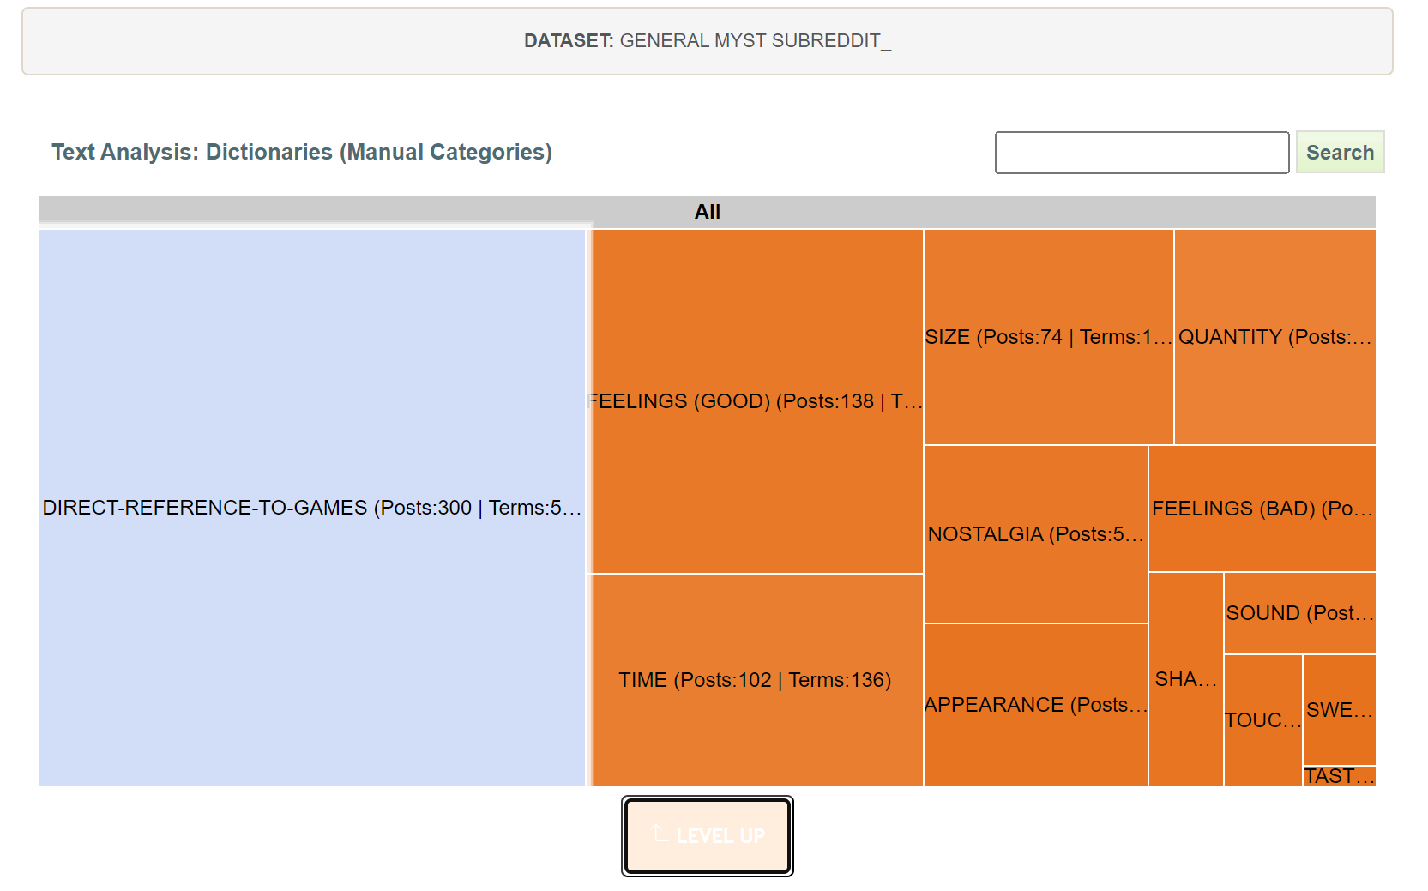
Figure 2.1: This is an example of what the front face of one of my Netlytic dictionaries looks like. It divides based on listed dictionaries and the search terms within those dictionaries that visually represent trends in comments between commenters.

I chose these tools because they are commonly used for this type of analysis; they are accessible for a newer Digital Humanities scholar; and they provide illustrative graphs that support my argument. I use them to examine the social dynamics between commenters both positive and negative.Importantly, when I refer to comments as positive, I mean that they contain lexical features that are more pleasant or happier in sentiment, while negative comments generally contain lexical features that are more unpleasant or unhappy in sentiment. These descriptions of positive and negative are derived from the sentiment analysis model of VADER, which is one of the two models Communalytics uses for sentiment analysis. For context, VADER “(Valence Aware Dictionary and sEntiment Reasoner) is a lexicon and rule-based sentiment analysis tool that is specifically attuned to sentiments expressed in social media. It is fully open-sourced under the [MIT License]” (Hutto, “vaderSentiment”). VADER will divide comments into categories of positive, negative, and neutral. The Github ReadME describes the sentiment scale thus:
Over 9,000 token features were rated on a scale from “[–4] Extremely Negative” to “[4] Extremely Positive”, with allowance for “[0] Neutral (or Neither, N/A)”. We kept every lexical feature that had a non-zero mean rating, and whose standard deviation was less than 2.5 as determined by the aggregate of those ten independent [human] raters. This left us with just over 7,500 lexical features with validated valence scores that indicated both the sentiment polarity (positive/negative), and the sentiment intensity on a scale from –4 to +4. For example, the word “okay” has a positive valence of 0.9, “good” is 1.9, and “great” is 3.1, whereas “horrible” is –2.5, the frowning emoticon :( is –2.2, and “sucks” and it’s slang derivative “sux” are both –1.5. (“vaderSentiment”).
This scale rates each lexical feature as negative, positive, or neutral on this numerical scale, and then combines those results to create a compound score that rates the comment’s overall tone. This is a useful nuance to understand, especially as some words that are considered negative, like curse words, are couched in positive sentiments. The other main tool I use from Communalytic is the toxicity analysis, which runs the comment sections through Detoxify. Detoxify’s GitHub Readme, which is owned by Unitary, describes Detoxify as being “Trained [on] models & code to predict toxic comments on 3 Jigsaw challenges: Toxic comment classification, Unintended Bias in Toxic comments, Multilingual toxic comment classification. [It was b]uilt by Laura Hanu at Unitary, where [they] are working to stop harmful content online by interpreting visual content in context” (“Detoxify”). On the basis of Detoxify’s GitHub Readme, I determined that when referring to a comment as toxic, I mean that it is “rude, disrespectful, or unreasonable” (i.e., values rated closer to 1).
There are constraints to my project, as I am looking at affect and interactions between users on two specific platforms with a limited number of datasets from those platforms. There are many other forums available on the internet where individuals might discuss these games or read about them, such as the website/gaming platform, Steam’s internal community message boards, and intellectual property-specific Wikipediaes. Detoxify also has limits in its ability to identify toxic language accurately. For instance, “If words that are associated with swearing, insults or profanity are present in a comment, it is likely that it will be classified as toxic, regardless of the tone or the intent of the author[,] e.g. humorous/self-deprecating. This could present some biases towards already vulnerable minority groups” (“Limitations and ethical considerations”). Despite these limitations, the results of my analysis are instructive for understanding what is so special about RealMyst and Paradise Killer. For a broader discussion of adventure games, I have also included a section examining the r/adventuregames Subreddit’s comment section. For contrast I also selected the main Grand Theft Auto Subreddit to examine against the results of RealMyst’s and Paradise Killer’s Subreddits.

RealMyst: Masterpiece Edition
This first section examines the ways players discuss RealMyst: Masterpiece Edition and includes a significant amount of discussion about the original 1993 Myst and other Myst remakes and sequels. Generally, discussions around the game and its other iterations are relatively positive: commenters speak mostly favorably about their gaming experience and interact with each other in mostly civil ways. Using Netlytic’s dictionaries and Communalytic’s sentimentality analysis and toxicity analysis functions, I found a trend in the Subreddit r/myst of mostly positive, non-toxic interactions in which players provide qualitative data describing their engagement with the ludic and aesthetic aspects of the many iterations of Myst, particularly RealMyst: Masterpiece Edition (see the base sentiment and toxicity analyses results for Reddit and YouTube in Figure 2.2 and 2.3).


Figure 2.2: These are the results for the r/Myst Subreddit. 76.57% of posts were identified as positive by VADER, and the closest toxicity scores to 1 were outlier posts under Toxicity and Profanity, which are two of the trickier categories for the model.

Figure 2.3: These are the results for the RealMyst Youtube series. 69.77% of comments were identified as positive by VADER, and the highest toxicity flagged posts were still under the minimum 1 threshold.

Reddit Comments, Sentimentality Analysis, and Dictionary Results
In searching for a good place to start, it made the most sense to look at the general r/myst Subreddit, as this thread contains a lot of relevant discussions of recent Myst iterations and a lot of comments from players returning to the game and new players looking for help with the game. Using Communalytic’s beta Reddit tool, I was able to gather 588 comments from 268 unique posters, though duplicate accounts are always possible. This is not the entirety of the Subreddit’s contents but as much as Communalytic could gather in its current state. The posts gathered span from February 2011 to November 2023, reflecting an ongoing engagement with the Myst series from a dedicated fan community. There are commenters who lodge complaints, some of which are related to optimization and porting issues with different versions of the game rather than the game itself, but several also commented on the dated feeling of the controls even in some of the reboots like RealMyst: Masterpiece Edition. Most of the most negative comments about the original Myst and the other reboots, according to the VADER score in Communalytic, revolve around issues with being able to play various versions of the game on different hardware. Below is my prime example (more examples can be found in Appendix A):
- “Real Myst[: Interactive 3D] had an art direction, but primative (relativly) graphics, whereas RealMyst: MP has no art direction whatsoever. The colors don't compliment each other, the lighting and setup of the island doesn't appear to be trying to set a tone or mood. I've studied a lot of game development, and this looked a lot like a ‘train the new interns and get a free game out of it’ effort, where you don't have an art director so much as someone supervising the new crew members while recreating an old game with the new tools, to get them used to the new tools without being distracted by developing a new game.”--Krist-Silvershade 2014-03-13
The important thing to note is that the negative emotions are mostly the result of struggles to access the game, but clearly indicate a strong attachment and willingness among players to find whatever workarounds are necessary to play the game again. The complaints of Krist-Silvershade regarding changes in RealMyst: Masterpiece Edition reflect the complex processes of remediation and nostalgia with which RealMyst: Masterpiece Edition and other remakes are engaged. The comment also suggests a distrust around the economic context in which such remakes are produced. Krist-Silvershade specifically posits that they know “game development” and that RealMyst: Masterpiece Edition was clearly a test game made by interns. The implicit complaint is that this “test” game was still sold commercially. They also take a dig at the lighting and textures of RealMyst: Masterpiece Edition over Interactive 3D. The critique about art direction also reveals a vested interest in the stylized visuals of the Myst series.
There are further complaints regarding the specific versions of the game. For instance, some players (like Krist-Silvershade) commented that they felt newer versions did not compare to the original, whereas others felt the original is the worst in the series due in part to its datedness. Some of those comments are:
- “Although it's just flavour, I highly suggest getting a hold of the original release. I don't think any of the remakes can quite capture that atmosphere.”--sudin 06-27-2014
- “The ‘original Myst’, which is hard to find nowadays, does not hold up well. Here's a quick rundown:* Myst (1993) *Ridiculously low resolution and 8-bit colors.* * Myst Masterpiece (2000) *Same game, but graphics updated to tolerable expectations** realMyst (2000) *Completely upgraded graphics, completely changed movement structure to free (instead of point and click), and added several things including a new age.** realMyst Mastepiece (2014) *Same graphics as realMyst (with a slight upgrade) but gives you the choice between free movement or point and click*Basically the original is not really playable anymore, Myst Masterpiece is fine if you want nostalgia or ‘to see how badly it's held up’, and realMyst just doesn't feel like Myst. The end result is that realMyst Masterpiece (the latest version) is really the best one because it feels more like the original game but with a huge shot in the arm graphics wise. ”--isestrex 2014-09-02
Despite disagreements about which version to recommend to new or returning players, the commenters are mostly polite to one another and more interested in sharing their love of the series with others. Despite being a solitary playing experience by design, RealMyst:Masterpiece Edition and all the other versions of Myst, rely upon a dedicated fan base that continually renews and reshares interest in the series with new players, which in turn spawns social spaces in which players can come together to share experiences and make connections. Attempts to make older versions of Myst work on modern hardware result in players participating in “coordinated action,” as Isbister calls it, to make the game accessible because it is a game that breeds continuous attention (45). The game may be played alone, or with a partner and/or audience in the case of Youtube, but the aura around the game is continually renewed by devoted players who come together on the internet in a social context.
Another interesting theme that emerges is that many players mention taking notes during play to keep track of information, and remark that sequels in the series require even more intensive notetaking at points. The act of notetaking reflects the attention that playing RealMyst and Myst inspire. One of the most pertinent comments is:
- “I recently finished Myst Masterpiece Edition, and I've got to say, I have been missing out on some phenomenal games. I knew Myst mainly from the memes of "what does this lever do, I've been stuck forever!", and was expecting to play through it with a guide in hand like an old adventure game. But I figured to give it a fair shot first, and made my way around Myst on my own. Seeing a clue and thinking "oh, I should write that down" is an experience that I've never seen in a puzzle game before. I was expecting puzzles that you had to just bumble your way through, like a zelda puzzle but bigger. But I can't imagine trying to figure out the observatory without knowing what you were doing, and that's great.The writing is also phenomenal, when I got to the books in the library, I expected to get bored by all that reading. Instead I hungrily devoured all of them right away and then reread them after I finished their relevant age…I needed a guide for [the rotation controls], as well as understanding the water in the stoneship age (I thought the sound effect was a timer, not a pump). And while I understand it was a tech limitation, I would have liked to see some sign of life in the ages, all of them being empty of life felt off...But yeah, I absolutely loved Myst, and I've immediately bought Riven.” –Turtlewax64, 2019-06-24
Turtlewax64’s note taking reflects the ways that Myst not only set the bar for puzzle challenge in adventure games, but also is a game that encourages players to participate in action external to the game in order to play it. It is important to note that the version Turtlewax64 is playing, Myst Masterpiece Edition, does have the hint system, which is included in RealMyst: Masterpiece Edition as well, though RealMyst’shint system has been updated (see Figure 2.4, 2.5, and 2.6 below). The hint system does not give perfect solutions to puzzles, however, and it acts exactly as labeled. A hint system–not a guide. Turtlewax64 also highlights the necessity of reading in Myst, as it is integral to solving certain puzzles, as well as understanding any sort of story of what is happening in the game. The nod to remediation of mediums that Bolter and Grusin noted is clear.

YouTube Walkthrough Comments and Dictionary Results
There were a few video walkthroughs available for RealMyst: Masterpiece Edition, but I selected the one that had the most views from the content creator with the most subscribers. The walkthrough selected was created by @Jon, who has over 151,000 subscribers and whose first walkthrough video received approximately 335,000 views. The walkthrough is broken into nine parts that follow Jon’s playthrough of RealMyst:
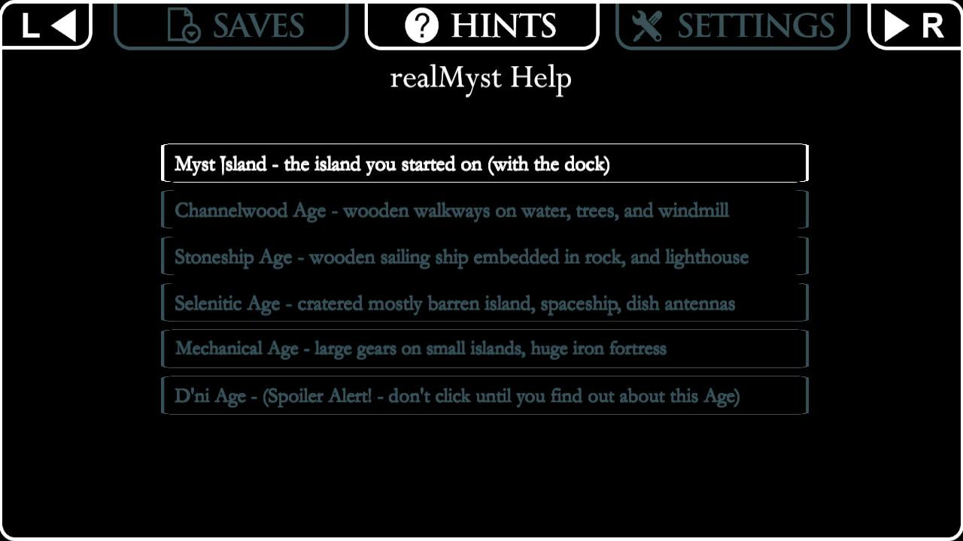
Figure 2.4: This is the main menu for hints, and it is divided by the different ages of RealMyst.
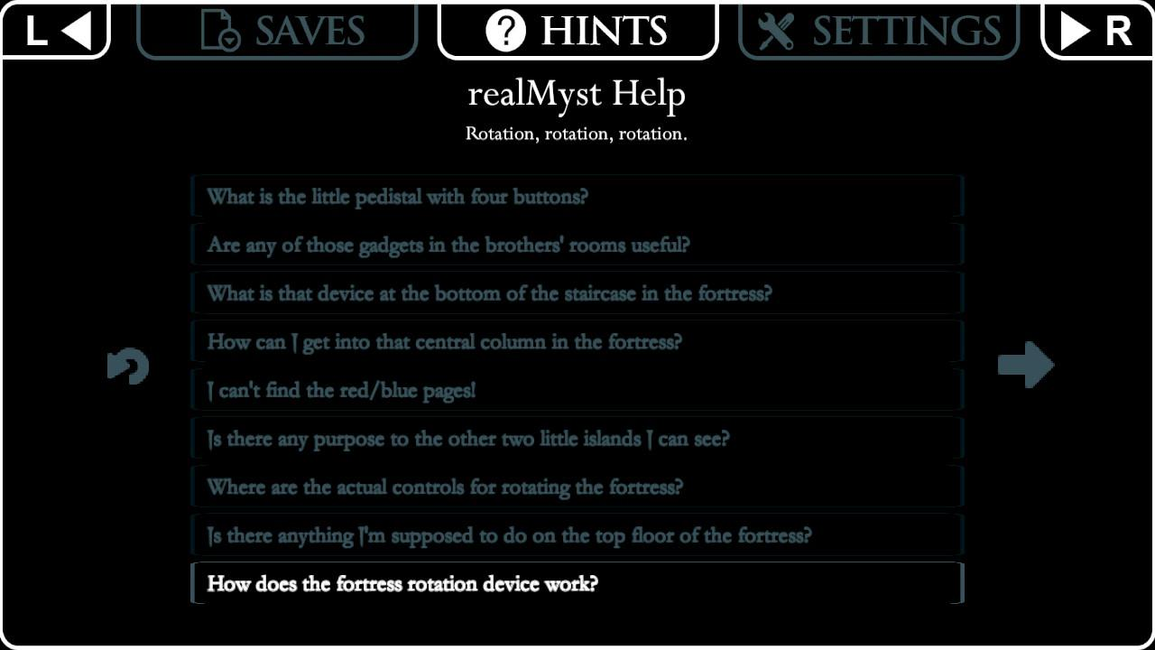
Figure 2.5: This is the submenu for the Mechanical Age, which is divided into the puzzles and features of the age.
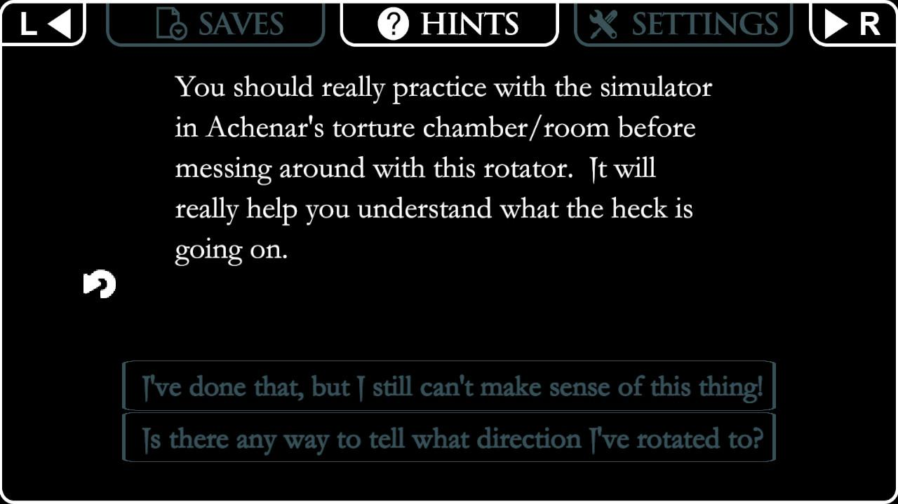
Figure 2.6: This is a submenu that shows the result of clicking on “How does the fortress rotation device work?”

Masterpiece Edition, and across all the videos, I collected 885 comments from 463 unique posters.It is important to note that as a medium, Youtube generally seems to result in large spikes of comments before coming to a halt, while the Subreddit receives continued interaction at lower levels over a longer span of time likely due to proprietary algorithms and the general use-value of the Subreddit over the specific experience of the video walkthrough.
There appears to be a greater number of negative interactions (i.e., interactions that involve trading insults and non-constructive critiques of the content creator or other posters) in the YouTube walkthrough. The “Feelings (Bad)” and “Swear Words (En)” dictionaries on Netlytic helped me to parse the most egregious of negative posts. The phenomena of trolling and flame wars are widely known and there are few comment sections that are free from them from personal experience. An example of these phenomena in the dataset is the following back and forth exchange between poster, Milosz_Ostrow and the video creator, Jon:
- “The video would have been more fun without a four-letter expletive every 30 to 60 seconds.”--Milosz_Ostrow
- “You gotta lighten up a bit, dude.”--Jon
- “You gotta improve your vocabulary to somewhere between 10,000 and 20,000 words so you're not stuck in a sub-2,000-word vocabulary and finding yourself resorting to a handful of cuss-words. Dude.”--Milosz_Ostrow
- “It's honestly embarrassing that you equate the occasional usage of a swear word to a limited vocabulary. My extensive lexicon and vulgar word-choice are NOT mutually exclusive. But it is extremely telling of your limited intelligence that you think they are. Moreso that you consider a single episode of a single let's play to be full representation of my entire personality, let alone my entire vocabulary. You need to get a clue, buddy.”--Jon
The exchange continues with a couple more zingers but is one of a few different mini-flame wars and instances of trolling identified in the walkthrough series; however, the positive recollections of childhood nostalgia and appreciation for shared experiences far outweigh the trolling and flaming. There is a definite possibility that the use of swear words by Jon constitutes a violation of politeness that may be expected of discourse around these types of video games. After all, the original Myst was made by developers whose previous work had primarily been kid-friendly edutainment games, such as The Manhole (1988) and Cosmic Osmo and the Worlds Beyond the Mackerel (1990). Many classic adventure games were made to be family-friendly and, though the genre certainly has many more mature entries, it generally carries with it a sense that everyone is welcome. Some of this is reflected in the netiquette rules that are established in the Subreddit r/myst (see Figure 2.7). In fact, the higher rate of negative interaction on YouTube may be partially attributable to a lack of structuring netiquette, while Subreddits often have established moderators. The main issue with this is that it assumes all moderators are made equally, and they are very much not.

Paradise Killer
This section looks at the main Subreddit for Paradise Killer and a YouTube walkthrough series from @KeithBallardA, examining the Subreddit comments using Netlytic’s dictionary tool and Communalytic’s sentimentality and toxicity analysis tools and examining the comments sections of the YouTube series using the same. There are a significant number of posts across both the YouTube series and Subreddit that consist of players asking for help or direction from other players on their own playthroughs of Paradise Killer. As with RealMyst: Masterpiece Edition and the other Myst games mentioned, Paradise Killer players and observers generally interact in positive and socially constructive ways (see Figures 2.8 and 2.9).
It is possible that this is because of the small sample size from which I am drawing my conclusions, but it may also be indicative. The comments also remark with relative frequency on the game’s aesthetics and music, as well as the moral quandaries that the game poses. Players also exchange theories on other aspects of the narrative extraneous to the game’s main plot, speculating about anything from lore to design choices on the developer’s part.


Figure 13: A screenshot of the listed r/Paradise Killer netiquette.
Figure 2.8: VADER reads the Paradise Killer Subreddit as 57.95% positive, and the highest rated posts under Toxicity, Insult, and Profanity do not reach a value of 1, indicating that there are few comments that are flagged as toxic.

Figure 2.9: VADER reads the Paradise Killer YouTube series comments as 53.86% positive, with fairly low toxicity ratings on average. The higher negativity ratio stems partially from cursing and discussion of the game’s mature themes.

Reddit Comments, Sentimentality Analysis, and Dictionary Results
The Subreddit, r/ParadiseKiller like most Subreddits tells users how many members have joined that particular Subreddit, as well as how many members are currently online, except that the r/ParadiseKiller page calls members, Syndicate Members, and instead of a number followed by the word “online,” it shows a number followed by the word “suspects” (see Figure 2.10). The adjusted phrasing, Syndicate Members, playfully signals the community members’ experiences playing as Lady Love Dies and their position in the game world as part of the Syndicate’s power structure, while the number of “suspects” online at any given time playfully references the omnipresence of guilt or innocence with which players contend while investigating the motives of other Syndicate Members represented by NPCs in the game. The touch is cute and kitschy perhaps, but certainly emphasizes the fond appreciation players have of the game.
The fondness fostered by the game’s loud aesthetics, musical flourishes, and remediation of 80s pastiche and detective noir fiction is evidenced by comments players make in the Reddit thread, such as:
- “ I really liked it - I’ve played a few detective games, and I thought actually getting to explore a 3d world was pretty neat for a genre of mostly visual novels… I felt a little disappointed by the trial in comparison to how much I enjoyed the build up to it - I already knew how it all pieced together and was hoping for some crazy unexpected revolutions. Maybe I’ve been spoilt by games like dangan ronpa or phoenix wright, but I expected more from the trial. The


Figure 2.10: Pictured is a screenshot of the “suspects” counter on r/Paradise Killer.

actual detective work wasn’t very difficult, either! However, I’ve come to appreciate that the point of the game is less about there being one “true” ending and chain of events, but more on how you, as the arm of justice, want to interpret those events. Being able to let certain characters go that were only tangentially involved, for example, is pretty cool. But the trial doesn’t matter too much, the characters, setting, music and aesthetic of the game made it work for me. There’s such a crazy blend of genres at work here, and the contrast of how dark that world is with the vaporwave looks is great!”--PM_me_legwear, 2022-09-08.
- “At first I was in a kind of ‘where the fuck do I go’ kind of vibe, that still hasn’t dissipated entirely, but at one point there was a game changer: I noticed I could present my facts to the Judge and end the game at whatever time I want.So…. Let me get this straight, and please tell me if I’m wrong. The game is an actual open world detective game, that you can end at whatever point the game is boring to you, but the more you explore the more clues you have? And you can present better cases… is that it?If so that + the vaporwave vibes will get strong grips of my heart. Also tbh one of the best parts is exploring to find more music tracks”--owlitup, 2021-11-14.
- “I’ve been thinking about the elements of the Paradise Killer’s mystery that I recognize from other detective stories and noir. I think these classic elements are part of what makes it so interesting. What do you all think?...The Patsy – There’s an obvious prime suspect who makes a convenient fall guy…Conspiracy – At least half the Syndicate (especially those in a position of power) keep telling the detective that the investigation is a waste of time and push her to stop asking questions and just convict the patsy.Locked Door Murder – …The question of how the murderer got in (and out, presumably) is a mystery in itself.Missing Person – Someone related to the victims who probably has useful information has been missing for some time…Demonic Rituals – its always fun when there’s a suggestion the crime could be connected to a Satanic cult or something” –TMIMeeg, 2021-05-26.
All of these comments reflect a keen interest in the aesthetic and generic qualities of Paradise Killer, identifying it with other noir detective works, as well as pointing out the vaporwave visuals. They also reflect a desire from the community to pinpoint what is uniquely engaging about the world and gameplay of Paradise Killer, pointing to an ongoing attention from players to the details of the gameworld and curiosity about its existence both mimetically and diegetically.
PM_me_legwear’s notes reflect not only Paradise Killer’s gripping aesthetics and how it intertwines the vibrant neon and boppy electronic sound of synth with incredibly dark themes, but also that Paradise Killer is a game set in comparison to other detective games of related mechanical genres (see Figure 2.11). The thing that makes it unique among other detective games is its open-world, first-person adventure game mechanics, which it mixes with some platformer mechanics. The two games to which PM_me_legwear compares Paradise Killer, Ace Attorney and Danganronpa, are notably made by studios much larger than Kaizen Game Works. Ace Attorney is a detective/mystery series developed by Capcom, whose name is known worldwide for several internationally acclaimed franchises including Street Fighter and Monster Hunter, and Danganronpa is a visual novel series made by relatively large developer, Spike Chunsoft, which has gained a larger following with each sequel in the series. Meanwhile, despite funding from the “UK Global Screen Fund[, which is] financed by the UK Government’s Department for Digital, Culture, Media and Sport and administered by the BFI[,]” Kaizen Game Works is a significantly smaller and much newer studio than Capcom or Spike Chunsoft (KaizenGameWorks.com). Not only does this materially affect how much time is given to the final game produced but it also means that what is done best often reflects the overarching goals and foci of the developers, of which PM_me_legwear makes note.
The community’s attempts to locate Paradise Killer within a larger generic framework is also innately tied to evocations of nostalgia. Vaporwave aesthetics recall the recursive obsession with the Euro and American-centric 1980s music and perceived excesses of violence that reemerges in the 2010s pop culture in films like Drive and video game series like Hotline Miami, and the noir detective story originates in not only the pulp detective fiction of the 1920s and the black and white noir films of the 1940s, but of course in the original detective story, “Murders in the Rue Morgue” by Edgar Allen Poe in 1841. Arthur Conan Doyle sparked a sustained interest in detective fiction later in the nineteenth in his creation of Sherlock Holmes and the series of novels that followed, which was a time period during which large paradigm shifts were occurring moving from religious ways of constructing the world and thinking to more secularized form of constructing the world and thinking.


Figure 2.11: Most frequently appearing emojis in r/ParadiseKiller, which collectively appeared 29 times in the 699 sample comments. The grinning emoji “😁” appears 3 times, various heart emojis appear 5 times, and the detective and Pinocchio appear 2 time

YouTube Walkthrough Comments and Dictionary Results
Presumably due to its more recent publication, there are fewer video walkthroughs of Paradise Killer available on Youtube than there are of Myst. I used my previously established criteria to select the most popular walkthrough to analyze,based on number of views, number of subscribers, and the rough average number of comments per video in the series. In this case, Keith Ballard, the main content creator, has over 119,000 subscribers following his Youtube channel, and the first video in the series received at least 18,000 views. He is joined by Stephanie, who is his partner in video creation. The videos themselves received roughly 20 comments per entry in the series, reflecting continued engagement despite the longevity of the series. There are 441 unique comments across the 27 videos from 144 unique posters, according to Nelytic’s findings. After running the comments through Communalytic’s sentiment analysis, I observed that not only did Vader’s findings reflect that the comments were largely positive, but that closer inspection revealed that even several comments flagged as potentially negative were actually intense lexical expressions of positive emotions that simply used phrases and punctuation that are coded as negative. For example, in response to an earlier episode, user @TDoThis writes “Yesss!! I just downloaded this game a few weeks ago and just the aesthetic alone hooked me 🤩”, which is flagged as negative with a compound score of -0.3818 likely due to the excessive punctuation of “yes” and perhaps words like “alone” and “hooked” even registering as negative in other contexts. The actual expression is largely about good feelings, such as the commenter being excited about the visuals of Paradise Killer and having a play experience of their own soon.
The commenters focus heavily on discussion of the game, but also on their enjoyment of Keith Ballard’s and Stephanie’s presentation of the play experience–just like the commenters in Jon’s RealMyst Youtube series. Commenters write things like, “Glad you guys made the choices you did. Great play through!” and “thus ends an era. i'd ask you to do more games like this with Stephanie but 1) are there any other games quite like this? 2) you're already doing great stuff together. keep it up” (leahwhite8212 and gravecactus respectively). There is an expression of gratitude for the shared experience of the game, as well as appreciation for how Keith and Stephanie interfaced with the game. Gravecactus also points out the unique nature of Paradise Killer as an experience. Other comments remained largely positive, aside from one or two critiques of Keith’s and Stephanie’s attempts at doing accents for characters in the game. There were comments that speak directly to some of the primary affects we have discussed so far.
A few commenters point out the vaporwave aesthetic of the game, as well as the way it contrasts with the darkness of the setting. MiMiLock58 writes “vaporwave time” and nettle8236 writes:
Had a lot of fun watching this playthrough! That vaporwave anime extravaganza and bizarre lore, hell yeah…I thought it was a pretty interesting storytelling choice to have the game acknowledge how horrific the Syndicate is, but ultimately not let the player do much more than vaguely question it. You just do your job as investigator. “Wow I solved the case! Now let's keep kidnapping people and sacrificing them to our homicidal gods I guess.”(“r/ParadiseKiller”).
The point nettle8236 makes is at the heart of Paradise Killer. Not only are players’ attention and curiosity piqued by the neon and vaporwave visuals and audio but also by the contrast with the darkness of the world. Many commenters also make the point that the game’s lack of direction in terms of who to prosecute adds to the tension and keeps them attentive to their choices, which are further informed by the environmental storytelling of the setting. Here is an exemplary comment demonstrating this:
- “​@@williancruz9657One quirk of this game that I enjoy is that there are no clear right answers about who to prosecute and what punishment to inflict, especially when, after the trial, LD's gun is permanently unlocked and she basically becomes Judge Dredd. Do you refuse to prosecute someone like Carmelina because she's the last of her family and therefore the last to possess the Architect ability? Do we prosecute someone who might've been involved but ignorant of the murder plot? Is it right to exile any of these people? Is it okay to let Henry be the scapegoat since he'll die with the island, anyway? Or should all guilty parties be exposed and executed? So many questions.”--RanMouri82, 2023-10-01
Players continue questioning what the morally right thing to do is, while acknowledging that everyone’s answers are different, if only a little. The combination of strong audiovisual design, streamlined mechanics, especially environmental storytelling, and difficult questions to wrangle alone and with others online make Paradise Killer a unique experience that continually entices new and old players to return to Paradise Island 24 for a new playthrough.

Conclusions and Recommendations

The comments across these platforms suggest that adventure games, despite their generic plasticity, are particularly disposed to affects like nostalgia, curiosity, attention, and pleasurable solitude. The analysis of qualitative and quantitative data in this chapter is not meant to create an illusory claim to empirical truth, since, as Lady Love Dies says, “The truth and the facts are not the same” (Paradise Killer); however, my observations and findings support the claims of other scholars in the field, such as Anable and Reed, Murray, and Salter. One of the most pertinent claims Anable makes about video games and affect is that video games often “traffic more interestingly in the minor affects”(viii), and this remains true of adventure games like RealMyst and Paradise Killer, though it must be acknowledged that nostalgia can be quite a big affect. As Anable acknowledges, it is not that games cannot evoke larger emotional responses but that their ability to evoke minor ones is one of their most interesting characteristics. Indeed, there are smaller evocations of nostalgia across both games that only result in larger emotional responses through accumulation throughout play and watch experiences. Curiosity and attention recursively drive players and observers forward and function to negate boredom in what is mechanically a less complex genre, and nostalgia works in concert with these affects as well to stimulate sense memory in ways that can result in a haunted or disconcerted sensation.
These games are aesthetically rich, relatively short in terms of playtime, and significantly cheaper to purchase than most AAA games, and they involve players in atmospheric, solitary play, which they then may share with others on the internet. While there are obvious exceptions, comments mostly demonstrate positive orientations towards the game, other commenters, and content creators in the specific spaces created on Reddit and Youtube for these games. When there are unpleasant or confrontational interactions between people, the negativity is generally oriented towards violations of expectations regarding politeness and civility in a given space. Reed, Murray, and Salter’s work on the “outsider” gamer, who embodies all those that do not perfectly fit the constructed norm of the cis-gendered, heterosexual, able-bodied, white male gamer only interested in physically strenuous or actively demanding AAA games, is represented in the online communities examined in this chapter. Here it is obvious that many players and fans of Paradise Killer and RealMyst exist and actively engage in building conversations about the games, expanding a repository of lore collection about the in-game worlds as well as a repository of different play experiences and end results, and that the affects intertwined with these games are ones that attract a certain type of “outsider” player. As Reed et al. note, “Adventure games are outlandish in a myriad of ways: their eyebrow-raising puzzles, their intriguing worlds demanding exploration, their awkward or troubled protagonists, their often-improbable origins on the laptops of struggling indies or scrappy studios” (loc. 282). The fans and players attracted to these games are looking for friendlier spaces to roam and different types of challenges to while away the hours.

                - List of References
“About.” Netlytic.com, 2024, https://netlytic.org/home/?page_id=10834.
Ahmed, Sara. The Cultural Politics of Emotion. Routledge, 2004.
Anable, Aubrey. Playing With Feelings: Video Games and Affect. Minnesota University Press, 2018.
Berger, Arthur Asa. “Myst, Riven, and the Adventure Video Game.” Video Games: A Popular Culture Phenomenon, Transaction Publishers, 2002, pp.73-82.
Bolter, David J. and Richard Grusin. Remediation: Understanding New Media. MIT Press, 1999.
Chess, Shira. Ready Player Two: Women Gamers and Designed Identity. University of Minnesota Press, 2017.
Eco, Umberto. “Travels in Hyperreality.” Travels in Hyperreality: Essays. Translated by William Weaver, Harcourt Brace & Company, 1983.
“FAQ.” Communalytic.org, https://communalytic.org/faq/.
Fernandez-Vara, Clara and Scott Osterweil. “The Key to Adventure Game Design: Insight and Sense-making.” Proceedings of Meaningful Play 2010, Michigan State University, 21-23 October 2010. MIT, 2010. MIT Open Access Articles, http://hdl.handle.net/1721.1/100238.
Hayles, N. Katherine. Electronic Literature: New Horizons For the Literary. University of Notre Dame Press, 2008.
Hutchinson, Andrew. “Making the Water Move: Techno-Historic limits in the Game Aesthetics of Myst and Doom.” Game Studies: the International Journal of Computer Game Research, vol. 8, no. 1, 2008.
Hutto, C.J. “vaderSentiment.” GitHub.com, 17 Nov. 2014, https://github.com/cjhutto/vaderSentiment?tab=readme-ov-file#about-the-scoring.
Isbister, Katherine. How Games Move Us: Emotions by Design. MIT Press, 2016.
Konijn, Elly A., et al. “YouTube as a Research Tool: Three Approaches: Social Media as a Research Environment.” Cyberpsychology, Behavior and Social Networking, vol. 16, no. 9, 2013, pp. 695–701.
Kaufmana, Michelle R., et al. “‘This show hits really close to home on so many levels’: An analysis of Reddit comments about HBO’s Euphoria to understand viewers’ experiences of and reactions to substance use and mental illness.” Drug and Alcohol Dependence, vol. 220, 2021, pp. 108468–108468, https://doi.org/10.1016/j.drugalcdep.2020.108468.
Lin, Brittney. “Diversity in Gaming Report: An Analysis of Diversity in Video Game Characters.” Diamond Lobby, 22 Feb. 2023, https://diamondlobby.com/geeky-stuff/diversity-in-gaming/. Accessed 30 Oct. 2023.
Massanari, Adrienne. “Gamergate and The Fappening: How Reddit’s Algorithm, Governance, and Culture Support Toxic Technocultures.” New Media & Society, vol. 19, no. 3, 2017, pp. 329–46, https://doi.org/10.1177/1461444815608807.
Massumi, Brian. “Introduction: Concrete Is as Concrete Doesn’t.” Parables for the Virtual: Movement, Affect, Sensation, Duke University Press, 2002, pp.1-22.
McLuhan, Marshall. “The Gadget Lover: Narcissus as Narcosis.” Understanding Media, Routledge, 1964, pp. 45-52.
Mortensen, Torill Elvira. “Anger, Fear, and Games: The Long Event of #GamerGate.” Games and Culture, vol. 13, no. 8, 2018, pp. 787–806, https://doi.org/10.1177/1555412016640408.
Mukherjee, Souvik. Video Games and Storytelling: Reading Games and Playing Games. Palgrave Macmillan, 2015.
“Myst.” Reddit, 11 March 2008, https://www.reddit.com/r/myst/comments/129rtyd/myst_versions_which_to_pick_and_differences/?onetap_auto=true.
Nooney, Laine. “A Pedestal, a Table, a Love Letter: Archaeologies of Gender in Videogame History.” Game Studies, vol. 13, no. 2, 2013.
Paaßen, Benjamin, et al. “What is a True Gamer? The Male Gamer Stereotype and the Marginalization of Women in Video Game Culture.” Sex Roles, vol. 76, 2017, pp.421–435.
Paradise Killer. Kaizen Game Works. Nintendo Switch.
“Paradise Killer.” Reddit, 8 September 2020, https://www.reddit.com/r/ParadiseKiller/comments/iq3bov/paradise_killer_megathread/?sort=new.
Plut, Cale, and Philippe Pasquier. “Music Matters: An Empirical Study on the Effects of Adaptive Music on Experienced and Perceived Player Affect.” 2019 IEEE Conference on Games (CoG), IEEE, 2019, pp. 1–8, https://doi.org/10.1109/CIG.2019.8847951.
RealMyst: Masterpiece Edition. Cyan Ventures. Nintendo Switch.
Reed, Aaron A., et al. Adventure Games (Approaches to Digital Game Studies). Bloomsbury Publishing. Kindle Edition.
Ryan, Marie-Laure. Avatars of Story. Minneapolis, University of Minnesota Press, 2006.
Shepard, Mike. “Other Narrative Tools.” Interactive Storytelling-Narrative Techniques and Methods in Video Games, https://scalar.usc.edu/works/interactive-storytelling-narrative-techniques-and-methods-in-video-games/other-narrative-tools?path=narrative-styles. Accessed October 30, 2023.
Tanner, Grafton. Babbling Corpse: Vaporwave and the Commodification of Ghosts. E-book, John Hunt Publishing, 2016.
Thomas, David. “The Curious Case of Myst.” Fun, Taste, and Games : An Aesthetics of the Idle, Unproductive, and Otherwise Playful, edited by John Sharp and David Thomas, MIT Press, 2019.
Unitary. “Detoxify.” GitHub.com, 1 Feb. 2024, https://github.com/unitaryai/detoxify?tab=readme-ov-file#readme.
Warhol, Robyn. Having a Good Cry: Effeminate Feelings and Pop-Culture Forms. Ohio State University, 2003.
Williams, Dmitri, et al. “The Virtual Census: Representations of Gender, Race and Age in Video Games.” New Media & Society, vol. 11, no. 5, 2009, pp. 815–34, https://doi.org/10.1177/1461444809105354.
Wolf, Mark J. P. Myst and Riven: The World of the D'ni. University of Michigan Press, 2011.
                - Appendix a: Full Social Media Comments

RealMyst Reddit Full Comments
- “I have all the games on disk and getting them to run has always been a huge pain in the brain, but I *have* been able to get them running on every pc I've owned since the 00s. So there's that.”--luckylenore 01-27-2015
- “Yes.. Had same issue. I've ran it in almost all of the compatibility modes and get nothing. I'm trying a GeForce 8800 today..maybe that will fix it? Fingers crossed.”--chlsEp0ttr 03-25-2014
- “Some of the originals don't run very well on modern operating systems, though - my original copy of Riven not only required a nigh non-existent version of Quicktime, but also crashed quite frequently, for example.”--SuitableDragonfly
- “Real Myst[: Interactive 3D] had an art direction, but primative (relativly) graphics, whereas RealMyst: MP has no art direction whatsoever. The colors don't compliment each other, the lighting and setup of the island doesn't appear to be trying to set a tone or mood. I've studied a lot of game development, and this looked a lot like a ‘train the new interns and get a free game out of it’ effort, where you don't have an art director so much as someone supervising the new crew members while recreating an old game with the new tools, to get them used to the new tools without being distracted by developing a new game.”--Krist-Silvershade 2014-03-13
- “Although it's just flavour, I highly suggest getting a hold of the original release. I don't think any of the remakes can quite capture that atmosphere.”--sudin 06-27-2014
- “The ‘original Myst’, which is hard to find nowadays, does not hold up well. Here's a quick rundown:* Myst (1993) *Ridiculously low resolution and 8-bit colors.* * Myst Masterpiece (2000) *Same game, but graphics updated to tolerable expectations** realMyst (2000) *Completely upgraded graphics, completely changed movement structure to free (instead of point and click), and added several things including a new age.** realMyst Mastepiece (2014) *Same graphics as realMyst (with a slight upgrade) but gives you the choice between free movement or point and click*Basically the original is not really playable anymore, Myst Masterpiece is fine if you want nostalgia or ‘to see how badly it's held up’, and realMyst just doesn't feel like Myst. The end result is that realMyst Masterpiece (the latest version) is really the best one because it feels more like the original game but with a huge shot in the arm graphics wise. The puzzles are still the same but they're easier to grasp and understand with better graphics and better movement. No, they aren't still good because of nostalgia. **Myst was always about story first, puzzles second, and that's why the series and the games have endured so long.**All that being said, there's a reason why Myst has gone through several face lifts but Riven remains untouched. Riven's 1997 graphics and gameplay still hold up ludicrously well. If you're going to make the plunge into Myst, see it as a preamble to the far superior game in Riven[.]”--isestrex 2014-09-02
- “I recently finished Myst Masterpiece Edition, and I've got to say, I have been missing out on some phenomenal games. I knew Myst mainly from the memes of "what does this lever do, I've been stuck forever!", and was expecting to play through it with a guide in hand like an old adventure game. But I figured to give it a fair shot first, and made my way around Myst on my own. Seeing a clue and thinking "oh, I should write that down" is an experience that I've never seen in a puzzle game before. I was expecting puzzles that you had to just bumble your way through, like a zelda puzzle but bigger. But I can't imagine trying to figure out the observatory without knowing what you were doing, and that's great.The writing is also phenomenal, when I got to the books in the library, I expected to get bored by all that reading. Instead I hungrily devoured all of them right away and then reread them after I finished their relevant age. Excellent quality prose, the dialogue was also good when I got past the static, though Achenar's actor was a little to hammy. To stem the gushing, I did have a few problems. There were a few screens that weren't obvious I could click to them, the tree on the island and the rotation controls in the mechanical age are bad for that. I needed a guide for them, as well as understanding the water in the stoneship age (I thought the sound effect was a timer, not a pump). And while I understand it was a tech limitation, I would have liked to see some sign of life in the ages, all of them being empty of life felt off. Being able to carry both pages at once would also have been nice, especially in the selenitic age.But yeah, I absolutely loved Myst, and I've immediately bought Riven. Giving myself a brief breather before going into it so I don't burn out, but from what I've heard, it's even better so I'm looking forward to it and the games that come after it.”–Turtlewax64, 2019-06-24
- “The video would have been more fun without a four-letter expletive every 30 to 60 seconds.”--Milosz_Ostrow
- “You gotta lighten up a bit, dude.”--Jon
- “You gotta improve your vocabulary to somewhere between 10,000 and 20,000 words so you're not stuck in a sub-2,000-word vocabulary and finding yourself resorting to a handful of cuss-words. Dude.”--Milosz_Ostrow
- “It's honestly embarrassing that you equate the occasional usage of a swear word to a limited vocabulary. My extensive lexicon and vulgar word-choice are NOT mutually exclusive. But it is extremely telling of your limited intelligence that you think they are. Moreso that you consider a single episode of a single let's play to be full representation of my entire personality, let alone my entire vocabulary. You need to get a clue, buddy.”--Jon

Paradise Killer Full Comments
- “I really liked it - I’ve played a few detective games, and I thought actually getting to explore a 3d world was pretty neat for a genre of mostly visual novels. As the saying goes, however, the journey is more important than the destination. I felt a little disappointed by the trial in comparison to how much I enjoyed the build up to it - I already knew how it all pieced together and was hoping for some crazy unexpected revolutions. Maybe I’ve been spoilt by games like dangan ronpa or phoenix wright, but I expected more from the trial. The actual detective work wasn’t very difficult, either! However, I’ve come to appreciate that the point of the game is less about there being one “true” ending and chain of events, but more on how you, as the arm of justice, want to interpret those events. Being able to let certain characters go that were only tangentially involved, for example, is pretty cool. But the trial doesn’t matter too much, the characters, setting, music and aesthetic of the game made it work for me. There’s such a crazy blend of genres at work here, and the contrast of how dark that world is with the vaporwave looks is great! It really opens up opportunity for some wild plot, aspects of which i wish had gotten more use, like the whole divine deception angle, or gods in general I want to say again I really enjoyed it, incase this sounds too negative. I think my issues are more to do with my own expectations for the game and so I can’t blame PK itself Does anyone have any suggestions for similar games? My favourite detective game is definitely Return of the Obra Dinn, please, please go check that out if you want something a bit more puzzle-y. It’s so satisfying to see it come together”----PM_me_legwear, 2022-09-08
- “I picked it up on the Switch because I wanted to play a cheap title and someone recommended it as a “console exclusive”, not that I care about that but the game looked interesting. At first I was in a kind of “where the fuck do I go” kind of vibe, that still hasn’t dissipated entirely, but at one point there was a game changer: I noticed I could present my facts to the Judge and end the game at whatever time I want. So…. Let me get this straight, and please tell me if I’m wrong. The game is an actual open world detective game, that you can end at whatever point the game is boring to you, but the more you explore the more clues you have? And you can present better cases… is that it? If so that + the vaporwave vibes will get strong grips of my heart. Also tbh one of the best parts is exploring to find more music tracks”--owlitup, 2021-11-14
- “I’ve been thinking about the elements of the Paradise Killer’s mystery that I recognize from other detective stories and noir. I think these classic elements are part of what makes it so interesting. What do you all think? Can you think of any more of these? The Patsy – There’s an obvious prime suspect who makes a convenient fall guy. He’s already a convicted criminal and he’s an outsider (as opposed to the member of the Syndicate who probably have ambitions and grudges against the victims). Obviously, he didn’t do it (or didn’t do it alone) because there wouldn’t be a mystery otherwise. Conspiracy – At least half the Syndicate (especially those in a position of power) keep telling the detective that the investigation is a waste of time and push her to stop asking questions and just convict the patsy. Locked Door Murder – When the council members were killed they were cloistered in their private chamber protected by 4 barriers. The question of how the murderer got in (and out, presumably) is a mystery in itself. Missing Person – Someone related to the victims who probably has useful information has been missing for some time. Maybe he’s the murderer hiding out? Maybe he’s another victim? Maybe he’s been kidnapped or something because he knows too much? Demonic Rituals – its always fun when there’s a suggestion the crime could be connected to a Satanic cult or something”--TMIMeeg, 2021-05-26
- “vaporwave time”--MiMiLock58
- Had a lot of fun watching this playthrough! That vaporwave anime extravaganza and bizarre lore, hell yeah. And you guys' tangents are really entertaining. I thought it was a pretty interesting storytelling choice to have the game acknowledge how horrific the Syndicate is, but ultimately not let the player do much more than vaguely question it. You just do your job as investigator. "Wow I solved the case! Now let's keep kidnapping people and sacrificing them to our homicidal gods I guess." I liked it. It fits the tone imo. –nettle8236
- @@williancruz9657One quirk of this game that I enjoy is that there are no clear right answers about who to prosecute and what punishment to inflict, especially when, after the trial, LD's gun is permanently unlocked and she basically becomes Judge Dredd. Do you refuse to prosecute someone like Carmelina because she's the last of her family and therefore the last to possess the Architect ability? Do we prosecute someone who might've been involved but ignorant of the murder plot? Is it right to exile any of these people? Is it okay to let Henry be the scapegoat since he'll die with the island, anyway? Or should all guilty parties be exposed and executed? So many questions.”--RanMouri82, 2023-10-01s

Appendix B: Wordpress

This section is under construction for the DH Portfolio presentation, but will be available while it is being finished. It will contain some basic video walkthroughs demonstrating gameplay for RealMyst and Paradise Killer, and it will also contain more thorough access to my datasets and Netlytic dictionaries. The address for the website is as follows: https://hannahtrammellappendixb.wordpress.com/.
                - Vita
Hannah Trammell is a second-year English MA student at the University of Tennessee, Knoxville, who holds a three-year MFA in Creative Writing from Old Dominion University in Norfolk, Virginia. They are working to create a Digital Humanities project portfolio and begin applying to conferences. Their areas of specialization include postmodernism, 20th century literature, affect theory, and video games, and they are an indie-game enthusiast with a frightening backlog of games to finish. They are also looking forward to getting married this October.

See Clara Fernandez-Vara’s and Scott Osterweil’s detailed definition of this term in “The Key to Adventure Game Design: Insight and Sense-making” 13-15.
Anable is borrowing from Laine Nooney’s essay, “A Pedestal, A Table, A Love Letter: Archaeologies of Gender in Videogame History,” which can be found in Game Studies, vol. 13, no. 2.
For greater detail on the history of Gamergate and scholarship that emerged to address it, see Adrienne Massanari’s “#Gamergate and The Fappening: How Reddit’s algorithm, governance, and culture support toxic technocultures,” as well as Torill Elvira Mortensen’s “Anger, Fear, and Games: The Long Event of #GamerGate.”
AAA Games refers to games that are made by larger studios and given a significantly larger budget (as opposed to smaller studios and independently made games) and expected to gross well into the millions or even hundreds of millions in profits.
See Marie Laure-Ryan’s work on video game formalism and hybridity in Avatars of Story, chapter 5, “Toward an Interactive Narratology,” pp. 97-125.
See N. Katherine Hayles’s Electronic Literature: New Horizons for the Literary, 2008.
Brett Camper equates ports with remakes of video games in his essay, “Retro Reflexivity: La-Mulana, an 8-Bit Period Piece” in the edited collection The Video Game Theory Reader 2, 2009. Port has also become common parlance for a game being re-coded to work with different consoles or PC’s, which is not necessarily the same as remakes in the sense of updated graphics, new mechanics, or new content.
See sales of Hotline Miami’s soundtracks on vinyl , as well as the soundtracks of the Persona series via record label, iam8bit. Paradise Killer’s soundtrack is also available on vinyl via independent record label, Ship to Shore.
For further literature on Myst see Arthur Asa Berger’s chapter, “Myst, Riven, and the Adventure Video Game” from his 2017 book, Video Games: A Popular Culture Phenomenon, and see David Thomas’s chapter, “The Curious Case of Myst” from Fun, Taste, and Games : An Aesthetics of the Idle, Unproductive, and Otherwise Playful, 2019.
This is an added feature of the RealMyst: Masterpiece Edition that did not exist in the original Myst.
Magic circle source
In examining the nostalgia permeating the game, it is necessary to concede that it is potentially a masculinized nostalgia–perhaps, for a world with space left to explore and conquer. This line of thought did not find space here, but points toward an important connection between adventure video games and the adventure novel, as it formed in relation to colonial exploration.
See Isbister’s discussion of how guilt and responsibility are evoked in experimental video games.
The punctuation and spellings of all user comments have been preserved.
Adobe.com defines content creator thus, “A content creator is someone who creates entertaining or educational material to be expressed through any medium or channel,” noting that this is often done with the intention to generate revenue from these materials. In this context, content creators refers to the people making the video walkthrough of the game in order to entertain often pre-established audiences and to attract new audiences.
According to Communalytic’s “FAQ” page, for Reddit comments it can only collect “Recent public submissions (≤ 900) plus any then-available corresponding comments/replies* from any public subreddit.”
Not all of the most interesting comments are represented in full to maintain focus and brevity. For the full version of comments, see Appendix A.
Merriam-Webster definition of “to troll”: v. transitive verb, to antagonize (others) online by deliberately posting inflammatory, irrelevant, or offensive comments or other disruptive content.
Oxford Languages definition of “flame war”: n. informal, a lengthy exchange of angry or abusive messages between users of an online forum or other discussion area.
Verb form of starting a flame war.
Entertainment, especially video games, with an educational aspect. (Oxford Languages via Google)
By definition, etiquette is "the customary code of polite behavior in society or among members of a particular profession or group." In the online environment, netiquette, or Internet etiquette, is a way of defining professionalism through network communication (Mintu-Wimsatt, Kernek & Lozada 2010). Netiquette refers to a set of core rules that delineates what should and should not be done with regards to online communication in order to maintain common courtesy (Shea 1994). (Qtd. in Texas A&M International University)

